DUAL USE OF BONE SCAFFOLD FOR ANTIBIOTICS DELIVERY
DELAYS THE ONSET OF OSTEOMYELITIS

A Thesis Presented for the
Master of Science
Degree
The University of Tennessee, Knoxville

Gabriela Santos Bastos
May 2025

Copyright © 2025 by Gabriela Bastos.
All rights reserved.

ACKNOWLEDGEMENTS
I would like to express my deepest gratitude to my advisor, Dr. Anderson, for believing in my ability to conduct this important project and for providing invaluable guidance, support, and encouragement throughout this research. The trust Dr. Anderson placed in me is immeasurable. I am truly honored to have been entrusted with the final chapter of years of refinement and dedication to this technology. His confidence in my ability to accomplish and represent his work within the scientific community has been inspiring.
I am also grateful to my committee members, Dr. Dustin Crouch and Dr. Pierre Mulon, for their constructive feedback and thoughtful discussions, which have greatly contributed to the development of this work.
A special thanks to my colleagues and Co-Investigators: Dr. Steve Adair for surgical performance support; Drs. Silke Hecht for radiograph and CT scoring; Dr. Sree Rajeev and Rebekah Jones for bacteriology support, and Dr. Sun for statistical analysis. To my labmates Elizabeth Croy, Lori Terrones, Kristin Bowers and Tatiane Dias at the University of Tennessee, whose collaboration and support made this journey both insightful and enjoyable. I sincerely appreciate the support from the CEM program and the LACS department for providing me with the resources for this research.
I extend my deepest appreciation to my family and friends for their unwavering encouragement and patience. Their belief in me has been my constant source of motivation.
Finally, I would like to acknowledge the funding support from DOD JWMRP 81XWH1920014, without which this research would not have been possible.
This thesis is dedicated to all those who have supported me along this journey.
ABSTRACT
The infection of the bone tissue, Osteomyelitis (OM), poses significant medical challenges. Diagnosis is difficult, requiring multiple diagnostic modalities and a deep understanding of the disease by the clinician. As a result, its recognition can be delayed, which may prolong hospitalization. The disease management cost increases medical expenses, representing a significant economic burden. Local drug delivery devices are a promising technology for the prevention and treatment of OM. This study evaluates an osteogenic scaffold that promotes bone healing and its ability to deliver antibiotics to prevent OM. The study hypothesis was that an established bone osteogenic scaffold could deliver antibiotics to eliminate bacteria at the surgery site.
Adult goats were randomly allocated into four treatment groups: 1) SA: Vancomycin-loaded scaffolds; 2) SB: scaffolds in presence of Staphylococcus aureus contaminated bone marrow; 3) SBA: Vancomycin-loaded scaffolds in addition to Staphylococcus aureus contaminated bone marrow; 4) NS: Native scaffolds. Scaffolds were implanted in a 2 cm segmental defect of the tibia of each goat. Radiographs were done biweekly over 3 months. Subsequently, goats were humanely euthanized, plate and screws removed, and computed tomography (CT), microbiological samples, and histopathological assessment of the tibias was completed. Each radiograph and CT image was scored for bone healing and OM. Group score data were evaluated using mixed model analysis for repeated measures.
All goats in the SB group were removed from the study within the first 6 weeks due to progressive OM. Two goats from the NS group experienced surgical site infection, with one developing OM. SA group showed better overall outcomes among all groups for bone healing, with no cases of infection. Radiographic OM scores differed across groups: SA and NS had similar outcomes, SB had high scores indicating marked OM progression, and SBA had less severe and delayed onset of OM. Both radiographs and CT provided consistent assessments of healing with no differences between the methods.
Results suggest that vancomycin-loaded scaffolds offer an advantage in contaminated surgeries compared to scaffolds without antibiotics. Local delivery of vancomycin delayed onset and reduced severity of OM, providing surgeons with sufficient time to prevent or address developing OM.

Table of Contents
Chapter One Introduction 1
Chapter Two Literature Review 3
Bone regenerative devices 3
Osteomyelitis OM 13
Study Purpose and Objectives 23
Chapter Three Materials and Methods 26
Animal population 26
Implantation surgery - Scaffold testing 27
Post-operative Management 28
Goat model 29
Bacterial culture for inoculum (Staph. aureus UAMS1) 30
In vivo data collection 31
Ex. Vivo data collection 37
Statistical Analysis 38
Chapter Four Results 40
Study outcomes 40
Bacteriology 41
Radiographic Imaging 42
Computed Tomography (CT) 49
Thermography Imaging 51
Fluorescence Imaging 55
Pressure sensing mat analysis 56
Histopathological assessment 71
Vancomycin assays 76
Chapter Five Discussion and Conclusions 80
Delayed osteomyelitis 80
Bone healing advantages 88
Limitations and future directions 90
Additional assessments 94
Bibliography 97
Appendix 119
Vita 194

LIST OF TABLES
Table 1: Radiographic Healing Score 32
Table 2: Harvesting samples 38
Table 3: Group survival rates to end-of-study (3 months). 41
Table 4: Radiograph Osteomyelitis Scores per group per time point. 44
Table 5: Average scores per groups per time point 45
Table 6: CT Osteomyelitis score 50
Table 7: CT vs. Radiographs Osteomyelitis score 50
Table 8: CT Healing score 51
Table 9: CT vs. Radiographs Healing score 51
Table 10: Scaffold Density per group 52
Table 11: Average temperatures per groups per time point 54
Table 12: Maximum Peak Pressure (kPa) 58
Table 13: Maximum Force (kgf) 59
Table 14: Maximum Force (%BW) 60
Table 15: Stride Length (m) 61
Table 16: Stride Velocity (m/s) 62
Table 17: Descriptive statistics per group per response criteria 72
Table 18: Response criteria score frequency per group 73
Table 19: Tx Group by Cell response (CR) 74
Table 20: Tx. Group by New bone response (NBR) 74
Table 21: Tx. Group by Soft tissue response surrounding bone 74
Table 22: Tx. Group by Soft tissue response surrounding defect 74
Table 23: Average concentration in media per scaffold over time (µg/ml) 77
Table 24: average concentration per group per time point (µg/ml) 78
Table 25: Radiographic findings SA 121
Table 26: Radiographic findings SB 126
Table 27: Radiographic findings SBA 130
Table 28: Radiographic findings NS 136
Table 29: OM score frequency SA 141
Table 30: OM score frequency SBA 141
Table 31: OM score frequency SB 142
Table 32: OM score frequency NS 142
Table 33: Thermography findings SA 147
Table 34: Thermography findings SB 151
Table 35: Thermography findings SBA 154
Table 36: Fluorescence imaging findings SA 159
Table 37: Fluorescence imaging findings SB 164
Table 38: Fluorescens imaging findings SBA 171
Table 39: Fluorescence imaging findings NS 177
Table 40: Slides obtained from 23 goats 188

LIST OF FIGURES
Figure 1: Survival curve for goats in 4 treatment groups. 42
Figure 2: Radiograph Osteomyelitis Scores per group per time point. 45
Figure 3: Average scores per groups per time point 48
Figure 4: CT Osteomyelitis score 50
Figure 5: CT Healing score 50
Figure 6: Average temperatures per groups per time point 54
Figure 7: Example of thermography image progression. 56
Figure 8: Images progression of fluorescence imaging positive case. 57
Figure 9: Maximum Peak Pressure (Kpa) RH 64
Figure 10: Maximum Force (kg) RH 65
Figure 11: Maximum Force (BW) RH 65
Figure 12: Stride Length (m) 66
Figure 13: Stride Velocity (m/s) RH 66
Figure 14: Response type score frequency per group 73
Figure 15: CR score frequency per group 75
Figure 16: NBR score frequency per group 75
Figure 17: SFB score frequency per group 75
Figure 18: SFD score frequency per group 76
Figure 19: Media concentration of vancomycin over time 78
Figure 20: Serum vancomycin concentration per group per time point 79
Figure 21: Overall Procedures 119
Figure 22: Bone Defect 119
Figure 23: Goat models expressing behavior post-surgery 120
Figure 24: Goat models expressing behavior during data collection 120
Figure 25: SA Group - Variable signs of scaffold integration 143
Figure 26: SB Group – No signs of scaffold integration 144
Figure 27: SBA Group - Variable signs of scaffold integration 145
Figure 28: NS Group - Variable signs of scaffold integration 146
Figure 29: Example of pressure mat data SA group 183
Figure 30: Example of pressure mat data SB group 183
Figure 31: Example of pressure mat data SBA group 183
Figure 32: Example of pressure mat data NS group 184
Figure 33: Diverse SA outcomes 184
Figure 34: Diverse SB outcomes 185
Figure 35: SBA – Abscess1 185
Figure 36: SBA – Abscess2 186
Figure 37: SBA outcomes - Variable macroscopic signs of scaffold integration 186
Figure 38: Contamination case1 187
Figure 39: Contamination case2 187
Figure 40: Diverse NS outcomes 188

Introduction
Bone tissue engineering has demonstrated promising advancements since the 1970s when the first successful fully restorative bone grafting surgery was reported[1, 2]. Research in regenerative medicine continues to develop innovative technologies to repair damaged bones, aiming to improve patient outcomes and provide long-term solutions for injuries. In orthopedics, autologous grafts remain the gold standard for bone regeneration due to their histocompatibility, osteogenicity, and lack of disease transmission[3]. However, their use is constrained by donor site morbidity, limited availability, and an inability to enhance or customize their properties [4]. These limitations have driven interest in bioengineered scaffolds as versatile alternatives for bone regeneration.
Types of synthetic biomaterials include bioactive ceramics, synthetic polymers, and composites[4]. Synthetic polymers are made with “biomechanical and physicochemical properties”[4] that mimic biological tissues and improve their biological activity[5]. The incorporation of bioactive materials into synthetic polymer scaffolds enhances their biodegradability and bioactivity[6]. Therefore, composite materials offer superior potential compared to single-material options, as it is rare for a single substance to possess all the properties required for effective tissue replacement [7].
Composite scaffolds have addressed many limitations of autologous materials, matching their performance in fusion rates [8] [9], radiographic union, functional outcomes, pain management, and complication rates[10, 11]. Additionally, a relevant number of experiments on synthetic scaffolding technologies have demonstrated promising results, both in vitro and in vivo using animal models. These studies have shown positive effects on cell viability, adhesion[[12], and enhanced osteoblast proliferation [13]. Such evidence underscores the advantages of synthetic biomaterials and highlights their potential to reduce the morbidity associated with tissue replacement.
Beyond comparable outcomes, synthetic grafts also reduce surgical time[14], which is a critical factor in lowering postoperative complications, such as infections. However, surgical site infections remain a significant postoperative challenge in the implantation of both autologous and synthetic materials. Surgical site infections are a major risk factor for developing osteomyelitis (OM), a severe complication.
Incorporating antibiotic delivery into synthetic scaffolds is a possible alternative to address this challenge by simultaneously promoting bone healing and providing prophylaxis to infections post-surgery, paving the way for innovative dual-purpose solutions. This study focuses on the assessment as a dual-use 3D scaffold device composed of polyurethane/ hydroxyapatite/bone particles. The goal is to prevent bacterial infections and support bone regeneration. By targeting perioperative infection management, this research aims to demonstrate the scaffold’s potential as a transformative tool in orthopedic surgery.

Literature Review

Bone regenerative devices
Restoring normal function and quality of life to patients after trauma or disease is the ultimate goal of regenerative medicine, including its applications in orthopedics. While bone typically possesses a remarkable capacity for natural healing, critical and load-bearing bone defects caused by trauma or disease can exceed its intrinsic regenerative potential leading to delayed or impaired healing. Such defects often result in the formation of large, critical-sized bone defects [15]. In these cases, as the regeneration process is hindered by factors such as avascular necrosis and local osteoporosis [5], reconstructive surgery is commonly necessary. Considering the diverse risk factors related to employing these surgeries for restoring bone, there remains a major challenge for orthopedic surgeons regardless of advances in the field.
The primary treatment for these challenging bone defects involves the implantation of porous bone substitutes. Reconstruction surgeries, categorized as bone grafting, are procedures performed to replace and repair fractured or missing bone[16]. This process consists of the implantation of biocompatible materials designed to enhance natural bone healing, by replacing missing bone and providing essential structural support[17]. These materials act as scaffolds, coordinating the regeneration of bone tissue by promoting cell attachment, proliferation, and differentiation[18].
By guiding natural bone formation, they enable bone and vascular cells to colonize the scaffold, ultimately forming new bone tissue with similar structure and functionality [6]. An ideal bone graft material replicates the physiological properties of autogenous bone in terms of porosity and mechanical properties [3]. It must be biocompatible, bioresorbable, osteoconductive, and, ideally, osteoinductive[19]. The material should be user-friendly, safe, cost-effective, and structurally similar to natural bone. Achieving these characteristics is essential to ensure effective integration and long-term functionality in clinical applications.
Biocompatible materials for bone regeneration can be derived from natural bone sources, such as autologous and allogenic grafts; or fabricated using synthetic materials. Regardless of the source, all these materials share the same core mechanism of action, providing structural support and biologic factors proven to be effective in promoting bone regeneration. Nonetheless, surgeons must carefully consider the associated risk factors and potential patient recovery when selecting a material. The intrinsic properties of these materials significantly influence outcomes including: radiographic union rates, functional recovery, pain management, and complication rates such as nonunion, surgical revisions, and postoperative infections, [8] [9] [10, 11] which directly affect the success of the procedure.
Autologous grafts are considered the gold standard for grafting surgeries [3] consistently demonstrating superior outcomes when compared to allogenic grafts. The superior outcomes of autografts compared to allografts stem from several biological and immunological mechanisms. Autografts naturally contain osteoprogenitor cells and growth factors essential for effective regeneration. Derived from the patient's own tissue, there is minimal immunogenic response, as they are recognized as self-tissue, reducing the risk of rejection and complications associated with graft-versus-host disease seen in allografts [20]. This scenario enhances integration with host tissues [21]. Autografts also undergo more efficient remodeling, crucial for long-term graft survival [20]. In contrast, allografts often face impaired remodeling due to their lack of live cells and processing of the tissues[22, 23].
Compared with allogenic grafts, autologous grafts exhibit enhanced graft integration and superior biological healing, leading to better long-term outcomes. Autografts integrate more effectively with the host tissue and is associated with lower complication rates[20]. Belk et al found failure rates of 4.7% for autografts compared to 10.2% for allografts [24]. In the same study, clinical outcomes in patients with autografts were found to have higher rates of returning to sports 66.2% versus 45.3% for allografts [24]. This reflects not only the physical integration but also the psychological confidence in the graft's stability. The long-term success rates can justify the initial costs compared other materials [25].
Although autografts are favored compared with allografts, these grafts can be associated with various morbidities. Complications related to autologous grafts reported in literature include limited availability of tissue, potential postoperative complications, and the risk of patellofemoral issues due to harvesting from healthy areas[8], donor site morbidity, increased surgical time, surgical harvesting from donor sites with related blood loss[4], higher morbidity and patient anxiety [12]. Variable graft retention rates, lack of consensus on optimal harvesting and processing techniques, and challenges in assessing tissue viability at microscopic levels are some of the factors that complicate achieving predictable outcomes in graft survival.[26] Additionally, graft congruence with the joint surface can lead to further cartilage degradation[27]. As a result, the potential morbidity associated with the harvesting process make it a palliative solution[8] and not a primary choice in some cases. This scenario lead practitioners to shift their preference to alternatives such as allogenic grafts or primary synthetics materials, especially in cases where minimizing operative risk is a priority [3].
Allogenic materials consist of bone tissue sourced from donors [23]. The use of these materials was found to have some advantages when compared to synthetic materials. In a study conducted by An. Et al [28] allogenic grafts were found to result in better postoperative pain relief and functional scores compared with synthetic grafts, with improved WOMAC pain scores of 49.3 in the allogenic group versus 27.8 in the synthetic group. Patients receiving allogenic grafts achieved full weight-bearing earlier (2.3 months) than those with synthetic grafts (2.7 months) and the complication rate for allogenic grafts was low, with only 3.6% experiencing infections, while synthetic grafts had a higher risk of hinge fractures. Additionally, in allogenic implants, immune regulatory cells in the recipient can mitigate cytotoxic responses, creating a tolerogenic environment that enhances graft survival [29].
However, the immune response triggered by allogenic materials can be severe, leading to graft rejection [12]. Allograft transplantation is associated with risks such as infection, disease transmission, limited osteogenic potential, delayed unification, and restricted integration with host tissue[17]. In contrast, synthetic materials are increasingly associated with exhibiting minimal immunological responses [30] [31], in addition to offering customizable properties to address specific clinical needs.
The limitations of allografts and autografts continue to stimulate the search for alternative biomaterials to be applied in reconstructing and augmenting bone defects. Consequently, advancements in synthetic scaffolds have led to improved outcomes in specific contexts. These advancements highlight the potential of synthetic alternatives in overcoming the limitations of naturally sourced grafts. Continuous advancement in the field have indicated that, while autografts remain the gold standard, the current landscape of grafting materials may offer viable alternatives in certain clinical scenarios[32].
Fabricated synthetic biomaterials are engineered scaffolds that mimic bone properties. These scaffolds have specific mechanical and biological properties, allowing for precise control over degradation rates and porosity[7], which is crucial for tissue integration. The materials and the methods employed in the fabrication of synthetic scaffolds enable them to have a controlled biodegradation profile, and controlled mechanical and biological properties[33, 34]. In addition, recent studies have incorporated bioactive molecules that enhance regenerative processes and controlled delivery of drugs.
Conventionally, synthetic fabricated bone substitutes should be fabricated with versatile methods to allow for controllable mechanical strength[18, 19], possess biocompatibility which does not interfere with natural regeneration (cell proliferation and differentiation), should be non-toxic to cells[18, 35], and provide appropriate degradation rates relative to bone regeneration rate [4]. Contradicting the classical selection criteria for an implant focused on using passive, inert materials, it is now acknowledged that any materials transplanted to a patient inevitably triggers a cellular response [22]. Therefore, modern grafting biomaterials should be fabricated not only targeting biological compatibility but also aiming for enhanced characteristics with additional functionalities[36]. This shift in approach sets the stage for synthetic materials that can be tailored to meet specific clinical needs. The combination of technology plus the addition of growth factors and antibiotics has the possibility to enable synthetic materials to surpass naturally composed implants (autologous and allografts) in performance, restore bone function, and improve patients' quality of life following trauma.
“The resulting biofunction of a scaffold depends on both the inherent properties of the biomaterial and the specifications of the fabrication or processing conditions” [37].
Together these factors will determine the scaffolds’ biocompatibility, structural and bioactive properties. mechanical characteristics, chemical composition, and degradation mechanisms[7]. The studies involved in designing and manufacturing scaffolds are important in biomaterial research for tissue engineering and regenerative medicine [14].
Biocompatibility, mechanical characteristics, pore size, porosity, osteoinductivity, osteogenesis, and osteointegration are the key design considerations for the scaffold [26,27]. Functionalized synthetic scaffolds can be engineered to present bioactive agents, enhancing cell-material interactions[38]. Additionally, scaffolds can be combined with different molecules or cell types that can enhance osteogenic lineage tissue formation in vivo or release target substances [36].
Synthetic materials used in bone repair can be classified into three main categories: bioactive ceramics, polymeric biomaterials, and composites[4]. Bioactive ceramic materials can be derived from natural or synthetic sources. These materials possess biocompatibility and desirable characteristics linked to durability such as resistance to compression and corrosion. Often studied ceramics are: bioactive glasses, calcium silicate, hydroxyapatite (HA), tricalcium phosphate (TCP α and β), and biphasic calcium phosphate (BCP)[4, 39, 40]. The limitations of its use is related to limited tensile strength[41], Many bioactive ceramics are not suitable for high-load applications[42], because of inherent brittleness which can lead to fracture under stress [43]. Also, their osteoconductive properties may not be sufficient for complete integration with host bone. Some ceramics do not resorb quickly enough, which can impede the natural bone remodeling process [44].
Polymers used as biomaterials may be naturally derived or synthetic polymers. Polymers may be designed to mimic the native extracellular matrix of bone, promoting natural regeneration processes. These materials can be tailored with various fabrication techniques to meet specific requirements such as porosity and mechanical strength. Polymers can be infused with drugs or bioactive agents, providing localized therapy to enhance healing and prevent infections. Degradable materials reduces the need for subsequent removal surgeries. However, compared to metals and ceramics, polymers typically have insufficient mechanical strength required for the patient’s load-bearing. The rate of degradation may not always match the pace of tissue regeneration, potentially causing complications. Degradation byproducts can sometimes trigger inflammatory or immune reactions. Advanced manufacturing techniques are often required to achieve the desired structure[4, 44, 45].
A composite biomaterial is a combination of two or more materials, designed to achieve enhanced properties for tissue engineering applications[46]. These materials work together to provide improved mechanical strength, biocompatibility, capacity to trigger an anti-allergic response, and controlled degradation rates essential for effective tissue regeneration. The combinations of materials also ensure advantages such as manufacturing stability, better control over surface-to-volume ratio and the possibility to ensure higher porosity facilitating cell proliferation and nutrient transport[47]. Natural polymers, including collagen, chitosan, and alginate, are usually combined with ceramics or elements such as cellulose, nanofibers, and hydroxyapatite [48]. The combination and structural integrity allow for modifications in physical, mechanical, and biological properties.
Composite synthetic scaffolds are designed to degrade as new tissue forms, with studies showing significant mass loss and degradation within weeks [49] mimicking the natural healing process. Studies have been published attesting increasing efficacy of composite synthetic scaffolds. Advances are exemplified by materials such as poly(L-lactide) (PLLA) composites, which exhibited biocompatibility, promote cell attachment and proliferation as reported by Porrata et.al [20]; or Tyrosine-derived polycarbonate scaffolds that demonstrated minimal inflammatory responses in vivo, indicating favorable biocompatibility as reported by Magno et al. [49]. The integration of bioactive materials, such as hydroxyapatite, can improve the biodegradability and bioactivity of synthetic scaffolds [6] Tissue engineering in regenerative medicine seeks to enhance scaffolds to enable them to “act as delivery vectors or as cellular systems for drugs and cells” [7].
Composites are pivotal in developing scaffolds that support cell adhesion and tissue formation [36]. Their biodegradability and compatibility with bodily fluids make them ideal for medical implants [37]. These materials, which have seen great success in promoting bone regeneration, also have been employed as drug delivery devices for bone. Many composite materials have been employed in drug delivery methods. Materials such as Hydroxyapatite, nanocarriers, polyethylene glycol (PEG) and hydrogels[50] can be incorporated in drug delivery vehicles. The dual functionality of some materials, which are employed in dual-use scaffolds for bone regeneration and as drug delivery systems, have inspired the creation of materials designed to integrate both capabilities into a single engineered biomaterial.
Current methods for drug delivery in bone regeneration include natural and synthetic biodegradable polymer-based systems. These systems enhance therapeutic efficacy through controlled and sustained release of drugs for improved bone healing.[51] Examples include natural and synthetic bone grafts, collagen sponges loaded with drugs, and innovative biodegradable polymer-based systems. These systems enhance therapeutic efficacy through controlled and sustained release of drugs for improved bone healing.[51][38]
Nanoparticles can eb used to promote osteogenic activity, inhibit osteoclast activity, and provide antibacterial effects, utilizing various drug loading mechanisms and construction strategies for effective treatment.[52] Nanoparticles can be engineered to specifically target bone tissue, improve drug delivery, reduce side effects [53], enhance osteogenic activity, inhibit osteoclast activity, and promote bone regeneration[52]. Calcium-based nanoparticles can modulate bone microenvironments, effectively inhibiting disease progression [53]. Hydrogels are favored for their biocompatibility and ability to encapsulate various therapeutic agents, including cells and cytokines [54]. They can be designed for specific drug release profiles, addressing the limitations of conventional delivery methods[54]. 3D-Printed Scaffolds allow for the creation of scaffolds that enhance drug delivery through their porous structures [17] These scaffolds can integrate various drug delivery mechanisms, such as polymer coatings and chemical crosslinking, to control drug release[17].
Utilizing methods including polymer coatings, formulation integration, microporous scaffold design, chemical crosslinking, and direct extrusion printing, enhances controlled drug release and addresses challenges like initial burst release and drug loss.[17] These approaches aim to enhance localized drug delivery, improve therapeutic efficacy, and minimize systemic side effects. The successful integration of an efficient drug delivery system with an effective bone regenerative scaffold holds the potential to significantly enhance patient outcomes and prevent one of the most common and challenging complications associated with reconstructive bone surgery: infection.
The selection of an antimicrobial agent for incorporation into a drug device is a critical consideration when developing dual regenerative and antimicrobial technologies. While ensuring strong antibacterial activity, the chosen antimicrobial must be non-toxic to osteoblasts and should not impair bone regeneration. Vancomycin holds a prominent role in the clinical treatment of osteomyelitis. It is recognized for its ideal antibacterial activity against S. aureus [55] and is considered the drug of choice for patients carrying MRSA [56] [57], particularly in local applications [58]. This drug offers well-documented advantages, including excellent tissue penetration [59] and low toxicity, even at higher doses [60] [61], without impairing bone healing [52]. Edin et al. [102] demonstrated its safety for human osteoblasts and chondrocytes. Recent studies have explored possible application of this antimicrobial on dual technology devices. Formulations, such as combinations with hydrogels and nanofibers, are being developed to further optimize vancomycin's antibacterial properties while supporting bone regeneration.
Many studies have focused on vancomycin as the antimicrobial to be delivered by dual technology platforms. One study developed a vancomycin and DGEA-loaded hydrogel-microsphere system that allows for sustained drug release, effectively controlling infection and promoting bone healing [62] Poly(lactic acid) nanofibers containing vancomycin demonstrated sustained release and significant antibacterial activity against resistant strains, showcasing their potential as a scaffold for bone regeneration[63] Other research utilized vancomycin-loaded nanohydroxyapatite scaffolds, which provided controlled release and effective treatment against MRSA osteomyelitis in animal models [64]. In those scenarios, the use of vancomycin was linked to enhanced bone regeneration outcomes[65, 66]. These innovative drug delivery systems aim to enhance efficacy and minimize potential side effects, making vancomycin a valuable component in the development of dual-function devices. In addition, in vivo tests have confirmed the safety and efficacy of vancomycin in these delivery systems, indicating minimal side effects while effectively combating infections [64, 67].

Osteomyelitis OM
Surgical site infections are a major risk factor for developing osteomyelitis (OM), a severe complication after orthopedic surgery. Clinical evidence indicates that wound infection in the postoperative period is the strongest predictor of early OM, with an odds ratio of 52 (95% CI, 21 to 130)[68]. In one study, surgical site infections accounted for 24.68% of complications (n = 78), with 21.52% of cases (n = 68) requiring revision procedures due to infection [69]. The presence of a foreign body, common with synthetic implants, increases susceptibility to infection [70, 71].
Osteomyelitis (OM) is inflammation and degradation of bone tissue caused by infectious pathogens. Bones are naturally resistant to infection, and physiologic conditions typically do not favor OM [72, 73]. For instance, the occurrence of OM is often linked to the presence of risk factors, including trauma, open fractures, orthopedic surgeries, and implantations as the most common risk factors for this infection.
OM and orthopedic surgeries, particularly implantations, have a bidirectional relationship: OM is the most frequent complication following orthopedic procedures while these surgeries are also a leading cause of the infection after orthopedic surgery. Collectively, posttraumatic and postoperative infections account for approximately 80% of OM cases [74]. Open fractures were found to be a predisposing factor in 22.5 to 53.1% of patients diagnosed with OM[71] while infection rates after orthopedic surgeries post-trauma vary widely, ranging from 1% to 50%[75], and in 3% to 50% after first- to third-degree open fractures[76]. The risk becomes even greater with the addition of synthetic implants. The presence of an implanted foreign body has been shown to reduce the amount of bacteria needed to establish an infection to as few as 10² [77]. Overall, 5% of traumatic/orthopedic implants during the lifetime of the implant were reported to be associated with infection [70]. As an example, a study involving 222 patients undergoing orthopedic surgeries with implants reported a surgical site infection rate of 12.6%, with Staphylococcus aureus identified as the most common pathogen [78].
Although OM can be polymicrobial, Staphylococcus aureus is historically the most common bacterium isolated in OM cases, accounting for 30% to 60% of isolates from patients [79, 80]. S. aureus is a commensal bacterium that opportunistically colonizes bone tissue [81]. This pathogen possesses the ability to produce and regulate a diverse array of virulence factors, which are critical for establishing a successful infection[82]. This infection is challenging in many aspects from difficulties in establishing a diagnosis to high rates of treatment failure. Several aspects of S. aureus biology play role in the many adversities related to OM. Among the key factors contributing to infection treatment failures proposed by Mouton et. Al[83], some are directly attributed to S. aureus biology: biofilm formation on prosthetic materials[84] and the internalization of bacteria into cells, notably osteoblasts[85], in which bacteria avoid extracellular antibiotics[86] and escape the immune system[87].
S. aureus expresses many valuable apparatuses for successful infection such as adhesins that are “both necessary and sufficient”[88, 89] to attach to orthopedic tissue and to implants[70, 73]. Most S. aureus strains retrieved from patients with osteomyelitis express collagen adhesin (Cna), clumping factor A (ClfA), and fibronectin-binding proteins (FnbA), which facilitate bacterial adherence to bone tissues and orthopedic implants, promoting infection [88, 90, 91]. Adherence plays a crucial role in causing infections, and in the case of S. aureus, it also serves as a critical precursor to biofilm formation[92].
After adhering to the infection site, S. aureus transitions to forming a biofilm. During this phase, bacterial cells adhere to each other during an accumulative phase and produce a self-generated polymeric matrix that encases the colony [92] and provides protection from the immune system and antibiotic treatment [35, 93]. These biofilm colonies are nearly impenetrable from the host’s defense mechanisms [74, 92]. This characteristic results in drug-resistance for those strains capable of biofilm formation, creating a significant therapeutic challenge. Antibiotics can penetrate the biofilm and be effective only during the accumulative phase of its formation, a window limited to just a few days [75]. Biofilms are a key contributor to chronic infections, increasing the risk of recurrence and making eradication difficult [35].
S. aureus is capable of invading into the osteocyte lacuno-canalicular network (OLCN) using the cell wall biosynthesis machinery, particularly penicillin-binding proteins (PBPs)[94]. Although large bacteria like S. aureus were previously classified as incapable to penetrate the OLCN, studies show they can alter their volume to occupy spaces as small as 100–600 nm[35]. The bacteria were isolated in OLCN samples both in infection models and in clinical cases [35] This further enables this bacterium to evade immune cells and survive for extended periods, even under high doses of antibiotics, enhancing its ability to persist within bone tissue. In addition, the bacteria's ability to survive within the OLCN contributes to bone architecture destroying culminating in localized necrosis [95] and impaired bone healing.
Coagulase and hyaluronidase contribute to tissue damage and immune evasion, enabling S. aureus to persist in the host’s tissue [91]. The bacteria also create a fibrin pseudo-capsule using coagulase and von Willebrand Factor (VWF). This pseudo-capsule acts as a protective barrier and attracts immune cells, including neutrophils. Many of these immune cells undergo cell death releasing inflammatory factors that contribute to tissue necrosis and bone matrix destruction [73, 96] Additionally, S. aureus induces tissue hypoxia, which upregulates molecules such as HIF-1α, STUB1[97], and TGF-β1[98] [99], exacerbating inflammation and impairing bone mineralization. The oxidative stress triggers cell death, resulting in osteoblast depletion and subsequent bone loss [52]. Persistent inflammation culminates with disruption of the balance between osteoclast and osteoblast activity, promoting bone loss and osteogenesis defects including impaired bone mineralization[97, 98]
In consequence, the presence of bacteria in the bone is harmful for the recovery process of the traumatized tissue. Internalization of S. aureus into osteoblasts disrupts their differentiation and function, decreasing the expression of critical bone formation markers such as RUNX2 and COL1A1[83]. This shift in cellular activity leads to reduced bone formation and increased susceptibility to bone destruction. Simultaneously, S. aureus triggers the release of cytokines like TNF-α, IL-1β, and CXCL8. These cytokines enhance osteoclast formation through pathways such as RANKL and NF-κB activation[100], recruit neutrophils, which secrete MMPs responsible for degrading bone and cartilage, and inhibit osteogenic factors such as BMP-2 and FGF-2, further impairing bone repair. In addition, virulence factor protein A (SpA) binds to osteoblasts, inducing apoptosis and increasing RANKL secretion. This molecule promotes osteoclast activation and subsequent bone resorption. This results in uncontrolled osteoclast activity, which increases bone loss impairing fracture healing [101]. In addition, large numbers of bacteria colonizing the surface of implants results in a “competition for colonization” between regenerative cells and bacteria[102].
Furthermore, persistent infection by S. aureus leads to changes in the microenvironment such as infection of extracellular matrix in bone, particularly affecting trabecular regions critical for mechanical support and leading to chronic inflammation[95]. Osteoclastogenesis activity persist upregulating the release of molecules that inhibit the expression of osteogenic factors while promoting the differentiation of osteoclast precursors into mature osteoclasts. Increased osteoclasts result in impaired bone formation[103]
In conclusion, the patient will face an inability to promote bone regeneration as a consequence of the persistent infection, degradation of bone and cartilage, and bone destruction.[35] Therefore, the primary goal in the field of bone regeneration is to develop a dual-use scaffolds that combine bone formation functionality with antimicrobial functions. Avoiding, in consequence, secondary surgery and reducing the rate of infection recurrence.
The diagnosis of osteomyelitis (OM) is challenging, often relying on the expertise of experienced orthopedic surgeons for accuracy[75]. Additionally, a multifactorial approach is frequently necessary. Unnecessary examinations not only fail to provide additional information but also lead to increased costs and anxiety for both patients and doctors [75]. This scenario highlights the importance of clinical experience in the diagnostic process. A combination of clinical assessment, laboratory tests, histopathology, microbiology, and imaging studies is typically employed to accurately diagnose OM[70]. Radiographs are the simplest and most widely available diagnostic tool due to their lower cost [104]. However, there are no established guidelines for using radiographic imaging in OM diagnosis, making this assessment reliable on the clinician’s expertise. Furthermore, radiographs have low sensitivity for detecting early-stage OM. Typically, lysis can only be detected on radiographs when > 50% of the bone matrix is destroyed [105, 106]. Therefore, radiographic changes are visible after about two weeks[107] which limits the diagnostic value of radiographs for diagnosing acute OM [107]. Microbial cultures and bone biopsies are more definitive, but these methods are invasive and time-consuming [68]. Magnetic resonance imaging (MRI) may be the most sensitivity clinical diagnostic modality for identifying OM, particularly in early stages [108], but it may not always be accessible due to cost or availability [109].
To optimize the diagnostic process, recommendations published by Hogan et al. propose an objective sequence of steps: 1) patient history, 2) clinical examination, 3) radiographs and 4) C-reactive protein (CRP) measurement [110]. In reviewing historical and clinical examination, osteomyelitis should be considered in any patient presenting acute onset or progressive worsening of musculoskeletal pain, especially when accompanied by generic symptoms such as fever, malaise, lethargy, and irritability [110]. The diagnostic approach by observance of such symptoms is only likely to be effective for patients with a history of trauma and/or orthopedic procedures, as general systemic disorders leading to OM are less common [75]. Consequently, prior trauma and/or orthopedic surgery remains a key indicator for suspecting this condition. [104]. Overall, a definitive diagnosis of osteomyelitis requires surgery or biopsy for microbial culture and/or histologic examination [107].
Due to the multifactorial approach required for diagnosis of infection, there is currently not a reliable or widely available alternative for early diagnosis. The complexity of the condition complicates timely and appropriate therapeutic interventions translated as delayed detection and management of infection. This delayed intervention increases the severity of the scenario, worsening the prognosis. As a consequence, traditional systemic antibiotic therapies often fail. Treatment failure rates have been found to range from 10% to 40%.[56, 111]. Therefore, the recurrence rate of chronic osteomyelitis remains as high as 20%–30%[112]. OM may not be effectively cured by the host immune response and, if not treated promptly, will lead to recurrent infections and prolonged morbidity. Sequalae may include amputation, when possible, and further psychosocial problems[113]. Among previously mentioned factors related to the pathogen’s virulence and delayed intervention, ineffective treatment protocols may lead to unsuccessful therapeutic intervention [114].
There are limited established standards of practice for treatment protocol for this infection[74]. Clinical treatment is based on physician experience and traditional treatments[70, 93]. There are relatively few studies addressing the optimal antimicrobial therapy for osteomyelitis.[73, 115, 116] The broad treatment plans described in literature are nonspecific, recommend individualized approach based on the patient’s underlying condition[117] and are occasionally contradictory. In addition, the much of the literature regarding approach to osteomyelitis are based on animal infection models[115]. The lack of comparison studies and randomized controlled trials makes it difficult to compare the relative efficacy of the different therapies[107]
The most variable for selecting an antimicrobial agent for the treatment of bone infection are the spectrum of activity of the drugs with respect to the most likely bacteria causing infection. Ideally, the pathogenic bacteria may be determined and antimicrobial susceptibility established when selecting the antimicrobial drug [80]. Antibiotics should then be adjusted based on microbial culture results obtained from surgical debridement or biopsy [117]. Practitioners, in most cases, will initiate antimicrobial therapy with broad-spectrum drugs at the time of clinical diagnosis because timing of therapy is critical to the treatment of the patient [118]. Ideally, surgical revision should not be delayed until the microbiological results are available, as these results may require an incubation period of up to 14 days[75] The importance of clinical experience and judgment in guiding patient management cannot be over emphasized.
Regardless of the antibiotic class and protocol for systemic antibiotic therapy, High-dose intravenous antibiotics are typically administered, often starting with agents, such as cefazolin or vancomycin, because of their effectiveness for Staphylococcus aureus infections[117] The treatment protocol may last for six weeks or longer, with a transition to oral antibiotics after initial treatment[117] However, successful management of severe acute and chronic osteomyelitis requires a combination of targeted antimicrobial therapy, surgical debridement of necrotic and devitalized tissue, drainage of abscesses, and removal of infected hardware and other foreign material.[115].
Treatment must be implemented immediately following diagnosis. Research has revealed that bone structure can undergo alterations as early as the first day of infection [95, 106] In cases following trauma or surgery, delayed diagnosis and subsequent treatment interventions often lead to complex scenarios where surgical intervention and localized treatment become necessary. Since this infection is typically accompanied by bone loss, treatment should, ideally, not only eliminate pathogenic bacteria but also promote rapid bone regeneration in the defect area[35, 106].
Treatment failure also may be caused by inadequate drug penetration into the infected bone, [59, 114] and systemic therapy, alone, rarely achieves sufficient drug concentration at the site to clear the microbial infection. Systemic antibiotic therapy is a key component in the management of OM but should be viewed as a supplemental therapy combined with surgical interventions, such as thorough bone debridement. Traditional protocols suggest a treatment duration of 4 to 6 weeks, based on animal studies and the revascularization period required after bone debridement. In addition, systemic therapy has other limitations, such as risks of drug toxicity, extended treatment period with hospitalization, and increased costs, which can increase medical expenses by up to $17,000 per affected patient[119].
The cornerstone of OM treatment is thorough surgical debridement, which is essential for eradicating infection. Local antibiotic therapy is then instituted to maximize treatment efficacy. Local therapy offers several advantages over systemic therapy, such as, higher antibiotic concentrations at the target site, reduced risk of systemic toxicity, and lower costs compared to systemic treatments. [120] In post-traumatic surgical OM, repeated surgical interventions to manage infection add financial and emotional burdens, increasing morbidity for patients. Although there are rare cases where antibiotic therapy without surgical intervention may be justified, this approach is generally not effective [120]. Radical surgical debridement combined with systemic and/or local antibiotics increase likelihood of successful outcomes.
Combining surgical debridement with local antibiotic therapy is a safe, effective, and cost-efficient strategy for managing osteomyelitis. Methods for local antibiotic administration include direct placement of drugs at the infection site, closed irrigation therapy, or the use of drug delivery implants. Currently, slow-release local antibiotic systems are the more commonly used approach for local treatment of infectious bone defects. These implants can be either degradable or non-degradable; however, the most widely and routinely utilized option is polymethylmethacrylate (PMMA), a non-degradable implant[121, 122].
This material has been used for decades, but it is not without several drawbacks[123]. Among these, PMMA beads placement requires a second operation for removal due to its non-degradable nature. Secondary surgery increases both surgical risks and the potential for infection[123]. Additionally, the decline in drug concentration to levels insufficient for bactericidal action can facilitate the formation of resistant bacteria[124]. The drug release concentration of PMMA is also difficult to precisely control, and release is often incomplete[125].
Biodegradable devices under development hold promise in their ability to customize antibiotic treatment based on bacterial and patient characteristics.[120]. Although degradable implants do not require a following surgery for implant removal and may possess some osteogenic activity, they are not primarily developed to stimulate bone regeneration. Therefore, there is an urgent clinical need for a new material that not only offers more efficient antibacterial action but possesses the supportive strength, biocompatibility, and biosafety to promote bone repair. Osteogenic induction can improve osteoblast activity, control bone disease caused by infection, and promote bone repair [126-128]. Consequently. this dual approach addresses the two-fold challenge of bone regeneration and infection eradication highlighting the critical role of localized treatments in achieving favorable clinical outcomes.

Study Purpose and Objectives
The multifactorial challenges related to osteomyelitis (OM) following trauma or orthopedic surgeries highlight the urgent need for improvements in implant technology targeting prophylaxis approaches[129-131]. Conventional bone grafts, including autologous, allogenic, and synthetic polymers or bioceramics, lack antimicrobial activity, dual-platform scaffolds have emerged as promising alternatives. An effective dual-bone scaffold and drug delivery device will stimulate bone healing and reconstruction, facilitate trauma treatment, fill critical sized defects, and be degradable. These systems prevent bacterial adherence, colonization, and biofilm formation on the implant, thereby reducing the risk of infection development. Despite their superior osteogenic properties, these scaffolds also release antibiotics at a controlled rate, making them suitable for preventing osteomyelitis during the first surgical intervention and for subsequent treatment as needed. Current efforts are focused on developing a pioneering dual-platform implant capable of maintaining high-quality bone regeneration while simultaneously preventing OM.
Surgeons and patients’ both need reliable, translatable interventions and would benefit greatly from an off-the-shelf bone regeneration treatment solution that can be trusted to prevent OM. Designing the appropriate scaffold to fulfill this goal involves decisions on polymer biocomposites properties, fabrication methods, and the choice between single-component or multicomponent approaches. Research in the field of tissue engineering need to focus on utilizing materials science and engineering technology to construct biomimetic 3D printed degradable scaffolds with structure, composition, and mechanical properties; achieving controlled release of antimicrobial drugs through nanocarriers or scaffold surface coating technologies; employing diverse techniques to achieve controlled release of antimicrobial drugs and bioactive substances[35].
Achieving this goal necessitates realization of several essential steps such as conducting in vitro and in vivo studies prior to clinical application, securing approval for clinical trials, executing those trials, bringing the scaffold-based therapy to the market, and aligning with patient needs. The translation from the laboratory to clinical applications is meticulous and time-consuming. Key areas requiring attention include safety and toxicity concerns, regulatory and approval processes, stability and shelf-life, clinical efficacy and the translational gap, as well as cost and commercial viability[35]. Accounting for these adversities is paramount to continuously test, improve, and enhance arising technology.
In this study, we used a bone regeneration scaffold to demonstrate dual-use to deliver vancomycin to prevent the establishment of osteomyelitis (OM) and decrease progression of infection using a goat tibia bone defect model. We hypothesized that loading the scaffold with vancomycin will either prevent the establishment of infection in tibia inoculated with Staphylococcus aureus bacteria.

Materials and Methods

Animal population
Adult female, Boer-cross goats (n=23), > 2years old with body weight ranging from 37kg to 65kg were acquired at least 20 days before surgery and were randomly assigned to one of 4 treatment groups. During intake, all goats were submitted to physical exams, record body weights and body condition scores (BCS).
Treatment Groups:
- Scaffold + antibiotic group goats (SA group, n=5) were implanted with scaffolds loaded with Vancomycin (125 mg/ml) as an antibiotic control group for the effect of vancomycin on scaffold outcomes measures. Scaffolds were loaded by soaking them in 4ml (500 mg total vancomycin) of the antibiotic solution. The scaffold was fully saturated for a minimum of 30 minutes, and the residual volume was measured to determine the total loading dose. The average loading volume was 3.1 + 0.5 ml of vancomycin solution, resulting in an average total loading dose of 394.3 + 0.64 mg per scaffold.
- Native Scaffold group goats (NS group, n=-6)) had scaffolds saturated with saline solution 0.9% as a control group for the effect of scaffold on outcomes measures. Scaffolds were loaded by soaking them in 4ml saline until fully saturated (approximately 30 minutes).
- Scaffold + Bacteria group goats (SB group, n=6) had native scaffolds (saturated with saline) implanted. After implantation of the scaffold, 0.1 mL of a suspension of Staph. aureus bacteria (UAMS-1 strain dispersed in PBS at 1 x10⁷ CFU/ml) inoculated directly into the distal tibia medullary cavity. This treatment group provides a positive control for the Staph. aureus osteomyelitis model used in this experiment.
- Scaffold + Bacteria + Antibiotic group goats (SBA group) had vancomycin saturated scaffolds implanted and 0.1 mL of a suspension of Staph. aureus bacteria (UAMS-1 strain dispersed in PBS at 1 x107 CFU/ml) inoculated directly into the distal medullary cavity. This is the treatment group to assess vancomycin’s ability to eliminate or mitigate Staph. aureus bacterial osteomyelitis.

Implantation surgery - Scaffold testing
Goats from the four treatment groups (SA, NS, SB, SBA) had surgery done on six distinct surgery days (n=4 goats per day) to allow for ABSL-1 surgeries to be completed on different day from ABSL-2 surgeries. All 4 groups of goats had a 2-cm long, mid-diaphyseal segmental ostectomy of the right tibia, followed by implantation of the assigned group scaffold.
Goats were sedated and induced under general anesthesia, following standard anesthesia protocols, by board-certified veterinary anesthesiologists. General anesthesia (isoflurane vaporized into 100% oxygen and administered via endotracheal tube) was maintained with the goats placed in left sided partial lateral recumbency. A longitudinal skin incision was made over the craniomedial aspect of the tibia; subcutaneous tissues were incised and retracted along with associated muscles; periosteum was incised and stripped from the surface of the bone.
The bone was stabilized using a locking plate with length varied from 14-cm to 18-cm based on tibial length. The tibia length was measured intra-operatively to guide positioning of the defect at the center portion of the bone and to guide the selection of the locking plate length. The plate length selection (14 cm, 16 cm, or 18 cm) was made to span the diaphyseal length of the tibia. Plates were custom-designed, low contact, round locking screw hole, double threaded 8-hole, 4.5-mm thick locking buttress plates with a central solid portion between the 4th and 5th screw holes (Veterinary Orthopedic Implants, St. Augustine, FL, USA). The plate was centered over the ostectomy site and secured with locking head screws. Initially, one screw each was placed in the most proximal and most distal hole in the plate (4.0-mm diameter self-tapping screws, Veterinary Orthopedic Implants, St. Augustine, FL, USA). After initial plate fixation the defect was created using an oscillating bone saw. After the defect was created, an additional three bi-cortical screws were inserted in each bone segment, proximal and distal, resulting in placement of a total of 8 screws. All the screws were tightened manually. The defects were filled in each goat with the appropriate scaffold according to the assigned treatment groups as previously described. The surgical wound was closed in two layers, subcutaneous tissue closure (PDS 2-0, Ethicon) and skin closure (Surgipro 0, Ethicon) using a simple continuous pattern. After surgery, a modified Robert-Jones bandage, incorporating 2 rear limb splints placed on the medial and lateral aspect of the limb, were placed for wound coverage and support for the limb.

Post-operative Management
Goats were maintained in full-limb bandages with medial and lateral plastic splints (Premier1 Supplies, Washington, IA, USA) incorporated so that the splints spanned the limb from foot to femorotibial joint (stifle). Bandages were continued postoperatively based on clinical condition, radiograph assessment, and clinical judgement as assessed by the supervising veterinarian. Splints typically remained in place between 8 to 12 weeks. Goats were maintained in individual housing as described previously but no additional activity, behavior, or mobility restrictions were in place in the postoperative period. The design of this study precludes any additional treatment of infections. Therefore, specific parameters were established to determine medical conditions that would require the early removal of any goat during the study. These included: 1) open wound with drainage; 2) uncontrolled pain based on an adapted visual analog scale[132] with removal criteria that was defined as non-response to therapeutic intervention for longer than 3 days; 3) progressive radiographic evidence of osteomyelitis 4) any medical conditions that compromised the health of the goat.

Goat model
All study procedures were approved by the University of Tennessee – Knoxville Institutional Animal Care and Use Committee (IACUC protocol #2776), UTK Institutional Biosafety Committee protocol IBC-20-545-2) and the USAMRDC Animal Care and Use Review Office (ACURO protocol JW180123.e003). Goats were housed in a conditioned facility (Johnson Research and Teaching Unit, UTK) and in individual pens (≅ 24 ft² per goat) for the duration of the project. Flooring was composed of a layer of wood shavings placed on top of rubber mats which covered a concrete floor. Environmental enrichment included side-by-side housing of goat in the same biosafety group (ABSL-1; ABSL-2), provision of Himalayan rock salt blocks suspended from the sides of the pens, rubber balls suspended from the opposite sides of the pens, and provision of music played during regular daylight hours. The conditioned facility had numerous windows which allowed entry of natural light based on diurnal cycles. The housing areas for the goats within the facility were set-up in two distinct rooms to accommodate bacteria free goats (ABSL1 room) completely separated from bacterial challenged goats (ABSL2 room). Goats challenged with bacteria were housed in the ABSL2 room throughout the study. Goats not submitted to bacterial challenge were housed in the ABSL room. There was no interaction between goats from the two distinct rooms for the duration of this study and all personnel entering the ABSL2 room wore personal protective equipment (PPE) when entering the goat housing area. The goats were fed a balanced ration of grass hay twice a day, alfalfa as needed to supplement nutritional needs, and a supplemental grain mix to facilitate cooperation during physical and clinical assessments. Fresh water was placed in water buckets and provided ad libitum in each of the individual pens. Goat treats were offered as a positive reinforcement when needed for data collection and to train the goats during acclimatization.

Bacterial culture for inoculum (Staph. aureus UAMS1)
Propagation of the isolate (Staphylococcus aureus, UAMS1; Staph. aureus) involved initial growth on an agar blood plate, incubated in a CO₂ environment at 35C for 16 to 18 hours. Three colonies from the cultured isolate were inoculated into a flask containing 5 ml tryptic soy broth (TSB), undergoing a 3-hour incubation period. A transfer of 2 ml from the flask was made to a flask containing 18 ml of TSB, and the flask was incubated on a shaker at 35 C with agitation at 100 RPM overnight (approximately 16 hours). To achieve a bacterial concentration of 1x10⁸, the bacterial solution underwent dilution in 3 ml of saline and was measured in a spectrophotometer at a wavelength of 600 nm. The bacterial solution was incrementally added to saline until it reached an absorbance of 1 on the spectrophotometer reader, requiring 1.2 ml of bacterial solution to attain the target absorbance. The final bacterial solution underwent serial dilution, with the bacterial concentration in the final dilution estimated to be 1 x 10⁷. This final solution was used as the inoculum was drawn for inoculation into the bone defect in goats assigned to bacterial challenge groups. Dilutions at 10⁻³ and 10⁻² were employed for colony-forming unit (CFU) verification.

In vivo data collection

Radiographic Imaging
Osteomyelitis and Bone Healing Scores was based on radiographic imaging.
Orthogonal radiographs, mediolateral (ML) and craniocaudal views (CD) of each tibia were obtained at preset post-surgical time points on Day 0 and 7 and at 2, 4, 6, 8, 10, and 12 weeks. Radiographic images were obtained using a digital radiographic system NEXT Equine DR, Sound®, Carlsbad, CA, USA and images uploaded to an image archival and communication system (Sectra PACS IDS7, Sectra AB, Linköping, Sweden). Numeric scoring systems were used to separately grade healing (Table 1) and osteomyelitis. For osteomyelitis the observed criteria were taken in consideration:
1. Soft tissue abnormalities (abnormal swelling, gas inclusions, mineralization);
2. Lysis or cortical necrosis;
3. Endosteal reaction or medullary sclerosis;
4. Abnormal periosteal reaction;
5. Implant associated abnormalities (implant loosening/failure; bone resorption adjacent to implant).

Table 1: Radiographic Healing Score

Criteria | Score
No interval change compared to immediate post-operative radiographs | 0
New bone filling <25% of ostectomy gap | 1
New bone filling 26-99% of ostectomy gap and/or bridging callus present on 2 cortices | 2
Ostectomy gap completely filled and/or bridging callus present on at least 3 cortices | 3

Individual criteria were scored as absent (0) or present (1). The total score was determined based on the sum of points. Evaluations were performed by a board-certified radiologist (Hecht) blinded to the type of treatment.

Computed Tomography (CT)
Computed tomography (CT) of the tibias were performed at termination of the study, after removal of the bone plate and screws, using a 40-slice helical CT scanner (Philips Brilliance-40, Philips International B.V., Amsterdam, Netherlands). Transverse images were reconstructed in 0.67 mm slice thickness, and sagittal and dorsal multiplanar reconstructed (MPR) images were generated. Images were uploaded to PACS for image processing. Numeric scoring systems were used to separately grade healing and osteomyelitis utilizing the same grading scoring system for radiographic images. Evaluations were performed by a board-certified radiologist (Hecht) blinded to the type of treatment and group assignments.
In addition to the CT scoring system, the following criteria were used to specifically evaluate the scaffold:
1. Scaffold absent (0) or present (1)
2. Scaffold located within gap (0) or displaced (1)
3. Density of scaffold center (Hounsfield units; HU).

Scaffold density
Density of scaffold center was measured in Hounsfield units (HU). To achieve a representative measurement, a 10mm transverse slab was generated from MPR data, and a region of interest was manually drawn in the center of the slab.

Vancomycin assays
In-vitro and in-vivo assessment of vancomycin concentration were performed. In vitro drug elution was performed using an established protocol with complete turnover of media. Samples were collected for analysis at days 0 (12 hours), 1, 2, 3, 5, 7, and 10. Vancomycin was reconstituted with 4 mL of sterile water for injection to achieve a high concentration of 125 mg/ml. The scaffold was aseptically placed in a 4-well plate and loaded with 4 mL of vancomycin for an hour, allowing full saturation. The vancomycin-loaded scaffold was transferred to a conical tube containing 7 mL of sterile deionized water (DI water) and incubated at 37⁰ C with 5% CO2. At each timepoint, all 7 mL of DI water was removed from the tube, and 2 mL of it was transferred to a cryopreservation vial for later analysis. Fresh 7 mL of DI water was then added to the scaffold tube. The cryopreservation vial was frozen at -80⁰C, and scaffold returned to the incubator after each collection. In vivo, blood samples were collected on: Hours 0 (pre-operative) and 12 hours, on days 1, 2, 3, 5, 7, 10, 12, and at 2, 3, 4, 8, and 12 weeks. 5ml of blood was drawn from the jugular vein, the blood was centrifuged at 2200 x g for 10 minutes, and plasma was harvested and stored at -80C until analysis could be done for vancomycin concentration and plasma biomarker analysis.
After conclusion of the in vivo portion of the study, vancomycin from groups (SA and SBA) was extracted from plasma samples using a solid phase extraction (SPE) method. Briefly, previously frozen plasma samples were thawed and vortexed and 100 µL was transferred to a glass test tube followed by 15 µL internal standard (100 µg/mL caffeine). Five hundred microliters of 0.1 M HCl was added, and the tubes were vortexed for 30 seconds and then centrifuged for 10 minutes at 1000 X g. The supernatant is added to a prewet (1 mL of methanol, 1 mL of water) Oasis MCX 1 cc cartridge. The cartridge was washed with 1 mL of 5% methanol in water and eluted with 1.5 mL of 5% ammonia in methanol. The eluent was evaporated with nitrogen gas and then the residue re-dissolved in 250 µL of mobile phase. One hundred microliters were injected into the HPLC system.
The analysis of vancomycin in plasma samples was conducted using reversed phase HPLC. The system consisted of a 2695 separations module and a 2487 UV detector (Waters, Milford, MA, USA.). Separation was attained on a Waters XBridge C 18 4.6 x 250 mm (5 µm) column. The mobile phase was an isocratic mixture of 0.1% formic acid in water pH 3.0 with 2 M sodium hydroxide (NaOH) and acetonitrile (90:10). The flow rate was 1.0 ml/min and UV absorbance was measured at 240 nm. Standard curves for plasma analysis were prepared by fortifying plasma with vancomycin to produce a linear concentration range of 0.1–100 µg/mL Average recovery for vancomycin was 99% while intra and inter-assay variability ranged from 0.85 to 6.4% and 0.72 to 10.4%, respectively. The lower limit of quantification was 0.1 µg/mL.

Infrared thermography Imaging
IR thermography images were acquired using a thermal imaging camera (FLIR Ex series, Teledyne FLIR, LLC, Wilsonville, OR, USA). Images were obtained twice a week for the first two weeks, then at the following time points: 3, 4, 6, 8, 10, 12 weeks. Goats were positioned on a standing platform to ensure consistent thermal exposure and minimize movement artifacts during image capture. The goats were restrained in an anatomically correct position with their heads secured ensuring stability and comfort for the goats during the procedure. Images were collected in a controlled temperature room ranging from 20 to 22 °C).

Fluorescence Imaging
A handheld fluorescence imaging camera (MolecuLight i:X® & DX™, MolecuLight Corp, Toronto, ON M5G 1T6 Canada.) was used for real-time visual detection of skin surface contamination with Staphylococcus aureus. Staph. aureus auto-fluoresces red under 405 nm violet light. Images were obtained immediately after thermography imaging using identical guidelines. Fluorescence images were captured twice a week for the first two weeks, and then at weeks 3, 4, 6, 8, 10, and 12 thereafter.

Pressure mat analysis
Goats were halter trained to be led across a pressure mat during the acclimation period prior to the start of the study. Gait parameters were objectively assessed using an automated, real-time pressure sensing system. During data collection, the goats were led across the pressure mat walkway for assessment of gait, focusing on biomechanics and kinematics. Data from multiple runs are collected to generate a gait table and a Stance-Stride table. Pressure sensing tests are done on days -1 (prior to surgery day) and 7, and then weeks 2, 4, 6, 8, 10, and 12 weeks.
The pressure mat data collection was performed in the molds of our laboratory stablished methodology described in full by Bowers et. al[133]. The pressure mat was calibrated according to the manufacturer’s instructions. Recordings were manually triggered and ended by the investigator. The mat was placed at the midpoint of the alley and covered with a soft, rubber overlay. Goats were trained to walk on a halter through the alleyway that housed the mat. Prior to each pass, goats were weighed on a digital scale and the weight was recorded in the computer system software to be used in future data analysis. The halter lead was held without tension applied to the halter during the pass to allow for freedom of movement at a normal pace. The investigator was positioned at the midpoint of the mat and each pass was recorded using a digital video camera (Microsoft LifeCam Cinema, Microsoft Corporation, Redmond, WA, USA) with the same frame rate of 15 frames per second and positioned at the same location as the investigator to allow for accurate determination of extremity strike and overall gait.
During each data collection session, each goat was walked across for a maximum of 6 passages. A valid walking pass was defined as traversal of the mat at a progressive and calm, without stopping walking gait. Three valid walking passes were obtained to generate average data for each goat and this averaged data was used for further analysis. Variables of interest included Maximum Peak Pressure (Kpa), Stride length (m), Stride velocity (m/sec), Maximum force (kg), Maximum force (%BW).

Ex. Vivo data collection

Specimen Harvesting
Goats were euthanized according to protocol guidelines and samples harvested in a dedicated animal necropsy facility. Each harvest day was limited to goats having the same biosafety classification. ABSL1 goats were processed on the necropsy room.
The hind limb was removed entirely by dismembering at the coxofemoral joint, and the limb processed inside of a BSL 2 biosafety cabinet. Different biosafety cabinets were used for non-infected (ABSL 1) and infected (ABSL 2) goats. Each limb had the hair clipped from the limb and the limb aseptically prepared for sample collection. Manipulation of the limb was conducted in a biosafety cabinet using sterile materials. Samples were collected after the removal of screws and plates and after completion of CT imaging. After imaging, samples were systematically collected from the limb inside the biosafety cabinet. (Table 2).

Bacteriology culture of tissues/swabs
Samples were inoculated to Columbia blood agar with 5% sheep blood, colistin-nalidixic acid 5% sheep blood, and MacConkey II agar plates using 4-quadrant streaking method and thioglycolate enrichment broth. Both blood agar plates were incubated at 35º C with 6% CO₂, MacConkey and broth incubated at 35º C ambient.
CDC (anaerobic) and phenol-ethyl-alcohol with 5% sheep blood agar plates were incubated in anaerobic environment at 35º C. Plates were observed every day for 5 days. Isolates resembling Staphylococcus were identified using (Bruker) MADLI-ToF. Antimicrobial susceptibilities were performed using ThermoFisher (Sensititire) CompGP1F.
Table 2: Harvesting samples
Sample | Site | Test
Culturette swab | Proximal medullary cavity | Bacteriology
Culturette swab | Distal medullary | Bacteriology
Soft tissues Fragment | Overlying the scaffold | Bacteriology
Scaffold Fragment | Scaffold | Bacteriology
Tibia | Full length | Histopathology

Histopathological assessment
Full length tibia samples were cleaned from soft tissues and fixed in 10% neutral buffered formalin for a minimum of 5 days before histology specimens were obtained. The bone was cut longitudinally, in a mid-sagittal plane, into two segments and placed in 70% ethanol for a minimum of 5 days. Specimens were decalcified, cut on 10 µm thick slides and stained (H&E, Gomori’s Trichrome Blue) for bone histomorphometry. Slides were scored for inflammation and healing responses according to Individual criteria:
1. Cell response
2. Soft tissue response - Surrounding bone
3. Soft tissue response - Defect area
4. New bone response
Individual criteria were scored as absent (0), present (1) and Abundant/planful (2).

Statistical Analysis
Osteomyelitis and healing score for radiographic imaging, thermal images and pressure mat analysis: Score data until 42 days and after 42 days were respectively summarized as mean +SD. Group score data were and evaluated using mixed model analysis for repeated
measures with group as the between-subject factor and days as the within-subject effect. Multiple Comparisons among group means were conducted with Tukey-Kramer adjustment.
Osteomyelitis and healing score for CT imaging: Group score data were evaluated using mixed model analysis for repeated measures. Multiple Comparisons among group means were conducted using Tukey-Kramer adjustment.
Histology: The association between group and histology criteria were estimated statistically using Chi-Square or Fisher's Exact Tests.

Results

Study outcomes
23 goats were enrolled in this study, with successful creation of segmental defects and implantation of the scaffold based on treatment group assignment: SA group, scaffold with vancomycin, n=5; SB group, n=6, scaffold + Staph. aureus at 1 x 10⁶ CFU); SBA group, scaffolds with both vancomycin and bacteria; NS group, n=6.
Out of the 23 goats assigned for the study, 16 goats (69.57%) reached the 3-month study endpoint and 7 goats were removed early from the study. Cases that were removed early from the study included: three goats with open wounds and purulent drainage (two goats from SB group and one goat from group NS) and four goats due to progressive osteomyelitis evident on radiographic images (all from SB group). Out of 12 goats inoculated with Staph. Aureus (SB and SBA groups), all goats (100%) developed clinical evidence of osteomyelitis based on physical and lameness examination, and/or radiographic assessment.
Survival rates were calculated per group, considering a survival case as a goat surviving to the planned end-of-study period. An event (early removal) was recorded for each animal removed from the study before the designated time. All goats in SB and SA groups survived until the study endpoint. None of the goats in the SB group survived to the end-of-study, with an average survival time of 40 ± 3 days. Five (83%) of the 6 goats in the NS group survived until the study endpoint. One goat was removed early from the study on day. The one goat removed early from this group had an open wound with purulent drainage attributed to incisional infection unrelated to the treatment group assignment. Bacteriology from this goat isolated Staph. aureus, which was not UAMS-1 and was likely a caprine strain. The radiographic osteomyelitis score for this animal was 0 at all but one of the imaging collection time points. Therefore, the early removal from the study was not considered a consequence of OM. Average survival time was calculated (Table3). SA, SBA: All goats reached the end of the study (100% survival), NS: 5 goats reached the end of the study (83,33% survival), SB: None of the goats reached the end of the study (0% survival)
Average survival time was calculated to generate the survival curve over time per group (Figure 1). SA, SBA: All goats reached the end of the study (survival time 90 + 5 D), NS: 5 goats reached the end of the study (One goat was removed on day 79), SB: None of the goats reached the end of the study (average 40 ± 3 of survival time)

Bacteriology
Bacterial cultures and PCR testing for Staph. aureus was completed on tissue culture swabs and harvested tissue specimens from all goats. A total of 46 samples (soft tissue and bone defect/scaffold) were collected and submitted to bacterial culture. All 12 goats challenged with bacteria were diagnosed with osteomyelitis. UAMS-1 Staph. aureus was isolated from at least one of the collected samples (soft tissue or scaffold) from all 12 goats (Groups SA and SBA). All the 12 goats submitted to bacterial challenge had.

Table 3: Group survival rates to end-of-study (3 months).
Group | SA | SB | SBA | NS
Count | 5 | 0 | 6 | 5
% | 100% | 0 | 100% | 83.33%
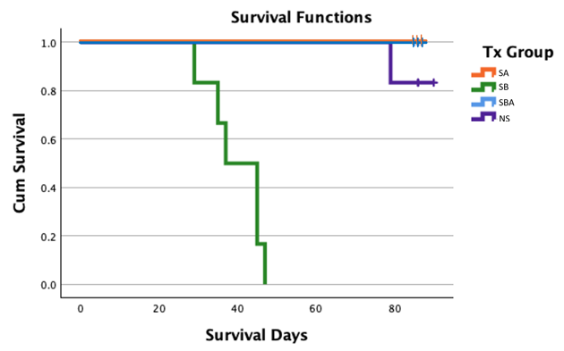
Figure 1: Survival curve for goats in 4 treatment groups.
positive OM score on radiograph images and CT imaging, indicating presence of infection.
One goat in NS cultured positive for a non-UAMS-1 Staph. aureus, likely of caprine origin and from incisional infection. This goat survived until the end-of study time point and did not develop clinical osteomyelitis. A small quantity of purulent material, soft tissue swelling, stiffness, and some erythema were observed in the dissected limb post-mortem. The Staph. aureus culture was determined not to be UAMS-1 based on colony phenotype. The radiograph OM scores for this goat were judged “0” during the entire period of study.

Radiographic Imaging
Group comparisons for all 4 groups were limited to images obtained through day 42 because of early removal of all goats in group SB. Further analysis comparing groups SA,
SBA and NS was done for data collected throughout the study period.

Osteomyelitis score
Summary statistics was performed for each group (Table 4, Figure 2). The average OM score for the SA group was 0 at all of the time points; group NS had scores varied from 0 to 0.20 $±$ 0.20 during the study period. Both groups were determined to be free of OM. SB goats OM scores increased from a mean of 0.67 + 0.33 on day 7 to a peak mean 2.67 + 0.33 at day 42 (Table 6). SBA group goats OM scores increased from a mean of 0.33 + 0.21 on day 7, to a peak mean of 1.83 + 0.40 on day 84.
Tests of fixed effects was performed initially for comparison between all 4 groups until day 42. (Values show in Table 5). There was a significant difference between groups (<.0001) and between time points (p = 0.0023), indicating that assessment of radiographic scores changed over time with OM progressively getting worse over time in the SB and SBA groups. There was no significant interaction found between groups and time points (p = 0.0895), indicating that changes over time were associated with the treatment group.
Post hoc analysis was performed to assess specific differences between groups withing time point. Between group comparations indicate that scores for groups SA and NS were similar across all time points. SB scores were significantly greater as compared with SA, NS, and SBA. Scores for the SBA group were significantly less than SB and significantly greater than those of SA and NS groups (Table 5).

Table 4: Radiograph Osteomyelitis Scores per group per time point.
Time point | Group
Time point | SA | SB | SBA | NS
 | ---------------------- Score ----------------------
7 | 0 A | 0.67 $±$ 0.33 A | 0.33 $±$ 0.21 A | 0.00 A
14 | 0 A | 1.50 $±$ 0.22 B | 0.67$±$ 0.42 AB | 0.00 A
28 | 0 A | 1.67 $±$ 0,33 B | 1.00 $±$ 0.26 B | 0.00 A
42 | 0 A | 2.67 $±$ 0,33 B | 1.00 $±$ 0.26 B | 0.17 $±$ 0.17 A
56 | 0 A | . | 1.33 $±$ 0.21B | 0.17 $±$ 0.17 A
70 | 0 A | . | 1.67 $±$0,33 B | 0.17 $±$ 0.17 A
84 | 0 A | . | 1.83 $±$0.40 B | 0.20 $±$ 0.20 A
LS-means with the same letter and on the same row are not significantly different.

Figure 2: Radiograph Osteomyelitis Scores per group per time point.

Table 5: Average scores per groups per time point
Time point |  | Group
 | SA |  | SB | SBA | NS
 | Mean |  | Mean | Mean | Mean
7 | 0.00 B |  | 0.00 B | 0.00 B | 0.00 B
14 | 0.20$±$0.20 B |  | 0.67$±$0.21 AB | 0.50$±$0.22 AB | 0.33$±$0.22 AB
28 | 0.80$±$0.20 AB |  | 1.00$±$0.26 AB | 0.50$±$0.22 AB | 0.50$±$0.22 AB
42 | 1.00$±$0.32 AB |  | 1.33$±$0.33 AB | 0.67$±$0.33 AB | 0.67$±$0.33 AB
56 | 1.80$±$0.37 A |  | - | 0.83$±$0.40 AB | 1.00$±$0.52 AB
70 | 1.80$±$0.37 A |  | - | 1.33$±$0.33 AB | 1.33$±$0.49 AB
84 | 1.80$±$0.37 A |  | - | 1.33$±$0.33 AB | 1.00$±$0.45 AB
LS-means with the same letter and on the same row are not significantly different.
Within time point comparation shows that SA and NS were similar at all time points. On Day 7, there was no significant difference among all four groups, indicating similar progression across all groups at this early time point. By Day 14, SB and SBA group goats remained similar; but SB was different from SA and NS groups; and SBA was similar to SA and NS. This suggests that OM progression in SB progressed much faster compared with that of SBA.
By Day 28, SB was significantly greater than SA and NS groups; groups SB and SBA were similar; and group SBA was significantly different from groups SA and NS. On day 42, SB group scores were significantly greater than SA and NS groups and similar to SBA group. There was a similarity between groups SB and NS on day 42 which can be attributed to the scores from one goat in the Group NS that exhibited signs of bacterial infection at the surgery site at the end of study. We consider this anomaly to be a result of contamination rather than a result of the model as this goat was not exposed to UAMS-1 Staph aureus.
Further statistical analysis was conducted to evaluate osteomyelitis (OM) among the remaining groups (SA, SBA and NS) after Day 42. A second analysis was performed comparing groups SA, SBA, and NS across all available time points of the study (Day 7 to 84). The analysis found that all groups were significantly different from each other (p < 0.0001) throughout the study period. There was also a significant difference in scores between time points (p = 0.0002) and a significant interaction between group and time point (p = 0.0023), suggesting that the effect of the groups on bone healing or OM progression changes over time.

Post hoc analysis was performed to compare the scores between groups over time. SBA was significantly different from both SA (p < 0.0001) and NS (p < 0.0001), while SA and NS remained similar (p = 0.7037). Time-point comparisons show that SA and NS remain similar throughout the entire period (Day 7 to 84). SBA exhibited a unique time progression pattern but was similar to SA and NS until day 42. From Day 56 onwards, Group SBA consistently showed the highest average scores and no similarity with the other groups.

Healing score
Summary statistics were performed for each group. There was no score count after day 42 for group SB because of early removal from the study of all goats. Group SA had the highest positive scores with scores varying from 0.20 + 0.20 to 1.8 + 0.37. Group SB had positive scores varying from 0.67 + 0.21 to 1.33 + 0,33. (until Day42). Group SBA had scores varying from 0.50 + 0.22 to 1.33 + 0.33 and group 4 NS had positive scores varying from 0.33 + 0.21 to 1.33 + 0.49 (Table 5, Figure 3).
Tests of fixed effects was performed initially for comparison between all 4 groups until day 42. Results determined that there was no statistically significant difference in healing scores between the four groups (p = 0.3675).
There was a statistically significant difference between times points (p <.0001) which indicate temporal progression for bone healing. There is no significant interaction between groups and data points (p = 0.2088), which indicates that healing scores vary consistently among groups over time.

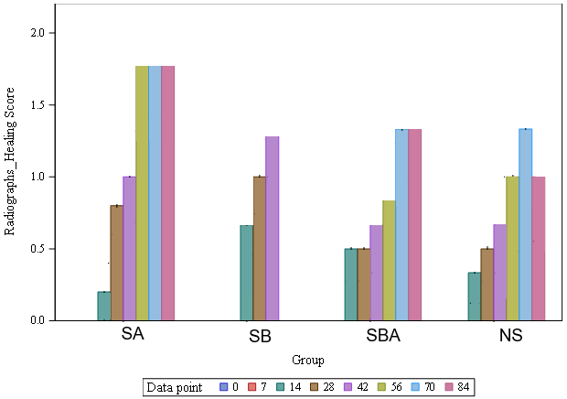
Figure 3: Average scores per groups per time point

Further statistical analysis was conducted to analyze bone healing outcomes among the groups. Analysis was performed comparing groups SA, SBA, and NS across all time points of the study (Day 7 to 84). The analysis found that all groups (SA, SBA, and NS) were similar (p = 0.6169) until the end of the study. However, different progression patterns could be identified among groups over time. Although not statistically significant, healing progression showed higher averages in group SBA.
Tukey-Kramer test was performed to compare the groups over time. All groups had similar healing progression in the earliest time point (Day 7). On Day 14, Group SBA and NS had greater healing scores compared with SA group. By day 28, SA showed higher averages than SBA and NS groups. This pattern continued until the end of the study. Although no significant differences were reported, the higher scores generated for SA suggest that this treatment tends to have better healing outcomes over the long term.

Computed Tomography (CT)
Computed tomography (CT) provided a three-dimensional view of the tibia, allowing for more detailed scoring based on different dimensional aspects of the bone compared to radiographs. The average osteomyelitis (OM) and healing scores per group generated by this test offer a snapshot of the factors of interest (OM or bone healing) at the end-of-study day (85 ± 5 days). Average scores were calculated for SA, SBA, and NS groups. CT data for the SB group was not used in statistical comparisons due to the variability in the timing of examinations within this group caused by early removal from the study (between days 35 to 47). CT data was reported for the median and range for the group.

Osteomyelitis score
The CT OM score was calculated based on images from the harvesting day for all 23 goats (Table 6, Figure 4). Statistical comparison was performed between groups SA, SBA, and NS (84 ± 6 days). There was a statistically significant difference between groups (p < .0001). SA and NS were similar (p = 0.8873); SBA was significantly different from SA and NS (p < .0001). The significance patterns align with radiograph findings. However, a statistically significant difference between methods was found (p = 0.0238) (Table 7), suggesting that the method (CT vs. radiograph) provides different interpretations of the severity of the disease.

Healing score
The CT healing score was calculated based on images from the end-of-study day for all 23 goats. The average score was calculated per group, results are presented in Table 8.
Statistical Comparison was performed between groups SA, SBA and NS (84 ± 6 days). There was no statistically significant difference between groups (p = 0.4009). Similarly,

Figure 4: CT Osteomyelitis score

Figure 5: CT Healing score
Table 6: CT Osteomyelitis score
 | Group
 | SA | SB | SBA | NS
Score | 0.2$±$0.2 | 2.5$±$0.56 | 2.67$±$0.33 | 0.2$±$0.2

Table 7: CT vs. Radiographs Osteomyelitis score
 | Group
 | SA | SBA | NS
 | --------- | Score | -----------
CT | 0.20$±$0.2 | 2.67$±$0.33 | 0.2$±$0.2
Radiographs | 0.0 | 1.83$±$0.4 | 0.2$±$0.2

Table 8: CT Healing score
 | Group
 | SA | SB | SBA | NS
Score | 1.80$±$0.37 | 1.17$±$0.17 | 1.33$±$0.33 | 0.80$±$0.49

there was no significant difference in the comparison between methods (p = 0.3332) (Table 9, Figure 5). Therefore, both radiographs and CT imaging provided similar analysis of healing.

Scaffold density
The density of the scaffold central region provides a quantitative assessment of osteogenic activity within the scaffold interior and the effectiveness of the scaffold in supporting bone in-growth. The main molecular and cellular events that contribute to changes in scaffold density are osteoblast activity, mineral deposition (a.k.a. biomineralization), and the integration of the scaffold with new bone ingrowth.
There was a statistically significant difference between the groups (p < 0.0001). SA had the highest average density (1076.4), followed by NS (997.2). The averages between these two groups are statistically similar (p = 0.3783). SBA differs significantly from both SA (p = 0.0019) and NS (p = 0.0277). The development of osteomyelitis (OM) in goats from SBA is likely responsible for the difference observed in this group (Table 10).

Thermography Imaging
Skin surface temperature (SST) assessment using a digital thermographic imaging camera (FLIR Ex series, Teledyne FLIR, LLC, Wilsonville, OR, USA) found significant

Table 9: CT vs. Radiographs Healing score
 | Group
 | SA | SBA | NS
 | --------- Score -----------
CT | 1.8$±$0.37 | 1.33$±$0.33 | 0.8$±$0.49
Radiographs | 1.8$±$0.37 | 1.33$±$0.33 | 1.0$±$0.45

Table 10: Scaffold Density per group
Group | Mean | a SEM
SA | 1076.4 | 31.5
SB | 683.5 | 19.81
SBA | 790.7 | 41.8
NS | 997.2 | 52.60

differences in temperature between the different treatment groups. (p = 0.0067) suggesting that treatment had a statistically significant effect on skin surface temperature. The average SST per group ranged between 30 C and 38 C (85.3 and 99.8 °F; Table 11, Figure 6). Statistical analysis identified significant SST changes over the study period indicating that temperature readings varied as a factor of time (p = 0.0001).
Based on the Tukey-Kramer post-hoc test, SA goats’ average temperatures were similar to NS goats’ and significantly different from SB and SBA group goats. No significant differences were found among Groups SB, SBA, and NS. The similarities in skin surface temperature between the NS group and the bacterial challenge groups (SB and SBA) may have been confounded by 2 NS group goats; one case of skin infection, and a case of soft tissue infection in the operated limb of another goat in this group.
Initial statistical analysis was done for treatment groups as a function of time considering all the groups (SA, BA, SBA, NS through day 42). There was a significant interaction between groups and time point (p= 0.0004) which indicates that the temperature differences observed are associated with both treatment group and time. Significant differences among temperatures between groups as a factor of time varied without following evident patterns.
Group SA average temperatures were similar to NS group temperatures throughout the period of the study and was consistently different from the other groups (SB and SBA), showing typically higher temperatures than those groups. Groups SB and SBA were not significantly different at all time points. Group SBA and group NS were not significantly different at all time points

Table 11: Average temperatures per groups per time point
 | Group
 | SA | SB | SBA | NS
Time point | ------- TEMPERATURE -------
2 | 96.2 $±$ 1.5A | 92.1 $±$ 1.9 AB | 95.6 $±$ 1.0 B | 99.3 $±$ 0.4 AB
07 | 97.9 $±$ 0.7 A | 99.1 $±$ 0.6 AB | 95.9 $±$ 0.8 B | 96.0 $±$ 2.2 AB
10 | 99.8 $±$ 0.2 A | 93.2 $±$ 2.8 AB | 95.9 $±$ 1.6 B | 99.1 $±$ 0.5 AB
14 | 96.1 $±$ 0.8 A | 94.4 $±$ 2.3 AB | 97.3 $±$ 0.3 B | 97.0 $±$ 0.7 AB
21 | 98.5 $±$ 0.7 A | 95.1 $±$ 2.3 AB | 93.2 $±$ 2.9 B | 97.5 $±$ 0.7 AB
28 | 97.7 $±$ 0.3 A | 94.1 $±$ 2.1 AB | 94.3 $±$ 1.0 B | 94.0 $±$ 2.3 AB
42 | 91.0 $±$ 3.0 A | 96.1 $±$ 0.8 AB | 89.8 $±$ 1.9 B | 91.0 $±$ 2.5 AB
56 | 94.6 $±$ 0.5 A | - | 90.2 $±$ 0.2 B | 92.8 $±$ 1.8 AB
70 | 91.3 $±$ 2.3 A | - | 88.9 $±$ 0.4 B | 90.4 $±$ 1.3 AB
84 | 85.3 $±$ 2.3 A | - | 91.2 $±$ 1.3 B | 86.6 $±$1.3 AB
LS-means with the same letter and on the same row are not significantly different.

Figure 6: Average temperatures per groups per time point

Group SB was not different from group NS on all time points except for day 21 when group NS had slightly higher readings. Similarities in temperature patterns suggests that group NS may have exhibited similar temperature patterns as an infected group until day 42. However, this pattern is not associated with OM.
After day 42, repeated measures analysis of variance with post-hoc Tukey’s adjustment analysis was done for groups SA, SBA and NS from day 56 to day 84. There was a significant difference between groups (p= 0.0053). Group SBA presented lower average temperatures compared to both SA (p= 0.0064) and NS (p= 0.7039) until day 70. The final time point (Day 84) is marked by a shift in patterns in which group SA and NS had a decrease in SST while SBA had an increase in SST. The increase in temperature for SBA group might represent the delayed onset of OM in this group. Group SA and NS were not different (p=0.7039). Example of Goat from the SBA group exhibit thermographic patterns showing a nonuniform decrease in temperature following surgery until Day 70, followed by a slight increase after Day 70 (Figure 7). Full representation of images acquired using the thermography tool is presented in the appendix.

Fluorescence Imaging
Imaging using a fluorescent camera (MolecuLight ® & DX™) over ten time points revealed infrequent colonization of the skin by Staph. Aureus. The fluorescence camera failed to identify osteomyelitis outcomes in the infected goats on the data collection time point. One NS group goat that had an open wound with purulent drainage was positive for Staph. aureus based on red fluorescence This goat was removed from the study on Day 79 due to the lack of improvement in the wound despite medical efforts. (Images
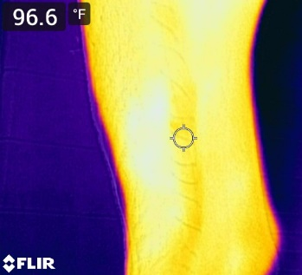  Week1, day2 | 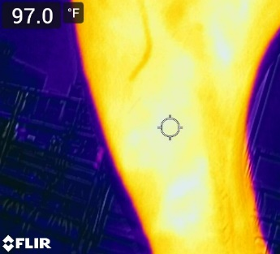  Week1, day7 | 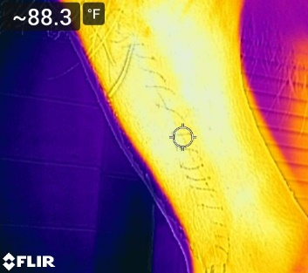Week2, day10 | 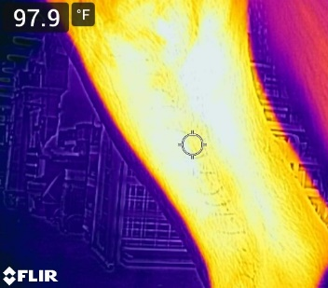  Week2, day14 | 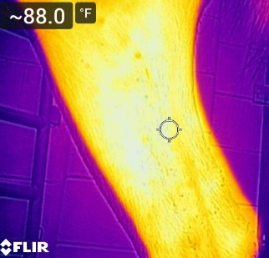  Week3, day21
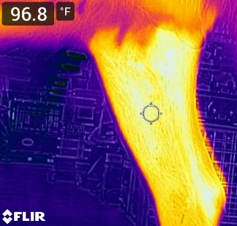  Week4, day 28 | 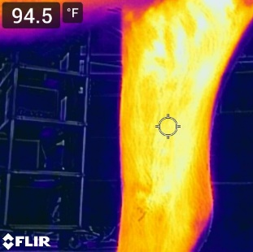  Week6, day 42 | 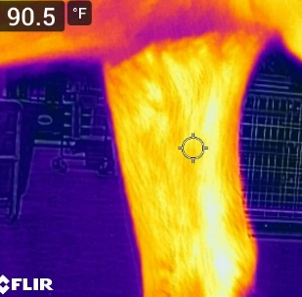  Week8, day 56 | 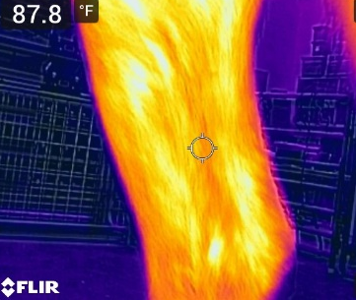  Week10, day 70 | 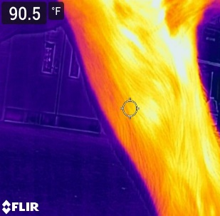  Week12, day 84
Figure 7: Example of thermography image progression.
progression are shown in Figure 8).
Culture of the wound and skin identified the presence of Staphylococcus simulans, Staphylococcus aureus, and other bacterial species. (Bruker) MADLI-ToF identification and phenotype categorization confirmed that the strain of Staphylococcus aureus found in this goat’s wound was not UAMS-1.
The goat's infection was classified as a surgical site infection unrelated to the OM model. The goat did not develop osteomyelitis based on radiographic assessment, CT scan, and gross examination.

Pressure sensing mat analysis
Descriptive and illustrative depictions of kinematic (Stride Length (m) and Stride Velocity (m/s)) and biomechanical (Maximum Peak Pressure (kPa), Maximum Force (kgf), Maximum Force (%BW)). variations among treatment groups are included in Tables 12 to 16 and in Figures 9 to 13.
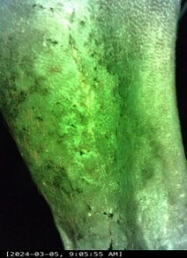  Week1, day2 | 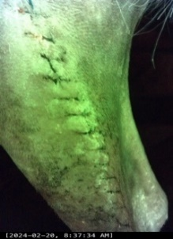  Week1, day7 | 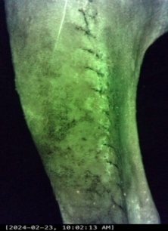Week2, day10 | 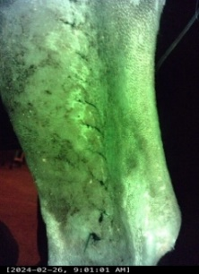  Week2, day14 | 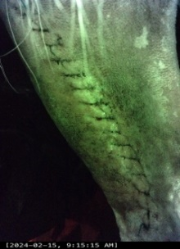  Week3, day21
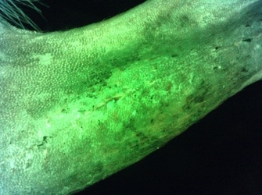  Week4, day 28 | 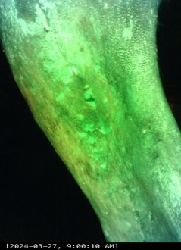  Week6, day 42 | 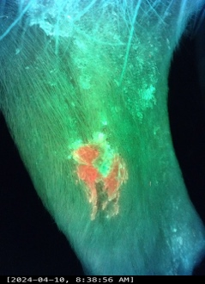  Week8, day 56 | 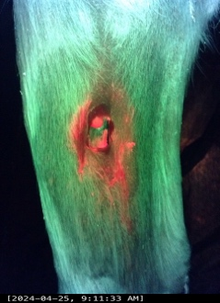  Week10, day 70
Figure 8: Images progression of fluorescence imaging positive case.

Table 12: Maximum Peak Pressure (kPa)
Limb | Time point | ------------------------------------- Group -------------------------------------
 |  | SA | SB | SBA | NS
LF | -1 | 449.6 + 50.9 | 445.2 + 34.0 | 414.0 + 19.8 | 406.3 + 17.3
LF | 7 | 400.6 + 09.4 | 412.8 + 11.9 | 445.5 + 21.3 | 436.8 + 26.4
LF | 14 | 438.8 + 22.9 | 406.2 + 08.4 | 410.3 + 13.0 | 422.7 + 27.4
LF | 28 | 424.8 + 18.0 | 418.8 + 15.5 | 386.7 + 19.6 | 451.2 + 21.1
LF | 42 | 411.4 + 33.5 | 371.3 + 11.7 | 422.0 + 22.2 | 462.7 + 16.7
LF | 56 | 483.0 + 49.8 |  | 407.3 + 29.0 | 423.0 + 31.7
LF | 70 | 405.4 + 14.8 |  | 438.3 + 29.7 | 391.8 + 24.1
LF | 84 | 432.2 + 42.6 |  | 357.3 + 14.3 | 386.4 + 45.7
LH | -1 | 405.8 $±$ 67.7 | 351.0 $±$ 13.4 | 372.2 $±$ 37.2 | 412.2 $±$39.2
LH | 7 | 381.0 $±$ 29.8 | 382.3 $± 18.1$ | 331.3 $± 28.1$ | 429.5 $±$ 22.1
LH | 14 | 352.2 $±$ 12.4 | 374.7 $± 16.1$ | 328.7 $± 25.1$ | 367.0 $±$ 18.4
LH | 28 | 397.6 $±$ 21.3 | 403.2 $±$ 17.5 | 319.3 $± 32.3$ | 382.7 $±$ 24.0
LH | 42 | 355.4 $±$ 19.2 | 386.0 $± 24.0$ | 340.2 $± 15.1$ | 389.5 $±$ 18.3
LH | 56 | 369.0 $±$ 41.3 |  | 330.0 $± 17.2$ | 370.8 $±$ 32.9
LH | 70 | 382.6 $±$ 19.5 |  | 331.0 $± 20.3$ | 348.5 $±$ 13.5
LH | 84 | 366.2 $±$ 20.5 |  | 339.7 $± 10.6$ | 348.0 $±$ 23.6
RF | -1 | 469.2 $±$ 28.5 | 423.2 $±$ 19.1 | 417.8 $±$ 32.3 | 425.2 $±$ 17.1
RF | 7 | 420.0 $±$ 16.3 | 425.2 $±$ 16.7 | 414.0 $±$ 27.7 | 406.3 $±$ 17.1
RF | 14 | 401.6 $±$ 23.6 | 411.2 $±$ 15.4 | 439.2 $±$ 21.5 | 432.7 $±$ 18.9
RF | 28 | 407.2 $±$ 23.6 | 373.2 $±$ 11.1 | 401.2 $±$ 32.9 | 469.7 $±$ 27.1
RF | 42 | 439.8 $±$ 26.3 | 402.7 $±$ 4.10 | 423.0 $±$ 20.5 | 423.0 $±$ 28.9
RF | 56 | 399.4 $±$ 16.3 |  | 428.7 $±$ 19.6 | 396.7 $±$ 26.9
RF | 70 | 416.6 $±$ 14.5 |  | 414.3 $±$ 16.8 | 416.8 $±$ 20.3
RF | 84 | 379.8 $±$ 29.9 |  | 389.8 $±$ 12.8 | 388.4 $±$12.5
RH | -1 | 339 $±$ 24.52 | 351.4 $±$22.08 | 377.2 $±$ 30.25 | 368.3 $±$ 20.25
RH | 7 | 296 $±$ 29.7 | 217.2 $±$ 34.5 | 189.8 $±$ 26.4 | 314.0 $±$ 20.3
RH | 14 | 360 $±$ 57.7 | 270.2 $±$ 33.9 | 331.3 $±$ 21.5 | 277.7 $±$ 57.2
RH | 28 | 269.8 $±$ 33.7 | 234.3 $±$ 22.2 | 355.5 $±$ 26.0 | 401.8 $±$ 21.4
Table 12 Continued
 | 42 | 307.8 $±$ 25.2 | 275.0 $±$ 32.1 | 315.3 $±$ 36.8 | 336.7 $±$ 21.1
 | 56 | 312.4 $±$ 18.3 |  | 300.3 $±$ 22.7 | 343.0 $±$26.5
 | 70 | 344.6 $±$ 27.7 |  | 287.7 $±$ 05.4 | 323.0 $±$ 08.0
 | 84 | 317.6 $±$ 33.6 |  | 251.7 $±$ 17.8 | 310.0 $±$ 16.6

Table 13: Maximum Force (kgf)
Limb | Time point | ------------------------------------- Group -------------------------------------
 |  | SA | SB | SBA | NS
LF | -1 | 42.1 $±$ 3.4 | 445.2 + 34.0 | 414.0 + 19.8 | 406.3 + 17.3
LF | 7 | 39.4 $±$ 1.8 | 412.8 + 11.9 | 445.5 + 21.3 | 436.8 + 26.4
LF | 14 | 40.8 $±$ 3.0 | 406.2 + 08.4 | 410.3 + 13.0 | 422.7 + 27.4
LF | 28 | 38.5 $±$ 3.2 | 418.8 + 15.5 | 386.7 + 19.6 | 451.2 + 21.1
LF | 42 | 35.1 $±$ 2.3 | 371.3 + 11.7 | 422.0 + 22.2 | 462.7 + 16.7
LF | 56 | 38.2 $±$ 4.1 |  | 407.3 + 29.0 | 423.0 + 31.7
LF | 70 | 35.0 $±$ 3.4 |  | 438.3 + 29.7 | 391.8 + 24.1
LF | 84 | 35.9 $±$ 4.3 |  | 357.3 + 14.3 | 386.4 + 45.7
LH | -1 | 31.72 | 28.07 $±$ 2.07 | 28.59 4.82 | 29.69 $±$ 2.57
LH | 7 | 31.01 | 32.76 $±$ 3.48 | 28.10 3.83 | 35.15 $±$ 3.04
LH | 14 | 31.44 $±$ 3.71 | 31.72 $±$ 2.00 | 26.56 $±$ 3.46 | 32.34 $±$ 2.40
LH | 28 | 29.25 $±$ 2.27 | 33.19 $±$ 2.50 | 28.12 $±$ 4.57 | 33.83 $±$ 1.81
LH | 42 | 29.99 $±$ 2.97 | 36.17 $±$ 5.50 | 29.27 $±$ 2.69 | 33.41 $±$ 1.80
LH | 56 | 30.38 $±$ 1.40 |  | 28.37 $±$ 3.13 | 30.91 $±$ 2.18
LH | 70 | 30.86 $±$ 1.70 |  | 27.46 $±$ 3.70 | 33.55 $±$ 1.74
LH | 84 | 29.08 $±$ 2.20 |  | 24.62 $±$ 3.23 | 29.92 $±$ 2.46
RF | -1 | 40.51 $±$ 4.65 | 39.22 $±$ 1.70 | 34.35 $±$ 2.84 | 35.50 $±$ 1.60
RF | 7 | 38.09 $±$ 2.61 | 37.94 $±$ 2.63 | 30.18 $±$ 1.46 | 38.48 $±$ 1.65
RF | 14 | 38.77 $±$ 3.63 | 38.16 $±$ 2.89 | 32.17 $±$ 2.12 | 37.34 $±$ 1.80
RF | 28 | 34.75 $±$ 2.55 | 36.56 $±$ 2.07 | 30.51 $±$ 1.97 | 38.11 $±$ 2.24
RF | 42 | 35.03 $±$ 2.85 | 37.82 $±$ 1.58 | 33.24 $±$ 2.64 | 35.09 $±$ 1.93
RF | 56 | 35.63 $±$ 1.59 |  | 34.98 $±$ 2.74 | 36.34 $±$ 1.96
RF | 70 | 33.10 $±$ 2.16 |  | 35.32 $±$ 2.02 | 34.55 $±$ 2.58
RF | 84 | 36.59 $±$ 2.35 |  | 31.83 $±$ 1.95 | 36.46 $±$ 3.10
Table 13 Continued
RH | -1 | 27.5 ± 2.0 | 29.8 ± 1.4 | 28.3 ± 3.5 | 28.0 ± 2.5
RH | 7 | 14.2 ± 2.0 | 11.3 ± 2.4 | 9.1 ± 1.4 | 17.2 ± 1.7
RH | 14 | 17.0 ± 1.5 | 15.5 ± 2.5 | 15.8 ± 2.4 | 15.9 ± 3.5
RH | 28 | 17.3 ± 3.3 | 11.2 ± 1.9 | 16.4 ± 2.8 | 23.9 ± 1.2
RH | 42 | 22.5 ± 3.3 | 15.4 ± 1.7 | 17.8 ± 2.3 | 22.4 ± 0.9
RH | 56 | 21.9 ± 1.8 |  | 15.7 ± 1.8 | 20.8± 1.4
RH | 70 | 24.4 ± 2.1 |  | 17.7 ± 1.8 | 22.1 ± 1.7
RH | 84 | 22.4 ± 2.7 |  | 14.6 ± 1.8 | 19.4 ± 1.4

Table 14: Maximum Force (%BW)
Limb | Time point | ------------------------------------- Group -------------------------------------
 |  | SA | SB | SBA | NS
LF | -1 | 29.8 $±$ 0.4 | 29.5 $±$ 1.5 | 31.2 $±$ 3.5 | 28.9 $±$ 1.1
LF | 7 | 32.2 $±$ 1.2 | 34.8 $±$ 1.2 | 35.3 $±$ 2.1 | 28.5 $±$ 1.0
LF | 14 | 32.1 $±$ 0.6 | 32.5 $±$ 0.9 | 30.1 $±$ 1.5 | 29.2 $±$ 0.6
LF | 28 | 31.4 $±$ 2.0 | 33.9 $±$ 0.7 | 31.6 $±$ 1.8 | 29.4 $±$ 1.0
LF | 42 | 28.8 $±$ 1.1 | 33.3 $±$ 1.0 | 29.9 $±$ 1.5 | 29.5 $±$ 1.1
LF | 56 | 29.9 $±$ 1.6 |  | 29.6 $±$ 0.8 | 30.2 $±$ 1.7
LF | 70 | 28.2 $±$ 1.6 |  | 31.5 $±$ 1.0 | 29.1 $±$ 1.2
LF | 84 | 28.7 $±$ 1.9 |  | 31.4 $±$ 1.0 | 29.6 $±$ 1.6
LH | -1 | 22.2 $±$ 0.9 | 20.8 $±$ 1.4 | 22.1 $±$ 1.4 | 22.6 $±$ 0.9
LH | 7 | 25.3 $±$ 0.7 | 26.8 $±$ 2.0 | 27.1 $±$ 1.9 | 27.7 $±$ 2.0
LH | 14 | 24.8 $±$ 0.9 | 25.1 $±$ 1.2 | 24.6 $±$ 1.9 | 25.5 $±$ 1.8
LH | 28 | 23.9 $±$ 0.5 | 27.1 $±$ 1.5 | 25.3 $±$ 2.4 | 25.0 $±$ 1.1
LH | 42 | 24.5 $±$ 0.8 | 26.9 $±$ 3.0 | 25.5 $±$ 1.2 | 26.0 $±$ 1.1
LH | 56 | 24.1 $±$ 0.8 |  | 25.2 $±$ 1.2 | 24.7 $±$ 1.1
LH | 70 | 25.2 $±$ 1.0 |  | 23.3 $±$ 2.1 | 26.5 $±$ 1.1
LH | 84 | 23.4 $±$ 0.7 |  | 23.4 $±$ 1.4 | 24.4 $±$ 1.6
RF | -1 | 28.46 $±$ 1.0 | 27.7 $±$ 0.8 | 27.8 $±$ 1.4 | 27.3 $±$ 0.5
RF | 7 | 31.08 $±$ 1.6 | 31.4 $±$ 2.0 | 30.9 $±$ 1.7 | 30.4 $±$ 1.2
RF | 14 | 30.76 $±$ 1.5 | 30.2 $±$ 1.7 | 30.8 $±$ 1.7 | 29.4 $±$0.9
RF | 28 | 30.38 $±$ 1.6 | 29.9 $±$ 1.5 | 28.3 $±$ 0.9 | 28.0 $±$ 0.6
Table 14 Continued
 | 42 | 28.62 $±$ 1.2 | 28.4 $±$ 2.1 | 29.0 $±$ 0.9 | 27.1 $±$ 0.7
 | 56 | 28.24 $±$ 0.5 |  | 31.4 $±$ 1.5 | 29.0 $±$ 1.8
 | 70 | 26.7 $±$ 0.8 |  | 30.6 $±$ 1.4 | 27.1 $±$ 1.1
 | 84 | 29.54 $±$ 0.5 |  | 30.9 $±$ 0.8 | 29.9 $±$ 1.8
RH | -1 | 19.5 $±$ 0.9 | 22.0 $±$ 1.1 | 22.4 $±$ 1.1 | 21.3 $±$ 1.0
RH | 7 | 11.5 $±$ 1.2 | 8.5 $±$ 1.6 | 9.1 $±$ 1.3 | 13.5 $±$ 1.2
RH | 14 | 13.6 $±$ 0.6 | 12.3 $±$ 2.0 | 14.6 $±$ 1.2 | 12.8 $±$ 2.7
RH | 28 | 14.7 $±$ 1.8 | 9.1 $±$ 1.3 | 14.9 $±$ 2.2 | 17.6 $±$ 0.8
RH | 42 | 18.1 $±$ 1.8 | 11.3 $±$ 1.3 | 15.7 $±$ 1.9 | 17.5 $±$ 0.9
RH | 56 | 17.7 $±$ 2.0 |  | 13.9 $±$ 0.8 | 16.2 $±$ 1.2
RH | 70 | 20.0 $±$ 1.7 |  | 15.3 $±$ 1.7 | 17.3 $±$ 0.9
RH | 84 | 18.4 $±$ 2.2 |  | 14.3 $±$ 1.9 | 16.2 $±$ 1.5

Table 15: Stride Length (m)
Limb | Time point | ------------------------------------- Group -------------------------------------
 |  | SA | SB | SBA | NS
LF | -1 | 1.28 $±$ 0.02 | 0.95 $±$ 0.03 | 0.82 $±$ 0.02 | 0.90 $±$ 0.02
LF | 7 | 0.77 $±$ 0.04 | 0.76 $±$ 0.04 | 0.67 $±$ 0.04 | 0.78 $±$ 0.02
LF | 14 | 0.89 $±$ 0.03 | 0.85 $±$ 0.03 | 0.78 $±$ 0.05 | 0.88 $±$ 0.03
LF | 28 | 0.86 $±$ 0.03 | 0.82 $±$ 0.04 | 0.83 $±$ 0.02 | 0.88 $±$ 0.01
LF | 42 | 0.91 $±$ 0.01 | 0.87 $±$ 0.01 | 0.87 $±$ 0.01 | 0.89 $±$ 0.03
LF | 56 | 0.90 $±$ 0.03 |  | 0.89 $±$ 0.04 | 0.87 $±$ 0.05
LF | 70 | 0.89 $±$ 0.03 |  | 0.87 $±$ 0.04 | 0.93 $±$ 0.03
LF | 84 | 0.92 $±$ 0.02 |  | 0.84 $±$ 0.03 | 0.93 $±$ 0.03
LH | -1 | 0.87 $±$ 0.02 | 0.96 $±$ 0.07 | 0.85 $±$ 0.02 | 0.83 $±$ 0.03
LH | 7 | 0.78 $±$0.03 | 0.74 $±$ 0.04 | 0.71 $±$ 0.05 | 0.73 $±$ 0.05
LH | 14 | 0.88 $±$ 0.02 | 0.85 $±$ 0.03 | 0.77 $±$ 0.04 | 0.86 $±$ 0.04
LH | 28 | 0.83 $±$ 0.00 | 0.80 $±$ 0.03 | 0.80 $±$ 0.04 | 0.81 $±$ 0.05
LH | 42 | 0.90 $±$ 0.02 | 0.85 $±$ 0.02 | 0.87 $±$ 0.01 | 0.86 $±$ 0.03
LH | 56 | 0.85 $±$ 0.04 |  | 0.87 $±$ 0.04 | 0.88 $±$ 0.03
LH | 70 | 0.88 $±$ 0.02 |  | 0.86 $±$ 0.04 | 0.91 $±$ 0.03

Table 15 Continued
 | 84 | 0.90 $±$ 0.02 |  | 0.83 $±$ 0.02 | 0.91 $±$ 0.02
RF | -1 | 0.89 $±$ 0.02 | 0.94 $±$ 0.03 | 0.82 $±$ 0.03 | 0.90 $±$ 0.02
RF | 7 | 0.78 $±$ 0.03 | 0.72 $±$ 0.03 | 0.69 $±$ 0.04 | 0.82 $±$ 0.04
RF | 14 | 0.88 $±$ 0.03 | 0.81 $±$ 0.03 | 0.79 $±$ 0.05 | 0.89 $±$0.02
RF | 28 | 0.86 $±$ 0.02 | 0.82 $±$ 0.03 | 0.80 $±$ 0.03 | 0.85$±$ 0.01
RF | 42 | 0.91 $±$ 0.01 | 0.85 $±$ 0.02 | 0.87 $±$ 0.02 | 0.89 $±$ 0.02
RF | 56 | 0.88 $±$ 0.03 |  | 0.88 $±$ 0.05 | 0.87 $±$ 0.03
RF | 70 | 0.90 $±$ 0.03 |  | 0.89 $±$ 0.04 | 0.92 $±$ 0.03
RF | 84 | 0.92 $±$ 0.04 |  | 0.82 $±$ 0.02 | 0.92 $±$ 0.02
RH | -1 | 0.85 $±$ 0.02 | 0.90 $±$ 0.03 | 0.83 $±$ 0.04 | 0.81 $±$ 0.07
RH | 7 | 0.78 $±$ 0.03 | 0.75 $±$ 0.04 | 0.67 $±$ 0.04 | 0.74 $±$ 0.03
RH | 14 | 0.78 $±$ 0.06 | 0.82 $±$ 0.03 | 0.78 $±$ 0.05 | 0.81 $±$ 0.07
RH | 28 | 0.84 $±$ 0.02 | 0.85 $±$ 0.08 | 0.80 $±$ 0.02 | 0.82 $±$ 0.05
RH | 42 | 0.88 $±$ 0.01 | 0.80 $±$ 0.02 | 0.84 $±$ 0.02 | 0.83 $±$ 0.03
RH | 56 | 0.83 $±$ 0.03 |  | 0.83 $±$ 0.05 | 0.84 $±$ 0.02
RH | 70 | 0.86 $±$ 0.02 |  | 0.85 $±$ 0.04 | 0.86 $±$ 0.04
RH | 84 | 0.90 $±$ 0.03 |  | 0.79 $±$ 0.03 | 0.90 $±$ 0.02

Table 16: Stride Velocity (m/s)
Limb | Time point | ------------------------------------- Group --------------------------------
 |  | SA | SB | SBA | NS
LF | -1 | 1.29 $±$ 0.16 | 1.32 $±$ 0.09 | 1.19 $±$ 0.09 | 1.25 $±$ 0.06
LF | 7 | 1.02 $±$ 0.10 | 1.10 $±$ 0.11 | 0.99 $±$ 0.12 | 1.05 $±$ 0.08
LF | 14 | 1.40 $±$ 0.05 | 1.30 $±$ 0.07 | 1.08 $±$ 0.08 | 1.34 $±$ 0.11
LF | 28 | 1.26 $±$ 0.12 | 1.32 $±$ 0.07 | 1.35 $±$ 0.10 | 1.20 $±$ 0.06
LF | 42 | 1.36 $±$ 0.09 | 1.38 $±$ 0.10 | 1.49 $±$ 0.09 | 1.24 $±$ 0.09
LF | 56 | 1.40 $±$ 0.09 |  | 1.58 $±$ 0.13 | 1.29 $±$ 0.15
LF | 70 | 1.39 $±$ 0.07 |  | 1.43 $±$ 0.15 | 1.53 $±$ 0.11
LF | 84 | 1.51 $±$ 0.14 |  | 1.44 $±$ 0.07 | 1.45 $±$ 0.10
 | -1 | 1.32 $±$ 0.04 | 1.23 $±$ 0.05 | 1.30 $±$ 0.06 | 1.05 $±$ 0.04
 | 7 | 1.00 $±$ 0.07 | 1.09 $±$ 0.11 | 1.09 $±$ 0.17 | 1.02 $±$ 0.10
 | 14 | 1.37 $±$ 0.06 | 1.28 $±$ 0.08 | 1.17 $±$ 0.13 | 1.35 $±$ 0.13
Table 16 Continued
 | 28 | 1.19 $±$ 0.11 | 1.27 $±$ 0.08 | 1.26 $±$ 0.11 | 1.10 $±$ 0.07
LH | 42 | 1.32 $±$ 0.10 | 1.30 $±$ 0.16 | 1.49 $±$ 0.10 | 1.20 $±$ 0.12
 | 56 | 1.33 $±$ 0.07 |  | 1.52 $±$ 0.13 | 1.24 $±$ 0.12
 | 70 | 1.38 $±$ 0.10 |  | 1.56 $±$ 0.14 | 1.47 $±$ 0.13
 | 84 | 1.46 $±$ 0.15 |  | 1.40 $±$ 0.08 | 1.53 $±$ 0.08
 | -1 | 1.30 $±$ 0.04 | 1.29 $±$ 0.07 | 1.21 $±$ 0.05 | 1.24 $±$ 0.05
 | 7 | 1.00 $±$ 0.08 | 1.04 $±$ 0.10 | 1.03 $±$ 0.13 | 1.08 $±$ 0.10
 | 14 | 1.40 $±$ 0.06 | 1.22 $±$ 0.08 | 1.17 $±$ 0.14 | 1.35 $±$ 0.12
RF | 28 | 1.24 $±$ 0.10 | 1.30 $±$ 0.07 | 1.27 $±$ 0.11 | 1.16 $±$ 0.07
 | 42 | 1.38 $±$ 0.08 | 1.31 $±$ 0.06 | 1.47 $±$ 0.09 | 1.24 $±$ 0.09
 | 56 | 1.37 $±$ 0.04 |  | 1.50 $±$ 0.13 | 1.26 $±$ 0.10
 | 70 | 1.38 $±$ 0.07 |  | 1.45 $±$ 0.13 | 1.50 $±$ 0.12
 | 84 | 1.48 $±$ 0.12 |  | 1.40 $±$ 0.05 | 1.40 $±$ 0.14
 | -1 | 1.26 $±$ 0.04 | 1.21 $±$ 0.08 | 1.24 $±$ 0.04 | 1.12 $±$ 0.06
 | 7 | 1.00 $±$ 0.08 | 0.91 $±$ 0.13 | 1.02 $±$ 0.14 | 0.97 $±$ 0.10
RH | 14 | 1.31 $±$ 0.11 | 1.17 $±$ 0.11 | 1.10 $±$ 0.11 | 1.27 $±$ 0.20
 | 28 | 1.22 $±$ 0.08 | 1.25 $±$ 0.07 | 1.31 $±$ 0.08 | 1.13 $±$ 0.09
 | 42 | 1.32 $±$ 0.07 | 1.36 $±$ 0.14 | 1.44 $±$ 0.09 | 1.18 $±$ 0.12
 | 56 | 1.30 $±$ 0.08 |  | 1.54 $±$ 0.15 | 1.21 $±$ 0.09
 | 70 | 1.30 $±$ 0.11 |  | 1.46 $±$ 0.16 | 1.38 $±$ 0.14
 | 84 | 1.47 $±$ 0.14 |  | 1.38 $±$ 0.06 | 1.39 $±$ 0.15

Figure 9: Maximum Peak Pressure (Kpa) RH

Figure 10: Maximum Force (kg) RH

Figure 11: Maximum Force (BW) RH

Figure 12: Stride Length (m)

Figure 13: Stride Velocity (m/s) RH

Maximum Peak Pressure (kPa)
Peak pressure of the implanted right tibia showed a significant statistical difference between Group SB and Group NS (p = 0.0207). Focused assessment of the affected limb revealed that this difference was recorded on Day 28 (p = 0.0103), at which time Group NS goats had the highest average peak pressure (401.8 ± 21.4), in contrast to Group SB goats, which had the lowest peak pressure average (234.3 ± 22.2).
There were no significant differences, based on time points, among treatment groups SA, SB, and NS throughout the study period. However, Group SBA showed significant differences between Day -1 (377.2 ± 30.25) and Day 7 (189.8 ± 26.4; p = 0.0016), as well as between Day 7 and Day 28 (355.5 ± 26.0, p = 0.0081). This group experienced the greatest decrease in peak pressure immediately post-surgery. Treatment group SB consistently exhibited the lowest pressures from Day 7 to Day 42, suggesting impaired function, possibly caused by inflammation and pain in response to the bacteria and without treatment. While both SBA and SB were most affected, SBA showed recovery to baseline, suggesting that vancomycin mitigated the severity of pain and inflammation associated with the bacteria.

Maximum Force (kgf)
There was no statically significant difference between groups for maximum force. There were significant affects based on time points: within time assessment per group found that Group SA showed significant differences between Day -1 (27.5 ± 2.0) and Days 7 (14.2 ± 2.0, p = 0.0013), 14 (17.0 ± 1.5, p = 0.0363), and 28 (17.3 ± 3.3, p = 0.0466). For Group SB, a statistically significant difference was observed between Day -1 and Day 42 (p = 0.0028). Group SBA had significant differences between Day -1 (28.3 ± 3.5) and Days 14 (15.8 ± 2.4, p = 0.0014), 28 (16.4 ± 2.8, p = 0.0031), and 42 (17.8 ± 2.3, p = 0.0169). In Group NS, significant differences were found between Day -1 (28.0 ± 2.5) and Days 7 (17.2 ± 1.7, p = 0.0081) and 14 (15.9 ± 3.5, p = 0.0014).
Although no significant differences were found between groups across time points, there was a noticeable decrease in weight-bearing at 7 days following surgery across all groups. Maximum force gradually increased for SA, NS, and SBA goats until Day 84, and in Group SB goats until Day 42. The averages for the infected groups (SB and SBA) remained lower than those for the non-infected groups (SA and NS) throughout the entire period while group SA had higher averages compared with group NS goats. None of the treatment groups fully recovered to pre-surgical baseline.

Maximum Force (%BW)
A statistically significant difference was noted between Group SB and both Groups SA (p = 0.0477) and NS (p = 0.045). Focused assessment of the affected limb revealed that this difference was observed specifically on Day 28 (p = 0.0218), with Group NS presenting the highest maximum force (17.6 ± 0.8), in contrast to Group SB, which had the lowest average maximum force (14.7 ± 1.8) among all groups. This suggests that severe acute inflammatory reactions culminated in weight-bearing differences among those groups.
Within time points, Group SA showed significant differences between Day -1 (19.5 ± 0.9) and Day 7 (11.5 ± 1.2, p = 0.0254). In Group SB, a statistically significant difference was observed between Day -1 (22.0 ± 1.1) and Day 14 (12.3 ± 2.0, p = 0.0003), and between Day -1 and Day 42 (11.3 ± 1.3, p = 0.0017). Additionally, significant differences were found between Day 7 (8.5 ± 1.6) and Day 28 (9.1 ± 1.3, p = 0.0145).
Group SBA showed differences between Day -1 (22.4 ± 1.1) and Days 14 (14.6 ± 1.2, p = 0.0099) and 28 (14.9 ± 2.2, p = 0.0175). From Day 7 to Day 28, there was an individual increase in weight-bearing for Group SBA, indicating a significant decrease after surgery followed by functional recovery.
In Group NS, significant differences were found between Day -1 (21.3 ± 1.0) and Days 7 (13.5 ± 1.2, p = 0.0124) and 14 (12.8 ± 2.7, p = 0.0034).
Although no significant differences were observed, there was a noticeable decrease in weight-bearing across all groups in the week following surgery (Day 7), followed by a gradual increase in maximum force as a % of body weight. This pattern was observed in Groups SA, NS, and SBA until Day 84. Group SB did not show the same improvement pattern through Day 42, maintaining weight-bearing consistently lower than the baseline (Day -1) and lower than the other groups.
The averages for the infected groups (SB and SBA) remained lower than those for the non-infected groups (SA and NS) on Day 7, suggesting that the acute inflammatory response altered with weight-bearing. However, Group SBA showed greater recovery over time compared to Group SB. The weight-bearing recovery for Group SBA was comparable to that of the SA and NS groups.

Stride Velocity (m/s)
There was no significant difference observed between groups or within time points through Day 42 for all 4 treatment groups and through day 84 for Groups SA, SBA, and NS. However, there was a consistent pattern of increased velocity in the week following surgery, followed by a gradual rise, similar to the other biomechanical parameters.
NS, SA, and SBA displayed comparable fluctuations, with a notable increase on Day 14. While Groups SA and NS showed a slight decrease after Day 28, Group SB continued to increase velocity in the affected limb, which could be indicative of discomfort.
Group SBA showed greater fluctuation when compared to Groups SA and NS, but over time, the differences between groups lessened. Unlike Group SB, the increase in velocity observed in Group SBA was aligned with improvements in biomechanical parameters, indicating good recovery in that group, especially when compared to SB.

Stride Length (m)
There were no statistically significant differences between groups. Within time points, Group SA showed significant differences between Day -1 (1.28 ± 0.02) and Days 7 (0.77 ± 0.04, p = 0.0047) and 14 (0.89 ± 0.03, p = 0.0249). An increase in velocity was observed during the week following surgery, followed by a gradual rise, similar to other biomechanical parameters.
All groups displayed comparable fluctuations until Day 28, at which point Group SB showed a sharp decrease in stride length, which may indicate discomfort. This is especially evident when cross-referencing with biomechanical parameters (maximum peak pressure, maximum force). The progressive decrease in biomechanical variables observed in this group, combined with shorter steps and faster stride velocity, indicates increasing discomfort. This reflects the progression of osteomyelitis in Group SB.
Cross-referencing observations from kinematic (stride length and stride velocity) and biomechanical variables (maximum peak pressure, maximum force) provides evidence of discomfort in Group SB, as the increase in velocity coincided with a decrease in biomechanical variables. This increase in velocity persisted in Group SB, aligning with lower values in biomechanical measures until Day 42 (the last data collection point for the group). This pattern is relevant when compared to the other three groups, where an overall increase in velocity corresponded with improvements in biomechanical parameters, indicating better recovery and alignment to baseline gait patterns.

Histopathological assessment
Descriptions of assessment outcomes per group per criteria (Cellular response (CR), new bone response (NBR), Soft tissue response - Surrounding bone (SFB) Soft tissue response - Defect area (SFD) are shown in tables 17 to 22, figures 14 to 18. Based on assessment of tissue responses to the treatment groups, significant differences in intensity of cellular response between groups were found (p = 0.0004). No statistically significant differences were found in the other criteria.
Group SB had the highest scores for cellular inflammatory response as compared with the other groups (Table17). Specimens from all goats in the SB group had abundant inflammatory cellular responses. Cellular inflammatory response in the SBA group were similar, with 5 out of 6 goats having similar abundant inflammatory cellular responses.
Inflammatory cellular responses were observed in 1 out of 5 specimens from SA group goats, and 1 out of 6 goats in the NS group. Comparison of the overall histopathological assessment between groups SA and NS shows significantly better outcomes in group SA as compared with that of the native scaffold (group NS). This finding may support an unknown mechanism of vancomycin influencing cellular responses to the implant.
Assessment of new bone response (NBR), soft tissue response surrounding the bone (SFB), and soft tissue response in the defect area (SFD) in SB group goat specimens was consistent with inflammatory response to the bacterial infection. In contrast, the NS and
Table 17: Descriptive statistics per group per response criteria
Group: | SA |  |  | SB |  |  | SBA |  |  | NS
Response criteria: | Median | Min. | Max. | Median | Min. | Max. | Median | Min. | Max. | Median | Min. | Max.
Cellular response (CR) | 1 | 0 | 1 | 2 | 2 | 2 | 2 | 1 | 2 | 1 | 1 | 2
New bone response (NBR) | 2 | 1 | 2 | 2 | 1 | 2 | 2 | 1 | 2 | 2 | 1 | 2
Soft tissue response - Surrounding bone (SFB) | 0 | 0 | 1 | 1 | 1 | 2 | 1 | 0 | 2 | 1 | 0 | 1
Soft tissue response - Defect area (SFD) | 2 | 0 | 2 | 1 | 1 | 2 | 2 | 1 | 2 | 2 | 2 | 2

Table 18: Response criteria score frequency per group
Group | Score | Cell response (CR) | New bone response (NBR) | Soft tissue response surrounding bone (SFB) | Soft tissue response surrounding defect (SFD)
SA | 0 | 1 | 0 | 4 | 1
SA | 1 | 4 | 2 | 1 | 1
SA | 2 | 0 | 3 | 0 | 3
SB | 0 | 0 | 0 | 0 | 0
SB | 1 | 0 | 1 | 5 | 4
SB | 2 | 6 | 5 | 1 | 2
SBA | 0 | 0 | 0 | 2 | 0
SBA | 1 | 1 | 3 | 3 | 3
SBA | 2 | 5 | 3 | 1 | 3
NS | 0 | 0 | 0 | 2 | 0
NS | 1 | 5 | 2 | 4 | 0
NS | 2 | 1 | 4 | 0 | 6

Figure 14: Response type score frequency per group

Table 19: Tx Group by Cell response (CR)
 | Response level frequency
Tx. Group | 0 | 1 | 2
SA | 1 | 4 | 0
SB | 0 | 0 | 6
SBA | 0 | 1 | 5
NS | 0 | 5 | 1

Table 20: Tx. Group by New bone response (NBR)
 | Response level frequency
Tx. Group | 0 | 1 | 2
SA | 0 | 2 | 3
SB | 0 | 1 | 5
SBA | 0 | 3 | 3
NS | 0 | 2 | 4

Table 21: Tx. Group by Soft tissue response surrounding bone
 | Response level frequency
Tx. Group | 0 | 1 | 2
SA | 4 | 1 | 0
SB | 0 | 5 | 1
SBA | 2 | 3 | 1
NS | 2 | 4 | 0

Table 22: Tx. Group by Soft tissue response surrounding defect
 | Response level frequency
Tx. Group | 0 | 1 | 2
SA | 1 | 1 | 3
SB | 0 | 4 | 2
SBA | 0 | 3 | 3
NS | 0 | 0 | 6

Figure 15: CR score frequency per group

Figure 16: NBR score frequency per group

Figure 17: SFB score frequency per group

Figure 18: SFD score frequency per group

SB group specimens predominantly had evidence of new bone response and limited SFB and SFD when compared with that of the SB and SBA groups.

Vancomycin assays

In vitro elution
In vitro assessment of 2 scaffolds (MM3-3-3 and MM2-158-3) showed a progressive decrease in concentration until Day 10, marked by a rapid decrease from 12 hours post-incubation to Day 2, with markedly lower concentrations after the Day 3 time point. Although the scales of the in vitro and in vivo analyses differ, these results suggest a comparable pattern between the in vivo pharmacokinetics and the in vitro drug release profile. The pattern is only interrupted by an anomaly in group SA on Day 1, where the concentration is higher than that observed at Day 0, 12 hours post-surgery differing from the SBA group and both scaffolds, which showed only decreasing concentrations over time. Table 23

Table 23: Average concentration in media per scaffold over time (µg/ml)
Time points ug/ML |  |  | D0 | D0 12hr | D1 | D2 | D3 | D5 | D7 | D10
Group |  | MM3-3-3 | ND | 9722 | 4707 | 1267 | 499 | 284 | 69 | 42
 | MM2-158-3 |  | ND | 10429 | 4650 | 1003 | 565 | 208 | 50 | 23

In vivo plasma concentration
Vancomycin plasma concentration analysis for groups SA and SBA detected the presence of vancomycin until Day 5 in the SA group and until Day 3 in the SBA group (Figure 19). No detection (ND) was observed on Days 0, 7, and 10. The average plasma concentration of vancomycin in group SA was higher than in group SBA (Table 24). Both groups exhibited similar vancomycin plasma concentration patterns, with a peak concentration on Day 1 followed by a progressive decline (Figure 20). Interestingly, group SA showed a higher peak concentration on Day 1 and a longer detection period. These findings suggest that the SBA group scaffold did not achieve detectable antibiotic release in vivo beyond 72 hours, and that the SA group scaffold did not achieve detectable antibiotic release in vivo beyond 120 hours. This may suggest that presence of bacterial infection, in the absence of vancomycin, during the immediate post-implantation period may have increased the rate and decreased the duration of release of vancomycin. Also, it is possible that vancomycin may have been sequestered in the “dead space” within the bone defect and scaffold resulting from disruption of blood supply.
Although the scales of the in vitro and in vivo analyses differ, these results suggest a comparable pattern between the in vivo pharmacokinetics and the in vitro drug release profile. The pattern is only interrupted by an anomaly in group SA on Day 1, where the concentration is higher than that observed at Day 0, 12 hours post-surgery differing from

Figure 19: Media concentration of vancomycin over time

Table 24: average concentration per group per time point (µg/ml)
 | Time point | D0 | D0 12hr | D1 | D | D3 | D5 | D7 | D10
Group | SA | ND | 1.27 | 2.27 | 0.90 | 0.15 | $$<0.1$$ | ND | ND
 | SBA | ND | 1.19 | 1.15 | 0.14 | 0.01 | ND | ND | ND
ND = nothing detected
*ND data is represented as gaps
Figure 20: Serum vancomycin concentration per group per time point

the SBA group and both scaffolds, which showed only decreasing concentrations over time.

Discussion and Conclusions

Delayed osteomyelitis
The purpose of this study was to evaluate the use of a bone regeneration scaffold technology as a dual-use platform for regenerating bone and delivery of sufficient quantities of antibiotics locally to prevent osteomyelitis. We aimed to test whether the scaffold could deliver vancomycin in sufficient quantities to eliminate bacteria from the surgery site while maintaining its bone healing properties[134]. The saturation of the scaffold with vancomycin did not completely eliminate bacterial infection. Hence, the discussion of the results is better expressed by separately evaluating the effects of vancomycin inoculation in the infected goats and the effects of vancomycin inoculation in non-infected goats. Initially, the description focuses on how the inoculation of vancomycin led to a lessening of severity and a delay in the onset of osteomyelitis (OM) in goats treated with vancomycin and challenged with bacteria. This is followed by a description of how the vancomycin loaded scaffolds in non-infected goats culminated in better healing outcomes in the absence of bacteria.
A combined analysis of clinical assessment, radiographs, and CT imaging indicated that loading the scaffold with vancomycin lessened the severity and delayed the onset of osteomyelitis (OM) in goats treated with vancomycin and challenged with bacteria. The delayed onset of osteomyelitis observed in our results is evidenced by comparing health outcomes between the bacterial challenge groups. All goats that had bacterial challenge, without vancomycin, showed rapid disease progression, leading to early removal from the study due to clinical morbidity including open wounds with draining exudate and radiographic signs of progressive osteomyelitis. In contrast, infected goats that received vancomycin did not exhibit clinical signs and completed the 12-week study period. Bacteriological growth and histopathological assessments, along with radiographic and CT OM scores, confirmed that OM was successfully induced in all goats inoculated with the Staphylococcus aureus (UAMS-1) bacteria. Radiographic, CT, and histopathological assessments aligned with kinematic and biomechanical results and demonstrated that the healing properties of the scaffold were not negatively affected by the addition of vancomycin.
Vancomycin inhibits the polymerization and cross-linking required to form the bacterial cell wall [135] leading to cell death. Bacterial lysis induced by vancomycin prevents the excessive release of pro-inflammatory cytokines, such as TNF-α, IL-1β, and IL-6[136], that are commonly elevated in bacterial infections. This “cytokine storm” often amplifies inflammation, and its mitigation is crucial for resolving inflammatory conditions. As vancomycin mitigates the infection, it allows tissues to repair and recover, further reducing inflammation associated with chronic infection or tissue damage. The anti-inflammatory effects of vancomycin are rapid, it can be quantified as early as 1 day after administration [136, 137]. In this study, vancomycin was administered during surgical intervention mimicking a contaminated surgery scenario where the antimicrobial intervention would be provided close to the time of the initial contamination.
The use of goats provides clinical relevance for conditions in human patients suffering bone injury in the face of infection. The goat model is highly versatile and has been well-established for orthopaedical research, regenerative medicine and infectious disease research for over 30 years[138]. Goats have been successfully used to test critical size defect therapeutics and remain a preferred model for osteomyelitis in long bones[139, 140]. Furthermore, goats have been utilized to evaluate dual-platform technologies for at least a decade[64, 141], further demonstrating their importance in orthopedic research. The goat model is favored due to its anatomical[140] and bone remodeling properties[142], which closely resemble those of people. Chang et al. conducted a study in goats that successfully delivered vancomycin to treat osteomyelitis without compromising bone regenerative abilities, a significant advancement in the prophylactic field[141]. Similarly, Alegrete et. al successfully tested a nanohydroxyapatite-based scaffold in sheep, highlighting the clinical relevance of small ruminants as a model for testing biomaterials for orthopedic procedures[64]. These findings demonstrate the value of goats as models for prophylaxis, infection management, and the development of biomaterials in the orthopedic field. Similarities between goats and people enables relevant imaging and histological assessments, facilitating detailed evaluation and comparison of treatment modalities. Relevance to human applications in orthopedic regenerative patients offers advantages compared with that of smaller animal models such as rats and rabbits.
The diagnosis of osteomyelitis (OM) and the evaluation of disease progression are typically performed using radiographic imaging in clinical settings. Standard radiographs are routinely obtained for all patients suspected of having osteomyelitis, with initial bone changes becoming detectable approximately 2–3 weeks after the onset of the condition[108]. In animal models, radiographic signs of osteomyelitis appear as early as 2 weeks after bacterial infection[108, 139, 143], and the disease can continue to progress beyond 12-weeks [139, 144]. The observed progression of OM in the infected groups in our study supports literature on OM induction, with initial radiographic findings appearing in both groups within 2 weeks in our study. However, establishment of osteomyelitis was delayed and significantly less severe in goats in which vancomycin was impregnated in the scaffold. This discrepancy is illustrated by the distinct radiographical findings observed over time in these groups. Soft tissue abnormalities were the most common findings in the infected goats.
The presence and progression of periosteal response is a typical radiographic sign of OM[145], often appearing around two weeks after establishment of infection and worsening over time. [3] This well-known chronological progression makes periosteal response a valuable indicator for monitoring OM[146]. Importantly in this study, periosteal reaction was present in all non-treated goats but absent in the infected treated group at this early (2 week) stage.
The progression of lysis in osteomyelitis (OM) presents distinct radiographic features between groups treated with vancomycin and untreated groups in late stage of OM (6 weeks), making this criterion a reliable indicator of infection severity and progression[146]. In this study, at this same time point (week 6), non-treated bacterial challenge goats presented a marked increase in the frequency of lysis, or cortical necrosis, in contrast with bacterial and vancomycin treated goats that did not show the same increase at this time point. This observance supports that loading the scaffold with vancomycin delayed onset and severity of OM and may be valuable in treatment of patients suffering contaminated orthopaedical injuries.

Compared to non-infected goats, infected goats that were implanted with vancomycin loaded scaffolds had significantly greater changes based on computed tomography (CT) assessment. Despite the advantages of CT with respect to 3-dimensional assessments compared with conventional radiography, serial CT was not feasible because of the presence of metal orthopaedical implants. [8, 13] Thus, a limitation of this study was the inability to serially assess disease progression using CT. This constraint was primarily due to the presence of metallic implants in the goat tibia which cause local artifacts that decrease image quality[108]. As such, removal of the orthopaedical implants was necessary to perform CT, which necessitated CT being done at the end-of-the-study period for each goat. Osteomyelitis research conducted in rats comparing antibiotic and non-antibiotic treated rats, found no significant differences in CT scores over a 6-week period[146]. Although temporal CT assessment may provide valuable information, we were able to demonstrate extensive changes over time utilizing digital radiography followed by end-of-study computed tomography.
Infected goats, not treated with vancomycin, had widespread histological evidence of osteomyelitis which was of greater severity in comparison with goats treated with vancomycin. The histopathological changes were dominated by marked inflammatory cell responses, extensive fibrous tissue formation surrounding the defect and scaffold, and irregular new bone (“spongy bone”) formation. The initial physiological and immunological reactions that normally occur after surgery, known as surgical stress, are expected and the duration is dependent on the type of surgery and biomaterials. [147] [148] These expected cellular and tissue responses are typically minimal with biocompatible materials. The histology responses observed in the infected goats were marked and represent a pathological response as a result of the presence of bacteria in the bone defect and scaffold.
The immunological reaction of excessive infiltration of cell from immunologic reaction endures for as long as bacteria manage to infect the tissue. S. aureus is an agent causal of exacerbated inflammatory response by recruiting large numbers of neutrophils and macrophages. The presence of pathogen-associated molecular patterns (PAMPs) in the bacteria triggers chemotaxis response that both recruits immune cells and simultaneously disrupts their function through its virulence factors, creating an environment conducive to its survival and proliferation[96]. Initially, this chemokine-driven recruitment is beneficial because neutrophils and macrophages are essential for the innate immune response. However, this leads to tissue damage, which releases more chemokines and creates a vicious cycle of immune cell recruitment. S. aureus invades osteoblasts by utilizing fibronectin-binding proteins (FnBPs) and integrins, facilitating its internalization [149, 150]. Once inside the cell the bacteria evade immune detection and antibiotic treatment. Its presence disrupts the balance between osteoblasts and osteoclasts[150], driving bone destruction through osteoclast activation. These mechanisms are critical for the establishment, persistence, and progression of infection into a chronic state. This extensive arsenal of virulence factors makes S. aureus the leading causative agent of osteomyelitis in humans[36, 151]. Vancomycin can disrupt these patterns of infection for susceptible bacteria, such as the Staph aureus utilized in this study. In histological assessment of infected goats, the beneficial role of vancomycin was evident by the lesser cellular response and more normal trabecular-type bone formation.

Even though the non-treated bacteria goats showed an increase in new bone formation, this does not indicate the development of quality bone. S. aureus UAMS-1 express Protein A (SpA)[152] which is a major virulence factor that plays a significant role in mediating bacterial adhesion, immune evasion, and interactions with host cells, including osteoblasts. The protein A (SpA) can cause osteoblasts to hyper-mineralize. This mineralization is seen in histological assessment as new bone; however, it is structurally compromised bone and reflects an overcompensation to maintain skeletal integrity amidst infection[153]. The role of vancomycin can be linked to a lower rate of osteoblasts intracellularly infected by Staphylococcus aureus. The exuberant new bone formation found in the bacterial challenge group goats with no treatment indicates uncontrolled bacterial infection.
CT and histopathological assessments provided only a single point in time at the study endpoint. Serial assessment tools provide for temporal evaluation of the progression of healing and OM. In this study, serial gait and radiographic image analyses offered valuable insights into the progression of over time. Comparison of biomechanical and kinematic gait parameters demonstrated the severity of OM in the infected non-treated goats, infected treated goats, and non-infected goats. These results support the mitigation of infection in goats treated with vancomycin and revealed interesting differences among the non-infected goats (native scaffold and vancomycin impregnated scaffold groups). The gait variables examined in this study serve as indicators of pain that can be caused by inflammation or infection [154, 155]. There is an expected variation in gait parameters following orthopedic surgeries that is induced by the surgical intervention itself (surgical stress)[147]. These variations are a result of the inflammatory response to the disruption of physiological homeostasis and were expected to be observed regardless of treatment group. Therefore, gait changes occur as part of the healing process inherent to the procedure, and this response progresses over time, ultimately returning to baseline levels within approximately 30 days[133, 154] The presence of bacteria is expected to increase inflammatory process beyond physiological response and this pattern developed is measured by worsening of gait in the two bacterial infection groups and most pronounced in the non-treated bacterial challenge goats. The presence of vancomycin played a significant role in mitigating infection and these goats improved during recovery compared with non-treated goats challenged with bacteria.
Early improvement of gait in infected goats inoculated with vancomycin represents enhanced anti-inflammatory response. This beneficial effect may support early bone regeneration after initial surgical intervention for bone repair. The gait improvement observed in vancomycin treated goats over time, despite the presence of bacteria, was comparable to that observed in the non-infected goat groups. The gait results underscore the mitigation of bacterial activity and inflammation in goats treated with the scaffolds containing vancomycin. This effect may have been associated with vancomycin suppression of bacterial proliferation. The implantation of scaffolds saturated with vancomycin was critical for the improved recovery process observed in goats challenged with bacteria and vancomycin.
Timing is a critical factor in the progression of infections, early treatment is linked to reduction of mortality in infections from 5-25%[156, 157]. Patients that receive early treatment recover more fully than patients in whom treatment is delayed, even if the early treatment was not with the most effective antibiotic [157]. In addition, infection progression is a possible factor of vancomycin’s decreases in bone penetration[158]. Vancomycin is one of the drugs of choice for broad spectrum treatment of osteomyelitis caused by S. aureus sp.[135] Local administration of vancomycin may offer advantages compared with systemic administration as a way to optimize drug concentration and durability at the site of infection and lessen the risk of toxicity[137]. Patients at risk of osteomyelitis may benefit better from the prophylactic use of antimicrobials at the time of surgery.

Bone healing advantages
Interestingly, the non-infected vancomycin inoculated group had better overall outcomes among all the groups. The pattern observed in this study suggest increased bone formation induced by vancomycin that aligns to previous findings in other studies[66]. The inoculation of vancomycin not only provided benefits in infected goats but also provided improved bone healing non-infected control groups. Enhanced outcomes in the scaffold and vancomycin group (SA) compared to native scaffold (NS) is supported by the higher healing score, greater scaffold CT density, and improved histological assessment. Despite numerically higher healing scores for scaffold and vancomycin group, radiographic assessment found statistically similar healing scores in all treatment groups withing the comparison frame. Nevertheless, the quality of the new bone formed must be accounted for. Considering lack of bacteria stimuli to bone formation in control groups, the new bone formed in the defect created in tibias in those groups were induced by the scaffold, or the scaffold and vancomycin.

The scaffold possesses properties that mimics the natural bone ECM, promoting osteogenic activity. Osteoblasts secrete extracellular matrix (ECM) proteins, which become mineralized increasing the overall density of the scaffold. The scaffold proprieties lead to its integration with newly formed bone tissue. This integration results in a denser composite material. As the scaffold’s porosity decreases with increasing bone tissue formation, the overall density increases. In scaffold and vancomycin group, the higher scaffold density and histological results in comparison with native scaffold suggest greater biomineralization and bone formation in that group.
Vancomycin is not likely to impair bone healing[159, 160] as it does not affect osteoblast activity[60, 161], in contrast, its presence has been linked to enhanced osteogenic activity. Vancomycin was found to possess osteogenic properties promoting bone repair and regeneration in vivo [162], and to stimulate osteointegration ensuring increase in new bone ingrowth compared to controls[163].. When applied in biomaterials, vancomycin can induce neovascularization and ectopic osteogenesis[66], and was previously found to increased new bone formation from 17% to 36% over 24 weeks [66].
The assessment of soft tissue surrounding a defect indicates how the tissue around an implant responds to healing processes or inflammation. Suchý et. al. used the presence of fibrous tissue as a marker to evaluate bone healing[163]. The excessive response evaluated in our study includes the presence of abundant fibrous tissue which often forms as part of the body's attempt to repair and/ or encapsulate an implant in response to inflammation or inadequate osseointegration. Excessive fibrous tissue may indicate poor integration of the implant with the surrounding bone, as it can act as a barrier to proper bone bonding [163]. Our histopathological results demonstrated less accentuated pathological soft tissue in goats that received scaffold and vancomycin (SA). The findings corroborate with the evidence found in current literature that vancomycin may enhance healing, hence, its use in prophylaxis for orthopedic traumatic surgeries might be explored to bring advantages in health outcomes for patients.

Limitations and future directions
Despite providing the discussed advantages, the inoculated vancomycin did not entirely eliminate the bacteria from the surgery site. Failure to eliminate bacteria from the surgical site may have been associated with the high CFU used in the inoculum, rapid release of vancomycin from the scaffold, or factors associated with the surgery model. The vancomycin impregnated scaffold’s inability to eradicate bacteria from an infection site could raise concerns about contributing to antimicrobial resistance, potentially challenging the clinical use of scaffolds loaded with antimicrobials. However, it is crucial to emphasize that the emergence of resistant bacterial strains is primarily driven by the indiscriminate and inappropriate use of antimicrobials [164] while the prophylactic use of antimicrobials in surgical settings has been shown to prevent resistance [165]. In orthopedic surgeries, the prophylactic use of antimicrobials significantly reduces the incidence of postoperative infections, decreasing the need for prolonged or repeated antibiotic therapies. While concerns about antimicrobial resistance in orthopedic procedures are valid, the overall reduction in infection rates achieved through prophylactic use outweighs the hypothetical risk of resistance development. Nonetheless, acknowledging that the increasing prevalence of resistant strains raises concerns about the long-term implications of antibiotic use in any surgical context[166], it is essential to ensure that antimicrobial scaffolds effectively mitigate bacterial infection before clinical adoption.
In research setting, the ideal colony forming unit (CFU) count is unknown, but it is a crucial factor for establishing infection^{[167]} and contributes to the severity of the infection^{[168].} We successfully induced OM in all the goats inoculated with bacteria using a high CFU size for the inoculum (x10⁶) however, since 10⁵ is the usual CFU related infections in surgical contamination scenarios[169], the inoculation dose 10⁵ could have provided compelling and different clearance results preserving clinical relevance. The inoculum size chosen for this study has been shown effective in causing hematogenous osteomyelitis but lower CFU counts, such as (x10²) or (x10³), have also been effective in inducing osteomyelitis using Staphylococcus in rats ^{[167],[168]} and the CFU of 10⁴ using UAMS-1 in rabbits[170]. In a study using rats as model the maximum inoculation dose of 10⁵ CFU issued severe inflammation with notable periosteal inflammation and bone necrosis in the first week after inoculation.
The inoculum size also interferes with vancomycin functioning, higher inoculum decreases vancomycin’s capability of killing staphylococcus[61], and delays the onset of killing[171]. higher inoculum size led to more intense inflammatory response that deceases permeability and reduces blood flow in bone tissue[172] culminating in decreased diffusion of the drug in the bone[59]. Furthermore, when tested with the same drug settings, the high bacterial load overwhelms vancomycin’s effectiveness due to factors like target saturation, limited drug distribution, and protective mechanisms such as biofilm formation[171]. Lee et. all. found that an inoculum of 10⁷ lead to less effective vancomycin activity than at 10⁵ in vivo[171].
Considering that both the CFU and antimicrobial concentration play significant roles in determining clearance[173, 174], it is crucial to explore the interaction between the strain of interest, Staphylococcus aureus UAMS-1, and the antibiotic used in this experiment, vancomycin. Although the strain has been demonstrated to be susceptible to vancomycin, the current literature lacks of in vitro and in vivo studies that evaluate varying inoculum concentrations and vancomycin doses specifically against Staphylococcus aureus UAMS-1. We hypothesize that using a lower CFU inoculum can lead to improved outcomes at the inoculation site. However, there is insufficient data to confirm whether reducing the CFU inoculum would indeed result in the complete elimination of this bacterial strain. Future studies could focus on determining the CFU threshold that can be effectively cleared using clinically relevant doses of vancomycin in UAMS-1 osteomyelitis models. Additionally, current literature also lacks critical data on the effective vancomycin concentration required for the clearance of UAMS-1 at an inoculum size of 10⁶ CFU or any concentration, underscoring the need for further research in this area.
In addition, to achieve ideal clearance concentrations of vancomycin in site for UAMS-1 inoculum, a more prolonged interaction between drug and agent may be necessary. Considering that vancomycin’s killing efficacy is mainly determined by interaction time with agent not by drug quantity[61], it is relevant to maintain sustained release to ensure sufficient availability time for clearance. One study involving methicillin-resistant Staphylococcus aureus (MRSA) at CFU levels of 10⁷ to 10⁸ CFU/ml tested clearance times with vancomycin plasma concentrations of 28–32 µg/mL and trough levels of 8–12 µg/ml. The median time to bacterial clearance ranged from 6.5 to 10.5 days, depending on susceptibility[175]. In our study, the infected groups reached a maximum plasma concentration of 2.27 µg/mL on day 1, with a sustained release lasting only 72 hours (3 days).
Systemic treatments often result in delayed clearance compared to localized treatments due to challenges in achieving sufficient drug concentrations at the infection site, particularly in necrotic or devascularized tissues [176]. The local route of administration used in our study, on the other hand, creates an environment lethal to bacteria, including those within biofilms, which are notoriously difficult to treat with systemic antibiotics. This makes local delivery ideal for both prophylaxis and initial infection control. While clinical practice often targets vancomycin plasma trough levels of 15–20 µg/ml [177], studies demonstrate that local delivery can achieve significantly higher concentrations in bone and soft tissues. For instance, in study conducted by working et. al[178], local application of vancomycin achieved peak bone concentrations of 199 mg/g, with plasma concentrations measuring just 1.8 µg/mL, exceeding the minimum inhibitory concentration (MIC) required to inhibit bacterial growth. These high local concentrations create a potent antibacterial environment, while systemic absorption remains minimal.
However, despite the effectiveness of local delivery in achieving high initial concentrations, the rapid decrease in drug levels is a limitation. Concentrations can become undetectable within 96 hours [179]. Similarly, in our study, the therapeutic window was 72 to 120 hours which may restrict its utility for treating established or persistent infections. Clearance is directly linked to drug release rates[179], hence, this points out one limitation of our scaffold as a drug delivery device. Even when considering the different route of administration, a more prolonged and sustained release than the achieved by our experiment is essential to ensure effective clearance. This limitation underscores the importance of combining local treatments with systemic antibiotics or developing scaffolds with sustained-release formulations to achieve total clearance culminating with the ideal therapeutic outcomes.
The direct inoculation of vancomycin into bone or traditional osteogenic materials without a controlled release system can be performed using various techniques. However, all these methods exhibit a similar release pattern: an initial burst of vancomycin is released within the first few days, followed by a rapid decline in concentration [45, 46]. This limitation highlights the ineffectiveness of using direct inoculation alone, making it a suboptimal choice overall. Recent advancements in scaffold manufacturing have incorporated antibiotics into their design. Integrating antimicrobial agents into scaffolds during their fabrication enables a controlled and sustained release of the drug over time. This approach has been shown to effectively eliminate bacteria [6,42]. By incorporating a drug carrier with a local drug delivery system, these scaffolds optimize antibiotic release directly at the wound site, ensuring prolonged activity and enhancing the therapeutic effect. Incorporating antibiotics into our scaffold during its fabrication would ideally enable a controlled and sustained release capable of effectively targeting infection while supporting the bone regeneration activity of the scaffold. The use of combination between different antimicrobial classes is another strategy to be explored. Shi et. All in a meta-analysis found that the combination of rifampicin with glycopeptide is more effective in the treatment of OM[180].

Additional assessments
Finally, we expected to find correlations between progression of osteomyelitis and skin surface temperature since skin surface temperature is an early indicative of fever[181]. In study, Fever is linked to up to 90% of infection cases. This finding would corroborate with the hypothesis that skin surface can be used as an early detector of osteomyelitis. However, in our study we did not find temperature patterns that linked skin surface temperature and osteomyelitis.
In this experiment, MolecuLight could only be applied with the intention of detecting suture contamination or confirming bacterial presence in open wounds. The fluorescence imaging tool (MolecuLight) has been proven effective in identifying Staphylococcus sp. in open wounds[182, 183]. However, the tool’s mechanism of action does not allow for the detection of bacterial activity in deep tissues, such as bone, beneath intact skin[184]. Since infections in our goats originated in the bone and progressed outward to the skin, any fluorescence detected by the tool would occur too late to be clinically useful. Indeed, fluorescent images were successfully generated in only one case of incisional contamination and did not provide any insights in osteomyelitis progression. This suggests that MolecuLight is not recommended for early detection of follow up of osteomyelitis.
ConclusionsThe integration of a controlled local drug delivery system with effective antibiotic combinations offers a promising strategy for managing infections. This approach is particularly advantageous in addressing challenging conditions such as necrotic tissues or biofilm-rich environments, optimizing both prophylactic and therapeutic outcomes. Our results align with prevailing literature, which suggests that simply incorporating antibiotics into a primarily regenerative device is insufficient. The fabrication of the scaffold with antibiotics added with sustained release are more likely to ensure prevention of infections.
The goat model holds significant importance in orthopedic research and provides valuable insights for advancing the biomedical field. Using antibiotics during the initial surgery as a prophylactic tool is a well-established practice that can save lives by reducing the incidence of postoperative infections.
One limitation of our study was the inability to quantify the remaining bacterial load following the initial elimination. Future studies could address this by developing methods to assess the severity of infection through bacterial load measurements, as supported by relevant literature. Additionally, measuring local vancomycin concentrations at the defect site could provide more precise data. Optimizing the quantity of vancomycin loaded into the scaffold and exploring higher drug doses may also enhance its effectiveness.

Bibliography

1. Mardini; CJSAAJS, Veit KBB. A model for chronic osteomyelitis using Staphylococcus aureus in goats. Clinical orthopaedics and related research. 2005 (436):246-250.
2. Odekerken JC, Walenkamp GH, Brans BT, et al. The longitudinal assessment of osteomyelitis development by molecular imaging in a rabbit model. Biomed Res Int. 2014;2014:424652.
3. Kennedy CWNE. Experimental Osteomyelitis. I. A Description of the Model. Oxford University Press. 1970;122:410-418.
4. Rana RS, Wu JS, Eisenberg RL. Periosteal reaction. AJR Am J Roentgenol. 2009;193(4):W259-272.
5. Aktekin CN, Ozturk AM, Tabak AY, et al. A different perspective for radiological evaluation of experimental osteomyelitis. Skeletal Radiol. 2007;36(10):945-950.

1. Samit Kumar Nandi a, P.M.a. and B.K.b. Subhasis Roy a, Dipak Kumar De a, Debabrata Basu b, Local antibiotic delivery systems for the treatment of osteomyelitis–a review. Materials Science and Engineering C, 2009. 29: p. 2478–2485.
2. Leung, P.-C., Vascularised Bone Grafts, in Current Trends in Bone Grafting, P.-C. Leung, Editor. 1989, Springer Berlin Heidelberg: Berlin, Heidelberg. p. 11-16.
3. Schmidt, A.H., Autologous bone graft: Is it still the gold standard? Injury, 2021. 52 Suppl 2: p. S18-S22.
4. Pourhajrezaei, S., et al., Bioactive polymers: A comprehensive review on bone grafting biomaterials. Int J Biol Macromol, 2024. 278(Pt 2): p. 134615.
5. Jadoun, S., U. Riaz, and V. Budhiraja, Biodegradable conducting polymeric materials for biomedical applications: a review. Medical Devices & Sensors, 2020. 4(1): p. n/a - n/a.
6. Xie, L., et al., Preparation, in vitro degradability, cytotoxicity, and in vivo biocompatibility of porous hydroxyapatite whisker-reinforced poly(L-lactide) biocomposite scaffolds. J Biomater Sci Polym Ed, 2016. 27(6): p. 505-28.
7. Reddy, M.S.B., et al., A Comparative Review of Natural and Synthetic Biopolymer Composite Scaffolds. Polymers (Basel), 2021. 13(7): p. 1105.
8. Buser, Z., et al., Synthetic bone graft versus autograft or allograft for spinal fusion: a systematic review. J Neurosurg Spine, 2016. 25(4): p. 509-516.
9. Hoveidaei, A.H., et al., Effectiveness of synthetic versus autologous bone grafts in foot and ankle surgery: a systematic review and meta-analysis. BMC Musculoskelet Disord, 2024. 25(1): p. 539.
10. Heifner, J.J., J.G. Monir, and C.W. Reb, Impact of Bone Graft on Fusion Rates in Primary Open Ankle Arthrodesis Fixated With Cannulated Screws: A Systematic Review. J Foot Ankle Surg, 2021. 60(4): p. 802-806.
11. Cooper GM, K.M., Jamal B, Shields DW,, Autologous versus synthetic bone grafts for the surgical management of tibial plateau fractures: a systematic review and meta-analysis of randomized controlled trials. Bone Jt Open, 2022. 3(3): p. 218-228.
12. Mohandesnezhad, S., et al., 3D-printed bioactive Chitosan/Alginate /Hardystonite scaffold for bone tissue engineering: Synthesis and characterization. Journal of Non-Crystalline Solids, 2023. 609.
13. Tao, J., et al., Injectable Chitosan-Based Thermosensitive Hydrogel/Nanoparticle-Loaded System for Local Delivery of Vancomycin in the Treatment of Osteomyelitis. Int J Nanomedicine, 2020. 15: p. 5855-5871.
14. Khan Z, P.S., Sharafat S, Comparative analysis of dural substitute autologous vs. semisynthetic collagen-based dura graft. European Review for Medical and Pharmacological Sciences, 2023. 27: p. 3887-3891.
15. Schemitsch, E.H., Size Matters: Defining Critical in Bone Defect Size! J Orthop Trauma, 2017. 31 Suppl 5: p. S20-S22.
16. Oshida, Y. and T. Miyazaki, Bone-Grafting Biomaterials: Autografts, Hydroxyapatite, Calcium-Phosphates, and Biocomposites. 2024: De Gruyter.
17. Chaudhari, S., et al., A Systematic review on Bone grafts and Biomaterials substitutes for Bone Regeneration. Journal of Physics: Conference Series, 2024. 2837(1): p. 012033.
18. Lee, S.S., et al., Scaffolds for bone-tissue engineering. Matter, 2022. 5(9): p. 2722-2759.
19. Wei, S., et al., Biodegradable materials for bone defect repair. Mil Med Res, 2020. 7(1): p. 54.
20. Porrata, L.F., The Impact of Infused Autograft Absolute Numbers of Immune Effector Cells on Survival Post-Autologous Stem Cell Transplantation. Cells, 2022. 11(14).
21. Wu, R.T. and J. Chuieng-Yi Lu, Nerve Autograft: Preservation of a Lost Art. Hand Clinics, 2024. 40(3): p. 347-356.
22. Libby, P. and J.S. Pober, Chronic Rejection. Immunity, 2001. 14(4): p. 387-397.
23. Paschall, L., et al., Allograft and Autograft Anterior Cruciate Ligament Reconstructions Exhibit a Similar Biological Response to Cyclic Loading. Connect Tissue Res, 2025. 66: p. 37-48.
24. Belk JW, L.C., Smith JH, McCulloch PC, McCarty EC, Frank RM, Kraeutler MJ,, Autograft Demonstrates Superior Outcomes for Revision Anterior Cruciate Ligament Reconstruction When Compared With Allograft: A Systematic Review. Am J Sports Med, 2023. 52(3): p. 859-867.
25. Steelman, T.J., et al., Is Structural Allograft Superior to Synthetic Graft Substitute in Anterior Cervical Discectomy and Fusion? Clinical Spine Surgery, 2018. 31(7): p. 274-277.
26. Landau, M.J., et al., Review: Proposed Methods to Improve the Survival of Adipose Tissue in Autologous Fat Grafting. (2169-7574 (Print)).
27. Ansah, P., et al., Osteochondral Transplantation to Treat Osteochondral Lesions in the Elbow. JBJS, 2007. 89(10): p. 2188-2194.
28. An, J.S., et al., Better clinical outcomes and faster weight bearing after medial opening-wedge high tibial osteotomy using allogeneic than synthetic graft: A secondary analysis of a Francophone Arthroscopy Society Symposium. Orthop Traumatol Surg Res, 2023. 109(8S): p. 103700.
29. Slepicka, P.F., M. Yazdanifar, and A. Bertaina, Harnessing Mechanisms of Immune Tolerance to Improve Outcomes in Solid Organ Transplantation: A Review. Front Immunol, 2021. 12: p. 688460.
30. Zhang, B., et al., Toward a Better Regeneration through Implant-Mediated Immunomodulation: Harnessing the Immune Responses. Adv Sci (Weinh), 2021. 8(16): p. e2100446.
31. Kyriakides, T.R., et al., Foreign body response to synthetic polymer biomaterials and the role of adaptive immunity. Biomed Mater, 2022. 17(2).
32. Misch, C.M., Autogenous bone: is it still the gold standard? Implant Dent, 2010. 19(5): p. 361.
33. Pacelli, S., et al., Strategies to develop endogenous stem cell-recruiting bioactive materials for tissue repair and regeneration. Adv Drug Deliv Rev, 2017. 120: p. 50-70.
34. Ovsianikov, A., A. Khademhosseini, and V. Mironov, The Synergy of Scaffold-Based and Scaffold-Free Tissue Engineering Strategies. Trends Biotechnol, 2018. 36(4): p. 348-357.
35. Qin, L., et al., Prospects and challenges for the application of tissue engineering technologies in the treatment of bone infections. Bone Res, 2024. 12(1): p. 28.
36. A. B, V., et al., Microbiological and antibiotic profile of osteomyelitis in tertiary care hospital. International Surgery Journal, 2021. 8(3).
37. Boccaccini, A.R. and J.J. Blaker, Bioactive composite materials for tissue engineering scaffolds. Expert Review of Medical Devices, 2005. 2(3): p. 303-317.
38. Liu, X., J.M. Holzwarth, and P.X. Ma, Functionalized synthetic biodegradable polymer scaffolds for tissue engineering. Macromol Biosci, 2012. 12(7): p. 911-9.
39. Ferraz, M.P., Bone Grafts in Dental Medicine: An Overview of Autografts, Allografts and Synthetic Materials. Materials (Basel), 2023. 16(11).
40. Re, F., et al., Bone Regeneration Using Mesenchymal Stromal Cells and Biocompatible Scaffolds: A Concise Review of the Current Clinical Trials. Gels, 2023. 9(5).
41. Kulkarni, S.V., A.C. Nemade, and P.D. Sonawwanay, An Overview on Metallic and Ceramic Biomaterials, in Recent Advances in Manufacturing Processes and Systems. 2022. p. 149-165.
42. Batool, M., et al., Applications of biodegradable polymers and ceramics for bone regeneration: a mini-review. International Journal of Polymeric Materials and Polymeric Biomaterials, 2024. 74: p. 1-15.
43. Brochu, B.M., et al., Advances in Bioceramics for Bone Regeneration: A Narrative Review. Biomimetics (Basel), 2024. 9(11).
44. Tavoni, M., et al., Bioactive Calcium Phosphate-Based Composites for Bone Regeneration. Journal of Composites Science, 2021. 5: p. 227.
45. Lei, B., et al., Hybrid polymer biomaterials for bone tissue regeneration. Front Med, 2019. 13(2): p. 189-201.
46. Sultana, N., A. Cole, and F. Strachan, Biocomposite Scaffolds for Tissue Engineering: Materials, Fabrication Techniques and Future Directions. Materials (Basel), 2024. 17(22).
47. Armentano, I., et al., Biodegradable polymer matrix nanocomposites for tissue engineering: A review. Polymer Degradation and Stability, 2010. 95(11): p. 2126-2146.
48. Al Mahmud, M.Z., Exploring the versatile applications of biocomposites in the medical field. Bioprinting, 2023. 36.
49. Magno, M.H.R., et al., Synthesis, degradation and biocompatibility of tyrosine-derived polycarbonate scaffolds. Journal of Materials Chemistry, 2010. 20(40).
50. Kortam, S., Z. Lu, and H. Zreiqat, Recent advances in drug delivery systems for osteosarcoma therapy and bone regeneration. Communications Materials, 2024. 5(1).
51. Ogay, V., et al., Progress and Prospects of Polymer-Based Drug Delivery Systems for Bone Tissue Regeneration. Polymers (Basel), 2020. 12(12).
52. Xu, H., et al., Nanoparticle-Based Drug Delivery Systems for Enhancing Bone Regeneration. ACS Biomater Sci Eng, 2024. 10(3): p. 1302-1322.
53. Wu, Y., et al., Bone targeted nano-drug and nano-delivery. Bone Res, 2024. 12(1): p. 51.
54. Bai, L., et al., Hydrogel Drug Delivery Systems for Bone Regeneration. Pharmaceutics, 2023. 15(5).
55. Wei, P., et al., Vancomycin- and Strontium-Loaded Microspheres with Multifunctional Activities against Bacteria, in Angiogenesis, and in Osteogenesis for Enhancing Infected Bone Regeneration. ACS Appl Mater Interfaces, 2019. 11(34): p. 30596-30609.
56. Schwarz, E.M., et al., 2018 International Consensus Meeting on Musculoskeletal Infection: Research Priorities from the General Assembly Questions. J Orthop Res, 2019. 37(5): p. 997-1006.
57. Gascon, A., et al., Combination of ceftaroline and daptomycin as treatment for complicated osteomyelitis. Eur J Hosp Pharm, 2021. 28(5): p. 289-292.
58. Rand, B.C.C., J.G. Penn-Barwell, and J.C. Wenke, Combined local and systemic antibiotic delivery improves eradication of wound contamination. The Bone & Joint Journal, 2015. 97-B(10): p. 1423-1427.
59. Thabit, A.K., et al., Antibiotic penetration into bone and joints: An updated review. Int J Infect Dis, 2019. 81: p. 128-136.
60. Kallala, R., et al., In vitro and in vivo effects of antibiotics on bone cell metabolism and fracture healing. Expert Opin Drug Saf, 2012. 11(1): p. 15-32.
61. Rybak, M.J., The Pharmacokinetic and Pharmacodynamic Properties of Vancomycin. Infectious Diseases Society of America, 2006. 42: p. 35–9.
62. Zheng, Y., et al., Treatment of chronic osteomyelitis with gradient release of DGEA and vancomycin hydrogel-microsphere system and its mechanism. Front Pharmacol, 2024. 15: p. 1499742.
63. Gama e Silva, G.L., et al., Nanofibers containing vancomycin for the treatment of bone infections: Development, characterization, efficacy and safety tests in cell cultures. Journal of Drug Delivery Science and Technology, 2023. 87(1).
64. Alegrete, N., et al., Vancomycin-Loaded, Nanohydroxyapatite-Based Scaffold for Osteomyelitis Treatment: In Vivo Rabbit Toxicological Tests and In Vivo Efficacy Tests in a Sheep Model. Bioengineering (Basel), 2023. 10(2).
65. Chen Y, C.S., Trembovler V, Weinstock M, Shohami E, An Experimental Model of Closed Head Injury in Mice: Pathophysiology, Histopathology, and Cognitive Deficits. Journal of Neurotrauma, 1996. 13(10): p. 557-68.
66. Wang, S.Y., et al., The efficacy of vancomycin-loaded biphasic calcium phosphate bone substitute in the promotion of new bone growth and the prevention of postoperative infection. Front Bioeng Biotechnol, 2022. 10: p. 988436.
67. Zhang, H., et al., Dual-functional borosilicate glass (BSG) delivery implant for osteomyelitis treatment and bone regeneration. Composites Part B: Engineering, 2023. 259: p. n/a - n/a.
68. Wymenga, A.B., et al., Perioperative factors associated with septic arthritis after arthroplasty. Prospective multicenter study of 362 knee and 2,651 hip operations. Acta Orthop Scand, 1992. 63(6): p. 665-71.
69. Saud, A.M., et al., Complications and Revision Surgery in Orthopedics Focusing on Traumatology. Cureus, 2024. 16(7): p. e65640.
70. Trampuz, A. and W. Zimmerli, Diagnosis and treatment of infections associated with fracture-fixation devices. Injury, 2006. 37 Suppl 2: p. S59-66.
71. Slyamova, G., et al., Risk Factors for Postoperative Osteomyelitis among Patients after Bone Fracture: A Matched Case-Control Study. J Clin Med, 2022. 11(20).
72. Chihara, S. and J. Segreti, Osteomyelitis. Dis Mon, 2010. 56(1): p. 5-31.
73. Lew, D.P. and F.A. Waldvogel, Osteomyelitis. Lancet, 2004. 364(9431): p. 369-79.
74. Walter, G., et al., Treatment algorithms for chronic osteomyelitis. Dtsch Arztebl Int, 2012. 109(14): p. 257-64.
75. Hogan, A., V.G. Heppert, and A.J. Suda, Osteomyelitis. Arch Orthop Trauma Surg, 2013. 133(9): p. 1183-96.
76. Gustilo, R.B., R.L. Merkow, and D. Templeman, The management of open fractures. JBJS, 1990. 72(2).
77. Werner Zimmerli, F.A.W., Pierre Vaudaux and Urs E. Nydegger, Pathogenesis of Foreign Body Infection: Description and Characteristics of an Animal Model. The Journal of Infectious Diseases, 1982. 146(4): p. 487-497.
78. Franco, L.M.d.C., F.F. Ercole, and A.D. Mattia, Surgical infection in patients undergoing orthopedic surgery with implant. Revista Sobecc, 2015. 20(3): p. 163-170.
79. Tong, S.Y., et al., Staphylococcus aureus infections: epidemiology, pathophysiology, clinical manifestations, and management. Clin Microbiol Rev, 2015. 28(3): p. 603-61.
80. Nigam, R., et al., Microbiological Profile of Osteomyelitis and Antibiotic Resistance Pattern of Bacterial Isolates with Special Reference to MDR Strains at a Tertiary Care Hospital, Kanpur, Uttar Pradesh, India. Journal of Clinical and Diagnostic Research, 2023. 17(4): p. DC10 - DC14.
81. Sung, J.M., D.H. Lloyd, and J.A. Lindsay, Staphylococcus aureus host specificity: comparative genomics of human versus animal isolates by multi-strain microarray. Microbiology (Reading), 2008. 154(Pt 7): p. 1949-1959.
82. Lazzarini, L., Osteomyelitis in Long Bones. Journal of Bone and Joint Surgery, 2004. 86(10): p. 2305-2318.
83. Mouton, W., et al., Staphylococcus aureus internalization impairs osteoblastic activity and early differentiation process. Sci Rep, 2021. 11(1): p. 17685.
84. Xu, Z., et al., Cell-wall-anchored proteins affect invasive host colonization and biofilm formation in Staphylococcus aureus. Microbiol Res, 2024. 285: p. 127782.
85. Wen, Q., et al., The Process of Osteoblastic Infection by Staphylococcus Aureus. Int J Med Sci, 2020. 17(10): p. 1327-1332.
86. Stracquadanio, S., et al., Staphylococcus aureus Internalization in Osteoblast Cells: Mechanisms, Interactions and Biochemical Processes. What Did We Learn from Experimental Models? Pathogens, 2021. 10(2).
87. Muthukrishnan, G., et al., Mechanisms of Immune Evasion and Bone Tissue Colonization That Make Staphylococcus aureus the Primary Pathogen in Osteomyelitis. Curr Osteoporos Rep, 2019. 17(6): p. 395-404.
88. Elasri, M.O., et al., Staphylococcus aureus collagen adhesin contributes to the pathogenesis of osteomyelitis. Bone, 2002. 30(1): p. 275-280.
89. Patti, J.M., J.O. Boles, and M. Hook, Identification and biochemical characterization of the ligand binding domain of the collagen adhesin from Staphylococcus aureus. Biochemistry, 1993. 32(42): p. 11428-35.
90. Pimentel de Araujo, F., et al., Virulence Determinants in Staphylococcus aureus Clones Causing Osteomyelitis in Italy. Frontiers in Microbiology, 2022. 13: p. n/a - n/a.
91. Dalal, A., Virulence Factors and Pathogenicity of Staphylococcus aureus, in Advances and Perspectives of Infections Caused by Staphylococcus aureus, B.-M. Dr. Jaime, V.-A. Dr. Juan José, and H.-P. Dr. Aida, Editors. 2024, IntechOpen: Rijeka. p. Ch. 0.
92. J. W. Costerton, P.S.S., and E. P. Greenberg, Bacterial Biofilms: A Common Cause of Persistent Infections. Science, 1999. 284(5418): p. 1318-1322.
93. Howell, W.R. and C. Goulston, Osteomyelitis: an update for hospitalists. Hosp Pract (1995), 2011. 39(1): p. 153-60.
94. Masters, E.A., et al., Staphylococcus aureus Cell Wall Biosynthesis Modulates Bone Invasion and Osteomyelitis Pathogenesis. Front Microbiol, 2021. 12: p. 723498.
95. Alunni Cardinali, M., et al., Combining Multiple Spectroscopic Techniques to Reveal the Effects of Staphylococcus aureus Infection on Human Bone Tissues. Appl Spectrosc, 2024. 78(12): p. 1295-1306.
96. Chen, Y., et al., The effect of Staphylococcus aureus on innate and adaptive immunity and potential immunotherapy for S. aureus-induced osteomyelitis. Front Immunol, 2023. 14: p. 1219895.
97. Cao, Y., et al., Staphylococcus aureus infection initiates hypoxia-mediated STIP1 homology and U-box containing protein 1 upregulation to trigger osteomyelitis. Toxicon, 2024. 248: p. 108049.
98. Zhang W, L.Y., Zong Y, Ma X, Jiang C, Shan H, Xia W, Yin L, Wang N, Zhou L, Zhou Z, Yu X., Staphylococcus aureus Infection Initiates Hypoxia-Mediated Transforming Growth Factor-β1 Upregulation to Trigger Osteomyelitis. American Society for microbiology, 2022. 7(4): p. 2379-5077.
99. Cheng, G., et al., Mitochondria in traumatic brain injury and mitochondrial-targeted multipotential therapeutic strategies. Br J Pharmacol, 2012. 167(4): p. 699-719.
100. Putnam, N.E., et al., MyD88 and IL-1R signaling drive antibacterial immunity and osteoclast-driven bone loss during Staphylococcus aureus osteomyelitis. PLOS Pathogens, 2019. 15(4): p. e1007744.
101. Widaa, A., et al., Staphylococcus aureus protein A plays a critical role in mediating bone destruction and bone loss in osteomyelitis. PLoS One, 2012. 7(7): p. e40586.
102. Inzana, J.A., et al., Biomaterials approaches to treating implant-associated osteomyelitis. Biomaterials, 2016. 81: p. 58-71.
103. Jiaying Li, J.M., Heng Sun, Meizhe Yu, Huan Wang, Qingchen Meng, Zexi Li1,Dachuan Liu, Jianzhong Bai, Guoping Liu, Xiaodong Xing, Fengxuan Han, Bin Li, Transformation of arginine into zero-dimensional nanomaterial endows the material with antibacterial and osteoinductive activity. Science Advances, 2022. 9(21).
104. Rawung, R.M., Chita Osteomyelitis: A Literature Review. JURNAL BIOMEDIK (JBM), 2019. 11(2): p. 69.
105. Howard Faden, M.G., Acute Osteomyelitis in Children. AJDC, 1991. 45: p. 65-69.
106. Calhoun, J.H., M.M. Manring, and M. Shirtliff, Osteomyelitis of the long bones. Semin Plast Surg, 2009. 23(2): p. 59-72.
107. Maffulli, N., et al., The management of osteomyelitis in the adult. The Surgeon, 2016. 14(6): p. 345-360.
108. Pineda, C., R. Espinosa, and A. Pena, Radiographic imaging in osteomyelitis: the role of plain radiography, computed tomography, ultrasonography, magnetic resonance imaging, and scintigraphy. Semin Plast Surg, 2009. 23(2): p. 80-9.
109. Jha, Y. and K. Chaudhary, Diagnosis and Treatment Modalities for Osteomyelitis. Cureus, 2022. 14(10): p. e30713.
110. David C. Bury, T.S.R., MD, Michael M. Dickman,, Osteomyelitis: Diagnosis and Treatment. American Family Physician, 2021. 104(4): p. 395-402.
111. Metsemakers, W.J., et al., Infection after fracture fixation: Current surgical and microbiological concepts. Injury, 2018. 49(3): p. 511-522.
112. Conterno, L.O. and M.D. Turchi, Antibiotics for treating chronic osteomyelitis in adults. Cochrane Database Syst Rev, 2013. 2013(9): p. CD004439.
113. Lerner RK, E.J.J., Polomano RC, Cheatle MD, Heppenstall RB., Quality of life assessment of patients with posttraumatic fracture nonunion, chronic refractory osteomyelitis, and lower-extremity amputation. Clin Orthop Relat Res., 1993. 295: p. 28-36.
114. Zambanini, T., et al., Chapter 14 - Bioactive Glasses for Treatment of Bone Infections, in Biomedical, Therapeutic and Clinical Applications of Bioactive Glasses, G. Kaur, Editor. 2019, Woodhead Publishing. p. 383-415.
115. Fraimow, H.S., Systemic antimicrobial therapy in osteomyelitis. Semin Plast Surg, 2009. 23(2): p. 90-9.
116. Mader JT, N.C., Nelson JD, Calandra GB., Evaluation of new anti-infective drugs for the treatment of osteomyelitis in adults. . Infectious Diseases Society of America and the Food and Drug Administration. Clin Infect Dis., 1992 15(1): p. 1058-4838.
117. Gentry, L.O., Management of osteomyelitis. International Journal of Antimicrobial Agents, 1997. 9(1): p. 37-42.
118. Davies, S.W., et al., Does it Matter if we get it right? Impact of appropriateness of empiric antimicrobial therapy among surgical patients. Shock, 2014. 42(3): p. 185-91.
119. D. Whitehouse, N.D.F., MBBS, Kathryn B. Kirkland, William J. Richardson, Daniel J. Sexton,, The Impact of Surgical-Site Infections Following Orthopedic Surgery at a Community Hospital and a University Hospital Adverse Quality of Life, Excess Length of Stay, and Extra Cost. Infection Control & Hospital Epidemiology, 2002. 23(4): p. 183-189.
120. Gogia, J.S., et al., Local antibiotic therapy in osteomyelitis. Semin Plast Surg, 2009. 23(2): p. 100-7.
121. Nelson, C.L., The Current Status of Material Used for Depot Delivery of Drugs. Clinical Orthopaedics and Related Research®, 2004. 427.
122. ter Boo, G.J., et al., Antimicrobial delivery systems for local infection prophylaxis in orthopedic- and trauma surgery. Biomaterials, 2015. 52: p. 113-25.
123. van Vugt, T.A.G., J.J. Arts, and J.A.P. Geurts, Antibiotic-Loaded Polymethylmethacrylate Beads and Spacers in Treatment of Orthopedic Infections and the Role of Biofilm Formation. Front Microbiol, 2019. 10: p. 1626.
124. Hope, P.G., et al., Deep infection of cemented total hip arthroplasties caused by coagulase-negative staphylococci. (0301-620X (Print)).
125. Bettencourt, A. and A.J. Almeida, Poly(methyl methacrylate) particulate carriers in drug delivery. J Microencapsul, 2012. 29(4): p. 353-67.
126. Pacheco, H., et al., Tissue engineering scaffold for sequential release of vancomycin and rhBMP2 to treat bone infections. J Biomed Mater Res A, 2014. 102(12): p. 4213-23.
127. Xie, C.M., et al., Silver nanoparticles and growth factors incorporated hydroxyapatite coatings on metallic implant surfaces for enhancement of osteoinductivity and antibacterial properties. ACS Appl Mater Interfaces, 2014. 6(11): p. 8580-9.
128. Lian, X., et al., Antibacterial and biocompatible properties of vancomycin-loaded nano-hydroxyapatite/collagen/poly (lactic acid) bone substitute. Progress in Natural Science: Materials International, 2013. 23(6): p. 549-556.
129. Lee, C.-H.M.C., Young Sub MD; Lee, Sang Hyung MD; Yang, Hee-Jin MD; Son, Young-Je MD., Analysis of the factors influencing bone graft infection after cranioplasty. Journal of Trauma and Acute Care Surgery, 2012. 73(1): p. 255-260.
130. Sanz‐Sánchez I, S.M.I., Ortiz‐Vigón A, Molina A, Sanz M. , Complications in bone‐grafting procedures: classification and management. Periodontology 2000, 2022. 88(1): p. 86-102.
131. Lord CF, G.M., Tomford WW, Mankin HJ., Infection in bone allografts. Incidence, nature, and treatment. J Bone Joint Surg Am., 1988. 70(3): p. 369-76.
132. Deeming, L.E., et al., Technical note: The development of a reliable 5-point gait scoring system for use in dairy goats. Journal of Dairy Science, 2018. 101(5): p. 4491-4497.
133. Bowers, K.M., et al., Assessment of Gait Following Locking Plate Fixation of a Tibial Segmental Defect and Cast Immobilization in Goats. Biomechanics, 2022. 2(4): p. 575-590.
134. Marjolaine Rousseau, D.E.A., James D. Lillich, and P.J.J. Michael D. Apley, Alexandru S. Biris, In vivo assessment of a multicomponent and nanostructural polymeric matrix as a delivery system for antimicrobials and bone morphogenetic protein-2 in a unicortical tibial defect in goats. American Journal of Veterinary Research, 2014. 75(3): p. 240–250.
135. PAUL E. HERMANS, M.P.W., Vancomycin. Mayo Clinic proceedings. 62(10): p. 901-905.
136. Chen, Y.-R., et al., The influence of vancomycin on extracellular matrix and pro-inflammatory cytokine expression in human articular chondrocytes. Process Biochemistry, 2018. 65: p. 178-185.
137. Melichercik, P., et al., The effect of Vancomycin degradation products in the topical treatment of osteomyelitis. Bratisl Lek Listy, 2014. 115(12): p. 796-9.
138. Dhert, W.J., et al., A histological and histomorphometrical investigation of fluorapatite, magnesiumwhitlockite, and hydroxylapatite plasma-sprayed coatings in goats. J Biomed Mater Res, 1993. 27(1): p. 127-38.
139. Mardini;, C.J.S.A.A.J.S. and K.B.B. Veit, A model for chronic osteomyelitis using Staphylococcus aureus in goats. Clinical orthopaedics and related research, 2005 (436): p. 246-250.
140. Patel, M., et al., Animal models for the study of osteomyelitis. Semin Plast Surg, 2009. 23(2): p. 148-54.
141. Chang, Z., et al., An anti-infection tissue-engineered construct delivering vancomycin: its evaluation in a goat model of femur defect. Int J Med Sci, 2013. 10(12): p. 1761-70.
142. Pearce, A.I., et al., Animal models for implant biomaterial research in bone: a review. Eur Cell Mater, 2007. 13: p. 1-10.
143. Odekerken, J.C., et al., The longitudinal assessment of osteomyelitis development by molecular imaging in a rabbit model. Biomed Res Int, 2014. 2014: p. 424652.
144. Kennedy, C.W.N.E., Experimental Osteomyelitis. I. A Description of the Model. Oxford University Press, 1970. 122: p. 410-418.
145. Rana, R.S., J.S. Wu, and R.L. Eisenberg, Periosteal reaction. AJR Am J Roentgenol, 2009. 193(4): p. W259-72.
146. Aktekin, C.N., et al., A different perspective for radiological evaluation of experimental osteomyelitis. Skeletal Radiol, 2007. 36(10): p. 945-50.
147. Giannoudis, P.V., et al., Surgical stress response. Injury, 2006. 37 Suppl 5: p. S3-9.
148. Carr, B.J., et al., Biologic response to orthopedic sutures: a histologic study in a rabbit model. Orthopedics, 2009. 32(11): p. 828.
149. Billings, C. and D.E. Anderson, Role of Implantable Drug Delivery Devices with Dual Platform Capabilities in the Prevention and Treatment of Bacterial Osteomyelitis. Bioengineering (Basel), 2022. 9(2).
150. Josse, J., F. Velard, and S.C. Gangloff, Staphylococcus aureus vs. Osteoblast: Relationship and Consequences in Osteomyelitis. Front Cell Infect Microbiol, 2015. 5: p. 85.
151. Lang, S., et al., Is There a Difference in Clinical Features, Microbiological Epidemiology and Effective Empiric Antimicrobial Therapy Comparing Healthcare-Associated and Community-Acquired Vertebral Osteomyelitis? Antibiotics (Basel), 2021. 10(11).
152. Jones, R.C., et al., Relative quantitative comparisons of the extracellular protein profiles of Staphylococcus aureus UAMS-1 and its sarA, agr, and sarA agr regulatory mutants using one-dimensional polyacrylamide gel electrophoresis and nanocapillary liquid chromatography coupled with tandem mass spectrometry. J Bacteriol, 2008. 190(15): p. 5265-78.
153. Kavanagh, N., F.J. O'Brien, and S.W. Kerrigan, Staphylococcus aureus protein A causes osteoblasts to hyper-mineralise in a 3D extra-cellular matrix environment. PLoS One, 2018. 13(6): p. e0198837.
154. de Kruijf, M., et al., Chronic joint pain in the lower body is associated with gait differences independent from radiographic osteoarthritis. Gait Posture, 2015. 42(3): p. 354-9.
155. Alexander NB, G.A., Gait disorders: Search for multiple causes. Cleveland clinic journal of medicine, 2005. 27: p. 72:586.
156. Erbay, A., et al., Impact of early appropriate antimicrobial therapy on survival in Acinetobacter baumannii bloodstream infections. Int J Antimicrob Agents, 2009. 34(6): p. 575-9.
157. Davey, P.G. and C. Marwick, Appropriate vs. inappropriate antimicrobial therapy. Clin Microbiol Infect, 2008. 14 Suppl 3: p. 15-21.
158. Bue, M., et al., Single-dose bone pharmacokinetics of vancomycin in a porcine implant-associated osteomyelitis model. J Orthop Res, 2018. 36(4): p. 1093-1098.
159. Arnold, P.M., Z. Ghogawala, and C. Tamerler, Editorial: Vancomycin, bone growth, and wound healing. J Neurosurg Spine, 2016. 25(2): p. 145-6.
160. Pountos, I., et al., The effect of antibiotics on bone healing: current evidence. Expert Opin Drug Saf, 2011. 10(6): p. 935-45.
161. Philp, A.M., et al., The Effect of Vancomycin and Gentamicin Antibiotics on Human Osteoblast Proliferation, Metabolic Function, and Bone Mineralization. Spine (Phila Pa 1976), 2017. 42(3): p. 202-207.
162. Chen, M., et al., The Antibacterial Effect, Biocompatibility, and Osteogenesis of Vancomycin-Nanodiamond Composite Scaffold for Infected Bone Defects. Int J Nanomedicine, 2023. 18: p. 1365-1380.
163. Suchy, T., et al., Vancomycin-Loaded Collagen/Hydroxyapatite Layers Electrospun on 3D Printed Titanium Implants Prevent Bone Destruction Associated with S. epidermidis Infection and Enhance Osseointegration. Biomedicines, 2021. 9(5): p. 531.
164. Li, B. and T.J. Webster, Bacteria antibiotic resistance: New challenges and opportunities for implant-associated orthopedic infections. J Orthop Res, 2018. 36(1): p. 22-32.
165. Upadhyyaya, G.K. and S. Tewari, Enhancing Surgical Outcomes: A Critical Review of Antibiotic Prophylaxis in Orthopedic Surgery. Cureus, 2023. 15(10): p. e47828.
166. Osmon, D.R., Antimicrobial Resistance: Guidelines for the Practicing Orthopaedic Surgeon. Journal of bone and joint surgery, 2001. 83(12): p. 1891-1901.
167. Lucke, M.S., G. Sadoni, S. Wildemann, B. Schiller, R. Stemberger, A. Haas, N. P. Raschke, M., A new model of implant-related osteomyelitis in rats. J Biomed Mater Res B Appl Biomater, 2003. 67(1): p. 593-602.
168. Fukushima, N., et al., Establishment of rat model of acute staphylococcal osteomyelitis: relationship between inoculation dose and development of osteomyelitis. Arch Orthop Trauma Surg, 2005. 125(3): p. 169-76.
169. Arthi K, D.R., Mangala A, Quantitative bacteriology-A predictor of risk of postoperative infection in open fractures. Indian J Microbiol Res, 2018. 5(3): p. 421-424.
170. Mark S. Smeltzer, J.R.T., Sandra G. Hickraon, Robert A. Skinner, Carl L. Nelson, David Griffith, Thomas R. Parr, Richard P. Evans, Smeltzer - Characterization of a rabbit model of staphylococcal osteomyelitis. Journal of Orthopaedic Research, 2005. 15(3): p. 414 - 421.
171. Lee, D.G., et al., Inoculum effects of ceftobiprole, daptomycin, linezolid, and vancomycin with Staphylococcus aureus and Streptococcus pneumoniae at inocula of 10(5) and 10(7) CFU injected into opposite thighs of neutropenic mice. Antimicrob Agents Chemother, 2013. 57(3): p. 1434-41.
172. Wu, S., et al., Mini Review Therapeutic Strategies Targeting for Biofilm and Bone Infections. Front Microbiol, 2022. 13: p. 936285.
173. Nedbalcová, K., K. Nechvátalová, and Z. Kučerová, Determination of the minimum inhibitory concentration (MIC) and mutant prevention concentration (MPC) of selected antimicrobials in bovine and swine Pasteurella multocida, Escherichia coli, and Staphylococcus aureus isolates. Acta Veterinaria Brno, 2015. 84(2): p. 83-89.
174. Schentag, J.J., Correlation of pharmacokinetic parameters to efficacy of antibiotics: relationships between serum concentrations, MIC values, and bacterial eradication in patients with gram-negative pneumonia. Scandinavian journal of infectious diseases, 1990. 74(74): p. 218-234.
175. Moise, P.A., et al., Vancomycin in vitro bactericidal activity and its relationship to efficacy in clearance of methicillin-resistant Staphylococcus aureus bacteremia. Antimicrob Agents Chemother, 2007. 51(7): p. 2582-6.
176. Alt Volker, J.F., Reinhard Schnettler, Local Delivery of Antibiotics in the Surgical Treatment of Bone Infections. Techniques in orthopaedics, 2015. 30(4): p. 230-235.
177. C. Andrew DeRyke, P., and Donald P. Alexander, BS, PharmD, Optimizing Vancomycin Dosing Through Pharmacodynamic Assessment Targeting Area Under the Concentration-Time Curve/Minimum Inhibitory Concentration. Hospital Pharmacy, 2009. 44: p. 751–765.
178. Working, Z.M., et al., Bone penetrance of locally administered vancomycin powder in a rat femur fracture model. Injury, 2017. 48(7): p. 1459-1465.
179. Wu, P. and D.W. Grainger, Drug/device combinations for local drug therapies and infection prophylaxis. Biomaterials, 2006. 27(11): p. 2450-67.
180. Shi, X., et al., Comparing the efficacy of different antibiotic regimens on osteomyelitis: A network meta-analysis of animal studies. Front Med (Lausanne), 2022. 9: p. 975666.
181. Chung, Y.T., et al., Early changes in skin surface temperature predict body temperature increases in patients with fever: A pilot study. Intensive Crit Care Nurs, 2024. 83: p. 103652.
182. Farhan, N. and S. Jeffery, Utility of MolecuLight i:X for Managing Bacterial Burden in Pediatric Burns. J Burn Care Res, 2020. 41(2): p. 328-338.
183. Blumenthal, E. and S.L.A. Jeffery, The Use of the MolecuLight i:X in Managing Burns: A Pilot Study. J Burn Care Res, 2018. 39(1): p. 154-161.
184. Rennie, M.Y., et al., Understanding Real-Time Fluorescence Signals from Bacteria and Wound Tissues Observed with the MolecuLight i:X(TM). Diagnostics (Basel), 2019. 9(1).

APPENDIX

Goat model – Illustrations
1. Scaffold implantation; 2. Anesthesia recovery; 3: Fluorescence imaging data collection
3
2
1
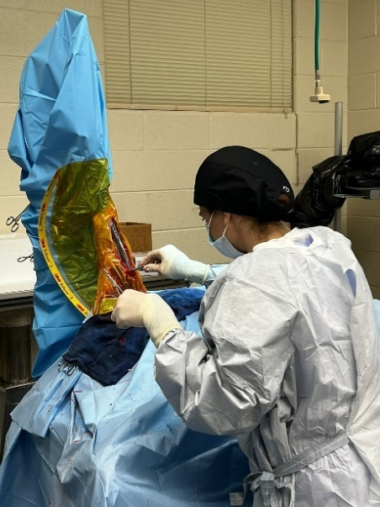 | 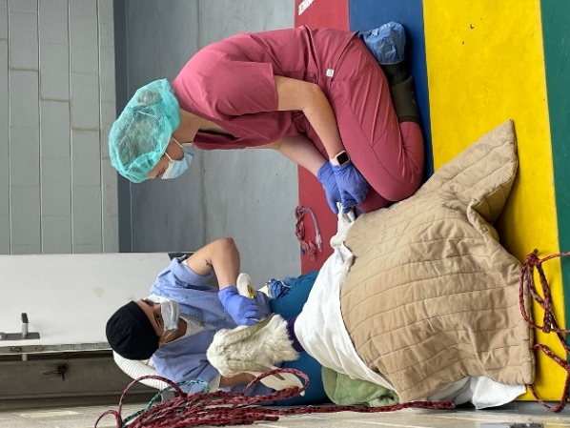 | 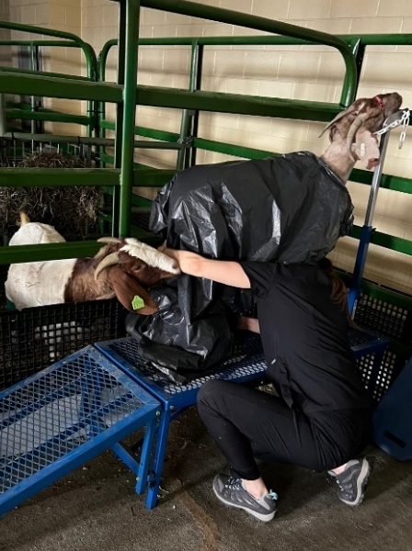
Figure 21: Overall Procedures

1. Defect before implantation; 2. Defect with scaffold; 3: Scaffold implanted in defect
1
3
2
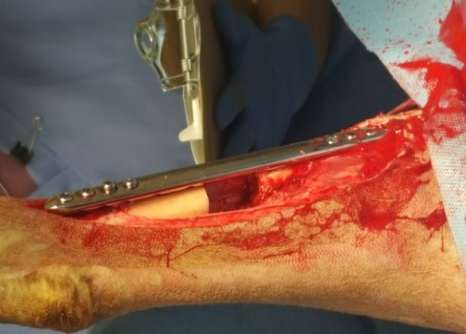 | 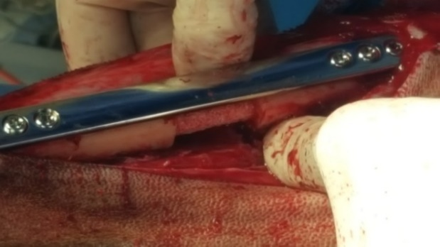 | 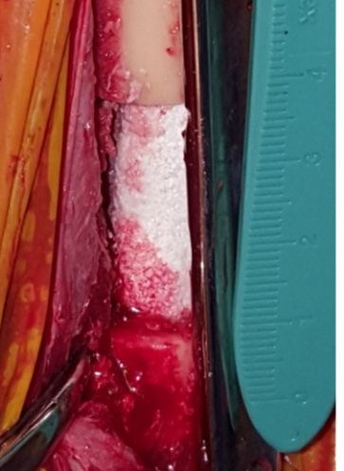
Figure 22: Bone Defect

1. Goat standing on hindlimb indicating comfort; 2. Goat leaning on thoracic limb indicative of discomfort; 3. Goat expressing normal behavior
3
2
1
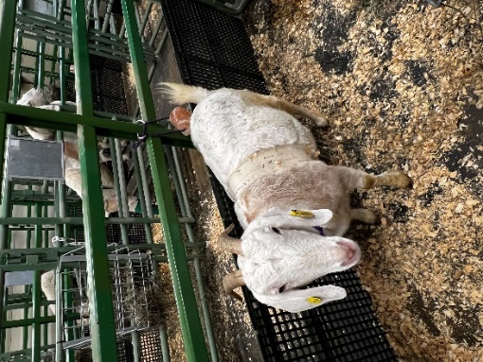 | 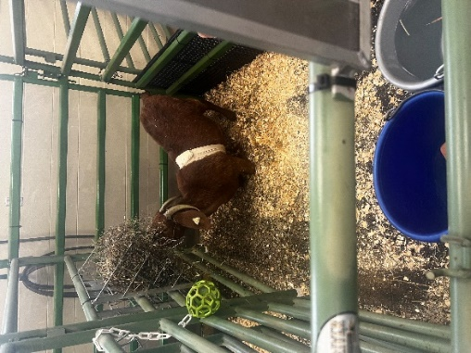 | 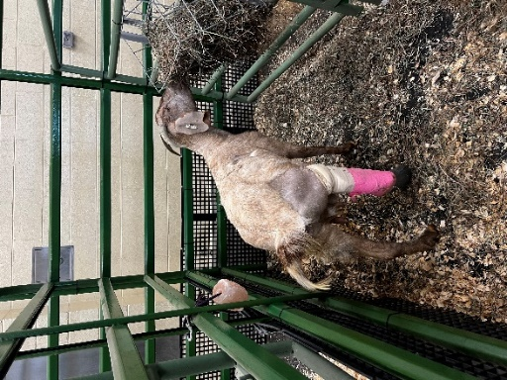
Figure 23: Goat models expressing behavior post-surgery

1. Goats expressing normal behavior; 2. Goat interacting with enrichment; 3. Goat restrained comfortably
3
2
1
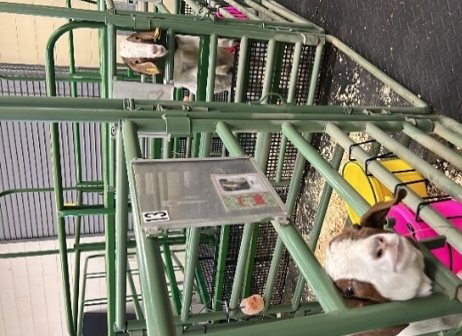 | 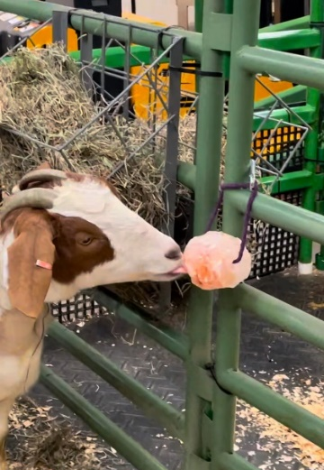 | 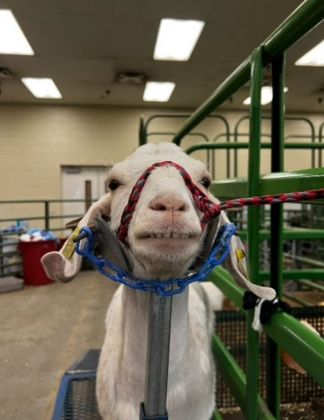
Figure 24: Goat models expressing behavior during data collection

Radiographic imaging
Table 25: Radiographic findings SA
G24002 | 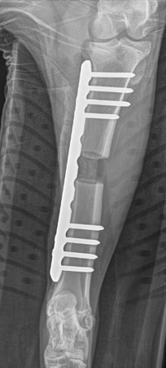  Day 0 | 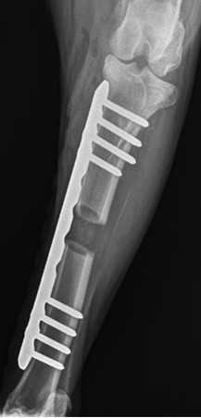Day 7 | 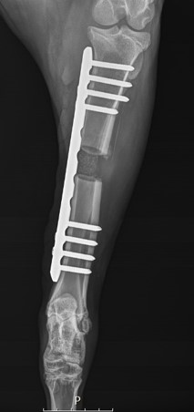  Day 14 | 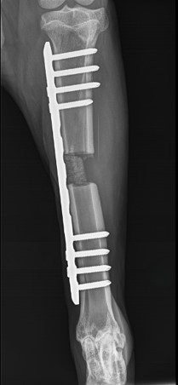  Day 28
G24002 | 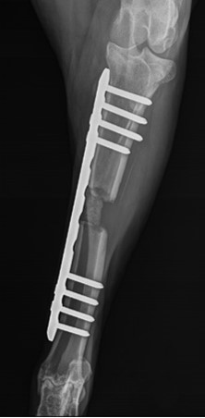  Day 42 | 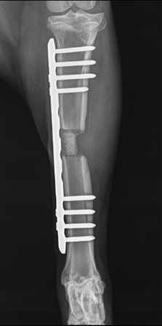  Day 56 | 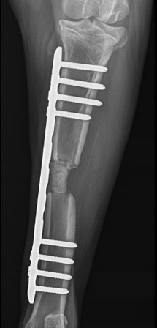  Day 70 | 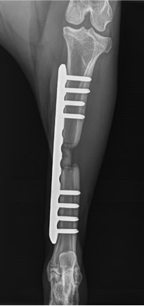  Day 84

Table 25 Continued
G24003 | 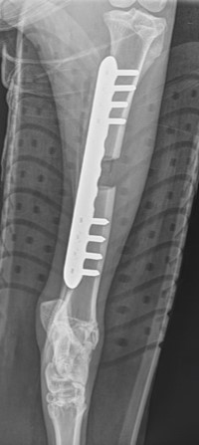  Day 0 | 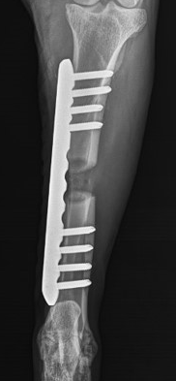Day 7 | 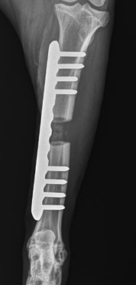  Day 14 | 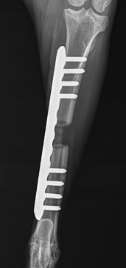  Day 28
G24003 | 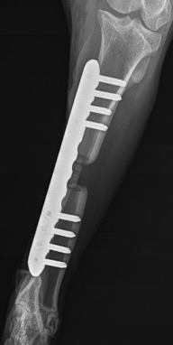  Day 42 | 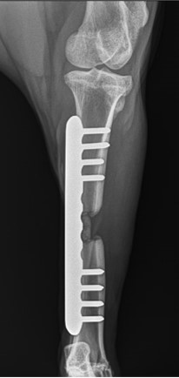  Day 56 | 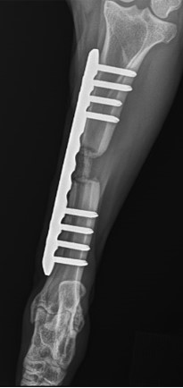  Day 70 | Day 84

Table 25 Continued
G24004 | 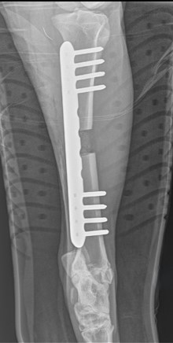  Day 0 | 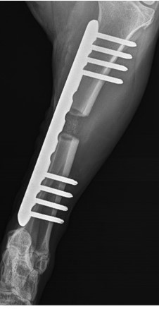Day 7 | 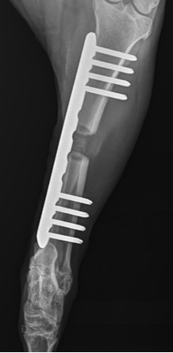  Day 14 | 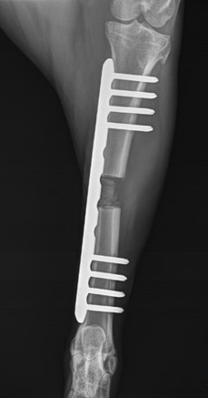  Day 28
G24004 | 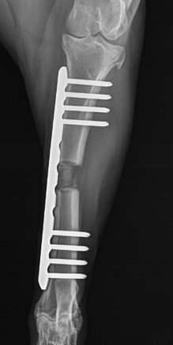  Day 42 | 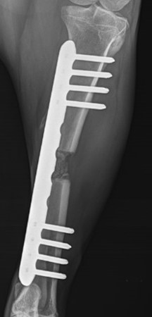  Day 56 | 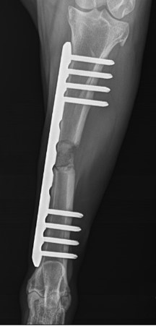  Day 70 | 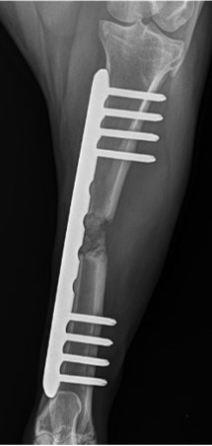  Day 84

Table 25 Continued
G24005 | 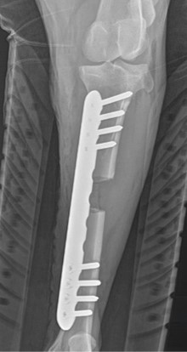  Day 0 | 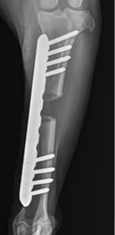Day 7 | 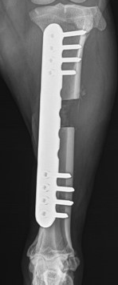  Day 14 | 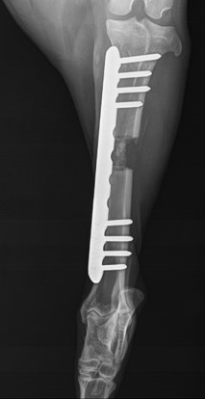  Day 28
G24005 | 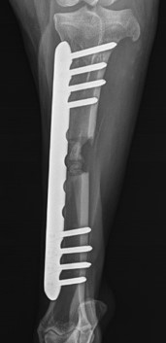  Day 42 | 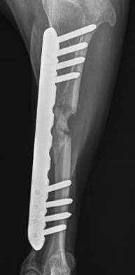  Day 56 | 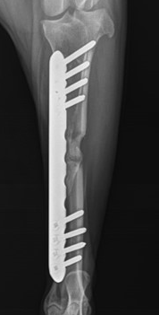  Day 70 | 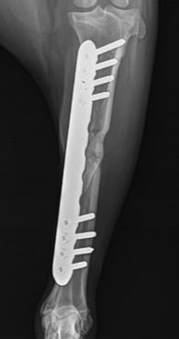  Day 84

Table 25 Continued
G24006 | 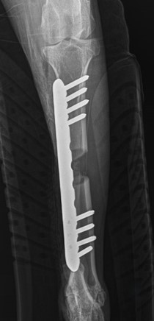  Day 0 | 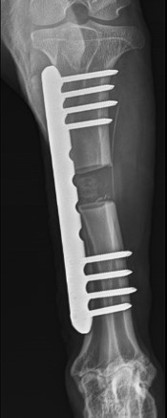Day 7 | 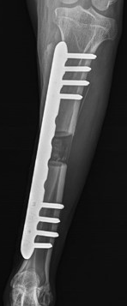  Day 14 | 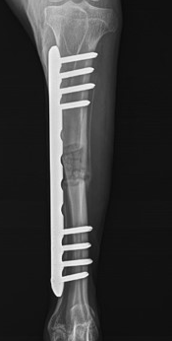  Day 28
G24006 | 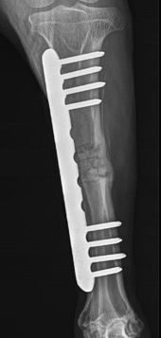  Day 42 | 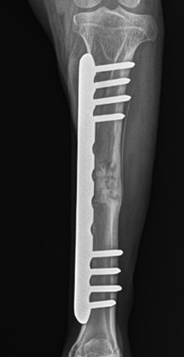  Day 56 | 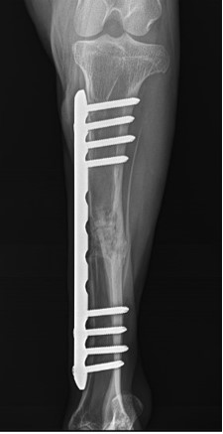  Day 70 | 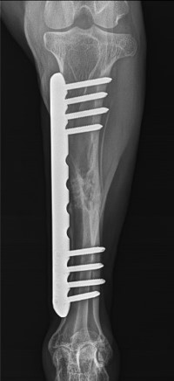  Day 84

Table 26: Radiographic findings SB
G24019 | 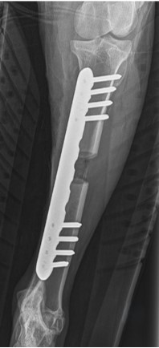  Day 0 | 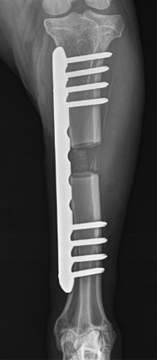Day 7 | 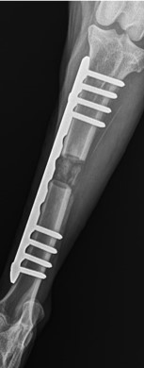  Day 14 | 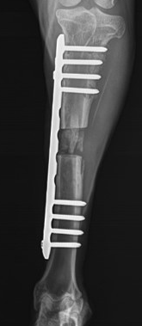  Day 28
G24019 | Day 42 | Day 56 | Day 70 | Day 84
G24020 | 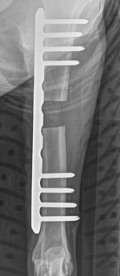  Day 0 | 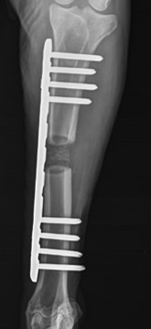Day 7 | 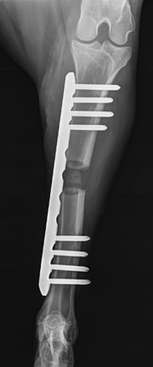  Day 14 | 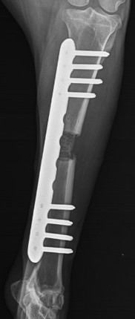  Day 28

Table 26 Continued
G24020 | 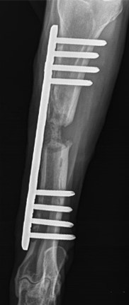  Day 42 | Day 56 | Day 70 | Day 84
G24021 | 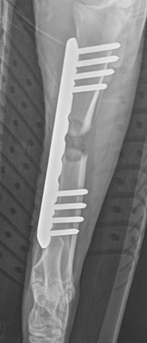  Day 0 | 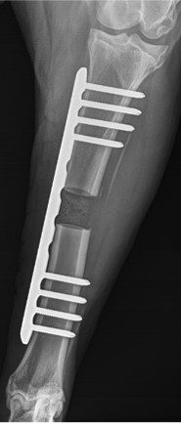Day 7 | 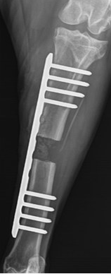  Day 14 | 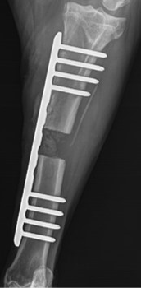  Day 28

Table 26 Continued
G24021 | 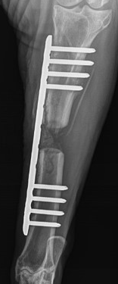  Day 42 | Day 56 | Day 70 | Day 84
G24022 | 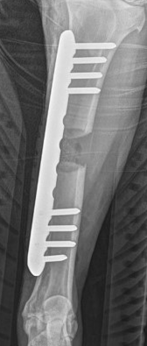  Day 0 | 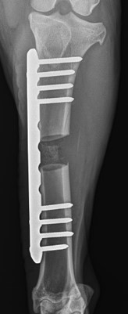Day 7 | 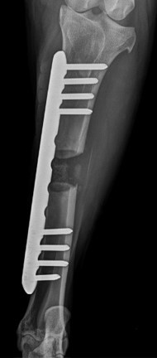  Day 14 | 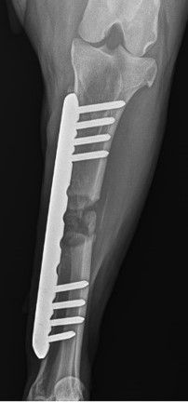  Day 28
G24022 | Day 42 | Day 56 | Day 70 | Day 84

Table 26 Continued
G24023 | 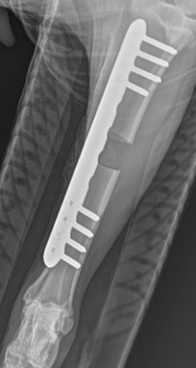  Day 0 | 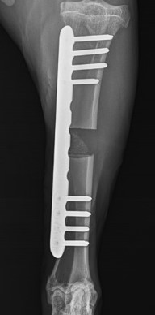Day 7 | 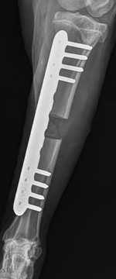  Day 14 | 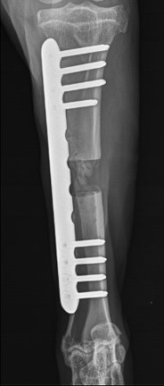  Day 28
G24023 | Day 42 | Day 56 | Day 70 | Day 84
G24024 | 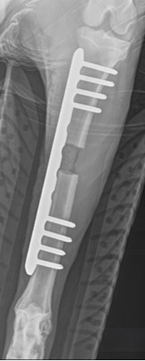  Day 0 | 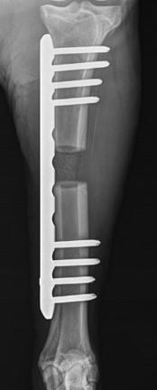Day 7 | 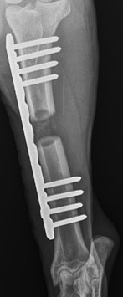  Day 14 | 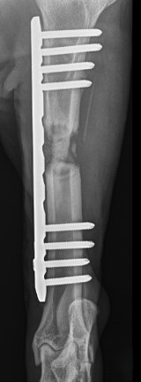  Day 28
G24024 | Day 42 | Day 56 | Day 70 | Day 84
Table 27: Radiographic findings SBA
G24013 | 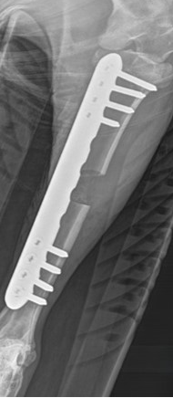  Day 0 | 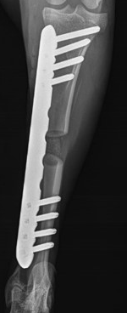Day 7 | 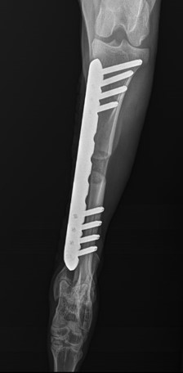  Day 14 | 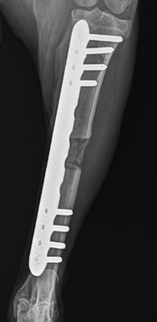  Day 28
G24013 | 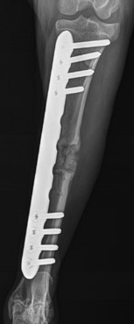  Day 42 | 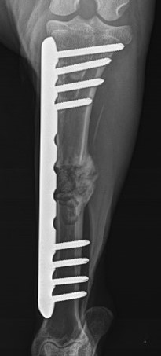  Day 56 | 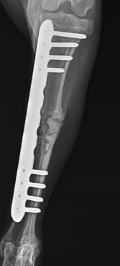  Day 70 | 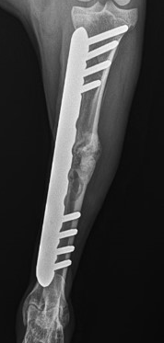  Day 84
Table 27: Continued
G24014 | 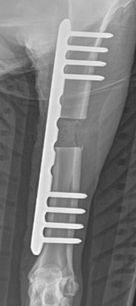  Day 0 | 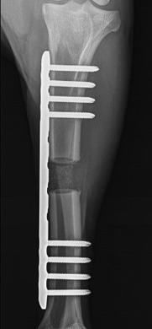Day 7 | 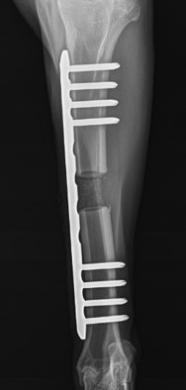  Day 14 | 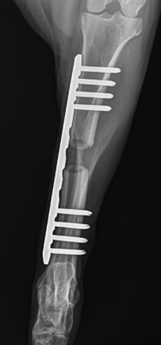  Day 28
G24014 | 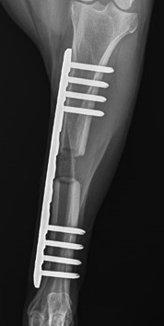  Day 42 | 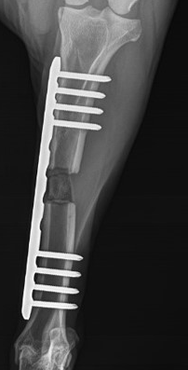  Day 56 | 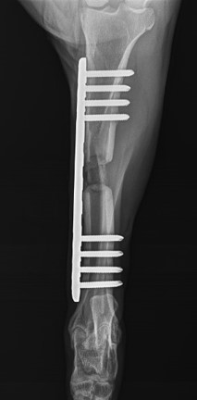  Day 70 | 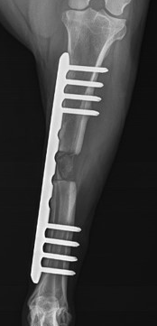  Day 84

Table 27 Continued
G24015 | 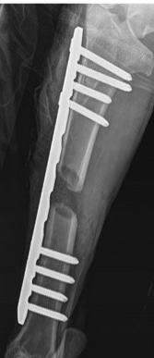  Day 0 | 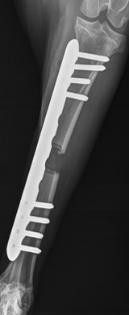Day 7 | 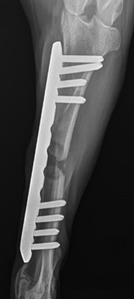  Day 14 | 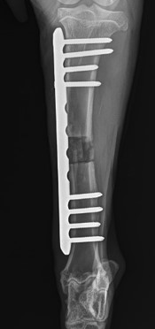  Day 28
G24015 | 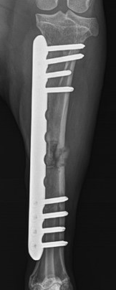  Day 42 | 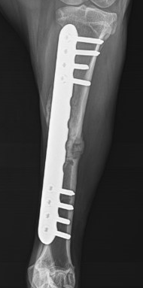  Day 56 | 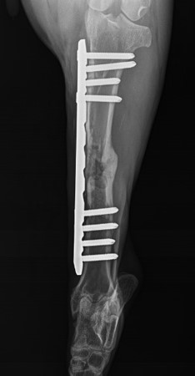  Day 70 | 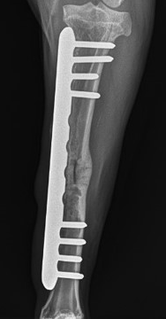  Day 84

Table 27 Continued
G24016 | 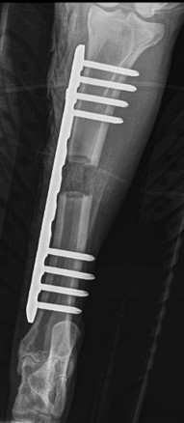  Day 0 | 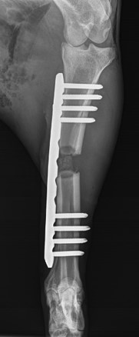Day 7 | 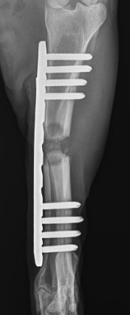  Day 14 | 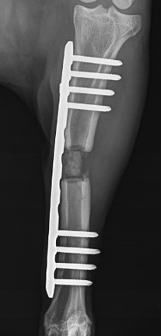  Day 28
G24016 | Day 42 | 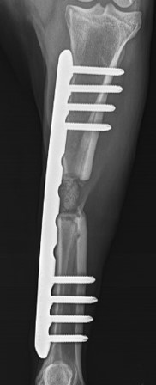  Day 56 | 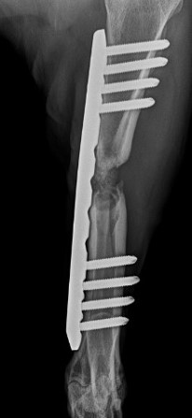  Day 70 | 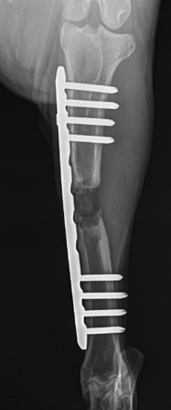  Day 84

Table 27 Continued
G24017 | 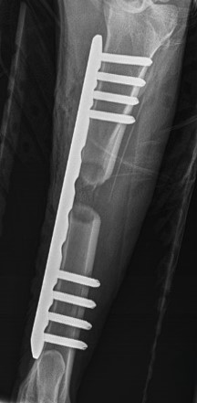  Day 0 | 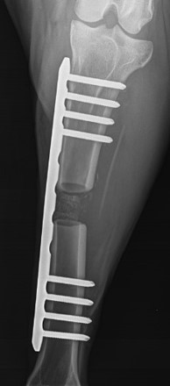Day 7 | 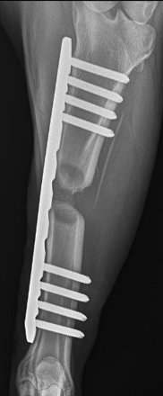  Day 14 | 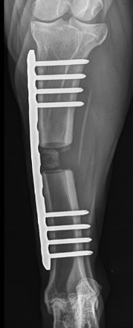  Day 28
G24017 | 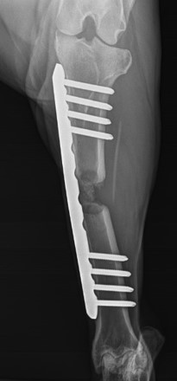  Day 42 | 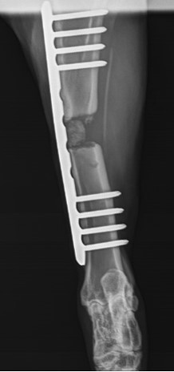  Day 56 | 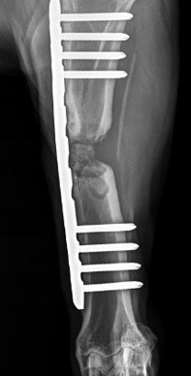  Day 70 | 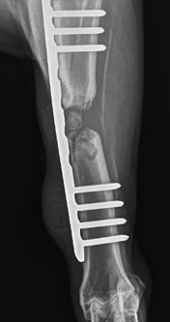  Day 84

Table 27 Continued
G24018 | 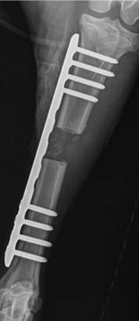  Day 0 | 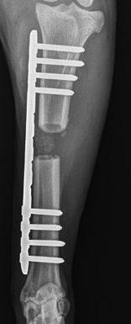Day 7 | 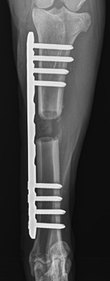  Day 14 | 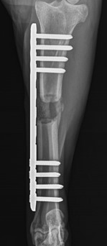  Day 28
G24018 | 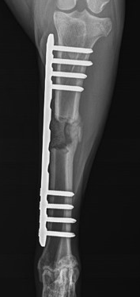  Day 42 | 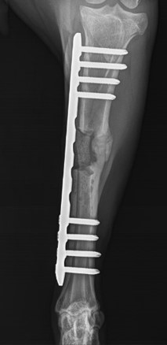  Day 56 | 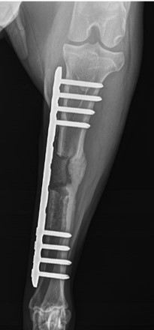  Day 70 | 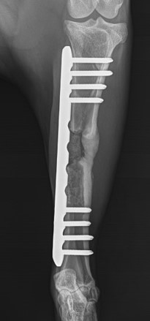  Day 84

Table 28: Radiographic findings NS
G24007 | 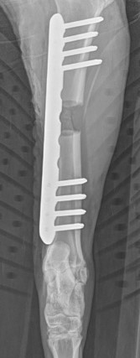  Day 0 | 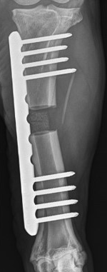Day 7 | 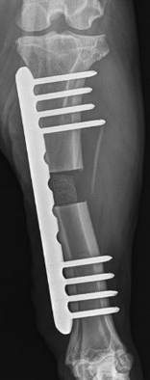  Day 14 | 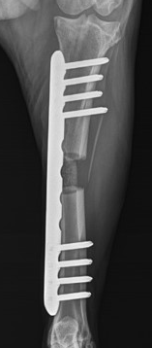  Day 28
G24007 | 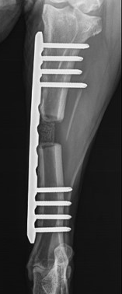  Day 42 | 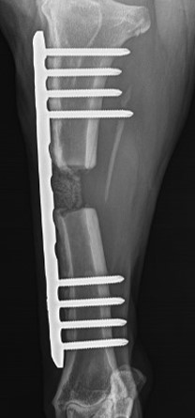  Day 56 | 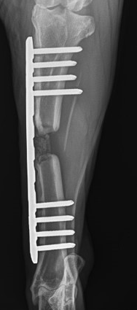  Day 70 | 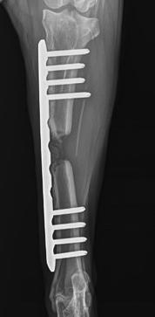  Day 84

Table 28 Continued
G24008 | 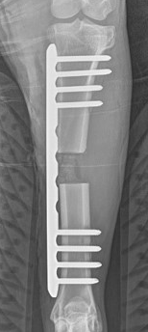  Day 0 | 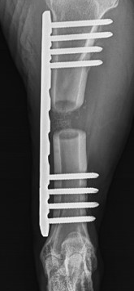Day 7 | 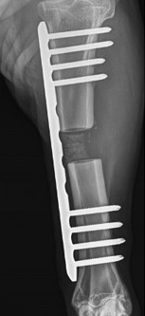  Day 14 | 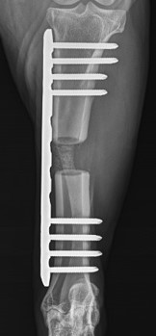  Day 28
G24008 | 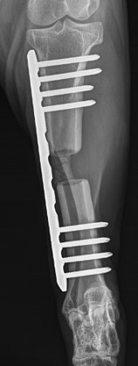  Day 42 | 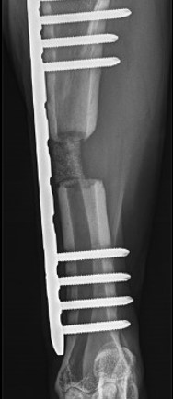  Day 56 | 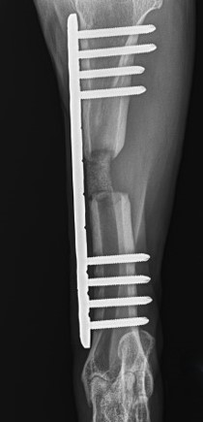  Day 70 | 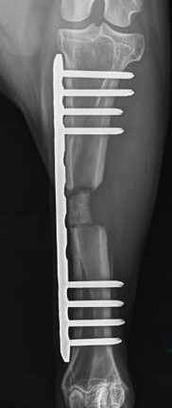  Day 84

Table 28 Continued
G24009 | 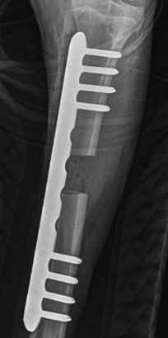  Day 0 | 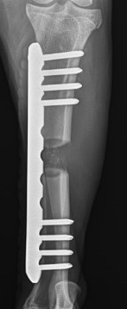Day 7 | 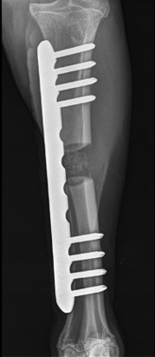  Day 14 | 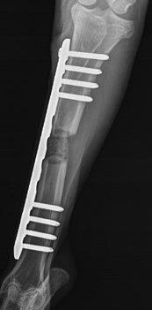  Day 28
G24009 | 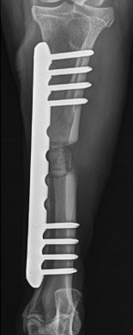  Day 42 | 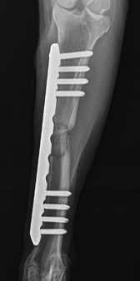  Day 56 | 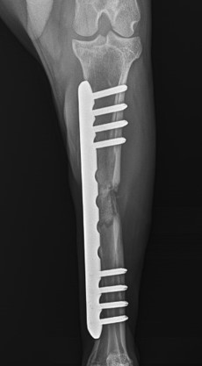  Day 70 | 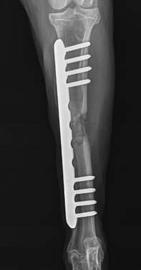  Day 84

Table 28 Continued
G24010 | 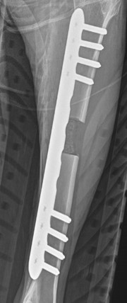  Day 0 | 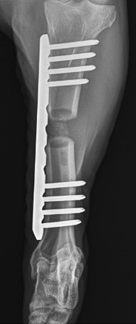Day 7 | 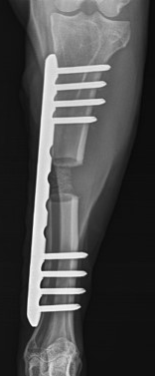  Day 14 | 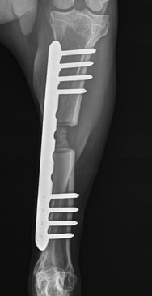  Day 28
G24010 | 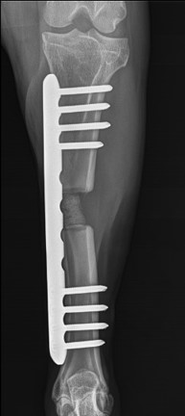  Day 42 | 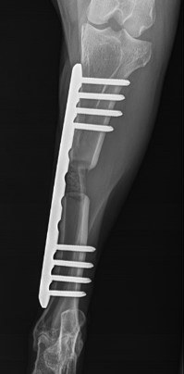  Day 56 | 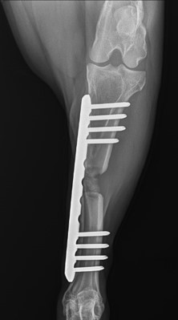  Day 70 | 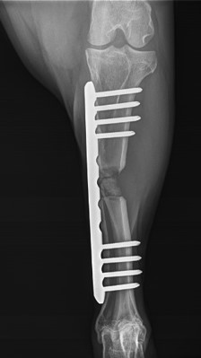  Day 84

Table 28 Continued
G24011 | 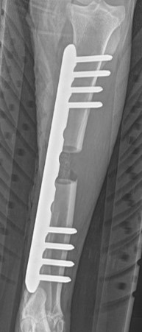  Day 0 | 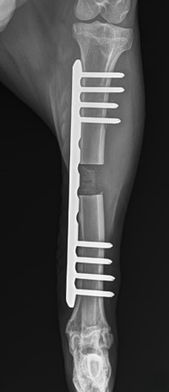Day 7 | 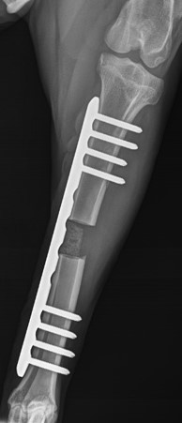  Day 14 | 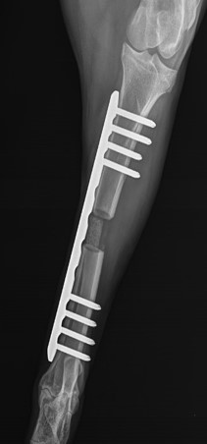  Day 28
G24011 | 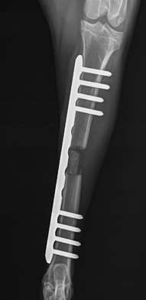  Day 42 | 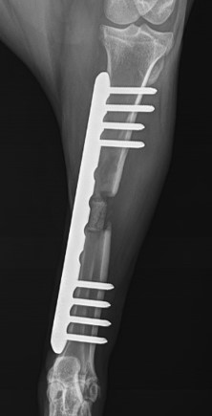  Day 56 | 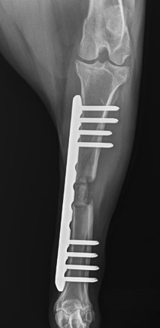  Day 70 | 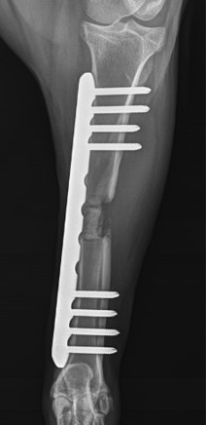  Day 84

Table 29: OM score frequency SA
Criteria | Soft tissue abnormalities (abnormal swelling, gas inclusions, mineralization) | Lysis or cortical necrosis | Endosteal reaction or medullary sclerosis | Abnormal periosteal reaction | Implant associated abnormalities (implant loosening/failure; bone resorption adjacent to implant) | Total
Day
7 | 0 | 0 | 0 | 0 | 0 | 0
14 | 0 | 0 | 0 | 0 | 0 | 0
28 | 0 | 0 | 0 | 0 | 0 | 0
42 | 0 | 0 | 0 | 0 | 0 | 0
56 | 0 | 0 | 0 | 0 | 0 | 0
70 | 0 | 0 | 0 | 0 | 0 | 0
84 | 0 | 0 | 0 | 0 | 0 | 0

Table 30: OM score frequency SBA
Criteria | Soft tissue abnormalities (abnormal swelling, gas inclusions, mineralization) | Lysis or cortical necrosis | Endosteal reaction or medullary sclerosis | Abnormal periosteal reaction | Implant associated abnormalities (implant loosening/failure; bone resorption adjacent to implant) | Total
Day
7 | 2 | 0 | 0 | 0 | 0 | 2
14 | 2 | 0 | 0 | 2 | 0 | 4
28 | 1 | 1 | 0 | 4 | 0 | 6
42 | 1 | 2 | 0 | 3 | 0 | 6
56 | 1 | 4 | 0 | 3 | 0 | 8
70 | 1 | 5 | 0 | 3 | 1 | 10
84 | 4 | 5 | 0 | 2 | 0 | 11

Table 31: OM score frequency SB
Criteria | Soft tissue abnormalities (abnormal swelling, gas inclusions, mineralization) | Lysis or cortical necrosis | Endosteal reaction or medullary sclerosis | Abnormal periosteal reaction | Implant associated abnormalities (implant loosening/failure; bone resorption adjacent to implant) | Total
Day
7 | 3 | 0 | 0 | 1 | 0 | 3
14 | 1 | 1 | 0 | 6 | 0 | 8
28 | 2 | 3 | 0 | 6 | 0 | 11
42 | 1 | 3 | 0 | 6 | 4 | 13

Table 32: OM score frequency NS
Criteria | Soft tissue abnormalities (abnormal swelling, gas inclusions, mineralization) | Lysis or cortical necrosis | Endosteal reaction or medullary sclerosis | Abnormal periosteal reaction | Implant associated abnormalities (implant loosening/failure; bone resorption adjacent to implant) | Total
Day
7 | 0 | 0 | 0 | 0 | 0 | 0
14 | 0 | 0 | 0 | 0 | 0 | 0
28 | 0 | 0 | 0 | 0 | 0 | 0
42 | 0 | 0 | 0 | 0 | 1 | 1
56 | 0 | 0 | 0 | 0 | 1 | 1
70 | 0 | 0 | 0 | 0 | 1 | 1
84 | 0 | 0 | 0 | 0 | 1 | 1

Computed tomography CT
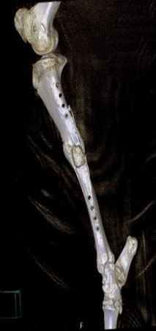 | 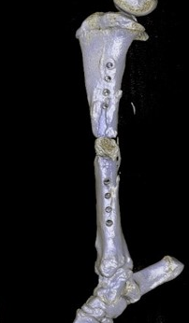 | 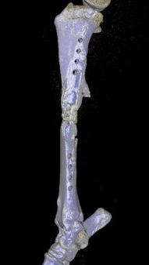
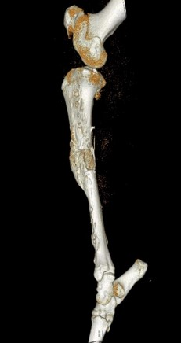 | 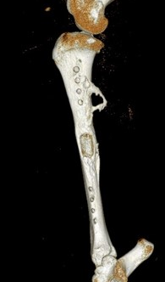
Figure 25: SA Group - Variable signs of scaffold integration

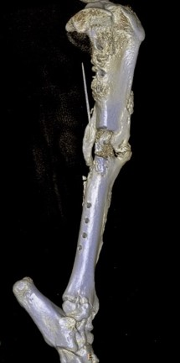 | 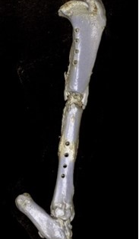 | 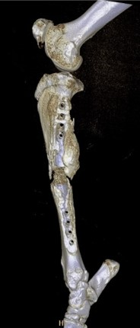
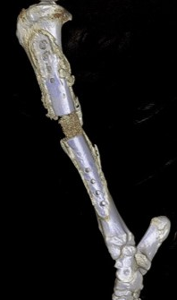 | 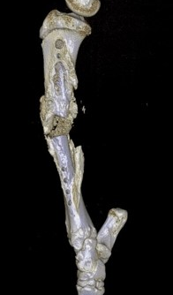 | 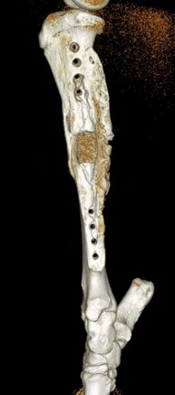
Figure 26: SB Group – No signs of scaffold integration

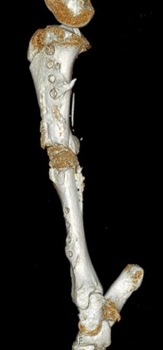 | 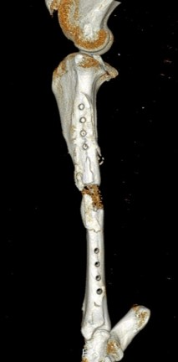 | 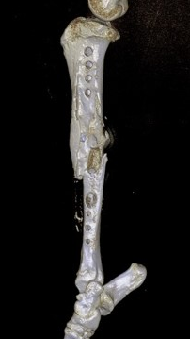
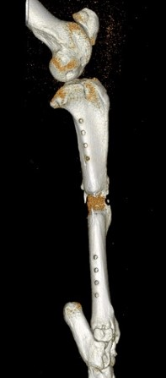 | 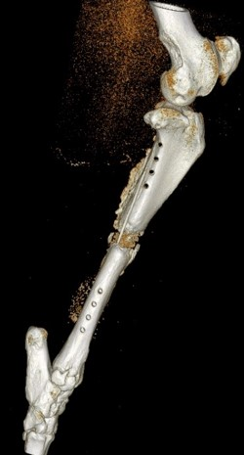 | 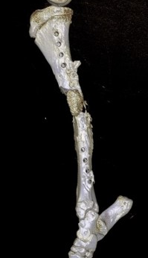
Figure 27: SBA Group - Variable signs of scaffold integration

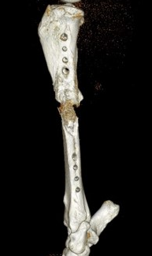 | 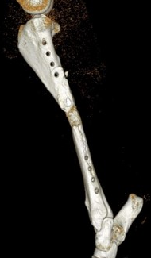 | 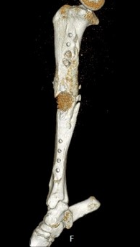
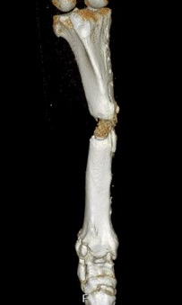 | 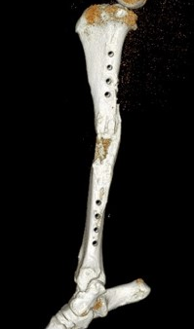 | 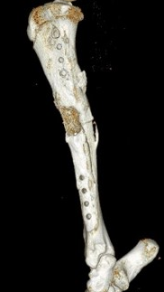
Figure 28: NS Group - Variable signs of scaffold integration

Thermography
Table 33: Thermography findings SA
(SA)
G24002 | 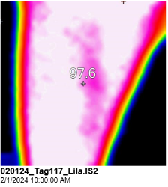  Week 1.1 | 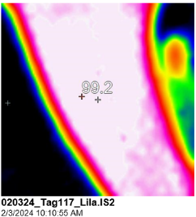  Week 1.2 |  | 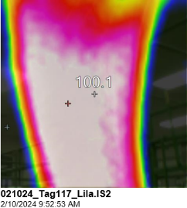  Week 2.1 |  | 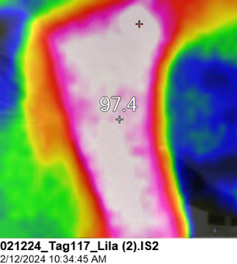  Week 2.2
G24002 | 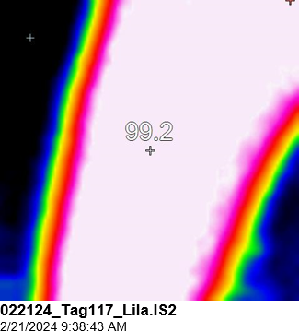  Week 3 |  | 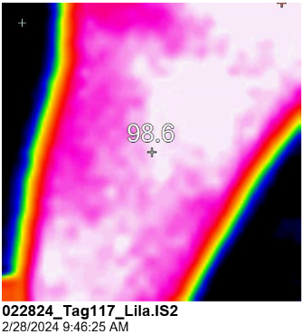  Week 4 |  | 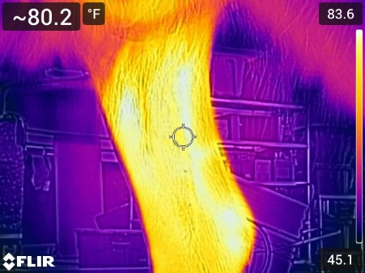  Week 6
G24002 | 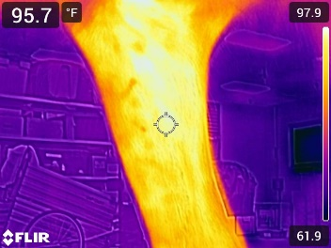  Week 8 |  | 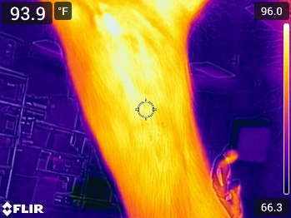  Week 10 |  | 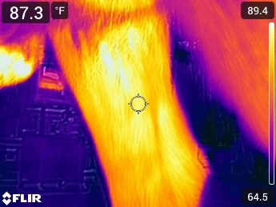  Week 12

Table 33 Continued
G24003 | 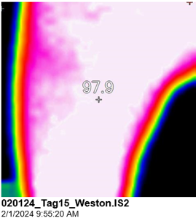  Week 1.1 | 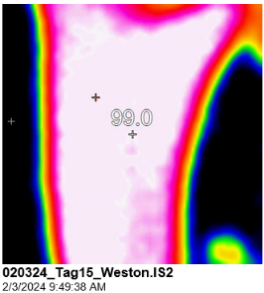  Week 1.2 |  | 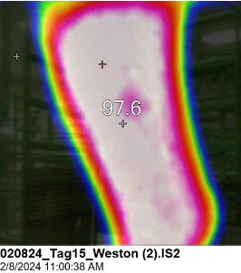  Week 2.1 |  | 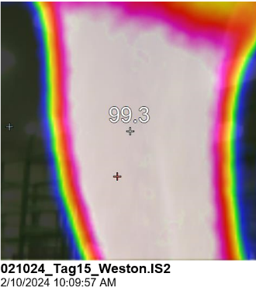  Week 2.2
G24003 | 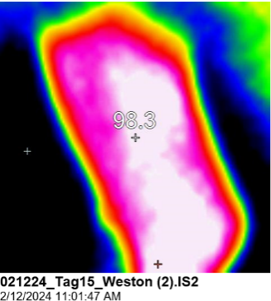  Week 3 |  | 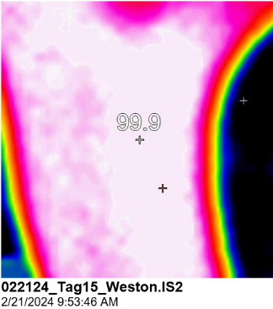  Week 4 |  | 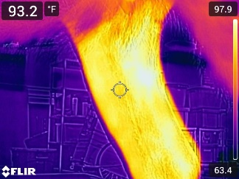  Week6
G24003 | 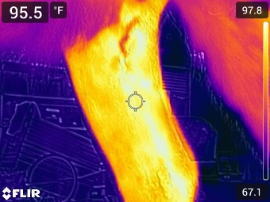  Week 8 |  | 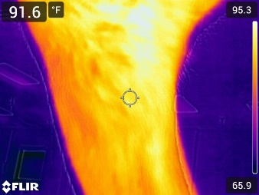  Week 10 |  | 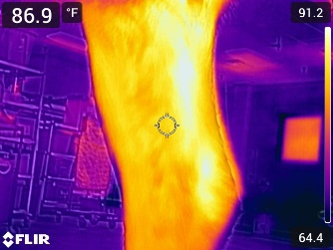  Week 12
G24004 | 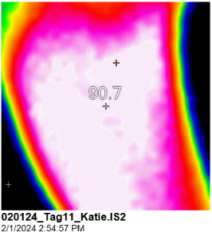  Week 1.1 | 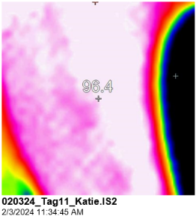  Week 1.2 |  | 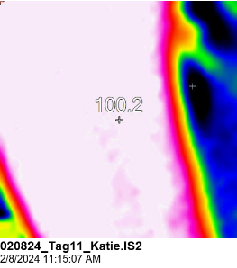  Week 2.1 |  | 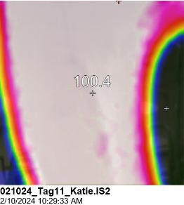  Week 2.2

Table 33 Continued
 | 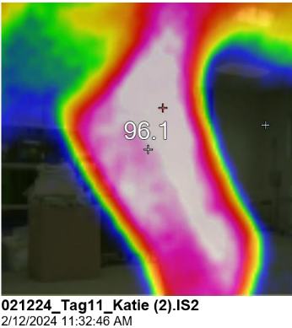  Week 3 |  | 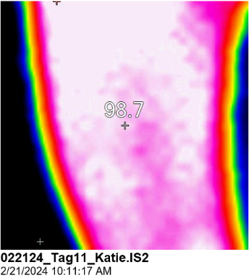  Week 4 |  | 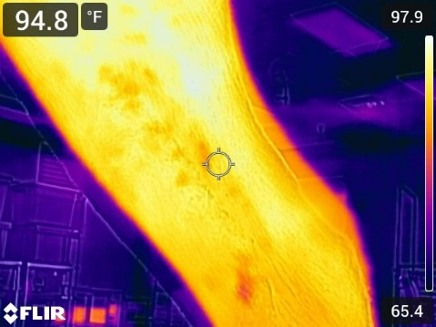  Week 6
 |   Week 8 |  | 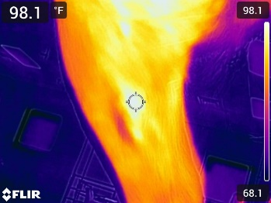  Week 10 |  | 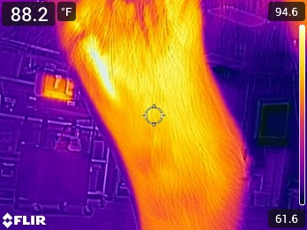  Week 12
G24005 | 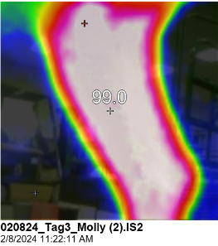  Week 1.1 | 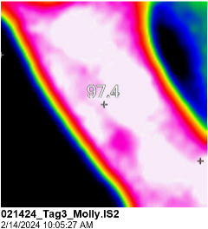  Week 1.2 |  | 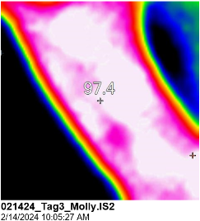  Week 2.1 |  | 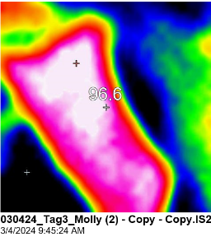  Week 2.2
G24005 | 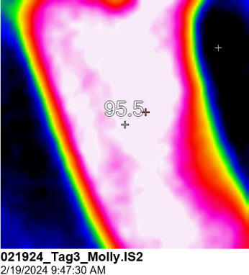  Week 3 |  | 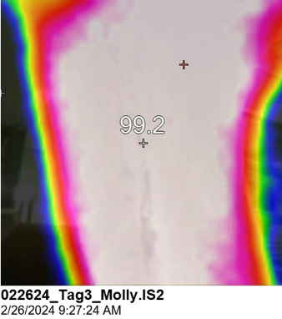  Week 4 |  | 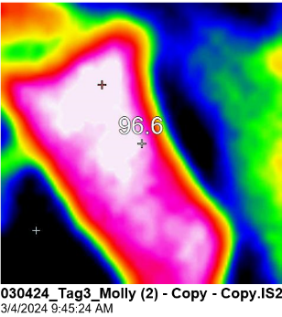  Week 6

Table 33 Continued
 | 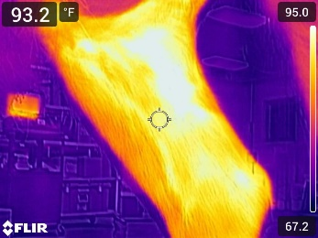  Week 8 |  | 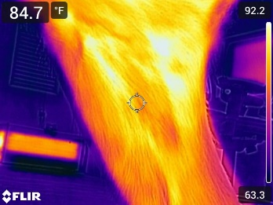  Week 10 |  | 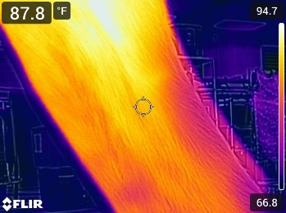  Week 12
G24006 | 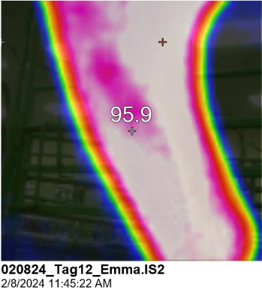  Week 1.1 | 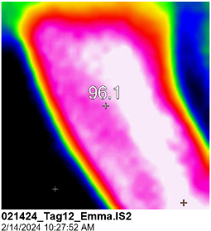  Week 1.2 |  | 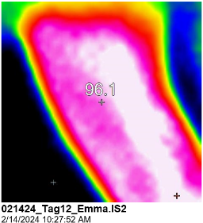  Week 2.1 |  | 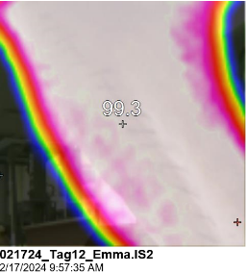  Week 2.2
G24006 | 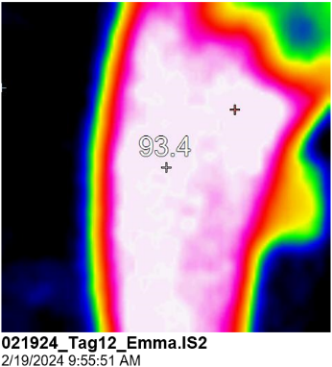  Week 3 |  | 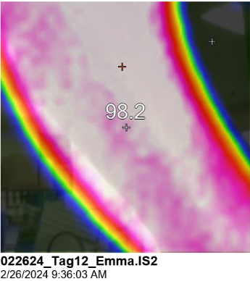  Week 4 |  | 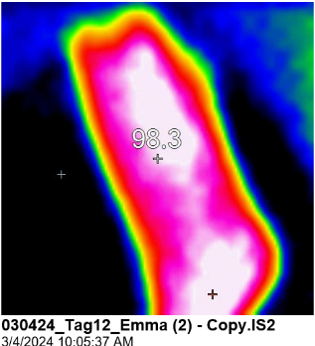  Week 6
G24006 | 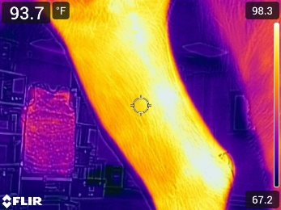  Week 8 |  | 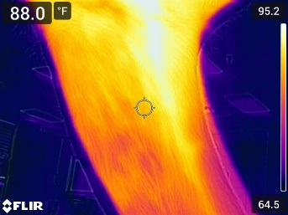  Week 10 |  | 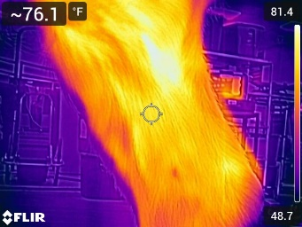  Week 12

Table 34: Thermography findings SB
(SB)
G24019 | 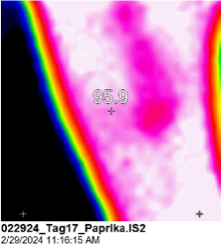  Week 1.1 | 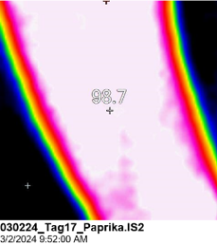  Week 1.2 |  | 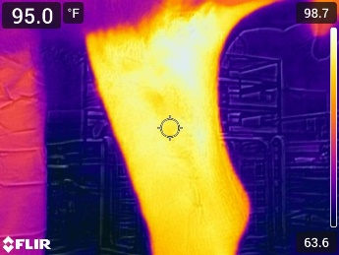  Week 2.1 |  | 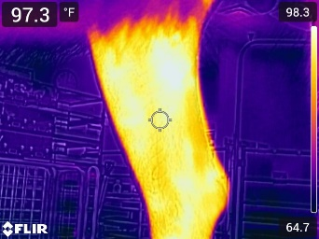  Week 2.2
G24019 | 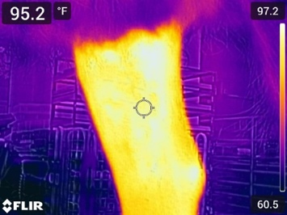  Week 3 |  | 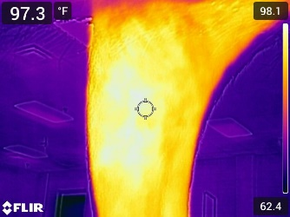  Week 4 |  | Not generated – Animal removed  Week 6
G24019 | Not generated – Animal removed  Week 8 |  | Not generated – Animal removed  Week 10 |  | Not generated – Animal removed  Week 12
G24020 | 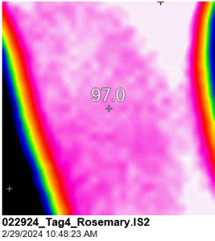  Week 1.1 | 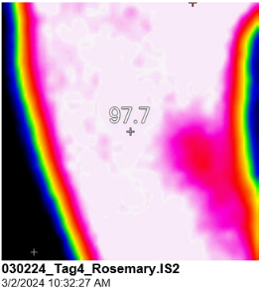  Week 1.2 |  | 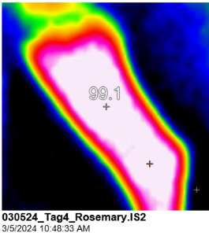  Week 2.1 |  | 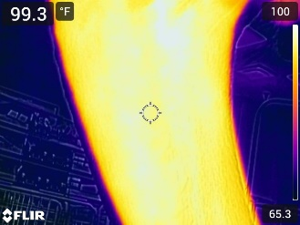  Week 2.2
G24020 | 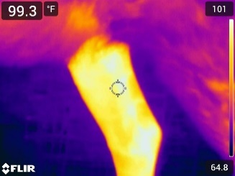  Week 3 |  | 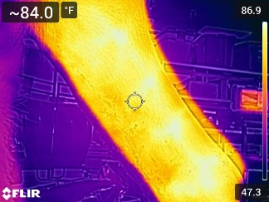  Week 4 |  | 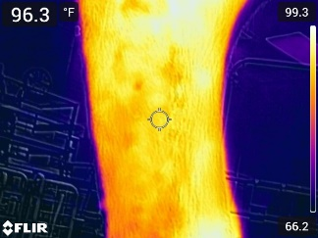  Week6
G24020 | Not generated – Animal removed  Week 8 |  | Not generated – Animal removed  Week 10 |  | Not generated – Animal removed  Week 12

Table 34 Continued
G24021 | 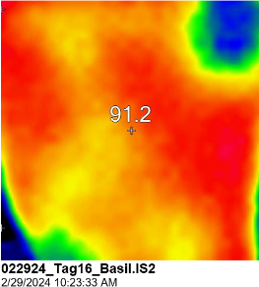  Week 1.1 | 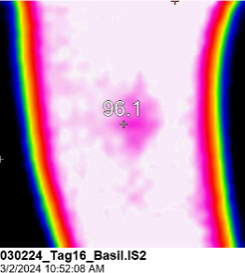  Week 1.2 |  | 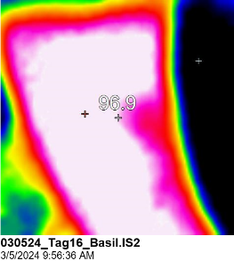  Week 2.1 |  | 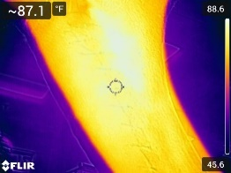  Week 2.2
G24021 | 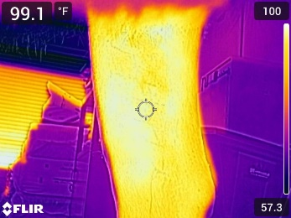  Week 3 |  | 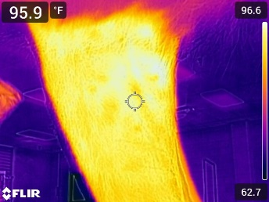  Week 4 |  | 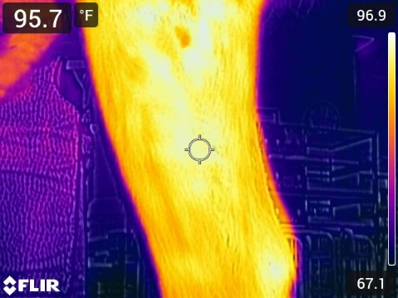  Week 6
G24021 | Not generated – Animal removed  Week 8 |  | Not generated – Animal removed  Week 10 |  | Not generated – Animal removed  Week 12
G24022 | 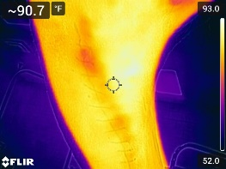  Week 1.1 | 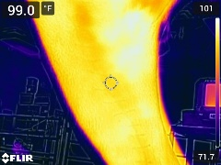  Week 1.2 |  | 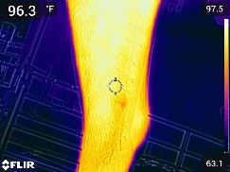  Week 2.1 |  | 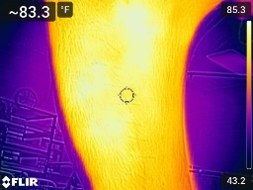  Week 2.2
G24022 | 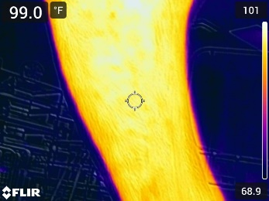  Week 3 |  | 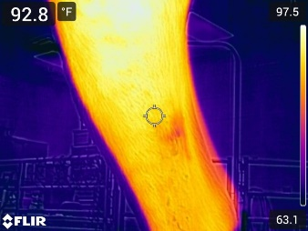  Week 4 |  | Not generated – Animal removed  Week 6

Table 34 Continued
 | Not generated – Animal removed  Week 8 |  | Not generated – Animal removed  Week 10 |  | Not generated – Animal removed  Week 12
G24023 | Week 1.1 | Week 1.2 |  | Week 2.1 |  | Week 2.2
G24023 | Week 3 |  | Week 4 |  | Week 6
G24023 | Week 8 |  | Week 10 |  | Week 12
G24024 | 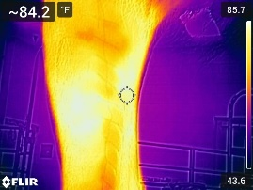Week 1.1 | 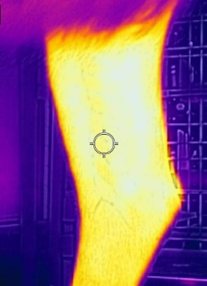  Week 1.2 |  | 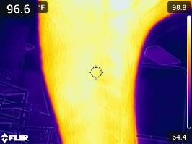  Week 2.1 |  | 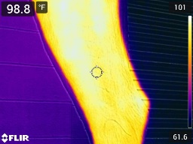  Week 2.1

Table 34 Continued
 | 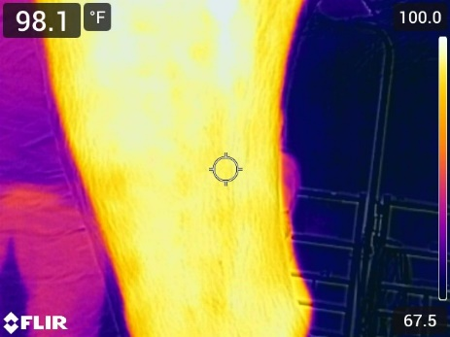  Week 3 | 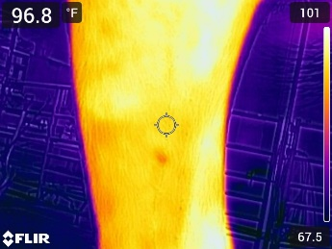  Week 4 | 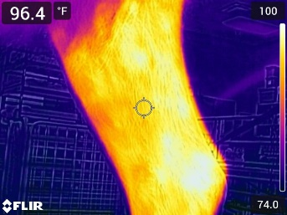  Week 6
 | Not generated – Animal removed  Week 8 | Not generated – Animal removed  Week 10 | Not generated – Animal removed  Week 12

Table 35: Thermography findings SBA
(SBA)
G24013 | 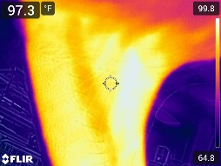  Week 1.1 | 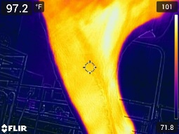  Week 1.2 |  | 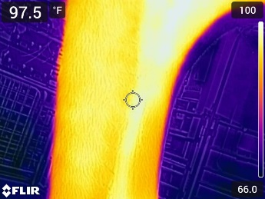  Week 2.1 |  | 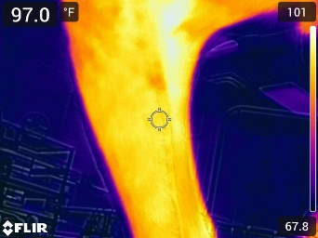  Week 2.2
G24013 | 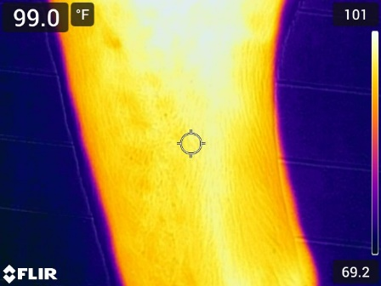  Week 3 |  | 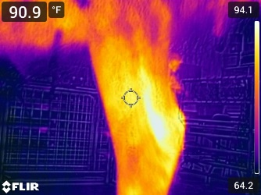  Week 4 |  | 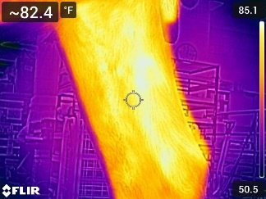Week 6

Table 35 Continued
 | 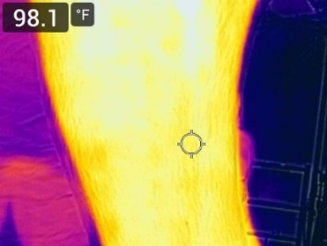  Week 8 |  | 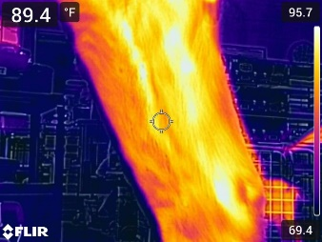Week 10 |  | 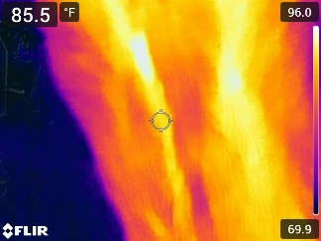  Week 12
G24014 | 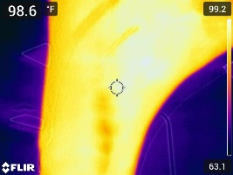  Week 1.1 | 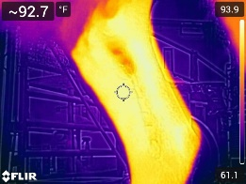  Week 1.2 |  | 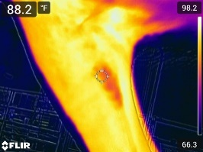  Week 2.1 |  | 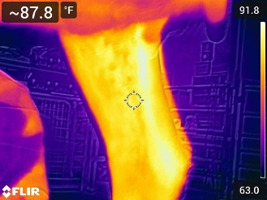  Week 2.2
G24014 | 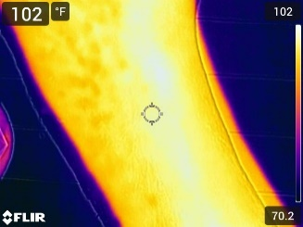  Week 3 |  | 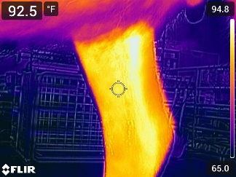  Week 4 |  | 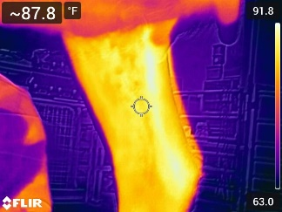  Week6
G24014 | 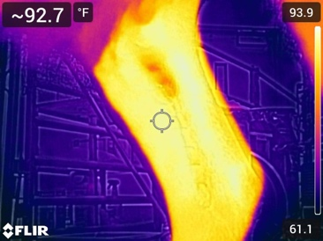  Week 8 |  | 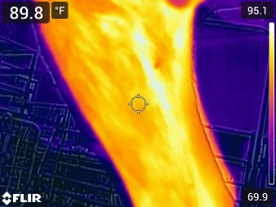  Week 10 |  | 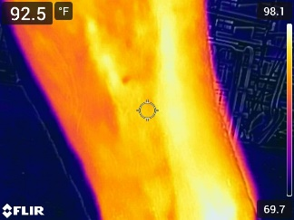  Week 12
G24015 | 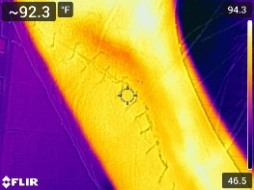  Week 1.1 | 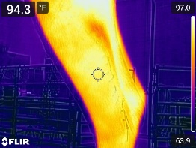  Week 1.2 |  | 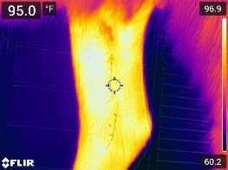  Week 2.1 |  | 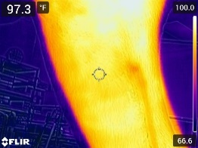  Week 2.2

Table 35 Continued
 | 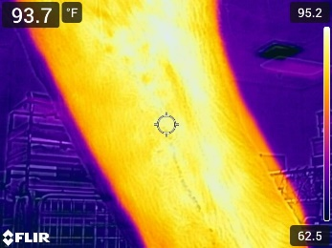  Week 3 |  | 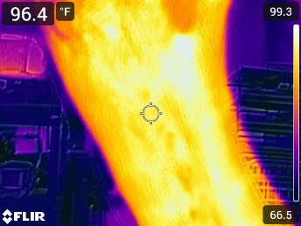  Week 4 |  | 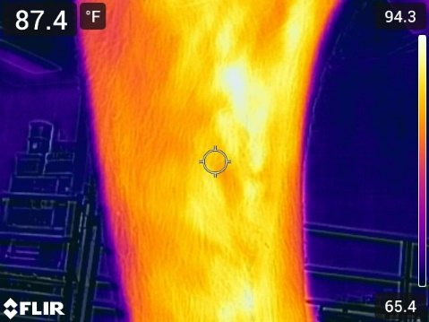  Week 6
 | 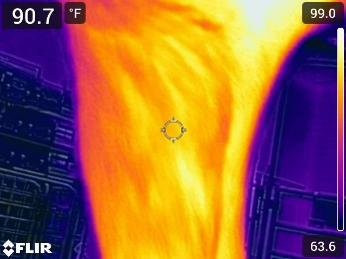  Week 8 |  | 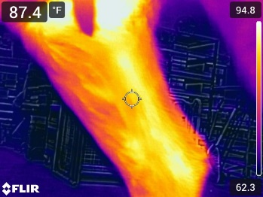  Week 10 |  | 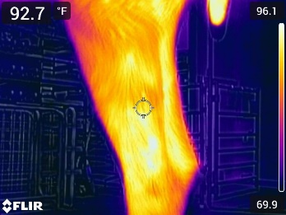  Week 12
G24016 | 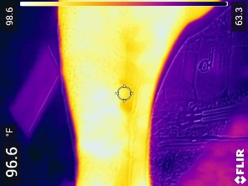  Week 1.1 | 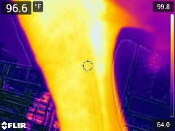  Week 1.2 |  | 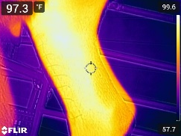  Week 2.1 |  | 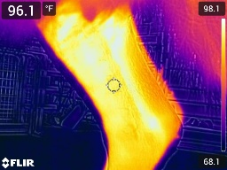  Week 2.2
G24016 | 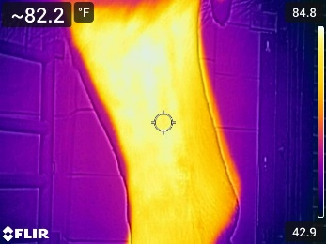  Week 3 |  | 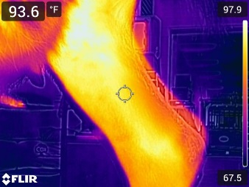  Week 4 |  | 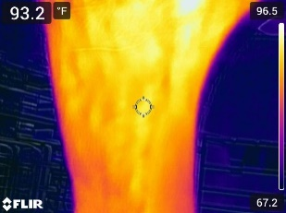  Week 6

Table 35 Continued
 |   Week 8 |  | 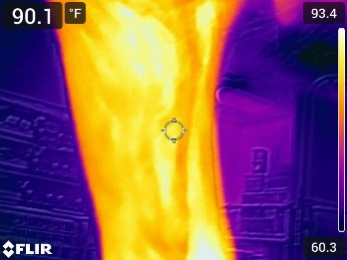  Week 10 |  | 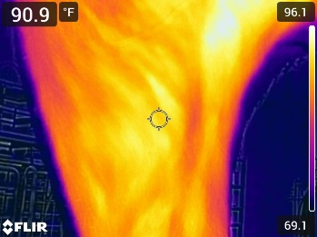  Week 12
G24017 | 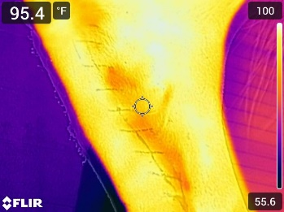  Week 1.1 | 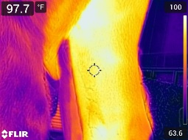  Week 1.2 |  | 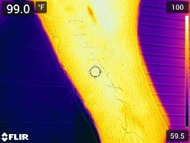  Week 2.1 |  | 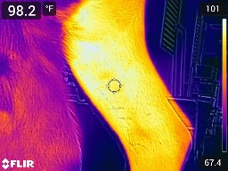  Week 2.2
G24017 | 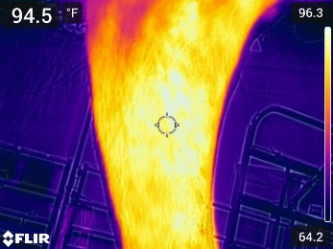  Week 3 |  | 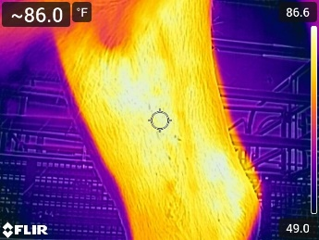  Week 4 |  | 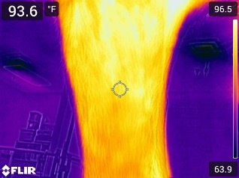  Week 6
G24017 | 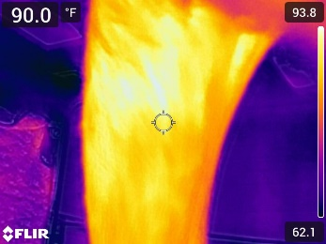  Week 8 |  | 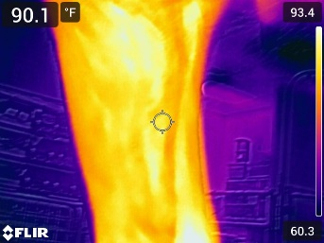  Week 10 |  | 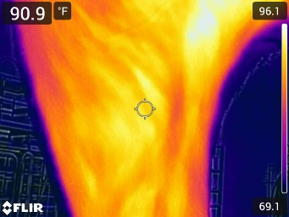  Week 12

Table 35 Continued
G24018 | 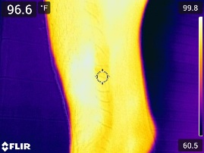Week 1.1 | 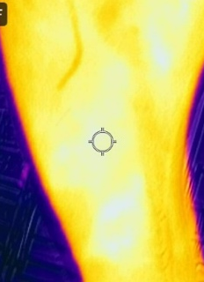  Week 1.2 |  | 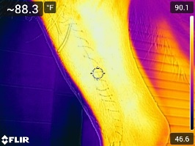  Week 2.1 |  | 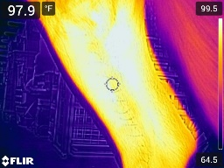Week 2.2
G24018 | 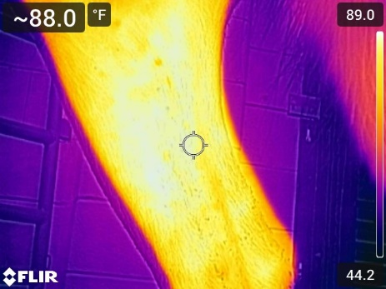  Week 3 |  | 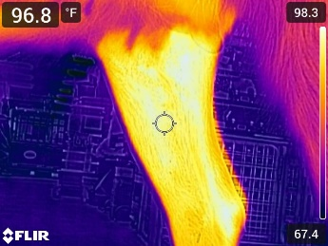  Week 4 |  | 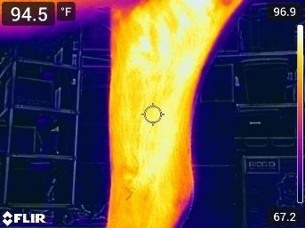  Week 6
G24018 | 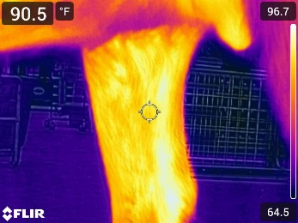  Week 8 |  | 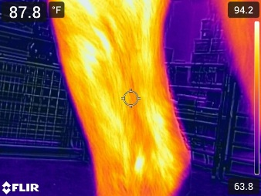  Week 10 |  | 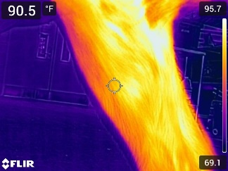  Week 12

Fluorescence image
Images obtained from 23 goats

Table 36: Fluorescence imaging findings SA
(SA)
G24002 | 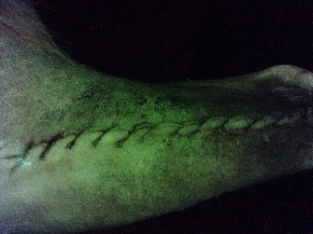  Week 1.1 | 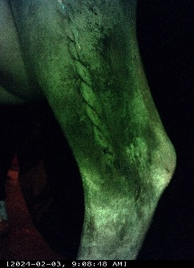  Week 1.2 |  | 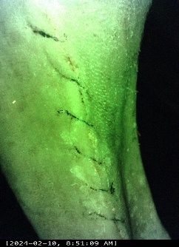  Week 2.1 |  | 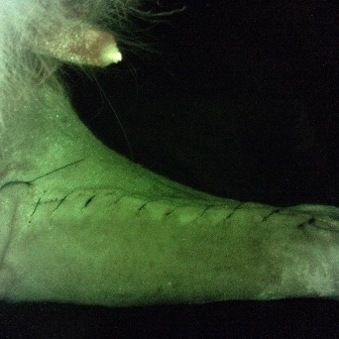  Week 2.2
G24002 | 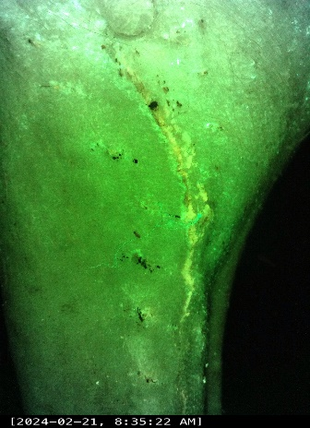  Week 3 |  | 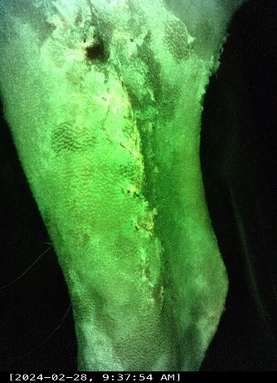  Week 4 |  | 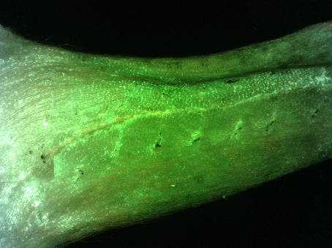  Week 6
G24002 | 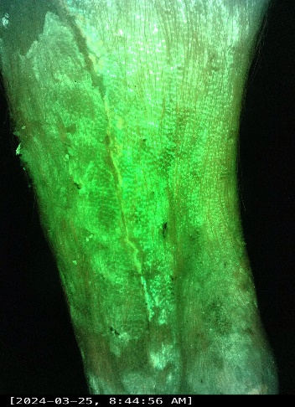  Week 8 |  | 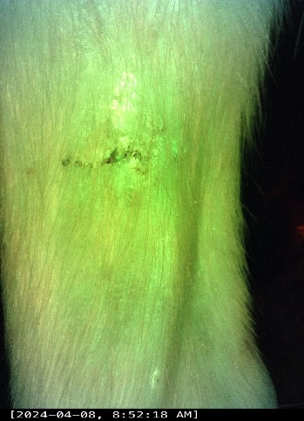  Week 10 |  | 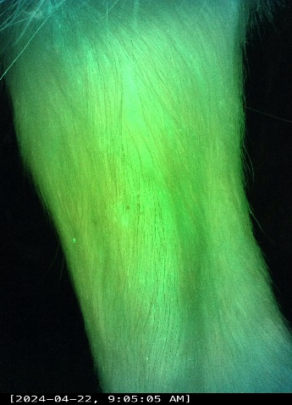  Week 12

Table 36 Continued
G24003 | 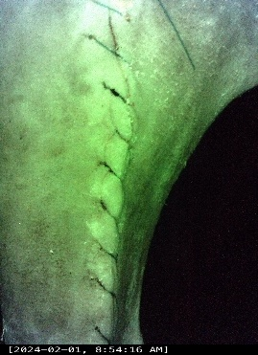  Week 1.1 | 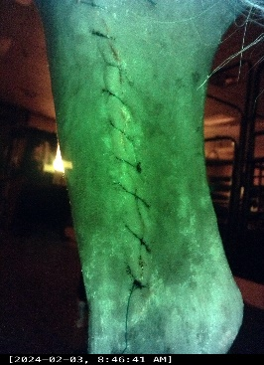  Week 1.2 |  | 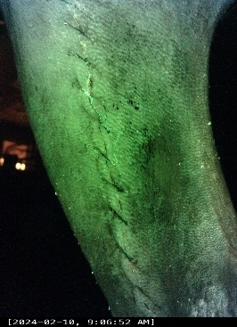  Week 2.1 |  | 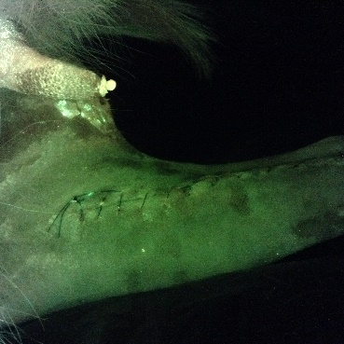  Week 2.2
G24003 | 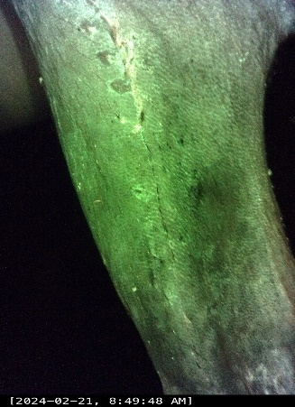  Week 3 |  | 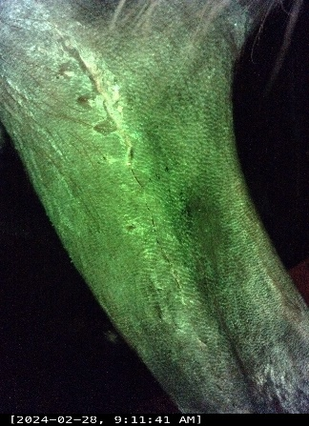  Week 4 |  | 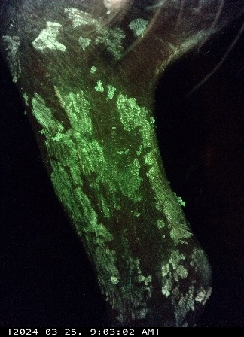  Week6
G24003 | 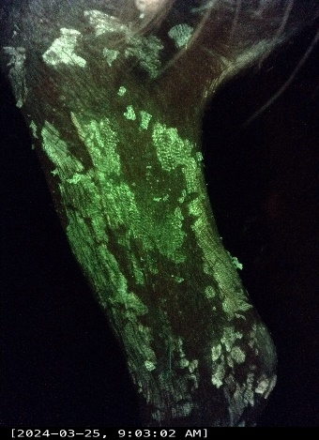  Week 8 |  | 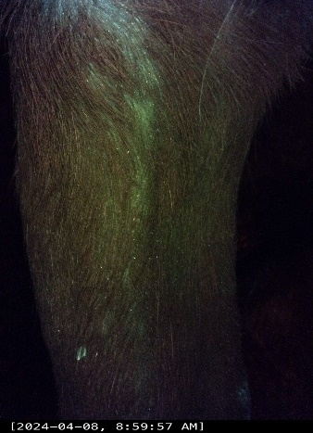  Week 10 |  | 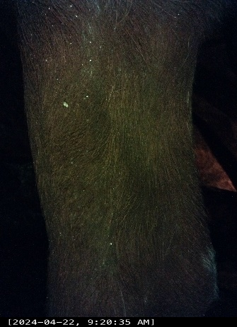  Week 12

Table 36 Continued
G24004 | 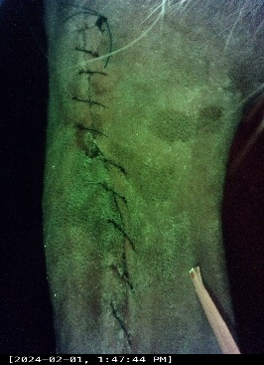  Week 1.1 | 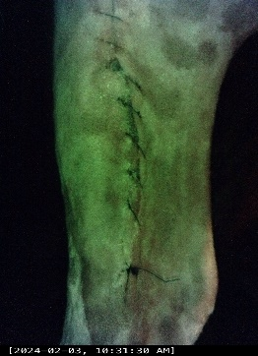  Week 1.2 |  | 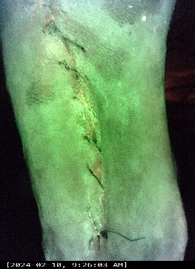  Week 2.1 |  | 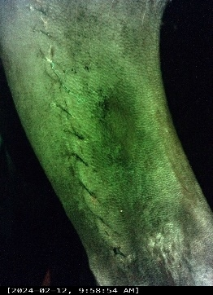  Week 2.2
G24004 | 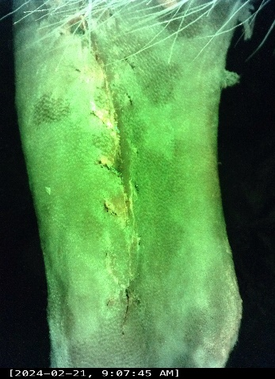  Week 3 |  | 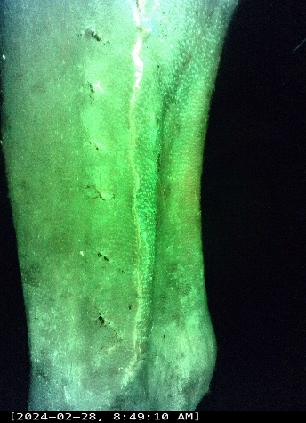  Week 4 |  | 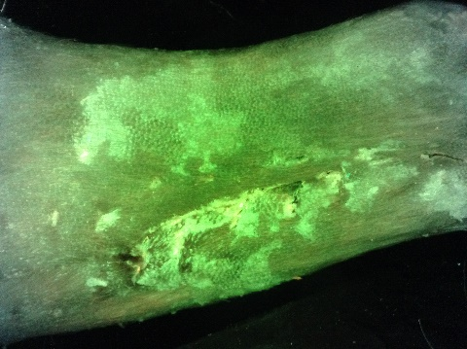  Week 6
G24004 | 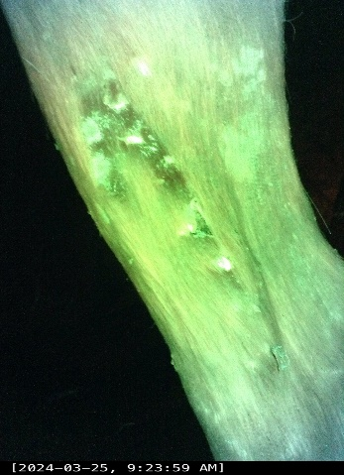  Week 8 |  | 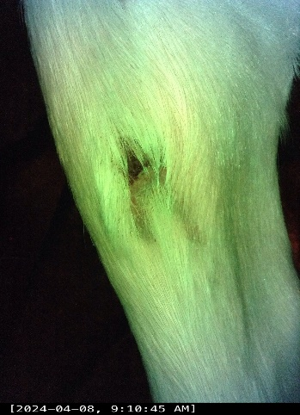  Week 10 |  | 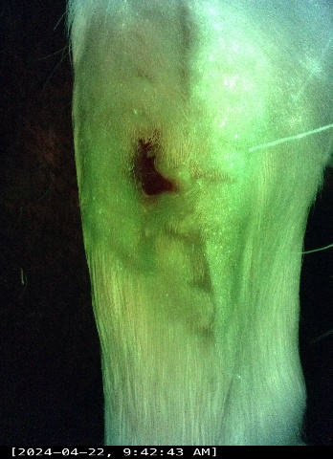  Week 12

Table 36 Continued
G24005 | 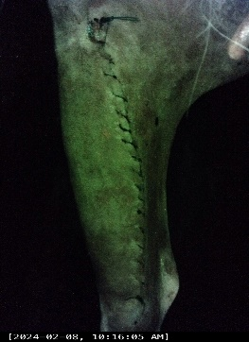  Week 1.1 | 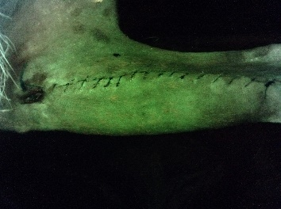  Week 1.2 |  | 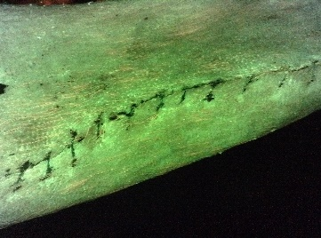  Week 2.1 |  | 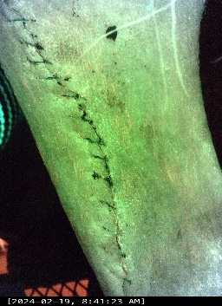  Week 2.2
G24005 | 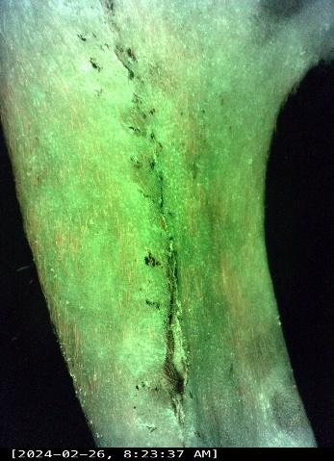  Week 3 |  | 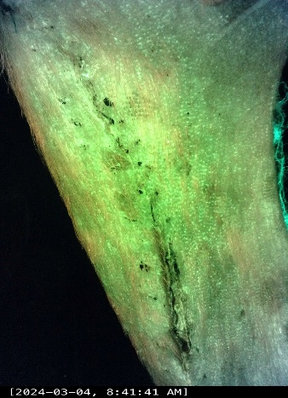  Week 4 |  | 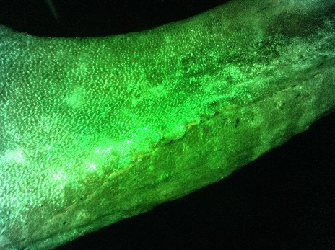  Week 6
G24005 | 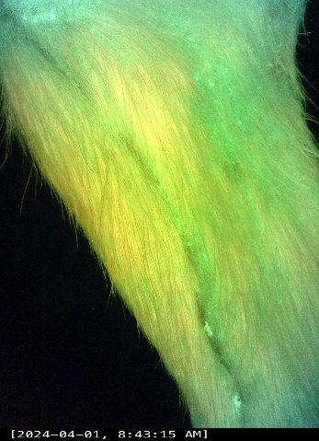  Week 8 |  | 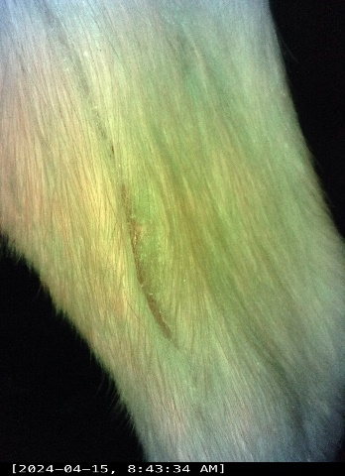  Week 10 |  | 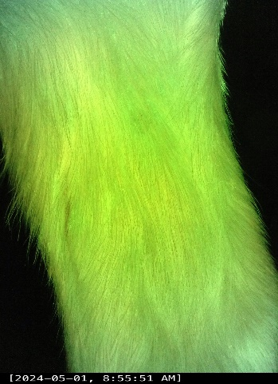  Week 12

Table 36 Continued
G24006 | 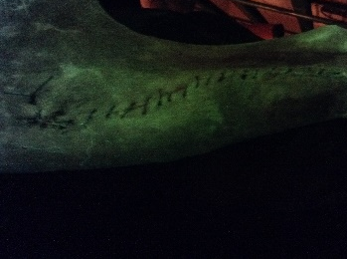  Week 1.1 | 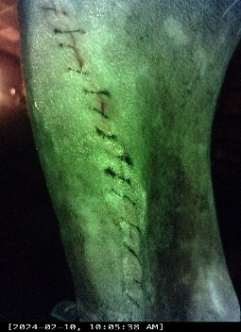  Week 1.2 |  | 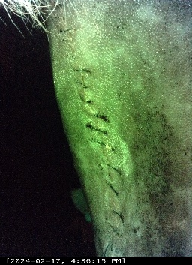  Week 2.1 |  | 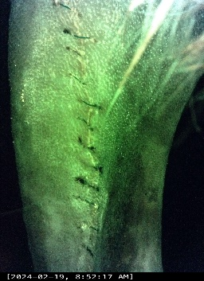  Week 2.2
G24006 | 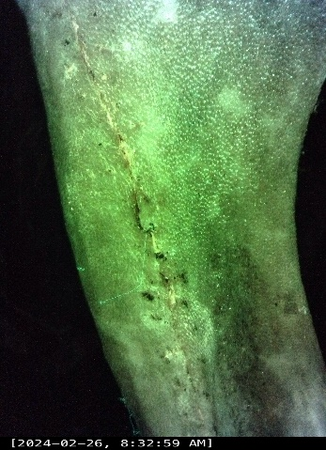  Week 3 |  | 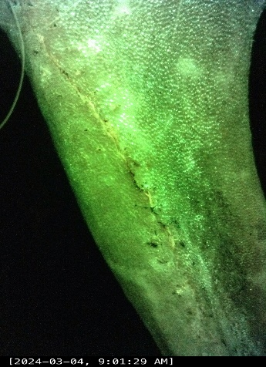  Week 4 |  | 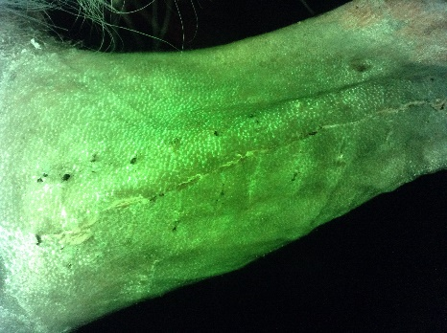  Week 6
G24006 | 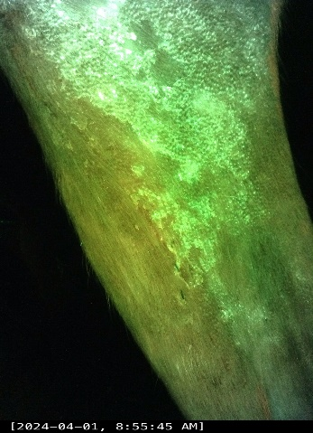  Week 8 |  | 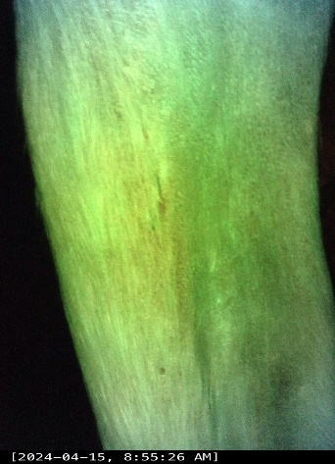  Week 10 |  | 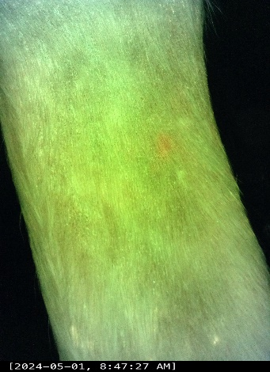  Week 12
Table 37: Fluorescence imaging findings SB
(SB)
G24019 | 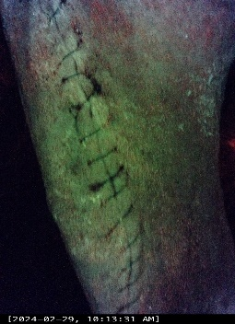  Week 1.1 | 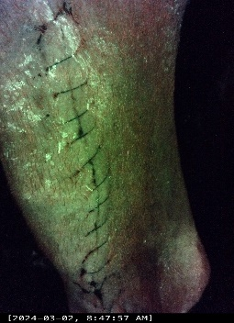  Week 1.2 |  | 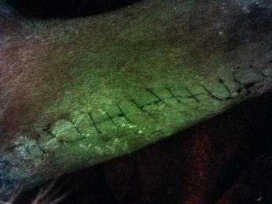  Week 2.1 |  | Week 2.2
G24019 | 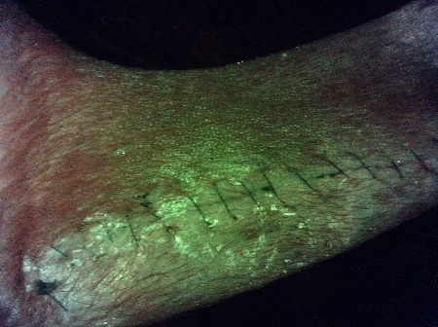  Week 3 |  | 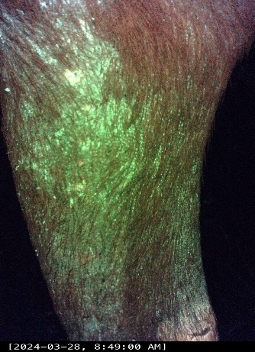  Week 4 |  | Not generated – Animal removed  Week 6
G24019 | Not generated – Animal removed  Week 8 |  | Not generated – Animal removed  Week 10 |  | Not generated – Animal removed  Week 12
G24020 | 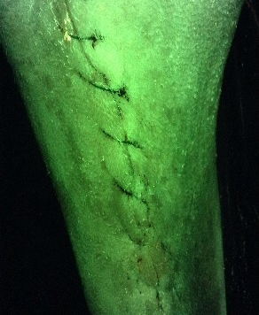  Week 1.1 | 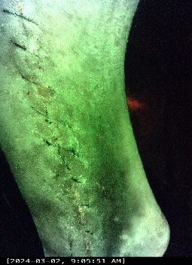  Week 1.2 |  | 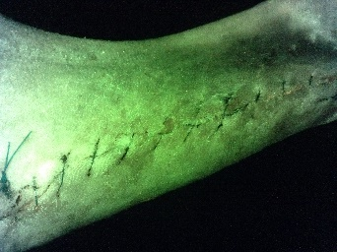  Week 2.1 |  | Week 2.2

Table 37 Continued
 | 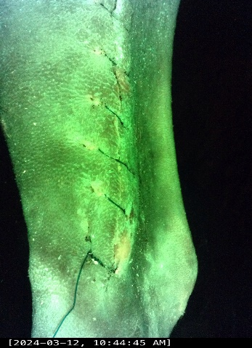  Week 3 | 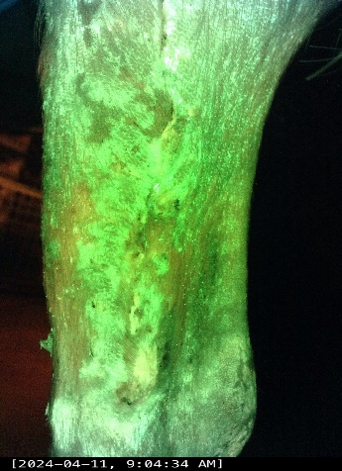  Week 4 | Not generated – Animal removed  Week 6
 | Not generated – Animal removed  Week 8 | Not generated – Animal removed  Week 10 | Not generated – Animal removed  Week 12

Table 37 Continued

G24021 | 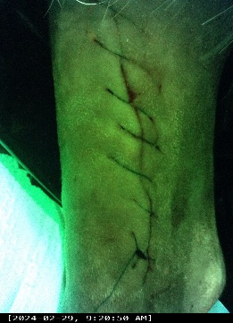  Week 1.1 | 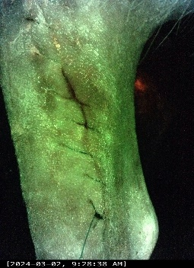  Week 1.2 | 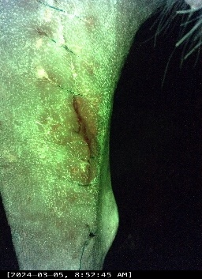  Week 2.1 | Week 2.2

Table 37 Continued
 | 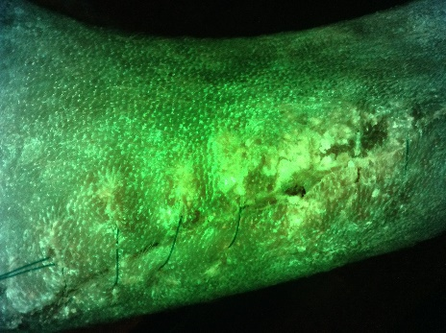  Week 3 | 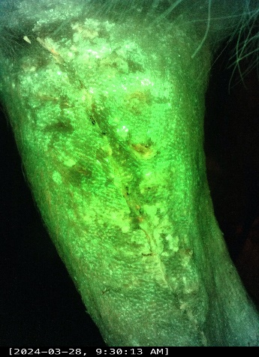  Week 4 | 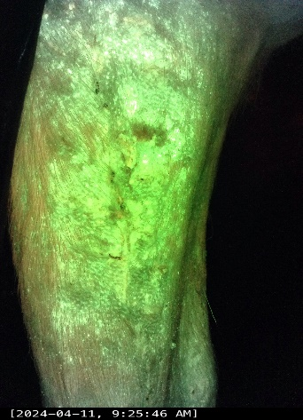  Week 6
 | Not generated – Animal removed  Week 8 | Not generated – Animal removed  Week 10 | Not generated – Animal removed  Week 12

Table 37 Continued

G24022 | 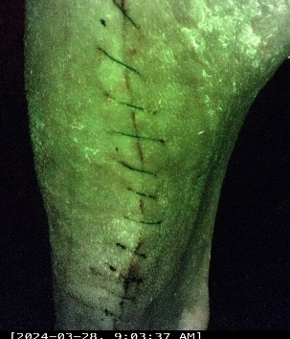  Week 1.1 | 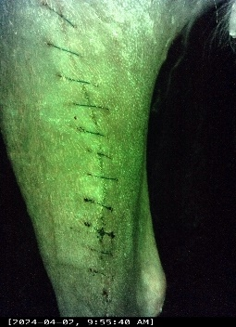  Week 1.2 |  | 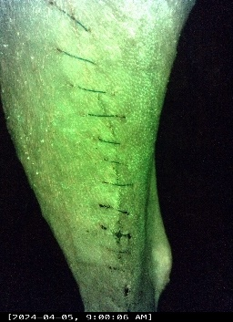  Week 2.1 |  | 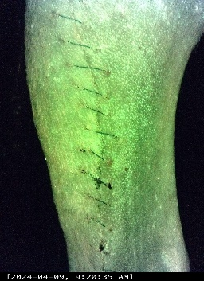  Week 2.2
G24022 | 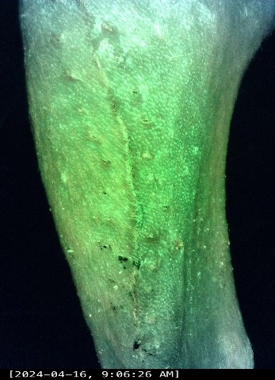  Week 3 |  | 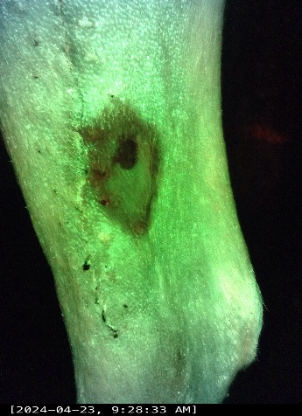  Week 4 |  | Not generated – Animal removed  Week 6
G24022 | Not generated – Animal removed  Week 8 |  | Not generated – Animal removed  Week 10 |  | Not generated – Animal removed  Week 12
Table 37 Continued
G24023 | 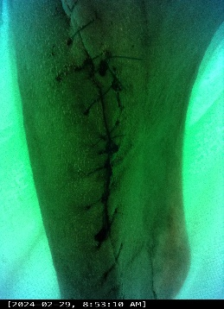Week 1.1 | 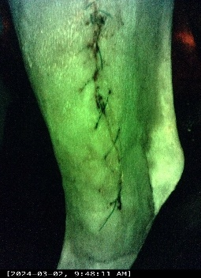  Week 1.2 |  | 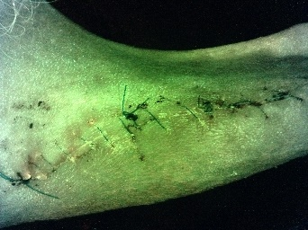  Week 2.1 |  | Week 2.2
G24023 | 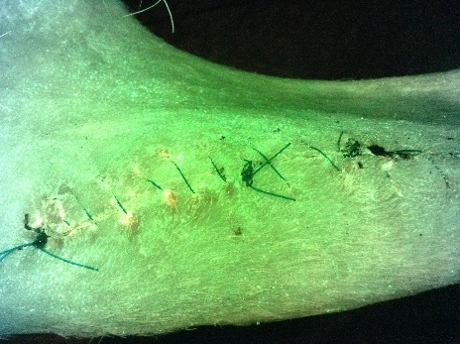  Week 3 |  | 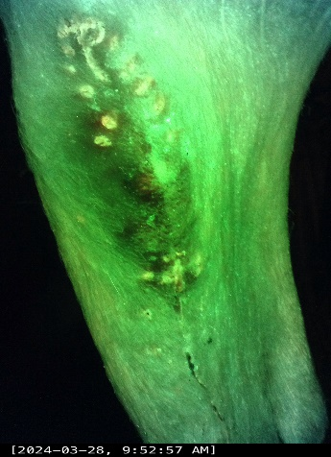  Week 4 |  | Not generated – Animal removed  Week 6
G24023 | Not generated – Animal removed  Week 8 |  | Not generated – Animal removed  Week 10 |  | Not generated – Animal removed  Week 12

Table 37 continued
G24024 | 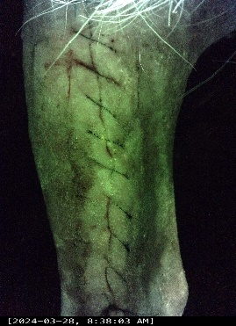Week 1.1 | 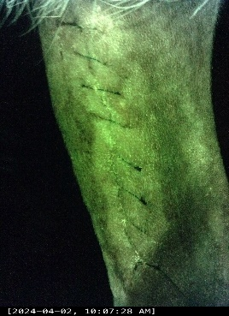  Week 1.2 |  | 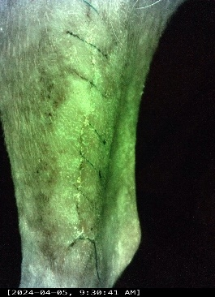  Week 2.1 |  | 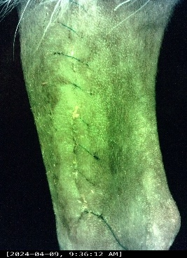  Week 2.2
G24024 | 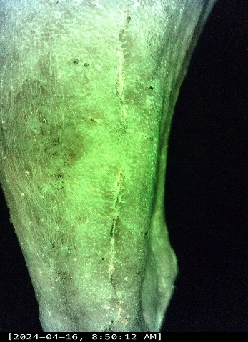  Week 3 |  | 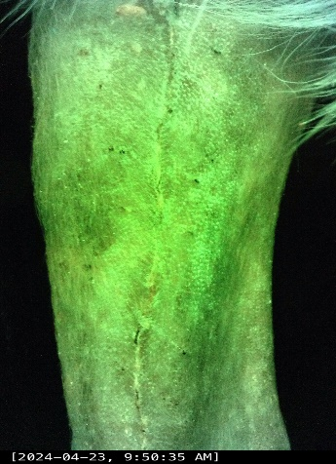  Week 4 |  | 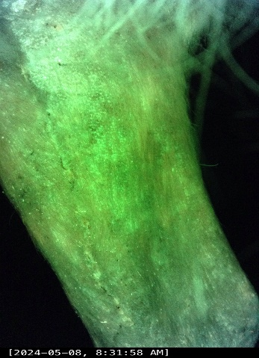  Week 6
G24024 | Not generated – Animal removed  Week 8 |  | Not generated – Animal removed  Week 10 |  | Not generated – Animal removed  Week 12

Table 38: Fluorescens imaging findings SBA
(SBA)
G24013 | 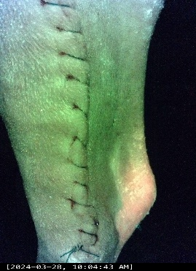  Week 1.1 | 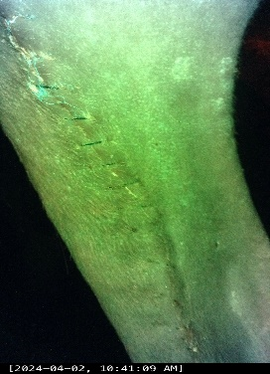  Week 1.2 |  | 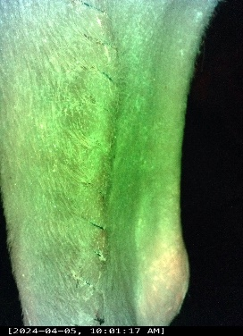  Week 2.1 |  | 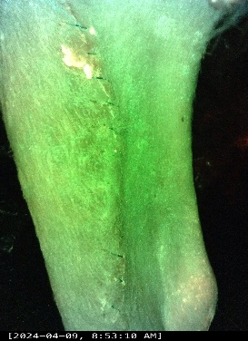  Week 2.2
G24013 | 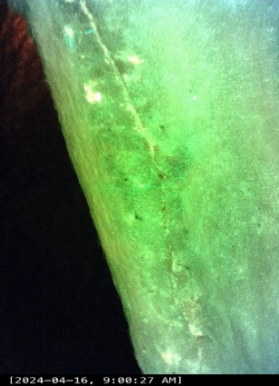  Week 3 |  | 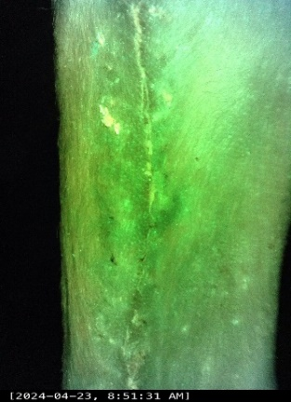  Week 4 |  | 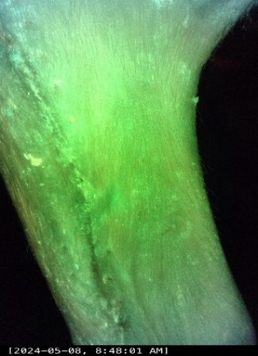  Week 6
G24013 | 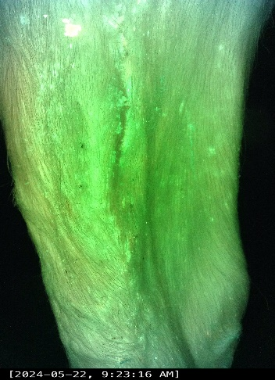  Week 8 |  | 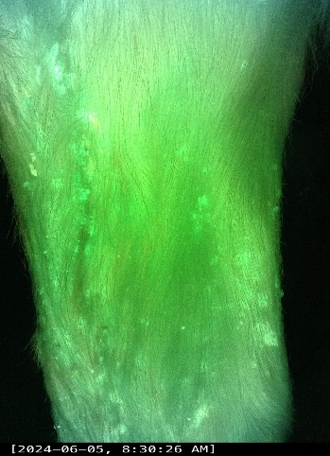  Week 10 |  | 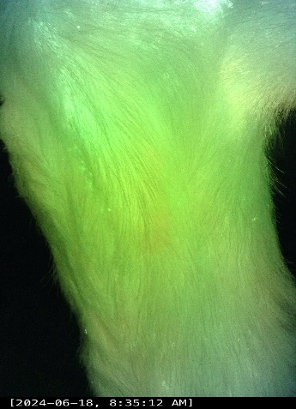  Week 12

Table 38 Continued
G24014 | 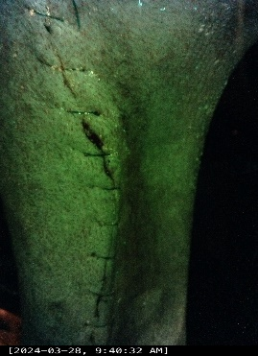Week 1.1 | 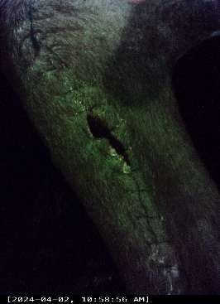  Week 1.2 |  | 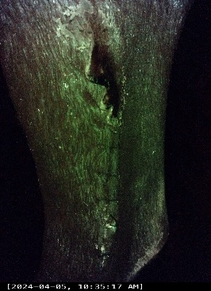  Week 2.1 |  | 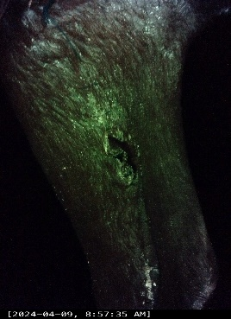  Week 2.2
G24014 | 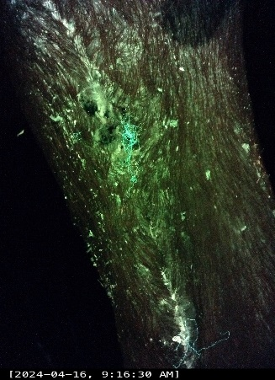  Week 3 |  | 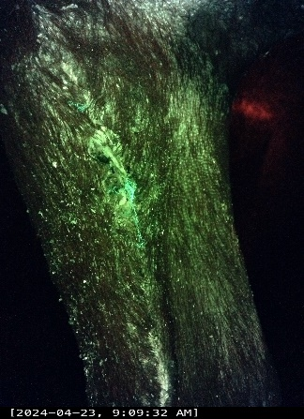  Week 4 |  | 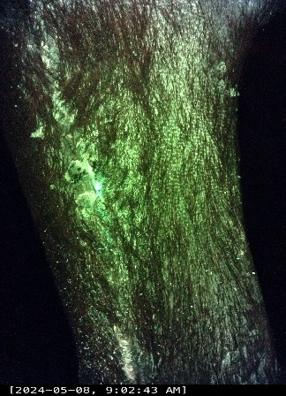  Week6
G24014 | 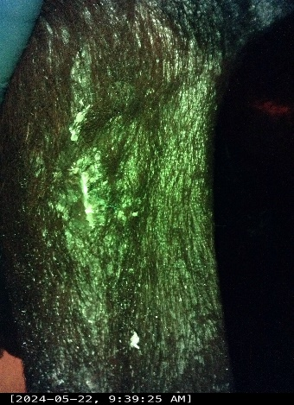  Week 8 |  | 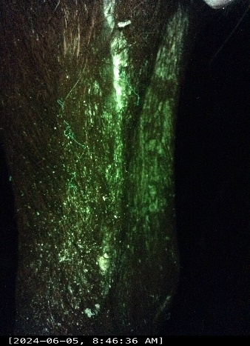  Week 10 |  | 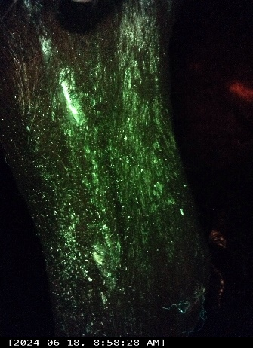  Week 12

Table 38 Continued
G24015 | 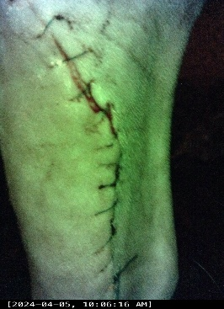  Week 1.1 | 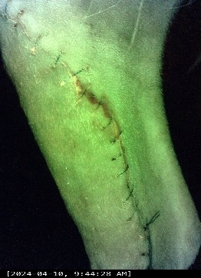  Week 1.2 |  | 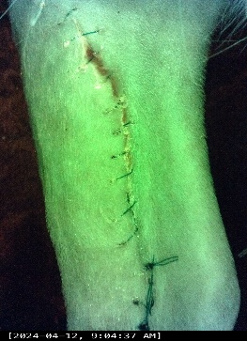  Week 2.1 |  | 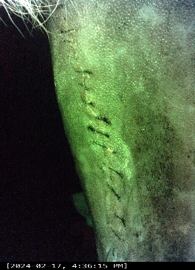  Week 2.2
G24015 | 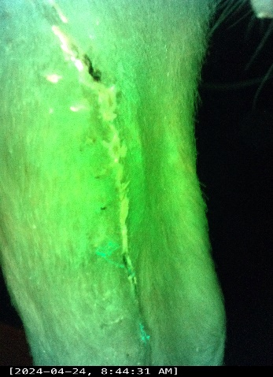  Week 3 |  | 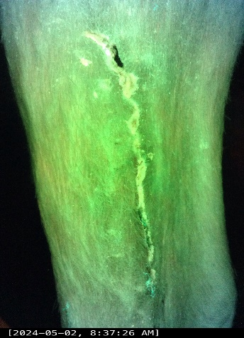  Week 4 |  | 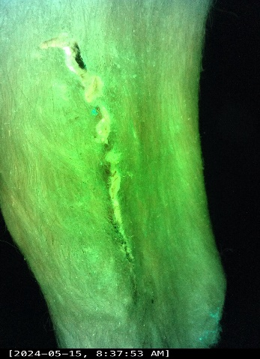  Week 6
G24015 | 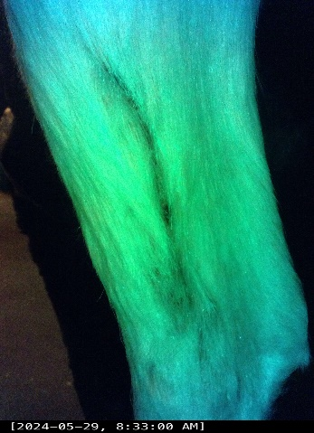  Week 8 |  | 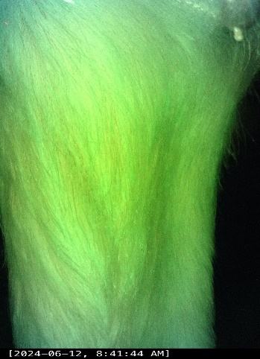  Week 10 |  | 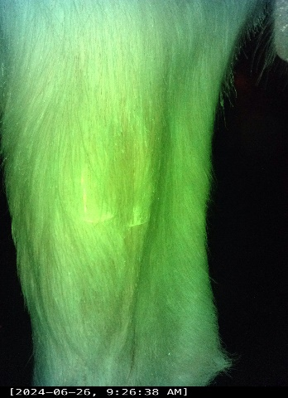  Week 12

Table 38 Continued
G24016 | 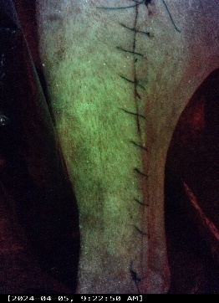  Week 1.1 | 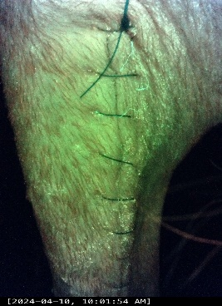  Week 1.2 |  | 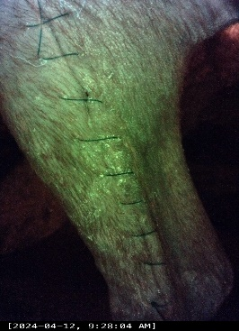  Week 2.1 |  | 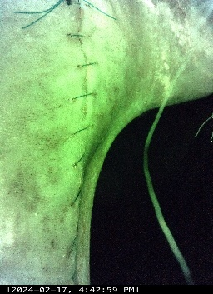  Week 2.2
G24016 | 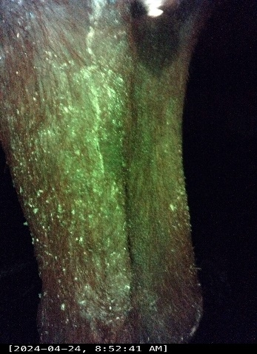  Week 3 |  | 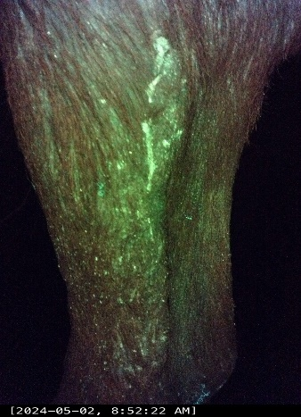  Week 4 |  | 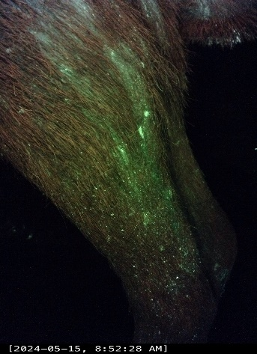  Week 6
G24016 | 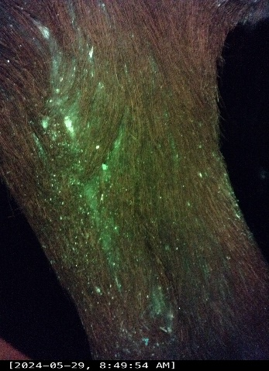  Week 8 |  | 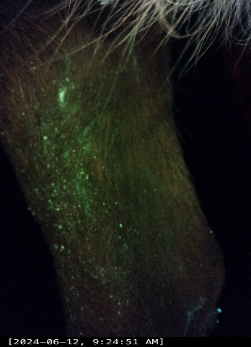  Week 10 |  | 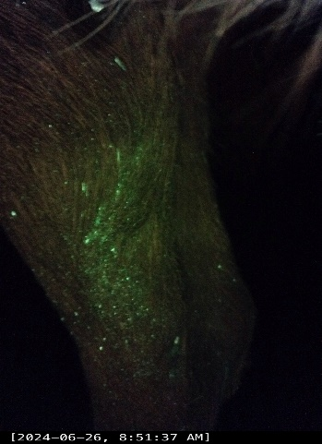  Week 12

Table 38 Continued
G24017 | 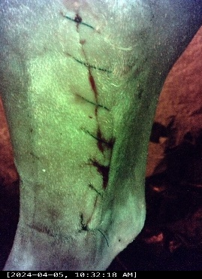  Week 1.1 | 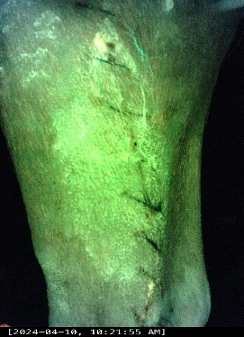  Week 1.2 |  | 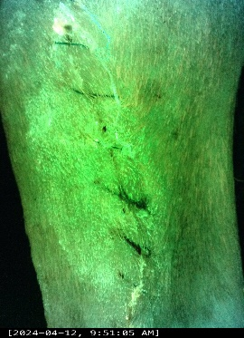  Week 2.1 |  | 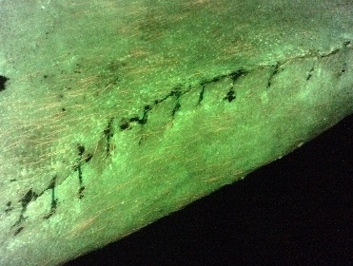  Week 2.2
G24017 | 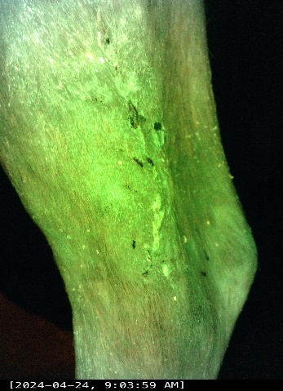  Week 3 |  | 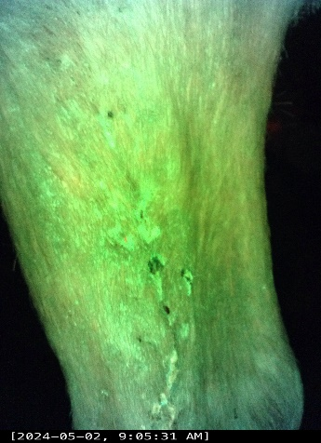  Week 4 |  | 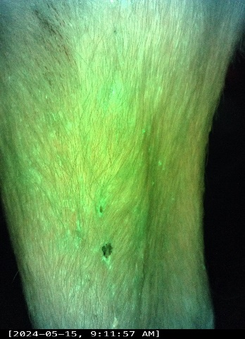  Week 6
G24017 | 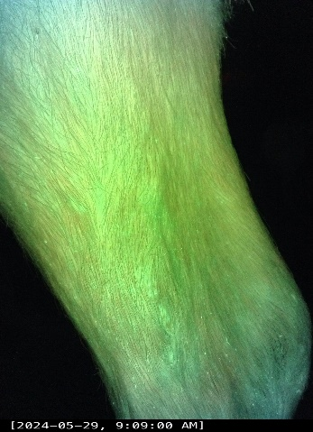Week 8 |  | 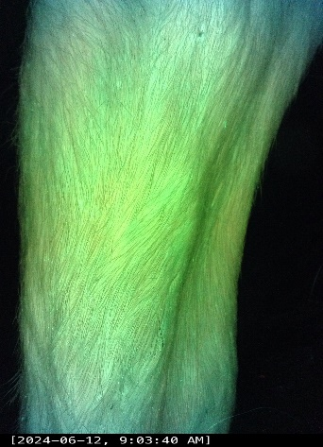  Week 10 |  | 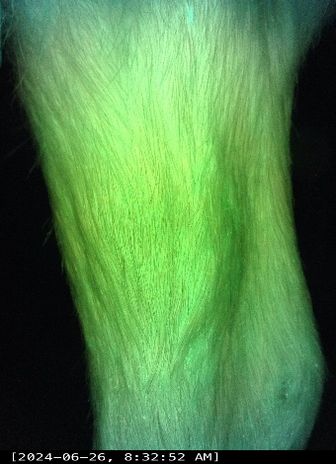  Week 12

Table 38 Continued
G24018 | 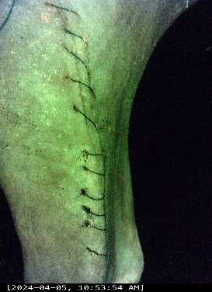  Week 1.1 | 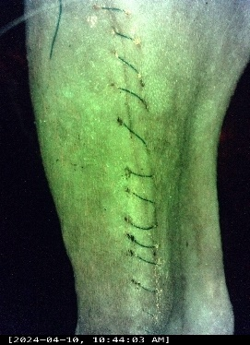  Week 1.2 |  | 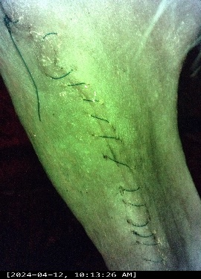  Week 2.1 |  | 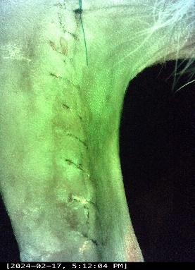  Week 2.2
G24018 | 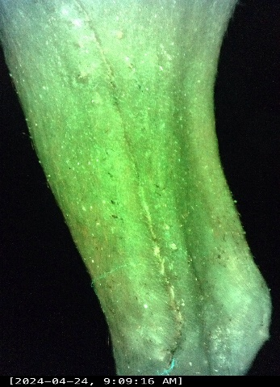  Week 3 |  | 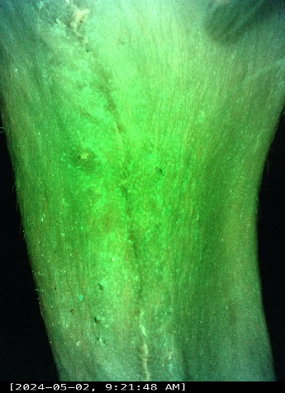  Week 4 |  | 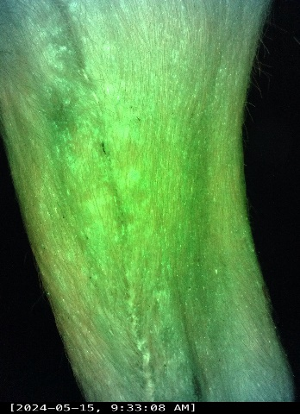  Week 6
G24018 | 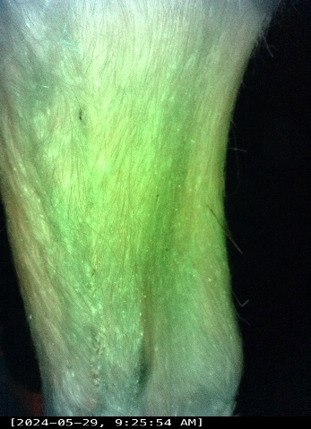Week 8 |  | 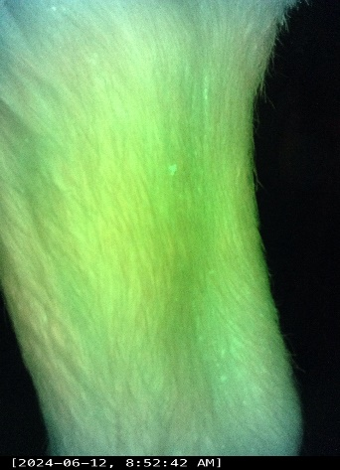  Week 10 |  | 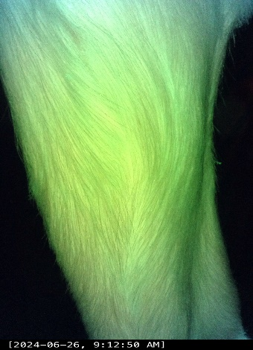  Week 12

Table 39: Fluorescence imaging findings NS
(NS)
G24007 | 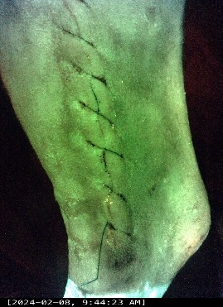  Week 1.1 | 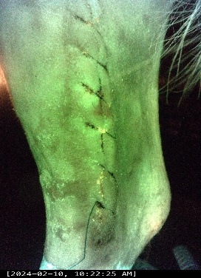  Week 1.2 |  | 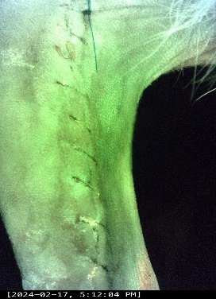  Week 2.1 |  | 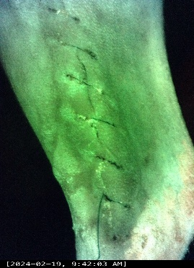  Week 2.2
G24007 | 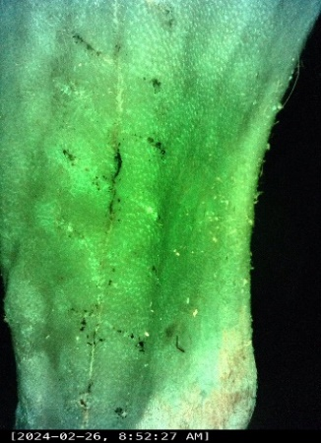  Week 3 |  | 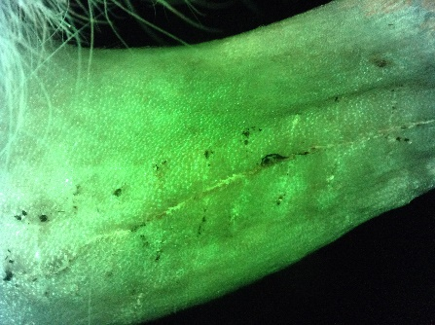  Week 4 |  | 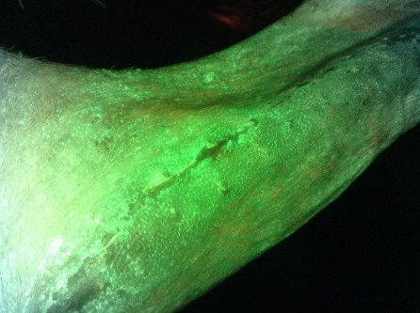  Week 6
G24007 | 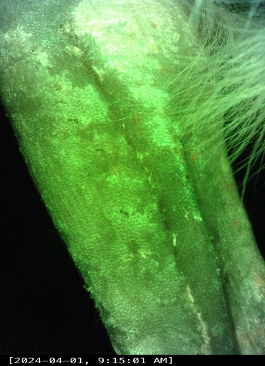  Week 8 |  | 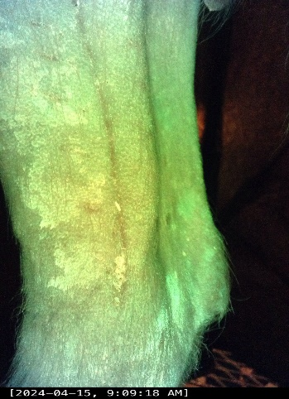  Week 10 |  | 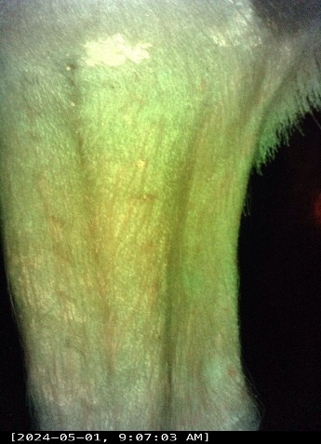  Week 12

Table 39 Continued
G24008 | 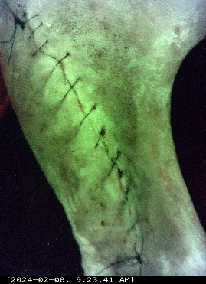Week 1.1 | 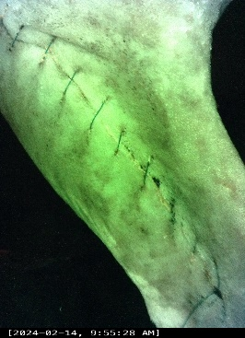  Week 1.2 |  | 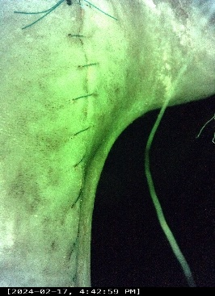  Week 2.1 |  | 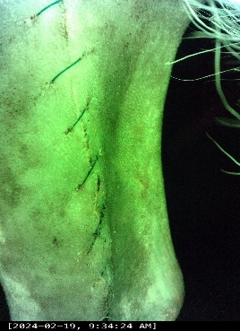  Week 2.2
G24008 | 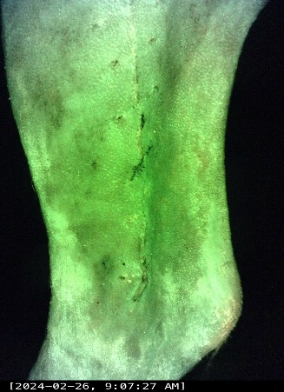  Week 3 |  | 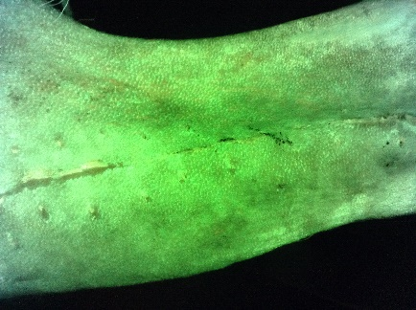  Week 4 |  | 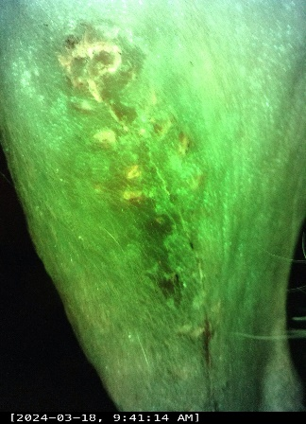  Week6
G24008 | 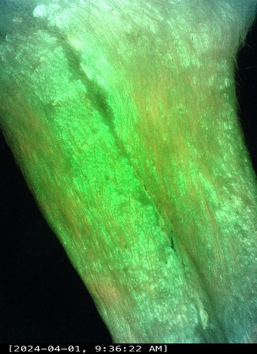  Week 8 |  | 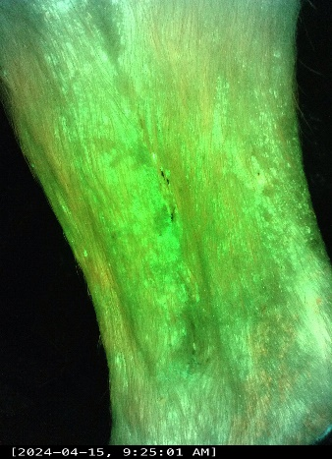  Week 10 |  | 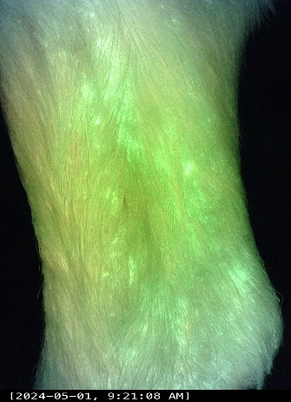  Week 12

Table 39 Continued
G24009 | 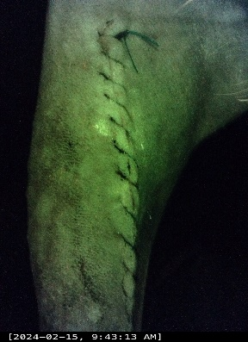  Week 1.1 | 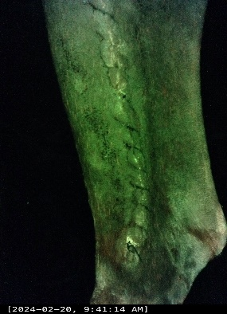  Week 1.2 |  | 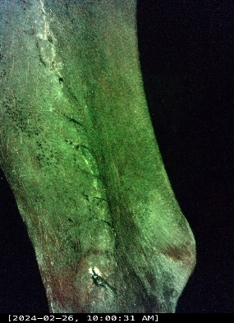  Week 2.1 |  | 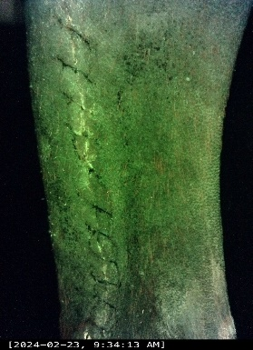  Week 2.2
G24009 | 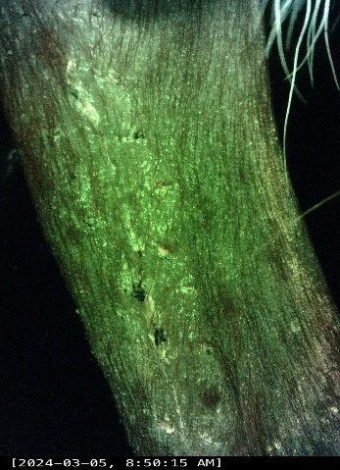  Week 3 |  | 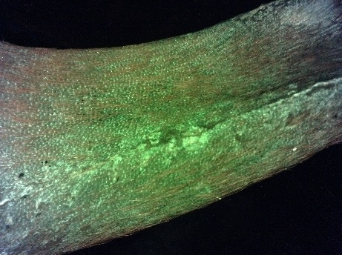  Week 4 |  | 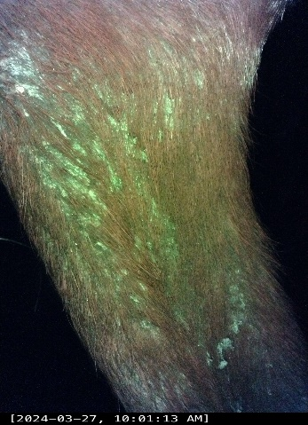  Week 6
G24009 | 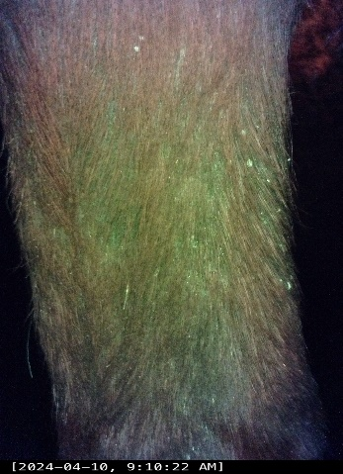  Week 8 |  | 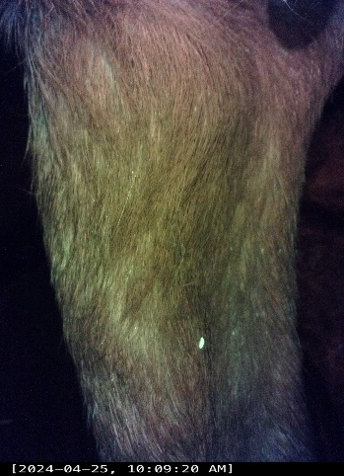  Week 10 |  | 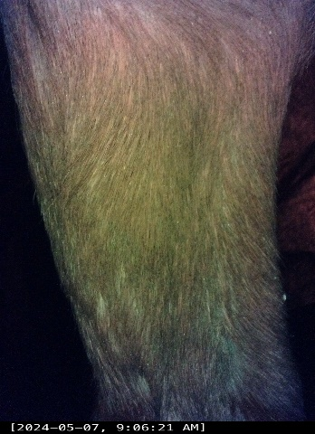  Week 12

Table 39 Continued
G24010 | 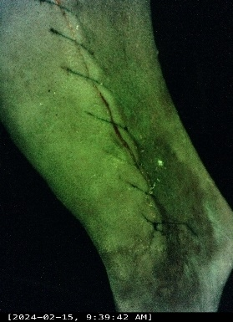  Week 1.1 | 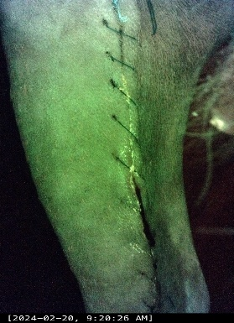  Week 1.2 |  | 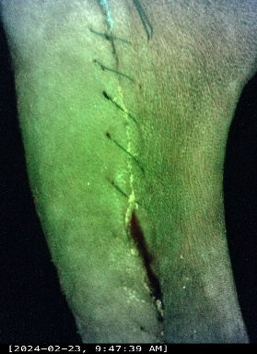  Week 2.1 |  | 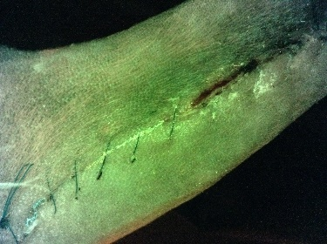  Week 2.2
G24010 | 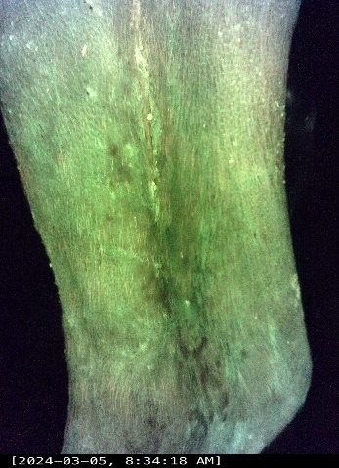  Week 3 |  | 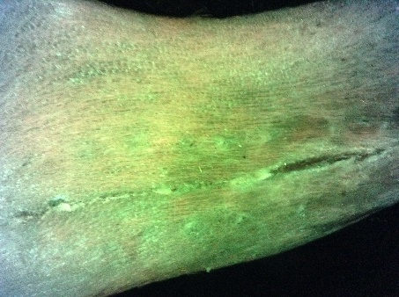  Week 4 |  | 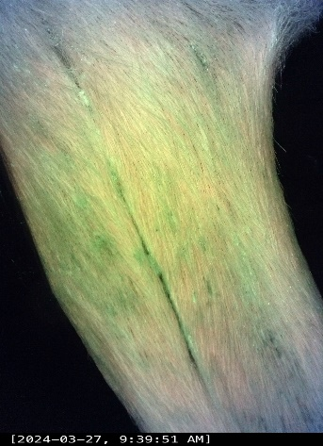  Week 6
G24010 | 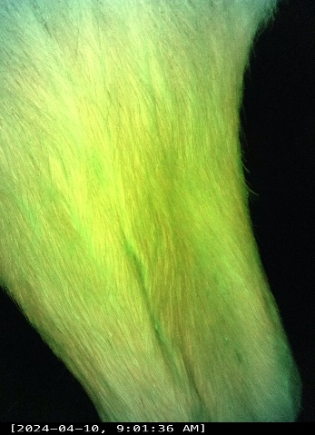  Week 8 |  | 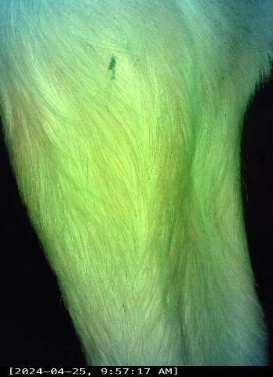  Week 10 |  | 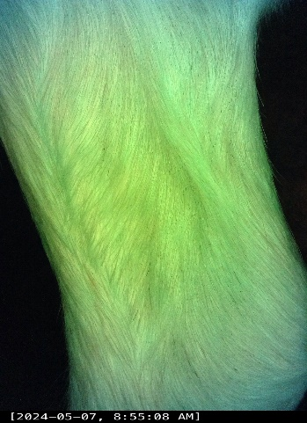  Week 12

Table 39 Continued
G24011 | 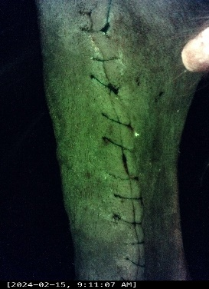  Week 1.1 | 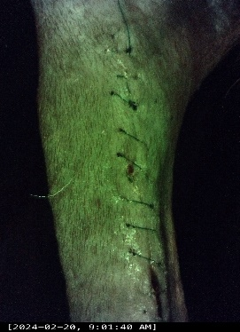  Week 1.2 |  | 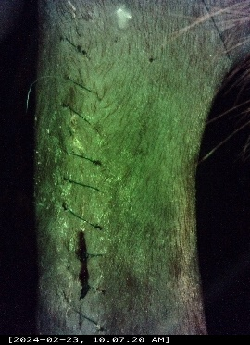  Week 2.1 |  | 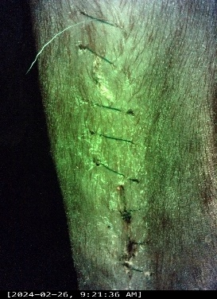  Week 2.2
G24011 | 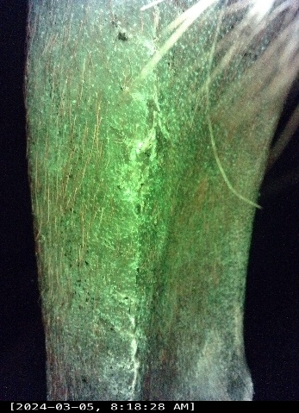Week 3 |  | 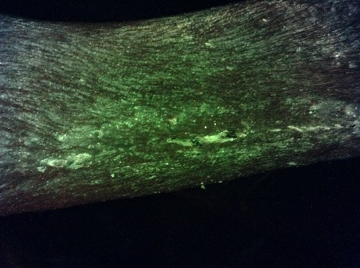  Week 4 |  | 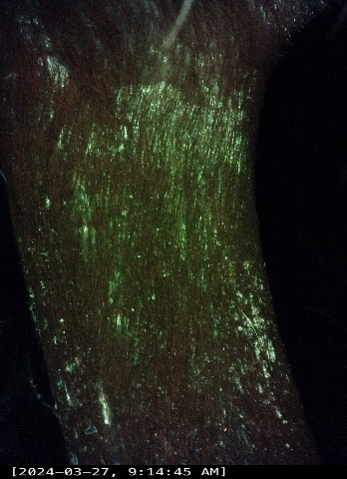  Week 6
G24011 | 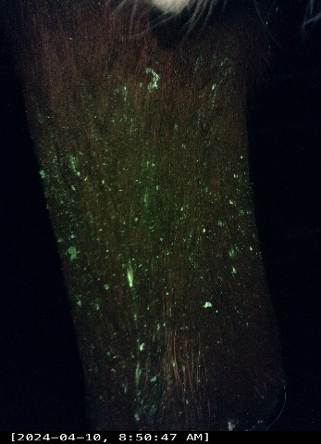Week 8 |  | 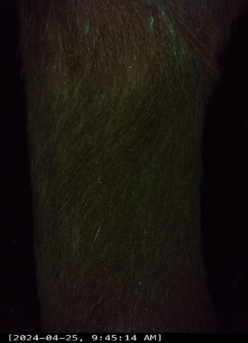  Week 10 |  | 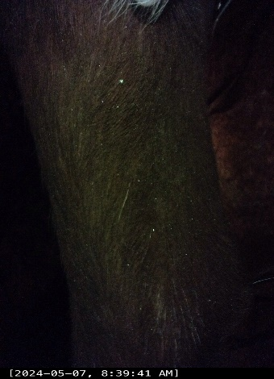  Week 12

Table 39 Continued
G24012 | 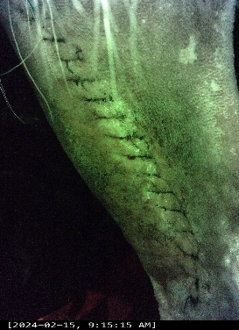  Week 1.1 | 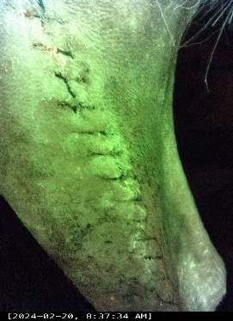  Week 1.2 |  | 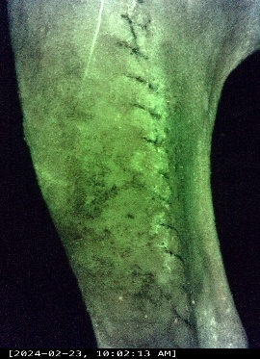  Week 2.1 |  | 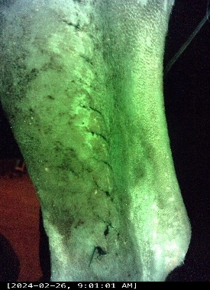  Week 2.2
G24012 | 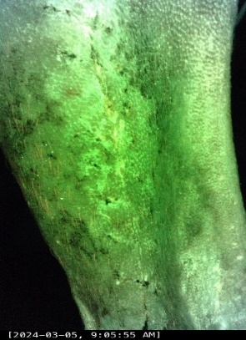Week 3 |  | 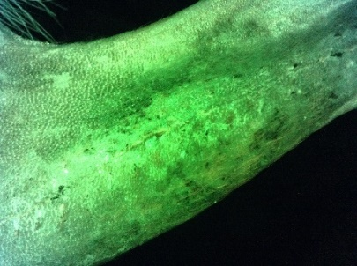  Week 4 |  | 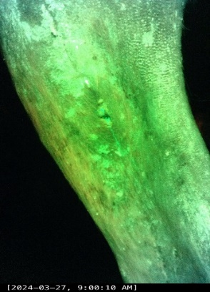  Week 6
G24012 | 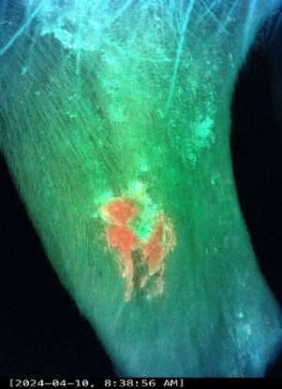Week 8 |  | 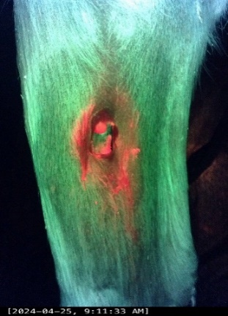Week 10 |  | Not generated – Animal removed  Week 12

Pressure mat

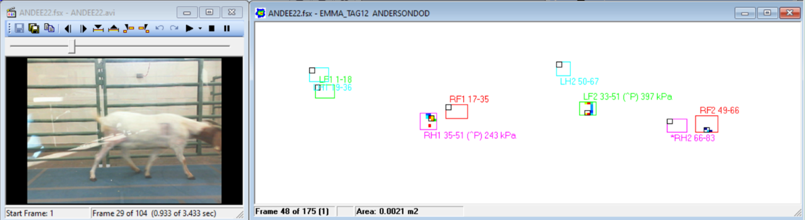
Figure 29: Example of pressure mat data SA group

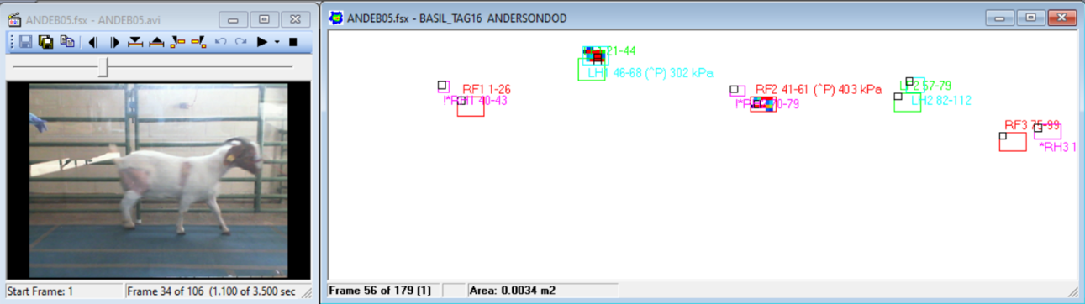
Figure 30: Example of pressure mat data SB group

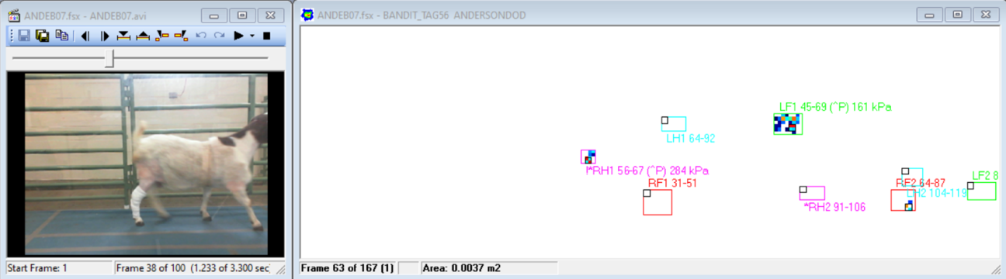
Figure 31: Example of pressure mat data SBA group

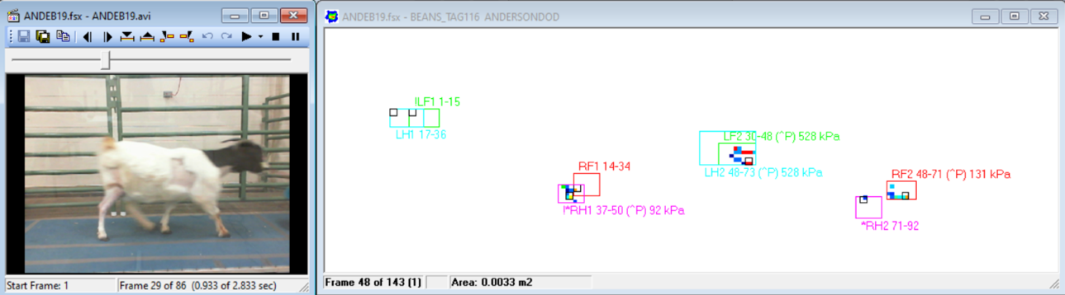
Figure 32: Example of pressure mat data NS group

Specimen harvesting
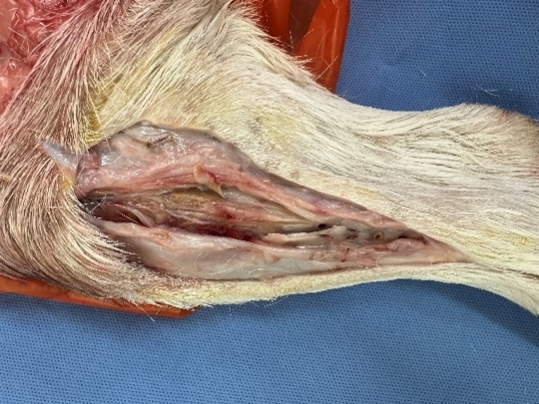 | 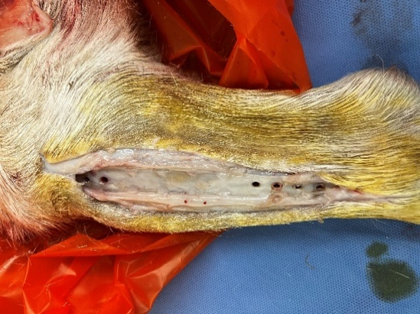 | 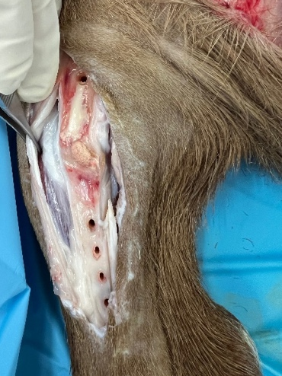 | 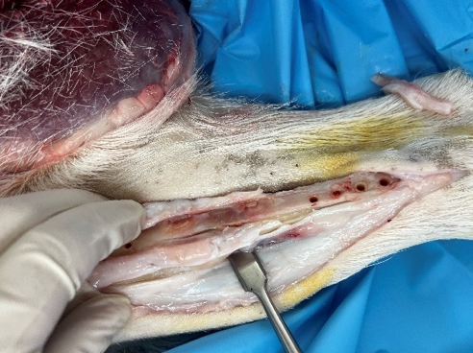
Figure 33: Diverse SA outcomes

Harvesting findings SB: No signs of scaffold integration, signs of intense infection
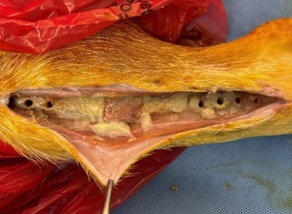 | 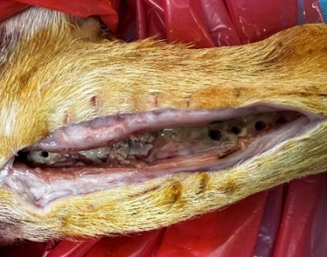
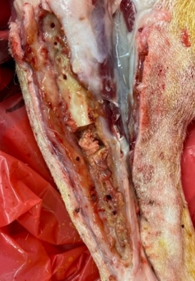 | 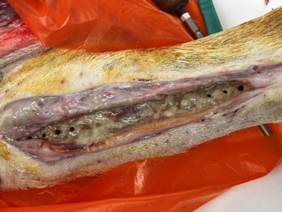
Figure 34: Diverse SB outcomes

Harvesting findings SBA
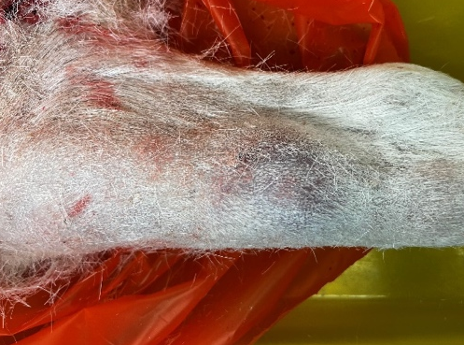 | 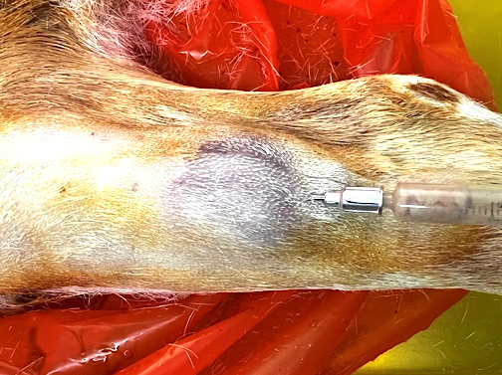 | 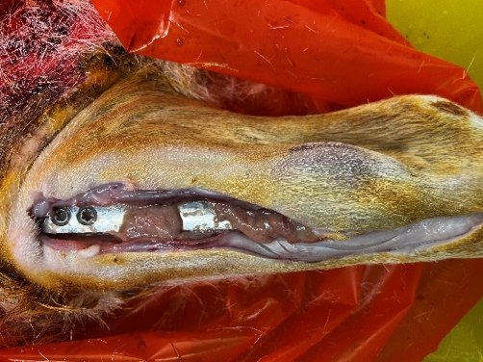
Figure 35: SBA – Abscess1

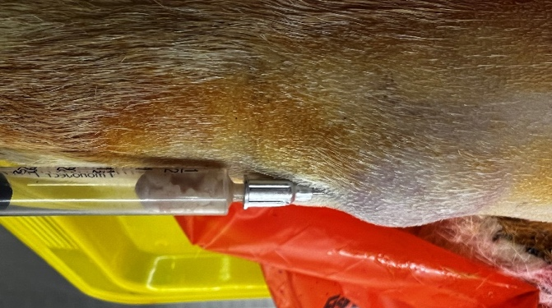 | 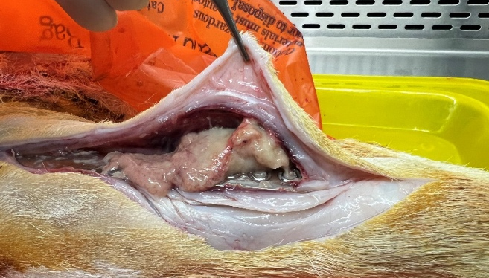
Figure 36: SBA – Abscess2

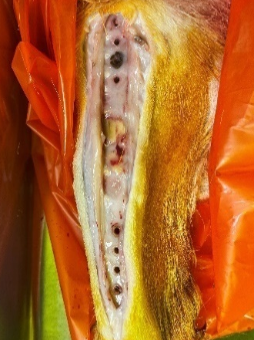 | 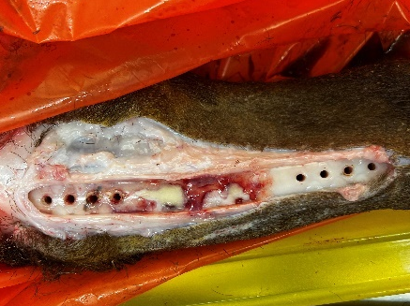 | 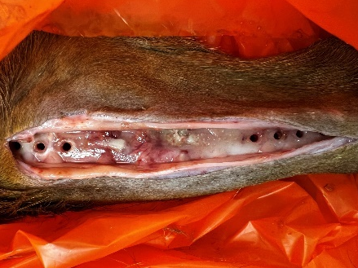
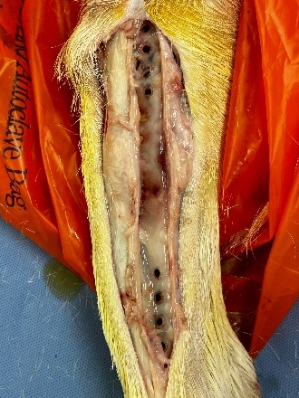 | 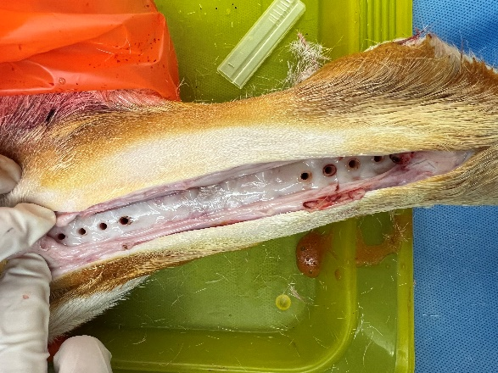 | 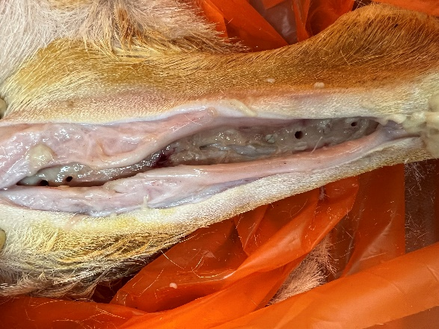
Figure 37: SBA outcomes - Variable macroscopic signs of scaffold integration

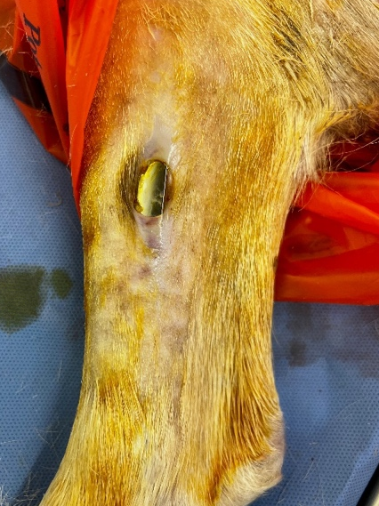 | 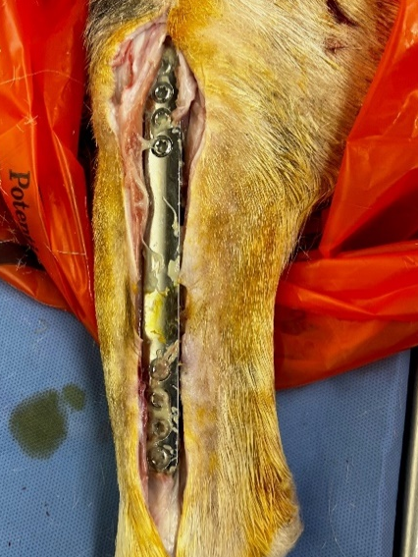 | 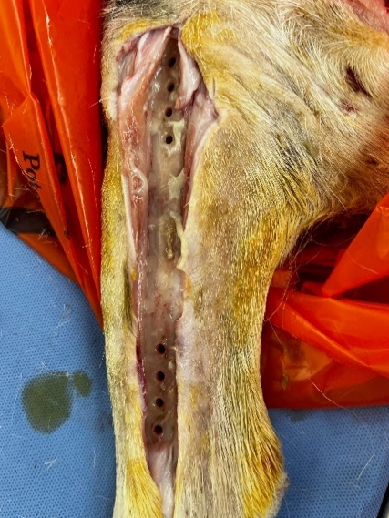
Figure 38: Contamination case1

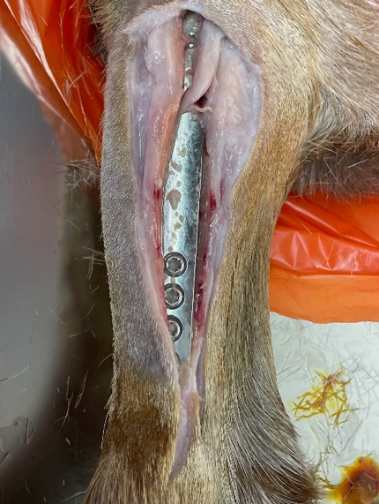 | 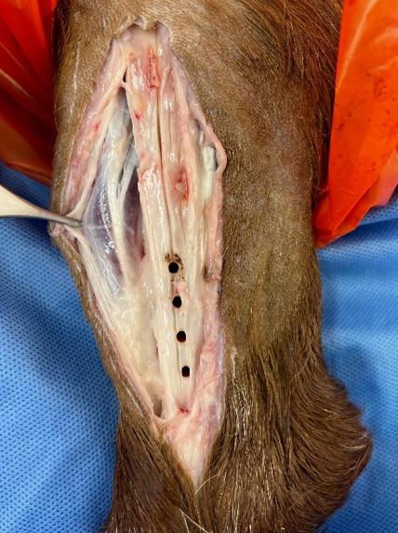
Figure 39: Contamination case2

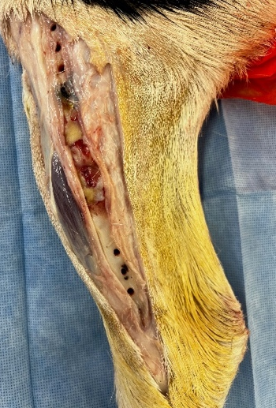 | 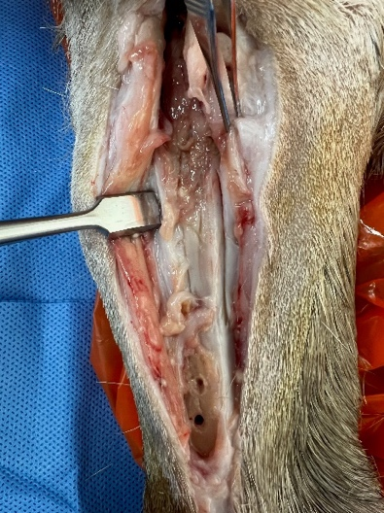 | 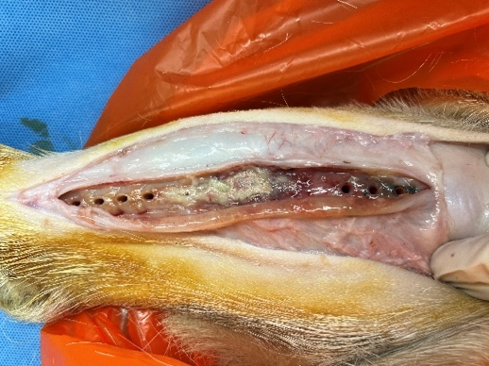 | 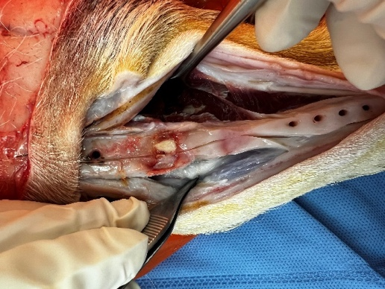
Figure 40: Diverse NS outcomes

Histopathological assessment
Table 40: Slides obtained from 23 goats
(SA)
G24002 | 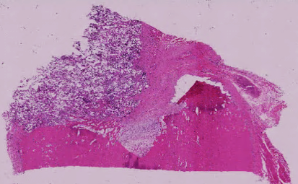 | Slide response score: (CR):0; (NBR):1; (SFB):0, (SFD):1  The slide shows no cellular response beyond what is expected in healthy tissue. New bone is present but not in abundance. The soft tissue surrounding the preexisting bone shows no reaction, while the soft tissue around the defect and new bone area is present and not excessively abundant, as expected in a regenerative process
G24003 | 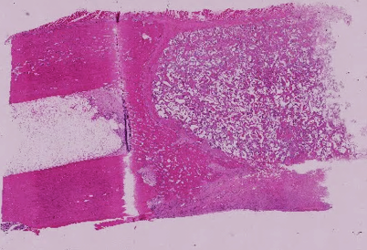 | Slide response score: (CR):1; (NBR):2; (SFB):0; (SFD): 2  The slide shows cellular response expected in a regenerative process. New bone is abundant. The soft tissue surrounding the preexisting bone shows no reaction, while the soft tissue around the defect and new bone area is abundant.

Table 40 continued
G24004 | 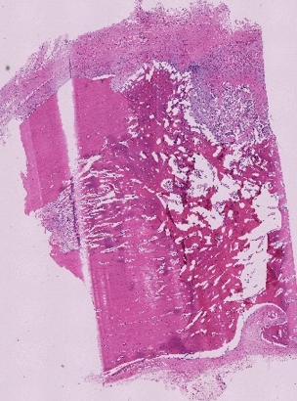 | Slide response score: (CR):1; (NBR):1; (SFB):1; (SFD): 2  The slide shows cellular response expected in a regenerative process. New bone is present but not in abundance. The soft tissue surrounding the preexisting bone shows cellular response expected in a regenerative process, while the soft tissue around the defect and new bone area is abundant.
G24005 | 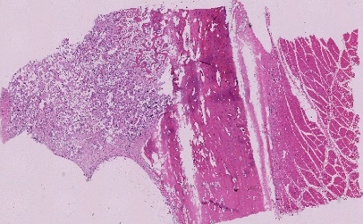 | Slide response score: (CR):1; (NBR):2; (SFB):0; (SFD): 0  The slide shows cellular response expected in a regenerative process. New bone is abundant. The soft tissue surrounding the preexisting bone and the soft tissue around the defect and new bone area show no reaction.
G24006 |  | Slide response score: (CR):1; (NBR):2; (SFB):0; (SFD): 2  The slide shows cellular response expected in a regenerative process. New bone is abundant. The soft tissue surrounding the preexisting bone shows no reaction, while the soft tissue around the defect and new bone area is abundant.
(SB)
G24019 | 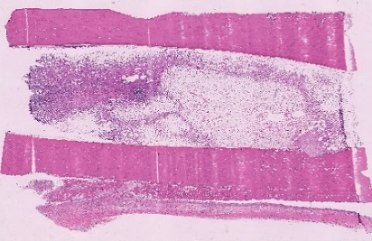 | Slide response score: (CR):2; (NBR):2; (SFB):1; (SFD): 1  The slide shows an abundant cellular response consistent with an intense inflammatory reaction typically seen in response to pathogens such as bacteria. New bone is present in abundance. The soft tissue surrounding the preexisting bone, as well as the soft tissue around the defect and new bone area, shows a reaction but is not excessively abundant

Table 40 continued
G24020 | 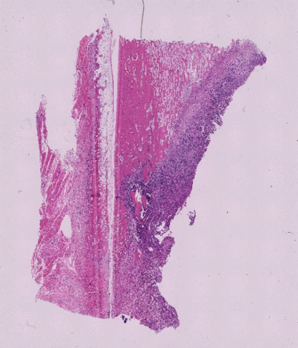 | Slide response score: (CR):2; (NBR):2; (SFB):1; (SFD):2  The slide shows an abundant cellular response consistent with an intense inflammatory reaction typically seen in response to pathogens such as bacteria. New bone is present in abundance. The soft tissue surrounding the preexisting bone shows cellular response expected in a regenerative process, while the soft tissue around the defect and new bone area is abundant.
G24021 | 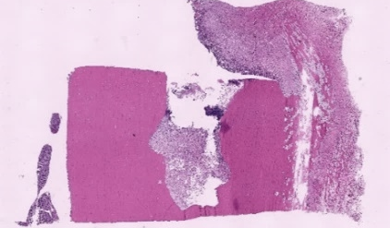 | Slide response score: (CR):2; (NBR):1; (SFB):1; (SFD):1  The slide shows an abundant cellular response consistent with an intense inflammatory reaction typically seen in response to pathogens such as bacteria. New bone is present but not in abundance. The soft tissue surrounding the preexisting bone, as well as the soft tissue around the defect and new bone area, shows a reaction but is not excessively abundant.
G24022 | 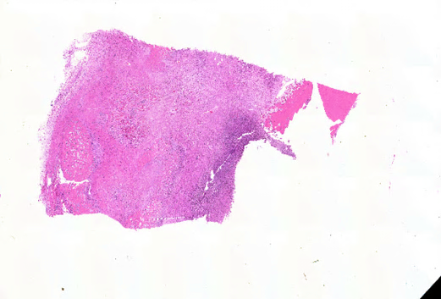 | Slide response score: (CR):2; (NBR):2; (SFB):1; (SFD):1  The slide shows an abundant cellular response consistent with an intense inflammatory reaction typically seen in response to pathogens such as bacteria. New bone is present in abundance. The soft tissue surrounding the preexisting bone, as well as the soft tissue around the defect and new bone area, shows a reaction but is not excessively abundant.
G24023 | 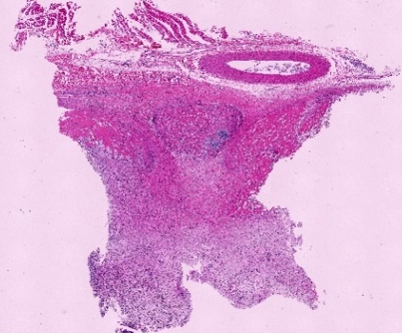 | Slide response score: (CR):2; (NBR):2; (SFB):2; (SFD):2  The slide shows an abundant cellular response consistent with an intense inflammatory reaction typically seen in response to pathogens such as bacteria. New bone is present in abundance. The soft tissue surrounding the preexisting bone, as well as the soft tissue around the defect and new bone area, shows an excessively abundant reaction compatible with response to pathogens such as bacteria
G24024 |  | Slide response score: (CR):2; (NBR):2; (SFB):1; (SFD):1  The slide shows an abundant cellular response consistent with an intense inflammatory reaction typically seen in response to pathogens such as bacteria. New bone is present in abundance. The soft tissue surrounding the preexisting bone, as well as the soft tissue around the defect and new bone area, shows a reaction but is not excessively abundant.

Table 40 continued
(SBA)
G24013 | 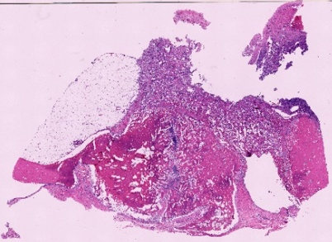 | Slide response score: (CR):2; (NBR):2; (SFB):1; (SFD):2  The slide shows an abundant cellular response consistent with an intense inflammatory reaction typically seen in response to pathogens such as bacteria. New bone is present in abundance. The soft tissue surrounding the preexisting bone shows cellular response expected in a regenerative process, while the soft tissue around the defect and new bone area shows an excessively abundant reaction compatible with response to pathogens such as bacteria
G24014 |  | Slide response score: (CR):2; (NBR):1; (SFB):1; (SFD):2  The slide shows an abundant cellular response consistent with an intense inflammatory reaction typically seen in response to pathogens such as bacteria. New bone is present but not in abundance. The soft tissue surrounding the preexisting bone shows cellular response expected in a regenerative process, while the soft tissue around the defect and new bone area shows an excessively abundant reaction compatible with response to pathogens such as bacteria
G24015 | 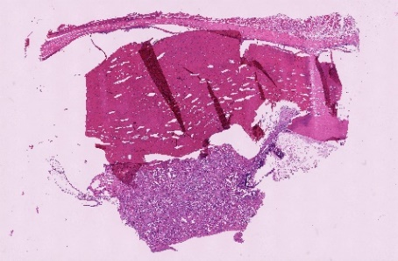 | Slide response score: (CR):2; (NBR):2; (SFB):0; (SFD):2  The slide shows an abundant cellular response consistent with an intense inflammatory reaction typically seen in response to pathogens such as bacteria. New bone is present in abundance. The soft tissue surrounding the preexisting bone shows no reaction, while the soft tissue around the defect and new bone area shows an excessively abundant reaction compatible with response to pathogens such as bacteria.
G24016 | 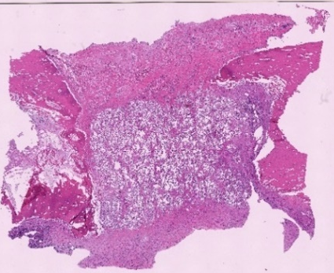 | Slide response score: (CR):1; (NBR):2; (SFB):1; (SFD):1  The slide shows cellular response expected in a regenerative process. New bone is abundant. The soft tissue surrounding the preexisting bone, as well as the soft tissue around the defect and new bone area, shows a reaction but is not excessively abundant.

Table 40 continued
G24017 | 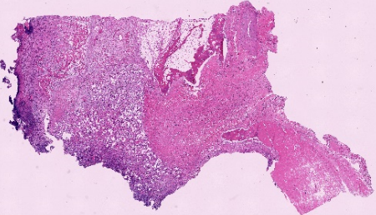 | Slide response score: (CR):2; (NBR):1; (SFB):0; (SFD):1  The slide shows an abundant cellular response consistent with an intense inflammatory reaction typically seen in response to pathogens such as bacteria. New bone is present but not in abundance. The soft tissue surrounding the preexisting bone shows no reaction, while the soft tissue around the defect and new bone area is present and not excessively abundant, as expected in a regenerative process
G24018 | 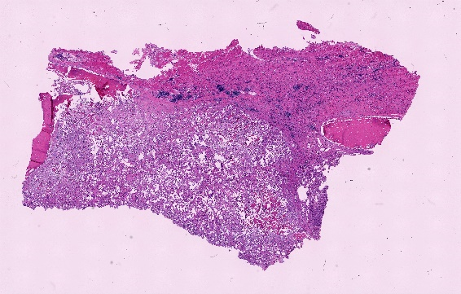 | Slide response score: (CR):2; (NBR):1; (SFB):2; (SFD):2  The slide shows an abundant cellular response consistent with an intense inflammatory reaction typically seen in response to pathogens such as bacteria. New bone is present but not in abundance. The soft tissue surrounding the preexisting bone, as well as the soft tissue around the defect and new bone area, shows an excessively abundant reaction compatible with response to pathogens such as bacteria
(NS)
G24007 | 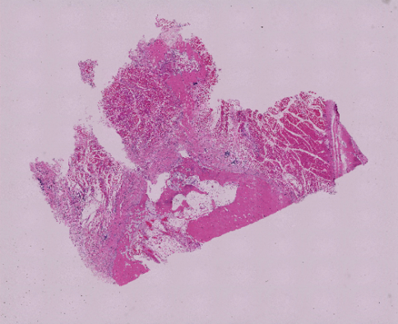 | Slide response score: (CR):1; (NBR):1; (SFB):1; (SFD):2  The slide shows cellular response expected in a regenerative process. New bone is present but not in abundance. The soft tissue surrounding the preexisting bone shows cellular response expected in a regenerative process, while the soft tissue around the defect and new bone area shows abundant reaction.
G24008 | 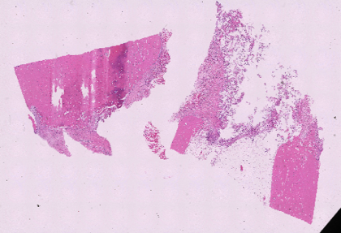 | Slide response score: (CR):1; (NBR):1; (SFB):1; (SFD):2  The slide shows cellular response expected in a regenerative process. New bone is present but not in abundance. The soft tissue surrounding the preexisting bone shows cellular response expected in a regenerative process, while the soft tissue around the defect and new bone area shows abundant reaction.
G24009 | 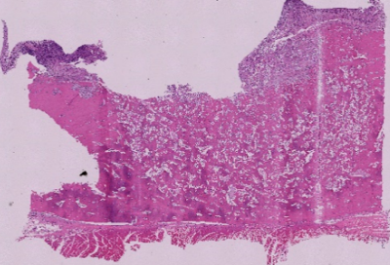 | Slide response score: (CR):2; (NBR):2; (SFB):0; (SFD):2  The slide shows an abundant cellular response consistent with an intense inflammatory reaction typically seen in response to pathogens such as bacteria. New bone is present in abundance. The soft tissue surrounding the preexisting bone shows no reaction, while the soft tissue around the defect and new bone area shows abundant reaction.

Table 40 continued
G24010 | 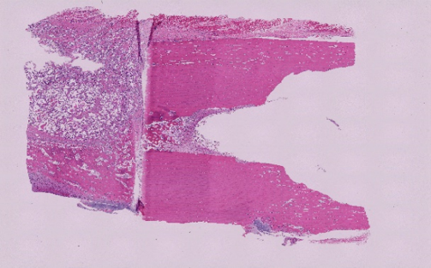 | Slide response score: (CR):1; (NBR):2; (SFB):1; (SFD):2  The slide shows cellular response expected in a regenerative process. New bone is abundant. The soft tissue surrounding the preexisting bone shows cellular response expected in a regenerative process, while the soft tissue around the defect and new bone area is abundant.
G24011 | 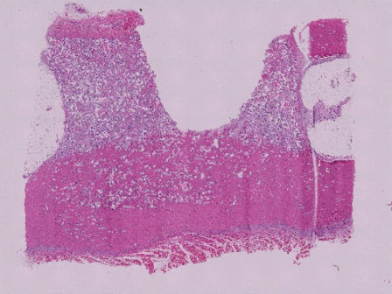 | Slide response score: (CR):1; (NBR):2; (SFB):0; (SFD):2  The slide shows cellular response expected in a regenerative process. New bone is abundant. The soft tissue surrounding the preexisting bone shows no reaction, while the soft tissue around the defect and new bone area shows abundant reaction.
G24012 | 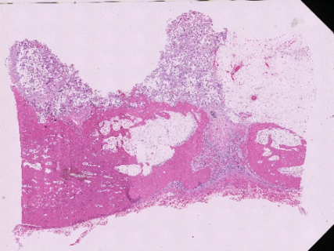 | Slide response score: (CR):1; (NBR):2; (SFB):1; (SFD):2  The slide shows cellular response expected in a regenerative process. New bone is abundant. The soft tissue surrounding the preexisting bone shows cellular response expected in a regenerative process, while the soft tissue around the defect and new bone area is abundant.

Vita
Gabriela Bastos was born in Campo Grande, MS, Brazil. She earned her Doctor of Veterinary Medicine (DVM) degree from the Federal university of Mato Grosso do Sul, Brazil before pursuing her Master of Science in Comparative & Experimental Medicine at the University of Tennessee. Her research focused on bone regeneration and infection prevention, evaluating the effectiveness of polymer scaffolds in a goat segmental bone defect model. Throughout her graduate studies, she contributed to laboratory animal research, participated in clinical discussions, and gained experience in comparative medicine. Upon completion of her degree, she continued to advance her expertise in orthopedic and behavioral research, with a particular interest in neuroscience and animal models.

