Investigating Cranial Variation in Japanese Populations Using Geometric Morphometrics

A Dissertation Presented for the
Doctor of Philosophy
Degree
The University of Tennessee, Knoxville

Beatrix Dudzik
August 2015
Dedicated to my father.
He has always encouraged me to explore scientific endeavors, adventures and passion for life, but has also been (more than) willing to provide a healthy dose of reality as needed. Thank you for your love and for teaching me the importance of living in the moment.

The forms may change but the essence remains the same.

ACKNOWLEDGEMENTS
First and foremost, I would like to highlight the patience and unwavering support from my advisors, Drs. Richard and Lee (Meadows) Jantz The appreciation I feel in regards to the advice, opportunities and guidance they have provided me is beyond words. A large thank you is offered to my additional committee members, Drs. Benjamin Auerbach and William Seaver. Their flexibility, patience and knowledge is deeply appreciated.
Dr. Noriko Seguchi was pivotal in gaining access to the majority of skeletal collections used in this work. ありがとうございます. This majority of data collection was funded by a grant from the National Science Foundation East Asian and Pacific Studies Summer Institute.
A warm thank you to Dr. Natalie Langley who has been a fantastic colleague and a true friend. Cheers to many more scientific collaborations, road trips, music festivals and drinking wine while running stats (wait, what?).
Of course, thank you to my friends, the West coast (best coast)- ers, the Tennessee natives and southern transplants alike for coffee, beer and marathon breaks (no literally… like an actual marathon) to break up the self loathing never ending darkness wonderfully rewarding yet tedious process of writing a dissertation. I look forward to providing a shoulder to cry hysterically on strong support system for those of you that have your own work to complete.
This is getting long… Thank you Dr². Heli Maijanen. Through the dark times, the darker times and then the times with a tiny bit of light, dog hair and muddy paw prints. Gorging myself on cheesecake just isn’t the same without you. Thank you for everything.
Last but not least, thank you to my baby sister, Allison. She is wise beyond her years and has helped me more than she knows. I only hope I can keep giving her examples of what “not to do”, so she can learn vicariously through my mistakes. Emoji laughing face. Love you.
ABSTRACT
One of the major research areas within biological anthropology is the examination and estimation of ancestral relationships between skeletal samples, both at the population and individual level. Thus, estimation of population affinity using the skeleton has been a central focus of paleoanthropologists and bioarchaeologists and is now a goal for forensic anthropologists when dealing with unidentified human remains in a modern context. While published research has examined skeletal variation in prehistoric and modern East and Southeast Asian human populations, more data is needed to represent the range of variation present in different geographic regions within the continent of Asia. Within the Japanese archipelago, there is an immense amount of variation in culture and history, despite the lay population mostly considering the modern Japanese as a homogeneous population. Japan has experienced an amazing amount of varied human groups that have migrated into this small group of islands. These migration events are well represented in the archaeological record and have provided fodder for hypotheses proposed for peopling of the new world.
Biological anthropologists have tested hypotheses surrounding the initial peopling of the islands using two dimensional linear data in conjunction with non-metric traits of the skull. Recent molecular studies have provided evidence for population substructure, which suggests an original founding group of North Asian descent, and a more recent migration into Southern Japan from the Korean peninsula. The secondary migration interbred with the indigenous Jomon inhabitants, ultimately giving rise to two distinct genetic lineages.
Given this foundational knowledge, an examination of a variety of skeletal collections from a range of temporal and regional samples in Japan allows for an expansion of hypotheses proposed by previous research to explain the range of variation observed through time and space in Japan. This study aims to build upon research endeavors that have quantified various aspects of skeletal morphology represented in Japan. This study reexamines the majority of analyses that have used metric data by using three dimensional data (3D). 3D or coordinate data can be used to better identify evolutionary patterns in biological populations via geometric morphometric approaches. Samples utilized represents skeletal collections of a nearly temporally continuous sequence that encompasses the indigenous Jomon culture that dates to 10,000 BP to the modern period.
Results indicate that the use of 3D cranial vault and base landmarks show more biological information that can be used to infer patterns of variation. However, it was also found that the inclusion of variables that encompass the cranium as a whole provides more interpretable results in regards to evolutionary events. This study highlights the utility of comparisons of various types of data that can be differentially representative of morphological variation. It is argued that 3D data can provide novel results and thus the reexamination of a host of hypothesis that examine morphology of the cranium is warranted.

TABLE OF CONTENTS
CHAPTER 1 INTRODUCTION 1
Proposed Hypotheses 4
CHAPTER 2 LITERATURE REVIEW 7
Growth and Development of the Cranium 14
Phenotypic Plasticity in the Cranium 23
Morphological Integration and Modularity in the Skull 24
Gene flow and admixture expression in the skull 26
CHAPTER 3 ARCHAEOLOGICAL BACKGROUND AND MATERIALS 29
Archaeological History of Japan 29
Anthropological Research in Japan 37
Secular Change Studies in Japan 40
Post-Cranial Studies 45
Genetic Studies 47
Geometric Morphometric Approaches 56
Samples Utilized 64
Variables Used 66
Statistical Analyses 76
CHAPTER 5 RESULTS 80
Modern Group Comparison Results 83
Male Vault Analysis 83
Male Facial Analysis 90
Male All Variable Analysis 96
Linear Data Analysis 103
Modern Females All Variable Analysis 109
Secular Change Shape Changes 116
Male Analysis 116
Female Analysis 124
Prehistoric and Modern Group Analysis 131
Male Vault Analysis 131
Male Facial Analysis 142
Males All Variables Analysis 151
Female All Variable Analysis 162
CHAPTER 5 DISCUSSION 174
Regional variability in modern Japanese samples 174
Secular Shape Changes 179
Jomon Yayoi Admixture Analysis 182
CHAPTER 6 CONCLUSIONS 186
REFERENCES CITED 190
APPENDICES 202
APPENDIX A: Results of variance and normality test for each comparison. 203
VITA 220

LIST OF TABLES
Table 1. Time period definitions for included samples. 65
Table 2. Landmarks used and associated definitions. 67
Table 3. Sample sizes by period for facial variables. 68
Table 4. Sample sizes by period for vault variables. 69
Table 5. Eigenvalues and percent variance for principal components 1-12. 84
Table 8. MANOVA Results for modern males vault variables. 85
Table 9. Hotelling’s T2 Two Sample Test for group comparisons. 85
Table 10. Eigenvalues and percent variance for canonical components 1 and 2. 86
Table 11. Mahalanobis distances among modern male regions. 89
Table 12. Eigenvalues and percent variance for principal components 1-11. 91
Table 13. MANOVA results for modern males facial variables. 91
Table 14. Hotelling’s T2 Two Sample Test for group comparisons. 92
Table 15. Eigenvalues and percent variance for canonical components 1 and 2. 93
Table16. Mahalanobis distances among modern male groups. 96
Table 17. Eigenvalues and percent variance for principal components 1-17. 97
Table 18. MANOVA results for modern male all variable analysis. 98
Table 19. Hotelling’s T2 Two Sample Test for group comparisons. 98
Table 20. Eigenvalues and percent variance for canonical components 1 and 2. 99
Table 21. Mahalanobis distances for modern male regions. 102
Table 22. Eigenvalues and percent variance for principal components 1-7. 104
Table 23. MANOVA Results for modern males vault linear data. 104
Table 24. Eigenvalues and percent variance for canonical components 1 and 2. 105
Table 25. Structure matrix for 2D canonical variate analysis. 106
Table 26. Component matrix for modern male analysis. 106
Table 27. Mahalanobis distance matrix for linear male analysis. 108
Table 28. Group means for modern males. 108
Table 29. Eigenvalues and percent variance for principal components 1-16. 110
Table 30. MANOVA results for modern female analysis. 111
Table 31. Hotelling’s T2 Two Sample Test for group comparisons. 111
Table 32. Eigenvalues and percent variance for canonical components 1 and 2. 112
Table 33. Mahalanobis distances for modern female regions. 116
Table 34. Eigenvalues and percent variance for principal components 1-17. 118
Table 35. MANOVA results for male secular change analysis. 119
Table 36. Hotelling’s T2 Two Sample Test for group comparisons. 119
Table 37. Eigenvalues and percent variance for canonical components 1 and 2. 120
Table 38. Mahalanobis distances for medieval, modern and Edo males. 123
Table 39. Eigenvalues and percent variance for principal components 1-17. 125
Table 40. MANOVA results for secular change female analysis. 125
Table 41. Hotelling’s T2 Two Sample Test for medieval and Edo groups. 126
Table 42. Eigenvalues and percent variance for canonical components 1 and 2. 127
Table 43. Mahalanobis distances for medieval, modern and Edo females. 130
Table 44. Eigenvalues and percent variance for principal components 1-13. 132
Table 45. MANOVA results for male vault analysis. 133
Table 46. Hotelling’s T2 Two Sample Test for Jomon and all other groups 133
Table 47. Hotelling’s T2 Two Sample Test for Ainu and all other groups. 134
Table 48. Hotelling’s T2 Two Sample Test for Yayoi and all other groups. 134
Table 49. Hotelling’s T2 Two Sample Test for Kofun and all other groups. 134
Table 50. Eigenvalues and percent variance for canonical components 1-4. 136
Table 51. Mahalanobis distances for Jomon, Kofun, Ainu and modern groups. 142
Table 52. Eigenvalues and percent variance for principal components 1-11. 143
Table 53. MANOVA results for male facial analysis. 143
Table 54. Hotelling’s T2 Two Sample Test for Jomon and all other groups 144
Table 55. Hotelling’s T2 Two Sample Test for Ainu and all other groups. 144
Table 56. Hotelling’s T2 Two Sample Test for Yayoi and all other groups. 145
Table 57. Hotelling’s T2 Two Sample Test for Kofun and all other groups. 145
Table 58. Eigenvalues and percent variance for canonical components 1-3. 147
Table 59. Mahalanobis distances of Ainu, Jomon, Kofun and modern groups. 151
Table 60. Eigenvalues and percent variance of principal components 1-18. 152
Table 61. MANOVA results for male all variable analysis. 153
Table 62. Hotelling’s T2 Two Sample Test for Jomon and all other groups. 153
Table 63. Hotelling’s T2 Two Sample Test for Ainu and all other groups. 154
Table 64. Hotelling’s T2 Two Sample Test for Yayoi and all other groups. 154
Table 65. Hotelling’s T2 Two Sample Test for Kofun and all other groups. 154
Table 66. Eigenvalues and percent variance for canonical components 1-4. 156
Table 67. Mahalanobis distances for Ainu, Jomon, Kofun and modern groups. 162
Table 68. Eigenvalues and percent variance for canonical components 1-17. 164
Table 69. MANOVA results for female all variable analysis. 165
Table 70. Hotelling’s T2 Two Sample Test for Jomon and all other groups. 165
Table 71. Hotelling’s T2 Two Sample Test for Ainu and all other groups. 166
Table 72. Hotelling’s T2 Two Sample Test for Yayoi and all other groups. 166
Table 73. Hotelling’s T2 Two Sample Test for Kofun and all other groups. 166
Table 74. Eigenvalues and percent variance for canonical components 1-5. 168
Table 75. Mahalanobis distance matrix for Jomon, Ainu, Yayoi, Kofun and modern females. 173
Table 1A. Results of Box’s M test for equality of covariance matrices for modern male vault variables. 203
Table 2A. Results of Royston’s multivariate normality test for modern male vault variables. 203
Table 3A Results of Box’s M test of equality of covariances matrices for modern male facial variables. 204
Table 4A. Results of Royston’s multivariate normality test for modern male facial variables. 205
Table 5A. Results of Box’s M test of equality of covariances matrices for modern male all variables. 206
Table 6A. Results of Royston’s multivariate normality test for modern male all variables. 206
Table 7A. Box’s M test for equal covariance matrices for modern females. 207
Table 8A. Results of Royston’s multivariate normality test for modern females. 208
Table 9A. Box’s M test for equal covariance matrices for medieval, Edo and modern males. 209
Table 10A. Results of Royston’s multivariate normality test for medieval, Edo and modern. 209
Table 11A. Box’s M test for equal covariance matrices for medieval, Edo and modern females. 210
Table 12A. Results of Royston’s multivariate normality test for medieval, Edo and modern females. 211
Table 13A. Box’s M test for equal covariance matrices for prehistoric and modern male vault variables. 212
Table 14A. Results of Royston’s multivariate normality test for prehistoric and modern male vault variables. 212
Table 15A. Box’s M test for equal covariance matrices for prehistoric and modern male facial variables. 213
Table 16A. Results of Royston’s multivariate normality test for prehistoric and modern male facial variables. 214
Table 17A. Box’s M test for equal covariance matrices for prehistoric and modern male all variables. 215
Table 18A. Results of Royston’s multivariate normality test for prehistoric and modern male all variables. 215
Table 19A. Box’s M test for equal covariance matrices for prehistoric and modern female all variables. 216
Table 20A. Results of Royston’s multivariate normality test for prehistoric and modern female all variables. 217
Table 21A. Centroid Size means and standard deviations. 218
Table 22. Shape variable Procrustes ANOVA results. 219

LIST OF FIGURES
Figure 1. Modules of the skull. Image modified from www2.aofoundation.org 15
Figure 2. Jomon sites indicating evidence of plant cultivation. (Image from Kotani 1981). 33
Figure 3. Anterior view of cranial landmarks. 60
Figure 4. Lateral view of cranial landmarks. 61
Figure 5. Inferior view of cranial landmarks. 62
Figure 6. Digitizing of cranial landmarks using Microscribe. 63
Figure 7. Average and above average deviation from the mean at landmarks. 81
Figure 8. Outlier detection using PCA plot. 82
Figure 9. CV1 shape differences for modern males. (a) Superior view, (b) Anterior view, (c) Lateral view. 87
Figure 10. CV1 shape differences for modern males. (a) Superior view, (b) Anterior view, (c) Lateral view. 88
Figure 11. CV1 and CV2 scores for modern male vault analysis. 89
Figure 12. CV1 shape differences for modern males. (a) Anterior view, (b) Lateral view. 94
Figure 13. CV2 shape differences for modern males. (a) Anterior view, (b) Lateral view. 94
Figure 14. CV1 and CV2 scores for modern male facial analysis. 95
Figure 15. CV1 shape differences for modern males. (a) Lateral view, (b) Superior view, (c) Anterior view. 100
Figure 16. CV1 shape differences for modern males. (a) Lateral view, (b) Superior view, (c) Anterior view. 101
Figure 17. CV1 and CV2 scores for modern male all variable analysis. 102
Figure 18. Canonical discriminant function score plot. 107
Figure 19. CV1 shape differences for modern females. (a) Lateral view, (b) Superior view, (c) Anterior view. 113
Figure 20. CV2 shape differences for modern females. (a) Lateral view, (b) Superior view, (c) Anterior view. 114
Figure 21. CV1 and CV2 scores for modern female all variable analysis. 115
Figure 22. CV1 shape differences for modern, medieval and Edo period males. (a) Lateral view, (b) Superior view, (c) Anterior view. 121
Figure 23. CV2 shape differences for modern. Medieval and Edo period males. (a) Lateral view, (b) Superior view, (c) Anterior view. 122
Figure 24. CV1 and CV2 scores for modern, medieval and Edo period males. 123
Figure 25. CV1 shape differences for modern, medieval and Edo period females. (a) Lateral view, (b) Superior view, (c) Anterior view. 128
Figure 26. CV2 shape differences for modern, medieval and Edo period females. (a) Lateral view, (b) Superior view, (c) Anterior view. 129
Figure 27. CV1 and CV2 scores for medieval, modern and Edo period females. 130
Figure 28. CV1 shape differences for Jomon, Ainu, Yayoi, Kofun and modern males. (a) Superior view, (b) Anterior view, (c) Lateral view. 137
Figure 29. CV2 shape differences for Jomon, Ainu, Yayoi, Kofun and modern males. (a) Superior view, (b) Anterior view, (c) Lateral view. 138
Figure 30. CV3 shape differences for Jomon, Ainu, Yayoi, Kofun and modern males. (a) Superior view, (b) Anterior view, (c) Lateral view. 139
Figure 31. CV1 and CV2 scores for Jomon, Ainu, Yayoi, Kofun and modern groups. 140
Figure 32. CV3 and C43 scores for Jomon, Ainu, Yayoi, Kofun and modern groups. 141
Figure 33. CV1 shape differences for Jomon, Ainu, Yayoi, Kofun and modern males. (a) Anterior view, (b) Lateral view. 147
Figure 34. CV2 shape differences for Jomon, Ainu, Yayoi, Kofun and modern males. (a) Anterior view, (b) Lateral view. 148
Figure 35.CV3 shape differences for Jomon, Ainu, Yayoi, Kofun and modern males. (a) Anterior view, (b) Lateral view. 148
Figure 36. CV1 and CV2 scores of Jomon, Ainu, Kofun, Yayoi and modern groups. 149
Figure 37. CV2 and CV3 of Jomon, Ainu, Kofun, Yayoi and modern males. 150
Figure 38. CV1 shape differences for Jomon, Ainu, Yayoi, Kofun and modern males. (a) Superior view, (b) Lateral view, (c) Anterior view. 157
Figure 39. CV2 shape differences for Jomon, Ainu, Yayoi, Kofun and modern males. (a) Superior view, (b) Lateral view, (c) Anterior view. 158
Figure 40. CV3 shape differences for Jomon, Ainu, Yayoi, Kofun and modern males. (a) Superior view, (b) Lateral view, (c) Anterior view. 159
Figure 41. CV1 and CV2 scores for Jomon, Ainu, Yayoi, Kofun and modern groups. 160
Figure 42. CV3 and CV4 scores for Jomon, Ainu, Yayoi, Kofun and modern groups. 161
Figure 43. CV1 shape differences for Jomon, Ainu, Yayoi, Kofun and modern females. (a) Superior view, (b) Lateral view, (c) Anterior view. 169
Figure 44. CV2 shape differences for Jomon, Ainu, Yayoi, Kofun and modern females. (a) Superior view, (b) Lateral view, (c) Anterior view. 170
Figure 45. CV3 shape differences for Jomon, Ainu, Yayoi, Kofun and modern females. (a) Superior view, (b) Lateral view, (c) Anterior view. 171
Figure 46. CV1 and CV2 scores for Jomon, Ainu, Yayoi, Kofun and modern females. 172
Figure 1A. QQ-plot of PC scores for modern male vault variables. 204
Figure 2A. Q-Q plot of PC scores for modern facial variables. 205
Figure 3A. Q-Q plot for PC scores for modern males all variables. 207
Figure 4A. Q-Q plot for PC scores for modern females. 208
Figure 5A. Q-Q plot for PC scores for medieval, Edo and modern males. 210
Figure 6A. Q-Q plot of PC scores for medieval, Edo and modern females. 211
Figure 7A. Q-Q plots for PC scores for prehistoric and modern male vault variables. 213
Figure 8A. Q-Q plot of PC scores for prehistoric and modern male facial variables. 214
Figure 9A. Q-Q plot of PC scores for prehistoric and modern male all variables. 216
Figure 10A. QQ-plot of PC scores for prehistoric and modern female all variables. 217

CHAPTER 1
INTRODUCTION

One of the major research areas within biological anthropology is the examination and estimation of ancestral relationships between skeletal samples, both at the population and individual level. Thus, estimation of population affinity using the skeleton has been a central focus of paleoanthropologists and bioarchaeologists and is now a goal for forensic anthropologists when dealing with unidentified human remains in a modern context. Studies of the human cranium have fueled a multitude of research within the last few centuries. Specifically, the last fifty years have provided some of the most fundamental sources of knowledge with respect to variation of the modern human skeleton. Craniometric analyses that utilize multivariate statistical approaches have long provided evidence for evolutionary histories of human and hominid populations and at a more finite level; relationships among both extinct and extant populations.
Collection of skeletal data that can be employed in multivariate analyses in parts of the world that is not well represented in the research literature is imperative for the advancement of both broad and focused studies of human variation. Procurement and curation of this type of information provides a means for researchers to address hypotheses that have far-reaching implications for scientific communities. While published research has examined skeletal variation in prehistoric and modern East and Southeast Asian human populations, more data is needed to represent the range of variation present in different geographic regions of Asia. This type of information can ultimately be used in future studies by students and professionals to answer questions within archaeological and forensic contexts.
It is important to highlight the ambiguous and often detrimental terms used to describe world populations by scientists and lay populations alike. The distinction between race as a social construct and biological reality is often difficult for non-anthropologists to understand. In particular, biological anthropologists have come under fire for studying human variation under large umbrella terms such as “Hispanic” or “Asian”. These broad terms are ambiguous and do not offer much biological meaning other than a label indicating which large region of the world a population inhabited. Even within the comparatively tiny archipelago of Japan, there is an immense amount of variation in culture and history, despite the lay population mostly considering modern Japanese as a homogeneous population (Low 2012). Unbeknownst to many, there has been tension and conflict between what is considered the dominant population of the ‘Japanese’ and the Ainu, who are considered the direct descendants of the indigenous population of the sedentary hunter-gatherer culture of the Jomon. Thus, Japan is considered a “multi-ethnic” society (Low 2012). This study aims to build upon research endeavors that have quantified various aspects of skeletal morphology represented in Japan. Research in this seemingly small portion of the world adds to the wealth of knowledge that can have implications that may not be apparent at first glance. For instance, Japan has experienced an amazing amount of varied human groups that have migrated into this small group of islands over the last 10,000 years. These migration events are well represented in the archaeological record and have provided fodder for hypotheses proposed for initial migrations into the new world.
Anthropological studies of East Asian skeletal samples have traditionally been carried out using linear data in conjunction with non-metric traits of the skull. Studies of metric and non-metric dental variation also comprise a large portion of the available literature.
Many hypotheses regarding migration theories for the initial peopling of East and Southeast Asia as well as North America have been based on analyses of craniometric and non-metric traits of mostly premodern skeletal samples from northern and southern Japan (Brace, et al. 1989; Hanihara 1991; Hanihara, et al. 2008a; Pietrusewsky 2004; Turner 1990) . Additionally, recent molecular studies have provided evidence for population substructure, which suggests an original founding population of north Asian descent, and a more recent migration into Southern Japan from the Korean peninsula (Nagaoka, et al. 2013). The secondary migration is believed to have interbred with the indigenous Jomon inhabitants, ultimately giving rise to two distinct genetic lineages.
Given this foundational knowledge, an examination of a variety of skeletal samples from a range of temporal and regional samples in Japan allows for an expansion of hypotheses proposed by previous research to explain the range of variation observed through time and space in Japan.
The goals of this research in the most general sense are as follows:
1) Examine variation of the human cranium in premodern and modern Japanese skeletal samples at a more in depth level by employing methods that utilize coordinate data in comparison to linear data.

2) Investigate how the shape of the cranium varies across skeletal collections that represent the regionally specific areas of northern, central and southern Japan, both in modern and prehistoric populations.

3) Explore the possibility that different bony components of the skull can potentially provide different results when partitioned during analyses.

In more detail, this study will investigate the premise that morphological patterns correlated with evolutionary events can be better identified with 3D data. The use of skeletal samples from various temporal depths, starting from the first archaeologically identifiable culture that occupied Japan over 10,000 years ago to (almost) present day Japan offers the opportunity to explore and expand upon several research questions. Statistical approaches using this type of data can provide more information that can be used by researchers to infer relationships among biological populations. Given the complexity of the data set, the questions to be addressed with this research project are provided in explicit terms, as the large time frame and multitude of geographic locations represented can leave a convoluted path of research bread crumbs that may or may not disappear the deeper into the woods (the data) we venture.
This study examines cranial variability of Japanese populations utilizing skeletal collections housed at Kyushu University, which curates samples from Kyushu Island (Southern Japan) and nearby locales that represent a nearly temporally continuous sequence from the prehistoric Jomon culture to the modern period. Additionally, modern skeletal material is examined from Sapporo University, Tohoku University, University of Tokyo, Kyoto University, and the University of the Ryukyus. Collectively, these skeletal samples represent northern, central and southern Japan and include individuals with birth years from the late 19th and early 20th century.

Proposed Hypotheses
1. The employment of coordinate data in analyses will provide different conclusions than found with linear data. Namely, a better understanding of how samples exhibit morphological similarities and differences in both size and shape can be reached to expand on results of previous analyses that have employed traditional linear metric data.
2. Examination of the shape of the cranium in units that represent different areas of bone that have been shown to respond to evolutionary forces differently can provide more conclusive results when using morphology to infer population history. Partitioning facial landmarks from those associated with the cranial vault and base will provide alternate results interpretations for sample comparisons.
3. The use of coordinate data to examine how Japanese populations have changed incrementally through time will better elucidate how morphology has changed. This approach will provide a better avenue of comparative changes in temporally comparable populations throughout the world. Specifically, analysis of samples from the medieval period to the modern period will allow for the identification of shape changes correlated with brachycephalization, which is the most cited morphological trend in modern Japanese populations.
4. The hybridization model for the peopling of Japan posits that peripheral regions of the archipelago, namely the northernmost and southernmost regions that encompass the Ainu and the Ryukyuans experienced less admixture with the Yayoi individuals than the mainland Japanese populations (Hanihara 1991; Ossenberg, et al. 2006). It is hypothesized that regional variation may be evident in the modern samples (particularly from the northernmost and southernmost islands) that may indicate a retention of morphology exhibited in premodern parental populations. Furthermore, comparison of the regionally distinct modern samples with Jomon, Ainu and Yayoi groups will identify population substructure that may not be immediately apparent in analyses of the modern data that do not include prehistoric samples.
The initial portion of this dissertation provides a theoretical foundation for the proposed hypotheses and an extensive literature review. The following chapter provides a brief history of archaeological and anthropological research in Japan. The next chapter provides a framework for the implementation of geometric morphometric approaches and outlines the statistical procedures that are used in this study. The following chapter will provide results of the analyses described. The final chapter discusses the implications of results, both in an archaeological and evolutionary context.

CHAPTER 2
LITERATURE REVIEW

Using craniometrics to infer evolutionary and population histories has experienced a long and troubled past in biological anthropology. In the 19th and early 20th century, researchers exhibited a typologist method of describing variation in cranial morphology and metric dimensions among world populations (Coon 1962). These associations harken back to racial descriptions invoked by Linnaeus (Carolus 1735). The last several decades of research has greatly improved our understanding of how the skeleton reflects function and adaptations (or lack thereof) to epigenetic factors including biomechanical loading, diet and nutrition, climate and temperature. The importance of genetics and the implications of heritability of traits has also become imperative in studies of biological form and has resulted in a multitude of interdisciplinary collaborations that have shaped current perceptions of evolution. As such, the definition and usage of morphoscopic and metric traits of the human form requires an in-depth knowledge of the complex and interactive relationship between genetics and functional anatomy, as well as an understanding of the evolutionary history of biological organisms.
Modern anthropological use of craniometric variation has been shown to be extremely informative for population history studies. Several influential studies by Relethford (Relethford 2001; Relethford 2002) have shown through model bound quantitative genetic approaches that selection pressures of inter-regional populations have played a limited role in producing global patterns of cranial diversity. However, some aspects of skeletal morphology have been subject to selection pressures in the recent past, as evidenced by correlation of morphology with climatic variables. Relethford has also shown that craniometric variation as a whole varies across regions in such a way that matches neutral genetic expectations. The similarities identified between genes and craniometric phenotypes may exist due to similar population history and structure (gene flow and genetic drift) and/or similarities due to selection pressures. A portion of the results of many of these analyses support the hypothesis that cranial traits are entirely too plastic to effectively be used for migration and population history research. However, recent work investigating morphological integration and modularity in the skull has provided better resolution to the intricate relationship between genetic and environmental factors and their combined effects on the cranium.
Many recent publications have built on foundational studies that defined morphological integration and modularity of the cranium (Cheverud 1988; Cheverud 1996) and demonstrate how the relationship between development and function of skeletal modules can provide insight into the plastic nature of the skull. Morphological integration is defined as cohesion or covariance among traits that result from biological processes that produce phenotypic structures. Integration can further be defined as features of developmental architecture. This set of potential connections or interactions between developmental components can result in developmental and phenotypic covariation (Hallgrimsson, et al. 2009). This intricate relationship within a biological form can enhance or impede evolution, depending on integration of the traits being selected for.
Within the context of the using the human skull to deduce what evolutionary mechanisms can be identified when examining morphology, many researchers have carried out analyses within the rubric that morphological integration theory defines. For example, Gonzalez-Jose et al.,(González‐José, et al. 2004) proposed that morphological integration of the human cranium is mainly determined by effects of functional and developmental characteristics of traits. The authors showed that modern human populations exhibit a stable pattern of correlation and covariation among cranial modules, which suggests that morphological differences are highly concordant with genetic differences. The tenet that phenotype and genotype is inherently related in the human skull has been a foundational concept for some time. Yet, the results of studies such as the aforementioned work highlight how changes to form can be incredibly difficult to achieve given the complex and interdependent relationship of the bony compartments of the skull that are required for normal development and function.
While much of the research of the last two decades has provided a solid foundation for biological anthropologists to elucidate which regions of the human skull are more susceptible to epigenetic factors, studies of population affinity and population history become more complex when taking gene flow into consideration. For example, it has been shown that gene frequencies of admixed populations place a hybrid population intermediately between two parent populations, but the effects of admixture on phenotypic morphology have been less clear within the discipline of anthropology (Elston and Stewart 1971).
Thus, debate still exists regarding which areas of the skull are better predictors of population affinity. This relates to the topic of assessing admixture, as it is essential to try to illustrate which areas of the cranium are more susceptible to exhibiting a larger range of plasticity and in turn which areas of the cranium will be more affected by heritability. Several recent works have provided examples that are extremely relevant in anthropological application as metric variation of the skull is often used to establish biological distance in such realms as an archaeological site of unknown cultural provenience or forensic cases involving unidentified skeletal remains. This approach becomes even more relevant in contexts where gene flow among defined parental populations has occurred, yet the morphological result is not well understood and/or has not been adequately modeled. A model example of such work is that of Holló et al., (Holló, et al. 2010), who compared the neurocranium to the facial skeleton to assess which region was able to better predict population affinity (e.g. estimating ancestral affiliation of an unknown). The authors suggest that the neurocranium contains more biological information for prediction purposes as the neurocranium reaches adult size before the facial skeleton and thus the developing viscerocranium is affected by environmental variables for a longer duration of time. If further supported, this principle has vast implications for application in research. By identifying portions of the skull that may better reflect heritability versus adaptability and/or plasticity, researchers can better isolate anatomical regions to employ for specific analyses, thus eliminating nuisance parameters that can skew results and interpretations.
In regards to work that has attempted to isolate and predict the effects of gene flow among distinct populations in the skull, Martínez‐Abadías et al., (Martínez‐Abadías, et al. 2006) analyzed cranial dimensions of individuals subsequent to Spanish and Amerindian contact. Results of this study suggest that admixture between defined populations does not necessarily result in a linear relationship that is intermediate between parental populations when the cranium is treated as a single entity. Rather, this analysis provides support for using the neurocranium as a more stable indicator of admixture. A more linear and intermediate relationship between distinct populations is identified with the cranial base and vault whereas the facial skeleton does not provide such explicit evidence.
These results coincide with conclusions of a study by Harvarti and Weaver (Harvati and Weaver 2006) which also postulated that different cranial regions preserved population histories in varying degrees. Neutral genetic distances were better correlated with the shape of the temporal bone, neurocranium, and overall cranial shape. However, shape associated with the facial skeleton did not appear to preserve population history as effectively. Climatic variables showed an association with face shape, possibly indicating that facial dimensions are more plastic, as has been proposed and supported by a number of other publications. However, also relevant in the Harvarti and Weaver (Harvati and Weaver 2006) study is the inclusion of an arctic population, which is representative of an extreme morphology that possibly inflated correlation.
Biomechanical stress is another variable relevant for interpretation of cranial morphology. Several morphological trends have been cited as resulting from modification of subsistence strategies. Most notable in the archaeological record is the transition from hunter-gatherer to agriculturalist approaches. A major result of such a change was a shift from a coarse, gritty diet that placed high stress on the masticatory complex to softer foods that required less intense muscle function. These changes have been reflected in the facial skeleton and resulted in more gracile and narrow dimensions directly associated with diverting energy produced by muscles and structures associated with chewing (Lieberman 2011). Gonzalez-Jose et al., (González‐José, et al. 2005) detailed this relationship in a study of craniofacial morphology among 18 populations of hunter-gatherers and farmers in South America, showing that differences in the masticatory complex could be identified and correlated with type of diet. The importance of studies that explicitly identify correlates among morphology and function helps rationalize the approaches for data collection and analyses that will later be described and implemented in this dissertation.
Other analytical approaches have expanded upon principles of genetic and phenotypic neutrality of the cranium most notably outlined by the work of Relethford (Relethford, et al. 1994; Relethford 2001; Relethford 2002). Several studies are cited as foundational works and impetus for hypotheses of much of the influential work of the last decade. For instance, a pivotal study by Roseman and Weaver (Roseman and Weaver 2004) converted craniometric data into size variables of specific morphological regions relative to the overall size of the cranium. This approach was used to assess which measurements vary more than expected under a model of genetic neutrality. Results indicate that some regions of the cranium, particularly nasal dimensions, differ among geographic groups, which are thought to be the result of differential selective pressures. Works such as this have proved to be an invaluable tool for aiding research that aims to examine morphology in an evolutionary framework, as it builds upon critiques of the adaptationist programme, or the tendency to assume that a phenotypic trait is the product of natural selection.
However, genetic and phenotypic neutrality of the cranium is by far irrefutable or even conclusively understood. For example, in a different, but related study to the previously cited work, Roseman et al., (Roseman, et al. 2010) demonstrated via an experimental baboon model that certain levels of environmental and genetic variation are randomly distributed across regions of the cranium, rather than being structured by developmental origin. Individual traits in the cranium tend to be constrained by covariance with other regions in the skull that are subjected to high amounts of strain. Therefore, it is suggested that a high stress-strain region such as the masticatory complex will not be any more variable than other traits which implies all cranial modules are equally reliable for reconstructing patterns of evolution. The juxtaposition of two publications coauthored by the same researcher illustrates two very different, seemingly mutually exclusive concepts hopefully illustrates the unfathomably complex nature of morphology.
Despite these headache inducing concepts and sometimes confounding conclusions, the overarching consensus is that studies that have compared cranial dimensions with genetic data, indisputably show that craniometric variation is geographically structured and for the most part coincide with patterns of variation found in studies of neutral DNA markers (Relethford 2001).
An important caveat to this consensus is that there is also evidence that neutrality of cranial dimensions may be more limited to the developmental and functional modules encompassed within the cranial vault, as was conveyed by summaries of select studies earlier in this chapter (Holló, et al. 2010; von Cramon-Taubadel 2011). To further support the skeletal evidence, recent molecular research has identified quantitative trait loci that influence normal craniofacial morphology and thus show high percentages of heritability in specific regions of the skull (Liu, et al. 2012). Narrow sense heritability has also been identified in certain regions of the cranium. For example, Carson (Carson 2006) found facial dimensions often exhibit lower heritability percentages than the neurocranium. This provides further support for partitioning the cranium when examining biological distance among samples or ascertaining population affinity.
The discussion of neutrality, heritability and adaptation in the cranium warrants examples of trends that are generally accepted as reflecting selection. An important example is that shape and size of the modern human skull reflects components of the Bergmann-Allen’s rules. Bergmann’s rule posits that organisms in cold climates will exhibit larger body mass as a mechanism for heat retention. Conversely, hotter climate dwelling organisms will exhibit reduced mass to better more efficiently disperse heat. Allen’s rules state that cold climate populations exhibit broad bodies with short extremities while hot climate organisms are narrow and have long, thin appendages. These rules applied to the skull results in smaller, narrower cranial vaults expressed in populations adapted to warmer/ hotter climates and larger, broader skulls in cooler climates where heat retention in the head and brain is necessary (Beals, et al. 1984; Ruff 1994).

Summary

Selected studies are summarized and presented as examples to support the use of cranial morphology to infer ancestral relationships within and between populations. However, caution should be used when averaging morphology throughout the entire skull both for heritability and modularity hypotheses.

Growth and Development of the Cranium

A brief overview of the development of the skull is warranted to provide necessary background information that helps elucidate the basis for hypotheses that postulate particular dimensions of the head as predisposed to be more responsive to environmental factors.
Three complex developmental modules make up the human cranium. These integrated modules consist of the cranial vault, or neurocranium, the base, or basicranium, and the facial skeleton, or viscerocranium (Figure 1). While growth and development is a highly coordinated and complex process, these regions of the skull grow and develop by different patterns of ossification and thus are somewhat independent of each other. While it may seem contradictory to describe these elements as independent as well as highly correlated and coordinated during growth, a review of how these distinct regions of the cranium move and enlarge during ontogeny provides insight into the developmental and functional relationship and independence between these units.

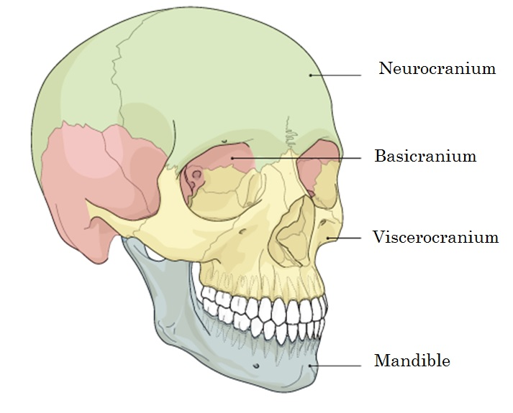
Figure 1. Modules of the skull. Image modified from www2.aofoundation.org

Roughly three weeks after conception, minute structures begin to form, including ectoderm, mesoderm, and endoderm tissues (Lieberman 2011). Ectoderm forms the nervous system, sense organs, skin and hair, bones, muscles of the head, and tooth enamel. Mesoderm forms the musculoskeletal system, dermal/subdermal layers of the skin, and tooth roots (Schoenwolf, et al. 2012) . Endoderm forms the epithelial lining of the gastrointestinal, respiratory, and urinary tracts. The notochord also begins to develop at this stage. Neuroectodermal cells begin to form the neural tube and epithelial cells cluster to form the nose, inner ears, and eyes. These cell clusters act as signaling centers to induce transformation in neighboring mesenchymal cells to stimulate craniofacial skeletogenesis. The next phase is gastrulation, in which clumps of embryonic connective tissue (mesenchyme) coalesce along sides of the notochord. Mesoderm closest to the notochord forms sclerotome which is a pre-cursor skeletal tissue that eventually gives rise to cartilage of the axial skeleton and the cranial base surrounding the foramen magnum. The remaining units of the head come from unsegmented paraxial mesoderm, endoderm, and ectoderm.
Formation of the cranial base begins roughly 28 days after conception when mesenchyme clusters beneath the brain and begins to differentiate into cartilages of the chondocranium via inductive interactions with other mesenchymal cells and ectodermal tissue around the brain (Schoenwolf, et al. 2012). Parachordal, prechordal, and sensory cartilages form the basicranium. Ossification of the chondrocranium begins roughly 8 weeks in utero, and results in roughly 41 ossification centers. The basicranium is the first part of the cranium to attain adult size and shape, slightly before the neurocranium, and drastically earlier than the face (Hallgrimsson, et al. 2007). The basicranium grows mostly through endochondral ossification and is thought to be less susceptible to epigenetic interactions with surrounding organs, however, growth of the face and brain can also influence endochondral growth of the cranial base (Enlow and Hans 1996). The cranial floor is considered the template from which the face develops.
During growth, the three fossae of the base elongate anteroposteriorly and widen mediolaterally, as well as grow deeper inferiorly (Enlow and Hans 1996). The cranial base angle flexes and extends in the mid-sagittal plane and the petrous pyramids rotate around a vertical axis. The endocranial surface of the basicranium is resorptive. Fossa enlargement is accomplished by direct remodeling, involving deposition on the outside and resorption on the inside. The elevated portions that compartmentalize the brain are depository in nature. As the fossae expand outward by resorption, the partitions between them must enlarge by deposition.
The midventral segment of the cranial floor grows slower than the lateral fossae to accommodate the slower growth of the medulla, pons, hypothalamus, and optic chiasma, which contrasts with the rapid growth of the cerebral hemispheres. In addition to remodeling, the floor of the neurocranium enlarges by sutural and synchondrosis, which allow for the differential speeds within the basicranium.
Each foramen encompassing a cranial nerve and major blood vessel undergo drift processes to maintain proper position. The foramina thus move by deposition and resorption to keep in synchronized movement with the growing brain, cranial nerves and blood vessels.
Although the posterior cranial fossa expands, the remodeling process maintains the proper position of the spinal cord, which passes through the foramen magnum. Synchondroses characterize the midline of the basicranium and are a retention of the primary cartilages after endochondral ossification centers appear during fetal development. The spheno-occipital synchondrosis (SOS) is the primary growth cartilage of the cranial base, which is a pressure adapted bone growth mechanism (as it supports the mass of the brain and face). The SOS allows for elongation in the midline, which also accommodates the growing neural mass and resulting compressive forces. The SOS is essentially two epiphyseal growth plates positioned back to back, resulting in two linear (opposite) growth patterns (Enlow and Hans 1996). ). The SOS reaches mature size between 12 and 15 years of age and typically closes in the later teenage years. The sphenoid and occipital are moved apart by primary displacement and new endochondral bone is laid down by the endosteum of each bone. Compact bone is formed around this core of endochondral/trabecular bone and each bone becomes lengthened and increase in girth by periosteal and endosteal remodeling. The sphenoidal sinus develops to stay in contact with the moving nasomaxillary complex.
Expansion of the middle cranial fossa and its neural contents (the brain) results in a secondary anteroforward displacement effect on the anterior cranial floor. Between 5-6 years of age frontal lobe growth and anterior fossa expansion are nearly complete. Further protrusion of the forehead is a result of thickening of the frontal bone. The temporal lobe and middle fossa continue to enlarge for several more years. The growth on the inner table stops around the sixth year, but the outer table continues to remodel anteriorly to keep up with the nasomaxillary complex, which continues to grow, and eventually forms a gap that results in the frontal sinus.
The bones of the cranial vault ossify by intramembranous ossification and begin to develop soon after the skull base (Lieberman 2011). The frontal bone and the temporal squama derive from neural crest cells, the parietals derive from mesoderm while the occipital squamous derives from a combination of neural crest cells and mesoderm. Mesenchymal cells around the vault are induced to form two periosteal membranes, the endocranium and ectocranium membranes. Intramembranous ossification occurs between these layers. The expanding brain and neurocranium grow as an integrated unit largely due to sutures. The sagittal and coronal sutures act as key signaling centers that coordinate vault osteogenesis by tensile forces placed on the sutures, stimulated by the expanding brain. Dura mater and dural bands also pull directly on sutures during brain growth. Flexible membranes (fontanelles) assist during rapid brain growth and permit rapid stretching and deformation as the brain expands faster than bone can grow.
As the brain expands, the separate bones of the calvaria are displaced in outward directions. The bones are carried, or displaced, by the expanding connective tissue membrane meninges, which separate the bones at their articular sections of the sutures. This displacement causes tension along the suture membranes and stimulates new bone deposition along the sutural edges. Bone deposition also occurs in small amounts along the flat endo and ectocranial surfaces of the bones. Brain volume and cranial capacity reach 96% of mature size at roughly six to seven years of age. The vault bones (excluding the parietals) also participate in growth of the face and cranial base.
The facial skeleton is described as the most variable and most evolvable part of the skull (Lieberman 2011). It is the most complex module within the cranium and also the least constrained. Bones of the facial skeleton grow intramembranously and are highly integrated to accommodate so many structures. Neural crest cells that form the face migrate toward and around what will develop into the mouth, or stomodeum. Differentiation results from interactions between the neural crest and epithelial cells. From the earliest stages of growth, the upper face grows through coordinated activity with the anterior cranial base, the forebrain, eyes, nose, and frontonasal prominences. The lower and middle portions of the face also develop around organs and functional spaces such as the nasal and oral cavities and the teeth, exhibiting patterns explained by the functional matrix hypothesis in which skeletal growth is governed by surrounding soft tissue and organs (Moss and Salentijn 1969; Moss and Young 1960)
Ossification of the face begins intramembranously, starting around six weeks in utero. At approximately eight weeks, the maxillae and zygomaticae begin to ossify and fuse with the zygomatic arches. By the end of the embryonic stage, the sphenoid and ethmoid connects the midface with the cranial base while the upper face articulates with the cranial base via the ethmoid (Schoenwolf, et al. 2012).
The facial skeleton grows anteriorly and inferiorly from the cranial base and is thus constrained by anterior and middle cranial fossae shape and position. The face grows at a different rate from the rest of the head, and the growth trajectory is not completed until the end of the adolescent growth spurt, roughly 10 years after the cranial base and neurocranium reach mature sizes.
The entire maxilla undergoes primary displacement in an anterior and inferior direction as it grows and lengthens posteriorly. It is believed that bone growth at sutures occurs in tandem with the displacement of the bone. A major component of the midfacial growth complex is the lacrimal bone, which is completely surrounded by sutures. The outward portion of the lacrimal keeps pace with the expanding ethmoidal sinuses while the medial/superior portion of the bone stays stationary against the nasal bones.
Growth at the maxillary tuberosity occurs in three directions: posteriorly, laterally, and inferiorly along the alveolar margin. Horizontal lengthening of the bony maxillary arch is carried out by remodeling at the maxillary tuberosity via a backward facing periosteal surface located on the tuberosity. The arch widens with the lateral surface being depository. The endosteal surface is resorptive. Due to these movements, the maxillary sinus becomes enlarged as well. The horizontal enlargement of the middle cranial fossa and brain advance and carry the nasomaxillary complex anteroinferiorly while the horizontal span of the pharynx increases as well.
The mandible develops from intramembranous growth around a central cartilaginous rod referred to as Meckel’s cartilage. The mandible grows forward from the cranial base and is highly integrated with the cranial base in an effort to avoid malocclusion. The lingual tuberosity is the border between the ramus and the corpus. It grows posteriorly by deposits placed on its posterior facing surface, almost exactly like the maxillary tuberosity (its counterpart). The tuberosity relocates posteriorly with a slight lateral shift. The entire ramus is also relocating posteriorly at the same time. Resorption on the anterior border of the ramus is making room for the third molars but also to relocate the entire ramus posteriorly. The condyles exhibit an obliquely backward and upward growth direction. The gonial region is variable and can have a resorptive buccal/depositional lingual surface or the reverse.
The mandibular foramen relocates backward and upward by deposition on the anterior and resorption on the posterior portion of its rim (Enlow and Hans 1996) . The mandibular condyle forms from endochondral ossification and grows toward the articulation with the temporomandibular joint. The anteroposterior dimension of the ramus is a direct counterpart to the middle cranial fossa, which is also roof of the pharyngeal compartment.
The mandibular ramus becomes more vertically inclined during development, which is accomplished by depositing greater amounts on the inferior part of the posterior body than on the superior part. A matching amount of corresponding resorption occurs on the anterior inferior border, more so than on the superior anterior border. Condylar growth becomes more vertically oriented in tandem with the uprighting of the ramus. Thus the angle of the ramus in relation to the corpus is greatly reduced to accommodate vertical nasomaxillary growth. Vertical lengthening of the ramus continues after horizontal widening of the ramus ceases to match the vertical growth of the midface.
During the descent of the maxillary arch and vertical drift of the mandibular teeth, the anterior mandibular teeth drift lingually, and superiorly to compensate for the superior overbite of the maxillary teeth. Bone is progressively added to the mental eminence. The human chin is a phylogenetic result of downward-backward face rotation into a vertical position, decreased prognathism, increased in vertical facial growth, and development of an overbite.
This overview provides the reader a glimpse of the complex patterns required to produce a mature human head. The different (but related) rates of growth in various portions of the skull is the basis for many hypotheses that explain how different regions of the cranium can reflect various levels of plasticity. Understanding the patterns and rate of growth is important for the current work as several of the proposed hypotheses are structured to reflect how partitioning modules of the skull can impact results.
Summary
Growth and development of the skull involves the three developmental modules of the cranial base, the cranial vault and the facial skeleton. The cranial vault is formed by intramembranous and makes up the bony armor that protects the brain. The cranial base and facial skeleton are formed by endochondral bone formation of neural crest cell origin.
The cranial base and vault grow rapidly and achieve mature sizes roughly ten years before the facial skeleton.

Phenotypic Plasticity in the Cranium

A more in depth discussion of phenotypic plasticity is provided and expands on the principles of growth provided in the previous section.
Rampant in anthropological and evolutionary biological literature is the debate surrounding whether environmental or molecular factors have a greater effect on the shape of the human skull. Although critiques exist regarding the interpretation that any given morphology must exist for an adaptive reason (Gould and Lewontin 1979), it can be argued that the combination of features that are unique to our species such as bipedality, encephalization, and distinct body proportions all hold some degree of adaptive significance (Aiello and Wheeler 1995; Lovejoy and McCollum 2010; Ruff 2002). It is argued in this section that much of the academic debate regarding how responsive the cranium is to environmental factors stems from how researchers define plasticity.
In a broad sense, plasticity is defined as environmental responsiveness (West-Eberhard 2003) but can further be defined as the range of phenotypes that are produced as a result of perturbations during ontogeny, or environmental variation (West-Eberhard 1989). Selection for a particular morphology within a range of given phenotypes can occur by epigenetic or developmental factors and become selected for and ultimately fixed if the selection coefficient is high enough. Consequently, the full range of a phenotype may be hidden by selection, which can make it difficult for the researcher to tease apart causation, or even correlation related to a specific trait. However, it is the aim of many disciplines to identify plasticity at the individual and population level. The results of such endeavors provides insight surrounding the etiology behind phenotypic accommodation and how environmental and or/genetic trends affect phenotypic traits in an organism.
The discussion of phenotypic plasticity necessitates a definition of constraints. While plasticity is defined as a range of expressible variation, developmental and genetic constraints or biases limit or deflect the potential response to selection in certain directions of phenotypic space (Smith 1985). This concept is the reason humans do not exhibit an unlimited amount of genetic potential that could be expressed as phenotypes that fuel science fiction, such as wings, gills, x-ray vision and such. Phenotypic constraint is interesting as it can also enhance variation. If environmental or genetic perturbations are extreme enough that a species cannot respond within the normal range of variability then developmental thresholds may be heightened. This can allow underlying variation to be expressed, which can result in the appearance of new phenotypes, or novelties (LLER and Newman 2005).

Morphological Integration and Modularity in the Skull

Directly related to plasticity is the concept of modularity. Wagner and Altenberg (Wagner and Altenberg 1996) explain that modularity limits the effects of mutations to sets of functionally or developmentally related traits. A modular organization derives from selection for integration (shared function between traits favors pleiotropy for those traits). This can result in a developmental architecture that connects genotypic to phenotypic variation through development. As a result, some structures will show higher levels of correlation with particular regions (Hallgrimsson, et al. 2009). The result of such a relationship limits the effects of mutations to sets of functionally or developmentally related traits. This reduces potential deleterious effects produced by mutations by isolating them. As a result, overall fitness is not immediately affected.
To illustrate this concept, the study by Hallgrimsson et al (Hallgrimsson, et al. 2007) is offered as an example. Via experimental mice models, cranial covariation is shown to be structured in a predictable manner. Genetic perturbations that affect the size and shape of a cranial unit, such as the neurocranium, are shown to have unequal but predictable effects on other regions of the cranium. Directly applicable to human models is the notion that width of vault and base are highly correlated while the facial module shows weaker correlations with these regions. As stated previously, this deduction has provided the foundation for many studies that investigate how modules of the skull can reflect evolutionary events differently.
Recent work describes the cranium as an integrated structure that allows for phenotypic accommodation by developmental adjustments which is constrained through correlations between modules. Additional studies have shown how specific modules can be more susceptible to environmental factors and thus expose a larger range of variation, or phenotypic plasticity than other regions of the cranium. These ideas were proposed long ago, such as with the work of Schmalhausen (Schmalhausen 1949), who described canalization and plasticity not as opposing forces, but complimentary mechanisms. However, recent work has helped provide a better understanding of these concepts within the context of cranial variability.
Modularity is generally assessed by examining the covariance of traits that are partitioned into subsets, or expected modules. It is important to recognize that the interactions of modularity at the genetic, developmental, and functional level can be highly correlated, and often produce downstream effects. Investigating modularity at only the phenotypic level may not fully reveal the interaction of genotype and phenotype (Hallgrimsson, et al. 2009). In addition to identifying where modularity occurs within an organism, researchers have also attempted to investigate why modularity occurs. Wagner and Altenberg (Wagner and Altenberg 1996) are often cited as stating that the advantage of modularity implies that genetic effects will only affect a portion (or module) of the phenotype. Responses will occur solely within the affected module, eliminating deleterious effects that can affect the entire genome, or many phenotypic areas of an organism. As deleterious effects are essentially avoided, modular organization can enhance the ability of a genetic system to generate adaptive variants and facilitate adaptive evolution.
Scientific investigations of these concepts in the cranium of primates and modern humans has been pioneered by the work of Cheverud (Cheverud 1984; Cheverud 1988; Cheverud 1996) who has assessed covariance of traits in the non-human primate cranium. Lieberman et al., (Lieberman, et al. 2000) (among others) have examined the presence of these concepts within the context of the human cranium. While the principles outlined in this section are not formally tested using the data collected in this dissertation, the relationship paradigms reviewed form the basis of the majority of proposed hypotheses and related analyses.

Gene flow and admixture expression in the skull

Phenotypic outcomes of gene flow and admixture have long been an interests of biological anthropologists and is still debated within the context of modern human origins. In forensic application and estimation of ancestry, understanding how admixture between established populations can affect morphology is an extremely important component for analysis. This concept is especially important within the context of the United States, which has high percentages of populations from all over the world, and is often referred to as a genetic and biological “melting pot”. It is well known that the delineation of social races does not have much biological meaning, but historical racism has played an important role in obstructing gene flow, most notably between American whites and blacks (Ousley, et al. 2009). Interestingly, it has been shown by genetic analyses that admixture has been a historical and largely undocumented and thus unquantified component within established U.S. populations.
For example, the work by Parra et al., (Parra, et al. 2001; Parra, et al. 1998) estimated the extent of European admixture in six different samples of African descendants in South Carolina. Autosomal markers were employed to show differences between African and European populations. The authors found that European admixture showed contribution that ranged from 5 to 15%. Howells (Howells 1970) showed this morphometrically in a multivariate study examining American blacks in comparison to West Africans and American whites. American blacks on average were metrically closer to the African sample, however also showed similarities to American whites which is interpreted as evidence of admixture.
An increase of Hispanic, or Spanish speaking individuals has greatly increased with immigration of individuals from Central and South America into the United States within the last several decades. The range of variability expressed by population samples in the Americas has often proved difficult for practitioners to adequately estimate (Spradley, et al. 2008). Similar to American Blacks, Hispanic populations are essentially defined by admixture between colonizing populations from Spain and the original inhabitants of the Americas. However, current research has shown that populations from Mexico and Latin America show differential percentages of admixture with other groups when partitioned into smaller geographical regions, resulting in identification of latitudinal clines (Hughes, et al. 2013; Rubi-Castellanos, et al. 2009).
Analyses involving the morphology of populations that have been defined by admixture can elucidate how hybridization between geographically distinct populations can affect phenotype in the skull. Specifically, practitioners in North America must be especially cognizant of these factors when estimating ancestry of unidentified individuals. For instance, it has been reported by forensic anthropologists in the Southwest United States that using reference samples provided by FORDISC 3.1 (FD3) software often misclassify Hispanic individuals into modern Japanese and other Asian populations. Dudzik and Jantz (B and R 2015) used a subset of the dataset presented in this dissertation to examine morphological overlap among Asian and Hispanic populations. Results revealed an interesting relationship between Hispanic and Japanese samples. The implication of this study will be addressed in the discussion section.
Earlier contributions to the study of admixture in the human cranium stem from the work of Jantz (Jantz 1973) and Key and Jantz (Key and Jantz 1981). Both of these studies identified gene flow related changes in pre-historic and historic Plains Arikara that resulted from contact with the Mandan tribe. Non-metric cranial and dental traits have also been employed in admixture analyses, however, patterns of variability are not linear (Stojanowski 2004; Wijsman and Neves 1986).
The current research incorporates a combination of the topics outlined above. The archipelago of Japan is an extremely unique and interesting area for research. The indigenous Jomon population experienced several significant gene flow events from immigrating populations both at the Northern and Southern portions of the island. After hundreds of years of evolutionary events, Japan has since been considered a fairly homogeneous population beginning in the late 17th century Edo period.

CHAPTER 3
ARCHAEOLOGICAL BACKGROUND AND MATERIALS

Archaeological History of Japan

During the last glacial period, the northernmost island of Hokkaido and the Sakhalin Islands were connected via a land bridge, while the southern islands of Japan were separate from the northern islands and the Asian mainland (Adachi, et al. 2009). The northern land bridge is considered to have been the most direct route into Hokkaido during the Paleolithic period. The earliest stone industries have been recovered at the Kanedori site in northeast Japan. These assemblages date from 67 to 80,000 years before present (BP) and are similar to tool traditions from northeast China. Close to six thousand Paleolithic sites have been identified throughout Japan, most of which are of a backed knife/ microblade culture associated with techniques dating to roughly 30,000 BP. Pebble and knife-shaped tool assemblages have also been found in Hokkaido and are dated at 40-15,000 BP. Some of the Hokkaido stone tool evidence show similarities to stone cores from the Maljta site in Siberia. A distinctive microblade style, the Yubetsu technique, appears to have been brought into this region via Siberia roughly 20,000 BP. This style of microblade appears in Honshu (mainland Japan) roughly 16-14,000 BP. During the interval between 20-14,000 BP, the water between Hokkaido and Honshu was very shallow and an ice bridge likely allowed for people to cross the Tsugaru Straight and enter the island of Honshu.
No hominin fossils have been found in the Japanese archipelago prior to 35,000 years BP (Matsufuji 2009) but various vertebrate fossils are found in Japan that date to the Middle Pleistocene. The only hominin evidence identified on the Japanese mainland were recovered in a limestone quarry in Hamakita city near Tokyo and are comprised of tibia, clavicle, humerus and skull fragments and date from 18 to 14,000 BP.
The oldest complete skeletal material found in Japan is that from Minatogawa quarry, recovered on the island of Okinawa, dates to 18-16,000 years BP. Descriptions and interpretations of Minatogawa skeletons vary and have been described as both similar to and distinct from Jomon morphology (Baba and Narasaki 1991; Kamminga 1992; Suzuki and Hanihara 1982; Takamiya and Obata 2002). Some studies argue a southern origin while other interpretations maintain that as the Jomon were isolated from mainland Eurasia for over 10,000 years, this population retained archaic morphologies shared with Upper-Paleolithic hunter-gatherers (Hanihara, et al. 1998; 山口敏 1982),
At roughly 14,000 years BP, distinctive stone tools and earthenware appears in northern Honshu. Referred to as Mikoshiba culture, the earliest evidence is found at the Yamomoto I site, and is described as quickly spreading to the northeastern half of the island (Nakamura, et al. 2001). A second colonization into Hokkaido is thought to have occurred between 13-20,000 BP with immigrants travelling from Northeast Asia. The microblade technology brought into Hokkaido replaced the larger knife-tool culture already present at around 15,000 BP (Hanihara and Ishida 2009b). Between 10-13,000 years BP, Paleolithic culture was replaced by the Neolithic Jomon ceramic culture. This period of cultural distribution is referred to as the start of the Jomon era. Again, similarities are identified between the Mikoshiba culture and the Osipovskaya culture of Siberia. For roughly 12,000 years, the Jomon culture relied on wild resources, managing the landscape but never ascribing to what is considered agriculture and domestication (Bleed and Matsui 2010). The Jomon culture was complex, exhibiting large sedentary communities and producing the earliest ceramic traditions ever documented.
Six time periods are considered within the Jomon culture; the Incipient, Initial, Early, Middle, Late, and Final. During these periods, the environmental makeup of the archipelago differed from north to south. The northeastern region to Honshu was covered in deciduous forests and had salmon filled rivers, while the southern portion of the archipelago was distinguished by evergreen forests. Climatic changes during the Jomon period resulted in rising sea levels that fluctuated considerably during the roughly 10,000 year period (Habu 2004). However, the Jomon people consistently lived in a region that could be supported by a lifestyle that is referred to as sedentary collectors (Habu 2002).
Jomon diet was diverse, with evidence of fish and seafood consumption, including oysters as well as deer and wild boar hunting using bows, stone tipped arrows and pit traps. There is a multitude of evidence of complex ceramic assemblages, with the most common form being large, open cooking vessels likely used for soups and stews. Evidence of plant and animal processing and storage pits are also rampant at Jomon sites, which existed across the entirety of the Japanese archipelago (Figure 2). Plant fibers were used to make fishing nets, looms and clothing as well as implemented to make the quintessential Jomon cord marking on large vessel ware. Archeological evidence also shows evidence of fishhooks, harpoons, and sunken pit dwellings (Hong 2005). The earliest evidence of pottery indicates that food resources were vast, and that hunter-gatherer populations had time to construct complex earthenware (Hong 2005).
Discussion surrounds why the Jomon never adopted pure agriculturalist practices, and one of the most paramount arguments involves niche-construction theory. This concept requires a population to form complex interactions with subsistence materials in their immediate surroundings, and it is posited that the Jomon were successful enough in their specific niche to exist as sedentary gatherers (Bleed 2006; Laland and Brown 2006).
While the Jomon culture has historically been defined as a sedentary hunter-gatherer society, interesting evidence also suggests possible plant cultivation. Kotani (Kotani and 小谷凱宣 1981) states that plant cultivation started during the Early Jomon period, while cultivation of cereal plants occurred during the Late Jomon period. Vegetation distribution in Japan offered a variety of ecosystems, with the north exhibiting a boreal forest zone, descending in a southern direction into a deciduous mixed forest, an evergreen forest and finally a sub-tropical forest zone (Kotani and 小谷凱宣 1981). Evidence of a pre-cursor type of wet rice agriculture introduced during the Yayoi period is shown to be correlated with pottery shards that date to the Final Jomon Period. Evidentiary materials associated with the presence of agriculture include carbonized kernels and grains, plant impressions on pottery, and pollen grains derived from cultivated species. Plants found and believed to be cultivated during the Jomon period also include gourd, pea, bean, barley and buckwheat.

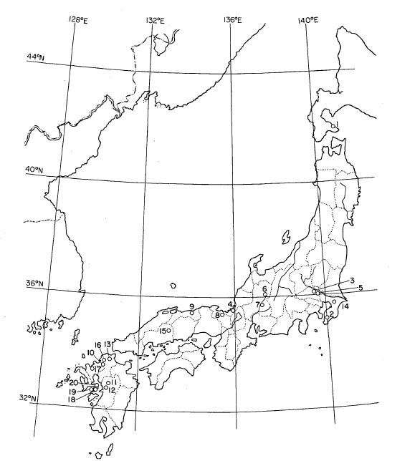
Figure 2. Jomon sites indicating evidence of plant cultivation. (Image from Kotani 1981).

The Japanese archipelago separated from the Eurasian continent roughly 10,000 BP which isolated the Jomon population from the mainland for several thousand years. While some researchers argue that the Jomon maintained the morphology of an initial founding population, other studies have shown the evidence of interregional cranial and body proportion variability among Jomon groups (Takigawa 2006). The existence of two distinct types of Jomon pottery is argued as evidence of multiple founding events (Sasaki 1991). These styles are found to be geographically separated, with the Tottaimon style on the western portion of the island, and the Kamegaoka on the eastern side.
Dramatic change occurred at the end of the Final Jomon Era, in which new ceramic and stone working patterns were introduced with the arrival of the Yayoi people. With the Yayoi came iron and bronze artifacts and perhaps most importantly, wet-rice agriculture (Matsui and Kanehara 2006). These new components were introduced in the Kyushu area of southern Japan and quickly moved to the northern regions. The impetus for movement from the Asian mainland into southern Japan via the Korean peninsula is described as an abrupt climate change that resulted in a cooler and drier landscape that could have led people to migrate in search of a more hospitable area (Hong 2005).
The influx of people into the Japanese archipelago brought a host of new technologies and subsistence patterns. Along with the wet rice paddy style of cultivation, pit-dwelling and storage also spread across the archipelago. However, Jomon culture did not become obsolete, and rather the Yayoi adopted and/or modified stone tool styles and the distinctive pottery methods unique to the Jomon people.
However, with the introduction of differing subsistence methods, diet and eating habits changed drastically(Hong 2005). Hunting and fishing was reduced and rice became a new staple. Axes, ploughs, daggers, grinding stones were made from iron and bronze while wooded tools were used for farming.
The Yayoi period lasted roughly 600 years and was followed by the Kofun or “Tomb” period, which lasted from roughly the 3rd to the 7th century. During this period cremation practices became common. Small tombs were typically built on top of hills during the beginning of the Kofun period. Tombs usually consisted of wood coffins that were dug into a hole at the top of a hill, surrounded with stones and topped with stone panels. Over the centuries, tomb style changed. Tombs were built on flat ground and became enormous in size, resembling a large, rounded keyhole shape. The fifth century showed Korean influence, such as with artifacts of horse effigies, at a time when no horses were found on the Japanese archipelago. The Kofun period experienced an influx of people migrating to the Japanese archipelago. Movement into the archipelago is thought to be the result of an epidemic of draught, disease and plagues on the Eurasian continent (Hong 2005).
During the 5th-12th centuries, migration events from Northeast Asia occurred in Hokkaido, the most northern island of Japan. These events brought (or further developed) a distinctive culture, referred to as the Okhotsk culture (Amano 2003). This period is characterized by extensive exploitation of maritime resources, and existed throughout Hokkaido.
The medieval period in Japanese history lasted roughly 400 years and dates approximately to 1185-1573 AD (Nagaoka, et al. 2013). The socioeconomic history of this period is characterized by the establishment of military force, social hierarchy and an increase of power and respect for the warrior/Samurai class. Past bioarchaeological studies of the medieval period in Japan have indicated high mortality rates, warfare and severe living conditions (Nagaoka 2012; Nagaoka, et al. 2010). The medieval period has also been shown to demonstrate a higher instance of younger ages at death than later periods.
The feudal activity between various parts of hierarchical society in Japan was greatly reduced during the more recent Edo period which lasted from 1600-1870 AD (Hanley 1997). Standard of living and overall health of the population is described as increasing during the Edo and modern periods. Industrialization, coupled with better nutrition and medical care are cited as reasons for the physical changes observed in the Japanese population during these more modern periods. The most majority of the population made a living as simple rice farmers but social structure was elaborate and hierarchical, which designated each citizen a social and economic role.
The modern period in Japan is cited as beginning with the Meiji Restoration during the 1860’s (Pyle 2006). This period restored imperial rule to Japan and resulted in rapid industrialization and modernization of the country’s society, economy and military (Yamamura 1977).
During the 13th century, the Ainu culture is described as developing, which involved a hunter-gatherer maritime lifestyle similar to Jomon culture (Habu 2004). In the late 19th century Japan was established as a modern nation-state which resulted in the colonization of northern Hokkaido, which was mostly populated by Ainu groups. Ainu have also historically populated portions of outlying islands of the Sakahlins and Kuriles. The signing of the St. Petersburg Treaty in1875 resulted in the delineation of Japanese and Russian borders that interrupted Ainu territory and the forcible relocation to Hokkaido the Ainu hunting lifestyle was forced to conform to that of an agriculturalist. These dislocated Ainu people were forced to be recorded in the national registry and given traditional Japanese names.

Anthropological Research in Japan

This section will focus on the majority of research that has analyzed osseous material found within the Japanese archipelago. Reference is made to some archaeological context and artifacts; however it is beyond the scope of this study to summarize every facet of the archaeological history of Japan.
Tsuboi Shogoro is credited as one of the founders of anthropology in Japan, and spearheaded research dedicated to documenting the history of the country, rather than using archaeological evidence to prove imperial lines (Low 2012). Shogoro founded the Anthropological Society of Nippon in 1884, and in 1893 founded the Institute of Archaeology in Tokyo, which focused on researching the origins of modern Japanese people.
The majority of research that has been carried out in Japan has aimed to identify Jomon culture and the ancestors of this population. This work has mainly focused on craniofacial and dental morphology, however some research has been published that has examined the post-cranial data (SCHmidT and Noriko). The following sections will summarize much of the pivotal research that has been published in the last 50 years.
A host of craniometric and non-metric trait studies have been carried out that examined relationships between the various cultures represented within the Japanese archipelago. Howells et al., (Howells and Crichton 1966) was one of the first to examine Japanese crania in a multivariate context. In addition to the examination of archaeological skeletal samples, studies of modern Japanese individuals have also been published to identify regional differences.
A multitude of research has been carried out on craniometric variation within the temporally and geographically different regions of Japan. Many studies have focused on identifying the relationship between the Jomon, Yayoi and their genetic contributions to the modern Japanese population. Additionally, many researchers have explored hypothetical parental gene pools that are ancestral to the Jomon and Yayoi groups. One of the most comprehensive studies was carried out by Ishida et al., (Ishida, et al. 2009) which compared an array of skeletal samples from northeast Asia to Japanese samples representing modern Honshu, Ryukyu Islander, Ainu and Jomon samples using linear measurements of the cranium. Prehistoric Japanese samples of the Okhotsk and Jomon showed greater than expected variation which implied external genetic contribution; however the Yayoi showed less than expected variation. Overall, the Japanese samples show greater craniometrics diversity than did the Arctic and Coastal Northeast Asian samples included in the analysis. This study also cites morphological similarities with the Iron Age Tagar samples from southern Siberia, which have been described as exhibiting European morphological features (Ishida 1997; ISHIDA 1996). These results provide implications for affinity with prehistoric Europeans and Americans, which has been proposed by a number of studies (Brace, et al. 2001; Cunningham and Jantz 2003; Hanihara and Ishida 2009a).
While the Jomon have been shown to exhibit high levels of variability, low level variability in southern Yayoi samples is cited by several studies and likely stems from a small number of founding immigrants (Iizuka and Nakahashi 2002). Interestingly, modern Honshu Japanese samples show more morphological affinity with Yayoi samples, while the Ainu and Ryukyu Islanders appear very distinct. High variability is also found in Ryukyu islanders, which could also indicate outside gene flow. Ishida et al., (Ishida, et al. 2009) also interestingly found low levels of variability in Arctic Asian samples, which could suggest a small founding population for this region, as is hypothesized for Yayoi populations.
Yayoi cranial morphology has been described as similar to modern East Asians (Nakahashi and Li 2002). However, Ishida et al., (Ishida, et al. 2009) emphasize the importance of immigrants from Northeast Asia and possible genetic and morphological contributions to modern Japanese populations via significant cultural (and biological) contact throughout the population history of Japan. Many studies have cited relationships among Northeast Asian groups, which show three major groups that consist of an Arctic component (Asian Eskimo, Chuckchi, Aleut), an Inland Asian component (Mongolian, Buryat, Yakut) and Baikal component (Ulch, Nanay, Negidal, Evenki and Yukagir) (Ishida 1995; Kozintsev 1992).
Research questions regarding parent populations for the Ainu have been somewhat contentious. Early research has generally shown that the Ainu share a number of morphological skeletal traits and genetic similarities with the indigenous Jomon (Brace, et al. 1989; Brace, et al. 2001). However, much of the dental research have interpreted Ainu and Jomon dentition to be similar to Southeast Asian populations that exhibit sundadonty. This simple trait dental complex is thought to be retained morphology from Pleistocene populations (Turner 1990). Despite the dental evidence, most morphologic and genetic studies have indicated that the Ainu and Jomon are descended from populations from Northeast Asia (Adachi, et al. 2009; Tajima, et al. 2004).
However, contradictory evidence exists in regard to interpretation of craniofacial morphology of Ainu and Jomon when compared to Northeast Asian populations. Some studies cite little to no morphological similarity (Dodo, et al. 1992; Hanihara 1991) whereas other report similarities between Ainu and Northeast Asian groups (Hanihara 2010; Hanihara, et al. 2008b; Komesu, et al. 2008).
Studies of the unique Ainu population in Northern Japan have spanned skeletal and molecular approaches. One of the largest efforts to examine physical evidence of a direct relationship between the Ainu and indigenous Jomon was by Koganei. In 1888-1889, Koganei excavated 166 Ainu skulls and 92 skeletons for examination and provided skeletal evidence for similarities between the Jomon and Ainu populations. The findings that the Japanese had mixed racial origins assisted in the justification of the annexation of Korea in 1910, eventually resulting in the rise of the Japanese Empire.
Morphological variation studies in modern populations of Japan have identified two distinct patterns that correlate with different geographic areas within the archipelago. Studies of modern Japanese skeletons have indicated that there is a northeast-southwest cline which has been shown through measurements of facial flatness (Yamaguchi 1980) and body size (Kouchi 1983). Larger body sizes are identified in the northeast and smaller overall body size in the southwest. Additionally, a circular distribution of morphological differences has also been cited by studies of somatometric and osteometric analyses (Kouchi 1983). Central Japanese samples that come from regions near where the establishment of the Imperial Court occurred have been shown to differ from more peripheral locations from this region.

Secular Change Studies in Japan

Initial studies of secular change began with Boas’ pivotal publication on the plasticity of cranial form of immigrant children entering the U.S. (Boas 1912). This study identified morphological change between American born and foreign born children. The results of this study have largely been discredited by Sparks and Jantz (Sparks and Jantz 2003) who found that differences were not as distinct as originally described. Much more recently Jantz and Jantz (Jantz and Meadows Jantz 2000) examined secular change in American crania over a 135 year period. Results of this study indicated an increase in vault height that correlated with an increase in stature.
Suzuki (Suzuki 1969) was one of the initial studies to examine micro-evolutionary change in Japan. Suzuki defined the “transformation theory” which was the initial hypothesis for the morphological variation observed in Japanese populations. This hypothesis is one that posits in situ change of a continuous population, and thus indicates that the modern Japanese are the direct descendants of the native Jomon occupants. Morphological changes were attributed to change in subsistence style, transitioning from sedentary hunter-gatherers to rice-agriculturalists. Suzuki acknowledged that immigrants from the Asian mainland entered the Japanese archipelago, but that physical changes were due to primarily cultural factors.
Other early studies have emphasized the importance of migration events from the Asian mainland and suggest that admixture occurred between the Jomon and incoming migrants. Kanaseki is credited with the first version of the “hybridization theory” which was later expanded upon by Hanihara (Hanihara 1991). Early excavations of Yayoi sites of the Doigahama and Mitsu sites in southern Japan showed that the Yayoi skeletons exhibited morphological features that were very different from previously discovered Jomon skeletal remains. Kanaseki (Kanaseki 1976) analyzed the newly excavated skeletons and observed overall taller body stature as well as longer facial dimensions. Kanaseki attributed these traits as being indicative of immigrant populations that travelled into southern Japan via the Korean Peninsula.
Nakahashi (Nakahashi 1993) explored what is defined as temporal changes in Jomon crania from the late period (1500 BC-300 BC) to the modern period in the western region of Japan. This large time depth could also be referred to as an examination of long-term microevolutionary changes in a region specific area of Japan. Nakahashi (Nakahashi 1993) found that cranial breadth shows a gradual decrease through time until the end of the Medieval period, in which a dramatic widening in vault breadth (brachycephalization) occurs during the modern period. The Kofun through the modern period also sees a marked increase of cranial vault height, with averages reaching modern values during the medieval period.
However, Nakahashi describes the most significant changes occurring within the dimensions of the facial skeleton. The Jomon and Yayoi are described as differing most dramatically in facial height, with the Yayoi exhibiting a much taller face than the Jomon. Upper facial height decreases gradually until the medieval period in which it then increases to modern day averages. The facial differences between Jomon and Yayoi are more significant in the Kyushu and Yamaguchi (Southern Japan) samples, rather than in the Kanto (central Japan) samples, indicating regional differences in the Jomon material.
However, an increase of facial height are observed in both regions in the medieval period. Nakahashi (Nakahashi 1993) also describes significant differences in nasal morphology, in which the Northern Kyushu Jomon show wide nasal bones and prominent nasal root morphology. This morphology is reduced in later populations, but is more significant in the Kanto (central Japan) samples during the medieval period. Modern populations show the smallest averages for this dimension. Comparison of lower facial heights showed significant differences between the Jomon and Yayoi, in which the Jomon show much shorter lower facial values. No differences were detected after the Yayoi period. Multivariate analysis of the various temporal samples does not show significant differences, except for the Jomon period samples. The historical population overlap is explained by the author as evidence for continuity among groups in Japan.
Okazaki and Nakahashi (Okazaki and Nakahashi 2011) explored this topic further with their study of sub-adult material that represents time periods from the middle-late Jomon period through the earliest portion of the modern period. Results indicated that the Jomon material differed from other samples in regards to upper facial height during childhood development and adolescence. The nasal region and breadth of mandible was also found to differ among Jomon and post-Jomon groups during development. Differences are thought to reflect distinct migratory events and different parental populations for the indigenous Jomon and post-Jomon series. Additionally, the authors cite a reduction in masticatory stress in post-Jomon series due to a reliance on rice. A softer diet is thought to have affected the growth trajectory of the mid-face and allowed for an overall height increase of facial dimensions observed.
Kawakubo (Kawakubo 2007) also examined the morphological variables of facial dimensions in prehistoric and modern samples, and quantified facial flatness. Facial flatness is one of the hallmark morphologies of Jomon crania, and is also found among Hokkaido Ainu samples. Yayoi and Kofun samples do not show facial flatness indices as found in Jomon and Ainu samples. Differences in facial flatness are found in modern samples, which represent northern and central Japan. The northern samples show higher degrees of facial flatness, while the central samples show varying levels of facial projection.
Arguably one the most important studies of secular change in modern Japanese crania has been the work of Kouchi (Kouchi 2000) who examined somatometetric data of recent populations. Collection of secular change data has been conducted via anthropometric surveys by the Japanese government since the 1890’s and Kouchi (Kouchi 2000) employed this data and examined just over 9,000 males and 3,400 females. The sample was divided into two birth cohorts, with one sample dating to the 1940’s and the second sample dating between 1977 to 1998 for males and 1955 to 1998 for females. Variables of sex, year of birth and socioeconomic status (education level) were included. Mean stature for Japanese males and females increased over time with an interesting decrease during the 1970’s. Body mass index (BMI) was also shown to increase for males born after 1950, but an overall decrease in BMI occurred in females born after 1930. Individuals with more recent birth years also showed wider heads, which the author argues reflects better nourishment and diet (Kouchi 2000). Individuals with higher education levels showed to be taller than the general population and was significantly correlated with wider head dimensions. However, as this data is based on somatometric data, changes in soft-tissue thickness could partially explain these trends.
An additional and more recent study of secular change in Japan comes from the work of Nagaoka (Nagaoka 2003) who examined cranial morphological variation in Japanese skeletons dating from the Edo through the modern period. Nagaoka states that modern individuals from central Japan differ from northern and southern counterparts. Namely, s larger cranial indices and shorter vault lengths characterize central Japanese males. Male samples from northern and southern regions show smaller cranial indices and longer cranial vaults. Southern individuals are also described as having larger bizygomatic breadths than central equivalents, which exhibit the largest nasal breadths out of any region. Comparisons of Edo period to modern period Japanese showed decreases in inter-regional variation as well the hallmark trend of brachycephalization, which characterizes modern Japanese cranial morphology.

Post-Cranial Studies

Geographic distributions of limb proportions in worldwide human populations generally follow Allen’s rule, which posits that organisms in colder environments will have shorter appendages and organisms living in warmer climates will have longer appendages (ALLEN 1877). This phenomenon is explained by the notion that a reduction in the size of appendages will mitigate heat loss via a decrease in overall surface area, while an increase in surface area will promote cooling of body temperature. Interestingly, the Yayoi population is representative of warmer climate and the Jomon culture is associated with a colder climate but neither group show predicted limb proportions. The Yayoi and Jomon exhibit differences in limb proportions, but the Jomon show longer distal elements relative to the proximal on the upper and lower limb, while the Yayoi exhibit shorter tibiae and radii relative to the femora and humerii. (Temple, et al. 2008). Limb proportions expressed by Jomon sample are more similar to populations from tropical environments of lower latitudes. Conversely, the limb proportions of the Yayoi show dimensions similar to groups of higher latitudes and colder environments. The Minatogawa specimens from one of the southernmost islands of the archipelago also show limb dimensions more similar to that of cold, high latitude environments. Proportions of modern Japanese show similarities to the Yayoi, which again similar to cold adapted, high latitude populations (Fukase, et al. 2012).
The differences observed in limb proportions among the Jomon and Yayoi and modern Japanese populations are hypothesized by Temple et al., (Temple, et al. 2008) to reflect either a retention of limb proportions from parental populations that lived in a warmer, tropical environment, or the result of change that reflects the climate warming trends in Japan over the last several thousand years.
In regards to body breadth, the Jomon also exhibit proportions that are similar to cold adapted populations (Temple 2007; Temple 2008). This supports the idea that the indigenous Jomon of Japan initially migrated from a cooler environment as seen in North and Central Asia. Estimation of body size of Minatogawa specimen 1 shows body proportions that are consistent with colder environments, which could indicate that the subsequent Jomon migration resulted in morphological change in response to the more temperate environment in Japan.
The Yayoi show limb and body proportions that are similar to other populations that live in high latitude, cold environments, which Temple et al., (Temple 2008) argue further supports that this group descended from a Northeast Asian parental population. It is further proposed that little change has occurred in the last several thousand years as is reflected by the similarly sized limb and body proportions expressed in modern Japanese populations.
To support hypotheses for the interesting post-cranial morphologies within the archaeological record of Japan, genetic evidence can be used for inference of retention of parental population morphology. Molecular studies indicate a population from northeast or central Asia to be ancestral to the Jomon, which is representative of a cold adapted populated (Hammer, et al. 2006; Omoto and Saitou 1997). In contrast, it is generally thought that the Yayoi agriculturalists are derived from a Korean or northern China parent population (Brace and Nagai 1982; Hanihara 1991). The differences in parental populations for the Yayoi and Jomon cultures could very well be responsible for the differences identified in body size and limb proportions.
Additionally, studies of post-cranial dimensions in modern Japanese samples have shown evidence of geographic clines. Kouchi (Kouchi 1983) identified differences in body size between northeast and southwest Japan, which the author attributes to climatic adaptations. Ainu samples exhibit high crural indices as are found in Jomon samples.

Genetic Studies

The origins and prehistory of East Asia are not as generally accepted as are hypotheses concerning modern humans out of Africa, largely because of a lack of archaeological evidence (Jin and Su 2000). Molecular studies of modern populations have been used to infer evolutionary events across Asia in an effort to support what has been found with skeletal and archaeological material, and to offer novel hypotheses regarding the peopling of this portion of the world. In China, one of the largest regions in mainland Asia, the genetic structure of modern populations has been shown to contain a northern and southern component, although mtDNA studies have indicated that the majority of East Asians have descended from a common ancestor. Studies of East Asian groups using autosomal-miscrosatellite data have shown a common African cluster for all Asian groups, with some differentiation between Northern and Southern groups (Chu, et al. 1998).
While it is somewhat easy to comprehend the scientific debate involved with identifying the who-what-when responsible for genetic diversity within Asia, it is interesting to highlight the lack of consensus in the much, much smaller region of Japan.
Previous hypotheses have approached the question of the peopling of Japan and have advocated for continuity and admixture models. Continuity models such as proposed by Suzuki (Suzuki 1969) have argued that genetic continuity exists within Japan, and cite morphological differences over time in Japan as relating to secular change. Admixture models were originally outlined by Kanaseki et al. (Kanaseki 1976), which identified change in culture and morphology on the Western portion of Japan as a result of gene flow with immigrating groups around 2300 BP.
Molecular studies have helped provide some clarity to the debate. Sequences of the modern Japanese genome exhibit a close genetic affinity with northeast Asians populations, especially Koreans (Tanaka, et al. 2004) while the Ryukyuans appear to have a southern Asian history for their lineage. The Paleolithic populations of Japan likely received portions of their populations from both north and south Asian populations, including Korea during the Neolithic period. Other contributors were likely from western Asia and Siberia. In addition to the first entry of people that became the Jomon culture, a second wave of migrants from Siberia (the Ainu) reached the Sakhalin Islands by foot and then into Hokkaido around the termination of the glacial period.
Both morphological and molecular studies support a model that involves admixture between several prehistoric populations that inhabited the Japanese archipelago. It has been extensively cited that the dual structure model proposed by Hanihara (Hanihara 1991) is too simplistic to account for the variability expressed in modern Japanese populations. Genetic studies have shown that Ainu and non-Ainu Japanese have deep temporal affiliations with Neolithic (indigenous) Jomon populations of Japan (Omoto and Saitou 1997; Ossenberg, et al. 2006). Rasteiro and Chikhi (Rasteiro and Chikhi 2009) specifically examined admixture between Jomon and Yayoi populations using Y-chromosomal data from modern individuals within Japan. Hypothetical models were examined by using a number of proxy parental populations to model the amount of estimated genetic drift that has occurred within daughter populations. Results indicate a likely “demic diffusion” model for Yayoi immigrants, with genetic drift accounting for less variation in populations in southern Japan that are located closer to the Korean peninsula. These populations would have been greater in size compared to northern populations and are likely to have been more affected by genetic drift.
Studies of ancestry informative markers (AIMs) have also been used to study the population history of Japan. AIMs are defined essentially as genetic markers that indicate a geographically constrained pattern of allele frequencies among regions that can be used to infer ancestral relatedness. Previous investigations of Y-chromosomal patterns have shown that halpologroups C1 and D2 are unique to the Japanese archipelago. Specifically, haplogroup D2 has been shown at high frequencies in Okinawa Ryukyu and Hokkaido Ainu populations, (upwards of 0.55 and 0.85, respectively) and at lesser values in mainland populations that range between 0.26-0.38 (Shi, et al. 2008). Haplogroups C1 and D2 have also been found in small frequencies in Chinese and Korean populations, respectively and thus can be described as mostly specific to Japanese populations. Hammer and Horai (Hammer and Horai 1995) hypothesized that since the Y alu polymorphism is absent in continental Asian populations but present in Jomon populations, this haplogroup D marker must have migrated with the Jomon during the initial peopling of Japan.
A large scale study carried out by Tajima et al., (Tajima, et al. 2002) examined distribution of Y-chromosome haplogroups in 14 global populations, which included a variety of Asian and Japanese samples. This study identified four major lineages, with three out of the four lineages accounting for almost 99% of the variation in Asian populations included in the study. Furthermore, the Asian data indicated three major clusters that represented North Asia, Southeast Asia and Japan. Additionally, it was found that the two North Asian populations of the Buryiat and the Nivkhi are closely related to Indonesian and Australo-Melanesian groups. In reference to the Japanese groups, similarities were found with Tibetan and Korean groups, albeit at low percentages. This study lends support to hypotheses that argue for multiple migratory events into the Asian continent. Coalescence of the three major clusters was estimated between 53,000 and 95,000 years BP.
The Ainu group has been rigorously investigated via maternal and paternal polymorphisms and compared to other Asian groups in an effort to identify a parental group. The Ainu exhibited 14 out of 25 mtDNA sequences that are frequently used in Asian studies and three Y-haplogroups were found to be unique to Ainu groups. Overlap with other Asian groups have indicated ancestral relatedness with the Nivkhi population from the Sakhalin islands, as well as the Koryaks in the Kamchatka peninsula (Tajima, et al. 2004). Results such as these indicate the Ainu have retained a unique genetic makeup with some overlap among North Asian populations. Studies using HLA genes and haplotypes support these types of findings in that there exists a shared haplotype among Ainu haplotypes and North Asian and Siberian groups. No Y-haplogroups have been found to be unique to the Ainu populations, and instead share Y-chromosome haplogroups with other Japanese groups.
Ancient DNA studies within Japan are somewhat scarce, and are not representative of the time depth that is found within the Japanese archaeological record. However, there has been some interesting site specific studies that have exposed various patterns.
An important ancient DNA study was carried out by Shinoda et al., (Shinoda 2005), which built on earlier work that examined the archaeological site of Kuma-Nishi-ioda, one of the largest Yayoi communities on the island of Kyushu. This sample dates to the middle to late Yayoi period. mtDNA was extracted from 35 individuals and compared to Late Jomon individuals from northern and central Japan to examine migration hypotheses within a molecular context. Results indicated that within superhaplogroups M and N, the Yayoi samples showed a complete absence of haplogroups F and A (under superhaplogroup N) and an absence of haplogroup M7, which are frequent in Jomon and Ryukyu populations, respectively. The Yayoi group did show a high frequency of the superhaplogroup M. Superhaplogroups M and N have been shown to completely cover East Asia, and that daughter haplogroup M7a is specific to Japan.
Genetic studies of occupants of the westernmost island of Japan, the island of Yonaguni-jima have been carried out by Shinoda and Doi (Shinoda and Doi 2008) in an effort to elucidate relationships with other East Asian groups using HVR-1. Individuals recovered from a cemetery from the western island of Subaru represented individuals from early modern to recent modern individuals. Analyses of mtDNA haplogroups indicated variation in maternal lineages, and were closely related to haplogroups associated with North Asian groups, and populations from the island of Okinawa.
Igawa et al., (Igawa, et al. 2009) extracted mitochondrial DNA from Yayoi individuals from the Doigahama site, located north of Kyushu island. Analysis of HVI showed that Kyushu Yayoi samples were more similar to modern Japanese samples than were the Doigahama samples
Several studies have successfully extracted DNA samples from Jomon sites in Hokkaido, Japan. Kazuta et al., (Kazuta, et al. 2011) utilized molecular data from Jomon, Epi-Jomon and Ainu specimens from various archaeological sites within the northernmost island of the archipelago. The authors showed that allele frequencies of the gene that determines ear wax phenotypes differed between Jomon and Ainu individuals, but that the Epi-Jomon were an intermediary that was not significantly different from either group. These results indicate that the Ainu have experienced gene flow with populations that are not descendent of the Jomon population.
Kanzawa-Kiriyama et al., (Kanzawa-Kiriyama, et al. 2013) extracted mitochondrial DNA from Jomon individuals from the Tohoku region and showed that these samples were genetically closer to Hokkaido Jomon than mainland counterparts. The northern samples exhibit subhaplogroup M7a2, which is also found in modern Siberian populations.
Adachi et al., (Adachi, et al. 2009) extracted mtDNA from 16 Jomon skeletons from Hokkaido that date to between 3800-3500 BP, which corresponds to the late Jomon period. Mitochondrial DNA was extracted and haplogroups D1a, M7a and N9b were identified. Haplogroup D1 is shared with Native Americans, which provides support for a common parental population among these groups.
Building on the 2009 study, Adachi (Adachi, et al. 2011) provides one of the most conclusive genetic analyses on available Jomon samples from all over Hokkaido. Four haplogroups were identified, which included N9b, D4h2, G1b and M7a. High frequencies of N9b in particular have been cited in Japanese populations and are thought to be a pre-Jomon genetic contributor to modern Japanese. This haplogroup is also found in southeastern Siberian populations, indicating the possibility of Paleolithic contributions to Jomon and Ainu populations. Interestingly, haplogroups A, C and D (barring D4h2) are present in modern Siberian populations, but are not identified in any of the Hokkaido Jomon material. Okhotsk Japanese, which date roughly to the 5th century in Hokkaido exhibit haplogroup Y, which is also the most prevalent haplogroup in Ainu populations. This indicates that the Okhotsk people may be the Siberian contributors that provided haplogroup Y to Ainu populations.
A recent study published by Adachi et al., (Adachi, et al. 2013) extracted mitochondrial DNA from what is considered the oldest Jomon skeleton to be successfully sequenced. The sample dates to nearly 8,000 BP. Extraction of mtDNA from dentition showed this adult skeleton belongs to haplogroup D4b, which is prevalent in East Asian (including Japanese) populations. Previous research has established that three haplogroups are present in Jomon material, including M7a, D4h2, and E1a1a, indicating that the early Jomon populations were heterogeneous in regards to matrilineal genetic structure.
Within the genetic literature of Japan, it has been generally accepted that Jomon males are representative of haplogroups C or D while Yayoi males typically belong to haplogroup O, which indicates genetic clines evident within the archipelago. Jomon populations are typically associated with the northernmost portions of the island (Hokkaido) while the Yayoi inhabited the southernmost portions initially. Data is described as lacking for modern Japanese males in regards to Y-chromosome data. To remedy this problem, Sato et al., (Sato, et al. 2014) examined Y-chromosome data from a sample of modern Japanese males from different regions within Japan. Results indicated that modern Japanese males are in general, genetically homogenized within the island of Honshu due to gene flow and genetic drift. However, analyses of maternal DNA indicated that the frequency of mitochondrial haplogroups M7 decrease from south to north, indicating the possibility of a different migratory pattern within the archipelago.
Polymorphisms of the ABO gene of prehistoric populations in Hokkaido have also been investigated. Sato et al., (Sato, et al. 2010) examined Jomon, Epi-Jomon and Okhotsk samples. Mitochondrial DNA analyses have shown that the Jomon/Epi-Jomon are dissimilar from the Okhotsk people, who inhabited the coastal regions around the Okhotsk Sea. Polymorphisms of the ABO blood groups were examined to further capture differences and/or similarities between the Jomon/Epi-Jomon and the Okhotsk people. Results indicated that both the Jomon/Epi-Jomon and Okhotsk groups showed ABO blood group alleles that are common to Asian populations, however at different frequency levels. Sato et al., (Sato, et al. 2009) examined mtDNA haplogroups within Okhotsk people and found a high prevalence of haplogroups Y, which is commonly found within the Sakhalin Islands and Ainu populations but interestingly not found within Jomon lineages. These results indicate that gene flow occurred between the Okhotsk people and Ainu populations. It has also been reported that gene flow occurred between the Nivkhi people (other occupants of the Sakhalin Islands) and the Ainu (Tajima, et al. 2004).
Work has been done to approximate size of founding populations as well as subsequent migratory waves that have occurred and thus influenced population history and to a certain degree, shaped modern Japanese populations. Zheng et al., (Zheng, et al. 2011) used Bayesian approaches to analyze modern Japanese mtDNA in an effort to estimate the rate of growth for females of specific migratory events. The authors cite a major migratory event occurring roughly at 5,000 BP which distinguished the Japanese population from North and Central Asia. Based on the genetic signature within the modern population, the authors show that population growth and expansion occurred rapidly, which likely resulted in a smooth transition from Jomon to Yayoi culture during the Middle Jomon period.
Other novel approaches have examined molecular evidence of the JC polyomavirus to examine the colonization of Japan. Kitamura et al., (Kitamura, et al. 1998) and Sugimoto et al., (Sugimoto, et al. 2002) showed two distinct genotypes of the JC virus within Japan, which they offer as support for the hybridization theory.
Other genetic studies that have examined the molecular structure of the modern Japanese have shown paternal lineages represented by haplogroup O at roughly 50%, and is also found in East Asian populations. Hapologroup D2 is also a paternal lineage that is found in roughly 35% of male modern Japanese and is only found in Japan, but related haplogroups D1 and D3 are found in more southern areas of Asia. Haplogroup C1 is also unique to Japan (He, et al. 2012). Interestingly mitochondrial haplotypes are found within Japan and throughout Asia, barring haplogroup M7a.
In an extremely influential study, Hammer et al., (Hammer, et al. 2006) examined SNP data to examine Y-chromosomal contribution of the Jomon and Yayoi populations to modern Japanese. This study showed definitive patterns of Y chromosome haplogroups D and O within the archipelago. Haplogroup D was shown to be present in roughly 35% of modern Japanese and showed highest frequencies in Ainu and Ryukyuan samples. Haplogroup O was found in roughly 50% of the modern population, with highest frequencies in Kyushu. Coalescence of the STRs used is estimated at expanding within Japan at around 20,000, 12,000 and 4,000 BP.
Generally, a northeast location within Asia is accepted as the parental population for Jomon, and time and isolation is thought to be responsible for the large morphological differences among these groups.

CHAPTER 4
MATERIALS AND METHODS

Geometric Morphometric Approaches

Geometric morphometry (GM) is described as the compilation of methods used to acquire, process, and analyze coordinate data that retain geometric shape information. This approach can encompass the collection of metric data in three dimensions. Landmark coordinates are collected with respect to arbitrary axes, and thus the data must be transformed onto a common coordinate system so that statistical analysis is viable. Once data has been collected on several specimens, the x, y and z coordinates can be analyzed, but data pre-processing is first required.
Procrustes superimposition is a least squares method that estimates the parameters for location and orientation that minimize the sum of squared distances between corresponding points on two configurations (Rohlf and Slice 1990). Centroid size (center of a form) is calculated by summing all squared distances, and then taking the square root of that sum (Zelditch, et al. 2004). Centroid size will then be set to one, which will remove isometric size. Centroid size can also be calculated based on interlandmark distances and is the one measure of size that is independent of shape. However, independence of size by calculation of group centroids is only valid if scaling (changes in size) does not affect shape. If size is not isometric and proportions within a form change when size variables are disrupted, then size cannot be considered orthogonal and/or independent of shape. Generalized procrustes analyses differs from Procrustes analyses in that after translation, scaling and rotation, an average is taken to calculate the mean of each specimen and is continued until there is no significant change from iteration to iteration. Following a Procrustes superimposition, the coordinates are representative of shape coordinates which can be analyzed using statistical methods. However, these coordinates do not function in Euclidean space, which can be thought of as a two dimensional plane. Thus, the new coordinates need to be projected onto a curved space that is more akin to a hemisphere. Statistical analyses are available that can approximate the curved space represented by the Procrustes shape coordinates.
Principal component analysis (PCA) is carried out on the shape variables that are projected onto tangent space, and PCA scores can then be used for multivariate analyses. Principal components that account for the largest amount of variation can be used for canonical discriminant analysis that in turn is used to calculate a Mahalanobis distance matrix.
The utility of geometric morphometric approaches is significant when compared to traditional morphometric analyses using linear metric data. The analysis of landmark data in three dimensions allows for visualization of similarities and/or differences of the entire specimen that has been recorded, rather than just isolated dimensions of metric differences (Marcus and Corti 1996).
Statistical analysis of Cartesian coordinates of cranial landmarks has been shown to be a viable means of investigating biological relationships and distances between human populations. Mckeown and Jantz (McKeown and Jantz 2005) evaluated the use of craniometric versus coordinate data. These methods showed high distances among the Sully site of the Arikara, where previous craniometric analysis did not show the same divergence. Similarly, Ross et al., (Ross, et al. 1999) were able to better describe where morphological variability exists among comparisons of American White and Black samples.
However, some caveats have been outlined for GM approaches. Richtsmeier et al., (Richtsmeier, et al. 2002) outline what is referred to as “nuisance parameters” in which rotation of an object corresponds to multiplication of a landmark coordinate matrix by an orthogonal matrix. Translation corresponds to a form sliding along a plane in any direction, by adding a matrix of identical rows to a landmark coordinate matrix. Reflection is flipping or mirroring an object across an axis or plane, by multiplying the values of a column of a coordinate matrix by-1.0. The authors argue against the use of GM as the mean form or the variance/covariance matrix can be estimated from the data, given the nuisance parameters used.
Linear distance-based methods, such as Euclidean distance-matrix analysis compare linear distances that connect landmarks in one form to the interlandmark distances of another form. Linear distances are written as a form matrix, rather than a matrix of coordinate data, and thus contain the distances between landmarks of a form (Richtsmeier, et al. 2005). Each linear distance of different forms is compared as a ratio or an absolute difference which can be
von Cramon-Taubadel et al., (von Cramon-Taubadel, et al. 2007) outlines the problems of inter/intraobserver error in geometric morphometrics and state that when raw configurations are superimposed using a least-squares criterion (generalized procrustes etc), the variance of individual landmarks is smeared out over all landmarks, which can be detrimental to studies that assess error or asymmetry, as the variance of essential landmarks can be distributed/allocated to other landmarks which results in what is referred to as the “The Pinnochio Effect”.
Despite these caveats, research has shown that using GM approaches can provide more insight into biological variability among samples.

Data Collection
Data collection procedures involved the recording of coordinate data from dry human skulls using a Microscribe digitizer and 3skull software (Ousley 2004). This non-invasive technique collects three dimensional coordinates of established bilateral and isolated skeletal landmarks as defined by Howells and Martin with respect to arbitrary axes (Howells 1973; R. 1956) (Figures 3-5). While over 80 landmarks were recorded, a much smaller subset was used for analyses due to the fragmentary state of many archaeological specimens. Landmarks used, associated definitions and abbreviations are defined in Table 1. Crania were placed on three clay pillars in an orientation so that the stylus of the digitizer could reach all landmarks, including those of the basicranium (Figure 6). Coordinate data was then imported into shape analysis software and transformed onto a common coordinate system so that statistical analysis was possible.

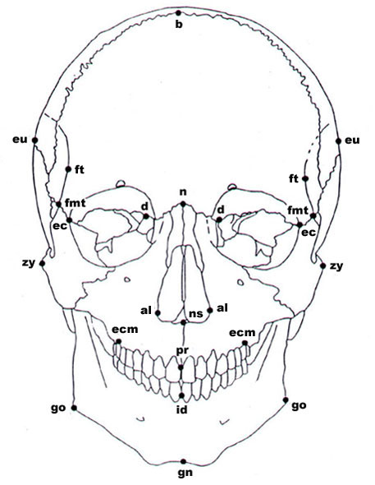
Figure 3. Anterior view of cranial landmarks.

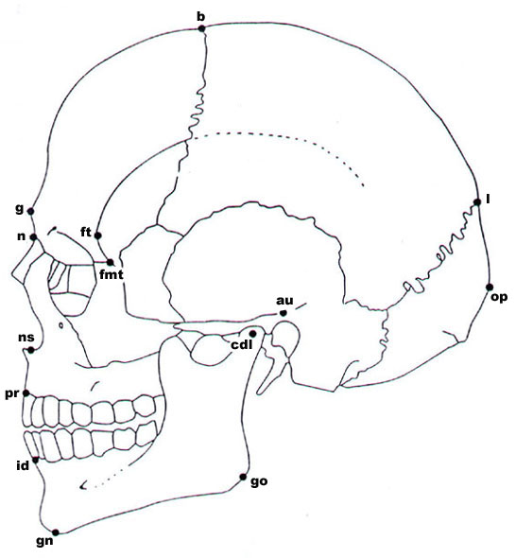
Figure 4. Lateral view of cranial landmarks.

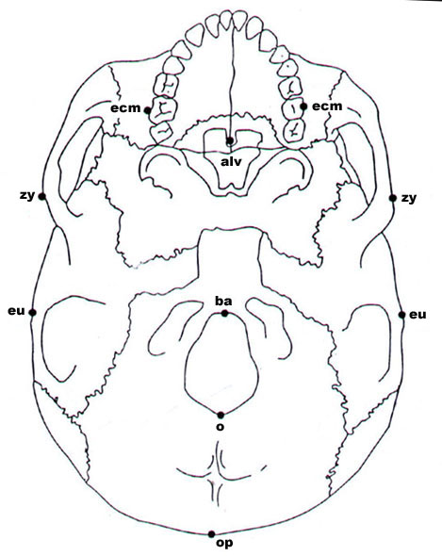
Figure 5. Inferior view of cranial landmarks.

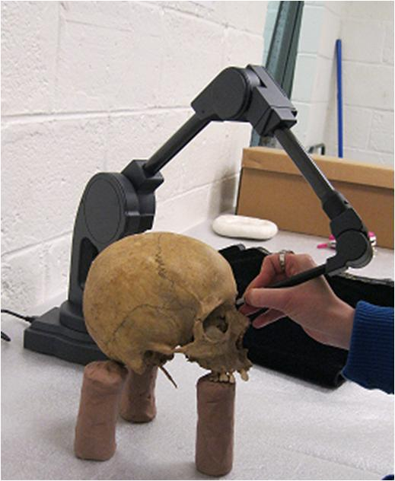
Figure 6. Digitizing of cranial landmarks using Microscribe.

Samples Utilized

The Yayoi samples were measured by the author at Kyushu University Museum (KU) in Fukuoka, Japan. Sample dates range from the Early Yayoi period to the Late Yayoi period and come from a number of archaeological sites from the southernmost portion of Honshu, as well as the islands of Kyushu and Okinawa. See Table 1 for definition of time periods. The majority of the samples come from the Doigohama archaeological site, in Yamaguchi prefecture. This site has been described as a cemetery and contains over 300 individuals that were buried either in stone coffins, large ceramic jars or directly within sandy shell middens.
The remaining Yayoi individuals have been excavated from a number of sites within or near Fukuoka including the Kanenokuma, Kiri-Toshi, Mitsu, and Nagaoka sites.
The Jomon samples from Kyushu island date mostly to the middle to late Jomon period. These individuals were excavated from the Einomaru, Yamagashi, Goryoukai (Kumamoto prefecture) sites. The Hokkaido Jomon samples were measured at Sapporo University and represent early, middle and late Jomon periods. The early and late specimens were excavated from sites in Abuta province, Hokkaido. The middle specimens are from Yakumo, Hokkaido and Chiba prefecture in Honshu.
The Kofun period samples were mostly excavated from sites on Kyushu Island, but several specimens were recovered from Okinawa Island. These specimens were measured at KU and University of the Ryukyus, respectively. The medieval samples were measured at KU and are from various sites on Kyushu Island.
The Edo period samples were measured at KU and University of the Ryukyus, and are from regions within Kyushu and Okinawa Islands.
The modern Japanese samples represent individuals with birth years from the late 19th century to the early 20th century and are representative of northern, middle and southern Japan and were collected Sapporo University, Tohoku University, University of Tokyo, Kyoto University, Kyushu University and University of the Ryukyus, respectively.

Table 1. Time period definitions for included samples.
Time Periods Defined
Jomon Period | 10000- 300 B.C.
Yayoi Period | 300-300 B.C.
Kofun Period | 300-700 A.D.
Medieval (Kamakura) Period | 1400-1600 A.D.
Recent (Edo) Period | 1700-1900 A.D.
Modern Period | 1900-1950 A.D.

Variables Used

An all too familiar problem in anthropological studies is the often fragmentary nature of skeletal remains recovered from archaeological sites. This study is no different, and due to the significant time depth represented, many of the earlier specimens (Jomon, mainly) are incomplete and most often missing the majority of the facial skeleton. While all landmarks were recorded and available for future studies, a subset of landmarks was utilized in this work to maximize number of individuals and maintain statistical power of the analyses performed (Table 2). The cranium and facial skeleton were initially analyzed separately to assess whether this approach would support the results of a multitude of studies that have been carried out using linear data. This approach also allowed for more individuals to be included, as not all individuals that were missing facial landmarks would have all the vault landmarks used and vice versa. Additionally, some groups had to be combined, regardless of geographic distinction to increase sample size and make statistical analysis possible. Thus, northern and southern Jomon specimens were combined into a subset. The same was carried out for Kofun and Edo samples, which have samples from Kyushu and Okinawa Islands. See Tables 3 and 4 for sample sizes.

Table 2. Landmarks used and associated definitions.
Landmark | Definition | Abbreviation
Alare (bilateral) | Instrumentally determined as the most lateral points on the nasal aperture in a transverse plane. | AL
Bregma (unilateral) | The ectocranial midline point where the coronal and sagittal sutures intersect. | BRG
Eurion (bilateral) | Instrumentally determined ectocranial points on opposite sides of the skull that form the termini of the line of greatest cranial breadth. | EUR
Glabella (unilateral) | Midline protrusion in the supraorbital region | GLB
Radiculare (bilateral) | A point on the lateral aspect of the root of the zygomatic process at the deepest incurvature | RAD
Opisthocranion (unilateral) | Instrumentally determined most posterior point of the skull not on the external occipital protuberance | O
Frontotemporale (bilateral) | The point where the temporal line reaches its most anteromedial position on the frontal. | F
Ectoconchion (bilateral) | The most anterior point on the lateral border and its intersection with a bisection line of the orbit on the long axis. | ECT
Nasion (unilateral) | The point of intersection between the naso-frontal suture, on the frontal | NAS
Dacryon (bilateral) | The apex of the lacrimal fossa | DAC
Prosthion (unilateral) | The most anterior point on the midline on the alveolar process | PRS
Lambda (unilateral) | Intersection of the sagittal and lambdoidal sutures, at the apex of occipital bone | LAM
Subspinale (unilateral) | Deepest point from lateral view below anterior nasal spine | SSP
Inferior point, nasal aperture (bilateral) | Lowest point on border of nasal aperture | NIL
Asterion (bilateral) | Intersection of the temporal, parietal and occipital bone. | AST
Basion (unilateral) | Intersection of the mid-sagittal plane with the most anterior portion of the foramen magnum | BAS

Table 3. Sample sizes by period for facial variables.
Facial Variables
Sample | Male | Female | Total
Ainu | 31 | 21 | 52
Jomon | 13 | 9 | 22
Yayoi | 58 | 42 | 100
Kofun | 22 | 12 | 34
Medieval | 13 | 17 | 30
Edo | 26 | 32 | 58
Modern Northern | 62 | 27 | 89
Modern Central | 57 | 36 | 93
Modern Southern | 78 | 53 | 131

Table 4. Sample sizes by period for vault variables.
Vault Variables
Sample | Male | Female | Total
Ainu | 31 | 21 | 52
Jomon | 16 | 14 | 30
Yayoi | 56 | 40 | 96
Kofun | 25 | 11 | 36
Medieval | 15 | 17 | 32
Edo | 29 | 33 | 62
Modern Northern | 62 | 28 | 90
Modern Central | 57 | 35 | 92
Modern Southern | 74 | 49 | 123

Coordinate Data Analysis

Coordinate data was recorded for each specimen and formatted for input into MorphoJ v1.06d shape analysis software (CP 2011) using a 3D formatting program written by Dr. Richard Jantz. Coordinates for each “configuration” exist in what is referred to as figure space in which pk dimensions exist, where p represents the number of landmarks and k represents coordinates (Rohlf 1996). Coordinates of homologous landmarks were first rotated, scaled and translated using a Generalized Procrustes Analysis (GPA), which provided fitted coordinates representative of shape variables. Specifically, GPA minimized the sum of squared differences among landmarks. All configurations were then centered upon the centroid and oriented so that bilateral landmarks made anatomical sense. MorphoJ allows for projection of these coordinates into a curved space that approximates a Euclidean space so that multivariate (linear) statistical analysis can be performed. Principal component analysis was performed on the fitted coordinates which produced principal components (PC) scores. Centroid size were calculated for each group observed and retained for further analyses. Although the coordinates of each specimen are scaled and size is effectively removed, males and females were analyzed separately to investigate shape differences that may exist among the sexes. GPA also produced a new dataset of Procrustes coordinates, which transfers the raw coordinates onto a common coordinate system among samples. The new Procrustes coordinate dataset was later used to assess differences in shape and size of groups
Principal component analysis maximizes the within sample variance of a linear combination of variables, which is effectively the opposite of discriminant function analysis. As there is no prior group assignment, variance representative of the entire sample is used. Results of principal component analysis will result in axes (dimensions) that can be visualized to assess biological variation. The Procrustes residuals can be used to construct a covariance matrix, and then PCA can be carried out on this covariance matrix.
This approach derives linear combination of variables utilized that are most representative of the variation observed. Identifying which variables will provide dimensions with the greatest spread of variance will ultimately reduce the dimensionality of the group differences evident in the data into one or more dimensional spaces. Differences among groups can be summarized by Mahalanobis distance matrices, which is a generalized distance used to look at relationships among groups (Mahalanobis 1936).
Visualization of morphological variation is accomplished by projecting eigenvectors of a principal or canonical component into a configuration space. This is achieved by producing eigenvectors that are uniformly scaled for each coordinate by some factor and then applying the product to the coordinates of the mean configuration (Slice 2005). Thus morphological variation will be represented by a score and placed on an axis within a hypothetical configuration in which all other component scores are equal to zero. MorphoJ defaults to a scaling factor of 0.1, which has been commonly used in geometric morphometric analyses within anthropology. See examples of visualized shape differences in Figures 7 through 10.
Detection of outliers was conducted in MorphoJ software, which allows for a visual display of variation exhibited at each landmark for each specimen. This approach allows for the detection of landmarks that could have been recorded incorrectly (such as swapping landmarks) and allows for removal from the dataset if necessary.

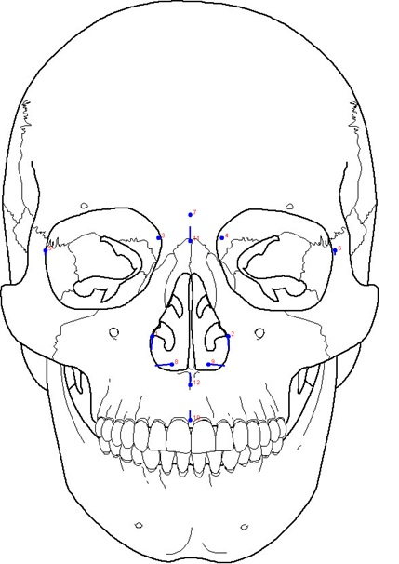
Figure 7. Anterior view of example facial variable analysis.

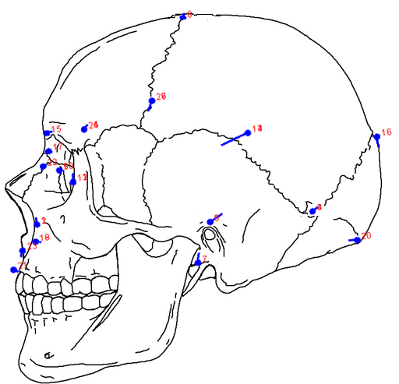
Figure 8. Lateral view example all variable analysis.

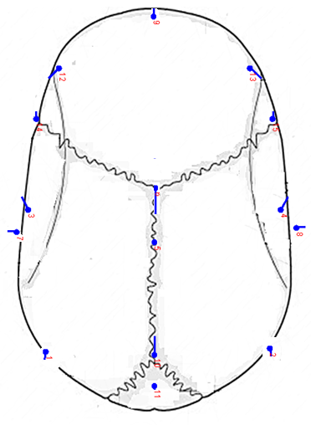
Figure 9. Superior view example vault analysis.

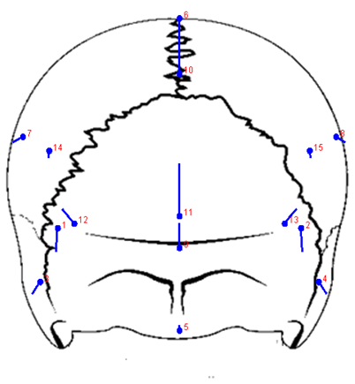
Figure 10. Posterior view example vault analysis.

Statistical Analyses

Several analyses were carried out to test the various hypotheses that were outlined previously. First, analyses were carried out using the 3D data, with male and female subsets analyzed separately.
Each group comparison was subjected to GPA superimposition and within group variance-covariance matrices were produced. Principal component analysis was carried out and the PC scores were retained for further comparisons. PC scores were inputted into IBM SPSS software (v.22.0) and a multivariate analysis of variance (MANOVA) was carried out to examine significant shape differences among regionally distinct modern Japanese groups. A Hotelling’s Two Sample T-Test was used for multiple comparisons.
Two major assumptions of MANOVA is equality of covariance matrices among groups and a normal data distribution. To test these assumptions, a Box’s M test was performed on PC scores to test for homogeneity of covariances matrices. PC scores were then tested for multivariate normality using Royston’s multivariate normality test. PC scores were also used to generate a QQ-plot, which visually compares Mahalanobis distances from the centroid against a chi-square distribution and is a common technique to identify outliers and assess multivariate normality. Royston’s test for multivariate normality and QQ-plots were carried out using the MVN package in R (Korkmaz, et al. 2014). Outliers were first identified and removed using the outlier detection option in MorphoJ. This approach provides a visual representation of the variance of each landmark for each observation relative to the cumulative distribution of Procrustes distances of the entire sample, which is representative of overall shape variation (Klingenberg and Monteiro, 2005).
For each sample comparison, an analysis of variance (ANOVA) was carried out on the Procrustes coordinates using grouping variables such as geographic region or time period to assess whether the classifier variable exhibited significant shape differences among groups. This approach also examined whether significant differences existed among compared groups in regards to centroid size.
Results of the male vault analysis using coordinate data was compared to a linear data analysis, to assess whether comparable results are found using coordinate data.
Group Comparisons/Hypothesis Testing
The goals of this dissertation are to build on the decades of research carried out in the Japanese archipelago to identify morphological patterns at a more finite level. This is achieved by recording and analyzing three dimensional coordinate data of the skull. With the use of coordinate data, examination of morphological shape can identify variation at a more meticulous level as each landmark and subsequently entire portions of the skull can be analyzed in relation to the rest of the specimen.
The first proposed hypothesis of this dissertation posits that employment of 3D data will provide differential conclusions regarding morphological trends in Japanese populations when compared to results achieved with linear data. This hypothesis is intentionally broad as to encompass a number of smaller scale, related questions. Thus, examination of this question comprises a number of group comparisons to re-examine major morphological trends in Japan that have been documented in the literature.
The first group of comparisons examines cranial variation in the modern period Japanese skeletal samples to provide a more in depth view of shape variables. The modern Japanese samples are also the best preserved and most complete, which allows for additional analyses. Consequently, the modern data set is also used to address the next broad question outlined in chapter one, which inquires whether different bony components of the skull (the facial and vault/base modules) will reflect different results in iterative comparisons. This is achieved by employing subsets of landmarks that represent different regions of the skull to ascertain whether the same result is achieved with a different type of data. For this initial run of comparative analyses, the samples representing northern (Hokkaido, Tohoku), central (Tokyo) and southern (Kyoto, Kyushu, Okinawa) Japan were grouped into subsets. Group comparisons involved a vault landmark only analysis, a facial landmark only analysis, an all variable landmark analysis and finally, the inclusion of linear distances of vault landmarks.

Following this initial battery of comparisons, a more focused hypothesis is addressed using 3D coordinate data. Examination of minute morphological changes in Japanese populations that represent the last several hundred years is employed to provide a more conclusive picture of shape changes associated with reported secular trends. Specifically, the comparison of samples from the medieval period, the Edo and the modern period using landmarks will allow for the identification of skeletal shape changes correlated with brachycephalization. This approach compares the results of studies that used somatometric data with data recorded from actual skeletal material in an effort to identify whether more biologically meaningful information can be inferred from the current data.
The final round of comparisons assesses whether any informative patterns can be gleaned from comparing the regional modern samples with the prehistoric groups. Potential similarities among Jomon and modern groups (particularly the geographically extreme northern and southern cohorts) are postulated to be either retention of morphology exhibited in premodern parental populations or occurrences of genetic drift (such as in isolation by distance). While some studies have described the modern Japanese population as a homogeneous, the current comparison of the regionally distinct modern samples with Jomon, Ainu and Yayoi groups with 3D data may identify population substructure that has not been apparent in previous studies that have used linear metric datasets.

CHAPTER 5
RESULTS

Results are presented for the various analyses described in the previous chapter. Results of the 3D analyses are presented first. The geometric morphometric approach of General Procrustes Analysis was performed on a number of subsets of total samples to investigate hypotheses previously described. GPA scaled variance/covariance matrices were computed and PC scores were produced via principal component analysis. For each comparison described previously, MANOVA results are first presented, followed by Hotelling’s T-Square Two Sample Test to identify which groups differ in regards to principal component scores. Results of the ANOVA’s used to examine differences in centroid size and overall shape are then presented. Finally, the results of canonical variate analyses and discriminant function analysis (DFA) on linear metrics are presented next (DFA used only for the first analysis). Visualization of shape changes are also provided via wireframe figures. Interpretation and discussion of results is offered in the following chapter.
Assumption Tests
Prior to each analysis, each dataset was examined for the presence of outliers. The squared Procrustes distances from the mean for each individual in cohort samples was compared to the cumulative distribution of Procrustes distances. Significant deviations from the mean are identified at all landmarks for each observation in a dataset (Figure XX). A preliminary principal components analysis was additionally run and observations were plotted by PC score to further identify any possible outliers (Figure XX). After outlier removal, each sample was checked for multivariate normality using Royston’s test in R. If the dataset was not normal, the previous steps were repeated until multivariate normality was achieved. See figures XX-XX in appendix XX for results of Royston’s test and QQ-plots with associated confidence bands surrounding the normal distribution line.
Homogeneity of covariance matrices among samples were assessed using Box’s M test in SPSS. All group comparisons had equal variances after outlier removal, barring the modern male facial variable analysis and the prehistoric and modern female comparison. The robust test statistics of Pillai’s Trace, Hotelling’s Trace and Wilks’ Lambda were reported in the MANOVA results in an effort to be conservative given that some assumptions were violated. See figures xx-xx in appendix X for results of Box’s M tests for all group comparisons.

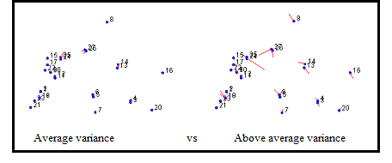
Figure 7. Average and above average deviation from the mean at landmarks.

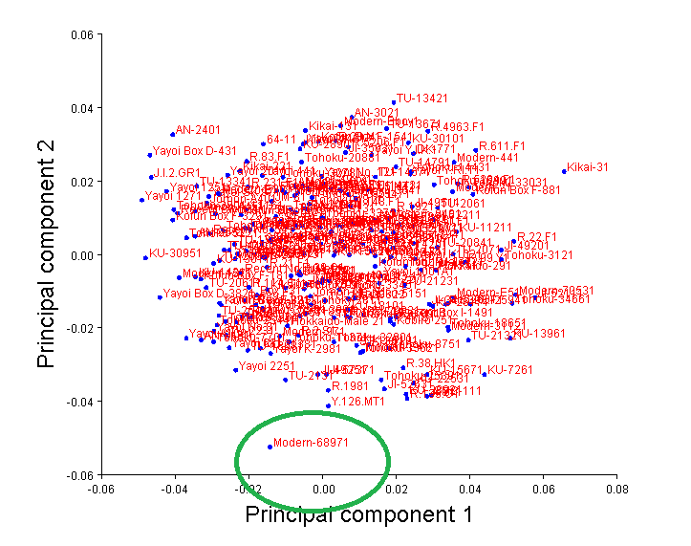
Figure 8. Outlier detection using PCA plot.

Modern Group Comparison Results

Male Vault Analysis

Principal component analysis was first carried out on the vault landmarks. The first twelve components account for 90.8% of the variance, and thus were retained to test for mean differences among groups (Table 5).
The first twelve principal components were used to compare the central, northern and southern regional samples. MANOVA showed that the samples differed in regards to the first twelve components (Table 8). The Hotelling’s T-2 indicated that the central group was distinct from the southern and northern groups (Table 9).
Centroid size was calculated and compared among groups and indicated that there were not significant differences among groups (Table 9). To examine if there were statistical differences for shape variables among groups, a Procrustes ANOVA was conducted, with region used as the effect. This test was significant and indicated that the shape variables (PC scores from the first fourteen principal components) differed among groups but overall size did not (Table 10).

Table 5. Eigenvalues and percent variance for principal components 1-12.
Component | Eigenvalues | % Variance | Cumulative %
1 | 0.00112952 | 27.084 | 27.084
2 | 0.00053700 | 12.876 | 39.961
3 | 0.00042899 | 10.287 | 50.247
4 | 0.00034028 | 8.159 | 58.406
5 | 0.00029797 | 7.145 | 65.551
6 | 0.00025608 | 6.141 | 71.692
7 | 0.00018522 | 4.441 | 76.133
8 | 0.00016919 | 4.057 | 80.190
9 | 0.00014129 | 3.388 | 83.578
10 | 0.00011764 | 2.821 | 86.399
11 | 0.00009734 | 2.334 | 88.733
12 | 0.00008698 | 2.086 | 90.819

Table 8. MANOVA Results for modern males vault variables.
 |  |  | Value | F | Hypothesisdf | Error DF | Sig.
Intercept |  | Pillai’s Trace | .016 | .263^{b} | 12 | 189.00 | .994
 |  | Wilks’ Lambda | .984 | .263^{b} | 12 | 189.00 | .994
 |  | Hotelling’s Trace | .017 | .263^{b} | 12 | 189.00 | .994
Region |  | Pillai’s Trace | .375 | 3.659 | 24 | 380.00 | .000
 |  | Wilks’ Lambda | .649 | 3.806^{b} | 24 | 378.00 | .000
 |  | Hotelling’s Trace | .505 | 3.952 | 24 | 376.00 | .000

Table 9. Hotelling’s T2 Two Sample Test for group comparisons.
Covariance Assumption |  | T2 | DF1 | DF2 | Parametric P | Randomization P
Central/Northern | Equal | 66.785 | 5 | 108.0 | 0.0000 | 0.0010
 | Unequal | 65.754 | 5 | 88.5 | 0.0000 | 0.0010
Southern/Northern | Equal | 7.351 | 5 | 167.0 | 0.2143 | 0.1930
 | Unequal | 8.774 | 5 | 137.4 | 0.1380 | 0.1270
Central/Southern | Equal | 34.504 | 5 | 159.0 | 0.0000 | 0.0010
 | Unequal | 36.296 | 5 | 86.0 | 0.0000 | 0.0010

Canonical Variate Analysis
Canonical variate analysis was conducted to explore differences and patterns between samples in regards to the majority of landmarks that make up the vault and cranial base. Results showed separation among groups, however a large amount of overlap is found. Canonical variate (CV) one accounted for 82% of the explained variance (Table 10). The wireframe shape change showed differences occurring in the superior region of the vault and the maximum vault breadth (Figure 12). Canonical variate plots of group centroids show the northern and southern group centroids is displaced towards the positive end of the axis, indicating higher vault heights and wider cranial breadths than the central group centroid, which plots on the negative side of the axis (Figure 14). CV two is responsible for roughly 18 % of the variance and shows the largest shape changes in breadth of the vault and the position of bregma and the occipital (Table 11 and Figure 13). Patterning of group centroids is much more difficult to discern, but shows the southern group slightly and northern group centroids are slightly displaced towards the positive end of the axis, indicating slightly wider crania overall and a higher position of bregma and more inferior placement of the occipital bone. Observation of Mahalanobis distance matrix supports the patterns observed in the CV plots and shows the least amount of distance between the northern and southern groups, with the central group showing a larger distance to the southern group, and the largest distance to the northern group (Table 12).

Table 10. Eigenvalues and percent variance for canonical components 1 and 2.
Component | Eigenvalues | Variance % | Cumulative %
1 | 1.91526920 | 83.920 | 83.920
2 | 0.36698090 | 16.080 | 100.00

(a)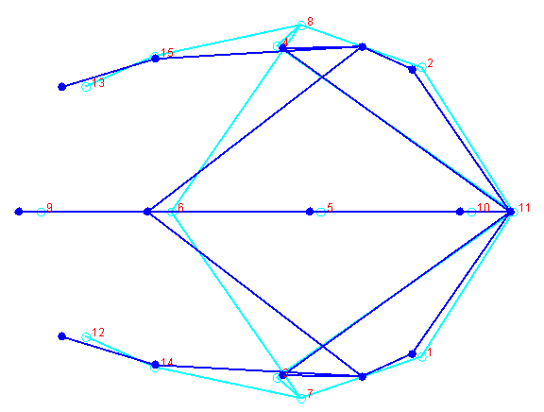 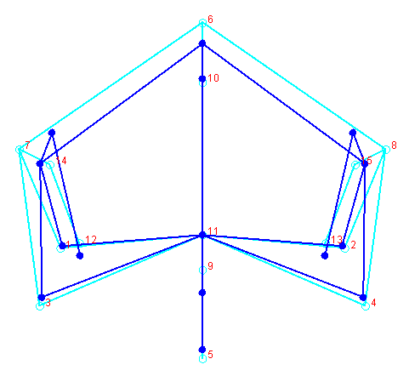(b)
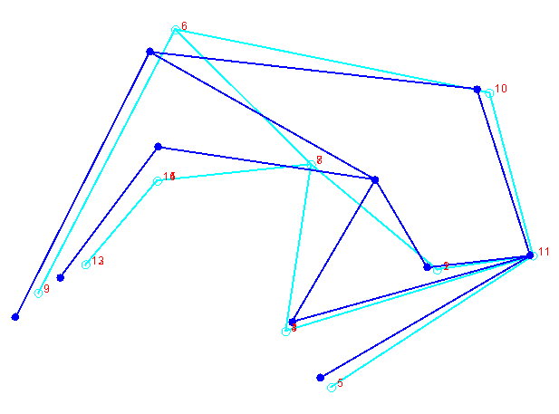(c)
Figure 9. CV1 shape differences for modern males. (a) Superior view, (b) Anterior view, (c) Lateral view.

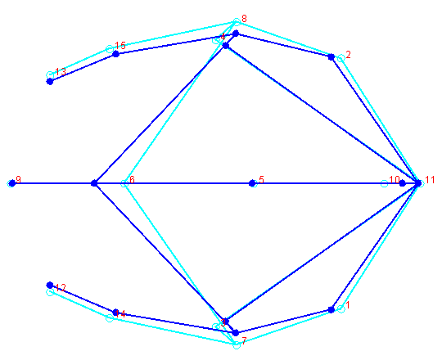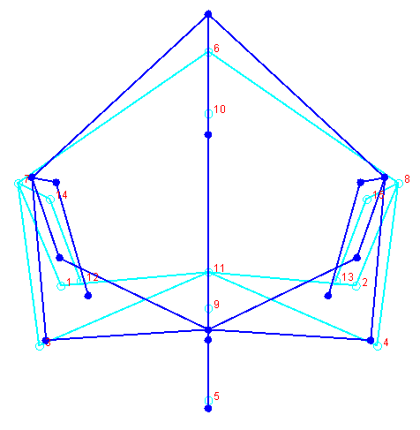
- (b)
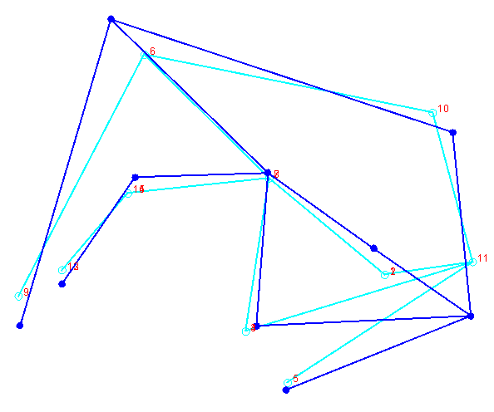(c)
Figure 10. CV1 shape differences for modern males. (a) Superior view, (b) Anterior view, (c) Lateral view.

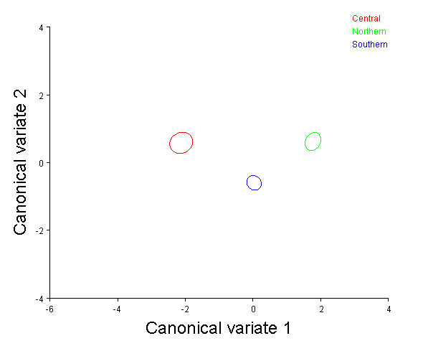
Figure 11. CV1 and CV2 scores for modern male vault analysis.

Table 11. Mahalanobis distances among modern male regions.
Central Northern
Northern 3.8971
<0.0001
Southern 2.4564 2.1287
<0.0001 <0.0001

Male Facial Analysis

Principal component analysis was also performed on the facial landmarks. The first eleven components account for 92.5% of the variance, and were used to compare means among groups (Table 13). The Pillai’s trace test statistic was used to examine statistical differences. The Box’s M test showed that there were equal covariance matrices among groups for the facial landmark analysis (Table 14). Upon removal of outliers, the Royston’s test showed that data was multivariate normal, which can be visually appreciated in the QQ-plot (Table 15 and Figure 15). Results of the MANOVA on the eleven first PCS indicated that groups differed (Pillai’s trace= .000) (Table 16).
As with the vault only analysis, centroid size was again calculated and compared among groups, and displayed no significant differences among groups (Table 17). Results of the Procrustes ANOVA showed statistical significant differences for shape variables among groups, again indicating that facial shape was different among groups but size was not (Table 18).

Table 12. Eigenvalues and percent variance for principal components 1-11.
Component | Eigenvalues | % Variance | Cumulative %
1 | 0.00070445 | 21.888 | 21.888
2 | 0.00045745 | 14.214 | 36.102
3 | 0.00040750 | 12.662 | 48.764
4 | 0.00035920 | 11.161 | 59.925
5 | 0.00022510 | 6.994 | 66.919
6 | 0.00018571 | 5.770 | 72.689
7 | 0.00017347 | 5.390 | 78.080
8 | 0.00014130 | 4.391 | 82.470
9 | 0.00011709 | 3.638 | 86.108
10 | 0.00009913 | 3.080 | 89.188
11 | 0.00009731 | 3.024 | 92.212

Table 13. MANOVA results for modern males facial variables.
 |  |  | Value | F | Hypothesisdf | Error DF | Sig.
Intercept |  | Pillai’s Trace | .015 | .268^{b} | 11 | 193.00 | .991
 |  | Wilks’ Lambda | .985 | .268^{b} | 11 | 193.00 | .991
 |  | Hotelling’s Trace | .015 | .268^{b} | 11 | 193.00 | .991
Region |  | Pillai’s Trace | .523 | 6.246 | 22 | 388.00 | .000
 |  | Wilks’ Lambda | .519 | 6.800^{b} | 22 | 386.00 | .000
 |  | Hotelling’s Trace | .844 | 7.362 | 22 | 384.00 | .000

Table 14. Hotelling’s T2 Two Sample Test for group comparisons.
Covariance Assumption |  | T2 | DF1 | DF2 | Parametric P | Randomization P
Central/Northern | Equal | 28.057 | 5 | 80.0 | 0.0003 | 0.0010
 | Unequal | 26.059 | 5 | 63.8 | 0.0008 | 0.0020
Southern/Northern | Equal | 14.321 | 5 | 138.0 | 0.0201 | 0.0220
 | Unequal | 16.103 | 5 | 102.7 | 0.0123 | 0.0140
Central/Southern | Equal | 11.388 | 5 | 120.0 | 0.0588 | 0.0510
 | Unequal | 14.305 | 5 | 53.7 | 0.0337 | 0.0250

Canonical Variate Analysis Results

Results of canonical variate analysis of the facial variables showed mostly similar patterns among groups, as was compared to the results of the vault only analysis. CV one accounted for 78% of the variance (Table 19). The wireframe shape change figure showed differences in the inferior portion of the nasal aperture and slight differences of the anteroposterior position of nasal landmarks (Figure 16). Examination of group plots shows group centroids equidistant to one another, with the central group at the positive end of the axis, the northern at the negative end and the southern group placed intermediate between (Figure 18). The central group exhibits a broader, slightly taller nasal aperture that projects more anteriorly than the other groups (Figure 18). CV two is responsible for 17% of the variance (Table 20). The wireframe shows minimal differences among groups but does indicate a slightly more anterior position of subspinale, just inferior to the nasal sill in the midline (Figure 17). Differences are also identified in the position of the lateral orbit in a superoinferior orientation, as well as the distance between the orbits at dacryon. Some differences are shown in the breadth of the nasal aperture, as was observed in CV1, but to a lesser degree (Figure 17). The group centroid plot shows the central and northern group slightly above the southern group, indicating a narrower interorbital breadth, a slightly higher positon of the lateral rim of orbits and an anterior projection of the maxilla below the nasal sill (Figure 18). The Mahalanobis distance matrix shows the similar patterns identified in the vault variable analysis. Primarily, the least amount of distance is found between the northern and southern groups (Table 21). However, the northern and central group exhibit the largest distance between them, as opposed to the southern and central group that was observed in the facial analysis.

Table 15. Eigenvalues and percent variance for canonical components 1 and 2.
Component | Eigenvalues | % Variance | Cumulative %
1 | 0.98281987 | 86.288 | 86.288
2 | 0.15618155 | 13.712 | 100.00

(a)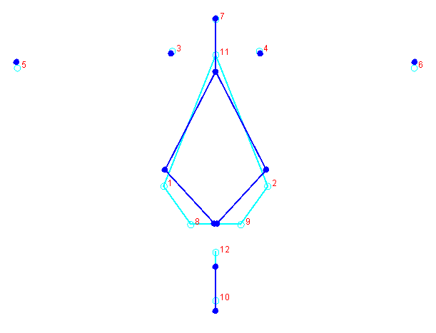 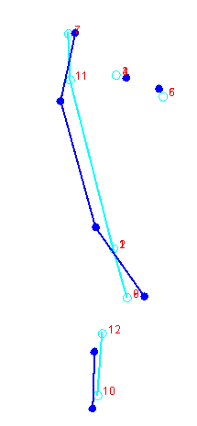(b)
Figure 12. CV1 shape differences for modern males. (a) Anterior view, (b) Lateral view.

(a)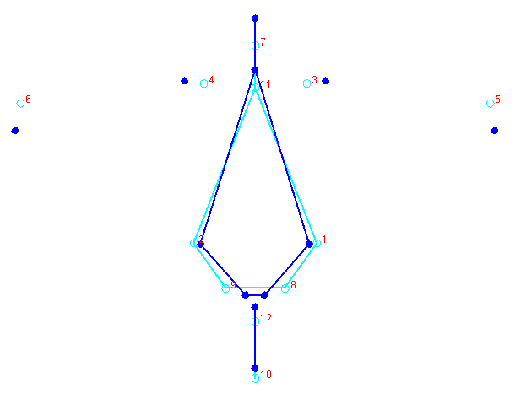 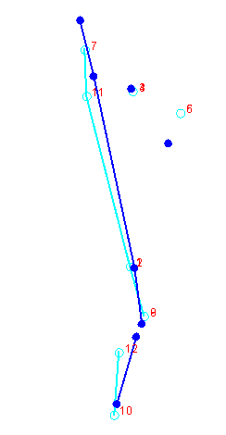 (b)
Figure 13. CV2 shape differences for modern males. (a) Anterior view, (b) Lateral view.

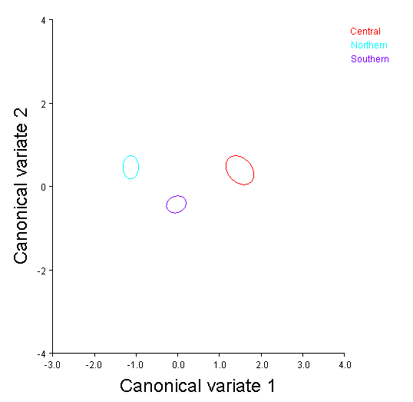
Figure 14. CV1 and CV2 scores for modern male facial analysis.

Table16. Mahalanobis distances among modern male groups.
Central Northern
Northern 2.8947
<.0001
Southern 1.7309 1.5687
<.0001 <.0001

Male All Variable Analysis

As the modern samples were the most complete in comparison to the archaeological groups, an additional analysis was run using all cranial landmarks. This approach was used as a way to examine the validity of using a particular module (such as the face or vault) rather than the skull in its entirety to examine group differences. Principal component analysis found that the first seventeen components accounted for 90.3% of the variance (Table 17). The Box’s M Test showed that groups had unequal covariance matrices, and the Royston’s test showed the data was multivariate (Tables 22 and 23). Examination of the QQ-plot supports the normality test (Figure 19).
Calculation and comparison of centroid size among groups indicated that groups were significantly different in regards to size (Table 24). The Procrustes ANOVA showed that the groups were also different in regards to shape variables (Table 25).

Table 17. Eigenvalues and percent variance for principal components 1-17.
Component | Eigenvalues | % Variance | Cumulative %
1 | 0.00076326 | 21.985 | 21.985
2 | 0.00039562 | 11.396 | 33.381
3 | 0.00029207 | 8.413 | 41.794
4 | 0.00026118 | 7.523 | 49.317
5 | 0.00022826 | 6.575 | 55.892
6 | 0.00019918 | 5.737 | 61.629
7 | 0.00016959 | 4.885 | 66.514
8 | 0.00014514 | 4.181 | 70.695
9 | 0.00012369 | 3.563 | 74.258
10 | 0.00011069 | 3.188 | 77.446
11 | 0.00009362 | 2.697 | 80.143
12 | 0.00008008 | 2.307 | 82.450
13 | 0.00006811 | 1.962 | 84.412
14 | 0.00006358 | 1.831 | 86.243
15 | 0.00005288 | 1.523 | 87.766
16 | 0.00004680 | 1.348 | 89.114
17 | 0.00004006 | 1.154 | 90.268

Table 18. MANOVA results for modern male all variable analysis.
 |  |  | Value | F | Hypothesisdf | Error DF | Sig.
Intercept |  | Pillai’s Trace | .020 | .211^{b} | 17 | 175.00 | .991
 |  | Wilks’ Lambda | .980 | .211^{b} | 17 | 175.00 | .991
 |  | Hotelling’s Trace | .020 | .211^{b} | 17 | 175.00 | .991
Region |  | Pillai’s Trace | .435 | 2.878 | 34 | 352.00 | .000
 |  | Wilks’ Lambda | .604 | 2.947^{b} | 34 | 350.00 | .000
 |  | Hotelling’s Trace | .441 | 4.568^{c} | 34 | 348.00 | .000

Table 19. Hotelling’s T2 Two Sample Test for group comparisons.
Covariance Assumption |  | T2 | DF1 | DF2 | Parametric P | Randomization P
Central/Northern | Equal | 10.352 | 2 | 95.0 | 0.0077 | 0.0100
 | Unequal | 10.524 | 2 | 79.0 | 0.0076 | 0.0100
Southern/Northern | Equal | 1.293 | 2 | 149.0 | 0.5275 | 0.5380
 | Unequal | 1.381 | 2 | 125.4 | 0.5060 | 0.5150
Central/Southern | Equal | 6.339 | 2 | 138.0 | 0.0461 | 0.0450
 | Unequal | 7.422 | 2 | 76.5 | 0.0303 | 0.0280

Canonical Variate Analysis Results

Results of the all variable analysis yielded very interesting results, as groups were easier to delineate by region than was found with the vault or facial variable only analyses. CV one accounts for 84% of the variance (Table 20). Examination of the wireframe shape change figure showed the largest amounts of variation among cranial vault height, cranial breadth width of the nasal aperture (Figures 20). Examination of the group centroid plot showed clear separation among all groups, with the northern group located on the positive end of the axis, indicating the widest vault breadths relative to the tallest vault heights and the narrowest nasal apertures (Figure 22). The central group centroid is on the negative side of the axis, indicating narrower vault breadth, shorter vault height but a wider nasal aperture. The southern group centroid is again positioned intermediate to both groups. CV two is responsible for roughly 16% of the variance (Table 28). Shape differences in the wireframe figure are identified in breadth of the frontal bone, length and breadth of the vault as well as position of the maxilla in an anteroposterior orientation (Figures 21). On this axis it is more difficult to distinguish patterns as group centroids are much closer to one another. However, the central and northern group centroids are displaced slightly above the southern group, indicating larger vault breadths and height relative to a more forward positioned maxilla (Figure 22). The Mahalanobis distance matrix again the least amount of distance between the northern and southern groups, as was found in previous analyses (Table 29). The central and northern groups show the largest difference within the matrix.

Table 20. Eigenvalues and percent variance for canonical components 1 and 2.
Component | Eigenvalues | % Variance | Cumulative %
1 | 2.08218593 | 84.423 | 84.423
2 | 0.38417894 | 15.577 | 100.000

(a)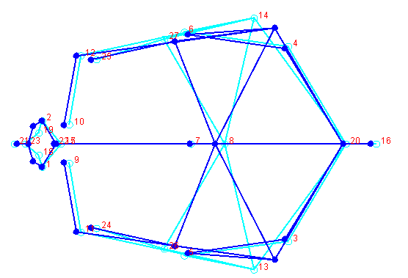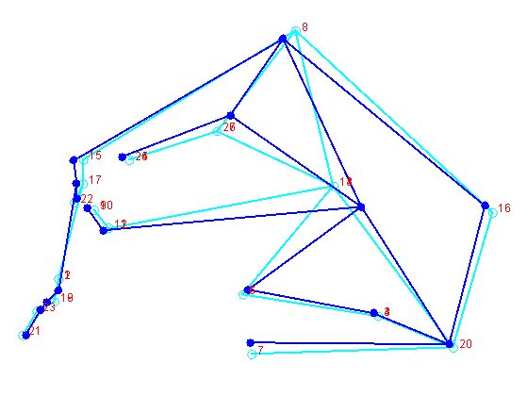(b)
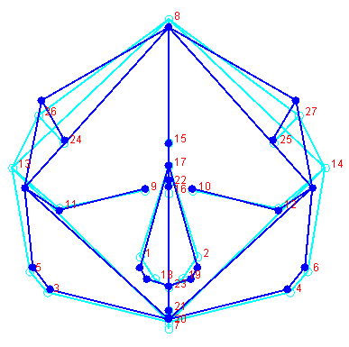(c)
Figure 15. CV1 shape differences for modern males. (a) Lateral view, (b) Superior view, (c) Anterior view.

(a)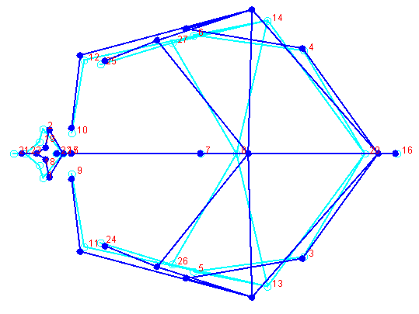 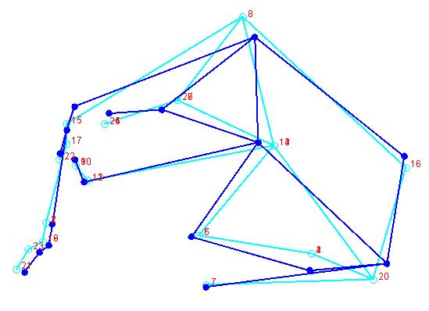(b)
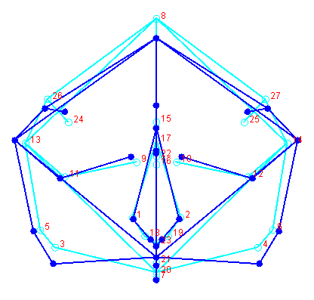(c)
Figure 16. CV1 shape differences for modern males. (a) Lateral view, (b) Superior view, (c) Anterior view.

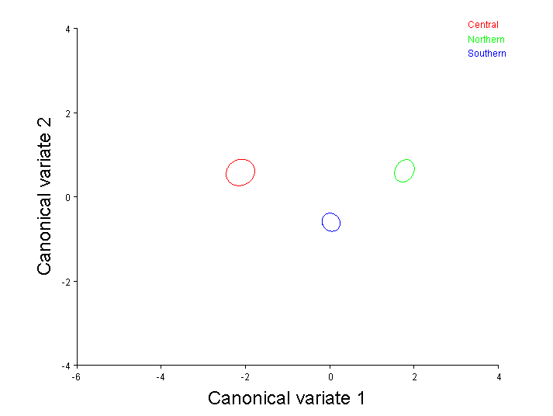
Figure 17. CV1 and CV2 scores for modern male all variable analysis.

Table 21. Mahalanobis distances for modern male regions.
Central Northern
Northern 4.0698
<.0001
Southern 2.4554 2.3030
<.0001 <.0001

Linear Data Analysis

The next component of this analysis is to examine whether results from a 2D analysis using traditional craniometrics provides the same results as does the 3D analysis. For simplicity purposes, and ease of interpretation, only the male vault landmark datasets were compared. Measurements using the landmarks that were available for the 3D analysis is fairly limited and only the variables of GOL, BBH, AUB, XCB, XFB, WFB, ASB, FRC and PAC were employed. Analyses were performed in SPSS. Principal component analysis was conducted and the first seven components were kept as they were found to be responsible for 94.6% of the variance (Table 29).
The Pillai’s trace test statistic was again used to identify any differences among groups. Results indicated that region differed in regards to the first seven components (Pillai’s trace= .014) (Table 30). The multiple comparison tests showed significant differences only for the central and southern group on PC2 (Appendix 4).

Table 22. Eigenvalues and percent variance for principal components 1-7.
Component | Eigenvalues | % Variance | Cumulative %
1 | 3.309 | 36.763 | 36.763
2 | 1.835 | 20.386 | 57.149
3 | .998 | 11.088 | 68.237
4 | .854 | 9.494 | 77.731
5 | .597 | 6.637 | 84.368
6 | .500 | 5.557 | 89.925
7 | .421 | 4.679 | 94.604

Table 23. MANOVA Results for modern males vault linear data.
Effect |  | Value | F | Hypothesis df | Error df | Sig.
Intercept | Pillai's Trace | .004 | .303^{b} | 3.000 | 231.000 | .823
Region | Pillai's Trace | .067 | 2.698 | 6.000 | 464.000 | .014

Canonical Variate Analysis Results

Canonical variate analysis using the PC scores showed minimal little separation among groups. CV one accounts for 60% of the explained variance (Table 31). Observation of the structure matrix shows CV1 loaded highest by PC5 and negatively loaded PC3 (Table 32). The component matrix shows that PC5 represents an inverse relationship between vault length, frontal breadth with posterior length and breadth of the vault (Table 33). Observation of the group centroid plot shows the central and southern group slightly distinct from the northern group on the positive end of the axis, indicating shorter vault lengths and narrow frontal breadths relative to larger values for parietal cord and asterionic breadth (Figure 23). CV2 accounts for 40% of the variance and is loaded almost entirely by PC2 (Table 31). The component matrix indicates that PC2 is negatively loaded by maximum cranial and frontal breadth and positively loaded by cranial length and parietal cord (Table 33). In regards to CV2, the southern group is located slightly higher than the central and northern group on the positive end of axis (Figure 23). Thus, the southern group represents narrow frontal and cranial breadths relative to a longer cranial length and parietal cord. The Mahalanobis distance matrix shows the relationships that were found with the facial variable analysis. Namely, that the southern and northern group shows the smallest distance, and the northern group is next closest to the central group (Table 34).
A cursory look at group means somewhat supports the slight differences observed in the canonical variate analysis (Table 35). However, it is important to highlight the overall similarity in group means. As centroid size was not found to be significantly different in the 3D analysis, it can be argued that the shape analysis provided variables that better identified differences amongst groups that can be used to better address hypotheses related to morphology, that are not necessarily dependent on size.

Table 24. Eigenvalues and percent variance for canonical components 1 and 2.
CV | Eigenvalues | % Variance | Cumulative %
1 | .102 | 60.0 | 60.0
2 | .068 | 40.0 | 100.00

Table 25. Structure matrix for 2D canonical variate analysis.

Structure Matrix
CV1 CV2
PC1 | .040 | .200
PC2 | -.210 | .821
PC3 | -.407 | .020
PC4 | .332 | .427
PC5 | .636 | .187
PC6 | .271 | -.063
PC7 | -.368 | .199

Table 26. Component matrix for modern male analysis.
Component Matrix
 | PC1 | PC2 | PC3 | PC4 | PC5 | PC6 | PC7
GOL | .629 | .585 | .114 | -.157 | -.310 | -.109 | .204
BBH | .691 | .310 | -.286 | .303 | .239 | .105 | -.403
XCB | .564 | -.666 | -.200 | .067 | .136 | -.030 | .168
XFB | .586 | -.599 | .079 | .338 | .041 | .069 | .229
WFB | .575 | -.253 | .599 | .060 | -.334 | .252 | -.227
AUB | .735 | -.241 | .011 | -.255 | -.019 | -.534 | -.182
ASB | .604 | .060 | .032 | -.653 | .318 | .303 | .065
FRC | .635 | .333 | -.542 | .127 | -.292 | .127 | .126
PAC | .367 | .598 | .450 | .328 | .354 | -.122 | .180

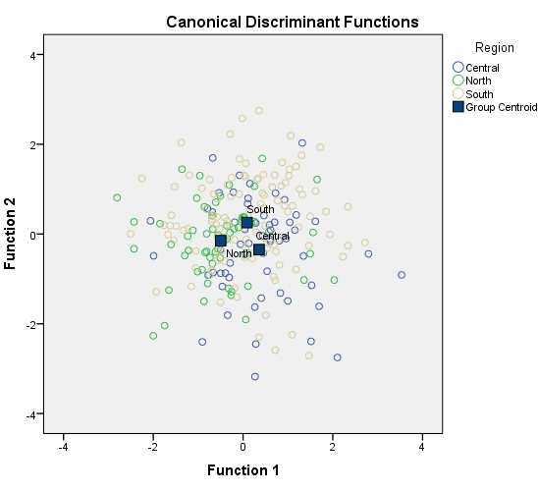

Figure 18. Canonical discriminant function score plot.

Table 27. Mahalanobis distance matrix for linear male analysis.
Central Northern
Northern 4.843

Southern 5.034 3.776

Table 28. Group means for modern males.
Group Means: Modern Male Vault Variables
Group | GOL | BBH | XCB | XFB | WFB | AUB | ASB | FRC | PAC
Northern | 180 | 136 | 137 | 115 | 93 | 123 | 107 | 110 | 112
Southern | 180 | 139 | 138 | 115 | 93 | 123 | 107 | 111 | 114
Central | 177 | 138 | 140 | 115 | 93 | 123 | 107 | 110 | 111

It thus can be argued that relationships were better identified with the 3D analysis, as delineation among groups was achieved. Additionally, the visual representation of shape differences among groups provides a guide for interpretation that can be better used to explore biological questions, As it has been established that more information about inter-group variation can be gleaned from the 3D analysis approach, the remaining hypotheses outlined in chapter one will be examined using coordinate data. It was also found that the partitioning of vault and facial variables did not produce significantly different results for the modern males, although it provided some additional information regarding morphological variation in the facial module. Therefore, to examine whether modern female groups show the same generally homogenous patterns that the males did, a female only analysis was performed with the vault and face combined.

Modern Females All Variable Analysis

Principal component analysis was performed on the combined vault and facial landmark dataset for the female samples. The first sixteen components accounted for 90.5% of the variance, and were retained to test for mean differences among groups (Table 29). The Box’s M Test showed that groups had unequal covariance matrices, but the Royston’s test showed the data was multivariate normal (Table 37 and 38). Examination of the QQ-plot shows a pattern that is consistent with multivariate normality (Figure 24). Given the unequal covariance matrices among groups however, the Pillai’s test statistic was still employed. Results of MANOVA indicated that regional samples differed in regards to the first sixteen components (Pillai’s trace= .000) (Table 39). However, upon examination of multiple comparison tests, it showed that significant differences were only identified in principal components 2, 4, 10 and 14. See Appendix 4 for pairwise differences.
Calculation and comparison of centroid size among groups indicated that the female groups were not significantly different in regards to size (Table 40). As with all of the modern male analyses, the Procrustes ANOVA showed that groups differed significantly in regards to shape variables (Table 41).

Table 29. Eigenvalues and percent variance for principal components 1-16.
Component | Eigenvalues | % Variance | Cumulative %
1 | 0.00080898 | 24.696 | 24.696
2 | 0.00041124 | 12.554 | 37.250
3 | 0.00028323 | 8.646 | 45.896
4 | 0.00025322 | 7.730 | 53.626
5 | 0.00021129 | 6.450 | 60.076
6 | 0.00017731 | 5.413 | 65.488
7 | 0.00014391 | 4.393 | 69.881
8 | 0.00012015 | 3.668 | 73.549
9 | 0.00011361 | 3.468 | 77.018
10 | 0.00009646 | 2.945 | 79.962
11 | 0.00008278 | 2.527 | 82.489
12 | 0.00006673 | 2.037 | 84.526
13 | 0.00006206 | 1.895 | 86.421
14 | 0.00005137 | 1.568 | 87.989
15 | 0.00004891 | 1.493 | 89.482
16 | 0.00004238 | 1.294 | 90.776

Table 30. MANOVA results for modern female analysis.
 |  |  | Value | F | Hypothesisdf | Error DF | Sig.
Intercept |  | Pillai’s Trace | .036 | .299^{b} | 16 | 127.00 | .996
 |  | Wilks’ Lambda | .964 | .299^{b} | 16 | 127.00 | .996
 |  | Hotelling’s Trace | .038 | .299^{b} | 16 | 127.00 | .996
Region |  | Pillai’s Trace | .391 | 1.941 | 32 | 32.00 | .003
 |  | Wilks’ Lambda | .643 | 1.976^{b} | 32 | 32.00 | .002
 |  | Hotelling’s Trace | .502 | 2.821^{c} | 32 | 32.00 | .002

Table 31. Hotelling’s T2 Two Sample Test for group comparisons.
Covariance Assumption |  | T2 | DF1 | DF2 | Parametric P | Randomization P
Central/Northern | Equal | 6.154 | 2 | 56.0 | 0.0569 | 0.0510
 | Unequal | 6.976 | 2 | 52.9 | 0.0402 | 0.0440
Southern/Northern | Equal | 1.011 | 2 | 109.0 | 0.6074 | 0.5940
 | Unequal | 1.656 | 2 | 39.7 | 0.4534 | 0.4480
Central/Southern | Equal | 2.836 | 2 | 119.0 | 0.2492 | 0.2690
 | Unequal | 2.966 | 2 | 57.7 | 0.2415 | 0.2550

Canonical Variate Analysis Results

Results of the female canonical variate analysis using all variables were comparable to those found with male analysis. Canonical variate one accounted for roughly 76% of the variance (Table 42). The wireframe shape change figure indicated the most differences at breadth of the frontal, breadth of the vault and forward projection of inferior border of the nasal aperture (Figure 25). Examination of group centroid plots show distinct separation among the northern and central groups, as was found in the male analysis (Figure 27). The central group shows larger dimensions at the positive end of the axis, indicating broader vault and frontal breadths and a more forwardly placed nasal aperture (Figure 27). The northern group is on the negative side of the axis, indicating narrower dimensions. As with the male analysis, the southern group is intermediate northern and central groups (Figure 27). Canonical variate two accounted for 24% of the variance and shows the majority of variation again at the frontal and vault breadth landmarks, as well as glabella and basion (Table 42 and Figure 26). The southern group is slightly displaced to the positive end of the axis, indicating broader frontal vault and base dimensions relative to taller and more anteriorly position dimensions for the frontal bone (Figure 27). The norther group shows the opposite of these patterns and the central group is intermediate. As with previous analyses, the Mahalanobis distance matrix shows the least amount of distance between the northern and southern groups (Table 43). The next smallest distance is between the central and southern group.

Table 32. Eigenvalues and percent variance for canonical components 1 and 2.
Component | Eigenvalues | % Variance | Cumulative %
1 | 1.35972992 | 76.560 | 76.560
2 | 0.41630257 | 23.440 | 100.000

- 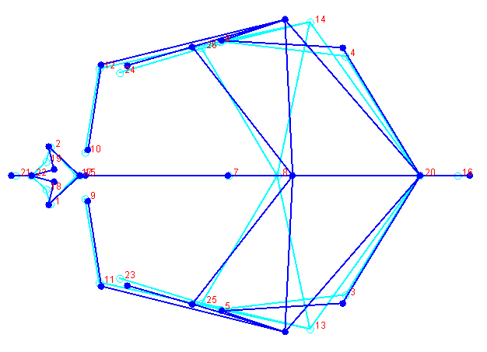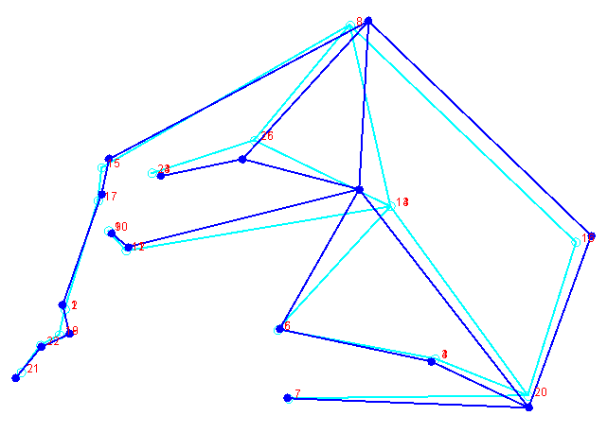(b)
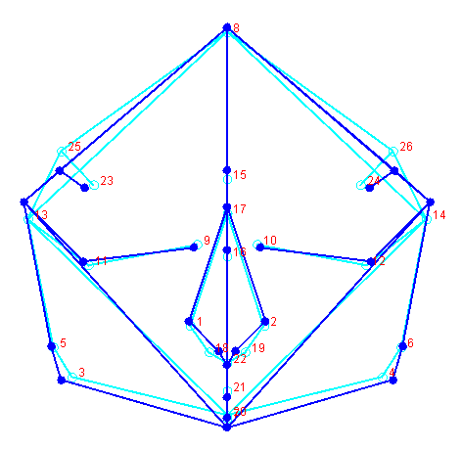(c)

Figure 19. CV1 shape differences for modern females. (a) Lateral view, (b) Superior view, (c) Anterior view.

(a)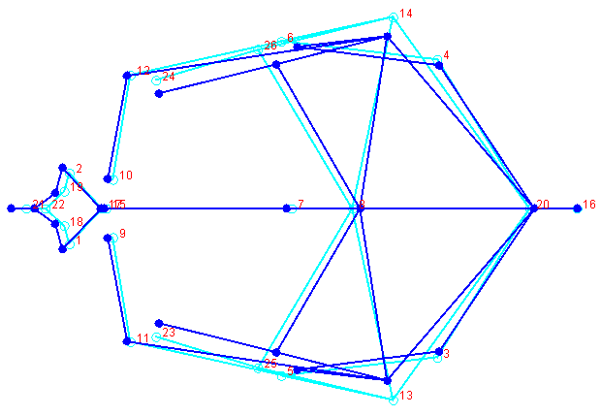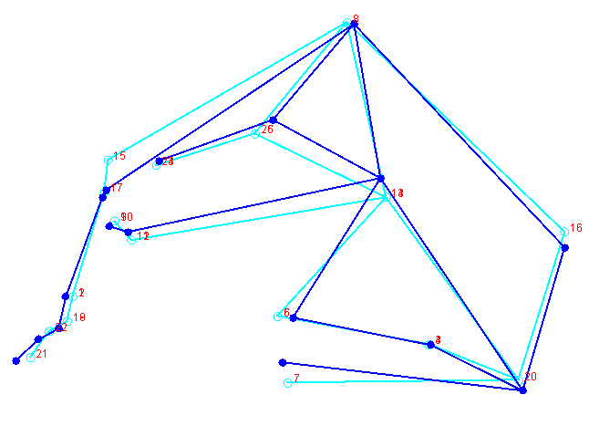(b)
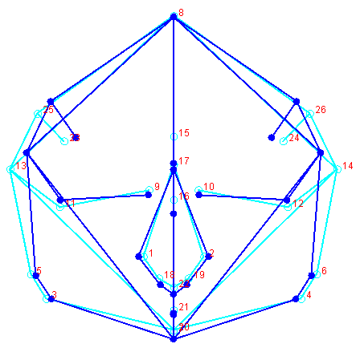(c)
Figure 20. CV2 shape differences for modern females. (a) Lateral view, (b) Superior view, (c) Anterior view.

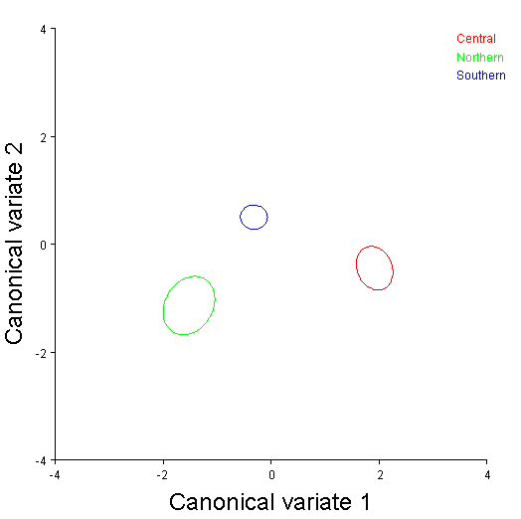
Figure 21. CV1 and CV2 scores for modern female all variable analysis.

Table 33. Mahalanobis distances for modern female regions.
Central Northern
Northern 3.5347
<.0001
Southern 2.45279 2.0027
<.0001 <.0001

Secular Change Shape Changes

The following analysis compared shape changes associated with samples from more recent time periods, in an effort to better quantify the morphological changes of modern Japanese people that have been documented in the literature. Male samples from the medieval, Edo and modern temporal periods were compared in the same manner as previous analyses. A female only analysis follows. As the more recent samples included in the following analyses are comparatively much more complete than the temporally earlier samples, the inclusion of vault and facial variables, all landmarks were used.

Male Analysis

Principal component analysis was performed using all landmarks. The first seventeen components account for 90% of the variance (Table 44). The Box’s M Test showed that groups had equal covariance matrices, however the Royston’s test showed the data was not multivariate normal, even after several iterations of outlier removal (Tables 45 and 46). Examination of the QQ-plot showed that deviation from normality did not occur in the majority of observations; however the Pillai’s test statistic was again used to examine differences among principal components (Table 47 and Figure 28). Results indicated that region differed in regards to the first seventeen components (Pillai’s trace= .000) (Table 48). The multiple comparison tests showed significant differences for PC 2, 5, 9, 10, 13 and 16. See Appendix 5 for significant pairwise differences.
Calculation and comparison of centroid size among groups indicated that the temporal groups were not significantly different in regards to size (Table 48. However, the Procrustes ANOVA showed that groups differed significantly in regards to shape variables (Table 49).

Table 34. Eigenvalues and percent variance for principal components 1-17.
Component | Eigenvalues | % Variance | Cumulative %
1 | 0.00064558 | 20.251 | 20.251
2 | 0.00035788 | 11.226 | 31.478
3 | 0.00027274 | 8.555 | 40.033
4 | 0.00025403 | 7.969 | 48.002
5 | 0.00022764 | 7.141 | 55.142
6 | 0.00019259 | 6.041 | 61.183
7 | 0.00014912 | 4.678 | 65.861
8 | 0.00013363 | 4.192 | 70.053
9 | 0.00010687 | 3.352 | 73.405
10 | 0.00009892 | 3.103 | 76.509
11 | 0.00009437 | 2.960 | 79.469
12 | 0.00007030 | 2.205 | 81.674
13 | 0.00006365 | 1.997 | 83.671
14 | 0.00005524 | 1.733 | 85.403
15 | 0.00005010 | 1.572 | 86.975
16 | 0.00004635 | 1.454 | 88.429
17 | 0.00003620 | 1.136 | 89.565
18 | 0.00003328 | 1.044 | 90.609

Table 35. MANOVA results for male secular change analysis.
 |  |  | Value | F | Hypothesisdf | Error DF | Sig.
Intercept |  | Pillai’s Trace | .157 | 2.158^{b} | 18 | 208.00 | ..005
 |  | Wilks’ Lambda | .843 | 2.158^{b} | 18 | 208.00 | .005
 |  | Hotelling’s Trace | .187 | 2.158^{b} | 18 | 208.00 | .005
Region |  | Pillai’s Trace | .329 | 2.284 | 36 | 418.00 | .000
 |  | Wilks’ Lambda | .695 | 2.306^{b} | 36 | 416.00 | .000
 |  | Hotelling’s Trace | .405 | 3.305^{c} | 36 | 414.00 | .000

Table 36. Hotelling’s T2 Two Sample Test for group comparisons.
Covariance Assumption |  | T2 | DF1 | DF2 | Parametric P | Randomization P
Medieval/Edo | Equal | 5.525 | 2 | 31.0 | 0.0854 | 0.0790
 | Unequal | 5.451 | 2 | 30.3 | 0.0886 | 0.0850
Edo/Modern | Equal | 12.394 | 2 | 54.0 | 0.0042 | 0.0080
 | Unequal | 19.596 | 2 | 8.9 | 0.0102 | 0.0240
Modern/Medieval | Equal | 28.624 | 2 | 60.0 | 0.0000 | 0.0010
 | Unequal | 32.870 | 2 | 15.0 | 0.0003 | 0.0010

Canonical Variate Analysis Results

Results of the secular change male analysis showed some differences among groups, but not as significantly as has been reported by previous studies. Canonical variate one accounts for roughly 60% of the variance (Table 37). Shape variation as indicated by the wireframe figure is most notable at the position of bregma in a superoinferior direction, and lambda in an anteroposterior direction. Also, the position of the region for maximum cranial breadth shows differences, but width of the vault does not (Figure 29). Additionally, the landmarks of the palate also differ in a superoinferior orientation (Figure 29). Vault length is also longer in the modern group due to a more posterior position of lambda, and the palate is slightly superior compared to other groups (Figure 29). Examination of group centroid plots for CV1 shows the modern group positioned at the positive end of the axis, indicating taller vault height due to a superior movement of bregma, as well as a higher position for maximum breadth of the vault (Figure 31). The medieval and Edo period group centroids are positioned almost directly on top of one another. CV2 two is responsible for just above 40% of the variance and shows the majority of variation occurring at the breadth of the frontal, the vault and cranial base at radiculare (Table 50 and Figure 30). Group centroid plots show the Edo group located at the highest end of the positive axis, with the modern group positioned slightly below it (Figure 31). These groups thus exhibit the largest vault and base breadths, with the medieval group exhibiting narrower dimensions for cranial breadth, which has been cited by previous studies. However, not found was a longer cranial length in the medieval group, which has been reported by several Japanese studies. The Mahalanobis distance matrix shows that the modern group is closest to the Edo group, but the medieval group is closer to the modern group (Table 51).

Table 37. Eigenvalues and percent variance for canonical components 1 and 2.
Component | Eigenvalues | % Variance | Cumulative %
1 | 0.59519624 | 65.324 | 65.324
2 | 0.31594800 | 34.676 | 100.000

(a)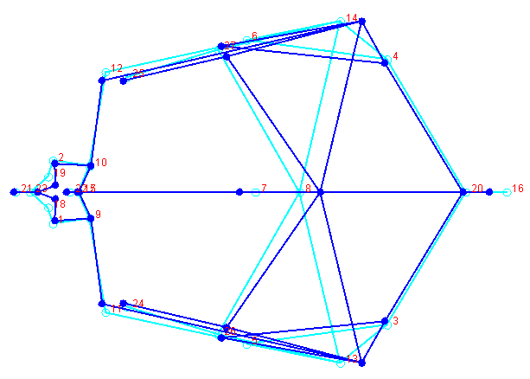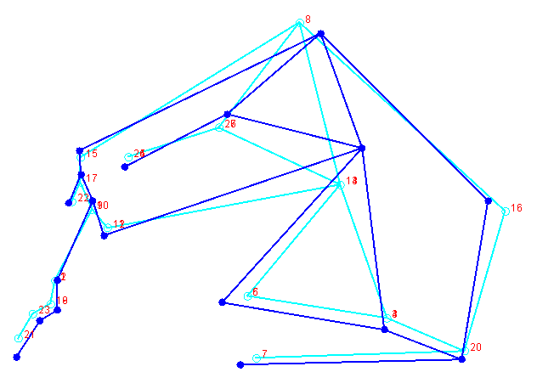(b)
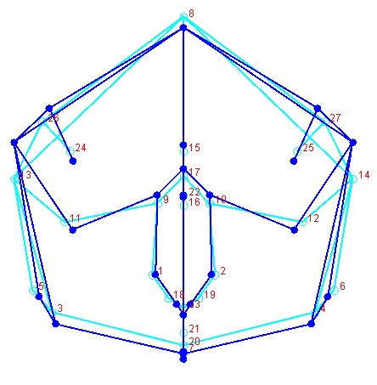(c)
Figure 22. CV1 shape differences for modern, medieval and Edo period males. (a) Lateral view, (b) Superior view, (c) Anterior view.

(a)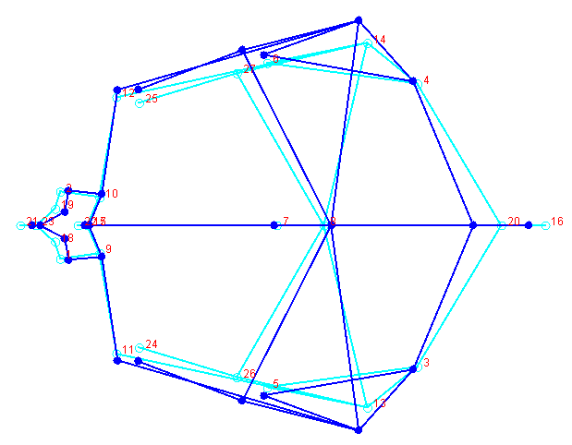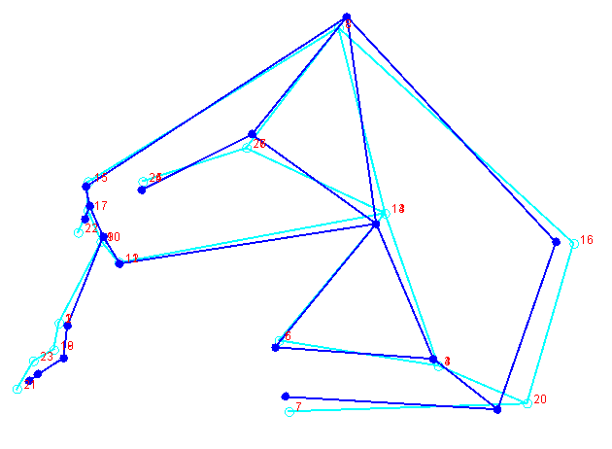(b)
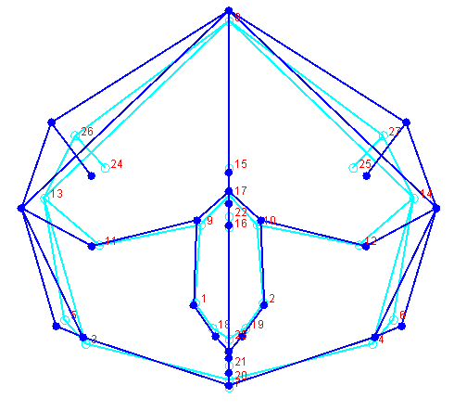 (c)
Figure 23. CV2 shape differences for modern. Medieval and Edo period males. (a) Lateral view, (b) Superior view, (c) Anterior view.

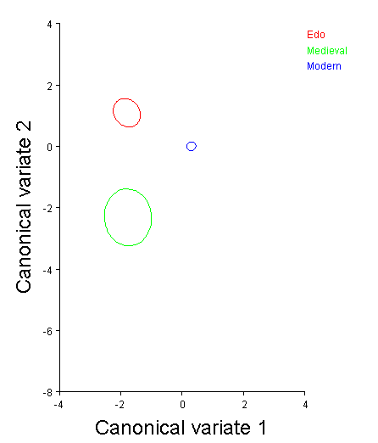
Figure 24. CV1 and CV2 scores for modern, medieval and Edo period males.

Table 38. Mahalanobis distances for medieval, modern and Edo males.
Edo Medieval
Medieval 3. 3570
<.0001
Modern 2.4926 3.1658 <. <.0001 <.0001

Female Analysis

Principal component analysis was performed using all landmarks for the female sample. The first sixteen components accounted for 90 % of the variance (Table 39). The Box’s M Test showed that groups had unequal covariance matrices, and the Royston’s test for multivariate showed the data was not multivariate normal (Tables 53 and 54). Examination of the QQ-plot showed that deviation from normality was minimal; however the Pillai’s test statistic was again used (Table 54 and Figure 32). Results indicated that the temporal samples differed in regards to the first sixteen components (Pillai’s trace= .000) (Table 55). The multiple comparison tests showed significant differences for PC 4-7, 11 and 12. See Appendix X for significant pairwise differences.
Calculation and comparison of centroid size among groups indicated that the female groups were not significantly different in regards to size (Table 56). As with the male analyses, the Procrustes ANOVA showed that groups differed significantly in regards to shape variables (Table 57).

Table 39. Eigenvalues and percent variance for principal components 1-17.
Component | Eigenvalues | % Variance | Cumulative %
1 | 0.00067026 | 22.062 | 22.062
2 | 0.00033700 | 11.092 | 33.154
3 | 0.00027317 | 8.992 | 42.146
4 | 0.00023705 | 7.803 | 49.948
5 | 0.00019926 | 6.559 | 56.507
6 | 0.00017351 | 5.711 | 62.218
7 | 0.00014299 | 4.707 | 66.925
8 | 0.00011775 | 3.876 | 70.801
9 | 0.00011088 | 3.650 | 74.450
10 | 0.00009585 | 3.155 | 77.605
11 | 0.00007659 | 2.521 | 80.126
12 | 0.00007081 | 2.331 | 82.457
13 | 0.00006350 | 2.090 | 84.547
14 | 0.00005572 | 1.834 | 86.381
15 | 0.00004529 | 1.491 | 87.872
16 | 0.00004172 | 1.373 | 89.245
17 | 0.00003470 | 1.142 | 90.387

Table 40. MANOVA results for secular change female analysis.
 |  |  | Value | F | Hypothesisdf | Error DF | Sig.
Intercept |  | Pillai’s Trace | .189 | 2.412^{b} | 17 | 176.00 | .002
 |  | Wilks’ Lambda | .811 | 2.412^{b} | 17 | 176.00 | .002
 |  | Hotelling’s Trace | .233 | 2.412^{b} | 17 | 176.00 | .002
Period |  | Pillai’s Trace | .513 | 3.594 | 34 | 354.00 | .000
 |  | Wilks’ Lambda | .545 | 3.6677^{b} | 34 | 352.00 | .000
 |  | Hotelling’s Trace | .726 | 5.410 | 34 | 348.00 | .000

Table 41. Hotelling’s T2 Two Sample Test for medieval and Edo groups.
Covariance Assumption |  | T2 | DF1 | DF2 | Parametric P | Randomization P
Medieval/Edo | Equal | 3.580 | 2 | 45.0 | 0.1856 | 0.1710
 | Unequal | 3.522 | 2 | 43.0 | 0.1914 | 0.1820
Edo/Modern | Equal | 12.394 | 2 | 54.0 | 0.0042 | 0.0080
 | Unequal | 19.596 | 2 | 8.9 | 0.0102 | 0.0240
Modern/Medieval | Equal | 28.624 | 2 | 60.0 | 0.0000 | 0.0010
 | Unequal | 32.870 | 2 | 15.0 | 0.0003 | 0.0010

Canonical Variate Analysis Results

Results of the secular change female analysis supported what was found in the male analysis. CV one accounted for roughly 73% of the variance (Table 42). Shape variation in the wireframe figure is most notable at the position of bregma in a superoinferior direction (Figure 33). To a lesser degree, shape change is also observed in the breadth of vault at eurion and in the position of the palate. The modern group shows the largest dimensions in regards to these variables, and observation of group centroid plots show the modern group at the positive end of the axis (Figure 35). The Edo group is at the negative end of the axis, while the medieval group is intermediate, indicating somewhat shorter vault heights due to the position of bregma (Figure 35). Additionally, the Edo and medieval groups show a slightly more inferiorly positioned palate. Canonical variate two is responsible for 27% of the variance and the wireframe figure shows the majority of variation occurring at landmarks that are responsible for width and length of the vault (Table 58 and Figure 34). The group centroid plots show the Edo and modern group at the positive end of the axis, distinct from medieval group which plots towards the negative end of the axis (Figure 35). The Edo and modern groups exhibit significantly wider vault breadths, and slightly longer lengths due to the anterior movement of glabella and posterior movement of the occipital and parietals. In the male analysis, the medieval group exhibited longer crania. The longer length of the vault in the recent female samples is interesting as that trend has not previously been described in the literature. The more anterior position of the upper face, and more posterior placement of the occipital shows the medieval group displaying narrower dimensions when compared to the modern and Edo periods. The Mahalanobis distance matrix showed that, as was found with the male analysis, the medieval and modern groups exhibit the smallest distance while the Edo group is more distant to both groups (Table 59).

Table 42. Eigenvalues and percent variance for canonical components 1 and 2.
Component | Eigenvalue | % Variance | Cumulative %
1 | 1.47804122 | 73.713 | 73.713
2 | 0.52708617 | 26.287 | 100.000

(a)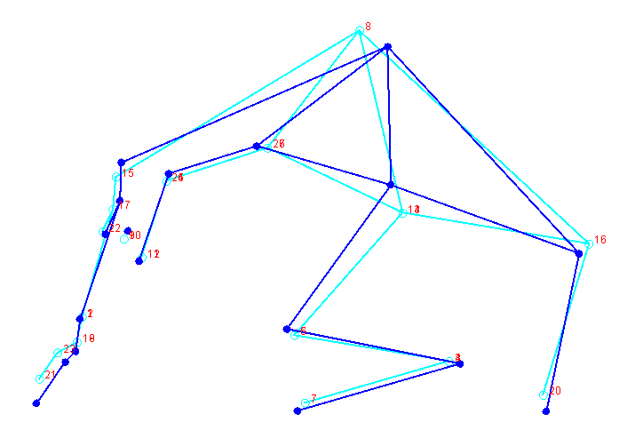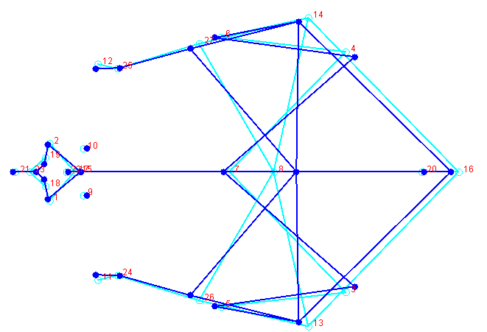(b)
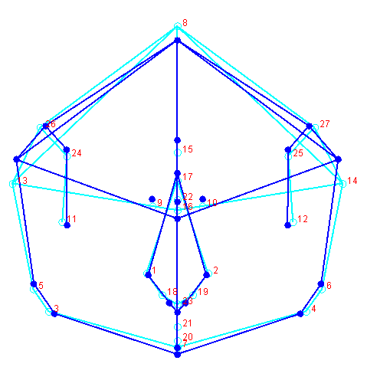(c)
Figure 25. CV1 shape differences for modern, medieval and Edo period females. (a) Lateral view, (b) Superior view, (c) Anterior view.

(a) 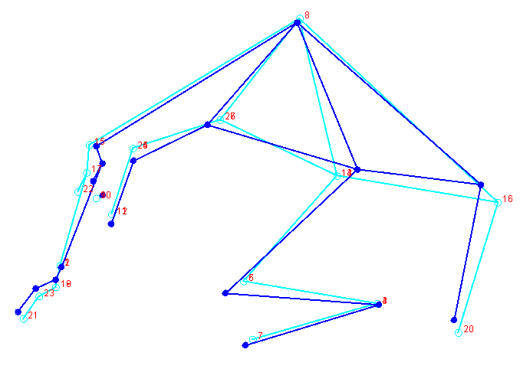 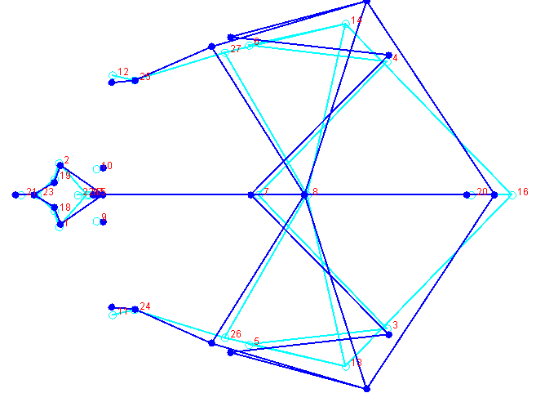(b)
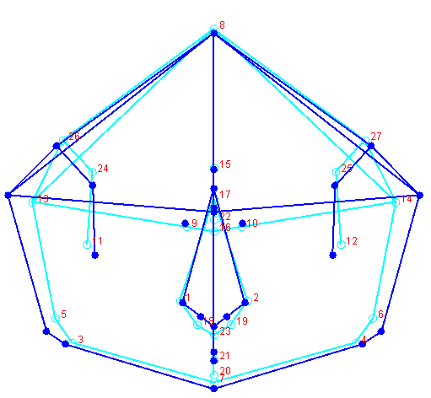(c)
Figure 26. CV2 shape differences for modern, medieval and Edo period females. (a) Lateral view, (b) Superior view, (c) Anterior view.

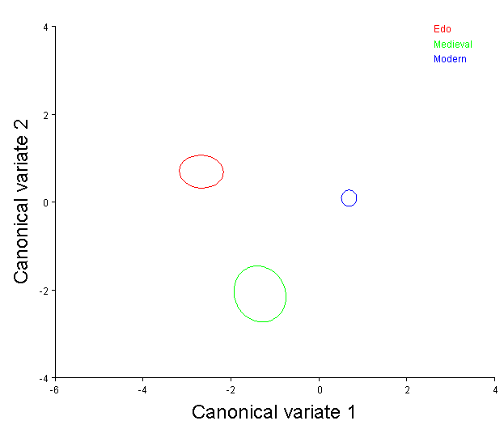
Figure 27. CV1 and CV2 scores for medieval, modern and Edo period females.

Table 43. Mahalanobis distances for medieval, modern and Edo females.
Edo Medieval
Medieval 3.1438
<.0001
Modern 3.2069 3.0537
<.0001 <.0001

Prehistoric and Modern Group Analysis

To examine the hypothesis that the northernmost populations (including the Ainu) and the southernmost populations experienced less admixture with the Yayoi than mainland Japanese populations, the regional modern samples were again partitioned into northern, central and southern cohorts. The regional groups were compared to the Jomon, Ainu, Yayoi and Kofun samples, with males and females analyzed separately. Male vault and facial landmarks were examined in separate analyses, partly to maximize sample size and to assess whether similar results are found when using landmarks that represent two separate cranial modules. The female groups were analyzed with all variables, as the same number of individuals was available in both datasets.

Male Vault Analysis

The first twelve components account for 90 % of the variance (Table 60). The Box’s M Test showed that groups had unequal covariance matrices and the Royston’s test showed that the data was not multivariate normal (Tables 61 and 62). Examination of the QQ-plot showed that deviation from normality only occurred for a small number of observations (Figure 36). The Pillai’s trace test statistic was used to examine statistical differences among principal components. Results indicated that temporal period differed in regards to the first seventeen components (Pillai’s trace= .000) (Table 63). The multiple comparison tests showed significant differences for PC 1-10, 12 and 14. See Appendix 7 for significant pairwise differences.

Calculation and comparison of centroid size among groups indicated that the vault variables of the prehistoric and modern groups were significantly different in regards to size (Table 64). Additionally, as with all previous analyses, the Procrustes ANOVA showed that groups differed significantly in regards to shape (Table 65).

Table 44. Eigenvalues and percent variance for principal components 1-13.
Component | Eigenvalues | % Variance | Cumulative %
1 | 0.00079179 | 22.881 | 22.881
2 | 0.00039888 | 11.527 | 34.408
3 | 0.00037452 | 10.823 | 45.230
4 | 0.00031036 | 8.969 | 54.199
5 | 0.00027362 | 7.907 | 62.106
6 | 0.00017777 | 5.137 | 67.243
7 | 0.00016572 | 4.789 | 72.031
8 | 0.00013315 | 3.848 | 75.879
9 | 0.00012102 | 3.497 | 79.376
10 | 0.00010731 | 3.101 | 82.477
11 | 0.00009688 | 2.800 | 85.277
12 | 0.00007296 | 2.108 | 87.385
13 | 0.00006678 | 1.930 | 89.315

Table 45. MANOVA results for male vault analysis.
 |  |  | Value | F | Hypothesisdf | Error DF | Sig.
Intercept |  | Pillai’s Trace | .205 | 6.305^{b} | 12 | 294.00 | .000
 |  | Wilks’ Lambda | .795 | 6.305^{b} | 12 | 294.00 | .000
 |  | Hotelling’s Trace | .257 | 6.305^{b} | 12 | 294.00 | .000
Period |  | Pillai’s Trace | .823 | 4.896 | 60 | 1490.00 | .000
 |  | Wilks’ Lambda | .367 | 3.806^{b} | 60 | 1380.47 | .000
 |  | Hotelling’s Trace | 1.251 | 3.952 | 60 | 1462.00 | .000

Table 46. Hotelling’s T2 Two Sample Test for Jomon and all other groups
Group Compared | Covariance Assumption | T2 | DF1 | DF2 | Parametric P | Randomization P
Ainu | Equal | 2.038 | 2 | 33.0 | 0.3834 | 0.3710
 | Unequal | 4.376 | 2 | 10.0 | 0.1950 | 0.1870
Yayoi | Equal | 0.768 | 2 | 47.0 | 0.6889 | 0.6950
 | Unequal | 1.838 | 2 | 7.9 | 0.4856 | 0.4950
Kofun | Equal | 12.394 | 2 | 54.0 | 0.0042 | 0.0080
 | Unequal | 19.596 | 2 | 8.9 | 0.0102 | 0.0240
Modern-C | Equal | 5.164 | 2 | 49.0 | 0.0903 | 0.1050
 | Unequal | 4.271 | 2 | 8.7 | 0.2154 | 0.2100
Modern-N | Equal | 4.625 | 2 | 59.0 | 0.1121 | 0.0970
 | Unequal | 6.756 | 2 | 7.6 | 0.1223 | 0.1000
Modern-S | Equal | 3.395 | 2 | 109.0 | 0.1908 | 0.1880
 | Unequal | 4.735 | 2 | 7.1 | 0.2101 | 0.1990
.

Table 47. Hotelling’s T2 Two Sample Test for Ainu and all other groups.
Group Compared | Covariance Assumption | T2 | DF1 | DF2 | Parametric P | Randomization P
Yayoi | Equal | 3.057 | 2 | 68.0 | 0.2292 | 0.2200
 | Unequal | 2.724 | 2 | 51.4 | 0.2722 | 0.2610
Kofun | Equal | 1.869 | 2 | 36.0 | 0.4124 | 0.4160
 | Unequal | 1.601 | 2 | 14.8 | 0.4923 | 0.4960
Modern-C | PC1 | 9.857 | 0.0025 | 6.425 | 0.0213 | 2.490
 | PC2 | 2.490 | 0.1191 | 13.792 | 0.0006 | 9.857
Modern-N | Equal | 2.401 | 2 | 80.0 | 0.3110 | 0.2870
 | Unequal | 2.575 | 2 | 48.8 | 0.2926 | 0.2740
Modern-S | Equal | 5.755 | 2 | 130.0 | 0.0612 | 0.0660
 | Unequal | 8.130 | 2 | 43.7 | 0.0262 | 0.0380

Table 48. Hotelling’s T2 Two Sample Test for Yayoi and all other groups.
Group Compared | Covariance Assumption | T2 | DF1 | DF2 | Parametric P | Randomization P
Kofun | Equal | 0.312 | 2 | 50.0 | 0.8585 | 0.8490
 | Unequal | 0.266 | 2 | 11.8 | 0.8867 | 0.8700
Modern-C | Equal | 28.088 | 2 | 84.0 | 0.0000 | 0.0010
 | Unequal | 28.040 | 2 | 81.5 | 0.0000 | 0.0010
Modern-N | Equal | 28.088 | 2 | 84.0 | 0.0000 | 0.0010
 | Unequal | 28.040 | 2 | 81.5 | 0.0000 | 0.0010
Modern-S | Equal | 19.135 | 2 | 144.0 | 0.0001 | 0.0010
 | Unequal | 22.821 | 2 | 90.3 | 0.0000 | 0.0010

Table 49. Hotelling’s T2 Two Sample Test for Kofun and all other groups.
Group Compared | Covariance Assumption | T2 | DF1 | DF2 | Parametric P | Randomization P
Modern-C | Equal | 14.368 | 2 | 52.0 | 0.0020 | 0.0060
 | Unequal | 12.430 | 2 | 12.9 | 0.0180 | 0.0210
Modern-N | Equal | 6.343 | 2 | 62.0 | 0.0513 | 0.0460
 | Unequal | 4.568 | 2 | 11.3 | 0.1740 | 0.1510
Modern-S | Equal | 7.752 | 2 | 112.0 | 0.0244 | 0.0220
 | Unequal | 7.181 | 2 | 10.6 | 0.0834 | 0.0740

Canonical Variate Analysis Results

Results of the male vault analysis provided insight into relationships between prehistoric and modern samples. CV one accounts for roughly 46% of the variance (Table 50). Shape variation is most at the position of bregma, basion and radiculare in a superoinferior direction, as well as at vault breadth and the position of glabella in an anteroposterior direction (Figure 37). Examination of group centroid plots shows the prehistoric samples grouped at the positive end of the axis, and the modern samples grouped on the negative side (Figure 40). The Ainu group plots intermediately. Yayoi, Kofun and Jomon groups at the positive end of the axis, indicating a wider, more anteriorly placed frontal, narrower vault breadth and shorter vault height than the modern groups, which cluster at the negative end of the axis (Figure 40). The prehistoric groups exhibit a more superior and inferior of bregma and basion, respectively, as well as a shorter vault length due to the posterior movement of glabella. The Ainu group is placed essentially in the middle of the axis. The modern groups conversely exhibit a longer vault that is shorter in height due to an inferior and movement of bregma, basion and radiculare. CV two is responsible for 28% of the variance and involves the majority of variation at the cranial base, both in directions that affect width and position in a superoinferior direction (Table 66 and Figure 38). The group centroid plot shows the Ainu and Jomon samples group at the positive end of the axis, while the Yayoi and Kofun samples group at the negative end, while the modern groups are intermediately placed (Figure 39). The Ainu and Jomon groups show a more inferiorly placed cranial base that is narrower in comparison to the remaining groups. The Yayoi and Kofun groups show the widest cranial bases and a more superior placement of bregma, indicating a taller vault height. Canonical variate three is responsible for nearly 16% of the variance and displays the largest amount of shape changes in the region of maximum cranial breadth (Table 66 and Figure 39). Group centroid distinction is difficult, but the Jomon group is slightly distinct from the rest of the samples, indicating the widest vault (Figure 41). Observation of the Mahalanobis distance matrix shows the least amount of distance between southern and northern modern groups, with the southern group being closer to the central group (Table 67). All modern groups are roughly equidistant to the Jomon group, with the central modern group distance being slightly larger. Interestingly, the modern northern group is closer to the Ainu group than the Jomon group is. Also of note is the close relationship that the modern northern and southern groups display with the Yayoi group, while the northern group exhibits a larger distance. The distance between the Yayoi and Kofun groups show the second smallest distance overall, supporting results of many studies (Table 67).

Table 50. Eigenvalues and percent variance for canonical components 1-4.
Component | Eigenvalues | % Variance | Cumulative %
1 | 1.11638811 | 47.137 | 47.137
2 | 0.63607805 | 26.857 | 73.993
3 | 0.30785783 | 12.998 | 86.992
4 | 0.12526401 | 5.289 | 92.281

(a)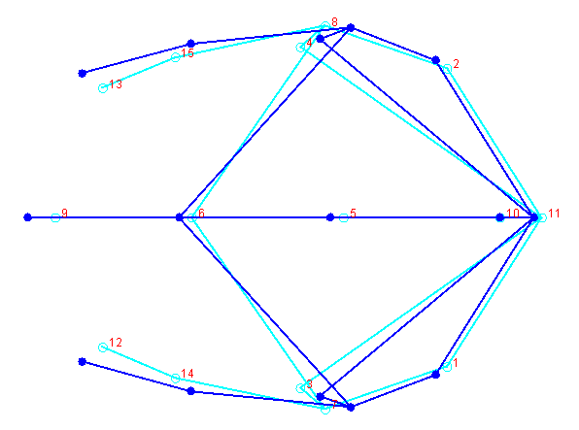 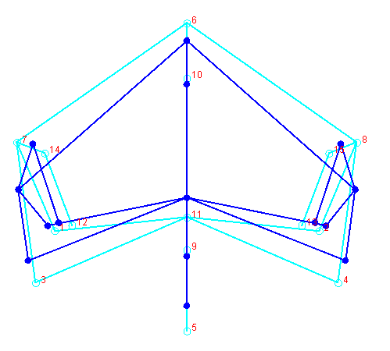(b)
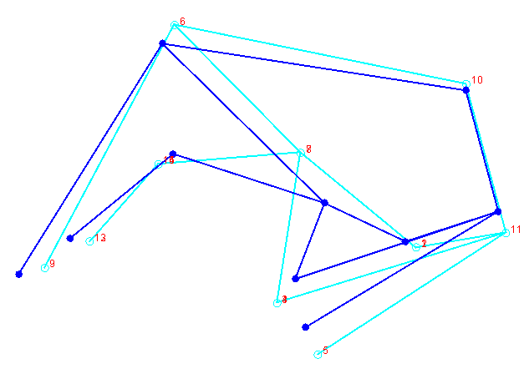(c)
Figure 28. CV1 shape differences for Jomon, Ainu, Yayoi, Kofun and modern males. (a) Superior view, (b) Anterior view, (c) Lateral view.

(a)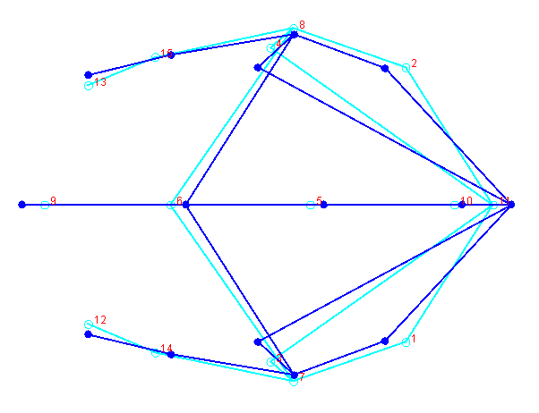 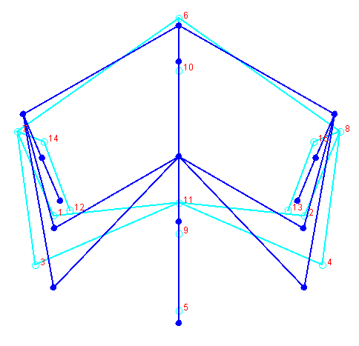(b)
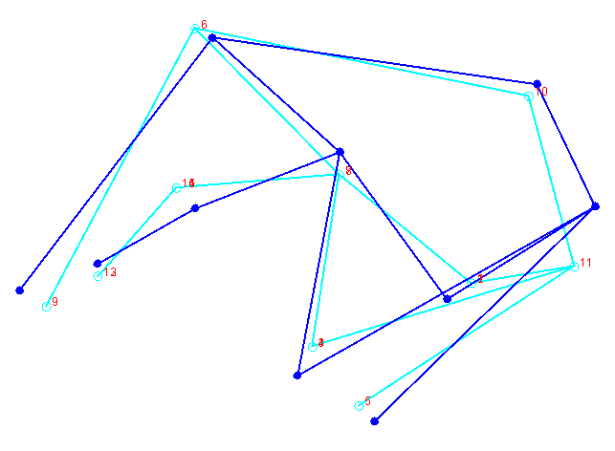(c)
Figure 29. CV2 shape differences for Jomon, Ainu, Yayoi, Kofun and modern males. (a) Superior view, (b) Anterior view, (c) Lateral view.

(a)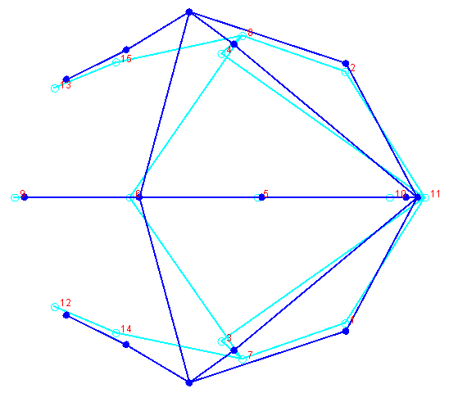 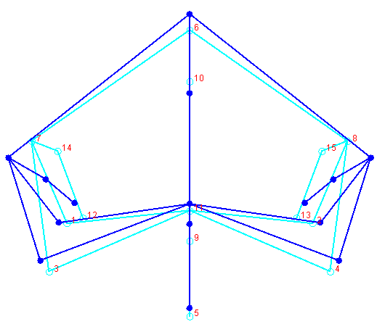(b)

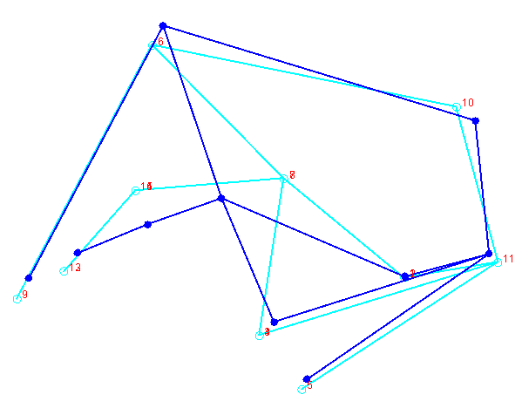(c)
Figure 30. CV3 shape differences for Jomon, Ainu, Yayoi, Kofun and modern males. (a) Superior view, (b) Anterior view, (c) Lateral view.

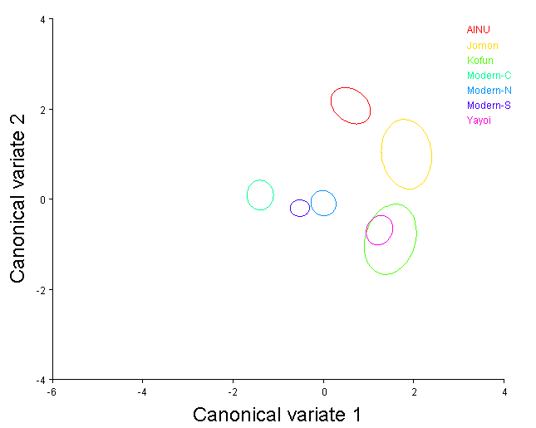
Figure 31. CV1 and CV2 scores for Jomon, Ainu, Yayoi, Kofun and modern groups.

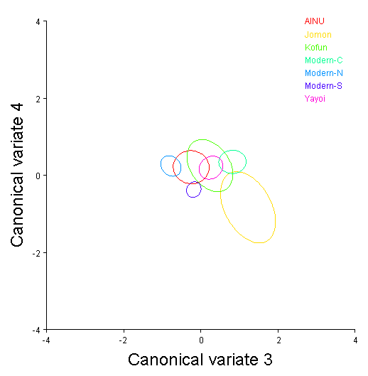

Figure 32. CV3 and C43 scores for Jomon, Ainu, Yayoi, Kofun and modern groups.

Table 51. Mahalanobis distances for Jomon, Kofun, Ainu and modern groups.
Ainu Jomon Kofun Mod-C Mod-N Mod-S
Jomon 3.1635
Kofun 3.7317 2.9645
Modern-C 3.2655 3.9737 3.6044
Modern-N 2.6163 3.2961 2.5990 2.2271
Modern-S 2.8314 3.3505 2.8256 1.5524 1.1945
Yayoi 3.1275 2.5791 1.8976 3.3266 2.3610 2.4404
All distances significant at 0.005, except Yayoi and Kofun groups.

Male Facial Analysis

Principal component analysis showed that first eleven components accounted for 92.3 % of the variance (Table 68). The Box’s M Test showed that groups had unequal covariance matrices, and the Royston’s test for multivariate showed the data was not multivariate normal (Tables 69 and 70). Examination of the QQ-plot showed that deviation from normality was minimal however the Pillai’s test statistic was again used for its robustness (Figure 42). The Pillai’s trace test statistic was used to examine statistical differences among principal components. Results indicated that region differed in regards to the first eleven components (Pillai’s trace= .000) (Table 71). The multiple comparison tests showed significant differences for PC 1-9. See Appendix for significant pairwise differences.
Calculation and comparison of centroid size among groups indicated that the facial variables of the male groups were not significantly different in regards to size (Table 72). The Procrustes ANOVA showed that groups differed significantly in regards to shape variables (Table 73).

Table 52. Eigenvalues and percent variance for principal components 1-11.
Component | Eigenvalues | % Variance | Cumulative %
1 | 0.00067360 | 22.074 | 22.074
2 | 0.00041141 | 13.482 | 35.557
3 | 0.00036149 | 11.846 | 47.403
4 | 0.00033745 | 11.059 | 58.462
5 | 0.00023694 | 7.765 | 66.227
6 | 0.00017379 | 5.695 | 71.922
7 | 0.00016751 | 5.490 | 77.411
8 | 0.00013930 | 4.565 | 81.976
9 | 0.00010184 | 3.337 | 85.314
10 | 0.00010005 | 3.279 | 88.593
11 | 0.00009560 | 3.133 | 91.726

Table 53. MANOVA results for male facial analysis.
 |  |  | Value | F | Hypothesisdf | Error DF | Sig.
Intercept |  | Pillai’s Trace | .075 | 2.00^{b} | 12 | 295.00 | .024
 |  | Wilks’ Lambda | .925 | 2.00^{b} | 12 | 295.00 | .024
 |  | Hotelling’s Trace | .081 | 2.00^{b} | 12 | 295.00 | .024
Period |  | Pillai’s Trace | .375 | 3.659 | 72 | 1800.00 | .000
 |  | Wilks’ Lambda | .649 | 3.806^{b} | 72 | 1610.778 | .000
 |  | Hotelling’s Trace | .505 | 3.952 | 72 | 1760.00 | .000

Table 54. Hotelling’s T2 Two Sample Test for Jomon and all other groups
Group Compared | Covariance Assumption | T2 | DF1 | DF2 | Parametric P | Randomization P
Ainu | Equal | 1.802 | 2 | 30.0 | 0.4293 | 0.4090
 | Unequal | 1.414 | 2 | 11.4 | 0.5443 | 0.5260
Yayoi | Equal | 1.802 | 2 | 30.0 | 0.4293 | 0.4090
 | Unequal | 1.414 | 2 | 11.4 | 0.5443 | 0.5260
Kofun | Equal | 3.509 | 2 | 55.0 | 0.1882 | 0.1740
 | Unequal | 3.335 | 2 | 10.3 | 0.2718 | 0.2540
Modern-C | Equal | 8.304 | 2 | 57.0 | 0.0222 | 0.0190
 | Unequal | 5.522 | 2 | 10.2 | 0.1365 | 0.1280
Modern-N | Equal | 9.923 | 2 | 66.0 | 0.0105 | 0.0100
 | Unequal | 6.115 | 2 | 9.6 | 0.1198 | 0.0880
Modern-S | Equal | 10.577 | 2 | 118.0 | 0.0066 | 0.0100
 | Unequal | 6.820 | 2 | 8.9 | 0.1062 | 0.0980
.

Table 55. Hotelling’s T2 Two Sample Test for Ainu and all other groups.
Group Compared | Covariance Assumption | T2 | DF1 | DF2 | Parametric P | Randomization P
Yayoi | Equal | 14.152 | 2 | 69.0 | 0.0018 | 0.0030
 | Unequal | 18.036 | 2 | 50.4 | 0.0005 | 0.0020
Kofun | Equal | 10.400 | 2 | 34.0 | 0.0122 | 0.0140
 | Unequal | 8.604 | 2 | 21.9 | 0.0313 | 0.0320
Modern-C | Equal | 16.268 | 2 | 71.0 | 0.0007 | 0.0010
 | Unequal | 17.615 | 2 | 50.4 | 0.0006 | 0.0010
Modern-N | Equal | 17.529 | 2 | 80.0 | 0.0004 | 0.0010
 | Unequal | 19.070 | 2 | 44.5 | 0.0004 | 0.0010
Modern-S | Equal | 28.719 | 2 | 132.0 | 0.0000 | 0.0010
 | Unequal | 34.517 | 2 | 34.3 | 0.0000 | 0.0010

Table 56. Hotelling’s T2 Two Sample Test for Yayoi and all other groups.
Group Compared | Covariance Assumption | T2 | DF1 | DF2 | Parametric P | Randomization P
Kofun | Equal | 2.214 | 2 | 59.0 | 0.3435 | 0.3330
 | Unequal | 4.193 | 2 | 19.7 | 0.1645 | 0.1520
Modern-C | Equal | 9.888 | 2 | 96.0 | 0.0095 | 0.0100
 | Unequal | 9.940 | 2 | 95.5 | 0.0093 | 0.0100
Modern-N | Equal | 16.142 | 2 | 105.0 | 0.0006 | 0.0020
 | Unequal | 16.009 | 2 | 98.3 | 0.0006 | 0.0020
Modern-S | Equal | 7.656 | 2 | 157.0 | 0.0244 | 0.0210
 | Unequal | 7.728 | 2 | 84.9 | 0.0259 | 0.0270

Table 57. Hotelling’s T2 Two Sample Test for Kofun and all other groups.
Group Compared | Covariance Assumption | T2 | DF1 | DF2 | Parametric P | Randomization P
Modern-C | Equal | 11.983 | 2 | 61.0 | 0.0046 | 0.0060
 | Unequal | 24.697 | 2 | 19.7 | 0.0005 | 0.0020
Modern-N | Equal | 18.039 | 2 | 70.0 | 0.0004 | 0.0010
 | Unequal | 33.745 | 2 | 17.6 | 0.0001 | 0.0010
Modern-S | Equal | 11.983 | 2 | 61.0 | 0.0046 | 0.0050
 | Unequal | 24.697 | 2 | 19.7 | 0.0005 | 0.0020

Canonical Variate Analysis Results

Results of the male face analysis provided an opportunity to assess whether the same results would be found that were identified in the vault analysis. CV one accounted for roughly 43% of the variance (Table 58). Shape variation as shown by the wireframe figure indicated the majority of changes occurred at the inferior border nasal aperture, the curvature of the nasal bones and projection of the aperture (Figure 43). The group centroid plot shows the modern northern and modern central group at the positive and negative extremes of the distribution, respectively (Figure 46). The remaining groups overlap heavily in the middle of axis. The northern group exhibits a narrower nasal aperture that projects more anteriorly than the other groups. CV two is responsible for 28% of the variance and shows the majority of variation occurring at the lateral orbits in a superoinferior and mediolateral direction as well as landmarks that are responsible for height of the face in a mostly superoinferior direction (Table 74 and Figure 44). The group centroid plot shows the Kofun, Jomon and Yayoi groups clustering at the positive end of the axis and exhibit wider dimensions for nasal breadth and biorbital breadth relative to the Ainu and modern groups (Figure 46). However the Kofun, Jomon and Yayoi cluster also exhibits a shorter face and less anteriorly projecting palate. CV three is responsible for roughly 19% of the variance and displays the largest amounts of variance in similar regions shown in CV one, namely breadth and anterior projection of the nasal aperture (Table 74 and Figure 45). Only the Ainu group is distinct from the other groups on the group centroid plot, and is located on the negative side of the axis, indicating a slightly wider nasal aperture relative to a flatter profile of this region (Figure 47). The remaining groups overlap considerably, however the confidence interval for the Jomon group centroid extends toward the negative end of the axis. The Mahalanobis distance matrix shows interesting patterns and exhibits the least amount of distance between the Yayoi and Kofun group, followed closely by the Yayoi and modern southern group (Table 75). The modern southern and modern northern groups show a small distance between them as does the Yayoi and Jomon groups. The modern southern group shows a much closer distance to the Jomon and Ainu groups than do the northern and central modern groups, and is closer than the Ainu and Jomon distance.

Table 58. Eigenvalues and percent variance for canonical components 1-3.
Component | Eigenvalues | % Variance | Cumulative %
1 | 0.67779609 | 41.679 | 41.679
2 | 0.46549698 | 28.624 | 70.303
3 | 0.35194456 | 21.642 | 91.944

(a)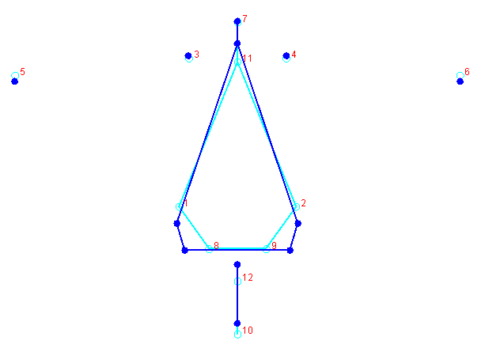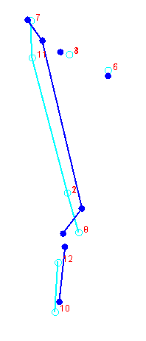(b)
Figure 33. CV1 shape differences for Jomon, Ainu, Yayoi, Kofun and modern males. (a) Anterior view, (b) Lateral view.

(a)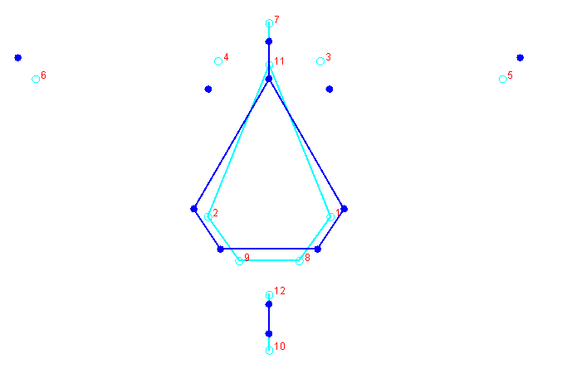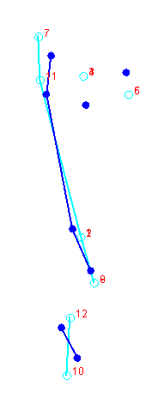(b)
Figure 34. CV2 shape differences for Jomon, Ainu, Yayoi, Kofun and modern males. (a) Anterior view, (b) Lateral view.

(a)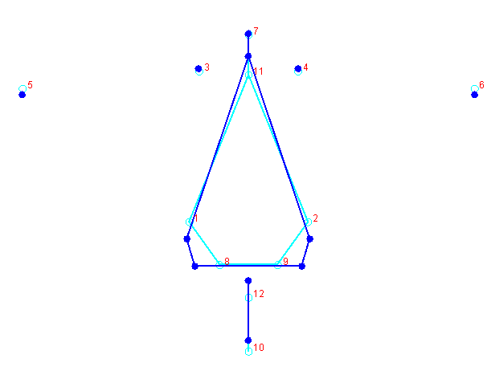 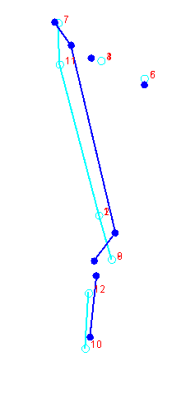(b)
Figure 35.CV3 shape differences for Jomon, Ainu, Yayoi, Kofun and modern males. (a) Anterior view, (b) Lateral view.

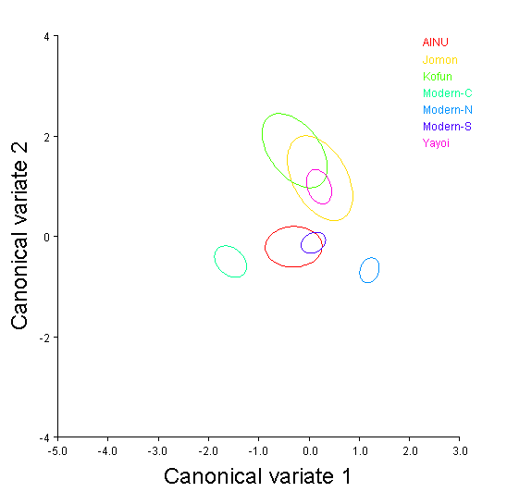
Figure 36. CV1 and CV2 scores of Jomon, Ainu, Kofun, Yayoi and modern groups.

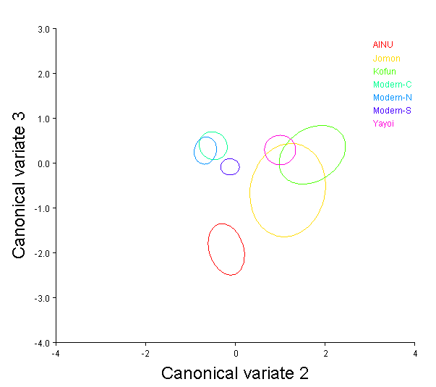
Figure 37. CV2 and CV3 of Jomon, Ainu, Kofun, Yayoi and modern males.

Table 59. Mahalanobis distances of Ainu, Jomon, Kofun and modern groups.
Ainu Jomon Kofun Mod-C Mod-N Mod-S
Jomon 2.2249
Kofun 3.1057 1.7211
Modern-C 2.7671 2.6342 2.7877
Modern-N 2.6579 2.3416 2.8401 2.8171
Modern-S 2.0656 1.6484 2.1126 1.8685 1.3393
Yayoi 2.6490 1.4256 1.3395 2.3632 1.9561 1.3340
All distances significant at α 0.05 except Jomon and Kofun, Kofun and Yayoi and Yayoi and Modern-S groups.

Males All Variables Analysis

The first eighteen components account for 90.6 % of the variance (Table 60). The Box’s M Test showed that groups had unequal covariance matrices, but the Royston’s test for multivariate showed the data was multivariate normal (Tables 77 and 78). Examination of the QQ-plot shows a pattern consistent with normality (Figure 48). The Pillai’s trace test statistic was used to examine statistical differences among principal components. Results indicated that region differed in regards to the first eighteen components (Pillai’s trace= .000) (Table 79). The multiple comparison tests showed significant differences for PCs 1-17. See Appendix 9 for significant pairwise differences.
Calculation and comparison of centroid size among groups indicated that the all variable data set of the male groups were not significantly different in regards to size (Table 80). The Procrustes ANOVA showed that groups differed significantly in regards to shape variables (Table 81).

Table 60. Eigenvalues and percent variance of principal components 1-18.
Component | Eigenvalues | % Variance | Cumulative %
1 | 0.00049032 | 16.754 | 16.754
2 | 0.00033827 | 11.559 | 28.313
3 | 0.00024961 | 8.529 | 36.842
4 | 0.00022857 | 7.810 | 44.652
5 | 0.00021750 | 7.432 | 52.084
6 | 0.00018306 | 6.255 | 58.339
7 | 0.00014089 | 4.814 | 63.154
8 | 0.00012220 | 4.176 | 67.329
9 | 0.00011463 | 3.917 | 71.246
10 | 0.00009793 | 3.346 | 74.593
11 | 0.00008720 | 2.980 | 77.572
12 | 0.00007918 | 2.706 | 80.278
13 | 0.00006174 | 2.110 | 82.388
14 | 0.00005570 | 1.903 | 84.291
15 | 0.00005097 | 1.741 | 86.033
16 | 0.00004359 | 1.490 | 87.522
17 | 0.00003933 | 1.344 | 88.866
18 | 0.00003435 | 1.174 | 90.040

Table 61. MANOVA results for male all variable analysis.
 |  |  | Value | F | Hypothesisdf | Error DF | Sig.
Intercept |  | Pillai’s Trace | .133 | 2.500^{b} | 15 | 244.00 | .002
 |  | Wilks’ Lambda | .867 | 2.500^{b} | 15 | 244.00 | .002
 |  | Hotelling’s Trace | .154 | 2.500^{b} | 15 | 244.00 | .002
Period |  | Pillai’s Trace | .949 | 3.117 | 90 | 1494.00 | .000
 |  | Wilks’ Lambda | .319 | 3.455 | 90 | 1378.77 | .000
 |  | Hotelling’s Trace | 1.417 | 3.815 | 90 | 1454.00 | .000

Table 62. Hotelling’s T2 Two Sample Test for Jomon and all other groups.
Group Compared | Covariance Assumption | T2 | DF1 | DF2 | Parametric P | Randomization P
Ainu | Equal | 2.686 | 2 | 26.0 | 0.2926 | 0.3220
 | Unequal | 4.027 | 2 | 14.0 | 0.1934 | 0.2020
Yayoi | Equal | 1.393 | 2 | 44.0 | 0.5115 | 0.5480
 | Unequal | 1.860 | 2 | 10.7 | 0.4593 | 0.4860
Kofun | Equal | 0.725 | 2 | 14.0 | 0.7201 | 0.7120
 | Unequal | 0.725 | 2 | 12.1 | 0.7239 | 0.7120
Modern-C | Equal | 13.798 | 2 | 46.0 | 0.0027 | 0.0030
 | Unequal | 13.010 | 2 | 11.6 | 0.0187 | 0.0210
Modern-N | Equal | 8.850 | 2 | 59.0 | 0.0174 | 0.0160
 | Unequal | 8.493 | 2 | 9.8 | 0.0640 | 0.0610
Modern-S | Equal | 9.740 | 2 | 104.0 | 0.0099 | 0.0100
 | Unequal | 12.792 | 2 | 8.9 | 0.0295 | 0.0280

Table 63. Hotelling’s T2 Two Sample Test for Ainu and all other groups.
Group Compared | Covariance Assumption | T2 | DF1 | DF2 | Parametric P | Randomization P
Yayoi | Equal | 7.830 | 2 | 56.0 | 0.0274 | 0.0320
 | Unequal | 7.356 | 2 | 37.4 | 0.0381 | 0.0430
Kofun | Equal | 1.082 | 2 | 26.0 | 0.6006 | 0.5780
 | Unequal | 1.198 | 2 | 11.2 | 0.5955 | 0.5670
Modern-C | Equal | 23.465 | 2 | 58.0 | 0.0001 | 0.0010
 | Unequal | 25.810 | 2 | 40.8 | 0.0001 | 0.0010
Modern-N | Equal | 12.249 | 2 | 71.0 | 0.0038 | 0.0090
 | Unequal | 14.144 | 2 | 33.7 | 0.0033 | 0.0040
Modern-S | Equal | 12.443 | 2 | 116.0 | 0.0029 | 0.0040
 | Unequal | 19.678 | 2 | 29.2 | 0.0007 | 0.0010

Table 64. Hotelling’s T2 Two Sample Test for Yayoi and all other groups.
Group Compared | Covariance Assumption | T2 | DF1 | DF2 | Parametric P | Randomization P
Kofun | Equal | 0.740 | 2 | 44.0 | 0.6988 | 0.6890
 | Unequal | 0.639 | 2 | 9.0 | 0.7601 | 0.7490
Modern-C | Equal | 7.691 | 2 | 46.0 | 0.0308 | 0.0360
 | Unequal | 10.345 | 2 | 9.5 | 0.0436 | 0.0510
Modern-N | Equal | 16.703 | 2 | 89.0 | 0.0005 | 0.0020
 | Unequal | 17.492 | 2 | 80.3 | 0.0004 | 0.0020
Modern-S | Equal | 25.771 | 2 | 134.0 | 0.0000 | 0.0010
 | Unequal | 32.211 | 2 | 76.5 | 0.0000 | 0.0010

Table 65. Hotelling’s T2 Two Sample Test for Kofun and all other groups.
Group Compared | Covariance Assumption | T2 | DF1 | DF2 | Parametric P | Randomization P
Modern-C | Equal | 7.691 | 2 | 46.0 | 0.0308 | 0.0320
 | Unequal | 10.345 | 2 | 9.5 | 0.0436 | 0.0330
Modern-N | Equal | 3.488 | 2 | 59.0 | 0.1891 | 0.2140
 | Unequal | 4.548 | 2 | 8.5 | 0.2004 | 0.2080
Modern-S | Equal | 4.307 | 2 | 104.0 | 0.1237 | 0.1160
 | Unequal | 6.499 | 2 | 8.0 | 0.1246 | 0.1210

Canonical Variate Analysis
Results of the male all variable analysis provided somewhat differential results compared to analyses with the facial and vault modules partitioned, but does not offer any conclusions that have not been addressed by previous analyses. CV one accounted for roughly 38% of the variance (Table 82). Shape changes are largest in the position of the frontal bone in an anteroposterior direction, as well as the cranial base in a superoinferior direction (Figure 49). Examination of group centroid plots for CV1 shows an interesting patterning of groups with the Jomon, Yayoi and Kofun groups forming a cluster at the positive end of the axis, indicating a somewhat longer vault length due to the more forward placement of the frontal bone (Figure 52). Additionally, these groups exhibit a more inferiorly placed cranial base. The central modern group is on the negative extreme of the axis, indicating a shorter vault length and height. The modern northern and southern samples group with the Jomon sample and are located intermediate to the negative and positive extremes (Figure 52). Canonical variate two is responsible for nearly 28% of the variance and shows slight shape changes at maximum cranial breadth (Table 82 and Figure 50). The group centroid plot shows the Ainu and modern northern group are somewhat distinct at the positive end of the axis, indicating wider cranial breadths (Figure 52). The remaining groups heavily overlap. CV three is responsible for roughly 21% of the variance and displays the largest amounts of variance in the position of the cranial base, the superior portion of the cranium, anterior facial projection and length of the vault due to the movement of the occipital (Table 82 and Figure 51). The Jomon and Ainu groups are displaced slightly towards the positive end of the axis on the group centroid plot, indicating slightly longer vaults relative to a more pronounced anterior placement of the midface as well as shorter vault height due to a more inferiorly placed cranial base and inferior movement of bregma (Figure 53). The remaining groups overlap considerably towards the negative side of the axis. The Mahalanobis distance matrix shows the least amount of distance between southern and northern modern groups, followed by the Yayoi and Kofun groups (Table 83). The modern southern group shows the least amount of distance to the Jomon group, as was found with previous analyses. The Yayoi and Kofun groups show the second smallest distance overall, as was found with previous analyses.

Table 66. Eigenvalues and percent variance for canonical components 1-4.
Component | Eigenvalues | % Variance | Cumulative %
1 | 1.37659975 | 34.634 | 34.634
2 | 1.10495238 | 27.799 | 62.433
3 | 0.95364395 | 23.992 | 86.425
4 | 0.25848534 | 6.503 | 92.928

(a)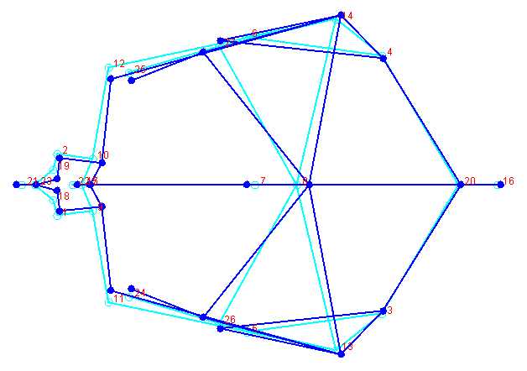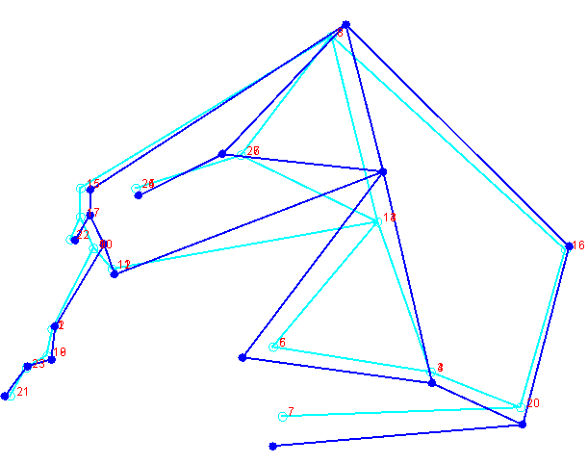(b)
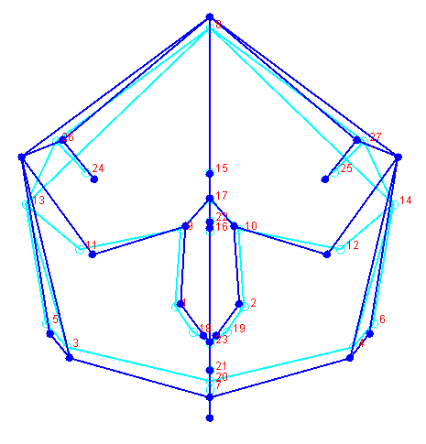(c)
Figure 38. CV1 shape differences for Jomon, Ainu, Yayoi, Kofun and modern males. (a) Superior view, (b) Lateral view, (c) Anterior view.

(a)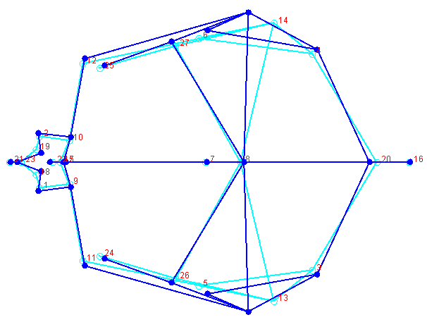 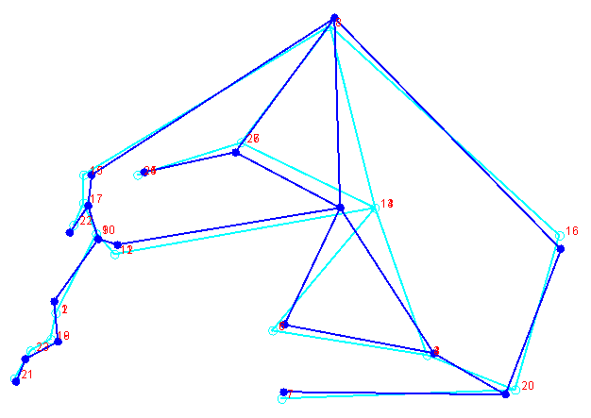(b)
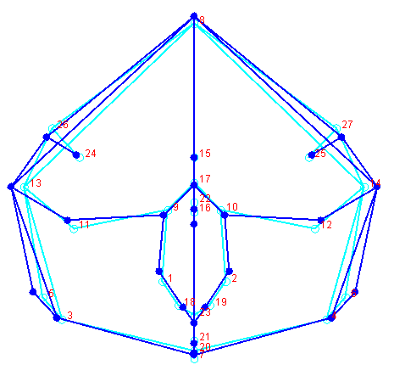(c)
Figure 39. CV2 shape differences for Jomon, Ainu, Yayoi, Kofun and modern males. (a) Superior view, (b) Lateral view, (c) Anterior view.

(a)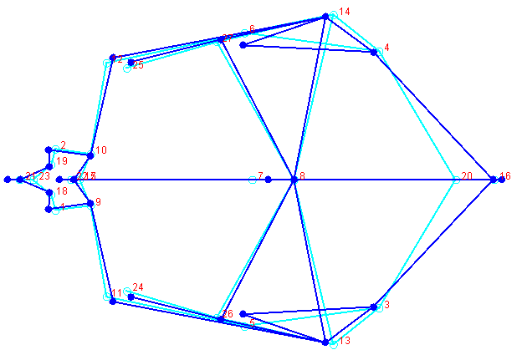 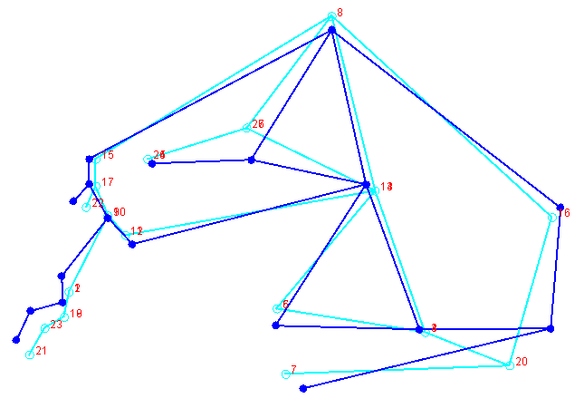(b)
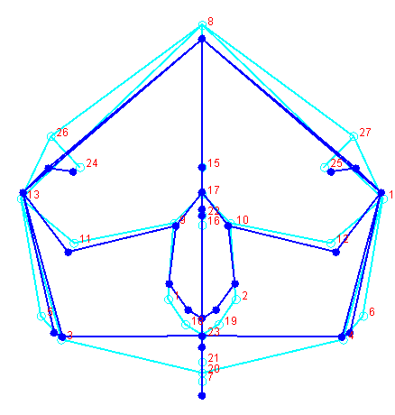(c)
Figure 40. CV3 shape differences for Jomon, Ainu, Yayoi, Kofun and modern males. (a) Superior view, (b) Lateral view, (c) Anterior view.

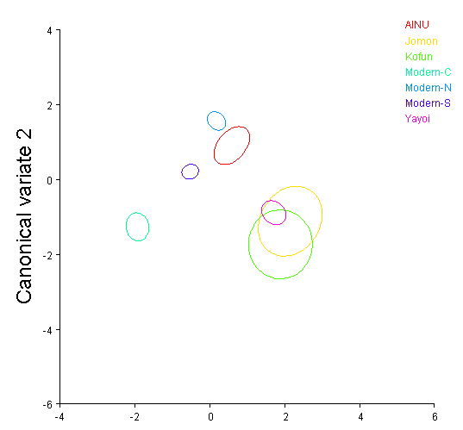
Figure 41. CV1 and CV2 scores for Jomon, Ainu, Yayoi, Kofun and modern groups.

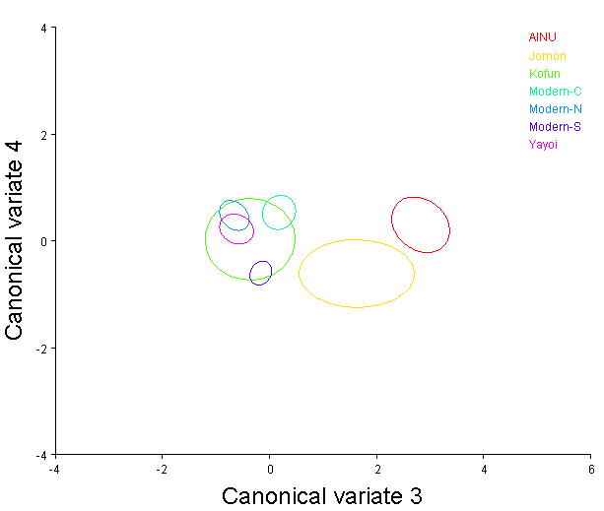
Figure 42. CV3 and CV4 scores for Jomon, Ainu, Yayoi, Kofun and modern groups.

Table 67. Mahalanobis distances for Ainu, Jomon, Kofun and modern groups.
Ainu Jomon Kofun Mod-C Mod-N Mod-S
Jomon 3.8040
Kofun 4.4622 3.2723
Modern-C 4.2845 4.7053 4.1055
Modern-N 3.7263 4.5588 4.0843 3.6121
Modern-S 3.4160 3.9467 3.5083 2.3180 1.9916
Yayoi 4.2670 3.3236 2.4920 3.7553 3.0543 2.7910
All distances significant at the α =0.005 level.

Female All Variable Analysis

The first seventeen components produced by principal component analysis accounted for 90.2% of the variance, and were retained to test for mean differences among groups (Table 68). The Box’s M Test showed that groups had unequal covariance matrices, but the Royston’s test for multivariate showed the data was multivariate normal (Table 85 and 86). The QQ-plot showed a distribution consistent with multivariate normality (Figure 54). The Pillai’s trace test statistic was used to assess differences among groups. Results of the vault only MANOVA indicated that the temporal samples differed in regards to the eighteen seventeen components (Pillai’s trace= .003) (Table 87).
Calculation and comparison of centroid size among female groups indicated that all landmark variables of the prehistoric and modern groups were significantly different in regards to size (Table 88). Additionally, as with all previous analyses, the Procrustes ANOVA showed that groups differed significantly in regards to shape (Table 89).

Component | Eigenvalues | % Variance | Cumulative %
1 | 0.00072713 | 23.210 | 23.210
2 | 0.00037212 | 11.878 | 35.089
3 | 0.00027670 | 8.832 | 43.921
4 | 0.00024724 | 7.892 | 51.813
5 | 0.00019532 | 6.235 | 58.048
6 | 0.00016419 | 5.241 | 63.289
7 | 0.00013650 | 4.357 | 67.646
8 | 0.00011045 | 3.526 | 71.172
9 | 0.00010239 | 3.268 | 74.440
10 | 0.00009304 | 2.970 | 77.410
11 | 0.00008622 | 2.752 | 80.162
12 | 0.00006734 | 2.150 | 82.312
13 | 0.00006235 | 1.990 | 84.302
14 | 0.00005978 | 1.908 | 86.211
15 | 0.00004640 | 1.481 | 87.692
16 | 0.00004219 | 1.347 | 89.038
17 | 0.00003774 | 1.205 | 90.243

Table 68. Eigenvalues and percent variance for canonical components 1-17.

Table 69. MANOVA results for female all variable analysis.
 |  |  | Value | F | Hypothesisdf | Error DF | Sig.
Intercept |  | Pillai’s Trace | .123 | 2.058^{b} | 12 | 176.00 | .022
 |  | Wilks’ Lambda | .877 | 2.058^{b} | 12 | 176.00 | .022
 |  | Hotelling’s Trace | .140 | 2.058^{b} | 12 | 176.00 | .022
Period |  | Pillai’s Trace | 1.302 | 3.133 | 72 | 1086.00 | .000
 |  | Wilks’ Lambda | .307 | 3.248 | 72 | 963.348 | .000
 |  | Hotelling’s Trace | 1.369 | 3.315 | 72 | 1046.00 | .000

Table 70. Hotelling’s T2 Two Sample Test for Jomon and all other groups.
Group Compared | Covariance Assumption | T2 | DF1 | DF2 | Parametric P | Randomization P
Ainu | Equal | 39.972 | 2 | 17.0 | 0.0001 | 0.0010
 | Unequal | 81.079 | 2 | 8.0 | 0.0002 | 0.0010
Yayoi | Equal | 14.788 | 2 | 36.0 | 0.0024 | 0.0020
 | Unequal | 70.818 | 2 | 7.3 | 0.0006 | 0.0010
Kofun | Equal | 15.348 | 2 | 14.0 | 0.0081 | 0.0170
 | Unequal | 20.245 | 2 | 7.3 | 0.0151 | 0.0100
Modern-C | Equal | 0.352 | 2 | 32.0 | 0.8441 | 0.8360
 | Unequal | 1.584 | 2 | 8.8 | 0.5244 | 0.5360
Modern-N | Equal | 2.602 | 2 | 28.0 | 0.3014 | 0.3070
 | Unequal | 7.830 | 2 | 9.0 | 0.0822 | 0.0900
Modern-S | Equal | 0.721 | 2 | 85.0 | 0.7013 | 0.7120
 | Unequal | 8.555 | 2 | 6.1 | 0.1074 | 0.1060

Table 71. Hotelling’s T2 Two Sample Test for Ainu and all other groups.
Group Compared | Covariance Assumption | T2 | DF1 | DF2 | Parametric P | Randomization P
Yayoi | Equal | 9.325 | 2 | 43.0 | 0.0162 | 0.0140
 | Unequal | 11.247 | 2 | 30.0 | 0.0099 | 0.0150
Kofun | Equal | 20.066 | 2 | 21.0 | 0.0012 | 0.0040
 | Unequal | 22.969 | 2 | 18.9 | 0.0008 | 0.0030
Modern-C | Equal | 13.972 | 2 | 39.0 | 0.0030 | 0.0030
 | Unequal | 21.894 | 2 | 35.4 | 0.0003 | 0.0010
Modern-N | Equal | 8.561 | 2 | 35.0 | 0.0242 | 0.0270
 | Unequal | 10.899 | 2 | 33.2 | 0.0104 | 0.0200
Modern-S | Equal | 8.502 | 2 | 92.0 | 0.0179 | 0.0240
 | Unequal | 24.560 | 2 | 22.4 | 0.0004 | 0.0010

Table 72. Hotelling’s T2 Two Sample Test for Yayoi and all other groups.
Group Compared | Covariance Assumption | T2 | DF1 | DF2 | Parametric P | Randomization P
Kofun | Equal | 0.740 | 2 | 44.0 | 0.6988 | 0.6890
 | Unequal | 0.639 | 2 | 9.0 | 0.7601 | 0.7490
Modern-C | Equal | 7.691 | 2 | 46.0 | 0.0308 | 0.0360
 | Unequal | 10.345 | 2 | 9.5 | 0.0436 | 0.0510
Modern-N | Equal | 16.703 | 2 | 89.0 | 0.0005 | 0.0020
 | Unequal | 17.492 | 2 | 80.3 | 0.0004 | 0.0020
Modern-S | Equal | 25.771 | 2 | 134.0 | 0.0000 | 0.0010
 | Unequal | 32.211 | 2 | 76.5 | 0.0000 | 0.0010

Table 73. Hotelling’s T2 Two Sample Test for Kofun and all other groups.
Group Compared | Covariance Assumption | T2 | DF1 | DF2 | Parametric P | Randomization P
Modern-C | Equal | 9.961 | 2 | 36.0 | 0.0139 | 0.0190
 | Unequal | 17.713 | 2 | 27.7 | 0.0014 | 0.0050
Modern-N | Equal | 8.868 | 2 | 32.0 | 0.0226 | 0.0300
 | Unequal | 16.566 | 2 | 27.4 | 0.0019 | 0.0080
Modern-S | Equal | 10.845 | 2 | 89.0 | 0.0064 | 0.0120
 | Unequal | 33.650 | 2 | 16.5 | 0.0002 | 0.0020

Canonical Variate Analysis
Results of the female all variable analysis reflected similar patterns identified in the male analysis. CV one accounted for roughly 37% of the variance (Table 90). Shape changes are shown by the wireframe figure and indicated the anteroposterior position of the facial region above nasion and to a lesser extent the anteroposterior position of the palate to be important among groups (Figure 55). Additionally the position of the occipital in a superoinferior direction also showed a large amount of shape variation. Examination of group centroid plots showed a dramatic distinction between the Ainu and Jomon groups, which clustered at the negative end of the axis and the Yayoi, Kofun and modern groups at the positive end of the axis (Figure 58). This pattern indicates that the Yayoi, Kofun and modern samples show narrower vaults, they also exhibit longer crania that are slightly taller than the Jomon and Ainu groups. Canonical variate two is responsible for 28% of the variance and shows the majority of variation occurring at the landmarks involved with facial height and vault height due to the movement of bregma and basion in a superoinferior direction (Table 90 and Figure 56). The group centroid plot shows the Jomon, Kofun and Yayoi groups on the positive side of the axis, indicating taller facial and vault heights due to a superior and inferior of bregma and basion, respectively (Figure 58). The Ainu and modern groups are displaced towards the negative end of the axis, indicating an overall shorter cranium (Figure 58). Canonical variate three is responsible for roughly 18% of the variance but displays such little shape change it will not be addressed (Table 90 and Figure 57). The Mahalanobis distance matrix shows the least amount of distance between southern and northern modern groups (Table 91). The southern modern group and central group also share a small distance between them, followed by the Yayoi and Kofun groups. The Jomon group shows relatively large distances to each group, but the smallest distance is shared with Ainu group. Interestingly, the Yayoi and modern southern group share a small distance that is much less than the Kofun and Yayoi distance.

Table 74. Eigenvalues and percent variance for canonical components 1-5.
Component | Eigenvalues | % Variance | Cumulative %
1 | 1.79368104 | 37.441 | 37.441
2 | 1.27194322 | 26.551 | 63.992
3 | 0.85951774 | 17.942 | 81.934
4 | 0.38618466 | 8.061 | 89.995
5 | 0.27729922 | 5.788 | 95.783

(a)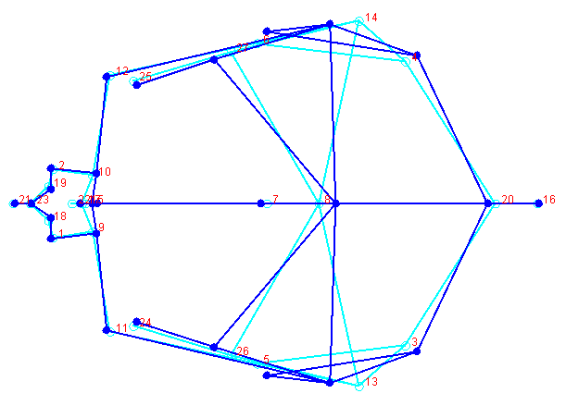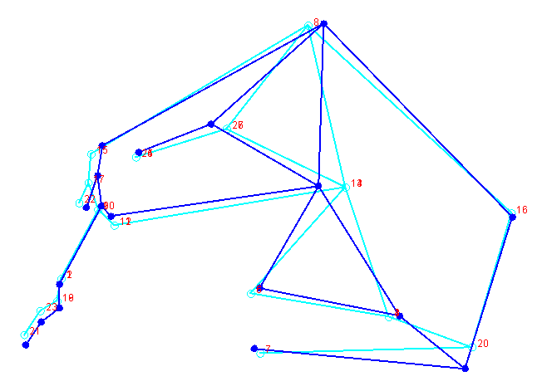(b)
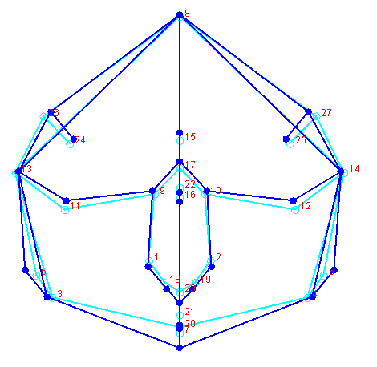(c)
Figure 43. CV1 shape differences for Jomon, Ainu, Yayoi, Kofun and modern females. (a) Superior view, (b) Lateral view, (c) Anterior view.

(a)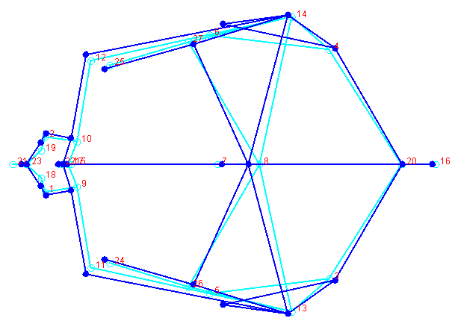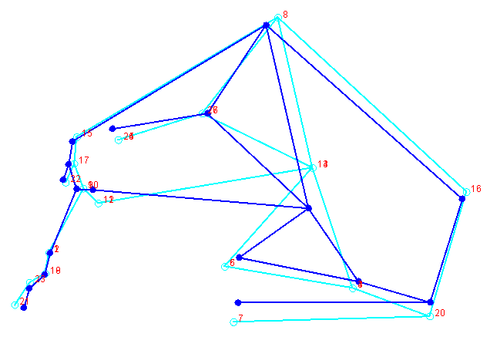(b)
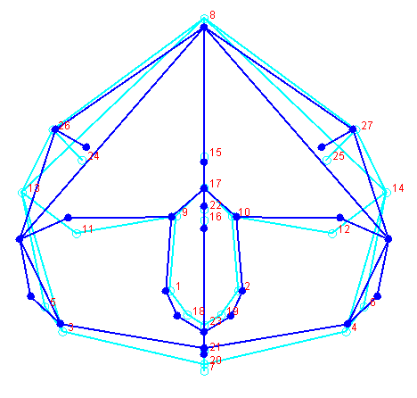(c)
Figure 44. CV2 shape differences for Jomon, Ainu, Yayoi, Kofun and modern females. (a) Superior view, (b) Lateral view, (c) Anterior view.

(a)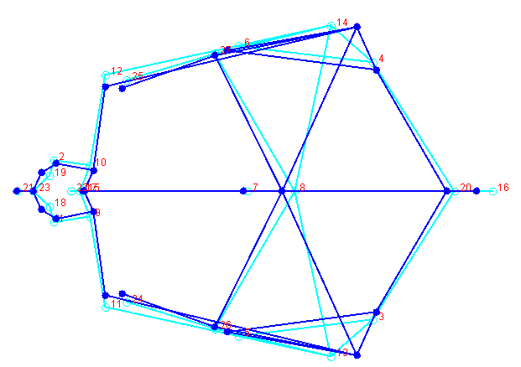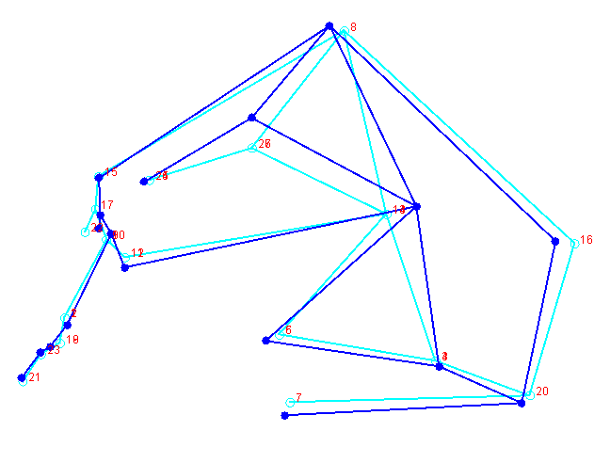(b)
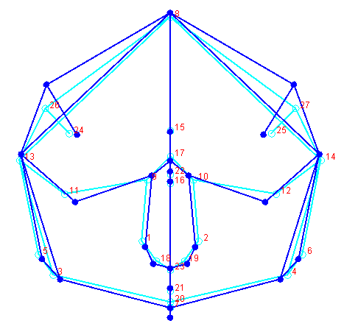(c)
Figure 45. CV3 shape differences for Jomon, Ainu, Yayoi, Kofun and modern females. (a) Superior view, (b) Lateral view, (c) Anterior view.

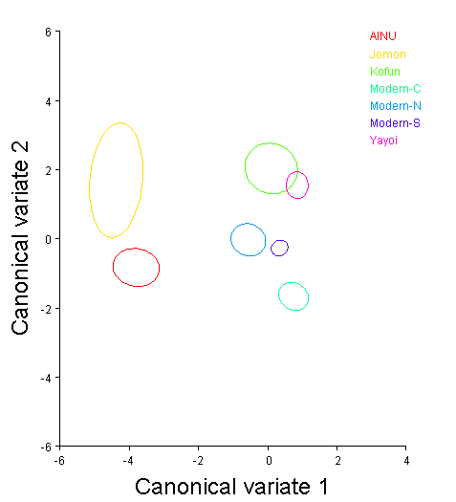
Figure 46. CV1 and CV2 scores for Jomon, Ainu, Yayoi, Kofun and modern females.

Table 75. Mahalanobis distance matrix for Jomon, Ainu, Yayoi, Kofun and modern females.
Ainu Jomon Kofun Mod-C Mod-N Mod-S
Jomon 4.5788
Kofun 5.6119 5.7350
Modern-C 5.0086 6.4714 4.4467
Modern-N 4.5215 5.6789 3.6590 3.6087
Modern-S 4.5344 5.9263 3.2778 2.3904 2.1283
Yayoi 5.3532 5.9187 3.0638 3.3993 3.4628 2.4384
All distances significant at the α= 0.005 level.

CHAPTER 5
DISCUSSION

This dissertation addressed several related hypotheses that stemmed from the re-examination of variation of the skull in Japanese populations using three dimensional data. The primary goal of this research was to address whether coordinate data provided results that differed from the host of studies within Japan that have been carried out on traditional metric data. Encompassed within this broad hypothesis are more specific questions that this body work attempted to answer. Given the a number of recent studies that have aimed to elucidate whether specific modules of the cranium are more plastic than others and have shown that different areas of the skull can provide different results, the current research assessed whether partitioning landmarks by developmental module would affect results. Additionally, the nature of the data collected for this research allowed several specific questions to be addressed. As temporally deep and somewhat continuous samples were available, the idea that morphologies associated with indigenous and prehistoric parental populations could be identified in modern populations was addressed. This was accomplished with several iterations of analyses that utilized partitioned landmark subsets, as well as combinations of landmarks that better represented the skull as a complete entity. Lastly, secular change and the phenomenon of brachycephalization that has been reported in several seminal studies by Japanese researchers were reexamined using three dimensional data.

Regional variability in modern Japanese samples

Modern Japanese groups were first partitioned by corresponding region of north, central or south and analyzed to examine if regional variation could be identified.
The male vault variable analysis indicated small amounts of identifiable differences among groups, with the northern and southern groups being slightly more morphologically similar to each other than the samples from the central region. The northern and southern groups displayed taller and wider vaults than the central group.
The facial variable analysis of the same regionally partitioned samples showed the same patterns identified with the vault only analysis, namely that the northern and southern groups were more similar while the central group was distinct and displayed a wider nasal aperture.
The only significant difference between the vault variable and the facial analysis was that relatedness to the central group differed. In the vault only analysis, the central group was closer to the northern group and furthest from the southern group. This potentially provides implications for differential interpretation of relationships between groups when employing the vault and face separately. As the brunt of the differences identified in the nasal aperture, and the northern group exhibits a narrower breadth, this could potentially be inferred as reflecting retention of morphology that reflects a response to the significantly colder climate in the northern portions of the Japanese archipelago.
The all variable analyses for males showed essentially the same patterns described above, but with more delineation between groups. The more interpretable results indicated that the two step process of analyzing different modules individually could be condensed into a single analysis. However, it is interesting to note that with the all variable analysis, the majority of variation is found at landmarks of the vault and base. This observation lends credence to the possibility that the vault may express patterns of variation differently than the facial skeleton.
This initial analysis also compared results to a two dimensional analysis of the modern male vault to assess whether more interpretable information is accrued with three dimensional shape analysis. For ease of interpretation, the vault variable measurements were selected for the 2D/3D comparison. Results indicated that the majority of variation within principal component analysis was explained by variables of the vault. While overall patterns were consistent with what was found in the 3D vault analysis, comparison of plots of canonical scores indicates that more delineation is evident in the 3D analysis (Figures 59 and 60). This suggests that the availability of more information (i.e. landmarks) can be used to better recognize underlying patterns within the data. Also, the visualization of shape changes assists in identifying which regions of the cranium contain the most meaningful information for parsing out similarities and differences among comparative analyses.

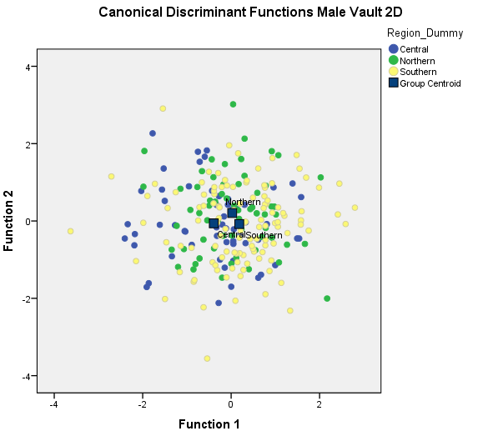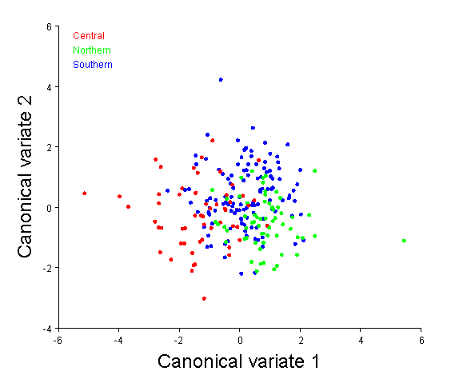Figure 48. CVA Plot of metric data. Figure 49. CVA plot of 3D data.

The female only analyses examined the vault and facial landmarks congruently. Results were consistent with the patterns between regions as was described in the male analysis. Namely, that the southern and northern groups were more similar to one another, while the central groups was distinct. Again, the central group was furthest from the northern group.
These results are interesting given the archaeological history of the Jomon and the belief that indigenous populations within the most northern and southern extremes experienced lesser percentages of admixture with migrant groups (Ossenberg, et al. 2006). It has been cited by several studies that modern populations from the central region of Japan exhibit differences when compared to samples from northern or southern Japan. In particular, Yamaguchi (Yamamura 1977) showed that Japanese samples from regions near where the establishment of the Imperial Court occurred (i.e. central Japan) differ from contemporaneous samples from northern and southern Japan. Interestingly, Jomon samples from the Kanto (central) region of Japan have also been shown to differ from northern and southern counterparts. Nakahashi (Nakahashi 1993) showed that in regards to facial flatness, the Kanto district Jomon were extremely different from Jomon period crania from the Kyushu (southern) region. It is thus difficult to postulate whether the distinctness identified with modern samples from the Kanto region reflect initial differences that are identified with the indigenous samples, or if morphology is related to differential quality of life populations near the Imperial Court experienced.
Additionally, it is important to take into consideration the following when interpreting differences identified in the modern samples. Differences have been described in environmental conditions between northern and southern Japan during the Jomon period. While the northeastern region of the archipelago was covered in deciduous forests and salmon filled rivers, the southern portion of the archipelago was distinguished by evergreen forests and a subtropical zone. While the culture and subsistence practices of the “sedentary gatherer” are documented as fairly consistent throughout the islands, the differences in environment could be reflected in north and south Jomon morphology. Unfortunately, the small Jomon sample sizes required pooling of samples from this time period, but future researchers will hopefully be granted access to more southern material that is curated on the island of Kyushu (Seguchi, personal communication).
An additional factor that could account for some of the distinctions between the northern and southern modern groups is the point of entry for initial migrations into the archipelago. It is well documented that individuals representative of Yayoi culture first entered the archipelago via the Korean peninsula as climatic conditions abruptly changed and caused dry, less hospitable conditions to be rampant in mainland Asia (Hong 2005). While models of admixture are mostly unanimously accepted between Yayoi and Jomon cultures based on morphology, archaeological evidence further supports this. Yayoi cultures are shown to have adopted stone tool and ceramic practices from the Jomon and modified them, indicating that cultural exchange was occurring rather than the Jomon being replaced or made obsolete.
In regards to the actual shape differences identified, in the male analysis the modern northern group showed broader vault and frontal breadths, longer vault length and slightly taller facial heights than the central and southern groups. The northern and southern groups also exhibited wider nasal apertures and taller facial heights. The female analysis indicated that the modern central group was distinct from the northern in southern groups by exhibiting broader parietal and frontal breadths as well as an overall longer and taller vault.
The findings that the central group is the distinct from the northern and southern groups is further supported by the work of Nagaoka (Nagaoka 2003) who identified different cranial morphologies with central area samples. Specifically, the author found that central Japanese males showed larger cranial indices and longer vault lengths, while the southern groups exhibited wide facial dimensions, including nasal breadth. These general trends are supported by the current study, but are better shown by the female analysis.
A final point can be made in regards to the similarities found between northern and southern modern groups. The southern islands of Japan that encompass the Ryukyus have been separate from the Japanese mainland since the last glacial period (Adachi, et al. 2009).

Secular Shape Changes

To examine shape changes associated with secular change samples from the medieval, Edo and modern temporal periods were compared. This analysis was performed in an effort to better identify how regions of the cranium reflect change over time within the context of Japanese history.
The male analysis indicated slight differences among the medieval and the more recent periods that are considered Edo and modern. The modern group does show slightly larger breadths of the parietals, as well as a narrower base and more anterior placement of basion. However, the largest differences among the more recent periods and the medieval group is the increase in vault height and length, and the position of maximum cranial breadth, but not actual width dimensions. This finding is extremely interesting when compared to the well documented trends of European studies that have shown an increase in vault height is correlated with an overall increase in stature, and ultimately is representative of access to better living conditions (Jantz and Meadows Jantz 2000). The medieval samples did show narrower breadth dimensions cited by the majority of studies of secular change in Japan, but did not exhibit longer vault lengths when compared to the more recent groups.
The female analysis showed the modern group as showing the broadest breadth dimensions of the vault, but as with the male analysis, more notable is an increase in vault height due to the superior movement of bregma. Overall, both components of the secular change analysis using 3D data did identify a trend of brachycephalization in the more recent samples, but not to the drastic degree indicated by other secular change studies within Japan, Specifically, Nakahashi (Nakahashi 1993) reports that that a dramatic reverse in cranial breadth, resulting in significant brachycephalization occurs at the end of the medieval period, and into the Edo and modern periods. Also identified by earlier studies is a marked increase of cranial vault height during the medieval period, however an increase in vault height and length was rather identified in the more recent samples.
Differing results between this analysis and previous studies can be partially explained by the different types of data that were analyzed. The Kouchi (Kouchi 2000) study was based on somatometric data and could be skewed by variation of soft-tissue. The author states that better nourished individuals, regardless of height will reflect wider heads, and while this general trend is observed in the current study, it is not as significant as is described by earlier studies. This highlights the importance of using actual skeletal material to examine changes directly reflected in skeletal morphology.
It is interesting to place the morphological trends identified into historical context. The medieval period is characterized by the establishment of military force and hierarchical power. These political changes greatly affected socioeconomic status and quality of life for many portions of the Japanese population. Social classes became distinct, and a new class of the Samurai was treated as royalty compared to the majority of the common population. Paleodemographic studies of the medieval period in Japan have indicated high mortality rates, lower averages for age at death, instances of violent warfare and severe living conditions. All of these factors undoubtedly affected general health, and is reflected by skeletal markers that indicate high instances of healed traumatic injury as well as disruption in normal growth rates (Nagaoka and Hirata 2008; Nagaoka, et al. 2010). The medieval period has also been shown to demonstrate a higher instance of younger ages at death than later periods.
During the Edo period, the feudal activity between various parts of hierarchical society in Japan was greatly reduced. The standard of living and overall health of the population was increased during this period, and even more dramatically during the modern period, which shows not only (debatably) drastic morphological changes in the cranium, but also the largest increases in stature. Industrialization, coupled with better nutrition and medical care are cited as reasons for the changes observed during these more modern periods.
Quality of nutritional intake has improved greatly in Japan within the last century, and especially since 1945. A correlation between an increase in height and head breadth has been cited in other Asian samples, including individuals from Korea, China and Japanese immigrants in the United States (Appleton 1927; Lasker 1946). As is well known in the literature, secular change studies that examined populations of European descent have shown cranial shape trends of debrachycephalization. Hypotheses for the brachycephalization observed in recent Japanese populations tend to emphasize an improvement in nutritional quality. Mizoguchi (Mizoguchi 2007) showed a correlation between cranial dimensions and muscle attachments on long bones, which he attributes to a possible relationship between brachycephalization and diachronic development of skeletal muscles. It is argued in this dissertation that the Edo and modern periods actually show some morphological trends that are identified in European populations. An increase in vault height has not been previously reported and may reflect a common response of the cranium to better nutrition and overall quality of life.

Jomon Yayoi Admixture Analysis

The final analysis examined the modern regional samples in relation to the prehistoric samples in an effort to assess whether elements of genetic contribution from the Jomon or Yayoi groups would be morphologically identifiable. In addition to the prehistoric samples of Jomon, Yayoi and Kofun periods, this analysis included the Ainu population samples as well.
Interestingly, results indicated that the Yayoi, Kofun and Jomon show similarities in regards to the vault when compared to the modern samples. On average, the prehistoric groups show shorter vault heights, narrower vault breadths and shorter vault lengths than the modern groups. However, the Yayoi and Kofun groups show vault heights that are taller than the Jomon and Ainu. This trend is well documented in the literature. The Jomon and Ainu groups also show wider and flatter dimensions of the face relative to the other groups. A relationship between the Ainu and modern northern group is identifiable with the Mahalanobis distance matrix, as is a closer relationship between the modern northern and southern group with the Yayoi. These results are interesting, as other studies have found that modern Honshu (central) Japanese show similarities to Yayoi groups, while the southern groups do not (Iizuka and Nakahashi 2002). With the facial analysis, the southern modern group shows a close relationship with the Jomon and Ainu groups, indicating similarities in regard to facial breadth and mid face projection. However, the facial variable analysis also shows a very small Mahalanobis distance among the Yayoi and modern southern group. The all variable analysis generally supported the relationships found by the partitioned vault and facial analyses, and group delineation was again easier to interpret when the vault and the face were partitioned.
The female version of this analysis indicated a strong relationship between the Jomon and Ainu groups in relation to vault breadth and height, as well as facial breadth and projection. The Yayoi and Kofun females show longer, narrower crania that are taller than the Jomon and Ainu samples. The modern groups cluster with the Yayoi and Kofun groups, however the modern northern and southern groups show narrower facial dimensions. Relationships among groups as evidenced by Mahalanobis distances shows the same patterns that were identified with the male analysis.
While it has been hypothesized by previous research that the populations on the extreme ends of the archipelago experienced less admixture with immigrating Yayoi cultures, it is also important to highlight migration events that have occurred within the northern portion of the archipelago. Immigration of northeast Asian groups is thought to have begun roughly around the fifth century and introduced a maritime dependent culture (Amano 2003). This influx of movement likely brought sources of variation that made the northern populations somewhat distinct when compared to the archipelago as a whole, and do not necessarily reflect retention of indigenous Jomon characteristics. In that same vein, while most researchers accept that the Ainu population descended directly from the indigenous Jomon, other studies have argued similarities with other circumpacific populations. This study shows that the Ainu group does not exclusively group with Jomon samples, but rather shows a relationship with the northern modern group as well. This finding could stem from multiple gene flow events with individuals that arrived in Japan via the northern land bridge after the end of the Jomon period.
An important pattern emerged that possibly highlights the importance of populations that inhabited remote portions of the archipelago. Across the combination of comparisons of prehistoric and modern groups, the modern southern sample most consistently grouped closer with the Jomon group than do the other modern samples. Of further interest is that Mahalanobis distances between the Jomon and the modern southern, Kofun and Yayoi groups were consistently smaller than distances between the Ainu and the Jomon samples. This trend lends support to the idea that retention of parental population traits is identifiable in groups from the southernmost portion of the archipelago. This may indicate that less admixture occurred in the southern islands during the expansion of Yayoi people. This is a logical assumption as the Ryukyu Islands were separate from Kyushu and Honshu by a large body of water (Adachi, et al. 2009) .
Across all combinations of comparisons and analyses, a few common trends were identified. Namely, centroid size was not significantly different among the majority of group comparisons. However, centroid size was shown to be significantly different when the prehistoric groups were compared with the modern period groups, but the male analysis was only significant for the vault only analysis. Conversely, the female all variable analysis showed significant differences in regards to centroid size.
All comparisons showed significant differences in regard to shape. Additionally, the majority of shape variation almost always involved vault and base landmarks, and facial landmarks typically showed lower degrees of variation among group comparisons. The findings that shape of the vault and base are extremely important for identifying variation among Japanese groups supports the conclusions of many studies that identify the neurocranium as retaining more biologically meaningful information (Hallgrimsson, et al. 2007; Holló, et al. 2010). Furthermore, the importance of the vault and base as indicators of group differences can be supported by descriptions of the facial skeleton which has been described as the most variable, the most evolvable and the least constrained portion of the skull (Lieberman 2011). It is not for this study to state that the shape of the face does not reflect biological meaning, as that would be an empty and unsupported claim. The results of this study does warrant further examination into what the neurocranium can provide for reconstruction of relationships and evolutionary events within Japan.

CHAPTER 6
CONCLUSIONS

In an effort to summarize the findings of this study, it is practical to provide the questions posed and the results reported.

- Does the use of 3D data provide different results regarding variation in the Japanese archipelago than has been reported in previous studies?
The overall patterns identified in this analysis support findings of previous researchers, such as the modern central group being distinct from the northern and southern modern groups. However, comparisons of linear 2D analysis with 3D approaches shows that patterns within the data are better identified with geometric morphometric approaches and multivariate statistical analyses. Additionally, morphological patterns are identified that are not available in the literature. One of the most important uses of the 3D approach is the ability to identify not only shape variation within the cranium, but the direction of change expressed in groups of landmarks. This allows for descriptions of which specific portions of the skull is changing and thus contributing to shape changes across groups. For instance in the secular change analysis, the movement of the landmark bregma is responsible for an increase in vault height in modern populations. This trend has not previously been described by the seminal secular change studies within Japan. The seemingly small impact of such a result can become magnified when taking into consideration the implications for not only other studies of secular change, but as 3D data analyses can provide novel results, re-examination of a host of hypothesis that examine morphology of the cranium is warranted.

- Does the removal of facial landmarks and emphasis on dimensions of the cranial vault and base provide means for alternative interpretations regarding admixture between Jomon and Yayoi populations?
The initial and final analyses of this study compared the effects of partitioning landmarks into facial and vault/base modules with the results of an all variable analysis. With the modern group by region analysis did not show drastically different results when using the facing module versus the vault module data, it is interesting to note that the majority of variation was identified within the vault/base region of the cranium when the all variable analysis was performed. This is indicative of the vault as containing more information that can be better used to infer patterns of variability.

- Do the northern and southern modern Japanese samples exhibit evidence of retention of morphology that could be interpreted as experiencing less admixture with Yayoi groups than mainland counterparts?
The results of the comparisons between prehistoric groups with the regional modern groups generally supported results published in other studies. Namely, that the northern and southern groups are distinct from modern samples from the Honshu (mainland) region on Japan. However, some differences are identified. Specifically, with facial variable analyses, the southern modern group showed affinities with the Jomon and Ainu groups, but also showed a close relationship with Yayoi samples as well. This pattern opposes results from previous studies that have found similarities among central modern and Yayoi groups. Again, results such as this highlights the utility of comparisons of various types of data that can be differentially representative of morphological variation.
- Does the use of 3D data identify any patterns of secular change among the recent samples that is not apparent in the published 2D analyses?
Based on the results of previous analyses, it was expected to find a gradual increase in vault breadth through the Edo and modern periods, as is described by the drastic brachycephalization event towards the end of the medieval period in Japan. However, only slight morphological distinctions were observed between the medieval, Edo and modern period samples. While a larger vault breadth was noted in the more recent samples, it was not as dramatically different than is identified in earlier studies using different data mediums. An increase of vault height and vault length within the temporally recent groups show larger differences when compared to the medieval group than does the expansion of the breadth of the vault.
Overall it can be stated that this study identifies the use of the cranial vault and base as exhibiting a large amount biological information that can be used to infer patterns of variation. While it cannot conclusively be stated that the neurocranium provides more information than the face, it is interesting to note that landmarks representative of the base and vault were important across all group comparisons. However, it was also found that the inclusion of variables that encompass the cranium as a whole provides can provide interpretable results. Additionally, this work has shown that the use of three dimensional data can provide more insight into the patterns of human variation within Japan. The results outlined in this study provide different results regarding shape changes through time than have been previously reported by researchers. These findings are encouraging, as it provides the opportunity to not only build upon previous research, but also show how the inclusion of different types of data can provide different answers to the same questions.

REFERENCES CITED

Adachi, Noboru, et al.
2013 Mitochondrial DNA analysis of the human skeleton of the initial Jomon phase excavated at the Yugura cave site, Nagano, Japan. Anthropological Science 121(2):137-143.
Adachi, Noboru, et al.
2009 Mitochondrial DNA analysis of Jomon skeletons from the Funadomari site, Hokkaido, and its implication for the origins of Native American. American Journal of Physical Anthropology 138(3):255-265.
Adachi, Noboru, et al.
2011 Mitochondrial DNA analysis of Hokkaido Jomon skeletons: Remnants of archaic maternal lineages at the southwestern edge of former Beringia. American journal of physical anthropology 146(3):346-360.
Aiello, Leslie C, and Peter Wheeler
1995 The expensive-tissue hypothesis: the brain and the digestive system in human and primate evolution. Current anthropology:199-221.
Allen, JA
1877 The influence of physical conditions on the genesis of species. Radical Rev (1):108-140.
Amano, T
2003 What is the Okhotsk culture. Epi-jomon, Okhotsk Culture. Hokkaido Shinbunsha, Sapporo:110-133.
Appleton, Vivia B
1927 Growth of Chinese children in Hawaii and in China. American Journal of Physical Anthropology 10(2):237-252.
Dudzik, B and Jantz, R
2015 Comparing Cranial Morphology in Asian and Hispanic Populations: Exploring Why Misclassification Can Occur When Using Fordisc 3.1. Journal of Forensic Sciences.
Baba, Hisao, and Shuichiro Narasaki
1991 Minatogawa Man, the Oldest Type of Modern Homo sapiens in East Asia. 第四紀研究 30(3):221-230.
Beals, Kenneth L, et al.
1984 Brain size, cranial morphology, climate, and time machines [and comments and reply]. Current Anthropology:301-330.
Bleed, Peter
2006 Living in the human niche. Evolutionary Anthropology: Issues, News, and Reviews 15(1):8-10.
Bleed, Peter, and Akira Matsui
2010 Why Didn’t Agriculture Develop in Japan? A Consideration of Jomon Ecological Style, Niche Construction, and the Origins of Domestication. Journal of Archaeological Method and Theory 17(4):356-370.

Boas, Franz
1912 Changes in the bodily form of descendants of immigrants. American Anthropologist 14(3):530-562.
Brace, C Loring, Mary L Brace, and William R Leonard
1989 Reflections on the face of Japan: a multivariate craniofacial and odontometric perspective. American Journal of Physical Anthropology 78(1):93-113.
Brace, C Loring, and Masafumi Nagai
1982 Japanese tooth size: past and present. American journal of physical anthropology 59(4):399-411.
Brace, C. L., et al.
2001 Old World sources of the first New World human inhabitants: a comparative craniofacial view. Proc Natl Acad Sci U S A 98(17):10017-22.
Carolus, Linnaeus
1735 Systema Naturae.
Carson, E
2006 Maximum likelihood estimation of human craniometric heritabilities. American Journal of Physical Anthropology 131(2):169-180.
Cheverud, James M
1984 Quantitative genetics and developmental constraints on evolution by selection. Journal of Theoretical Biology 110(2):155-171.
Cheverud, James B 1988 A comparison of genetic and phenotypic correlations. Evolution:958-968.
Cheverud, James B 1996 Developmental integration and the evolution of pleiotropy. American Zoologist 36(1):44-50.
Chu, JY, et al.
1998 Genetic relationship of populations in China. Proceedings of the National Academy of Sciences 95(20):11763-11768.
Coon, Carleton S.
1962 The Origin of Races. New York: Knopf.
CP, Klingenberg
2011 MORPHOJ: an intergrated software package for geometric morphometrics.
Cunningham, Deborah L, and Richard L Jantz
2003 The morphometric relationship of Upper Cave 101 and 103 to modern Homo sapiens. Journal of human evolution 45(1):1-18.
Dodo, Yukio, Hajime Ishida, and Naruya Saitou
1992 28. Population History of Japan: A Cranial Nonmetric Approach.
Dudzik, B and Richard Jantz.
2015 Comparing cranial morphology in Asian and Hispanic populations: exploring why misclassification can occur when using Fordisc 3.1. Journal of Forensic Sciences (In Press).
Elston, Robert C, and John Stewart
1971 A general model for the genetic analysis of pedigree data. Human heredity 21(6):523-542.
Enlow, Donald H, and Mark G Hans
1996 Essentials of facial growth: WB Saunders Company.
Fukase, Hitoshi, et al.2012 Geographic variation in body form of prehistoric Jomon males in the Japanese archipelago: its ecogeographic implications. American journal of physical anthropology 149(1):125-135.
González‐José, Rolando, et al.
2005 Functional‐cranial approach to the influence of economic strategy on skull morphology. American Journal of Physical Anthropology 128(4):757-771.
González‐José, Rolando, et al.
2004 Patterns of phenotypic covariation and correlation in modern humans as viewed from morphological integration. American Journal of Physical Anthropology 123(1):69-77.
Gould, S. J., and R. C. Lewontin
1979 The spandrels of San Marco and the Panglossian paradigm: a critique of the adaptationist programme. Proc R Soc Lond B Biol Sci 205(1161):581-98.
Habu, Junko
2002 Jomon collectors and foragers. In Beyond foraging and collecting. Pp. 53-72: Springer.
Habu, J
2004 Ancient Jomon of Japan. Volume 4: Cambridge University Press.
Hallgrimsson, B., et al.
2009 Deciphering the Palimpsest: Studying the Relationship Between Morphological Integration and Phenotypic Covariation. Evol Biol 36(4):355-376.
Hallgrimsson, B., et al.
2007 Evolution of covariance in the mammalian skull. Novartis Found Symp 284:164-85; discussion 185-90.
Hammer, Michael F, and Satoshi Horai
1995 Y chromosomal DNA variation and the peopling of Japan. American journal of human genetics 56(4):951.
Hammer, Michael F, et al.
2006 Dual origins of the Japanese: common ground for hunter-gatherer and farmer Y chromosomes. Journal of human genetics 51(1):47-58.
Hanihara, Kazuro
1991 Dual structure model for the population history of the Japanese. Nichibunken Japan Review:1-33.
Hanihara, T, H Ishida, and Y Dodo
1998 Place of the Hokkaido Ainu (northern Japan) among circumpolar and other peoples of the world—a comparison of the frequency variations of discrete cranial traits. International journal of circumpolar health 57(4):257-275.
Hanihara, T., and H. Ishida
2009a Regional differences in craniofacial diversity and the population history of Jomon Japan. Am J Phys Anthropol 139(3):311-22.
Hanihara, T., K. Yoshida, and H. Ishida
2008a Craniometric variation of the Ainu: an assessment of differential gene flow from northeast Asia into northern Japan, Hokkaido. Am J Phys Anthropol 137(3):283-93.

Hanihara, Tsunehiko
2010 Metric and nonmetric dental variation and the population structure of the Ainu. American Journal of Human Biology 22(2):163-171.
Hanihara, Tsunehiko, and Hajime Ishida
2009b Regional differences in craniofacial diversity and the population history of Jomon Japan. American Journal of Physical Anthropology 139(3):311-322.
Hanihara, Tsunehiko, Kohzo Yoshida, and Hajime Ishida
2008b Craniometric variation of the Ainu: an assessment of differential gene flow from Northeast Asia into northern Japan, Hokkaido. American Journal of Physical Anthropology 137(3):283-293.
Hanley, Susan B
1997 Everyday things in premodern Japan: the hidden legacy of material culture: Univ of California Press.
Harvati, K., and T. D. Weaver
2006 Human cranial anatomy and the differential preservation of population history and climate signatures. Anat Rec A Discov Mol Cell Evol Biol 288(12):1225-33.
He, Yungang, et al.
2012 Paleolithic contingent in modern Japanese: estimation and inference using genome-wide data. Scientific reports 2.
Holló, Gábor, et al.
2010 Linear measurements of the neurocranium are better indicators of population differences than those of the facial skeleton: comparative study of 1,961 skulls. Human biology 82(1):29-46.
Hong, Wontack
2005 Yayoi Wave, Kofun Wave, and Timing: The Formation of the Japanese People and Japanese Language. korean studies:1-29.
Howells, William W
1970 Multivariate analysis for the identification of race from crania. In Personal Identification in Mass Disasters. Pp. 111-112: National Museum of Natural History Washington, DC.
Howells, William White
1973 Cranial variation in man. A study by multivariate analysis of patterns of difference. Among recent human populations. Papers of the Peabody Museum of Archaeology and Ethnology (67):1-259.
Howells, William White, and Michael Crichton
1966 Craniometry and Multivariate Analysis: The Jomon Population of Japan: a study by discriminant analysis of Japanese and Ainu crania: Peabody Museum Cambridge.
Hughes, Cris E, et al.
2013 Cranial morphological variation among contemporary Mexicans: Regional trends, ancestral affinities, and genetic comparisons. American journal of physical anthropology 151(4):506-517.
Igawa, Kazunari, et al.
2009 Mitochondrial DNA analysis of Yayoi period human skeletal remains from the Doigahama site. Journal of human genetics 54(10):581-588.
Iizuka, Masaru, and Takahiro Nakahashi
2002 A population genetic study on the transition from Jomon people to Yayoi people. Genes & genetic systems 77(5):287-300.
Ishida, H
1997 Craniometric variation of the Northeast Asian populations. Homo 48(2):106-124.
Ishida, Hajime
1995 Nonmetric Cranial Variation of Northeast Asians and Their Population Affinities. Anthropological Science 103(4):385-401.
Ishida, Hajime
1996 Metric and nonmetric cranial variation of the prehistoric Okhotsk people. Anthropological Science 104(3):233-258.
Ishida, Hajime, et al.
2009 Craniometric divergence history of the Japanese populations. Anthropological Science 117(3):147-156.
Jantz, Richard L
1973 Microevolutionary change in Arikara crania: a multivariate analysis. American Journal of Physical Anthropology 38(1):15-26.
Jantz, Richard L, and Lee Meadows Jantz
2000 Secular change in craniofacial morphology. American Journal of Human Biology 12(3):327-338.
Jin, Li, and Bing Su
2000 Natives or immigrants: modern human origin in East Asia. Nature Reviews Genetics 1(2):126-133.
Kamminga, Johan
1992 New interpretations of the upper cave, Zhoukoudian. The Evolution and Dispersal of Modern Humans in Asia. Hokusensha, Tokyo:379-400.
Kanaseki, T.
1976 The Origin of the Japanese People. Hosei Daigaku Shuppan-kyoku:24-43, 249-259.
Kanzawa-Kiriyama, Hideaki, et al.
2013 Ancient mitochondrial DNA sequences of Jomon teeth samples from Sanganji, Tohoku district, Japan. Anthropological Science 121(2):89-103.
Kawakubo, Yoshinori
2007 Geographical and temporal variation in facial flatness in the crania of eastern Japan. Anthropological Science 115(3):191-200.
Kazuta, Hisako, et al.
2011 Genotype frequencies of the ABCC11 gene in 2000-3000-year-old human bones from the Epi-Jomon and Jomon sites in Hokkaido, Japan. Anthropological Science 119(1):81-86.
Key, Patrick, and RL Jantz
1981 A multivariate analysis of temporal change in Arikara craniometrics: a methodological approach. American journal of physical anthropology 55(2):247-259.

Kitamura, Tadaichi, et al.
1998 Peopling of Japan as revealed by genotyping of urinary JC virus DNA. Anthropological Science 106(4):311-325.
Komesu, Atsuko, et al.
2008 Nonmetric cranial variation in human skeletal remains associated with Okhotsk culture. Anthropological Science 116(1):33-47.
Korkmaz, Selcuk, Dincer Goksuluk, and Gokmen Zararsiz
2014 MVN: An R Package for Assessing Multivariate Normality. A peer-reviewed, open-access publication of the R Foundation for Statistical Computing:151.
Kotani, Yoshinobu, and 小谷凱宣
1981 Evidence of plant cultivation in Jomon Japan: some implications. Senri Ethnological Studies.
Kouchi, Makiko
1983 Geographic variation in modern Japanese somatometric data and its interpretation: University of Tokyo Press.
Kouchi, Makiko
2000 Brachycephalization in Japan has ceased. American journal of physical anthropology 112(3):339-347.
Kozintsev, Alexander G
1992 Prehistoric and Recent Populations of Japan: Multwariate Analysis of Cranioscopic Data. Arctic Anthropology:104-111.
Laland, Kevin N, and Gillian R Brown
2006 Niche construction, human behavior, and the adaptive‐lag hypothesis. Evolutionary Anthropology: Issues, News, and Reviews 15(3):95-104.
Lasker, Gabriel Ward
1946 Migration and physical differentiation. A comparison of immigrant with American‐born Chinese. American Journal of Physical Anthropology 4(3):273-300.
Lieberman, Daniel
2011 The evolution of the human head: Harvard University Press.
Lieberman, Daniel E, Callum F Ross, and Matthew J Ravosa
2000 The primate cranial base: ontogeny, function, and integration. American Journal of Physical Anthropology 113(s 31):117-169.
Liu, Fan, et al.
2012 A genome-wide association study identifies five loci influencing facial morphology in Europeans.
Muller, GB, and Stuart A Newman
2005 The innovation triad: an EvoDevo agenda. Journal of Experimental Zoology (Mol Dev Evol) 304:487-503.
Lovejoy, C. O., and M. A. McCollum
2010 Spinopelvic pathways to bipedality: why no hominids ever relied on a bent-hip-bent-knee gait. Philos Trans R Soc Lond B Biol Sci 365(1556):3289-99.
Low, Morris
2012 Physical Anthropology in Japan: The Ainu and the Search for the Origins of the Japanese. Current Anthropology 53(S5):S57-S68.

Mahalanobis, Prasanta Chandra
1936 On the generalized distance in statistics. Proceedings of the National Institute of Sciences (Calcutta) 2:49-55.
Marcus, Leslie F, and Marco Corti
1996 Overview of the new, or geometric morphometrics. In Advances in morphometrics. Pp. 1-13: Springer.
Martínez‐Abadías, Neus, et al.
2006 Phenotypic evolution of human craniofacial morphology after admixture: a geometric morphometrics approach. American journal of physical anthropology 129(3):387-398.
Matsufuji, Kazuto
2009 When were the earliest hominin migrations to the Japanese Islands? . In Asian Paleoanthropology: An Introduction. D.R.B. Christopher J. Norton, ed. Netherlands: Springer.
Matsui, Akira, and Masaaki Kanehara
2006 The question of prehistoric plant husbandry during the Jomon period in Japan. World Archaeology 38(2):259-273.
McKeown, Ashley H, and Richard L Jantz
2005 Comparison of coordinate and craniometric data for biological distance studies. In Modern morphometrics in physical anthropology. Pp. 215-230: Springer.
Mizoguchi, Yuji
2007 Ecological correlations between neurocranial and limb bone measurements: toward the solution of the brachycephalization problem. Anthropological Science 115(3):173-190.
Moss, Melvin L, and Letty Salentijn
1969 The primary role of functional matrices in facial growth. American journal of orthodontics 55(6):566-577.
Moss, Melvin L, and Richard W Young
1960 A functional approach to craniology. American journal of physical anthropology 18(4):281-292.
Nagaoka, Tomohito
2003 Secular changes in Japanese crania from the late Edo period to the modern period. Anthropological Science 111(1):1-29.
Nagaoka, Tomohito
2012 Cranial traumatic injuries caused by weapons in Tokugawa Japan. International Journal of Osteoarchaeology 22(2):138-144.
Nagaoka, Tomohito, and Kazuaki Hirata
2008 Demographic structure of skeletal populations in historic Japan: a new estimation of adult age-at-death distributions based on the auricular surface of the ilium. Journal of Archaeological Science 35(5):1370-1377.
Nagaoka, Tomohito, Junmei Sawada, and Kazuaki Hirata
2013 Demographic and pathological characteristics of the medieval Japanese: new evidence from human skeletons from Kamakura, Japan. Anthropological Science 121(3):203-216.

Nagaoka, Tomohito, Kazuhiro Uzawa, and Kazuaki Hirata
2010 Evidence for weapon-related traumas in medieval Japan: observations of the human crania from Seiyokan. Anthropological Science 118(2):129-140.
Nakahashi, T, and M Li
2002 Ancient People in the Jiangnan Region, China: Anthropological Study on the Origin of the Yayoi People in Northern Kyushu: Kyushu University Press, Fukuoka.
Nakahashi, Takahiro
1993 Temporal craniometric changes from the Jomon to the Modern period in western Japan. American Journal of Physical Anthropology 90(4):409-425.
Nakamura, Toshio, et al.
2001 Radiocarbon dating of charred residues on the earliest pottery in Japan. Radiocarbon 43(2B):1129-1138.
Okazaki, Kenji, and Takahiro Nakahashi
2011 Developmental variation in facial forms in Japan. Anthropological Science 119(1):49-65.
Omoto, K., and N. Saitou
1997 Genetic origins of the Japanese: a partial support for the dual structure hypothesis. Am J Phys Anthropol 102(4):437-46.
Ossenberg, Nancy Suzanne, et al.
2006 Ethnogenesis and craniofacial change in Japan from the perspective of nonmetric traits. Anthropological Science 114(2):99-115.
Ousley, SD
2004 3Skull Computer Program. Version 2:111.
Ousley, Stephen, Richard Jantz, and Donna Freid
2009 Understanding race and human variation: why forensic anthropologists are good at identifying race. American Journal of Physical Anthropology 139(1):68-76.
Parra, Esteban J, et al.
2001 Ancestral proportions and admixture dynamics in geographically defined African Americans living in South Carolina. American journal of physical anthropology 114(1):18-29.
Parra, Esteban J, et al.
1998 Estimating African American admixture proportions by use of population-specific alleles. The American Journal of Human Genetics 63(6):1839-1851.
Pietrusewsky, Michael
2004 Multivariate comparisons of female cranial series from the Ryukyu Islands and Japan. Anthropological Science 112(3):199-211.
Pyle, Kenneth B
2006 Profound Forces in the Making of Modern Japan. The Journal of Japanese Studies 32(2):393-418.
R., Martin
1956. In Lehrbuch der anthroplogie. 3rd edition. K. Saller, ed. Stuttgart:: Gustav Fischer Verlag.
Rasteiro, Rita, and Lounès Chikhi
2009 Revisiting the peopling of Japan: an admixture perspective. Journal of human genetics 54(6):349-354.
Relethford, Dr, H John, and Henry C Harpending
1994 Craniometric variation, genetic theory, and modern human origins. American Journal of Physical Anthropology 95(3):249-270.
Relethford, J. H.
2001 Global analysis of regional differences in craniometric diversity and population substructure. Hum Biol 73(5):629-36.
Relethford, J.H.
2002 Apportionment of global human genetic diversity based on craniometrics and skin color. Am J Phys Anthropol 118(4):393-8.
Richtsmeier, Joan T, Valerie Burke Deleon, and Subhash R Lele
2002 The promise of geometric morphometrics. American journal of physical anthropology 119(S35):63-91.
Richtsmeier, Joan T, Subhash R Lele, and Theodore M Cole III
2005 Landmark morphometrics and the analysis of variation. Variation: A central concept in biology:49-69.
Rohlf, F James
1996 Morphometric spaces, shape components and the effects of linear transformations. In Advances in morphometrics. Pp. 117-129: Springer.
Rohlf, F James, and Dennis Slice
1990 Extensions of the Procrustes method for the optimal superimposition of landmarks. Systematic Biology 39(1):40-59.
Roseman, C. C., and T. D. Weaver
2004 Multivariate apportionment of global human craniometric diversity. Am J Phys Anthropol 125(3):257-63.
Roseman, C. C., et al.
2010 Genetic and environmental contributions to variation in baboon cranial morphology. Am J Phys Anthropol 143(1):1-12.
Ross, Ann H, Ashley H McKeown, and Lyle W Konigsberg
1999 Allocation of crania to groups via the" new morphometry". Journal of forensic sciences 44:584-587.
Rubi-Castellanos, R, et al.
2009 Genetic data of 15 autosomal STRs (Identifiler kit) of three Mexican Mestizo population samples from the States of Jalisco (West), Puebla (Center), and Yucatan (Southeast). Forensic Science International: Genetics 3(3):e71-e76.
Ruff, Christopher
2002 Variation in human body size and shape. Annual Review of Anthropology:211-232.
Ruff, Christopher B
1994 Morphological adaptation to climate in modern and fossil hominids. American Journal of Physical Anthropology 37(S19):65-107.
Sasaki, K
1991 From Jomon people to Modern people. The birth of Japanese history.(ed. Sasaki, K.):262-296.
Sato, Takehiro, et al.
2009 Mitochondrial DNA haplogrouping of the Okhotsk people based on analysis of ancient DNA: an intermediate of gene flow from the continental Sakhalin people to the Ainu. Anthropological Science 117(3):171-180.
Sato, Takehiro, et al.
2010 Polymorphisms and allele frequencies of the ABO blood group gene among the Jomon, Epi-Jomon and Okhotsk people in Hokkaido, northern Japan, revealed by ancient DNA analysis. Journal of human genetics 55(10):691-696.
Sato, Youichi, et al.
2014 Overview of genetic variation in the Y chromosome of modern Japanese males. Anthropological Science.
Schmalhausen, Ivan I
1949 Factors of evolution: the theory of stabilizing selection.
Schmidt, Ryan W, and Seguchii Noriko
Jomon Culture and the peopling of the Japanese archipelago: advancements in the fields of morphometrics and ancient DNA.
Schoenwolf, Gary C, et al.
2012 Larsen's Human Embryology: with STUDENT CONSULT Online Access: Elsevier Health Sciences.
Shi, Hong, et al.
2008 Y chromosome evidence of earliest modern human settlement in East Asia and multiple origins of Tibetan and Japanese populations. BMC biology 6(1):45.
Shinoda, Ken-ichi, and Naomi Doi
2008 Mitochondrial DNA Analysis of Human Skeletal Remains Obtained from the Old Tomb of Suubaru: Genetic Characteristics of the Westernmost Island Japan. Bulletin of National Museum of Nature and Science, D 34:11-18.
Shinoda, KI
2005 Ancient DNA analysis of skeletal samples recovered from the Kuma-Nishioda Yayoi site. Bull Natl Sci Mus Ser D (Anthropol) 30:1-8.
Slice, Dennis E
2005 Modern morphometrics. In Modern morphometrics in physical anthropology. Pp. 1-45: Springer.
Smith, J Maynard
1985 Sexual selection, Handicaps and true fintess. Journal of Theoretical Biology 115(1):1-8.
Sparks, Corey S, and Richard L Jantz
2003 Changing times, changing faces: Franz Boas's immigrant study in modern perspective. American Anthropologist 105(2):333-337.
Spradley, M Katherine, et al.
2008 Demographic Change and Forensic Identification: Problems in Metric Identification of Hispanic Skeletons*. Journal of Forensic Sciences 53(1):21-28.
Stojanowski, Christopher M
2004 Population history of native groups in pre‐and postcontact Spanish Florida: Aggregation, gene flow, and genetic drift on the Southeastern US Atlantic coast. American Journal of Physical Anthropology 123(4):316-332.
Sugimoto, Chie, et al.
2002 Evolution of human polyomavirus JC: implications for the population history of humans. Journal of Molecular Evolution 54(3):285-297.

Suzuki, H
1969 Microevolutionary changes in the Japanese
population from the prehistoric age to the presentday. J Fac
Sci Univ Tokyo (3):279-308.
Suzuki, Hisashi, and Kazurō Hanihara
1982 The Minatogawa man: the Upper Pleistocene man from the island of Okinawa: University of Tokyo Press.
Tajima, Atsushi, et al.
2004 Genetic origins of the Ainu inferred from combined DNA analyses of maternal and paternal lineages. Journal of human genetics 49(4):187-193.
Tajima, Atsushi, et al.
2002 Three major lineages of Asian Y chromosomes: implications for the peopling of east and southeast Asia. Human genetics 110(1):80-88.
Takamiya, Hiroto, and Hiromi Obata
2002 Peopling of western Japan, focusing on Kyushu, Shikoku, and Ryukyu archipelago. Radiocarbon 44(2):495-502.
Takigawa, W
2006 Inter-regional variation of metric traits of limb bones in Jomon and modern Japanese. Anthropological Science (Japanese Series) 114:101-129.
Tanaka, Masashi, et al.
2004 Mitochondrial genome variation in eastern Asia and the peopling of Japan. Genome research 14(10a):1832-1850.
Temple, Daniel H
2007 Dietary variation and stress among prehistoric Jomon foragers from Japan. American journal of physical anthropology 133(4):1035-1046.
—
2008 What can variation in stature reveal about environmental differences between prehistoric Jomon foragers? Understanding the impact of systemic stress on developmental stability. American Journal of Human Biology 20(4):431-439.
Temple, Daniel H, et al.
2008 Variation in limb proportions between Jomon foragers and Yayoi agriculturalists from prehistoric Japan. American journal of physical anthropology 137(2):164-174.
Turner, C. G., 2nd
1990 Major features of Sundadonty and Sinodonty, including suggestions about East Asian microevolution, population history, and late Pleistocene relationships with Australian aboriginals. Am J Phys Anthropol 82(3):295-317.
von Cramon-Taubadel, N.
2011 The relative efficacy of functional and developmental cranial modules for reconstructing global human population history. Am J Phys Anthropol 146(1):83-93.
von Cramon-Taubadel, Noreen, Brenda C Frazier, and M Mirazón Lahr
2007 The problem of assessing landmark error in geometric morphometrics: theory, methods, and modifications. American Journal of Physical Anthropology 134(1):24.

Wagner, Gunter P, and Lee Altenberg
1996 Perspective: complex adaptations and the evolution of evolvability. Evolution:967-976.
West-Eberhard, Mary Jane
1989 Phenotypic plasticity and the origins of diversity. Annual review of Ecology and Systematics:249-278.
West-Eberhard, Mary Jane
2003 Developmental plasticity and evolution: Oxford University Press.
Wijsman, Ellen M, and Walter A Neves
1986 The use of nonmetric variation in estimating human population admixture: a test case with Brazilian blacks, whites, and mulattos. American journal of physical anthropology 70(3):395-405.
Yamaguchi, B
1980 A study on the facial flatness of the Jomon crania. Bull. Natn. Sci. Mus., Tokyo, Ser. D 6:21-28.
Yamamura, Kozo
1977 Success illgotten? The role of Meiji militarism in Japan's technological progress. The Journal of Economic History 37(01):113-135.
Zelditch, Miriam Leah, Barbara L Lundrigan, and Theodore Garland
2004 Developmental regulation of skull morphology. I. Ontogenetic dynamics of variance. Evolution & development 6(3):194-206.
Zheng, Hong-Xiang, et al.
2011 Major population expansion of East Asians began before neolithic time: evidence of mtDNA genomes. PLoS One 6(10).
山口敏
1982 A review of the osteological characteristics of the Jomon population in prehistoric Japan. 人類學雜誌 90:77-90.

APPENDICES

APPENDIX A: Results of variance and normality test for each comparison.

Table 1A. Results of Box’s M test for equality of covariance matrices for modern male vault variables.
Box’s M | 211.180
F | 1.221
df1 | 156
df2 | 56647.998
Sig. | .031

Table 2A. Results of Royston’s multivariate normality test for modern male vault variables.
H | 16.46325
p-value | 0.225
Data multivariate normal at the α= 0.05 level.

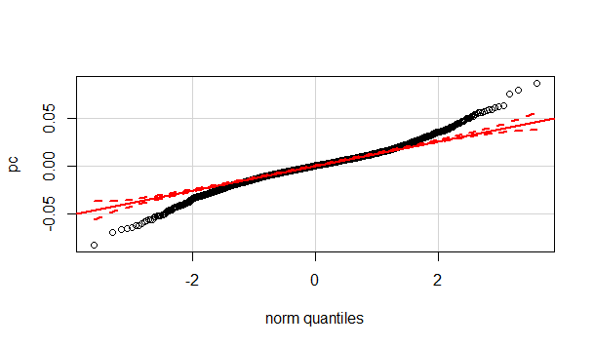
Figure 1A. QQ-plot of PC scores for modern male vault variables.

Table 3A Results of Box’s M test of equality of covariances matrices for modern male facial variables.

Box’s M | 192.266
F | 1.289
df1 | 132
df2 | 29129.990
Sig. | .014

Table 4A. Results of Royston’s multivariate normality test for modern male facial variables.
H | 16.2331
p-value | 0.181
Data multivariate normal at α=0.05.
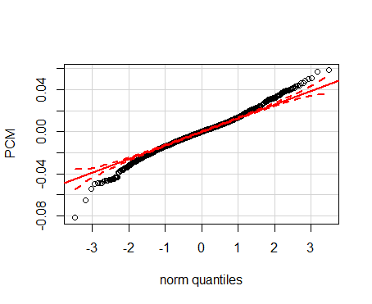
Figure 2A. Q-Q plot of PC scores for modern facial variables.

Table 5A. Results of Box’s M test of equality of covariances matrices for modern male all variables.

Box’s M | 367.134
F | 1.026
df1 | 306
df2 | 50714.274
Sig. | .367

Table 6A. Results of Royston’s multivariate normality test for modern male all variables.
H | 18.60447
p-value | 0.416
Data is multivariate normal at α=0.05.

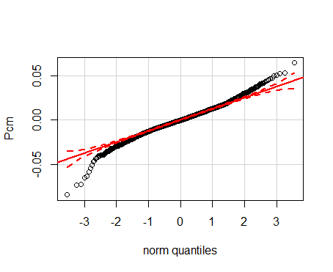
Figure 3A. Q-Q plot for PC scores for modern males all variables.

Table 7A. Box’s M test for equal covariance matrices for modern females.

Box’s M | 400.574
F | 1.129
df1 | 272
df2 | 14415.769
Sig. | .073

Table 8A. Results of Royston’s multivariate normality test for modern females.
H | 21.1498
p-value | 0.219663
Data Multivariate normal at the α=0.05 level.

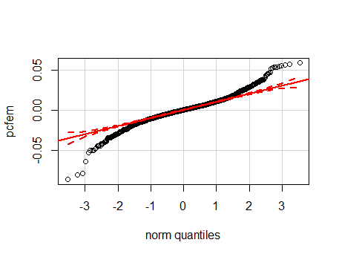

Figure 4A. Q-Q plot for PC scores for modern females.

Table 9A. Box’s M test for equal covariance matrices for medieval, Edo and modern males.
Table 57. Box’s M | 304.043
F | 1.179
df1 | 171
df2 | 4197.796
Sig. | .058

Table 10A. Results of Royston’s multivariate normality test for medieval, Edo and modern. males
H | 22.34716
p-value | 0.267320
Data is multivariate normal at the α=0.05 level.

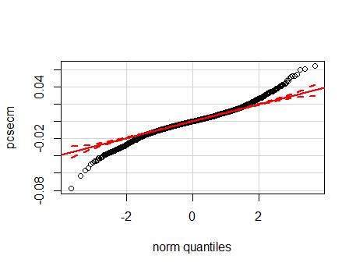
Figure 5A. Q-Q plot for PC scores for medieval, Edo and modern males.

Table 11A. Box’s M test for equal covariance matrices for medieval, Edo and modern females.

Box’s M | 178.527
F | .904
df1 | 153
df2 | 8566.430
Sig. | .794

Table 12A. Results of Royston’s multivariate normality test for medieval, Edo and modern females.
H | 13.0597
p-value | 0.1599
Data is multivariate normal at the α=0.05 level.

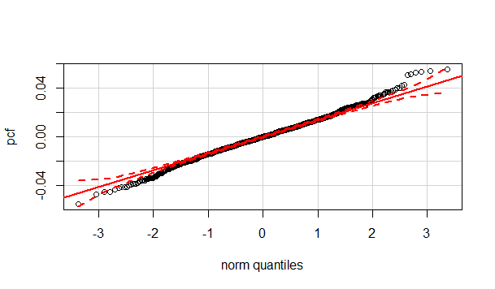
Figure 6A. Q-Q plot of PC scores for medieval, Edo and modern females.

Table 13A. Box’s M test for equal covariance matrices for prehistoric and modern male vault variables.

Box’s M | 271.686
F | 1.026
df1 | 234
df2 | 35484.609
Sig. | .378

Table 14A. Results of Royston’s multivariate normality test for prehistoric and modern male vault variables.
H | 7.57278
p-value | 0.47
Data is multivariate normal at the α=0.05 level.

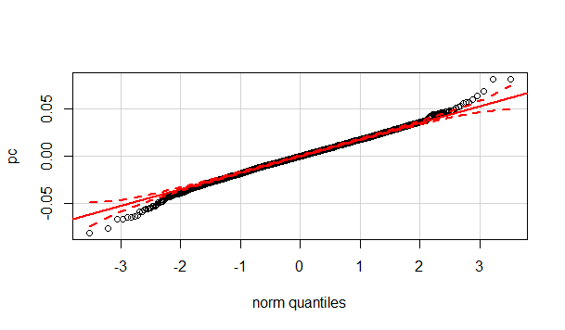
Figure 7A. Q-Q plots for PC scores for prehistoric and modern male vault variables.

Table 15A. Box’s M test for equal covariance matrices for prehistoric and modern male facial variables.

Box’s M | 507.30
F | 1.034
df1 | 420
df2 | 37918.776
Sig. | .305

Table 16A. Results of Royston’s multivariate normality test for prehistoric and modern male facial variables.
H | 15.15922
p-value | 0.056
Data multivariate normal at the α=0.05 level.

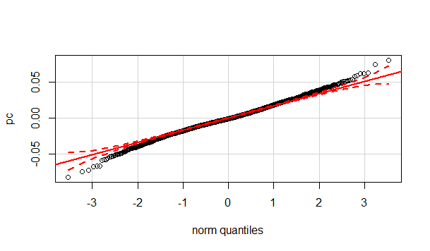
Figure 8A. Q-Q plot of PC scores for prehistoric and modern male facial variables.

Table 17A. Box’s M test for equal covariance matrices for prehistoric and modern male all variables.

Box’s M | 905.109
F | 1.024
df1 | 684
df2 | 27421.886
Sig. | .324

Table 18A. Results of Royston’s multivariate normality test for prehistoric and modern male all variables.

H | 25. 0823
p-value | 0.1223
Data multivariate normal at the α=0.05 level.
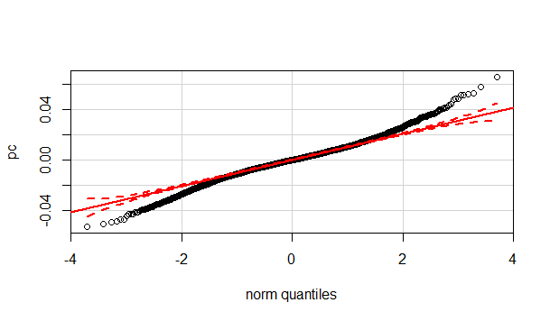
Figure 9A. Q-Q plot of PC scores for prehistoric and modern male all variables.

Table 19A. Box’s M test for equal covariance matrices for prehistoric and modern female all variables.

Box’s M | 481.542
F | 1.175
df1 | 312
df2 | 10877.539
Sig. | .020

Table 20A. Results of Royston’s multivariate normality test for prehistoric and modern female all variables.
H | 13.05975
p-value | 0.1599
Data is multivariate normal at the α=0.05 level.

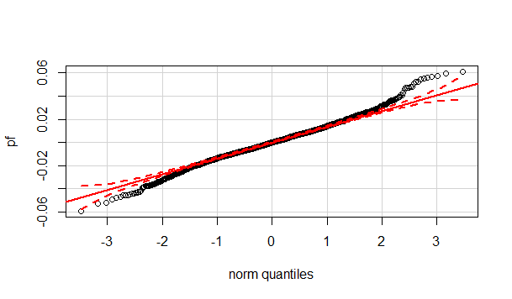
Figure 10A. QQ-plot of PC scores for prehistoric and modern female all variables.

Table 21A. Centroid Size means and standard deviations.
Group | Centroid Size Mean | Std. Deviaiton | Sig. Dif at 0.05
Modern Male Vault | 290 | 0.38 | No
Modern Male Face | 123 | 0.73 | No
Modern Male All | 396 | 2.30 | Yes
Modern Female All | 377 | 2.00 | No
Male Secular Samples | 398 | 4.40 | No
Female Secular Samples | 382 | 3.06 | No
Prehistoric Modern Male Vault | 329 | 3.50 | Yes
Prehistoric Modern Male Face | 111 | 1.89 | Yes
Prehistoric Modern Male All Var | 402 | 4.69 | No
Prehistoric Modern Female | 380 | 4.83 | Yes

Table 22. Shape variable Procrustes ANOVA results.
Effect: Shape |  | SS | MS | df | F | P
Mod Male Vault
Region |  | 0.03150648 | 0.0009185 | 82 | 16.08 | <0.0001
Residual |  | 0.81309567 | 0.0000506 | 16058
Mod Male Face
Region |  | 0.03553309 | 0.0011104 | 32 | 16.45 | <0.0001
Residual |  | 0.735330098 | 0.0001249 | 5887
Mod Male All
Region |  | 0.0209281 | 0.0002552 | 82 | 10.33 | <0.0001
Residual |  | 0.6362656 | 0.0000450 | 14134
Mod Female All
Region |  | 0.0128373 | 0.0001645 | 78 | 6.77 | <0.0001
Residual |  | 0.5236600 | 0.0000519 | 10082
Male Secular
Period |  | 0.0418680 | 0.0002252 | 164 | 6.13 | <0.0001
Residual |  | 0.8624788 | 0.0000479 | 17982
Female Secular
Period |  | 0.0211383 | 0.0002577 | 82 | 3.23 | <0.0001
Residual |  | 0.6845713 | 0.0000489 | 13986
Prehistoric Modern Male Vault
Period |  | 0.1108895 | 0.000770 | 144 | 15.01 | <0.0001
Residual |  | 1.2606111 | 0.000094 | 13376
Prehistoric Modern Male Face
Period |  | 0.1018225 | 0.001061 | 96 | 10.15 | <0.0001
Residual |  | 1.0851500 | 0.0001268 | 7975
Prehistoric Modern Male All
Period |  | 0.0847401 | 0.0003444 | 246 | 12.52 | <0.0001
Residual |  | 1.0030498 | 0.0000470 | 21312
Prehistoric Modern Female All
Period |  | 0.07472468 | 0.0002603 | 287 | 9.19 | <0.0001
Residual |  | 0.7320101 | 0.0000482 | 15170

VITA

Beatrix Dudzik was born and raised in Northern California. She attended community college and transferred to the University of Tennessee in 2005 where she completed a BA in anthropology. She completed a MA in biological anthropology at the University of Montana in 2009 and returned to Knoxville to pursue her PhD in 2010. During her pursuit of her doctoral degree, Beatrix was a research assistant for the Forensic Databank under the guidance of Dr. Richard Jantz, a position that she is most thankful to have been appointed. Beatrix completed her doctoral degree July 2015. She lives with her two dogs and is starting as an assistant professor of anatomy at Lincoln Memorial University August 2015. She lived happily ever after (with her two dogs).

