A mitotic cue triggers the resumption of cell growth after division

Afton Russell

December 12th, 2019
Das Lab
Maitreyi Das, Julie Rich-Robinson
Department of Biochemistry & Cellular and Molecular Biology
University of Tennessee, Knoxville
Abstract
Cell growth stops during mitosis and then resumes after cell separation. The mechanism that controls this growth resumption is largely unknown. It is important that cells properly regulate cell growth and separation to ensure that cells separate correctly. In our lab, we study Schizosaccharomyces pombe (S. pombe), or fission yeast, which is a good model system to study this mechanism. During cytokinesis, fission yeast cells build a septum made out of new cell wall, which is partially digested to allow cell separation. Since growth resumes after cell separation, it stands to reason that the physical separation of the cells cues the resumption of growth at the cell ends. In our lab, we are able to chemically delay cell separation, leading to an uncoupling of cell separation and cell growth. Once these processes are uncoupled, we observe long multiseptated cells. These cells resumed growth without undergoing cell separation, showing that physical cell separation is not necessary for growth to resume after mitosis. By imaging cells containing fluorescent markers that allow us to see what cell cycle stage the cell is in, we were able to show that cell growth is triggered in the cell during mitosis. After this mitotic cue, the cell ends are able to out-compete the cell middle. When this happens, cell separation becomes delayed because resources are brought to the ends rather than the septum, causing the ends to grow and the cell to fail to separate before growth resumption. Cdc42 is a small GTPase that is a highly conserved regulator of growth and polarity in eukaryotes. Normally, Cdc42 is activated at the septum until the cell separates, and afterward becomes activated at the cell ends. However, in the uncoupled cells, the mitotic cue for growth resumption leads to Cdc42 activation at the cell ends to promote growth sometimes even before completion of septum formation. Future investigation of this mitotic cue could lead to a better understanding of what the cell cycle cue is and how it regulates Cdc42.
Introduction
Cytokinesis and growth must be regulated to ensure the proper separation of cells at the end of division (Guertin et al. 2002). Cells must stop growth during cell division and then resume again after the separation of the two cells. This is important so the cell can maintain a proper size. The cue that leads to the resumption of growth after cell separation is not understood.

S. pombe (fission yeast) is a good model organism when looking at cell cycle and growth. This is because these cells display polarized growth that can be easily assessed. S.pombe can be manipulated by deleting or tagging different genes and proteins and can be easily imaged.

Cdc42 is a small GTPase that is a major regulator of polarity in eukaryotes (Miller and Johnson 1994; Johnson et al. 1999). Cdc42 is active when bound to GTP and is inactive when bound to GDP (Figure 1). Guanine exchange factors (GEFs) and GTPase activating proteins (GAPs) are regulators of GTPases (Bos et al. 2007). GEFs are activators of GTPases and remove bound GDP so that GTP can bind. In fission yeast, the GEFs of Cdc42 are Gef1 and Scd1. (Chang et al. 1994; Coll et al. 2003) GAPs are inactivators of GTPases and work by promoting GTP hydrolysis to GDP. In fission yeast, the GAPs of Cdc42 are Rga4, Rga6, and Rga3 (Tatebe et al. 2008; Revilla-Guarinos et al. 2016; Gallo Castro and Martin 2018).
Figure 1: Cdc42 activation pattern. GEFs activate Cdc42-GDP by removing the GDP, allowing GTP to bind. GAPs inactivate Cdc42-GTP by dephosphorylating the GTP on the active Cdc42 back to GDP. (Bos et al. 2007)
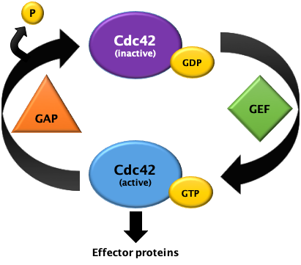

Cdc42 is activated at the cell ends in an oscillatory pattern (Das et al. 2012). As seen in Figure 2, Cdc42 cannot be simultaneously activated at each end. This observation led to the understanding that there is competition for the limited resources in the cell, so the limited resources move from one end to the other, such that at any given time, only one end activates Cdc42 (Das et al. 2012). As the cell starts cytokinesis, Cdc42 activation stops at the cell ends and transitions to the cell middle (Wei et al. 2016). Once the cell starts separating, Cdc42 activation at the cell ends resume, and growth ensues.
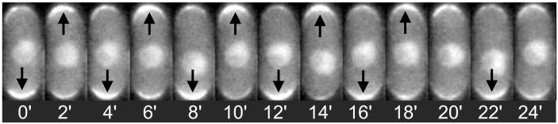

Figure 2: Cdc42 activation displays an oscillatory pattern at the cell ends during interphase. CRIB-GFP is a probe that selectively binds active Cdc42. This probe has been used to show that active Cdc42 oscillates between the two ends of a bipolar cell. This reveals a competition for resources in the cell. Image from Das et al. 2012¹

The question that we pose is: what is the cue that causes growth to continue, and when does it occur? We hypothesized that the physical separation of the cells signaled the ends to resume growth.

Methods
Cell immobilization
Place 10µl of 1mg/mL Lectin on a movie dish and leave for 30 minutes at 25°C. After, rinse the dish, and add 50µl of concentrated cells onto the lectin in the dish. After 30 minutes, rinse the excess cells off the dish. Quickly place the dish on the microscope, so the cells do not dry out on the plate. Immediately add 100µl media. Once the microscope is focused and initial images have been taken, add LatA treatment and after treatment wash cells. Leave excess media in the dish. Continue to image past LatA rinse out to see effects (Ye Dee et al. 2018).

LatA Treatment
10µM concentration of LatA drug is added to cells. This drug is left on cells for 30 minutes to ensure complete depolarization of actin structures in the cells. The LatA is then washed out three times, and the actin structures are once again allowed to be remade. This remaking of the actin structures, including the actomyosin ring, which delays the separation clock and leads to the uncoupling of cell separation and growth resumption (Spector et al.1983).

Results
To test this, we treated cells with Latrunculin A (LatA) at a concentration of 10 µM for 30 minutes. LatA depolarizes actin, and this disrupts the actomyosin ring (Spector et al.1983). The LatA was then washed out, allowing the actin to polymerize once again, allowing cytokinesis to resume. This treatment delays the cytokinetic and separation clock of the cells. We find that while cytokinesis was delayed in these cells, they were able to resume growth from the cell ends in a timely manner even before the cells separated. Moreover, the cells failed to complete cytokinesis and failed to separate. These cells appeared elongated and multiseptated, and we referred to them as PrESS cells or Polar Elongation Sans cell Separation (Figure 3). Since the cells fail to separate and begin to grow before completion of cytokinesis, our data suggest that growth resumes independently of cell separation.



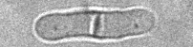
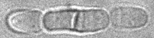
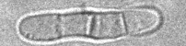
Figure 3: Premature elongation sans separation (PrESS) as observed in cells recovering from LatA treatment. After being treated with 10µM LatA for 30 minutes, a subset of asynchronous wild type cells shows what we call the PrESS phenotype. This unique phenotype is characterized by long cells that resume growth during or immediately after septum formation, fail to separate, and eventually become multiseptated.
bright-field

Next, using time-lapse imaging, we further analyzed the PrESS phenotype in the LatA treated cells. We used Rlc1-tdTomato and Sad1-mCherry to tag the ring and the spindle pole bodies, respectively. The cell cycle stage was determined by viewing the stage of the ring formation or constriction and the distance between the spindle pole bodies. Previously in the Das Lab, LatA experiments consisted of imaging cells before LatA treatment, treating the cells, then washing out the drug, and then imaging the cells once again. With this method, there was no way to image the same cell before, during, and after treatment. I adapted a lectin protocol to allow us to image the same cells throughout the treatment process (Spector et al.1983).

Imaged cells treated with lectin and LatA
Wild type cells with fluorescently tagged Bgs1-GFP, Rlc1-tdTomato, and Sad1-mCherry were adhered to plates using lectin and then treated with LatA for 30 minutes and then washed out with fresh media. Bgs1 or 1,3-beta-glucan synthase, makes 1,3-beta-glucan, which is a major component of fission yeast cell wall. By tagging Bgs1, we were able to see where new cell wall was being produced. We used Bgs1 localization as a metric to show when the initiation of growth occurs. Cells that were treated with LatA during mitosis displayed the PrESS phenotype during recovery (Figure 4A), while those that were treated in interphase or after the completion of mitosis separated normally and developed into two daughter cells (Figure 4B and C).

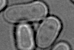
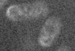
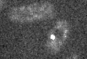
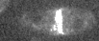
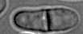
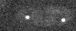
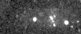
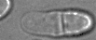
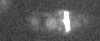
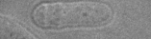
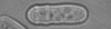
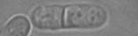
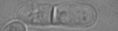
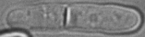
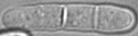
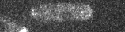

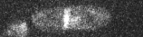
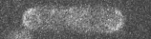
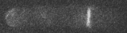
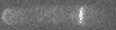
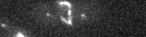

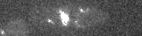
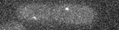
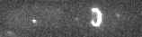
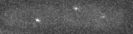
Rlc1-tomato, Sad1-mCherry
Bright-field
Bgs1-GFP
-36
38
250
B.
-32 18 118 328 598 638

Bright-field
BGS1-GFP
Rlc1-tomato
Sad1-mCherry
A.

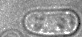
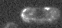
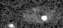
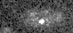
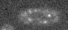
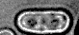
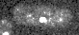
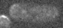
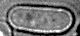
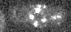
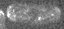
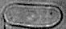
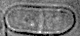
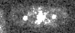
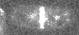
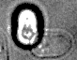
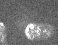
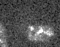
Rlc1-tomato, Sad1-mCherry
Bright-field
Bgs1-GFP
-32
72
358
478
548
668
C.
Figure 4: PrESS phenotype is cell-cycle stage-dependent. Wild type cells containing Bgs1–GFP, Rlc1–tdTomato, and Sad1–mCherry adhered to a plate with lectin. (A) Cells treated with LatA during mitosis exhibit the PrESS phenotype. (B) Cells treated with LatA after septum formation do not exhibit the PrESS phenotype. (C) Cells treated with LatA while in interphase do not exhibit the PrESS phenotype.

Next, we examined Cdc42 activation in the PrESS cells. Cells expressing CRIB-GFP, a probe for active Cdc42, were once again adhered with lectin and treated with LatA as before. We found that in the cells that were treated with LatA during mitosis, CRIB-GFP shows up at the cell ends earlier, leading to PrESS cells (Figure 5A). Cells that were in interphase during LatA treatment did not show the PrESS phenotype. In these cells, active Cdc42 leaves the cell middle after the ring has fully constricted, and the septum is fully formed, as seen in Figure 5B. In the PrESS cells, active Cdc42 leaves the cell middle before the ring has fully constricted, and the septum has been fully formed, as seen in Figure 5A.

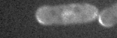
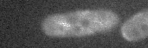
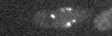
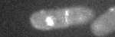
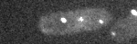
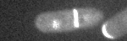
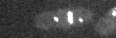
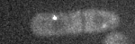
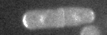
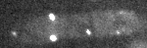
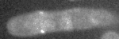
-32 8 98 128 198 328
CRIB-GFP
Rlc1–tdTomato
Sad1–mCherry
A.
Figure 5: PrESS cells sequester Cdc42 activation at the cells ends. Wild type cells containing with CRIB–GFP, Rlc1–tdTomato, and Sad1–mCherry adhered to the plate with lectin. (A) In mitotic cells treated with LatA, active Cdc42 leaves the cell middle before the septum is fully formed, and then localizes to the cell ends. (B) In interphase cells treated with LatA, active Cdc42 leaves the cell middle once the septum has fully formed and then appears at the cell ends.

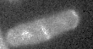
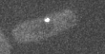
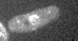
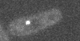
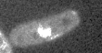
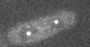
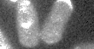
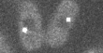
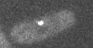
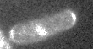
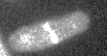
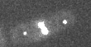
-31 20 110 180 210 250
CRIB-GFP
Rlc1–tdTomato
Sad1-mCherry
B.

Discussion
Cells that had their actin disrupted during mitosis developed into the PrESS cells, while those that were disrupted at any other stage of the cell cycle did not. With this information, we hypothesize that the cue that triggers growth resumption occurs during mitosis and not in cell separation. Cells must pass this cue in order to resume growth. In the uncoupled cells, active Cdc42 leaves the cell middle early, while the cell is still forming, and then appears at the cell ends. This observation shows that there could be a link between the mitotic cue and active Cdc42 localization to the ends after the cells separate. This indicates that the mitotic cue could allow the cell ends to become more competitive for resources that move from the middle where the cells were separating to the cell ends where they resume growth. Future research is necessary in identifying the nature of mitotic cue and how it affects the activation of Cdc42 at the cell ends.

References
Bos, J. L., H. Rehmann, and A. Wittinghofer, 2007 GEFs and GAPs: critical elements in the control of small G proteins. Cell 129: 865–877. doi:10.1016/j.cell.2007.05.018
Chang, E. C., M. Barr, Y. Wang, V. Jung, H. P. Xu et al., 1994 Cooperative interaction of S. pombe proteins required for mating and morphogenesis. Cell 79: 131–141. doi:10.1016/0092-8674(94)90406-5
Coll, P. M., Y. Trillo, A. Ametzazurra, and P. Perez, 2003 Gef1p, a new guanine nucleotide exchange factor for Cdc42p, regulates polarity in Schizosaccharomyces pombe. Mol. Biol. Cell 14: 313–323. doi:10.1091/mbc.e02-07-0400
Das M, Drake T, & Verde F (2012). Oscillatory dynamics of Cdc42 GTPase in the control of polarized growth. Science 337(6091), 239-243.
Gallo Castro, D., & Martin, S. G. (2018). Differential GAP requirement for Cdc42-GTP polarization during proliferation and sexual reproduction. The Journal of cell biology, 217(12), 4215–4229. doi:10.1083/jcb.201806016
Guertin, D.A., Trautmann, S. and McCollum, D. (2002) Cytokinesis in eukaryotes. Microbiology and Molecular Biology Reviews, 66(2), 155–178.
Johnson, D. I., 1999 Cdc42: an essential Rho-type GTPase controlling eukaryotic cell polarity. Microbiol. Mol. Biol. Rev. 63: 54–105.
Miller, P. J., and D. I. Johnson, 1994 Cdc42p GTPase is involved in controlling polarized cell growth in Schizosaccharomyces pombe. Mol. Cell. Biol. 14: 1075–1083. doi:10.1128/MCB.14.2.1075
Revilla-Guarinos M.T., Martin-Garcia R., Villar-Tajadura M.A., Estravis M., Coll P.M., and Perez P. 2016. Rga6 is a Fission Yeast Rho GAP Involved in Cdc42 Regulation of Polarized Growth. Mol. Biol. Cell. 27:1524–1539. 10.1091/mbc.E15-120818
Spector I, Schochet NR, Kashman Y, & Groweiss A (1983). Latrunculins: Novel marine toxins that disrupt microfilament organization in cultured cells. Science 214, 493-495.
Tatebe H., Nakano K., Maximo R., and Shiozaki K. 2008. Pom1 DYRK regulates localization of the Rga4 GAP to ensure bipolar activation of Cdc42 in fission yeast. Curr. Biol. 18:322–330. 10.1016/j.cub.2008.02.005
Wei, B., Hercyk, B. S., Mattson, N., Mohammadi, A., Rich, J., DeBruyne, E., Clark, M. M. and Das, M. (2016). Unique spatiotemporal activation pattern of Cdc42 by Gef1 and Scd1 promotes different events during cytokinesis. Mol. Biol. Cell 27, 1235-1245. doi:10.1091/mbc.E15-10-0700
Ye Dee Tay, Marcin Leda, Andrew B. Goryachev, & Kenneth E. Sawin (2018) Local and global Cdc42 guanine nucleotide exchange factors for fission yeast cell polarity are coordinated by microtubules and the Tea1-Tea4-Pom1 axis. Journal of Cell Science (131).

