Is Identity Fusion a Catalyst of Extreme Self-Sacrifice for the Ingroup? Examining Threat to Group vs. Member Welfare

A Dissertation Presented for the
Doctor of Philosophy
Degree
The University of Tennessee, Knoxville

Brandon Lawrence Porter
May 2025
ACKNOWLEDGEMENTS
Thank you to the members of my dissertation committee (Garriy Shteynberg, Michael Kotowski, and Michael Olson), and to my advisor, Lowell Gaertner, for the insightful feedback and guidance. A special thanks to my spouse, Jes Parker, for their never-ending care and support.

ABSTRACT
Identity fusion (a visceral sense of oneness between the individual and collective self) is proposed to be a catalyst for extreme pro-group behavior. However, existing work relies on self-report and relatively mundane behavioral interventions. As such, studies one through three explore whether identity fusion predicts a willingness to do an ostensibly real painful act (donating plasma, skin, joining the military) that benefits their group. Identity fusion only predicts willingness to volunteer within a military context. One possibility is that a military context creates a sense of group existence threat (as opposed to group member wellbeing threat). Study four examines this pattern by independently varying threat to group existence (yes, no) and threat to group member wellbeing (yes, no). Results suggest that identity fusion only predicts self-sacrifice in situations threatening group existence. Study five attempts to explore this threat distinction using an ostensibly real situation that varies in whether it is framed as threatening group existence or group member wellbeing. However, study five results were unusable due to the high rate of participant inattention. Overall, the pattern of findings suggest that identity fusion is a catalyst for extreme pro group behaviors but only in contexts where the group’s existence is threatened. Limitations and theoretical importance are discussed.

Table of Contents

Chapter One Introduction and General Information 1
Identity Fusion 1
Identity Fusion and Pro Group Behaviors 2
Current Studies 4
Chapter Two Study One: Plasma Donation 6
Procedure 6
Results 7
Discussion 8
Chapter Three Study Two: Skin Donation 9
Procedure 9
Results 10
Discussion 11
Chapter Four Study Three: Military Service 12
Procedure 12
Results 13
Discussion 14
Chapter Five Study Four: Group vs Member Threat as Moderator 15
Procedure 15
Results 16
Discussion 18
Chapter Six Study Five: Existence vs Wellbeing Behavioral Study 19
Procedure 20
Results 21
Discussion 22
Chapter Seven Conclusions and Recommendations 24
General Discussion 24
Limitations and Future Directions 25
Conclusion 25
References 27
Appendices 30
Vita 47

LIST OF FIGURES

Figure 1. Fusion distributions across studies one through four. 30

Figure 2. Fusion slopes across conditions, study four. 31

CHAPTER ONE
INTRODUCTION AND GENERAL UNFORMATION
Tales of heroism are commonly heralded regaling acts of bravery of one person for the benefit of their group. Yet, such behaviors tend to be considered as outside the range of normal group behavior and happen with relative infrequency (Johnson, 1996). Whether it be mythological or based in reality, the question emerges as to whether a person’s connection to their group, when strong enough, can lead to a willingness to risk their life for the benefit of that group. Numerous models attempt to explain why people engage in extreme pro-group behaviors varying from pathological (Lankford, 2014), relationship-based (manipulated kin selection; Lyons, 2005; Qirko, 2002, 2013) to identity-based perspectives (Identity Fusion; Swann et al., 2009). The latter approach will be the focus of these studies. Namely, does an individual in a state of identity fusion really have a heightened willingness to commit extreme acts to the benefit of their in-group and is this motivation differentially activated based on whether the situation threatens the group’s existence or their fellow group members’ wellbeing?
Identity fusion
Fusion is a visceral sense of oneness with a group (Swann & Buhrmester, 2015; Swann et al., 2012). Theoretically, identity fusion is a state where one’s collective identity and individual identity can remain salient simultaneously (Swann et al., 2009). There are a few key aspects of identity fusion that make it distinct from other identity theories and relevant to investigations of extreme pro-group behavior. First, people in a state of fusion perceive deeply meaningful family-like ties with members of their group (even those they have not met; Swann et al., 2014). Another key component of this explanation lies in the salience of the personal self while in a state of fusion, which permits a wider range of behaviors and greater flexibility (Swann et al., 2009; Swann et al., 2012). Theoretically, people in a fused state can utilize the agency of the personal self to further fuel group directed behavior, while those in a non-fused state cannot as the personal self is dormant in an intergroup context. This dual activation may contribute to a greater tendency to endorse costly pro-social action (Swann et al., 2010a). Personal agency has been manipulated in lab by raising autonomic arousal (physical exertion) to further promote pro-group action from fused participants (Swann et al., 2010a). Indeed, fusion has been found to predict extreme behaviors (Swann et al., 2010b). High fusion levels have even been found to predict group-serving behaviors even when the individual self is made salient, which counters traditional identity models where an antagonistic relationship between the collective and individual identity is assumed (Swann et al., 2009; Gómez et al., 2020). Based off of these findings, identity fusion has been attributed as the catalyst for extreme acts such as suicide bombings (Whitehouse, 2018).
Identity fusion and pro group behaviors
Identity fusion has been proposed as a source for extreme pro-group behaviors. Prior research suggests that identity fusion (i.e., a visceral sense of oneness with a social group; e.g. “I am one with my country”) promotes a willingness to engage in extreme sacrifice for the group (Heger & Gaertner, 2018; Swann et al., 2012, 2015). Fusion to one’s country, for example, predicts self-reported willingness to fight and die for the country in samples from 11 nations (Australia, Chile, China, Germany, India, Indonesia, Japan, Poland, South Africa, Spain, United States; Swann, Buhrmester, et al., 2014). These findings reinforce the importance of identity fusion as a contributor to extreme pro group behaviors, but many of the behaviors examined to date have relied on relatively mundane behaviors or self-report. As such, claims of identity fusion as being a catalyst for such extreme acts as suicide bombings (as proposed by Whitehouse et al., 2018) or actual fighting-and-dying warrants further testing.
The relationship between identity fusion and extreme pro-group behavior has been found repeatedly using self-report methods. For example, much work utilizes the fight-and-die scale (Swann et al., 2009) which features questions such as “I would be willing to fight if someone insults my country.” This work has repeatedly found a connection between self-reported identity fusion and higher scores on this fight-and-die scale (Swann et al., 2009) or self-report hypothetical trolley dilemmas (Swann et al., 2010). However, expressing a willingness to fight-and-die might be different from actually fighting and dying. Participants might be self-enhancing on these scales due to the relative importance of the group to them (someone who fuses to a group likely considers the group as important to them and therefore might exaggerate their willingness in order to bolster their self-esteem). Likewise, potential costs are less salient and more easily ignored when contemplating behavior in scenarios than real situations.
While self-report studies leave much to be desired in terms of ecological validity, field work in anthropology provides some suggestions on the source of extreme pro-group behaviors. ISIS fighters in the Middle East, who were highly fused to their fellow unit members, expressed a willingness to protect their fellow unit members to the same degree as their own family (Gómez et al., 2017). Moreover, it has been observed that some organizations which require more from their members (e.g., Catholic church and Priests) tend to create environments which manipulate feelings of closeness (termed manipulated kin selection; Qirko, 2002, 2013). However, these non-experimental studies cannot answer the question causally. As such, systematic experimental studies are needed to examine the proposed relationship between identity fusion and extreme pro-group behavior.
Experimental attempts to operationalize extreme pro group behaviors pale in the extremity of action the model seeks to explain. Donations to charitable causes have been used as extreme behaviors in several studies. For example, people highly fused to WildCRU (the research team studying lions in the area) were more likely to continue donating money following the poaching of Cecil the Lion than were non-fused people (Buhrmester et al., 2018a). Additionally, when asked to donate their 5-euro study compensation after completing a survey, participants fused to Spain were more likely to donate than were non-fused participants (Swann et al., 2010a). Donating money (especially relatively small amounts) might not reach the extremity required to test fusion as a predictor of self-sacrifice. Similarly, in the aftermath of the Boston Marathon bombing, those fused to Boston were more likely to write letters to victims (Buhrmester et al., 2015). However, it is questionable whether monetary donations and letter writing efforts constitute extreme sacrifices on par with fighting and dying and the likes of martyrdom discussed in theoretical models (Whitehouse, 2018). Indeed, a small donation or written letter might be dwarfed by the anticipated guilt of not having donated or written. Consequently, it is dubious whether such actions can even be considered a sacrifice. As such, the current work attempts to go beyond such limitations and examine actual (vs imagined) costly behavior.
Current studies
The current project consists of five studies (four of which have been completed) and has two foci. Studies 1, 2, and 3, test whether the positive association between identity fusion and extreme pro-group behavior persists when the situation is real (rather than presented as a scenario) and entails actual costs. In these studies, we pre-measure identity fusion and confront participants (via random assignment) with an ostensibly real opportunity to sacrifice for the ingroup or to report what they would do when that same opportunity is presented as a scenario. Study 4 addresses an inconsistent pattern in Study 3 versus that of Studies 1 and 2 and tests whether a fusion to sacrifice link requires a threat to the existence of the ingroup (rather than a threat to the wellbeing of ingroup members). Study 5 attempts to explore the relationship of fusion and self-sacrifice as moderated by whether the same ostensibly real situation threatens either group members or group existence. All studies use the United Stated as the ingroup because past research with our student population reveals a normal distribution of fusion to the United States that spans the full range of the fusion scale (Heger & Gaertner, 2018).

CHAPTER TWO
Study One: Plasma Donation
To test whether the fusion-to-sacrifice association occurs in real situations or is an artifact of the typical scenario procedure, we randomly assigned participants to have the opportunity to voluntarily sacrifice in an ostensibly real and painful blood-plasma donation or to report what they would do when the donation opportunity was presented as a scenario. We attempted to maximize our ability to observe a relationship between fusion and sacrifice by enhancing the salience of the ingroup (using the colors of the flag in the stimuli), presenting the sacrifice opportunity in the context of a threat to the ingroup (i.e., low plasma levels in US Blood Banks), and removing potential barriers to sacrificing (e.g., insufficient time, inability to access) by giving participant the opportunity to sacrifice while completing the study.
If the relationship between identity fusion and extreme pro-group behavior is an artifact of scenario methodology, we would anticipate a Fusion x Condition interaction such that fusion predicts plasma-donation in the scenario but not real situation. Alternatively, if fusion is an actual catalyst of extreme pro-group behavior fusion should predict plasma-donation regardless of condition.
Procedure
Three hundred and twenty-eight participants (females = 228, males = 100, M_{age} = 18.41, SD_{age} = 1.00), who had completed the identity fusion to the United States scale (Gomez et al., 2011; see Appendix A) during the online mass screening session, were randomly assigned to the imagined or real condition. The experimenter (whose biological sex was matched to that of the participant) explained to participants randomly assigned to the actual condition they would be completing a survey and they could do it in the lab or down the hall while donating blood-plasma for the United States Blood Bank. The experimenter handed the participant a pamphlet to read while s/he retrieved the questionnaire. The pamphlet emphasized the threateningly low blood-plasma levels in the US and the salience of the US via the name of the program and utilizing the colors of the flag (see Appendix B for plasma pamphlet) and explained that the blood-plasma extraction process was painful. The experimenter returned, asked the participant, where s/he wanted to complete the questionnaire, had the participant complete a questionnaire assessing age and biological sex, and then performed a funnel debriefing. Participants in the scenario condition received the same pamphlet but it was presented in a questionnaire as a scenario asking the participant to “Imagine what you would do if you arrived to a study and the experimenter asked you to…” (see Appendix C for plasma scenario wording).
Results
Of the 327 participants, 2 were removed due to giving inconsistent responses in the prescreen (indicating that they were biologically male but also stating they were on hormonal birth control and/or pregnant). Thus, a final sample of 325 participants (males = 98, females = 227, M_{age} = 18.42, SD_{age} = 1.00) was used for the analysis (conclusions, based on direction and p-values, remain unchanged regardless of inclusion). As seen in Figure 1 panel a, fusion was normally distributed and spanned the full range of the scale.
Using logistic regression, I regressed willingness to volunteer (yes, no) onto mean-centered fusion, effects-coded condition (actual, scenario), and the interaction of condition with fusion. Participants were more likely to volunteer to donate blood plasma when the opportunity was presented as a scenario (42%) than an actual situation in which only a small minority did so (13%; b = 1.57, SE = 0.29), Wald χ² = 29.55, p < .0001. Unfortunately for the goal of this research, there was neither an effect of fusion (b = - 0.14, SE = 0.10), Wald χ² = 1.92, p = .166, nor a Fusion x Condition interaction (b = 0.18, SE = 0.20), Wald χ² = 0.80, p = .374.
Discussion
That participants were more willing to volunteer to donate plasma when the situation was a scenario rather than ostensibly real, underscores the importance of employing behavioral measures particularly when studying outcomes such as willingness to sacrifice. Costs are more easily ignored in scenarios and levels of reported sacrifice are apparently exaggerated. More troubling, however, for the purpose of this research, fusion was unrelated to self-sacrifice even in the scenario condition. Consequently, these data are relatively uninformative for testing whether the sacrificial effect of fusion is limited to scenario studies where behavioral costs are easier to ignore. This begs the question as to why, unlike other scenario studies, we did not find an effect of fusion? Fusion scores spanned the full range of the scale, ruling out concerns with restriction of range. One possibility was the timing of the study. We conducted it the first semester after the COVID quarantine ended. Perhaps participants were hesitant to provide blood-draws with needles due to the salience of disease. Such a pattern is consistent with the substantially diminished rate of volunteering in the actual relative to scenario condition. But it is not immediately clear why concern with disease or needles would be problematic for highly fused persons who are ostensibly willing to engage in extreme self-sacrifice (e.g., fighting and dying) particularly in the scenario condition. Another possibility, however unlikely, is that fusion levels changed from the pre-screener to the lab session thereby rendering fusion unpredictive of sacrifice. A third possibility could be sampling error. We conducted Study 2 as a conceptual replication to again test whether the sacrificial effect of fusion is limited to scenario paradigms.

CHAPTER THREE
Study 2: Skin Donation
Study 2 offers four changes from Study 1. First, it puts more time between data collection and the Covid quarantine. Second, we changed the sacrifice opportunity from donating blood to rectify low plasma levels in US blood banks to donating a skin sample via a painful skin punch to combat a US cancer epidemic. Third, we measured fusion to the US both in the pre-screener and in the laboratory session to assess a possible change in fusion. Fourth, we included the fight-and-die for the US scale at the end of the laboratory session to see if fusion differentially predicts that scale relative to our sacrifice opportunity.
Procedure
Upon arrival to the lab, participants (N = 100; 24 males, 66 females; M_{age} = 19.14, SD_{age} = 1.06) completed three fusion scales in regard to the US, their birth city, and their high school (the latter two were included to minimize demand effects). As in Study 1, the experimenter (whose biological sex was matched to that of the participant) subsequently informed participants randomly assigned to the actual condition that they could complete the remaining questionnaires in the lab or down the hall while making a skin donation to help the United States Institute for Cancer research to help fight skin cancer. The experimenter gave the participant a pamphlet to read while s/he prepped the materials for the study. The pamphlet (provided in both the real and scenario condition) emphasized the threat of cancer to the US and the salience of the US via the name of the program and utilizing the colors of the flag (see appendix D for skin biopsy pamphlet). The experimenter returned, asked the participant whether they wanted to go down the hall to donate a skin sample, and prior to the debriefing, had the participant complete the fight and die for the United States scale (see Appendix F; Swann et al., 2009), physical inadequacy subscale of the masculine gender roll stress scale (See Appendix G; Eisler & Skidmore, 1987), along with demographics assessing age, biological sex, US citizenship, and how many people they knew who had cancer. The participant then conducted a funnel debriefing. Participants randomly assigned to the scenario condition completed the same scales and funnel debriefing, however the skin donation was presented as a scenario in a questionnaire asking the participant to “imagine what you would do if after arriving to a study the experimenter asked you if you wanted to…; see Appendix E).
Results
Of the 100 participants, 16 participants were excluded due to either indicating they were suspicious of deception (n = 3), misunderstood the volunteer opportunity as being related to the current study’s compensation (n = 4), or failed the pre-screen attention check attached to the fusion questionnaire (n = 9). Thus, a final sample of 84 (females = 60, males = 24, M_{age} = 19.14, SD_{age} = 1.11) participants was used for analyses. As in Study 1, fusion was normally distributed and spanned the full range of the fusion scale (see Figure 1 panel b). Furthermore, the pre-screen and in-lab assessments of fusion correlated strongly (r = .85, p < 0001) ruling out the possibility that fusion dramatically changed across occasions.
With logistic regression, skin-donation (yes, no) was regressed on mean-centered fusion, effects-coded condition, and Fusion x Condition. As in Study 1, participants were more likely to voluntarily sacrifice in the scenario condition (49%) than in the actual condition where, again, only a minority of participants sacrificed (18%), b = -1.07, SE = 0.31, Wald χ² = 11.76, p = .0006. Once again, however, there was neither an effect of fusion (b = 0.06, SE = 0.23), Wald χ² = 0.06, p = .813, nor an interaction of fusion and condition (b = 0.16, SE = 0.23), Wald χ² = 0.44, p = .505 (the same conclusions based on direction of effects and p-values occur with the in-lab fusion measure). In contrast to fusion’s null effect on the skin-donation, the fusion pre-screen (and in lab) positively predicted self-reported willingness to fight and die for the US, (r = .57, p < .0001).
Discussion
Despite being normally distributed, spanning the full range of the fusion scale, and evidencing strong stability between the pre-screen and in-lab assessment, fusion scores were unrelated (in both the scenario and real situation) to participants’ decision to sacrifice with a painful skin donation to combat the US skin cancer epidemic. This replicates the same null effect in Study 1 with the blood-plasma donation procedure. Curiously, however, fusion positively predicted willingness to fight-and-die for the US. So, why would highly fused persons report an elevated willingness to fight and die but not donate blood-plasma nor a skin sample for their country? Perhaps participants are differentially conceptualizing the threat surrounding their fight-and-die decision versus the blood and skin donation decisions. In retrospect, it is possible that our blood-plasma and skin-cancer paradigms entail a threat to group members, but not necessarily the group itself. That is, some US citizens might die due to lack of blood-plasma in hospitals and diseases such as cancer, but US nonetheless persists. This raises the possibility that a sacrificial effect of fusion is triggered by an existence threat to the ingroup. To assess this possibility, Study 3 conceptually replicates the real vs. scenario approach of Studies 1 and 2 but presents a sacrificial opportunity in response to an existence threat to the ingroup.

CHAPTER FOUR
Study 3: Military Service
People high in identity fusion might respond more to threats to in-group existence as opposed to threats to individual group member wellbeing. Indeed, ideological threats have been posited as particularly important in motivating fused persons (Gómez et al., 2017). The Devoted Actor model argues that mere threat is not sufficient but rather that fused persons are sensitive to threats relevant to the group’s core identity and that these fused persons view their groups in highly essentialist ways, making the group’s existence more than the sum of its parts (Gomez et al., 2017). Additionally, when competition is framed as affecting the country's essence (i.e., core component of the group's identity), highly fused participants were more willing to engage in combative and relativistic strategies on a modified prisoner's dilemma (Buhrmester et a., 2018b). Study 3 uses a sacrifice opportunity similar to that of the fight-and-die scale and targets an ingroup existence threat. In particular, participants are presented with the opportunity to volunteer for a new military program that would be implemented only in the event of a foreign attack on US soil that depletes current forces to emergency levels.
Procedure
Upon arrival to the lab, 455 participants (males = 221, females = 234, M_{age} 18.74, SD_{age} = 1.43) were greeted by an experimenter (whose biological sex was matched to that of the participant). The experimenter explained and handed a letter to participants randomly assigned to the Actual condition that, “because the lab receives funding from the Department of Defense, we were asked to share the following opportunity with all relevant persons. While I go next door to prepare the materials for your study, please read the document and register if you want to do so – I’ll be back in a few minutes ” The letter (see Appendix H) served as an enrollment form for a new military program that would be activated only in the event of a foreign attack on US soil that depleted current forces to emergency levels. Participants in the Scenario condition received the same letter but in scenario form as part of a questionnaire, with the preface “imagine you arrive at a psychology study to complete a questionnaire” (See Appendix I for DOD imagined scenario). All participants then completed the fusion to the US scale (Gomez et al., 2011), fight and die for the United States scale (Swann et al., 2009) and provided demographics (age, sex, citizenship, political orientation [1 = extremely liberal, 10 = extremely conservative]) before experiencing a funnel debriefing.
Results
Of the 455 participants, 33 were excluded due to failure on the fusion prescreen attention check (n = 17), indicating they responded insincerely (n = 5), were current or former members of the military (n = 7), current or former members of ROTC (n = 3), or misunderstood the DOD program (n = 1). Thus, a final sample of 422 participants (males = 194, females = 228, M_{age} = 18.63, SD_{age} = 1.27) was used for analyses. The pre-screen assessment of fusion was normally distributed, spanned the full the range of the scale (see Figure 1 panel c), and strongly correlated with the in-lab assessment (r = .77, p < .0001).
I regressed enrollment in the DOD program (yes, no) onto mean centered fusion, effects-coded condition, and the Fusion x Condition interaction using firth logistic regression due to the low frequency of yes responses (Firth, 1993). As in the previous studies, participants were more likely to voluntarily sacrifice in the scenario (20%) than actual condition (5%), (b =0.72, SE = .18), Wald χ² = 16.21, p < .0001. Importantly, fusion positively predicted willingness to volunteer, (b = 0.26, SE = .13), Wald χ² = 3.998, p = .0456, and the effect was not moderated by condition (i.e., Fusion x Condition) (b = -0.06, SE = .13), Wald χ² = 0.233, p = .630.
Discussion
Unlike Studies 1 and 2 that presumably threatened the welfare of ingroup members but not the existence of the ingroup, fusion positively predicted sacrifice regardless of whether it was presented as a scenario or a real situation. This provides evidence consistent with the possibility that fusion does indeed serve as a catalyst of extreme sacrifice for the ingroup in the face of an ingroup existence threat. Study 4 more directly tests the moderating effect of a group existence vs. member threat on the sacrificial effect of fusion.

CHAPTER FIVE
Study 4: Group vs Member Threat as Moderator
Study 3 provides circumstantial evidence that a group-existence threat induces a sacrificial-fusion effect. Study 4 tests this possibility directly by independently manipulating 2(Group-Existence Threat: No, Yes) x 2(Member-Welfare Threat: No, Yes) and assessing self-reported willingness to sacrifice. If the fusion-to-sacrifice effect requires an ingroup-existence threat, we would expect a Fusion x Group-existence interaction such that fusion predicts sacrifice in the presence but not absence of a group-existence threat.
Procedure
Participants (N = 465 males = 199, females = 266, M_{age} = 18.61, SD_{age} = 1.11) completed the Fusion to the US in a pre-screening session and upon arrival at the lab were seated in a computer cubicle and presented with four prompts in a random order that were derived from a 2(group-existence threat: no, yes) x 2(member-welfare threat: no, yes) design. For example, “Imagine something is about to happen that WILL end the existence of the United States as a country but WILL NOT harm nor kill any citizens of the United States” or “Imagine something is about to happen that WILL NOT end the existence of the United States as a country but WILL harm and kill many citizens (not you) of the United States.” Furthermore, we counterbalanced between-subjects whether the prompt started or ended with the group or member description. After reading a given prompt, participants separately rated their willingness (1=very unwilling, 7=very willing) to (a) sacrifice their life, (b) end their life, (c) live a life of misery and pain, and (d) live a lonely and unhappy life, if doing so would forever prevent the event from happening Participants were also asked to provide a written description of what they imagined in the given situation. After responding to all four prompts, participants were re-presented with the four sacrifice items (i.e., sacrifice your life, end your life, live a life of misery and pain, live a lonely and unhappy life) and rated the extremity of each sacrifice (1 = somewhat of a sacrifice, 7 = an extreme sacrifice). Lastly, participants completed the Fusion to the US scale, Fight-and-die scale, and a demographic questionnaire assessing age, biological sex, political orientation, and whether they answered the questions sincerely.
Results
Of 465, at total of 10 participants were removed prior to data analysis due to either indicating insincerity in their responses (n = 2), indicating they were not US citizens (n = 3), inconsistent responses between pre-screen and in-lab data concerning citizenship (n = 2), computer issues during the in-lab portion (n = 1), indicating they responded incorrectly to questions (N =1), or indicating that they misunderstood the questions (n = 1). Two judges coded whether participants’ descriptions of what they imagined accurately reflected the intended context of the situation defined by the 2x2 manipulation. For example, if a participant stated they imagined a nuclear bomb as something that would end the existence of the US but not harm any citizens the description was coded as not reflecting the situation or if a participant responded with the same situation for all four scenarios, they were removed). Judges agreed on 92.47% of the 1820 descriptions and discussed disagreements to consensus. We excluded responses corresponding to 164 descriptions (9%) that did not reflect the situation, which ultimately excluded another participant. Due to data being analyzed using a Multilevel model, participants’ responses were eliminated case by case rather than row-wise deletion. Thus, a final sample of 454 participants (males = 195, females = 259, M_{age} = 18.61, SD_{age} = 1.11) used for analysis. The pre-screen assessment of fusion was normally distributed, spanned the full range of the scale (see Figure 1 panel d), and correlated strongly (r = .82, p < .0001) with the in lab assessment.
We analyzed responses using a multilevel model (the same conclusions based on p-values and direction of effects are obtained with a between-subject analysis of only the first presented situation). We regressed the average sacrifice score onto a factorial-crossing of mean-centered fusion, effects-coded group-threat, effects-coded member-threat, and effects-coded sacrifice type. The analysis included random effects for the intercept, effects-coded group threat, effects-coded member threat, effects-coded sacrifice type, the interaction of effects-coded group threat and member threat, and the interaction of effects-coded member threat with sacrifice type (the model would not converge with interaction of group threat and sacrifice type interaction random effect term).
There were significant effects of group threat, member threat, mean centered identity fusion, interactions of group threat and member threat, member threat and sacrifice type, group threat and mean centered fusion, member type and identity fusion. However and importantly, these effects were moderated by a three-way interaction of group threat, member threat, and identity fusion (b = -0.06, SE = 0.02), t(414) = -3.30, p =.001, which was not moderated by the four-way interaction of group threat, member threat, sacrifice type and identity fusion (b = 0.008, SE = 0.009), t(833) = 0.96, p = .336. Breaking down the three-way interaction reveals that identity fusion emerges as a predictor of sacrifice in the condition where group threat is present and member threat is absent (b = 0.35, SE = 0.06), t(404) = 6.21, p < .0001 . However, the fusion slope is not significant when both threat types are present (b = 0.10, SE = 0.05), t(446) = 1.84, p = .067, because member threat increases sacrifice for both low and high fusion persons. Similarly, fusion does not predict sacrifice when both threat types are absent, (b = 0.04, SE = 0.04), t(401) = 1.00, p = .316, nor when member threat is present but group existence threat is absent (b = 0.02, SE = 0.06), t(443) = 0.37, p = .711. (See Figure 2 for a breakdown of the fusion slopes across all four conditions).
Discussion
Study 4 confirms the circumstantial patterns from Studies 1-3 that a sacrificial fusion effect is triggered by a threat to group-existence but not necessarily member wellbeing. Although the current study provides evidence of the operating characteristics of fusion, it does so in the context of a scenario-based study. Study 5 overcomes the limitation of the scenario methodology by testing the presumed moderating effect of group-vs-member threat on the fusion-to-sacrifice link in the context of a presumably real situation.

CHAPTER SIX
Study five: Existence vs Wellbeing Behavioral Study
Study 5 will conceptually replicate the procedures of Studies 1-3 but rather than manipulating whether the situation is ostensibly real or presented as a scenario, it will manipulate whether an ostensibly real situation is framed as either threatening group existence or group-member wellbeing. Study 5 thereby ensures that a fusion to sacrifice effect is not limited to scenario paradigms. If a sacrificial fusion effect is triggered by threat to group-existence rather than member-wellbeing, then fusion should predict willingness to voluntarily sacrifice to protect against a group-existence threat but not when that same situation is framed as a threat to group-member wellbeing. To test this, we created an ostensibly real volunteer opportunity from the National Security Agency (NSA) which presented an opportunity to help combat cyber-security threats that were either threatening to the existence of the United States or threatening to the wellbeing of US citizens.
Data collection was originally initiated using NSA forms which introduced the program details (e.g., duration, requirements, tasks) before specifying the threat type details (see appendices K and L). After 122 participants, we revised the procedure to include imagined scenarios of the two NSA forms. This change effectively makes the project a 2(threat: group existence vs group member wellbeing) x 2(Condition: Actual versus imagined) design. We also revised the form to introduce the threat type first (see appendices M and N) in order to ensure participants’ immediate attention is drawn to the manipulated variable (i.e., threat to wellbeing or threat to group existence) rather than program specific details. We also added additional phrasing by the researcher specifying that they should read the form “carefully” and added additional attention checks to ensure our data were reliable. Participants ran before these changes were excluded from analyses.
Procedure
Fusion to the US was measured in a pre-screening session and, upon arrival to the lab, the experimenter handed the participant an enrollment form. Based on random assignment, the enrollment form described a voluntary program for the deterrence of cyber-threats that are designed to threaten either the existence of the US but not the wellbeing of US citizens (see appendix M) or the wellbeing of US citizens but not the existence of the US (see appendix N). The experimenter then explained the following:
Because this lab receives research funding from the US National Security Agency, we were asked to share this enrollment form with all relevant people before beginning the study. While I go next door to prepare the materials for your study, please read this enrollment form. Be sure to read it carefully so you know what it is asking of you. If you are interested, you can complete the form to register or leave it blank if you are not interested. I’ll be back in a few minutes.
The researcher returned after a few moments to continue. If the participants filled out the form then it is scored as a “yes,” whereas if the participant did not fill out the form, or verbally indicated disinterest, then it is scored as a “no.” Once this was completed, participants in all conditions completed, on a computer, scales measuring fusion-to-the-United-States (see Appendix A), willingness to fight-and-die (see Appendix F), manipulation checks assessing whether they understood the purpose of the NSA program (i.e., nature/type of threat being highlighted on the enrollment form) and asking them to rate how threatening the situation detailed by the NSA was to the wellbeing of US citizens and to the existence of the US (see Appendix O). They then completed attention checks addressing 1) how closely they read the form, 2) inquiring whether the program could be added to resumes, and 3) whether they guessed on the resume check question (see Appendix O). They were also asked about their political orientation, whether they answered the questions sincerely, and given a demographics questionnaire that assessed age, biological sex, race, and US citizenship.
Results
392 participants completed the study in its final form. Participants were excluded if they indicated they were not US citizens (N = 9), indicated insincerity (N = 2), or indicated that they did not believe the manipulation (N = 23). This left a sample of 359 participants (males = 122, females = 237, M_{age} = 18.67, SD_{age} = 1.20). Unfortunately, only 206 participants (57.38%) indicated that they closely read the NSA form, which compromises an accurate test of our hypotheses. To explore the promise of our hypotheses, we limited data analysis to those 206 participants (males = 70, females = 136, M_{age} = 18.66, SD_{age} = 1.32).
To check the efficacy of our threat manipulation, we entered participants threat ratings into a multivariate repeated measures analysis as a function of 2(threat-rating: nation, citizen) x 2 (threat-target: nation vs. citizen) x 2(condition: scenario vs. actual), with threat-rating varying within-subject. As intended there was significant threat-rating x threat target interaction, F(1, 202) = 23.08, p < .0001, that was not moderated further by condition, F(1, 202) = 0.02, p = .88. In particular, participants in the nation-threat condition perceived stronger threat to the nation (M = 3.31, SD = 0.86) than to the wellbeing of citizens (M = 2.93, SD = 1.02), F(1, 107) = 16.42, p < .0001. Participants in the citizen threat condition perceived stronger threat to the wellbeing of citizens (M = 3.22, SD = 0.81) than to the nation (M = 2.92, SD = 0.98), F(1, 95) = 7.63, p = .007. Likewise, nation threat rating was stronger when the nation was threatened than when citizens were threatened, F(1, 202) = 6.99, p = .009, and citizen threat rating was stronger when citizens were threatened than when the nation was threatened, F(1, 202) = 4.91, p = .028. In other words, our threat manipulation worked exactly as intended.
To test the main hypothesis, we predicted NSA enrollment in a moderated Firth logistic regression as a function of the factorial crossing of mean centered fusion, effects coded threat-type and condition. There was non-significant evidence of the predicted Threat-type x Fusion interaction (b = 0.84, SE = .44), Wald χ² = 3.73, p = .0536. Although neither simple effect reached significance, fusion positively predicted enrollment in the nation threat condition (b = 0.46, SE = .31), Wald χ² = 2.31, p = .137, and negatively predicted enrollment in the citizen threat condition (b = -0.38, SE = .30), Wald χ² = 1.54, p = .215.
Discussion
Given the underpowered nature of our statistical tests due to the loss of nearly half of the sample, we consider these patterns as promising evidence of fusion’s sacrificial effect in the face of a group-existence threat. To remedy the loss of participants due to inattentive reading, we have begun a replication study with improved methods. This new procedure involves the research assistant staying in the room while the participant reviews the NSA form. The wording the research assistant uses to introduce the NSA form has also been adjusted to maximize participant attention:
The study should take about 30 minutes. However, before you start the study, we were asked to share a volunteer opportunity with you. Because our lab receives funding from the US National Security Agency, they asked us to share this enrollment form with all relevant people before beginning the study. Be sure to read the enrollment form carefully and completely before making any decision. If you’d like to volunteer, fill out the registration information or leave it blank if you don’t want to volunteer. I have to finish preparing the materials for this study, it should take about 5 minutes. During that time go ahead and carefully read the form. When I am finished preparing the materials, we’ll begin the study.
It is hoped that this procedural change will result in participants reading the form more carefully and completely, thus making a test of the hypothesis possible.

CHAPTER SEVEN
Conclusions and Recommendations
General Discussion
These studies suggest two points. First, there is a distinction between “real” behavior and self-report methodology. In the first three studies, when participants believed they were faced with a real volunteer opportunity, willingness decreased substantially. Caution should be taken when using self-report questionnaires as a proxy for actual behaviors. This is particularly important in cases where one is interested in the frequency of extreme behaviors as self-report likely inflates estimates of willingness. As such, efforts should be made to approximate these behaviors as closely as possible. However, in cases where one is interested in finding moderating factors impacting a relationship between extreme pro-group behaviors and its predicted antecedents, these concerns might not be as relevant.
The second takeaway from these studies is the moderating impact of threat type. Study four reinforces the circumstantial pattern of the first three studies. Identity fusion related with sacrifice only in the presence of a group existence threat. This is important theoretically and practically. First, the linking of existential concerns and extreme pro-group behavior is noted within the literature (Gómez et al., 2017) and this study reinforces this work by providing experimental evidence of the sensitivity of highly fused persons of threats to group existence. Secondly, applied application of this work might be helpful in situations such as charity, blood drives, and other real-world volunteer opportunities. Reframing a situation as threatening to group existence might be useful in cases where one wants increased volunteer rate among highly fused persons.

Limitations and future work
These studies are not without their limitations. The first three studies create circumstantial evidence that threat context matters. Study four experimentally tests this directly but does so using imagined scenarios. As such, future work needs to consider the distinction between what participants claim they would do versus what participants are actually willing to do. Future work should also consider whether the situations are devoid of outgroup presence. The first two studies presented situations without an outgroup whereas study 3 used a military invasion context (implying an outgroup). Moreover, many of the situations imagined by participants in study 4 featured outgroups to varying degrees (e.g., war, bombs). Future work should explicitly test the impact of outgroup presence on willingness to sacrifice for their group.
The nature of the group should also be considered in work examining any threat context differences in self-sacrificial group behavior willingness. As groups increase in size so too might the perceived differences in impact of threats to existence versus wellbeing. For example, large groups might be existentially unaffected by medical issues but for smaller groups, medical issues could present both an existential and group member relevant threat. Moreover, how one relates to their group might also have an impact on how responsive one is to different threat types. Groups where members are connected via relational ties rather than large-scale collective aspects might be more responsive to group member wellbeing threats.
Conclusion
The pattern of findings from these studies suggest the relationship between fusion and self-sacrifice may depend on the nature of the threat being implicated. In circumstances where group member wellbeing is threatened (e.g., medical emergencies), fused persons might not be as responsive as when the existence of the group is being threatened (e.g., war). The findings also highlight the distinction between measuring behavior in situations participants believe to be real versus situations they know are not. Hypotheticals and imagined scenarios likely lead to exaggerated responses which might be undesirable in cases where one is interested in looking at raw frequency of agreement.

References
Buhrmester, M. D., Burnham, D., Johnson, D. D., Curry, O. S., Macdonald, D. W., & Whitehouse, H. (2018a). How moments become movements: Shared outrage, group cohesion, and the lion that went viral. Frontiers in Ecology and Evolution, 6, 54.
Buhrmester, M. D., Fraser, W. T., Lanman, J. A., Whitehouse, H., & Swann Jr, W. B. (2015). When terror hits home: Identity fused Americans who saw Boston bombing victims as “family” provided aid. Self and Identity, 14(3), 253-270.
Buhrmester, M. D., Newson, M., Vázquez, A., Hattori, W. T., & Whitehouse, H. (2018b). Winning at any cost: Identity fusion, group essence, and maximizing ingroup advantage. Self and Identity, 17(5), 500-516.
Eisler, R. M., & Skidmore, J. R. (1987). Masculine gender role stress: Scale development and component factors in the appraisal of stressful situations. Behavior modification, 11(2), 123-136.
Firth, D. 1993. “Bias reduction of maximum likelihood estimates.” Biometrika, 80, 27-38.
Gómez, Á., Brooks, M. L., Buhrmester, M. D., Vázquez, A., Jetten, J., & Swann, W. B., Jr. (2011). On the nature of identity fusion: Insights into the construct and a new measure. Journal of Personality and Social Psychology, 100, 918-933.
Gómez, A., Chinchilla, J., Vázquez, A., López‐Rodríguez, L., Paredes, B., & Martínez, M. (2020). Recent advances, misconceptions, untested assumptions, and future research agenda for identity fusion theory. Social and Personality Psychology Compass, 14(6), e12531.
Gómez, Á., López-Rodríguez, L., Sheikh, H., Ginges, J., Wilson, L., Waziri, H., ... & Atran, S. (2017). The devoted actor’s will to fight and the spiritual dimension of human conflict. Nature Human Behaviour, 1(9), 673-679.
Gómez, Á., & Vázquez, A. (2015). The power of 'feeling one' with a group: Identity fusion and extreme pro-group behaviors. International Journal of Social Psychology, 30, 481-511.
Heger, A. & Gaertner, L. (2018). Testing the identity synergy principle: Identity fusion promotes self and group sacrifice. Self and Identity, 17, 487-499.
Johnson, R. C. (1996). Attributes of Carnegie medalists performing acts of heroism and of the recipients of these acts. Ethology and Sociobiology, 17, 355–362.
Lankford, A. (2014). Précis of the myth of martyrdom: What really drives suicide bombers, rampage shooters, and other self-destructive killers. Behavioral and Brain Sciences, 37, 351-393. doi:10.1017/S0140525X13001581.
Lyons, M. (2005). Who are the heroes? Characteristics of people who rescue others. Journal of Cultural and Evolutionary Psychology, 3, 239-248.
Qirko, H. (2002). The institutional maintenance of celibacy. Current Anthropology, 43, 321-329.
Qirko, H. N. (2013). Induced altruism in religious, military, and terrorist organizations. Cross-Cultural Research, 47(2), 131-161.
Stephan, W. G., Ybarra, O., & Rios, K. (2016). Intergroup threat theory. In T. D. Nelson (Ed.), Handbook of prejudice, stereotyping, and discrimination (pp. 255–278). Psychology Press.
Swann, W. B. Jr., & Buhrmester, M. D. (2015). Identity fusion. Current Directions in Psychological Science, 24, 52-57.
Swann Jr, W. B., Buhrmester, M. D., Gómez, A., Jetten, J., Bastian, B., Vázquez, A., ... & Zhang, A. (2014). What makes a group worth dying for? Identity fusion fosters perception of familial ties, promoting self-sacrifice. Journal of personality and social psychology, 106(6), 912-926.
Swann Jr, W. B., Gómez, Á., Dovidio, J. F., Hart, S., & Jetten, J. (2010b). Dying and killing for one’s group: Identity fusion moderates responses to intergroup versions of the trolley problem. Psychological Science, 21(8), 1176-1183.
Swann Jr, W. B., Gómez, A., Huici, C., Morales, J., & Hixon, J. G. (2010a). Identity fusion and self-sacrifice: arousal as a catalyst of pro-group fighting, dying, and helping behavior. Journal of personality and social psychology, 99(5), 824-841.
Swann Jr., W. B., Gómez, Á., Seyle, D. C., Morales, J. F., & Huici, C. (2009). Identity Fusion: The interplay of personal and social identity in extreme group behavior. Journal of Personality and Social Psychology, 96, 995-1011.
Swann Jr, W. B., Jetten, J., Gómez, Á., Whitehouse, H., & Bastian, B. (2012). When group membership gets personal: a theory of identity fusion. Psychological review, 119(3), 441-456.
Whitehouse, H. (2018) Dying for the group: Towards a general theory of extreme self-sacrifice. Behavioral and Brain Sciences, 41, 1-62. doi:10.1017/S0140525X18000249

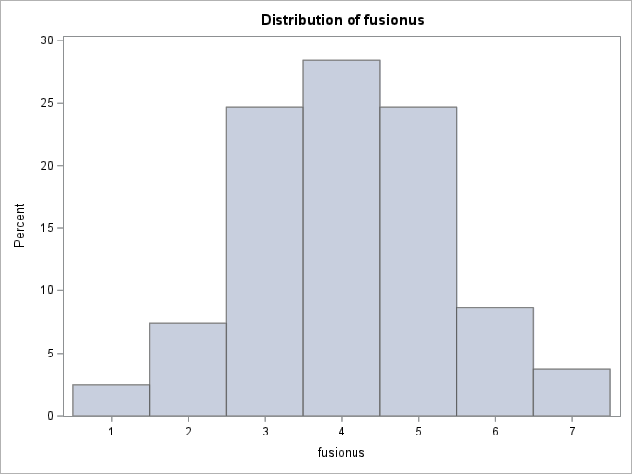
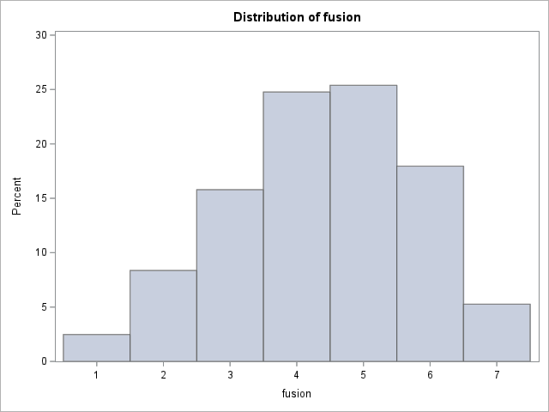
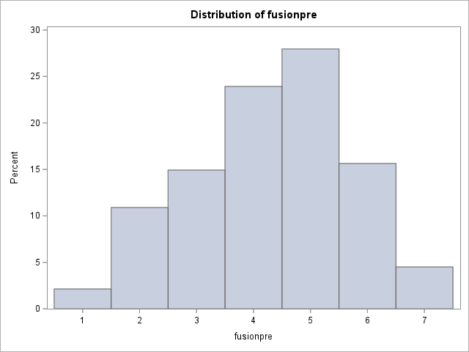
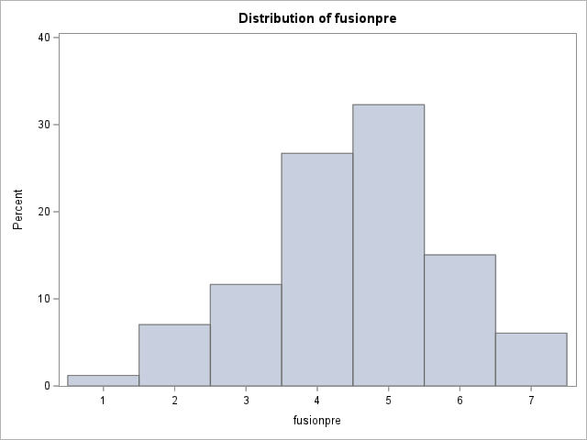
APPENDICES
a.
b.

c.
d.

Figure 1. distributions for fusion across all 4 studies. Clockwise from top left: Plasma study (panel a), Biopsy study (panel b), Military study (panel c), and threat-context study (panel d)
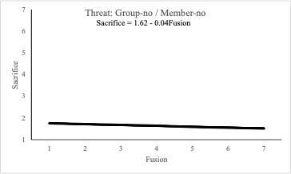
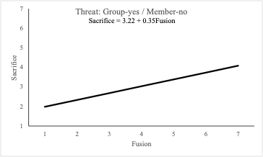
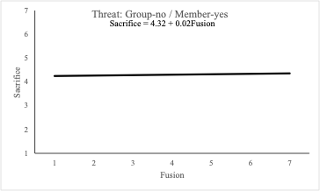
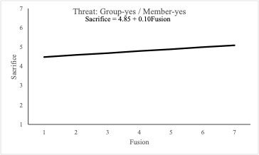

Figure 2. Fusion slopes across the group threat x member threat conditions. Note that the only instance where fusion meaningfully predicts sacrifice is in the presence of group threat and absence of member threat.
Appendix A: Fusion Scale

Gomez, A., Brooks, M. L., Buhrmester, M. D., Vazquez, A., & Jetten, J. (2011) On the nature of identity fusion: Insights into the construct and a new measure. Journal of Personality and Social Psychology, 100, 918-933.

The following questions refer to your country (the USA). Indicate your degree of agreement with each of the following items by choosing a number from the following scale and then write it in the blank space provided next to each item.

1 | 2 | 3 | 4 | 5 | 6 | 7
Strongly disagree | Moderately disagree | Slightly disagree | Neither disagree, nor agree | Slightly agree | Moderately agree | Strongly agree
_____ | I am one with my country
_____ | I feel immersed in my country
_____ | I have a deep emotional bond with my country
_____ | My country is me
_____ | I'll do more for my country than any of the other group members would do
_____ | I am strong because of my country
_____ | I make my country strong

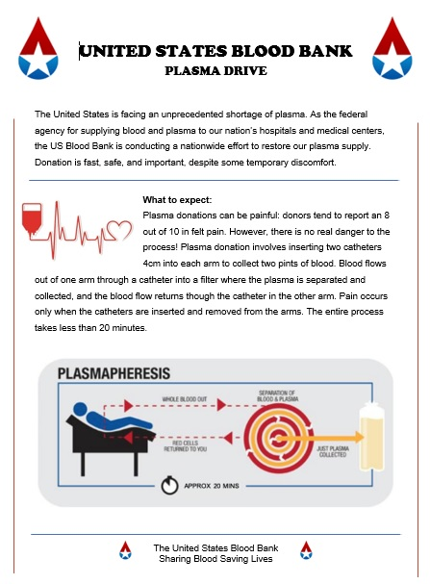
Appendix B: Plasma Information Pamphlet

Appendix C: Plasma Study Scenario
Imagine you arrive at a psychology study to complete a questionnaire.

The experimenter informs you that there is a plasma drive going on down the hall sponsored by the United States Blood Bank to restore our Country's depleted plasma supply, the plasma donation will not take any longer than the current study, and you can complete the questionnaire while donating plasma.

The experimenter pauses and notes "I should tell you that the plasma donation procedure is quite painful due to inserting catheters in your arms. Please read this pamphlet and let me know if you'd like to complete the packet while donating plasma or complete the packet here in this room."

Please read the pamphlet on the following page:

What would you do (check one)?

_____ I would donate plasma while completing the questionnaire

_____ I would not donate plasma and complete the questionnaire in the lab

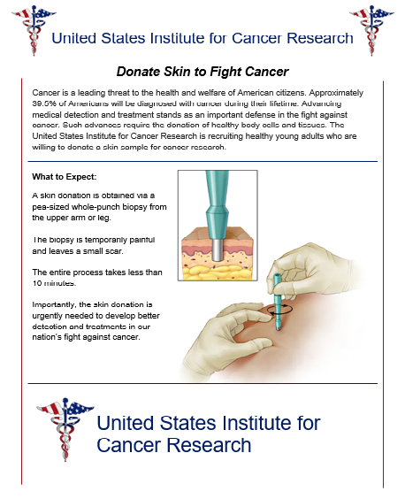
Appendix D: Biopsy Information Pamphlet

Appendix E: Biopsy Study Scenario
Imagine you arrive at a psychology study to complete a questionnaire.

The experimenter informs you that the United States Institute for Cancer Research is conducting a skin-sample donation drive down the hall and needs healthy Americans to donate a skin sample for cancer research. The researcher explains that they need healthy Americans to test a new early detection protocol that could help save the lives of many Americans. The Biopsy will not take any longer than the current study and you can complete the survey while they are preparing you for the study. The experimenter will pause and note "I should tell you that biopsy procedure is quite painful due to having to insert a biopsy punch into your skin. However, it does not leave a visible scar. Please read this pamphlet and let me know if you'd like to complete the questionnaire while participating in the skin cancer study or complete the packet here in this room." (See attached skin sample pamphlet).

Please read the pamphlet on the following page:

What would you do (check one)?

_____ I would undergo the skin biopsy while completing the questionnaire

_____ I would not undergo the skin biopsy and complete the questionnaire in the lab

Appendix F: Fight-and-Die for United States Scale

Adapted from: Swann, W. B., Gomez, A., Seyle, D. C., Morales, J. F., & Huici, C. (2009). Identity Fusion: The interplay of personal and social identities in extreme group behavior. Journal of Personality and Social Psychology, 96, 995-1011.

Indicate your agreement with each statement by circling a number from the scale.
 | 1  disagree  strongly | 2  disagree | 3  disagree  somewhat | 4  neither agree nor disagree | 5  agree  somewhat | 6  agree | 7  agree  strongly
I would fight if someone physically threatened another citizen of my country (USA) | 1 | 2 | 3 | 4 | 5 | 6 | 7
I would fight if someone insults or makes fun of my country (USA) as a whole | 1 | 2 | 3 | 4 | 5 | 6 | 7
I would help others get revenge on someone who insulted my country (USA) | 1 | 2 | 3 | 4 | 5 | 6 | 7
Hurting other people is acceptable if it means protecting my country (USA) | 1 | 2 | 3 | 4 | 5 | 6 | 7
I would do anything to protect my country (USA) | 1 | 2 | 3 | 4 | 5 | 6 | 7
I would sacrifice my life if it saved the life of another citizen of my country (USA) | 1 | 2 | 3 | 4 | 5 | 6 | 7
I would sacrifice my life if it gave my country (USA) status or monetary reward | 1 | 2 | 3 | 4 | 5 | 6 | 7

Appendix G: Physical inadequacy scale
Circle a number to indicate how stressful each situation would be to you

 | 1  not at all stressful | 2 | 3 | 4 | 5 | 6 | 7  extremely stressful
Feeling that you are not in good physical condition | 1 | 2 | 3 | 4 | 5 | 6 | 7
Not being able to find a sexual partner | 1 | 2 | 3 | 4 | 5 | 6 | 7
Having your lover say that she/he is not satisfied | 1 | 2 | 3 | 4 | 5 | 6 | 7
Being perceived by someone as "gay" | 1 | 2 | 3 | 4 | 5 | 6 | 7
Losing in a sports competition | 1 | 2 | 3 | 4 | 5 | 6 | 7
Being perceived as having feminine traits | 1 | 2 | 3 | 4 | 5 | 6 | 7
Appearing less athletic than a friend | 1 | 2 | 3 | 4 | 5 | 6 | 7
Being compared unfavorably to men | 1 | 2 | 3 | 4 | 5 | 6 | 7
Knowing you cannot hold your liquor as well as others | 1 | 2 | 3 | 4 | 5 | 6 | 7

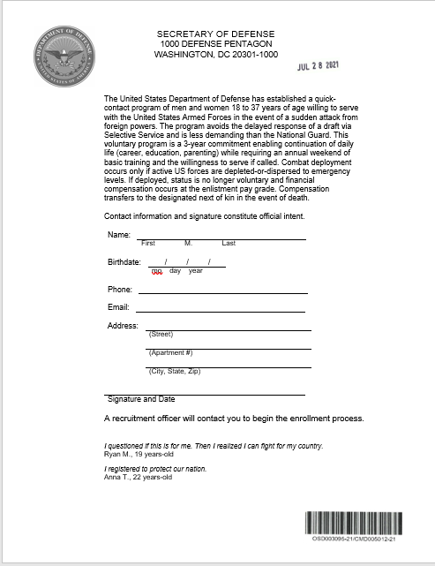
Appendix H: DOD Letter

Appendix I: Military Study Scenario
Imagine you arrive at a psychology study to complete a questionnaire.

The experimenter informs you that because this laboratory receives federal funding for research from the US Department of Defense, we were asked to share the following opportunity with all relevant persons before beginning the study. They then hand you a letter. “While I go next door to prepare the materials for your study, please read the document and register if you want to do so – I’ll be back in a few minutes.”

Please read the letter on the following page:

What would you do (check one)?

_____ I would sign-up for the program.

_____ I would not sign-up for the program.

Appendix J: Threat prompts and sacrifice items for Study 4
Instructions:
In this study you will answer a variety of questionnaires. There are no right or wrong answers. We are interested in your honest response.

For the first questionnaire, you will be asked to imagine a hypothetical situation that could occur in the United States. We are interested in how willing you would be to sacrifice yourself to forever prevent that situation from happening.

member mentioned first items:
Imagine something is about to happen that WILL harm and kill many citizens (not you) of the United States and WILL end the existence of the United States as a country. (hmhg)

Imagine something is about to happen that WILL NOT harm nor kill any citizens of the United States but WILL end the existence of the United States as a country. (lmhg)

Imagine something is about to happen that WILL harm and kill many citizens (not you) of the United States but WILL NOT end the existence of the United States as a country. (hmlg)

Imagine something is about to happen that WILL NOT harm nor kill any citizens of the United States and WILL NOT end the existence of the United States as a country. (lmlg)

Group mentioned first items:
Imagine something is about to happen that WILL end the existence of the United States as a country and WILL harm and kill many citizens (not you) of the United States. (hghm)

Imagine something is about to happen that WILL end the existence of the United States as a country but WILL NOT harm nor kill any citizens of the United States. (hglm)

Imagine something is about to happen that WILL NOT end the existence of the United States as a country but WILL harm and kill many citizens (not you) of the United States. (lghm)

Imagine something is about to happen that WILL NOT end the existence of the United States as a country and WILL NOT harm nor kill any citizens of the United States. (lglm)

Sacrifice items and scale:
How willing would you be to sacrifice your life (i.e., die) if doing so would forever prevent the event from happening?

How willing would you be to end your life (i.e., die) if doing so would forever prevent the event from happening?

How willing would you be to live a life of misery and pain if doing so would forever prevent the event from happening?

How willing would you be to live a lonely and unhappy life if doing so would forever prevent the event from happening?

1 | 2 | 3 | 4 | 5 | 6 | 7
extremely unwilling | very  unwilling | somewhat unwilling | neither unwilling or willing | somewhat willing | very  willing | extremely willing

Appendix K: NSA Country Letter
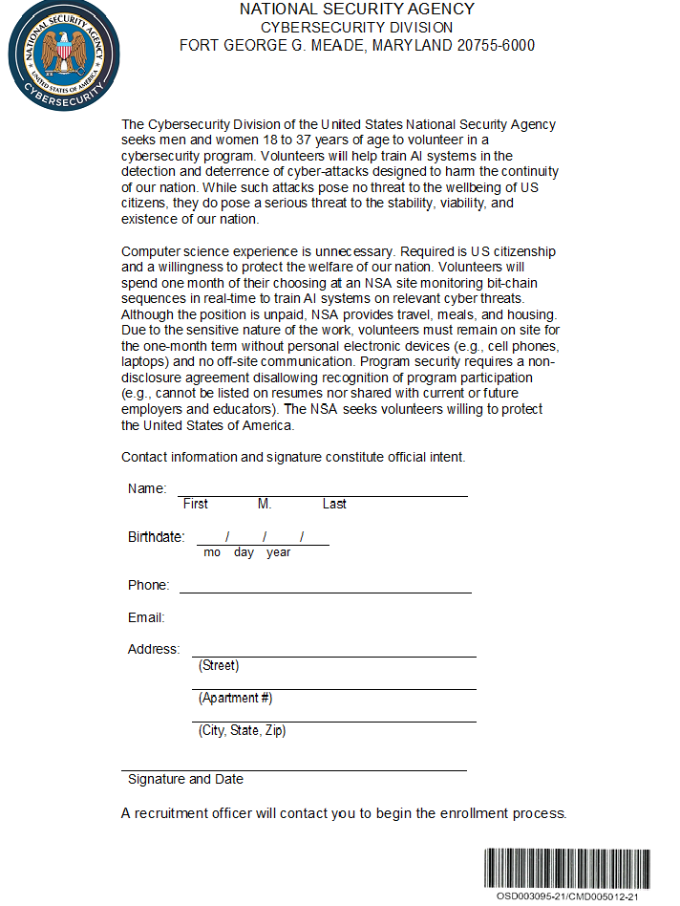
Appendix L: NSA citizen letter
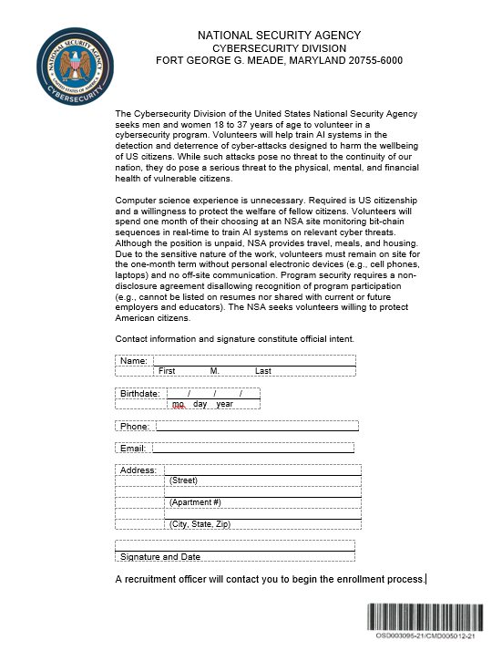
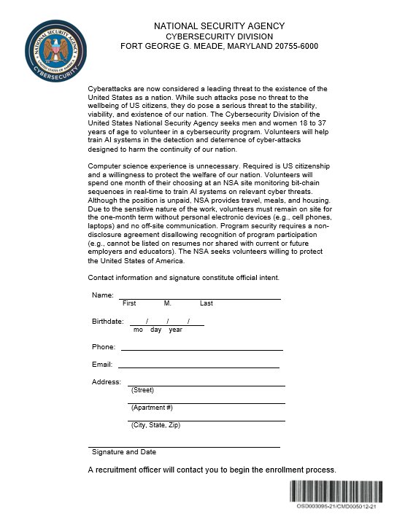
Appendix M: NSA Country Letter Revised

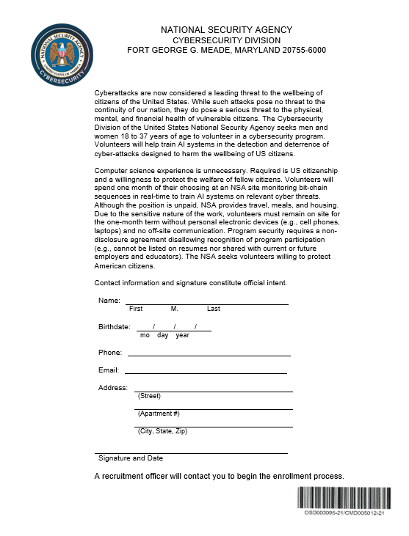
Appendix N: NSA citizen letter revised

Appendix O: Threat manipulation and attention checks
At the beginning of the study today the experimenter handed you an enrollment form for a voluntary program run by the National Security Agency.

According to the form, what is the purpose of the voluntary program:

a) detect and deter cyber-threats designed to harm the continuity of our nation
b) detect and deter cyber-threats designed to harm the wellbeing of US citizens
c) collect information about communications among suspected Iranian spies
d) collect information about communications among suspected Russian spies

To what extend did you feel that the cyber-attacks pose a threat to the continuity of our nation?
1 = not at all | 2 = slightly | 3 = moderately | 4 = very | 5 = extremely

To what extend did you feel that the cyber-attacks pose a threat to the wellbeing of US citizens?
1 = not at all | 2 = slightly | 3 = moderately | 4 = very | 5 = extremely

According to the form, can participation in the program be listed on resumes or shared with current or future employers and educators:

Yes
No

When answering yes or no to the previous question, did you guess or respond based on your memory of the form?
I guessed
I responded based off of my memory of the form

How did you read the NSA form?
I read it carefully
I skimmed it
I started reading and then stopped
I did not read it at all
VITA
Brandon Porter was born in Ohio. He did his undergraduate studies at the Ohio State University, Newark campus, and worked in a language development lab. He began his work in social psychology as a Master’s student at the University of Dayton before coming to the University of Tennessee, Knoxville (UTK) for his doctoral work. It was at UTK where he began his work on extreme pro-group behavior.

