The Role of Grain Morphology and Individual Grain Fracture on Granular Material Behavior

A Dissertation Presented for the

Doctor of Philosophy

Degree

The University of Tennessee, Knoxville

Anne Katherine Turner
May 2024

Copyright © 2024 Anne Katherine Turner
All rights reserved.

DEDICATION
This dissertation is dedicated to my supportive husband, Matthew Turner, our amazing daughter, Molly Turner, and my always encouraging parents, Karen Teague and James Himebaugh.

ACKNOWLEDGEMENTS
First and foremost, I would like to acknowledge my advisor, Dr. Dayakar Penumadu for his guidance, support, encouragement, and patience as I completed my doctoral work.
I would also like to thank my committee members, Dr. Khalid Alshibli, Dr. Timothy Truster, and Dr. Yanfei Gao for their continued support.
I am extremely grateful for the financial support provided by the Defense Threat Reduction Agency. I would also like to thank the University of Tennessee Graduate School for providing me the Chancellor’s Graduate Research Fellowship as well as the Joint Institute for Advanced Materials for their additional fellowship.
I would also like to thank my colleagues within Dr. Penumadu and Dr. Alshibli’s research group for their friendship and guidance. Particularly, I’d like to thank Dr. Felix Kim, Dr. Aashish Sharma, and Dr. Mohsin Thacker for their assistance in completing the research that supports this dissertation.
I would like to thank Dr. Eric Herbold and Dr. Michael Homel with Lawrence Livermore National Lab for their collaboration on exploring the capabilities of GEODYN-L.
I would like to acknowledge the support of my current supervisors at the University of Arkansas Little Rock, Dr. Hollis Bray and Dr. Lawrence Whitman, for their continued support as I finished my Ph.D. while also navigating the demands of a new assistant professor.
I would not have survived this process without the daily love, enthusiastic encouragement, and commiseration of many friends both near and far, in particular Kathleen Mondino, Sarah Dixon, Rebecca Little, Dr. Kisha Hardwick, and Dr. Erin Flowers.

ABSTRACT
Granular materials, such as sand, are multi-scale materials combining an immense number of crushable particles to create an assembly. Numerical approaches to modeling sand’s mechanical behavior often use simplifications, such as treating the volume as a continuum or representing the particles with rigid, idealized spheres using the discrete element method. These approaches overlook crucial nonlinear phenomena, such as individual grain morphology and fracture, which have been shown to influence sand’s strength and plasticity behavior. This research investigated methods to incorporate such phenomena , focusing on simulating single grain crushing tests and 1D confined compression of Ottawa sand using finite element analysis (FEA) codes, GEODYN-L and ABAQUS, to resolve internal stresses and strains.
Grain morphology was incorporated through finite element meshes derived from x-ray computed tomography images. Two approaches were employed to incorporate grain fracture: a damage mechanics model (GEODYN-L) and a brittle cracking model (ABAQUS). The specified ultimate tensile strength was shown have the greatest influence on the peak force associated with catastrophic grain splitting. The brittle cracking model was determined to be too computationally demanding due to mesh refinement requirements.
Investigating grain properties like orientation and coordination number revealed their impact on catastrophic splitting force, underscoring the necessity of incorporating accurate grain morphology due to its effect on grain arrangement within the granular assembly.
Simulating single particle compression of elastic quartz spheres, this research also examined the impact of mesh discretization approaches and finite element types on capturing high contact stresses that lead to fracture, determining that quadratic tetrahedral elements rather than linear tetrahedral elements could balance accuracy with computational efficiency.
Finally, this study utilized FEA of 1D confined compression to determine that incorporating grain fracture softened the overall stress-strain response, with the softening directly correlating to a decrease in the ultimate tensile strength. A representative volume element size based on the maximum grain diameter was also recommended for capturing macroscale stress behavior in granular assemblies under 1D confined compression, considering grain morphology and fracture, which is especially important when computational resource constraints prevent explicit modeling of individual grains in large assemblies.

TABLE OF CONTENTS
Chapter 1. Introduction 1
1.1. Motivation 2
1.2. Literature Review 3
1.2.1. Particle Morphology 3
1.2.2. Individual Particle Fracture 5
1.2.3. Numerical Models of Granular Assemblies 6
1.3. Objectives 8
Chapter 2. Meso-Scale Framework for modeling granular material using computed tomography 12
2.1. Abstract 13
2.2. Introduction 14
2.3. Methods and Computer Codes Used 17
2.3.1. Obtaining Grain Morphology 17
2.3.2. Image Processing and Mesh Codes 17
2.3.3. Finite Element Codes 18
2.4. Effect of Mesh Refinement and Coordination Number at Meso-Scale 18
2.4.1. Effect of Mesh Refinement 18
2.4.2. Effect of Coordination Number 24
2.5. Conclusions 24
Chapter 3. Finite Element Analyses of Single Particle Crushing Tests Incorporating Computed Tomography Imaging and Damage Mechanics 26
3.1. Abstract 27
3.2. Introduction 28
3.3. Methods 30
3.3.1. Experimental Methods 30
3.3.2. Finite Element (FE) Analysis 31
3.3.3. Material Properties 32
3.4. Quartz Sphere Simulation Results 34
3.4.1. Parametric Study of Fracture Properties 34
3.5. Morphology of sand particles and the role of particle shape and orientation with loading axis 36
3.5.1. Effect of Grain Orientation 36
3.5.2. Damage Accumulation Pattern 37
3.6. Summary and Conclusions 37
Chapter 4. MODELING SINGLE GRAIN CRUSHING TESTS OF OTTAWA SAND INCORPORATING GRAIN MORPHOLOgy AND BRITTLE CRACKING 39
4.1. Abstract 40
4.2. Introduction 41
4.3. Methods 42
4.3.1. Experimental Methods 42
4.3.2. Finite Element Analysis 44
4.4. Results/Discussion 46
4.4.1. Effect of Particle Size and Shape 46
4.4.2. Force-Displacement Curve 47
4.4.3. Contact Area 48
4.4.4. Effect of Coordination Number 49
4.5. Summary and Conclusions 49
Chapter 5. FINITE ELEMENT ANALYSIS of Granular Assemblies INCORPORATING MORPHOLOGY AND INDIVIDUAL GRAIN FRACTURE 51
5.1. Abstract 52
5.2. Introduction 53
5.3. Methods 55
5.3.1. Incorporating Grain Morphology into Finite Element Analysis 55
5.3.2. Finite Element Analysis of 1D Confined Compression 55
5.3.3. Individual Grain Coordination Number 58
5.3.4. Representative Volume Element 59
5.4. Results/Discussion 60
5.4.1. Granular Assembly Behavior 60
5.4.2. Individual Grain Behavior 63
5.4.3. Representative Volume Element Analysis 64
5.4.4. Summary and Conclusions 65
Chapter 6. Conclusions and Recommendations 68
6.1. Summary of Major Conclusions 69
6.2. Future Work 72
6.3. Statement of Significance 72
REFERENCES 74
APPENDIX A: Tables 80
APPENDIX B: Figures 89
Vita 133

LIST OF TABLES
Table 1. Splitting Force of Sand Grains 81
Table 2. Properties used in GEODYN-L Analyses 82
Table 3. Example Maximum Equivalent Stress and Coordination Number at 5% Axial Strain of Larger Specimen 83
Table 4. Mesh Attributes of Spherical Single Grain Analyses 84
Table 5. Material properties of quartz sphere simulations using GEODYN-L 85
Table 6. Grain Orientation Results 86
Table 7. Material Properties used in Particle Crushing Analyses 87
Table 8. RVE Lengths (xD_{max}) based on stress values at different applied strains for both analyses with and without fracture 88

LIST OF FIGURES
Figure 1. Coordination Number Configurations of Spherical Single Grain 90
Figure 2. Coarse and Fine Mesh of Small Ottawa Sand Specimen used in GEODYN-L Analyses 91
Figure 3. Contact Line Between Two Grains 92
Figure 4. Variation of Equivalent Stress Along Contact Line with Discretization 93
Figure 5. Maximum Equivalent Stress in Assembly of Small Specimen with Respect to Applied Axial Strain 94
Figure 6. Mesh of Large Ottawa Sand Specimen used in GEODYN-L Analyses 95
Figure 7. Axial Stress-Strain from 1D Loading of Large Specimen 96
Figure 8. Effect of Mesh Refinement and Element Type on Stress Distribution within Spherical Single Grain Subjected to Varying Coordination Number of Contacts. Mesh Attributes for Each Analysis Provided in Table 4. 97
Figure 9. Effect of Coordination Number on Stress Distribution within Spherical Single Grain 98
Figure 10. Experimental Setup 99
Figure 11. Image processing progression: (a) images of sand grains are obtained using X-ray CT, (b) reconstructed raw images (slice and stack), (c) processed images (slice and stack), and (d) 3D finite element mesh of selected grains 100
Figure 12. Effect of fracture properties, (a) ultimate tensile strength, σ₀ and (b) fracture energy, G_{f}, on the response fused quartz sphere loaded diametrically between two horizontal platens 101
Figure 13. Force-displacement of quartz sphere crushing test 102
Figure 14. Accumulation of damage in quartz sphere with progressive loading from simulations 103
Figure 15. High-speed images showing meridional crack of sand particles after catastrophic splitting 104
Figure 16. Orientations of Grain in Numerical Analyses 105
Figure 17. Effect of Grain Orientation on Force-Displacement Curve 106
Figure 18. Force-displacement of Ottawa sand: Experiments vs Simulation 107
Figure 19. Accumulation of progressive damage from simulations 108
Figure 20: Experimental Setup 109
Figure 21. Brittle cracking model crack propagation 110
Figure 22. Weibull probability distribution for individual silica sand laboratory measurements 111
Figure 23. Grain orientations 112
Figure 24. Diameters of Ottawa grains, spheres, and ellipsoids analyzed for single particle crushing 113
Figure 25. Zingg shape classifications 114
Figure 26. Spherical particle analyzed for increasing coordination number 115
Figure 27. Particle crushing loading curves for one particle 116
Figure 28. (a) Breakage force vs. particle volume , (b) Breakage force vs. initial diameter in the direction of loading 117
Figure 29. (a) Breakage force vs. sphericity (elongation and flatness indices) , (b) Breakage force vs. sphericity (width/length) 118
Figure 30. (a) Breakage stress vs. particle volume , (b) Breakage stress vs. initial diameter in the direction of loading 119
Figure 31. (a) Breakage stress vs. sphericity (elongation and flatness indices) , (b) Breakage stress vs. sphericity (width/length) 120
Figure 32. Coefficient from fitting force-displacement curves 121
Figure 33. (a) Applied displacement vs. contact area, (b) Applied force vs. contact area 122
Figure 34. Effect of sphericity on contact area at catastrophic splitting 123
Figure 35. (a) Applied displacement vs. coordination number, (b) Applied force vs. coordination number 124
Figure 36. Granular Assembly under 1D Compression 125
Figure 37. Samples for RVE prediction in granular assembly 126
Figure 38. Stress-Strain Curves with Varying Ultimate Tensile Strength (σ_{tu}) 127
Figure 39. Assembly Volume Loss with Varying Ultimate Tensile Strength (σ_{tu}) 128
Figure 40. Percent grains experiencing fracture (From analysis with σ_{tu=}1500MPa, and μ=0.5) 129
Figure 41. Coordination Number with Applied Strain for (a) Elastic Analysis and (b) Fracture Analysis 130
Figure 42. Volume Loss Per Grain with Grain Coordination Number 131
Figure 43. RVE Size Prediction based on applied strain, stress, and inclusion of fracture 132

Introduction

Motivation
Due to the many complexities of simulating granular materials, especially at the meso-scale or particle level, analytical approaches to simulating the mechanical deformation behavior of these materials often use simplifications. Most design approaches used in professional practice ignore the discrete nature of granular material and treat the entire volume of a granular assembly as a continuum with an assumed constitutive stress-strain relationship based on in-situ or laboratory testing. While these approaches are chosen for computational efficiency, considering the behavior of granular materials only at the macro-scale level ignores the multiple, nonlinear, multi-scale phenomena occurring at the meso (particle level) and micro (within the particle) scales, such as individual grain morphology and fracture.
Grain morphology has been shown to influence assembly density [1], affecting the coordination number, or number of grain contacts on an individual grain. In turn, research has shown that coordination number plays a significant role in individual particle fracture and comminution ([2], [3], [4]). Subsequently, individual grain fracturing and fragmentation has been shown to have a significant influence on the stress-strain response of granular material under high stress one-dimensional (1D) compression ([5] , [6]) and triaxial compression ([7]) loadings. Additionally, laboratory tests on projectile penetration have revealed significant comminution along the projectile's trajectory as well as within the false tip created by projectile [8]. The ability to incorporate these phenomena in numerical simulations of granular material will allow us to better understand the mechanical behavior of granular material at a continuum level.
This research will center on integrating grain morphology and fracture into computational models of both individual Ottawa sand grains and granular assemblies, employing the finite element method. Three-dimensional (3D) solid finite elements are selected for their capacity to simulate stresses within grains. Given that intergranular contact forces induce high stress gradients at contact points within grains, leading to grain fracture, the finite element mesh's ability to capture these stresses will impact the approach's overall accuracy in modeling granular materials with explicitly modeled discrete grains. Consequently, mesh discretization strategies, such as element type selection and mesh refinement, are explored to provide recommendations on effectively capturing the high stress gradients at grain contact points while maintaining computational efficiency.
A sample of granular materials subjected to 1D compression testing may contain thousands of individual grains. Modeling each grain in a 3D solid finite element analysis is computationally expensive and prohibitive with current computational resources. Representative volume elements (RVEs), in which the effects of particle level phenomena, such as individual grain fracture, are averaged over a volume, can be used to represent the behavior of granular materials at the continuum level. The modeling of smaller sample sizes of granular materials, such as those determined by an RVE analysis, are less computationally expensive. Therefore, in this research, an RVE analysis is performed on a granular assembly subjected to 1D confined compression incorporating both grain morphology and grain fracture.

Literature Review
This section presents a literature review of published research in which grain morphology and grain fracture have been included in numerical modeling of grains and granular assemblies.

Particle Morphology
The influence of the varying multifaceted morphologies has been shown to play a key role in the contact forces between grains. To exploit the discrete nature of a granular assembly, the discrete element method (DEM) is often chosen to model the discrete particles. For simplicity, many chose to model the granular assembly with idealized spheres ([9–11]), disks ([12–14]). However, with this approach, the angularity of the grain’s surface is not accounted for, which Cho et al. [1] noted has a significant impact on the void ratio, stiffness, and strength of the sand as a whole. Additionally, the packing density of the simulated assembly can be arbitrary and not representative of an actual granular assembly.
Not only can grain morphology affect the behavior of the granular material at the continuum level, but it can also affect the fracture behavior of the individual grains. Previous methods of determining fracture stresses with in grains assume an idealized sphere and do not account for the actual grain morphology. Grains shapes are irregular and not idealized spheres, and consequently their response to loading differs. Utilizing micro-CT images taken during in-situ single grain crushing tests, Zhao et al. [15] determined that initial particle morphology is an important factor that influences how a grain fractures. Thus, representing individual grains with finite elements not only allows the actual grain morphology to be included but also is beneficial to better understand the actual stresses present within the grains during the crushing tests and will allow us to better capture the fragmentation of the grains and their influence on the behavior of the granular assembly.
Recently, computed tomography (CT) image based modeling, which captures actual morphology of a real material such as sand, has been used to simulate flow through porous media ([16–19]). For DEM simulations, some have modeled individual grains as agglomerates of spheres in order to capture the irregular shape of a grain determined by X-ray CT data ([20], [21], [22], [23], [24], [25], [26], [27]). Yet again the continuous surface of the grain is lost affecting the contact forces between grains.
To account for the grain morphology and continuous grain surface, Imseeh et al [28] utilized X-ray CT images of a confined 1D compression experiment on Ottawa sand to develop FEM and DEM simulations and study the effect of sand morphology on force chains within the granular assembly.

Individual Particle Fracture
The first step for inclusion of grain fracture and fragmentation in modeling granular materials is to simulate single grain crushing tests to investigate the appropriateness of different fracture models and determine their corresponding material properties.
Experimental studies on single grain crushing tests of silica sand grains, published by Nakata et al. [7] and McDowell [29], indicate that the force leading to catastrophic splitting of a grain typically increases with the nominal diameter of the grain. Work performed by McDowell and Bolton [5] and Nakata et al. [7] determined that stress corresponding to this catastrophic splitting was inversely proportional to the nominal diameter of the grain. However, their method of computing the stress at failure was based on the method presented by Jaeger [30], which assumes an idealized spherical grain and calculates the stress as σ=F/d², where F is the force at failure and d is the initial diameter of the grain. Brzesowsky et al. [31] developed a micromechanical model for grain crushing using Hertzian contact theory [32] and linear elastic fracture mechanics. Hertzian contact theory assumes that strains are small, and that contact is frictionless. Yet the work of Alshibli et al. [33] showed that at fracture, strains in the direction of loading are greater than 5%, and as such Hertzian contact theory may not accurately calculate the stresses within the grain at near the contact area. The inability of the Hertzian model to determine contact forces and stresses at large strain values is discussed by Dintwa et al. [34]. The shortcomings of these numerical approaches, assuming small strains and idealized spheres, indicate a need to develop more accurate simulations of grain fracture such as can be performed using FEM or DEM.
Using DEM simulations, Harireche and McDowell [6] and Komanduri et al. [35] accounted for grain fracturing by representing each grain as an agglomerate of spherical discrete elements. Jarrar et al [36] used agglomerates of rigid blocks. In those models, a specified bond strength between the agglomerate’s discrete elements was used to simulate fracture resistance. A disadvantage of this approaches is the loss of the individual grain’s continuous outer surface, which can be accounted for by creating a finite element mesh of the individual grain.
Druckrey and Alshibli [37] did just that, using the extended finite element method (XFEM) to model single grain crushing tests of actual sand grains and comparing results to the in-situ fracturing of the particle using 3D x-ray radiography and synchrotron micro-CT. Wei et al [38] utilized finite element modeling to simulate single grain crushing tests in which grain morphology was incorporated using CT images, with cohesive elements between finite elements to incorporate grain fracture.

Numerical Models of Granular Assemblies
In this research, a numerical approach to modeling granular assemblies under one-dimensional confined and unconfined compression loadings utilizing FEM in which both grain morphology and grain fracture are incorporated been proposed. Using finite elements to represent individual particles provides the capability to determine deformations and stresses within particles that lead to their fracture and fragmentation of particles at the micro-scale.
Most published research in on modeling granular assemblies has utilized DEM or a combined DEM/FEM approach. Some have linked the micro and meso scales by using deformable discrete elements, the importance of which in geotechnical applications investigated by Ghaboussi [39]. A combined FEM/DEM method was used by Bagherzadeh et al. [40], who performed 2D simulations of fracture in angular rockfill by representing individual particles as discrete elements and at each time step treating the particles as a finite element to determine the stresses and strains within the particle and potential fracturing of the particle. Dwivedi et al. [41] performed 2D simulations of a projectile penetrating sand with discrete polyhedral particles comprised on finite elements. Mahabadi et al. [42] also presented an approach which utilized deformable discrete elements to simulate fracture and failure of geomaterials.
Others have combined FEM/DEM to connect the meso and macro scales. Meier et al. [43] modeled granular material as a continuum with each finite element of the bulk material considered an REV of a collection of DEM particles. Utilizing discrete elements in the fracture zone and finite elements outside the fracture zone, Azevedo and Lemos [44] modeled the fracturing of notched beams. Similarly, Dang and Meguid [45] proposed a method for simulating soil-structure interaction problems with discrete elements representing soil particles near the structure and finite elements representing the far field soil.
Incorporating grain morphology using X-ray CT, Thakur and Penumadu [46] utilized finite discrete element modeling (FDEM) to simulate triaxial compression of an assembly of Ottawa sand grains. Chen at al [47] combined CT and FDEM to simulate a granular assembly under triaxial compression. While both of these models allowed for individual grain deformation, grain fracture was not included.
Very little research has been conducted in which both grain morphology and fracture have been incorporated into finite element models of granular assemblies. Investigating the transmission of force chains through an assembly of grains subjected to 1D confined compression, Imseeh and Alshibli [48] also used FEM incorporating a brittle cracking model to represent fracture within individual grains. Imseeh and Alshibli [49] also developed a material-point user subroutine within the finite element framework in which anisotropic linear elastic behavior and continuum damage mechanics were accounted for to represent individual grain fracture within a granular assembly.
The incorporation of both grain morphology and grain fracture in finite element simulations of granular assemblies in which deformable discrete grains are explicitly modeled remains challenging, particularly due to the high computational cost of larger assemblies with a considerable number of grains.

Objectives
The following objectives have been formulated for this Ph.D. dissertation to further advance the finite element approach of modeling granular materials comprised of explicitly modeled discrete grains, specifically investigating how to incorporate the nonlinear phenomena of grain morphology and individual grain fracture.
- Use the explicit finite element codes GEODYN-L [50] and ABAQUS [51] to model
  - Single grain crushing tests of quartz spheres and Ottawa sand grains including grain fracture
  - 1D confined compression of an assembly of dry Ottawa sand grains including grain fracture
  - In all finite element models of Ottawa sand grains, grain morphology is incorporated through the use of x-ray computed tomography images.
  - Utilize two different approaches (a damage mechanics model in GEODYN-L and the brittle cracking model in ABAQUS) for incorporating grain fracture in finite element models of single grain crushing tests of quartz spheres and Ottawa sand grains. While both approaches use the same specified fracture properties (ultimate principal tensile stress and mode I fracture energy) to determine fracture initiation and propagation, the damage model applies element softening isotropically, and the brittle cracking model applies element softening in the mode I fracture direction only.
- Investigate the effect of specified fracture properties, grain orientation, grain size, and grain shape on the force required for catastrophic splitting of individual sand grains by modeling single grain crushing tests of quartz spheres and Ottawa sand grains, as the force required to break an individual grain is integral to characterizing the stress-strain behavior of an entire granular assembly.
- Examine the effect of mesh discretization approaches and finite element type on the model’s ability to accurate capture high contact stresses which ultimately lead to grain fracture by simulating 1D compression of a single quartz sphere and 1D confined compression of small granular assembly, both without fracture. Mesh discretizations of varying refinement comprised of both linear and quadratic tetrahedral elements were used. This aims to provide guidance in terms of optimizing meshing strategies and enabling the accurate capture of high contact stresses in granular material simulations while keeping computational costs manageable. As the number of finite elements per grain and nodes per element increases, so does the computational demand when modeling granular assemblies with discrete, deformable grains using the finite element method.
- As grain morphology has been shown to affect the density of a granular assembly and subsequently the coordination number of individual grains within the assembly, investigate the effects of coordination number on:
  - Intergranular contact forces by modeling 1D confined compression of a granular assembly without fracture
  - The possible contact stress distribution from contact forces within an individual particle by simulating 1D compression of a quartz sphere without fracture in which the number of simulated contacts the sphere increases from 2 to 6
  - The fracture behavior of individual grains of sand by modeling single grain crushing incorporating fracture and increasing the coordination number from 2 to 10.
- Examine the effects of (1) including grain fracture in finite element modeling and (2) the specified ultimate tensile strength fracture property on exclusively the overall stress-strain behavior of a granular assembly by simulating 1D confined compression of a dry Ottawa sand granular assembly with and without fracture. The results should demonstrate a gradual reduction in the stress response of the granular assembly as fracture is incorporated, directly correlating with a decrease in the specified ultimate tensile strength.
- Determine a recommended representative volume element size based on the maximum diameter of grains within an assembly that can be used to represent the overall stress response of a granular assembly under 1D confined compression by modeling 1D confined compression of a dry Ottawa sand granular assembly including fracture and performing an RVE analysis of cubes of varying size within the assembly. This analysis can be used to recommend finite element model sizes of granular assemblies in which individual grains are explicitly modeled and grain morphology and fracture is incorporated in order to quantify the macroscopic behavior of the assembly under 1D confined compression. The results of which can be used for simulations of granular assemblies which are too large to explicitly model individual grains due to computational resource constraints.

Meso-Scale Framework for modeling granular material using computed tomography

This chapter is revised based on a paper published by: Turner, A.K., Kim F. H., Penumadu, D. Herbold, E. B. (2016) Meso-scale framework for modeling granular material using computed tomography. Computers and Geotechnics, 76, 140-146.
My primary contributions to this paper included: (i) understanding of technique, (ii) gathering and reviewing literature, (iii) performing finite element analyses, (iv) processing, analyzing, and interpreting the data, (v) most of the writing.

Abstract
Numerical modeling of unconsolidated granular materials is comprised of multiple nonlinear phenomena. Accurately capturing these phenomena, including intergranular forces and grain deformation, depends on resolving contact regions several orders of magnitude smaller than the grain size. Here, we investigate a method for capturing the morphology of the individual particles using computed X-ray tomography, which allows for accurate characterization of the interaction between grains. Additionally, the ability of these numerical approaches to determine stress concentrations at grain contacts is important in order to capture catastrophic splitting of individual grains, which has been shown to play a key role in the plastic behavior of the granular material on the continuum level. Samples of Ottawa sand are numerically modeled under one-dimensional compression loadings in order to determine the effect of discretization approaches, such as mesh refinement, on the resulting stress concentrations at contact points between grains. The effects of grain coordination number and finite element type selection on these stress concentrations are also investigated.

Introduction
An analytical approach to modeling granular materials subjected to various loadings, such as one- dimensional compression or triaxial compression, contains many complexities at the meso-scale or particle level. The influence of the varying multifaceted morphologies and the mechanical behavior of the individual grains under high impact loadings, including grain fracture and fragmentation, which has been shown to play a key role in the plastic behavior of the sand, are not taken into account with current methodologies. The discrete element method (DEM) is often chosen to model the discrete particles of a granular assembly. However, for simplicity, many chose to use idealized spheres ([9–11]) or disks ([12–14]) to represent sand grains and an arbitrary packing of sand grains based on a predetermined packing density. This is far from how sand grains are truly shaped and geometrically oriented. Cho et al. [1] discussed the significant impact that actual grain shape has on the stiffness and strength of the sand as a continuum. Thus, including the actual grain morphology in numerical modeling will allow us to better capture the behavior of the granular assembly. Recently, tomography image based modeling, which utilizes the realistic microstructure of porous material, is starting to be used to simulate flow through porous media ([16–19]). Matsushima et al. [26] have used a method of combining several spheres to model the irregular shape of a grain based on X-ray tomography data for DEM simulation. It is also now possible to obtain finite element mesh of tomography image data for FEM simulation.
Additionally, fracturing and fragmentation of particles have been shown to affect the plastic behavior of the granular material and is expected to happen near the locations of high stresses, such as the near end platens for quasi-static 1D compression or where a projectile penetrates the sand at a high-speed causing high gradients of deformation. The influence of grain fracture and fragmentation on the behavior of a soil was investigated by McDowell and Bolton [5], who determined that grain strength governs the strength and dilatancy of crushable soils. Additionally, in their work studying the role of grain fragmentation in the mechanical behavior of a granular material under cyclic loading, Harireche and McDowell [6] found that it in fact provides a mechanism for plastic hardening of granular materials. The significant role of grain fragmentation on the plastic behavior of soil proves the importance of including grain fracturing in the meso-scale modeling of granular materials.
Experimental studies on the fragmentation of individual sand grains have been performed by others in which grains were placed between two flat platens, and the breakage force corresponding to the splitting of the grain into at least two similarly sized pieces was identified as the “splitting force”. A summary of these forces is shown in Table 1. Using the idealized sphere approach described in Section 2.4.1.2, the maximum equivalent stress corresponding to the grain size and force at catastrophic splitting was determined and is also presented in Table 1. In this table and all other results presented in this paper, equivalent stress is calculated according to the Von Mises stress criterion. The maximum stress is taken to be the maximum elemental stress (calculated at the centroid of each tetrahedral element in the mesh) observed within discretized grains and is typically located at the edge of the contact area between grains, as expected by Hertz contact theory [32]. These results indicate that the force required to split a grain typically increases with the nominal diameter of the grain. A similar size dependence has been seen by Brzesowsky et al. [31], McDowell and Bolton [5], and Nakata et al. [7], who also determined the stress corresponding to catastrophic splitting is inversely proportional to the nominal diameter of the grain. However, their approaches to calculate the stress at failure used assumptions and simplifications, such as assuming an idealized spherical grain or calculating the stress as σ = F/d², where F is the force at failure and d is the initial diameter of the grain, based on the method presented by Jaeger [30].
One current approach to account for grain fracturing is to represent each grain as an agglomerate of spherical discrete elements ([6,35]), utilizing a specified bond strength between elements of an agglomerate to mimic the resistance of the grain to fragmentation. However, a disadvantage of this approach is the loss of the individual grain’s continuous surface and the angularities of the surface, which is necessary to properly simulate the normal and tangential contact forces between grains.
This paper establishes that the grain topology may be important to understand how grains orient themselves and rotate/slide/re-arrange during elastic loading. Additionally, in order to understand how grains fracture, we must first understand how they load elastically. Hertz’ seminal work on the subject has been used to estimate stresses in sand grains using DEM methods or idealized particle shapes. However, it is important to investigate how to utilize the detailed information obtained using X-ray computed tomography. Conventional notions of mesh refinement are not as straightforward since the grain surface topology will change (affecting the contact areas and emerging force chains) along with the stress concentrations within the grain material. In this paper, numerical modeling of sand grains at the meso-scale, taking into account actual grain morphology is examined. Modeling considerations and the ability of the numerical approach to capture high stress concentrations that lead to grain fracture and fragmentation are discussed for efficient and accurate computational efforts.

Methods and Computer Codes Used

Obtaining Grain Morphology
The utilization of actual grain morphology, obtained with X-ray computed tomography, in lieu of simplified shapes such as spheres, allows for a more realistic representation of the granular material at the meso-scale. In this proposed meso-scale approach, X-ray computed tomography of naturally occurring Ottawa sand (20/40) was obtained using a microfocus X-ray system at Helmholtz-Zentrum-Berlin (HZB). Dry Ottawa sand was placed in an aluminum cylindrical container and compacted allowing the sand specimen to reach its densest state at void ratio of 0.52, which is approximately 100% relative density (D_{r}). For tomography, 1000 projections were obtained over 360º total rotation of the container, and a filtered backprojection algorithm was used to reconstruct the data.
The reconstructed data set went through a series of image processing algorithms, e.g., noise filtering (median 3D), thresholding to binary image, and watershed separation, to separate any touching particles. A similar procedure was illustrated in Kim et al. [16]. The image processing was performed in the environment of Avizo [52]. The segmented sand grain images were converted to finite element mesh in Simpleware+FE [53]. The binary image data was initially converted to a very fine mesh based on the approach of Young et al. [54]. However, the mesh can be optimized to reduce the number of elements while maintaining the original grain surface structures.

Image Processing and Mesh Codes
Avizo is a software application that allows users to process 2D images, such as those obtained using tomography, and build 3D visualizations. Simpleware+FE is a software that utilizes the images, such as those created in Avizo, to generate a finite element mesh using smoothing algorithms to preserve the topology of the grain surfaces and allowing users to specify meshing techniques.

Finite Element Codes
Two codes that utilize the finite element method (FEM) were used in this paper: GEODYN-L [55] and ABAQUS/Standard [56]. GEODYN-L is a parallel 3D explicit Lagrangian finite element code with contact, including Discrete Element Method (DEM) coupling through the Simple Common Plane contact algorithm [57]. GEODYN-L is well-suited for large-scale contact problems including large material deformations. ABAQUS/Standard is also used as a 3D parallel Lagrangian finite element code for implicit time-stepping for static loading and higher order elements.

Effect of Mesh Refinement and Coordination Number at Meso-Scale

Effect of Mesh Refinement
At the granular level, stress distributions within the grains, which indicate the likelihood of grain fracturing, are obtained using FEM. This approach assumes that the grain is a singular continuous entity subjected to the forces imposed on it by surrounding grains. The stress distribution within an individual grain is utilized to determine if the grain has reached a stress level leading to fragmentation or splitting. The magnitude of the calculated stress within a grain can be influenced by the type of element chosen for FEM as well as the mesh refinement of those elements. If the grain is represented by a stiffer mesh, due to the implementation of a coarser meshing scheme or lower order elements, the stress within the grain will be underestimated, leading to retarded fracture initiation. Grain fracture initiates at surface flaws positioned near the points of contact between grains, where stresses are high. To accurately capture the stress distribution inside the grain itself, a finer mesh is required at the surface of the grain, however a coarser mesh can be used away from the grain surface to decrease the total number of elements per grain and increase computational efficiency. This yields a proposed discretization approach in which an outer portion of the grain (shell) is represented by a fine mesh and the inner portion of the grain (core) is represented by a coarse mesh. In this work, grain fracture and fragmentation is not included in the numerical analysis, however, due to the importance of the phenomenon on the behavior of the granular material, it will be included in future work. The results of analyses presented below have been used to understand the effect of mesh refinement, element type, and coordination number on stresses near the high stress concentrations at the grain contact, which will then be used to initiate grain fracture and fragmentation. The coordination number of a grain is the number of contact points on an individual grain by neighboring grains. Using idealized spheres, example configurations of grains and corresponding coordination numbers is provided in Figure 1.

Input Tomography Geometry
A tomographically imaged sample of Ottawa sand grains was reduced to a 1.712 mm x 1.73 mm x 1.296 mm cube. The cube contained 12 full grains and 12 partial grains bisected by the cube boundaries. The grains within the cube were discretized using Simpleware into a coarse and fine mesh, with 54,243 and 235,858 total linear tetrahedral elements (approximately 2,200 and 10,000 elements per grain), respectively, shown in Figure 2.
The two discretizations were subjected to one-dimensional confined compressive loading. Deviatoric stress is applied by axial displacement of the top plane in the negative X direction at a constant velocity corresponding to an axial strain rate of 5.8x10⁴ s⁻¹. The effect of strain rate was investigated and found to have no influence on the resulting stresses within the particles. The total displacement applied to the sand grain sample was 0.100 mm corresponding to 5.8% axial strain in the X direction. A summary of the material properties used in the analyses is presented in Table 2. The plastic stress-strain relationship of the sand grain material was assumed to follow Johnson-Cook power law strain hardening, with the material properties used in these analyses determined from the stress-strain relationship presented in the nanoindentation tests of quartz sand performed by Komanduri et al. [35]. It should be noted that the maximum equivalent stress (~3.0 GPa) corresponding to the catastrophic grain splitting, presented in Table 1 is less
than the yield stress (6.85 GPa) of the proposed material model indicating that the material of the grains themselves remains elastic prior to splitting.
To demonstrate both the effect of mesh refinement and confirm the need for the shell-core discretization approach previously discussed, the variation of the equivalent stress along a line defined by the normal contact between two grains (as illustrated in Figure 3) is shown in Figure 4. As anticipated, the finer mesh resulted in equal or higher stresses at the contact point with increased applied axial stress due to the stiff behavior of the coarser mesh. However, the finer mesh required 180 CPU-Hrs while the coarser mesh required only 60 CPU-Hrs. These results emphasize the need for efficient discretization in which a finer mesh is located along the surface of grains where contact will occur such as the shell-core approach described previously. Additionally, it should be noted that the maximum equivalent stress observed in the entire assembly of grains, shown in Figure 5, reaches the maximum equivalent stress corresponding to catastrophic splitting of the grains (~3.0 GPa) with less than 1.0% axial strain applied. This illustrates the need to include grain fracture and fragmentation in numerical analyses even with small applied strains.
A larger cube from an imaged Ottawa sand specimen, shown in Figure 6 was analyzed under both one-dimensional confined and unconfined compression loading. The cube had dimensions of 4.458 mm x 4.458 mm x 4.458 mm and contained 99 full and 228 partial grains. The same material properties as the smaller specimen were utilized. Each full grain contained approximately 8,600 linear tetrahedral elements for a total of 1,905,481 elements in the specimen. Therefore, the mesh refinement was similar to that of the finely discretized small sample previously analyzed. Increasing the specimen size also increased the computational time required to complete the analyses to 1500 CPU-Hrs. The resulting axial stress-strain curves from the large specimen analyses are shown in Figure 7. While grain rearrangement occurs throughout duration of the analyses, significant grain rearrangement, determined by monitoring the kinetic energy of the grains at the nodes, was observed between 1% and 2% axial strain resulting in the dip in the axial stress-strain curves. High equivalent stresses concentrated at points of contact were also seen in grains of the larger specimen. In reviewing the variation of the contact stress with the coordination number on individual grains, example maximum contact stresses at 5% axial strain provided in Table 3, it is seen that with a higher the coordination number the maximum contact stress on an individual grain decreases nonlinearly, as was also observed by Gu and Yang [58]. This nonlinear relationship indicates that as the coordination number increases, the maximum contact stress on the particle decreases converging to a limit such that an increase in coordination number will not decrease the maximum contact stress significantly. This relationship also means that granular materials with higher densities are less likely to experience particle fragmentation due to decreased stress concentrations at contact points between grains. These findings are consistent with those of Hagerty et al [59], who determined that particle crushing increases with decreasing density in 1D high pressure compression tests.
As previously mentioned, the accuracy of the predicted stress distribution at points of contact can also be influenced by element type. A higher order element, such as a quadratic tetrahedral element, will more accurately predict the stress distribution within a grain with a fewer number of elements than the linear tetrahedral element used in these analyses. Additionally, the lower order element may cause locking at nodes again increasing the stiffness of the mesh and underestimating the stress concentrations. Unfortunately, a higher order element is not currently available in GEODYN-L. Future work for this research includes the implementation of finite elements, which minimize the effect of locking, such as higher order elements. This nonlinear relationship indicates that as the coordination number increases, the maximum contact stress on the particle decreases converging to a limit such that an increase in coordination number will not decrease the maximum contact stress significantly.

Idealized Spherical Geometry
Since higher order elements are currently available in the finite element code ABAQUS/Standard, analyses using this code were performed to investigate the effects of element type and mesh refinement on the stress distribution through the grain. For simplification, the grain was represented as a 0.700 mm diameter sphere of linear elastic material with an elastic modulus of 70 GPa and Poisson’s ratio 0.30. The grain was considered to have a coordination number of 2 (see Figure 1) with the contact forces assumed to be 50 N, based on the splitting force of a grain this size, and represented as a pressure over a circular area with a 3D parabolic distribution. The distribution and area of the contact pressure was calculated according to Hertz/Huber theory of contact between elastic spheres as outlined by Schönert [60].
Seven finite element discretizations of linear and quadratic tetrahedral elements using the shell-core approach were implemented, varying from 381 to 183,455 elements, as shown in Table 4.
To evaluate the ability of each meshing scheme to most accurately capture the stress distribution through the grain, the equivalent stress distributions along a path corresponding to the centerline of the spherical grain along the Y-axis are shown in Figure 8. The distance along the centerline is normalized by the radius of the sphere, so that 0 corresponds to the center, +1 corresponds to the surface in the positive Y direction, and -1 corresponds to the surface in the negative Y direction.
The ability of a finer mesh to more accurately capture the stress distribution is most noticeable in the comparison of results using linear elements. A coarser discretization increases the overall stiffness of the continuum, decreasing the stress experienced by the grain. Using the stress to determine grain fracture initiation, a coarser discretization would over-predict the capacity of the grain. Comparing the linear and quadratic stress distributions, more than 28,000 linear tetrahedral elements (39,000 nodes / 117,000 degrees of freedom) are required to most accurately predict stress near contacts, whereas 6,800 (11,000 nodes / 33,000 degrees of freedom) quadratic tetrahedral elements can be used instead. Decreasing the number of elements and number of nodes also decreases the number of degrees of freedom in the model, decreasing the computational effort and time required for analysis. Since the analysis of actual grain assemblies are large models requiring significant computational time, a decrease in this number of degrees of freedom in the model would allow for faster results and larger assemblies analyzed. These results also indicate that the highest stress gradient occurs within approximately a 30% radial distance from the surface suggesting that that the shell of finer elements have a thickness corresponding to 30% of the grain radius, or 15% of the grain diameter.

Effect of Coordination Number
In addition to varying the discretization and element type, a study on the effect of the grain’s coordination number was also performed. In the granular matrix, individual grain coordination numbers can vary from 2 to 10 and affect the stress distribution within the grain. The grains within a looser packed matrix will have a lower coordination number, whereas the grains within a more densely packed matrix will have a higher coordination number. Again, neighboring grains were not explicitly modeled, but contact forces between grains were represented by pressures as described above, with the magnitude of the forces determined by assuming a 50 N contact force from the upper grain and calculating the resultant reaction forces from the lower grains. The resulting equivalent stress distributions along a path corresponding to the vertical centerline of the spherical grain are shown in Figure 9. The maximum equivalent stress in the bottom half of the grain decreases from 5.5 GPa to 3.2 GPa (41%) as the coordination number increases from 2 to 6. Again, the decrease in contact stress with increasing coordination number, corresponding to an increase in density, is observed. The radial distance of the highest stress gradient from the surface decreases from 30% to 20% of the spherical radius. Therefore, the thickness of the shell required decreases with increasing coordination number.

Conclusions
The following conclusions are made to facilitate more accurate and efficient numerical analyses of granular material at the meso-scale:
- In this study, a new procedure is developed to precisely model the meso-scale structure of granular materials using high resolution computed tomography, advanced thresholding and digitization to model a complex geometry of particles and contacts using a viable number of finite elements, and a framework for solving boundary value problems involving complex loading.
- Due to the high stress gradient near the grain surface where contact occurs and fragmentation initiates, a discretization approach in which a shell of finer elements with a depth of 15% of the grain diameter and core of coarser elements more efficiently calculates the stress distribution through the grain.
- Stresses greater than those typically observed at catastrophic grain splitting are seen at small applied axial strains in the current study, since formulation of particle fracture has not been developed, illustrating the need to include fracture and fragmentation in future studies.
- Higher order elements should be implemented to decrease computational time of large assemblies of grains while maintaining accuracy.
- A higher coordination number, such as those observed in a densely packed assembly of grains, decreased the depth of the high stress gradient from the surface, requiring a thinner shell of fine meshing near the surface of grains.
This work focuses on the quasi-static loading of 1D compression. Additional research should be performed to better understand the effect of dynamic loadings, such as that from a projectile penetrating the granular assembly, which cause high gradients of deformation in a short period of time likely leading to significant particle fragmentation.

Finite Element Analyses of Single Particle Crushing Tests Incorporating Computed Tomography Imaging and Damage Mechanics

This chapter is revised based on a paper published by: Turner, A.K., Sharma, A., Penumadu, D. Herbold, E. B. (2019) Finite Element Analyses of Single Particle Crushing Tests Incorporating Computed Tomography Imaging and Damage Mechanics, Computers and Geotechnics, 115, 103158.
My primary contributions to this paper included: (i) understanding of technique, (ii) gathering and reviewing literature, (iii) performing finite element analyses, (iv) processing, analyzing, and interpreting the data, (v) most of the writing.

Abstract
Fracture of individual grains within a granular assembly affect the strength and deformation behavior of granular materials under large stress states. Interparticle forces, leading to contact stresses and ultimately fracture initiation, are influenced by particle morphology. A numerical method that incorporates both particle fracture and morphology can provide a more accurate model of a granular material’s macro-scale response. This research investigates an approach to modeling fracture initiation and propagation within individual grains, utilizing high resolution x-ray computed tomography (CT) imaging to consider grain morphology and an explicit finite element code optimized for high performance computing which incorporates damage mechanics. Using precisely measured force-displacement curves from single particle crushing tests of manufactured quartz spheres, the method is validated, and the effects of fracture properties on grain fragmentation are determined. This approach is then used to simulate single particle crushing of Ottawa sand, with grain morphology incorporated through discretized CT images. The effect of grain orientation on the force and applied displacement at catastrophic splitting is also explored. The proposed discrete particle based finite element framework can be applied to modeling granular assemblies, considering the effect of individual particle shape and fracture on the assembly’s deformation response through well calibrated numerical simulations.

Introduction
Individual grain fracturing and fragmentation has a significant influence on the constitutive behavior of the granular material at the assembly scale (continuum level) and to date has not been considered in detailed multi-scale modeling approaches that utilize direct numerical simulations with FEM, account for particle morphology with images of the particulate assembly state and are verified with measured experimental response at single particle scale. Grain strength has been shown to govern not only the strength and dilatancy of crushable soils [5], but also their plastic hardening behavior [6]. In addition to grain fracture, it has been noted that grain morphology affects granular interactions, the arrangement of the particles within the granular material, and, ultimately, the macroscale deformation behavior of the material ([1,61]). Thus, a numerical approach to modeling granular materials that incorporates both individual grain fracture and particle morphology would provide a more accurate representation of the macroscale behavior and is needed to predict the response for complex stress states with a limited number of experiments. Such an approach is also necessary to properly interpret the experimental results such as triaxial shear test or one-dimensional/laterally confined compression test as it is not possible to measure detailed kinematics and particle reorientation in three dimensions at multiple scales.
The first step for inclusion of grain fracture and fragmentation in modeling granular materials is to determine appropriate fracture models and their corresponding material properties, such as fracture strength. Using the results of single grain crushing tests, McDowell and Bolton [5] and Nakata et al. [7] calculated the particle level stress (σ) corresponding to catastrophic splitting force (F) of single grains as σ=F/d², following the method presented by Jaeger [30], in which grains are assumed to be idealized spheres with diameter (d). Combining Hertzian contact theory, linear elastic fracture mechanics, and Weibull statistics, Brzesowsky et al. [31] calculated fracture stress based on particle diameter and force at failure from single grain crushing tests. Alshibli et al [33] used x-ray diffraction to measure strains within sand particles under 1D compression and calculated the stress tensor at fracture using published elastic constants of quartz. The discrete element method (DEM) approach has been generally used to model fracturing of particles ([6,22,35]). In this technique, particles are modeled as agglomerates of spherical discrete elements with a specified bond strength between the agglomerate’s discrete elements representing fracture resistance. A disadvantage of this approach is the difficulty in evaluating shear and normal stiffness and damping parameters, loss of the continuous granular surface, and the difficulty of incorporating actual grain morphology, which has been shown to affect the contact stresses within the grain.
Computed tomography (CT) imaging is a powerful tool that can be utilized to capture grain morphology. In their work combining in-situ micro computed tomography and single grain crushing tests, Zhao et al. [15] investigated the role of grain morphology on fracture patterns. Ma et al. [62] used CT imaging to create finite element discretizations of rock grains to simulate fracture in rock with a combined finite discrete element method (FDEM). Also utilizing CT imaging, Druckrey and Alshibli [37] simulated fracture in single Ottawa sand grains with the extended finite element method (XFEM).
In this paper, a numerical approach to simulating individual grain fracture and fragmentation, utilizing explicit finite element analysis and incorporating actual grain morphology through CT imaging, is examined. Single grain crushing tests on manufactured quartz spheres are first used to validate this method, and the method is then extended into simulating single grain crushing tests of actual Ottawa sand grains. The effects of material properties and particle orientation on the fracture behavior and force-displacement curves are investigated. Due to its ability to efficiently simulate contact between individual particles, the explicit finite element method allows for a large number of individual grains within a granular assembly to be modeled. Using this approach, once grain fracture process is validated, its effect on the behavior of an assembly of particles representing granular material can be investigated.0/0/00 0:00:00 AM

Methods

Experimental Methods
Single grain crushing tests of manufactured 350μm quartz spheres were performed using Zwick/Roell Z2.5 instrumented indentation system equipped with a high-resolution hardness measurement head. The resolution of displacement measurement was 0.02μm, and the capacity of the load cell was 200N. Particles were placed on a silicon carbide bottom platen, and displacement was applied at 100μm/min from above with a 3mm diameter flat-tipped diamond indenter head. The equivalent diameter of the grain, defined as the height of the grain in the direction of load application, was determined as the difference between the distance the indenter head traveled to contact the particle and the distance to contact the silicon carbide base alone. A compressive load of 0.2N was specified for contact detection and prior to the start of the test for zeroing the displacement sensor. The orientation of each grain prior to the test was also recorded using photography. A schematic and photographs of the experimental setup are shown in Figure 10.
Similar tests were performed on individual grains of ASTM 20/40 Ottawa sand, which is a naturally occurring silica sand with rounded to sub-rounded particles. The sand was washed and sieved, and grains were randomly chosen from the portion retained on the #30 (0.59mm) sieve.
X-ray computed tomography was used for 3D imaging of the sand grains. Sand grains were stacked inside a 1mm diameter plexiglass tube and imaged at 11μm resolution to preserve grain morphology. Projected images were captured every 0.12degree rotation for a complete rotation of 360 degrees. A three-dimensional image was obtained from reconstruction of these projections using filtered back projection techniques and detailed analysis using software called Avizo. The contacting sand grains in the stack were separated by binarizing the image through thresholding and then applying the watershed algorithm. Simpleware [53] was used for 3D finite element mesh generation. The progression from obtaining images of the sand grains using CT through creating 3D finite element meshing of individual sand grains is presented in Figure 11.

Finite Element (FE) Analysis
The explicit finite element program, GEODYN-L [50] was used to model crushing of particles (both quartz spheres and Ottawa sand grains) between two horizontal platens. GEODYN-L is a parallel code which can run on high performance clusters and is capable of simulating interactions between a larger number of discrete, deformable bodies through the coupling of Discrete Element Method (DEM) and Simple Common Plane contact algorithm [57]. The particles were modeled using linear, tetrahedral elements and the horizontal platens were modeled using linear brick elements. Mesh refinement studies were performed to investigate the effect of element size on the resulting force-displacement curves. The chosen meshes for both the quartz sphere and sand grain were the coarsest mesh that provided the same results as a more refined mesh, resulting in the quartz sphere and the sand particle being comprised of 2,599 and 9,438 elements, respectively.
Contact between the platens and particles was modeled using Lagrangian formulation allowing no overlap between meshes with the contact normal force proportionate to the stiffness of the materials in contact and a small friction tangential force using a coefficient of μ=0.01 to prevent the particles from completely losing contact with the platens.
To simulate experimental loading, the bottom platen was fixed in all three directions, and displacement was applied to the top platen at a rate of 0.5m/s. The particle was free to move and rotate throughout the simulation. The total displacements applied to the top platen were 20μm and 30μm for the quartz sphere and Ottawa sand particle respectively, corresponding to the approximate displacement at failure of these particles from experiments.

Material Properties
Isotropic, linear elasticity was assumed for all materials prior to fracture and fragmentation. The densities and elastic parameters used in the simulation are presented in Table 5.
The elastic modulus of 65.9GPa for the fused quartz sphere was determined from experimental force-displacement curve assuming a Hertzian contact solution [32], taking into account compliance of the testing setup. The elastic modulus of 100GPa for the sand particle was based on nanoindentation [63].
Fracture and fragmentation of the particles were simulated using damage accumulation as proposed by Cervera and Chiumenti [64]. With increasing elemental stress, damage is accumulated within the individual elements, softening the element stiffness until fracture occurs. The constitutive relationship between the element stress tensor, σ, the accumulated damage, d, the stress-strain constitutive relationship tensor, C, and the total strain tensor, ε, is provided in Equation (1).
$σ=\left(1-d\right)C:ε$ ( 1 )
After the threshold stress is reached, the damage surface expands, and at each applied load increment the current damage threshold is represented by an internal stress-like variable, r, which is determined by Equation (2), where r₀ = σ ₀, the threshold stress at which damage initiates. In these analyses, the maximum principal stress ($〈σ_{1}〉)$ was used to determine the initiation of damage accumulation within an element. As indicated by the Macauley brackets, only tensile principal stresses will initiate damage.
$r=max⁡\left(r_{0},max\left(〈σ_{1}〉\right)\right)$ ( 2 )
The accumulation of damage within an element is calculated as:
$d(r)=\left\{\begin{aligned}\left(1+H_{S}\right)\left(1-\frac{r_{0}}{r}\right), &r_{0}≤r≤r_{u}=r_{0}\left(1+\frac{1}{H_{S}}\right) \\ 1, &r≥r_{0}\end{aligned}\right.$ ( 3 )
Where $H_{S}$ is the elemental softening modulus, determined by Equation (4). A damage value of 0 indicates that the element has no damage while a value of 1 indicates that the element has complete damage and stiffness of the element is reduced to zero.
$H_{S}=\frac{\overline{H_{S}}l_{ch}}{1-\overline{H_{S}}l_{ch}}≥0$ ( 4 )
$\overline{H_{S}}=\frac{σ_{0}^{2}}{2EG_{f}}$ ( 5 )
The elemental softening modulus depends on the width of the fracture zone, or characteristic length of the individual element, $l_{ch}$, and the material softening modulus, $\overline{H_{S}}$, which is dependent only on the material’s elastic modulus, E, mode I fracture energy per unit area, $G_{f}$, and σ₀, which is taken as the uniaxial tensile strength. The material softening modulus represents the dissipation of energy as damage accumulates assuming that the damage increases monotonically, while the elemental softening modulus represents the energy dissipated as an individual element accumulates damage and is scaled by the characteristic length of the individual element.
In this approach, the material properties governing the accumulation of damage are E, σ₀, and $G_{f}$. A parametric study of material properties σ₀ and $G_{f}$ was performed for each particle crushing test to determine the material properties that best approximate the experimental data.

Quartz Sphere Simulation Results

Parametric Study of Fracture Properties
The effects of the input model parameters associated with fracture, σ₀ and $G_{f}$, on the force-displacement response are presented in Figure 12. The experimental results are also presented in the same figure for comparison to demonstrate the process of obtaining representative input parameters for modeling the force value leading to particle fracture or splitting and the force-displacement variation prior to reaching this value. In Figure 12(b), note that fracture energies of 3.3x10⁻⁶J/mm² and 1.65x10⁻⁶J/mm² all result in the same force-displacement curve with all other material properties used in the analyses remaining the same.
The ultimate tensile strength, σ₀, governs the maximum force at splitting, with a higher tensile strength correlated to a higher splitting force. Hiramatsu and Oka [65] proposed that the tensile strength of a spherical particle, with radius R, in uniaxial compression could be related to the force at failure (F) by:
$σ=k\frac{F}{πR^{2}}$ ( 6 )
where k varies from 0.7 to 1.4. The value of ultimate tensile strength determined through numerical analyses (570MPa) is within the range of stresses, 355 – 710MPa, from Equation 6, for the catastrophic splitting force of 48.8N.
Decreasing the fracture energy, $G_{f}$, increases the brittle response of the quartz material, such that failure occurs at a lower applied displacement/strain without noticeable effect on the peak splitting force. Damage Accumulation Pattern
The simulated force-displacement curve with σ_{o} of 570MPa and $G_{f}$ of 3.3x10⁻⁶J/mm², is compared to the experimental result in Figure 13. Corresponding patterns of damage accumulation within the cross-section of the sphere are presented in Figure 14, with the dark color regions indicating those elements that have an accumulated damage value of 1. Similar to patterns seen in experimental results published by Salman and Gorham (Salman and Gorham 2000), fracture within the sphere begins at the contact points between the spherical particle and the platens. Ultimate catastrophic splitting occurs with a meridional crack through the sphere, similar to fracture patterns observed by high-speed imaging of single sand grain crushing tests performed by the authors of this paper, shown in Figure 15. At point A, damage has initiated at the top platen due to higher contact stiffness of the diamond indenter leading to higher contact stresses. At point B, damage has continued to accumulate at the top contact and begins to accumulate at the bottom contact. At point C, damage begins to accumulate in the center of sphere, indicating the propagation of fracture towards the center of the sphere. By point D, damage has accumulated along the centerline of the sphere indicating that catastrophic splitting and complete fragmentation has occurred and is validated by the sudden decrease in force.

Morphology of sand particles and the role of particle shape and orientation with loading axis

Effect of Grain Orientation
Particle morphology not only affects contacts within grains but can also affect the orientation of a grain within an assembly. To study the effect of grain orientation on grain fragmentation, three orientations of the same grain, presented in Figure 16, were analyzed. These orientations had similar diameters in the direction of loading to that experimentally measured; orientation A was the orientation validated by a photograph of the grain taken prior to loading and assumed to be the correct orientation of the grain associated with the experiment. A virtual crushing test simulation for each grain orientation was performed with suitable fracture material properties: σ₀=320MPa and $G_{f}$=1.0x10⁻⁶J/mm². The ultimate tensile strength was determined by comparing force-displacement curves from numerical and experimental results, with the ultimate tensile strength falling within the range of 244 to 489MPa, assuming a spherical particle as proposed by Hiramatsu and Oka. The fracture energy was determined by matching simulated force-displacement curves for representing brittle behavior of the sand material, which is primarily crystalline quartz.
As can be seen in Figure 17 and Table 6, even small differences in grain orientation affect the force and displacement at catastrophic splitting of the grain. As seen with Orientation C, a rotation of 4.5° reduces the force required for splitting by 13%. Additionally, looking at Orientation B, a rotation of 21.5° allows for 16% more deformation to occur within the grain before grain fragmentation occurs, causing the force at splitting to increase 11%.

Damage Accumulation Pattern
The force-displacement curve of the sand grain in Orientation A, with an ultimate tensile strength of 320MPa and fracture energy of 1.0x10 ⁻⁶J/mm, is compared to experimental results in Figure 18. Corresponding patterns of damage accumulation within the cross-section of the grain are presented in Figure 19. Damage accumulation begins at the top platen contact (A), continuing by accumulating at the bottom platen contact (B), and growing towards the center of the grain (C) until catastrophic splitting occurs as a meridional crack through the grain (D). Damage propagation is similar to that observed in the spherical fused quartz specimen reported earlier.

Summary and Conclusions
In this paper, a methodology for modeling individual particle fracture and fragmentation by calculating damage accumulation through the finite element method was investigated for use in numerical simulations of granular materials. Simulating single grain crushing tests of manufactured quartz spheres, the method was validated, and the effects of specified material fracture properties on the force-displacement curve was examined. The ultimate tensile strength had a direct relationship with the peak force associated with catastrophic splitting. The fracture energy governed the brittle behavior of the quartz material, with a lower specified energy causing complete fragmentation of the grain at a smaller displacement. A convergence study on the specified fracture energy should be performed to capture brittle behavior.
Grain morphology captured using CT imaging was used to study the effect of grain orientation on the resulting particle fracture behavior and force-displacement curves. Even small changes in grain orientation showed significant differences in the applied displacement and peak force associated with catastrophic splitting of the grain.
For both the amorphous sphere and crystalline sand, damage accumulation initiated at the contact of the particles with the platens and continued towards the center of the particle until complete failure occurred indicating that fracture initiates at contact points and propagates along a meridional crack through the grain.
Future work of this research includes analyzing additional single particle crushing tests of sand grains incorporating morphology through CT imaging and verifying orientation and fracture patterns with high-speed images to obtain a range of fracture properties for Ottawa sand particles. This method of including individual grain failure and morphology will also be applied to simulations of granular assemblies as proposed by Turner et al [66]. By including the failure of individual grains and the decreased stiffness associated with grain failure, the effect grain fracture and fragmentation on the assemblage behavior of the material can be evaluated, and this approach can be validated through numerical simulations of realistic boundary value problems in granular mechanics, such as one-dimensional confined compression tests, with the results compared to those from laboratory tests.

MODELING SINGLE GRAIN CRUSHING TESTS OF OTTAWA SAND INCORPORATING GRAIN MORPHOLOgy AND BRITTLE CRACKING

This chapter is being prepared for submission in Summer 2024 to Computers and Geotechnics.
My primary contributions to this paper included: (i) understanding of technique, (ii) gathering and reviewing literature, (iii) performing finite element analyses, (iv) processing, analyzing, and interpreting the data, (v) most of the writing.

Abstract
Fracture of individual grains within a granular assembly affect the strength and deformation behavior of granular materials under large stress states. Interparticle forces, leading to contact stresses and ultimately fracture initiation, are influenced by particle morphology. A numerical method that incorporates both particle fracture and morphology can provide a more accurate model of a granular material’s macro-scale response. This research investigates an approach to modeling fracture initiation and propagation within individual grains, utilizing high resolution x-ray computed tomography (CT) imaging to consider grain morphology and explicit finite element analysis which incorporates a brittle cracking model. Single grain crushing tests of 32 Ottawa sand grain particles in multiple orientations are simulated with grain morphology incorporated through discretized CT images. Brittle cracking properties are kept constant to explore the effect of grain orientation on the force required for catastrophic splitting of the individual grains. Increasing the coordination number of the grains, which leads to increased contact area and possible overlap of stress distribution within the grains, is also explored to simulate the number of nearest neighbors a grain would experience within a granular assembly and investigate the effect of density on the individual grain fracture initiation.

Introduction
While individual grain fracture and morphology have been shown to play a pivotal role in the constitutive behavior of granular materials at the continuum scale, however, these phenomena are not typically incorporated in numerical approaches, such as finite element analysis.
Grain strength has been shown to dictate the mechanical properties of crushable soils, such as strength and dilatancy [5] and plastic hardening [6]. Grain morphology influences granular interactions, particle arrangement, and overall deformation behavior ([1], [61]). Consequently, a numerical modeling framework that considers both individual grain fracture and particle morphology is indispensable for accurately predicting macroscale behavior and predicting experimental results, such as triaxial shear tests or one-dimensional confined compression tests.
The incorporation of grain fracture and fragmentation into granular material modeling necessitates the selection of suitable fracture models and the determination of corresponding material properties, including fracture strength. Previous research has explored various numerical approaches to determining individual particle strengths, such as calculating particle-level stress based on catastrophic splitting force from single grain crushing tests ([5], [7]), and combining Hertzian contact theory, linear elastic fracture mechanics, and Weibull statistics [31]. Additionally, discrete element method (DEM) approaches ([6], [34], [35]) have been utilized to model particle fracturing. However, DEM encounters challenges in assessing stiffness parameters, representing continuous granular surfaces, and integrating actual grain morphology, which significantly impacts contact stresses within grains.
Particle morphology has been shown to play a critical role in the force corresponding to catastrophic splitting in single grain crushing tests of silica grains [67]. Computed tomography (CT) imaging is a powerful tool for capturing grain morphology in granular materials. Studies combining in-situ micro CT with single grain crushing tests [15] have delved into the influence of grain morphology on fracture patterns. Furthermore, CT imaging has been leveraged to develop finite element discretizations of rock grains for simulating fracture using a combined finite-discrete element method (FDEM) [62] and enabling the simulation of fracture in single Ottawa sand grains using extended finite element method (XFEM) [37])
In this paper, a numerical approach to simulating individual grain fracture and fragmentation, utilizing explicit finite element analysis and incorporating actual grain morphology through CT imaging, is examined. Single grain crushing tests of actual Ottawa sand grains are simulated. The effects of particle size, shape, orientation, and coordination number on the fracture behavior are investigated. Due to its ability to efficiently simulate contact between individual particles, the explicit finite element method allows for a large number of individual grains within a granular assembly to be modeled. Using this approach, once grain fracture process is validated, its effect on the behavior of an assembly of particles representing granular material can be investigated.

Methods

Experimental Methods
Single grain crushing tests of 32 individual grains of ASTM 20/40 Ottawa sand were performed using Zwick/Roell Z2.5 instrumented indentation system equipped with a high-resolution hardness measurement head. Ottawa sand is a naturally occurring silica sand with rounded to sub-rounded particles. The sand was washed and sieved, and grains were randomly chosen from the portion retained on the #30 (0.59mm) sieve. The resolution of displacement measurement was 0.02μm, and the capacity of the load cell was 200N. Particles were placed on a silicon carbide bottom platen, and displacement was applied at 100μm/min from above with a 3mm diameter flat-tipped diamond indenter head. The equivalent diameter of the grain, defined as the height of the grain in the direction of load application, was determined as the difference between the distance the indenter head traveled to contact the particle and the distance to contact the silicon carbide base alone. A compressive load of 0.2N was specified for contact detection and prior to the start of the test for zeroing the displacement sensor. The orientation of each grain prior to the test was also recorded using photography. A schematic and photographs of the experimental setup are shown in Figure 20.
X-ray computed tomography was used for 3D imaging of the sand grains. Sand grains were stacked inside a 1mm diameter plexiglass tube and imaged at 11μm resolution to preserve grain morphology. Projected images were captured every 0.12degree rotation for a complete rotation of 360 degrees. A three-dimensional image was obtained from reconstruction of these projections using filtered back projection techniques and detailed analysis using software called Avizo. The contacting sand grains in the stack were separated by binarizing the image through thresholding and then applying the watershed algorithm. Simpleware [53] was used for 3D finite element mesh generation.
Utilizing the expression proposed by Jaeger [30] to determine the tensile strength of the rocks crushed between two platens, the tensile strength of the individual particles (σ) was calculated as σ=F/d², using the catastrophic splitting force (F) and the distance between the platens at the time of catastrophic splitting corresponding to the diameter of the grain in the direction of loading at catastrophic splitting. As the Weibull statistical model has been shown to capture the experimental variation of silica sand tensile strength well [29], a Weibull analysis was performed on the tensile strengths determined using experimental data using equation (7),
$P_{s}\left(d\right)=e^{{-\left(σ/{σ_{0}}\right)}^{m}}$ ( 7 )
where P_{s}(d) is the probability of survival of a particle with diameter, d, σ is the calculated tensile strength of the particle, σ₀ is the characteristic tensile strength corresponding to a 37% survival probability, and m is the Weibull modulus. The characteristic tensile strength of the particles were determined by plotting by fitting a linear curve to a plot of the ln(σ) vs. ln(ln(P_{s})). The characteristic tensile strength determined from experimental results was used in the finite element analysis of individual grain crushing tests.

Finite Element Analysis
Particle crushing analyses of the 32 individual Ottawa sand grains were performed with ABAQUS/Explicit finite element software [51]. To simulate experimental loading, the bottom platen was fixed in all three directions, and displacement was applied to the top platen at a rate of 0.5m/s. Contact between the platens and particles was modeled using Lagrangian formulation allowing no overlap between meshes with the contact normal force proportionate to the stiffness of the materials in contact. Rough friction contact conditions, which prevent slipping, were utilized to avoid rigid body motion of the sand grains.
Isotropic, linear elasticity was assumed for all materials prior to fracture and fragmentation. The densities and elastic parameters used in the simulation are presented in Table 7. The elastic modulus of 100GPa for the sand particle was based on nanoindentation [63].
Grain fracture was modeled using the brittle cracking model in which a crack within an element initiates once the maximum principal tensile stress of the element exceeds the ultimate tensile strength of the material and propagates based on the specified Mode I fracture energy as shown in Figure 21. In this work, the Mode I fracture energy was specified as 2J/mm², in line with the fracture properties determined to match experimental data by Turner et al[68]. The Weibull probability distribution from laboratory experiments is presented in Figure 22. The 37% characteristic tensile strength of the sand particles was 134.7MPa, which is similar to the silica sand characteristic tensile strength of 137.9MPa found by Cil & Alshibli [69]. The ultimate tensile strength of quartz was kept constant at 134.7MPa to investigate the effect of grain orientation on fracture behavior. Each grain was analyzed in six different orientations: four orientations that are orthogonal to each other and two orientations representing the maximum and minimum diameter of the grain in the direction of loading (Z-axis). An example of one grain in its six orientations is presented in Figure 23.
In addition to simulating crushing experiments of the sand grains, crushing of spheres and ellipsoids were analyzed for comparison. The dimensions of the spheres and ellipsoids were chosen to represent a spectrum of sizes and aspect ratios encompassing those of the actual sand grains as shown in Figure 21. Utilizing the Zingg [70] classification system, the shape of the grains and particles are presented in Figure 25, which shows that the Ottawa sand grains are classified as spherical particles, although they do have a variation in their shape, the effect of which on the behavior of the particles under compressive loading will be explored.
In situ, individual sand grains are in contact with neighboring grains, the number of which corresponds to the coordination number of the grain, which depends on the density of the granular assembly. Ottawa sand grains in a densely packed assembly typically have a coordination number from 2 to 10. Therefore, single grain crushing analyses were also performed on two sand particles with increasing coordination numbers. Contact with neighboring grains were simulated with small rigid platens. To also study the effect of particle shape and diameter in direction of loading, the two sand particles chosen for analysis were the most “spherical” and most “ellipsoidal” based on the Zingg classifications above. The increasing coordination number of the “spherical” particle analyzed is presented in Figure 26. In the XY plane, the top and bottom platens, which account for two of the contacts, are not shown for clarity. The grain is compressively loaded in the Z direction.

Results/Discussion
For all analyses and experimental results, the force and applied displacement were recorded, producing loading curves for each sand grain in multiple orientations similar to those in Figure 27. Curves were also produced for numerical analyses of spheres and ellipsoids. The maximum breakage force for each particle crushing, corresponding to the maximum force applied to the particle prior to catastrophic splitting, is noted for all analyses. Very little deformation of the particles occurs prior to catastrophic splitting, which is expected for a brittle material.

Effect of Particle Size and Shape
Figure 28 and Figure 29 show the effect of particle size and shape on the force at catastrophic splitting. The sphericity of the particles is based on (a) normalizing the elongation and flatness indices to a perfectly spherical particle and (b) the width and length of the particle corresponding to the maximum and minimum orthogonal diameters. For both measurements, a sphericity of 1 corresponds to a perfect sphere.
As expected, a larger force is typically needed for catastrophic splitting of a larger particle, both in volume and in the initial diameter in the direction of loading. This correlation is observed for experimental and numerical results regarding the particle volume; however, it is only seen in numerical results for the initial diameter. A slight relationship between breakage force and increasing sphericity is seen for the numerical analyses of the particles and ellipsoids, but generally, particle shape does not appear to affect the breakage force.
Defining the breakage stress as σ=F/d² ([30]), which utilizes the force at catastrophic splitting (F) and the initial diameter in the direction of loading, effect of particle size and shape the breakage stress is presented in Figure 30 and Figure 31. The absence of correlation between breakage stress and volume may imply that determining the breakage stress normalizes results for particles of varying sizes. When revisiting the comparison between breakage stress and initial diameter, numerical findings again reveal a correlation, indicating a decrease in breakage stress with increasing diameter across all ABAQUS analyses. However, experimental results do not exhibit any discernible relationship between breakage stress and initial diameter. There does appear to be a relationship between a correlation between breakage stress and the width/length ratio for the numerical analyses performed on the grain particles, however, in general particle shape does not appear to affect the breakage stress, again implying that breakage stress may be independent of the particle size and shape.

Force-Displacement Curve
Elastic compression of a sphere between two planes, following Hertzian compression effects that assume perfectly smooth, frictionless contact and homogenous, elastic materials was determined by [71] to be governed by the following equation:
$F=Ad^{3/2}$ ( 8 )

Where F is the applied force, d is the elastic compression of the sphere, corresponding to the applied displacement, and A is a coefficient that is directly proportionate to the elastic moduli of the materials in contact and the diameter of the sphere.
Assuming the same relationship between the applied force and displacement throughout the loading of the particles both experimentally and numerically, produces the coefficients presented in Figure 32. The theoretical values associated with the material properties of the particles and platens as well as the diameter of the spheres analyzed are also shown.
In general, the coefficient for the spherical particle analyses is slightly higher than theoretical values, indicating that the analysis results are stiffer, which could be related to the rough contact between the particles and platens as well as the mesh density of the particles. Compared with a sphere of the same volume, the curves fit to experimental results have smaller coefficients, perhaps related to the heterogeneity of the naturally occurring sand material as well as the fact that the sand grains are not perfect spheres. Looking at the numerical analyses of the sand grains also shows some softening of the force-displacement curves compared to a perfect sphere; however this relationship is not seen with the analyses of ellipsoids.

Contact Area
The contact area between the particles and the platens was determined for all numerical analyses. The relationship between contact area and applied force/displacement at particle breakage is presented in Figure 33.
Especially for the sand particles analyzed, a higher contact area corresponded to a smaller applied displacement at but a higher applied force at catastrophic splitting as the stress within the particle was distributed over a larger area requiring a higher force to reach the stress corresponding to brittle failure.
The effect of the sphericity on the contact area at catastrophic splitting is presented in Figure 34. There is a slight increase in the contact area with sphericity.

Effect of Coordination Number
The effect of increasing coordination number on a spherical and ellipsoidal particle are presented in Figure 35, with the results of the ellipsoidal particle loaded in both the longest diameter and shortest diameter directions.
In general, increasing the coordination number, increases the applied displacement at breakage for the spherical particle and ellipsoidal particle loaded in the long diameter direction. The force required for catastrophic splitting for the more spherical particle also increased. These phenomena can be associated with the increased contact area and overlapping stress distributions throughout the particle, similar to previous results. Increasing the coordination number had very little effect on the ellipsoidal particle loaded in the short direction, as the neighboring contacts were spread far apart from each other in the orthogonal direction, making the analysis more closely resemble a single grain crushing test with only two contacts.

Summary and Conclusions
In this paper, single grain crushing tests were performed experimentally on Ottawa sand grains. Numerical analyses of the same sand grains in varying orientations were also performed using explicit finite element analyses and incorporating grain fracture through the brittle cracking model. Additional analyses were performed on spherical and ellipsoidal grains. The effect of coordination number of the catastrophic splitting of grains was also investigated.
These result in the following conclusions:
- Force corresponding to catastrophic splitting increases with size.
- Utilizing breakage stress to quantify catastrophic splitting behavior can eliminate size effects when comparing results.
- Particle shape had negligible effects on splitting behavior as most of the sand grains analyzed were considered “spherical.”
- Increased coordination number increased the force required for catastrophic splitting for a more spherical particle. As the coordination number increases with sphericity within a dense granular assembly, the means that more spherical particles are able to achieve higher densities and sustain higher applied loads prior to the initiation of grain fracture.

FINITE ELEMENT ANALYSIS of Granular Assemblies INCORPORATING MORPHOLOGY AND INDIVIDUAL GRAIN FRACTURE

This chapter is being prepared for submission in Summer 2024 to Computers and Geotechnics.
My primary contributions to this paper included: (i) understanding of technique, (ii) gathering and reviewing literature (iv) processing, analyzing, and interpreting the data, (v) most of the writing.

Abstract
The fracture of individual grains within a granular assembly influences both the strength and deformation characteristics of granular materials subjected to significant stress conditions. This paper presents a methodology for incorporating individual grain fracture using the brittle cracking method and actual grain morphology captured through X-ray computed tomography imaging into finite element analysis. The methodology is applied to simulate one-dimensional confined compression of Ottawa sand grains using ABAQUS/Explicit software. Results indicate that incorporating grain fracture softens the stress-strain behavior of the granular assembly, with stress decreasing as the specified ultimate tensile strength of the individual grains decreases. Mesh refinement is essential to mitigate volume loss due to element removal during fracture but comes at a significant computational cost. The effect of coordination number on grain fracture is also investigated, showing a slight relationship between decreasing fracture and increasing coordination number. Additionally, a Representative Volume Element (RVE) analysis suggests that an RVE size 19 times larger than the maximum grain diameter within the assembly may capture the granular assembly’s stress strain response incorporating grain fracture. Despite its potential, the brittle cracking model’s computational demands due to mesh refinement pose challenges, suggesting the need for alternative approaches to modeling grain fracture be explored for incorporating individual grain fracture efficiently. This research underscores the importance of accurately representing grain fracture in finite element analysis while highlighting computational considerations in modeling granular assemblies’ nonlinear mechanical behavior.

Introduction
Granular materials, including sand, play a vital role in various engineering and geotechnical applications such as foundation design, soil mechanics, and the stability of slopes. Understanding the mechanical behavior of sand under different loading conditions is essential for ensuring the safety and efficiency of these applications. Understanding the mechanical behavior of granular assemblies under different loading conditions is essential for optimizing the design and performance of structures and processes involving these materials. One fundamental aspect of this understanding lies in the accurate representation of grain morphology and fracture behavior within these assemblies. Grain strength plays a pivotal role not only in dictating the strength and dilatancy of crushable soils [5] but also in influencing their plastic hardening behavior [6]. Additionally, it has been observed that grain morphology exerts significant influence on granular interactions, particle arrangement within the material, and ultimately, the macroscopic deformation behavior ([1], [61], [72],[73]). Consequently, a numerical modeling approach for granular materials that incorporates both individual grain fracture and particle morphology is essential for achieving a more accurate portrayal of macroscopic behavior at the assembly level.
Previous research has utilized various approaches to incorporate grain fracture into analyzing the behavior of granular assemblies using numerical methods. Cheng and Wang [74] utilized DEM to study biaxial tests, addressing limitations related to strain localization and particle size-stress relationships. Fu et al. [23] used DEM to examine the differences in breakage behavior between spherical and realistic grain shapes in granular assemblies. Zheng and Tannant [75] investigated particle breakage in 1D compression tests using DEM, where spherical particles fractured into smaller fragments upon reaching threshold stress. Jarrar et al [36] employed agglomerates composed of rigid blocks in their models. These models utilized a designated bond strength between the discrete elements of the agglomerate to represent fracture resistance. However, a drawback of this approach is the omission of the individual grain's seamless outer surface, a factor that could be addressed by generating a finite element mesh for each individual grain.
Incorporating grain morphology through the use of x-ray computed tomography images, Ma et al. ([76] and [77]) used a combined FEM/DEM approach, incorporating cohesive elements with a progressive damage model to simulate fracture behavior in granular assemblies under triaxial compression tests investigating the development of shear bands. Thakur and Penumadu [78] also utilized cohesive elements in a combined FEM/DEM analysis of 1D confined compression in a 2D simulation. Imseeh and Alshibli [49] developed a material-point user subroutine within the finite element framework [49] to account for anisotropic linear elastic behavior and continuum damage mechanics, representing individual grain fracture within the assembly. Additionally, they [48] investigated force chain transmission in 1D confined compression, integrating FEM with a brittle cracking model to represent grain fracture.
In this paper, the effect of incorporating grain fracture and its specified properties on the overall stress-strain behavior of a granular assembly subjected to 1D confined compression is investigated, utilizing the brittle cracking model, available in ABAQUS/Explicit [51]. Individual grain morphology is incorporated through x-ray computed tomography images. A representative volume element (RVE) analysis is performed to determine a recommended RVE size that will incorporate the nonlinearity of individual grain fracture into the overall stress response of a granular assembly.

Methods

Incorporating Grain Morphology into Finite Element Analysis
X-ray computed tomography imaging has been utilized to incorporate actual grain morphology in several studies that analyze the behavior of granular assemblies using finite element analysis ([46], [48], [66]). In this work, X-ray computed tomography imaging was used to create a 3D image of an assembly of Ottawa sand grains approximately 10mm in diameter and 10.4mm in height. Simpleware [53] was used for image processing and 3D finite element mesh generation.

Finite Element Analysis of 1D Confined Compression
One-dimensional confined compression of the granular assemblies was performed with ABAQUS/Explicit finite element software. The granular assembly was placed between two platens and surrounded by a ring mold. The model is shown without the ring mold in Figure 36. All parts of the analysis were meshed with linear tetrahedral elements, which have four nodes and three translational degrees of freedom (DOF) per node. The original height of the specimen was cropped to 2.77mm in order to maintain a high rate of loading, reducing computation time, while still attaining equilibrium. The full assembly contained 2,042 full grain, while assembly analyzed for 1D confined compression contained 703 total grains (372 full grains and 331 partial grains cropped at the top and bottom boundary with the platens to create a flat surface). This reduced the DOF in the model by 75% from 945,127 to 231,484. There were on average 280 elements per full grain.
The granular assembly, platens, and mold were assigned the same material properties, except that the granular assembly material incorporated fracture using the brittle cracking model. This was done to avoid impedance mismatch and reduce wave reflections between the boundaries of the different parts Therefore, the elastic modulus (100GPa), Poisson’s ratio (0.17), and density (2.65g/cm³) was the same for all parts within the model. The elastic modulus of 100GPa for the grains was based on nanoindentation [63]. Isotropic, linear elasticity was assumed prior to the fracture and fragmentation of the individual grains.
Individual grain fracture was modeled using the brittle cracking model in ABAQUS/Explicit. This is a smeared crack approach in which a crack is assumed to formed within an element once the maximum principal tensile stress (σ_{t}) exceeds the ultimate tensile strength of the material (σ_{tu}). The crack then opens in the normal direction with the principal tensile stress within the element decreasing based on the specified Mode I fracture energy (G_{f}) as shown in Figure 21. Once the normal crack distance corresponding to total loss of the strength within the element, u_{no}, is reached, the individual finite element is removed from the model. A characteristic length, defined as the length of a line across a linear element, is used to relate the strain within the element and the crack distance. In these analyses, Mode I fracture energy was specified as 1x10⁻⁶ J/mm² while the ultimate tensile strength was varied to study its effect on the overall behavior of the granular assembly.
Contact between grains and the platens and mold ring was modeled using the General Contact algorithm in ABAQUS/Explicit in which the outside surfaces of all grains, platens, and the mold are specified as contact surfaces. Hard contact between grains in which the normal contact force between surfaces is proportionate to the stiffness of the materials in contact was specified. The tangential friction coefficient between grains was μ=0.5, based on experimental results by Thakur & Penumadu [46], whereas contact between the grains and the platens and ring mold was considered frictionless.
One-dimensional compression was applied to the granular assembly by keeping the outer face of top platen fixed in all three directions and applying displacement to the bottom platen at a rate of 30μm/s. the total displacement applied to the granular bottom platen was 0.15mm (150μm).
The explicit solver was chosen due to its computational efficiency particularly for highly nonlinear problems, such as those involving nonlinear material behaviors and contact interactions. Moreover, its straightforward time-stepping scheme facilitates parallel computing, enabling faster solutions on multiple processors or computing cores for large-scale simulations. ABAQUS/Explicit utilizes the explicit central-difference integration rule:
${\dot{u}}_{i+\frac{1}{2}}$ ${\dot{u}}_{i-\frac{1}{2}}+\frac{Δt_{i+1}+Δt_{i}}{2}\ddot{u_{i}}$ ( 9 )
$u_{i+1}=u_{i}+Δt_{i+1}{\dot{u}}_{i+\frac{1}{2}}$ ( 10 )
$Δt=\sqrt{\frac{ρ}{E}}l_{min}$ ( 11 )
Where u is a DOF (translation or rotation), Δt is the maximum stable time increment, ρ is the material density, E is the modulus of elasticity, and l_{min} is the smallest element length. The simulation time required to complete an explicit analysis is proportionate to the number of DOF within an analysis and the maximum stable time increment. As the maximum stable time increment is proportionate to the minimum element size, balancing mesh refinement and simulation time for efficient, accurate results is crucial and will be discussed later.
In these simulations, a mass-scaling factor of 10³ was used to increase the material density, increasing the time increment size by a factor of 10⁶, and decreasing the computational time required to complete the analyses. In this work, each analysis of the granular assembly, with varying ultimate tensile strength, took approximately 96 CPU-Hours to complete.

Individual Grain Coordination Number
The coordination number, number of contacting grains, of an individual grain has been shown to greatly influence the likelihood of grain fracture. As coordination number increases, the likelihood of fracture decreases. The finite elements and nodes associated individual grains within the assembly were determined using a depth-first search (DFS) algorithm. In this procedure, an element is chosen to start, assigned a grain id, and marked as visited. An empty stack is created to keep track of elements that need to be visited. Neighboring elements to the selected starting element, if they have not been visited, are pushed onto the stack. The neighboring elements, and their neighboring elements, are explored recursively, marked as visited, and assigned the current grain id, until there are no more elements on the stack meaning that all neighbors and neighbors of neighbors have been visited. The grain id is increased, and this method is repeated for all unvisited elements until all elements have been visited and assigned a grain id. By using DFS in this manner, the finite element mesh representing the granular assembly was effectively traversed associating each finite element with the respective grain it belongs to. Knowing the nodal connectivity of each element, the grains associated with each node were also determined. Individual grain behavior can be explored by associating elements, nodes, and their output with individual grains.
A DFS was also performed to determine the coordination number of individual grains in which nodal contact pressures were monitored to determine neighboring nodes with contact pressure greater than zero that comprise a single contact area for an individual grain. The number of single contact areas for each grain determined in order to calculate the grain’s coordination number. The entire DFS was repeated at each timestep to determine the coordination number of individual grains with respect to with applied strain.

Representative Volume Element
The Representative Volume Element (RVE) is a fundamental concept that can be used to describe the homogenous behavior of a granular assembly incorporating the heterogeneous behavior of the individual grains within the assembly. Previous research has established that the size of the RVE depends on factors such as the specific property being studied, material characteristics, volume proportions, and boundary conditions. In this work, the influence of incorporating grain morphology and individual grain fracture the RVE size was examined. The RVE size was assessed by examining how the variance of a property changes as the sampling volume increases. This variation was modeled using a power law equation where 𝑧 represents the property of interest, 𝑣 denotes the sampling volume, 𝐴 is a material constant, and 𝑏 indicates the rate at which the variance decreases with increasing sampling size.
$variance\left(z\left(v\right)\right)=A/{v^{b}}$ ( 12 )
Previous investigations have shown that the value of 𝑏 undergoes a transition from being less than 1 to greater than 1 as the sampling volume increases, signifying the shift from statistically heterogeneous to statistically homogeneous media. Results from the finite element simulations were used to predict RVE sizes. Five non-overlapping samples were chosen from the modeled assembly with a width and length equal to the height of the modeled assembly to create a perfect cube. The samples were divided into non-overlapping cubical windows of the same side lengths. The five samples along, with an example of one sample divided into 3x3x3 cubical windows, are shown in Figure 37. For each cubical window of the same size, a physical property of interest was determined, and the mean and standard deviation of the windows were calculated. The dimensionless coefficient of variation, defined as the standard deviation divided by the mean, was then calculated. This procedure was repeated for a range of cubical window sizes. A log-log variogram was plotted for each physical property of interest, and the RVE size associated with a coefficient of variation equal to 0.1 was determined to represent the RVE size capable of representing the physical property of interest.

Results/Discussion

Granular Assembly Behavior
The effects of the specified ultimate tensile strength of the grain material on the stress-strain behavior of the granular assembly are shown in Figure 38. Also shown in the figure are the results from a granular assembly analysis without fracture as well as experimental results from the 1D confined compression of a larger sample comprised of Ottawa sand grains. As expected, incorporating fracture in the 1D confined compression of a granular assembly results in a softened stress-strain response compared to an analysis without fracture incorporated. Also as expected, as the specified ultimate tensile strength of the individual sand grains decreases, the stress response decreases as well. This is due to the decreasing stiffness of the granular assembly as the detection of crack initiation within individual grains leads to decreasing stiffness of individual finite elements within the grains, eventually resulting in the removal of completely fractured elements. While the numerical results are stiffer than the experimental results, they do show a similar stress-strain curve shape. Note that the experimental results presented are of a much larger sample (height=20mm and diameter=20mm) than the assembly analyzed (height=2.77mm and diameter=10mm).
Particle breakage stresses determined from single grain crushing tests, presented in 4.4 as well as previously published studies [69], indicate that the ultimate tensile stress of Ottawa sand grains varies from 40-200MPa. While decreasing the specified ultimate tensile strength to what has been observed in single grain crushing tests may result in numerical results that more closely match experimental, in this work large oscillations in the stress-strain response are observed as the ultimate tensile stress decreases to values comparable to published values. This is likely due to the brittle cracking model utilized in the analyses in which individual elements are removed once they have all stiffness due to cracking propagation within the element. This deletion creates empty space within the granular assembly leading to grain rearrangement to fill voids and unloading of the granular assembly as voids are filled. The accumulation of granular assembly volume loss due to element fracture and subsequent removal with increasing applied strain is presented in Figure 39. The two analyses with lower ultimate tensile strengths, 200MPa and 700MPa, which had large oscillations in the stress response, also had considerably more volume loss as individual finite elements were deleted than those analyses with larger ultimate tensile strengths. Additionally, volume loss, indicating individual grain fracture, is negligible until 1.5-2% applied strain for analyses with ultimate tensile strengths of 1500MPa, 1700MPa, and 2000MPa, although the stress-strain response between those analyses with fracture and the analysis without fracture begins to diverge from the analysis without fracture with less than 1% applied strain. This may be a result of the softening of individual finite elements as cracks open prior to complete failure and removal of the elements. It should be noted that based on the results presented in Chapter 4 as well as work by others [69], that the ultimate tensile for silica sand grains has been found by Weibull probability statistics to be approximately 135MPa, which is considerably smaller than the values used in these analyses.
In order to use a lower ultimate tensile strength, a much more refined mesh is required to avoid significant volume loss due to element deletion. However, as previously discussed mesh refinement would significantly increase the required computational resources to complete the analyses, as the size of the maximum stable time step increment (Δt) is directly proportionate to the minimum element size within the analysis. Additionally, increased mesh refinement would result in an increased number of degrees of freedom (DOF) further increasing the computational resources required to complete the simulations. To capture the stress concentrations at grain contacts that lead to fracture, Turner et al [66] recommended at least 28,000 linear tetrahedral elements which is 100x more than the number of elements used in these simulation and would increase the simulation time dramatically.
In lieu of solid elements of the finite element method, the finite discrete element method (FDEM) in which grains act like discrete elements with their surfaces modeled as shell finite elements, has been shown to greatly decrease the computational costs required with analyzing granular assemblies. While this approach allows for grain morphology to be incorporated, it would not be suitable for the 1D confined compression analyses in this work, as it would not be able to capture the particle breakage that occurs. As noted by Thakur & Penumadu [46], the FDEM approach is best suited for capturing particle contact fabric revolution in cases of low confining stress where particle breakage is negligible. One approach that could be taken is a multi-scale approach in which the FDEM method is used to capture grain rearrangement, associated low confining stresses and looser assemblies, while FEM is used to capture grain fracture, associated with high stress and denser assemblies.
Figure 40 presents the percentage of grains within the granular assembly experiencing some fracture as strain is applied. Granular fracture begins to pick up around 0.35% strain and by 3% strain, all grains are experiencing fracture. Therefore, the multi-scale approach would likely not be appropriate for this application, as the switching from FDEM to FEM would happen quickly at low strain values resulting in the computational savings being kept to a minimum. Again, this is a dense sample of Ottawa sand subjected to high stress. Analysis involving a looser sample at lower stress could see computational savings with the FDEM to FEM approach.

Individual Grain Behavior
Since the mechanical behavior of individual grains impact the overall behavior of the granular assembly, a closer examination of these grains is conducted using the results from the elastic analysis and the fracture analysis in which the σ_{tu}=1500MPa. Due to cropping of grains at the top and bottom boundaries, only complete grains within the assembly were included in this examination. As shown in Figure 41, the coordination number, the number of contacting neighbors, for the majority of grains within the assembly varied from 2 to 5. In both analyses, the number of grains with higher coordination numbers (3 or more) stayed the same or increased with increasing strain, whereas the number of grains with lower coordination numbers (2 or fewer) decreased. The number of grains with a coordination number of zero decreased significantly with 0-1% applied strain. These observations are likely due to the density of the granular assembly allowing for very little rigid body motion of individual grains.
The average element volume loss along with the maximum and minimum loss for grains with varying coordination numbers is shown in Figure 42. It is expected that as the coordination number of a grain increases, its likelihood for crack initiation and propagation resulting in element removal and volume loss decreases. While a slight decrease in volume loss is seen with increasing coordination number, the difference is very minimal. This could be due to coarseness of the finite element mesh, as the larger the element being removed due to complete crack opening, the larger the volume that is lost. A more refined mesh would allow for smaller volumes representing cracks within individual grains to be removed, leaving behind more of the grain, thus a smaller percentage of volume lost. However, mesh refinement comes with additional computational requirements as previously discussed. An approach to incorporating grain fracture that would eliminate the element deletion issue entirely is to utilize cohesive elements that would be placed between individual finite elements, although mesh refinement may again play a role as crack propagation with cohesive elements is constrained by the mesh topology.

Representative Volume Element Analysis
A Representative Volume Element (RVE) analysis was conducted using the results from the elastic analysis and the fracture with σ_{tu}=1500MPa analyses at four different applied strains. Figure 43 presents the variograms for both analyses that were determined based on normal stresses and the principal tensile stresses within the samples. Note that the Z axis is parallel to the direction of 1D compression loading, and the X and Y axes are transverse to the direction of loading. The RVE size (as a multiple of the maximum grain diameter, D_{max}) corresponding to a coefficient of variation equation to 0.1 is presented in Table 8 for strains, stresses of interest, and models with and without fracture incorporated. As previously noted, increased coordination numbers are also associated with increasing strain, meaning that as the applied strain increases, the heterogeneity of the stresses of individual grains decreases. This decreased heterogeneity is reflected in the decreasing RVE lengths with applied strain corresponding to the model without fracture indicating that as strain is applied, the stresses within the grains and thus the granular assembly as a continuum tend to become more homogenous. This trend is not observed in the analysis with fracture and in fact the RVE lengths associated with the stress aligned with the direction of loading, σ_{zz}, generally increase with increasing applied strain and are significantly larger (2-4x) than those recommended for the model without fracture. This could be the result of element deletion associated with the brittle cracking model approach. As cracks propagate through grains, individual finite elements are deleted creating voids and increasing the heterogeneity of the granular assembly and requiring a larger RVE size to represent it. Based on this work, an RVE size of 19D_{max} is recommended to capture the effect of individual grain fracture on the stress-strain response of a granular material to 1D confined compression.

Summary and Conclusions
In this paper, a methodology for incorporating individual grain fracture using the brittle cracking model available in ABAQUS/Explicit was investigated for use in analyzing the 1D confined compression of Ottawa sand grains using the finite element method. Actual grain morphology captured using CT imaging was also incorporated.
Incorporating grain fracture decreased the stress within the granular assembly compared to analysis without fracture, with the stress response decreasing with decreasing specified ultimate tensile strength related to the initiation of fracture with the brittle cracking model. Due to element removal with crack propagation, significant volume loss was observed in analyses with lower ultimate tensile strengths, resulting in open space within the granular assembly and significantly reducing the stress response of the assembly as the open space left by the deleted elements had no stiffness. This resulted in an oscillating stress-strain response as grains rearranged to fill the voids. Thus, the ultimate tensile stress was set considerably higher than values determined by single grain crushing tests to prevent these oscillations resulting in a likely less accurate, stiffer stress response. Mesh refinement could be used to mitigate the volume loss; however this comes at a significant computational cost. A multi-scale approach using FDEM could be utilized to incorporate grain morphology and capture grain rearrangement while decreasing computational requirements, however such a method would not be appropriate in high stress areas where grain fracture is likely to occur.
Investigating the effect of coordination number on grain fracture, represented as volume loss, showed a slight direct relationship between decreasing grain fracture and increasing grain coordination number. Again, this may be due to the element removal process in this approach, exacerbated by decreasing the mesh refinement.
In addition to increased mesh refinement leading to significant computational cost, an increase in assembly size, increasing the DOF within the model, would also increase the computational resources required to complete a highly nonlinear analysis of a granular assembly under 1D confined compression in which grain fracture and morphology were incorporated. Thus, there is desire to determine an RVE size that can represent the stress-strain response of the granular assembly. An RVE size of approximately 19D_{max} may be considered appropriate to incorporate grain fracture behavior a granular assembly under 1D confined compression, however the effect of element deletion with the brittle cracking model may be adversely affect this recommended RVE size.
Due to the mesh refinement required to accurately capture grain fracture by specifying ultimate tensile strengths of the brittle grain material correlating to those seen in experimental results, the brittle cracking model used in this work comes with significant computational cost, which may make it prohibitive as an approach for incorporating individual grain fracture in the finite element analysis of a granular assembly. It is recommended that future research attempting to incorporate grain fracture research other approaches, such as the cohesive zone modeling approach, particularly if computational resources are not adequate to complete extremely large, explicit, nonlinear finite element analysis of granular assemblies incorporating grain morphology and fracture.

Conclusions and Recommendations

Summary of Major Conclusions
While multiscale phenomena such as individual grain fracture at the microscale and grain morphology at the mesoscale, have been shown to greatly affect the constitutive behavior of granular materials at the macroscale, they are often not incorporated in numerical analyses due to the computational expense of simulating large assemblies of explicitly modeled sand grains. This dissertation focuses on possible approaches to incorporate these phenomena in finite element analyses of single grain crushing tests and 1D confined compression of granular assemblies through the use of available material models and X-Ray CT imaging. Two different material models, a damage mechanics approach and a brittle cracking model, were investigated for their suitability to model grain fracture. The effects of their specified material properties on the fracture behavior of individual grains as well as the overall behavior of the granular assembly at the macroscale level were also examined. Numerical considerations, such as mesh discretization approaches and element type selection, were investigated to provide recommendations for how best to capture stress concentrations at intergranular contacts. The effects of grain orientation due irregular grain morphology and coordination number were investigated to determine their effects on catastrophic grain splitting. An RVE analysis was performed to determine a recommended model size, in which grain morphology and fracture are incorporated, that can be used to capture the macroscopic stress response of a granular assembly subjected to 1D confined compression.
The major conclusions are summarized below to provide guidance on numerical modeling of granular materials subjected to single grain crushing and 1D confined compression of granular assemblies:
- When aiming to replicate experimental findings from single grain crushing tests of a brittle material like Ottawa sand using finite element modeling, where fracture mechanisms are incorporated and determined by properties such as ultimate tensile strength and mode I fracture, it is evident that the specified ultimate tensile strength plays a notably more significant role than the specified fracture energy in aligning with the peak force linked to catastrophic splitting, owing to the inherently brittle nature of the material. A convergence study should be performed on the fracture energy to ensure that brittle behavior is being captured.
- Grain orientation and coordination number are shown to significantly affect the force associated catastrophic splitting in simulations of single grain compression tests of Ottawa sand in which grain fracture is incorporated. As grain orientation and coordination number are affected by the arrangement and density of the individual grains within the granular assembly, both of which are affected by grain morphology, the inclusion of grain morphology through x-ray computed tomography will allow for more accurate modeling of a granular assembly subjected to 1D compression.
- While the force associated with catastrophic splitting is shown to be directly related to grain size in simulations of single grain crushing tests of Ottawa sand, the size effect is normalized by calculating the breakage stress of σ=f/d² proposed by Jaeger [30].
- Due to the high stress gradients at intergranular contacts observed in both simulations of 1D compression of quartz spheres and 1D compression of a small granular assembly without fracture, mesh refinement is necessary to more accurately capture the stresses associated with grain fracture initiation. However, as mesh refinement increases the computational requirements for explicitly modeling individual grains of sand using finite elements, the meshing approach should be chosen for efficiency. Mesh refinement was shown to be necessary in ring of width 0.3*diameter of a 700μm fused quartz sphere from the outer surface of the sphere in order to accurately capture the contact stress gradient.
- The ability of quadratic tetrahedral elements to accurately capture the stress concentrations associated with intergranular contact forces in 1D compression simulations of a quartz sphere, while using a coarser mesh and requiring less computational resources than a model using linear tetrahedral elements, was demonstrated. Therefore, models in which high stress concentrations are present, such as granular materials subjected to 1D confined compression in which individual grains are explicitly modeled, should investigate the use of higher order finite elements to reduce computation time.
- Incorporating grain fracture in numerical analyses of a granular assembly under 1D confined compression, softens the stress-strain response of the granular assembly at a continuum level. As the specified ultimate tensile stress associated with grain fracture initiation decreases, this softening of the assembly’s stress response is more pronounced. Incorporating grain fracture in numerical analyses of granular assemblies subjected to 1D confined compression may allow numerical results to more closely match experimental results.
- However, the brittle cracking model utilized in this dissertation may not be suitable for modeling granular assemblies. Lower ultimate tensile strengths that correlate to single grain crushing test experimental data, result in significant volume and mass loss due to element removal with crack propagation. Significantly increased mesh refinement is likely necessary to reduce the effect of this phenomena, which will significantly increase computation time. Until computational resources are made more efficient, different approaches to modeling grain fracture within large assemblies, such as utilizing cohesive elements, should be investigated.
- An RVE size between 14 and 17 times the maximum grain diameter may be considered appropriate to capture the macroscale stress behavior a granular assembly under 1D confined compression in which grain morphology and grain fracture are incorporated.

Future Work
The following recommendations are made for future work based on the findings of this dissertation:
- Highly nonlinear finite element models of discrete granular materials incorporating contact and brittle material fracture are computationally extremely expensive, even at quasistatic loadings. Approaches that reduce the number of elements, such as adaptive meshing, or multiscale models such as combined FEM/DEM should be explored to solve these problems and then extended to more complex problems, such as triaxial loadings and dynamic project penetration.
- While new approaches are being developed, alternative approaches to modeling individual grain fracture using finite element analysis, such as cohesive zone modeling, should be utilized to eliminate the numerical issues caused by volume loss associated with the brittle cracking model.

Statement of Significance
The work presented in this dissertation is aimed at investigating approaches to incorporating grain fracture and morphology in numerical analyses of granular assemblies. While the incorporation of grain morphology through X-Ray CT has been used extensively in previous research, this work highlights the need to continue to use this powerful tool in order to capture intergranular contact forces which directly impact the fracture and fragmentation behavior of grains within the assembly. The effects of individual grain fracture on the macroscale stress-strain behavior of granular materials subjected to 1D confined compression has been shown to be significant. Capturing and quantifying this behavior using numerical analyses will allow for better material models to be developed for granular materials at the continuum level. However, many numerical approaches to modeling grain fracture have drawbacks such as the loss of the continuous grain surface with DEM. This research determined that one possible material model, the brittle cracking model, in which elements were removed after fracture, may not be suitable without a highly refined mesh, and that other approaches should be explored.
I hope that the work presented in this dissertation provides guidance on how to approach finite element analysis of granular materials incorporating grain morphology and fracture to increase the capabilities of numerical analyses to capture this complex problem.

REFERENCES

[1] Cho G-C, Dodds J, Santamarina JC. Particle Shape Effects on Packing Density, Stiffness, and Strength: Natural and Crushed Sands. Journal of Geotechnical and Geoenvironmental Engineering 2006;132:591–602.
[2] Einav I. Fracture propagation in brittle granular matter. Proc R Soc A 2007;463:3021–35. https://doi.org/10.1098/rspa.2007.1898.
[3] McDowell GR, Bolton MD, Robertson D. The fractal crushing of granular materials. Journal of the Mechanics and Physics of Solids 1996;44:2079–101. https://doi.org/10.1016/S0022-5096(96)00058-0.
[4] Tsoungui O, Vallet D, Charmet J-C. Numerical model of crushing of grains inside two-dimensional granular materials. Powder Technology 1999;105:190–8. https://doi.org/10.1016/S0032-5910(99)00137-0.
[5] McDowell GR, Bolton MD. On the micromechanics of crushable aggregates. Geotechnique 1998;48:667–79.
[6] Harireche O, McDowell GR. Discrete element modelling of cyclic loading of crushable aggregates. Granular Matter 2003;5:147–51. https://doi.org/10.1007/s10035-003-0143-9.
[7] Nakata Y, Kato Y, Hyodo M, Murata H, Hyde AFL. Single Particle Crushing and the Mechanical Behavior of Sand. Pre-Failure Deformation Characteristics of Geomaterials; Proceedings of the Second International Symposium on Pre-Failure Deformation Characteristics 1999;2:221–8.
[8] Glößner C, Moser S, Külls R, Heß S, Nau S, Salk M, et al. Instrumented Projectile Penetration Testing of Granular Materials. Exp Mech 2017;57:261–72. https://doi.org/10.1007/s11340-016-0228-0.
[9] Fakhimi A. A hybrid discrete–finite element model for numerical simulation of geomaterials. Computers and Geotechnics 2009;36:386–95. https://doi.org/10.1016/j.compgeo.2008.05.004.
[10] Minh NH, Cheng YP. A DEM investigation of the effect of particle-size distribution on one-dimensional compression. Géotechnique 2013;63:44.
[11] Belheine N, Plassiard J-P, Donzé F-V, Darve F, Seridi A. Numerical simulation of drained triaxial test using 3D discrete element modeling. Computers and Geotechnics 2009;36:320–31. https://doi.org/10.1016/j.compgeo.2008.02.003.
[12] Oñate E, Rojek J. Combination of discrete element and finite element methods for dynamic analysis of geomechanics problems. Computer Methods in Applied Mechanics and Engineering 2004;193:3087–128. https://doi.org/10.1016/j.cma.2003.12.056.
[13] Gu XQ, Yang J. A discrete element analysis of elastic properties of granular materials. Granular Matter 2013;15:139–47. https://doi.org/10.1007/s10035-013-0390-3.
[14] Cundall PA, Strack ODL. A discrete numerical model for granular assemblies. Geotechnique 1979;29:47–65.
[15] Zhao B, Wang J, Coop MR, Viggiani G, Jiang M. An investigation of single sand particle fracture using X-ray micro-tomography. Géotechnique 2015;65:625–41.
[16] Kim FH, Penumadu D, Gregor J, Kardjilov N, Manke I. High-Resolution Neutron and X-Ray Imaging of Granular Materials. Journal of Geotechnical and Geoenvironmental Engineering 2013;139:715–23. https://doi.org/10.1061/(ASCE)GT.1943-5606.0000809.
[17] Vogel H-J, Tölke J, Schulz VP, Krafczyk M, Roth K. Comparison of a Lattice-Boltzmann Model, a Full-Morphology Model, and a Pore Network Model for Determining Capillary Pressure–Saturation Relationships. Vadose Zone Journal 2005;4:380. https://doi.org/10.2136/vzj2004.0114.
[18] Kutay ME, Aydilek AH, Masad E. Laboratory validation of lattice Boltzmann method for modeling pore-scale flow in granular materials. Computers and Geotechnics 2006;33:381–95. https://doi.org/10.1016/j.compgeo.2006.08.002.
[19] Narsilio GA, Buzzi O, Fityus S, Yun TS, Smith DW. Upscaling of Navier–Stokes equations in porous media: Theoretical, numerical and experimental approach. Computers and Geotechnics 2009;36:1200–6. https://doi.org/10.1016/j.compgeo.2009.05.006.
[20] Yan B, Regueiro RA, Sture S. Three-dimensional ellipsoidal discrete element modeling of granular materials and its coupling with finite element facets n.d.
[21] Zhang B, Regueiro R, Druckrey A, Alshibli K. Construction of poly-ellipsoidal grain shapes from SMT imaging on sand, and the development of a new DEM contact detection algorithm. EC 2018;35:733–71. https://doi.org/10.1108/EC-01-2017-0026.
[22] Cil MB, Alshibli KA. Modeling the influence of particle morphology on the fracture behavior of silica sand using a 3D discrete element method. Comptes Rendus Mécanique 2015;343:133–42. https://doi.org/10.1016/j.crme.2014.11.004.
[23] Fu R, Hu X, Zhou B. Discrete element modeling of crushable sands considering realistic particle shape effect. Computers and Geotechnics 2017;91:179–91. https://doi.org/10.1016/j.compgeo.2017.07.016.
[24] Ferellec J-F, McDowell GR. A method to model realistic particle shape and inertia in DEM. Granular Matter 2010;12:459–67. https://doi.org/10.1007/s10035-010-0205-8.
[25] Li H, McDowell GR. Discrete element modelling of under sleeper pads using a box test. Granular Matter 2018;20:26. https://doi.org/10.1007/s10035-018-0795-0.
[26] Matsushima, Takashi, Katagiri J, Tsuchiyama A, Nakano T. 3D Shape Characterization and Image-Based DEM Simulatio of the Lunary Soil Simulant FJS-1. Journal of Aerospace Engineering 2009;22:15–23.
[27] Wang L, Park J-Y, Fu Y. Representation of real particles for DEM simulation using X-ray tomography. Construction and Building Materials 2007;21:338–46. https://doi.org/10.1016/j.conbuildmat.2005.08.013.
[28] Imseeh WH, Jarrar ZA, Alshibli KA. Influence of Sand Morphology on Interparticle Force and Stress Transmission Using Three-Dimensional Discrete- and Finite-Element Methods. J Eng Mech 2021;147:04021081. https://doi.org/10.1061/(ASCE)EM.1943-7889.0001977.
[29] McDowell GR. On the yielding and plastic compression of sand. Soils and Foundations 2002;42:139–45.
[30] Jaeger JC. Failure of rocks under tensile conditions. International Journal of Rock Mechanics and Mining Sciences & Geomechanics Abstracts, vol. 4, Elsevier; 1967, p. 219–27.
[31] Brzesowsky RH, Spiers CJ, Peach CJ, Hangx SJT. Failure behavior of single sand grains: Theory versus experiment. Journal of Geophysical Research 2011;116. https://doi.org/10.1029/2010JB008120.
[32] Hertz H. Über die Berührung fester elastischer Körper. Journal Für Die Reine Und Angewandte Mathematik 1881;92:156–71.
[33] Alshibli K, Cil MB, Kenesei P, Lienert U. Strain tensor determination of compressed individual silica sand particles using high-energy synchrotron diffraction. Granular Matter 2013;15:517–30. https://doi.org/10.1007/s10035-013-0424-x.
[34] Dintwa E, Tijskens E, Ramon H. On the accuracy of the Hertz model to describe the normal contact of soft elastic spheres. Granular Matter 2008;10:209–21. https://doi.org/10.1007/s10035-007-0078-7.
[35] Komanduri R, Lu H, Subramanian V, Luo H, Wang F, Cooper WL. Mechanics of Granular Materials: Experimentation and Simulations for Determining the Compressive and Shear Behaviors of Sand at Granular and Meso Scales. DTIC Document; 2011.
[36] Jarrar ZA, Alshibli KA, Al-Raoush RI. Three-Dimensional Evaluation of Sand Particle Fracture Using Discrete-Element Method and Synchrotron Microcomputed Tomography Images. J Geotech Geoenviron Eng 2020;146:06020007. https://doi.org/10.1061/(ASCE)GT.1943-5606.0002281.
[37] Druckrey AM, Alshibli KA. 3D finite element modeling of sand particle fracture based on in situ X-Ray synchrotron imaging: 3D Finite Element Modeling of Sand Particle Fracture. International Journal for Numerical and Analytical Methods in Geomechanics 2015;40:105–16. https://doi.org/10.1002/nag.2396.
[38] Wei D, Zhao B, Dias-da-Costa D, Gan Y. An FDEM study of particle breakage under rotational point loading. Engineering Fracture Mechanics 2019;212:221–37. https://doi.org/10.1016/j.engfracmech.2019.03.036.
[39] Ghaboussi J. Fully deformable discrete element analysis using a finite element approach. Computers and Geotechnics 1988;5:175–95.
[40] Bagherzadeh Kh. A, Mirghasemi AA, Mohammadi S. Numerical simulation of particle breakage of angular particles using combined DEM and FEM. Powder Technology 2011;205:15–29. https://doi.org/10.1016/j.powtec.2010.07.034.
[41] Dwivedi SK, Teeter RD, Felice CW, Gupta YM. Two dimensional mesoscale simulations of projectile instability during penetration in dry sand. Journal of Applied Physics 2008;104:083502. https://doi.org/10.1063/1.2999391.
[42] Mahabadi OK, Lisjak A, Munjiza A, Grasselli G. Y-Geo: new combined finite-discrete element numerical code for geomechanical applications. International Journal of Geomechanics 2012;12:676–88.
[43] Meier HA, Schlemmer M, Wagner C, Kerren A, Hagen H, Kuhl E, et al. Visualization of Particle Interactions in Granular Media. IEEE Transactions on Visualization and Computer Graphics 2008;14:1110–25. https://doi.org/10.1109/TVCG.2008.65.
[44] Azevedo NM, Lemos JV. Hybrid discrete element/finite element method for fracture analysis. Computer Methods in Applied Mechanics and Engineering 2006;195:4579–93. https://doi.org/10.1016/j.cma.2005.10.005.
[45] Dang HK, Meguid MA. An efficient finite-discrete element method for quasi-static nonlinear soil-structure interaction problems: FEM FOR SOIL-STRUCTURE INTERACTION PROBLEMS. International Journal for Numerical and Analytical Methods in Geomechanics 2013;37:130–49. https://doi.org/10.1002/nag.1089.
[46] Thakur MM, Penumadu D. Triaxial compression in sands using FDEM and micro-X-ray computed tomography. Computers and Geotechnics 2020;124:103638. https://doi.org/10.1016/j.compgeo.2020.103638.
[47] Chen Y, Ma G, Zhou W, Wei D, Zhao Q, Zou Y, et al. An enhanced tool for probing the microscopic behavior of granular materials based on X-ray micro-CT and FDEM. Computers and Geotechnics 2021;132:103974. https://doi.org/10.1016/j.compgeo.2020.103974.
[48] Imseeh WH, Alshibli KA. 3D finite element modelling of force transmission and particle fracture of sand. Computers and Geotechnics 2018;94:184–95. https://doi.org/10.1016/j.compgeo.2017.09.008.
[49] Imseeh WH, Alshibli KA. Influence of Micro- and Crystalline-Scale Properties on the Fracture of Silica Sand Particles Using 3D Finite-Element Analysis. Int J Geomech 2021;21:04021154. https://doi.org/10.1061/(ASCE)GM.1943-5622.0002117.
[50] GEODYN-L 2014.
[51] ABAQUS/Explicit Version 6.12 n.d.
[52] Avizo 2013.
[53] Simpleware + FE Module 2013.
[54] Young PG, Beresford-West TBH, Coward SRL, Notarberardino B, Walker B, Abdul-Aziz A. An efficient approach to converting three-dimensional image data into highly accurate computational models. Philosophical Transactions of the Royal Society of London A: Mathematical, Physical and Engineering Sciences 2008;366:3155–73.
[55] Vorobiev O. Simple Common Plane contact algorithm for explicit FE/FD methods. United States. Department of Energy; 2006.
[56] ABAQUS/Standard Version 6.12 n.d.
[57] Vorobiev O. Simple Common Plane contact algorithm. International Journal for Numerical Methods in Engineering 2012;90:243–68. https://doi.org/10.1002/nme.3324.
[58] Gu XQ, Yang J. A discrete element analysis of elastic properties of granular materials. Granular Matter 2013;15:139–47. https://doi.org/10.1007/s10035-013-0390-3.
[59] Hagerty BMM, Member A, Hite DR, Ullrich CR, Hagerty DJ. ONE-DIMENSIONAL HIGH-PRESSURE COMPRESSION OF G R A N U L A R M E D I A as 689 MPa ( 100 , 000 psi ), on a selection of silica specimens incorporating variations in particle size and shape . PREVIOUS INVESTIGATIONS Compression tests on sand samples from de 1993;119:1–18.
[60] Schönert K. Breakage of spheres and circular discs. Powder Technology 2004;143–144:2–18. https://doi.org/10.1016/j.powtec.2004.04.004.
[61] Edwards SF, Grinev DV. The statistical-mechanical theory of stress transmission in granular materials. Physica A: Statistical Mechanics and Its Applications 1999;263:545–53.
[62] Ma G, Zhou W, Regueiro RA, Wang Q, Chang X. Modeling the fragmentation of rock grains using computed tomography and combined FDEM. Powder Technology 2017;308:388–97. https://doi.org/10.1016/j.powtec.2016.11.046.
[63] Dutta AK. Mechanical Properties of Granular Materials Using Nanoindentation and Modeling with Distinct Element Method 2006.
[64] Cervera M, Chiumenti M. Mesh objective tensile cracking via a local continuum damage model and a crack tracking technique. Computer Methods in Applied Mechanics and Engineering 2006;196:304–20. https://doi.org/10.1016/j.cma.2006.04.008.
[65] Hiramatsu Y, Oka Y. Determination of the tensile strength of rock by a compression test of an irregular test piece. International Journal of Rock Mechanics and Mining Sciences & Geomechanics Abstracts, vol. 3, Elsevier; 1966, p. 89–90.
[66] Turner AK, Kim FH, Penumadu D, Herbold EB. Meso-scale framework for modeling granular material using computed tomography. Computers and Geotechnics 2016;76:140–6. https://doi.org/10.1016/j.compgeo.2016.02.019.
[67] Sharma A, Penumadu D. Role of particle shape in determining tensile strength and energy release in diametrical compression of natural silica grains. Soils and Foundations 2020;60:1299–311. https://doi.org/10.1016/j.sandf.2020.08.004.
[68] Turner AK, Sharma A, Penumadu D, Herbold EB. Finite element analyses of single particle crushing tests incorporating computed tomography imaging and damage mechanics. Computers and Geotechnics 2019;115:103158. https://doi.org/10.1016/j.compgeo.2019.103158.
[69] Cil MB, Alshibli KA. 3D assessment of fracture of sand particles using discrete element method. Géotechnique Letters 2012;2:161–6. https://doi.org/10.1680/geolett.12.00024.
[70] Zingg Th. Beitrage zur Schotteranalyse. Schweizer Mineralog u Petrog Mitt 1935;15:39–140.
[71] Puttock MJ, Thwaite EG. Elastic Compression of Spheres and Cylinders at Point and Line Contact n.d.
[72] Thakur MM, Penumadu D. Influence of Friction and Particle Morphology on Triaxial Shearing of Granular Materials. J Geotech Geoenviron Eng 2021;147:04021118. https://doi.org/10.1061/(ASCE)GT.1943-5606.0002634.
[73] Sharma A, Leib-Day AR, Thakur MM, Penumadu D. Effect of Particle Morphology on Stiffness, Strength and Volumetric Behavior of Rounded and Angular Natural Sand. Materials 2021;14:3023. https://doi.org/10.3390/ma14113023.
[74] Cheng Z, Wang J. Quantification of particle crushing in consideration of grading evolution of granular soils in biaxial shearing: A probability-based model. International Journal for Numerical and Analytical Methods in Geomechanics 2018;42:488–515. https://doi.org/10.1002/nag.2752.
[75] Zheng W, Tannant DD. Grain breakage criteria for discrete element models of sand crushing under one-dimensional compression. Computers and Geotechnics 2018;95:231–9. https://doi.org/10.1016/j.compgeo.2017.10.004.
[76] Ma G, Zhou W, Chang X-L, Chen M-X. A hybrid approach for modeling of breakable granular materials using combined finite-discrete element method. Granular Matter 2016;18. https://doi.org/10.1007/s10035-016-0615-3.
[77] Ma G, Regueiro RA, Zhou W, Wang Q, Liu J. Role of particle crushing on particle kinematics and shear banding in granular materials. Acta Geotechnica 2018;13:601–18. https://doi.org/10.1007/s11440-017-0621-6.
[78] Thakur MM, Penumadu D. Capillary suction predictions in granular materials subjected to 1D compression and triaxial loading with emphasis on projectile penetration. AIP Advances 2022;12:025010. https://doi.org/10.1063/5.0072195.

APPENDIX A: Tables

Table 1. Splitting Force of Sand Grains
Diameter (mm) | Sand | Splitting Force (N) | Maximum Equivalent Stress (GPa) | Reference
0.50 | silica sand | 33.1 | 2.51 | McDowell [29]
0.65 | silica sand | 30.9 | 1.55 | Nakata et al. [7]
1.00 | silica sand | 59.0 | 2.96 | McDowell [29]
1.00 | calcareous sand | 61.9 | 1.92 | McDowell and Bolton [5]
1.55 | silica sand | 74.4 | 2.87 | Nakata et al. [7]

Table 2. Properties used in GEODYN-L Analyses
Property | Value
Elastic Modulus (GPa) | 66.9
Poisson’s Ratio | 0.18
Yield Stress (GPa) | 6.85
Hardening Constant | 13.1
Hardening Exponent | 0.656

Table 3. Example Maximum Equivalent Stress and Coordination Number at 5% Axial Strain of Larger Specimen
Coordination Number | Maximum Equivalent Stress (GPa)
4 | 7.9
5 | 5.7
6 | 4.8
7 | 4.2

Table 4. Mesh Attributes of Spherical Single Grain Analyses
Mesh | Elements | Nodes | Element Type
A | 183455 | 32419 | linear
A | 183455 | 252150 | quadratic
B | 160971 | 28663 | linear
B | 160971 | 222154 | quadratic
C | 27667 | 5114 | linear
C | 27667 | 38850 | quadratic
D | 10120 | 2199 | linear
D | 10120 | 15473 | quadratic
E | 6811 | 1655 | linear
E | 6811 | 11076 | quadratic
F | 1010 | 353 | linear
F | 1010 | 2019 | quadratic
G | 381 | 126 | linear
G | 381 | 732 | quadratic

Table 5. Material properties of quartz sphere simulations using GEODYN-L
Material | Density  (g/cm³) | Elastic Modulus  (GPa) | Poisson’s Ratio
Diamond (Top Platen) | 3.51 | 950 | 0.2
Fused Quartz (Sphere) | 2.2 | 65.9 | 0.17
Silicon Carbide (Bottom Platen) | 3.3 | 410 | 0.14

Table 6. Grain Orientation Results
Orientation | Diameter in Percent Difference from Measured | Angle Between Orientations | Displacement at Splitting | Peak Force at Splitting
Experimental Data | 0.0000% | - | 18.7μm | 65.3N
A | 0.0023% | 0° | 18.6μm | 65.8N
B | 0.0004% | 21.52° | 21.6μm | 72.9
C | 0.0797% | 4.49° | 17.0μm | 57.0N

Table 7. Material Properties used in Particle Crushing Analyses
Material | Density  (g/cm³) | Elastic Modulus  (GPa) | Poisson’s Ratio
Diamond (Top Platen) | 3.51 | 950 | 0.2
Single Crystal Quartz (Grains) | 2.65 | 100 | 0.17
Silicon Carbide (Bottom Platen) | 3.3 | 410 | 0.14

Table 8. RVE Lengths (xD_{max}) based on stress values at different applied strains for both analyses with and without fracture
Without Fracture
Strain | σ_{xx} | σ_{yy} | σ_{zz} | σ_{prin,max}
1% | 9.0 | 7.7 | 8.5 | 6.8
2% | 6.0 | 6.5 | 6.1 | 6.5
3% | 4.4 | 5.2 | 5.3 | 5.2
4% | 4.3 | 4.7 | 4.8 | 5.2
With Fracture
Strain | σ_{xx} | σ_{yy} | σ_{zz} | σ_{prin,max}
1% | 6.8 | 7.8 | 7.2 | 5.4
2% | 5.4 | 4.7 | 11.4 | 8.0
3% | 6.4 | 4.7 | 19.2 | 8.2
4% | 7.3 | 6.0 | 15.7 | 8.0

APPENDIX B: Figures

Figure 1. Coordination Number Configurations of Spherical Single Grain

Figure 2. Coarse and Fine Mesh of Small Ottawa Sand Specimen used in GEODYN-L Analyses
Figure 3. Contact Line Between Two Grains
Figure 4. Variation of Equivalent Stress Along Contact Line with Discretization

Figure 5. Maximum Equivalent Stress in Assembly of Small Specimen with Respect to Applied Axial Strain
Figure 6. Mesh of Large Ottawa Sand Specimen used in GEODYN-L Analyses

Figure 7. Axial Stress-Strain from 1D Loading of Large Specimen

Figure 8. Effect of Mesh Refinement and Element Type on Stress Distribution within Spherical Single Grain Subjected to Varying Coordination Number of Contacts. Mesh Attributes for Each Analysis Provided in Table 4.

Figure 9. Effect of Coordination Number on Stress Distribution within Spherical Single Grain

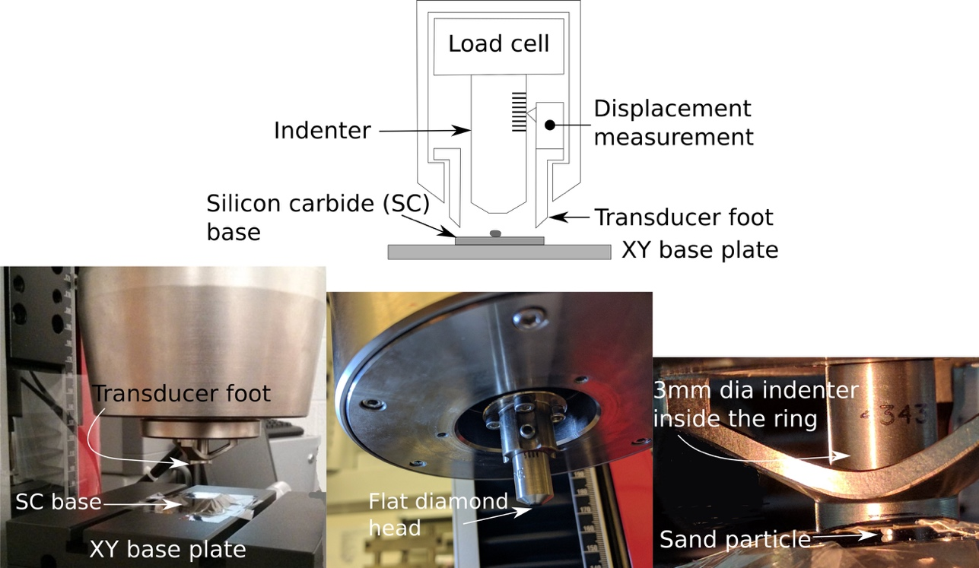
Figure 10. Experimental Setup

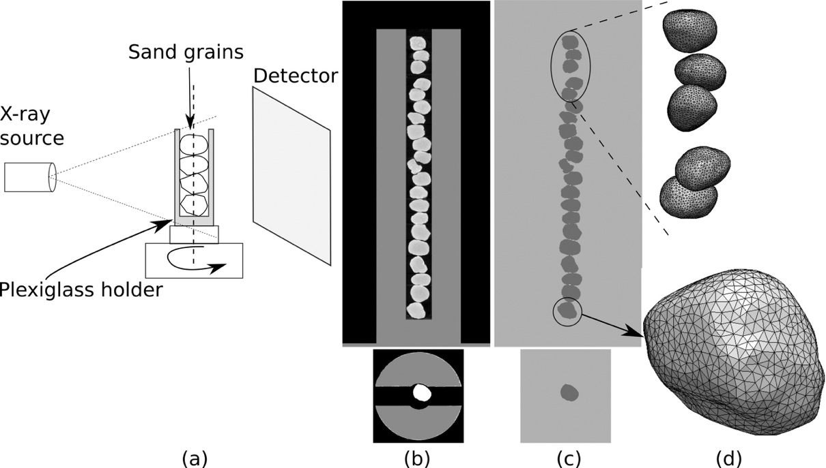
Figure 11. Image processing progression: (a) images of sand grains are obtained using X-ray CT, (b) reconstructed raw images (slice and stack), (c) processed images (slice and stack), and (d) 3D finite element mesh of selected grains

Figure 12. Effect of fracture properties, (a) ultimate tensile strength, σ₀ and (b) fracture energy, G_{f}, on the response fused quartz sphere loaded diametrically between two horizontal platens

Figure 13. Force-displacement of quartz sphere crushing test

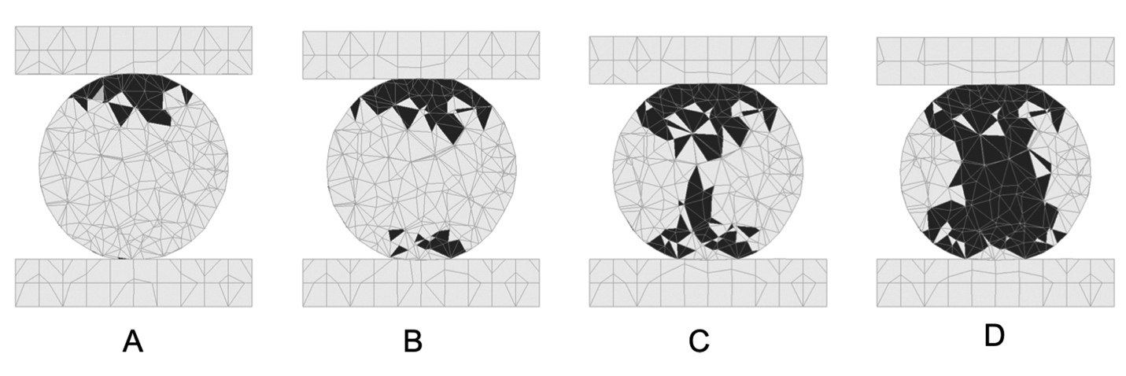
Figure 14. Accumulation of damage in quartz sphere with progressive loading from simulations

Figure 15. High-speed images showing meridional crack of sand particles after catastrophic splitting

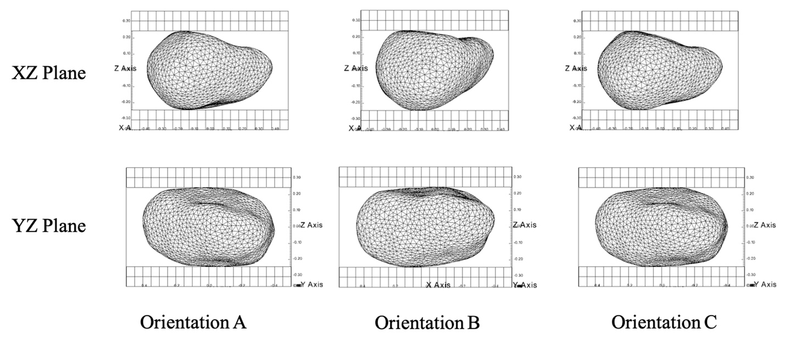
Figure 16. Orientations of Grain in Numerical Analyses

Figure 17. Effect of Grain Orientation on Force-Displacement Curve
Figure 18. Force-displacement of Ottawa sand: Experiments vs Simulation

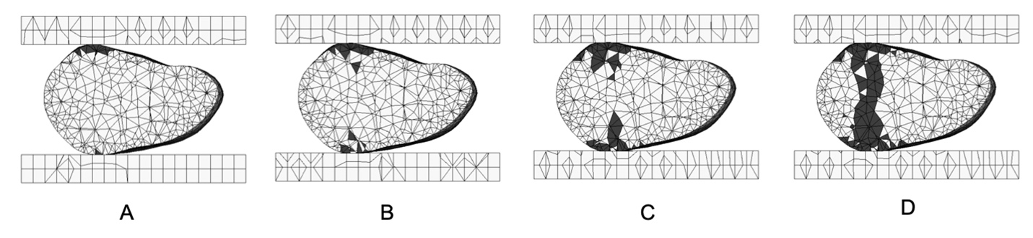
Figure 19. Accumulation of progressive damage from simulations

Figure 20: Experimental Setup

Figure 21. Brittle cracking model crack propagation

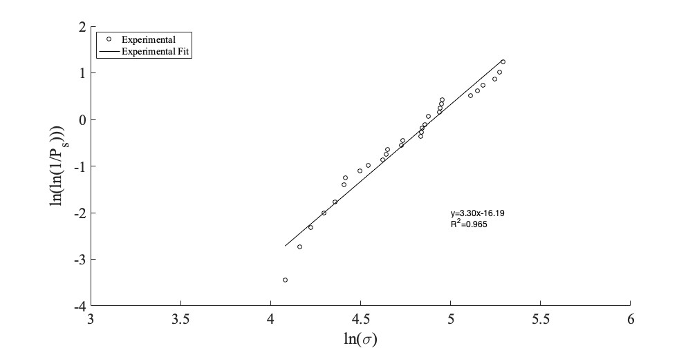
Figure 22. Weibull probability distribution for individual silica sand laboratory measurements

Figure 23. Grain orientations

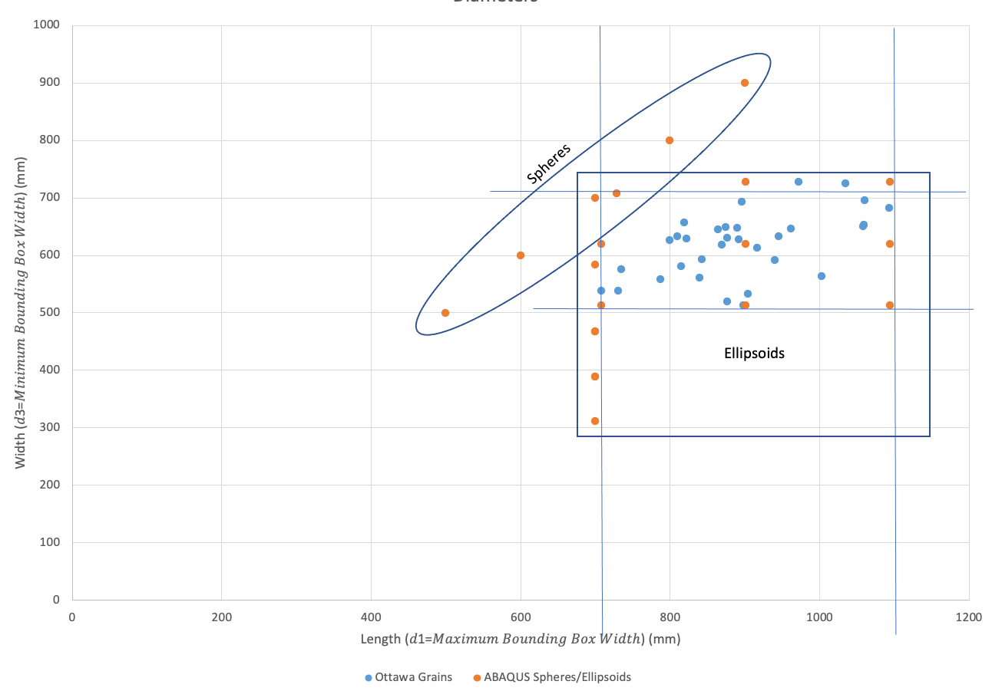
Figure 24. Diameters of Ottawa grains, spheres, and ellipsoids analyzed for single particle crushing

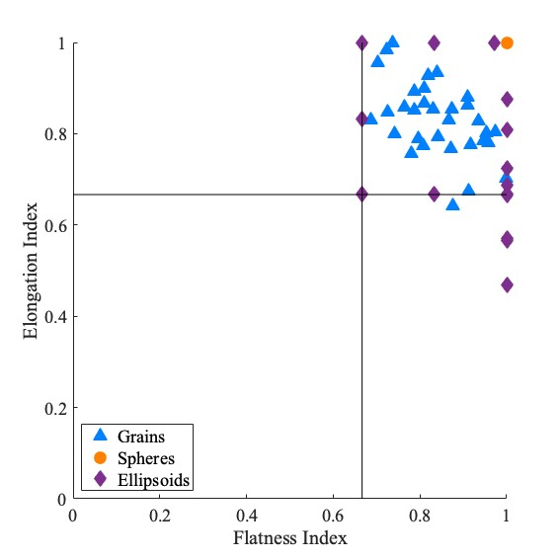
Figure 25. Zingg shape classifications

Figure 26. Spherical particle analyzed for increasing coordination number

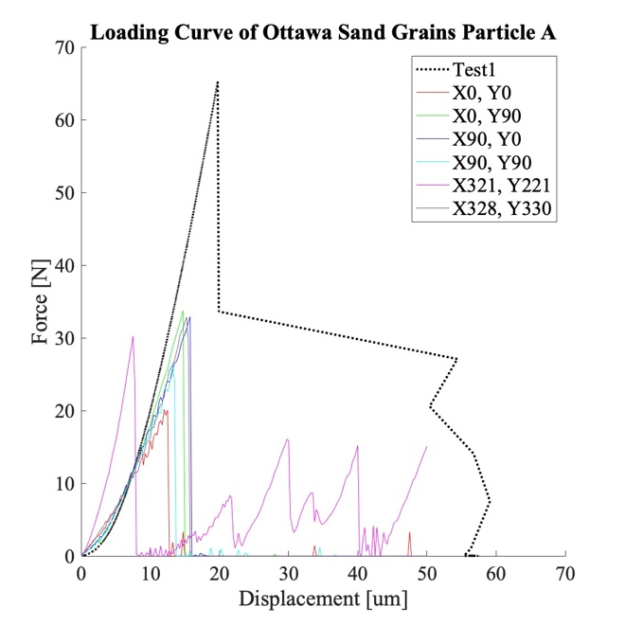
Figure 27. Particle crushing loading curves for one particle

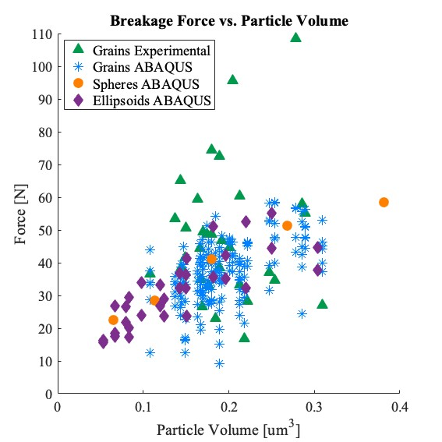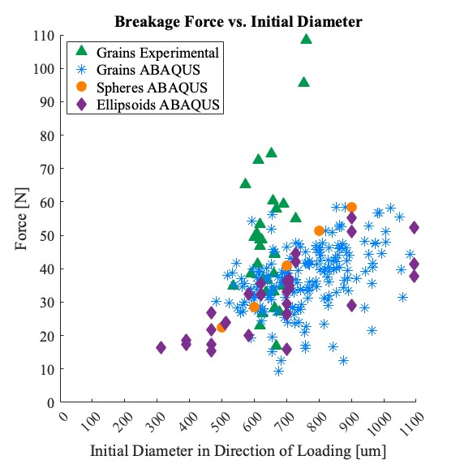
(a) (b)
Figure 28. (a) Breakage force vs. particle volume , (b) Breakage force vs. initial diameter in the direction of loading

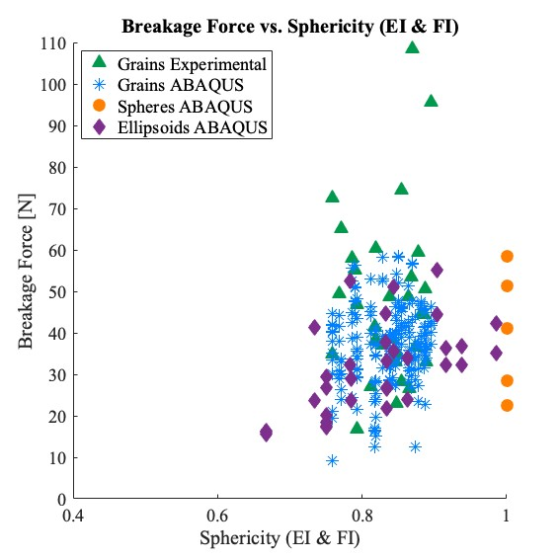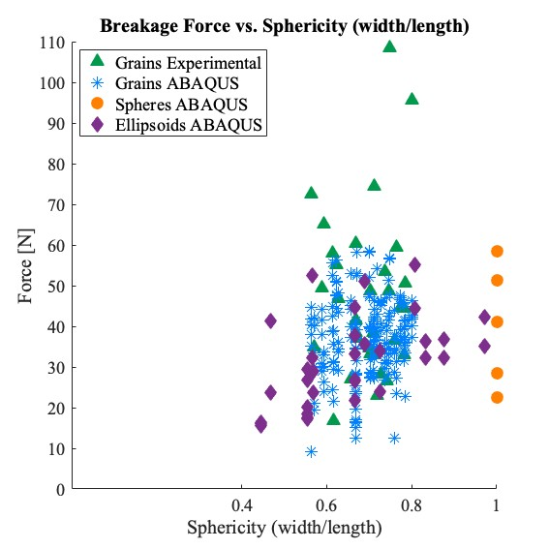
(a) (b)
Figure 29. (a) Breakage force vs. sphericity (elongation and flatness indices) , (b) Breakage force vs. sphericity (width/length)

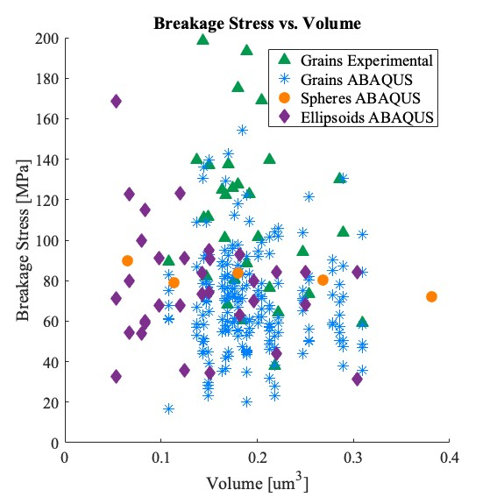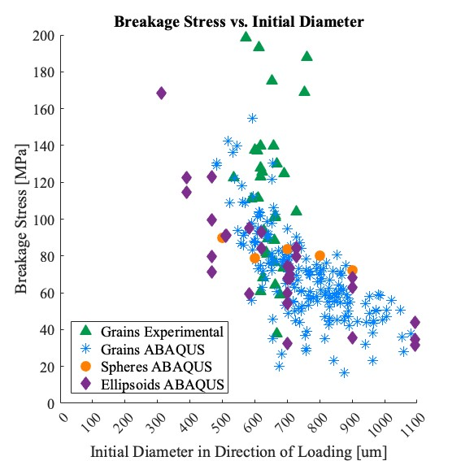
(a) (b)
Figure 30. (a) Breakage stress vs. particle volume , (b) Breakage stress vs. initial diameter in the direction of loading

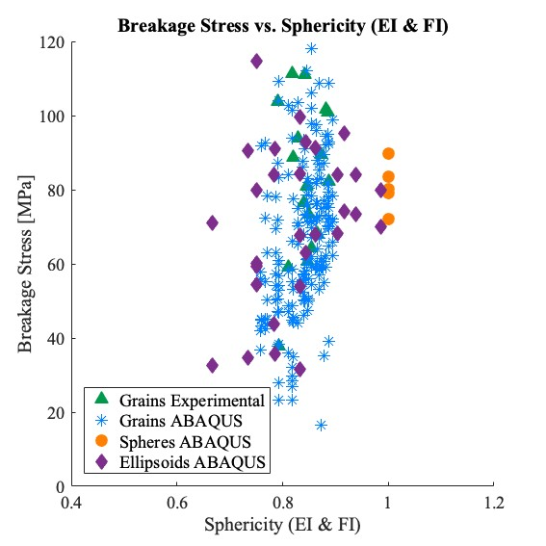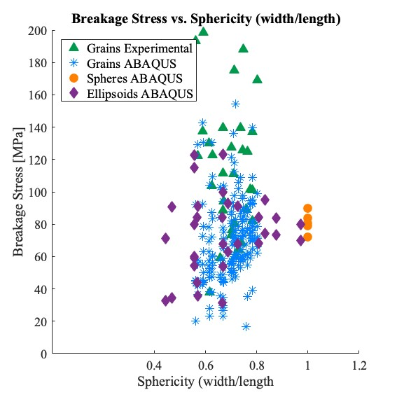
(a) (b)
Figure 31. (a) Breakage stress vs. sphericity (elongation and flatness indices) , (b) Breakage stress vs. sphericity (width/length)

Figure 32. Coefficient from fitting force-displacement curves

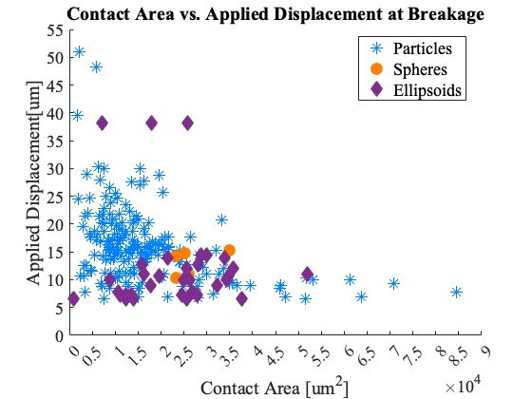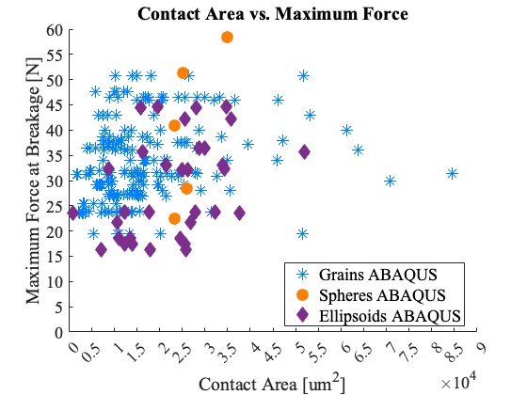
(a) (b)
Figure 33. (a) Applied displacement vs. contact area, (b) Applied force vs. contact area

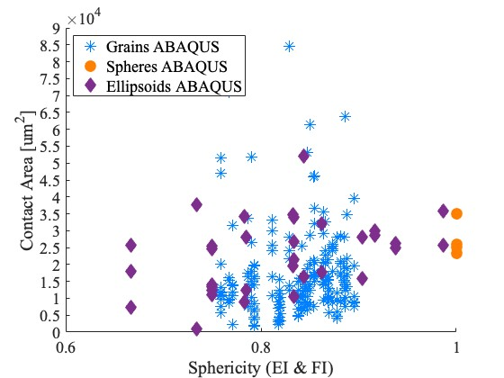
Figure 34. Effect of sphericity on contact area at catastrophic splitting

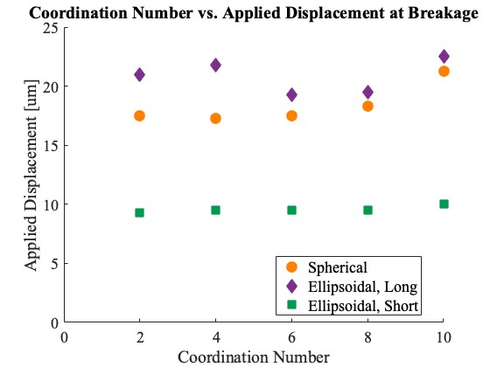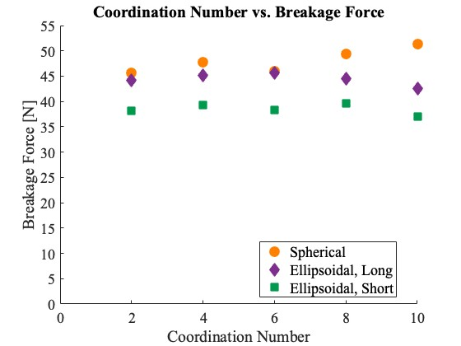
(a) (b)
Figure 35. (a) Applied displacement vs. coordination number, (b) Applied force vs. coordination number

Figure 36. Granular Assembly under 1D Compression

Figure 37. Samples for RVE prediction in granular assembly

Figure 38. Stress-Strain Curves with Varying Ultimate Tensile Strength (σ_{tu})

Figure 39. Assembly Volume Loss with Varying Ultimate Tensile Strength (σ_{tu})

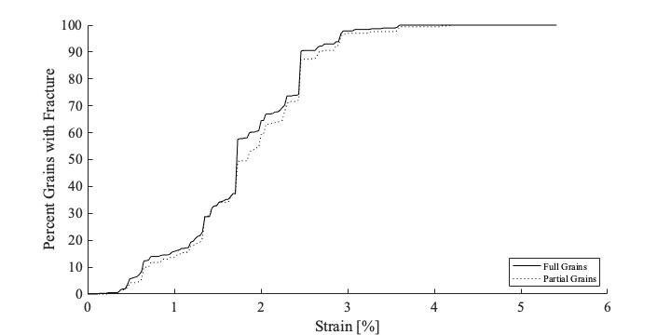
Figure 40. Percent grains experiencing fracture (From analysis with σ_{tu=}1500MPa, and μ=0.5)

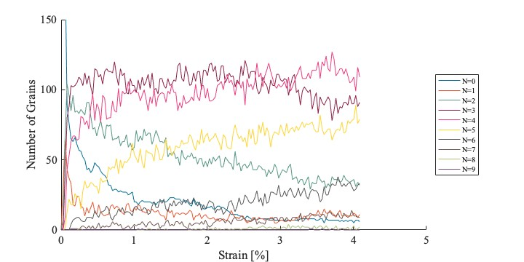(a)
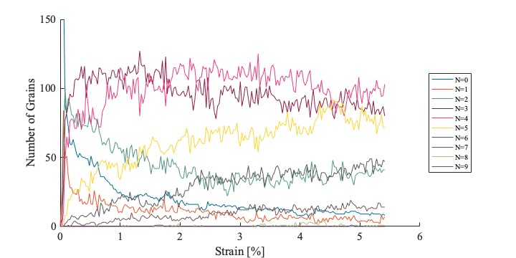
(b)
Figure 41. Coordination Number with Applied Strain for (a) Elastic Analysis and (b) Fracture Analysis

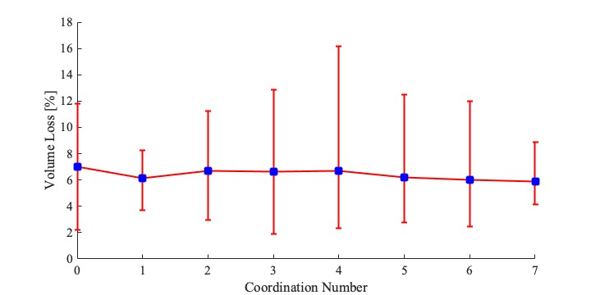
Figure 42. Volume Loss Per Grain with Grain Coordination Number

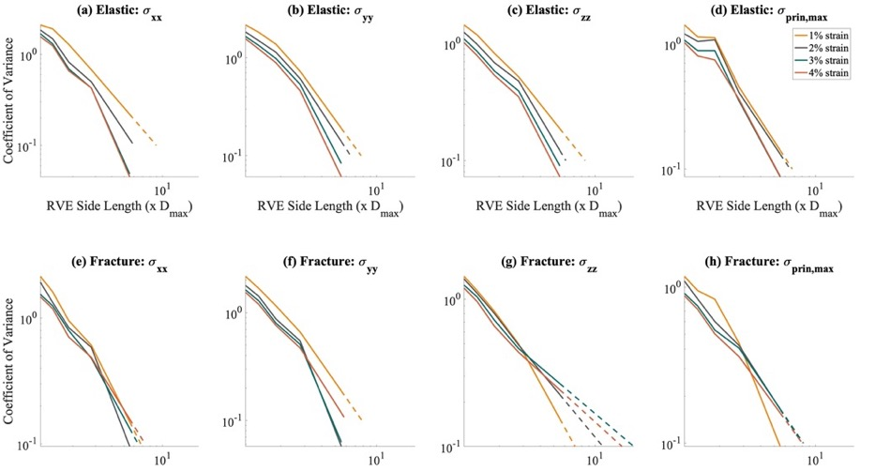
Figure 43. RVE Size Prediction based on applied strain, stress, and inclusion of fracture

Vita
Anne K. Turner (née Himebaugh) was born in Mariemont, Ohio in 1981. She spent her childhood in Cincinnati, Ohio. Prior to attending the University of Tennessee, she attended Purdue University where she earned a Bachelor of Science in Civil Engineering in 2005 and also participated in their University Sponsored Cooperative Education Program working at HNTB Corporation. Supported by the Via Fellowship and advised by Dr. Raymond H. Plaut, Anne earned a Master of Science in Civil Engineering from Virginia Polytechnic Institute and State University in 2006. Anne then spent five and a half years working as a structural engineer in the Engineering Mechanics and Infrastructure department of Simpson, Gumpertz, and Heger in Boston, Massachusetts. She obtained her professional engineering license in 2010.
Anne began her work towards obtaining her doctorate at the University of Tennessee in August 2012 under the direction of Dr. Dayakar Penumadu, supported by the Chancellor’s Fellowship and Joint Institute for Advanced Materials Fellowship. While at the University of Tennessee, Anne served on the Graduate Student Senate representing the Department of Civil and Environmental Engineering and overseeing the Committee for Communication and Outreach. She was also an active member of the Pipeline: Vols for Women in STEM supporting initiatives to enhance the status and representation of women in STEM on campus.
Anne is currently an Assistant Professor in the Department of Construction Management and Civil and Construction Engineering at the University of Arkansas Little Rock.

