Flash Flood Climatology and Emergency Management Considerations in the County Warning Area of the Morristown, TN, Weather Forecasting Office
Emily Litrakis
University of Tennessee, Knoxville

Abstract
Flash floods typically occur from heavy rainfall events that cause a rapid inundation of land, usually in under 6 hours. The Southeastern United States has unique geographic features that make this region more susceptible to heavy rainfall events and flash floods. In this region, there has also been an increase in temperature which subsequently can lead to higher precipitation rates and sea-level rise. Forecasters at the National Weather Service (NWS) encounter difficulties in predicting flash flood events because of such variability in factors contributing to the occurrence of flash floods. Forecasters work closely with EMs in their County Warning Area (CWA) to facilitate a “weather-ready nation” by providing accurate and timely information regarding the possibility of a flash flooding event. The goal of this study was to understand the flash flood climatology of the Morristown (MRX) CWA using NOAA flash flood data to understand seasonal peaks in flash floods and assessing EMs’ perception of flash flood risk to provide information on preparedness and mitigation. EMs contend with misinformation and lack of awareness among their residents which can lead to failure to follow proper orders regarding weather and hazard safety. Communication between acting EMs, NWS partners, and the county residents is a top priority when assessing preparedness in the event of a flash flood.

- Introduction
What are Flash Floods?
Flash floods are flooding that occurs within a span of minutes to a few hours, typically within the span of under 6 hours (NWS, n.d.). In this context, flash flood events are caused by heavy rainfall most commonly due to severe storms (tropical storms, hurricanes, slow moving thunderstorms, etc.) (NOAA, n.d.). Extensive rainfall is associated with certain atmospheric conditions: latent instability, high moisture, and slow storm organization and movement. Types of weather such as tropical storms and thunderstorms are capable of producing heavy rain and are the most frequent driver of flash flooding (Alipour et al., 2020). However, flash floods have also occurred from ruptured levees or dams (Saharia et al., 2017). Flash flooding and its severity are dependent on the duration of the rainfall and the topography of an area (NOAA, n.d.). Flashiness is a variable used to describe flood severity, and is determined by quantifying the difference between the peak discharge and action stage discharge normalized by the flooding rise time and basin area (Saharia et al., 2017). At times, it is challenging to discern flash floods from regular floods (Saharia et al., 2017), which poses a challenge in assessing risk and hazard preparedness. Educating the public for understanding of flashiness is valuable in regards to hazard mitigation.
The nature of a flash flood is unexpected and quickly onset, making them dangerous for the affected infrastructure and populations. The rapid inundation of land can be accelerated by certain soil textures and the amount of ground cover present, and the massive influx of water has the potential to cost up to billions of dollars worth of damage and high numbers of fatalities (Saharia et al., 2017). Those factors make flash floods one of the most frequent causes of weather-related fatalities and injuries (Saharia et al., 2017). Despite the severity of flash floods, they do not receive the research attention that aligns with their destructiveness and frequency in some regions, and there are not easily accessible and comprehensive databases of flash floods and flashiness. This can lead to lack of preparedness for affected areas and ill-suited infrastructure. Understanding the climatology of flash floods in the United States and the impacts that occur in conjunction with the floods can help populations prepare for such events and properly mitigate the amount of damage.
United States Flash Flood Climatology
Seasonally, peak precipitation varies throughout the regions in the United States. The standard meteorological classification of seasons is: December-February (winter), March-May (spring), June-August (summer), and September-November (fall) (NWS, n.d.). In the Southeast, the spring and summer months typically have higher precipitation totals and a higher measure of flashiness (NOAA, 2023). However, the risk of flash floods does not disappear in the winter and fall as the Southeast can also receive significant rainfall during these seasons. The climatology of rainfall in the Southeast is important in understanding the risk of flash floods in this region. Understanding the season that is at the highest chance of experiencing intense or heavy amounts of precipitation is fundamental in being prepared for such an event.
The Southeast experiences more thunderstorms and hurricanes per year compared to other regions in the United States, which correlates to the flash flooding experienced in this region (Alipour et al., 2020). Along the Appalachian Mountains, there is risk of increased flooding due to the orographic lifting and runoff. Small basins, also, enhance risk of flooding in the areas along the mountain range. Along the eastern coast of the United States, the Gulf Stream produces warm waters that provide necessary components for rain producing cyclogenesis or tropical systems. Many flash flooding events occur in proximity to bodies of water. This explains the large amount of flash flooding events on low-lying coasts or rivers that are prevalent in the Southeastern region (EPA, n.d.). According to Fernandez and Zegre (2019), the Blue Ridge (Appalachian Mountains, North Carolina, South Carolina, Georgia, and Tennessee) receives the highest amount of precipitation and lower amounts of evapotranspiration due to the higher elevation in these regions.
Over the past several decades, this region has experienced adverse effects from climate change. Annual temperatures have been increasing due to anthropogenic and natural reasons. Since 1970, the annual temperature in the Southeast has increased 2 °F (EPA, n.d.). Increases in temperature can cause higher annual precipitation, thunderstorms, and hurricane activity all of which are prone to create flash flooding (EPA, n.d.). Accompanied with higher temperatures and increased precipitation, is the impact on sea level in the coastal regions of the Southeast. Rising sea level increases the risk of flash flooding when warmer temperatures expand sea water and melt ice caps, which can erode shorelines and inundate the low-lying wetlands (EPA, n.d.). According to the Fifth National Climate Assessment (2023), the contiguous United States has experienced an overall increase in heavy precipitation. Since the 1980s, statistics have shown an upward trend in the amount of rainfall. Specifically, the Southeast has experienced a 37% change in total precipitation events on the heaviest 1% of days (NCA5, 2023). With this increase in heavy rainfall events, there is a higher probability of increased flash flooding events.
Flash flood forecasting and forecast products
Flash floods are one of the most dangerous weather related hazards in the United States (Ashley and Ashley, 2008). In 2015, 2016, and 2017, flash floods had the highest mortality rate of all weather-related deaths (Ahmadalipour and Moradkhani, 2019). There is complexity in forecasting such events, which makes them of particular importance to meteorologists, emergency managers (EMs), and city planners. There are many variables that contribute to the difficulties in forecasting flash floods. Some of these factors include how quickly the storm is moving, soil type and texture, the topography of the land, and storms repeatedly impacting the same region (NOAA National Severe Storms Laboratory, n.d.). Accurate and timely prediction of flash floods are difficult for forecasters as they can be produced by different storm types: convective, synoptic, and tropical. Accompanied with other components (orographic lifting, dam or levee breaks, runoff), forecasters struggle to predict severity of flash floods (LaPenta et al., 1992). With the complexities of forecasting and the rapid inundation, flash floods are among one of the natural disasters with the most insured losses (Ahmadalipour and Moradkhani, 2019).
EMs rely on flash flood forecasts to protect the public. Much of the forecast information they use is provided by the National Weather Service (NWS). The information provided by the NWS, or products, is important in understanding the risk and severity of a flash flood. A flash flood watch is given when conditions are or could be favorable for flash flooding. However, a flash flood warning is to indicate that a flash flood is very likely, about to occur, or already in progress (NWS, n.d.). Other flood related products that are crucial to emergency management are the hazardous weather outlook and the excessive rainfall outlook. These outlooks provide critical information on the likelihood of certain events for the next 5–7 days, respectively (NWS, n.d.). EMs and the NWS work closely together, as they are considered a core partner of the NWS. The NWS relies on EMs to provide key information regarding their communities in order to successfully become a “Weather-Ready Nation” (NWS, n.d.).
- Objective and research questions
There is a vague understanding of the severity of flash flooding among the public. This can lead to a lack of proper preparedness within affected communities by both EMs and the public. In regards to flash flooding, EMs and other local officials must make decisions that aid governments, businesses, schools, and local infrastructure during such events. This study aims to understand the patterns of flash floods that occur over time and space in the county warning area (CWA) of the NWS - Morristown (MRX) Weather Forecasting Office (WFO) and how EMs and other public officials are responding to that risk. Understanding how EMs in the MRX CWA perceive flash flood threats, use NWS products to establish information regarding flash floods, and are faced with communication challenges is important in providing critical information regarding public safety and infrastructure and revenue loss.
- Data and Methods
CWAs are boundaries in which the WFO is responsible for issuing forecasts and warning (NWS, n.d.). The MRX CWA consists of counties mainly in eastern Tennessee but also includes a few counties in Virginia, Kentucky, Georgia, and North Carolina (Fig.1). I gathered flash flood data from NOAA (2023) for the MRX CWA from 1996 to 2022. Using this quantitative data, patterns of flash flooding can be found, and it can be assessed in conjunction with how emergency managers understand and use NWS products and what challenges they face.
EM information was gathered using a survey administered by the University of Tennessee’s College of Geography and Sustainability and the College of Social Work that aimed to assess EMs’ understanding of flash flood risk in their area. The survey asked questions regarding the acting Emergency Management Directors’ experiences and challenges relating to flash floods faced during their time in this role. They were contacted, by email, several times in regards to filling out the survey, and told that it would only take 20–30 minutes to complete. Out of 40 counties in the MRX CWA, EMs of only 15 counties replied and completed the survey. Those who completed the survey were not compensated for their time. The survey was IRB approved.
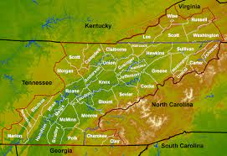
Fig. 1. MRX CWA Map (NWS n.d.).

- Results and discussion
Flash flood climatology in the MRX CWA
The distribution of the annual flash flood reports in the MRX CWA shows that a majority of flash flooding events occur within the month of July and the least amount of events occur in the fall months of October, September, and November (Fig. 2b) (NOAA, 2023). This spike of flash flooding events in July are potentially attributable to the warmer temperatures that occur in the Southeastern region of the United States during the summer months. Understanding that increased risk of heavy rainfall events in the summer are valuable in preparing for flash flooding events. The NOAA (2023) data on flash floods in the MRX CWA shows that there is not a consistent trend in the number of events from the years 1996 to 2022. The data shows a spike in flash flooding events in 1996, 2003, and 2022 (Fig. 2a). However, there is little evidence to explain these increases, but changes in frequency of reporting could have an effect on the number of events per year, as well as cyclical changes in climate.
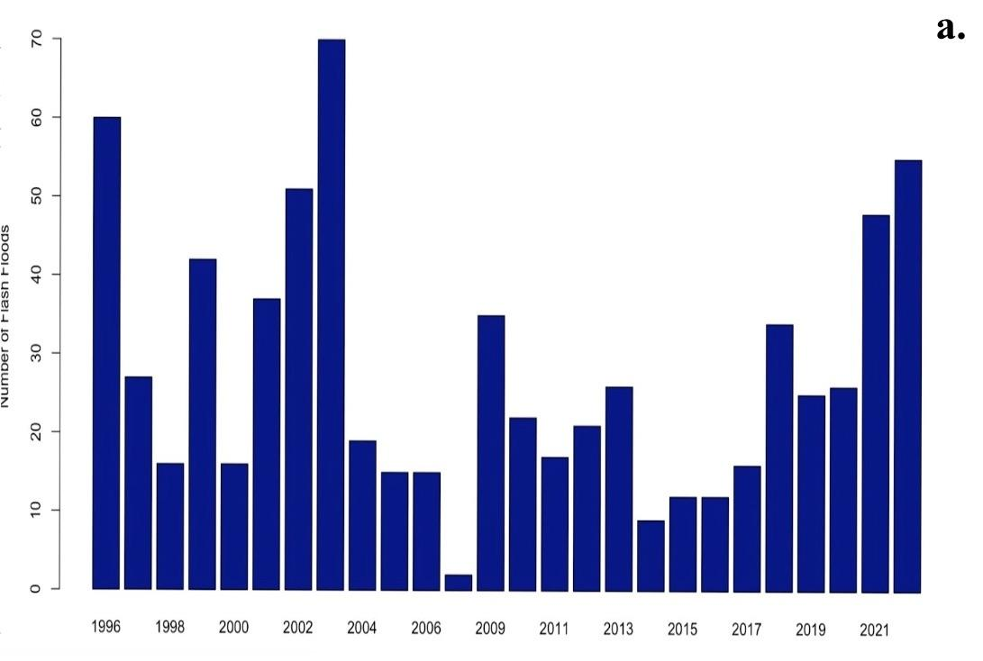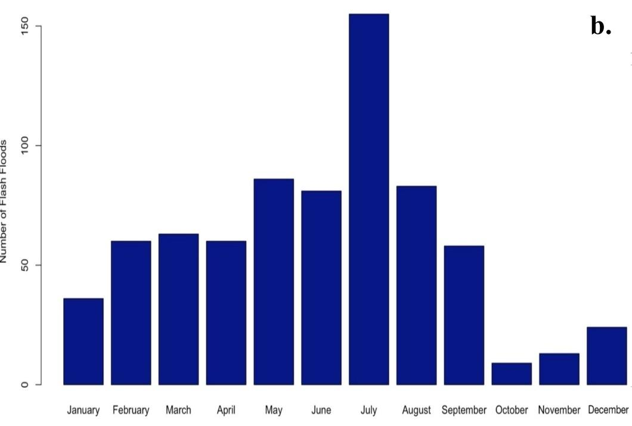
Fig. 2. Flash floods in the MRX CWA from 1996–2022 including a. annual frequency and b. seasonal frequency.
Emergency managers results
Out of the 15 counties that responded in full, 14 of the counties are in Tennessee and 1 county is in Virginia. Their responses were recorded from October 2020 to February 2021, and there were 3 EMs that only responded to the first 17 questions out of 34 total.
The surveyed EMs were asked to order hazards based on their level of concern they have for each within their county. Out of the 6 hazards, including hurricanes, tornadoes, high-winds, hail, wildfires, and flash floods, 55.56% of EMs rated flash floods as their highest level of hazard-related concern within their county. The survey asked for the respondents to define flash floods; almost all of the answers incorporated a variation of a heavy rainfall event. Most of the EMs understood that flash flooding is caused by heavy precipitation in a short period of time, but their opinions of the definition could have adverse effects in regards to emergency planning and response.
In aiming to understand EMs acknowledgement of the threat of flash floods, they were asked if their county has experienced a flash flood during their time as acting EM, what they felt their county’s threat level was, what are the biggest factors contributing to susceptibility, and what effects persist after a flash flood event. All surveyed EMs reported that their county has experienced a flash flood, but only 17.65% stated they viewed their threat level as very significant. The three biggest factors that EMs believed makes their country susceptible to flash floods are lack of flood insurance for residents and local businesses, lack of awareness about flash flood risk, and significant socio-economically vulnerable populations. Damaged infrastructure was stated to be the effect that typically persisted after a flash flood event which coincides with the lack of flood insurance within counties.
Amongst the surveyed EMs, 87.5% reported that there could be further actions taken to reduce the effects of flash floods in their county. They were asked if they faced any challenges regarding conveying flash flood risk to the public; contending with misinformation, resident lack of awareness, and socio-economically vulnerable residents were the top three challenges. While EMs face misinformation and lack of awareness among residents, 50% of EMs said that their residents viewed their county as only having a slight threat of flash floods. Nearly all respondents are under the impression that the type of flood alert from the NWS affects how EMs make decisions regarding public safety, but only half of the surveyed EMs believed their residents would be likely to follow a protective order in the event of a flash flood. Understanding how EMs and their team work with other agencies and stakeholders is important in flash flood management. A majority of EMs agreed that the biggest obstacles they face during flash flood events are a lack of collaborative effort and communication resources between them and the other agencies. According to the survey, EMs believe the strength of their collaboration to be the strongest with NWS forecasters, first responders, and EMs in surrounding counties, but they face the weakest collaboration with TVA, US Army Corps of Engineers, media broadcasters, and local business owners.
While there were limitations with this survey due to the lack of participation amongst EMs in the MRX CWA, their responses are informative and influential in regards to emergency management and preparedness.
- Conclusions
The Southeastern U.S. has an increased risk of flash floods due to its unique geography. The diverse topography of the region, including mountains, valleys, low-lying coastal regions, and the Gulf of Mexico, creates an apt environment for high precipitation totals. This region has also seen an annual temperature increase and a positive trend in rainfall amounts since the 1980s. NOAA flash flood data has shown that there are more flash floods in the summer months, but there is not a consistent trend in flash floods from 1996–2022. This could likely be because of inconsistencies in reporting events. It can be difficult for forecasters to predict flash floods and their severity in this region because of many outlying factors. Flash floods are one of the most destructive and deadliest natural hazards because of the issues in proper forecasting which makes them of particular importance to the NWS, EMs, and city planners. EMs are not meteorologists and rely on close relationships with NWS forecasters to provide accurate and timely information to their residents.
After surveying EMs from the MRX CWA about their perception of flash flood risk, it can be assumed that EMs are aware of the risk of flash flooding in their county, but failed to provide a consistent definition of what a flash flood entailed. This could have a significant role in emergency planning and preparedness as all EMs stated that their county had experienced a flash flood since their time as acting EM. However, half of the surveyed EMs residents do not believe that their county has a high threat level of flash floods, which can make it difficult for forecasters and EM’s to emphasize the level of flashiness. Contending with misinformation, lack of awareness, and socio-economically vulnerable populations were the biggest factors contributing to EMs difficulty relaying flash flood risk to residents, and lack of collaboration and communication between contributors are the biggest challenges in EMs knowing their risk.
By surveying the EMs in the MRX CWA, it can be concluded that communication between EMs, NWS partners, and residents should remain consistent and timely. Flash floods can be dangerous because of misinformation and lack of awareness. There needs to be further efforts in joining EMs and the NWS to create timely, accurate, and similar reports regarding flash flood events. This will be important for being able to properly educate residents on their risk within their area and providing them with mitigation strategies to prevent significant impacts could aid in being prepared for a flash flood.

Acknowledgements
I would like to thank Dr. Savannah Collins-Key for her work on developing the survey used in this publication.

References
Ahmadalipour, A., & Moradkhani, H. (2019). A data-driven analysis of flash flood hazard, fatalities, and damages over the CONUS during 1996–2017. Journal of Hydrology, 578, 124106. https://doi.org/10.1016/j.jhydrol.2019.124106
Alipour, A., Ahmadalipour, A., & Moradkhani, H. (2020). Assessing flash flood hazard and damages in the southeast United States. Journal of Flood Risk Management, 13(2). https://doi.org/10.1111/jfr3.12605
Ashley, S. T., & Ashley, W. S. (2008). Flood fatalities in the United States. Journal of Applied Meteorology and Climatology, 47(3), 805–818. https://doi.org/10.1175/2007jamc1611.1
Climate impacts in the Southeast | Climate change impacts | US EPA. (n.d.). https://climatechange.chicago.gov/climate-impacts/climate-impacts-southeast
Lapenta, K. D., McNaught, B. J., Capriola, S. J., Giordano, L. A., Little, C. D., Hrebenach, S. D., Carter, G. M., Valverde, M. D., & Frey, D. S. (1995). The Challenge of Forecasting Heavy Rain and Flooding throughout the Eastern Region of the National Weather Service. Part I: Characteristics and Events. AMETSOC. https://doi.org/10.1175/1520-0434(1995)010
NOAA’s National Weather Service. (n.d.-a). A precipitation and flood climatology of the Southern Appalachian Mountains. https://www.weather.gov/mrx/heavyrainclimo
NOAA’s National Weather Service. (n.d.-a). County warning area boundaries. https://www.weather.gov/gis/CWABounds
NOAA’s National Weather Service. (n.d.-c). County Warning Area of WFO Morristown, TN. https://www.weather.gov/mrx/cwa_mrx
NOAA’s National Weather Service. (n.d.). Flash Flooding Definition. https://www.weather.gov/phi/FlashFloodingDefinition
NOAA’s National Weather Service. (n.d.-b). Floods. https://www.weather.gov/pbz/floods
NOAA National Severe Storms Laboratory. (n.d.). Flooding. https://www.nssl.noaa.gov/research/flood/
NOAA’s National Weather Service. (n.d.-d). Flood related products. https://www.weather.gov/safety/flood-products
NOAA’s National Weather Service. (n.d.-b). Rainfall climatology. https://www.weather.gov/meg/rainfallclimatology
NWS. (2021). NWS PARTNERSHIP STRATEGY. https://www.weather.gov/media/ooe/NWS%20Partnership%20Strategy%20-%20FINAL%20March%202021.pdf
Program, U. G. C. R. (2023). Fifth National climate assessment. Fifth National Climate Assessment. https://nca2023.globalchange.gov/
Saharia, M., Kirstetter, P., Vergara, H., Gourley, J. J., Hong, Y., & Giroud, M. (2017). Mapping flash flood severity in the United States. Journal of Hydrometeorology, 18(2), 397–411. https://doi.org/10.1175/jhm-d-16-0082.1

