The Lived Resettlement Experience
for Single Refugee Mothers
from the Democratic Republic of Congo

A Dissertation Presented for the
Doctor of Philosophy
Degree
The University of Tennessee, Knoxville

Lauren Michelle Mefford
December 2020
Copyright © 2020 by Lauren Michelle Mefford
All rights reserved.

DEDICATION
This dissertation is dedicated to my family.
Jeremy, you have been a rock throughout this whole process. Thank you for supporting me and for the countless hours that you gave to free me to write. The last years have been comically difficult—though tears have been mingled with much joy. You clung to Christ through it all and stood unwaveringly strong for our family.
Again and again, you spoke timely words of encouragement when the pressures of life brought me to my knees.
You were (and are) such a wonderful source of refreshment when I needed to step away, breathe, and enjoy life with you. You are a wonderful husband and my best friend. I love you.
And to our little ones: thank you for being patient with mommy in this huge endeavor. The PhD journey started before you were born—who would have dreamed that you would all be with us by the end of it? Life is so much richer with you. We treasure your sweet smiles and the unique ways that God made each of you. We are grateful to have the privilege to love you and to awaken your hearts to the wonders of God’s love and His work in the world. As you marvel at it all, we hope to cultivate a love for learning and a passion to bring light and goodness to the world around you.
We love life with you, and your mom and dad love you so very much.

ACKNOWLEDGEMENTS
I would like to thank my Dear Friend and her sweet children for letting me into your lives when you first resettled to America. Your ingenuousness opened my world to a new realm that I was not previously aware of and compelled me to respond. To the women who welcomed me into your homes and into your stories—thank you. I pray that what you shared with me will awaken and move people to make resettlement better for other single mothers.
Fila, thank you for the countless hours you devote to sacrificially and graciously serve the single moms—and so many others-- in our city. I could not have done this study without you and your wisdom, linguistic talents, and time. I am deeply grateful.
To the staff and volunteers and Bridge Refugee Services--thank you for partnering with me in this study and for what you do. I am grateful for your passion to welcome the stranger and to help our cities do the same; to see strangers become neighbors and friends; to see the persecuted find rest, dignity, and a new life. Your work is invaluable.
To my dissertation committee: Drs. Sandra Thomas (Chair), Sandy Mixer, Lisa Davenport, and Isabel Solange Muñoz; thank you the investment of your time, expertise, and energy to help me succeed. Dr. Thomas, in my journey as a graduate student, you have spurred me on to become a better scholar and phenomenological researcher. Thank you for your continued help, instruction, and encouragement as I slowly learned what I needed to in order to get to this point. Drs. Mixer, Davenport, and Muñoz, thank you for your essential guidance and encouragement along this rocky and curvy road. Your expertise and perspectives were formative in my thinking and writing, and your presence on my committee was a gift. Dr. Hillary Fouts, thank you for your contribution to this study and for guiding me in matters related to the culture and ethnohistory of DRC. I would also like to thank the College of Nursing, Graduate School, and the University of Tennessee for scholarships that funded my doctoral education and this study.
To the Transdisciplinary Phenomenology Research Group (TPRG), thank you all for your many hours of dedication to this band of scholars. I set many transcripts and ideas before all of you, and you handled them with care. Your insights were vital as I moved through the research process.
I want to recognize Dr. Susan Speraw, my mentor and dear friend; a pivotal presence over the last seven years. In 2013, when I started the Global Disaster Nursing Program, you saw something in me that I did not see and called out the person that you saw I could become. You invited me into a new world of learning and inspired me to go beyond what I thought I could—and so here I am. To this day, your words are life-giving, and your insight is invaluable. Thank you for your faithful help, care, consideration, and wisdom. I am blessed to have the gift of such a wonderful mentor and friend.
In closing, I want to thank my favorite people--my parents, family, and friends; the ones who have walked beside me, unconditionally loved me, and have faithfully encouraged me to press on in this challenging journey. Thank you for believing in me and for pointing me to the Truth of God’s word when I needed it most. I am a rich woman to have you in my life, and I hope that I can be as equally of a blessing to you as you are to me.

Abstract
At least 72% of the 50,000 Congolese refugees resettled in the USA in the last 5 years are women and children. Many are single refugee mothers (SRM) disadvantaged by obstacles (i.e., childcare) that hinder them from becoming self-sufficient within the required timeframe post-resettlement. Published research on resettlement has focused general challenges, but an understanding of the unique needs and perspectives of SRMs is lacking. This phenomenological, qualitative study provides insight into the lived resettlement experience for SRMs from the Democratic of Congo (DRC). Participants (n=7) were recruited from a refugee resettlement agency in East Tennessee and partook in open-ended, unstructured interviews lasting from 45-60 minutes, mediated by an interpreter. A university Transdisciplinary Phenomenology Research Group augmented the rigor of the data analysis. Participants’ median age was 36 years, most had 3-4 children, and the length of time living in the US ranged from 1 to 5 years.
The story of the lived resettlement experience for Congolese SRMs begins with life in Africa, the place they once called home and knew as “normal” before moving to the US. Life with family and friends in Africa colored their experiences post-resettlement, thus, the theme “From Collective Survival to Lone Motherhood in a Precarious World” is the central theme. In essence, the meaning of the experience can be vividly seen among four interrelated figural themes within the central theme: “Powerlessness/’I Want to be in Charge of my Own Life’”; “Alone in America/Connection”; “Perpetual Loss & Betrayal/Miraculous Provision”; and “Worry/’Little by Little’”. The role of resettlement agency was critical to sustaining hope.
Practice implications surround supporting SRMs throughout resettlement to bolster their overall physical and mental health. Current resettlement policies inconsistently address SRMs’ needs, though there are precedents and provisions that organizations can implement. Research is needed to understand best practices to support SRMs post-resettlement, resettlement experiences for children of SRMs, and resettlement issues of SRMs versus other refugee women (e.g., women-at-risk, married refugee women, etc.). Overall, greater attention should be given to SRMs in practice, policy, and research in order to improve the resettlement experience and likelihood for successful integration for this population.

TABLE OF CONTENTS
CHAPTER ONE 1
INTRODUCTION 1
Overview of the Problem 6
Cultural Background 10
Political Perspectives 16
US Political Climate 20
Philosophical Basis 22
Study Purpose 23
Definition of Terms 24
Resettlement 25
Integration 25
Acculturation 27
Culture 27
Personal Perspective 27
Assumptions 30
Limitations 31
Summary 33
CHAPTER TWO 38
LITERATURE REVIEW 38
Methods of Literature Search 38
Motherhood 39
Acculturation 48
Health and Resettlement 54
Health and Well-Being 55
Accessing the Healthcare System 58
Resilience 59
Gaps in Knowledge 61
CHAPTER THREE 64
METHODOLOGY 64
Existential Phenomenology 65
Figure/Ground 69
Application to Human Science Research and Nursing 70
Human Subjects Procedure 73
Existential Phenomenology Method Applied 77
Procedure 80
Methodological Rigor 87
CHAPTER FOUR 90
FINDINGS AND DISCUSSION 90
Existential Grounds 94
Figural Themes 99
Central Theme: From Collective Survival to Lone Motherhood 99
Figural Themes 107
Theme One: Powerlessness/”I want to be in charge of my own life” 108
Theme Two: Alone in America/Connection 117
Theme Three: Perpetual Loss & Betrayal/Miraculous Provision 127
Theme Four: Worry/”Little by little” 135
Thematic Structure 141
CHAPTER FIVE 143
CONCLUSIONS AND RECOMMENDATIONS 143
Themes and the Literature 144
Central Theme: From Collective Survival to Lone Motherhood 144
Powerlessness/“I Want to be in Charge of My Own Life” 145
Alone in America/Connection 148
Perpetual Loss & Betrayal/Miraculous Provision 150
Worry/”Little by Little” 154
Nursing Implications 157
Education 157
Practice 160
Policy 164
Recommendations for Future Research 168
Conclusions 169
List of References 171
APPENDICES 178
VITA 191

CHAPTER ONE

INTRODUCTION
It’s strange, how you go from being a person who is away from home to a person with no home at all. The place that is supposed to want you has pushed you out. No other place takes you in. You are unwanted, by everyone. You are a refugee (Wamariya, 2018, p. 29).
As a prelude to presenting this study of refugee mothers from the Democratic Republic of Congo (DRC), I provide an ethnohistory of the Congo to enable readers to grasp the historical and cultural context of the study participants.
The Democratic Republic of Congo (DRC) is a country that is located in Central Africa. Its land and people have manifold attributes that shape the country’s history. The landscape varies from a massive rainforest to plateaus that meld into savannahs, and there are rolling mountains in western DRC with large stretches of grasslands and agricultural farmlands in the north. The Congolese people and culture are just as, if not more, ethnically diverse than the land they inhabit.
To this day, DRC is lavish with natural resources, such as diamonds, gold, coal, uranium, petroleum and numerous minerals that are coveted by surrounding countries (BBC, 2012; Cordell, Lemarchand, Wiese, & Payanzo, 2020). Despite its wealth, the Congolese people have hardly seen any benefit. Instead, infrastructure remains rugged, education is poor, healthcare systems are lacking, and violence persists from within and without. For decades, various countries, governments, warlords, and corporations have exploited the country’s resources. Ethnic conflict, division over resources, and complex political and military turbulence has marked the country for over a century. Collectively, these issues have resulted in millions of lives lost and led to massive displacement. In this chapter, I provide background material about the history and culture of DRC before I introduce the research problem. This provides context to help readers better understand the stories and perspectives of the Congolese women that I interviewed for this study.
DRC History and Colonization
During the precolonial era between the 15th to 17th centuries, Congolese societies experienced significant disturbances between regions. The Kongo kingdom in the west and Luba-Lunda states in the east established political systems and military forces, and the regions were often in conflict over power. Subsequent instability combined with regional leaders who bargained with advocates of the Atlantic slave trade left the country vulnerable to intruders from surrounding countries who sought to have their hand in slave trade and resource extraction. Ultimately, because of long-standing insecurity, DRC succumbed to Belgian colonial forces (Cordell et al., 2020).
King Leopold II of Belgium coveted the resources layered throughout Congo and saw potential for European trade along the Congo River. Beginning in 1878, Leopold generated a plan that ultimately allowed he and his confidants to negotiate with local chiefs, sign treaties with 450 African bodies, and establish Belgian governance within Congo. Subsequently, he continued his conquest to colonize the Congo River basin area and called this the Congo Free State, which remained as so from 1885-1908. Initially, he operated under a façade of pure intentions and led people to believe this was an effort to end slavery, bring religion to the country, and work for the betterment of the country by introducing elements of modern life to the people (Cordell et al., 2020). Little did they know that his conquest would be to their detriment.
Ulterior motives for massive revenue compelled Leopold to build a system of people that would accomplish his aim, yet it was at the expense of millions of lives. Those who explored the Congo for Leopold suggested that a railroad be built for profitable trade. In order to build a railroad and extract the greatest amount of resources from Congo, Leopold assumed that the Congolese people would need to be forced to accomplish his lofty goals. In order to prevent and overcome any resistance, he quickly recruited a substantial amount of Congolese men to join indigenous troops that would support his cause. Leopold ordered the troops to take cruel measures to secure and force men to do the work he ordered them to do. Women and children were kidnapped and taken for ransom, and Congolese men were ordered to complete an insurmountable amount of labor in order to fund their release. Men who rebelled against Leopold’s initiatives faced horrific consequences, such as the slaughtering of their families or burning of their homes (Cordell et al., 2020). Ten million people died as a result of his rule over the Congo Free State (Hochschild, 2020).
The Beginnings of Decolonization
Ultimately, the Belgian parliament annexed the Congo Free State and Leopold’s sovereignty over Congo ended in 1908. Even so, successive consequences of his destructive initiatives rippled throughout history and are partly to blame for instability today. The massive social disturbances made it difficult for the Congolese to institute a sustainable governance at that point, and little has improved in this regard since then; though Leopold’s reign is not solely the only one to blame (Newbury, 2012).
Belgian rule over Congo continued with its political sentiment for control and resisted input from the Congolese people, hence, they began to resist colonial powers. After major reform that ultimately took place, DRC became a democracy in 1957 as Congolese men and women had greater interests in voicing political wishes; the country remained under Belgian rule. Eventually, within the context of two world wars and massive psychological trauma from political reform, civil unrest developed in DRC with an outcry for independence. By 1959, Congolese leaders and rioters demanded immediate liberation from Belgian rule. The Belgian government responded by agreeing to begin this process, but with wishes to transfer leadership over the course of six months so that the country would be sustained. Nevertheless, Congo wished for instant decolonization and received their request. The country quickly became unstable as members of the Congolese government clashed over who had supreme political power. Intermingled within the political conflict, Joseph Mobutu took advantage of weak and disunified government and assumed power via coup d’état in 1960 and 1965. Mobutu ruled for over thirty years with promises of peace, but he ultimately repressed the Congolese people until he was overthrown in the late 1990s (Cordell et al., 2020; Newbury, 2012).
The Great African War
In the mid 1990s, the existing instability in DRC was exacerbated by the genocide that occurred in neighboring Rwanda. The effects from the genocide pushed DRC over the ledge into a deadly war that claimed approximately 5 million lives in less than ten years (BBC, 2012). During the war, most people died from starvation and disease, though many were tortured and hacked to death.
The Rwandan genocide of 1994 played a significant part in the ongoing and current conflict in DRC. The Hutu nationalist regime was responsible for the genocide that targeted the Tutsi minority group and murdered at least 800,000 people within 100 days (History, 2009). Ultimately, the regime was overthrown and driven out of the country by an army of exiled Tutsi men. Thus, the Tutsis dominated the Rwandan government while two million Hutu militia men that were responsible for the genocide fled to DRC (BBC, 2012). At the time, the government in DRC was corrupt and led by president Joseph Mobutu. Hutu militia men joined forces with the DRC government and, once again, targeted the Tutsi ethnic groups of DRC as well as those who were of mixed race (Smigelsky, Gill, Foshager, Aten, & Im, 2017). In response, the Rwandan government allied with Ugandan forces and rival militias to overthrew Mobutu’s government and appointed Laurent Kabila as president. When Kabila did not expel the Hutu militiamen, but rearmed them, Rwanda joined forces with Uganda and Burundi and attempted to remove him from presidency; this ultimately spawned a proxy war fought within DRC borders (BBC, 2012). The war ended in 2003, but conflict ensued between Tutsi and Hutu militias in eastern DRC and propagated the existing instability. Meanwhile, government and rebel groups from within and without committed mass rapes of women and children, murdered thousands, and relentlessly looted the country for its resources (Newbury, 2012).
Ethnic Conflict
While political powers inside and outside DRC were to blame for much of the long-standing insecurity and instability within the country, it is also important to note that there is also a long history of conflict between Congolese ethnic groups that continues today. There are a variety reasons that contribute to the animosity that has perpetually existed between groups over time, including conflict over resources. But there was a time long ago when some ethnic groups shared common interests. It was not until the intervention of colonizers, foreign powers, rebel groups, and eventually the media that created illusions of irreconcilable ethnic differences that were worthy of opposition; this sentiment continues today (Karbo & Mutisi, 2012). Not only that, but weak governmental powers and the pervasiveness of rebel groups throughout DRC contribute to the country’s instability and undermine any possibilities for ethnic reconciliation. Without a stable and wholesome government, the country lacks order, security, and the ability to execute justice that would protect the Congolese people and provide an environment conducive to rebuilding bridges between groups (Karbo & Mutisi, 2012). Adversely, ethnic tensions are strong enough to transcend the borders of DRC; this complicates the lives of the those who are displaced by war, live in a refugee camp, or resettle to another country among an ethnic blend of Congolese men and women.

Overview of the Problem
As a result of war that has torn the Democratic Republic of Congo at its seams, over 4.5 million people have been displaced within the country. African countries that surround DRC have hosted at least 900,000 Congolese refugees, and thousands of Congolese refugees have resettled to countries outside of Africa (UNHCR, 2019). Between 2014 and 2019, the U.S. was projected to receive approximately 50,000 Congolese refugees and has since received 58,972 Congolese men, women, and children; DRC is currently the most represented country of origin for refugees that have resettled to the US (Busch-Armendariz, Wachter, Heffron, Nsonwu, & Snyder, 2014; Center, 2020; Proposed refugee admissions for fiscal year 2019: Report to congress, n.d.). Out of the Congolese refugees who have moved to the US, at least 72% are women and children; this percentage includes single refugee mothers (SRM) (US Department of State, 2017).
SRM from DRC are at a significant disadvantage when resettling to the US. The standards for refugee resettlement programming are that refugees find employment and become economically self-sufficient within 90 days post-arrival. This is challenging but achievable for many; however, it is exceptionally difficult for SRM to attain. SRM face unique obstacles that make it difficult to find employment, which includes language barriers, childcare issues, inadequate transportation access, and a lack of transferrable employment skills (Busch-Armendariz et al., 2014; Shishegar, Gholizadeh, DiGiacomo, Green, & Davidson, 2017; Vervliet, De Mol, Broekaert, & Derluyn, 2014; Wachter & Gulbas, 2018). Language barriers make employment difficult for most refugees, but single mothers have added challenges that make it exceptionally difficult to attend English classes (e.g., childcare issues, inadequate transportation, acting as the sole parent of the home). These factors collectively contribute to delayed employment, economic instability, and difficulty with integrating to the US (Wachter, Heffron, Snyder, Nsonwu, & Busch-Armendariz, 2016).
The challenges that SRM face post-resettlement negatively impact their mental health and well-being. A significant piece of this is tied to their loss of social support, which was foundational to their way of life in DRC (Browne et al., 2017; Salami, Ali Hirani, Meherali, Amodu, & Chambers, 2017; Shishegar et al., 2017; Wachter & Gulbas, 2018). In Africa, women were accustomed to communal living amongst family and friends and had help raising their children. When Congolese women leave DRC with their children, they leave their loved ones and culture behind and enter into a foreign world that values autonomy and independence. Unlike life in Africa, they know no one and initially have no social support networks to help them navigate America as a single mother. The aforementioned economic instability that many SRM from DRC face post-resettlement combined with little to no social support is linked to isolation, poor mental and physical health, and delayed integration to the US (Browne et al., 2017; Cline, 2013; R. D. Schweitzer et al., 2018; Shishegar et al., 2017).
Stressors post-resettlement may also exacerbate preexisting mental health issues that are related to traumatic experiences that women faced in Africa (East & Gahagan, 2017). Studies have shown that at least 40% of Congolese women have experienced some form of past trauma and/or sexual violence that impact them post resettlement, which is likely an underreported statistic (Busch-Armendariz et al., 2014; International Rescue Committee, 2014; UNHCR, 2013; Wachter et al., 2016). Sexual and gender based violence (SGBV) has been a common occurrence in DRC and inside refugee camps. Armed groups in DRC have used sexual violence as a weapon of war to terrorize the Congolese. Examples of SGBV that Congolese women have experienced or have seen happen to family members include: gunshot wounds to the genitalia; mutilation with knives or blades; penetration of the body with guns, machetes, and other weapons; sex slavery; gang rape; murder; and children or family members who are forced to hold down a female member of their family while they are raped (Busch-Armendariz et al., 2014; Peterman, Palermo, & Bredenkamp, 2011; Smigelsky et al., 2017).
Many refugee women have experienced SGBV, but all refugee women have experienced traumatic loss in some form (Convention relating to the status of refugees, 1951). The vulnerability and trauma that women experienced in Africa contribute to challenges post-resettlement and have been shown to negatively impact their well-being, their children, and the ability to successfully integrate to the US (Bartolomei, Eckert, & Pittaway, 2014). These issues compound the challenges of single parenthood for single mothers from DRC.
Given the multifaceted issues that SRM from DRC face post-resettlement, it is imperative to their well-being and success that steps are taken to improve resettlement for this population. Dr. Mary Wakefield, the former deputy secretary of the US Department of Health and Human Services, identified refugees as one of the most vulnerable populations worldwide and called nurses to lead change to improve refugee health (Jones-Berry, 2017). She suggested that nurses aim to demonstrate person-centered care, political advocacy, and humanitarian values towards the refugee community (OCHA, 2012). In order to extend such care to SRM from DRC, greater insight into their first-hand perspectives on the resettlement experience is necessary. This is especially important given the all-encompassing nature of resettlement and its known impact on health and well-being. The literature to date has focused on resettlement challenges that refugee women face at large, but little to no focus has been given to the meaning of the experience for SRM from DRC. This study aims to address this problem by utilizing an in-depth, phenomenological approach that captures the essence of the resettlement experience for SRM from DRC.

Cultural Background
Before delving into the philosophical basis and methods for the study, it is important to consider the cultural and political background that shapes the perspectives of contemporary Congolese women. The DRC is made up of more than 200 culturally diverse ethnic groups. The majority of the population are of the Bantu group, but many ethnicities are lumped into other major cultural groups that include the Mongo (central), Kongo (west), the Luba (south-central), Lunda (south), Bemba (southeast), and the Kasai (Cordell et al., 2020). There are 700 languages and dialects with four national languages that are used to communicate between ethnic groups: Swahili, Tshiluba, Lingala, and Kongo. French is the national language that is used for instruction, business, and other official affairs. Given the ethnic diversity, there are varied cultural beliefs and practices. However, there are major patterns of social organization and cultural values that are more prevalent.
Gender Roles
DRC is a predominantly patriarchal culture where men are the heads of households and make most major decisions without much input from women. Culturally, women are encouraged to get married early, give birth to multiple children, and are primarily responsible for caring for the children’s needs (Mafuta et al., 2016). Women usually tend to domestic matters of the home and are discouraged from outside work, but if they earn money, they usually ask for permission before spending it (Matuskey, n.d.; Quattrochi et al., 2019). This general male role is prevalent in settled farming communities; however, it is inconsistent with hunter-gatherer or foraging ethnic groups (e.g., the Bambuti group in eastern DRC and Mbendjele in northern DRC). These hunter-gatherer groups value gender autonomy and equality even though they do not explicitly discuss these ideas (Lewis, 2008; Roulette, Hagen, & Hewlett, 2016). Neither men nor women depend on the other for food and resources, and so one gender cannot exert power over the other. Both men and women can become economically independent if needed. At the same time, they both value interconnectedness between genders and work together to produce and build their livelihoods. Unlike most of DRC, foraging groups understand men and women to be equal in value, yet they hold different roles and skills that are complementary to the opposite gender (Lewis, 2008).
While most agricultural and farming Congolese communities regard men and women differently, women’s roles go beyond domestic work. In most areas, women are active participants in community or religious groups that intend to benefit and influence their communities. Some regions that are especially male dominant may not permit women to hold prominent decision-making roles (e.g., chair-person) in groups that contain both men and women. Some of the underlying reasons for this are that women are limited by lack of education and resources that would make them competent to make important decisions for the community (Mafuta et al., 2016). On the other hand, some Congolese communities have been influenced by NGOs that have promoted the status and education of women. Women in some of these communities do not consider themselves marginalized but proudly hold important positions and feel they are contributing members of their community (Mafuta et al., 2016). Regardless of what position women hold, they generally feel comfortable sharing thoughts in group meetings. Even so, women do not usually feel comfortable voicing opinions that are contrary to those of someone in authority, such as a religious or community leader (Quattrochi et al., 2019). These attributes of the Congolese culture likely color interactions that women have with men or authority figures post-resettlement.
Family Culture
The immediate Congolese family structure in DRC includes family members such as grandparents, aunts, uncles, and cousins. Life is lived communally, and family members depend on one another. When a family member is elderly, sick, or has a need, the family is collectively responsible to meet the need(s). When a man and a woman have children, child-rearing is a family endeavor; many relatives contribute to the “parenting” of a child. The entire family is so connected that cousins of their children are considered siblings (Matuskey, n.d.).
Marital traditions also vary between ethnic groups and geographical settings, but there are patterns that are common throughout DRC. Marriage is not only seen as an agreement between a man and woman, but is a family affair; it is ultimately an alliance between families ("Responses to information requests: Democratic Republic of Congo: marriage practices among the Luba," 2014). Historically, arranged marriages have been a common practice in the Congolese culture, though this is less common today in more urban areas (Matuskey, n.d.). If a man wants to pursue marrying a woman, he proposes to her and a bride-price is set between the families; the bride-price is usually high and requires money, livestock, and other goods. In some ethnic groups and situations, the father confirms with his daughter that she wants to marry the man. Upon her consent, the two families join together to celebrate, the man pays the bride-price, and they are married. Upon full payment, the woman leaves her family to live with the man and is now under his headship. She does not return to live with her family except to collect the things that she will contribute to her new home. In cases when the woman is unhappy or experiencing abuse, she is usually obligated to continue living with the man. Divorce is mostly an option exclusively for males, since most women do not have the money to repay the bride-price (Matuskey, n.d.).
If there are problems in the family, such as domestic violence or rape, the family usually deals with the situation themselves. Domestic violence is common, since it is culturally accepted as a consequence for women who do not obey their husbands (Lusey, Sebastian, Christianson, & Edin, 2017; Quattrochi et al., 2019). If problems between a man and woman are outside their ability to handle themselves, they seek counsel from a religious or traditional leader in the community ("Responses to information requests: Democratic Republic of Congo: marriage practices among the Luba," 2014). For example, if a man believes his wife conceived a child with another man, he may take her to the leader to find a solution to the problem. Since the man is the decision maker of the home and the leader holds a certain level of authority, the woman has little to no say in this situation. If the man believes the child is not his offspring, he and the leader can decide to place the child with extended family. The family member who receives the child is determined whether the ethnic group is matrilineal or patrilineal, which varies throughout the country. This is one reason, among many, why Congolese women who resettle to the US may have children remaining in Africa. These children were not a part of the same household when the woman applied for resettlement.

Religion and Spirituality
Religion and spirituality are complex, but integral, elements of the Congolese culture that shape how men and women view the world and themselves. Christianity has long been a dominant religion in DRC, tracing back to 1484 when Portuguese colonizers and missionaries shared their faith with Congolese leaders. During the early 1500s, King Afonso I of Congo was an advocate of the Christian faith, established relations with the Vatican, and founded the Roman Catholic Church in DRC (McKenna, n.d.); to this day, half of the population identifies as Roman Catholic (Cordell et al., 2020). Belgian colonizers continued to share the Christian faith with Congolese men and women in the 1800s, leading to widespread conversion to Christianity. (Findlay, 2018). Since then, missionaries from a variety of countries have a continued presence in DRC.
Even though most Congolese hold to varied denominations of Christianity (e.g., Catholicism, Protestantism, etc.), many pair their religious beliefs with African traditions and practices. How this manifests is highly diverse throughout the country and is largely dependent on the ethnic group; examples include the belief in spirits (e.g., ancestors, animism, etc.), traditional medicine, and magic (Findlay, 2018).
Religious beliefs and practices follow Congolese men and women as they flee from war, experience loss and trauma, endure hardship in a refugee camp, and leave the camp to resettle to a foreign country (Piwowarczyk, Bishop, Yusuf, Mudymba, & Raj, 2014; Smigelsky et al., 2017). Smigelsky & Aten (2017) found that participants in their study were devoted to trusting God and “faith in the face of trauma was demonstrated to be a way of life, a manner of coping with many challenges, including those of being a refugee” (p. 269). Sexual violence, traumatic loss, and other hardships of being a refugee only served to strengthen their faith and not diminish it. Even in the presence of strong faith, there are mental health consequences of trauma. In these case, it is common for Congolese men and women to pray and wait for God to heal their emotional distress rather than seeking mental health services (Piwowarczyk et al., 2014).
Though there are variations among ethnic groups, spirituality influences how the Congolese perceive health and illness. Generally speaking, religion and spirituality are practices that are important to the Congolese culture; the spiritual realm is woven into the fabric of what they believe about the physical world (Mokgobi, 2015). Blessings and curses are manifested in mental and physical health, which partly explains the negative stigma associated with psychiatric illness. To be well is to be blessed by God. If someone is physically disabled, sick, or suffering from psychiatric illness in any regard (e.g., chronic depression, anxiety, schizophrenia), they are cursed ("Democratic Republic of the Congo: The treatment of people with mental health disorders; protection and services provided by the state," 2012). A curse is thought to be caused by witchcraft or supernatural forces. ("Caring for the health of refugees and immigrants with disabilities: Democratic Republic of Congo," 2019). Services from a healthcare provider are considered insufficient to cure a curse; only prayer and God can heal them.
Cultural views about health
Additional components of the culture that can impact resettlement are views on trauma, mental health, and mental health services. Sexual violence and rape are stigmatized, which means that survivors of sexual trauma may be abandoned and cast-off by family or friends (Bosch, 2019; Busch-Armendariz et al., 2014). Because of the stigmatization, shame, and rejection that accompanies sexual violence, women from DRC are more hesitant to expose this element of their past to anyone who asks about it. Women generally do not seek mental health services for emotional and psychological consequences of sexual trauma (Bass et al., 2014). In fact, the mention of mental health services can lead women to emotionally shut down. Such a suggestion implies that they would be asked to talk about what they have been through, which is too painful and too personal to discuss with a stranger.
Women from DRC are less likely to seek mental health services, but it is not solely because of cultural issues with sexual violence. There are multifactorial reasons that Congolese men and women do not utilize mental health services, namely: 1) it is more common to seek help from close family or religious leaders in the community for mental health concerns; 2) the role of mental healthcare providers is unclear; and 3) mental illness (in addition to sexual trauma) is stigmatized in the Congolese culture (Piwowarczyk et al., 2014). Religious leaders have a level of unspoken authority, and the guidance they provide is highly regarded. It is much more common to seek guidance about emotional matters from leaders they know rather than from a stranger in a white coat. It is an anomaly to seek help from an outsider, especially in circumstances when they perceive that medical services are inadequate to heal them.

Political Perspectives
The political climates in Africa and the US color the way refugee women experience the world pre and post resettlement. As described earlier, the Congolese government contributed to the civil war and was known for its corruption. During the war, the country was exploited for its resources from all sides, including government officials, at the expense of more than five million lives (BBC, 2012). The Congolese perceive government as a powerful entity that executes decisions that mercilessly oppress its people. The government is not perceived as a resource that people can turn to for help and protection, nor does it welcome input from the Congolese people.
Though the Congolese have the right to vote, elections are extreme sources of contention and violence. In the 2019 elections, millions were unable to vote due to several obstacles, such as last minute closure of more than 1,000 polling stations. Armed groups coerced and intimated voters to vote for specific candidates. Government officials prevented opposition supporters from participating in elections ("DR Congo: Voter Suppression, Violence ", 2019). All this to say, the Congolese are accustomed to a corrupt government that they cannot influence nor oppose.
Refugee Camp
When Congolese men and women flee their country, they are classified as displaced persons (DP) and are stateless, depoliticized, unprotected, and prone to having their personal rights violated (Agier, 2011). DPs are burdensome to host countries and disrupt national order, and refugee camps are intended to bring order and contain the refugee population (Turner, 2015). The government and the United Nations High Commissioner for Refugees (UNHCR) see refugee camps as a temporary solution for DPs with an ultimate end in sight (Thomson, 2014). Camps are usually in a secluded area of a country and unmarked on a map, even though the inside of the camp is heavily concentrated with people and local trade (Turner, 2015). Trade and business exchange inside the camp can become so prevalent, that governing officials have been known to tear down markets to discourage any thought that the camp is long-term. The temporary nature of refugee camps makes life precarious and uncertain for the refugees who live there (Thomson, 2014). Some camps require refugees to build their own homes with clay bricks that can easily be destroyed, so that there are no traces of the camp once it ultimately closes down (Thomson, 2014).
While living inside the camp, refugees are governed by the UNHCR, which is a nongovernmental humanitarian apparatus with inadequate accountability and no democratic regulation (Pallis, 2005). Camp authorities assume that refugees have no agency and expect them not to express political demands, thus Congolese refugees continue to have no political voice as they did in DRC. Instead, they are expected to keep silent while receiving the aid they are given (Turner, 2015). Michael Agier (2011) critically appraises the humanitarian infrastructure and suggests that refugees are dehumanized within the refugee camp. Agier defines dehumanization as “suppression of life” (p. 18) and elaborates by describing how refugees are reduced to bodies with basic needs for survival: food, water, and shelter (Agier, 2011; Turner, 2015). They are physically kept alive but stripped of their humanity, history, politics, and dignity (Thomson, 2014).
Life in the camp is precarious and dehumanizing, yet new social structures can yield a sense of new possibilities (Turner, 2015). War in DRC disrupted families, social networks, and social structures, but social life reforms as Congolese resettle to the camp among other Congolese. Since ethnic groups live near one another, the culture does not dissolve but is magnified. Social hierarchies reform and sociopolitical views among refugees may intensify, even as they are depoliticized in the eyes of those who govern them (Turner, 2015). Even so, the camp holds new opportunities for those who may have been marginalized in DRC (e.g., women and children). Initiatives put forward by NGOs intend to empower and improve the status of these groups (Turner, 2015).
Despite its flaws, many appreciate the security and provisions of living in the refugee camp (Turner, 2015). The UNHCR creates policies and systems that aim to provide for and protect its inhabitants. Initiatives in the Northwestern Tanzanian camps, which host mostly Congolese refugees, prevent and respond to sexual and gender based violence (SGBV); SGBV includes rape, assault (sexual or physical), emotional abuse, forced marriage, and withholding of resources (Factsheet: Sexual and gender based violence (SGBV) situation in Nyarugusu, Nduta, and Mtendeli refugee camps, 2016). When SGBV occurs inside the camp, it is attributed to substance abuse, firewood collection, early marriage, poor living conditions (e.g., tents), and people who abuse power (Factsheet: Sexual and gender based violence (SGBV) situation in Nyarugusu, Nduta, and Mtendeli refugee camps, 2016). In rural areas of DRC and during flight, women did not have access to services if they experienced SGBV. Inside the camp, however, the UNHCR provides access to medical, legal, and psychosocial services for women who would seek them out. While some women take advantage of these services, culturally ingrained expectations of being stigmatized prevent some from seeking these services. In cases such as this, women may accept SGBV as a normal part of being a refugee.
United States
When Congolese women resettle to the United States, their perceptions are influenced by their culture, experiences in DRC, and life in the refugee camp. Their perception of government as a powerful, oppressive entity follows them, and there is little comprehension of what a democracy is. Any disapproval of government initiatives will not be voiced, since criticism of the government was not tolerated in the DRC (Mafuta et al., 2016). In DRC and in the refugee camp, they became accustomed to having no political voice.
In the US, governmental laws may delineate acceptable behavior within a family, which is mostly unheard of in DRC. Congolese women who continue the practice of physically disciplining their child may be stunned by a visit from Child Protective Services. Since physical discipline is the cultural norm and the Congolese have preconceived ideas about the government, women may perceive they are being targeted because they are a refugee. There is little understanding that, in the government’s eyes, they actually did something wrong that warrants intervention. Even in situations that involve their children, Congolese women will likely not argue or question government representatives. In Africa, what the government says stands; surely, this is how the US operates in their minds as well.

US Political Climate
Currently, refugees who resettle to the US enter into a political climate that is more hostile to immigrants and refugees than in years past (Miller, 2018). There is a subgroup of government officials and their constituents who oppose refugee resettlement. Recent policy changes have brought resettlement to the foreground of political conversation and fueled contention between those with opposing views. In the last year of Barack Obama’s presidency, he increased the annual ceiling for refugee resettlement from 70,000 to 85,000 people. The following year, the administration under president Donald Trump swung the pendulum in the opposite direction when he signed an executive order to lower the ceiling to a record low, namely, 50,000. In the year 2020, the administration sliced this number even further to 18,000 after requiring state governors to sign written consent before resettling more refugees to their state (Trump, 2019). The cut in the annual ceiling, combined with state freedom to easily opt out of refugee resettlement, meant significant budget cuts to refugee resettlement agencies. These agencies are the lifeline for refugees, including single mothers, who are newly resettled to the US and some of the only help they receive to successfully integrate post-resettlement. However, financial restrictions have led to the shutdown of many resettlement agencies, rendering local refugees without needed support or any hope of family reunification. The US is no longer a world leader on refugee resettlement. Instead, more refugees are blockaded from entering the US and greater focus is given to national security and foreign policy interests. This emphasis has spawned more fear in the general population, which is intensified by a general lack of understanding about who refugees are, why they need to resettle, and what ensues post-resettlement.
The political hostility, xenophobia, maltreatment, and anti-refugee rhetoric in the US is not much of a change from what Congolese refugees experienced in Africa (Miller, 2018). They feel this negativity, and they know they are not wanted in America just as they were not wanted in DRC nor by the country that hosted the refugee camp (Scribner, 2017; Thomson, 2014). Throughout their lives, they were mistreated and devalued as human beings; why would this change after moving to the US?

Philosophical Basis
I used phenomenology as the method of inquiry for this study because of its emphasis on the essence of human experience (Greenberg et al., 2019). As a general rule of phenomenology, the researcher does not impose a priori knowledge or theoretical explanations, but humbly and openly approaches the participant as the expert on the topic under study. Since the participant experienced the phenomenon directly, they are the source of knowledge about the lived human experience. Therefore, the researcher remains close to the participant’s words as they describe their first-hand perspective about an experience (Sohn, Thomas, Greenberg, & Pollio, 2017; Thomas & Pollio, 2002).
The phenomenological approach I used for this study was guided by the philosophical tenets of Maurice Merleau-Ponty. Merleau-Ponty understood that consciousness exists within the world and is inseparable from the world. Therefore, the conscious human experience of a phenomenon is contextual. Merleau-Ponty gives us four contextual and existential grounds of human experience, namely, the body, others, time, and the surrounding world (Sohn et al., 2017). Elements of the contextual grounds shape how someone experiences a phenomenon, and what stands out to a person within these contextual grounds is termed as figural; what is figural is also known as the meaning of the experience.
When the researcher asks the participant to describe their experience, the participant naturally expresses what stands out to them the most about the experience; this provides a window into what is meaningful to them. At this point, it is the researcher’s duty to draw out detailed, rich descriptions from the participant about what they share (Thomas & Pollio, 2002). A phenomenological interview is successful when the researcher guides the participant into giving full, textured depictions of the experience. In a research study, the researcher interviews multiple participants who have experienced the same phenomenon but have varied perceptions. When the researcher successfully interviews multiple participants, she will see commonalities across interviews that reveal the collective essence and meaning of a lived experience.
To date, there are no studies that have explored the essence of the resettlement experience for SRM from DRC. Studies have discussed important issues that characterize resettlement for SRM, but this is mostly from the perspective of the researcher. The literature to date does not reveal what is meaningful to SRM about their resettlement experience. In order for nurses and other providers to provide specific, effective, and person-centered care to this population, greater insight into the perspectives of SRM from DRC is needed. This phenomenological study is an essential step towards contributing to the nursing knowledge base about this important topic.

Study Purpose
The primary objective of this study is to understand the meaning of the lived resettlement experience for SRM from DRC. To meet my objective, I conducted face-to-face, unstructured, qualitative interviews with a phenomenological methodology based on the tenets of Maurice Merleau-Ponty (Matthews, 2006; Sohn et al., 2017; Thomas & Pollio, 2002). This approach allowed participants to openly describe their experience without a predetermined structure or questionnaire that is often seen in other research methods. Therefore, participants were unhindered and freely able to articulate the meaning of their resettlement experiences as single mothers. Findings from this study can provide healthcare providers, policymakers, and resettlement agencies with rich, textured insight into the essence of this phenomenon from the perspective of an understudied population.

Definition of Terms
The key terms in this study include refugee, resettlement, integration, and acculturation.
Refugee
The 1951 Refugee Convention defines a refugee as “someone who is unable or unwilling to return to their country of origin owing to a well-founded fear of being persecuted for reasons of race, religion, nationality, membership of a particular social group, or political opinion” (Convention relating to the status of refugees, 1951). Often, people who are displaced leave their homes with little to no personal belongings and flee to another country, which is known as the country of first asylum. According to the UNHCR (2019), there are 70.8 million people who are displaced by conflict, and 25.9 million of those who are displaced are refugees; over half of registered refugees are under 18 years old (UNHCR, 2019). International law does not automatically recognize all who are displaced as refugees, since this is a legal classification that requires application and approval. Those who receive refugee status have access to reside in a refugee camp and live underneath the protections of international law. International law requires the recognition of human rights, provision of basic needs, and protection from harm for refugees while they live in the asylum country (UNHCR, n.d.). Legally, no one can force a refugee to return to their home country as long as the causes for persecution persist.

Resettlement
Refugee resettlement is the permanent relocation of a refugee from a camp to a third country, such as the US. Out of the 25.9 million registered refugees in 2019, only 92,400 (<1%) were granted resettlement (UNHCR, 2019). For those who are resettled, the resettlement country provides refugees with legal protection and access to rights (e.g., social, economic, civil) and services that are available to national citizens (UNHCR, n.d.). In the US, refugees may apply for permanent residency after one year post-resettlement. After five years of permanent residency, refugees may apply for US citizenship.
Refugee resettlement is often an exciting transition but is also very challenging. Refugees are often resettled to a country that is completely foreign to them linguistically and culturally. Initially, refugees depend on refugee resettlement agencies and local volunteers to help them find a home, a job, access to services (i.e., health, school, etc.), and English classes. These initial phases of resettlement are crucial to their ability to integrate to their new home, achieve socioeconomic stability, and become productive members of society.

Integration
Integration is when a refugee moves to a new country and, in various ways, is incorporated into the society. There are different views on how integration is defined, however, Hynie (2018) provides a definition that considers multiple theories and dimensions. She defines successful integration as when there is “equitable access to opportunities and resources, participation in the community and society, and feelings of security and belonging in their new homes” (Hynie, 2018). According to Davenport (2017), Sister Callista Roy specified that “integration is the highest level of adaptation for individuals and/or groups” (p. 358). It is permitted when national policies provide access to services and entitlements that are available to citizens; this includes legal services, housing, education, employment, and economic opportunity. Political structures that work with refugees, and not against them, provide opportunities for refugees to become economically self-sufficient and successful post-resettlement.
Integration also involves societal interaction and engagement, which requires that refugees are able to form social bonds and connections within the community. Sometimes, refugees live near people from their cultural background and are easily able begin forming social networks. However, the majority of the people that surround them are from the country where their resettled. Linguistic and cultural differences can impact refugees’ ability to connect with those who are different from them, especially initially, but these challenges can be overcome. Engagement with the local culture requires that refugees extend themselves toward community members, which requires a certain level of comfort. This is impacted by the perception, receptivity, and attitude of community members as well as the ability for individual refugees to acculturate. Public attitudes about refugees are, at least in part, influenced by the political climate and national conversations surrounding refugee resettlement. Collectively, the sociopolitical environment can either enhance or limit the refugee’s ability to make social connections, feel protected or welcomed, successfully integrate into their new home, and acculturate to the new country (Hynie, 2018).

Acculturation
Acculturation is similar to integration in that it refers to changes that occur when refugees resettle to a new country. However, acculturation refers to changes that occur at a deeper and more unseen level and impacts how well refugees integrate into society. Acculturation is also different from integration in that it is not limited to refugees but also includes changes that occur in the host society when the two cultures meet. The non-dominant culture is more affected than the dominant culture, but changes inevitably occur in both cultures (Hynie, 2018; Phillimore, 2011). Acculturation for refugees occurs when they begin to adapt to and understand the new culture while maintaining their own cultural identity. I will explain this more in Chapter 2. Acculturative changes in the dominant culture happen at a societal level as it becomes more culturally diverse (Phillimore, 2011). Collectively, acculturation is impacted by whether or not there are social connections between the two different cultures.

Culture
Deriving a definition from Merriam-Webster, culture represents the custom principles, social patterns of behavior, and traits that people of a certain group share ("Culture," n.d.). The group can either be racial, ethnic, religious, linguistic, or some sort of social group. Cultural norms include, but are not limited to, moral beliefs, ethics, and gender roles and relations. Cultural norms also influence how people behave, dress, speak, and relate to other people within and outside of the cultural group.

Personal Perspective
I became interested in this topic after befriending a woman who was a SRM from DRC in April 2017. I had already volunteered as a board member for the local resettlement agency, but I later led a team of men and women from my church to sponsor a refugee family. Soon after everyone received training, we received a call about a family who would shortly arrive to the local airport; the family consisted of a twenty four year old woman named Mercy and her three children who were five years old and under. We immediately rounded up the troops and were eager to welcome this family to the US and help them in whatever ways we could. Some of us met them at the airport while another team stocked her pantry. We were happy for the opportunity to walk with Mercy and her children as they navigated life in the US and adapted to their new home. Little did we know how difficult of a process that would be for a single mother of three.
Though Mercy was excited to be in America, she did not anticipate the troubles that were on the long, windy road ahead. When Mercy moved to the US, she left behind a strong support system and the culture that helped her and her children survive. In the camp, she had a close community of family and friends that helped her raise the children. Once she arrived to America, she was isolated in an apartment with her children and suddenly had to raise them and provide for their needs on her own. It took Mercy nearly a year to find her first job, which made it very difficult for her to become economically stable during that period of time. Once she started to work and was finally able to pay most of her bills, it was not long before she lost her job because she did not have childcare. The sudden loss of income after the time and effort that it took to find that job compounded her stress and fueled the worry that already consumed her mind. She repeatedly asked me if she and her children would become homeless. In order to find another job that would allow her to provide for her family, she needed childcare, transportation, a family-friendly work schedule, and a job that did not require her to speak English. All of this seemed impossible.
Mercy’s limitations as a Swahili-speaking refugee and a single mother also made it difficult to respond to her children’s needs in the ways that knew she needed to. At one point, her one year old child was severely dehydrated from a gastrointestinal virus and had to be taken to the hospital, yet she had no way of driving him there on her own. Panicked, Mercy called us, and we swiftly drove to pick them up and take them to the hospital. At another point, her 4 year old son had a difficult time breathing, became lethargic, and was ultimately diagnosed with pneumonia; this was not the only circumstance that he experienced respiratory distress. Yet, she felt frustratingly unable to care for her son during these times of urgent need and quickly had to reach out to us for help. There were multiple “crisis moments” the first year she lived in the US that included health issues, lost income, conflict, and car accidents (once she learned how to drive). But those stories are for another day. Case in point, Mercy scraped by her first year post-resettlement, even with the countless hours that we spent helping her and her children with everyday affairs.
The experience that I had witnessing my friend’s difficulties post-resettlement prompted me to ask more questions about SRMs, and what I discovered was troubling. Despite growing numbers of single mothers from DRC who had resettled in our city, most of them were not sponsored by community members. Beyond the initial aid from the resettlement agency, most single mothers and their children were alone in the affairs of daily life; that is, until the occasional stranger came along or they eventually made friends. As I considered the incredible amount of support that Mercy and her children needed from us, it troubled me to think that SRMs in our area were mostly alone in their precarious fight for survival in a new country.
In my quest to understand more about the topic, I also realized that there is no margin in resettlement policy that allows additional time and financial aid for SRMs who struggle to find employment; policy holds them to the same standards as all other refugees. During Mercy’s long search for employment, she eventually exhausted all aid from the resettlement agency. Thankfully, she was temporarily supported by generous donations from community members until she was able to find a job. But what about the women who do not have community support? Our local resettlement agency recognized that single mothers required more support, and so they designated a pool of money and resources that were reserved for the needs of SRM in our city. There are no federal provisions for SRMs in resettlement policy, and so our local nonprofit stepped in to fill this need despite their financial limitations.
The progression of what I learned throughout these experiences awakened me to a problem that is, to date, scarcely considered in current research and policy; I felt that this problem needed to be addressed, and thus this study was born.

Assumptions
Based on my experience combined with findings in the literature, the assumptions for this study are:
- SRM from DRC experience unique challenges post-resettlement that make it difficult to integrate to the US. These challenges include, but are not limited to: language barriers, inadequate childcare, transportation issues, and economic instability.
- It is more difficult for SRM to find employment and become economically self-sufficient than the average refugee.
- Economic instability is a significant source of stress for single mothers.
- Resettlement stressors collectively impact the physical and emotional health and well-being of SRM.
- SRM from DRC are resilient, since they are accustomed to surviving in challenging circumstances (e.g., DRC, war, life in the refugee camp, etc.) and endured difficulty prior to resettling to the US. While they have learned to handle challenges, coping abilities post-resettlement are different for all women.

Limitations
There are limitations to this study. First of all, the interviews were conducted with the use of an interpreter since I did not know the Swahili language and none of the participants were fluent in English. Aspects of the meaning of the experience could have been partly lost in translation due to the language barrier or because the interpreter was not initially familiar with qualitative methods. Secondly, phenomenological research requires that the researcher be open and immediately present with the participant during the interviews. In other words, the researcher should be focused, open, and actively listening to the participant in order to respond with intuitive follow up questions. The presence of an interpreter as a mediator between the participant and interviewer impacted the level of immediacy during interviews and delayed follow up questions. Third, a methodological limitation is generalizability. The findings of this study cannot be generalized to all single refugee mothers from DRC or other countries. However, the aim of phenomenological research is not generalizability.
To address the limitations inherent in using an interpreter for the study, I intentionally hired an experienced interpreter. As a Tanzanian woman she was fluent in Swahili. She has worked extensively for our local resettlement agency, provided interpretation at various confidential appointments for refugee clients, and has interpreted for clients who spoke different dialects. She has also spent years working with Congolese women and was intimately familiar with the nuances of the Congolese culture.
There were several additional steps that I took to address the limitations associated with using an interpreter in my phenomenological study. At the outset of the study, I explained to the interpreter basic elements of qualitative research, the necessity of open ended questions, and the aim of the phenomenological method (e.g., to find the meaning of an experience). We agreed that she would do her best to translate as accurately and verbatim as possible, while doing her best to convey the meaning of participant descriptions(Brämberg & Dahlberg, 2013). Before each interview, the interpreter clarified with each participant that she may need to signal them to pause at times so that she could fully interpret what they expressed if their descriptions were particularly long. I addressed the issues related to immediacy as I actively listened to the interpreted answers, responded with sensitive follow up questions, and often led the participant back to something she had previously mentioned in order to hear a fuller description of her experience (Brämberg & Dahlberg, 2013). I also asked the interpreter to translate in first-person voice.
Third, though findings cannot be generalized, this study provides valuable insight into the meaning of resettlement for a select group of single mothers from DRC who have comparable characteristics to other single mothers who have resettled to the US. Findings can be valuable to resettlement agencies and healthcare providers who want to understand how to better serve Congolese SRM post-resettlement. This study is also an important contribution to current literature regarding SRM who resettle to the US and can provide direction for future research. However, findings should be interpreted in light of the fact that the study was limited to participants who had been present in the US for no more than five years. Results may be different if the time since resettlement was longer. Finally, though phenomenology is unfamiliar to some, I provide an overview of the philosophical underpinnings, phenomenological research methods, and refer to sources that can provide clarity to readers and fellow researchers.

Summary
Decades worth of conflict, war, and instability in the Democratic Republic of Congo has cost millions of lives and led to massive displacement of men, women, and children. Currently, close to one million Congolese people are classified as refugees and reside in neighboring African countries. Less than 1% of these are resettled to a third asylum country, such as the US. The US has received nearly 60,000 Congolese refugees over the last six years, and most who have resettled are women and children; many of the women who have resettled are single mothers.
Various aspects of resettlement are uniquely challenging for SRM from DRC when compared to the general refugee population. To understand a fuller picture of why this is, it is important to first consider elements of the culture and political climate in DRC and in the refugee camps. While DRC is culturally diverse, there are commonalities across ethnicities that shape Congolese women post-resettlement. First, DRC is predominantly a patriarchal society where men make most major decisions and work outside the home while women are mostly preoccupied with domestic work. Women also actively participate in local groups that shape their communities, but they rarely feel comfortable voicing opinions that contradict someone who had greater authority (e.g., a man or a religious leader). This can impact the way that Congolese women perceive and relate with men, employers, and other community members post-resettlement.
Secondly, life in DRC is communal and centered around family. The immediate Congolese family generally includes a man, woman (or multiple wives), children, grandparents, aunts, uncles, and cousins; all members are responsible for tending to the needs of the family. Life is openly lived together, and even marriage between a man and woman is an entire family affair. When a woman bears children, the children are raised by multiple adult members of the family. Post-resettlement, SRM leave family behind to move to the US alone with their children. They are suddenly responsible for being the sole parent and provider of the home, which is much different from what Congolese women are used to.
Third, religion and spirituality are integral elements of the culture that shape how Congolese women experience and respond to life, including trauma they have experienced. A large part of the Congolese culture is influenced by Christianity, and so it is common for women to pray as a means of coping and healing. Religion and spirituality also impact the way that Congolese view health and illness. Blessings from God are equivalent to emotional and physical health, while Congolese men and women can attribute physical and psychiatric illness to a supernatural curse or witchcraft; this partially explains the stigmatization of psychiatric illness.
A large portion of Congolese women experienced sexual trauma in Africa, yet this is also heavily stigmatized in the culture. Women who are sexual traumatized commonly keep it to themselves, even if there are lingering psychological or physical consequences. Because of the cultural stigmatization of mental illness and sexual trauma, many women will not seek care post resettlement. It is much more common to seek help from those they are familiar with, such as family members or religious leaders, rather than seeking care from a stranger.
Congolese women are also shaped by the political environment in DRC and the refugee camp before they resettle to the US. The Congolese people view the DRC government as a corrupt, powerful entity that oppressed its people and partially caused their displacement. Government representatives did not tolerate political opposition, and the DRC government was not ultimately influenced by the Congolese people. Upon displacement, women could register to become a refugee and live in a temporary refugee camp. Life in the camp was also without democratic regulation and accountability. The humanitarian apparatus took initiatives to protect the refugee women and gave them food, water, and shelter; but they stripped refugees of their political voice and expected them to quietly accept their provisions.
Upon resettlement to the US, past experiences in Africa may shape how Congolese women perceive the US political climate. The Congolese culture and politics trained women not to express disapproval of those who are in higher power, and this likely impacts them in their dealings with most people who have power post-resettlement (e.g., healthcare workers, government officials, landlords, etc.). Democracy is a foreign concept. Additionally, Congolese women are accustomed to hostility from people in DRC and the refugee camp, and so the anti-refugee rhetoric that currently stains the US is familiar to them. Yet, in Africa, women endured the hostility and survived alongside family members and friends. In the US, the lack of community is unfamiliar and disruptive.
SRM from DRC are suddenly alone and without family support when they arrive to the US, and this compounds the struggles they face with resettlement. The stressors unique to a SRM make it exceptionally difficult for them to integrate to the US, become economically self-sufficient, and gain a sense of well-being. Current literature explains the common elements and challenges with resettlement for refugee women and SRM, but little to no focus has been given to the meaning of the resettlement experience for SRM from DRC. This phenomenological study is an important step forward to better understand the essence of the lived resettlement experience for SRM from DRC. Chapter 2 presents an integrated review of the literature concerning resettlement issues for refugee women. Since there is little information solely devoted to SRMs, this review encompasses the resettlement experiences and challenges for all refugee women, which includes SRM, single refugee women, and refugee women. Chapter 3 provides a description of the phenomenological study methods that I employed for this study. Chapter 4 presents the study findings, and chapter 5 outlines implications of the findings, contributions to nursing science, direction for future research, and implications for nursing and resettlement practice and policy.

CHAPTER TWO

LITERATURE REVIEW
There are 25.4 million refugees worldwide (UNHCR, 2018). Of the nearly 85,000 refugees that resettled to the United States in FY 2016, approximately 72% were women and children (U.S. Department of State, 2017). There is extant literature about resettlement for the broad refugee population, but little focus has been given to refugee women (Shishegar et al., 2017); research on single refugee mothers is even more scarce. In this chapter, I present a critical analysis of current literature related to the resettlement experience for refugee women. I conclude with a summary of what is known, not adequately covered, what is missing about this topic, and areas for future research.

Methods of Literature Search
The review of the literature covered a ten-year period (2010-2020) and was limited to peer reviewed studies. I searched four electronic databases, including PubMed, CINAHL, PsycINFO, and Web of Science and scanned titles and article abstracts for the following keywords: single motherhood, motherhood, Congo, women, refugee, resettle, resettlement, and resettlement experience. My search resulted in 901 articles, from which I excluded 862 based on irrelevant titles and abstracts and removed 10 duplicate articles. After deep reading, I eliminated 7 more articles that were ultimately irrelevant due to topics that were unrelated to resettlement or demographics that were not limited to refugee women or SRM (e.g., men, non-refugee single mothers, etc.). Ultimately, I retained a total of twenty two papers for analysis. Four themes emerged in the literature: motherhood, acculturation, health and resettlement, and resilience.

Motherhood
Regardless of where a mother is in the world, her role as the primary guardian and nurturer her children remains. Yet, studies show that different elements of motherhood shift post-resettlement and can be difficult for refugee women to adjust to; this is especially true for SRM. SRM and those who are married have a few similar struggles with resettlement, but these two groups are not one in the same. Women who raise children without a husband or partner face distinct challenges. Single motherhood is a unique dimension of mothering that is common among refugee women, yet current literature on this topic is scarce. In this section, I describe unique facets of single motherhood that are especially burdensome for this subgroup of refugee women. I also elaborate on challenges that single and married refugee mothers share post-resettlement, namely, with parenting and education.
Single Motherhood
Resettlement policy in the US prioritizes early employment and allocates funding to support newly resettled refugees in the interim. The government provides financial support that help meet the basic needs of refugees for the first thirty to ninety days post-resettlement, but the expectation is that refugees should become economically self-sufficient within this time frame (Daewood, 2011); this standard is difficult for SRM to meet. Most SRMs do not speak English, have problems with transportation, and lack transferrable employment skills that are attractive to US employers; this leaves women with minimal employment options (Busch-Armendariz et al., 2014; Shishegar et al., 2017; Vervliet et al., 2014; Wachter & Gulbas, 2018). Additionally, most SRM leave behind social support networks when they move to the US and are burdened with the responsibility of finding trustworthy childcare and the means to pay for it if they are to work and provide for their children (Busch-Armendariz et al., 2014; Salami et al., 2017; Wachter & Gulbas, 2018; Wachter et al., 2018). Even if they find an affordable childcare provider that they trust, actual or potential work schedules can complicate matters. Some employers require that women work in shifts that are outside of traditional business hours. This combined with lengthy travel times that are typical of public transportation can make it difficult to pick up children before a childcare facility closes or a babysitter must leave for the day. Collectively, these dynamics are often to blame for delayed employment. Once SRMs do finally find employment that they qualify for and have adequate childcare, compensation is often low and inadequate to support their families; these issues compound the burdens that SRMs carry as the sole caregiver of their children (Busch-Armendariz et al., 2014; Shishegar et al., 2017; Vervliet et al., 2014; Wachter et al., 2016).
A multi-site (Lexington, KY; San Antonio, TX; and Salt Lake City, Utah), qualitative study by Busch-Armendariz (2014) found that refugee women (n=57) in their study faced economic challenges that they attributed to high housing costs, low-wage incomes, and a lack of English proficiency. Economic survival was especially troublesome for single mothers who had only one source of insufficient income and limited childcare options. Paying for living expenses was cited as the largest source of stress for SRM (Busch-Armendariz et al., 2014; Wachter et al., 2016). Vervliet et al (2014) found similar issues in their study. The authors used a multiple case study methodology that explored the lives and experiences of SRM from multiple countries (n=20) who had resettled to Belgium. Participants were concerned that they were economically unable to support their children, had little say in the type of environment they raised their children because they could not afford safe housing, and were concerned with how the living environment would impact their children’s’ well-being and development. Participants also discussed that the individualistic culture that they lived in intensified the loneliness, stress, and isolation that they experienced as single mothers.
Grant (2018) derived comparable results from his case studies that explored how SRM from Africa (n=10) managed challenges they had with raising their children after resettling to Australia. Participants described motherhood in a new country as a season where they were lonely, had difficulty connecting with other people, and made little money to support their children. SRM who have challenges with economic survival due to a single, low-wage income is confirmed by other literature (Busch-Armendariz et al., 2014; Shishegar et al., 2017; Vervliet et al., 2014; Wachter et al., 2016). Despite difficulties, participants reported that motherhood was a salient piece of their identity and gave them meaning, which is also something that reverberates throughout other studies (Lenette, 2013; Parajuli, Horey, & Avgoulas, 2019). Children motivated participants to transcend the difficulties of being a single parent in a foreign country to help their children go to school, find work, and thrive. Participants’ roles as the caretaker, nurturer, and provider of their children made them feel they were capable of developing human, social economic, and cultural capital post-resettlement (Grant, 2018).
Something that is also important to take into account when considering SRM are events that led up to their singleness and the consequential implications for their socioeconomic status, parenting, and mental health. All refugee women have experienced trauma and loss, while some have husbands who were killed as a product of violence and war, leaving mothers with the responsibility to raise their children alone; others may have children as a result of rape (Shishegar et al., 2017). Lenette (2013) conducted an ethnographic study to explore the experience of resettled refugee women from Africa (n=2) who had resettled to Australia and were concurrently single and widowed. Participants suddenly assumed the role of sole provider and reported that they did not anticipate how difficult it would be to raise their children in a foreign country, deal with financial stresses, and manage other daily concerns without their husbands present. At the same time, widowhood provoked them to seek out opportunities that would benefit their children while unexpectedly empowering them (e.g., work, training, community activities). It was up to participants to do so since they were ostracized by their families and community, who viewed them has suspicious women with substandard moral and social standing.
In some cultures, raising children without a husband is heavily stigmatized. This can lead to negative community chatter and consequentially to loneliness and social isolation for SRM (Lenette, 2013; Vromans et al., 2018). Vromans (2018) confirmed this issue in their qualitative study of African and Afghan refugee women (n=10). Their purpose was to explore the lived experience of refugee women-at-risk who had recently resettled to Australia. Through focus group interviews, the authors found that SRM were discriminated against, were the subject of gossip, felt incapable as a single parent, and were ostracized by the community because of their marital status. This also implies that single mothers were without needed social support, which makes it difficult to economically survive (Wachter et al., 2016). Stigmatization, loneliness, pre-migration trauma, and single motherhood has been linked to a high risk for psychiatric disorders in refugee women post-resettlement, which I will discuss in greater depth at a later point (Browne et al., 2017; R. Schweitzer et al., 2018; Wachter et al., 2018). For now, I will continue my focus on motherhood post-resettlement.
Parenting Challenges & Practices
Refugee women, single and married, face challenges with parenting post-resettlement. The cultural shift and uneven pace at which individual family members integrate can undermine refugee mothers’ confidence in how they parent their children in the US. American cultural views and legal regulations related to parenting often challenge traditional ways of child-rearing. Upon arrival in the US, refugees must immediately learn and adapt to new norms that determine what are acceptable and unacceptable parenting methods. Once children become familiar with US norms and become aware of laws and regulations intended to protect children, such as child abuse reporting options, they may leverage this knowledge to threaten their mothers who maintain traditional parenting styles.
Parajuli, Horey, & Avgoulas (2019) conducted a qualitative study exploring the perceptions on identity for Bhutanese refugee women (n=30) who resettled to Australia. While motherhood was important to participants, their identity and role as mothers shifted post-resettlement. They were accustomed to their children fully depending on them for everything, but participants found that they became dependent on their children to help them communicate. Not knowing English was a significant problem to them post-resettlement, since it challenged their role as the mother and complicated daily life after they moved to Australia.
Similarly, Tsai, Barr, & Welch (2017) conducted a phenomenological study that explored the lived experience of acculturation and parenting practices for Burundi SRMs (n=8) who resettled to Australia. The authors also found that parenting was much more difficult for SRM post-resettlement because of the generational gap that formed when their children learned English. Participants did not know the local language and had to rely on their children to interpret for them, which undermined their authority as it empowered their children. These issues are confirmed and further explained by other studies (Busch-Armendariz et al., 2014; Parajuli et al., 2019; Salami et al., 2017; Vromans et al., 2018) where single mothers report that children become more disrespectful after resettling to a new country, learn the language, and quickly adapt to the dominant culture. Sometimes, children have outright rejected their authority and threatened to call police or child protective services (CPS) when SRMs have attempted to discipline them (Busch-Armendariz et al., 2014; Salami et al., 2017).
The authors also found that participants found it difficult to navigate cultural differences in parenting values and norms post-resettlement. Unlike Australia, Burundian communities took responsibility for raising children together until they reached adulthood. Parents were always held with high authority and expected their children to respect and obey them and other adults in the community. If children disobeyed, it was acceptable behavior for parents to physically discipline them as they saw fit. Upon arrival to Australia, child-rearing was difficult without family and community members nearby to reinforce teachings. Not only that, but traditional mothering practices and values (e.g., elder respect, physical discipline, communal child-rearing, etc.) that participants were accustomed to were not valued or accepted by the host country. Other studies confirm these findings and add that this dynamic impacts how children respond to their mothers post-resettlement (Salami et al., 2017; Tsai, Barr, & Welch, 2017). As refugee women resettle to western countries, they are forced to reconcile differences in parenting norms and often must change their approach (Tsai et al., 2017) . Some feel like the values and standards in some western countries (e.g., discipline practices, independence, and teenage freedom) are flawed, disrupt the family structure, and could negatively impact the well-being of their children (Cline, 2013).
Childhood Education
Cultural and language barriers make it difficult for refugee women to be involved in their children’s education post-resettlement, and three studies illuminated these concerns. Cline (2013) employed grounded theory to explore resettlement issues for African refugee women (n=25) who resettled to the US. Among other issues, most participants were concerned about the inadequacy of the US education system to meet the needs of their children. The first year living in the US was most difficult for their children because they did not know the language or what was culturally acceptable behavior in school. In the refugee camp, their children were accustomed to fighting for survival, yet they had to learn to operate differently in America; even when bullied by classmates. Even though language barriers were responsible for some problems in school, teachers responded by labeling their children as having behavioral or learning issues and did not understand how to best help them improve. Some participants gauged the quality of the education system by the fact that their children struggled with grades and a few ultimately dropped-out of school. Participants were concerned about how the education system, living environment (e.g., low cost housing, nearby gangs, little mentorship, etc.), and US customs would affect their children’s well-being long term.
Some studies have suggested that refugee mothers are concerned that their inability to speak English hinders them from participating in school-related activities, such as helping their children with homework or discussing concerns they have with teachers (McBrien, 2011; Salami et al., 2017). McBrien (2011) conducted a mixed-methods study to gain insight into refugee mothers’ experiences with schools after resettling to the United States. The three different focus groups contained Somali (n=7), Iranian (n=8), and Vietnamese (n=7) mothers, and each group contained one nationality. The author found that the experiences, concerns, and needs that participants voiced varied among those from different cultures, though there were some similarities. Among all three groups, participants expressed great appreciation for the liaisons and teachers in the school who exceeded expectations to help them and their children in a variety of ways. All had high hopes for their children’s education and expected that they would pursue high-achieving academic success and jobs in the future.
The participants from Somalia felt that their children were not adequately prepared for US schools, since academic education was not culturally important to them back home. Problems with not knowing English were a significant concern to participants, since this made it difficult to navigate the school system, jobs, and the US in general. When their children experienced conflict at school, language barriers prevented participants from understanding the situation fully. Iranian mothers were troubled by problems with communication between them and the school, and language barriers were a part of this problem. They were also concerned that their children would adopt the disrespectful behaviors of other children they observed in the US. Not only that, but sexual permissiveness and greater access to drugs in the US also concerned them. Participants from both Somalia and Iran were troubled that their children were bullied and discriminated against by other students at school.
Conversely, Vietnamese (n=7) participants in this study had nothing negative to say about US education and only spoke positively of the school experience post-resettlement, other than the initial struggles with language and new environment. The author suggested that the perspectives of the Vietnamese women could have been influenced by the relief they felt as they entered the US school system after leaving the Vietnamese schools that were characterized by massive corruption. In their homeland, teachers sold drugs to children and coerced parents to pay for good grades. This contrasted with teachers in the US who were willing to help participants and their children in various ways. Because of where they now lived, participants felt that their children would have opportunities to go to college or find a job once they graduated. The author noted that it could also be possible that the participants answered the researcher according to what they thought he expected of them. It is apparent across studies that while refugee mothers recognize that there are new opportunities for their children post-resettlement, they are troubled by many challenges they have with the US educational system (McBrien, 2011; Salami et al., 2017). Given the aforementioned difficulties with education, parenting, and socioeconomic survival, SRMs are under a tremendous amount of stress as they make efforts to integrate and acculturate to the US.

Acculturation
Acculturation represents the all-encompassing, complex process of adapting to a new culture (Frounfelker, Assefa, Smith, Husseign, & Betancourt, 2017). As I discussed in chapter 1, it includes changes that occur in both the minority and dominant cultures (Hynie, 2018; Phillimore, 2011), however, I focus here on the deep, internal changes that happen in refugee women post-resettlement. These changes occur in varied lengths of time as women are exposed to a new language, culture, rules and laws, dietary patterns, and social norms (Baird, 2012). As refugee women transition to the new culture, they wrestle with tensions and challenges with communication (Busch-Armendariz et al., 2014; Shishegar et al., 2017), bridging old and new cultures (Cline, 2013; Salami et al., 2017; Shishegar et al., 2017; Tsai et al., 2017), and as they seek to reconcile differences in social norms (Vervliet et al., 2014; Wachter & Gulbas, 2018).
Communication Challenges
Initially, most refugee women speak only their native language or dialect, and therefore have difficulty communicating with those outside their ethnic community (Busch-Armendariz et al., 2014; Shishegar et al., 2017). Since most people who surround refugee women in the US are from the dominant, English-speaking American culture, communication barriers increase the risk for social isolation post-resettlement and can leave women feeling like they are alone in a world full of people with whom they have no connection and cannot speak or socially relate (Kristjánsdóttir & Skaptadóttir, 2019; Owino & Weber, 2020; Parajuli et al., 2019). Women who are accustomed to communal living, such as those who originate from the DRC, can have an especially difficult time with the lack of human connection. Although refugee women may eventually build post-resettlement relationships with people who are from their cultural and ethnic background, those networks will remain relatively constrained because they will be limited to fellow refugees; instead, the majority of those around them are from the American culture, speaking a language that is foreign to the refugee community. In order to adapt socio-culturally and integrate into the community, resettled refugees must learn to interact with the new culture (Alsahow, 2018), a process often hindered by the language barrier (Parajuli et al., 2019).
Kristjánsdóttir & Skaptadóttir (2019) conducted a qualitative study to explore the resettlement experience for Palestinian refugee women (n=8) who resettled to Iceland. One major theme that emerged from the interviews related to language barriers. While participants were able to engage with other middle eastern refugee women, they were unable to communicate and build relationships with the majority of people in the Icelandic community because they did not know the local language. This made it difficult to understand what was going on around them and left participants feeling lonely and isolated. Ultimately, the consequences of not knowing the Icelandic language hindered the integration process.
Owino & Weber (2020) found similar issues in their study that explored the concept of anomie for African refugee women (n=16) who resettled to the US. The authors defined anomie as an “environmental state where society fails to exercise adequate regulation or constraint over the goals and desires of its individual members, leaving them in a state of despair” (p. 70). This can lead people to feeling disheartened as they live in a society that is not structured in a way that allows them to thrive and find meaning in their lives. For participants in this study, anomie yielded feelings of loneliness, lack of purpose/meaning, unmet expectations, and isolation. Participants were interested in learning English but were hindered by issues such as lack of childcare or transportation. Since they could not learn English, participants could not have meaningful relationships with people from the local community and they felt isolated. Some alluded to the fact that while they suffered in Africa, at least they suffered with friends and family. In America, they suffered alone in a culture that valued independence.
Riggs et al (2012) conducted a qualitative study and utilized focus groups to understand how refugee women (n=87) from various backgrounds utilized maternal and child health services in Melbourne, Australia. During the study, the authors discovered that participants experienced significant barriers to participating in English courses (Riggs, Block, et al., 2012; Riggs, Davis, et al., 2012). Participants desired to learn English but were unable to attend classes because they had transportations issues and little to no childcare options. A few women received in-home tutoring one hour per week, but they found that this was insufficient to learn a new language. Overall, the consequences of not knowing English were far-reaching: it led to isolation, made it difficult to access services, contributed to family dysfunction (e.g., as their children became proficient in the language), and compounded parenting challenges (e.g., unable to be involved with their children’s school). The authors suggested that policy makers and practitioners should prioritize adopting innovative models for refugee women to learn English, since this would improve their overall quality of life post-resettlement.
Bridging Cultures
In addition to communication barriers, there are also vast cultural differences between the country of origin and the host country. As refugee women integrate to the US, many experience tension from adapting to new societal norms while being faithful to the beliefs and values of the traditions in which they were raised (Baird, 2012; Cline, 2013). Mothers who are exposed to the host country culture through their children are especially pulled by these tensions (Baird, 2012; Salami et al., 2017; Shishegar et al., 2017; Tsai et al., 2017).
Children adapt to the new culture at a faster pace compared to their mothers, a fact that is at least partially explained by the rapid pace with which children are able to learn to speak English (Telzer, 2011). With language acquisition comes exposure to societal norms that pervade dominant culture. Through their own social interactions in the classroom and playground, children may start to accept as their own dominant American values that diverge from the cultural beliefs of the refugee community. Those changes can breed family conflict (Telzer, 2011). Consequently, pushed by rapid child adaptation, a mother must choose what cultural differences to embrace and which original values to preserve. Some women straddle this line to the point of feeling they are not a part of either culture (Baird, 2012), while others are concerned with their inability to understand the host society, and apprehensive that they may not be able to successfully integrate (McBrien, 2011). Conversely, other women embrace the new culture with excitement, ultimately integrate, and feel empowered as a result (Baird, 2012; Tsai et al., 2017).
Social Norms
Acculturation also requires that refugee women adapt to new social norms, such as differences in social interactions. Wachter & Gulbas (2018) utilized a grounded theory methodology to understand how Congolese refugee women (n=27) recreated social support once they resettled to the United States. Participants were concerned with the low level of social interaction in the US, which was much different than what they were used to in DRC. To them, the US culture seemed more closed off and individualistic compared to DRC; Americans locked their doors, raised their children independent of the community, and resided in separate living quarters. This contrasts with most African countries, where communal living and child rearing are common (Salami et al., 2017). Participants in this study complained about the challenges of being alone at home for hours on end without the companionship of friends or family. Through their newly partitioned lives in the US, participants ultimately became self-reliant and learned to live daily life alone. However, participants who were alone at home due to unemployment, caring for young children, and other reasons expressed challenges with their health and well-being because of the isolation; they missed the human connection that they once knew pre-resettlement.
Baird (2012) presented a situation-specific theory for refugee women experiencing cultural transition with resettlement. The theory resulted from two studies that the author previously conducted with refugee women from South Sudan, one being an interpretive ethnographic study (n=10) immediately followed by a community-based action research project (n=20) . Participants felt conflicted about the differences between their home culture and that of American culture. They described their home culture as more tribal, patriarchal, and communal than the American culture, which participants labeled as more industrial, liberal, and individualistic. At times, the sociocultural differences hindered the acculturative process and, consequentially, the ability to successfully integrate to the US.
There are other social norms in the US that have posed stumbling blocks to refugee women post-resettlement. Some women from DRC have found it difficult to adapt to American time-related expectations, such as the requirements for them to arrive to appointments on time or pay bills by a certain due date (Wachter & Gulbas, 2018). The US culture rigidly values time and schedules, so much that schedules can crowd out time spent in relationship. Congolese women perceived that, in contrast to than what they experienced in DRC, people in the US allotted inadequate time periods to get to know new people and establish relationships. Women described the DRC as a place where people had more time to relate to one another (Wachter & Gulbas, 2018). An additional element of the US culture that can be problematic for some refugee women are matters related to social liberality. Some refugee women have expressed concerns with how people openly relate with those of the opposite sex in the US. Refugee mothers were concerned for their children, since they felt that the level of sexual permissiveness and access to illicit drugs was more common in the US than their home country (McBrien, 2011). Collectively, social norms in the US can be difficult for refugee women to adapt to post-resettlement.
Acculturation is a dynamic and complex process for refugee women as they encounter customs, behaviors, and societal expectations that are different from what they are used to. Because of language barriers, refugee women have found it challenging to make social connections and navigate daily life post-resettlement (Alsahow, 2018; Busch-Armendariz et al., 2014; Shishegar et al., 2017; Wachter et al., 2016). Cultural differences are also tensions that refugee women wrestle with as they seek to integrate to the US while upholding their values for themselves and their children (Baird, 2012; Cline, 2013; McBrien, 2011; Salami et al., 2017; Shishegar et al., 2017; Tsai et al., 2017). This issue can be disruptive to the mother-child relationship (Telzer, 2011). Lastly, social norms in the US (e.g., individualism, independence, time-expectations, etc.) can be especially uncomfortable and difficult for refugee women to adapt to post-resettlement (Baird, 2012; McBrien, 2011; Salami et al., 2017; Wachter & Gulbas, 2018).

Health and Resettlement
For refugee women, premigration trauma combined with dynamic post-resettlement stressors can impact their mental health, physical wellbeing, and how well they adapt to the host country (Bartolomei et al., 2014; Browne et al., 2017; Davenport, 2017; Mangrio, Zdravkovic, & Carlson, 2019; R. D. Schweitzer et al., 2018; Wachter & Gulbas, 2018). This can consequentially drive refugee women into a vicious cycle of isolation and psychological distress, which can make it difficult to assimilate to the US (Davenport, 2017; Kristjánsdóttir & Skaptadóttir, 2019). These can be perpetual issues, since problems integrating to the community propagate emotional struggles and isolation (Baird, 2012; Shishegar et al., 2017; Vervliet et al., 2014).
A second factor that impacts health is the challenge of accessing the US healthcare system, which is initially foreign to refugees. SRM often find it difficult to access timely, affordable transportation to appointments. Specific details of processes involved in accessing healthcare, such as making appointments, registering at an intake desk, or calling to schedule or obtain test results, may differ greatly from the processes they experienced in their country of origin. Language barriers may also delay their ability to understand all things related to healthcare and the healthcare system, which further impedes access to care and can negatively impact their health and well-being post-resettlement (Baird, 2012; Busch-Armendariz et al., 2014; Cline, 2013).

Health and Well-Being
The UNHCR has designated the category of “women-at-risk” (AWR) to represent a subgroup of refugee women who are particularly vulnerable to harm because they lack protection; this category includes single women and single mothers (Busch-Armendariz et al., 2014; UNHCR, 2013). The immediate goal for classifying women into the AWR group is to protect them from further trauma and to give them priority for resettlement (UNHCR, 2013). Unfortunately, many refugee women and AWR have a traumatic history (e.g., sexual violence, torture, abuse, etc.) that negatively impacts their mental health post-resettlement (Bartolomei et al., 2014; Browne et al., 2017; R. D. Schweitzer et al., 2018).
Schweitzer et al (2018) conducted a cross-sectional survey (n=104) of refugee women from multiple ethnic groups to determine attributes of psychological symptoms post-resettlement to Australia. They compared AWR to a reference group of women who did not have this designation. When compared to the reference group, AWR experienced more traumatization, post-traumatic stress disorder (PTSD), depression, and somatization symptoms. Additionally, women who had children had even higher levels of trauma, anxiety, and somatic symptoms compared to those without children. This is important to note when considering SRM from DRC, since they likely fell under the umbrella of AWR when in the refugee camp. In other words, the UNHCR considered SRM to be a more vulnerable group of women. Because they lack protection, SRM were more prone to trauma and sexual violence throughout their displacement as well as in the camp. The findings from this study suggest that SRM may be especially prone to poor mental health post-resettlement.
A qualitative study by Bartolomei et al (2014) complements and support these findings. The authors used participatory action research to explore the resettlement experience for AWR who resettled to Australia, and they drew conclusions from research that spanned over a decade across eighteen international sites (n= >500 refugee women and n= >100 service providers). Findings suggested that women who suffered from traumatic experiences premigration were more likely to be isolated and have difficulty functioning in daily life post resettlement. Furthermore, isolation exacerbated existing mental health issues. Participants were less likely to seek psychological support because of cultural beliefs that stigmatized mental health issues and because they did not trust healthcare providers. Consequentially, poor mental health led to family breakdown, destabilization, and greater vulnerability post-resettlement.
East, Gahagan, & Al-Delaimy (2017) conducted a quantitative study to study how past trauma and current mental health impacted Somali refugee mothers (n=198) and their children post-resettlement to the US. Specifically, the authors wanted to understand how the mother’s mental health state impacted how their children adjusted psychosocially. Results from structural equation modeling suggested that past trauma did not have a direct effect on the well-being of their children, though current mental health illness had a mediating effect between past trauma and how their children adjusted to the US. The authors proposed that these results indicate intergenerational traumatization, which means that the mother transmits psychological distress from trauma to her children. In other words, children experience consequences of trauma that their mothers experienced, which occurs through how much or how little the mother is able to socialize, engage with, and care for her children.
Mangrio, Zdravkovic, & Carlson (2019) conducted a qualitative study in Sweden to explore how refugee women (n=11) perceived the resettlement process. Participants suffered emotionally from being separated from their loved ones post-resettlement, which contributed to feelings of loneliness. They also continuously thought about their family that they left behind and were concerned for their safety. Though these thoughts lingered, participants wanted to pursue things that would improve their well-being. They wanted to achieve something meaningful in their new home (e.g., learn the local language and set education goals) while caring for their mental and physical health.
Similar to aforementioned aspects of resettlement, SRM tend to experience greater problems with health and well-being when compared to refugees at large.
Browne et al (2017) conducted a quantitative study with a longitudinal design that examined various predictors of emotional problems in immigrants (n=7,055), which included refugee participants; the study location was based in Canada. Data collection points were at six months, two years, and four years post-migration. They found that single parents were at greatest risk for experiencing mental health problems when compared to those who had a spouse or significant other. In this study, the authors also found that female gender, low income, minority status, and refugee status were other predictors of poor mental health post-migration; the probability of mental health issues increased over time. The qualities of the participants in this study who had greater problems with mental health coincide with those of SRM: female gender, low income, minority status, refugee status, and single parenthood. In summary, SRM are more prone to psychiatric problems post-resettlement due to traumatic experiences pre-migration and post-migration stressors that are unique to them.

Accessing the Healthcare System
A second factor that impacts the health and well-being of refugee women is the challenge of accessing the healthcare system. Some refugee women have blamed logistical issues, such as a lack of childcare and insufficient transportation, for problems accessing the healthcare system (Busch-Armendariz et al., 2014; Cline, 2013). Others have suggested that the US healthcare system is too complex to understand and competently navigate for themselves and their families (Baird, 2012; Cline, 2013). Language and cultural barriers make it difficult to navigate and understand necessary pieces of how healthcare in the US functions (i.e., paying bills). Refugee women and children who have difficulty accessing timely healthcare may experience delays in care that can be detrimental to their health.
Once women are able to access a healthcare provider, some have described the provider’s interactions with them as cold, condescending, and culturally insensitive (Cline, 2013). Issues with logistics, cultural or language barriers, difficulty accessing the system, and culturally insensitive healthcare providers can make it less likely that refugee women will seek healthcare for themselves and their children.

Resilience
Though refugee women experience multiple challenges throughout the resettlement process, it is also important to note that many exhibit resilience. Refugee women have various methods to deal with past trauma and the losses they experience as they leave home to resettle to a new country. They employ similar means throughout the transition post-resettlement. It is common for refugee women to rely on their faith, spirituality, and/or religion throughout the entire process (Baird, 2012; Davenport, 2017; Shishegar et al., 2017; Smigelsky et al., 2017; Wachter & Gulbas, 2018). As sources of hope and stability, faith and religious practices motivate some refugee women to endure hardship.
Smigelsky, Gill, Foshager, Aten, & Im (2017) conducted a qualitative study and utilized semi-structured interviews to examine the spiritual experiences of Congolese refugee women (n=9) who survived past sexual violence. The authors conducted interviews within the post-resettlement context in the US. Results suggested that even though participants experienced horrific sexual violence towards themselves or close family members, they believed in the sovereignty of God, utilized prayer and gratitude as a form of coping, and were committed to their spiritual growth post-resettlement, though it was more difficult to cultivate their faith in the USA because they had less time to pray. Participants reported that their faith did not diminish after experiencing past violence; rather, through prayer, their faith was strengthened, and they were increasingly able to make sense of past hardships. Prayer and gratitude to God continued to be important forms of handling difficulties post-resettlement. The authors suggested that since spirituality was a central form of coping for these Congolese refugee women, practitioners should consider how to incorporate religion and spirituality in supporting them through resettlement struggles.
Studies have also shown a strong link between social support and resilience in refugee women post-resettlement (Baird, 2012; Shishegar et al., 2017; Wachter et al., 2018). Although a lack of social support contributes to instability and poor mental health (Wachter et al., 2018), the presence of social support provides refugee women with important resources and emotional stability; it also leads to greater resilience and feelings of competency (Baird, 2012). When refugee women exhibit resilience post-resettlement, they have greater capacity to gain new skills, feel empowered to support themselves and their families, and ultimately integrate to the new culture (Baird, 2012). Skill development (e.g., related to employment, driving a car, managing money, etc.) allows refugee women to go beyond survival to becoming a productive member of society, affirming that they are able to succeed in the face of resettlement challenges (Baird, 2012).
Shishegar et al (2017) conducted an integrative review of 20 studies to understand how resettlement and socio-cultural experiences impact the health of refugee women. One main theme that the authors noted to be common throughout the literature was the concept of resilience, which described how refugee women coped with resettlement (e.g., social support, spirituality) and how resilience impacted emotional well-being. Refugee women found most social support through their families and ethnic communities who linked them to resources, healthcare, information, and helped them deal with difficulties post-resettlement; the presence or lack of such help . was a significant predictor of mental health for refugee women. The authors also found that refugee women who had extensive support until they were more self-sufficient had a greater sense of well-being, agency, and capability to turn and help others in need—which continued to increase their self-confidence post-resettlement.
Lenette, Brough, & Cox (2012) conducted an ethnographic study based in Australia and sought to understand the resettlement experience of single refugee mothers (n=4) as it relates to resilience and well-being. Though this is a very small sample size and cannot be generalized, there are insightful findings that warrant further research. The women in this study did not associate resilience with the common definition of the ability to bounce back from difficulty. Instead, they saw resilience as the ability to lead normal and meaningful lives as they pursued daily, mundane responsibilities. Though they were in a constant state of shifting and transition, they felt that it was necessary to endure with this daily mindset because “giving up was not an option for participants” (Lenette, Brough, & Cox, 2012, p. 648). Participants felt that it was important to focus on goals and to achieve a sense of normality and everyday resilience. Some were able to endure as they leaned on prayer and religious beliefs. Women also articulated that both a sense of feeling desperate and optimistic were imperative to achieving resilience.

Gaps in Knowledge
There is a relatively sparse knowledge base inside and outside the discipline of nursing concerning resettlement challenges for refugee women. This is especially true for SRM. The studies that do exist indicate important issues that should be considered by nurses, healthcare providers, resettlement agencies, and policymakers when serving refugee women who resettle to the U.S. One known issue is acculturative stress, which is caused by language barriers, difficulty bridging cultures, and facing unfamiliar social norms that can hinder cultural integration. Secondly, refugee women face challenges with parenting and childhood education post-resettlement, while single mothers carry the added burdens of being the sole parent and provider in the home with limited income potential. Single mothers are further encumbered by childcare and transportation issues that make it difficult to find employment and contribute to economic instability and poor mental health. Despite having complex health needs, many refugee women have trouble accessing the healthcare system for themselves and their children. Taken together, the above factors collectively and negatively impact the health and well-being of refugee women.
In defiance of all of these challenges, some refugee women exhibit resilience throughout the resettlement process. Social support and religion or spirituality are two known factors that help refugee women cope and adapt post-resettlement.
In summary, existing literature focuses most heavily on the resettlement struggles for refugee women at large but gives much less attention to the added burdens that SRM face. Collectively, it is known that SRM have greater difficulty with elements of resettlement than their refugee women counterparts who have spouses or partners to help share responsibilities. Examples include, but are not limited to, difficulties related to parenting alone and being the sole provider of the home. Even so, the meaning of the resettlement experience for single mothers who have resettled to the US is unclear, and their voices are lacking in the literature. Therefore, research is needed to elucidate the meaning of the resettlement experience for SRM who comprise a large segment of all refugees who are resettled in America. This information is important if resettlement agencies and healthcare providers are to effectively support single mothers in their adjustment. This phenomenological study meaningfully contributes to filling this knowledge gap.
One aim of phenomenology is to provide a vivid, textured view into the experiences of those whose worlds we want to understand better. This study, to my knowledge, is the first to phenomenologically delve into the lived experience of SRM from DRC who resettle to the US. Findings illuminate important aspects of what is most meaningful to participants about their resettlement experience and has the potential to challenge and shift current resettlement and nursing practices. The nursing profession is marked by its holistic stance on health and well-being when compared to other professions, thus, it is fitting that a nurse should endeavor to understand the whole of this experience for SRMs.

CHAPTER THREE

METHODOLOGY
The primary objective of this study was to better understand the lived experience for single refugee mothers from the Democratic Republic of Congo (DRC) who have resettled to the U.S. To accomplish my aim, I utilized a phenomenological method guided by the tenets of Merleau-Ponty to provide rich, holistic insight into the meaning and essence of this phenomenon from the perspective of an understudied population. This method focuses on how participants experience the world prior to creating and applying explanatory theories (Brämberg & Dahlberg, 2013). Interview techniques allowed participants to speak freely and naturally articulate what stood out to them as most important about their experience. They were not hindered by predetermined, structured questions.
This method made it possible to unfold, interpret, and provide a rich, textured description of the essence of the resettlement experience for SRM from DRC.
I analyzed transcripts hermeneutically and stuck closely to the participants’ words throughout analysis and writing. I also portrayed the meaning of their experience within the contextual grounds of body, time, their interactions with others (e.g., resettlement service providers, their children, etc.), and the world around them (e.g., the United States). In this chapter, I will provide an overview of the tenets of existential phenomenological philosophy, discuss how the tenets have been applied to human science research, and describe the procedures that I used in this study.

Existential Phenomenology
The birth of existential phenomenology was influenced by Immanuel Kant’s dissatisfaction with the empirical and rationalist philosophical movements of the nineteenth-century. Empirical philosophers believed that the mind is a blank slate at birth, is written on by the empirical world, and true knowledge can only be found independent of the world (McCormick, n.d.). Kant disagreed with both lines of thought. He argued that the mind actively contributes to knowledge formation, and knowledge cannot be gained independent from a conscious experience of the world (Buckingham et al., 2011). The mind actively processes elements of the world, influences human perception, gives meaning to experience, and forms knowledge. Kant’s line of thought and understanding of human consciousness largely influenced Husserl’s development of phenomenology (Buckingham et al., 2011; Rodgers, 2005).
The philosophical underpinnings of phenomenology emerged in the twentieth century through Edmund Husserl, a German philosopher. It was later developed by his student, Martin Heidegger, whose ideas of phenomenology differed in some ways from Husserl’s. Later, Maurice Merleau-Ponty became deeply interested in phenomenology after hearing a lecture by Husserl and ultimately drew from both philosophers to develop his phenomenological approach (Thomas & Pollio, 2002).
Edmund Husserl (1859-1938)
Husserl criticized the idea that empirical science was the source of all credible knowledge. He argued that any efforts to maintain objectivity failed to consider that all reason comes from a person with preexisting ideas and perceptions about the world. Instead of attempting to gain knowledge independent of the experienced world, science should start by “(going) back to the things themselves” (Husserl, 2001). Scientists should take this approach before applying scientific logic and abstract theoretical concepts (Matthews, 2006; Rodgers, 2005). In other words, the initial aim of science should be to understand the way things are experienced before applying distanced, empirical science to understand more about topics under study.
Husserl distinguished phenomenology from introspection in that consciousness is always intentional. The meaning of intentional here is not that consciousness is deliberate, but it means that consciousness is always directed towards an object in the world (Thomas & Pollio, 2002). Phenomenology is concerned with how an object or experience appears to the consciousness with the understanding that the same object or experience can be perceived differently by two different people.
Eventually, Husserl’s musings developed into what is known as transcendental phenomenology. He eventually took the stance that consciousness transcends the surrounding world. This phenomenological approach was an attempt to understand consciousness apart from the influence of the world (Matthews, 2006).
Martin Heidegger (1889-1976)
Heidegger was a student of Husserl’s and eventually established his own ideas about phenomenology. He disagreed with Husserl’s musings on transcendental phenomenology, since it contradicted his earlier views on intentionality (consciousness is always directed towards and interacts with an object). He interpreted consciousness of the world from the standpoint of being-in-the-world, in that human beings are inseparable from, conscious of, and always interacting with the world (Matthews, 2006; Rodgers, 2005). To Heidegger, phenomenology was not only the study of consciousness, but the study of how things appear to people as they interact with the world. Heidegger also incorporated hermeneutics with phenomenology, which shaped how he interpreted and conveyed descriptions about human experience (Rodgers, 2005).
Hermeneutics is a process that people have used across centuries to interpret the meaning of language, actions, and texts. For example, scholars have used hermeneutics to interpret ancient biblical texts for systematic study or to translate the text to another language (Thomas & Pollio, 2002). For example, to hermeneutically interpret a biblical text, questions such as who, when, and what are important to initially ask. Who wrote the text? When was the text written (i.e., socio-historical context)? What is the purpose of the text (i.e., to narrate history, provide wisdom, admonish a church through an epistle)? What does it say? What does it mean? To accurately be able to know what the text says, it is important to first understand the context. In order to know what words and phrases mean, they have to be interpreted in light of what is known about the context, as well as the immediate surrounding text and the whole of scripture. Similarly, hermeneutic analysis in phenomenology requires that the researcher consider what is said in light of what is unsaid--the context of the person’s past and present life. To understand the meaning of the language that a participant used to describe an experience, the researcher contemplates the past and present, thoughtfully considers the experience with the person, and interprets words and phrases in light of the whole of the interview (Thomas & Pollio, 2002).

Maurice Merleau-Ponty (1908-1961)
Merleau-Ponty was a philosopher and phenomenologist who was shaped by Husserl and Heidegger. Similar to Husserl, the aim of Merleau-Ponty’s phenomenology was to carefully describe the meaning of human experience with the understanding that consciousness is always intentional. For Merleau-Ponty, as for Heidegger, consciousness is also contextual; in other words, meaning is inseparable from the world (Thomas & Pollio, 2002). It is continuously engaging with and influenced by the other people, the body, culture, political climate, and other elements of the surrounding world.
Merleau-Ponty believed that the quest for knowledge should begin with an awe and wonder of the world or the phenomena of interest, which should occur before scientific reasoning is applied (Matthews, 2006; Thomas & Pollio, 2002). Research is purest when we humbly endeavor to understand the lived experience of the world before we seek to gain knowledge about the world from a distance (Matthews, 2006). Merleau-Ponty believed that all efforts to objectively gain knowledge about the world is inevitably influenced by human subjectivity. All humans have preconceived ideas, experiences, and perceptions. The inner experience is always constructed by involvement with the external world, yet the external world exists independently from the individual (Matthews, 2006).
According to Merleau-Ponty, phenomenology stirs us to describe the meaning of existing in the world, which provides a greater capacity to later theorize about the world we live in (Matthews, 2006). Phenomenologists who follow the tenets of Merleau Ponty aim to see the world through the eyes of another. While some scientific approaches use anthropometric measurements, surveys, or other instruments, phenomenologists hold that human perception is the tool that best reaches the heart of the lived experience (Thomas & Pollio, 2002). Phenomenologists use language in order to see the world from the perceptions of another. When the researcher engages in meaningful conversation with the participant and focus on the content of interest, both individuals plumb into the depths of its meaning and greater understanding of human perception unfolds.

Figure/Ground
Before we can understand human experience, it is important to consider all of the parts that contribute to the whole of human perception. Merleau-Ponty used the figure/ground ideology from German Gestalt psychology to illustrate how perception is inseparable from the surrounding world (Sohn et al., 2017). In the well-known black and white face-vase drawing, only one of the two pictures can stand out to the viewer as figural in a given moment; yet, what is figural cannot be seen without the ground. For example, if focus is directed to black shapes around the periphery, the white falls into the background and the viewer clearly sees two faces. On the other hand, if focus is directed to the white figure in the middle, a vase is prominent and faces are no longer seen, yet they still exist and are the reason the viewer can clearly see the vase. In phenomenology, what is figural to someone about their experience is determined by several contextual grounds and cannot exist without the influence of grounds (Thomas & Pollio, 2002). It is more natural for someone to describe what is figural and not give as much verbal attention to the contextual grounds of their experience. As a whole, this is how human perception is understood.

Application to Human Science Research and Nursing
In order to understand how phenomenology applies to human science research, I want to recall that phenomenology emerged at a time when philosophers felt that epistemology based on rationalism, skepticism, and empiricism missed an important component to understanding the world. Husserl, Heidegger, Merleau-Ponty, and others argued that researchers should initially seek to understand the conscious experience of the world before applying theory and scientific objectivity. Similar to this line of thinking, human science researchers in the 20th century steered away from the natural sciences with the realization that objectivity and reductionistic tendencies were insufficient to understand the humanness of human beings (Giorgi, 2005). Quantitative methods were no longer the only way to gain credible knowledge, as qualitative methods surfaced and evolved in the human sciences.
Scholars in the fields of psychology and nursing were among the first in the human sciences to apply tenets of phenomenology in research. The phenomenological research method first surfaced in the realm of clinical psychology and psychiatry in the early 1960s. Amedeo Giorgi pioneered the development of systematic phenomenological research methods for the field of psychology at Duquesne (Giorgi, 1975); procedures included data collection, the determination of meaning units, analysis, and how to present phenomenological reflections in writing (Cloonan, 1995). Phenomenology also emerged in nursing literature in the 1970s around the time period when nursing scholars were seeking to better understand the essence of the nursing field (Taylor, 1993; Thomas & Pollio, 2002). Nurses employed the phenomenological method to develop knowledge about the nursing field and better understand patient experiences. Among some of the nursing scholars that explicated and applied phenomenology in nursing were Carolyn Oiler (1982, 1986) , Patricia Benner (1984), and Rosemarie Parse (1985) (Rodgers, 2005; Taylor, 1993; Thomas & Pollio, 2002). Oiler interpreted the philosophy of phenomenology and described how the method could be applied in nursing research (Oiler, 1982, 1986; Taylor, 1993). Benner introduced Heideggerian hermeneutics to nursing research (Rodgers, 2005). Parse et al (1985) expounded on the fundamentals of phenomenology in nursing, developed a method based on the Husserlian tradition, and applied it in her own research (Parse, Coyne, & Smith, 1985; Taylor, 1993; Thomas & Pollio, 2002). Since then, nursing scholars have continued to develop (Sohn et al., 2017; Thomas & Pollio, 2002) and apply the method to help nurses understand human experiences that are relevant to the profession.
Existential Grounds
Pollio, Henley, & Thompson (1997) developed the approach employed at the University of Tennessee and in this study, and it was further elucidated by Thomas and Pollio (2002) and Sohn et al (2017). Drawing from the tenets of MP, these scholars designated four existential themes as the major grounds of human existence, which shape the meaning of the lived experience: Body, Others, Time and World (Sohn et al., 2017; Thomas & Pollio, 2002). In other words, what is figural about an experience can be understood in relation to these four grounds of human experience. Merleau-Ponty argued that the Body is central to human existence. It is where we mentally and physically experience the world and where we feel our mortality. The body is also the home for human relationships, experience, and intellectual meaning (Thomas & Pollio, 2002). How our bodies operate, to the degree which it functions, or whether we feel pleasure or pain colors our perspective of objects around us. Merleau-Ponty opposed the Cartesian belief that the mind-body is dualistic, or distinct and separate; rather, the mind and body are inseparable.
The ground of Others refers to those that intersect a person’s life and shape the meaning of the lived experience. Those who affect the experiences of another can be friends, family, acquaintances, or people who impact their lives without the presence of a relationship. Someone’s perception of the world can be influenced by others as they compare themselves with other people, are or are not helped by others, and by how they perceive their social world (Webb, 2017). In phenomenology, the existence or lack of people within someone’s experience helps us understand the meaning of the lived experience.
The ground of Time involves themes of change and continuity, limits and choices, urgency to get things we want, and the rate at which events take place (Thomas & Pollio, 2002). Participants may refer to time as they compare experiences across time periods, discuss not having enough time to do things, or as they refer to barriers due to a schedule. Though time itself is objective (e.g., time on a clock, date on a calendar, etc.), the experience of it is purely subjective. Phenomenologists seek to understand how the subjective experience of time influences the meaning of a lived experience.
Merleau-Ponty argued that “the world is…the natural setting of, and field for, all (our) thoughts and all (our) explicit perceptions…man is in the world, and only in the world does he know himself” (Merleau-Ponty, 2002). The natural setting includes the physical space where a person inhabits, such as the geographical location or characteristics of the area that surrounds them. Phenomenological research is interested in the meaning of the physical spaces that people encounter in the surrounding world and how they influence the lived experience (Sohn et al., 2017).
There are deep seated similarities between the phenomenological perspective and values that are central to the nursing field, such as the belief that humans are holistic beings whose perceptions are contextually shaped (Taylor, 1993). Therefore, the phenomenological approach to nursing science is fitting. This methodology goes beyond, or rather precedes, scientific objectivity and provides nurses with a window into the world of their patients. This perspective gives nurses a greater capacity to understand the whole of human experience and empathetically provide care while adhering to the empirical evidence.

Human Subjects Procedure
Prior to initiating research, I received approval from the university Institutional Review Board (IRB) to ensure that research activities did not violate the safety and well-being of participants. All study materials were submitted and approved, including English and Swahili versions of the recruitment flyer (Appendices A & B), demographic sheet (Appendices C & D), and consent form (Appendices E & F). The interpreter translated all study documents to Swahili. Upon IRB review and approval, I proceeded with the bracketing interview, discussed study details with the resettlement agency whom I recruited through, and began to recruit participants.
Prior to each interview, the interpreter verified eligibility and explained the informed consent process to participants over the phone. Once the interpreter confirmed eligibility and each woman agreed to participate in the study, she confirmed a mutually agreed upon time and private location for the interview to take place. At the time of the individual face-to-face interview, the interpreter and I spent some time making introductions and talking with the participant to establish rapport. I often asked to see a picture of her children, and I would show her a picture of my own. Despite the fact we came from different cultures and backgrounds, the bond and commonality of motherhood established a sense of warmth and ease.
Once it seemed that we built rapport, the interpreter reviewed the consent form with each participant for signature. It should be noted that most Congolese adults have not had access to secondary education, and women attended school at lower rates than men in DRC; thus, several participants had low literacy rates. The consent form contained simple terminology, which helped ensure that participants could easily understand the content. For those who were not literate, the interpreter read the consent form word for word. All women verified that they understood the consent, including that their participation was voluntary, and they could withdraw from the study at any point. We answered any questions that each participant had and clarified any potential confusion. Participants agreed to allow us to utilize the services of the interpreter and to audio record the interview so that we could accurately capture their words and portray findings to the scientific community with integrity. After the consent form was signed, each participant completed a demographic sheet with the help of the interpreter. At that point, each woman chose an alias was chosen for the printed transcripts. We informed participants that their interview would be transcribed verbatim without identifiers, analyzed for research purposes, and included in a written document that would be available for publication and presentation to the scientific community. Only members of the research team, who had signed a confidentiality pledge, would see the interview transcript in order to assist with data analysis. After we reviewed the informed consent and research procedures with each participant, they agreed to participate in the study and signed the consent form.
In order to minimize the risk of deducing a participant’s identity based on demographic information, I only reported demographic data in the aggregate (e.g., women ranged in age from 20s to 50s, number of children ranged from 2-5, education ranged from zero to ten years, etc.). Consent forms for the study were the only documents with participants actual names, and these were stored in a secured file in my home office along with demographic sheets and printed transcripts. All data were transcribed and saved to a secured file on my password-protected personal computer along with the audio files.
Participants
The primary risk to participants in this study was the possibility of emotional distress. Participants discussed the resettlement experience for themselves and their children, and every woman began this discussion by stating how difficult of a topic it was for them. Resettlement for the women in this study included stories of extreme stress, uncertainty, loneliness, and worry about basic needs. Two of the women suffered from debilitating disabilities that hindered them from working and paying bills, and they constantly wondered if they would end up homeless. Resettlement was a stressful topic to discuss because it was a stressful process that they were still walking through at the time of the interviews.
During the interviews, I paid close attention to body language, the tone of voice, and any signs of impending emotional distress. If I suspected that a participant was stressed or upset for any reason, I reminded them that they were free to choose not to answer a question or discuss a topic. I also gave the opportunity to either pause the recording to take a break or terminate the interview, depending on the situation. Several of the women had tears in their eyes at varying points as they spoke, but two women seemed to be more emotionally distressed as they discussed painful aspects of their experience. One of the two chose to continue sharing her story, and the other woman felt it was best to terminate the interview early. At the end of this interview, I stayed with the participant and provided emotional support to her. As a primary healthcare provider, I recognized that she could benefit from mental health services and discussed this with her. Though seeking mental health services is not common to the Congolese culture, she was inclined to pursue medical help because of how severe of her depression was after her stroke debilitated her. We provided her with phone numbers to a local clinic that she was familiar with, and she planned to make an appointment. We stayed for a while longer to talk about other topics to reduce her stress, and she was in much better spirits by the time we left her home.
Benefits
While talking about resettlement may be upsetting at points, it could have also been a relief for participants to share their story. Some have suggested that phenomenological interviews can be therapeutic, even though this is not the purpose of the interview (Walker, 2007). Participation in this study allowed women to talk to someone who empathized with single refugee mothers who resettle and has experience working with the refugee population. All participants volunteered to share about their experience and freely discussed the aspects of resettlement that they wanted to talk about the most. Participants thanked me after the end of each interview, and some shared specific messages that they wanted me to relay to the public. The women wanted to share about resettlement as a single mother in hopes that it would help other single refugee mothers in the future. Before we left the interview site, I compensated each participant with a $20 Wal-Mart gift card for their time.

Existential Phenomenology Method Applied
Bracketing Interview
Following the phenomenological procedures outlined in Thomas & Pollio (2002), I completed a bracketing interview prior to beginning my study. During this interview, an experienced phenomenological interviewer asked about my experience with SRM to help me become more self-aware of my knowledge, expectations, and presuppositions about resettlement for SRM. The intention for this procedure is not so that I completely set aside my prior experiences to attain complete objectivity, given that this idea conflicts with the philosophical underpinnings of phenomenology (Matthews, 2006; Rodgers, 2005; Thomas & Pollio, 2002). Rather, the aim is to raise self-awareness about what biases I could potentially contribute to the study and alleviate the chance that my prior experiences and knowledge influence data collection and analysis (Creswell & Poth, 2018; Sohn et al., 2017). I audio recorded the bracketing interview, submitted it for verbatim transcription, and analyzed it with the help of the Transdisciplinary Phenomenology Research Group (TPRG) at the University of Tennessee.
During the interview, I talked about my experience working with a group of volunteers from my church to sponsor a single mother and her three children. Throughout the interview, it is clear that this was a weighty subject and an awakening experience. The majority of my reflection on working with the woman and her children throughout resettlement was mostly focused on the abundance of needs and struggles that the family faced because of the predicament they were in. She was vulnerable because she could not speak the language, she had no transportation, and she could not find a job for nearly a year that worked well with her children’s schedules. I recalled that this woman continually feared of homelessness and was frequently overwhelmed. She faced many troubles, yet she was extremely resilient and persevered. Collectively, however, resettlement for her was marked by difficulty. As I reflected on the interview, I realized that I needed to avoid projecting what I witnessed about this woman’s experience onto participants in this study. I should not assume that I would only hear stories about the difficulties with resettlement.
The second realization that I drew from the bracketing interview was the level of burden I felt and carried for this woman and her children for an extended period of time. I voiced frustration when there were circumstances where I felt helpless to help her. It was apparent that I needed to be self-aware of my inclination to want to solve acute problems or help someone who has a desperate need, knowing that I could not do this for every single mother that I interviewed for the study. I anticipated that some of the stories I would hear would be gut wrenching and heart breaking. To helpfully process my thoughts and emotions, I determined it would be important to journal, take field notes, and have regular times to debrief with a trusted individual after each interview. It was also helpful to keep the larger picture of my research in mind, namely, that I am conducting this study with prospects of helping women on a much larger scale. My ultimate aim is to address the problem of little being known about the resettlement experience for SRMs with hopes that this knowledge will inform policy and practice.
Pilot Interview
I completed one pilot interview with a SRM from DRC to test data collection procedures and gauge potential issues with research procedures. I knew this participant from previous volunteer experiences, and she was happy to help me with my study. The interpreter reviewed the consent form with the participant and obtained her signature. The participant acknowledged the readability of the form and easily comprehended its content. This was affirming, considering she had a 4th grade education. With the interpreter’s help, she also completed the demographic sheet without any problems. Upon completion of the pilot, I recorded field notes to debrief and reflect on issues to consider in future interviews. I found that it was important to practice interviewing with the interpreter so that I could get used to the flow of our time and dialogue with the participant. Some of the challenges that I noted reinforced the issues that I discussed during the bracketing interview, namely, the emotional pull of interviewing a SRM who is in distress due to perplexing financial, emotional, and physical situations. While this may not be every participant’s experience, it was certainly the experience of the pilot interviewee. Her experience aligned with what current literature says about common challenges for SRM, and so it was not surprising to consider that there would be similar situations in other interviews with SRM. The pilot interview confirmed that I needed to be prepared to experience the emotional weight of interviews, and it would be wise to prioritize time to debrief immediately following each interview. I audio recorded the pilot interview, submitted it for verbatim transcription, and presented it to the University of Tennessee TPRG for analysis and feedback. Subsequently, I proceeded to recruit and interview participants for the study.

Procedure
Sample and Recruitment
I define SRM as women who raise children without spousal presence or influence in their homes post-resettlement. I recruited participants from a mid-sized city in the southeastern region of the US, and each participant was required to meet the following inclusion criteria: a Congolese refugee woman who 1) has resettled in the U.S. as a refugee; 2) has resettled to the U.S. under the provisions of the Refugee Act of 1980; 3) is without a spouse in the US and is not cohabitating with any significant other; 4) is the mother of one or more children that live with her; 5) can speak English or Swahili and is willing to have an experienced Swahili interpreter present to provide services during the interview; and 6) is willing to talk about her experience with resettlement as a SRM. Excluded from this study are: 1) individuals residing outside the geographical area served by the local resettlement agency and 2) the cognitively impaired.
I have a long-standing relationship with a local resettlement agency that serves refugees who resettle to the eastern Tennessee region. The executive director granted me permission to recruit through their organization, and so I recruited by using non-coercive, purposive sampling through word of mouth and informational flyers that I posted at the resettlement agency. At one point, I shared information about my study with a group of single Congolese women at a class given through the agency. The intention was that those who learned about the study and wanted to participate could contact the interpreter by phone with password protected voicemail and be screened for eligibility. Initially, no women responded to these recruitment efforts, and I found later that this was likely because they did not know me. As mentioned earlier, it is culturally abnormal to discuss personal issues with someone outside of their immediate family, friends, or religious leaders. To mitigate this issue, the interpreter reached out to Congolese women in the community to share information about the study. Since the interpreter is well-known by the local refugee community and has served many of the women in various capacities, this approach was the most successful. One of the staff members at the resettlement agency also reached out to single mothers in the community to share information about the study, and several women were interested in participating.
The typical sample size to reach data saturation in a phenomenological study is somewhere between 5-20 participants, and so from the outset I estimated that a sample size within this range would suffice for my study (Guest, Bunce, & Johnson, 2006; Sohn et al., 2017). Saturation is apparent when no new information or themes emerge out of the interviews that describe the phenomenon. Perceptions shared by different participants begin to sound similar, despite coming from various backgrounds (Sohn et al., 2017). For this study, I reached data saturation after I conducted six interviews, and I interviewed a seventh woman to ensure that I reached saturation. I considered interviewing one or two more women, but the COVID-19 global pandemic that impacted the United States in 2020 inhibited me from doing so. At that point, the university IRB halted all face-to-face data collection in order to protect researchers and participants from potential exposure to the virus. Fortunately, 7 interviews were sufficient. It is a limitation of the study that member checking could not be done because of the onset of the pandemic.
Data Collection
I conducted individual, face-to-face interviews in each participant’s home, since this was their preferred location and was comfortable, safe, private and allowed us to build rapport. As mentioned earlier, we initially spent time making introductions and conversing about other topics, such as family, to establish a sense of personal connection and ease. I wanted each participant to understand that they were speaking to someone who genuinely cared about their story before I asked them to describe an experience that was so sensitive and potentially troubling. It was important that I helped them feel comfortable throughout our conversation, both for their sakes and to cultivate an environment where we could unearth rich descriptions about their experience. The quality of the study findings, thus what the world would learn about their experiences, depended on openness.
During each interview, I sat facing the participant with the interpreter sitting to one side of me. After obtaining written consent and completing the demographic sheet, I prefaced the interview by encouraging the participant to simply share the story of her experience, and I assured her that there was no right or wrong answer; she could talk freely and share whatever she chose to discuss. At that point, I began the interview. The initial question I posed was for the participant to describe what stood out about her experience resettling from the refugee camp to the US. Subsequent questions were unstructured, based on her response, and intended to help her further elaborate on words or phrases she used throughout the interviews (Sohn et al., 2017). Examples of follow up questions include, “tell me more about X”, “what is it like to (repeat back her words)”, and “give me an example of when you (her words)”. At times, I needed to ask direct, clarifying questions of the interpreter so that I would not miss the nuances of words and phrases that the participant used to describe meaning (Brämberg & Dahlberg, 2013). To ensure that I accurately comprehended what the participant aimed to communicate, I repeated a summary of what she described about her experience, asked clarifying questions, and resolved any obvious discrepancies. When it seemed the interview was near its end, I always asked if the participant had anything else she would like to share about her resettlement experience. The interview ended when the participant had nothing more to say and on average lasted approximately 60 minutes, though some were longer.
When I finished the interviews, I recorded field notes that consisted of personal reflections about the interview, the setting, nonverbal cues, interruptions, and my reactions to the experiences that participants described. I often shared about the desires that I had to intervene after I heard about difficult situations that women and their children faced. I felt heavily burdened for each woman that I interviewed. If I was particularly troubled, I processed my thoughts and feelings with my husband without sharing identifying information that could compromise confidentiality.
Transcription
Immediately following each interview, I submitted audio recordings to a transcription company to transcribe the interviews. All transcribers signed a confidentiality agreement before they were able to work for the company. Interview content spoken in the English language were transcribed verbatim. Often the transcripts were completed as soon as 24 hours after the interview, which allowed me to review the content soon after the actual interview took place and while it was fresh on my mind. At this point, I reviewed transcripts to ensure that the written words matched what was said on the audio recording and made necessary corrections. After I reviewed and finalized transcripts, they were ready for data analysis.
Data Analysis
Following the phenomenological procedures developed by Dr. Howard Pollio (Pollio, Henley, & Thompson, 1997) and Dr. Sandra Thomas (Thomas & Pollio, 2002), data collection and analysis occurred simultaneously. To analyze the data, I began by reading each transcript entirely to capture a sense of the whole and noted general impressions about the experience. I then carefully re-read transcripts line-by-line with the intention to identify meaning units, or small descriptors that were building blocks to understanding the meaning of the resettlement experience for each participant. I gave special attention to repetitive words, phrases, and patterns of meaning that each woman used to describe her experience, since repetition signals something that is particularly meaningful to the participant (Pollio et al., 1997). I also noted metaphorical language, knowing that metaphors are a powerful way to describe the essence of a thing when mere words and phrases fail to adequately express meaning. Collectively, these salient descriptors were the meaning units (Sohn et al., 2017).
To understand the meaning of the words and phrases women used to describe their experience, I interpreted the text hermeneutically. I considered meaning units in light of the immediate surrounding text as well as how they related to the entire transcript. I subsequently clustered meaning units into overarching themes and based themes off of repeated patterns of description throughout each interview. These preliminary themes illuminated the meaning of each women’s resettlement experience and facilitated comparison across transcripts. I repeatedly analyzed transcripts individually, compared findings across transcripts, and ultimately arrived at a cohesive description of its essence. While there are variations between individuals in how resettlement was perceived, there were commonalities across all participants that provided a unified description of the experience and its meaning.
The vivid reflections of Clementine Wamariya (2018) about her arduous and disorienting journey from normal life to becoming a refugee has relevance to this study. With careful attentiveness to detail, her words capture the beauty of home in Africa before the disruption of violence. She takes the same raw and thoughtful approach to craft language that graphically describes her flight, experience in the camp, and life post-resettlement in the US. When I read the first-handed account of her experience, I was pierced and sobered by her words. As a former refugee with similar experiences, Wamariya’s story inspired my depiction of life pre-resettlement and further compelled me to great care in how I conveyed what participants shared with me; unlike Wamariya, they are not currently able to tell their own stories to the world. As I analyzed and wrote, I aimed to do so with integrity. To help achieve this endeavor, I reviewed transcripts and preliminary findings with members of the Transdisciplinary Phenomenology Research Group (TPRG) at the University of Tennessee.
Throughout data collection and analysis, I presented five transcripts to TPRG. TPRG is an interdisciplinary group that is composed of people with various backgrounds who provide reflective feedback about interview content and assist with data analysis (Sohn et al., 2017). This was an important aspect of the phenomenological procedures developed by Pollio & Thomas (Pollio et al., 1997; Thomas & Pollio, 2002). Prior to transcript review by the group, I removed all participant identifiers and TPRG members signed a confidentiality pledge. Two members volunteered to read the transcript out loud, one as the interviewer and the other as the participant. As group members read transcripts line-by-line, group members were free to pause the reading to discuss words, phrases, or patterns of meaning that stood out to them. Often this resulted in a group discussion about the meaning of what was said, left unsaid, and how a small phrase compared to other parts of the text or interviews that had been reviewed in prior meetings. This process continued either until the end of the transcript or until time ran out. As the PI, I sat in the room quietly throughout this process to avoid interjecting my views, which enhanced the rigor of the study and helped minimize bias. At the end of the transcript reading, the group ruminated over the text and discussed possible themes. All hard copies of the interviews were given to me so I could reflect on written input given by each member and store the copies in a secure location at my home office.
I incorporated input from TPRG into my data analysis and theme identification, which ultimately gave way to a thematic structure that described the essence of the resettlement experience for SRM from DRC. I presented the preliminary thematic structure to the TPRG, shared my thoughts behind each theme, and requested feedback as to whether this adequately captured the essence of the experience. The interpreter was present during this meeting so that she could also provide feedback. Receiving feedback from the TPRG enhanced the rigor of the study, minimized bias, and strengthened the reliability of study findings.

Methodological Rigor
The standards of methodical rigor for phenomenology are similar to other research methods in terms of systematic data collection, rigorous analysis, and reliable findings that are open to public scrutiny (Thomas & Pollio, 2002). Throughout the study, I took careful measures to enhance the rigor the study so that I could report valid and reliable findings. I began with the knowledge that my observations are unable to be totally removed from prior experiences and perspectives, thus I took measures to ensure fidelity to the phenomenon rather than attempt to achieve objectivity (Thomas & Pollio, 2002). These efforts began before I started interviewing participants and continued throughout data collection, analysis, and writing.
Before data collection, the bracketing interview was an important step to manage bias and ensure the rigor of this study. Findings from this interview enhanced my level of self-awareness about how my experiences and presuppositions could impact the research, and so I considered findings throughout the course of the study. A second method that alleviated potential bias and strengthened the reliability and validity of the study was through utilizing the services and input from TPRG members. The peer check process, perspective, and phenomenological experience that characterizes this group enhanced the data analysis process.
It is also important to note how the use of an interpreter could have potentially posed a threat to validity and reliability. The validity of the interview content, and subsequent data analysis, depended on the ability of the interpreter to accurately capture the participant’s intended meaning and then share this in a different language. An inexperienced interpreter who is unfamiliar with the cultural background of participants could miss the nuances and meanings of words used to describe the resettlement experience (Brämberg & Dahlberg, 2013). Thankfully, the interpreter that assisted with this study was experienced in verbal translation, shared a similar cultural background with participants, was familiar with the culture, and personally knew most of the participants. She also translated responses as verbatim as possible in first-person voice. Her competency was fundamentally important and strengthened the validity of the study (Brämberg & Dahlberg, 2013). Even though her competency contributed to the study and minimized the risk to validity, the reality remains that there was a mediator of meaning between two languages. This likely impacted study findings in some capacity.
As an important effort to strengthen the reliability of the study, I introduced the interpreter to the aim of the research and the phenomenological interview methods (Brämberg & Dahlberg, 2013). Before we began the first interview, I explained that the interviews would seem more like a conversation rather than using structured interview questions. She understood that it was important to allow participants to freely share aspects of their experience that they chose to share. I also explained that after the initial question, I would follow the participant’s lead and craft follow up questions according to words and phrases the she used to describe her experience. The interpreter understood that it is not appropriate to ask leading questions or interrupt the participant in order to redirect her. However, if the participant talked at length about a subject, the interpreter asked her to temporarily pause while she translated what was said, and then directed the participant to continue sharing. She did this as often as she needed to in order to provide as close to verbatim translation as possible, which is preferable in phenomenological research (Brämberg & Dahlberg, 2013).
Thomas & Pollio (2002) suggest that in phenomenology, the validity of a study involves the extent to which the meaning of the experience is richly communicated to the reader. Validity depends on the level of texture and opulence of study findings, and this determines how convincing findings are to the reader. Is the reader moved and captured? Are they taken into the world and experience of another? The ability to provide full and textured descriptions of an experienced phenomenon comes from the quality and richness of the data. In order to present findings in this way and enhance validity, I continued collecting data until I identified recurrent themes and patterns. At that point, I interviewed one more woman to ensure that I achieved data saturation and could provide rich descriptions of each theme (Thomas & Pollio, 2002).

CHAPTER FOUR

FINDINGS AND DISCUSSION
The purpose of conducting this study was to understand the lived resettlement experience for SRM from DRC who resettled to the US. With the help of an interpreter, I interviewed seven women between August 2019 and January 2020 about their experience resettling to the US. Participant’s ages ranged from 23 to 50, and most (5) were of the Mbembe tribe and from the North Kivu (5) province of DRC. One woman had a 7th grade education, two had a sixth grade education level, and three had no prior formal education. Nearly half of the women and their children fled DRC to a refugee camp somewhere between 1994-1999 when the war started, and others fled between 2000-2004 (1) or 2010-2014 (1) as violence and persecution continued. Most lived in a refugee camp in Tanzania, while one fled to Burundi and another to Uganda. Out of all participants, the earliest arrival to the U.S. was in 2014, followed by two arrivals in 2015 , two in 2016, and the most recent arrival was in 2019. The single mothers had anywhere from 1-4 children living with them, while two women also had children living overseas. Most were unemployed, while one was working part-time and another full-time; participants worked in either a factory or cleaned rooms at a hotel. One 33 year old woman who was unemployed was disabled from a recent stroke due to untreated hypertension, but she had worked two years prior to this unfortunate event. Another participant had been physically disabled for years prior to resettlement but worked anyway. All but one of the women were employed in the refugee camp prior to moving to the U.S. More specific demographic information is withheld to protect privacy of participants.
The interpreter played a pivotal role in the success of this study. Since she actively helps and interprets for our local refugee community, most participants knew her and were comfortable with her. This was especially important for the interviews, since I hoped that participants would be able to share their stories openly and without reserve. Typically, the Congolese culture is less likely to share intimate information with strangers but usually turn to family, friends, or religious leaders for such conversations. The presence of an interpreter who shared a similar cultural background and who was familiar to participants played a part in facilitating openness. Some suggest that personal knowledge between the interpreter and informant can lead to potential issues with confidentiality (Brämberg & Dahlberg, 2013). Maintaining privacy was not problematic for this study since she had been trained to maintain high levels of discretion for her occupation. Additionally, she read and signed a confidentiality agreement prior to beginning research procedures.
It was important that the interpreter was experienced, ready to learn basic information about qualitative research, and willing to adhere to basic methods for phenomenological interviewing. At the time of the interviews, she had been a long-term volunteer for the local resettlement agency as an interpreter, worked for a local organization that provided interpretation services, and had worked with a variety of other industries to translate for adults and children. She was fluent in English and Swahili with experience interpreting various Swahili dialects and had previously interpreted for courts, churches, hospitals, government entities, and private individuals.
Prior to beginning the interviews for this study, I explained the concept of phenomenology, open-ended interviews, and the research aim. The interpreter agreed to translate as close to verbatim as possible, avoid summarizing ideas, translate in the first-person voice, and not interrupt answers with questions or redirecting, (Brämberg & Dahlberg, 2013). If an informant talked at length, she signaled them to briefly pause as she translated (Brämberg & Dahlberg, 2013). Collectively, this approach to interpretation is important for the phenomenological method, since the aim is to remain close to the participants words and ultimately grasp the meaning of their experience.
Where and How the Stories Were Told
I waited for the interpreter’s arrival in the parking lot of a run-down apartment complex, eagerly anticipating to meet Susan—our first participant. The concrete was cracked and uneven; faded, broken toys rested abandoned near the weathered brick wall of the building; the front door leaned slanted on its hinges, the paint peeled, and the wood splintered. Once she arrived, we made our way up the creaky stairs and my nose twinged with the smell of stale cigarettes from the apartment below. I knocked on the door, and a beautiful brown woman swung it open with a warm, welcoming smile and a newborn baby in her arms. We stepped through the front door and stood for a moment to see where she would like for us to sit. Across the room sat a small kitchen table with two mismatched chairs. Her walls were bare, but she had a surprisingly large television and a sizable couch. The couch stretched from the opening of the front door to the corner of the room and turned to cover the wall that was perpendicular to the one we stood near. Several bright, colorful square cloths draped across each cushion and head rest, warmly welcoming all who entered her humble home.
Over the course of several months, I found that each woman we interviewed either had a couch like this or a conglomeration of furniture pieces that allowed generous amounts of seating. This suggested what they loved-- since the couches were mostly the fruit of their labor. When able, participants either replaced or added to the basic living room furniture that they received when they initially arrived; they needed more room for people. Because they cherished human connection, financial hardship did not undermine this priority. Sadly, we realized that those couches were often empty of guests. In Africa, they would have been regularly filled with friends and family.
The women happily welcomed us into their homes. All but one lived in an old apartment building with bare to no amenities. For some, water leaked from faucets, mold rampantly spread across bathroom walls, and often the infrastructure as a whole seemed brittle. Yet, it was apparent that each woman desired to make their dwelling place a home and a place where their children could flourish. They pieced together items that were bright and beautiful to decorate with, like a conglomeration of patterned rugs that they covered the cold floors with; some hung bright garlands from their living room windows. Participants endeavored to bring the vibrancy of the Congolese culture with them to the US.
We made introductions and spent some time casually talking about something that we shared in common, namely, our children. This seemed to relax the overall environment and establish a bit of rapport. Subsequently, we began our discussion about their resettlement experiences. All of the women began with referring to how difficult of an experience it had been. Initially, women were matter-of-fact in their tone. It was as if they were venturing to discuss the familiar. The difficult life was normal to them, and they were simply telling somebody else about it. However, as the stories went on, what was meaningful to them surfaced and, sometimes, their words were painfully spoken. When women talked about their children, loss, poor health, or the worry they felt, the tone shifted. Sometimes tears filled their eyes as they looked off into the distance or looked down at the ground in front of them. It was as if the life they knew felt cruel, and they did not know if or how it would change. Other times, the women were vibrant and humorously expressive as they described something about their experience—whether out of optimism and gratitude or because of a situation that was unfortunate, but they were able to laugh about.
Once the interviews ended, I thanked the women for sharing their stories with me. They thanked me for being there and for the opportunity to share. Though a smile often stretched across their faces as we hugged and said our goodbyes, there remained a sliver of sadness in their eyes. Life would continue as they knew it, and they would keep pressing on to survive in a world that was so much different than it was at home.

Existential Grounds
When analyzing the data, I gave special attention to four existential grounds by which participants experienced resettlement to the US: body, others, time, and world. I provided a more in depth explanation of these grounds in chapter 3. In this chapter, I will present how participants experienced resettlement contextualized within each ground, which enhances our ability to understand the meaning of their resettlement experience. Next, I present the figural themes that emerged from the data.
The body is “our general medium for having a world” (Merleau-Ponty, 2002, p. 169). In other words, it is the means by which we experience and perceive the world. Naturally, the condition of the mind and body collectively impacts the human experience and influences intellectual meaning of the world (Thomas, 2005). In this study, participants were any combination of sick, disabled, exploited, limited by language, or emotionally troubled; I will address this further in the figural themes. Their ability to meet basic needs for their families—to provide a roof over their heads and food in their stomachs—depended on their how well they physically functioned. They sensed the inevitable finitude of their bodies, which deeply concerned participants; it had implications for survival in the US. Those who were disabled were especially plagued by the prospect of homelessness. On another related note, language was a bodily limitation that prevented women from thriving post-resettlement. All of the women voiced needing and desiring to know English, but several were unable to learn. Some were illiterate and did not know how to read or write in Swahili, much less learn how to do so in English.
The existential ground of others refers to how the presence or absence of people influences the meaning of an experience. People who shaped the resettlement experience for women in this study included their children, family members in Africa, resettlement agency workers, individuals in the community who helped them, government representatives, and other people in their spheres who had some element of power over them (e.g., bosses, landlords, etc.). The capacity that women had to navigate life in America was influenced by the needs of their children, whether the children were in the US or in Africa. Participants longed that family and friends in Africa could be with them in the US, and some were very lonely as they ruminated over how they missed their loved ones. Though many did not have dependable support networks after leaving family to move to the US, resettlement agency workers were important sources of help for participants. Employees and volunteers from the resettlement agency welcomed participants and their children into the country, led them to their newly furnished home, and helped them find employment among other things that I will describe more in the figural themes. Occasionally, community members (e.g., strangers, teachers, church members, etc.) gave timely support. Rarely, participants had family members who lived in the same city. On another note, people who had a mostly intimidating influence on participants’ resettlement experiences were government representatives and those in higher power. This group of people could influence whether or not participants had their basic needs met. Even so, there were situations when someone in a position of authority showed unexpected kindness, which was a welcomed relief. It also should be noted that participants made no mention of reciprocal friendships during the interviews. This was unusual, considering the cultural emphasis on relationships and since mothers, in general, commonly enjoy spending time with other women who have children. However, participants’ inability to speak English prevented them from having casual conversations and building friendships with non-Congolese women who lived nearby.
The existential ground of time involves how time is perceived and how it influences the resettlement experience. During participant interviews, time passed by both too slowly and too quickly. For some, time dragged on painfully slow as they were alone at home for hours, days, and months at a time, waiting for a phone call with news that their job application had been accepted. The long hours that passed by each day left space for troubling thoughts that often consumed their minds. Some mourned the friends and family they left in the refugee camp. Others anxiously wondered when they would be able to make money to pay the rent and put food on the table for their children. Meanwhile, time passed by too quickly. Participants had ninety days to become economically self-sufficient, and those days ended all too expeditiously. This meant less financial support from the resettlement agency. As the hourglass dwindled down to nothing, their pockets remained empty.
Participants also referred to not having enough time to learn English because “life demanded (them) to work more”. They invested all time and energy into working and motherhood, leaving no room to learn another language. Classes were offered at times that were either inconvenient or inaccessible for working mothers who also managed the home. Participants voiced frustration at their inability to learn and speak English, knowing how much this hindered their success and quality of life post-resettlement.
The world is the setting that resettlement took place. In this case, participants lived in a mid-sized city in the southeastern region of the United State where 75% of the population was white and 17.5% was black or African American. Participants viewed most of what they experienced in the US through the lens of what was normal in the world of Africa—the place where they lived for most of their lives. This influenced how they experienced resettling to the new world of the US, with all of its foreign culture and geography. Their lifeworld now existed in a place that was perceived as totally abnormal. The physical spaces they inhabited were no longer near people they knew and loved. Instead, participants were mostly alone with their children and far from others. Unlike Africa, this world required more than their two feet to walk to work so that they could make a living. Since most of everything was scattered throughout the city, they needed some mode of transportation to survive in the US. Finding a method of getting to a job, daycare, doctor appointments, and grocery stores required strategizing and careful—though sometimes unsuccessful--planning. Participants mastered the bus schedule, though in another language, and found rides from neighbors or fellow employees; these modes of transportation were undependable. Some eventually learned how to drive, passed a licensing exam, and purchased their own vehicle. In all of their life affairs, participants made no mention of places where they freely engaged with the new culture or enjoyed leisurely activities.
Within the context of these four existential grounds, participants described the figural aspects of the resettlement experience that stood out to them as single mothers from DRC (See Figure 4.1). First, I will present the central theme “From Collective Survival to Lone Motherhood”.

Figural Themes

Central Theme: From Collective Survival to Lone Motherhood
Collective Survival
The story of the Congolese SRM who resettles to America begins with life in Africa, because the “normal” life back home colors her experience in the US. She remembers that once upon a time, she and her family happily lived in a home that they built. “It was a grass house, but it was mine.” Mornings began with the rising sun that casted a myriad of warm, proud colors across the African sky. The days consisted of life together as a large family. She and the other adults tended to affairs of the land and home while children imaginatively played after morning chores. People freely enjoyed one another and shared meals together. That is, until life got much darker. There became rumors of war and homes that were robbed or set on fire. Soon, after the explosions began in the near distance, the tales became a cruel reality and life became somber. She started to keep the windows covered, and the family never left home after dark. Eventually, her village was ransacked by violent men who murdered and tortured without hesitation.
The day I left Congo, we were invaded by the bad people during the noon hours, robbers. They took my children away in school. I was at home with my girl. When the robbers entered into the house, the very first thing they did, they killed my husband and they raped me…I realized they gave me HIV.
And so, she and her children fled with nothing but the clothing on their backs--away from home and the people she knew and loved. The war viciously disrupted life as she knew it. Their journey to a refugee camp was arduous. She and her children “ran”, walked, or crawled during the night and hid during the day; corpses became a familiar sighting along the way. She lost count of the days that they continued this grueling pattern, but they finally arrived at the camp.
We ran from the war zone, to the camp. They interviewed us and then we explained to them we were running away from war.
The refugee camp was the place where the single mother and her children would spend the next several years. Some of her family members also arrived at this camp, and she found some old friends that she knew from home; she also made new friends. This was the group of people that she built her new home with, and this is how she and her children survived. Their mud brick home sat just a few feet away from their neighbors’ homes, and they were always within talking distance of a familiar face.

COLLECTIVE SURVIVAL
IN AFRICA

Figure 4.1 Thematic Structure for the Resettlement Experience of Congolese SRM who resettle to the US

In Tanzania you can sit there and (as she laughs and calls out as if talking to someone across the street) call somebody and somebody (would) come.
While camp life was far from easy, she described that it was “normal” that family and friends were nearby, ready to share responsibilities, enjoyment, and endure hardship together. It was rare for the mother to be alone. Family members helped her with any needs that arose, and she helped them. They watched her children so she could work, and she contributed money that helped meet the needs of the whole family.
When I was in Africa, we were in a big family in our own house we built ourselves…So if you go to the job, you have a place to leave your kid. It was easy for me to go to another state to work…for six months...and get a very good pay, then go home (and) I leave money for the baby, food, and (family)…If you're not working there's no food. For me, I had to make sure there's money at home so my child (did not) sleep without food.
(In Africa) the family members are the ones who would be there. If you don't have food. I mean, you can't sleep with hunger. They will always provide something for you to eat. If you don't have anything to wear. Any need, the family's the one responded to it, helping you (with) all your needs.
To have family nearby was essential, and it was the silver lining of the mostly dark and precarious life within the rickety walls of a refugee camp. The camp was never meant to be permanent, so when would the government lose their patience, close it all down, crush their mud brick homes, and return them back to the dirt that they were created from? There were food shortages and a familiar echo throughout the camp--babies who cried and mothers who grieved their tears, or lack of tears for dehydration. The single mother struggled to earn money so that she could relieve gnawing hunger pains and put clothes on her children’s backs. Food and clothing were precious and scarce commodities, as were opportunities for children to thrive and transcend the wicked grip of war and persecution. Even in the presence of family, motherhood in the camp meant a deep ache for something better for her children.
Once you're in the camp, the life in the camp is very difficult and different…When you're in the camp, it's very difficult for the children to have the education you want or the quality education you envision them to have
Back home there's no food, so even if the children is able to go to school, still they don't get food at school, so they're hungry. And then after school when they come home, they're looking for food… And then clothes…if you're not at least economically a little bit able to buy clothes, you suffer a lot because nobody gives you clothes. You have to find out how your kids will dress to go to school or to go somewhere else…
When the option to resettle to America was offered to the single mother and her children, they had hopes for a better life outside the camp. Having a home in America could mean greater opportunities, more food, and safety. All of these concepts once seemed so impossible, so far away; but the prospect was suddenly within her reach.

So, when I went to complain about my daughter's killer…they told me, you are a single mother, you don't have anybody to fight for you. This is the time for you to process to go to United States with…(your) son. To process everything and go, because here it's not safe for you… After I lost my daughter, I thought about it and thought, maybe it's safer for me to go. Yeah. Okay.
In the camp, I went through a lot. There are days we were sleeping with no food. Sometimes my child would go to school with nothing. But I had a lot of people helping me. I had friends…I continued like that, then I got the help to come to one of the western countries. They were helping us to get to United States.
The Congolese SRM and her children pack one bag, say goodbye to their families, and walk onto a plane that is headed for America—the land of opportunity. She carefully keeps her children nearby, since they have never been on a plane. This is only the beginning of all of the newness they will soon encounter. After a long series of flights, they finally land on American soil. As the small family walks off the plane into the airport hallway, they follow all of the others that seem to know where they are going. Down the long hallway, past the gates, they see a couple of people with brightly colored signs and radiant smiles on their faces, looking straight at them. These friendly faces would take them to their new home, stocked with food, and walk them through the initial days and months of living in the US.
So, when we arrived at the airport (the caseworkers) were waiting for us. Then they took us from the airport to the place where they prepared for us to sleep. They welcomed us well, they show around… There was everything in the house, there was food…We were all excited that they were nice to us.
The home is much different from the home in Africa. The Congolese woman brushes her hand over the deadbolt, a new concept to her. The walls are thick between her and the neighbors. She looks out the window and notes that the apartment complex seems strangely devoid of people, other than the occasional person walking across the parking lot to their vehicle—there are so many vehicles here. Is she supposed to learn how to drive one of those? Sometimes she sees children outside playing with each other. They seem happy. She wonders if her children will make new friends here-- or if she will make new friends. Over time, she finds out that it is very difficult to build new relationships in America.
Lone Motherhood
Challenges for the Congolese SRM have to do with the sudden shift in the culture and geography—people and places in this midsized US city are distant, in actuality and metaphorically. She is relieved that her children have clothes for their backs, food for their stomachs, and opportunities to go to school; but now, she has to carry the burdens of life alone. All of the needs of her children fall on her and are no longer shared amongst family members and friends. No one is there to help her juggle all of the demands of parenting—or of resettlement. This new world strangely values privacy and independence, leaving little hope for companionship. Somehow, she has to figure out a way to live life, adapt to a new country, and parent her children by herself.
In our African tribe we cannot be as lonely as I am… It's just not normal… You don't see people live lonely like this… I'm not used to this. You can't get somebody to talk to.
I was so worried because at one time the kids came from school, they crossed the road by themselves… I started worrying about them a lot, and that made me not to just want to work, because I just want to make sure they cross the road, they go to school, somebody is home… So I had to be a stay at home mom so I can take the kids to the bus stop so the driver can pick them up and then bring them home while I'm still there…(but) I had to find a job and so I had to figure out how (to work with) the kids schedule.
The geography makes it difficult for the refugee mother to work and tend to the needs of her children without anybody else present to help. Very little to nothing is within walking distance, and she never learned to drive in Africa. She has to find a way to get to work, the store, daycare, the hospital, and anywhere else she needs to go either on a public bus or through a neighbor who is willing to give her a ride. She also has to strategize between multiple schedules and closing times. All the while, there is a constant, painful reminder…no family. Lone motherhood in a new country is all so new, so difficult.
I want to do the same thing I was doing in Africa, just work hard and provide for them….In Africa, if you look outside you can just walk somewhere to work. They don't need your ID, social, nothing. If you're there present working, work, it's how you're able to work…Here you probably need to have a car, you have ID, social, and things like that.
So, the place where my child was in the daycare is far. When I get off from work, take a bus, go pick her up, come home, it's already total darkness. My child was not happy. She said, "Mommy, will you be just getting home every day every night like this?" If I leave her at home by herself, it's not safe. So, I just decided to quit the job. Now I'm at home, no job.
Each Congolese SRM may have different emotional responses and perspectives about resettling to the US alone with their children. From a phenomenological perspective, I not only seek to understand these reactions but also aim to become familiar with what it is like to be in their world. In the following sections, I “make visible...that which constitutes the nature or the essence” of what the resettlement experience meant to the Congolese SRMs in this study (M. Van Manen, 1984, p.64). To accomplish this, I give examples of the various facets of the phenomenon to shed light on all that contributed to its essence. I share their words, stories, and thoughts and interpret these in light of the whole interview. I also direct careful attention to what was unsaid or implied based on the context of their past and present lives. These phenomenological reflections follow the principles of hermeneutic analysis in phenomenology (Thomas & Pollio, 2002).

Figural Themes
What it means to resettle to the US as a SRM is seen through four interrelated figural themes that constitute the thematic structure, the name of each theme depicting a polarity: (1) powerlessness/”I want to be in charge of my own life”, (2) alone in America/connection, (3) perpetual loss & betrayal/miraculous provision, and (4) worry/”little by little”. Throughout the following sections, I include verbatim quotations from participants to illustrate these themes. In reading this text, the reader should continuously reflect and ask questions, such as: Is this what it means to resettle to the US as a SRM? What may the experience of resettlement be like for the SRM? Is there a difference in the way a SRM experiences resettlement from the way others might experience it? Why is the example of resettlement for SRM different from other refugee populations? How might being a SRM affect relationships in the US, and how might the presence or lack of these relationships impact their lives? These questions are inspired by experts in phenomenological research who have asked similar questions of both researchers and readers alike (M. Van Manen, 1984; M. A. van Manen, 2017).

Theme One: Powerlessness/”I want to be in charge of my own life”
The first theme of the resettlement experience for the SRM includes two polar aspects. Powerlessness is a pervasive and predominate part of her experience. Yet, she deeply desires and strives, as much as it depends on her, to be in charge of her own life.
Powerlessness
The SRM who leaves the confines of the camp to move to the US finds greater freedom in some ways, but she is far from it in other capacities. In the camp, she “could not (freely) go out” but “had to have a permit…(and) had to have a reason to go outside the camp”, such as to work. In America, she is able to come and go as she pleases—that is, if she has a way to get somewhere that she wants to go. Freedom is a reality in one aspect; but in the sense that it refers to having the power to unreservedly make decisions for herself and her children, this is far from true. For the most part, she is rendered powerless by her limitations and by others who are more powerful than her. She lives in a body that cannot speak or function in the same ways that people around her do. Her inability to hear, understand, and speak English makes it difficult to find a job and meaningfully engage with the world. It also frustratingly undermines her role as the mother.
You have to know the language. You have to know English to get the job…I don't know the language, so even finding a job is difficult.
When the children bring papers from school, I can't understand what the papers are talking about, so I depend on the same children to translate what they're saying… Sometimes the paperwork is saying I have to go to school to meet the teacher at a certain point in a day, but I signed that I'll be there, and then I don't show up because the children didn't tell me enough information... That really troubles me because I sign things with not enough information.
For the SRM, the American dream is just that—a picture in her mind that fades when she wakes up to reality. She did not anticipate the implications of not holding the key, the English language, that would help her family thrive in the US. Without it, she is at the mercy of others or her children to translate for her in everyday situations, such as when she applies for employment; there are only a few employers who do not mind that she cannot speak to or understand people around her. She spends weeks and sometimes months to finally hear from someone that she has the job, which pays little money and is hardly enough to sustain her family; she is desperate for anything that would help her pay the bills that pile on her kitchen counter. She knows that to gain traction in the US as a single mother, she must learn English and wants to know the language. Yet, she is bound by the limits of time and her own mind.
I tried to learn, but how can I spend some time to learn while life demands me to work more?
There's a church that offers English classes, but my schedule doesn't allow, I don't have that schedule.
Who's going to teach me (English)? People who were supposed to teach me, they're really busy. It's very, very difficult because I don't have the basic education, even reading. I don't know how to read so I can't teach myself or I can't find things to educate myself, because I don't have the basic education.
Without certain knowledge, like understanding the English language, the SRM cannot navigate life in America without depending on others for help. She quickly finds that the issue of not knowing enough bleeds into other areas. When she arrives to the US, she does not know how to drive; though she fantasizes about the day that she can afford and competently operate her own vehicle. That would make life in America much easier, since work, food, and everything that she needs is spread throughout the city. Until she finds the wherewithal to learn, she compensates by depending on people who might support her in the areas that she lacks knowledge or ability (e.g., English, driving, etc.). Sometimes she receives the support she needs, and she is grateful. Most of the time, aid ends prematurely, is inconsistent, or her needs completely go unmet, leaving her with all of the consequences.
I get somebody who volunteered to (take me to work) and return me home. That…helped me a lot. But later the person got a job to a different place, so I couldn't get that transport anymore. Then, I had no transport at all. I had to stop (working). But that was a good job.
And then one of my children who was sick, had a health scare, so we were supposed to visit a specialist from a far hospital. There's a lady from the church who helped us once or twice, and probably she had so much to do. She couldn't do it anymore. I can put information in the GPS, but it's so far. Because I don't know English that much, I wouldn't be able to get there, so… we haven't been able to attend all the other appointments because…I don't understand.
The Congolese SRM is often left to her own devices, and so she remains in a position to go without. Because of her inability to speak, understand, or move on her own terms, she cannot move out of the hole that she finds herself in once people withdraw help from her. This can be a desperate situation where she is willing to accept help from anyone who offers it. Unfortunately, some men who agree to provide transportation or assist with interpretation expect sexual favors in return.
If you ask for help from men, like you don't have transport… They want to use you… If I want to go somewhere, and I ask somebody to translate for me, that's when they want more than that. That's the difficult part…
To avoid this treatment, she feels she needs to both learn English and how to drive a vehicle—two ambitious goals that require time, intentionality, and capability. The SRM who first arrives to the US has to assimilate, help her children adapt to their new home, and somehow become economically self-sufficient; she has little bandwidth to learn the extra skills that America requires of her. Yet, if she does not learn, she and her children will suffer for it. They will remain vulnerable and limited in how far and quickly they can progress.
The SRM who cannot effectively communicate or move at her own will is juxtaposed with those in her world who have more power (e.g., landlords, managers, government representatives, etc.). The powerful ones make decisions that determine the course of her and her children’s lives, and she often has little say in these matters. Not all decision makers in her world are concerned for their well-being, yet they influence how she and her children experience life in the US. Sometimes, the Congolese SRM perceives that they mistreat, misunderstand, and disrespect her because of her ethnicity or her limitations.
I have seen that a lot, that a certain group is given priority and we are just left...Since I came to America, those are the three places I work, and they always have some sort of discrimination…I think it's happened to everybody that looks like me. It's like we don't deserve to get some jobs or some positions…It's always difficult to get the job. And if you get the job, you get the challenging one, so you work in a very difficult environment.
(Because of my disability) it gets to a point where my legs couldn't perform anymore. My legs were stuck…Some supervisors challenge you a lot. They question why you always sit in a chair… If there's nobody to defend you, they make the environment difficult for you. If they just don't give me a chair that day, that means I can stay home two days without going to work because of the pain I’m getting.
In spite of such despicable plights, the SRM’s economic and bodily constraints may keep her from removing herself from these situations. Collectively, her limitations widely color her resettlement experience to the US; in one sense, they render her powerless. However, she has an inner drive to transcend what oppresses her.

“I want to be in charge of my own life”
Powerlessness is a familiar experience. It was what she knew in the refugee camp, and it continued to life in the US-- but in the strangest and most unexpected ways. In the camp, the single mother and her children could never leave and most things about their lives (e.g., the homes they lived in, the food they ate, the amount they could eat, etc.) were dictated by camp officials. But at least she could communicate with people around her and could choose to work if she wanted to. In the camp, she had some element of agency, and the culture was familiar to her. The US, on the other hand, is like another dimension. When she first looked on its horizon, she imagined she would know freedom. But here, like life in the camp, she has to fight and is bound. Food is in her reach, but she has to be able to pay for it. The fenced in boundaries of the camp are no longer in sight, but her bodily limitations contain her and keep her from living freely. But the same drive that enabled her to survive the war and life in the camp is the same drive that she carries with her to the US: “I want to be in charge of my own life.”
I want to do the same thing I was doing in Africa, just work hard and provide for (my children).
The Congolese SRM is determined to endure the difficulties that come with living in uncharted territory. Without a guide, she stumbles along a path that she can hardly see, but she is resolute. A world that seems to be set against her and her children is not new to her; because her soul has never known what it is to not fight, it suffers no atrophy from idleness. Though dismayed, she continues to do what is necessary to support her family.

Since my brother left, I'm in this house, I'm by myself, and God enabled me to help kids go to school. I'm living here by myself, I'm able to provide for my kids up to today. I really thank God
Everything depends on me, so I have to switch the job. Once I switch the job and get a good (English) skill then I can go back. I'm the mother and the father, so everything depends on me.
In the camp, her drive was directed towards working and providing food for her children. In the US, that fact remains, but there are nuances that are unique to America and subtle aspects of survival that beg her attention. She recognizes that the US is hierarchal and based on capability. Therefore, she understands that the issues that render her powerless make it difficult to rise above the lowest point on the socioeconomical hierarchy. This is not sustainable, because minimum wage as a single mother is insufficient to provide for her family in America. Her ability to find a job with better pay depends on the extent to which she can move beyond her bodily limitations. So, as much as it depends on her, she labors to overcome her hindrances for the sake of her family.
I say to myself, "I have to know this language. I have to know this language
…when I'm with (my children) inside the house, I try not to speak a different language. I speak English… if you know English, you won't just have these kind of jobs, low-paying jobs. You'll have a good job. You won't be in the same level with the people who don't know English. You'll be on a different level and getting more money

When I see bills, it just makes me, it doesn't matter how I feel, if I'm in so much pain I have to go to work. Because when you see bills and all the letters, you just, you can't just sit there. You just have to go
For as long as she remembers, life has been about merely surviving for the Congolese SRM. Yet, she does not want to continue scraping by, but she wants to gain traction in the US. Strangely enough, she will have to learn to do so without leaning on anyone else. The support she receives in America is either temporary, conditional, or nonexistent; it is not the enduring, long-term help from family that she once knew and loved. This is much different than anything she experienced back home, but she has to adapt, move forward, and figure out how to do well in this new country. She takes pride in the degree to which she is able to do so without depending on people and programs that she has found to be unreliable.
…at first people advise me to take the government assisted homes, which will be easier for me. But I prayed to God, ‘I just don't want people to do everything for me, I just want to work hard and do things for myself.’ So, I said, ‘I need an apartment where if I start with assistance, at some point I want to be in charge of my own life.’
Life was good (when I had a job in America). At that time, if I need something…I go get it myself. Or the child needs something and you can provide… You don't get food stamp, but you feel good because you can buy what you need… That makes me happy that I bought things I need.

…I had looked for a job by myself, and I got a job at newspaper office... The money was really, really low compared to other places. But at least you get something to eat. You don't have to rely on food stamp.
While there are things about her that render the SRM more powerless and dependent, this is not a position that she is fond of. She wants to have the necessary skills to be able to provide for her family in every way. Though the SRM values support from her community, she does not want to depend on anyone or anything that is undependable or reluctant to give. Ultimately, she wants to transcend her limitations and “be in charge of (her) own life”.

Theme Two: Alone in America/Connection
The second element of resettlement for the SRM has two facets that are seemingly opposite. She is mostly alone in America, and this is a painful part of her experience that causes regret. But, her hunger for human connection leaves much room to be filled—or at least have the edge taken off—by the little that she experiences post-resettlement.
Alone in America
The shift from Africa to the US is initially exciting, but once the novelty wears off, it is painfully lonely for the Congolese SRM. In DRC and in the camp, she walked through the joys and trials of each day with other people. Living and surviving together was an important part of daily life, and anything other than this was inconceivable. She never knew a time without the support and company of family until she moved to America. In the US, life as she knew it is radically different.

When we got here there are no relatives, don't know nobody, don't know anything, how to operate things, nothing.
New life without relatives nearby is one of the first aspects of the SRM’s resettlement experience that she notices. It was something she knew would happen when she left, yet, she did not anticipate all of the implications of being far away from those she knew and who knew her best. Now, most of the people that she sees day-to-day, aside from her children, speak a language that she cannot understand. The difference in language is like an insurmountable wall that totally separates her from most and leaves little hope for building new relationships. She never realized that she could be surrounded by people, yet so alone.
I was working like a person who doesn't know how to talk. Pretty much you’re mechanical. You're just doing things without speaking a word. Even when I came in the morning I just said, "Morning, or hi." I do my job then the day's over, "Bye." (laughs)… I was not talking to anybody…
The difficult part is to speak, to talk. Somebody can talk, and you can get somewhere. You can understand, but you can't respond. That's the difficult part. You don't have the words to respond
When the Congolese SRM lives and works among Americans and is far from people who have a similar ethnic background, there is little opportunity to engage with others. Without meaningful human interaction, she is lonesome. On days that she does not work, and her children are at school, she sits in her home alone in the quiet. Thoughts of the past and the “what-ifs” of the here and now plague her. She longs for companionship. Then she could share her burdens with another, and she would not have to carry them alone.
Living single in America is not good... If I had somebody, I wouldn't worry by myself. We will be two people helping each other…. living in America as a single parent is very difficult.
I'm very lonely. I'm not used to it by myself. Uh-huh. If you are by yourself, you think. You have so many thoughts going on. But if you have somebody inside the house, you can talk. It keeps time and the thoughts go away. It keeps you going.
The emotional pain that the SRM experiences is not the only problem with being far away from other Congolese, but her capabilities as a single mother suffer. In America, little is familiar to her and most places are far from her; it would be much better to have familiar people nearby to help her navigate the challenges of resettling as a single mother. Who will watch her children while she works? How will she get to work if the bus is not an option? She aimlessly ruminates over possible solutions to her problems, but her musings seemingly lead to nowhere.
When my mom was here, she would help but now I don't know, I'm just asking myself, Momma's not here, how can I work with these kids? Who's going to watch them?...I don’t know what’s going to happen.
The really difficult encounter here in United States is because the place I am now, I'm very far from other Congolese….I think if I moved from here and go to live where there are a lot of Congolese, I can be able to work and get the transport.
In rare cases, the SRM moves to the same city with other members of her family, such as her adult children, but has little input in living arrangements. She deeply desires to be near to her relatives, knowing that it would help them all as they integrate to America. But her desires, for reasons that she does not understand, may go unfulfilled. When this happens, the separation disrupts family bonds and makes daily life difficult for her.
In this government houses, you have to go with the agreement. They were specifically, they want two people. I had to tell (my son) to move out… I had to turn against him because of the policies in America
My daughter (who is also a single mother) lives very far. And I had to explain to the caseworker, "Bring her close by somewhere here, where she can live in a place where I can walk by and help her with the kids and then she can work more and help us.”... She lives way far from here and she's also struggling...She has a job, but whatever job she's doing, she's getting very little…It would be better off if she was living close by or lived together, so we can help each other. And that worries me.
In one sense, separation from others means physical distance from family or other people who speak her language; but it can also mean estrangement for the SRM from DRC. Even when she is near other Congolese families, some may not accept her because of her ethnic origins. But this is a mutually acceptable reason to maintain distance; the tensions between ethnicities go far back into her family’s history. What is more difficult to accept is how people sever the possibility of relationship with her because of her marital status. Isolation is perpetual as a Congolese single mother.

Even friendship, those that are married normally separate themselves from those single women households. If you ask for help from men…, the first thing they want is more than friendship…. if you're a married woman, I don't think they will go to ask you for more than help…because they respect you. You're a married woman. But if you're a single woman and you ask for help, they just want more than that.
No, adults don't adapt to the environment well. Even with your (married) neighbors, they have to study you, read you, understand you (before they accept you)… It's quite difficult sometimes, the children get used to each other, and then you want to know the family where your children go to play or go to stay. You want to know the family better, but the problem is I'm single, I don't have a husband. And the other family has a wife and there's a wife and a husband. The wife gets so insecure thinking, "Why are you coming? You don't have a husband, so you're coming to create problem with my husband." So, it takes time for them to read you and understand you until they get to be friendly and invite you to their place.
Because she is unmarried, efforts to reach out to other Congolese families may result in her being disrespected or experiencing regret. On one hand, she finds it best to steer away from both single and married men, because they only “want to use (her)” and give her “no respect” as a single mother. On another hand, she would enjoy building friendship with a family as a whole, but the wife is automatically suspicious of gestures she makes to know them better. Over time, if she gracefully endures the scrutiny, she may win the woman’s approval and gain friendship. But for the SRM, attempts to have relationships with other people is an arduous, sometimes painful and fruitless, process. Nevertheless, she welcomes the rare moments of human connection that she has post-resettlement.
Connection
From a young age, the culture engraved the value of relationships on the soul of the Congolese mother. She has deep seated desires for them, even as she moves to America; this was all she has ever known, and it was her lifeline back home. Resettlement to the US brought uninvited changes to this element of her world. Separation from people now permeates many aspects of her existence, but she welcomes the rare occasions when she experiences human connection. They are a breath of familiar air, though still not the same. There are varying degrees of meaningful interaction with others, and it usually comes in the form of people who provide help. The case workers and volunteers from the resettlement agency have been present from the beginning.
So, when we arrived at the airport (people from the resettlement agency were) waiting for us. Then they took us from the airport to the place where they prepared for us to sleep. They welcomed us well, they show around, and they said they can find us food.
We came to the resettlement agency and that’s where I met Sally (a volunteer)… Sally has been a friend and a very, very good help to our family… Sally came here when I was sick, when I needed to go to doctor's appointment. When I need anything, she was going everywhere with me… Sally was the one who's making sure I buy the medicine, I have the medicine, I go to doctor's appointment. So, Sally was helping me keeping up with this up to now… Sally was helping me to communicate with the doctor...I feel so happy because I have a truthful friend and I'm thankful.
The Congolese SRM knows she would not make it through the initial days of living in America without the help of the kind souls who worked and volunteered for the resettlement agency. After the early days post-resettlement, help from the agency eventually tapers off. If the SRM is so fortunate, she might engage with a neighbor or family member who lives nearby, provides support, and possibly alleviates some of the burdens she carries as a single parent.
It feels good (to have a neighbor who can help sometimes). Feels good. If I have appointment or I'm required to go somewhere, at least my child can come home and know there's somebody there to spend time with her until mommy gets home. That feels really, really good.
Since she is often pulled in multiple directions at the same time, any occasion that someone is able to help with her children is invaluable. As her children are taken care of, her soul can rest. When people help her, despite language differences, their kindness strikes a deep chord in her; it reminds her of family.
… the people who help me they help me like they know me. Like I'm a member of their family. So, I thank God, I know God knows… Not knowing the language is not really the barrier of the person being your family member. Once they show up to help you, that's a family already.

Most of life is lonely, but the SRM who receives warmth and charity from people who help her feels supported; so much so, that she attributes acts of kindness to God’s involvement in her life. Sometimes, she experiences God’s care for her through members of the local church who give her spiritual encouragement.
Spiritually, churches help. Like people can call and just tell you, "God is looking at you, God is seeing you. Just open your heart and just relax, God is in charge." And you wonder, "Where are these people coming from, how do they know that I'm going through what I'm going through?" So, you just find people from different places calling you and starting to give you hope, and that just makes you not worried.
In some instances, human connection comes through words rather than acts of service—which can be equally as potent in certain instances. In moments where the SRM is weighed down by fear and worry, timely words spoken by people from the church can have the power to inspire hope and bring her peace.
The ache of missing family and home leaves a raw, empty pit in her soul, but these moments of connection are like soothing balm. Unfortunately, interactions with people outside the home are mostly sparse. The Congolese SRM has few to no reciprocal friendships in the US, depending on where she lives, how long she has been in America, and who lives nearby.
But at least she has her children. The familiarity of these relationships gives some sort of reprieve, and they endure all of the changes of resettlement together; at least initially. The SRM with younger children is still at a point where she must tend to their needs day-by-day. She wakes them up, ensures they go to school, keeps the house, welcomes them home after school, cooks the food, takes care of their endless needs, and helps them adapt to their home. Over time, the children learn English in their classrooms. The SRM benefits from this, since they can both interpret for her and teach her the language. It is a new way of relating to them, but she is grateful for their presence and capabilities.
When you're in the house, you really need people to help you out…Sometimes I can't stand up, I can't do this. (My kids) helped me a lot… especially in the English, speaking English and doing things.
My children are my first teachers. They teach me English. Like when I'm with them inside the house, I try not to speak a different language. I speak English. I laugh at the words I say, and then they told, "Mommy, don't laugh," and they explain to me how to pronounce it and what to say, so I try little by little.
How the SRM experiences human connection varies from person to person. Collectively, the Congolese SRM misses the ample relationships and support she knew in Africa; but she is grateful for small tastes of this post-resettlement. Per my own reflections about what I heard during interviews, it seems that such occasions are enough to momentarily lift the SRM above the rising waters and allow her to breathe; she has some sort of relief from living alone with her children in the US. Unfortunately, moments like these are generally short-lived. She mostly wades alone, with her children, in the deep waters of resettlement as a SRM.

Theme Three: Perpetual Loss & Betrayal/Miraculous Provision
The third aspect of the SRM’s experience resettling to the US has two opposing facets. On one hand, loss and betrayal are ubiquitous, dominating her experience. At the same time, the relief that comes from timely acts of kindness and miraculous gifts is magnified.
Perpetual Loss & Betrayal
In Africa, loss was a horrific and familiar part of life for the Congolese SRM. When her home was ravaged by war, she lost family members, her home, and everything that she knew; she and her children were forced to run for their lives. The camp was better, in that it was comparatively safer, but it was still so difficult. She lost her freedom and her sense of being someone with a name; the camp continued to strip her of her humanity, and she became no more than a body that needed to be controlled, sheltered, and fed.
When she was told that they selected her and her children to move to America, she knew that this was such a rare occasion. People were both born and died in the camp, and she and her children had been there for years. Ultimately, she agreed to go, even when leaving meant leaving some of her children behind. She could only apply for her household, and some of her children lived with other members of the family.
The Congolese SRM expected that her troubles would remain in Africa where the war was. Surely life in America meant happiness and no more loss or pain. To her dismay, the trend of suffering that marked her life followed her to her new country.
In Africa, we were told, "You're going to America. There's no war. There's nothing to think about, there's no pain, there's no problems. You will even forget what you went through in Africa." But it looks like here, I just came to even make things worse because I have so many thoughts. I think a lot.

The misfortunes that accompany resettlement to America are disorienting to the SRM. She knowingly left the comfort of relationships and familiarity with the world when she left Africa. But, with that, she left behind war and hunger and expected that life could improve for her and her children. What could possibly be worse than war or living in constant fear? Now that she is in America, there is no blood-stained clay underneath her feet, no food shortages, and her home is sturdy. But over time, she realizes that suffering and loss can come in many forms. Unforeseen betrayal by those she loves or leans on for support leaves more scars.
The difficult started when ... Two weeks before I had my baby. My brother, who I used to live with in the same apartment, just moved. At that time the Resettlement agency had reached the maximum amount of helping us. I asked my brother, "Why did you move out the time that I need you most to help me with the house?" He said, "I'm not running away, I just can't stay with you in the house, I have to find (someone else) to live with."… It was very, very painful, especially because he's my brother, my blood brother. Every time I remember that time, I cry
When a family member that remains in her life leaves her, it is as if she is gashed by a double edged sword. One side of the blade reopens a wound that never had time to heal, namely, the trauma of losing the family she once had. Only this time, it was not war or famine that tore her family apart, but it was perceived betrayal. This is especially painful for the SRM who loses an older child to the American culture and way of life.

He is my grandson but I'm the mother… because I don't know the language and I don't have the education, he had to go to live with the other family so they can help him with school. We thought, if he knows the language, later he will be the one who's translating for us, like, helping us to do things…. But now we don't see him at all … I feel sad. I feel sorrow. How can you forget your mother?
I can't even talk much about (my son) … He refused to acknowledge in front of other people I'm his mother. He said, "Everybody should be responsible for himself."…He doesn't want to be worried about anybody else….though he sees me struggling and in pain. I can't talk much about him because at night, like any other parent, I go to bed and think about him and cry.
The Congolese SRM may suffer the loss of children in more than one way pre and post resettlement. She might lose children to violence, which causes a deep pain that she will always carry. On another hand, the SRM may lose a child to their own decision to willingly betray their mother. The mother who endures this post-resettlement experiences pain that is daily reproduced by child’s continued choice to forget her.
On other side of the problem, the SRM who is betrayed by family post-resettlement not only loses relationships, but she is stripped of support that she once depended on. All of this may happen around the time that she inevitably loses other forms of help.
At that time (when my brother left) the resettlement agency had reached the maximum amount of helping us.

Then (the resettlement agency) said that's the end of their service. They can't continue. I have exhaust all of the resources I was supposed to get.
The local resettlement agency only has so many resources to offer their clients when they first move to the US. Like all other refugees, the SRM eventually reaches the end of their help and may exhaust other forms of assistance (e.g., financial) along the way. Families with two parents seem to handle this loss much better than she does; they do not need to worry about childcare, and so there are more job opportunities available for those families. Some families have two incomes that they can use to support their children, unlike the SRM who can only provide one low-wage income. When she loses support from outside sources, it is yet another “painful” loss of something that she leaned on to survive post-resettlement. With or without the support, she scrapes by with each paycheck to feed her children and keep a roof over their heads.
Having a low-paying job is very difficult because you can get such a little amount of money, and you're required to buy this and this for the children. If you're making at least $1,500 a month, they don't give you food stamps anymore. Then Family First (funding) they take it away. They don't give it to you. Being a single parent it's even more painful because you work hard for that, and then they're taking food stamps away and Family First away. It's so painful. You just find yourself you only have 200 to live with.
Any loss of help or monthly income can be much more difficult for the SRM to cope with. Her family’s livelihood depends on her, but her low earnings are hardly enough to sustain them. Even so, she continues to work where possible; it is the only way that she can provide for her family. Everything depends on her ability to work. Unfortunately, for some, the trend of loss may unforgivingly penetrate this area of the SRM’s life as well.
I worked almost for…two years and a few months until I (had a stroke), so I was not able to work again. I haven't been able to work again since January (she begins crying)…it was a very difficult time.
Loss began in Africa and is a continued experience for the SRM after resettling to the US. As time passes, life does not become more certain. She loses family in ways that she did not anticipate. Support dwindles or is undependable, even if she does not know how she will go on without it. If at any point she becomes too sick or disabled to work, she has little left to lose. This capability is fundamental to her confidently being able to provide for her family and have any hope to do well in her new home. Ultimately, the expectations that she had for what America would be like are betrayed by a very harsh reality. With her barren hands and broken heart, she prays for help; and “then…miracles happened.”
Miraculous Provision
Women in this study alluded to what life would be like if they were married, because married women have someone to share burdens with. When assistance dwindles, the loss is buffered by either two incomes or one income that is fully devoted to living expenses and no childcare costs. When a family member or friend betrays them, the couple is not left without relationships or support but have one another. The couple copes with challenges, losses, and disappointments together. The SRM, unlike the married woman, suffers alone. Betrayal may leave her desolate or, at times, wondering how she will provide for her children. As time marches on and they go without, she becomes increasingly desperate for someone to intervene. Miraculously, unexpectedly, and in perfect time, someone provides help.
It's like God is sending you people. You hear people at the door, knocking at the door and they brought food…We were living like those old ages where people were living in their houses and pray for God to deliver bread or food. Because I just remained praying and then people would deliver food, and then it's just like miracles happened. There's nothing really I did, just prayed.
The resettlement agency helped pay for the house and electricity, because before that, the kids were just brushing their teeth and going to school without taking a shower. The water was so cold. But after they start paying the bills for electricity and the house, then the kids started seeing light and taking a shower and go to school clean… also people in their school will give them food and they deliver food in our door, so we had always had something to eat.
When a SRM receives unexpected and extraordinary help in a time of uncertainty and desperation, she sees the provision as nothing short of miraculous. Though she lost support from the resettlement agency after a set amount of time, she finds that the case workers are generous and willing to extend themselves again when she is has nowhere else to turn. When the possibility of homelessness looms over her head, despite her diligent efforts to survive, they intervene.

The resettlement agency. Only the resettlement agency helped me… They paid for my house and they paid for electricity…Without the resettlement agency, I would probably be evicted now.
I spoke with (the resettlement agency) about all the problems I go through. I'm thankful they start paying for my electricity. So far, I see the lights are on…
The SRM is also astonished when she experiences generous charity from community members. Their simple acts of kindness have a ripple effect on her and her children’s lives, whether for a day’s time or over the course of months. Since these timely gestures satisfy empty stomachs, clothe her children, and keep a roof over their heads, she is deeply grateful; she may even consider the kindness of people as a gift from God.
The manager suggested that because I don't have a car, she will be coming to pick me up to go to work, and then bring me home. I think she saw I was a good worker…That money I got that time, I really thanked God because I was able to pay for the rent for seven months. I really thank God for that now.
You ask them, "Where did you get this?" They say, "This and this teacher gave it to me.”… it can happen somebody can call you and say, "There are children clothes here. Do you want to come and see if you can use them?" People give you clothes. They just give you clothes, so that helps a lot.
The experience of timely and miraculous provision is profoundly meaningful to the SRM; unfortunately, these stories are few and far between. Much of the help she receives is not from welcoming strangers, but from those at the resettlement agency whose abilities are limited. Though she is grateful for the episodic help that some have given her in moments of greatest need, she knows that time and finances limit their ability to help her much more than this. She is mostly alone in her precarious fight for survival.

Theme Four: Worry/”Little by little”
Yet again, a fourth aspect of the SRM’s experience holds a seemingly conflicting tension. Worry penetrates and consumes her, yet, she finds the wherewithal to move forward little by little. She simultaneously feels two sides of the spectrum, though in varied degrees as the weeks, months, and years move on.
Worry
Life in the US is uncertain, and nothing feels secure. The SRM continuously worries about basic needs, looming authorities, and the prospect of being held accountable for situations that are outside of her control. She toils to feed, clothe, and shelter her family, and sometimes to no avail. Landlords and government workers have the power to take away if she falls short. She anxiously wonders, what if her body were to stop functioning? She dreads the possible consequences of having a physical disability or an incapacity to work.
That worries me. That really worries me. I'm pretty worried. I'm really worried of this. These are government houses, but you still have to pay. I worry about my children, I worry about my child, that they'll be kicked out. I have other things to pay… In this government, I still have to worry about paying, although I see other people who are struggling with health problems, they're not paying anything…. I know in other states if you have a heart problem…like me…they don't work, they don't pay anything. But here, I pay everything.
Her body is the only thing she can somewhat control. Everything hangs on whether or not it will operate adequately enough for her to work and make a living. Yet, she knows that the body is fickle and can fail her at any moment. The slightest and most temporary sickness steals the little money that she makes, which is incompatible with living in America. Without it, she cannot pay rent or buy food; there is no one else who can provide for her family but herself. The thought makes her shudder.
(Resettlement to the US) was a scary thing. You start to worry, "What if I get sick and don't go to work? Who's going to pay for the rent?" Even if you're sick, you find yourself going to work because you have to make the commitment. Paying the rent, it's a scary thing... These things, oh my God, worries me.
Even when able-bodied, the SRM is sick with worry because she does not consistently have enough money to pay bills. It is hard to find a job, and the ones that are available are the “challenging ones” with a “very difficult environment” and little pay. The options are frustratingly limited, especially given the arduous process of needing to care for her children, find childcare, and promptly arrive to work when the shift begins; all too often without having her own vehicle. But this holds no weight in comparison to the need to pay rent and feed her family, and so she labors on without hesitation. It is unsettling when she sees the fruit of her labor, because she realizes it is miniscule compared to what is required of her. The bills pile high, and she struggles to pay them all; anxiety consumes her.
I found the letter… My portion was only $400, but because I was late paying it, it was $466. I was just walking around like crazy. My mind was all over the place. I was so worried…Your mind is not okay…not there... I was driving a car, and my mind was not there, so the lights were not on. I found myself two police cars are following me, and they stopped me, and they said, "Why are you driving with the lights off?"…I realized, "Oh, I didn't turn the lights on." But thank God they didn't give me a ticket, so my brain was really not there. I was just thinking.
I'm worried because when they told me, " You have to pay for the house," I said, "I don't have money." They money you gave me for food, I bought food. I don't have any other money. But I'm just worried. I feel like anytime they will come and say I need to pay this and this and that. And I don't have money. I'm always worried all the time because I know I'm living in other people's house.
She dreads those who have the power to take their home away. Will they become homeless? “Where's the food going to come from?” The constant worry over having enough money to pay rent, with no irony, provokes nostalgia over how secure she felt in her home in DRC.
Sometimes I think I'm way better in Africa. I don't have food, but I have a place to sleep and nobody will kick me out… In Africa, I had my own house. … it's a grass house, but it's mine. Nobody will kick me out. I have a place I can sleep and not worry that someone will hold me accountable for paying something.
When the SRM thinks of what home ought to be like, it is a place where she can rest secure because it is hers. In Africa, she proudly owned the house that she built; but her home was torn apart by war. In the US, the building she inhabits is a constant reminder that she lives in a place that is not her own. She “worries all (of) the time, because (she) knows that (she) is living in someone else’s house”. She is constantly at the mercy of the people on the other end of all of the bills that she frettingly holds in her hands. She owns nothing, but they own her. Because she strives, yet often fails, to make enough money to meet basic needs—even when she is healthy enough to work—worry is a familiar nemesis that never seems to give her any rest. Yet, she presses on day-by-day, little by little.
“Little by little”
Life in the US does not give any time for the SRM to recoil into despondency, even if worry plagues her. For most of her life, she has known what it is to fight to survive. First in DRC, when robbers ransacked her house and destroyed her life; second in the long, dangerous journey away from home in hopes for some sort of refuge; third in the camp; and now in the US. To grasp for more of what America offers only causes her anguish, because it requires money that is completely out of her reach. The little that she does involuntarily have, and has to have for survival, holds her hostage and demands payment. So, like she has always done, she daily puts her hands to the plow with hopes for an eventual harvest. Maybe one day, if she keeps going, the burden will lift, and life will be bright again.
I'm doing little by little, I'm still in pain. I'm just doing little by little. And when I go to work, I explain to them, "I can't stand." So, they give me a chair, and I sit and do my work.
(Having goals) makes you calm. Having faith, (being) hopeful, makes you calm…You think of difficulties and challenges you have, and you feel like you're also confused, but when you remain hopeful of the things you wish to do, it feels good. You remain calm. You really feel good inside. It gives you courage to do some other things.
The SRM perseveres by simply taking life one day at a time, even as she stands in the path of strong and adversarial winds; they only cause her roots to grow deeper. But this is not without tears in her eyes, pain in her body, or ache in her heart. She has no relief from life’s ambiguity, yet she accepts her lot and moves on with life. Thankfully, time allows her to adapt to the new world, which relieves some of the pain and uncertainty of living in the US alone with her children.
…life goes on…I just see those are just life challenges… Some other things happen, I stay in the house and I cry, but those are challenges.
At first, it's kind of scary, because it's not something you're used to. But as you get used to it, it's okay… There's nothing to do, you just remain hopeful and pray…and you get used to it little by little.
As the SRM becomes used to life in the US, her worry is not as intense as it was at the very beginning. She has a daily routine, and life feels more certain. Once she feels she has gained some traction, her mind is at ease. Throughout the “long (span of) time” that this takes, some SRMs are carried by their faith. Faith may alleviate suffering, calm the mind, and give hope for her to endure through life’s darkest moments.
By believing in God, I have been able to accomplish a lot.
People (from the church) call and just tell you, "God is looking at you, God is seeing you. Just open your heart and just relax, God is in charge." And you wonder, "Where are these people coming from, how do they know that I'm going through what I'm going through?" So, you just find people from different places calling you and starting to give you hopes, and just make you not worried… I keep praying and believing in God, I know God is fighting for me.
Though the SRM mostly carries all burdens alone in the US, faith in God can be an ample source of strength and steadiness for her. Her faith is one of the only things that has not changed between Africa and the US. This allows her to “get used to” new life in America as a single mother, as difficult, lonely, and painfully uncertain as it is.
For the Congolese SRM who resettles to the US with her children, we may wonder to what extent she is able to integrate to a place that is so different from DRC. It is an arduous and lonely road, with little relief over the initial years of living in America. The meaning of this experience has a distinctive phenomenology, in that SRMs see, understand, feel, and live life much differently than other refugees who resettle to the US; this includes espoused women who have a partner to share the burdens of parenthood and resettlement with. The themes discussed above illuminate facets of existence that are unique to the refugee woman who is both single and a mother.

Thematic Structure
The story of the Congolese SRM who resettles to the US begins with life in Africa, since this is the life she knew as “normal” before she moved to America. Because the life in Africa colors all that she experiences post-resettlement, the theme “From Collective Survival to Lone Motherhood in a Precarious World” is the central theme. There are four interrelated figural themes within this central theme: “Powerlessness/‘I Want to be in Charge of my Own Life’”, “Alone in America/Connection”, “Perpetual Loss & Betrayal”/Miraculous Provision”, and “Worry/’Little by little’” (See Figure 4.1).
To close the chapter, I will convey the essence of the resettlement experience for SRMs and demonstrate how the four interrelated themes tie together.
Once someone leaves a refugee camp to resettle to America, it is a permanent move with little to no prospect for returning home. Post-resettlement, the Congolese SRM experiences a continual tension between powerlessness and desiring to have control over her life; this is, in part, related to how isolated or connected she is with people around her. She is limited in ways that make it difficult to engage with the world or navigate the US alone, so she depends on people for help. The presence or absence of others, as well as their attitudes and intentions, impact how powerless or empowered the SRM is. She is mostly alone in America, aside from interactions with her children. However, rare moments of connection are deeply meaningful; they reflect what was once normal and regular—life together with people. Human connection often comes in the form of timely and miraculous provision, which is deeply refreshing to her when it comes; especially since she has, for so long, tasted the bitter fruit of loss and betrayal. The familiarity of a precarious life continues across continents, and it is deeply unsettling for her to manage the uncertainties alone in a new country. Consequentially, she is consumed with worry. Even so, she moves forward with life one day at a time, “little by little”, as she slowly adapts to life in America.

CHAPTER FIVE

CONCLUSIONS AND RECOMMENDATIONS
Finally, to bring refugees closer to the centre of this story is to explore and go beyond their responses to displacement. The testimony of refugees speaks to a fundamental alteration in their lives. Tesfay, an Eritrean refugee, told Caroline Moorehead that ‘at home I always felt safe. I was respected, popular, I had friends. Here I knew no one…The only place I could find to live was in the past’. This disconsolate statement underscores the importance of human relationships and connections…this hardly exhausts the significance of the networks in which refugees are enmeshed (Gatrell, 2013, p. 11).
The purpose of this study was to gain understanding about the lived resettlement experience for single refugee mothers (SRM) from the Democratic Republic of Congo (DRC). I conducted seven qualitative interviews with women who volunteered to openly share their perspective on what resettlement to the US was like for them. Interviews were audio recorded, transcribed verbatim, and analyzed using the phenomenological procedures developed by those at the University of Tennessee, Knoxville. The central theme, “from collective survival to lone motherhood in a precarious world”, represents the overall experience of SRMs who resettle to the US, and four figural themes reveal the facets of this experience. In this chapter, I discuss the findings of this study in relation to current literature. I also suggest implications for nursing practice, nursing education, policy and future research.

Themes and the Literature
Current literature to date does not describe the meaning of the resettlement experience for SRMs who resettle to the US. While nursing and social science literature has mostly focused on various resettlement issues for refugee women, the thematic findings of this study necessarily fill a gap in the current body of knowledge. Specifically, they provide deeper insight into what the resettlement process means to the Congolese SRM. Rather than limiting our understanding to that of the onlooker, study findings illumine the hearts and minds of the women whom I interviewed. Some findings echo the literature, while others do not.

Central Theme: From Collective Survival to Lone Motherhood
Participants in this study often referred to what was “normal” about life in Africa as they reflected on their experiences in the US. The culture of the mid-sized US city that they resettled to was vastly different. Rather than living near others and having the ability to walk to work or buy food, people and places were spread out and difficult to access. In the US, a vehicle was required to go to work, the market, or to appointments; and time was of the essence. Bills had to be paid by a specified date, and they could not be late to an appointment. Yet, there was little to no time for relationships. As one participant said, “you can’t get someone to talk to.”
Once upon a time, they dwelt among family and community members. Communal living was ingrained in the deepest fiber of their beings, and so it wove into the fabric of daily existence and survival; it was as natural as breathing. Suffice it to say, resettling to America meant a sudden shift in this central dynamic of their lives. Participants felt that America was individualistic and isolating, which impacted everything about their resettlement experience as single mothers. This is consistent with the literature that I reviewed for this study, which shows that SRMs have difficulty raising and providing for their children with a sudden change in culture and social support (Busch-Armendariz et al., 2014; Salami et al., 2017; Tsai et al., 2017; Wachter & Gulbas, 2018; Wachter et al., 2018). Though life in Africa was difficult, participants reflected on the benefits of surviving together versus alone; this is also echoed in the literature (Owino & Weber, 2020). It is essential that service providers understand how the context (e.g., cultural, social, geographical, etc.) of the US influences the resettlement experience for Congolese SRMs. More research on this is needed.

Powerlessness/“I Want to be in Charge of My Own Life”
Powerlessness
This theme refers to the difficult tension participants felt between the powerlessness they experienced and their ultimate desire for empowerment. As for the former, participants frustratingly experienced this on account of their limited ability to speak English or transport themselves places they wished to go; consequentially, they were unable to freely engage with or navigate the world around them. Complaints about the consequences of language and transportation barriers (e.g., on autonomy, employment, single parenthood, etc.) are also reflected in the literature (Busch-Armendariz et al., 2014; Shishegar et al., 2017; Vervliet et al., 2014; Wachter & Gulbas, 2018).
Busch-Armendariz et al (2014) and Shishegar et al (2017) focus some attention on how the aforementioned problems with language and transportation have led to delayed employment and undermined prospects of economic self-sufficiency for refugee women. Participants in the current study confirmed that it was challenging to find employment because they did not know English or could not easily transport themselves to work. Not only that, but they took these issues a step further as they gave descriptions of being fundamentally powerless because of their limitations. Though participants wanted to solve this problem and learn English, they were unable to attend courses because of their convoluted schedules; this is not an uncommon problem among other SRMs (Riggs, Block, et al., 2012; Riggs, Davis, et al., 2012).
Current literature suggests that because it is difficult for SRMs to find timely employment, they often struggle to meet basic needs (Busch-Armendariz et al., 2014; Shishegar et al., 2017; Wachter et al., 2016); language barriers contribute to the matter. There is little to no focus on how not knowing the local language infiltrates every aspect of the post-resettlement experience for single mothers. Participants in the current study not only faced basic survival challenges, but their experiences of being powerless—largely traced back to language--made it nearly impossible to gain traction and rise above this predicament. Their limits as a single mother who could not drive or speak English meant they were confined to jobs with wages that were insufficient to support their family. It also meant that they depended on people who, at times, exploited them; this is not an uncommon experience for refugee women post-resettlement (Bartolomei et al., 2014).
While these issues are consistent with the literature, this study adds another layer to our understanding. Findings suggest that we ought not think about language and transportation difficulties shallowly or fatalistically, as if they are inevitable issues that all refugee women experience with resettlement. The barriers that SRMs experience, because of their uninvited limitations, render them powerless and vulnerable to harm post-resettlement. Rather than having the ability to speak for themselves and move at their discretion, they are forced to depend on programs and people who are inconsistently dependable. This strips them of their dignity and puts them in the path of possible exploitation; they are also subject to decisions made by those who have power, which is very similar to life lived in a refugee camp.
But the story does not stop here.
“I Want to Be in Charge of My Own Life”
Participants in this study suggested that they wanted to “be in charge” of their lives, and some took pride in the degree to which they were able to do so. For them, to “be in charge” meant they were able to meet their own needs without outside help. This sentiment was not explicitly reflected in the literature that I reviewed, though there were related discussions. Prior research has illuminated how SRMs cope or transcend difficulties for the sake of their children post-resettlement (Baird, 2012; Grant, 2018; Shishegar et al., 2017; Smigelsky et al., 2017). Baird (2012) suggested that the women in her study took pride in learning new skills and taking on roles in the US that made them feel more capable. But studies did not specifically refer to a desire to live life without the need to depend on the government, resettlement programs, or other forms of aid from people who were detached from the lives of SRMs.
This element of their experiences, the desire for self-reliance, reflected something deeper than an inclination towards coping or learning new skills; it also did not mean independence from other people. They valued relationships and communal living but regretted that they were captive to indifferent people and programs in order to live. To the SRMs in the current study, this was not freedom. They looked to the day when they could “be in charge of (their) own (lives)”, even as they longed for connection with other people.

Alone in America/Connection
Alone in America
The women in this study were separated from people in every regard, which was unfamiliar to what they had known their whole lives. In Africa, they lived and raised their children communally as a normal and important part of life. When participants moved to the US, this radically shifted; they were existentially separated from people in multiple ways. The US culture was more individualistic and had lower levels of social interaction than in DRC; this frustration is voiced by other Congolese refugee women (Baird, 2012; Wachter & Gulbas, 2018). While participants in the current study did not make these explicit complaints about the US culture, they spoke of how lonely life was in America (Wachter & Gulbas, 2018).
Even when participants had neighbors, some were severed from interaction either because of their marital status or because they did not speak the English language. Vromans et al (2018) and Lenette (2013) suggest that being a single mother is heavily stigmatized in certain parts of DRC, which may partially explain why participants felt isolated from Congolese families who lived near them. As for the issue with language, participants could not effectively communicate with community members who spoke English, which made it lonely and difficult to “get used to” America. Often, interactions with English-speakers were limited to “hi”, “bye”, or attempting to signal in order to communicate a need and had a difficult time adapting to the culture. This is a similar complaint among other refugee women, and its impact on integration is a well-known problem (Alsahow, 2018; Busch-Armendariz et al., 2014; Kristjánsdóttir & Skaptadóttir, 2019; Owino & Weber, 2020; Parajuli et al., 2019; Shishegar et al., 2017).
The multifaceted separation from other people left participants feeling alone, isolated, and mechanical. They talked about being sad, worried, and left with “having so many thoughts” to deal with on their own. Studies have shown that refugee women, like the ones in the current study, who experience isolation post-resettlement are more prone to psychological distress; this makes it even more difficult to integrate to the host country (Baird, 2012; Kristjánsdóttir & Skaptadóttir, 2019; Shishegar et al., 2017; Vervliet et al., 2014).
Connection
While participants missed the riches of human relationship in Africa, they were grateful to even taste fragments of it post-resettlement. Though there were varying degrees of meaningful interactions, participants described the worth and essential nature of these connections to their well-being post-resettlement, which is found in the literature (Baird, 2012; Browne et al., 2017; Wachter & Gulbas, 2018; Wachter et al., 2018). Baird (2012) found that refugee women who have social support have greater emotional stability, feel more competent, have more resilience, and are able to better integrate to the new culture. Similarly, several studies in an integrative review suggested that refugee women with social support had greater resilience and more ability to cope, though social support often came through family and ethnic communities (Shishegar et al., 2017). Unfortunately, the participants in the current study made little mention of this kind of support or of any reciprocal friendships outside of the home. Most help or interaction came from volunteers in the community, the resettlement agency, and their own children.
Several participants talked about the meaningful connections they had with their children. They were relieved that their children could help them in daily life (e.g., apply for jobs, transportation, tasks around the home, provide interpretation when needed, etc.) and teach them English as the children learned the language in school. This finding diverges from a number of studies that discuss the complications that refugee mothers face when their children adapt to the culture and language more rapidly than they. In other studies, refugee mothers felt this caused disparities and problems within the family (e.g., undermined the mother’s authority, empowered children, caused conflict, etc.) (Busch-Armendariz et al., 2014; Parajuli et al., 2019; Salami et al., 2017; Telzer, 2011; Tsai et al., 2017; Vromans et al., 2018). The differences in perspectives between participants in the current study and those in those aforementioned may be, in part, due to the ages of their children, who were mostly younger. Two of the participants in this study had older children and were perturbed by their rebellion and betrayal. The length of time that participants had been in the US (five years or less) may also be a contributing factor. One woman—who had been in the US the longest out of all others-- talked about how her children lost their native culture and values over time. It is possible that earlier in the resettlement process, refugee women are more relieved than perturbed by the generational gap. More research is needed to understand this better.

Perpetual Loss & Betrayal/Miraculous Provision
Perpetual Loss
Participants anticipated that the US would be a safe place with promises of a better life, yet, a harsh reality betrayed their expectations. Life in Africa and America had bewildering similarities—it was precarious and marked by loss. The first incidence of loss happened when they left Africa and lost their relational networks. This was a source of emotional struggle for some, which is not uncommon for SRMs (Vervliet et al., 2014). The absence of this support in the US has implications for their safety, social well-being, and access to material needs, which is remarkably stressful for SRMs when compared to other refugees (Wachter & Gulbas, 2018).
Participants in this study reported that their children were sources of help post-resettlement, but some felt that their children eventually became disloyal to their culture and family. This can be attributed, in part, to how some children ultimately reject African values after they rapidly adapt to the dominant culture (Busch-Armendariz et al., 2014; Parajuli et al., 2019; Salami et al., 2017; Vromans et al., 2018). While the literature mentions reasons why refugee mothers have relational tensions with their children post-resettlement, it does not fully reflect how this impacts their lived experience. In the current study, it was evident that participants were deeply plagued by loss of relationship with their children. To them, it meant the sorrowful loss of both the support they needed and the intimate bond that a mother longs to have with her child.
SRMs have voiced the need to learn to stand alone post-resettlement (Wachter & Gulbas, 2018), but this is often as a reaction to having inadequate social support (e.g., family, friends, etc.). Since participants in this study had little to no family or friends to help, they shared a similar desire. Yet, they often lived with little money, wondered how they would pay bills and feed their families, and needed financial backing; the sudden loss of it was very difficult. It is not currently known how this impacts SRMs when compared to refugee families who, comparatively, have more economic stability (Browne et al., 2017; Lenette, 2013). More research is needed on this topic.
Any loss of support was especially difficult for two participants who were physically debilitated. One of the women was in her early 30s and had been in the US for two years, employed full-time, when she became incapacitated from a stroke due to untreated hypertension; the other had been disabled since leaving the camp. Both women feared the consequences of their infirmities and had no confidence they would do well in the US long-term. Neither knew how to navigate resources for those with disabilities and struggled to understand US healthcare. Both experiences are examples of why there are concerns about the complexity of the US healthcare system in light of refugee resettlement (Baird, 2012; Cline, 2013).. The healthcare system, and other resources that are available to US residents, is too convoluted for refugees to competently and independently traverse for themselves and their families. For the women in the current study, this became detrimental to their health led to more suffering and loss.
Hobfoll’s Conservation of Resources (COR) Theory suggests how loss might impact SRMs’ capacities to manage stress post-resettlement (Betancourt et al., 2015). The theory describes how ‘loss spirals’ occur, where the loss of one resource propagates the loss of another, which can massively disrupt the integration process and make it difficult for SRMs to cope (Betancourt et al., 2015). The COR theory contains four types of resources that determine how well an individual deals with stress: object resources (e.g., life’s essentials, employment), condition resources (e.g., social status), personal resources (e.g., coping skills, language), and energy resources (e.g., finances, time, literacy, etc.). Participants in the current study lost resources from all four of these categories (e.g., employment, financial support, discrimination, language/communication skills, and family support) upon resettlement to the US. Betancourt et al (2015) suggest that high amounts of resource loss increase the risk for poor mental health and can be detrimental to family function. It is also more difficult to recover when this occurs on a multitude of levels, which we see happen in the experiences of participants in the current study. Based on the COR theory, the amount of loss that Congolese SRMs experience post-resettlement can have far-reaching consequences; it can also negatively affect their children (East & Gahagan, 2017). This is only a preliminary discussion, and further research is needed to see how COR theory might reveal more about how loss impacts the SRM and/or their children post-resettlement.
Miraculous Provision
Current literature does not explain how SRMs experience moments of provision in times of desperation post-resettlement. Since participants in the current study had little to no family nearby for support and continually experienced loss, moments of unexpected and timely help from the community or resettlement agency stood out to them. Participants talked about their experience in terms of survival, thus, these episodic moments of provision were timely, “miraculous”, and usually met a felt deficit. Findings in a study by Wachter et al (2016) suggested that unexpected, long-term support instilled hope in young refugee mothers as they endured various difficulties post-resettlement. More research is needed to better understand how practical interventions like this (e.g., paying bills, providing clothing and food, etc.) impact SRMs in need who have also experienced multiple forms of loss.

Worry/”Little by Little”
Worry
Participants were plagued by the stressors of being the sole parents and providers of their homes. While many single mothers, refugee or not, experience similar stressors, a number of studies suggest that SRMs carry added burdens (e.g., language barriers, inability to drive, etc.) that make it especially difficult to find employment with adequate enough compensation to support their children (Busch-Armendariz et al., 2014; Grant, 2018; Shishegar et al., 2017; Vervliet et al., 2014; Wachter et al., 2016).
Busch-Armendariz (2014) found that SRMs in their study, who lived on a single and low-wage income, were anxious about living expenses that they could not consistently pay. Similarly, SRMs who participated in a study by Vervliet et al (2014) were concerned that they could not economically support their children. They were also anxious about the unsafe living arrangement they were in; they regretted that they could not afford to raise their children in a more optimal environment. Participants in the current study were mostly troubled by insurmountable living expenses and possible homelessness in the event they could not afford rent. They did not mention apprehensions about the environments that they lived in, but this may have been because basic survival was a predominant concern.
The current study illuminates a figural aspect of the resettlement experience for SRMs that I did not see reflected in the literature. The pervasive problems that SRMs have with economic instability post-resettlement, as well as its effect on mental health, is well-known (Browne et al., 2017; Busch-Armendariz et al., 2014; Vervliet et al., 2014; Wachter & Gulbas, 2018); but this is mostly from a high-level view. There is inadequate focus on the thought processes and concerns that lie behind the mental health issues that many SRMs experience. Participants in the current study revealed their worries about basic survival and the apprehensions that simmered underneath the surface. They were anxious about possibly losing their health and the ability to provide for their children--sadly, this fear became a reality for one participant. They are, after all, alone with their children in a foreign country and hardly able to make ends meet as it is; what would become of them in the event of a tragedy? The fickleness of the body was a constant threat to their livelihoods and caused great anxiety. The current study sheds light on the distress that participants experienced as they projected possible scenarios into the uncertain future. To them, life was precarious, and nothing felt secure. Findings also provide a glimpse into the all-consuming nature of worry for the SRMs in this study.
“Little by Little”
Participants, similar to SRMs in other studies, ultimately found ways to cope with the formidable challenges of resettling to the US (Lenette, Brough, & Cox, 2012; Shishegar et al., 2017; Smigelsky et al., 2017). In a review by Shishegar et al (2017), refugee women handled stress by leaning on spiritual beliefs and social support (e.g., family ties). Some participants in the current study were confident that God protected them in Africa and would continue to do so in the US (Smigelsky et al., 2017). They, like other refugee women, also leaned on prayer, faith, and religious beliefs as they endured difficulty and uncertainty (Lenette et al., 2012; Shishegar et al., 2017; Smigelsky et al., 2017). However, they made little mention of having regular social support as they moved throughout the resettlement process. Most participants made little mention of church involvement, though one woman shared that church members played an important role in providing her spiritual support; this helped her feel hopeful when anxious or despondent. This example of spiritual support and the general importance of spirituality, faith, and prayer to the Congolese culture has implications for practice. First, Congolese refugees should be made aware of local religious organizations that are available to them (i.e., whether Congolese church congregations or another church that has translation services). Second, churches and other religious organizations should be made aware about the needs of SRMs in their area and be encouraged to look for opportunities to engage, befriend, and serve them (e.g., provide transportation, spiritual support, etc.).
Participants did not boast of resilience as they reflected on their experience. Instead, they described what is was like for them to get used to life in America “little-by-little”; as if quitting was not a possible course of action (Lenette et al., 2012). In the face of adversity and trial, they did not succumb to despondency but pressed forward each day—even when was painful to do so. Participants were living examples of resilience, as defined by refugee women in the past; they faithfully moved through daily life in the context of mundane and difficult transitions (Lenette et al., 2012). Given all that Congolese refugee women endure pre and post-resettlement, service providers should not romanticize or over-emphasize resilience. While it is good to commend the deep strength and agency that SRMs exhibit, providers ought to help replenish lost resources (e.g., a network of relationships) while offering support as SRMs recover from the tremendous losses they have experienced (Wachter et al., 2016).

Nursing Implications

Education
Fundamentally, nurses are trained to view people as whole beings and to provide holistic care; this is central to the nursing field. From this perspective, nurses see humans as physical, emotional, spiritual, and social beings who live within a complex environment. All of these aspects of a person are interdependent, not separate, and impact health (Zamanzadeh, Jasemi, Valizadeh, Keogh, & Taleghani, 2015). This mindset requires the nurse to consider all of these various facets, and include input from the client, as they shape the care they provide. For example, consider the nurse who welcomes a newly resettled Congolese SRM to their clinic; this is her first medical appointment post-resettlement. During the visit, the client is diagnosed with a Loa Loa parasitic infection and requires medication. The nurse prioritizes the infection knowing that if it remains untreated, there is potential for the woman to develop cardiomyopathy, brain swelling, or other complications (Pearson, 2019).
The same nurse also considers the client’s literacy level and emotional state as a part of the overall picture of her health. After asking more questions with the help of an interpreter, he or she finds that the client feels overwhelmed by moving to a new country alone with her children and does not think she can remember to take medicine. She is also concerned that most materials she has received from organizations are written in English, a language she does not understand or speak. The nurse considers these concerns as she thinks about how to accomplish the ultimate desired outcome, namely, to complete the medication regimen and treat the infection. Meanwhile, she provides emotional support and gives materials written in Swahili that the woman is able to read. The nurse uses his or her medical knowledge, along with input from the client’s perspective, to come up with a culturally-sensitive plan that addresses the problems (e.g., infection risk, stress and anxiety, language barrier, etc.) that are impacting her health and well-being. This is an example of the holistic thinking process that nurses are trained in as they provide care to clients (Vera, 2020).
Though nurses are trained to think holistically, the standard nursing curriculum could improve in its well-roundedness. Generally speaking, current trends in nursing curriculum are geared towards acute care in hospital settings, which means there is less focus on community healthcare. The customary course schedule for a Bachelor of Science in nursing (BSN) is mostly focused on pathophysiology, health assessment, pharmacology, medical-surgical nursing, maternal and newborn nursing, pediatric nursing, and psychiatric care; clinical rotations are mostly within the hospital. Out of at approximately sixty hours of focused nursing courses, only about three to six hours are devoted to cultural studies and/or community nursing, which includes didactic and clinical work ("Nursing, BSN Curriculum, Class of 2019 and 2020," 2020; "Traditional Bachelor’s Curriculum," 2020; "UConn School of Nursing Bachelor of Science in Nursing Sample Curriculum," 2017). This is insufficient training for nurses who work in the community setting, which is where Congolese SRMs and other refugees seek care.
Nursing education ought to improve its focus on community healthcare and in cultural competence. Nurses who are trained with an emphasis on acute care lack the skills to consider aspects of clients’ lives that lie beyond hospital walls. On the other hand, nurses in the community learn to take the long-view of clients’ lives in a manner that is truly holistic. Since they often see clients repeatedly for chronic and acute issues, community nurses see how poverty, lack of transportation, socioeconomic burdens, and other multi-faceted issues affect the health and well-being of those in their care. They learn the nuances of providing care to clients from all walks of life and socioeconomic situations. In some cases, providing the best healthcare means finding resources that are not explicitly related to health.
As an example scenario, the Congolese SRM mentioned above has three small children, including an infant, who present to the clinic with upper respiratory infections in the middle of winter. The nurse finds out that she recently lost her job, cannot pay for her electricity bill or groceries, and so they have no heat and no food. The SRM still cannot speak English, which means it is not easy for her to find community resources on her own when she needs them—such as the local nonprofit who assists with electricity bills for those in need. In order to provide holistic care in this situation, the nurse cannot simply provide medical treatment and send the woman and her children to their heatless home. As a competent nurse, part of her care involves connecting the client with appropriate resources (e.g., the aforementioned nonprofit organization) so that her family can have heat and live in an environment that is conducive to healing. Unfortunately, it seems that current nursing curriculum leaves nurses to learn the nuances of community based nursing on their own. It would benefit increasingly diverse community populations, such as SRMs and their children, for nursing students to receive enhanced training in culturally competent community-based nursing.
Additionally, without appropriate training, service providers (e.g., resettlement workers, healthcare providers, nurses, etc.) may assume that post-resettlement challenges for Congolese SRMs are no different than those from other refugee groups. Likewise, they may not understand the history of DRC, including that there are more than 200 ethnic tribes and many Congolese tribes have long-standing conflict with others. Without this training, service providers may mistakenly think that DRC is culturally homogenous and consequentially do more harm than good when working with SRMs (Lenette, 2015). If providers carelessly blend SRMs among an established Congolese community without regard to ethnicity, this can mean very little for building social support. If at all possible, SRMs ought to live near people who are from their ethnic tribes to alleviate the likelihood of ostracization and conflict. Given the number of tribes in DRC, this may be difficult. But, it is important that service providers who work with Congolese refugees be aware of the possible resettlement issues for SRMs in hopes to mitigate them (Busch-Armendariz et al., 2014).

Practice
Basic survival was a predominant concern for participants in the current study. One main cause for worry was the insurmountable language barrier, which infiltrated every aspect of resettlement for participants. Not knowing English impacted employment, led to greater isolation, and made participants more vulnerable to sexual exploitation ploys; this was partially why they felt powerless post-resettlement. Since it is especially difficult for SRMs to attend language courses post-resettlement, they need creative solutions that both meet their needs and give them the opportunity to learn English (Riggs, Block, et al., 2012).
Additionally, service providers who work with Congolese SRMs in various arenas should familiarize themselves with common issues they face post-resettlement and consider how to best provide support through the integration process. Nurses who work at health departments or select primary care clinics are among some of the first people that SRMs will encounter after moving to the US since all refugees undergo medical screening within the first thirty to ninety days of arrival. In this visit, the CDC recommends screening for specific medical and psychological conditions, but nearly half of the states do not screen for behavioral health symptoms (e.g., due to inadequate current procedural terminology [CPT] codes, etc.) (Afkhami & Gorentz, 2019). This study suggests that nurses and other healthcare clinicians ought prioritize the mental health and well-being of SRMs, however, prior research suggests that providers should approach this carefully (Bass et al., 2014). Congolese men and women generally do not share the same views with those from the US about mental healthcare. Women from DRC have a multitude of reasons why they are less likely to seek formal mental health services, despite past trauma or current distress (Piwowarczyk et al., 2014). But there are effective, ways that providers can care for the emotional well-being of SRMs from DRC while accommodating their cultural perspectives.
Without question, loneliness and all-consuming anxiety marked the lives of participants in this study. They lacked the safety net and comfort of having consistent help from family, friends, or others outside of the resettlement agency, which contributed to their anguish. On the other hand, they were relieved in moments when they haphazardly received help. Considering how significantly the presence or absence of social support impacts SRMs, service providers should prioritize and facilitate this for SRMs during early resettlement (e.g., community groups); this has been shown to build their confidence, bolster mental health, and promote integration post-resettlement (Browne et al., 2017; Wachter & Gulbas, 2018).
There are additional ways that service providers can emotionally support Congolese SRMs as they undergo the stress of resettling to the US. Participants in this study coped by taking life one day at a time; like other refugee women, some leaned on their faith throughout this process (Lenette et al., 2012; Shishegar et al., 2017; Smigelsky et al., 2017). Healthcare providers and resettlement workers who strive to support SRMs post-resettlement should consider how to incorporate religion and spirituality into interventions (Lenette et al., 2012; Shishegar et al., 2017; Smigelsky et al., 2017). While religion and spirituality widely vary for Congolese refugee women, it is an important part of the culture and could be an effective means of helping SRMs cope (Mokgobi, 2015). Generally, to promote the health of Congolese SRMs and support their views of resilience, practitioners should acknowledge their strengths while helping SRMs gain a sense of normalcy in daily life; this is opposed to an overemphasis on eliminating major risks post-resettlement (Lenette et al., 2012).
Nurses can promote the health and well-being of Congolese SRMs by helping them integrate into the local community and gain a sense of normalcy in daily life post-resettlement (Lenette et al., 2012). Early in the process, nurses can help newly resettled SRMs understand aspects of the US culture that are different from their own. Providing such clarity can alleviate potential issues (e.g., legal) that could otherwise complicate resettlement (e.g., parenting strategies). This can be accomplished through cultural orientation classes or community groups that both support the bond between SRMs and their children while helping them comprehend cultural differences (Tsai et al., 2017). On a practical note, nurses can provide information about community resources that can help meet basic survival needs in the event that they need the support (e.g., religious organizations, churches, food pantries, etc.). They can review and provide a list of resources to the client at the initial medical appointment in the appropriate language. Nurses should also inform SRMs of programs that are available in the event they become debilitated, which was a common concern for participants (e.g., disability services). Finally, nurses can also help SRMs understand basic information about how to navigate the US healthcare system, so they are equipped to tend to their family’s health when needed. Though the aforementioned resources are practical and necessary to share with Congolese mothers, nurses should remember that one ultimate aim is to support the resilience of SRMs by helping them gain a sense of normalcy in daily life (Lenette et al., 2012). This can look differently among SRMs depending on their capabilities, background, and circumstances.
Dr. Mary Wakefield, former acting deputy secretary of the US department of health and human services, called nurses to lead change in improving refugee health-related issues since they are some of the most vulnerable populations worldwide (Jones-Berry, 2017). She suggested practical steps, such as bridging communities; political advocacy; and respecting the needs, desires, and dignity of individuals when providing support to members of the refugee community (OCHA, 2012). I join Dr. Wakefield in her call for nurses to serve and advocate for the refugee population; however, the findings of this study prompt a more specific and urgent beckoning. Worldwide, SRMs are some of the most vulnerable among the most vulnerable (Jones-Berry, 2017; UNHCR, 2013); yet they—despite all of their needs--are often overlooked. The ramifications of their sufferings have ripple effects that extend to generations beyond them. If the imperative for humanitarian advocacy is based on the level of vulnerability, the stories told by the women in this study ought to provoke a deep and profound urge to intervene on behalf of the SRMs who have and will resettle to the US. Otherwise, the stories will continue as they are with tragic endings and no closure.

Policy
The UNHCR classifies SRMs as “women-at-risk” to expedite the resettlement process, protect women who are within this group, and guarantee specialized aid and support for them post-resettlement (Busch-Armendariz et al., 2014; UNHCR, 2013). Unfortunately, these expectations are inconsistently met upon arrival to the host-country (Busch-Armendariz et al., 2014; UNHCR, 2013). Part of the reason for this is because of resettlement program differences. State funded resettlement contracts are broadly specific and flexible so that local organizations can meet the unique needs of the refugees within their regions. Some cities have become hubs for resettling women-at-risk and have developed programs to meet their needs. However, the ability to do this depends on organizations’ approaches to resettlement, community connections, and the ability to leverage federal and private funding (UNHCR, 2013). Not all resettlement agencies provide specialized services to SRMs that are beyond the basic resettlement model. In this section, I discuss why this approach is inadequate and follow with a brief overview of policy suggestions that can help state and local organizations better serve SRMs, and other women-at-risk, in their regions. Specifically, I provide suggestions for the issues that participants in this study discussed. Additional problems and possible solutions are addressed in the literature that I reference below.
Current resettlement policy, which influences basic programming, focuses on economic independence without considering factors that facilitate or hinder this (UNHCR, 2013; Wachter & Gulbas, 2018). The findings of this study and current literature show that there are a multitude of issues that negatively impact SRMs post-resettlement (language barriers; marital status; education level; social, psychological, and physical health, etc.) (Busch-Armendariz et al., 2014; Cline, 2013; Lenette, 2013; Wachter et al., 2016). If the ultimate policy goal is for refugees to achieve economic self-sufficiency, resettlement programs who serve women-at-risk ought to find ways to address the specific issues that hinder them from integrating and becoming productive, contributing members of their communities. Resettlement providers who have successfully fine-tuned their services to support SRMs have published examples of practices that other organizations could replicate (Busch-Armendariz et al., 2014; UNHCR, 2013). Examples include: prolonged case management services; extended financial support for housing and childcare; accessible, prolonged opportunities for English training; and emphasizing the facilitation of social support bonds (e.g., mentorship program, community groups, etc.) (Busch-Armendariz et al., 2014; Im, Rodriguez, & Grumbine, 2020; UNHCR, 2013).
Participants in this study carried the burdens of single motherhood alone and complained of loneliness and isolation. This was partly because of inflexible housing policies and occupancy limits that did not allow them to remain in the same household as their own family (e.g., their adult children), which resulted in frayed relationships and greater social isolation. Others were in homes or apartments that were far from other members of the Congolese community. There are policy ideas that local organizations can institute to alleviate the risk of isolation for SRMs. Some have suggested that service providers place SRMs in the same housing complex so that they can share expenses and childcare responsibilities; if that is not possible, community groups for SRMs are also helpful (UNHCR, 2013). This is with the caveat that there may be preexisting tensions between women from different ethnic backgrounds, and providers should consider this before blending SRMs together.
Language was a pervasive issue for women in this study. It not only left participants feeling isolated, but they were often powerless to change the predicaments they were in. Since they did not know English, they were limited to a narrow range of low-paying jobs and immediately entrenched in a cycle of poverty. “Life required (them) to work more”, whether at home or their occupations, and so there was little time to learn the language. Thus, they were unable to learn English, move beyond low-wage jobs, and thus were dependent on public assistance.
One approach to address language, employment, and poverty issues for SRMs are for states to consider how they utilize provisions of the Temporary Assistance of Needy Families program (TANF). Each state receives a fixed amount of money each year for this, and unused funding rolls over to the following year’s reserves. The purpose of TANF is to help needy families achieve economic self-sufficiency through employment, and individual states choose how they implement the program. There are two specific ways that TANF can be utilized within refugee resettlement programming to help SRMs and other women-at-risk. First, all states require individual applicants to meet work requirements in order to receive the funding, and each state determines what activities qualify. Some may or may not choose to include English-training on this list, which can impact SRMs who have limited language proficiency and must find a job with pay that is adequate enough to support their families (UNHCR, 2013). Secondly, states choose whether or not to use TANF provisions to fund a subsidized employment program. Doing so incentivizes employers to create job positions and offsets the costs of hiring people who, for various reasons, are initially difficult to employ (e.g., SRMs). This approach has long-term benefits for SRMs, since subsidized employment programs both enhance employability and improve English skills in refugees (Pavetti, 2014).
Utah is an example of a state that has leveraged TANF provisions to effectively benefit refugee women-at-risk. The resettlement program in Salt Lake City, UT utilizes TANF as one piece of their multi-faceted approach to help SRMs and their families successfully integrate to the US. Some of their TANF-funded services include English as a Second Language (ESL) classes, job skills training, and an subsidized employment program to boost employability and help beneficiaries become economically independent (Herbert & Pierpont, 2017). Utah considers literacy development as an activity that meets the work requirement and qualifies individuals for funding. Additionally, single mothers are qualified for two years of case management assistance and housing subsidies. The state of Utah also supports groups and organizations that refugee communities develop to provide help and social connections for fellow refugees who have exhausted services from resettlement agencies (UNHCR, 2013). Other states and resettlement agencies can look at the resettlement program in Salt Lake City, Utah as an example of one that effectively supports SRMs and other women-at-risk.

Recommendations for Future Research
There are recommendations for future research. In matters related to SRM and their children, current related literature heavily focuses on the problems between the mother and child (e.g., generational gap, disrespect, parenting challenges, etc.). However, participants in the current study leaned on their children post-resettlement (e.g., for translation, learning English, etc.) and were grateful for the mutually beneficial support. In order to better understand the relational dynamics between SRMs and their children, future research should explore factors that impact and characterize the mother-to-child relationship. Additionally, research is needed to understand the lived experience of children of SRMs who resettle to the US. A phenomenological study guided by the tenets of Merleau-Ponty would be a helpful method to gain a foundational understanding of the perspectives of this population (Sohn et al., 2017; Thomas & Pollio, 2002).
Future research should also seek to understand how to best support SRMs post-resettlement. It would benefit resettlement organizations for researchers to design, pilot, and evaluate a program that specifically supports SRMs with the ultimate goal of determining best practices (Busch-Armendariz et al., 2014). Another research focus should be given to how SRMs experience and benefit from various types of support post-resettlement compared to other refugees (e.g., women who are married). It would also benefit service providers and policy makers to understand how long-term support impacts integration for SRMs, especially considering the loss they experience throughout the resettlement process. Theory-driven research would provide greater insight into how loss impacts the mental health, family function, and recovery for SRM from DRC (Betancourt et al., 2015). Finally, there are studies that explore women-at-risk, which includes but is not limited to SRMs (Bartolomei et al., 2014; Busch-Armendariz et al., 2014; R. Schweitzer et al., 2018; UNHCR, 2013; Vromans et al., 2018). Research should compare elements of resettlement for AWR at large and SRM to determine if there are any differences (e.g., in mental health, integration success, resettlement difficulties, etc.) between the two groups.

Conclusions
At least 72% of the 50,000 Congolese refugees resettled in the USA in the last 5 years are women and children. Many are single refugee mothers (SRM) disadvantaged by obstacles (i.e., childcare) that hinder them from becoming self-sufficient within the required 90 days post-resettlement. Published research on resettlement has focused on general challenges, but an understanding of the unique needs and perspectives of SRMs is lacking. This phenomenological, qualitative study provides insight into the lived resettlement experience for SRM from the Democratic of Congo (DRC). SRMs (n=7), originally from the DRC and recruited from a refugee resettlement agency in East Tennessee, participated in open-ended, unstructured interviews lasting from 45-60 minutes, mediated by an interpreter. A university Transdisciplinary Phenomenology Research Group augmented the rigor of the data analysis. Participants’ median age was 36 years, most had 3-4 children, and the length of time living in the US ranged from 1 to 5 years.
The story of the lived resettlement experience for Congolese SRMs begins with life in Africa, the place they once called home and knew as “normal” before moving to the US. Life with family and friends in Africa colored their experiences post-resettlement, thus, the theme “From Collective Survival to Lone Motherhood in a Precarious World” is the central theme. In essence, the meaning of the experience can be seen among four interrelated figural themes within the central theme: “Powerlessness/’I Want to be in Charge of my Own Life’”; “Alone in America/Connection”; “Perpetual Loss & Betrayal/Miraculous Provision”; and “Worry/’Little by Little’”. The role of resettlement agency was critical to sustaining hope.
Practice implications surround supporting SRMs throughout resettlement to bolster their overall physical and mental health. Current resettlement policies inconsistently address SRMs’ needs, though there are precedents and provisions that organizations can implement. Research is needed to understand best practices to support SRMs post-resettlement, resettlement experiences for children of SRMs, and resettlement issues of SRMs versus other refugee women (e.g., women-at-risk, married refugee women, etc.). Overall, greater attention should be given to SRMs in practice, policy, and research in order to improve the resettlement experience and likelihood for successful integration for this population.

List of References
Afkhami, A., & Gorentz, K. (2019). Addressing the invisible affliction: An assessment of behavioral health services for newly resettled refugees in the United States. Journal of International Migration and Integration, 20, 247-259. doi:https://doi.org/10.1007/s12134-018-0603-z
Agier, M. (2011). Managing the Undesirables: Polity.
Alsahow, E. (2018). Acculturation and cross-cultural adaptation among refugees: The moderating role of emotions. Abilene Christian University, Digital Commons.
Baird, M. (2012). Well-being in refugee women experiencing cultural transition. Advances in Nursing Science, 35(3), 249-263.
Bartolomei, L., Eckert, R., & Pittaway, E. (2014). "What happens there…follows us here": Resettled but still at risk: Refugee women and girls in Australia. Refuge, 30(2), 45-56.
Bass, J. K., Annan, J., Murray, S. M., Kaysen, D., Griffiths, S., Cetinoglu, T., . . . Bolton, P. A. (2014). Controlled trial of psychotherapy for Congolese survivors of sexual violence. New England Journal of Medicine, 368(23), 2182-2191. doi:10.1056/NEJMoa1211853
BBC. (2012). Q&A: DR Congo conflict. BBC News. Retrieved from https://www.bbc.com/news/world-africa-11108589
Betancourt, T. S., Abdi, S., Ito, B., Lilienthal, G. M., Agalab, N., & Ellis, H. (2015). We left one war and came to another: Resource loss, acculturative stress, and caregiver-child relationships in Somali refugee families. Cultural Diversity & Ethnic Minority Psychology, 21(1), 114-125. doi:10.1037/a0037538
Bosch, A. (2019). The impact of sexual violence in the Democratic Republic of the Congo: Implications for the care of Congolese refugees. University of Virginia School of Medicine. Retrieved from https://med.virginia.edu/family-medicine/wp-content/uploads/sites/285/2019/09/Allison-Bosch-DRC-Paper-Final.pdf
Brämberg, E., & Dahlberg, K. (2013). Interpreters in cross-cultural interviews: A three-way coconstruction of data. Qualitative Health Research, 23(2), 241-247.
Browne, D. T., Kumar, A., Puente-Duran, S., Georgiades, K., Leckie, G., & Jenkins, J. (2017). Emotional problems among recent immigrants and parenting status: Findings from a national longitudinal study of immigrants in Canada. PLoS ONE, 12(4).
Buckingham, W., Burnham, D., Hill, C., King, P. J., Marenbon, J., & Weeks, M. (2011). The Philosophy Book. Great Britain: Dorling Kindersley Limited.
Busch-Armendariz, N., Wachter, K., Heffron, L. C., Nsonwu, M. B., & Snyder, S. (2014). The continuity of risk: A three-city study of Congolese women-at-risk resettled in the U.S. . Retrieved from http://sites.utexas.edu/idvsa/the-continuity-of-risk-a-three-city-study-of-congolese-women-at-risk-resettled-in-the-u-s/
Caring for the health of refugees and immigrants with disabilities: Democratic Republic of Congo. (2019). Retrieved from https://nscphila.org/sites/default/files/attachments/DRC%20-%20Country%20Primer%20on%20Disabilities.pdf
Center, R. P. (2020). Admissions and arrivals: Arrival reports. Retrieved from https://ireports.wrapsnet.org/Interactive-Reporting/EnumType/Report?ItemPath=/rpt_WebArrivalsReports/MX%20-%20Arrivals%20by%20Nationality%20and%20Religion
Cline, L. I. (2013). The resettlement experiences of African refugee single mothers and hypertension management in United States. Dissertation-University of Phoenix.
Cloonan, T. F. (1995). The early history of phenomenological psychological research in America. Journal of Phenomenological Psychology, 26(1), 46-126.
Convention relating to the status of refugees. (1951). UN General Assembly.
Cordell, D. D., Lemarchand, R., Wiese, B. M., & Payanzo, N. (2020). Democratic Republic of the Congo. Retrieved from https://www.britannica.com/place/Democratic-Republic-of-the-Congo
Creswell, J. W., & Poth, C. N. (2018). Qualitative inquiry & research design : Choosing among five approaches (4 ed.). Thousand Oaks, California SAGE publications, Inc.
Culture. (n.d.). Retrieved from https://www.merriam-webster.com/dictionary/culture
Daewood, N. (2011). From persecution to poverty: The cost of the U.S. refugee resettlement program’s narrow emphasiss on early employment. Berkeley Public Policy Journal.
Davenport, L. (2017). Living with the choice: A grounded theory of Iraqi refugee resettlement to the U.S. Issues in Mental Health Nursing, 38(4), 352-360. doi:10.1080/01612840.2017.1286531
Democratic Republic of the Congo: The treatment of people with mental health disorders; protection and services provided by the state. (2012). Retrieved from https://www.refworld.org/docid/50eac5442.html
DR Congo: Voter Suppression, Violence (2019). Retrieved from https://www.hrw.org/news/2019/01/05/dr-congo-voter-suppression-violence#
East, P. L., & Gahagan, S. (2017). The impact of refugee mothers’ trauma, posttraumatic stress, and
depression on their children’s adjustment. Journal of Immigrant and Minority Health. doi:10.1007/s10903-017-0624-2
Factsheet: Sexual and gender based violence (SGBV) situation in Nyarugusu, Nduta, and Mtendeli refugee camps. (2016). Retrieved from https://reliefweb.int/report/united-republic-tanzania/factsheet-sexual-and-gender-based-violence-sgbv-situation-0
Findlay, J. (2018). Religious beliefs in the Democratic Republic of the Congo (Congo-Kinshasa). Retrieved from https://www.worldatlas.com/articles/religious-beliefs-in-the-democratic-republic-of-the-congo-congo-kinshasa.html
Frounfelker, R., Assefa, M., Smith, E., Husseign, A., & Betancourt, T. (2017). “We would never forget who we are”: resettlement, cultural negotiation, and family relationships among Somali Bantu refugees. European Child & Adolescent Psychiatry, 26, 1387-1400.
Gatrell, P. (2013). The Making of the Modern Refugee. Oxford: Oxford University Press.
Giorgi, A. (1975). An application of phenomenological method in psychology. In A. Giorgi, C. Fischer, & E. Murray (Eds.), Duquesne studies in phenomenological psychology (Vol. 2, pp. 82-103). Pittsburgh: Duquesne University Press.
Giorgi, A. (2005). The phenomenological movement and research in the human sciences. Nursing Science Quarterly, 18(1), 75-82.
Grant, J. (2018). Motherhood as identity: African refugee single mothers working the intersections. Journal of Refugee Studies, 32(4). doi:10.1093/jrs/fey049
Greenberg, K., Sohn, B., Greenberg, N., Pollio, H., Thomas, S., & Smith, J. (2019). The Phenomenological Heart of Teaching and Learning. New York, NY: Taylor & Francis.
Guest, G., Bunce, A., & Johnson, L. (2006). How many interviews are enough?: An experiment with data saturation and variability. Field Methods, 18(1), 59-82.
Herbert, G., & Pierpont, J. (2017). Utah’s Temporary Assistance for Needy Families (TANF) state plan. Retrieved from https://jobs.utah.gov/edo/stateplans/tanfstateplan.pdf.
History. (2009, September 30, 2019). Rwandan genocide. Retrieved from https://www.history.com/topics/africa/rwandan-genocide
Hochschild, A. (2020). Leopold II: King of Belgium. Retrieved from https://www.britannica.com/biography/Leopold-II-king-of-Belgium
Husserl, E. (2001). Logical Investigations (D. Moran Ed. 2 ed. Vol. 2). London: Routledge.
Hynie, M. (2018). Refugee integration: Research and policy. Peace and Conflict: Journal of Peace Psychology, 24(3), 265-276.
Im, H., Rodriguez, C., & Grumbine, J. M. (2020). A multitier model of refugee mental health and psychosocial support in resettlement: Toward trauma-informed and culture-informed systems of care. Psychological Services. doi:http://dx.doi.org/10.1037/ser0000412
International Rescue Committee. (2014). Experiences of refugee women and girls from the Democratic Republic of Congo (DRC): Learning from IRC’s women’s protection and empowerment programs in DRC, Tanzania, Burundi, and Uganda. . Retrieved from https://ethnomed.org/culture/other-groups/congolese/IRC%20Backgrounder%20on%20Congolese%20Women%20and%20Girls.pdf.
Jones-Berry, S. (2017). Campaign aims to boost profile of nurse leaders. Nursing Standard, 31(41), 9.
Karbo, T., & Mutisi, M. (2012). Ethnic conflict in the Democratic Republic of Congo (DRC). In D. Landis & A. Rosita D (Eds.), International and Cultural Psychology, Handbook of Ethnic Conflict: International Perspectives (pp. 381-402). Boston, MA: Springer.
Kristjánsdóttir, E. S., & Skaptadóttir, U. D. (2019). “I’ll always be a refugee”: The lived experience of Palestinian refugee women of moving to a small society in Iceland. Journal of Immigrant & Refugee Studies, 17(3), 389-404. doi:10.1080/15562948.2018.1499065
Lenette, C. (2013). ‘I am a widow, mother, and refugee’: Narratives of two refugee widows resettled to Australia. Journal of Refugee Studies
, 27(3), 403-421. doi:10.1093/jrs/fet045
Lenette, C. (2015). Mistrust and refugee women who are lone parents in resettlement contexts. Qualitative Social Work, 14(1), 119-134. doi:10.1177/1473325013517924
Lenette, C., Brough, M., & Cox, L. (2012). Everyday resilience: Narratives of single refugee women with children. Qualitative Social Work, 12(5), 637-653.
Lewis, J. (2008). Ekila: blood, bodies, and egalitarian societies. Journal of the Royal Anthropological Institute, 14, 297-315.
Lusey, H., Sebastian, M., Christianson, M., & Edin, K. (2017). Factors associated with gender equality among church-going young men in Kinshasa, Democratic Republic of Congo: a cross-sectional study. International Journal for Equity in Health, 16. doi:DOI 10.1186/s12939-017-0707-7
Mafuta, E., Hogema, L., Mambu, T., Kiyimbi, P., Indebe, B., Kayembe, P., . . . Dieleman, M. (2016). Understanding the local context and its possible influences on shaping, implementing and running social accountability initiatives for maternal health services in rural Democratic Republic of the Congo: a contextual factor analysis. BMC Health Services Research, 16. doi:DOI 10.1186/s12913-016-1895-3
Mangrio, E., Zdravkovic, S., & Carlson, E. (2019). Refugee women’s experience of the resettlement process: a qualitative study. BMC Women’s Health, 19. doi:10.1186/s12905-019-0843-x
Matthews, E. (2006). Merleau-Ponty: A Guide for the Perplexed. New York: Continuum International Publishing Group.
Matuskey, D. (n.d.). Republic of Congo. Retrieved from https://www.everyculture.com/Bo-Co/Republic-of-Congo.html
McBrien, J. L. (2011). The importance of context: Vietnamese, Somali, and Iranian refugee mothers discuss their resettled lives and involvement in their children’s schools. Compare, 41(1), 75-90.
McCormick, M. (n.d.). Immanuel Kant: Metaphysics Internet Encyclopedia of Philosophy.
McKenna, A. (n.d.). Afonso I: King of Kongo Kingdom. Retrieved from https://www.britannica.com/biography/Afonso-I-king-of-Kongo-kingdom
Merleau-Ponty, M. (2002). Phenomenology of perception. London: Routledge.
Miller, S. (2018). Xenophobia toward refugees and other forced migrants. Retrieved from World Refugee Council: https://www.worldrefugeecouncil.org/publications/xenophobia-toward-refugees-and-other-forced-migrants
Mokgobi, M. (2015). Understanding traditional African healing. African Journal for Physical, Health Education, Regreation, and Dance., 20, 24-34.
Newbury, D. (2012). The continuing process of decolonization in the Congo: Fifty years later
. African Studies Review, 55(1), 131-141.
Nursing, BSN Curriculum, Class of 2019 and 2020. (2020). Retrieved from https://www.nursing.pitt.edu/degree-programs/bsn-program/curriculum-classes-2019-and-2020
OCHA. (2012). What are humanitarian principles? Retrieved from http://www.unocha.org/sites/dms/Documents/OOM-humanitarianprinciples_eng_June12.pdf
Oiler, C. (1982). The phenomenological approach in nursing research. Nursing Research, 31(3), 171-181.
Oiler, C. (1986). Phenomenology: the method. In P. Munhall & J. Oiler (Eds.), Nursing Research: A Qualitative Perspective. Norwalk: Appleton-Century-Crofts.
Owino, J., & Weber, C. D. (2020). Explicating anomie in refugee women’s integration narratives: A
qualitative research study. International Journal of Intercultural Relations, 74, 69-79.
Pallis, M. (2005). The operation of UNHCR’s accountability mechanisms. 37, 869-918.
Parajuli, J., Horey, D., & Avgoulas, M. I. (2019). Resettlement challenges and dilemmas: An in-depth
case study of Bhutanese refugee women in Australia. Australian Journal of Anthropology, 30, 309-323. doi:10.1111/taja.12334
Parse, R. R., Coyne, A. B., & Smith, M. J. (1985). Nursing Research: Qualitative Methods. Bowie, MD: Brady Communications.
Pavetti, L. (2014). Subsidized jobs: Providing paid employment opportunities when the labor market fails. Retrieved from https://www.cbpp.org/sites/default/files/atoms/files/4-2-14fe-pavetti.pdf
Pearson, R. D. (2019). Loiasis. Retrieved from https://www.merckmanuals.com/professional/infectious-diseases/nematodes-roundworms/loiasis
Peterman, A., Palermo, T., & Bredenkamp, C. (2011). Estimates and determinants of sexual violence against women in the Democratic Republic of Congo. American Journal of Public Health, 101, 1060-1067. doi:10.2105/AJPH.2010.300070
Phillimore, J. (2011). Refugees, acculturation strategies, stress and integration. Journal of Social Policy, 40(3), 575-593.
Piwowarczyk, L., Bishop, H., Yusuf, A., Mudymba, F., & Raj, A. (2014). Congolese and Somali beliefs about mental health services. The Journal of Nervous and Mental Disease, 202(3), 209-216.
Pollio, H. R., Henley, T. B., & Thompson, C. J. (1997). The phenomenology of everyday life. New York: Cambridge University Press.
Proposed refugee admissions for fiscal year 2019: Report to congress. (n.d.). Retrieved from https://www.state.gov/wp-content/uploads/2018/12/Proposed-Refugee-Admissions-for-Fiscal-Year-2019.pdf.
Quattrochi, J., Biaba, R., Nordås, R., Østby, G., Alldén, S., Cikara, A., . . . Amisi, C. (2019). Effects of an empowerment program for survivors of sexual violence on attitudes and beliefs: evidence from the Democratic Republic of Congo. International Journal for Equity in Health, 18(1), 149. doi:10.1186/s12939-019-1049-4
Responses to information requests: Democratic Republic of Congo: marriage practices among the Luba. (2014). Retrieved from https://www.justice.gov/sites/default/files/eoir/legacy/2014/08/04/COD104852.E.pdf
Riggs, E., Block, K., Gibbs, L., Davis, E., Szwarc, J., Casey, S., . . . Waters, E. (2012). Flexible models for learning English are
needed for refugee mothers. Australian Journal of Adult Learning, 52(2), 397-405.
Riggs, E., Davis, E., Gibbs, L., Block, K., Szwarc, J., Casey, S., . . . Waters, E. (2012). Accessing maternal and child health services in
Melbourne, Australia: Reflections from refugee
families and service providers. BMC Health Services Research, 12.
Rodgers, B. (2005). Developing Nursing Knowledge: Philosophical Traditions and Influences. Philadelphia, PA: Lippincott Williams & Wilkins.
Roulette, C., Hagen, E., & Hewlett, B. (2016). A biocultural investigation of gender differences in tobacco use in an egalitarian hunter-gatherer population. Human Nature, 27, 105-129. doi:10.1007/s12110-016-9255-x
Salami, B., Ali Hirani, S. A., Meherali, S., Amodu, O., & Chambers, T. (2017). Parenting practices of African immigrants in destination countries: A qualitative research synthesis. Journal of Pediatric Nursing, 36, 20-30. doi:10.1016/j.pedn.2017.04.016
Schweitzer, R., Vromans, L., Brough, M., Asic-Kobe, M., Correa-Velez, I., Murray, K., & Lenette, C. (2018). Recently resettled refugee women-at-risk in Austrailia evidence high levels of psychiatric symptoms: Individual, trauma and post-migration factors predict outcomes. BMC Medicine, 16(1). doi:10.1186/s12916-018-1143-2
Schweitzer, R. D., Vromans, L., Brough, M., Asic-Kobe, M., Correa-Velez, I., Murray, K., & Lenette, C. (2018). Recently resettled refugee women-at-risk in Australia evidence high levels of psychiatric symptoms: individual,
trauma and post-migration factors predict outcomes. BMC Medicine, 16. doi:https://doi.org/10.1186/s12916-018-1143-2
Scribner, T. (2017). You are not welcome here anymore: Restoring support for refugee resettlement in the age of Trump. Journal on Migration and Human Security, 5(2), 263-284.
Shishegar, S., Gholizadeh, L., DiGiacomo, M., Green, A., & Davidson, P. M. (2017). Health and socio-cultural experiences of refugee women: An integrative review. Journal of Immigrant and Minority Health, 19(4), 959-973. doi:10.1007/s10903-016-0379-1
Smigelsky, M., Gill, A., Foshager, D., Aten, J., & Im, H. (2017). “My heart is in his hands”: The lived spiritual experiences of Congolese refugee women survivors of sexual violence. Journal of Prevention & Intervention Community, 45(4), 261-273. doi:http://dx.doi.org/10.1080/10852352.2016.1197754
Sohn, B. K., Thomas, S. P., Greenberg, K. H., & Pollio, H. R. (2017). Hearing the voices of students and teachers: A phenomenological approach to educational research. Qualitative Research in Education, 6(2), 121-148. doi:10.17583/qre.2017.2374
Taylor, B. (1993). Phenomenology: one way to understand nursing practice. Journal of Nursing Studies, 30, 171-179.
Telzer, E. (2011). Expanding the acculturation gap-distress model: An integrative review of research. Human Development, 53, 313-340. doi:10.1159/000322476
Thomas, S. P. (2005). Through the lens of Merleau-Ponty: advancing the phenomenological approach to nursing research. Nursing Philosophy, 6, 63-76.
Thomas, S. P., & Pollio, H. R. (2002). Listening to patients: A phenomenological approach to nursing research and practice. New York: Springer Publishing Company.
Thomson, M. (2014). Mud, dust, and marougé: Precarious construction in a Congolese refugee camp. Architectural Theory Review, 19(3), 376-392. doi:10.1080/13264826.2014.1041633
Traditional Bachelor’s Curriculum. (2020). Retrieved from https://nursing.rutgers.edu/academics-admissions/bachelors/bs/curriculum/
Trump, D. (2019). Executive order on enhancing state and local involvement in refugee resettlement. Retrieved from https://www.whitehouse.gov/presidential-actions/executive-order-enhancing-state-local-involvement-refugee-resettlement/.
Tsai, L. P., Barr, J. A., & Welch, A. (2017). Single mothering as experienced by Burundian refugees in Australia: A qualitative inquiry. BMC Nursing, 16(1). doi:10.1186/s12912-017-0260-0
Turner, S. (2015). What is a refugee camp? Explorations of the limits and effects of the camp. Journal of Refugee Studies, 29(2), 139-148. doi:10.1093/jrs/fev024
U.S. Department of State. (2017). Fact sheet: Fiscal year 2016 refugee admissions. Retrieved from https://www.state.gov/j/prm/releases/factsheets/2017/266365.htm
UConn School of Nursing Bachelor of Science in Nursing Sample Curriculum. (2017). Retrieved from https://nursing.uconn.edu/wp-content/uploads/sites/939/2017/02/BSN-Curriculum-revised-2017-.pdf
UNHCR. (2013). Resettlement and women-at-risk: Can the risk be reduced? Retrieved from https://www.unhcr.org/51de6e929.pdf
UNHCR. (2018, 19 June 2018). Figures at a glance. Retrieved from https://www.unhcr.org/figures-at-a-glance.html
UNHCR. (2019). Figures at a glance. Retrieved from https://www.unhcr.org/figures-at-a-glance.html
UNHCR. (n.d.). Refugees. Retrieved from https://www.unhcr.org/refugees.html
US Department of State. (2017). Fact sheet: Fiscal year 2016 refugee admissions. Retrieved from https://www.state.gov/j/prm/releases/factsheets/2017/266365.htm
Van Manen, M. (1984). Practicing Phenomenological Writing. Phenomenology+Pedagogy, 2(1), 36-68.
van Manen, M. A. (2017). The ventricular assist device in the life of the child: A phenomenological pediatric study. Qualitative Health Research, 27(6), 792-804.
Vera, M. (2020). Nursing care plans (NCP): Ultimate guide and database. Retrieved from https://nurseslabs.com/nursing-care-plans/
Vervliet, M., De Mol, J., Broekaert, E., & Derluyn, I. (2014). 'That I live, that's becauase of her': Intersectionality as framework for unaccompanied refugee mothers. British Journal of Social Work, 44.
Vromans, L., Schweitzer, R. D., Farrell, L., Correa-Velez, I., Brough, M., Murray, K., & Lenette, C. (2018). ‘Her cry is my cry’: resettlement experiences of
refugee women at risk recently resettled in
Australia. Public Health, 158, 149-155.
Wachter, K., & Gulbas, L. (2018). Social support under siege: An analysis of forced migration among women from the Democratic Republic of Congo. Social Science & Medicine, 208, 107-116.
Wachter, K., Heffron, L. C., Snyder, S., Nsonwu, M. B., & Busch-Armendariz, N. B. (2016). Unsettled integration: Pre-and post-migration factors in Congolese refugee women's resettlement experience in the United States. International Social Work, 59, 875-889.
Wachter, K., Murray, S. M., Hall, B. J., Annan, J., Bolton, P., & Bass, J. (2018). Stigma modifies the association between social support and mental health amount sexual violence survivors in the Democratic Republic of Congo: implications for practice. Anxiety, Stress, & Coping, 31(4), 459-474. doi:https://doi.org/10.1080/10615806.2018.1460662
Walker, W. (2007). Ethical considerations in phenomenological research. Nurse Researcher, 14(3), 36-45.
Wamariya, C. (2018). The Girl Who Smiled Beads: A Story of War and What Comes After (1st ed.). New York: Crown.
Webb, J. (2017). A Phenomenological Study of Adolescent Pregnancy Loss. (Doctoral Dissertation, University of Tennessee, Knoxville). Retrieved from https://trace.tennessee.edu/utk_graddiss/4822 TRACE database.
Zamanzadeh, V., Jasemi, M., Valizadeh, L., Keogh, B., & Taleghani, F. (2015). Effective factors in providing holistic care: A qualitative study. Indian Journal of Palliative Care, 21(2), 214-224. doi:10.4103/0973-1075.156506

APPENDICES

Appendix A
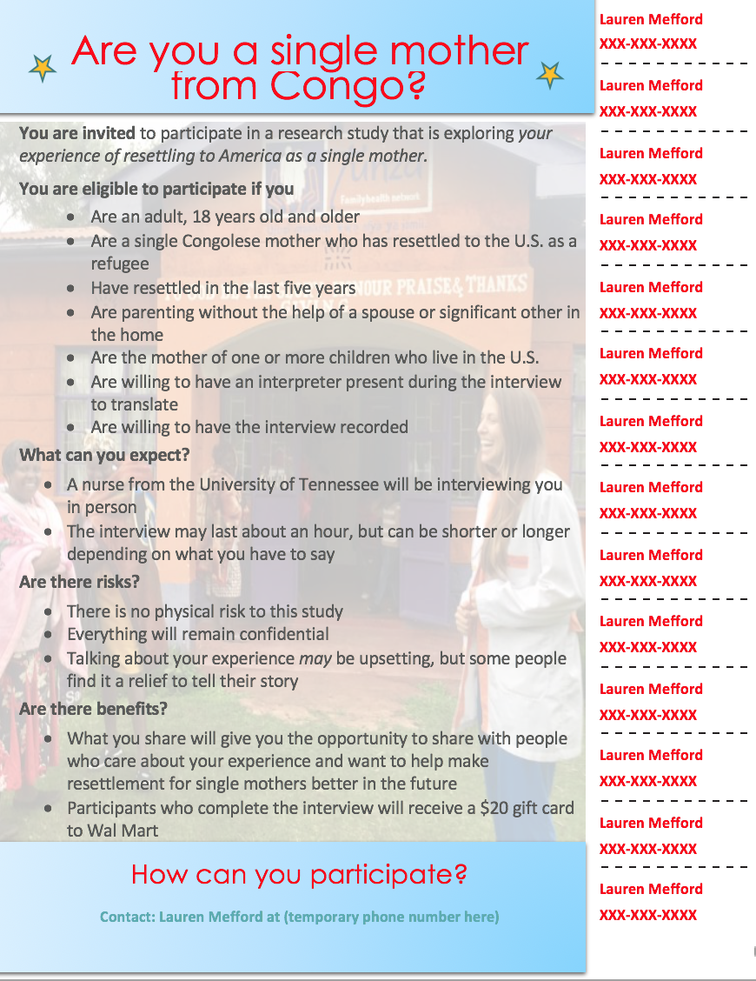
Appendix B
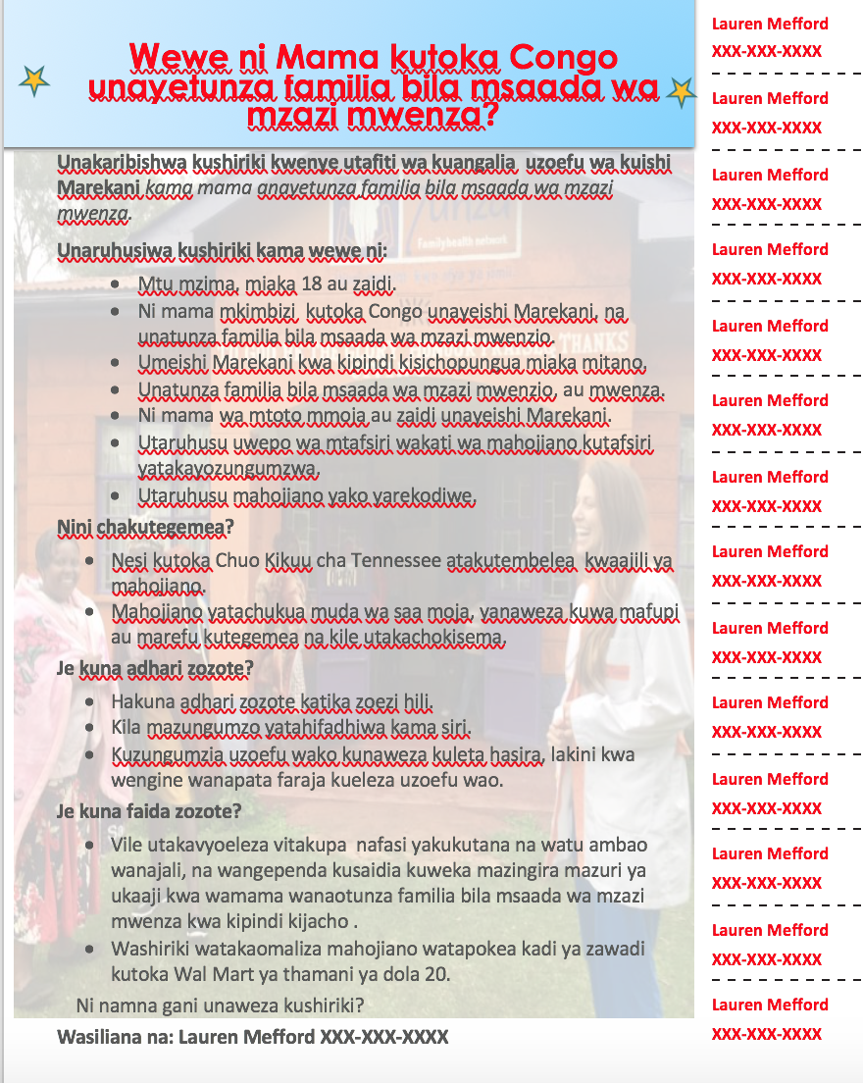

Appendix C
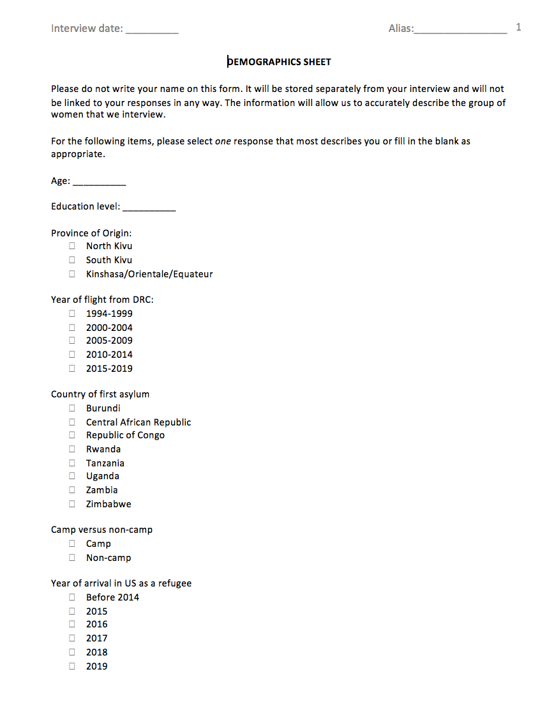
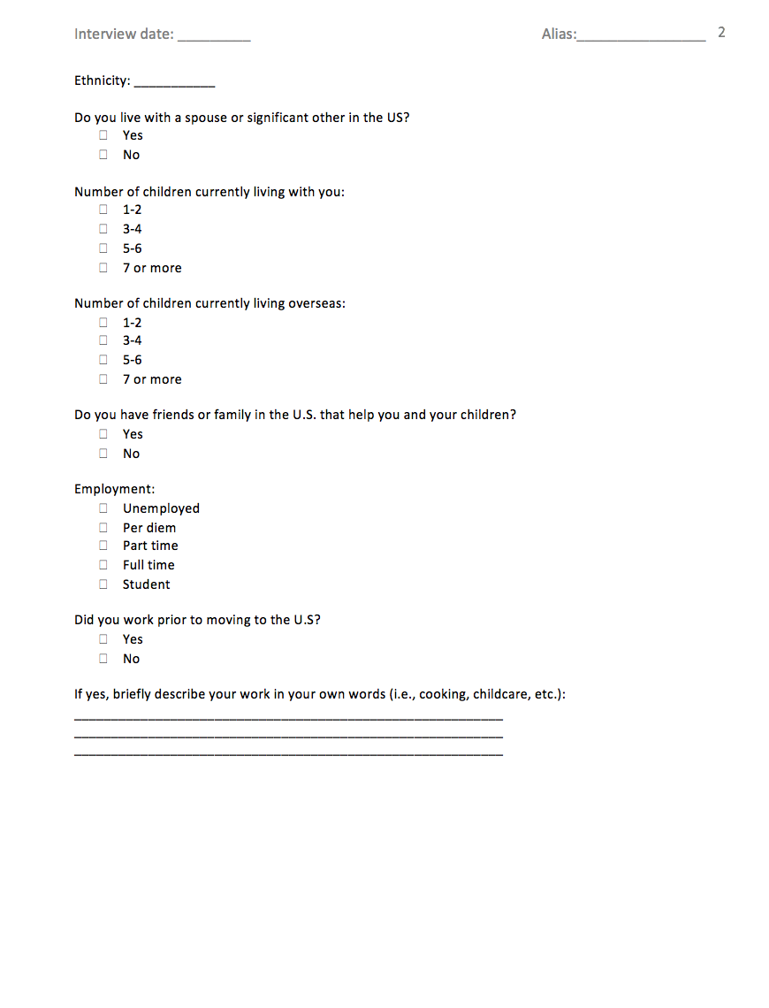

Appendix D
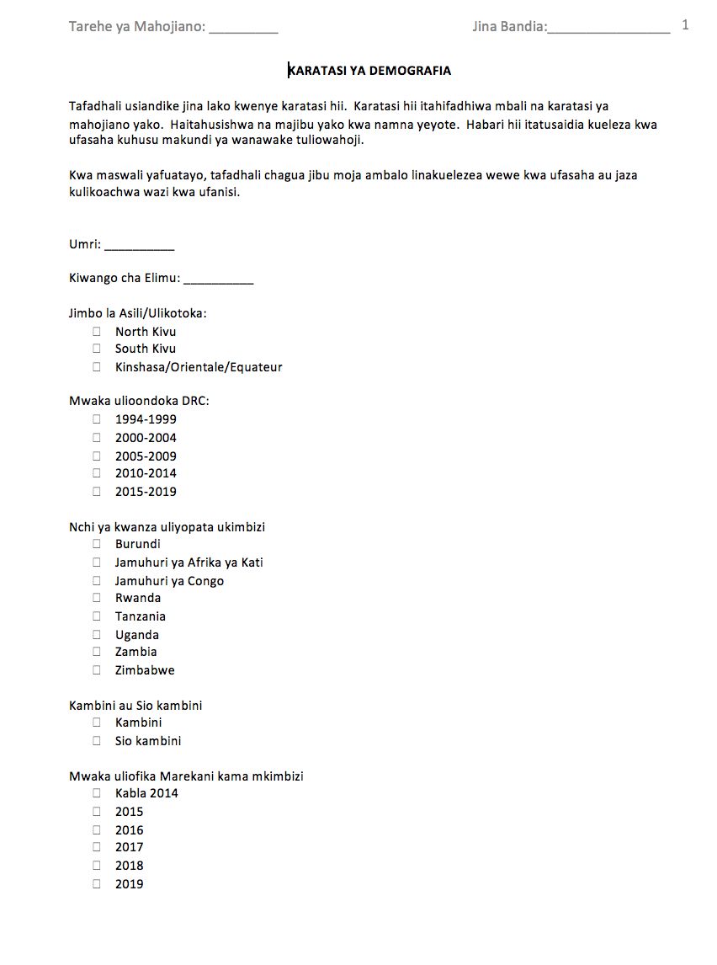
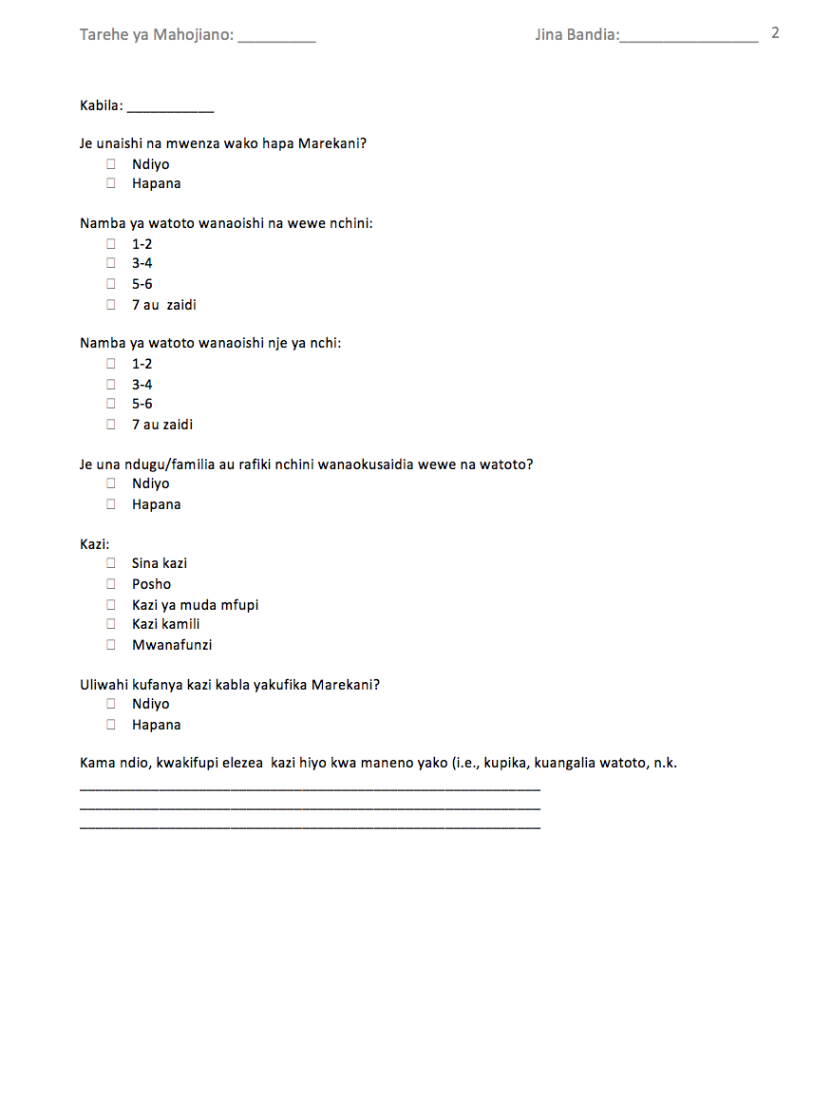

Appendix E
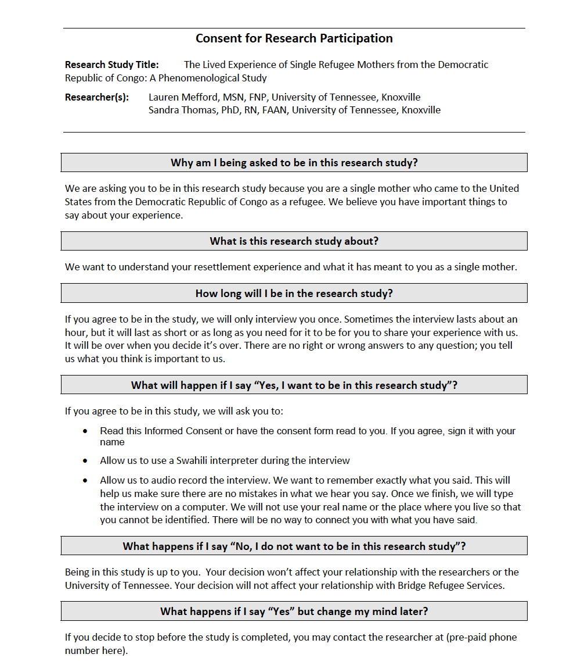
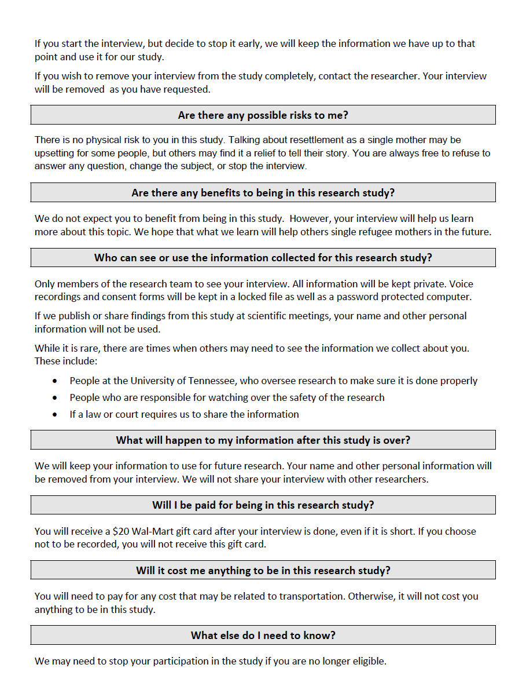
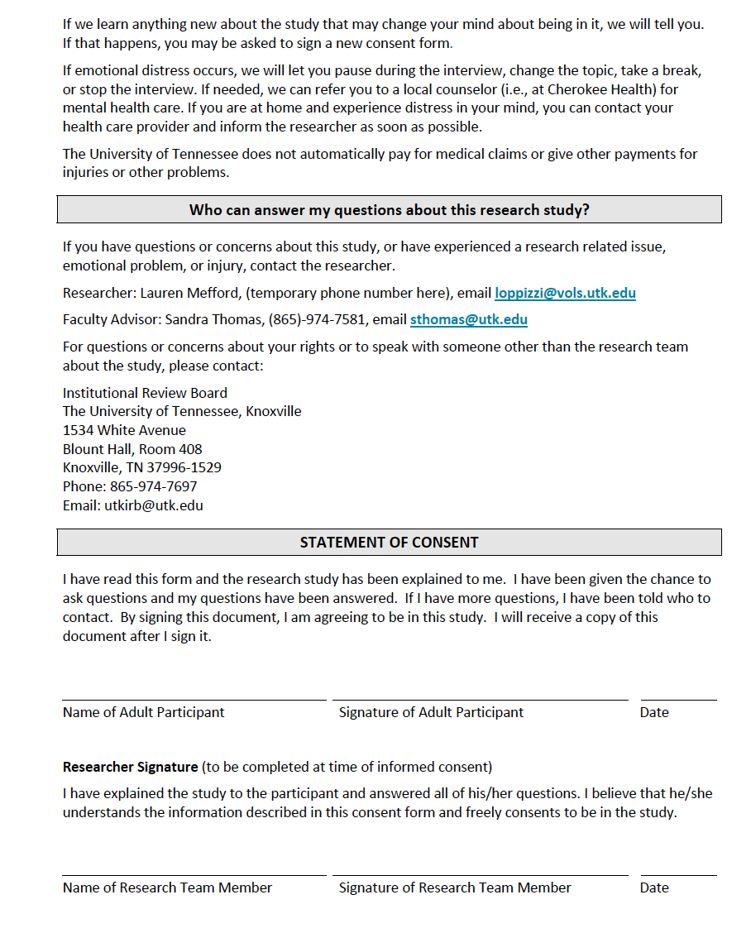

Appendix F

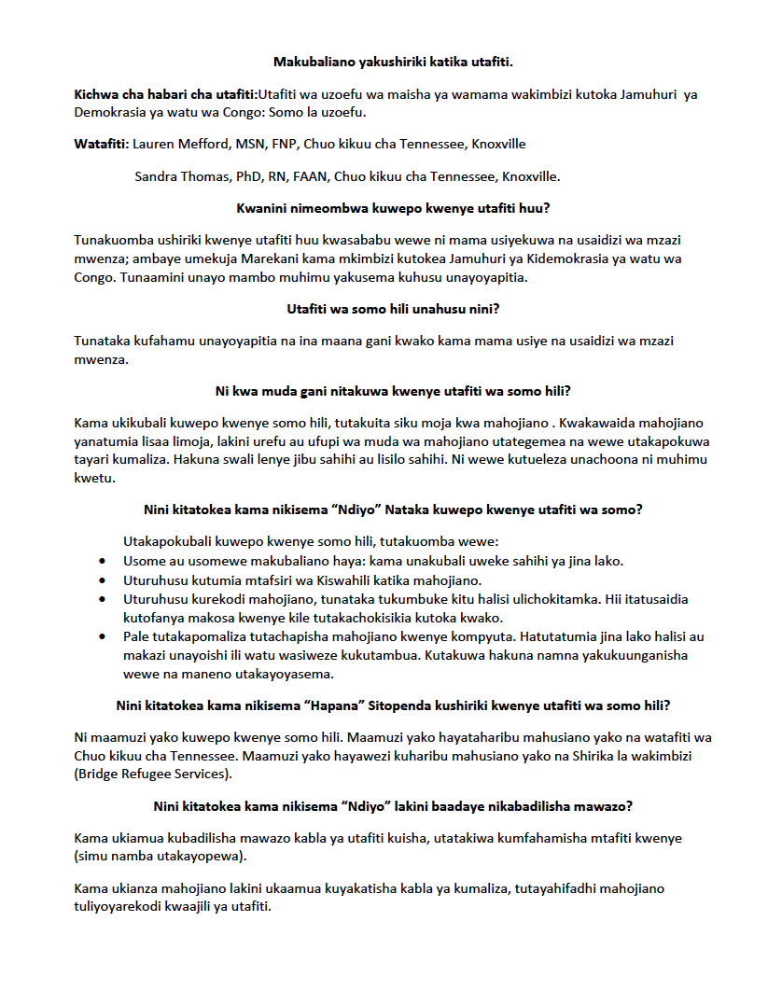

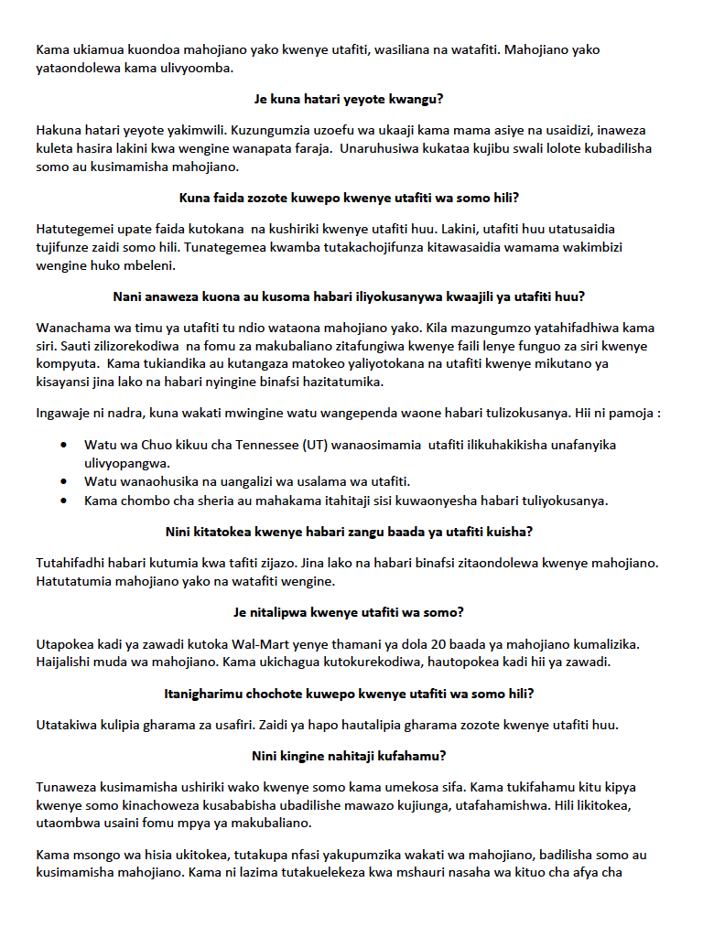
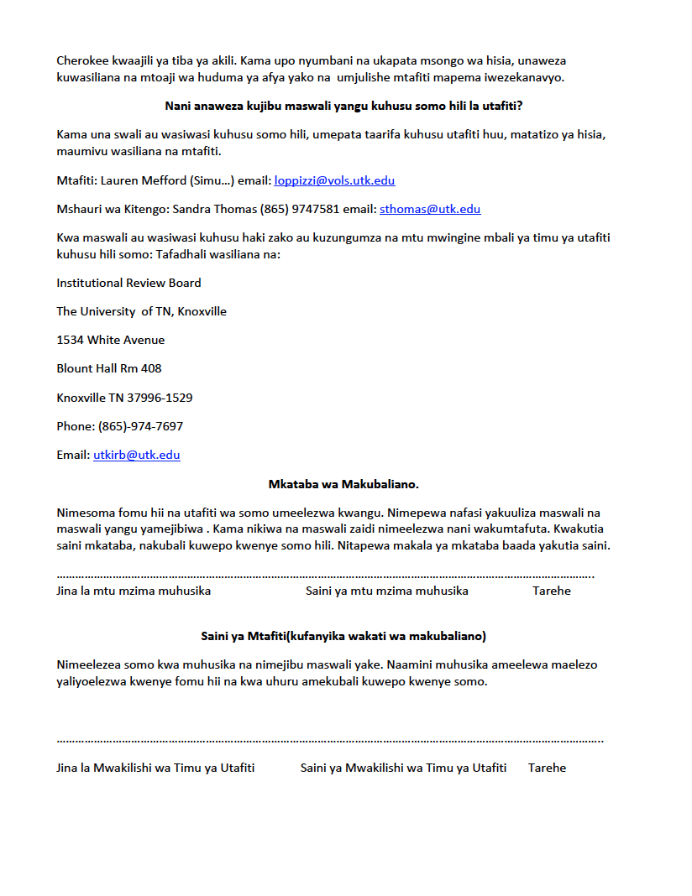

VITA
Lauren Michelle Mefford was born October 4, 1987 to Michael and Jana Oppizzi in Arlington, TX. She graduated from Ooltewah High School in Chattanooga, TN in 2006. She attended Lincoln Memorial University in Harrogate, TN, and graduated in 2010 with a Bachelor’s Degree of Science in Nursing. She began her professional nursing career as a staff nurse in the Heart, Lung, Vascular Institute at the University of Tennessee Medical Center, where she worked for seven years. She started graduate school in 2013 through the Global Disaster Nursing program at the University of Tennessee, Knoxville (UTK) and graduated in 2015. While in this program, she received the UTK Citation for Extraordinary Professional Promise (2014). Lauren also presented several posters at professional meetings. Midway through the program, she accepted a graduate teaching assistant position for the UT College of Nursing from January 2014 to June 2018.
She continued on to pursue her Doctorate of Philosophy at the University of Tennessee, which she completed in December 2020. In the middle of this program, she completed her post-Master’s Family Nurse Practitioner (FNP) certificate (2016) and subsequently worked as a FNP in a local outpatient clinic while pursuing her doctoral degree. Throughout the time of this program, she has published two papers and presented her work at a national conference. Her doctoral work was funded by a combination of awards from the UTK Chancellor’s office, UTK Graduate school, and UTK College of Nursing.

