
7-2014
A Study of Prestressed Concrete Girders using High-Capacity Stand and High- Strength Concrete

John Verlin Cabage, Jr.
jcabage1@utk.edu

Recommended Citation
Cabage, John Verlin, Jr., "A Study of Prestressed Concrete Girders using High-Capacity Strand and High-Strength Concrete. " PhD diss., University of Tennessee, 2012.
http://trace.tennessee.edu/utk_graddiss/????
This Dissertation is brought to you for free and open access by the Graduate School at Trace: Tennessee Research and Creative Exchange. It has been accepted for inclusion in Doctoral Dissertations by an authorized administrator of Trace: Tennessee Research and Creative Exchange. For more information, please contact trace@utk.edu.

To the Graduate Council:

I am submitting herewith a dissertation written by John Verlin Cabage, Jr. entitled "A Study of Prestressed Concrete Beams using High-Capacity Strand and High-Strength Concrete." I have examined the final electronic copy of this dissertation for form and content and recommend that it be accepted in partial fulfillment of the requirements for the degree of Doctor of Philosophy, with a major in Civil Engineering.

Zhongguo J. Ma, Major Professor

We have read this dissertation and recommend its acceptance:
Edwin Burdette, Richard Bennett, Christian Parigger

Accepted for the Council:
Carolyn R. Hodges
Vice Provost and Dean of the Graduate School

(Original signatures are on file with official student records.)

A Study of Prestressed Concrete Girders using High-Capacity Strand and High- Strength Concrete

A Dissertation
Presented for the
Doctor of Philosophy
Degree
The University of Tennessee, Knoxville

John Verlin Cabage, Jr.
July 2014

Dedication

I dedicate this dissertation to my wife Sue E. Barnhill Cabage and my family who have supported me with their vigilance and constant perseverance and love particularly over the last four years. Without their support, this study and dissertation would not have been possible.

Acknowledgement
I would like to praise God who has been guiding my life in the way that he sees fit for the last 40 years. In this, he has given me the ability strength and ability to accomplish this course of study.
I would like to express my appreciation to Dr. Edwin G. Burdette and Dr. Chris Cox for allowing me to participate in this study and who have put their trust and confidence in me though I was at a later stage in my life.
I specifically wish to express my gratitude to Zhongguo John Ma. He is one of the best developers of young professional talent that I have encountered to this point in my life. He has allowed me to have a freedom to learn and explore while maintaining my focus upon our objectives. He has been my best advocate and has pushed me to achieve a higher level of experience and exposure than I could have done on my own. He has been my promoter in the field of academia when I was going through difficult times. I thank the heavenly Father for providing one of the best mentors for me that I could have to assist me with this research. I am excited about the opportunity to collaborate with him and the Tennessee Bridge Research Laboratory in the future.
I would also like to thank Dr. Richard Bennett and Dr. Christian Parigger who have shown that it is possible to teach a willing, old dog new tricks.
I would like to thank my colleagues in the Tennessee Bridge Research Laboratory for their assistance with my study. These include: Dr. Wenchao Song, Dr. Xin Jiang, Ms. Yuan Jing, Ms. Weiwei Lu, Dr. Wenchi Hou, Mr. Bin, Dr. Longjun Zhou, Mr. Cody Mitchell, and Mr. Alex Ferrara.
Finally, I wish to express my thanks to Mr. Wayne Seger of the Tennessee Department of Transportation, Mr. Rick Merritt and Mr. Steve Brown of Ross Prestress, Mr. Jerry Britton of Britton Bridge, In-Steel Wire Corporation, and Sumiden Wire Corporation who have provided the funding to make this research possible.
  - Abstract

  - Table of Contents

  - List of Tables

  - List of Figures

1.0 INTRODUCTION

1.1 Understanding the Problem
Precast pretensioned girders are often the most economical bridge superstructure component used in the United States (US). Pretensioned bonded strands are used to provide the flexural capacity of the component. The largest pretensioning force, and accordingly number of strands, needed to resist the external loads is required at only one location in the full span, generally the midspan section. After the component is cast, the strands are detensioned and the prestress force is transferred from the prestressing bed to the concrete member.
Strands are generally located below the centroid of the component. When the strands are released the pretensioning force imposes both compressive and bending stresses within the girder. The imposed stresses are generally larger than the stresses imposed by the self-weight of the girder resulting in an immediate camber upward. The net compressive stress at midspan often determines how much prestressing force can be applied without exceeding the compressive stress limit at prestress release. In turn, the amount of prestress introduced into the component determines how much additional external load can be applied without exceeding allowable stress limits. In addition, the midspan section is checked for various strength limit states as required by design.
As larger strand is used, a second critical section occurs. This section occurs near the end of the member. The “end” section does not have the benefit of the offsetting self-weight moment in reducing the high compressive and tensile stresses in the extreme fibers of the component due to the initial prestress force transfer. Thus, this section must be checked for excessive tensile stresses at the top of the section. If excessive, some of the prestressing force must be reduced to satisfy the compressive and tensile stress limits at prestress force release.
Prestensioned components, such as I-girders and Bulb-Tees, have been widely used in the construction of bridges. Currently, the prestressing strand diameters used in these components are predominantly 0.5- and 0.6-inch utilizing Grade 270 steel. This combination of section geometry and strand has worked well regardless of the particular shape when used with normal strength concrete.
With the development and use of high-strength concrete (HSC), many states have developed sections with a wider bottom flange to allow the placement of more strands in the bottom flange. Increasing the number of strands will allow a more efficient use of the HSC materials and provide a longer span length in the section. Other States have elected to continue using the American Association of State Highway and Transportation Officials (AASHTO) sections rather than requiring the prestressed girder manufacturers in their State to acquire new forms.
Within the last few years, researchers have been investigating the use of larger capacity strands in prestressed concrete components.^{1,2} These strands, utilizing 0.62-inch diameter Grade 330 and 0.7-inch diameter Grade 270 steel, have been used in mining applications, and based upon preliminary findings, can be used in highway structural components. Bridges using these strands are being designed and manufactured currently. One example is the Pacific Street Bridge over I-680 in Omaha, Nebraska.¹
Initial studies of the use of the higher-capacity strands indicate that they have the ability to introduce almost twice the prestressing force, when compared with 0.5-inch strand and 135% of the prestressing force when compared with 0.6-inch strand.² This could result in a significant span capacity increase of the current AASHTO sections. Form replacement would not likely be necessary. The improved capacity of the current section also could lead to other structural efficiencies such as wider girder spacing, reduced structural mass for seismic design, and reduced substructure and foundational requirements—all of which reduce costs.
To achieve the enhanced flexural capacity in a concrete girder, several conditions must exist. First, the longitudinal flexural reinforcement steel within the concrete girder must be developed. This development occurs longitudinally along the length of the component due to the bonding of the steel to the concrete. Once bonded, flexural capacity can be attained by the interaction of the longitudinal steel in tension and the compression of the concrete.
The second condition that must be met is that the girder must develop enough shear capacity at the girder end to develop the flexure capacity at the middle of the beam. Shear capacity is attained as a property of the concrete itself and through the use of steel reinforcement within the girder. The combination of shear and moment forces at the girder end can introduce tensile forces which can cause the concrete to crack. When this cracking occurs, the bond between the longitudinal reinforcement and the concrete will become weakened; the longitudinal strands may become debonded and the flexural capacity of the structural girder can become substantially reduced.
Due to its low tensile strength, concrete has a proclivity to crack which can result in an adverse effect in the development of the longitudinal reinforcement. Strand slippage due to cracking within the beam can be prevented in a number of different ways. In 2000, Ma et al. examined extending the strand end into an end diaphragm as method of end anchorage with 0.5-inch strands in an NU 1100 I-girder section.² A total of five shear tests were performed on two specimens, four of which included end anchorage and one did not. An end block was poured at the end of the girder and the longitudinal strands were cast inside this end block to simulate extending strands into an end diaphragm. The three testing specimens with end anchorage failed by the crushing of the web, and one specimen did not fail within the loading limits of the testing apparatus. The specimen without end anchorage failed with a bond-slip mode. Ma’s research demonstrated the importance of end anchorage in developing the shear strength of a girder.
The objective of this research is to examine behavior in a concrete prestressed girder using high-capacity strand with high-strength concrete. Differing end anchorage and longitudinal strand positioning will be considered in this investigation. This study provides a further knowledge in shear behavior, evaluates the change in shear capacity using a variety of end conditions, and provide the practicing designer with insight and tools necessary to design girders with high-capacity strand and HSC safely.
This dissertation presents the culmination of a three-year study into the behavior of high-capacity strand and high-strength concrete. The dissertation is divided into two major sections. The first examines the development length of high-capacity strand and provides a new approach and methodology in evaluating the development for all strand types. The second section examines the end-zone behavior of an AASHTO Type I beam constructed with high-capacity strand and high-strength concrete. The follows lists the research objectives which have been achieved by this research and recorded in this dissertation:
- Development length for high-capacity strand has been evaluated using single-stranded small-scale specimens. A new development length formula has been developed for reinforcing strand based upon a frictional-based analysis.
- A comparison is presented between the development length tests results attained from the small-scale tests to a multiple strand pattern. An assessment is presented comparing the response of the multi-strand pattern and a single strand.
- An investigation into whether the derivation of shear slip resistance and crack spacing is as determined by the modified compression theory is appropriate for use in the design of high-strength concrete members with high-capacity strand.
- An assessment of the equation for calculating the longitudinal strain at mid-depth is sufficiently accurate when using high-capacity strands.
- An evaluation whether the angle of principal compression is sufficiently accurate when evaluating high-capacity strand.
- An evaluation whether the assumption that the specification for transverse shear reinforcement can be based upon using the required shear at d_{v} away from the support is substantiated.
- An investigation of the demand and capacity of longitudinal end region reinforcement in member support regions. Also, an examination of how turning up strands within an end block modifies strains observed within the section particularly at the end zone region.
- An evaluation whether the maximum shear stress design limit is appropriate when using high-capacity strand when using high capacity concrete.
- An assessment of the performance of the flexural members at serviceability load levels.
- An assessment whether computer-based numerical analysis methods can successfully predict the capacity of test members and then can subsequently be used for conducting parametric studies.
- An evaluation of the ease and reliability of fabricating high-capacity strand bridge members with high-strength concrete by local producers.
This section provides a literature review regarding development length and beam current beam behavioral models. The next section documents the small- and large-scale testing programs for this study. The next section presents the results of the small-scale testing program. The fourth section presents the results of the large-scale testing program. The final section presents the conclusions and recommendations of this study.

1.2 Development Length Literature Review

1.2.1 Definition

According to the American Concrete Institute (ACI), development length, l_{d}, is the length of strand required to develop the stress in the strand corresponding to the full flexural strength of the member. The relationship of transfer length, flexural length and development length is shown in Figure 1.1.

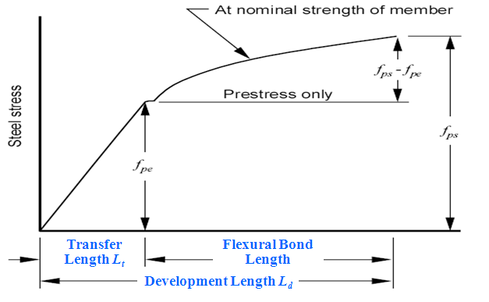
Figure 1.1 - Definition of Development Length

1.2.2 Current Code Provisions

The present provisions for development length of prestressing strand are contained in Section 12.9 of ACI 318-08 and Section 5.11.4 in AASHTO LRFD Specifications 2012. Equations for development length were based on tests performed on normal weight concrete members with a minimum cover of 2 in.

1.2.3 ACI Building Code

The provisions in ACI 318-08 read as follows:

Seven-wire strand shall be bonded beyond the critical section, a distance not less than

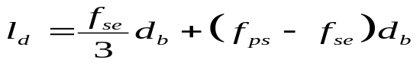  where,  f_{ps} = average stress in prestressing steel at ultimate load (ksi);  f_{pe} = effective stress in the prestressing steel after losses (ksi); and  d_{b} = nominal strand diameter (in.) | (1)
The first term in the above equation represents the transfer length and the second term represents the flexural bond length. The ACI commentary acknowledges other factors that may affect the development length such multiple strand configuration, strand surface condition, and the amount of concrete from the exterior edge of the component and the strand.

1.2.4 AASHTO Bridge Design Specifications

In AASHTO Standard Specifications (1992), the equation for development length is the same as that in ACI Building Code. In the mid-1980s, Cousins, Johnston, and Zia (1990) measured transfer lengths that exceeded the standard design predictions by a wide margin. Their findings led the Federal Highway Administration (FHWA) to adopt a moratorium on the use of 0.6-inch diameter strands and to increase the development length for other sizes of prestressing strands. The arbitrary 1.6 multiplier from the original FHWA moratorium is incorporated into the AASHTO LFRD Bridge Design Specifications. The development length shall satisfy the following equation:

L_{d} ≥ κ [ f_{ps} – 2/3 f_{pe} ] d_{b}  where,  d_{b} = nominal strand diameter (in.)  f_{ps} = average stress in prestressing steel at the time for which the nominal resistance of the member is required (ksi)  f_{pe} = effective stress in the prestressing steel after losses (ksi)  κ = 1.0 for pretensioned panels, piling, and other pretensioned members with a depth of less than or equal to 24 inches; and  κ = 1.6 for pretensioned members with a depth greater than 24 inches. | (2)
Based on the current AASHTO Specification, the development lengths of the two full-scale prestressed concrete girder specimens of the project are shown in Table 1.1.

Table 1.1 - Calculation of the Development Length Based on AASHTO 2007

Specimen | d_{b} (in.) | f_{ps} (ksi) | f_{pe} (ksi) | L_{d} (in.)
1 | 0.7 | 270 | 163.6 | 180
2 | 0.62 | 330 | 213.3 | 186

1.2.5 Research on Development Length

In 1988, FHWA issued a memorandum that placed restrictions on the use of seven-wire strands for pretensioned concrete members in highway bridge applications. The FHWA action led to the creation of a large number of research programs intent on measuring the transfer and development of prestressing strands. Numerous studies have been conducted on both 0.5- and 0.6-inch-diameter strand, often with conflicting conclusions.

Table 1.2 shows the proposed equations by different researchers. Prediction formulas have been developed with no clear consensus among researchers.

Table 1.2 - Different Proposed Equations for Development Length

Zia and Mostafa (1977) | 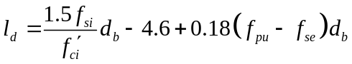
Abdalla et al. (1993) | 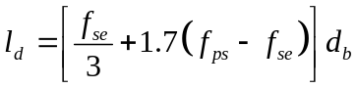
Mitchell et al. (1993) | 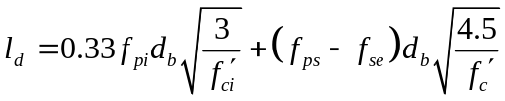
Burdette et al. (1994) | 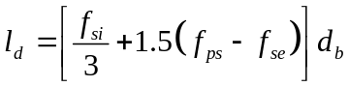
Buchner (1995) | 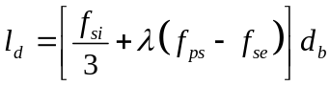  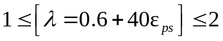
Lane (1998)
Barnes et al. (1999) | 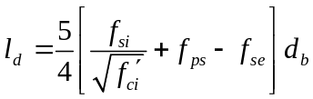
Shahawy (2001) | 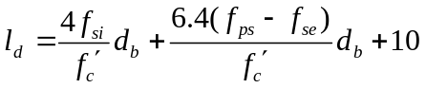
Kose and Burkett (2005) | 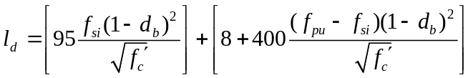
Ramirez and Russell (2007) | 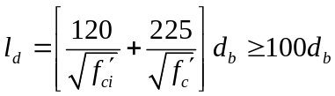

The symbols used in Table 1.2 are defined as follows:
d_{b} = nominal strand diameter (in.)
f_{c}’ = concrete compressive strength at 28 days (psi);
f_{ci}’ = concrete compressive strength at time of release (psi);
f_{ps} = average stress in prestressing steel at ultimate load (ksi);
f_{pu} = ultimate tensile strength of prestressing strand (ksi);
f_{se} = effective stress in the prestressing steel after losses (ksi);
f_{si} = effective stress in prestressed steel after short-term losses (ksi);
ε_{ps} = strain in prestressed reinforcement at nominal strength.

It should be emphasized, however, that the impact of variability of development length on bridge beams using 0.5- and 0.6-inch strand is small (PCI 1997). An over-estimation of l_{d} will not significantly increase the cost of beams from a flexural standpoint, but can have a performance impact in the end regions of the beam.

The following subsections describe major finding of former development length research.

Hanson and Kaar (1959) investigated the flexural bond behavior of pretensioned prestressed beams. The main objective was to gain a full understanding of the flexural bond behavior and use such information to develop design criteria. A theory of bond action was proposed to predict ultimate strength in bond and various factors affecting the bond behavior was studied. The main variables were embedment length and strand size. Also, other variables were studied including percentage of steel reinforcement, reduction of concrete strength, surface condition of the strand, and use of embedded anchorages on bond performance of the strand.

Martin and Scott (1976) proposed revisions to the ACI 318 development length criteria requirements for prestressing strand. They proposed an approach for short span prestressed members which do not have adequate embedment length to develop full ultimate strength. They reasoned that the existing code equations based on the research conducted by Hanson and Kaar (1959) were unconservative for members with lower steel percentage.

Zia and Mostafa (1977) performed an extensive literature review of past work concerning transfer and development length of pretensioned strands. Zia proposed a development length equation based on his review. This equation took into account the effect of strand size, initial prestress and concrete strength at transfer. The proposed equation gave comparable values of transfer length for the smaller size strands but longer transfer length for the larger size strands, and especially for cases where the concrete strength was low at transfer. They suggested increasing the ACI Code flexural bond length by 25% to ensure that flexural failure at ultimate should occur without any bond slip. And this increase was based on their assessment of the research conducted by Hanson and Kaar (1959).

Cousins et al. (1986) studied the effect of epoxy coating on the transfer and development length of prestressing strands. Tested strands had diameters of 0.375, 0.5 and 0.6 inches. The tested strands had either uncoated or epoxy coated surfaces. The research results showed that the three different types of strands require a transfer length of 34, 50, and 56 inches, and a development length of 57, 119, and 132 inches. These values were higher than the estimated transfer and development length by either AASHTO or ACI code equations. These research findings lead to the issuance of the aforementioned FHWA 1988 memorandum regarding the transfer and development length.

Abdalla et al. (1993) conducted a research to develop equations for strand development length. The experimental program included the testing of AASHTO bridge girders and box beams. Based on multiple experiments, an equation for the strand development length calculation was proposed.

Russell and Burns (1993) conducted an experimental research at the University of Texas at Austin concerning the strands transfer and development length. The two main objectives of the research were to determine the transfer length and the development length of both 0.5- and 0.6-inch prestressing strands, and to develop design guidelines for the use of debonded strands in pretensioned concrete. The University of Texas study concluded that the 0.6-inch diameter strand was recommended for use in pretensioned members, without restriction, and subject to the same design provisions of other strand size. They suggested that bond failure initiated by web shear cracking should be prevented by providing both horizontal and vertical shear reinforcement. Flexural cracking and web cracking affected the development length; thus, the loading pattern and cross sectional shape influenced the required development length.

The University of Tennessee at Knoxville (Burdette et al. 1994) conducted a project, involving small prisms and full-sized AASHTO Type I girders. This project considered both uncoated and epoxy-coated strands and examined several important variables including strand size and spacing, strand surface condition and stress level at release. Based on the test data, equations for transfer and development length of strand were proposed.

A summary of research on 0.5-inch strand was reported by Buckner (1995). He proposed a new expression for transfer and development length after considering all of the research performed since the 1988 FHWA memorandum. Fearing that the recent bond related research on transfer and development length did not strain the strands high enough; Buckner proposed a conservative expression for transfer and development length.

Kilgore (1997) studied the transfer and development length of debonded 0.6-inch diameter prestressing strand in AASHTO Type I concrete beams. He investigated the effect of debonding on the transfer and development lengths of the large diameter seven wire strands placed in concrete beams. The concrete strength ranged from 6.2 to 11.4 ksi. The development lengths were determined indirectly by loading 12 beam ends at different embedment lengths. The test results showed that ACI/AASHTO equations for development length of 0.6-inch seven wire strand with good bond characteristics was conservative.

Susan Lane (1998) at the FHWA conducted an experimental research program to investigate the transfer and development length of prestressing strands. A number of parameters were investigated for possible use in the new transfer length equations. Flexural bond length needed beyond the transfer length to achieve the ultimate strength of the prestressed member was evaluated.

Barnes et al. (1999) at the University of Texas at Austin conducted a research to determine the anchorage behavior of 0.6-inch strands at 2-inch spacing in full-size bridge members. The experimental program consisted of assessing transfer and development lengths in plant-cast AASHTO Type I I-beams. The influence of concrete compressive strengths ranging from 5700 to 14,700 psi was examined. The use of 0.6-inch strand at 2-inch spacing is concluded to be safe. A new equation for development length was proposed for seven-wire prestressing strand.

Shahawy (2001) suggests that for members with depths greater than 24 inches, the STD equation results in an unacceptably low development length while LRFD equation yield conservative results. Shahawy also concludes that flexure-shear interaction has a significant effect on the development length of prestressing strands and should be incorporated into the design equations.

Kahn et al. (2002) at Georgia Institute of Technology conducted an experimental research to verify that the transfer and development length of 0.6-inch diameter prestressing strands were less than calculated by the current AASHTO LRFD when high strength concrete is used. The current AASHTO provisions for transfer and development length are recommended for HPC girders with concrete strengths less than 100 MPa because of their simplicity and accuracy.

In the study conducted by Kose and Burkett (2005), the transfer and development length results from various studies were collected in addition to the results obtained from the tests performed in regional laboratories. Proposed equations for transfer and development length were compared with current equations in ACI, AASHTO, and other codes. Comparisons showed that the proposed equations give better estimates than other equations for 0.5- and 0.6-inch diameter prestressing strand.

Ramirez and Russell (2008) conducted an experimental research to calculate the transfer, development and splice length of strands/reinforcement in high-strength concrete (HPC). Transfer and development length of prestressing strand with diameters up to 0.62 inches were studied. The proposed equations correlated the transfer and development length of prestressing strands with initial concrete compressive strength (in case of transfer length), and both initial and final compressive strength (in case of development length). It revealed that the development length requirements diminished with increasing concrete strength.

Floyd et al. (2011) measured the development lengths in self-consolidating concrete (SCC) beams and compared them with those determined from conventional, high-strength concrete beams. 19 prestressed rectangular concrete beams were tested to evaluate the development length. It showed that the ACI-AASHTO equation overestimated the development length for all beams by more than 60%.

1.3 End Anchorage Literature Review

Russell and Burns (1992, 1993, and 1999) at UT-Austin performed series of tests on pretensioned girders with 0.5- and 0.6-inch diameter strands, mainly regarding the anchorage behavior of partially debonded strands. The following conclusions were drawn from the tests:

- Either web shear cracking or flexural cracking in the transfer zones of debonded strands would cause premature bond failure. Therefore, to prevent anchorage failures, girders should be designed so that no concrete cracks will propagate through the transfer zone of a pretensioned strand;
- The potential for cracking was exacerbated due to the reductions of effective prestress force in the zones of debonded strands;
- All debonding should be staggered. Staggering the debond terminations allows for greater precompression in the debond/transfer zones, preventing adverse behavior due to reduced shear capacity or reduced cracking moment. Staggered bond lengths should be determined by the minimum debonding required; and
- If the conditions were met for the anchorage of debonded strands, the rules in the AASHTO Bridge Design Specifications that limit the percentage of debonded strands in the member and in each horizontal row are unnecessary.

Ma et al. (2000) demonstrated that shear strength may be enhanced by extending strands beyond the ends of girders, bending the strands upward, and casting a diaphragm around the extended strands, again providing external anchorage. There is strong evidence, as shown in Figure 1.2, to support that a girder with end anchorage fails in a web-crushing mode while the one without end anchorage fails in premature shear/bond mode, all other parameters being equal.

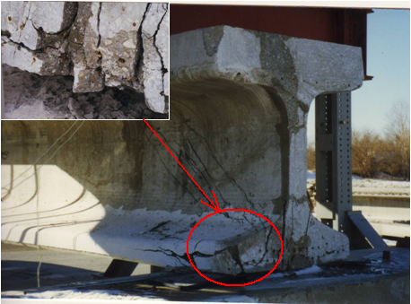
- Without End Anchorage
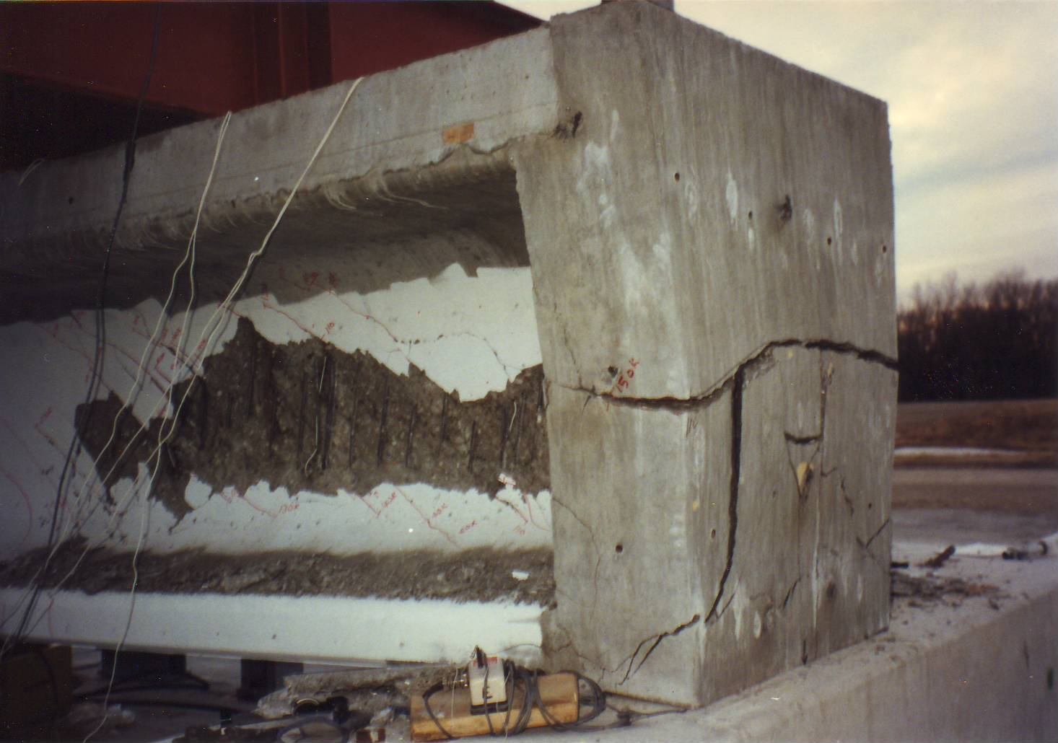
- With End Anchorage

Figure 1.2 – Impact of End Anchorage on Shear Failure Modes

Shahawy and Cai (2001) reported tests in which the shear strength of pretensioned girders had been enhanced by external anchors applied to the ends of the girders after the girders were cast and prestress transferred to the concrete. Lybas et al. (2003) from University of Florida presented the potential of strand end anchorage to enhance shear capacity in the end regions of pretensioned girders. The tests in this study have indicated that the use of external anchorage devices and partial debonding of strand from surrounding concrete represent a promising means of increasing the shear strength contribution of concrete in the prestress transfer region at the ends of girders, effectively converting a pretensioned girder into a post-tensioned girder.

1.4 Development of Cracking in the End Zone due to Shear and Bending Stress Combinations

As mentioned earlier, shear cracking in the Skyway Bridge in Florida attracted a reconsideration of the strand debonding practices in prestressed girder design (Shahawy and Hassan 2009; Illig and White 2010). In the exterior girders of this bridge, AASHTO Type IV girders were used with 61% of the strands being shielded in the bottom flange. The inspection report generated during the investigation of this bridge attributed the cracking to excessive strand debonding at the ends of the girders.

Shear stress cracking at the end of a girder is due to a combination of shear and moment at the end zone. In a parametric study as part of this dissertation, three girders of similar size were examined, the Florida I-Beam 78 (FIB-78), the Texas U-Shape 54 (TU54), and the AASHTO Bulb Tee 72 (BT72). Two different concrete strengths were considered, 7,500 psi and 12,000 psi. At the span lengths demarked in Figures 1.3 through 1.6, the primary tensile stress was calculated at a location 60 times the strand diameter (60 d_{b}) from the face of the support for each of the three sections. The girders were assumed to be uncracked for simplicity of the analysis. The maximum principal tensile stress results at 60 d_{b} for each girder versus the span length are presented in the figures. The estimated rupture stress was also plotted upon each figure.

The preliminary result of this study was to show that during Service III loading conditions, the combination of shear and moment loading can generate tensile stresses above the modulus of rupture. This indicates that cracking may occur at the end zone in these example girders when the concrete strength is below 12,000 psi. One item of note, the primary tensile stress for the BT72 sections at the strand and concrete strength analyzed exceeded the rupture strength at 0.6-strand with 7,500 psi and then by a small percentage. This would seem to indicate that this section is not as susceptible to end zone cracking.

Figure 1.3 – Principal Tensile Stress versus Maximum Span Length using 0.5-inch Strand

Figure 1.4 – Principal Tensile Stress versus Maximum Span Length using 0.6-inch Strand

Figure 1.5 – Principal Tensile Stress versus Maximum Span Length using 0.5-inch Strand

Figure 1.6 – Principal Tensile Stress versus Maximum Span Length using 0.6-inch Strand

1.5 Literature Review Flexural Member Modeling

1.5.1 45 Degree Truss Model and Traditional Approaches
Modeling of cracked reinforced concrete beams for design has been discussed and debated for over one hundred years. Most models currently used in practice stem from early research conducted by Morsch where he predicted that shear stress within a reinforced concrete beam would reach its maximum at the neutral axis and would then remain constant from the neutral axis down to the flexural steel (Collins and Mitchell 1991).

One of the original models to explain the flow of forces within a cracked reinforced concrete beam was originated by Ritter in 1899. This is known as the 45 degree truss model. This model envisioned diagonal compressive members within the cracked concrete beam acted in conjunction with vertical and longitudinal steel reinforcement to form a truss within the concrete beam. Morsch expanded Ritter’s work and explained that the compression in the concrete was a compression field rather than a single strut element resisting the shear. (Collins and Mitchell 1991)

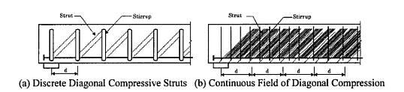

Figure 1.7 – Diagonal Truss Model (Mitchell and Collins 1991)

From this basis, several methods of evaluating force flow and the required flexural and shear reinforcement have developed.

The traditional approach, generally used and recommended by the American Concrete
Institute (ACI), is to separate beam capacity into bending and shear components, and then further divide shear into contributions derived from the shear strength of the concrete and the vertical reinforcing steel. This approach is based upon recommendations of ACI Subcommittee 426 and summarized in a report by MacGregor and others (1969) utilizing work conducted at the University of Illinois by MacGregor, Sozen, and Siess (1965).

1.5.2 Strut-and-Tie Modeling
Strut-and-tie modeling is another modeling technique which is popular in Europe and is becoming more familiar in the United States. This method derives its basis from the 45 degree truss model. Strut-and-tie modeling has been the focus of many international researchers, and it is particularly useful in visualizing force flow within a concrete component, especially in “disturbed” regions of a section. Force flow is visualized in the form of a truss and the tensile components, concrete struts, and connection nodes are apportioned based upon the visualized stress at each component.

One of the first authoritative articles on strut-and-tie modeling was presented by Schlaich and others (1987). In their report to Prestressed Concrete Institute, the use of Strut-and-Tie modeling in the design of concrete components particularly in the disturbed regions of these members was presented in the form of written examples. They introduced the topic by demonstrating the flow of forces within the disturbed regions and how the resistance to the forces can be visualized and then modeled using a truss analogy. The analogy included assigning compression strut to areas where compressive forces occur and tension ties where tensile forces occur. The concrete and steel reinforcement was then designed to counteract the force exhibited by the model.
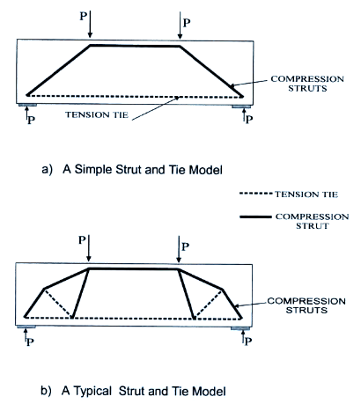
Figure 1.8 – Typical Strut-and-Tie Models from Shahawy and Chen (1999)

In their report they gave several examples of unusual conditions frequently found in beam design. These included beams with designed penetrations, corbels, deep beams, and prestressed and post tensioned girders. In each case, they applied the Strut-and-Tie model to and presented a good detailing design for each condition.
Alshegeir and Ramirez (1992) at Purdue University presented an evaluation of the strength and behavior of prestressed concrete deep girders using the strut-and-tie method. Strut-and-tie system analyses reflecting actual support and loading conditions were developed for three pretensioned deep girders tested to failure. As shown in Figure 1.9, the strut-and-tie approach is used to illustrate the effects of prestressing, concrete compressive strength, and reinforcement detailing on the behavior and strength of these members. The strands are represented by a horizontal tie at the centroid of the prestressing steel, and vertical ties are placed at each stirrup location within the shear span. Particular attention should be placed at points where the prestressing steel is changed, such as debonding points.
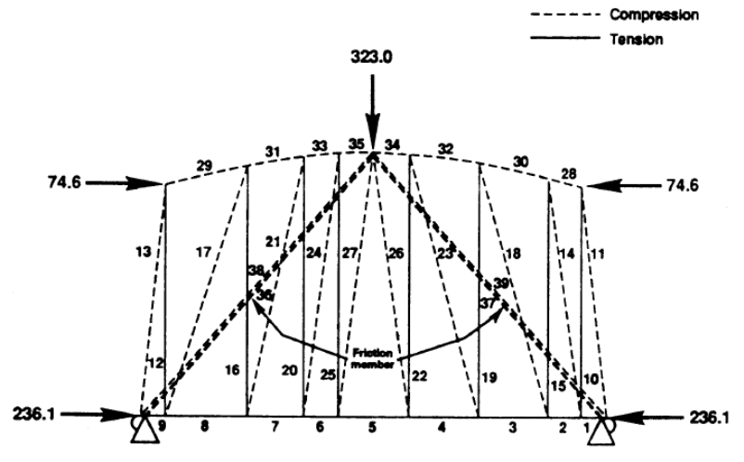

Figure 1.9 - Strut-and-tie model from Alshegeir and Ramirez (1992)

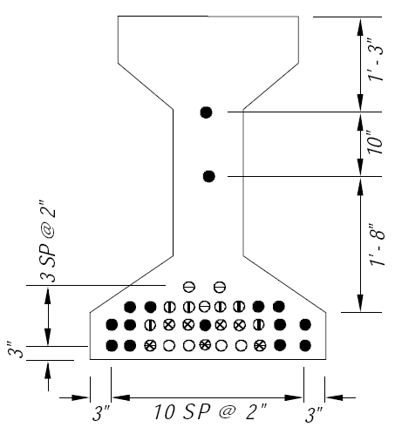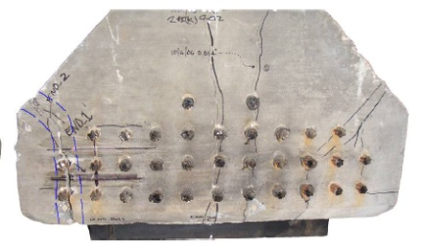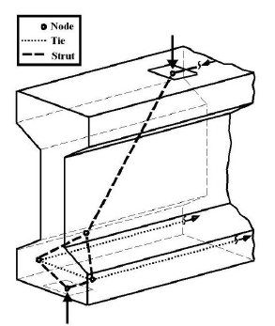
(a) (b) (c)
Figure 1.10 - Pretensioned girder: (a) strand details; (b) cracking;
and (c) strut-and-tie model

Another good design example of strut-and-tie model was presented by Wight and Parra-Montesinos (2003). Their example paid particular attention to nodal bearing pressures, nodal bearing areas, and strut widths. The example provided and excellent example on how to split load forces to approximate the strut widths within the system. The report focused on practical detailing in their design example.

Crispino, Cousins, and Robert-Wollmann (2009) conducted a study sponsored by the Virginia Department of Transportation and the Federal Highway Administration to develop a design model to guide the bridge designers in properly sizing reinforcement to control the length and width of crack with the end zone regions of prestressed concrete girders. They used strut-and-tie modeling in the prestressed girders in their parametric study. Once the parametric study was completed, they used the developed guidelines and performed full-scale testing on their design recommendations. They found that strut-and-tie modeling can be effectively used in anchorage zone modeling and recommend that the method be adopted by the Virginia Department of Transportation.

Nagle and Kuchma conducted a shear study of Prestressed Concrete Girders where strut-and-tie modeling was used as an alternate approach in checking the anchorage of longitudinal reinforcement in the beam end zone. The study primarily focused on shear strength and stress of prestressed concrete girders, but they used strut-and-tie modeling to provide an upper bound for the demand on longitudinal reinforcement in both lightly- and heavily-reinforced members. They determined that strut-and-tie modeling is useful in determining the demand in longitudinal reinforcement that does not yield.

1.5.3 Truss-Arch Model
Another approach, which was initially developed by Kani (1964) is to visualize flexural failure in a reinforced concrete beam as a comb with the compressive zone being the backbone of the comb and the tensile zone being the concrete teeth. With this visualization, Kani used a free-body method to analyze the mechanism of flexural failure and the mechanism of what he called diagonal failure. He chose the term diagonal failure because of confusion with what constituted a “shear” failure. At the time, some researchers would consider a bond-related failure a shear failure while others would consider them separately. For the purposes of this dissertation, failure mechanisms will be separated into three distinct categories; flexural, bond, and diagonal.
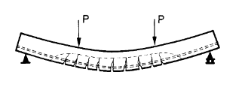
Figure 1.11 – Visualization of Comb-type Cracking Pattern
from Kani (1964)

In his work, Kani also developed his understanding—using a free-bodied analysis—of the distribution of tensile forces within the longitudinal reinforcement and how these forces are transferred within the reinforced concrete beam. A concept of moment transfer between the “concrete teeth” and the compression zone was developed as part of the overall analysis of his concepts.
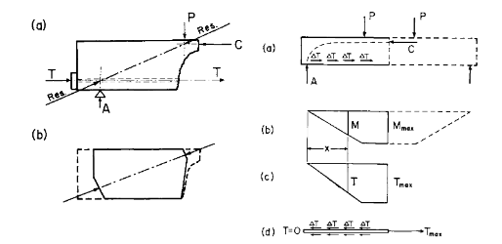
Figure 1.12 – Free-body Analysis used by Kani

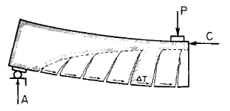

Figure 1.13 – Free-body Diagram of Concrete Teeth from Kani

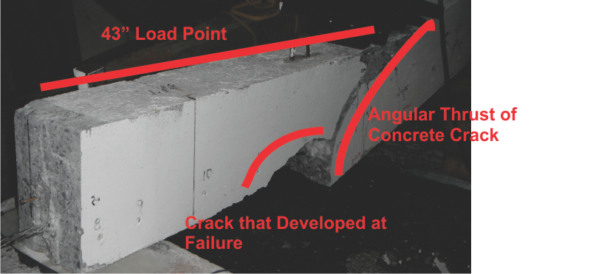

Figure 1.14 – Specimen D0.70-6, Cabage and Ma 2013,
Showing Formation of Thrust Angulation Crack

In 1999, a similar approach to Kani’s was developed by Shahawy, Batchelor, Chen, and others in cooperation with the Florida Department of Transportation (FDOT). (Shahawy and Chen 1999) In their paper, they pointed out that using strut-and-tie modeling for analysis was subjective and entirely dependent upon the selection of the position of the struts by the designer. Shahawy and Chen showed that assuming a straight-line strut from the load point to the reaction position versus a model that had a variable thrust angle at the reaction site could result in a 50 percent underestimation of shear stress within an end zone region. The occurrence of the thrust angle and the mechanism of its formulation was defined in Kani’s work and based upon recent prestressed concrete test results from Cabage and Ma (2014), seems to exist, though it is not initially obvious to most designers. (see Figure 1.14)

Shahawy and Chen (1999) proposed visualizing a prestressed concrete beam as a tied arch with three distinct diagonal crack failure modes to be evaluated and an arch rib evaluation. For the end evaluation, a free-body approach was used to quantify the limiting parameter and the capacity of the beam was based upon that evaluation. This approach is useful, but continues to rely upon the selection of a design failure angle and is iterative. The iteration involves balancing the loading with sectional design parameters which includes mild steel shear reinforcement.

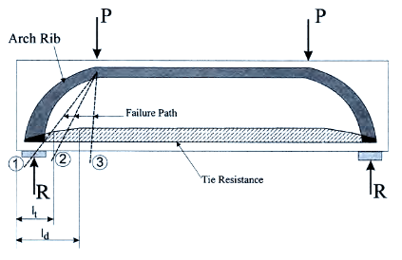
Figure 1.15 – Tied Arch Visualization
From Shahawy and Chen

Shahawy and Cai (1999) from FDOT developed a tie-arch model to study the shear behavior of pretensioned girder with strand debonding. This model can be used to predict the failure load of prestressed concrete girders and to study the interaction between the tie, shear reinforcement, and compressive struts. The weakness of longitudinal tie due to excessive strand debonding was considered in the model. In this report, they present three modes of failure in the tied-arch model and correlate the modes of failure to modes of shear failure in the anchorage zone region of a beam. Reinforcement is then specified to prevent these failure modes resulting in the detailing of the beam.
In their report, their design recommendations were then compared with existing test data and the ability of the model was tested with these actual results. They found this model to be a rational method of predicting the angle of cracking and the mode of shear failure. The model was compare to testing data and provided a verifiable response. The proposed method was claimed useful in sizing components without over- and under-sizing reinforcement in prestressed and reinforce concrete members.
In a research conduct by FDOT (Llanos et al. 2009), the AASHTO Type IV test girders were built to replicate existing girders that are in service in Florida. It was found that capacity was not controlled by the typical shear failure mechanisms, but rather was due to the cracking and separation of the bottom bulb flange of the girder. This was a result of the unusual debonding pattern that placed the fully bonded strands out in the bulb flange and the debonded strands under the web. Because of the offset between the strut in the web and the two ties in each flange of the bulb, a transverse tie must be generated.

1.5.4 Finite Element Modeling
The interaction (bond) between concrete and strands is complicated (Stocker and Sozen, 1969). The bond can be attributed to adhesion, mechanical interlock and friction, depending on the extent of bond development and the nature of the strand surface. For the purpose of a better understanding of the bonding/debonding mechanism, the influence of different variables on the stress distribution in strands and surrounding concrete, and the effect of debonding on the performance of prestressed concrete girders, finite element (FE) analysis is commonly conducted with some general FE software.
In the past three decades, finite element models were proposed to capture the response of prestressed concrete members. The FE analysis has evolved from the original one-dimensional model to three-dimensional model which considers the tri-dimension state of stresses and strains, from perfectly bond to partially bond in which slip between concrete and strands is considered, and from the linear-elastic analysis to non-linear plastic analysis of materials.
To understand the vertical cracks in the end zone of pre-tensioned members during detensioning, Mirza and Tawfik (1978) developed a one-dimensional model based on the assumption of linear-elastic behavior of concrete and steel. They claimed that uncut strands should be lengthened to accommodate the elastic shortening of girders while some of the strands were cut.
Keuser et al. (1983) conducted a two-dimensional FE analysis with the ADINA program. A contact element with a nonlinear bond-slip-relation was introduced into the program. Extensive analytical studies were conducted to investigate the load carrying behavior of prestressed hollow-core slabs as well as the stress state at different load stages. The analytical results gave satisfactory agreement with appropriate test measurements. Keuser and Mehlhorn (1987) developed FE models to investigate the bond behavior in reinforced concrete structures. The superiority of a continuous bond slip function to the bond link element was demonstrated. Consideration of local influences was required by a realistic analytical bond model.
Ahmad and Bangash (1987) developed a three-dimensional finite element analysis incorporating a three-dimensional solid element, an axial line element and a three-dimensional bond-linkage element. The mechanical action of the bond-linkage element was represented by three orthogonal springs connected in the horizontal, vertical and lateral directions to steel and concrete elements. An octagonal prestressed concrete slab was analyzed using the non-linear FE computer program NSARVE, with consideration of three cases: bonded with simulation of the linkage element, perfectly bonded and unbonded. The validity of the specially developed bond-element was established.
Kannel et al. (1997) studied the end cracking of pre-tensioned I-shape girder numerically and experimentally. Three-dimensional FE models were established, in which strands were simulated with truss elements and materials were assumed linear elastic. Also, they evaluated the effect of strand debonding. They concluded that strand cutting order affected the stress distribution in the girder end, and appropriate debonding was beneficial for cracking control.
Rabczuk and Eibl (2004) analyzed the performance of prestressed concrete girders under quasi-static loading using a coupled element free Galerkin finite element approach. The concrete was modeled with particles, via a continuum damage model, where an anisotropic tensile damage variable was introduced to capture the behavior of concrete in tension. The reinforcement was discretized with beam elements, in which an elastoplastic constitutive law with isotropic hardening and a tension cutoff was applied. The relative displacement between the reinforcement and the adjacent concrete particles was calculated, and no interface elements were introduced. Compared with two experiments with different failure mechanisms, a bending failure and a shear failure, the two-dimensional model was validated. However, for structures without constant thickness, this model cannot reproduce the appropriate complete failure mechanism.
Baxi (2005) presented an in-depth analytical study of the bond behavior of strands in the end zone of pre-tensioned concrete girders. An axi-symmetric FE analysis of concrete cylinders using ABAQUS was conducted to investigate the state of stress in the concrete surrounding the strands just after transfer of prestress. Both fully bonded and debonded models were considered. The modeling approach allowed for slip between the strand and the concrete within the development length of the prestressed concrete members. And the FE analysis also allowed for modeling the cracking and crushing of concrete.
Vecchio et al. (2006) studied the behavior of post-tensioned concrete beams with FE analysis. The post-tensioning tendons were represented by truss bar elements and the concrete by solid elements. A stress-slip model was defined to describe the differential movement of the tendon elements relative to the surrounding concrete elements. It was shown that neglecting friction effects in unbonded post-tensioned beams had a minor influence on the computed response, whereas ignoring tendon force increases due to additional straining under loading may cause a significant under-estimation of load capacity in shear-critical beams.
Based on the FE program DIANA, Bolmsvik and Lundgren (2006) studied the bond mechanism between strands and concrete and how different detailing of the strand interface affected the behavior. A bond model was calibrated by use of pull-through tests. It was shown that the initial bond response was mainly attributed to adhesion in the strand-concrete interface. Regarding indented strands, the maximum bond capacity was determined by the strand indentation.
The fully-bonded FE model was established based on a recent research project at the University of Tennessee (Vadivelu 2009) to analyze the performance of a prestressed concrete I-girder as shown in Figure 1.16. In this model, the girder concrete was meshed with 20-noded quadratic brick elements and the strands were modeled with 3-node quadratic 3-dimensional (3D) truss elements. The contact between the concrete and the strands were applied using a technique called the “embedded element technique”. The embedded element technique was used to specify an element or a group of elements that lay embedded in a group of host elements whose response would be used to constrain the translational degree of freedom of the embedded nodes (i.e., nodes of the embedded elements). All the host elements can have only translational degrees of freedom, and the number of translational degrees of freedom at a node on the embedded element must be identical to the number of translational degrees of freedom at a node on the host element.
Prestressing force was the only external force considered for the analysis, and was introduced by applying an initial compressive stress to the strand elements within the transfer length of the girder. The FE model was calibrated by using transfer-length data from two AASHTO type I girders with 0.7-inch strands sponsored by the Tennessee Department of Transportation (TDOT). The calibrated FE model can be used to predict the distribution of stresses from the strands to concrete, and to predict where the concrete may crack. The example prepared by Vadivelu (2009), shown in Figure 1.17, predicts concentrated tensile stresses exist at the transition zone between the bottom flange and the web of an AASHTO type I-girder. This distribution reveals the cracking potential in the end zone of the girder which is confirmed in the testing.
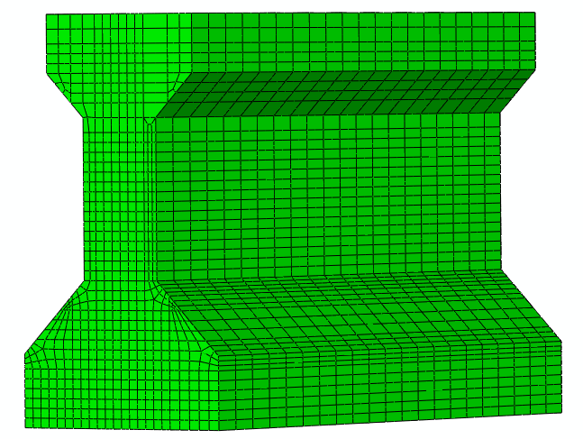
X= 0
X= 2
X= 8
X= 12
X= 20
X= 24
X= 28
X= 32
X= 42
X= 4

Figure 1.16 - Finite element model of a prestressed concrete I-girder (Vadivelu 2009)

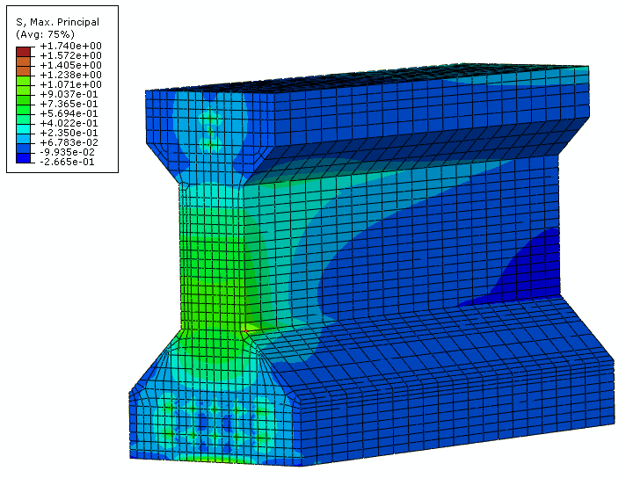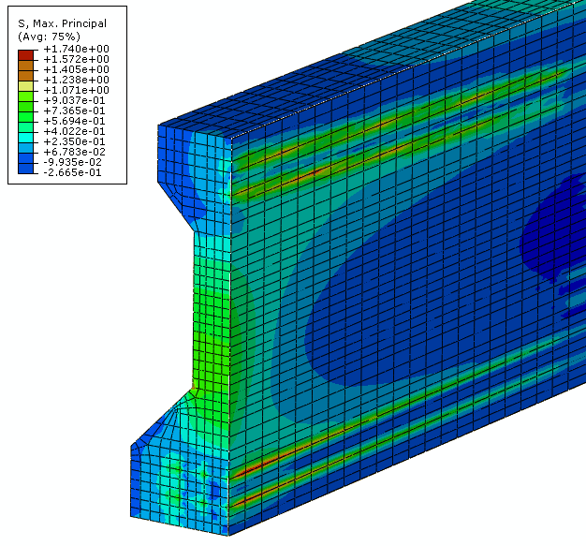
Figure 1.17 - Maximum principal stress distribution near the end zone with 0.7-inch strand (Vadivelu 2009)
Ayoub and Filippou (2010) introduced a nonlinear FE model for pretensioned prestressed concrete girders. The model consisted of three components: a fiber beam-column element for concrete, a truss element for prestressing tendons, and a bond element that described the transfer of stresses between tendons and surrounding concrete. This model was based on a two-field mixed formulation, where both forces and deformations were approximated within the element. The stress transfer mechanism was modeled with a distributed interface element with special bond stress-slip relation. The experimental results confirmed the accuracy and efficiency of the FE model.
Arab et al. (2011) presented a three-dimensional FE simulation of pre-tensioned concrete members, and its validity was verified by experimental results. Two approaches were examined for FE modeling: the extrusion technique utilizing friction-based contact simulations, and the embedment technique simulating equivalent responses. By comparison, the former technique provided more detailed information including the interface overstresses and bond slippage while the latter was a computationally less expensive alternate to simulate the overall response with comparable accuracy.
Burgueno and Sun (2011) analyzed the effects of debonded strands on the production and performance of prestressed concrete beams. The proposed nonlinear FE models simulating the bond between concrete and strands were calibrated by small-scale prestressed concrete beam tests. Three FE models of AASHTO box girders were analyzed to study an incident of end cracking in the manufacturing of a bridge girder. The effect of different debonding method was also discussed through FE method with ABAQUS.

1.6 Crack Development in Reinforced Concrete Beams and Shear Transfer through the Cracked Section

1.6.1 Truss Angulation Models
The illustration in Figure 1.18 by Mitchell and Collins (1991) presents the two early tests conducted by Morsch. These illustrations present the behavior of unreinforced and reinforced concrete beams under a distributed load after developing diagonal cracking. Each step in the illustration shows similar cracking patterns, but for the reinforced concrete member the cracking occurs at an elevated loading when compared to the unreinforced section. The unreinforced section failed with a 24-ton loading while the reinforced beam failed with a loading of 42 tons. The unreinforced beam encountered a sudden shear failure while the stirrups in the reinforced section transferred the shear to the stirrups and failed with a flexural failure at a much higher loading.
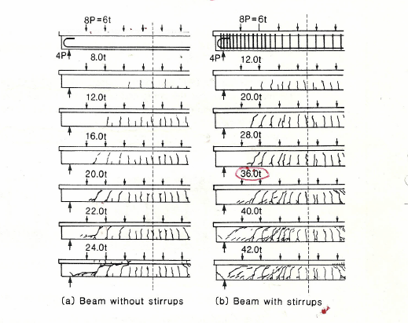
Figure 1.18 - Tests of Simply-Supported T-beams Subjected to Uniformly Distributed Loads. Adapted from Morsch and Collins and Mitchell (1991)
This forms the basis of shear design. The objective is to avoid premature brittle failures as displayed by the beams without stirrups. The members are to be designed with sufficient shear capacity to ensure a ductile failure as exhibited by the beams with stirrups. (Collins and Mitchell, 1991)
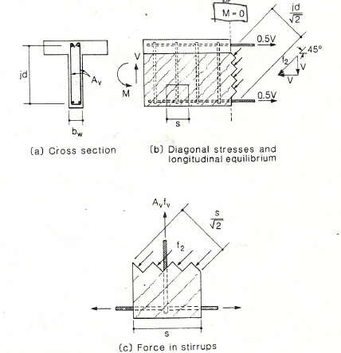
Figure 1.19 – Equilibrium Considerations for 45º Truss Model (Mitchell and Collins 1991)
In the late 1960’s and early 1970’s, many researchers including Fenwick, Pauley, Gergeley, Leonhardt, Walther, and Taylor published work concerning the distribution of shear stress across the cross section of an unreinforced concrete beam. These finding are summarized in Taylor’s (1970) literature review in his report. Through testing, Taylor published that his work was in agreement with other work on dowel and compression zone forces. Taylor and others contributed shear stress in unreinforced concrete members to three different sections of an unreinforced concrete beam. They could easily measure the average surface strain in the compression zone and the shear strain resisted in the longitudinal (dowels) reinforcement. The remainder was the attributed to the center (web) section of the beam. Early researchers considered that this section, when cracked, would contribute very little to the shear resistance of a concrete girder and was often neglected. Through testing Taylor published the following result:

Shear Capacity Percentage by Section (Taylor, 1970)

Compression Zone 20 – 40%
Aggregate Interlock 33 – 50%
Dowel Action 15 – 25%

This testing demonstrated that even though cracking existed, a significant amount of shear resistance was generated in the web section ≈ 41.5% of the capacity of the beam subsequent to cracking.

Figure 1.19 from Mitchell and Collins (1991) present a model showing the diagonal truss field as it is developed with stirrups crossing the cracks developed under applied load. The initial assumption from researchers was that the compression field could be described as a 45 degree angle. This would give the most conservative value of the tensile force within the stirrups. Consider the free body diagram presented in Figure 1.19b. The shear resistance in the web of the T-beam is modeled by visualizing angulated concrete columns restrained by the vertical stirrups. Using this model the shear in the section is distributed across the surface area of the concrete columns at the section of interest. In this case, the surface area can be described as jd/$\sqrt{2}$ or d_{v}/$\sqrt{2}$. Assuming the angle of inclination of the stress field is 45 degrees, the average stress in the concrete can be determined and the stress divided by the area included in the spacing of the vertical stirrups can be calculated. By equilibrium, the vertical component of the stress field will equal the resistance in the vertical stirrups which is A_{v}f_{v} for a given spacing. This is illustrated in Figure 1.19c.

According to Mitchell and Collins (1991), from many of the tests conducted by the University of Illinois, Richart noted that the 45º for the direction of principal compression might be the cause of the reduced strain in the stirrups that were observed in the beam tests. Richart pointed out that by reducing the angulation of the concrete compression field to 40º would reduce the predicted strain in the stirrups by 20%.

In Figure 1.20, Mitchell and Collins (1991) present the same model as Figure 1.20 but considering a variable truss angle. With the reduced angle, less of the shear at the section is transferred to the vertical stirrups and more to the longitudinal reinforcement. From this general free body diagram, equilibrium equations can be written which correlate the conditions within the beam to the angle of the compression field to the longitudinal reinforcement. As an example, the stress in the concrete (f₂) can be given as such:
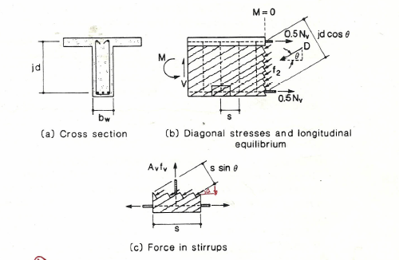
Figure 1.20 - Equilibrium Conditions for Variable-Angle Truss,
Mitchell and Collins (1991)

f₂ = V/b_{v} d_{v} (1/(sin θ . cos θ) | (3)
where the vertical component of the shear is V/sin θ and the area is expressed as d_{v} cos θ.

Additionally, the longitudinal component of the diagonal compressive force due to shear is

N_{v} = V cot θ = A_{Longitudinal Steel} f_{Long Stl} + A_{Conc} f_{Conc} | (4)

A third equation is illustrated in Figure 20c. The outward thrust of the stress created by the stress in the concrete created by the shear in the system must be equilibrated by the stress in the stirrup. This gives the following:

f₂ b_{v} s sin²θ = A_{v}f_{v} | (5)
Substituting,

f₂ = V/ b_{v} d_{v} [1/(sin θ x cos θ)] | (6)
A_{v} f_{v} / s = V/d_{v} tan θ | (7)
These equilibrium equations relate four variables in three equations. These equations cannot be solved algebraically without introducing other intrinsic relationships to solve the variables.

In 1964, Kupfer developed a procedure for determining the angle θ using minimum energy procedure. According to Mitchell and Collins (1991), this deviation used linear elastic properties of the steel and concrete and realizing is much stiffer than the steel, it was capable of carrying more of the shear stress, therefore θ had to be less than 45º.

1.6.2 Compression Field Theory and the Contribution of Tensile Stress across Concrete

Cracks
Another refinement of the truss model is the compression theory and the modified compression theory as developed by Collins, Mitchell, and Vecchio in the 1980’s. Their attempt was to take the current truss models and using work conducted by Taylor regarding mechanical aggregate interlock; Kupfer regarding the minimum potential energy concepts to derive more accurate crack angle equations; and work that they completed to quantify the tensile stress component that crossed concrete cracks developed their model for evaluating shear in a reinforced and prestressed concrete beam. They developed new material properties for cracked concrete, took into account the variability of the crack angulation, and resolved equilibrium, compatibility and constitutive relationships within a concrete specimen and formulated them in terms of average stresses and average strains. (Vecchio and Collins, 1988) They understood that this level of analysis, at the time, was “too complex for regular use in the design of simple beams,” but that “the procedure has value in its ability to provide a rational method of analysis and design for members having unusual or complex geometry or loading, or whenever a more thorough analysis is warranted.” Since the 1980’s, they have developed a computerized program called “RESPONSE” which is a design program based upon their research that simplified this effort. This modified compression theory method has been incorporated into the American Association of State Highway Officials (AASHTO) Load and Resistance Factor Design (LRFD) manual.
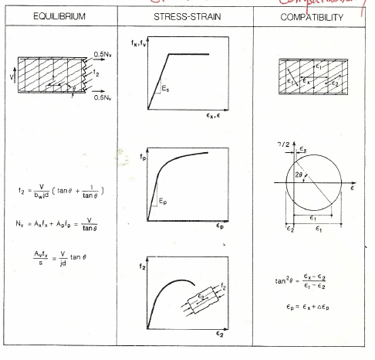
Figure 1.22 – Summary of Property Relationships in Reinforced Concrete Beam
(Mitchell and Collins, 1991)
The modified compression theory, because of its complexity and iterative process, was thought to be too complicated for general use by designers. As a result, the ACI-American Association of Civil Engineers (ASCE) Shear Committee 426 desired to seek a rational simplification of the shear design procedures. Their desire was to have a simplified procedure that would provide an adequate level of safety, be correct in basic concept although not necessarily accurate in details, be simple to understand and use, mathematically derived, and not necessarily increase design or construction costs. Based upon this intent, Ma and Tadros (1999) developed simplified empirical equations to quantify approximations of the effective shear depth (d_{v}), factor indicating the ability of diagonally-cracked concrete to transmit tension (β), and the angle of inclination of diagonal compressive stresses (θ). In their work, Ma and Tadros demonstrated that their empirical equations approximated the results obtained from modified compression theory, provided a safe and simple method for evaluating shear within a concrete beam, did not require charts and graphs to evaluate a beam, and was not an iterative procedure.

Before the equilibrium equations of the variable-angle truss model can be used to design a member for shear, the inclination angle θ must be known (Mitchell and Collins, 1991). Wagner in studying postbuckling shear assessed that thin web would not resist compression and shear would be resisted by diagonal tension. The inclination angle of the diagonal tensile stresses would coincide with the inclination of principal tensile strains.

The compression field theory applies this approach to reinforced concrete, and upon cracking the assumption is that the concrete carries no tension and the shear is carried by a field of diagonal compression. Using this assumption, Mohr’s circle can be used to develop an expression for the shear that is carried by a field of diagonal compression. Figure 1.21 presents Mohr’s circle of strain compatibility using the average strain across several tension cracks.
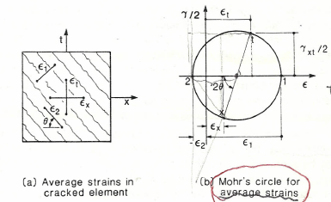
Figure 1.21 – Compatibility Conditions for Cracked Web Element
(Mitchell and Collins, 1991)

Using Mohr’s Circle we understand that

cos 2θ = [ (ε₁ – ε₂ )/2 (radius) – ε_{x} + ε₂ ] / (ε₁ – ε₂)/2  = [ ε₁ – ε₂ - 2ε_{x} + 2ε₂ ] / ( ε₁ – ε₂)  = [ ε₁ - 2ε_{x} + ε₂ ] / ( ε₁ – ε₂)  tan²θ = ( 1 – cos2θ) / ( 1 + cos2θ )  = { [ 1 – ( ε₁ - 2ε_{x} + ε₂ ) / ( ε₁ – ε₂ ) ] / [ 1 + ( ε₁ - 2ε_{x} + ε₂ ) / ( ε₁ – ε₂ ) ]}  = (ε₁ – ε₂ – ε₁ + 2ε_{x} – ε₂ ) / (ε₁ – ε₂ + ε₁ - 2ε_{x} + ε₂ )  = ( ε_{x} – ε₂ ) / (ε₁ – ε_{x}) | (6)  (7)  (8)  (9)  (10)  (11)  (12)

and,

ε₁ = ε_{x} + ε_{t} – ε₂ | (13)
so,

tan²θ = ( ε_{x} – ε₂ ) / (ε_{t} – ε₂) | (14)
With compatibility, we have added two more equations and one more unknown. Knowing this and coupled with the relationships between stress and strain, a solution can be attained algebraically that yields a solution for each unknown. This approach is known as the compression field theory. Figure 1.22 summarizes the equilibrium, stress-strain, and compatibility relationships for the compression field theory.

1.6.3 Predicting Response in Shear using Modified Compression Theory
The primary difference between the Compression Theory and the Modified Compression Theory is that the Compression Theory neglects the contribution of tensile stresses in cracked concrete and a contribution is attributed to the modified compression theory. Prior to cracking, shear is carried by both diagonal tensile and compressive stress. After diagonal cracking, the tensile stress in the concrete are substantially reduced and carried across the cracks. The tensile stresses in the concrete vary from zero at the cracks to a maximum at the midpoint between the cracks.

The diagonal compressive stresses push apart the flanges of the beam while the tensile stresses pull them together. Based upon testing conducted by Vecchio and Collins equations for the average strain across the cracks have been developed which relate the average strains in these zones, the bond characteristics of the reinforcement and the type of loading.

1.7 Summary of High-Capacity Strand Research
A need for using increasing the capacity of prestressed concrete girders has been on-going for some time. Vadivelu (2009), in his Master’s thesis presented a case for the use of this strand. In this thesis, he presented the results a parametric study using 0.7-inch 270 ksi strand and concluded that using this strand at a 2-inch spacing a considerable savings in flexural member material would result. To determine the adequacy of the strand, Vadivelu developed a 3-dimensional finite element model examining the effects that the additional prestressing force had on AASHTO Type I girders. Principal and axial stresses were examined and based upon the modeling, it was found that the 0.7-inch strand beams with 2-inch spacing would likely be more vulnerable to cracking at the transition zone between the bottom flange and web. The study recommended the use of confining steel to overcome this tendency. Following this study, two I-girder specimens were cast, one with 0.7-inch 270 ksi strand and the other with 0.62-inch 330 ksi strand. The transfer lengths were measured and it was found that the transfer lengths for both specimens were shorter than the lengths estimated using AASHTO 2008 and ACI 318-08 equations.
In December 2008, Akhnoukh presented a Master’s thesis looking at the use of 0.7-inch 270 ksi strand. The specific items addressed were as follows: 1) Determine the required confinement steel necessary that would allow the determination of transfer and development lengths according to current procedures in the AASHTO LRFD Bridge Design Specifications for smaller strands; 2) Develop a 15 ksi self-consolidating mix design with a one day compressive strength of 10 ksi; and 3) Test the use of 80 ksi welded wire reinforcement as auxiliary reinforcement for shear, web end splitting, and confinement.
Akhnoukh used shear friction theory to estimate the level of confinement required to comply with the AASHTO LRFD specification and developed a simplified mathematical expression to calculate the area of confining steel required as a function of prestressing, concrete strength, and strand distribution. Akhnoukh observed that the transfer length of 0.7-inch strand was shorter that the lengths predicted by AASHTO LRFD specifications. He noticed that the level of confinement had only a slight impact on transfer length. A successful mix design was developed and he had success using 80 ksi welded wire reinforcement in his design.
Another parametric study was conducted by Ferhadi and Badie (2010) looking at extending span lengths of prestressed I-girders using high performance concrete, high-strength light-weight concrete, large-diameter high-strength strand, and bridges made continuous for slab weight and superimposed loads. They recommended the use of 0.7-inch strands with normal-weight concrete, rather than light-weight concrete, which would offer better performance for the difference in cost. For 0.6-inch strand, using light-weight concrete is more economical.
Patzlaff (2010) conducted a study on the impact of bottom flange confinement on the performance of prestressed concrete bridge girders. Transfer length, development length, and vertical shear capacity was examined using eight tee-girders and three NU1100 girders. The results of the study indicated that the amount or distribution of confinement reinforcement did not have a significant effect on the initial or final transfer length of the prestressing strands. Additionally, no significant impact of confinement was found on either the nominal flexural capacity or bond capacity of the prestressing steel, and the effect of confinement on the shear resistance of the girder was negligible. Confinement across the entire girder was observed to increase the ductility of the girder and reduced cracking under extreme loading conditions.
Hatami, Morcous, and Tadros (2011) evaluated the bond performance of 0.7-inch diameter, 270 ksi, low-relaxation strands in mortar and concrete using the North American Strand Producer (NASP) bond test method. Fifty-eight samples were tested and an equation that predicted the bond in mortar and concrete was developed. Tests were conducted on both clean and rusted strands. They found that the NASP test method can be applied to 0.7-inch strand, the performance of rusted strand was 40% higher than clean strand except during end slip conditions. At end slip conditions, they found that the performance of rusted strand could be highly variable and performance lower than clean strands.
Tadros, and Morcous (2011) conducted an examination of the use of 0.7-inch strands for their use in bridge girders. This study was conducted for the Nebraska Department of Roads (Project Number: SPR-1(08)P311). Several experimental investigations were conducted to determine the mechanical properties of 0.7-inch diameter strands, address production concerns, evaluated transfer and development length, and end zone cracking associated with using these larger diameter strands. Specimens included rectangular prisms, 24-inch deep T-beams, NU900 and NU1100 girders. The work indicated that girders could be produced using 0.7-inch diameter strands with no major changes to current production practices or to the current design criteria according to AASHTO LRFD specifications.
Morcous, Hanna, and Tadros (2011) published a summary of this testing in the PCI Journal. In this article, they noted that 0.7-inch strand is stiffer and heavier and producers should be aware of this when using this strand. Some modifications will be to be made to enlarge bulkheads and increase the jacking capacity of the equipment or prestressing bed. They noticed a reduction of the predicted transfer length to 50d_{b} instead of the 60d_{b} predicted using AASHTO LRFD specifications. Further, they defined values of strand spacing, concrete strength, and confinement to develop the 0.7-inch strand.

1.8 Recent Shear Design Approaches in Prestressed Concrete Members
Ma, Tadros, and Baishya (2000) conducted a study into the shear behavior of pretensioned high-strength concrete bridge I-girders. Current AASHTO Standard specifications require that V_{s} not exceed 8√f’c b_{w} d_{v} (f’c in psi) without otherwise widening the section web or increasing the depth of web. Also, a maximum shear limit of 0.25 f’c b_{w} d_{v} is required by AASHTO LRFD Specifications. These two limits were examined and it was observed that as high-strength concrete was used the V_{s} limitation would unduly widen the prestressed concrete member. An experimental testing program was created to examine these limits using full-scale beams and high-strength concrete. Strand draping and shielding were also used as parameter in the testing program.
It was determined that both limits provided conservative results when compared with the testing data. The tests produced shear capacities in excess of the AASHTO LRFD limits with shear reinforcement less than the maximum allowed. The AASHTO-STD maximum allowable shear limit appears to be too restrictive which may result in unnecessary widening of the beam web. Anchoring strands within end blocks or end diaphragms can significantly improve the shear resistance of a beam. Beams without end anchorage have significantly lower shear capacity. Their test results confirmed that the 0.25 f’c b_{w} d_{v} value is a reasonable limit for concrete shear resistance.
Ma and Tadros (1999) developed a simplified (non-iterative) approach to shear design. This was a goal set by the ACI-ASCE Shear Committee 426 for the simplification of concrete shear design. The procedure applies to members not subjected to axial tension and having the minimal amount of transverse reinforcement requirements specified in Article 5.8.2.5 of the ASASHTO LRFD specifications. The β₁ term is simplified as the multiplication of γ_{a} and γ_{p}. γ_{a} is dependent on the beam’s M_{u}/M_{cr} ratio and γ_{p} is dependent on the ratio of prestressing stress to the concrete compressive strength. The angle of inclination of diagonal compressive stresses is also given in terms of γ_{a} and γ_{p.} Their simplified procedure was validated using testing results from previous shear testing programs and matched the results given by the iterative calculation procedure from AASHTO LRFD.
Kuchma, et al. (2008) conducted shear testing on several high-strength prestressed bulb-tee sections and compared the measured shear strength capacities to five different methods of shear capacity determination. The methods compared were the sectional design model of AASHTO LRFD, the Canadian Standards Association design of Concrete Structures, Response Program 2000 (a sectional analysis program), AASHTO Standard Specifications, 17th edition, and simplified design provisions of the LRFD specifications. The report concluded that the compressive strength limit of concrete can be increased from 10 ksi to 18 ksi without impacting safety. They recommended the use of strut-and-tie modeling be used in lieu of a sectional approach when the shear design stresses exceeded 0.18f’c unless the member is cast integrally with the support or is continuous over the support. They observed that the calculated shear capacity of the test girders was conservative for the AASHTO LRFD, AASHTO STD, and Response Program 2000. They reported that AASHTO LRFD approximated the angle of inclination and initial position for the shear cracking appropriately. They observed that significant cracking and shear reinforcement yielding occurred when the beam was designed to support shear stresses in excess of 0.15 f’_{c}.
Concrete beam failure can occur in a number of ways. Ma and Tadros (1999) defined the failure mechanisms as follows:

- The compression zone is reduced by the increasing vertical flexural crack and finally is crushed in compression (a typical flexural type failure).
- A diagonal crack extends at both ends towards the flanges, and finally the beam splits into two pieces (a diagonal tension failure).
- The compression zone is reduced and crushed in compression by the extended diagonal crack (a diagonal compression failure).
- Both diagonal and vertical cracks widen, but spalling appears along the longitudinal reinforcement, and finally the beam loses its capacity (a typical bond failure).
- Diagonal cracks appear in the web of the beam near the support, spacing between the almost parallel diagonal crack is reduced, spalling of the web surface appears, and the web concrete is crushed (a typical web-crushing failure).

In addition to these, if appropriate development length of the longitudinal reinforcement is not attained before the necessary tensile capacity demand is met, the failure can also occur due to insufficient end anchorage of this reinforcement.

2.0 Numeric Basis for Strand Behavior in Prestressed Concrete
The behavior of strand within concrete is a complex series of time-dependent processes which is influenced by the material properties of concrete and strand. The best way to understand the process is to separate the interactions that occur and understand each individual component. This section examines each component and then combines these into a mathematic model to describe strand behavior.

2.1 Strand Properties
Strand is a seven-wire, stiff metal component that is manufactured using steel rod. Steel wire stock is heated, pulled, reduced in size and wrapped in a helical fashion while the strand is still hot. Though not welded together, the individual strands are pulled while being wound around the center strand, and the contact surfaces are pressed together to form a slight bond. Strand with a nominal 0.7-inch diameter is typically made from 0.26-inch diameter wires. This result approximately 0.18 inches of material is compressed together. Though this bond is substantial, it has been observed under ultimate loading that the center wire can slip relative to the other six wires.
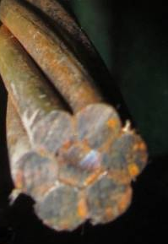
Figure 2.1 – Photograph of 0.7-inch Strand
The helical weave was measured to depart from the longitudinal axis of the strand by approximately 14 degrees. Strand, after being spun together, is reheated and some residual stress is applied to the product so that it unrolls straight when being unspooled. When the strand is cut perpendicularly to the longitudinal axis, a cross section is created as shown in Figure 2.1. The cross section of the exterior strands is slightly elliptical due to the helical weave. The cross sectional area for 0.7-inch strand is 0.2923 in² as reported by Insteel Wire Products. (See Appendix A for a copy of the Material Certifications for the 0.62- and 0.7-inch strand used in this investigation.) The contact surface area was measured during the course of this study. It was found to be 2.911 in²/in. Also, the contact surface area for 0.5- and 0.6-inch strand was estimated to be 2.083 in²/in and 2.497 in²/in respectively.
As mentioned, Appendix A contains material certification reports for the 0.62- and 0.7-inch strand. Within the reports each of these strands were tested to failure. A load was given for a 1% extension of the strand as well as the ultimate elongation cross sectional area and observed modulus of elasticity. The steel sent is listed as 7W 270 LR ASTM A416. The Poisson’s ratio used was 0.3 which was used typically in papers regarding strand research that were examined.
Strand behaves similarly to steel rod when being elongated. As longitudinal stress is placed upon the strand, the strand elongates and shrinks longitudinally. This variance is proportional in the elastic range of the steel and occurs at a uniform rate. This rate, Poisson’s Ratio, can be described mathematically as follows:
ν = - dε_{transverse} / dε_{axial}  where,  ν is the resulting ratio,  ε_{transverse} is the transverse strain,  ε_{axial} is the axial strain. | (2.1)
Once the strand is elongated—prior to casting within a concrete member—the strand shrinks radially. It is customary to prestress the strand by elongating the strand to a stress of 75% of its yield stress. Though some of this prestress is lost in the manufacturing process, through concrete creep, steel relaxation, concrete shrinkage, and thermal differences, a majority of the stress is retained in the strand. These losses typically account for a stress reduction of approximately 20 to 25% of the original stress level. The remaining stress level then becomes 56 to 60% of the yield stress of the strand.
After the concrete is cast allowed to set to the designated release strength, the strand is cut releasing the tensile energy applied to the strand. When this occurs, the stress in the strand at the end of the section returns to zero and the stress within the strand is transferred to the section through the bonding of the cast concrete to the strand. The stress is variable from the end of the section to the transfer point which is defined as the position where the initial stress which was applied to the strand—less prestress losses described earlier—to the transfer point.

2.2 Concrete Properties
Concrete in its simplest form is a mixture of aggregate—both large and small—and a binding agent. Portland cement paste is generally the most common binder used in the manufacture of concrete. It mainly consists of oxides of calcium, silicon and aluminum with a source of sulfate. These components are heated and ground to formulate dried cement.
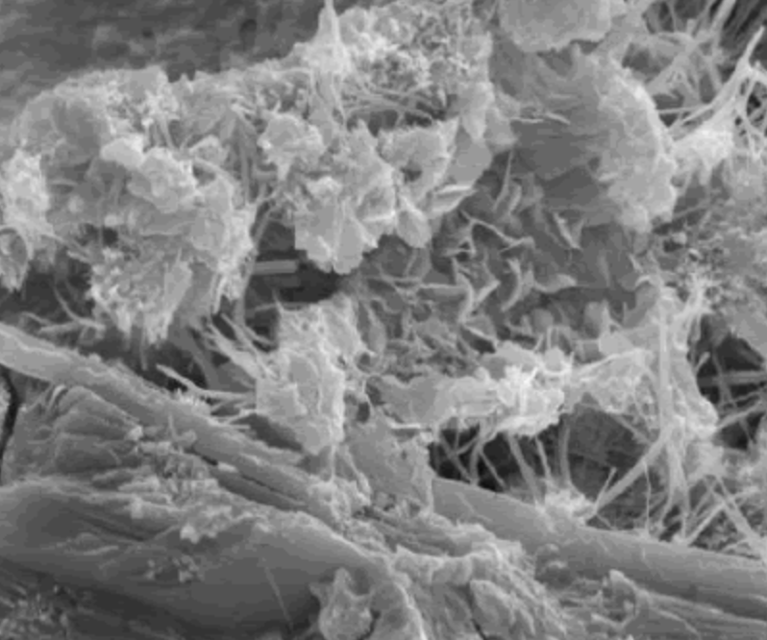

Figure 2.2 – C-S-H and Ettringite Molecules from FWHA
When water is added a chemical reaction ensues. This reaction (hydration) glues the aggregate and reinforcement together. Many chemical reactions take place over time including the formation of Calcium-Silica-Hydrates (C-S-H) and Ettringite. These molecules shown in Figure 2.2 develop long finger-like crystalline appendages which attach themselves to any embedded material.
Consider the visualization in Figure 2.3. If we consider that the cement molecules, for the sake of the visualization, bound itself to strand in the form of long slender columns, we can see several correlations to the macroscopic world. For instance, if we considered the column density of normal strength concrete to be as shown in Figure 2.3a, then the density of bonding columns along a unit length of the strand would be increased. If the cement columns were compressed, the adjacent columns would act as lateral bracing against itself. If the cement columns were pulled, lateral bracing from the adjoining columns would not occur and the concrete column would have to rely only upon its slender cross-sectional area to resist the tensile forces. Precompressing the concrete would be akin to increasing the density and adding lateral bracing between the microscopic cement columns. Shear behavior can be described similarly. With an increase in cement column density an increase in the shear strength of the concrete can be realized. If the columns were confined with lateral pressure, then the columns would not collapse as easily and the relative strength of the system would be increased.
I understand that this is a visualization tool, but it is useful in describing the development of a concrete system behavior. It is based upon the microscopic properties of concrete and can be used to develop a model for concrete behavior.
Because of the molecular shape of concrete, it behaves much differently than steel which has a more compacted and round microstructure—see Figure 2.4. Steel particles are welded together to form their bond and are tightly packed confining each molecule together. As a result steel is much stronger than concrete particularly in tension. Also if steel components are shaped as long slender elements, than we see similar behavior in steel as we do in concrete.

2.3 Dynamics of Strand Interaction

2.0 DEVELOPMENT LENGTH TESTING
Six specimens were produced for development length testing. Figure 2.1 on the next page provides a schematic of these specimens. Three of these specimens were prepared with 0.7-inch, 270 ksi strand and the other three with 0.62-inch, 330 ksi strand. Each specimen was designed to tested on each end to give a total of 12 tests. The specimens contained a single high-capacity strand and were unreinforced with shear reinforcement at each end. This was planned so that vertical shear reinforcement would not add another variable to the test. The members were sized with enough concrete shear capacity (V_{c}) to develop a full bending capacity near the end of the specimen. One specimen for each strand size was cast with a different concrete compressive strength. Design concrete strengths of 5000, 7500, and 10,000 psi were used in this testing. Each specimen was 50 feet long and had four lifting points. A spreader bar and overhead crane was used to unload the specimens. The ends were supported when positioned before testing so that cracks were not induced into the specimens.
Though these precautions were taken, one end of one specimen was broken during handling at the lab and another end was broken during transportation. The damaged sections were cut off and the remaining specimen was tested. The tests were conducted using three-point flexural tests. Staged loading was applied at a predetermined distance from the end of the beam. The initial distance used was determined by calculating the development length using the formulas described in Section 1.2.5. The development length tests were accomplished by testing portions of the specimens with a load near the end of the specimen. This distance was changed and load applied to the specimen until the specimen either failed in flexure, shear or bond.
The objective was to attain full moment capacity with an end loading. Full moment capacity was defined as achieving an average stress over an eight-inch gage distance of 1.25% strain. Different end positions were used until the development length distance was determined by two relatively close end loading positions were found; one that failed plastically in flexure and another test that failed in by a bond failure. The initial specimen was tested five times because the current development length formulas did not properly predict the development length distance of the high-capacity strand. As a result, initial tests were positioned too far away from the end of the beam. Five tests were conducted on first specimen and some of the tests included sections where there was vertical shear reinforcement. Though it was not desired, the additional vertical shear reinforcement did not have a significant impact upon the results of the testing program.
The following subsections describe the procedures that were used in conducting each of the 16 tests that were conducted using the six specimens followed by a detailed description of each tests. The results of each test are presented. The next major section provides an analysis of the results obtained from this testing a the development of a model that describes the behavior of strand within a prestressed concrete beam.

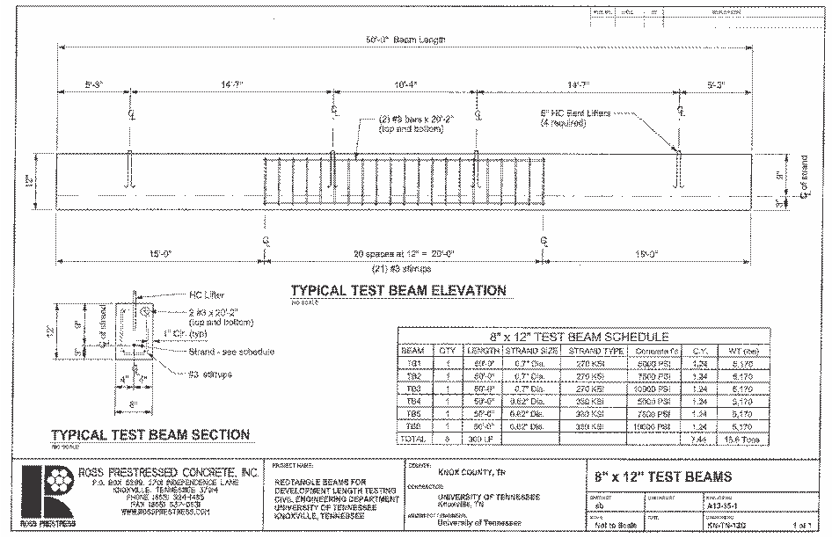
Fig. 17 – Development Length Specimen

2.1 Estimation of Development Length using Formulas from Previous Research
During this testing we intend to conduct two tests for each end of each specimen. One test will be conducted to force a bond slip failure in the strand at loading and the other at a distance slightly beyond the development length. It is anticipated that the two tests will band the actual development length of the specimen. Concrete surface strain measurements will be taken at intervals during the testing. Strand strain measurement data will be collected continuously during testing.
The Table 2 gives formulas developed for development length by previous researchers. An estimation of the development length of the 0.7 and 0.62-inch strand based upon these development length formulas is provided in Table 3. Values measured and estimated for each formula variable are given below the table or previously in Table 1.
Table 2 - Different Proposed Equations for Development Length

Researcher | Development Length Equation
Zia and Mostafa (1977)
Abdalla et al. (1993)
Mitchell et al. (1993)
Burdette et al. (1994)
Buchner (1995)
Lane (1998)
Barnes et al. (1999)
Shahawy (2001)
Kose and Burkett (2005)
Ramirez and Russell (2007)
AASHTO | l_{d} = κ(f_{ps} – 2/3f_{se})d_{b}

The symbols used in Table 1.2 are defined as follows:
d_{b} = nominal strand diameter (either 0.7 or 0.62-inch)
f_{c}’ = concrete compressive strength at 28 days (psi – See Table 1);
f_{ci}’ = concrete compressive strength at time of release (psi – See Table 1);
f_{ps} = average stress in prestressing steel at ultimate load (ksi – 270 for 0.7, 330 for 0.62);
f_{pu} = ultimate tensile strength of prestressing strand (ksi - 270 for 0.7, 330 for 0.62);
f_{se} = effective stress in the prestressing steel after losses (ksi – Assumed Elastic reduction from
release stress for these calculations. Strain gage measurements are hoped to be used to
measure the actual stress in the strand at the time of the test.);
f_{si} = effective stress in prestressed steel after short-term losses (ksi – Used the same value as
f_{se}.);
ε_{ps} = strain in prestressed reinforcement at nominal strength. (9310 microstrain for 0.7, 8921
microstrain for 0.62)

Table 3 – Development Length Estimations

Strand Size | 0.7-inch |  |  | 0.62-inch
Release Concrete Compressive Strength | 6366 | 7122 | 10,126 | 6366 | 7122 | 10,126
Development Length by Researcher (in)
Zia and Mostafa (1977) | 37.5 | 33.8 | 24.6 | 34.0 | 30.2 | 20.6
Abdalla et al. (1993) | 123.0 | 122.3 | 121.5 | 76.0 | 75.4 | 74.6
Mitchell et al. (1993) | 66.9 | 61.9 | 53.0 | 46.0 | 42.9 | 36.2
Burdette et al. (1994) | 114.2 | 113.5 | 112.5 | 73.0 | 72.5 | 71.9
Buchner (1995) | 92.3 | 91.8 | 91.1 | 65.6 | 65.3 | 65.0
Barnes et al. (1999) | 126.8 | 122.2 | 110.5 | 94.1 | 89.6 | 77.6
Shahawy (2001) | 145.3 | 130.5 | 94.4 | 120.7 | 108.8 | 79.4
Kose and Burkett (2005) | 58.5 | 55.7 | 48.0 | 67.6 | 63.9 | 54.5
Ramirez and Russell (2007) | 90.8 | 84.0 | 72.8 | 80.4 | 74.4 | 64.5
AASHTO | 147.6 | 147.1 | 146.4 | 105.0 | 104.6 | 104.0
Average (neglecting Zia and Mostafa Estimate) | 107.3 | 103.2 | 94.5 | 80.9 | 77.5 | 69.7
80% of Average | 85.8 | 82.6 | 75.6 | 64.7 | 62 | 55.8

Development Length estimates vary considerably from one researcher to another. Some of these equations were developed for 0.5 and 0.6-inch strand and relate the diameter of the strand and the difference in ultimate strand stress and stress at the time of loading to the development length. Some account for the difference in concrete strength, but for simplification many ignore this parameter. As with transfer length, the three components of stress transfer adhesion, mechanical interlock, and Hoyer’s effect should also be incorporated into a more rational approach that can be uniformly applied to any prestressing strand size and concrete strength.
In an effort to force a strand slip failure in at least one of the development length tests, I propose that a load be placed at the 80% average position shown in Table 3 be applied in 1000 lb increments. The specimen will be monitored for slip failure. Surface strain measurements will be taken at each loading increment and the average strain will be calculated for each gauge length. As the strain approaches steel yield, the incremental deflection will be used to determine when surface strain measurements will be taken. The intent is to examine the strain distribution within the steel across the length of the beam. A deflection limitation will be used to cease testing.
The second test of the same specimen will occur following the conclusion of the first. Data collected from the first test will be examined and a projected development length will be determined. The load point for the next test will be placed at a distance of 12 inches outside this estimate. The goal is to bound the development length, and allow concrete surface strain measurements and steel strain measurement to predict the actual location of full strand stress development.

Beam Capacity Checks
Table 4 presents calculation estimates for each specimen using the estimated load point, concrete strength, and strand size/type. It gives anticipated loading for full moment capacity as defined by a concrete strain of the extreme fiber of 0.003. Testing of the specimen will continue until failure. Shear requirement for moment capacity is given and compared to the calculated concrete shear capacity of the specimen.
Table 4 – Beam Capacity Checks
Specimen | BM1 East | BM1 West | BM2 East | BM2 West | BM3 East | BM3 West
Strand Size | 0.62 | 0.62 | 0.62 | 0.62 | 0.62 | 0.62
A_{ps} | 0.2348 | 0.2348 | 0.2348 | 0.2348 | 0.2348 | 0.2348
f_{pu} | 330 | 330 | 330 | 330 | 330 | 330
f'_{c} | 7500 | 7500 | 9000 | 9000 | 11500 | 11500
d_{p} | 9 | 9 | 9 | 9 | 9 | 9
β₁ | 0.675 | 0.675 | 0.65 | 0.65 | 0.65 | 0.65
c | 2.104 | 2.104 | 1.837 | 1.837 | 1.455 | 1.455
f_{ps} | 308.4 | 308.4 | 311.1 | 311.1 | 315.1 | 315.1
M_{n} | 50.0 | 50.0 | 51.2 | 51.2 | 52.6 | 52.6
V_{c} | 14.7 | 14.7 | 15.5 | 15.5 | 17.6 | 17.6
Location of Load Point | 65 | 81 | 62 | 78 | 56 | 70
Load to Capacity with 32' Span | 11.1 | 9.4 | 11.8 | 9.9 | 13.2 | 11.0
Shear at Beam Short End | 9.2 | 7.4 | 9.9 | 7.9 | 11.3 | 9.0
Shear Capacity Sufficient? | YES | YES | YES | YES | YES | YES

Specimen | BM4 East | BM4 West | BM5 East | BM5 West | BM6 East | BM6 West
Strand Size | 0.7 | 0.7 | 0.7 | 0.7 | 0.7 | 0.7
Aps | 0.2923 | 0.2923 | 0.2923 | 0.2923 | 0.2923 | 0.2923
fpu | 270 | 270 | 270 | 270 | 270 | 270
f'c | 7500 | 7500 | 9000 | 9000 | 11500 | 11500
dp | 9 | 9 | 9 | 9 | 9 | 9
β1 | 0.675 | 0.675 | 0.65 | 0.65 | 0.65 | 0.65
c | 2.140 | 2.140 | 1.869 | 1.869 | 1.481 | 1.481
fps | 252.0 | 252.0 | 254.3 | 254.3 | 257.6 | 257.6
Mn | 50.8 | 50.8 | 52.0 | 52.0 | 53.4 | 53.4
Vc | 14.7 | 14.7 | 15.5 | 15.5 | 17.6 | 17.6
Location of Load Point | 86 | 107 | 83 | 103 | 76 | 94
Load to Capacity with 32' Span | 9.1 | 7.9 | 9.6 | 8.3 | 10.5 | 9.0
Shear at Beam Short End | 7.1 | 5.7 | 7.5 | 6.1 | 8.4 | 6.8
Shear Capacity Sufficient? | YES | YES | YES | YES | YES | YES

Based upon these calculations, I will begin with a loading of 6000 lb for the 0.62-inch strand and 5000 lb for the 0.7-inch strand. Concrete surface strain measurements will be taken initially, at the starting load and at 1000 lb increments to the load required to moment capacity. From moment capacity, if attained without bond slip, the beam will be loaded until a deflection of 1/8 to ¼ inch is attained. The deflection will be a testing day decision based upon the load required to attain this deflection. It is anticipated that the beam will deflect without appreciable additional loading. This deflection will continue until beam the beam falls apart or the deflection of the testing apparatus is reached.
Measuring Devices
Several measuring devices will be used during the course of this testing. Loading will be monitored and recorded using the MTS actuator and this will be based upon the pressure sensors incorporated into the actuator to be used in the testing procedure. Deflection at the point of load will be monitored using the MTS LVDT incorporated into the actuator. Other LVDTs will be used to measure the deflection of the beam at various places along the length of the beam. This data may be useful, though probably not entirely necessary for development length testing, for future analysis or other examinations using these specimens. Concrete surface strain measurements will be taken and recorded at each step loading. These measurements will be manually taken and recorded. Strand strain will be monitored using the strain gages attached to the strand when the concrete was cast.
The specimens will be loaded at 14 feet from the end of the beam until failure. Strain gauges will be placed upon the strand before casting, and the strain in the strand will be monitored throughout the testing process. From this testing, we will determine the distance to where the development length of the strand was obtained.
Before strand release, Gilson Surface strain Measurement inserts were placed at 8-inch centers on one side of each specimen as shown in Figure 2. Initial readings of the distance between the inserts were taken and the specimens were released from the casting bed.
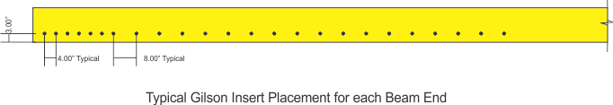

Figure 2

Summary of Testing Procedure
The following chart displays the steps to test these specimens:

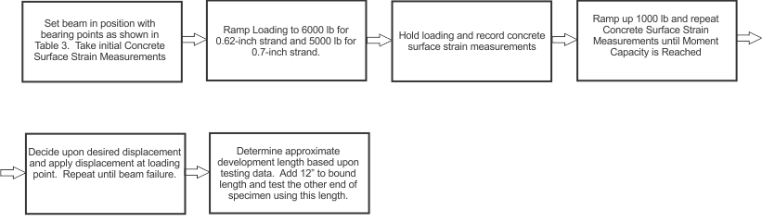
Following the testing of the beams, there should be enough information to develop a method to estimate development length which can be applied to all current strand sizes.

Photos of Initial Development Length Tests

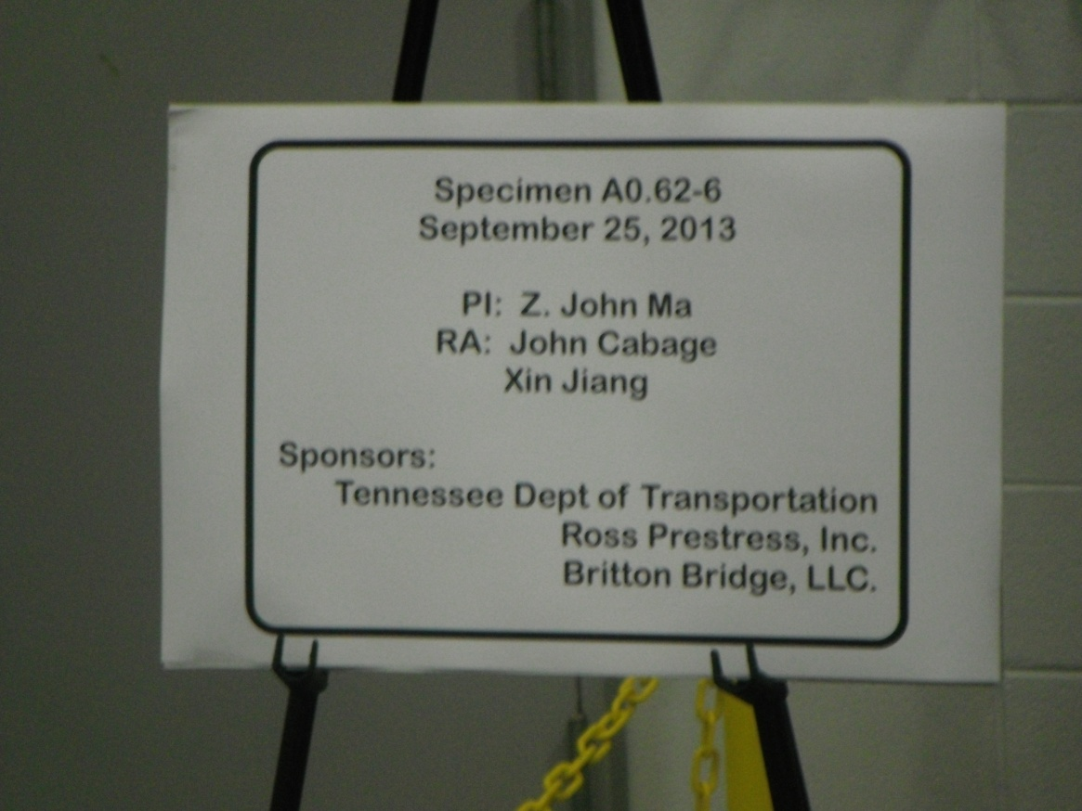

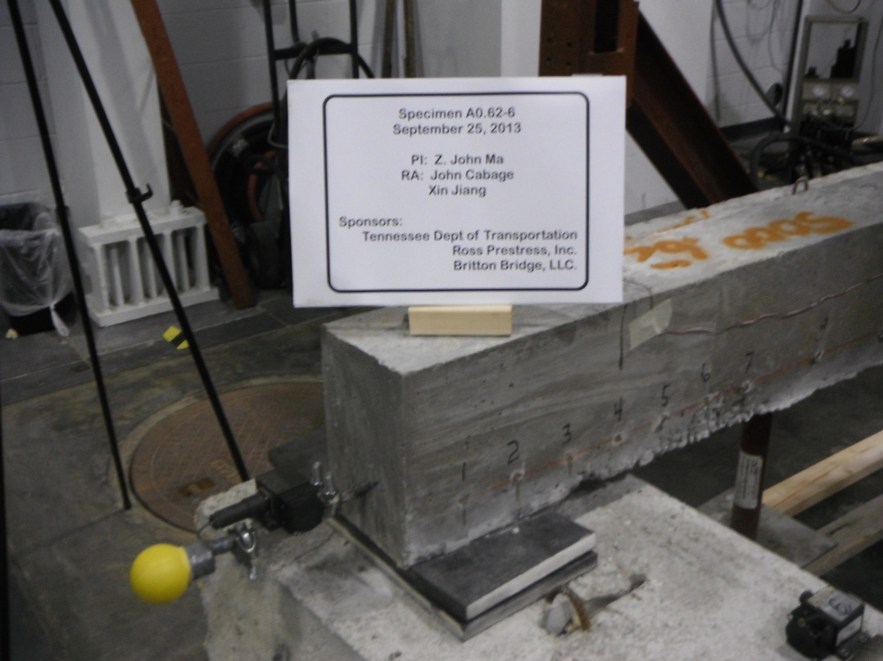

End Zone Arrangement Showing LVDT to Monitor Slip and 2-inch Neoprene Bearing Pads
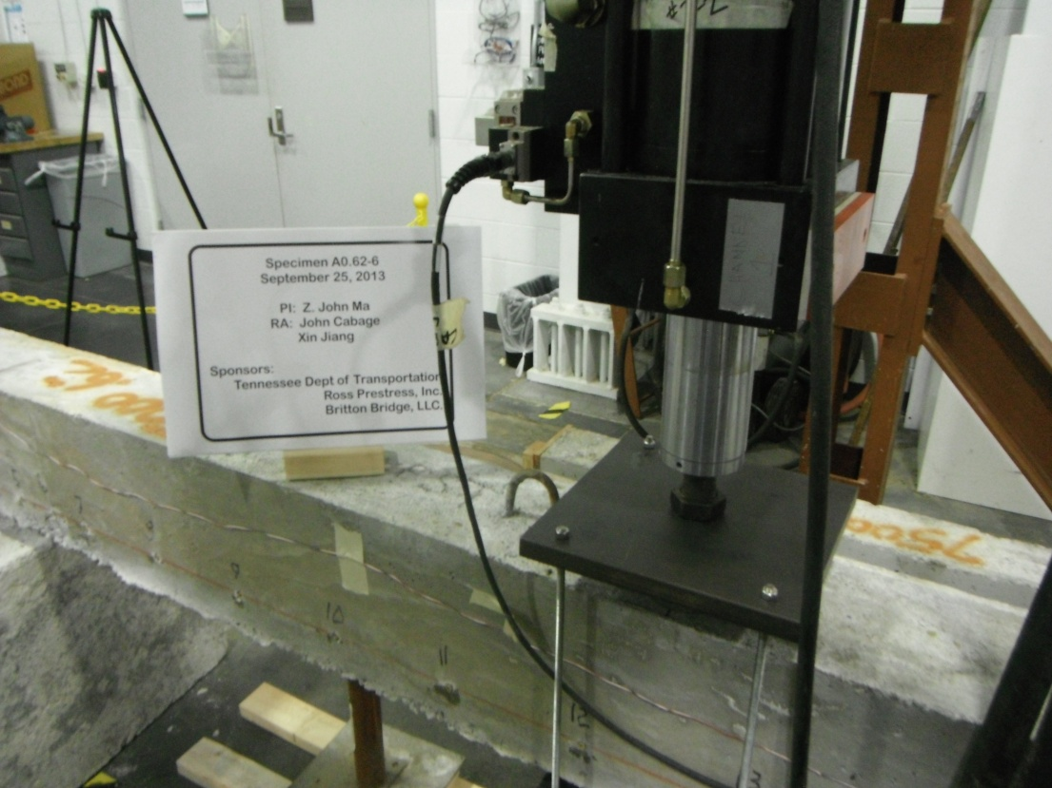

Hydraulic Actuator at Load Point (Note numbered Surface Strain Inserts along the side of specimen.)

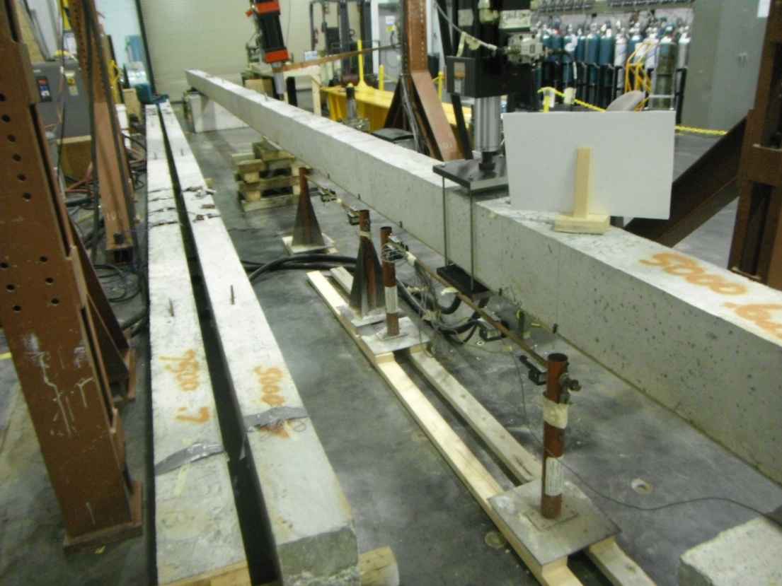

Vertical Displacement Monitoring Using LVDTs

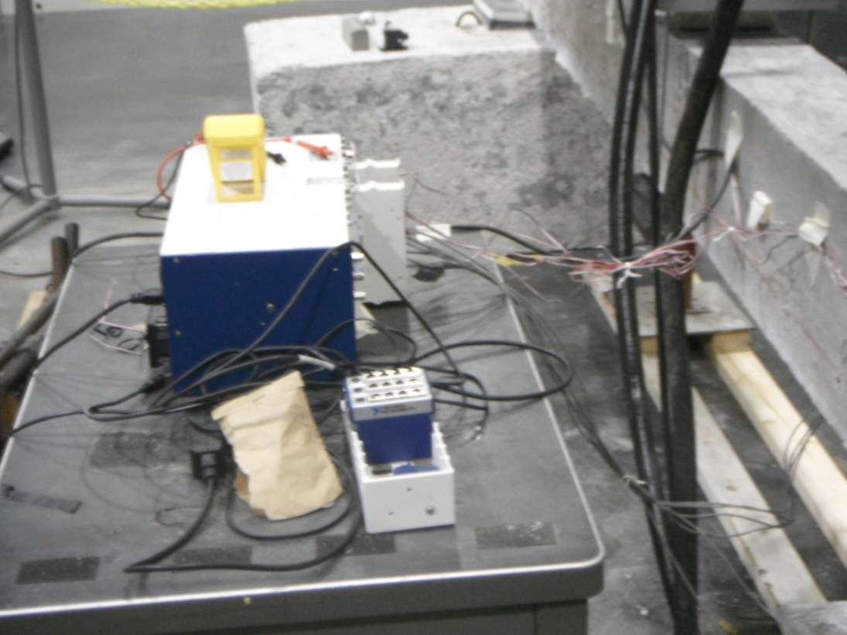

LabView Data Acquisition System for Embedded Strain Gages and LVDTs

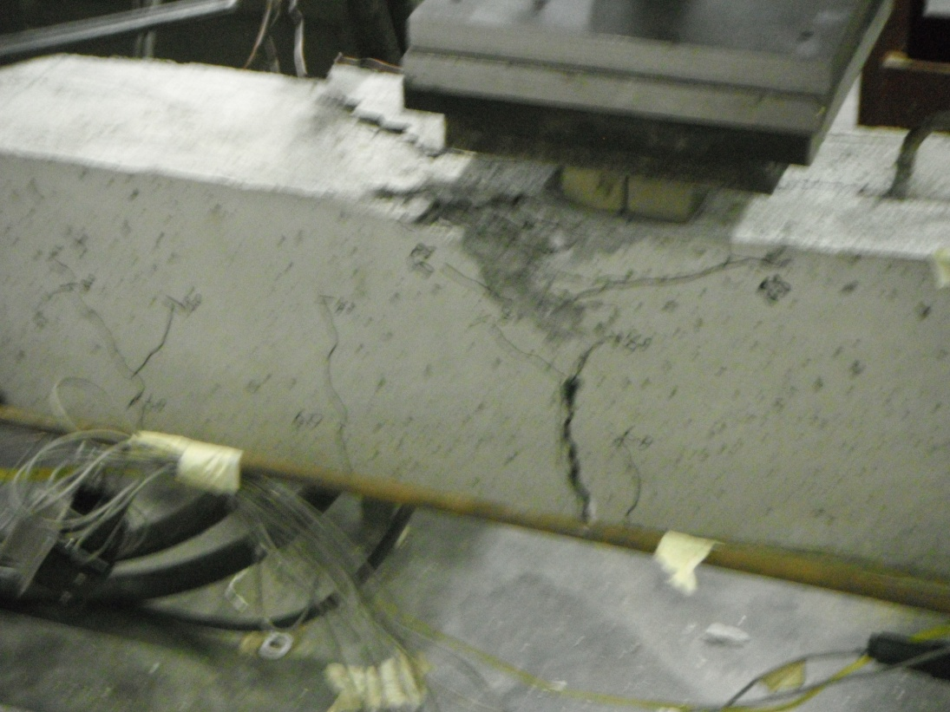

Concrete Localized Crushing at Load Point Near Slip Failure for this Specimen

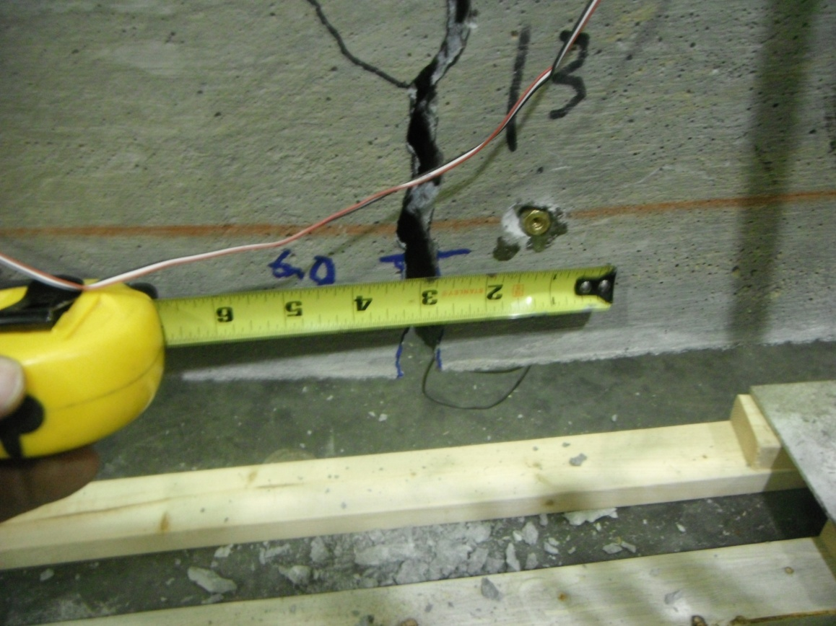

Permanent Strain Deformation at Specimen Failure

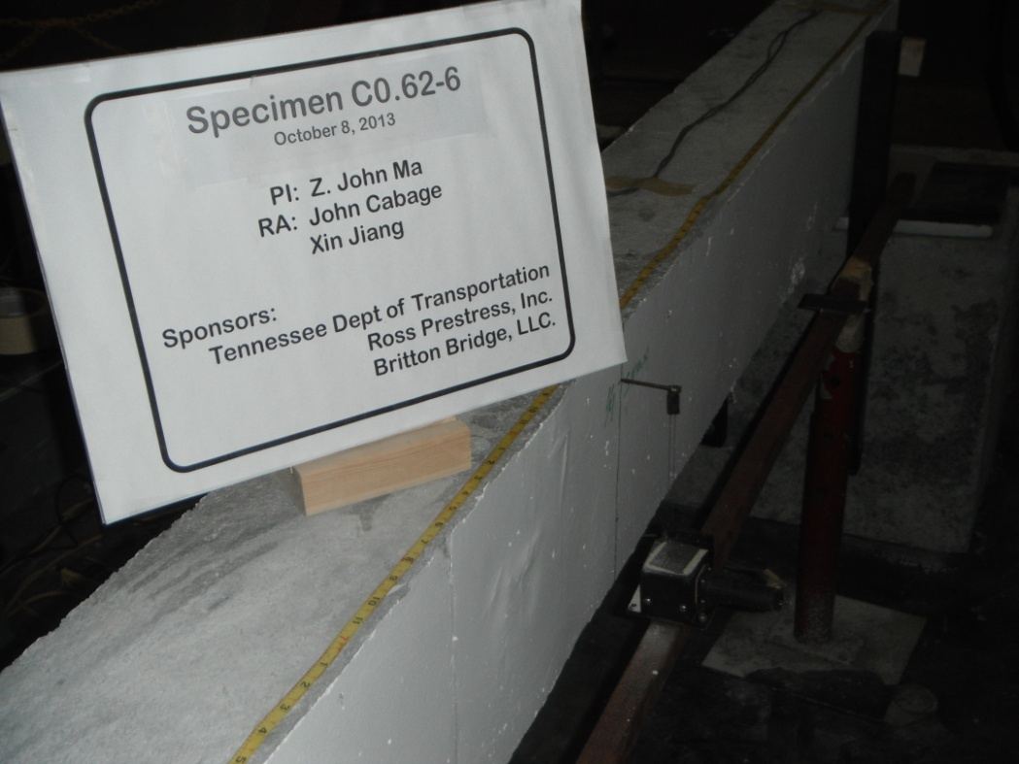

Testing of Middle Specimen. This specimen had mild compression and tensile steel reinforcement.

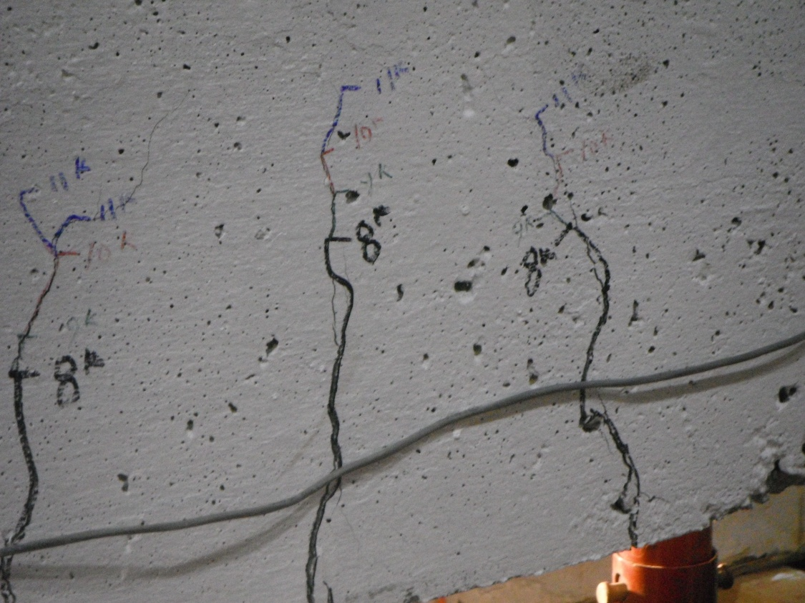

Crack Progression with loading near center of specimen.

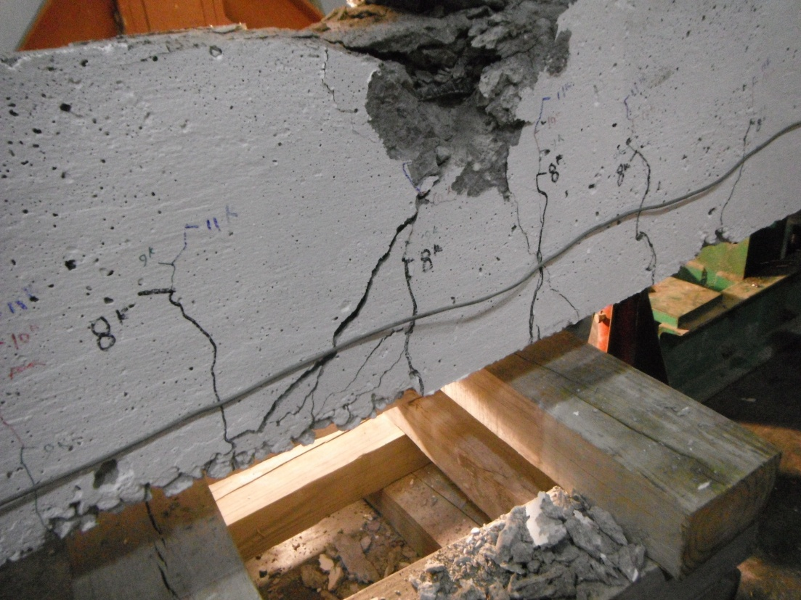

Concrete Failure and Compression Failure of Compression Steel at Full Load. This specimen had a plastic failure with minimal slip.
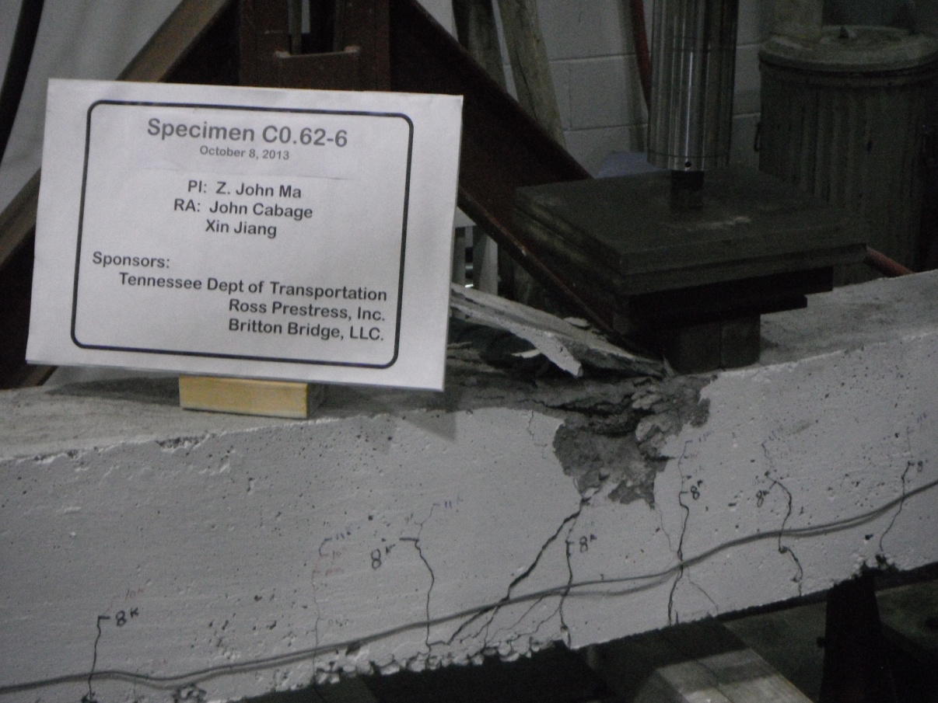

Cracking at Concrete Failure

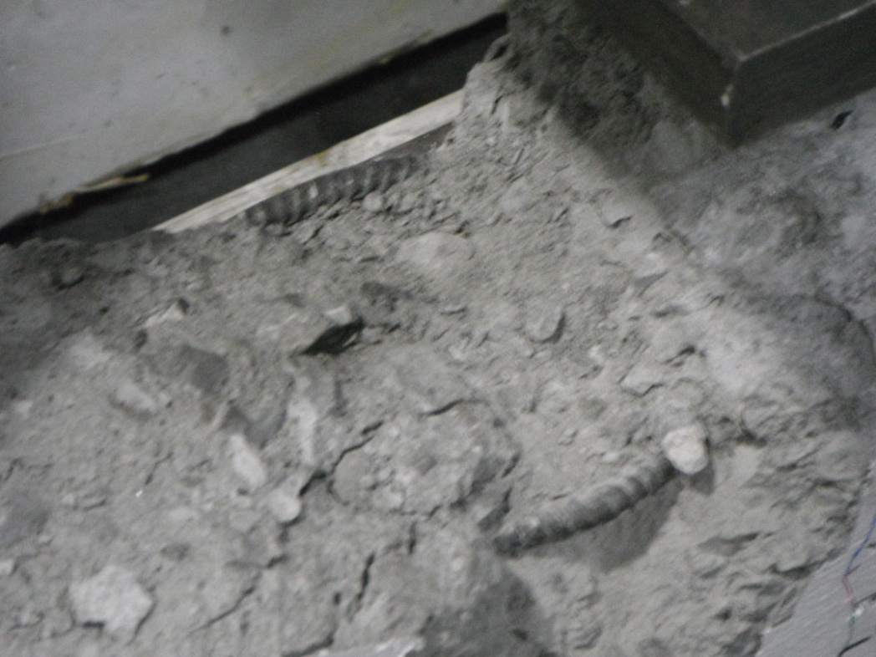

Close-up of Mild Reinforcement Failure.
Introduction
A total of 12 development length tests have been conducted with five more to occur within the next two weeks. Some preliminary findings have been developed during the course of this testing. Based upon this testing we find that the development length of the high-capacity strand, both 0.7-inch and 0.62-inch is shorter than the available prediction models suggest. Also, we find that the development length is dependent upon the geometric size of the strand, the strength of the concrete, and the occurrence of shear cracking at the end. This brief report will describe some specific testing results which will support our claim. A new development length formula will be developed at the end of our testing which will summarize the observations made during the testing. This formula will adequately predict the development length of strand of all sizes. The following sections summarize the results of three of the specimens that have been tested and evaluated at this point.
Specimen D0.7-6
The nomenclature of the specimen numbers is relatively simple. Of the six specimens manufactured by Ross Prestress for this testing, three of them used 0.7-inch strand and three of them used 0.62-inch strand. Each of these used concrete of three different strengths. The design strength at the time was 6,000, 8,000, and 10,000 psi. In this case, this was the fourth test conducted (signified by the “D”) on the specimen containing 0.7-inch strand and 6,000 psi concrete. Figure 1 shows the test set-up for this evaluation.
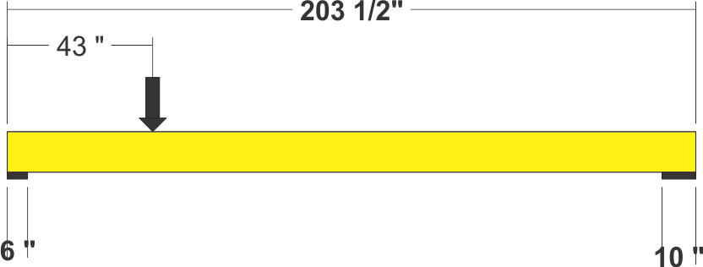
Figure 1 – Specimen D0.7-6
As seen from the picture the specimen when tested was 203.5” long and was loaded at 43” from the end. The support on the loaded side was a two-inch-thick neoprene pad, six inches wide and the other end used a 10-inch-wide pad. The loading of the specimen was evaluated before testing and a prediction of the cracking load and the load where a flexure failure would occur was determined. Using these predictions, loading points were staged during the testing process. The load upon the specimen was increased at a rate of 20 lb/sec until the first stage was attained. The first stage was positioned just below the predicted cracking strength. Surface strain and deformation measurements were made and recorded. The next stages were equally spaced between the first stage and the predicted flexural capacity of the beam.
To achieve a full development length, the strand would be required to stretch beyond its yield strain (f_{ps}) as determined by the 2% offset method for yield strength without losing bond. The specimens were initially designed so that a shear failure was unlikely during the range of test loading. As the loading reached the plastic limit of the beam, the loading was paused and surface strain readings were taken and recorded. The beam was allowed to fail by exacting a constant displacement at the loading point (0.003 inches/sec) until the specimen failed in flexure by concrete crushing. To this point, the strands have yielded into their elastic range, but have not broken.
Figure 2 presents the average strain between gauge points versus the distance from the live end of the specimen. This was plotted for each stage loading of the specimen. In this case, the stages occurred at a loading of 8000, 12,000, 16,000, 20,000, and 21,000 pounds. Slip was measured at the live end of the specimen at each loading stage.

Figure 2 – Steel Strain vs Distance from Live End
Notice that this specimen an average steel strain of 16,500 microstrain near the load point of the specimen. This exceeded the f_{ps} strain for this strand of 12,500 microstrain. A plastic failure mode was observed to occurring during the test and a loading stage of 21,000 lbs was attained. This specimen failed at a load of 21,300 lbs with a flexure failure. No slip in the strand was observed during the course of this examination.
Using the data attained from this testing a load versus deflection curve was plotted and is presented in Figure 3. This curve clearly depicts the behavior of the beam under loading. Linear-elastic behavior occurs during the initial loading conditions, followed by cracking of the specimen. The behavior

Figure 3 – Load versus Deflection Curve for Specimen D0.70-6
becomes non-linear as the concrete is cracked and load is increased. As the steel reaches its plastic limit continued deflection occurred until the specimen broke as a result of a flexural failure. No slip was observed at the live end of the specimen through failure. Figures 4 and 5 show the failure mode of this specimen. A clear thrust crack formed as a result of the combination of shear and flexure forces applied to the specimen. This crack became angulated as it reached the load point. A second crack along the bottom of the beam then formed and the concrete at the bottom of the specimen spalled off. The

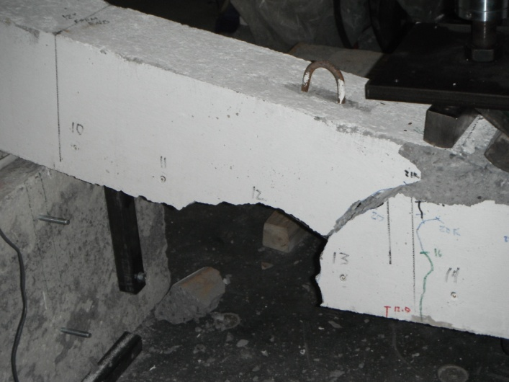
Figure 4 – Failure of Specimen D0.70-6
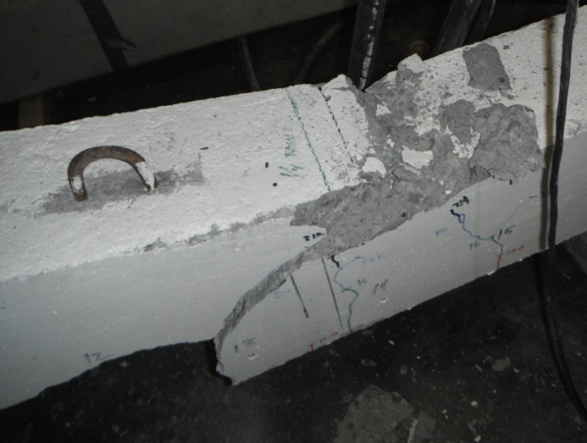
Figure 5 – Failure of Specimen D0.70-6
concrete at the top of the specimen crushed and the specimen collapsed. The spalling of the bottom concrete and the crushing of the top concrete occurred simultaneously as the beam collapsed. Since the strand did not slip, this indicates that for 0.70-strand with a concrete strength of approximately 6,000 psi, the development length is less than 43”. As further testing ensured, the researchers observed that the development length is dependent upon the load combination that will exact the first crack. Cracking in the end zone as noticed by other researches will adversely impact the bond between the strand and the concrete creating a weak zone in the anchorage structure of a beam.
Specimen E0.70-6
Specimen E0.70-6 was another test conducted upon the remaining portion of 6,000 psi, 0.70-inch strand specimen prepared by Ross Prestress, Inc. As shown in Figure 6, the specimen was 158” long and had a load point at 37.5”. The load point was reduced so that the development length could be bounded.

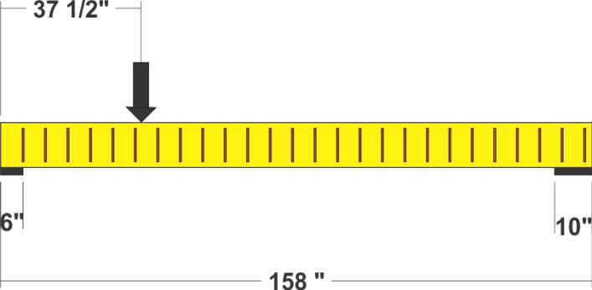
Figure 6 – Specimen E0.70-6
Notice that in this tested portion that we had placed vertical steel reinforcement in the specimen to prevent cracking of the specimen during shipping. This mild steel also acted as vertical shear reinforcement during this test. The additional shear capacity was warranted to enable a flexural failure with a high-shear loading caused by the shortening of the specimen and the position of the loading point. With this arrangement, loading stages were and the specimen was loaded according to that plan.

Figure 7 – Steel Strain versus Distance from Live End
Three load points were attained before a sudden slip failure of the specimen. These were at 12,000, 21,000, and 24,000 lbs. The average strain between gauge points of 12,000 microstrain was reached, but this specimen did not achieve the full 12,500 microstrain required for a “flexural failure. This specimen failed by the bond between the strand and the concrete breaking and the strand slipping at the end of the specimen. Figure 8 shows the failure of the specimen. Observe at the lower left.
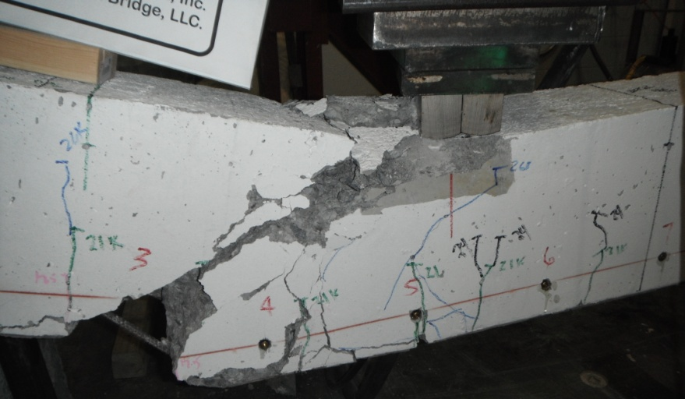
Figure 8 – Failure of Specimen E0.70-6
The mild steel reinforcement can be seen stretched as the specimen failed. As the strand slipped it rotated through the end of the strand. The typical thrust crack formed in this specimen as well. Figure 9 shows the load verses deflection diagram for this specimen.

Figure 9 – Load versus Deflection Diagram, Specimen E0.70-6
As can be seen from this diagram, the beam behaved linear-elastically until it cracked and the slip failure occurred. This failure occurred suddenly at a load of 26,000 lbs.
Based upon these two tests, we can say that for this strand embedded in this strength concrete the development length of this strand is between 37.5 and 43 inches.
Specimen A0.70-8
This specimen was tested upon one end of a beam created with 0.70-inch strand and a design concrete strength of 8,000 psi. The specimen was loaded at 34” from the end of the specimen as shown in Figure 10. The vertical steel mild reinforcement was close to the end of this test specimen and a plastic hinge

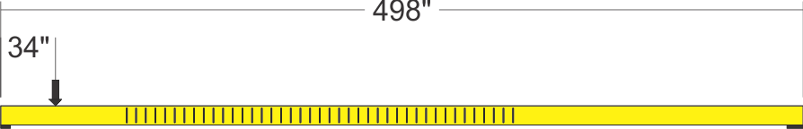
Figure 10 – Specimen A0.70-8 Schematic
point formed at the junction of the mild steel reinforcement during the testing. Again this specimen was tested in stages as before with loading points occurring at 7,000, 11,000, 15,000, 18,500, 21,000, and 23,000 lbs. Failure in this specimen occurred at a loading of 23,400 lbs with a flexural failure at the hinge point.
Figure 11 shows the strain versus the distance from the live end. In this graph notice that the average strain in the specimen was over 20,000 microstrain before the failure of the specimen occurred. This level of strain is well in excess of the 12,500 microstrain level to qualify as a flexural failure.

Figure 11 - Load versus Deflection Diagram, Specimen A0.70-8
The load point was at 37.5” which is less than that of the 6,000 psi concrete specimen of 43”. As seen from the load versus deformation curve. The specimen experienced a flexure with a distinct zone of plasticity forming before the beams compression failure. This curve is presented in Figure 12.

Figure 12 - Load versus Deflection Diagram, Specimen A0.70-8
Figures 13 shows the failure mechanism of this specimen. The formation of the angulated thrust crack occurred as a result of the combination of the shear and moment loading at the load point with the concrete crushing at the hinge point due to excessive rotation occurring at that point. Notice the excessive concrete cracking that occurred at the top of the specimen about 30” to the right of the load point. Also a secondary shear crack developed at the bottom of the specimen to the left of the thrust crack, which is left of the load point. This type of crack development was observed during each test which resulted in a flexural failure.
The testing of this specimen in comparison with the testing of specimens D0.70-6 and E0.70-6 shows that an increase of compressive strength of the specimen will shorten the development length of the specimen.
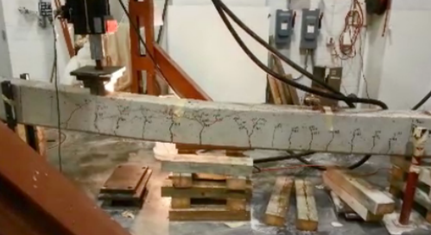
Additional Testing
Other tests were conducted to bound the development length of this specimen and other tests have been or are being conducted at other strand sizes and concrete compression strengths. From this testing and by incorporating geometrical properties of each strand, a general development length formula will be developed to predict the development length of any size strand. Further analysis is required and these results will be provided in the final report.
Introduction
A total of 17 development length tests are completed. Since then, we have moved and set up our testing equipment at the Edwin G. Burdette Structural Laboratory. Both full-scale beams have been relocated to the structural laboratory. Bearing supports have been modified and reinforced for the placement of the 0.7-inch specimen. Formwork was completed and a concrete deck has been poured atop one of the specimens. The test plan for the specimens has been finalized, and the actuator hydraulic system has been designed and assembled. Currently work is ongoing to test the hydraulics system before applying load to the specimen. Testing should begin within the month of May and should be completed by the end of June. The following sections summarize the progress that has been completed this quarter and gives the basis for our full-scale testing program.
Pouring of Composite Deck
During this quarter the first of the two large-scale specimens was positioned upon a reinforced bearing support and braced by four structural steel lateral braces attached to the strong floor at the Edwin G. Burdette Structural Lab at the University of Tennessee. The formwork was constructed using 4-foot by 8-foot panels which were easily removed and stored for reuse for the second specimen. Approximately five yards of concrete was poured using a high-strength Type I/II mix which achieved a 7-day strength 7,451 psi and a 28-day strength of 9,575 psi. This concrete deck was poured with the higher strength mix to achieve a high early strength for ready testing after pouring and to simulate a deck with a 10-foot width using 4,000 psi concrete.
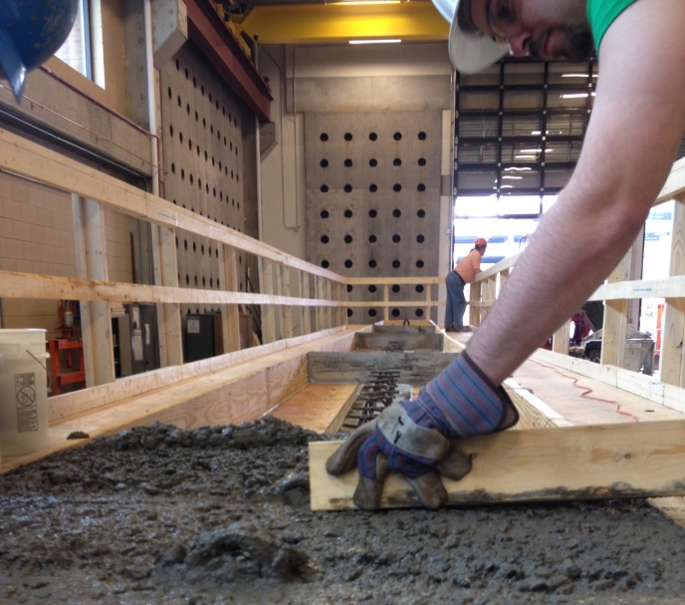
Figure 1 – Formwork and Pouring of Composite Deck atop AASHTO Type 1 Specimen
A day after the concrete was poured, the forms were removed and the concrete is currently ready for testing. Figure 2, on the next page, shows the measurement of concrete properties at the time of pour. Initially the concrete tested with a 4.75” slump, but during the pour the slump became considerable less than that. Due to the high cement ratio in the mix it was necessary to add retarder to the mix to slow the curing process. Nevertheless, there were no problems associated with mix placement. The concrete was consolidated using a vibrator and there were relatively few instances of entrapped air present in the deck based upon our visual observation of the deck’s exterior surface. 12 cylinders were prepared for compression testing and placed into a humidity-controlled environment.
Figures 3-5 show the photos of the concrete placement and final poured deck. The whole process was completed within four hours and the forms were entirely removed the following day. Student labor was used to complete the concrete forming and placement task. The yard bucket was supplied by Britton Bridge at no expense.
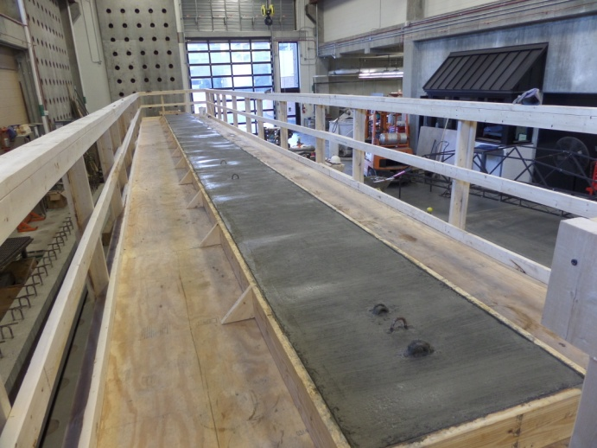
Figure 4 – Completed Deck Pour
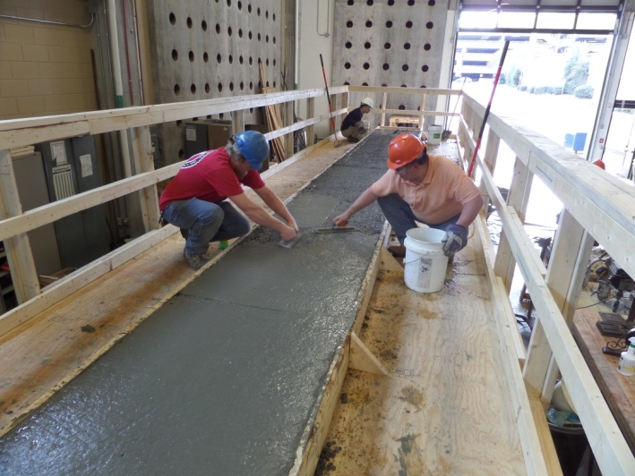
Figure 3 – Concrete Deck Finishing
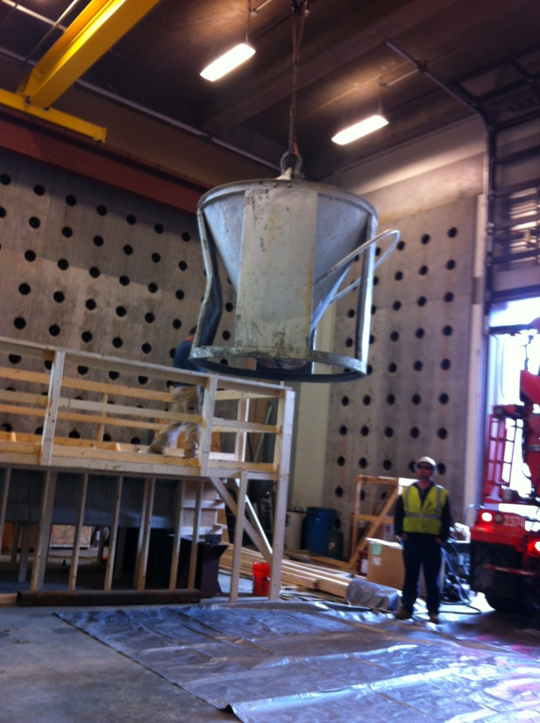
Figure 5 – Concrete Placement using a Yard Bucket
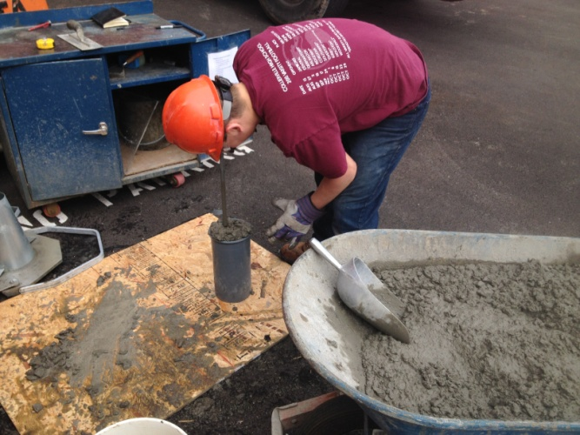
Figure 2 – Cylinder Preparation and Concrete Property Measurement at Placement

Following the concrete pour and after the removal of the forms, a considerable amount of time has been spent preparing a hydraulic actuator system and preparing the final testing program to evaluate the full-scale specimens. A large shear force is required to evaluate the end zone behavior using high-strength concrete and high-capacity strands. Figure 6 shows the hydraulics for the high-capacity strand test set-up. Four hydraulic actuators will be used to place a point load of 460 kips in between the middle actuators. Each actuator is equipped with an individual load cell which will allow the recording of the force applied to the specimen. The two middle actuators are equipped with vertical displacement measurement devices which will allow monitoring vertically while testing. This system has been design and one trial test has of the system has been conducted with initial success. Further modifications of the system are required, but the system should be ready in approximately two weeks.
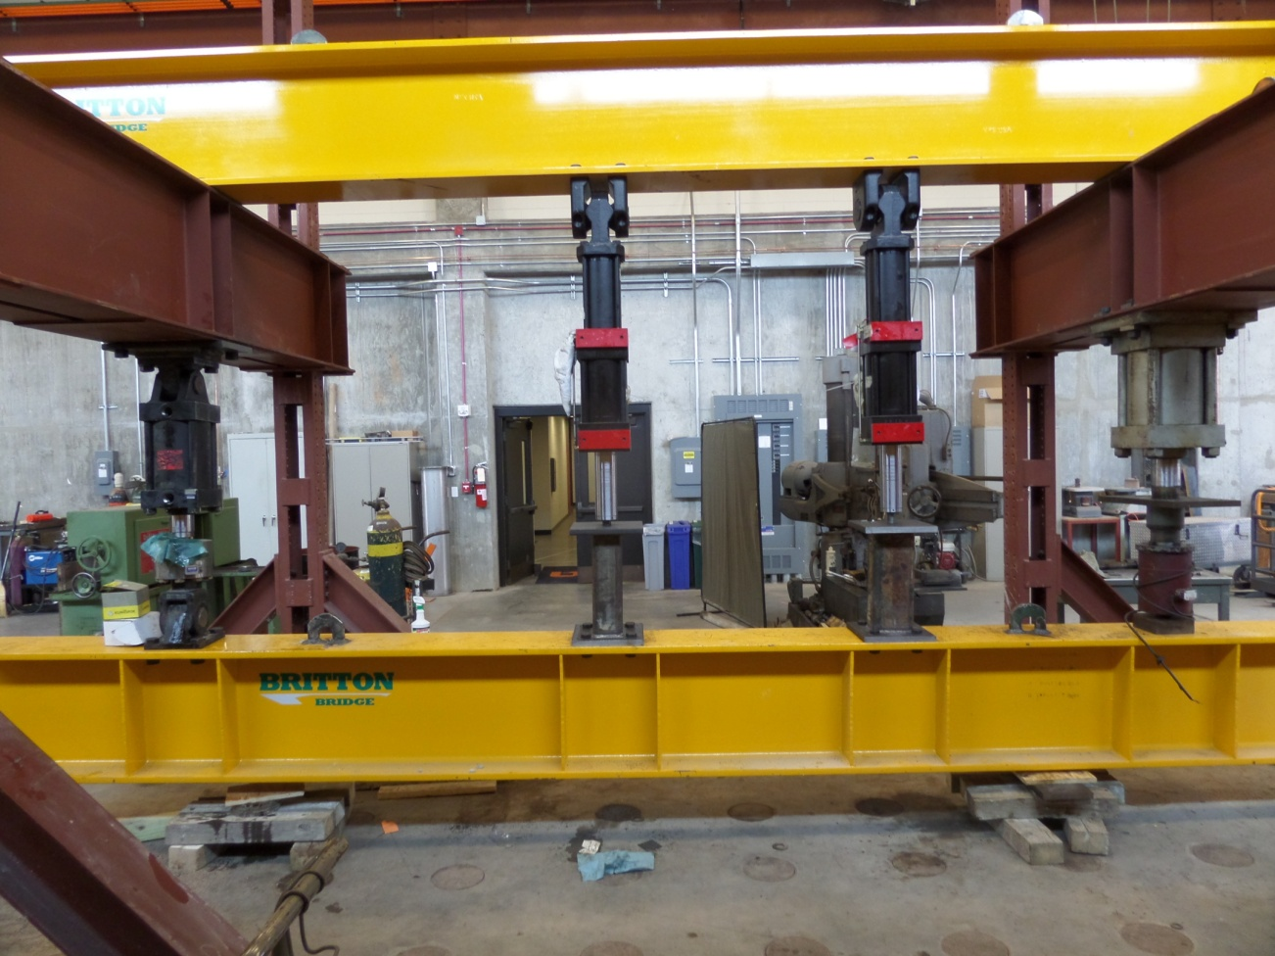
Figure 6 – Series of Actuators to Test Beam Specimens
Full-Scale Testing Plan Development
A considerable amount of time and effort has gone into the development of a testing plan for the full-scale testing of these bridge beams which utilize high-strength concrete and high-capacity strand. The following sections provide the background and calculations for the goals which we are trying to achieve through this testing. The beams using the high-capacity strands must be tested so that designers know that the methods that they currently use are still applicable for use with high-capacity strands.
Our testing program needs to further investigate objectives similar to the Hawkins and Kuchma study (NCHRP Report 579), but relating our program to the differences created by high-capacity strand. Based upon our initial small-scale testing, we have found that end zone stresses are transferred to the section much quicker than that of smaller strand. This coupled with the magnification effect at the interface of the web and flange can cause a further reduction in the ability of the section to distribute shear force without crushing the concrete at this interface.
To accomplish these goals, four tests will be conducted. A point load will be applied at a distance of 6.776’ from the center of the support. Sample calculations of this loading with the modified compression theory, AASHTO Generalized Method, AASHTO Simplified Method, Response 2000 program are provided in following sections as a basis for comparison. The 0.7-inch specimen had a 28-day concrete compressive strength of 14,191 psi and the 0.62-inch strand specimen had a strength of 12,295 psi. Because of this difference in strength and due to the existing capacity of our actuators, the testing of the 0.7-inch strand specimen will be conducted in two ways, one with the strand straight out to establish a baseline and the other with the strands turned up to examine the difference in behavior.
All four of the tests will be used to evaluate the listed objectives, but the 0.62-inch specimen will be used to primarily assess the maximum shear stress design limit. Each end of this specimen will be treated with a fiberglass reinforced coating to increase the shear capacity so that a high shear capacity exists to attempt to crush the concrete. Based upon my calculations, we can attain a shear of 0.15 f’_{c} at 6.776 feet loading point from the center of the support. The first test shall be conducted at this point. This will vet the development length and provide information regarding the strain distribution in the end zone. From this a comparison can be made with the results obtained from the 0.7-inch strand tests.
The last test will be conducted on a fiberglass-coated specimen with the end overhanging the support. The direct shear load will be placed at a distance of 0.05L from the support. With our current load capacity we can attain a shear loading of 0.17 f’_{c}. It is not quite 0.18 or 0.25 f’_{c}, but it is close.
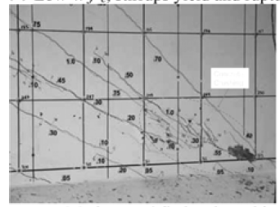
Figure 7 – Typical DEMEC Grid Pattern, (Source: ACI Structural Journal, May-June 2008, Kuchma, Kim, Nagle, et al.)
Measuring the response to load and surface strain will be conducted by using a DEMEC gauge pattern at 2 inches on center along the centroid of the prestressing steel and in the web of the section. Orthogonal disk placement will allow the determination of stress and strain in two directions and thus the principal tensile and compression stress/strain can be quantified (See Figure 7.). Another line of DEMEC gauges will be placed at the approximate centroid of the composite section which falls within the top flange of the section. This will give us information regarding the average strain at that section so a comparison can be made to the average strain at the top of the web. To ensure that the average strain is not distorted by crack widths and spacing, measurements will be performed with an average gauge length of 4 inches. Since the web is relatively short, a larger gauge length cannot be reasonably attained.
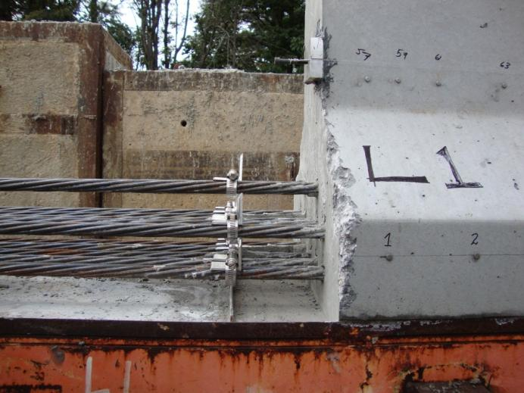
Figure 8 – Strand Drawn-in Measurement Set-up
LVDTs will be used to monitor the deflection of the test specimen during the course of testing. They will be placed at the load point, ¼ span, ½ span, and ¾ span. Physical measurements will also be made at each of these points to validate the LVDT data. Figure 8 shows the set-up which will be employed to measure the strand draw-in as loading is staged upon the specimen.
Strain gauges have been affixed to vertical shear reinforcement at one inch from top of the beam. If not damaged during the concrete pour, these will be used to measure the longitudinal strain of the transverse steel reinforcement. Response 2000 predicts that these sections will fail at the web and top flange interface and Hawkins and Kuchma tend to suggest that the intersection between the web and the bottom flange at the support will be an area of concern. Special attention will be given to potential failure in these areas.
Loading will be staged at several points during the test. The first point will be near initial cracking which Response 2000 predicts to occur at a shear of approximately 119k (load of approximately 140k). The next load point will be at the point where the longitudinal strand begins to yield which is predicted to occur at a shear of approximately 200k (load of 235k). A staged point will then be examined at the midpoint between ultimate loading and yield. This point will have a shear of 270k (load of 320k). Response 2000 predicts that the maximum shear that the section will attain is 316k (load of 372k). This will be the next examination point. From this the load will be increased at 50k increments until failure or the capacity of the load frame is reached at 460k.
The same loading points will be used for both the 0.7-inch and the 0.62-inch specimens. This will give a direct comparison in the response of these specimens.
After this data is collected it will be compiled and reduced and a final report to TDOT will be prepared and papers of our findings will be finalized.
Compression Field Analysis
As an example, consider a Type I AASHTO girder with 0.7-inch strand is shown in Figure 9 on the next page. The objective of this example is to determine the amount of shear reinforcement required to attain full service strength moment capacity using a point load of 400k as near the end of the beam as possible. The first step would be to determine the service moment capacity, then the associated shear and distance from the end of the beam using a 400k loading. The beam will be set up with an 8-inch bearing pad support at one end and an overhang on the other. The distance between the center of the supports will be 45 feet.

Using a Service Limit Analysis, a service limit moment capacity of 2,290 k-ft is calculated with the compression block depth “a” being 3.597” and “c” being 5.533”. If a 400k loading is used to achieve this moment, then the distance required to achieve the service limit moment is 6.776’ or 81.316” ( 0.143L of 45’ Span Length).

Assuming an idealized stress/strain curve for concrete where the concrete cracks at a strain of 0.001 in/in and the maximum strain in the concrete of 0.003 in/in will be used for this analysis. From this, the average longitudinal strain at the centroid of the composite section can be calculated and the shear strain can be approximated using the equilibrium and compatibility equations presented by Collins and Mitchell.

To accomplish this, longitudinal strains are calculated for the loading progression of the beam. First, the strain due to the release of the strand is calculated in the following manner:

ε_{P/A} = f_{se} A_{ps} / A_{Beam} E_{Conc Beam}  = -152 ksi ( 0.294in²/strand x 12 strands) / 276 in² / 6,768 kips  = -0.000287 in/in (Compression) | (1)
Strand: 0.70” dia., low relaxation
Area of Strand A_{p} = 0.294 in²
Ultimate Strength f_{ps} = 270 ksi
Yield Strength f_{py} = 0.9 f_{pu} =243 ksi
Stress Limits
before transfer f_{pi} = 0.75 f_{pu}
= 182 ksi
f_{se} = 152 ksi
E_{p} = 28,500 ksi
E_{s} = 29,000 ksi
E_{c} = 57,000$\sqrt{f'c}$ = 6768 ksi

36”
Next, the strain created by the eccentricity of the strand to the centroid of the beam to the top and bottom extreme fiber is as follows:
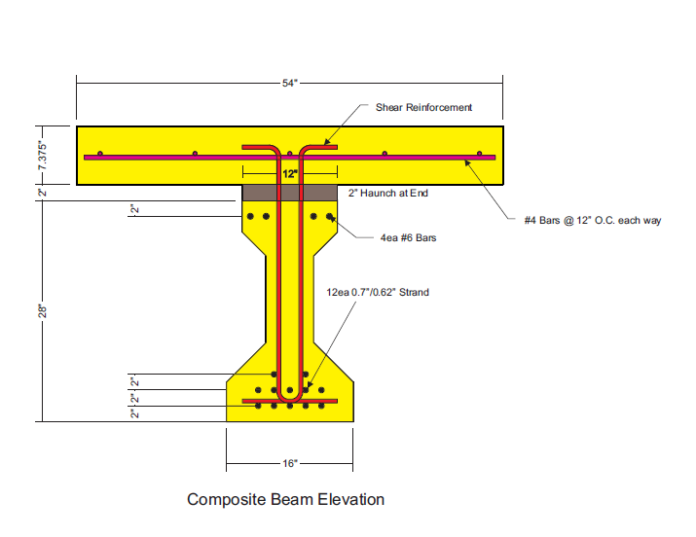
 | Beam Properties | Comp Sect  Properties
Area | 276 in² | 566 in²
h | 28 in | 37.375 in
I | 22,750 in⁴ | 72,850 in⁴
y_{b} | 12.59 in | 21.58 in
y_{t} | 15.41 in | 15.80 in
S_{b} | 1,807 in³ | 3,376 in³
S_{t} | 1,476 in³ | 4,612 in³
Weight | 288 lb/ft | 590 lb/ft
f’_{ci} | 10.6 ksi | ---
f’_{c} | 14.1 ksi | 8.5 ksi (slab)

Figure 9 – Design Example Beam Properties

ε_{Pe/S top} = f_{se} A_{ps} e / S_{top} E_{Conc Beam}  = 152 ksi ( 0.294in²/strd x 12 strands) ( 12.59” – 3.5”) / 1476 in³ / 6,768 ksi  = 0.000488 in/in (Tension ) | (2)
ε_{Pe/S bottom} = f_{se} A_{ps} e / S_{bottom} E_{Conc Beam}  = -152 ksi ( 0.294in²/strd x 12 strands) ( 12.59” – 3.5”) / 1807 in³ / 6,768 ksi  = -0.000399 in/in (Compression) | (3)
Also, the strain created by the dead weight—at the critical section—of the beam and composite deck at the top and bottom extreme fiber is:

ε_{MDLtop} = M_{DL} / S_{top} E_{Conc Beam at Release}  = -48.52 k-ft x 12 / 1476 in³ / 5,861 ksi  = -0.0000673 in/in (Compression) | (4)
ε_{MDL bottom} = M_{DL} / S_{top} E_{Conc Beam at Release}  = 48.52 k-ft x 12 / 1807 in³ / 5,861 ksi  = 0.0000550 in/in (Tension) | (5)
Rather than a simplified compression block, a limit analysis will be used to better approximate the longitudinal strain at the centroid of the strand pattern. Several equations of equilibrium must be satisfied simultaneously to satisfy a solution. These equations are as follows:

C_{TOTAL} = C₁ + C₂  C₁ = (x) (b_{f eff}) ( 0.85 f’c ) = 201.9 x  C₂ = ½ (y) (b_{f eff}) ( 0.85 f’c ) = 100.97 y | (6)
The distance (L) from the top of the composite deck to the resultant C_{TOTAL} occurs at the following location:

L = [C₁ (x/2) + C₂ (y/3 + x)] / [C₂ + C₁]  T = M_{LL}/d_{v} = 2290 k-ft x 12 in/ft / (33.875 – L) = 201.9 x + 100.97 y  y = 0.003(33.875 – x)/(ε_{ps} + 0.003) | (7)
Using Excel, a trial and error solution was found. The results are as follows:

x = 2.88”
y = 2.84”
c = 5.72”
L = 2.228”
C₁ = 582.0 k
C₂ = 286.4 k
C_{TOTAL} = 868.4 k = T
ε_{ps} = 0.029778 in/in (Tension)
ε_{top of the beam} = 0.000003 (Tension)
ε _{bottom of beam} = 0.033480 (Tension)

Summing each load condition the strain at the top and bottom of the beam becomes as follows by superposition:

ε_{top of the beam} = -0.000287 + 0.000488 – 0.000067 + 0.000003 = 0.000137 (Tension)
ε _{bottom of beam} = -0.000287 – 0.000399 – 0.000055 + 0.033480 = 0.032739 (Tension)

Considering the strain condition at the center of the beam alone, the longitudinal strain (ε_{x}) at that point is 0.016742 in/in (Tension).

The shear at a distance 6.776’ from the end of the beam is 355.4k. This creates a shear stress which can be estimated as follows:

f_{v} = f_{t} = | V_{u} – φ V_{p} |/(φ b_{v} d_{v} )  = (355.4 k – 0k) / (1.0 x 6” x 31.65” ) = 1.871 ksi | (8)

ϒ_{t} = ϒ_{xy} = 1.871 ksi / 57 $\sqrt{14,100}$ = 0.000277 in/in | (9)

Using Equilibrium equations,

ϒ_{xy} = 2 ( ε_{x} – ε₂ ) cot θ  0.000277 = 2 ( 0.016742 – ε₂ ) cot θ | (10)

cot θ = 2 ( 0.016742 – ε₂ ) / 0.000277 = 120.88 – 7220.22 ε₂ | (11)

and,
ε₂ = V / ( b_{w} d_{v} E_{WEB} ) [ tan θ + cot θ ]  = 355.4 k / ( 6” x 31.65” x 6768 ksi ) [ 1 / (120.88 – 7220.22 ε₂) + (120.88 – 7220.22 ε₂ )] | (12)

Solving for ε₂ and θ,

ε₂ = 0.022417, and θ = 89.3^{O}. | (13)
Also,

tan²θ = ( ε_{x} – ε₂ ) / ( ε_{t} – ε₂ )  giving ε_{t} = 0.022416 | (14)
And,

ε₁ = ε_{x} + ε_{t} – ε₂ ε₁ = 0.016741 | (15)

Based upon this, at this point under this loading the beam is highly influenced by the applied moment and longitudinal strain as evidenced by the steep angulation of the vertical crack angle.

Predicting Response in Shear using Modified Compression Theory

The primary difference between the Compression Theory and the Modified Compression Theory is that the Compression Theory neglects the contribution of tensile stresses in cracked concrete and a contribution is attributed to the modified compression theory. Prior to cracking, shear is carried by both diagonal tensile and compressive stress. After diagonal cracking, the tensile stress in the concrete are substantially reduced and carried across the cracks. The tensile stresses in the concrete vary from zero at the cracks to a maximum at the midpoint between the cracks.

The diagonal compressive stresses push apart the flanges of the beam while the tensile stresses pull them together. Based upon testing conducted by Vecchio and Collins equations for the average strain across the cracks have been developed which relate the average strains in these zones, the bond characteristics of the reinforcement and the type of loading.

Using our Type I beam, this example designs the stirrups using the modified compression theory. Each section to be designed will be for a distance of d_{v} cot θ starting from the edge of the support. Parameters will be taken for this section at the middle of the section and applied across the section. Near the support the angle θ will be approximately 0^{O}. A conservative θ angle of 30^{O} will be used for a d_{v} cot θ equal to ( 31.65” cot 30 = 54.82” or 62.8” from the beam end). The section will then be analyzed at 31.4” from the center of the support.

Step 1 – Determine the Shear and Moment at each 31.4” from the Center of the Support and Every 54.82” Thereafter

For this example, the reaction and moments can be determined using the following equations:

R_{L} = 400 k ( 45’ – 6.776’) / 45’ + 0.590 k/ft (56) ( 45 – 27.667’)/45 = 352.50

V_{x from 4” to 6.776’} = 352.5 - 0.590 (x)

V_{x from 6.776’ to 45’} = -47.5k - 0.590 (x)

M_{x from 4” to 6.776’} = 353.46 (x) – [(x +4”/12) (0.590)² / 2

M_{x from 6.776’ to 45’} = 353.46 (x) – (x + 4”/12)(0.590)² / 2 – 400 (x -6.776’)

Table 1 summarizes each of the calculated values for this example and the shear and moment for each section are presented there.

Step 2 – Determine d – a/2 for each Section

From equilibrium,
M_{x} / (d – a/2) = 0.85 f’c b_{f} a | (16)

a (d – a/2) = M_{x} / [0.85 f’c b_{f}] | (17)

For a moment of 923.66 k-ft and d = 33.8756”,

a (d – a/2) = 923.66 k-ft x 12 in/ft / [0.85 (8.5) (36”)] = 42.61  a²/2 – 33.875 a + 42.61 = 0  a = 1.282” | (18)
d – a/2 = 33.875 – 1.282/2 = 33.234” | (19)

The term “jd” then becomes d –a/2 but not less than 0.9 d or 0.72 h. The rest of the sections are calculated and summarized in Table 1.

Step 3 – Design the Stirrups

For each section determine v/f’c:

v/f’c = ( V_{u} /0.85 – V_{p} ) / ( b_{w} jd f’_{c} ) | (20)

For the first section, this is:

v/f’_{c} = ( 350.96 /0.85 – 0 ) / ( 6” x 33.23 x 14.1 ) = 0.147 | (21)

With this v/f’_{c} and assuming ε_{x} ≈ 0, a θ of 25^{O} is used as an initial estimate. The value of ε_{x} then can be estimated using the following equation:

ε_{x} = [ M_{u}/jd + 0.5N_{u} +0.5V_{u} cot θ – Aps fse ] / [ E_{s}A_{s} + E_{p}A_{ps} ]  = [923.67x12/33.23 + 0 +0.5(350.96) cot(25)–12 x 0.294 x 152]/[ 28,500(12) 0.294 ]  = 0.001726 in/in | (22)

From Table 1, θ is 34^{O} by interpolation. Revising the estimate for θ to 33^{O}, ε_{x} becomes 0.000671 in/in. Again from Table 1, θ = 33^{O} and β = 2.08.

Next the concrete capacity can be expressed as

V_{c} = β $\sqrt{f'c}$ b_{w} jd = 2.08 (14,100)^{1/2} (6”)(33.23”) /1000 lb/k = 49.2 k | (23)

This,
V_{s} = V_{u} / φ – V_{c} - V_{p}  = 350.96 – 49.2 – 0 = 301.7 k | (24)

Also,

V_{s} = A_{v} f_{y} jd cotθ / s | (25)
Assuming double legged #4 bars

s ≤ 0.4 in² ( 60 ksi ) (33.23 in) cot(33) / 301.7 k = 4.07” Use 4”

Minimum shear reinforcement spacing is as follows:

s ≤ A_{v} f_{y} / 50 b_{w} = 0.4 in² (60,000 psi) / 50 (6”) = 80” | (26)

Spacing Requirements:

s ≤ 0.75 h = 0.75(37.375”) = 28.0” | (27)

Step 4 – Double Check the Longitudinal Reinforcement

The longitudinal reinforcement must be capable of resisting the force generated by the moment and concrete pressure applied to the horizontal reinforcement. This is given by the following equation:

V_{s ACT} = 0.4 in² x 60 ksi x 33.23” cot (33) / 4” = 307.0 k  A_{ps} f_{ps} = M_{u}/(φ jd) + ( V_{u} / φ – 0.5 V_{s} – V_{p} ) cot θ  = 923.67 k-ft x 12 / 33.23 + (350.96 k – 0.5 x 307.0 k ) cot (33)  f_{ps} = 637.6 k / (12 x 0.294 in²) = 180.7 ksi | (28)
Check to see if this stress can be developed at this section. Using AASHTO’s equations, the transfer length is equal to 60 d_{b}, which is 42” and the development length is as follows:

l_{d} ≥ κ [ f_{ps} – 2/3 f_{pe} ] d_{b} (AASHTO Equation 5.11.4.2-1)  = 1.6 [ 270 ksi – 2/3 (152 ksi) ] (0.5”) = 135” | (29)
This section is at 31.4” + 4” from the end of the beam to the center of the support, or 35.4” < transfer length predicted by AASHTO. As a result, a bond failure is predicted using this equation. Based upon small-scale testing by Xin, Cabage, and others the transfer length for this size strand will likely occur at a distance of approximately 20” and the development length at approximately 28”. If the small-scale tests are predictive of multiple strand performance, then the strand should be fully developed at this section, and bond slip failure should not occur under this loading.

Table 1 - Summary Data for each Beam Section

No. | x, ft | V_{u}, kips | M_{u}, kip-ft | d - a/2, in | jd, in | v/f'c | θ | ε_{x,} in/in | β | V_{c}, kips | s, in | f_{ps}, ksi
1 | 2.62 | 351.0 | 924 | 33.2 | 33.2 | 0.24360 | 33 | 0.00067103 | 2.08 | 49.2 | 4 | 181.9
2 | 6.78 | 51.5 | 2386 | 32.2 | 32.2 | 0.03693 | 49.7 | 0.00373825 | 1.22 | 28.0 | 28 | 261.9
3 | 7.19 | 51.7 | 2366 | 32.2 | 32.2 | 0.03709 | 49.3 | 0.00366357 | 1.23 | 28.2 | 28 | 259.8
4 | 11.75 | 54.4 | 2138 | 32.4 | 32.4 | 0.03882 | 45.8 | 0.00281706 | 1.44 | 33.2 | 28 | 236.9
5 | 16.32 | 57.1 | 1902 | 32.5 | 32.5 | 0.04052 | 42.8 | 0.00195414 | 1.74 | 40.3 | 28 | 213.9
6 | 20.89 | 59.8 | 1660 | 32.7 | 32.7 | 0.04220 | 38.6 | 0.00109612 | 2.25 | 52.4 | 28 | 192.5
7 | 25.46 | 62.5 | 1410 | 32.9 | 32.9 | 0.04386 | 32.8 | 0.00026514 | 3.29 | 77.1 | 28 | 176.5
8 | 30.03 | 65.2 | 1152 | 33.1 | 33.1 | 0.04549 | 28 | -0.00056436 | 5.24 | 123.5 | 28 | 168.8
9 | 34.60 | 67.9 | 888 | 33.3 | 33.3 | 0.04710 | 28 | -0.00151187 | 5.24 | 124.2 | 28 | 142.0
10 | 39.16 | 70.6 | 616 | 33.5 | 33.5 | 0.04869 | 28 | -0.00247456 | 5.24 | 124.9 | 28 | 114.8
11 | 43.73 | 73.3 | 337 | 33.6 | 33.6 | 0.05026 | 28 | -0.00345191 | 5.24 | 125.6 | 28 | 87.1
12 | 45.00 | 74.1 | 258 | 33.7 | 33.7 | 0.05069 | 28 | -0.00372561 | 5.24 | 125.8 | 28 | 79.4

Determine Shear Design Using AASHTO General Procedure

The shear reinforcement is designed for the same sections as the modified compression theory. Only one section is presented and the rest are summarized in Table 2.

Step 1 - Determine Crack Spacing Parameter, s_{xe}

s_{xe} = s_{x} [ 1.38 / (a_{g} + 0.63)]  where,  s_{x} = the lesser of dv or the maximum distance between  layers of crack control, where the area of the  reinforcement is not less than 0.003 b_{v} s_{x}.  Since no longitudinal reinforcement is provided, s_{x} = d_{v}. For the first section, d_{v} = 33.2”.  a_{g} = 0.75” – Assumed Value  s_{xe} = 33.2” [ 1.38 / (0.75” + 0.63)] = 33.2” | (30)

Step 2 - Determine Net Longitudinal Tensile Strain in Section at Centroid of Tensile Reinforcement, є_{s}

є_{s} = [ |M_{u}|/d_{v} + 0.5 N_{u} + |V_{u} – V_{p}| - A_{ps} f_{po} ] / [E_{s} A_{s} + E_{p} A_{ps}]  = 0.000176 in/in  M_{u} = 924 k-ft  d_{v} = 33.234”  N_{u} = 0.0 – No Axial Load  V_{u} = 351.0 k  V_{p} = 0 k  A_{ps} = 12 strands x 0.294 in²/strand = 3.528 in²  f_{po} = 0.7 fpu = 0.7 x 270ksi = 189 ksi  E_{s} = 29,000 ksi; A_{s} = 0 in²  E_{p} = 28,500 ksi; | (31)
Step 3 - Determine θ and β

θ = 29 + 3500 є_{s} = 29.62 degrees (5.8.3.4.2-3)  β = [ 4.8 / (1 + 750 є_{s} ) ] (5.8.3.4.2-1)  Assumes Minimal Amount of Shear Reinforcement  β = 4.24 | (32)
Step 4 - Determine Vc

Vc = 0.0316 β $\sqrt{f^{'}c}$ b_{v} d_{v} = 0.0316 (4.24) (14.1)^{1/2} (6”) (33.2”) = 100.3 k | (33)

Step 5 - Determine V_{s Required}

ФV_{s Required} = Vu – ФVc – ФVp = Vu/Ф – Vc – Vp  Note: For this analysis φ = 1.0  = 351.0k – 100.3k – 0k = 250.7 k | (34)
Step 6 - Determine Transverse Shear Size and Spacing using Double #4 Stirrups

V_{s} = [A_{v} f_{y} d_{v} cot θ ] / s  250.7k = [ (2 x 0.2in²) ( 60 ksi) (33.2”) cot(29.63) / s  s = 5.60” use 5” V_{s} @ 5” = 280.2k | (35)

Step 7 - Determine Minimum Steel Requirement

A_{v} >= 0.0316 $\sqrt{f^{'}c}$ ( b_{v} s / f_{y}) (5.8.2.4-1)  = 0.0316 (14.1)^{1/2} (6”) (18”) / (60 ksi)  = 0.213 in² < 0.4 in² ----- OK | (36)

Table 2 – Summary Data for each Beam Section

No. | x, ft | V_{u}, kips | M_{u}, kip-ft | d - a/2, in | jd, in | s_{xe} | ε_{x,} in/in | θ | β | V_{c}, kips | s, in | f_{ps}, ksi
1 | 2.62 | 351.0 | 924 | 33.2 | 33.2 | 33.23387 | 0.000176 | 29.62 | 4.24 | 100.3 | 5.60 | 207.1
2 | 6.78 | 51.5 | 2386 | 32.2 | 32.2 | 32.16356 | 0.002735 | 38.57 | 1.57 | 36.0 | 28.00 | 267.9
3 | 7.19 | 51.7 | 2366 | 32.2 | 32.2 | 32.17879 | 0.002659 | 38.31 | 1.60 | 36.7 | 28.00 | 266.0
4 | 11.75 | 54.4 | 2138 | 32.4 | 32.4 | 32.35051 | 0.001797 | 35.29 | 2.04 | 47.1 | 28.00 | 245.1
5 | 16.32 | 57.1 | 1902 | 32.5 | 32.5 | 32.52572 | 0.000917 | 32.21 | 2.84 | 65.8 | 28.00 | 226.6
6 | 20.89 | 59.8 | 1660 | 32.7 | 32.7 | 32.70430 | 0.000020 | 29.07 | 4.73 | 110.1 | 28.00 | 215.9
7 | 25.46 | 62.5 | 1410 | 32.9 | 32.9 | 32.88613 | 0.000000 | 29.00 | 4.80 | 112.4 | 28.00 | 190.5
8 | 30.03 | 65.2 | 1152 | 33.1 | 33.1 | 33.07111 | 0.000000 | 29.00 | 4.80 | 113.0 | 28.00 | 164.1
9 | 34.60 | 67.9 | 888 | 33.3 | 33.3 | 33.25912 | 0.000000 | 29.00 | 4.80 | 113.7 | 28.00 | 137.2
10 | 39.16 | 70.6 | 616 | 33.5 | 33.5 | 33.45007 | 0.000000 | 29.00 | 4.80 | 114.3 | 28.00 | 109.9
11 | 43.73 | 73.3 | 337 | 33.6 | 33.6 | 33.64385 | 0.000000 | 29.00 | 4.80 | 115.0 | 28.00 | 82.2
12 | 45.00 | 74.1 | 258 | 33.7 | 33.7 | 33.69811 | 0.000000 | 29.00 | 4.80 | 115.2 | 28.00 | 74.5

Determine Shear Design Using AASHTO Simplified Procedure

The shear reinforcement is designed for the same sections as the modified compression theory. Only one section is presented and the rest are summarized in Table 3.

Step 1 - Determine V_{ci}

V_{ci} = 0.02 $\sqrt{f^{'}c}$ b_{v} d_{v} + V_{d} + V_{i} M_{cre}/M_{max} ≥ 0.06 $\sqrt{f^{'}c}$ b_{v} d_{v}  V_{d} = Shear Force at Section due to Unfactored Dead Loads  = 12.7 k  V_{i} = Factored Shear Force at Section due to Externally-applied  Loads Occurring Simultaneously with M_{max} ( φ = 1.0 )  = V_{u} – V_{d} (without factor) = 350.1 k – 12.7 k = 337.4 k  M_{cre} = Moment Causing Flexural Cracking at Section due to  Externally-applied Loads  = [ 6 $\sqrt{f^{'}c}$ + f_{pe} – f_{d}] S_{bc}  = [ 712 psi + 4,639 psi – 221 psi] (3,376 in³ /12,000) = 1,443 k-ft  f_{pe} = P_{se}/A + P_{se} e / S_{b}  = (12 strands x 0.294 in² x 152 ksi) / 276 in²  + 536 k ( 9.09” ) / 1,807 in⁴ = 4.639 ksi  f_{d} = M_{DL} / S_{b} = 33.3 k-ft x 12 / 1,807 in⁴ x 1,000 = 221 psi  M_{max} = Maximum Factored Moment at Section due to  Externally-applied Loads  = M_{u} – M_{d} = 924.0 – 33.3 = 890.7 k-ft  V_{ci} = 0.02 $\sqrt{f^{'}c}$ b_{v} d_{v} + V_{d} + V_{i} M_{cre}/M_{max} ≥ 0.06 $\sqrt{f^{'}c}$ b_{v} d_{v}  = 0.02 (14.1)^{1/2} (6”) ( 33.2”) + 12.7 k + 338.3 x 1,443 k-ft / 890.7 k-ft  = 576 k ≥ 0.06 (14.1)^{1/2} (6”) (33.2”) = 44.9 k  Use 576 k | (37)  (38)  (39)  (40)  (41)

Step 2 - Determine V_{cw}

V_{cw} = ( 0.06 $\sqrt{f^{'}c}$ + 0.30 f_{pc}) b_{v} d_{v} + V_{p}  f_{pc} = Compressive Stress in Concrete (after allowances for all  losses) at centroid of cross section resisting externally  applied loads. This stress is due to both prestress and  moments resisted by precast member acting alone.  f_{pc} = P_{se}/A – P_{se} e (y_{bc} – y_{b})/I + M_{D} (y_{bc} – y_{b}) / I  = 536 k / 276 in² – 536 k ( 9.09 in ) ( 21.58 – 12.59 ) in / 72,850 in⁴  + 33.2 k-ft x 12 in/ft ( 21.58 – 12.59 ) in / 72,850 in⁴  = 1.390 ksi  V_{cw} = ( 0.06 $\sqrt{f^{'}c}$ + 0.30 f_{pc}) b_{v} d_{v} + V_{p}  = [ 0.06 (14.1)^{1/2} + 0.30 (1.390 ksi)] (6”) (33.2”) + 0 k = 128 k  For Shear Capacity Use 128 k < 576 k | (42)  (43)  (44)

Step 3 - Determine V_{s} / s

V_{s} = [A_{v} f_{y} d_{v} cot θ ] / s Assumes α = 90º  where V_{ci} < V_{cw}  cot θ = 1.0  where V_{ci} > V_{cw}  cot θ = 1.0 + 3 [ f_{pe} / $\sqrt{f^{'}c}$ ] ≤ 1.8 (5.8.3.4.3-4)  = 1.0 + 3 [ 4.639 ksi / (14.1)^{1/2} ] = 4.71 ≤ 1.8  Use 1.8  For Double #4 Stirrups  s = [A_{v} f_{y} d_{v} cot θ ] / ( V_{u Required} / Ф – V_{c} )  = [ 0.4 in2 ( 60 ksi) ( 33.2” ) (1.8) ] / [( 351.0 k) /1.0 – 128 k ] = 6.44”  Use 6” | (45)  (46)  (47)

Table 3 – Summary Data for each Beam Section

No. | x, ft | V_{u}, kips | M_{u}, kip-ft | d - a/2, in | jd, in | M_{d}, k-ft | f_{d}, psi | M_{cre,} k-ft | V_{ci}, k | f_{pc}, ksi | V_{cw}, k | cot θ | s, in
1 | 2.62 | 351.0 | 924 | 33.2 | 33.2 | 33.2 | 221 | 1443 | 576 | 1.390 | 128.08 | 1.8 | 6.44
2 | 6.78 | 51.5 | 2386 | 32.2 | 32.2 | 86.1 | 571 | 1345 | 50 | 1.468 | 12.79 | 1.8 | 28.00
3 | 7.19 | 51.7 | 2366 | 32.2 | 32.2 | 91.3 | 606 | 1335 | 51 | 1.476 | 12.63 | 1.8 | 28.00
4 | 11.75 | 54.4 | 2138 | 32.4 | 32.4 | 149.3 | 991 | 1227 | 53 | 1.562 | 10.91 | 1.8 | 28.00
5 | 16.32 | 57.1 | 1902 | 32.5 | 32.5 | 207.3 | 1377 | 1118 | 57 | 1.648 | 28.00 | 1.8 | 28.00
6 | 20.89 | 59.8 | 1660 | 32.7 | 32.7 | 265.3 | 1762 | 1010 | 62 | 1.734 | 28.00 | 1.8 | 28.00
7 | 25.46 | 62.5 | 1410 | 32.9 | 32.9 | 323.3 | 2147 | 901 | 69 | 1.820 | 28.00 | 1.8 | 28.00
8 | 30.03 | 65.2 | 1152 | 33.1 | 33.1 | 333.3 | 62 | 1488 | 123 | 1.834 | 28.00 | 1.8 | 28.00
9 | 34.60 | 67.9 | 888 | 33.3 | 33.3 | 298.4 | -497 | 1645 | 182 | 1.783 | 28.00 | 1.8 | 28.00
10 | 39.16 | 70.6 | 616 | 33.5 | 33.5 | 263.5 | -1056 | 1802 | 324 | 1.731 | 28.00 | 1.8 | 28.00
11 | 43.73 | 73.3 | 337 | 33.6 | 33.6 | 228.6 | -1615 | 1960 | 1122 | 1.679 | 28.00 | 1.8 | 28.00
12 | 45.00 | 74.1 | 258 | 33.7 | 33.7 | 218.9 | -1770 | 2003 | 3142 | 1.665 | 28.00 | 1.8 | 28.00

Analysis of Composite Beam using Response 2000

The Response 2000 program is a free program developed using the modified compression theory. This was developed by Bentz and Collins (2001). This program models a beam and examines the projected response of a member—for Response 2000, a flexural member—under the combined moment and shear. A beam section is created using either standardized sections or customized sections per the user.

Following the description of a section, the user can then specify concrete strengths, the placement of a composite deck, the location of transverse reinforcement, location of prestressing strand, and mild longitudinal steel reinforcement. Detailed material properties for the steel reinforcement can be used or default parameters based upon various testing by researcher can be specified. Experimental reinforcement parameters can be included—such as 0.7-inch and 0.62-inch strand—by modifying the rebar.dat file and including these in the file. This was done to include these strand sizes into the program.

The model takes a section, incremental loading approach to estimating shear and moment capacity, crack spacing and width, load capacity, deflection, tensile and compression stress/strain, as well as other parameters. For a sectional analysis, two control diagrams are created—a shear versus loading step control and a Moment versus rotation control. After the analysis is run, the user can take these diagrams and step through the loading diagram. The influence that this stepping has is then reflected upon cross sectional plots of various parameters which include force, moment, longitudinal strain at depth, and others.

Using this program, an analysis was conducted for the Type I girder. Four different runs were conducted in this study. All runs examined the section at 6.776 feet from the center of the support, but each had different vertical shear reinforcement spacing. The vertical reinforcement spacing used was 4, 6, 8, and 28 inches. A moment to shear ratio was included in the loading parameter of the program. In this case, the maximum design moment was paired with the maximum shear which gives a ratio of moment to shear of 6.776:1.0.

From the analysis many different parameter predictions can be readily developed and predictions of capacity and failure mode and behavior can be assessed. The following provide figures of analysis output obtained from the four aforementioned runs of Response 2000. With each group of figures, a comparison of the behavior with the change in reinforcement spacing is given.
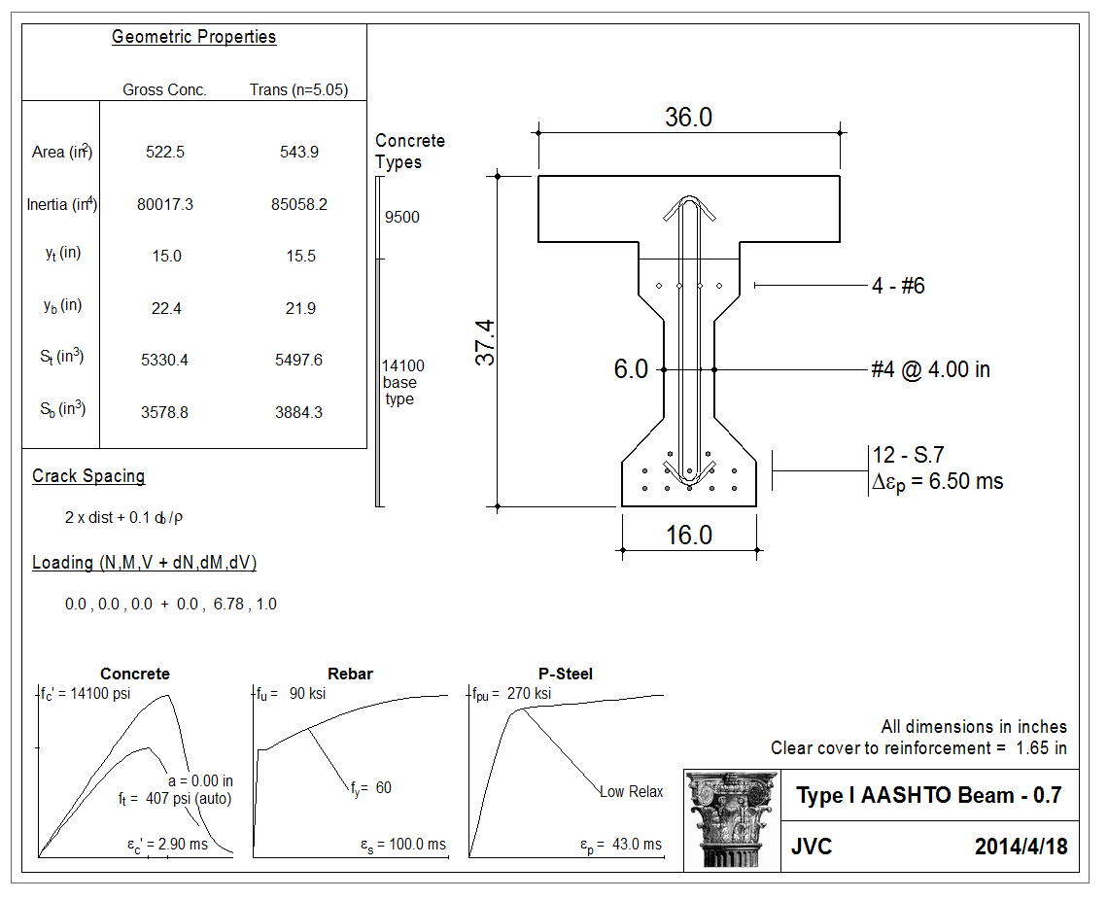
Figure 10 – Example of Material and Section Inputs into Response 2000,
4-inch Transverse Shear Spacing

Figure 10 presents a graphical summary of the parameters used for the Type I beam. Response 2000 automatically calculates the section properties and creates a cross sectional drawing of the test specimen. This presentation is a relative fast way of checking that the input parameters were placed into the computer properly.
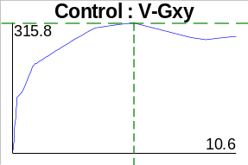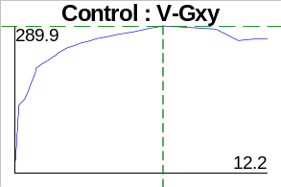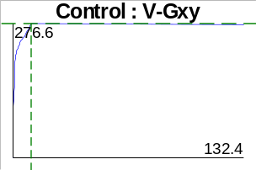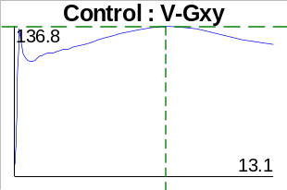
4-inch Spacing 6-inch Spacing 8-inch Spacing 28-inch Spacing

Figure 11 – Shear Control Curve for Varying Reinforcement Spacing

In Figure 11 below is a collection of shear control graphs for four different transverse reinforcement levels. Response 2000 predicts a different maximum shear capacity and a different mode of failure for the beam. For the 4-inch and 6-inch reinforcement level, a relatively high shear capacity is given, 315.8k and 289.9k respectively. The beam with this type of reinforcement level is predicted to have a ductile failure. The curve shows a straight line response to the cracking strength of the concrete followed by a second straight line portion to yield and then a ductile portion where strain hardening of the reinforcement occurs in the transverse reinforcement.
Stage 1 - No Loading, V = 0 k, M = 0 k-ft
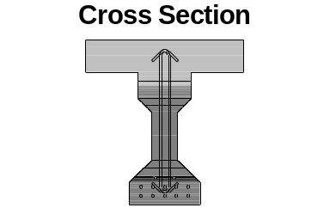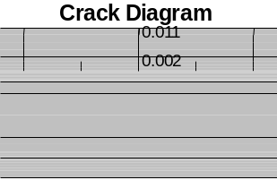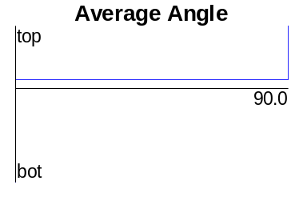
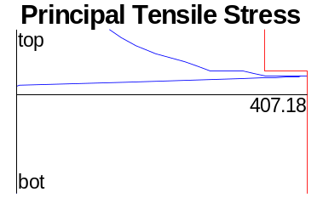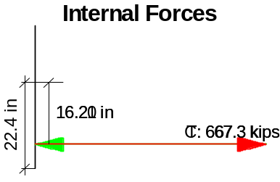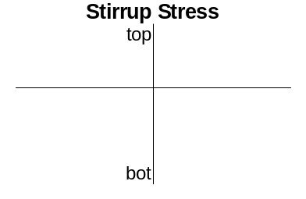
Stage 2 – At Initial Cracking, V = 134 k, M = 911 k-ft
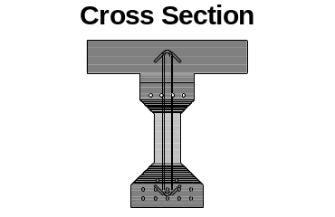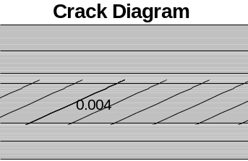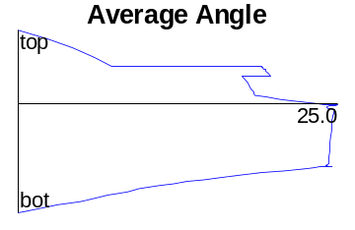
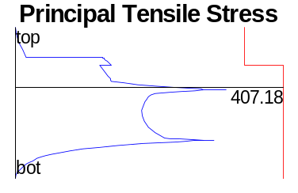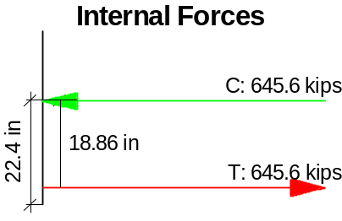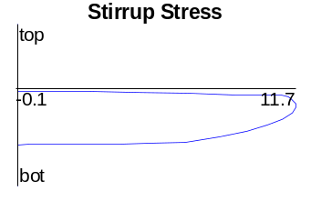

Figure 12 – Predicted Type I Beam Response to Progressive Loading

The capacity level is reduced for the 6-inch when compared to the 4-inch spacing, but the behavior is similar and is what would be expected for a ductile failure.
Stage 3 – At Initial Yield, V = 213.2k, M = 1468 k-ft
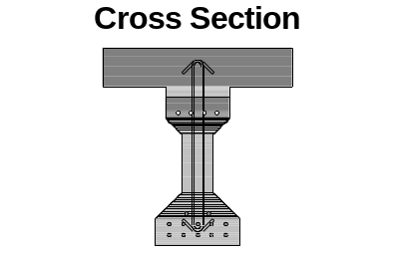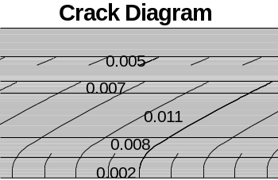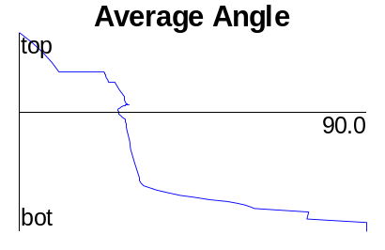

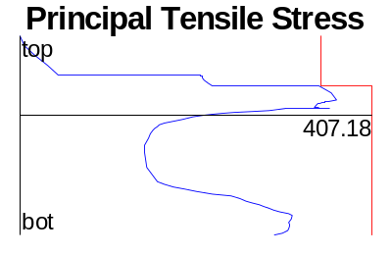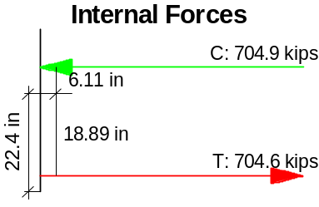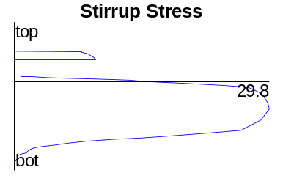
Stage 4 – At Maximum Shear Capacity, V = 316 k, M = 2141 k-ft
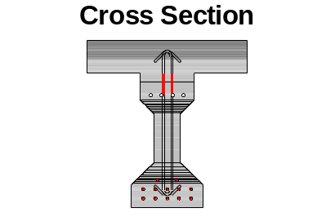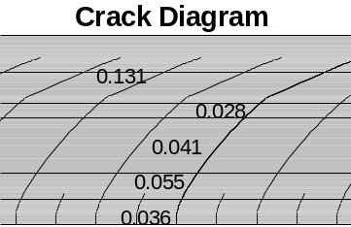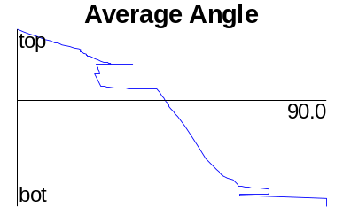
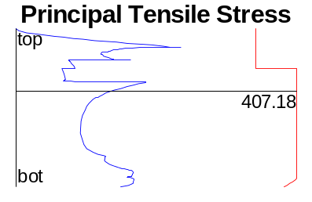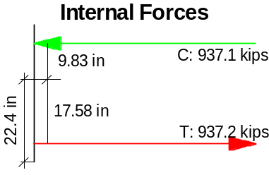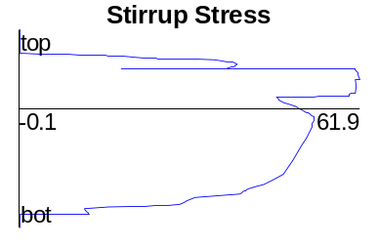
Figure 12 (continued) – Predicted Type I Beam Response to Progressive Loading

Response 2000 predicts a different type failure mode for the 8-inch and 28-inch spacing under the prescribed loading condition. With the 8-inch spacing, the steel quickly goes to yield and to strain hardening. For the 28-inch spacing the capacity is diminished to about one-third of the 4-inch capacity. Some strain hardening occurs within the transverse reinforcement, but the specimen will fail prematurely because of a lack of reinforcement under the given load.

This is the type behavior that is generally to be expected when the shear reinforcement is being varied for the same type of beam subjected to a flexural loading.

Figure 12, which is presented upon three pages shows a progression for the failure of the Type I example with transverse reinforcement at 4-inch spacing. Six different graphs are presented that show the various predicted parameters at each loading stage. The first graph is a cross section which of itself is not very interesting. The programmers added some interesting touches to highlight the constantly changing load condition of the section. In the cross section, the concrete and reinforcement are shown, but change color to indicate a change of state.

For the concrete, the lighter gray color represents an area of tensile stress while the darker gray indicates compression. Note the color progression. At zero load, the concrete beam is in compression and the deck is shown to be in tension. As the loading increases at Stage 2, the deck and flanges of the section remain in compression, but a tensile force is predicted to develop in the web of the section near the centroid of the section. At Stage 3, moment has a stronger influence over the behavior of the section and the tensile zone extends to the extreme bottom fiber of the section. What is interesting to note is that a compression zone remains in the vicinity of the longitudinal mild steel reinforcement in the top flange of the section at this Stage. By Stage 4, maximum shear capacity, the compression zone lies entirely within the deck and a longitudinal tensile stress exists in the lower section of the deck, haunch, and throughout the beam section as well.
Stage 5 – At Failure, V = 283 k, M = 1920 k-ft
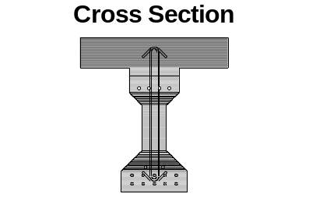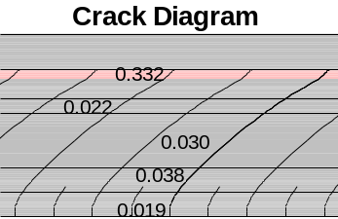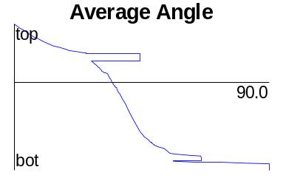
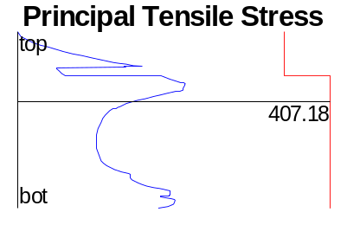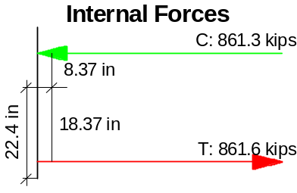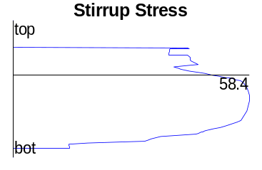
Figure 12 (continued) – Predicted Type I Beam Response to Progressive Loading

Stress in the reinforcement of the section is illustrated by the changing of the color of the reinforcement. As seen in Stage 1, the reinforcement is represented by hollowed circles for strand and mild longitudinal reinforcement. As the stress condition changes, the reinforcement color changes to a dark red when the reinforcement is yielded and a bright red when the strain of the reinforcement is within the strain hardening zone. Also note that gray is also used in the reinforcement to indicate compression. Examining Stage 3, we can see that the concrete is in a state of tension, but that the strand is still in a net state of compression due to the initial prestressing force applied to the strand. By Stage 4, the strand has yielded in tension and the transverse reinforcement has yielded and is in the state of strain hardening. Once permanent plastic deformation has occurred—Stage 5—the capacity of the section is reduced in shear and in moment and with the reduced capacity stress is alleviated from the section.

The results shown by this sectional analysis seem reasonable for this load progression. The second set of drawings is the crack diagrams. At Stage 1, the Response 2000 program predicts that tensile will develop at the top of the deck. While tensile cracks were observed in the top of the beam, this cracking will not extend to the top of a deck poured subsequent to the beam itself. Therefore, it is assumed that the program applies the initial strain 0f 6.5 ms assigned to the strand to the entire section upon release. This could distort the strain distribution throughout the section and causes some error in the predictions.

At Stage 2, Response 2000 predicts that web cracking will begin to occur. The cracks are predicted to be 0.004 inches in width and based upon the crack angle graph expected to be angulated at 23^{O} from the axis of longitudinal reinforcement. The principal tensile stress graph would tend to indicate that the principal tensile stress has not exceeded the tensile capacity of the beam concrete. This seems to be in error as the principal tensile stress must be exceeded before cracking can initiate. For this loading, it does seem reasonable that the compression field may be angulated at 23^{O}, but additional loading—beyond the rupture strength of the concrete—is required for cracking to ensue.

At Stage 3, the compression field at the bottom fiber of the section becomes highly influenced by the added moment onto the section. Response 2000 predicts that the crack angle is nearly vertical under this loading to the interface between the bottom flange and the web. The compression field becomes steeper and now Response 2000 estimate the width of the cracks to be nearly 0.011 inches.

At Stage 4, Response predicts that the compression field and associated cracking within the web of the section to be between 45 and 60 degrees. Crack widths by this analysis are expected to be 0.055 inches at the bottom flange and web interface and 0.131 inches at the interface between the haunch and beam section.

At Stage 5, final failure is predicted and shown graphically by the yielding of the concrete at the intersection of the top flange and the web of the section. This is shown by the concrete at this section being colored pink. It will be interesting to see if this type of failure is actually observed when testing the specimen.

Another observation is that while we went through a tremendous amount of work to exude exactness in the Response 2000 model, the final predicted compression field angulation is still approximately 45^{O} for this section under the given shear to moment ratios.

Two other sets of graphs are presented in Figure 12. These are an internal forces plot which show the compression and tensile force acting at the compression block and the centroid of the strand respectively and a plot predicting the stirrup stress with depth. Using the Compression Block model a moment capacity of 2,290 k-ft was approximated for this section under the loading considered. This is to be compared with a capacity of 2,141 k-ft predicted by Response 2000. This is a 6.5% difference for the two predictions which is relatively close. Testing will reveal the true capacity.

Response 2000 predicts that at Stage 4, a maximum stirrup stress of 61.9 ksi will be attained at maximum load capacity. This is predicted to occur from the interface of the deck and beam through the top flange of the beam portion of the section. Strain gauges have been mounted within this section of the test specimen to compare the strain results with the Response 2000 predictions.

Discussion of AASHTO Equation 5.8.3.3-2
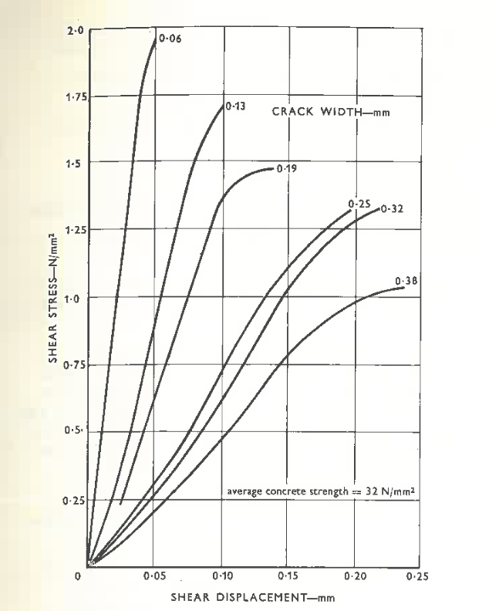
Figure 13 – Figure 5 from Taylor (1970)

According to AASTHO, equation 5.8.3.3-2 is intended to ensure that the concrete in the web of the beam will not crush prior to yield of the transverse reinforcement. This limit was loosely based upon research conducted by Taylor, Fenwick, Paulay, Gergeley, and Marti. Early in the development of shear theory, shear was thought to be carried by the concrete compression zone and the dowel action provided by the longitudinal reinforcement. According to Taylor, Gergeley was one of the first to demonstrate that cracked concrete in the web could contribute to the resistance of a flexural member in shear. Taylor concluded that Gergeley overestimated this contribution due to his test mechanism procedure.

Fenwick and Paulay developed a testing mechanism which would measure shear transfer across a crack by varying the crack width. Figure 13 shows Fenwick and Pauley’s results. Notice as the crack width is increased that the capability of the section to restrain shear forces is reduced. For this test, the shear capacity was reduced by approximately 50% when the crack width was increased by 0.32 mm.
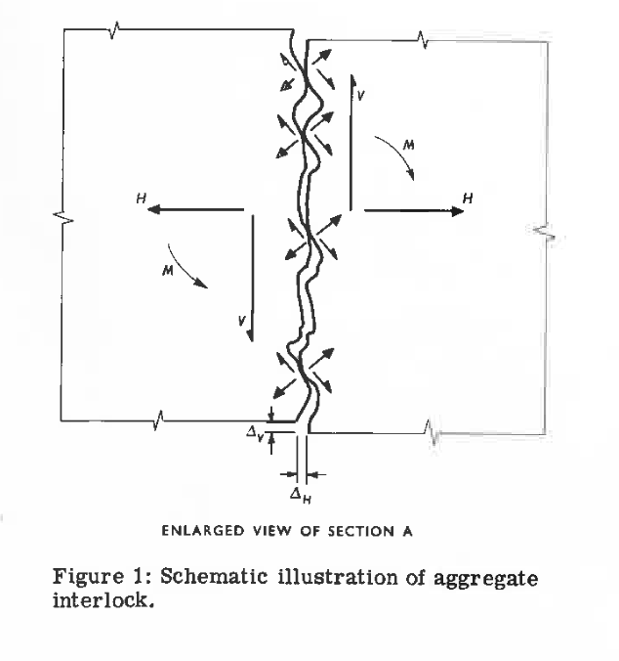
Figure 14 – Aggregate Interlock Representation from Taylor (1970)
In Taylor’s work, he refined the test mechanism and conducted several tests which assessed the contribution of cracked concrete to shear by varying parameters of displacement ratio and aggregate size, concrete strength, aggregate type, and stirrups. Figure 14 graphically presents Taylor’s concept of aggregate interlock across a crack. As the crack is subjected to shear, the shear force is transferred as each section of the member rubs across each other. The contact area between the sections can transfer force as long as these sections remain in contact. As the cracks separate, the ability to transfer the shear force across the cracks is reduced as indicated by the Fenwick and Paulay research.
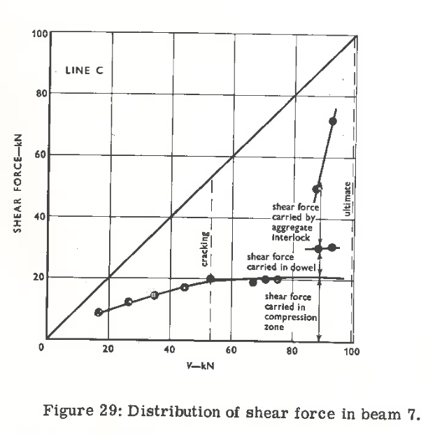
Figure 15 – Distribution of Shear Force from Taylor (1970)

In Taylor’s study, several specimens which were designed to assess the variation of each of the discussed properties were conducted and the contribution of shear stress to the dowels, compressive concrete, and aggregate interlock were measured and plotted. The plots were similar to the one presented in Figure 15.

In this case, the shear contribution from the compressive zone was about 25%, dowel action contributed about 10%, and the remainder was attributed to aggregate interlock—65%. In terms of average percentages, Taylor found that the compressive zone contributed between 20 and 40% to the shear resistance of a member, dowel action typically contributed between 15 and 25%, and aggregate interlock contributed approximately 33 and 50%. These percentages are highly dependent upon the width of the crack that the force is being transmitted.

Marti (1985) recommended that when using variable-angle truss models it is necessary to use an effective concrete strength less that the cylinder crushing strength (Collins and Mitchell, 1991). A value of 0.6f’_{c} was recommended by Marti. If an average contribution to the web is realized—or 41.5%—is applied to 0.6 f’_{c}, then a reasonable stress which can be applied to the web would be 0.415(0.6 f’_{c}) = 0.249 f’_{c} or 0.25 f’_{c}. Applying the shear force across the entire shear area yields a shear force of 0.25 f’_{c} b_{v} d_{v}. Adding any contribution due to draped or harped longitudinal reinforcement gives equation 5.8.3.3-2.

Taylor (1970) recommended that further investigation was necessary to determine the impact of adding additional types of reinforcement and how that reinforcement impacts the transfer of shear across the web of the beam section.

Hawkins and Kuchma (2007) presented a comprehensive research report regarding the use of high-strength concrete and ability of current AASHTO shear design methods to correctly predict the response in flexural members. Their findings were presented to the Transportation Research Board in report NCHRP Report 579. In this research, there was a sharp contrast in the upper limit of shear allowed by the AASHTO Standard Design Specifications and the AASHTO Load Factor and Resistance Design Specifications. As the concrete design strength was increased, this allowable limit for LRFD continued to diverge. Their research included testing which would assess the reasonableness of this limit as it pertained to high-strength concrete with recommendations for inclusion into a revised AASHTO specification.

In their assessment, they reported that this limit was derived from the modified compression theory when the compression softening model is used as a precaution against concrete crushing before the transverse shear reinforcement yielded. Hawkins and Kuchma remarked that the diagonal stress field model assumes that the compression field is uniformly distributed throughout the cross section of the component where shear is applied. They observed that as the flow of forces migrated to a support at the end zone of a beam that the compressive forces were magnified at the intersection of the flange and web. This can be a problem particularly with heavily shear-reinforced flexural members that are supported only at the bottom flange.

For heavily-reinforced members, this magnification can result in a premature concrete crushing—a brittle failure mode—at the flange/web interface. Based upon their findings, they proposed that the upper shear limit be reduced to 0.18 f’_{c} from 0.25 f’_{c}. While this was their recommendation, they also conceded that there was not sufficient testing conducted within their study to demonstrate this conclusively. They did suggest that where this was an issue that the end zone design be performed using the strut-and-tie method taking into account the detailed geometry at the end zone. Also they recommended the use of wider supports, distributed horizontal reinforcement, and draped strands that would allow the flexural component to sustain a higher level of sustained compression.

Even with these observations, Hawkins and Kuchma concluded that the level of maximum shear—0.25 f’_{c}—was reasonable.

