Mountain Dew’s Brand Personality

Cara Hollenbeck
Mark Collins
UH 498
May 5 2012

Mountain Dew’s Brand Personality
Just as with people, every company has a personality that it presents to the public. Even a lack of any personality at all is in itself a personality. Simply defined, brand personality is the set of human characteristics associated with a brand (Moser 67). In his renowned book, Confessions of an Advertising Man, David Ogilvy states “the manufacturer who dedicates his advertising to building the most sharply defined personality for his brand will get the largest share of the market at the highest profit” (102). This phenomenon is the result of a brand’s personality boosting brand equity, known as the “set of brand assets and liabilities linked to a brand…that add to or subtract from the value provided by a product or service to a firm and/or to that firm’s customers” (D. Aaker, “Managing Brand Equity” 15).
This brand value exists in the mind of the consumer and can be formed in several ways. A brand’s personality has the ability to differentiate its products in the market place. Differentiation can make the brand recognizable and increases brand awareness, thus increasing equity (Pullig). With high brand equity also comes customer loyalty. Loyal customers may perceive the brand’s products to be of a higher quality than competitors’. This perceived quality may then allow the brand to price their products at a premium. When these measure combine, it can increase the brand’s sales and even provide free advertising: provide positive word of mouth from consumers.
A lack of brand personality can be just as impactful; it leaves a company vulnerable to losing its current and potential customer base to the competition (Moser 68).

Literature Review
Pierre Martineau was an early champion for the idea of brand personality. In his article The Personality of the Retail Store, he set out to answer the question of why customers prefer one store to another. For example, he found that a leading retail grocery store chain was far out selling every other grocery store in Chicago even though the stores offered identical prices, services, and products. He declared that a store’s personality was an essential operative force in the determination of a store’s customer body (Martineau 47). Essentially, the way that the leading grocery store positioned itself in the mind of its customer base was more favorable to that of the other stores.
Since the 1950’s, a multitude of research has been done on the subject of brand personality for both consumers and businesses. Consumers think of their possessions as part of themselves, and can reinforce their sense of self through the products they buy. These products not only symbolize the consumer’s identity, but also can communicate aspects of the consumer to others (Batra, Myers, and D. Aaker 340). Using the notion that consumers associate self-concepts with brands allows marketers to position and promote brands with a higher rate of effectiveness to carefully chosen target markets (Levy 117). Marketers also use brand personality as a vital way to create a competitive advantage in customers’ minds for a brand in a product category that is otherwise identical to its competitors (Moser 47). Other uses include using brand personality as a tool to market internationally (Batra, Myers, and D. Aaker 375). Though there were a plethora of papers and books written on the subject, there was no set scale on how to measure a brand’s personality until the late 1990’s.
Jennifer Aaker, a distinguished social psychologist and marketing professor, was the first to truly give structure to the idea of measuring brand personality. Having had much of her education centered around psychology, she was well versed in the renowned Big Five personality traits that are used to describe human personality. Building upon the concept that brands communicate their own personalities to consumers, Aaker developed the Brand Personality Dimensions framework in her 1997 article, Dimensions of Brand Personality. The framework measures the personality of a brand using the five core dimensions of Sincerity, Excitement, Competence, Sophistication, and Ruggedness. Each dimension is divided into a set of several facets shown in Figure 1. These facets are further described in turn by a set of traits as shown in Figure 2.

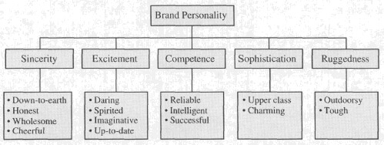
Figure 1: The five core dimensions and their respective facets

Facet | Traits
Down-to-earth | down-to-earth, family-oriented, small-town
Honest | honest, sincere, real
Wholesome | wholesome, original
Cheerful | cheerful, sentimental, friendly
Daring | daring, trendy, exciting
Spirited | spirited, cool, young
Imaginative | imaginative, unique
Up-to-date | up-to date, independent, contemporary
Reliable | reliable, hard working, secure
Intelligent | intelligent, technical, corporate
Successful | successful, leader, confident
Upper Class | upper class, glamorous, good looking
Charming | charming, feminine, smooth
Outdoorsy | outdoorsy, masculine, western
Tough | tough, rugged
Figure 2: The facets and their traits

In an effort to conceptualize the brand personality of Mountain Dew, a popular soft drink, I chose to utilize Jennifer Aaker’s Brand Personality Dimensions framework because I find it to be the most detailed basis available to truly gain a clear idea of a brand’s personality. It is also worthwhile to note that in addition to the personality traits described above, researchers argue that demographic characteristics such as age, gender, and socioeconomic class should be included in the description of a brand’s personality to further detail the understanding of how the brand is perceived (D. Aaker, “Building Strong Brands” 137). In order to form a complete picture of Mountain Dew’s personality I will also include these demographic characteristics in my research.

Methodology
Mountain Dew has always been an entertaining brand. Originating in Tennessee in the 1940’s, the drink’s name was a common southern slang term for moonshine and was originally used as a lemon lime mixture for whiskey. Playing off the drink’s tongue in cheek origin, Willy the Hillbilly emerged as the drink’s mascot. The overall clad country bumpkin appeared on both the bottle and television ads. In the ads he excitedly proclaims “Yahoo! Mountain Dew! It’ll tickle yore innards!” as he drinks Mountain Dew out of a clay jug that looks suspiciously like those used for moonshine (“Willy the Hillbilly”).
Ever the progressive company, Mountain Dew set its sights on the younger generation in the 1970’s, adapting its logo, packaging, and positioning to reflect the drink’s newfound target market. Its aim was to appeal to a consumer base looking for a highly caffeinated beverage (Collins). It eventually found this market within the extreme sports and video gaming community. Over the years, Mountain Dew has produced over 30 unique variations of the original drink and has rose to become the 4th most popular brand of soda in the world with Diet Mountain Dew trailing closely in 8th place (“Huffington Post Business”). Together the sodas have 8.8% of global soda market share ("Beverage-Digest" 1).
Mountain Dew has proven to be exceedingly popular and influential among the younger generations through channels such as promotional events on social media and widely viewed event sponsorships. In order to appeal to the young, caffeine-loving market, the company has utilized every aspect of social media. A shining example is the reoccurring DEWmocracy promotion. Mountain Dew produced and distributed a new beverage completely designed by its fans with the highest amount of votes on the DEWmocracy website, Facebook, and Twitter. The commercials promoting the new drink were likewise fan created. The genius in this plan was that Mountain Dew had all but ensured a successful launch by having the target customer base create their ideal custom product and method of advertising. Promotion of the event spread like wildfire thought every form of social media by both company and fan created posts.
Along side actively engaging its tech savvy customers in two-way communication, Mountain Dew has also utilized sponsorships to appeal to its target market. For example, Mountain Dew is the title sponsor of The Dew Tour. Featuring skateboarding, BMX, and free style motocross, the tour is the most viewed and attended action sports property in the world (“NBC Sports”). The company has also created Green Label, which sponsors individual artists, extreme athletes, and videogame designers and players.
In order to gain such success, the company must be presenting a cohesive brand personality to its large and loyal customer base along side its attractive flavor. The perception of a brand’s personality traits is formed through direct and indirect contact from the brand to the consumer. Direct contact can occur through images of people associated with the brand such as the customer base, the company’s employee and management teams, and product endorsers. Consumers form an idea of the brand’s personality through their perceptions of these people based on their actions, personalities, and appearance (J. Aaker 348). Indirect contact can be made through the brand’s logo, product attributes, brand name, price, associations about the product category, style of advertising, and distribution channels (J. Aaker 348). By using qualitative interviews, I aim to understand which forms of indirect and direct contact with the brand formed the subject’s views on Mountain Dew.
I will conduct qualitative interviews with six knowledgeable respondents 18 to 24 years of age. The acceptable ages were chosen in order to ensure that the respondents were within Mountain Dew’s young target market and to allow me to better understand what the company is communicating to this demographic and how it in turn creates a personality.
The first step was creating a survey that would later be used as a guideline in the interviews. To better understand the respondents, the survey combined qualitative and quantitative measures of Aaker’s Brand Personality Dimensions framework. The framework’s dimensions and facets are listed on the survey. Respondents will rank the dimensions in order from most to least descriptive of Mountain Dew. Respondents will then circle the randomly listed facets that they associate with the brand. The final section of the survey is open-ended. Respondents will be asked to think of Mountain Dew as a person and write down what they believe would be the person’s age, gender, ethnicity, personality, and personal values.
Once I have collected all six surveys, I will then sit down with each respondent individually to conduct a recorded in-depth interview. In-depth interviews are the most useful and flexible method to use in order to understand a deeper meaning of the respondents’ reasoning behind each and every question on the quiz. I will also use the interview method of laddering. When given a reason behind a response on the survey, I will ask a series of probing questions to get to the base motive for the response. I hope to better understand consumers’ perception of the Mountain Dew brand through using these methods.
Once completed, I will review each interview, organize the received data, and reveal the conclusive brand personality of Mountain Dew and how it is communicated.

Results

Personality Dimensions:
Respondents were shown a list of the five personality dimensions and asked to order the words from 1 to 5 (1 being the most and 5 being the least) that best describe Mountain Dew’s Brand.

Ranking | Personality Dimension | Placement Percentage
1 | Excitement | 100%
2 | Ruggedness | 83.3%
3 | Competence | 66.7%
4 | Sophistication | 50%
5 | Sincerity | 50%

Dimension Facets:
Respondents were shown a list of all 15 subsets of the 5 personality dimensions. The words were organized randomly. Respondents were asked to circle the words that they would associate with Mountain Dew.

Facets | Selection Percentage
Outdoorsy | 66.7%
Tough | 66.7%
Facets | Selection Percentage
Reliable | 0%
Intelligent | 16.1%
Successful | 50%
Excitement Ruggedness Competence
Facets | Selection Percentage
Daring | 66.7%
Spirited | 66.7%
Imaginative | 33.3%
Up-to-date | 33.3%

Sophistication Sincerity
Facets | Selection Percentage
Down-to-Earth | 0%
Honest | 0%
Wholesome | 0%
Cheerful | 33.3%
Facets | Selection Percentage
Upper-class | 0%
Charming | 16.1%

Describing Mountain Dew as a Person
Respondents were asked to describe Mountain Dew as if the brand were a living person in open-ended questions about age, gender, ethnicity, personality, and values.

Average Age: 18
Gender: Male
Ethnicity: White
Personality:
If Mountain Dew were a person, he would be a young guy who is into extreme sports. He’s courageous and knows what he is doing. He is constantly in go-mode. He is continuously chasing after the trill. He’s an adrenaline junky who just wants to have fun with his life.
Values:
Enjoying life to the fullest. Excitement and having a good time are his top priorities.

Conclusions
Personality Dimensions:
Excitement collectively ranked as the most descriptive personality dimension of Mountain Dew. Respondents felt that the commercials, which mainly highlighted extreme sports, gave off an air of excitement. They felt that theses commercials served to excite the consumers about the drink by displaying high energy.
Ruggedness was the second most descriptive. Some respondents associated the word with manliness and others with extreme behavior. Respondents collectively felt that not everyone could participate in the extreme sports showcased in Mountain Dew’s commercials and that in order to participate, one had to be manly or extreme. “ It’s not a drink for pansies”, remarked one of the respondents.
Competence came in third. The general feeling was that in order to successfully perform the sporting stunts seen in the commercials or Mountain Dew sponsored events, the athletes had to understand exactly what they were doing. Many respondents had varying definitions of the word. There was a definitive split among those who applied the word to the actions of the company and those who applied it to the idea of the brand. Those who applied it to the company thought that since Mountain Dew was so successful financially, the company had to be competent. Those that applied the word to the brand felts that the commercials were communicating that anyone who drank Mountain Dew could also try their hand at extreme sports. Most of the respondents felt that Competence was not the best description for the Mountain Dew.
Sophistication was ranked as the fourth personality dimension. Many respondents felt that the word didn’t describe Mountain Dew at all. The idea that Mountain Dew was not a drink meant for professionals was voiced in almost every interview. No one thought that there was anything sophisticated about the commercials.
Sincerity was seen as the least descriptive personality dimension for Mountain Dew. There were a variety of reasons for this. Again, there was a split among the respondents. Some applied the word towards the company itself, and others applied it to the brand. Those who thought that Mountain Dew did display sincerity to some extent voice that the company seemed to honestly love its brand and wasn’t pretentious. Those who thought that the word was not descriptive at all thought that the message conveyed in the commercials that Mountain Dew consumers could participate in the extreme sports shown came off as a lie.
Dimension Facets:
Facets of Excitement:
Daring was chosen four times. The unanimous reasoning for this was because it took courage to participate in the extreme sports shown in Mountain Dew’s commercials and promotional events.
Spirited was also circled four times. Reasons included that the word was descriptive of the consumers of Mountain Dew, that there was a lot of hype and energy in the commercials and promotional events, and that the brand came off as extremely youthful.
Up-to-date was selected three times. Again the brand was seen as very youthful. Other reasons included that the commercials seemed cutting edge, hip, used popular music. Respondents also noted that the brand was usually seen at popular events and that it was unafraid of change.
Imaginative was chosen twice. Again, it was voiced that the Mountain Dew was open to change. The commercials were viewed as extreme, clever, and funny which takes imagination. A final reason was that Mountain Dew always seems to figure out how to been seen by their target market.
Facets of Ruggedness:
Outdoorsy was circled four times. This decisive reasoning was that the commercials took place outside and that Mountain Dew was a drink for those who participated in outdoor activities, mainly extreme sports.
Tough was also chosen four times because respondents felt that one had to be tough in order to participate in extreme sports.
Facets of Competence:
Successful was circled three times. The respondents only applied the word to the success of the company, not the idea of the brand.
Intelligent was circled by only one respondent. He believed that the company would like to be perceived as intelligent. The other 5 respondents did not view the word as descriptive of Mountain Dew.
Reliable was not chosen at all. Respondents did not think the word described anything to do with Mountain Dew other than the fact that the company was reliable enough to get their product of the shelves of stores.
Facets of Sophistication:
Charming was only circled once. The respondent believed that the word was applicable to Mountain Dew’s commercials because he found them funny. The other respondents viewed the high-energy commercials to be too extreme to be charming.
Upper-class was not chosen by any respondent because they believed that the word was the polar-opposite of that they would describe Mountain Dew’s consumer base to be. It was repeated several times that it was not a drink for professionals.
Facets of Sincerity:
Cheerful was selected twice because both respondents found Mountain Dew’s commercials to be consistently happy and humorous.
Down-to-Earth was not circled. There was a split between the reasons why. Some respondents thought that Mountain Dew’s commercials were too energetic to be considered down-to-Earth. The rest did not view the word as particularly descriptive or not descriptive of the brand.
Honest was not selected at all. Most respondents had no opinion. Others viewed it as an inaccurate description because of the earlier mentioned perceived message that drinking Mountain Dew would give the consumer the ability to do extreme sports.
Wholesome was also not chosen by any respondent. No one had an opinion of the word when applied to Mountain Dew at all.

Describing Mountain Dew’s Person
Average Age: 18
Responses ranged from 13 to 22. The lower ages were chosen because respondents imagined a hyperactive child running around due to the amount of caffeine in the drink itself and because they drank Mountain Dew when they were younger. The median ages were chosen because they were seen as the ages when teenagers are energetic and without the weight of responsibility on their shoulders, yet still have the freedom to make their own decisions. The oldest ages were chosen because of the idea of young adults having the ability to enjoy the crazy side of life while still being considered kids and because of identifying with the brand. Every respondent thought of Mountain Dew as a youthful brand.
Gender: Male
The decision of gender was unanimous. Some respondents believed that Mountain Dew doesn’t come of as feminine at all. All mentioned that the commercials were extremely male dominated. Only one respondent could recall a single female in a commercial for Diet Mountain Dew. Many mentioned that the colors and artwork used in Mountain Dew’s logo and advertising was dark and masculine. Two respondents thought that Mountain Dew only targeted males, one giving the example of Mountain Dew’s product placement in the lowbrow comedy, Ricky Bobby.
Ethnicity: White
Once more, the choice of ethnicity was unanimous. Most respondents remarked that almost if not every person shown in a Mountain Dew commercial was white. The majority of respondents also brought up the fact that the majority of extreme sports athletes are white. Many simply stated that they related to the brand and projected their ethnicity onto their imagined person.
Personality:
If Mountain Dew were a person, he would be a young guy who is into extreme sports. He’s courageous and knows what he is doing. He is constantly in go-mode. He is continuously chasing after the trill. He’s an adrenaline junky who just wants to have fun with his life.
Respondents collectively imagined an energetic young man. Some believed that he would be an extroverted thrill seeker while others reasoned that he would just be hyper. When questioned as to how they came up with their ideas, almost all respondents voiced that they believed that he would engage in the extreme sports shown in Mountain Dew commercials or sponsored events. The few respondents who didn’t link his adventurousness to the commercials or events gained the idea of Mountain Dew’s person being hyper from the amount of caffeine in the drinks.
The idea that he would be courageous and knowledgeable about his pastimes came from the fact that the extreme athletes in all of Mountain Dew’s marketing communications exude confidence and bravery when participating in their sport.
Values:
Enjoying life to the fullest. Excitement and having a good time are his top priorities.
There were a few distinct reasons of why respondents created the values that Mountain Dew’s person would hold. The overwhelming answer was that Mountain Dew was a fun and exciting company. Respondents also looked at the in-your-face action in the commercials. One respondent remarked that the commercials are all about fun and basically scream the fact that Mountain Dew is on the edge, exciting, and cool. Some noted the excitement seeking pastimes of the number of extreme athlete spokespeople for the brand. Again, the amount of caffeine in Mountain Dew’s products was brought up several times to explain why this person would be apt to be active and enjoy life.

Conclusions on How Mountain Dew Presents its Personality
What I have come to find is that Mountain Dew does an excellent job of communicating a steady and well-put together brand personality to the public. While the respondents’ answers and choices may have varied on the survey, I discovered that the majority of the opinions I heard had a very common basis.
Mountain Dew’s strength is in its consistency. The brand puts forth an exciting and youthful personality in every marketing communication it executes. From commercials with a high-energy feel, to extreme sports sponsored events, Mountain Dew doesn’t dilute its image. This consistency provides consumers such as the respondents used in my research with a strong understanding of the brand personality that Mountain Dew puts forth. By promoting a consistent message through every marketing element, consumers who are exposed to as little as one marketing communication will be able to understand the personality of Mountain Dew.

Limitations of the paper
One of the limitations I faced while conducting my research was that I had a limited sample size due to the time constraint of only having a semester to execute my research. Since I had limited time, I wanted to view how Mountain Dew’s personality was communicated to a restricted age group; it’s target market. Due to the age limitation I realize that the conclusions found might not apply to other age rages such as generation X or baby boomers. Again, since my time was limited, I felt that I selected the proper age range since Mountain Dew doesn’t actively target the older generations.
Another limitation was the fact that I was only able to talk to one female. Mountain Dew primarily targets young males and her interpretation of the brand’s personality fell directly in line with the other respondents. While this may be indicative of Mountain Dew’s well-defined personality, interviews with more women would be conclusive.
Finally, all of the respondents were white. As mentioned earlier, everyone described that they felt that if Mountain Dew were a person, he would also be white. Due to the high amount of self-identification with the brand that I heard while interviewing each of the respondents, I feel that it would not be a definitive statement to say that the brand personality of Mountain Dew would in fact be white.

Considerations for Future Research
If I could execute this study in a year and had unlimited resources at my disposal I would change some aspects.
I would obtain a larger and more diversified pool of respondents by conducting my survey online. By using the Internet as a resource, I would be able to reach hundreds if not thousands of people. This would vastly increase the generalizability of the conclusions reached due to the variety of ages, ethnicities, and genders of the respondents.
If I were able to conduct in depth interviews with each of the respondents, I feel that their answers would be able to truly and conclusively create the true brand personality that Mountain Dew presents to the public.

Works Cited
Aaker, David. Building Strong Brands. New York: The Free Press, 1996. Print.
Aaker, David. Managing Brand Equity: Capitalizing on the Value of a Brand Name. New York: The Free Press, 1991. Print.
Aaker, Jennifer. "Dimensions of Brand Personality." Journal of Marketing Research. 34.1 (1997): 347-356. Print.
Batra, Rajeev, John Myers, and David Aaker. Advertising Management . 5th. India: Dorling Kindersley, 1992. Print.
Biel, Alexander. "Converting Image into Equity." Brand Equity & Advertising. Ed. A. Biel and Ed. D. Aaker. New Jersey: Lawrence Erlbaum Associates, Inc, 1993. 67-82. Print.
Collins, Glen. "Ya-hooo! A Marketing Coup; At 50, Mountain Dew Manages To Tickle Innards of Young Men." Business Day. New York Times, 30 May 1995. Web. 25 April 2012. <http://www.nytimes.com/1995/05/30/business/ya-hooo-marketing-coup-50-mountain-dew-manages-tickle-innards-young-men.html?pagewanted=all&src=pm>.
"Dew Tour." NBC Sports. NBC , 2009. Web. 4 May 2012. <http://www.nbcumv.com/mediavillage/sports/nbcsports/dewtour>.
Levy, Sidney. "Symbols for Sale." Harvard Business review. 37. (1959): 117-124. Print.
Martineau, Pierre. "The Personality of the Retail Store." Harvard Business Review. 36.1 (1958): 47-55. Print.
Moser, Mike. "Brand Personality: How to Build a Unique Brand ." United We Brand: How to Create a Cohesive Brand That's Seen, Heard, and Remembered. Boston: Harvard Business School Press, 2003. 67-90. Print.
Ogilvy, David. Confessions of an Advertising Man. New York: Atheneum, 1963. Print.
Pullig, Chris. "What is Brand Equity and What Does the Branding Concept Mean to You?." Keller Center Research. Baylor University, Jun 2008. Web. 26 April 2012. <http://www.baylor.edu/business/kellercenter/index.php?id=55735>.
"Special Issue: Top-10 CSD Results for 2010." Beverage-Digest. 59.5 (2011): 1-2. Print. <http://www.beverage-digest.com/>.
"The Most Popular Sodas In The World." Huffington Post Business. Huffington Post, 02 23 2012. Web. 25 April 2012. <http://www.huffingtonpost.com/2012/02/23/top-soda-brands_n_1297205.html
“Willy the Hillbilly”. Commercial. YouTube. 25 Apr 2012. <http://www.youtube.com/watch?v=4xd8fzk8Rlk>

Appendix 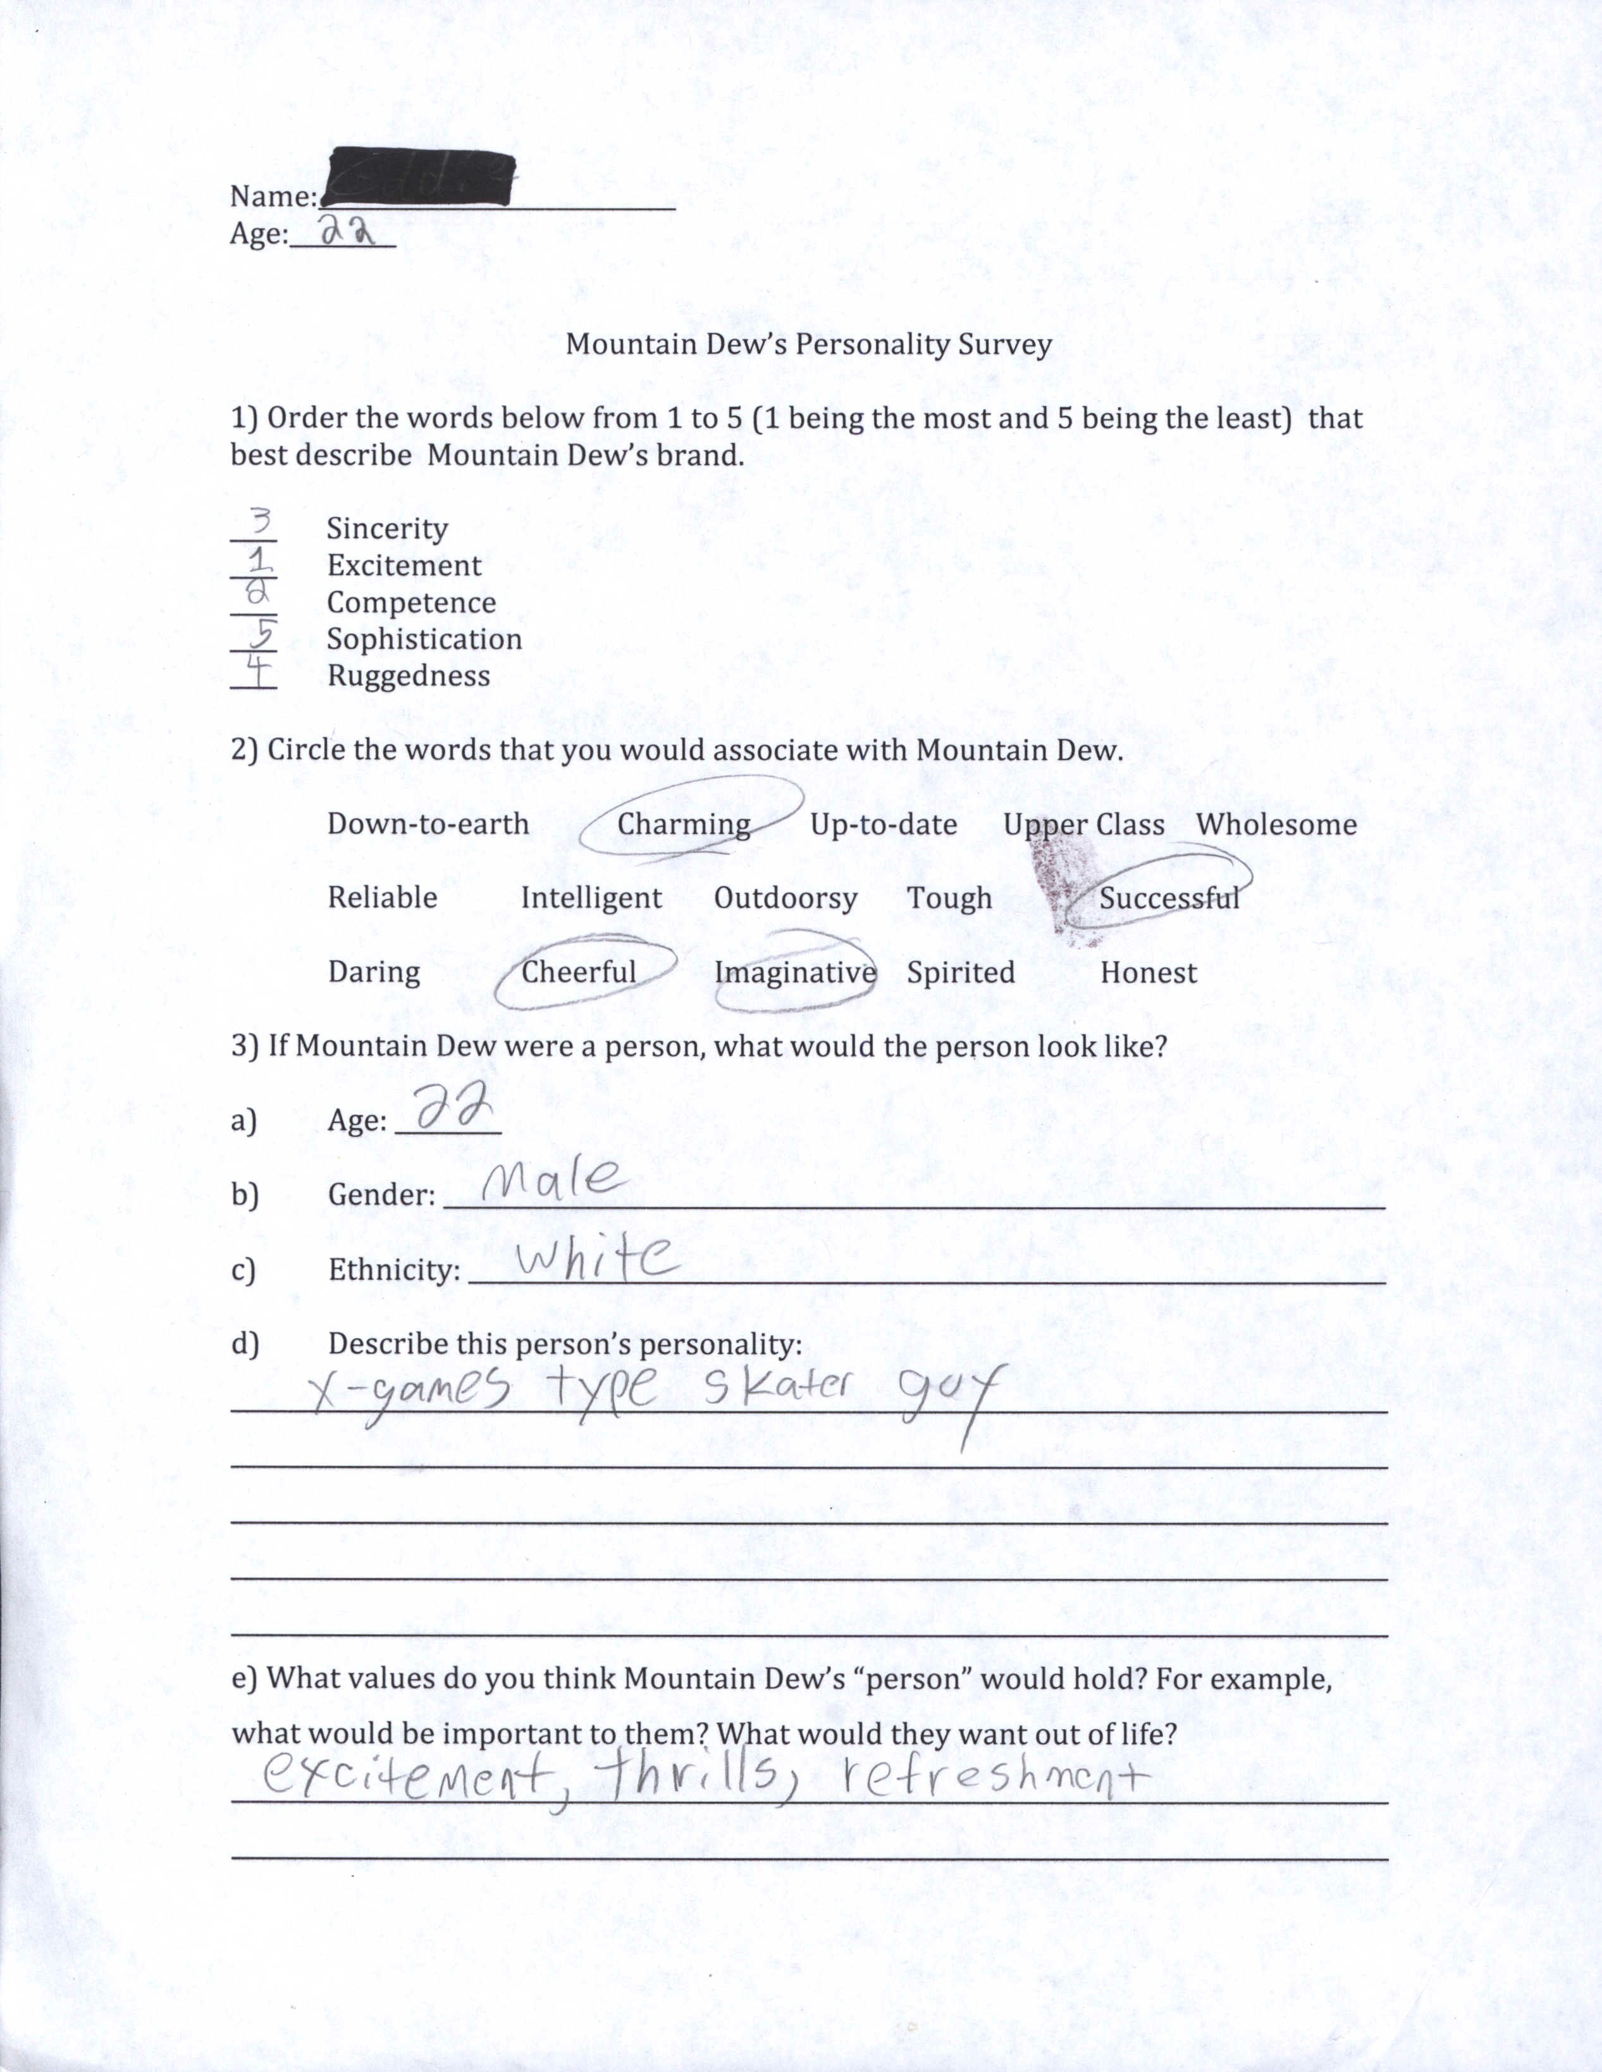

A1

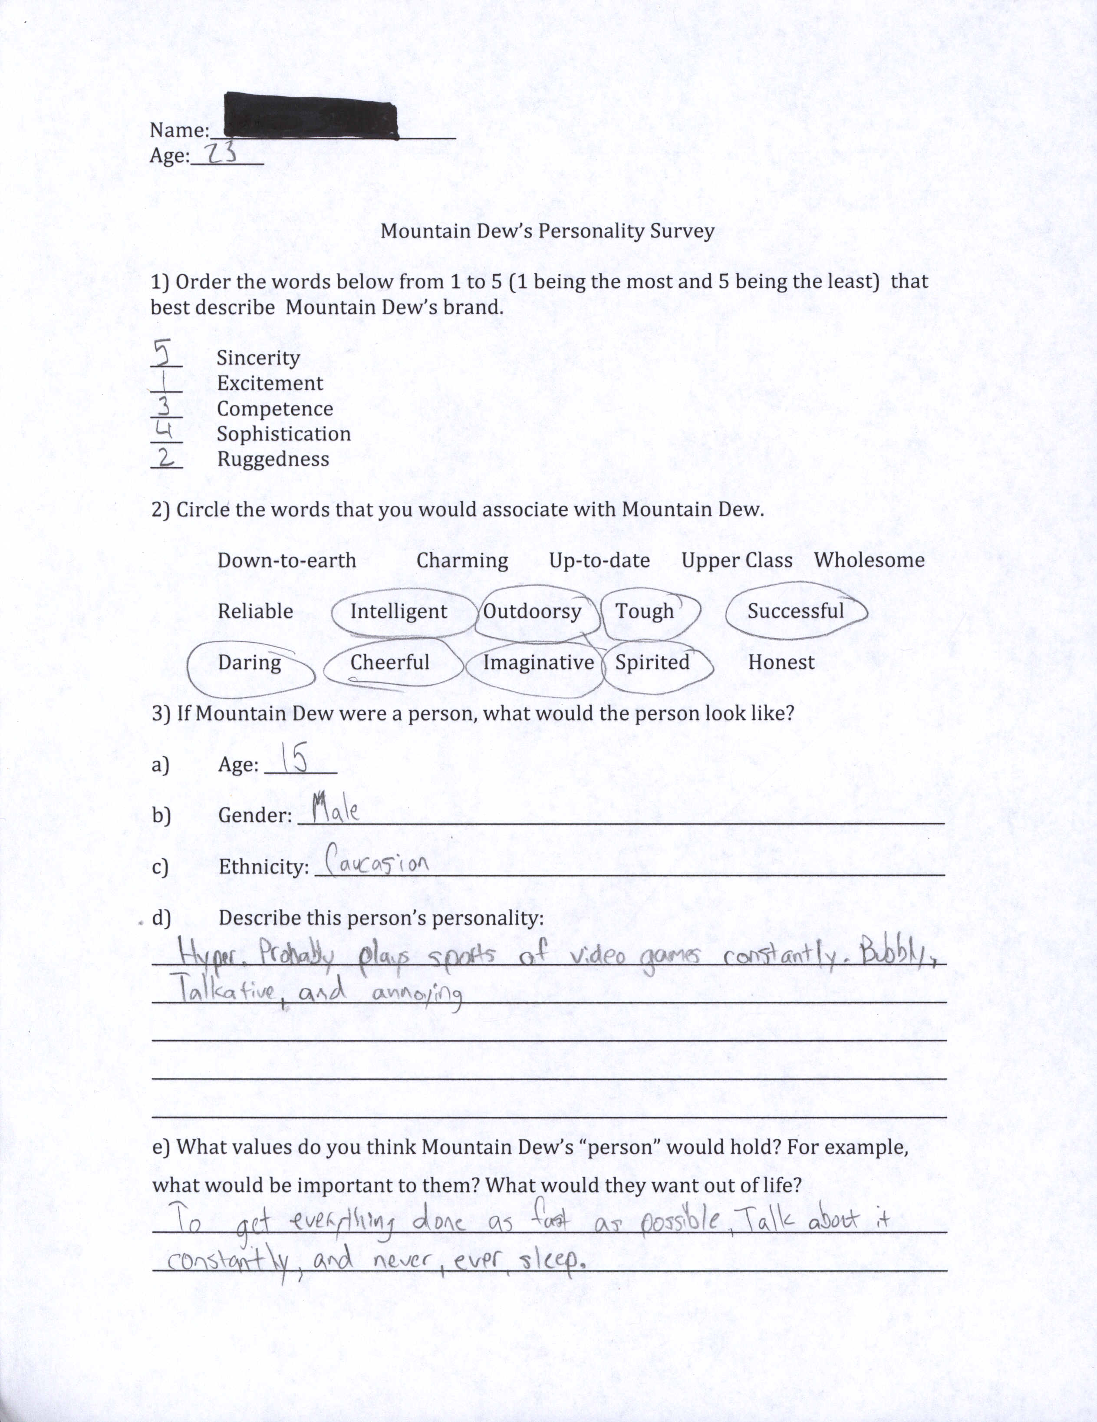
A2
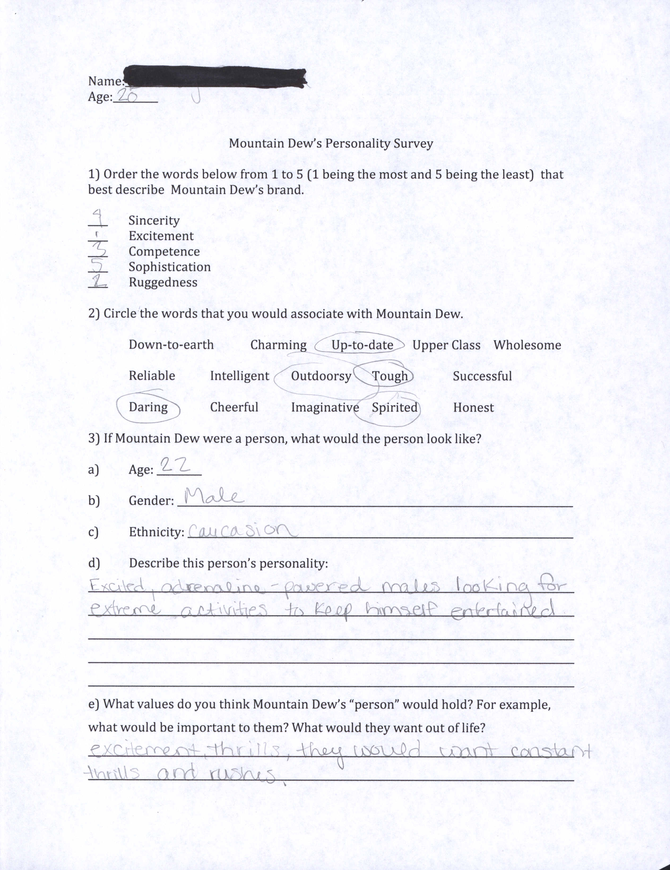

A3
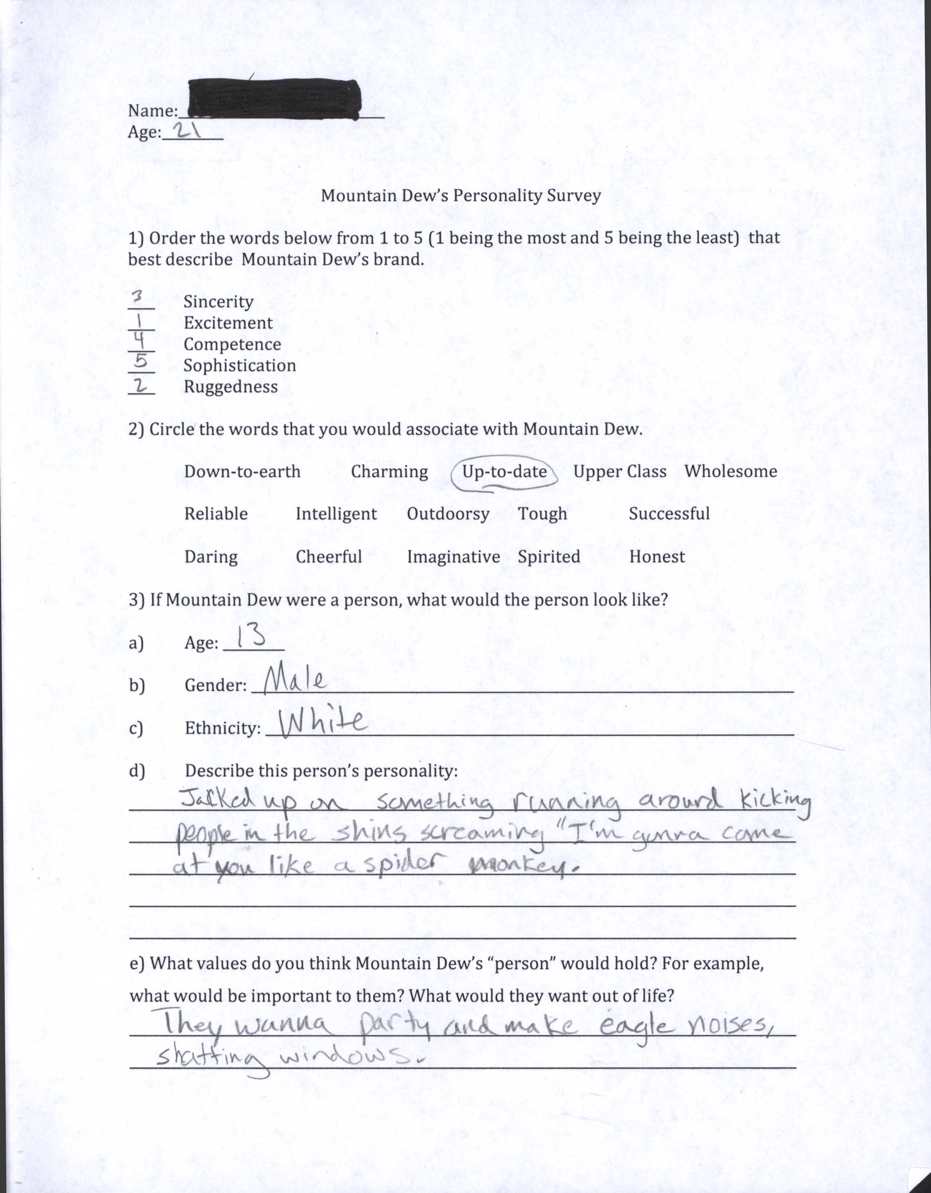

A4
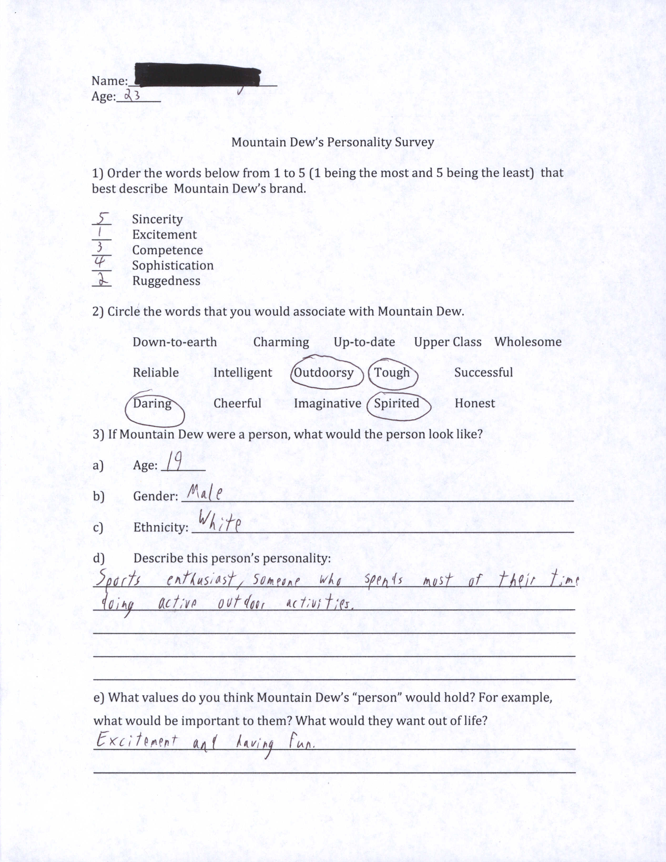
A5
Name:_______________
Age:___21______

Mountain Dew’s Personality Survey

1) Order the words below from 1 to 5 (1 being the best and 5 being the least) that best describe Mountain Dew’s brand.

____5 Sincerity
____1 Excitement
____3 Competence
____4 Sophistication
____2 Ruggedness

2) Circle the words that you would associate with Mountain Dew.

Down-to-earth Charming Up-to-date Upper Class Wholesome

Reliable Intelligent Outdoorsy Tough Successful

Daring Cheerful Imaginative Spirited Honest

3) If Mountain Dew were a person, what would the person look like?

a) Age: ___17______
b) Gender: ____male_______________________________________________
c) Ethnicity: ________white__________________________________________
d) Describe this person’s personality :
He’s young and courageous. He’s extroverted and is a thrill seeker. You would find him trying to do new things, usually something that is an extreme sport. Often bikes, skates and plays video games. He’s confident. He probably listens to dubstep or rock.
e) What values do you think Mountain Dew’s “person” would hold? For example. what would be important to them? What would they want out of life?
Doing what you want and living life to the fullest. Make a name for yourself.

A6

