Quantifying Tree Canopy Contributions to
Stormwater Runoff Reductions in Urban Watersheds

A Thesis Presented for the
Master of Science
Degree
The University of Tennessee, Knoxville

Matthew Howard
May 2021

Copyright © 2021 by Matthew Howard.
All rights reserved.

ABSTRACT

Table of Contents
Chapter One Introduction 7
Introduction 7
Literature Review 9
Rainfall Interception of Open-Grown Trees 9
Throughfall 9
Stemflow 9
Intensity 9
Antecedent Dry Period 9
Event Duration 9
Seasonality 9
Chapter Two Materials and Methods 11
Study Area 11
Tree Characteristic Data Collection 11
Monitoring Methodology 13
Rain Gauge Calibration 14
Outlier Detection and Removal 15
Rainfall Partitioning 16
Chapter Three Results and discussion 17
Data Summary 17
Rainfall Interception 17
Stem Flow 18
Event Characteristics Controlling Interception 18
Rainfall Depth 19
Intensity 20
Duration 21
Antecedent Moisture 22
Seasonality 22
Conclusions (bullet points, for now) 26
List of References 28
Appendix 31
Vita 35

LIST OF TABLES

Table 2.1: Measured and Dynamic Infiltration Rates……………………………………19
Table 3.1: Data Collection Summary Statistics………………………………………….21
Table 3.2: TSS Summary Statistics……………………………………………………...24
Table 3.3: Nutrient Summary Statistics………………………………………………….27
Table 3.4: Inlet and Outlet Heavy Metal Concentrations………………………………..30
Table A.1: Measured Infiltration Rates………………………………………………….47
Table A.2: Hydrology Results…………………………………………………………...47

LIST OF FIGURES
Figure 2.1 Project site figure showing aerial view of swale and associated catchment, and the WinSLAMM model representation of the site………………………………………...…16
Figure 3.1 Rainfall-Outflow Data………………………………………………………………...21
Figure 3.2 Rainfall-Outflow Data with Outliers Removed……………………………………….22
Figure 3.3 Percent Runoff Reduction…………………………………………………………….22
Figure 3.4: TSS Inlet and Outlet Concentrations………………………………………...24
Figure 3.5: Nitrate Concentrations………………………………………………………………..25
Figure 3.6: Ammonium Concentrations………………………………………………………….25
Figure 3.7: Chloride Concentration………………………………………………………………25
Figure 3.8: Nitrate with Elevated Concentration Removed………………………………………25
Figure 3.9: Ammonium with Elevated Concentrations Removed………………………………..25
Figure 3.10: Chloride with Elevated Concentrations Removed…………………………25
Figure 3.11: Inlet and Outlet Ammonium Concentrations……………………………....27
Figure 3.12: Inlet and Outlet Chloride Concentrations…………………………………..28
Figure 3.13 Inlet and Outlet Nitrite Concentrations……………………………………………...28
Figure 3.14: Copper Inlet and Outlet Concentrations…………………………………………….30
Figure 3.15: Lead Inlet and Outlet Concentrations……………………………………………….31
Figure 3.16: Zinc Inlet and Outlet Concentrations……………………………………………….31
Figure 3.17 NSE Curve…………………………………………………………………………...33
Figure 3.18 Measured vs. Calibrated Model Runoff Volume……………………………………35
Figure A.1: WinSLAMM Infiltration Values……………………………………………49
Figure A.2: Typical cross-section of 4 lane arterial highway with depressed medians (TDOT, 2017) ………………………………………………………...…………………50

Introduction

Introduction
Urban tree canopies increase the livability of cities by providing environmental and psycho-social benefits to the urban habitat. From an environmental standpoint, the urban canopy provides shade on hot summer days, reduces the effects of the urban heat island by releasing water vapor during the process of evapotranspiration and shading heat-reflecting surfaces, and reduces the potential for nuisance flooding and other runoff-related issues by intercepting and storing a percentage of rainfall from storm events (Kueheler et al. 2017, Xiao and McPherson 2016). Additionally, urban trees increase quality-of-life for city inhabitants. Wolf (2003) showed that urban trees both increase the perceived quality-of-life of the inhabitants of urban centers and increase the price evaluation of consumers which may aid in driving economic activity for local businesses. Because excessive runoff is correlated to increased cost of infrastructure maintenance, soil erosion, and contaminant flushing which degrade the quality of urban aquatic environments, the National Academy of Engineering urges cities around the world to develop green infrastructure practices such as the restoration of the urban tree canopy, to address the consequences of increased runoff volume and intensity while increasing the livability of urban centers (National Academy of Engineering 2008). For these reasons, greening efforts in major cities can be seen across the United States. In Nashville, Tennessee, stormwater management has shifted to a focus on green infrastructure specifically dealing with the urban canopy in hopes to weatherize the city. Other efforts, such as those being made in Chesapeake Bay, aim to provide large amounts of nutrient removal to save the surrounding aquatic environment, and as a result, dozens of tree canopy restoration projects have been launched throughout the Northeastern United States. To aid in such efforts, watershed planning uses crediting systems for implementation of stormwater control measures (SCMs). To properly credit urban trees for restoration efforts, a wholistic knowledge of the interception potential of urban tree species is imperative.
A thorough review of previous research on the topic reveals two main theories used to describe interception loss of trees which can be described as static storage and dynamic storage (Xiao and McPherson 2016, Smets et al. 2019). Static storage, otherwise known as minimum storage, saturation storage, or surface storage capacity, is described as the depth of water that must be stored on a tree canopy’s surface before precipitation will flow to the ground as throughfall. The most simplistic application of this modeling technique is to assume that any rainfall past this depth will fall to the ground, but these modeling techniques do not account for important dynamics that occur during the interception process. Dynamic storage, also known as detention storage or maximum storage, is the amount of water that can be stored on the surface of the canopy temporarily and will either flow to the ground as throughfall, flow down the trunk of the tree as stemflow, or evaporate into the atmosphere. Studies that focus on dynamic storage such as those performed by Xiao et al. 2000 and Keim et. all 2006 reveal complex interactions between rainfall characteristics (intensity, depth, and rainfall incidence angle) and tree characteristics (age, species, canopy health, and branch architecture) that influence rainfall interception. Until recently, the majority of the research on rainfall interception has focused on forested areas with widespread canopy cover which is difficult to apply to urban hydrology where most trees are grown in the open with less competition from other tree canopies and influenced by the urban heat island effect (Asadian and Weiler 2009, Smets et al. 2019). The majority of studies on open-grown tree species in the urban environment apply the minimum storage capacity model to a volume balance of a single individual with no replication, analyze few events and miss seasonal effects on interception, or apply a long-term volume balance that disregards individual events and is less useful for watershed planning and small-scale stormwater management utilizing trees as green infrastructure.
Introduction Paragraph 3: What separates our study from others / conclusion for paragraph 2 (I think that this section might be easier to write when the results are finished)
- We use triplicates of each tree species studied. This aids in the generalization of our data to the entire species.
  - Do we need to prove that individuals within a species have significant differences? Like analyze each individual against the others within a species and try to relate differences to LAI, leaf biomass, DBH, etc?
- The use of automatic rain gauges allow us to compare intensity to interception, throughfall, stemflow, etc on a seasonal basis.
- Data was collected throughout the year. We can observe conclusions based on the differences in canopy density and climate over the study period, and draw conclusions on the seasonal behavior of our trees in our climate.

Literature Review

Rainfall Interception of Open-Grown Trees

Throughfall

Stemflow

Intensity

Antecedent Dry Period

Event Duration

Seasonality

Materials and Methods

Study Area
Three Knoxville parks were chosen as locations for the study because of the species of interest they contain, accessibility within the park, and proximity to the University of Tennessee, Knoxville. Willow oak (Quercos phellos, Caswell Park), red maple (Acer rubrum, Adair Park), and white pine (Pinus strobus, Victor Ashe Park) were selected for the study because they are native to East Tennessee and the surrounding region and because their potential for stormwater management has yet to be documented (Figure 1). Three trees were chosen in each park to allow replication and account for natural variations within the species, resulting in nine trees studied over a fourteen-month time period. Only open-grown trees were chosen for the study to avoid overhead obstruction by overlapping tree canopies, allowing isolation of measurements to an individual specimen.
Figure 1: Site Map

Tree Characteristic Data Collection
Each tree varied in leaf area index (LAI), diameter at breast height (DBH), crown projection area (CPA), height, and branch architecture. Further, LAI was variable based on season (in particular for red maple and willow oak), and changes in these characteristics were expected over the course of the study. As such, measurements of LAI, DBH, and canopy width and height were taken every 6 months throughout the study and averaged for analysis (Table 2.1).
The diameter of the canopy was measured using a surveyor’s tape in two directions perpendicular to each other from dripline (the farthest reach of the canopy) to dripline. The two measurements were averaged, and the crown cover was assumed to be circular to obtain the surface area of the tree crown projection (O’Brien et al. 1995, Xiao and McPherson 2011). Measurement of the diameter at breast-height—a commonly used metric of the maturation of a tree within a species—was performed using a standard DBH tape. A notable difficulty in obtaining a DBH measurement occurred with tree 2 in Victor Ashe park. At breast height, the tree grew as a double stem. The DBH for this tree was simply measured for both stems, and an average value was recorded. Tree height measurements were taken using a clinometer with a 66-foot baseline. When performing each tree survey, a percentage of leaf area missing from the crown was also estimated by two individuals and then averaged (Schomaker 2007).
The results of each tree survey were input into i-Tree which utilizes the UFORE model to obtain Leaf Biomass—the estimated weight of the leaves comprising the canopy of each individual—in kilograms and Leaf Area Index (LAI). LAI is a measure of the density of leaves over the area projected by the tree canopy. It is measured as the area of the vertical projection of leaf surfaces divided by the area of the vertical projection of the canopy and is therefore unitless. The UFORE methods utilize regression equations for deciduous urban tree species and the same set of equations with a shading factor applied to the canopy projection for conifers (Nowak 2000).

Table 2.1: Tree Characteristic Data
 | Adair  Acer rubrum |  |  | Caswell  Quercus phellos |  |  | Victor Ashe  Pinus strobus
 | Tree 1 | Tree 2 | Tree 3 | Tree 1 | Tree 2 | Tree 3 | Tree 1 | Tree 2 | Tree 3
Average Tree Height  m | 9.54 | 12.5 | 12.5 | 6.80 | 9.14 | 8.38 | 7.99 | 8.53 | 10.1
Average Canopy Cover  m² | 74.77 | 72.48 | 40.89 | 49.46 | 53.24 | 35.88 | 21.97 | 33.26 | 52.95
Average DBH  cm | 24 | 22 | 18 | 26 | 35 | 25 | 20 | 23 | 27
Average Crown Missing  % | 15 - 20 | 20 - 25 | 20 - 25 | 1 - 5 | 5 - 10 | 10 - 15 | 0 | 1 - 5 | 0
Average LAI  Dimensionless | 4.4 | 5.1 | 6.9 | 4.5 | 4.4 | 5.0 | 5.0 | 6.2 | 5.7
Average Leaf Biomass  kg | 22.2 | 24.9 | 19.0 | 8.8 | 13.1 | 23.5 | 15.8 | 21.0 | 13.1

Monitoring Methodology
Schedule 40 PVC troughs were placed under each tree and funneled into automatic rain gauges in a manner similar to Asadian and Weiler 2009. Davis automatic tipping-bucket rain gauges were chosen for their ability to record the depth of throughfall averaged over the vertically-projected surface area of each trough while providing information on the timing and intensity of the canopy-impeded throughfall. Water was funneled into the rain gauges with three 6-inch PVC pipes cut in half to form a trough. These troughs were laid at a 25-degree angle and extended from the dripline of the tree canopy to the opening of the rain gauge to quickly convey the throughfall into the mouth of the rain gauge while reducing water lost to splash that occurs at shallower angles (McJannet et al. 2007). The troughs and gauges were spaced evenly around the circumference of each tree canopy (each one representing a third) to account for radial and axial variability in canopy density that affects throughfall spatially underneath the tree (Smets et al. 2019, Zabret and Sraj 2018).
Stemflow was collected using methods similar to Xiao and McPherson (2011). A length of 1-inch water conduit was cut in half down their length, wrapped around the stem approximately two full revolutions, and caulked with silicon to ensure a water tight seal. The conduit fed into a 1-inch PVC pipe which conveyed the stemflow into a tipping-bucket rain gauge placed in a plastic box to protect from exposure to throughfall. CPA was used to convert the volume of rainfall measured by the stemflow rain gauges to a depth measurement as a part of the urban tree water balance equation (Xiao and McPherson 2011, Smets et. al. 2019).
Finally, a rain gauge was also placed outside of the canopy to collect precipitation measurements to allow a water balance and assessment of storm characteristics (intensity, duration, etc.). The out-of-canopy rain gauge was placed level on a Unistrut and connected to a Hoboware event pendant that recorded precipitation depth in 1-minute intervals. The location was chosen away from any overhead obstructions and a manual rain gauge was placed directly next to the tipping bucket to allow calibration of the rainfall readings.
The throughfall and stemflow rain gauges were secured in place by two 2x4’s that were nailed into the ground with landscaping nails. Wooden shims were placed in between the 2x4’s and the rain gauges to ensure that the rain gauges remained level throughout the period of study. The throughfall and stemflow rain gauges were connected to a Hoboware U-21 microstation to record continuous measurements in 1-minute intervals throughout the year. A biweekly data collection and maintenance routine was performed to minimize rain gauge clogging and to avoid time drift of the sensors. (Need more about characteristics of rain gauges and microstation/pendant)

Rain Gauge Calibration
While tipping bucket rain gauges are subject to errors that are not associated with volume-capture approaches (Smets et al. 2019), the decision was made to use automatic rain gauges for the ease of data collection for a study of this scale. The Davis tipping-bucket rain gauges used in the study are rated to accurately record precipitation data up to a rainfall intensity of 102 millimeters per hour. The troughs, designed to convey water into the rain gauges, effectively increased the surface area contributing to the tipping bucket (i.e. beyond just the area of the bucket) by a ratio that ranged from 9.44 to 21.7 depending on a given trough’s length. Therefore, at rainfall intensities between 4.7 and 10.8 millimeters per hour, the 102 millimeter per hour range was exceeded for at least one throughfall gauge. To account for errors in measurement that may have occurred due to exceeding this intensity threshold, and to calibrate the gauges to the known uncertainties added when using tipping buckets, a 7-point calibration was repeated three times for each throughfall gauge to obtain a linear correction factor to be applied throughout the dataset. The automatic rain gauges measuring gross precipitation were calibrated against manual rain gauges in the same location that were read intermittently throughout the study.

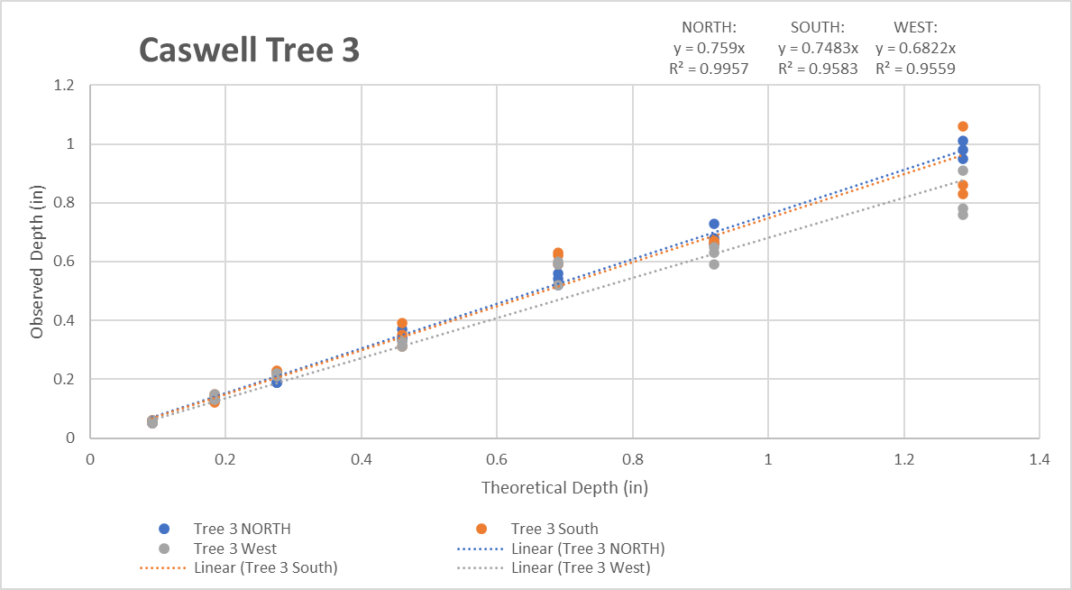
Figure 2.1: Example Calibration of Throughfall Gauges

Outlier Detection and Removal
Throughout the study period, throughfall and gross precipitation values were impacted by physical phenomena such as vandalism, clogging due to the accumulation of leaves and needles at the mouth of the rain gauge, and freezing temperatures causing ice accumulation in the gauges. Additionally, the possibility of over-estimation of throughfall caused by the application of the linear correction factors to the dataset exists. To account for physical and calibration-related errors that could not be accounted for during the study, an outlier removal process was performed to clean the data. First, cumulative rainfall and cumulative throughfall averaged by tree were plotted against time for each storm and analyzed to observe any erroneous phenomena like clogging. A rain gauge was assumed to have clogged if its behavior deviated significantly from the other gauges, or if it exhibited obvious signs of clogging (i.e. a linear increase in rainfall depth with time that exists before or after the defined time boundaries of a particular storm event). If the rain gauge collecting gross precipitation was clogged, the data for that storm was removed. If it was a throughfall gauge that presented errors, the interception values were simply censored from the dataset and further statistical analysis. Rainfall and throughfall data from each gauge were plotted as a regression in JMP Pro for each of the nine trees in the study. A linear regression equation was produced, and a 95% prediction band was applied to the regression. It was assumed that values that fell outside the low or high boundaries of the prediction band were outliers, and data from that particular gauge was removed and the gauge was considered to not be properly functioning for that event. The data were then stratified by storm event, and events with two or more non-functioning rain gauges were removed from further analysis.

Rainfall Partitioning
Interception loss was calculated as the amount of gross precipitation that cannot be accounted for directly by throughfall and stemflow measurements (Staelens et al. 2008, Xiao and McPherson 2011). Interception loss was therefore calculated for each tree on a per-event basis as:
$$IL=P-(TH+SF)$$
Where IL is interception loss in mm, P is gross precipitation in mm, TH is average throughfall in mm, and SF is stemflow in mm. The stemflow-collecting rain gauges were not constructed until June of 2018, and because of the relatively small contribution of stemflow to interception loss (Asadian and Weiler 2009), stemflow data for these events were censored from statistical analysis and ignored for rainfall partitioning.

Results and discussion

Table 3.1: Summary Statistics for Study Period

Storm Characteristics
A total of 106, 104, and 99 selected events were analyzed for the maple, oak, and pine, respectively. Average rainfall amounts varied between parks due to the spatial variability of regional storm events as well as the outlier removal process that resulted in a variable number of analyzed storms in each park. Red maples experienced an average of 16.2 mm of rain, white pines experienced an average of 12.4 mm, and willow oaks experienced 14.7 mm on average. Rainfall intensity also varied between the parks with the mean rainfall intensity being 22.6 mm/hr, 17.6 mm/hr, and 19.4 mm/hr for the red maples, white pines, and willow oaks, respectively. Despite these small differences, the data sets were considered comparable between all sites, allowing comparison amongst the species.

Interception, Throughfall, and Stemflow
Interception values for red maples (Mean = 4.05 mm, Median = 2.65 mm, SD = 4.55 mm) did not differ significantly from willow oaks (Mean = 3.30 mm, Median = 2.13 mm, SD = 4.01 mm) in the wilcoxon rank sum test (p = 0.1998, W = 46012). Despite having a lower average leaf area index and less sturdy leaf characteristics, the willow oaks had healthier crowns (See Table 2.1). The red maples monitored in this study were estimated to miss between 15% and 25% of the full crown. Gaps in the canopy provide direct paths for precipitation to fall to the ground unobstructed which is known as free throughfall (Smets et al. 2019, Xiao et al. 2000). The white pines were found to have the highest interception losses (Mean = 4.32 mm, Median = 2.87 mm, SD = 4.93 mm) which deviated significantly from the red maples (p < 0.05, W = 45517) as well as the willow oaks (p < 0.05, W = 48292). On average, the white pine intercepted 50.5% of gross precipitation throughout the study period which compares favorably in the context of other open-grown conifers which have interception losses in the range of 44.7% – 60.9% (Asadian and Weiler 2009, Asadian and Weiler 2010, Zabret and Sraj 2018). Red maples and willow oaks intercepted 31.1% and 36.5% of gross precipitation, respectively, which also falls within the range of open-grown deciduous tree species of 23.5% - 38.7% (Smets et al. 2019, Zabret and Sraj 2018, Asadian and Weiler 2010). Since pines maintain their needles year-round, and the canopies of the pine trees studied were dense and healthy, these results were logical.
Stemflow was generally a negligible portion of the tree canopy water balance which agrees with results from several other studies (Xiao and McPherson 2011, however the average portion of gross precipitation attributed to stemflow for the white pine and willow oak were higher and more similar than that of the red maple. Both willow oaks and white pines have a greater number of smaller branches when compared to red maples which may contribute to the difference in stemflow volumes as branches are direct flow paths to the stem of the tree. Other studies that have quantified both interception and stemflow have shown…..similar results? Different? Species dependency?

Event Characteristics Controlling Interception
Throughfall and interception values were compared against event characteristics to determine what storm characteristics are most important for prediction of per-event interception loss values. Peak 5-minute rainfall intensity, gross precipitation depth, event duration, and antecedent moisture were chosen as the characteristics of each storm to be analyzed against throughfall and interception.

Rainfall Depth
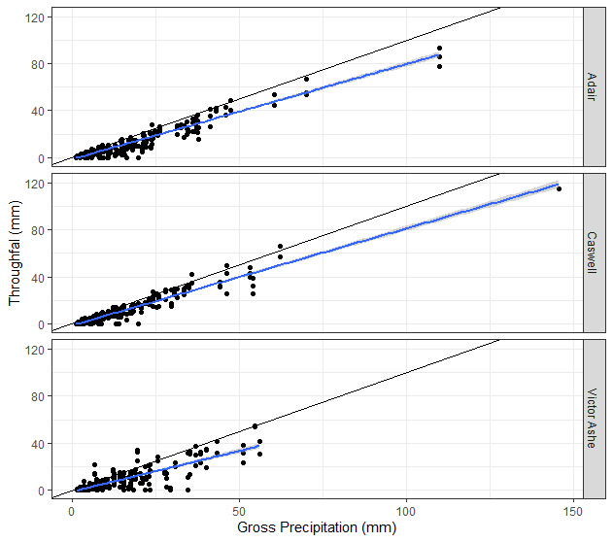
Figure 3.1: Throughfall versus Gross Precipitation

Throughfall was plotted against gross precipitation for all trees by park (Figure 2). When compared to gross precipitation, throughfall tends to increase linearly. Some individual throughfall values fall above the line y = x. Two possible reasons exist for these values showing throughfall in excess of gross precipitation. First, the throughfall values were adjusted based on the calibration of the throughfall gauges at the end of the study period. While the calibration increased the accuracy of the data overall, it is possible that the calibration over-adjusted some throughfall values. The other explanation is that paths of least-resistance are present in tree canopies that funnel water through the canopy such that the spatial distribution of gross precipitation and throughfall are different. Regardless of season, gross precipitation remained the best predictor of throughfall volume for each species.

Intensity
For each storm event, throughfall data from each tree was averaged based on species and parsed between leaf-on and leaf-off periods. These average interception losses were then plotted against the peak 5-minute rainfall intensity for the corresponding storm. Scatterplots of the data are presented in Figure 4. For both deciduous species, a trend correlating interception loss and peak 5-minute rainfall intensity is apparent during the leaf-on period but not the leaf-off periods. The red maples have consistent interception losses up to a threshold of rainfall intensity (approximately 30 mm/hr) but then the interception loss potential seems to decrease linearly with an increase in intensity past this point. The same trend is apparent for the willow oaks located at Caswell park, but the threshold is lower before interception potential tends to trend downward (approximately 20 – 25 mm/hr). The white pines do not show the same threshold as the deciduous tree species, but instead, both leaf-off and leaf-on interception losses vary by a seemingly inverse linear relationship with intensity (although the trend is more apparent during the leaf-on period). It is difficult to determine whether or not the same inverse linear trend is present past the intensity threshold for red maples or white pines, since there were not enough high-intensity storm events during the leaf-off period to extend the trend far enough. Due to the similarities in trends between the leaf-on and leaf-off period at Victor Ashe, it is possible that the same trend that describes leaf-on interception at varying rainfall intensities also describes leaf-off interception of deciduous trees but at overall lower magnitudes of interception.

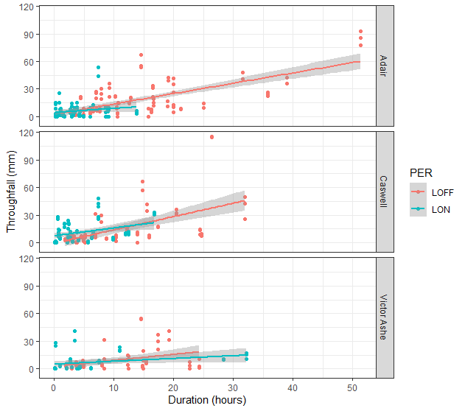
Figure 3.2: Seasonal variation in Throughfall (mm) and Event Duration (hours)

Duration
Species-averaged throughfall data were split into leaf-on and leaf-off periods and plotted against rainfall event duration. Regardless of the period, the linear regression of the throughfall data is nearly the same, however, a large amount of spread is present within the plotted data. Event duration does little to describe the volume of gross precipitation of a storm and says even less about the temporal distribution of the event, two variables that were shown to be important in describing the data. For example, a short and intense rain event is capable of producing the same volume of rainfall as a long, gentle event, but depending on a species’ response to intensity as well as the leaf development stage of the canopy, the volumes of throughfall seen underneath the canopy could be drastically different between the events. This leaves storm duration susceptible to regional temporal rainfall characteristics as a predictor of throughfall. While duration is a consistent predictor of throughfall throughout the year, the spread of the trend makes it a less-accurate predictor of interception loss or throughfall than intensity or depth.

Antecedent Moisture
Antecedent dry period is the gap in time between storm events that allows intercepted water stored on the surface of a tree’s canopy to evaporate. Given that up to 46% of total interception loss of a tree occurs due to evaporation during the drying period between storms (Reid and Lewis 2009), antecedent dry period seems a possible controlling variable in the process of rainfall interception. However, a regression was plotted for throughfall versus antecedent dry period and little to no trend was observed, likely due to the complexity of this process. It is likely that other controlling factors such as the effect of temperature on evaporation and water availability (i.e. the amount of moisture leftover on the tree canopy) after an event substantially influenced these results. The other rainfall characteristics discussed herein can be more directly tied to the single-event performance of a tree in a given rainfall event.

Seasonality

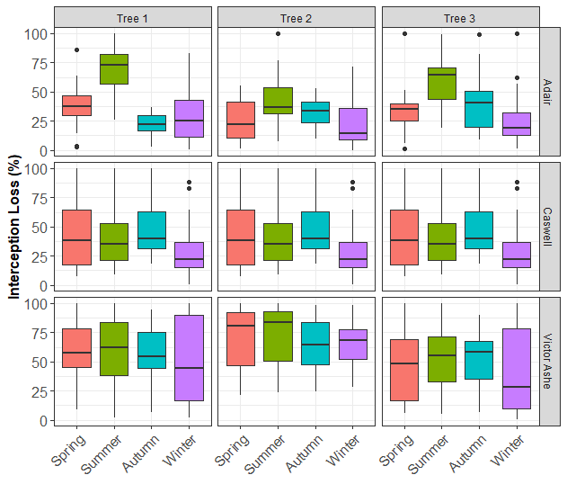
Figure 3.3: Boxplots showing seasonal interception loss percentages for each park.
As noted above, differences between species were apparent in the summary statistics which were attributed, at least in part, to seasonal changes. To gain a better understanding of the seasonal differences between the tree species, boxplots were made for each tree and categorized by season (Figure 3). Two influential factors appeared in the data: (1) differences in interception for leaf-on/leaf-off, and (2) differences in interception due to shifts in rainfall patterns over the year. Despite the assumption that white pines maintain consistent canopy density throughout the year, they showed somewhat lower and more varied interception losses during the autumn and winter. The inconsistency of the interception loss experienced by the pines in the winter is most likely a function of temporal changes in mean event depth, intensity, and duration during the wet and dry seasons. The willow oaks located at Caswell Park show a more consistent interception potential than expected for deciduous trees during spring, summer, and autumn. The consistency of the interception potential for willow oaks can likely be attributed to the long leaf-on period of the tree species since willow oaks typically bud between February and May and seed as late as October (Schlaegel 1990). All three willow oaks experienced peak-interception loss during autumn, further pointing to the late leaf-development period of the species. Red maples, while having an annual interception loss percentage similar to the willow oaks, had a much more severe peak of interception potential in the summer period, but average interception losses decreased during autumn and winter.
As noted above, both leaf-development cycles and rainfall event characteristics are thought to control the interception potential of trees. Further, these leaf development cycles are variable between species, adding bias to comparisons among trees using data parsed by astronomically defined seasons. Thus two periods were selected when red maple and willow oak were known to have leaf-on or leaf-off respectively. This allowed a comparison of tree interception under the same physiological conditions while controlling for the seasonal differences in rainfall volume and intensity experienced in East Tennessee.

Table 3.2: Leaf-On Summary Statistics
Table 3.3: Leaf-Off Summary Statistics

During the leaf-on period, the average intensity of rainfall was roughly 2.5 to 4 times greater than the leaf-off period, while average precipitation depth decreased by a factor of approximately 0.2 to 2. . Despite the increase in rainfall intensity, significantly higher interception losses were seen during the leaf-on period for the red maples and willow oaks when compared to the winter months. The same trend (albeit less substantial) was noted for the white pines which may be due to differences in canopy density throughout the year despite being an evergreen. The summer interception of the red maple was similar to that of the white pine (54.9% and 55.3%, respectively) which correlates well with the LAI of both species during the leaf on period (5.5 and 5.6, respectively). However, during the leaf-off period when white pine performance only slightly dropped, the average interception loss of the maples decreased significantly and was more similar to that of the willow oak. The discrepancy in event characteristics as well as individual tree species response between the winter and summer months indicate the importance of analyzing and modelling tree interception loss on a seasonal basis.

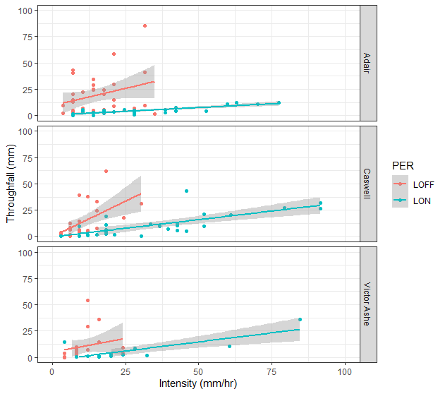
Figure 3.4: Seasonal variations in Throughfall (mm) versus Peak 5-minute Intensity (mm/hr)

Conclusions (bullet points, for now)
- White pines had the highest overall annual interception potential.
- White pines had the most consistent interception potential annually due to evergreen species’ consistent canopy density.
- Leaf development seems to be the most important factor controlling a tree’s maximum interception potential.
  - Even though trees favor less intense, longer storms for intercepting rainfall, summer interception for the red maple and willow oaks were significantly higher than winter interception—despite the average rainfall intensity being three times greater in the summer.
- The maple and oak trees studied show consistent interception values up until a certain intensity threshold during the leaf-on period. Past the threshold, which is specific to each tree species, interception loss varied according to an inverse linear relationship with intensity. The same trend likely applies to leaf-off interception, but the range of intensity values in the winter months in East Tennessee makes this analysis impossible.
- Trees with larger, heartier leaves are better at handling severely intense storm events, while trees with smaller, more abundant leaves and greater branch-density have more consistent annual interception values as well as a higher potential to intercept large amounts of rainfall over long durations (higher saturation capacity)
- Duration has a less significant impact on interception losses than intensity or gross rainfall depth. The observable trend is relatively consistent throughout the year and does not seem to vary much between leaf development stages.
- Antecedent moisture conditions dictate the existing conditions of a tree subjected to a rainfall event, but the antecedent dry period is not a good predictor of interception losses in and of itself.
Design Implications
The above data implies that different trees may be able to be used to aid in the goals of urban stormwater design. Not only can individual tree species be studied to determine the annual interception potential of urban forests and open-grown trees for the purposes of watershed rehabilitation, but the differences in characteristics between species may also be utilized for stormwater planning of urban design such as parks, government buildings, roadways, and residential areas. While evergreens tend to have higher and more consistent annual interception potentials (Citation needed), there is a maintenance component that must be considered as their needles are shed year-round. For different climates and weather patterns, some trees may fair better than others. For instance, the red maples observed in our study yielded significantly higher summer interception values than the willow oaks, despite having a similar annual interception rate. For climates that favor a rainy summer, the consistency of evergreens or hearty deciduous trees, such as the willow oak, may not be needed. Willow oaks, too have an advantage over other urban tree species as they grow quite tall, wide, and very quickly, making them excellent trees to provide shade in urban green spaces.

List of References

Asadian, Yeganeh, and Markus Weiler. "A new approach in measuring rainfall interception by urban trees in coastal British Columbia." Water Quality Research Journal 44.1 (2009): 16-25.

Kuehler, Eric, Jon Hathaway, and Andrew Tirpak. "Quantifying the benefits of urban forest systems as a component of the green infrastructure stormwater treatment network." Ecohydrology 10.3 (2017): e1813.
McJannet, David, Jim Wallace, and Paul Reddell. "Precipitation interception in Australian tropical rainforests: I. Measurement of stemflow, throughfall and cloud interception." Hydrological Processes: An International Journal 21.13 (2007): 1692-1702.
National Academy of Engineering. NAE Grand Challenges for Engineering. National Academy of Sciences, 2008.
Nowak, David J., and Daniel E. Crane. "The Urban Forest Effects (UFORE) Model: quantifying urban forest structure and functions." In: Hansen, Mark; Burk, Tom, eds. Integrated tools for natural resources inventories in the 21st century. Gen. Tech. Rep. NC-212. St. Paul, MN: US Dept. of Agriculture, Forest Service, North Central Forest Experiment Station. 714-720. 212 (2000).
O'Brien, Sean T., et al. "Diameter, height, crown, and age relationship in eight neotropical tree species." Ecology 76.6 (1995): 1926-1939.
Walters, Russell S., and Harry W. Yawney. "Acer rubrum L. Red maple." Silvics of North America 2 (1990): 60-69.
Reid, Leslie M., and Jack Lewis. "Rates, timing, and mechanisms of rainfall interception loss in a coastal redwood forest." Journal of Hydrology 375 (2009): 459-470.
Schlaegel, Bryce E. "Quercus phellos L. willow oak." Silvics of North America 2 (1990): 715-720.
Schomaker, Michael. Crown-condition classification: a guide to data collection and analysis. Vol. 102. US Department of Agriculture, Forest Service, Southern Research Station, 2007.
Smets, Vincent, et al. "The importance of city trees for reducing net rainfall: comparing measurements and simulations." Hydrology and Earth System Sciences 23.9 (2019): 3865-3884.
Staelens, Jeroen, et al. "Rainfall partitioning into throughfall, stemflow, and interception within a single beech (Fagus sylvatica L.) canopy: influence of foliation, rain event characteristics, and meteorology." Hydrological Processes: An International Journal 22.1 (2008): 33-45.Wendel, G. W., and H. Clay Smith. "Pinus strobus L. eastern white pine." Silvics of North America 1 (1990): 476-488.
Wolf, Kathleen L. "Public response to the urban forest in inner-city business districts." Journal of Arboriculture. 29 (3): 117-126. 29.3 (2003): 117-126.
Xiao, Q., Mcpherson, E.G., Ustin, S.L., Grismer, M.E., 2000. A new approach to modeling tree rainfall interception. Journal of Geophysical Research 105, 29173–29188.. doi:10.1029/2000jd900343
Xiao, Qingfu, and E. Gregory McPherson. "Rainfall interception of three trees in Oakland, California." (2011).
Xiao, Qingfu, and E. Gregory McPherson. "Surface water storage capacity of twenty tree species in Davis, California." Journal of environmental quality 45.1 (2016): 188-198.
Zabret, Katarina, and Mojca Šraj. "Spatial variability of throughfall under single birch and pine tree canopies." Acta hydrotechnica 31.54 (2018): 1-20.

Appendix

Table A.1: Measured Infiltration Rates

*Each value is in inches per hour and bold values are averages.

Table A.2: Hydrology Results

Figure A.1: WinSLAMM Infiltration Values

Figure A.2: Typical cross-section of 4 lane arterial highway with depressed medians (TDOT, 2017)

Vita
Matthew Howard was born in Little Rock, Arkansas. As a baby, he moved to Maryville, Tennessee, where he attended Maryville High School and played football, earning the Rivalry Thursday Scholar-Athlete scholarship for his academic and extra-curricular efforts. After graduating high school, he moved to Knoxville to study at the University of Tennessee where he found a passion for water resources engineering. In May 2018, he graduated Summa Cum Laude with a Bachelor of Science in Civil Engineering. He continued his education as a graduate research assistant with Dr. Jon Hathaway as his adviser. He will graduate with a Master of Science in Environmental Engineering with a concentration in Water Resources in May 2021.

