“It all began, like so many things, with an egg,”
An Analysis of the Avian Fauna and
Eggshell Assemblage
From a 19th Century Enslaved African American
Subfloor Pit, Poplar Forest, Virginia.

A Thesis Presented for the
Master of Arts
Degree
The University of Tennessee

Kathryn Elizabeth Lamzik
May 2013
Copyright © 2013 by Kathryn Elizabeth Lamzik
All rights reserved.

Title quotation from Eastham and Gwynn 1997:86

Dedication

Acknowledgments

Financial support for this project was provided in part by the Patrician Black Scholarship Fund, The University of Tennessee Anthropology Department. The project has benefited greatly thanks to Dr. Walter E. Klippel, Dr. Barbara J. Heath, Dr. Gerald F. Schroedl, Greg Jones, Howard Cyr, Jack Gary, Lori Lee, Meghan Dennison, and Jennifer Synstelien; thank you all for your continued support, constructive criticism and comments, revision consultation, and assistance with microscope training. Josh Price and David Mercer deserve much of the credit for statistics consultation. Without their help, I believe that SAS might have defeated me. Also, many thanks should be given to the Archeological Society of Virginia, Thomas Jefferson’s Poplar Forest, and the Archaeological Research Laboratory, Knoxville, Tennessee. Ann Ramsey, Pam and Kourtney Bailey, Terry Monday, Robert and Danna Morris, Spring Creek Farms, and the Knoxville Zoo, thanks for the eggs! Finally, thanks to Andrew Wilkins, whose help in all of the previously mentioned areas could not be replaced and who remained a constant source of support throughout this project. And of course, thanks Mom and Dad. Without your help, guidance, and encouragement throughout the years, particularly for allowing me to collect rocks in shoeboxes and keep animal bones in my tackle box, I wouldn’t be me. Thank you one and all! Any errors and omissions are, of course, my own responsibility.

Abstract

During the 2003-2004 archaeological investigations at Thomas Jefferson’s Poplar Forest Plantation, a small, subfloor pit feature was discovered on the Southeast Terrace, in an area well known for its historical connection to the plantation’s 19th century enslaved African American laborers. Among the collected artifacts, the subfloor pit feature yielded over 30,000 faunal materials; not included in this calculated total are several thousand eggshell fragments. Although eggshell and avian faunal materials continue to be an understudied, peripheral component to faunal analyses, this thesis aims to show how, based on a few selected measurements and morphological variations observed in eggshell structure, a positive identification for these fragments can lead to a better understanding of species diversity, consumer choice, and subsistence practices. Furthermore, the development of a modern comparative eggshell collection can allow for an evaluation of current identification methods. This thesis provides a unique resource for documenting taxon abundance among faunal assemblages from historic sites.

Table of Contents
Chapter 1: Introduction and Objectives 1
Chapter 2: Background 4
Poplar Forest 4
Site A 10
Avian Fauna 15
Chapter 3: Literature Review 24
Early Literature 24
Contemporary Literature 28
Archaeology Literature 31
New Techniques 35
Chapter 4: Materials and Methods 38
Eggshell Morphology 38
Research Methodologies 40
Measurement Features 45
Chapter 5: Results and Discussion 57
Statistical Analysis 57
Additional Statistical Analyses 65
Poplar Forest Subfloor Pit Eggshell Identification Results 67
Chapter 6: Summary 82
List of References 90
Appendices 102
Appendix 1. Tables 103
Appendix 2. Figures 112
Vita 132

List of Tables

Table 1. Stratigraphic Layers of Subfloor Pit Deposits: Eggshell Recovered
From Heavy Fraction Samples .........................................................................................12

Table 2. Poplar Forest Avian Bone Faunal Material ........................................................22

Table 3. The University of Tennessee Modern Comparative Eggshell
Collection: Species ...........................................................................................................41

Table 4. Student’s T-test: Comparing measurement Variables from Supplementary Literature Data and University of Tennessee’s Modern Comparative Collection ............58

Table 5. Stepwise Selection Summary: Comparative Collection Variables .....................60

Table 6. Univariate Test Statistics Output for Discriminant Analysis of the Known Comparative Collection Data ............................................................................................61

Table 7. Discriminant Analysis on Known Data: Resubstitution Summary Statistics Using the Quadratic Discriminant Analysis Function ......................................................62

Table 8. Number of Observations and Percentages Classified into Species by the Discriminant Analysis Function for the Archaeological Eggshell Sub-samples ..............63

Table 9. Modern Comparative Collection Thickness Ranges: Species Low and
High Measurements (mm) ................................................................................................70

Table 10. Discriminant Analysis and Microscope Thickness Measurement
Identification Comparisons ..............................................................................................71

Table 11. Comparison of Identified Faunal Elements From Subfloor Pit
Feature ER2352 ............................................................................................................... 77

Table 12. Poplar Forest Subfloor Pit Eggshell Preservation and Number
of Samples Analyzed ........................................................................................................79

Table 13. Modern Comparative Collection and Archaeological Sub-Sample
Data ..........................................................................................................................104-109

Table 14. Discriminant Analysis Results for the Archaeological Eggshell
Sub-Sample ....................................................................................................................110

Table 15. Subfloor Pit Feature Context for Archaeological Sub-Samples ....................111

List of Figures

Figure 1. Map of Virginia with Location of Poplar Forest .................................................4

Figure 2. Site Map Featuring Site A, Southeast Terrace of Poplar Forest ........................10

Figure 3. North Wall Profile Stratigraphy of Poplar Forest Subfloor Pit
Feature 2352 R-DD/4 ........................................................................................................11

Figure 4. Medullary Bone: Stewing Hen Tarsometatarsus (mm) .....................................20

Figure 5. Illustration of Eggshell Structure .......................................................................25

Figure 6. Illustration of Egg: Turkey Egg with Features Labeled ....................................27

Figure 7. Turkey (Meleagris gallopavo) Eggshell SEM Micrograph ...............................29

Figure 8. Eggshell Feature Morphology Illustration .........................................................32

Figure 9. Organic Membrane: Interior of Chicken (Gallus gallus)
Eggshell Surface with Organic Membrane Intact, x40 .....................................................40

Figure 10. Organic Membrane Removed: Interior of Chicken (Gallus gallus)
Eggshell Surface with Mammillae Cones Visible, x40 ....................................................40

Figure 11. Chicken (Gallus gallus) Eggshell Radial Cross-section:
Straight-line Thickness Measurements, x40 .....................................................................47

Figure 12.1 SEM Red Star Chicken (Gallus gallus) Eggshell Interior:
No Visible Resorption Example, 300x .............................................................................50

Figure 12.2 SEM Jungle Fowl Chicken (Gallus gallus) Eggshell Interior: Minimal/Complete Resorption Example, 300x ................................................................51

Figure 13.1 Scanning Electron Microscope Image of Archaeological Turkey Eggshell (ER2352BB/4.251.12): Interior of Eggshell 300x ............................................................54

Figure 13.2 Scanning Electron Microscope Image of Archaeological Turkey Eggshell: Interior of Eggshell 800x ..................................................................................................54

Figure 13.3 Scanning Electron Microscope Image of Archaeological Turkey Eggshell: Radial Cross-section of Eggshell, 300x ............................................................................55

Figure 14. Archaeological Random Sample Thickness Distribution Scatter Plot:
Overlaid with Comparative Eggshell Species’ Thickness Ranges ...................................69

Figure 15. Comparative Collection Eggshell Thickness Ranges:
Separated by Species .......................................................................................................113

Figure 16.1. Level R/4 Eggshell Identification ...............................................................114
Figure 16.2. Level R/4 Eggshell Resorption: Chicken ...................................................114
Figure 16.3. Level R/4 Eggshell Resorption: Guinea fowl/goose ..................................115

Figure 17.1. Level S/4 Eggshell Identification ...............................................................116
Figure 17.2. Level S/4 Eggshell Resorption: Chicken ....................................................116

Figure 18.1. Level W/4 Eggshell Identification ............................................................. 117
Figure 18.2. Level W/4 Eggshell Resorption: Chicken ................................................. 117
Figure 18.3. Level W/4 Eggshell Resorption: Turkey ................................................... 118
Figure 18.4. Level W/4 Eggshell Resorption: Possible Quail ....................................... 118

Figure 19.1. Level V/4 Eggshell Identification ............................................................. 119
Figure 19.2. Level V/4 Eggshell Resorption: Chicken .................................................. 119
Figure 19.3. Level V/4 Eggshell Resorption: Turkey .................................................... 120
Figure 19.4. Level V/4 Eggshell Resorption: Quail ...................................................... 120

Figure 20.1. Level X/4 Eggshell Identification ............................................................. 121
Figure 20.2. Level X/4 Eggshell Resorption: Chicken .................................................. 121
Figure 20.3. Level X/4 Eggshell Resorption: Possible Turkey ..................................... 122

Figure 21.1. Level Y/4 Eggshell Identification ............................................................. 123
Figure 21.2. Level Y/4 Eggshell Resorption: Chicken .................................................. 123

Figure 22.1. Level Z/4 Eggshell Identification .............................................................. 124
Figure 22.2. Level Z/4 Eggshell Resorption: Chicken .................................................. 124
Figure 22.3. Level Z/4 Eggshell Resorption: Turkey .................................................... 125

Figure 23.1. Level AA/4 Eggshell Identification ........................................................... 126
Figure 23.2. Level AA/4 Eggshell Resorption: Chicken ............................................... 126
Figure 23.3. Level AA/4 Eggshell Resorption: Turkey ................................................. 127

Figure 24.1. Level BB/4 Eggshell Identification ........................................................... 128
Figure 24.2. Level BB/4 Eggshell Resorption: Chicken ................................................ 129
Figure 24.3. Level BB/4 Eggshell Resorption: Turkey ................................................. 129
Figure 24.4. Level BB/4 Eggshell Resorption: Guinea fowl/Goose .............................. 130
Figure 24.5. Level BB/4 Eggshell Resorption: Quail .................................................... 130
Figure 24.6. Level BB/4 Eggshell Resorption: Passerine .............................................. 131

List of Attachments

Attachment 1. University of Tennessee Zooarchaeology Laboratory Comparative Eggshell (Excel source data)

Attachment 2. Poplar Forest Subfloor Pit Eggshell Assemblage (Excel source data)

Chapter 1: Introduction and Objectives

“It all began, like so many things, with an egg.”
-Anne Eastham and Iolo Ap Gwynn 1997:86

During the 2003-2004 archaeological investigations of Site A, the Southeast Terrace of Poplar Forest, more than 33,000 pieces of faunal material were collected from a single 3 ft. by 3 ft. mid-nineteenth century subfloor pit feature. Associated with an enslaved African American cabin site occupied from circa 1840 to 1860, the artifacts collected and examined from this subfloor pit feature have provided researchers with considerable insight into Piedmont Virginia antebellum social dynamics and subsistence strategies. While previous zooarchaeological research has focused considerable attention to the mammal and fish faunal contributions of the historical archaeology record (Barber 1976; Bowen 1993, 1996a, 1996b; Crader 1984, 1990; Franklin 2001; Klippel et al. 2011; McKee 1987, 1992, 1999; Reitz 1987; Samford 1996; Scott 2001; Singleton 1995; Tuma 2006; Yentsch 1994, 2007), this thesis seeks to highlight the presence and importance of the avian taxa represented in the assemblage. Site A serves as a model for how a relatively unexplored category of faunal material can be used to further interpret subsistence preference and choice.
Excluded from the count of more than 33,000 pieces of faunal material recovered from the subfloor pit are thousands of eggshell fragments. These eggshells represent a continually marginalized source of information, often collected yet seldom identified beyond an assigned label of “eggshell.” The focus of the present study is to determine what archaeologically-recovered avian fauna, particularly the eggshell material, can tell researchers about changing social dynamics at Poplar Forest during the final years of slavery in Virginia. This objective provides a platform on which to reaffirm the continued importance of foodway studies. Avian fauna and eggshell analysis has the potential to illustrate how specialized research methods facilitate assumptions regarding animal exploitation patterns and consumer choices by the enslaved African American residents of Poplar Forest.
The present research aims to provide a series of systematic and testable methods for identifying eggshell fragments found during archaeological excavations. Additionally, this thesis attempts to reinforce the potential of eggshell studies as a developing analytical tool, using the eggshell assemblage from Poplar Forest as a case study. Identifying fragments of eggshell offers an interesting look at a selective dietary resource that regularly goes unnoticed by researchers. Limited research attention has been given to eggshell identification methods with North American archaeological projects in mind. Therefore, the present research agenda is similar in design to eggshell research conducted within the international scholarly community. The overall emphasis of the archaeological paradigm at present, both internationally and regionally, and the widespread attitude of scholars, is focused on giving increased attention to specialized analysis projects. Site A at Poplar Forest provides an ideal model, through the use of for specialized research topics, for the development of a general understanding of people on the landscape.
I begin the analysis with a chronological review and abbreviated history of the prior residents at Poplar Forest landscape, until the mid- to late- nineteenth century. After synthesizing the archaeological investigations that resulted in the excavation of a mid 19th century subfloor pit feature, I will briefly examine the history and importance of subfloor pit use by enslaved African Americans. Chapter 2 will conclude with a focus on the specialized role of avian faunal material from previously documented historic sites in the Tidewater and Piedmont regions, as well as introducing international research projects exploring the potential of archaeologically recovered avian fauna. In Chapter 3, I review the literature associated with modern eggshell classification strategies and archaeological eggshell identification guides. Chapter 4 offers a brief review of eggshell morphology and the defining shell features used as identification markers in this study. A detailed account of the thesis research framework and experimental methods follow, exploring empirical testing methods for accurate eggshell identification techniques. Chapter 5 provides a list of the measurement results and includes a brief interpretation of these findings. Chapter 6 includes an interpretation of the final results and how these relate to understanding enslaved African American producing and procuring strategies on historical sites. Chapter 6 also summarizes the project goals and concludes with a summary of the thesis, encouraging future developments in eggshell identification research.

Chapter 2: Background

Poplar Forest
Poplar Forest is a historic site, comprised of a 19th century plantation house and estate located in Bedford and Campbell counties, Virginia near the city of Lynchburg, in an area situated along the eastern foothills of the Blue Ridge Mountains of the Virginia Piedmont (Figure 1).

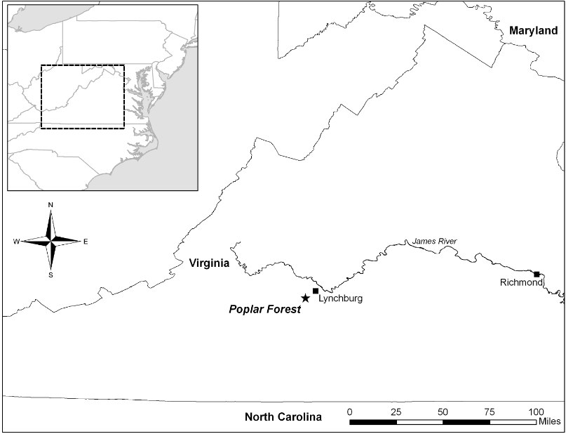
Figure 1. Map of Virginia with Location of Poplar Forest

Mixed hardwood forests comprised primarily of oak, pine, and hickory trees and secondary vegetation undergrowth, dominate the flora for this region. As a result of the principal settlement of the Virginia frontier by Europeans and enslaved Africans, much of the land surrounding Poplar Forest was initially used for tobacco cultivation. However, because of the deleterious effect the growing of tobacco has on soil nutrition, later cultigens were restricted to primarily grains, including wheat and oats (Hutter Income and Expense Journal 1856 – 1862; Hutter Farm Journal 1844 - 1854; Bowes and Trigg 2012). Archaeological excavations at Poplar Forest have been on-going since the late-1980s with one focus of research examining the past dynamic relationships that existed between the Poplar Forest plantation owners and managers and the enslaved African American residents. Assessing the historic importance for both of these interrelated yet separate social classes and racial groups continues to be one of the dominant research emphases for maintaining a holistic interpretation of the plantation’s history (Heath and Gary 2012).
Ownership and management of the plantation changed several times in the 18th-century, a period of dynamic modification during the early years of settlement in the Piedmont region. From 1773-1826 the property was owned, operated, and maintained as a second home by Thomas Jefferson, who acquired the property as part of an inheritance from his father-in-law and the plantation’s previous owner, John Wayles. During his early years of ownership, Thomas Jefferson visited Poplar Forest only periodically. However, while absent he kept records chronicling plantation events and observations for all of his plantations, but relied largely on overseers to report on the management of land and status of the enslaved populations (Betts 1944; Bear and Stanton 1997). Jefferson not only inherited the Poplar Forest land holdings and buildings associated with the property, but also several enslaved African American individuals and family groups living and working on several plantations previously owned by Wayles (Heath et al. 2004). After his retirement from public office, Jefferson intensified construction at Poplar Forest, transforming the landscape to better suit his desires for a retreat house and pleasure grounds located away from his primary residence, Monticello, situated 90 miles to the north (Betts 1944; Heath and Gary 2012).
Two years after Jefferson’s death, his heirs sold the plantation to William Cobbs. Cobbs brought a number of new enslaved individuals with him to work at Poplar Forest, breaking the historic continuity between the largely dispersed population of Jeffersonian slaves and the newly introduced enslaved African American community owned by Cobbs (Heath and Gary 2012; Heath et al. 2004).
By 1842, Poplar Forest was managed by Cobbs’ son-in-law, Edward S. Hutter. The Cobbs-Hutter occupation era at Poplar Forest lasted well into the later years of the 19th century. Throughout these succeeding years, the new residents reworked Jefferson’s landscape design and vision for the surrounding natural environment and main house, adding barns, outbuildings, and a variety of different crops, thereby significantly altering the landscape (Heath and Gary 2012). During this time, Hutter and Cobbs changed the dynamics of life for the enslaved community, reshaping the work structure to more accurately mirror a plantation work style common throughout much of the Antebellum South (Morgan 1998). The farm journal kept by Hutter from 1844 to 1854 documents the type of work required from field laborers; planting, field tending, crop harvesting, and occasionally repairing or constructing new buildings for the plantation were among the more common tasks (Hutter Farm Journal of Events 1844 – 1854). These prescribed social stations allowed workers to fluidly cross both social and physical boundaries, especially when Hutter began incorporating the practice of leasing enslaved laborers to neighboring planters (Heath et al. 2004; Lee 2012:177; Young 2004).
Enslaved African Americans living in the Tidewater and Piedmont regions were regularly allowed to cultivate their own garden plots and to maintain poultry yards as early as the 18th century (Morgan 1998:358-359; Heath and Bennett 2000:42; Gibbs 1999). According to the documentary evidence provided by travellers and planter accounts, slave owners and overseers living in rural areas generally encouraged their enslaved inhabitants to maintain garden plots attached to or near-by their homes, producing owner-approved high-yield, low maintenance crops and raising poultry to supplement their poorly provisioned diets (Gibbs 1999). While Thomas Jefferson did not readily allow his slaves to cultivate many goods, he did allow the enslaved inhabitants of Monticello and Poplar Forest to engage in selling eggs and raising poultry, allowing them to cultivate small garden plots and permitting slaves to take harvested crops to market (Gibbs 1999; Heath 2001, 2004; Bear and Stanton 1997). In fact, Jefferson’s memorandum books detailing household accounts and legal records reveals information about frequent purchasing of chickens, duck, eggs, and other poultry from the enslaved inhabitants at Monticello (Bear and Stanton 1997: 251, 299, 300, 353, 749, 1304). Additionally, Heath (2004) notes that during the first decade of the 19th century Ann Cary Randolph, Jefferson’s granddaughter, documents in her ledger that slaves often sold eggs for profit; additional transactions included the sale of chickens, ducks, vegetables, and fruits to the Jefferson family (Heath 2004:23).
It can therefore be presumed that the enslaved community at Poplar Forest during the Hutter period were familiar with the practice of raising poultry and possessed the knowledge to actively utilize the surrounding natural environment to procure or produce for themselves certain foods in order to supplement their provisioned diet. While the practice of raising poultry by the Hutter occupation enslaved population is not explicitly remarked upon, it is not unreasonable to assume that different types of poultry were in fact present. For example, on January 7, 1847, laborers were tasked with “...hauling logs for henhouse...” and on January 13 work began on “...putting up [the] hen house...” presumably for the Hutter family (Hutter Farm Journal of Events 1844 – 1854). Frequently mentioned in the Hutter Farm Income and Expense journal are itemized entries recording the sale and purchase of chickens, turkeys, and eggs (Hutter Income and Expense Journal 1856 – 1862). This self provisioning system benefited and fulfilled the needs of both the plantation owners and the enslaved, encouraging increased freedom for the African American residents to produce goods that could be bartered or sold at market in exchange for the acquisition of personal possessions or perhaps sold to the Hutter family for monetary benefits (Morgan 1998; Lee 2012:174; Bowes and Trigg 2012: 158; Penningroth 2003).
Personal property, of any kind, was particularly important to the enslaved. Slaves utilized yard spaces as areas to maintain personal property such as “...chicken coops, heehives, hogs, [and] small gardens...” (Penningroth 2003:95). Extra personal time, such as Sunday or holidays, provided a day of rest from plantation work and gave slaves the opportunity to work on cultivating their own crops and provisioning for themselves (Lee 2012:174; Penningroth 2003:47; Schlotterbeck 1991). This may have been more profitable for plantation owners and permitted slaves a degree of freedom and choice, but these privileges could easily be taken away, creating a reliable and effective form of punishment (Penningroth 2003:57). Chickens and poultry were often the first animals that slaves invested in, creating a foundation for other sources of renewable income (Penningroth 2003:47). The dichotic relationship between slaves and plantation owners for control over time and the resources produced as a result of property ownership may reinforce the restructuring and intensification of social interactions between neighboring plantations’ enslaved communities.
Population growth within the enslaved community did not occur during the Hutter period of ownership; instead the enslaved population suffered considerable loss in familial growth. In fact, the number of leased slaves considerably outnumbered the permanent slaves residing at Poplar Forest. The ratio between leased and permanent slaves, in combination with a decline in births of enslaved children relative to the increase in deaths recorded by Hutter in his farm journal, strained family growth and development (Heath et al. 2004:5; Hutter Farm Journal of Events 1844 - 1854; Klippel et al. 2011:28). However, the fluid boundaries and self-procuring strategies practiced by the early Poplar Forest slaves continued to develop and change during the Hutter occupation. The presence of chickens and eggs likely represents a form of produced and procured dietary supplementation, indicative of food resources not provisioned by the Hutter family. This thesis seeks to understand if chicken eggs were in fact the only produced foodstuff available to the enslaved community, or were independent, procurement strategies for eggs from wild species of bird was also practiced. It is these years of hardship leading up to the abolishment of slavery that are highlighted by the Site A cabin excavations, and the eggshell assemblage associated with the subfloor pit feature.

Site A
The enslaved African American cabin site at Site A is located less than 100 yards to the southeast of the main house, situated on what remains of a man-made terraced landscape (Figure 2).

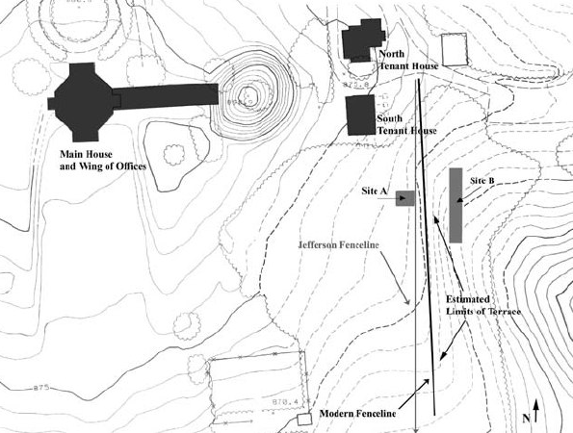

Figure 2. Site Map Featuring Site A, Southeast Terrace of Poplar Forest (Heath et al. 2004:2; used with permission)

The cabin features were excavated during the 2002 and 2003 field seasons at Poplar Forest and a number of features were recorded, including a rubble-filled feature assumed to be a stone and brick chimney base, assorted post-hole features, and a subfloor pit (Feature ER2352 R-DD/4). The remains of this subfloor pit feature measured approximately 3ft. long by 3 ft. wide and extended to a depth of 2.2 – 2.4 ft. (Heath et al. 2004:16; Figure 3).

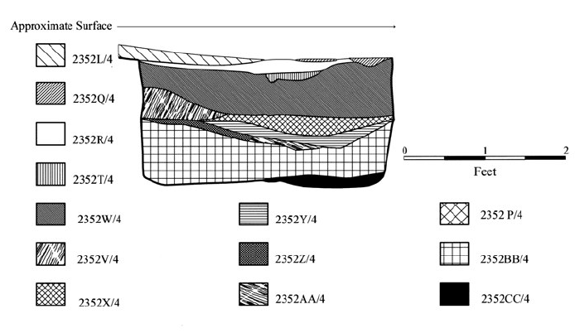

Figure 3. North Wall Profile Stratigraphy of Poplar Forest Subfloor Pit Feature 2352 R-DD/4 (Heath et al. 2004:22; used with permission).

In total, eleven fill deposits were identified and categorized as separate depositional events, each assumed to be the result of accumulated cultural material discarded in dumping episodes spanning a relatively short period of time (Heath et al. 2004:21; Klippel et al. 2011:29). Eggshell fragments were collected in 105 of the 170 total combined heavy fraction and light fraction flotation samples from nine of these cultural levels of the subfloor pit. However, only 70 heavy fraction samples, or 2/3 of the assemblage, were analyzed for this thesis project. In one stratigraphic level (ER2352V/4), an almost completely intact egg was recovered and has been included as part of the tested material. At present, additional eggshell samples collected from ¼” screened material and disturbed contexts have been removed from the current analysis. The chronological dates assigned to these cultural layers were constructed based on terminus post quem (TPQ) dates recorded and provided by Heath et al. (2004) [Table 1].

Table 1. Stratigraphic Layers of Subfloor Pit Deposits: Eggshell Recovered from Heavy Fraction Samples (TPQ dates provided by Heath et al. 2004)

Level | TPQ | # of eggshell fragments | Preservation
ER2352R/4 | 1858 | 989 | Poor
ER2352S/4 | 1858 | 92 | Poor
ER2352V/4 | 1845 | 1533 | Excellent
ER2352W/4 | 1845 | 387 | Very Poor
ER2352X/4 | 1845 | 234 | Fair
ER2352Y/4 | 1842 | 247 | Good
ER2352Z/4 | 1853 | 153 | Good
ER2352AA/4 | 1848 | 182 | Fair/Poor
ER2352BB/4 | 1851 | 3590 | Excellent
ER2352CC/4 | n/a | 0 | n/a
ER2352DD/4 | 1805 | 0 | n/a

The soil collected from the subfloor pit layers, with the exception of small soil samples collected for chemical and micro-botanical analyses, were screened through ¼” mesh and nearly 100% was further processed using flotation and water-screening methods (Heath et al. 2004:21). This optimal recovery strategy ensured that well-preserved artifacts and fauna observed during excavation of the feature could be collected and examined at a later date. Doing so offers a unique opportunity for the incorporation of specialized microanalyses of subfloor pit assemblages. The presence of very fine faunal elements, such as eggshells, fish scales, and small mammal skeletal elements can attest to the exceptional preservation of the subfloor pit feature at Site A. Based on the archaeological investigations and analysis of the artifacts associated with the cabin site and subfloor pit feature, occupation of Site A and use of the subfloor pit can be dated from as early as the 1840s to as late as 1857 or even the mid-1860s.

Subfloor Pits
Subfloor pits have been associated with African American slave quarter archaeology and historical sites throughout Virginia, particularly at enslaved quarter sites, since the early 1970s, and 1980s. During these early years, the focus of historical archaeology began a shift to incorporate the enslaved African American presence in the archaeological record and historical archaeologists began to develop early interpretations of subfloor pits (Ferguson 1992; Heath and Breen 2009[2012]; Kelso 1984; Morgan 1988; Neiman 2008; Noël Hume 1966; Samford 1996, 2007; Singleton 1991; 1995). Located under the floors and within the walled boundaries of enslaved cabins, one or more of these pits could be cut into the soil throughout the interior of the home, and varied in size, shape, and function (Samford 2007). It was not uncommon for these pits to be used as root cellars for food storage, personal possession storage area, or possibly as a convenient hidden location for West-African type shrines (Kelso 1984; Samford 2007: 108). Material remains found in subfloor pit assemblages range from household and personal items to ceramics, food preparation materials, or building materials. This variety of cultural material assemblages provides detailed information documenting community relationships, acts of resistance, individual agency, and the quality of life experienced by the enslaved African American occupants (Samford 2007; Singleton 1991). For example, Lee (2012) offers a discussion on the many views interpreting the presence of one artifact type, a mass-produced stamped brass cloths fastener with a depiction of a clenched fist. These objects, often described as hand charms, are found in archaeological contexts at enslaved sites across Virginia, Maryland, and Tennessee (Lee 2012:177). While the object’s intended function is that of a cloths fastener, the clenched fist and its association with antebellum enslaved sites suggests that the object was assigned shared meaning by the enslaved population, perhaps functioning as a symbol of resistance and representing social solidarity (Lee 2012:179).
Eggshells are a common artifact type recovered in association with subfloor pit faunal assemblages. Previous research has tended to link this presence with West-African spiritualism, attaching symbolic meanings to eggshell through historical and cultural contexts and West-African spiritual practices (Samford 2007:156). While it is difficult to categorize specific objects as representing a spiritual function, eggshell is considered a symbol of fertility and its presence in subfloor pits could indicate a link to West-African spiritual practices (Samford 2007:157). This interpretation of eggshell, as a symbol of ritual significance, is not exclusive to subfloor pit contexts. For example, whole eggs placed as offerings in burials or as inclusions in other forms of ritual deposits are common. Serjeanston (2009) provides examples of whole eggs found as ritual offerings from Hellenistic Greek burial sites, Roman cemeteries, and human burials in New Zealand (Serjeanston 2009:178-179).
African diaspora research suggests that subfloor pit initial appearance, popularity, and widespread distribution can be seen as a response to enslavement (Samford 2007:8). Indeed, the use of these pits abruptly declines in popularity during the early 19th century antebellum period. This decline has been attributed to a number of differing, yet equally comparable factors, including improvements or changes in slave housing styles, sanitation modifications, plantation owner prevention, or possibly due to the dramatic shift in societal structure and the changing dynamics of the enslaved lifestyles (McKee 1992; Singleton 1991). However, the Site A subfloor pit provides an example of these later antebellum period pit features.
Subfloor pit excavation provides researchers with an ideal platform from which to test specialized archaeological recovery techniques and advanced research methods. Analyses of the remains from the Poplar Forest subfloor pit feature have been subjected to a variety of such specialized research projects (Bowes 2010; Klippel et al. 2011; Heath and Gary 2012; Kealhofer 1997; Lamzik 2012; Raymer 1996), providing researchers with an increased understanding of the community interactions and food procurement strategies of the people living within the Piedmont landscape.

Avian Fauna
Documentation for the presence of birds in the archaeological record is almost exclusively contingent upon the recovery and accurate identification of avian skeletal faunal material. Unfortunately, bird fauna has been poorly represented in the archaeological record, due primarily to reduced rates of faunal preservation and inadequate methods of recovery (ie. screen size; Payne 1975). If samples are present and recovered, the total number of identifiable fragments is so low that a positive identification can not be determined. Because of their fragile, hollow bones and the subsequent destructive taphonomic processes, bird fauna can often not be identified beyond a class level of taxonomic identification. However, this bias can be alleviated with the incorporation of and attention to specialized recovery methods, including recovery of faunal remains for water flotation and 1/8”-1/16” screening. During excavation of the Site A features, recovery biases were considered when devising a sampling strategy. Faunal material not frequently recovered using standard ¼” mesh screen, such as eggshell, was collected in large quantities as a result.
Few faunal analysis projects of the recent past considered the effects recovery problems have on the interpretations of faunal assemblages (Payne 1975). While beneficial and necessary for archaeological standardization, screening all soil through only ¼” mesh continues to actively bias the interpretation of the historic foodways environment. While this observation is certainty not intended to sound critical of these previous contributions, it is important note that these limited recovery methods affect the validity of early faunal literature attempting to reconstruct and record subsistence strategies, diet, nutritional thresholds, environmental reconstruction, proportions of wild and domestics species distribution, and socioeconomic patterns associated with meat cut preference or other cultural foodways traditions. Since historical archaeologists have taken an increased interest in the enslaved African American response to diet, health problems, social status, and material expressions of individual resistance, a range of publications detailing these issues, including, enslaved diet and food preparation activities, have been made available (Barber 1976; Bowen 1993, 1996a, 1996b; Crader 1984, 1990; Franklin 2001; Klippel et al. 2011; McKee 1987, 1992, 1999; Reitz 1987; Samford 1996; Scott 2001; Singleton 1995; Tuma 2006; Warner 1998; Yentsch 1994, 2007). McKee reinforces the value of foodways studies by stating that, “food is one of the primary symbols manipulated by people seeking to maintain their cultural identity and group solidarity” (McKee 1987).
Crader’s (1990) assessment of the unusual quality of the enslaved diet illustrated by the excavations of Building O at Monticello reveals detailed evidence concerning the variety of food types and meat cuts consumed by the slave community. While pork and beef certainly comprise a large portion of meat consumed in their diets (Crader 1990), her findings may underrepresent additional sources of food and represent a somewhat limited view of the overall quality of diet for enslaved populations. This can be attributed to recovery bias and overall faunal preservation. Morgan (1998) discusses a number of Chesapeake archaeological sites where the small percent of wild birds can be quantified. These reports, however, document birds as a marginal resource, recovered and representing such a small amount of the assemblage, researchers often ignore the potential influence of an avian presence in relation to the landscape, subsistence practices, and site function.
Tuma (2006) mentions the utility of recording butchery patterning on avian remains at African American slave quarter sites. Despite the absence of butchery marks on the avian material provided for his study, Tuma reports that through ethnographic interviews, information concerning butchery patterns and spatial distribution of avian bones provide a detailed analysis of food processing, cooking behaviors, and subsistence strategies (Tuma 2006).
An initial assessment of the faunal assemblages from historic Virginia sites appears similar in content concerning their interpretation and utility of avian fauna. However, some reports include specialized research projects that recognize the presence of both mammal and fish taxonomic class divisions. This is a trend beginning to increase in popularity with researchers focusing on projects in the Mid-Atlantic region (Bowen 1993, 1996a, 1996b; Klippel et al. 2011; Warner 1998). Unfortunately, birds are largely absent from specialized research questions and analyses. Earlier works do not consider the utility that animal by-products provide to supplement diet (ie. eggs), nor do they offer suggestions for a clearer understanding of human-altered breeding practices for the exploitation of domestic species. An increased awareness of the potential importance of avian fauna to a variety of communities across the historic landscape, including how researchers interpret avian representation on sites and correct the faunal bias resulting in the underrepresentation of avian species’ importance, is re-evaluated through research projects in Europe, Great Britain, Africa, and South-America (Russell and McGowan 2005; Gál 2004; Serjeantson 1997, 2011; Hamilton-Dyer 1997; Medina et al. 2011; Yalden and Carthy 2004; Stewart and Carrasquilla 1997). These projects emphasize the re-examination of the roles and relationships between humans, the environment, and birds within the archaeological record.
In England, Dale Serjeantson examines issues associated with the assumption that bird bone only allows for an understanding of the simplistic roles of consumer and consumed, thereby ignoring the larger and more complex dynamic relationships of birds and human interaction (Serjeantson 1997). As per Serjeantson’s interpretation, birds were not singularly exploited for their meat; their bones were modified and used extensively as tools or personal objects, while feathers became objects of trade, clothing, or items of complex social signaling (Serjeantson 1997:257). Additionally, identification of bird bones benefits both environmental reconstruction and recording past distributions of bird species, including extinct varieties (Serjeantson 1997:258; Eastham 1997).
One alternative method for amending avian underrepresentation and research biases requires the examination of faunal material for evidence of breeding practices. Indeed, incorporating the notion of secondary by-products produced via the raising of domestic fowl increases the likelihood of keeping certain animals for reasons other than meat production. Medullary bone, or the build-up of calcium deposits in the medullary cavities of female avian skeletal elements, can act as a useful indicator for seasonality or, for the purposes of the present thesis, breeding patterns of bird species for the production of eggs found at archaeological sites. The hollow cavity of bird long bones provides an ideal environment for short-term storage of the extra calcium needed by female birds for the internal development and laying of eggs (Bloom et al. 1950; Dacke et al. 1993; Gál 2004:53; Lentacker and Van Neer 1996; Rick 1975; Simkiss 1967; Van Neer et al. 2002, 2005). Medullary bone appears as a granular powder or cement-like substance that forms along the inner cortical surface and is best observed in the femur, tibiotarsus, and ulna (Rick 1975:184; Figure 4).

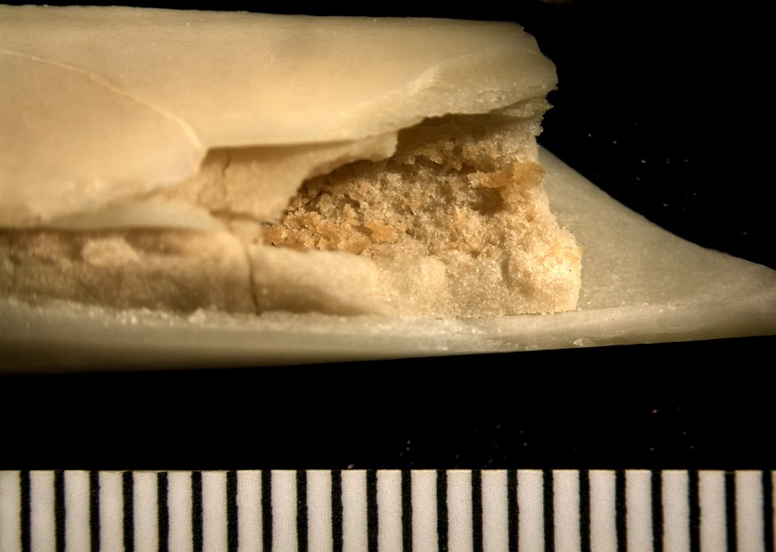

Figure 4. Medullary Bone: Stewing Hen Tarsometatarsus (measured in mm); photograph taken by author

The repeated appearance of medullary bone as part of the avian faunal assemblage suggests that birds might have been valued as much or more for egg production than meat and its presence is a good indicator to determine whether chickens were maintained mainly for eggs or for meat (Serjeantson 2009:48-53).
However, following an analysis of the bird bones from the Poplar Forest subfloor pit collection, it was determined that none of the chicken, nor any of the additional avian species’ faunal remains, exhibit the effects of medullary bone build up in the already fragmented long bones. Some of the bones are in fact whole and may contain medullary bone in the cavity, but laterally cutting them in order to observe the inside of the medullary cavity for the presence of medullary bone would destroy the integrity of the archaeological sample and is not permissible at this time. Because of the absence of medullary bone in the Poplar Forest subfloor pit faunal material, the recovery and identification of eggshell fragments is the only method that allows for an assessment of this topic.
Furthermore, it appears that according to the DAACS (Digital Archaeology Archive of Comparative Slavery) online database, the recovery of eggshell is extremely common at many Chesapeake Virginia archaeology projects; several assemblages from enslaved African American contexts exhibit large quantities of recovered eggshell (DACCS 2013). Other than a cursory count of total fragments recovered followed by the label “eggshell”, minimal contextual information is given for these collected samples. Almost certainly, eggshell identification research would contribute to these faunal analyses projects. It appears that overall, the present research bias stems from unfamiliarity with the applicability of eggshell identification literature and identification techniques.
Juxtaposed to this underrepresentation is the frequent mention in planter’s journals, travel accounts, associated historical documents, and the WPA (Works Progress Administration’s Federal Writers’ Project) narratives collected during the 1930s recording enslaved African reliance on and the utility of a variety of bird species (Covey and Eisnach 2009). Interviewees remarked that chickens were often kept and primarily used for their eggs, while other varieties of birds such as duck, goose, and turkey eggs were collected from both wild and domestic sources (Covey and Eisnach 2009). While the WPA narratives may reflect both 1930s interviewer and interviewee bias, when used in conjunction with additional primary historical documents and the archaeological record, these informative avenues of research provide first-person oral histories of the dynamic nature of people and the environment.
During the analysis of the faunal material recovered from the subfloor pit at Poplar Forest, a total of 302 bird bones were positively identified to species level; of that total, 243 pieces were identified as chicken (Gallus gallus). Many more avian skeletal elements remain unidentified to a specific species. Table 2 illustrates the number of identified specimen (NISP) for the bird bone collected from the subfloor pit at Poplar Forest.

Table 2. Poplar Forest Avian Bone Faunal Material

Species | Common name | Elements identified
Agelaius phoeniceus | Red-winged blackbird | 1
Anatidae | Duck/goose/swan | 1
Anserinae | Goose | 3
Colinus virginianus | Common bobwhite | 2
Gallus gallus | Domestic chicken | 243
Meleagris gallopava | Domestic turkey | 7
Numida meleagris | Guinea fowl | 1
Passerine | Perching bird | 22
Quiscalus quiscula | Common grackle | 13
Tyrannus tyrannus | Eastern kingbird | 4
Zenaida macroura | Mourning dove | 4
Zonotrichia albicollis | White-throated sparrow | 1

Bird bone accounts for approximately 12% of the Poplar forest subfloor pit assemblage identifiable to the genus or species taxonomic level; 10% of this total accounts for the material identified as chicken. Therefore, if we were to quantify only the bird bone, it would be assumed that the cabin occupants were singularly concerned with raising chicken for their meat. In the absence of medullary bone samples, without the careful excavation methodologies employed for the recovery of eggshell, researchers would not be aware of the importance that eggs played in the everyday life of the Poplar Forest inhabitants, culminating in a further underrepresentation of the practice of breeding chickens for eggs rather than for the consumption of meat.
Until now, literature and available resources pertaining to eggshell identification for historic sites in North America has been non-existent; at present, no systematic analysis of preserved bird eggshell from any historical context has been undertaken. Therefore, this thesis project offers an initial attempt at the identification of different kinds of birds represented by archaeologically recovered eggshell.
This chapter demonstrates that while collectively avian skeletal elements have largely been an ignored component of faunal reports, there is sufficient evidence to support a more detailed examination of all avian faunal material. Eggshell fragments are surprisingly resilient to deterioration, particularly in alkaline soils (Sidell 1993:8), and can therefore provide an alternative method for assessing the historic importance, availability, and variability of birds on archaeological sites.

Chapter 3: Literature Review

Early Literature

In general, early interest in the study of eggs remained restricted to the collection of wild avian specimens by amateur collectors for inclusion in private or curated museum collections. While admittedly some of these collections have been selectively accumulated for ulterior purposes, the eggs housed in museum collections provide researchers with a readily available resource to a wide range of species that today are endangered, already extinct, or difficult to locate for a particular research area (Kiff 2005). Research projects concerning eggshell variability in the archaeological record originally grew in popularity from a developing interest in biological variation, scientific hypothesis testing, and the role that birds occupy in human subsistence practices. This interest is manifest in the ethnographic research projects completed throughout the 19th and 20th centuries. Eggs, both from wild and domesticated sources, were collected and consumed as a significant contribution to human dietary requirements and economic commodities in cultures across the globe, beginning with early pre-historic hunter-gatherer societies and including more recent cultures such as the Pacific Northwest Tlingit, Artic Nunamuit, New Zealand Maori, and 19th- century North Atlantic British Island populations and Norwegian cultures (Serjeantson 2009: 167-169). In addition to dietary supplementation, additional uses of the often-discarded eggshell fragments include jewelry ornamentation, storage containers, decorative material, and mortuary offerings (Steward 2012).
Modern research methods exploring the importance of eggshell studies start with Alexis L. Romanoff and Anastasia J. Romanoff’s 1949 publication, which attempts to synthesize the available literature detailing the biological, morphological, and utilitarian nature of bird’s eggs (Romanoff and Romanoff 1949). They credit Hermann von Nathusius (1871) for observing that eggshell thickness is correlated to species determination, a feature that appears to be a useful characteristic for overall taxonomic classification (Romanoff and Romanoff 1949:150). The authors go on to review mode of laying, internal and external egg formation and structure, and chemical composition of the entire egg. In the concluding chapters, they address the issue of the bio-economic importance of the egg in society, including an historic and modern assessment of nutritional value and industrial food uses for the egg (Romanoff and Romanoff 1949). For the purposes of this thesis project, it is their detailed examination of the eggshell’s microscopic structure that illustrates the importance of eggshell variation between species (Figure 5).

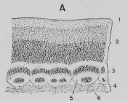

Figure 5. Illustration of Hen’s Eggshell Structure According to Alexis Romanoff and Anastasia Romanoff, The Avian Egg 1949:160; 1. cuticle; 2. spongy layer; 3. mammillary layer; 4. shell membrane; 5. mammilla (mammillary knob); 6. protein matrix material forming the core of the mammilla (Romanoff and Romanoff 1949:160)

Romanoff and Romanoff provide some of the first detailed information assessing overall eggshell structure, including both organic and inorganic components and individual variation in a single clutch. For example, factors influencing shell thickness may include heredity and the ability to metabolize calcium, seasonal climactic variation, and nutrition (Romanoff and Romanoff 1949:154). Additionally, the authors provide an analysis for the form and function of mammillary layer and pores, detailing the shape and size of mammilla characteristic of species according to the cross-section measurements noted by previous researchers and their own observations (Romanoff and Romanoff 1949:164). They hypothesize that, “in the hen’s egg, the thickness of the mammillary layer is about 0.11mm, or approximately one-third that of the entire shell” (Romanoff and Romanoff 1949:165). This research, while not the first of its kind, provides scholars with a synthesized, yet solid foundation from which to continually build upon eggshell research.
Following the Romanoff and Romanoff publication, British researcher C.B. Tyler published several studies documenting morphological eggshell variability of chickens in the Journal of Science and Food Studies and British Poultry Science (Tyler 1953, 1955, 1961a, 1961b, 1969; Tyler and Geake 1965). Each article introduced and reviewed a scientific methodological approach for interpreting variability in eggshell porosity, marking and counting pore distributions, thickness patterning, and overall shell durability. Tyler provided a series of methods for viewing eggshell characteristics with a low-powered microscope and followed these observations by statistically evaluating the results. For example, Tyler’s methods for viewing and marking eggshell pores utilized both concentrated nitric acid and a staining agent as the primary techniques for surface pore counting on fragmented chicken eggshells. By immersing small fragments in the acidic solution and staining another sample of shell with aqueous dye solution, the resulting visibly enlarged pores and stained pores within a 1-centimeter sq. area were examined and tabulated using a transmitted light microscope (Tyler 1953).
A second method explored by Tyler involves the study of chicken eggshell thickness variation and uniformity from different areas of the same egg, while also comparing eggs produced by a single bird to multiple birds from the same species. Fragment samples of eggshell were taken from all areas of the egg, including the poles and the mid-section. These were then measured for thickness along the cross-section break and averaged to obtain an accurate mean shell thickness value (Tyler 1961a; Tyler and Geake 1965; Figure 6).

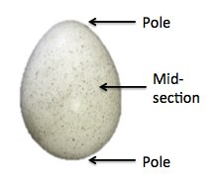

Figure 6. Illustration of Egg from Comparative Collection with Features Labeled; photograph taken by author

Tyler determined that by utilizing both pore frequency distributions calculated across the surface of the eggshell and thickness measurements, the mean eggshell measurements could be collected, analyzed, and later compared to shells fragments collected from a variety of bird species. However, this pore counting method is a highly destructive technique for the eggshell fragment undergoing analysis.

Contemporary Literature

Fossilized eggshell material, as well as recent eggshell material from amniotic vertebrates provides valuable information concerning the detailed ultrastructure of eggshell, including the utility of comparative identification collections (Carpenter 1999; Clayburn et al. 2004; Hayward et al. 2000; Mikhailov 1991, 1997). For example, Konstantine E. Mikhailov’s Micrograph Atlas (1997) provides information about detailed morphological variation and methods of analysis, examining fossil eggshell material and comparing the samples to modern avian and reptile specimens. Using scanning electron microscopy, Mikhailov illustrates three-dimensionally the usefulness of detailing microstructures for detailed taxonomic identification of modern bird eggs, a process that aids both modern ornithologists and individual researchers interested in fossilized eggshell fragments (Mikhailov 1991, 1997). This publication highlights the effectiveness of SEM techniques for capturing detailed images of eggshell structure and comparative research methods (Figure 7).
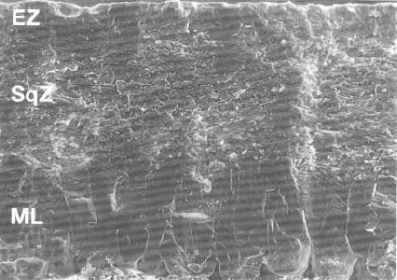

Figure 7. Mikhailov Turkey (Meleagris gallopavo) Eggshell SEM Micrograph: Radial Fracture, x180 (Mikhailov 1997:45); EZ – external zone, SqZ – squamatic zone, ML – mammillary layer

Additionally, Kenneth Carpenter’s analysis of fossilized dinosaur eggs (1999) similarly incorporates birds and reptile egg information as a proxy for understanding what is observed in fossilized dinosaur eggs samples (Carpenter 1999:85-107;122-144). Furthermore, many of the eggshell feature measurements utilized by naturalists and archaeologists come from biological or ecological studies (Becking 1975; Haegele and Tucker 1974, Tyler and Geake 1958). Environmental publications are repositories for large quantities of data, collected to assess overall wild and domestic species’ well-being and avian fecundity. Often the thickness of the eggshell is used to assess shell quality, a particularly plastic feature indicative of environmental pollution. For example, Becking’s (1975) research provided a means for understanding eggshell thinning caused by the widespread use of pesticides while also providing a preliminary account for the expected differential characteristics of wild bird eggs.
Each of the authors cited above successfully illustrates, based on an understanding of eggshell microstructure, that a great deal can be learned by determining the identification of eggshell samples from an unknown source. This becomes especially feasible when a modern comparative collection is available for referencing. Further more, modern avian taxa can be used successfully to identify fossil material by comparing observed structural differences identified between avian taxa from features visible at the microscopic level. These differences can then be tabulated and used to create a set of unique defining characteristics for species differentiation and ultimately identification. However, the question remains: can these differences be seen with a low powered microscope or must researchers resort to using Scanning Electron Microscopy (SEM) images to attain positive species-specific identifications? Mikhailov (1997) states that most variation can be seen and addressed at the order taxonomic level when utilizing SEM micrographs and some detailed identifications can be made within family or subfamily levels of the order, especially between the Anseriformes and Galliformes. However, much of the literature reviews and documents the characteristics of eggs from larger birds for their comparative collections, such a specimens from ostrich, emu, and rhea species. These analyses, while helpful for addressing methodological identification techniques and sample processing methods, are not very informative for identifying eggshell fragments recovered from the archaeological record.

Archaeology Literature

The study of eggshell material recovered from archaeological contexts may be a relatively unknown research approach to many archaeologists working in North America, but in fact it is not a recent addition to the archaeological literature. The vast majority of eggshell identification methods originated from projects pioneered by archaeologists working in Great Britain and Europe. Several sources, including those listed below, offer valuable guides and supplementary resource material for the study of eggshell in the archaeological record (Mikhailov 1997; Reitz and Shackley 2012; Serjeantson 2009; Sidell 1993).
Carol Keepax (1981) published an article exploring eggshell structural differences and distinctive identifiable features that vary on a number of small fragments of archaeological eggshell. These fragmented eggshell samples were recovered from fourteen different historic sites in England, ranging in date from the early 4th century Roman occupation, through the medieval period, and into the present day (Keepax 1981:319). Using modern eggshell specimens for a control group, Keepax observed and measured a series of variable characteristics including estimated egg size, egg shape, color, thickness, surface texture, mammillae size, mammillae number, height and structure of mammillae, number of pores, pore size and pore shape for all modern and archaeological samples (Keepax 1981). Her research contained a listing of species-specific morphological features and these were then used to facilitate the identification of the archaeologically-recovered eggshell samples. Assisted by SEM (Scanning Electron Microscopy) images, Keepax employed a new method for increasing the accuracy of identifying even the smallest eggshell in a sample.
Elizabeth J. Sidell is perhaps the most well known scholar to advance eggshell identification studies and focus attention to the repeatability of identification methods for archaeologically-recovered eggshell fragments. As author of the definitive eggshell identification guide detailing standardization procedures and best practice methods for the classification and identification of eggshells and the effects of taphonomic processes (Sidell 1993; Figure 8), Sidell interprets observable variations between eggshell fragments and recognizes the utility of avian taxa for interpreting human behavior and subsistence practices.

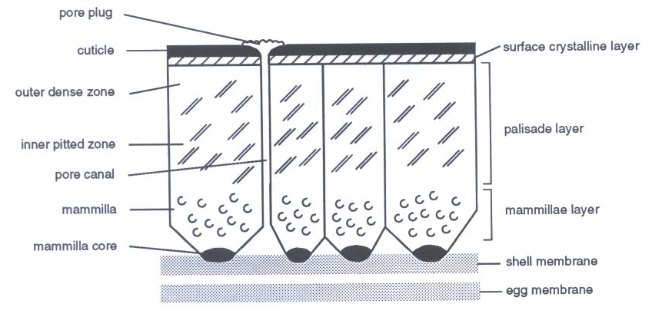
Figure 8. Eggshell Feature Morphology Illustration (Sidell 1993:6)

Sidell has completed eggshell identification for archaeological material collected from several sites in Great Britain and Europe, including the Roman suburban site of Durnovaria (Sidell 2008), Viking settlements in Iceland (McGovern 2006), the pre-Norse and Norse occupations of Freswick Links, Caithness in northern Scotland (Sidell 1995), and from Çatalhöyük, Turkey (Sidell 2005). For these projects, Sidell has explored the potential of spatial and diachronic variables affecting site function, diet, economy, discarded food contexts, and the role that birds play in forming an integral part of larger scale human-animal interaction relationships. Sidell expands her research goals to include an interpretation of the data and incorporates an analysis of the social implications relating to site function and artifact deposition with regard to the newly acquired avian species identification methods.
By identifying the eggshell fragments from the Freswick material, including Norse and pre-Norse occupations in northern Scotland, Sidell identified nineteen species of domestic and wild birds. The results of the eggshell examination highlighted several key points of interest, including the domestication and exploitation of birds for their eggs during pre-Norse occupation periods. This observation prompted a further examination of the material to better understand and for the first time document the expansion of historic avian breeding distributions for several poorly documented species, such as the fulmar, great skua, and manx shearwater (Sidell 1995).
Keepax and Sidell independently constructed similarly designed modern reference collections to facilitate identification of macro- and microscopic features present on the inner and outer surfaces of the eggshell samples (Keepax 1981; Sidell 1993). Both sets of comparative materials were collected from modern bird specimens residing in Britain and Europe. This range of species’ geographic distribution can potentially invalidate their comparability to specimens collected from the Southeast and Middle Atlantic regions of the United States. Comparing the archaeological samples to modern specimens collected from a variety of geographically diverse environs fails to capture the presence of regional variation, including specimens altered by breeding or regional and environmental factors effecting eggshell size, shape, and thickness. Differential avian diets, nutrition, environment, and breeding practices might have the potential to influence the results of the collected archaeological metric data when comparing historic to modern species of fowl (Keepax 1981:332). However, this assumption has yet to be systematically assessed and there may be no appreciable or significant difference. Regardless, the inclusion of additional species may increase the reliability and accuracy of determining the identification of archaeological samples. Therefore, the comparative material collected by Keepax, Sidell, and other researchers has been included as secondary comparative material, supplementing the measurement data collected from the modern eggshell comparative collection curated at the University of Tennessee, Knoxville.
Unfortunately, many of the earlier studies concerning eggshell analysis were not incorporated into projects documenting North American archaeological sites. However, within the last decade or more, a number of research projects examining eggshells from prehistoric North American archaeological sites have frequently appeared in journal publications. For example, innovative research methods have been completed by Beacham and Durand (2007) on 12th century AD turkey husbandry in the American Southwest. Similarly, Decker’s (1998) research detailing the utility of eggshell for hunter-gatherer subsistence behaviors at the prehistoric Wilson-Leonard site in Texas offers another example of a project emphasizing the future applicability of eggshell analysis in North America.
Beacham and Durand (2007) identify and record the potential of archaeological eggshell for purposes other than species identification. The authors determined that differences in internal eggshell structural features of turkey eggshells collected from archaeological contexts could document embryonic development, an indicator for human- assisted modification of animal resources.
Embryonic development, or embryogenesis, conforms to a relatively consistent sequence of stages (Beacham and Durand 2007; Chien et al. 2009). Calcium is required for sustained embryonic development and the internal structure of the eggshell provides the necessary nutrients for growth during the incubation period. The resorption of calcium from the internal structure is a recordable, time dependent, and patterned process, visible on the internal portion of archaeological eggshell fragments that differ among avian species. Recording the degree of embryonic resorption, including depletion or changes present on the internal structure, can determine if an egg was used as a food resource or if it was allowed to hatch, facilitating the continuation of animal husbandry practices. In conclusion, these assessments of internal structural differences provide clear evidence that during the 12th century AD, purposeful breeding of captive turkeys in the American Southwest was practiced. This conclusion allowed for the identification and interpretation of patterned human behaviors in relation to the other archaeological faunal material in the assemblage (Beachman and Durand 2007).

New Techniques

Recently, a range of methodological studies designed to simplify or challenge existing methods of identification for archaeologically recovered eggshell have been proposed and empirically tested. Each of these approaches explores the use of a particular technique, assessing the reproducibility and broader applicability for a particular method. Most of these research projects compare observation using scanning electron microscopy (SEM) images and micrometer measurements or other similar cost-efficient methods employed to assess differences in shell thickness and facilitating the identification of eggshell fragments to species (Igic et al. 2010; Gill 2010; Murphy 1985; Bušs and Keišs 2009). However, a number of additional analytical methods are available and with further refinement and testing, these may prove beneficial and viable for future eggshell analysis projects.
For example, Eastham and Gwynn (1997) attempt to correlate the relationship between the archaeological eggshell fragments and the avian fauna recovered from the excavation of Skara Brae on the Orkney Islands of Scotland. They used a computer based neural network program capable of comparing SEM images taken of the avian eggshell ultrastructure to a database of known avian eggshell samples. This method was applied to the Skara Brae micrographs and the findings indicate that the archaeological samples could be positively identified as belonging predominately to a wide variety of seabird species. Researchers could then interpret the relationship observed between the avian bone assemblage and the eggshell assemblage to determine which bird species were utilized for meat and which were used for egg exploitation.
Analysis of ancient DNA extracted from archaeological eggshell fragments can be used to acquire precise species-specific biological identification markers (Oskam et al. 2011). By testing both mitochondrial and nuclear DNA signatures, researchers in New Zealand have positively identified eggshell fragments belonging to the extinct moa bird from intact DNA samples recovered in burnt archaeological fragments found during the excavation of a 13th-century AD hearth/oven feature (Oskam et al. 2011).
Furthermore, Stewart et al. (2012) have recently developed a method they call ZooMS peptide mass fingerprinting analysis. The authors propose to utilize mass spectrometry and peptide mass fingerprinting analysis to reliably illustrate the positive identification of archaeologically recovered eggshell fragments. This technique, while minimally destructive to both the archaeological and modern samples and lacking a degree of cost-effectiveness, does provide a robust testing platform for the future of eggshell identification studies when large samples sizes are examined.
In conclusion, eggshell studies have been a broadly applicable method of research, utilized as a testable analytical research tool by the international archaeological community for many years. Following Romanoff and Romanoff, Sidell, and Keepax, other scholars have further incorporated a variety of testable and repeatable methodologies available for use in specialized reports or collaborative analyses. Therefore, it can be expected that eggshell studies indeed have the potential to enrich the understanding of historic utility and overall avian presence in the archaeological record.

Chapter 4: Materials and Methods

The research framework employed for this study incorporates a research design influenced by similar projects completed by Carol Keepax (Keepax 1981), Elizabeth J. Sidell (Sidell 1993; Sidell and Scudder 2005), and others (Beachman and Durand 2007; Decker 1998; Iglic et al. 2011). From these initial reports examining eggshell variability in the archaeological record, the present analysis seeks to replicate and test the validity of selected eggshell identification techniques. While the methods remain similar, it is important to note the effectiveness and uniqueness of the independently collected modern avian species comparative collection, assembled specifically for this project and now a curated part of the faunal comparative collection at The University of Tennessee zooarchaeology laboratory. An initial assessment of the eggshell assemblage from Poplar Forest indicates that variability and chronological trends exist with regard to types and quantity of eggshell recovered. These changes are worth further examination and provide additional refinement of the established identification methodologies. This chapter also further examines the unique characteristics of eggshell ultrastructure and provides a detailed summary of the analytical methods used during the examination of the Poplar Forest eggshell fragments.

Eggshell Morphology

Freshly produced whole eggs are initially comprised of both organic and inorganic materials. Calcite, in the form of calcium carbonate, can be identified as the primary inorganic mineral present in eggshell composition, accounting for almost 98% of the total mass of most avian eggs. The remaining mineral components include smaller amounts of magnesium, iron, sulfur, phosphorus, organic proteins and fats (Romanoff and Romanoff 1949:353; Serjeantson 2009:170; Taylor 1970). Figure 8, borrowed from E. J. Sidell’s Guide to Eggshell Identification (1993), presents a detailed illustration of avian eggshell structure and general descriptive terminology and nomenclature. However, many of the organic features, like the pore plugs and both the inner and outer membrane layers, are either removed or depleted through post-depositional processes.
For the purposes of this study, the most important features are the cuticle layer, pores, palisade layer (also called the continuous layer), mammillae layer, and membranous material. These eggshell characteristics can be measured for differences in structure and morphology to identify and tentatively quantify species representation. The cuticle layer acts as a thin barrier, protecting the interior shape and structure of the eggshell from the outside environment. This layer is variable in appearance and can be quite thin or relatively thick, depending on the species of bird under examination. The palisade or continuous layer forms above the mammillae layer, and is separated into two distinct zones; the outer zone is a dense layer of material and defines the shape of the egg’s surficial appearance, while the inner zone consists of well-defined palisaded formations and vesicular pitting (Sidell 1993:6-7; Mikhailov 1997). The mammillae layer represents the lowest stratum of eggshell and is most notably recognized by the cone-shape structure that forms against the shell membrane. Variations in thickness occur between the palisade layer and mammillae layer. The inner and outer shell membranes appear as woven fibrous material adhering to and obscuring the mammillary cones (Figure 9).

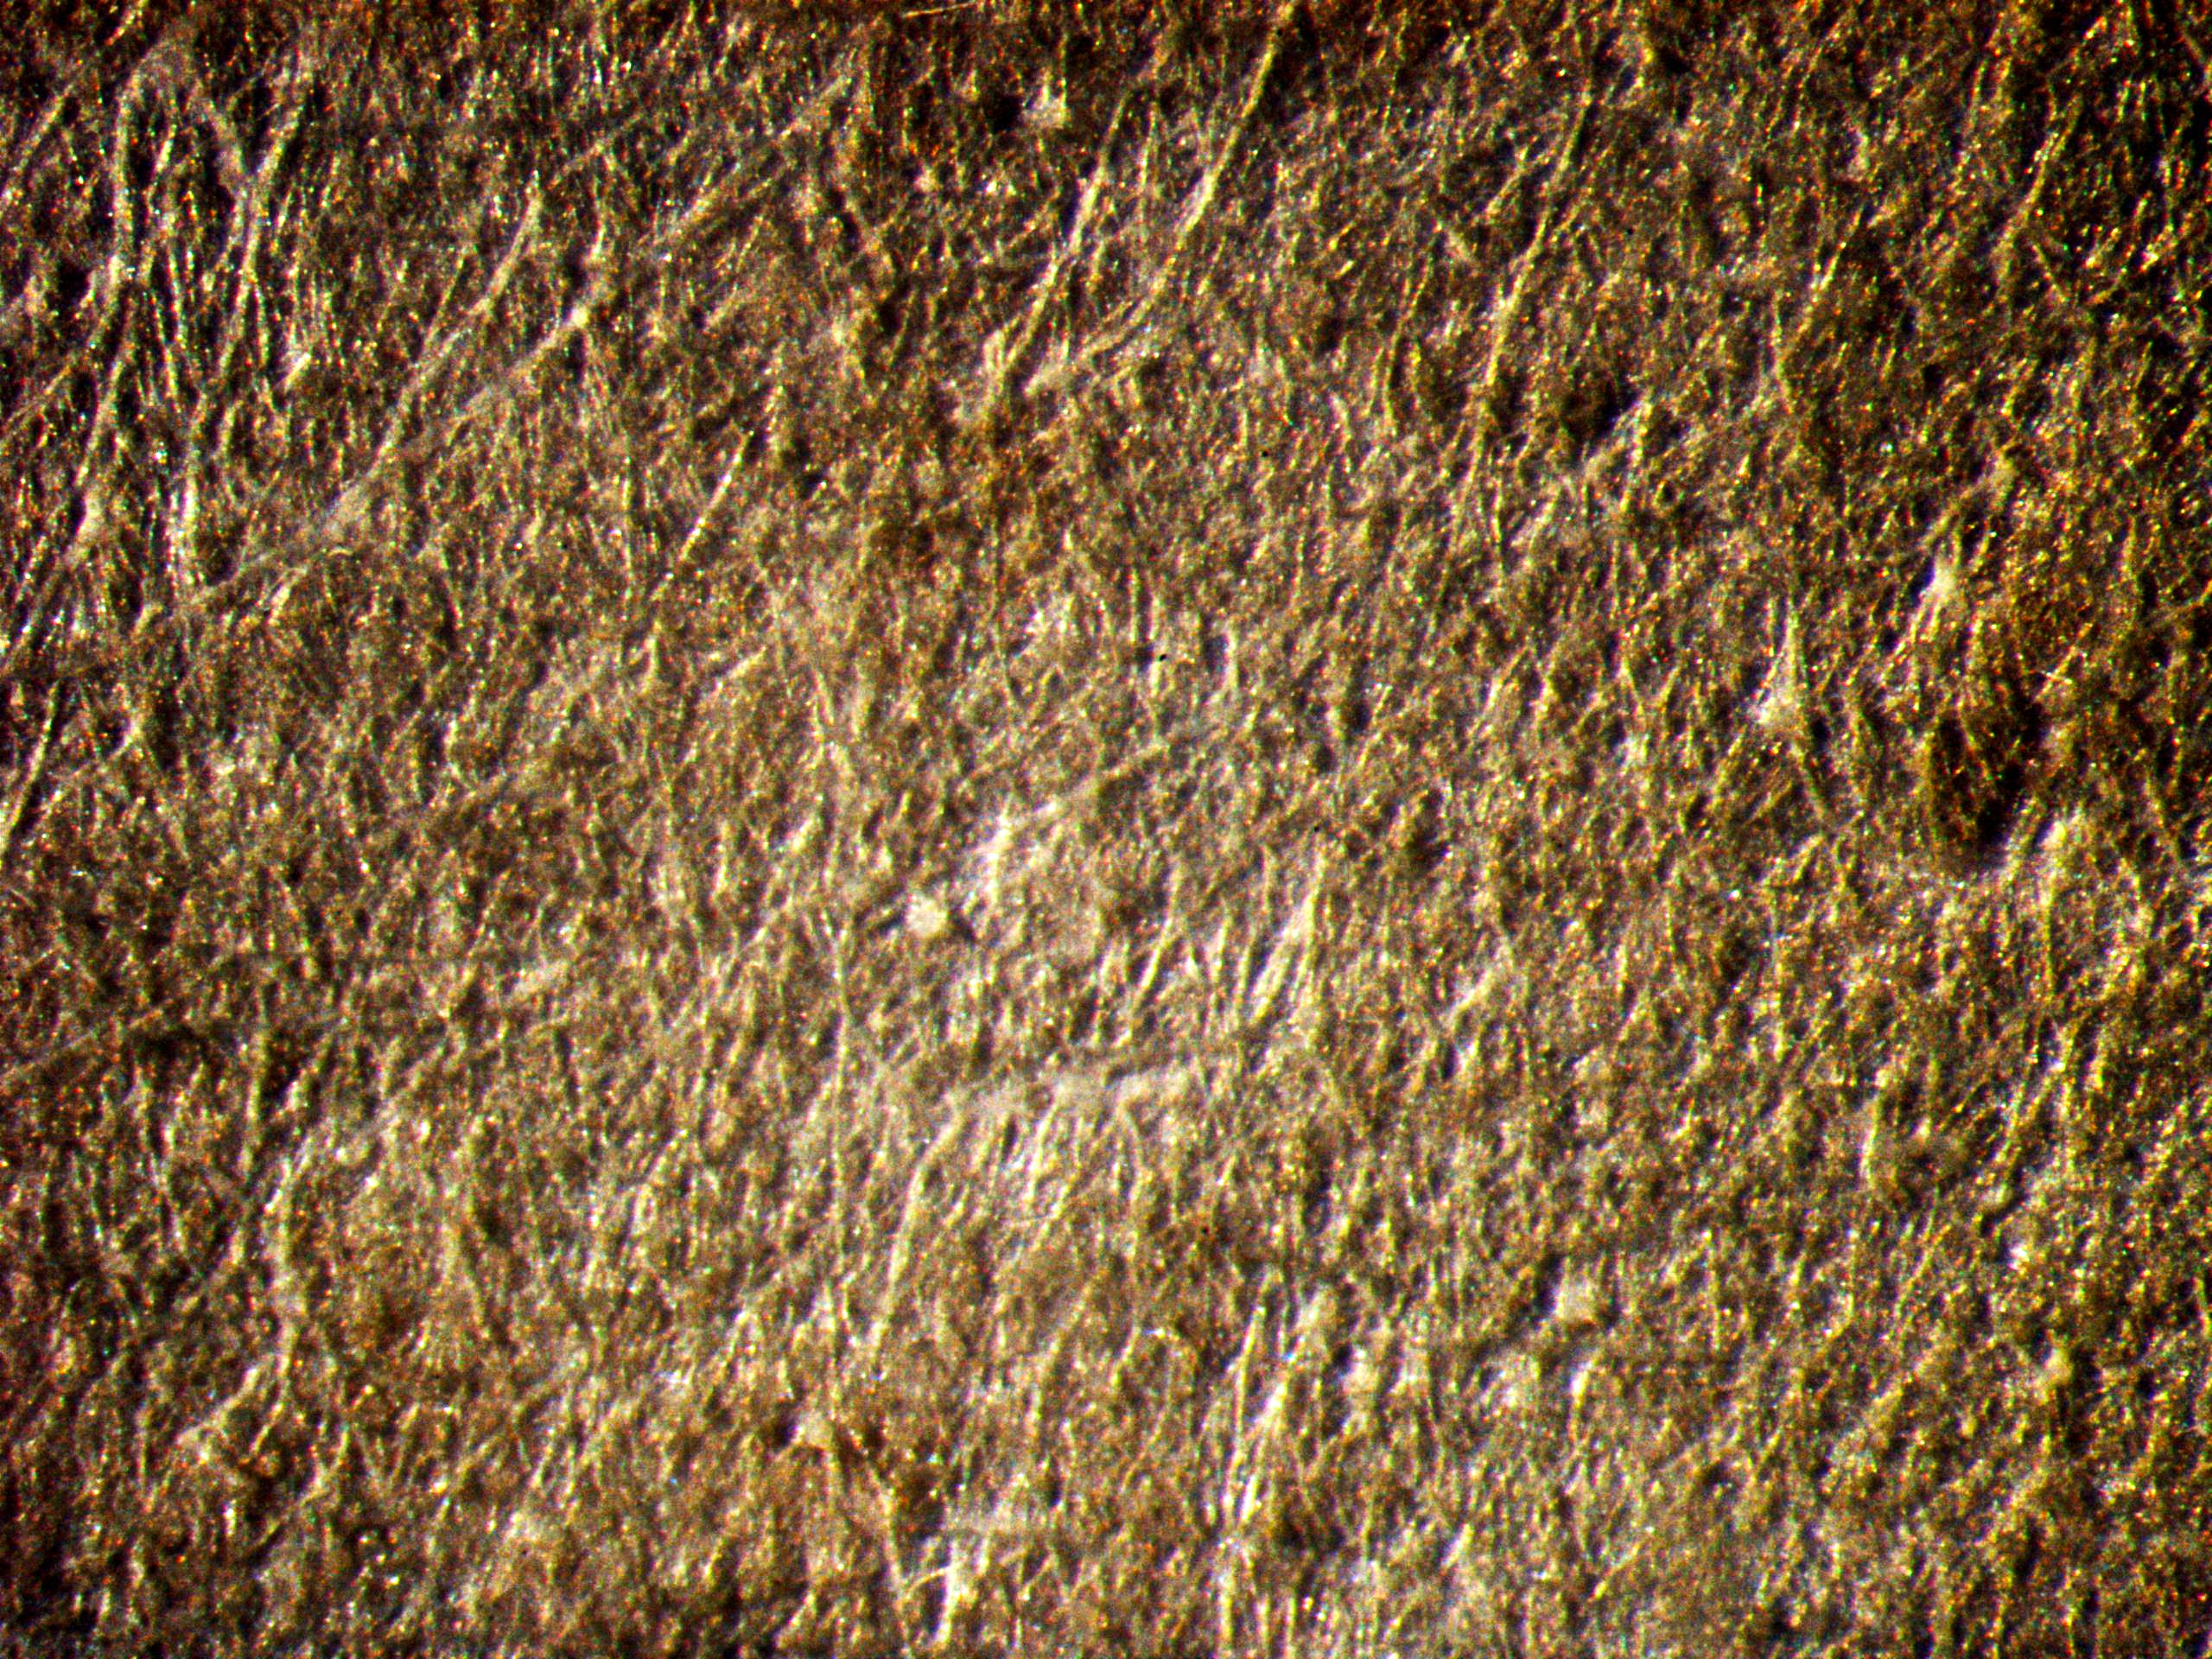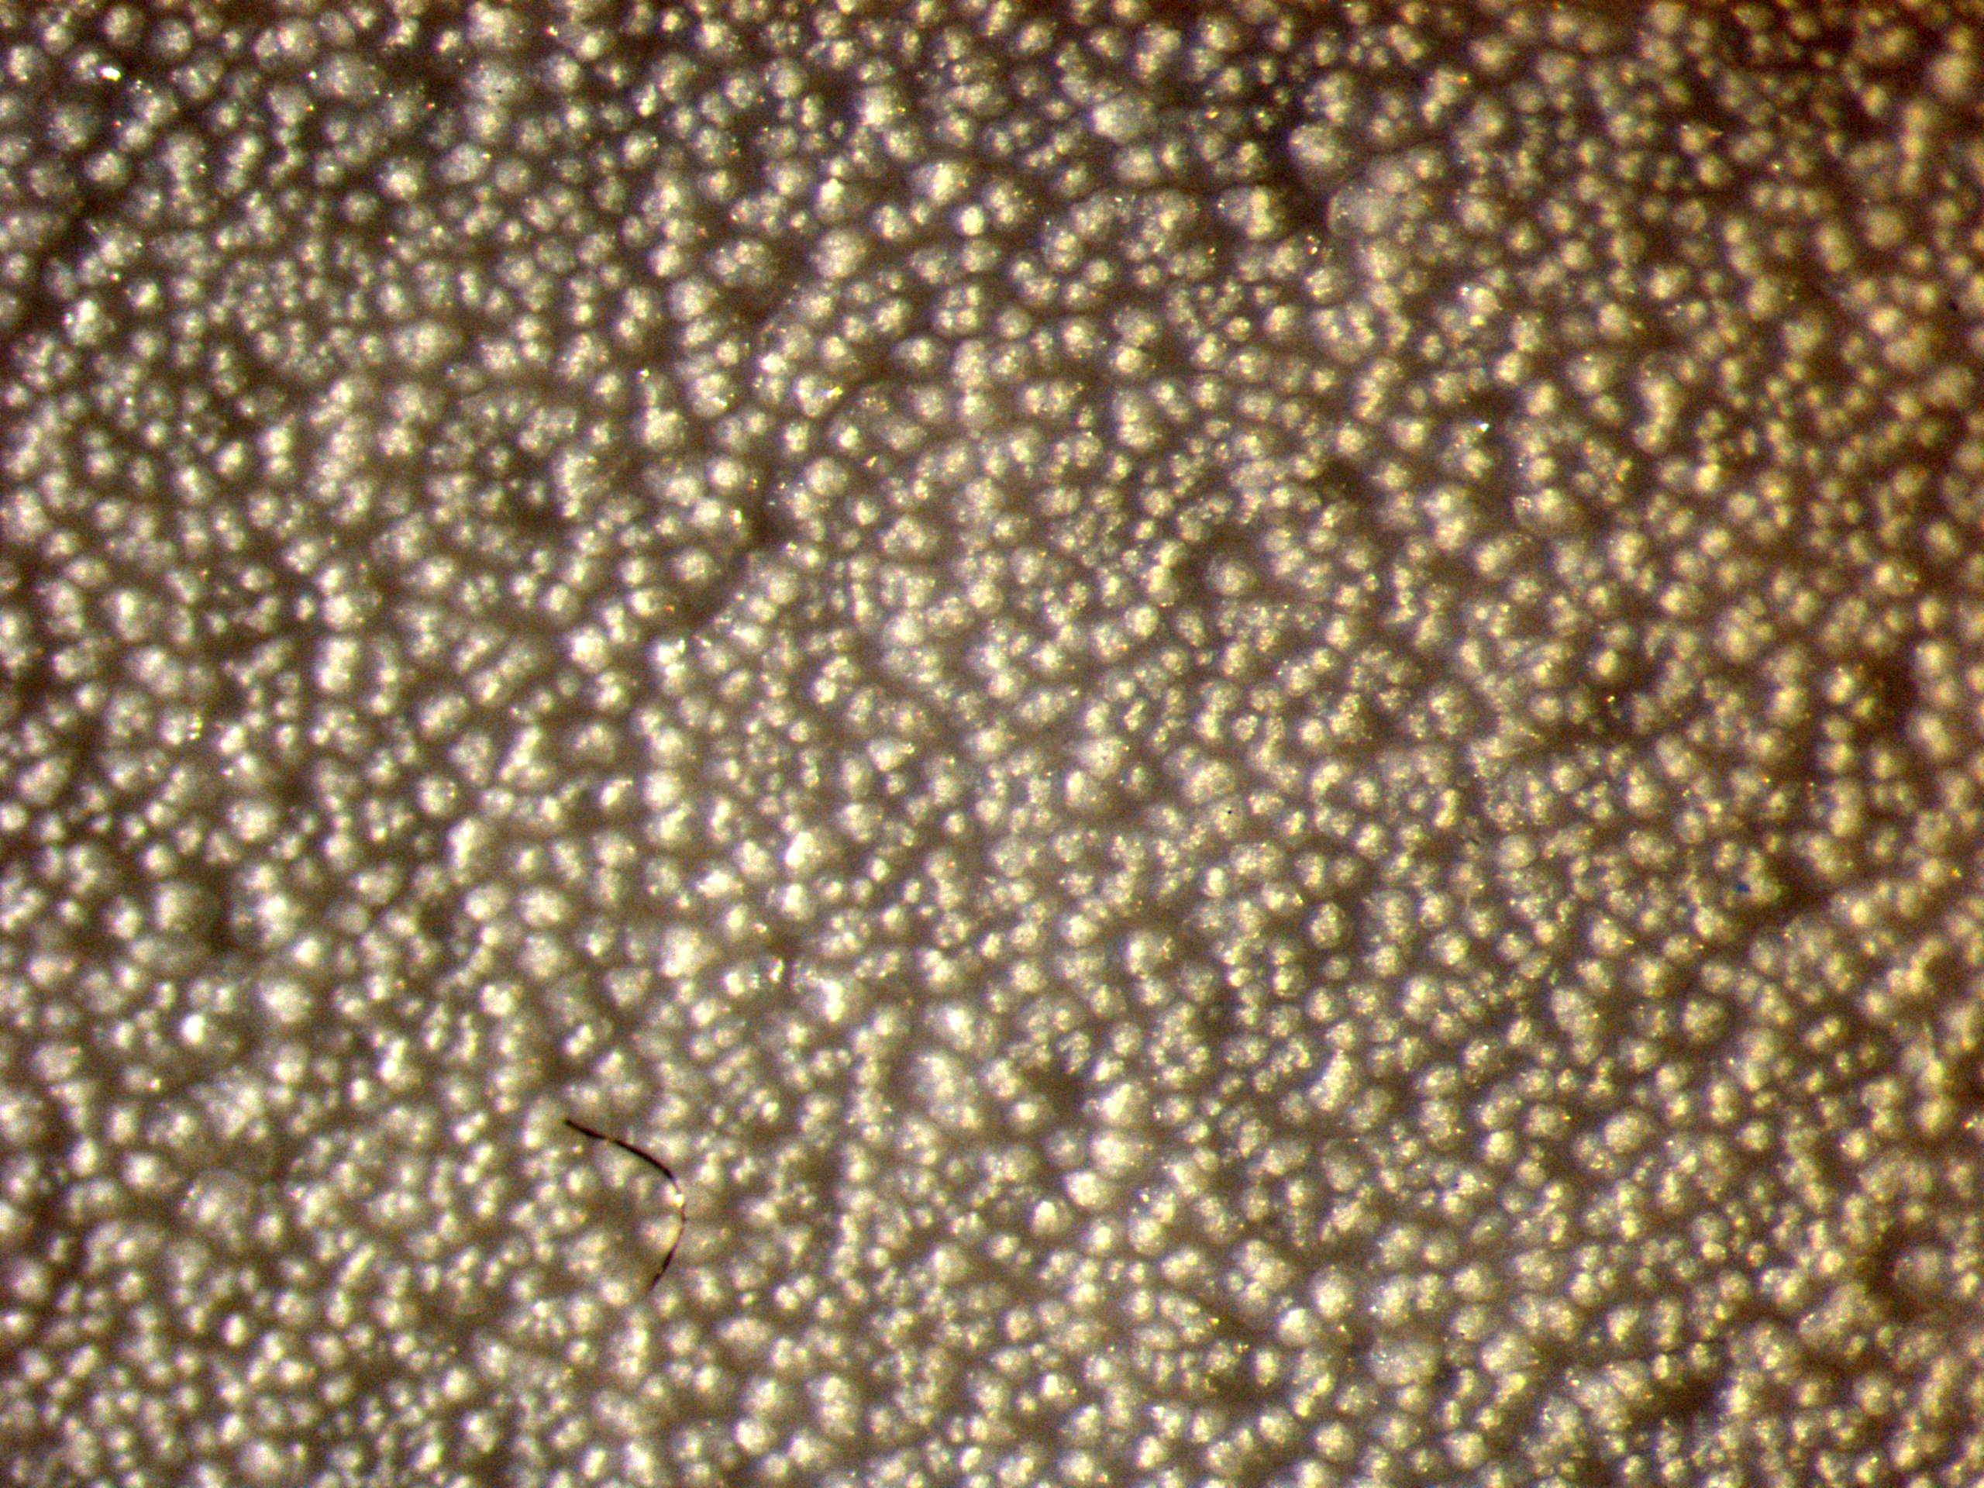

Figure 9. (Left) Organic Membrane: Interior of Chicken (Gallus gallus) Eggshell Surface with Organic Membrane Intact, stereomicroscope, x40; photograph taken by author

Figure 10. (Right) Organic Membrane Removed: Interior of Chicken (Gallus gallus) Eggshell Surface with Mammillae Cones Visible, stereomicroscope, x40; photograph taken by author

Once the membrane is removed, the mammillary cones appear as conical shaped ridges across the interior surface of the eggshell (Figure 10). Similar to these organic membranes, prior to deterioration pores allowed for the exchange of water and gases to pass through the shell and encourage embryonic development (Serjeantson 2009:171). After the deterioration of these organic plugs, the pore canals are cleared of residual organic materials and appear as open holes covering the surface of the shell fragment.

Research Methodologies

Published reports detailing eggshell identification methods incorporate a range of bird species for the collection of data. However, many of these species are not always found in abundance in archaeological faunal assemblages from historic sites in the Middle Atlantic and southeastern United States. For example, Sidell includes ostrich and great skau eggshells in her identification guide, species that are unlikely to be recovered in archaeological assemblages from the Virginia Piedmont. Therefore, the formation of a regionally-specific modern eggshell comparative collection was assembled for this project in order to compensate for any issues that may be associated with diachronic and geographic variability associated with the measurements of eggshell features collected by previous researchers. Multiple specimens assumed to be comparable to those present during the historic occupation of the site were collected from wild and domestic bird species (Table 3).

Table 3. The University of Tennessee Modern Comparative Eggshell Collection: Species

Species | Common Name | # of eggs
Anser anser | Domestic Goose | 1
Anas platyrhynchos | Indian Runner | 4
Cairina moschata | Muscovy Duck | 2
Cardinalis cardinalis | Northern Cardinal | 1
Coturnix coturnix | Quail | 1
Gallus gallus | Rhode Island Red | 4
Gallus gallus | Ameraucana | 1
Gallus gallus | Yellow Legged Hutch/White Hackle | 1
Gallus gallus | Red Star or Red Sex Line | 4
Gallus gallus | Game Hen | 1
Gallus gallus | Banty | 1
Gallus gallus | Jungle Fowl | 2
Meleagris gallopava | Wild Turkey | 4
Meleagris gallopava | Domestic Turkey | 4
Numida meleagris | Guinea Fowl | 2
Sturnus vulgaris | Starling | 1

These include Rhode Island Red, Jungle Fowl, and Red Star chickens (Gallus gallus), wild and domestic Turkey (Melegris gallopavo), Goose (Anser anser), Indian Runner duck (Anas platyrhynchos), Muscovy duck (Cairina moschata), Guinea Fowl (Numida meleagris), Quail (Coturnix coturnix), Northern Cardinal (Cardinalis cardinalis), and European Starling (Sturnus vulgaris). The Starling is an introduced invasive species to North America, but it is used here as a typified specimen to represent the wide range of other Passerine avian species not included in most studies. Each of these specimens were selected first because bones of similar avian species were identified in the archaeological faunal material recovered from Poplar Forest (Table 2), and second, because eggshells from these bird specimens were readily available in the East Tennessee region, an area geographically and climactically similar to the Virginia Piedmont.
Eggs were acquired from a number of local sources, including farmers markets, local farms, and from friends and family. Most unfertilized samples were consumed and the shells saved, while others were collected after the fertilized eggs were allowed to hatch. When possible, for fresh, unhatched samples, one or two eggs were preserved as whole hollowed-out samples, preserving the measurable dimensions of the entire specimen for future study. The remaining eggs were fragmented and individually bagged and cataloged according to species, date of collection, and collection locality. Three fragments of eggshell were collected from each egg for comparative analysis; two midsection fragments and one sample from the top or bottom pole region of the egg. The organic membrane layers, located on the inside of the eggshell and covering the outside surface plugging the pore canals, needed to be removed before further identification of specific features could be noted. Each sample was individually processed and submerged in bleach for fifteen to twenty minutes or more, depending on the eggshell, in order to obtain a better view of the interior structure without the attached organic components, which archaeological samples lack. This proved to be the easiest method to replicate, delivered the best results, produced no loss to overall thickness, and allowed for a clear view of the mammillae layer (Sidell 1993). This process ensures that when the measurements collected for each modern fragment are averaged, an accurate mean can be recorded for those fragments and the entire egg can then be compared to the archaeological eggshell material. The three individual fragment samples measured from each egg were then bagged separately and stored according to species.
At the present time, the comparative material compiled for this project provides researchers with detailed observations on regional variation and morphological differences. These observations can then be compared to supplementary external sources that broadly categorize species differences or alterations of eggshell characteristics (Table 13; Ancel and Girard 1992; Board and Scott 1980; Hoyt et al. 1979; Mikhailov 1997; Schönwetter 1960-1992; Sidell 1993; Spaw and Rohwer 1987). Although a few of these sources are not archaeological in nature, they still offer species-specific measurements collected from eggshell characteristics and include valuable information pertaining to other methods of comparison and morphological differences when comparing wild and domestic varieties of the same species.
For example, Ancel and Girard (1992) examine the apparent morphological differences between wild and domestic guinea fowl by measuring eggs from each group produced over a given amount of time. They postulate that shell thickness acts as a selective evolutionary characteristic for the protection of incubated eggs from predatory animals and may be a trait that decreases in thickness over time as a result of long-term selective breeding practices or domestication. They report a decrease of 20% in shell thickness between domestic and wild varieties over a 50-year time span (Ancel and Girard 1992:995-996). Based on the results from this study, perhaps archaeological eggshell more closely resembles wild avian species and their corresponding shell thickness measurements. This observation could explain the thickness differences recorded in the comparative collection metric data between domestic turkey breeds and wild turkeys.
Schönwetter, in his Handbuch Der Oologie (1960-1992), lists a large number of thickness measurements of bird species from across the globe, which provides a comprehensive guide listing thickness measurement information for over 100 different avian types and separated by species-specific classification information (Schönwetter 1960-1992; Maurer et al. 2010). However, researchers often misinterpret this publication; Maurer et al. (2010) states that it is not often realized that the eggshell thickness measurements recorded in the Handbuch were not measure directly, but instead were derived from measurements taken from the shell length, breadth, and shell weight (Maurer et al. 2010:941). Fortunately, Maurer and colleagues provide a reference for interpreting the correct use of the measurement tables and equations used to calculate shell thickness, with the intent to promote increase correct use of the Handbuch by the larger scientific community.
Using the modern comparative eggshell collection and metrics collected from supplementary sources as a basis for comparison, samples from the Poplar Forest archaeological eggshell assemblage were systematically measured for variability of eggshell characteristics. All organic layers had been previously dissolved, due in part to the duration of burial and soil acidity. Consequently, the only additional step required for completion of processing the archaeological samples was the removal of residual sediment attached to the shell fragment. To address this issue, the samples were agitated for 60 – 90 seconds using a small sonicator filled with distilled water (Sidell 1995). This technique lifted the majority of the sediment adhering to the surface, however some fragments retained small amounts. After the samples were air-dried, eggshell fragments collected from 9 strata of the subfloor pit heavy fraction flotation samples were evaluated under a Leica stereomicroscope MZ6 between magnifications of 10 and 40x. This was done in order to isolate those samples deemed unsuitable for examination (i.e. burned fragments [Janssen et al. 2011], heavily weathered, poorly preserved, extraneous materials misinterpreted as eggshell, or samples measuring < 2 mm²). Of the 8727 total fragments evaluated, 3353 were identified as suitable specimens meriting further study. Due to the large amount of material recovered and processed, it was necessary to employ a random sampling strategy; 30% of the good eggshell fragments were selected from approximately two-thirds of the total heavy fraction samples, and measured for thickness, resorption patterns, and unusual interior morphological variations. Therefore, of the 105 heavy fraction samples recovered from the subfloor pit feature, only the eggshell removed from 71 of the heavy fraction samples was randomly selected to undergo further analysis. This sampling strategy yielded the selection of 1,026 eggshell specimens for identification determination. All collected information from each heavy fraction sample was cataloged and recorded in an excel spreadsheet (see Appendix 1).

Measurement Features

A variety of independent measuring methods are available to ensure accuracy and reinforce confident avian identification based on fragmented eggshell. Eggshell characteristics considered effective in determining probable identification include whole egg size and shape, eggshell color, cuticle texture, total thickness, mammillae size and mean distribution, number of pores, pore size and pore shape (Keepax 1981). From this detailed series of methods, the following attributes were selected for inclusion in the study for highlighting both the attribute’s robust survivability over time and subsequent ability to identify the observed attributes using a low-powered microscope. The preferred attributes that were selected include overall mean thickness (measured in millimeters), mean pore count and pore distribution, ratio of mammillae thickness to palisade layer thickness (measured in millimeters), and mammillae cone resorption phases.
Thickness measurements are relatively easy to compile and are effective in illustrating the range of variation among fragments, especially when large sample sizes are present. This can be accomplished using either micrometer calipers or employing computer-based image capturing software. Fragments from both of the modern eggshell comparative collection material and the Poplar Forest archaeological material were measured using a Leica MZ6 stereomicroscope at a magnification of 40x. The samples were turned on end for a clear view of the cross-section radial view and six straight-line measurements were taken on the fractured surface of each fragment. An attached Leica DFC camera and the image capture computer program Image-Pro® Express were used to digitally capture pictures and record feature characteristics using the line measurement tool and magnifying radial fracture stratification. Photograph filters were applied to the images to better detect the contours of both the interior and exterior shell cross-section boundaries. The six-straight line measurements collected for each shell fragment were then combined to create a mean thickness for that particular shell and recorded in Microsoft 2011 Excel spreadsheets (Figure 11; Attachment 2). The procedure was repeated for two to four individual eggs per species. All pictures from both the comparative and archaeological materials were saved for use in future projects and are stored digitally at the University of Tennessee Zooarchaeology Laboratory.

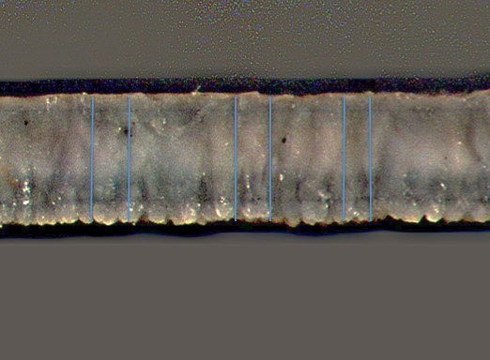

Figure 11. Chicken (Gallus gallus) Eggshell Radial Cross-section: Straight-line Thickness Measurements, stereomicroscope, x40; photograph taken by author

Figure 15 demonstrates that comparisons made between the thickness measurements and taken using modern eggshell fragments offers a reliable method for determining possible identification of eggshell samples. However, to insure accurate identifications, a large number of samples combined with a greater diversity of regionally-available species is preferred in order for this method to be completely successful. The thickness range for certain species, chicken and duck for example, overlap, perhaps making these measurements more valuable when compared with another method.
A number of researchers have investigated methods for determining structure and increasing visibility of pores in order to measure distribution, size, canal complexity, and total number of pores across the surface of the eggshell (Ancel and Girard 1992; Blankespoor 1987; Board and Scott 1980; Boesrma and Rebstock 2009; Hoyt et al. 1979; Keepax 1981; Tyler 1953, 1955, 1969). Keepax hypothesized that by recording differential pore distribution across the surface of eggshell fragments, the variability in the counts could be used to separate duck from chicken fragmented samples (Keepax 1981:327). While ducks and chickens are similar in overall thickness measurements, on average duck eggs have 1.1 pores/mm² and chicken eggs on average have 2.8 pores/mm². Unfortunately, Tyler’s (1955) technique for processing fresh eggshell fragments and producing an accurate pore count employed the use of immersion in 2.5% hydrochloric acid solution. By following Tyler’s procedure, the pores are enlarged and visible, however, the application of hydrochloric acid is a destructive process for the entire eggshell fragment and if immersed for long periods of time will dissolve the entire eggshell. Similar results to Tyler’s method were replicated by immersing the eggshell in vinegar; however this also completely destroyed the integrity of the eggshell. This problem was resolved by immersing the eggshell fragments in bleach, which accomplished the same pore protein clearing effects without damaging the eggshell fragment. After this, a light-microscope and 1mm x 1mm gridded reticule was used to view the exterior portion of the shell and the number of pores visible in a 1mm² area was averaged to produce a generalized numerical classificatory observation. Theoretically, this process allows for duck eggs to be separated from the chicken eggs, but the current project was unable to confirm the accuracy of this method. Even after the application of bleach was used to remove organic material from the comparative collection, some pores remained clogged with organic fats and protein material. Archaeological fragments exhibit a greater number of cleared pores, but even following longer periods of immersion and agitation in distilled water, some pores remained clogged due to the persistency of Virginia Piedmont clay. Perhaps with the inclusion of additional reference collection material and experimentation, this problem can be more definitively addressed, but at this time, no further steps were taken to alleviate the issue.
Similar to obtaining thickness measurements, the imaging software Image-Pro® Express was used to determine the ratio of the mammillae layer to palisade layer by viewing the eggshell fragment radial fracture from a sample of the Poplar Forest material. The same photographs taken with Image-Pro® Express for the thickness measurement determination were also used to collect measurement data for this method. The ratio measurements were then acquired using Adobe Acrobat 9 Pro measuring tool. Three straight-line measurements of the palisade layer and three straight-lined measurements of the mammillae layer were collected; totals for the palisade layer were divided by totals from the mammillae layer to determine a ratio for that selected fragment. This procedure is similar to projects completed by Sidell (1993) and others. This method might aid researchers in further separating probable species for a more precise identification. Occasionally, photographic filters were applied through Image-Pro® Express in order to better see the distinct separation between layers. These can be measured individually and a ratio of the measurements combined to determine family affiliation (Serjeantson 2009:171-172; Mikhailov 1997:41; Sidell 1993:7).
In addition to the cross-sectioned radial fracture measurements, the eggshell interior was viewed under 40x magnification to observe variability of the interior structural features. Resorption transformations are one example of an internal structural feature clearly observed using low powered magnification or the scanning electron microscope (Figure 12.1; Figure 12.2).

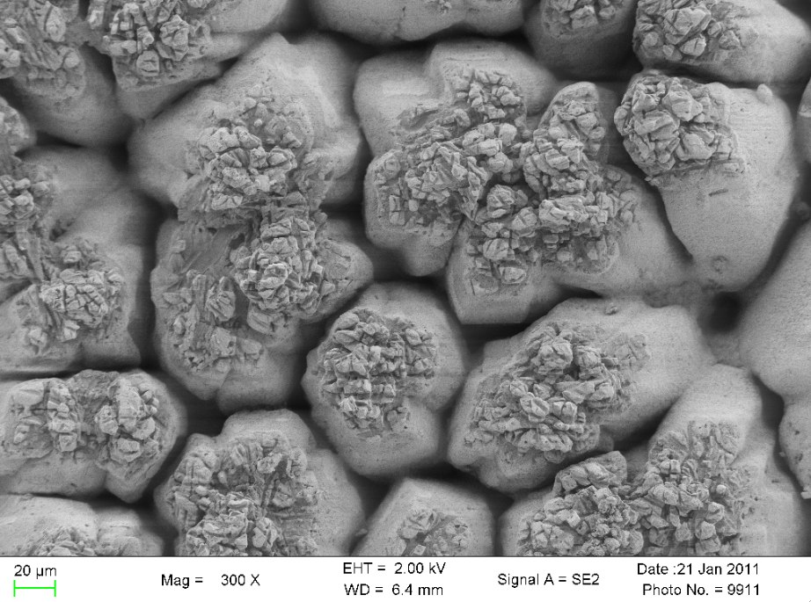

Figure 12.1 SEM Red Star Chicken (Gallus gallus) Eggshell Interior: No Visible Resorption Example, 300x; photograph taken by author

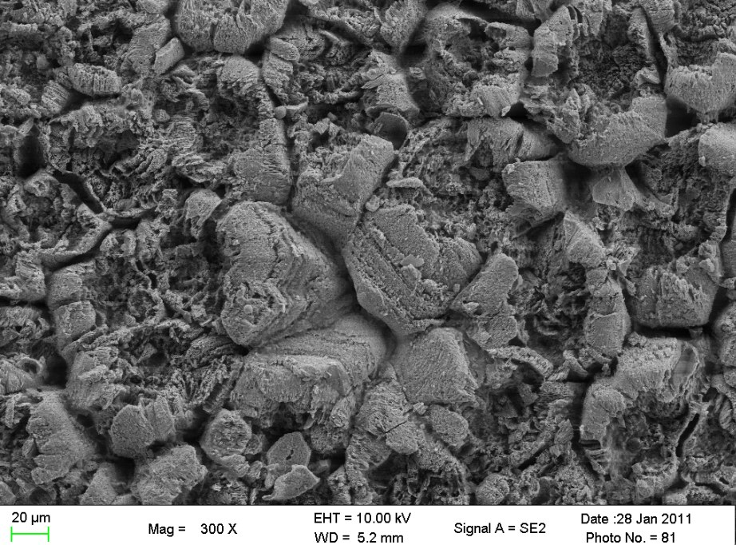

Figure 12.2 SEM Jungle Fowl Chicken (Gallus gallus) Eggshell Interior: Minimal/Complete Resorption Example, 300x; photograph taken by author

These crater-like depressions visible on the interior surface of the shell are formed as the embryo of a laid, fertilized egg begins to develop and absorb the available developmental nutrients stored in the mammillae cones (Beacham and Durand 2007; Chien et al. 2009). This structural depletion of the mammillae cones is a time-dependent process and, based on a visual analysis of the pitted shell interior, can be used to estimate the proportion of unhatched eggs, exhibiting no signs of resorption, to those eggs showing signs of hatching or advance fertilization, indicated by complete resorption. This ratio provides an estimation of those fertilized eggs consumed as food relative to those eggs allowed to hatch, producing a new generation of birds. However, eggs can still be fertilized and yet, show no signs of resorption. Resorption begins during the second half of embryonic development; in chickens, for example, if the 21-day incubation period is observed, resorption begins on day 11 and continues until the chick hatches on day 21 (Chien et al. 2009:527). Prior to day 11 (from days 7 – 10) the chick receives most of the nutrients it requires for development from the yolk (Chein et al. 2009:534). After day 11 the embryo then receives large amounts of calcium released from the eggshell, which promotes skeletal growth but also weakens the shell in preparation for the hatching process (Chien et al. 2009:528). But, if the 21-day incubation period is stopped before day 11, the resorption process will not have started and therefore its effects will not be observed on the eggshell interior. This suggests that the egg was intentionally selected and likely consumed as a viable food source. However, if egg-laying periods are not managed properly, and incubation continues beyond the 11th or 12th day after the egg is laid, then embryonic development and resorption stages can advance.
Additionally, incubation periods and resorption stage timelines are variable among species; the incubation period for a chicken is 21 days, but the incubation period for a turkey is 28 days (Beacham and Durand 2007). Based on the observed resorption stage results, categorized as nor resorption (NR), minimal resorption (MR), and complete or significant resorption (CR/SR), these observations can be considered evidence for either selective breeding practices or opportunistic collecting strategies (Beacham and Durand 2007; Lamzik 2012).
A subsample of 20 archaeological eggshell fragments were selected form the assemblage to undergo additional analysis. This was done to confirm the validity, as well as the accuracy, of the stereomicroscope thickness test identifications and morphological variability estimations. These subsamples underwent SEM testing, an identification technique utilized by several researchers specifically for its ability to acquire detailed images of eggshell cross-section features and for its increased accuracy in comparison to images captured using a microscope with lower magnification capabilities. The 20 archaeological samples were collected from each of the depositional layers in the subfloor pit feature. After the samples were (ie. agitated in distilled water), they required additional preparation prior to the SEM analysis. First, a cleaned fragment was removed from the larger sample fragment and mounted with the internal surface facing up, on the edge of an aluminum stub with double-sided conductive carbon tape. Once each fragment was affixed to the stub, the samples were vacuum-sealed and sputter-coated with a thin layer of gold. Sputter-coating the entire surface of the eggshell insures that during SEM analysis, the eggshell will remain suitably conductive. After the samples remained vacuum-sealed overnight, the aluminum stubs with the gold-coated samples were then placed in a Hitachi S-3200 SEM Scanning Electron Microscope. Both the radial cross-section and the interior surface were evaluated and photographed at 300x and 800x magnification for the 20 archaeological samples scanned (Figures 13.1, 13.2, 13.3).

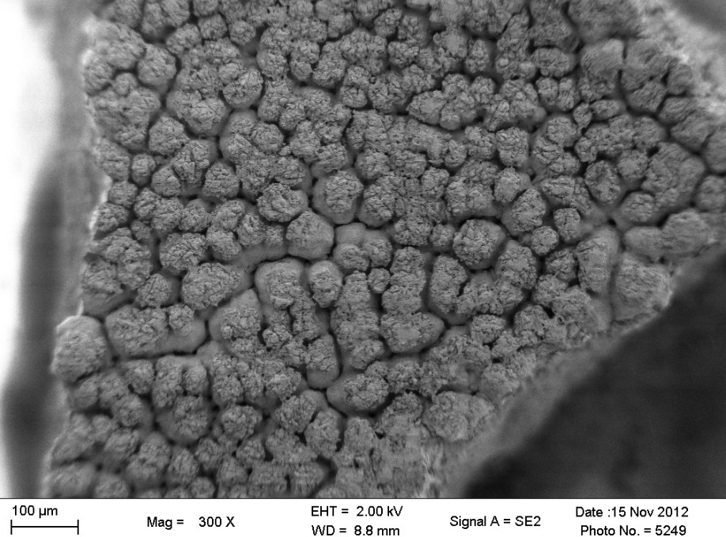

Figure 13.1 Scanning Electron Microscope Image of Archaeological Turkey Eggshell (ER2352BB/4.251.12): Interior of Eggshell, 300x; photograph taken by author

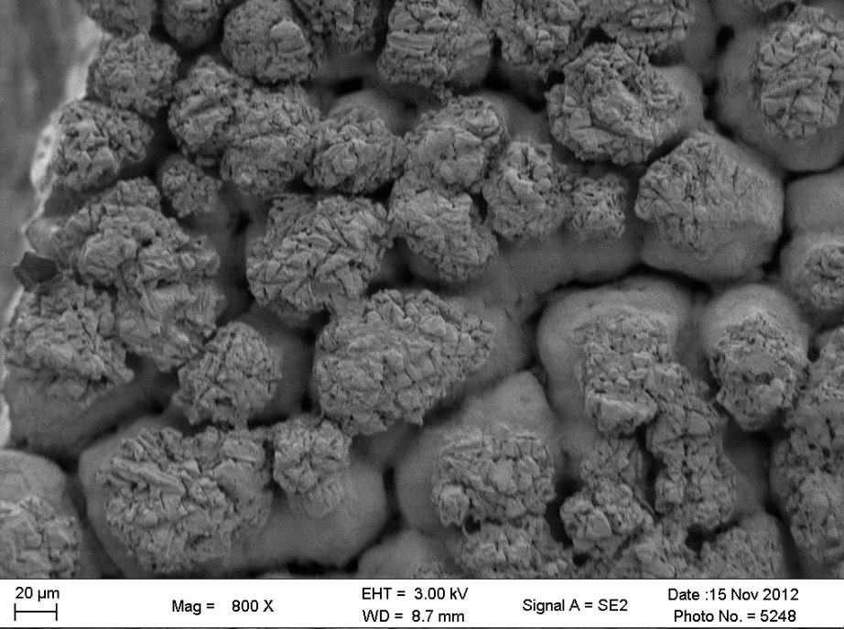

Figure 13.2 Scanning Electron Microscope Image of Archaeological Turkey Eggshell: Interior of Eggshell, 800x; photograph taken by author

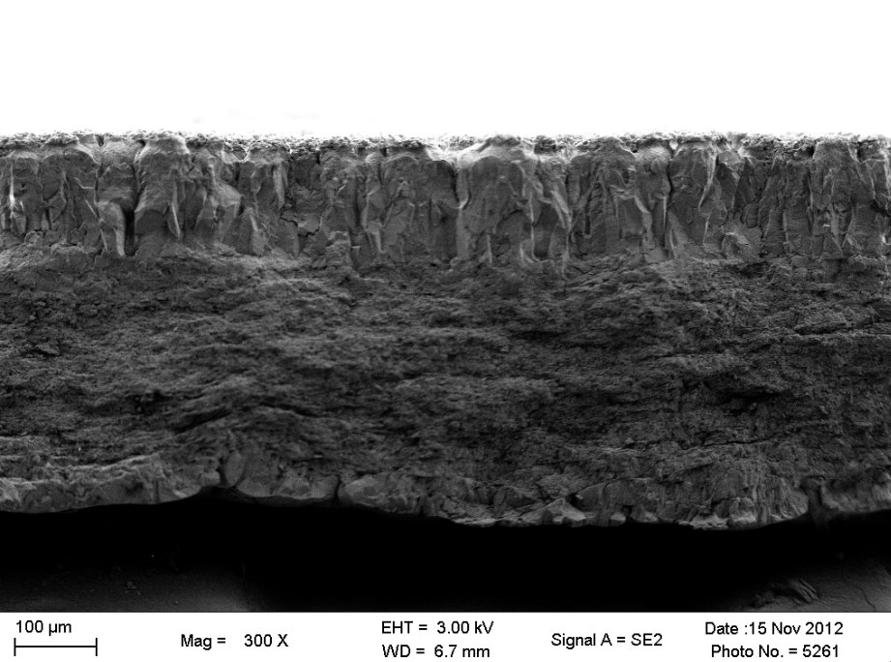

Figure 13.3 Scanning Electron Microscope Image of Archaeological Turkey Eggshell: Radial Cross-section of Eggshell, 300x; photograph taken by author
Mean thickness, ratio of mammillae to palisade layer, stage of resorption, and interior gross-morphological differences were also noted characteristics that were collected and evaluated from the SEM digital photographs.
The non-destructive nature of low-powered microscope analysis presents the researcher with a budget-conscious quantifiable tabulation for species representation. A number of destructive methods are available and do produce reliable results, but often these are expensive and destroy the archaeological samples. Using these methods selectively may offer a more agreeable alternative for assessing species specific identifications, after initial low-powered microscope analysis has been completed. This methodology, using SEM to validate a less expensive identification alternative, will be tested and is the preferred method of analysis for the current thesis project. A database for both the archaeological eggshell and modern comparative collection was set up to record all information gathered from this study.

Chapter 5: Results and Discussion

Statistical Analysis

Initial statistical analyses aimed to identify the 20 archaeological sub-sample eggshell fragments selected from the Poplar Forest subfloor pit feature. In order to determine statistically significant identifications for these eggshell samples, metric data from both the known modern comparative collection and unknown archaeological samples were analyzed using a discriminant analysis function. The primary objective for performing discriminant function analyses was to determine if the statistical measure for group metric data differs according to their independent variable means, providing probabilities for group classification. Table 13 illustrates the appropriate categorization of the data for a discriminant analysis, which assembles the collected metrics from both the comparative collection and the archaeological material for the statistical analyses. The table lists the tested comparative collection species’ names (Chicken, Duck, Unknown [for archaeological samples], etc.), followed by a corresponding arbitrarily assigned group classification number. Specific breed names for species have not been individually identified; eggshell fragments from Rhode Island Red chickens and Red Star chickens are not separated, but simply collectively labeled as “Chicken”. “Microscope thickness” for all specimens was calculated using the Leica MZ6 stereomicroscope and the means averaged according to individual shell fragment. The measurements for “SEM Thickness”, “SEM Thickness Low”, and “SEM Thickness High” for only the comparative collection material (denoted by a “1” in the comparative indicator column) include the measurement data collected from several supplementary literature sources (Sidell 1993; Ancel and Girard 1992; Mikhailov 1997; Schönwetter 1967). Ratio measurement and pore distribution data are similarly depicted. For the unknown archaeological material, both microscope and SEM data were collected by the author and do not depend on the data provided by the supplementary literature resources.
First, a single sample T-test was performed in order to assess statistically significant differences between the modern comparative collection and the known metric data provided by published sources. The null hypothesis for this test states that the three variable measurements taken from the modern comparative metric data are equal in value to the corresponding literature metric data. Table 4 lists the p-value results according to species and individual variables.

Table 4. Student's T-test: Comparing Measurement Variables from Supplementary Literature data and the University of Tennessee’s modern comparative collection

Species | Thickness p-value | Ratio p-value | Pore  p-value
Chicken (1) | 0.1422 | 0.0039 | 0.0001
Duck (2) | <.0001 | 0.0152 | 0.3670
Wild Turkey (3) | 0.0002 | 0.7333 | <.0001
Goose (4) | 0.0485 | 0.0656 | 0.500
Guinea fowl (5) | 0.0010 | <.0001 | na
Domestic Turkey(6) | <.0001 | 0.3229 | 0.0014
Quail (7) | 0.0861 | 1.0000 | 0.4009
Passerine (8) | 0.2357 | na | na
*alpha 0.05

These results indicate that the differences between the modern comparative metric data and the supplementary literature data for mean thickness, ratio, and pore distribution are statistically too variable to use interchangeably. For those p-values greater than the 0.05 alpha, the null hypothesis is acceptable, indicating that there is no change or difference between the two metric data sets. However, the opposite is true for those p-values less than the 0.05 alpha, indicating that the provided data exhibit statistically significant differences. Some discrepancies, such as goose variable p-values, are very close to the 0.05 alpha, but this can likely be a factor correlated with small sample size. Thickness, ratio, and pore measurements for the goose sample were delineated by only two eggshell fragments taken from the same egg and therefore do not represent a sufficient sample size to determine statistically significant results.
The variability between the modern comparative collection and literature data sets may be an unintentionally produced abnormality, arising from the fact that the supplementary literature data set has been collected from several different referenced sources, almost all of which were gathered from international avian breeds. Due to these abnormalities, it was determined to continue with the statistical analysis using only the regionally comparable University of Tennessee modern comparative collection metric data that was collected using the Leica MZ6 stereomicroscope.
In total, 90 fragments from the comparative eggshell collection were tested using the discriminant analysis, comprising 16 different avian breeds. Initial analysis to determine whether the chosen variables were well-suited discriminators between species resulted in low p-values and robust R-squared values produced by a stepwise selection analysis summary (Table 5).

Table 5. Stepwise Selection Summary: Comparative Collection Variables

Step | Number | Variable | Partial R-Squared | F Value | Pr > F
1 | 1 | Microscope _Thickness | 0.8147 | 70.34 | <0.0001
2 | 2 | Microscope_Pores | 0.5727 | 21.18 | <0.0001
3 | 3 | Microscope_Ratio | 0.228 | 4.61 | 0.001

These results clearly indicate that the selected variables of thickness, pore distribution, and palisade to mammillae layer ratios for the comparative material are indeed all highly correlated metric values and are considered good predictors of variation within the data set.
After confirming this correlation, the metric data was sub-sectioned by species into groups whereby the data points for each individual variable were plotted on a graph to check for multivariate normal distributions for the data set. After a visual analysis of the generated graphs to confirm that the data provided for the analysis is indeed multivariate normal, tests of homogeneity within the covariance matrices were also examined. In this case, covariance matrices were not equal, indicated by a Chi-square value of 151.129953. These conclusions ultimately determined that the appropriate analysis function for the data to produce statistically significant results is a quadratic discriminant analysis. Using the discriminant analysis function for comparing the known microscope data set from the comparative collection to the unknown archaeological sample generates an empirical and repeatable technique for testing the identification of eggshell fragments. First, partial R-squared values generated for the univariate statistical analysis indicate the amount of variability that can be explained within species if each of the tested variables were included as the only variable for the model.

Table 6. Univariate Test Statistics Output for Discriminant Analysis of the Known Comparative Collection Data

Variable | Total Standard Deviation | Pooled Standard Deviation | Between Standard Deviation | R-Squared | F value | Pr > F
Microscope Thickness | 0.0786 | 0.0349 | 0.0773 | 0.8147 | 70.34 | <.0001
Microscope Pores | 0.8314 | 0.5118 | 0.7263 | 0.6434 | 28.87 | <.0001
Microscope Ratio | 0.4565 | 0.3554 | 0.3258 | 0.4295 | 12.04 | <.0001

The above table suggests that according to the R-squared values for the variable thickness, 81% of variability within species can be explained by thickness measurements. Explained another way, based on the averaged R-squared value (0.6291711), this analysis can be used to determine whether groups of data are categorized correctly according to the selected variable. In this instance, the averaged R-squared value indicates that the majority of the eggshell fragments from the comparative collection tested according to the variable averages were categorized into the correct species classification parameters (Table 6).
Additionally, according to the resubstitution and cross-validation summary statistics, the comparative collection metric data set for the eggshell fragments were correctly separated according to species with minimal misidentification errors. Table 7 summarizes the resubstitution classifications according to species with the associated number of observations and percentages.
Table 7: Discriminant Analysis on Known Data: Resubstitution Summary using Quadratic Discriminant Function

Species | 1 | 2 | 3 | 5 | 6 | 7 | Total
Chicken (1) | 28 82.35 | 4 11.76 | 0 0.00 | 0 0.00 | 2 5.88 | 0 0.00 | 34 100.00
Duck (2) | 0 0.00 | 16 94.12 | 0 0.00 | 0 0.00 | 1 5.88 | 0 0.00 | 17 100.00
Wild Turkey (3) | 0 0.00 | 0 0.00 | 11 100.00 | 0 0.00 | 0 0.00 | 0 0.00 | 11 100.00
Guinea fowl (5) | 0 0.00 | 0 0.00 | 0 0.00 | 6 100.00 | 0 0.00 | 0 0.00 | 6 100.00
Domestic Turkey (6) | 0 0.00 | 2 13.33 | 2 13.33 | 0 0.00 | 11 73.33 | 0 0.00 | 15 100.00
Quail (7) | 0 0.00 | 0 0.00 | 0 0.00 | 0 0.00 | 0 0.00 | 3 100.00 | 3 100.00
Total | 28 32.56 | 22 25.58 | 13 15.12 | 6 6.98 | 14 16.28 | 3 3.49 | 86 100.00

For example, eggshell fragments from Species 1 (chicken) were classified, according to the three measurable variables, as chicken for 28 of the 34 tested fragments. Put another way, the classification parameters for resubstitution were correct 82% of the time indicated by the species metric data provided for chicken eggshell. This means that if a fragment of chicken eggshell was analyzed using the parameters determined by the discriminant analysis test, these results indicate that there is high probability that the fragment would be correctly categorized as chicken. However, the use of discriminant analysis for eggshell identification only specifies probability assessments according to the provided individual species groups.
The archaeological sub-sample of 20 fragments pulled for detailed analysis were similarly tested using the discriminant analysis function, producing corresponding identifications based on the comparative collection. Table 8 summarizes the results, but for a more detailed summery of the results see Table 14.

Table 8. Number of Observations and Percentages Classified into Species by the Discriminant Analysis Function for the Archaeological Eggshell Sub-samples

 | Chicken | Duck | W. Turkey | Guinea fowl | D. Turkey | Quail | Total
Number Percent | 8 40.00 | 1 5.00 | 5 25.00 | 1 5.00 | 5 25.00 | 0 00.00 | 20 100.00

Table 8 shows that 8 of the 20 sub-sample archaeological eggshell fragments are classified as chicken. These analysis results also detected the presence of 1 duck, 5 wild turkey, 1 guinea fowl, and 5 domestic turkey eggshells. The archaeological context for each of these fragments is summarized in Table 15.
While these results confirm the presence of these particular birds at Poplar Forest, there are still a number of possible underlying complications associated with the results using this discriminant analysis procedure. First, the eggshell fragments collected from goose and passerine species were omitted from the sample, because of the limited number of eggshell fragments available for the analysis. This type of comparative collection limitation can hinder identifications relating to precise species determinations. For example, according to Table 13, observations 102 and 104 of the archaeological discriminant analysis were identified as chicken eggshell fragments, when thickness tests alone identified them as closer in similarity to goose or guinea fowl (Table 13). Additionally, Canada goose, mallard duck, quail, and wild turkey are federally or state protected species and a permit is required to collect the eggs from the wild nests of these species. Indeed, many of these non-domesticated birds, which today are infrequently encountered due to modern subsistence practices, only have one or two examples of eggs produced from the same clutch, or simply a single egg from one bird representing an entire species in the comparative collection. Separation of species could be further improved by acquiring a wider variety of eggs from different clutch groupings and eggs produced during various times of the year, strengthening the analysis and helping to further delineate species categories.
Secondly, many of the averaged variable measurements for different species overlap. For example, possible chicken eggshells were frequently classified as modern domestic turkey eggshell fragments by the discriminant analysis tests for the comparative collection (Tables 8 and 9). This misclassification can potentially be attributed to modern breeding practices, similar to those observations on eggshell thickness recorded by Ancel and Girard (1992) in their observations on wild and domestic guinea fowl. Therefore, historic domestic turkey eggs may not resemble modern domestic turkeys and instead may exhibit increased resemblance to modern wild varieties. Additionally, this misclassification problem could certainly alter the results of the discriminant analysis. A similar problem arises with regard to guinea fowl eggshells; guinea fowl might be more closely matched with goose, but goose fragments were eliminated from sample test because only two fragments of eggshell from same goose egg were tested. Therefore the single specimen identified as guinea fowl will at this time (according to the discriminant analysis) only be classified as possible guinea fowl or goose.
Finally, the discriminant analysis does not consider the possibility for unknown species that have the potential to be present in the tested sample; all samples incorporated into the discriminant analysis were assigned to a category, even if that assigned category does not offer the best possible fit for that particular eggshell fragment. Discriminant analysis only provides probability assessments for the data provided, not definitive identifications. For example, pigeon eggshells were not collected and therefore remained untested for the project. However, pigeon eggshell thickness closely resembles quail and this similarity results in the possibility of a species misclassification (Sidell 1993:19; Attachment 1).

Additional Statistical Analyses

Other validation concerns were addressed through additional statistical analyses. These were aimed to test the archaeological eggshell sub-sample data for differences attributed to inconsistencies within the data collection methods (ie. variation between the SEM generated data and the stereomicroscope data). Iglic and associates (2010) have published results refuting the assumption that differences in collected data metrics are common; they conclude that SEM imagery holds no empirical superiority over observations recorded with a low-powered microscope (Iglic et al. 2010). However, if a statistically significant difference is found regarding the data collection methods, then one particular method can be assumed superior to the other.
A single sample T-test was constructed for each variable, “thickness” and “ratio”, and tested for normal distribution patterns regarding variation between the data collection methods for the archaeology sub-sample. Differences in “pore” distribution could not be compared in this test because pore distribution averages could only be accounted for using a Bausch and Lomb dissecting light microscope. Therefore no SEM data is available because the SEM procedural methods used to collect thickness and ratio data could not detect pores over an area. A null hypothesis of no difference between the data generated by the opposing methods was tested and revealed that in this case the null hypothesis should be accepted. This conclusion can be based on the generated p-values of 0.9054 for the variable “thickness” and a p-value of 0.1987 for the variable “ratio” under an alpha of 0.05. According to these large p-values, the t-test indicates that no statistical difference can be observed, within the parameters of the data provided, between metric data collected from the same group of samples using the Leica stereomicroscope or collected via the Scanning Electron Microscopy images.
Additionally, linear regression models comparing the same data examined during the t-tests were compared for how well a regression line fits the data. This test moves a step beyond simply indicating no change between the methods and provides a statistical measure, the R-squared value, for the proportion of variability in the data set. Low R-squared values indicate that the regression line does not fit the data well, while a score closer to the value of 1.0 means that the regression line fits the data set. Linear regression analysis between the variables, thickness and ratio, were compared between SEM and stereomicroscope measurements, producing an R- squared value for each test. Thickness measured between the stereomicroscope and the SEM measurements produced an R-squared value of 0.9845 and a p-value of 0.0001. This indicates that the regression line fits the tested data set and demonstrates high accuracy for calculating future results. However, linear regression analysis for the variable “ratio” indicated a lower R-squared value of 0.3724 and a p-value of 0.0121. While these numbers indicate that the regression line for “ratio” is not as strong of a fit as “thickness”, the regression can still be considered a good fit for the data provided.
In conclusion, based on these results from these statistical tests, it can be determined that thickness measurements are the strongest indicator of species identification from the three variables tested. Additionally, this suggests that it is not necessary to utilize SEM images to interpret thickness or ratio measurements; the results from both the t-test and linear regression are very similar. Therefore, the remaining sampled Poplar Forest eggshells were measured for thickness and the results are described below. While there is no method for saving the exact location of the line measurements, pictures were saved as image files and measurement data was saved in excel spreadsheet form.

Poplar Forest Subfloor Pit Eggshell Identification Results

Due to the large sample size of the Poplar Forest eggshell, only a sample of the material could be interpreted using statistical analysis. Because the SEM generated data offers no statistically significant advantage for determining eggshell identifications based on the 3 selected variables, thickness, ratio, and pores, the metric data collected from the remaining randomly sampled subfloor pit archaeological eggshell was instead examined using only the Leica MZ6 stereomicroscope. While these selected variables cannot provide precise categorical species identifications, broad classifications can be assigned to the collected data based primarily on thickness measurements.
As previously mentioned, Figure 15 illustrates the modern comparative data collected for this project and delineates groupings based on thickness averages from each shell fragment of the tested species. The highlighted ranges for each species can then be compared to the distribution of individual data points positioned on a scatter plot of the archaeological data. This provides the researcher with a visual representation of the metric data distribution matched against the comparative material data ranges. It should be noted that based on the disproportionate amount of identified chicken bone collected from the subfloor pit (N=243; Table 2) when compared to bone identified as duck (N=1; Table 2), the corresponding eggshell similar in thickness to either chicken or duck will therefore be interpreted as chicken. Again, additional research will need to be completed to address this issue.
Figure 14 illustrates the distribution of the 20 archaeological samples used in the discriminant analysis according to probable species using the stereomicroscope identification measurement criteria (Figure 14).

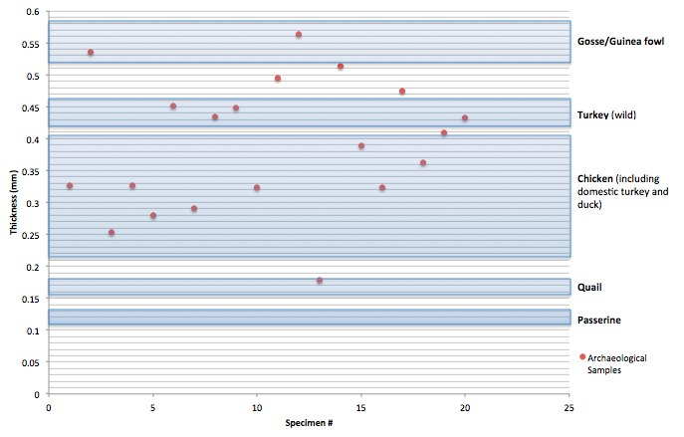

Figure 14. Archaeological Random Sample Thickness Distribution Scatter Plot: Overlaid with Comparative Eggshell Species’ Thickness Ranges

The following table (Table 9) synthesizes the thickness ranges determined for the eggshell classification and identification analysis. Each archaeological eggshell fragment can be categorized according these thickness ranges.

Table 9. Modern Comparative Collection Thickness Ranges

Species | Low (mm) | High (mm)
Passerine | 0.108 | 0.134
Quail | 0.157 | 0.179
Possible Quail | 0.18 | 0.217
Chicken | 0.218 | 0.406
Duck | 0.306 | 0.363
Possible Turkey | 0.407 | 0.42
Wild Turkey | 0.42 | 0.459
Possible Turkey | 0.46 | 0.498
D. Turkey | 0.332 | 0.434
Possible Goose or Guinea fowl | 0.499 | 0.518
Goose | 0.543 | 0.565
Guinea fowl | 0.519 | 0.582
Possible Goose or Guinea fowl | 0.583 | 0.6

Table 10 illustrates that while differences in classification do occur between the discriminant analysis and stereomicroscope identification methods, these differences are not completely incorrect. Compare the results for each fragment listed in the “Discriminant Analysis Classification” column and the “Microscope Classification” column.

Table 10. Discriminant Analysis and Microscope Thickness Measurement Identification Comparisons

Observation | Context | HF Sample | Portion | Thickness | Discriminant Analysis Classification | Microscope Classification
Unknown 91 | 2352 V/4 | whole egg | .2 | 0.326 | Chicken | Chicken
Unknown 92 | 2352 R/4 | HF #160 | .3 | 0.536 | Goose/Guinea Fowl | Goose/Guinea Fowl
Unknown 93 | 2352 W/4 | HF #161 | .3 | 0.253 | Chicken | Chicken
Unknown 94 | 2352 W/4 | #176 | .1 | 0.327 | Domestic Turkey | Chicken
Unknown 95 | 2352 W/4 | #182 | .2 | 0.279 | Chicken | Chicken
Unknown 96 | 2352 V/4 | #192 | .11 | 0.452 | Wild Turkey | Wild Turkey
Unknown 97 | 2352 V/4 | #193 HF | .15 | 0.29 | Chicken | Chicken
Unknown 98 | 2352 V/4 | #200 | .4 | 0.434 | Wild Turkey | Wild Turkey
Unknown 99 | 2352 Z/4 | #221 | .1 | 0.448 | Wild Turkey | Wild Turkey
Unknown 100 | 2352 AA/4 | #267 | .1 | 0.324 | Domestic Turkey | Chicken
Unknown 101 | 2352 BB/4 | HF 226 | .11 | 0.495 | Wild Turkey | Possible Turkey
Unknown 102 | 2352 BB/4 | HF 227 | .9 | 0.564 | Chicken | Goose
Unknown 103 | 2352 BB/4 | HF 227 | .40 | 0.179 | Chicken | Quail
Unknown 104 | 2352 BB/4 | HF 228 | .1 | 0.514 | Chicken | Possible Goose/Guinea Fowl
Unknown 105 | 2352 BB/4 | #231 | .21 | 0.389 | Domestic Turkey | Chicken
Unknown 106 | 2352 BB/4 | HF 236 | .14 | 0.323 | Duck | Chicken
Unknown 107 | 2352 BB/4 | #251 | .12 | 0.475 | Wild Turkey | Possible Turkey
Unknown 108 | 2352 BB/4 | HF 255 | .17 | 0.362 | Chicken | Chicken
Unknown 109 | 2352 BB/4 | HF 257 | .3 | 0.409 | Domestic Turkey | Possible Turkey
Unknown 110 | 2352 BB/4 | HF 262 | .14 | 0.432 | Domestic Turkey | Wild Turkey

Discriminant analysis classifications of domestic turkey are most likely simply chicken eggshell fragments, and the discriminant analysis eggshell fragment classified as duck is most likely correct. However, some observations classified a few of the fragments incorrectly. This likely occurs because each of the tested variables (thickness, ratio, and pore count) are considered equally strong indicators of species, when in fact thickness is the strongest identification indicator. Due to the underrepresentation of the thickness measurements, some discriminant analysis classifications (such as Observations 102, 103, and 104) are misleading.
The thickness distribution graphs for the remaining archaeological specimens, separated according to stratigraphic level, are listed in Appendix 2 (Figures 16.1, 17.1, 18.1, 19.1, 20.1, 21.1, 22.1, 23.1). Of the 1,026 archaeological eggshell fragments tested for variation in thickness through out all contexts of the subfloor pit, 90% can be classified as chicken (or duck), 8% turkey, 1% goose or guinea fowl, 1% quail, and < 1% passerine. These percentages have not changed since a preliminary sample of 400 eggshells were tested from the subfloor pit; during this previous examination, 86% were within the range of chicken (or duck), 10% turkey, <1% goose or guinea fowl, and 4% were smaller than chicken (Lamzik 2012). With access to a larger comparative material collection, the numbers have changed slightly but not appreciably, therefore, it can be determined that the sampling strategy employed for this analysis is a robust representation of the entire assemblage.
The eggshell fragments recovered from the heavy fraction flotation samples of level R/4 exhibited signs of poor to very poor preservation quality. This preservation description indicates that many of the eggshells were heavily worn or otherwise exposed to weathering conditions, with many fragments missing the cuticle layer or simply too small (less than 2mm ²) for examination. Of the 989 total eggshell fragments collected from level R/4, 137 fragments were determined acceptable for examination. Therefore, according to the sampling strategy, 44 were selected and measured for thickness. Ninety-three percent (i.e. NISP = 41) of the eggshell fragments sampled from level R/4 were identified as domestic chicken taxa. The remaining 7% were determined to belong to either goose or guinea fowl. Resorption rates were also recorded and separated by species determinations. For the chicken eggshell, 54% exhibited no signs of resorption, 17% exhibited minor signs of resorption, and 29% were completely resorbed or exhibited significant signs of resorption. All goose/guinea fowl eggshells were completely resorbed or showed significant signs of resorption.
The eggshell fragments recovered from level S/4 exhibited minor signs of weathering and preservation concerns. A total of 92 fragments were recovered from flotation samples; 30 fragments were considered acceptable for examination. All 10 fragments that were sampled for further analysis were classified as chicken eggshell. Of these, 40% had no signs of resorption, 50% exhibited minor resorption, and 10% were completely resorbed.
The eggshell fragments recovered from the heavy fraction flotation samples from level W/4 were very poorly preserved and many fragments exhibited substantial signs of weathering. Of the 340 total heavy fraction sampled fragments, only 93 fragments were considered acceptable for analysis. The sampling strategy selected 37 fragments for further examination. Ninety-two percent of the sample corresponded in thickness measurements with chicken, while 5% were identified as possible quail and only 3% were identified as turkey eggshell fragments. Fifty-percent of the fragments exhibited no signs of resorption, 18% appeared to be minimally resorbed, and 32% were significantly resorbed. Additionally, 100% of the possible quail fragments were completely resorbed and 100% of the turkey fragments were minimally resorbed.
Contrastingly, a total of 1,533 eggshell fragments were recovered from the heavy fraction material in level V/4 of the subfloor pit. A sample of 144 fragments was selected for further analysis from the 470 well-preserved, complete, and larger fragments from the heavy fraction samples. Chicken eggshell dominates the eggshell count from level V/4, comprising 90% of the assemblage from this level. Additionally, a combined 9% of the assemblage falls within the thickness range for turkey eggshell, while 1% is within the thickness range for quail. Eighty-four percent of the identified chicken eggshells exhibit no signs of resorption, while the remaining 10% show minor resorption and 6% are completely resorbed. All identified turkey eggshell fragments exhibited no signs of resorption and 100% of the quail eggshell show minor resorption.
Additionally, two eggshell fragments were analyzed from the whole egg recovered from level V/4. Fragments from this egg were tested using both the stereoscopic microscope measurement techniques and the SEM method of analysis. The results of the stereoscopic microscope thickness tests revealed that the egg at the time of deposition displayed signs of minimal resorption and measured an averaged thickness of 0.331mm along the radial cross-section, thus categorizing the egg as possible chicken or duck. Additionally, the discriminant analysis function confirmed this assumption, determining that pore counts, thickness, and thickness ratio measurements categorized one of the tested fragments as also closely resembling that of a chicken eggshell.
The eggshell fragments recovered from level X/4 all exhibited minimal weathering and preservation concerns. A total of 118 fragments were recovered from flotation samples. Forty-three fragments were considered acceptable for examination and a total of 14 fragments were randomly sampled for further analysis. Ninety-two percent of these were classified as chicken eggshell and only 8% were classified as possible turkey eggshell. Of the 13 chicken eggshell fragments (93%) identified, 54% exhibited no signs of resorption, 31% had minor resorption, and 15% were completely resorbed. The one eggshell fragment identified as possibly belonging to turkey also exhibited no signs of resorption.
Eggshell recovered from level Y/4 exhibited minor preservation concerns but overall the fragments were classified in good condition. A total of 132 fragments were recovered from the sampled flotation samples. Of these, 48 fragments were considered acceptable for examination, but only 15 fragments were randomly sampled for detailed analysis. All 15 fragments (100%) sampled were classified as chicken eggshell. However, resorption stages revealed that 67% exhibited no signs of resorption, 6% had minor resorption, and 27% were completely resorbed.
The eggshell fragments recovered from level Z/4 exhibited minimal signs of weathering and almost no preservation issues were noted. Only 50 fragments of the 153 total fragments recovered from flotation were considered acceptable for further examination. A random sample of 30% (16 fragments) selected from the good eggshell fragments, were chosen for thickness measurement analysis. Of these, 94% were classified as chicken and 6% were classified as turkey. All identified chicken and turkey eggshell fragments (100%) exhibited no evidence of resorption.
Overall, eggshell recovered from Level AA/4 exhibited poor signs of preservation. A total of 134 fragments were recovered from the tested flotation samples. Of these, 34 fragments were considered acceptable for examination and 12 fragments were randomly sampled for detailed analysis. Ten fragments (83%) were classified as chicken eggshell and the remaining 17% were classified as turkey eggshell. Resorption stages revealed that 70% of the sample exhibited no signs of resorption, while 30% exhibited minor resorption pattering. Resorption stages of the turkey eggshell fragments were evenly distributed; 50% were completely resorbed and 50% exhibited no signs of resorption.
Finally, the eggshell fragments recovered from the sampled heavy fraction flotation in level BB/4 exhibited exceptional preservation quality and many fragments were substantial in size and lacked significant weathering concerns. Of the 3590 total heavy fraction sampled fragments recovered, 2456 fragments were considered very well preserved and large enough for further analysis. The sampling strategy selected 734 fragments for advanced thickness measurement analysis. Chicken eggshell dominates the level BB/4 assemblage, comprising 89% of the sample. Additionally, 8% of the assemblage was identified as turkey, while the remaining 3% of the eggshell fragments were evenly distributed between guinea fowl or goose, passerine, and quail identifications. Resorption stages for those fragments identifies as chicken eggshell were 90% no resorption, 7% appeared to be minimally resorbed, and 3% were significantly resorbed. Turkey eggshell resorption stages were similarly distributed among those identified, with 91% exhibiting no resorption, 7% minimally resorbed, and 2% completely resorbed. Additionally, 100% of the goose/guinea fowl eggshell fragments exhibited no signs of resorption. Differences in resorption patterning occur when examining the passerine and quail eggshell fragments. Forty percent of the classified passerine eggshell fragments were considered completely resorbed and 60% exhibited no signs of resorption. Completely resorbed quail eggshell dominated the identified quail fragments, while 13% were minimally resorbed and 37% were classified as showing no signs of resorption.
The thickness distribution groupings for the types of birds present on site do not exhibit much variability throughout the stratigraphy of the subfloor pit (see Figures 16.1, 17.1, 18.1, 19.1, 20.1, 21.1, 22.1, 23.1). Eggshell fragments comparable in thickness to chicken are consistently the dominant species present throughout all levels of the pit feature, accounting for 90% of the total fragments. In fact, the avian bone material recovered from the subfloor pit confirms this finding (Table 11).

Table 11. Comparison of Identified Faunal Elements From Subfloor Pit Feature ER2352
Species | Common name | Elements identified | Eggshell identified
Agelaius phoeniceus | Red-winged blackbird | 1 | 0
Anatidae | Duck/goose/swan | 1 | 0
Anserinae | Goose | 3 | 11*
Colinus virginianus | Common bobwhite | 2 | 11
Gallus gallus | Domestic chicken | 243 | 900
Meleagris gallopava | Domestic turkey | 7 | 74
Numida meleagris | Guinea fowl | 1 | 11*
Passerine | Perching bird | 22 | 5
Quiscalus quiscula | Common grackle | 13 | 0
Tyrannus tyrannus | Eastern kingbird | 4 | 0
Zenaida macroura | Mourning dove | 4 | 0
Zonotrichia albicollis | White-throated sparrow | 1 | 0
*Unable to differentiate goose and guinea fowl eggshell

Variation in eggshell thickness indicates additional types of birds present throughout the pit feature assemblage, including turkey (8%), goose or guinea fowl (1%), quail (1%), and passerine varieties (<0.1%). However these species do not appear to be as extensively utilized or exploited as chicken. While thickness variation tells us much about the types of birds present on site, resorption patterning provides additional information concerning the role of certain types of birds at the site.
Resorption patterns differ by level and by the species represented in each level of the subfloor pit (Figures 16.2, 16.3, 17.2, 18.2, 18.3, 18.4, 19.2, 19.3, 19.4, 20.2, 20.3, 21.2, 22.2, 22.3, 23.2, 23.3, 24.2, 24.3, 24.4, 24.5, 24.6.). While differences in resorption stages effect a portion of thickness measurements, they do not alter overall thickness distributions or species representation; therefore many of the measurements remain well within the range of chicken (or duck).
Levels R/4, S/4, W/4, X/4, Y/4 and AA/4 of the subfloor pit appear less uniform according to the distribution of eggshell fragment resorption patterns. While chicken fragments are still the dominant type recovered, a few of the levels (R/4, S/4, and W/4) display increased signs of weathering and advanced stages of resorption for all represented species (Table 12). The presence of heavily weathered eggshell fragments could signify a depositional layer indicative of a filled context comprised of floor sweepings or they could indicate the presence of fill soil brought from different areas of the site to seal or cover the contents of the previous layer.
In contrast, levels V/4, Z/4 and BB/4 all exhibit less variation for resorption stage differences, for not only chicken eggshell fragments, but also other species such as goose and turkey.

Table 12. Poplar Forest Subfloor Pit Eggshell Preservation and Number of Samples Analyzed

Level | # Total Eggshell Fragments | Preservation | # Good Preservation | # Sampled
ER2352R/4 | 989 | Poor | 137 | 44
ER2352S/4 | 92 | Poor | 30 | 10
ER2352W/4 | 387 | Very Poor | 93 | 37
ER2352V/4 | 1533 | Excellent | 470 | 144
ER2352X/4 | 234 | Fair | 43 | 14
ER2352Y/4 | 247 | Fair | 48 | 15
ER2352Z/4 | 153 | Good | 50 | 16
ER2352AA/4 | 182 | Fair/Poor | 34 | 12
ER2352BB/4 | 4910 | Excellent | 2465 | 734
ER2352CC/4 | 0 | n/a | 0 | 0
ER2352DD/4 | 0 | n/a | 0 | 0
Total | 8727 |  | 3370 | 1026

Resorption stages are similarly distributed and appear identical among chicken and turkey eggshell fragments for Level BB/4 (Figure 24.2 and Figure 24.3) and Level V/4 (Figure 19.2 and Figure 19.3). Eighty-five to ninety percent of the chicken and turkey eggshells from these levels show no sign of resorption, indicating that these eggs were collected and used before the effects of the incubation process could affect the morphology of the eggshell. This almost identical distribution pattern may indicate that during these periods chicken and turkey were raised and managed in similar ways, perhaps specifically for egg production.
However, when resorption patterns more closely resemble distributions similar to chicken eggshell fragments recovered from levels Level Y/4 (Figure 21.2) and Level X/4 (Figure 20.2), with a larger percentage of the fragments exhibiting signs of minimal to complete/significant resorption, these patterns seem to suggest differential avian management. Perhaps the differences could indicate periods of decreased intentional egg production produced solely for consumption; instead a more opportunistic strategy for the collection of eggs was practiced. If eggs were actively collected for consumption or sale, then they would be quickly collected minimizing the time allotted for incubation. However, if eggs were instead opportunistically collected and given time to incubate, then more eggs would be collected with varying signs of resorption patterning. Other represented birds, such as quail and passerine, exhibiting increasingly advanced levels of resorption, might indicate differential avian management and could be indicative of opportunistic collecting of eggs from wild sources. This exploitation of wild resources collection strategy is entirely feasible, based on the increased movement of enslaved people throughout the landscape and the easy with which these types of eggs are found and quickly collected.
One final measure of analysis involved the visual examination of the scanning electron microscope images for gross morphological variation. SEM pictures were reviewed and compared to supplementary micrographs published by Mikhailov (1997) and Sidell (1993). While some differences and similarities were noted from a visual analysis of the material, these observations remain highly subjective. Detailed measurements offer a more empirical and less subjective approach for verifying possible eggshell identification. Perhaps the distribution of vascular pitting, visible using increased magnification with SEM, will increase the usefulness of this subjective technique (Sidell 1993). There are additional advantages to using SEM, but unless these methods are considered testable and are not simply the result of arbitrarily assigning identifications based on personal subjective determinations, their utility will be questioned.

Chapter 6: Summary

The goal of this project has been to introduce eggshell identification methods to the North American archaeological and zooarchaeological scholarly communities. Additionally, it presents an assessment for the overall validity of eggshell identification as an emerging research tool in the study of avian faunal assemblages. The analysis of the eggshell assemblage from Poplar Forest has highlighted several key points of interest. First, it appears from the analysis, that the enslaved African American inhabitants of the cabin at Site A utilized more than one variety of avian species in subsistence and possible economic strategies. Clearly, preference for one particular avian species (ie. chicken) does comprise the majority of the sampled fragments; however, the presence and resorption patterns of additional avian eggshell types confirms that the previously-analyzed fragmented bone faunal assemblage underrepresents the varied utility and pervasiveness of species other than chicken.
By assessing the differences in the taxa represented stratigraphically, it can be concluded that altogether different varieties of taxa are not observed; chicken eggshells dominate the assemblage, with limited but visible inclusions of turkey, guinea fowl or goose, passerine, and quail. However, each of these similarly distributed taxa exhibit drastically different rates of resorption according to stratigraphic location and differences in preservation quality. This varied distribution pattern could indicate of reduced usage of the subfloor pit during these periods or be produced by the introduced fill soil (Table 1). Poor preservation of eggshell material from some levels could be the result of either the slow accumulation of extraneous cultural debris or quicker accumulations of material caused by purposeful dumping or filling episodes.
Resorption differences among species could also suggests a possible alteration in subsistence and producing strategies, indicating a functional re-structuring of the represented avian taxa from egg production for consumption, to more hands-off, non-intervention avian husbandry breeding practices. Perhaps the collection of eggs by enslaved inhabitants was closely monitored during periods when most of the eggshell fragments exhibit no signs of resorption and are well preserved. Alternatively, when there is a recorded increase in the amount of minimally resorbed and significantly resorbed fragments, but they display signs of good preservation, perhaps these deposits account for periods of opportunistic egg collecting. Finally, levels with eggshell fragments displaying both poor preservation and advanced stages of resorption could represent intentionally filled deposits using soil found outside the cabin.
There is the possibility that observed variability between the distinct clustering of non-domestic eggshell types, such as wild turkey, quail, and passerine species could indicate some form of independent localized provisioning practiced within the enslaved community. The appearance of these wild avian species suggests that subsistence strategies expanded beyond the enslaved cabin and yard boundaries and incorporated the surrounding natural environment. Compiling a regionally-specific comparative collection is critical to the future development and effectiveness of eggshell studies. The inclusion of larger reference collections does help to narrow down probable species identification and minimizes misidentification.
And lastly, eggshell studies can provide an alternative method for assessing the historic importance, availability, and variability of birds on archaeological sites, especially with regard to enslaved archaeological faunal assemblages. Eggshell identification can expand faunal interpretation independently or in conjunction with observations concerning avian fauna. Included in these interpretations is increased visibility of enslaved agency in the archaeological record, which is often examined through archaeological interpretations of largely ephemeral landscape features. Archaeologically-recovered eggshells have proven to be an significant analytical tool for interpreting subsistence behaviors and observing “personal empowerment through consumer activities” offering the enslaved a degree of control over their personal lives (Lee 2012:172). Indeed, similar to personal adornment or other items determined as personal possessions, the sale of eggs and poultry raising could potentially act as another means for slaves to “express, negotiate, challenge, or maintain relations with owners” (Lee 2012:184). Gardens and poultry husbandry could potentially have acted as an outlet for enslaved communities, allowing slaves to succeed in establishing a measure of independence separate from the plantation system. Indeed, independent provisioning and producing strategies influenced a families’ ability to provide adequate and reliable nutrition for the household. Or constructs of purchasing power, through the sale of eggs, poultry, or other avian by-products facilitate a market economy actively competing with socially structured aspects of enslaved plantation life (Heath 2004).
The presence of large amounts of chicken eggshells exhibiting no signs of resorption could suggest independent provisioning of eggs, and could also be interpreted as evidence for actively engaging in consumer economic behavior. However, based on the archaeology research completed so far, this conclusion remains an interpretation only. At this time, eggshell fragments cannot be quantified and therefore definitively verifying that the individuals utilizing the subfloor pit are engaged in the broader consumer behavior, cannot be concluded based on the data available at present.
This research framework also helps understand and consider the role of eggs before deposition in the subfloor pit. Poultry keeping by enslaved African Americans was quite common and required little maintenance; housekeeping books and farmer manuals published in the 19th-century provide a reference for best-practice tips on poultry diet, housing, management, cost, breed selection, and recipes for preparing fowl (Walsh 1857; Mackenzie 1829).
Breed qualities are often remarked upon and proper selection for economical success is considered crucial. For economical purposes, it is suggested that “no species pay like fowls and ducks, which may also be very well kept together where there is any water for the latter, and a proper situation for the former” (Walsh 1857:254). For example, “Bantams are beautiful little fowls of all colours...[but] none of them can be reared or kept for any purpose but as pets...the size of the bird and egg is so small as to make them far from serviceable” (Walsh 1857:250). Additionally, while the Hamburg fowl may produce eggs all year round, they “do not bear close confinement” and therefore forage well (Walsh 1875:250). The Dorking fowl “is difficult to breed...to a very large size, but the flesh is of excellent quality, and the hen is a very close sitter” (Walsh 1857:247). These management concerns and breed criteria affect decisions concerning lodging and feeding for the type of bird selected.
Passages like the following indicate that raising poultry correctly often required extra care and attention:
“…sometimes she [the hen] bustles about in the officious manner as soon as one [a hatched chick] comes forth, and if this were allowed to remain, she would probably destroy all the others…In such a case, a warm basket of wool by the fire is the best alternative, where the chickens may be placed as they come out until all are hatched. In the depth of winter or in the cold of spring, artificial heat of some kind is required to rear chickens, and this is afforded in the cottages of the poor by allowing them to live in the same room with them…” (Walsh 1857:260).

Guidelines on how “to manage a dairy” where chickens can be properly hatched and recommendations on the preparation of fowl for consumption are also explicitly described (Mackenzie 1829:167, 358). It is interesting to note that there are several methods mentioned for choosing the best eggs for consumption, preserving eggs, and keeping eggs. For example, one method suggests the following procedure for preserving eggs:
“It consists in making a thin mortar, by slacking some quicklime with water, and mixing it with sand until it I of the consistence of cream. This is to be kept for a fortnight, stirring and beating it occasionally, until all the tendency to set has gone by, and then the eggs are to be covered with it, adding a layer of mortar over each layer of eggs, and piling them up as high as the vessel with hold. The top much be kept constantly covered with water, or the lime and sand with become hard, and enclose all the eggs so firmly as to forbid their extraction. In this way I have known eggs kept sweet for many months” (Walsh 1857:263).

Another earlier method suggests the following:
“Apply with a brush a solution of gum-arabie to the shells, or immerse the eggs therein, let them dry, and afterwards pack them in dry charcoal dust. This prevents their being affected by any alterations of temperature” (Mackenzie 1829:360).

These methods were often extremely effective, blocking the exchange of air and gases through the eggshell pores, preserving them for months and perhaps for as long as two years (Mackenzie 1829:360).
Clearly enslaved objectivity to select breed at Site A is difficult to account for archaeologically. However, these manuals (Walsh 1857;Mackenzie 1829) or similar publications were utilized by plantation owners and may have influenced the types of resources available to the enslaved population. Commonalities between the types of livestock kept by plantation owners and the enslaved community may have influenced similar management techniques.

Future Research
Future research topics specific to the continued research pertaining to the Poplar Forest eggshell assemblage might include identifying the range and variety of eggshell species outliers. This project would include replacing the random sampling procedures employed for the present analysis and instead adopt more selective measures of examination. More specifically, this would involve purposefully selecting for those eggshell fragments displaying visible signs of morphological variation or differences in thickness, shell structure, or other interior shell dissimilarities. This alternative analysis method would aid researchers in identifying the entire range of species available to inhabitants at the cabin site.
This method would also require an increase in curated eggshell specimens from a wider variety of avian species and expand the comparative collection. Additional wild and domestic species, such as duck, pigeon, quail, goose, and other birds of prey would be beneficial for incorporating a wider variety of wildlife possibilities.
Finally, perhaps an attempt to refine the discriminant analysis to incorporate a larger sample of fragments from a few selected species should be considered. This, combined with the expansion of the comparative collection, could influence the accuracy and identification possibilities for a wider variety of eggshell identification projects.
Future research developments employing the identification techniques used for this project could be expanded to include the identification of eggshell fragments from a range of sites with enslaved African American contexts. This inclusion would offer the advantages of identifying more sites with a joint avian faunal and eggshell assemblage, useful not only for discussing differences or similarities in taxa representation spatially and diachronically, but also beneficial for producing a dialogue about differential producing strategies, consumerism, and general subsistence strategies and animal husbandry management. This type of analysis could act as a suitable addition to already analyzed avian faunal assemblages or perhaps alternatively incorporated into the material remains analysis for a site with no bone fauna or overall poor faunal preservation.
This project does not attempt to encompass the full range of species present on site; instead a purposeful effort was made to first understand subsistence and independent producing strategies for the enslaved African American community at Poplar Forest during the mid-19th century Cobbs-Hutter occupation. The goal was not simply to perform an eggshell identification for the whole range of species present in the assemblage, but rather the project attempted to outline a number of possible interpretations for the differential eggshell distribution patterns observed throughout the subfloor pit stratigraphic sequence.
I have proposed that for interpreting historical archaeology of plantation life, and slavery in general, the identification of archaeologically recovered eggshell may shed light on the diverse dietary habits, as well as subsistence and market opportunities, available to the enslaved African America populations. This type of analysis can enable further exploration of regional diversity and help to clarify subsistence choices, including individual trade, market, and independent producing opportunities. Also, eggshell identification and analysis studies offer another interesting look at the use of animals as opportunistic secondary by-product producers.
In conclusion, while I have discussed that additional methods for eggshell identification are available, the low cost method for assessing the eggshell identification used for this project is a viable alternative technique. With continued interest in the application of advanced analytical methods and the potential for increasing the limited amount of retrievable data from avian fauna, the future of eggshell studies looks promising.

List of References
Ancel, A. and Girard, H.
1992 Eggshell of the Domestic Guinea Fowl. British Poultry Science 33:933-1001.

Barber, Michael
1976 The Vertebrate Fauna From a Late eighteenth Century Well: The Bray Plantation, Kingsmill, Virginia. Historical Archaeology 10:68-72.

Beacham, Bradley E. and Stephen R. Durand
2007 Eggshell and the Archaeological Record: New Insights into Turkey Husbandry in the American Southwest. Journal of Archaeological Science 34:1610-1621.

Bear, James A. Jr., and Lucia C. Stanton (editors)
1997 The Papers of Thomas Jefferson, Second Series, Jefferson’s Memorandum Books: Accounts, with Legal Records and Miscellany, 1767-1826. Volume II. Princeton University Press, Princeton, NJ.

Becking, J.H.
1975 The Ultrastructure of the Avian Eggshell. The Ibis 117(2):143-151.

Betts, Edwin Morris (editor)
1944 Thomas Jefferson’s Garden Book, 1766-1824: With Relevant Extracts From His Other Writings. The American Philosophical Society, Philadelphia.

Blankespoor, Gilbert W.
1987 An Improved Procedure for Counting Pores in Avian Eggshells. The Condor 89(3):663-665.

Bloom, Margaret A., Lincoln V. Domm, Andrew V. Nalbandov, and William Bloom
1958 Medullary Bone of Laying Chickens. American Journal of Anatomy 102(3): 411-453.

Board, R.G. and V.D. Scott
1980 Porosity of the Avian Eggshell. American Zoology 20:339-349.

Boersma, P. Dee and Ginger A. Rebstock
2009 Magellanic Penguin Eggshell Pores: Does Number Matter? Ibis 151: 535-540.

Bowen, Joanne
1993 Faunal Remains from the House for Families Cellar. Prepared for the Mount Vernon Ladies’ Association, Archaeology Department, Mount Vernon, Virginia.
1996a Beef, Venison, and Imported Haddock in Colonial Virginia: A Report on the Analysis of Faunal Remains from Jordan’s Journey. Ms. on file, Virginia Department of Historic Resources.

1996b Foodways in the 18th-century Chesapeake. In The Archaeology of 18th-century Virginia, T.R. Reinhart, editor, pp. 87-130. Special Publication no. 35, Archaeological Society of Virginia, Richmond, Virginia.

Bowes, Jessica
2011 Provisioned, Produced, Procured: Slave Subsistence Strategies and Social Relations at Thomas Jefferson’s Poplar Forest. Journal of Ethnobiology 31(1): 89-109.

Bowes, Jessica and Heather Trigg
2012 Social Dimensions of Eighteenth- and Nineteenth- Century Slaves’ Uses of Plants at Poplar Forest. In Jefferson’s Poplar Forest: Unearthing A Virginia Plantation. Barbara J. Heath and Jack Gary, editors, pp. 155 – 171. University Press of Florida, Gainesville.

Bušs, Agnis and Oskars Keišs
2009 Method for Identification of Avian Species by Eggshell Microstructure: Preliminary Study. Acta Universitatis Latviensis 753:89-98.

Carpenter, Kenneth
1999 Eggs, Nests, and Baby Dinosaurs: A Look at Dinosaur Reproduction. Indiana University Press, Bloomington.

Chien, Y.C., M.T. Hincke, and M.D. McKee
2009 Ultrastructure of Avian Eggshell During Resorption Following Egg Fertilization. Journal of Structural Biology 168:527-538.

Clayburn, Jere K., Denise L. Smith, and James L. Hayward
2004 Taphonomic Effects of pH and temperature on Extant Avian Dinosaur Eggshell. PALAIOS 19(2):170-177.

Covey, Herbert C. and Dwight Eisnach
2009 What the Slaves Ate: Recollections of African American Foods and Foodways from the Slave Narratives. Greenwood Press, Santa Barbara, Ca.

Crader, Diana C.
1984 The Zooarchaeology of the Storehouse and the Dry Well at Monticello. American Antiquity 49(3):542-558.
1990 Slave Diet at Monticello. American Antiquity 55(4):690-717.

Dacke, C.G., S. Arkle, D.J. Cook, I. M. Wormstone, S. Jones, M. Zaidi, and Z. A. Bascal
1993 Medullary Bone and Avian Calcium Regulation. Journal of Experimental Biology 184:63-88.

Decker, Susan
1998 Eggshell Analysis. Chapter 36. In Wilson-Leonard: An 11,000-year Archeological Record of Hunter-Gathers in Central Texas. Volume V: Special Studies. Assembled and Edited by Michael B. Collins. 1543-1554.

Digital Archaeological Archive of Comparative Slavery (DAACS)
2013 Artifact Queries. Digital Archaeological Archive of Comparative Slavery Database, Thomas Jefferson Foundation, Monticello. Accessed at: http://www.daacs.org/resources/queries/submit/artifact/aq1/2/ on 17 February 2013.

Eastham, Anne and Iolo Ap Gwynn
1997 Archaeology and the Electron Microscope. Eggshell and Neural Network Analysis of Images in the Neolithic. Anthropozoologica 25(1):85-94.

Eastham, Anne
1997 The Potential of Bird Remains for Environmental Reconstruction. International Journal of Osteoarchaeology 7:422-429.

Ferguson, Leland
1992 Uncommon Ground: Archaeology and Early African America, 1650-1800. Smithsonian Institution Press, Washington D.C.

Franklin, Maria
2002 The Archaeological Dimensions of Soul Food: Interpreting Race, Culture, and Afro-Virginian Identity. In Race and the Archaeology of Identity, Charles E. Orser Jr. editor, pp. 88 – 107. The University of Utah Press.

Gál, Erika
2004 The Role of Archaeo-Ornithology in the Environmental and Animal
History Studies. In Archaeological and Cultural Heritage Preservation within the Light of New Technologies, Selected papers from the joint Archaeolingua-EPOCH workshop. E. Jerem, Zs. Mester and R. Benczes, editors, pp. 49-61. Archaeolingua Foundation, Budapest, Százhalombatta, Hungary.

Gibbs, Patricia A.
1999 “Little Spots allow’d them:” Slave Garden Plots and Poultry Yards. Colonial Williamsburg Interpreter 20(4):9-13.

Gill, B.J.
2010 Regional Comparisons of the Thickness of Moa Eggshell Fragments (Aves: Dinornithiformes). In Proceedings of the VII International Meeting of the Society of Avian Poleontology and Evolution, ed. W.E. Boles and T.H. Worthy. Records of the Australian Museum 62(1):115-122.

Haegele, Max A. and Richard K. Tucker
1974 Effects of 15 Common Environmental Pollutants on Eggshell Thickness in Mallards and Coturnix. Bulletin of Environmental Contamination and Toxicology 11(1):1-9.

Hamilton-Dyer, Sheila
1997 The Domestic Fowl and Other Birds from the Roman Site of Mons Claudianus, Egypt. International Journal of Osteoarchaeology 7:326-329.

Hayward, James L., Darla K. Zelenitsky, Denise L. Smith, Darlene M. Zaft, and Jere K. Clayburn
2000 Eggshell Taphonomy at Modern Gull Colonies and a Dinosaur Clutch Site. PALAIOS 15(4):343-355.

Heath, Barbara J. and Amber Bennett
2000 ‘The little Spots allow’d them’: The Archaeological Study of African Yards. Historical Archaeology 34(2):38-55.

Heath, Barabara J. and Eleanor Breen
2009 [2012] Assessing Variability Among Quartering Sites in Virginia. Northeast Historical Archaeology 38:1-28.

Heath, Barbara J. and Jack Gary (editors)
2012 Jefferson’s Poplar Forest: Unearthing a Virginia Plantation. University Press of Florida, Gainesville.

Heath, Barbara J., Randy Lichtenberger, Keith Adams, Lori Lee, and Elizabeth Paull
2004 Poplar Forest Archaeology: Studies in African American Life, Excavations and Analysis of Site A, Southeast Terrace and Site B, Southeast Curtilage June 2003-June 2004. Report to the Public Welfare Foundation.

Heath, Barbara J.
1999 Hidden Lives: The Archaeology of Slave Life at Thomas Jefferson’s
Poplar Forest. University Press of Virginia, Charlottesville.

2001 Bounded Yards and Fluid Boundaries: Landscapes of Slavery at Poplar Forest. pp.69-82.

2004 Engendering Choice: Slavery and Consumerism in Central Virginia. In Engendering African American Archaeology: A Southern Perspective. Jillian E. Galle and Amy L. Young, editors, pp. 19-38. The University of Tennessee Press, Knoxville.

Hoyt, Donald F., Ronald G. Board, Hermann Rahn, and Charles V. Pagnelli
1979 The Eggs of the Anatidae: Conductance, Pore Structure, and Metabolism. Physiological Zoology 52(4):438-450.

Hutter, Edward S.
1856 – 1862 Income and Expense Journal, July 1, 1856 – January 1, 1862. Ms. on loan to Thomas Jefferson’s Poplar Forest from the estate of Mrs. Edwin C. Hutter, Princeton, N.J.

1844 – 1854 Hutter Farm Journal of Events, January 1, 1844 – January 1, 1854. Ms. on loan to Thomas Jefferson’s Poplar Forest from the estate of Mrs. Edwin C. Hutter, Princeton, N.J.

Igic, Branislav, Mark E. Hauber, Josie A Galbraith, Tomas Grim, Donald C. Dearborn, Patricia L. R. Brennan, Csaba Moskat, Pankaj K. Choudhary, and Phillip Cassey
2011 Comparison and Micrometer- and Scanning Electron Microscope-based Measurements of Avian Eggshell Thickness. Journal of Field Ornothology 81(4):402-410.

Janssen, Jennifer D., William Mutch, and James L. Hayward
2011 Taphonomic Effects of high Temperature on Avian Eggshell. PALAIOS 26(10):658-664.

Kealhofer, Lisa
1997 Poplar Forest: Phytolith Analysis. Ms. on file, Thomas Jefferson’s Poplar Forest, Poplar Forest, VA.

Keepax, Carole A.
1981 Avian Egg-shell form Archaeological Sites. Journal of Archaeological Science 8:315-335.
Kelso, William
1984 Kingsmill Plantations 1619-1800: Archaeology of Country Life in Colonial Virginia. Academic Press, Inc., Orlando, Florida.

Kiff, Lloyd F.
2005 History, Present Status, and Future Prospects of Avian Eggshell Collections in North America. The Auk 122(3):994-999.

Klippel, Walter E., Jennifer A. Synstelien and Barbara J. Heath
2011 Taphonomy and Fish Bones from an Enslaved African American Context at Poplar Forest, Virginia, USA. Archaeofauna 20:27-45.

Lamzik, Kathryn E.
2012 The Identification and Analysis of the Bird Eggshell Fragments Recovered from Thomas Jefferson’s Poplar Forest, Site A, The Southeast Terrace. Archeological Society of Virginia Quarterly Bulletin 67(2):63-71.

Lee, Lori
2012 Consumerism, Social Relations, and Antebellum Slavery at Poplar Forest. In Jefferson’s Poplar Forest: Unearthing A Virginia Plantation. Barbara J. Heath and Jack Gary, editors, pp. 172-188. University Press of Florida, Gainesville.

Lentacker, An and Wim Van Neer
1996 Bird Remains from Two Sites on the Red Sea Coast and Some Observations on Medullary Bone. International Journal of Osteoarchaeology 6:488-496.

Mackenzie, Colin
1829 Mackenzie’s Five thousand Receipts In All The Useful and Domestic Arts. James Kay, Jun. & Co., Philadelphia.

Maurer, Golo, Douglas G.D. Russell and Phillip Cassey
2010 Interpreting the Lists and Equations of Egg Dimensions in Schönwetter’s Handbuck Der Oologie. The Auk 127(4):940-947.

McGovern, Thomas H., Sophia Perdikaris, Arni Einarsson and Jane Sidell
2006 Coastal Connections, Local Fishing, and Sustainable Egg Harvesting: Patterns of Viking Age Inland Wild Resource Use in Myvatn District Iceland. Environmental Archaeology 11(2):187-205.

McKee, Larry W.
1987 Delineating Ethnicity from the Garbage of Early Virginians: Faunal Remains from the Kingsmill Plantation Slave Quarter. American Archaeology 6(1):31-39.

1992 The Ideals and Realities Behind the Design and Use of 19th Century Virginia Slave Cabins. In The Art and Mystery of Historical Archaeology: Essays in Honor of Jim Deetz, Anne Yentsch and Mary Beaudry, editors, pp. 195-213. CRC Press, Boca Raton, FL.

1999 Food Supply and Plantation Social Order: An Archaeological Perspective. In I, Too, Am American: Archaeological Studies of African American Life, Theresa Singleton, editor, pp. 218 – 239. The University Press of Virginia.

Medina, M., S. Pastor, E. Apolinaire, and L, Turnes
2011 Late Holocene Subsistence and Social Integration in Sierras of Córdoba (Argentina): The South-American Ostrich Eggshell Evidence. Journal of Archaeological Science 38:2071-2078.

Mikhailov, Konstantine E.
1991 Classification of Fossil Eggshells of Amniotic Vertebrates. Palaeontologica 36(2):193-238.

1997 Fossil and Recent Eggshell in Amniotic Vertebrates: Fine Structure, Comparative Morphology and Classification. Special Papers in Palaeontology No. 56, The Palaeontological Association, London.

Morgan, Philip D.
1988 Slave Life in Piedmont Virginia, 1720-1800. In Colonial Chesapeake Society, Lois Green Carr, Philip Morgan, and Jean Russo, editors, pp. 433-484. University of North Carolina Press, Chapel Hill, NC.

1998 Slave Counterpoint: Black Culture in the Eighteenth-Century Chesapeake and Lowcountry. University of North Carolina Press, Chapel Hill and London.

Murphy, P.
1985 Avian Archaeology. East Anglican Arch. Report 26:68.

Neiman, Fraser
2008 The Lost World of Monticello: An Evolutionary Perspective. In Journal of Anthropological Research 64(2):161-193.

Oskam, Charlotte L., Chris Jacomb, Morten E. Allentoft, Richard Walter, R. Paul Scofield, James Haile, Richard N. Holdaway, and Michael Bunce
2011 Molecular and Morphological Analyses of Avian Eggshell Excavated From a Late Thirteenth Centrury Earth Oven. Journal of Archaeological Science 38:2589-2595.

Payne, Sebastian
1975 Partial Recovery and Sample Bias. In Archaeological Studies, Anneke T. Clason, editor, pp. 7-17. North Holland Publishing, Amsterdam, NL.

Penningroth, Dylan C.
2003 The Claims of Kinfolk: African American Property and Community in the Nieteenth-Century South, The University of North Carolina Press, Chapel Hill.

Raymer, Leslie M.
1996 Macroplant Remains from the Jefferson’s Poplar Forest Slave Quarter, A
Study in African American Subsistence Practices. Ms. on file, Thomas Jefferson’s Poplar Forest, Poplar Forest, VA.

Reitz, Elizabeth J.
1987 Vertebrate Faunal and Socioeconomic Status. In Consumer Choice in Historical Archaeology. Suzanne M. Spencer-Wood, editor, pp. 101-119. Plenum Press, New York.

Reitz, E.J. and Myra Shackley
2012 Vertebrates. In Environmental Archaeology: Manuals in Archaeological Method, Theory and Technique, pp. 383-422. Springer, New York.

Rick, Anne Meachem
1975 Bird Medullary Bone: A Seasonal Dating Technique For Faunal Analysts. Bulletin Canadian Archaeological Association 7:183-190.

Romanoff, Alexis L. and Anastasia J. Romanoff
1949 The Avian Egg. John Wiley & Sons, INC., New York.

Russell, Nerissa and Kevin J. McGowan
2005 Catalhoyuk Bird Bones. Chapter 3. In Inhabiting Catalhoyuk: Reports from the 1995-99 Seasons, vol. 4, Ian Hodder, editor, pp. 117-121. British Institute of Archaeology at Ankara, London.

Samford, Patricia M.
1996 The Archaeology of African-American Slavery and Material Culture. The William and Mary Quarterly 53:87-114.

2004 Engendering Enslaved Communities on Virginia’s and North Carolina’s Eighteenth-Century and Nineteenth-Century Plantations. In Engendering African American Archaeology: A Southern Perspective. Jillian E. Galle and Amy L. Young, editors, pp. 151-167. The University of Tennessee Press, Knoxville.

2007 Subfloor Pits and the Archaeology of Slavery in Colonial Virginia. The University of Alabama Press, Tuscaloosa.

Schlotterbeck, John
1991 The Internal Economy of Slavery in Rural Piedmont Virginia. Slavery and Abolition: A Journal of Slave and Post-Slave Studies 12:170-181.

Schönwetter, Max
1960-1992 Handbuch der Oologie. Akademie Verlag, Berlin.

Scott, Elizabeth M.
2001 Food and Social Relations at Nina Plantation. American Anthropologist 103(3):671-691.

Serjeantson, Dale
1997 Subsistence and Symbol: The Interpretation of Bird Remains in Archaeology. International Journal of Osteoarchaeology 7:255-259.

2009 Birds. Cambridge Manuals in Archaeology, Cambridge University Press, New York NY.

2011 Ravens and Crows in Iron Age and Roman Britain. Oxford Journal of Archaeology 30(1):85-107.

Sidell, Elizabeth J.
1993 A Methodology for the Identification of Archaeological Eggshell. Museum Applied Science Center of Archaeology, University of Pennsylvania, Philadelphia.

1995 Eggshell. In Freswick Links, Caithness: Excavation and Survey of a Norse Settlement. Christopher D. Morris, Colleen E. Batey and James Rackham, editors, pp. 211-213. Highland Libraries, Great Britain.

Sidell, Jane
2008 Environmental Eggshell: Additional specialist report. In Suburban Life in Roman Durnovaria: Excavations at the Former County Hospital Site, Dorchester, Dorset 2000-2001, Mike Trevarthen. Wessex Archaeology, Salisbury.

Sidell, Jane and Claire Scudder
2005 The Eggshell from Catalhoyuk: a Pilot Study. Chapter 5. In Inhabiting Catalhoyuk: Reports from the 1995-99 Seasons, vol. 4, Ian Hodder, editor, pp. 117-121. British Institute of Archaeology at Ankara, London.

Singleton, Theresa A.
1991 The Archaeology of Slave Life, In Before Freedom Came: African American Life in the Antebellum South. Edward D. C. Campbell, Jr., and Kym S. Rice, editors, pp.155-175. University Press of Virginia, Charlottesville.

1995 The archaeology of slavery in North America. Annual Review of Anthropology 24:119-140.

Simkiss, K.
1961 Calcium Metabolism and Avian Reproduction. Biological Review 36:321-367.

Spaw, Carol D. and Sievert Rohwer
1987 A Comparative Study of Eggshell Thickness in Cowbirds and Other Passerines. The Condor 89(2):307-318.

Stewart, John R. and Francisco Hernandez Crrasquilla
1997 The Identification of Extant European Bird Remains: A Review of the Literature. International Journal of Osteoarchaeology 7:364-371.

Stewart, John R.M., Richard B. Allen, Andrew K.G. Jones, Kirsty Penkman, and Matthew Collins
2012 ZooMS: Making Eggshell Visible in the Archaeological Record. Accepted Manuscript Journal of Archaeological Science.

Taylor, T.G.
1970 How An Eggshell Is Made. Scientific American 222(3):89-95.

Tuma, Michael W.
2006 Ethnoarchaeology of Subsistence Behaviors within a Rural African American Community: Implications for Interpreting Vertebrate Faunal Data from Slave Quarters Areas of Amtebellum Plantation Sites. Historical Archaeology 40(4):1-26.

Tyler, C.
1953 Studies on Egg Shells. II.*- A Method for Marking and Counting Pores. Journal of Science, Food, and Agriculture 4:266-272.

1955 Studies on Egg Shells. VI.*- The Distribution of Pores in Egg Shells. Journal of Science, Food, and Agriculture 6:170-176.

1961a Studies on Egg Shells. XVI*- Variations in Shell Thickness Over Different Parts of the Same Shell. Journal of Science, Food, and Agriculture 12:459-470.

1961b Shell Strength: Its Measurement and Its Relationship to Other Factors. British Poultry Science 2:1,3-19.

1969 The Distribution of Pores in the Egg Shells of the Domestic Fowl: A Further Study. British Poultry Science 10:4, 375-380.

Tyler, C. and Geake
1965 Studies on Egg Shells. IX.*-The Influence of Individuality, Breed and Season on certain Characteristics of Egg Shells from Pullets. Journal of Science, Food, and Agriculture 9:473-483.

Van Neer, Wim, Katrien Noyen and Bea De Cupere
2002 On the Use of Endosteal Layers and Medullary Bone From Domestic Fowl in Archaeozoological Studies. Journal of Archaeological Science 29:123-134.

Van Neer, Wim, Bea De Cupere, Hervé Monchot, Elina Rijmenants, Mircea Udrescu, Marc Waelkens
2005 Ancient Breeds of Domestic Fowl (Gallus gallus f. domestica) Distinguished on the Basis of Traditional Observations Combined With Mixture Analysis. Journal of Archaeological Science 32:1587-1597.
Walsh, J.H.
1857 The Economical Housekeeper: Being Practical Advice For Purchasing the Supplies of the House, and For Brewing, Baking, Preserving, and Pickling At Home. M’Corquodale and Co., London.

Warner, Mark Steven
1998 Food and the Negotiation of African American Identities in Annapolis, Maryland and the Chesapeake. Doctoral Dissertation, Department of Anthropology, The University of Virginia. UMI Microform, Ann Arbor, MI.

Yalden, Derek W. and Robert I. Carthy
2004 The Archaeological Record of Birds in Britain and Ireland Compared: Extinctions or Failures to Arrive? Environmental Archaeology 9:123-126.

Yentsch, Anne E.
1994 A Chesapeake Family and Their slaves: A Study in Historical Archaeology. Cambridge: Cambridge University Press.

2007 Excavating the South’s African American food history. In African American foodways: Exploration of History and Culture, ed. Anne L. Bower, 59-98. Urvana, IL: University of Illinois Press.

Appendices

Appendix 1. Tables

Table 13. Modern Comparative Collection and Archaeological Sub-Sample Data

Obs | Species name | Species | Microscope Thickness | SEM ThicknessLOW | SEM Thickness HIGH | Comparative indicator | Microscope Pores | SEM Pores | Microscope Ratio | SEM Ratio | Microscope Resorption | SEM Resoption
1 | Chicken | 1 | 0.35 | 0.325 | 0.35 | 1 | 3 | 2.8 | 3.5 | 2.4 | 1 | 1
2 | Chicken | 1 | 0.37 | 0.325 | 0.35 | 1 | 2.75 | 2.8 | 2.7 | 2.4 | 1 | 1
3 | Chicken | 1 | 0.369 | 0.325 | 0.35 | 1 | 3 | 2.8 | 2.6 | 2.4 | 1 | 1
4 | Chicken | 1 | 0.363 | 0.325 | 0.35 | 1 | 1.75 | 2.8 | 2.9 | 2.4 | 1 | 1
5 | Chicken | 1 | 0.357 | 0.325 | 0.35 | 1 | 2.5 | 2.8 | 2.8 | 2.4 | 1 | 1
6 | Chicken | 1 | 0.351 | 0.325 | 0.35 | 1 | 2.25 | 2.8 | 2.8 | 2.4 | 1 | 1
7 | Chicken | 1 | 0.225 | 0.325 | 0.35 | 1 | 2 | 2.8 | 2.9 | 2.4 | 1 | 1
8 | Chicken | 1 | 0.218 | 0.325 | 0.35 | 1 | 2.5 | 2.8 | 2.9 | 2.4 | 1 | 1
9 | Chicken | 1 | 0.246 | 0.325 | 0.35 | 1 | 2.75 | 2.8 | 2.6 | 2.4 | 1 | 1
10 | Chicken | 1 | 0.329 | 0.325 | 0.35 | 1 | 1.5 | 2.8 | 1.8 | 2.4 | 1 | 1
11 | Chicken | 1 | 0.301 | 0.325 | 0.35 | 1 | 1.75 | 2.8 | 2.7 | 2.4 | 1 | 1
12 | Chicken | 1 | 0.272 | 0.325 | 0.35 | 1 | 1.75 | 2.8 | 2.2 | 2.4 | 1 | 1
13 | Duck | 2 | 0.347 | 0.35 | 0.4 | 1 | 1.5 | 1.1 | 2.3 | 2.2 | 1 | 1
14 | Duck | 2 | 0.343 | 0.35 | 0.4 | 1 | 1 | 1.1 | 2.8 | 2.2 | 1 | 1
15 | Duck | 2 | 0.34 | 0.35 | 0.4 | 1 | 1 | 1.1 | 2.7 | 2.2 | 1 | 1
16 | Duck | 2 | 0.342 | 0.35 | 0.4 | 1 | 1 | 1.1 | 1.7 | 2.2 | 1 | 1
17 | Duck | 2 | 0.343 | 0.35 | 0.4 | 1 | 1 | 1.1 | 2.3 | 2.2 | 1 | 1
18 | Duck | 2 | 0.315 | 0.35 | 0.4 | 1 | 1.5 | 1.1 | 1.9 | 2.2 | 1 | 1
19 | Duck | 2 | 0.306 | 0.35 | 0.4 | 1 | 1.5 | 1.1 | 2.3 | 2.2 | 1 | 1
20 | Duck | 2 | 0.319 | 0.35 | 0.4 | 1 | 0.75 | 1.1 | 2.3 | 2.2 | 1 | 1
21 | Duck | 2 | 0.347 | 0.35 | 0.4 | 1 | 1.5 | 1.1 | 2.4 | 2.2 | 1 | 1
22 | Duck | 2 | 0.349 | 0.35 | 0.4 | 1 | 1.5 | 1.1 | 3 | 2.2 | 1 | 1
23 | Duck | 2 | 0.347 | 0.35 | 0.4 | 1 | 0.75 | 1.1 | 2.7 | 2.2 | 1 | 1
24 | Wild W.Turkey | 3 | 0.429 | 0.39 | 0.43 | 1 | 1.75 | 0.8 | 2 | 2 | 1 | 1
Table 13 cont. Modern Comparative Collection and Archaeological Sub-Sample Data

Obs | Species name | Species | Microscope Thickness | SEM ThicknessLOW | SEM Thickness HIGH | Comparative indicator | Microscope Pores | SEM Pores | Microscope Ratio | SEM Ratio | Microscope Resorption | SEM Resoption
25 | Wild Turkey | 3 | 0.42 | 0.39 | 0.43 | 1 | 2.25 | 0.8 | 2 | 2 | 1 | 1
26 | Wild Turkey | 3 | 0.426 | 0.39 | 0.43 | 1 | 1.75 | 0.8 | 2.1 | 2 | 1 | 1
27 | Wild Turkey | 3 | 0.432 | 0.39 | 0.43 | 1 | 2.25 | 0.8 | 2.1 | 2 | 1 | 1
28 | Wild Turkey | 3 | 0.42 | 0.39 | 0.43 | 1 | 1 | 0.8 | 1.9 | 2 | 1 | 1
29 | Wild Turkey | 3 | 0.438 | 0.39 | 0.43 | 1 | 1.75 | 0.8 | 2.2 | 2 | 1 | 1
30 | Wild Turkey | 3 | 0.457 | 0.39 | 0.43 | 1 | 1.75 | 0.8 | 2.38 | 2 | 1 | 1
31 | Wild Turkey | 3 | 0.456 | 0.39 | 0.43 | 1 | 2.25 | 0.8 | 2.18 | 2 | 1 | 1
32 | Wild Turkey | 3 | 0.445 | 0.39 | 0.43 | 1 | 2 | 0.8 | 1.7 | 2 | 1 | 1
33 | Wild Turkey | 3 | 0.42 | 0.39 | 0.43 | 1 | 2.25 | 0.8 | 2.1 | 2 | 1 | 1
34 | Wild Turkey | 3 | 0.459 | 0.39 | 0.43 | 1 | 1.5 | 0.8 | 1.6 | 2 | 1 | 1
35 | Goose | 4 | 0.543 | 0.525 | 0.65 | 1 | 1.5 | 1 | 1.7 | 3 | 1 | 1
36 | Goose | 4 | 0.565 | 0.525 | 0.65 | 1 | 1 | 1 | 1.4 | 3 | 1 | 1
37 | Guinea Fowl | 5 | 0.543 | 0.43 | 0.486 | 1 | 0 | 0 | 1.9 | 2.5 | 3 | 3
38 | Guinea Fowl | 5 | 0.539 | 0.43 | 0.486 | 1 | 0 | 0 | 1.6 | 2.5 | 3 | 3
39 | Guinea Fowl | 5 | 0.582 | 0.43 | 0.486 | 1 | 0 | 0 | 1.5 | 2.5 | 3 | 3
40 | Guinea Fowl | 5 | 0.519 | 0.43 | 0.486 | 1 | 0 | 0 | 1.6 | 2.5 | 3 | 3
Table 13 cont. Modern Comparative Collection and Archaeological Sub-Sample Data

Obs | Species name | Species | Microscope Thickness | SEM ThicknessLOW | SEM Thickness HIGH | Comparative indicator | Microscope Pores | SEM Pores | Microscope Ratio | SEM Ratio | Microscope Resorption | SEM Resoption
41 | Guinea Fowl | 5 | 0.498 | 0.43 | 0.486 | 1 | 0 | 0 | 1.6 | 2.5 | 3 | 3
42 | Guinea Fowl | 5 | 0.556 | 0.43 | 0.486 | 1 | 0 | 0 | 1.7 | 2.5 | 3 | 3
43 | Chicken | 1 | 0.337 | 0.325 | 0.35 | 1 | 3.25 | 2.8 | 2.4 | 2.4 | 1 | 1
44 | Chicken | 1 | 0.348 | 0.325 | 0.35 | 1 | 3 | 2.8 | 2 | 2.4 | 1 | 1
45 | Chicken | 1 | 0.359 | 0.325 | 0.35 | 1 | 2.75 | 2.8 | 2.3 | 2.4 | 1 | 1
46 | Chicken | 1 | 0.35 | 0.325 | 0.35 | 1 | 3.25 | 2.8 | 1.88 | 2.4 | 1 | 1
47 | Chicken | 1 | 0.406 | 0.325 | 0.35 | 1 | 2.75 | 2.8 | 2.3 | 2.4 | 1 | 1
48 | Chicken | 1 | 0.33 | 0.325 | 0.35 | 1 | 3.25 | 2.8 | 3.4 | 2.4 | 1 | 1
49 | Chicken | 1 | 0.333 | 0.325 | 0.35 | 1 | 3 | 2.8 | 2.8 | 2.4 | 1 | 1
50 | Chicken | 1 | 0.315 | 0.325 | 0.35 | 1 | 2.25 | 2.8 | 2.4 | 2.4 | 1 | 1
51 | Chicken | 1 | 0.381 | 0.325 | 0.35 | 1 | 1.5 | 2.8 | 2.6 | 2.4 | 1 | 1
52 | Chicken | 1 | 0.379 | 0.325 | 0.35 | 1 | 1.75 | 2.8 | 2.5 | 2.4 | 1 | 1
53 | Chicken | 1 | 0.349 | 0.325 | 0.35 | 1 | 1 | 2.8 | 2.5 | 2.4 | 1 | 1
54 | Chicken | 1 | 0.366 | 0.325 | 0.35 | 1 | 2.25 | 2.8 | 3.3 | 2.4 | 1 | 1
55 | Chicken | 1 | 0.378 | 0.325 | 0.35 | 1 | 2.25 | 2.8 | 3.2 | 2.4 | 1 | 1
56 | Chicken | 1 | 0.37 | 0.325 | 0.35 | 1 | 1.5 | 2.8 | 2.9 | 2.4 | 1 | 1
57 | Domestic Turkey | 6 | 0.362 | 0.325 | 0.35 | 1 | 0.75 | 0.8 | 2.5 | 2 | 1 | 1
58 | Domestic Turkey | 6 | 0.361 | 0.325 | 0.35 | 1 | 1 | 0.8 | 2 | 2 | 1 | 1
59 | Domestic Turkey | 6 | 0.332 | 0.325 | 0.35 | 1 | 1.25 | 0.8 | 1.8 | 2 | 1 | 1
60 | Domestic Turkey | 6 | 0.397 | 0.325 | 0.35 | 1 | 1 | 0.8 | 2.2 | 2 | 1 | 1
61 | Domestic Turkey | 6 | 0.405 | 0.325 | 0.35 | 1 | 1.5 | 0.8 | 2.3 | 2 | 1 | 1
Table 13 cont. Modern Comparative Collection and Archaeological Sub-Sample Data

Obs | Species name | Species | Microscope Thickness | SEM ThicknessLOW | SEM Thickness HIGH | Comparative indicator | Microscope Pores | SEM Pores | Microscope Ratio | SEM Ratio | Microscope Resorption | SEM Resoption
62 | Domestic Turkey | 6 | 0.395 | 0.325 | 0.35 | 1 | 1 | 0.8 | 2 | 2 | 1 | 1
63 | Domestic Turkey | 6 | 0.434 | 0.325 | 0.35 | 1 | 2.5 | 0.8 | 2.2 | 2 | 1 | 1
64 | Domestic Turkey | 6 | 0.418 | 0.325 | 0.35 | 1 | 1.5 | 0.8 | 2.2 | 2 | 1 | 1
65 | Domestic Turkey | 6 | 0.382 | 0.325 | 0.35 | 1 | 1.75 | 0.8 | 2.5 | 2 | 1 | 1
66 | Domestic Turkey | 6 | 0.391 | 0.325 | 0.35 | 1 | 1.75 | 0.8 | 2.2 | 2 | 1 | 1
67 | Domestic Turkey | 6 | 0.4 | 0.325 | 0.35 | 1 | 1 | 0.8 | 2.9 | 2 | 1 | 1
68 | Domestic Turkey | 6 | 0.361 | 0.325 | 0.35 | 1 | 0.75 | 0.8 | 1.9 | 2 | 1 | 1
69 | Domestic Turkey | 6 | 0.384 | 0.325 | 0.35 | 1 | 1 | 0.8 | 1.7 | 2 | 1 | 1
70 | Domestic Turkey | 6 | 0.392 | 0.325 | 0.35 | 1 | 1.5 | 0.8 | 1.7 | 2 | 1 | 1
71 | Domestic Turkey | 6 | 0.343 | 0.325 | 0.35 | 1 | 1 | 0.8 | 1.4 | 2 | 1 | 1
72 | Chicken | 1 | 0.269 | 0.325 | 0.35 | 1 | 3 | 2.8 | 2.4 | 2.4 | 1 | 1
73 | Chicken | 1 | 0.269 | 0.325 | 0.35 | 1 | 2 | 2.8 | 2.2 | 2.4 | 1 | 1
74 | Chicken | 1 | 0.298 | 0.325 | 0.35 | 1 | 3.25 | 2.8 | 2.3 | 2.4 | 1 | 1
75 | Duck | 2 | 0.326 | 0.35 | 0.4 | 1 | 1.25 | 1.1 | 3 | 2.2 | 1 | 1
76 | Duck | 2 | 0.332 | 0.35 | 0.4 | 1 | 0.75 | 1.1 | 2.2 | 2.2 | 1 | 1
77 | Duck | 2 | 0.363 | 0.35 | 0.4 | 1 | 1 | 1.1 | 2.6 | 2.2 | 1 | 1
78 | Duck | 2 | 0.356 | 0.35 | 0.4 | 1 | 1.75 | 1.1 | 2.3 | 2.2 | 1 | 1
79 | Duck | 2 | 0.351 | 0.35 | 0.4 | 1 | 1.5 | 1.1 | 2.2 | 2.2 | 1 | 1
80 | Duck | 2 | 0.361 | 0.35 | 0.4 | 1 | 0.75 | 1.1 | 2.7 | 2.2 | 1 | 1
Table 13 cont. Modern Comparative Collection and Archaeological Sub-Sample Data

Obs | Species name | Species | Microscope Thickness | SEM ThicknessLOW | SEM Thickness HIGH | Comparative indicator | Microscope Pores | SEM Pores | Microscope Ratio | SEM Ratio | Microscope Resorption | SEM Resoption
81 | Chicken | 1 | 0.306 | 0.325 | 0.35 | 1 | 1.75 | 2.8 | 3.1 | 2.4 | 1 | 1
82 | Chicken | 1 | 0.294 | 0.325 | 0.35 | 1 | 2 | 2.8 | 2.5 | 2.4 | 1 | 1
83 | Chicken | 1 | 0.314 | 0.325 | 0.35 | 1 | 2.5 | 2.8 | 2.5 | 2.4 | 1 | 1
84 | Chicken | 1 | 0.303 | 0.325 | 0.35 | 1 | 1 | 2.8 | 2.5 | 2.4 | 1 | 1
85 | Chicken | 1 | 0.25 | 0.325 | 0.35 | 1 | 2 | 2.8 | 2.5 | 2.4 | 1 | 1
86 | Quail | 7 | 0.158 | 0.175 | 0.2 | 1 | 1.75 | 1.6 | 2.3 | 2.5 | 1 | 1
87 | Quail | 7 | 0.179 | 0.175 | 0.2 | 1 | 1.5 | 1.6 | 2.4 | 2.5 | 1 | 1
88 | Quail | 7 | 0.157 | 0.175 | 0.2 | 1 | 2.25 | 1.6 | 2.8 | 2.5 | 1 | 1
89 | Passerine | 8 | 0.108 | 0.025 | 0.15 | 1 | 1 | na | 2.6 | na | 1 | 1
90 | Passerine | 8 | 0.134 | 0.025 | 0.15 | 1 | 1.5 | na | 3.4 | na | 1 | 1
91 | Unknown | 9 | 0.326 | 0.32 | 0.329 | 0 | 2.5 | 2.5 | 2.4 | 1.9 | 1 | 2
92 | Unknown | 9 | 0.536 | 0.52 | 0.539 | 0 | 0 | 0 | 2.3 | 2.1 | 3 | 3
93 | Unknown | 9 | 0.253 | na | na | 0 | 3.5 | 3.5 | 3.4 | na | 3 | 3
94 | Unknown | 9 | 0.327 | na | na | 0 | 0 | 0 | 2.2 | na | 3 | 3
95 | Unknown | 9 | 0.279 | 0.274 | 0.295 | 0 | 3 | 3 | 2.3 | 1.5 | 3 | 3
96 | Unknown | 9 | 0.452 | 0.453 | 0.462 | 0 | 0.5 | 0.5 | 2.3 | 2.1 | 1 | 1
97 | Unknown | 9 | 0.29 | na | na | 0 | 1.75 | 1.75 | 3.3 | na | 1 | 2
98 | Unknown | 9 | 0.434 | 0.413 | 0.435 | 0 | 1.5 | 1.5 | 2.3 | 2.2 | 1 | 1
99 | Unknown | 9 | 0.448 | na | na | 0 | 1.75 | 1.75 | 2.1 | na | 1 | 1
100 | Unknown | 9 | 0.324 | 0.318 | 0.3 | 0 | 0 | 0 | 2.3 | 2.2 | 1 | 2
101 | Unknown | 9 | 0.495 | 0.474 | 0.488 | 0 | 1.5 | 1.5 | 2.1 | 2 | 1 | 1
102 | Unknown | 9 | 0.564 | 0.566 | 0.581 | 0 | 0.5 | 0.5 | 2.4 | 2.3 | 1 | 1
103 | Unknown | 9 | 0.179 | 0.178 | 0.185 | 0 | 2.5 | 2.5 | 3.3 | 3.3 | 1 | 1
104 | Unknown | 9 | 0.514 | 0.512 | 0.525 | 0 | 2 | 2 | 2.3 | 2.2 | 1 | 1
Table 13 cont. Modern Comparative Collection and Archaeological Sub-Sample Data

Obs | Species name | Species | Microscope Thickness | SEM ThicknessLOW | SEM Thickness HIGH | Comparative indicator | Microscope Pores | SEM Pores | Microscope Ratio | SEM Ratio | Microscope Resorption | SEM Resoption
105 | Unknown | 9 | 0.389 | 0.342 | 0.363 | 0 | 0.75 | 0.75 | 2.4 | 3.1 | 1 | 1
106 | Unknown | 9 | 0.323 | 0.322 | 0.323 | 0 | 1.5 | 1.5 | 2.4 | 1.9 | 1 | 1
107 | Unknown | 9 | 0.475 | 0.453 | 0.48 | 0 | 0.75 | 0.75 | 1.9 | 2 | 1 | 1
108 | Unknown | 9 | 0.362 | 0.372 | 0.378 | 0 | 2.75 | 2.75 | 3.2 | 2.3 | 1 | 1
109 | Unknown | 9 | 0.409 | 0.402 | 0.406 | 0 | 1.5 | 1.5 | 1.8 | 1.8 | 1 | 1
110 | Unknown | 9 | 0.432 | 0.401 | 0.414 | 0 | 0.5 | 0.5 | 2.3 | 2 | 1 | 1

Table 14. Discriminant Analysis Results for the Archaeological Eggshell Sub-Sample: Expanded Table; 1-Chicken, 2-Duck, 3-Wild Turkey, 5-Guinea fowl, 6-Domestic Turkey, 7-Quail

Obs | Sample | Classification into species | 1 | 2 | 3 | 5 | 6 | 7
1 | Unknown 91 | Chicken (1) | 0.9973 | 0.0027 | 0.0000 | 0.0000 | 0.0000 | 0.0000
2 | Unknown 92 | Goose/Guinea fowl (5) | 0.0000 | 0.0000 | 0.0000 | 1.0000 | 0.0000 | 0.0000
3 | Unknown 93 | Chicken (1) | 1.0000 | 0.0000 | 0.0000 | 0.0000 | 0.0000 | 0.0000
4 | Unknown 94 | Domestic Turkey (6) | 0.0209 | 0.1217 | 0.0000 | 0.0000 | 0.8573 | 0.0000
5 | Unknown 95 | Chicken (1) | 1.0000 | 0.0000 | 0.0000 | 0.0000 | 0.0000 | 0.0000
6 | Unknown 96 | Wild Turkey (3) | 0.2462 | 0.0000 | 0.7249 | 0.0000 | 0.0000 | 0.0000
7 | Unknown 97 | Chicken (1) | 0.9998 | 0.0002 | 0.0000 | 0.0000 | 0.0000 | 0.0000
8 | Unknown 98 | Wild Turkey (3) | 0.0082 | 0.0000 | 0.7906 | 0.0000 | 0.2012 | 0.0000
9 | Unknown 99 | Wild Turkey (3) | 0.0012 | 0.0000 | 0.9836 | 0.0000 | 0.0152 | 0.0000
10 | Unknown 100 | Domestic Turkey (6) | 0.0399 | 0.1893 | 0.0000 | 0.0000 | 0.7708 | 0.0000
11 | Unknown 101 | Wild Turkey (3) | 0.0516 | 0.0000 | 0.9477 | 0.0000 | 0.0007 | 0.0000
12 | Unknown 102 | Chicken (1) | 1.0000 | 0.0000 | 0.0000 | 0.0000 | 0.0000 | 0.0000
13 | Unknown 103 | Chicken (1) | 1.0000 | 0.0000 | 0.0000 | 0.0000 | 0.0000 | 0.0000
14 | Unknown 104 | Chicken (1) | 0.9032 | 0.0000 | 0.0607 | 0.0000 | 0.0091 | 0.0000
15 | Unknown 105 | Domestic Turkey (6) | 0.0171 | 0.0213 | 0.0000 | 0.0000 | 0.9615 | 0.0000
16 | Unknown 106 | Duck (2) | 0.1435 | 0.8560 | 0.0000 | 0.0000 | 0.0005 | 0.0000
17 | Unknown 107 | Wild Turkey (3) | 0.0049 | 0.0000 | 0.9951 | 0.0000 | 0.0000 | 0.0000
18 | Unknown 108 | Chicken (1) | 1.0000 | 0.0000 | 0.0000 | 0.0000 | 0.0000 | 0.0000
19 | Unknown 109 | Domestic Turkey (6) | 0.0046 | 0.0000 | 0.4926 | 0.0000 | 0.5028 | 0.0000
20 | Unknown 110 | Domestic Turkey (6) | 0.2059 | 0.0000 | 0.3543 | 0.0000 | 0.4398 | 0.0000

Table 15. Subfloor Pit Feature Context for Archaeological Sub-Samples

Observation | Context | HF Sample | portion
Unknown 91 | 2352 V/4 | whole egg | .2
Unknown 92 | 2352 R/4 | HF #160 | .3
Unknown 93 | 2352 W/4 | HF #161 | .3
Unknown 94 | 2352 W/4 | #176 | .1
Unknown 95 | 2352 W/4 | #182 | .2
Unknown 96 | 2352 V/4 | #192 | .11
Unknown 97 | 2352 V/4 | #193 HF | .15
Unknown 98 | 2352 V/4 | #200 | .4
Unknown 99 | 2352 Z/4 | #221 | .1
Unknown 100 | 2352 AA/4 | #267 | .1
Unknown 101 | 2352 BB/4 | HF 226 | .11
Unknown 102 | 2352 BB/4 | HF 227 | .9
Unknown 103 | 2352 BB/4 | HF 227 | .40
Unknown 104 | 2352 BB/4 | HF 228 | .1
Unknown 105 | 2352 BB/4 | #231 | .21
Unknown 106 | 2352 BB/4 | HF 236 | .14
Unknown 107 | 2352 BB/4 | #251 | .12
Unknown 108 | 2352 BB/4 | HF 255 | .17
Unknown 109 | 2352 BB/4 | HF 257 | .3
Unknown 110 | 2352 BB/4 | HF 262 | .14

Appendix 2. Figures

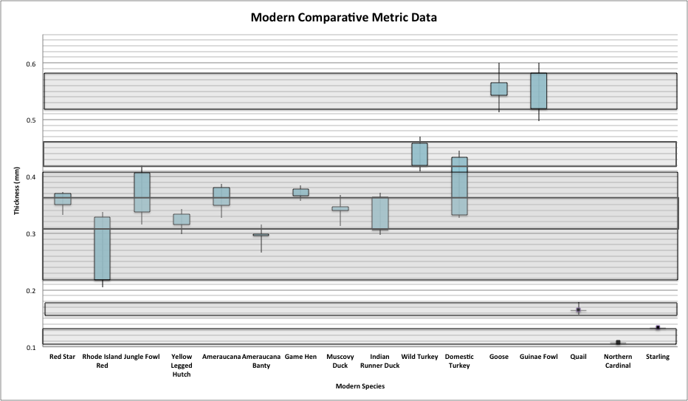

Figure 15. Comparative Collection Eggshell Thickness Ranges: Separated by species

Figure 16.1. Level R/4 Eggshell Identification

Figure 16.2. Level R/4 Eggshell Resorption: Chicken

Figure 16.3. Level R/4 Eggshell Resorption: Guinea fowl/goose

Figure 17.1. Level S/4 Eggshell Identification

Figure 17.2. Level S/4 Eggshell Resorption: Chicken

Figure 18.1. Level W/4 Eggshell Identification

Figure 18.2. Level W/4 Eggshell Resorption: Chicken

Figure 18.3. Level W/4 Eggshell Resorption: Turkey

Figure 18.4. Level W/4 Eggshell Resorption: Possible Quail

Figure 19.1. Level V/4 Eggshell Identification

Figure 19.2. Level V/4 Eggshell Resorption: Chicken

Figure 19.3. Level V/4 Eggshell Resorption: Turkey

Figure 19.4. Level V/4 Eggshell Resorption: Quail

Figure 20.1. Level X/4 Eggshell Identification

Figure 20.2. Level X/4 Eggshell Resorption: Chicken

Figure 20.3. Level X/4 Eggshell Resorption: Possible Turkey

Figure 21.1. Level Y/4 Eggshell Identification

Figure 21.2. Level Y/4 Eggshell Resorption: Chicken

Figure 22.1. Level Z/4 Eggshell Identification

Figure 22.2. Level Z/4 Eggshell Resorption: Chicken

Figure 22.3. Level Z/4 Eggshell Resorption: Turkey

Figure 23.1. Level AA/4 Eggshell Identification

Figure 23.2. Level AA/4 Eggshell Resorption: Chicken

Figure 23.3. Level AA/4 Eggshell Resorption: Turkey

Figure 24.1. Level BB/4 Eggshell Identification

Figure 24.2. Level BB/4 Eggshell Resorption: Chicken

Figure 24.3. Level BB/4 Eggshell Resorption: Turkey

Figure 24.4. Level BB/4 Eggshell Resorption: Guinea fowl/Goose

Figure 24.5. Level BB/4 Eggshell Resorption: Quail

Figure 24.6. Level BB/4 Eggshell Resorption: Passerine

Vita

Kathryn Lamzik was raised in Augusta, Missouri where she attended St. Francis Borgia Regional High School in Washington, Missouri and graduated in 2003. After attending Missouri State University, she graduated in May 2007 with a Bachelor of Science Degree in Anthropology and a Double Minor in English and Antiquities. In the two years following graduation, Kathryn worked as an archaeologist across the Midwestern states, the Caribbean, and the Middle East. She was accepted into the University of Tennessee Anthropology graduate program in 2010 and will graduate in May 2013.

