βusiness Anαlytics: Converging Expectations
Laura Burgin

Faculty Advisor: Charles Cwiek
Department of Statistics, Operations, and Management Science

THESIS ADVISOR SIGNATURE APPROVAL PAGE

TO THE GLOBAL LEADERSHIP SCHOLARS PROGRAM:

As GLS Thesis Faculty Advisor for __________________________________________, I have read this paper and find it satisfactory.

___________________________________________
GLS Thesis Faculty Advisor

___________________________________________
Date

Abstract
With the rapidly growing field of Business Analytics making its mark on the corporate world, schools such as the University of Tennessee are beginning to respond with undergraduate majors to match this growth. However, because of the relative infancy of the field, it is difficult to establish a curriculum that properly prepares Business Analytics students to meet the technical, software, and general expectations of future employers. This paper evaluates the current position of the Business Analytics field along with the expectations of recruiters in order to discover any gaps in student skills to see how those gaps should be addressed in the training that Business Analytics students receive at the University of Tennessee. The aim of this paper is to offer recommendations that seek to lessen the divide between what potential employers expect in terms of skill sets from students and what students feel they are prepared to provide.

Table of Contents
Abstract 3
Introduction and Literature Review 5
Thesis 9
Methodology 10
I. Procedural 10
Method Choice: 10
Survey Development: 10
Survey Deployment and Data Collection: 11
Survey Limitations and Bias: 11
II. Analytical 12
Analysis Completed: 12
Analysis Methods 13
Limitations of Analysis: 14
Results 15
Overview: 15
Stage One: 15
Stage Two: 18
Stage Three: 19
Recommendations 22
Conclusion 25
References 26
Appendix A: Recruiter Survey 27
Appendix B: Student Survey 30
Appendix C: Skill Rankings 34
Appendix D: Differences in Mean Ratings 35
Appendix E: JMP Output Difference in Means 36

Introduction and Literature Review
The era of Big Data is here. The digital age has ushered in the capabilities to collect and store data at a rate that may surpass even the ability to process it. With the emergence of this Big Data trend comes the emergence of the associated field of Business Analytics. Analytics in business is no new phenomenon. In fact, it gained recognition in the late 1800’s when Frederick Winslow Taylor was being scorned for his evidence based management theories that eventually earned him the title of “Father of Scientific Management.” Henry Ford continued the promotion of analytics as he revolutionized the efficiency of manufacturing. However, it was not until the 1960’s, when computers began to be used to collect enormous amounts of data and aid decision-making, that analytics took center stage. The Harvard Business Review identifies that the current challenge is that, “companies are now wrestling with information that comes in varieties and volumes never encountered before” (Davenport). This challenge has given rise to the field of Business Analytics and the profession of Data Analysts or Data Scientists.
Organizations are eager to collect large amounts of data, but without proper interpretation and application, that data is practically useless. “Because large data sets can be modeled, data are often reduced to what can fit into a mathematical model. Yet, taken out of context, data loses meaning and value,”(Boyd, 670). The individuals in the field of Business Analytics are responsible for providing the context. They take information that is being collected and turn it into knowledge. These Data Scientists are an integral part of using analytics in business. According to Gartner, Inc., the world's leading information technology research and advisory company, Business Analytics is defined as “solutions used to build analysis models and simulations to create scenarios, understand realities and predict future states”(“IT Glossary,” Gartner). The ability to create, understand, and predict is what makes those with training in Business Analytics invaluable to companies.
The Big Data boom, or information explosion, has created and will continue to create many opportunities for professionals in the field of Business Analytics. According to Gartner Research, Data Analytics is expected to create 4.4 million jobs globally by 2015. This growing field presents many opportunities, but requires a specific skill set. In a presentation at the Gartner Symposium/ITxpo in October 2012, Peter Sondergaard, Senior Vice President and head of global research at Gartner observed, “There is a challenge. There is not enough talent in the industry. Our public and private education systems are failing us. Therefore, only one-third of the IT jobs will be filled. Data experts will be a scarce, valuable commodity”(Sondergaard). He is not the only one to predict a shortage in talent in the industry. The Harvard Business Review states “Much of the current enthusiasm for big data focuses on technologies that make taming it possible, but at least as important are the people with the skill set (and the mind-set) to put them to good use. On this front, demand has raced ahead of supply. Indeed, the shortage of data scientists is becoming a serious constraint in some sectors” (Davenport). Additionally, the McKinsey Global Institute was among those to identify a likely shortage: “There will be a shortage of talent necessary for organizations to take advantage of big data. By 2018, the United States alone could face a shortage of 140,000 to 190,000 people with deep analytical skills as well as 1.5 million managers and analysts with the know-how to use the analysis of big data to make effective decisions” (Manyika). There is no question that the need for qualified Data Analysts is great and ever growing. The real question is what will be done in response to this need?
Colleges and universities are tuning into this talent gap and creating new programs or revamping existing majors to facilitate the development of analytical skills in a business context for students. The main focus, at this time, seems to be placed on the masters programs pioneering the efforts to bridge the talent gap. As of 2013, The University of Tennessee is ranked among the Top 20 Big Data Analytics Master’s Programs ranking among universities such as Harvard, MIT, Carnegie Mellon, and other prestigious institutions. According to Ken Gilbert, head of UT's Department of Statistics, Operations, and Management Science at the time, “[The University of Tennessee] has been an innovator in incorporating business analytics into our curriculum. We were the first business school in the country to offer an undergraduate, master's degree, and master's /MBA dual degree in business analytics” This innovation has clearly distinguished UT’s Business Analytics Master’s Program, but as the University gains recognition for its master’s program, it is important that the undergraduate Business Analytics program displays the same strength and value.
Recruiters and potential employers naturally expect undergraduate UT Business Analytics students to be of high quality due to the prestige of the master’s program. However, the undergraduate program has a limitation that the master’s program does not have. Students entering the master’s program have already obtained a bachelor’s degree and some even have prior work experience, so they are able to focus entirely on Business Analytics courses. As a part of the undergraduate program, students must, of course, fulfill credits in general education as well as taking a broad survey of other business courses to gain an understanding of the context of Business Analytics. This creates a natural time constraint and forces students to pick and choose what skill sets they will develop outside of the required Business Analytics courses while in the undergraduate program. This limitation has the potential to create a discrepancy between the skill sets recruiters expect from undergraduate Business Analytics students and the skills with which students feel they are actually proficient.

Thesis

This paper will investigate the expectations of recruiters and potential employers as they relate to the self-evaluations of students regarding the skill sets they have gained through their experiences in the undergraduate Business Analytics program at the University of Tennessee. This is done in order to identify discrepancies in expectations that can point to important areas for improvement or focus for the undergraduate curriculum as well as areas in which UT is currently excelling.

Methodology

Procedural

Method Choice:
In order to study the different views and expectations surrounding the Business Analytics undergraduate program at The University of Tennessee, two target audiences were important to reach: recruiters/potential employers and current undergraduate Business Analytics students at UT. After considering conducting interviews with representatives from both constituencies and then relying on qualitative research to reach a conclusion about the potentially differing expectations, I decided and was advised that it would be more effective to create surveys to reach larger samples of the two populations. This quantitative approach would allow for more definitive conclusions about the two views on the program and whether or not they differ. Therefore, two surveys were created.

Survey Development:
The first survey was created to reach the population of recruiters and/or potential employers. It addressed three overarching areas of focus for students (Technical Skills, Software Skills, and General Skills) by providing specific skills within each area and asking them to rate how familiar they would expect a student graduating from UT’s undergraduate program to be with each skill. The ratings were on a five-point scale ranging from “Not at all familiar” to “Extremely familiar.” The second survey was created for current Business Analytics students at UT and it directly mirrored the first survey. It listed the exact same selection of skills and asked them to rate on the same scale how familiar they feel they are with each skill due to their experience in the Business Analytics program at UT. Both surveys were developed using SurveyMonkey, a web-based survey site. (For both full surveys see Appendices A and B)

Survey Deployment and Data Collection:
After developing the two surveys, I sent them out to the respective populations in order to receive a sample of data to use in the analysis of the two potentially differing views. The recruiter survey was sent out through the Office of Statistics, Operations, and Management Science in a monthly newsletter that goes to alumni and corporate partners. It was also sent out through this office to participants in the Business Analytics Forum. 30 complete responses were collected through these channels. The student survey was sent out to Business Analytics students through class email lists and shared on social media (with special instruction as to the target audience). 29 complete responses were collected through these channels.

Survey Limitations and Bias:
As with any research method, there were limitations and possible bias introduced through the survey process. The first limitation is the relatively small sample size obtained. It would, of course, have been better to have a larger sample size from both the recruiters and students, but with such a specific target audience, this was inevitably going to be a challenge. The next limitation was a result of the nature of the survey itself. Since the survey listed an array of statistical and technical terms that may not have universally agreed upon names, it is possible that both recruiters and students could have rated certain skills lower simply because they did not recognize the name used, not because they are not familiar with the skill. Another limitation is that the survey addresses topics that are covered in classes that are electives and not required for all students. Due to this, responses had to be screened to make sure that only sections that fit the student’s class history were included. This made it very difficult to obtain 29 complete responses. Lastly, there is also some possible bias in this survey process. The recruiter survey was sent out in a newsletter that reached participants that may have been inclined to answer favorably towards the department because they have a prior interest in or connection to the department. Similarly, students may have over or under estimated their comfort level with skills depending on grades, time passed since the course, whether or not they enjoyed the topic, or even frustration. These limitations and possible biases in no way entirely invalidate this research, however, it should be noted that these limitations and biases could be factors in the responses. For future study, it is advised that a larger sample size be collected in a more random fashion to mitigate the effect of these limitations and biases.

Analytical

Analysis Completed:
The goal of the analysis was to determine whether or not the recruiters’ expectations were being met according to the self-evaluations of the students. In order to do this, I compared averages from each individual skill listed. Each rating on the scale for the survey was assigned a numerical value (1-5) and these values were then used to numerically examine the mean response for each particular skill from both recruiters and students. These two average values could be compared directly because the list of skills on the two surveys was identical. For each skill I calculated a mean value for recruiters and for students and then tested to see if the difference in the two means was statistically significant. I also assigned a rank to each skill according to the recruiters and also according to the students. These ranks are used to show the importance placed on each skill relative to the other skills. As a result, each skill was assigned two different rankings and these ranking were then compared to find any apparent discrepancies. This showed which skills had the largest (or smallest) discrepancies in perceived importance. (For list of rankings see Appendix C) Lastly, I calculated the difference in the means to show which skills had the highest margin of difference and therefore the most room for improvement or change. (For list of differences in means see Appendix D)

Analysis Methods
I used a statistical program, JMP, in order to compute the mean values for each skill as well as testing for statistically significant differences in the means. I did this by running a T-Test. The means that were compared were the mean value for each skill from the recruiter survey and the corresponding mean value from the student survey. The T-Test was able to either reject or fail to reject the null hypothesis. The hypotheses were as follows:
H0: µ_{recruit}-µ_{student} = 0
Ha: µ_{recruit}-µ_{student} ≠ 0
Therefore, if the test failed to reject the null hypothesis then the two means were not statistically significantly different. If the test was able to reject the null hypothesis then the recruiter mean was statistically significantly different from the student mean. (For associated JMP outputs see Appendix E)

The remaining analysis was done in Microsoft Excel. The rankings were assigned by sorting the data first by recruiter mean. The skill with the highest mean was assigned a rank of 1. The data was then sorted by student mean and similarly assigned an additional ranking. As a result, each skill received two rankings. The last part of the analysis was to calculate the difference in means by finding the absolute value of the difference in the two means. The higher the difference, the larger the discrepancies between what recruiters expect and of what students feel they are capable.

Limitations of Analysis:
Since the survey asked respondents to rate on a scale from 1-5, the mean for each skill fell between two choices on the survey. For example, a mean of 3.5 would fall somewhere between “Moderately familiar” and “Very Familiar,” which is somewhat of a grey area. Another limitation exists when assigning ranks to the skills. Some skills had identical mean values, which means they received the same rank. For example, there could be multiple skills that received a rank of 7.

Results

Overview:
After collecting data from recruiters and potential employers on the expected level of student familiarity with an array of analytical and general skills as well as corresponding data from students on their actual level of familiarity with those topics, I was able to conduct an analysis that led to several results. The first stage of analysis tested whether there was a discrepancy in expected student familiarity and actual student familiarity. The next stage of analysis examined the magnitude of this discrepancy. The final stage of analysis investigated which, if any, of these discrepancies would be beneficial to address. Following is a discussion of the results of each stage of analysis and their practical implications.

Stage One:
The first step in the analysis, after collecting the data, was to examine the average level of familiarity attributed to each skill from both recruiters and students. By doing this, I hoped to see if there was a difference in the expected level of student familiarity (recruiter responses) and the observed level of familiarity (student responses). After simply calculating the average for each skill for both groups, it was clear that the means were different for almost all of the individual skills. However, since the sample size was small, I wanted to see if the difference I was observing was statistically significant. A statistically significant difference in the means would indicate that there is potentially an actual difference in the views of recruiters and students and not just a difference in sample means due to sampling variability. What I found was that for 37 of the 45 skills in questions, the recruiter mean was statistically significantly higher than the student mean. In fact, student responses were, on average, 0.75 points lower than the recruiter responses, which is almost a full rating on the survey scale. This gives the overall impression that, across the board, students are not as familiar with these skills as recruiters would expect.
It may be initially alarming to learn that students seem to be falling short on 82% of the skills investigated through this survey. However, just because recruiters have seemingly higher expectations across the board does not necessarily mean that changes need to be made. There are many factors to be considered when looking at these data such as the importance placed on the skills and the magnitude of the discrepancy, both of which will be addressed in the results to follow. The larger implications of the higher expectations in general will be better understood in relation to these factors.

The results from this analysis that are important to consider are the skills for which the recruiter mean was not significantly higher. These exceptions to the general rule offer important insight about the nature of the Business Analytics undergraduate program at UT. There were five skills that did not have a statistically significant difference in recruiter and student means: Access, Control Charts, Experiment Design, PowerPoint, and Process Improvement Study. This means that, though the two sets of means were not identical for each of these skills, they were not different enough to indicate a true difference in the views of recruiter and students. This indicates that these skills are being addressed through the Business Analytics curriculum in a way that prepares students appropriately for the expectations of future employers, meaning that no change in the way these topics are taught should be made.

On the flip side, there were two skills for which the student mean was significantly higher than the recruiter mean: JMP and NCSS. It is this result that I consider the biggest concern. The mean recruiter expectation for student familiarity with the statistical software, JMP, was 3.17 and the student mean was 4.48. This means that recruiters expect students to be “Moderately familiar” with this program, but students are actually closer to “Extremely familiar” with JMP. Similarly, the recruiter mean for student familiarity with the statistical software, NCSS, was 2.31 (the lowest average for any of the 45 skills) and the student mean was 3.76. This means that recruiters expect or want students to be about “Slightly familiar” with this program, but students are actually closer to “Very familiar.” It is not inherently bad that students are more familiar with these two programs then recruiters expect; the issue arises when these programs are compared to other possible statistical programs that students could be learning to use. For example, on average, recruiters expect students to be “moderately” to “very” familiar with SAS whereas they do not expect this same level of familiarity with either JMP or NCSS. Even the statistical program R received a higher mean response, even if only slightly, from recruiters than both JMP and NCSS. Therefore, it could be more beneficial for students to be trained more extensively on programs like SAS or R that are more widely recognized by recruiters than on JMP or NCSS in order to be more marketable.

Stage Two:
The second phase of analysis was done in order to provide context and additional or surrounding factors for the first stage, which considered only whether expectations were the same from recruiters and students. This stage of analysis was done to examine the magnitude of the differences in the responses. To do this, I calculated the difference in the two means. Any difference that was greater than 1 indicates that, on average, there was a difference of an entire rating on the survey scale. There were eleven skills that had a difference greater than 1 (Two of these skills were the aforementioned JMP and NCSS). There were twenty-five skills that had a difference greater than 0.50. Though these differences are statistically significant, they are not as extreme as the eleven values with differences greater than 1. (For full list see Appendix D)

One of the highest discrepancies was in response to familiarity with “Text Mining.” Recruiters expect students to be almost one and a half full ratings on the survey scale more familiar with text mining than they are. However, recruiters only expect students to be “Moderately familiar” with text mining, so this does not indicate that any immediate response or change is necessary even though students, on average, are between “Slightly Familiar” and “Moderately familiar” with the skill. This is why it is more beneficial to look at the differences in means in the context of the importance that recruiters place on these skills. Therefore, I looked at the skills in the group with this extreme difference in means that had a recruiter mean of 4 and above. This meant that these skills not only had a large difference in expectations, but also that recruiters expect students to be at least “Very familiar” with these skills. Students falling short in these areas is more concerning than students having a very large discrepancy in familiarity with skills, such as bootstrapping, that are not as important to recruiters. The skills that fit these criteria were: Data Screening, Data Preparation, Model Assessment, Identifying Problems, and Decision Trees. This means that these particular skills are important to recruiters but are presenting notable difficulty for students. In order to determine which skills should be a focus for possible improvement, such as those just listed, it was necessary to delve further into which skills are most highly valued by recruiters. This led to the third and final stage of analysis.

Stage Three:

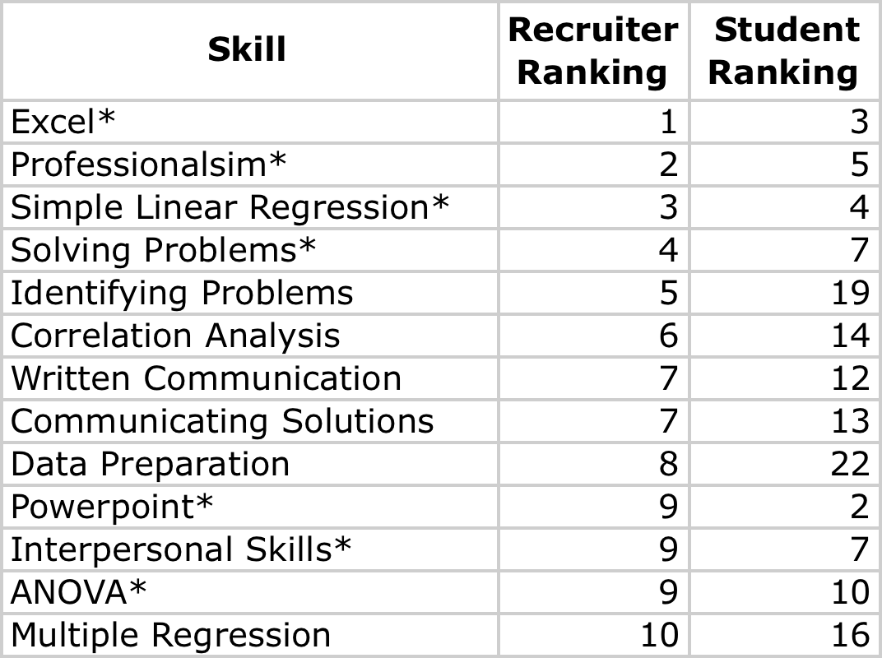
This stage of analysis sought to better determine which skills had discrepancies in expectations that posed actual concern. In order to gain perspective on the importance that recruiters place on each of the skills in question, I assigned a ranking to each skill based on the level of familiarity that recruiters and students expect. For example, the skill with the highest mean value for recruiters was Excel with a mean of 4.59 so it received a rank of 1. Students had a mean familiarity of 4.24 with Excel, which was the third highest mean value of the skills, so Excel received a rank of 3 from students. These ranks allowed me to assess the general importance placed on each skill relative to the other listed skills for both recruiters and students. I was most interested in finding out which skills recruiters found most important and therefore expected the highest level of familiarity from students, and whether or not students were appropriately familiar with these important skills. I found that the top skills that recruiters expect students to master are different from the top skills that students feel they have mastered. It is encouraging to see that there are seven skills that are considered top skills by both recruiters and students. However, there are some rather large discrepancies as well:
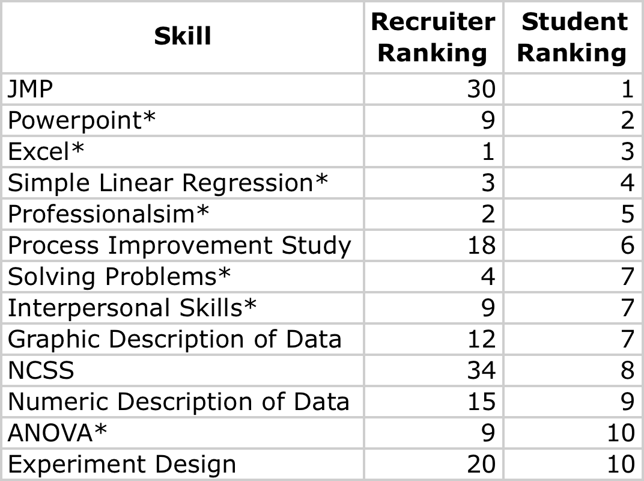
*Indicates skill that appears on both lists

The largest discrepancy here is that the top ranked skill according to students is JMP, which is ranked 30 out of 34 for recruiters. Similarly, NCSS is ranked eighth for students and is the lowest ranked skill for recruiters. These two programs have already been addressed, and this further shows that there is a divide in the two views regarding software. Another takeaway from this comparison is that recruiters place great importance on communication. Both “Written Communication” and “Communicating Solutions” have made their way to the top of the recruiter rankings. It is no longer enough for graduates to have solely statistical or analytical capabilities, there is now a great emphasis placed on one’s ability to effectively communicate a solution. The Harvard Business Review states, “Most enduring will be the need for data scientists to communicate in language that all their stakeholders understand—and to demonstrate the special skills involved in storytelling with data, whether verbally, visually, or—ideally—both” (Davenport). It is important to integrate communication into the teaching of analytics in order to give students the ability to effectively communicate solutions in a way that is easily understood and implemented. It is useful to keep the skills that recruiters value most in mind when considering the curriculum and even emphasis within the classroom.

Recommendations
Before delving into recommendations, it is important to acknowledge that there are many factors that go into curriculum and teaching decisions that are deeper than simply what recruiters want to see from students. There are financial and personnel implications for changes made in an academic institution that will not be addressed in the following recommendations. These recommendations are based purely on bridging the gap between recruiter expectations and student capabilities. With that being said, the results from this study can be applied by way of three main recommendations: 1) Consider shifting statistical software emphasis in the classroom 2) Provide increased emphasis on the five skills that were identified as both important to recruiters and a challenge for students 3) Further integrate communication into the Business Analytics curriculum. These three recommendations together address the main implications of the results of this study.
The first recommendation stems from the first stage of analysis and addresses the question of whether students are learning the most beneficial software programs. According to this study, it would be more useful for students to learn a program such as SAS instead of focusing as highly on JMP and NCSS. This was shown through the differences in the mean responses of recruiters and students regarding these two programs in comparison to the responses for programs such as SAS or R. Both of these programs have significant influence in the corporate and higher education realm as well. A New York Times article published in 2009 was already discussing the influence of these two packages, “While it is difficult to calculate exactly how many people use R, those most familiar with the software estimate that close to 250,000 people work with it regularly. The popularity of R at universities could threaten SAS Institute, the privately held business software company that specializes in data analysis software. SAS, with more than $2 billion in annual revenue, has been the preferred tool of scholars and corporate managers” (Vance). As reflected in this data, SAS and R are both prevalent software packages that are widely used by companies and organizations. It could be beneficial for students to learn programs that they are likely to use after graduation.
I recommend that professors be encouraged to integrate these software packages into their teaching as a supplemental tool if not the primary. The University of Tennessee now offers a course that prepare students to take the SAS certification examination, however it is not a required course for any Business Analytics students. I recommend that UT consider including this course as a requirement for Business Analytics majors in the future who are pursuing a major with the collateral option because they have 6 hours of Business Analytics electives to complete. Requiring students who have to choose an elective anyway to take this course would supply them with their SAS certification, which is a tangible and marketable asset. Though there are many factors that make up curriculum decisions, it could be beneficial to consider shifting the software emphasis away from JMP and NCSS to programs such as R and SAS in order to better meet companies’ needs in the future.
The second recommendation is rooted in the results of the second stage of analysis, which explored the gaps in expected versus actual student familiarity with the skills in question. The result of this stage of analysis was that there are five skills that emerged from the data as important to recruiters but difficult or not comfortable for students. These skills are: Data Screening, Data Preparation, Model Assessment, Identifying Problems, and Decision Trees. These are the skills that have the most “urgent” need for attention due to the high level of discrepancy between what recruiters expect and what students can deliver. However, these are skills that are being addressed in multiple classes in the Business Analytics curriculum already. These skills are mostly preliminary steps in problem solving. Due to the nature of these skills, I recommend that professors integrate more real life data sets and case studies in order to provide students the opportunity to work with a problem from the beginning. This could augment students’ abilities to deal with these first-stage steps. Allowing students to handle a business problem start to finish also provides valuable experience working with real life data and challenges.
The last recommendation was discussed briefly in relation to the third stage of analysis, which showed the importance placed on each individual skill by recruiters by looking at the assigned rankings. One takeaway from this analysis was that communication, specifically the ability to communicate solutions, is very important to recruiters. All Business students at The University of Tennessee are required to take a Communications Study class as a part of the core Business curriculum; however, most students do not continue taking courses in Communications unless they are pursuing a major in Communications. Though public speaking is indeed a valuable skill, Business Analytics students need experience communicating statistical results in a language that is understood by management and those not familiar with statistical jargon. In order to achieve this experience, students need the chance to practice. I recommend that professors consider incorporating more opportunities for students to present findings, either in writing or orally. This would be especially valuable in lower level statistics classes in order to get students used to the challenge of communicating statistical findings in a universally understandable way. The more comfortable students are communicating solutions and speaking in front of other people, the more valuable they will be to firms. This is reflected in the importance that recruiters place on communication according to their responses.

Conclusion
These three recommendations are in no way comprehensive, however, they address the main implications of the results of this study. These recommendations seek to lessen the divide between what recruiters expect and what students are prepared to deliver. This study was conducted on a rather small scale and, without access to more extensive resources it cannot hope to create a perfect Business Analytics program. It can, however, provide insight into the mindset of potential employers and current students in order to understand how the University can best serve its students. If the Business Analytics program is serious about “Continuous Improvement,” then this study can serve as a launching point for further research or reform. Just as the field of Business Analytics is forever changing and evolving, so too should the curriculum that seeks to train its future professionals.

References

"Business Analytics Master's Degree Is Named One of "20 Top Programs"" Top Business Analytics Programs. University of Tennessee, Knoxville, n.d. Web. 21 Apr.
2014.
"Gartner Says Big Data Creates Big Jobs: 4.4 Million IT Jobs Globally to Support Big
Data By 2015." Gartner Says Big Data Creates Big Jobs. Gartner, Inc., 22 Oct. 2012. Web. 21 Apr. 2014.

"IT Glossary." Gartner. Gartner, Inc., 2013. Web. 21 Apr. 2014.

Boyd, Danah, and Kate Crawford. "Critical Questions For Big Data." Information,
Communication & Society 15.5 (2012): 662-79. Web.

Cukier, Kenneth. "Data, Data Everywhere." The Economist. The Economist Newspaper,
27 Feb. 2010. Web. 21 Apr. 2014.

Davenport, Thomas H., and D.J. Patil. "Data Scientist: The Sexiest Job of the 21st
Century." Harvard Business Review. N.p., Oct. 2012. Web. 21 Apr. 2014.

Henschen, Doug. "Big Data Analytics Master's Degrees: 20 Top Programs –
InformationWeek." InformationWeek. N.p., 7 Jan. 2013. Web. 21 Apr. 2014.

Manyika, James, Michael Chui, Brad Brown, Jacques Bughin, Richard Dobbs, Charles
Roxburgh, and Angela Byers. "Big Data: The next Frontier for Innovation,
Competition, and Productivity." McKinsey & Company. N.p., May 2011. Web. 21 Apr. 2014.

Sondergaard, Peter. "Peter Sondergaard, Gartner, Says Big Data Creates Big Jobs."
YouTube. N.p., 22 Oct. 2012. Web. 21 Apr. 2014.

Vance, Ashlee. "Data Analysts Captivated by R’s Power." The New York Times. The
New York Times, 06 Jan. 2009. Web. 21 Apr. 2014.

Willmott, Hugh. "Dictatorship of the Technocrat." Times Higher Education. N.p.,
6 Apr. 1998. Web. 21 Apr. 2014.

Appendix A: Recruiter Survey

The following survey is about the UNDERGRADUATE Business Analytics Program at the University of Tennessee. Your responses are completely anonymous and greatly appreciated. The survey should take approximately 5 minutes to complete.

Rate the following based on how closely you associate them with the Undergraduate Business Analytics major at the University of Tennessee
 | Not at all Associated | Slightly Associated | Moderately Associated | Very Associated | Extremely Associated
Accounting | 1 | 2 | 3 | 4 | 5
Communication | 1 | 2 | 3 | 4 | 5
Economics | 1 | 2 | 3 | 4 | 5
Finance | 1 | 2 | 3 | 4 | 5
Statistics | 1 | 2 | 3 | 4 | 5
Supply Chain Management | 1 | 2 | 3 | 4 | 5

This section asks about the technical skills that you, as a potential employer, would EXPECT to see from a student graduating from the University of Tennessee with an Undergraduate degree in Business Analytics.

 | Not at all Familiar | Slightly Familiar | Moderately Familiar | Very Familiar | Extremely Familiar
Data Sampling | 1 | 2 | 3 | 4 | 5
Data Partitioning (training, validation, test sets) | 1 | 2 | 3 | 4 | 5
Numeric Description of Data | 1 | 2 | 3 | 4 | 5
Graphic Description of Data | 1 | 2 | 3 | 4 | 5
Data Preparation (transformations, etc) | 1 | 2 | 3 | 4 | 5
Data Screening | 1 | 2 | 3 | 4 | 5
Data Sampling | 1 | 2 | 3 | 4 | 5
Probability and Probability Distribution | 1 | 2 | 3 | 4 | 5
Simulation | 1 | 2 | 3 | 4 | 5
Hypothesis Testing | 1 | 2 | 3 | 4 | 5
Bootstrapping | 1 | 2 | 3 | 4 | 5
Analysis of Variance | 1 | 2 | 3 | 4 | 5
 | Not at all Familiar | Slightly Familiar | Moderately Familiar | Very Familiar | Extremely Familiar
Simple Linear Regression | 1 | 2 | 3 | 4 | 5
Correlation Analysis | 1 | 2 | 3 | 4 | 5
Time Series Analysis | 1 | 2 | 3 | 4 | 5
Multiple Regression | 1 | 2 | 3 | 4 | 5
Variable Selection | 1 | 2 | 3 | 4 | 5
Categorical Data Analysis | 1 | 2 | 3 | 4 | 5
Decision Trees | 1 | 2 | 3 | 4 | 5
Model Assessment | 1 | 2 | 3 | 4 | 5
Text Mining | 1 | 2 | 3 | 4 | 5
Forecasting | 1 | 2 | 3 | 4 | 5
Exponential Smoothing | 1 | 2 | 3 | 4 | 5
Time Series Decomposition | 1 | 2 | 3 | 4 | 5
 | Not at all Familiar | Slightly Familiar | Moderately Familiar | Very Familiar | Extremely Familiar
Control Charts (P-charts, X-charts, MR-charts, etc.) | 1 | 2 | 3 | 4 | 5
Tools for Process Study (process flow diagrams, process maps, etc.) | 1 | 2 | 3 | 4 | 5
Experiment Design | 1 | 2 | 3 | 4 | 5
Evaluating Measurement Processes | 1 | 2 | 3 | 4 | 5
Analysis of Variance | 1 | 2 | 3 | 4 | 5
Six-Sigma | 1 | 2 | 3 | 4 | 5
This section asks about the software skills that you, as a potential employer, would EXPECT to see from a student graduating from the University of Tennessee with a major in Business Analytics.

 | Not at all Familiar | Slightly Familiar | Moderately Familiar | Very Familiar | Extremely Familiar
Google AdWords | 1 | 2 | 3 | 4 | 5
JMP | 1 | 2 | 3 | 4 | 5
Microsoft Access | 1 | 2 | 3 | 4 | 5
Microsoft Excel | 1 | 2 | 3 | 4 | 5
Microsoft Powerpoint | 1 | 2 | 3 | 4 | 5
NCSS | 1 | 2 | 3 | 4 | 5
R | 1 | 2 | 3 | 4 | 5
SAS | 1 | 2 | 3 | 4 | 5
SPSS | 1 | 2 | 3 | 4 | 5

This section asks about the general skills that you, as a potential employer, would EXPECT to see from a student graduating from the University of Tennessee with a major in Business Analytics.

 | Not at all Familiar | Slightly Familiar | Moderately Familiar | Very Familiar | Extremely Familiar
Identifying Problems | 1 | 2 | 3 | 4 | 5
Solving Problems | 1 | 2 | 3 | 4 | 5
Communicating Solutions | 1 | 2 | 3 | 4 | 5
Oral Communication | 1 | 2 | 3 | 4 | 5
Written Communication | 1 | 2 | 3 | 4 | 5
Professionalism | 1 | 2 | 3 | 4 | 5
Interpersonal Skills | 1 | 2 | 3 | 4 | 5

Thank you for taking the time to complete this survey! Please select "Done" to submit your responses.

Appendix B: Student Survey

The following survey is about the UNDERGRADUATE Business Analytics Program at the University of Tennessee. Your responses are completely anonymous and greatly appreciated. The survey should take approximately 5 minutes to complete.

Rate the following based on how closely you associate them with the Undergraduate Business Analytics major at the University of Tennessee
 | Not at all Associated | Slightly Associated | Moderately Associated | Very Associated | Extremely Associated
Accounting | 1 | 2 | 3 | 4 | 5
Communication | 1 | 2 | 3 | 4 | 5
Economics | 1 | 2 | 3 | 4 | 5
Finance | 1 | 2 | 3 | 4 | 5
Statistics | 1 | 2 | 3 | 4 | 5
Supply Chain Management | 1 | 2 | 3 | 4 | 5

Please select all Statistics courses you have taken at UT:

None

Stat 320 Regression Modeling

Stat 340 Exper Methods/Process Improv

Stat 370 Search Engine Marketing

Stat 471 Business Analytics Capstone

Stat 474 Data Mining/Bus Analytics

Stat 475 Applied Time Series/Forecast

Stat 483 SAS

This section asks about the technical skills that you, as an Undergraduate Business Analytics senior, feel you have gained from your studies in Business Analytics as the University of Tennessee.
 | Not at all Familiar | Slightly Familiar | Moderately Familiar | Very Familiar | Extremely Familiar
Data Sampling | 1 | 2 | 3 | 4 | 5
Data Partitioning (training, validation, test sets) | 1 | 2 | 3 | 4 | 5
Numeric Description of Data | 1 | 2 | 3 | 4 | 5
Graphic Description of Data | 1 | 2 | 3 | 4 | 5
Data Preparation (transformations, etc) | 1 | 2 | 3 | 4 | 5
Data Screening | 1 | 2 | 3 | 4 | 5
Data Sampling | 1 | 2 | 3 | 4 | 5
Probability and Probability Distribution | 1 | 2 | 3 | 4 | 5
Simulation | 1 | 2 | 3 | 4 | 5
Hypothesis Testing | 1 | 2 | 3 | 4 | 5
Bootstrapping | 1 | 2 | 3 | 4 | 5
Analysis of Variance | 1 | 2 | 3 | 4 | 5
 | Not at all Familiar | Slightly Familiar | Moderately Familiar | Very Familiar | Extremely Familiar
Simple Linear Regression | 1 | 2 | 3 | 4 | 5
Correlation Analysis | 1 | 2 | 3 | 4 | 5
Time Series Analysis | 1 | 2 | 3 | 4 | 5
Multiple Regression | 1 | 2 | 3 | 4 | 5
Variable Selection | 1 | 2 | 3 | 4 | 5
Categorical Data Analysis | 1 | 2 | 3 | 4 | 5
Decision Trees | 1 | 2 | 3 | 4 | 5
Model Assessment | 1 | 2 | 3 | 4 | 5
Text Mining | 1 | 2 | 3 | 4 | 5
Forecasting | 1 | 2 | 3 | 4 | 5
Exponential Smoothing | 1 | 2 | 3 | 4 | 5
Time Series Decomposition | 1 | 2 | 3 | 4 | 5
 | Not at all Familiar | Slightly Familiar | Moderately Familiar | Very Familiar | Extremely Familiar
Control Charts (P-charts, X-charts, MR-charts, etc.) | 1 | 2 | 3 | 4 | 5
Tools for Process Study (process flow diagrams, process maps, etc.) | 1 | 2 | 3 | 4 | 5
Experiment Design | 1 | 2 | 3 | 4 | 5
Evaluating Measurement Processes | 1 | 2 | 3 | 4 | 5
Analysis of Variance | 1 | 2 | 3 | 4 | 5
Six-Sigma | 1 | 2 | 3 | 4 | 5

This section asks about the software skills that you, as an Undergraduate Business Analytics senior, feel you have gained from your studies in Business Analytics as the University of Tennessee.

 | Not at all Familiar | Slightly Familiar | Moderately Familiar | Very Familiar | Extremely Familiar
Google AdWords | 1 | 2 | 3 | 4 | 5
JMP | 1 | 2 | 3 | 4 | 5
Microsoft Access | 1 | 2 | 3 | 4 | 5
Microsoft Excel | 1 | 2 | 3 | 4 | 5
Microsoft Powerpoint | 1 | 2 | 3 | 4 | 5
NCSS | 1 | 2 | 3 | 4 | 5
R | 1 | 2 | 3 | 4 | 5
SAS | 1 | 2 | 3 | 4 | 5
SPSS | 1 | 2 | 3 | 4 | 5

This section asks about the general skills that you, as an Undergraduate Business Analytics senior, feel you have gained from your studies in Business Analytics as the University of Tennessee.
 | Not at all Familiar | Slightly Familiar | Moderately Familiar | Very Familiar | Extremely Familiar
Identifying Problems | 1 | 2 | 3 | 4 | 5
Solving Problems | 1 | 2 | 3 | 4 | 5
Communicating Solutions | 1 | 2 | 3 | 4 | 5
Oral Communication | 1 | 2 | 3 | 4 | 5
Written Communication | 1 | 2 | 3 | 4 | 5
Professionalism | 1 | 2 | 3 | 4 | 5
Interpersonal Skills | 1 | 2 | 3 | 4 | 5

Thank you for taking the time to complete this survey! Please select "Done" to submit your responses.

Appendix C: Skill Rankings
Skill | Mean Recruit Rating | Mean Student Rating | Rank Recruit | Rank Student | Difference in Rank
Excel | 4.59 | 4.24 | 1 | 3 | 2
Professionalsim | 4.48 | 3.89 | 2 | 5 | 3
Simple Linear Regression | 4.47 | 3.97 | 3 | 4 | 1
Solving Problems | 4.45 | 3.79 | 4 | 7 | 3
Identifying Problems | 4.41 | 3.34 | 5 | 20 | 15
Correlation Analysis | 4.4 | 3.53 | 6 | 14 | 8
Written Communication | 4.38 | 3.62 | 7 | 12 | 5
Communicating Solutions | 4.38 | 3.55 | 7 | 13 | 6
Data Preparation | 4.37 | 3.1 | 8 | 23 | 15
Powerpoint | 4.28 | 4.38 | 9 | 2 | 7
Interpersonal Skills | 4.28 | 3.79 | 9 | 7 | 2
ANOVA | 4.28 | 3.69 | 9 | 10 | 1
Multiple Regression | 4.27 | 3.47 | 10 | 16 | 6
Model Assessment | 4.23 | 3.1 | 11 | 23 | 12
Graphic Data Description | 4.21 | 3.79 | 12 | 7 | 5
Probability | 4.17 | 3.34 | 13 | 20 | 7
Hypothesis Testing | 4.14 | 3.38 | 14 | 19 | 5
Oral Communication | 4.14 | 3.28 | 14 | 22 | 8
Numeric Data Description | 4.07 | 3.72 | 15 | 9 | 6
Variable Selection | 4.07 | 3.53 | 15 | 14 | 1
Data Sampling | 4.07 | 3.34 | 15 | 20 | 5
Time Series Analysis | 4.07 | 3.3 | 15 | 21 | 6
Evaluate Measurement | 4.03 | 3.52 | 16 | 15 | 1
Data Screening | 4.03 | 2.76 | 16 | 26 | 10
Decision Trees | 4 | 3 | 17 | 24 | 7
Process Improvement | 3.93 | 3.83 | 18 | 6 | 12
Data Partitioning | 3.93 | 3.41 | 18 | 17 | 1
Categorical Data Analysis | 3.93 | 3.1 | 18 | 23 | 5
Forecasting | 3.87 | 3 | 19 | 24 | 5
Experiment Design | 3.86 | 3.69 | 20 | 10 | 10
SAS | 3.72 | 2.14 | 21 | 29 | 8
Control Charts | 3.62 | 3.65 | 22 | 11 | 11
Exponential Smoothing | 3.6 | 2.73 | 23 | 27 | 4
Simulation | 3.59 | 2.9 | 24 | 25 | 1
Access | 3.52 | 3.41 | 25 | 18 | 7
Decomposition | 3.47 | 2.73 | 26 | 27 | 1
R | 3.45 | 1.79 | 27 | 32 | 5
Text Mining | 3.4 | 2.03 | 28 | 30 | 2
Bootstrapping | 3.21 | 3 | 29 | 24 | 5
JMP | 3.17 | 4.48 | 30 | 1 | 29
Six-Sigma | 3.14 | 2.52 | 31 | 28 | 3
SPSS | 2.86 | 2.14 | 32 | 29 | 3
Google AdWords | 2.69 | 1.86 | 33 | 31 | 2
NCSS | 2.31 | 3.76 | 34 | 8 | 26

Appendix D: Differences in Mean Ratings
Skill | Mean Recruit Rating | Mean Student Rating | Difference in Mean | Rank Recruit
R | 3.45 | 1.79 | 1.66 | 27
SAS | 3.72 | 2.14 | 1.58 | 21
NCSS | 2.31 | 3.76 | 1.45 | 34
Text Mining | 3.4 | 2.03 | 1.37 | 28
JMP | 3.17 | 4.48 | 1.31 | 30
Data Screening | 4.03 | 2.76 | 1.27 | 16
Data Preparation | 4.37 | 3.1 | 1.27 | 8
Model Assessment | 4.23 | 3.1 | 1.13 | 11
Identifying Problems | 4.41 | 3.34 | 1.07 | 5
Decision Trees | 4 | 3 | 1 | 17
Correlation Analysis | 4.4 | 3.53 | 0.87 | 6
Forecasting | 3.87 | 3 | 0.87 | 19
Exponential Smoothing | 3.6 | 2.73 | 0.87 | 23
Oral Communication | 4.14 | 3.28 | 0.86 | 14
Communicating Solutions | 4.38 | 3.55 | 0.83 | 7
Probability | 4.17 | 3.34 | 0.83 | 13
Categorical Data Analysis | 3.93 | 3.1 | 0.83 | 18
Google AdWords | 2.69 | 1.86 | 0.83 | 33
Multiple Regression | 4.27 | 3.47 | 0.8 | 10
Time Series Analysis | 4.07 | 3.3 | 0.77 | 15
Written Communication | 4.38 | 3.62 | 0.76 | 7
Hypothesis Testing | 4.14 | 3.38 | 0.76 | 14
Decomposition | 3.47 | 2.73 | 0.74 | 26
Data Sampling | 4.07 | 3.34 | 0.73 | 15
SPSS | 2.86 | 2.14 | 0.72 | 32
Simulation | 3.59 | 2.9 | 0.69 | 24
Solving Problems | 4.45 | 3.79 | 0.66 | 4
Six-Sigma | 3.14 | 2.52 | 0.62 | 31
Professionalism | 4.48 | 3.89 | 0.59 | 2
ANOVA | 4.28 | 3.69 | 0.59 | 9
ANOVA | 4.14 | 3.55 | 0.59 | 14
Variable Selection | 4.07 | 3.53 | 0.54 | 15
Data Partitioning | 3.93 | 3.41 | 0.52 | 18
Evaluate Measurement | 4.03 | 3.52 | 0.51 | 16
Simple Linear Regression | 4.47 | 3.97 | 0.5 | 3
Interpersonal Skills | 4.28 | 3.79 | 0.49 | 9
Graphic Data Description | 4.21 | 3.79 | 0.42 | 12
Numeric Data Description | 4.07 | 3.72 | 0.35 | 15
Excel | 4.59 | 4.24 | 0.35 | 1
Bootstrapping | 3.21 | 3 | 0.21 | 29
Experiment Design | 3.86 | 3.69 | 0.17 | 20
Access | 3.52 | 3.41 | 0.11 | 25
Process Improvement | 3.93 | 3.83 | 0.1 | 18
Powerpoint | 4.28 | 4.38 | 0.1 | 9
Control Charts | 3.62 | 3.65 | 0.03 | 22

Appendix E: JMP Output Difference in Means
- Data Sampling:
t Test
Stu-Rec
Assuming unequal variances
Difference | -0.7552 | t Ratio | -3.32555
Std Err Dif | 0.2271 | DF | 56.49294
Upper CL Dif | -0.3004 | Prob > |t| | 0.0016*
Lower CL Dif | -1.2100 | Prob > t | 0.9992
Confidence | 0.95 | Prob < t | 0.0008*
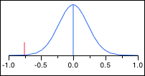

- Data Partitioning:

t Test
Stu-Rec
Assuming unequal variances
Difference | -0.5529 | t Ratio | -2.07457
Std Err Dif | 0.2665 | DF | 56.26523
Upper CL Dif | -0.0191 | Prob > |t| | 0.0426*
Lower CL Dif | -1.0867 | Prob > t | 0.9787
Confidence | 0.95 | Prob < t | 0.0213*
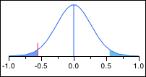

- Numeric Description of Data:
t Test
Stu-Rec
Assuming unequal variances
Difference | -0.37586 | t Ratio | -1.6731
Std Err Dif | 0.22465 | DF | 56.98455
Upper CL Dif | 0.07399 | Prob > |t| | 0.0998
Lower CL Dif | -0.82572 | Prob > t | 0.9501
Confidence | 0.95 | Prob < t | 0.0499*
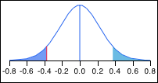

- Graphic Description of Data:
t Test
Stu-Rec
Assuming unequal variances
Difference | -0.44023 | t Ratio | -2.24462
Std Err Dif | 0.19613 | DF | 54.3973
Upper CL Dif | -0.04709 | Prob > |t| | 0.0289*
Lower CL Dif | -0.83337 | Prob > t | 0.9856
Confidence | 0.95 | Prob < t | 0.0144*
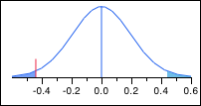

- Data Preparation:
t Test
Stu-Rec
Assuming unequal variances
Difference | -1.2966 | t Ratio | -5.91537
Std Err Dif | 0.2192 | DF | 49.6097
Upper CL Dif | -0.8562 | Prob > |t| | <.0001*
Lower CL Dif | -1.7369 | Prob > t | 1.0000
Confidence | 0.95 | Prob < t | <.0001*
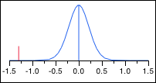

- Data Screening:
t Test
Stu-Rec
Assuming unequal variances
Difference | -1.3080 | t Ratio | -5.01144
Std Err Dif | 0.2610 | DF | 56.66199
Upper CL Dif | -0.7853 | Prob > |t| | <.0001*
Lower CL Dif | -1.8308 | Prob > t | 1.0000
Confidence | 0.95 | Prob < t | <.0001*
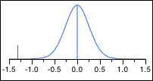
- Probability and Probability Distribution:
t Test
Stu-Rec
Assuming unequal variances
Difference | -0.8552 | t Ratio | -4.15693
Std Err Dif | 0.2057 | DF | 54.51153
Upper CL Dif | -0.4428 | Prob > |t| | 0.0001*
Lower CL Dif | -1.2675 | Prob > t | 0.9999
Confidence | 0.95 | Prob < t | <.0001*
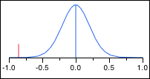

- Simulation:
t Test
Stu-Rec
Assuming unequal variances
Difference | -0.7368 | t Ratio | -2.91172
Std Err Dif | 0.2530 | DF | 56.17505
Upper CL Dif | -0.2299 | Prob > |t| | 0.0051*
Lower CL Dif | -1.2436 | Prob > t | 0.9974
Confidence | 0.95 | Prob < t | 0.0026*
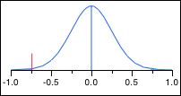

- Hypothesis Testing:
t Test
Stu-Rec
Assuming unequal variances
Difference | -0.7874 | t Ratio | -3.55713
Std Err Dif | 0.2213 | DF | 55.48627
Upper CL Dif | -0.3439 | Prob > |t| | 0.0008*
Lower CL Dif | -1.2309 | Prob > t | 0.9996
Confidence | 0.95 | Prob < t | 0.0004*
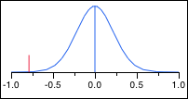

- Bootstrapping:
t Test
Stu-Rec
Assuming unequal variances
Difference | -0.26667 | t Ratio | -0.89465
Std Err Dif | 0.29807 | DF | 50.8332
Upper CL Dif | 0.33178 | Prob > |t| | 0.3752
Lower CL Dif | -0.86511 | Prob > t | 0.8124
Confidence | 0.95 | Prob < t | 0.1876
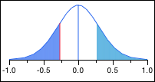

- ANOVA (Analysis of Variance):
t Test
Stu-Rec
Assuming unequal variances
Difference | -0.6149 | t Ratio | -2.5838
Std Err Dif | 0.2380 | DF | 54.82617
Upper CL Dif | -0.1379 | Prob > |t| | 0.0125*
Lower CL Dif | -1.0919 | Prob > t | 0.9938
Confidence | 0.95 | Prob < t | 0.0062*
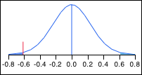

- Simple Linear Regression:
t Test
Stu-Rec
Assuming unequal variances
Difference | -0.50115 | t Ratio | -2.40014
Std Err Dif | 0.20880 | DF | 54.76468
Upper CL Dif | -0.08266 | Prob > |t| | 0.0198*
Lower CL Dif | -0.91963 | Prob > t | 0.9901
Confidence | 0.95 | Prob < t | 0.0099*
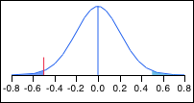
- Correlation Analysis:
t Test
Stu-Rec
Assuming unequal variances
Difference | -0.8483 | t Ratio | -4.98714
Std Err Dif | 0.1701 | DF | 56.94418
Upper CL Dif | -0.5077 | Prob > |t| | <.0001*
Lower CL Dif | -1.1889 | Prob > t | 1.0000
Confidence | 0.95 | Prob < t | <.0001*
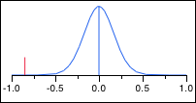

- Time Series Analysis:
t Test
Stu-Rec
Assuming unequal variances
Difference | -0.7218 | t Ratio | -3.06763
Std Err Dif | 0.2353 | DF | 56.32216
Upper CL Dif | -0.2505 | Prob > |t| | 0.0033*
Lower CL Dif | -1.1932 | Prob > t | 0.9983
Confidence | 0.95 | Prob < t | 0.0017*
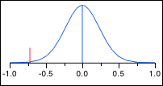

- Multiple Regression:
t Test
Stu-Rec
Assuming unequal variances
Difference | -0.7839 | t Ratio | -3.30614
Std Err Dif | 0.2371 | DF | 56.14475
Upper CL Dif | -0.3090 | Prob > |t| | 0.0017*
Lower CL Dif | -1.2589 | Prob > t | 0.9992
Confidence | 0.95 | Prob < t | 0.0008*
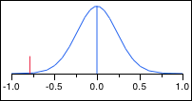

- Variable Selection:
t Test
Stu-Rec
Assuming unequal variances
Difference | -0.51494 | t Ratio | -2.22614
Std Err Dif | 0.23132 | DF | 56.99649
Upper CL Dif | -0.05174 | Prob > |t| | 0.0300*
Lower CL Dif | -0.97815 | Prob > t | 0.9850
Confidence | 0.95 | Prob < t | 0.0150*
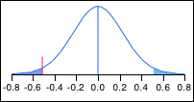

- Categorical Data Analysis:
t Test
Stu-Rec
Assuming unequal variances
Difference | -0.7954 | t Ratio | -3.14746
Std Err Dif | 0.2527 | DF | 54.12531
Upper CL Dif | -0.2888 | Prob > |t| | 0.0027*
Lower CL Dif | -1.3020 | Prob > t | 0.9987
Confidence | 0.95 | Prob < t | 0.0013*
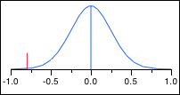

- Decision Trees:
t Test
Stu-Rec
Assuming unequal variances
Difference | -0.9655 | t Ratio | -3.91057
Std Err Dif | 0.2469 | DF | 55.05569
Upper CL Dif | -0.4707 | Prob > |t| | 0.0003*
Lower CL Dif | -1.4603 | Prob > t | 0.9999
Confidence | 0.95 | Prob < t | 0.0001*
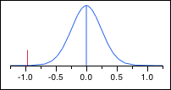

- Model Assessment:
t Test
Stu-Rec
Assuming unequal variances
Difference | -1.0954 | t Ratio | -4.06406
Std Err Dif | 0.2695 | DF | 55.7196
Upper CL Dif | -0.5554 | Prob > |t| | 0.0002*
Lower CL Dif | -1.6354 | Prob > t | 0.9999
Confidence | 0.95 | Prob < t | <.0001*
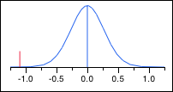

- Text Mining:
t Test
Stu-Rec
Assuming unequal variances
Difference | -1.3655 | t Ratio | -5.49818
Std Err Dif | 0.2484 | DF | 55.82166
Upper CL Dif | -0.8680 | Prob > |t| | <.0001*
Lower CL Dif | -1.8631 | Prob > t | 1.0000
Confidence | 0.95 | Prob < t | <.0001*
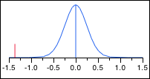

- Forecasting:
t Test
Stu-Rec
Assuming unequal variances
Difference | -0.8322 | t Ratio | -3.26138
Std Err Dif | 0.2552 | DF | 55.034
Upper CL Dif | -0.3208 | Prob > |t| | 0.0019*
Lower CL Dif | -1.3435 | Prob > t | 0.9990
Confidence | 0.95 | Prob < t | 0.0010*
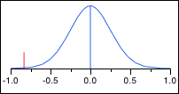

- Exponential Smoothing:
t Test
Stu-Rec
Assuming unequal variances
Difference | -0.8414 | t Ratio | -3.13297
Std Err Dif | 0.2686 | DF | 56.57344
Upper CL Dif | -0.3035 | Prob > |t| | 0.0027*
Lower CL Dif | -1.3792 | Prob > t | 0.9986
Confidence | 0.95 | Prob < t | 0.0014*
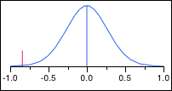

- Time Series Decomposition:
t Test
Stu-Rec
Assuming unequal variances
Difference | -0.7080 | t Ratio | -2.54575
Std Err Dif | 0.2781 | DF | 55.87533
Upper CL Dif | -0.1509 | Prob > |t| | 0.0137*
Lower CL Dif | -1.2652 | Prob > t | 0.9932
Confidence | 0.95 | Prob < t | 0.0068*
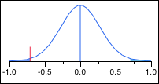

- Control Charts:
t Test
Stu-Rec
Assuming unequal variances
Difference | -0.01149 | t Ratio | -0.04684
Std Err Dif | 0.24542 | DF | 52.13016
Upper CL Dif | 0.48095 | Prob > |t| | 0.9628
Lower CL Dif | -0.50393 | Prob > t | 0.5186
Confidence | 0.95 | Prob < t | 0.4814
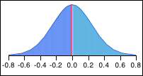
- Process Improvement Study:
t Test
Stu-Rec
Assuming unequal variances
Difference | -0.13908 | t Ratio | -0.6041
Std Err Dif | 0.23023 | DF | 51.53813
Upper CL Dif | 0.32301 | Prob > |t| | 0.5484
Lower CL Dif | -0.60117 | Prob > t | 0.7258
Confidence | 0.95 | Prob < t | 0.2742
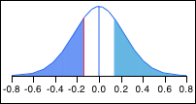

- Experiment Design:
t Test
Stu-Rec
Assuming unequal variances
Difference | -0.21034 | t Ratio | -0.89758
Std Err Dif | 0.23435 | DF | 47.92863
Upper CL Dif | 0.26086 | Prob > |t| | 0.3739
Lower CL Dif | -0.68155 | Prob > t | 0.8131
Confidence | 0.95 | Prob < t | 0.1869
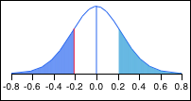

- Evaluating Measurement Processes:
t Test
Stu-Rec
Assuming unequal variances
Difference | -0.54943 | t Ratio | -2.49899
Std Err Dif | 0.21986 | DF | 52.06746
Upper CL Dif | -0.10826 | Prob > |t| | 0.0156*
Lower CL Dif | -0.99059 | Prob > t | 0.9922
Confidence | 0.95 | Prob < t | 0.0078*
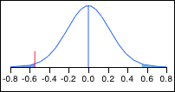

- ANOVA (Analysis of Variance):
t Test
Stu-Rec
Assuming unequal variances
Difference | -0.6103 | t Ratio | -3.03279
Std Err Dif | 0.2012 | DF | 50.40287
Upper CL Dif | -0.2062 | Prob > |t| | 0.0038*
Lower CL Dif | -1.0145 | Prob > t | 0.9981
Confidence | 0.95 | Prob < t | 0.0019*
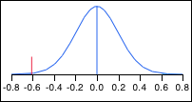

- “Six-Sigma”:
t Test
Stu-Rec
Assuming unequal variances
Difference | -0.6828 | t Ratio | -2.61892
Std Err Dif | 0.2607 | DF | 48.09908
Upper CL Dif | -0.1586 | Prob > |t| | 0.0118*
Lower CL Dif | -1.2069 | Prob > t | 0.9941
Confidence | 0.95 | Prob < t | 0.0059*
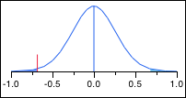

- Google AdWords:
t Test
Stu-Rec
Assuming unequal variances
Difference | -0.8046 | t Ratio | -2.45992
Std Err Dif | 0.3271 | DF | 56.95469
Upper CL Dif | -0.1496 | Prob > |t| | 0.0170*
Lower CL Dif | -1.4596 | Prob > t | 0.9915
Confidence | 0.95 | Prob < t | 0.0085*
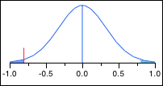
- JMP:
t Test
Stu-Rec
Assuming unequal variances
Difference | 1.34943 | t Ratio | 4.52092
Std Err Dif | 0.29848 | DF | 39.27537
Upper CL Dif | 1.95303 | Prob > |t| | <.0001*
Lower CL Dif | 0.74582 | Prob > t | <.0001*
Confidence | 0.95 | Prob < t | 1.0000
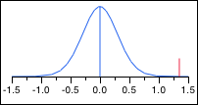

- Access:
t Test
Stu-Rec
Assuming unequal variances
Difference | -0.15287 | t Ratio | -0.50671
Std Err Dif | 0.30170 | DF | 56.69102
Upper CL Dif | 0.45134 | Prob > |t| | 0.6143
Lower CL Dif | -0.75709 | Prob > t | 0.6928
Confidence | 0.95 | Prob < t | 0.3072
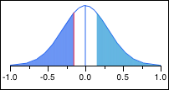

- Excel:
t Test
Stu-Rec
Assuming unequal variances
Difference | -0.35862 | t Ratio | -1.75869
Std Err Dif | 0.20391 | DF | 49.19213
Upper CL Dif | 0.05112 | Prob > |t| | 0.0849
Lower CL Dif | -0.76836 | Prob > t | 0.9576
Confidence | 0.95 | Prob < t | 0.0424*
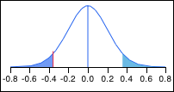

- PowerPoint:
t Test
Stu-Rec
Assuming unequal variances
Difference | 0.07931 | t Ratio | 0.440623
Std Err Dif | 0.18000 | DF | 55.8292
Upper CL Dif | 0.43991 | Prob > |t| | 0.6612
Lower CL Dif | -0.28129 | Prob > t | 0.3306
Confidence | 0.95 | Prob < t | 0.6694
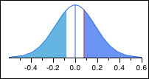

- NCSS:
t Test
Stu-Rec
Assuming unequal variances
Difference | 1.42529 | t Ratio | 3.963578
Std Err Dif | 0.35960 | DF | 54.28822
Upper CL Dif | 2.14615 | Prob > |t| | 0.0002*
Lower CL Dif | 0.70443 | Prob > t | 0.0001*
Confidence | 0.95 | Prob < t | 0.9999
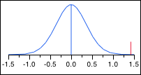

- R:
t Test
Stu-Rec
Assuming unequal variances
Difference | -1.7069 | t Ratio | -5.68401
Std Err Dif | 0.3003 | DF | 55.86763
Upper CL Dif | -1.1053 | Prob > |t| | <.0001*
Lower CL Dif | -2.3085 | Prob > t | 1.0000
Confidence | 0.95 | Prob < t | <.0001*
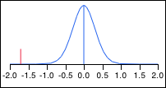

- SAS:
t Test
Stu-Rec
Assuming unequal variances
Difference | -1.6287 | t Ratio | -6.55987
Std Err Dif | 0.2483 | DF | 44.67924
Upper CL Dif | -1.1286 | Prob > |t| | <.0001*
Lower CL Dif | -2.1289 | Prob > t | 1.0000
Confidence | 0.95 | Prob < t | <.0001*
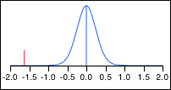

- SPSS:
t Test
Stu-Rec
Assuming unequal variances
Difference | -0.6954 | t Ratio | -1.9976
Std Err Dif | 0.3481 | DF | 56.39165
Upper CL Dif | 0.0019 | Prob > |t| | 0.0506
Lower CL Dif | -1.3927 | Prob > t | 0.9747
Confidence | 0.95 | Prob < t | 0.0253*
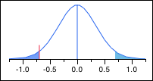

- Identifying Problems:
t Test
Stu-Rec
Assuming unequal variances
Difference | -1.0885 | t Ratio | -5.2509
Std Err Dif | 0.2073 | DF | 54.90108
Upper CL Dif | -0.6731 | Prob > |t| | <.0001*
Lower CL Dif | -1.5040 | Prob > t | 1.0000
Confidence | 0.95 | Prob < t | <.0001*
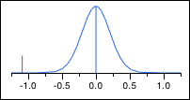

- Solving Problems:
t Test
Stu-Rec
Assuming unequal variances
Difference | -0.6736 | t Ratio | -3.6806
Std Err Dif | 0.1830 | DF | 56.88922
Upper CL Dif | -0.3071 | Prob > |t| | 0.0005*
Lower CL Dif | -1.0400 | Prob > t | 0.9997
Confidence | 0.95 | Prob < t | 0.0003*
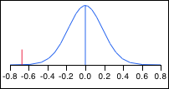

- Communicating Solutions:
t Test
Stu-Rec
Assuming unequal variances
Difference | -0.8483 | t Ratio | -4.30737
Std Err Dif | 0.1969 | DF | 54.01284
Upper CL Dif | -0.4534 | Prob > |t| | <.0001*
Lower CL Dif | -1.2431 | Prob > t | 1.0000
Confidence | 0.95 | Prob < t | <.0001*
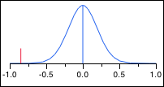

- Oral Communication:
t Test
Stu-Rec
Assuming unequal variances
Difference | -0.8908 | t Ratio | -3.71789
Std Err Dif | 0.2396 | DF | 54.59201
Upper CL Dif | -0.4106 | Prob > |t| | 0.0005*
Lower CL Dif | -1.3711 | Prob > t | 0.9998
Confidence | 0.95 | Prob < t | 0.0002*
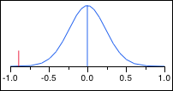
- Written Communication:
t Test
Stu-Rec
Assuming unequal variances
Difference | -0.7793 | t Ratio | -3.5553
Std Err Dif | 0.2192 | DF | 52.56881
Upper CL Dif | -0.3396 | Prob > |t| | 0.0008*
Lower CL Dif | -1.2190 | Prob > t | 0.9996
Confidence | 0.95 | Prob < t | 0.0004*
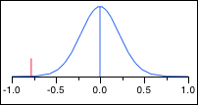

- Professionalism:
t Test
Stu-Rec
Assuming unequal variances
Difference | -0.6034 | t Ratio | -2.748
Std Err Dif | 0.2196 | DF | 52.89258
Upper CL Dif | -0.1630 | Prob > |t| | 0.0082*
Lower CL Dif | -1.0439 | Prob > t | 0.9959
Confidence | 0.95 | Prob < t | 0.0041*
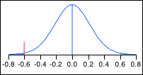

- Interpersonal Skills:
t Test
Stu-Rec
Assuming unequal variances
Difference | -0.50690 | t Ratio | -2.47336
Std Err Dif | 0.20494 | DF | 54.01918
Upper CL Dif | -0.09601 | Prob > |t| | 0.0166*
Lower CL Dif | -0.91778 | Prob > t | 0.9917
Confidence | 0.95 | Prob < t | 0.0083*
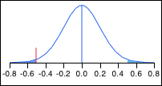

"Dictatorship of the Technocrat." Times Higher Education.
Another name for the big data boom appearing in an article by The Economist: “Data, Data Everywhere.”
“Gartner Says Big Data Creates Big Jobs: 4.4 Million IT Jobs Globally to Support Big Data By 2015”
According to Information Week Rankings 2013
"Business Analytics Master's Degree Is Named One of "20 Top Programs"" Top Business Analytics Programs. University of Tennessee, Knoxville, n.d. Web. 21 Apr. 2014.
30 recruiter responses and 29 student responses made up the data set
The recruiter mean for familiarity with SAS was 3.45 falling between “Moderately familiar” and “Very familiar.
R received a mean value of 3.45 from recruiters, which translates to “moderately” to “very” familiar
Note that ranks 1-10 are included, but some values may have received the same rank due to identical mean values
See Appendix E
See pages 20-21

