EXAMINING THE IMPACT OF SPORTS INFLUENCER ADVERTISING ON CONSUMER BEHAVIOR IN THE UNITED STATES AND SAUDI ARABIA ON INSTAGRAM.

A Thesis Presented for the
Master of Science
Degree
The University of Tennessee, Knoxville

Mohammed Samer Alassaf
August 2023

ABSTRACT
This paper discusses the influence of sports influencers on the buying pattern of fans in the United States and Saudi Arabia. Sports are a crucial part of life in both countries, with numerous athletes being considered celebrities. Sports influencers have a tremendous impact on the audience, who often imitate their behavior and buy the products they advertise. The sports market is huge in both countries, with businesses utilizing sports influencers to promote their brands. Sports influence ads have become a widespread phenomenon; they are mostly everywhere. These special commercials capture people's attention and will be discussed for what makes them special. This paper will look at how this type of advertisement and its objectives differ on Instagram in the United States and Saudi Arabia. Social media lets users watch and engage with sporting events differently (Lamirán-Palo Mares, 2020). The purpose of this research paper is to investigate the roles of sports influencers in advertising on Instagram in the United States and Saudi Arabia. The study utilized SPSS software to analyze data and assess the relationship between sports influencer marketing and brand awareness among influencers and consumers in Saudi Arabia and the United States. A two-way ANOVA test was conducted, and the results revealed a significant difference in the effectiveness of sports influencers on social media and advertisement between the two countries.

TABLE OF CONTENTS
Part 1: Introduction 1
Part 2: Literature Review 5
Part 3: Methodology & Material 12
3.1 Research Design: Quantitative Study 12
3.2 Sample and Sampling 12
3.3 Data Collection: Instruments And Procedures 14
3.3.1 Instruments 14
3.3.2 Procedures 14
Part 4: Results And Discussion 18
4.1 Data Analysis 18
Part 5: Discussion 27
Part 6: Conclusion 30
References 31
Appendices 35
Appendix A: Survey: 35
Appendix B: USA & Saudi Arabia Sports Revenue 40
Vita 41

LISTS OF FIGURES
Figure 1: Line chart of trust in advertisements vs nationality 23
Figure 2: Line chart of purchase intention vs nationality 25
Figure 3: Line chart of the average belief that a product advertised by an influencer is of a higher quality vs nationality. 25
Figure 4: Line chart of the likelihood of sharing a post-Vs. nationality. 26
Figure 5: Sports Revenue by Segment (United States) 40
Figure 6: Sports Revenue by Segment (Saudi Arabia) 40

Part 1: Introduction
Sports are a cornerstone of entertainment in the United States and Saudi Arabia. Anyone who turns on the television will be sure to see at least one of their games. In recent years, popular sports leagues such as Major League Baseball (MLB), the National Football League (NFL), the National Basketball Association (NBA), and Major League Soccer (MLS) have formed partnerships with multiple media partners, reflecting the constantly evolving broadcasting landscape. MLB, for example, has broadcast rights with ESPN, Fox, and Turner Sports, and in March 2022, Apple signed a seven-year deal with MLB for the broadcast for US$85 million per year (Steinberg, 2022). The NFL's recent announcement of a fresh series of nationwide television agreements ensures the continuation of broadcasting games on ESPN/ABC, Fox, CBS, NBC, Amazon, and NFL Network until the conclusion of the 2033 season (ESPN, 2021). The NBA has broadcast rights with ESPN, Turner Sports, and ABC, and the league renewed its agreements with ESPN and Turner Sports through 2025. There are many ways that fans can engage with the sport, including playing a sport themselves, going to an event in person, watching live matches on television, or using digital media (Chmait, 2020). In search of their preferred teams and players, spectators from both nations watch the action. Every night, millions of people watch different sports, whether it be baseball, basketball, football, or soccer (Burns, 2022).
Sport is a big part of life in the U.S. and Saudi Arabia. These two countries have numerous athletes, who are also considered celebrities. Whenever they go to play a match, people will not be talking about the match but instead about their clothes, cars, and other luxury items that come with popularity. Representatives of brands are increasingly turning to sports influencers with the largest audience and a significant influence on the mentality and their impression of the product by pure chance. The audience follows sports influencers on Instagram and is willing to buy sports shoes to play football just because their idols do that.
The influence of sports influencers and celebrities on Instagram on the buying pattern of fans is enormous. It is a fact that people look up to these influential sports personalities and tend to imitate their behavior as well as buy the products they advertise. The celebrity endorser is seen as a well-known someone whom the public may identify by name and face (Schimmelpfennig, 2018). Businesses have profited immensely by roping in these sports personalities in their marketing campaigns, be it for promoting the sale of food products, fashion apparel, automobiles, or anything else you can imagine.
The market for sports is massive in the United States and Saudi Arabia; according to Statista, the sports market in Saudi Arabia is expected to generate $2.54 million in total sales in 2022. Market volume is predicted to reach US$3.86 million by 2026, with total revenue forecast to rise at a 10.99% CAGR from 2022 to 2026.
In 2022, the sports market in the United States was expected to generate $1.33 billion in total sales. By 2026, the total revenue is predicted to expand at a 7.15% annual rate (CAGR 2022-2026), with a market size of US$1.76 billion. (Sports - United States - Statista, 2022). The data is shown in the appendix in Figure 5: Sports Revenue by Segment (United States) & Figure 6: Sports Revenue by Segment (Saudi Arabia).
So, businesses use sports influencers to advertise their brand by inviting them to their contests or events through Instagram. This way, they attract many young fans and customers. Sports influencers are being used as a powerful marketing tool in the U.S. and Saudi Arabia. They become the face of a brand, which is the main explanation for this. One example is LeBron James, an American professional basketball player who competes for the National Basketball Association's Los Angeles Lakers. He is a businessman, philanthropist, and actor in addition to being regarded as one of the greatest basketball players in NBA history. Additionally, Lobos 1707 paid him to record an advertisement and publish it on various promotional platforms, including billboards, T.V. commercials, and social media, particularly Instagram, where he regularly posted four posts per week (Springer. 2022).
On the other side, Salem Al-Dawsari, a football player for Al-Hilal Club in the Saudi League, is arguably the most well-known athlete in Saudi Arabia. After participating in the 2022 World Cup, PepsiCo hired him to promote their chips by encouraging viewers to embark on a trip of football mania. The commercial video highlights the excitement and enjoyment of the game as well as the sense of pride in the national identity that Saudis feel when their national team is competing (Abuzayed, 2013). Using famous sports figures and personalities to promote a product or service on Instagram is a great way to increase sales. Customers who like a sports star or celebrity are more likely to buy from that product brand. It is why businesses in America keep advertising with sports influencers and celebrities on Instagram. They want the endorsements of these famous figures since they have huge followings, but also because of the assurance that people will buy their product if they endorse it. Businesses advertise and use the Instagram platform and sports celebrities to gain advertisement in America because it helps them to sell their products and make more money (Wellman et al., 2020).
Saudi Arabia is one of the biggest and most promising emerging markets in the world. It is home to one-third of the wealthiest people on earth. Consequently, the country is a substantial sports-obsessed market and home to high-reputation athletes and influencers. Additionally, it gives Saudi businesses great opportunities. However, meaningful changes occur over time and require consideration of private markets and state policies (Simpson, 2019). They can use Instagram and sports influencers more than ever for advertising their brands, services, or products. Sports influencers are people who have sports-related issues, industries, or capital. Businesses use Instagram and Sports influencers advertising in Saudi Arabia to gain people's trust, especially adolescents. This advertisement is prominent when a particular product is aimed at young people. The rationale is that if you can gain their trust as a fan, they will do more business with you when they grow up.
The research and development of the sports industry in the United States and Saudi Arabia have led to a considerable development of related businesses and industries. The paper discusses the role of sports influencers advertising in the United States and Saudi Arabia on Instagram. Sports influencers' advertising has been studied in previous research to investigate its influence on promoting team and country identification of sports fans. However, previous studies have not examined the influence of different sports cultures.

Part 2: Literature Review
The utilization of Instagram as a marketing platform, along with the endorsement of popular athletes who possess a massive following, holds substantial sway over the purchasing patterns of the intended audience. This trend has led to a surge in the adoption of athlete endorsements by companies as a means to advertise their merchandise or services, driven by the increasing prominence of Instagram as a marketing tool (Montoro & Pires, 2020). Their popularity and fame have been rising over the years, which causes a very high interest from audiences and advertisers alike in endorsement deals. It is evident in the argument of whether athletes should be allowed to endorse specific brands in different countries worldwide. In this paper, we conduct a literature review on the effects of sports influencers advertising in the United States and Saudi Arabia on Instagram (Hosseini & Aalipour, 2021).
Companies that market their products often look to develop product images and brand names in the minds of healthful-minded people via intellectual advertising on Instagram. In this category, particular advertising is carried out by influential athletes and women to promote their products regarding physical fitness. Sports marketing is now improving its appearance by developing commercials and campaigns that are more concise and to the point (Thorpe, 2017). It is argumentative that they do this through a series of strategies. Publicity agencies create advertisements, conduct research studies and surveys, and develop marketing strategies. They might help a company to release products, expand its business to another country or a new market or keep its name in the public view.
Sports influencer marketing on Instagram is a relatively new marketing strategy in sports. Even though there are many challenges, such as low sponsorship rates and lack of consistent interest from advertisers, they can increase their funding by creating brand awareness through paid promotional activities through video content (Yoon et al., 2021).
Sports influencers are responsible for promoting sports events, teams, and athletes in their respective industries by creating content on their Instagram accounts. They also have to create content that they can post online and create products related to their sports, like clothing, gear, and drink. These channels can be used as a part of social media marketing strategies because many people find these posts interesting. However, only some people will buy the advertised product on these platforms. More individuals in these two areas have recently discussed influencers and their rise (Alwafi, 2022). Sports influencers need to be aware of their audience and take time to understand how different groups of people perceive messages from them.
Sports influencers ensure that their audience and potential customers know what they can accomplish with their products. It involves using Instagram to share product information through videos, pictures, or simply by creating content. Sports influencers also use their influence to directly affect product pricing and availability changes through social sharing techniques like hashtag campaigns and geotargeting.
According to Alruwaili & Ku (2020), sports influencers are responsible for advertising in the United States of America as they play a vital role in building brand equity and reputation, increasing demand for a product or brand, enhancing consumer trust and confidence in the authenticity of product claims, and creating value for customers. Sports Influencers can perform this function by generating awareness about their brand across their Instagram accounts, creating a community dedicated to promoting particular products or experiences.
Sports influencers who are celebrities in the community include those entertainers with a popular track record in acting or performing that are well-known among the public and generate a positive image for themselves (King & Bush,2014) posits that sports influencers are a vital resource for advertisers in Saudi Arabia. Surveys show that sports influencers and fans play a significant role in influencing audience decision-making and product choice.
By connecting with these influential individuals through social media, brands can promote their products and services to many potential customers. In recent years, there has been an explosion in the number of local brands trying to reach out to influencers on Instagram to promote their products, especially regarding education, healthcare, and daily goods (Althunayan et al., 2018).
Sports influencers have developed a dedicated Instagram following that may come from any background, and their influence is spread across Instagram accounts. Reporting on significant sporting events, video uploads, and posts on social media play a significant role in sharing content with followers and advertisers alike. Athletes use digital platforms to target and engage their audience, develop relationships with sponsors, and help create overall brand awareness for the sport or team at hand.
Sports influencers use Instagram to advertise sports products. The Instagram picture/video is posted/ recorded by a famous athlete or sports star sponsored by an athletic company. In this Video, the influencer explains how they run, eat, train, and live their life, which will affect the consumer in determining if they should purchase the particular product.
The influence of sports celebrities has made it possible to promote specific products, brands, and organizations through their public appearances and the use of Instagram to create a positive image in the minds of individuals. Celebrities are capable, credible, and famous figures who possess a significant degree of influence on people. It is necessary to ascertain and establish the influences of these influencers on the sporting industry (Truhlar, 2020). Their popularity is attributed to their ability to spread positive images within Instagram circles to their followers. They can also provide an improved understanding of the product, brands, and organizations they endorse by showing off their lifestyles and conveying specific values synonymous with their agreements.
Companies using sports personalities in their advertising can achieve higher sales depending on the athlete used, so their companies increase market share. Various athletes were researched in Saudi Arabia and the United States, but there needs to be more presence of those countries' brands in Saudi Arabia. In the United States, there is a massive presence of Nike, Adidas, and Reebok, which have been distributing advertisements to promote their products via sports channels, considering that these companies sponsor influencers such as Lebron James, and Michael Jordan (Millan, Ball, 2012).
Several factors affect the impact of sports influencers’ advertising on purchasing behavior and market share in the United States and Saudi Arabia. First, market penetration is the degree to which a firm sells its product in an existing market. It contributes to purchasing behavior because it makes consumers feel that there is no need for them to try out yet another sports brand. On the other hand, influencer marketing uses "social capital" to target a specific customer segment (Watkins, 2014). Second, advertising clutter is the total volume of advertising messages a consumer is exposed to at any time. It makes consumers need help distinguishing between marketing messages and influences their purchase decisions.
Thirdly, time consistency refers to the fact that people have strong incentives to maintain self-impressions about their past actions even when those actions are no longer strategically relevant. For example, buying Nike will influence your impression of yourself as a sports lover and make you buy more products from Nike to keep your impression consistent.
Sports influencers and influencers significantly impact purchasing behavior and market share in the United States and Saudi Arabia through Instagram. These influencers can change marketing strategies and methods to achieve their goals. For example, they can use their image for advertising competitions, leagues, or teams' sites (Kim, D. Y, 2022). This way, they can attract many fans and reach their commercial objectives quickly and easily. American children between the ages of 8 and 12 are three times more likely to desire to be YouTube influencers (29%) than other careers, such as astronauts (11%) in the future (Escobar, 2018). The influential factor is the 'price' which depends on the purchasing power, macroeconomy, and consumption consistency. In addition, the influence of people's power depends on the following factors: how many 'followers,' their social status, and how frequently they engage in conversation with other consumers.
The challenges for sports influencers in advertising in the United States Of America and Saudi Arabia are related to the fact that neither country has laws concerning sports performance. The journal also faces difficulties in reducing its revenue from government advertising (Shawl, 2021). Thus, these two countries are often considered non-compliant regarding having laws on financial legislation.
Several challenges exist with influencer marketing in sports. In both the United States Of America and Saudi Arabia, the portrayal of this social phenomenon is at a crossroads: athletes' image rights have become increasingly important as they have grown in popularity among young adults (Romer, 2017).
Furthermore, Instagram has made it easier for followers on a grander scale to interact with an athlete's brand or company than ever before. Several issues need to be addressed with these consideration factors to ensure consistency when using influencers in marketing campaigns like those seen through sports.
In the U.S. and Saudi Arabia, influencers are responsible for decisions that affect their brand. However, in both countries, these influencers are often paid and heavily influenced by advertisers to promote their brands.
The existence of influencers in the marketing strategy is a challenge for the United States and Saudi Arabia regarding advertising. Sports agencies are looking for an effective way to market their products that would attract the desired audience. They will target athletes considered as customers so they can use this information while creating a campaign to carry out marketing strategies targeting their potential customers/users. Sports agencies do not only concentrate on just creating content but also on how they advertise it on Instagram.
The future of sports influencers in advertising is a tricky question to answer. On the one hand, there is no doubt that they have become a vital part of the marketing ecosystem. American firms now use "influencers" as a powerful advertising strategy (Wong, 2021). Brands are now looking to their followers, or potential followers, to promote their products and services online through Instagram. Sports influencers know the ins and outs of their respective sports, which means they possess an innate understanding of what sets those sports apart. They also tend to possess excellent writing abilities and creative talent—qualities that make them attractive to brands seeking commentary-based storytelling strategies. In short, sports influencers can be invaluable partners in brand marketing efforts. The paper is using communication theory used Social Marketing theory.
This research paper explores sports media personalities' role and influences in advertising compared to the general market in the United States and Saudi Arabia. The country-level comparison will illustrate how sports influencers can be effective mediums in advertising on Instagram. The research is essential because it will provide insight into a new marketing strategy that companies, sports clubs, and organizations can use. And we hypothesize that the use of sports influencers in advertisements on Instagram effectively captures audiences' attention in both the United States and Saudi Arabia, but the approach and tactics used may vary based on cultural and societal norms.
Successful companies often rely on the services of advertising agencies that specialize in marketing and publicity. Since athletes' influencers' advertising is a reliable source speaking to them and someone they can rely on, their views are altered (Ford, 2022). The United States Office of Technology Assessment a study tested and proved the importance of sport in American culture. This report aims to analyze this phenomenon from the perspective of both the United States and Saudi Arabia to understand the role of Instagram influencers in business growth.

Part 3: Methodology & Material

3.1 Research Design: Quantitative Study
The research design chosen for this research was a quantitative study. Using a quantitative approach, the surveys used for this study will have a sample size of two hundred participants (one hundred participants from the United States and one hundred participants from Saudi Arabia). The researcher conducted this study on the role of sports influences in advertising in the United States and Saudi Arabia. The quantitative method aims to help marketers know more about influencers' marketing strategy and their impact on their target markets. It is used because the study is not evaluating any specific athletic ability or skills but rather how consumers react to sports and regular social media advertising by sports personalities. The approach analyzes their opinions about advertising through Instagram, covering two content areas: (1) Sports brand advertising, and (2) Sports Influencer advertising. Information about the research design and justification for the same is summarized in Table 3.1.

3.2 Sample and Sampling
This research was conducted using surveys with a sample size of two hundred people (one hundred participants from the United States and one hundred participants from Saudi Arabia), including male and female respondents. The population size was stratified by gender, race, and regional area by using a snowball sampling method. To find individuals among other participants, utilize snowball sampling, the more individuals you communicate with, the more people you can reach. The population encompassed people of all ages interested in sports and other related topics like promos. One sample with a snowball sampling technique is the best way to collect data from respondents in this study. The characteristics of the study sample and sampling strategy are summarized in Table 3.2: Sample and sampling.
Sample | Strategy
200 (100 US, 100 Saudi Arabia) | Snowball sampling
Gender | Stratified
Race | Stratified
Regional Area | Saudi Arabia and the United States
Interests | Sports and promos
Ages | 18-65+

Table 3.1: Research Design

Table 3.2: Sample and Sampling
Sample Size | 200 participants (100 US, 100 Saudi Arabia)
Focus | Role of sports influences in Advertising in the U.S. and Saudi Arabia
Reasons for the quantitative approach | Evaluate reactions to sports and regular social media advertising
Content Area | Sports brand advertising, sports influencers advertising
Sample gender | United States: 65 male 60 woman
Sample gender | Saudi Arabia: 58 men 52 woman

3.3 Data Collection: Instruments And Procedures

Instruments
The study presents the results of a survey in which participants were asked to answer questions related to their reactions to sports and regular social media advertising. The instrument used in data collection is a survey. Surveys are typically a more structured form of information gathering. They usually contain a set of questions that have been designed to collect data on a particular topic. The survey instrument used in this study consists of questions related to reactions to sports and regular social media advertising.

Procedures
The Quantitative data was collected by conducting structured surveys that include closed-ended questions. The instrument used to collect data was an online survey. Two Instagram posts were selected to examine the influence of brand communication on consumer behavior. The two posts were by the brand itself and the other by a sports influencer. This decision was made considering how effectively brands manage social media (SoTrender, 2012). The respondent indicated a post they reviewed at the beginning of the survey for each post. Both posts have the same number of likes and similar captions. The post was sponsored by the same brand as well. The following criteria guided the selection of brand pages:
a) The brand should fall under one of the three product categories listed in the study.
b) Respondents should perceive the content produced by the company as advertising and for brand purposes.
c) Only on Instagram users.
d) The brand page needs to reach at least five hundred people.
The respondent had access to the post and was directed to the survey after clicking on the survey's link. The screening questions were:
- What is your age?
- What is your gender?
- What is your nationality?
The respondents who did not make it through the screening process were not allowed to participate in the survey. The respondent was also asked in the metric questions if they could recall the name of the influencer they had just watched. This information was required to determine whether the influencer in the advertisement affected the intention to purchase.
The questionnaire for the experimental study included the same questions for all advertisements. The survey's format was the only element that varied between questionnaires.
Brands can function as indicators of product positions when consumers need clarification on brands, and there is information asymmetry in the market (Wernerfelt, 1988). A brand's essential quality is its credibility as a signal of product positioning. In addition to the brand, a company can signal product quality using other components of the marketing mix, such as price, warranty, and distribution channels (Herbig & Milewicz, 1995). Depending on the market conditions, including consumer and competitor behavior, each action may or may not be credible. The information economics literature has referred to the historical idea that credibility is based on the total of prior behaviors as reputation (Herbig & Milewicz, 1995Brand quality is a term that refers to the degree to which a brand satisfies its customers. Traditionally, this has been measured by asking respondents to rate their trust in a brand advertising on social media, positive feelings, and reputability on a scale of 1-10. The higher the rating, the better quality the brand is perceived to be.
This research tests the quality of brands' and influencers' advertising by examining behavior data from an online survey. This survey enabled me to determine if there is any correlation between brand credibility and other demographic variables such as age, gender, or nationality. For instance, Erdem, Swait, and Louvière (2002) propose that brand credibility can operate as a moderator for the impact of purchase intentions. Despite the fact that brand credibility's significance can vary from brand to brand, Maathuis et al. (2004) discover that brand credibility is highly related to emotion and reason in customer decision-making. The impact of brand reputation on customer purchase decisions and the creation of choice sets is examined by Swait & Erdem (2007). Past research on source credibility shows a link between source credibility and how consumers view the source (Brinol et al.,2004). Moreover, Erdem and Swait (2004) found that brand credibility could positively affect consumers' inclination to buy and brand preference. According to this study, a brand's perceived credibility affects how likely consumers are to purchase it.
The survey tested the brand credibility with two questions:
- How much do you trust the information provided by the brand in the advertisement?
- The brand/person that posted this ad is trustworthy.
The survey tested the influencers' credibility with two questions:
- I think the sports influencer in the advertisement is trustworthy.
- How much do you trust the information provided by the influencer's profile?
Considering the increased interest in using influencers as a marketing communication tool, much study needs to be done to ascertain how customers' perceptions of influencer advertising posts are affected when sports' influencers are paired with brand credibility (Citation, 1999). Additional consideration should be given to whether the disclosure of sponsorship on influencer promotional posts helps viewers to evaluate the advertising message critically. This study seeks to ascertain how disclosure kinds, influencer, and brand credibility, as well as their respective levels of high and low, affect the effectiveness of Instagram influencer promotional posts. Consumers' views toward advertising, eWOM intention, and purchase intentions have been demonstrated to commonly be positively impacted by celebrity endorsers with high credibility as opposed to those with low credibility (Spry et al., Citation, 2011). For instance, Lafferty and Goldsmith (Citation 1999) discovered that when a highly trustworthy celebrity was included in magazine advertising, customers had a more excellent attitude toward the ad, the company, and the desire to purchase.

Part 4: Results And Discussion

4.1 Data Analysis
The SPSS software was used for data analysis and predictive statistics in the research. The data was used to examine whether there is any relationship between sports influencer marketing and brand purchase intention among influencers and consumers. A two-way ANOVA test was conducted to determine whether there are any significant differences (p-value) between Saudis, Americans, or All respondents when comparing sports influencers’ effectiveness on social media with advertisement effectiveness. The data we will use will go through a coding process to learn more about the role of sports influencers in Saudi Arabia and the United States on Instagram. From the results in Table 4.1, it is evident that there is a statistically significant difference in the level of trust in information provided in advertisements between Americans and Saudi Arabians (F (1, 272) =7.731, p= .006). Figure 1 and Table 4.2. show that, on average, Saudi Arabians (M =4.61, SD=1.991) have a lower level of trust in advertisements than Americans (M=5.17, SD=1.342). However, there was no significant difference in the level of trust in a brand/person that posts an ad between the Americans and Saudi Arabians (F (1, 272) =1.629, p= .203). Also, the difference in the level of trust in sports influencers in advertisements between the two groups was not st Secondly, the results in Table 4.2 show that the difference in the likelihood of purchasing an advertised product in the future between Saudi Arabians and Americans is not statistically significant (F (1, 272) =.082, p= .775). However, Figure 2. shows that on average, Americans (M =4.12, SD=1.721) are likelier to purchase an advertised product in the future than Saudi Arabians (M=4.06, SD=1.839). atistically significant (F (1, 272) =1.565, p= .217).

Table 4.1. ANOVA test results

 |  | Sum of Squares | df | Mean Square | F | Sig.
How likely are you to share this post online | Between Groups | 11.001 | 1 | 11.001 | 3.370 | .067
How likely are you to share this post online | Within Groups | 887.992 | 272 | 3.265
How likely are you to share this post online | Total | 898.993 | 273
Please respond to the following statements - how much do you trust the information provided in the advertisement? | Between Groups | 20.134 | 1 | 20.134 | 7.731 | .006
 | Within Groups | 708.424 | 272 | 2.605
 | Total | 728.558 | 273
please respond to the following statements - The brand/person that posted this ad is trustworthy | Between Groups | 4.364 | 1 | 4.364 | 1.629 | .203
 | Within Groups | 728.662 | 272 | 2.679
 | Total | 733.026 | 273
Inflncr Crid - "I think the sports influencer in the advertisement is trustworthy." | Between Groups | 3.900 | 1 | 3.900 | 1.565 | .212
 | Within Groups | 677.680 | 272 | 2.491
 | Total | 681.580 | 273
Inflncr Crid - How much do you trust the information provided by the influencer's profile? | Between Groups | 9.288 | 1 | 9.288 | 3.796 | .052
 | Within Groups | 665.588 | 272 | 2.447
 | Total | 674.876 | 273
How likely are you to - Purchase this product in the future? | Between Groups | .256 | 1 | .256 | .082 | .775
How likely are you to - Purchase this product in the future? | Within Groups | 848.083 | 272 | 3.118
How likely are you to - Purchase this product in the future? | Total | 848.339 | 273

Do you believe the product advertised by the influencer is of higher quality than the product advertised by the brand? | Between Groups | 1.664 | 1 | 1.664 | 2.787 | .096
 | Within Groups | 162.369 | 272 | .597
 | Total | 164.033 | 273
Which type of ads usually convince you more about the quality of a sports product? | Between Groups | .431 | 1 | .431 | .549 | .459
 | Within Groups | 213.554 | 272 | .785
 | Total | 213.985 | 273
Do you believe the product advertised by the influencer is of higher quality than the product advertised by the brand? | Between Groups | 1.664 | 1 | 1.664 | 2.787 | .096
 | Within Groups | 162.369 | 272 | .597
 | Total | 164.033 | 273
Which type of ads usually convince you more about the quality of a sports product? | Between Groups | .431 | 1 | .431 | .549 | .459
 | Within Groups | 213.554 | 272 | .785
 | Total | 213.985 | 273
Do you believe the product advertised by the influencer is of higher quality than the product advertised by the brand? | Between Groups | 1.664 | 1 | 1.664 | 2.787 | .096
 | Within Groups | 162.369 | 272 | .597
 | Total | 164.033 | 273
Which type of ads usually convince you more about the quality of a sports product? | Between Groups | .431 | 1 | .431 | .549 | .459
 | Within Groups | 213.554 | 272 | .785
 | Total | 848.339 | 273
Table 4.1 Continued

Table 4.2 Descriptive statistics
 |  | N | Mean | Std. Deviation | Std. Error | 95% Confidence Interval for Mean |  |  | Minimum | Maximum
 |  |  |  |  |  | Lower Bound | Upper Bound |  | Minimum | Maximum
Please respond to the following statements - how much do you trust the information provided in the advertisement? | Saudi Arabia | 102 | 4.61 | 1.991 | .197 | 4.22 | 5.00 | 1 |  | 7
 | United States | 172 | 5.17 | 1.342 | .102 | 4.97 | 5.37 | 2 |  | 7
 | Total | 274 | 4.96 | 1.634 | .099 | 4.77 | 5.15 | 1 |  | 7
please respond to the following statements - The brand/person that posted this ad is trustworthy | Saudi Arabia | 102 | 4.72 | 1.885 | .187 | 4.35 | 5.09 | 1 |  | 7
 | United States | 172 | 4.98 | 1.471 | .112 | 4.76 | 5.20 | 1 |  | 7
 | Total | 274 | 4.88 | 1.639 | .099 | 4.68 | 5.07 | 1 |  | 7
Influencer Crid - "I think the sports influencer in the advertisement is trustworthy." | Saudi Arabia | 102 | 4.61 | 1.753 | .174 | 4.26 | 4.95 | 1 |  | 7
 | United States | 172 | 4.85 | 1.466 | .112 | 4.63 | 5.08 | 1 |  | 7
 | Total | 274 | 4.76 | 1.580 | .095 | 4.57 | 4.95 | 1 |  | 7
Influencer Crid - How much do you trust the information provided by the influencer's profile? | Saudi Arabia | 102 | 4.58 | 1.726 | .171 | 4.24 | 4.92 | 1 |  | 7
 | United States | 172 | 4.96 | 1.460 | .111 | 4.74 | 5.18 | 1 |  | 7
 | Total | 274 | 4.82 | 1.572 | .095 | 4.63 | 5.00 | 1 |  | 7

Table 4.2. continued
How likely are you to - Purchase this product in the future? | Saudi Arabia | 102 | 4.06 | 1.839 | .182 | 3.70 | 4.42 | 1 | 7
How likely are you to - Purchase this product in the future? | United States | 172 | 4.12 | 1.721 | .131 | 3.86 | 4.38 | 1 | 7
How likely are you to - Purchase this product in the future? | Total | 274 | 4.10 | 1.763 | .106 | 3.89 | 4.31 | 1 | 7
Do you believe the product advertised by the influencer is of higher quality than the product advertised by the brand? | Saudi Arabia | 102 | .70 | .806 | .080 | .54 | .85 | 0 | 2
 | United States | 172 | .53 | .752 | .057 | .42 | .65 | 0 | 2
 | Total | 274 | .59 | .775 | .047 | .50 | .69 | 0 | 2
Which type of ads usually convince you more about the quality of a sports product? | Saudi Arabia | 102 | 1.06 | .830 | .082 | .90 | 1.22 | 0 | 2
 | United States | 172 | .98 | .917 | .070 | .84 | 1.11 | 0 | 2
 | Total | 274 | 1.01 | .885 | .053 | .90 | 1.11 | 0 | 2

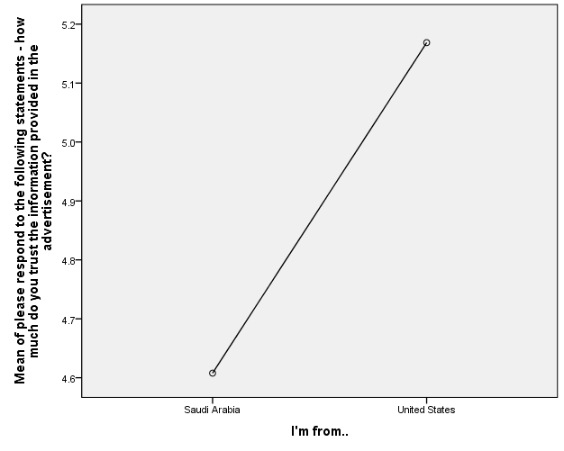

Figure 1: Line chart of trust in advertisements vs nationality

Thirdly, there was no significant difference in the belief that a product advertised by an influencer is of higher quality than that advertised by a brand between Saudi Arabians and Americans (F (1, 272) =2.787 p =.096). Overall, Figure 3. shows that Saudi Arabians were likelier than Americans to believe that a product advertised by an influencer is of higher quality than a product advertised by a brand.
Thirdly, the results in Table 4.2 show that there is no significant difference in the types of ads that usually convince one more about the quality of a sports product between Saudi Arabians and Americans (F (1, 272) =.549, p= .459). Lastly, results in Table 4.2 show that there was no significant difference in the likelihood of sharing an advertisement post online between Americans and Saudi Arabians (F (1, 272) =.3.370, p= .067). However, as shown in Figure 4. Saudi Arabians are, on average likelier to share a post online than Americans.

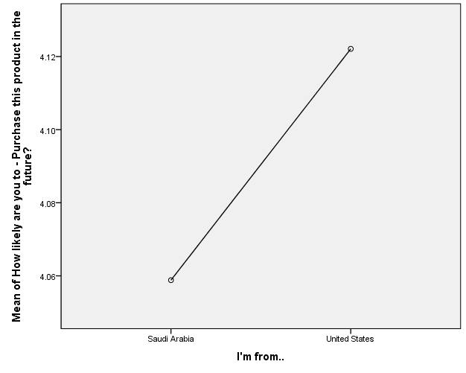
Figure 2: Line chart of purchase intention vs nationality

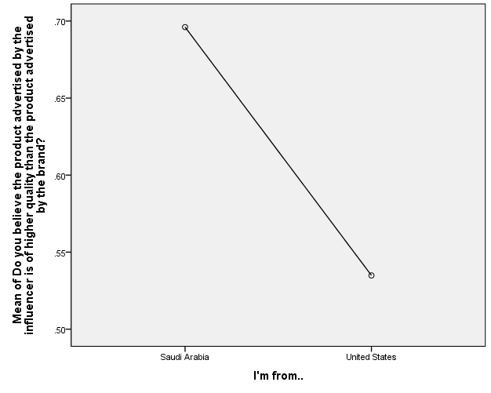
Figure 3: Line chart of the average belief that a product advertised by an influencer is of a higher quality vs nationality.

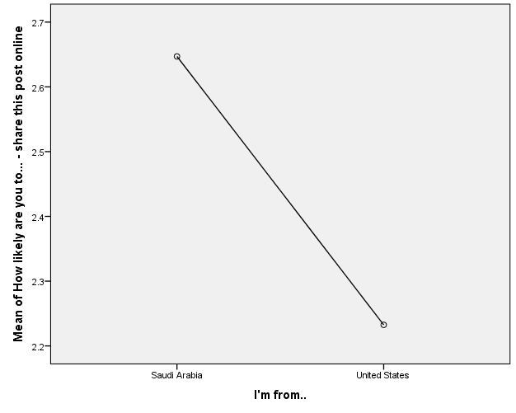
Figure 4: Line chart of the likelihood of sharing a post-Vs. nationality.

Part 5: Discussion
The results of the study conducted to examine the differences in consumer behavior between Saudi Arabia and the United States revealed an interesting finding. Saudi Arabian consumers were found to be more likely to be influenced by a brand and share a post online than their American counterparts. This result is consistent with previous research that suggests people in collectivist cultures value group identity and social influence more than those in individualistic cultures. The findings may be explained by the fact that in collectivist cultures, individuals are more likely to conform to the norms and values of their group, and their behavior is more influenced by the opinions of their peers and family members. This behavior is in contrast to individualistic cultures where people are more independent and focused on their own goals and desires.
In Saudi Arabia, the cultural emphasis on collective harmony and the importance of social relationships likely contribute to the higher inclination toward brand influence and online sharing. Individuals in collectivist societies often prioritize the opinions and approval of their social groups, which can extend to their preferences for brands and their willingness to share content online. The desire to maintain social connections and adhere to group norms may motivate Saudi Arabian consumers to engage with brands and participate in online sharing activities more readily. On the other hand, in individualistic cultures like the United States, personal autonomy, self-expression, and individual goals take precedence over collective considerations. As a result, American consumers may be more discerning when it comes to brand influence and online sharing, with a greater emphasis on personal preferences and individual decision-making.
However, it is important to note that cultural differences are complex and multifaceted. While collectivism and individualism are useful frameworks for understanding broad cultural tendencies, there can be considerable variation within each culture and overlap between the two. Cultural values are not static and can evolve over time, influenced by factors such as globalization, technological advancements, and socio-political changes. Therefore, it is crucial to interpret the findings of this study with caution and recognize that individual variations and contextual factors may also contribute to the observed differences in consumer behavior.
In addition to cultural factors, the historical context of media consumption in the two countries may have played a role in shaping the observed results. The past perception of media in Saudi Arabia was predominantly negative, with restrictions on media content and limited access to certain platforms. This historical context could have influenced the participants' perspectives on media and their receptiveness to brand influence. On the other hand, Americans have a long history of using television as a source of information and entertainment, and the reputation of television in the United States has generally been positive. This positive perception of television may have made American participants more accepting of brand influence through this medium. Thus, cultural and historical factors likely interacted to shape the observed differences in consumer behavior between Saudi Arabia and the United States.
Moving forward, future research endeavors should aim to delve deeper into the underlying mechanisms that drive consumer behavior in different cultural contexts. An in-depth exploration of the psychological, sociocultural, and contextual factors influencing brand influence and online sharing can provide a more comprehensive understanding of consumer behavior dynamics. In-person interviews could be conducted to gain a deeper understanding of participants' reactions and attitudes towards brand influence and online sharing. In-person interviews allow for direct interaction with participants, facilitating a more nuanced exploration of their thoughts, emotions, and motivations. This qualitative approach can uncover rich insights that go beyond the limitations of quantitative data alone.
Moreover, future studies should consider expanding the sample size to enhance the generalizability of the findings. A larger and more diverse sample would better represent the broader population and account for potential variations within the cultural context. This would allow researchers to capture a more comprehensive snapshot of consumer behavior and draw more robust conclusions. By including participants from various demographic groups, socioeconomic backgrounds, and geographical regions, researchers can identify potential moderating variables that may influence.

Part 6: Conclusion
The results show that Saudi Arabians are less likely to trust the information provided in an ad than Americans. Secondly, even though the differences between the groups of participants were not significant, Saudi Arabians had a low level of trust than Americans in sports influencers and brands/people that post an ad. Additionally, even though the differences were not significant, Saudi Arabians were less likely than Americans to purchase products advertised by either influencers or brands in the future. However, an interesting point to note is that Saudi Arabians were likelier than Americans to believe that a product advertised by an influencer is of higher quality than a product advertised by a brand. Also, they were likelier to share a post online than the American counterparts.

References
Abuzayed, B. (2013). Sport and emerging capital markets: market reaction to the 2022 World Cup announcement. International Journal of Islamic and Middle Eastern Finance and Management.
Alruwaili, T., & Ku, H. Y. (2020). Saudi Female International College Students' Self-Identities Through the Use of Social Media in the United States. Journal of International Students, 10(3), 629–645.
Althunayan, A., Alsalhi, R., & Elmoazen, R. (2018). Role of social media in dental health promotion and behavior change in Qassim Province, Saudi Arabia. International Journal of Medical and Health Research, 4(2), 98-103.
Alwafi, H., Alwafi, R., Naser, A. Y., Samannodi, M., Aboraya, D., Salawati, E., ... & Almatrafi, M. (2022). The Impact of Social Media Influencers on Food Consumption in Saudi Arabia, a Cross-Sectional Web-Based Survey. Journal of Multidisciplinary
Steinberg, B. (2022, March 8). Apple takes swing at Sports with Major League Baseball Rights deal. Variety. Retrieved April 30, 2023, from https://variety.com/2022/tv/news/apple-major-league-baseball-rights-deal-1235198815/ 15, 2129-2139.
Burns, M. J. (2022, December 13). Gen Z keeps sports executives up at night. here's what they're doing about it. Morning Consult. Retrieved April 30, 2023, from https://morningconsult.com/2022/12/13/gen-z-interest-in-watching-sports/
Chmait, N., Westerbeek, H., Eime, R., Robertson, S., Sellitto, C., & Reid, M. (2020). Tennis influencers: the player effect on social media engagement and demand for tournament attendance. Telematics and Informatics, 50, 101381.
Dalibor Truhlar. (2020, February 3). 10 Best Super Bowl Commercials 2020 [Video]. YouTube. Retrieved November 29, 2022, from https://www.youtube.com/watch?v=OQmhLOFbRQw
Erdem T., & Swait, J. (2004). Brand credibility, brand consideration, and choice. Journal of Consumer Research,31(1), 191–198
Escobar-Viera, C. G., Shensa, A., Bowman, N. D., Sidani, J. E., Knight, J., James, A. E., & Primack, B. A. (2018). Passive and active social media use and depressive symptoms among United States adults. Cyberpsychology, Behavior, and Social Networking, 21(7), 437–443.
ESPN Internet Ventures. (2021, March 18). NFL announces TV deals with ESPN/ABC, NBC, CBS, Fox, Amazon. ESPN. Retrieved April 30, 2023, from https://www.espn.com/nfl/story/_/id/31088098/nfl-announces-tv-deals-espn-abc-nbc-cbs-fox-amazon
Ford, J. B. (2022). Advertising Message Impact on Consumers: How to Enhance Positive effect. Journal of Advertising Research, 62(1), 1–2.
Hosseini, S. S., & Aalipour, H. (2021). The impact of Instagram influencers on purchase intention: The mediating role of advertising skepticism and advertising value. Journal of Retailing and Consumer Services, 61, 102590.
Jon Springer. (2022) LeBron James stars in new ad for Lobos 1707 tequila. https://adage.com/article/marketing-news-strategy/lebron-james-stars-lobos-1707-tequila-ad/2400526
Kim, D. Y., & Kim, H. Y. (2022). Social media influencers as human brands: an interactive marketing perspective. Journal of Research in Interactive Marketing.
King, R. A., Racherla, P.and Bush, V. D. (2014). What We Know and Don't Know About Online Word-of-Mouth: A Review and Synthesisof the Literature. Journal of Interactive Marketing, 28, 167–183.
Lamirán-Palomares, J. M., Baviera, T., & Baviera-Puig, A. (2020). Sports influencers on Twitter. Analysis and comparative study of Track Cycling World Cups 2016 and 2018. Social Sciences, 9(10), 169.
Montoro, T. A., & Pires, L. A. (2020). Influencer marketing on Instagram: How sponsorship disclosure, influencer credibility, and brand credibility impact the effectiveness of Instagram promotional post. Telematics and Informatics, 50, 101384.
Schimmelpfennig, C. (2018). Who is the celebrity endorser? A content analysis of celebrity endorsements. Journal of International Consumer Marketing, 30(4), 220-234.
Shawl, N. K. (2021). The Challenges of a Changing Communication Landscape: An Examination of Saudi Arabian Media (Doctoral dissertation, Université d'Ottawa/the University of Ottawa).
Simpson, A. T. (2019). The medical metropolis: Health care and economic transformation in Pittsburgh and Houston. University of Pennsylvania Press.
Spry, A., Pappu, R. and Bettina Cornwell, T. (2011), "Celebrity endorsement, brand credibility and brand equity", European Journal of Marketing, Vol. 45 No. 6, pp. 882-909.
Sports - United States - Statista, 2022 from https://www-statista-com.utk.idm.oclc.org/outlook/dmo/app/sports/united-states
Thorpe, H. (2017). Action Sports, Social Media, and New Technologies: Towards a Research Agenda. Communication & Sport, 5(5), 554–578.
Watkins, B. (2014). An Integrated Approach to Sports Branding: Examining the Influence of Social Media on Brand Outcomes. International Journal of Integrated Marketing Communications, 6(2), 30–40.
Wong, S. (2021). Influencing Immigration: The Need for Immigration Reform in the Age of Social Media Influencers. Loy. LA Ent. L. Rev., pp. 42, 1.
Wellman, M. L., Stoldt, R., Tully, M., & Ekdale, B. (2020). Ethics of authenticity: Social media influencers and the production of sponsored content. Journal of Media Ethics, 35(2), 68-82.
Yoon, J., Sung, M., Kim, M., & Kang, J. (2021). Sports influencer marketing on Instagram: An analysis of its determinants and effects. Sustainability, 13(2), 801.

Appendices

Appendix A: Survey:
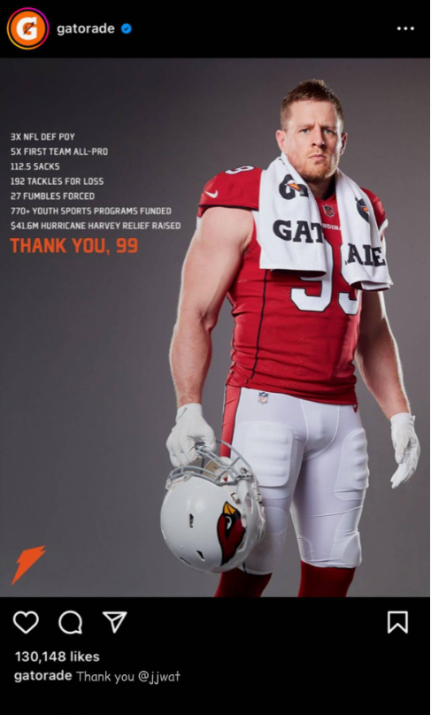
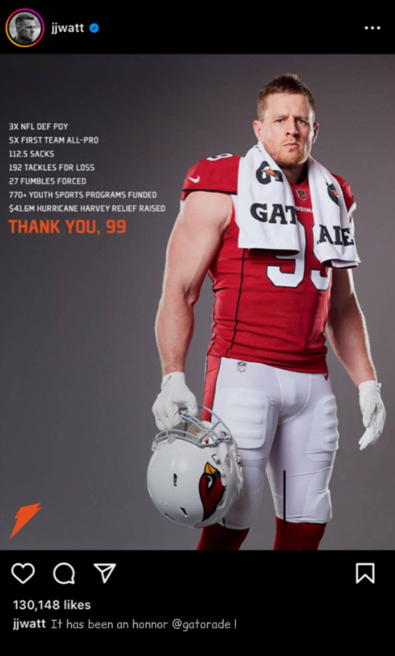

- What is your age?
- 18-24
- 25-34
- 35-44
- 45-54
- 55-65
- 66 or above
- What is your gender?
- Male
- Female
- Non-binary / third gender
- Prefer not to say.
- What is your nationality?
- Saudi Arabia
- United States
- How much do you trust the information provided by the brand in the advertisement?
- Not at all
- Slightly
- Somewhat
- Moderately
- Mostly
- Fully
- Completely
- To what extent do you agree or disagree with the following statement: "I think the sports influencer in the advertisement is trustworthy."
- Not at all
- Slightly
- Somewhat
- Moderately
- Mostly
- Fully
- Completely
- How much do you trust the information provided by the influencer's profile?
- Not at all
- Slightly
- Somewhat
- Moderately
- Mostly
- Fully
- Completely
- How likely are you to purchase this product?
- Extremely unlikely
- Highly unlikely
- Somewhat unlikely
- Undecided or neutral
- Somewhat likely
- Highly likely
- Extremely Likely
- Do you believe the product advertised by the influencer is of higher quality than the product advertised by the brand?
- Yes, the product advertised by the influencer is of higher quality.
- No, the product advertised by the brand is of higher quality.
- I do not have enough information to make a comparison.
- Which type of ads usually convince you more about the quality of a sports product?
- Influencer advertisement.
- Brand advertisement.
- Neither advertisement has convinced me about the product.
- How likely are you to tell a friend about this product?
- Extremely unlikely
- Highly unlikely
- Somewhat unlikely
- Undecided or neutral
- Somewhat likely
- Highly likely
- Extremely Likely
- How likely are you to share this post?
- Extremely unlikely
- Highly unlikely
- Somewhat unlikely
- Undecided or neutral
- Somewhat likely
- Highly likely
- Extremely Likely
- What brand was advertised in the post?
- Gatorade.
- VitaminWater.
- Bodyarmor.
- Can you name any ports influencers that you have seen recently?
Stimuli:

Appendix B: USA & Saudi Arabia Sports Revenue
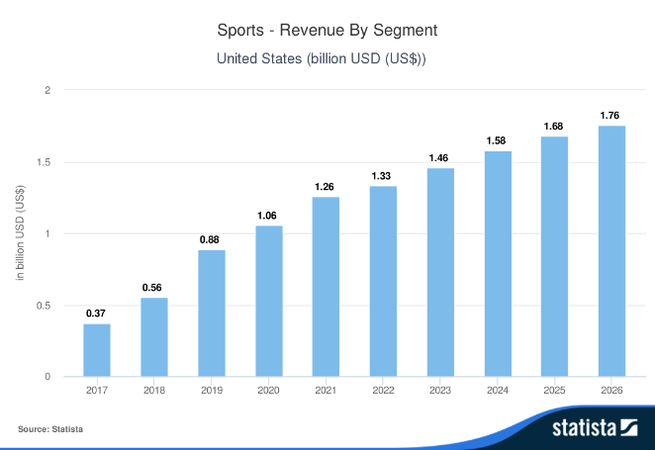

Figure 5: Sports Revenue by Segment (United States)
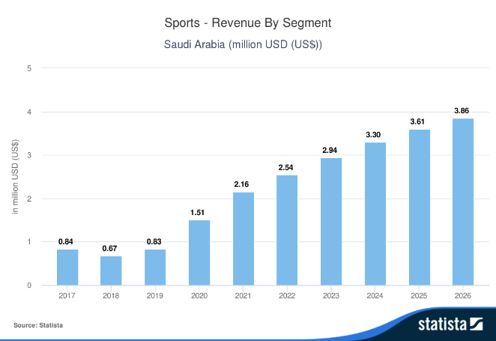

Figure 6: Sports Revenue by Segment (Saudi Arabia)

Vita
Mohammed Alassaf was born and raised in Riyadh, Saudi Arabia. He attended elementary and secondary schools in Riyadh and graduated with honors from Imam Mohammed bin Saud Islamic University in May 2018 with a Bachelor of Advertising and marketing communication. In August 2021, he entered the University of Tennessee at Knoxville, where he is currently pursuing a Master of Science in Advertising and Marketing Communication, with an expected graduation date of May 2023.

