Microbial Community Structure and Function in Intensively Managed Landscapes Compared to Restored Prairies

A Thesis Presented for the
Master of Science
Degree
The University of Tennessee, Knoxville

Morgan Alexandria Isaacs
August 2025
Copyright © 2025 by Morgan Alexandria Isaacs. “Microbial Community Structure and Function in Intensively Managed Landscapes Compared to Restored Prairies
All rights reserved.

ACKNOWLEDGEMENTS
I would like to express my deepest gratitude to my advisor, Dr. Sean Schaeffer, for assisting me on this academic journey. The opportunity to work on this project allowed me to develop skills that helped me grow both as a professional and as a researcher.
I would like to thank my lab mates, both past and present: Jacob Clements, Alexis Gilmore, Cori Martin, Will Hatcher, Anna Caldwell, and Aubrey Fine for their support and assistance during my time in the lab.
I would like to thank members of the CINET project and the Missouri Soil Health Laboratory, such as Dr. Ashlee Dere, Dr. Brian Saccardi, Andrew Stumpf, Dr. Tim Filley, Ian Frantal, Ron Collman, and Donna Brandt for assisting me with this project.
I would like to thank the faculty at UTK and Pellissippi State Community College. To Dr. Neal Eash, Dr. Michael Essington, Dr. Zhuang, and Dr. Daniel Yoder, for encouraging me and to Lesia Rucker, Sandra Marine, Ruth Watt-Yates, and Ryan Callaway for always being a source of comfort throughout this research project. To Miss Sheila, my first biology tutor. I often think about our tutoring sessions at Pellissippi State. You were truly a gem.
Such a big endeavor cannot be accomplished alone, and I am forever grateful to each of you for your support and assistance throughout this journey.

DEDICATION
To my father, Chad Isaacs who inspired me to pursue a career in science, my mother Christina Isaacs, and my twin brother Christian Isaacs. Without their unwavering support, I would not be where I am today in my academic career. This graduate school journey had its many ups and downs and I am forever thankful to my support system for reminding me that no great achievement comes without its difficulty.
"It is not the critic who counts; not the man who points out how the strong man stumbles, or where the doer of deeds could have done them better. The credit belongs to the man who was actually in the arena." Theodore Roosevelt

ABSTRACT
Investigating the impact intensively managed landscapes have on biotic-abiotic interfaces in the root zone is critical for understanding how intensive management affects microbial communities across the soil profile. The root zone comprises the soil-root-microbe system and is a hotspot of biogeochemical transformations. This critical interface regulates sub-surface biogeochemical environments as well as dynamics in the soil surface that are primarily influenced by management activities, such as artificial ditches, fertilizer applications, and tile drains. In this study, the soil’s “active root zone” is in reference to six depths: 0-10cm, 10-20cm, 20-30cm (upper active root zone), 55-65cm (lower active zone), and 105-115cm, 175-185cm (below the active root zone) within soil profiles from intensively managed systems and restored prairies in both Illinois and Nebraska. Hydrolytic enzyme activity was used to illustrate microbial community function while phospholipid fatty acid analysis was used to identify the structure of the microbial community. Incorporating both together in addition to other abiotic and abiotic factors in the soil such as % sand, % clay, soil temperature, water content, AL2O3, nitrate, microbial biomass carbon (MBC), permanganate oxidizable carbon (POXC), and soil pH can assist in illustrating a more complete depiction of what is occurring across the active root zone between systems heavily impacted by anthropogenic activities and systems that are not. Results showed that restored prairies have overall higher microbial activity compared to intensively managed systems (p<0.01). The management effects on enzyme activity were inconclusive for every enzyme except N-acetyl-β-glucosaminidase which was consistently higher in prairies. This suggests nutrient cycling differences between intensively managed systems and prairies, as demonstrated by enzymatic activity results. This suggests that intensive agriculture affects nutrient dynamics and carbon cycling which is reflected by the microbial community and their functionality.

TABLE OF CONTENTS
CHAPTER I: INTRODUCTION 1
Introduction 1
Background 2
Materials and Methods 18
CHAPTER II: MICROBIAL COMMUNITY STRUCTURE IN INTENSIVELY MANGAGED LANDSCAPES AND RESTORED PRAIRIES IN THE UNITED STATES MIDWEST 22
Introduction 24
Methods 25
Results 32
Discussion 46
CHAPTER III: MICROBIAL COMMUNITY FUNCTION IN INTENSIVELY MANAGED SYSTEMS AND RESTORED PRAIRIES IN THE UNITED STATES MIDWEST 53
Introduction 53
Methods 54
Results 61
Discussion 72
CHAPTER IV: CONCLUSIONS 81
REFERENCES 82
APPENDICES 94
VITA 99

LIST OF TABLES
Table 1: Site Specific Information for Illinois and Nebraska 21
Table 2: Summary of Analyses 23
Table 3: Untransformed mean and standard deviation of AM Fungi by depth. *Square-root-transformation required to meet normality assumptions. Across each soil microbe, depths that do not share a common lowercase superscript letter ^{a, b, c, d} significantly differ (p<0.05) as a result of main effect differences. Across each soil microbe, values that do not share a common asterisk * significantly differ (p<0.05) as a result of post hoc analysis of plot differences. Values that do not share a common number ^{1,2,3,4} significantly differ (p<0.05) by depth only as a result of post hoc analysis of plot and plot-by-depth differences. 33
Table 4: Untransformed mean and standard deviation of Gram Negative by depth. *Square-root-transformation required to meet normality assumptions. 35
Table 5: Untransformed mean and standard deviation of Gram Positive by depth. *Square-root-transformation required to meet normality assumptions. 36
Table 6: Untransformed mean and standard deviation of Total Bacteria by depth. *Square-root-transformation required to meet normality assumptions. 37
Table 7: Untransformed mean and standard deviation of Eukaryote by depth. *Square-root-transformation required to meet normality assumptions. 39
Table 8: Untransformed mean and standard deviation of Fungi by depth. *Square-root-transformation required to meet normality assumptions. 40
Table 9: Untransformed mean and standard deviation of Total Fungi by depth. *No transformations required to meet normality assumptions. 42
Table 10: Untransformed mean and standard deviation of Actinomycetes by depth. *Square-root-transformation required to meet normality assumptions. 43
Table 11: Untransformed mean and standard deviation of F:B by depth. 43
Table 12: Untransformed mean and standard deviation of Gram+/Gram- by depth. 45
Table 13: Summary of Analyses 62
Table 14: Untransformed mean and standard deviation of leucine aminopeptidase (LAP) by depth. Across each soil enzyme, depths that do not share a common lowercase superscript letter ^{a, b, c, d} significantly differ (p<0.05) as a result of main effect differences. Across each soil enzyme, values that do not share a common asterisk * significantly differ (p<0.05) as a result of post hoc analysis of plot differences. Values that do not share a common number ^{1,2,3,4} significantly differ (p<0.05) by depth as a result of post hoc analysis of plot and plot-by-depth differences. 63
Table 15: Untransformed mean and standard deviation of N-acetyl-β-glucosaminidase by depth. *Log-transformation required to meet normality assumptions. 64
Table 16:Untransformed mean and standard deviation of cellubiosidase (CB) by depth. *Log-transformation required to meet normality assumptions. 65
Table 17:Untransformed mean and standard deviation of xylosidase (XYL) by depth. *Log-transformation required to meet normality assumptions. 66
Table 18:Untransformed mean and standard deviation of β-glucosaminidase (BG) by depth. Log-transformation required to meet normality assumptions. 67
Table 19:Untransformed mean and standard deviation of α-glucosaminidase (AG) by depth. *Log-transformation required to meet normality assumptions. 67
Table 20:Untransformed mean and standard deviation of phosphatase (PHOS) by depth. *Log-transformation required to meet normality assumptions. 69
Table 21: Selected Physical and Chemical Characteristics of Soils 94
Table 22: Selected Chemical Properties of Soil 95
Table 23: F Value for Microbes Between Management in Illinois and Nebraska 96
Table 24: F Values for Enzymes Between Management in Illinois and Nebraska 97
Table 25: P Values for Microbes Between Management Systems in Illinois and Nebraska 98
Table 26: P Values For Enzymes Between Management Systems in Illinois and Nebraska 99

LIST OF FIGURES
Figure 1: United States Midwest Region. Figure obtained from US Census Bureau. 5
Figure 2: Soil pH is the master soil variable as it effects many factors in the soil. Figure obtained from (Neina et al., 2019). 14
Figure 3: Total Abundance of Microbial Community Structure in Nebraska 45
Figure 4: Total Abundance of Microbial Community Structure in Illinois 46
Figure 5:Stacked bar plots of total abundance (top) and relative abundance (bottom) of soil microbial community. 47
Figure 6: a biplot showing the results for Illinois microbial composition against all the other soil properties 49
Figure 7: a biplot showing the results for Nebraska microbial composition against all the other soil properties 50
Figure 8: Hydrolase Activity Across Soil Depth and Land Use in Illinois 70
Figure 9: Hydrolase Activity Across Soil Depth and Land Use in Nebraska 70
Figure 10: Stacked bar plots of total activity (top) and relative activity (bottom) of soil microbial function. 71
Figure 11:a biplot showing the results for Illinois enzyme activity against all the other soil properties 73
Figure 12:a biplot showing the results for Nebraska enzyme activity against all the other soil properties 73
Figure 13: A picture taken at the Sangamon River Forest Preserve in Fisher, Illinois displaying the weather monitoring station as well as the concentration of native tallgrasses growing aboveground. 77
Figure 14: A picture taken of the Allerton Trust Farm in Monticello, Illinois displaying the weather monitoring station along with the soybeans in their early stage of development. 78
Figure 15: A picture of the Glacier Creek Preserve in Bennington, Nebraska displaying the concentration of native tallgrasses aboveground as well as the weather monitoring station. 79
Figure 16: A picture of the Glacier Creek Preserve soybean system in Bennington, Nebraska displaying the early stage soybeans as well as the weather monitoring station. 80

CHAPTER I: INTRODUCTION

Introduction
The United States Midwest encompasses a soil environment that is not only topographically ideal for agricultural production but also biogeochemically significant due to a glacial legacy that produced a highly productive landscape for agriculture (Kumar et al., 2022). In conjunction with its high productivity, soils in the US Midwest are extensively managed to ensure yields align with growing demands to produce more efficiently and effectively. These intensively managed systems undergo agricultural practices such as tillage, synthetic fertilizer applications, and tile drainage systems which are sizeable pipes installed underneath agricultural fields to remove excess water from the entire root zone of the crop (Kumar et al., 2022). Over time, intensive management has been shown to alter soil biogeochemical processes and greenhouse gas fluxes by destroying soil aggregates through tillage practices, increase soil compaction due to the deployment of heavy machinery, alter fungal: bacterial ratios, and increase the concentration of more readily available nutrients through fertilizer applications which influences enzymatic activity (Süunnemann et al.; Zheng et al.), as well as altering surface and subsurface hydrological regimes (Kumar et al., 2022).
The root zone is a critical interface and hotspot of biogeochemical transformations in most ecosystems. The active root zone critical interface comprises the dynamic soil-root-microbe system that regulates the sub-surface biogeochemical environment and soil surface dynamics that are primarily influenced by artificial ditches and tile drains (Kumar et al., 2022; Gao et al., 2024). There has been greater interest in critical zone systems through the lens of human activity as intensive agricultural management continues to undergo advancements in technology which increases productivity while conjunctionally shifts the soil system far from equilibrium. The purpose of this thesis is to better understand the influence intensively managed systems have on soil microbial communities and biogeochemical processes throughout the active root zone.
To determine the influence intensively managed systems have on soil biogeochemical cycles, it is important to assess the soil microbial community across various biotic and abiotic soil characteristics within intensively managed systems and more natural state soil systems such as restored prairies. The microbial community in soil encompasses soil microorganisms such Gram-positive bacteria, Gram-negative bacteria, fungi, archaea, and protozoa. These organisms are strongly interconnected within the soil environment, meaning they provide strong indications of the state of the system (Sharma et al., 2010; Ma et al., 2022). The biogeochemical processes facilitated by these microorganisms are referred to as microbial community function. Plant residues on the soil surface are made up of large, polymeric structures that require depolymerization before monomeric nutrients can be acquired. This process of depolymerization is facilitated by extracellular enzymes which are peptide chains released by microorganisms that are specialized for specific substrates such as cellulose, hemicellulose, and lignin (Blonska et al., 2020). These enzymes eventually release essential nutrients into the soil solution which are taken up by microorganisms and incorporated into the microbial biomass-the masses of all soil microorganisms in volume <5000 μm³(Brookes et al., 2008). Understanding the dynamics and soil characteristics within intensively managed systems along the active root zone is critical to facilitating sustainable agricultural practices that are productive while also cognizant of the microbial community that is vulnerable to disturbance for the purposes of meeting growing food, fiber, and biofuel demands (Kemmerling et al., 2022).

Background
Soil is one of the most microbially diverse ecosystems in the world, containing bacteria and fungi that provide fundamental support to agricultural ecosystems through processes such as decomposition of organic matter and nutrient cycling (Hao et al., 2021; Maron et al., 2018). Understanding how microbial communities are changing throughout the active root zone is necessary to better comprehend important soil processes occurring across the root zone. Soil microorganisms facilitate the relationship between soil and plant roots through the plant-microbe-soil system (Hao et al., 2021). There is evidence that supports microbial community composition decreases with depth to 2 meters across a plethora of soil environments and that extracellular enzyme activities, microbial biomass, nutrient content, and soil organic carbon demonstrate stark differences between the soil surfaces and subsurface (Hao et al., 2021; Fierer et al., 2003; Brew et al., 2019). However, there is still less known about the microbial community below 25 cm despite estimates that 35-50% of the soil microbial biomass lives in the soil subsurface and that deep soils contain 50% or higher total soil organic carbon by volume compared to upper soil horizons, making soil microbial communities especially important in deeper soil for carbon sequestration (T.G. Weldmichael et al., 2020; Hao et al., 2021).
When comparing the soil community between intensively managed systems and more natural state systems such as restored prairies, stark differences have been observed. An intensively managed system is defined as a management system in which human activity is the dominant influencer. These systems are altered by human activity, and function through the continuous input of human beings. Common practices associated with intensively managed systems in the Midwest include synthetic fertilizer applications, tile drainage systems, and tillage practices. While inorganic fertilizer applications have been shown to increase soil bacterial diversity and abundance in the soil surface, they are often overapplied and change soil pH and osmolarity-leading to decreases in microbial activity over time. For example, a single application of N fertilizer reportedly alters community composition due to soil acidification while metanalyses reveal that N fertilization reduces the microbial biomass by an average of 15% and 5.8% (Lu et al., 2010; Treseder, 2008; Zheng et al., 2017). On the contrary, other studies reveal that fertilizer applications lead to 15.1% increases in microbial biomass compared to unfertilized systems by providing microbial niches in the soil surface (Geisseler & Scow, 2014; Mackelprang et al., 2018). Regarding microbial processes, mineralization and decomposition in prairie systems are reportedly more “self-regulated” and have a larger potential for carbon sequestration when compared to heavily cultivated soil (Chen et al., 2020). This is primarily due to reduced tillage practices in prairie systems as well as the continuous plant residue.
Soil organic carbon and other soil properties are shown to change across the soil profile, contributing to microbial community stratification patterns across the active root zone. On average, agricultural roots can extend to depths of 200cm although on average, the maximum rooting depth of soybeans and corn in the United States Midwest is 150cm (Hao et al., 2021). When analyzing one-meter-deep profiles, the top 20cm of soil generally contains five times more carbon than below 20cm (Brewer et al., 2019). Furthermore, the residence time of deep soil carbon is typically higher than surface soil carbon which means that a large portion of soil organic matter located in the subsurface is not readily available for microorganisms. This can alter microbial function and produce differences in the way microbes allocate energy towards enzyme production from the soil surface to two meters below ground. Additional soil properties such as total organic C and total N are shown to be negatively correlated with soil depth. For example, total organic C below 50cm is reportedly 4.4 times lower in soil subsurface horizons compared to the soil surface while total N is 6.3 times lower. This is the result of greater organic inputs at the soil surface such as plant residues, roots, and biological activity which decline with soil depth (Wang et. al., 2022). Clay content is generally consistent in soil depth studies in which the percent clay generally increases with depth (Brewer et al., 2019).
Economic Implications
From an economic perspective, agriculture in the United States Midwest is a big business. According to the US Census Bureau, the US Midwest encompasses states such as North Dakota, South Dakota, Nebraska, Kansas, Minnesota, Iowa, Missouri, Wisconsin, Illinois, Indiana, Michigan, and Ohio-summarized in Figure 1.
Illinois alone generates $51.1 billion annually through marketing agricultural commodities, and crops account for 40% of that total. Nationally, Illinois is fifth in agricultural product exports with $10.6 billion generated following shipment to other countries (Illinois Department of Agriculture, 2025). In 2023, Nebraska generated $7.2 billion dollars in farm incomes-making these states’ agricultural production heavily intertwined with economy at the state and national level (Farm Income, 2024). Of the 127 million acres, 75% of US Midwestern land is used for corn and soybean production (USDA, 2017). Research projects that focus on intensively managed systems as well as root zone stratification patterns benefit not only the soil science community but also the sustainability of the economy. It is important then to study the impact intensively managed systems have on microbial communities across the active root zone as upholding soil quality across the soil profile has direct economic impacts on these states and the nation.
Climatic Differences
Nebraska is currently experiencing increased temperatures and decreased precipitation. The average annual temperature is expected to rise by 2-5 degrees F by midcentury, extending the growing season by several weeks and doubling the frequency of extreme heat by 2050 (Shulski & Williams, 2020). Precipitation has been declining in recent decades, reduced by approximately an inch in the last three decades (Shulski & Williams, 2020). Midcentury estimations predict that the winter and spring season will be 15-25% wetter, the summer season will be 5-15% drier, and the fall will be slightly wetter at 5% (Shulski & Williams, 2020).
Illinois’ climate on the other hand has experienced warmer temperatures and more rainfall since the beginning of the 20th century. According to NOAA Centers for Environmental Information, the average daily temperature in Illinois has increased by 1 to 2 degrees F over the past 120 years while the nighttime minimum temperature has increased beyond daytime
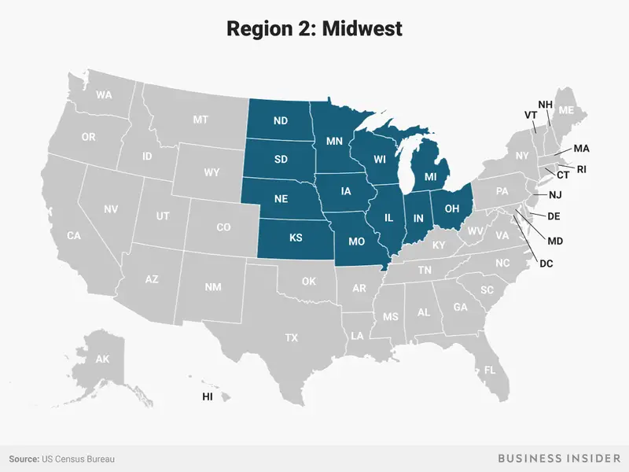
Figure 1: United States Midwest Region. Figure obtained from US Census Bureau.
maximum temperatures. Seasonal variations in warming have also been observed in which the spring and winter temperatures have increased by 2 to 3 degrees F while the summer has experienced very little increased temperatures since the beginning of the 20th century (Illinois State Climatologist, 2024). Precipitation has increased across Illinois in which the total annual precipitation has increased by 5 inches over the past 120 years, a roughly 12 to 15% increase in total annual precipitation. Precipitation is also more intense in which the number of 2-inch rain days have increased by 40% since the start of the 20th century (Illinois State Climatologist, 2024).
The microbial community and their associated enzymes are more simply assessed through the high throughput phospholipid fatty acid method and hydrolase activity. To ascertain the influence soil depth-a proxy of soil properties-on the microbial community, additional physical, chemical, and biological soil properties in the soil are incorporated in this study. While an array of ecosystems have been analyzed such as those undergoing intensive agriculture, few have compared microbial communities and their function across the active root zone in systems such as restored prairies. A fluorometric assay was incorporated to assess microbial function through hydrolytic enzyme activity. Incorporating this as well as a phospholipid fatty acid analysis to ascertain microbial community structure sufficiently expresses how soil depth influences the microbial community. Furthermore, incorporating this information in addition to other biotic and abiotic factors in the soil such as soil texture, soil temperature, water content, ammonium (NH₄-N), nitrate (NO₃-N), metal oxides, microbial biomass carbon (MBC), permanganate oxidizable carbon (POXC), and soil pH illustrated a much more complete depiction of what is occurring across the active root zone interface in systems heavily impacted by intensive agriculture and systems that are not.
Microbial Biomass Carbon
One way of analyzing the soil microbial community is through microbial biomass carbon. Microbial biomass is a measure of the living and nonliving microorganisms in a soil ecosystem, comprised of bacteria, fungi, and archaea. Microorganisms are made up of C and N, and a common method of analyzing microbial biomass is through assessing microbial biomass carbon (MBC). Microbial biomass carbon is generally 1-4% of soil organic carbon and is regarded as a labile soil C fraction that is sensitive to changes in land management (Geraei, 2016; Sparling., 1992). It plays a significant role in soil organic matter dynamics despite being a small fraction of total organic carbon (Kallenbach & Grandy, 2011). When incorporated into long-term management studies, microbial biomass carbon can provide indications of how tillage, crop rotations, fertilizer applications, and native tallgrass prairie management impacts the microbial biomass (Mbuthia et al., 2015). However, microbial biomass represents both active and dormant biomass, which means that it may be limited in determining biogeochemical cycling (Min et al., 2021). Resource gradients are shown to be strongly correlated with microbial biomass which generally decline with increasing soil depth. More specifically, per gram of soil, microbial biomass is generally 1 to 2 orders lower in soil subsurface horizons compared to surface horizons (Brew et al., 2019). Yet, the cumulative biomass of microbes in deeper soil horizons (generally below 30cm) is often equivalent to the soil surface due to the mass and volume of soil subsurface horizons. (Brewer et al., 2019).
Intensively managed systems have a direct impact on microbial biomass which facilitates necessary services and functions such as decomposition, soil aggregation, and mineralization (Kallenbach & Grandy, 2011). Due to microbial biomass carbon (MBC) having a short turnover time, and being sensitive to soil environmental disturbances and conditions, it can provide strong indications of nutrient dynamics and soil C stabilization following land use changes (Kallenbach & Grandy, 2011). There are generally significant reductions in soil (MBC) and nitrogen under intensive management. More specifically, in grassland and forest soils, MBC is roughly <5% of total soil organic carbon (SOC). However, in agricultural systems, MBC tends to be less than 2.5% of SOC due to reduced organic amendments. MBC facilitates necessary services and functions such as decomposition, soil aggregation, and mineralization (Kallenbach & Grandy, 2011).
Phospholipid Fatty Acid Analysis (PLFA)
Another way of analyzing the microbial community is through phospholipid fatty acid analysis. This analysis is generally used to distinguish between microbial groups such as gram-positive bacteria, gram-negative bacteria, fungi, actinobacteria, etc. by quantifying various phospholipid fatty acids which are the largest component of cell membranes within these living organisms (Borjesson et al., 2012; Gorka et al., 2023). In fact, measuring total PLFA concentrations in soil is an increasingly prevalent method used to assess microbial biomass (Gorka et al., 2023; Joergensen, R. G, 2022). The stratification of specific microbial biomarkers is attributed to dispersal limitations as well as how species respond to variations in soil moisture, pH, temperature, and nutrients, which all change with land and climate (Lennon, 2020). The heterogeneity of soil aggregates and pores that facilitate connections among microorganisms and other belowground soil organisms are what equate soil with such microbial diversity (Lennon, 2020). When assessing microbial biomarkers in various land management systems, total microbial biomass and fungal to bacterial (F:B) ratios tend to be higher in restored prairies compared to forested, deserted, and agroecosystems with agricultural systems exhibiting the lowest F:B (Bailey et al., 2002). This is thought to primarily be due to greater fungal hyphal networks in restored prairies which bind soil particles together into micro-aggregates and provide protection to soil organic matter. Studies invoking the PLFA method have assessed the concentration of microbial biomarkers from the soil surface to 2 meters belowground, observing that microbial diversity decreases by as much as 30% from the surface down to 2 meters (Fierer et al., 2003). This shift in the abundance and diversity of microorganisms across the soil profile is attributed to a different soil environment below the near soil surface that is characterized by less labile carbon, lower redox potential, and leached minerals due to the percolation of water through the soil profile. Deep soil microorganisms are also physically separated from more diverse regions of the soil which makes this region exceptionally unique to study the effects of depth on microbial community structure and function (Lennon, 2020).
Extracellular Enzymes
One way of analyzing microbial function in the soil system is through assessing hydrolase activity. Soil hydrolytic enzymes are primarily responsible for the catalyzation of nutrient-rich “labile” soil organic matter, ultimately providing soil microorganisms with C, N, and P that are necessary for plant growth (Piotrowska-Długosz et al., 2022). The most common hydrolases assayed are involved in the degradation of lignin and cellulose which are the most prominent components of plant litter. Other commonly measured hydrolytic enzymes are those involved with hydrolyzing chitin, proteins, and peptidoglycan which contain high concentrations of organic N. Phosphatases are assayed for their contribution in mineralizing P derived from phospholipids, nucleic acid, and other ester phosphates. While the varying arrangements of biopolymers in soil require the interaction of multiple enzyme classes to reduce them to constituent monomers, enzymes that catalyze production of the terminal monomer are most often studied. This is mostly because the kinetics of terminal cleavage is easier to study (Sinsabaugh et al., 2008). Detection of soil hydrolytic activity is often determined using MUB (4-methylumbelliferyl) and MUC (4-methylumbelliferyl acetate) substrates that cause fluorescence to occur. The substrate-fluorophore complex is cleaved by specific enzymes.
High N fertilization in intensively managed systems has been shown to influence the production of specific hydrolases. More specifically, management practices that result in more N additions are shown to increase the activity of glycosidase enzymes such as α-glucosidase, β-glucosidase, β-cellobiosidase, and β-xylosidase as well as N-acetyl-β-glucosaminidase. These activities are associated with the breakdown of chitin, carbohydrates, cellulose, and N mineralization (Ullah et al., 2019). Phosphatase production has also been shown to increase with increasing N additions as excessive N fertilization can increase soil acidification which causes more P to bind to mineral surfaces-reducing the availability of P to soil microbes. This subsequentially causes microbes to release more phosphatase to meet P demands (Ullah et al., 2019). On the contrary, other studies have found that β-glucosidase activity is unaffected by urea-based N fertilization, while others have found that N additions increase β-glucosidase activity but decrease N-acetyl-β-glucosaminidase and leucine aminopeptidase activity which are two prominent nitrogen-cycling enzymes (Davies et al., 2022). These impacts on enzyme activity were shown to be strongly correlated with soil pH, which is shown to decrease with high rates of N fertilization (Liu et al., 2022).
The distribution of hydrolases along the soil profile is shown to change due to carbon dynamics as well as substrate and nutrient availability. Deep soil carbon has a relatively longer turnover time than surface horizons and its availability is affected by depth-specific soil characteristics including low temperature, reduced oxygen availability, and low nutrient availability (Harrison et al., 2010; Ko et al.,2017). These characteristics ultimately impact soil microorganisms as hydrolytic activity and functional diversity of soil microorganisms is shown to decrease with soil depth (Piotrowska-Długosz et al., 2022). These decreases with soil depth correspond to soil property changes along the soil profile such as soil pH, oxygen concentration, and the relative proportion of labile, easily degradable substrates (Piotrowska-Długosz et al., 2022; Ko et al., 2017). In soil horizons impacted by higher water saturation, facultative and obligate anaerobic microorganisms will predominantly decompose organic matter over aerobic microorganisms-causing decomposition to slow at rate much slower than the surface horizon (Piotrowska-Długosz et al., 2022). Furthermore, the movement of fine particles such as clay fractions (< 2.0 µm), humic substances, and free iron oxides from eluvial horizons to illuvial horizons can occur which influences nutrient accessibility. For example, materials such as clay have a large specific surface and negative charge that can retain nutrients that would otherwise be leached (Huntley, 2023). Even the absorption of microorganisms and their associated enzymes onto clay minerals or organo-mineral complexes can occur with depth which influences hydrolase activity and enzyme turnover rates (Piotrowska-Długosz et al., 2022).
Permanganate-Oxidizable Carbon
Another way of analyzing microbial function in soil is through measuring permanganate oxidizable carbon fractions. Permanganate-oxidizable carbon (POXC) makes up 1 to 4% of total organic carbon which is the sum of both organic and inorganic carbon in the soil (Breker, 2021; Nelson & Sommers, 1982). It is the biologically active or labile SOC fraction that reacts with potassium permanganate (KMnO₄), which is thought to be reflective of the oxidative activity of microbial enzymes (Jones et al., 2023; Breker, 2021; Wells, 2024). POXC is strongly related to organic matter and is more sensitive to soil and crop management. For example, total organic carbon has been found to not significantly change following conversion from tilled to no-tilled plots. However, following a POXC analysis, POXC is shown to significantly increase due to the conversion (Weil et al., 2003). Moreover, when assessing soil POXC concentrations among land uses, soil POXC is shown to be the lowest in cropping systems and higher in natural state systems or tree crop systems (Badagliacca, 2020). Few studies have investigated soil depth’s influence on POXC concentrations within various land management systems. As POXC is a carbon fraction separate from recalcitrant or minerally associated carbon, it is reasonable to assume it follows similar soil profile trends as labile carbon fractions which generally decrease with depth. However, further investigation is needed to quantify POXC trends across the active root zone in intensively managed systems and restored prairies.
Necromass
Microbial necromass is dead microbial cells that can contribute around 80% to SOC which is separate from microbial biomass, the living microbial pool (Bhople et al., 2020; Bargali, 2024). Necromass can influence the production of N-acetyl-β-glucosaminidase, an enzyme targeting glucosamine in soil (Bhople et al., 2020). Recent studies have revealed fungi and bacteria in necromass as the principal C-components contributing to stable soil organic matter (Liang et al., 2019). Therefore, the primary driver of SOM accumulation under certain conditions is potentially microbial growth over litter decomposition and transformation as this leads to the production of microbially derived carbon into the SOM pool via biomass turnover and necromass accumulation (Liang et al., 2017). When tracing the mineral origin of SOC, amino sugar biomarkers are used (Liang et al., 2019). Following death of a soil microorganism, their cell components survive and remain in the environment, eventually accumulating. Different microbial groups are responsible for producing different amino sugars. For example, studies involving forest soils are found to have higher microbial biomass than agricultural soils because fungal groups contribute more biomass, leading to higher microbial necromass (Liang 2017). As fungi have been found to produce most of the glucosamine in the soil while bacteria have been found to produce muramic acid, it can be assumed that soil environments with greater fungal populations and fungal derived necromass likely correlate to greater N-acetly-β-glucosaminidase production (Liang et al., 2017).

Soil Properties
Soil Moisture
Water is extremely important in regulating microbial function. Water contributes to microbial dynamics by acting as a resource, solvent, and transport medium (Tecon & Or 2017). When water is being used by microbes as all three, biogeochemical processes operate at full capacity (Moyano et al. 2013). Water acting as a resource is directly correlated to its role in chemical reactions such as hydrolysis and redox reactions. Water also acts as a solvent because when microorganisms break down larger polymers, they must excrete extracellular enzymes to bind to substrates and cleave the larger molecules apart (Moyano et al., 2013). Since most substrates are water soluble, waterfilled pores with connected pathways are critical for resource and extracellular enzyme transportation (Tecon & Or 2017). When soils are dry, the pathway becomes more treacherous and might break altogether, leaving microorganisms without a way to obtain resources and decompose organics. While it is difficult to prove that direct physiological stress and indirect limitations on substrates specifically cause declines in microbial activity in soils experiencing drought, it is generally agreed that microbial community declines in dry soils are due to moisture stress and decreasing water potential which inevitably hinders transport of resources to microorganisms (Schimel, 2018). On the other extreme, while soil moisture is necessary for sustaining biological activity in soils, anaerobiosis can occur in soils with excess moisture. Anaerobiosis occurs in soil when the oxygen consumption rate exceeds supply rates (Tiedje et al., 1984). Anaerobiosis can lead to loss of N by denitrification, root stress due to anoxia, increases in root pathogens, and production of organic acids and other plant toxicants (Tiedje et al., 1984). The influence water inflicts upon the soil environment either from being present in excess or the lack thereof demonstrates its significance in altering the microbial community and its function, therefore, it is a necessary parameter to incorporate in this study.
Tile Drains
In the 19th and 20th century, European settlements throughout the U.S. Midwest saw much success due to the area’s productive soil. However, localized poor drainage and resulting anaerobic conditions within these soils prevented maximum crop yield. This led to artificial drainage systems installed underneath agricultural fields and connected to drainage ditches and stream networks (Kumar et al., 2018). The tile drains are typically situated 2 to 4 meters underground and are widely used to reduce ponding in lower lying areas, and to drain root zones. Tile drainage decreases soil moisture and surface runoff, which has improved agricultural practices within the area and caused there to be less soil, chemical, and nutrient loss from agricultural fields. Some soils may also have higher capacities to store water due to tile drains improving soil structure and making the soil more porous (Fraser and Fleming, 2001). Differences in precipitation patterns between the eastern and western Great Plains contribute largely to infiltration rates and water availability (Hanberry et al., n.d.; Dugan and Zelt; 2000). More precipitation generally means more water can percolate throughout the soil. Due to heavier precipitation in the eastern Great Plains, the intensively managed system in Illinois contains tile drains in the field while the intensively managed system in Nebraska does not. While intensively managed systems are impacted by fertilization, crop rotations, tillage practices, and tile drainage systems, climates such as the one in Nebraska are drier and therefore, do not see the prevalence of tile drains to the extent of Illinois. Therefore, Nebraska’s intensively managed system does not have a tile drain.
Bulk Density
Bulk density provides a measure of the degree of soil compaction. Soils impacted by livestock and anthropogenic activities such as agriculture are often compacted, resulting in increased bulk densities (Kranz et al., 2020). Severe soil compaction reduces root growth, preventing plants from being anchored and acquiring nutrients, water, and oxygen from soil pores for transport to the plant leaves for photosynthesis (Kranz et al., 2020). If root penetration and elongation is constricted due to high bulk density, soils containing water and essential nutrients are less accessible, preventing plants from growing to their full potential (Kranz et al., 2020). Severe soil compaction can alter air permeability, pore-size distribution, and water conductivity which has direct impacts on the microbial community structure and microbial habitats (Frey et al., 2009).
Soils from restored prairies that were once used for row cropping have been shown to exhibit 70% greater bulk density after 10 years than a restored prairie previously used as a pasture (Glass et al, 2020). After 10 years, a restored prairie that was previously a row-cropped field shows 33% higher bulk density than a remnant prairie. A prairie restored from a pasture and a remnant prairie have approximately the same bulk densities after 10 years, while a cow pasture that was converted from row cropping shows higher soil bulk densities initially than a cow pasture that has always been used for cattle grazing (Glass et al, 2020). After 10 years, both long-term cow pastures and cow pastures converted from row cropping exhibit relatively similar bulk densities. This suggests that systems restored for at least 10 years from lands that were previously intensively managed, or that incorporated livestock grazing are likely to have higher soil bulk densities than remnant prairies and grasslands. However, over time these bulk densities trend towards those for untouched prairie and grassland counterparts (Glass et al., 2020).
Soil pH
In the natural environment, the pH of the soil has an enormous influence on soil biogeochemical processes, upholding its title as the “master soil variable.” Soil pH is likened to the temperature of a patient undergoing a medical diagnosis because of its strong capabilities of giving hints to the current condition of the soil as well as future soil processes-highlighted in Figure 2 (Neina, 2019). Soil pH impacts a plethora of soil physical, chemical, and biological properties that ultimately affect biomass yields and plant growth, and there is a direct relationship between soil pH and biogeochemical processes (Neina, 2019). Due to soil pH being so influential in soil biogeochemical processes, it is important to include soil pH as an abiotic factor that could potentially influence microbial community structure and function in our intensively managed systems and restored prairies as it can act as a trend control.
Soil pH is generally lower in prairie soils compared to agricultural soils (Li et al, 2021). This is due to the oxidation of sulfur and nitrogen from year-round organic matter residues in addition to the uptake of basic cations and release of H+ ions from prairie plant roots. In fact, a metanalysis of 1059 observations finds that no till systems on average acidify soils more than conventional tillage systems (Zhao et al., 2022). Soil acidification changes the biogeochemistry of soil ecosystems, causing microbial community diversity to decrease, plant productivity to be disturbed, and cationic nutrients such as Na, Ca, Mg, and K to be leached. (Yan et al., 2020). When basic cations are leached, H+ and Al3+ ions are left to occupy exchangeable cations. Furthermore, humic residues following the humification of soil organic matter produce phenolic and carboxyl groups that dissociate to release H+ ions. In intensively managed systems in which N fertilizer is applied, soil acidification occurs in the near-surface depths (0-10cm) (Reeves and Liebig, 2016).

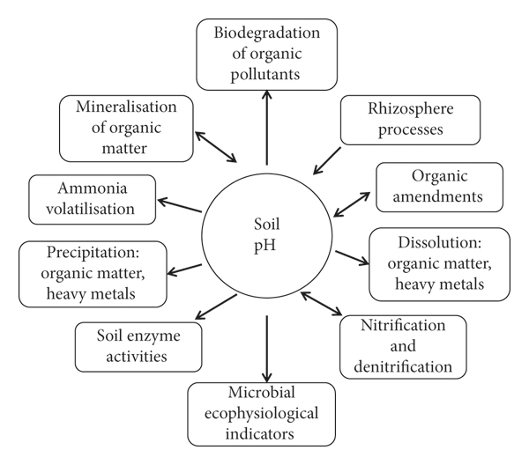
Figure 2: Soil pH is the master soil variable as it effects many factors in the soil. Figure obtained from (Neina et al., 2019).

Soil Temperature
Soil temperature is perhaps one of the most important factors impacting microbial communities in land management systems such as restored prairies and intensively managed systems. Temperature dependence of soil microorganisms is generally studied by assessing microbial respiration rates (total activity), however the temperature dependence of different soil microorganisms such as bacteria and fungi have also been assessed (Pietikainen, et al., 2005). Comparing temperature dependence between restored prairies and intensively managed agricultural systems remains relatively less studied, however, when comparing microbial communities and their temperature dependence in forest and agricultural systems, forest systems trend toward a lower minimum temperature for respiration. This is thought to be because of the difference in microbial community structure between forests and agricultural systems. Forest systems are more influenced by fungi which are generally more active at lower temperatures than bacteria. The temperature dependence of fungal growth is therefore less inhibited by low temperatures while the temperature dependence of bacterial growth is less inhibited by high temperatures (Pietikainen, et al., 2005). As forest systems have greater biomass and canopy cover compared to agricultural systems, it can be assumed that a restored prairie would observe similar results to forest ecosystems.
Soil Texture
The most used size classes to categorize soil texture which has been adopted by World Reference Base (WRB) for soil resources (FAO, 2015) are 0-0.002mm for clay, 0.002-0.05mm for silt, and 0.05-2mm for sand (Augustin & Cihacek, 2016). The amount of carbon sequestered in the soil is related to soil texture and soil management. When assessing soils undergoing varying management practices, % silt is shown to positively correlate with organic C content (% C) and organic C mass while sand is shown to be negatively correlated with organic %C and organic C mass. Clay and silt particles support more diverse microbial communities than sand particles which are occupied primarily by fungi (Bach et al., 2010). Soils with higher clay content exhibit more aggregation which better protects the soil’s microbial biomass and increases water holding capacity, assisting hyphal networks and nutrient transport. Clay content’s positive correlation with nutrient retention in soils potentially benefits soil microbial communities in systems experiencing environmental stress (Bach et al., 2010). The % clay content is generally shown to increase with soil depth across numerous soil profiles. As clay increases with soil depth, there is greater aggregation facilitated by cationic bridging between humic acid and clay molecules which creates a variety of metabolic niches that benefit microorganisms. While this creates increased microbial diversity within these aggregates, overall microbial diversity can be limited due to these aggregates sequestering carbon (Naylor et al., 2022).
Ammonium and Nitrate
Ammonium N (NH₄⁺⁻N) and nitrate N (NO₃⁻ N) are the two main forms of N taken up by plants. Their uptake is 70% of the total cations and anions taken up by plants. In unfertilized grasslands, nutrient demands of plants and microorganisms generally exceed the concentration of nutrients available in the system, causing both microorganisms and plants to compete. During these instances of competition, microorganisms can outcompete the plants due to their close association with the substrate (Schimel & Bennett, 2004). In strongly calcareous soils, NH₄⁺⁻N present in the soil, whether from OM mineralization or from fertilization, is transformed into NO₃⁻ N through the process of nitrification (Wang et al., 2015). NH₄⁺⁻N concentrations are often low due to this, at 0.77 mmol dm⁻³ while nitrate N concentrations are high sometimes at 6.0 mmol dm⁻³ . This results in nitrate N being the dominant mineral N source taken up by plants (Wang et al., 2015). In addition, plants tend to prefer NO₃ ⁻ as a primary N source because NH₄⁺ quickly turns into NO₃⁻ in warm, well-aerated soil. Despite energy conservation occurring when NH₄⁺ is the primary N source, its tolerance limit is narrower, and high rates of NH₄⁺ can limit growth and halt the uptake of other cations (Havlin et al., 2013). Soil properties such as nitrate and ammonium have been studied across depth in which NH₄⁺⁻N and nitrate NO₃⁻ N are shown to decrease drastically with depth, thus causing declines in N-cycling microbes such as N-fixing bacteria, denitrifying bacteria, and nitrifiers. These N-cycling microbial groups are shown to decrease between 100-200cm and then further reduce by 200-300cm (He et al., 2022).
Regarding land management impacts on total nitrogen (TN) and soil organic carbon (SOC), changes in management can be difficult to identify due to the need for long-term studies. Crop rotations and tillage practices influence the quantity and quality of soil organic N (SON). The impact of tillage and crop rotations on mineralizable N has been extensively studied in which mineralizable N in the Ap horizons are generally greater under no-tillage compared to conventional tillage except in deeper soil layers in which the opposite is true (Carter & Rennie, 1982). Mineralizable N at a depth of 0-7.5cm is found to be higher in no till compared to conventional tillage systems (Liang et al., 2004). However, conflicting results have been found in which no significant changes in mineralizable N have been found following 6 years of tillage (Franzluebbers & Arshad, 1996). In systems where N fertilizer is applied, stimulation of the microbial bacterial community can occur due to the readily available supply of NO3- (Havlin et al., 2013). Rhizosphere pH is greatly reduced following the plant uptake of NH4+. This is because of the release of H+ from plants roots to maintain electroneutrality. In fact, a difference of 2 pH units near the root surface have been observed between NO3- and NH4+ uptake which has a significant impact on the microbial community within the rhizosphere due to this impact on soil pH within the vicinity of roots.
Studies analyzing ammonium and nitrate concentrations along the soil profile have found that soil N content decreases from the soil surface to one meter belowground and that ammonium is the dominant nitrogen form along this depth increment. Nitrogen was shown to continue decreasing from 1 meter to 3.5 meters, but increase from 3.5 meters to 5 meters. This suggests leaching of nitrogen in the upper soil horizons, with eventual accumulation in deeper soil layers (Jin et al., 2015). Other studies have found that concentrations of nitrogen vary greatly between land management systems, but overall decrease with increasing soil depth (Wang et al., 2022).
Metal Oxides
Prominent metal oxides in the soil environment include but are not limited to: CuO, ZnO, Fe₂O₄, Fe₃O_{4,} Fe₂O₃, TiO₂, ZnO, and CuZn (Frenk et al., 2013). Soil microbial communities and associated hydrolytic activity have been shown to decrease in the presence of metal oxides such as CuO (Frenk et al., 2013). Regarding mineral chemistry, mineral oxides have been shown to significantly influence microbial community structure (p<0.001) for prokaryotes and eukaryotes (Ahmed et al., 2016). The relationship between mineral oxide concentrations and microbial communities is thought to be due to the nutrient content of the surrounding soil which creates a microenvironment that selects certain microorganisms over others (Ahmed et al., 2016). For example, specific mineral oxides found in apatite, phlogopite-quartz, and plagioclase have been found to select for specific bacterial communities over others (Uroz et al., 2012). Fe is the fourth most abundant element in the earth’s crust (Philippot et al., 2024). Fe provides a broad range of redox potentials which means that a diverse array of soil microorganisms can use these Fe (II)/Fe (III) containing minerals as electron acceptors or donors. This pathway allows bacteria and archaea to use these metal ions to harvest reducing equivalents and generate energy.
A metanalysis of over 3,000 soil profiles revealed that that Fe and Al oxides vary between land management systems but generally increase with soil depth. However, the concentrations of minerally associated Fe and Al is shown to be primarily impacted by mineralogical factors, climate, and soil properties (Jia et al., 2024). Grasslands and forests were shown to have higher concentrations of Fe and Al oxides with agricultural systems exhibiting the lowest concentrations. This is thought to be due to tillage practices which expose deeper soils with greater Fe-Al oxide concentrations to the surface, thereby decreasing overall concentrations (Jia et al., 2024).

Materials and Methods
To determine the influence depth has on soil microbial communities and function in intensively managed systems and restored prairies, this study was conducted from 2023-2025 with field work being completed in the summer of 2023 and lab work being conducted until the fall of 2024. Two sites were chosen in Illinois and Nebraska that represent an intensively managed system and a restored prairie. All sites’ soils are classified as mollisols and undergo either restored prairie management or intensive management. All samples in Illinois were collected in the summer of 2023, specifically 6/26/23 and 6/27/23. All samples in Nebraska were collected in the summer of 2023, specifically 7/6/23 and 7/7/23. All samples were collected either by staff or faculty from the University of Tennessee, Knoxville using a sterilized bucket auger. Samples were collected using a randomized sampling design with four field replicates per plot, resulting in 96 bulk soil samples, from which 192 subsamples were sent to the Missouri Soil Health Assessment Center (SHAC) and Dr. Dere’s laboratory in Omaha, Nebraska for PLFA analysis, metal oxide information, soil temperature, and soil texture classification.
Study Sites:
Sangamon River Forest Preserve (ILPR)
For this study, four sites were chosen that constitute our Management Induced Reactive Zones (MIRZ), a region in which the management practices have a dominant influence on the biogeochemical reactions within that area. Each management system within this study was characterized as a MIRZ. Within each plot a MIRZ weather station funded by the CINET project was erected that gathered continuous data on relative humidity, temperature, and atmospheric pressure. Soil moisture probes were also installed surrounding each weather station at depths of 5cm, 20cm, and 60cm.
Sangamon River Forest Preserve (ILPR)
The first sampling site in this study was the Sangamon River Forest Preserve (ILPR) in Champaign-Urbana, Illinois which is situated in a glaciated part of the Midwest and outer reaches of the upper Mississippi River Basin. This site was cultivated for more than 70 years before being seeded back to a native prairie in 2007. This location is important because it provides us with an idea of how weather, water, and various soil properties behave in a reasonably native landscape. The field is thought to contain old clay tiles that do not impact surface drainage. The soil series within this plot is an Elliott which consists of poorly drained loess soils with a 2-4% slope. The average clay content is 41.74%. The mean annual precipitation is roughly 914 mm (36 inches) while the mean annual air temperature is around 10 degrees C (50 degrees F). The parent material is colluvium or loess over loess over till.
Allerton Trust Farm (ILAG)
This second site in this study is Allerton Trust Farm (ILAG), an intensively managed system situated along a tributary of the Sangamon River in Champaign-Urbana, Illinois. This site was originally established to measure sediment and water changes in the flow from tile drains throughout the field. This site contains tile drains located roughly 6 feet underground and has undergone a crop rotation of corn and soybeans since 1993, although the rotation has likely occurred since the 1940’s because of a soybean processing plant located nearby in Monticello. The land is conventionally tilled yearly. A MIRZ weather station is also erected within the plot to measure similar environmental parameters such as precipitation, temperature, moisture, air pressure, wind, and relative humidity using sensors. Soil sensors are also placed in the field surrounding the weather station at 5cm, 20cm, and 60cm to measure soil moisture, electrical conductivity, and temperature (CINET, 2022) The fertilizer applications applied on the field in the spring of 2023 include NH₃, P₂O₅, and K₂O. Liquid ammonium thiosulfate (ATS) is mixed with 32% urea-ammonium nitrate (UAN) and applied as a top dress (from herbicide carrier) or side-dressed. The soil series is an Elliott which consists of poorly drained loess soils with a 2-4% slope. The parent material is colluvium or loess over loess over till. The mean annual precipitation is roughly 914 mm (36 inches) while the mean annual air temperature is around 10 degrees C (50 degrees F).
Glacier Creek Preserve
The third plot in this study is the Glacier Creek Preserve which resides in Omaha, Nebraska. Glacier Creek Preserve is a 212 ha (525 acre) preserve situated northwest of Omaha in eastern Nebraska (Glacier Creek Preserve, 2023). Prior to being reseeded back to native prairie, the preserve experienced a crop rotation of corn and soybeans between 1870 to 1970. In 1970, the first 0.5 km² tract was reseeded back to a native tallgrass prairie followed by other tracts. The preserve currently includes agricultural lands, a restored tallgrass prairie, a riparian zone woodland, spring-fed perennial streams, and a few administrative buildings (Li & White, 2024). The soil series within this region is classified as a Marshall-contrary which is characteristic of well drained loess soils. The slopes range from 0-25%. The mean annual air temperature is roughly 11 degrees C and the mean annual precipitation is around 765 millimeters.
Glacier Creek Preserve: Nebraska Prairie
The native tallgrass prairie located in Glacier Creek Preserve is a 57-hectare (140 acre) Allwine Prairie Tract that was reseeded in 1970. Glacier Creek Preserve’s Allwine Prairie Tract contains a rich diversity of plant and animal communities which serve as our more natural state system in Nebraska. One MIRZ station is located within the Allwine Prairie Tract that is identical to the stations in Illinois, gathering continuous data on precipitation, humidity, soil moisture, and electrical conductivity.
Glacier Creek Preserve (NEAG)
An agricultural field situated within the preserve represents our intensively managed system in Nebraska. This field undergoes a crop rotation of corn and soybeans. Dry fertilizers such as MAP, Potash, AMS, Circa, and Titan were applied in October 2022, Liquid fertilizers including 32%, Thio-Sul, and Harness Xtra were applied in Spring 2023, and dry fertilizers MAP, Potash, AMS, Circa, and Titan were applied in October 2023. The chemicals used on the soybeans in 2023 include Round up, Authority Edge, Dicamba, Crop Oil, Liberty, Clethodiem, AMS, and a pH balancer. There is no tile drainage system or tillage practices occurring within this site. There is a MIRZ station erected within this plot. A summary of site-specific information can be found in Table 1.
Lab analyses were completed between the Schaeffer lab at UTIA, the Soil Health Assessment Center (SHAC) in Columbia, Missouri, and Dr. Dere’s laboratory in Omaha, Nebraska. At UTIA, samples were analyzed for pH, water content, permanganate oxidizable carbon, microbial biomass carbon, nitrate, ammonium, a-glucosidase, b-glucosidase, b-d-
Table 1: Site Specific Information for Illinois and Nebraska
 | Site Designation | Site Location (Coordinates) | Site Location (County, State) | Site Description | Site Soil Texture
Sangamon River Forest Preserve | Restored Prairie | 40.281455, -88.355455 | Fisher, Illinois | Restored tallgrass prairie | Elliott
Allerton Trust Farm | Intensively Managed Landscape | 40.025223, -88.661188 | Monticello, Illinois | Corn-Soybean Rotation, conventional tillage, tile drains | Elliott
Glacier Creek Preserve | Restored Prairie | 41.33886, -96.14702 | Omaha, Nebraska | Restored tallgrass prairie, tallgrass prairie grasses, wildflowers, shrubs | Marshall-Contrary
Glacier Creek Preserve | Intensively Managed Landscape | 41.33886, -96.14702 | Omaha, Nebraska | Corn-Soybean Rotation  No till, no tile drain | Marshall-Contrary

cellubiosidase, leucine aminopeptidase, n-acetyl-glucosaminidase, b-xylosidase, and phosphatase. The SHAC laboratory analyzed subsamples for microbial biomarkers such as AM Fungi, Gram Negative, Gram Positive, Eukaryotes, Fungi, and Actinomycetes. At Dr. Dere’s laboratory, samples were analyzed for bulk density, % sand, % silt, % clay, soil temperature, Al₂O₃, and Fe₂O₃. Measurements gathered following laboratory procedures were converted to the proper units before preliminary plots were constructed in Excel to analyze the relationship between enzymatic activity and microbial community structure across soil depth. The analysis for phospholipid fatty acids is a notably lengthy procedure that takes time to prepare. During its preparation and eventual analysis, experiments analyzing water content, soil pH, and bulk density were conducted first. Following this, MBC, enzyme assays, and nitrate and ammonium concentrations were measured followed by POXC. The timeline for these analyses was approximately six weeks per state. After each of these analyses were conducted, their concentrations or values were converted in excel to the proper units. When the procedure for the PLFA’s was eventually completed and the data from Dr. Dere’s laboratory was received, all the data was gathered into one excel sheet to facilitate the construction of our mixed model. A summary of each standard protocol can be found in Table 2.

Table 2: Summary of Analyses
Soil analyses | Method of Analysis
pH | pH electrode.
Bulk density | Core method (Walter, 2016)
Gravimetric water content | Oven drying method.
Soil Texture (%sand, %silt ,%clay) | Hydrometer method at Ward Labs.
MBC | Konkel., 2017
Enzyme Assay | Fluorometric method
Ammonium Assay | Rhine et al. (1998).
Nitrate Assay | Doane & Horwath (2003).
Metal Oxides | Lithium metaborate fusion and ICP-MS at SGS Canada.
POXC | Weil et al. (2003) and Culan et al. (2012)
SOC | Bulk density data and the CSOC concentration from EA-IRMS analysis (Equation 7).
Soil Temperature | Soil sensors with Campbell Scientific CR-1000 datalogger in each location
Phospholipid Fatty Acid Analysis | Beyer and Sasser, 2012.

CHAPTER II: MICROBIAL COMMUNITY STRUCTURE IN INTENSIVELY MANGAGED LANDSCAPES AND RESTORED PRAIRIES IN THE UNITED STATES MIDWEST

Introduction
The microbial community in soil encompasses microorganisms such Gram-positive bacteria, Gram-negative bacteria, fungi, archaea, and protozoa. These organisms are strongly interconnected within the soil environment, meaning they provide strong indications of the state of the system (Sharma et al., 2010; Ma et al., 2022). Intensive management such as tillage, synthetic fertilizer applications, and tile drainage systems have been shown to alter soil microbial communities and fungal: bacterial ratios by destroying soil aggregates through tillage practices, increasing soil compaction due to heavy machinery, and increasing the concentration of more readily available nutrients through fertilizer applications-all of which influence the soil microbial community (Süunnemann et al.; Zheng et al., Kumar et al., 2022). While it is generally concluded that the microbial community is active at some capacity across the soil profile, most studies assessing the soil microbial community focus on the upper 15-30cm of the soil profile where carbon is more labile and recalcitrant (Stone et al., 2014). This creates a knowledge gap as to the activity of soil microbes below 30cm in intensively managed systems and more natural state systems such as restored prairies. Therefore, the following research question is addressed to better understand the influence intensively managed systems and restored prairies have on soil microbial communities across the active root zone: 1. Are there differences in microbial density and activity from the soil surface to the bottom of the active root zone between restored prairies and intensively managed landscapes? In response to this research question, the following hypotheses were established:
Hypothesis 1:
The abundance of microbial biomarkers will decrease with soil depth and be greater in prairie systems compared to agricultural systems.
Hypothesis 2:
Microbial community structure and composition will have a greater impact on enzyme activities per unit of microbial abundance than soil environmental factors such as SOC, nitrate, calcium oxide, iron oxide, clay content, water content, and soil pH.

Rationale for Hypothesis 1:
Previous studies have shown that the number of individual PLFAs detected in soil samples decreases by roughly a third from the soil surface to 2 m belowground. Microbial groups such as fungi, gram-negative bacteria, and protozoa abundances are shown to be highest at the surface and significantly lower in the subsurface (Fierer et al., 2003). One study found that bacterial diversity was highest in the upper 10 cm of the profile and dropped by 20–40% from the soil surface to the deepest horizons sampled (Eilers et al., 2012). Microbial biomass has also been found to be lower in deeper soils compared to surface soils by roughly two orders of magnitude while the microbial turnover is also significantly slower (Naylor et al., 2022).
Rationale for Hypothesis 2:
Microbial communities are strongly correlated with enzyme production and activity, as shown in numerous studies. The relationship between microbial communities and extracellular enzymes are found to be context dependent and rather complex, with numerous studies stating inconsistent results between the two (Li et al., 2018; Raiesi & Salek-Gilani, 2018; Williams et al., 2024). For example, one study found that agricultural abandonment had more significant effects on microbial biomass than extracellular enzymes, while another study found that the correlation between microbial communities and enzyme activities were insignificant (Li et al., 2018; Williams et al., 2024).

Methods
Soil collection and preparation
Randomized field sampling with 4 replicates occurred at all 4 sampling locations mentioned in Nebraska and Illinois in the summer and fall growing seasons of summer 2023 (Fig. 1). Illinois soil samples were collected at Sangamon River Forest Preserve (40.281455, -88.355455) in Fisher and Allerton Trust Farm in Monticello (40.025223, -88.661188) on June, 06/2023 and June, 27/2023. Nebraska soil samples were collected at Glacier Creek Preserve in Omaha, NE at MIRZ site 1 and 2 on July, 06/2023 and July, 07/2023. Soil samples in this study were extracted by hand using a sterilized bucket auger at depths of 0-10cm, 10-20cm, 20cm-30cm, 55-65cm, 105-115cm, and 175-185cm. On June, 26/2023 in Fisher, Illinois, the wind was 10-20mph, temperature was 69-81 degrees F, humidity was 81 %, precipitation was 20%, visibility was 10-mile, and dew point was 62 degrees F. On June, 27/2023 in Monticello, Illinois, the wind was 11 mph, 83 degrees F, 76% humidity, 0% precipitation, 8 miles of visibility, and 60 degrees F dew point. On July, 06/2023 in Omaha, Nebraska, the wind was less than 4 mph, temperature was a high of 60 degrees F, the humidity was 76%, precipitation was 0%, visibility was 10 miles, and dew point was 53 degrees F. On July, 07/2023 in Omaha, Nebraska, the wind was 7 mph, the temperature was 68 degrees F, the humidity was 88%, the precipitation was 100%, and dew point was 58 degrees F. The soil collected from the field was shipped back to the laboratory in coolers for both biological and physical analysis. All soil samples were mixed by hand and sieved to 2mm. The following analyses were performed to address microbial community structure:
Phospholipid Fatty Acid Analysis (PLFA)
Microbial community structure was determined using the Beyer & Sasser protocol. Phospholipid fatty acid analysis is an extremely time and energy intensive procedure. To extract fatty acids, the protocol is divided into four parts (Buyer & Sasser, 2012). The first part is drying and extraction. Roughly 2 g of moist, sieved soil in triplicate is weighed into a 13 mm × 100 mm screw-cap test tube followed by drying each sample in bacuo overnight as room temperature in the centrifuge evaporator. The dry weight is measured. After 4.0 mL of the Bligh-Dyer extractant containing an internal standard is added to the sample. Each test tube is then sonicated in an ultrasonic cleaning bath for 10 minutes at room temperature before rotating the tube end-over-end for two hours. After centrifuging for 10 minutes, the liquid phase of extractant is placed in a clean 13 mm × 100 mm screw-tap test tube and 1.0mL of chloroform and water both is added (Buyer & Sasser, 2012). The test tubes are then vortexed for 5 seconds and then centrifuged for 10 minutes. The upper phase was removed by aspiration and discarded while the lower phase that contains the extracted lipids is evaporated at 30 degrees C. The sample is then kept overnight at -20degrees C.
To conduct lipid separation, the lipid classes are separated by solid phase extraction (SPE) using a 96-well SPE plate that has 50 mg of silica in it per well. Each well is exposed to methanol and then chloroform (3 × 1 mL) The samples dissolve in 1 mL chloroform, are transported to the SPE plate, and then passed through the silica. The test tube is rinsed with another 1 mL of chloroform which is transported to the SPE plate and passed through again. After exposing each well to 1mL of chloroform and 1 mL of acetone, phospholipids are extracted by using 0.5mL of 5:5:1 methanol-chloroform: H2O into 1.5 mL glass vials. The solution is then evaporated for 30 minutes at 70 degrees C and then until dry at 37 degrees C.
The third part is transesterification in which 0.2 mL of a transesterification reagent is added to each vial (Buyer & Sasser, 2012). The vials are sealed using a PTFE/silicon cap mat and then incubated at 37 degrees C for fifteen minutes. Following this, 0.075 M of acetic acid and 0.4 mL of chloroform is added to each. After shaking for 10 seconds the phases are separated by allowing to sit. The bottom 0.3 mL are then removed with a pipette into clean, 1 mL vials located in a multi-Tier microplate. The chloroform extraction is then repeated in which the bottom 0.4 mL is removed and the extracts are combined. The chloroform is then evaporated to dryness at room temperature. To ensure balance of the centrifuge, alternate columns of vials are moved into an extra vial rack. Samples are then dissolved in 75 uL hexane, moved to gas chromatography vials with conical glass inserts, and then stored -20 degrees C until they are ready to be analyzed.
The fourth part involves gas chromatography in which an Agilent 6890 gas chromatograph (GC) utilizing an autosampler, a split-spitless inlet, and flame ionization detector. The system is controlled with MIS Sherlock and Agilent ChemStation (Buyer & Sasser, 2012). FAMEs were distinguished on an Agilent Ultra 2 column, 25 m long × 0.2mm internal diameter × 0.33 um film thickness. A 30:1 ratio is used with a hydrogen carrier gas at 1.2 mL/min constant flow rate. The oven temperature begins at 190 degrees C followed by 285 degrees C (10degrees C/min) and then 310 degrees C at (60 degrees C/min). The temperature is held at 310 degrees C for two minutes. The injector temperature is 250 degrees C and the detector temperature is 300 degrees C. The FAMEs are determined using the MIDI PLFAD1 calibration mix and naming table. Fatty acids were summed into biomarker groups including eukaryotes, polyunsaturated fatty acids, and eubacteria; 15:0, 15:1 iso, 17:0, 17:1 iso, 17:1 anteiso, and 19:0 cyclo. Gram positive bacteria being iso and anteiso saturated branched fatty acids, gram negative bacteria monounsaturated fatty acids and cyclopropyl 17:0 and 19:0. Actinobacteria being 10-methyl fatty acids, fungi as 18:2 w6 cis, and protozoa being 20:3 and 20:4 fatty acids (Buyer & Sasser, 2012).
FAMEs with a length of 14 carbon chains and higher are used to estimate total FAME (mmolg1 soil) which is often used to represent total microbial biomass (Mbuthia et al., 2015). The bacteria biomarkers identified include five gram positive bacteria (Gramþ) such as i15:0, a15:0, i16:0, i17:0, a17:0, three Gram negative bacteria (Gram) cy17:0, cy19:0, 16:1w7c, and three actinomycetes 10Me16:0, 10Me17:0, 10Me18:0. The sum of bacteria is calculated based on the summation of gram positive, gram negative, and actinomycete biomarkers. The indication of fungi is based on two saprophytic biomarkers (18:2u6c, 18:3u6c) and a mycorrhizal fungi biomarker (16:1u5c). The fungal summation was calculated by adding 18:2u6c and 18:3u6c. The AMF biomarker is not incorporated into the fungal summation because it is considered a symbiotic, but not a saprophytic, fungi in which its soil function is unique. Fungal/bacterial ratios (F:B) are determined by dividing the fungal sum to the bacterial sum (Mbuthia et al., 2015).
Soil Organic Carbon (SOC)
SOC stocks were provided by Ian Frantal (Purdue University) who calculated SOC stocks using the bulk density data provided by Dr. Ashlee Dere (University of Nebraska, Omaha), and the CSOC concentration from EA-IRMS analysis (Equation 7).
Microbial Biomass Carbon (MBC)
Two 10 g samples of field moist soil was weighed into two glass extraction jars. One jar containing 10 g of field moist soil contained 40mL of potassium sulfate and 1mL of chloroform, while the duplicate jar contained 10 g field moist soil and 40mL of potassium sulfate only. Chloroform is used in this study to lyse microbial cells, which releases microbial carbon into the soil slurry. The jar containing potassium sulfate and chloroform was used to extract soil organic carbon and extractable microbial biomass carbon into solution while the jar containing just potassium sulfate was used to extract only soil organic carbon.
Permanganate Oxidizable Carbon (POXC)
Permanganate Oxidizable Carbon was estimated using the Weil et al. (2003) and Culan et al. (2012) protocols. To conduct this analysis, 5.0 grams of air-dry soil was weighed into 50 mL centrifuge tubes. Following this, 18 mL of deionized water was added to each tube followed by 2.0 mL of KMno4. Once KMno4 is added, the tubes were capped immediately and hand shaken until the soil was thoroughly mixed. The 50 mL centrifuge tubes was then transferred to a laboratory shaker where they were shaken for two minutes at 240 oscillations per minute. The tubes were then shaken by hand and stored in a dark area for 10 minutes. While the samples were resting, a fresh set of 50 mL centrifuge tubes were gathered and filled with 49.5 mL of DI water to prepare standards. After 10 minutes, 0.5 mL of the supernatant was pipetted off the top of the shaken tubes into the fresh set of centrifuge tubes. These tubes were then vortexed to mix supernatant thoroughly. Standards/samples were pipetted into a microplate and read using a Synergy HT microplate reader. The process was repeated until every plate had been read. POXC was then calculated using equations provided by Weil et al. (2003).
Enzyme Assay
β-Glucosidase (BG) and β-D-cellubiosidase (CB) are enzymes that degrade cellulose and other beta-1,4 glucans (Ljungdahl & Eriksson 1985). The principal function of BG is the hydrolysis of cellobiose to glucose, but these enzymes can act upon other substrates as well. CB hydrolyzes cellobiose units from the non-reducing ends of cellulose molecules to form glucose (Sapkota & Aryal, 2022). N-acetyl-B-Glucosaminidase (NAG) degrades chitin and other b-1,4-linked glucosamine polymers, similar to the role of BG in cellulose degradation (Sinsabaugh 2005). Leucine aminopeptidase (LAP) hydrolyzes amino acids including leucine from the N terminus of polypeptides (Worthington, 2025). While there are other classes of aminopeptidases, assays of environmental samples demonstrate the strongest activities towards leucine- andalanine-linked substrates. Therefore, LAP activity is broadly used to identify peptidase potential (Sinsabaugh & Foreman2001; Stursova et al. 2006). Alkaline and acidic phosphatases hydrolyze phosphomonoesters, and sometimes phosphodiesters, releasing phosphate (Turner et al. 2002; Toor et al. 2003).
Enzymes were estimated using a fluorometric method. To conduct this assay, 3 grams of field moist soil were weighed, placed into 15mL test tubes, and frozen until use. Fluorescently labelled substrates were made in advance and frozen according to the protocol. The fluorescently labelled substrates used in this assay included:
1. a-Glucosidase (sugar degradation): AG-4-MUB-a-D-glucopyranoside (6.77mg/100mL)
2. B-Glucosidase (sugar degradation): BG-4-MUB-B-D-glucopyranoside (6.77mg/100mL)
3. B-D-cellubiosidase (cellulose degradation): CB-4-MUB-B-D-cellobioside (10mg/100mL)
4. Leucine aminopeptidase (protein degradation): LAP-L-leucine-7-amido-4-methylcoumarin hydrochloride (6.50mg/100mL)
5. N-acetyl-B-Glucosaminidase (chitin degradation): NAG-4-MUB-N-acetyl-B-D-glucosaminide (7.59mg/100mL)
6. Phosphotase (phosphorus mineralization): PHOS-4-MUB phosphate (5.12mg/100mL)
7: B-Xylosidase (Hemicellulose degradation): XYL-4-MUB-B-D-xylopyranoside (6.17mg/100mL)
The process began with 99 mL of a 50mM Sodium acetate extraction buffer blended with each soil sample for 1 minute to make slurry. Following blending, 800 ul of soil slurry was pipetted into three deep well channel plates labelled MUB, MUC, and SUB. Each column of well plate represents 1 soil sample. After soil samples were pipetted into the deep well plates, substrates were added on top of soil slurries. Soil slurries with added substrate were incubated for 4.5 hours at 20 degrees Celsius. After incubation, deep well plates were centrifuged to separate soil from solution. 250 microliters of supernatant were then pipetted into respective microplates that were placed into a laboratory microplate reader followed by additions of 10 microliters of 0.5 NaOH (Milli Q) to each well in the microplates.
Soil pH
A 5g sample of air-dry soil was weighed into 15mL centrifuge tubes along with 10mL of distilled water. The sample was vortexed and allowed to sit for 10 minutes before the soil pH was measured using a pH electrode.
Gravimetric Water Content
A 5 g sample of field moist soil was weighed in a tared aluminum tin and placed in an oven at 105 degrees C for 48 hours to ensure full drying. The tins was then reweighed to determine the mass of water loss (GWC = g water/g dry soil).
Nitrate Assay
The concentration of nitrate was estimated as per Doane & Horwath (2003). To conduct this analysis, extracts made for EOC and MBC analysis were be thawed. Once the samples were thawed, 30 uL of sample and standard was pipetted into a series of microplates. Following this, 300 uL of vanadium chloride reagent was added on top of the respective sample/standard. The plate corners were then tapped to ensure the reagent was mixed with each sample or standard before being incubated overnight. The plates were read using the Nitrate Protocol Low Concentration in the Gen5 plate reader software.
Ammonium Assay
The concentration of ammonium was estimated as per Rhine et al. (1998). To conduct this analysis, EOC and MBC extracts was thawed. Once the extracts were thawed, 70uL of soil extracts were pipetted into respective microplates followed by 50 uL of citrate reagent, and the mix was left to react. After one minute, 50 uL of PPS-nitroprusside was added to the microplates followed by 25 uL of buffered hypochlorite and 50 uL of milli Q. Lids were then attached to microplates and shaken by hand gently for 30 seconds. The plates sat for two hours and then read using an Open Plate Reader software.
Soil Texture Analysis
Soil texture data including %sand, %silt, and %clay was measured using the hydrometer method at Ward Labs. This is a full-service agricultural testing laboratory in Kearney, Nebraska.
Soil Temperature
Soil temperature was measured by using information from the Campbell Scientific CR-1000 datalogger connected to the soil probes that are installed at depths 20cm, 60cm, 110cm, and 180cm in all four management systems. Soil temperature values were chosen based on the specific time stamp that field collection occurred.
Bulk Density
Soil bulk density was measured using the core method. This method involves using sample rings of 100-cm³ that are inserted horizontally into the side of a soil pit (Walter, 2016).
Metal Oxides
Major and trace elemental geochemistry was measured by lithium metaborate fusion and ICP-MS at SGS Canada. Sixteen major, minor, and trace elements were identified in geological materials using a lithium metaborate fusion with an Inductively Coupled Plasma-Mass Spectroscopy (ICP-MS). The sample is blended with lithium metaborate and dissolved using dilute HNO_{3.}
Statistical Analyses
The data from the lab was compiled into an excel sheet where the appropriate conversions were completed to obtain the desired unit. Descriptive statistics were computed in SAS to produce simple figures displaying general trends of enzymatic activity and microbial community structure across six depths in the intensively managed systems and restored prairies. A repeated measures mixed model analysis of variance (ANOVA) was used to analyze differences in enzyme activity and microbial community structure and density across plot, depth, and plot-by-depth. Tukey-Kramer p-value adjustments were applied to post hoc tests. Normality of residuals were evaluated using the Shapiro-Wilk test and Q-Q plots. A log-transformation was required for all soil enzymes except leucine aminopeptidase and for fungi/bacteria and gram positive/gram negative. A square root transformation was required for AM fungi, gram negative, gram positive, total bacteria, eukaryote, fungi, and actinomycetes. Levene’s test for equality of variance and boxplots were used to evaluate equality of variance. After transformations were applied, the statistical assumptions were met for all models. A p-value less than 0.05 was considered significant. Statistical analysis was performed using commercial software (SAS software, Version 9.4, Cary, North Carolina, Release TS1M8).
Principal Component Analysis
A separate distance-based ReDundancy Analysis (dbRDA) was performed in R Studio on the same dataset to determine the correlation between microbial community structure and each principal coordinate or soil variable. A PCoA was applied using a Bray-Curtis distance matrix and an RDA was conducted on the microbial biomarkers, restoration, and provenance effects (state, plot, and depth). A dbRDA was then computed on a dataset that included microbial biomarkers and soil properties, and hydrolase activities and soil properties. A collinearity test was performed, and a reduced model was computed in which state or geographic location was a leading factor driving the outcome. Therefore, a dbRDA was performed separately for each geographic location or state to assess management and depth effects on microbial biomarkers and hydrolase activity. Visualizations of beta-diversity were produced with an unconstrained coordination (Bakker, 2024).
A summary of the analyses can be found in Table 2.

Results
Microbial biomass carbon (MBC) and permanganate oxidizable carbon (POXC) produced negatives or zeros to the extent that these variables were removed from the final dbRDA.
AM Fungi
Significant plot (p=0.0426), depth (p<0.001) and plot-by-depth (p=0.0018) differences were found for arbuscular mycorrhizal fungi summarized in Table 3. AM Fungi in pmols/g soil ranged from 2399.75 to 0.00 in Illinois agricultural systems with the highest mean and standard deviation (2399.75 ± 452.08) at 10cm and a the lowest activity (0.00 ± 0.00) at 180cm. AM Fungi ranged from 5874.75 to 95.00 in Illinois prairie systems with the highest activity (5874.75 ± 1477.71) at 10cm and the lowest activity (95.00 ± 134.35) at 180cm. AM Fungi ranged from 1063.50 to 30.00 in Nebraska agricultural systems with the highest mean and standard deviation (1063.50 ± 279.31) at 10cm and a the lowest activity (30.00 ± 60.00) at 180cm. AM Fungi ranged from 6806.00 to 1023.69 in Nebraska prairie systems with the highest activity (6806.00 ± 1023.69) at 10cm and the lowest activity (167.00 ± 62.62) at 180cm. Post hoc tests reveal that a
Table 3: Untransformed mean and standard deviation of AM Fungi by depth. *Square-root-transformation required to meet normality assumptions. Across each soil microbe, depths that do not share a common lowercase superscript letter ^{a, b, c, d} significantly differ (p<0.05) as a result of main effect differences. Across each soil microbe, values that do not share a common asterisk * significantly differ (p<0.05) as a result of post hoc analysis of plot differences. Values that do not share a common number ^{1,2,3,4} significantly differ (p<0.05) by depth only as a result of post hoc analysis of plot and plot-by-depth differences.
Soil Microbe | Depth | IL Ag * | NE Ag * | IL Prairie * | NE Prairie *
AM Fungi (pmols/g soil) | 10 | 2399.5 ± 452.08 ª | 1063.50 ± 279.31 ª | 5874.75 ± 1477.71 ª | 6806.00 ± 1023.69 ª
 | 20 | 1500.52 ± 626.89 ª | 560.75 ± 134.52 ^{b} | 2750.75 ± 421.97 ^{b} | 3320.50 ± 459.32 ^{b}
 | 30 | 642.75 ± 261.71 ^{b} | 509.52 ± 242.63 ^{b} | 1367.50 ± 299.95 ^{c} | 1633.75 ± 182.14 ^{c}
 | 60 | 312.50 ± 59.72 ^{bc} | 312.25 ± 132.20 ^{b} | 397.25 ± 155.11 ^{d} | 707.50 ± 80.67 ^{d}
 | 110 | 162.25 ± 47.13 ^{c} | 245.00 ± 74.66 ^{b} | 319.25 ± 152.63 ^{d} | 393.25 ± 126.49 ^{de}
 | 180 | 0.00 ± 0.00 ^{d} | 30.00 ± 60.00 ^{c} | 95.00 ± 134.35 ^{d} | 167.00 ± 62.62 ^{e}

depth of 180 had significantly lower AM Fungi than all other depths above 110cm for agricultural and prairie plots.
Gram Negative
Significant plot (p=0.0380), depth (p<0.001) and plot-by-depth (p=0.0049) differences were found for gram negative bacteria summarized in Table 4. Gram negative bacteria in pmols/g soil ranged from 24839.25 to 331.50 in Illinois agricultural systems with the highest mean and standard deviation (24839.25 ± 3154.88) at 10cm and the lowest activity (331.50 ± 248.12) at 180cm. Gram negative bacteria ranged from 48621.25 to 1023.50 in Illinois prairie systems with the highest activity (48521.25 ± 6303.76) at 10cm and the lowest activity (1023.50 ± 948.23) at 180cm. Gram negative bacteria ranged from 16976.25 to 1622.25 in Nebraska agricultural systems with the highest mean and standard deviation (16976.25 ± 3934.36) at 10cm and the lowest activity (1622.25 ± 620.19) at 180cm. Gram negative bacteria ranged from 67094.00 to 1629.75 in Nebraska prairie systems with the highest activity (67094.00 ± 3773.63) at 10cm and the lowest activity (1629.75 ± 295.06) at 180cm.
Gram Positive
Significant plot (p=0.0492), depth (p<0.001) and plot-by-depth (p=0.0081) differences were found for gram positive bacteria summarized in Table 5. Gram positive bacteria in pmols/g soil ranged from 18462.75 to 246.25 in Illinois agricultural systems with the highest mean and standard deviation (18462.75 ± 2585.08) at 10cm and the lowest activity (246.25 ± 204.92) at 180cm. Gram positive bacteria ranged from 35670.00 to 825.00 in Illinois prairie systems with the highest activity (35670.00 ± 4776.76) at 10cm and the lowest activity (825.00 ± 794.79) at 180cm. Gram positive bacteria ranged from 17132.25 to 971.25 in Nebraska agricultural systems with the highest mean and standard deviation (17132.25 ± 2838.61) at 10cm and the lowest activity (971.25 ± 151.78) at 180cm. Gram positive bacteria ranged from 48034.25 to 1484.00 in Nebraska prairie systems with the highest activity (48034.25 ± 2323.89) at 10cm and the lowest activity (1484.00 ± 192.18) at 180cm.
Total Bacteria
Significant plot (p=0.0434), depth (p<0.001) and plot-by-depth (p=0.0048) differences were found for total bacteria summarized in Table 6. Total bacteria in pmols/g soil ranged from 53432.00 to 689.00 in Illinois agricultural systems with the highest mean and standard deviation

Table 4: Untransformed mean and standard deviation of Gram Negative by depth. *Square-root-transformation required to meet normality assumptions.
Soil Microbe | Depth | IL Ag * | NE Ag * | IL Prairie * | NE Prairie *
Gram Negative (pmols/g soil) | 10 | 24839.25 ± 3154.88 ª | 1063.50 ± 279.31 ª | 5874.75 ± 1477.71 ª | 6806.00 ± 1023.69 ª
 | 20 | 16299.00 ± 6287.58 ^{b} | 560.75 ± 134.52 ^{b} | 2750.75 ± 421.97 ^{b} | 3320.50 ± 459.32 ^{b}
 | 30 | 8687.00 ± 2724.46 ^{c} | 509.52 ± 242.63 ^{b} | 1367.50 ± 299.95 ^{c} | 1633.75 ± 182.14 ^{c}
 | 60 | 4544.75 ± 744.51 ^{c} | 312.25 ± 132.20 ^{bc} | 397.25 ± 155.11 ^{d} | 707.50 ± 80.67 ^{d}
 | 110 | 1483.25 ± 546.98 ^{d} | 245.00 ± 74.66 ^{cd} | 319.25 ± 152.63 ^{e} | 393.25 ± 126.49 ^{de}
 | 180 | 0.00 ± 0.00 ^{d} | 30.00 ± 60.00 ^{d} | 95.00 ± 134.35 ^{e} | 167.00 ± 62.62 ^{e}

Table 5: Untransformed mean and standard deviation of Gram Positive by depth. *Square-root-transformation required to meet normality assumptions.
Soil Microbe | Depth | IL Ag * | NE Ag * | IL Prairie * | NE Prairie *
Gram Positive (pmols/g soil) | 10 | 18462.75 ± 2585.08 ª | 17132.25 ± 2838.61 ª | 35670.00 ± 4776.76 ª | 48034.25 ± 2323.89 ª
 | 20 | 15979.50 ± 2711.04 ^{ab} | 7792.75 ± 1239.01 ^{b} | 26857.50 ± 2370.43 ^{b} | 32215.25 ± 3565.31 ^{b}
 | 30 | 10519.00 ± 2968.30 ^{b} | 7779.75 ± 4466.87 ^{c} | 17856.50 ± 5940.75 ^{c} | 17766.25 ± 1144.44 ^{b}
 | 60 | 4738.00 ± 570.49 ^{c} | 4939.25 ± 1955.48 ^{d} | 5091.00 ± 1514.80 ^{d} | 7568.25 ± 1240.17 ^{bc}
 | 110 | 1267.50 ± 429.50 ^{d} | 3054.75 ± 1315.32 ^{e} | 2290.00 ± 1530.56 ^{e} | 3470.50 ± 950.99 ^{c}
 | 180 | 246.25 ± 204.92 ^{d} | 971.25 ± 151.78 ^{f} | 825.00 ± 794.79 ^{e} | 1484.00 ± 192.18 ^{d}

Table 6: Untransformed mean and standard deviation of Total Bacteria by depth. *Square-root-transformation required to meet normality assumptions.
Soil Microbe | Depth | IL Ag * | NE Ag * | IL Prairie * | NE Prairie *
Total Bacteria (pmols/g soil) | 10 | 53432.00 ± 7023.58 a | 43519.75 ± 8307.25 a | 101837.50 ± 7741.95 a | 141180.75 ± 7741.95 a
 | 20 | 43001.75 ± 9036.83 a | 20624.50 ± 2738.28 b | 69227.50 ±6921.05 b | 85602.75 ± 8780.84 b
 | 30 | 28031.75 ± 7501.31 b | 20480.50 ± 10236.83 bc | 44709.50 ± 13385.46 c | 45820.75 ± 4673.15 c
 | 60 | 13500.25 ± 1857.45 c | 12665.25 ± 3892.29 cd | 15488.25 ± 4875.47 d | 19019.50 ± 2933.17 d
 | 110 | 3863.50 ± 1405.34 d | 8318.75 ± 2676.83 d | 7485.00 ± 5312.60 e | 8649.00 ± 2165.83 e
 | 180 | 689.00 ± 575.73 d | 3024.25 ± 898.14 e | 1153.25 ± 1848.12 f | 4085.75 ± 527.48 e

(53432.00 ± 7023.58) at 10cm and the lowest activity (689.00 ± 575.73) at 180cm. Total bacteria ranged from 101837.50 to 1153.25 in Illinois prairie systems with the highest activity (101837.50 ± 12726.32) at 10cm and the lowest activity (1153.25 ± 1848.12) at 180cm. Total bacteria ranged from 43519.75 to 3024.25 in Nebraska agricultural systems with the highest mean and standard deviation (43519.75 ± 8307.25) at 10cm and the lowest activity (3024.25 ± 898.14) at 180cm. Total bacteria ranged from 141180.75 to 4085.75 in Nebraska prairie systems with the highest activity (141180.75 ± 7741.95) at 10cm and the lowest activity (4085.75 ± 527.48) at 180cm.
Eukaryotes
Significant plot (p<0.001), depth (p<0.001) and plot-by-depth (p=0.0005) differences were found for eukaryotes summarized in Table 7. Eukaryotes in pmols/g soil ranged from 653.00 to 66.25 in Illinois agricultural systems with the highest mean and standard deviation (653.00 ± 283.64) at 10cm and the lowest activity (65.25 ± 45.15) at 180cm. Eukaryotes ranged from 3215.00 to 26.75 in Illinois prairie systems with the highest activity (3215.00 ± 652.40) at 10cm and the lowest activity (43.00 ± 60.81) at 180cm. Eukaryotes ranged from 488.50 to 82.00 in Nebraska agricultural systems with the highest mean and standard deviation (488.50 ± 270.91) at 10cm and the lowest activity (82.00 ± 164.00) at 180cm. Eukaryotes ranged from 2490.75 to 22.50 in Nebraska prairie systems with the highest activity (2490.75 ± 587.91) at 10cm and the lowest activity (22.50 ± 45.00) at 180cm.
Fungi
Significant depth (p<0.001) and plot-by-depth (p<0.001) differences were found for fungi summarized in Table 8. Fungi in pmols/g soil ranged from 1883.50 to 62.00 in Illinois agricultural systems with the highest mean and standard deviation (1883.50 ± 965.95) at 10cm and the lowest activity (62.00 ± 81.23) at 180cm. Fungi ranged from 9035.25 to 116.50 in Illinois prairie systems with the highest activity (9035.25 ± 4521.59) at 10cm and the lowest activity (116.50 ± 54.45) at 180cm. Fungi ranged from 3028.25 to 242.25 in Nebraska agricultural systems with the highest mean and standard deviation (3028.25 ± 2176.68) at 10cm and the lowest activity (242.25 ± 32.61) at 180cm. Fungi ranged from 10326.25 to 2449.46 in Nebraska prairie systems with the highest activity (10326.25 ± 2449.46) at 10cm and the lowest activity (398.25 ± 84.37) at 180cm.

Table 7: Untransformed mean and standard deviation of Eukaryote by depth. *Square-root-transformation required to meet normality assumptions.
Soil Microbe | Depth | IL Ag | NE Ag | IL Prairie | NE Prairie
Eukaryote (pmols/g soil) | 10 | 653.00 ± 283.74 | 488.50 ± 270.91 | 3215.00 ± 652.40 | 2490.75 ± 587.91
 | 20 | 613.50 ± 362.72 | 84.25 ± 97.59 | 1980.75 ± 694.83 | 1458.25 ± 814.96
 | 30 | 161.25 ± 69.55 | 42.00 ± 84.00 | 692.50 ± 319.42 | 397.00 ± 83.41
 | 60 | 0.00 ± 0.00 | 39.50 ± 79.00 | 82.25 ± 101.40 | 79.75 ± 159.50
 | 110 | 28.25 ± 56.50 | 0.00 ± 0.00 | 26.75 ± 53.50 | 58.50 ± 67.87
 | 180 | 65.25 ± 45.15 | 82.00 ± 164.00 | 43.00 ± 60.81 | 22.50 ± 45.00

Table 8: Untransformed mean and standard deviation of Fungi by depth. *Square-root-transformation required to meet normality assumptions.
Soil Microbe | Depth | IL Ag * | NE Ag * | IL Prairie * | NE Prairie *
Fungi (pmols/g soil) | 10 | 1883.50 ± 965.95 ª | 3028.25 ± 2176.88 ª | 9035.25 ± 4521.59 ª | 10326.25 ± 2449.46 ª
 | 20 | 619.75 ± 526.20 ^{ab} | 530.00 ± 142.11 ^{b} | 4395.50 ± 2069.36 ^{b} | 7813.75 ± 2149.60 ª
 | 30 | 318.00 ± 166.78 ^{b} | 532.50 ± 242.18 ^{b} | 1761.25 ± 710.79 ^{c} | 4900.50 ± 836.21 ^{b}
 | 60 | 285.25 ± 147.76 ^{b} | 377.00 ± 243.43 ^{b} | 457.50 ± 97.59 ^{d} | 1518.25 ± 541.18 ^{c}
 | 110 | 143.00 ± 53.54 ^{b} | 679.00 ± 751.24 ^{b} | 161.25 ± 46.24 ^{d} | 839.00 ± 361.26 ^{cd}
 | 180 | 62.00 ± 81.23 ^{b} | 242.25 ± 32.61 ^{b} | 116.50 ± 54.45 ^{d} | 398.25 ± 84.37 ^{d}

Total Fungi
Total Fungi in pmols/g soil ranged from 4283.25 to 62.00 in Illinois agricultural systems with the highest mean and standard deviation (4283.25 ± 1347.51) at 10cm and the lowest activity (62.00 ± 81.23) at 180cm summarized in Table 9. Total Fungi ranged from 14910.00 to 105.75 in Illinois prairie systems with the highest activity (14910.00 ± 5949.84) at 10cm and the lowest activity (105.75 ± 163.68) at 180cm. Total fungi ranged from 4091.75 to 272.25 in Nebraska agricultural systems with the highest mean and standard deviation (4091.75 ± 2404.52) at 10cm and the lowest activity (272.25 ± 32.30) at 180cm. Total fungi ranged from 17132.25 to 565.25 in Nebraska prairie systems with the highest activity (17132.25 ± 565.25) at 10cm and the lowest activity (565.25 ± 42.63) at 180cm.
Actinomycetes
Significant depth (p<0.001) differences were found for actinomycetes summarized in Table 10. Actinomycetes in pmols/g soil ranged from 10130.00 to 111.25 in Illinois agricultural systems with the highest mean and standard deviation (10130.00 ± 111.25) at 10cm and the lowest activity (111.25 ± 141.44) at 180cm. Actinomycetes ranged from 17546.25 to 458.00 in Illinois prairie systems with the highest activity (17546.25 ± 2536.50) at 10cm and the lowest activity (458.00 ± 476.59) at 180cm. Actinomycetes ranged from 9411.25 to 430.75 in Nebraska agricultural systems with the highest mean and standard deviation (9411.25 ± 1829.08) at 10cm and the lowest activity (111.25 ± 141.44) at 180cm. Actinomycetes ranged from 26052.50 to 972.00 in Nebraska prairie systems with the highest activity (26052.50 ± 1817.52) at 10cm and the lowest activity (972.00 ± 165.16) at 180cm.
Fungi/Bacteria
No significant plot, depth, and plot-by-depth differences were found for fungal/bacterial ratios summarized in Table 11. Fungal/bacterial ratios ranged from 0.08 to 0.03 in Illinois agricultural systems with the highest mean and standard deviation (0.09 ± 0.12) at 180cm and the lowest ratio (0.03 ± 0.01) at 30cm. Fungal/bacterial ratios ranged from 0.14 to 0.06 in Illinois prairie systems with the highest activity (0.14 ± 0.04) at 10cm and the lowest ratio (0.06 ± 0.01) at 60cm. Fungal/bacterial ratios ranged from 0.12 to 0.05 in Nebraska agricultural systems with the highest mean and standard deviation (0.12 ± 0.09) at 110cm and the lowest ratio (0.05 ± 0.01) at 10-30cm. Fungal/bacterial ratios ranged from 0.14 to 0.12 in Nebraska prairie systems with the

Table 9: Untransformed mean and standard deviation of Total Fungi by depth. *No transformations required to meet normality assumptions.
Soil Microbe | Depth | IL Ag * | NE Ag * | IL Prairie * | NE Prairie *
Total Fungi (pmols/g soil) | 10 | 1883.50 ± 965.95 ª | 3028.25 ± 2176.88 ª | 9035.25 ± 4521.59 ª | 10326.25 ± 2449.46 ª
 | 20 | 619.75 ± 526.20 ^{ab} | 530.00 ± 142.11 ^{b} | 4395.50 ± 2069.36 ^{b} | 7813.75 ± 2149.60 ^{b}
 | 30 | 318.00 ± 166.78 ^{bc} | 532.50 ± 242.18 ^{bc} | 1761.25 ± 710.79 ^{c} | 4900.50 ± 836.21 ^{c}
 | 60 | 285.25 ± 147.76 ^{cd} | 377.00 ± 243.43 ^{bc} | 457.50 ± 97.59 ^{d} | 1518.25 ± 541.18 ^{d}
 | 110 | 143.00 ± 53.54 ^{cd} | 679.00 ± 751.24 ^{bc} | 161.25 ± 46.24 ^{de} | 839.00 ± 361.26 ^{de}
 | 180 | 62.00 ± 81.23 ^{d} | 242.25 ± 32.61 ^{c} | 116.50 ± 54.45 ^{e} | 398.25 ± 84.37 ^{e}

Table 10: Untransformed mean and standard deviation of Actinomycetes by depth. *Square-root-transformation required to meet normality assumptions.
Soil Microbe | Depth | IL Ag * | NE Ag * | IL Prairie * | NE Prairie *
Actinomycetes (pmols/g soil) | 10 | 10130.00 ± 1789.17 ª | 9411.25 ± 1829.08 ª | 17546.25 ± 2536.50 ª | 26052.50 ± 1817.52 ª
 | 20 | 10723.25 ± 890.77 ª | 5388.75 ± 724.64 ^{b} | 14970.75 ± 885.71 ^{ab} | 17738.50 ± 2097.61 ^{b}
 | 30 | 8825.75 ± 1937.12 ª | 5388.25 ± 724.64 ^{b} | 11566.25 ± 2803.62 ^{b} | 12398.00 ± 1025.41 ^{c}
 | 60 | 4217.50 ± 547.52 ^{b} | 3241.00 ± 750.39 ^{bc} | 4592.25 ± 1540.59 ^{c} | 5455.75 ± 893.88 ^{d}
 | 110 | 1112.75 ± 439.35 ^{bc} | 1805.50 ± 686.08 ^{cd} | 2272.75 ± 1709.82 ^{c} | 2245.50 ± 534.72 ^{e}
 | 180 | 111.25 ± 141.44 ^{c} | 430.75 ± 190.99 ^{d} | 458.00 ± 476.59 ^{c} | 972.00 ± 165.16 ^{e}

Table 11: Untransformed mean and standard deviation of F:B by depth.
Soil Microbe | Depth | IL Ag | NE Ag | IL Prairie | NE Prairie
F:B | 10 | 0.08 ± 0.02 | 0.09 ± 0.05 | 0.14 ± 0.04 | 0.12 ± 0.02
 | 20 | 0.05 ± 0.02 | 0.05 ± 0.01 | 0.10 ± 0.03 | 0.13 ± 0.03
 | 30 | 0.03 ± 0.01 | 0.05 ± 0.01 | 0.08 ± 0.03 | 0.14 ± 0.02
 | 60 | 0.04 ± 0.01 | 0.05 ± 0.01 | 0.06 ± 0.01 | 0.12 ± 0.02
 | 110 | 0.08 ± 0.02 | 0.12 ± 0.09 | 0.08 ± 0.03 | 0.14 ± 0.02
 | 180 | 0.09 ± 0.12 | 0.09 ± 0.02 | 0.10 ± 0.01 | 0.14 ± 0.02

highest ratio (0.14 ± 0.02) at 30, 110, and 180cm and the lowest activity (0.12 ± 0.02) at 10 and 60cm.
Gram+/Gram-
Gram+/Gram- ratios ranged from 0.12 to 0.05 in Illinois agricultural systems with the highest mean and standard deviation (0.12 ± 0.02) at 110cm and the lowest ratio (0.05 ± 0.01) at 30cm summarized in Table 12. Gram+/Gram- ratios ranged from 0.18 to 0.08 in Illinois prairie systems with the highest activity (0.18 ± 0.05) at 10cm and the lowest ratio (0.08 ± 0.02) at 60cm. Gram+/Gram- ratios ranged from 1.83 to 0.90 in Nebraska agricultural systems with the highest mean and standard deviation (1,83 ± 0.34) at 60cm and the lowest ratio (1.40 ± 0.33) at 110cm. Gram+/Gram- ratios ranged from 2.21 to 1.11 in Nebraska prairie systems with the highest ratio (2.21 ± 0.39) at 60cm and the lowest ratio (1.11 ± 0.02) at 10cm.
Total Abundance of Microbial Community Structure in Both States
Stacked Relative and Total Abundance of Microbial Community Structure
The relative abundance and total abundance for microbial community structure and soil depth in Illinois and Nebraska prairie and agricultural plots are shown in Figure 3. The bars represent mean microbial abundance.
A dbRDA biplot with a vector plot of soil environmental factors overlaying Illinois enzyme composition is shown in Figure 4. Soil depth represented by colors and land management reflected by triangles (prairie) and circles (agriculture). Microbial community structure, soil organic carbon (SOC), and %clay content positively correlated with enzyme composition in the upper 30cm of the soil profile. Nitrate concentrations positively correlated with enzyme composition at 10cm, 30cm, and 60cm. Fe2O3 concentration positively correlated with enzyme composition at 110cm while soil pH is positively correlated with enzyme activity at 110 and 180cm. CaO concentrations and % silt content positively correlated with enzyme composition at 180cm. Agricultural and prairie enzymatic activity less variable in the soil surface (10-30cm) compared to deeper soil horizons (60-180cm). As soil depth increases, more variability in enzymatic activity between management systems is observed.

Table 12: Untransformed mean and standard deviation of Gram+/Gram- by depth.
Soil Microbe | Depth | IL Ag | NE Ag | IL Prairie | NE Prairie
Gram+/Gram- | 10 | 0.10 ± 0.02 | 1.59 ± 0.18 | 0.18 ± 0.05 | 1.11 ± 0.02
 | 20 | 0.07 ± 0.02 | 1.79 ± 0.24 | 0.14 ± 0.05 | 1.42 ± 0.14
 | 30 | 0.05 ± 0.01 | 1.78 ± 0.21 | 0.10 ± 0.04 | 1.97 ± 0.26
 | 60 | 0.07 ± 0.01 | 1.83 ± 0.34 | 0.08 ± 0.02 | 2.21 ± 0.39
 | 110 | 0.12 ± 0.02 | 1.40 ± 0.33 | 0.11 ± 0.04 | 1.95 ± 0.13
 | 180 | 0.10 ± 0.13 | 0.90 ± 0.18 | 0.12 ± 0.01 | 1.53 ± 0.24

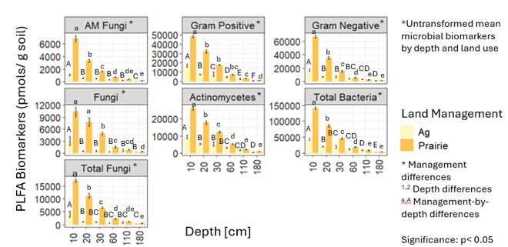
Figure 3: Total Abundance of Microbial Community Structure in Nebraska
The total abundance of microbial community structure across soil dpeth and land use in Nebraska.
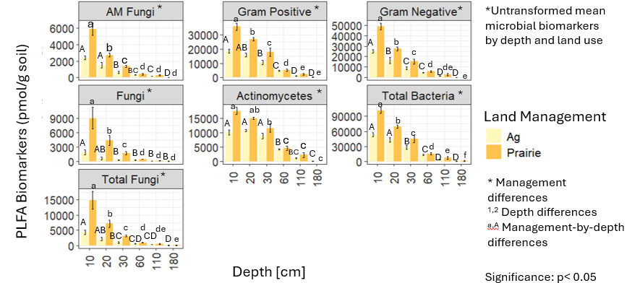
Figure 4: Total Abundance of Microbial Community Structure in Illinois
The total abundance of microbial community structure across soil depth and land use in Illinois.

A dbRDA biplot with a vector plot of soil environmental factors overlaying Nebraska microbial composition is shown in Figure 5. Soil depth is represented by colors and land management reflected by triangles (prairie) and circles (agriculture). Soil organic carbon (SOC), and %clay content positively correlated with enzyme composition in the upper 30cm of the soil profile. Nitrate concentrations positively correlated with microbial composition at 20cm and 60cm. Fe2O3 concentration positively correlated with microbial composition at 30cm and 110cm while soil pH, % silt, and calcium oxide concentrations were positively correlated with microbial composition at 110cm and 180cm. Agricultural and prairie microbial community structure less variable in the soil surface (10-30cm) compared to deeper soil horizons (60-180cm). As soil depth increases, more variability in microbial community structure activity between management systems is observed.

Discussion
Microbial Community Structure across depth and land use
All microbial biomarkers including gram-positive bacteria, gram-negative bacteria, actinomycetes, AMF fungi, and fungi were shown to significantly decrease with soil depth (p>0.01), supporting the first hypothesis. This is likely because of soil environmental factors such as decreased oxygenation, lower temperature, less labile SOC, and higher metal oxide concentrations which increase with depth (Neira et al., 2015; Poeplau & Don, 2013; Xu et al., 2023). Microbial communities had a greater impact on enzyme activities per unit of microbial
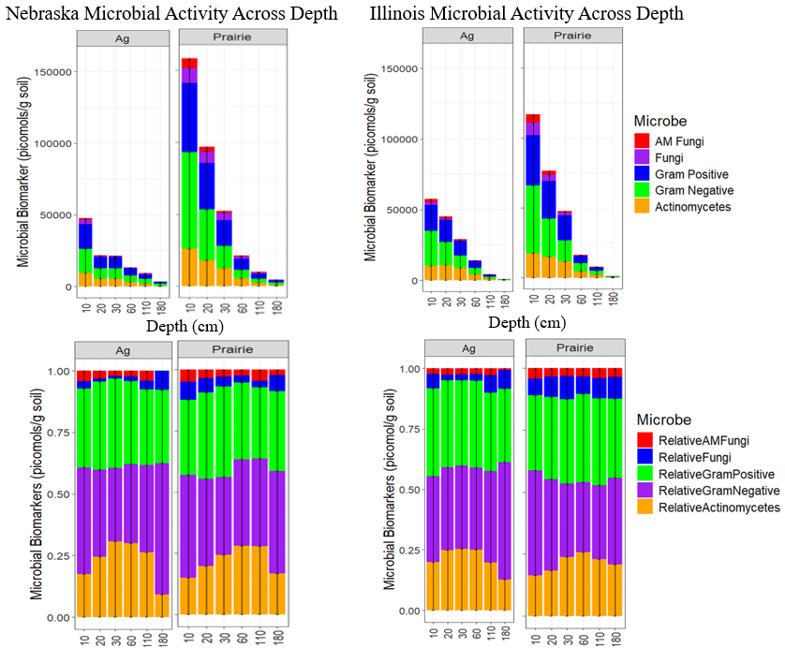
Figure 5: Stacked bar plots of total abundance (top) and relative abundance (bottom) of soil microbial community.

abundance in the near soil surface based on the distance-based redundancy analysis, partially supporting hypothesis two. There were greater biological controls for microbial community structure in the upper 20cm of the soil profile as observed by the biplot. However, as soil depth increased there were noticeable soil texture differences between Illinois and Nebraska, suggesting that mineralogical and eluvial processes might be driving some of the depth differences observed between each state. In Illinois in the upper 30cm of the soil profile, the total abundance of microbial biomarkers was shown to be controlled predominately by silt content and enzymatic activity, while the microbial community was more controlled by clay content as soil depth increased (Figure 6). In Nebraska the opposite relationship was shown as microbial community structure was influenced more by clay content and enzymatic activity in the upper 30cm of the soil profile, and by silt content in deeper soil horizons.
Current literature agrees that soil structure is important for the development and resilience of the microbial community by creating unique and spatially divided microhabitats (Biesgen et al., 2020). Characteristics such as minerals, iron oxide concentration, and clay content can influence the distribution of microbial communities as microorganisms require inorganic nutrients which are stored within soil minerals (Cuadros, 2018; Babin et al., 2013; England et al., 1992; Dong et al., 2009). For example, clays in soil attract nutrient cations (NH4+) and anions like phosphate species which can be acquired by microorganisms through ion exchange (Fomina, 2020). This could partially explain why there was clay control on microbial activity in the soil surface in Nebraska (Figure 7). Conversely, microbes require organic matter to sustain their activity which can be impacted by the presence of clay. If absorbed by clay minerals, organic matter can significantly decrease which prevents it from being available for microbial assimilation, possibly explaining clay influence on microbial activity at deeper soil depths in Illinois (Fomina, 2020). Since most biogeochemical processes in the soil are facilitated by microorganisms and carried out by enzymes, it is reasonable that the variability in microbial activity was partially explained by hydrolase activity.
The relative abundance of fungal populations was shown to be higher in the prairie near the soil surface compared to the agricultural system in both Illinois and Nebraska. The relative abundance of Illinois fungal populations decreased significantly with soil depth while the relative abundance of AMF fungi in Nebraska decreased more gradually throughout the soil profile. This is likely the result of no till practices in Nebraska which promote greater fungal consistency
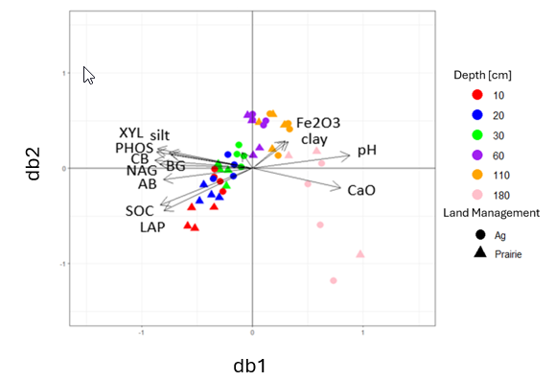
Figure 6: a biplot showing the results for Illinois microbial composition against all the other soil properties
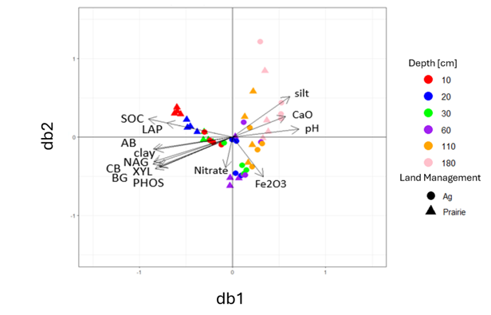
Figure 7: a biplot showing the results for Nebraska microbial composition against all the other soil properties
through the soil profile (Wang et al., 2021). However, Illinois’ agricultural system saw higher AMF fungi in the surface compared to Nebraska agricultural system, despite Illinois undergoing conventional tillage which has been shown to destroy soil hyphal networks (Lu et al., 2018). One possibility for this is that while no-tillage practices generally increase AMF diversity and abundance overtime, specific conditions such as poor organic matter decomposition and increased bulk density can cause AMF propagules to be lower in no-till systems compared to tilled systems. This can be further enhanced when synthetic fertilizers are used as they reduce plant dependence on AMF to acquire nutrients (Khuila & Ghush, 2022; Lu et al., 2018). For example, one study found that AMF diversity significantly decreased with N fertilizer inputs (Graaff et al., 2019).
Furthermore, bacterial populations were shown to be more abundant in both management systems compared to fungal populations, likely as the result of specific life-history traits of fungi versus bacteria. In general, bacteria are shown to account for 15% of the total living biomass while fungi and archaea make up approximately 2% and 1% (Daunoras et al., 2024). More

broadly speaking, fungi have slower turnover rates and tend to thrive in more stable, less disturbed soil systems. This generally categorizes them as K-strategists while bacteria are considered R-strategists when it comes to carbon and nutrient use (Rousk & Frey, 2015; Yu et al., 2022; Hoorman, 2025). One study assessing conversion of forests to agricultural systems found that the conversion decreased soil quality and inevitably reduced K-strategist populations by degrading soil, C/N ratios, and C-and N-acquiring enzymes (Liu et al., 2022). However, categorizing fungi and bacteria as either K or R strategists can be an oversimplification of the extensive variation in their microbial lifestyles (Siles et al., 2023). Numerous studies have observed bacterial dominance in systems that are frequently disturbed with higher soil nutrient contents and warmer temperatures while fungi have higher carbon use efficiency and ability to degrade a broader range of substrates (Siles et al., 2023; Yu et al., 2022).
Additionally, it is generally agreed due to the heterogeneity of the microbial community that bacteria are more abundant than larger, more complex microorganisms such as fungi which is supported by our results (Siles et al., 2023; Hoorman, 2025). Bacteria’s small size also enables them to adapt and expand more in a rapidly changing environment compared to fungi. For example, bacteria can survive in both disturbed and favorable conditions, explaining why bacteria dominate in locations with high soil nutrient content or in frequently disturbed soils. Increased abundance of saprophytic fungi compared to bacteria in agricultural systems can indicate greater capabilities for disease restraint and soil structure formation. Furthermore, climate differences between Illinois and Nebraska likely explain some of the variability in fungal and bacterial populations as fungi tend to be more impacted by dry/wet cycles related to irrigation compared to bacteria (Brito et al., 2021, Six et al., 2006).
In summary, all microbial biomarkers including gram-positive bacteria, gram-negative bacteria, actinomycetes, AMF fungi, and fungi significantly decreased with soil depth (p>0.01), supporting the first hypothesis. Microbial communities had a greater impact on enzyme activities per unit of microbial abundance in the near soil surface based on the distance-based redundancy analysis, partially supporting hypothesis two. In Illinois in the upper 30cm of the soil profile, the total abundance of microbial biomarkers was shown to be controlled predominately by silt content and enzymatic activity while the microbial community was more controlled by clay content as soil depth increased. In Nebraska the opposite relationship was shown as microbial community structure was influenced more by clay content and enzymatic activity in the upper 30cm of the soil profile, and by silt content in deeper soil horizons, likely the result of clay surface charges and its impact on nutrient and water retention. The relative abundance of fungal populations was shown to be higher in the prairie near the soil surface compared to the agricultural system in both Illinois and Nebraska while bacterial populations were shown to be more abundant in both management systems compared to fungal populations, likely the result of specific life-history traits of fungi versus bacteria.

CHAPTER III: MICROBIAL COMMUNITY FUNCTION IN INTENSIVELY MANAGED SYSTEMS AND RESTORED PRAIRIES IN THE UNITED STATES MIDWEST

Introduction
The microbial community in soil encompasses soil microorganisms such as Gram-positive bacteria, Gram-negative bacteria, fungi, archaea, and protozoa. These organisms are strongly interconnected within the soil environment, meaning they provide strong indications of the state of the system (Sharma et al., 2010; Ma et al., 2022). The biogeochemical processes facilitated by these microorganisms are referred to as microbial community function. Plant residues on the soil surface are made up of large, polymeric structures that require depolymerization before monomeric nutrients can be acquired. This process of depolymerization is facilitated by extracellular enzymes which are peptide chains released by microorganisms that are specialized for specific substrates such as cellulose, hemicellulose, and lignin (Blonska et al., 2020). These enzymes eventually release essential nutrients into the soil solution which are taken up by microorganisms and incorporated into the microbial biomass-concentration of living organisms within the soil environment (Brookes et al., 2008). Intensively managed systems have been shown to alter soil biogeochemical processes by destroying soil aggregates through tillage practices and increasing the concentration of more readily available nutrients through fertilizer applications, which influence enzymatic activity (Süunnemann et al.; Zheng et al.). However, most studies focus on relatively carbon and nutrient dense soil surfaces, leaving less known about how intensive management impacts soil microorganisms along and below the soil’s active root zone. To address the effects intensive management has on soil microbial communities and their associated enzymes, the following research question was asked: 2. Has more than 10 years of restored prairie management caused microbial community function to diverge across the active root zone compared to intensively managed landscapes? The following hypotheses were proposed to address this question.
Hypothesis 3:
Enzyme activities will decrease with soil depth and be higher in prairies compared to intensively managed systems as tillage practices and fertilization are shown to decrease enzyme activity compared to less disturbed, more natural systems such as prairies.

Hypothesis 4:
Intensive management will result in higher N availability and lower N-acquiring enzyme activity relative to restored prairies.
Rationale for Hypothesis 3:
N fertilization in intensively managed agricultural systems has been shown to effect enzyme activity. One study found that N fertilization increased activities of acid phosphatase and β-glucosidase, but decreased the activity of urease (Ajwa, et al., 1999). Other studies have found that tillage greatly reduces the activity of various enzymes such as dehydrogenase, phosphatase, urease, β-glucosidase (Saikia & Sharma, 2017), while conservation tillage and increased organic residues on the soil surface has been found to increase the activity of many different enzymes (Wen et al., 2023; Shahariar et al., 2021).
Rationale for Hypothesis 4:
Evidence of enzyme resource allocation has been found in a handful of studies. This theory suggests that enhancement of inorganic compounds inhibits the activity of the related nutrient-acquiring enzyme. A meta-analysis of 120 peer reviewed papers observed this trend, as N enrichment significantly enhanced the activities of C- and P- acquiring enzymes such as β-glucosidase and phosphatase, while suppressing the activity of N-acquiring enzymes (Jia et al., 2020). Additional analyses observed similar trends, in which N-additions significantly decreased the activity of leucine aminopeptidase, a nitrogen acquiring enzyme (Cenini et al., 2015).

Methods
Soil collection and preparation
To address our hypotheses, randomized field sampling with 4 replicates occurred at two sampling locations in Nebraska and two sampling locations in Illinois in the summer of 2023 (Fig. 1). Illinois soil samples were collected at Sangamon River Forest Preserve (40.281455, -88.355455) in Fisher and Allerton Trust Farm in Monticello (40.025223, -88.661188) on 6/26/23 and 6/27/23. Nebraska soil samples were collected at Glacier Creek Preserve in Omaha, NE at MIRZ site 1 and 2 on 7/6/23 and 7/7/23. Soil samples in this study were extracted by hand using a sterilized bucket auger at depths of 0-10cm, 10-20cm, 20cm-30cm, 55-65cm, 105-115cm, and 175-185cm. On 6/26/23 in Fisher, Illinois, the wind was 10-20mph, temperature was 69-81 degrees F, humidity was 81 %, precipitation was 20%, visibility was 10-mile, and dew point was 62 degrees F. On 6/27/23 in Monticello, Illinois, the wind was 11 mph, 83 degrees F, 76% humidity, 0% precipitation, 8 miles of visibility, and 60 degrees F dew point. On 7/6/23 in Omaha, Nebraska, the wind was less than 4 mph, temperature was a high of 60 degrees F, the humidity was 76%, precipitation was 0%, visibility was 10 miles, and dew point was 53 degrees F. On 7/7/23 in Omaha, Nebraska, the wind was 7 mph, the temperature was 68 degrees F, the humidity was 88%, the precipitation was 100%, and dew point was 58 degrees F. Soil collected from the field was shipped back to the laboratory in coolers for both biological and physical analysis. All soil samples will be mixed by hand and sieved to 2mm.
Soil Organic Carbon (SOC)
SOC stocks were provided by Ian Frantal (Purdue University) who calculated SOC stocks using the bulk density data provided by Dr. Ashlee Dere (University of Nebraska, Omaha), and the CSOC concentration from EA-IRMS analysis (Equation 7).
Microbial Biomass Carbon (MBC)
Two 10 g samples of field moist soil were weighed into two glass extraction jars. One jar containing 10 g of field moist soil contained 40mL of potassium sulfate and 1mL of chloroform, while the duplicate jar contained 10 g field moist soil and 40mL of potassium sulfate only. Chloroform is used in this study to lyse microbial cells, which release microbial carbon into the soil slurry. The jar containing potassium sulfate and chloroform extracted soil organic carbon and extractable microbial biomass carbon into solution while the jar containing just potassium sulfate extracted only soil organic carbon.
Phospholipid Fatty Acid Analysis (PLFA)
Microbial community structure is determined using the Beyer & Sasser protocol. Phospholipid fatty acid analysis is an extremely time and energy intensive procedure. To extract fatty acids, the protocol is divided into four parts (Buyer & Sasser, 2012). The first part is drying and extraction. Roughly 2 g of moist, sieved soil in triplicate is weighed into a 13 mm × 100 mm screw-cap test tube followed by drying each sample in bacuo overnight as room temperature in the centrifuge evaporator. The dry weight is measured. After 4.0 mL of the Bligh-Dyer extractant containing an internal standard is added to the sample. Each test tube is then sonicated in an ultrasonic cleaning bath for 10 minutes at room temperature before rotating the tube end-over-end for two hours. After centrifuging for 10 minutes, the liquid phase of extractant is placed in a clean 13 mm × 100 mm screw-tap test tube and 1.0mL of chloroform and water both is added (Buyer & Sasser, 2012). The test tubes are then vortexed for 5 seconds and then centrifuged for 10 minutes. The upper phase was removed by aspiration and discarded while the lower phase that contains the extracted lipids is evaporated at 30 degrees C. The sample is then kept overnight at -20degrees C.
To conduct lipid separation, the lipid classes are separated by solid phase extraction (SPE) using a 96-well SPE plate that has 50 mg of silica in it per well. Each well is exposed to methanol and then chloroform (3 × 1 mL) The samples dissolve in 1 mL chloroform, are transported to the SPE plate, and then passed thorug the silica. The test tube is rinsed with another 1 mL of chloroform which is transported to the SPE plate and passed through again. After exposing each well to 1mL of chloroform and 1 mL of acetone, phospholipids are extracted by using 0.5mL of 5:5:1 methanol-chloroform: H2O into 1.5 mL glass vials. The solution is then evaporated for 30 minutes at 70 degrees C and then until dry at 37 degrees C.
The third part is transesterification in which 0.2 mL of a transesterification reagent is added to each vial (Buyer & Sasser, 2012). The vials are sealed using a PTFE/silicon cap mat and then incubated at 37 degrees C for fifteen minutes. Following this, 0.075 M of acetic acid and 0.4 mL of chloroform is added to each. After shaking for 10 seconds the phases are separated by allowing to sit. The bottom 0.3 mL are then removed with a pipette into clean, 1 mL vials located in a multi-Tier microplate. The chloroform extraction is then repeated in which the bottom 0.4 mL is removed and the extracts are combined. The chloroform is then evaporated to dryness at room temperature. To ensure balance of the centrifuge, alternate columns of vials are moved into an extra vial rack. Samples are then dissolved in 75 uL hexane, moved to gas chromatography vials with conical glass inserts, and then stored -20 degrees C until they are ready to be analyzed.
The fourth part involves gas chromatography in which an Agilent 6890 gas chromatograph (GC) utilizing an autosampler, a split-spitless inlet, and flame ionization detector. The system is controlled with MIS Sherlock and Agilent ChemStation (Buyer & Sasser, 2012). FAMEs were distinguished on an Agilent Ultra 2 column, 25 m long × 0.2mm internal diameter × 0.33 um film thickness. A 30:1 ratio is used with a hydrogen carrier gas at 1.2 mL/min constant flow rate. The oven temperature begins at 190 degrees C followed by 285 degrees C (10degrees C/min) and then 310 degrees C at (60 degrees C/min). The temperature is held at 310 degrees C for two minutes. The injector temperature is 250 degrees C and the detector temperature is 300 degrees C. The FAMEs are determined using the MIDI PLFAD1 calibration mix and naming table. Fatty acids were summed into biomarker groups including eukaryotes, polyunsaturated fatty acids, and eubacteria; 15:0, 15:1 iso, 17:0, 17:1 iso, 17:1 anteiso, and 19:0 cyclo. Gram positive bacteria being iso and anteiso saturated branched fatty acids, gram negative bacteria monounsaturated fatty acids and cyclopropyl 17:0 and 19:0. Actinobacteria being 10-methyl fatty acids, fungi as 18:2 w6 cis, and protozoa being 20:3 and 20:4 fatty acids (Buyer & Sasser, 2012).
FAMEs with a length of 14 carbon chains and higher are used to estimate total FAME (mmolg1 soil) which is often used to represent total microbial biomass (Mbuthia et al., 2015). The bacteria biomarkers identified include five gram positive bacteria (Gramþ) such as i15:0, a15:0, i16:0, i17:0, a17:0, three Gram negative bacteria (Gram) cy17:0, cy19:0, 16:1w7c, and three actinomycetes 10Me16:0, 10Me17:0, 10Me18:0. The sum of bacteria is calculated based on the summation of Gramþ, Gram, and actinomycete biomarkers. The indication of fungi is based on two saprophytic biomarkers (18:2u6c, 18:3u6c) and a mycorrhizal fungi biomarker (16:1u5c). The fungal summation was calculated by adding 18:2u6c and 18:3u6c. The AMF biomarker is not incorporated into the fungal summation because it is considered a symbiotic, but not a saprophytic, fungi in which its soil function is unique. Fungal/bacterial ratios (F:B) are determined by dividing the fungal sum to the bacterial sum (Mbuthia et al., 2015).
Enzyme Assay
β-Glucosidase (BG) and β-D-cellubiosidase (CB) are enzymes that degrade cellulose and other beta-1,4 glucans (Ljungdahl & Eriksson 1985). The principal function of BG is the hydrolysis of cellobiose to glucose, but these enzymes can act upon other substrates as well. CB hydrolyzes cellobiose units from the non-reducing ends of cellulose molecules to form glucose (Sapkota & Aryal, 2022). N-acetyl-B-Glucosaminidase (NAG) degrades chitin and other b-1,4-linked glucosamine polymers, similar to the role of BG in cellulose degradation (Sinsabaugh 2005). Leucine aminopeptidase (LAP) hydrolyzes amino acids including leucine from the N terminus of polypeptides (Worthington, 2025). While there are other classes of aminopeptidases, assays of environmental samples demonstrate the strongest activities towards leucine- andalanine-linked substrates. Therefore, LAP activity is broadly used to identify peptidase potential (Sinsabaugh & Foreman2001; Stursova et al. 2006). Alkaline and acidic phosphatases hydrolyze phosphomonoesters, and sometimes phosphodiesters, releasing phosphate (Turner et al. 2002; Toor et al. 2003).
Enzymes were estimated using a fluorometric method. To conduct this assay, 3g of field moist soil were weighed, placed into 15mL test tubes, and frozen until use. Fluorescently labelled substrates were made in advance and frozen according to the protocol. The fluorescently labelled substrates used in this assay included:
1. a-Glucosidase (sugar degradation): AG-4-MUB-a-D-glucopyranoside (6.77mg/100mL)
2. B-Glucosidase (sugar degradation): BG-4-MUB-B-D-glucopyranoside (6.77mg/100mL)
3. B-D-cellubiosidase (cellulose degradation): CB-4-MUB-B-D-cellobioside (10mg/100mL)
4. Leucine aminopeptidase (protein degradation): LAP-L-leucine-7-amido-4-methylcoumarin hydrochloride (6.50mg/100mL)
5. N-acetyl-B-Glucosaminidase (chitin degradation): NAG-4-MUB-N-acetyl-B-D-glucosaminide (7.59mg/100mL)
6. Phosphotase (phosphorus mineralization): PHOS-4-MUB phosphate (5.12mg/100mL)
7: B-Xylosidase (Hemicellulose degradation): XYL-4-MUB-B-D-xylopyranoside (6.17mg/100mL)
The process begins with 99 mL of a 50mM Sodium acetate extraction buffer blended with each soil sample for 1 minute to make slurry. Following blending, 800 ul of soil slurry are pipetted into three deep well channel plates labelled MUB, MUC, and SUB. Each column of well plate represents 1 soil sample. After soil samples are pipetted into the deep well plates, substrates are added on top of soil slurries. Soil slurries with added substrate are incubated for 4.5 hours at 20 degrees Celsius. After incubation, deep well plates are centrifuged to separate soil from solution. 250 microliters of supernatant are then pipetted into respective microplates that are placed into a laboratory microplate reader followed by additions of 10 microliters of 0.5 NaOH (Milli Q) to each well in microplates.
Permanganate Oxidizable Carbon
Permanganate Oxidizable Carbon was estimated Weil et al. (2003) and Culan et al. (2012). To conduct this analysis, 5.0 grams of air-dry soil was weighed into 50 mL centrifuge tubes. Following this, 18 mL of deionized water was added to each tube followed by 2.0 mL of KMno4. Once KMno4 was added, the tubes were capped immediately and hand shaken until the soil was thoroughly mixed. The 50 mL centrifuge tubes were then transferred to a laboratory shaker where they were shaken for two minutes at 240 oscillations per minute. The tubes were then shaken by hand and stored in a dark area for 10 minutes. While the samples were resting, a fresh set of 50 mL centrifuge tubes were gathered and filled with 49.5 mL of DI water to prepare standards. After 10 minutes, 0.5 mL of the supernatant were pipetted off the top of the shaken tubes into the fresh set of centrifuge tubes. These tubes were then vortexed to mix supernatant thoroughly. Standards/samples were pipetted into a microplate and read using a Synergy HT microplate reader. The process was repeated until every plate was completed. POXC was then calculated using equations provided by Weil et al. (2003).
Soil pH
A 5g sample air-dry soil was weighed into 15mL centrifuge tubes along with 10mL of distilled water. The sample was vortexed and allowed to sit for 10 minutes before reading the soil pH with a pH electrode.
Gravimetric Water Content
A 5 g sample of field moist soil was weighed in a tared aluminum tin and placed in an oven at 105 degrees C for 48 hours to ensure full drying. The tins were then reweighed to determine the mass of water loss (GWC = g water/g dry soil).
Nitrate Assay
Nitrate assay was estimated per Doane & Horwath (2003). To conduct this analysis, extracts made for the EOC and MBC analysis were thawed. Once the samples were thawed, 30 uL of sample and standard were pipetted into a series of microplates. Following this, 300 uL of vanadium chloride reagent was added on top of respective sample/standard. The plate corners were tapped to ensure the reagent was mixed with each sample or standard before being incubated overnight. The plates were read using the Nitrate Protocol Low Concentration in the Gen5 plate reader software.
Ammonium Assay
Ammonium assay was estimated as per Rhine et al. (1998). To conduct this analysis, EOC and MBC extracts were thawed. Once the extracts were thawed, 70uL of soil extracts were pipetted into respective microplates followed by 50 uL of citrate reagent, and the mix was left to react. After one minute, 50 uL of PPS-nitroprusside was added to the microplates followed by 25 uL of buffered hypochlorite and 50 uL of milli Q. Lids were then attached to microplates and shaken by hand gently for 30 seconds. The plates sat for two hours and was then read using an Open Plate Reader software.
Soil Texture Analysis
Soil texture data including %sand, %silt, and %clay was measured using the hydrometer method at Ward Labs. This is a full-service agricultural testing laboratory in Kearney, Nebraska.
Soil Temperature
Soil temperature was measured by using information from the soil probes that are installed at depths 20cm, 60cm, 110cm, and 180cm in all four management systems. Soil temperature values were chosen based on the specific time stamp that field collection occurred.
Bulk Density
Soil bulk density was measured using the core method. This method involves using sample rings of 100-cm³ that are inserted horizontally into the side of a soil pit (Walter, 2016).
Metal Oxides
Major and trace elemental geochemistry was measured by lithium metaborate fusion and ICP-MS at SGS Canada. Sixteen major, minor, and trace elements were identified in geological materials using a lithium metaborate fusion with an Inductively Coupled Plasma-Mass Spectroscopy (ICP-MS). The sample is blended with lithium metaborate and dissolved using dilute HNO_{3.}
Statistical Analyses
The data from the lab was compiled into an excel sheet where the appropriate conversions were completed to obtain the desired unit. Descriptive statistics were then computed in Excel to produce simple figures displaying general trends of enzymatic activity and microbial community structure across six depths in intensively managed systems and restored prairies. A repeated measures mixed model analysis of variance (ANOVA) using SAS was conducted to analyze differences in enzyme activity and microbial community structure and density across plot, depth, and plot-by-depth. Tukey-Kramer p-value adjustments were applied to post hoc tests. Normality of residuals were evaluated using the Shapiro-Wilk test and Q-Q plots. A log-transformation was required for all soil enzymes except leucine aminopeptidase and for fungi/bacteria and gram positive/gram negative. A square root transformation was required for AM fungi, gram negative, gram positive, total bacteria, eukaryote, fungi, and actinomycetes. Levene’s test for equality of variance and boxplots were used to evaluate equality of variance. After transformations were applied, the statistical assumptions were met for all models. A p-value less than 0.05 was considered significant. Statistical analysis was performed using commercial software (SAS software, Version 9.4, Cary, North Carolina, Release TS1M8).
Principal Component Analysis
A separate distance-based ReDundancy Analysis (dbRDA) was performed on the same dataset in R version 4.4.2 (2024-10-31 ucrt) to determine the correlation between enzymatic activity, microbial community structure, and each principal coordinate or soil variable. A log-transformation was required for all soil enzymes except leucine aminopeptidase. A PCoA was applied using a Bray-Curtis distance matrix and an RDA was conducted on enzymatic activity, restoration, and provenance effects (state, plot, and depth). A dbRDA was then computed on a dataset including enzymatic activity (except leucine aminopeptidase), microbial community structure, and soil properties. A collinearity test was performed, and a reduced model was computed in which state or geographic location was a leading factor driving the outcome. Therefore, a dbRDA was performed separately for each geographic location or state to assess management and depth effects. Visualizations of beta-diversity were produced with an unconstrained coordination (Bakker, 2024).
A summary of analyses can be found in Table 13.

Results
All soil enzyme activities decreased with soil depth. ANOVA results found significant depth differences for all enzymes except LAP (p<0.001, for all), plot differences for NAG (p<0.05), and plot-by-depth differences for BG (p<0.01), NAG (p<0.01) and PHOS (p<0.05). Post hoc tests revealed that enzyme activity was significantly lower at lower active root zones compared to upper active root zones (p<0.05, for all) as shown in Table 1. Post hoc tests also revealed that prairie plots had higher NAG than agricultural plots (p<0.05). Microbial biomass carbon (MBC) and permanganate oxidizable carbon (POXC) produced negatives or zeros to the extent that these variables were removed from the final dbRDA.
N-Cycling Enzymes
Leucine aminopeptidase (LAP)
The activity of LAP ranged from 13.61 to 9.06 in Illinois agricultural systems with the highest mean and standard deviation (13.61 ± 4.21) at 10cm and the lowest activity (9.06 ± 3.67) at 30cm summarized in Table 14. The activity of LAP ranged from 23.08 and 4.64 in Illinois prairie systems with the highest activity (23.08 ± 5.33) at 10cm and the lowest activity (4.64 ± 2.39) at 30cm. The activity of LAP ranged from 2.29 to 3.12 in Nebraska agricultural systems with the highest mean and standard deviation (3.12 ± 2.29) at 30cm and the lowest activity (2.29 ± 1.93) at
Table 13: Summary of Analyses
Soil analyses | Method of Analysis
pH | pH electrode.
Bulk density | Core method (Walter, 2016)
Gravimetric water content | Oven drying method.
Soil Texture (%sand, %silt ,%clay) | Hydrometer method at Ward Labs.
MBC | Konkel., 2017
Enzyme Assay | Fluorometric method
Ammonium Assay | Rhine et al. (1998).
Nitrate Assay | Doane & Horwath (2003).
Metal Oxides | Lithium metaborate fusion and ICP-MS at SGS Canada.
POXC | Weil et al. (2003) and Culan et al. (2012)
SOC | Bulk density data and the CSOC concentration from EA-IRMS analysis (Equation 7).
Soil Temperature | Soil sensors with Campbell Scientific CR-1000 datalogger in each location
Phospholipid Fatty Acid Analysis | Beyer and Sasser, 2012.

Table 14: Untransformed mean and standard deviation of leucine aminopeptidase (LAP) by depth. Across each soil enzyme, depths that do not share a common lowercase superscript letter ^{a, b, c, d} significantly differ (p<0.05) as a result of main effect differences. Across each soil enzyme, values that do not share a common asterisk * significantly differ (p<0.05) as a result of post hoc analysis of plot differences. Values that do not share a common number ^{1,2,3,4} significantly differ (p<0.05) by depth as a result of post hoc analysis of plot and plot-by-depth differences.
Soil Enzyme | Depth | IL Ag | NE Ag | IL Prairie | NE Prairie
LAP (nmols/ g dry soil) | 10 | 13.61 ± 4.21 | 2.29 ± 1.93 | 23.08 ± 5.33 | 14.90 ± 13.43
 | 20 | 9.43 ± 6.38 | 2.17 ± 1.12 | 10.81 ± 4.12 | 6.38 ± 6.66
 | 30 | 9.06 ± 3.67 | 3.12 ± 2.26 | 4.64 ± 2.39 | 8.57 ± 6.46

10cm. The activity of LAP ranged from 14.90 and 8.57 in Nebraska prairie systems with the highest activity (14.90 ± 13.43) at 10cm and the lowest activity (8.57 ± 6.46) at 30cm. Plot, depth and plot-by-depth differences were not detected in LAP. However, when controlling for state, LAP was significantly impacted by pH (p=0.01). It was found that for every unit increase in pH, LAP increases by 170.31%.
N-acetyl-β-glucosaminidase (NAG)
The activity of NAG ranged from 53.35 to 0.52 in Illinois agricultural systems with the highest mean and standard deviation (53.35 ± 18.04) at 10cm and the lowest activity (0.52 ± 0.28) at 180cm summarized in Table 15. The activity of NAG ranged from 62.34 to 8.65 in Illinois prairie systems with the highest activity (62.34 ± 34.37) at 10cm and the lowest activity (8.65 ± 5.45) at 180cm. The activity of NAG ranged from 27.00 to 0.51 in Nebraska agricultural systems with the highest mean and standard deviation (27.00 ± 12.07) at 10cm and the lowest activity (0.51 ± 0.28) at 180cm. The activity of NAG ranged from 107.77 to 6.99 in Illinois prairie systems with the highest activity (107.77 ± 23.83) at 10cm and the lowest activity (6.99 ± 2.12) at 180cm. Significant plot (p=0.0235), depth (p<0.001) and plot-by-depth (p=0.0027) differences were found for NAG. Post hoc tests reveal that a depth of 180 had significantly lower NAG than all other depths (p<0.001, for all), a depth of 110 had significantly lower NAG than all shallower depths (p<0.01, for all), and a depth of 60 had lower NAG than depths of 10 and 30 (p<0.05, for all) for agricultural plots. However, depths of 180 and 110 had significantly lower NAG than depths between 10 and 60 (p<0.01, for all) for prairie plots.
Table 15: Untransformed mean and standard deviation of N-acetyl-β-glucosaminidase by depth. *Log-transformation required to meet normality assumptions.
Soil Enzyme | Depth | IL Ag * | NE Ag * | IL Prairie * | NE Prairie *
NAG (nmols/g dry soil) | 10 | 53.35 ± 18.04 ª | 27.00 ± 12.07 ª | 62.34 ± 34.37 ª | 107.77 ± 23.83 ª
 | 20 | 45.91 ± 12.52 ^{ab} | 23.25 ± 6.47 ^{ab} | 129.12 ± 34.44 ª | 95.99 ± 13.57 ª
 | 30 | 50.25 ± 6.85 ª | 26.56 ± 9.20 ª | 122.54 ± 75.68 ª | 111.03 ± 32.28 ª
 | 60 | 17.43 ± 5.37 ^{b} | 12.02 ± 3.72 ^{b} | 47.03 ± 9.12 ª | 53.62 ± 11.09 ª
 | 110 | 3.72 ± 1.63 ^{c} | 3.94 ± 1.43 ^{c} | 12.40 ± 6.59 ^{b} | 17.70 ± 3.42 ^{b}
 | 180 | 0.52 ± 0.28 ^{d} | 0.51 ± 0.28 ^{d} | 8.65 ± 5.45 ^{b} | 6.99 ± 2.12 ^{b}

Post hoc tests revealed that all prairie plots had higher NAG than agricultural plots for all depths (p<0.05, for all). When controlling for state, NAG was also significantly impacted by PLFA, Fe2O3, gram positive, and actinomycetes (p<0.05, for all) when tested as predictors in separate models. It was found that for every unit increase in PLFA, NAG increases by 0.00095%. It was found that for every unit increase in Fe2O3, NAG decreases by 25.13%. It was found that for every unit increase in gram positive, NAG increases by 0.0046%. It was found that for every unit increase in actinomycetes, NAG increases by 0.0077%.
C-Cycling Enzymes
β-D-cellubiosidase (CB)
The activity of CB in nmols/g dry soil ranged from 39.17 to 0.40 in Illinois agricultural systems with the highest mean and standard deviation (39.17 ± 18.63) at 10cm and the lowest activity (0.40 ± 0.37) at 180cm summarized in Table 16. The activity of CB ranged from 27.68 to 0.64 in Illinois prairie systems with the highest activity (27.68 ± 17.65) at 10cm and the lowest activity (0.64 ± 0.68) at 180cm. The activity of CB ranged from 10.30 to 1.50 in Illinois agricultural systems with the highest mean and standard deviation (10.30 ± 4.40) at 10cm and the lowest activity (1.50 ± 1.68) at 180cm. The activity of CB ranged from 42.85 to 1.34 in Illinois prairie systems with the highest activity (42.85 ± 4.20) at 10cm and the lowest activity (1.34 ± 0.80) at 180cm. Significant differences in CB were found by depth (p<0.001). Post hoc tests revealed that
Table 16:Untransformed mean and standard deviation of cellubiosidase (CB) by depth. *Log-transformation required to meet normality assumptions.
Soil Enzyme | Depth | IL Ag | NE Ag * | IL Prairie | NE Prairie *
CB (nmols/ g dry soil) | 10 | 39.17 ± 18.63 ¹ | 10.30 ± 4.40 a | 27.68 ± 17.65 ¹ | 42.85 ± 4.20 a
 | 20 | 37.03 ± 12.03 ¹ | 9.17 ± 5.68 ab | 36.26 ± 9.52 ¹ | 28.59 ± 5.99 b
 | 30 | 39.38 ± 7.34 ¹ | 8.67 ± 8.29 ab | 26.60 ± 5.79 ¹ | 27.89 ± 5.81 b
 | 60 | 19.82 ± 5.58 ¹ | 3.16 ± 0.51 ab | 11.67 ± 3.04 ¹ | 15.73 ± 2.13 c
 | 110 | 2.62 ± 1.81 ² | 2.49 ± 1.60 ab | 1.30 ± 1.03 ² | 3.19 ± 0.86 d
 | 180 | 0.40 ± 0.37 ³ | 1.50 ± 1.68 b | 0.64 ± 0.68 ³ | 1.34 ± 0.80 d

a depth of 180 had significantly lower CB than all other depths (p<.05, for all), and a depth of 110 had significantly lower CB than all higher depths (p<0.01, for all). When controlling for state, CB was also significantly impacted by the percentage of sand (p=0.0138), and it was found that for every unit increase in sand, CB decreases by 3.86%.
Xylosidase (XYL)
The activity of XYL in nmols/g dry soil ranged from 10.27 to 0.72 in Illinois agricultural systems with the highest mean and standard deviation (10.27 ± 11.66) at 10cm and the lowest activity (0.72 ± 0.22) at 180cm summarized in Table 17. The activity of XYL ranged from 16.43 to 1.28 in Illinois prairie systems with the highest activity (16.43 ± 9.52) at 10cm and the lowest activity (1.28 ± 0.90) at 180cm. The activity of XYL ranged from 6.45 to 0.36 in Nebraska agricultural systems with the highest mean and standard deviation (6.45 ± 4.03) at 10cm and the lowest activity (0.36 ± 0.08) at 180cm. The activity of XYL ranged from 23.52 to 1.33 in Nebraska prairie systems with the highest activity (23.52 ± 5.86) at 10cm and the lowest activity (1.33 ± 0.79) at 180cm. Significant differences in XYL were found by depth (p<0.001). Post hoc tests revealed that a depth of 180 had significantly lower XYL than all other depths (p<.001, for all), a depth of 110 had significantly lower XYL than all higher depths (p<0.01, for all), and a depth of 60 had significantly lower XYL than depths 20 and 30 (p<0.01, for all). When controlling for state, XYL was significantly impacted by actinomycetes (p<0.05) when present in the model. It was found that for every unit increase in actinomycetes, XYL increases by 0.0096%. Gram positive (p<0.05) was also found to impact XYL in a separate model, where every unit increase in gram positive increases XYL by 0.0057%.
Table 17:Untransformed mean and standard deviation of xylosidase (XYL) by depth. *Log-transformation required to meet normality assumptions.
Soil Enzyme | Depth | IL Ag | NE Ag * | IL Prairie | NE Prairie *
XYL (nmols/g dry soil) | 10 | 10.27 ± 11.66 ¹ | 6.45 ± 4.03 ¹ | 16.43 ± 9.52 ¹ | 23.52 ± 5.86 ¹
 | 20 | 29.29 ± 12.99 ¹ | 8.19 ± 2.09 ¹ | 25.21 ± 3.84 ¹ | 13.26 ± 2.18 ¹
 | 30 | 27.39 ± 4.95 ¹ | 11.15 ± 7.89 ¹ | 18.19 ± 8.48 ¹ | 17.53 ± 6.66 ¹
 | 60 | 14.27 ± 10.60 ¹ | 6.11 ± 8.60 ^{1,2} | 9.25 ± 2.02 ¹ | 8.16 ± 1.36 ^{1,2}
 | 110 | 4.78 ± 2.65 ² | 2.67 ± 1.88 ² | 1.93 ± 1.00 ² | 2.95 ± 0.49 ²
 | 180 | 0.72 ± 0.22 ³ | 0.36 ± 0.08 ³ | 1.28 ± 0.90 ³ | 1.33 ± 0.79 ³

β-glucosidase (BG)
The activity of BG in nmols/g dry soil ranged from 143.88 to 2.47 in Illinois agricultural systems with the highest mean and standard deviation (143.88 ± 59.32) at 10cm and the lowest activity (2.47 ± 1.31) at 180cm summarized in Table 18. The activity of BG ranged from 84.79 to 5.00 in Illinois prairie systems with the highest activity (84.79 ± 46.25) at 10cm and the lowest activity (5.00 ± 4.10) at 180cm. The activity of BG ranged from 39.99 to 1.21 in Nebraska agricultural systems with the highest mean and standard deviation (39.99 ± 1.72) at 10cm and the lowest activity (1.21 ± 0.31) at 180cm. The activity of BG ranged from 132.93 to 17.83 in Nebraska prairie systems with the highest activity (132.93 ± 17.83) at 10cm and the lowest activity (8.47 ± 3.63) at 180cm. When controlling for state, significant plot-by-depth (p<0.001) differences were found for BG. Post hoc tests reveal that a depth of 180 had significantly lower BG than all other depths (p<0.05, for all) and a depth of 110 had lower BG than depths 20 and 30 (p<0.05, for all) for agricultural plots. However, no depth differences were found between prairie plots. Post hoc tests also reveal that agricultural plots had lower BG than prairie plots at a depth of 180 (p=0.0024). BG was also significantly impacted by soil temperature (p=0.0166), and it was found that for every unit increase in soil temperature BG increases by 22.07%.
α-glucosidase (AG)
The activity of AG ranged from 24.64 to 0.68 in Illinois agricultural systems with the highest mean and standard deviation (24.64 ± 6.81) at 10cm and the lowest activity (0.68 ± 0.46) at 180cm summarized in Table 19. The activity of AG ranged from 7.85 to 0.46 in Illinois prairie
Table 18:Untransformed mean and standard deviation of β-glucosaminidase (BG) by depth. Log-transformation required to meet normality assumptions.
Soil Enzyme | Depth | IL Ag * | NE Ag * | IL Prairie * | NE Prairie *
BG (nmols/ g dry soil) | 10 | 143.88 ± 59.32ª | 39.99 ± 1.72ª | 84.79 ± 46.25ª | 132.93 ± 17.83ª
 | 20 | 123.88 ± 26.33ª | 48.64 ± 5.63ª | 77.87 ± 19.48ª | 76.11 ± 7.55^{ab}
 | 30 | 140.39 ± 32.69ª | 56.88 ± 37.31ª | 62.80 ± 12.54ª | 83.15 ± 11.53^{ab}
 | 60 | 92.77 ± 8.75ª | 46.52 ± 35.89ª | 34.14 ± 11.40ª | 48.72 ± 4.57^{b}
 | 110 | 16.77 ± 6.28^{b} | 10.97 ± 5.84^{b} | 8.90 ± 4.74^{b} | 21.11 ± 2.82^{c}
 | 180 | 2.47 ± 1.31^{c} | 1.21 ± 0.31^{c} | 5.00 ± 4.10^{b} | 8.47 ± 3.63^{d}

Table 19:Untransformed mean and standard deviation of α-glucosaminidase (AG) by depth. *Log-transformation required to meet normality assumptions.
Soil Enzyme | Depth | IL Ag * | NE Ag | IL Prairie * | NE Prairie
AG (nmols/g dry soil) | 10 | 24.64 ± 6.81 ¹ | 5.72 ± 2.68 ¹ | 7.85 ± 4.41 ¹ | 8.59 ± 2.18 ¹
 | 20 | 13.57 ± 4.94 ^{1,2} | 3.47 ± 2.20 ^{1,2} | 3.96 ± 2.52 ^{1,2} | 2.58 ± 0.36 ^{1,2}
 | 30 | 4.75 ± 1.12 ² | 1.76 ± 0.82 ^{1,2} | 2.84 ± 0.42 ² | 2.07 ± 0.84 ^{1,2}
 | 60 | 1.36 ± 0.40 ³ | 0.91 ± 0.34 ² | 1.09 ± 0.34 ³ | 1.96 ± 0.39 ²
 | 110 | 1.05 ± 0.57 ^{3,4} | 0.66 ± 0.31 ³ | 0.73 ± 0.32 ^{3,4} | 1.28 ± 0.18 ³
 | 180 | 0.68 ± 0.46 ⁴ | 0.24 ± 0.04 ⁴ | 0.46 ± 0.32 ⁴ | 0.80 ± 0.27 ⁴

systems with the highest activity (7.85 ± 4.41) at 10cm and the lowest activity (0.46 ± 0.32) at 180cm. AG ranged from 5.72 to 0.24 in Nebraska agricultural systems with the highest mean and standard deviation (5.72 ± 2.68) at 10cm and the lowest activity (0.24 ± 0.04) at 180cm. AG ranged from 8.59 to 0.80 in Nebraska prairie systems with the highest activity (8.59 ± 2.18) at 10cm and the lowest activity (0.80 ± 0.27) at 180cm.
When controlling for state, significant depth (p<0.001) and plot-by-depth (p=0.0028) differences were found for AB. Post hoc tests reveal that agricultural plots had higher AB than prairie plots at a depth of 20 (p=0.0277), whereas agricultural plots had lower AB than prairie plots at depths 60, 110, and 180 (p<0.05, for all). Post hoc tests revealed that a depth of 180 had significantly lower AB than all other depths (p<0.05, for all), a depth of 110 had significantly lower AB than depths of 10, 20 and 30 (p<0.01, for all), and depths of 30 and 60 had lower AB than depths of 10 and 20 (p<0.05, for all) for agricultural plots. However, a depth of 180 had significantly lower AB than depths between 10 and 60 (p<0.05, for all), a depth of 110 had lower AB than depths 10 and 60 (p<0.05), and a depth of 20 had lower AB than 10 (p<0.05) for prairie plots.
AB was significantly impacted by Fe2O3 (p<0.001). Total bacteria (p=0.0178), gram positive (p=0.0308), and gram negative (p=0.0161) also impacted AB in the presence of Fe2O3 when tested in separate models. It was found that every unit increase in Fe2O3 decreased AB by 54.75% when tested alone in the model. However, Fe2O3 decreased AB by approximately 52% in the presence of the other variables. For every unit increase in total bacteria, AB increased by 0.0032%. For every unit increase in gram positive, AB increased by 0.0033%. For every, unit increase in gram negative, AB increased by 0.0027%.
P-Cycling Enzymes
Phosphatase (PHOS)
The activity of PHOS in nmols/g dry soil) ranged from 504.18 to 25.59 in Illinois agricultural systems with the highest mean and standard deviation (504.18 ± 223.92) at 10cm and the lowest activity (25.59 ± 10.05) at 180cm summarized in Table 20. The activity of PHOS ranged from 191.79 to 36.39 in Illinois prairie systems with the highest activity (191.79 ± 84.74) at 10cm and the lowest activity (36.39 ± 42.64) at 180cm. The activity of PHOS ranged from 204.84 to 11.97 in Nebraska agricultural systems with the highest mean and standard deviation (204.84 ± 30.25) at 10cm and the lowest activity (11.97 ± 5.59) at 180cm. The activity of PHOS ranged from

Table 20:Untransformed mean and standard deviation of phosphatase (PHOS) by depth. *Log-transformation required to meet normality assumptions.
Soil Enzyme | Depth | IL Ag * | NE Ag * | IL Prairie * | NE Prairie *
PHOS (nmols/g dry soil) | 10 | 504.18 ± 223.92ª | 204.84 ± 30.25ª | 191.79 ± 84.74^{ab} | 452.03 ± 46.45ª
 | 20 | 589.08 ± 146.93ª | 211.46 ± 30.02ª | 226.66 ± 35.30ª | 225.65 ± 76.60^{b}
 | 30 | 275.23 ± 70.51ª | 129.33 ± 12.60ª | 199.08 ± 35.39ª | 212.56 ± 36.01^{b}
 | 60 | 108.37 ± 11.68^{b} | 67.10 ± 25.10^{b} | 113.46 ± 20.62^{ab} | 183.17 ± 53.80^{b}
 | 110 | 75.89 ± 32.05^{b} | 47.78 ± 26.71^{b} | 81.33 ± 26.08^{b} | 90.51 ± 16.31^{c}
 | 180 | 25.59 ± 10.05^{c} | 11.97 ± 5.59^{c} | 36.39 ± 42.64^{c} | 35.13 ± 7.36^{d}

452.03 to 35.13 in Nebraska prairie systems with the highest activity (452.03 ± 46.45) at 10cm and the lowest activity (35.13 ± 7.36) at 180cm.
Significant depth (p<0.001) and plot-by-depth (p=0.0182) differences were found for PHOS when controlling for state. Post hoc tests revealed that a depth of 180 had significantly lower PHOS than all other depths (p<0.01, for all), a depth of 110 had lower PHOS than all depths 10, 20 and 30 (p<0.05, for all), and a depth of 60 had lower PHOS than all shallower depths (p<0.05, for all) for agricultural plots. However, only a depth of 180 had lower PHOS compared to depths of 30, 60 and 110 (p<0.05, for all) for prairie plots. PHOS was significantly impacted by gram positive (p=0.0377), and it was found that for every unit increase in gram positive, PHOS increases by 0.0029%.
The relationships between microbial community function and soil depth in Illinois and Nebraska prairie and agricultural plots are shown in Figure 10. The bars represent mean enzyme activity.
Following a distance-based redundancy analysis (dbRDA), depth was shown to be the strongest predictor of enzymatic activity, with a constrained variance of (4.7720) and a highly significant effect (F = 72.71, p = 0.001). State or geographic location was also a significant predictor (F = 4.77, p = 0.008), though it accounted for a smaller proportion of constrained
Total Abundance of Enzyme Activity Across Both States
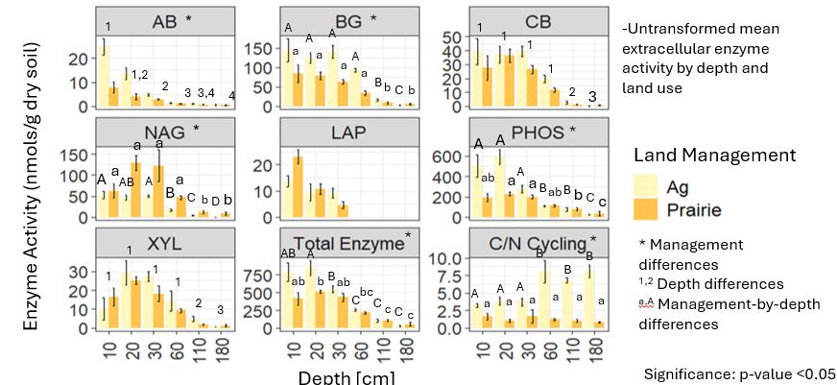
Figure 8: Hydrolase Activity Across Soil Depth and Land Use in Illinois

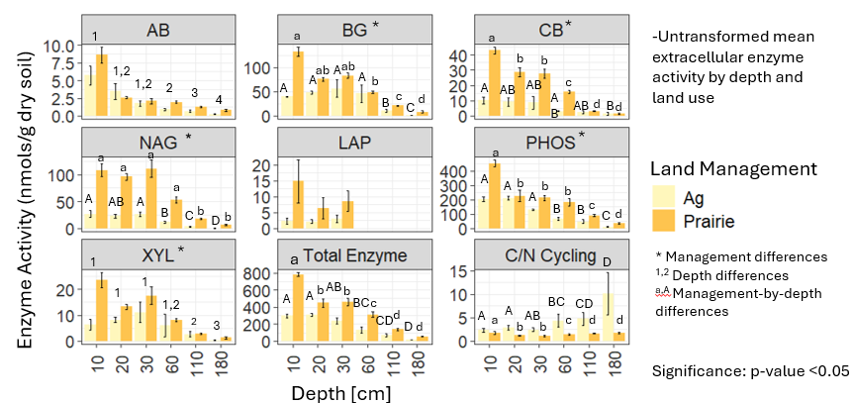
Figure 9: Hydrolase Activity Across Soil Depth and Land Use in Nebraska

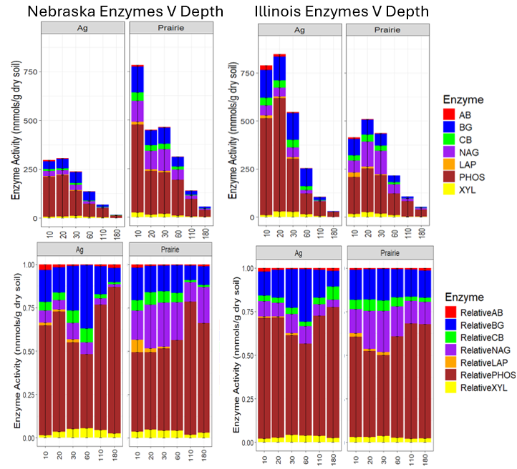
Figure 10: Stacked bar plots of total activity (top) and relative activity (bottom) of soil microbial function.

variance (0.3132). Conversely, Plot did not significantly contribute to enzyme variation (F = 1.51, p = 0.186). The residual variance (5.9065) suggests that additional unmeasured factors contribute to enzyme stratification patterns. These results highlight depth as a primary driver of enzyme activity, with potential geographical influences reflected in the significance of State.
A dbRDA biplot with a vector plot of soil environmental factors overlaying Illinois enzyme composition is shown in Figure 11. Soil depth represented by colors and land management reflected by triangles (prairie) and circles (agriculture). Microbial community structure and soil organic carbon (SOC) positively correlated with enzyme composition in the upper 20cm of the soil profile. Nitrate concentrations positively correlated with enzyme composition at 10cm and 60cm. Clay content and Fe2O3 positively correlated with enzyme composition at 110cm, and soil pH and CaO positively correlated with enzyme composition at 110cm and 180cm. Agricultural and prairie enzymatic activity less variable in the soil surface (10-30cm) compared to deeper horizons (60-180cm). As soil depth increases, more variability in enzymatic activity between management systems is observed.
A dbRDA biplot with a vector plot of soil environmental factors overlaying Illinois enzyme composition is shown in Figure 12. Soil depth represented by colors and land management reflected by triangles (prairie) and circles (agriculture). Microbial community structure, soil organic carbon (SOC), and %clay content positively correlated with enzyme composition in the upper 30cm of the soil profile. Nitrate concentrations positively correlated with enzyme composition at 10cm, 30cm, and 60cm. Fe2O3 concentration positively correlated with enzyme composition at 110cm while soil pH is positively correlated with enzyme activity at 110 and 180cm. CaO concentrations and % silt content positively correlated with enzyme composition at 180cm. Agricultural and prairie enzymatic activity less variable in the soil surface (10-30cm) compared to deeper soil horizons (60-180cm). As soil depth increases, more variability in enzymatic activity between management systems is observed.

Discussion
The proposed third and fourth hypotheses were that enzyme activity would decrease with soil depth and be higher in prairies compared to intensively managed systems as restoration influences nutrient and carbon cycling dynamics. These hypotheses were mostly correct as the relative and total abundance of enzyme activities did significantly differ from soil surface to 180cm below ground. However, enzyme activities were not necessarily higher in prairie
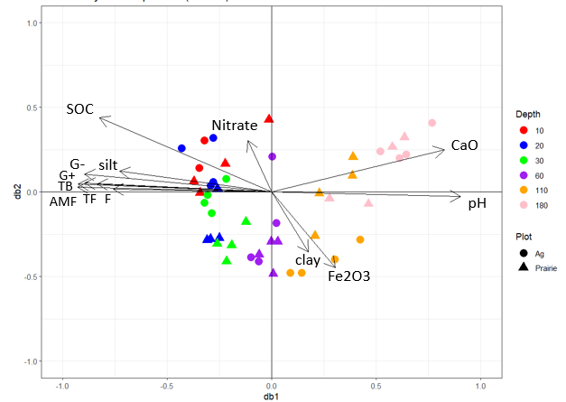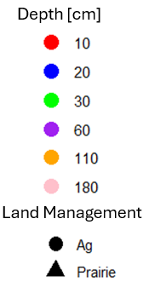
Figure 11:a biplot showing the results for Illinois enzyme activity against all the other soil properties

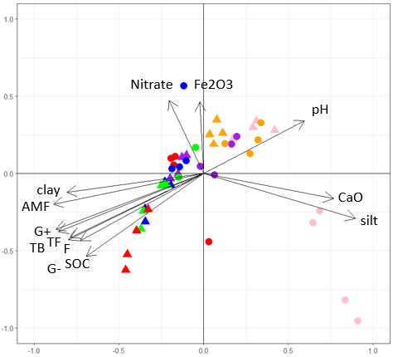
Figure 12:a biplot showing the results for Nebraska enzyme activity against all the other soil properties

systems compared to agricultural systems in both states. Between Illinois and Nebraska’s agricultural system, the activities of α-glucosidase, β-glucosidase, β-D-cellubiosidase, leucine aminopeptidase, phosphatase, and xylosidase showed inconsistent results. The activity of NAG was the only enzyme that was consistently higher in both prairie systems compared to agricultural systems (p<0.01). One possible explanation for why NAG is consistently higher in the prairies is that there might be a nitrogen limitation in the prairie systems compared to agricultural systems, invoking microbes to produce N-acetyl-β-glycosaminidase to target glucosamine which has nitrogen in its amine group. Another possibility is that there might be higher necromass concentrations driven by fungal populations in the prairie systems versus agricultural systems (Liang et al 2019). An additional analysis analyzing necromass concentrations in each plot could elucidate this relationship further. Additional possibilities could be that in the agricultural systems, nitrogen additions are likely to reduce N limitation of microbes, thereby causing less microbes to allocate energy towards N-cycling enzyme production. The prairie systems, conversely, are more nitrogen-limited which require the production of N-cycling enzymes. Another observation following the distance-based redundancy analysis is that there was more clustering of microbial communities in the deeper soil environment. This suggests that land use has a greater impact on microbial communities in the upper soil horizons. The opposite was observed for enzymes, in which land use had less effect on their activity in the surface soil but as soil depth increased, there was greater variability between management systems.
Intensive agriculture was context dependent for carbon cycling enzymes, meaning the initial predictions were incorrect. There were inconclusive results for carbon cycling enzymes β-D-cellubiosidase, xylosidase, α-glucosidase, and β-glucosidase between management systems. This suggests soil depth, a proxy for SOM content, has the largest impact on carbon cycling enzymes, overshadowing land management effects. It is possible that characteristics of increasing soil depth such as less substrate availability and oxygenation might also be overriding land management effects on the activities of enzymes such as β-D-cellubiosidase and xylosidase. This would need to be to be explored further. β-glucosidase and α-glucosidase activities were impacted by plot, depth, and plot by depth (BG), and plot, and depth (AG). Both beta-glucosidase and alpha-glucosidase activity were higher in Nebraska prairie system compared to intensively managed system. This is likely due to plant residues, organic matter, and root biomass which are generally higher in prairies compared to intensively managed agricultural systems. Thereby, supplying more substrates for β- and α-glucosidase enzymes. Opposite results were observed in Illinois in which α-glucosidase and β-glucosidase were higher in the intensively managed agricultural systems compared to prairie systems, suggesting that the activity of these enzymes seems to be influenced by specific mineralogical and weathering differences than just management. In Illinois, silt has greater control on enzyme variability in the upper soil horizons (0-30cm) while clay content has greater control at lower soil depths (110cm). Nebraska demonstrated slightly different results as clay content controlled for enzyme variability around 30-60cm while silt content controlled for this viability at 180cm. A possible explanation for this is that the decrease in enzyme activity associated with clay content is likely the result of enzymes, substrates, organo-mineral interactions, and illuviated clay (Marinari et al., 2021). Clay content has been shown to inhibit the activity of enzymes due to selective sorption of hydrophobic and aromatic compounds such as lipids onto clay mineral surfaces, making them less susceptible to microbial assimilation (Kaiser & Guggenberger, 2000; Marinari et al., 2021). As clay content increases, adsorption of enzymes to soil increases, making them temporarily inactive (Olagoke et al., 2020).Other studies have found similar results in which clay content suppressed the activity of carbon and nitrogen cycling enzymes (Poudel et al., 2024; Ye et al., 2019).
Phosphatase activity was higher in the Nebraska prairie system compared to the agricultural system but showed the opposite trend in Illinois, making the initial predictions for this enzyme incorrect. A possible reason for phosphatase activity being higher in the agricultural system in Illinois compared to prairie system is N amendment. When N is deposited at higher rates, microbes have been shown to invest N into the production of phosphatase. Phosphatase is made up of 15-20% nitrogen by mass (Arenberg & Arai, 2021; Marklein & Houlton, 2011) Therefore, greater N availability can increase the activity of phosphatase. This is supported by a meta-analysis of 279 soils in which total N was shown to be the strongest variable influencing phosphatase activity (Margalef et al., 2017). Nevertheless, the form of nitrogen that influences phosphatase activity remains a source of debate (Arenberg & Arai, 2021). Another possible explanation for the inconsistency between management systems in each state is soil mineralogy and eluvial processes. Results from the dbRDA revealed that in Illinois, silt is the driving variable of enzyme activity in the soil upper horizons (0-30cm) while clay and iron oxide concentrations are more responsible in the deeper soil horizons (110cm). Phosphorus can bind to Fe and Al oxides following transformations in the soil to form stable complexes (Fink et al., 2016). Since Illinois has a wetter climate, one possible explanation is that the tile drain in Illinois’ agricultural system creates a more aerated soil environment, making ferric iron precipitate as iron oxide minerals (hematite, geothite, and ferrihydrite) (Fink et al., 2016). As more iron oxide is in the soil system, P adsorption can be more prevalent which could possibly explain the increase in phosphatase activity in Illinois’ agricultural system. As lower available P increases, there is often more phosphatase produced by soil microorganisms to mineralize organic phosphorus compounds needed for microbial growth (Margelef et al., 2017). A future study incorporating more plots in different regions could expand upon these findings, although the results observed in our study are reliable enough to assume a similar outcome.
In summary, the proposed third and fourth hypotheses were that enzyme activity would decrease with soil depth and be higher in prairies which was mostly correct as the relative and total abundance of enzyme activities did significantly differ from soil surface to 180cm below ground. However, enzyme activities were not necessarily higher in prairie systems compared to agricultural systems in both states. Between Illinois and Nebraska’s agricultural system, the activities of α-glucosidase, β-glucosidase, β-D-cellubiosidase, leucine aminopeptidase, phosphatase, and xylosidase showed inconsistent results. The activity of NAG was the only enzyme that was consistently higher in both prairie systems compared to agricultural systems (p<0.01), potentially the result of nitrogen limitation or necromass concentrations. Phosphatase activity was higher in the Nebraska prairie system compared to the agricultural system but showed the opposite trend in Illinois, making the initial predictions for this enzyme incorrect. In Illinois, silt has greater control on enzyme variability in the upper soil horizons (0-30cm) while clay content has greater control at lower soil depths (110cm). Nebraska demonstrated slightly different results as clay content controlled for enzyme variability around 30-60cm while silt content controlled for this viability at 180cm. This suggests mineralogical and eluvial processes as a control on enzyme production in each state.
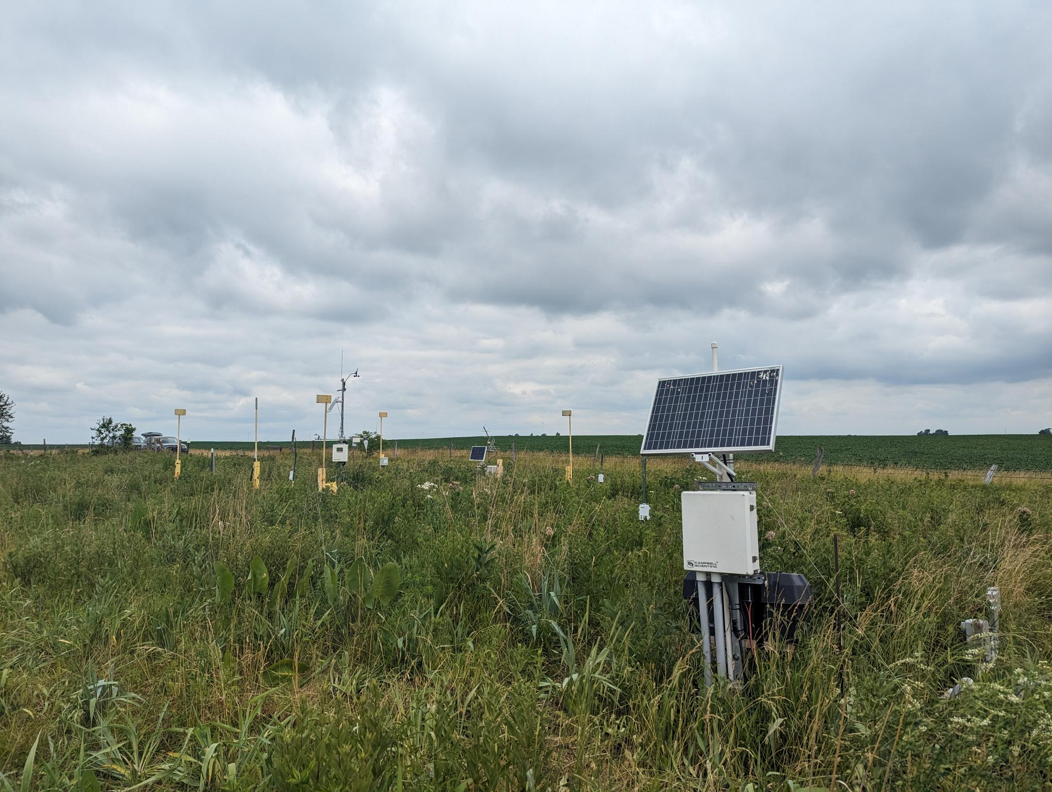
Figure 13: A picture taken at the Sangamon River Forest Preserve in Fisher, Illinois displaying the weather monitoring station as well as the concentration of native tallgrasses growing aboveground.

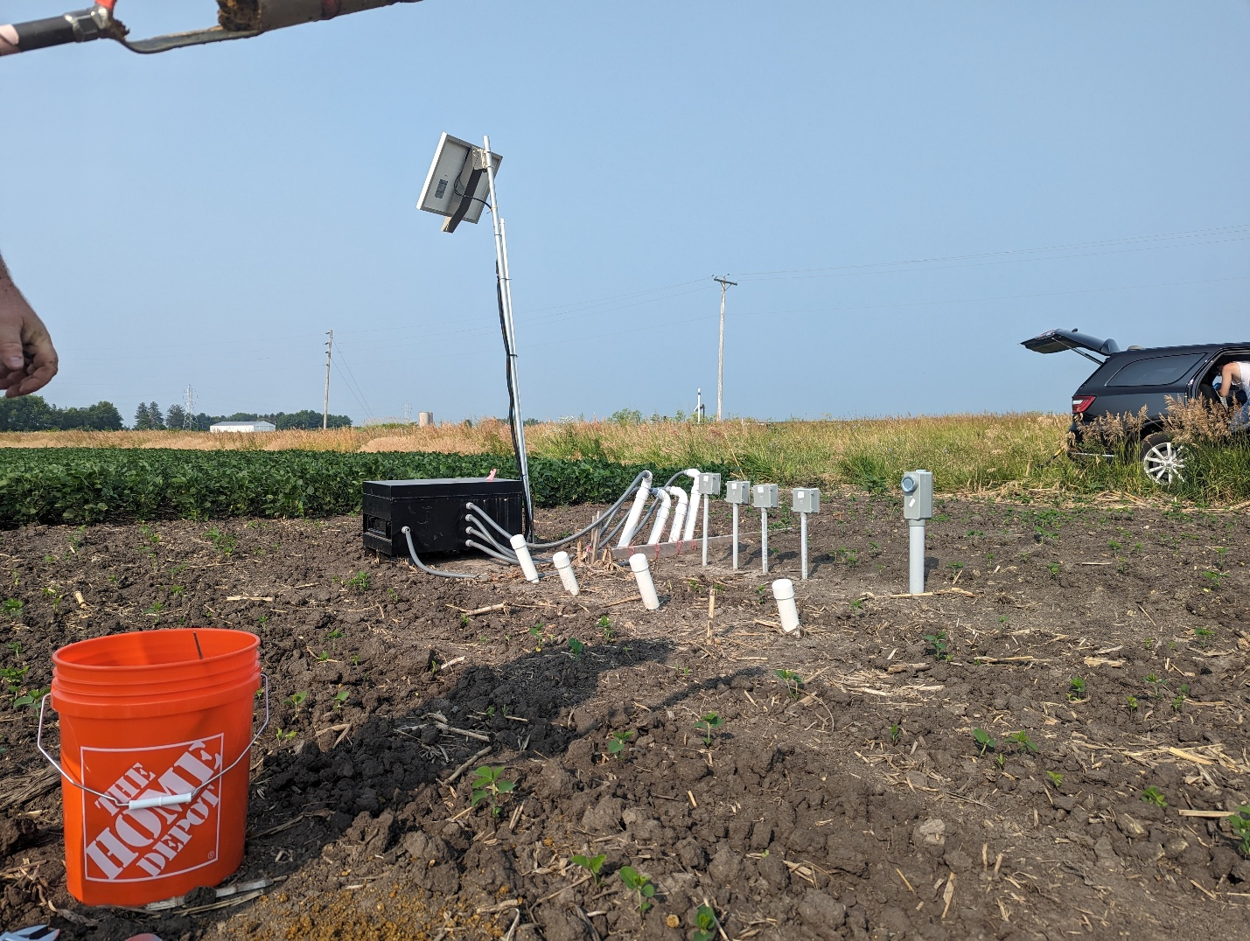
Figure 14: A picture taken of the Allerton Trust Farm in Monticello, Illinois displaying the weather monitoring station along with the soybeans in their early stage of development.

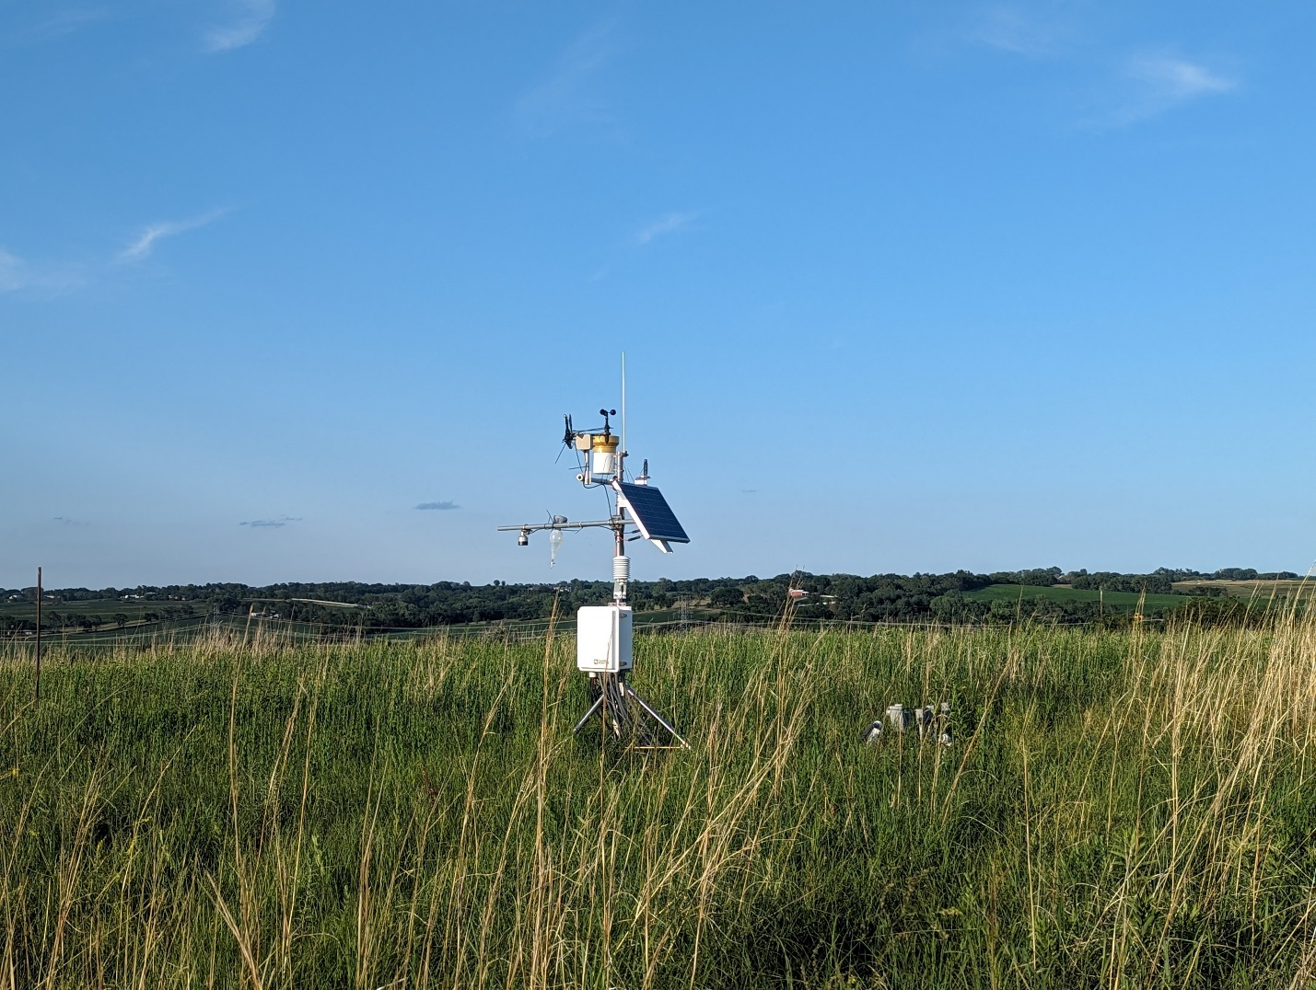
Figure 15: A picture of the Glacier Creek Preserve in Bennington, Nebraska displaying the concentration of native tallgrasses aboveground as well as the weather monitoring station.

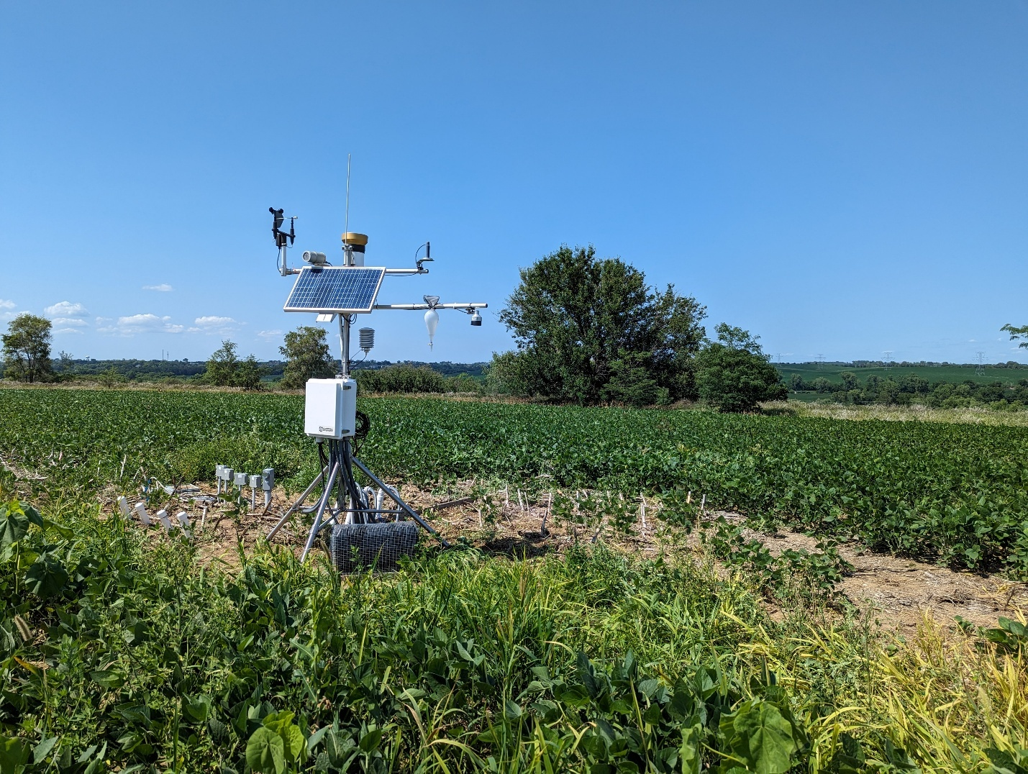
Figure 16: A picture of the Glacier Creek Preserve soybean system in Bennington, Nebraska displaying the early stage soybeans as well as the weather monitoring station.

CHAPTER IV: CONCLUSIONS
Understanding the effects of land management on soil microbial biomarkers and their associated enzymes across soil depth is necessary for sustaining soil health. The results discovered within this research project illustrates the impact of intensification and restored prairie management on microbial communities across soil profiles in the United States Midwest. Restored prairie management revealed higher relative and total abundance of microbial biomarkers than intensively managed agricultural systems in Illinois and Nebraska while hydrolase activity was relatively inconclusive. The hydrolase N-acetyl-β-glucosaminidase was the only enzyme consistently higher in restored prairie systems compared to intensively managed systems. This is potentially the result of N limitation or necromass concentrations in prairie systems versus agricultural systems, although other soil factors such as weathering processes and soil texture may control for this variation as well. Microbial biomarkers and their associated enzymes significantly decreased with soil depth from the soil surface to two meters belowground, likely the result of various environmental factors such as OM concentrations, soil texture, and nutrient limitations in both states. By integrating an extensive list of soil variables including texture, chemical composition, and physical properties, this study explored the role these variables play in shaping biomarker distribution across the active root zone. Few studies have undertaken such a thorough examination of the soil environment at six depth increments across two-meter soil profiles in the United States Midwest.
This study contributes valuable knowledge to our current understanding of soil microbial communities and their associated enzymes in intensively managed agricultural systems. Due to soil heterogeneity and variability within each plot, it is recommended that future studies incorporate more field replicates to further validate our results. Seasonality was originally a component to this research project as it is shown to produce unique and ephemeral conditions that influence microbial community structure and function (Li et al., 2023). However, budget limitations resulted in the exclusion of fall seasonal data from this study as well as carbon use efficiency data for the entire soil profile. Carbon use efficiency for only the 0-10cm depth from each plot was estimated, resulting in the exclusion of this from the research study. Phospholipid fatty acid analysis is also expensive and was subsequently performed on samples from the summer sample collection only. Future studies incorporating more field replicates, analyzing carbon use efficiency across the entire active root zone, and assessing microbial biomarkers across seasons could further enhance the results of this study. These are important considerations that can expand upon the findings within this research project.

REFERENCES
Ahmed, E., Hugerth, L. W., Logue, J. B., Volker Brüchert, Andersson, A. F., & Sara. (2016). Mineral Type Structures Soil Microbial Communities. Geomicrobiology Journal, 34(6), 538–545. https://www.tandfonline.com/doi/full/10.1080/01490451.2016.1225868?scroll=top&needAccess=true#d1e912
Ajwa, H. A., Dell, C. J., & Rice, C. W. (1999). Changes in enzyme activities and microbial biomass of tallgrass prairie soil as related to burning and nitrogen fertilization. Soil Biology and Biochemistry, 31(5), 769–777. https://www.sciencedirect.com/science/article/pii/S0038071798001771
Arenberg, M. R., & Arai, Y. (2021). Nitrogen species specific phosphorus mineralization in temperate floodplain soils. Scientific Reports, 11(1). https://pmc.ncbi.nlm.nih.gov/articles/PMC8408222/
Augustin, C., & Cihacek, L. J. (2016). Relationships Between Soil Carbon and Soil Texture in the Northern Great Plains. Soil Science, 181(8), 386–392. https://journals.lww.com/soilsci/abstract/2016/08000/relationships_between_soil_carbon_and_soil_texture.4.aspx
Babin, D., Ding, G.-C., Pronk, G. J., Heister, K., Kögel-Knabner, I., & Smalla, K. (2013). Metal oxides, clay minerals and charcoal determine the composition of microbial communities in matured artificial soils and their response to phenanthrene. FEMS Microbiology Ecology, 86(1), 3–14. https://pubmed.ncbi.nlm.nih.gov/23336569/
Bach, E. M., Baer, S. G., Meyer, C. K., & Six, J. (2010). Soil texture affects soil microbial and structural recovery during grassland restoration. Soil Biology and Biochemistry, 42(12), 2182–2191. https://www.sciencedirect.com/science/article/abs/pii/S0038071710003020
Badger Hanson, E., & Docherty, K. M. (2022). Mini-review: Current and Future Perspectives on Microbially Focused Restoration Strategies in Tallgrass Prairies. Microbial Ecology. https://link.springer.com/article/10.1007/s00248-022-02150-1
Bakker, J. D. (2024, January 3). RDA and dbRDA. Pressbooks.pub; University of Washington. https://uw.pressbooks.pub/appliedmultivariatestatistics/chapter/rda-and-dbrda/
Bargali, S. (2024, March 1). Soil Microbial Biomass: A Crucial Indicator of Soil Health. Current Agriculture Research Journal, 12(1). https://www.agriculturejournal.org/volume12number1/soil-microbial-biomass-a-crucial-indicator-of-soil-health/
Bhople, P., Keiblinger, K., Djukic, I., Liu, D., Zehetner, F., Zechmeister-Boltenstern, S., Georg Joergensen, R., & Murugan, R. (2021). Microbial necromass formation, enzyme activities and community structure in two alpine elevation gradients with different bedrock types. Geoderma, 386, 114922. https://www.sciencedirect.com/science/article/pii/S001670612032677X#b0270
Błońska, E., Piaszczyk, W., Staszel, K., & Lasota, J. (2021). Enzymatic activity of soils and soil organic matter stabilization as an effect of components released from the decomposition of litter. Applied Soil Ecology, 157, 103723. https://www.sciencedirect.com/science/article/pii/S0929139320306521?via%3Dihub
Börjesson, G., Menichetti, L., Kirchmann, H., & Kätterer, T. (2011). Soil microbial community structure affected by 53 years of nitrogen fertilisation and different organic amendments. Biology and Fertility of Soils, 48(3), 245–257. https://link.springer.com/article/10.1007/s00374-011-0623-8
Brewer, T. E., Aronson, E. L., Arogyaswamy, K., Billings, S. A., Botthoff, J. K., Campbell, A. N., Dove, N. C., Fairbanks, D., Gallery, R. E., Hart, S. C., Kaye, J., King, G., Logan, G., Lohse, K. A., Maltz, M. R., Mayorga, E., O’Neill, C., Owens, S. M., Packman, A., & Pett-Ridge, J. (2019). Ecological and Genomic Attributes of Novel Bacterial Taxa That Thrive in Subsurface Soil Horizons. MBio, 10(5). https://journals.asm.org/doi/full/10.1128/mbio.01318-19
Brookes, P. C., Cayuela, M. L., Contin, M., De Nobili, M., Kemmitt, S. J., & Mondini, C. (2008). The mineralisation of fresh and humified soil organic matter by the soil microbial biomass. Waste Management, 28(4), 716–722. https://www.sciencedirect.com/science/article/pii/S0956053X07003182?casa_token=6rnKQkioaosAAAAA:KtbPp1tSXVnRf2WIJFbP-rDI2M4rS4axPYr0d9CuXRNColmN3td6fWiZ13rmTrlGZRnltqqcug
Carvalho, C. D., & Maria-José Caramujo. (2014). Fatty Acids as a Tool to Understand Microbial Diversity and Their Role in Food Webs of Mediterranean Temporary Ponds. Molecules, 19(5), 5570–5598. https://pmc.ncbi.nlm.nih.gov/articles/PMC6271346/
Cenini, V. L., Fornara, D. A., McMullan, G., Ternan, N., Lajtha, K., & Crawley, M. J. (2015). Chronic nitrogen fertilization and carbon sequestration in grassland soils: evidence of a microbial enzyme link. Biogeochemistry, 126(3), 301–313. https://link.springer.com/article/10.1007/s10533-015-0157-5
Climate Change in Illinois – Illinois State Climatologist. (2024). https://stateclimatologist.web.illinois.edu/climate-change-in-illinois/
Cuadros, J. (2017). Clay minerals interaction with microorganisms: a review. Clay Minerals, 52(2), 235–261. https://www.cambridge.org/core/journals/clay-minerals/article/clay-minerals-interaction-with-microorganisms-a-review/789BB08298385580F07B83BFCDF221D8
Daunoras, J., Kačergius, A., & Gudiukaitė, R. (2024). Role of Soil Microbiota Enzymes in Soil Health and Activity Changes Depending on Climate Change and the Type of Soil Ecosystem. Biology, 13(2), 85. https://pmc.ncbi.nlm.nih.gov/articles/PMC10886310/
Davies, B., Coulter, J. A., & Pagliari, P. H. (2022). Soil Enzyme Activity Behavior after Urea Nitrogen Application. Plants, 11(17), 2247. https://pmc.ncbi.nlm.nih.gov/articles/PMC9460541/
de Graaff, M.-A., Hornslein, N., Throop, H. L., Kardol, P., & van Diepen, L. T. A. (2019, January 1). Chapter One - Effects of agricultural intensification on soil biodiversity and implications for ecosystem functioning: A meta-analysis (D. L. Sparks, Ed.). ScienceDirect; Academic Press. https://www.sciencedirect.com/science/article/pii/S0065211319300136
Dong, H., Jaisi, D., Kim, J., & Zhang., G. Microbe-clay mineral interactions. American Mineralogist, 94, 1505-1519. file:///C:/Users/itwin/Downloads/10.2138_am.2009.3246.pdf
Dugan, J.T. & Zelt, R.B.(2000). Simulation and Analysis of Soil-Water Conditions in the Great Plains and Adjacent Areas, Central United States, 1951-80. https://pubs.usgs.gov/wsp/2427/report.pdf
Eilers, K. G., Debenport, S., Anderson, S., & Fierer, N. (2012). Digging deeper to find unique microbial communities: The strong effect of depth on the structure of bacterial and archaeal communities in soil. Soil Biology and Biochemistry, 50, 58–65. Digging deeper to find unique microbial communities: The strong effect of depth on the structure of bacterial and archaeal communities in soil - ScienceDirect
England, L. S., Lee, H., & Trevors, J. T. (1993). Bacterial survival in soil: Effect of clays and protozoa. Soil Biology and Biochemistry, 25(5), 525–531. https://www.sciencedirect.com/science/article/pii/003807179390189I
Farm Income | Center for Agricultural Profitability | Nebraska. (2024). https://cap.unl.edu/farm-income/
Fierer, N., Schimel, J. P., & Holden, P. A. (2003). Variations in microbial community composition through two soil depth profiles. Soil Biology and Biochemistry, 35(1), 167–176. Variations in microbial community comeilerposition through two soil depth profiles - ScienceDirect
Fomina, M., & Skorochod, I. (2020). Microbial Interaction with Clay Minerals and Its Environmental and Biotechnological Implications. Minerals, 10(10), 861. https://www.mdpi.com/2075-163X/10/10/861
Frenk, S., Ben-Moshe, T., Dror, I., Berkowitz, B., & Minz, D. (2013). Effect of Metal Oxide Nanoparticles on Microbial Community Structure and Function in Two Different Soil Types. PLoS ONE, 8(12), e84441. https://journals.plos.org/plosone/article?id=10.1371/journal.pone.0084441
Frey, B., Kremer, J., Rüdt, A., Sciacca, S., Matthies, D., & Lüscher, P. (2009). Compaction of forest soils with heavy logging machinery affects soil bacterial community structure. European Journal of Soil Biology, 45(4), 312–320. https://www.sciencedirect.com/science/article/abs/pii/S1164556309000466
Gao, H., Hrachowitz, M., Wang-Erlandsson, L., Fabrizio Fenicia, Xi, Q., Xia, J., Shao, W., Sun, G., & Hubert. (2024). Root zone in the Earth system. Hydrology and Earth System Sciences, 28(19), 4477–4499.
Glacier Creek Preserve. (2023, January 19). College of Arts & Sciences. https://www.unomaha.edu/college-of-arts-and-sciences/nature-preserves/preserves/index.php
Glass, N., Molano‐Flores, B., Dias, E., Meraz, E., Umar, S., Whelan, C. J., & Gonzàlez-Meler, M. A. (2021). Does Pastoral Land-Use Legacy Influence Topsoil Carbon and Nitrogen Accrual Rates in Tallgrass Prairie Restorations? Land, 10(7), 735–735. Land | Free Full-Text | Does Pastoral Land-Use Legacy Influence Topsoil Carbon and Nitrogen Accrual Rates in Tallgrass Prairie Restorations? (mdpi.com)
Han, C., Chen, L., Xin, X., Zhou, G., Zhang, C., Ma, D., Li, Y., Ma, L., & Zhang, J. (2023). Long-term fertilization affects microbial necromass accumulation by regulating nutrient and enzymatic stoichiometry in a calcareous Fluvisol. Applied Soil Ecology, 194, 105169. https://www.sciencedirect.com/science/article/abs/pii/S0929139323003670#bb0200
Hanberry, B., Reeves, M., Brischke, A., Hannemann, M., Hudson, T., Mayberry, R., Ojima, D., Prendeville, H., & Rangwala, I. (n.d.). Managing Effects of Drought in the Great Plains. https://www.fs.usda.gov/research/publications/gtr/gtr_wo98/gtr_wo98_chapter7.pdf
Harrison, R. B., Footen, P. W., & Strahm, B. D. (2011). Deep Soil Horizons: Contribution and Importance to Soil Carbon Pools and in Assessing Whole-Ecosystem Response to Management and Global Change. Forest Science, 57(1), 67–76. https://www.researchgate.net/publication/233592416_Deep_Soil_Horizons_Contribution_and_Importance_to_Soil_Carbon_Pools_and_in_Assessing_Whole-Ecosystem_Response_to_Management_and_Global_Change
Havlin, J.L., Tisdale, S.L., Nelson, W.L., & Beaton, J.D. (2013). Soil Fertility and Fertilizers: An Introduction to Nutrient Management (8). Pearson Education, Inc.
He, J., He, Y., Gao, W., Chen, Y., Ma, G., Ji, R., & Liu, X. (2022). Soil depth and agricultural irrigation activities drive variation in microbial abundance and nitrogen cycling. CATENA, 219, 106596.
Hoorman, J. (2016, June 6). Role of Soil Bacteria. Ohioline. https://ohioline.osu.edu/factsheet/anr-36
Illinois Department of Agriculture. (2025). Facts About Illinois Agriculture. Agr.illinois.gov. https://agr.illinois.gov/about/facts-about-illinois-agriculture.html
Jia, N., Li, L., Guo, H., & Xie, M. (2024). Important role of Fe oxides in global soil carbon stabilization and stocks. Nature Communications, 15(1). https://www.nature.com/articles/s41467-024-54832-8
Jia, X., Zhong, Y., Liu, J., Zhu, G., Shangguan, Z., & Yan, W. (2020). Effects of nitrogen enrichment on soil microbial characteristics: From biomass to enzyme activities. Geoderma, 366, 114256. https://www.sciencedirect.com/science/article/pii/S0016706120300604
Jin, Z., Zhu, Y., Li, X., Dong, Y., & An, Z. (2015). Soil N retention and nitrate leaching in three types of dunes in the Mu Us desert of China. Scientific Reports, 5(1). https://www.nature.com/articles/srep14222
Kaiser, K., & Guggenberger, G. (2000). The role of DOM sorption to mineral surfaces in the preservation of organic matter in soils. Organic Geochemistry, 31(7-8), 711–725. https://www.sciencedirect.com/science/article/pii/S0146638000000462
Kallenbach, C., & Grandy, A. S. (2011). Controls over soil microbial biomass responses to carbon amendments in agricultural systems: A meta-analysis. Agriculture, Ecosystems & Environment, 144(1), 241–252. https://www.sciencedirect.com/science/article/pii/S0167880911003240?casa_token=iUqiYcWGhpwAAAAA:KsID8-IfFhVtVyq_PX1E8LaeMxJpjnyNyKfW-ixzfscq7P8MCyjXfZtYxVSaj8aTRVfTaooaFg
Kemmerling, L., Rutkoski, C. E., Evans, S. E., Helms IV, J. A., Cordova-Ortiz, E.S., Smith, J. D., Vazquez Custodio, J.A., Vizza, C., Haddad, N. M. (2022). Prairie Strips and Lower Land Use Intensity Increase Biodiversity and Ecosystem Services. Frontiers in Ecology and Evolution, 10, https://www.frontiersin.org/articles/10.3389/fevo.2022.833170/full
Kuila, D., & Ghosh, S. (2022). Aspects, problems and utilization of Arbuscular Mycorrhizal (AM) application as bio-fertilizer in sustainable agriculture. Current Research in Microbial Sciences, 3, 100107. https://pmc.ncbi.nlm.nih.gov/articles/PMC8829076/
Lennon, J. T. (2020). Microbial Life Deep Underfoot. MBio, 11(1). https://journals.asm.org/doi/full/10.1128/mbio.03201-19
Leucine Aminopeptidase - Worthington Enzyme Manual | Worthington Biochemical. (n.d.). https://www.worthington-biochem.com/products/leucine-aminopeptidase/manual
Li, H., & White, J. A. (2024). Conservation Value to Bats: Assessing Multiple Functional Habitats in a Nature Preserve at the Urban-Agricultural Interface via Temporal Ecology. Sustainability, 16(7), 2858. Conservation Value to Bats: Assessing Multiple Functional Habitats in a Nature Preserve at the Urban-Agricultural Interface via Temporal Ecology
Liang, C., Amelung, W., Lehmann, J., & Kästner, M. (2019). Quantitative assessment of microbial necromass contribution to soil organic matter. Global Change Biology, 25(11), 3578–3590. https://onlinelibrary.wiley.com/doi/full/10.1111/gcb.14781
Liang, C., Schimel, J. P., & Jastrow, J. D. (2017). The importance of anabolism in microbial control over soil carbon storage. Nature Microbiology, 2(8). https://www.nature.com/articles/nmicrobiol2017105
Liu, M., Gan, B., Li, Q., Xiao, W., & Song, X. (2022). Effects of Nitrogen and Phosphorus Addition on Soil Extracellular Enzyme Activity and Stoichiometry in Chinese Fir (Cunninghamia lanceolata) Forests. Frontiers in Plant Science, 13. https://www.frontiersin.org/journals/plant-science/articles/10.3389/fpls.2022.834184/full
Liu, T., Wu, X., Li, H., Ning, C., Li, Y., Zhang, X., He, J., Filimonenko, E., Chen, S., Chen, X., Gibson, D. J., Kuzyakov, Y., & Yan, W. (2022). Soil quality and r – K fungal communities in plantations after conversion from subtropical forest. CATENA, 219, 106584. https://www.sciencedirect.com/science/article/pii/S0341816222005707
Lu, X., Lu, X., & Liao, Y. (2018). Effect of Tillage Treatment on the Diversity of Soil Arbuscular Mycorrhizal Fungal and Soil Aggregate-Associated Carbon Content. Frontiers in Microbiology, 9. https://www.frontiersin.org/journals/microbiology/articles/10.3389/fmicb.2018.02986/full
Ma, F., Wang, C., Zhang, Y., Chen, J., Xie, R., & Sun, Z. (2022). Development of Microbial Indicators in Ecological Systems. International Journal of Environmental Research and Public Health, 19(21), 13888. https://www.mdpi.com/1660-4601/19/21/13888
Mackelprang, R., Grube, A. M., Lamendella, R., Jesus, E. da C., Copeland, A., Liang, C., Jackson, R. D., Rice, C. W., Kapucija, S., Parsa, B., Tringe, S. G., Tiedje, J. M., & Jansson, J. K. (2018). Microbial Community Structure and Functional Potential in Cultivated and Native Tallgrass Prairie Soils of the Midwestern United States. Frontiers in Microbiology, 9. https://www.frontiersin.org/journals/microbiology/articles/10.3389/fmicb.2018.01775/full
Major Elements by ICP, Lithium Metaborate Fusion Method. (2019, April 17). USGS. https://www.usgs.gov/media/files/major-elements-icp-lithium-metaborate-fusion-method
Margalef, O., Sardans, J., Fernández-Martínez, M., Molowny-Horas, R., Janssens, I. A., Ciais, P., Goll, D., Richter, A., Obersteiner, M., Asensio, D., & Peñuelas, J. (2017). Global patterns of phosphatase activity in natural soils. Scientific Reports, 7. https://www.nature.com/articles/s41598-017-01418-8
Marklein, A. R., & Houlton, B. Z. (2011). Nitrogen inputs accelerate phosphorus cycling rates across a wide variety of terrestrial ecosystems. New Phytologist, 193(3), 696–704. https://nph.onlinelibrary.wiley.com/doi/10.1111/j.1469-8137.2011.03967.x#b41
Marinari, S., Marabottini, R., Falsone, G., Vianello, G., Vittori Antisari, L., Agnelli, A., Massaccesi, L., Cocco, S., Cardelli, V., Serrani, D., & Corti, G. (2021). Mineral weathering and lessivage affect microbial community and enzyme activity in mountain soils. Applied Soil Ecology, 167, 104024.https://www.sciencedirect.com/science/article/pii/S092913932100144X
Maron, P.-A., Sarr, A., Kaisermann, A., Lévêque, J., Mathieu, O., Guigue, J., Karimi, B., Bernard, L., Dequiedt, S., Terrat, S., Chabbi, A., & Ranjard, L. (2018). High Microbial Diversity Promotes Soil Ecosystem Functioning. Applied and Environmental Microbiology, 84(9). https://pmc.ncbi.nlm.nih.gov/articles/PMC5930326/
Naylor, D., McClure, R., & Jansson, J. (2022). Trends in Microbial Community Composition and Function by Soil Depth. Microorganisms, 10(3), 540. https://pmc.ncbi.nlm.nih.gov/articles/PMC8954175/
Neira, J., Ortiz, M., Morales, L., & Acevedo, E. (2015). Oxygen diffusion in soils: Understanding the factors and processes needed for modeling. Chilean Journal of Agricultural Research, 75, 35–44. https://www.scielo.cl/scielo.php?script=sci_arttext&pid=S0718-58392015000300005
Olagoke, F. K., Kaiser, K., Mikutta, R., Kalbitz, K., & Vogel, C. (2020). Persistent Activities of Extracellular Enzymes Adsorbed to Soil Minerals. Microorganisms, 8(11), 1796. https://pmc.ncbi.nlm.nih.gov/articles/PMC7698205/
Philippot, L., Chenu, C., Kappler, A., Rillig, M. C., & Fierer, N. (2023). The interplay between microbial communities and soil properties. Nature Reviews Microbiology, 22, 1–14. https://www.nature.com/articles/s41579-023-00980-5
Poeplau, C., & Don, A. (2013). Sensitivity of soil organic carbon stocks and fractions to different land-use changes across Europe. Geoderma, 192, 189–201. https://www.sciencedirect.com/science/article/pii/S0016706112002984
Pratima Poudel, Ye, R., & Binaya Parajuli. (2024). Clay soil amendment suppressed microbial enzymatic activities while increasing nitrogen availability in sandy soils. Soil Science Society of America Journal. https://acsess.onlinelibrary.wiley.com/doi/full/10.1002/saj2.20731
Reeves, J. L., & Liebig, M. A. (2016). Depth Matters: Soil pH and Dilution Effects in the Northern Great Plains. Soil Science Society of America Journal, 80(5), 1424–1427. https://acsess.onlinelibrary.wiley.com/doi/epdf/10.2136/sssaj2016.02.0036n
Rousk, J., & Frey, S. D. (2015). Revisiting the hypothesis that fungal-to-bacterial dominance characterizes turnover of soil organic matter and nutrients. Ecological Monographs, 85(3), 457–472. https://harvardforest1.fas.harvard.edu/publications/pdfs/Rousk_EcoMono_2015.pdf
Saikia, R. (2017). Soil Enzyme Activity as Affected by Tillage and Residue Management Practices under Diverse Cropping Systems. International Journal of Current Microbiology and Applied Sciences, 6(10), 1211–1218. https://www.ijcmas.com/6-10-2017/Rituparna%20Saikia%20and%20Sandeep%20Sharma.pdf
Sapkota, A. (2020, November 13). Microbial degradation of cellulose (Enzymes, Steps, Mechanisms). Microbe Notes. https://microbenotes.com/microbial-degradation-of-cellulose/
Sasser, M. (2006). Bacterial Identification by Gas Chromatographic Analysis of Fatty Acid Methyl Esters (GC-FAME). MIDI. https://gcms.cz/labrulez-bucket-strapi-h3hsga3/paper/MIS_Technote_101.pdf
Schimel, J. P., & Bennett, J. (2004). NITROGEN MINERALIZATION: CHALLENGES OF A CHANGING PARADIGM. Ecology, 85(3), 591–602. https://esajournals.onlinelibrary.wiley.com/doi/epdf/10.1890/03-8002?saml_referrer
Sharma, S. K., Ramesh, A., Sharma, M. P., Joshi, O. P., Govaerts, B., Steenwerth, K. L., & Karlen, D. L. (2010). Microbial Community Structure and Diversity as Indicators for Evaluating Soil Quality. Sustainable Agriculture Reviews, 317–358. https://link.springer.com/chapter/10.1007/978-90-481-9513-8_11
Shayeb Shahariar, Helgason, B., Raju Soolanayakanahally, & Bedard-Haughn, A. (2021). Soil Enzyme Activity as Affected by Land-Use, Salinity, and Groundwater Fluctuations in Wetland Soils of the Prairie Pothole Region. Wetlands, 41(2). https://link.springer.com/article/10.1007/s13157-021-01431-8
Shen, C., Wang, J., He, J.-Z., Yu, F.-H., & Ge, Y. (2021). Plant Diversity Enhances Soil Fungal Diversity and Microbial Resistance to Plant Invasion. Applied and Environmental Microbiology, 87(11). https://journals.asm.org/doi/full/10.1128/aem.00251-21
Siles, J. A., Vera, A., Díaz-López, M., García, C., van, Crowther, T. W., Eisenhauer, N., Guerra, C., Jones, A., Orgiazzi, A., Delgado-Baquerizo, M., & Bastida, F. (2023). Land-use- and climate-mediated variations in soil bacterial and fungal biomass across Europe and their driving factors. Geoderma, 434, 116474–116474. https://www.sciencedirect.com/science/article/pii/S0016706123001519
Sinsabaugh, R. S. (1994). Enzymic analysis of microbial pattern and process. Biology and Fertility of Soils, 17(1), 69–74. https://link.springer.com/article/10.1007/bf00418675
Six, J., Frey, S. D., Thiet, R. K., & Batten, K. M. (2006). Bacterial and Fungal Contributions to Carbon Sequestration in Agroecosystems. Soil Science Society of America Journal, 70(2), 555–569. https://acsess.onlinelibrary.wiley.com/doi/full/10.2136/sssaj2004.0347
Soil & Soil Health Analysis - Ward Laboratories, Inc. (2025, May 6). Ward Laboratories, Inc. https://www.wardlab.com/services/soil-health-analysis/
Stone, M. M., DeForest, J. L., & Plante, A. F. (2014). Changes in extracellular enzyme activity and microbial community structure with soil depth at the Luquillo Critical Zone Observatory. Soil Biology and Biochemistry, 75, 237–247. https://www.sciencedirect.com/science/article/pii/S0038071714001370?casa_token=deZ2It83J48AAAAA:Hr7pyoEqZfqctLuthQWLHb4bp8kAwzymkz7LGVYX8s4Q7Wly6B_KfuNDfD1FqqSRRPS7YpR4YA
Sünnemann, M., Alt, C., Kostin, J. E., Lochner, A., Reitz, T., Siebert, J., Schädler, M., & Eisenhauer, N. (2021). Low‐intensity land‐use enhances soil microbial activity, biomass and fungal‐to‐bacterial ratio in current and future climates. 58(11), 2614–2625. https://besjournals.onlinelibrary.wiley.com/doi/full/10.1111/1365-2664.14004
S. Uroz, Marie Pierre Turpault, Delaruelle, C., Mareschal, L., Jean-Claude Pierrat, & Pascale Frey-Klett. (2012). Minerals Affect the Specific Diversity of Forest Soil Bacterial Communities. Geomicrobiology Journal, 29(1), 88–98. https://www.tandfonline.com/doi/10.1080/01490451.2010.523764
USDA. (2017, October 19). Agriculture in the Midwest | USDA Climate Hubs. Usda.gov. https://www.climatehubs.usda.gov/hubs/midwest/topic/agriculture-midwest
Walter, K., Don, A., Tiemeyer, B., & Freibauer, A. (2016). Determining Soil Bulk Density for Carbon Stock Calculations: A Systematic Method Comparison. Soil Science Society of America Journal, 80(3), 579–591. https://acsess.onlinelibrary.wiley.com/doi/full/10.2136/sssaj2015.11.0407
Wang, Z., Miao, Y., & Li, S. (2015). Effect of ammonium and nitrate nitrogen fertilizers on wheat yield in relation to accumulated nitrate at different depths of soil in drylands of China. Field Crops Research, 183, 211–224. https://www.sciencedirect.com/science/article/abs/pii/S0378429015300253
Wang, Q., Liang, A., Chen, X., Zhang, S., Zhang, Y., McLaughlin, N. B., Gao, Y., & Jia, S. (2021). The impact of cropping system, tillage and season on shaping soil fungal community in a long-term field trial. European Journal of Soil Biology, 102, 103253. https://www.sciencedirect.com/science/article/pii/S116455632030323X
Wang, H., Cai, T., Tian, X., Chen, Z., He, K., Wang, Z., Gong, H., Miao, Q., Wang, Y., Chu, Y., Zhang, Q., Zhuang, M., Yin, Y., & Cui, Z. (2022). Global patterns of soil organic carbon distribution in the 20–100 cm soil profile for different ecosystems: a global meta-analysis. Earth System Science Data, 17(7), 3375–3390. https://www.sciencedirect.com/science/article/abs/pii/S0341816222004647
Wang, Y., Zhang, P., Sun, H., Jia, X., Zhang, C., Liu, S., & Shao, M. (2022). Vertical patterns and controlling factors of soil nitrogen in deep profiles on the Loess Plateau of China. 215, 106318–106318. https://www.sciencedirect.com/science/article/pii/S0341816222003046
Wen, L., Peng, Y., Zhou, Y., Cai, G., Lin, Y., & Li, B. (2023). Effects of conservation tillage on soil enzyme activities of global cultivated land: A meta-analysis. Journal of Environmental Management, 345, 118904 118904. https://www.sciencedirect.com/science/article/pii/S0301479723016924
Wilschefski, S.C., & Baxter, M.R. (2019). Inductively Coupled Plasma Mass Spectrometry: Introduction to Analytical Aspects. Clinical Biochemist Reviews, 40(3), 115-133. https://pmc.ncbi.nlm.gov/articles/PMC6719745/#sec55

Xu, H., Zhang, D., Tang, Y., Dai, L., Kong, W., & Li, X. (2023). Response of soil oxides in complex terrain region to environment revealed by hyperspectral observations. Frontiers in Environmental Science, 11. https://www.frontiersin.org/journals/environmental-science/articles/10.3389/fenvs.2023.1138177/full
Ye, R., Parajuli, B., & Sigua, G. (2019). Subsurface Clay Soil Application Improved Aggregate Stability, Nitrogen Availability, and Organic Carbon Preservation in Degraded Ultisols with Cover Crop Mixtures. Soil Science Society of America Journal, 83(3), 597–604. https://acsess.onlinelibrary.wiley.com/doi/abs/10.2136/sssaj2018.12.0496
Yu, K., van den Hoogen, J., Wang, Z., Averill, C., Routh, D., Smith, G. R., Drenovsky, R. E., Scow, K. M., Mo, F., Waldrop, M. P., Yang, Y., Tang, W., De Vries, F. T., Bardgett, R. D., Manning, P., Bastida, F., Baer, S. G., Bach, E. M., García, C., & Wang, Q. (2022). The biogeography of relative abundance of soil fungi versus bacteria in surface topsoil. Earth System Science Data, 14(9), 4339–4350. https://essd.copernicus.org/articles/14/4339/2022/
Zheng, H., Liu, W., Zheng, J., Luo, Y., Li, R., Wang, H., & Qi, H. (2018). Effect of long-term tillage on soil aggregates and aggregate-associated carbon in black soil of Northeast China. PloS One, 13(6), e0199523. https://pmc.ncbi.nlm.nih.gov/articles/PMC6023111/
2023 farm income projections for Nebraska producers. (n.d.). Center for Agricultural Profitability. 2023 farm income projections for Nebraska producers | Center for Agricultural Profitability

APPENDICES
Table 21: Selected Physical and Chemical Characteristics of Soils
Soil | Depth (cm) | pH | Bulk Density | Texture | %sand | %silt | %clay | %SOC
ILAG | 0-10 | 5.53625 | 1.28 | Silt Loam | 17 | 56.5 | 26.5 | 0.02575
ILAG | 10-20 | 5.53625 | 1.37 | Clay Loam | 21 | 44 | 35 | 0.022375
ILAG | 20-30 | 5.83425 | 1.325 | Silty Clay Loam | 18 | 48 | 34 | 0.014375
ILAG | 55-65 | 6.22375 | 6.22375 | Silty Clay Loam | 17 | 46 | 37 | 0.005125
ILAG | 105-115 | 7.4225 | 7.4225 | Clay Loam | 25 | 44 | 31 | 0.0025
ILAG | 175-185 | 7.75625 | 7.75625 | Loam | 52 | 28 | 20 | 0.00125
ILPR | 0-10 | 5.44625 | 1.01 | Loam | 31.5 | 42.5 | 26 | 0.025875
ILPR | 10-20 | 5.15825 | 1.27 | Silty Clay Loam | 17 | 50 | 33 | 0.019625
ILPR | 20-30 | 5.17125 | 1.305 | Silty Clay Loam | 18 | 48 | 34 | 0.015
ILPR | 55-65 | 6.338 | 1.46 | Clay | 27 | 22 | 51 | 0.00475
ILPR | 105-115 | 7.80875 | 1.65 | Loam | 25 | 36 | 39 | 0.002625
ILPR | 175-185 | 7.90825 | 1.64 | Clay | 34 | 10 | 56 | 0.002
NEAG | 0-10 | 5.62125 | 1.065 | Silty Clay Loam | 14 | 53 | 33 | 0.004125
NEAG | 10-20 | 5.165 | 1.29 | Clay Loam | 21 | 50 | 29 | 0.0125
NEAG | 20-30 | 5.14125 | 1.21 | Clay Loam | 21 | 48 | 31 | 0.00675
NEAG | 55-65 | 5.4025 | 1.09 | Clay Loam | 17 | 55 | 28 | 0.004375
NEAG | 105-115 | 5.73075 | 1.03 | Silt Loam | 16 | 58 | 26 | 0.002375
NEAG | 175-185 | 6.06625 | 1.07 | Silt Loam | 12 | 64 | 24 | 0.002
NEPR | 0-10 | 4.28875 | 1.19 | Silty Clay Loam | 17 | 52 | 31 | 0.02925
NEPR | 10-20 | 4.74875 | 1.13 | Silty Clay Loam | 13 | 52 | 35 | 0.01575
NEPR | 20-30 | 5.15075 | 1.18 | Clay Loam | 21 | 48 | 31 | 0.01125
NEPR | 55-65 | 6.08125 | 1.14 | Clay Loam | 19 | 50.5 | 30.5 | 0.005125

Table 21: Continued
NEPR | 105-115 | 6.5475 | 1.17 | Loam | 21 | 52 | 27 | 0.00275

NEPR | 175-185 | 7.72375 | 1.14 | Silty Clay Loam | 16 | 56 | 28 | 0.002

Table 22: Selected Chemical Properties of Soil
Soil | Depth (cm) | Al2O3 | Fe2O3 | NO3-N | NH4-N | PLFA (pmolsg-1)
ILAG | 0-10 | 9.67 | 3025 | 3.083119 | 0.288213 | 86296
ILAG | 10-20 | 9.74 | 3.09 | 2.059924 | 0.363518 | 63030.5
ILAG | 20-30 | 9.98 | 3.22 | 1.663292 | 0.250519 | 45937.25
ILAG | 55-65 | 12.1 | 3.805 | 2.639095 | 0.183169 | 27753
ILAG | 105-115 | 12.06 | 3.55 | 1.72785 | 0.2510504 | 22718.25
ILAG | 175-185 | 7.71 | 3.07 | 1.596309 | -0.49016 | 9406
ILPR | 0-10 | 9.565 | 3.565 | 1.677943 | -0.10615 | 167644
ILPR | 10-20 | 9.75 | 3.54 | 1.74546 | 0.600751 | 106979.8
ILPR | 20-30 | 11.42 | 4.54 | 1.848227 | 0.079113 | 70158.75
ILPR | 55-65 | 14.15 | 5.735 | 1.868703 | -0.14533 | 29416.25
ILPR | 105-115 | 11.42 | 4.54 | 2.228281 | 0.004978 | 19426.25
ILPR | 175-185 | 11.36 | 4.89 | 1.947325 | -0.03726 | 9695.25
NEAG | 0-10 | 11.7 | 4.15 | 4.833436 | 0.507744 | 72316.75
NEAG | 10-20 | 12.4 | 4.44 | 4.349737 | 0.740118 | 34378
NEAG | 20-30 | 11.98 | 4.26 | 8.869531 | 0.364118 | 35911.75
NEAG | 55-65 | 12.18 | 4.39 | 3.456314 | 0.622952 | 31484.75
NEAG | 105-115 | 11.67 | 4.22 | 0.159324 | 0.670757 | 23877
NEAG | 175-185 | 11.34 | 4.1 | -0.36772 | 0.381805 | 16138.75
NEPR | 0-10 | 11.05 | 3.85 | 1.805753 | 11.34787 | 215147.5
NEPR | 10-20 | 11.66 | 4.1 | 1.33148 | 1.560862 | 135240.3
NEPR | 20-30 | 12.5 | 4.58 | 1.256161 | 1.381672 | 76677.25
NEPR | 55-65 | 12.265 | 4.405 | 1.187575 | 0.08674 | 41529.25
NEPR | 105-115 | 12.22 | 4.33 | 1.208405 | 0.075174 | 24128.75
NEPR | 175-185 | 12.19 | 4.31 | 1.21933 | 0.17153 | 15889
Table 23: F Value for Microbes Between Management in Illinois and Nebraska
State | Depth | AMFungi | Fungi | Gram Positive | Gram Negative | Actinomycetes | Total Bacteria | Total Fungi
IL | 0-10 | 25.858 | 9.5702 | 40.148 | 45.528 | 22.834 | 44.358 | 17.084
IL | 10-20 | 9.7122 | 12.508 | 36.497 | 8.7805 | 45.759 | 21.234 | 18.756
IL | 20-30 | 14.438 | 15.631 | 4.883 | 5.7032 | 2.5869 | 4.7256 | 33.021
IL | 55-65 | 0.979 | 3.7849 | 0.1902 | 1.4945 | 0.2102 | 0.5808 | 3.8263
IL | 105-115 | 3.9143 | 0.2662 | 1.655 | 1.7831 | 1.7271 | 1.7372 | 2.5483
IL | 175-185 | 2.6667 | 0.6961 | 2.3578 | 2.3564 | 2.2331 | 0.2301 | 0.0636
NE | 0-10 | 117.15 | 19.84 | 283.82 | 338.07 | 166.6 | 295.86 | 83.012
NE | 10-20 | 132.99 | 45.726 | 167.47 | 152.13 | 123.87 | 199.63 | 100.06
NE | 20-30 | 54.951 | 100.7 | 18.762 | 13.839 | 27.505 | 20.284 | 127.88
NE | 55-65 | 26.053 | 14.795 | 5.1561 | 2.7463 | 14.405 | 6.7993 | 21.663
NE | 105-115 | 4.0746 | 0.1474 | 0.2624 | 0.8979 | 1.0235 | 0.0368 | 0.5289
NE | 175-185 | 9.9817 | 11.898 | 17.536 | 0.0005 | 18.38 | 4.1544 | 120.02

Table 24: F Values for Enzymes Between Management in Illinois and Nebraska
State | Depth | AB | BG | CB | LAP | NAG | PHOS | XYL
IL | 0-10 | 8.484 | 1.8414 | 0.8907 | 7.7597 | 0.1413 | 7.5958 | 0.212
IL | 10-20 | 16.001 | 9.131 | 0.0025 | 0.1308 | 28.11 | 44.81 | 0.1238
IL | 20-30 | 12.433 | 25.788 | 7.9422 | 4.0808 | 0.9217 | 3.4544 | 3.9465
IL | 55-65 | 0.81 | 31.345 | 7.1008 | NA | 25.746 | 0.1242 | 0.0027
IL | 105-115 | 0.5672 | 4.0414 | 1.9859 | NA | 12.199 | 0.1631 | 4.7691
IL | 175-185 | 0.6715 | 1.8823 |  | NA | 61.722 | 0.0002 | 0.8516
NE | 0-10 | 2.613 | 316.71 | 114.52 | 4.4433 | 29.309 | 82.054 | 5.5846
NE | 10-20 | 0.1449 | 32.355 | 22.129 | 3.9367 | 84.048 | 0.022 | 9.8408
NE | 20-30 | 0.3106 | 2.3652 | 14.414 | 25797 | 34.29 | 27.822 | 2.0742
NE | 55-65 | 12.958 | 0.522 | 132.13 | NA | 60.255 | 18.177 | 2.2787
NE | 105-115 | 8.6702 | 8.9346 | 0.5909 | NA | 48.092 | 7.9554 | 0.5951
NE | 175-185 | 26.447 | 74.871 | 0.0288 | NA | 65.201 | 22.438 | 16.222

Table 25: P Values for Microbes Between Management Systems in Illinois and Nebraska
State | Depth | AMFungi | Fungi | Gram Positive | Gram Negative | Actinomycetes | Total Bacteria | Total Fungi
IL | 0-10 | 0.002254 | 0.02129 | 0.000723 | 0.000517 | 0.003068 | 0.000554 | 0.006124
IL | 10-20 | 0.02068 | 0.01227 | 0.00093 | 0.02518 | 0.00051 | 0.003661 | 0.004924
IL | 20-30 | 0.00897 | 0.007507 | 0.06917 | 0.05416 | 0.1589 | 0.07268 | 0.001208
IL | 55-65 | 0.3607 | 0.09968 | 0.678 | 0.2674 | 0.6628 | 0.4749 | 0.09823
IL | 105-115 | 0.09523 | 0.6243 | 0.2457 | 0.2302 | 0.2368 | 0.2356 | 0.1615
IL | 175-185 | 0.1778 | 0.451 | 0.1995 | 0.1996 | 0.2094 | 0.6484 | 0.8093
NE | 0-10 | 0.00003682 | 0.004309 | 0.000002795 | 0.000001668 | 0.0000133 | 0.000002473 | 0.00009823
NE | 10-20 | 0.00002556 | 0.0005106 | 0.0000131 | 0.00001732 | 0.00003137 | 0.00000785 | 0.00005782
NE | 20-30 | 0.00031 | 0.00005678 | 0.004921 | 0.009852 | 0.00193 | 0.004088 | 0.00002861
NE | 55-65 | 0.002212 | 0.008495 | 0.06361 | 0.1486 | 0.009017 | 0.04025 | 0.003488
NE | 105-115 | 0.09008 | 0.7143 | 0.6268 | 0.3799 | 0.3507 | 0.8542 | 0.4945
NE | 175-185 | 0.01958 | 0.01364 | 0.005765 | 0.9833 | 0.005165 | 0.08766 | 3.44E-05

Table 26: P Values For Enzymes Between Management Systems in Illinois and Nebraska
State | Depth | AB | BG | CB | LAP | NAG | PHOS | XYL
IL | 0-10 | 0.02688 | 0.2236 | 0.3817 | 0.0796 | 0.7199 | 0.03303 | 0.6645
IL | 10-20 | 0.007118 | 0.02334 | 0.9616 | 0.104 | 0.001827 | 0.0005391 | 0.737
IL | 20-30 | 0.01243 | 0.00227 | 0.03043 | 0.1594 | 0.3741 | 0.1124 | .09416
IL | 55-65 | 0.4028 | 0.001383 | 0.03729 | NA | 0.002279 | 0.7366 | 0.9606
IL | 105-115 | 0.4799 | 0.09111 | 0.2084 | NA | 0.01294 | 0.7003 | 0.07168
IL | 175-185 | 0.4439 | 0.2192 | 0.8708 | NA | 0.000225 | 0.9893 | 0.3917
NE | 0-10 | 0.157 | 0.000002023 | 0.0000393 | 0.0796 | 0.001642 | 0.0001015 | 0.05604
NE | 10-20 | 0.7166 | 0.001274 | 0.003312 | 0.104 | 0.00009485 | 0.887 | 0.02014
NE | 20-30 | 0.5975 | 0.175 | 0.009003 | 0.1594 | 0.001095 | 0.001875 | 0.1999
NE | 55-65 | 0.01137 | 0.4972 | 0.00002604 | NA | 0.0002404 | 0.005301 | 0.1819
NE | 105-115 | 0.0258 | 0.02435 | 0.4712 | NA | 0.000446 | 0.03033 | 0.4697
NE | 175-185 | 0.002131 | 0.000131 | 0.8708 | NA | 0.000193 | 0.003202 | 0.006899

Additional Microbial Biomarker Plots
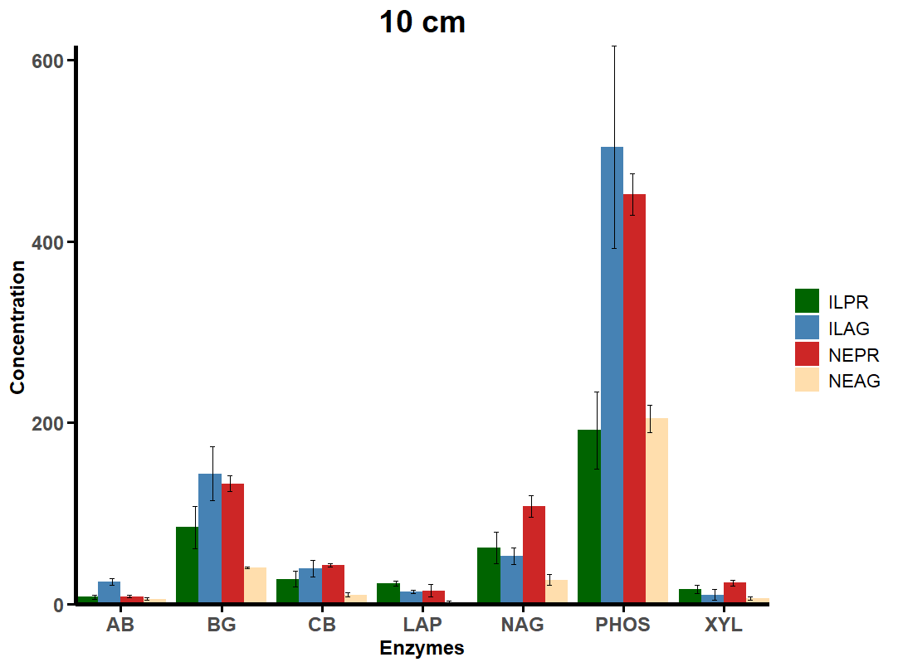

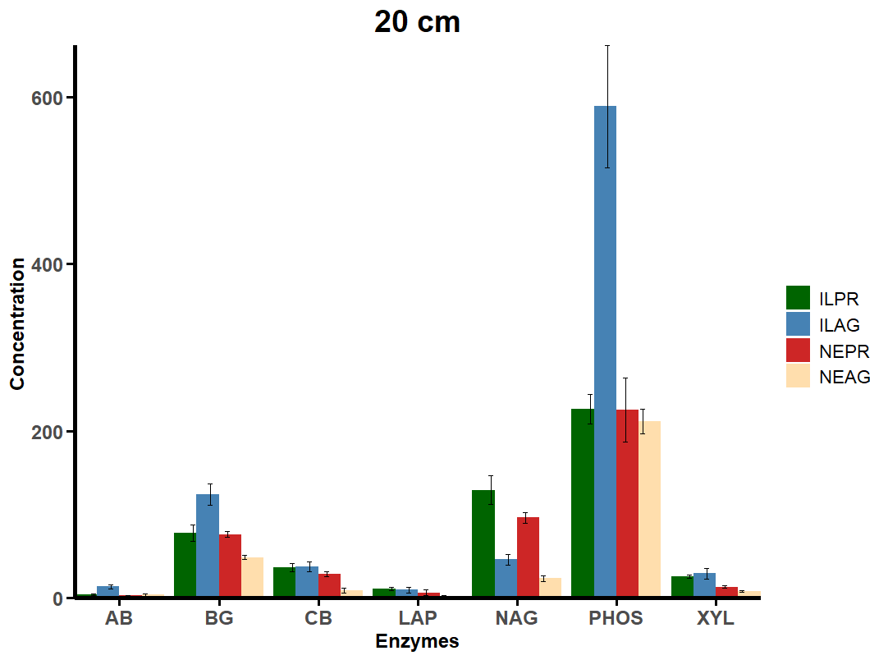

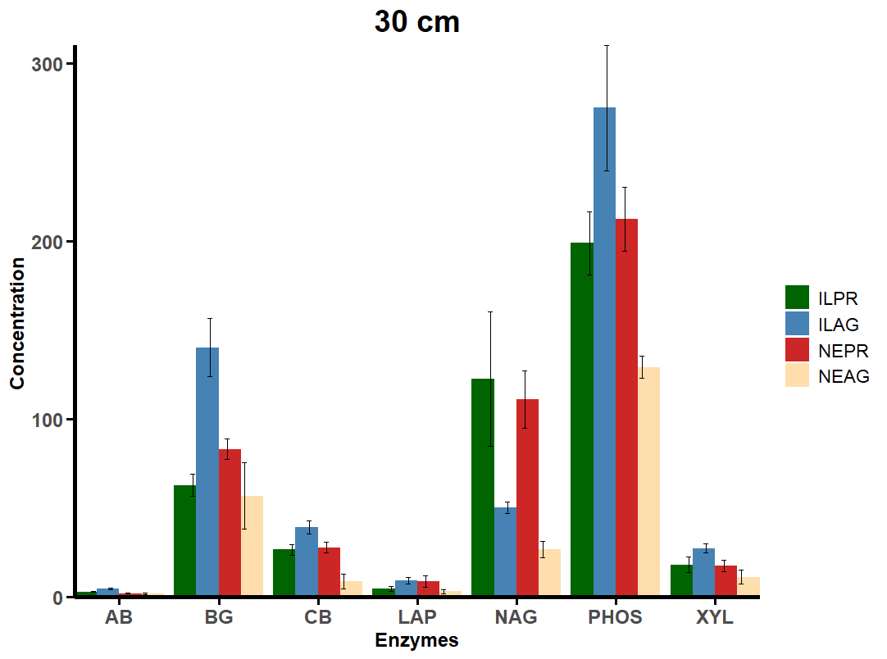

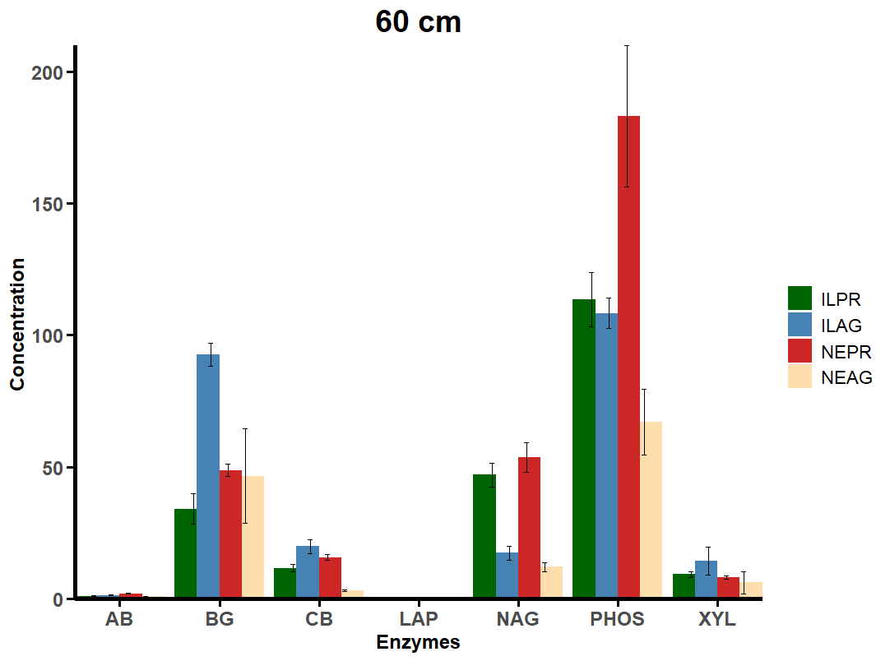

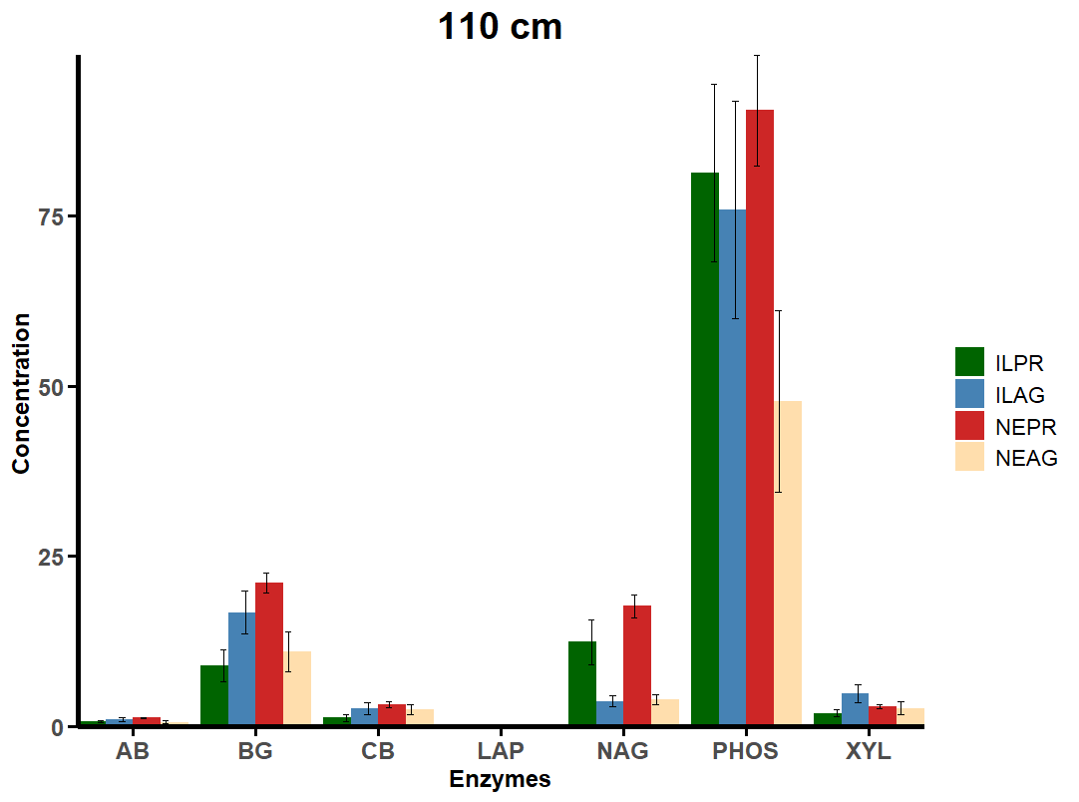

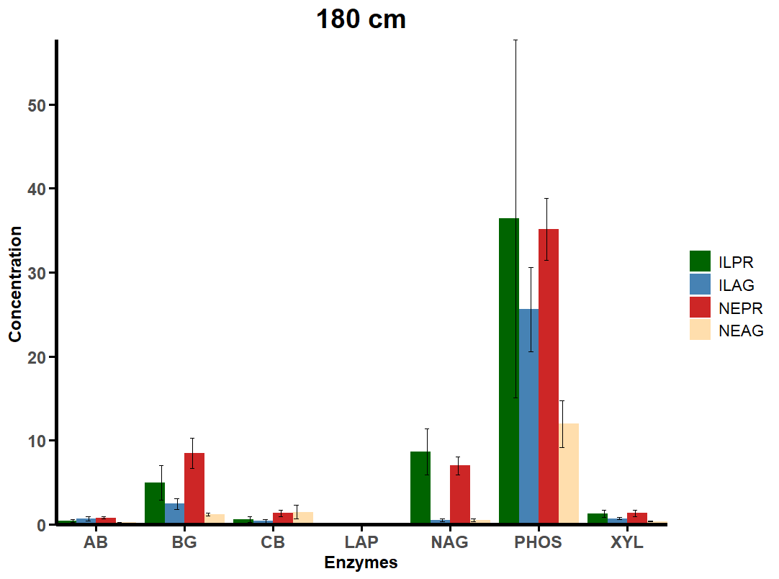

Additional Microbial Biomarker Concentration Plots
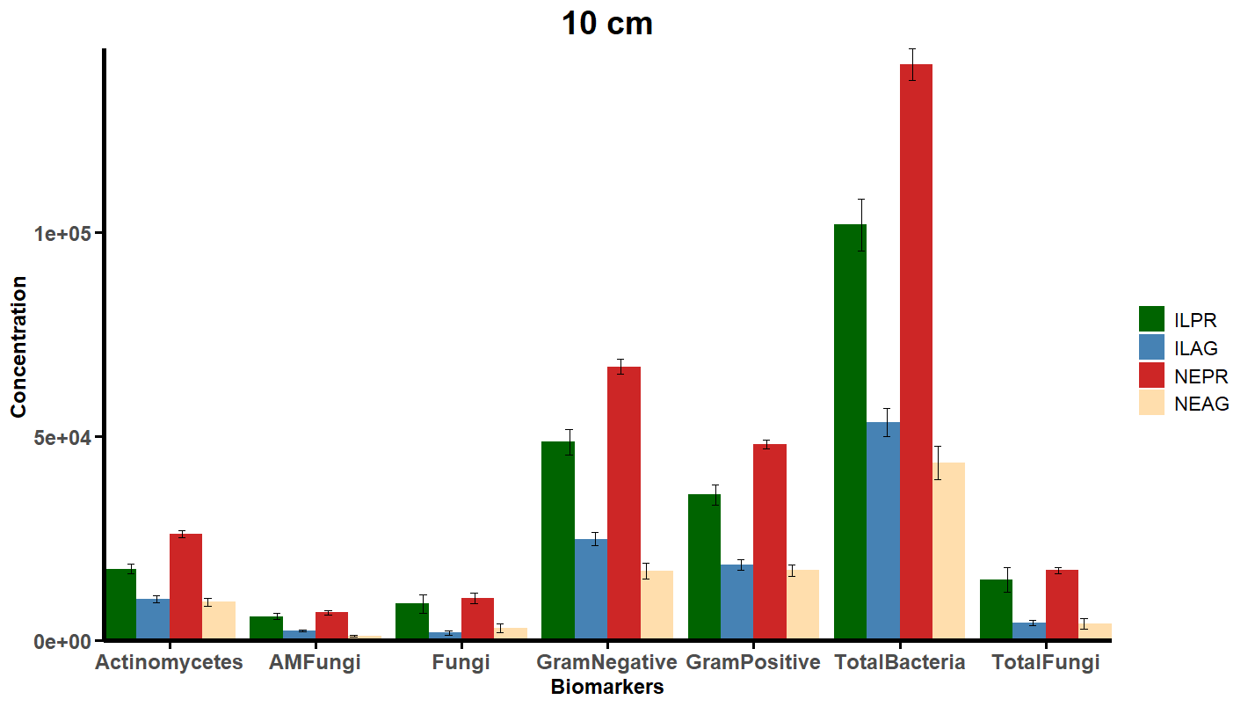

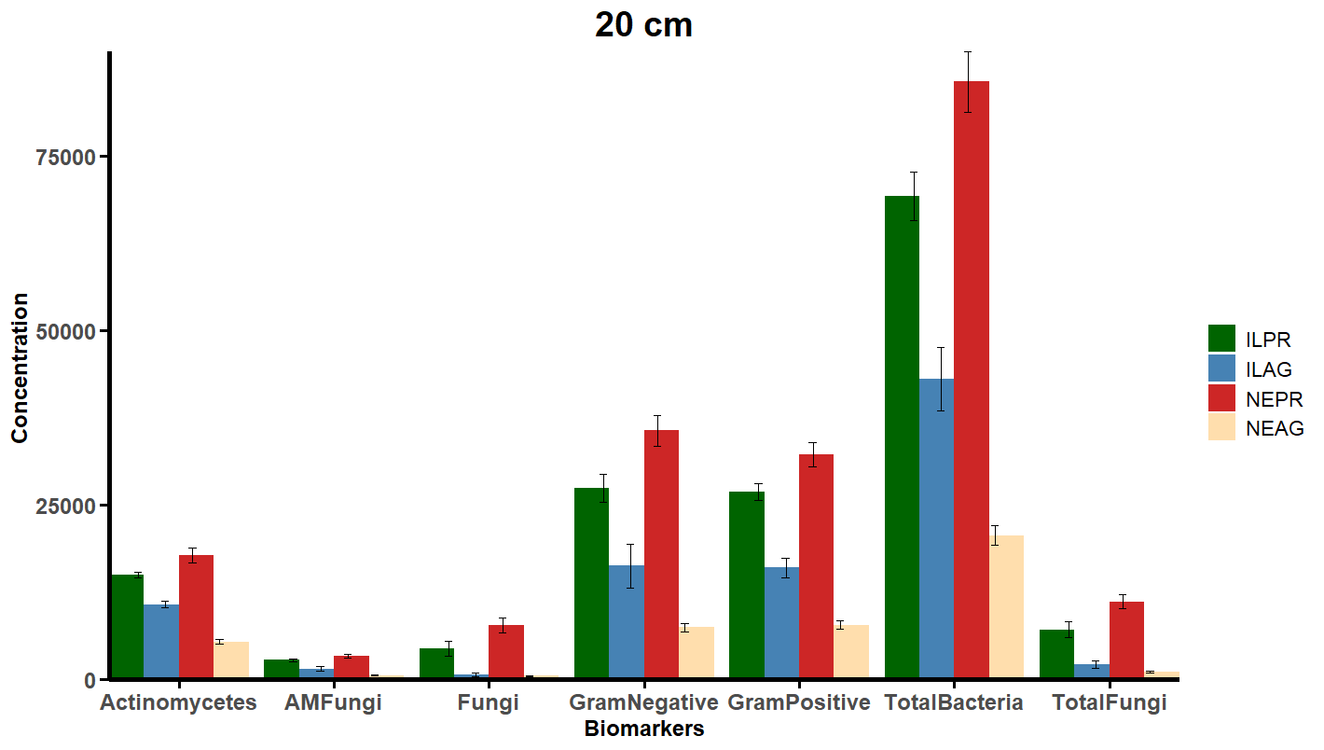

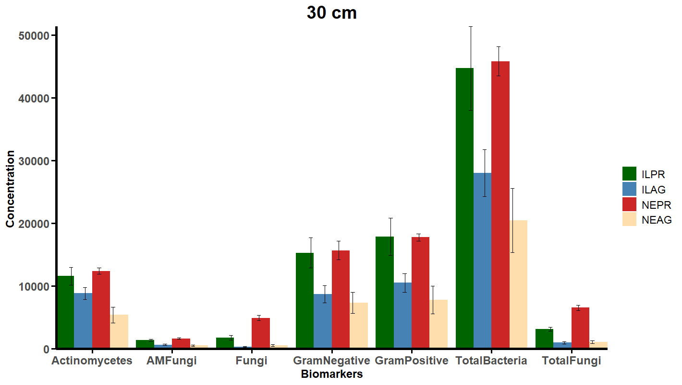

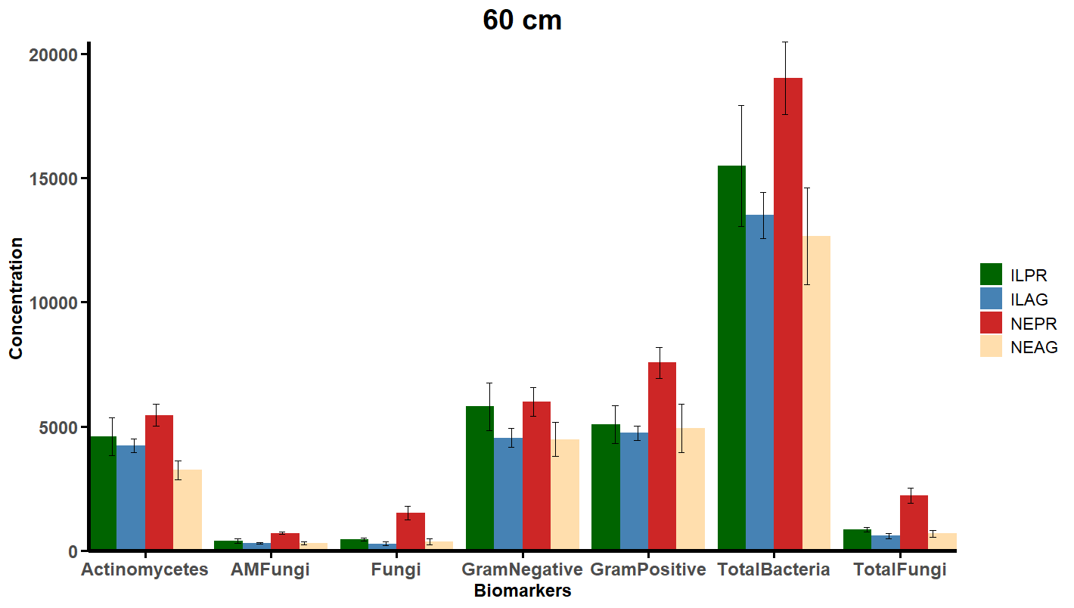

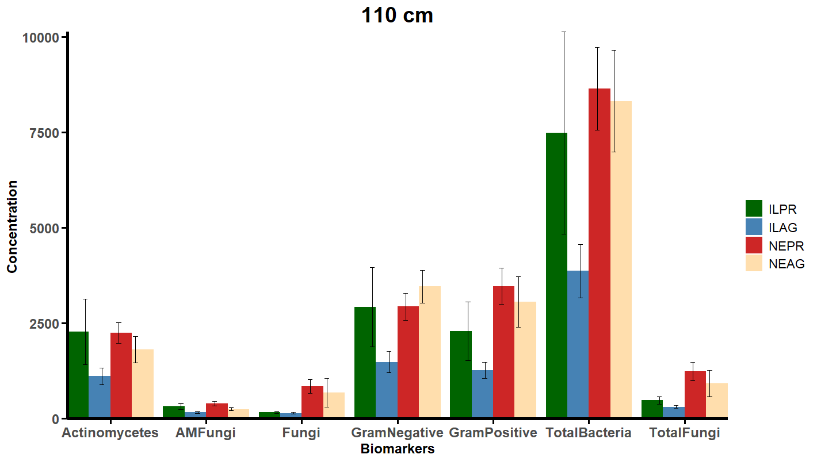

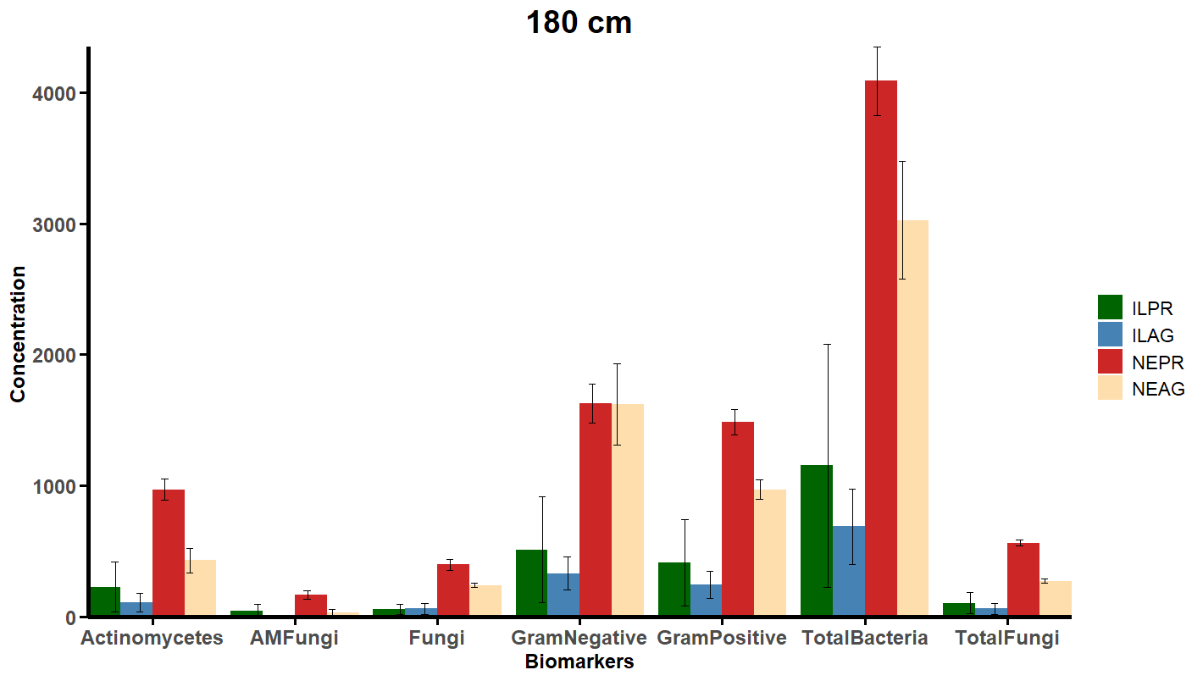

Correlation Matrix
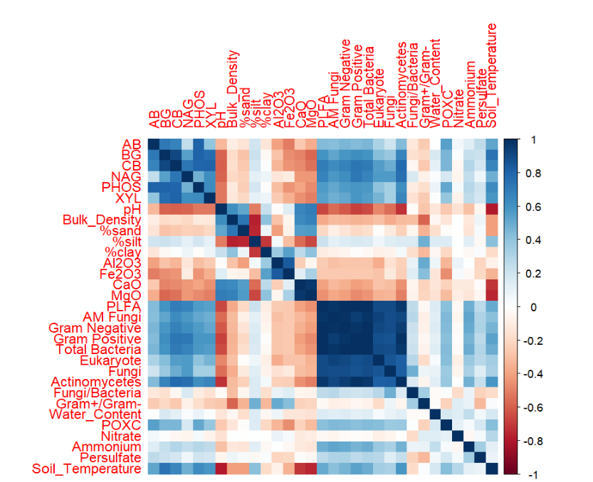
This plot does not account for multi-collinearity.

Vita
Morgan Isaacs was born in South Carolina and raised for a time in Huntsville, Alabama before settling in Knoxville, Tennessee. She received her Bachelor of Science in Environmental and Soil Science with a concentration in Environmental Science from the University of Tennessee, Knoxville in December of 2022. She continued her education at the University of Tennessee, Knoxville in Environmental and Soil Science under the supervision of her advisor Dr. Sean Schaeffer. Morgan graduated with her Master of Science in Environmental and Soil Science in August 2025.

