Obesity in Society: The Importance of Perception

A Thesis Presented for the
Master of Arts
Degree
The University of Tennessee, Knoxville

Michael Darnell Oliver II
May 2016

Copyright © 2016 by Michael Darnell Oliver II
All rights reserved.

ABSTRACT
In the current study, I examined the role of positive and negative media images of obese individuals on attitudes and physiological responding in relation to an actual discrimination incident. Various surveys were administered and Body Mass Index (BMI), salivary Alpha Amylase (sAA), and Galvanic Skin Response (GSR) or Skin Conductance (SC) were measured. Participants read a vignette in which an obese individual was discriminated against and further questions were administered to assess attributional blame. My primary hypothesis in this study was that there would be a decrease in stigma due to positive priming, specifically stigma directed at the obese population. Results indicated that only the self-report measure of Need to Belong showed differences among the priming groups as individuals in the positive group reported higher need to belong prior to study manipulation. There were no significant differences between the priming groups in relation to sex for sAA. However, there was a time x priming interaction in which sAA increased post-stressor, regardless of group. Individuals in the negative priming group exhibited the highest overall response post-stressor, indicating more reactivity to the stressor. With regard to Skin Conductance, all participants displayed a decrease in arousal post stressor. More importantly, participants in the negative priming group were less aroused than their counterparts, as measured by SC change scores. There was also a time x priming x sex 3-way interaction on SC. Finally, there were no observable differences between groups on their written responses to the vignette. Collectively, these findings suggest that priming affects physiological responding to obesity stigmatization and further validates the use of sAA and SC as markers of SNS activation in response to psychosocial stress.

TABLE OF CONTENTS
Chapter Page

I Introduction and General Information 1-18

II Methods 19-24

III Results 25-30

IV Discussion 31-40

References 41

Appendices 52

Vita 104

LIST OF TABLES
Table Page
Table 1: Descriptive Statistics for the Survey Questionnaires 53
Table 2: Descriptive Statistics for the pre- and post-stressor physiological measures 54
Table 3: Descriptive Statistics for Sex of study participants 55
Table 4: Descriptive Statistics for Race of study participants 56
Table 5: Descriptive Statistics for Body Mass Index category of all participants 57
Table 6: Descriptive Statistics for Normal vs. Overweight comparison of 58
study participants

Table 7: Descriptive Statistics for Priming Group assignment of study participants 59
Table 8: Descriptive Statistics for Demographic Variables for the study participants 60
Table 9: Independent Samples T-test of priming group on dependent measures 61
Table 10: Means and Standard Deviations of Normal vs. Overweight classification 62
on survey questionnaires

Table 11: Correlation between study surveys and BMI 63
Table 12: Means and Standard Deviations of sAA by Priming Group 64
Table 13: 2 x 2 x 2 Repeated Measures ANOVA for sAA (between-groups) 65
Table 14: 2 x 2 x 2 Repeated Measures ANOVA for sAA (within-groups) 66
Table 15: Paired Samples T-test for sAA by positive priming group 67
Table 16: Paired Samples T-test for sAA by negative priming group 68
Table 17: Paired Samples T-test for sAA for all study participants 69
Table 18: One-way ANOVA for change scores in sAA 70
Table 19: Means and Standard Deviations of SC by Priming Group 71
Table 20: 2 x 2 x 2 Repeated Measures ANOVA for sAA (between-groups) 72
Table 21: 2 x 2 x 2 Repeated Measures ANOVA for SC (within-groups) 73
Table 22: Paired Samples T-test for SC by positive priming group 74
Table 23: Paired Samples T-test for SC by negative priming group 75

Table 24: One-way ANOVA for change scores in SC 76
Table 25: Paired Samples T-test for SC for all study participants 77
Table 26: Correlation between physiological measures 78
Table 27: Chi-Square Tests for the Priming manipulation for Individual wronged 79
Table 28: Chi-Square Tests for the Priming manipulation for Extent wronged 80
Table 29: Chi-Square Tests for the Priming manipulation by attributional blame 81
Table 30: Chi-Square Tests for the Priming manipulation by attributional blame 82
on individual

Table 31: Chi-Square Tests for the Priming manipulation by attributional blame 83
on airline
Table 32: Chi Square Results for all vignette questions 84
Table 33: Means and Standard Deviations of sAA by Sex 85
Table 34: Paired Samples T-Tests of sAA and SC Males 86
Table 35: Means and Standard Deviations of SC by Sex 87
Table 36: Paired Samples T-Tests of sAA and SC Females 88

LIST OF FIGURES
Figure Page
Figure 1. Pie Chart of racial breakdown of all study participants 89
Figure 2. Histogram of BMI for all study participants 90
Figure 3. Categorical Histogram of BMI for all study participants 91
Figure 4. Scatterplot of participant PSS Total by BMI 92
Figure 5. Scatterplot of participant Fat Phobic Attitudes by BMI 93
Figure 6. Scatterplot of participant NTB Total by BMI 94
Figure 7. Scatterplot of participant SE Total by BMI 95
Figure 8. Bar Graph of pre- and post- stressor mean sAA by Priming Group 96
Figure 9. Bar Graph of pre- and post- stressor mean sAA by Sex 97
Figure 10. Bar Graph of pre- and post- stressor mean SC by Sex 98
Figure 11. Bar Graph of pre- and post-stressor mean SC by Priming Group 99
Figure 12. Bar Graph of pre- and post- stressor means for SC 100
Figure 13. Time x Sex x Priming Group 3-way interaction for SC 101

CHAPTER I
Introduction and General Information
Obesity is defined by the Mayo Clinic as a complex disorder involving an excessive amount of body fat that increases one’s risk for diseases such as: heart disease, diabetes, and high blood pressure. Studies show that in 2011-2012, more than one-third of adults and approximately one-fifth of children and adolescents in the United States were obese (e.g. Ogden, Carroll, Kit, & Flegal, 2014). This translates to approximately 79 million adults and 13 million children. With millions of United States citizens classified as obese, coupled with the known negative health implications, there is no wonder why obesity is receiving so much attention at the state and national levels. Not only are the numbers of obese individuals increasing, but the estimated annual medical cost of obesity is also substantially increasing as health professionals attempt to combat, prevent, and treat obesity-related medical conditions. For example, in 2008, $147 billion was spent on obesity related issues (Finkelstein, Trogdon, Cohen, & Dietz, 2009).
With obesity rates on the rise, discrimination directed toward this vulnerable population is also becoming more and more ubiquitous. Hilbert, Rief, & Braehler (2008) conducted a study in which telephone interviews were used in order to assess stigmatizing attitudes and causal attributions of obesity. They found that the most significant predictor of stigmatizating attitudes was in fact, personal causal attributions of obesity. The authors concluded that in order to reduce stigma, a necessary strategy should be initiated to highlight the clinical relevance of obesity in terms of genetic causation as opposed to the common belief of only personal causes to obesity.
There is abundant news coverage surrounding obesity-related issues as of late, and what should be done to reduce the “problem of obesity” in American society. Obesity is a societal issue that is not portrayed very positively in the media. Obesity has even been referred to as “fattertainment” in the media, and there are numerous shows on television that are focused around the concept of obesity (Heuer, n.d.). NBC’s The Biggest Loser, FOX’s More to Love, and CBS’s Mike and Molly are a few prime examples. Other examples of people being mocked in society because of their weight are depicted in movies such as: The Nutty Professor, Fat Albert, Big Momma, and Click. In all of the aforementioned movies, actors dress up in “fat suits” to portray an overweight character for entertainment purposes. Negative portrayals often facilitate the stigmatization of obesity in today’s society. Hollywood tends not to portray obese individuals in romantic roles; however, they are often cast in supporting roles.
Previous research shows that exposure to discrimination can elicit negative psychological (Ahern, Stuber, & Galea, 2007; Major & O’Brien, 2005; Prelow, Mosher, & Bowman, 2006) and physiological (Gee et al., 2006; Sawyer et al., 2012) effects on individual well-being. Unfortunately, individuals are discriminated against in society every day for numerous reasons. Race, gender, sexual preference, ethnic origin, height, and weight are some of the prime examples. Discrimination threatens overall well-being. Well-being is defined as the state of being happy, healthy, or successful (Merriam-Webster's Collegiate Dictionary, 2003). Development of depression (Torres & Ong, 2010), lower life satisfaction (Saini, 2014), decreases in self-esteem (Verkuyten, 1998), elevated blood pressure (Lewis et al., 2009) and dysregulations of stress response systems in the body (Zeiders, Hoyt, & Adam, 2014) are some of the detrimental effects social discrimination places on individual well-being.

Concept of Well-being
Well-being is defined in various ways depending on the specific area of focus. For example, in psychological methodology, the study of well-being tends to focus on the individual and the internal meaning of self and self-worth, whereas in the medical literature, the approach tends to be concentrated more on physical health and health promotion (de Chavez, Backett-Milburn, Parry, & Platt, 2005). However, being that the phenomenon is so broad, no specific universal definition has been established. Although most disciplines are biased toward aspects of well-being that pertain to their respective area (de Chavez, Backett-Milburn, Parry, & Platt, 2005), a couple of definitions of well-being have emerged over the past few years that have attempted to be more universal across various disciplines.
In the literature review by Ryan & Deci (2001), two approaches to psychological well-being are discussed: hedonic (e.g. high positive affect) and eudaimonic (e.g. feelings of belongingness). Both of these approaches have been widely utilized in the literature based on the seemingly all-encompassing elements of their respective definitions. The hedonic well-being approach focuses on happiness and defines well-being in terms of pleasure attainment and pain avoidance. The eudaimonic approach focuses its’ attention on meaning and self-realization and defines well-being in terms of the degree in which a person is fully functioning (Ryan & Deci, 2001). The field of Psychology often emphasizes the hedonic approach, or commonly referred to as subjective well-being, as a method to represent life quality. Higher subjective well-being on an individual level leads to higher societal and economic flourishing (Oishi, Diener, Suh, & Lucas, 1999). Subjective well-being includes affective, as well as, cognitive properties. In other words, having a positive mood and being satisfied with life, equates to enhanced subjective well-being.
Another view of well-being, and probably the one most represented in this paper, is Schwartz’s self-determination view. This view has similar qualities to the eudaimonic perspective of well-being. In this view, perceived control over one’s own life is viewed as a sign of psychological well-being of the individual and moral well-being of culture (Schwartz, 2000). This simply means that when individuals feel they have control over their own lives and have the ability to make their own decisions regarding their lives, this points to higher psychological well-being for the individual, and collectively, higher well-being for the society as a whole. Therefore, individuals may attribute lower well-being to obese persons because they may feel that the obese individual has lower self-determination and will-power to control their own actions based upon their weight. This goes back to the notion that the blame is placed on the individual for what is perceived to be his/her own doing and lack of effort to change.
An approach that has been used in social psychology to influence the way individuals feel, as well as, assess attitudes both implicitly and explicitly toward various phenomena is priming. Priming is defined as the implicit memory effect in which exposure to a stimulus influences response to a later stimulus. That is, by exposing one to a particular stimulus, subsequent responses should therefore be altered in the direction of the priming manipulation. By altering the associative structure between obesity and negativity, and associating obesity with more positivity, it was expected that individuals would subsequently feel less discriminatory and hold less stigmatizing views toward this population. Studies such as Olson & Fazio (2001) show that by reassigning evaluative conditioning of an attitude, subsequent attitude change can result.
The purpose of this study is to examine the psychophysiological aspects of obesity stigma in a college student sample. I will examine this phenomenon via priming of participants with pictures of obese individuals engaged in positive and negative behaviors. I expect that by priming an individual to think either positively or negatively about obesity, it will in turn influence the way he/she responds to subsequent discrimination of an obese person assessed via a vignette. I expect to observe that positive priming of obesity will reduce stigma associated with the preexisting negative societal view of obesity. The priming manipulation will aim to highlight the idea that media coverage of social phenomena proves to be very important in how society views such occurrence and how influential exposure to different social phenomena can be in shaping opinions.

Literature Review
Obesity Stigma
The consequences of stigma are not trivial, and I am interested in one particular form that is potentially harmful to both the individual and the observers; stigma directed at the obese population. Weight stigma is responsible for a host of negative psychological outcomes, in particular, for those who are targeted. Research shows that people who have experienced stigma because of their weight have an increased risk of depression, low self-esteem, anxiety, and suicidality (Puhl & Heuer, 2009).
In a series of studies conducted by Crandall (1994), it was concluded that society tends to discriminate more against individuals who are thought to possess some sort of responsibility for their traits, rather than those who are not seen to have any sort of responsibility for their respective character trait. In study one, undergraduates completed a questionnaire assessing perceived causes of fatness, willingness to interact with fat people, and other items examining this topic. Men scored higher on dislike of fat people, while women scored higher on fear of becoming fat. In study two, participants were divided into five separate groups in order to assess ideological assumptions about obesity. All participants were asked to fill out an anti-fat attitudes questionnaire. Consistent with the hypothesis, it was found that rejection of fat people was based on the notion that they get what they deserve, essentially highlighting the blame placed solely at the individual level. In study four, an experiment was designed in hopes of persuading participants that weight and obesity are a direct outcome of physiology, therefore acknowledging a more genetic causal factor. Interestingly, individuals in this manipulation group placed less blame on lack of will-power and dislike toward obese persons than that of the control group. This shows that by taking the blame off of the individual and placing it on genetics or something of the sort, people are more understanding and less discriminatory against obese individuals. Finally, in study six, it was hypothesized that obese individuals should possess more accepting attitudes towards other obese individuals in general. However, no such finding occurred. Obese/overweight people were reported being no less anti-fat and having no less dislike of obese/overweight people than their lean counterparts. This finding indicates that this population contains no “in-group bias” as do other stigmatized groups. Moreover, they appear to have no internal support from fellow obese individuals.
More stigmatizing attitudes are thus associated with stronger beliefs that the individual shows lack of self-discipline (Hilbert, Rief, & Braehler, 2008). In another study by Ebneter, Latner, & O’Brien (2011), participants were given vignettes pertaining to different types of weight problems and were then asked to think about the person depicted in the vignette when answering subsequent questions. The participants were given self-report stigma questionnaires, a Just World Beliefs scale, a causal attribution questionnaire, a brief form of the Marlowe-Crowne social desirability scale, and were asked if they knew anyone personally who had ever experienced similar problems. It was hypothesized and later confirmed, that Just World Beliefs attitudes, or the belief that people’s fortunes or misfortunes are deserved, were correlated with more stigmatizing obesity attitudes. This study also found that the lack of self-discipline could be seen as one contributing factor of obesity. However, obesity due to biological causes equated to less stigmatizing attitudes. In concordance with these findings, my aim in this study will be to assess whether a priming manipulation can alter one’s causal attributional blame of obesity. Traditionally, one commonly views obesity in terms of personal causal factors, which is seen more negatively. Through priming, I expect to reduce the negative connotations associated with personal causes of obesity, thus reducing stigmatizing attitudes toward the group as a whole.
Oftentimes with some of the other areas of discrimination, individuals may attribute the perceived issue to genetics. Examples of this may be, “I cannot help that I was born this height” or “It’s not their fault they were born into a minority”. On the other hand, with obesity we tend to see the blame being solely attributed to the individual. Interestingly, a study conducted by Schwartz and colleagues (2003) shows that even health professionals specializing in obesity exhibit weight bias and signs of stigma toward this population. When given both an Implicit Association Test (IAT), as well as an explicit survey, health professionals showed significant weight stigma bias and associated the words: “lazy”, “stupid”, and “worthless” with obese people. It was concluded that oftentimes the stigma toward obesity is so strong and prevalent that even those who are knowledgeable about this condition will still place the blame solely on the individual and discriminate against them.
In a study conducted by Latner and colleagues (2008), a total of 368 undergraduate students from two different universities were recruited. Students were administered scales designed to examine different forms of biases: weight, homosexuality, and Muslim. It was hypothesized that weight bias would be stronger than the other forms of biases (i.e. homosexual or Muslim) in this college student sample. Concurrent with their hypothesis, weight bias was found to be the strongest form of bias among the three. Moreover, this bias was also unrelated to the BMI of the participant. Men also tended to report greater biases in regard to weight than women. It was concluded that weight discrimination might be the strongest form of bias because it is the most socially acceptable. I believe that weight is potentially the most socially acceptable form of bias because of how obesity is portrayed in the media. Increasing efforts in the media to be more accepting of lifestyle choices and of other cultures can be a potential reason why Muslim and homosexual biases were not as high in this study in comparison to bias centered on weight.
What may be the most interesting of all, is the fact that even individuals who themselves identify as overweight tend to hold less favorable attitudes toward their own in-group members (Wang, Brownell, & Wadden, 2004). The two part study conducted by Wang and colleagues (2004) included 68 participants, all of which were overweight. In study one, IAT was administered with the specific target groups being ‘fat people’ and ‘thin people’. The IAT was designed to examine whether specific attributes, either good or bad, would be more implicitly associated with the differing target groups. In study two, four forms of the IAT were administered with the same target variables. This time there were more adjective pairs, and the participants were also asked to complete a self-report assessment on their perceived attitudes about the target groups. They found that overweight individuals held anti-fat biases on the IAT, and they also explicitly stated that ‘fat people’ were more “lazy” than ‘thin people’. This finding also supports prior research that overweight individuals do not possess favorable in-group attitudes.
This lack of favorable in-group attitudes can potentially lead to very negative consequences for individuals who are overweight. Without having some sort of support system, obese individuals can consequently feel alone, and therefore result to deleterious ways of coping with the stigma they are faced with. Although stigma may be directed toward a particular group or personal trait, it can actually affect all that have been exposed to it. In other words, the obese population, as well as the by-standers, are impacted. For example, Schvey and colleagues (2011) assessed the influence of exposure to weight stigma on caloric consumption. Both overweight and normal weight women were exposed to videos depicting either weight stigmatizing or neutral material. After the videos, all participants consumed snacks at their own pleasure. They found that overweight women who watched the stigmatizing video ate three times as many calories compared with overweight women who watched the neutral video. They also ate significantly more calories than the normal weight individuals regardless of manipulation.
Research by Schvey, Puhl, & Brownell (2014) has shown that exposure to obesity stigma is associated with greater cortisol reactivity in both overweight as well as lean female participants. One hundred and twenty-three women, both lean and overweight were subjected to either a weight stigmatizing or a neutral video. Subsequent physiological and self-report measures were taken in order to assess reaction to the video. It was hypothesized that women exposed to the weight stigmatizing material would exhibit greater cortisol concentrations compared to the neutral group. More specifically, overweight women would exhibit the highest cortisol reactivity to the stigmatizing material. These researchers found that participants in the stigmatizing condition did in fact exhibit significantly higher cortisol reactivity when compared with the neutral group. However, the overweight women did not exhibit a significantly higher cortisol response compared to their lean counterparts. The evidence suggests that regardless of BMI, individuals exposed to obesity stigmatizing and/or discriminating stimuli will be affected by it. This finding is very alarming because we might not expect that mere exposure to stigmatizing material that may not even be relatable to us, could in fact cause harmful physiological effects. What is also very interesting is that the above study was conducted on women only. We know that lean and overweight women both respond similarly to obesity stigmatizing stimuli. However, the data are limited in terms of men and their responses to obesity stigma. To our knowledge, our study is the first to examine if men also respond in similar fashion to stigmatizing obesity stimuli as women. Due to the fact that women are the primary focus of weight research thus far, we expect that women will be more reactive both psychologically, as well as physiologically, to weight stigma.

Stress and Physiological Activation
According to a meta-analysis by Dickerson & Kemeny (2004), various stimuli associated with one’s societal social status and/or personal social evaluations were associated with the largest increases in cortisol responsiveness and longer recovery time in comparison to control groups. An increase in cortisol is one of the endocrine responses associated with psychosocial stress stimuli. Previous research is abundant on cortisol and the Hypothalamic-Pituitary-Adrenal (HPA) axis pathway responsible for its release in regards to social-evaluative stimuli. However, evidence is growing on the enzyme, alpha-amylase’s role in stress responsiveness to such stimuli. Both cortisol and alpha-amylase are seen as biomarkers for sympathetic nervous system activity (van Veen et al., 2008). The sympathetic nervous system (SNS) is responsible for the body’s “fight or flight” response to stress. Seeing as both cortisol, as well as alpha amylase, has been shown to increase in response to stressful encounters, both prove to be useful mechanisms in detecting stress in the body.
Alpha amylase (AA) is an enzyme found in the body that breaks carbohydrates down into glucose molecules. It can be located in saliva, as well as in the pancreas. AA is released when food is ingested and as the process of digestion begins. Increases in salivary Alpha Amylase (sAA) have been linked with activation of the Sympathetic-Adrenal-Medullary (SAM) system (Ehlert et al., 2006), as well with stimuli previously known to induce stress (Bosch et al., 2003; Rohleder et al., 2006). sAA can be used as an alternative way to measure levels of stress in the body, as the SAM system is responsible for short term fight or flight responses to stressful stimuli (Sapolsky, 2003).
In relation to psychological stress, sAA is used as a marker to examine adrenergic activity (Nater et al., 2007). A double-blind, placebo-controlled study (van Stegeren, Rohleder, Everaerd, & Wolf, 2006) was conducted in which 30 right-handed students from the University of Amsterdam were recruited. There was an initial acclimation period of 15-minutes, directly followed by an obtainment of saliva for AA analysis. Participants were then either given the placebo or an adrenergic beta receptor antagonist to assess if increases in sAA resulting from a stressor could be reduced. A 90-minute resting period followed the drug administration. Following the 90-minutes, a scanning procedure of about 45-minutes took place. During this scanning procedure, 92 stimulus pictures either neutral or extremely negative were presented to the participants, paired with an emotional intensity rating scale for each picture. The authors found, consistent with their hypothesis, that the beta receptor blockade did in fact block the increases in sAA caused by the emotional stress from the picture viewing task seen in the placebo group. This was further evidence that sAA is indeed affected by emotional stimuli and that sAA reactivity is modulated by SNS activity.
Other studies have proven that activation of sAA occurs in response to psychosocial stress. Rohleder and colleagues (2004) examined stress-induced increases of sAA using a psychosocial stress test known as the Trier Social Stress Test (TSST). The TSST is a test often used in psychological research to assess stress in response to a social evaluation situation. In this instance, individuals are asked to prepare a five minute presentation, which was followed by a mental arithmetic component. Twelve participants were administered the TSST in this study and saliva samples were taken immediately before and after administration. A sample of saliva was also obtained both 10-and 20-minutes post stressor as well. The authors found that the TSST induced significant increases in sAA compared to unstressed controls. The authors concluded that acute psychosocial stress, does in fact, increase levels of sAA.
In 2005, Nater et al. expanded on this study. In this iteration, the researchers still administered the TSST as a social stressor, but this time, they also introduced other forms of stressors to the participants to further analyze sAA. The TSST was administered first, followed by a 10-minute period in which participants are asked to prepare for a speech. Next, participants are exposed to a simulated job interview, followed by an arithmetic task designed to evoke mental stress. Saliva samples were taken at various time points (before and after TSST administration, 10, 20, 30, 45, and 60 minutes). Other psychometric measures were obtained (e.g. Trier Inventory for the Assessment of Chronic Stress and the Perceived Stress Scale). Finally, a rest condition was introduced and physiological activity was obtained via the same time points as the stress condition. Results indicated that increases in sAA were seen in regard to the TSST, and the amount of sAA activity was significantly different between the rest and stress conditions. In this instance, psychosocial stress played a significant role in inducing SAM system activity.
In all of the aforementioned studies, sAA has been used to assess SNS activity in the body as a response to psychosocial stress. In contrast with cortisol, a commonly used biomarker for stress, sAA is used as an immediate indicator of stress. Increases in sAA have been observed immediately upon introduction of stress, whereas increases in cortisol typically peak around thirty minutes after the initial stressful encounter. For this reason, I have decided to employ sAA in my study as a more immediate indicator of social stress assessed via SNS activity.
Another indicator of sympathetic nervous system activity is Galvanic Skin Response (GSR). Galvanic Skin Response, or Skin Conductance (SC), has been used to examine the autonomic nervous system response to stress and other psychophysiological stimuli (Guyton & Hall, 1996). GSR is an index of autonomic arousal and is measured via changes in electrical resistance of the skin. Arousal to stimuli increases sweat gland activity via the ‘fight or flight’ response. The secretion of sweat is controlled by the sympathetic nervous system, and these nerves are cholinergic fibers (Guyton & Hall, 1996). When the sweat glands become activated, they fill-up and SC increases before the sweat is removed. Thus, bursts of sympathetic nervous system (SNS) activity lead to changes in SC (Storm et al., 2002). Therefore, we can infer a link between GSR and the stress response.
Many studies have been conducted which indicate the effectiveness of SC as a good measurement tool for SNS activity. Increases in GSR are positively correlated with increases in levels of stress as demonstrated by Perala & Sterling (2007). In this study, an armband designed to allow for the obtainment of physiological activity outside of a laboratory setting was utilized. This armband was used to gather GSR in soldiers as they were subjected to daily stressors in a more natural setting. Participants wore this armband and were evaluated on aspects of target detection, recognition, and identification as they moved through military operations on urbanized terrain (MOUT) and a movement route. Results showed that GSR levels were less in the movement route than the MOUT trials. The authors suggested that this might be due to the fact that the unpredictable nature of the targets and more confined space led to more stress in the participants. They also examined GSR in comparison to self-report measures of stress. GSR and self-report measures were in the same general direction and were higher at night. The authors state that this may be due to the fact that night scenarios could be more stressful from the lack of resources available in the daytime.
Similarly, Sharma et al. (2006) demonstrated that mean GSR does increase with the introduction of stress. Forty-three participants were asked to play a computer game or complete arithmetic calculations. Various physiological and biochemical data were obtained during both stressor manipulations. In both instances, mean GSR significantly increased post stressor. This study indicates that regardless of the type of stress evoked, GSR does in fact increase when an individual feels stressed. On the basis of this notion, the introduction of GSR in the current study will be beneficial. As another physiological measure of SNS activity, increases in GSR due to the manipulations in the study will further validate that stress has in fact been introduced.
A study conducted by Graves, Cassisi, & Penn (2005) examined various physiological responses to participants’ imagined interactions with patients classified as having schizophrenia. Thirty-five participants were shown images of African-Americans who were labeled as either having schizophrenia or not. Electromyography, SC, and heart rate activity were measured continuously during this imagined interaction. They found more self-reported stigmatizing attitudes toward labeled schizophrenic individuals than those individuals not labeled with the illness. What was interesting however, is the fact that SC was not a mechanism that identified attitudinal differences in this regard. This suggests that other physiological measures may be more efficient in addressing such changes.
With regard to obesity stigma, the psychophysiological correlates are not well defined. The current study will examine physiological responses to the stressful act of being exposed to real-life obesity stigmatizing stimuli. By incorporating GSR with sAA, we believe we can garner a better physiological understanding of the phenomenon of stigma as it relates to the sympathetic nervous system’s response to stress.

Media Portrayal
A very obvious solution to the problem of obesity stigma would be to stop discriminating against obese individuals. Unfortunately, this is easier said than done. One reason people discriminate against obesity is because of how obese individuals are portrayed in society. Obesity in our society tends to be portrayed very negatively and is seen as something we should all try to avoid. Previous research shows that society overwhelmingly views the individual as responsible for causing and fixing their obesity related issues (Brownell et. al, 2010). For example, Kim & Willis (2007) analyzed news stories pertaining to obesity between January 1995 and August 2004. A total of about 2,750 news articles and about 1,075 newscasts were coded for their attribution of responsibility for obesity. Results showed that television focused more on personal responsibility of obesity than did newspapers. Overall, there were significantly more media references alluding to personal causes and solutions of obesity than social solutions or attributions of responsibility, thus indicating that the media attributes the prevalence of obesity to personal causes, and therefore individuals are personally responsible to come up with solutions.
In another example, the influence of the media on childhood obesity was examined. Latner, Rosewall, & Simmonds (2007) examined 261 children between ten and thirteen years of age. The children were asked to complete a three-part questionnaire designed to test the hypothesis of whether obesity stigma was associated with increased levels of exposure to media outlets. For this study, the media outlets were: TV, videogames, and magazines. The study found that higher exposure to mass media outlets was positively correlated with stigmatizing attitudes towards obese children.
In Stuart’s (2006) review of the literature, the role of the media and its subsequent influences are discussed in regard to media portrayals of mental illness. Both fictional, as well as, non-fictional portrayals include negative and stereotypical images. Various consequences of the negative depictions were highlighted. Negative media exposure tends to increase misconceptions about mental illness, distresses individuals and their families who have mental illness, and perpetuate stigmatizing and discriminatory attitudes as a result. The author concluded that negative portrayals, which are often seen in the media, have deleterious consequences not only on the individuals upon which the stigma is targeted, but also on their families as well as on all others who are exposed.
The media in these instances are contributing to the negative stigma images of obesity and its stigmatization. I believe that by reducing the negative stigma surrounding obesity, this can in turn, help improve their social image in society. Thereby, leading to a reduction in obesity discrimination in our society. According to the aforementioned studies, a reduction in negative stigma can potentially eliminate negative physiological outcomes. Due to this notion, it is expected that the group exposed to the positive obesity images will exhibit a more positive attitude and less physiological responding than their negative group counterparts, as they will be subdued to less stress and arousal via SNS activation from social stressors.

Purpose and Hypotheses
This study examines if the perception of obesity in a college sample, is in fact, context dependent. More specifically, if obese individuals are viewed negatively and if more causal attribution of blame is placed onto this sample because they are often portrayed as lazy, containing no self-control, sitting around, and eating all day. I propose that by introducing positive and productive images of obese individuals, via media portrayals, that this population will see drastic decreases in discrimination, thus leading to less sympathetic nervous system activation.
In the current study, I examined the role of positive and negative media images of obese individuals on attitudes and physiological responding in relation to an actual discrimination incident. More specifically, all participants completed self-report measures on psychological aspects of well-being (e.g., self-esteem, stress levels, and need to belong) and were exposed to either positive or negative images of obese individuals. BMI, sAA, and GSR were also measured and participants read a vignette in which an obese individual was discriminated against. The vignette served as the stressor in this study. This study tested the following hypotheses:
Hypothesis 1: Obese participants will report higher on the self-report measures of perceived stress, need to belong, and self-esteem; and lower on the measure of fat phobia compared to normal weight participants.
Hypothesis 2: The negatively primed group will exhibit higher levels of sAA and SC post-stressor than will their positively primed counterparts.
Hypothesis 3: The priming manipulation will result in a decrease on stigmatizing/discriminatory views of obesity.
Hypothesis 4: Females will exhibit larger increases in sAA and SC compared to males.

CHAPTER II
Methods

Participants
Participants consisted of seventy students from the University of Tennessee – Knoxville. Participants were recruited online from undergraduate courses via the Department of Psychology’s SONA system, as well as from word of mouth. Supplemental course credit and/or extra credit was given to those who agreed to participate. Participation was strictly voluntary and alternative forms of extra credit were offered to those who did not wish to participate in this study. The experiment was a 2 (sex) x 2 (stigmatized vs non-stigmatized) x 2 (time) study design. The participants were randomly assigned to either the stigmatized (N=36) or non-stigmatized group (N=34) based on time and date of sign-up. Fifty females (71.4%) and 20 males (28.6%) ranging from ages 18-53 agreed to participate in this study (M= 20.94, SD = 6.11). The average BMI for this study sample was 26.48 (SD = 6.10), which is considered “Overweight” according to the Centers for Disease Control and Prevention (CDC).

Measures Utilized
Demographic Questionnaire: A self-report questionnaire was used to obtain information on age, race, height, gender, relationship status, and other demographic information.
Fat Phobia Scale (short form): This 14-item short form of the original 50-item scale was developed by Bacon, Scheltema, and Robinson (2001) to study, measure, and treat fat phobic attitudes, fat prejudice and body image, and stigmatization caused by obesity. Responses range from 1 (having the least fat phobic attitudes) to 5 (having the most fat phobic attitudes). Higher total scores suggest higher fat phobic attitudes. Bacon et al. (2001) reported a Cronbach’s alpha of 0.87 in their 1984-1991 sample, and a Cronbach’s alpha of 0.91 in their 1999 sample. Both samples consisted of predominately Caucasian adults.
Perceived Stress Scale: This scale was developed by Cohen, Kamarck and Mermelstein (1983) to assess global non-specific stress levels during the last month. This survey is comprised of 14 items of which 7 are positively formulated (i.e. “In the last month, how often have you felt things are going your way?”), and 7 items which are negatively formulated (i.e. “In the last month, how often have you felt that you were unable to control the important things in your life?”). This is a widely used instrument, and higher scores indicate greater stress levels. Coefficient alpha reliability for this measure was 0.84, 0.85, and 0.86 in a test of three student samples (Cohen et al., 1983).
Other Scales included for exploratory purposes
Participants were administered other surveys for exploratory purposes to test potential mediators of the stress effects of exposure to stigmatized others. For example, participants higher in perceived stress or need to belong may show greater responses to the images.
Need to Belong Scale: This scale developed by Leary, Kelly, Cottrell, & Schreindorfer (2013) assesses the degree to which respondents desire to be accepted by others, seek opportunities to belong to social groups, and react negatively when they are shunned, rejected, or ostracized. This is a 10-item scale, and participants will respond on a 5-point scale ranging from “strongly disagree” (1) to “strongly agree” (5). Higher scores indicate a greater need to belong. Mellor and colleagues (2008) reported a Cronbach’s alpha of 0.78 in an adult Australian sample.
Rosenberg Self-Esteem Scale: This is a popular scale developed by Rosenberg (1965). This scale consists of 10 items. The scale ranges from 0 to 30, and scores between 15 and 20 are within normal range. Scores lower than 15 are considered indicative of low self-esteem.

Physiological Measures
Alpha Amylase: Alpha Amylase was obtained from saliva samples. More specifically, the Pool-and-Drool technique of salivary data collection. Participants were asked to salivate into a sanitized 50mL test tube for pre- and post- stressor analyses. sAA concentrations were determined via an assay kit (Salimetrics, State College, PA) expressed in U/ml with a dilution rate of 1:150. Higher levels of alpha amylase are indicative of higher levels of sympathetic nervous system activity.
Skin Conductance: Skin conductance (SC) was measured using cuffs with sensors placed on the middle and index fingers of the non-dominant hand. These sensors were connected to the ProComp Infinity (Thought Technology Ltd., CA) analog-to-digital converter. Five minute pre- and post- stressor recordings were taken and participants were asked to relax during this process. SC is measured in micro-Siemens units. A higher level of skin conductance indicates higher levels of arousal. In the purpose of this study, I want to assess if this arousal is stress-induced.

Procedure
Participants reported to the laboratory between the hours of 8AM and 5PM. At which time, a document of informed consent was presented on a desktop computer using an online survey generator (i.e. Qualtrics), and was further verbally explained to each participant. After providing their consent to the study, the participant was asked to complete all of the surveys on the computer using the link provided by Qualtrics. Pilot testing indicated an estimated time for survey completion to be around 15-20 minutes. The survey packet consisted of: a Demographic Questionnaire, the Fat Phobia Scale, the Need to Belong Scale, the Perceived Stress Scale, and the Rosenberg Self-Esteem Scale.
Upon completion of the surveys, the participant was asked to weigh themselves on a scale as a way of confirming their weight for later use in BMI calculations. They were also asked to give their height information on the demographic questionnaire. The participant was then guided into a separate examination room and thus asked to render a saliva sample, which was used to assess baseline Alpha Amylase levels. First, participants were asked to rinse their mouths with a few ounces of water that was provided to them in a small Dixie cup. This was to ensure no extraneous particles in the mouth (i.e. food, tobacco, etc.) would interfere with the analyses. Next, the participant was asked to relax and sit quietly in a chair for the next 60 seconds while allowing the saliva to pool in their mouth. Then, all participants were asked to salivate into a sanitized 50 ml collection tube. All participants were specifically instructed not to spit into the tube as spitting may alter the amount and quality of the enzyme being collected. This “pool-and-drool” process took place three times and lasted a total of about five minutes. Samples were centrifuged and further distributed into microtubes and stored at -70⁰ C until subsequent analysis. Samples were stored in WLS room A304, and they were labeled only by participant number to maintain anonymity.
In this experimental room, the participants were also asked to relax in a chair for five minutes, while being attached to the encoder (Thought Technology Ltd. Software) where subsequent GSR was measured. For skin conductance, the electrode strap was fastened around both fingers on the non-dominant hand tightly enough that the electrode surface was in contact with the finger pad, but not so tightly that it limited blood circulation. The leads were connected to the multichannel Procomp Infiniti hardware and Biograph software from Thought Technology (Montreal, Canada). GSR data was collected at 256 Hz. During this time, the participant was asked to remain seated in the chair and to relax as baseline measures were attained for the next five minutes. After five minutes, the sensors were turned off and the participants were exposed to stimuli based upon their previously assigned group.
Regardless of group, stigmatized or non-stigmatized, all participants were exposed to pictures of obesity in society. The stigmatized group was shown pictures that represented negative societal views of obesity (e.g. obese individuals sitting on a couch watching TV, obese individuals eating profusely, etc.). The non-stigmatized group was shown pictures that represented a more hopeful positive societal view of obesity (e.g. obese individuals working out, plus size models, fat loss transformations, etc.). Both groups were shown 21 pictures via slideshow on a laptop for about five seconds per picture. This procedure was repeated for a total of two viewings. This exposure time is consistent with previous studies examining emotional induction due to visual stimuli (van Stegeren, Rohleder, Everaerd, & Wolf, 2006)
After exposing all participants to pictures of obese individuals, a vignette was introduced. The same vignette was used for both groups. The vignette was a real-life story given to the participants to read in which an airline has kicked an obese individual off of the plane because the individual was too large and could not fully fit in the seat. This vignette is a real-life scenario of discrimination that many people can actually relate to (See Appendix). The vignette served as the stressor in this study. Immediately, after the vignette, the participant was asked to answer six brief questions designed to discover whether the positive or negative pictures primed participants for exposure to the negative life event reflected in the vignette. Questions such as: “Was this individual wronged?” and “Who is at fault, the airline or the obese individual?” were asked. These questions were open-ended in nature. All participants wrote down their reaction to this vignette.
Finally, a second saliva sample for alpha amylase was obtained via the “pool-and-drool” technique. Similar to the first collection process, the participant rendered a three minute sample of saliva. Next, another measure of skin conductance was obtained for each participant for a total of five minutes. Upon completion of this task the participant was debriefed, thanked for their time, and their participation was complete.

CHAPTER III
Results

All surveys and physiological samples were keyed into a data file. All data were analyzed using SPSS version 22 (SPSS, Chicago, USA). A paired samples T-test, test of correlations, chi-squared analysis, and repeated measures analysis of variance (ANOVA) were performed on the data. The alpha levels were set at 0.05 for all analyses. Mean change scores on the physiological measures were computed by subtracting post-vignette scores from pre-vignette scores. See Appendix for all tables and figures.

Analysis of Self-Report Measures (Hypothesis #1):
Means and Standard Deviations for study data are provided in Tables 1-8 and Figures 1-7. For exploratory purposes, we also examined whether there were differences on the self-report measures by priming group (see Table 9). The reason for this was to ensure that there were no extraneous differences among the groups prior to the manipulation that could confound the results. Only the self-report measure of Need to Belong showed a statistically significant difference among the priming groups, t(68) = -2.445, p = 0.017. Although this finding was not what we hoped for, we attribute this finding to chance error.
A correlational analysis was run on the dependent self-report measures. The study variables were correlated and based upon the results, it was concluded that there were no correlations between the self-report measures and BMI (see Tables 10-11). There was also no correlation between BMI and physiological responding.

Analysis of Physiological Measures (Hypothesis #2):
Salivary Alpha Amylase (sAA): Prior to data analyses, a test for normality was performed. The sAA data were within the normal limits, and no log-transformation was needed. Means and Standard Deviations are provided in Table 12. A 2 (priming group) x 2 (Time condition) x 2 (Sex) repeated measures ANOVA, as well as a paired samples T-test, was conducted on the physiological measure sAA. When testing for between-subject effects, the repeated measures ANOVA revealed no significant main effect of priming, F(1, 66) = 0.366, p = 0.547, sex, F(1, 66) = 0.300, p = 0.586, nor the interaction between priming and sex, F(1, 66) = 0.027, p = 0.869 (see Table 13). When testing for within-subject effects, there was no significant main effect of time, F(1, 66) = 2.433, p = 0.124. Also, the interaction between time and sex, F(1, 66) = 0.123, p = 0.727, and the 3-way interaction between time, priming, and sex, F(1, 66) = 2.090, p = 0.153 yielded no significant results. However, analysis did indicate a significant time x priming interaction, F(1, 66) = 5.175, p = 0.026 (see Table 14). When examining the means, we see that the negative priming group responded with higher sAA levels post-stressor than did the positive group (see Tables 15-16, Figure 8). There was a significant increase in sAA post-stressor in both men and women, t(35) = -2.821, p = 0.008. (Table 17; Figure 9).
There was a trend in the hypothesized direction in the change scores between sAA pre- and post-stressor, F(1, 69) = 3.324, p = 0.073 (see Table 18). When collapsing across priming group and examining sAA as a function of time, sAA increased post-stressor. This could indicate that a stigmatizing nature toward obesity had inevitably become more prominent in both groups, thus causing this increase in sAA. Furthermore, we rejected the null hypothesis and concluded that there are differences between positive and negative priming groups in terms of sAA.
Skin Conductance (SC)/ Galvanic Skin Response (GSR): Means and Standard Deviations are provided in Table 19. A 2 (priming group) x 2 (Time condition) x 2 (sex) Repeated measures ANOVA, as well as a paired samples T-test, were conducted on the physiological measure SC. When testing for between-subject effects, the repeated measures ANOVA revealed no significant main effect of priming, F(1, 66) = 0.126, p = 0.724, sex, F(1, 66) = 0.350, p = 0.556, nor an interaction between priming and sex, F(1, 66) = 0.893, p = 0.348 (see Table 20). When testing for within-subject effects, there was a significant main effect of time, F(1, 66) = 7.244, p = 0.009 (see Table 21). I found that when holding group and sex constant, all participants exhibited a decrease in SC post-stressor compared to pre-stressor (see Figure 10).
The interaction between time and priming, F(1, 66) = 7.061, p = 0.010, was significant. When collapsing across groups, both priming groups showed a decrease in SC post-stressor. However, when examining differences by group, there were no significant differences among the participants in the positive group. The negative priming group showed a significant decrease in SC post-stressor, t(35) = 3.398, p = 0.002 (see Tables 22-23, figure 11-12).
The 3-way interaction between time, priming, and sex, F(1, 66) = 6.603, p = 0.012 yielded significant results as well (see Figure 13). Although both priming groups experienced decreases in SC post-stressor, those in the negative priming group experienced the greatest decreases in SC as opposed to their positive group counterparts. Females also exhibited such decrease post-stressor, whereas their male counterparts did not. Males in the negative priming group pre-stressor exhibited the highest SC reactivity, while females in the negative priming group post-stressor exhibited the lowest SC responding (see Figure 10). However, the results did not indicate a significant time x sex interaction, F(1, 66) = 2.709, p = 0.105, when collapsing across priming groups.
Change scores in SC were not significant either (see Table 24). The paired samples T-test indicated that there was a statistically significant difference in the scores for SC pre- (M = 3.18, SD = 2.25) and post-stressor (M = 2.60, SD = 2.53) per condition, t(69) = 3.533, p = 0.001 (see Table 25). Therefore, individuals in the negative priming group had significantly more SC arousal than those in the positively primed group (see Figure 11).
Finally, a correlation analysis was run to test the relationship between sAA and SC (see Table 26). As expected sAA pre- and post- stressor were positively correlated (r = 0.74), as well as SC pre- and post-stressor (r = 0.84). However, an unexpected correlation between sAA pre- and SC post- stressor (r = 0.28) was observed that could suggest a time lag difference in response activity.

Analysis of priming manipulation (Hypothesis #3):
In order to address the question of whether or not priming affected participants’ view of discrimination, qualitative responses to the vignette had to be coded. Items were coded on attribution of blame to either the Airline, Obese Individual, or Both. The question of “who was at fault?” was asked of the participants. Sample responses attributing blame to the airline were: “I believe the airline is at fault. They should at least put a plus-sized section on planes for people who are or would be uncomfortable sitting in a small seat. If that's not possible, the airlines should make special accommodations for plus-sized people. They shouldn't make one person pay for two seats. For most plus-sized people, they can't help it. It's a medical condition that can't be changed as easily as people think.” and “The airline is at fault. It is the airlines job to ensure the safety and comfort of a passenger. If that certain passenger needs a larger space to sit, it should be able to be accommodated. The individual should have equal opportunity to fly like anyone else no matter their size.”
Samples of individual attributions include: “The individual, they are the only ones who are in control of there body. The airlines deal with thousands of customers everyday. There job is to provide the best customer service they can”, and “I think the individual is at fault because the person is only thinking about herself/himself. The airline has to accommodate several people not just one. Sometimes, because the airline has to take care of so many people, the airline cannot make everyone else feel uncomfortable for just one person.”
Examples of “Both” responses are as follows: “I believe the airline is at fault for making the obese individual feel so uncomfortable and embarrassed. However, I also believe that the obese individual is at fault. They need to exercise better self-control and maintain themselves better so that they are at a more manageable size. However, some weight problems are due to health issues, and these can be hard to control. So it may not entirely be the individual's fault” , and “Both. The airline should have approached this situation a lot differently and more professionally. Every person has the right to be taken aside to talk about private things. On the other hand, I respect the airline's need to try to make every flyer comfortable.”
In order to assess differences in responding based on priming group, I decided to perform a Pearson Chi Square analysis. These analyses were used to examine the degree of attribution of blame for the post-vignette questions. When conducting the chi-square analyses, I found no significant attribution of blame being placed on the airline, χ² = 3.319, p =0.068, nor the obese individual, χ² = 0.300, p =0.584, as the result of priming. Both groups were fairly equal on all response items. It was concluded that the priming effect was not strong enough to significantly influence one group to be more or less supportive or attribute more or less individual or societal blame than the other group (see Tables 27-32).

Analysis of Sex differences on the dependent measures (Hypothesis #4):
Salivary Alpha Amylase (sAA): When examining whether or not sex played a key role in determining responding to sAA, it was concluded that when collapsed across sex and looking at all of the participants as a whole, sex was not significant, t(69) = -1.558, p = 0.124. There were also no differences in sAA response for women pre- to post-stressor, t(49) = -1.298, p = 0.200, nor men, t(19) = -0.869, p = 0.396, when holding the other sex constant. Overall, men had lower sAA both pre- and post-stressor compared to women (see Table 33-34).

Skin Conductance (SC)/ Galvanic Skin Response (GSR): In terms of SC, there was a significant main effect of sex in regard to time, t(69) = 3.533, p = 0.001. When collapsing across priming groups, both males and females experienced a decline in SC. When parceling out to see where the significance lies, I found that there were no differences in SC for males, t(19) = 0.446, p = 0.661. However, for females there was a significant decrease in SC post-stressor, t(49) = 4.553, p < 0.001 (see Table 35-36).
In conclusion, sex was only a factor is SC responding. In terms of sAA, males and females did not differ as a function of time. When examining SC as a function of time, there was a main effect of sex. More specifically, females showed a significant decrease in SC post-stressor compared to their male counterparts.

CHAPTER IV
Discussion
The primary purpose of this study was to examine whether or not the priming of individuals to either positive or negative images of obesity, would influence subsequent responding to an actual obesity discrimination incident in the media. I evaluated whether individuals would exhibit differences in their physiological responding based upon their group assignment (i.e. positive or negative). Qualitative data were also analyzed in expectation of finding differences in written responses to the vignette based upon priming group.
It was hypothesized that there would be differences between individuals classified as overweight and normal BMI on the self-report measures. In terms of BMI classification, there were no significant differences on the measures of Perceived Stress, Fat Phobia, Need to Belong, or Self-Esteem. Differences in perceived stress were expected based upon a study by Cartwright et al. (2003) in which higher levels of perceived stress were correlated with higher rates of consumption of fatty foods and unhealthy eating habits independent of sex and weight. Individuals would exhibit higher BMIs when exposed to this type of behavior. Previous research indicates that obese individuals also tend to exhibit decreased levels of self-esteem (Strauss, 2007). It must be noted that the participants in this current study displayed a mean BMI that is considered overweight. One reason why we may not have observed the expected results in this study could be that higher levels of BMI are more prevalent in today’s society, and individuals may not feel as though they are inherently different from others around them. Thus, they are not more stressed, and do not exhibit lack of self-esteem. Moreover, the participants in our study may not feel as ostracized, as in the years prior, when obesity was less prevalent. Furthermore, a more diverse sample in regard to weight may be necessary to explore these psychological differences.
My second hypothesis was that there would be differences between the randomly assigned positive and negative obesity primed groups on the physiological measures. In terms of sAA, it was expected that there would be significant differences in change scores between the groups. Psychosocial stress has been shown to induce increases in sAA (Almela et al., 2011). The analyses revealed no differences in a main effect of priming, sex, or time. Neither the priming by sex, time by sex, nor priming by sex by time interactions showed significant results. There are several reasons for the null findings regarding sAA. It could be that our sample size was too small to detect such changes, the priming manipulation was not strong enough, and/or that the stressor was not strong enough to evoke noticeable changes. However, there was a significant priming by time interaction. The negative priming group at time 2 (post-vignette), exhibited the highest overall response, indicating greater reactivity to the vignette. This could be because individuals in the negative group may have experienced negative thoughts about the obese images prior to reading the vignette. Thus, upon reading the vignette and imagining the embarrassment or discomfort the obese individual may have felt after being kicked off of the airline, participants in this group may have experienced more stress. An increase in sAA at time 2 alludes to the notion that the vignette was successful in evoking stress. This psychosocial stressor consequently induced activation of the sympathetic nervous system causing the increase in sAA. Finally, there was a trend in the hypothesized direction in terms of change scores from pre to post-stressor for sAA. I found that after the introduction of the vignette, sAA increased at time 2, relative to time 1, when collapsed across priming groups. This is consistent with previous literature in that the introduction of a psychosocial stressor has been used to evoke increases in sAA when stressed (Nater et al., 2005). This is indicative of something that is uniform in both conditions, such as the introduction of the vignette. This could play a role in sAA responding that differs depending on the time sAA was obtained. sAA peaks during psychological and/or psychosocial stressful situations (Rohleder et al., 2006). Being that this vignette incorporated a real-life stressful situation, evocation of sAA may be imminent. Furthermore, sAA appears to be a good indicator of the effectiveness of positive priming. When comparing means for the positive and negative priming groups pre-stressor, they are fairly identical, however, after introduction of the priming manipulations, they differ drastically. In the negative group, sAA increases, which we can assume is a result of the stressor paired with the negative images. In contrast, the positive group actually decreases in sAA post-stressor. This seems so elude to the notion that positive priming may serve as a buffer for sympathetic nervous system activation as the stressful encounter was not as pronounced in this group.
When examining SC, a significant main effect of time was obtained, indicating that the variances in SC responding can be explained by time. There were significant differences in regard to arousal measured via SC between time 1 and time 2. The introduction of the vignette could be an explanation for such changes. SC was obtained at time 1 prior to the vignette, as well as, time 2, after the vignette. The vignette may have played an important role in the physiological arousal of the participants that manifested itself via SC response. There was a significant priming by time interaction as well. Even though both groups showed a decline in SC in response to the stressor, the negative group was the one most affected by the priming manipulation. Significant decreases were shown within the negative group manifesting itself post-stressor. This seems to suggest that those individuals within the negative priming group were less aroused by the stressor than their counterparts. It is plausible that the negative priming facilitated a blunted affect to the stressor in these participants. However, the positive priming may have facilitated an unexpected affect in participants, which lead to less of a decline in SC. Our findings are similar to that of a 2005 study by Graves, Cassisi, & Penn in which a dampening of negative affect and arousal were associated with reductions to stigma of schizophrenia.
Interestingly, there was a significant 3-way interaction on SC reactivity. Males in the negative priming group pre-stressor exhibited the highest SC reactivity, while females in the negative priming group post-stressor exhibited the lowest SC responding. SC is used to assess arousal; in this instance, physiological arousal to a stressful situation on obesity stigma. In this sample of college students, males and females reported similar levels of arousal prior to the introduction of the vignette. This finding is expected as no experimental manipulation has occurred thus far. However, after introducing the vignette, females decline drastically in their SC responding compared with males. This is indicative of sustained arousal in the males and decreased arousal in the females. This could either suggest that our sample of men were more sympathetic to the stigmatization scenario or that body image issues tend to be arousing to them. On the other side of this very interesting finding, is the fact that women in our sample dropped significantly in SC. This could be due to a number of factors. One, women may have become so used to dealing with issues with weight that this problem does not actively affect them as much anymore as a blunted response has ensued. Secondly, women may not be as aroused because the obese individual may not be seen as a threat to them in today’s society. Third, compared to the women in the negative priming manipulation, the female participants may have not been as aroused as the obese images may have lead them to feel better about themselves. Finally, women may already possess an inherently stigmatizing nature toward body weight in the first place. Therefore, reducing their arousal to the vignette because of repeated exposure to similar scenarios.
When examining mean change scores, we did see that the negative stigma group exhibited significantly less responding via SC compared to the positive priming group. This blunted response could be due to the fact that this group was already primed to negativity pre-vignette and therefore did not experience the same arousal as did those who were primed in a more positive manner. This finding is consistent with the previous literature, in that acute psychological stress has been shown to cause blunted physiological responding (Carroll et al., 2012). However, a more plausible explanation is that of cognitive dissonance. Individuals in the positive priming group were confronted with images that may have gone against their preconceived ideas on obesity, thus causing an increase in SC.
My third hypothesis was that the priming manipulation would have an influential effect on participants’ view of discrimination. Priming has been shown to induce differences based upon group assignment (Olson & Fazio, 2003). After coding the responses, it was concluded that there were no differences in response to the vignette. We hoped that the priming manipulation would contribute to either more support and less attribution in the positive group or more attribution and less support for the obese in the negative group. The results indicated that regardless of group, most attributed blame to the airline company and not to the individual. Although it is good that there was less individual attribution overall, it does not support our hypothesis that the priming manipulation would influence this attribution of blame. This particular vignette may not have been a good example of a stigmatizing situation that blame can be equally attributed to both parties. Given that the obese individual was potentially publicly humiliated by being asked to exit the flight because she was considered “too fat to fly”, may have increased empathy in all of our participants. Another explanation for these findings is that this study was conducted at a university in the Southeastern portion of the United States. According to the Centers for Disease Control and Prevention, there is a 31.2% prevalence rate of self-reported obesity among adults in the state of Tennessee. Being that almost 1/3 of the population in the state reports being obese, obesity may be a more acceptable norm at the University. Living in Tennessee, and the south in general, may account for why we did not observe any differences in response to the vignette. Nonetheless, we should not fail to mention the fact that attitudes about obesity in my sample tend to be more positive in general and that in and of itself is a great finding. Future research on this topic should examine populations in other regions of the United States such as the west coast or even in the northern states to see if this trend still holds.
My fourth and final hypothesis was that there would be sex differences on the dependent measures of sAA and SC. In terms of sAA, males and females did not differ as a function of time. Both males and females responded similarly in both situations pre- and post-stressor. This finding indicates that males and females are seemingly equal in regard to the stressor in this study. Both groups experienced an increase in sAA in response to the stressor, which was in the hypothesized direction. On the other hand, in terms of SC, sex played an important role in responding. Females decreased significantly more than their male counterparts post-stressor. As mentioned previously, this finding could be due to a developed blunted affect that manifested itself in our sample of college-aged women. In the current study, the men were essentially equally aroused pre- and post-stressor. This finding could lend contradiction to the previously assumed norms in the literature that men do not care about body image (Sira & Ballard, 2011). However, men may still not care about their body image, but may be interested in the image of others, which in this vignette happened to be a female.
Several strengths of the current study should be noted. First, I assessed both men and women, whereas much of the existing literature focused solely on women. Second, I examined two different physiological modalities responding to psychosocial stress. In regard to sAA, we found that the vignette seemed to evoke stress. SNS activation occurred in response to the social stressor. We found that SC was also a sensitive measure of obesity stigma. There were differences among stigma groups on the SC measure in response to the vignette. We therefore attributed these significant differences to the sympathetic nervous system’s stress response evoked by the vignette. Our results suggest that although seemingly responding in different fashions, both sAA and SC can be utilized in assessments of the SNS’s response to psychosocial stressors, and more specifically, to obesity-related stimuli. In order to add to the literature, it was decided to include a qualitative analysis component to our study. I reviewed the written responses to attribution of blame upon reading the vignette based upon randomly assigned stigma group. This introduction would provide us with extra insight as to how the participants in our study actually felt about real-life stigma as reported by the media.
A number of study limitations are also present. We aimed to assess both men and women in our study, but there were over twice as many women than men who participated. In order to obtain a more accurate representation of both men and women, more men need to be recruited to examine potential sex effects. It must be noted, that the sample size was small. A larger sample size is beneficial in most all cases. When dividing into groups, we had about thirty-five participants in each manipulation group. More participants would be beneficial in a number of ways. Primarily, it would increase the power in our study. Future studies should include a larger and more diverse sample size in order to increase the generalizability of the findings. It is also possible that due to the order of operations with weight being taken before participants viewing of the images, that individuals were inherently more stressed prior to the manipulation. One simple solution to this is that weight could be taken at the close of future studies to eliminate potential confounding results. Another limitation is the chosen vignette utilized in this study. As previously stated, it is possible that the vignette elicited empathy, and therefore lessened the impact of the priming manipulation. The vignette included a woman in the stigmatizing situation. This fact could have influenced lack of responding in men or more responding in women. Future studies should manipulate the gender of the person in the vignette to match that of the participant. Also, participants read the article and did not witness this event first hand or by visual representation. Future studies should test whether the delivery of the discrimination influences results. Finally, the priming manipulation may not have been strong enough. Participants were shown either positive or negative images of obese individuals and were expected to respond to the vignette accordingly. The positive pictures may not have been “positive” enough and the negative pictures not “negative” enough. Although we had nine people rate the pictures ahead of time to be either positive or negative, the pictures still could have not been enough to evoke the response we were looking for.
The current study found college students to be largely unaffected by the positive or negative images of obese individuals. Regardless of priming group, participants were less likely to indicate a dispositional attribution to the individual removed from the flight because of weight issues. There was support for the stressfulness of the vignette used in this study. Participants in the negative prime image condition displayed greater change SC values from Time 1 to Time 2 than those in the positive prime image group. All participants showed an increase in sAA post-stressor as well. This further illustrates the utility of both sAA and SC as dependent measures in stigma related studies.
Although this study shows a link between both sAA and SC to SNS activation, it is important to note that there was no clear reciprocal correlation between sAA and SC for both pre- and post-stressor. What is important to note is the fact that sAA pre and SC post were correlated and in the same positive direction. This is an important finding as it is indicative of differing mechanisms between the two physiological measures that may be driving these results. It is proposed from the results of this study that sAA and SC may have differing reaction times to social stressors. sAA is an immediate measure of stress whereas SC tends to vary in its’ time course. In a study by Bach, Flandin, Friston, and Dolan (2010), it was shown that the variance in skin conductance could be explained by differing event-related skin conductance responses. That is, examining the onset of the event in relation to whether the stimulus evoked the response or a non-stimulus-locked skin conductance response has occurred. Event-related SC responses tend to peak in seconds, whereas non-stimulus-locked SC responses can vary up to minutes. Although the vignette proved to stimulate the sAA response, it may not have been enough to evoke immediate SC responding. This may allude to the idea of a time parameter continuity in the SNS in which sAA is activated due to an immediate stressor. However, the ruminating effects of the stressor later activate SC. Future research should assess the differing SC time courses to assess the mechanism of action related to SC and SNS activity in regard to psychosocial stressors.
In conclusion, the media is very powerful. Overweight people remain among the last acceptable target of derogatory behavior in both TV and film (Puhl & Heuer, 2009). They are commonly seen engaging in stereotypical eating behaviors and are rarely depicted in romantic relationships (White, 1999). If we can identify that there are differences in viewpoints based upon media portrayals, this can inform those in mass media production that there may be more effective and positive ways to promote a healthier society. Ultimately, and most importantly, in identifying and documenting variables that contribute to the stigma of obesity, adverse health outcomes associated with this form of social stigma can also be reduced. This can in turn contribute to a society with greater mental and psychological well-being in the long run. The current study shows that by introducing positive portrayals of obesity into the minds of individuals in society, we can reduce stigma and the various physiological consequences associated with it.

References

About Adult BMI. (2015). Retrieved January 23, 2016, from http://www.cdc.gov/healthyweight/assessing/bmi/adult_bmi/index.html#Definition.

Ahern, J., Stuber, J., & Galea, S. (2007). Stigma, Discrimination and the Health of Illicit drug users. Drug and Alcohol Dependence, 88(2), 188-196.

Almela, M., Hidalgo, V., Villada, C., van der Meij, L., Espín, L., Gómez-Amor, J., & Salvador, A. (2011). Salivary alpha-amylase response to acute psychosocial stress: The impact of age. Biological psychology, 87(3), 421-429.

Bach, D. R., Flandin, G., Friston, K. J., & Dolan, R. J. (2010). Modelling event-related skin conductance responses. International Journal of Psychophysiology, 75(3), 349-356.

Bacon, J. G., Scheltema, K. E., & Robinson, B. E. (2001). Fat phobia scale revisited: the short form. International journal of obesity and related metabolic disorders: journal of the International Association for the Study of Obesity, 25(2), 252-257.

Bosch, J. A., de Geus, E. J., Veerman, E. C., Hoogstraten, J., & Amerongen, A. V. N. (2003). Innate secretory immunity in response to laboratory stressors that evoke distinct patterns of cardiac autonomic activity. Psychosomatic medicine, 65(2), 245-258.

Brownell, K. D., Kersh, R., Ludwig, D. S., Post, R. C., Puhl, R. M., Schwartz, M. B., & Willett, W. C. (2010). Personal responsibility and obesity: a constructive approach to a controversial issue. Health Affairs, 29(3), 379-387.

Cartwright, M., Wardle, J., Steggles, N., Simon, A. E., Croker, H., & Jarvis, M. J. (2003). Stress and dietary practices in adolescents. Health Psychology, 22(4), 362.

Cohen, S., Kamarck, T., Mermelstein, R. (1983). A global measure of perceived stress. Journal of Health and Social Behavior, 24, 385-396.

Crandall, C. S. (1994). Prejudice against fat people: ideology and self-interest. Journal of personality and social psychology, 66(5), 882.

de Chavez, A. C., Backett-Milburn, K., Parry, O., & Platt, S. (2005). Understanding and researching wellbeing: Its usage in different disciplines and potential for health research and health promotion. Health Education Journal, 64(1), 70-87.

Dickerson, S. S., & Kemeny, M. E. (2004). Acute stressors and Cortisol responses: A theoretical integration and synthesis of laboratory research. Psychological bulletin, 130(3), 355.

Ebneter, D. S., Latner, J. D., & O’Brien, K. S. (2011). Just world beliefs, causal beliefs, and acquaintance: Associations with stigma toward eating disorders and obesity. Personality and Individual Differences, 51(5), 618-622.
Ehlert, U., Erni, K., Hebisch, G., & Nater, U. (2006). Salivary α-amylase levels after yohimbine challenge in healthy men. The Journal of Clinical Endocrinology & Metabolism, 91(12), 5130-5133.

Finkelstein, E. A., Trogdon, J. G., Cohen, J. W., & Dietz, W. (2009). Annual medical spending attributable to obesity: payer-and service-specific estimates. Health affairs, 28(5), w822 w831.

Gee, G. C., Ryan, A., Laflamme, D. J., & Holt, J. (2006). Self-reported discrimination and mental health status among African descendants, Mexican Americans, and other Latinos in the New Hampshire REACH 2010 Initiative: The added dimension of immigration. American Journal of Public Health, 96(10), 1821.

Graves, R. E., Cassisi, J. E., & Penn, D. L. (2005). Psychophysiological evaluation of stigma towards schizophrenia. Schizophrenia Research, 76(2), 317-327.

Guyton Arthur, C., & Hall Jhon, E. (1996). Textbook of medical physiology.

Heuer, C. A. (n.d.). "Fattertainment" - Obesity in the Media. Retrieved June 8, 2015.

Hilbert, A., Rief, W., & Braehler, E. (2008). Stigmatizing Attitudes Toward Obesity in a Representative Population‐based Sample. Obesity, 16(7), 1529-1534.

Kim, S. H., & Anne Willis, L. (2007). Talking about obesity: News framing of who is responsible for causing and fixing the problem. Journal of Health Communication, 12(4), 359-376.

Latner, J. D., Rosewall, J. K., & Simmonds, M. B. (2007). Childhood obesity stigma: association with television, videogame, and magazine exposure. Body Image, 4(2), 147-155.

Latner, J. D., O'Brien, K. S., Durso, L. E., Brinkman, L. A., & MacDonald, T. (2008). Weighing obesity stigma: the relative strength of different forms of bias. International Journal of Obesity, 32(7), 1145-1152.

Leary, M. R., Kelly, K. M., Cottrell, C. A., & Schreindorfer, L. S. (2013). Individual differences in the need to belong: Mapping the nomological network. Journal of Personality Assessment, 95(6), 610-624.

Lewis, T. T., Barnes, L. L., Bienias, J. L., Lackland, D. T., Evans, D. A., & De Leon, C. F. M. (2009). Perceived discrimination and blood pressure in older African American and white adults. The Journals of Gerontology Series A: Biological Sciences and Medical Sciences, glp062.

Major, B., & O'Brien, L. T. (2005). The social psychology of stigma. Annu. Rev. Psychol., 56, 393-421

Mellor et al., (2008). Need to belonging, relationship satisfaction, loneliness, and life satisfaction. Personality and Individual Differences, 45, 213-218.

Merriam-Webster's Collegiate Dictionary (11th ed.). (2003). Springfield, MA: Merriam Webster.

Nater, U. M., Rohleder, N., Gaab, J., Berger, S., Jud, A., Kirschbaum, C., & Ehlert, U. (2005). Human salivary alpha-amylase reactivity in a psychosocial stress paradigm. International Journal of Psychophysiology, 55(3), 333-342.

Nater, U. M., Rohleder, N., Schlotz, W., Ehlert, U., & Kirschbaum, C. (2007). Determinants of the diurnal course of salivary alpha-amylase. Psychoneuroendocrinology, 32(4), 392-401.

Obesity. (2014). Retrieved June 8, 2015, from http://www.mayoclinic.org/diseases conditions/obesity/basics/definition/con-20014834

Ogden, C. L., Carroll, M. D., Kit, B. K., & Flegal, K. M. (2014). Prevalence of childhood and adult obesity in the United States, 2011-2012. Jama, 311(8), 806-814.

Oishi, S., Diener, E., Suh, E., & Lucas, R. E. (1999). Value as a moderator in subjective well- being. Journal of personality, 67(1), 157-184.

Olson, M. A., & Fazio, R. H. (2001). Implicit attitude formation through classical conditioning. Psychological Science, 12, 413–417.

Olson, M. A., & Fazio, R. H. (2003). Relations Between Implicit Measures of Prejudice What Are We Measuring?. Psychological Science, 14(6), 636-639.

Perala, C. H., & Sterling, B. S. (2007). Galvanic skin response as a measure of soldier stress (No.ARLTR-4114). ARMY RESEARCH LAB ABERDEEN PROVING GROUND MD HUMAN RESEARCH AND ENGINEERING DIRECTORATE.

Prelow, H. M., Mosher, C. E., & Bowman, M. A. (2006). Perceived racial discrimination, social support, and psychological adjustment among African American college students. Journal of Black Psychology, 32(4), 442-454.

Puhl, R. M., & Heuer, C. A. (2009). The stigma of obesity: a review and update. Obesity, 17(5), 941-964.

Rohleder, N., Nater, U. M., Wolf, J. M., Ehlert, U., & Kirschbaum, C. (2004). Psychosocial Stress‐Induced Activation of Salivary Alpha‐Amylase: An Indicator of Sympathetic Activity? Annals of the New York Academy of Sciences, 1032(1), 258-263.

Rohleder, N., Wolf, J. M., Maldonado, E. F., & Kirschbaum, C. (2006). The psychosocial stress induced increase in salivary alpha‐amylase is independent of saliva flow rate. Psychophysiology, 43(6), 645-652.

Rosenberg, M. (1965). Society and the adolescent self-image.

Ryan, R. M., & Deci, E. L. (2001). On happiness and human potentials: A review of research on hedonic and eudaimonic well-being. Annual review of psychology, 52(1), 141-166.

Saini, G. K. (2014). Identity, Perceived Discrimination, and Psychological Well-Being in Sikh Americans.

Sapolsky, R. (2003). Taming stress. Scientific American, 289(3), 86-95.

Sawyer, P. J., Major, B., Casad, B. J., Townsend, S. S., & Mendes, W. B. (2012). Discrimination and the stress response: psychological and physiological consequences of anticipating prejudice in interethnic interactions. American Journal of Public Health, 102(5), 1020- 1026.

Schvey, N. A., Puhl, R. M., & Brownell, K. D. (2011). The impact of weight stigma on caloric consumption. Obesity, 19(10), 1957-1962.

Schvey, N. A., Puhl, R. M., & Brownell, K. D. (2014). The stress of stigma: exploring the effect of weight stigma on cortisol reactivity. Psychosomatic medicine, 76(2), 156-162.

Schwartz, B. (2000). Self-determination: The tyranny of freedom. American psychologist, 55(1), 79.

Schwartz, M. B., Chambliss, H. O. N., Brownell, K. D., Blair, S. N., & Billington, C. (2003). Weight bias among health professionals specializing in obesity. Obesity research, 11(9), 1033-1039.

Sharma, R., Khera, S. H. V. E. T. A., Mohan, A. M. I. T., Gupta, N., & Ray, R. B. (2006). Assessment of computer game as a psychological stressor. Indian journal of physiology and pharmacology, 50(4), 367.

Sira, N., & Ballard, S. M. (2011). Gender differences in body satisfaction: An examination of familial and individual level variables. Family Science Review, 16(1), 57-73.

Storm, H., Myre, K., Rostrup, M., Stokland, O., Lien, M. D., & Raeder, J. C. (2002). Skin conductance correlates with perioperative stress. Acta Anaesthesiologica Scandinavica, 46(7), 887-895.

Strauss, R. S. (2000). Childhood obesity and self-esteem. Pediatrics, 105(1), e15-e15.

Stuart, H. (2006). Media portrayal of mental illness and its treatments. CNS drugs, 20(2), 99- 106.

Torres, L., & Ong, A. D. (2010). A daily diary investigation of Latino ethnic identity, discrimination, and depression. Cultural Diversity and Ethnic Minority Psychology, 16(4), 561.

van Stegeren, A. H., Rohleder, N., Everaerd, W., & Wolf, O. T. (2006). Salivary alpha amylase as marker for adrenergic activity during stress: effect of betablockade. Psychoneuroendocrinology, 31(1), 137-141.

van Stegeren, A. H., Wolf, O. T., & Kindt, M. (2008). Salivary alpha amylase and cortisol responses to different stress tasks: impact of sex. International Journal of Psychophysiology, 69(1), 33-40.

Van Veen et al. (2008). Elevated alpha-amylase but not cortisol in generalized social anxiety
disorder. Psychoneuroendocrinology, 33, 1313-1321.

Verkuyten, M. (1998). Perceived discrimination and self-esteem among ethnic minority adolescents. The Journal of social psychology, 138(4), 479-493.

Wang, S. S., Brownell, K. D., & Wadden, T. A. (2004). The influence of the stigma of obesity on overweight individuals. International journal of obesity, 28(10), 1333-1337.
Zeiders, K. H., Hoyt, L. T., & Adam, E. K. (2014). Associations Between Self-Reported Discrimination and Diurnal Cortisol Rhythms Among Young Adults: The Moderating Role of Racial-Ethnic Minority Status. Psychoneuroendocrinology, 50, 280-288.

Appendices

Table 1
Descriptive Statistics for the Survey Questionnaires
______________________________________________________________________________
Surveys N Min Max Mean Std. Dev. Skewness
Statistic Std. Error
PSSTotal 70 22.00 47.00 34.24 4.35 0.15 0.29
FatPhobia 70 1.50 4.43 2.99 0.75 -0.11 0.29
Total

NTBTotal 70 23.00 42.00 32.71 3.82 -0.04 0.29
SETotal 70 8.00 20.00 14.09 2.19 0.16 0.29
Valid N 70_______________________________________________________________

Table 2
Descriptive Statistics for the pre- and post-stressor physiological measures
______________________________________________________________________________
Physiological
Measures N Min Max Mean Std. Dev. Skewness
Statistic Std. Error
sAApre 70 -28.75 170.80 18.89 31.94 3.41 0.29
sAApost 70 -33.91 188.73 23.49 36.10 2.98 0.29

SC_pre 70 0.35 11.21 3.18 2.24 1.57 0.29
SC_post 70 0.34 13.29 2.60 2.53 2.81 0.29
Valid N 70_________________________________________________________

Table 3
Descriptive Statistics for Sex of study participants
______________________________________________________________________________
Sex Frequency Percent Valid Percent Cumulative Percent

Female 50 71.40 71.40 71.40
Male 20 28.60 28.60 100.00

Total 70__________100.00 ______100.00____________________________________

Table 4
Descriptive Statistics for Race of study participants
______________________________________________________________________________
Race Frequency Percent Valid Percent Cumulative Percent
Caucasian 53 75.70 75.70 75.70
African American 7 10.00 10.00 85.70
Asian 1 1.40 1.40 87.10
Latino/Hispanic 1 1.40 1.40 88.60
Middle Eastern 1 1.40 1.40 90.00
Bi-Racial 6 8.60 8.60 98.60
Other (Indian) 1 1.40 1.40 100.00
Total 70__________100.00 100.00______________________________

Table 5
Descriptive Statistics for Body Mass Index category of all participants
______________________________________________________________________________
BMI Category Frequency Percent Valid Percent Cumulative Percent

Normal 35 50.00 50.00 50.00
Overweight 21 30.00 30.00 80.00

Obese 14 20.00 20.00 100.00

Total 70__________100.00 ______100.00_____________________________

Table 6
Descriptive Statistics for Normal vs. Overweight comparison of study participants
______________________________________________________________________________
Weight Frequency Percent Valid Percent Cumulative Percent

Normal 35 50.00 50.00 50.00
Overweight 35 50.00 50.00 100.00

Total 70__________100.00 ______100.00____________________________________

Table 7
Descriptive Statistics for Priming Group assignment of study participants
______________________________________________________________________________
Priming Group Frequency Percent Valid Percent Cumulative Percent

Negative 36 51.40 51.40 51.40
Positive 34 48.60 48.60 100.00

Total 70__________100.00 ______100.00______________________________

Table 8
Descriptive Statistics for Demographic Variables for the study participants
______________________________________________________________________________
Demographics N Min Max Mean Std. Dev. Skewness
Statistic Std. Error

Age 70 18.00 53.00 20.94 6.11 3.63 0.29
BMI 70 18.56 47.25 26.48 6.10 1.25 0.29

Height (in) 70 60.00 78.00 66.88 3.68 0.72 0.29

Weight (lbs.) 70 111.00 323.00 169.89 47.62 1.24 0.29

Total 70__________ _____________________________

Table 9
Independent Samples T-test of priming group on dependent measures ______________________________________________________________________________
Priming Group
Positive Negative
Surveys_ M SD M SD t(68) p
SETotal 13.91 2.38 14.25 2.00 0.64 0.52

NTBTotal 33.82 3.75 31.67 3.63 -2.45 0.02*

FatPhobia 3.01 0.67 2.97 0.82 -0.22 0.82
Total

PSSTotal 34.24 3.81 34.25 4.85 0.01 0.99

Note. * = p < 0.05

Table 10
Means and Standard Deviations of Normal vs. Overweight classification on survey questionnaires ______________________________________________________________________________
Surveys_ Weight N Mean Std. Dev. Std. Error Mean
SETotal Normal 35 14.14 2.35 0.40
Overweight 35 14.03 2.04 0.34

NTBTotal Normal 35 32.94 4.26 0.72
Overweight 35 32.49 3.37 0.57

FatPhobia Normal 35 3.04 0.79 0.13
Total Overweight 35 2.93 0.71 0.12

PSSTotal Normal 35 34.11 4.21 0.71
Overweight 35 34.37 4.53 0.77

Table 11
Correlation between study surveys and BMI ______________________________________________________________________________
Measure 1 2 3 4 5
1. PSS --- 0.33** 0.23 -0.40** 0.09
2. FatPhobia --- --- 0.20 -0.46** -0.06
3. NTB --- --- --- -0.33** 0.01
4. SE --- --- --- --- -0.01
5. BMI --- --- --- --- ---
Note. ** = p < 0.01

Table 12
Means and Standard Deviations of sAA by Priming Group ______________________________________________________________________________
sAA
Priming Group_ pre post
Negative 19.17 28.90
(30.93) (42.97)

Positive 18.60 17.76
(33.45) (26.49)

Total 18.89 23.49
(31.94) (36.10)

Table 13
2 x 2 x 2 Repeated Measures ANOVA for sAA (between-groups)
_________________________________________________________________________
Source_ Df F p
Intercept 1 22.14 0.00

Priming Group 1 0.37 0.55

Sex 1 0.30 0.59

Priming Group x Sex 1 0.03 0.87

Error (between-groups) 66

Table 14
2 x 2 x 2 Repeated Measures ANOVA for sAA (within-groups) _________________________________________________________________________
Source_ Df F p
Time 1 2.43 0.12

Time x Priming Group 1 5.18 0.03*

Time x Sex 1 0.12 0.73

Time x Priming Group x Sex 1 2.09 0.15

Error (within-groups) 66

Note: p < .05*

Table 15
Paired Samples T-test for sAA by positive priming group _________________________________________________________________________
_ Mean 95% CI Df t p
sAApre-post 0.85 -8.76, 10.45 33 0.18 0.86
(27.53)

Table 16
Paired Samples T-test for sAA by negative priming group _________________________________________________________________________
_ Mean 95% CI Df t p
sAApre-post -9.73 [-16.73, -2.73] 35 -2.82 0.01**
(20.69)
Note. ** = p < 0.01

Table 17
Paired Samples T-test for sAA for all study participants _________________________________________________________________________
_ Mean 95% CI Df t p
sAApre-post -4.59 [-10.47, 1.29] 69 -1.56 .124
(24.65)

Table 18
One-way ANOVA for change scores in sAA _________________________________________________________________________
_ Df F p
Between-groups 1 3.32 0.07*

Within-groups 68

Total 69

Note: p < .05*

Table 19
Means and Standard Deviations of SC by Priming Group ______________________________________________________________________________
SC
Priming Group_ pre post
Negative 3.32 2.49
(2.38) (2.41)

Positive 3.03 2.73
(2.12) (2.68)

Total 3.18 2.60
(2.24) (2.53)

Table 20
2 x 2 x 2 Repeated Measures ANOVA for sAA (between-groups)
_________________________________________________________________________
Source_ Df F p
Intercept 1 93.25 0.00

Priming Group 1 0.13 0.72

Sex 1 0.35 0.56

Priming Group x Sex 1 0.89 0.35

Error (between-groups) 66

Table 21
2 x 2 x 2 Repeated Measures ANOVA for SC (within-groups) _________________________________________________________________________
Source_ Df F p
Time 1 7.24 0.01**

Time x Priming Group 1 7.06 0.01**

Time x Sex 1 2.71 0.11

Time x Priming Group x Sex 1 6.60 0.01**

Error (within-groups) 66
Note. ** = p < 0.01

Table 22
Paired Samples T-test for SC by positive priming group _________________________________________________________________________
_ Mean 95% CI Df t p
SCpre-post 0.30 [-0.12, 0.72] 33 1.47 0.15
(1.19)

Table 23
Paired Samples T-test for SC by negative priming group _________________________________________________________________________
_ Mean 95% CI Df t p
SCpre-post 0.84 [0.34, 1.34] 35 3.40 0.00**
(1.48)
Note. ** = p < 0.01

Table 24
One-way ANOVA for change scores in SC _________________________________________________________________________
_ Df F p
Between-groups 1 2.78 0.10

Within-groups 68

Total 69

Table 25
Paired Samples T-test for SC for all study participants _________________________________________________________________________
_ Mean 95% CI Df t p
SCpre-post 0.58 [0.25, 0.90] 69 3.53 .00**
(1.36)
Note. ** = p < 0.01

Table 26
Correlation between physiological measures ______________________________________________________________________________
Measure 1 2 3 4
1. sAApre --- 0.74** 0.22 0.28*
2. sAApost --- --- 0.06 0.10
3. SCpre --- --- --- 0.84**
4. SCpost --- --- --- ---
______________________________________________________________________________Note. ** = p < 0.01, * = p < 0.05

Table 27
Chi-Square Tests for the Priming manipulation for Individual wronged ______________________________________________________________________________
Priming Group
Individual wronged_ Negative Positive Total
Yes 32 30 62

No 4 3 7

Both 0 1 1

Total 36 34 70

Table 28
Chi-Square Tests for the Priming manipulation for Extent wronged ______________________________________________________________________________
Priming Group
Extent wronged_ Negative Positive Total
Indifferent 0 2 2

Disagree 3 3 6

Agree 33 29 62

Total 36 34 70

Table 29
Chi-Square Tests for the Priming manipulation by attributional blame ______________________________________________________________________________
Priming Group
Blame _ Negative Positive Total
Airline 27 23 50

Individual 0 3 3

Both 9 8 17

Total 36 34 70

Table 30
Chi-Square Tests for the Priming manipulation by attributional blame on individual ______________________________________________________________________________
Priming Group
Blame Individual Negative Positive Total
Little/none 21 22 43

Blame 15 12 27

Total 36 34 70

Table 31
Chi-Square Tests for the Priming manipulation by attributional blame on airline ______________________________________________________________________________
Priming Group
Blame Airline Negative Positive Total
Little/none 0 3 3

Blame 36 31 67

Total 36 34 70

Table 32
Chi Square Results for all vignette questions _________________________________________________________________________
_Variable Chi-square Df p
Indiv_Wronged 1.15 2 0.56

Extent_Wronged 2.20 2 0.33

Attributional Blame 3.32 2 0.19

Extent Blame_Ind 0.30 1 0.58

Extent Blame_Air 3.32 1 0.07*

Note: p < .05*

Table 33
Means and Standard Deviations of sAA by Sex ______________________________________________________________________________
sAA
Sex _ pre post
Female 20.57 24.55
(29.14) (36.33)

Male 14.70 20.81
(38.59) (36.32)

Total 18.89 23.49
(31.94) (36.10)

Table 34
Paired Samples T-Tests of sAA and SC Males _________________________________________________________________________
_ Mean 95% CI Df t p
sAApre-post -6.12 [-20.86, 8.62] 19 -0.87 0.40
(31.49)

SCpre-post 0.18 [-0.65, 1.09] 19 0.45 0.66
(1.76)

Table 35
Means and Standard Deviations of SC by Sex ______________________________________________________________________________
SC
Sex _ pre post
Female 3.16 2.42
(1.97) (2.06)

Male 3.24 3.06
(2.88) (3.46)

Total 3.18 2.60
(2.24) (2.53)

Table 36
Paired Samples T-Tests of sAA and SC Females _________________________________________________________________________
_ Mean 95% CI Df t p
sAApre-post -3.98 [-10.14, 2.18] 49 -1.30 0.20
(21.68)

SCpre-post 0.74 [0.41, 1.06] 49 4.55 0.00**
(1.14)
Note. ** = p < 0.01

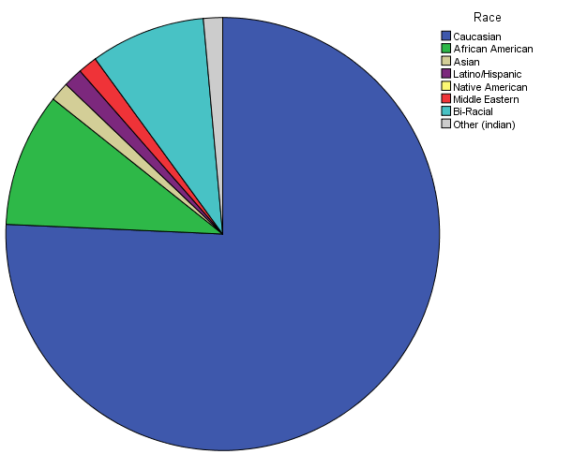

Figure 1. Pie Chart of racial breakdown of all study participants
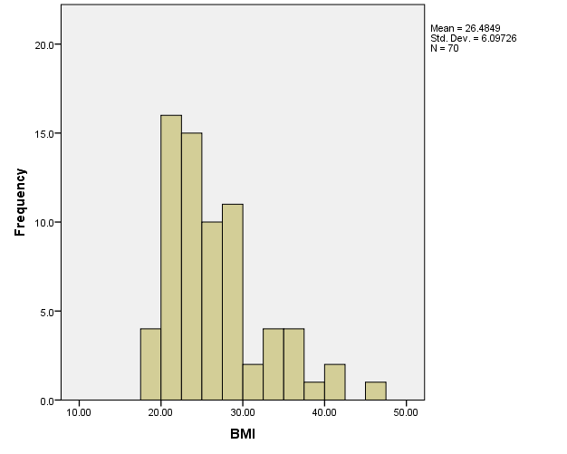

Figure 2. Histogram of BMI for all study participants

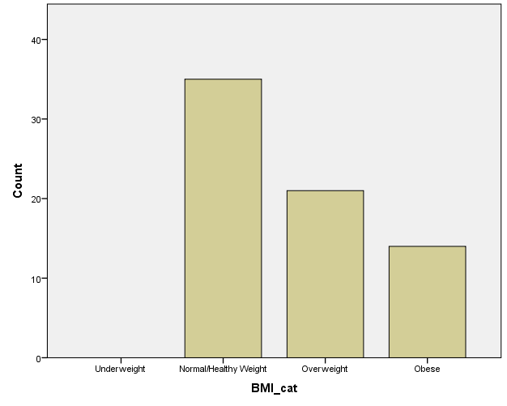

Figure 3. Categorical Histogram of BMI for all study participants

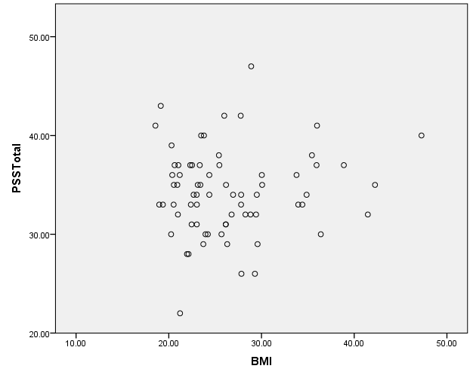

Figure 4. Scatterplot of participant PSS Total by BMI

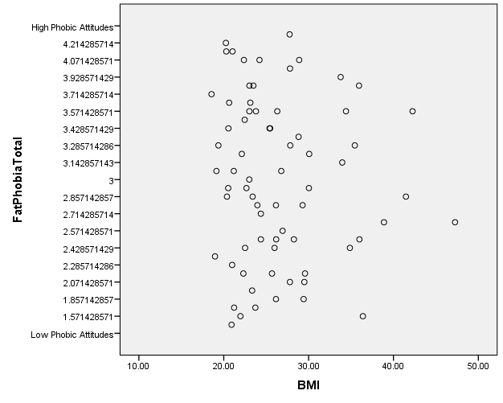

Figure 5. Scatterplot of participant Fat Phobic Attitudes by BMI

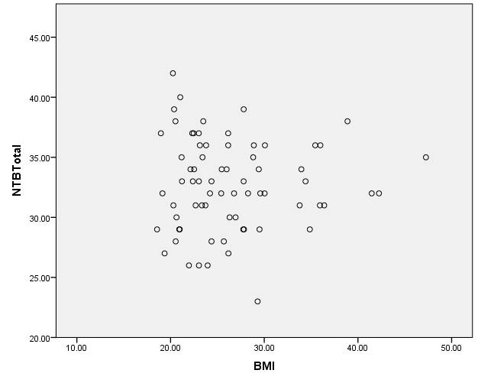

Figure 6. Scatterplot of participant NTB Total by BMI

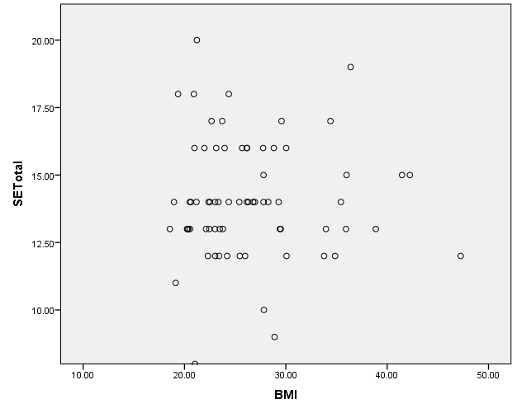

Figure 7. Scatterplot of participant SE Total by BMI

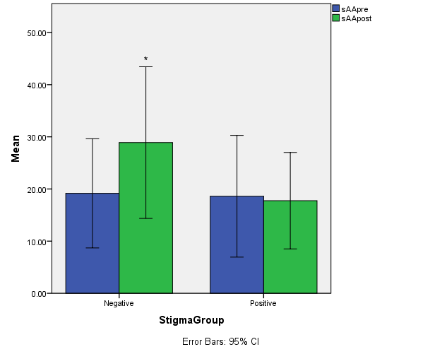

Figure 8. Bar Graph of pre- and post- stressor mean sAA by Priming Group

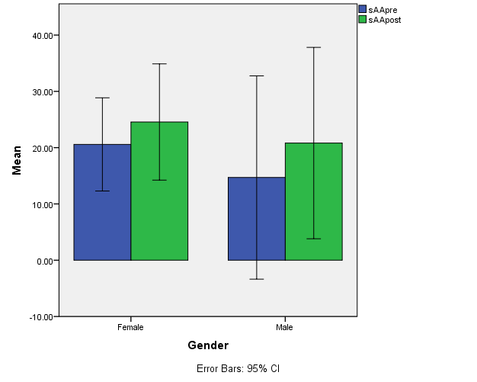

Figure 9. Bar Graph of pre- and post- stressor mean sAA by Sex

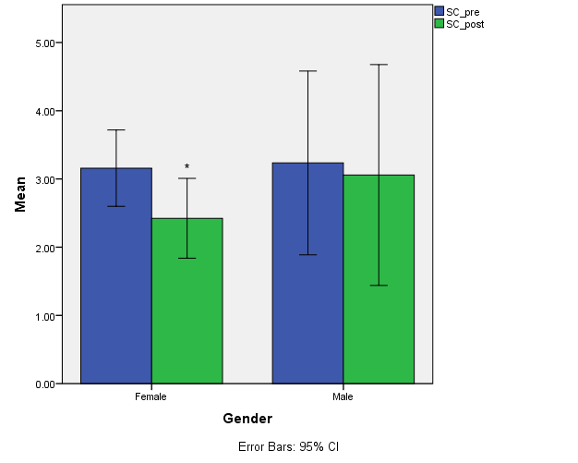

Figure 10. Bar Graph of pre- and post- stressor mean SC by Sex

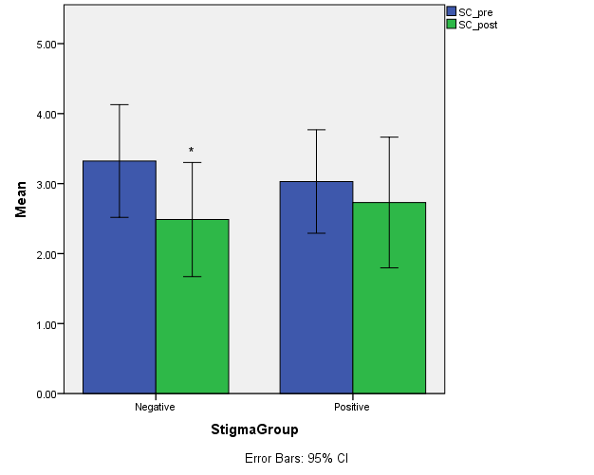

Figure 11. Bar Graph of pre- and post-stressor mean SC by Priming Group

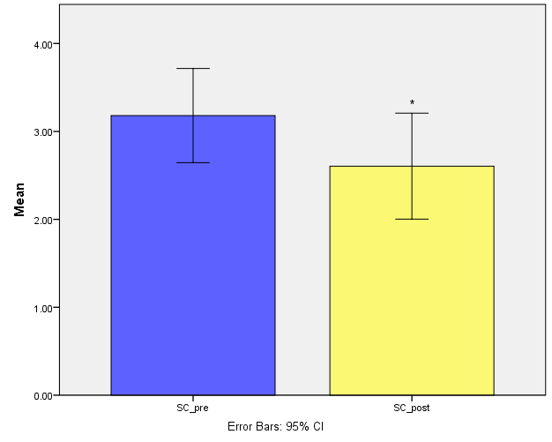

Figure 12. Bar Graph of pre- and post- stressor means for SC

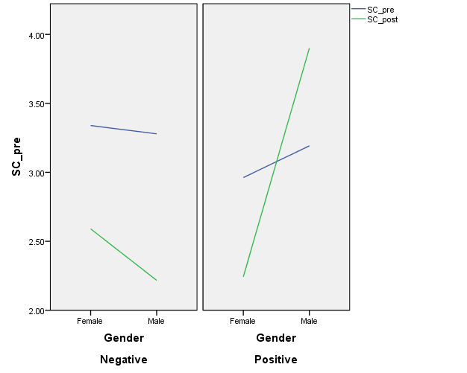

Figure 13. Time x Sex x Priming Group 3-way interaction for SC

Vignette
Southwest tells another person they are ‘too fat to fly.’
I can only imagine the humiliation and stress of getting to the airport and being told that you are ‘too fat to fly.’ Apparently, Southwest is not as concerned with its passenger’s feelings of comfort, safety or respecting people’s basic dignity. And you would think after the last time this happened, to someone famous and with so much media attention, they would have had some training or a change in policy–but you would be wrong. Kenlie Tiggeman and her mother were singled out over Easter weekend of this year as being Too Fat To Fly (TFTF).
“I know that I have a lot of weight to lose but I am definitely not too fat to fly. I do it all the time, domestically and internationally, and I have never had anyone approach me and particularly in the way that they did,” said Tiggeman.
Issues with Southwest’s “Customers of Size” policy are not new. A spokeswoman said employees are told to speak with customers in a private area, and if necessary, check if they fit in the seats prior to boarding and always use the utmost discretion. However, Tiggeman and her mom, Joan Charpentier, said the 45 minute conversation, which included questions about their weight and what size clothing they wear, in front of more than 100 people, was anything but discreet.
“It was the worst time I’ve ever had in my whole life. I was embarrassed, humiliated,” said Charpentier. The worker then tried to strike a deal. Tiggeman, Charpentier and a third overweight woman could fly, if they would sit together.
I think it is telling that Southwest’s “deal” with the three ladies they targeted as TFTF were told they could sit separately. You know, segregated from the rest of the normal, paying, deserving of comfort customers.
Kate Harding said it best the first time Southwest’s fat hate hit the news,
I think of the non-famous people who have been thrown off flights for making thin people uncomfortable — the brother and sister on their way home from their mom’s memorial service, the man who didn’t make it to a family funeral at all, the man living on disability who couldn’t afford a second seat to meet with doctors about a liver transplant — and all of the commenters at my blog who say, every time we talk about this, “I’m terrified to fly” or “I just don’t fly.” Not because they have anxiety disorders, or they were traumatized by “Lost,” or because airplane terrorism has done its job on them — because they’re fat. And they can’t afford two seats. And even if they’re just small or lucky enough that they can probably avoid being escorted off the plane like a criminal, the risk of smaller-scale humiliations — sitting next to someone who complains about their size; absorbing flight attendants’ naked disdain; overhearing someone say “I hope I don’t have to sit next to her“; being told, as Smith’s seatmate on his later flight was, that they should really purchase two seats in the future to avoid making other people uncomfortable; plus the aforementioned dirty looks and heavy sighs — is often enough to keep them at home. It’s enough to make people say things like, “Maybe I don’t really need to see my family this year” and “I won’t bother applying for a job that requires travel” and “It’s just easier to vacation close to home” and “If I start driving now, I think I’ll get there in time to say goodbye.”

Vita
Michael Darnell Oliver was born in Virginia, but moved to Tennessee at an early age by way of his military family. He was raised by his parents Kendall and Shannon Kitchen and is the eldest of two boys. Michael was educated through the Clarksville Montgomery County School System from elementary through high school. He has always been interested in Psychology, but his interests peaked in his senior year of high school in his first psychology course. Upon graduation, he decided to attend the University of Tennessee – Knoxville. At UTK he worked as an undergraduate research assistant his senior year in Dr. Debora Baldwin’s biopsychology lab. Michael graduated in May 2013 with a Bachelor of Arts degree in Psychology with a minor in Business Administration. He then accepted a graduate teaching assistantship in August 2013 at the University of Tennessee – Knoxville in Experimental Psychology with a Biological program focus. Michael is currently working on furthering his education by pursuing a Ph.D. at UTK.

