The Role of Cdc42 Regulation in
Cell Growth Pattern and Timing

A Dissertation Presented for the
Doctor of Philosophy
Degree
The University of Tennessee, Knoxville

Julie Tia Robinson
August 2021

© by Julie Tia Robinson, 2021
All Rights Reserved.

Dedication
This is dedicated to my husband, my family, and my friends, without whom I would be only a small fraction of myself. I love you all.

Acknowledgements
I would first like to acknowledge my PI, Dr. Maitreyi Das. You have mentored me since I was an undergrad, and you’ve seen me through my greatest successes and my lowest moments as a scientist. I will always admire your dedication to training great scientists. I would also like to acknowledge the members of my committee – Drs. Steve Abel, Gladys Alexandre, Mariano Labrador, and Andreas Nebenführ – who provided me with excellent advice through the years and also helped me learn how to better communicate about my work.

And finally, I would like to acknowledge my fellow Das Lab members, past and present: I couldn’t have done this without you. For every time we ate together, for every time I vented to you about an experiment gone wrong, for every city we navigated together at a conference, for every time you listened to a Mamamoo or Stray Kids song I wanted to share with you, for every time you diluted my cells, for every time we just talked about nothing important – it was all important. Thank you.

Abstract
In fission yeast, polarized cell growth stops during division and resumes after cell separation at the end that existed in the previous generation. It is unclear how growth occurs specifically at this end after cell division. Via a pedigree analysis of mutant cells which display a unique polarity phenotype, we show the existence of a memory of growth. This memory of growth exists at the pre-existing cell end, which grew in the previous generation, and facilitates growth at that end in the next generation. This memory of growth gives the pre-existing end some advantage in a competition for active Cdc42, which is a major regulator of polarized growth. In a mutant that has more available active Cdc42, we observe precociously bipolar growth, indicating that, while the memory of growth gives the pre-existing cell end an advantage, this advantage is immaterial when there is enough Cdc42 activity for both cell ends.

The memory of growth promotes growth, but growth does not occur during cell division. Once cell division is complete, the memory of growth is able to promote growth. How is growth activated after cell division? To investigate this, we uncoupled cytokinesis and growth, which are normally sequential events, by delaying cytokinesis with a temporary Latrunculin A treatment. Mitotic cells recovering from treatment initiate end growth without cell separation, displaying a polar elongation sans separation (PrESS) phenotype. PrESS cell ends reactivate Cdc42 before cell separation, but at a fixed time after anaphase B. A candidate screen implicates Rga4, a negative regulator of Cdc42, in this process. We show that Rga4 appears punctate at the cell sides during G2, but is diffuse during mitosis, extending to the ends. While the Morphogenesis Orb6 (MOR) pathway is known to promote cell separation and growth by activating protein synthesis, we find that for polarized growth, removal of Rga4 from the ends is also necessary. Therefore, we propose that growth resumes after division once the MOR pathway is activated and the ends lose Rga4 in a cell-cycle-dependent manner.

Table of Contents
Chapter I: CELL GROWTH IN FISSION YEAST.....................................................1
Chapter II: A MEMORY OF GROWTH......................................................................8
Chapter III: A NOVEL PHENOTYPE REVEALS A TIMER FOR GROWTH......14
Introduction............................................................................................................14
Results....................................................................................................................16
Chapter IV: LOSS OF THE CDC42 INHIBITOR RGA4 FROM CELL ENDS ALLOWS GROWTH AFTER CELL DIVISION.........................................................38
Introduction............................................................................................................38
Results....................................................................................................................40
Chapter V: Discussion..................................................................................................59
Materials and Methods..............................................................................................68
List of Strains...............................................................................................................75
References.....................................................................................................................77
Vita..................................................................................................................................90

List of Figures
Figure 1.1 Life cycle of fission yeast.................................................................................3
Figure 1.2 Cdc42 activation cycle.....................................................................................4
Figure 1.3 Cdc42 oscillates between cell ends.................................................................5
Figure 2.1 Gef1 promotes bipolar growth via new end take-off..................................10
Figure 2.2 Phenotype of rdi1Δ.........................................................................................13
Figure 3.1 Cytokinetic delay uncouples end growth resumption from cell
separation.............................................................................................................18
Figure 3.2 The PrESS phenotype is cell-cycle-dependent............................................21
Figure 3.3 Cdc42 is activated at the ends prior to cell separation in PrESS cells.....27
Figure 3.4 Cdc42 effectors localize to the growing ends of PrESS cells.....................31
Supplemental Figure S3.1.............................................................................................. 34
Supplemental Figure S3.2...............................................................................................36
Supplemental Figure S3.3...............................................................................................37
Figure 4.1 Loss of negative regulation of Cdc42 increases the incidence of the PrESS
phenotype..............................................................................................................44
Figure 4.2 Rga4 localization changes in a cell-cycle-dependent manner....................46
Figure 4.3 Loss of rga4 allows polarized growth in cells constitutively activating the
MOR pathway......................................................................................................51
Supplemental Figure S4.1...............................................................................................55
Supplemental Figure S4.2...............................................................................................56
Supplemental Figure S4.3...............................................................................................57
Supplemental Figure S4.4...............................................................................................59
Figure 5.1 Model for growth resumption after cell division........................................66
Chapter I
Cell Growth in Fission Yeast
Asymmetry is essential for life. Even the simplest cell must maintain an asymmetry between itself and its environment. Polarized growth accomplishes an asymmetry that gives rise to specific shapes which permit specialized functions. In the context of a multicellular organism, asymmetry allows communication between different parts of the organism. A neuron forms an axon that allows it to propagate cellular signals, while its dendrites receive signals. A cell must thus execute a highly-specific program of polarized growth to achieve an appropriate shape in order that it might function successfully.

We use Schizosaccharomyces pombe in our study of the complex mechanisms governing cell polarity. Also known as fission yeast, this unicellular, eukaryotic organism grows in a defined bipolar fashion until it reaches an optimal size, at which point medial fission occurs (Estravis et al., 2012; Mitchison and Nurse, 1985). Many proteins involved in cell cycle control and cell growth and polarity are highly conserved between yeast and higher eukaryotes (Etienne-Manneville, 2004; Johnson, 1999). The ease with which fission yeast can be imaged and genetically manipulated contribute to making it an excellent model organism for the study of these processes.

Growth pattern of fission yeast
A wild-type fission yeast cell exhibits polarized growth until mitosis, after which the cell divides into two identical daughter cells. The end of a cell derived from a division site is its new end and is composed of newly-synthesized cell membrane and cell wall. The end that persists from the previous generation is a cell’s old end. Immediately after cell division, the old end rapidly resumes growth. After the cell attains a certain size, the new end begins growing by a process called NETO (New End Take-Off). Once the cell achieves an appropriate length, it ceases growth and assembles an actomyosin ring in the cell middle. As the ring constricts, a septum is synthesized, part of which is digested upon completion of constriction to physically separate the two daughter cells. Growth resumes only after cell separation. (Mitchison and Nurse, 1985) (Figure 1.1)

Competitive polarized growth
Growth is driven by Cdc42, a conserved small GTPase that is the primary regulator of not only eukaryotic cell growth, but also endocytosis, cell migration, and other crucial processes (Johnson, 1999). A highly conserved protein, Cdc42 has been found to be overexpressed in multiple types of human cancers (Stengel and Zheng 2011). Cdc42 is regulated by activators called GEFs (Guanine nucleotide exchange factors) and inactivators called GAPs (GTPase-activating proteins) (Figure 1.2). Different organisms vary in the numbers of these regulators that they contain. Fission yeast has two Cdc42 GEFs: Gef1 and Scd1 (Coll et al., 2003; Fukui and Yamamoto, 1988) and two Cdc42 GAPs: Rga4 and Rga6
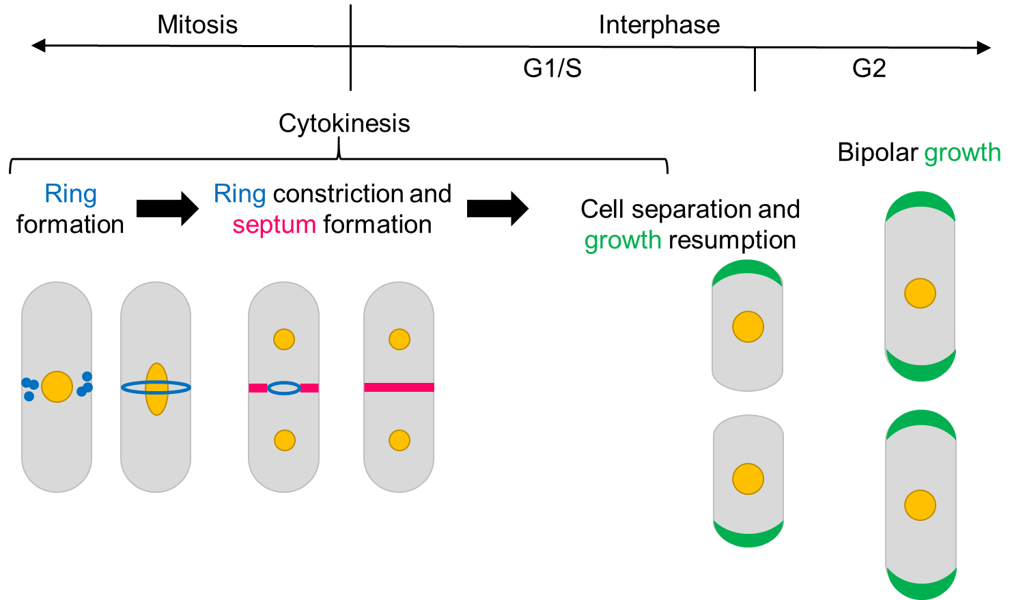
Figure 1.1 Life cycle of fission yeast. During mitosis in fission yeast cells, growth does not occur, and an actomyosin ring is built at the cell middle. As this ring constricts, a septum is synthesized in its wake, ultimately separating the parent cell into two daughter cells. After cell separation, growth resumes at the cell ends which existed in the previous generation.

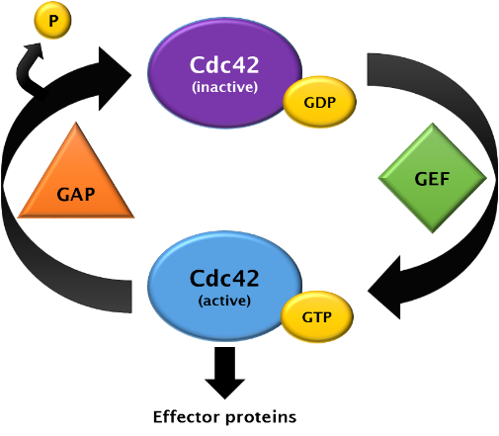
Figure 1.2 Cdc42 activation cycle. Cdc42 is activated by Guanine nucleotide exchange factors, or GEFs, and inactivated by GTPase-activating proteins, or GAPs.

(Das et al., 2007; Revilla-Guarinos et al., 2016; Tatebe et al., 2008). Inactive Cdc42 is located all along the cortex, so the localization of its regulators controls where Cdc42 is activated. Localization of GEFs to cell ends results in local activation of Cdc42 and cell growth. However, Cdc42 activation does not occur at both ends simultaneously even after NETO. It has been shown that Cdc42 activation displays anti-correlated oscillations between the ends with a period of approximately five minutes (Das et al., 2012) (Figure 1.3). These oscillations indicate a competition for either Cdc42 or, more likely, one of its upstream activators. The term “competition” refers to a state in which molecular interactions requiring the same substrate occur simultaneously and draw from the same pool of that substrate. In the case of Cdc42 oscillations between the old and new ends of a cell, this suggests a competition between two sites actively trying to recruit proteins that promote the activation of Cdc42, which promotes growth. In this sense, we can say that competition exists between the two ends of a fission yeast cell.

Cell-cycle regulation of growth
The morphogenesis Orb6 network (MOR) is responsible for promoting septum digestion (Ray et al., 2010). The most crucial constituent of the MOR is the Orb6 kinase; upon completion of cytokinesis, the MOR drives polarized growth through Orb6 regulation of Cdc42 localization (Das et al., 2009). Fusion of Nak1 to the scaffold Mor2 results in increased Orb6 activity, and it has been shown that Nak1 requires the scaffold Mor2 in order to activate Orb6 (Gupta et al., 2013; Hergovich et al., 2006). Once the cell grows to a certain size, growth halts and the cell undergoes mitosis. The onset of mitosis is
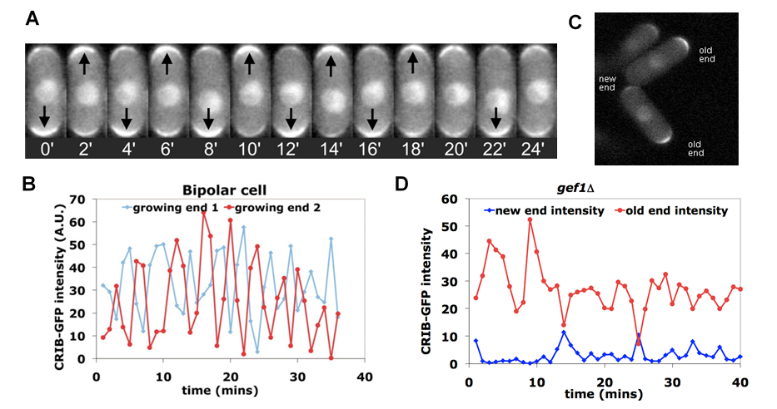
Figure 1.3 Cdc42 oscillates between cell ends. A) Time-lapse images of CRIB-GFP (active Cdc42) oscillating between the new and old ends. B) CRIB-GFP intensity at the old end (red) and new end (blue). C) CRIB-GFP in monopolar gef1∆ cells appears only at the only growing end, which is the old end. D) CRIB-GFP intensity at old end (red) and new end (blue) in gef1∆ cells. (Adapted from Das et al. 2012.)
controlled by Cdk1, also known as Cdc2 (Gautier et al., 1988). In fission yeast, the activity of this master regulator of cell cycle progression is positively regulated by Cdc25 and negatively regulated by Wee1 (Murakami et al. 2010).

During anaphase, the septation initiation network (SIN) becomes active. The SIN orchestrates septum formation by promoting cytokinesis while inhibiting polarized growth (Simanis, 2015). This inhibition is achieved through Sid2 phosphorylation of Nak1, which blocks Nak1 interaction with Mor2 and thus prevents Nak1 association with Orb6 (Gupta et al., 2014). At the end of cytokinesis, the MOR again becomes active and promotes cell separation. It does so by up-regulating the transcription factor Ace2, which promotes the transcription of septum-digesting enzymes, and by phosphorylating the exoribonuclease Sts5 (Gupta et al., 2014; Nunez et al., 2016). When Sts5 is present in P-bodies, it degrades mRNAs. When phosphorylated, Sts5 cannot be incorporated into P-bodies, resulting in more protein synthesis. Once the septum is formed, the septum-digesting enzymes Agn1 and Eng1 are secreted into the junction between the cell wall and the septum, where they break down the primary septum to allow separation of the daughter cells (Sipiczki, 2007).

Chapter II
A Memory of Growth
Wild type fission yeast cells grow first from their old end until they reach a certain size, and then grow from their new end in a process called new end take-off (NETO) (Mitchison and Nurse, 1985). Therefore, wild type cells first grow in a monopolar fashion, and then switch to a bipolar growth mode. When genes involved in cell polarity are mutated, a cell’s growth pattern and shape are affected.

Loss of gef1 reveals a memory of growth
The Rho GTPase Cdc42 promotes polarized growth (Estravis et al., 2012; Miller and Johnson, 1994). In fission yeast, it is activated by two Guanine nucleotide exchange factors (GEFs), Scd1 and Gef1. Scd1 activates Cdc42 via a strong positive feedback loop, and when scd1 is deleted, cells appear nearly spherical (Chang et al., 1994). Gef1 activates Cdc42 more weakly; when gef1 is deleted, cells remain rod-shaped, just like the wild type. However, while wild type cells undergo NETO, and thus transition from a monopolar to a bipolar mode of growth (Figure 2.1A), many gef1Δ cells exhibit monopolar growth at their old end, with their new end failing to grow at all before the cell enters mitosis (Coll et al., 2003; Das et al., 2012). We observed an interesting phenomenon among the progeny of monopolar gef1Δ cells. 68% of monopolar gef1Δ parent cells gave rise to a monopolar cell from their old end, which grew in the previous generation, and a precociously bipolar cell from their new end, which did not grow in the previous generation (Figure 2.1B). This pattern suggests that the old end of a daughter cell inherited some factor from the parent cell that imparted it with growth dominance over the new end, resulting in a monopolar cell. Accordingly, a daughter cell derived from the new end of the monopolar parent cell did not inherit an end that grew in the previous generation, meaning that neither of its ends has an advantage for growth, resulting in a precociously bipolar cell. Altogether, these results indicate that an end that grew in one generation has a growth advantage, or is dominant, in the next generation. This growth advantage is some factor that the end achieves by having undergone growth which also makes it more competent for growth in the next generation. We call this factor the “memory of growth.” It is unclear what constitutes the memory of growth.

We recorded the growth pattern of cells derived from ends which grew in the previous generation. We found that, in the wild type, 97% of such cells underwent NETO in the following generation (Figure 2.1C). However, in gef1Δ, 81% of cells derived from an end that grew in the previous generation were monopolar, growing only from their old end, while 9% underwent NETO and 9% displayed precociously bipolar growth (Figure 2.1C). These data suggest a role for Gef1 in allowing the new end to overcome old end dominance, leading to bipolar growth (Hercyk et al., 2018; Hercyk et al., 2019b).

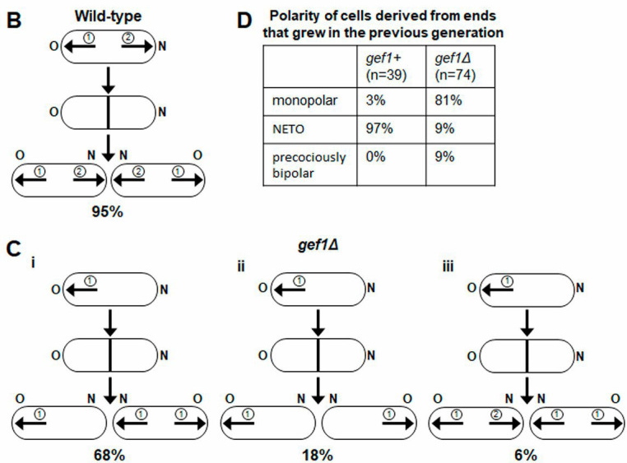
C
B
A

Figure 2.1 Gef1 promotes bipolar growth via new end take-off. A) Wild-type cells predominately display old-end (O) growth, followed by a delayed onset of new-end growth (N). B) i. In gef1Δ mutants, 68% of monopolar cells yield a monopolar daughter cell from the end that grew in the previous generation and a bipolar daughter cell from the end that failed to grow in the previous generation. ii. 18% of monopolar cells yield two monopolar cells. iii. 6% of monopolar cells yield two monopolar cells. Circled numbers describe the order of growth. Arrows correspond to direction of growth. C) Percentage polarity of cells derived from ends that grew in the previous generation in gef1⁺ and gef1Δ cells. NETO, new end take-off.
*This figure is adapted from Hercyk, Rich-Robinson et al. 2019.

Loss of rdi1 highlights a competition for Cdc42 activity
Guanine nucleotide dissociation inhibitors (GDIs) regulate Rho GTPases such as Cdc42 by binding their inactive, GDP-bound form (DerMardirossian and Bokoch, 2005; Dransart et al., 2005; Garcia-Mata et al., 2011). While bound to a GDI, a GTPase is not able to become active and also cannot associate with the plasma membrane. GDIs thus affect the distribution of active Cdc42 along the membrane by recycling its inactive form into the cytoplasm. GDIs can be considered negative regulators of Rho GTPases, given that they prevent a fraction of the GTPases from being able to be activated. Accordingly, when a GDI is deleted, there is more Rho GTPase available to be activated in the cell.

Rdi1 is the only known GDI present in fission yeast (Nakano et al., 2003). The rdi1Δ mutant displays an abnormal polarity phenotype. We find that the rdi1Δ mutant displays a higher rate of bipolarity than the wild type and often grows in a precociously bipolar fashion (Figure 2.2A, B). It has previously been shown that the two ends of a fission yeast cell compete for Cdc42 activity (Das et al., 2012). We suggest that growth pattern emerges in rdi1Δ cells due to an increase in the amount of active Cdc42 available for the two ends to compete for, essentially diminishing this competition. The new end thus need not compete as much with the old end in order to activate Cdc42, enabling premature bipolar growth. We also find that more septated rdi1Δ cells show active Cdc42 at their cell ends than wild type cells (Figure 2.2C), suggesting that they are able to activate Cdc42 at growth sites sooner than wild type cells.

Sometimes, rdi1Δ displays a minor cell separation defect characterized by two sister cells staying connected at one small point; we call this the “kissing” phenotype (Figure 2.2A). Interestingly, strains lacking rdi1 emit a foul odor reminiscent of rotten eggs. This could potentially be due to an irregularity in endocytosis or exocytosis due to different Cdc42 activity.

Inactive Cdc42 displays more mobility than active Cdc42 (Bendezu et al., 2015). It has been reported that, when compared to wild type, Cdc42 mobility at the cell ends of rdi1Δ cells does not change, but is decreased at the cell sides (Bendezu et al., 2015). Since active Cdc42 displays decreased mobility compared to inactive Cdc42, this observation suggests that there is indeed more active Cdc42 in rdi1Δ than there is in the wild type. This supports our observation that rdi1Δ cells are more bipolar than the wild type.

C
A
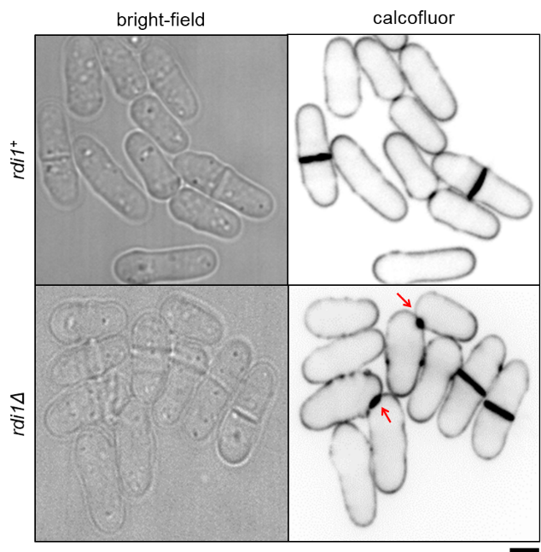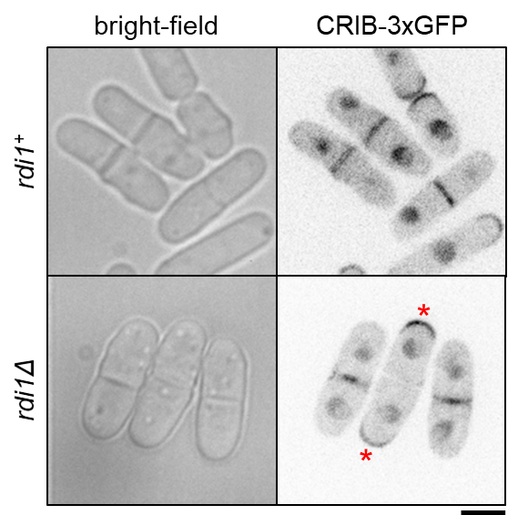
D
B
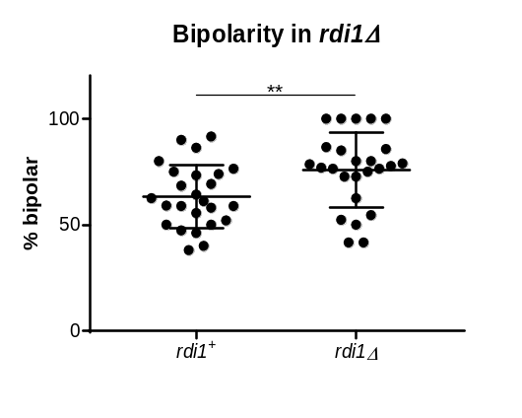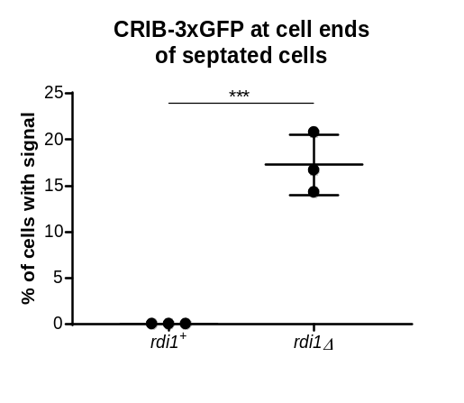
Figure 2.2 Phenotype of rdi1Δ. A) rdi1⁺ and rdi1Δ cells stained with calcofluor. These cells display a “kissing” phenotype characterized by two sister cells remaining attached to each other at their new ends (arrows). B) rdi1Δ are significantly more bipolar than wild type cells (p = 0.0079; Student’s t-test). % bipolar cells counted per field of cells. n = 25. C, D) Cdc42 activation at cell ends in septated cells in rdi1⁺ and rdi1Δ. More septated cells show CRIB-3xGFP at their ends in rdi1Δ than in rdi1⁺ (p = 0.0008; Student’s t-test).
Chapter III
A Novel Phenotype Reveals a Timer for Growth
Introduction
Most eukaryotic cells undergo polarized growth to achieve specific shapes that enable them to interact with their environment in a biologically productive manner. Polarized growth requires polarization of growth-promoting signaling networks, actin organization, and membrane trafficking (Etienne-Manneville, 2004; Nance and Zallen, 2011; Ridley, 2006). Polarization is also essential for cytokinesis, the final step in cell division (Albertson et al., 2005; Echard, 2008; Hercyk et al., 2019a; Wang et al., 2016). Since polarized growth and cytokinesis share the same polarization apparatus, they must be temporally distinct events. Accordingly, careful regulation ensures that the cell can alternate between successful growth and division. However, it is unclear how this is regulated at the molecular level. The major drivers of polarization are highly conserved among eukaryotes (Etienne-Manneville, 2004; Johnson, 1999). For this reason, we use the unicellular fission yeast Schizosaccharomyces pombe to establish basic principles about how cells spatiotemporally regulate their polarization machinery.

In fission yeast, cytokinesis involves the formation of an actomyosin ring, which constricts along with an ingressing membrane barrier and septum to physically separate two daughter cells (Cheffings et al., 2016; Pollard, 2010; Pollard, 2014). The septum undergoes maturation and is eventually digested by glucanases, leading to cell separation (Cortes et al., 2016; Garcia Cortes et al., 2016; Sipiczki, 2007). Immediately after cell separation, polarized growth initiates from the old ends, which existed in the previous generation (Mitchison and Nurse, 1985). Once the cells attain a certain size, the new ends, generated as a result of cell division, start to grow by a process called new end take-off (NETO). The Rho GTPase Cdc42 is a major regulator of cell growth and polarity, and is highly conserved among eukaryotes (Etienne-Manneville, 2004; Johnson, 1999). Recently, we have shown that Cdc42 also plays a role in cytokinesis (Hercyk and Das, 2019a; Onwubiko et al., 2020; Wei et al., 2016). Regulation of Cdc42 determines when and where polarization occurs (Das et al., 2012; Das et al., 2009; Etienne-Manneville, 2004; Howell et al., 2012). In S. pombe, Cdc42 is activated by two Guanine nucleotide exchange factors (GEFs), Scd1 and Gef1 (Chang et al., 1994; Coll et al., 2003), and is inactivated by three GTPase-activating proteins (GAPs), Rga4, Rga6, and Rga3 (Das et al., 2007; Gallo Castro and Martin, 2018; Revilla-Guarinos et al., 2016; Tatebe et al., 2008). Of these, Rga4 appears to be the primary GAP, while Rga6 and Rga3 appear to play minor roles in polarity and cell pairing during sexual reproduction, respectively.

The ends of dividing cells inactivate Cdc42 during mitosis, and polarized growth consequently stops (Hercyk and Das, 2019b). Once two daughter cells have been generated via cytokinesis at the end of cell division, Cdc42 is reactivated at the old ends and polarized growth resumes (Wei et al., 2016). The bio-probe CRIB-3xGFP specifically binds active Cdc42, and thus is used to identify sites of Cdc42 activation (Tatebe et al., 2008). Using CRIB-3xGFP, it has been shown that Cdc42 is activated at growing cell ends during interphase (Das et al., 2012; Tatebe et al., 2005). Once the cell enters mitosis, active Cdc42 disappears from the cell ends and appears at the division site (Wei et al., 2016). After cell separation, Cdc42 is not immediately activated at a daughter cell’s new end, which was created as a result of cell separation. Instead, Cdc42 is first activated at the old end, which is the farthest point from the site of cell division. It is unclear how Cdc42 activation transitions from the division site to the old ends after cell separation.

Results
Cytokinetic delay results in growth resumption without cell separation.
Since initiation of polarized growth at cell ends only occurs after cell separation, we asked if the timing of polarized growth initiation is impacted by cytokinesis. To test this, we used Latrunculin A (LatA) to induce a cytokinetic delay. LatA prevents the polymerization of actin, leading to loss of dynamic actin-based structures (Spector et al., 1983). Phalloidin staining shows loss of actomyosin rings upon LatA treatment (Supplemental Figure S3.1A). LatA treatment disrupts the actomyosin ring, and upon washout, a new actomyosin ring assembles and cytokinesis resumes, albeit it is delayed (Supplemental Figure S3.1B) (Swulius et al., 2018). We treated an asynchronous population of wild type cells with 10µM LatA for 30 minutes and then washed it out. Cells typically take about 45-60 minutes after LatA washout to recover before they display growth. After recovery, we observed that some cells – about 9% – show a unique phenotype in which they initiate growth at their ends but do not undergo cell separation (Figure 3.1A, B). We analyzed the timing of end growth initiation with reference to completion of septum closure in these cells. We monitored cells using bright-field imaging over time to detect septum closure (Supplemental Figure S3.1C). In untreated wild type cells, growth at the ends initiates on average 50 minutes after septum closure. However, in cells recovering from LatA treatment, end growth initiates on average 6 minutes after septum closure (Figure 3.1D). In some cells, growth initiates even before the completion of septum closure. We observe similar results when growth resumption is timed from the completion of ring closure, as depicted by Rlc1-tdTomato (Supplemental Figure S3.1D). Although these cells fail to separate, they enter the next cell cycle and undergo cell division. The septum formed in the second generation separates normally, suggesting that the LatA treatment only impacts the cell cycle in which the cell was treated (Figure 3.1A, arrow). We call this phenotype the polar elongation sans separation, or PrESS, phenotype. We also observe that the old ends of PrESS cells grow up to three times as fast as old ends in wild type cells before new end take-off (Supplemental Figure S3.1E). The PrESS phenotype suggests that growth initiation after mitosis is not timed by cytokinesis.

PrESS cells visually resemble septin mutants, in which cell separation defects have been previously documented (Figure 3.1C) (An et al., 2004; Berlin et al., 2003; Martin-Cuadrado et al., 2005; Tasto et al., 2003). However, while PrESS cells resume growth as the septum forms, it was unclear if the spn1Δ mutants behave similarly or whether they
Figure 3.1 Cytokinetic delay uncouples end growth resumption from cell separation. A) An asynchronous population of wild type cells was treated with 10µM Latrunculin A (LatA) for 30 minutes, and was then washed and allowed to recover. A subset of cells consistently shows a phenotype wherein they form a septum as they resume growth and fail to undergo cell separation (asterisk next to original septum). These cells grow, and the septa formed in the next cell cycle separate normally (arrows). We call this the polar elongation sans separation, or PrESS, phenotype. B) Time-lapse of two wild type cells after LatA washout, showing the PrESS phenotype. Growth resumed in the left cell at 60mins, and in the right cell at 85mins after washout (asterisks). C) Time-lapse of growth after division in an spn1Δ cell. Asterisks denote growth initiation, which occurs after septum formation. D) PrESS cells resume growth significantly earlier in relation to septum closure than untreated or spn1Δ cells (Student’s t-test, p < 0.0001; n ≥ 10 cells). Timestamps in B and C refer to time since completion of septum closure. Scale bars, 5μm.
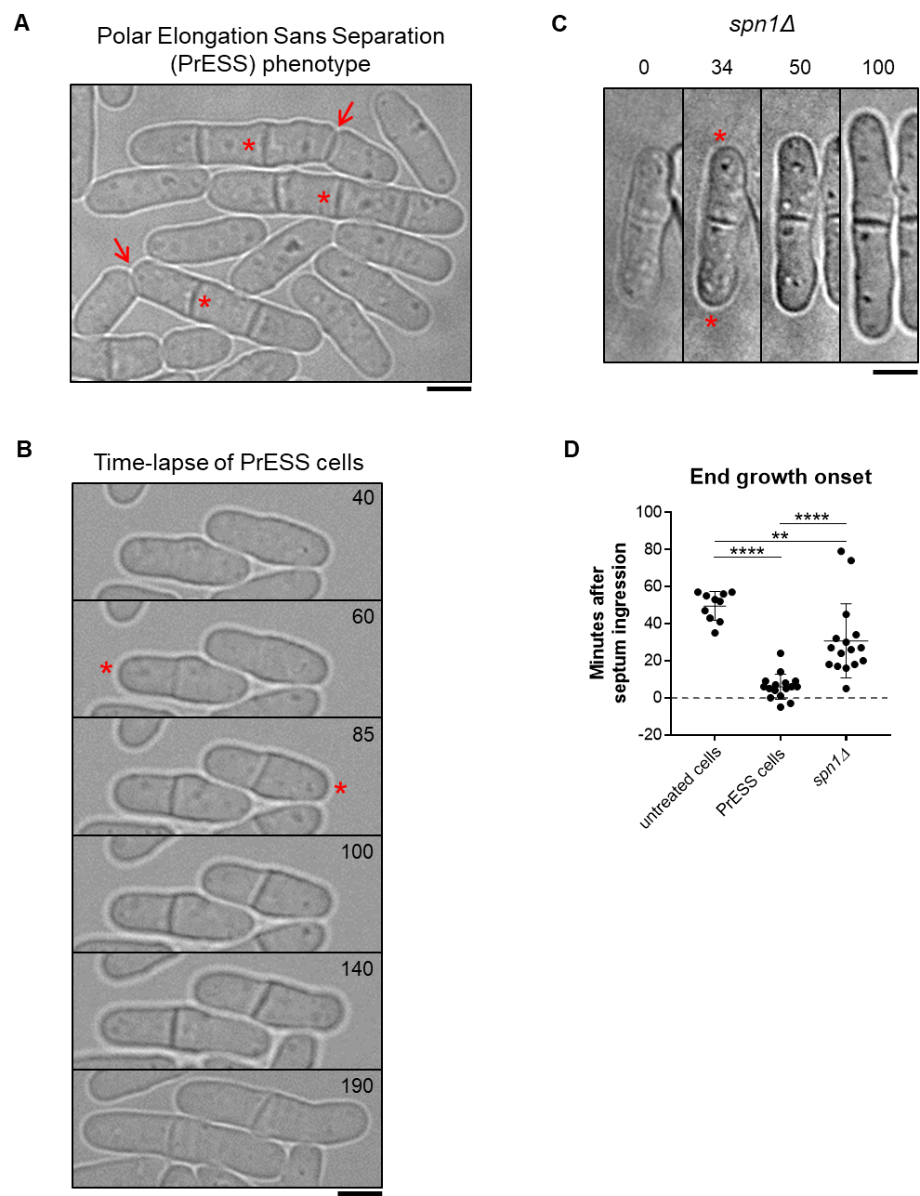
Figure 3.1
only resume growth after cell separation failure. To test this, we analyzed the timing of end growth resumption in spn1Δ mutants compared to the time of septum closure, as we did for PrESS cells. We find that in spn1Δ cells, the ends resume growth on average about 31 minutes after septum closure in cells which fail to separate (Figure 3.1D). This suggests that these cells fail to separate, and then eventually growth resumes at the proper time. In contrast, in PrESS cells, cytokinesis and growth are uncoupled such that growth resumes even before cell separation is possible.

Cdc42 activation at cell ends is cell-cycle-dependent.
Only a subset of asynchronous cells exhibits the PrESS phenotype upon recovery from LatA treatment. We asked if this is because the PrESS phenotype only occurs in cells that are in a certain cell cycle stage. To address this, we imaged cells at various cell-cycle stages before, during, and after LatA treatment. We accomplished this by affixing the cells to the imaging dish using lectin (Tay et al., 2018), and performing LatA treatment and washout within the dish itself. Cells in lectin-coated dishes tend to grow slower than normal, but do not show any significant growth defects. We found that mitotic cells treated with LatA show the PrESS phenotype after recovery (Figure 3.2Aii, Supplemental Figure S3.2A), and that cells treated during interphase or G1/S separate normally (Figure 3.2Ai, iii, Supplemental Figure S3.2A). When treated with LatA, cells in anaphase continue to proceed through mitosis, as detected with the spindle pole body marker Sad1-mCherry. However, the actomyosin ring disassembles, as marked by the type 2 myosin
Figure 3.2 The PrESS phenotype is cell-cycle-dependent. A) Time-lapse imaging of cells undergoing LatA treatment and recovery. Vertical red bars denote cells undergoing a 30min 10µM LatA treatment. Time 0 marks LatA washout. Rlc1-tdTomato and Sad1-mCherry mark the actomyosin ring and spindle pole bodies and indicate the cell cycle stage of the cells. Cells in G2 (i) or in G1/S (iii) at the time of LatA treatment do not show the PrESS phenotype during recovery. Cells in mitosis at the time of LatA treatment (ii) show the PrESS phenotype during recovery. The arrowhead marks the recovered actomyosin ring undergoing constriction. B) cdc25-22 cells containing CRIB-3xGFP were synchronized by cell cycle block and release. During the indicated cell cycle stages, occurring 0 (G2), 40 (Mitosis), and 80 (G1/S) minutes after release, cells were treated for 30 minutes with LatA and then washed. Cells recovering from LatA treatment in G2 or G1/S do not yield PrESS cells while those undergoing mitosis exclusively yield PrESS cells. Arrows mark PrESS cells with active Cdc42 at cell ends. Scale bars, 5μm.

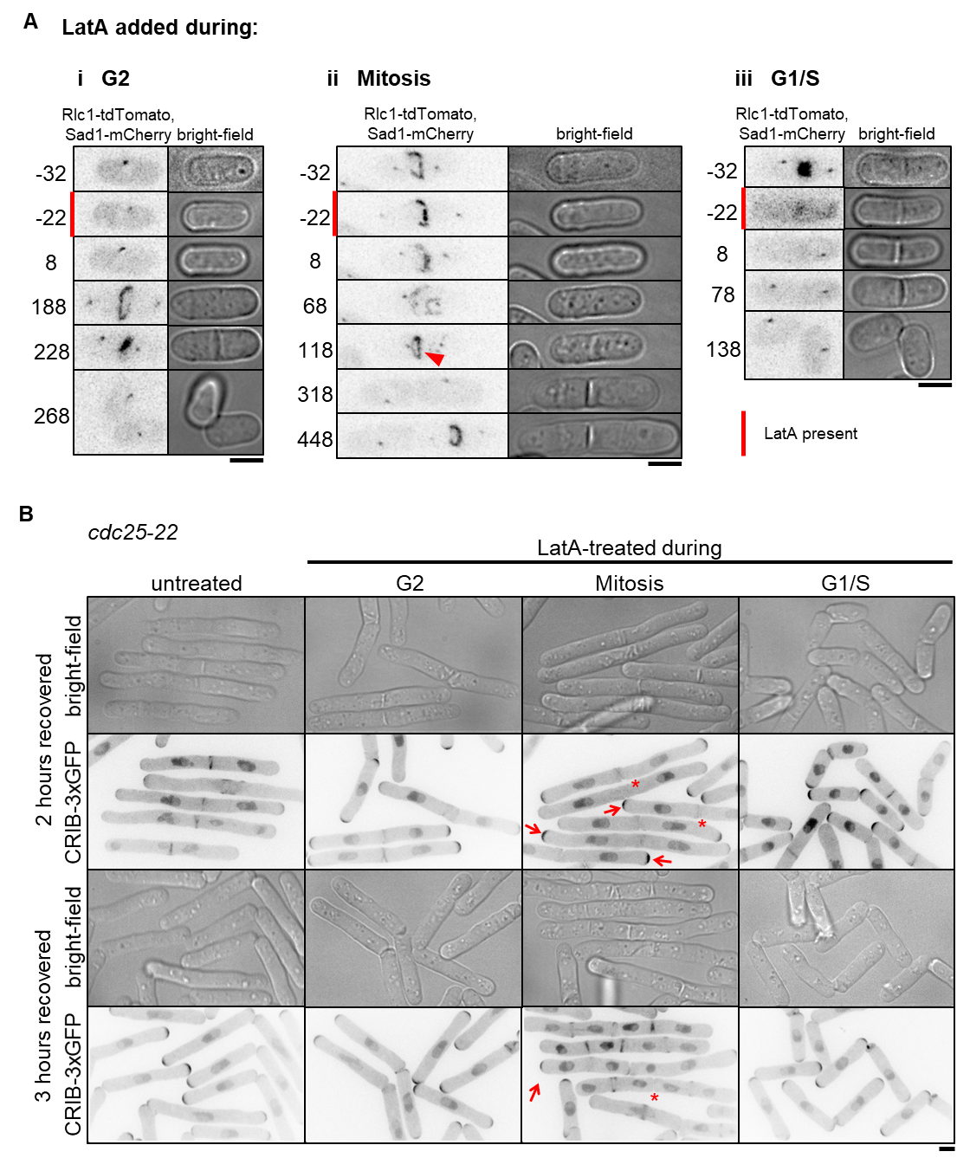
Figure 3.2
light chain Rlc1-tdTomato. After LatA washout, a new actomyosin ring assembles and then proceeds to constrict along with septum ingression (Figure 3.2Aii, arrowhead; Supplemental Figure S3.1B and C). However, instead of undergoing septum digestion and cell separation, these cells grow from the ends, thus displaying the PrESS phenotype. These observations show that the PrESS phenotype arises from cells that are in mitosis at the time of LatA treatment.

To confirm this, we synchronized cdc25-22 cells by shifting them to restrictive temperature and arresting them in late G2 (Fantes and Nurse, 1978; Tormos-Perez et al., 2016). Upon shifting back to permissive temperature, the synchronized cells enter mitosis. We took samples of cells released from arrest at regular time intervals. The cell-cycle stage of these cells was determined by Phalloidin and DAPI staining after formaldehyde fixation of a fraction of the samples. Cells in G2 show a single nucleus with actin mainly at the cell ends. Cells in mitosis show a dividing nucleus with an actin ring at the cell middle (Supplemental Figure S3.2B). In G1/S, the cell middle shows a septum instead of an actin ring, with a single nucleus in each sister cell. The remaining fractions of the samples were treated with LatA like before and allowed to recover. We found that cells treated with LatA during late G2 went on to septate and divide normally (Supplemental Figure S3.2B). Cells released from restrictive temperature for 40 minutes were in mitosis at the time of LatA treatment. These cells almost exclusively displayed the PrESS phenotype during recovery. Cells released from restrictive temperature for 80 minutes were septated (in G1/S) at the time of LatA treatment, as evidenced by the divided nuclei and the lack of an actomyosin ring. These cells successfully separated after recovery and did not display the PrESS phenotype. To confirm that cells treated during mitosis were indeed able to grow from their ends, we looked for the presence of active Cdc42 at those ends. To do this, we treated cdc25-22 mutants expressing CRIB-3xGFP, a probe for active Cdc42, in the same way as above. As expected, cells treated in G2 or G1/S underwent cell separation 2 hours after LatA washout and did not display the PrESS phenotype (Figure 3.2B). However, cells treated during mitosis displayed the PrESS phenotype, with CRIB3x-GFP present at the cell ends and absent at the site of failed cell separation (Figure 3.2B, arrows). 3 hours after LatA washout, cells which were treated in G2 or G1/S had completed cell separation and had entered the next cell cycle. The cells treated in mitosis also entered the next cell cycle, however the original division site still failed to separate and did not display CRIB-3xGFP (Figure 3.2B, asterisk). These findings suggest that the PrESS phenotype is cell-cycle-dependent and only occurs in cells that are in mitosis at the time of LatA treatment. Thus, in an asynchronous population, only mitotic cells display the PrESS phenotype upon recovery from LatA treatment.

PrESS cells activate Cdc42 at the growing ends at the expense of the division site.
Why do PrESS cells fail to separate? Cell separation requires the formation of a tri-layered septum which is subsequently digested by glucanases (Cortes et al., 2016; Garcia Cortes et al., 2016; Sipiczki, 2007). The septum is comprised of a primary septum flanked by secondary septum. Glucanases are delivered to the cortex at the outer edge of the septum barrier to digest the primary septum and allow separation. Separation defects occur either due to inadequate primary septum formation or improper delivery of the glucanases. We asked if separation failure in PrESS cells is due to improper primary septum formation. To test this, we performed electron microscopy of cells recovering from LatA treatment. Electron microscopy shows that the non-separating septum in a PrESS cell is constructed properly, displaying a distinct tri-layer similar to that observed in untreated cells (Supplemental Figure S3.3A). These cells also showed proper recruitment of the primary septum-synthesizing enzyme Bgs1 during septation (Supplemental Figure S3.3B). Moreover, the original septum in a PrESS cell often goes on to separate, albeit after a prolonged delay (Supplemental Figure S3.3C). The septum therefore appears competent for separation, suggesting that cell separation does not fail in PrESS cells due to a structural defect in the septum.

Cell separation failure can occur due to improper delivery of the septum-digesting glucanases to the division site (Garcia Cortes et al., 2016). Normally, once delivered to the division site, glucanases are secreted to the outer edge of the membrane barrier, where they digest the primary septum. We asked if PrESS cells’ failure to undergo cell separation is due to improper delivery of these glucanases. To test this, we imaged the glucanases Eng1 and Agn1 (Dekker et al., 2004; Martin-Cuadrado et al., 2003) at the division site of PrESS cells. In untreated cells, Eng1 and Agn1 localize to the outer edge of the membrane barrier and thus appear as a ring when viewed laterally (Supplemental Figure S3.3D) (Martin-Cuadrado et al., 2005). In PrESS cells, Eng1 and Agn1 appear as a patchy disc all over the membrane barrier and do not localize to the outer edge (Supplemental Figure S3.3D). This altered localization pattern is similar to that observed in mutants which fail to deliver glucanases and thus fail to undergo cell separation (Martin-Cuadrado et al., 2005; Perez et al., 2015; Santos et al., 2005; Wang et al., 2015). This suggests that cell separation failure in PrESS cells is due to improper delivery of the glucanases required for septum digestion.

We have recently reported that the glucanases do not localize properly to the outer edge of the membrane barrier in a hypomorphic mutant of the small GTPase Cdc42 (Onwubiko et al., 2020). Cdc42 activity stops at the cell ends during mitosis and transitions to the division site during cytokinesis (Merla and Johnson, 2000; Rincon et al., 2007; Wei et al., 2016). Once the cell separates, Cdc42 activity returns to the cell ends and growth resumes (Figure 3.3A, upper panel, asterisks). Competition for Cdc42 activity occurs between the two growing ends of a fission yeast cell (Das et al., 2012). Normally, Cdc42 is not activated at the old ends of daughter cells until after cell separation has occurred (Figure 3.3A). However, in PrESS cells, we find that Cdc42 activation occurs earlier at these ends (Figure 3.3B, asterisks), while it gradually fades away from the intact septum (Figure 3.3B, arrowhead). We quantified active Cdc42, as determined by CRIB-3xGFP intensity at the cell ends, normalized to the cell middle (Figure 3.3C). In non-PrESS cells, Cdc42 activity was measured at the cell middle and the ends throughout cytokinesis through cell separation. We find that Cdc42 activity is higher at the cell middle than at the cell ends throughout cytokinesis. However, in PrESS cells, Cdc42
Figure 3.3 Cdc42 is activated at the ends prior to cell separation in PrESS cells. Localization of the active Cdc42 marker CRIB-3xGFP in an untreated cell (A) and a PrESS cell (B). Asterisks denote growth onset. Arrowhead denotes loss of CRIB-3xGFP from the cell middle. Arrow shows the formation of a new ring in the next cell cycle. Rlc1-tdTomato and Sad1-mCherry mark the actomyosin ring and spindle pole bodies and indicate the cell cycle stage of the cells. Time 0 marks ring/septum closure. A single z-plane is shown for clarity and hence the spindle pole body is not visible in all the time frames. C) Quantification of CRIB-3xGFP intensities at cell ends of non-PrESS and PrESS cells, normalized to the cell middle. n = 6 cells. D) The time between completion of Anaphase B and appearance of CRIB-3xGFP at the cell ends is similar in non-PrESS and PrESS cells. E) The PrESS frequency is lower in cells treated with LatA for a shorter duration as compared to those treated for a longer duration. All cells were treated with 10µM LatA. n > 800 cells.
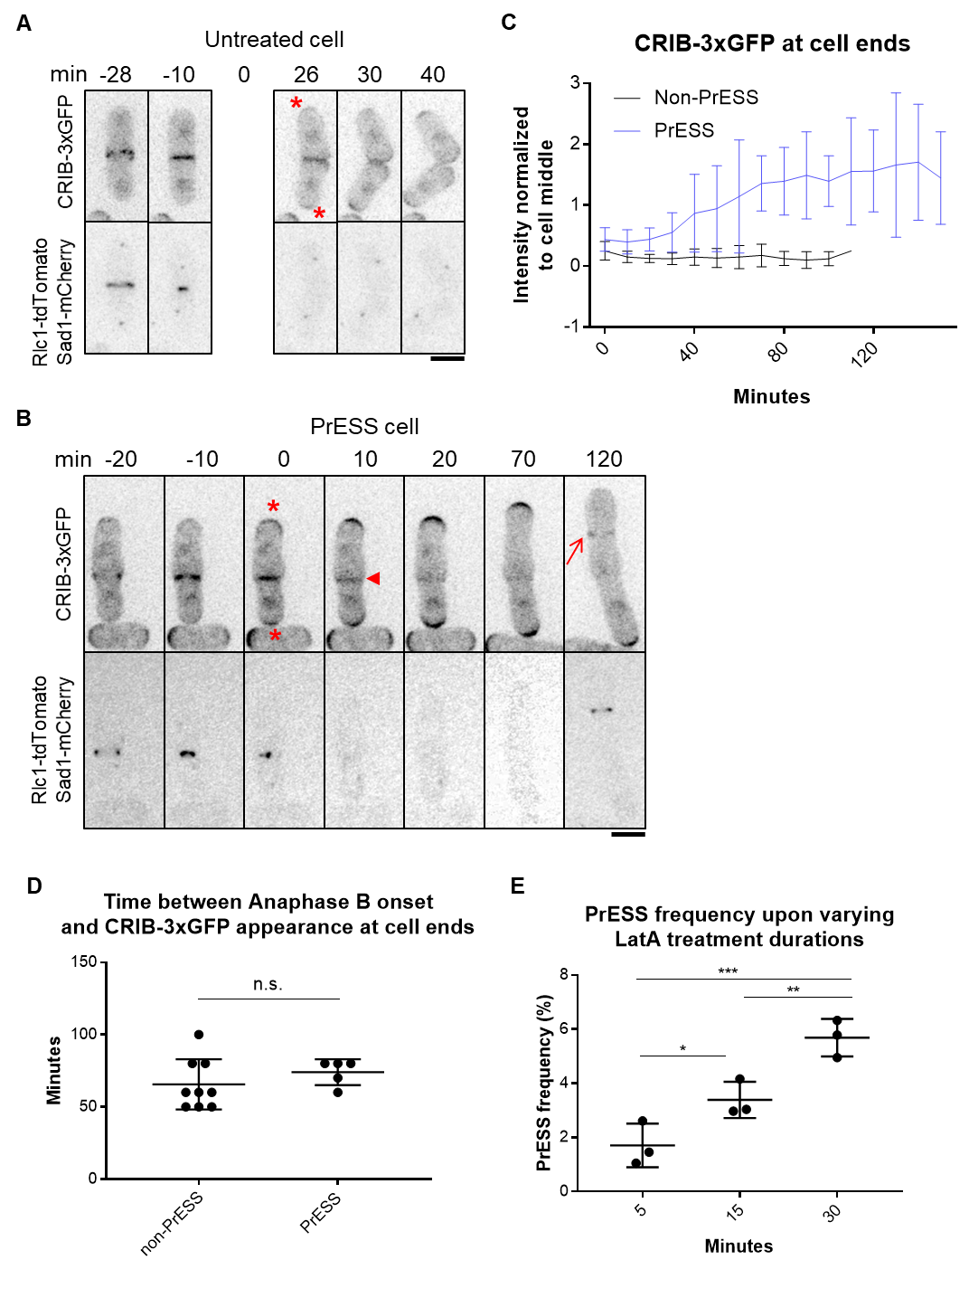Figure 3.3
activation at the cell ends increases over time, soon overcoming the cell middle. We hypothesize that this is indicative of a competition in PrESS cells between the ends and the septum. These sites ordinarily do not attempt to activate Cdc42 concurrently, and thus do not compete with each other. However, since PrESS cells experience a cytokinetic delay, the ends and the septum attempt to activate Cdc42 simultaneously, resulting in a competition for Cdc42 activity. The site of cell division fails in this competition, resulting in cell separation failure. These conjoined cells eventually enter the next cell cycle and show normal Cdc42 activation at the cell ends during interphase and at the new division site (arrow) during cytokinesis, as evident in the two sister cells at 120 minutes in Figure 3.3B showing that subsequent cell cycles progress normally.

We observe that in PrESS cells, Cdc42 is activated at the cell ends prematurely with respect to cytokinesis. This raises the question of whether an intrinsic timer, independent of cytokinesis, determines when Cdc42 is activated at the cell ends after division. To address this, we measured the timing of when CRIB-3xGFP returns to the cells ends after completion of anaphase B. In non-PrESS cells CRIB-3xGFP appears at the ends about 66 minutes after anaphase B. In PrESS cells, after accounting for the 30-minute LatA treatment and 60 minutes recovery, we find that CRIB-3xGFP appears at the ends about the same time (74 minutes, p = 0.3364) as non-PrESS cells (Figure 3.3D). This indicates that an intrinsic timer within the cell determines when Cdc42 activity should return to the cell ends after division. Cells that are undergoing this triggering event when treated with LatA will eventually show the PrESS phenotype. We thus speculate that fewer cells will undergo this Cdc42 activation trigger upon a shorter LatA treatment, resulting in fewer PrESS cells. Indeed, we find that the frequency of the PrESS phenotype does decrease with decreasing duration of LatA treatment (Figure 3.3E).

If Cdc42 activation indeed resumes at the cell ends at the expense of the division site in PrESS cells, we should see this reflected in the levels of Cdc42 regulators in these cells. We analyzed the localization of the Cdc42 GEF Scd1 and its scaffold Scd2 (Chang et al., 1994). During cytokinesis, Scd1 and Scd2 localize to the division membrane barrier and remain there until cell separation (Hercyk et al., 2019b; Hirota et al., 2003). In PrESS cells, we find that Scd1-3xGFP and Scd2-GFP are lost from the division site (Figure 3.4A, i, ii arrowheads) and appear at the cell ends, where they become enriched over time (Figure 3.4A, i, ii, asterisks). While it is not easy to image Scd1-3xGFP over long periods of time due to bleaching, we were able to perform time-lapse imaging of Scd2-GFP. Quantification of Scd2-GFP over time reveals a localization pattern similar to that of CRIB-3xGFP, with PrESS cells showing an increase in signal intensity at the cell ends in relation to the cell middle (Figure 3.4Bi).

Our data show that in PrESS cells, glucanases required for cell separation are not trafficked properly during cytokinesis. Membrane trafficking occurs at sites of Cdc42 activation (Estravis et al., 2012; Estravis et al., 2011; Harris and Tepass, 2010; Murray and Johnson, 2001). Thus, in PrESS cells, with Cdc42 activity decreasing at the cell middle and increasing at the ends, we expect a similar pattern for the membrane
Figure 3.4 Cdc42 effectors localize to the growing ends of PrESS cells. A) In untreated cells, Scd1-3xGFP (i), Scd2-GFP (ii), and Myo52-tdTomato (iii) localize to the septum. When PrESS cells start to grow, all three gradually disappear from the cell middle (arrowheads) and appear at the growing cell ends (asterisks). Maximum projections of Myo52-tdTomato and single planes of Scd1-3xGFP and Scd2-GFP are shown. For Scd1-3xGFP images were taken every hour after LatA washout and different cells at the depicted time point are shown. Time lapse imaging after LatA washout was performed for Scd2-GFP and Myo52-tdTomato. A different untreated Scd2-GFP or Myo52-tdTomato is shown while treated cells shown are the same cell over time B) Quantification of Scd2-GFP (i) and Myo52-tdTomato (ii) intensities at cell ends of non-PrESS and PrESS cells, normalized to the cell middle. n = 6 cells. Scale bars, 5μm.
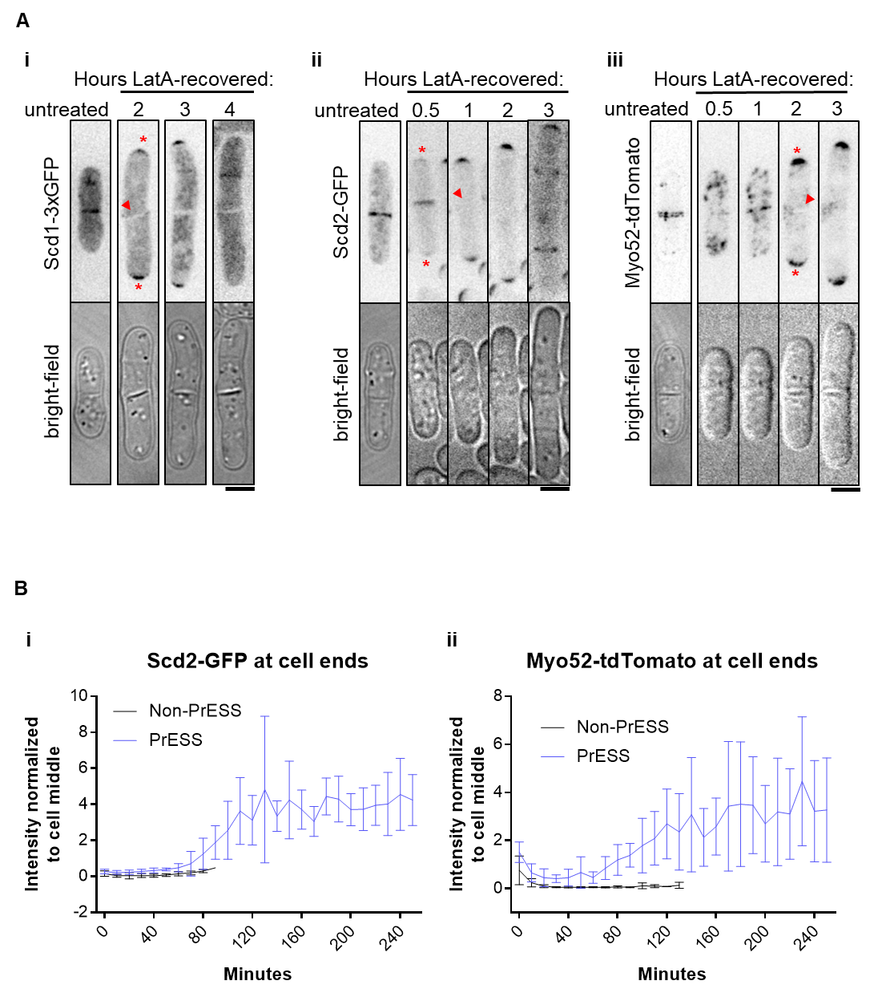

Figure 3.4
trafficking apparatus. To test this, we analyzed the recruitment of the type 5 myosin Myo52 to the division site (Win et al., 2001). Indeed, in PrESS cells, we observe that Myo52-tdTomato intensity gradually increases at the cell ends while it decreases at the septum (Figure 3.4Aiii, Bii). Myo52-tdTomato levels at the cell ends over time thus resemble that of CRIB-3xGFP and Scd2-GFP in PrESS cells (Figure 3.3C, 4B). These findings together suggest that, in PrESS cells, Cdc42 activity, and consequently the membrane trafficking apparatus, transition to the cell ends from the division site. This leads to cell separation failure due to improper delivery of the glucanases that are supposed to digest the primary septum.

Supplemental Figure S3.1 A) Phalloidin staining of untreated cells and cells treated with 10µM LatA for 30 minutes. Actomyosin rings are marked by red arrows. B) Rlc1-tdTomato (arrowhead) and Sad1-mCherry (arrows) mark the actomyosin ring and spindle pole bodies. Time 0 is ring closure. During a 30-minute 10µM LatA treatment (red bar), the original actomyosin ring is disrupted. During recovery, a new ring is built, which undergoes constriction. C) In this sample cell, we determined that septum closure occurred at 80 minutes, because this is the first frame in which the gap that was still visible at 79 minutes (as shown by the red bar) was closed. D) Onset of growth in PrESS and non-PrESS cells after ring closure. E) Rate of old end growth of untreated and PrESS cells. (p < 0.0001; n ≥ 16 cell ends. Statistical tests = Student t-test. Scale bars = 5µm.
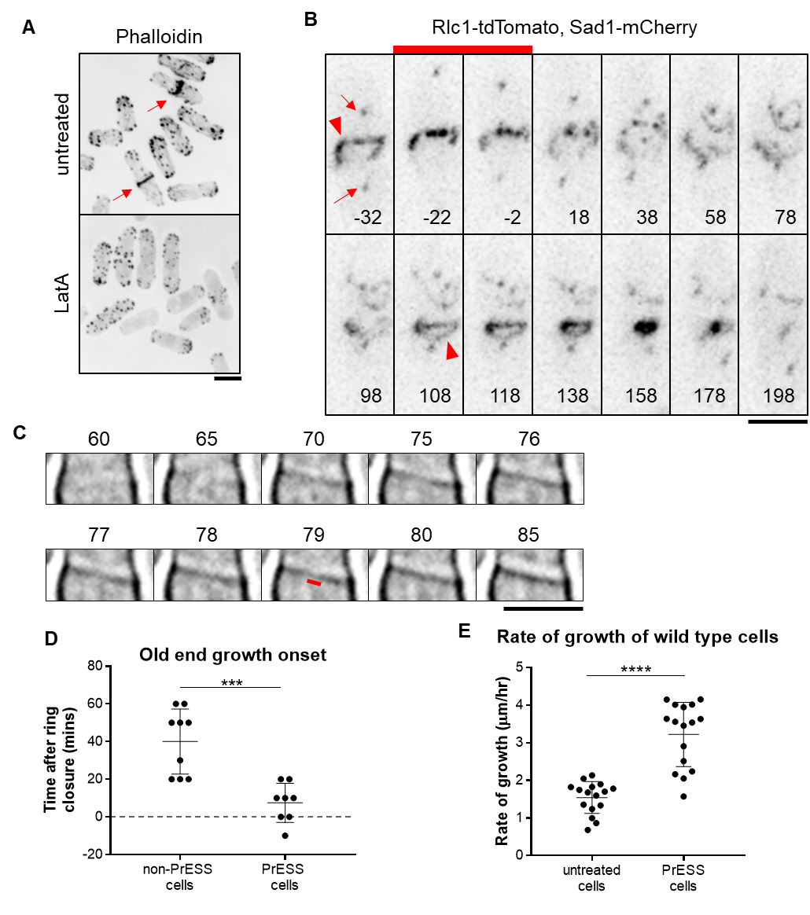
Supplemental Figure S3.1
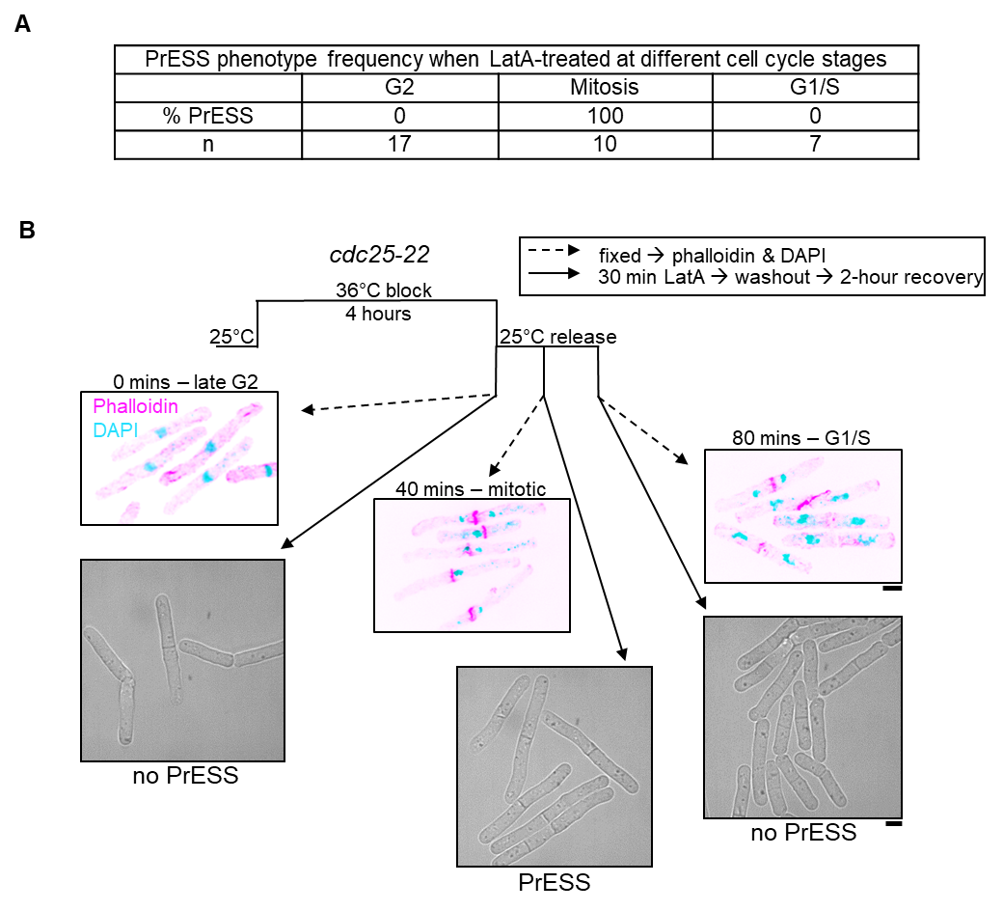
Supplemental Figure S3.2 A) Table showing the frequency of the PrESS phenotype when cells are treated in different cell cycle stages. B) cdc25-22 cells were synchronized by cell cycle block and release. During the indicated cell cycle stages occurring 0, 40, and 80 minutes after release, a fraction of cells was fixed and stained with phalloidin (magenta) and DAPI (cyan), to mark the actomyosin ring and nucleus respectively, while the rest were treated for 30 minutes with LatA and then washed. Cells recovering from LatA treatment in G2 or G1/S does not yield PrESS cells while those undergoing mitosis exclusively yield PrESS cells. Scale bars, 5μm.

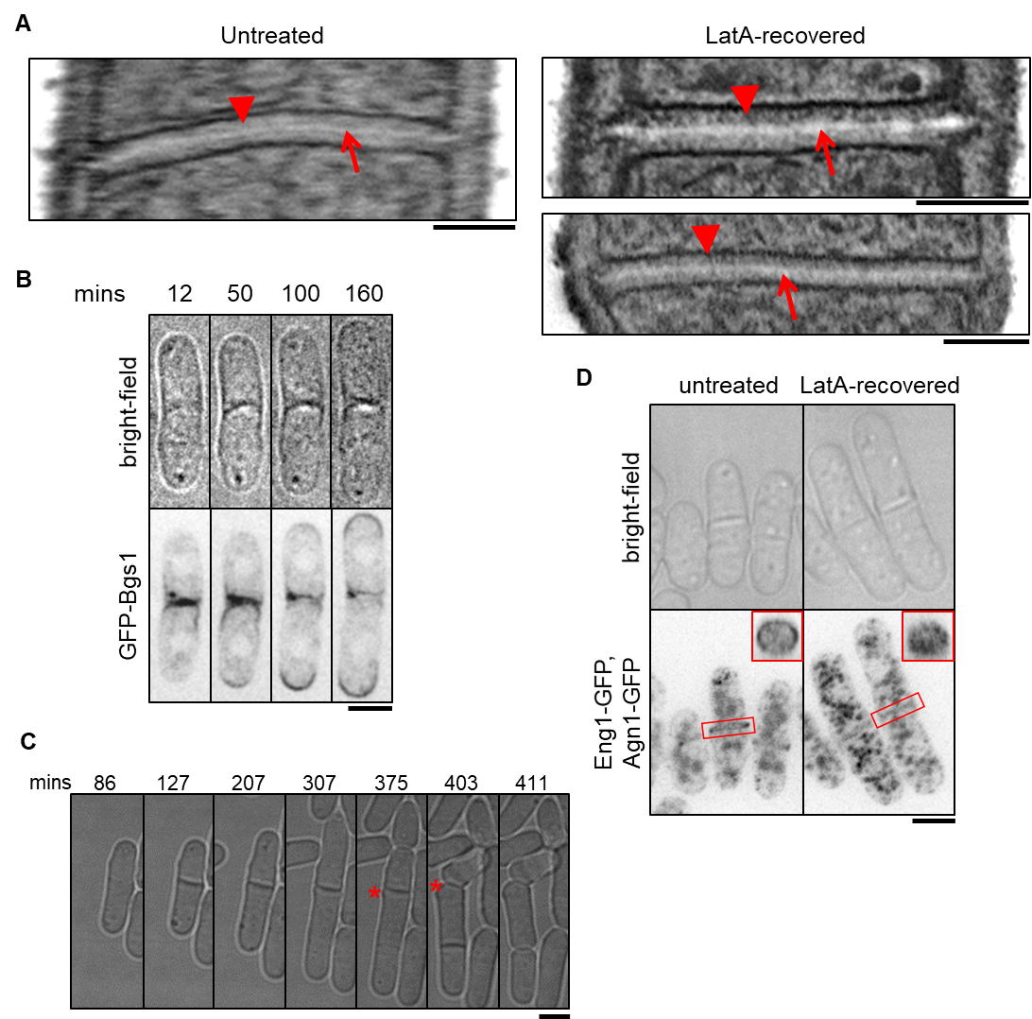
Supplemental Figure S3.3 A) Electron micrographs of wild-type septa; untreated (left) and LatA-treated after 2.5-hour recovery (right). Arrows indicate primary septum, while arrowheads indicate secondary septum. Scale bars, 500nm. B) Montage of a time lapse of GFP-Bgs1 localization in a PrESS cell. Minutes are since LatA washout. Scale bar, 5μm C) The original septum of a PrESS cell sometimes separates (asterisk) albeit after a delay. Minutes are since LatA washout. D) Septum-digesting enzymes, Eng1-GFP and Agn1-GFP, in control cells show cortical distribution at the septum, effectuating a ring, while in PrESS cells their localization appears as a disc all over the septum barrier. The LatA-treated cells shown were imaged 3 hours after LatA washout. 3D-reconstructed membrane barriers are shown in the insets. Scale bars, 5μm.
Chapter IV
Loss of the Cdc42 Inhibitor Rga4 from Cell Ends Allows Growth After Cell Division
Introduction
While much is understood about how polarized growth occurs, little is known about the regulation of when polarized growth occurs. It has been shown that cell-cycle-dependent signaling pathways temporally segregate cell division and growth phases (Ray et al., 2010; Simanis, 2015). During interphase, the Morphogenesis Orb6 (MOR) pathway promotes cell growth (Nunez et al., 2016; Ray et al., 2010). During cell division, the septation initiation network (SIN) is activated, allowing septum formation (Johnson et al., 2012; Simanis, 2015). Activation of the SIN leads to inactivation of the MOR pathway, thus inhibiting cell growth during septum closure (Ray et al., 2010). Subsequent SIN inactivation allows MOR pathway activation, which leads to cell separation and growth (Gupta et al., 2014; Gupta et al., 2013). This crosstalk between the SIN and MOR signaling pathways thus enforces temporal separation of cytokinesis and cell growth.
The MOR pathway promotes cell separation and polarized growth activation, which occur sequentially. It is unclear how the MOR pathway promotes these distinct, sequential cellular processes. The MOR pathway involves activation of the Orb6/NDR kinase, which phosphorylates the exoribonuclease (Nunez et al., 2016).

Phosphorylation of Sts5 prevents its incorporation into processing bodies (P-bodies), where mRNA is stored or degraded (Nunez et al., 2016). Orb6 activity thus prevents Sts5-dependent degradation of mRNA in the P-bodies, leading to increased protein synthesis. Among the mRNAs spared from degradation are those that encode the glucanases Eng1 and Agn1, and the Ras1 GEF Efc25 (Chen et al., 2019; Nunez et al., 2016). While Eng1 and Agn1 promote septum digestion and cell separation, Efc25-mediated Ras1 activation promotes the localization of the Cdc42 GEF Scd1 to cell ends (Garcia et al., 2005; Lamas et al., 2020a; Martin-Cuadrado et al., 2003; Papadaki et al., 2002). In this way, Orb6 activity promotes cell separation and polarized cell growth. However, constitutively activating the MOR pathway does not lead to constitutive cell growth, but rather to premature cell separation that results in cell lysis (Gupta et al., 2014). This suggests that, once the MOR pathway is activated, it immediately promotes both cell separation and growth initiation. Thus, the nature of the regulation that allows cell separation and growth initiation to occur sequentially is unclear, and is the focus of this study.

Here we investigate how growth is reactivated at the cell ends after cell division. After artificially delaying cytokinesis, we observe that the timing of growth activation at the ends is not influenced by the completion of cytokinesis and consequent cell separation. In keeping with this, we find that Cdc42 activity at the cell ends resumes at a fixed time after completion of anaphase B and is independent of cell separation. Our candidate screen for regulators involved in reactivation of Cdc42 at the cell ends identified the Cdc42 GAP Rga4. Rga4 has previously been shown to localize to the cell sides, where it prevents Cdc42 activation (Das et al., 2007; Tatebe et al., 2008). We find that the localization pattern of Rga4 along the cortex changes in a cell-cycle-dependent manner. During interphase, Rga4 appears punctate along the cortex and is excluded from cell ends. During mitosis, Rga4 appears diffuse and localizes all along the cortex, including the cell ends. We propose that Rga4 localization at the cell ends during mitosis blocks Cdc42 activation at these ends. Upon completion of mitosis, Rga4 is lost from the ends and Cdc42 activity resumes. This suggests that once mitosis completes, growth activation at the cell ends occurs once Rga4 is lost from these ends. MOR pathway activation promotes both cell separation and end growth, which normally occur sequentially. Our data suggest that polarized growth activation occurs only once Rga4 is lost from growth sites, allowing these events to occur in sequence. In keeping with our findings, we show that, in mutants constitutively activating the MOR pathway, loss of rga4 leads to enhanced polarized cell growth. These data suggest that cell-cycle-dependent regulation of Rga4 paired with MOR pathway activation allow cell separation and polarized cell growth to occur sequentially.

Results
A candidate screen to identify cell-cycle-dependent regulators of Cdc42 activation
Next, we wanted to identify how Cdc42 is regulated in a cell-cycle-dependent manner at the cell ends. We hypothesized that a Cdc42 regulator is under cell cycle control. Once cell division completes, this regulator allows Cdc42 activation at the ends. To identify
this regulator, we performed a candidate screen of known mutants of Cdc42 regulators, listed in Table S2. We measured the frequency of the PrESS phenotype in these mutants. We considered the different mutants’ cell sizes in computing the PrESS frequency, as described in the Materials and Methods. We observed the PrESS phenotype in all but one of the mutants analyzed. The PrESS phenotype did not occur in the cdc16-116 mutant (Table 4.1). Cdc16 is a GAP that inactivates the SIN pathway. This hypomorphic cdc16-116 mutant shows constitutive SIN activation that leads to repeated septation and absence of cell growth (Schmidt et al., 1997). This suggests that the PrESS phenotype occurs as long as a cell is capable of growth. It is reported that Cdc42 activation in LatA-treated cells is regulated by the MAP kinase Sty1 (Mutavchiev et al., 2016; Toda et al., 1996). We asked if the PrESS phenotype is a Sty1-dependent stress response. The PrESS phenotype persisted in sty1Δ mutants, suggesting that this phenotype is not a stress response to LatA treatment (Supplemental Figure S4.1A). Cell polarity in fission yeast depends on actin as well as the microtubule cytoskeleton. The microtubule-dependent Tea1 protein localizes polarity markers to the cell ends (Feierbach et al., 2004; Glynn et al., 2001). However, tea1Δ mutants show the PrESS phenotype after recovery from LatA treatment. This suggests that the PrESS phenotype is independent of the microtubule-associated polarity markers (Supplemental Figure S4.1B).

Polarized Cdc42 activation depends on Ras1 GTPase, which promotes polarized localization of the Cdc42 GEF Scd1 (Chang et al., 1994; Chen et al., 2019; Lamas et al., 2020c). However, ras1Δ mutants continue to display the PrESS phenotype after recovery
Table 4.1 Candidate screen of mutants to identify changes in the PrESS phenotype. All mutants listed here showed the PrESS phenotype during LatA recovery unless marked with an asterisk.

Protein | Mutant | Role
Cdc16 | cdc16-116* | SIN inhibitor
Scd1 | scd1Δ | Cdc42 GEF
Gef1 | gef1Δ | Cdc42 GEF
Gef1 | gef1S112A | Cdc42 GEF
Rga4 | rga4Δ | Cdc42 GAP
Rga6 | rga6Δ | Cdc42 GAP
Scd2 | scd2Δ | Scaffold for Scd1
Rdi1 | rdi1Δ | Cdc42 GDI
Ras1 | ras1Δ | RAS GTPase
Tea1 | tea1Δ | Polarity marker
Tea4 | tea4Δ | Polarity marker
For3 | for3Δ | Actin regulator
Myo1 | myo1Δ | Type I myosin
Sec8 | sec8-1 | Exocyst component
Exo70 | exo70Δ | Exocyst component
Sty1 | sty1Δ | MAP kinase
Orb2 / Shk1 / Pak1 | orb2-34 | PAK kinase
Plo1 | plo1.as8 | Polo kinase
Cdc10 | cdc10-129 | Cell cycle regulator

from LatA treatment (Supplemental Figure S4.1C). We also find that loss of either of the partially redundant GEFs, Scd1 or Gef1, does not lead to reduced PrESS frequency (Figure 4.1A, B). This suggests that cell-cycle-dependent activation of Cdc42 at the ends is not dependent on a specific GEF, and that as long as a GEF is available, Cdc42 will be activated at the cell ends. We find that gef1Δ shows a higher PrESS frequency than wild type (Figure 4.1B). We have previously shown that in gef1Δ cells, the old end competes with the new end for Cdc42 activity more effectively than wild type (Hercyk et al., 2019b). Thus, in gef1Δ mutants, a robust old end can explain the higher PrESS frequency we observe.

Next, we analyzed the PrESS phenotype in deletion mutants of the Cdc42 GAPs Rga4 and Rga6. These GAPs inactivate Cdc42 at the cortex (Das et al., 2007; Revilla-Guarinos et al., 2016; Tatebe et al., 2008). We did not see any change in the PrESS frequency of rga6Δ cells. In contrast, rga4Δ shows a significantly higher incidence of the PrESS phenotype compared to wild type cells (p < 0.05) (Figure 4.1C, D). rga4Δ cells are wider and shorter than wild type (Das et al., 2007). This observation is consistent among PrESS cells. One explanation for the higher PrESS frequency in gef1Δ and rga4Δ cells could be a longer mitotic phase or septation defect. However, mitosis is not prolonged, compared to wild type cells, in either gef1Δ mutants (Wei et al., 2016) or in rga4Δ mutants (Supplemental Figure S4.2C). We did observe a higher septation index in gef1Δ mutants but not in rga4Δ mutants (Supplemental Figure S4.2A, B). This indicates that the higher PrESS frequency in these mutants is not due to a mitotic delay or a septation defect.
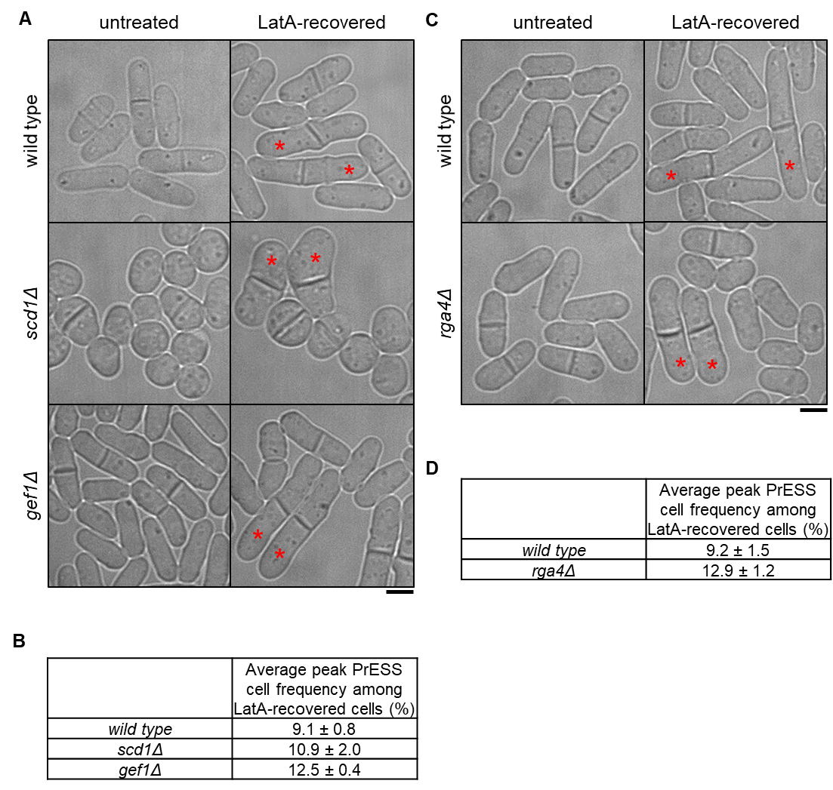
Figure 4.1 Loss of negative regulation of Cdc42 increases the incidence of the PrESS phenotype. A, B) PrESS phenotype persists in mutants of Cdc42 activators scd1Δ and gef1Δ. scd1Δ does not show a significant change from wild type, while gef1Δ shows an increase (p = 0.015) (Ordinary 1-way ANOVA with Dunnett’s multiple comparisons test). Asterisks denote PrESS cells. Repeated in triplicate, n ≥ 350 cells per experiment. C, D) Loss of Cdc42 inactivator Rga4 increases PrESS frequency during recovery from LatA treatment (Student’s t-test, p = 0.033). Repeated in triplicate, n ≥ 350 cells per experiment. Scale bars, 5μm.

Rga4 localization is regulated in a cell-cycle-dependent manner
In PrESS cells, Cdc42 is activated at the ends earlier with respect to septation. This enhanced Cdc42 activity at the ends could be due to either an increased activity of one of its GEFs or loss of one of its GAPs. We find that the GEFs are non-essential for the PrESS phenotype, suggesting that increased GEF activity is not responsible for this phenotype. Since deletion of the Cdc42 GAP rga4 results in a higher PrESS frequency, we asked if Rga4 has a role in regulating Cdc42 activity at the ends and thus growth during mitosis. Previous studies have shown that Rga4 localizes mainly to the cell sides, where it blocks Cdc42 activation (Das et al., 2007; Tatebe et al., 2008). In wild type cells, we observe that Rga4-GFP localizes mostly to the cell sides during interphase (Figure 4.2A). As the cell enters division, Rga4-GFP can be found not only at the cell sides, but also at the ends (Figure 4.2A, asterisks). Time-lapse imaging of Rga4-GFP (10 sec intervals for 1 minute) indicates that Rga4-GFP at the cell ends is dynamic in nature (Supplemental Figure S4.3A). A time-lapse projection of Rga4-GFP (10 sec intervals for 5 minutes) shows increased signal at the cell ends in mitotic cells as compared to interphase cells (Figure 4.2B, asterisks). We measured the mean intensity of Rga4-GFP at cell ends in these time-projected wild type cells. We find that mitotic cells have significantly more Rga4-GFP at their cell ends than cells in G2 or G1/S (Figure 4.2C). We also observed that in time-projected cells, the intensity of Rga4-GFP at the cortex in relation to the cytoplasm is elevated in G2 and G1/S cells compared to mitotic cells (Supplemental Figure S4.3B).

Figure 4.2 Rga4 localization changes in a cell-cycle-dependent manner. A) During G2 and septation (G1/S), Rga4-GFP localizes to the cortex along the cell sides as distinct puncta. During mitosis (late and early anaphase) Rga4-GFP at the cortex appears diffuse (bracket) with localization extending to the cell ends (asterisks). B) Time-lapse projection (10 sec intervals over 5 mins) of Rga4-GFP localization at different cell cycle stages. Asterisk denotes enhanced tip localization in mitotic cells. C) Quantification of Rga4-GFP intensities to cell ends during different cell cycle stages. Significantly more Rga4-GFP localizes to cell ends during mitosis than during either G2 (p = 0.0002) or G1/S (p = 0.0027). D) Quantification of the Rga4-GFP localization pattern along the cell sides (increased co-efficient of variance = decreased homogeneity = increased punctate appearance) in wild type cells through different cell cycle stages. (n ≥ 10 cells) e.a. = early anaphase; l.a. = late anaphase. E) cdc2-as mutant cells blocked in G2 upon 1NM-PP1 treatment show distinct Rga4-GFP puncta along the cell sides. After 1NM-PP1 washout, cdc2-as mutant enters mitosis and Rga4-GFP appears more diffuse along the cortex. Once in G1/S, Rga4-GFP again localizes as puncta. F) Quantification of the Rga4-GFP homogeneity along the sides, as done for D, in synchronized cdc2-as cells through different cell cycle stages. (n ≥ 14 cells) Ordinary one-way ANOVA with Tukey’s multiple comparisons was used for statistical analysis. Scale bars, 5µm.
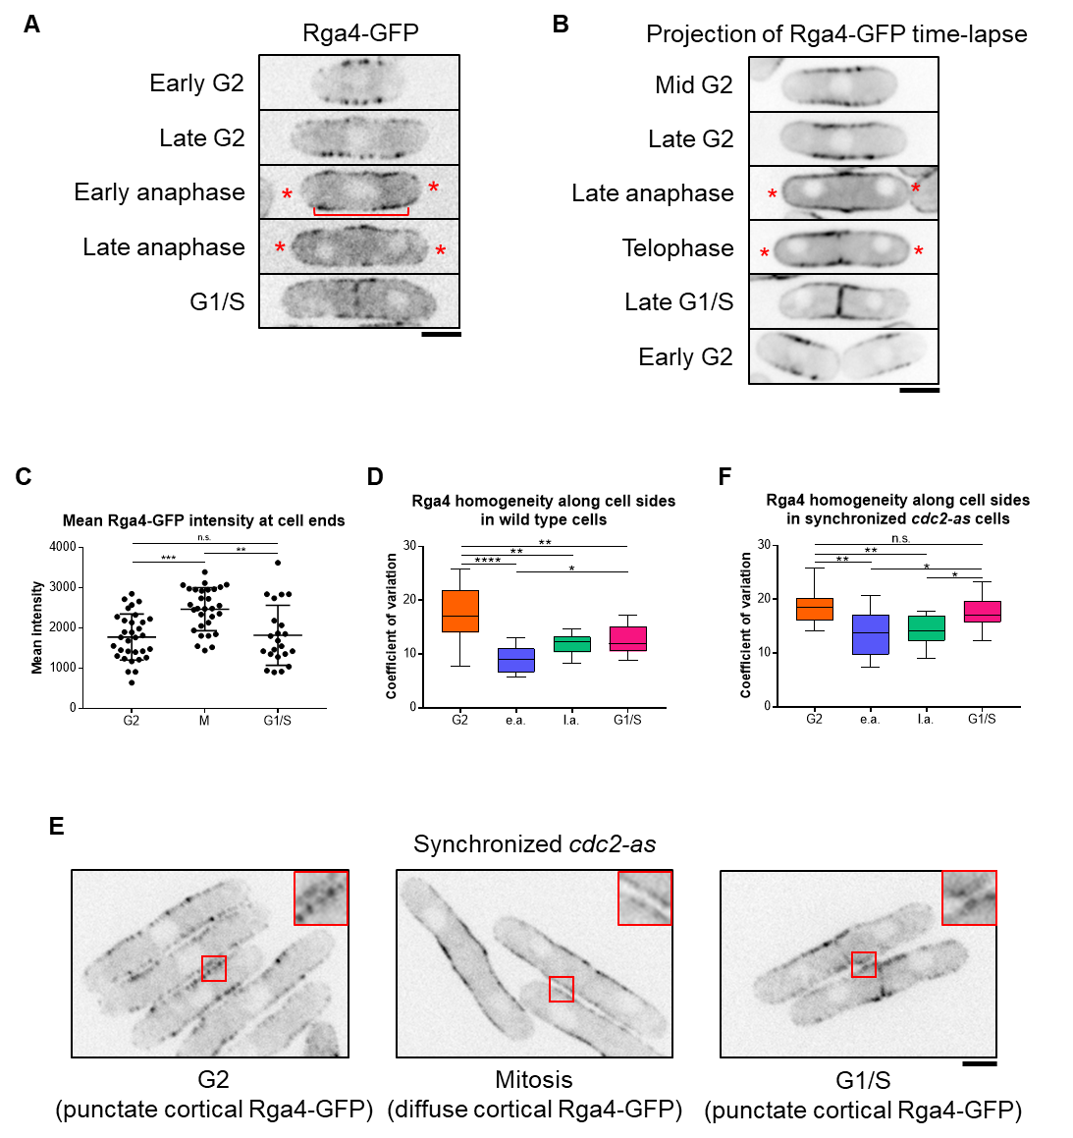

Figure 4.2
We further observe that not only the localization, but also the distribution, of Rga4-GFP along the cortex changes throughout the cell cycle. In G2, Rga4-GFP appears as puncta dispersed along the cell sides (Figure 4.2A). During mitosis, it appears to be spread more homogeneously along the cortex (Figure 4.2A, bracket). We quantified these changes by measuring the coefficient of variation of Rga4-GFP distribution along the cortex. The higher the coefficient of variation, the less homogeneous the distribution of Rga4-GFP. We find that the coefficient of variation is higher during G2 than it is during mitosis, reflecting our observation that Rga4-GFP appears more punctate during G2 and more diffuse during mitosis (Figure 4.2D). The coefficient of variation drops in cells undergoing mitosis and appears to begin to increase again in G1/S cells. This suggests that, in mitotic cells, the distribution of Rga4-GFP along the cortex is more homogeneous, and gradually reverts back to a more punctate appearance as the cells enter G1/S.

Our analysis indicates that Rga4 localization and distribution change through different cell cycle stages. We asked if these changes are indeed cell-cycle-dependent. To test this, we analyzed the localization pattern of Rga4-GFP throughout the cell cycle via cell-cycle block and release. In our experience Rga4-GFP localization shows artifacts at high temperature and hence we did not use the cdc25-22 mutants. Instead we used an analog-sensitive mutant cdc2-as of the mitotic kinase Cdk1 which allows specific inhibition of its kinase activity upon addition of the inhibitor 1NM-PP1 (Aoi et al., 2014). In untreated and thus asynchronous cdc2-as cells, the Rga4-GFP distribution pattern is similar to that observed in control cells (Supplemental Figure S4.3C). Next, we synchronized cdc2-as cells by adding the inhibitor 1NM-PP1. We distinguished between different cell cycle stages by observing the nucleus/nuclei and Rga4 localization at the division site (Supplemental Figure S4.3D). After arresting the cells in G2, we washed out the inhibitor to allow release into mitosis. Distribution of Rga4-GFP along the cortex was analyzed in cells at different cell cycle stages. Cells arrested in G2, when Cdc2 activity is inhibited, show a high coefficient of variation, corresponding to a more punctate Rga4-GFP distribution (Figure 4.2E, F). Approximately 20 minutes after removal of the inhibitor, the cells were in early anaphase. Under these conditions, the coefficient of variation of Rga4-GFP distribution is significantly reduced, corresponding to a more homogeneous distribution (Figure 4.2E, F). Similarly, cells in late anaphase, about 40 minutes after release, also show a decreased coefficient of variation of Rga4-GFP distribution. The coefficient of variation in cdc2-as cells synchronized in G1/S (~70 minutes after release) is higher than in mitotic cells, suggesting that the punctate distribution reappears after mitosis. However, in asynchronous cells, the coefficient of variation in G1/S is lower than it is in G2 (Supplemental Figure S4.3C). During G1/S, Rga4-GFP distribution returns to a more punctate appearance, similar to G2. This change is likely better captured in synchronized cells. In cell-cycle-arrested cdc2-as cells, which are larger than wild type cells, Rga4-GFP was not clearly visible at the cell ends. It is possible that the increased cell size of these arrested cells leads to a decrease in the local concentration of Rga4-GFP at the ends.

Loss of Rga4 allows polarized growth activation after cell division.
Our data suggest that Cdc42 regulation at the cell ends is cell-cycle-dependent and that loss of rga4 enhances PrESS frequency. Moreover, we find that localization of Rga4 to cell ends increases during mitosis when Cdc42 activation at those ends is known to decline. We propose that two elements are necessary for polarized growth to occur: MOR pathway activation leading to protein synthesis, as well as Cdc42 activation at the cell ends. During mitosis, the MOR pathway is inactive and Rga4 is present at the ends, and growth does not occur. As cell division completes, the MOR pathway becomes active and the cell ends lose Rga4, allowing local Cdc42 activation. In PrESS cells, cytokinesis is delayed, but the MOR pathway and Cdc42 at the ends are activated as normal, resulting in polarized growth. We should thus be able to recapitulate the PrESS phenotype in cells both constitutively activating the MOR pathway and activating Cdc42 at the ends even without a delay cytokinesis. Constitutive activation of the MOR pathway via expression of the nak1-mor2 fusion leads to premature protein synthesis during cytokinesis (Gupta et al., 2014). This includes the glucanases that are then prematurely delivered to the incomplete septum barrier, resulting in cell lysis (Figure 4.3A, arrows; Supplemental Figure 4.3A). We hypothesized that if the cell ends were instead able to activate growth, the glucanases would be delivered to the cell ends rather than the division site, resulting in a PrESS-like phenotype. Based on our previous observations, we should accomplish this by deleting rga4 in a mutant constitutively activating the MOR pathway. Since nak1-mor2-expressing cells undergo cell lysis resulting in cell death, they display a low optical
Figure 4.3 Loss of rga4 allows polarized growth in cells constitutively activating the MOR pathway. A) Cells expressing nak1-mor2 (-thiamine) show cell lysis (red arrow) at the division site during cytokinesis in rga4⁺ cells, while in rga4Δ mutants nak1-mor2 expression leads to a PrESS-like phenotype (arrowhead) in which cells fail separation and grow from the ends. B) Growth curve of rga4⁺ or rga4Δ cells either expressing nak1-mor2 or repressing nak1-mor2. Optical density was measured every 15 minutes at 595nm for 2 days. (Ordinary one-way ANOVA with Tukey’s multiple comparisons. **** = p < 0.0001; 5 experiments averaged for each genotype) C) rga4⁺ cells expressing nak1-mor2 (n-m) showed significantly more lysis than rga4Δ cells either repressing or expressing nak1-mor2 (p = 0.0042; p = 0.0030) D) Percent of cells displaying a PrESS-like phenotype. rga4Δ cells containing nak1-mor2 (n-m) display a significantly higher PrESS-like frequency than rga4⁺ cells containing nak1-mor2 (p < 0.0001). E) rga4⁺ and rga4Δ cells expressing nak1-mor2 and containing CRIB-3xGFP. While only a few septated rga4⁺ cells show CRIB-3xGFP at their ends, a large fraction of septated rga4Δ cells do. F) Quantification of CRIB-3xGFP presence at cell ends in rga4⁺ and rga4Δ cells expressing nak1-mor2 (n-m). Ordinary one-way ANOVA with Tukey’s multiple comparisons was used for statistical analysis. Experiments repeated in triplicate. Scale bars, 5µm.
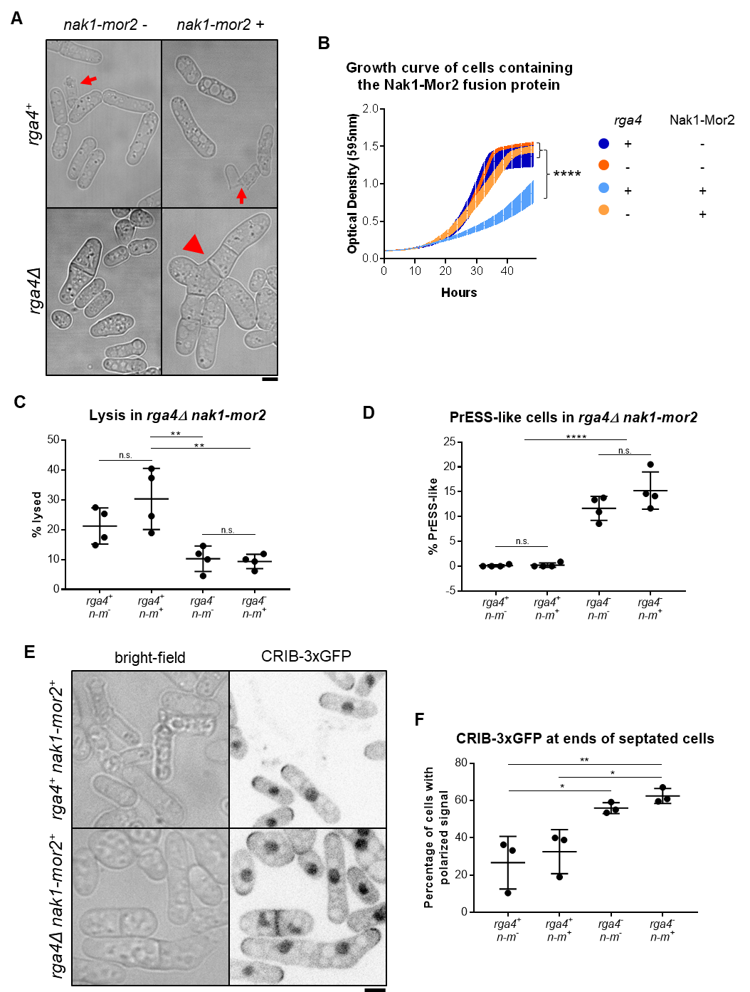Figure 4.3
density (Gupta et al., 2014). We observed cell lysis in rga4⁺ cells with nmt1-nak1-mor2 under both expressing and repressing conditions. This is likely due to leaky expression of nak1-mor2 in these cells. However, cell lysis was enhanced under expressing conditions compared to repressing conditions, resulting in a significantly lower optical density in rga4⁺ cells expressing nak1-mor2 (Figure 4.3B). Accordingly, the fraction of lysed cells in rga4Δ mutants expressing nak1-mor2 was significantly reduced compared to rga4⁺ cells expressing nak1-mor2 (Figure 4.3C). These cells fail to undergo cell separation and continue to grow from their ends, similar to PrESS cells (Figure 4.3A, arrowhead). Indeed, while rga4⁺ cells expressing nak1-mor2 did not show PrESS-like cells, rga4Δ cells expressing nak1-mor2 consistently showed this phenotype in the population (Figure 4.3D). Note that rga4Δ cells are capable of cell separation, and thus failure to separate in nak1-mor2-expressing conditions is due to premature growth at the ends, similar to PrESS cells.

Next, we asked if this PrESS-like phenotype is due to Cdc42 activation at the ends in dividing cells. PrESS cells have a septum and show active Cdc42 at their ends. Thus, we analyzed CRIB-3xGFP at the ends of septated cells in rga4⁺ and rga4Δ cells expressing nak1-mor2. We find that, in rga4Δ cells expressing nak1-mor2, a larger fraction of septated cells shows CRIB-3xGFP at the cells ends compared to the rga4⁺ control (Figure 4.3E and F). We asked if the PrESS-like phenotype was specific to Rga4. We show that the PrESS frequency also increases in gef1Δ mutants (Figure 4.1). However, we did not observe PrESS-like cells or rescue of cell lysis in gef1Δ cells expressing nak1-mor2 (Supplemental Figure S4.4B). Similarly, it is possible that the PrESS-like phenotype could be due to loss of any Cdc42 GAP. However, in rga6Δ cells expressing nak1-mor2, we did not observe PrESS-like cells or rescue of cell lysis (Supplemental Figure S4.4B). We thus propose that lack of Rga4 at the cell ends allows the ends to better compete for growth machinery, preventing localization of these proteins to the division site. This suggests that under normal conditions, after MOR pathway activation, cell growth occurs once the ends lose Rga4.

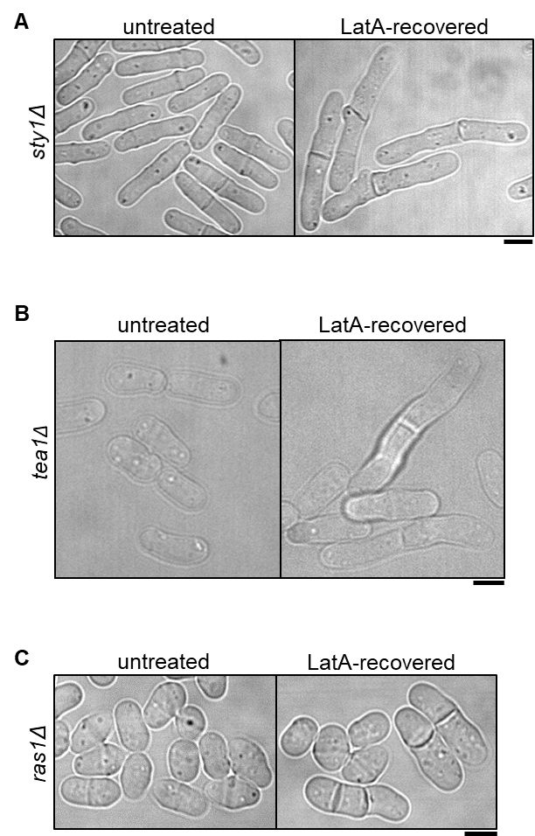
Supplemental Figure S4.1 The PrESS phenotype was observed in mutants of the MAP kinase sty1Δ (A), GTPase ras1Δ (B) and tea1Δ (C). Scale bars, 5μm.

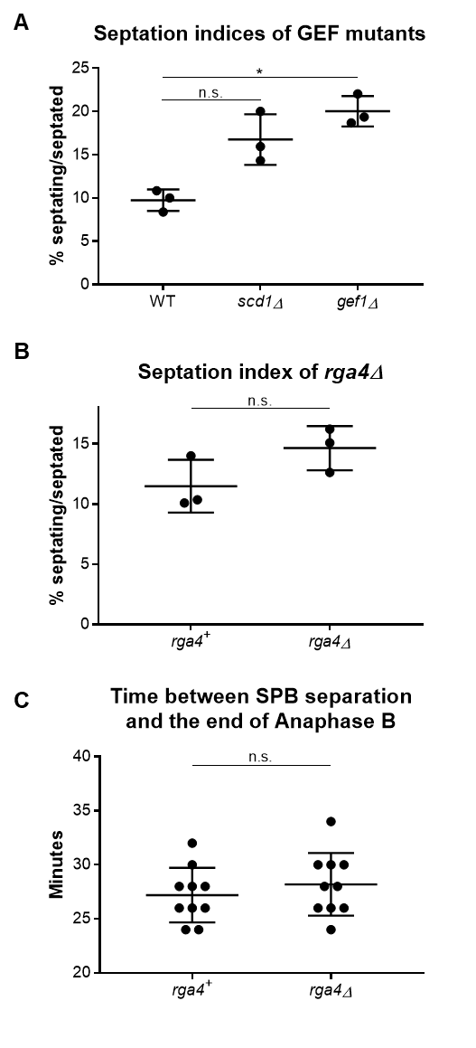
Supplemental Figure S4.2 A) Septation indices of the Cdc42 GEF mutants scd1Δ and gef1Δ. gef1Δ shows significantly more septated cells than the wild type (p = 0.0396), while scd1Δ does not (p = 0.1017). B) Septation index of the Cdc42 GAP mutant rga4Δ, which was similar to wild type (p = 0.1277). C) Quantification of the time between spindle pole body separation (completion of spindle formation) and the end of Anaphase B. We find no significant difference between rga4⁺ and rga4Δ cells. Statistical tests used for A is Ordinary one-way ANOVA with Tukey’s multiple comparisons and for B and C is Student’s t-test.

Supplemental Figure S4.3 A) Montages of the same cells in Figure 4.2B. Images are from the first minute of the time-lapse with an interval of 10 seconds. B) Quantification of Rga4-GFP intensity throughout the cell cycle. The values are ratios of the intensity at the cortex to the intensity in the cytosol. The intensity of Rga4-GFP is lower in the cytoplasm during G2 than late mitosis (p = 0.0189). C) Quantification of the homogeneity of Rga4-GFP in asynchronous cdc2-as cells without inhibitor treatment. e.a. = early anaphase; l.a. = late anaphase. Ordinary one-way ANOVA with Tukey’s multiple comparisons. D) Sample Rga4-GFP expressing cdc2-as cells demonstrating how cells in different cell cycle stages were selected. Arrows show a single nucleus in G2, an elongated nucleus in early anaphase, a binuclear cell with no signal at the division site for late anaphase, and a binuclear cell with signal at the division site (arrowhead) for post-anaphase cells. Scale bars, 5μm.
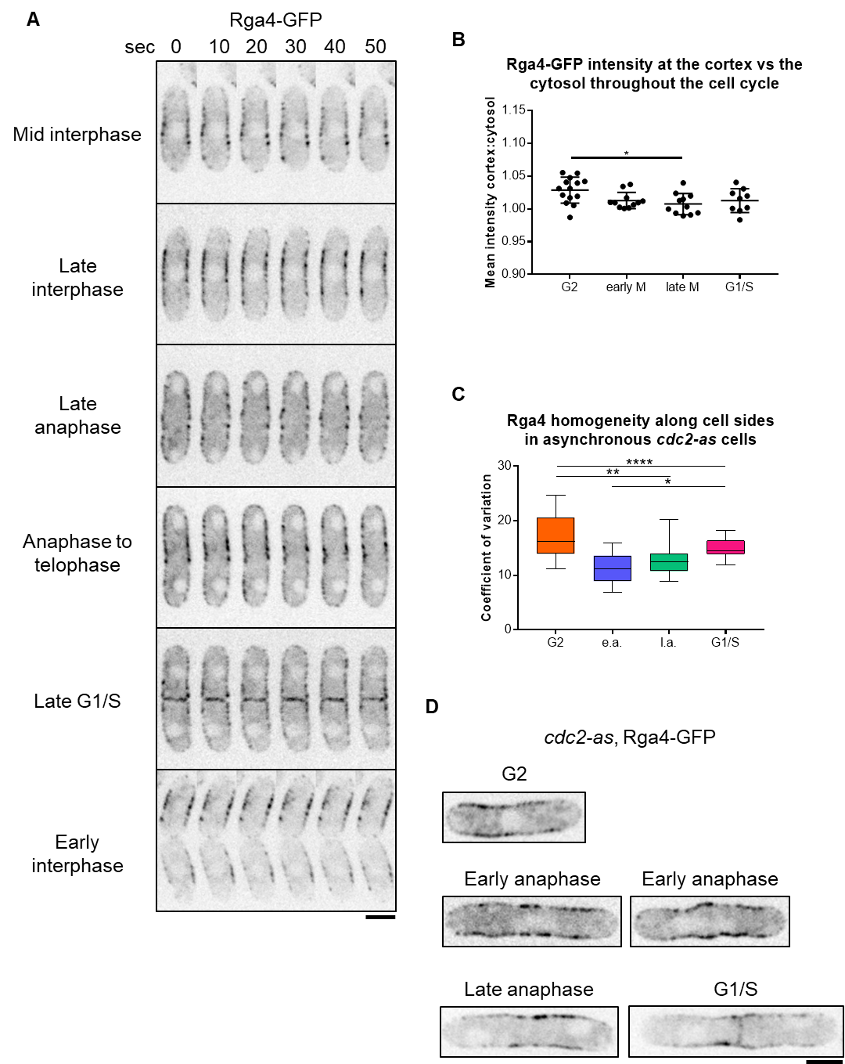
Supplemental Figure S4.3
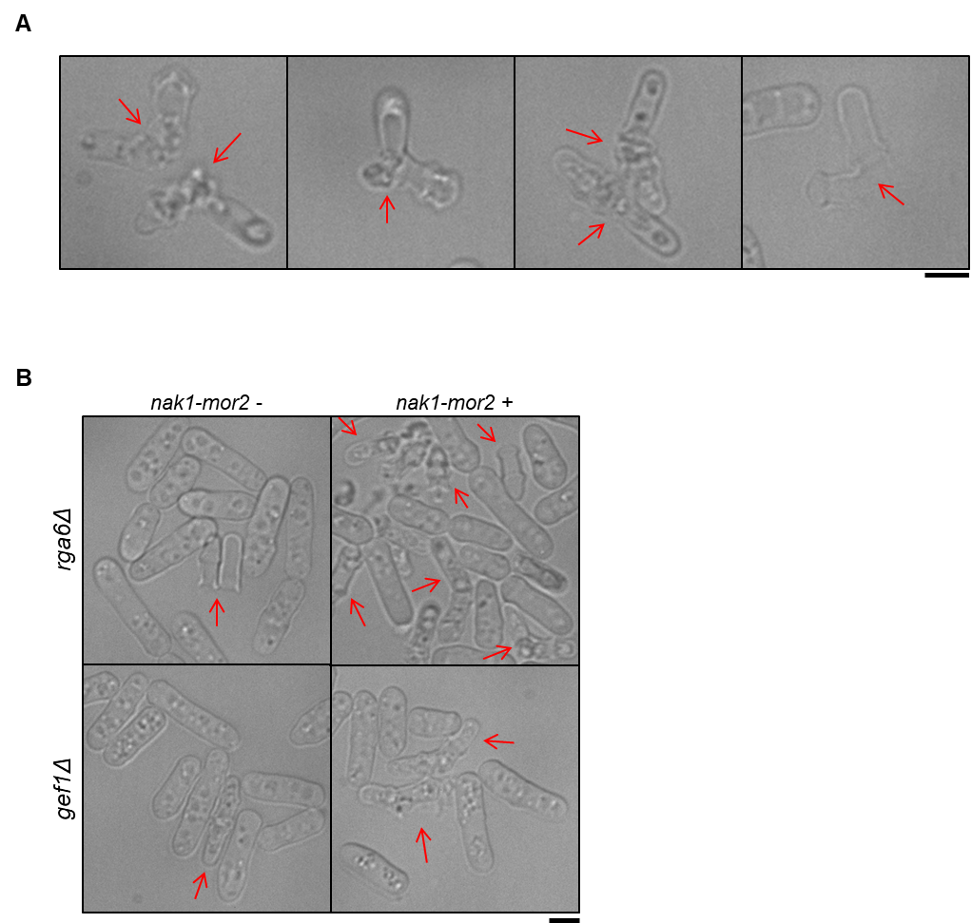
Supplemental Figure S4.4 A) Examples of lysed cells (arrows) in wild type cells expressing nak1-mor2 (-thiamine). Cells mostly lyse at the division site. B) gef1Δ and rga6Δ cells under conditions where they repress nak1-mor2 or express nak1-mor2. Lysed cells are shown with arrows. Scale bars, 5μm.

Chapter V
Discussion
Although much is known about how polarized growth occurs in fission yeast, it is unclear how polarized growth resumes at the old ends after cell division completes. Our work with gef1Δ shows growth dominance of ends which grew in the previous generation, revealing the existence of a heritable memory of growth. It is unclear what constitutes this factor, but it is possible that there could be some protein or lipid modification at an end that has undergone growth that primes it to grow in the following generation and out-compete the new end. gef1Δ cells have less active Cdc42, making the memory of growth apparent. However, when Cdc42 activity is increased, the memory of growth is not necessary to ensure that growth occurs at the old end. We find that in the absence of the GDI rdi1, the competition between the old and new ends is reduced due to the increase in active Cdc42, resulting in precociously bipolar growth. While the memory of growth is still present in these cells, the abundance of Cdc42 activity means that once the old end is saturated with Cdc42 activity, there is enough leftover for the new end without having to compete for it. Mathematical modeling of the memory of growth would likely provide valuable insights into how the memory of growth affects growth polarity in wild type and mutant cells.

It is unknown how Cdc42 activity is timed to transition from the division site to the ends to drive polarized growth. Since Cdc42 activation at the ends normally does not occur until after completion of cell separation, we asked if the timing of Cdc42 activation and consequent growth resumption could depend on cell separation itself. However, here we show that the timing of Cdc42 activation at the old end is independent of cell separation and is instead cell-cycle-dependent.

The MOR pathway promotes cell separation and polarized growth after mitosis (Chen et al., 2019; Gupta et al., 2014; Nunez et al., 2016; Ray et al., 2010). The final step in cell division, cytokinesis, involves actomyosin ring formation and subsequent constriction in coordination with septum formation and membrane invagination (Cheffings et al., 2016; Garcia Cortes et al., 2016; Pollard, 2010). After ring constriction, the septum matures to form a tri-layer – a primary septum flanked by secondary septum (Cortes et al., 2016; Garcia Cortes et al., 2016). MOR pathway activation allows synthesis of glucanases, which are delivered to the outer edge of the membrane barrier to precisely digest the primary septum, resulting in cell separation (Martin-Cuadrado et al., 2005; Nunez et al., 2016; Santos et al., 2005). Once septum digestion starts, Cdc42 activity transitions to the old ends and polarized growth initiates. It was unclear how cell separation and growth initiation occur sequentially since the MOR pathway promotes both processes.

Constitutively activating the MOR pathway leads to cell lysis during division, which is caused by premature cell separation as a result of unregulated glucanase synthesis and delivery (Gupta et al., 2014). Here we report the novel PrESS phenotype, in which polarized cell growth initiates during septation. Our data suggest that, in these cells, Cdc42 is activated at the ends at the expense of cell separation. Activation of Cdc42 at the ends of these cells coincides with a decrease in Cdc42 activity at the division site. Thus, instead of delivering glucanases to the division site resulting in premature cell lysis, the ends show polarized growth. This indicates that, under normal conditions, Cdc42 activity at the ends is inhibited while the division site successfully undergoes cell separation. The ends are able to activate Cdc42 only after cell separation completes, even though the MOR pathway is active throughout this stage. Indeed, we find that constitutively activating the MOR pathway does not lead to Cdc42 activation at the cell ends during division. These observations together suggest that, in addition to MOR activation, another pathway regulates Cdc42 at the ends after division.

Our results indicate that Rga4 is regulated at the cell ends during mitosis. We show that Rga4 localizes all the way to the cell ends during mitosis, instead of being restricted to the cell sides (Das et al., 2007). It is possible that Rga4 at the ends during mitosis blocks Cdc42 activation. Accordingly, we hypothesize that, in the absence of rga4, cells should initiate growth at their ends during division as long as protein synthesis via the MOR pathway is active, thus recapitulating the PrESS phenotype. Indeed, in cells constitutively activating the MOR pathway, loss of rga4 leads to end growth and cell separation failure in a recapitulation of the PrESS phenotype, thus supporting our hypothesis.

How does Rga4 localize to the cell ends during mitosis? Rga4 typically localizes to the cell sides during G2 and is excluded from the cell ends. During this phase, Rga4 appears as distinct puncta dotted along the cell sides. However, during mitosis, Rga4 appears more diffuse along the cortex and extends all the way to the cell ends. Cells arrested in G2 show distinct punctate Rga4 distribution at the cell sides. Upon release, when the cells enter mitosis, Rga4 appears diffuse at the cortex. It is unclear how Rga4 localization and distribution are regulated during mitosis. Rga4 could be a direct target of the mitotic kinase Cdc2 or of an unknown cell-cycle-dependent regulatory module. In another study, Rga4 has been identified as a target of Cdk1 kinase activity, however the physiological significance of this interaction is unknown (Swaffer et al., 2016). We are currently investigating the nature of cell-cycle-dependent Rga4 regulation during mitosis. It is not clear how Rga4 is removed from the ends upon completion of mitosis. Rga4 still lingers at the ends after activation of the anaphase-promoting complex, which promotes Cdk1 inactivation. It is possible that Rga4 undergoes some modification that gradually leads to its loss from the ends. This could be mediated by a phosphatase, by turnover of Rga4, or by an unknown mechanism. While it is unknown how changes in the localization pattern of Rga4 affects Cdc42 regulation, a similar concept has been recently shown in another study (Gerganova et al., 2021). There, the authors show that artificially localizing a Cdc42 GAP to the cortex completely blocks Cdc42 activity, while conditions leading to its oligomerization result in its loss from the ends, enabling local Cdc42 activation.
Similar to our findings in fission yeast, another report in budding yeast has shown that the start of polarization after cell division is independent of cytokinesis (Moran et al., 2019). Moreover, it was shown in the same study that the start of polarization is earlier in mutants lacking the Cdc42 GAPs BEM3 and RGA2. In yet another study, it has been shown that Cdc42 inactivation at the onset of mitosis is mediated by BEM3 (Gihana et al., 2021). Thus, it is possible that the role of GAPs in the regulation of polarization after cell division is conserved. Moreover, in budding yeast, CDKs Pho85 and Cdc28 phosphorylate the GAP Rga2 to restrain its activity and promote polarized growth (Sopko et al., 2007). It has also been shown in budding yeast that the G1-cyclin-bound CDKs promote Cdc42 activation (McCusker et al., 2007). G1-cyclin-CDK promotes Cdc42 activation via the GEF Cdc24, thus allowing bud growth. Our findings suggest a mitosis-dependent negative regulation of Cdc42 activity. It is unclear if the G1-cyclin-CDK complex also regulates Cdc42 in fission yeast.

While we find that Rga4 localizes to the cell ends during mitosis, it should be noted that loss of rga4 alone does not allow Cdc42 activation at the ends at this stage. This is probably because, even in the rga4 mutants, the MOR pathway is inhibited during mitosis. Cdc42 activation at the ends is not possible while the MOR pathway is inactive. Consequently, after division, Cdc42 activation at the cell ends requires both loss of Rga4 from the cell ends and MOR pathway activation. It is possible that in an rga4Δ mutant, since cytokinesis is not delayed, the ends do not have a sufficient advantage in activating growth because the MOR pathway is only activated during septation. In rga4Δ cells constitutively activating the MOR pathway, the ends do have an advantage since the MOR pathway has been active even before septation, thus leading to growth. A recent report has shown that presence of the GAPs at the cortex prevents local Cdc42 activation even upon localization of the scaffold Scd2, which recruits Scd1 to the cortex (Lamas et al., 2020b). Another preprint suggests that Cdc42 GAP levels in daughter cells determine the pattern of polarized growth in those cells (Pino et al., 2020). These reports and our findings together indicate that loss of Rga4 from the cell ends after mitosis is necessary to allow Cdc42 activation at these ends, so long as the MOR pathway is active.

The MOR pathway is necessary for cell separation as well as polarized cell growth. Once the MOR pathway is activated, cells first undergo separation and then initiate polarized growth at their ends. Based on our findings, we propose a model to describe how polarized growth is initiated after cell separation (Figure 5.1). Cdc42 activity at the ends declines once the cell enters mitosis and is completely lost from these sites as mitosis progresses. At this stage, Rga4 no longer appears as distinct puncta along the cell sides. Rather, it displays a diffuse distribution along the cortex which extends to the cell ends. After the metaphase checkpoint, the cell enters anaphase, and the SIN is activated while the MOR pathway is inactivated (Simanis, 2015). Polarized cell growth at the ends stops at this stage. Once mitosis is complete, the SIN is inactivated and the MOR pathway is activated, allowing synthesis of proteins necessary for cell separation and polarized growth. As the cells separate, Rga4 is gradually lost from the ends, its punctate distribution is restored, and growth initiates. In LatA-treated cells, cytokinesis is delayed while mitosis progresses. In such cells, Rga4 is removed from the cell ends on time, allowing Cdc42 activation and growth at these sites since the MOR pathway is active, thus resulting in the PrESS phenotype.

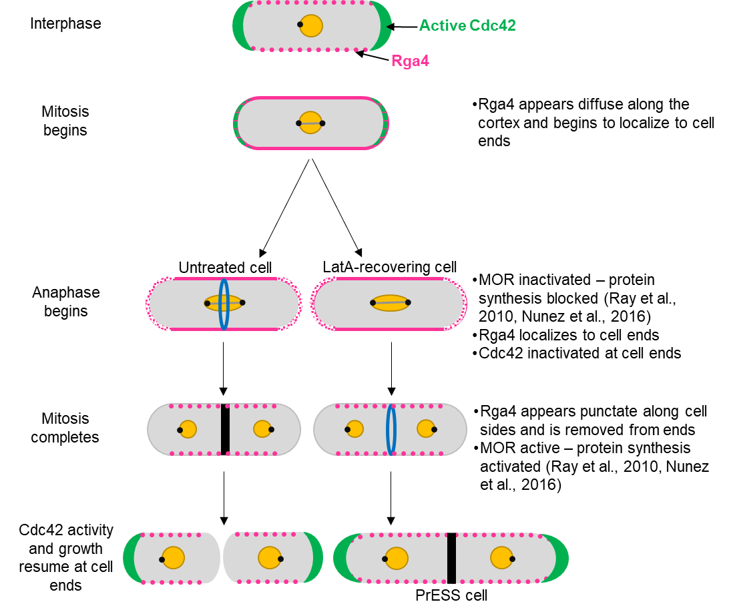
Figure 5.1 Model for growth resumption after cell division. Rga4 localizes to the cell sides during G2 (magenta). As the cells enter mitosis, Rga4 extends all the way to the cell ends (magenta). Upon activation of the anaphase-promoting complex, the MOR pathway is inactivated and Cdc42 activation and growth (green) stop at the cell ends. After mitosis, MOR is activated while Rga4 is lost from the cell ends, which now resume growth. In PrESS cells, LatA treatment delays cytokinesis while mitosis continues to proceed, and the cell progresses to interphase. In these cells, Rga4 is removed from the cell ends before the completion of cytokinesis, resulting in Cdc42 activation and growth at cell ends at the expense of cytokinetic events at the cell middle. This suggests that the timing of growth resumption upon completion of cell division is independent of cytokinesis and dependent on cell-cycle cues.

We propose that the localization of Rga4 changes in a cell-cycle-dependent manner such that it is present at the cell ends during mitosis but not during interphase. There, it restricts Cdc42 activity during mitosis, while its absence makes Cdc42 activity possible during interphase. The nature of the regulation of Rga4 localization is unclear. It is possible that this regulation is accomplished via direct modification of Rga4, such as one or more phosphorylation event, or some other protein modification. Such a modification could alter the way Rga4 interacts with the plasma membrane, which could in turn alter its mobility along the membrane.

While it is clear that the localization of Rga4 changes in a cell-cycle-dependent manner, it is also possible that its activity changes in a similar manner. While there are no known proteins which alter Rga4 activity, cell-cycle control of such a protein’s levels in the cell could regulate Rga4 in such a way that Rga4 is able to restrict Cdc42 activity at the cell ends during mitosis, but not during interphase. Finally, it is possible that Rga4 is sequestered away from the plasma membrane during interphase, resulting in less available Rga4 at the cortex to inactivate Cdc42. However, we show a higher intensity of Rga4 at the cortex compared to the cytosol during late mitosis than during G2 phase, which contradicts this idea (Supplemental Figure S4.3).

Through an artificial cytokinetic delay, we have uncovered a basic cellular principle which ensures that growth occurs at an appropriate time. It is interesting that growth is carefully suppressed during mitosis, and that a cytokinetic delay will not prevent growth. Cdc42 activity is thus regulated based on a mitotic timer without regard to completion of cytokinesis. This especially makes sense in the context of pseudohyphal growth, which fission yeast typically undergo in nature. Our findings suggest that growth initiation is cell-cycle-dependent and is timed to occur after cell separation. It is not very clear how growth and mitosis crosstalk in animal cells. A recent report suggests that, in animal cells, growth stops as cells approach the metaphase-to-anaphase transition and resumes in late cytokinesis (Miettinen et al., 2019). The Cdc42 activation pattern at cell ends in fission yeast is similar to these observations. It is possible that the nature of cell-cycle-dependent regulation of polarized growth is conserved throughout all eukaryotes. Our work provides a better understanding of how growth initiates after mitosis in fission yeast. An elegant cell-cycle-dependent system causes a subtle but effective localization change, controlling the timing of Cdc42 activation at the cell ends.

Materials and Methods
Strains and cell culture
The Schizosaccharomyces pombe strains used in this study are listed in Table 5.1. Cells were cultured in yeast extract (YE) medium and grown exponentially at 25°C unless otherwise specified (Moreno et al., 1991). Cells were grown for at least three days before imaging.

Latrunculin A treatments
Cells were treated with 10µM Latrunculin A (LatA) (Sigma-Aldrich #428021) for 30 minutes. The cells were washed twice with the appropriate media, switched to a fresh tube, and washed a third time.

PrESS frequency measurements
Wild type, scd1Δ and gef1Δ were all imaged on the same three days, and wild type and rga4Δ were both imaged on the same three days. Cells were LatA-treated and washed as described above, and then imaged immediately after wash as well as every hour after wash for five hours. Untreated cells were imaged as a control for each strain. The length of each septated cell was measured, and the average and standard deviation were calculated. Any cell measured to be longer than two standard deviations more than the average for the corresponding untreated sample was counted as a PrESS cell. The reported peaks are the actual PrESS percentages minus the control PrESS percentage, which was always under 1%.

cdc25-22 synchronization
Strains synchronized using the cdc25-22 temperature-sensitive mutation were shifted to restrictive temperature, 36°C, for four hours and then shifted back to permissive temperature, 25°C.

Cdc2-as inhibition and synchronization
Synchronization of cells containing cdc2-as was achieved via addition of 1NM-PP1 (Toronto Research Chemicals #A603003) to a concentration of 500nM for four hours. Cells were then washed three times with YE media to remove the inhibitor.

Phalloidin staining
Phalloidin staining of actin structures was performed as described previously (Das et al., 2009; Pelham and Chang, 2002). Cells were fixed with 3.5% formaldehyde for 10 minutes at room temperature. After fixation, the cells were permeabilized with PM buffer (35 mM potassium phosphate pH 6.8, 0.5 mM MgSO4) with 1% TritonX-100, then washed with PM buffer and stained with Alexa-Fluor-phalloidin (Molecular Probes) for 30 minutes.

Growth curve
Cells were grown at 25°C. To achieve plasmid expression, thiamine was washed out immediately before the experiment began. Cells were diluted to an O.D. of 0.01 and loaded into a 96-well plate, which was read by a BioTek Cytation 5 plate reader. O.D. measurements at 595nm were collected every fifteen minutes for 48 hours. During the experiment, the cells were maintained at 29°C, with shaking.

Analysis of Rga4 distribution and localization
To quantify Rga4 distribution along the cell sides, a line was drawn along the cell side in ImageJ for both sides of each cell in a single plane. Then, a plot profile was generated, and the intensity values were averaged to give an average coefficient of variation for Rga4-GFP distribution along the sides.
To quantify Rga4 localization at cell ends, background subtraction was first performed on each field of cells in ImageJ. A cap was drawn around each cell end, and the intensities of the two ends of each cell were averaged together to provide one value per cell.

Constitutive MOR activation
Cells were grown at 25°C in minimal media with thiamine. Thiamine was washed out 16 hours prior to imaging to allow plasmid expression.

Statistical tests
GraphPad Prism was used to perform statistical tests. A Student’s t-test (two-tailed, unequal variance) was used to determine significance when comparing two samples. When comparing three or more samples, one-way ANOVA was used alongside Tukey’s multiple comparisons, unless otherwise mentioned.

Microscopy
Imaging was performed at room temperature (23-25°C). We used an Olympus IX83 microscope equipped with a VTHawk two-dimensional array laser scanning confocal microscopy system (Visitech International, Sunderland, UK), electron-multiplying charge-coupled device digital camera (Hamamatsu, Hamamatsu City, Japan), and a 100x/1.49 numerical aperture UAPO lens (Olympus, Tokyo, Japan). We also used a spinning disk confocal microscope system with a Nikon Eclipse inverted microscope with a 100x /1.49 numerical aperture lens, a CSU-22 spinning disk system (Yokogawa Electric Corporation), and a Photometrics EM-CCD camera. Images were acquired with MetaMorph (Molecular Devices, Sunnyvale, CA) and analyzed with ImageJ (National Institutes of Health, Bethesda, MD (Schneider et al., 2012). For still and z-series imaging, the cells were mounted directly on glass slides with a #1.5 coverslip (Fisher Scientific, Waltham, MA) and imaged immediately, and with fresh slides prepared every ten minutes. Z-series images were acquired with a depth interval of 0.4 μm. For time-lapse images, cells were placed in 3.5mm glass-bottom culture dishes (MatTek, Ashland, MA) and overlaid with YE medium containing 0.6% agarose and 100 μM ascorbic acid as an antioxidant to minimize toxicity to the cell, as reported previously.
For cells attached to MatTek dishes with lectin, we first let 10μL of 1mg/1mL lectin (Sigma-Aldrich #L1395) incubate in the center of the dish at room temperature for 30 minutes. Then, we washed with 1mL of YE media three times to remove excess lectin not adhered to the dish. We spun down 1mL of cells at an O.D. of about 0.5 and removed all 950μL of the supernatant, then resuspended and pipetted the remaining 50μL into the center of the dish. We then rinsed the dish with YE media three times to remove excess cells not adhered to the lectin. YE media was subsequently kept in the dish at all times to prevent cell starvation, except during short time periods during washes and drug treatments.

Electron microscopy
Wild type cells in late G2 were selected from a sucrose gradient. These cells were treated with 10μM LatA for 30 minutes and then washed three times with YE media. The untreated wild type control cells were not selected from a sucrose gradient. Both samples were washed in sterile water three times and fixed in 2% potassium permanganate for one hour at room temperature. They were again washed three times in sterile water and then resuspended in 70% ethanol and incubated overnight at room temperature. Dehydration was achieved via an ethanol series at room temperature: in order, two 15-minute incubations in 70% ethanol, two 15-minute incubations in 95% ethanol, and finally three 20-minute incubations in 100% ethanol. The cells were then incubated for 30 minutes in propylene oxide, followed by a 1-hour incubation in a 1:1 mixture of propylene oxide and Spurr’s resin, and lastly two 1-hour incubations in neat Spurr’s resin. The cells were pelleted via centrifugation and the supernatant carefully removed in between each incubation. The cells were transferred into small plastic tubes, and fresh Spurr’s resin was layered above to the top of the tube. The two resulting tubes were incubated at 60°C overnight. Sectioning yielded approximately 100nm sections. Sections were post-stained with lead citrate for 8 minutes. Sections were washed by dunking in three sequential beakers of sterile water thirty times each, and allowed to dry on filter paper. Samples were imaged with the Zeiss Dual Beam FIB/SEM microscope at the Joint Institute for Advanced Materials (Knoxville, Tennessee). All images were collected at 15kV.

Acknowledgements
We thank Brian Hercyk, Udo Onwubiko, Bethany Campbell, Marcus Harrell, Samridhi Pathak, Justin McDuffie, and Abigail Vickers for discussions and feedback; Kathy Gould, Sophie Martin, Jonathan Millar, Pilar Perez, and Fulvia Verde for strains; Dannel McCollum for plasmids; and John Dunlap for electron microscopy.
This work was funded by an NIH-NIGMS R01 grant (#1R01GM136847-01) awarded to MD. JRR was awarded an NSF Graduate Research Fellowship Program (GRFP) (#1452154), as well as the NIH’s Initiative for Maximizing Student Development (IMSD) (#R25GM086761).

List of Strains
Table S5.1 List of Strains
Strain | Genotype | Source
PN567 | h+ ade6-704 leu1-32 ura4-d18 | Paul Nurse
FV467 | h+ tea1∆::ura4+ ura4-D18 ade6-M210 | (Verde et al., 1995)
FV513 | h- rga4Δ::ura4+ ade6-704 leu1-32 ura4-d18 | (Das et al., 2007)
FV784 | h+ rga4-gfp::KanMX ade6-704 ura4-D18 leu1-32 | (Das et al., 2007)
JM1745 | h- sty1Δ:ura4+ leu1-32 ura4-D18 | (Millar et al., 1995)
JX125 | h90 Δscd1::ura4+ ade6 leu1-32 ura4-d18 h210 | (Hirota et al., 2003)
JZ521 | h90 ras1Δ::ura4+ ade6-M210 leu1-32 ura4-D18 | (Hakuno et al., 1996)
PPG2601 | h+ Δgef1::ura4+ ura4-D18 leu1-32 | (Coll et al., 2003)
PPG3750 | h- bgs1Δ::ura4 Pbgs1::GFP-bgs1:leu1 leu1-32 ura4-D18 his3-D1 h- | (Cortes et al., 2002)
PPG5668 | h+ scd2-GFP-kanMX6+ leu1-32 ura4-d18 | (Rincon et al., 2007)
WF206 | h- cdc25-22 ade6-704 leu1-32 ura4-D18 | (Russell and Nurse, 1986)
YSM740 | h+ myo52-tdTomato-NATrMX ade6-M216 leu1-32 ura4-D18 | (Martin et al., 2007)
YSM947 | h+ scd1-3GFP-kanMX+ ade6-m216 leu1-32 ura4-d18 | (Bendezu and Martin, 2013)
YMD317 | CRIB-GFP-ura4+ rlc1-Tomato-NATr sad1-mCherry:kanMX ade6-M21X leu1-32 ura4-D18 his7+ | Lab stock
Table S5.1 continued
Strain | Genotype | Source
YMD546 | bgs1Δ::ura4 Pbgs1::GFP-bgs1:leu1+ Rlc1-tdTomato-NATr Sad1-mCherry:kanMX leu1-32 ura4-D18 | (Wei et al., 2016)
YMD772 | rga4-GFP-KanMX rlc1-tdTomato-NATr sad1-mCherry:kanR ade6-M216 leu1-32 ura4-D18 his7+ | Lab stock
YMD824 | eng1-GFP-KanMX agn1-GFP-KanMX  leu1-32 ura4-D18 | This study
YMD1200 | h- [pREP41X-Nak1-Mor2] ade6-704 leu1-32 ura4-d18 | This study
YMD1253 | [pREP41X] CRIB-GFP-ura4+ ade6-704 leu1-32 ura4-d18 | This study
YMD1255 | [pREP41X-Nak1-Mor2] CRIB-GFP-ura4+ ade6-704 leu1-32 ura4-d18 | This study
YMD1509 | h90 cdc2-as-bsd rga4-GFP::KanMX leu1-32 ura4-D18 ade6-M216 | This study
YMD1512 | h- rga4Δ::ura4+ [pREP41X-Nak1-Mor2] ade6-704 leu1-32 ura4-d18 | This study
YMD1735 | h- rga6Δ::ura4+ [pREP41X-Nak1-Mor2] ade6-704 leu1-32 ura4-d18 | This study
YMD1737 | h- gef1Δ::ura4+ [pREP41X-Nak1-Mor2] ade6-704 leu1-32 ura4-d18 | This study
YMD1741 | h- rga6Δ::ura4+ [pREP41X] ade6-704 leu1-32 ura4-d18 | This study
YMD1743 | h- gef1Δ::ura4+ [pREP41X] ade6-704 leu1-32 ura4-d18 | This study
YMD1831 | h- rga4Δ::ura4+ [pREP41X-Nak1-Mor2] CRIB-GFP-ura4+ ade6-704 leu1-32 ura4-d18 | This study
YMD1835 | h- rga4Δ::ura4+ [pREP41X] CRIB-GFP-ura4+ ade6-704 leu1-32 ura4-d18 | This study

References
Albertson, R., B. Riggs, and W. Sullivan. 2005. Membrane traffic: a driving force in cytokinesis. Trends in cell biology. 15:92-101.
An, H., J.L. Morrell, J.L. Jennings, A.J. Link, and K.L. Gould. 2004. Requirements of fission yeast septins for complex formation, localization, and function. Molecular biology of the cell. 15:5551-5564.
Aoi, Y., S.A. Kawashima, V. Simanis, M. Yamamoto, and M. Sato. 2014. Optimization of the analogue-sensitive Cdc2/Cdk1 mutant by in vivo selection eliminates physiological limitations to its use in cell cycle analysis. Open biology. 4.
Bendezu, F.O., and S.G. Martin. 2013. Cdc42 explores the cell periphery for mate selection in fission yeast. Current biology : CB. 23:42-47.
Bendezu, F.O., V. Vincenzetti, D. Vavylonis, R. Wyss, H. Vogel, and S.G. Martin. 2015. Spontaneous Cdc42 polarization independent of GDI-mediated extraction and actin-based trafficking. PLoS biology. 13:e1002097.
Berlin, A., A. Paoletti, and F. Chang. 2003. Mid2p stabilizes septin rings during cytokinesis in fission yeast. The Journal of cell biology. 160:1083-1092.
Chang, E.C., M. Barr, Y. Wang, V. Jung, H.P. Xu, and M.H. Wigler. 1994. Cooperative interaction of S. pombe proteins required for mating and morphogenesis. Cell. 79:131-141.
Cheffings, T.H., N.J. Burroughs, and M.K. Balasubramanian. 2016. Actomyosin Ring Formation and Tension Generation in Eukaryotic Cytokinesis. Current biology : CB. 26:R719-R737.
Chen, C., M. Rodriguez Pino, P.R. Haller, and F. Verde. 2019. Conserved NDR/LATS kinase controls RAS GTPase activity to regulate cell growth and chronological lifespan. Molecular biology of the cell. 30:2598-2616.
Coll, P.M., Y. Trillo, A. Ametzazurra, and P. Perez. 2003. Gef1p, a new guanine nucleotide exchange factor for Cdc42p, regulates polarity in Schizosaccharomyces pombe. Molecular biology of the cell. 14:313-323.
Cortes, J.C., J. Ishiguro, A. Duran, and J.C. Ribas. 2002. Localization of the (1,3)beta-D-glucan synthase catalytic subunit homologue Bgs1p/Cps1p from fission yeast suggests that it is involved in septation, polarized growth, mating, spore wall formation and spore germination. Journal of cell science. 115:4081-4096.
Cortes, J.C., M. Ramos, M. Osumi, P. Perez, and J.C. Ribas. 2016. Fission yeast septation. Communicative & integrative biology. 9:e1189045.
Das, M., T. Drake, D.J. Wiley, P. Buchwald, D. Vavylonis, and F. Verde. 2012. Oscillatory Dynamics of Cdc42 GTPase in the Control of Polarized Growth. Science. 337:239-243.
Das, M., D.J. Wiley, X. Chen, K. Shah, and F. Verde. 2009. The conserved NDR kinase Orb6 controls polarized cell growth by spatial regulation of the small GTPase Cdc42. Current biology : CB. 19:1314-1319.
Das, M., D.J. Wiley, S. Medina, H.A. Vincent, M. Larrea, A. Oriolo, and F. Verde. 2007. Regulation of cell diameter, For3p localization, and cell symmetry by fission yeast Rho-GAP Rga4p. Molecular biology of the cell. 18:2090-2101.
Dekker, N., D. Speijer, C.H. Grun, M. van den Berg, A. de Haan, and F. Hochstenbach. 2004. Role of the alpha-glucanase Agn1p in fission-yeast cell separation. Molecular biology of the cell. 15:3903-3914.
DerMardirossian, C., and G.M. Bokoch. 2005. GDIs: central regulatory molecules in Rho GTPase activation. Trends in cell biology. 15:356-363.
Dransart, E., B. Olofsson, and J. Cherfils. 2005. RhoGDIs revisited: novel roles in Rho regulation. Traffic. 6:957-966.
Echard, A. 2008. Membrane traffic and polarization of lipid domains during cytokinesis. Biochemical Society transactions. 36:395-399.
Estravis, M., S. Rincon, and P. Perez. 2012. Cdc42 regulation of polarized traffic in fission yeast. Communicative & integrative biology. 5:370-373.
Estravis, M., S.A. Rincon, B. Santos, and P. Perez. 2011. Cdc42 regulates multiple membrane traffic events in fission yeast. Traffic. 12:1744-1758.
Etienne-Manneville, S. 2004. Cdc42--the centre of polarity. Journal of cell science. 117:1291-1300.
Fantes, P.A., and P. Nurse. 1978. Control of the timing of cell division in fission yeast. Cell size mutants reveal a second control pathway. Exp Cell Res. 115:317-329.
Feierbach, B., F. Verde, and F. Chang. 2004. Regulation of a formin complex by the microtubule plus end protein tea1p. The Journal of cell biology. 165:697-707.
Fukui, Y., and M. Yamamoto. 1988. Isolation and characterization of Schizosaccharomyces pombe mutants phenotypically similar to ras1. Molecular & general genetics : MGG. 215:26-31.
Gallo Castro, D., and S.G. Martin. 2018. Differential GAP requirement for Cdc42-GTP polarization during proliferation and sexual reproduction. The Journal of cell biology. 217:4215-4229.
Garcia-Mata, R., E. Boulter, and K. Burridge. 2011. The 'invisible hand': regulation of RHO GTPases by RHOGDIs. Nature reviews. Molecular cell biology. 12:493-504.
Garcia Cortes, J.C., M. Ramos, M. Osumi, P. Perez, and J.C. Ribas. 2016. The Cell Biology of Fission Yeast Septation. Microbiology and molecular biology reviews : MMBR. 80:779-791.
Garcia, I., D. Jimenez, V. Martin, A. Duran, and Y. Sanchez. 2005. The alpha-glucanase Agn1p is required for cell separation in Schizosaccharomyces pombe. Biol Cell. 97:569-576.
Gautier, J., C. Norbury, M. Lohka, P. Nurse, and J. Maller. 1988. Purified maturation-promoting factor contains the product of a Xenopus homolog of the fission yeast cell cycle control gene cdc2+. Cell. 54:433-439.
Gerganova, V., I. Lamas, D.M. Rutkowski, A. Vještica, D.G. Castro, V. Vincenzetti, D. Vavylonis, and S.G. Martin. 2021. Cell patterning by secretion-induced plasma membrane flows. bioRxiv:2020.2012.2018.423457.
Gihana, G.M., A.A. Cross-Najafi, and S. Lacefield. 2021. The mitotic exit network regulates the spatiotemporal activity of Cdc42 to maintain cell size. The Journal of cell biology. 220.
Glynn, J.M., R.J. Lustig, A. Berlin, and F. Chang. 2001. Role of bud6p and tea1p in the interaction between actin and microtubules for the establishment of cell polarity in fission yeast. Current biology : CB. 11:836-845.
Gupta, S., M. Govindaraghavan, and D. McCollum. 2014. Cross talk between NDR kinase pathways coordinates cytokinesis with cell separation in Schizosaccharomyces pombe. Eukaryotic cell. 13:1104-1112.
Gupta, S., S. Mana-Capelli, J.R. McLean, C.T. Chen, S. Ray, K.L. Gould, and D. McCollum. 2013. Identification of SIN pathway targets reveals mechanisms of crosstalk between NDR kinase pathways. Current biology : CB. 23:333-338.
Hakuno, F., D.A. Hughes, and M. Yamamoto. 1996. The Schizosaccharomyces pombe mra1 gene, which is required for cell growth and mating, can suppress the mating inefficiency caused by a deficit in the Ras1 activity. Genes to cells : devoted to molecular & cellular mechanisms. 1:303-315.
Harris, K.P., and U. Tepass. 2010. Cdc42 and vesicle trafficking in polarized cells. Traffic. 11:1272-1279.
Hercyk, B., and M. Das. 2019a. Rho Family GTPases in Fission Yeast Cytokinesis. Communicative & integrative biology. 12:171-180.
Hercyk, B., J. Rich, and M.E. Das. 2018. A novel interplay between GEFs orchestrates Cdc42 activation in cell polarity and cytokinesis. bioRxiv.
Hercyk, B.S., and M.E. Das. 2019b. F-BAR Cdc15 Promotes Gef1-mediated Cdc42 Activation During Cytokinesis and Cell Polarization in S. pombe. Genetics.
Hercyk, B.S., U.N. Onwubiko, and M.E. Das. 2019a. Coordinating septum formation and the actomyosin ring during cytokinesis in Schizosaccharomyces pombe. Molecular microbiology. 112:1645-1657.
Hercyk, B.S., J. Rich-Robinson, A.S. Mitoubsi, M.A. Harrell, and M.E. Das. 2019b. A novel interplay between GEFs orchestrates Cdc42 activity during cell polarity and cytokinesis in fission yeast. Journal of cell science. 132.
Hergovich, A., M.R. Stegert, D. Schmitz, and B.A. Hemmings. 2006. NDR kinases regulate essential cell processes from yeast to humans. Nature reviews. Molecular cell biology. 7:253-264.
Hirota, K., K. Tanaka, K. Ohta, and M. Yamamoto. 2003. Gef1p and Scd1p, the Two GDP-GTP exchange factors for Cdc42p, form a ring structure that shrinks during cytokinesis in Schizosaccharomyces pombe. Molecular biology of the cell. 14:3617-3627.
Howell, A.S., M. Jin, C.F. Wu, T.R. Zyla, T.C. Elston, and D.J. Lew. 2012. Negative feedback enhances robustness in the yeast polarity establishment circuit. Cell. 149:322-333.
Johnson, A.E., D. McCollum, and K.L. Gould. 2012. Polar opposites: Fine-tuning cytokinesis through SIN asymmetry. Cytoskeleton. 69:686-699.
Johnson, D.I. 1999. Cdc42: An essential Rho-type GTPase controlling eukaryotic cell polarity. Microbiology and molecular biology reviews : MMBR. 63:54-105.
Lamas, I., L. Merlini, A. Vjestica, V. Vincenzetti, and S.G. Martin. 2020a. Optogenetics reveals Cdc42 local activation by scaffold-mediated positive feedback and Ras GTPase. PLoS biology. 18:e3000600.
Lamas, I., N. Weber, and S.G. Martin. 2020b. Activation of Cdc42 GTPase upon CRY2-Induced Cortical Recruitment Is Antagonized by GAPs in Fission Yeast. Cells. 9.
Lamas, I., N. Weber, and S.G. Martin. 2020c. Clustering-mediated activation of Cdc42 GTPase antagonized by GAPs in fission yeast. bioRxiv:2020.2006.2002.130336.
Martin-Cuadrado, A.B., E. Duenas, M. Sipiczki, C.R. Vazquez de Aldana, and F. del Rey. 2003. The endo-beta-1,3-glucanase eng1p is required for dissolution of the primary septum during cell separation in Schizosaccharomyces pombe. Journal of cell science. 116:1689-1698.
Martin-Cuadrado, A.B., J.L. Morrell, M. Konomi, H. An, C. Petit, M. Osumi, M. Balasubramanian, K.L. Gould, F. Del Rey, and C.R. de Aldana. 2005. Role of septins and the exocyst complex in the function of hydrolytic enzymes responsible for fission yeast cell separation. Molecular biology of the cell. 16:4867-4881.
Martin, S.G., S.A. Rincon, R. Basu, P. Perez, and F. Chang. 2007. Regulation of the formin for3p by cdc42p and bud6p. Molecular biology of the cell. 18:4155-4167.
McCusker, D., C. Denison, S. Anderson, T.A. Egelhofer, J.R. Yates, 3rd, S.P. Gygi, and D.R. Kellogg. 2007. Cdk1 coordinates cell-surface growth with the cell cycle. Nature cell biology. 9:506-515.
Merla, A., and D.I. Johnson. 2000. The Cdc42p GTPase is targeted to the site of cell division in the fission yeast Schizosaccharomyces pombe. European journal of cell biology. 79:469-477.
Miettinen, T.P., J.H. Kang, L.F. Yang, and S.R. Manalis. 2019. Mammalian cell growth dynamics in mitosis. Elife. 8.
Millar, J.B., V. Buck, and M.G. Wilkinson. 1995. Pyp1 and Pyp2 PTPases dephosphorylate an osmosensing MAP kinase controlling cell size at division in fission yeast. Genes & development. 9:2117-2130.
Miller, P.J., and D.I. Johnson. 1994. Cdc42p GTPase is involved in controlling polarized cell growth in Schizosaccharomyces pombe. Molecular and cellular biology. 14:1075-1083.
Mitchison, J.M., and P. Nurse. 1985. Growth in cell length in the fission yeast Schizosaccharomyces pombe. Journal of cell science. 75:357-376.
Moran, K.D., H. Kang, A.V. Araujo, T.R. Zyla, K. Saito, D. Tsygankov, and D.J. Lew. 2019. Cell-cycle control of cell polarity in yeast. The Journal of cell biology. 218:171-189.
Moreno, S., A. Klar, and P. Nurse. 1991. Molecular genetic analysis of fission yeast Schizosaccharomyces pombe. Methods in enzymology. 194:795-823.
Murray, J.M., and D.I. Johnson. 2001. The Cdc42p GTPase and its regulators Nrf1p and Scd1p are involved in endocytic trafficking in the fission yeast Schizosaccharomyces pombe. The Journal of biological chemistry. 276:3004-3009.
Mutavchiev, D.R., M. Leda, and K.E. Sawin. 2016. Remodeling of the Fission Yeast Cdc42 Cell-Polarity Module via the Sty1 p38 Stress-Activated Protein Kinase Pathway. Current biology : CB. 26:2921-2928.
Nakano, K., T. Mutoh, R. Arai, and I. Mabuchi. 2003. The small GTPase Rho4 is involved in controlling cell morphology and septation in fission yeast. Genes to cells : devoted to molecular & cellular mechanisms. 8:357-370.
Nance, J., and J.A. Zallen. 2011. Elaborating polarity: PAR proteins and the cytoskeleton. Development. 138:799-809.
Nunez, I., M. Rodriguez Pino, D.J. Wiley, M.E. Das, C. Chen, T. Goshima, K. Kume, D. Hirata, T. Toda, and F. Verde. 2016. Spatial control of translation repression and polarized growth by conserved NDR kinase Orb6 and RNA-binding protein Sts5. Elife. 5.
Onwubiko, U.N., J. Rich-Robinson, R.A. Mustaf, and M.E. Das. 2020. Cdc42 promotes Bgs1 recruitment for septum synthesis and glucanase localization for cell separation during cytokinesis in fission yeast. Small GTPases:1-8.
Papadaki, P., V. Pizon, B. Onken, and E.C. Chang. 2002. Two ras pathways in fission yeast are differentially regulated by two ras guanine nucleotide exchange factors. Molecular and cellular biology. 22:4598-4606.
Pelham, R.J., and F. Chang. 2002. Actin dynamics in the contractile ring during cytokinesis in fission yeast. Nature. 419:82-86.
Perez, P., E. Portales, and B. Santos. 2015. Rho4 interaction with exocyst and septins regulates cell separation in fission yeast. Microbiology. 161:948-959.
Pino, M.R., I. Nuñez, C. Chen, M.E. Das, D.J. Wiley, G. D’Urso, P. Buchwald, D. Vavylonis, and F. Verde. 2020. Cdc42 GTPase Activating Proteins (GAPs) Maintain Generational Inheritance of Cell Polarity and Cell Shape in Fission Yeast. bioRxiv:2020.2006.2016.151308.
Pollard, T.D. 2010. Mechanics of cytokinesis in eukaryotes. Current opinion in cell biology. 22:50-56.
Pollard, T.D. 2014. The value of mechanistic biophysical information for systems-level understanding of complex biological processes such as cytokinesis. Biophysical journal. 107:2499-2507.
Ray, S., K. Kume, S. Gupta, W. Ge, M. Balasubramanian, D. Hirata, and D. McCollum. 2010. The mitosis-to-interphase transition is coordinated by cross talk between the SIN and MOR pathways in Schizosaccharomyces pombe. The Journal of cell biology. 190:793-805.
Revilla-Guarinos, M.T., R. Martin-Garcia, M.A. Villar-Tajadura, M. Estravis, P.M. Coll, and P. Perez. 2016. Rga6 is a Fission Yeast Rho GAP Involved in Cdc42 Regulation of Polarized Growth. Molecular biology of the cell.
Ridley, A.J. 2006. Rho GTPases and actin dynamics in membrane protrusions and vesicle trafficking. Trends in cell biology. 16:522-529.
Rincon, S., P.M. Coll, and P. Perez. 2007. Spatial regulation of Cdc42 during cytokinesis. Cell cycle (Georgetown, Tex ). 6:1687-1691.
Russell, P., and P. Nurse. 1986. cdc25+ functions as an inducer in the mitotic control of fission yeast. Cell. 45:145-153.
Santos, B., A.B. Martin-Cuadrado, C.R. Vazquez de Aldana, F. del Rey, and P. Perez. 2005. Rho4 GTPase is involved in secretion of glucanases during fission yeast cytokinesis. Eukaryotic cell. 4:1639-1645.
Schmidt, S., M. Sohrmann, K. Hofmann, A. Woollard, and V. Simanis. 1997. The Spg1p GTPase is an essential, dosage-dependent inducer of septum formation in Schizosaccharomyces pombe. Genes & development. 11:1519-1534.
Schneider, C.A., W.S. Rasband, and K.W. Eliceiri. 2012. NIH Image to ImageJ: 25 years of image analysis. Nat Methods. 9:671-675.
Simanis, V. 2015. Pombe's thirteen - control of fission yeast cell division by the septation initiation network. Journal of cell science. 128:1465-1474.
Sipiczki, M. 2007. Splitting of the fission yeast septum. FEMS Yeast Res. 7:761-770.
Sopko, R., D. Huang, J.C. Smith, D. Figeys, and B.J. Andrews. 2007. Activation of the Cdc42p GTPase by cyclin-dependent protein kinases in budding yeast. The EMBO journal. 26:4487-4500.
Spector, I., N.R. Shochet, Y. Kashman, and A. Groweiss. 1983. Latrunculins: novel marine toxins that disrupt microfilament organization in cultured cells. Science. 219:493-495.
Swaffer, M.P., A.W. Jones, H.R. Flynn, A.P. Snijders, and P. Nurse. 2016. CDK Substrate Phosphorylation and Ordering the Cell Cycle. Cell. 167:1750-1761 e1716.
Swulius, M.T., L.T. Nguyen, M.S. Ladinsky, D.R. Ortega, S. Aich, M. Mishra, and G.J. Jensen. 2018. Structure of the fission yeast actomyosin ring during constriction. Proc Natl Acad Sci U S A. 115:E1455-E1464.
Tasto, J.J., J.L. Morrell, and K.L. Gould. 2003. An anillin homologue, Mid2p, acts during fission yeast cytokinesis to organize the septin ring and promote cell separation. The Journal of cell biology. 160:1093-1103.
Tatebe, H., K. Nakano, R. Maximo, and K. Shiozaki. 2008. Pom1 DYRK regulates localization of the Rga4 GAP to ensure bipolar activation of Cdc42 in fission yeast. Current biology : CB. 18:322-330.
Tatebe, H., K. Shimada, S. Uzawa, S. Morigasaki, and K. Shiozaki. 2005. Wsh3/Tea4 is a novel cell-end factor essential for bipolar distribution of Tea1 and protects cell polarity under environmental stress in S. pombe. Current biology : CB. 15:1006-1015.
Tay, Y.D., M. Leda, A.B. Goryachev, and K.E. Sawin. 2018. Local and global Cdc42 guanine nucleotide exchange factors for fission yeast cell polarity are coordinated by microtubules and the Tea1-Tea4-Pom1 axis. Journal of cell science. 131.
Toda, T., H. Niwa, T. Nemoto, S. Dhut, M. Eddison, T. Matsusaka, M. Yanagida, and D. Hirata. 1996. The fission yeast sts5+ gene is required for maintenance of growth polarity and functionally interacts with protein kinase C and an osmosensing MAP-kinase pathway. Journal of cell science. 109 ( Pt 9):2331-2342.
Tormos-Perez, M., L. Perez-Hidalgo, and S. Moreno. 2016. Fission Yeast Cell Cycle Synchronization Methods. Methods Mol Biol. 1369:293-308.
Verde, F., J. Mata, and P. Nurse. 1995. Fission yeast cell morphogenesis: identification of new genes and analysis of their role during the cell cycle. The Journal of cell biology. 131:1529-1538.
Wang, N., I.J. Lee, G. Rask, and J.Q. Wu. 2016. Roles of the TRAPP-II Complex and the Exocyst in Membrane Deposition during Fission Yeast Cytokinesis. PLoS biology. 14:e1002437.
Wang, N., M. Wang, Y.H. Zhu, T.W. Grosel, D. Sun, D.S. Kudryashov, and J.Q. Wu. 2015. The Rho-GEF Gef3 interacts with the septin complex and activates the GTPase Rho4 during fission yeast cytokinesis. Molecular biology of the cell. 26:238-255.
Wei, B., B.S. Hercyk, N. Mattson, A. Mohammadi, J. Rich, E. DeBruyne, M.M. Clark, and M. Das. 2016. Unique Spatiotemporal Activation Pattern of Cdc42 by Gef1 and Scd1 Promotes Different Events during Cytokinesis. Molecular biology of the cell. 27:1235-1245.
Win, T.Z., Y. Gachet, D.P. Mulvihill, K.M. May, and J.S. Hyams. 2001. Two type V myosins with non-overlapping functions in the fission yeast Schizosaccharomyces pombe: Myo52 is concerned with growth polarity and cytokinesis, Myo51 is a component of the cytokinetic actin ring. Journal of cell science. 114:69-79.

Vita
Julie was born and raised in Knoxville, Tennessee. She completed her Bachelor’s degree in Biochemistry & Cellular and Molecular Biology at the University of Tennessee, Knoxville. She loved the lab she was working in and the project she was working on so much that she decided to stay and complete a PhD there, too.

