Exploration of Mid to Late Paleozoic Tectonics along the Cincinnati Arch using GIS and Python to Automate Geologic Data Extraction from Disparate Sources

A Dissertation Presented for the

Doctor of Philosophy

Degree

The University of Tennessee, Knoxville

Kenneth S. Boling

December 2020

Copyright © 2020 by Kenneth Steven Boling
All rights reserved.

DEDICATION

To my parents Bill and Lois Boling.

ACKNOWLEDGEMENTS

I would like to thank my significant other Erica Allen and her son Nathan for their love and support over the past four years. Bob Hatcher for being an incredibly supportive advisor. My parents Bill and Lois Boling for their support and encouragement. I would also like to thank my committee members Gary Bible, Pete Lemiszki, Micah Jessup and Khalid Alshibli for their advice and guidance during this project. I especially want to thank Pete for granting me access to an invaluable dataset without which this project would not have been possible. I would also like to thank Tom and Helen Cronin, Rick Traylor and my AAPG Imperial Barrel Award competition teammates. I would also like to thank the Tennessee Oil and Gas Association, and Elaine Foust from the Tennessee Oil and Gas Program.
ABSTRACT

Structure contour maps are one of the most common methods of visualizing geologic horizons as three-dimensional surfaces. In addition to their practical applications in the oil and gas and mining industries, these maps can be used to evaluate the relationships of different geologic units in order to unravel the tectonic history of an area. The construction of high-resolution regional structure contour maps of a particular geologic horizon requires a significant volume of data that must be compiled from all available surface and subsurface sources. Processing these data using conventional methods and even basic GIS tools can be tedious and very time consuming, particularly if there are a large volume of data and manual error correction or data entry are required.
A semi-automated process for data aggregation, cleaning, and cross-verification of surface and subsurface data in this project using Python and ArcGIS. This process was then applied to all of the publicly available surface and subsurface geologic data from central Kentucky to northern Alabama, along the southern Cincinnati arch. These data were compiled from 887 published and unpublished digital 1:24,000-scale geologic quadrangle maps acquired from the Tennessee Geological Survey, Kentucky Geological Survey, United States Geological Survey, and Alabama Geological Survey. Subsurface data from 24,833 wells were also compiled from oil and gas well logs, mineral exploration boreholes, and state oil and gas well databases. From these data a total of 7,200,000 data points were generated over an area of 69,000 square miles. The results from this process were compared to a pilot survey that was performed manually in ArcGIS™. The resulting structure contour maps were used to identify structures related to potential far-field effects of the Taconian, Neoacadian, and Alleghanian orogenies along the southern Cincinnati arch. Isopach maps were then used to indicate the location of uplift and erosion that took place over time. With this information it was possible to determine that the majority of the uplift of the Nashville dome occurred between the deposition of the Stones River Group and the pre-Chattanooga unconformity.

TABLE OF CONTENTS

INTRODUCTION 1
CHAPTER I Proof of Concept Test to Determine the Viability of Building an Extensive Database for Resolution of Far-Field Effects of the Acadian and Alleghanian Orogenies 3
Abstract 5
Introduction 6
Methodology 8
Results 13
Conclusions 20
Acknowledgements 21
CHAPTER II Applications of Process Automation and Spatial Data Management Using Python and GIS to Explore the Structural History of the Southern Cincinnati Arch 22
Abstract 24
Introduction 26
Data 30
Kentucky Data 32
Tennessee Data 32
Alabama Data 33
Sources of Error 33
Methods 36
Results 41
Pilot Study 41
Regional Structures 43
Map-Scale Structures 45
Conclusions 49
Acknowledgements 50
Data Availability 50
Software 51
CHAPTER III Mid to Late Paleozoic Tectonics along the Southern Cincinnati Arch 53
Abstract 55
Introduction 57
Overview of Regional Structures in the Study Area 62
Cincinnati Arch 62
Nashville Dome 65
Jessamine Dome 66
Pascola Arch 67
Stratigraphy Along the Southern Cincinnati Arch 68
Knox Dolomite (Upper Cambrian to Lower Ordovician) 69
Regional Bentonites (Middle Ordovician) 79
Nashville Group (Trenton) 85
Silurian Formations 90
Chattanooga Shale 91
Mississippian Limestones 95
Previous efforts 97
Methodology 102
Results 110
Regional Structure Contour Maps 110
Regional Isopach maps 117
Discussion 129
Deformational history 132
Taconic Orogeny 133
Acadian Orogeny 134
Alleghanian Orogeny 135
Model of Deformation History of the Nashville and Jessamine domes 135
Implications for oil and gas exploration 137
Conclusions 141
References 143
Geologic Quadrangle References 157
Quadrangles used in the pilot study. 157
Tennessee Quadrangle Map References 160
Kentucky Quadrangle Map References 198
Appendix 274
VITA 277

LIST OF TABLES

Table I-1. Methods of data collection. 15
Table II-1. Sources of surface and subsurface data used in this study. 31
Table III-1. Other names used for the original T-1 through T-5 bentonite layers in Tennessee. 82

LIST OF FIGURES

Figure I-1. Location map showing the selected study area in southern Tennessee (indicated by the red square). This area consists of 32 geologic quadrangles across the southern end of the Nashville dome. 8
Figure I-2. Geologic map from a central Tennessee quadrangle showing the locations of the intersection points (black closed circles) of geologic boundaries and topographic contour lines generated using the GIS tools method. These points were generated for all surfaces using the GIS systematic method, but only two surfaces (base of Mfp and Olcy-Obc) using the manual data entry method. 12
Figure I-3. Comparison of the structure contour maps on the base of the Mfp generated using two methods of data collection for the area in the southern Nashville dome. These maps were constructed using identical parameters with the exception of the data collection methods across an area of 32 quadrangles: (a) was constructed by manually picking ~4,000 data points (gray circles) and (b) was generated from ~82,000 auto-picked points (gray dots that appear as a dendritic pattern along outcrop surfaces, the density of points were too high to display correctly at this resolution) These maps appear very similar regionally, but many more sub-quadrangle-scale features are visible in the higher-resolution auto-picked map that are not present in the lower-resolution manually picked map. The white areas indicate areas where no outcrops for this contact occur. 16
Figure I-4. Histograms showing the distribution of point elevations for both methods. The distribution of elevations are slightly different between collection methods. 18
Figure I-5. Differential map of the study area. The colder colors indicate where the surface produced by contouring the points using each method differs from each other. Blue areas indicate where the handpicked surface is lower in elevation than the auto-picked method, red areas indicate the hand-picked surface is higher in elevation than the auto-picked method; Green areas indicate where the surfaces are roughly equal in elevation. 19
Figure II-1. Geologic map of the study area along the southern Cincinnati arch. The locations of major structural features including the Nashville and Jessamine domes that make up the southern Cincinnati arch, and the Pascola, Findlay, and Kankakee arches that branch off of it. 28
Figure II-2. Distribution of primarily 1:24,000 scale maps used in this study. Kentucky has complete coverage of digitized 1:24,000 scale geologic maps, central Tennessee has mostly complete coverage for the primary area of interest although a few gaps in data coverage exist. The 1:250,000 scale Alabama state geologic map was also used but the resolution is too poor to display quadrangle-scale structures. Regional trends, however, can be observed. 35
Figure II-3. Data pipeline and initial workflow displaying the data sources and the processes used in this study. 38
Figure II-4. Comparison of the structure contour maps on the base of the Chattanooga Shale (Mfp-Olcy contact) generated using two methods of data collection for the area around the southern Nashville dome. These maps were constructed using identical parameters with the exception of the data collection methods: (a) was constructed during a pilot study by manually picking ~4,000 data points (red circles) and (b) was generated from ~73,000 auto-picked points (gray dots that appear as a dendritic pattern along outcrop surfaces) using the methods developed during this study. These maps appear very similar regionally but many more quadrangle-scale features are visible in the higher-resolution auto-picked map that are not present in the lower-resolution manually picked map. 42
Figure II-5. Structure contour map of the top of the Stones River Group, (and High Bridge Group equivalent). 44
Figure II-6. Structure contour map on the base of the Chattanooga Shale on the southern flank of the Nashville dome. Several folds and other deformational features can be observed on the southwest side of the map. The northeast side of the map displays few deformational features by comparison. The red dashed line indicates the location of Figure II-7. 47
Figure II-7. Structure map of the base of the Silurian in south-central Tennessee. Silurian outcrops along the southern Nashville dome are typically preserved in synclines fold axes because of the truncation of structural highs by the base Chattanooga Shale unconformity. The Silurian units seen here have not been completely eroded off the crests of anticlines, and thicken into the synclines due to higher preservation. 48
Figure III-1. Schematic diagram of the locations of major structures. Modified from (Brett et al., 2012). 59
Figure III-2. Location of the study area (shown in orange). 63
Figure III-3. Geologic map showing the rock units regional structures along the southern end of the Cincinnati arch, which includes the Nashville and Jessamine domes (modified from King et al., 1974; Schruben et al., 1998). The heavy dashed line indicates the extent of the study area for this project. 64
Figure III-4. Generalized regional stratigraphy of the Lower Ordovician to Pennsylvanian rock units of the southern Cincinnati arch. The stratigraphic units in this figure are defined according to the stratigraphy of central Tennessee. The equivalents in central Kentucky are also listed. Modified from (Hatcher and Milici, 2015). 70
Figure III-5. Geologic map showing the exposures of the lower Stones River Group (Lsr) (Murfreesburo, Pierce, and Ridley Formations), which occur across the top of the Nashville dome. The units in yellow are stratigraphically below the red units and indicate the location of anticlines. Middle and Upper Ordovician formations (mO, uO respectively) outcrop on the outer flanks of the dome. The Silurian units (S) only occur on the northwestern side of the dome, and are completely eroded from the eastern side. The Mississippian formations (M) surround the dome, and some Cretaceous formations (K) outcrop west of the dome into the coastal plain. The formations highlighted in red and yellow are lower Stones River Group formations from a compilation of several 1:24,000 scale quadrangle maps from the area around the Nashville dome, while the base map was constructed using the 1:2,500,000 scale U.S. geologic map (King et al., 1974; Schruben et al., 1998). 74
Figure III-6. Generalized section diagrammatically showing the relationships between the Lebanon, lower Carters Limestone. the upper Carters, and the Hermitage Formation in Central Tennessee. From (Wilson, 1949). 77
Figure III-7. Road cut, I-840 Lebanon, Tennessee (East of Nashville): Outcrop of Middle and Upper Ordovician formations with the Millbrig and Deicke K-bentonites exposed. These bentonites serve as marker layers for local drilling operations and time-equivalent surfaces for correlation. The contrast in resistance to erosion compared to the limestone units permits them to be easily identified as recessive zones in outcrops. 80
Figure III-8. Areal extent of Ordovician bentonites in the eastern United States (Kolata et al., 1996). 83
Figure III-9. Gamma-ray geophysical log with peaks showing the distribution of bentonites in the Ordovician formations in Tennessee. These bentonites may be spotted with relative ease because of their high K-feldspar content (and clay alteration products). Gamma-ray peaks are produced by the decay of radioactive isotopes of potassium, with smaller amounts of thorium, and uranium which are also typically present in bentonites. From (Evenick and Hatcher, 2006). 86
Figure III-10. Stratigraphy of the Ordovician units exposed at the surface of the Nashville and Jessamine domes. The wavy lines indicate the positions of unconformity surfaces in the section. The unconformity surfaces in the Stones River (High Bridge) Group on the two domes formed during the Blountian phase of the Taconic orogeny. Modified from: (Holland and Patzkowsky, 1997; Pope et al., 2012). 89
Figure III-11. Geologic map from part of the Columbia quadrangle, Tennessee (Wilson et al., 1964). Faulted syncline preserving Silurian Brassfield (Sbr) and Wayne Group (Sw) rocks occurs beneath the Devonian Chattanooga Shale (mapped here with the base of the Fort Payne (Mfp)). Graphic from (Hatcher et al., 2007). Silurian formations are preserved in synclines on the Nashville dome overlying the Hermitage (Oh), Bigby-Cannon (Obc), and the Catheys-Leipers (Olcy) formations. The upper portions of these units were eroded following the Devonian unconformity. 92
Figure III-12. Road Cut, TN-109, 4 miles north of Gallatin, Tennessee. Outcrop of Upper Ordovician, Silurian, Devonian, and Mississippian formations northeast of Nashville. The unconformity at the base of the Chattanooga Shale truncates the underlying lighter-colored Silurian formations; the angularity of the truncation is well illustrated in this image. Waldron Shale is the light gray unit truncated about midway across the photo. (Photo by Robert D. Hatcher Jr., 2017). 93
Figure III-13. (a) Gamma-ray well log showing the high gamma-ray response at the Chattanooga Shale interval related to its high uranium content. (b) Aeroradioactivity survey map showing the uranium content of the Chattanooga Shale is high enough that the outcrop belt (roughly indicated by the dashed lines) along the Nashville and Jessamine domes is visible as bands of high uranium spectral radiation. From the National Uranium Resource Evaluation (NURE) program (Hill et al., 2009). 96
Figure III-14. Model of lithospheric flexure by load emplacement on the crust. In this model, the emplacement of a load on a lithospheric plate (by an orogenic event) results in the formation of an area of low elevation (foreland basin) immediately proximal to the load. Farther into the foreland from the load uplift occurs in response to the progressive sinking of the area beneath the load. This is supposed to be a response of the lithosphere to the downward flexure occurring at the load location. In addition, as the flexure continues, the uplifted dome begins to "roll" toward the load location. (From Quinlan and Beaumont, 1984). 98
Figure III-15. Location of the Grenville front, contours on the basement surface primarily in Neoproterozoic basins, and faults identified from subsurface data. From Drahovzal et al. (1992). 101
Figure III-16. Typical 1:24,000 paper geologic quadrangle map, part of the Beech Grove quadrangle in central Tennessee (Wilson and Taylor, 1973). This map was scanned and used to verify the accuracy of the digitized map data. 106
Figure III-17. Same map from Figure III-16 with the digitized quadrangle map overlain with a slight transparency applied and colored by formation. Manual correction of any errors was required if misalignment was detected. 106
Figure III-18. Same map from Figure III-17 displaying the points generated using the digitized 1:24,000 scale contour lines from the USGS topographic quadrangles. 107
Figure III-19. Same map from Figure III-17 displaying the points generated using the 1/3rd arc-second DEM data from the USGS 3DEP dataset (U.S. Geological Survey, 2017). Data points are generated every 200ft horizontal along each geologic contact. 107
Figure III-20. Visualization of the offset between the reported well elevation and the land surface as determined by the DEM data. Most of the wells for this area are accurate to within less than 10-20ft, but two wells are off by more than 1000ft, most likely due to typographical errors in manually recorded data. 109
Figure III-21. Data point locations for the top of the Knox Group. Red dots indicate well data locations. The Knox Group does not outcrop within the study area, therefore all locations are based on well data. Subsurface data: 4526 data points. 111
Figure III-22. Structure contour map of the top of the Knox Group, which occurs throughout the eastern and central United States. The base of the Stones River Group lies above this unconformity. 112
Figure III-23. Data point locations of the top of the Stones River Group. Red dots indicate well data locations, gray dots indicate surface points. Subsurface data: 5,147 points, surface data: surface points: 99,979 115
Figure III-24. Structure contour map of the top of the Stones River Group. Several major structures are well defined in this map, such as the Nashville and Jessamine domes and the Illinois and Appalachian basins. 116
Figure III-25. Data point locations of the base of the Chattanooga Shale. Red dots indicate well data locations, gray dots indicate surface points. Subsurface data: 12,530 points, surface data: 406,558 points. 118
Figure III-26. Structure contour map of the base of the Chattanooga Shale. 119
Figure III-27. Structure Contour map on the top of the Ft. Payne Formation, which grades into the Borden Formation (blue) that adds complexity to the stratigraphy. As a result the Borden Formation was excluded from the study. This map does, however, clearly outline the Nashville and Jessamine domes and Cumberland saddle that connects them. 120
Figure III-28. Isopach map of the Wells Creek Formation. Red dots indicate well data locations (1,530 points total) which were used to generate the structure contour of the top of the Wells Creek Formation. This surface was then used to determine the thickness of the Wells Creek Formation by subtracting the difference in contour horizon elevation from the top of the Wells Creek and top of the Knox Group surfaces. Data availability is sparse for this formation in some areas. Areas of 'no data' indicate locations of poor data coverage of one or more of the two formations used to calculate the isopach surface. 123
Figure III-29. Isopach map from the top of Knox to the top of the Stones River Group. Although there are areas of sparse data coverage, this isopach map generally indicates that this section thins toward the north. This isopach map is roughly the same as that of Wilson and Stearns (1963). This isopach map may indicate that, during the Blountian orogeny, the interval between the top of the Stones River Group and the top of the Knox Group was eroded as a result of uplift during the time. The area of thick section to the northwest of the Nashville dome corresponds roughly to the location of the Sebree trough (Kolata et al., 2001). 124
Figure III-30. Regional isopach map from the top of the Mid-Ordovician Stones River Group to the base of the Devonian Chattanooga Shale. This interval thins over the crest of the Nashville dome and thicken along the flanks. The areas in gray labeled "no data" are locations where the upper or lower surfaces had no data available. 127
Figure III-31. Isopach map of the Lebanon Limestone along the crest of the Nashville dome. Because the map is based solely on two horizons that only outcrop at the surface, the accuracy of this isopach map decreases with distance away from the outcrop belt. Two potential folds are marked, interpreted by the isopach and from the observations of Wilson (1949) in that area. Thinner areas (dark blues and greens) occur across the top of a potential anticline, and thicker areas (yellows and orange) and seem to suggest the presence of a syncline, because of the erosional surface at the top of the Lebanon Limestone. 128
Figure III-32. Conceptual model showing the series of depositional, tectonic, and erosional events from the mid-Silurian- to Permian, top to bottom T₁-T₄, focusing on events that occurred before and after the formation of the pre-Chattanooga unconformity. T₁ represents the deposition of the Lower Ordovician (dark green) Middle Ordovician (light green) and Silurian (magenta) formations. This was followed by T₂ where the Silurian formations were eroded during the uplift and deformation of the area resulting from the Acadian-Neo Acadian orogenies. T₃ represents the deposition of the Devonian (blue) through Pennsylvanian formations on the eroded sections. The final events T₄ represent renewed uplift, deformation, and subsequent erosion of the Lower Ordovician to Pennsylvanian formations during the Alleghanian orogeny. 138
Figure III-33. Structural history of the Nashville dome based on the unconformities recognizable in the stratigraphic section. 139
Figure 0-1, Isopach map of the Nashville Group. This isopach map may contain errors despite the fact that the top of the Nashville Group is contoured correctly to the equivalent formations in Kentucky, the data are suspect because of a difference in geophysical well log interpretation between Tennessee and Kentucky. Therefore, this map was excluded from analysis. 275
Figure 0-2. Isopach map from the base of the Lebanon Limestone to the base of the stones river group (this includes the Carters Limestone). Note that because these units are on the surface, this isopach map represents the thickness of the Lebanon Limestone or more accurately the distance between the projected spline surface of the base of the Lebanon and the base of the Stones river group. The accuracy of this map is highest closest to the outcrop belt (black dots). In general it appears that the Lebanon thins in a band over the top of the dome. Two potential folds are marked. 276

INTRODUCTION

The Cincinnati arch is a regional structure that spans from the south eastern United States northward into Canada. This feature sits just to the west Appalachian basin and has undergone several phases of uplift and erosion, followed by phases of non-deposition or subsidence. These phases of tectonic changes are presumed to be related to the major orogenic events which occurred along this area. Though determining the timing of uplift relative to these orogenic events has proven to be difficult, in part due to the sheer scale of these features. In order to study large features such as these, the most difficult part is getting enough data about the structure within a reasonable timeframe. This research aims to simplify the process of acquiring and managing data that may have been generated decades ago as geologic maps. The level of spatial resolution required to construct accurate models of the structure of any features large or small depends largely on the scale of the structure under investigation. Typically with geologic map data, the 1:24,000 scale quadrangle map can provide a high enough level of detail for most applications.
Geologic data, when they are required for a research project or exploring for oil and gas resources, are not typically as readily available in the quantities required for the project. If these data are available, it may not be in a spatial distribution that would be ideal. Furthermore, these data may be in a format that are not useful and requires some level of preprocessing, whether that means converting a legacy data format into a more modern form, or scanning paper maps by hand and processing the images into a vector format.
Worse than that is if these data do exist, but are for one reason or another inaccessible. It may be that critical information is sitting on a shelf in a storage room somewhere, long forgotten and of no use to anyone in its current form. It is important that these resources, that were generated decades ago, be as available as possible and in a useable format.
With that in mind, this research seeks to provide examples of the conversion and implementation of geologic data from legacy formats into resources that can be easily accessed. The study area for this project spanned across three states, each with very different approaches to handing geologic data. Kentucky, for example, has a robust online service that allows anyone to download and use digitized geologic map and well data. Tennessee data, both geologic map data and oil and gas data are available, although they are not particularly easily accessible. Alabama has some resources available online through the Oil and Gas Board site, but the field data for the area of this study has yet to be collected. The study of large scale structures, such as the Cincinnati arch, require a large amount of data, and the lack of accessibility of this data has been, and will continue to be, an impedance to regional scale investigations.

Proof of Concept Test to Determine the Viability of Building an Extensive Database for Resolution of Far-Field Effects of the Acadian and Alleghanian Orogenies

This section is a slightly revised version of a peer-reviewed paper published by the Journal of Geosciences and Geomatics in 2020 by Kenneth S. Boling, Robert D. Hatcher Jr, Peter J. Lemiszki, and Gary G. Bible:

Kenneth S. Boling, Robert D. Hatcher Jr, Peter J. Lemiszki and Gary G. Bible. Proof of Concept Test to Determine the Viability of Building an Extensive Database for Resolution of Far-Field Effects of the Acadian and Alleghanian Orogenies. Journal of Geosciences and Geomatics. 2020; 8(1):9-14. doi: 10.12691/jgg-8-1-2

Authorship Statement

Kenneth S. Boling: Designed and implemented the methodology and wrote the code in Python, generated and edited figures, majority of writing and revisions.

Robert D. Hatcher Jr: Primary advisor, directed the initial pilot study, assisted with writing and revisions, and geologic background.

Peter J. Lemiszki: Revised paper, assisted with initial data acquisition and advised on data provenance.

Gary G. Bible: Revised paper, assisted with interpretation of well data.

Abstract

Several episodes of uplift have occurred along the Cincinnati arch. These periods of uplift are likely a result of several orogenic events although the exact timing of the uplift in relation to these orogenic events is not fully understood. One reason for this has been the lack of accessible structural data over this region. The southern end of the Cincinnati arch and the Nashville and Jessamine domes occur along the arch in Kentucky, Tennessee, and northern Alabama. These states have very different levels of data availability, but potentially enough to identify more subtle, second- and third-order folds and faults along and on the flanks of the arch. These structures may be the key to unraveling the pre-Devonian tectonic history of the two domes, and can be identified in structure contour maps with sufficient data. The goal of this study was to perform a preliminary assessment of the viability of constructing a complete series of structure contour maps of several geologic units across the region, using publicly available data. Thirty-two geologic quadrangle maps selected across the southern end of the Nashville dome in Tennessee were manually digitized utilizing ArcGIS™. The results from this initial study were then compared to the results produced using a less labor intensive method using basic GIS functions to generate data points. The results of this initial investigation seem promising, but methods of cross-verification to remove erroneous data points, the incorporation of subsurface data, and the incorporation of data sets from other states will be required to expand the coverage area. Automation of this process will need to be developed to allow further research to be performed.

Introduction

The Cincinnati arch is a regional structure that extends from northern Alabama to southern Ontario (King et al., 1974). The Nashville and Jessamine domes make up the southern portion of this structure. Although there has been a great deal of research done on these structures, the tectonic history during the uplift of the Cincinnati arch and the formation of the Nashville and Jessamine domes along this feature are still poorly understood. One way of resolving the timing of these events is by constructing structure contour maps at important horizons along these structures, that can be performed either manually or automatically using GIS processing tools, if the appropriate data are available from published geologic maps. These maps could then potentially be used to identify 1:24,000 scale structural features related to tectonic events prior to the deposition of the Upper Devonian Chattanooga Shale (and equivalents) for the southern Cincinnati arch. The observed relationships between structural features and the timing of orogenic events may be used to tie these features to the Alleghanian or pre-Alleghanian orogenies.
To this end, this study serves as a preliminary assessment of the viability of using the available data from a subset of the total study area to construct accurate structure contour maps on top of several rock units within the study area. In addition, this study serves as a proof-of-concept test to evaluate the viability of automating parts of the process of constructing structure contour maps. The performance of this process was evaluated by comparing the resulting structure contour maps generated using both GIS tools and manual entry methods across a specific test area. The selected test area was located in south-central Tennessee, on the southern flank of the Nashville dome. Thirty-two of the available 7.5-minute 1:24,000 geologic quadrangle maps in the area were utilized to construct structure contour maps of specific geologic horizons (Figure I-1). These selected horizons may provide critical geometries of pre- and post-Chattanooga unconformity deformation.

Methodology

In order to construct a structure contour map from a geologic map the elevation along the geologic contact must be determined. The typical method to accomplish this is to locate points on a geologic map where the geologic contact intersects a topographic contour. These points can then be contoured by hand or by using a GIS software package to interpolate between points. This will produce a structure contour map that depicts the structure of the surface of the geologic horizon.

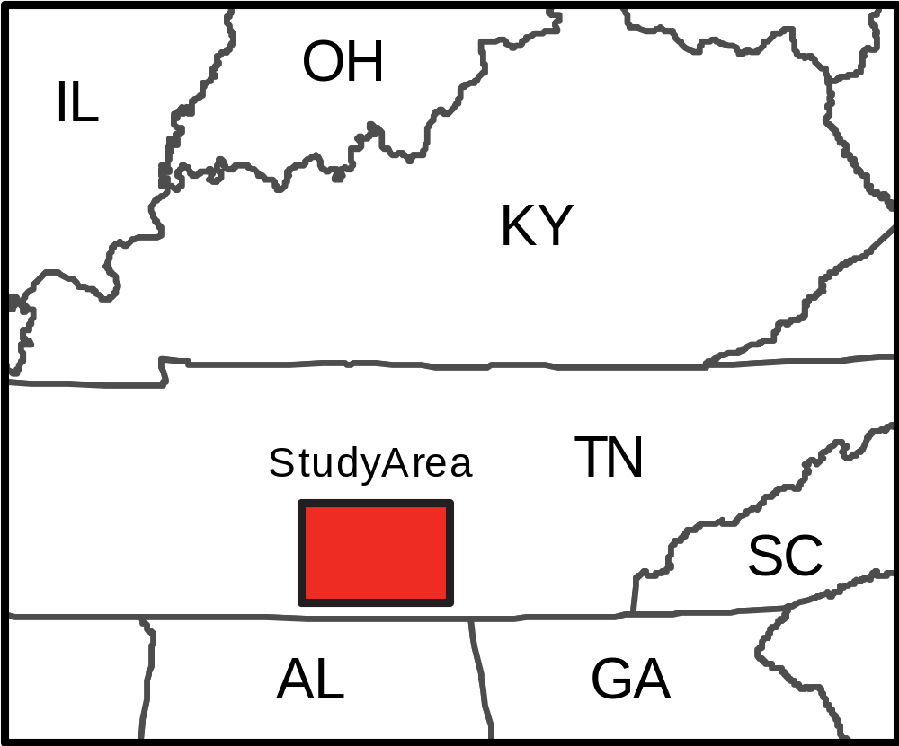
Figure I-1. Location map showing the selected study area in southern Tennessee (indicated by the red square). This area consists of 32 geologic quadrangles across the southern end of the Nashville dome.

The manual method is obviously time consuming and even potentially a source of error due to the human component in manually reading contours and recording points. It is possible to automate this process using basic GIS tools, if the required data are available in digital format. Tennessee currently has no publicly available digital database of 7.5-minute geologic quadrangle maps. However, the majority of the quad maps that make up the area around the Nashville dome were manually digitized into ArcInfo™ coverage files as part of a USGS initiative in the mid 1990's to digitize the available 7.5-minute quadrangle maps from the original film scribecoats (Connell et al., 1994). These scribecoats were scanned using a full scanner to minimize distortion. The maps were then vectorized using ArcInfo™ and transformed to state plane projection.
Unfortunately, despite the processes in place for checking the accuracy of the scanned maps, the digitized maps fail to register correctly with those in the printed quadrangle maps. The digitized data contain errors in location, due to problems with georeferencing, or possibly errors in the conversion process used to transform legacy coordinate systems for each map. These errors are somewhat different for each quadrangle, making any programmatic method of correction difficult. While the majority of the maps only contain minor errors in georeferencing, a few displayed significant errors resulting from the misplacement of the points used to align the corners of the maps in the initial setup. Consequently, this caused the geometry of the geologic contacts on the digital map to differ considerably after these points were used to transform between projections. These errors had to be corrected by manual spatial adjustment of the line and polygon data before the dataset could be used for the GIS tools method.
The manual data entry method utilized scanned images of the printed paper quadrangles that were then georeferenced to the corners of each 7.5 minute quadrangle area in the NAD 1927 Geographic Coordinate System and projected into UTM Zone 16N. Each map was then visually searched for the desired points where the geologic contact lines crossed the elevation contours for the base of Mfp and Olcy-Obc contacts. The values of the contour lines were read directly from the map and recorded as a point feature using the ArcGIS™ software suite, as each point was created within the database. The recorder was instructed to map enough points across each map to ensure a representative spatial distribution, because recording all points manually would be infeasible.
In contrast, the GIS-tools-method utilized the digitized geologic contact lines after manual correction. The digital geologic contacts were converted from their original ArcInfo™ coverage files into feature classes and stored in a file geodatabase. The converted files consist of a polygon feature class containing fields for the name of the geologic unit, and a line feature class that contain fields that define the type of line (outcrop, fault, and map edge boundary). Two point feature classes containing the corner “tic-mark” locations (originally used to transform the maps between projections), and label location for each geologic unit, were also imported but not used for this study. The geologic unit polygons were converted to line features in such a way that the resulting line feature contains the name of the geologic unit on both sides of the line. This information was used to define the contact between each geologic formation. Finally, the ArcMap™ "intersect" tool was used to create a point at each intersection of the geologic contact and topographic contour line (Figure I-2). This process recorded intersection points for all geologic contacts across the area and incorporated the elevation and the formation name information. These data were then integrated into a single database, that could then be queried to display all points for a specified contact.

The resulting data points generated by each method were then used to create structure contour maps of the study area. A spline-with-barriers function was used to interpolate between data points. This function generates a continuous interpolated surface using a minimum-curvature method that minimizes the integral of the squared curvature over the surface. A database fault locations was used to define the barriers, that created discontinuities in the interpolated surface in order to preserve the differences in the surface elevation across each fault. The settings for this function remained static for each method so that the resulting interpolated surfaces could be compared.
Figure I-2. Geologic map from a central Tennessee quadrangle showing the locations of the intersection points (black closed circles) of geologic boundaries and topographic contour lines generated using the GIS tools method. These points were generated for all surfaces using the GIS systematic method, but only two surfaces (base of Mfp and Olcy-Obc) using the manual data entry method.

Results

The results of each method of data collection were compared both visually and in terms of their spatial and frequency distribution. The base of the Ft. Payne Formation and Chattanooga Shale was chosen as the basis of comparison between the two methods because of its lateral extent across the area and its potential utility as a means of differentiating between structures resulting from orogenic events before and following its deposition. The resulting structure contour maps produced using the manually picked and auto-picked methods can be seen in Figure I-3 .
The two maps appear generally visually similar, with only minor differences visible at the current scale. Both methods produced maps that clearly show the change in elevation of the base Mfp contact from ~700 ft in the southwestern most corner, to over 1200 ft approaching the crest of the dome. Although most areas are fairly consistent, the subset of data points was picked up using the auto-picked method in areas where no points were initially identified through manual picking, specifically in the Wartrace and Normandy quadrangles (Wilson, 1965, 1970). These locations are indicated by where the gray dots occur within the white spaces on the auto-picked map (Figure I-3b) but were excluded from the final map in order to maintain consistency between the two maps for comparison purposes. The data point density of the auto-picked map was much greater than the manually picked map. The data point elevation values used to construct each map for each data collection process for the base Mfp contact are summarized in Table I-1.
A total of 4044 intersection points were recorded for the manually picked Mfp-Olcy surface. The values of elevations determined by the topographic contour at each point were divided across a set of 47 discrete values. These values ranged from 720 ft to 1230 ft, with an average of μ = 959.58 ft, and a standard deviation of σ = 84.64 ft. The total number of points collected using the GIS tools method (n = 82,524), is an order of magnitude greater than those collected by the manually picked method. The elevations at these points had almost the same range as the handpicked points (720 ft to 1240 ft) across 47 total possible discrete values that were largely similar (though not identical) to those collected using the manual method. Despite this, the manually picked points and had an almost identical mean of μ = 959.01ft. The standard deviation of this set was slightly lower σ = 74.41ft, indicating the distribution of points collected using the auto picking method have a slightly different distribution.
The histograms in Figure 4 show the frequency of the point elevations for each method and the differences in the distribution of the sampled points. The contour line intervals are typically 20ft and, as a result, most of the point elevations are multiples of 20 although a few maps contain different contour intervals (e.g. 10 ft) and as a result, possible elevation values are not restricted to multiples of 20.

Table I-1. Methods of data collection.
Method | Number of Points (n) | Mean (μ) | Standard Deviation (σ)
Manual Entry | 4044 | 959.58 ft | 84.64 ft
GIS tools | 82,524 | 959.01 ft | 74.41 ft

Figure I-3. Comparison of the structure contour maps on the base of the Mfp generated using two methods of data collection for the area in the southern Nashville dome. These maps were constructed using identical parameters with the exception of the data collection methods across an area of 32 quadrangles: (a) was constructed by manually picking ~4,000 data points (gray circles) and (b) was generated from ~82,000 auto-picked points (gray dots that appear as a dendritic pattern along outcrop surfaces). The white areas indicate areas where no outcrops for this contact occur.

Different distributions between the two collection methods may result from visual bias when identifying and manually recording a point (some points may be more apparent or easier to see than others). The small difference in the two methods indicates that manual picking can still achieve a representative distribution, but requires a much larger time investment.
The differential map (Figure I-5) was constructed in order to better visualize the spatial distribution of locations where the results differ from each method. The map was generated by simply subtracting the elevation values at each pixel of the raster surface of the automated map from the hand-picked map. The result highlights locations where the two maps differ by a significant degree. The majority of the area displays only minor differences between the results of each collection method, however some isolated locations display a higher differential. These locations are most likely a result of a misplaced, or erroneously entered elevation value at that location on the manually picked map, or an incorrectly labeled point (e.g. a point labeled as Mfp-Olcy that should be labeled as Olcy-Obc due to a polygon that was mislabeled during the initial digitization of the geologic map), though only one instance of this was identified.

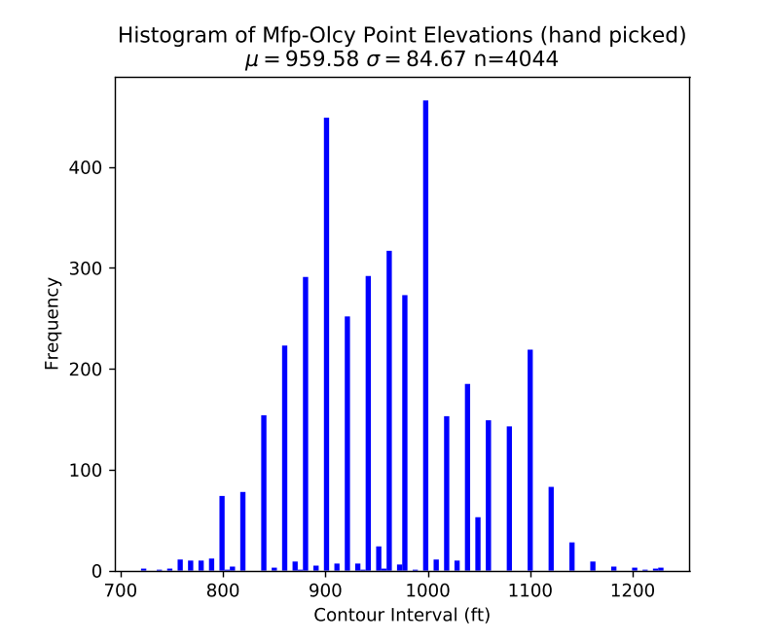
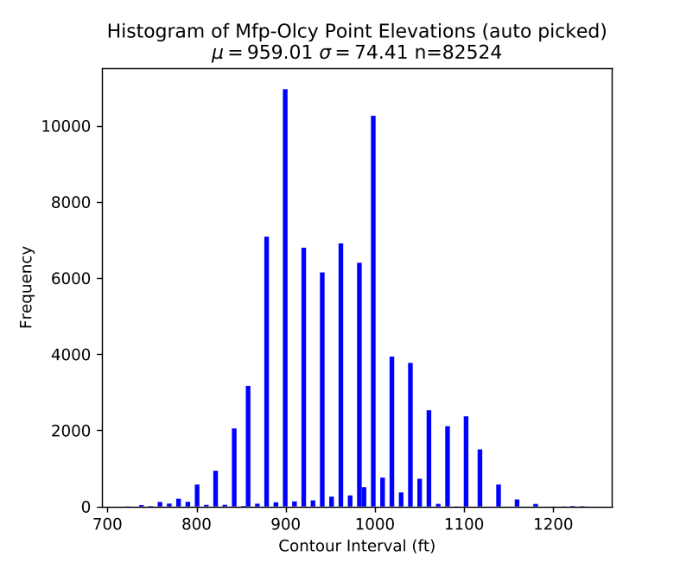
Figure I-4. Histograms showing the distribution of point elevations for both methods. The distribution of elevations are slightly different between collection methods.

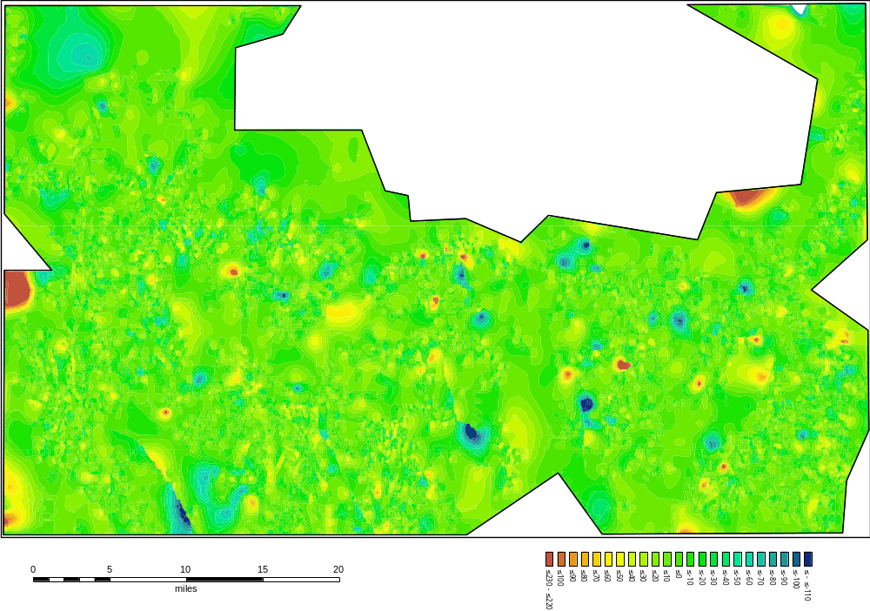
Figure I-5. Differential map of the study area. The colder colors indicate where the surface produced by contouring the points using each method differs from each other. Blue areas indicate where the handpicked surface is lower in elevation than the auto-picked method, red areas indicate the hand-picked surface is higher in elevation than the auto-picked method; Green areas indicate where the surfaces are roughly equal in elevation.

Conclusions

1) The volume of digital data available for this region is sufficient to allow the process of construction of structure contour maps to be automated, so long as the errors in georeferencing are corrected.
2) The method of picking points automatically using geologic contacts and elevation contours produces similar results to those picked by manual entry (so long as the digital geologic contact lines are equivalent).
3) The manually picked points have a slightly different distribution, the are still a representative sample.
4) The manual correction of the geologic contact lines was necessary, however it saved more time compared to manual picking.
5) An automated approach to this problem can yield results on a much shorter timescale, allowing larger-scale studies to be performed.
6) The resulting structure contour maps display many subtle features along outcrop belts and in areas with high well density. These maps also identify potential faults where none are shown on existing detailed geologic maps.
7) The structure contour maps generated using the GIS automated method are a higher resolution than handpicked maps and can be used to identify small-scale structures that can be used to infer information about the tectonic uplift history of the Cincinnati arch.

Acknowledgements

We thank the Tennessee Geological Survey and the USGS for providing the digital data from Tennessee for this project. Andrew L. Wunderlich and Morgan Strissel provided the manually compiled data used in part of this pilot study. Partial support for this research has been provided by the University of Tennessee Science Alliance Center of Excellence.

Applications of Process Automation and Spatial Data Management Using Python and GIS to Explore the Structural History of the Southern Cincinnati Arch

This section is a slightly revised version of a peer-reviewed paper currently in review by the Journal of Maps in 2020 by Kenneth S. Boling, Robert D. Hatcher Jr, Peter J. Lemiszki, and Gary G. Bible:

Kenneth S. Boling, Robert D. Hatcher Jr, Peter J. Lemiszki and Gary G. Bible. Applications of Process Automation and Spatial Data Management Using Python and GIS to Explore the Structural History of the Southern Cincinnati Arch. Journal of Maps. 2020 (in review)

Authorship Statement

Kenneth S. Boling: Designed and implemented the methodology and wrote the code in Python, manually spatially adjusted map data where appropriate, generated and edited figures, majority of writing and revisions.

Robert D. Hatcher Jr: Primary advisor, assisted with writing and revisions.

Peter J. Lemiszki: Assisted with the initial data acquisition and advised on data provenance.

Gary G. Bible: Revised paper, advised on the interpretation of well data provenance

Abstract

Structure contour maps are one of the most common methods of visualizing geologic horizons as three-dimensional surfaces. In addition to their practical applications in the oil and gas and mining industries, these maps can be used to evaluate the relationships of different geologic units in order to unravel the structural history of an area. The construction of high resolution structure contour maps of a particular geologic horizon across regional scales requires a significant volume of data that must first be compiled from all available surface and subsurface sources. Processing this data using conventional methods and even basic GIS tools can be tedious and time consuming, particularly if manual error correction or data entry is required.
We developed a semi-automated process for data aggregation, cleaning, and cross-verification of surface and subsurface data using Python™ and ArcGIS™. This process was then applied to all of the publicly available surface and subsurface geologic data from central Kentucky to northern Alabama, along the southern Cincinnati arch. These data were compiled from 887 published and unpublished digital 1:24,000-scale geologic quadrangle maps acquired from the Tennessee Geological Survey, Kentucky Geological Survey, United States Geological Survey, and Alabama Geological Survey. Subsurface data from 24,833 wells were also compiled from oil and gas well logs, mineral exploration boreholes, and state oil and gas well databases. We then generated structure contour maps of key surfaces and identified map-scale folds and faults within the study area. The results from this process were compared to a pilot survey that was performed manually in ArcGIS™. The resulting structure contour maps were used to identify structures relating to potential far-field effects of the Taconian, Neoacadian and Alleghanian orogenies across the southern Cincinnati arch.

Introduction

Structure contour maps have long been a useful tool for resolving the structure of geologic formations in the oil and gas and mining industries, as well as deciphering the geologic history of an area. Prior to the development of geophysical techniques, the earliest major development in oil and gas exploration was the use of outcrop patterns to infer underlying structures prior to drilling (Clark, 1952; Gillespie, 1995). Using geologic maps to produce structure contour maps may seem low-tech in the age of high-resolution 3D seismic imaging, but it remains a valuable technique for the industry and in areas where seismic and well data are sparse. Producing structure contour maps of large areas from surface geologic maps and well data by conventional methods can be tedious and time consuming, particularly if no digital data are available and manual data entry is required. Where digital data are available, data quality and formats may vary considerably across sources and must be standardized and cleaned to be integrated. As a result of these limitations, the areal extent of a study area, or data-point density may be sacrificed to complete the study manually within a reasonable timeframe. Consequently, the purpose of this study was to develop a more advanced, semi-automated approach to these problems that can yield more timely results, and assemble very large amounts of digital data, permitting larger regional studies to be performed with greater resolution.

In order to facilitate the analysis of large data sets, we developed a semi-automated process for generating structure contour maps from surface and subsurface geologic data in Python™. This process was used to generate regional structure contour maps across the southern Cincinnati arch, particularly on the Nashville and Jessamine domes, and the proximal flanks of the Appalachian and Illinois basins. This area was chosen to address the question of the timing of the uplift history of the southern Cincinnati arch, that can best be investigated by compiling the available surface and subsurface geologic data from central Kentucky, central Tennessee, and northern Alabama. There are other large scale studies that have been performed around the vicinity of the Cincinnati arch and along the Appalachian basin (Patchen et al., 2006), but few of these studies include Tennessee, in part due to the lack of data accessibility. In contrast, Kentucky has had a larger volume of research published, and all 1:24,000 scale maps have been digitized and are available to the public though an online portal. Although there are many studies that implement procedures that produce similar outcomes (e.g. Pflug et al., 1992; Roberts, 2003; Wu et al., 2005), many of these relied on closed source commercial software to accomplish this task. In contrast, this study employed primarily open source freely available software packages where feasible.

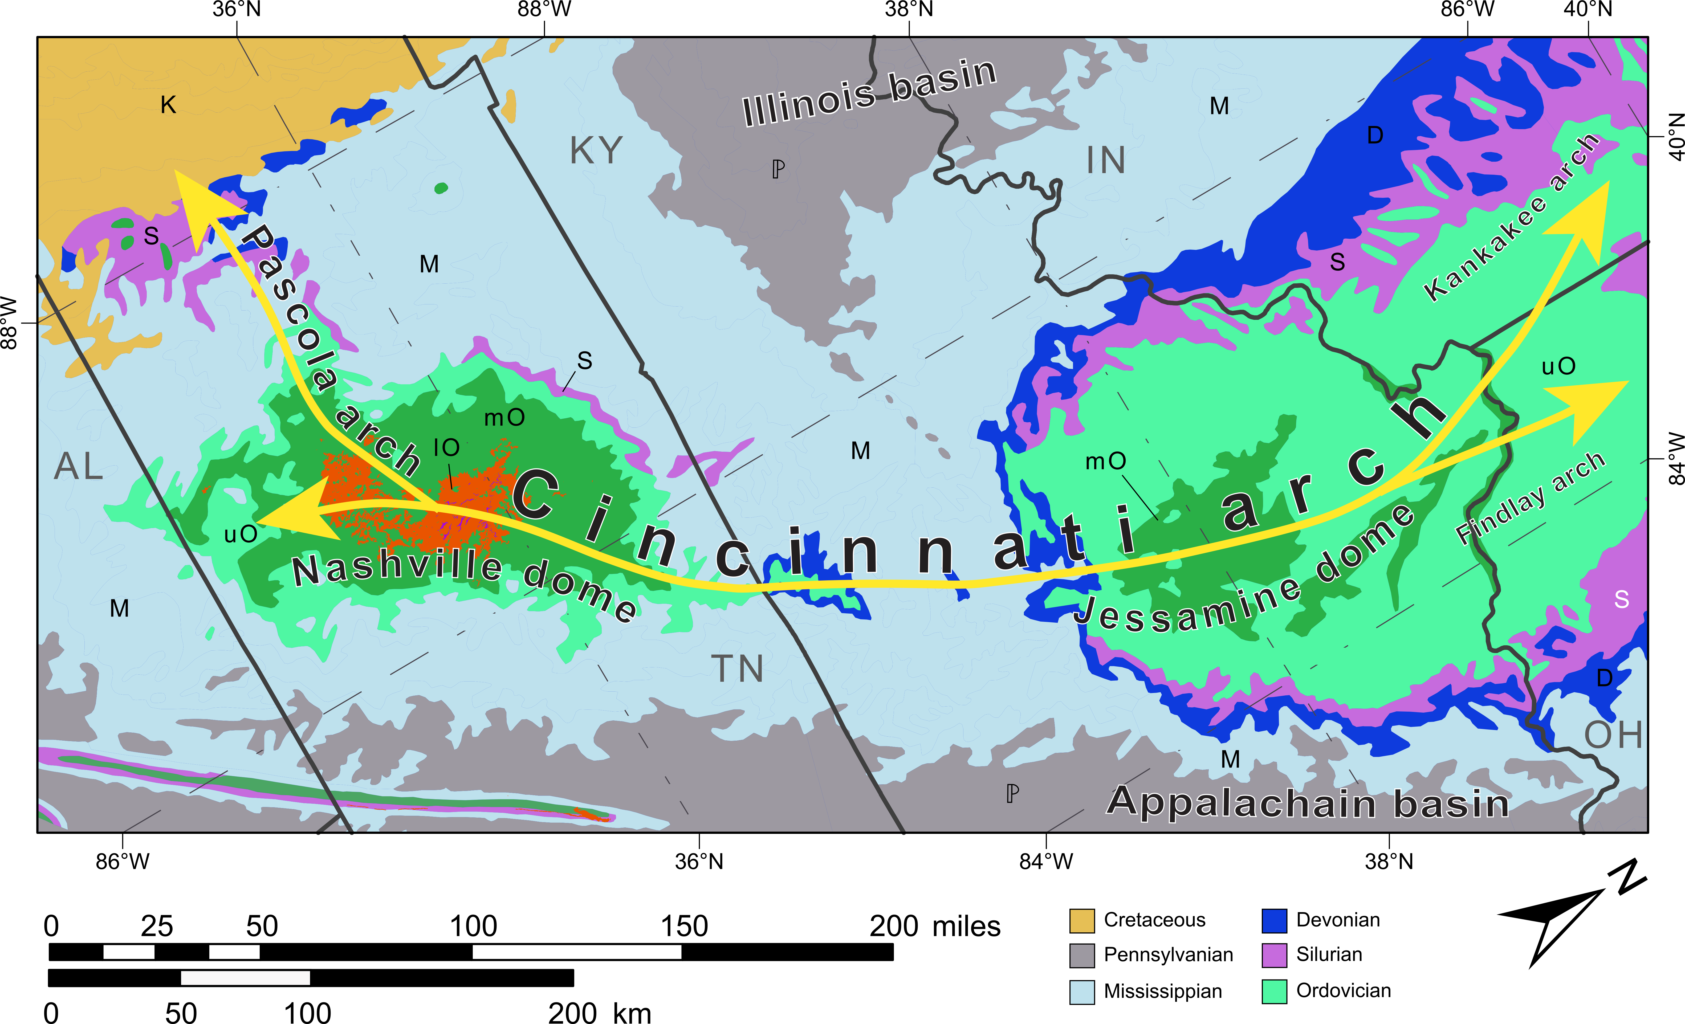
Figure II-1. Geologic map of the study area along the southern Cincinnati arch. The locations of major structural features including the Nashville and Jessamine domes that make up the southern Cincinnati arch, and the Pascola, Findlay, and Kankakee arches that branch off of it.

Formation of the Cincinnati arch has been attributed to a peripheral bulge that formed to the west of the Sevier-Martinsburg foreland basin during the Mid-to Late Ordovician Taconic orogeny (Quinlan and Beaumont, 1984). Renewed uplift of the arch occurred several times during the later Paleozoic (Stearns and Reesman, 1986). A better understanding of the timing of these events may reveal important information about the tectonic history of the Cincinnati arch and possibly the fault-controlled fractured oil and gas reservoirs in the Ordovician limestone and dolomite formations on the crest and flanks of the arch (Hamilton-Smith, 1992).
Previous work within this area has produced a large volume of information about the regional structure. Early interpretations of these structures were based on manually constructed structure contour maps on the base of the Chattanooga Shale, a laterally extensive Devonian black shale formation, using field data collected in the early 1930’s (Wilson, 1935, 1949). Several other studies have also constructed structure contour maps at various scales across portions of the study area (Moore and Horton, 1999; Patchen et al., 2006; Zurawski and Lemiszki, 2012). Well log and aeromagnetic data have been used to estimate the thickness of the formations on the Nashville dome in the context of the long-term history of the dome leading Stearns and Reesman (1986) to conclude that there has been a persistent structural high along the Cincinnati arch since Middle Ordovician time, although it did not occupy the same axis. One study questioned the cause for the initial formation of the Cincinnati arch (Pope et al., 2012). They examined the carbonate facies from a limited set of outcrop and core data to put together a sequence stratigraphic framework of the Upper Ordovician rocks to resolve the depositional history along the Nashville and Jessamine domes during the Taconic orogeny (Pope et al., 2012). Pope et al. (2012) concluded that shallow-water features along the Cincinnati arch occurred over a more narrow, restricted area than would be predicted based on development of a peripheral bulge.

Data

The data utilized in this study include surface and subsurface geologic data assembled from various sources across central Kentucky, central Tennessee, and northern Alabama (Table II-1). Subsurface data consist primarily of formation tops from oil and gas wells and mineral test wells. Subsurface data are available in GIS databases maintained by each state agency. Generally, these databases include API number, well location, formation tops, elevation, and other information in well logs. The surface data (Figure II-2) consist of digitized 1:24,000-scale geologic quadrangle maps in Tennessee and Kentucky. Alabama surface geologic data were derived from the 1:250,000-scale state geologic map (Szabo et al., 1988). Elevation data for the region were acquired using 1/3rd arc-second DEMs from the USGS 3DEP products (U.S. Geological Survey, 2017).

Table II-1. Sources of surface and subsurface data used in this study.

State | Surface data sources (Geologic maps) | Total quads | Subsurface data sources (wells) | Wells with data
KY | Kentucky Geological Survey (online map service) | 588 | Kentucky Geological Survey Oil and Gas Database | 17,235  (116,514 total formation tops)
TN | Tennessee Geological Survey (digitized and paper quad maps), USGS (digitized quads) | 299 | Tennessee Oil and Gas Database, previous publications, manually picked horizons | 7,556  (34,168 total formation tops)
AL | USGS 1:250,000 scale digital map | N/A | Alabama State Oil and Gas Board Well Database (manually picked horizons from scanned paper logs) | 42  (194 total formation tops)

Kentucky Data

The 1:24,000-scale geologic map data for Kentucky are available in digital format from the Kentucky Geological Survey (KGS) as an online map service with complete coverage of the state (Kentucky Geological Survey, 2018a). These data typically consist of an ArcGIS file geodatabase containing polygons representing the areas of geologic formations, and polyline data representing geologic contacts, faults, and other boundaries. An oil and gas well location database and a database of formation tops for a subset of wells are also available from the KGS website (Kentucky Geological Survey, 2018b).

Tennessee Data

Tennessee geologic map data were acquired by request from the Tennessee Geological Survey (TGS, formerly Division of Geology). The majority of the Tennessee digital map data originated from a USGS project where the original mylar scribecoats from 368 7.5 minute, 1/24,000 scale geologic quadrangles from an area in Central Tennessee were scanned and manually digitized (Connell et al., 1994). These data are available as ArcInfo™ coverage files, a subset of which contains non-uniform errors in georegistration, and, as a result, do not align perfectly with scanned paper maps; these errors were corrected manually for use in this study by spatially adjusting them to line up with the original paper maps. Several more recently digitized quadrangles were also obtained (Tennessee Geological Survey, 2018). In addition, a select group of quadrangles in important locations were manually digitized from scanned paper maps for this study, but the geologic maps of several quadrangles in Central Tennessee are currently incomplete and were not available. The majority of the Tennessee subsurface formation tops data were obtained from the Tennessee Oil and Gas database archived by the Tennessee Oil and Gas Program. Additional subsurface data were collected from publications by Evenick (2006) and Zurawski and Lemiszki (2012). Formation tops data for this study were also manually picked from scanned paper well logs specifically for this study.

Alabama Data

At the time of this study, Alabama had not completed 1:24,000-scale detailed geologic mapping along its northern border with Tennessee, so the 1:250,000-scale state geologic map was used (Szabo et al., 1988). The Alabama state well database does not include formation tops information, so formation tops data were manually picked from scanned well logs provided by the Alabama Oil and Gas Board.

Sources of Error

Subsurface data quality varies across sources and may contain errors introduced by differences in record keeping over time. Sources of errors include misreported well locations, unreported borehole deviation, and inconsistent elevation datum (e.g., reporting the kelly bushing elevation as ground level). In addition, different drillers define the tops of subsurface formations differently, particularly across state lines.
Surface geologic maps are prone to differences in naming conventions of equivalent units and splitting of members between maps, although major divisions are typically consistent and contact locations appear to be accurate. Once these errors were identified the general approach taken by this study subscribes to the idea that "no data is better than bad data", and therefore all data points that displayed questionable data quality were simply dropped from the database, rather than attempt to include these data by applying a correction.

Figure II-2. Distribution of primarily 1:24,000 scale maps used in this study. Kentucky has complete coverage of digitized 1:24,000 scale geologic maps, central Tennessee has mostly complete coverage for the primary area of interest although a few gaps in data coverage exist. The 1:250,000 scale Alabama state geologic map was also used but the resolution is too poor to display quadrangle-scale structures. Regional trends, however, can be observed.

Methods

The goal for developing the methodology for this study was to combine geologic map and elevation data across the study area and integrate the results with subsurface well data into a single database. The process implemented several open-source Python™ packages from the SciPy library (Jones et al., 2014). Python was selected for use in this study for two reasons: 1) It is currently one of the more popular scripting languages in use at the time of the study, and 2) it interfaces easily with ArcGIS 10.5 without requiring extra plug-ins or interpreters (as was the case for the R programming language for example). While it is possible to use the ArcGIS Model builder to accomplish similar results, the authors of this study wanted to use open source and freely available resources where feasible that would enable users from low income or developing economies equal access to these resources.
The Pandas (McKinney, 2010) and NumPy (Oliphant, 2006) Python™ packages were also the primary tools for data management, processing of disparate data objects, and conversion to standard formats. The ArcPy package from the ESRI ArcGIS™ platform was also used for final interpolation and visualization. This study follows a somewhat similar set of methodologies that have been developed for use in 3D geologic modeling, though these studies have typically utilized closed source applications such as one heavily cited study that used AutoCAD™ (e.g., Kaufmann and Martin, 2009). This study does not imply that the use of open source programming is a best practice from a technical or ease of use stand point, but for the purposes of this project we project felt that it was in the best interest to use resources that are easily accessible. That said, the use of ArcGIS for the final visualization was primarily based on my familiarity with the software, although other open source options are available (such as Q-GIS™).
Data were assembled from the sources described in the previous section. The process developed involves three steps (Figure II-2): 1) preprocessing and initial integration of disparate data sets; 2) cleaning and cross-verification to remove erroneous data; and 3) querying and interpolation of the final integrated database. The preprocessing step first involved digitization of scanned 1:24,000 scale paper geologic maps and conversion from legacy data formats (ArcInfo™ coverages). A portion of the quadrangles in Tennessee digitized by Connell et al. (1994) were manually spatially adjusted in ArcMap to correct for improper geo-registration of geologic maps, most likely resulting from errors in converting between projections, as well as incorrectly entered coordinates used to define the corners of each quadrangle. Manual formation top picks from paper logs, state oil and gas databases, and published data were converted from Excel spreadsheets, comma-separated value files and integrated into a Pandas dataframe. All spatial data were converted from their initial coordinate systems to the NAD 1983 geographic coordinate system and projected in UTM zone 16N.
Figure II-3. Data pipeline and initial workflow displaying the data sources and the processes used in this study.

After an initial analysis of available data, routines were developed for cleaning of inaccurate and duplicate data by cross-verification with other data sources. Duplicate well, map, and formation top entries for each individual well dataset were removed. In some cases, multiple formation tops picks were available for a specific well so a “best pick” value was determined by selecting either the pick from the most reliable source available (i.e. down-hole well logs, drillers logs, core, state survey geologist pick, etc.) or, an average value of the picks in cases of variations in picks across different reporters. In cases of multiple picks having greater than 20 ft difference than the average of the picks, all picks for that interval were considered erroneous or ambiguous and were dropped. Reported well elevations were also cross-checked with elevation data to identify potentially unreliable well data. Point features (points that were generated along the formation contacts before the spot elevations were extracted from the DEM data) were automatically generated at a specified interval of 50 ft along all formation boundaries from the combined geologic maps, and spot elevations for each point were extracted from the 1/3rd arc-second DEMs. Finally, surface and subsurface point data were combined into a single database that could then be queried to select points belonging to each geologic contact to be contoured. Specific horizons were selected for constructing structure contour maps based on their regional extent and subsurface equivalent units across the study area. A spline-with-barriers function was used in ArcMap to generate an interpolated surface between data points using a set of line features representing mapped fault locations for the barriers.
The major advantages to using large data compilations are an increased resolution of small-scale structures across larger study areas over a shorter period of time. The pitfalls of this method primarily involve a lack of understanding of the underlying data sources, formats, and provenance. The most significant pitfalls to the use of this methodology for the collection and processing of this large data set were typically encountered when attempting to apply the same methods to data from other states. Even naming conventions and the methods used by drillers to identify geologic horizons can differ wildly across state boundaries. For example, treating datasets that span multiple agencies and states the same way my result in inaccuracies that may not be immediately detectable and may introduce errors in the final surface. =

Results

The semi-automated process produced high-resolution structure contour maps for several horizons that were thought to be the most useful for investigating the relationships of small and regional-scale structures to the tectonic events thought to have affected the structure and stratigraphy of the study area. The initial results were compared with structure contour maps that were generated manually (in ArcMap) over a small area during a pilot study to compare the time investment, validity, and reproducibility of this process.

Pilot Study

Initial results were compared with a structure contour map constructed from visually picked geologic map data in a pilot survey of 32 quadrangles over part of the southern flank of the Nashville dome to validate results (Figure II-4). The regional structure of the Nashville dome and many smaller, map-scale structures are clearly visible in both the hand-picked map (Figure II-4a) and the map constructed via the semi-automated process (Figure II-4b). Neither display any significant differences in the broad regional structure of the southern portion of the Nashville dome. The automated map, however, resolves finer details of the sub-quadrangle-scale structures than the hand-picked map. NW-SE-trending linear structures and faults along this section of the dome are particularly apparent. The map produced by the automated process was also constructed over a period of hours rather than weeks of manually picking data points.
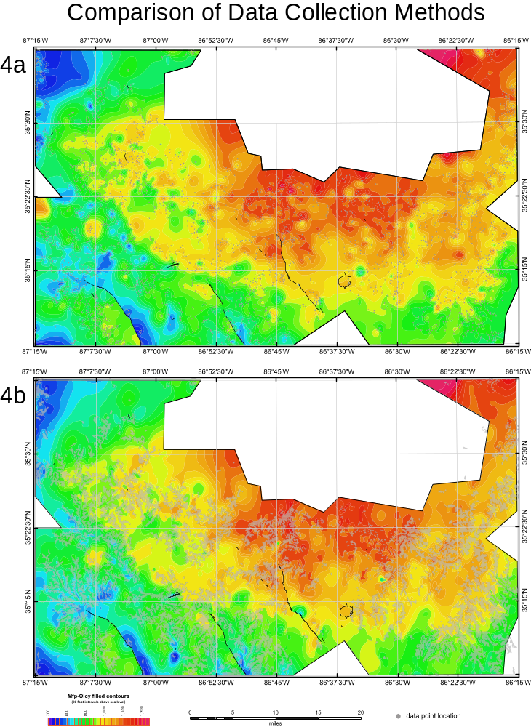
Figure II-4. Comparison of the structure contour maps on the base of the Chattanooga Shale (Mfp-Olcy contact) generated using two methods of data collection for the area around the southern Nashville dome. These maps were constructed using identical parameters with the exception of the data collection methods: (a) was constructed during a pilot study by manually picking ~4,000 data points (red circles) and (b) was generated from ~73,000 auto-picked points (gray dots that appear as a dendritic pattern along outcrop surfaces) using the methods developed during this study.

Regional Structures

Two laterally extensive horizons were selected for mapping the structure in the study area: the base of the Devonian-Mississippian Chattanooga Shale (Plate II-1), and the top of the Mid-Ordovician Stones River (High Bridge) Group (Figure II-5). Regional structural features easily identified on these maps include the Nashville and Jessamine domes separated by the Cumberland saddle, the flanks of the Illinois and Appalachian basins, the Moorman syncline (Rough Creek graben), and the Lexington, Kentucky River and Paint Creek-Irvine fault systems.
There are notable differences in the overall structure between the Nashville and Jessamine domes. For instance, the Jessamine dome is broader than the Nashville dome, which is more elongated, and transitions into the Pascola arch to the west. The Nashville dome also has higher structural relief than the Jessamine dome, exposing a much larger area of Lower Middle Ordovician rocks (Stones River Group) than the Jessamine dome. Fewer faults, however, have been identified on the Nashville dome. This may be a result of a lesser degree of reactivation of basement faults along the Nashville dome, as the major fault complexes on the Jessamine dome have been interpreted as being the product of reactivated basement faults (Black, 1989).

Figure II-5. Structure contour map of the top of the Stones River Group, (and High Bridge Group equivalent).

On a large scale, the resulting regional scale maps yielded results roughly similar to those of other studies completed in Tennessee (Wilson, 1949; Zurawski and Lemiszki, 2012) and Kentucky (Hickman, 2011). However, the greatest strength of this approach is the ability to resolve smaller-scale structures using the same map.

Map-Scale Structures

The structure contour maps produced for this study display many subtle, small-scale features along outcrop belts and in areas with high well density. Several quadrangle-scale faults and folds occur along the southern and western flanks of the Nashville dome that deform the base of the Chattanooga Shale and older surfaces (Figure II-6 and Figure II-7).
These folds form a series of N-S-oriented anticline-syncline pairs. These folds may be the surface expressions of blind faults, similar to field-mapped faulted structures as described by Abolins et al. (2015), although they are much tighter folds. Most notably, however, is the preservation of Silurian units, which are commonly restricted to synclines preserved beneath the unconformity at the base of the Chattanooga Shale (Hatcher et al., 2007). Outcrops of Silurian rocks that are present along the southern flank of the Nashville dome display increasing thickness down plunge and along the hinges of the synclines (Figure II-7).
These folds may be the surface expressions of blind faults, similar to field-mapped faulted structures as described by Abolins et al. (2015), although they are much tighter folds. Most notably, however, is the preservation of Silurian units, which are commonly restricted to synclines preserved beneath the unconformity at the base of the Chattanooga Shale (Hatcher et al., 2007). Because these folds deform the base of the Chattanooga Shale the deformation clearly occurred following the deposition of the shale. However, the Silurian units preserved in synclines appear to also have the same folding pattern as the overlying Chattanooga Shale. Because the Chattanooga Shale was deposited immediately following the widespread erosional surface that is presumed to be responsible for the removal of the Silurian formations, it seems paradoxical that the Chattanooga Shale would display the same fold pattern as the Silurian formations.
One explanation for this may be that the apparent folds in the base of the Chattanooga may actually be a representation of the paleo-surface, during erosion which resulted in the base-Devonian unconformity, these units may have been far enough below storm weather wave base to avoid being truncated as the structural highs were, and resulted in the infilling of structural lows.
This has been reported to have occurred with the Flynn Creek impact structure, following the impact event the Chattanooga Shale filled in the crater, such that the thickness of the shale inside the crater is an order of magnitude greater than in the areas surrounding it (Schieber and Over, 2005).

Figure II-6. Structure contour map on the base of the Chattanooga Shale on the southern flank of the Nashville dome. Several folds and other deformational features can be observed on the southwest side of the map. The northeast side of the map displays few deformational features by comparison. The red dashed line indicates the location of Figure II-7.

Figure II-7. Structure map of the base of the Silurian in south-central Tennessee. Silurian outcrops along the southern Nashville dome are typically preserved in synclines fold axes because of the truncation of structural highs by the base Chattanooga Shale unconformity. The Silurian units seen here have not been completely eroded off the crests of anticlines, and thicken into the synclines due to higher preservation.

Conclusions

1) A semi-automated method of data compilation, cleaning, cross-verification, and visualization of surface and subsurface data using of Python and GIS for compiling multiple disparate datasets has been developed to generate regional structure contour maps. This method was then implemented to consolidate several contrasting data sets from a variety of sources on the Nashville and Jessamine domes in Tennessee and Kentucky to generate structure contour maps of several horizons. This process has broader implications to the oil and gas industry for data management and processing, and may be used to assist in preliminary oil and gas assessments in areas where only surface geologic data are available.
2) 1:24,000-scale structure contour maps may be an important source of data to identify individual folds and related faults that may become oil and gas prospects, as well as provide greater insight into the geologic history of a region.
3) Pre-Devonian (Acadian-Neoacadian) deformation produced quadrangle-scale folds along the Nashville and Jessamine domes, and the southern Cincinnati arch, that preserved Lower Silurian rocks in synclines. Based on fold geometry and the differences in the surface expressions of these folds in units deposited before and after the erosional events prior to deposition at the base of the Chattanooga Shale, it would seem that the Alleghanian orogeny was most likely responsible for the majority of the regional-scale structures depicted in these maps, except the pre-Chattanooga structures. These structures were likely formed during the mid-Paleozoic Acadian-Neoacadian orogeny.

Acknowledgements

We thank the Tennessee Geological Survey, Kentucky Geological Survey, Alabama Geological Survey, Oil and Gas Board of Alabama, B. H. (Nick) Tew, State Geologist; and the USGS for providing the data for this project. The cooperation of Elaine Foust with the Tennessee Oil and Gas Program for providing updates to the Tennessee oil and gas database is much appreciated. Andrew L. Wunderlich and Morgan Strissel provided invaluable assistance in compiling the data used in the pilot study. Support for this research has been provided by the University of Tennessee Science Alliance Center of Excellence and funding for open access to this research was provided by University of Tennessee’s Open Publishing Support Fund.

Data Availability

The data used in this project were obtained from several different state agencies and have been listed below:

A copy of the Tennessee oil and gas well database may be obtained by mail by contacting Elaine Foust at the Tennessee Oil and Gas Program (Elaine.Foust@tn.gov)

The Kentucky digital geologic map data may be accessed: https://kgs.uky.edu/kgsmap/kgsgeoserver/

The Kentucky oil and gas well database may be accessed: https://kgs.uky.edu/kygeode/services/oilgas/

The Alabama oil and gas database may be accessed: https://www.gsa.state.al.us/ogb/

Software
The primary tools used for data management and cleaning include the Python 3 packages pandas and numpy. Python scripts were written using the Pycharm Integrated Development Environment. ArcGIS 10.5 and the arcpy python package were used to create the map visualizations. The final maps were edited using Adobe Illustrator.

Plate II-1. Structure contour maps on the base of the Chattanooga Shale. Regional structures are easily identifiable on these maps, including the Nashville and Jessamine domes separated by the Cumberland saddle, the flanks of the Illinois and Appalachian basins, the Moorman syncline (Rough Creek graben), and vertical displacement along the Lexington, Kentucky River and Paint Creek-Irvine fault systems.

Mid to Late Paleozoic Tectonics along the Southern Cincinnati Arch

The final section was not yet submitted for external publication at the time of this publication.

Kenneth S. Boling, Robert D. Hatcher Jr, Peter J. Lemiszki and Gary G. Bible. Mid to Late Paleozoic Tectonics along the Southern Cincinnati Arch, (publication to be determined)

Authorship Statement

Kenneth S. Boling: Designed and implemented the methodology and wrote the code in Python, generated and edited figures, majority of writing and revisions.

Robert D. Hatcher Jr: Primary advisor, assisted with writing and revisions, and geologic background, also generated figure III-39.

Peter J. Lemiszki: Extensively reviewed and suggested specific revisions to the paper.

Gary G. Bible: Reviewed and revised paper.

Abstract

The initial formation of the Cincinnati arch has been attributed to the peripheral bulge of the foreland basin formed during the Mid to Late Ordovician Taconic orogeny. A better understanding of the timing of these events may reveal important information about the fault controlled fractured oil and gas reservoirs in the Ordovician limestone and dolomite formations on the margins of the arch. The tectonic history following the initial uplift of the arch and the formation of the Nashville and Jessamine domes is poorly understood. This is due in part to the complexities of the interplay of unconformities and structural overprinting resulting from subsequent Paleozoic orogenies. This study attempts to determine the timing of deformation of the unconformity-bound sequences exposed along the southern Cincinnati arch by generating high resolution structure contour maps of the Mid-Ordovician to Mississippian formations. These maps were used to identify structures relating to potential far-field effects of the Taconic, Neoacadian, and Alleghanian orogenies. Structures previously identified in geologic maps and other published works across central Kentucky, Tennessee, and northern Alabama were also incorporated.
Due to the large volume of data available for this study, we developed a semi-automated process for data collection, cleaning, and cross-verification using Python™ and ArcGIS™. This process was used to compile data from 887 published and unpublished digital 1:24,000-scale geologic quadrangle maps acquired from the Tennessee Geological Survey, Kentucky Geological Survey, USGS, and Alabama Geological Survey. Subsurface data from 24,833 wells were also compiled from oil and gas well logs, mineral exploration boreholes, resource summary reports, and state oil and gas well databases. We then generated structure maps of key surfaces that were used to construct a series of isopach maps to determine areas of relative thinning or thickening of the section, which may indicate areas of erosion after being uplifted. The resulting maps found that there does not seem to have been a great amount of uplift along the Nashville dome during the interval from the erosion of the Knox to the deposition of the Stones River Group. A greater amount of uplift took place between the top of the Stones River Group, and the formation of the pre-Chattanooga unconformity, and there is evidence for several intervals of uplift across the top of the Nashville dome from several unconformities. These unconformities appear to record intermittent uplift of the Nashville dome with little change in orientation. This has been interpreted as representing a Type-0 fold interference pattern, which are rarely recorded in the geologic record.

Introduction

The Eastern United States has been affected by several major orogenic events. The most recent of these events resulted in the formation of the Appalachian orogen. The events that occurred in this area also affected the formation of structures to the west of the Appalachians, the most prominent of which are the Cincinnati arch and flanking Appalachian, Black Warrior, and Illinois basins. The Cincinnati arch is a broad structural feature that extends from northern Alabama to southern Ontario.
The exact timing of the initial formation of this structure, as well as the timing of its intermittent uplift throughout much of the Paleozoic are not completely understood, although it is generally thought that some relationship exists between the timing of orogenic events and intermittent uplift of the arch. The focus of this study is the southern Cincinnati arch that extends from northern Alabama, through central Tennessee, and into central Kentucky. This area was chosen primarily because of the availability of usable data and lack of regional tectonic syntheses involving the entire region, as many past studies have been limited in scope to one state or a small part of the arch. Sections of the Cincinnati arch have been studied using structure contour maps for various formations, which have previously been generated for parts of Alabama (e.g. Mellen, 1947), Tennessee (e.g. Wilson, 1949; Moore and Horton, 1999; Zurawski and Lemiszki, 2012), and Kentucky, and areas of the Appalachian basin to the north (e.g. Patchen et al., 2006; Hickman, 2011).
In order to generate structure contour maps that span most of the Nashville and Jessamine domes, regional marker formations must be used to correlate across an extremely large area. The rock units of primary interest for this purpose consist of the top of the Lower Ordovician Knox Group, the Middle Ordovician Stones River and Nashville (and equivalent Kentucky) Groups, and the base of the regionally extensive Devonian shales.
The primary focus of this research is to attempt to recognize the effects of a series of tectonic events on the structural evolution of the Cincinnati arch and the smaller structures superposed on this structure. This effort was aided by the presence of several major unconformity surfaces identifiable along the arch. These unconformity surfaces can be interpreted as periods of time where the surface of domes were subaerially exposed, resulting in erosion or non-deposition, and can thus be used to potentially identify periods of time when major uplift events occurred. A complicating factor to using this method are changes in relative sea level which can also result in erosion during marine regressive sequences. The relative timing of these uplift events can then be compared to the timing of orogenic events in the Appalachian orogen with the goal of better understanding the nature of these structures through time.

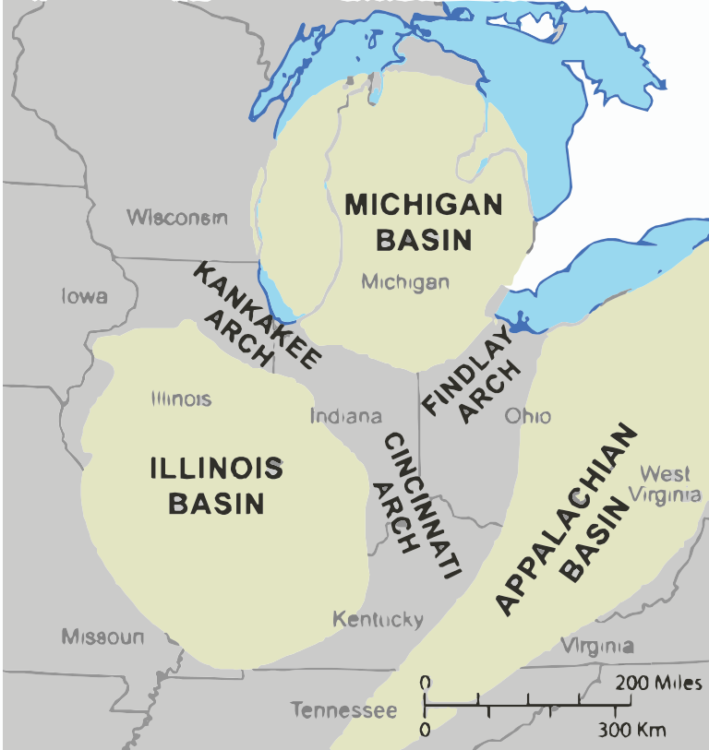
Figure III-1. Schematic diagram of the locations of major structures. Modified from (Brett et al., 2012).

In addition to unconformity surfaces, several regionally, extensive bentonite layers that occur within the intervals of interest can be used as time-equivalent markers to correlate across the region (Haynes, 1994; Kolata et al., 1996). These surfaces are extremely valuable sources of geologic structural information spanning much of the eastern United States. Due to the widespread regional extent of these features, they are the primary surfaces for generating regional structure contour maps, along with the post-Knox and Pre-Chattanooga unconformities.
The research presented here used a variety of data sources to produce a standardized database of information about the surface and subsurface geologic contacts that occur across this region (Boling et al., 2020a). This database was then used to derive data points that when interpolated permit resolution of second- and third-order structures along the southern Cincinnati arch.
In order to generate regional structure contour maps over a large area, all available surface and subsurface data within the study area were collected and transformed into a standard digital format, which could then be queried to generate structure contour maps. This research was made possible by the large volume of published detailed geologic maps, oil and gas well logs, mineral prospect holes, mineral resource summary reports, and digital oil and gas databases. Surface geologic data were compiled from a digital database of published and unpublished 1:24,000 geologic maps in Tennessee and Kentucky. Several geologic maps were also manually digitized. An automated process was implemented using ArcMap™ and Python scripts, which permitted rapid data collection and aggregation.
Several regional structure contour maps were generated using a semi-automated process developed specifically for this project (Boling et al., 2020a). The major horizons contoured for this purpose include: 1) The top of the Upper Cambrian-Lower Ordovician Knox Group, which is a widespread unconformity along the study area. 2) The top of the Middle Ordovician Stones River (Black River equivalent) and the base of the Nashville (Trenton equivalent) Group, a boundary which is very close to the prominent Millbrig bentonite (also known as the T-4 bentonite under Tennessee naming convention) (Wilson, 1949). 3) The base of the Devonian Chattanooga Shale, which is the pre-Chattanooga (and equivalent) unconformity and represents a third major unconformity surface.
In addition, a major source of information were the derivative products generated from each of these structure contour maps, primarily isopach maps showing the thickness between the upper and lower units. By comparing the thickness of specific formations it is possible to determine areas that potentially have experienced periods of uplift and erosion (as indicated by thinning of the selected formations), or deposition (as indicated by an increase in the thickness of the formations). This approach of using isopach maps to infer uplift and erosion is similar to those of other previous studies (e.g. Mederos et al., 2005).

Overview of Regional Structures in the Study Area

The study area for this project included a large portion of the southeastern United States, which included the area of central Tennessee, central Kentucky, and northern Alabama (Figure III-2). The major structure within the study area is the Cincinnati arch, the axis of which trends northeast through Alabama and Tennessee rotating to north-northeast Kentucky. The Cincinnati arch is flanked by the Appalachian basin to the east, and the Illinois basin to the west (Figure III-3). The Nashville dome is located on the southern end of the Cincinnati arch, and extends from northern Alabama to south-central Kentucky. The Jessamine dome spans from central Kentucky northward along the Cincinnati arch which splits into the Findlay and Kankakee arches into southern Indiana and Ohio to the north of the study area. The Appalachian orogen lies to the east of the arch, along the eastern margin of the Appalachian basin. The Michigan basin and the Ozark dome are also important structures on the flanks of the study area.

Cincinnati Arch

The Cincinnati arch is a regional structure that extends from northern Alabama to southern Ontario, over an area of about 65,000 mi² (Ryder and Hatch, 1995).

Figure III-2. Location of the study area (shown in orange).

62.5
Figure III-3. Geologic map showing the rock units regional structures along the southern end of the Cincinnati arch, which includes the Nashville and Jessamine domes (modified from King et al., 1974; Schruben et al., 1998). The heavy dashed line indicates the extent of the study area for this project.

The arch was initially discovered when it was noted that sections of geologic units repeat in the opposite order across Ohio from east to west (Locke, 1838). It was not recognized as an anticlinal feature or named the "Cincinnati arch" until much later (Newberry, 1873), and was named after Cincinnati Ohio where it seemed to be centered. The arch can be subdivided into northern and southern sections; the northern Cincinnati arch bifurcates to form the Kankakee arch that extends northwest into Indiana and Illinois, and the Findlay arch that extends to the northeast through Ohio (McLaughlin et al., 2008).
The southern section of the Cincinnati arch trends roughly north-south across the area from northern Kentucky through central Tennessee and into northern Alabama. This region is the primary focus of this investigation. superimposed along the arch are two discrete structural highs, the Jessamine and Nashville domes. The Cincinnati arch also divides the Illinois and Appalachian hydrocarbon producing basins, which have been drilled extensively for over 100 years. As a result of the these exploration activities, a wealth of subsurface geologic data is available across the entire basin, and more importantly, up onto the flanks of the Jessamine and Nashville domes.

Nashville Dome

The Nashville dome occupies central Tennessee west of the Appalachian fold-thrust belt. The earliest descriptions of the Nashville dome as a structure along the southern Cincinnati arch were by Foerste, (1895, 1901, 1904). Early interpretations of these structures were based on structure contour maps of the top of the Chattanooga Shale using field data collected in the early 1930’s (e.g., Wilson, 1935, 1949). Well log and aeromagnetic data have been used to estimate the thickness of the formations on the Nashville dome in the context of the long-term history of the dome, leading Stearns and Reesman, (1986) to conclude there has been a persistent structural high here along the Cincinnati arch since Middle Ordovician time. Fischer (1977) reported that the crest of the main basement high is not centered on the Nashville dome but rather is located on the eastern side of the present dome crest, corresponding with the location of the deepest erosion of the top of the Knox.

Jessamine Dome

The Jessamine dome extends from northern Kentucky into southern Ohio and southeastern Indiana. The northern end of this feature plunges toward the Michigan basin. The Jessamine dome is occasionally referred to as the Lexington dome and has been described as having a broad, irregular structure that dips at a low angle away from the crest, with strata dipping generally from 3.79 to 5.68 m/km (20 to 30 ft/mi) or a dip angle of about 0.2° to 0.3° in the west and somewhat less to the north (Cressman, 1973; Borella and Osborne, 1978).
The Jessamine dome is transected by three major roughly east-west trending fault systems: the Kentucky River fault system, Irvine-Paint Creek fault system, and the Lexington fault system (formerly the West Hickman Creek–Bryant Station fault zone) (Cressman, 1973). The Kentucky River fault system is a series of normal faults trending from northeast to east-northeast that extends from central to northeastern Kentucky. The Lexington fault system joins the northeast-trending part of the Kentucky River fault system in southern Jessamine County and extends northeast-ward into Bourbon County (Black and Haney, 1975). It has been hypothesized that the Kentucky River fault system and the Irvine-Paint Creek fault system may represent ancient structural elements in the Precambrian basement. These features extend to basement, and may have been active during Cambrian time (McGuire and Howell, 1963; Bayley and Muehlberger, 1968; Webb, 1969; Borella and Osborne, 1978).

Pascola Arch

The Pascola arch connectings the Ozark and Nashville domes (Wilson, 1939; Marcher and Stearns, 1962; Schwalb, 1982; Rabak et al., 2011). The surface outcrop pattern of the Pascola arch is expressed in southwest central Tennessee, although in the subsurface it extends from southwestern Tennessee to southeastern Missouri underlying the sediments of the Coastal Plain (Grohskopf, 1956; Schwalb, 1982). The origin of the Pascola arch is debatable, although some authors believe that the arch formed during the late Paleozoic Ouachita or the Alleghanian orogeny (Marcher and Stearns, 1962; McBride et al., 2003), and some authors suggest that the uplift of the arch was driven by some kind of intrusion (Rabak et al., 2011), although there is little supporting evidence.

Stratigraphy Along the Southern Cincinnati Arch

The surface expression of the Nashville and Jessamine domes can be seen as a series of outcrops of Middle and Upper Ordovician limestone formations exposed at the surface on the crests of both domes. The present-day area of central Tennessee displays low topographic relief, and as a result the extent of the domes are clearly represented in the geologic map of the region (Figure III-3). The oldest Middle Ordovician formations appear toward the center of the dome, with the area surrounding these central exposures displaying progressively younger formations.
On the Nashville dome, the center of the dome is dominated by a wide area of Middle Ordovician formation exposures at the surface. In contrast, only a small outcrop belt of Middle Ordovician limestones is exposed on the Jessamine dome (Cressman, 1973). Silurian formations are generally exposed along the flanks of each dome, with the exception of the eastern limb of the Nashville dome, where these units were eroded and truncated by the pre-Chattanooga unconformity, or never deposited.
In general, the stratigraphy of the region of interest consists of the Upper Cambrian to Lower Ordovician Knox Dolomite, which is overlain unconformably by Middle Ordovician carbonates of the Stones River Group in Tennessee, and the equivalent High Bridge Group in Kentucky (Figure III-4). The Carters Limestone at the upper part of the Stones River Group contains several bentonites that are useful markers for correlation between well logs. Above the Stones River/High Bridge Group the remaining Middle Ordovician formations consist primarily of the Nashville Group in Tennessee, and the Lexington Limestone in Kentucky. The Devonian Chattanooga Shale is regionally extensive and is a facies and diachronous time equivalent to the New Albany and Ohio Shales. Several localized unconformities have been recognized in the exposed Ordovician units that may be linked to the tectonic history (Pope et al., 2012).

Knox Dolomite (Upper Cambrian to Lower Ordovician)

The Knox Group is primarily made up of Late Cambrian to Early Ordovician dolomitized limestone formations. The uppermost member of the Knox Group is the Mascot Dolomite, which underlies the post-Knox unconformity. This unconformity separates the Lower Ordovician from Middle Ordovician rocks across most of the region, although the amount of erosion that took place is highly variable and the Knox section is conformable in some areas. In southwest Virginia for example, this unconformity has up to 140 m of erosional relief decreasing to <20 m in northern Virginia
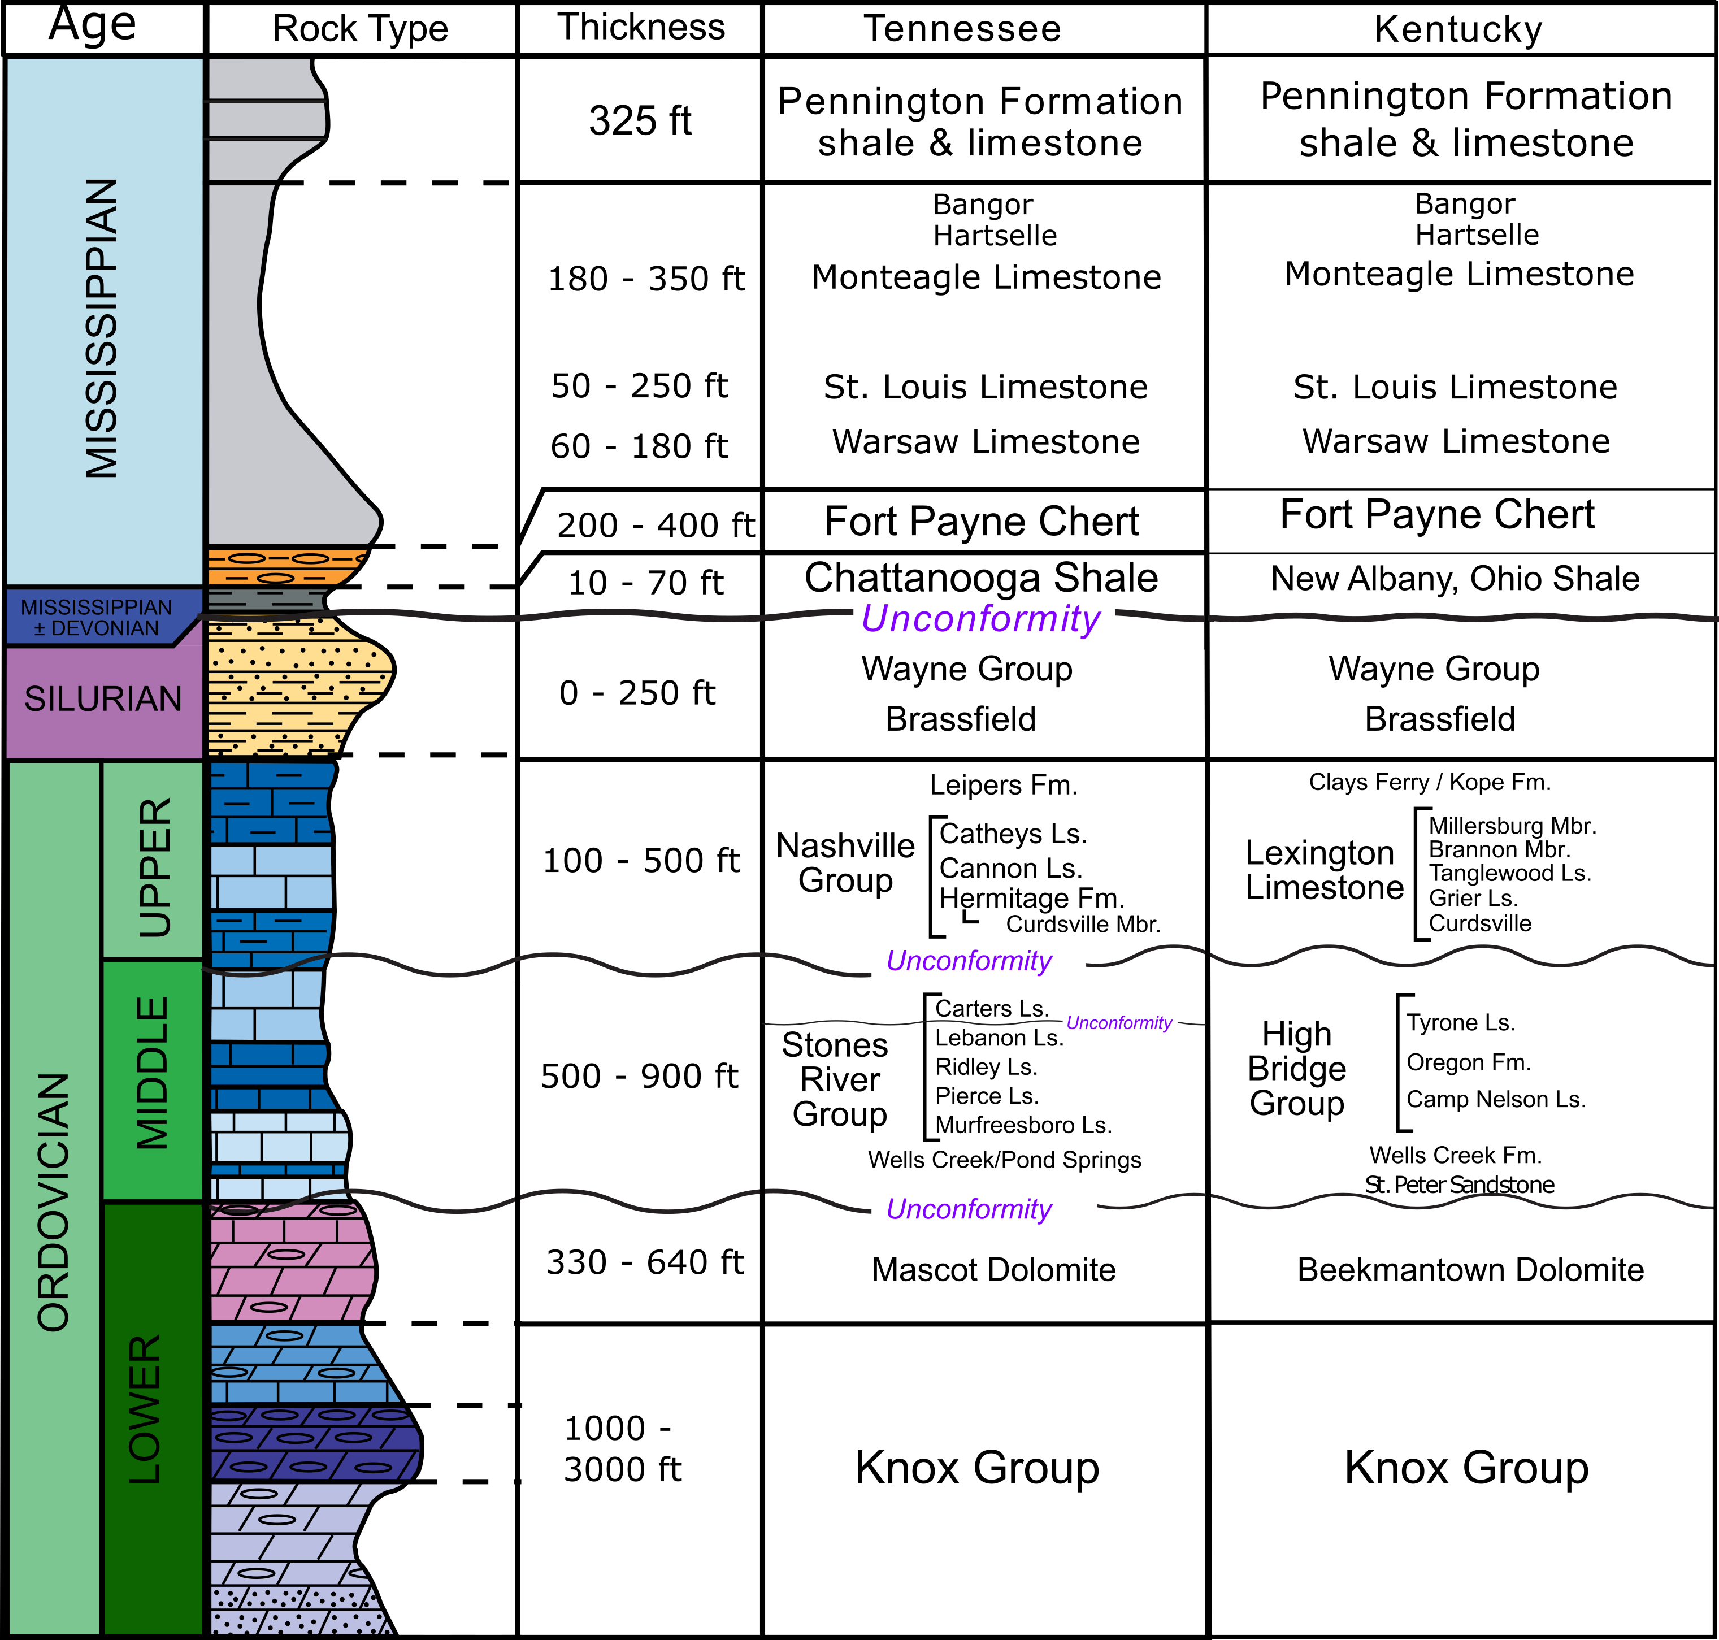
Figure III-4. Generalized regional stratigraphy of the Lower Ordovician to Pennsylvanian rock units of the southern Cincinnati arch. The stratigraphic units in this figure are defined according to the stratigraphy of central Tennessee. The equivalents in central Kentucky are also listed. Modified from (Hatcher and Milici, 2015).

(Mussman et al., 1988). The highest erosion rates occurred along a "paleo arch" that exposed portions of the Knox Group (Fischer, 1977). This erosion event also produced a karst surface throughout most of the central and eastern U.S. and eastern Canada (Repetski and Hatcher, 2006), which is thought to have been formed at least 500 ft above sea-level (Stearns and Reesman, 1986). Breccia-filled collapse structures resulting from the formation of karst features during this period of sub-areal exposure later became traps for metal rich hydrothermal fluids that resulted in the precipitation of large volumes of sphalerite, galena, and fluorite. These locations have been mined for zinc ore for many years and represent important economic Mississippi Valley-type ore deposits in Tennessee and the eastern U.S. These same structures may also act as a trap for hydrocarbons. In northern Kentucky the top of the Knox is occasionally recorded on well logs defined by the uppermost member known as the Beekmantown Dolomite (Smosna et al., 2005; Bowersox, 2013). The Knox Group is primarily limited to the subsurface within the study area, however a small outcrop occurs in the central uplift of the Wells Creek impact structure (Wilson, 1953; Wilson and Stearns, 1968).

Stones River Group (Middle Ordovician)

The Stones River Group was the name originally given to a succession of limestones exposed along "Stones River" in the Central Basin of Tennessee (Safford, 1851; Cooper, 1945). The Stones River Group has a Middle Ordovician age, and consists of six limestone formations, the Wells Creek, Murfreesboro, Pierce, Ridley, Lebanon, and Carters Limestones. The depositional environment of the Stones River Group may have been analogous to modern tidal flats in the Bahamas (Stith, 1981). The Stones River Group is partly equivalent to the High Bridge Group in central Kentucky and both groups are regionally equivalent to the Black River Group in New York and Ohio.
Throughout most of central Tennessee and Kentucky, the formation directly above the Knox Group is the Wells Creek Formation; a fine-grained argillaceous dolomite (Wolcott et al., 1972). In Tennessee the unit is also occasionally referred to as the "Pond Spring Formation", which is described as a glauconitic dolomite with interspersed shale beds (Brahana and Bradley, 1985). While not technically initially included as part of the Stones River Group (likely due to being below the Murfreesboro, the base of which does not outcrop in central Tennessee) (Wilson, 1949), the Wells Creek Formation was named for the creek that ran through the Wells Creek impact structure before Lake Barkley was impounded (Wilson, 1953). This unit is the basal member of both the High Bridge Group, and the Stones River Group, which was deposited atop the Knox unconformity as part of a carbonate platform deposited following the karst erosion surface that developed on the Knox. This is one of the most widespread and recognizable unconformities in the stratigraphic section of the continental interior of the eastern United States and Canada, and part of the craton-wide unconformity that separates the Sauk and Tippecanoe sequences (Sloss, 1963; Wolcott et al., 1972). The unit is primarily restricted to the subsurface and is typically recognized on well logs throughout central Tennessee, Kentucky, and Ohio by its appearance on a neutron or gamma ray log (Milhous, 1959; Stith, 1981). The Wells Creek Formation is considered to be a transgressive unit deposited on top of the Knox unconformity as the relative sea-level rose (Wolcott et al., 1972). It is also noted that the Pond Springs/Wells Creek consists of erosional debris on top of the Knox paleokarst surface and displays a variable thickness across short distances. This has been interpreted as the result of the formation conforming to the highs and lows of the Knox Group karst surface (Newcome and Smith, 1962).
In Tennessee, the Stones River Group is subdivided into the Murfreesboro, Pierce, Ridley, Lebanon, and Carters Limestones (Wilson, 1949). The outcrop belts of these formations are restricted to the central area of the Nashville dome in Tennessee (Figure III-5).
The Murfreesboro Limestone is a thick- to thin-bedded, very dark-gray, fine-grained limestone throughout most of the stratigraphic section, although occasionally displays a "sugary" texture (Wilson, 1949). It outcrops only in the central crest of the Nashville dome, where it outcrops along the crests of minor anticlines. It is somewhat cherty in the upper part, and has a maximum thickness of about 70 feet at the surface (Wilson, 1949).

Figure III-5. Geologic map showing the exposures of the lower Stones River Group (Lsr) (Murfreesburo, Pierce, and Ridley Formations), which occur across the crest of the Nashville dome. The units in yellow are stratigraphically below the red units and indicate the location of anticlines. Middle and Upper Ordovician formations (mO, uO respectively) outcrop on the outer flanks of the dome. The Silurian units (S) only occur on the northwestern flank of the dome, and are completely eroded from the eastern flank. The Mississippian formations (M) surround the dome, and some Cretaceous formations (K) outcrop west of the dome into the coastal plain. The formations highlighted in red and yellow are lower Stones River Group formations from a compilation of several 1:24,000 scale quadrangle maps from the area around the Nashville dome, while the base map was constructed using the 1:2,500,000 scale U.S. geologic map (King et al., 1974; Schruben et al., 1998).

The Pierce Limestone is a gray, thin-bedded limestone with some shale partings. It is generally around 27 feet thick in most areas in Tennessee where it outcrops (primarily Rutherford county). It is named for the type section at "Pierces Mill" and is generally more silty than either the formations above or below (Wilson, 1949). Above the Pierce is the Ridley Limestone, which is a thick-bedded, brownish-gray, fine-grained limestone, with minor mottlings of magnesian limestone, with chert commonly found at the base and in the upper third of the formation (Wilson, 1949). It is usually conformable with the formations above and below (Wilson, 1949), and the thickness of the Ridley Limestone ranges from 90 to 150 feet (Hardeman et al., 1966).
The Lebanon Limestone is a thin-bedded, gray limestone with calcareous shale partings. It has a thickness ranging from 74 to 118 feet with an average of 92 feet (Wilson, 1949). It has been noted that the Lebanon Limestone has been eroded at the upper contact with the Carters Limestone, and that generally the Lebanon thins across the top of the dome and thickens along the flanks. This was interpreted as evidence of post-Lebanon pre-Carters uplift of the dome (Wilson, 1949) (Figure III-6).
The Carters Limestone unconformably overlies the Lebanon and is a thin- to medium-bedded, yellowish-brown, fine-grained limestone in upper part of the section, though massive beds like those in the Ridley characterize the lower part of the section. The lower Carters is also very slightly cherty with scattered mottlings of magnesian limestone. It also contains several thin bentonite beds toward the upper part of the section labeled T-1 through T-4 (Wilson, 1949). The Carters is overlain unconformably by the Hermitage Formation and generally has a thickness of around 50 to 100 feet (Wilson, 1949; Hardeman et al., 1966). The top of the Stones River Group is marked by a widespread unconformity, which is recognizable in the equivalent Black River Formation in New York. The Carters Limestone and part of the Lebanon Limestone are equivalent to the Tyrone Limestone within the High Bridge Group in Kentucky.
The High Bridge Group in Kentucky is the equivalent to the Stones River Group in Tennessee, is reported as being 430 to 570 feet thick, and is limited to central Kentucky over the crest of the Jessamine dome (Cressman, 1973). In Central Kentucky the High Bridge Group is broken down into the Camp Nelson, Oregon, and Tyrone Limestones (Cressman, 1973). The fine-grained limestone of the Tyrone Limestone, which makes up the upper unit of the High Bridge Group, is overlain unconformably by the bioclastic limestones of the base of the Lexington Limestone, making the contact easily identifiable. While the upper contact of the High Bridge Group forms a sharp contact with the overlying Lexington Limestone, the contact between the underlying Camp Nelson and Wells Creek appears gradational in the subsurface (Dever, 1980). The Camp Nelson Limestone is roughly equivalent to the Murfreesboro in Tennessee, and is described as being a low silica, high carbonate limestone with some dolomitization (Dever et al., 1994).

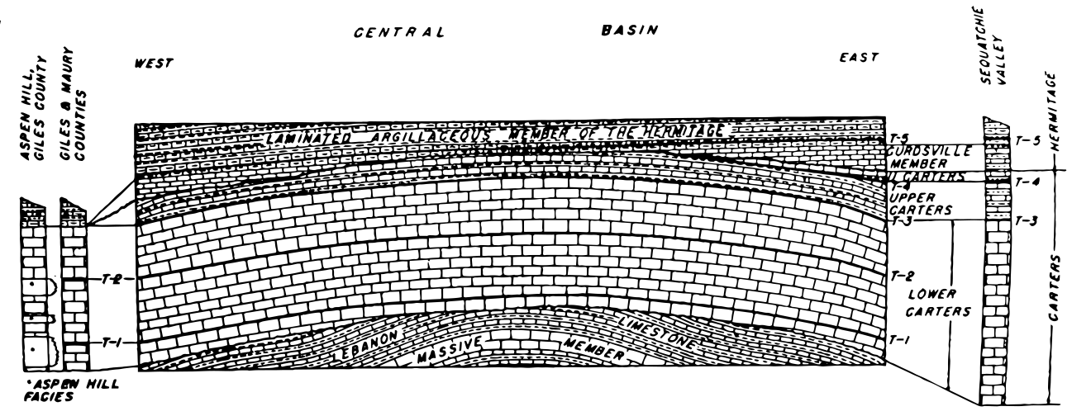.

Figure III-6. Generalized section diagrammatically showing the relationships between the Lebanon, lower Carters Limestone, the upper Carters, and the Hermitage Formation in Central Tennessee. From (Wilson, 1949).

Sections of the High Bridge Group are quarried for construction and agricultural stone, and for the production of lime for flux, flue-gas desulfurization, and chemical industries and as a result has been studied extensively (Dever, 1980).
The Stones River Group and the High Bridge Group appear to be mostly equivalent in the study area, with the exception of the crests of the Nashville and Jessamine domes. One study used an isopach map from the top of the Knox Dolomite to the base of the Lexington Limestone (encompassing the entire High Bridge Group) around the Jessamine dome to conclude that the uplift of the dome had been initiated during the Middle Ordovician, prior to the deposition of the Lexington Limestone (McGuire and Howell, 1963). However a trend surface analysis performed using well data from the High Bridge Group revealed no relationship with its location on the Cincinnati arch, leading Wolcott et al. (1972) to conclude that there was little to no movement along the arch during the Middle Ordovician and that the arch was not present at the time of deposition.
In contrast, (Wilson, 1949) reported the presence of an unconformity at the top of the Lebanon Limestone, which produced variations in thickness of the Lebanon across the Nashville dome: the Lebanon thins across the top of the dome and thickens on the flanks (Wilson, 1949) The Jessamine dome does not appear to display a similar feature of an erosional surface within the High Bridge Group, although it has been reported that an older unconformity occurs at the base of the Walker Mountain Sandstone Member of the Bays-Moccasin clastics that underlies the Deicke bentonite, this feature is only present close to the basin margin in Virginia (Haynes, 1994; Goggin and Haynes, 1995; Pope et al., 1997).\

Regional Bentonites (Middle Ordovician)

In eastern North America, there are as many as sixty altered volcanic ash beds that were deposited during the Ordovician (Kolata et al., 1996). The earliest description of these bentonites in North America was in the upper part of the Tyrone Limestone in Kentucky (Ulrich, 1888), and was described simply as a layer of clay. In more recent years the value of these formations has been recognized; non-reworked, regionally extensive bentonites can provide an excellent time-equivalent surface across large areas, because they are deposited during a geologically instantaneous event (Bergström et al., 1998). The geologically instantaneous deposition of volcanic ash falls makes them ideal for correlation across wide areas. As a result, these bentonite layers are more likely to be recorded by oil and gas well logs as a strong gamma-ray spike, because they provide a powerful correlation tool not only for correlation between wells, but in outcrops as well (Figure III-7). The bentonites in Tennessee can provide a time-equivalent surfaces that can be dated using U-Pb, Ar-Ar, or fission track methods (Huff, 2008).

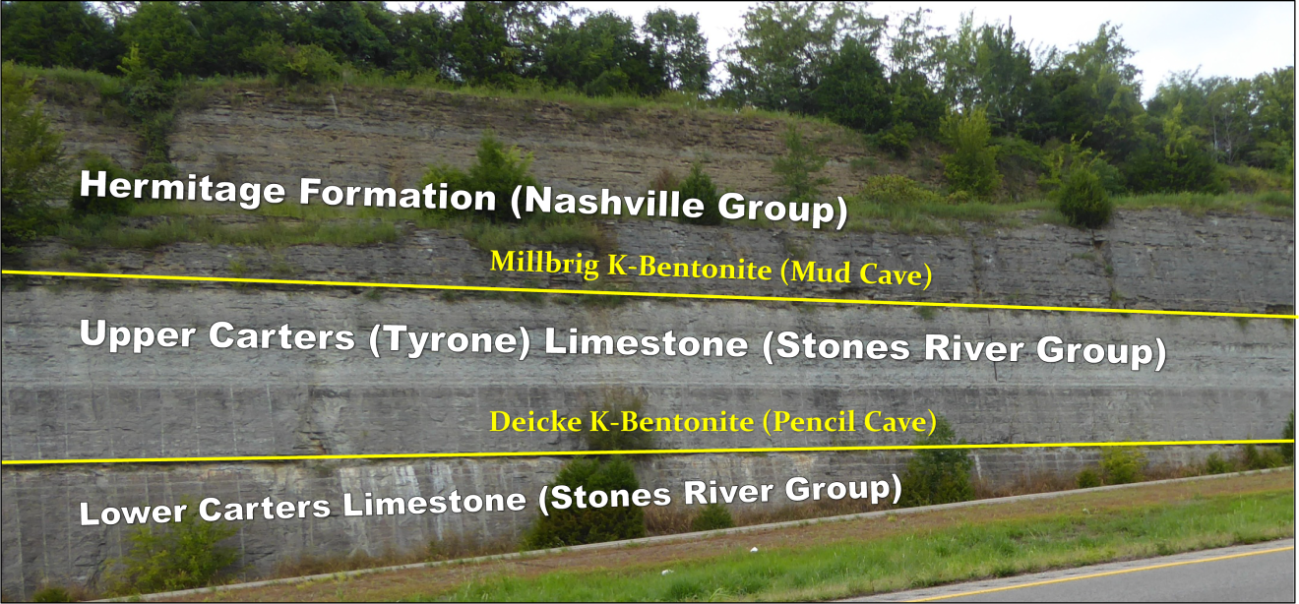
Figure III-7. Road cut, I-840 Lebanon, Tennessee (East of Nashville): Outcrop of Middle and Upper Ordovician formations with the Millbrig and Deicke K-bentonites exposed. These bentonites serve as marker layers for local drilling operations and time-equivalent surfaces for correlation. The contrast in resistance to erosion compared to the limestone units permits them to be easily identified as recessive zones in outcrops.

In Tennessee, four regionally continuous ash-fall layers (K-bentonites) were initially identified on the Nashville dome in the Carters Limestone (partially equivalent to the Tyrone Limestone in Kentucky) by Wilson (1949), who labeled them: (T-1 through T-4) where the "T" stands for "Tennessee". Bentonites T-1 and T-2 occur within the lower Carters, with the two more prominent (T-3 and T-4) ash beds occurring in the upper Carters. The upper Carters bentonites are now known to be equivalent to the Millbrig and Deicke bentonites (Table III-1). A common drillers term for this marker is the "mud cave" due to its mechanical properties (caving in, leaving a wider borehole) during drilling.
The Millbrig and Deicke bentonites, in addition to other Ordovician bentonites, are widespread across the North American continent, and can be correlated from southeastern Canada to northern Texas (Figure III-8). The Millbrig bentonite ranges from 10 to 60 cm thick with sharp upper and lower contacts and the Deicke bentonite ranges from 15 to 64 cm thick (Huff, 1983), although it is known to display greater thicknesses in some locations, e.g., in Oak Ridge, Tennessee.

Table III-1. Other names used for the original T-1 through T-5 bentonite layers in Tennessee.
Wilson (1949) | Kolata et al. (1996) | Drillers Terms
T-5 | - | -
T-4 | Millbrig | Mud Cave
T-3 | Deicke | Pencil Cave
T-2 | Ocoonita | -
T-1 | - | -

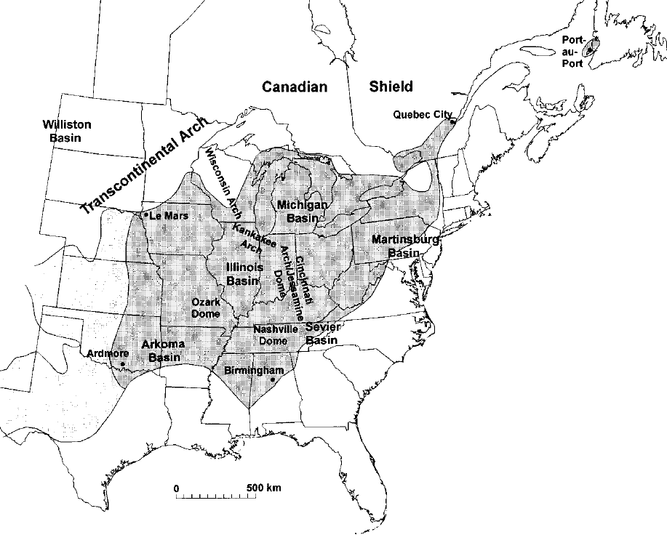
Figure III-8. Areal extent of Ordovician bentonites in the eastern United States (Kolata et al., 1996).

A fifth bentonite (T-5) was also identified in the overlying Hermitage Formation (Wilson, 1949). Other studies have identified a total of six bentonites in time equivalent sections of rocks in Kentucky and southern Ohio (Huff, 1983). The Millbrig (T-4) bentonite, for example, can be correlated from Tennessee to southern Ontario and upstate New York (Bergström et al., 1998; Mitchell et al., 2004).
The occurrence of several bentonite layers over a short interval can be problematic for regional reconstructions in areas where these layers may be eroded. The Millbrig K-bentonite (T-4) may be misidentified as the Deicke K-bentonite (T-3) in the subsurface where the Millbrig is absent due to the truncation of the upper Stones River Group, which is also seen occasionally in the Tyrone Formation on the Jessamine dome (Cressman, 1973). The number of bentonites present in this section, as well as the naming system implemented by various drillers over time can make correlation difficult if not all the bentonites are present in the area (Evenick and Hatcher, 2006). In Figure III-9., a geophysical log shows a series of K-bentonites that occur in the Nashville and Stones River Groups, which appear as spikes on a gamma ray log produced by their high potassium, thorium, and uranium concentrations. The labels on each bentonite indicate the possible misidentified names given to each bentonite by drillers (Evenick and Hatcher, 2006). Fortunately the geochemical signatures of these ash beds can permit them to be more concretely identified and allows some bentonites to be differentiated from one another (Huff, 2008).
The origin of the Ordovician bentonites in North America is not fully understood, but believed to be related to volcanism as a result of the closing of the Iapetus ocean basin beginning at the end of the Cambrian (Stillman, 1988).

Nashville Group (Trenton)

The Middle Ordovician Nashville Group is made up of a series of limestone units, and is the equivalent to the Trenton Group in New York and the Lexington Limestone in Kentucky. In Tennessee the Nashville Group can be broken down into the Hermitage, Bigby-Cannon, and Catheys Formations (Wilson, 1949).
The lowermost formation of the Nashville Group is the Hermitage Formation, named for the type locality in the vicinity of Hermitage Station (Hayes and Ulrich, 1903). The lowermost member of the Hermitage was defined by Wilson (1949) as the Curdsville Limestone Member, which lies unconformably on top of the Carters Limestone. The Curdsville Member has been interpreted as having been deposited during a marine transgression following the erosion of the uppermost Stones River Group. The Curdsville Member correlates around the Nashville dome with a thickness of 0 to 15 feet, thinning to zero towards the crest of the dome (Wilson, 1949).

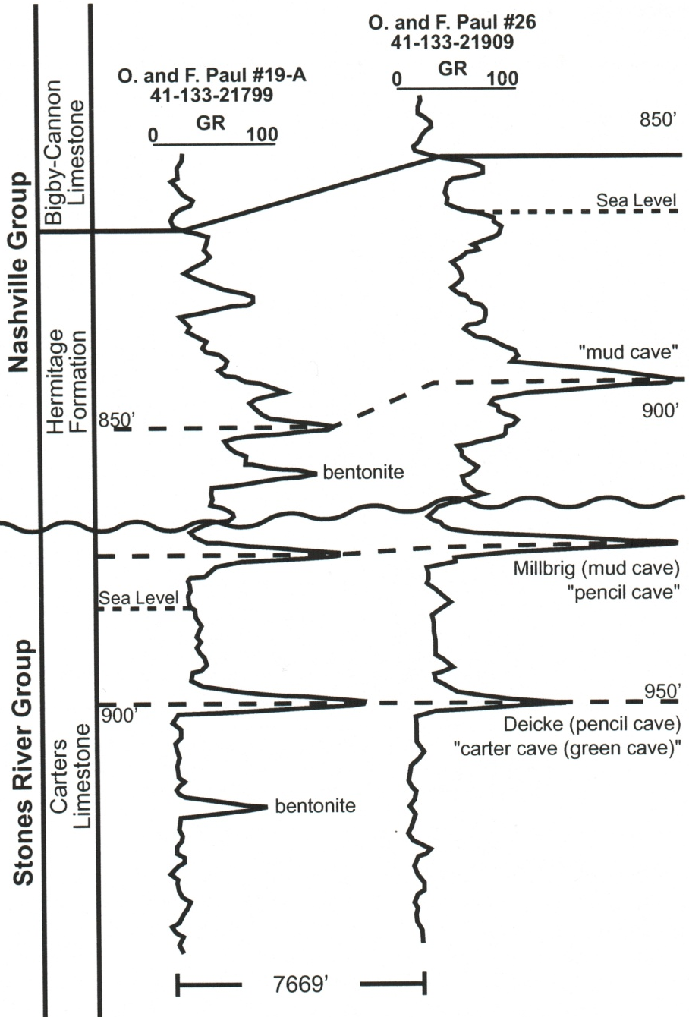
Figure III-9. Gamma-ray geophysical log with peaks showing the distribution of bentonites in the Ordovician formations in Tennessee. These bentonites may be spotted with relative ease because of their high K-feldspar content (and clay alteration products). Gamma-ray peaks are produced by the decay of radioactive isotopes of potassium, with smaller amounts of thorium, and uranium which are also typically present in bentonites. From (Evenick and Hatcher, 2006).

There are several other members of the Hermitage Formation the most noteworthy is the "Laminated Argillaceous member" which lies just above the Curdsville Member, except on the crest of the dome where the Curdsville has been eroded. This "member" of the Hermitage is unusual because it appears to thicken dramatically westward, from 0 ft in Sequatchie Valley to 20-70 ft in the Central Basin, and finally up to 180 ft in Decatur County. This member also contains more silt and fine sand than any of other members of the Hermitage Formation, suggesting the presence of a clastic source west of the Nashville dome during the deposition of the Hermitage (Wilson, 1949). The T-5 bentonite occurs within the lower Hermitage.
Overlying the Hermitage Formation is the Bigby-Cannon Limestone, named for the exposures along Big Bigby Creek and its tributaries in Maury County. The Bigby Limestone appears to be conformable with the underlying Hermitage Formation, although it displays an abrupt transition from the silt- and clay-rich Hermitage. Initially, the Bigby Limestone and Cannon limestone were identified separately, but (Wilson, 1949) described them as being different facies of the same limestone unit, thus naming this formation the Bigby-Cannon Limestone. The Bigby facies has been interpreted as having been deposited in a very shallow sea. The top of the Bigby-Cannon Limestone displays a slight unconformity with the overlying Catheys Formation. Historically, this limestone was named the "Capitol Limestone" by (Safford, 1869) where this unit supplied the rock to build the Capitol Building in Nashville. The quarry from which it was mined was in sight of the building at that time.
In addition to the Bigby and Cannon facies, a third facies termed the dove-colored facies was also described by Wilson (1949). The dove-colored member was named, unsurprisingly, for its dove-like color of the limestone where unweathered, a light mottled, variegated gray color on fresh surfaces, but it weathers to a striking white patina. This dove-colored facies occurs in lenses, where some of the largest quarries are mined for its use in aesthetically pleasing aggregates (Wilson, 1949).
In Kentucky, the equivalent unit of the Nashville Group is the Lexington Limestone, which is ~320 ft thick around the crest of the Jessamine dome, and thins northward to less than 200 ft. The lowermost member of the Lexington Limestone is the Curdsville Member. Wilson, (1949) was able to correlate the Curdsville Member from Kentucky with the basal formation of the Nashville Group. The basal formation in the Nashville Group was then named after the Curdsville Member because of their similarity. The Curdsville Member of the Lexington unconformably overlies the Tyrone Limestone and is similar to the Curdsville of the Nashville Group, it also contains discontinuous bentonites (Figure III-10). The overlying members of the Lexington Limestone are the Grier Limestone, Tanglewood Limestone, and Brannon and Millersburg members (Cressman, 1973).

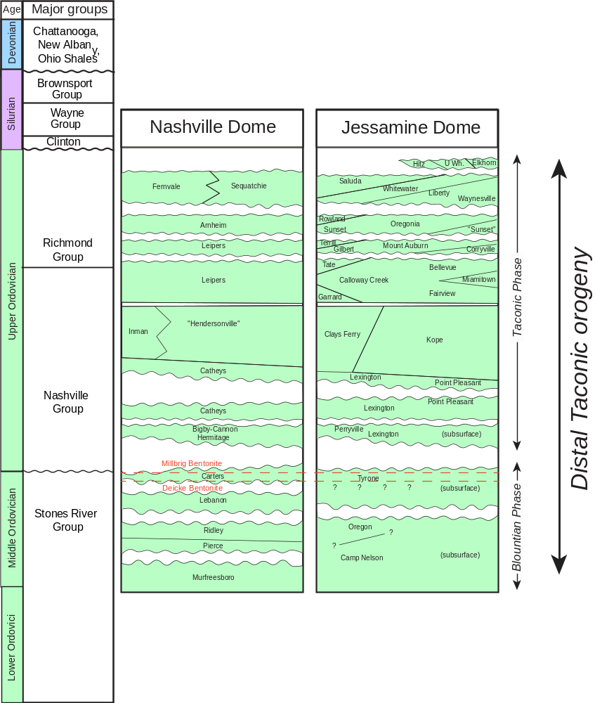
Figure III-10. Stratigraphy of the Ordovician units exposed at the surface of the Nashville and Jessamine domes. The wavy lines indicate the positions of unconformity surfaces in the section. The unconformity surfaces in the Stones River (High Bridge) Group on the two domes formed during the Blountian phase of the Taconic orogeny. Modified from: (Holland and Patzkowsky, 1997; Pope et al., 2012).
Cressman (1973) also observed that the main difference between the facies of the Nashville Group and the Lexington Limestone is that the Nashville Group appears to strike north-south on a west-facing paleo-seafloor slope, while the Lexington Limestone strikes almost east-west on a north-sloping seafloor or irregular surface.

Silurian Formations

The Silurian units are extensively eroded in most areas on the flanks of the domes. In Tennessee Silurian units are only present on the western side of the Nashville dome (Figure III-5). The Silurian units that are preserved along the southern and western margins of the Nashville dome occur predominantly in the cores of synclines (Figure III-11) (Wilson et al., 1964). The Silurian Brassfield Limestone and Wayne Group make up the major Silurian formations at the surface, which outcrop along the distal western flank of the Nashville dome and encircle the Jessamine dome. This sequence was folded and locally faulted, and then uplifted and eroded as possible far-field products of the Acadian-Neoacadian orogeny (Hatcher et al., 2007). There was no additional deposition on the crest and flanks of the Nashville dome until Late Devonian time when the Chattanooga Shale was deposited (e.g. Hardeman et al., 1966); deposition also resumed during the Devonian on the crest and flanks of the Jessamine dome, but deposition occurred on both the east and west flanks of this dome throughout much of the Silurian and into the Devonian recording a more complete stratigraphic section (McDowell et al., 1981). The Silurian formations are usually truncated by the unconformity at the base of the Chattanooga Shale (Figure III-12).

Chattanooga Shale

The Chattanooga Shale is an organic-rich black shale that has a thickness of around 20 to 40 feet throughout northern Alabama, Central Tennessee, and southern Kentucky (Wilson, 1949; Conant and Swanson, 1961; Reesman and Stearns, 1989; Moore and Horton, 1999). The Chattanooga Shale was deposited unconformably on the pre-Chattanooga sedimentary rocks during the Late Devonian. As a result, the Chattanooga Shale unconformably overlies at least twenty-three different formations as observed by Wilson (1949). In Tennessee the Chattanooga Shale can be subdivided into the Maury, Gassaway, and Dowelltown members (Conant and Swanson, 1961), although these members are rarely subdivided in well logs. The Dowelltown Member is the oldest, and shows some evidence of reworking. The presence of hummocky cross stratification beds identified in the Dowelltown member in central Tennessee led Schieber (1994) to conclude that the lower Chattanooga Shale member had been deposited above storm wave base which resulted in the erosion of the lower sub-formation.

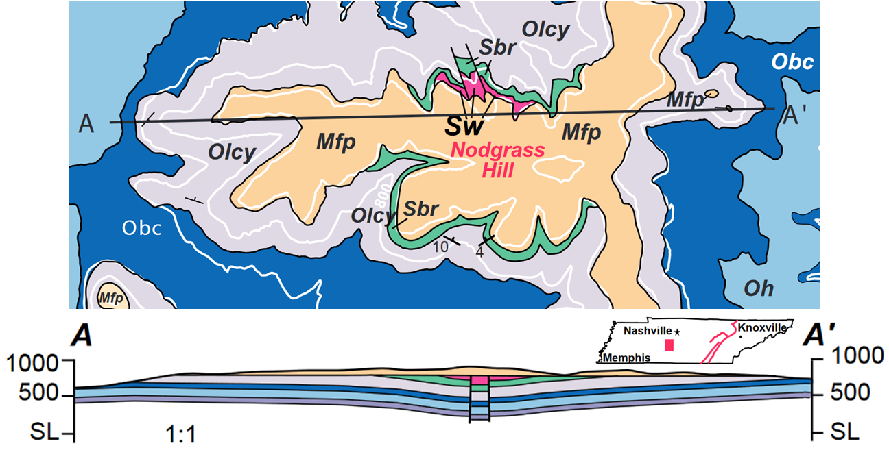
Figure III-11. Geologic map from part of the Columbia quadrangle, Tennessee (Wilson et al., 1964). Faulted syncline preserving Silurian Brassfield (Sbr) and Wayne Group (Sw) rocks occurs beneath the Devonian Chattanooga Shale (mapped here with the base of the Fort Payne (Mfp)). Graphic from (Hatcher et al., 2007). Silurian formations are preserved in synclines on the Nashville dome overlying the Hermitage (Oh), Bigby-Cannon (Obc), and the Catheys-Leipers (Olcy) formations. The upper portions of these units were eroded following the Devonian unconformity.

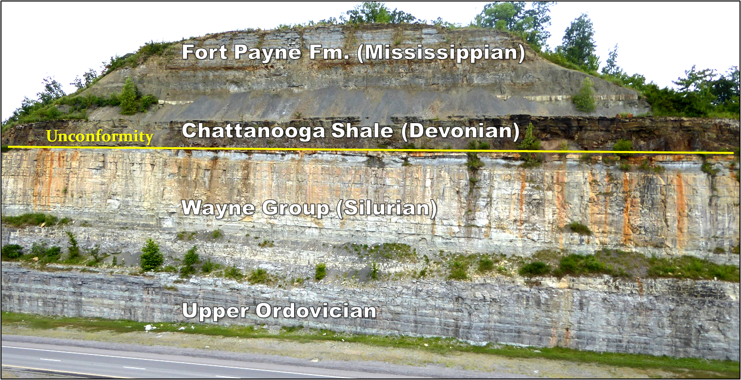
Figure III-12. Road Cut, TN-109, 4 miles north of Gallatin, Tennessee. Outcrop of Upper Ordovician, Silurian, Devonian, and Mississippian formations northeast of Nashville. The unconformity at the base of the Chattanooga Shale truncates the underlying lighter-colored Silurian formations; the angularity of the truncation is well illustrated in this image. Waldron Shale is the light gray unit truncated about midway across the photo. (Photo by Robert D. Hatcher Jr., 2017).

Schieber (1994) also concluded based on other observations suggested that these small-scale unconformity surfaces were not likely to have been a result of lowering sea level (Ettensohn et al., 1988).
Some authors report that the Chattanooga Shale was deposited under anoxic to euxinic conditions and that this was the result of restriction of the water mass from the presence of the "Cumberland Sill" (Hager, 1949; Song et al., 2020). There is little evidence supporting the existence of such a structure during the deposition of this unit. A more widely accepted explanation is that the Chattanooga Shale was deposited over a wide area following the flexure of the lithosphere during orogenic events (Quinlan and Beaumont, 1984; Ettensohn and Lierman, 2013).
The Chattanooga Shale is the facies equivalent to the New Albany Shale in western Kentucky, which thickens to over 400 feet into the Illinois basin. In Eastern Kentucky the Chattanooga equivalent is the Ohio Shale which thickens substantially going into the Appalachian basin up to 1700 feet or more (Burwell, 1967; Reesman and Stearns, 1989). The same is true of the Chattanooga Shale in northeastern Tennessee. An isopach map of the Chattanooga Shale was compiled by Moore and Horton, (1999) from well data across central Tennessee. Their isopach map indicates that the Chattanooga Shale thins from around 30 to 40 feet thick along the eastern and northwestern flanks of the Nashville dome, to around 10 to 20 feet moving towards the dome's axis, and pinching out entirely across the top and along the southwestern flanks (Moore and Horton, 1999).
The Chattanooga Shale is well known for its uranium content, making it a good marker sequence for oil and gas drillers, because it is prominent in gamma-ray well logs (Figure III-9). The Chattanooga Shale has been noted as being locally rich in uranium 0.004% (40ppm) to 0.008% (80ppm) uranium (Conant and Swanson, 1961). The uranium content of this formation is so high that it was once considered as a potential resource for uranium extraction (Pollara et al., 1958; Glover, 1960). It also allows the Chattanooga Shale to be detectable from aeroradioactivity surveys from the air (Hill et al., 2009) (Figure III-13).

Mississippian Limestones

Mississippian age rocks are exposed along the flanks of the domes, with the Fort Payne Formation resting above the Chattanooga Shale Formation, and the Warsaw Limestone above it. The Fort Payne is a chert-bearing siltstone (Marcher, 1962). The thickness of the Fort Payne varies considerably in southern Kentucky, and may be between 210 and 310 feet thick (Thaden et al., 1961). A portion of this variation can be attributed to mud mounds and carbonate buildups. This variation in thickness may make interpretation of structures in the top of this unit difficult. The Fort Payne Formation is overlain by the Warsaw and St. Louis Limestones which are exposed on the flanks of both domes along with successively younger units.

(a) 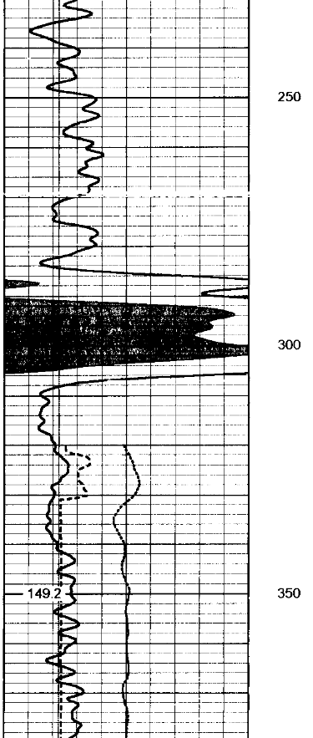 (b)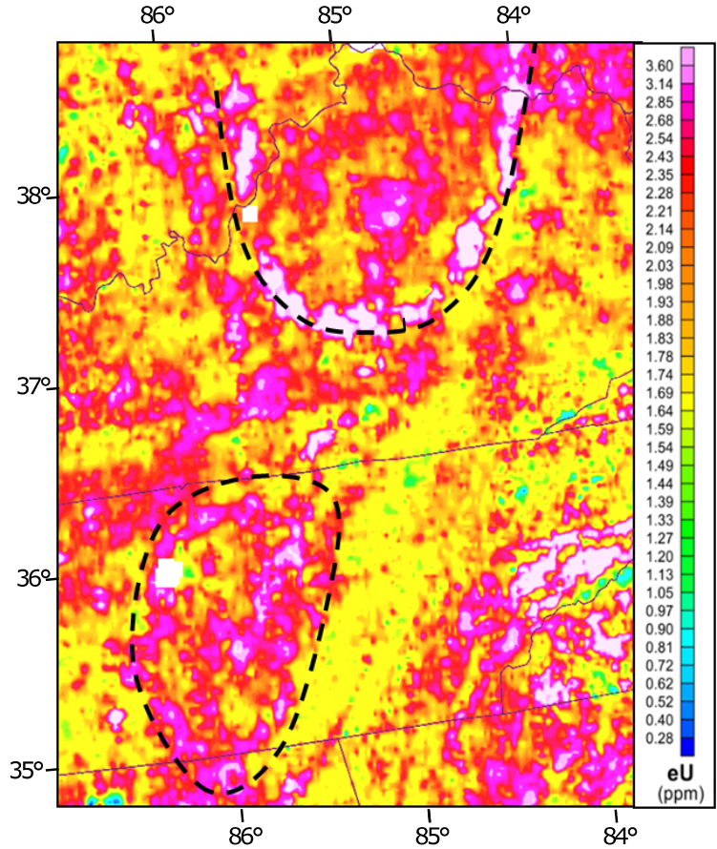
Figure III-13. (a) Gamma-ray well log showing the high gamma-ray response at the Chattanooga Shale interval related to its high uranium content. (b) Aeroradioactivity survey map showing the uranium content of the Chattanooga Shale is high enough that the outcrop belt (roughly indicated by the dashed lines) along the Nashville and Jessamine domes is visible as bands of high uranium spectral radiation. From the National Uranium Resource Evaluation (NURE) program (Hill et al., 2009).

Previous efforts

The previous work done in this area has produced a volume of information including detailed surface bedrock geologic maps and stratigraphy of the units exposed on the domes. There have been many studies published where the authors attempted to determine various things about the structure of different parts of this region. Beginning with field surveys in the 1930's which were compiled to create the first structure contour maps of the formations around the Nashville dome (Wilson, 1949). Reesman and Stearns, (1989) attempted to calculate a "no-load" surface for the pre-Chattanooga unconformity, which was isostatically adjusted for mass eroded from below the Chattanooga in the Central Basin. They concluded that the Nashville dome is a product of provincial isostatic adjustment.
A model invoking a peripheral bulge as a lithospheric flexural response to loading by arc obduction or regional-scale thrusting and resulting sedimentation was developed to explain the existence of the Cincinnati arch as well as the persistence of the arch through time (Quinlan and Beaumont, 1984). In this model, the emplacement of a load onto a portion of the lithosphere results in the progressive sinking of the lithosphere (Figure III-14).

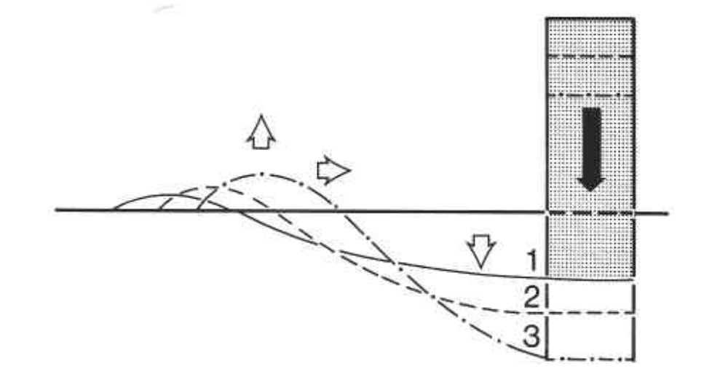
Figure III-14. Model of lithospheric flexure by load emplacement on the crust. In this model, the emplacement of a load on a lithospheric plate (by an orogenic event) results in the formation of an area of low elevation (foreland basin) immediately proximal to the load. Farther into the foreland from the load uplift occurs in response to the progressive sinking of the area beneath the load. This is supposed to be a response of the lithosphere to the downward flexure occurring at the load location. In addition, as the flexure continues, the uplifted dome begins to "roll" toward the load location. (From Quinlan and Beaumont, 1984).

As an orogen becomes increasingly loaded with emplaced material, the lithosphere in the immediate area of the chain begins to sink, forming a foreland basin in this area. Farther into the craton, ahead of the foreland basin, the lithosphere begins to flex upward, creating a broad peripheral bulge arch (Quinlan and Beaumont, 1984).
A more recent study examined the carbonate facies from outcrop and core data to put together a sequence stratigraphic framework of the Upper Ordovician to determine the depositional history of the domes during the Taconic orogeny (Pope et al., 2012). They concluded, based on a limited number of wireline logs indicate that shallow water features on the Cincinnati arch formed over a narrower area than would be predicted based on the depth of the foreland basin, that the Cincinnati arch was too narrow to be a peripheral bulge.
Several studies have made the observation that the apparent general trend of the Cincinnati arch coincides with the boundary between the Grenville front and the Eastern Granite-Rhyolite Province (EGRP). These studies suggest that the static position and potentially initial formation of the arch may have been controlled by reactivation of basement faults along this crustal heterogeneity (Drahovzal et al., 1992; Ettensohn, 1992; Pope et al., 2012; Ettensohn and Lierman, 2015).
Some studies have suggested that the deposition of the units on the domes were at least partially controlled by reactivated basement faulting (Ettensohn, 1992; Ettensohn and Lierman, 2015). These basement faults may have experienced several periods of renewed tectonic activity such as along the Kentucky River fault system. Basement faulting may also play a role in the localization of uplift in the Nashville and Jessamine domes. During the Neoproterozoic and Early Cambrian, normal faults formed during the opening of the Iapetus ocean basin. These basement faults may have acted as zones of weakness, allowing them to be reactivated and inverted by later orogenic events (Ettensohn et al., 2004).
It had long been noted since the discovery of the East Continent rift basin (ECRB) that this structure roughly coincides with the axis of the Cincinnati arch and possibly influenced its location (Drahovzal et al., 1992) (Figure III-15). The reactivation of basement faults along this structure is one explanation as to why the Cincinnati arch and the associated dome axes may not have migrated as various models have predicted.
The timing of the formation of foreland basins can be interpreted through identifying tectophase cycles in the sequence of sediments. Tectophase cycles usually begin with a basal unconformity, followed by a thin or condensed section of shallow-water deposits, overlain by deep water organic-rich shales (Ettensohn, 2008). These are typically thicker and are deposited during the most active phases of convergence because of the rapid subsidence in the foreland basin. Sequences are unconformity-bound at the top of the section and as such they may be incomplete or eroded from the top.

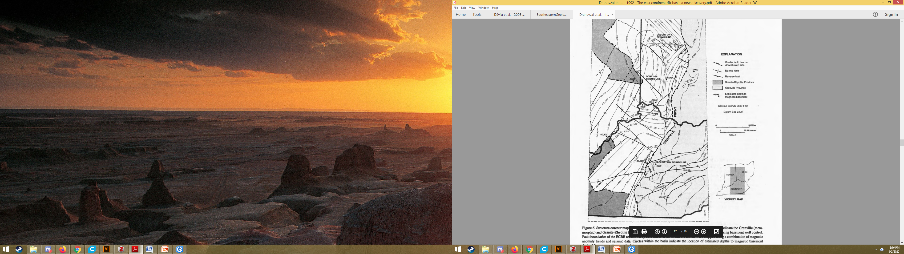
Figure III-15. Location of the Grenville front, contours on the basement surface primarily in Neoproterozoic basins, and faults identified from subsurface data. From Drahovzal et al. (1992).

Methodology

When conducting a study that covers such a large area, it is extremely important to have a good understanding of the stratigraphic relationships of each formation across the area. Some formations may be used to correlate locally, but may not be as laterally continues as required by the study. The simplest method for achieving this is to select formations that are fairly continuous over a large area because of the nature of the formations themselves. For example, the Chattanooga Shale is laterally extensive across the Cincinnati arch with contrasting rock types making up the upper and lower contacts, with a sharp basal unconformity. Formations that can easily be identified in well logs in the subsurface, and extensively mapped on the surface are ideal for mapping over large distances.
One way to resolve the relative timing of deformation is by working out the structures beneath vs. events affecting the rocks above an unconformity. To this end, a conceptual model was developed for the series of events produced by two phases of deformation separated by the pre-Chattanooga unconformity. Following the deposition of the Early-Silurian units, deformation and uplift produced by the Acadian-Neoacadian orogeny resulted in erosion of the Silurian units from the crests of anticlines along the western flank of the Nashville dome, and regional-scale erosion and complete removal of the Silurian units from the eastern flank of the Nashville dome. The Chattanooga Shale was then deposited during the Late Devonian-Early Mississippian above the unconformity, followed by younger Mississippian and Pennsylvanian rocks. These units were deformed again during the late Pennsylvanian-Permian Alleghanian orogeny.
The methods used here revolve around building a large database of points that can be queried and used to generate structure contour maps. The structure contour maps can then be used to generate isopach maps of large structures. The orientation of fold axes that occur throughout the study area can be used to make interpretations about the events that produced them. Finally, the relationship between fold axes and specific marker layers including unconformities and regionally continuous ash layers were used to attempt to draw inferences about the formation and timing of the uplift of the Nashville and Jessamine domes.
To accomplish this task, a series of data sources were compiled from Tennessee, Kentucky, and Alabama. These data were collected from state agencies and publications, and, as a result, data from each state required a different process for standardization and for conversion from legacy data types. A process for automating parts of the data workflow was developed using Python and ArcGIS.
The viability of this approach was first checked by performing a pilot study over a relatively limited area spanning 32 geologic quadrangles (Boling et al., 2020b). While the pilot study only contained surface data, it provided a convenient comparison between manually recording geologic points for contouring, and using an automated process. The process was implemented on a series of 7.5 Minute quadrangle maps and well data. This study contains a brief summary of the methods implemented, please see the previous chapters for a more comprehensive description of the methodology (Figure. I-3). This process, which differed greatly by state and data source is briefly summarized below for the procedure followed on data from the state of Tennessee.
The data used for this study included both surface and subsurface data. The surface data for this study was primarily from 1:24,000-scale 7.5-minute quadrangle maps (though a 1:250,000-scale map was used for the area of northern Alabama due to the lack of available larger-scale data for that area).
The Tennessee digitized maps were the products of a USGS initiative in the mid-1990's, which digitized the available 7.5-minute quadrangle maps from film scribecoats. The scribecoats were scanned using a flatbed scanner to minimize distortion. These maps were then vectorized using ArcInfo and transformed to state plane projection.
Despite the process in place for checking the accuracy of the scanned maps, many errors in the quad maps made the dataset difficult to use. The errors appear random, but may have been caused by distortions of the paper maps when compared to the digital maps. The majority of the maps only contain minor errors, but others contain serious errors as a result of misplacement of tick marks in the initial setup. The tick marks were used to transform the digital maps into the state plane projection. As such, the misplacement of these tick marks resulted in distortion of the geometry of the geologic contacts on the digital map to differ considerably. These errors had to be corrected before the dataset could be used, which required the original maps to be scanned and used for comparison to identify and correct errors in the digitized maps (Figure III-16 and Figure III-17).
The elevation along the geologic contact must be known to construct a structure contour map from a geologic map. The typical method for this is to locate places on a geologic map where the contact intersects an elevation contour. This information is then recorded at each point along the geologic contact. These points can then be contoured by hand or using GIS software to interpolate between points. The end result is a structure contour map that shows the structure of the surface of the geologic contact.
This method is time consuming and potentially a source of error due to the human component in reading the contours and recording the points. An automated approach to this problem can yield results on a much shorter timescale, allowing more regional studies to be performed. Initially this process was "automated" by using the "intersect" tool, a basic GIS routine in ArcMap which will create a point everywhere the geologic contact crosses a topographic line (Figure III-18). This was found to be reasonably effective, but a much higher spatial resolution can be achieved by generating points at a given interval along the geologic contact, and extracting the elevations directly from the USGS 1/3rd arc-second topographic data set (U.S. Geological Survey, 2017) (Figure III-19).
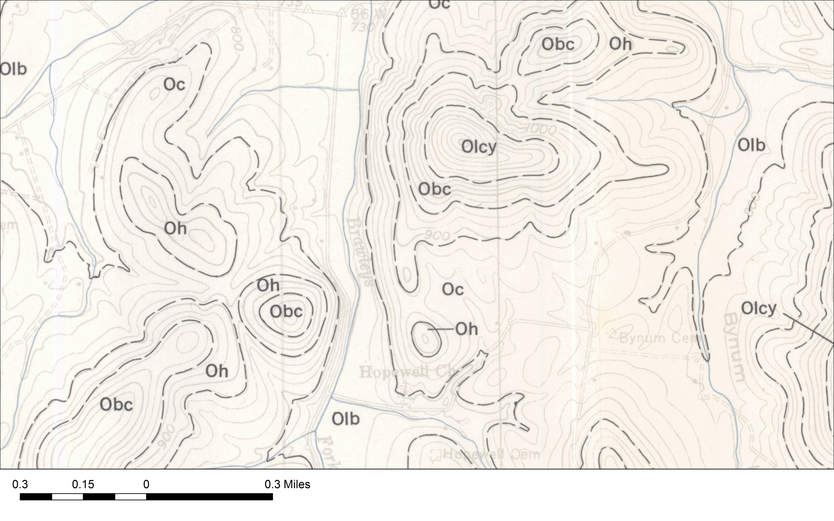
Figure III-16. Typical 1:24,000 paper geologic quadrangle map, part of the Beech Grove quadrangle in central Tennessee (Wilson and Taylor, 1973). This map was scanned and used to verify the accuracy of the digitized map data.

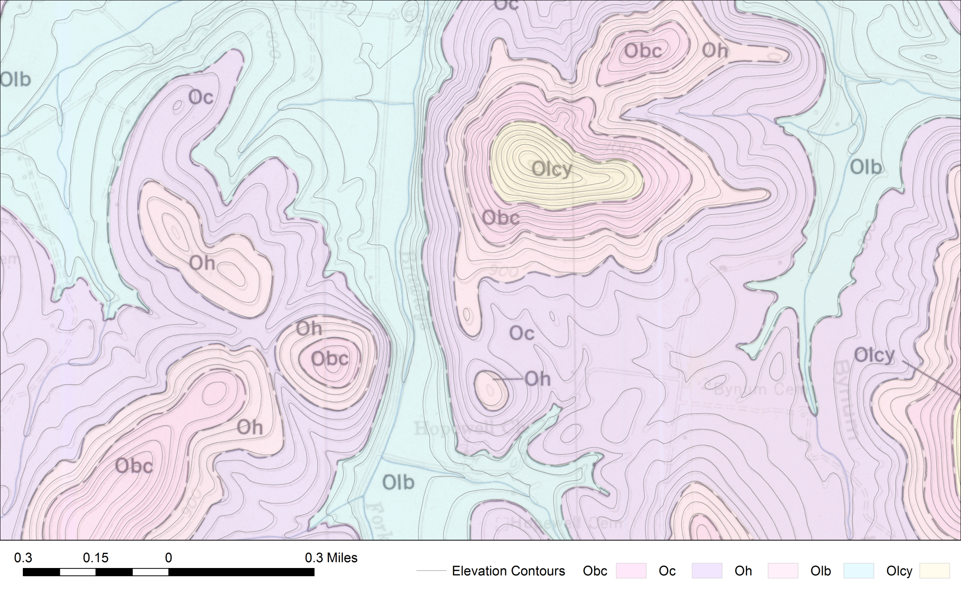
Figure III-17. Same map from Figure III-16 with the digitized quadrangle map overlain with a slight transparency applied and colored by formation. Manual correction of any errors was required if misalignment was detected.

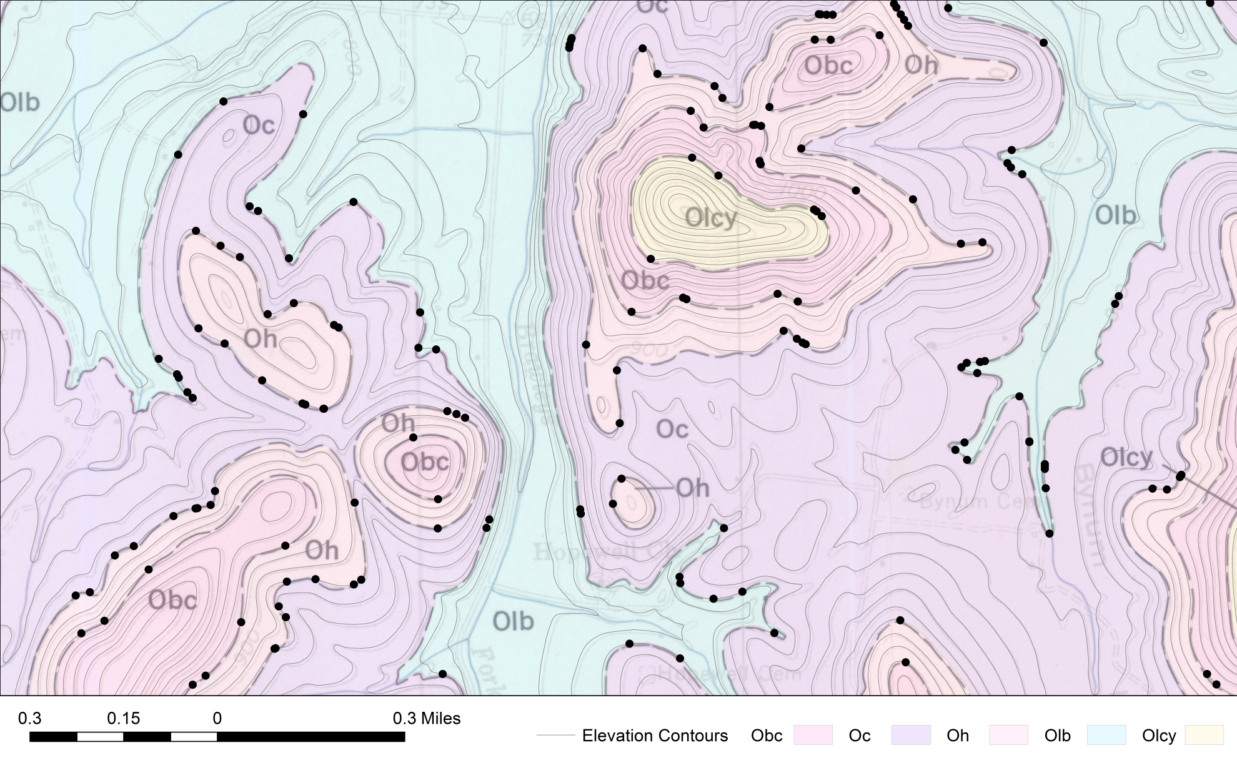
Figure III-18. Same map from Figure III-17 displaying the points generated using the digitized 1:24,000 scale contour lines from the USGS topographic quadrangles.

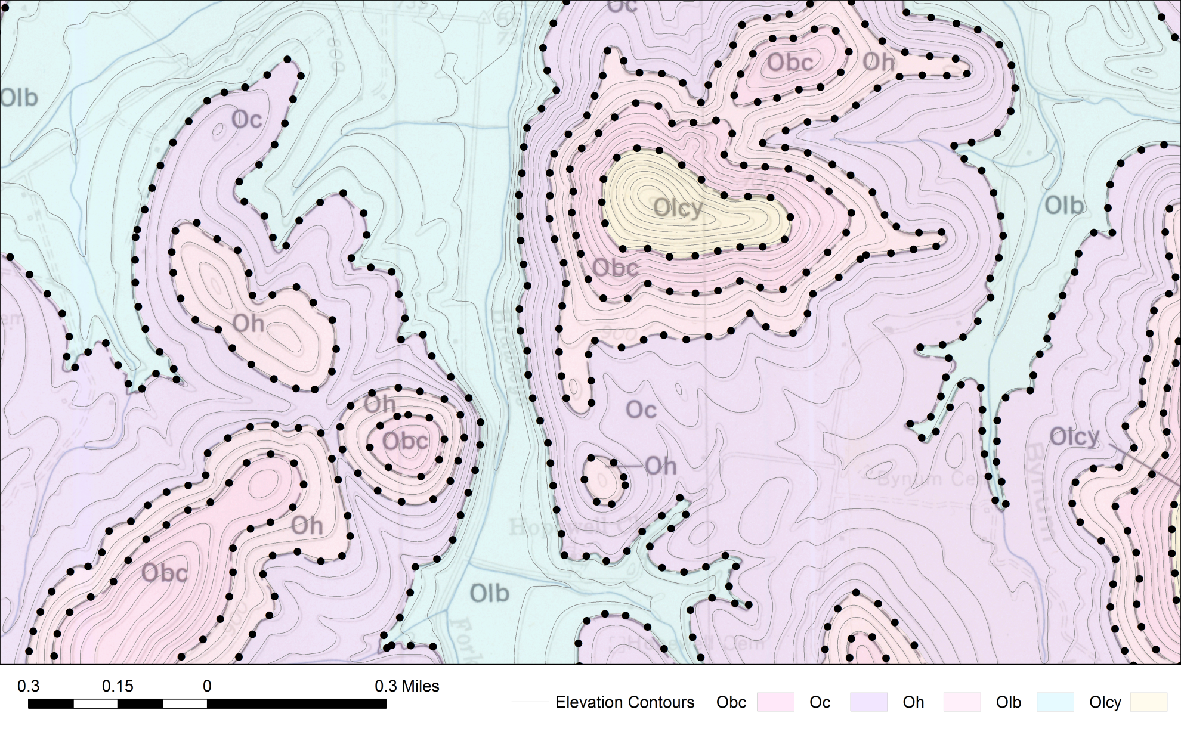
Figure III-19. Same map from Figure III-17 displaying the points generated using the 1/3rd arc-second DEM data from the USGS 3DEP dataset (U.S. Geological Survey, 2017). Data points are generated every 200ft horizontal along each geologic contact.

The digital geologic contacts were converted from their original ArcInfo coverage files into feature classes and stored in a file geodatabase. The converted files consist of a polygon feature class containing fields for the geologic unit, a line feature class that contained fields that defined the type of line (outcrop, fault, boundary) and two point classes containing the tic-mark locations used to transform the maps, and the label for the geologic unit.
The polygons for all coverages were first appended together, then lines were generated between all polygons to preserve the relationships between the geologic contacts in the fields of the created lines. The information from the polygons and lines were joined together so that each line segment contained information about the geologic units that occurred on either side of the line, as well as the type of line. This process also generated a large number of points in areas other than along geologic contacts. These points were identified using the line type and the relationships of the two contacts and excluded from the analysis.
Because oil and gas record keeping can be somewhat unreliable even in the best of times, a cross check of the well data was performed to determine the accuracy of the data. Reported oil and gas well data for elevation, county name, and associated quadrangle map (if specified) were checked for accuracy against the reported data from the reported location of the well. A comparison with elevation was found to be the most effective methods for detecting mislocated oil and gas wells (Figure III-20).

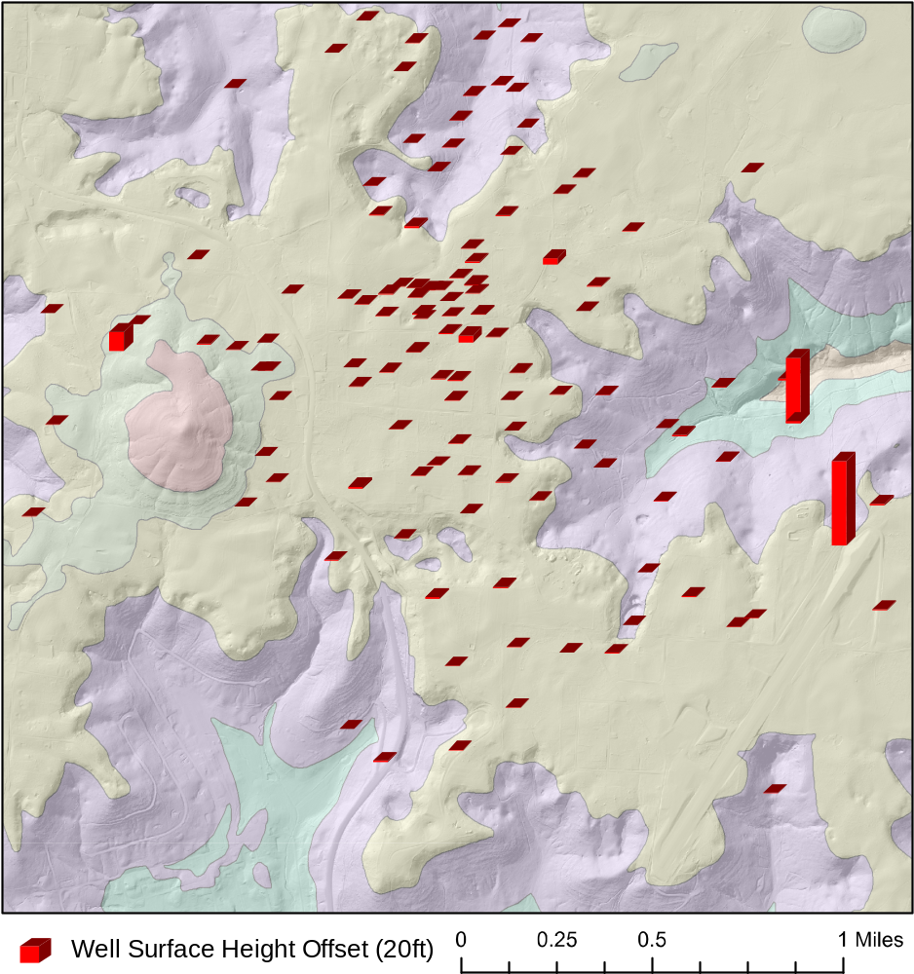
Figure III-20. Visualization of the offset between the reported well elevation and the land surface as determined by the DEM data. Most of the wells for this area are accurate to within less than 10-20ft, but two wells are off by more than 1000ft, most likely due to typographical errors in manually recorded data.

Results

Regional Structure Contour Maps

The results of the automated procedure for generating structure contour maps as described in the two previous chapters produced maps of several key horizons. The earliest of these stratigraphically is the top of the Knox Group. The point density for the Knox Group was highly variable (Figure III-21) The area of highest point density was in north-central Tennessee and south-central Kentucky due to the prevalence of oil and gas resources in the area and the relatively shallow depth. Moderate point density was achieved along the Nashville dome and along the majority of the central Jessamine dome. The area far to the west of the Cincinnati arch in Kentucky and along the Gulf Coastal Plain in Tennessee have relatively poor data density. After contouring these points, the Nashville and Jessamine domes can be clearly seen in the top of the Knox (Figure III-22). The Nashville dome, as it is represented in the top of the Knox Group, appears to taper into the Jessamine dome across the Cumberland saddle. A portion of the Pascola arch is visible to the southwest of the Nashville dome.
The next stratigraphically higher major surface that was contoured was the top of the Stones River Group. Because of this, the regional surface was contoured using combined well and outcrop data.

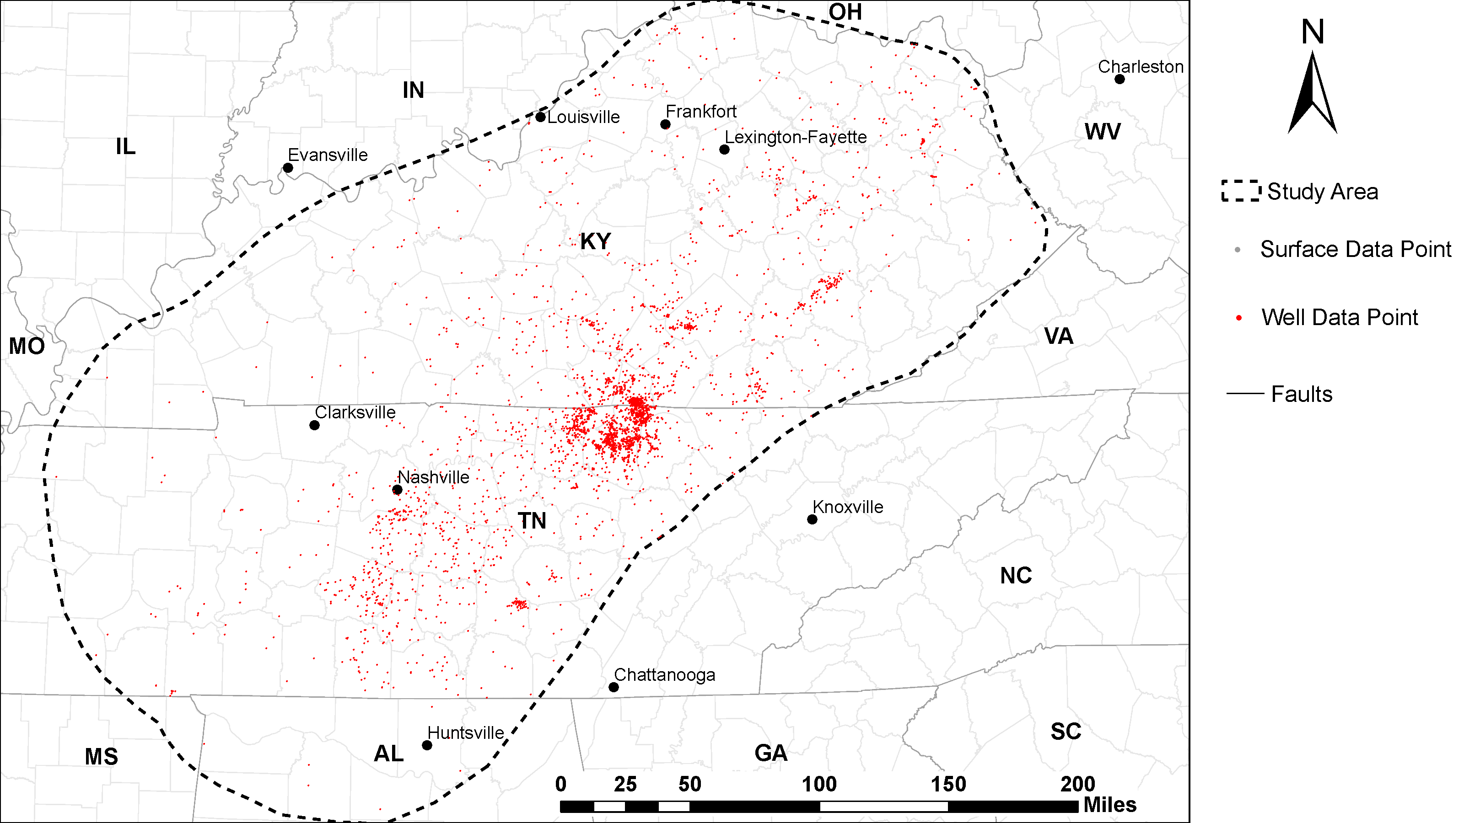

Figure III-21. Data point locations for the top of the Knox Group. Red dots indicate well data locations. The Knox Group does not outcrop within the study area, therefore all locations are based on well data. Subsurface data: 4526 data points.

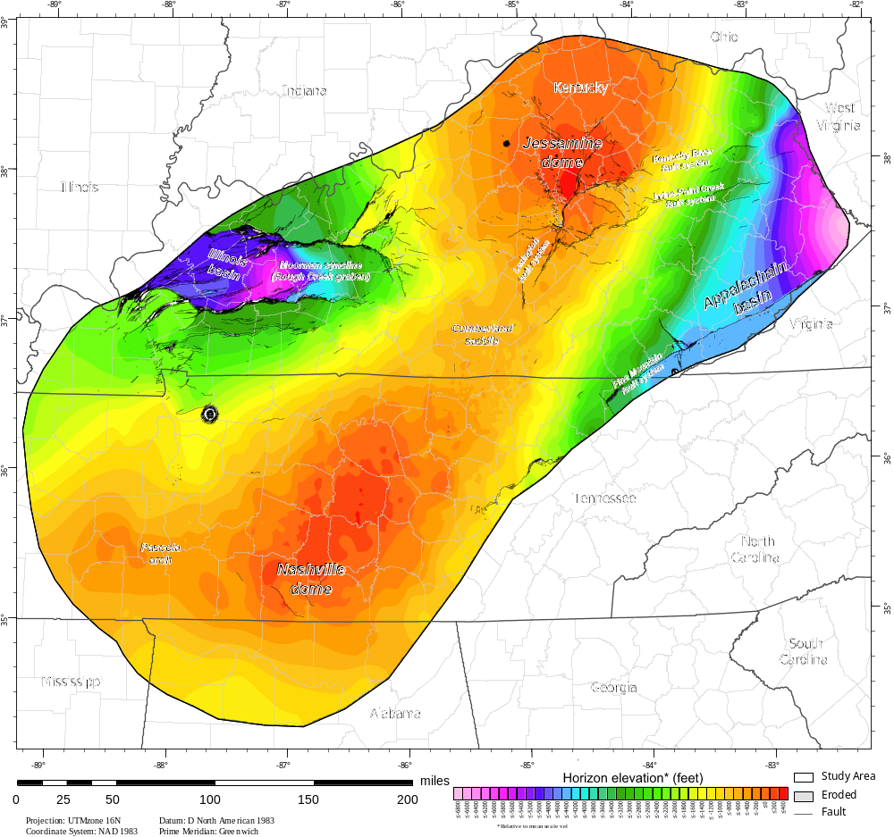

Figure III-22. Structure contour map of the top of the Knox Group, which occurs throughout the eastern and central United States. The base of the Stones River Group lies above this unconformity.

At the surface, this interval was identified by the contact between the Carters Limestone and the Hermitage Formation in Tennessee and the contact between the Tyrone and the Lexington Limestones in Kentucky. In the subsurface, this contact was identified by the reported formation top, though this is sparsely reported in most drillers logs for the region. In order to improve the number of data points available for this surface for contouring, a marker bed that is very commonly reported on drilling logs was used as an approximation of the location of the top of the Stones River Group. The marker layer selected was the Millbrig bentonite, due to the ease of identification on gamma ray and drilling logs, the proximity to the top of the Stones River Group in most areas (within a few feet most of the time), and the widespread occurrence of this bentonite.
The spatial distribution of the oil and gas wells that reported the formation top for the Stones River Group was somewhat similar to the Knox Group. Most of the subsurface data points were centered around north-central Tennessee and south-central Kentucky, although a higher density of points was present along the eastern margin of the Jessamine dome into the Appalachian basin (Figure III-23). The lowest point density occurred in the western side of the study area along the margin of the Illinois basin in Kentucky, and in the Gulf Coastal Plain in Tennessee.
The structure contour map of the Stones River Group produced by contouring both the surface and subsurface points is shown in (Figure III-24). The top of the Stones River Group forms a crest at the same location as the Knox under the Nashville dome, though most of the Stones River has been eroded over the Nashville dome, some scattered outcrops still exist in some areas along the crest of the dome. In contrast, the Stones River equivalent on Jessamine dome is only exposed in a small area at the crest of the dome, indicated by the gray dots in (Figure III-23).
The youngest stratigraphic unit that can be traced laterally for large distances is the base of the Devonian Chattanooga Shale. This formation is used as a marker bed for oil and gas exploration and occurs at relatively shallow depths along the margins of the Nashville and Jessamine domes, making it an ideal formation for interpreting the structure of the area. Subsurface data coverage for the Chattanooga Shale is excellent along the Nashville and Jessamine domes, particularly in along the Appalachian basin and in the oil producing areas of northern eastern central Tennessee and southern Kentucky (Figure III-25).
The outcrop belt for the Chattanooga Shale is also extensive, occurring over much of the areas across the Cumberland saddle. This formation, however, has been completely eroded from the crests of both domes. Subsurface data coverage for the Chattanooga Shale is poor in northeastern Tennessee, largely due to lack of data availability, since many wells have been drilled in the area that would have been deep enough to reach the Chattanooga, but these data have not yet been included in the well database because of the structural complexity.
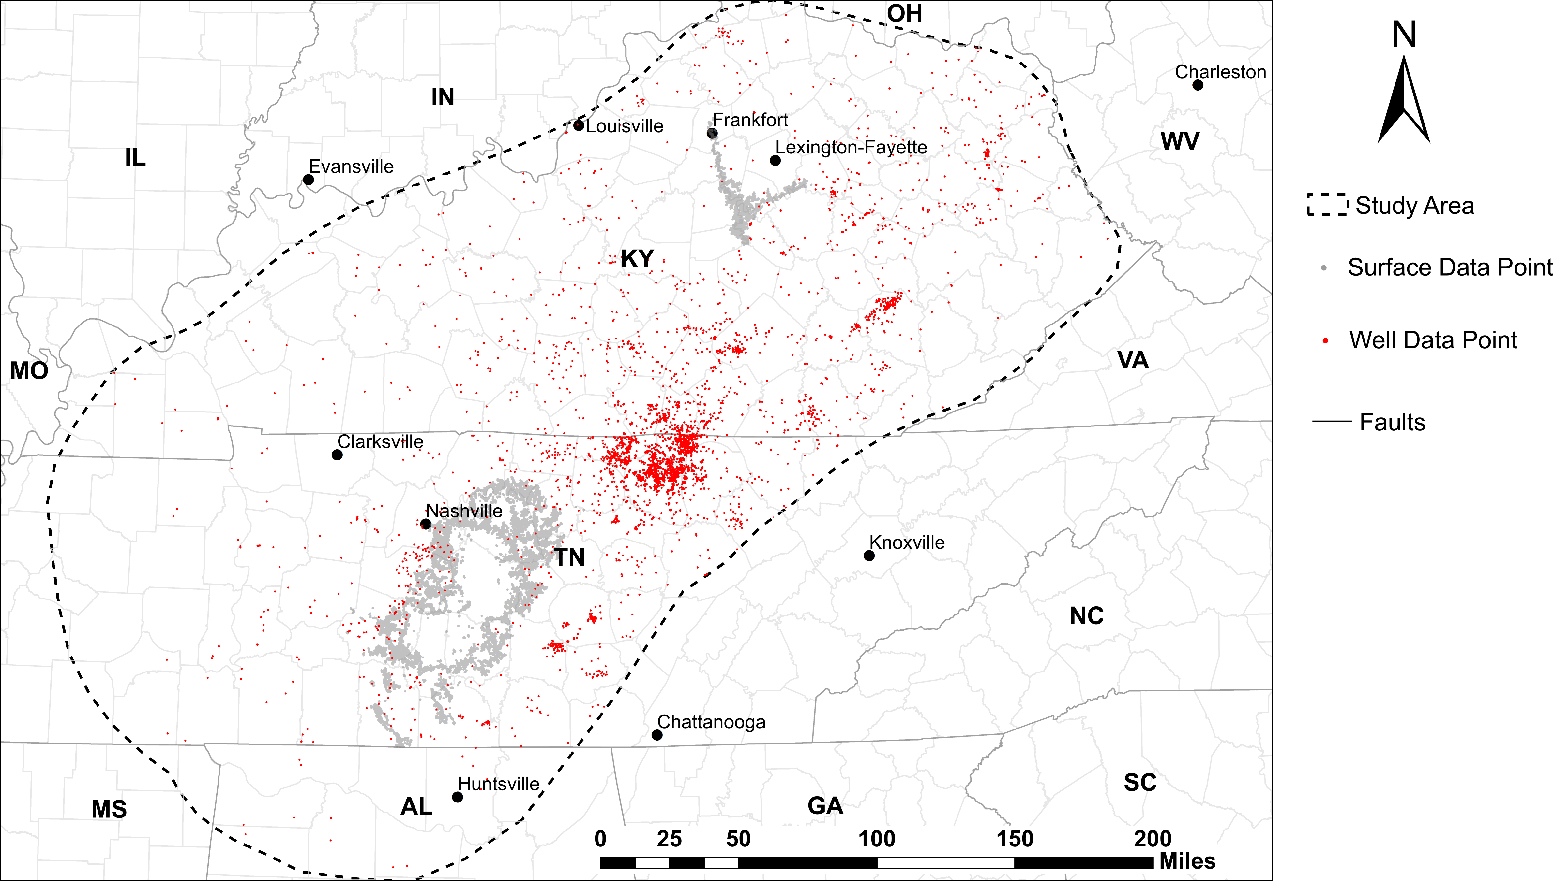
Figure III-23. Data point locations of the top of the Stones River Group. Red dots indicate well data locations, gray dots indicate surface points. Subsurface data: 5,147 points, surface data: surface points: 99,979

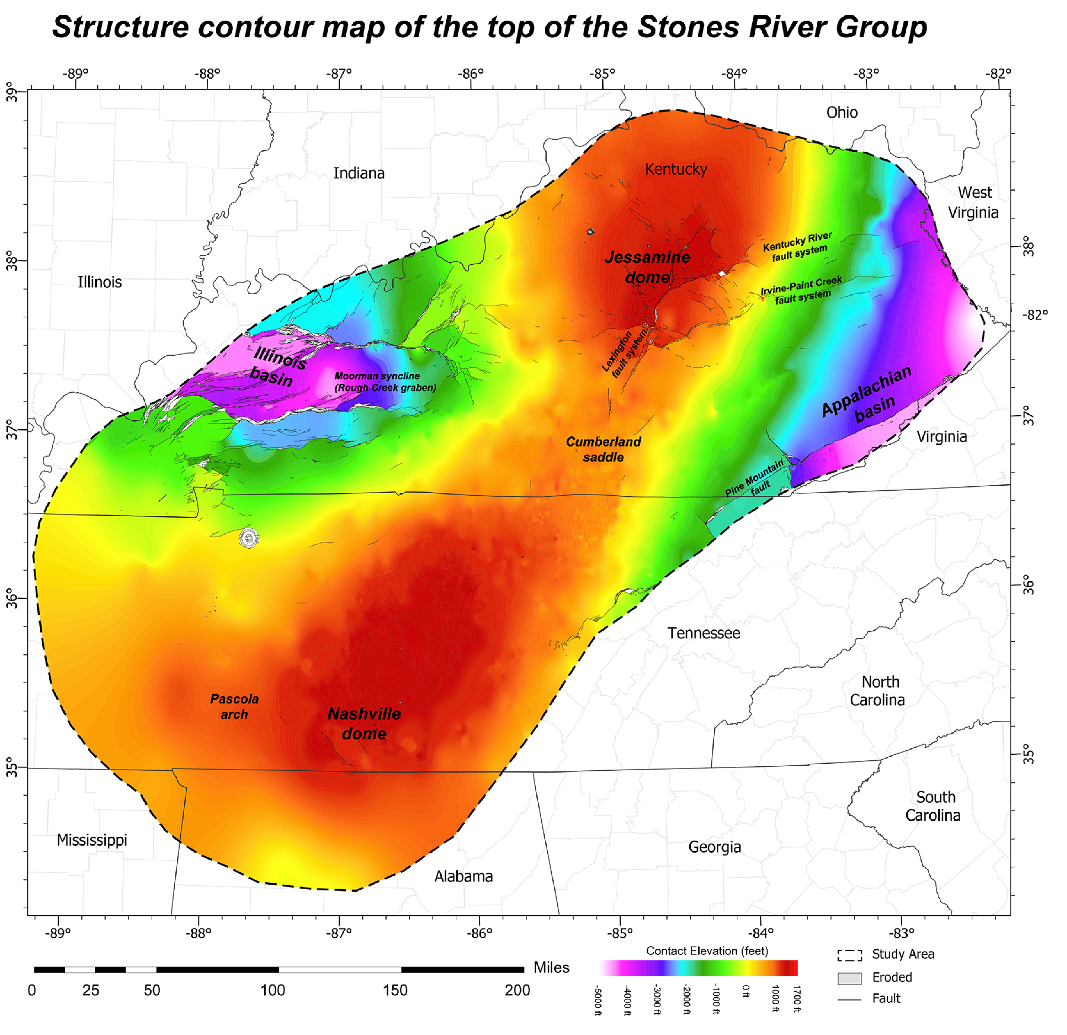Figure III-24. Structure contour map of the top of the Stones River Group. Several major structures are well defined in this map, such as the Nashville and Jessamine domes and the Illinois and Appalachian basins.

There were few wells for which the formation data was recorded in along the present-day axis of the Nashville dome, much more data were available from areas of both Tennessee and Kentucky along the flanks of the arch. In western Tennessee the Chattanooga outcrops along the updip edge of the Coastal Plain sediments. The structure of the Nashville dome is well represented in the base of the Chattanooga Shale (Figure III-26). Overall it has the same general shape as that of the Stones River and Knox Groups.
In addition to the useful maps, several other formation contacts were mapped, although they were not found to be relevant to this investigation. The most regionally extensive of these is the Mississippian Fort Payne Formation (Figure III-27). However due to the know prevalence of reefs and other carbonate build ups, and more complex stratigraphy, the Ft. Payne Formation was determined to be unreliable as a source of structural data. Therefore this formation was excluded from this investigation.

Regional Isopach maps

After each structure contour map was generated for each horizon of interest, derivative products such as isopach maps that indicate the stratigraphic thickness between two formations could be generated.

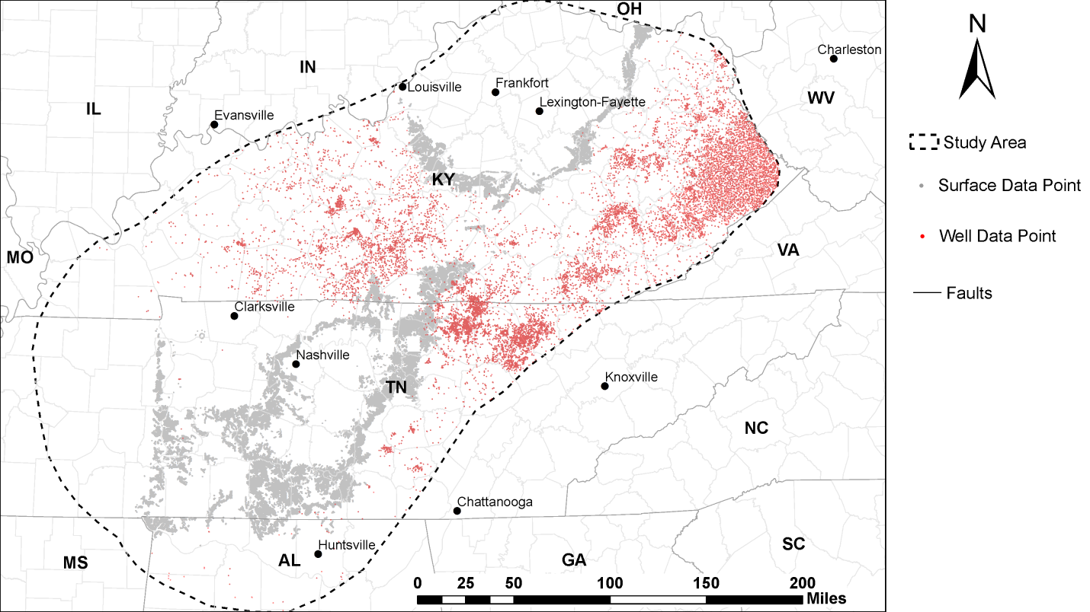

Figure III-25. Data point locations of the base of the Chattanooga Shale. Red dots indicate well data locations, gray dots indicate surface points. Subsurface data: 12,530 points, surface data: 406,558 points.

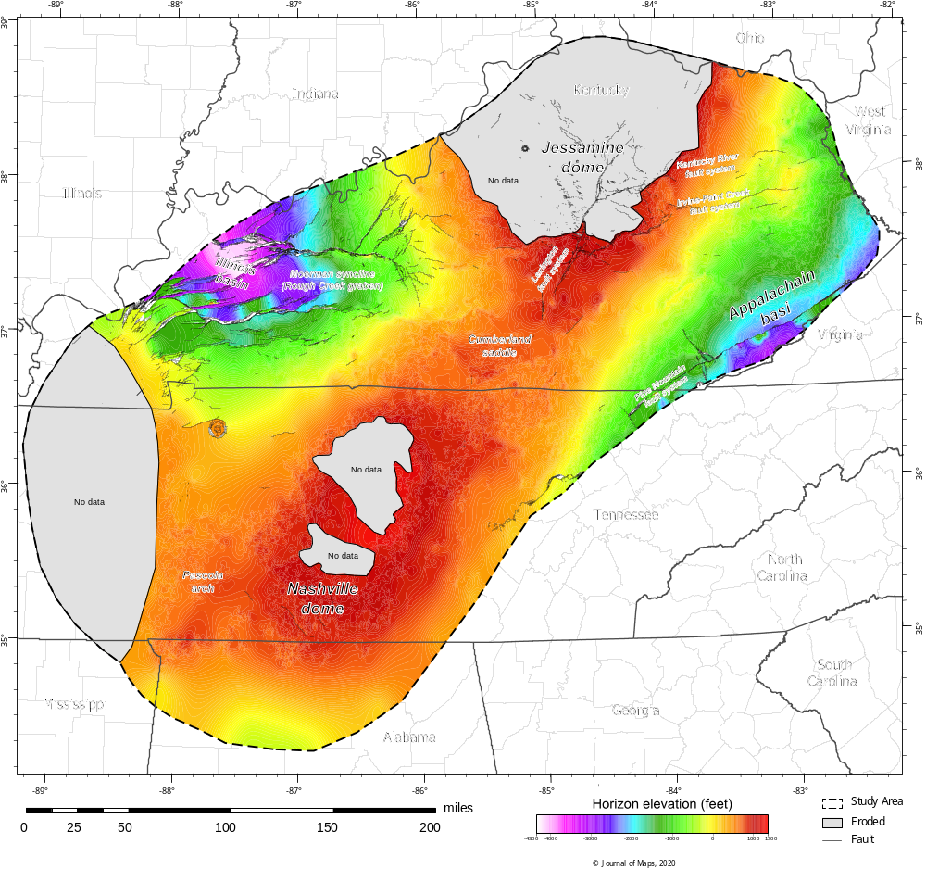
Figure III-26. Structure contour map of the base of the Chattanooga Shale.

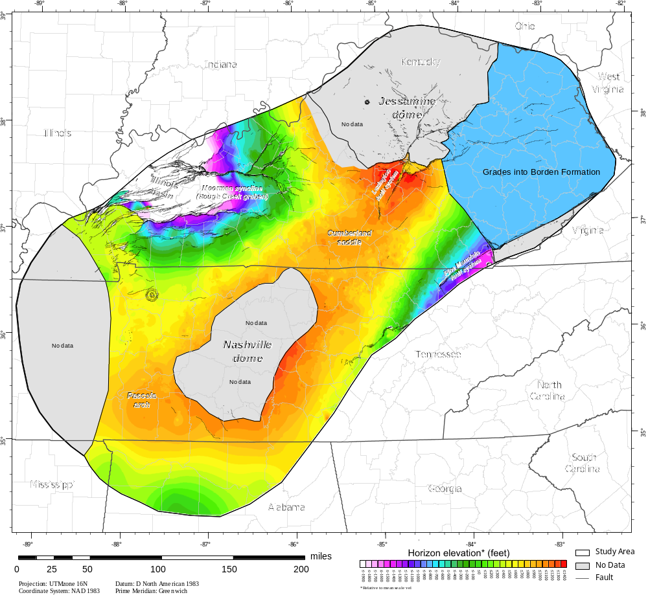
Figure III-27. Structure Contour map on the top of the Ft. Payne Formation, which grades into the Borden Formation (blue) that adds complexity to the stratigraphy. As a result the Borden Formation was excluded from the study. This map does, however, clearly outline the Nashville and Jessamine domes and Cumberland saddle that connects them.
Isopach maps typically can be generated by measuring the interval between two geologic formation tops encountered down a well borehole in a series of wells, and then contouring the data points to represent the areal thickness of the section. This method works well for subsurface data, and for units where both top and base are exposed on the surface. The method used to generate isopach maps for this dataset was to determine the distance from one structure contour map surface to another by simply subtracting the vertical elevation of the lower formation from the upper formation at each cell along a raster image of the geologic horizon.
By using the most laterally continuous horizons, regional isopachs were produced for several horizons of interest. Particular care must be taken, however, to only use areas where data exist for both the upper and lower contact in relatively close proximity. Using an interpolated or predicted surface (in areas distant from any real data points) for one surface of an isopach map, and a well- constrained surface for another can result in inaccuracies in the final map. As a result, any isopachs generated are limited to the area where data points are readily available for both surfaces relatively close by.
The stratigraphically lowest isopach map generated was for Wells Creek Formation (Figure III-28). Data from the Wells Creek Formation are limited to subsurface well data that do not always report the upper formation contacts. In addition, the Wells Creek Formation varies in thickness and is known to pinch out entirely in some areas, making it impossible to determine if the absence of well data from one area is due to absence of the formation, or lack of data.
In general, the Wells Creek Formation appears to thicken slightly toward northwestern Kentucky. These variations in thickness may represent changes in the surface of the Knox Group following the erosion of the upper Knox (Newcome and Smith, 1962), where the Wells Creek would thicken in areas of topographic lows and thin over highs in the Knox surface. The general increase in thickness in Kentucky may also be the result of the presence of the St. Peter Sandstone below the Wells Creek because not all drilling logs differentiate between the two. The lowest stratigraphic interval feasible to construct a regional isopach map with any degree of confidence was the interval from the top of the Knox Group to the top of the Stones River Group (Figure III-29). Although there are areas of sparse data coverage, a few patterns can be observed.
Around the northern flank of the Jessamine dome the Wells Creek-to Stones River Group section is considerably thinner (400 ft to 550 ft) than the area around the Nashville dome, where it averages about 650 ft to 900 ft thick. This thinning may have been a result of a general uplift of the area north of the Kentucky River fault zone, and may fit with the idea of fault reactivation uplifting carbonate banks in this location, although this would reactivate earlier than Late Ordovician (Ettensohn et al., 2004).

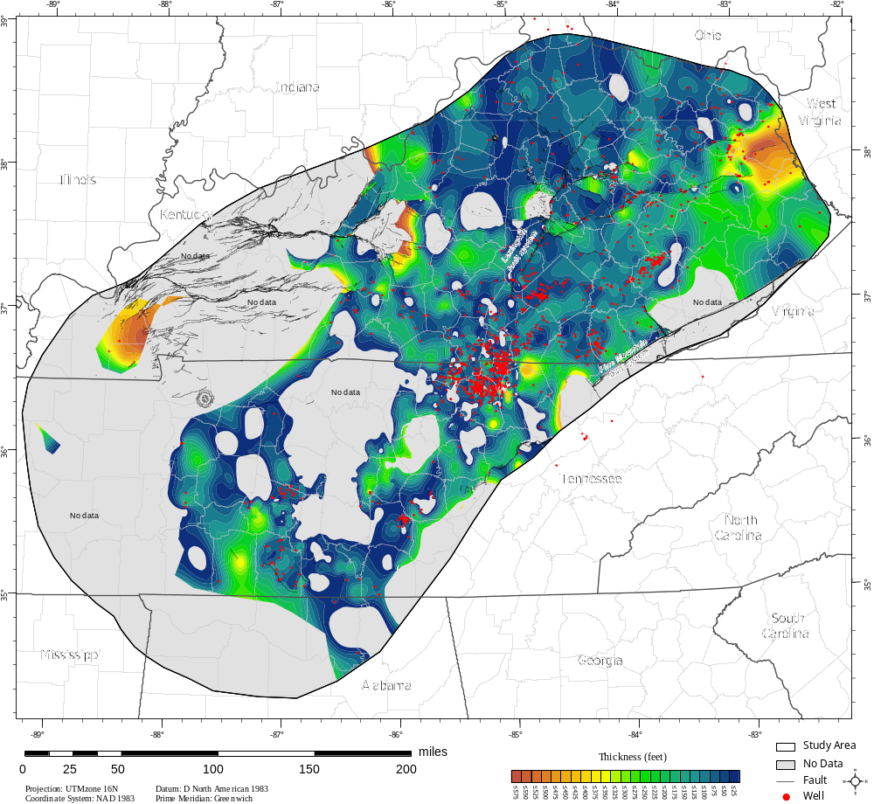
Figure III-28. Isopach map of the Wells Creek Formation. Red dots indicate well data locations (1,530 points total) which were used to generate the structure contour of the top of the Wells Creek Formation. This surface was then used to determine the thickness of the Wells Creek Formation by subtracting the difference in contour horizon elevation from the top of the Wells Creek and top of the Knox Group surfaces. Data availability is sparse for this formation in some areas. Areas of 'no data' indicate locations of poor data coverage of one or more of the two formations used to calculate the isopach surface.

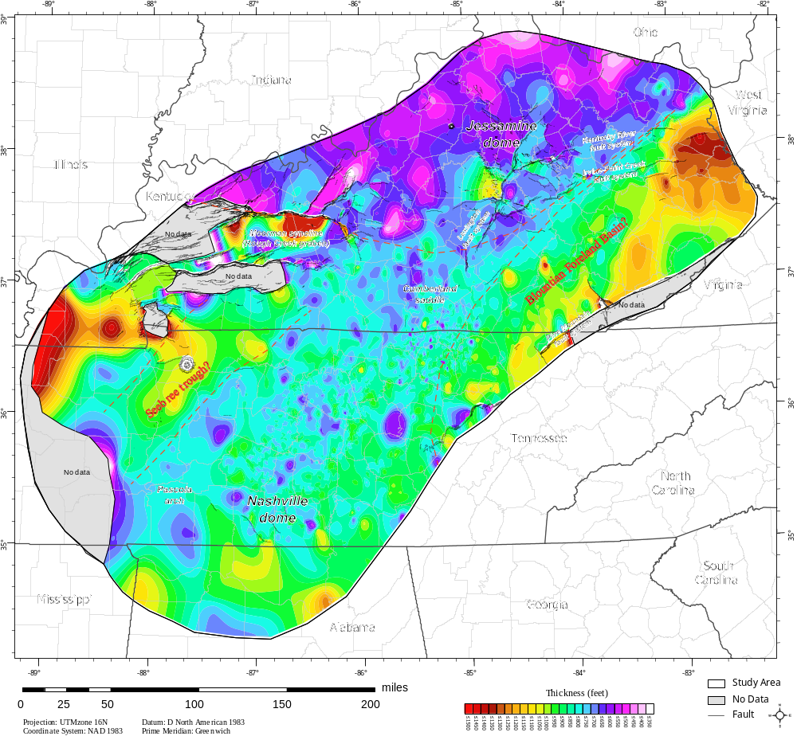
Figure III-29. Isopach map from the top of Knox to the top of the Stones River Group. Although there are areas of sparse data coverage (number of well data points used: 5,147), this isopach map generally indicates that this section thins toward the north. This isopach map is roughly the same as that of Wilson and Stearns (1963). This isopach map may indicate that, during the Blountian orogeny, the interval between the top of the Stones River Group and the top of the Knox Group was eroded as a result of uplift during the time. The area of thick section to the northwest of the Nashville dome corresponds roughly to the location of the Sebree trough (Kolata et al., 2001).

The interval thickens considerably to the east across a basement fault in Kentucky that may have been reactivated at some point in time (Patchen et al., 2006). The thickness of this section around the Nashville dome appears relatively consistent, although some thickening may occur on the northwest and southeast sides of the dome.
The interval from the top of the Knox to the top of the Stones River Group was deposited during the early Taconic orogeny, or Blountian orogeny, above the post-Sauk unconformity (top of the Knox). The Stones River Group on the present-day Nashville dome has roughly a uniform thickness, with comparatively little variation compared with the areas to the north along the axis of the present-day Cincinnati arch. This is consistent with the findings of Holland and Patzkowsky (1997), who found that the wide facies belts occurring across the dome lack a consistent dip direction, and suggest that the platform during this time was a flat shelf lacking significant dip.
The area where the section that thickens slightly to the west of the Nashville dome appears to coincide with the projected location of the Seebree trough (Kolata et al., 2001). This structure is thought to have subsided some time during the Late Ordovician and involved drowning the carbonate platform there. This area may have been stable during the Middle Ordovician to allow thickening of this section before later subsidence occurred.
A second major isopach map was constructed of the thickness from the top of the Stones River Group to the base of the Chattanooga, New Albany, and Ohio Shales (Figure III-30). This isopach is more limited in areal extent because of the erosion of the Chattanooga Shale across the Jessamine dome and along the Pascola arch. The general pattern displayed here is the thickening of the Chattanooga Shale into the Appalachian basin. The section thins over the crest of the Nashville dome. This may indicate that uplift of the Nashville dome occurred at some point between the deposition of the Chattanooga Shale and the deposition of the Stones River Group. It is impossible to say when that uplift occurred between those time periods.
Wilson (1949) described an unconformity between the Lebanon Limestone and the overlying Carters Limestone, which he described as being somewhat angular in some locations along the Nashville dome (Figure III-6). In Wilson's (1949) interpretation of the structure the Lebanon Limestone is slightly folded and eroded at the point that would have been the paleo-crest of the Nashville dome. To investigate this an isopach map of the Lebanon Limestone was constructed across the present day crest of the Nashville dome (Figure III-31). This map reveals the location of a north-northwest trending band of decreased thickness (indicated by the dark blue areas). Another band of greater thickness is shown just to the east of the thinner section (orange and yellow areas). These bands of increased thickness may be interpreted as the result of truncation on the top of the Lebanon by erosion across the top of the dome, where areas of thicker section represent synclines and thinning across anticlines.

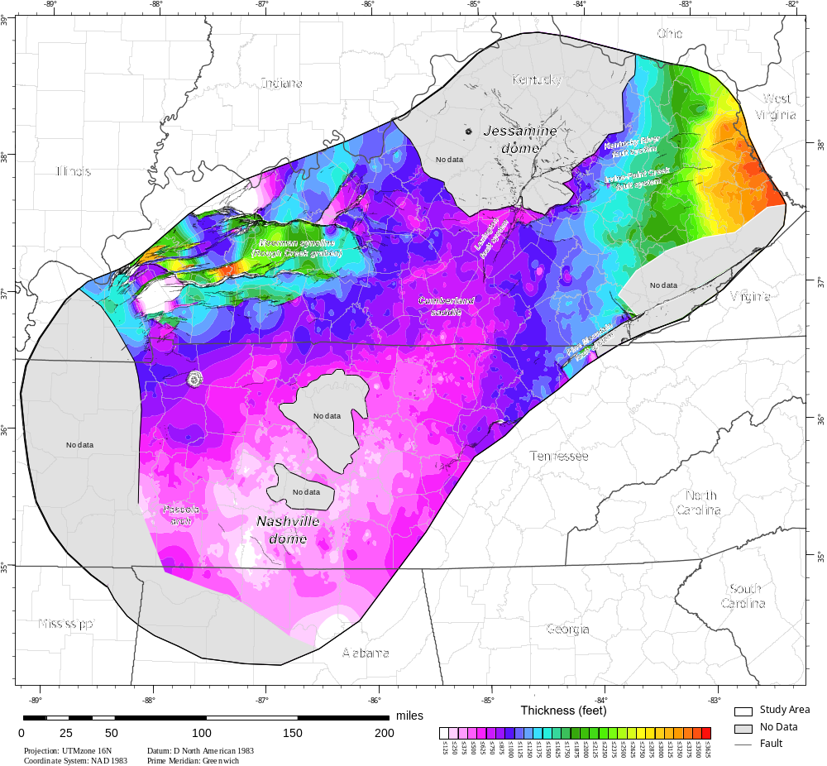

Figure III-30. Regional isopach map from the top of the Mid-Ordovician Stones River Group to the base of the Devonian Chattanooga Shale. This interval thins over the crest of the Nashville dome and thicken along the flanks. The areas in gray labeled "no data" are locations where the upper or lower surfaces had no data available. The map was generated using 12,530 well data points.

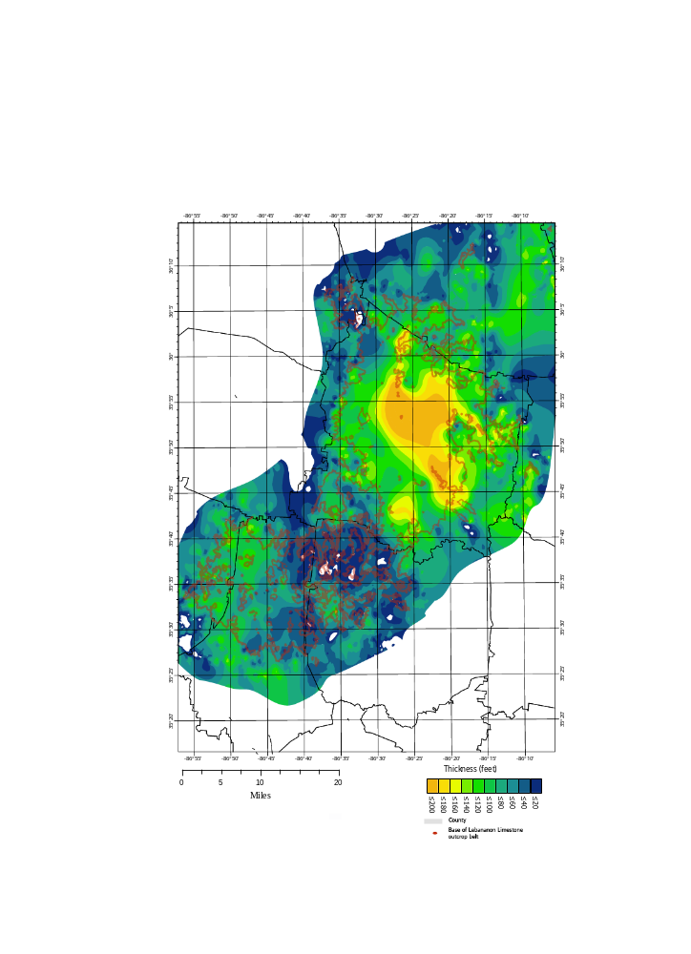
Lebanon, TN
Figure III-31. Isopach map of the Lebanon Limestone along the crest of the Nashville dome. Because the map is based solely on two horizons that only outcrop at the surface, the accuracy of this isopach map decreases with distance away from the outcrop belt. There are two potential folds here, interpreted by the isopach and from the observations of Wilson (1949) in that area. Thinner areas (dark blues and greens) occur across the top of a potential anticline, and thicker areas (yellows and orange) and seem to suggest the presence of a syncline, because of the erosional surface at the top of the Lebanon Limestone.

Discussion

The isopach maps produced in this study indicate that there was a persistent feature along the area of the Nashville and Jessamine domes though time. Dávila et al. (2003) were able to use the angular relationships between a series of unconformities to track the renewed uplift of a Type 0 (defined by Ramsay and Huber, 1987) anticline from the Early Ordovician to the Tertiary in the Famatina range of Argentina. This type of interference pattern occurs where a fold axis remains in the same location through time, requiring the source of regional deformation remain in the same orientation through millions of years, making this kind of fold pattern not only rare but difficult to identify. It could be viewed from the perspective of continuation of progressive folding over time with no major changes in the direction of maximum stress orientation (Thiessen and Means, 1980).
Type 0 interference folds are typically not readily differentiated from folds produced by a single episode of folding (Suppe, 1985). If the structure has been uplifted and eroded several times however, to create successive unconformity surfaces, it may be possible to separate and determine the timing of folding and thus recognize the Type 0 interference structure (Dávila et al., 2003).
The axis of the Nashville dome has maintained roughly the same location from the Middle Ordovician at least through the Early Mississippian. Isopach and structure contour maps constructed as part of this research, and unconformities, can be used to track the history of the Nashville dome through geologic time and demonstrate that it too is a Type 0 fold (Figures III-24, III-26, III-27, III-29, and III-30). Thinning of stratigraphic units over the crests of the Nashville and possibly Jessamine domes suggest that multiple periods of post-Stones River Group uplift occurred while the location of the axis of the dome remained unchanged. The occurrence of a stack of unconformities may identify these domes as "Type-0" interference folds.
The Nashville dome has undergone several periods of uplift through time with a similar orientation of the deformation source. Uplift of the domes along the arch may result in erosion of the crests of the domes resulting in stratigraphic thinning over the areas that were uplifted. With that idea in mind, isopach maps of the units between unconformities may help document areas of erosion or deposition.
Changes in eustatic sea-level can be another complicating factor, because a period of sea-level fall can result in the erosion of any land mass that is subaerially exposed following sea-level fall. Despite the difficulty in attributing erosional events to either changes in eustatic sea-level or uplift and subsidence, changes in eustatic sea-level produce short-term features, while tectonically driven changes occur over longer periods (Holland and Patzkowsky, 1998; Pope et al., 2012).
Based on the apparent changes in the thickness of the Stones River Group to the base of the Chattanooga Shale compared to the changes in thickness of the earlier Knox Group to the top of the Stones River Group across the domes, the uplift cannot have been continuous through geologic time. The period of time between erosion of the top of the Knox Group that produced the regional Knox unconformity, and the deposition of the Stones River Group appears to have been relatively uniform in terms of uplift. This unconformity is present throughout eastern North America and possibly on other continents (Hatcher and Repetski, 2007) The period of time following the deposition of the Stones River Group to deposition of the Chattanooga Shale was substantially tectonically more active.
The relationship between the position of the Cincinnati arch and the Nashville and Jessamine domes is not fully understood. It is unclear whether the domes were superimposed on the Cincinnati arch at the same time as the arch was initially uplifted or if the domes formed afterwards, or independently of the Cincinnati arch, or some other more complex relationship exists between the location of the arch and the domes. Several studies have made the observation that the apparent general trend of the Cincinnati arch roughly coincides with the boundary between the Grenville front and the Eastern Granite-Rhyolite Province (e.g. Van Schmus et al., 1993). These studies suggest that the static position and initial formation of the arch may have been controlled by the reactivation of basement faults along this crustal heterogeneity (Drahovzal et al., 1992; Ettensohn, 1992; Pope et al., 2012; Ettensohn and Lierman, 2015). There is, however, no substantial evidence of those faults along this boundary in potential field or seismic reflection data in Kentucky or Tennessee (Patchen et al., 2006; Bankey et al., 2015).
The Rough Creek-Kentucky River-Lexington fault system trends approximately east-west. These faults clearly involve and displace the basement surface. No faults have been observed beneath the Cincinnati arch in the best geophysical data (seismic reflection, gravity, and aeromagnetic) available from Tennessee and Kentucky. The Grenville front faults pass beneath the arch in Kentucky, but they also do not displace the basement surface from western Ohio through Kentucky and Tennessee.

Deformational history

This region has been affected by a series of tectonic events, which helped shape, form, and modify the Cincinnati arch. Three major orogenic events occurred in this region: the Taconic, Acadian-Neoacadian, and Alleghanian orogenies. In addition, other events occurred much earlier (Late Neoproterozoic) that may have faulted the basement, which may have acted as zones of weakness for reactivation during Paleozoic events.
Paleozoic orogenies generated proximal sediment sources from uplifted orogenic belts and enough foreland basin accommodation space to accumulate more than 13,700 m (44,948 ft) of sediment in the Appalachian basin (Ettensohn and Lierman, 2013). The deformational history of this area is primarily recorded by the presence of thick, unconformity-bound sequences of sediments that have shed off of the uplifted mountain belts resulting from each orogenic event (Sloss, 1963).

Taconic Orogeny

Following the Grenville orogeny, the Taconic orogeny was initiated by the obduction of a series of island arcs onto the North American craton. It occurred in multiple phases, and the earlier event may be referred to as the "Blountian orogeny" or Blountian phase of the Taconic orogeny, although it is not always described as a separate event, and is usually considered to be the early phase of the Taconic orogeny (Rodgers, 1970; Hatcher et al., 1989; Holland and Patzkowsky, 1997). The Blountian phase of the Taconic orogeny was initiated during the Middle Ordovician (463 Ma) and was centered in East Tennessee (Rodgers, 1971), whereas the type Taconic orogeny is located in New Jersey, and occurred during the late Middle Ordovician (454 Ma) (Rodgers, 1971; Stearns and Reesman, 1986; Holland and Patzkowsky, 1998; Hatcher, 2010). The foreland basin produced by this event was bordered by a carbonate bank which developed west of the orogen, extending to the crests of the Nashville and Jessamine domes.
The Taconic orogeny produced a clastic wedge that shed material onto the platform margin of the Appalachians from the Middle Ordovician into the Silurian (Hatcher et al., 1989). This clastic material was deposited progressively westward to the carbonate platform, and was deposited as argillaceous limestones and shale along the distal edge of the basin. Another event following the Taconic orogeny (though usually included in the Taconic orogeny) was the Salinic orogeny, which is best documented in Newfoundland and New Brunswick (van Staal et al., 2007; Van Staal et al., 2008), but may be manifested only by pluton emplacement in the interior of the southern Appalachians (Sinha et al., 2012).

Acadian Orogeny

The Acadian orogeny was interpreted as having originated from the closing of the Iapetus ocean (Dewey and Bird, 1970), but more current data confirm that the younger Rheic ocean closed at this time (e.g. Hatcher, 2010). The Acadian orogeny took place largely from the end of the Silurian to the end of the Devonian (Hatcher, 1989). The shedding of material off of the uplifted mountain belts produced by the Acadian orogeny created a diachronous clastic wedge that was deposited in the foreland basin generated a widespread dark shale (Chattanooga, New Albany, and Ohio Shales) coarsening northeastward into the Catskill "delta" in New York and Pennsylvania (Rodgers, 1971). The Acadian orogeny is largely associated with the Kaskaskia sequence (Sloss, 1963; Frazier and Schwimmer, 1987).

Alleghanian Orogeny

The Alleghanian orogeny was the youngest Paleozoic orogenic event in the Appalachian orogen, beginning in the Late Mississippian and continuing through the Pennsylvanian, and most of the Permian until ~260 Ma (Hatcher, 2010). The Africa-North America collision resulted in the widespread deformation of the area from Alabama to Newfoundland, dextral to the north, and manifested as a foreland fold-thrust belt to the south. The foreland fold-thrust belt consists of a series of thrust faults that propagated northwest through the previously deposited Paleozoic sedimentary. The Alleghanian orogeny represented the last stage in the Appalachian Wilson cycle, where the Rheic ocean closed by continent-continent collision between Africa and North America. This collision eventually resulted in the formation of the supercontinent of Pangea (Hatcher, 2010).

Model of Deformation History of the Nashville and Jessamine domes

A conceptual model was developed for the series of events produced by two phases of deformation separated by the pre-Chattanooga unconformity (Figure III-32). Following the deposition of the Lower to Mid-Silurian formations, deformation and subsequent uplift resulted first in erosion of much of the Silurian units from the crests of anticlines along the western flank of the Nashville dome, preserving them only in locally faulted synclines, and complete removal of the Silurian section from the eastern flank of the Nashville dome. The Chattanooga Shale was then deposited during the Late Devonian-Early Mississippian following formation of a regional unconformity. The most likely cause of folding and faulting was the far-field effects of the Middle Devonian to Early Mississippian Acadian-Neoacadian orogeny. This event is well documented in the interior of the southern Appalachians (Merschat et al., 2005, 2010, 2012). These domes were deformed again during the late Pennsylvanian-Permian Alleghanian orogeny, and possibly later.
This sequence was folded and locally faulted, and then uplifted and eroded, as possible far-field products of the Acadian-Neoacadian orogeny (Hatcher et al., 2007). There was no additional deposition on the crest and flanks of the Nashville dome until Late Devonian time when the Chattanooga Shale was deposited (e.g., (Hardeman et al., 1966; Moore and Horton, 1999); deposition also resumed during the Devonian on the crest and flanks of the Jessamine dome, but deposition occurred on both the east and west flanks of this dome throughout much of the Silurian and into the Devonian, recording a more complete stratigraphic section (McDowell et al., 1981) (T₂ in Figure III-32).
The Chattanooga Shale and equivalents were succeeded by deposition of the marine Mississippian section followed by the largely nonmarine Pennsylvanian clastic wedge (Ettensohn and Lierman, 2013) (T₃ Figure III-32). This sequence was largely uninterrupted by major unconformities, because the influx of eastward-derived clastics into the Late Mississippian (Pennington) marine to nonmarine environments produced a smooth transition into the overlying incoming flood of Pennsylvanian clastic sediments derived from the rising Alleghanian mountains (Hatcher et al., 1989). The entire sequence was deformed during the latest Pennsylvanian-Early Permian with clastic sediments being shed from the rising mountains into the Permian in the westernmost parts of the clastic wedge (e.g., Rodgers, 1970) (T₄ in Figure III-33).
The evolution of the Nashville dome may also be represented in a series of cross sections that represent the known uplift and erosional history from the stratigraphic record of unconformities and deformational events (Figure III-33). While there are many unconformities in the stratigraphic section, some formed by eustatic processes are regional, continental, and possibly intercontinental (e.g., the top-of-Knox unconformity), while others were produced by the major Appalachian orogenies. Still others appear to be localized on the Nashville or Jessamine domes, and may be the products of local crustal adjustments.

Implications for oil and gas exploration

The first commercial oil production in the Cincinnati arch province was established in 1829 in the Cumberland saddle from the Sunnybrook limestone (Upper Ordovician) in Cumberland County, Kentucky (Ryder and Hatch, 1995).

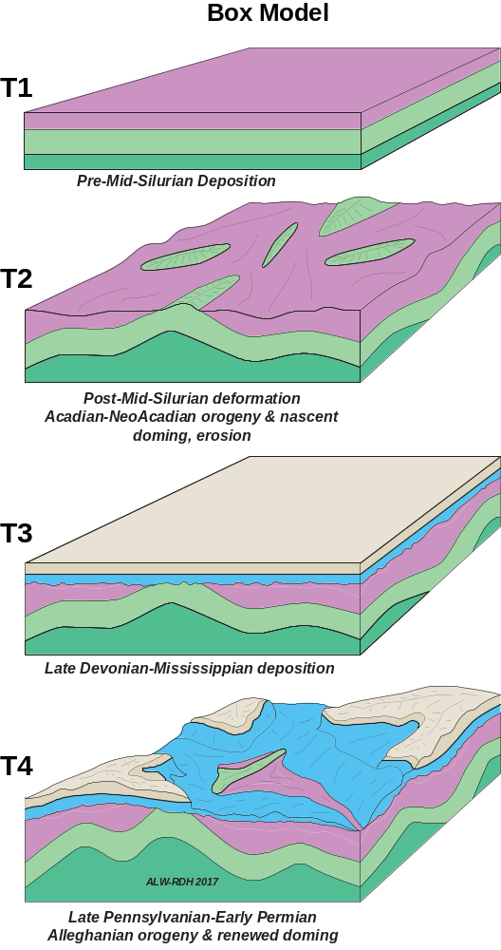
Figure III-32. Conceptual model showing the series of depositional, tectonic, and erosional events from the mid-Silurian- to Permian, top to bottom T₁-T₄, focusing on events that occurred before and after the formation of the pre-Chattanooga unconformity. T₁ represents the deposition of the Lower Ordovician (dark green) Middle Ordovician (light green) and Silurian (magenta) formations. This was followed by T₂ where the Silurian formations were eroded during the uplift and deformation of the area resulting from the Acadian-Neo Acadian orogenies. T₃ represents the deposition of the Devonian (blue) through Pennsylvanian formations on the eroded sections. The final events T₄ represent renewed uplift, deformation, and subsequent erosion of the Lower Ordovician to Pennsylvanian formations during the Alleghanian orogeny.

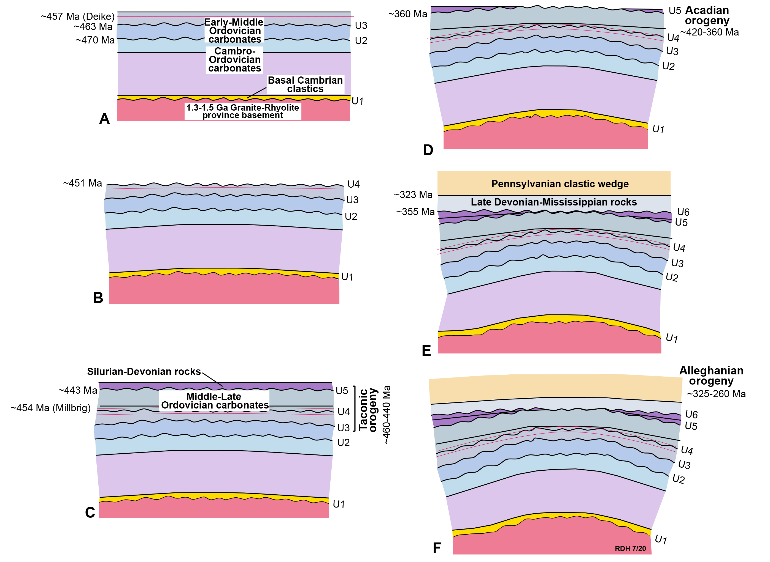
Figure III-33. Structural history of the Nashville dome based on the unconformities recognizable in the stratigraphic section. Beginning at time (A) with the deposition of Middle Ordovician carbonates and bentonites, this was followed by time (B) where the upper surfaces of these carbonates were eroded following uplift of the dome. This was then followed by the Taconic (C), Acadian (D) orogenies. Finally following the deposition of the Pennsylvanian clastic wedge (E), which is later deformed by the Alleghanian orogeny (F). (Graphic by R. D. Hatcher, Jr. 2020).
The use of these maps to locate fractures, that not only control the porosity in a reservoir but also have a tendency to produce karst features capable of containing oil. One of the most famous occurrences of this happened on September 25, 1990, when the Syndicated Options 9372 Ferguson Brothers well underwent a sudden bit drop as the bit breached the karst feature. This is said to be a classic sign of cavernous porosity associated with a fractured reservoir (Hamilton-Smith, 1992).
The reactivation of basement structures has been thought to be an important factor in oil and gas reservoir formation in the Trenton/Black River (Nashville/Stones River equivalents) formations of the Albion-Scipio (Michigan) and Lima-Indiana trends (Indiana-Ohio). These fields are a product of hydrothermal dolomitization in the fractured Ordovician limestones along strike slip-faults and negative flower structures, appearing as subtle synclines on structure contour maps (Smith, 2006). Patchen et al., (2006) pointed out that hydrothermal dolomite reservoirs are likely to be a significant underdeveloped resource in mature petroleum producing regions, as a result of their occurrence in structural lows that are unlikely to have been drilled during earlier exploration stages. Such structures have been reported in southern Kentucky in the Indian Creek syncline, where oil and gas reservoirs are primarily controlled by small, low-angle thrust faults (Rutledge et al., 1998). Basement-controlled strike-slip faults have been associated with oil production in Kentucky from fractured Ordovician carbonates west of Clinton County (Black, 1986).
Another noteworthy feature is the Burning Springs Anticline in Clay county Kentucky (not to be confused with the anticline of the same name in West Virginia). The structure was first developed in the 1920s as a gas field producing from the "Corniferous" (drillers term for Late Silurian and Middle Devonian age sandstones and limestones) (McFarlan, 1943). The anticline occurs along northern Clay and Laurel counties along what is now known as the Rockcastle River uplift, a positive structure on the upthrown side of the Rockcastle River Fault (Maynor and MacQuown, 1983; Harris and Sparks, 2005), which coincides with the southern edge of the Rome trough. This feature was originally thought to have formed as a result of a northward dipping normal fault, however seismic imaging was able to resolve that this feature was likely the result of a southward dipping thrust fault (White and Drahovzal, 2002).

Conclusions

- The uplift of the Nashville dome in the Ordovician occurred primarily following the deposition of the Stones River group and before the deposition of the Chattanooga Shale. There is some evidence of thinning of the formations on the crest of the dome (primarily the Lebanon Limestone).

- The erosion of the Knox Group before the beginning of the Taconic orogeny was followed by the deposition of the Wells Creek Formation that filled in areas where the surface of the Knox was topographically lower.

- The thinning of the section between the top of the Stones River Group and the Chattanooga Shale indicates that uplift was occurring at some point in time following the deposition of the Stones River Group, after deposition of Silurian rocks, and before the deposition of the Chattanooga Shale.

- Based on the isopach maps generated using the regional maps of the study area, the Nashville dome was uplifted primarily between the Middle Ordovician and before the Late Devonian. The interval between the Stones River Group and the base of the Chattanooga Shale is considerably thinner across the Nashville dome.

- Regional structural investigations require large volumes of previously collected geologic data. The data used in this study proved to be invaluable for determining information about the tectonic history of the region, a task that would have been impossible without this information and the methods developed to facilitate generation of the maps used in analysis.

- The methods used in this research can be applied to any region to speed the rate of production of structure contour maps. They are especially useful when large datasets are available.

References

Abolins, M., Young, S., Camacho, J., Trexler, M., Ward, A., Cooley, M., and Ogden, A., 2015, A road guide to the Harpeth River and Stones River fault zones on the northwest flank of the Nashville dome, central Tennessee, in Diverse Excursions in the Southeast: Paleozoic to Present, Geological Society of America Field Guide, p. 1–20, doi:10.1130/2015.0039(01).
Bankey, V., Cuevas, A., Daniels, D., Finn, C., Hernandez, I., Hill, P., Kucks, R., Miles, W., Pilkington, M., and Roberts, C., 2015, Digital data grids for the magnetic anomaly map of North America: USGS Open-File Report 02-414:
Bayley, R.W., and Muehlberger, W.R., 1968, Basement rock map of the United States: U.S. Geological Survey.
Bergström, S.M., Huff, W.D., and Kolata, D.R., 1998, Early Silurian (Llandoverian) K-bentonites discovered in the southern Appalachian thrust belts, eastern USA: Stratigraphy, geochemistry, and tectonomagmatic and paleogeographic implications: GFF, v. 120, p. 149–158, doi:10.1080/11035899801202149.
Black, D.F., 1986, Basement faulting in Kentucky, in Proceedings of the sixth international conference on basement tectonics: Salt Lake City, International Basement Tectonics Association, p. 125–139.
Black, D.F.B., 1989, Tectonic evolution in central and eastern Kentucky : a multidisciplinary study of surface and subsurface structure: U.S. Geological Survey Open-File Report 89–106, doi:10.3133/ofr89106.
Black, D.F., and Haney, D.C., 1975, Selected structural features and associated dolostone occurrences in the vicinity of the Kentucky River Fault System: Kentucky Geological Survey.
Boling, K.S., Hatcher, R.D., Jr., Lemiszki, P.J., and Bible, G.G., 2020a, Applications of process automation and spatial data management using python and GIS to explore the structural history of the southern Cincinnati arch: Journal of Maps (in review),.
Boling, K.S., Hatcher, R.D., Jr., Lemiszki, P.J., and Bible, G.G., 2020b, Proof of concept test to determine the viability of building an extensive database for resolution of far-field effects of the Acadian and Alleghanian orogenies: Journal of Geosciences and Geomatics, v. 8, p. 9–14.
Borella, P.E., and Osborne, R.H., 1978, Late Middle and early Late Ordovician history of the Cincinnati arch province, central Kentucky to central Tennessee: Geological Society of America Bulletin, v. 89, p. 1559, doi:10.1130/0016-7606(1978)89<1559:LMAELO>2.0.CO;2.
Bowersox, J.R., 2013, Evaluation of Phase 2 CO2 Injection Testing in the Deep Saline Gunter Sandstone Reservoir (Cambrian-Ordovician Knox Group), Marvin Blan No. 1 Well, Hancock County, Kentucky: Kentucky Geological Survey Series XII Contract Report 53, 49 p.
Brahana, J.V., and Bradley, M.W., 1985, Delineation and Description of the Regional Aquifers of Tennessee: The Knox Aquifer in Central and West Tennessee: US Geological Survey Water-Resources Investigations Report 83-4012.
Brett, C.E., Dattilo, B.F., McLaughlin, P.I., Schramm, T.J., Thomka, J.R., and Cramer, B.D., 2012, Middle Paleozoic sequence stratigraphy and paleontology of the Cincinnati arch: part 2 Northern Kentucky and SE Indiana: International Geoscience Programme Project 591 2nd Annual Meeting and 1st Foerste Symposium Field Trip Guidebook, v. 591, p. 91.
Burwell, H.B., 1967, Well Sample Descriptions and Drillers’ Logs, Scott County, Tennessee: Tennessee Division of Geology Report of Investigations 21, 175 p.
Clark, J.A., 1952, Spindletop: New York, Random House.
Conant, L.C., and Swanson, V.E., 1961, Chattanooga Shale and related rocks of central Tennessee and nearby areas: Geological Survey Professional Paper, v. 357.
Connell, J.F., Barron, W.R., and Mitchell, R.L., 1994, Conversion of geologic quadrangle maps to geologic coverages: U.S. Geological Survey Open-File Report Report 94–359, http://pubs.er.usgs.gov/publication/ofr94359.
Cooper, B.N., 1945, The Stones River equivalents in the Appalachian Region: The Journal of Geology, v. 53, p. 262–276, doi:10.1086/625285.
Cressman, E.R., 1973, Lithostratigraphy and depositional environments of the Lexington Limestone (Ordovician) of central Kentucky: U.S. Geological Survey, Professional Paper 768, 61 p.
Dávila, F.M., Astini, R.A., and Schmidt, C.J., 2003, Unraveling 470 m.y. of shortening in the Central Andes and documentation of Type 0 superposed folding: Geology, v. 31, p. 275, doi:10.1130/0091-7613(2003)031<0275:UMYOSI>2.0.CO;2.
Dever, G.R., 1980, High-Carbonate and Low-Silica Stone in the High Bridge Group (Middle Ordovician), Fayette County, Central Kentucky: Kentucky Geological Survey Information Circular. 32., doi:10.13023/KGS.IC04.11.
Dever Jr, G.R., Anderson, W.H., Francis, H.E., Davidson, O.B., and Thompson, M.F., 1994, Chemical and Statistical Analysis of a Sampled Interval in the Camp Nelson Limestone (Upper Ordovician) Madison County, Central Kentucky: Kentucky Geological Survey Information Circular. 55,.
Dewey, J.F., and Bird, J.M., 1970, Mountain belts and the new global tectonics: Journal of Geophysical Research (1896-1977), v. 75, p. 2625–2647, doi:10.1029/JB075i014p02625.
Drahovzal, J.A., Harris, D.C., Wickstrom, L.H., Walker, D., Baranoski, M.T., Keith, B., and Furer, L.C., 1992, The east continent rift basin: a new discovery: Ohio. Division of Geological Survey, 25 p.
Ettensohn, F.R., 2008, Chapter 4 The Appalachian Foreland Basin in Eastern United States, in Sedimentary Basins of the World, Elsevier, v. 5, p. 105–179, doi:10.1016/S1874-5997(08)00004-X.
Ettensohn, F.R., 1992, Regressive facies in the upper Lexington Limestone: Tanglewood-Millersburg relationships: Changing interpretations of Kentucky Geology—layer-cake, facies, flexure, and eustasy: Ohio Division of Geological Survey Miscellaneous Report, v. 5, p. 62–66.
Ettensohn, F.R., Kasl, J.M., and Stewart, A.K., 2004, Structural inversion and origin of a Late Ordovician (Trenton) carbonate buildup: evidence from the Tanglewood and Devils Hollow members, Lexington Limestone, central Kentucky (USA): Palaeogeography, Palaeoclimatology, Palaeoecology, v. 210, p. 249–266, doi:10.1016/j.palaeo.2004.02.040.
Ettensohn, F.R., and Lierman, R.T., 2013, Large-scale tectonic controls on the origin of paleozoic dark-shale source-rock basins: Examples from the Appalachian foreland basin, eastern United States, in Gao, D. ed., Tectonics and Sedimentation, Tulsa, Oklahoma, American Association of Petroleum Geologists, p. 95–124, doi:10.1306/13351549M1003529.
Ettensohn, F., and Lierman, R.T., 2015, Using black shales to constrain possible tectonic and structural influence on foreland-basin evolution and cratonic yoking: Late Taconian Orogeny, Late Ordovician Appalachian Basin, eastern USA: v. 413, 119 p., doi:10.1144/SP413.5.
Ettensohn, F.R., Miller, M.L., Dillman, S.B., Elam, T.D., Geller, K.L., Swager, D.R., Markowitz, G., Woock, R.D., and Barron, L.S., 1988, Characterization and implications of the Devonian-Mississippian black shale sequence, eastern and central Kentucky, USA: Pycnoclines, transgression, regression, and tectonism, in Devonian of the World: Proceedings of the 2nd International Symposium on the Devonian System, Dallas Geological Society, Memoir 14, v. Volume II: Sedimentation, p. 323–345.
Evenick, J.C., 2006, Potential subsurface structures and hydrocarbon reservoirs in the southern Appalachian basin beneath the Cumberland Plateau and eastern Highland Rim, Tennessee, Kentucky, and southwestern Virginia [PhD diss.]: University of Tennessee, 402 p., http://trace.tennessee.edu/utk_graddiss/1663/ (accessed June 2017).
Evenick, J.C., and Hatcher, R.D., Jr., 2006, Geophysical log characteristics for subdividing the Stones River (Black River) and Nashville (Trenton) Groups beneath the southern Cumberland Plateau in Tennessee and southern Kentucky: Tennessee Division of Geology: Report of Investigations, p. 15.
Fischer, F.T., 1977, The geologic setting of a persisting paleo-aquifer--the Elmwood mine, Middle Tennessee zinc district: Lead-zinc update: New York, Soc. Mining Engineers, Am. Inst. Mining Metall. Petroleum Engineers, p. 3–19.
Foerste, A.F., 1895, On Clinton conglomerates and wave marks in Ohio and Kentucky: The Journal of Geology, v. 3, p. 50–60, doi:10.1086/607114.
Foerste, A.F., 1901, Silurian and Devonian limestones of Tennessee and Kentucky: Geological Society of America Bulletin, v. 12, p. 395–444, doi:10.1130/GSAB-12-395.
Foerste, A.F., 1904, The Ordovician-Silurian contact in the Ripley Island area of southern, Indiana, with notes on the age of the Cincinnati geanticline: American Journal of Science, v. 4, p. 321.
Frazier, W.J., and Schwimmer, D.R., 1987, The Kaskaskia Sequence: Middle Devonian—Upper Mississippian, in Frazier, W.J. and Schwimmer, D.R. eds., Regional Stratigraphy of North America, Boston, MA, Springer US, p. 203–269, doi:10.1007/978-1-4613-1795-1_6.
Gillespie, R.H., 1995, Rise of the Texas oil industry: Part 1: Exploration at Spindletop: The Leading Edge, v. 14, p. 22–24, doi:10.1190/1.1437058.
Glover, L., 1960, Stratigraphy and uranium content of the Chattanooga Shale in northeastern Alabama, northwestern Georgia and eastern Tennessee: US Geol. Survey Bull., p. 21.
Goggin, K.E., and Haynes, J.T., 1995, Mohawkian clastic wedges in the central and southern Appalachians: Early signatures of the Taconic orogeny, in Geological Society of America Abstracts with Programs, v. 27, p. 56–57.
Grohskopf, J.G., 1956, Subsurface geology of the Mississippi embayment of southeast Missouri: Missouri School of Mines and Metallurgy, 133 p.
Hager, D., 1949, Tectonics of north-central States: AAPG Bulletin, v. 33, p. 1198–1205.
Hamilton-Smith, T., 1992, Kentucky exploration targets oil in fractured High Bridge, Knox zones: Oil and Gas Journal;(United States), v. 90, p. 142.
Hardeman, W.D., Miller, R.A., and Swingle, G.D., 1966, Geologic map of Tennessee: State of Tennessee, Department of Conservation, Division of Geology 1:250,000.
Harris, D.C., and Sparks, T.N., 2005, Structure and Isopach Maps of the Mississippian “Big Lime” (Newman Limestone/Slade Formation), Eastern Kentucky:, doi:10.13023/KGS.MC77.12.
Hatcher, R.D., Jr., 1989, Tectonic synthesis of the US Appalachians: The Appalachian-Ouachita orogen in the United States: Boulder, Colorado, Geological Society of America, Geology of North America, v. 2, p. 511--535.
Hatcher, R.D., Jr., 2010, The Appalachian orogen: A brief summary, in From Rodinia to Pangea: The Lithotectonic Record of the Appalachian Region, Geological Society of America, doi:10.1130/2010.1206(01).
Hatcher, R.D., Jr., Bream, B.R., and Merschat, A.J., 2007, Tectonic map of the southern and central Appalachians: A tale of three orogens and a complete Wilson cycle, in Hatcher, R.D., Jr., Carlson, M.P., McBride, J.H., and Catalán, J.R.M. eds., 4-D Framework of Continental Crust, Geological Society of America Memoir, v. 200, p. 595–632, doi:10.1130/2007.1200(29).
Hatcher, R.D., Jr., and Milici, R.C., 2015, Sequatchie Valley structure and stratigraphy, in Diverse Excursions in the Southeast: Paleozoic to Present, Geological Society of America, p. 169–195, doi:10.1130/2015.0039(06).
Hatcher, R.D., Jr., and Repetski, J.E., 2007, The Post-Knox Unconformity: Product of Global, Not Regional Processes, in Geological Society of America Abstracts with Programs (SE Section), no. 2, v. 39, p. 8.
Hatcher, R.D., Jr., Thomas, W.A., and Viele, G.W., 1989, The Appalachian-Ouachita Orogen in the United States, in The Geology of North America, Boulder, Colorado, Geological Society of America, v. F-2, p. 767.
Hayes, C., and Ulrich, E., 1903, Description of the Columbia Quadrangle [Tennessee]: U.S. Geological Survey Atlas Folio.
Haynes, J.T., 1994, The Ordovician Deicke and Millbrig K-bentonite beds of the Cincinnati Arch and the southern Valley and Ridge Province: Geological Society of America Special Publication, v. 290, 51 p.
Hickman, J.B., 2011, Structural evolution of an intracratonic rift system; Mississippi Valley graben, Rough Creek graben, and Rome trough of Kentucky, USA [Doctoral Dissertations. 144.]: University of Kentucky.
Hill, P.L., Kucks, R.P., and Ravat, D., 2009, Aeromagnetic and Aeroradiometric Data for the Conterminous United States and Alaska from the National Uranium Resource Evaluation (NURE) Program of the U.S. Department of Energy: Open-File Report Report 2009–1129, doi:10.3133/ofr20091129.
Holland, S.M., and Patzkowsky, M.E., 1997, Distal orogenic effects on peripheral bulge sedimentation; Middle and Upper Ordovician of the Nashville Dome: Journal of Sedimentary Research, v. 67, p. 250–263, doi:10.1306/D4268545-2B26-11D7-8648000102C1865D.
Holland, S.M., and Patzkowsky, M.E., 1998, Sequence stratigraphy and relative sea-level history of the Middle and Upper Ordovician of the Nashville Dome, Tennessee: Journal of Sedimentary Research, v. 68, http://archives.datapages.com/data/doi/10.1306/D426883D-2B26-11D7-8648000102C1865D (accessed June 2017).
Huff, W.D., 1983, Correlation of Middle Ordovician K-Bentonites Based on Chemical Fingerprinting: The Journal of Geology, v. 91, p. 657–669, doi:10.1086/628818.
Huff, W.D., 2008, Ordovician K-bentonites: Issues in interpreting and correlating ancient tephras: Quaternary International, v. 178, p. 276–287, doi:10.1016/j.quaint.2007.04.007.
Jones, E., Oliphant, T., and Peterson, P., 2014, {SciPy}: open source scientific tools for {Python}:
Kaufmann, O., and Martin, T., 2009, 3D geological modelling from boreholes, cross-sections and geological maps, application over former natural gas storages in coal mines: Computers & Geosciences, v. 35, p. 70–82.
Kentucky Geological Survey, 2018a, 7.5-Minute Quadrangle Geologic Map Series: Kentucky Geological Survey Geologic.
Kentucky Geological Survey, 2018b, Kentucky Oil and Gas Online Database: KY Geode, https://kgs.uky.edu/kygeode/services/oilgas/.
King, P.B., Beikman, H.M., and Edmonston, G.J., 1974, Geologic map of the United States (exclusive of Alaska and Hawaii): USGS 1:2,500,000, http://pubs.er.usgs.gov/publication/70136641.
Kolata, D.R., Huff, W.D., and Bergström, S.M., 1996, Ordovician K-bentonites of eastern North America: Boulder, Colo, Geological Society of America, Special Paper 313, 84 p.
Kolata, D.R., Huff, W.D., and Bergström, S.M., 2001, The Ordovician Sebree trough: An oceanic passage to the Midcontinent United States: Geological Society of America Bulletin, v. 113, p. 1067–1078, doi:10.1130/0016-7606(2001)113<1067:TOSTAO>2.0.CO;2.
Locke, J., 1838, Ohio Geological Survey Annual Report: Ohio Geological Survey 2nd Annual Report, 206 p.
Marcher, M.V., 1962, Petrography of Mississippian Limestones and Cherts from the Northwestern Highland Rim, Tennessee: SEPM Journal of Sedimentary Research, v. 32, p. 14, doi:10.1306/74D70D80-2B21-11D7-8648000102C1865D.
Marcher, M.V., and Stearns, R.G., 1962, Tuscaloosa Formation in Tennessee: Geological Society of America Bulletin, v. 73, p. 1365, doi:10.1130/0016-7606(1962)73[1365:TFIT]2.0.CO;2.
Maynor, G.K., and MacQuown, W.C., 1983, Paleozoic history of the Rockcastle River Uplift in eastern Kentucky, in Proceedings of the Appalachain Basin Industrial Associates fall meeting, v. 5, p. 95–107.
McBride, J.H., Kolata, D.R., and Hildenbrand, T.G., 2003, Geophysical constraints on understanding the origin of the Illinois basin and its underlying crust: Tectonophysics, v. 363, p. 45–78, doi:10.1016/S0040-1951(02)00653-4.
McDowell, R.C., Grabowski, G.J., and Moore, S.L., 1981, Geologic Map of Kentucky: US Geological Survey 1:250,000.
McFarlan, A.C., 1943, Geology of Kentucky: Lexington, Kentucky, University of Kentucky.
McGuire, W.H., and Howell, P., 1963, Oil and gas possibilities of the Cambrian and Lower Ordovician in Kentucky: Spindletop Research Center: Lexington, Ky,.
McKinney, W., 2010, Data structures for statistical computing in python, in Proceedings of the 9th Python in Science Conference, Austin, TX, v. 445, p. 51–56.
McLaughlin, P.I., Cramer, B.D., Brett, C.E., and Kleffner, M.A., 2008, Silurian high-resolution stratigraphy on the Cincinnati Arch: Progress on recalibrating the layer-cake, in Maria, A.H. and Counts, R.C. eds., From the Cincinnati Arch to the Illinois Basin: Geological Field Excursions along the Ohio River Valley, Geological Society of America, v. 12, p. 0, doi:10.1130/2008.fld012(08).
Mederos, S., Tikoff, B., and Bankey, V., 2005, Geometry, timing, and continuity of the Rock Springs uplift, Wyoming, and Douglas Creek arch, Colorado : Implications for uplift mechanisms in the Rocky Mountain foreland, U.S.A.: Rocky Mountain Geology, v. 40, p. 167–191, doi:10.2113/40.2.167.
Mellen, F.F., 1947, Black Warrior Basin, Alabama and Mississippi: AAPG Bulletin, v. 31, p. 16, doi:10.1306/3D933A55-16B1-11D7-8645000102C1865D.
Merschat, A.J., Hatcher, R.D., Jr., Bream, B.R., Miller, C.F., Byars, H.E., Gatewood, M.P., and Wooden, J.L., 2010, Detrital zircon geochronology and provenance of southern Appalachian Blue Ridge and Inner Piedmont crystalline terranes: Geological Society of America Memoirs, v. 206, p. 661–699.
Merschat, A.J., Hatcher Jr, R.D., and Davis, T.L., 2005, The northern Inner Piedmont, southern Appalachians, USA: kinematics of transpression and SW-directed mid-crustal flow: Journal of Structural Geology, v. 27, p. 1252–1281.
Merschat, A.J., Hatcher, R.D., Jr., Peterson, V., Stahr III, D.W., Cyphers, S.R., and Jubb, M.G.V., 2012, Tectonics of the Central and Eastern Blue Ridge: Geotraverse from the Hayesville Fault to the Brevard Fault Zone: Asheville, in North Carolina, Geological Society of America Southeastern Section Meeting,.
Milhous, H.C., 1959, Well logs in Tennessee: Department of Conservation and Commerce, v. 62, 236 p.
Mitchell, C.E., Adhya, S., Bergström, S.M., Joy, M.P., and Delano, J.W., 2004, Discovery of the Ordovician Millbrig K-bentonite Bed in the Trenton Group of New York State: implications for regional correlation and sequence stratigraphy in eastern North America: Palaeogeography, Palaeoclimatology, Palaeoecology, v. 210, p. 331–346, doi:10.1016/j.palaeo.2004.02.037.
Moore, J.L., and Horton, A.B., 1999, Structure and isopach maps of the Chattanooga Shale in Tennessee: Nashville, Tennessee Division of Geology, Report of Investigation, v. 48, 34 p.
Mussman, W.J., Montanez, I.P., and Read, J.F., 1988, Ordovician Knox paleokarst unconformity, Appalachians, in Paleokarst, Springer, p. 211–228.
Newberry, J.S., 1873, Report of the Geological Survey of Ohio: Geological Survey of Ohio 1, 103 p.
Newcome Jr, R., and Smith Jr, O., 1962, Geology and ground-water resources of the Knox Dolomite in Middle Tennessee: Tennessee Division of Water Resources: Water Resources Series, p. 43.
Oliphant, T.E., 2006, A guide to NumPy: Trelgol Publishing USA, v. 1.
Patchen, D.G., Hickman, J.B., Harris, D.C., Drahovzal, J.A., Lake, P.D., Smith, L.B., Nyahay, R., Schulze, R., Riley, R.A., and Baranoski, M.T., 2006, A Geologic Play Book for Trenton-Black River Appalachian Basin Exploration: Department of Energy: Final report, p. 600.
Pflug, R., Klein, H., Ramshorn, Ch., Genter, M., and Stärk, A., 1992, 3-D visualization of geologic structures and processes, in Pflug, R. and Harbaugh, J.W. eds., Computer Graphics in Geology, Berlin, Heidelberg, Springer Berlin Heidelberg, Lecture Notes in Earth Sciences, v. 41, p. 29–39, doi:10.1007/BFb0117783.
Pollara, F.Z., Levine, N., Killelea, J.R., Musa, R.C., and Hassialis, N.D., 1958, Recovery of Uranium from Chattanooga Shale: Industrial & Engineering Chemistry, v. 50, p. 1750–1753, doi:10.1021/ie50588a030.
Pope, M.C., Holland, S.M., and Patzkowsky, M.E., 2012, The Cincinnati Arch: a stationary peripheral bulge during the Late Ordovician: Perspectives in Carbonate Geology: A Tribute to the Career of Robert Nathan Ginsburg (Special Publication 41 of the International Association of Sedimentologists), v. 98, p. 255–275.
Pope, M.C., Read, J.F., Bambach, R., and Hofmann, H.J., 1997, Late Middle to Late Ordovician seismites of Kentucky, southwest Ohio and Virginia: Sedimentary recorders of earthquakes in the Appalachian basin: Geological Society of America Bulletin, v. 109, p. 489–503, doi:10.1130/0016-7606(1997)109<0489:LMTLOS>2.3.CO;2.
Quinlan, G.M., and Beaumont, C., 1984, Appalachian thrusting, lithospheric flexure, and the Paleozoic stratigraphy of the eastern interior of North America: Canadian Journal of Earth Sciences, v. 21, p. 973–996, doi:10.1139/e84-103.
Rabak, I., Langston, C., and Powell, C., 2011, The Reelfoot magnetic anomaly and its relationship to the Pascola arch and the Reelfoot fault: Seismological Research Letters, v. 82, p. 132–140, doi:10.1785/gssrl.82.1.132.
Ramsay, J.G., and Huber, M.I., 1987, The techniques of modern structural geology: Folds and fractures: Academic press, v. 2, 392 p.
Reesman, A., and Stearns, R., 1989, The Nashville dome, an isostatically induced erosional structure and the Cumberland Plateau Dome, an isostatically suppressed late Paleozoic extension of the Jessamine dome: Southeastern Geology, v. 30, p. 147–174.
Repetski, J.E., and Hatcher, R.D., Jr., 2006, Conodonts From The Walden Creek Group, Southeastern Tennessee, in Knoxville, TN, Southeastern section, Geological Society of America, https://gsa.confex.com/gsa/2006SE/webprogram/Paper102447.html.
Roberts, L.N., 2003, Structure Contour Map of the Top of the Dakota Sandstone, Uinta-Piceance Province, Utah and Colorado, in Petroleum systems and geologic assessment of oil and gas in the Uinta-Piceance Province, Utah and Colorado, USGS, U.S. Geological Survey Digital Data Series DDS–69–B, p. 7.
Rodgers, J., 1971, The taconic orogeny: Geological Society of America Bulletin, v. 82, p. 37, doi:10.1130/0016-7606(1971)82[1141:TTO]2.0.CO;2.
Rodgers, J., 1970, The tectonics of the Appalachians: New York: John-Wiley and Sons, 271 p.
Rutledge, J.T., Phillips, W.S., and Schuessler, B.K., 1998, Reservoir characterization using oil-production-induced microseismicity, Clinton County, Kentucky: Tectonophysics, v. 289, p. 129–152, doi:10.1016/S0040-1951(97)00312-0.
Ryder, R.T., and Hatch, J.R., 1995, Cincinnati Arch Province(066): National Resource Assessment: U.S. Geological Survey,.
Safford, J.M., 1869, Geology of Tennessee: Nashville: Tennessee, Mercer, p. 68.
Safford, J.M., 1851, The Silurian basin of Middle Tennessee: with notices of the strata surrounding it: Printed by BL Hamlen, 145 p.
Schieber, J., 1994, Evidence for high-energy events and shallow-water deposition in the Chattanooga Shale, Devonian, central Tennessee, USA: Sedimentary Geology, v. 93, p. 193–208, doi:10.1016/0037-0738(94)90005-1.
Schieber, J., and Over, J.D., 2005, Chapter 4 Sedimentary fill of the late Devonian Flynn Creek crater: a hard target marine impact, in Developments in Palaeontology and Stratigraphy, Elsevier, v. 20, p. 51–69, doi:10.1016/S0920-5446(05)80004-4.
Schruben, P.G., Arndt, R.E., and Bawiec, W.J., 1998, Geology of the conterminous United States at 1:2,500,000 scale a digital representation of the 1974 P.B. King and H.M. Beikman map: Data Series Report 11, doi:10.3133/ds11.
Schwalb, H.R., 1982, Geologic-tectonic history of the area surrounding the northern end of the Mississippi embayment: UMR Journal -- V. H. McNutt Colloquium Series, v. 3, p. 13.
Sinha, A.K., Thomas, W.A., Hatcher, R.D., Jr., and Harrison, T.M., 2012, Geodynamic evolution of the central Appalachian orogen: Geochronology and compositional diversity of magmatism from Ordovician through Devonian: American Journal of Science, v. 312, p. 907–966, doi:10.2475/08.2012.03.
Sloss, L.L., 1963, Sequences in the Cratonic Interior of North America: Geological Society of America Bulletin, v. 74, p. 93–114, doi:10.1130/0016-7606(1963)74[93:SITCIO]2.0.CO;2.
Smith, L.B., 2006, Origin and reservoir characteristics of Upper Ordovician Trenton Black River hydrothermal dolomite reservoirs in New York: AAPG Bulletin, v. 90, p. 1691–1718, doi:10.1306/04260605078.
Smosna, R., Bruner, K.R., and Riley, R.A., 2005, Paleokarst and reservoir porosity in the Ordovician Beekmantown Dolomite of the central appalachian basin: Carbonates and Evaporites, v. 20, p. 50–63, doi:10.1007/BF03175448.
Song, Y., Gilleaudeau, G.J., Algeo, T.J., Over, D.J., Lyons, T.W., Anbar, A.D., and Xie, S., 2020, Biomarker evidence of algal-microbial community changes linked to redox and salinity variation, Upper Devonian Chattanooga Shale (Tennessee, USA): Geological Society of America Bulletin, v. 132, p. 16, doi:10.1130/B35543.1.
van Staal, C.R., Whalen, J.B., McNicoll, V.J., Pehrsson, S., Lissenberg, C.J., Zagorevski, A., van Breemen, O., and Jenner, G.A., 2007, The Notre Dame arc and the Taconic orogeny in Newfoundland, in Geological Society of America Memoirs, Geological Society of America, v. 200, p. 511–552, doi:10.1130/2007.1200(26).
Stearns, R.G., and Reesman, A.L., 1986, Cambrian to Holocene structural and burial history of Nashville dome: AAPG Bulletin, v. 70, p. 143–154.
Stillman, C.J., 1988, Ordovician to Silurian volcanism in the Appalachian—Caledonian orogen: Geological Society, London, Special Publications, v. 38, p. 275, doi:10.1144/GSL.SP.1988.038.01.17.
Stith, D.A., 1981, Chemical composition, stratigraphy, and depositional environments of the Black River Group (Middle Ordovician), southwestern Ohio: Geological Society of America Bulletin, v. 92, p. 629, doi:10.1130/0016-7606(1981)92<629:CCSADE>2.0.CO;2.
Suppe, J., 1985, Principles of structural geology: Prentice Hall, 264 p.
Szabo, M.W., Osborne, E.W., Copeland, C.W.Jr., and Neathery, T.L., 1988, Geologic Map of Alabama: Geological Survey of Alabama Geologic.
Tennessee Geological Survey (formerly Division of Geology), 2018, 7.5-Minute Quadrangle Geologic Map Series: Tennessee Department of Environment and Conservation 1:24,000 Scale.
Thaden, R.E., Lewis, R. Q., Sr., Cattermole, J. M., and Taylor, A. R., 1961, Reefs in the Fort Payne Formation of Mississippian age, south-central Kentucky: U.S. Geological Survey, Prof. Paper, v. 424-B, 42 p.
Thiessen, R.L., and Means, W.D., 1980, Classification of fold interference patterns: a reexamination: Journal of structural Geology, v. 2, p. 311–316.
Ulrich, E.O., 1888, A correlation of the Lower Silurian horizons of Tennessee and of the Ohio and Mississippi Valleys with those of New York and Canada: American Geologist, v. 2, p. 39–44.
U.S. Geological Survey, 2017, 3DEP products and services: The National Map: U.S. Geological Survey 3D Elevation Program products and services: The National Map Elevation.
Van Schmus, W.R., Bickford, M.E., and Condie, K.C., 1993, Early Proterozoic crustal evolution: Precambrian: Conterminous US: Boulder, Colorado, Geological Society of America, Geology of North America, v. 2, p. 270–281.
Van Staal, C.R., Currie, K.L., Rowbotham, G., Rogers, N., and Goodfellow, W., 2008, Pressure-temperature paths and exhumation of Late Ordovician–Early Silurian blueschists and associated metamorphic nappes of the Salinic Brunswick subduction complex, northern Appalachians: Geological Society of America Bulletin, v. 120, p. 1455–1477.
Webb, E., 1969, Geologic history of the Cambrian system in the Appalachian basin.: Kentucky Geological Survey Special Publication 18, p. 7–15.
White, T.M., and Drahovzal, J.A., 2002, Transpression or compression: An early event in the tectonic history of the Rome Tough, in Abstracts with programs, no. 2, v. 34, p. A-100.
Wilson, C.W., Jr, 1970, Geologic Map and Mineral Resources Summary of the Normandy Quadrangle: Tennessee Division of Geology 79 NE Geologic.
Wilson, C.W., Jr, 1965, Geologic Map and Mineral Resources Summary of the Wartrace Quadrangle: Tennessee Division of Geology, v. 78 SE, 24,000 p.
Wilson, C.W., 1949, Pre-Chattanooga stratigraphy in central Tennessee: Nashville, Tenn., Tennessee State Geological Survey, v. 56, 415 p.
Wilson, C.W., 1939, Probable Connection of the Nashville and Ozark Domes by a Complementary Arch: The Journal of Geology, v. 47, p. 583–597, doi:10.1086/624814.
Wilson, C.W., 1935, The pre-Chattanooga development of the Nashville dome: The Journal of Geology, v. 43, p. 449–481.
Wilson Jr, C.W., 1953, Wilcox deposits in explosion craters, Stewart County, Tennessee, and their relations to origin and age of Wells Creek Basin structure: Geological Society of America Bulletin, v. 64, p. 753–768.
Wilson Jr, C.W., and Stearns, R.G., 1963, Quantitative analysis of Ordovician and younger structural development of Nashville Dome, Tennessee: AAPG Bulletin, v. 47, p. 823–832.
Wilson, C.W., Jr., Kirby, J.P., Miller, R.A., Hershey, R.E., and McCary, C.E.L., 1964, Geologic Map and Mineral Resources Summary of the Columbia Quadrangle: Tennessee Division of Geology 57 SE Geologic.
Wilson, C.W., and Stearns, R.G., 1968, Geology of the Wells Creek Structure, Tennessee: Tennessee Division of Geology, v. 68, 1–236 p.
Wilson, C.W., Jr., and Taylor, L.C., 1973, Geologic Map and Mineral Resources Summary of the Beech Grove Quadrangle: Tennessee Division of Geology, v. 85 NW.
Wolcott, D.E., Cressman, E.R., and Connor, J.J., 1972, Trend-surface analysis of the thickness of the High Bridge Group (Middle Ordovician) of central Kentucky and its bearing on the nature of the post-Knox unconformity: U.S. Geologic Survey Prof. Paper, v. 800, p. B25–B33.
Wu, Q., Xu, H., and Zou, X., 2005, An effective method for 3D geological modeling with multi-source data integration: Computers & Geosciences, v. 31, p. 35–43, doi:10.1016/j.cageo.2004.09.005.
Zurawski, R.P., and Lemiszki, P.J., 2012, CO2 Sequestration Potential in Tennessee: Structure Contour Maps, Geologic Cross Sections and Core Sample Porosity Testing of the Stones River Group – Knox Group Storage Assessment Unit: Tennessee Division of Geology, 6 p.

Geologic Quadrangle References

Quadrangles used in the pilot study.

Barnes, R.H., Wilson, C.W., Jr., and McCary, C.E.L., 1964, Geologic Map and Mineral Resources Summary of the Bedford Quadrangle: Tennessee Division of Geology, Geologic Quadrangle Map 72 NE, scale 1:24,000.
Barnes, R.H., and Wilson, C.W., Jr., 1971, Geologic Map and Mineral Resources Summary of the Tarpley Quadrangle: Tennessee Division of Geology, Geologic Quadrangle Map 66 NW, scale 1:24,000.
Barnes, R.H., Wilson, C.W., Jr., and McCary, C.E.L., 1978, Geologic Map and Mineral Resources Summary of the Boonshill Quadrangle: Tennessee Division of Geology, Geologic Quadrangle Map 73 NW, scale 1:24,000.
Barnes, R.H., Wilson, C.W., Jr., and Hershey, R.E., 1963, Geologic Map and Mineral Resources Summary of the Frankewing Quadrangle: Tennessee Division of Geology, Geologic Quadrangle Map 66 NE, scale 1:24,000.
Luther, E.T., and Barnes, R.H., 1964, Geologic Map and Mineral Resources Summary of the Campbells Station Quadrangle: Tennessee Division of Geology, Geologic Quadrangle Map 65 NW, scale 1:24,000.
Miller, R.A., Wilson, C.W., Jr., and Jewell, J.W., 1964, Geologic Map and Mineral Resources Summary of the Mount Pleasant Quadrangle: Tennessee Division of Geology, Geologic Quadrangle Map 57 SW, scale 1:24,000.
Wilson, C.W., Jr., and Barnes, R.H., 1966, Geologic Map and Mineral Resources Summary of the Sandy Hook Quadrangle: Tennessee Division of Geology, Geologic Quadrangle Map 58 NW, scale 1:24,000.
Wilson, C.W., Jr., and Miller, R.A., 1964, Geologic Map and Mineral Resources Summary of the Campbellsville Quadrangle: Tennessee Division of Geology, Geologic Quadrangle Map 58 SW, scale 1:24,000.
Wilson, C.W., Jr., and Barnes, R.H., 1970, Geologic Map and Mineral Resources Summary of the Bodenham Quadrangle: Tennessee Division of Geology, Geologic Quadrangle Map 59 NW, scale 1:24,000.
Wilson, C.W., Jr., Kirby, J.P., Miller, R.A., Hershey, R.E., and McCary, C.E.L., 1964, Geologic Map and Mineral Resources Summary of the Columbia Quadrangle: Tennessee Division of Geology, Geologic Quadrangle Map 57 SE, scale 1:24,000.
Wilson, C.W., Jr., Kirby, J.P., Miller, R.A., and McCary, C.E.L., 1964, Geologic Map and Mineral Resources Summary of the Lynnville Quadrangle: Tennessee Division of Geology, Geologic Quadrangle Map 58 NE, scale 1:24,000.
Wilson, C.W., Jr., McCary, C.E.L., Barnes, R.H., and Hershey, R.E., 1966, Geologic Map and Mineral Resources Summary of the Milky Way Quadrangle: Tennessee Division of Geology, Geologic Quadrangle Map 58 SE, scale 1:24,000.
Wilson, C.W., Jr., Kirby, J.P., and Hershey, R.E., 1967, Geologic Map and Mineral Resources Summary of the Pulaski Quadrangle: Tennessee Division of Geology, Geologic Quadrangle Map 59 NE, scale 1:24,000.
Wilson, C.W., Jr., Miller, R.A., and Hershey, R.E., 1963, Geologic Map and Mineral Resources Summary of the Glendale Quadrangle: Tennessee Division of Geology, Geologic Quadrangle Map 64 SW, scale 1:24,000.
Wilson, C.W., Jr., and Barnes, R.H., 1972, Geologic Map and Mineral Resources Summary of the Brick Church Quadrangle: Tennessee Division of Geology, Geologic Quadrangle Map 65 SW, scale 1:24,000.
Wilson, C.W., Jr., and McCary, C.E.L., 1963, Geologic Map and Mineral Resources Summary of the Verona Quadrangle: Tennessee Division of Geology, Geologic Quadrangle Map 64 SE, scale 1:24,000.
Wilson, C.W., Jr., Luther, E.T., and McCary, C.E.L., 1963, Geologic Map and Mineral Resources Summary of the Lewisburg Quadrangle: Tennessee Division of Geology, Geologic Quadrangle Map 65 NE, scale 1:24,000.
Wilson, C.W., Jr., Morrow, W.E., and Miller, R.A., 1963, Geologic Map and Mineral Resources Summary of the Cornersville Quadrangle: Tennessee Division of Geology, Geologic Quadrangle Map 65 SE, scale 1:24,000.
Wilson, C.W., Jr., and McCary, C.E.L., 1963, Geologic Map and Mineral Resources Summary of the Farmington Quadrangle: Tennessee Division of Geology, Geologic Quadrangle Map 71 SW, scale 1:24,000.
Wilson, C.W., Jr., and Barnes, R.H., 1964, Geologic Map and Mineral Resources Summary of the Belfast Quadrangle: Tennessee Division of Geology, Geologic Quadrangle Map 72 NW, scale 1:24,000.
Wilson, C.W., Jr., Barnes, R.H., Morrow, W.E., and McCary, C.E.L., 1966, Geologic Map and Mineral Resources Summary of the Petersburg Quadrangle: Tennessee Division of Geology, Geologic Quadrangle Map 72 SW, scale 1:24,000.
Wilson, C.W., Jr., and Miller, R.A., 1963, Geologic Map and Mineral Resources Summary of the Unionville Quadrangle: Tennessee Division of Geology, Geologic Quadrangle Map 71 SE, scale 1:24,000.
Wilson, C.W., Jr., 1970, Geologic Map and Mineral Resources Summary of the Belleville Quadrangle: Tennessee Division of Geology, Geologic Quadrangle Map 72 SE, scale 1:24,000.
Wilson, C.W., Jr., Barnes, R.H., and McCary, C.E.L., 1973, Geologic Map and Mineral Resources Summary of the Fayetteville Quadrangle: Tennessee Division of Geology, Geologic Quadrangle Map 73 NE, scale 1:24,000.
Wilson, C.W., Jr., and Miller, R.A., 1964, Geologic Map and Mineral Resources Summary of the Deason Quadrangle: Tennessee Division of Geology, Geologic Quadrangle Map 78 SW, scale 1:24,000.
Wilson, C.W., Jr., and Barnes, R.H., 1964, Geologic Map and Mineral Resources Summary of the Shelbyville Quadrangle: Tennessee Division of Geology, Geologic Quadrangle Map 79 NW, scale 1:24,000.
Wilson, C.W., Jr., 1969, Geologic Map and Mineral Resources Summary of the Booneville Quadrangle, Tennessee (renamed Lynchburg West): Tennessee Division of Geology, Geologic Quadrangle Map 79 SW, scale 1:24,000.
Wilson, C.W., Jr., and Taylor, L.C., 1971, Geologic Map and Mineral Resources Summary of the Mulberry Quadrangle: Tennessee Division of Geology, Geologic Quadrangle Map 80 NW, scale 1:24,000.
Wilson, C.W., Jr., 1965, Geologic Map and Mineral Resources Summary of the Wartrace Quadrangle: Tennessee Division of Geology, Geologic Quadrangle Map 78 SE, scale 1:24,000.
Wilson, C.W., Jr., 1970, Geologic Map and Mineral Resources Summary of the Normandy Quadrangle: Tennessee Division of Geology, Geologic Quadrangle Map 79 NE, scale 1:24,000.
Wilson, C.W., Jr., 1969, Geologic Map and Mineral Resources Summary of the Cumberland Springs Quadrangle, Tennessee (renamed Lynchburg East): Tennessee Division of Geology, Geologic Quadrangle Map 79 SE, scale 1:24,000.
Wilson, C.W., Jr., 1985, Geologic Map and Mineral Resources Summary of the Lois Quadrangle: Tennessee Division of Geology, Geologic Quadrangle Map 80 NE, scale 1:24,000.

Tennessee Quadrangle Map References

Alexander, F.M., and Jewell, J.W., 1986, Geologic Map and Mineral Resources Summary of the Carters Creek Quadrangle: Tennessee Division of Geology, v. 64 NW.
Antonacci, V., 2008, Geologic Map and Mineral Resources Summary of the Collierville Quadrangle (Including the Tennessee Part of the Byhalia NW Quadrangle, Mississippi-Tennessee: Tennessee Division of Geology, v. 416 SW.
Antonacci, V., 2018, Geologic Map of the Brazil quadrangle, Tennessee: Tennessee Geological Survey, v. 429- NE.
Antonacci, V., 2009, Geologic map of the Eads quadrangle, Tennessee: Tennessee Division of Geology, v. 416- NW.
Antonacci, V., 2017, Geologic map of the Friendship quadrangle, Tennessee: Tennessee Geological Survey, Geologic Quadrangle Map: v. 429- NW.
Antonacci, V., and Hoyal, M., 2011, Geologic Map and Mineral Resources Summary of the Medina Quadrangle, Tennessee: Tennessee Division of Geology, v. 437SE.
Antonacci, V., and Hoyal, M., 2010, Geologic Map and Mineral Resources Summary of the Westover Quadrangle: Tennessee Division of Geology, v. 438 SW.
Antonacci, V., and Hoyal, M., 2012a, Geologic map of the Adair quadrangle, Tennessee: Tennessee Division of Geology, v. 437- SE.
Antonacci, V., and Hoyal, M., 2013a, Geologic map of the Alamo quadrangle, Tennessee: Tennessee Division of Geology, v. 429- SE.
Antonacci, V., and Hoyal, M.L., 2014a, Geologic map of the Bells quadrangle, Tennessee: Tennessee Geological Survey, v. 430- NE.
Antonacci, V., and Hoyal, M.L., 2014b, Geologic map of the Denmark quadrangle, Tennessee: Tennessee Geological Survey, v. 430- SE.
Antonacci, V., and Hoyal, M., 2012b, Geologic map of the Humboldt quadrangle, Tennessee: Tennessee Division of Geology, v. 437- SW.
Antonacci, V., and Hoyal, M., 2013b, Geologic map of the Milan quadrangle, Tennessee: Tennessee Division of Geology, v. 437- NE.
Antonacci, V., Hoyal, M.L., and Horton, A.B., 2016, Geologic map of the Maury City quadrangle, Tennessee: Tennessee Geological Survey, v. 429- SW.
Antonacci, V., Hoyal, M.L., and Horton, A.B., 2015, Geologic map of the Sunnyhill quadrangle, Tennessee: Tennessee Geological Survey, v. 430- SW.
Barnes, R.H., and Larson, L.T., 1967, Geologic Map and Mineral Resources Summary of the Hustburg Quadrangle: Tennessee Division of Geology, v. 31 NW.
Barnes, R.H., Lounsbury, R.E., and Miller, R.A., 1965, Geologic Map and Mineral Resources Summary of the Lawrenceburg Quadrangle: Tennessee Division of Geology, v. 52 NE.
Barnes, R.H., Lounsbury, R.E., Moore, G.K., and Larson, L.T., 1966a, Geologic Map and Mineral Resources Summary of the Graves Spring Quadrangle: Tennessee Division of Geology, v. 41 SW.
Barnes, R.H., and Marcher, M.V., 1963, Geologic map and mineral resources summary of the Texas Hollow quadrangle [Tennessee: Tennessee Division of Geology, v. 49 NW.
Barnes, R.H., Marcher, M.V., and Miller, R.A., 1966b, Geologic Map and Mineral Resources Summary of the Bonnertown Quadrangle: Tennessee Division of Geology, v. 52 SE.
Barnes, R.H., Marsh, O.T., and Colvin, J., 1964a, Geologic Map of the Johnsonville quadrangle: Tennessee, Tennessee Geological Survey, v. 30- SW.
Barnes, R.H., Milhous, H.C., and Taylor, L.C., 1968a, Geologic Map and Mineral Resources Summary of the Moodyville Quadrangle: Tennessee Division of Geology, v. 333 SE.
Barnes, R.H., and Wilson, C.W., Jr, 1968, Geologic Map and Mineral Resources Summary of the Gassaway Quadrangle: Tennessee Division of Geology, v. 323 NW.
Barnes, R.H., and Wilson, C.W., Jr, 1971, Geologic Map and Mineral Resources Summary of the Tarpley Quadrangle: Tennessee Division of Geology, v. 66 NW.
Barnes, R.H., Wilson, C.W., Jr., and Fullerton, D.S., 1966c, Geologic Map and Mineral Resources Summary of the Alexandria Quadrangle: Tennessee Division of Geology, v. 318 SE.
Barnes, R.H., Wilson, C.W., Jr., and Hershey, R.E., 1963a, Geologic Map and Mineral Resources Summary of the Dellrose Quadrangle, Tennessee (Including the Tennessee Portion of the Ardmore Quadrangle, Alabama-Tennessee: Tennessee Division of Geology, v. 66 SE.
Barnes, R.H., Wilson, C.W., Jr., and Hershey, R.E., 1963b, Geologic Map and Mineral Resources Summary of the Elkton Quadrangle, Tennessee (Including the Tennessee Portion of the Elkmont Quadrangle, Alabama-Tennessee: Tennessee Division of Geology, v. 66 SW.
Barnes, R.H., Wilson, C.W., Jr., and Hershey, R.E., 1963c, Geologic Map and Mineral Resources Summary of the Frankewing Quadrangle: Tennessee Division of Geology, v. 66 NE.
Barnes, R.H., Wilson, C.W., Jr., and Larson, L.T., 1967, Geologic Map and Mineral Resources Summary of the Beaverdam Springs Quadrangle: Tennessee Division of Geology, v. 41 NE.
Barnes, R.H., Wilson, C.W., Jr., Lounsbury, R.E., and Miller, R.A., 1968b, Geologic Map and Mineral Resources Summary of the Long Branch Quadrangle: Tennessee Division of Geology, v. 52 NW.
Barnes, R.H., Wilson, C.W., Jr., and McCary, C.E.L., 1964b, Geologic Map and Mineral Resources Summary of the Bedford Quadrangle: Tennessee Division of Geology, v. 72 NE.
Barnes, R.H., Wilson, C.W., Jr., and McCary, C.E.L., 1978, Geologic Map and Mineral Resources Summary of the Boonshill Quadrangle: Tennessee Division of Geology, v. 73 NW.
Barnes, R.H., Wilson, C.W., Jr., and Miller, R.A., 1964c, Geologic Map and Mineral Resources Summary of the Fosterville Quadrangle: Tennessee Division of Geology, v. 78 NW.
Barnes, R.H., Wilson, C.W., Jr., and Taylor, L.C., 1968c, Geologic Map and Mineral Resources Summary of the Baxter Quadrangle: Tennessee Division of Geology, v. 326 NW.
Brent, W.B., 1988, Geologic Map and Mineral Resources Summary of the Back Valley Quadrangle: Tennessee Division of Geology, v. 161 SE.
Brent, W.B., 1993, Geologic Map and Mineral Resources Summary of the Kingsport Quadrangle: Tennessee Division of Geology, v. 188 SE.
Brent, W.B., 1990, Geologic Map and Mineral Resources Summary of the Kyles Ford Quadrangle: Tennessee Division of Geology, v. 170 SE.
Brent, W.B., 1985, Geologic Map and Mineral Resources Summary of the Looneys Gap Quadrangle Tennessee-Virginia: Tennessee Division of Geology, v. 179 SW.
Brent, W.B., 1987, Geologic Map and Mineral Resources Summary of the Sneedville Quadrangle: Tennessee Division of Geology, v. 170 SW.
Bridge, J., Hatcher, R.D., and Swingle, G.D., 1973, Geologic Map and Mineral Resources Summary of the New Market Quadrangle: Tennessee Division of Geology, v. 155 SE.
Brown, D.L., and Sykes, C.R., 1970, Geologic Map and Mineral Resources Summary of the Buena Vista Quadrangle: Tennessee Division of Geology, v. 10 NE.
Brown, D.L., and Sykes, C.R., 1969a, Geologic Map and Mineral Resources Summary of the Henderson Quadrangle: Tennessee Division of Geology, v. 12ANW.
Brown, D.L., and Sykes, C.R., 1969b, Geologic Map and Mineral Resources Summary of the Jacks Creek Quadrangle: Tennessee Division of Geology, v. 12ANE.
Brown, D.L., and Sykes, C.R., 1968a, Geologic Map and Mineral Resources Summary of the Luray Quadrangle: Tennessee Division of Geology, v. 446 SE.
Brown, D.L., and Sykes, C.R., 1968b, Geologic Map and Mineral Resources Summary of the Masseyville Quadrangle: Tennessee Division of Geology, v. 12ASW.
Brown, D.L., and Sykes, C.R., 1969c, Geologic Map and Mineral Resources Summary of the Yuma Quadrangle: Tennessee Division of Geology, v. 10 SE.
Brown, D.L., Sykes, C.R., and Moore, J.L., 1992, Geologic Map and Mineral Resources Summary of the Lexington Quadrangle: Tennessee Division of Geology, v. 11 NW.
Burwell, H.B., and Jewell, J.W., 1964, Geologic Map and Mineral Resources Summary of the Godwin Quadrangle: Tennessee Division of Geology, v. 57 NE.
Byerly, D.W., Finlayson, C.P., and Maher, S.W., 1969, Geologic Map and Mineral Resources Summary of the Baileyton Quadrangle: Tennessee Division of Geology, v. 180 SE.
Byerly, D.W., and Maher, S.W., 1996, Geologic Map and Mineral Resources Summary of the Greeneville Quadrangle: Tennessee Division of Geology, v. 181 NE.
Clendening, R.J., and Horton, A.B., 2010, Geologic Map and Mineral Resources Summary of the Honey Creek Quadrangle: Tennessee Division of Geology, v. 128A NW.
Clendening, R.J., and Horton, A.B., 2017, Geologic map of the Huntsville quadrangle, Tennessee: Tennessee Geological Survey, v. 128- NW.
Clendening, R.J., and Horton, A.B., 2012, Geologic map of the Oneida South quadrangle: Tennessee, Tennessee Division of Geology, v. 128- A NE.
Clendening, R.J., and Horton, A.H., 2018, Geologic Map of the Winfield quadrangle, Tennessee: Tennessee Geological Survey, v. 337- SW.
Clendening, R.J., Horton, A.B., Gilmore, D., and Kerrigan, W., 2011, Geologic Map and Mineral Resources Summary of the Rugby Quadrangle, Tennessee: Tennessee Division of Geology, v. 128ASW.
Clendening, R.J., Horton, A.B., and Hoyal, M.L., 2007, Geologic Map and Mineral Resources Summary of the Brownsville Quadrangle: Tennessee Division of Geology, v. 422 SE.
Clendening, R.J., Horton, A.B., and Jewell, J.W., 2009, Geologic Map and Mineral Resources Summary of the Stockton Quadrangle: Tennessee Division of Geology, v. 115 NE.
Coker, A.E., 1965a, Geologic Map and Mineral Resources Summary of the Jones Knob Quadrangle: Tennessee Division of Geology, v. 116 NW.
Coker, A.E., 1965b, Geologic Map and Mineral Resources Summary of the Twin Bridges Quadrangle: Tennessee Division of Geology, v. 116 NE.
Coker, A.E., and Milici, R.C., 1982, Geologic Map and Mineral Resources Summary of the Henson Gap Quadrangle: Tennessee Division of Geology, v. 104 SE.
Coker, A.E., Milici, R.C., and Finlayson, C.P., 1967, Geologic Map and Mineral Resources Summary of the Billingsley Gap Quadrangle: Tennessee Division of Geology, v. 110 NW.
Colvin, J.M., Jr, 1970, Geologic Map and Mineral Resources Summary of the Sunrise Quadrangle: Tennessee Division of Geology, v. 50 NW.
Colvin, J.M., Jr., and Hershey, R.E., 1963, Geologic Map and Mineral Resources Summary of the Centerville Quadrangle: Tennessee Division of Geology, v. 49 SW.
Colvin, J.M., Jr., and Marcher, M.V., 1964, Geologic Map and Mineral Resources Summary of the Gordonsburg Quadrangle: Tennessee Division of Geology, v. 50 SW.
Colvin, J.M., Jr., Wilson, C.W., Jr., and Hershey, R.E., 1965, Geologic Map and Mineral Resources Summary of the Primm Springs Quadrangle: Tennessee Division of Geology, v. 56 SW.
Ferguson, C.C., 1969a, Geologic Map and Mineral Resources Summary of the Henry Quadrangle: Tennessee Division of Geology, v. 9 NW.
Ferguson, C.C., 1970, Geologic Map and Mineral Resources Summary of the Huntingdon Quadrangle: Tennessee Division of Geology, v. 9 SW.
Ferguson, C.C., 1969b, Geologic Map and Mineral Resources Summary of the Sparta Quadrangle: Tennessee Division of Geology, v. 332 NW.
Ferguson, C.C., and Milici, R.C., 1970, Geologic Map and Mineral Resources Summary of the Bald Knob Quadrangle: Tennessee Division of Geology, v. 332 SW.
Ferguson, C.C., and Stearns, R.G., 1968, Geologic Map and Mineral Resources Summary of the Pitcher Ridge Quadrangle (Including the Tennessee Portion of the Hytop Quadrangle, Alabama-Tennessee: Tennessee Division of Geology, v. 87 SE.
Ferguson, C.C., and Taylor, L.C., 1968a, Geologic Map and Mineral Resources Summary of the Alpine Quadrangle: Tennessee Division of Geology, v. 334 NW.
Ferguson, C.C., and Taylor, L.C., 1968b, Geologic Map and Mineral Resources Summary of the Cookeville East Quadrangle: Tennessee Division of Geology, v. 331 NW.
Ferguson, C.C., and Wilson, C.W., Jr, 1974, Geologic Map and Mineral Resources Summary of the Whites Creek Quadrangle: Tennessee Division of Geology, v. 307 SE.
Finlayson, C.P., 1965, Geologic Map and Mineral Resources Summary of the Joppa Quadrangle: Tennessee Division of Geology, v. 155 NE.
Finlayson, C.P., 1964a, Geologic Map and Mineral Resources Summary of the Maynardville Quadrangle: Tennessee Division of Geology, v. 145 SE.
Finlayson, C.P., 1964b, Geologic Map and Mineral Resources Summary of the White Hollow Quadrangle: Tennessee Division of Geology, v. 145 SW.
Finlayson, C.P., Barnes, R.H., Colvin, J.M., Jr., and Luther, E.T., 1966, Geologic Map and Mineral Resources Summary of the Chattanooga Quadrangle (Including the Tennessee portion of the Fort Oglethorpe Quadrangle, Georgia-Tennessee) (Blackline Copy Only: Tennessee Division of Geology, v. 105 SE.
Finlayson, C.P., Moore, G.K., Jones, M.L., and Barnes, R.H., 1980, Geologic Map and Mineral Resources Summary of the Excell Quadrangle: Tennessee Division of Geology, v. 302 NE.
Finlayson, C.P., Oder, C.R.L., and Coker, A.E., 1965a, Geologic Map and Mineral Resources Summary of the Talbott Quadrangle: Tennessee Division of Geology, v. 163 NW.
Finlayson, C.P., Powell, R.L., Kronman, G.E., and Moore, J.L., 1985, Geologic Map and Mineral Resources Summary of the Pilot Mountain Quadrangle: Tennessee Division of Geology, v. 122 NW.
Finlayson, C.P., Vest, W.C., Henderson, A.R., and McReynolds, J.L., Jr, 1965b, Geologic Map and Mineral Resources Summary of the Powder Springs Quadrangle: Tennessee Division of Geology, v. 154 SW.
Finlayson, C.P., and Wilson, C.W., Jr, 1983, Geologic Map and Mineral Resources Summary of the Ruskin Quadrangle: Tennessee Division of Geology, v. 39 NE.
Floyd, R.J., Luther, E.T., and Statler, A.T., 1963, Geologic Map and Mineral Resources Summary of the Spring Hill Quadrangle: Tennessee Division of Geology, v. 63 SW.
Garman, R.K., 1969a, Geologic Map and Mineral Resources Summary of the Monterey Lake Quadrangle: Tennessee Division of Geology, v. 331 SE.
Garman, R.K., 1969b, Geologic Map and Mineral Resources Summary of the Vale Quadrangle: Tennessee Division of Geology, v. 9 SE.
Garman, R.K., 1969c, Geologic Map and Mineral Resources Summary of the Welchland Quadrangle: Tennessee Division of Geology, v. 328 NE.
Garman, R.K., and Ferguson, C.C., 1970, Geologic Map and Mineral Resources Summary of the Buchanan Quadrangle: Tennessee Division of Geology, v. 19 NW.
Garman, R.K., Ferguson, C.C., and Jones, M.L., 1975, Geologic Map and Mineral Resources Summary of the Fork Mountain Quadrangle: Tennessee Division of Geology, v. 129 NW.
Garman, R.K., and Milici, R.C., 1967, Geologic Map and Mineral Resources Summary of the Brockdell Quadrangle (Blackline Copy Only: Tennessee Division of Geology, v. 103 SE.
Garman, R.K., and Russell, E.E., 1969, Geologic Map and Mineral Resources Summary of the West Sandy Dike Quadrangle: Tennessee Division of Geology, v. 19 SW.
Garman, R.K., and Taylor, L.C., 1971, Geologic Map and Mineral Resources Summary of the Dry Valley Quadrangle: Tennessee Division of Geology, v. 331 SW.
Garman, R.K., and Taylor, L.C., 1968a, Geologic Map and Mineral Resources Summary of the Monterey Quadrangle: Tennessee Division of Geology, v. 331 NE.
Garman, R.K., and Taylor, L.C., 1968b, Geologic Map and Mineral Resources Summary of the Okalona Quadrangle: Tennessee Division of Geology, v. 330 SE.
Garman, R.K., Wilson, C.W., Jr., Ferguson, C.C., and Taylor, L.C., 1981, Geologic Map and Mineral Resources Summary of the Goodlettsville Quadrangle: Tennessee Division of Geology, v. 310 SW.
Garman, R.K., Wilson, C.W., Jr., Ferguson, C.C., Taylor, L.C., and Moore, J.L., 1971, Geologic Map and Mineral Resources Summary of the Dale Hollow Dam Quadrangle: Tennessee Division of Geology, v. 329 SW.
Geologic Map and Mineral Resources Summary of the Appleton Quadrangle (Including the Tennessee Portion of the Union Hill Quadrangle, Alabama-Tennessee, 1972a, Tennessee Division of Geology, v. 59 SW.
Geologic Map and Mineral Resources Summary of the Appleton Quadrangle (Including the Tennessee Portion of the Union Hill Quadrangle, Alabama-Tennessee, 1972b, Tennessee Division of Geology, v. 59 SW.
Geologic Map and Mineral Resources Summary of the Littlelot Quadrangle, 1967a, Tennessee Division of Geology, v. 49 SE.
Geologic Map and Mineral Resources Summary of the Littlelot Quadrangle, 1967b, Tennessee Division of Geology, v. 49 SE.
Hale, R.C., and Kohl, M.S., 2011, Geologic Map and Mineral Resources Summary of the Louisville Quadrangle: Tennessee, Tennessee Division of Geology, v. 138SE.
Hart, T.A., 1986, Geologic Map and Mineral Resources Summary of the Capitol Hill Quadrangle: Tennessee Division of Geology, v. 86 SE.
Hart, T.A., 1972, Geologic Map and Mineral Resources Summary of the Centertown Quadrangle: Tennessee Division of Geology, v. 92 NW.
Hart, T.A., 1979, Geologic Map and Mineral Resources Summary of the Morrison Quadrangle: Tennessee Division of Geology, v. 92 SW.
Hart, T.A., and Parks, W.S., 1979, Geologic Map and Mineral Resources Summary of the Fletcher Lake Quadrangle (Including the Tennessee part of Lake Cormorant, Horseshoe Lake NE, and Edmondson SE: Tennessee Division of Geology, v. 404 SW.
Hart, T.A., and Sykes, C.R., 1980, Geologic Map and Mineral Resources Summary of the McMinnville Quadrangle: Tennessee Division of Geology, v. 92 NE.
Hatcher, R.D., Jr., and Swingle, G.D., 1973, Geologic Map and Mineral Resources Summary of the Jefferson City Quadrangle: Tennessee Division of Geology, v. 163 SW.
Horton, A.B., Clendening, R.J., and Hoyal, M.L., 2013, Geologic map of the Oneida North quadrangle, Tennessee: Tennessee Division of Geology, v. 336- SE.
Horton, A.B., and Hoyal, M.L., 2014, Geologic map of the Barthell SW quadrangle, Tennessee: Tennessee Geological Survey, v. 336- SW.
Horton, A.B., and Hoyal, M.L., 2015, Geologic map of the Sharp Place quadrangle, Tennessee: Tennessee Geological Survey, v. 335- SE.
Horton, A.B., and Wilson, C.W., Jr, 1995, Geologic Map and Mineral Resources Summary of the Galen Quadrangle: Tennessee Division of Geology, v. 320 SW.
Hoyal, M.L., Antonacci, V., and Horton, A.B., 2015, Geologic map of the Trenton quadrangle, Tennessee: Tennessee Geological Survey, v. 437- NW.
Hoyal, M.L., and Horton, A.B., 2016, Geologic map of the Grimsley quadrangle, Tennessee: Tennessee Geological Survey, v. 115- SW.
Jewell, J.W., 1998, Geologic Map and Mineral Resources Summary of the Bristol Quadrangle: Tennessee Division of Geology, v. 206 SW.
Jewell, J.W., 1972, Geologic Map and Mineral Resources Summary of the Burrville Quadrangle: Tennessee Division of Geology, v. 115 SE.
Jewell, J.W., 2006, Geologic Map and Mineral Resources Summary of the Jackson North Quadrangle: Tennessee Division of Geology, v. 438 NE.
Jewell, J.W., 1997, Geologic Map and Mineral Resources Summary of the Johnson City Quadrangle: Tennessee Division of Geology, v. 198 SE.
Jewell, J.W., 2010, Geologic Map and Mineral Resources Summary of the Lovelace Quadrangle: Tennessee Division of Geology, v. 189 NW.
Jewell, J.W., 2007, Geologic Map and Mineral Resources Summary of the Sweetwater Quadrangle (revised: Tennessee Division of Geology, v. 131 SW.
Jewell, J.W., and Kohl, M.S., 2006, Geologic Map and Mineral Resources Summary of the Loudon Quadrangle (revised: Tennessee Division of Geology, v. 131 NE.
Jewell, J.W., and Lemiszki, P.J., 1996, Geologic Map and Mineral Resources Summary of the Lenoir City Quadrangle: Tennessee Division of Geology, v. 130 SE.
Johnson, R.W., 1971, Total intensity magnetic map of the Pleasant Hill quadrangle, Tennessee: Tennessee Division of Geology.
Jones, M.L., 1982, Geologic Map and Mineral Resources Summary of the Collins Quadrangle: Tennessee Division of Geology, v. 99 NE.
Jones, M.L., and Moore, J.L., 1982, Geologic Map and Mineral Resources Summary of the Altamont Quadrangle: Tennessee Division of Geology, v. 99 NW.
Jones, M.L., and Moore, J.L., 1986, Geologic Map and Mineral Resources Summary of the Palmer Quadrangle: Tennessee Division of Geology, v. 99 SE.
Jones, C., and Sykes, C.R., 1973, Geologic Map and Mineral Resources Summary of the Hornsby Quadrangle: Tennessee Division of Geology, v. 440 NE.
Kerrigan, L.W., and Wilson, C.W., Jr, 2002, Geologic Map and Mineral Resources Summary of the Carthage Quadrangle: Tennessee Division of Geology, v. 321 SW.
Kohl, M.S., 1994, Geologic Map and Mineral Resources Summary of the Ausmus Quadrangle: Tennessee Division of Geology, v. 145 NE.
Kohl, M.S., 2001, Geologic Map and Mineral Resources Summary of the Clouds Quadrangle: Tennessee Division of Geology, v. 154 NW.
Kohl, M.S., 2008a, Geologic Map and Mineral Resources Summary of the Norris Quadrangle: Tennessee Division of Geology, v. 137 NE.
Kohl, M.S., 2008b, Geologic Map and Mineral Resources Summary of the Philadelphia Quadrangle (revised: Tennessee Division of Geology, v. 131 NW.
Kohl, M.S., 2002, Geologic Map and Mineral Resources Summary of the Sullivan Gardens Quadrangle: Tennessee Division of Geology, v. 189 NE.
Kohl, M.S., 1996, Geologic Map and Mineral Resources Summary of the Well Spring Quadrangle: Tennessee Division of Geology, v. 145 NW.
Kohl, M.S., 2016, Geologic map of the Big Ridge Park quadrangle, Tennessee: Tennessee Geological Survey, v. 146- NW.
Kohl, M.S., and Lemiszki, P.J., 2004, Geologic Map and Mineral Resources Summary of the Camelot Quadrangle: Tennessee Division of Geology, v. 171 NE.
Kohl, M.S., and Lemiszki, P.J., 2009, Geologic Map and Mineral Resources Summary of the Tranquillity Quadrangle: Tennessee Division of Geology, v. 124 SW.
Kohl, M.S., and Miller, B.W., 2007, Geologic Map and Mineral Resources Summary of the Binfield Quadrangle (revised: Tennessee Division of Geology, v. 139 NE.
Kohl, M.S., Miller, B.W., Miller, G.A., and Hale, R.C., 2013, Geologic map of the Concord quadrangle, Tennessee: Tennessee Division of Geology, v. 138- SW.
Kohl, M.S., Price, R.C., and Russell, T.G., 2010, Geologic Map and Mineral Resources Summary of the La Follette Quadrangle: Tennessee Division of Geology, v. 136 NE.
Kohl, M.S., and Sykes, C.R., 1991, Geologic Map and Mineral Resources Summary of the Fork Ridge Quadrangle: Tennessee Division of Geology, v. 144 SE.
Larsen, D., Cox, R., Gallo, H., and Ferriera, L., 2013, Geologic map of the Locke quadrangle: Tennessee - Arkansas, Tennessee Geological Survey, v. 403- SE.
Lemiszki, P.J., 2001, Geologic Map and Mineral Resources Summary of the Cave Creek Quadrangle: Tennessee Division of Geology, v. 130 SW.
Lemiszki, P.J., 2003, Geologic Map and Mineral Resources Summary of the Mosheim Quadrangle: Tennessee Division of Geology, v. 181 NW.
Lemiszki, P.J., 2018, Geologic Map of the Bacon Gap quadrangle, Tennessee: Tennessee Geological Survey, v. 123- SE.
Lemiszki, P.J., 2000, Geologic map of the Bethel Valley quadrangle, Tennessee: Tennessee Division of Geology, v. 130- NE.
Lemiszki, P.J., 2015, Geologic map of the Elverton quadrangle, Tennessee: Tennessee Geological Survey, v. 130- NW.
Lemiszki, P.J., 2013, Geologic map of the Lovell quadrangle, Tennessee: Tennessee Division of Geology, v. 138- NW.
Lemiszki, P.J., and Kohl, M.S., 2007, Geologic Map and Mineral Resources Summary of the Benton Quadrangle: Tennessee Division of Geology, v. 126 NW.
Lemiszki, P.J., and Kohl, M.S., 2010, Geologic Map and Mineral Resources Summary of the Pattie Gap Quadrangle: Tennessee Division of Geology, v. 124 NE.
Lemiszki, P.J., Kohl, M.S., and Sutton, E.F., 2008, Geologic Map and Mineral Resources Summary of the Decatur Quadrangle: Tennessee Division of Geology, v. 118 SE.
Lemiszki, P.J., and Price, R.C., 2005, Geologic Map and Mineral Resources Summary of the Newport Quadrangle: Tennessee Division of Geology, v. 173 NW.
Lounsbury, R.E., Finlayson, C.P., and Larson, L.T., 1965, Geologic Map and Mineral Resources Summary of the Waverly Quadrangle: Tennessee Division of Geology, v. 30 SE.
Lounsbury, R.E., and Larson, L.T., 1967, Geologic Map and Mineral Resources Summary of the Ashland City Quadrangle: Tennessee Division of Geology, v. 304 SE.
Lounsbury, R.E., Marcher, M.V., and Miller, R.A., 1964, Geologic Map and Mineral Resources Summary of the Ethridge Quadrangle: Tennessee Division of Geology, v. 51 SE.
Luther, E.T., 1967, Geologic Map and Mineral Resources Summary of the Block Quadrangle (Blackline Copy Only: Tennessee Division of Geology, v. 128 SE.
Luther, E.T., and Avery, G.G., 1970, Geologic Map and Mineral Resources Summary of the Norma Quadrangle (Blackline Copy Only: Tennessee Division of Geology, v. 128 SW.
Luther, E.T., and Barnes, R.H., 1964, Geologic Map and Mineral Resources Summary of the Campbells Station Quadrangle: Tennessee Division of Geology, v. 65 NW.
Luther, E.T., Hershey, R.E., and Swingle, G.D., 1963, Geologic Map and Mineral Resources Summary of the Fairmount Quadrangle (Blackline Copy Only: Tennessee Division of Geology, v. 105 NE.
Marcher, M.V., Barnes, R.H., and Colvin, J.M., Jr, 1963a, Geologic Map and Mineral Resources Summary of the Collinwood Quadrangle: Tennessee Division of Geology, v. 43 NW.
Marcher, M.V., Barnes, R.H., and Colvin, J.M., Jr, 1963b, Geologic Map and Mineral Resources Summary of the Whitten Quadrangle: Tennessee Division of Geology, v. 43 SW.
Marcher, M.V., Barnes, R.H., and Larson, L.T., 1965a, Geologic Map and Mineral Resources Summary of the Kimmins Quadrangle, Tennessee (renamed Hohenwald: Tennessee Division of Geology, v. 41 SE.
Marcher, M.V., Barnes, R.H., Larson, L.T., and Hershey, R.E., 1967, Geologic Map and Mineral Resources Summary of the Tharpe Quadrangle: Tennessee Division of Geology, v. 28 SW.
Marcher, M.V., Colvin, J.M., Jr., and Barnes, R.H., 1963c, Geologic Map and Mineral Resources Summary of the Ovilla Quadrangle: Tennessee Division of Geology, v. 42 SE.
Marcher, M.V., Colvin, J.M., Jr., and Barnes, R.H., 1963d, Geologic Map and Mineral Resources Summary of the Westpoint Quadrangle: Tennessee Division of Geology, v. 43 NE.
Marcher, M.V., Finlayson, C.P., and Barnes, R.H., 1965b, Geologic Map and Mineral Resources Summary of the Vanleer Quadrangle: Tennessee Division of Geology, v. 48 NW.
Marcher, M.V., Finlayson, C.P., Colvin, J.M., Jr., and Fullerton, D.S., 1965c, Geologic Map and Mineral Resources Summary of the Charlotte Quadrangle: Tennessee Division of Geology, v. 48 NE.
Marcher, M.V., and Larson, L.T., 1965, Geologic Map and Mineral Resources Summary of the Bumpus Mills Quadrangle (Including the Tennessee Portion of the Hohnson Hollow Quadrangle, Kentucky-Tennessee: Tennessee Division of Geology, v. 28 SE.
Marcher, M.V., Larson, L.T., and Barnes, R.H., 1965d, Geologic Map and Mineral Resources Summary of the Dover Quadrangle: Tennessee Division of Geology, v. 29 NE.
Marcher, M.V., Larson, L.T., and Barnes, R.H., 1965e, Geologic Map and Mineral Resources Summary of the Standing Rock Quadrangle: Tennessee Division of Geology, v. 29 NW.
Marcher, M.V., Lounsbury, R.E., and Colvin, J.M., Jr, 1964a, Geologic Map and Mineral Resources Summary of the Lyles Quadrangle: Tennessee Division of Geology, v. 49 NE.
Marcher, M.V., Lounsbury, R.E., and Larson, L.T., 1965f, Geologic Map and Mineral Resources Summary of the Henryville Quadrangle: Tennessee Division of Geology, v. 51 NW.
Marcher, M.V., Lounsbury, R.E., and Larson, L.T., 1966a, Geologic Map and Mineral Resources Summary of the Summertown Quadrangle: Tennessee Division of Geology, v. 51 NE.
Marcher, M.V., Lounsbury, R.E., and Miller, R.A., 1964b, Geologic Map and Mineral Resources Summary of the Deerfield Quadrangle: Tennessee Division of Geology, v. 51 SW.
Marcher, M.V., Marsh, O.T., and Larson, L.T., 1966b, Geologic Map and Mineral Resources Summary of the McEwen Quadrangle: Tennessee Division of Geology, v. 39 SW.
Marcher, M.V., Moore, G.K., and Larson, L.T., 1965g, Geologic Map and Mineral Resources Summary of the Tennessee City Quadrangle: Tennessee Division of Geology, v. 39 SE.
Marcher, M.V., Nyman, D.J., and Miller, R.A., 1964c, Geologic Map and Mineral Resources Summary of the Burns Quadrangle: Tennessee Division of Geology, v. 48 SE.
Marcher, M.V., Nyman, D.J., and Miller, R.A., 1964d, Geologic Map and Mineral Resources Summary of the Dickson Quadrangle: Tennessee Division of Geology, v. 48 SW.
Marcher, M.V., Wilson, C.W., Jr., Colvin, J.M., Jr., and Barnes, R.H., 1963e, Geologic Map and Mineral Resources Summary of the Negro Hollow Quadrangle, Tennessee (renamed Waynesboro East: Tennessee Division of Geology, v. 42 SW.
Marsh, O.T., and Hershey, R.E., 1966, Geologic Map and Mineral Resources Summary of the Slayden Quadrangle: Tennessee Division of Geology, v. 302 SW.
Marsh, O.T., Lounsbury, R.E., and Larson, L.T., 1966a, Geologic Map and Mineral Resources Summary of the Henrietta Quadrangle: Tennessee Division of Geology, v. 304 NW.
Marsh, O.T., Lounsbury, R.E., and Larson, L.T., 1966b, Geologic Map and Mineral Resources Summary of the Pleasant View Quadrangle: Tennessee Division of Geology, v. 304 NE.
Marsh, O.T., Marcher, M.V., and Larson, L.T., 1966c, Geologic Map and Mineral Resources Summary of the Cumberland Furnace Quadrangle: Tennessee Division of Geology, v. 302 SE.
Marsh, O.T., Marcher, M.V., Wilson, C.W., Jr., and Manning, R.A., 1975, Geologic Map and Mineral Resources Summary of the New Providence Quadrangle: Tennessee Division of Geology, v. 301 SW.
Marsh, O.T., and Sykes, C.R., 1969, Geologic Map and Mineral Resources Summary of the Palmyra Quadrangle: Tennessee Division of Geology, v. 302 NW.
Marsh, O.T., Taylor, L.C., and Barnes, R.H., 1968, Geologic Map and Mineral Resources Summary of the Byrdstown Quadrangle: Tennessee Division of Geology, v. 333 SW.
Marsh, O.T., Wilson, C.W., Jr., Barnes, R.H., and Sykes, C.R., 1973, Geologic Map and Mineral Resources Summary of the Clarksville Quadrangle: Tennessee Division of Geology, v. 301 SE.
Milici, R.C., 1965, Geologic Map and Mineral Resources Summary of the Grassy Cove Quadrangle (Blackline Copy Only: Tennessee Division of Geology, v. 117 SW.
Milici, R.C., 1969a, Geologic Map and Mineral Resources Summary of the Sampson Quadrangle: Tennessee Division of Geology, v. 103 NE.
Milici, R.C., 1969b, Geologic Map and Mineral Resources Summary of the Spencer Quadrangle: Tennessee Division of Geology, v. 103 NW.
Milici, R.C., and Coker, A.E., 1967, Geologic Map and Mineral Resources Summary of the Melvine Quadrangle (Blackline Copy Only: Tennessee Division of Geology, v. 110 NE.
Milici, R.C., Coker, A.E., and Garman, R.K., 1979, Geologic Map and Mineral Resources Summary of the Mount Airy Quadrangle: Tennessee Division of Geology, v. 104 NE.
Milici, R.C., Coker, A.E., and Luther, E.T., 1972, Geologic Map and Mineral Resources Summary of the Ketner Gap Quadrangle: Tennessee Division of Geology, v. 105 NW.
Milici, R.C., and Finlayson, C.P., 1967, Geologic Map and Mineral Resources Summary of the Pikeville Quadrangle (Blackline Copy Only: Tennessee Division of Geology, v. 110 SW.
Milici, R.C., and Finlayson, C.P., 1983, Geologic Map and Mineral Resources Summary of the South Pittsburg Quadrangle: Tennessee Division of Geology, v. 100 SW.
Milici, R.C., and Finlayson, C.P., 1979, Geologic Map and Mineral Resources Summary of the Whitwell Quadrangle: Tennessee Division of Geology, v. 100 NE.
Milici, R.C., Finlayson, C.P., Barnes, R.H., and Colvin, J.M., Jr, 1986, Geologic Map and Mineral Resources Summary of the Sequatchie Quadrangle: Tennessee Division of Geology, v. 100 SE.
Milici, R.C., and Moore, J.L., 1992, Geologic Map and Mineral Resources Summary of the Jamestown Quadrangle: Tennessee Division of Geology, v. 115 NW.
Milici, R.C., and Swingle, G.D., 1972, Geologic Map and Mineral Resources Summary of the Roddy Quadrangle: Tennessee Division of Geology, v. 117 SE.
Miller, R.A., 1963, Geologic Map and Mineral Resources Summary of the Nolensville Quadrangle: Tennessee Division of Geology, v. 70 NW.
Miller, B.W., and Dafferner, A.T., 1998, Geologic Map and Mineral Resources Summary of the Dutch Valley Quadrangle: Tennessee Division of Geology, v. 154 SE.
Miller, B.W., Fetters, R.T., Jr., Hathaway, D.J., and Kimball, K.K., 2015, Geologic map of the Meadow quadrangle, Tennessee: Tennessee Geological Survey, v. 139- NW.
Miller, B.W., and Lemiszki, P.J., 2016, Geologic map of the Windrock quadrangle, Tennessee: Tennessee Geological Survey, v. 129- SE.
Miller, R.A., and McCary, C.E.L., 1963, Geologic Map and Mineral Resources Summary of the College Grove Quadrangle: Tennessee Division of Geology, v. 70 SW.
Miller, B.W., Price, R.C., Bridge, J., Fischer, M.P., and Palmer, R.A., 2004, Geologic Map and Mineral Resources Summary of the Mascot Quadrangle: Tennessee Division of Geology, v. 155 SW.
Miller, B.W., Whisner, S.C., and Kashfi, M., 2018, Geologic Map of the Madisonville quadrangle, Tennessee: Tennessee Geological Survey, v. 131- SE.
Wilson, C.W., Jr, 1970a, Geologic Map and Mineral Resources Summary of the Belleville Quadrangle: Tennessee Division of Geology, v. 72 SE.
Wilson, C.W., Jr, 1970b, Geologic Map and Mineral Resources Summary of the Belleville Quadrangle: Tennessee Division of Geology, v. 72 SE.
Wilson, C.W., Jr, 1975a, Geologic Map and Mineral Resources Summary of the Bellwood Quadrangle: Tennessee Division of Geology, v. 317 SW.
Wilson, C.W., Jr, 1975b, Geologic Map and Mineral Resources Summary of the Bellwood Quadrangle: Tennessee Division of Geology, v. 317 SW.
Wilson, C.W., Jr, 1969a, Geologic Map and Mineral Resources Summary of the Booneville Quadrangle, Tennessee (renamed Lynchburg West: Tennessee Division of Geology, v. 79 SW.
Wilson, C.W., Jr, 1969b, Geologic Map and Mineral Resources Summary of the Booneville Quadrangle, Tennessee (renamed Lynchburg West: Tennessee Division of Geology, v. 79 SW.
Wilson, C.W., Jr, 1972a, Geologic Map and Mineral Resources Summary of the Chestnut Grove Quadrangle: Tennessee Division of Geology, v. 32 NE.
Wilson, C.W., Jr, 1972b, Geologic Map and Mineral Resources Summary of the Chestnut Grove Quadrangle: Tennessee Division of Geology, v. 32 NE.
Wilson, C.W., Jr, 1969c, Geologic Map and Mineral Resources Summary of the Cumberland Springs Quadrangle, Tennessee (renamed Lynchburg East: Tennessee Division of Geology, v. 79 SE.
Wilson, C.W., Jr, 1969d, Geologic Map and Mineral Resources Summary of the Cumberland Springs Quadrangle, Tennessee (renamed Lynchburg East: Tennessee Division of Geology, v. 79 SE.
Wilson, C.W., Jr, 1971a, Geologic Map and Mineral Resources Summary of the Eagle Creek Quadrangle: Tennessee Division of Geology, v. 33 SW.
Wilson, C.W., Jr, 1971b, Geologic Map and Mineral Resources Summary of the Eagle Creek Quadrangle: Tennessee Division of Geology, v. 33 SW.
Wilson, R.L., 1989, Geologic Map and Mineral Resources Summary of the East Chattanooga Quadrangle: Tennessee Division of Geology, v. 112 SW.
Wilson, C.W., Jr, 1972c, Geologic Map and Mineral Resources Summary of the Fairview Quadrangle: Tennessee Division of Geology, v. 56 NE.
Wilson, C.W., Jr, 1972d, Geologic Map and Mineral Resources Summary of the Fairview Quadrangle: Tennessee Division of Geology, v. 56 NE.
Wilson, C.W., Jr, 1988a, Geologic Map and Mineral Resources Summary of the Flintville Quadrangle (Including the Tennessee part of the New Market Quadrangle, Alabama-Tennessee: Tennessee Division of Geology, v. 80 SW.
Wilson, C.W., Jr, 1988b, Geologic Map and Mineral Resources Summary of the Flintville Quadrangle (Including the Tennessee part of the New Market Quadrangle, Alabama-Tennessee: Tennessee Division of Geology, v. 80 SW.
Wilson, C.W., Jr, 1973a, Geologic Map and Mineral Resources Summary of the Fredonia Quadrangle: Tennessee Division of Geology, v. 85 SE.
Wilson, C.W., Jr, 1973b, Geologic Map and Mineral Resources Summary of the Fredonia Quadrangle: Tennessee Division of Geology, v. 85 SE.
Wilson, C.W., Jr, 1988c, Geologic Map and Mineral Resources Summary of the Harmon Creek Quadrangle: Tennessee Division of Geology, v. 30 NW.
Wilson, C.W., Jr, 1988d, Geologic Map and Mineral Resources Summary of the Harmon Creek Quadrangle: Tennessee Division of Geology, v. 30 NW.
Wilson, C.W., Jr, 1970c, Geologic Map and Mineral Resources Summary of the Hollow Springs Quadrangle: Tennessee Division of Geology, v. 85 NE.
Wilson, C.W., Jr, 1970d, Geologic Map and Mineral Resources Summary of the Hollow Springs Quadrangle: Tennessee Division of Geology, v. 85 NE.
Wilson, C.W., Jr, 1969e, Geologic Map and Mineral Resources Summary of the Leatherwood Quadrangle: Tennessee Division of Geology, v. 33 NE.
Wilson, C.W., Jr, 1969f, Geologic Map and Mineral Resources Summary of the Leatherwood Quadrangle: Tennessee Division of Geology, v. 33 NE.
Wilson, C.W., Jr, 1972e, Geologic Map and Mineral Resources Summary of the Lillamay Quadrangle: Tennessee Division of Geology, v. 305 NE.
Wilson, C.W., Jr, 1972f, Geologic Map and Mineral Resources Summary of the Lillamay Quadrangle: Tennessee Division of Geology, v. 305 NE.
Wilson, C.W., Jr, 1972g, Geologic Map and Mineral Resources Summary of the Linden Quadrangle: Tennessee Division of Geology, v. 32 SE.
Wilson, C.W., Jr, 1972h, Geologic Map and Mineral Resources Summary of the Linden Quadrangle: Tennessee Division of Geology, v. 32 SE.
Wilson, C.W., Jr, 1987a, Geologic Map and Mineral Resources Summary of the Lobelville Quadrangle: Tennessee Division of Geology, v. 31 SE.
Wilson, C.W., Jr, 1987b, Geologic Map and Mineral Resources Summary of the Lobelville Quadrangle: Tennessee Division of Geology, v. 31 SE.
Wilson, C.W., Jr, 1985a, Geologic Map and Mineral Resources Summary of the Lois Quadrangle: Tennessee Division of Geology, v. 80 NE.
Wilson, C.W., Jr, 1985b, Geologic Map and Mineral Resources Summary of the Lois Quadrangle: Tennessee Division of Geology, v. 80 NE.
Wilson, C.W., Jr, 1979a, Geologic Map and Mineral Resources Summary of the Lowryville Quadrangle: Tennessee Division of Geology, v. 24 SE.
Wilson, C.W., Jr, 1979b, Geologic Map and Mineral Resources Summary of the Lowryville Quadrangle: Tennessee Division of Geology, v. 24 SE.
Wilson, C.W., Jr, 1976a, Geologic Map and Mineral Resources Summary of the Manchester Quadrangle: Tennessee Division of Geology, v. 86 NE.
Wilson, C.W., Jr, 1976b, Geologic Map and Mineral Resources Summary of the Manchester Quadrangle: Tennessee Division of Geology, v. 86 NE.
Wilson, C.W., Jr, 1970e, Geologic Map and Mineral Resources Summary of the Normandy Lake Quadrangle: Tennessee Division of Geology, v. 86 NW.
Wilson, C.W., Jr, 1970f, Geologic Map and Mineral Resources Summary of the Normandy Lake Quadrangle: Tennessee Division of Geology, v. 86 NW.
Wilson, C.W., Jr, 1970g, Geologic Map and Mineral Resources Summary of the Normandy Quadrangle: Tennessee Division of Geology, v. 79 NE.
Wilson, C.W., Jr, 1970h, Geologic Map and Mineral Resources Summary of the Normandy Quadrangle: Tennessee Division of Geology, v. 79 NE.
Wilson, C.W., Jr, 1970i, Geologic Map and Mineral Resources Summary of the Olivehill Quadrangle: Tennessee Division of Geology, v. 23 SE.
Wilson, C.W., Jr, 1970j, Geologic Map and Mineral Resources Summary of the Olivehill Quadrangle: Tennessee Division of Geology, v. 23 SE.
Wilson, R.L., 1986, Geologic Map and Mineral Resources Summary of the Ooltewah Quadrangle (Including the Tennessee Portion of the Ringgold Quadrangle, Georgia-Tennessee: Tennessee Division of Geology, v. 112 SE.
Wilson, C.W., Jr, 1988e, Geologic Map and Mineral Resources Summary of the Pleasantville Quadrangle: Tennessee Division of Geology, v. 41 NW.
Wilson, C.W., Jr, 1988f, Geologic Map and Mineral Resources Summary of the Pleasantville Quadrangle: Tennessee Division of Geology, v. 41 NW.
Wilson, C.W., Jr, 1979c, Geologic Map and Mineral Resources Summary of the Scottsboro Quadrangle: Tennessee Division of Geology, v. 308 NW.
Wilson, C.W., Jr, 1979d, Geologic Map and Mineral Resources Summary of the Scottsboro Quadrangle: Tennessee Division of Geology, v. 308 NW.
Wilson, C.W., Jr, 1970k, Geologic Map and Mineral Resources Summary of the Shop Spring Quadrangle: Tennessee Division of Geology, v. 318 NW.
Wilson, C.W., Jr, 1970l, Geologic Map and Mineral Resources Summary of the Shop Spring Quadrangle: Tennessee Division of Geology, v. 318 NW.
Wilson, C.W., Jr, 1968a, Geologic Map and Mineral Resources Summary of the Smithville Quadrangle: Tennessee Division of Geology, v. 323 NE.
Wilson, C.W., Jr, 1968b, Geologic Map and Mineral Resources Summary of the Smithville Quadrangle: Tennessee Division of Geology, v. 323 NE.
Wilson, R.L., 1983, Geologic Map and Mineral Resources Summary of the Snow Hill Quadrangle: Tennessee Division of Geology, v. 112 NE.
Wilson, C.W., Jr, 1973c, Geologic Map and Mineral Resources Summary of the Tullahoma Quadrangle: Tennessee Division of Geology, v. 86 SW.
Wilson, C.W., Jr, 1973d, Geologic Map and Mineral Resources Summary of the Tullahoma Quadrangle: Tennessee Division of Geology, v. 86 SW.
Wilson, C.W., Jr, 1977a, Geologic Map and Mineral Resources Summary of the White Bluff Quadrangle: Tennessee Division of Geology, v. 305 SW.
Wilson, C.W., Jr, 1977b, Geologic Map and Mineral Resources Summary of the White Bluff Quadrangle: Tennessee Division of Geology, v. 305 SW.
Wilson, R.L., 2017, Geologic map of the Birchwood quadrangle, Tennessee: Tennessee Geological Survey, v. 119- SW.
Wilson, R.L., 2011, Geologic map of the Birchwood quadrangle, Tennessee [Superseded by Wilson, 2017: Tennessee Geological Survey, v. 119- SW.
Wilson, C.W., Jr., and Barnes, R.H., 1966a, Geologic Map and Mineral Resources Summary of the Auburntown Quadrangle: Tennessee Division of Geology, v. 319 NE.
Wilson, C.W., Jr., and Barnes, R.H., 1966b, Geologic Map and Mineral Resources Summary of the Auburntown Quadrangle: Tennessee Division of Geology, v. 319 NE.
Wilson, C.W., Jr., and Barnes, R.H., 1964a, Geologic Map and Mineral Resources Summary of the Belfast Quadrangle: Tennessee Division of Geology, v. 72 NW.
Wilson, C.W., Jr., and Barnes, R.H., 1964b, Geologic Map and Mineral Resources Summary of the Belfast Quadrangle: Tennessee Division of Geology, v. 72 NW.
Wilson, C.W., Jr., and Barnes, R.H., 1970a, Geologic Map and Mineral Resources Summary of the Bodenham Quadrangle: Tennessee Division of Geology, v. 59 NW.
Wilson, C.W., Jr., and Barnes, R.H., 1970b, Geologic Map and Mineral Resources Summary of the Bodenham Quadrangle: Tennessee Division of Geology, v. 59 NW.
Wilson, C.W., Jr., and Barnes, R.H., 1972a, Geologic Map and Mineral Resources Summary of the Brick Church Quadrangle: Tennessee Division of Geology, v. 65 SW.
Wilson, C.W., Jr., and Barnes, R.H., 1972b, Geologic Map and Mineral Resources Summary of the Brick Church Quadrangle: Tennessee Division of Geology, v. 65 SW.
Wilson, C.W., Jr., and Barnes, R.H., 1967a, Geologic Map and Mineral Resources Summary of the Center Hill Dam Quadrangle: Tennessee Division of Geology, v. 322 SE.
Wilson, C.W., Jr., and Barnes, R.H., 1967b, Geologic Map and Mineral Resources Summary of the Center Hill Dam Quadrangle: Tennessee Division of Geology, v. 322 SE.
Wilson, C.W., Jr., and Barnes, R.H., 1966c, Geologic Map and Mineral Resources Summary of the Sandy Hook Quadrangle: Tennessee Division of Geology, v. 58 NW.
Wilson, C.W., Jr., and Barnes, R.H., 1966d, Geologic Map and Mineral Resources Summary of the Sandy Hook Quadrangle: Tennessee Division of Geology, v. 58 NW.
Wilson, C.W., Jr., and Barnes, R.H., 1964c, Geologic Map and Mineral Resources Summary of the Shelbyville Quadrangle: Tennessee Division of Geology, v. 79 NW.
Wilson, C.W., Jr., and Barnes, R.H., 1964d, Geologic Map and Mineral Resources Summary of the Shelbyville Quadrangle: Tennessee Division of Geology, v. 79 NW.
Wilson, C.W., Jr., and Barnes, R.H., 1968a, Geologic Map and Mineral Resources Summary of the Sligo Bridge Quadrangle: Tennessee Division of Geology, v. 327 NW.
Wilson, C.W., Jr., and Barnes, R.H., 1968b, Geologic Map and Mineral Resources Summary of the Sligo Bridge Quadrangle: Tennessee Division of Geology, v. 327 NW.
Wilson, C.W., Jr., and Barnes, R.H., 1972c, Geologic Map and Mineral Resources Summary of the Whitfield Quadrangle: Tennessee Division of Geology, v. 40 SE.
Wilson, C.W., Jr., and Barnes, R.H., 1972d, Geologic Map and Mineral Resources Summary of the Whitfield Quadrangle: Tennessee Division of Geology, v. 40 SE.
Wilson, C.W., Jr., and Barnes, R.H., 1968c, Geologic Map and Mineral Resources Summary of the Woodbury Quadrangle: Tennessee Division of Geology, v. 319 SE.
Wilson, C.W., Jr., and Barnes, R.H., 1968d, Geologic Map and Mineral Resources Summary of the Woodbury Quadrangle: Tennessee Division of Geology, v. 319 SE.
Wilson, C.W., Jr., and Barnes, R.H., 1986a, Geologic Map and Mineral Resources Summary of the Woodlawn Quadrangle: Tennessee Division of Geology, v. 300 SE.
Wilson, C.W., Jr., and Barnes, R.H., 1986b, Geologic Map and Mineral Resources Summary of the Woodlawn Quadrangle: Tennessee Division of Geology, v. 300 SE.
Wilson, C.W., Jr., Barnes, R.H., Lounsbury, R.E., and Miller, R.A., 1965a, Geologic Map and Mineral Resources Summary of the Loretto Quadrangle: Tennessee Division of Geology, v. 52 SW.
Wilson, C.W., Jr., Barnes, R.H., Lounsbury, R.E., and Miller, R.A., 1965b, Geologic Map and Mineral Resources Summary of the Loretto Quadrangle: Tennessee Division of Geology, v. 52 SW.
Wilson, C.W., Jr., Barnes, R.H., and McCary, C.E.L., 1967a, Geologic Map and Mineral Resources Summary of the Aspen Hill Quadrangle (Including the Tennessee Portion of the Salem Quadrangle, Alabama-Tennessee: Tennessee Division of Geology, v. 59 SE.
Wilson, C.W., Jr., Barnes, R.H., and McCary, C.E.L., 1967b, Geologic Map and Mineral Resources Summary of the Aspen Hill Quadrangle (Including the Tennessee Portion of the Salem Quadrangle, Alabama-Tennessee: Tennessee Division of Geology, v. 59 SE.
Wilson, C.W., Jr., Barnes, R.H., and McCary, C.E.L., 1973a, Geologic Map and Mineral Resources Summary of the Fayetteville Quadrangle: Tennessee Division of Geology, v. 73 NE.
Wilson, C.W., Jr., Barnes, R.H., and McCary, C.E.L., 1973b, Geologic Map and Mineral Resources Summary of the Fayetteville Quadrangle: Tennessee Division of Geology, v. 73 NE.
Wilson, C.W., Jr., Barnes, R.H., and Miller, R.A., 1965c, Geologic Map and Mineral Resources Summary of the Mount Joy Quadrangle: Tennessee Division of Geology, v. 50 SE.
Wilson, C.W., Jr., Barnes, R.H., and Miller, R.A., 1965d, Geologic Map and Mineral Resources Summary of the Mount Joy Quadrangle: Tennessee Division of Geology, v. 50 SE.
Wilson, C.W., Jr., Barnes, R.H., and Miller, R.A., 1964a, Geologic Map and Mineral Resources Summary of the Webbs Jungle Quadrangle: Tennessee Division of Geology, v. 78 NE.
Wilson, C.W., Jr., Barnes, R.H., and Miller, R.A., 1964b, Geologic Map and Mineral Resources Summary of the Webbs Jungle Quadrangle: Tennessee Division of Geology, v. 78 NE.
Wilson, C.W., Jr., Barnes, R.H., Miller, R.A., and Jewell, J.W., 1964c, Geologic Map and Mineral Resources Summary of the Williamsport Quadrangle: Tennessee Division of Geology, v. 57 NW.
Wilson, C.W., Jr., Barnes, R.H., Miller, R.A., and Jewell, J.W., 1964d, Geologic Map and Mineral Resources Summary of the Williamsport Quadrangle: Tennessee Division of Geology, v. 57 NW.
Wilson, C.W., Jr., Barnes, R.H., Morrow, W.E., and McCary, C.E.L., 1966a, Geologic Map and Mineral Resources Summary of the Petersburg Quadrangle: Tennessee Division of Geology, v. 72 SW.
Wilson, C.W., Jr., Barnes, R.H., Morrow, W.E., and McCary, C.E.L., 1966b, Geologic Map and Mineral Resources Summary of the Petersburg Quadrangle: Tennessee Division of Geology, v. 72 SW.
Wilson, C.W., Jr., Colvin, J.M., Jr., Barnes, R.H., Ferguson, C.C., Taylor, L.C., and Moore, J.L., 1988a, Geologic Map and Mineral Resources Summary of the Dale Hollow Reservoir SE Quadrangle: Tennessee Division of Geology, v. 329 SE.
Wilson, C.W., Jr., Colvin, J.M., Jr., Barnes, R.H., Ferguson, C.C., Taylor, L.C., and Moore, J.L., 1988b, Geologic Map and Mineral Resources Summary of the Dale Hollow Reservoir SE Quadrangle: Tennessee Division of Geology, v. 329 SE.
Wilson, C.W., Jr., Colvin, J.M., Jr., and Fullerton, D.S., 1964e, Geologic Map and Mineral Resources Summary of the Theta Quadrangle: Tennessee Division of Geology, v. 56 SE.
Wilson, C.W., Jr., Colvin, J.M., Jr., and Fullerton, D.S., 1964f, Geologic Map and Mineral Resources Summary of the Theta Quadrangle: Tennessee Division of Geology, v. 56 SE.
Wilson, C.W., Jr., Colvin, J.M., Jr., and Taylor, L.C., 1968a, Geologic Map and Mineral Resources Summary of the Hilham Quadrangle: Tennessee Division of Geology, v. 330 NW.
Wilson, C.W., Jr., Colvin, J.M., Jr., and Taylor, L.C., 1968b, Geologic Map and Mineral Resources Summary of the Hilham Quadrangle: Tennessee Division of Geology, v. 330 NW.
Wilson, C.W., Jr., and Ferguson, C.C., 1979a, Geologic Map and Mineral Resources Summary of the Coble Quadrangle: Tennessee Division of Geology, v. 40 SW.
Wilson, C.W., Jr., and Ferguson, C.C., 1979b, Geologic Map and Mineral Resources Summary of the Coble Quadrangle: Tennessee Division of Geology, v. 40 SW.
Wilson, C.W., Jr., and Ferguson, C.C., 1988a, Geologic Map and Mineral Resources Summary of the Cottontown Quadrangle: Tennessee Division of Geology, v. 310 NE.
Wilson, C.W., Jr., and Ferguson, C.C., 1988b, Geologic Map and Mineral Resources Summary of the Cottontown Quadrangle: Tennessee Division of Geology, v. 310 NE.
Wilson, C.W., Jr., and Ferguson, C.C., 1976a, Geologic Map and Mineral Resources Summary of the Forest Grove Quadrangle: Tennessee Division of Geology, v. 307 SW.
Wilson, C.W., Jr., and Ferguson, C.C., 1976b, Geologic Map and Mineral Resources Summary of the Forest Grove Quadrangle: Tennessee Division of Geology, v. 307 SW.
Wilson, C.W., Jr., and Ferguson, C.C., 1975a, Geologic Map and Mineral Resources Summary of the Harpeth Valley Quadrangle: Tennessee Division of Geology, v. 305 NW.
Wilson, C.W., Jr., and Ferguson, C.C., 1975b, Geologic Map and Mineral Resources Summary of the Harpeth Valley Quadrangle: Tennessee Division of Geology, v. 305 NW.
Wilson, C.W., Jr., and Ferguson, C.C., 1986a, Geologic Map and Mineral Resources Summary of the Lincoln Quadrangle (Including the Tennessee Part of the Fisk Quadrangle, Alabama-Tennessee: Tennessee Division of Geology, v. 73 SE.
Wilson, C.W., Jr., and Ferguson, C.C., 1986b, Geologic Map and Mineral Resources Summary of the Lincoln Quadrangle (Including the Tennessee Part of the Fisk Quadrangle, Alabama-Tennessee: Tennessee Division of Geology, v. 73 SE.
Wilson, C.W., Jr., and Ferguson, C.C., 1986c, Geologic Map and Mineral Resources Summary of the Orlinda Quadrangle: Tennessee Division of Geology, v. 309 SW.
Wilson, C.W., Jr., and Ferguson, C.C., 1986d, Geologic Map and Mineral Resources Summary of the Orlinda Quadrangle: Tennessee Division of Geology, v. 309 SW.
Wilson, C.W., Jr., and Ferguson, C.C., 1976c, Geologic Map and Mineral Resources Summary of the Springfield South Quadrangle: Tennessee Division of Geology, v. 307 NW.
Wilson, C.W., Jr., and Ferguson, C.C., 1976d, Geologic Map and Mineral Resources Summary of the Springfield South Quadrangle: Tennessee Division of Geology, v. 307 NW.
Wilson, C.W., Jr., and Ferguson, C.C., 1986e, Geologic Map and Mineral Resources Summary of the Taft Quadrangle: Tennessee Division of Geology, v. 73 SW.
Wilson, C.W., Jr., and Ferguson, C.C., 1986f, Geologic Map and Mineral Resources Summary of the Taft Quadrangle: Tennessee Division of Geology, v. 73 SW.
Wilson, C.W., Jr., and Ferguson, C.C., 1973a, Geologic Map and Mineral Resources Summary of the Westmoreland Quadrangle: Tennessee Division of Geology, v. 316 SW.
Wilson, C.W., Jr., and Ferguson, C.C., 1973b, Geologic Map and Mineral Resources Summary of the Westmoreland Quadrangle: Tennessee Division of Geology, v. 316 SW.
Wilson, C.W., Jr., Ferguson, C.C., and Barnes, R.H., 1987a, Geologic Map and Mineral Resources Summary of the Gallatin Quadrangle: Tennessee Division of Geology, v. 313 NW.
Wilson, C.W., Jr., Ferguson, C.C., and Barnes, R.H., 1987b, Geologic Map and Mineral Resources Summary of the Gallatin Quadrangle: Tennessee Division of Geology, v. 313 NW.
Wilson, C.W., Jr., Ferguson, C.C., Barnes, R.H., and Taylor, L.C., 1972a, Geologic Map and Mineral Resources Summary of the Hartsville Quadrangle: Tennessee Division of Geology, v. 317 NW.
Wilson, C.W., Jr., Ferguson, C.C., Barnes, R.H., and Taylor, L.C., 1972b, Geologic Map and Mineral Resources Summary of the Hartsville Quadrangle: Tennessee Division of Geology, v. 317 NW.
Wilson, C.W., Jr., Ferguson, C.C., and Manning, R.A., 1975a, Geologic Map and Mineral Resources Summary of the Lafayette Quadrangle: Tennessee Division of Geology, v. 316 SE.
Wilson, C.W., Jr., Ferguson, C.C., and Manning, R.A., 1975b, Geologic Map and Mineral Resources Summary of the Lafayette Quadrangle: Tennessee Division of Geology, v. 316 SE.
Wilson, C.W., Jr., Ferguson, C.C., and Moore, J.L., 1988c, Geologic Map and Mineral Resources Summary of the Whitleyville Quadrangle: Tennessee Division of Geology, v. 325 NW.
Wilson, C.W., Jr., Ferguson, C.C., and Moore, J.L., 1988d, Geologic Map and Mineral Resources Summary of the Whitleyville Quadrangle: Tennessee Division of Geology, v. 325 NW.
Wilson, C.W., Jr., Finlayson, C.P., and Ferguson, C.C., 1986a, Geologic Map and Mineral Resources Summary of the Stewart Quadrangle: Tennessee Division of Geology, v. 29 SE.
Wilson, C.W., Jr., Finlayson, C.P., and Ferguson, C.C., 1986b, Geologic Map and Mineral Resources Summary of the Stewart Quadrangle: Tennessee Division of Geology, v. 29 SE.
Wilson, C.W., Jr., Finlayson, C.P., Hatcher, R.D., and Upchurch, S.B., 1984a, Geologic Map and Mineral Resources Summary of the McKinnon Quadrangle: Tennessee Division of Geology, v. 29 SW.
Wilson, C.W., Jr., Finlayson, C.P., Hatcher, R.D., and Upchurch, S.B., 1984b, Geologic Map and Mineral Resources Summary of the McKinnon Quadrangle: Tennessee Division of Geology, v. 29 SW.
Wilson, C.W., Jr., and Fullerton, D.S., 1965a, Geologic Map and Mineral Resources Summary of the Antioch Quadrangle (Blackline Copy Only: Tennessee Division of Geology, v. 311 SW.
Wilson, C.W., Jr., and Fullerton, D.S., 1965b, Geologic Map and Mineral Resources Summary of the Antioch Quadrangle (Blackline Copy Only: Tennessee Division of Geology, v. 311 SW.
Wilson, C.W., Jr., and Fullerton, D.S., 1966a, Geologic Map and Mineral Resources Summary of the Nashville East Quadrangle: Tennessee Division of Geology, v. 311 NW.
Wilson, C.W., Jr., and Fullerton, D.S., 1966b, Geologic Map and Mineral Resources Summary of the Nashville East Quadrangle: Tennessee Division of Geology, v. 311 NW.
Wilson, C.W., Jr., and Fullerton, D.S., 1966c, Geologic Map and Mineral Resources Summary of the Nashville West Quadrangle (Blackline Copy Only: Tennessee Division of Geology, v. 308 NE.
Wilson, C.W., Jr., and Fullerton, D.S., 1966d, Geologic Map and Mineral Resources Summary of the Nashville West Quadrangle (Blackline Copy Only: Tennessee Division of Geology, v. 308 NE.
Wilson, C.W., Jr., Fullerton, D.S., and Taylor, L.C., 1991a, Geologic Map and Mineral Resources Summary of the Hendersonville Quadrangle: Tennessee Division of Geology, v. 310 SE.
Wilson, C.W., Jr., Fullerton, D.S., and Taylor, L.C., 1991b, Geologic Map and Mineral Resources Summary of the Hendersonville Quadrangle: Tennessee Division of Geology, v. 310 SE.
Wilson, C.W., Jr., Garman, R.K., Manning, R.A., and Baker, L.N., 1974a, Geologic Map and Mineral Resources Summary of the Bethpage Quadrangle: Tennessee Division of Geology, v. 313 NE.
Wilson, C.W., Jr., Garman, R.K., Manning, R.A., and Baker, L.N., 1974b, Geologic Map and Mineral Resources Summary of the Bethpage Quadrangle: Tennessee Division of Geology, v. 313 NE.
Wilson, C.W., Jr., Garman, R.K., and Taylor, L.C., 1972c, Geologic Map and Mineral Resources Summary of the Hillsdale Quadrangle: Tennessee Division of Geology, v. 317 NE.
Wilson, C.W., Jr., Garman, R.K., and Taylor, L.C., 1972d, Geologic Map and Mineral Resources Summary of the Hillsdale Quadrangle: Tennessee Division of Geology, v. 317 NE.
Wilson, C.W., Jr., and Hughes, T.H., 1963a, Geologic Map and Mineral Resources Summary of the Gladeville Quadrangle: Tennessee Division of Geology, v. 314 SW.
Wilson, C.W., Jr., and Hughes, T.H., 1963b, Geologic Map and Mineral Resources Summary of the Gladeville Quadrangle: Tennessee Division of Geology, v. 314 SW.
Wilson, C.W., Jr., Jones, M.L., and Hart, T.A., 1988e, Geologic Map and Mineral Resources Summary of the Portland Quadrangle: Tennessee Division of Geology, v. 309 SE.
Wilson, C.W., Jr., Jones, M.L., and Hart, T.A., 1988f, Geologic Map and Mineral Resources Summary of the Portland Quadrangle: Tennessee Division of Geology, v. 309 SE.
Wilson, C.W., Jr., Jones, M.L., and Moore, J.L., 1986c, Geologic Map and Mineral Resources Summary of the Dodson Branch Quadrangle: Tennessee Division of Geology, v. 325 SE.
Wilson, C.W., Jr., Jones, M.L., and Moore, J.L., 1986d, Geologic Map and Mineral Resources Summary of the Dodson Branch Quadrangle: Tennessee Division of Geology, v. 325 SE.
Wilson, C.W., Jr., Kirby, J.P., and Hershey, R.E., 1967c, Geologic Map and Mineral Resources Summary of the Pulaski Quadrangle: Tennessee Division of Geology, v. 59 NE.
Wilson, C.W., Jr., Kirby, J.P., and Hershey, R.E., 1967d, Geologic Map and Mineral Resources Summary of the Pulaski Quadrangle: Tennessee Division of Geology, v. 59 NE.
Wilson, C.W., Jr., Kirby, J.P., Miller, R.A., Hershey, R.E., and McCary, C.E.L., 1964g, Geologic Map and Mineral Resources Summary of the Columbia Quadrangle: Tennessee Division of Geology, v. 57 SE.
Wilson, C.W., Jr., Kirby, J.P., Miller, R.A., Hershey, R.E., and McCary, C.E.L., 1964h, Geologic Map and Mineral Resources Summary of the Columbia Quadrangle: Tennessee Division of Geology, v. 57 SE.
Wilson, C.W., Jr., Kirby, J.P., Miller, R.A., and McCary, C.E.L., 1964i, Geologic Map and Mineral Resources Summary of the Lynnville Quadrangle: Tennessee Division of Geology, v. 58 NE.
Wilson, C.W., Jr., Kirby, J.P., Miller, R.A., and McCary, C.E.L., 1964j, Geologic Map and Mineral Resources Summary of the Lynnville Quadrangle: Tennessee Division of Geology, v. 58 NE.
Wilson, C.W., Jr., and Lounsbury, R.E., 1972a, Geologic Map and Mineral Resources Summary of the Craigfield Quadrangle: Tennessee Division of Geology, v. 56 NW.
Wilson, C.W., Jr., and Lounsbury, R.E., 1972b, Geologic Map and Mineral Resources Summary of the Craigfield Quadrangle: Tennessee Division of Geology, v. 56 NW.
Wilson, C.W., Jr., Lounsbury, Ref., and C.C., 1976a, Geologic Map and Mineral Resources Summary of the Greenbrier Quadrangle: Tennessee Division of Geology, v. 307 NE.
Wilson, C.W., Jr., Lounsbury, Ref., and C.C., 1976b, Geologic Map and Mineral Resources Summary of the Greenbrier Quadrangle: Tennessee Division of Geology, v. 307 NE.
Wilson, C.W., Jr., Lounsbury, R.E., and Marcher, M.V., 1968c, Geologic Map and Mineral Resources Summary of the Woolworth Quadrangle: Tennessee Division of Geology, v. 39 NW.
Wilson, C.W., Jr., Lounsbury, R.E., and Marcher, M.V., 1968d, Geologic Map and Mineral Resources Summary of the Woolworth Quadrangle: Tennessee Division of Geology, v. 39 NW.
Wilson, C.W., Jr., Luther, E.T., and McCary, C.E.L., 1963a, Geologic Map and Mineral Resources Summary of the Lewisburg Quadrangle: Tennessee Division of Geology, v. 65 NE.
Wilson, C.W., Jr., Luther, E.T., and McCary, C.E.L., 1963b, Geologic Map and Mineral Resources Summary of the Lewisburg Quadrangle: Tennessee Division of Geology, v. 65 NE.
Wilson, C.W., Jr., and Marcher, M.V., 1972a, Geologic Map and Mineral Resources Summary of the Three Churches Quadrangle: Tennessee Division of Geology, v. 34 NE.
Wilson, C.W., Jr., and Marcher, M.V., 1972b, Geologic Map and Mineral Resources Summary of the Three Churches Quadrangle: Tennessee Division of Geology, v. 34 NE.
Wilson, C.W., Jr., Marcher, M.V., Barnes, R.H., and Colvin, J.M., Jr, 1963c, Geologic Map and Mineral Resources Summary of the St. Joseph Quadrangle: Tennessee Division of Geology, v. 43 SE.
Wilson, C.W., Jr., Marcher, M.V., Barnes, R.H., and Colvin, J.M., Jr, 1963d, Geologic Map and Mineral Resources Summary of the St. Joseph Quadrangle: Tennessee Division of Geology, v. 43 SE.
Wilson, C.W., Jr., Marcher, M.V., Barnes, R.H., and Taylor, L.C., 1968e, Geologic Map and Mineral Resources Summary of the Silver Point Quadrangle: Tennessee Division of Geology, v. 326 SW.
Wilson, C.W., Jr., Marcher, M.V., Barnes, R.H., and Taylor, L.C., 1968f, Geologic Map and Mineral Resources Summary of the Silver Point Quadrangle: Tennessee Division of Geology, v. 326 SW.
Wilson, C.W., Jr., Marcher, M.V., Colvin, J.M., Jr., and Barnes, R.H., 1962a, Geologic Map and Mineral Resources Summary of the Riverside Quadrangle: Tennessee Division of Geology, v. 42 NE.
Wilson, C.W., Jr., Marcher, M.V., Colvin, J.M., Jr., and Barnes, R.H., 1962b, Geologic Map and Mineral Resources Summary of the Riverside Quadrangle: Tennessee Division of Geology, v. 42 NE.
Wilson, C.W., Jr., Marcher, M.V., Colvin, J.M., Jr., and Barnes, R.H., 1963e, Geologic Map and Mineral Resources Summary of the Topsy Quadrangle: Tennessee Division of Geology, v. 42 NW.
Wilson, C.W., Jr., Marcher, M.V., Colvin, J.M., Jr., and Barnes, R.H., 1963f, Geologic Map and Mineral Resources Summary of the Topsy Quadrangle: Tennessee Division of Geology, v. 42 NW.
Wilson, C.W., Jr., Marcher, M.V., and Moore, G.K., 1983a, Geologic Map and Mineral Resources Summary of the Spot Quadrangle: Tennessee Division of Geology, v. 40 NE.
Wilson, C.W., Jr., Marcher, M.V., and Moore, G.K., 1983b, Geologic Map and Mineral Resources Summary of the Spot Quadrangle: Tennessee Division of Geology, v. 40 NE.
Wilson, C.W., Jr., Marcher, M.V., and Taylor, L.C., 1968g, Geologic Map and Mineral Resources Summary of the Burgess Falls Quadrangle: Tennessee Division of Geology, v. 326 SE.
Wilson, C.W., Jr., Marcher, M.V., and Taylor, L.C., 1968h, Geologic Map and Mineral Resources Summary of the Burgess Falls Quadrangle: Tennessee Division of Geology, v. 326 SE.
Wilson, C.W., Jr., Marcher, M.V., and Taylor, L.C., 1968i, Geologic Map and Mineral Resources Summary of the Cookeville West Quadrangle: Tennessee Division of Geology, v. 326 NE.
Wilson, C.W., Jr., Marcher, M.V., and Taylor, L.C., 1968j, Geologic Map and Mineral Resources Summary of the Cookeville West Quadrangle: Tennessee Division of Geology, v. 326 NE.
Wilson, C.W., Jr., and McCary, C.E.L., 1963a, Geologic Map and Mineral Resources Summary of the Farmington Quadrangle: Tennessee Division of Geology, v. 71 SW.
Wilson, C.W., Jr., and McCary, C.E.L., 1963b, Geologic Map and Mineral Resources Summary of the Farmington Quadrangle: Tennessee Division of Geology, v. 71 SW.
Wilson, C.W., Jr., and McCary, C.E.L., 1963c, Geologic Map and Mineral Resources Summary of the Rover Quadrangle: Tennessee Division of Geology, v. 71 NE.
Wilson, C.W., Jr., and McCary, C.E.L., 1963d, Geologic Map and Mineral Resources Summary of the Rover Quadrangle: Tennessee Division of Geology, v. 71 NE.
Wilson, C.W., Jr., and McCary, C.E.L., 1963e, Geologic Map and Mineral Resources Summary of the Verona Quadrangle: Tennessee Division of Geology, v. 64 SE.
Wilson, C.W., Jr., and McCary, C.E.L., 1963f, Geologic Map and Mineral Resources Summary of the Verona Quadrangle: Tennessee Division of Geology, v. 64 SE.
Wilson, C.W., Jr., McCary, C.E.L., Barnes, R.H., and Hershey, R.E., 1966c, Geologic Map and Mineral Resources Summary of the Milky Way Quadrangle: Tennessee Division of Geology, v. 58 SE.
Wilson, C.W., Jr., McCary, C.E.L., Barnes, R.H., and Hershey, R.E., 1966d, Geologic Map and Mineral Resources Summary of the Milky Way Quadrangle: Tennessee Division of Geology, v. 58 SE.
Wilson, C.W., Jr., and Miller, R.A., 1980, Geologic Map and Mineral Resources Summary of the Bellevue Quadrangle: Tennessee Division of Geology, v. 308 SW.
Wilson, C.W., Jr., and Miller, R.A., 1964a, Geologic Map and Mineral Resources Summary of the Campbellsville Quadrangle: Tennessee Division of Geology, v. 58 SW.
Wilson, C.W., Jr., and Miller, R.A., 1964b, Geologic Map and Mineral Resources Summary of the Campbellsville Quadrangle: Tennessee Division of Geology, v. 58 SW.
Wilson, C.W., Jr., and Miller, R.A., 1964c, Geologic Map and Mineral Resources Summary of the Deason Quadrangle: Tennessee Division of Geology, v. 78 SW.
Wilson, C.W., Jr., and Miller, R.A., 1964d, Geologic Map and Mineral Resources Summary of the Deason Quadrangle: Tennessee Division of Geology, v. 78 SW.
Wilson, C.W., Jr., and Miller, R.A., 1965a, Geologic Map and Mineral Resources Summary of the Greenfield Bend Quadrangle: Tennessee Division of Geology, v. 50 NE.
Wilson, C.W., Jr., and Miller, R.A., 1965b, Geologic Map and Mineral Resources Summary of the Greenfield Bend Quadrangle: Tennessee Division of Geology, v. 50 NE.
Wilson, C.W., Jr., and Miller, R.A., 1964e, Geologic Map and Mineral Resources Summary of the Lascassas Quadrangle: Tennessee Division of Geology, v. 315 NE.
Wilson, C.W., Jr., and Miller, R.A., 1964f, Geologic Map and Mineral Resources Summary of the Lascassas Quadrangle: Tennessee Division of Geology, v. 315 NE.
Wilson, C.W., Jr., and Miller, R.A., 1966a, Geologic Map and Mineral Resources Summary of the Milton Quadrangle: Tennessee Division of Geology, v. 319 NW.
Wilson, C.W., Jr., and Miller, R.A., 1966b, Geologic Map and Mineral Resources Summary of the Milton Quadrangle: Tennessee Division of Geology, v. 319 NW.
Wilson, C.W., Jr., and Miller, R.A., 1972, Geologic Map and Mineral Resources Summary of the Oak Hill Quadrangle: Tennessee Division of Geology, v. 308 SE.
Wilson, C.W., Jr., and Miller, R.A., 1968, Geologic Map and Mineral Resources Summary of the Readyville Quadrangle: Tennessee Division of Geology, v. 319 SW.
Wilson, C.W., and Miller, R.A., 2008, Geologic Map and Mineral Resources Summary of the Turners Station Quadrangle: Tennessee Division of Geology, v. 312 SE.
Wilson, C.W., Jr., and Miller, R.A., 1963a, Geologic Map and Mineral Resources Summary of the Unionville Quadrangle: Tennessee Division of Geology, v. 71 SE.
Wilson, C.W., Jr., and Miller, R.A., 1963b, Geologic Map and Mineral Resources Summary of the Unionville Quadrangle: Tennessee Division of Geology, v. 71 SE.
Wilson, C.W., Jr., and Miller, R.A., 1966c, Geologic Map and Mineral Resources Summary of the Watertown Quadrangle: Tennessee Division of Geology, v. 318 SW.
Wilson, C.W., Jr., and Miller, R.A., 1966d, Geologic Map and Mineral Resources Summary of the Watertown Quadrangle: Tennessee Division of Geology, v. 318 SW.
Wilson, C.W., Jr., Miller, R.A., and Fullerton, D.S., 1963g, Geologic Map and Mineral Resources Summary of the Hunters Point Quadrangle: Tennessee Division of Geology, v. 313 SE.
Wilson, C.W., Jr., Miller, R.A., and Hershey, R.E., 1963h, Geologic Map and Mineral Resources Summary of the Franklin Quadrangle: Tennessee Division of Geology, v. 63 NE.
Wilson, C.W., Jr., Miller, R.A., and Hershey, R.E., 1963i, Geologic Map and Mineral Resources Summary of the Glendale Quadrangle: Tennessee Division of Geology, v. 64 SW.
Wilson, C.W., Jr., Miller, R.A., and Hershey, R.E., 1963j, Geologic Map and Mineral Resources Summary of the Rally Hill Quadrangle: Tennessee Division of Geology, v. 64 NE.
Wilson, C.W., Jr., Miller, R.A., and McCary, C.E.L., 1963k, Geologic Map and Mineral Resources Summary of the Bethesda Quadrangle: Tennessee Division of Geology, v. 63 SE.
Wilson, C.W., Jr., Miller, R.A., and McClary, C.E.L., 1963l, Geologic Map and Mineral Resources Summary of the Chapel Hill Quadrangle: Tennessee Division of Geology, v. 71 NW.
Wilson, C.W., Jr., and Moore, J.L., 1989, Geologic Map and Mineral Resources Summary of the Burristown Quadrangle: Tennessee Division of Geology, v. 325 NE.
Wilson, C.W., Jr., and Moore, J.L., 1987, Geologic Map and Mineral Resources Summary of the Celina Quadrangle: Tennessee Division of Geology, v. 324 SE.
Wilson, C.W., Jr., and Moore, G.K., 1968, Geologic Map and Mineral Resources Summary of the Daniels Landing Quadrangle: Tennessee Division of Geology, v. 31 SW.
Wilson, C.W., Jr., and Moore, J.L., 1988a, Geologic Map and Mineral Resources Summary of the Red Boiling Springs Quadrangle: Tennessee Division of Geology, v. 320 SE.
Wilson, C.W., Jr., and Moore, J.L., 1981, Geologic Map and Mineral Resources Summary of the Union Hill Quadrangle: Tennessee Division of Geology, v. 324 SW.
Wilson, C.W., Jr., and Moore, J.L., 1988b, Geologic Map and Mineral Resources Summary of the Willette Quadrangle: Tennessee Division of Geology, v. 321 NE.
Wilson, C.W., Jr., Morrow, W.E., and Miller, R.A., 1963m, Geologic Map and Mineral Resources Summary of the Cornersville Quadrangle: Tennessee Division of Geology, v. 65 SE.
Wilson, C.W., Jr., Roddy, D.J., Moore, J.L., and Ferguson, C.C., 1990, Geologic Map and Mineral Resources Summary of the Gainesboro Quadrangle: Tennessee Division of Geology, v. 325 SW.
Wilson, C.W., Jr., and Russell, E.E., 1969a, Geologic Map and Mineral Resources Summary of the Camden Quadrangle: Tennessee Division of Geology, v. 20 SE.
Wilson, C.W., Jr., and Russell, E.E., 1968a, Geologic Map and Mineral Resources Summary of the Poplar Creek Quadrangle: Tennessee Division of Geology, v. 19 SE.
Wilson, C.W., Jr., and Russell, E.E., 1969b, Geologic Map and Mineral Resources Summary of the Rockport Quadrangle: Tennessee Division of Geology, v. 21 NE.
Wilson, C.W., Jr., and Russell, E.E., 1967, Geologic Map and Mineral Resources Summary of the Scotts Hill Quadrangle: Tennessee Division of Geology, v. 22 SW.
Wilson, C.W., Jr., and Russell, E.E., 1968b, Geologic Map and Mineral Resources Summary of the Sugar Tree Quadrangle: Tennessee Division of Geology, v. 21 SE.
Wilson, C.W., Jr., Russell, E.E., and Colvin, J.M., Jr, 1971a, Geologic Map and Mineral Resources Summary of the Hookers Bend Quadrangle: Tennessee Division of Geology, v. 23 SW.
Wilson, C.W., Jr., Russell, E.E., and Jewell, J.W., 1982, Geologic Map and Mineral Resources Summary of the Savannah Quadrangle: Tennessee Division of Geology, v. 24 NW.
Wilson, C.W., Jr., Russell, E.E., and Jewell, J.W., 1972e, Geologic Map and Mineral Resources Summary of the Wolf Pit Ridge Quadrangle: Tennessee Division of Geology, v. 24 NE.
Wilson, C.W., Jr., Stearns, R.G., and Marcher, M.V., 1971b, Geologic Map and Mineral Resources Summary of the Waynesboro Quadrangle: Tennessee Division of Geology, v. 33 SE.
Wilson, C.W., Jr., Stearns, R.G., and Tiedemann, H.A., 1968k, Geologic Map and Mineral Resources Summary of the Ellis Mills Quadrangle: Tennessee Division of Geology, v. 38 SE.
Wilson, C.W., Jr., and Taylor, L.C., 1973a, Geologic Map and Mineral Resources Summary of the Beech Grove Quadrangle: Tennessee Division of Geology, v. 85 NW.
Wilson, C.W., Jr., and Taylor, L.C., 1971a, Geologic Map and Mineral Resources Summary of the Buffalo Valley Quadrangle: Tennessee Division of Geology, v. 322 NE.
Wilson, C.W., Jr., and Taylor, L.C., 1968a, Geologic Map and Mineral Resources Summary of the Campaign Quadrangle: Tennessee Division of Geology, v. 327 SW.
Wilson, C.W., Jr., and Taylor, L.C., 1965, Geologic Map and Mineral Resources Summary of the Livingston Quadrangle: Tennessee Division of Geology, v. 330 NE.
Wilson, C.W., Jr., and Taylor, L.C., 1971b, Geologic Map and Mineral Resources Summary of the Mulberry Quadrangle: Tennessee Division of Geology, v. 80 NW.
Wilson, C.W., Jr., and Taylor, L.C., 1973b, Geologic Map and Mineral Resources Summary of the Noah Quadrangle: Tennessee Division of Geology, v. 85 SW.
Wilson, C.W., Jr., and Taylor, L.C., 1968b, Geologic Map and Mineral Resources Summary of the Short Mountain Quadrangle: Tennessee Division of Geology, v. 323 SW.
Wilson, C.W., Jr., and Taylor, L.C., 1967, Geologic Map and Mineral Resources Summary of the Windle Quadrangle: Tennessee Division of Geology, v. 330 SW.
Wilson, C.W., Jr., Taylor, L.C., and Manning, R.A., 1975c, Geologic Map and Mineral Resources Summary of the Dixon Springs Quadrangle: Tennessee Division of Geology, v. 317 SE.
Wilson, C.W., Jr., Taylor, L.C., and Manning, R.A., 1976c, Geologic Map and Mineral Resources Summary of the Gordonsville Quadrangle: Tennessee Division of Geology, v. 322 NW.
Wilson, C.W., Jr., Taylor, L.C., and Manning, R.A., 1976d, Geologic Map and Mineral Resources Summary of the New Middleton Quadrangle: Tennessee Division of Geology, v. 318 NE.
Wilson, C.W., Jr., Taylor, L.C., and Moore, J.L., 1980, Geologic Map and Mineral Resources Summary of the Granville Quadrangle: Tennessee Division of Geology, v. 321 SE.

Kentucky Quadrangle Map References

Andrews, W.M., Jr., Patton, J.A., Clark, L., Hesley, J., and Lambert, J.R., 2006, Spatial database of the Booneville quadrangle, Owsley and Lee Counties, Kentucky [The original, paper version of this product, and online images, are available]: Kentucky Geological Survey, Digitally Vectorized Geological Quadrangle DVGQ-12_1479, scale 1:24,000.
Andrews, W.M., Jr., Patton, J.A., Hesley, J., and Lambert, J.R., 2005, Spatial database of the Hazard South quadrangle, Kentucky [The original, paper version of this product, and online images, are available]: Kentucky Geological Survey, Digitally Vectorized Geological Quadrangle DVGQ-12_343, scale 1:24,000.
Andrews, W.M., Jr., Patton, J.A., Hesley, J., and Lambert, J.R., 2005, Spatial database of the Noble quadrangle, eastern Kentucky [The original, paper version of this product, and online images, are available]: Kentucky Geological Survey, Digitally Vectorized Geological Quadrangle DVGQ-12_1476, scale 1:24,000.
Ashcraft, M.C., 2005, Spatial database of the Hanson quadrangle, Kentucky [The original, paper version of this product, and online images, are available]: Kentucky Geological Survey, Digitally Vectorized Geological Quadrangle DVGQ-12_365, scale 1:24,000.
Ashcraft, M.C., 2006, Spatial database of the Blaine quadrangle, Lawrence County, Kentucky [The original, paper version of this product, and online images, are available]: Kentucky Geological Survey, Digitally Vectorized Geological Quadrangle DVGQ-12_1507, scale 1:24,000.
Ashcraft, M.C., 2006, Spatial database of the Boltsfork and Burnaugh quadrangles, Kentucky [The original, paper version of this product, and online images, are available]: Kentucky Geological Survey, Digitally Vectorized Geological Quadrangle DVGQ-12_316, scale 1:24,000.
Ashcraft, M.C., 2006, Spatial database of the Hiseville quadrangle, Kentucky [The original, paper version of this product, and online images, are available]: Kentucky Geological Survey, Digitally Vectorized Geological Quadrangle DVGQ-12_401, scale 1:24,000.
Ashcraft, M.C., and Hosey, K.T., 2005, Spatial database of the Sacramento quadrangle, western Kentucky [The original, paper version of this product, and online images, are available]: Kentucky Geological Survey, Digitally Vectorized Geological Quadrangle DVGQ-12_1306, scale 1:24,000.
Ashcraft, M.C., and Petersen, C., 2006, Spatial database of the Manchester Islands quadrangle, Lewis County, Kentucky [The original, paper version of this product, and online images, are available]: Kentucky Geological Survey, Digitally Vectorized Geological Quadrangle DVGQ-12_581, scale 1:24,000.
Bhattarai, K., 2007, Spatial database of the Colesburg quadrangle, Hardin and Bullitt Counties, Kentucky [The original, paper version of this product, and online images, are available]: Kentucky Geological Survey, Digitally Vectorized Geological Quadrangle DVGQ-12_602, scale 1:24,000.
Bhattarai, K., 2007, Spatial database of the Fort Knox quadrangle, north-central Kentucky [The original, paper version of this product, and online images, are available]: Kentucky Geological Survey, Digitally Vectorized Geological Quadrangle DVGQ-12_1375, scale 1:24,000.
Bhattarai, K., 2007, Spatial database of the Pitts Point quadrangle, Bullitt and Hardin Counties, Kentucky [The original, paper version of this product, and online images, are available]: Kentucky Geological Survey, Digitally Vectorized Geological Quadrangle DVGQ-12_1376, scale 1:24,000.
Bhattarai, K., 2007, Spatial database of the Vine Grove quadrangle, Hardin and Meade Counties, Kentucky [The original, paper version of this product, and online images, are available]: Kentucky Geological Survey, Digitally Vectorized Geological Quadrangle DVGQ-12_645, scale 1:24,000.
Carey, D.I., 2000, Spatial database of the Buckeye quadrangle, central Kentucky [The original, paper version of this product, and online images, are available]: Kentucky Geological Survey, Digitally Vectorized Geological Quadrangle DVGQ-12_0843, scale 1:24,000.
Carey, D.I., and Hettinger, C.P., 2000, Spatial database of the Bryantsville quadrangle, central Kentucky [The original, paper version of this product, and online images, are available]: Kentucky Geological Survey, Digitally Vectorized Geological Quadrangle DVGQ-12_0945, scale 1:24,000.
Carey, D.I., Noger, M.C., and Howell, P., 2003, Generalized geologic map for land-use planning: Berea 7.5-minute quadrangle, Kentucky: Kentucky Geological Survey, Map and Chart Series MCS-12_052, scale 1:24,000.
Ciszak, E.A., 2000, Spatial database of the Little Hickman quadrangle, central Kentucky [The original, paper version of this product, and online images, are available]: Kentucky Geological Survey, Digitally Vectorized Geological Quadrangle DVGQ-12_0792, scale 1:24,000.
Ciszak, E.A., 2000, Spatial database of the McBrayer quadrangle, Anderson and Mercer Counties, Kentucky [The original, paper version of this product, and online images, are available]: Kentucky Geological Survey, Digitally Vectorized Geological Quadrangle DVGQ-12_1079, scale 1:24,000.
Ciszak, E.A., 2000, Spatial database of the Richmond South quadrangle, Madison County, Kentucky [The original, paper version of this product, and online images, are available]: Kentucky Geological Survey, Digitally Vectorized Geological Quadrangle DVGQ-12_0479, scale 1:24,000.
Ciszak, E.A., 2000, Spatial database of the Valley View quadrangle, central Kentucky [The original, paper version of this product, and online images, are available]: Kentucky Geological Survey, Digitally Vectorized Geological Quadrangle DVGQ-12_0470, scale 1:24,000.
Ciszak, E.A., 2000, Spatial database of the Wilmore quadrangle, central Kentucky [The original, paper version of this product, and online images, are available]: Kentucky Geological Survey, Digitally Vectorized Geological Quadrangle DVGQ-12_0847, scale 1:24,000.
Ciszak, E.A., 2006, Spatial database of the Delmer quadrangle, Pulaski County, Kentucky [The original, paper version of this product, and online images, are available]: Kentucky Geological Survey, Digitally Vectorized Geological Quadrangle DVGQ-12_909, scale 1:24,000.
Ciszak, E.A., 2006, Spatial database of the Faubush quadrangle, Pulaski and Russell Counties, Kentucky [The original, paper version of this product, and online images, are available]: Kentucky Geological Survey, Digitally Vectorized Geological Quadrangle DVGQ-12_802, scale 1:24,000.
Ciszak, E.A., Hesley, J., and Lambert, J.R., 2005, Spatial database of the Salyersville North quadrangle, Kentucky [The original, paper verison of this product, and online images, are available]: Kentucky Geological Survey, Digitally Vectorized Geological Quadrangle DVGQ-12_276, scale 1:24,000.
Ciszak, E.A., Hesley, J., and Lambert, J.R., 2005, Spatial database of the Salyersville South quadrangle, Magoffin and Breathitt Counties, Kentucky [The original, paper version of this product, and online images, are available]: Kentucky Geological Survey, Digitally Vectorized Geological Quadrangle DVGQ-12_1373, scale 1:24,000.
Ciszak, E.A., Hesley, J., and Lambert, J.R., 2005, Spatial database of the White Oak quadrangle, Magoffin and Morgan Counties, Kentucky [The original, paper version of this product, and online images, are available]: Kentucky Geological Survey, Digitally Vectorized Geological Quadrangle DVGQ-12_1480, scale 1:24,000.
Ciszak, E.A., and Lambert, J.R., 2005, Spatial database of the Lenox quadrangle, Kentucky [The original, paper version of this product, and online images, are available]: Kentucky Geological Survey, Digitally Vectorized Geological Quadrangle DVGQ-12_181, scale 1:24,000.
Ciszak, E.A., Lambert, J.R., and Sparks, T.N., 2005, Spatial database of the West Liberty quadrangle, Morgan County, Kentucky [The original, paper version of this product, and online images, are available]: Kentucky Geological Survey, Digitally Vectorized Geological Quadrangle DVGQ-12_589, scale 1:24,000.
Conley, T.J., 2003, Spatial database of the Artemus quadrangle, Bell and Knox Counties, Kentucky [The original, paper version of this product, and online images, are available]: Kentucky Geological Survey, Digitally Vectorized Geological Quadrangle DVGQ-12_1207, scale 1:24,000.
Conley, T.J., 2003, Spatial database of the Fount quadrangle, Knox County, Kentucky [The original, paper version of this product, and online images, are available]: Kentucky Geological Survey, Digitally Vectorized Geological Quadrangle DVGQ-12_1487, scale 1:24,000.
Conley, T.J., 2003, Spatial database of the Kayjay quadrangle and part of the Fork Ridge quadrangle, Bell and Knox Counties, Kentucky [The original, paper version of this product, and online images, are available]: Kentucky Geological Survey, Digitally Vectorized Geological Quadrangle DVGQ-12_1505, scale 1:24,000.
Conley, T.J., 2004, Spatial database of the Mayking quadrangle, Letcher and Knott Counties, Kentucky [The original, paper version of this product, and online images, are available]: Kentucky Geological Survey, Digitally Vectorized Geological Quadrangle DVGQ-12_1309, scale 1:24,000.
Conley, T.J., 2004, Spatial database of the McDowell quadrangle, Floyd and Pike Counties, Kentucky [The original, paper version of this product, and online images, are available]: Kentucky Geological Survey, Digitally Vectorized Geological Quadrangle DVGQ-12_732, scale 1:24,000.
Conley, T.J., 2005, Spatial database of the Alton and Derby quadrangles, Meade and Breckinridge Counties, Kentucky [The original, paper version of this product, and online images, are available]: Kentucky Geological Survey, Digitally Vectorized Geological Quadrangle DVGQ-12_845, scale 1:24,000.
Conley, T.J., 2005, Spatial database of the Creelsboro quadrangle, Kentucky [The original, paper version of this product, and online images, are available]: Kentucky Geological Survey, Digitally Vectorized Geological Quadrangle DVGQ-12_204, scale 1:24,000.
Conley, T.J., 2005, Spatial database of the Greenville quadrangle, Muhlenburg County, Kentucky [The original, paper version of this product, and online images, are available]: Kentucky Geological Survey, Digitally Vectorized Geological Quadrangle DVGQ-12_907, scale 1:24,000.
Conley, T.J., 2005, Spatial database of the New Amsterdam quadrangle, Kentucky-Indiana, and part of the Mauckport quadrangle, Kentucky [The original, paper version of this product, and online images, are available]: Kentucky Geological Survey, Digitally Vectorized Geological Quadrangle DVGQ-12_990, scale 1:24,000.
Conley, T.J., 2005, Spatial database of the Summer Shade quadrangle, Kentucky [The original, paper version of this product, and online images, are available]: Kentucky Geological Survey, Digitally Vectorized Geological Quadrangle DVGQ-12_308, scale 1:24,000.
Cordiviola, S.J., Patton, J.A., Hesley, J., and Lambert, J.R., 2005, Spatial database of the Canoe quadrangle, Breathitt and Perry Counties, Kentucky [The original, paper version of this product, and online images, are available]: Kentucky Geological Survey, Digitally Vectorized Geological Quadrangle DVGQ-12_1497, scale 1:24,000.
Crawford, M.M., 2001, Spatial database of the Dekoven and Saline Mines quadrangles, Crittenden and Union Counties, Kentucky [The original, paper version of this product, and online images, are available]: Kentucky Geological Survey, Digitally Vectorized Geological Quadrangle DVGQ-12_1147, scale 1:24,000.
Crawford, M.M., 2001, Spatial database of the Grove Center quadrangle, Kentucky-Illinois, and part of the Shawneetown quadrangle, Kentucky [The original, paper version of this product, and online images, are available]: Kentucky Geological Survey, Digitally Vectorized Geological Quadrangle DVGQ-12_1314, scale 1:24,000.
Crawford, M.M., 2003, Spatial database of the Rose Hill quadrangle, Harlan County, Kentucky [The original, paper version of this product, and online images, are available]: Kentucky Geological Survey, Digitally Vectorized Geological Quadrangle DVGQ-12_1121, scale 1:24,000.
Crawford, M.M., 2005, Spatial database of the Rosewood quadrangle, western Kentucky [The original, paper version of this product, and online images, are available]: Kentucky Geological Survey, Digitally Vectorized Geological Quadrangle DVGQ-12_1445, scale 1:24,000.
Crawford, M.M., 2005, Spatial database of the Saint Charles quadrangle, Hopkins and Christian Counties, Kentucky [The original, paper version of this product, and online images, are available]: Kentucky Geological Survey, Digitally Vectorized Geological Quadrangle DVGQ-12_674, scale 1:24,000.
Crawford, M.M., 2006, Spatial database of the Canmer quadrangle, Hart County, Kentucky [The original, paper version of this product, and online images, are available]: Kentucky Geological Survey, Digitally Vectorized Geological Quadrangle DVGQ-12_816, scale 1:24,000.
Crawford, M.M., 2006, Spatial database of the Exie quadrangle, Green County, Kentucky [The original, paper version of this product, and online images, are available]: Kentucky Geological Survey, Digitally Vectorized Geological Quadrangle DVGQ-12_752, scale 1:24,000.
Crawford, M.M., 2006, Spatial database of the Knifley quadrangle, Kentucky [The original, paper version of this product, and online images, are available]: Kentucky Geological Survey, Digitally Vectorized Geological Quadrangle DVGQ-12_294, scale 1:24,000.
Crawford, M.M., 2007, Spatial database of the Brush Grove quadrangle, Nelson and Washington Counties, Kentucky [The original, paper version of this product, and online images, are available]: Kentucky Geological Survey, Digitally Vectorized Geological Quadrangle DVGQ-12_1076, scale 1:24,000.
Crawford, M.M., 2007, Spatial database of the Elizabethtown quadrangle, Hardin and Larue Counties, Kentucky [The original, paper version of this product, and online images, are available]: Kentucky Geological Survey, Digitally Vectorized Geological Quadrangle DVGQ-12_559, scale 1:24,000.
Crawford, M.M., 2007, Spatial database of the Gravel Switch quadrangle, central Kentucky [The original, paper version of this product, and online images, are available]: Kentucky Geological Survey, Digitally Vectorized Geological Quadrangle DVGQ-12_1506, scale 1:24,000.
Crawford, M.M., 2007, Spatial database of the Mackville quadrangle, central Kentucky [The original, paper version of this product, and online images, are available]: Kentucky Geological Survey, Digitally Vectorized Geological Quadrangle DVGQ-12_1378, scale 1:24,000.
Crawford, M.M., 2007, Spatial database of the Raywick quadrangle, central Kentucky [The original, paper version of this product, and online images, are available]: Kentucky Geological Survey, Digitally Vectorized Geological Quadrangle DVGQ-12_1048, scale 1:24,000.
Criss, D.J., 2003, Spatial database of the Gracey quadrangle, Trigg and Christian Counties, Kentucky [The original, paper version of this product, and online images, are available]: Kentucky Geological Survey, Digitally Vectorized Geological Quadrangle DVGQ-12_753, scale 1:24,000.
Curl, D.C., 2001, Spatial database of the Lexington East quadrangle, Fayette and Bourbon Counties, Kentucky [The original, paper version of this product, and online images, are available]: Kentucky Geological Survey, Digitally Vectorized Geological Quadrangle DVGQ-12_0683, scale 1:24,000.
Curl, D.C., and Petersen, C., 2005, Spatial database of the Olympia quadrangle, Bath and Menifee Counties, Kentucky [The original, paper version of this product, and online images, are available]: Kentucky Geological Survey, Digitally Vectorized Geological Quadrangle DVGQ-12_1406, scale 1:24,000.
Curl, D.C., and Sparks, T.N., 2006, Spatial database of the Saxton quadrangle, and part of the Jellico East quadrangle, Whitley County, Kentucky [The original, paper version of this product, and online images, are available]: Kentucky Geological Survey, Digitally Vectorized Geological Quadrangle DVGQ-12_1264, scale 1:24,000.
Curl, D.C., and Stidham, M., 2006, Spatial database of the Sawyer quadrangle, Kentucky [The original, paper version of this product, and online images, are available]: Kentucky Geological Survey, Digitally Vectorized Geological Quadrangle DVGQ-12_179, scale 1:24,000.
Curl, D.C., Wente, K.J., and Petersen, C., 2005, Spatial database of the Mount Sterling quadrangle, Montgomery County, Kentucky [The original, paper version of this product, and online images, are available]: Kentucky Geological Survey, Digitally Vectorized Geological Quadrangle DVGQ-12_1335, scale 1:24,000.
Davidson, S.T., 2002, Spatial database of the Eminence quadrangle, Shelby and Henry Counties, Kentucky [The original, paper version of this product, and online images, are available]: Kentucky Geological Survey, Digitally Vectorized Geological Quadrangle DVGQ-12_1385, scale 1:24,000.
Davidson, S.T., 2006, Spatial database of the Bowling Green North quadrangle, Kentucky [The original, paper version of this product, and online images, are available]: Kentucky Geological Survey, Digitally Vectorized Geological Quadrangle DVGQ-12_234, scale 1:24,000.
Davidson, S.T., 2006, Spatial database of the Mammoth Cave quadrangle, Kentucky [The original, paper version of this product, and online images, are available]: Kentucky Geological Survey, Digitally Vectorized Geological Quadrangle DVGQ-12_351, scale 1:24,000.
Duncan, R.S., 2001, Spatial database of the Sideview quadrangle, east-central Kentucky [The original, paper version of this product, and online images, are available]: Kentucky Geological Survey, Digitally Vectorized Geological Quadrangle DVGQ-12_1356, scale 1:24,000.
Duncan, R.S., 2002, Spatial database of the Hardin quadrangle, Marshall County, Kentucky [The original, paper version of this product, and online images, are available]: Kentucky Geological Survey, Digitally Vectorized Geological Quadrangle DVGQ-12_759, scale 1:24,000.
Duncan, R.S., 2002, Spatial database of the Hickory quadrangle, Graves County, Kentucky [The original, paper version of this product, and online images, are available]: Kentucky Geological Survey, Digitally Vectorized Geological Quadrangle DVGQ-12_457, scale 1:24,000.
Duncan, R.S., 2002, Spatial database of the Hico quadrangle, Kentucky [The original, paper version of this product, and online images, are available]: Kentucky Geological Survey, Digitally Vectorized Geological Quadrangle DVGQ-12_332, scale 1:24,000.
Duncan, R.S., 2002, Spatial database of the Williamstown quadrangle, Grant and Pendleton Counties, Kentucky [The original, paper version of this product, and online images, are available]: Kentucky Geological Survey, Digitally Vectorized Geological Quadrangle DVGQ-12_1104, scale 1:24,000.
Duncan, R.S., 2006, Spatial database of the Coopersville quadrangle, Wayne and McCreary Counties, Kentucky [The original, paper version of this product, and online images, are available]: Kentucky Geological Survey, Digitally Vectorized Geological Quadrangle DVGQ-12_1315, scale 1:24,000.
Duncan, R.S., 2006, Spatial database of the Corbin quadrangle, Kentucky [The original, paper version of this product, and online images, are available]: Kentucky Geological Survey, Digitally Vectorized Geological Quadrangle DVGQ-12_231, scale 1:24,000.
Duncan, R.S., and Martin, S.L., 2002, Spatial database of the Elva quadrangle, Kentucky [The original, paper version of this product, and online images, are available]: Kentucky Geological Survey, Digitally Vectorized Geological Quadrangle DVGQ-12_230, scale 1:24,000.
Duncan, R.S., and Petersen, C., 2005, Spatial database of the Morehead quadrangle, Rowan County, Kentucky [The original, paper version of this product, and online images, are available]: Kentucky Geological Survey, Digitally Vectorized Geological Quadrangle DVGQ-12_1022, scale 1:24,000.
Duncan, R.S., and Thompson, M.F., 2002, Spatial database of the Elliston quadrangle, Grant County, Kentucky [The original, paper version of this product, and online images, are available]: Kentucky Geological Survey, Digitally Vectorized Geological Quadrangle DVGQ-12_0994, scale 1:24,000.
Harper, A.S., 2002, Spatial database of the Alexandria quadrangle, Campbell and Kenton Counties, Kentucky [The original, paper version of this product, and online images, are available]: Kentucky Geological Survey, Digitally Vectorized Geological Quadrangle DVGQ-12_0926, scale 1:24,000.
Harper, A.S., 2002, Spatial database of the Mount Olivet quadrangle, Robertson and Bracken Counties, Kentucky [The original, paper version of this product, and online images, are available]: Kentucky Geological Survey, Digitally Vectorized Geological Quadrangle DVGQ-12_1404, scale 1:24,000.
Harper, A.S., and Martin, S.L., 2002, Spatial database of the Rushing Creek quadrangle, southwestern Kentucky [The original, paper version of this product, and online images, are available]: Kentucky Geological Survey, Digitally Vectorized Geological Quadrangle DVGQ-12_445, scale 1:24,000.
Harper, A.S., and Sparks, T.N., 2002, Spatial database of the DeMossville quadrangle, north-central Kentucky [The original, paper version of this product, and online images, are available]: Kentucky Geological Survey, Digitally Vectorized Geological Quadrangle DVGQ-12_0862, scale 1:24,000.
Hettinger, C.P., 2000, Spatial database of the Stanford quadrangle, Boyle and Lincoln Counties, Kentucky [The original, paper version of this product, and online images, are available]: Kentucky Geological Survey, Digitally Vectorized Geological Quadrangle DVGQ-12_1137, scale 1:24,000.
Hettinger, C.P., 2001, Spatial database of the Carlisle quadrangle, Nicholas and Bourbon Counties, Kentucky [The original, paper version of this product, and online images, are available]: Kentucky Geological Survey, Digitally Vectorized Geological Quadrangle DVGQ-12_1450, scale 1:24,000.
Hettinger, C.P., 2001, Spatial database of the Lawrenceburg quadrangle, Anderson and Franklin Counties, Kentucky [The original, paper version of this product, and online images, are available]: Kentucky Geological Survey, Digitally Vectorized Geological Quadrangle DVGQ-12_1026, scale 1:24,000.
Hettinger, C.P., 2002, Spatial database of the Birmingham Point quadrangle, western Kentucky [The original, paper version of this product, and online images, are available]: Kentucky Geological Survey, Digitally Vectorized Geological Quadrangle DVGQ-12_471, scale 1:24,000.
Hettinger, C.P., 2002, Spatial database of the Cuba quadrangle, Kentucky [The original, paper version of this product, and online images, are available]: Kentucky Geological Survey, Digitally Vectorized Geological Quadrangle DVGQ-12_322, scale 1:24,000.
Hettinger, C.P., 2002, Spatial database of the Dexter quadrangle, Kentucky [The original, paper version of this product, and online images, are available]: Kentucky Geological Survey, Digitally Vectorized Geological Quadrangle DVGQ-12_244, scale 1:24,000.
Hettinger, C.P., 2002, Spatial database of the Glensboro quadrangle, central Kentucky [The original, paper version of this product, and online images, are available]: Kentucky Geological Survey, Digitally Vectorized Geological Quadrangle DVGQ-12_1355, scale 1:24,000.
Hettinger, C.P., 2002, Spatial database of the Kirksey quadrangle, Kentucky [The original, paper version of this product, and online images, are available]: Kentucky Geological Survey, Digitally Vectorized Geological Quadrangle DVGQ-12_246, scale 1:24,000.
Hettinger, C.P., 2002, Spatial database of the New Concord quadrangle and part of the Buchanan quadrangle, Kentucky [The original, paper version of this product, and online images, are available]: Kentucky Geological Survey, Digitally Vectorized Geological Quadrangle DVGQ-12_313, scale 1:24,000.
Hettinger, C.P., and Petersen, C., 2006, Spatial database of the Hustonville quadrangle, Casey and Lincoln Counties, Kentucky [The original, paper version of this product, and online images, are available]: Kentucky Geological Survey, Digitally Vectorized Geological Quadrangle DVGQ-12_916, scale 1:24,000.
Hettinger, C.P., and Solis, M.P., 2002, Spatial database of the Mont quadrangle, Kentucky [The original, paper version of this product, and online images, are available]: Kentucky Geological Survey, Digitally Vectorized Geological Quadrangle DVGQ-12_305, scale 1:24,000.
Hettinger, C.P., and Stidham, M., 2006, Spatial database of the London Southwest quadrangle, Kentucky [The original, paper version of this product, and online images, are available]: Kentucky Geological Survey, Digitally Vectorized Geological Quadrangle DVGQ-12_195, scale 1:24,000.
Hettinger, C.P., and Stidham, M., 2006, Spatial database of the Shopville quadrangle, Kentucky [The original, paper version of this product, and online images, are available]: Kentucky Geological Survey, Digitally Vectorized Geological Quadrangle DVGQ-12_282, scale 1:24,000.
Hettinger, C.P., Zhang, Q., and Petersen, C., 2006, Spatial database of the Yosemite quadrangle, Casey and Lincoln Counties, Kentucky [The original, paper version of this product, and online images, are available]: Kentucky Geological Survey, Digitally Vectorized Geological Quadrangle DVGQ-12_910, scale 1:24,000.
Hosey, K.T., 2003, Spatial database of the Cobb quadrangle, Trigg and Caldwell Counties, Kentucky [The original, paper version of this product, and online images, are available]: Kentucky Geological Survey, Digitally Vectorized Geological Quadrangle DVGQ-12_710, scale 1:24,000.
Hosey, K.T., 2003, Spatial database of the Herndon quadrangle, Kentucky-Tennessee [The original, paper version of this product, and online images, are available]: Kentucky Geological Survey, Digitally Vectorized Geological Quadrangle DVGQ-12_572, scale 1:24,000.
Hosey, K.T., 2003, Spatial database of the Honey Grove quadrangle, Kentucky [The original, paper version of this product, and online images, are available]: Kentucky Geological Survey, Digitally Vectorized Geological Quadrangle DVGQ-12_376, scale 1:24,000.
Hosey, K.T., 2003, Spatial database of the Hopkinsville quadrangle, Christian County, Kentucky [The original, paper version of this product, and online images, are available]: Kentucky Geological Survey, Digitally Vectorized Geological Quadrangle DVGQ-12_651, scale 1:24,000.
Hosey, K.T., 2003, Spatial database of the Model quadrangle, Kentucky [The original, paper version of this product, and online images, are available]: Kentucky Geological Survey, Digitally Vectorized Geological Quadrangle DVGQ-12_409, scale 1:24,000.
Hosey, K.T., 2005, Spatial database of the Dawson Springs Southeast quadrangle, Christian and Hopkins Counties, Kentucky [The original, paper version of this product, and online images, are available]: Kentucky Geological Survey, Digitally Vectorized Geological Quadrangle DVGQ-12_1365, scale 1:24,000.
Johnson, T.L., 2003, Spatial database of the Auburn quadrangle, Kentucky [The original, paper version of this product, and online images, are available]: Kentucky Geological Survey, Digitally Vectorized Geological Quadrangle DVGQ-12_415, scale 1:24,000.
Johnson, T.L., 2003, Spatial database of the Barbourville quadrangle, Knox and Whitley Counties, Kentucky [The original, paper version of this product, and online images, are available]: Kentucky Geological Survey, Digitally Vectorized Geological Quadrangle DVGQ-12_1254, scale 1:24,000.
Johnson, T.L., 2003, Spatial database of the Dennis quadrangle, Logan County, Kentucky [The original, paper version of this product, and online images, are available]: Kentucky Geological Survey, Digitally Vectorized Geological Quadrangle DVGQ-12_450, scale 1:24,000.
Johnson, T.L., 2003, Spatial database of the Frakes quadrangle, and part of the Eagan quadrangle, southeastern Kentucky [The original, paper version of this product, and online images, are available]: Kentucky Geological Survey, Digitally Vectorized Geological Quadrangle DVGQ-12_1249, scale 1:24,000.
Johnson, T.L., 2003, Spatial database of the Heidrick quadrangle, Knox and Laurel Counties, Kentucky [The original, paper version of this product, and online images, are available]: Kentucky Geological Survey, Digitally Vectorized Geological Quadrangle DVGQ-12_1501, scale 1:24,000.
Johnson, T.L., 2003, Spatial database of the Holland quadrangle, Kentucky-Tennessee [The original, paper version of this product, and online images, are available]: Kentucky Geological Survey, Digitally Vectorized Geological Quadrangle DVGQ-12_174, scale 1:24,000.
Johnson, T.L., 2003, Spatial database of the Petroleum quadrangle, Kentucky-Tennessee [The original, paper version of this product, and online images, are available]: Kentucky Geological Survey, Digitally Vectorized Geological Quadrangle DVGQ-12_352, scale 1:24,000.
Johnson, T.L., 2003, Spatial database of the Russellville quadrangle, Logan County, Kentucky [The original, paper version of this product, and online images, are available]: Kentucky Geological Survey, Digitally Vectorized Geological Quadrangle DVGQ-12_714, scale 1:24,000.
Johnson, T.L., 2003, Spatial database of the Scottsville quadrangle, Kentucky [The original, paper version of this product, and online images, are available]: Kentucky Geological Survey, Digitally Vectorized Geological Quadrangle DVGQ-12_184, scale 1:24,000.
Johnson, T.L., 2003, Spatial database of the Varilla quadrangle, Kentucky-Virginia [The original, paper version of this product, and online images, are available]: Kentucky Geological Survey, Digitally Vectorized Geological Quadrangle DVGQ-12_190, scale 1:24,000.
Johnson, T.L., 2004, Spatial database of the Elkhorn City quadrangle, Kentucky-Virginia, and part of the Harman quadrangle, Pike County, Kentucky [The original, paper version of this product, and online images, are available]: Kentucky Geological Survey, Digitally Vectorized Geological Quadrangle DVGQ-12_951, scale 1:24,000.
Johnson, T.L., 2004, Spatial database of the Jamboree quadrangle, Pike County, Kentucky [The original, paper version of this product, and online images, are available]: Kentucky Geological Survey, Digitally Vectorized Geological Quadrangle DVGQ-12_775, scale 1:24,000.
Johnson, T.L., 2004, Spatial database of the Kite quadrangle, southeastern Kentucky [The original, paper version of this product, and online images, are available]: Kentucky Geological Survey, Digitally Vectorized Geological Quadrangle DVGQ-12_1317, scale 1:24,000.
Johnson, T.L., 2005, Spatial database of the Cumberland City quadrangle, southern Kentucky [The original, paper version of this product, and online images, are available]: Kentucky Geological Survey, Digitally Vectorized Geological Quadrangle DVGQ-12_475, scale 1:24,000.
Johnson, T.L., 2005, Spatial database of the Jamestown quadrangle, Kentucky [The original, paper version of this product, and online images, are available]: Kentucky Geological Survey, Digitally Vectorized Geological Quadrangle DVGQ-12_182, scale 1:24,000.
Johnson, T.L., 2005, Spatial database of the Kirkmansville quadrangle, Muhlenberg and Todd Counties, Kentucky [The original, paper version of this product, and online images, are available]: Kentucky Geological Survey, Digitally Vectorized Geological Quadrangle DVGQ-12_1421, scale 1:24,000.
Johnson, T.L., 2005, Spatial database of the Savage quadrangle and part of the Moodyville quadrangle, Clinton and Wayne Counties, Kentucky [The original, paper version of this product, and online images, are available]: Kentucky Geological Survey, Digitally Vectorized Geological Quadrangle DVGQ-12_1318, scale 1:24,000.
Johnson, T.L., 2005, Spatial database of the Vernon quadrangle and part of the Celina quadrangle, Monroe and Cumberland Counties, Kentucky [The original, paper version of this product, and online images, are available]: Kentucky Geological Survey, Digitally Vectorized Geological Quadrangle DVGQ-12_966, scale 1:24,000.
Johnson, T.L., 2006, Spatial database of the Millerstown quadrangle, Kentucky [The original, paper version of this product, and online images, are available]: Kentucky Geological Survey, Digitally Vectorized Geological Quadrangle DVGQ-12_417, scale 1:24,000.
Johnson, T.L., 2007, Spatial database of the Hodgenville quadrangle, Larue and Nelson Counties, Kentucky [The original, paper version of this product, and online images, are available]: Kentucky Geological Survey, Digitally Vectorized Geological Quadrangle DVGQ-12_749, scale 1:24,000.
Johnson, T.L., 2007, Spatial database of the Howardstown quadrangle, central Kentucky [The original, paper version of this product, and online images, are available]: Kentucky Geological Survey, Digitally Vectorized Geological Quadrangle DVGQ-12_505, scale 1:24,000.
Johnson, T.L., 2007, Spatial database of the Nelsonville quadrangle, central Kentucky [The original, paper version of this product, and online images, are available]: Kentucky Geological Survey, Digitally Vectorized Geological Quadrangle DVGQ-12_564, scale 1:24,000.
Johnson, T.L., 2007, Spatial database of the Sonora quadrangle, Hardin and Larue Counties, Kentucky [The original, paper version of this product, and online images, are available]: Kentucky Geological Survey, Digitally Vectorized Geological Quadrangle DVGQ-12_492, scale 1:24,000.
Johnson, T.L., 2007, Spatial database of the Tonieville quadrangle, Larue and Hardin Counties, Kentucky [The original, paper version of this product, and online images, are available]: Kentucky Geological Survey, Digitally Vectorized Geological Quadrangle DVGQ-12_560, scale 1:24,000.
Johnson, T.L., and Sparks, T.N., 2003, Spatial database of the Pineville quadrangle, Bell and Knox Counties, Kentucky [The original, paper version of this product, and online images, are available]: Kentucky Geological Survey, Digitally Vectorized Geological Quadrangle DVGQ-12_1129, scale 1:24,000.
Johnson, T.L., and Thompson, M.F., 2003, Spatial database of the Austin quadrangle, Kentucky [The original, paper version of this product, and online images, are available]: Kentucky Geological Survey, Digitally Vectorized Geological Quadrangle DVGQ-12_173, scale 1:24,000.
Johnson, T.L., and Thompson, M.F., 2003, Spatial database of the Homer quadrangle, Logan County, Kentucky [The original, paper version of this product, and online images, are available]: Kentucky Geological Survey, Digitally Vectorized Geological Quadrangle DVGQ-12_549, scale 1:24,000.
Lambert, J.R., 2003, Spatial database of the Allensville quadrangle, Kentucky-Tennessee [The original, paper version of this product, and online images, are available]: Kentucky Geological Survey, Digitally Vectorized Geological Quadrangle DVGQ-12_502, scale 1:24,000.
Lambert, J.R., 2003, Spatial database of the Church Hill quadrangle, Christian County, Kentucky [The original, paper version of this product, and online images, are available]: Kentucky Geological Survey, Digitally Vectorized Geological Quadrangle DVGQ-12_556, scale 1:24,000.
Lambert, J.R., 2005, Spatial database of the Amandaville quadrangle, Kentucky [The original, paper version of this product, and online images, are available]: Kentucky Geological Survey, Digitally Vectorized Geological Quadrangle DVGQ-12_186, scale 1:24,000.
Lambert, J.R., 2005, Spatial database of the Breeding quadrangle, Kentucky [The original, paper version of this product, and online images, are available]: Kentucky Geological Survey, Digitally Vectorized Geological Quadrangle DVGQ-12_287, scale 1:24,000.
Lambert, J.R., 2005, Spatial database of the Edmonton quadrangle, Metcalfe County, Kentucky [The original, paper version of this product, and online images, are available]: Kentucky Geological Survey, Digitally Vectorized Geological Quadrangle DVGQ-12_523, scale 1:24,000.
Lambert, J.R., 2005, Spatial database of the Temple Hill quadrangle, Barren County, Kentucky [The original, paper version of this product, and online images, are available]: Kentucky Geological Survey, Digitally Vectorized Geological Quadrangle DVGQ-12_402, scale 1:24,000.
Lambert, J.R., 2005, Spatial database of the Waterview quadrangle, Kentucky [The original, paper version of this product, and online images, are available]: Kentucky Geological Survey, Digitally Vectorized Geological Quadrangle DVGQ-12_286, scale 1:24,000.
Lambert, J.R., 2005, Spatial database of the Wolf Creek Dam quadrangle, Kentucky [The original, paper version of this product, and online images, are available]: Kentucky Geological Survey, Digitally Vectorized Geological Quadrangle DVGQ-12_177, scale 1:24,000.
Lambert, J.R., 2006, Spatial database of the Columbia quadrangle, Kentucky [The original, paper version of this product, and online images, are available]: Kentucky Geological Survey, Digitally Vectorized Geological Quadrangle DVGQ-12_249, scale 1:24,000.
Lambert, J.R., 2006, Spatial database of the Greensburg quadrangle, Green and Taylor Counties, Kentucky [The original, paper version of this product, and online images, are available]: Kentucky Geological Survey, Digitally Vectorized Geological Quadrangle DVGQ-12_739, scale 1:24,000.
Lambert, J.R., and Sparks, T.N., 2005, Spatial database of the Wesleyville quadrangle, northeastern Kentucky [The original, paper version of this product, and online images, are available]: Kentucky Geological Survey, Digitally Vectorized Geological Quadrangle DVGQ-12_1305, scale 1:24,000.
Martin, S.L., 2002, Spatial database of the Arlington and Wickliffe Southwest quadrangles, Carlise and Hickman Counties, Kentucky [The original, paper version of this product, and online images, are available]: Kentucky Geological Survey, Digitally Vectorized Geological Quadrangle DVGQ-12_1329, scale 1:24,000.
Martin, S.L., 2002, Spatial database of the Briensburg quadrangle, Kentucky [The original, paper version of this product, and online images, are available]: Kentucky Geological Survey, Digitally Vectorized Geological Quadrangle DVGQ-12_327, scale 1:24,000.
Martin, S.L., 2002, Spatial database of the Cayce quadrangle, Hickman and Fulton Counties, Kentucky [The original, paper version of this product, and online images, are available]: Kentucky Geological Survey, Digitally Vectorized Geological Quadrangle DVGQ-12_601, scale 1:24,000.
Martin, S.L., 2002, Spatial database of the Fairdealing quadrangle, Kentucky [The original, paper version of this product, and online images, are available]: Kentucky Geological Survey, Digitally Vectorized Geological Quadrangle DVGQ-12_320, scale 1:24,000.
Martin, S.L., 2002, Spatial database of the Fancy Farm quadrangle, western Kentucky [The original, paper version of this product, and online images, are available]: Kentucky Geological Survey, Digitally Vectorized Geological Quadrangle DVGQ-12_1491, scale 1:24,000.
Martin, S.L., 2002, Spatial database of the Fenton quadrangle, Kentucky [The original, paper version of this product, and online images, are available]: Kentucky Geological Survey, Digitally Vectorized Geological Quadrangle DVGQ-12_317, scale 1:24,000.
Martin, S.L., 2002, Spatial database of the Lynn Grove quadrangle, Kentucky [The original, paper version of this product, and online images, are available]: Kentucky Geological Survey, Digitally Vectorized Geological Quadrangle DVGQ-12_268, scale 1:24,000.
Martin, S.L., 2002, Spatial database of the Milburn quadrangle, Carlisle and Hickman Counties, Kentucky [The original, paper version of this product, and online images, are available]: Kentucky Geological Survey, Digitally Vectorized Geological Quadrangle DVGQ-12_1420, scale 1:24,000.
Martin, S.L., 2002, Spatial database of the New Madrid Southeast and Hubbard Lake quadrangles, Kentucky [The original, paper version of this product, and online images, are available]: Kentucky Geological Survey, Digitally Vectorized Geological Quadrangle DVGQ-12_292, scale 1:24,000.
Martin, S.L., 2002, Spatial database of the Oak Level quadrangle, western Kentucky [The original, paper version of this product, and online images, are available]: Kentucky Geological Survey, Digitally Vectorized Geological Quadrangle DVGQ-12_744, scale 1:24,000.
Martin, S.L., 2002, Spatial database of the Symsonia quadrangle, Kentucky [The original, paper version of this product, and online images, are available]: Kentucky Geological Survey, Digitally Vectorized Geological Quadrangle DVGQ-12_326, scale 1:24,000.
Martin, S.L., 2003, Spatial database of the Balkan quadrangle, Bell and Harlan Counties, Kentucky [The original, paper version of this product, and online images, are available]: Kentucky Geological Survey, Digitally Vectorized Geological Quadrangle DVGQ-12_1127, scale 1:24,000.
Melton, C.E., and Martin, S.L., 2002, Spatial database of the Water Valley quadrangle, Kentucky [The original, paper version of this product, and online images, are available]: Kentucky Geological Survey, Digitally Vectorized Geological Quadrangle DVGQ-12_269, scale 1:24,000.
Melton, C.E., and Martin, S.L., 2002, Spatial database of the Wickliffe quadrangle, Kentucky-Missouri, and part of the Wyatt quadrangle, Kentucky [The original, paper version of this product, and online images, are available]: Kentucky Geological Survey, Digitally Vectorized Geological Quadrangle DVGQ-12_1161, scale 1:24,000.
Miller, J.M., 2000, Spatial database of the Moberly quadrangle, Madison and Estill Counties, Kentucky [The original, paper version of this product, and online images, are available]: Kentucky Geological Survey, Digitally Vectorized Geological Quadrangle DVGQ-12_0664, scale 1:24,000.
Miller, J.M., 2000, Spatial database of the Panola quadrangle, Estill and Madison Counties, Kentucky [The original, paper version of this product, and online images, are available]: Kentucky Geological Survey, Digitally Vectorized Geological Quadrangle DVGQ-12_0686, scale 1:24,000.
Miller, J.M., Patton, J.A., Hesley, J., and Lambert, J.R., 2006, Spatial database of the Tyner quadrangle, Kentucky [The original, paper version of this product, and online images, are available]: Kentucky Geological Survey, Digitally Vectorized Geological Quadrangle DVGQ-12_247, scale 1:24,000.
Morris, L.G., 2005, Spatial database of the Clay City quadrangle, Powell and Estill Counties, Kentucky [The original, paper version of this product, and online images, are available]: Kentucky Geological Survey, Digitally Vectorized Geological Quadrangle DVGQ-12_663, scale 1:24,000.
Morris, L.G., 2005, Spatial database of the Irvine quadrangle, Estill County, Kentucky [The original, paper version of this product, and online images, are available]: Kentucky Geological Survey, Digitally Vectorized Geological Quadrangle DVGQ-12_1285, scale 1:24,000.
Morris, L.G., 2005, Spatial database of the Levee quadrangle, east-central Kentucky [The original, paper version of this product, and online images, are available]: Kentucky Geological Survey, Digitally Vectorized Geological Quadrangle DVGQ-12_1478, scale 1:24,000.
Morris, L.G., 2005, Spatial database of the Means quadrangle, east-central Kentucky [The original, paper version of this product, and online images, are available]: Kentucky Geological Survey, Digitally Vectorized Geological Quadrangle DVGQ-12_1324, scale 1:24,000.
Morris, L.G., and Lambert, J.R., 2005, Spatial database of the Leighton quadrangle, east-central Kentucky [The original, paper version of this product, and online images, are available]: Kentucky Geological Survey, Digitally Vectorized Geological Quadrangle DVGQ-12_1495, scale 1:24,000.
Morris, L.G., Lambert, J.R., and Sparks, T.N., 2005, Spatial database of the Jackson quadrangle, Kentucky [The original, paper version of this product, and online images, are available]: Kentucky Geological Survey, Digitally Vectorized Geological Quadrangle DVGQ-12_205, scale 1:24,000.
Morris, L.G., Murphy, M.L., Patton, J.A., Hesley, J., and Lambert, J.R., 2005, Spatial database of the Krypton quadrangle, Kentucky [The original, paper version of this product, and online images, are available]: Kentucky Geological Survey, Digitally Vectorized Geological Quadrangle DVGQ-12_389, scale 1:24,000.
Morris, L.G., Patton, J.A., Clark, L., Hesley, J., and Lambert, J.R., 2005, Spatial database of the Tilford quadrangle, southeastern Kentucky [The original, paper version of this product, and online images, are available]: Kentucky Geological Survey, Digitally Vectorized Geological Quadrangle DVGQ-12_451, scale 1:24,000.
Morris, L.G., Patton, J.A., Hesley, J., and Lambert, J.R., 2005, Spatial database of the Buckhorn quadrangle, southeastern Kentucky [The original, paper version of this product, and online images, are available]: Kentucky Geological Survey, Digitally Vectorized Geological Quadrangle DVGQ-12_1449, scale 1:24,000.
Morris, L.G., Patton, J.A., Hesley, J., and Lambert, J.R., 2005, Spatial database of the Carrie quadrangle, Kentucky [The original, paper version of this product, and online images, are available]: Kentucky Geological Survey, Digitally Vectorized Geological Quadrangle DVGQ-12_422, scale 1:24,000.
Morris, L.G., Patton, J.A., Hesley, J., and Lambert, J.R., 2005, Spatial database of the Creekville quadrangle, Clay and Leslie Counties, Kentucky [The original, paper version of this product, and online images, are available]: Kentucky Geological Survey, Digitally Vectorized Geological Quadrangle DVGQ-12_1464, scale 1:24,000.
Morris, L.G., Patton, J.A., Hesley, J., and Lambert, J.R., 2005, Spatial database of the Haddix quadrangle, eastern Kentucky [The original, paper version of this product, and online images, are available]: Kentucky Geological Survey, Digitally Vectorized Geological Quadrangle DVGQ-12_447, scale 1:24,000.
Morris, L.G., Patton, J.A., Hesley, J., and Lambert, J.R., 2005, Spatial database of the Hoskinston quadrangle, Leslie County, Kentucky [The original, paper version of this product, and online images, are available]: Kentucky Geological Survey, Digitally Vectorized Geological Quadrangle DVGQ-12_1456, scale 1:24,000.
Morris, L.G., Patton, J.A., Hesley, J., and Lambert, J.R., 2005, Spatial database of the Leatherwood quadrangle, southeastern Kentucky [The original, paper version of this product, and online images, are available]: Kentucky Geological Survey, Digitally Vectorized Geological Quadrangle DVGQ-12_723, scale 1:24,000.
Morris, L.G., Patton, J.A., Hesley, J., and Lambert, J.R., 2005, Spatial database of the Ogle quadrangle, Clay and Knox Counties, Kentucky [The original, paper version of this product, and online images, are available]: Kentucky Geological Survey, Digitally Vectorized Geological Quadrangle DVGQ-12_1484, scale 1:24,000.
Morris, L.G., Patton, J.A., Hesley, J., and Lambert, J.R., 2005, Spatial database of the Oneida quadrangle, Clay and Owsley Counties, Kentucky [The original, paper version of this product, and online images, are available]: Kentucky Geological Survey, Digitally Vectorized Geological Quadrangle DVGQ-12_1470, scale 1:24,000.
Morris, L.G., Patton, J.A., Hesley, J., and Lambert, J.R., 2005, Spatial database of the Vest quadrangle, eastern Kentucky [The original, paper version of this product, and online images, are available]: Kentucky Geological Survey, Digitally Vectorized Geological Quadrangle DVGQ-12_1441, scale 1:24,000.
Morris, L.G., Patton, J.A., Hesley, J., and Lambert, J.R., 2005, Spatial database of the Vicco quadrangle, Kentucky [The original, paper version of this product, and online images, are available]: Kentucky Geological Survey, Digitally Vectorized Geological Quadrangle DVGQ-12_418, scale 1:24,000.
Mullins, C.E., and Thompson, M.F., 2003, Spatial database of the Lewisburg quadrangle, Logan County, Kentucky [The original, paper version of this product, and online images, are available]: Kentucky Geological Survey, Digitally Vectorized Geological Quadrangle DVGQ-12_830, scale 1:24,000.
Mullins, J.E., 2002, Spatial database of the Mount Eden quadrangle, central Kentucky [The original, paper version of this product, and online images, are available]: Kentucky Geological Survey, Digitally Vectorized Geological Quadrangle DVGQ-12_1313, scale 1:24,000.
Mullins, J.E., 2002, Spatial database of the New Castle quadrangle, Henry County, Kentucky [The original, paper version of this product, and online images, are available]: Kentucky Geological Survey, Digitally Vectorized Geological Quadrangle DVGQ-12_1431, scale 1:24,000.
Mullins, J.E., 2002, Spatial database of the Taylorsville quadrangle, Spencer and Shelby Counties, Kentucky [The original, paper version of this product, and online images, are available]: Kentucky Geological Survey, Digitally Vectorized Geological Quadrangle DVGQ-12_1433, scale 1:24,000.
Mullins, J.E., 2003, Spatial database of the Adolphus quadrangle, Kentucky-Tennessee [The original, paper version of this product, and online images, are available]: Kentucky Geological Survey, Digitally Vectorized Geological Quadrangle DVGQ-12_299, scale 1:24,000.
Mullins, J.E., 2003, Spatial database of the Allen Springs quadrangle, Kentucky [The original, paper version of this product, and online images, are available]: Kentucky Geological Survey, Digitally Vectorized Geological Quadrangle DVGQ-12_285, scale 1:24,000.
Mullins, J.E., 2003, Spatial database of the Evarts quadrangle, and part of the Hubbard Springs quadrangle, southeastern Kentucky and Virginia [The original, paper version of this product, and online images, are available]: Kentucky Geological Survey, Digitally Vectorized Geological Quadrangle DVGQ-12_914, scale 1:24,000.
Mullins, J.E., 2003, Spatial database of the Ewing quadrangle, Kentucky-Virginia [The original, paper version of this product, and online images, are available]: Kentucky Geological Survey, Digitally Vectorized Geological Quadrangle DVGQ-12_172, scale 1:24,000.
Mullins, J.E., 2003, Spatial database of the Hickory Flat quadrangle, Kentucky-Tennessee [The original, paper version of this product, and online images, are available]: Kentucky Geological Survey, Digitally Vectorized Geological Quadrangle DVGQ-12_420, scale 1:24,000.
Mullins, J.E., 2003, Spatial database of the Lucas quadrangle, Kentucky [The original, paper version of this product, and online images, are available]: Kentucky Geological Survey, Digitally Vectorized Geological Quadrangle DVGQ-12_251, scale 1:24,000.
Mullins, J.E., 2003, Spatial database of the Scalf quadrangle, southeastern Kentucky [The original, paper version of this product, and online images, are available]: Kentucky Geological Survey, Digitally Vectorized Geological Quadrangle DVGQ-12_1267, scale 1:24,000.
Mullins, J.E., 2003, Spatial database of the South Union quadrangle, Kentucky [The original, paper version of this product, and online images, are available]: Kentucky Geological Survey, Digitally Vectorized Geological Quadrangle DVGQ-12_275, scale 1:24,000.
Mullins, J.E., 2004, Spatial database of the Wheelwright quadrangle, southeastern Kentucky [The original, paper version of this product, and online images, are available]: Kentucky Geological Survey, Digitally Vectorized Geological Quadrangle DVGQ-12_1251, scale 1:24,000.
Mullins, J.E., 2005, Spatial database of the Glasgow South quadrangle, Barren County, Kentucky [The original, paper version of this product, and online images, are available]: Kentucky Geological Survey, Digitally Vectorized Geological Quadrangle DVGQ-12_416, scale 1:24,000.
Mullins, J.E., 2005, Spatial database of the Haleys Mill quadrangle, western Kentucky [The original, paper version of this product, and online images, are available]: Kentucky Geological Survey, Digitally Vectorized Geological Quadrangle DVGQ-12_1428, scale 1:24,000.
Mullins, J.E., 2005, Spatial database of the Princeton East quadrangle, Caldwell County, Kentucky [The original, paper version of this product, and online images, are available]: Kentucky Geological Survey, Digitally Vectorized Geological Quadrangle DVGQ-12_1032, scale 1:24,000.
Mullins, J.E., 2005, Spatial database of the Providence quadrangle, western Kentucky [The original, paper version of this product, and online images, are available]: Kentucky Geological Survey, Digitally Vectorized Geological Quadrangle DVGQ-12_491, scale 1:24,000.
Mullins, J.E., 2005, Spatial database of the Shady Grove quadrangle, Crittenden and Caldwell Counties, Kentucky [The original, paper version of this product, and online images, are available]: Kentucky Geological Survey, Digitally Vectorized Geological Quadrangle DVGQ-12_880, scale 1:24,000.
Mullins, J.E., 2005, Spatial database of the Slaughters quadrangle, Kentucky [The original, paper version of this product, and online images, are available]: Kentucky Geological Survey, Digitally Vectorized Geological Quadrangle DVGQ-12_360, scale 1:24,000.
Mullins, J.E., 2005, Spatial database of the Sulphur Lick quadrangle, Kentucky [The original, paper version of this product, and online images, are available]: Kentucky Geological Survey, Digitally Vectorized Geological Quadrangle DVGQ-12_323, scale 1:24,000.
Mullins, J.E., 2006, Spatial database of the Bee Spring quadrangle, Edmonson and Grayson Counties, Kentucky [The original, paper version of this product, and online images, are available]: Kentucky Geological Survey, Digitally Vectorized Geological Quadrangle DVGQ-12_757, scale 1:24,000.
Mullins, J.E., 2006, Spatial database of the Brownsville quadrangle, Kentucky [The original, paper version of this product, and online images, are available]: Kentucky Geological Survey, Digitally Vectorized Geological Quadrangle DVGQ-12_411, scale 1:24,000.
Mullins, J.E., 2006, Spatial database of the Caneyville quadrangle, Grayson County, Kentucky [The original, paper version of this product, and online images, are available]: Kentucky Geological Survey, Digitally Vectorized Geological Quadrangle DVGQ-12_1472, scale 1:24,000.
Mullins, J.E., 2006, Spatial database of the Clarkson quadrangle, Kentucky [The original, paper version of this product, and online images, are available]: Kentucky Geological Survey, Digitally Vectorized Geological Quadrangle DVGQ-12_278, scale 1:24,000.
Mullins, J.E., 2006, Spatial database of the Flener quadrangle, Butler and Ohio Counties, Kentucky [The original, paper version of this product, and online images, are available]: Kentucky Geological Survey, Digitally Vectorized Geological Quadrangle DVGQ-12_1049, scale 1:24,000.
Mullins, J.E., 2006, Spatial database of the Glasgow North quadrangle, Kentucky [The original, paper version of this product, and online images, are available]: Kentucky Geological Survey, Digitally Vectorized Geological Quadrangle DVGQ-12_339, scale 1:24,000.
Mullins, J.E., 2006, Spatial database of the Hadley quadrangle, Kentucky [The original, paper version of this product, and online images, are available]: Kentucky Geological Survey, Digitally Vectorized Geological Quadrangle DVGQ-12_237, scale 1:24,000.
Mullins, J.E., 2006, Spatial database of the Morgantown quadrangle, Butler and Warren Counties, Kentucky [The original, paper version of this product, and online images, are available]: Kentucky Geological Survey, Digitally Vectorized Geological Quadrangle DVGQ-12_1040, scale 1:24,000.
Mullins, J.E., 2006, Spatial database of the Munfordville quadrangle, Hart County, Kentucky [The original, paper version of this product, and online images, are available]: Kentucky Geological Survey, Digitally Vectorized Geological Quadrangle DVGQ-12_1055, scale 1:24,000.
Mullins, J.E., 2006, Spatial database of the Ready quadrangle, western Kentucky [The original, paper version of this product, and online images, are available]: Kentucky Geological Survey, Digitally Vectorized Geological Quadrangle DVGQ-12_1263, scale 1:24,000.
Mullins, J.E., 2006, Spatial database of the South Hill quadrangle, Butler and Ohio Counties, Kentucky [The original, paper version of this product, and online images, are available]: Kentucky Geological Survey, Digitally Vectorized Geological Quadrangle DVGQ-12_1180, scale 1:24,000.
Mullins, J.E., 2006, Spatial database of the Sugar Grove quadrangle, Kentucky [The original, paper version of this product, and online images, are available]: Kentucky Geological Survey, Digitally Vectorized Geological Quadrangle DVGQ-12_225, scale 1:24,000.
Mullins, J.E., and Murphy, M.L., 2003, Spatial database of the Beverly quadrangle, southeastern Kentucky [The original, paper version of this product, and online images, are available]: Kentucky Geological Survey, Digitally Vectorized Geological Quadrangle DVGQ-12_1310, scale 1:24,000.
Mullins, J.E., and Murphy, M.L., 2004, Spatial database of the Hindman quadrangle, Knott County, Kentucky [The original, paper version of this product, and online images, are available]: Kentucky Geological Survey, Digitally Vectorized Geological Quadrangle DVGQ-12_1308, scale 1:24,000.
Mullins, J.E., and Thompson, M.F., 2005, Spatial database of the Dubre quadrangle, southern Kentucky [The original, paper version of this product, and online images, are available]: Kentucky Geological Survey, Digitally Vectorized Geological Quadrangle DVGQ-12_676, scale 1:24,000.
Mullins, J.E., and Thompson, M.F., 2006, Spatial database of the Paradise quadrangle, Muhlenberg and Ohio Counties, Kentucky [The original, paper version of this product, and online images, are available]: Kentucky Geological Survey, Digitally Vectorized Geological Quadrangle DVGQ-12_1173, scale 1:24,000.
Mullins, J.E., and Thompson, M.F., 2006, Spatial database of the Russell Springs quadrangle, Kentucky [The original, paper version of this product, and online images, are available]: Kentucky Geological Survey, Digitally Vectorized Geological Quadrangle DVGQ-12_383, scale 1:24,000.
Murphy, M.L., 2000, Spatial database of the Hedges quadrangle, east-central Kentucky [The original, paper version of this product, and online images, are available]: Kentucky Geological Survey, Digitally Vectorized Geological Quadrangle DVGQ-12_1235, scale 1:24,000.
Murphy, M.L., 2000, Spatial database of the Winchester quadrangle, Clark and Madison Counties, Kentucky [The original, paper version of this product, and online images, are available]: Kentucky Geological Survey, Digitally Vectorized Geological Quadrangle DVGQ-12_1159, scale 1:24,000.
Murphy, M.L., 2001, Spatial database of the Clintonville quadrangle, central Kentucky [The original, paper version of this product, and online images, are available]: Kentucky Geological Survey, Digitally Vectorized Geological Quadrangle DVGQ-12_0717, scale 1:24,000.
Murphy, M.L., 2001, Spatial database of the North Middletown quadrangle, east-central Kentucky [The original, paper version of this product, and online images, are available]: Kentucky Geological Survey, Digitally Vectorized Geological Quadrangle DVGQ-12_1444, scale 1:24,000.
Murphy, M.L., 2002, Spatial database of the Dublin quadrangle, Graves and Hickman Counties, Kentucky [The original, paper version of this product, and online images, are available]: Kentucky Geological Survey, Digitally Vectorized Geological Quadrangle DVGQ-12_972, scale 1:24,000.
Murphy, M.L., 2002, Spatial database of the Farmington quadrangle, Graves County, Kentucky [The original, paper version of this product, and online images, are available]: Kentucky Geological Survey, Digitally Vectorized Geological Quadrangle DVGQ-12_530, scale 1:24,000.
Murphy, M.L., 2002, Spatial database of the Hazel quadrangle, Kentucky [The original, paper version of this product, and online images, are available]: Kentucky Geological Survey, Digitally Vectorized Geological Quadrangle DVGQ-12_203, scale 1:24,000.
Murphy, M.L., 2002, Spatial database of the Mayfield quadrangle, Graves County, Kentucky [The original, paper version of this product, and online images, are available]: Kentucky Geological Survey, Digitally Vectorized Geological Quadrangle DVGQ-12_372, scale 1:24,000.
Murphy, M.L., 2004, Spatial database of the Blackey quadrangle, Letcher and Knott Counties, Kentucky [The original, paper version of this product, and online images, are available]: Kentucky Geological Survey, Digitally Vectorized Geological Quadrangle DVGQ-12_1322, scale 1:24,000.
Murphy, M.L., 2004, Spatial database of the Dorton quadrangle, Pike County, Kentucky [The original, paper version of this product, and online images, are available]: Kentucky Geological Survey, Digitally Vectorized Geological Quadrangle DVGQ-12_713, scale 1:24,000.
Murphy, M.L., 2004, Spatial database of the Handshoe quadrangle, eastern Kentucky [The original, paper version of this product, and online images, are available]: Kentucky Geological Survey, Digitally Vectorized Geological Quadrangle DVGQ-12_1372, scale 1:24,000.
Murphy, M.L., 2004, Spatial database of the Hurley quadrangle, Pike County, Kentucky [The original, paper version of this product, and online images, are available]: Kentucky Geological Survey, Digitally Vectorized Geological Quadrangle DVGQ-12_748, scale 1:24,000.
Murphy, M.L., 2004, Spatial database of the Lick Creek quadrangle, Pike County, Kentucky [The original, paper version of this product, and online images, are available]: Kentucky Geological Survey, Digitally Vectorized Geological Quadrangle DVGQ-12_716, scale 1:24,000.
Murphy, M.L., 2004, Spatial database of the Millard quadrangle, Pike County, Kentucky [The original, paper version of this product, and online images, are available]: Kentucky Geological Survey, Digitally Vectorized Geological Quadrangle DVGQ-12_659, scale 1:24,000.
Murphy, M.L., 2004, Spatial database of the Pikeville quadrangle, Pike and Floyd Counties, Kentucky [The original, paper version of this product, and online images, are available]: Kentucky Geological Survey, Digitally Vectorized Geological Quadrangle DVGQ-12_480, scale 1:24,000.
Murphy, M.L., 2004, Spatial database of the Wayland quadrangle, Knott and Floyd Counties, Kentucky [The original, paper version of this product, and online images, are available]: Kentucky Geological Survey, Digitally Vectorized Geological Quadrangle DVGQ-12_1451, scale 1:24,000.
Murphy, M.L., 2005, Spatial database of the Belfry quadrangle, Pike County, Kentucky [The original, paper version of this product, and online images, are available]: Kentucky Geological Survey, Digitally Vectorized Geological Quadrangle DVGQ-12_1369, scale 1:24,000.
Murphy, M.L., 2005, Spatial database of the Broad Bottom quadrangle, eastern Kentucky [The original, paper version of this product, and online images, are available]: Kentucky Geological Survey, Digitally Vectorized Geological Quadrangle DVGQ-12_442, scale 1:24,000.
Murphy, M.L., 2005, Spatial database of the David quadrangle, eastern Kentucky [The original, paper version of this product, and online images, are available]: Kentucky Geological Survey, Digitally Vectorized Geological Quadrangle DVGQ-12_720, scale 1:24,000.
Murphy, M.L., 2005, Spatial database of the Grahn quadrangle, Carter County, Kentucky [The original, paper version of this product, and online images, are available]: Kentucky Geological Survey, Digitally Vectorized Geological Quadrangle DVGQ-12_1262, scale 1:24,000.
Murphy, M.L., 2005, Spatial database of the Head of Grassy quadrangle, Lewis County, Kentucky [The original, paper version of this product, and online images, are available]: Kentucky Geological Survey, Digitally Vectorized Geological Quadrangle DVGQ-12_484, scale 1:24,000.
Murphy, M.L., 2005, Spatial database of the Hillsboro quadrangle, Fleming and Bath Counties, Kentucky [The original, paper version of this product, and online images, are available]: Kentucky Geological Survey, Digitally Vectorized Geological Quadrangle DVGQ-12_876, scale 1:24,000.
Murphy, M.L., 2005, Spatial database of the Isonville quadrangle, eastern Kentucky [The original, paper version of this product, and online images, are available]: Kentucky Geological Survey, Digitally Vectorized Geological Quadrangle DVGQ-12_501, scale 1:24,000.
Murphy, M.L., 2005, Spatial database of the Ivyton quadrangle, eastern Kentucky [The original, paper version of this product, and online images, are available]: Kentucky Geological Survey, Digitally Vectorized Geological Quadrangle DVGQ-12_801, scale 1:24,000.
Murphy, M.L., 2005, Spatial database of the Kermit quadrangle, Kentucky [The original, paper version of this product, and online images, are available]: Kentucky Geological Survey, Digitally Vectorized Geological Quadrangle DVGQ-12_178, scale 1:24,000.
Murphy, M.L., 2005, Spatial database of the Lancer quadrangle, Kentucky [The original, paper version of this product, and online images, are available]: Kentucky Geological Survey, Digitally Vectorized Geological Quadrangle DVGQ-12_347, scale 1:24,000.
Murphy, M.L., 2005, Spatial database of the Majestic-Hurley and Wharncliffe quadrangles, Pike County, Kentucky [The original, paper version of this product, and online images, are available]: Kentucky Geological Survey, Digitally Vectorized Geological Quadrangle DVGQ-12_748, scale 1:24,000.
Murphy, M.L., 2005, Spatial database of the Meta quadrangle, Pike County, Kentucky [The original, paper version of this product, and online images, are available]: Kentucky Geological Survey, Digitally Vectorized Geological Quadrangle DVGQ-12_497, scale 1:24,000.
Murphy, M.L., 2005, Spatial database of the Naugatuck and Delbarton quadrangles, eastern Kentucky [The original, paper version of this product, and online images, are available]: Kentucky Geological Survey, Digitally Vectorized Geological Quadrangle DVGQ-12_879, scale 1:24,000.
Murphy, M.L., 2005, Spatial database of the Offutt quadrangle, Kentucky [The original, paper version of this product, and online images, are available]: Kentucky Geological Survey, Digitally Vectorized Geological Quadrangle DVGQ-12_348, scale 1:24,000.
Murphy, M.L., 2005, Spatial database of the Oil Springs quadrangle, eastern Kentucky [The original, paper version of this product, and online images, are available]: Kentucky Geological Survey, Digitally Vectorized Geological Quadrangle DVGQ-12_586, scale 1:24,000.
Murphy, M.L., 2005, Spatial database of the Paintsville quadrangle, Johnson and Floyd Counties, Kentucky [The original, paper version of this product, and online images, are available]: Kentucky Geological Survey, Digitally Vectorized Geological Quadrangle DVGQ-12_495, scale 1:24,000.
Murphy, M.L., 2005, Spatial database of the Plummers Landing quadrangle, Fleming and Rowan Counties, Kentucky [The original, paper version of this product, and online images, are available]: Kentucky Geological Survey, Digitally Vectorized Geological Quadrangle DVGQ-12_964, scale 1:24,000.
Murphy, M.L., 2005, Spatial database of the Preston quadrangle, Bath and Montgomery Counties, Kentucky [The original, paper version of this product, and online images, are available]: Kentucky Geological Survey, Digitally Vectorized Geological Quadrangle DVGQ-12_1334, scale 1:24,000.
Murphy, M.L., 2005, Spatial database of the Prestonsburg quadrangle, Floyd and Johnson Counties, Kentucky [The original, paper version of this product, and online images, are available]: Kentucky Geological Survey, Digitally Vectorized Geological Quadrangle DVGQ-12_641, scale 1:24,000.
Murphy, M.L., 2005, Spatial database of the Redbush quadrangle, eastern Kentucky [The original, paper version of this product, and online images, are available]: Kentucky Geological Survey, Digitally Vectorized Geological Quadrangle DVGQ-12_708, scale 1:24,000.
Murphy, M.L., 2005, Spatial database of the Richardson quadrangle, Lawrence and Johnson Counties, Kentucky [The original, paper version of this product, and online images, are available]: Kentucky Geological Survey, Digitally Vectorized Geological Quadrangle DVGQ-12_1460, scale 1:24,000.
Murphy, M.L., 2005, Spatial database of the Sandy Hook quadrangle, Elliott and Morgan Counties, Kentucky [The original, paper version of this product, and online images, are available]: Kentucky Geological Survey, Digitally Vectorized Geological Quadrangle DVGQ-12_521, scale 1:24,000.
Murphy, M.L., 2005, Spatial database of the Soldier quadrangle, northeastern Kentucky [The original, paper version of this product, and online images, are available]: Kentucky Geological Survey, Digitally Vectorized Geological Quadrangle DVGQ-12_1233, scale 1:24,000.
Murphy, M.L., 2005, Spatial database of the Stricklett quadrangle, northeastern Kentucky [The original, paper version of this product, and online images, are available]: Kentucky Geological Survey, Digitally Vectorized Geological Quadrangle DVGQ-12_394, scale 1:24,000.
Murphy, M.L., 2005, Spatial database of the Williamson quadrangle, Kentucky [The original, paper version of this product, and online images, are available]: Kentucky Geological Survey, Digitally Vectorized Geological Quadrangle DVGQ-12_187, scale 1:24,000.
Murphy, M.L., 2005, Spatial database of the Wrigley quadrangle, Kentucky [The original, paper version of this product, and online images, are available]: Kentucky Geological Survey, Digitally Vectorized Geological Quadrangle DVGQ-12_170, scale 1:24,000.
Murphy, M.L., 2006, Spatial database of the Bobtown quadrangle, Pulaski County, Kentucky [The original, paper version of this product, and online images, are available]: Kentucky Geological Survey, Digitally Vectorized Geological Quadrangle DVGQ-12_1102, scale 1:24,000.
Murphy, M.L., 2006, Spatial database of the Bradfordsville Northeast quadrangle, central Kentucky [The original, paper version of this product, and online images, are available]: Kentucky Geological Survey, Digitally Vectorized Geological Quadrangle DVGQ-12_1396, scale 1:24,000.
Murphy, M.L., 2006, Spatial database of the Brodhead quadrangle, east-central Kentucky [The original, paper version of this product, and online images, are available]: Kentucky Geological Survey, Digitally Vectorized Geological Quadrangle DVGQ-12_662, scale 1:24,000.
Murphy, M.L., 2006, Spatial database of the Cane Valley quadrangle, Kentucky [The original, paper version of this product, and online images, are available]: Kentucky Geological Survey, Digitally Vectorized Geological Quadrangle DVGQ-12_369, scale 1:24,000.
Murphy, M.L., 2006, Spatial database of the East Fork quadrangle, Kentucky [The original, paper version of this product, and online images, are available]: Kentucky Geological Survey, Digitally Vectorized Geological Quadrangle DVGQ-12_413, scale 1:24,000.
Murphy, M.L., 2006, Spatial database of the Gradyville quadrangle, Kentucky [The original, paper version of this product, and online images, are available]: Kentucky Geological Survey, Digitally Vectorized Geological Quadrangle DVGQ-12_233, scale 1:24,000.
Murphy, M.L., 2006, Spatial database of the Mannsville quadrangle, south-central Kentucky [The original, paper version of this product, and online images, are available]: Kentucky Geological Survey, Digitally Vectorized Geological Quadrangle DVGQ-12_562, scale 1:24,000.
Murphy, M.L., 2006, Spatial database of the Mill Springs quadrangle, south-central Kentucky [The original, paper version of this product, and online images, are available]: Kentucky Geological Survey, Digitally Vectorized Geological Quadrangle DVGQ-12_1057, scale 1:24,000.
Murphy, M.L., 2006, Spatial database of the Mintonville quadrangle, Casey and Pulaski Counties, Kentucky [The original, paper version of this product, and online images, are available]: Kentucky Geological Survey, Digitally Vectorized Geological Quadrangle DVGQ-12_1198, scale 1:24,000.
Murphy, M.L., 2006, Spatial database of the Montpelier quadrangle, Kentucky [The original, paper version of this product, and online images, are available]: Kentucky Geological Survey, Digitally Vectorized Geological Quadrangle DVGQ-12_337, scale 1:24,000.
Murphy, M.L., 2006, Spatial database of the Spurlington quadrangle, Marion and Taylor Counties, Kentucky [The original, paper version of this product, and online images, are available]: Kentucky Geological Survey, Digitally Vectorized Geological Quadrangle DVGQ-12_1181, scale 1:24,000.
Murphy, M.L., 2006, Spatial database of the Woodstock quadrangle, south-central Kentucky [The original, paper version of this product, and online images, are available]: Kentucky Geological Survey, Digitally Vectorized Geological Quadrangle DVGQ-12_776, scale 1:24,000.
Murphy, M.L., and Duncan, R.S., 2005, Spatial database of the Thomas quadrangle, Kentucky [The original, paper version of this product, and online images, are available]: Kentucky Geological Survey, Digitally Vectorized Geological Quadrangle DVGQ-12_227, scale 1:24,000.
Murphy, M.L., and Lambert, J.R., 2005, Spatial database of the Cobhill quadrangle, east-central Kentucky [The original, paper version of this product, and online images, are available]: Kentucky Geological Survey, Digitally Vectorized Geological Quadrangle DVGQ-12_1347, scale 1:24,000.
Murphy, M.L., and Lambert, J.R., 2005, Spatial database of the Heidelberg quadrangle, east-central Kentucky [The original, paper version of this product, and online images, are available]: Kentucky Geological Survey, Digitally Vectorized Geological Quadrangle DVGQ-12_1340, scale 1:24,000.
Murphy, M.L., Lambert, J.R., and Sparks, T.N., 2005, Spatial database of the Ezel quadrangle, Morgan and Menifee Counties, Kentucky [The original, paper version of this product, and online images, are available]: Kentucky Geological Survey, Digitally Vectorized Geological Quadrangle DVGQ-12_721, scale 1:24,000.
Murphy, M.L., Lambert, J.R., and Sparks, T.N., 2005, Spatial database of the Hazel Green quadrangle, Kentucky [The original, paper version of this product, and online images, are available]: Kentucky Geological Survey, Digitally Vectorized Geological Quadrangle DVGQ-12_266, scale 1:24,000.
Murphy, M.L., and Martin, S.L., 2002, Spatial database of the Westplains quadrangle, Graves County, Kentucky [The original, paper version of this product, and online images, are available]: Kentucky Geological Survey, Digitally Vectorized Geological Quadrangle DVGQ-12_587, scale 1:24,000.
Murphy, M.L., and Petersen, C., 2005, Spatial database of the Cranston quadrangle, northeastern Kentucky [The original, paper version of this product, and online images, are available]: Kentucky Geological Survey, Digitally Vectorized Geological Quadrangle DVGQ-12_1212, scale 1:24,000.
Murphy, M.L., and Petersen, C., 2005, Spatial database of the Farmers quadrangle, east-central Kentucky [The original, paper version of this product, and online images, are available]: Kentucky Geological Survey, Digitally Vectorized Geological Quadrangle DVGQ-12_1236, scale 1:24,000.
Murphy, M.L., and Petersen, C., 2005, Spatial database of the Tygarts Valley quadrangle, Kentucky [The original, paper version of this product, and online images, are available]: Kentucky Geological Survey, Digitally Vectorized Geological Quadrangle DVGQ-12_289, scale 1:24,000.
Murphy, M.L., and Petersen, C., 2006, Spatial database of the Crab Orchard quadrangle, Lincoln County, Kentucky [The original, paper version of this product, and online images, are available]: Kentucky Geological Survey, Digitally Vectorized Geological Quadrangle DVGQ-12_571, scale 1:24,000.
Murphy, M.L., and Stidham, M., 2006, Spatial database of the Billows quadrangle, Kentucky [The original, paper version of this product, and online images, are available]: Kentucky Geological Survey, Digitally Vectorized Geological Quadrangle DVGQ-12_228, scale 1:24,000.
Murphy, M.L., and Stidham, M., 2006, Spatial database of the Burnside quadrangle, south-central Kentucky [The original, paper version of this product, and online images, are available]: Kentucky Geological Survey, Digitally Vectorized Geological Quadrangle DVGQ-12_1253, scale 1:24,000.
Murphy, M.L., and Thompson, M.F., 2005, Spatial database of the Inez quadrangle, Kentucky [The original, paper version of this product, and online images, are available]: Kentucky Geological Survey, Digitally Vectorized Geological Quadrangle DVGQ-12_226, scale 1:24,000.
Murphy, M.L., and Thompson, M.F., 2005, Spatial database of the Matewan quadrangle, Kentucky [The original, paper version of this product, and online images, are available]: Kentucky Geological Survey, Digitally Vectorized Geological Quadrangle DVGQ-12_373, scale 1:24,000.
Murphy, M.L., and Tyra, M.A., 2005, Spatial database of the Sitka quadrangle, Johnson and Lawrence Counties, Kentucky [The original, paper version of this product, and online images, are available]: Kentucky Geological Survey, Digitally Vectorized Geological Quadrangle DVGQ-12_1398, scale 1:24,000.
Murphy, M.L., and Tyra, M.A., 2005, Spatial database of the Varney quadrangle, Kentucky [The original, paper version of this product, and online images, are available]: Kentucky Geological Survey, Digitally Vectorized Geological Quadrangle DVGQ-12_180, scale 1:24,000.
Murphy, M.L., and Yang, X.Y., 2005, Spatial database of the Harold quadrangle, Floyd County, Kentucky [The original, paper version of this product, and online images, are available]: Kentucky Geological Survey, Digitally Vectorized Geological Quadrangle DVGQ-12_441, scale 1:24,000.
Murphy, M.L., and Yang, X.Y., 2005, Spatial database of the Milo quadrangle, Kentucky-West Virginia, and the part of the Webb quadrangle in Kentucky [The original, paper version of this product, and online images, are available]: Kentucky Geological Survey, Digitally Vectorized Geological Quadrangle DVGQ-12_543, scale 1:24,000.
Nelson, H.L., Jr., 2000, Spatial database of the Alcorn quadrangle, east-central Kentucky [The original, paper version of this product, and online images, are available]: Kentucky Geological Survey, Digitally Vectorized Geological Quadrangle DVGQ-12_0963, scale 1:24,000.
Nelson, H.L., Jr., 2000, Spatial database of the Berea quadrangle, east-central Kentucky [The original, paper version of this product, and online images, are available]: Kentucky Geological Survey, Digitally Vectorized Geological Quadrangle DVGQ-12_0649, scale 1:24,000.
Nelson, H.L., Jr., 2000, Spatial database of the Bighill quadrangle, east-central Kentucky [The original, paper version of this product, and online images, are available]: Kentucky Geological Survey, Digitally Vectorized Geological Quadrangle DVGQ-12_0900, scale 1:24,000.
Nelson, H.L., Jr., 2000, Spatial database of the Coletown quadrangle, east-central Kentucky [The original, paper version of this product, and online images, are available]: Kentucky Geological Survey, Digitally Vectorized Geological Quadrangle DVGQ-12_0644, scale 1:24,000.
Nelson, H.L., Jr., 2000, Spatial database of the Ford quadrangle, central Kentucky [The original, paper version of this product, and online images, are available]: Kentucky Geological Survey, Digitally Vectorized Geological Quadrangle DVGQ-12_0764, scale 1:24,000.
Nelson, H.L., Jr., 2000, Spatial database of the Harrodsburg quadrangle, Mercer and Woodford Counties, Kentucky [The original, paper version of this product, and online images, are available]: Kentucky Geological Survey, Digitally Vectorized Geological Quadrangle DVGQ-12_1020, scale 1:24,000.
Nelson, H.L., Jr., 2000, Spatial database of the Kirksville quadrangle, Garrard and Madison Counties, Kentucky [The original, paper version of this product, and online images, are available]: Kentucky Geological Survey, Digitally Vectorized Geological Quadrangle DVGQ-12_0452, scale 1:24,000.
Nelson, H.L., Jr., 2000, Spatial database of the Lancaster quadrangle, Lincoln and Garrard Counties, Kentucky [The original, paper version of this product, and online images, are available]: Kentucky Geological Survey, Digitally Vectorized Geological Quadrangle DVGQ-12_0888, scale 1:24,000.
Nelson, H.L., Jr., 2000, Spatial database of the Nicholasville quadrangle, Jessamine and Fayette Counties, Kentucky [The original, paper version of this product, and online images, are available]: Kentucky Geological Survey, Digitally Vectorized Geological Quadrangle DVGQ-12_0767, scale 1:24,000.
Nelson, H.L., Jr., 2000, Spatial database of the Paint Lick quadrangle, east-central Kentucky [The original, paper version of this product, and online images, are available]: Kentucky Geological Survey, Digitally Vectorized Geological Quadrangle DVGQ-12_0800, scale 1:24,000.
Nelson, H.L., Jr., 2000, Spatial database of the Richmond North quadrangle, Madison and Fayette Counties, Kentucky [The original, paper version of this product, and online images, are available]: Kentucky Geological Survey, Digitally Vectorized Geological Quadrangle DVGQ-12_0583, scale 1:24,000.
Nelson, H.L., Jr., 2000, Spatial database of the Salvisa quadrangle, central Kentucky [The original, paper version of this product, and online images, are available]: Kentucky Geological Survey, Digitally Vectorized Geological Quadrangle DVGQ-12_0760, scale 1:24,000.
Nelson, H.L., Jr., 2000, Spatial database of the Union City quadrangle, Madison and Clark Counties, Kentucky [The original, paper version of this product, and online images, are available]: Kentucky Geological Survey, Digitally Vectorized Geological Quadrangle DVGQ-12_0585, scale 1:24,000.
Nelson, H.L., Jr., 2001, Spatial database of the Breckinridge quadrangle, Harrison and Scott Counties, Kentucky [The original, paper version of this product, and online images, are available]: Kentucky Geological Survey, Digitally Vectorized Geological Quadrangle DVGQ-12_1344, scale 1:24,000.
Nelson, H.L., Jr., 2001, Spatial database of the Centerville quadrangle, central Kentucky [The original, paper version of this product, and online images, are available]: Kentucky Geological Survey, Digitally Vectorized Geological Quadrangle DVGQ-12_0653, scale 1:24,000.
Nelson, H.L., Jr., 2001, Spatial database of the Delaplain quadrangle, Scott County, Kentucky [The original, paper version of this product, and online images, are available]: Kentucky Geological Survey, Digitally Vectorized Geological Quadrangle DVGQ-12_1426, scale 1:24,000.
Nelson, H.L., Jr., 2001, Spatial database of the Frankfort East quadrangle, Franklin and Woodford Counties, Kentucky [The original, paper version of this product, and online images, are available]: Kentucky Geological Survey, Digitally Vectorized Geological Quadrangle DVGQ-12_0707, scale 1:24,000.
Nelson, H.L., Jr., 2001, Spatial database of the Frankfort West quadrangle, Franklin and Anderson Counties, Kentucky [The original, paper version of this product, and online images, are available]: Kentucky Geological Survey, Digitally Vectorized Geological Quadrangle DVGQ-12_1221, scale 1:24,000.
Nelson, H.L., Jr., 2001, Spatial database of the Georgetown quadrangle, Scott and Fayette Counties, Kentucky [The original, paper version of this product, and online images, are available]: Kentucky Geological Survey, Digitally Vectorized Geological Quadrangle DVGQ-12_0605, scale 1:24,000.
Nelson, H.L., Jr., 2001, Spatial database of the Leesburg quadrangle, north-central Kentucky [The original, paper version of this product, and online images, are available]: Kentucky Geological Survey, Digitally Vectorized Geological Quadrangle DVGQ-12_1328, scale 1:24,000.
Nelson, H.L., Jr., 2001, Spatial database of the Midway quadrangle, central Kentucky [The original, paper version of this product, and online images, are available]: Kentucky Geological Survey, Digitally Vectorized Geological Quadrangle DVGQ-12_0856, scale 1:24,000.
Nelson, H.L., Jr., 2001, Spatial database of the Millersburg quadrangle, east-central Kentucky [The original, paper version of this product, and online images, are available]: Kentucky Geological Survey, Digitally Vectorized Geological Quadrangle DVGQ-12_1219, scale 1:24,000.
Nelson, H.L., Jr., 2001, Spatial database of the Sadieville quadrangle, north-central Kentucky [The original, paper version of this product, and online images, are available]: Kentucky Geological Survey, Digitally Vectorized Geological Quadrangle DVGQ-12_1486, scale 1:24,000.
Nelson, H.L., Jr., 2001, Spatial database of the Shady Nook quadrangle, northeastern Kentucky [The original, paper version of this product, and online images, are available]: Kentucky Geological Survey, Digitally Vectorized Geological Quadrangle DVGQ-12_1261, scale 1:24,000.
Nelson, H.L., Jr., 2001, Spatial database of the Shawhan quadrangle, Bourbon and Harrison Counties, Kentucky [The original, paper version of this product, and online images, are available]: Kentucky Geological Survey, Digitally Vectorized Geological Quadrangle DVGQ-12_1122, scale 1:24,000.
Nelson, H.L., Jr., 2001, Spatial database of the Stamping Ground quadrangle, north-central Kentucky [The original, paper version of this product, and online images, are available]: Kentucky Geological Survey, Digitally Vectorized Geological Quadrangle DVGQ-12_1430, scale 1:24,000.
Nelson, H.L., Jr., 2001, Spatial database of the Switzer quadrangle, north-central Kentucky [The original, paper version of this product, and online images, are available]: Kentucky Geological Survey, Digitally Vectorized Geological Quadrangle DVGQ-12_1266, scale 1:24,000.
Nelson, H.L., Jr., 2001, Spatial database of the Tyrone quadrangle, Kentucky [The original, paper version of this product, and online images, are available]: Kentucky Geological Survey, Digitally Vectorized Geological Quadrangle DVGQ-12_0303, scale 1:24,000.
Nelson, H.L., Jr., 2001, Spatial database of the Versailles quadrangle, Kentucky [The original, paper version of this product, and online images, are available]: Kentucky Geological Survey, Digitally Vectorized Geological Quadrangle DVGQ-12_0325, scale 1:24,000.
Nelson, H.L., Jr., 2002, Spatial database of the Anchorage quadrangle, Jefferson and Oldham Counties, Kentucky [The original, paper version of this product, and online images, are available]: Kentucky Geological Survey, Digitally Vectorized Geological Quadrangle DVGQ-12_906, scale 1:24,000.
Nelson, H.L., Jr., 2002, Spatial database of the Berlin quadrangle, Bracken and Pendleton Counties, Kentucky [The original, paper version of this product, and online images, are available]: Kentucky Geological Survey, Digitally Vectorized Geological Quadrangle DVGQ-12_1256, scale 1:24,000.
Nelson, H.L., Jr., 2002, Spatial database of the Brooksville quadrangle, Bracken County, Kentucky [The original, paper version of this product, and online images, are available]: Kentucky Geological Survey, Digitally Vectorized Geological Quadrangle DVGQ-12_0905, scale 1:24,000.
Nelson, H.L., Jr., 2002, Spatial database of the Butler quadrangle, Pendleton and Campbell Counties, Kentucky [The original, paper version of this product, and online images, are available]: Kentucky Geological Survey, Digitally Vectorized Geological Quadrangle DVGQ-12_0982, scale 1:24,000.
Nelson, H.L., Jr., 2002, Spatial database of the Claysville quadrangle, northeastern Kentucky [The original, paper version of this product, and online images, are available]: Kentucky Geological Survey, Digitally Vectorized Geological Quadrangle DVGQ-12_1341, scale 1:24,000.
Nelson, H.L., Jr., 2002, Spatial database of the Fisherville quadrangle, north-central Kentucky [The original, paper version of this product, and online images, are available]: Kentucky Geological Survey, Digitally Vectorized Geological Quadrangle DVGQ-12_1321, scale 1:24,000.
Nelson, H.L., Jr., 2002, Spatial database of the Franklinton quadrangle, Henry County, Kentucky [The original, paper version of this product, and online images, are available]: Kentucky Geological Survey, Digitally Vectorized Geological Quadrangle DVGQ-12_1330, scale 1:24,000.
Nelson, H.L., Jr., 2002, Spatial database of the Glencoe quadrangle, north-central Kentucky [The original, paper version of this product, and online images, are available]: Kentucky Geological Survey, Digitally Vectorized Geological Quadrangle DVGQ-12_1154, scale 1:24,000.
Nelson, H.L., Jr., 2002, Spatial database of the Jeffersontown quadrangle, Jefferson County, Kentucky [The original, paper version of this product, and online images, are available]: Kentucky Geological Survey, Digitally Vectorized Geological Quadrangle DVGQ-12_999, scale 1:24,000.
Nelson, H.L., Jr., 2002, Spatial database of the Jeffersonville, New Albany, and Charlestown quadrangles, Kentucky-Indiana [The original, paper version of this product, and online images, are available]: Kentucky Geological Survey, Digitally Vectorized Geological Quadrangle DVGQ-12_1211, scale 1:24,000.
Nelson, H.L., Jr., 2002, Spatial database of the Lawrenceburg, Aurora, and Hooven quadrangles, Boone County, Kentucky [The original, paper version of this product, and online images, are available]: Kentucky Geological Survey, Digitally Vectorized Geological Quadrangle DVGQ-12_0989, scale 1:24,000.
Nelson, H.L., Jr., 2002, Spatial database of the Lawrenceville quadrangle, Grant and Owen Counties, Kentucky [The original, paper version of this product, and online images, are available]: Kentucky Geological Survey, Digitally Vectorized Geological Quadrangle DVGQ-12_1204, scale 1:24,000.
Nelson, H.L., Jr., 2002, Spatial database of the Louisville East quadrangle, Jefferson County, Kentucky [The original, paper version of this product, and online images, are available]: Kentucky Geological Survey, Digitally Vectorized Geological Quadrangle DVGQ-12_1203, scale 1:24,000.
Nelson, H.L., Jr., 2002, Spatial database of the Mason quadrangle, Grant and Harrison Counties, Kentucky [The original, paper version of this product, and online images, are available]: Kentucky Geological Survey, Digitally Vectorized Geological Quadrangle DVGQ-12_1311, scale 1:24,000.
Nelson, H.L., Jr., 2002, Spatial database of the New Liberty quadrangle, Owen and Henry Counties, Kentucky [The original, paper version of this product, and online images, are available]: Kentucky Geological Survey, Digitally Vectorized Geological Quadrangle DVGQ-12_1348, scale 1:24,000.
Nelson, H.L., Jr., 2002, Spatial database of the North Pleasureville quadrangle, Shelby and Henry Counties, Kentucky [The original, paper version of this product, and online images, are available]: Kentucky Geological Survey, Digitally Vectorized Geological Quadrangle DVGQ-12_1346, scale 1:24,000.
Nelson, H.L., Jr., 2002, Spatial database of the Owenton quadrangle, Owen and Grant Counties, Kentucky [The original, paper version of this product, and online images, are available]: Kentucky Geological Survey, Digitally Vectorized Geological Quadrangle DVGQ-12_1237, scale 1:24,000.
Nelson, H.L., Jr., 2002, Spatial database of the Sanders quadrangle, north-central Kentucky [The original, paper version of this product, and online images, are available]: Kentucky Geological Survey, Digitally Vectorized Geological Quadrangle DVGQ-12_1095, scale 1:24,000.
Nelson, H.L., Jr., 2002, Spatial database of the Verona quadrangle, north-central Kentucky [The original, paper version of this product, and online images, are available]: Kentucky Geological Survey, Digitally Vectorized Geological Quadrangle DVGQ-12_0819, scale 1:24,000.
Nelson, H.L., Jr., 2002, Spatial database of the Walton quadrangle, north-central Kentucky [The original, paper version of this product, and online images, are available]: Kentucky Geological Survey, Digitally Vectorized Geological Quadrangle DVGQ-12_1080, scale 1:24,000.
Nelson, H.L., Jr., 2003, Spatial database of the Allegre quadrangle, Todd County, Kentucky [The original, paper version of this product, and online images, are available]: Kentucky Geological Survey, Digitally Vectorized Geological Quadrangle DVGQ-12_446, scale 1:24,000.
Nelson, H.L., Jr., 2003, Spatial database of the Cadiz quadrangle, Trigg County, Kentucky [The original, paper version of this product, and online images, are available]: Kentucky Geological Survey, Digitally Vectorized Geological Quadrangle DVGQ-12_412, scale 1:24,000.
Nelson, H.L., Jr., 2003, Spatial database of the Canton quadrangle, Kentucky [The original, paper version of this product, and online images, are available]: Kentucky Geological Survey, Digitally Vectorized Geological Quadrangle DVGQ-12_279, scale 1:24,000.
Nelson, H.L., Jr., 2003, Spatial database of the Elkton quadrangle, Todd County, Kentucky [The original, paper version of this product, and online images, are available]: Kentucky Geological Survey, Digitally Vectorized Geological Quadrangle DVGQ-12_650, scale 1:24,000.
Nelson, H.L., Jr., 2003, Spatial database of the Guthrie quadrangle, Kentucky-Tennessee [The original, paper version of this product, and online images, are available]: Kentucky Geological Survey, Digitally Vectorized Geological Quadrangle DVGQ-12_539, scale 1:24,000.
Nelson, H.L., Jr., 2003, Spatial database of the Johnson Hollow quadrangle, Trigg County, Kentucky [The original, paper version of this product, and online images, are available]: Kentucky Geological Survey, Digitally Vectorized Geological Quadrangle DVGQ-12_722, scale 1:24,000.
Nelson, H.L., Jr., 2003, Spatial database of the Kelly quadrangle, Kentucky [The original, paper version of this product, and online images, are available]: Kentucky Geological Survey, Digitally Vectorized Geological Quadrangle DVGQ-12_307, scale 1:24,000.
Nelson, H.L., Jr., 2003, Spatial database of the Lamasco quadrangle, western Kentucky [The original, paper version of this product, and online images, are available]: Kentucky Geological Survey, Digitally Vectorized Geological Quadrangle DVGQ-12_608, scale 1:24,000.
Nelson, H.L., Jr., 2003, Spatial database of the Oak Grove quadrangle, Kentucky-Tennessee [The original, paper version of this product, and online images, are available]: Kentucky Geological Survey, Digitally Vectorized Geological Quadrangle DVGQ-12_565, scale 1:24,000.
Nelson, H.L., Jr., 2003, Spatial database of the Olmstead quadrangle, Todd and Logan Counties, Kentucky [The original, paper version of this product, and online images, are available]: Kentucky Geological Survey, Digitally Vectorized Geological Quadrangle DVGQ-12_553, scale 1:24,000.
Nelson, H.L., Jr., 2003, Spatial database of the Pembroke quadrangle, Christian and Todd Counties, Kentucky [The original, paper version of this product, and online images, are available]: Kentucky Geological Survey, Digitally Vectorized Geological Quadrangle DVGQ-12_709, scale 1:24,000.
Nelson, H.L., Jr., 2003, Spatial database of the Pleasant Green Hill quadrangle, Kentucky [The original, paper version of this product, and online images, are available]: Kentucky Geological Survey, Digitally Vectorized Geological Quadrangle DVGQ-12_321, scale 1:24,000.
Nelson, H.L., Jr., 2003, Spatial database of the Roaring Spring quadrangle, Kentucky-Tennessee [The original, paper version of this product, and online images, are available]: Kentucky Geological Survey, Digitally Vectorized Geological Quadrangle DVGQ-12_658, scale 1:24,000.
Nelson, H.L., Jr., 2003, Spatial database of the Sharon Grove quadrangle, Todd and Logan Counties, Kentucky [The original, paper version of this product, and online images, are available]: Kentucky Geological Survey, Digitally Vectorized Geological Quadrangle DVGQ-12_482, scale 1:24,000.
Nelson, H.L., Jr., 2005, Spatial database of the Central City East quadrangle, Muhlenberg and Ohio Counties, Kentucky [The original, paper version of this product, and online images, are available]: Kentucky Geological Survey, Digitally Vectorized Geological Quadrangle DVGQ-12_1031, scale 1:24,000.
Nelson, H.L., Jr., 2005, Spatial database of the Crider quadrangle, Caldwell County, Kentucky [The original, paper version of this product, and online images, are available]: Kentucky Geological Survey, Digitally Vectorized Geological Quadrangle DVGQ-12_1283, scale 1:24,000.
Nelson, H.L., Jr., 2005, Spatial database of the Frenchburg quadrangle, east-central Kentucky [The original, paper version of this product, and online images, are available]: Kentucky Geological Survey, Digitally Vectorized Geological Quadrangle DVGQ-12_1390, scale 1:24,000.
Nelson, H.L., Jr., 2005, Spatial database of the Graham quadrangle, western Kentucky [The original, paper version of this product, and online images, are available]: Kentucky Geological Survey, Digitally Vectorized Geological Quadrangle DVGQ-12_765, scale 1:24,000.
Nelson, H.L., Jr., 2005, Spatial database of the Princeton West quadrangle, Kentucky [The original, paper version of this product, and online images, are available]: Kentucky Geological Survey, Digitally Vectorized Geological Quadrangle DVGQ-12_385, scale 1:24,000.
Nelson, H.L., Jr., 2005, Spatial database of the Sharpsburg quadrangle, east-central Kentucky [The original, paper version of this product, and online images, are available]: Kentucky Geological Survey, Digitally Vectorized Geological Quadrangle DVGQ-12_1419, scale 1:24,000.
Nelson, H.L., Jr., 2005, Spatial database of the Slade quadrangle, east-central Kentucky [The original, paper version of this product, and online images, are available]: Kentucky Geological Survey, Digitally Vectorized Geological Quadrangle DVGQ-12_1183, scale 1:24,000.
Nelson, H.L., Jr., 2007, Spatial database of the Bardstown quadrangle, Nelson County, Kentucky [The original, paper version of this product, and online images, are available]: Kentucky Geological Survey, Digitally Vectorized Geological Quadrangle DVGQ-12_825, scale 1:24,000.
Nelson, H.L., Jr., 2007, Spatial database of the Cravens quadrangle, Bullitt and Nelson Counties, Kentucky [The original, paper version of this product, and online images, are available]: Kentucky Geological Survey, Digitally Vectorized Geological Quadrangle DVGQ-12_737, scale 1:24,000.
Nelson, H.L., Jr., 2007, Spatial database of the Lebanon East quadrangle, Marion County, Kentucky [The original, paper version of this product, and online images, are available]: Kentucky Geological Survey, Digitally Vectorized Geological Quadrangle DVGQ-12_1508, scale 1:24,000.
Nelson, H.L., Jr., 2007, Spatial database of the Lebanon Junction quadrangle, central Kentucky [The original, paper version of this product, and online images, are available]: Kentucky Geological Survey, Digitally Vectorized Geological Quadrangle DVGQ-12_603, scale 1:24,000.
Nelson, H.L., Jr., 2007, Spatial database of the Lebanon West quadrangle, Marion County, Kentucky [The original, paper version of this product, and online images, are available]: Kentucky Geological Survey, Digitally Vectorized Geological Quadrangle DVGQ-12_1509, scale 1:24,000.
Nelson, H.L., Jr., 2007, Spatial database of the Loretto quadrangle, central Kentucky [The original, paper version of this product, and online images, are available]: Kentucky Geological Survey, Digitally Vectorized Geological Quadrangle DVGQ-12_1034, scale 1:24,000.
Nelson, H.L., Jr., 2007, Spatial database of the Maud quadrangle, Nelson and Washington Counties, Kentucky [The original, paper version of this product, and online images, are available]: Kentucky Geological Survey, Digitally Vectorized Geological Quadrangle DVGQ-12_1043, scale 1:24,000.
Nelson, H.L., Jr., 2007, Spatial database of the New Haven quadrangle, Nelson and Larue Counties, Kentucky [The original, paper version of this product, and online images, are available]: Kentucky Geological Survey, Digitally Vectorized Geological Quadrangle DVGQ-12_506, scale 1:24,000.
Nelson, H.L., Jr., 2007, Spatial database of the Saint Catharine quadrangle, central Kentucky [The original, paper version of this product, and online images, are available]: Kentucky Geological Survey, Digitally Vectorized Geological Quadrangle DVGQ-12_1252, scale 1:24,000.
Nelson, H.L., Jr., 2007, Spatial database of the Samuels quadrangle, north-central Kentucky [The original, paper version of this product, and online images, are available]: Kentucky Geological Survey, Digitally Vectorized Geological Quadrangle DVGQ-12_824, scale 1:24,000.
Nelson, H.L., Jr., 2007, Spatial database of the Shepherdsville quadrangle, Bullitt County, Kentucky [The original, paper version of this product, and online images, are available]: Kentucky Geological Survey, Digitally Vectorized Geological Quadrangle DVGQ-12_740, scale 1:24,000.
Nelson, H.L., Jr., 2007, Spatial database of the Springfield quadrangle, Washington and Marion Counties, Kentucky [The original, paper version of this product, and online images, are available]: Kentucky Geological Survey, Digitally Vectorized Geological Quadrangle DVGQ-12_1380, scale 1:24,000.
Nelson, H.L., Jr., and Curl, D.C., 2006, Spatial database of the Argillite quadrangle, Kentucky [The original, paper version of this product, and online images, are available]: Kentucky Geological Survey, Digitally Vectorized Geological Quadrangle DVGQ-12_175, scale 1:24,000.
Nelson, H.L., Jr., and Curl, D.C., 2006, Spatial database of the Rush quadrangle, Kentucky [The original, paper version of this product, and online images, are available]: Kentucky Geological Survey, Digitally Vectorized Geological Quadrangle DVGQ-12_408, scale 1:24,000.
Nelson, H.L., Jr., and Lambert, J.R., 2005, Spatial database of the Pomeroyton quadrangle, east-central Kentucky [The original, paper version of this product, and online images, are available]: Kentucky Geological Survey, Digitally Vectorized Geological Quadrangle DVGQ-12_1184, scale 1:24,000.
Nelson, H.L., Jr., and Lambert, J.R., 2005, Spatial database of the Scranton quadrangle, Menifee County, Kentucky [The original, paper version of this product, and online images, are available]: Kentucky Geological Survey, Digitally Vectorized Geological Quadrangle DVGQ-12_1488, scale 1:24,000.
Nelson, H.L., Jr., Patton, J.A., Hesley, J., and Lambert, J.R., 2006, Spatial database of the Hima quadrangle, Kentucky [The original, paper version of this product, and online images, are available]: Kentucky Geological Survey, Digitally Vectorized Geological Quadrangle DVGQ-12_319, scale 1:24,000.
Nelson, H.L., Jr., Patton, J.A., Hesley, J., and Lambert, J.R., 2006, Spatial database of the Maulden quadrangle, southeastern Kentucky [The original, paper version of this product, and online images, are available]: Kentucky Geological Survey, Digitally Vectorized Geological Quadrangle DVGQ-12_1140, scale 1:24,000.
Nelson, H.L., Jr., Patton, J.A., Hesley, J., and Lambert, J.R., 2006, Spatial database of the McKee quadrangle, Jackson and Owsley Counties, Kentucky [The original, paper version of this product, and online images, are available]: Kentucky Geological Survey, Digitally Vectorized Geological Quadrangle DVGQ-12_1125, scale 1:24,000.
Nelson, H.L., Jr., Patton, J.A., Hesley, J., and Lambert, J.R., 2006, Spatial database of the Sturgeon quadrangle, east-central Kentucky [The original, paper version of this product, and online images, are available]: Kentucky Geological Survey, Digitally Vectorized Geological Quadrangle DVGQ-12_1455, scale 1:24,000.
Nelson, H.L., Jr., Patton, J.A., Hesley, J., Lambert, J.R., and Sparks, T.N., 2006, Spatial database of the Blackwater quadrangle, Kentucky [The original, paper version of this product, and online images, are available]: Kentucky Geological Survey, Digitally Vectorized Geological Quadrangle DVGQ-12_304, scale 1:24,000.
Nelson, H.L., Jr., Patton, J.A., and Lambert, J.R., 2006, Spatial database of the Manchester quadrangle, Kentucky [The original, paper version of this product, and online images, are available]: Kentucky Geological Survey, Digitally Vectorized Geological Quadrangle DVGQ-12_318, scale 1:24,000.
Nelson, H.L., Jr., Patton, J.A., and Lambert, J.R., 2006, Spatial database of the Portersburg quadrangle, Kentucky [The original, paper version of this product, and online images, are available]: Kentucky Geological Survey, Digitally Vectorized Geological Quadrangle DVGQ-12_359, scale 1:24,000.
Nelson, H.L., Jr., and Petersen, C., 2005, Spatial database of the Colfax quadrangle, east-central Kentucky [The original, paper version of this product, and online images, are available]: Kentucky Geological Survey, Digitally Vectorized Geological Quadrangle DVGQ-12_1332, scale 1:24,000.
Nelson, H.L., Jr., and Petersen, C., 2005, Spatial database of the Haldeman quadrangle, Kentucky [The original, paper version of this product, and online images, are available]: Kentucky Geological Survey, Digitally Vectorized Geological Quadrangle DVGQ-12_169, scale 1:24,000.
Nelson, H.L., Jr., and Petersen, C., 2005, Spatial database of the Olive Hill quadrangle, northeastern Kentucky [The original, paper version of this product, and online images, are available]: Kentucky Geological Survey, Digitally Vectorized Geological Quadrangle DVGQ-12_1270, scale 1:24,000.
Nelson, H.L., Jr., and Petersen, C., 2005, Spatial database of the Owingsville quadrangle, Bath and Montgomery Counties, Kentucky [The original, paper version of this product, and online images, are available]: Kentucky Geological Survey, Digitally Vectorized Geological Quadrangle DVGQ-12_1242, scale 1:24,000.
Nelson, H.L., Jr., and Petersen, C., 2005, Spatial database of the Salt Lick quadrangle, east-central Kentucky [The original, paper version of this product, and online images, are available]: Kentucky Geological Survey, Digitally Vectorized Geological Quadrangle DVGQ-12_1499, scale 1:24,000.
Nelson, H.L., Jr., and Sparks, T.N., 2002, Spatial database of the Brooks quadrangle, Bullitt and Jefferson Counties, Kentucky [The original, paper version of this product, and online images, are available]: Kentucky Geological Survey, Digitally Vectorized Geological Quadrangle DVGQ-12_961, scale 1:24,000.
Nelson, H.L., Jr., and Sparks, T.N., 2002, Spatial database of the Louisville West and Lanesville quadrangles, Jefferson County, Kentucky [The original, paper version of this product, and online images, are available]: Kentucky Geological Survey, Digitally Vectorized Geological Quadrangle DVGQ-12_1202, scale 1:24,000.
Nelson, H.L., Jr., and Sparks, T.N., 2002, Spatial database of the Valley Station quadrangle, and part of the Kosmosdale quadrangles, north-central Kentucky [The original, paper version of this product, and online images, are available]: Kentucky Geological Survey, Digitally Vectorized Geological Quadrangle DVGQ-12_962, scale 1:24,000.
Palmgreen, K.A., 2005, Spatial database of the Ault quadrangle, northeastern Kentucky [The original, paper version of this product, and online images, are available]: Kentucky Geological Survey, Digitally Vectorized Geological Quadrangle DVGQ-12_1066, scale 1:24,000.
Palmgreen, K.A., 2005, Spatial database of the Moorefield quadrangle, northeastern Kentucky [The original, paper version of this product, and online images, are available]: Kentucky Geological Survey, Digitally Vectorized Geological Quadrangle DVGQ-12_1510, scale 1:24,000.
Palmgreen, K.A., and Murphy, M.L., 2005, Spatial database of the Sherburne quadrangle, northeastern Kentucky [The original, paper version of this product, and online images, are available]: Kentucky Geological Survey, Digitally Vectorized Geological Quadrangle DVGQ-12_854, scale 1:24,000.
Palmgreen, K.A., and Petersen, C., 2005, Spatial database of the Bangor quadrangle, east-central Kentucky [The original, paper version of this product, and online images, are available]: Kentucky Geological Survey, Digitally Vectorized Geological Quadrangle DVGQ-12_947, scale 1:24,000.
Patton, J.A., 2000, Spatial database of the Parksville quadrangle, Boyle and Casey Counties, Kentucky [The original, paper version of this product, and online images, are available]: Kentucky Geological Survey, Digitally Vectorized Geological Quadrangle DVGQ-12_1494, scale 1:24,000.
Patton, J.A., 2001, Spatial database of the New Columbus quadrangle, north-central Kentucky [The original, paper version of this product, and online images, are available]: Kentucky Geological Survey, Digitally Vectorized Geological Quadrangle DVGQ-12_1492, scale 1:24,000.
Patton, J.A., and Stidham, M., 2006, Spatial database of the Vox quadrangle, Kentucky [The original, paper version of this product, and online images, are available]: Kentucky Geological Survey, Digitally Vectorized Geological Quadrangle DVGQ-12_224, scale 1:24,000.
Petersen, C., 2004, Spatial database of the Hellier and Clintwood quadrangles, Pike County, Kentucky [The original, paper version of this product, and online images, are available]: Kentucky Geological Survey, Digitally Vectorized Geological Quadrangle DVGQ-12_950, scale 1:24,000.
Petersen, C., 2004, Spatial database of the Jenkins East quadrangle, Pike and Letcher Counties, Kentucky [The original, paper version of this product, and online images, are available]: Kentucky Geological Survey, Digitally Vectorized Geological Quadrangle DVGQ-12_1210, scale 1:24,000.
Petersen, C., 2004, Spatial database of the Jenkins West quadrangle, Kentucky-Virginia [The original, paper version of this product, and online images, are available]: Kentucky Geological Survey, Digitally Vectorized Geological Quadrangle DVGQ-12_1126, scale 1:24,000.
Petersen, C., 2004, Spatial database of the Roxana quadrangle, Letcher and Harlan Counties, Kentucky [The original, paper version of this product, and online images, are available]: Kentucky Geological Survey, Digitally Vectorized Geological Quadrangle DVGQ-12_1299, scale 1:24,000.
Petersen, C., 2004, Spatial database of the Whitesburg quadrangle, Kentucky-Virginia, and part of the Flat Gap quadrangle, Letcher County, Kentucky [The original, paper version of this product, and online images, are available]: Kentucky Geological Survey, Digitally Vectorized Geological Quadrangle DVGQ-12_1119, scale 1:24,000.
Petersen, C., 2005, Spatial database of the Cowan quadrangle, northeastern Kentucky [The original, paper version of this product, and online images, are available]: Kentucky Geological Survey, Digitally Vectorized Geological Quadrangle DVGQ-12_1466, scale 1:24,000.
Petersen, C., 2006, Spatial database of the Bradfordsville quadrangle, central Kentucky [The original, paper version of this product, and online images, are available]: Kentucky Geological Survey, Digitally Vectorized Geological Quadrangle DVGQ-12_1386, scale 1:24,000.
Petersen, C., 2006, Spatial database of the Campbellsville quadrangle, southern Kentucky [The original, paper version of this product, and online images, are available]: Kentucky Geological Survey, Digitally Vectorized Geological Quadrangle DVGQ-12_448, scale 1:24,000.
Petersen, C., 2006, Spatial database of the Charters quadrangle, Kentucky [The original, paper version of this product, and online images, are available]: Kentucky Geological Survey, Digitally Vectorized Geological Quadrangle DVGQ-12_293, scale 1:24,000.
Petersen, C., 2006, Spatial database of the Clementsville quadrangle, Casey and Adair Counties, Kentucky [The original, paper version of this product, and online images, are available]: Kentucky Geological Survey, Digitally Vectorized Geological Quadrangle DVGQ-12_1033, scale 1:24,000.
Petersen, C., 2006, Spatial database of the Dunnville quadrangle, Kentucky [The original, paper version of this product, and online images, are available]: Kentucky Geological Survey, Digitally Vectorized Geological Quadrangle DVGQ-12_367, scale 1:24,000.
Petersen, C., 2006, Spatial database of the Fallsburg quadrangle, Kentucky-West Virginia, and the Prichard quadrangle, Kentucky [The original, paper version of this product, and online images, are available]: Kentucky Geological Survey, Digitally Vectorized Geological Quadrangle DVGQ-12_584, scale 1:24,000.
Petersen, C., 2006, Spatial database of the Gresham quadrangle, Kentucky [The original, paper version of this product, and online images, are available]: Kentucky Geological Survey, Digitally Vectorized Geological Quadrangle DVGQ-12_421, scale 1:24,000.
Petersen, C., 2006, Spatial database of the Hammonville quadrangle, Larue and Hart Counties, Kentucky [The original, paper version of this product, and online images, are available]: Kentucky Geological Survey, Digitally Vectorized Geological Quadrangle DVGQ-12_1051, scale 1:24,000.
Petersen, C., 2006, Spatial database of the Hibernia quadrangle, central Kentucky [The original, paper version of this product, and online images, are available]: Kentucky Geological Survey, Digitally Vectorized Geological Quadrangle DVGQ-12_1352, scale 1:24,000.
Petersen, C., 2006, Spatial database of the Hudgins quadrangle, Green and Hart Counties, Kentucky [The original, paper version of this product, and online images, are available]: Kentucky Geological Survey, Digitally Vectorized Geological Quadrangle DVGQ-12_834, scale 1:24,000.
Petersen, C., 2006, Spatial database of the Mays Lick quadrangle, Mason County, Kentucky [The original, paper version of this product, and online images, are available]: Kentucky Geological Survey, Digitally Vectorized Geological Quadrangle DVGQ-12_784, scale 1:24,000.
Petersen, C., 2006, Spatial database of the Oldtown quadrangle, Kentucky [The original, paper version of this product, and online images, are available]: Kentucky Geological Survey, Digitally Vectorized Geological Quadrangle DVGQ-12_353, scale 1:24,000.
Petersen, C., 2006, Spatial database of the Saloma quadrangle, central Kentucky [The original, paper version of this product, and online images, are available]: Kentucky Geological Survey, Digitally Vectorized Geological Quadrangle DVGQ-12_1351, scale 1:24,000.
Petersen, C., 2006, Spatial database of the Sulphur Well quadrangle, Metcalfe and Green Counties, Kentucky [The original, paper version of this product, and online images, are available]: Kentucky Geological Survey, Digitally Vectorized Geological Quadrangle DVGQ-12_555, scale 1:24,000.
Petersen, C., 2006, Spatial database of the Summersville quadrangle, Green County, Kentucky [The original, paper version of this product, and online images, are available]: Kentucky Geological Survey, Digitally Vectorized Geological Quadrangle DVGQ-12_870, scale 1:24,000.
Petersen, C., 2006, Spatial database of the Tollesboro quadrangle, Lewis and Fleming Counties, Kentucky [The original, paper version of this product, and online images, are available]: Kentucky Geological Survey, Digitally Vectorized Geological Quadrangle DVGQ-12_661, scale 1:24,000.
Plauche, S.T., 2005, Spatial database of the Bruin quadrangle, Elliott and Carter Counties, Kentucky [The original, paper version of this product, and online images, are available]: Kentucky Geological Survey, Digitally Vectorized Geological Quadrangle DVGQ-12_522, scale 1:24,000.
Plauche, S.T., 2006, Spatial database of the Adams quadrangle, Lawrence County, Kentucky [The original, paper version of this product, and online images, are available]: Kentucky Geological Survey, Digitally Vectorized Geological Quadrangle DVGQ-12_1489, scale 1:24,000.
Plauche, S.T., 2006, Spatial database of the Concord and Buena Vista quadrangles, Lewis County, Kentucky [The original, paper version of this product, and online images, are available]: Kentucky Geological Survey, Digitally Vectorized Geological Quadrangle DVGQ-12_525, scale 1:24,000.
Plauche, S.T., 2006, Spatial database of the Higginsport quadrangle, Ohio-Kentucky, and part of the Russellville quadrangle, Mason County, Kentucky [The original, paper version of this product, and online images, are available]: Kentucky Geological Survey, Digitally Vectorized Geological Quadrangle DVGQ-12_1065, scale 1:24,000.
Plauche, S.T., 2006, Spatial database of the Load quadrangle, Greenup County, Kentucky [The original, paper version of this product, and online images, are available]: Kentucky Geological Survey, Digitally Vectorized Geological Quadrangle DVGQ-12_519, scale 1:24,000.
Plauche, S.T., 2006, Spatial database of the Rosine quadrangle, western Kentucky [The original, paper version of this product, and online images, are available]: Kentucky Geological Survey, Digitally Vectorized Geological Quadrangle DVGQ-12_928, scale 1:24,000.
Plauche, S.T., 2006, Spatial database of the Sardis quadrangle, northeastern Kentucky [The original, paper version of this product, and online images, are available]: Kentucky Geological Survey, Digitally Vectorized Geological Quadrangle DVGQ-12_1091, scale 1:24,000.
Plauche, S.T., 2006, Spatial database of the Webbville quadrangle, eastern Kentucky [The original, paper version of this product, and online images, are available]: Kentucky Geological Survey, Digitally Vectorized Geological Quadrangle DVGQ-12_927, scale 1:24,000.
Plauche, S.T., and Petersen, C., 2006, Spatial database of the Brushart quadrangle, Kentucky [The original, paper version of this product, and online images, are available]: Kentucky Geological Survey, Digitally Vectorized Geological Quadrangle DVGQ-12_324, scale 1:24,000.
Plauche, S.T., and Petersen, C., 2006, Spatial database of the Garrison quadrangle, Kentucky-Ohio, and part of the Pond Run quadrangle, Lewis County, Kentucky [The original, paper version of this product, and online images, are available]: Kentucky Geological Survey, Digitally Vectorized Geological Quadrangle DVGQ-12_1490, scale 1:24,000.
Plauche, S.T., and Petersen, C., 2006, Spatial database of the Grayson quadrangle, Carter County, Kentucky [The original, paper version of this product, and online images, are available]: Kentucky Geological Survey, Digitally Vectorized Geological Quadrangle DVGQ-12_640, scale 1:24,000.
Plauche, S.T., and Petersen, C., 2006, Spatial database of the Vanceburg quadrangle, Kentucky-Ohio [The original, paper version of this product, and online images, are available]: Kentucky Geological Survey, Digitally Vectorized Geological Quadrangle DVGQ-12_598, scale 1:24,000.
Robinson, E.D., 2003, Spatial database of the Caledonia quadrangle, Trigg and Christian Counties, Kentucky [The original, paper version of this product, and online images, are available]: Kentucky Geological Survey, Digitally Vectorized Geological Quadrangle DVGQ-12_604, scale 1:24,000.
Settle, H. W., 1952, Preliminary Geologic and Structure Map Pembroke Quadrangle, Kentucky: Kentucky Geological Survey, KGS Historical Oil and Gas Map 6485, scale 1:24,000.
Settle, H. W., 1952, Preliminary Geologic & Structure Map Elkton Quadrangle: Kentucky Geological Survey, KGS Historical Oil and Gas Map 6486, scale 1:24,000.
Settle, H.W., 1952, Elkton Quadrangle (7.5-min.; part of Todd Co.; areal, with structural geology on top of the Paint Creek Formation): Kentucky Geological Survey, Oil and Gas Investigations 1096, scale 1:24,000.
Settle, H.W., 1952, Hopkinsville Quadrangle (7.5-min., scale 1:24,000; part of Christian Co.; areal, with structural geology on top of the Paint Creek Formation): Kentucky Geological Survey, Oil and Gas Investigations 1097, scale 1:24,000.
Settle, H.W., 1952, Pembroke Quadrangle (planimetric base; 7.5-min., scale 1:24,000; parts of Christian and Todd Cos.; areal and structural geology on top of the Paint Creek Formation): Kentucky Geological Survey, Oil and Gas Investigations 1098, scale 1:24,000.
Smith, P.C., 2005, Spatial database of the Dalton quadrangle, western Kentucky [The original, paper version of this product, and online images, are available]: Kentucky Geological Survey, Digitally Vectorized Geological Quadrangle DVGQ-12_490, scale 1:24,000.
Smith, P.C., 2005, Spatial database of the Dawson Springs quadrangle, western Kentucky [The original, paper version of this product, and online images, are available]: Kentucky Geological Survey, Digitally Vectorized Geological Quadrangle DVGQ-12_573, scale 1:24,000.
Smith, P.C., 2005, Spatial database of the Dawson Springs Southwest quadrangle, western Kentucky [The original, paper version of this product, and online images, are available]: Kentucky Geological Survey, Digitally Vectorized Geological Quadrangle DVGQ-12_1061, scale 1:24,000.
Smith, P.C., 2005, Spatial database of the Livermore quadrangle, western Kentucky [The original, paper version of this product, and online images, are available]: Kentucky Geological Survey, Digitally Vectorized Geological Quadrangle DVGQ-12_1467, scale 1:24,000.
Smith, P.C., 2005, Spatial database of the Madisonville East quadrangle, Kentucky [The original, paper version of this product, and online images, are available]: Kentucky Geological Survey, Digitally Vectorized Geological Quadrangle DVGQ-12_252, scale 1:24,000.
Smith, P.C., 2005, Spatial database of the Millport quadrangle, Muhlenberg and Hopkins Counties, Kentucky [The original, paper version of this product, and online images, are available]: Kentucky Geological Survey, Digitally Vectorized Geological Quadrangle DVGQ-12_1050, scale 1:24,000.
Smith, P.C., 2005, Spatial database of the Nebo quadrangle, Webster and Hopkins Counties, Kentucky [The original, paper version of this product, and online images, are available]: Kentucky Geological Survey, Digitally Vectorized Geological Quadrangle DVGQ-12_777, scale 1:24,000.
Smith, P.C., 2005, Spatial database of the Tracy quadrangle, Kentucky [The original, paper version of this product, and online images, are available]: Kentucky Geological Survey, Digitally Vectorized Geological Quadrangle DVGQ-12_217, scale 1:24,000.
Smith, P.C., 2006, Spatial database of the Ashland quadrangle, Kentucky-Ohio, and Catlettsburg quadrangle in Kentucky [The original, paper version of this product, and online images, are available]: Kentucky Geological Survey, Digitally Vectorized Geological Quadrangle DVGQ-12_196, scale 1:24,000.
Smith, P.C., 2006, Spatial database of the Germantown quadrangle, Mason and Bracken Counties, Kentucky [The original, paper version of this product, and online images, are available]: Kentucky Geological Survey, Digitally Vectorized Geological Quadrangle DVGQ-12_971, scale 1:24,000.
Smith, P.C., 2006, Spatial database of the Horse Cave quadrangle, Barren and Hart Counties, Kentucky [The original, paper version of this product, and online images, are available]: Kentucky Geological Survey, Digitally Vectorized Geological Quadrangle DVGQ-12_558, scale 1:24,000.
Smith, P.C., 2006, Spatial database of the Leitchfield quadrangle, Grayson County, Kentucky [The original, paper version of this product, and online images, are available]: Kentucky Geological Survey, Digitally Vectorized Geological Quadrangle DVGQ-12_1316, scale 1:24,000.
Smith, P.C., 2006, Spatial database of the Louisa quadrangle, Kentucky-West Virginia [The original, paper version of this product, and online images, are available]: Kentucky Geological Survey, Digitally Vectorized Geological Quadrangle DVGQ-12_1462, scale 1:24,000.
Smith, P.C., 2006, Spatial database of the Portsmouth quadrangle, Kentucky-Ohio, and parts of the Wheelersburg and New Boston quadrangles, Kentucky [The original, paper version of this product, and online images, are available]: Kentucky Geological Survey, Digitally Vectorized Geological Quadrangle DVGQ-12_312, scale 1:24,000.
Smith, P.C., 2006, Spatial database of the Spring Lick quadrangle, western Kentucky [The original, paper version of this product, and online images, are available]: Kentucky Geological Survey, Digitally Vectorized Geological Quadrangle DVGQ-12_1475, scale 1:24,000.
Smith, P.C., and Petersen, C., 2006, Spatial database of the Mazie quadrangle, eastern Kentucky [The original, paper version of this product, and online images, are available]: Kentucky Geological Survey, Digitally Vectorized Geological Quadrangle DVGQ-12_1388, scale 1:24,000.
Smith, P.C., and Petersen, C., 2006, Spatial database of the Willard quadrangle, eastern Kentucky [The original, paper version of this product, and online images, are available]: Kentucky Geological Survey, Digitally Vectorized Geological Quadrangle DVGQ-12_1387, scale 1:24,000.
Solis, M.P., 2002, Spatial database of the Blandville quadrangle, Ballard and Carlisle Counties, Kentucky [The original, paper version of this product, and online images, are available]: Kentucky Geological Survey, Digitally Vectorized Geological Quadrangle DVGQ-12_938, scale 1:24,000.
Solis, M.P., 2002, Spatial database of the Clinton quadrangle, Hickman County, Kentucky [The original, paper version of this product, and online images, are available]: Kentucky Geological Survey, Digitally Vectorized Geological Quadrangle DVGQ-12_1030, scale 1:24,000.
Solis, M.P., 2002, Spatial database of the Crutchfield quadrangle, Kentucky [The original, paper version of this product, and online images, are available]: Kentucky Geological Survey, Digitally Vectorized Geological Quadrangle DVGQ-12_270, scale 1:24,000.
Solis, M.P., 2002, Spatial database of the Hickman quadrangle, Fulton County, Kentucky, and Mississippi County, Missouri [The original, paper version of this product, and online images, are available]: Kentucky Geological Survey, Digitally Vectorized Geological Quadrangle DVGQ-12_874, scale 1:24,000.
Solis, M.P., 2002, Spatial database of the Lovelaceville quadrangle, western Kentucky [The original, paper version of this product, and online images, are available]: Kentucky Geological Survey, Digitally Vectorized Geological Quadrangle DVGQ-12_763, scale 1:24,000.
Solis, M.P., 2002, Spatial database of the Lynnville quadrangle, Kentucky [The original, paper version of this product, and online images, are available]: Kentucky Geological Survey, Digitally Vectorized Geological Quadrangle DVGQ-12_414, scale 1:24,000.
Solis, M.P., 2002, Spatial database of the Melber quadrangle, Graves and McCracken Counties, Kentucky [The original, paper version of this product, and online images, are available]: Kentucky Geological Survey, Digitally Vectorized Geological Quadrangle DVGQ-12_860, scale 1:24,000.
Solis, M.P., 2002, Spatial database of the Oakton quadrangle and part of the Wolfe Island quadrangle, Hickman and Fulton Counties, Kentucky [The original, paper version of this product, and online images, are available]: Kentucky Geological Survey, Digitally Vectorized Geological Quadrangle DVGQ-12_1187, scale 1:24,000.
Solis, M.P., 2005, Spatial database of the Central City West quadrangle, Muhlenberg and Ohio Counties, Kentucky [The original, paper version of this product, and online images, are available]: Kentucky Geological Survey, Digitally Vectorized Geological Quadrangle DVGQ-12_831, scale 1:24,000.
Solis, M.P., and Hettinger, A., 2000, Spatial database of the Glenville quadrangle, McLean and Daviess Counties, Kentucky [The original, paper version of this product, and online images, are available]: Kentucky Geological Survey, Digitally Vectorized Geological Quadrangle DVGQ-12_1046, scale 1:24,000.
Solis, M.P., and Hettinger, A., 2000, Spatial database of the Sturgis quadrangle, western Kentucky [The original, paper version of this product, and online images, are available]: Kentucky Geological Survey, Digitally Vectorized Geological Quadrangle DVGQ-12_1273, scale 1:24,000.
Solis, M.P., and Stidham, M., 2006, Spatial database of the Sandgap quadrangle, Jackson County, Kentucky [The original, paper version of this product, and online images, are available]: Kentucky Geological Survey, Digitally Vectorized Geological Quadrangle DVGQ-12_1100, scale 1:24,000.
Solis, M.P., and Terry, J.S., 2000, Spatial database of the Beech Grove quadrangle, western Kentucky [The original, paper version of this product, and online images, are available]: Kentucky Geological Survey, Digitally Vectorized Geological Quadrangle DVGQ-12_1230, scale 1:24,000.
Solis, M.P., and Terry, J.S., 2000, Spatial database of the Delaware quadrangle, western Kentucky [The original, paper version of this product, and online images, are available]: Kentucky Geological Survey, Digitally Vectorized Geological Quadrangle DVGQ-12_1087, scale 1:24,000.
Solis, M.P., and Terry, J.S., 2000, Spatial database of the Evansville South quadrangle, Henderson County, Kentucky [The original, paper version of this product, and online images, are available]: Kentucky Geological Survey, Digitally Vectorized Geological Quadrangle DVGQ-12_1089, scale 1:24,000.
Solis, M.P., and Terry, J.S., 2000, Spatial database of the Newburgh and Yankeetown quadrangles, Henderson and Daviess Counties, Kentucky [The original, paper version of this product, and online images, are available]: Kentucky Geological Survey, Digitally Vectorized Geological Quadrangle DVGQ-12_1045, scale 1:24,000.
Solis, M.P., and Terry, J.S., 2000, Spatial database of the Owensboro West quadrangle, Daviess County, Kentucky [The original, paper version of this product, and online images, are available]: Kentucky Geological Survey, Digitally Vectorized Geological Quadrangle DVGQ-12_890, scale 1:24,000.
Solis, M.P., and Terry, J.S., 2000, Spatial database of the Panther quadrangle, Daviess County, Kentucky [The original, paper version of this product, and online images, are available]: Kentucky Geological Survey, Digitally Vectorized Geological Quadrangle DVGQ-12_866, scale 1:24,000.
Solis, M.P., and Terry, J.S., 2000, Spatial database of the Reed quadrangle, Kentucky-Indiana [The original, paper version of this product, and online images, are available]: Kentucky Geological Survey, Digitally Vectorized Geological Quadrangle DVGQ-12_1038, scale 1:24,000.
Solis, M.P., and Terry, J.S., 2000, Spatial database of the Smith Mills quadrangle, Henderson and Union Counties, Kentucky [The original, paper version of this product, and online images, are available]: Kentucky Geological Survey, Digitally Vectorized Geological Quadrangle DVGQ-12_1215, scale 1:24,000.
Solis, M.P., and Terry, J.S., 2000, Spatial database of the Spottsville quadrangle, Henderson County, Kentucky [The original, paper version of this product, and online images, are available]: Kentucky Geological Survey, Digitally Vectorized Geological Quadrangle DVGQ-12_1090, scale 1:24,000.
Solis, M.P., and Terry, J.S., 2000, Spatial database of the Sutherland quadrangle, Daviess County, Kentucky [The original, paper version of this product, and online images, are available]: Kentucky Geological Survey, Digitally Vectorized Geological Quadrangle DVGQ-12_839, scale 1:24,000.
Solis, M.P., and Terry, J.S., 2000, Spatial database of the West Franklin, Caborn, and Mount Vernon quadrangles, Henderson and Union Counties, Kentucky [The original, paper version of this product, and online images, are available]: Kentucky Geological Survey, Digitally Vectorized Geological Quadrangle DVGQ-12_1152, scale 1:24,000.
Solis, M.P., and Terry, J.S., 2000, Spatial database of the Wilson quadrangle, Henderson County, Kentucky [The original, paper version of this product, and online images, are available]: Kentucky Geological Survey, Digitally Vectorized Geological Quadrangle DVGQ-12_1136, scale 1:24,000.
Solis, M.P., and Tyra, M.A., 2002, Spatial database of the Bondurant quadrangle, Fulton County, Kentucky, and New Madrid and Mississippi Counties, Missouri [The original, paper version of this product, and online images, are available]: Kentucky Geological Survey, Digitally Vectorized Geological Quadrangle DVGQ-12_944, scale 1:24,000.
Solis, M.P., and Venard, E.A., 2000, Spatial database of the Bordley quadrangle, Union and Webster Counties, Kentucky [The original, paper version of this product, and online images, are available]: Kentucky Geological Survey, Digitally Vectorized Geological Quadrangle DVGQ-12_1275, scale 1:24,000.
Solis, M.P., and Venard, E.A., 2000, Spatial database of the Dixon quadrangle, Webster County, Kentucky [The original, paper version of this product, and online images, are available]: Kentucky Geological Survey, Digitally Vectorized Geological Quadrangle DVGQ-12_1293, scale 1:24,000.
Solis, M.P., and Venard, E.A., 2000, Spatial database of the Poole quadrangle, western Kentucky [The original, paper version of this product, and online images, are available]: Kentucky Geological Survey, Digitally Vectorized Geological Quadrangle DVGQ-12_1088, scale 1:24,000.
Solis, M.P., and Venard, E.A., 2000, Spatial database of the Robards quadrangle, Henderson and Webster Counties, Kentucky [The original, paper version of this product, and online images, are available]: Kentucky Geological Survey, Digitally Vectorized Geological Quadrangle DVGQ-12_1084, scale 1:24,000.
Solis, M.P., and Venard, E.A., 2000, Spatial database of the Sebree quadrangle, Webster County, Kentucky [The original, paper version of this product, and online images, are available]: Kentucky Geological Survey, Digitally Vectorized Geological Quadrangle DVGQ-12_1238, scale 1:24,000.
Solis, M.P., and Venard, E.A., 2000, Spatial database of the Uniontown and Wabash Island quadrangles, Union and Henderson Counties, Kentucky [The original, paper version of this product, and online images, are available]: Kentucky Geological Survey, Digitally Vectorized Geological Quadrangle DVGQ-12_1291, scale 1:24,000.
Solis, M.P., and Venard, E.A., 2000, Spatial database of the Waverly quadrangle, Union and Henderson Counties, Kentucky [The original, paper version of this product, and online images, are available]: Kentucky Geological Survey, Digitally Vectorized Geological Quadrangle DVGQ-12_1220, scale 1:24,000.
Sparks, T.N., 2001, Spatial database of the Piqua quadrangle, northeastern Kentucky [The original, paper version of this product, and online images, are available]: Kentucky Geological Survey, Digitally Vectorized Geological Quadrangle DVGQ-12_1425, scale 1:24,000.
Sparks, T.N., 2002, Spatial database of the Burlington and Addyston quadrangles, Boone County, Kentucky [The original, paper version of this product, and online images, are available]: Kentucky Geological Survey, Digitally Vectorized Geological Quadrangle DVGQ-12_1025, scale 1:24,000.
Sparks, T.N., 2002, Spatial database of the Covington quadrangle, northern Kentucky [The original, paper version of this product, and online images, are available]: Kentucky Geological Survey, Digitally Vectorized Geological Quadrangle DVGQ-12_0955, scale 1:24,000.
Sparks, T.N., 2002, Spatial database of the Newport and Withamsville quadrangles, Campbell and Kenton Counties, Kentucky [The original, paper version of this product, and online images, are available]: Kentucky Geological Survey, Digitally Vectorized Geological Quadrangle DVGQ-12_1072, scale 1:24,000.
Sparks, T.N., 2003, Spatial database of the Benham and Appalachia quadrangles, Harlan and Letcher Counties, Kentucky [The original, paper version of this product, and online images, are available]: Kentucky Geological Survey, Digitally Vectorized Geological Quadrangle DVGQ-12_1059, scale 1:24,000.
Sparks, T.N., 2003, Spatial database of the Bledsoe quadrangle, southeastern Kentucky [The original, paper version of this product, and online images, are available]: Kentucky Geological Survey, Digitally Vectorized Geological Quadrangle DVGQ-12_889, scale 1:24,000.
Sparks, T.N., 2003, Spatial database of the Keokee quadrangle, Virginia-Kentucky [The original, paper version of this product, and online images, are available]: Kentucky Geological Survey, Digitally Vectorized Geological Quadrangle DVGQ-12_851, scale 1:24,000.
Sparks, T.N., 2003, Spatial database of the Louellen quadrangle, southeastern Kentucky [The original, paper version of this product, and online images, are available]: Kentucky Geological Survey, Digitally Vectorized Geological Quadrangle DVGQ-12_1060, scale 1:24,000.
Sparks, T.N., 2003, Spatial database of the Nolansburg quadrangle, southeastern Kentucky [The original, paper version of this product, and online images, are available]: Kentucky Geological Survey, Digitally Vectorized Geological Quadrangle DVGQ-12_868, scale 1:24,000.
Sparks, T.N., 2003, Spatial database of the Pennington Gap quadrangle, Lee County, Virginia, and Harlan County, Kentucky [The original, paper version of this product, and online images, are available]: Kentucky Geological Survey, Digitally Vectorized Geological Quadrangle DVGQ-12_1098, scale 1:24,000.
Sparks, T.N., 2005, Spatial database of the Stanton quadrangle, Powell and Estill Counties, Kentucky [The original, paper version of this product, and online images, are available]: Kentucky Geological Survey, Digitally Vectorized Geological Quadrangle DVGQ-12_1182, scale 1:24,000.
Sparks, T.N., and Galvin, R.S., 2002, Spatial database of the Simpsonville quadrangle, Shelby and Spencer Counties, Kentucky [The original, paper version of this product, and online images, are available]: Kentucky Geological Survey, Digitally Vectorized Geological Quadrangle DVGQ-12_1461, scale 1:24,000.
Sparks, T.N., Hesley, J., and Lambert, J.R., 2005, Spatial database of the Guage quadrangle, Breathitt and Magoffin Counties, Kentucky [The original, paper version of this product, and online images, are available]: Kentucky Geological Survey, Digitally Vectorized Geological Quadrangle DVGQ-12_1416, scale 1:24,000.
Sparks, T.N., Hesley, J., and Lambert, J.R., 2005, Spatial database of the Seitz quadrangle, eastern Kentucky [The original, paper version of this product, and online images, are available]: Kentucky Geological Survey, Digitally Vectorized Geological Quadrangle DVGQ-12_1435, scale 1:24,000.
Sparks, T.N., Hesley, J., and Lambert, J.R., 2005, Spatial database of the Tiptop quadrangle, eastern Kentucky [The original, paper version of this product, and online images, are available]: Kentucky Geological Survey, Digitally Vectorized Geological Quadrangle DVGQ-12_1410, scale 1:24,000.
Sparks, T.N., and Lambert, J.R., 2003, Spatial database of the Middlesboro North quadrangle, Kentucky [The original, paper version of this product, and online images, are available]: Kentucky Geological Survey, Digitally Vectorized Geological Quadrangle DVGQ-12_1663, scale 1:24,000.
Sparks, T.N., and Lambert, J.R., 2005, Spatial database of the Beattyville quadrangle, Lee and Owsley Counties, Kentucky [The original, paper version of this product, and online images, are available]: Kentucky Geological Survey, Digitally Vectorized Geological Quadrangle DVGQ-12_1483, scale 1:24,000.
Sparks, T.N., and Lambert, J.R., 2005, Spatial database of the Cannel City quadrangle, eastern Kentucky [The original, paper version of this product, and online images, are available]: Kentucky Geological Survey, Digitally Vectorized Geological Quadrangle DVGQ-12_1498, scale 1:24,000.
Sparks, T.N., and Murphy, M.L., 2003, Spatial database of the Helton quadrangle, southeastern Kentucky [The original, paper version of this product, and online images, are available]: Kentucky Geological Survey, Digitally Vectorized Geological Quadrangle DVGQ-12_1227, scale 1:24,000.
Sparks, T.N., and Nuttall, B.C., 2000, Spatial database of the Perryville quadrangle, Mercer and Boyle Counties, Kentucky [The original, paper version of this product, and online images, are available]: Kentucky Geological Survey, Digitally Vectorized Geological Quadrangle DVGQ-12_1185, scale 1:24,000.
Sparks, T.N., Patton, J.A., Hesley, J., and Lambert, J.R., 2005, Spatial database of the Cowcreek quadrangle, Owsley and Breathitt Counties, Kentucky [The original, paper version of this product, and online images, are available]: Kentucky Geological Survey, Digitally Vectorized Geological Quadrangle DVGQ-12_1448, scale 1:24,000.
Sparks, T.N., Patton, J.A., Hesley, J., and Lambert, J.R., 2005, Spatial database of the Cutshin quadrangle, Leslie County, Kentucky [The original, paper version of this product, and online images, are available]: Kentucky Geological Survey, Digitally Vectorized Geological Quadrangle DVGQ-12_1424, scale 1:24,000.
Sparks, T.N., Patton, J.A., Hesley, J., and Lambert, J.R., 2005, Spatial database of the Hazard North quadrangle, Kentucky [The original, paper version of this product, and online images, are available]: Kentucky Geological Survey, Digitally Vectorized Geological Quadrangle DVGQ-12_344, scale 1:24,000.
Sparks, T.N., Patton, J.A., Hesley, J., and Lambert, J.R., 2005, Spatial database of the Hyden West quadrangle, Leslie and Perry Counties, Kentucky [The original, paper version of this product, and online images, are available]: Kentucky Geological Survey, Digitally Vectorized Geological Quadrangle DVGQ-12_1468, scale 1:24,000.
Sparks, T.N., Patton, J.A., Hesley, J., and Lambert, J.R., 2005, Spatial database of the Mistletoe quadrangle, southeastern Kentucky [The original, paper version of this product, and online images, are available]: Kentucky Geological Survey, Digitally Vectorized Geological Quadrangle DVGQ-12_1474, scale 1:24,000.
Sparks, T.N., Patton, J.A., and Lambert, J.R., 2005, Spatial database of the Barcreek quadrangle, Clay County, Kentucky [The original, paper version of this product, and online images, are available]: Kentucky Geological Survey, Digitally Vectorized Geological Quadrangle DVGQ-12_1485, scale 1:24,000.
Sparks, T.N., Patton, J.A., and Lambert, J.R., 2005, Spatial database of the Big Creek quadrangle, southeastern Kentucky [The original, paper version of this product, and online images, are available]: Kentucky Geological Survey, Digitally Vectorized Geological Quadrangle DVGQ-12_1477, scale 1:24,000.
Sparks, T.N., Patton, J.A., and Lambert, J.R., 2005, Spatial database of the Hyden East quadrangle, Kentucky [The original, paper version of this product, and online images, are available]: Kentucky Geological Survey, Digitally Vectorized Geological Quadrangle DVGQ-12_423, scale 1:24,000.
Sparks, T.N., and Stidham, M., 2006, Spatial database of the Lily quadrangle, Kentucky [The original, paper version of this product, and online images, are available]: Kentucky Geological Survey, Digitally Vectorized Geological Quadrangle DVGQ-12_218, scale 1:24,000.
Sparks, T.N., and Stidham, M., 2006, Spatial database of the London quadrangle, Kentucky [The original, paper version of this product, and online images, are available]: Kentucky Geological Survey, Digitally Vectorized Geological Quadrangle DVGQ-12_245, scale 1:24,000.
Sullivan, V.M., 2000, Spatial database of the Palmer quadrangle, east-central Kentucky [The original, paper version of this product, and online images, are available]: Kentucky Geological Survey, Digitally Vectorized Geological Quadrangle DVGQ-12_0613, scale 1:24,000.
Sullivan, V.M., and Lambert, J.R., 2005, Spatial database of the Landsaw quadrangle, Kentucky [The original, paper version of this product, and online images, are available]: Kentucky Geological Survey, Digitally Vectorized Geological Quadrangle DVGQ-12_201, scale 1:24,000.
Sullivan, V.M., and Lambert, J.R., 2005, Spatial database of the Tallega quadrangle, east-central Kentucky [The original, paper version of this product, and online images, are available]: Kentucky Geological Survey, Digitally Vectorized Geological Quadrangle DVGQ-12_1500, scale 1:24,000.
Sullivan, V.M., and Lambert, J.R., 2005, Spatial database of the Zachariah quadrangle, east-central Kentucky [The original, paper version of this product, and online images, are available]: Kentucky Geological Survey, Digitally Vectorized Geological Quadrangle DVGQ-12_1452, scale 1:24,000.
Sullivan, V.M., Lambert, J.R., and Sparks, T.N., 2005, Spatial database of the Campton quadrangle, east-central Kentucky [The original, paper version of this product, and online images, are available]: Kentucky Geological Survey, Digitally Vectorized Geological Quadrangle DVGQ-12_1502, scale 1:24,000.
Sullivan, V.M., Lambert, J.R., and Sparks, T.N., 2005, Spatial database of the Lee City quadrangle, Kentucky [The original, paper version of this product, and online images, are available]: Kentucky Geological Survey, Digitally Vectorized Geological Quadrangle DVGQ-12_198, scale 1:24,000.
Sullivan, V.M., Lambert, J.R., and Sparks, T.N., 2005, Spatial database of the Quicksand quadrangle, Kentucky [The original, paper version of this product, and online images, are available]: Kentucky Geological Survey, Digitally Vectorized Geological Quadrangle DVGQ-12_240, scale 1:24,000.
Terry, J.S., and Solis, M.P., 2000, Spatial database of the Henderson quadrangle, Henderson County, Kentucky [The original, paper version of this product, and online images, are available]: Kentucky Geological Survey, Digitally Vectorized Geological Quadrangle DVGQ-12_1074, scale 1:24,000.
Thompson, M.F., 2000, Spatial database of the Cornishville quadrangle, Mercer County, Kentucky [The original, paper version of this product, and online images, are available]: Kentucky Geological Survey, Digitally Vectorized Geological Quadrangle DVGQ-12_1135, scale 1:24,000.
Thompson, M.F., 2000, Spatial database of the Keene quadrangle, central Kentucky [The original, paper version of this product, and online images, are available]: Kentucky Geological Survey, Digitally Vectorized Geological Quadrangle DVGQ-12_0440, scale 1:24,000.
Thompson, M.F., 2001, Spatial database of the Cynthiana quadrangle, Harrison County, Kentucky [The original, paper version of this product, and online images, are available]: Kentucky Geological Survey, Digitally Vectorized Geological Quadrangle DVGQ-12_1333, scale 1:24,000.
Thompson, M.F., 2001, Spatial database of the Gratz quadrangle, Owen and Henry Counties, Kentucky [The original, paper version of this product, and online images, are available]: Kentucky Geological Survey, Digitally Vectorized Geological Quadrangle DVGQ-12_1359, scale 1:24,000.
Thompson, M.F., 2001, Spatial database of the Monterey quadrangle, Owen County, Kentucky [The original, paper version of this product, and online images, are available]: Kentucky Geological Survey, Digitally Vectorized Geological Quadrangle DVGQ-12_1400, scale 1:24,000.
Thompson, M.F., 2001, Spatial database of the Polsgrove quadrangle, north-central Kentucky [The original, paper version of this product, and online images, are available]: Kentucky Geological Survey, Digitally Vectorized Geological Quadrangle DVGQ-12_1349, scale 1:24,000.
Thompson, M.F., 2002, Spatial database of the Bethlehem quadrangle, Trimble and Oldham Counties, Kentucky [The original, paper version of this product, and online images, are available]: Kentucky Geological Survey, Digitally Vectorized Geological Quadrangle DVGQ-12_1436, scale 1:24,000.
Thompson, M.F., 2002, Spatial database of the Campbellsburg quadrangle, north-central Kentucky [The original, paper version of this product, and online images, are available]: Kentucky Geological Survey, Digitally Vectorized Geological Quadrangle DVGQ-12_1364, scale 1:24,000.
Thompson, M.F., 2002, Spatial database of the Carrollton quadrangle, Carroll and Trimble Counties, Kentucky [The original, paper version of this product, and online images, are available]: Kentucky Geological Survey, Digitally Vectorized Geological Quadrangle DVGQ-12_1281, scale 1:24,000.
Thompson, M.F., 2002, Spatial database of the Goforth quadrangle, Pendleton and Grant Counties, Kentucky [The original, paper version of this product, and online images, are available]: Kentucky Geological Survey, Digitally Vectorized Geological Quadrangle DVGQ-12_0925, scale 1:24,000.
Thompson, M.F., 2002, Spatial database of the Madison West quadrangle, Trimble County, Kentucky [The original, paper version of this product, and online images, are available]: Kentucky Geological Survey, Digitally Vectorized Geological Quadrangle DVGQ-12_1469, scale 1:24,000.
Thompson, M.F., 2002, Spatial database of the Rising Sun quadrangle, Boone County, Kentucky [The original, paper version of this product, and online images, are available]: Kentucky Geological Survey, Digitally Vectorized Geological Quadrangle DVGQ-12_0929, scale 1:24,000.
Thompson, M.F., 2002, Spatial database of the Shelbyville quadrangle, Shelby County, Kentucky [The original, paper version of this product, and online images, are available]: Kentucky Geological Survey, Digitally Vectorized Geological Quadrangle DVGQ-12_1258, scale 1:24,000.
Thompson, M.F., 2002, Spatial database of the Union quadrangle, Boone County, Kentucky [The original, paper version of this product, and online images, are available]: Kentucky Geological Survey, Digitally Vectorized Geological Quadrangle DVGQ-12_0779, scale 1:24,000.
Thompson, M.F., 2002, Spatial database of the Waddy quadrangle, central Kentucky [The original, paper version of this product, and online images, are available]: Kentucky Geological Survey, Digitally Vectorized Geological Quadrangle DVGQ-12_1255, scale 1:24,000.
Thompson, M.F., 2003, Spatial database of the Bowling Green South quadrangle, Kentucky [The original, paper version of this product, and online images, are available]: Kentucky Geological Survey, Digitally Vectorized Geological Quadrangle DVGQ-12_235, scale 1:24,000.
Thompson, M.F., 2003, Spatial database of the Franklin quadrangle, Kentucky-Tennessee [The original, paper version of this product, and online images, are available]: Kentucky Geological Survey, Digitally Vectorized Geological Quadrangle DVGQ-12_281, scale 1:24,000.
Thompson, M.F., 2003, Spatial database of the Meador quadrangle, Kentucky [The original, paper version of this product, and online images, are available]: Kentucky Geological Survey, Digitally Vectorized Geological Quadrangle DVGQ-12_288, scale 1:24,000.
Thompson, M.F., 2003, Spatial database of the Middlesboro South quadrangle, Tennessee-Kentucky-Virginia [The original, paper version of this product, and online images, are available]: Kentucky Geological Survey, Digitally Vectorized Geological Quadrangle DVGQ-12_301, scale 1:24,000.
Thompson, M.F., 2003, Spatial database of the Polkville quadrangle, Kentucky [The original, paper version of this product, and online images, are available]: Kentucky Geological Survey, Digitally Vectorized Geological Quadrangle DVGQ-12_194, scale 1:24,000.
Thompson, M.F., 2003, Spatial database of the Prices Mill quadrangle, Kentucky-Tennessee [The original, paper version of this product, and online images, are available]: Kentucky Geological Survey, Digitally Vectorized Geological Quadrangle DVGQ-12_449, scale 1:24,000.
Thompson, M.F., 2003, Spatial database of the Rockfield quadrangle, Kentucky [The original, paper version of this product, and online images, are available]: Kentucky Geological Survey, Digitally Vectorized Geological Quadrangle DVGQ-12_309, scale 1:24,000.
Thompson, M.F., 2003, Spatial database of the Woodburn quadrangle, Kentucky [The original, paper version of this product, and online images, are available]: Kentucky Geological Survey, Digitally Vectorized Geological Quadrangle DVGQ-12_280, scale 1:24,000.
Thompson, M.F., 2005, Spatial database of the Burkesville quadrangle, Kentucky [The original, paper version of this product, and online images, are available]: Kentucky Geological Survey, Digitally Vectorized Geological Quadrangle DVGQ-12_220, scale 1:24,000.
Thompson, M.F., 2005, Spatial database of the Freedom quadrangle, Kentucky [The original, paper version of this product, and online images, are available]: Kentucky Geological Survey, Digitally Vectorized Geological Quadrangle DVGQ-12_349, scale 1:24,000.
Thompson, M.F., 2005, Spatial database of the Tompkinsville quadrangle, and part of the Union Hill quadrangle, Monroe County, Kentucky [The original, paper version of this product, and online images, are available]: Kentucky Geological Survey, Digitally Vectorized Geological Quadrangle DVGQ-12_937, scale 1:24,000.
Thompson, M.F., 2006, Spatial database of the Center quadrangle, south-central Kentucky [The original, paper version of this product, and online images, are available]: Kentucky Geological Survey, Digitally Vectorized Geological Quadrangle DVGQ-12_693, scale 1:24,000.
Thompson, M.F., 2006, Spatial database of the Magnolia quadrangle, central Kentucky [The original, paper version of this product, and online images, are available]: Kentucky Geological Survey, Digitally Vectorized Geological Quadrangle DVGQ-12_1280, scale 1:24,000.
Thompson, M.F., 2006, Spatial database of the Park City quadrangle, Kentucky [The original, paper version of this product, and online images, are available]: Kentucky Geological Survey, Digitally Vectorized Geological Quadrangle DVGQ-12_183, scale 1:24,000.
Thompson, M.F., 2006, Spatial database of the Park quadrangle, south-central Kentucky [The original, paper version of this product, and online images, are available]: Kentucky Geological Survey, Digitally Vectorized Geological Quadrangle DVGQ-12_634, scale 1:24,000.
Thompson, M.F., 2006, Spatial database of the Reedyville quadrangle, western Kentucky [The original, paper version of this product, and online images, are available]: Kentucky Geological Survey, Digitally Vectorized Geological Quadrangle DVGQ-12_520, scale 1:24,000.
Thompson, M.F., 2006, Spatial database of the Smiths Grove quadrangle, Kentucky [The original, paper version of this product, and online images, are available]: Kentucky Geological Survey, Digitally Vectorized Geological Quadrangle DVGQ-12_357, scale 1:24,000.
Thompson, M.F., and Toth, K.S., 2006, Spatial database of the Welchs Creek quadrangle, Butler and Grayson Counties, Kentucky [The original, paper version of this product, and online images, are available]: Kentucky Geological Survey, Digitally Vectorized Geological Quadrangle DVGQ-12_1339, scale 1:24,000.
Thompson, M.F., Toth, K.S., Mullins, J.E., and Andrews, W.M., Jr., 2006, Spatial database of the Cromwell quadrangle, Butler and Ohio Counties, Kentucky [The original, paper version of this product, and online images, are available]: Kentucky Geological Survey, Digitally Vectorized Geological Quadrangle DVGQ-12_1250, scale 1:24,000.
Toth, K.S., 2003, Spatial database of the Adairville quadrangle, Kentucky-Tennessee [The original, paper version of this product, and online images, are available]: Kentucky Geological Survey, Digitally Vectorized Geological Quadrangle DVGQ-12_569, scale 1:24,000.
Toth, K.S., 2003, Spatial database of the Dot quadrangle, Kentucky-Tennessee [The original, paper version of this product, and online images, are available]: Kentucky Geological Survey, Digitally Vectorized Geological Quadrangle DVGQ-12_568, scale 1:24,000.
Toth, K.S., 2003, Spatial database of the Drake quadrangle, Kentucky [The original, paper version of this product, and online images, are available]: Kentucky Geological Survey, Digitally Vectorized Geological Quadrangle DVGQ-12_277, scale 1:24,000.
Toth, K.S., 2003, Spatial database of the Harlan quadrangle, Harlan County, Kentucky [The original, paper version of this product, and online images, are available]: Kentucky Geological Survey, Digitally Vectorized Geological Quadrangle DVGQ-12_1015, scale 1:24,000.
Toth, K.S., 2005, Spatial database of the Coiltown quadrangle, Hopkins County, Kentucky [The original, paper version of this product, and online images, are available]: Kentucky Geological Survey, Digitally Vectorized Geological Quadrangle DVGQ-12_629, scale 1:24,000.
Toth, K.S., 2005, Spatial database of the Crofton quadrangle, Christian and Hopkins Counties, Kentucky [The original, paper version of this product, and online images, are available]: Kentucky Geological Survey, Digitally Vectorized Geological Quadrangle DVGQ-12_1361, scale 1:24,000.
Toth, K.S., 2005, Spatial database of the Drakesboro quadrangle, Muhlenberg County, Kentucky [The original, paper version of this product, and online images, are available]: Kentucky Geological Survey, Digitally Vectorized Geological Quadrangle DVGQ-12_934, scale 1:24,000.
Toth, K.S., 2005, Spatial database of the Madisonville West quadrangle, Kentucky [The original, paper version of this product, and online images, are available]: Kentucky Geological Survey, Digitally Vectorized Geological Quadrangle DVGQ-12_346, scale 1:24,000.
Toth, K.S., 2005, Spatial database of the Nortonville quadrangle, Hopkins and Christian Counties, Kentucky [The original, paper version of this product, and online images, are available]: Kentucky Geological Survey, Digitally Vectorized Geological Quadrangle DVGQ-12_762, scale 1:24,000.
Toth, K.S., 2005, Spatial database of the Olney quadrangle, Caldwell and Hopkins Counties, Kentucky [The original, paper version of this product, and online images, are available]: Kentucky Geological Survey, Digitally Vectorized Geological Quadrangle DVGQ-12_742, scale 1:24,000.
Toth, K.S., 2006, Spatial database of the Bristow quadrangle, Kentucky [The original, paper version of this product, and online images, are available]: Kentucky Geological Survey, Digitally Vectorized Geological Quadrangle DVGQ-12_216, scale 1:24,000.
Toth, K.S., 2006, Spatial database of the Cub Run quadrangle, Kentucky [The original, paper version of this product, and online images, are available]: Kentucky Geological Survey, Digitally Vectorized Geological Quadrangle DVGQ-12_386, scale 1:24,000.
Toth, K.S., 2006, Spatial database of the Dunmor quadrangle, Kentucky [The original, paper version of this product, and online images, are available]: Kentucky Geological Survey, Digitally Vectorized Geological Quadrangle DVGQ-12_290, scale 1:24,000.
Toth, K.S., 2006, Spatial database of the Greenup and Ironton quadrangles, Greenup and Boyd Counties, Kentucky [The original, paper version of this product, and online images, are available]: Kentucky Geological Survey, Digitally Vectorized Geological Quadrangle DVGQ-12_532, scale 1:24,000.
Toth, K.S., 2006, Spatial database of the Hartford quadrangle, Ohio County, Kentucky [The original, paper version of this product, and online images, are available]: Kentucky Geological Survey, Digitally Vectorized Geological Quadrangle DVGQ-12_741, scale 1:24,000.
Toth, K.S., 2006, Spatial database of the Maysville West quadrangle, Kentucky-Ohio [The original, paper version of this product, and online images, are available]: Kentucky Geological Survey, Digitally Vectorized Geological Quadrangle DVGQ-12_1005, scale 1:24,000.
Toth, K.S., 2006, Spatial database of the Nolin Reservoir quadrangle, western Kentucky [The original, paper version of this product, and online images, are available]: Kentucky Geological Survey, Digitally Vectorized Geological Quadrangle DVGQ-12_895, scale 1:24,000.
Toth, K.S., 2006, Spatial database of the Orangeburg quadrangle, northeastern Kentucky [The original, paper version of this product, and online images, are available]: Kentucky Geological Survey, Digitally Vectorized Geological Quadrangle DVGQ-12_588, scale 1:24,000.
Toth, K.S., 2006, Spatial database of the Quality quadrangle, Butler and Logan Counties, Kentucky [The original, paper version of this product, and online images, are available]: Kentucky Geological Survey, Digitally Vectorized Geological Quadrangle DVGQ-12_673, scale 1:24,000.
Toth, K.S., 2006, Spatial database of the Rhoda quadrangle, Kentucky [The original, paper version of this product, and online images, are available]: Kentucky Geological Survey, Digitally Vectorized Geological Quadrangle DVGQ-12_219, scale 1:24,000.
Toth, K.S., 2006, Spatial database of the Riverside quadrangle, Butler and Warren Counties, Kentucky [The original, paper version of this product, and online images, are available]: Kentucky Geological Survey, Digitally Vectorized Geological Quadrangle DVGQ-12_736, scale 1:24,000.
Toth, K.S., 2006, Spatial database of the Rochester quadrangle, western Kentucky [The original, paper version of this product, and online images, are available]: Kentucky Geological Survey, Digitally Vectorized Geological Quadrangle DVGQ-12_1171, scale 1:24,000.
Toth, K.S., 2006, Spatial database of the Upton quadrangle, central Kentucky [The original, paper version of this product, and online images, are available]: Kentucky Geological Survey, Digitally Vectorized Geological Quadrangle DVGQ-12_1000, scale 1:24,000.
Toth, K.S., 2007, Spatial database of the Cecilia quadrangle, Kentucky [The original, paper version of this product, and online images, are available]: Kentucky Geological Survey, Digitally Vectorized Geological Quadrangle DVGQ-12_263, scale 1:24,000.
Toth, K.S., and Petersen, C., 2006, Spatial database of the Friendship quadrangle, Lewis and Greenup Counties, Kentucky [The original, paper version of this product, and online images, are available]: Kentucky Geological Survey, Digitally Vectorized Geological Quadrangle DVGQ-12_526, scale 1:24,000.
Toth, K.S., and Petersen, C., 2006, Spatial database of the Maysville East quadrangle, Ohio-Kentucky [The original, paper version of this product, and online images, are available]: Kentucky Geological Survey, Digitally Vectorized Geological Quadrangle DVGQ-12_1006, scale 1:24,000.
Toth, K.S., and Sparks, T.N, 2003, Spatial database of the Wallins Creek quadrangle, Harlan and Bell Counties, Kentucky [The original, paper version of this product, and online images, are available]: Kentucky Geological Survey, Digitally Vectorized Geological Quadrangle DVGQ-12_1016, scale 1:24,000.
Toth, K.S., Thompson, M.F., and Andrews, W.M., Jr., 2006, Spatial database of the Horton quadrangle, Ohio County, Kentucky [The original, paper version of this product, and online images, are available]: Kentucky Geological Survey, Digitally Vectorized Geological Quadrangle DVGQ-12_915, scale 1:24,000.
Tyra, M.A., 2002, Spatial database of the Bedford quadrangle, north-central Kentucky [The original, paper version of this product, and online images, are available]: Kentucky Geological Survey, Digitally Vectorized Geological Quadrangle DVGQ-12_1409, scale 1:24,000.
Tyra, M.A., 2002, Spatial database of the Hamlin and Paris Landing quadrangles, western Kentucky [The original, paper version of this product, and online images, are available]: Kentucky Geological Survey, Digitally Vectorized Geological Quadrangle DVGQ-12_498, scale 1:24,000.
Tyra, M.A., 2002, Spatial database of the Independence quadrangle, Kenton and Boone Counties, Kentucky [The original, paper version of this product, and online images, are available]: Kentucky Geological Survey, Digitally Vectorized Geological Quadrangle DVGQ-12_0785, scale 1:24,000.
Tyra, M.A., 2002, Spatial database of the Madison East quadrangle, Trimble and Carroll Counties, Kentucky [The original, paper version of this product, and online images, are available]: Kentucky Geological Survey, Digitally Vectorized Geological Quadrangle DVGQ-12_1471, scale 1:24,000.
Tyra, M.A., 2002, Spatial database of the New Richmond quadrangle, Kentucky-Ohio [The original, paper version of this product, and online images, are available]: Kentucky Geological Survey, Digitally Vectorized Geological Quadrangle DVGQ-12_1228, scale 1:24,000.
Tyra, M.A., 2002, Spatial database of the Patriot and Florence quadrangles, north-central Kentucky [The original, paper version of this product, and online images, are available]: Kentucky Geological Survey, Digitally Vectorized Geological Quadrangle DVGQ-12_0846, scale 1:24,000.
Tyra, M.A., 2002, Spatial database of the Vevay South and Vevay North quadrangles, north-central Kentucky [The original, paper version of this product, and online images, are available]: Kentucky Geological Survey, Digitally Vectorized Geological Quadrangle DVGQ-12_1123, scale 1:24,000.
Tyra, M.A., 2002, Spatial database of the Worthville quadrangle, north-central Kentucky [The original, paper version of this product, and online images, are available]: Kentucky Geological Survey, Digitally Vectorized Geological Quadrangle DVGQ-12_1265, scale 1:24,000.
Tyra, M.A., 2005, Spatial database of the Blackford quadrangle, western Kentucky [The original, paper version of this product, and online images, are available]: Kentucky Geological Survey, Digitally Vectorized Geological Quadrangle DVGQ-12_873, scale 1:24,000.
Tyra, M.A., and Crawford, M.M., 2005, Spatial database of the Equality quadrangle, western Kentucky [The original, paper version of this product, and online images, are available]: Kentucky Geological Survey, Digitally Vectorized Geological Quadrangle DVGQ-12_815, scale 1:24,000.
Tyra, M.A., and Murphy, M.L., 2005, Spatial database of the Martin quadrangle, Floyd County, Kentucky [The original, paper version of this product, and online images, are available]: Kentucky Geological Survey, Digitally Vectorized Geological Quadrangle DVGQ-12_563, scale 1:24,000.
Tyra, M.A., and Terry, J.S., 2000, Spatial database of the Curdsville quadrangle, western Kentucky [The original, paper version of this product, and online images, are available]: Kentucky Geological Survey, Digitally Vectorized Geological Quadrangle DVGQ-12_1039, scale 1:24,000.
Tyra, M.A., and Venard, E.A., 2000, Spatial database of the Calhoun quadrangle, western Kentucky [The original, paper version of this product, and online images, are available]: Kentucky Geological Survey, Digitally Vectorized Geological Quadrangle DVGQ-12_1239, scale 1:24,000.
Tyra, M.A., and Venard, E.A., 2000, Spatial database of the Utica quadrangle, western Kentucky [The original, paper version of this product, and online images, are available]: Kentucky Geological Survey, Digitally Vectorized Geological Quadrangle DVGQ-12_995, scale 1:24,000.
Venard, E.A., and Solis, M.P., 2000, Spatial database of the Morganfield quadrangle, Union County, Kentucky [The original, paper version of this product, and online images, are available]: Kentucky Geological Survey, Digitally Vectorized Geological Quadrangle DVGQ-12_1269, scale 1:24,000.
Venard, E.A., and Solis, M.P., 2000, Spatial database of the Owensboro East quadrangle, Daviess County, Kentucky [The original, paper version of this product, and online images, are available]: Kentucky Geological Survey, Digitally Vectorized Geological Quadrangle DVGQ-12_751, scale 1:24,000.
Wilhelm, D.B., 2003, Spatial database of the Hammacksville quadrangle, Kentucky-Tennessee [The original, paper version of this product, and online images, are available]: Kentucky Geological Survey, Digitally Vectorized Geological Quadrangle DVGQ-12_540, scale 1:24,000.
Yang, X.Y., 2001, Spatial database of the Austerlitz quadrangle, Clark and Bourbon Counties, Kentucky [The original, paper version of this product, and online images, are available]: Kentucky Geological Survey, Digitally Vectorized Geological Quadrangle DVGQ-12_1245, scale 1:24,000.
Yang, X.Y., 2001, Spatial database of the Paris East quadrangle, Bourbon County, Kentucky [The original, paper version of this product, and online images, are available]: Kentucky Geological Survey, Digitally Vectorized Geological Quadrangle DVGQ-12_1167, scale 1:24,000.
Yang, X.Y., 2001, Spatial database of the Paris West quadrangle, Bourbon and Fayette Counties, Kentucky [The original, paper version of this product, and online images, are available]: Kentucky Geological Survey, Digitally Vectorized Geological Quadrangle DVGQ-12_1162, scale 1:24,000.
Yang, X.Y., 2002, Spatial database of the Falmouth quadrangle, Pendleton County, Kentucky [The original, paper version of this product, and online images, are available]: Kentucky Geological Survey, Digitally Vectorized Geological Quadrangle DVGQ-12_1037, scale 1:24,000.
Yang, X.Y., 2006, Spatial database of the Eubank quadrangle, south-central Kentucky [The original, paper version of this product, and online images, are available]: Kentucky Geological Survey, Digitally Vectorized Geological Quadrangle DVGQ-12_1096, scale 1:24,000.
Yang, X.Y., 2006, Spatial database of the Science Hill quadrangle, south-central Kentucky [The original, paper version of this product, and online images, are available]: Kentucky Geological Survey, Digitally Vectorized Geological Quadrangle DVGQ-12_1105, scale 1:24,000.
Yang, X.Y., and Petersen, C., 2006, Spatial database of the Halls Gap quadrangle, Lincoln County, Kentucky [The original, paper version of this product, and online images, are available]: Kentucky Geological Survey, Digitally Vectorized Geological Quadrangle DVGQ-12_1009, scale 1:24,000.
Yang, X.Y., and Stidham, M., 2006, Spatial database of the Ano quadrangle, Kentucky [The original, paper version of this product, and online images, are available]: Kentucky Geological Survey, Digitally Vectorized Geological Quadrangle DVGQ-12_171, scale 1:24,000.
Yang, X.Y., and Stidham, M., 2006, Spatial database of the Bernstadt quadrangle, Kentucky [The original, paper version of this product, and online images, are available]: Kentucky Geological Survey, Digitally Vectorized Geological Quadrangle DVGQ-12_202, scale 1:24,000.
Yang, X.Y., and Stidham, M., 2006, Spatial database of the Dykes quadrangle, Pulaski County, Kentucky [The original, paper version of this product, and online images, are available]: Kentucky Geological Survey, Digitally Vectorized Geological Quadrangle DVGQ-12_1197, scale 1:24,000.
Yang, X.Y., and Stidham, M., 2006, Spatial database of the Hail quadrangle, McCreary and Pulaski Counties, Kentucky [The original, paper version of this product, and online images, are available]: Kentucky Geological Survey, Digitally Vectorized Geological Quadrangle DVGQ-12_1058, scale 1:24,000.
Yang, X.Y., and Stidham, M., 2006, Spatial database of the Hollyhill quadrangle, McCreary and Whitley Counties, Kentucky [The original, paper version of this product, and online images, are available]: Kentucky Geological Survey, Digitally Vectorized Geological Quadrangle DVGQ-12_615, scale 1:24,000.
Yang, X.Y., and Stidham, M., 2006, Spatial database of the Livingston quadrangle, southeastern Kentucky [The original, paper version of this product, and online images, are available]: Kentucky Geological Survey, Digitally Vectorized Geological Quadrangle DVGQ-12_1179, scale 1:24,000.
Yang, X.Y., and Stidham, M., 2006, Spatial database of the Maretburg quadrangle, Kentucky [The original, paper version of this product, and online images, are available]: Kentucky Geological Survey, Digitally Vectorized Geological Quadrangle DVGQ-12_338, scale 1:24,000.
Yang, X.Y., and Stidham, M., 2006, Spatial database of the Mount Vernon quadrangle, Rockcastle County, Kentucky [The original, paper version of this product, and online images, are available]: Kentucky Geological Survey, Digitally Vectorized Geological Quadrangle DVGQ-12_902, scale 1:24,000.
Yang, X.Y., and Stidham, M., 2006, Spatial database of the Parrot quadrangle, Kentucky [The original, paper version of this product, and online images, are available]: Kentucky Geological Survey, Digitally Vectorized Geological Quadrangle DVGQ-12_236, scale 1:24,000.
Yang, X.Y., and Stidham, M., 2006, Spatial database of the Somerset quadrangle, Pulaski County, Kentucky [The original, paper version of this product, and online images, are available]: Kentucky Geological Survey, Digitally Vectorized Geological Quadrangle DVGQ-12_1196, scale 1:24,000.
Yang, X.Y., and Stidham, M., 2006, Spatial database of the Wildie quadrangle, Garrard and Rockcastle Counties, Kentucky [The original, paper version of this product, and online images, are available]: Kentucky Geological Survey, Digitally Vectorized Geological Quadrangle DVGQ-12_684, scale 1:24,000.
Yang, X.Y., and Zhang, Q., 2006, Spatial database of the Liberty quadrangle, Casey County, Kentucky [The original, paper version of this product, and online images, are available]: Kentucky Geological Survey, Digitally Vectorized Geological Quadrangle DVGQ-12_946, scale 1:24,000.
Yang, X.Y., Zhang, Q., and Petersen, C., 2006, Spatial database of the Ellisburg quadrangle, Casey County, Kentucky [The original, paper version of this product, and online images, are available]: Kentucky Geological Survey, Digitally Vectorized Geological Quadrangle DVGQ-12_1397, scale 1:24,000.
Zhang, Q., 2000, Spatial database of the Danville quadrangle, Mercer and Boyle Counties, Kentucky [The original, paper version of this product, and online images, are available]: Kentucky Geological Survey, Digitally Vectorized Geological Quadrangle DVGQ-12_0985, scale 1:24,000.
Zhang, Q., 2000, Spatial database of the Junction City quadrangle, central Kentucky [The original, paper version of this product, and online images, are available]: Kentucky Geological Survey, Digitally Vectorized Geological Quadrangle DVGQ-12_0981, scale 1:24,000.
Zhang, Q., 2001, Spatial database of the Lexington West quadrangle, Fayette and Scott Counties, Kentucky [The original, paper version of this product, and online images, are available]: Kentucky Geological Survey, Digitally Vectorized Geological Quadrangle DVGQ-12_0600, scale 1:24,000.
Zhang, Q., 2002, Spatial database of the Ballardsville quadrangle, north-central Kentucky [The original, paper version of this product, and online images, are available]: Kentucky Geological Survey, Digitally Vectorized Geological Quadrangle DVGQ-12_1389, scale 1:24,000.
Zhang, Q., 2002, Spatial database of the Berry quadrangle, north-central Kentucky [The original, paper version of this product, and online images, are available]: Kentucky Geological Survey, Digitally Vectorized Geological Quadrangle DVGQ-12_1284, scale 1:24,000.
Zhang, Q., 2002, Spatial database of the Crestwood quadrangle, north-central Kentucky [The original, paper version of this product, and online images, are available]: Kentucky Geological Survey, Digitally Vectorized Geological Quadrangle DVGQ-12_1342, scale 1:24,000.
Zhang, Q., 2002, Spatial database of the Felicity quadrangle, Ohio-Kentucky [The original, paper version of this product, and online images, are available]: Kentucky Geological Survey, Digitally Vectorized Geological Quadrangle DVGQ-12_1063, scale 1:24,000.
Zhang, Q., 2002, Spatial database of the Kelat quadrangle, Harrison and Pendleton Counties, Kentucky [The original, paper version of this product, and online images, are available]: Kentucky Geological Survey, Digitally Vectorized Geological Quadrangle DVGQ-12_1172, scale 1:24,000.
Zhang, Q., 2002, Spatial database of the LaGrange quadrangle, Oldham County, Kentucky [The original, paper version of this product, and online images, are available]: Kentucky Geological Survey, Digitally Vectorized Geological Quadrangle DVGQ-12_901, scale 1:24,000.
Zhang, Q., 2002, Spatial database of the Laurel quadrangle, Ohio-Kentucky [The original, paper version of this product, and online images, are available]: Kentucky Geological Survey, Digitally Vectorized Geological Quadrangle DVGQ-12_1075, scale 1:24,000.
Zhang, Q., 2002, Spatial database of the Moscow quadrangle, Ohio-Kentucky [The original, paper version of this product, and online images, are available]: Kentucky Geological Survey, Digitally Vectorized Geological Quadrangle DVGQ-12_1069, scale 1:24,000.
Zhang, Q., 2002, Spatial database of the Mount Washington quadrangle, north-central Kentucky [The original, paper version of this product, and online images, are available]: Kentucky Geological Survey, Digitally Vectorized Geological Quadrangle DVGQ-12_1282, scale 1:24,000.
Zhang, Q., 2002, Spatial database of the Owen quadrangle, Oldham County, Kentucky [The original, paper version of this product, and online images, are available]: Kentucky Geological Survey, Digitally Vectorized Geological Quadrangle DVGQ-12_904, scale 1:24,000.
Zhang, Q., 2002, Spatial database of the Smithfield quadrangle, north-central Kentucky [The original, paper version of this product, and online images, are available]: Kentucky Geological Survey, Digitally Vectorized Geological Quadrangle DVGQ-12_1371, scale 1:24,000.
Zhang, Q., 2002, Spatial database of the Waterford quadrangle, north-central Kentucky [The original, paper version of this product, and online images, are available]: Kentucky Geological Survey, Digitally Vectorized Geological Quadrangle DVGQ-12_1432, scale 1:24,000.
Zhang, Q., 2005, Spatial database of the Burtonville quadrangle, Kentucky [The original, paper version of this product, and online images, are available]: Kentucky Geological Survey, Digitally Vectorized Geological Quadrangle DVGQ-12_396, scale 1:24,000.
Zhang, Q., 2005, Spatial database of the Elizaville quadrangle, Fleming and Mason Counties, Kentucky [The original, paper version of this product, and online images, are available]: Kentucky Geological Survey, Digitally Vectorized Geological Quadrangle DVGQ-12_893, scale 1:24,000.
Zhang, Q., 2005, Spatial database of the Flemingsburg quadrangle, Fleming and Mason Counties, Kentucky [The original, paper version of this product, and online images, are available]: Kentucky Geological Survey, Digitally Vectorized Geological Quadrangle DVGQ-12_837, scale 1:24,000.
Zhang, Q., 2006, Spatial database of the Bell Farm quadrangle and part of the Barthell Southwest quadrangle, McCreary and Wayne Counties, Kentucky [The original, paper version of this product, and online images, are available]: Kentucky Geological Survey, Digitally Vectorized Geological Quadrangle DVGQ-12_1496, scale 1:24,000.
Zhang, Q., 2006, Spatial database of the Eli quadrangle, Kentucky [The original, paper version of this product, and online images, are available]: Kentucky Geological Survey, Digitally Vectorized Geological Quadrangle DVGQ-12_393, scale 1:24,000.
Zhang, Q., 2006, Spatial database of the Frazer quadrangle, Pulaski and Wayne Counties, Kentucky [The original, paper version of this product, and online images, are available]: Kentucky Geological Survey, Digitally Vectorized Geological Quadrangle DVGQ-12_1223, scale 1:24,000.
Zhang, Q., 2006, Spatial database of the Kentucky part of the Jellico West quadrangle [The original, paper version of this product, and online images, are available]: Kentucky Geological Survey, Digitally Vectorized Geological Quadrangle DVGQ-12_855, scale 1:24,000.
Zhang, Q., 2006, Spatial database of the Kentucky part of the Ketchen quadrangle [The original, paper version of this product, and online images, are available]: Kentucky Geological Survey, Digitally Vectorized Geological Quadrangle DVGQ-12_500, scale 1:24,000.
Zhang, Q., 2006, Spatial database of the Monticello quadrangle, Wayne County, Kentucky [The original, paper version of this product, and online images, are available]: Kentucky Geological Survey, Digitally Vectorized Geological Quadrangle DVGQ-12_1319, scale 1:24,000.
Zhang, Q., 2006, Spatial database of the Parmleysville quadrangle, and part of the Sharp Place quadrangle, Wayne and McCreary Counties, Kentucky [The original, paper version of this product, and online images, are available]: Kentucky Geological Survey, Digitally Vectorized Geological Quadrangle DVGQ-12_1405, scale 1:24,000.
Zhang, Q., 2006, Spatial database of the Powersburg quadrangle, and part of the Pall Mall quadrangle, Wayne and Clinton Counties, Kentucky [The original, paper version of this product, and online images, are available]: Kentucky Geological Survey, Digitally Vectorized Geological Quadrangle DVGQ-12_1377, scale 1:24,000.
Zhang, Q., 2007, Spatial database of the Ashbrook quadrangle, central Kentucky [The original, paper version of this product, and online images, are available]: Kentucky Geological Survey, Digitally Vectorized Geological Quadrangle DVGQ-12_1289, scale 1:24,000.
Zhang, Q., 2007, Spatial database of the Bloomfield quadrangle, Nelson and Spencer Counties, Kentucky [The original, paper version of this product, and online images, are available]: Kentucky Geological Survey, Digitally Vectorized Geological Quadrangle DVGQ-12_1101, scale 1:24,000.
Zhang, Q., 2007, Spatial database of the Cardwell quadrangle, Washington and Mercer Counties, Kentucky [The original, paper version of this product, and online images, are available]: Kentucky Geological Survey, Digitally Vectorized Geological Quadrangle DVGQ-12_1379, scale 1:24,000.
Zhang, Q., 2007, Spatial database of the Chaplin quadrangle, central Kentucky [The original, paper version of this product, and online images, are available]: Kentucky Geological Survey, Digitally Vectorized Geological Quadrangle DVGQ-12_1279, scale 1:24,000.
Zhang, Q., 2007, Spatial database of the Fairfield quadrangle, central Kentucky [The original, paper version of this product, and online images, are available]: Kentucky Geological Survey, Digitally Vectorized Geological Quadrangle DVGQ-12_1225, scale 1:24,000.
Zhang, Q., Lambert, J.R., and Sparks, T.N., 2005, Spatial database of the Dingus quadrangle, eastern Kentucky [The original, paper version of this product, and online images, are available]: Kentucky Geological Survey, Digitally Vectorized Geological Quadrangle DVGQ-12_1463, scale 1:24,000.
Zhang, Q., and Melton, C.E., 2006, Spatial database of the Phil quadrangle, Kentucky [The original, paper version of this product, and online images, are available]: Kentucky Geological Survey, Digitally Vectorized Geological Quadrangle DVGQ-12_395, scale 1:24,000.
Zhang, Q., and Stidham, M., 2006, Spatial database of the Barthell quadrangle and part of the Oneida North quadrangle, Kentucky [The original, paper version of this product, and online images, are available]: Kentucky Geological Survey, Digitally Vectorized Geological Quadrangle DVGQ-12_314, scale 1:24,000.
Zhang, Q., and Stidham, M., 2006, Spatial database of the Cumberland Falls quadrangle, Kentucky [The original, paper version of this product, and online images, are available]: Kentucky Geological Survey, Digitally Vectorized Geological Quadrangle DVGQ-12_274, scale 1:24,000.
Zhang, Q., and Stidham, M., 2006, Spatial database of the Johnetta quadrangle, Rockcastle and Jackson Counties, Kentucky [The original, paper version of this product, and online images, are available]: Kentucky Geological Survey, Digitally Vectorized Geological Quadrangle DVGQ-12_685, scale 1:24,000.
Zhang, Q., and Stidham, M., 2006, Spatial database of the Nevelsville quadrangle, south-central Kentucky [The original, paper version of this product, and online images, are available]: Kentucky Geological Survey, Digitally Vectorized Geological Quadrangle DVGQ-12_1326, scale 1:24,000.
Zhang, Q., and Stidham, M., 2006, Spatial database of the Rockholds quadrangle, Whitley and Knox Counties, Kentucky [The original, paper version of this product, and online images, are available]: Kentucky Geological Survey, Digitally Vectorized Geological Quadrangle DVGQ-12_677, scale 1:24,000.
Zhang, Q., and Stidham, M., 2006, Spatial database of the Wiborg quadrangle, McCreary County, Kentucky [The original, paper version of this product, and online images, are available]: Kentucky Geological Survey, Digitally Vectorized Geological Quadrangle DVGQ-12_867, scale 1:24,000.
Zhang, Q., Stidham, M., and Sparks, T.N., 2006, Spatial database of the Whitley City quadrangle, Kentucky, and the Kentucky part of the Winfield quadrangle [The original, paper version of this product, and online images, are available]: Kentucky Geological Survey, Digitally Vectorized Geological Quadrangle DVGQ-12_260, scale 1:24,000.
Zhang, Q., Stidham, M., and Sparks, T.N., 2006, Spatial database of the Williamsburg quadrangle, Whitley County, Kentucky [The original, paper version of this product, and online images, are available]: Kentucky Geological Survey, Digitally Vectorized Geological Quadrangle DVGQ-12_616, scale 1:24,000.
Zhang, Q., and Yang, X.Y., 2006, Spatial database of the Jabez quadrangle, Russell and Wayne Counties, Kentucky [The original, paper version of this product, and online images, are available]: Kentucky Geological Survey, Digitally Vectorized Geological Quadrangle DVGQ-12_483, scale 1:24,000.
Zhang, Q., and Yang, X.Y., 2006, Spatial database of the Parnell quadrangle, Wayne County, Kentucky [The original, paper version of this product, and online images, are available]: Kentucky Geological Survey, Digitally Vectorized Geological Quadrangle DVGQ-12_861, scale 1:24,000.
Zhang, Q., Yang, X.Y., and Stidham, M., 2006, Spatial database of the Wofford quadrangle, Whitley County, Kentucky [The original, paper version of this product, and online images, are available]: Kentucky Geological Survey, Digitally Vectorized Geological Quadrangle DVGQ-12_617, scale 1:24,000.

Appendix

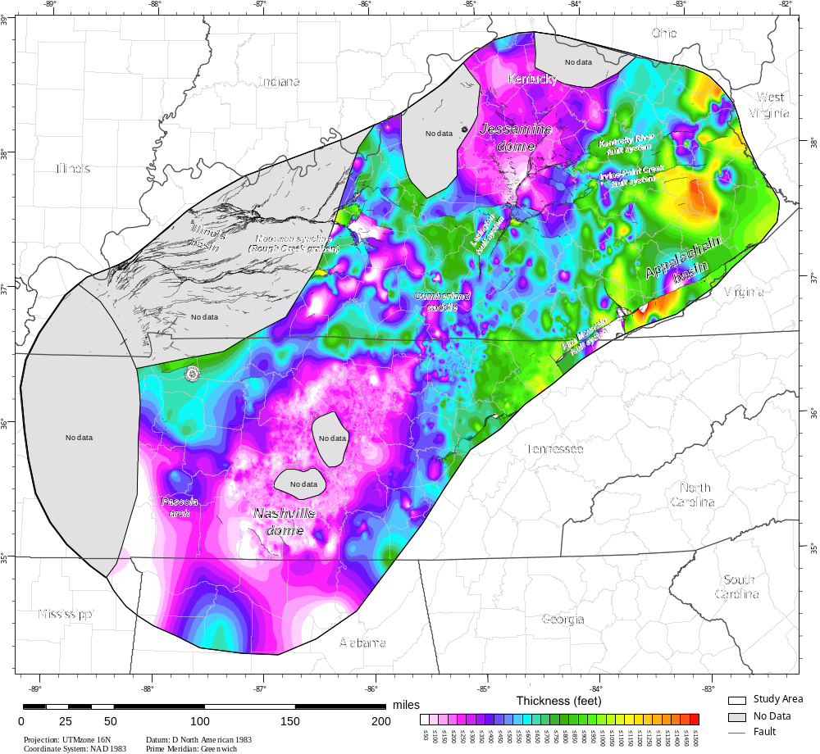

Figure 0-1, Isopach map of the Nashville Group. This isopach map may contain errors despite the fact that the top of the Nashville Group is contoured correctly to the equivalent formations in Kentucky, the data are suspect because of a difference in geophysical well log interpretation between Tennessee and Kentucky. Therefore, this map was excluded from analysis.

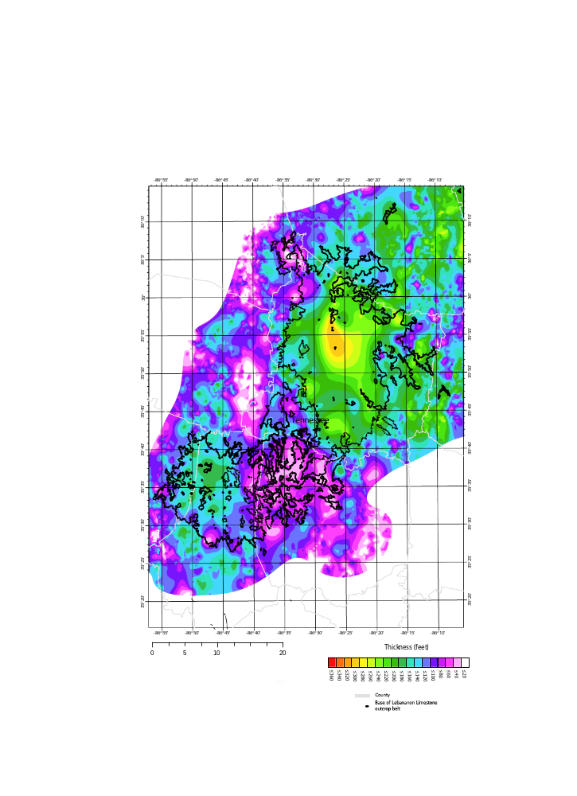
Figure 0-2. Isopach map from the base of the Lebanon Limestone to the base of the stones river group (this includes the Carters Limestone). Note that because these units are on the surface, this isopach map represents the thickness of the Lebanon Limestone or more accurately the distance between the projected spline surface of the base of the Lebanon and the base of the Stones river group. The accuracy of this map is highest closest to the outcrop belt (black dots). In general it appears that the Lebanon thins in a band over the top of the dome. Two potential folds are marked.

VITA
Kenneth Boling received his Bachelor's of Science in geology from Central Connecticut State University (2011) where he studied glacial geomorphology and cretaceous paleosol geochemistry. He went on to receive a Master's of Science in geology from the Baylor University (2013),where he studied the utility of organic and inorganic geochemistry of mudrocks for paleoceanographic reconstructions, with particular interest in the Eagle Ford Formation and the oceanic anoxic event at the Cenomanian/Turonian boundary. He worked in the oil and gas industry for a year before beginning his PhD at the University of Tennessee.

