LOCAL CRAFTMANSHIP OR EXTERNAL INTERVENTION? A COMPOSITIONAL STUDY OF CLAY TOBACCO PIPES IN A YORUBA INTERIOR CA. 1600-1840.

A Thesis Presented for the
Master of Arts
Degree
The University of Tennessee, Knoxville

Farouk A. Ajibade
August 2025

ACKNOWLEDGEMENTS
This research is the culmination of efforts, guidance, support, and input from various institutions and numerous individuals. First and foremost, I owe a deep appreciation to the University of Tennessee Anthropology Graduate Program and its faculty. Their unwavering support and the resources they provided have been instrumental in shaping my academic journey. My profound gratitude goes to my MA thesis committee: Barbara Heath, Akin Ogundiran, and Stephen Collins-Elliott for being exemplary mentors. I would especially like to thank Dr. Heath for all her efforts since I began my MA studies. The inspiration to pursue this research was sparked in her “Archaeology of the African Diaspora” class, which I took during my first semester. I am grateful I enrolled in the class. Outside of the classroom, I have also had the opportunity to do fieldwork here in the United States, thanks to Dr. Heath’s Coan Hall project. This, in addition to my enrollment in her Historic Archaeology Lab class, not only solidified my interest in studying clay pipes but also deepened my appreciation for historical archaeology. Her patience, feedback, and encouragement guided me through the data collection, analysis, and writing stages. Next, I would like to thank Dr. Akin Ogundiran, without whom this project would be impossible. His willingness to share not only the resources for my research but also the connections he facilitated allowed me to undertake this study, and for that, I am truly grateful. I credit him with directing me toward archaeometric analysis. I would also like to thank Dr. Stephen Collins-Elliott for completing my A-Team of advisors. I appreciate his accepting to be a part of my committee, and most importantly, for teaching the “Archaeological Statistics” class this semester. Although I am still learning to be an archaeostatistician, this class has greatly assisted me in addressing my research questions and completing my thesis.
I owe Laure Dussubieux of the Elemental Analysis Facility at the Chicago Field Museum a debt of gratitude for guiding me through archaeometric analyses. I appreciate her patience during the chemical analysis stage of my research and her willingness to meet with me remotely whenever I have questions about my data. I am equally grateful to Dr. Macham Mangut (University of Jos) for his assistance in the chemical analysis stage of my research. I would also like to acknowledge Dr. Matt Greer (Southern Illinois University) for organizing the Archaeometry Workshop in collaboration with the University of Missouri Research Reactor (MURR) in the summer of 2024. This workshop not only provided me with valuable insights but also deepened my interest in archaeometry and enhanced my appreciation for the potential of interdisciplinary studies in archaeology.
I would like to acknowledge the Anthropology Graduate Students for their unwavering support and camaraderie. In particular, I want to express my gratitude to Charles Reece for his friendship and support. I am also indebted to Dr. Elizabeth Adeyemo (University of Notre Dame) for her valuable input during the writing stage of my thesis proposal. I am equally grateful to Dr. Karim Alizadeh (University of Tennessee, Knoxville) and Dr. Tomos Evans (Washington University) for reading drafts of my thesis proposal and providing comments that were instrumental in the defense of my proposal. I especially want to thank my friend from Brazil, Bruna Braz, for doing a mock thesis proposal defense with me. My appreciation also goes to Tom Vallrugo (University of Tennessee) and Laure Dussubieux for reviewing my thesis drafts and offering thoughtful comments. Without a doubt, all of these efforts and feedback contributed to bringing this project through to completion.
Lastly, I want to express my gratitude to the Nigerian Student Association (NSA_UTK) for their unwavering support, which has truly made Knoxville feel like a home away from home. To my family – my parents and siblings (Kafayat, Naimat, Yusuf, Abdullah), your prayers and constant calls have been a source of strength throughout my MA journey. I cannot thank you enough. To my graduate school colleagues, Agezeh Ovie (Purdue University), Oyewole Ibukunoluwa (Arizona State University), Olatunji Babatunde (University of Tennessee, Knoxville), Salau Abdullah (University of Tennessee) and Yusuff Asiat (Northeastern University), your support has been invaluable. And to my dearest Olayimika, I appreciate everything you do for me. Last but not least, I extend my thanks to the Harveys for their support. I am grateful that our paths crossed.

ABSTRACT
My research examines clay tobacco pipes from Ede-Ile, a historic settlement whose occupation spanned the seventeenth to nineteenth centuries. Historically, Ede-Ile was a colony of the Oyo Empire. Archaeological investigations into the material life and domestic economy of Ede-Ile indicate that the colony transformed into a thriving and self-sustaining town, partly due to craft specialization and its entanglement with the Atlantic trade. Tobacco consumption, an Atlantic import, constitutes an essential facet of the quotidian life of the Ede-Ile population, as evidenced by the presence of clay smoking pipes. Descriptive analysis revealed that Ede-Ile smoking pipes resemble those from Oyo-Ile, the capital of the Oyo Empire, and a contemporaneous neighboring Yoruba site, Osogbo. However, it is unclear whether tobacco pipes were part of the specialized craft production activities at Ede-Ile. I combine the descriptive data with compositional analyses, employing Portable X-ray Fluorescence (pXRF) and Laser Ablation-Inductively Coupled-Mass Spectrometry (LA-ICP-MS) to understand the variations in the chemical compositions of clay pipes from Ede-Ile, Oyo-Ile, and Osogbo. The chemical data indicate that pipes were transported across the three sites from the seventeenth to the nineteenth centuries, reinforcing the complex cultural interactions and developments ongoing in Yorubaland during the Atlantic Age.

TABLE OF CONTENTS
CHAPTER ONE 1
Background of the Study 1
Research Questions 3
Geography, History, and Archaeology of Study Area 5
Oyo-Ile 5
Ede-Ile 8
Early Osogbo 13
Significance of the Study 16
CHAPTER TWO 18
An Overview of the History of Tobacco in Atlantic West Africa 18
The Technology of Smoking 21
Archaeology of Smoking Pipes in West Africa 24
Theoretical Framework 35
CHAPTER THREE 42
Materials 42
Methods 42
Chemical Analysis 44
Methods of Elemental Data Acquisition 47
pXRF 47
LA-ICP-MS 49
Statistical Analysis 53
CHAPTER FOUR 55
Descriptive Analysis 55
Chemical Analysis 63
LA-ICP-MS Statistical Analysis 63
PXRF Paste Analysis 76
pXRF Analysis of Pipe Pigment 82
Discussion 82
CHAPTER FIVE 93
Recommendations 95
APPENDIX I: LA-ICP-MS Data 108
APPENDIX II: pXRF Paste Data 116
APPENDIX III: Summary of Pipe Attributes 123
VITA 128

LIST OF TABLES
Table 4.1: Distribution of Pipe Fragments by Site 55
Table 4.2: Decorative Techniques on Pipe Stem Fragments. 57
Table 4.3: Base Forms by Site. 61
Table 4.4: Decorative Techniques on Base Fragments by Site 61
Table 4.5: Perforation Types on Base Fragments by Site. 61
Table 4.6: Near Complete Pipe Fragments by Site 66
Table 4.7: Table showing misclassified observations in the LA-ICP-MS data. 74
Table 4.8: Table showing cluster membership with 84% Accuracy. 75
Table 4.9: Table showing pipes arranged into predicted groups. 75
Table 4.10: Table showing misclassified observations in the pXRF paste data. 80
Table 4.11: Table showing cluster membership of pXRF paste data with 89% Accuracy. 81
Table 4.12: Table showing pipes arranged according to the predicted groups 81
Table 6.1: Table showing LA-ICP-MS pipe samples 108
Table 6.2: Table showing pXRF pipe paste samples 116
Table 6.3: Table showing pipe samples and context 123

LIST OF FIGURES
Figure 1.1: Map showing Oyo-Ile at its peak (Ogundiran et al. 2021) 7
Figure 1.2: Map showing the Upper Osun Region (shaded area) (Ogundiran 2014). 9
Figure 1.3: Map showing Ede-Ile (Ogundiran and Agbaje-Williams 2017). 12
Figure 2.1: Profiles of round-base pipes (Ozanne 1962) 26
Figure 2.2: Profiles of flat-based pipes (Ozanne 1962). 27
Figure 2.3: Profiles of square-shaped and cup-shaped pipes (Ozanne 1962) 27
Figure 2.4: Four-sided stem (McIntosh et al., 2003) 30
Figure 2.5: Rounded Bowls (McIntosh et al., 2003) 30
Figure 2.6: Single angle base (left) and double angle base (right) (McIntosh et al., 2003). 31
Figure 2.7: V-shaped stem designs (Gijanto 2017). 33
Figure 3.1: LED Stand 45
Figure 3.2: pXRF analyzer placed in a cubicle 48
Figure 3.3: pXRF CPU 48
Figure 3.4: ESL NWR213 Laser Ablation System 50
Figure 3.5: Pipe samples arranged in the laser cell. 51
Figure 3.6: The laser cell being inserted into the laser chamber. 51
Figure 3.7: Ablation being performed using the laser ablation set up 51
Figure 3.8: Ablation spots 52
Figure 4.1: bevel-shaped stem with rows of carved roulette decoration 57
Figure 4.2: Round red-slipped pipe stem designed with horizontal incisions. 58
Figure 4.3: Pedestal base with rouletted impression 59
Figure 4.4: dark red slipped pedestal with double rows of vertical incisions 59
Figure 4.5: Ball clay pipe bowl fragment with basket and rope motif. 62
Figure 4.6: Bowl fragment with V-shaped incisions. 64
Figure 4.7: Black-slipped bowl fragment with ram-head and round motifs. 64
Figure 4.8: European-made pipe bowl/base exterior. 65
Figure 4.9: European-made pipe bowl/base interior. 65
Figure 4.10: Red-slipped Bowl/Base fragment with owl-like impression. 66
Figure 4.11: Near complete pipe with a combination of incised, dot punctate designs 67
Figure 4.12: Slashed basal perforation 67
Figure 4.13: summary of PCs 69
Figure 4.14: Scree plot showing the percentage of variance preserved in the LA-ICP-MS data. 69
Figure 4.15: PCA biplot displaying observations and variables in the LA-ICP-MS data. 70
Figure 4.16: Dendrogram showing clusters of observations in the LA-ICP-MS data. 72
Figure 4.17: Ggplot of cluster assignments in the LA-ICP-MS data. 73
Figure 4.18: LDA plot of the LA-ICP-MS data showing well-separated clusters. 74
Figure 4.19: Scree plot showing the percentage of variance preserved in the pXRF paste data. 77
Figure 4.20: PCA biplot displaying observations and variables in the pXRF paste data. 78
Figure 4.21: Dendrogram showing clusters of observations in the pXRF paste data. 79
Figure 4.22: LDA plot of the pXRF paste data showing well-separated clusters. 80
Figure 4.23: PCA biplot displaying observations and variables in the pXRF pigment data. 83
Figure 4.24: Image showing the best number of clusters in the pXRF pigment data. 84
Figure 4.25: Round stem with four horizontal incisions on either sides. 88

CHAPTER ONE
INTRODUCTION

Background of the Study
Understanding the quotidian lives of people in the past and gaining valuable insights into their socio-economic and cultural practices have been made possible through the study of artifacts and other material vestiges from the past. This research focuses on a unique class of artifacts – clay tobacco pipes from Ede-Ile, a settlement in the Yoruba interior, whose occupation spanned the seventeenth to nineteenth centuries C.E. This period was characterized by the significant transformation of settlements in the forest zones of West Africa that coincided with the transatlantic slave trade.
Tobacco pipes are ubiquitous in historic sites in West Africa and have been used by archaeologists and historians to address a range of questions within the context of the Atlantic trade (McIntosh et al. 2003). These questions relate to establishing chronologies and tracing the diffusion and propagation of the habit of smoking in the African subregion ( Shaw 1960; Ozanne 1962, 1969). In addition, the study of pipes has offered valuable insights into the socio-cultural and religious lives of Atlantic West Africa, including the multiple uses of pipes based on gender, ethnicity, and social status (Laufer et al. 1930; DeCorse 2001a; McIntosh et al. 2003; Vivian 2005; Duco 2006; Handler 2008). Most importantly, scholars have examined smoking pipes, alongside other kinds of artifacts, to understand how West African societies, especially those in the interior, responded to the Atlantic trade (DeCorse 2001b; Ogundiran 2007; Ogundiran and Falola 2007; Stahl 2007; DeCorse 2013).
Although significant transformations of coastal West African societies have, in particular, been the focus of earlier investigations (DeCorse 2001a; DeCorse 2001b; Kelly 2001), subsequent studies have proven that societies in the interior were not isolated, as they experienced significant political, economic, and social transformations due to their integration into the transatlantic trade (Stahl 2007; Ogundiran 2009; Usman 2016). In fact, these societies participated actively in the wider network of trade and exchange ushered in by the Atlantic trade. Tobacco, a non-endemic plant introduced into West Africa via the West African coast, grew to be a popular commodity, and the apparatuses of its consumption—clay pipes—emerged, symbolizing local and global entanglements. West African-produced pipes developed, reflecting local craftsmanship. Artisans crafted these local pipes to have intricate decorative motifs in varying styles. These characteristics indicate that local pipes not only served functional purposes but also had embedded unique symbolic meanings.
Investigations at Ede-Ile (Ogundiran 2009, 2012; Ogundiran and Agbaje-Williams 2017) show a limited presence of exotic (European) trade items compared to seventeenth and eighteenth-century coastal West African towns. This lack does not connote that Ede-Ile, a settlement in the forest zone, was peripheral to the Atlantic Revolution. The town was settled not just to serve the political expansion program initiated by the Oyo Empire but also to link the imperial power to commercial activities in the coastal areas. As explained by Ogundiran (2012), Ede-Ile was transformed by the activities of the Atlantic economy. Demands for locally made goods from Yorubaland spiraled. People acquired new tastes, including tastes for tobacco, and adapted new goods, such as clay pipes and lamps, to local needs. All of these changes indicate how one society in the interior of West Africa uniquely responded to the Atlantic revolution and, in the process, transformed the everyday lives of residents through craft specializations.
It remains to be addressed whether tobacco pipes were a part of the specialized production activities that transformed Ede-Ile in the context of the Atlantic trade. This study intends to combine compositional with attribute analyses to provide a more comprehensive understanding of the origins of these artifacts while offering a unique insight into complex cultural interactions and developments in the Yoruba hinterland during the Atlantic Age. The findings of this study could significantly contribute to our understanding of smoking culture. This study will shed light on the spread and movement of smoking pipes in Yorubaland while providing unique insights into the socio-economic and cultural practices of the people during this period.

Research Questions
Archaeologists working at Ede-Ile have focused on how societies in the interior were transformed by the events and experience of the Atlantic trade. In addition, the site has proven significant for investigating the development of the Oyo Empire. The emphasis has also been on the material culture that characterized the everyday lives of the past Ede-Ile population. Within these contexts, my research focuses on one type of material evidence—clay tobacco pipes.
Clay tobacco pipes from Ede-Ile, based on their physical attributes, indicate they were African-produced and not European imports. However, it is unknown whether the pipes were a part of the local craftsmanship that was going on in the town. According to Ogundiran (2009; 2012), the pottery wares at Ede-Ile are similar to those found at Old Oyo. Oral and ethnographic data collected by him, combined with the analysis of the numerous potsherds collected through excavation, suggest that the knowledge of pottery production must have been transferred from Oyo into Ede-Ile during the colonization process. Did a similar process of knowledge transfer occur with tobacco pipes? Were they a localized invention, or did the population depend on Oyo-Ile or elsewhere for their supply of tobacco pipes? My thesis will attempt to address this question first with a descriptive analysis of pipe attributes found at the site. The data will be compared with the data for tobacco pipes in Oyo-Ile, the capital of the Oyo Empire, and Osogbo, a settlement only 18km from Ede-Ile. The results of these comparisons will provide new insights into the dynamics of craft specialization, knowledge transfer, and trade in the Yoruba interior during the Atlantic Age.
The descriptive analysis will then be combined with chemical analysis. Visual description alone cannot help in accurately establishing the variations in pipes. By examining the clay fabric through compositional analysis, I will determine whether similar or different clay sources were used in the production of pipes across the three sites. This will be a pioneering effort in Nigerian archaeology concerning the study of tobacco pipes. The scientific analytical tools that I will employ include portable X-ray Fluorescence (pXRF) and laser ablation inductively coupled plasma mass spectrometry (LA-ICP-MS) to evaluate the chemical composition of the pipes from Ede-Ile in comparison to those from Oyo-Ile and Osogbo. Therefore, the next question is, what are the variations/similarities in the elemental compositions of pipes from Ede-Ile, Osogbo, and Oyo? Understanding the chemical compositions and patterning of pipes from these sites will lay the groundwork for determining their provenance, which can, in future studies, be aided by such mineralogical techniques as petrography.
Although LA-ICP-MS (Dussubieux 2023) is regarded as a much better method for understanding bulk compositions, pXRF, is cost-effective, convenient, and fast. To get the best results, these tools will be combined, and the results will be compared to see if similar conclusions can be drawn. The next question is, how comparable is pXRF to LA-ICP-MS? Given that LA-ICP-MS is expensive and not obtainable in West Africa, and since pXRF is cheaper and more convenient to use, are the results of pXRF analysis as good as those of LA-ICP-MS to answer the questions that I am proposing?
Answering the above questions will help us better understand the production, distribution, and consumption choices for tobacco pipes and smoking culture in Yorubaland and, by extension, West Africa.

Geography, History, and Archaeology of Study Area

Oyo-Ile
Oyo-Ile, also known as Old Oyo, was the capital of the Oyo Empire from ca.1570 to 1836 C.E. The ancient city, located near the Niger River, was situated in the savanna, an ecological zone that is characterized by grasses and scattered trees (Law 1977; Agbaje-Williams 1983; Usman and Falola 2019). Various tree species, such as African Rosewood (Pterocarpus erinaceus) and Shea tree (Viterllaria paradoxa), dominated the landscape of Old Oyo, with the African Baobab (Adansonia digitata) being the most predominant (Akintoye 2010; Ogundiran et al., 2021).
Oyo-Ile came into existence between 1570 and 1600 (Ogundiran 2020) when Oyo leaders from Ighoho founded the new city in an open grassland set on a gently undulating lowland that was marked by low hills and rock outcrops. The area was also well-watered, with streams flowing southwards and northwards into River Osun and River Niger respectively and was characterized by fertile soils. These factors meant that Oyo-Ile was situated in an area that favored agriculture, leading to conclusions by historians that successful farming must have contributed to the city being the most densely populated Yoruba settlement in the late fifteenth century (Law 1977; Agiri 1975; Ogunnaike 2022)
Oyo-Ile’s geographical location and rich agricultural lands attracted enemies, particularly neighbouring settlements to the north, such as the Nupe. This adversity would only strengthen Oyo-Ile. Oyo-Ile leaders in the sixteenth century established alliances with non-Yoruba-speaking groups like the Ibariba (Ogundiran 2020), while also establishing a standing army – an army that would play a crucial role in the kingdom’s subsequent territorial expansion missions (Akintoye 2010). In addition to the army, the rocky hills provided natural defenses. To further bolster their natural defense, the authorities of Oyo-Ile authorized and embarked on the construction of city walls, making the city impregnable to attacks (Soper and Darling 1980; Akintoye 2010).
With the arrival of the European traders in the Bight of Benin in the fifteenth century, the transatlantic trade developed. The Benin people, by virtue of making early contact with the European traders, not only established trade with them but were also able to establish a monopoly on European goods. This monopoly allowed them to control trade in eastern Yorubaland (Usman and Falola 2019). Leaders of Oyo-Ile plugged Oyo into the Atlantic trade by establishing colonies and military outposts in the frontier region, such as Ede-Ile (Ogundiran 2020). By establishing this settlement, Oyo leaders were able to control trade routes while also providing safe passage for Oyo traders. Similarly, Oyo secured the Yewa-Ogun frontier, having recognized it as a critical route to the coastal markets. Trade thus became one of the motivations for the territorial expansion and political consolidation efforts initiated by Oyo-Ile around the last quarter of the sixteenth century (Figure 1.1).
With the imperialistic foundations already laid in the second quarter of the sixteenth century, Oyo became the second Yoruba empire (after Ile-Ife) in the seventeenth century, reaching its zenith in the eighteenth century (Law 1977; Ogundiran 2012). During these periods, Oyo’s presence and imperialistic reach stretched southwards beyond its core in northwest Yorubaland into regions far beyond its nucleus (Ogundiran and Saunders 2011; Ogundiran 2012). Early scholars of the history of the Oyo Empire noted that the rise of Oyo to an imperialistic state could also be attributed to its involvement in the Atlantic trade. Oyo flourished during the height of the Atlantic Age in the seventeenth and eighteenth centuries. For this reason, it was branded an Atlantic Age empire (Law 1977). Oyo’s imperialistic dominance began to wane in the early nineteenth century due to revolts from its provinces. This led to the gradual depopulation of the city beginning in 1817 (Cole 2004; Ogunnaike 2022). Following a final defeat to Ilorin from 1836 to 1837, Oyo-Ile was abandoned.
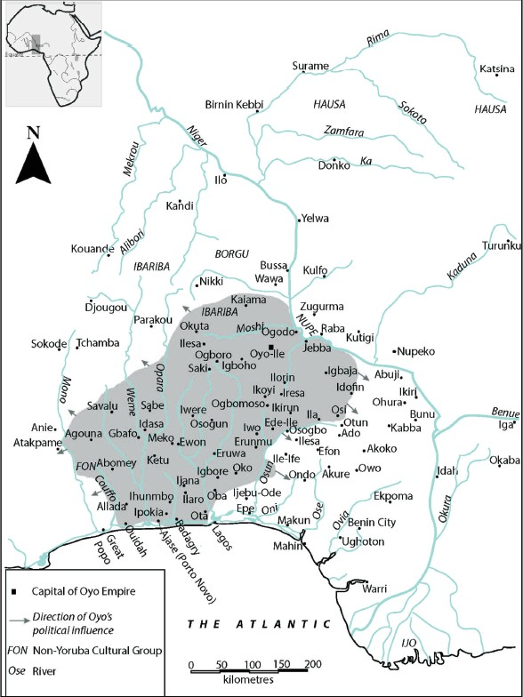

Figure 1.1: Map showing Oyo-Ile at its peak (Ogundiran et al. 2021)

Due to the Oyo Empire’s historical significance, its political hub, Oyo-Ile, has been the focus of archaeological investigations for decades (Willett 1960; Soper and Darling 1980; Agbaje-Williams 1983). For instance, in 1978, Agbaje-Williams conducted an archaeological survey of the city with a view to determining the spatial distribution of surface materials and their relationship to the natural environment. This survey led to the identification of the residential area, city walls, composed mainly of compound-courtyard structures, refuse mounds, a vast palace complex, and grinding hollows on rock outcrops (Ogundiran and Agbaje-Williams 2017:70). Most importantly, the survey provided information about the spatial density of Oyo-Ile’s occupation and urban configuration. In this regard, it was estimated that at the apogee of the Oyo Empire in the eighteenth century, the maximum population of the imperial capital was estimated to be ca. 100,000 people.

Ede-Ile
The processes that facilitated the transformation of Oyo into an imperialistic power started with expansionist missions (by Oyo political authority) southwards into the interior of Yorubaland from the last quarter of the sixteenth to the first quarter of the seventeenth centuries (Ogundiran and Agbaje-Williams 2017). Ogundiran (2012:224) highlighted that the expansion processes followed five patterns/strategies: conquest and formation of client states and tributary states, conquest and formation of tributary states, transformation of independent polities into junior gift-giving partners, consolidation of independent polities in the heartland, and the formation of colonies in frontier zones. Of the five strategies, colonization is the focus here as it pertains to the formation of Ede-Ile.
Located in the Upper Osun region of central Yorubaland (Figure 1.2) and specifically in the upper reaches of the rainforest ecological zone, Ede-Ile’s very existence is tied to the early phase of the Oyo Empire (Ogundiran 2012). Specifically, the town is described as a product of the Oyo Empire colonization project (Ogundiran 2009; Usman 2012). According
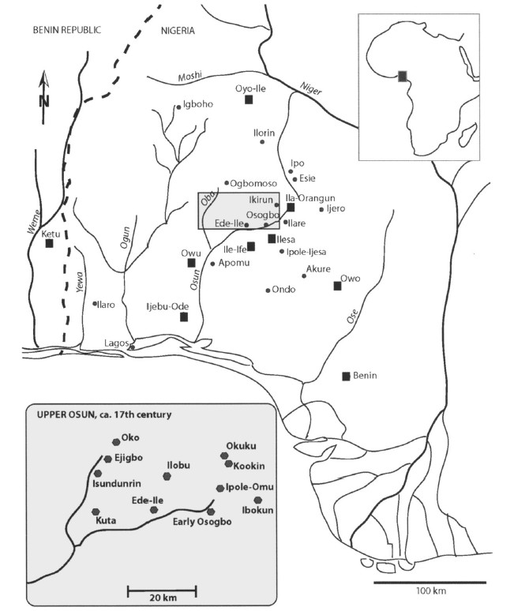
Figure 1.2: Map showing the Upper Osun Region (shaded area) (Ogundiran 2014).

to oral tradition, Ede-Ile is viewed as the settlement that launched Oyo’s march towards an imperial presence south of the River Niger. As Ogundiran (2009, 2012) argues, colonization was the most viable political expansion strategy that provided an avenue for the authorities at Oyo-Ile to access the trade routes that connected the coastal areas with the Yoruba mainland during the Atlantic Age. With this expansion, Oyo political authorities embarked on a mission of gradually moving elements of the Oyo population to the frontier zones in the early decades of the seventeenth century.
Although historians such as Oyeweso (2016) argued that Ede-Ile may have been established in the sixteenth century, the colonization process initiated by the Oyo ruling class in the early years of the seventeenth century places the foundation of Ede at a much later date (Ogundiran 2009; Ogundiran and Agbaje-Williams 2017). Ede-Ile was strategically located,
such that it linked Oyo-Ile with the coast while also serving as a base from which the Oyo ruling class exerted political and economic influence in the heartland of Yorubaland. Ede-Ile served the aforementioned purposes until its abandonment about 1840 (Ogundiran and Saunders 2011; Ogundiran 2012). The abandonment of Ede-Ile can be linked to the fall of the Oyo Empire in the 1830s, which dealt Ede-Ile a huge blow. Upon the settlement’s abandonment, the population moved a few kilometers southwards to present-day Ede town in Osun State, southwest Nigeria.
Archaeological investigation in Ede-Ile began in 2004 (Ogundiran 2009; Ogundiran and Agbaje-Williams 2017). Akin Ogundiran and his team employed oral history to locate the erstwhile settlement. The goal of the investigation of Ede-Ile was to understand the socio-political and economic processes that shaped the Oyo Empire (Ogundiran and Agbaje-Williams 2017) and particularly to evaluate how the material life and domestic economy of the Yoruba interior were shaped in response to the commercial revolution of the Atlantic Age (Ogundiran 2009). This makes sense. As Usman (2000; 2004; 2012) notes, rather than focusing solely on the imperial metropole, there is much to learn in the frontier zones about the events that led to the emergence, blossoming, and possibly the decline of such empires.
The investigation began with an archaeological survey. How was the settlement related to the once-great Yoruba empire? Ogundiran, alongside his informants, identified, collected, and analyzed ceramics that on the basis of form and surface pattern, mirrored those produced in Old Oyo. The ceramics that were collected exhibit diagnostic surface patterns and decorations peculiar to Oyo, such as burnishing, brush marking, dot punctate, shell-edge, and scallop impressions, roulette, and incised geometric symbols consisting of cross, triangular, and square motifs (Agbaje-Williams 1995; Ogundiran 2012; Ogiogwa 2017; Usman and Falola 2019). Likewise, distinctive bowl types (primarily serving and cooking) and lid forms at Ede-Ile also bear the diagnostic characteristics of the Oyo-Ile ceramic complex.
Aside from pottery, the presence of African baobab trees in significant numbers further helped in asserting that the site was a former Oyo colony. The African baobab is peculiar to the savanna ecotone. Identifying a concentration of over twenty such trees at Ede-Ile, a rainforest settlement, suggests a deliberate action of tree planting by the Ede-Ile population as a way of recreating the Oyo landscape in the newly established colony. This act of tree planting could also be attributed to the many uses of the baobab. Ethnobotanical studies of the tree suggest that the fiber from the bark was used to make rope, baskets, and other goods. The leaves, which provide edible vegetables, also serve medicinal purposes in the treatment of various ailments (Blench and Dendo 2007; Blench 2018). Although, baobab trees are known to be capable of living several hundreds to thousands of years, like many large tropical trees, they have no reliable tree rings, and size does not actually indicate age (Blench and Dendo 2007:1). Given the number of and tremendous size of the baobab trees at Ede-Ile, however, Ogundiran concluded that they may be as old as the site.
From 2004 to 2007, a total area of 79 m$²$, consisting of 27 excavation units, with depths ranging from 60 cm in house deposits to 290 cm in refuse mounds, was excavated. This work began with a survey that facilitated the identification and subsequent mapping of wall remnants enclosing the settlement. What followed was a systematic mapping of the density of artifact distribution on the surface within the perimeter walls (Ogundiran and Agbaje-Williams 2017:73). The entire site was then divided into 40 m$²$ grids (Figure 1.3), with each grid individually investigated for surface archaeological materials. Activity areas at the site were identified on the basis of surface ceramic scatters and features in each square grid. These areas, referred to as the core of the settlement, were identified as Loci A-G by the principal investigator. Locus A is identified as the market area. On the basis of
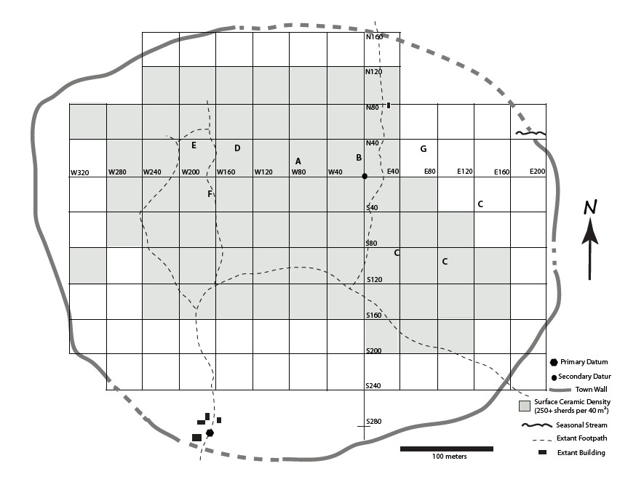
Figure 1.3: Map showing Ede-Ile (Ogundiran and Agbaje-Williams 2017).

refuse and residential mounds, Locus B is identified as the area where the imperial governor, his family, and attendants resided. In this locus, excavations provided such evidence as horse remains and tobacco pipes. Locus C is identified as a pottery making area due to observable ash deposit in the area. Locus F, on the basis of iron slag concentration, was identified as an area where iron manufacturing was taking place. Locus E was identified as a residential iron workshop. Finds such as a blacksmithing furnace and pottery indicate that the area was a commercial area (Ogundiran 2009; Ogundiran and Agbaje-Williams, 2017).
These activity areas yielded important material evidence. Artifacts and faunal remains that were recovered, such as pottery, clay lamps, horse remains, spindle whorls, and iron artifacts (Ogundiran 2009, 2012), suggest that Ede-Ile was peopled by immigrants of diverse socioeconomic statuses, such as blacksmiths, potters, traders, and horse handlers. Imported materials such as tobacco pipes, glass beads, and cowry shells were also recovered. The presence of these imported goods indicates and confirms that Ede-Ile was deeply entangled in the Atlantic trade. The dating of the excavation units relied on a combination of methods. Charcoal samples and bone collagen assays were submitted for radiocarbon dating, which returned multiple probability age ranges. However, with the presence of imported goods with known periods of circulation, in combination with historical and traditional oral accounts, the occupation of Ede-Ile was placed firmly within the seventeenth and eighteenth centuries (Ogundiran 2012:230). Combined, the material remains (both imported and local), attest to the fact that despite being a colony of the Oyo Empire, the town was self-sustaining through craft specialization, production, and distribution.

Early Osogbo
Early Osogbo, the ancestral site of modern-day Osogbo, is located north of the Osun Grove, a World Heritage site. The settlement was situated in the Upper Osun area of central Yorubaland and in close proximity to the Osun River, which served as a reliable water source for farming, drinking, and other domestic uses. According to oral accounts, the settlement was established by migrant hunters. The motivation behind the migration and subsequent occupation of Early Osogbo is tied to the episodes of drought that affected the Yoruba mainland. This precarious condition motivated migration towards the Osun River, where prospects were more favorable for agriculture and dependable water sources were located. Archaeology of the Upper Osun region places these events chronologically from the late sixteenth to the early seventeenth centuries (Ogundiran 2014a; 2014b). The settlement, over time, grew in size to become a diverse community of hunters, farmers, traders, and artisans. This growth was attributed to two factors. First, the hegemonic political ambitions of powerful polities such as Old Oyo, Ilesa, and Owu in the Upper Osun area from 1575 to 1700 facilitated the migration of people to the banks of River Osun. Second, the Atlantic trade facilitated the influx of traders and craft specialists, such that the Upper Osun became a conduit that linked the people on the coast with those in the forest-savanna ecotone (Akintoye 2010; Ogundiran 2014a:19). Ogundiran (2014a) concludes that the occupation of Early Osogbo was not mainly the result of a single wave of migration; rather, the settlement was populated by people from different parts of the Yoruba mainland with different motivations and goals.
Archaeological investigations into Early Osogbo have principally been conducted by Akinwumi Ogundiran. Work started with surveys in 2003. Based on the distribution and density of potsherds on the surface, the settlement was mapped and was estimated to be about 18 hectares at its peak (Ogundiran 2014a:7). Archaeological excavations followed, with thirteen units opened. The excavation efforts focused on a refuse mound in the southern part of the settlement, Mound A, which ranged from 60 cm to 100 cm in depth. Three depositional sequences were identified from this mound. The earliest deposit was dated to the late sixteenth and early seventeenth centuries, further backing the oral accounts regarding the occupation of the site. The second and third deposits were contemporaneous and date from the seventeenth to the eighteenth centuries. Other excavated areas within the settlement were test units with shallow depths ranging from 20 cm to 30 cm.
These excavations yielded animal remains, pottery, cowry shells, clay oil lamps, and glass beads, among other artifacts, all pointing to the diverse socioeconomic activities Osogbo settlers engaged in. Based on morphology and surface patterns, the ceramic assemblage reflects three ceramic complexes: Osun, Oyo-Ile, and Ife, with Osun being the most dominant. The presence of Oyo and Ife ceramic complexes in the Upper Osun area thus reflects the regional exchange networks that Osogbo settlers were a part of.
Glass bead manufacture can be inferred on the basis of glass beads and fragments of glass bead crucibles. The presence of these materials in archaeological context suggests that highly sophisticated craft production, that is, glass manufacture was ongoing at Osogbo. Also, at Osogbo, a dug-out pit containing pegmatite was found in the southern edge of the settlement. Pegmatite is an important ingredient in glass bead production. Its presence, alongside the presence of beads and fragments of glass bead crucibles, would suggest that glass beads were manufactured locally in Osogbo. Chemical analysis of the glass beads using LA-ICP-MS further backed up the claim for local production. Also, African-produced tobacco pipes and clay oil lamps, both adapted to mimic imported smoking pipes and European candle stands, respectively, are indicators of Osogbo settlers’ engagement in long-distance exchanges. Imports such as cowry shells found in abundance in Osogbo confirm that the settlers were deeply integrated into the Atlantic trade, as cowries were Indo-Pacific shells transported by European traders to the West African coast during the era of the transatlantic trade (Haour and Christie 2019). According to the principal investigator, these lines of evidence all confirmed the diverse socioeconomic engagement, craftsmanship, consumption, exchange of ideas, and cultural transformations significant with Early Osogbo and, by extension, central Yorubaland.

Significance of the Study
What makes this study important? The significance of this study lies in the methodological approach used, which combines descriptive with chemical analysis. As much as descriptive analysis is important to the study of artifacts, there is more that can be understood about artifacts beyond visual observation. The application of chemical analysis is not new to the Upper Osun region. At Ede-Ile, ceramics and clay oil lamps were subjected to instrumental neutron activation analysis (INAA). The results from this analysis confirm that while a few of these artifacts came to Ede-Ile through trade, most of them were locally produced, underscoring the creativity as well as the social and economic organization of the population during the time of occupation. Similarly, glass beads recovered from Early Osogbo after being analyzed using LA-ICP-MS also helped in understanding that glass bead makers were part of the population that settled in the area. Against this backdrop, the motivation behind the study of the elemental compositions of tobacco pipes becomes justified. Beyond visual characterization, this type of analysis will potentially enrich our understanding of pipe-smoking tradition, exchange, craft specialization, and even internal migration within Yorubaland. The application of LA-ICP-MS in this study is the first of its kind in West Africa. As such, this study will be a contribution to the archaeometry of pipes in West Africa, as the data will be part of an elemental compositional database that can be used for comparative analysis by researchers interested in the historical period of West Africa.
Furthermore, this study embodies the multidisciplinary nature of archaeology. My study is rooted in archaeometry – the combination of archaeology with chemistry. Another important discipline which my study draws from is statistics. The results from the chemical analysis that was carried out require visualization and interpretation. This is where statistics come in, given that the archaeometric data are multivariate. Therefore, multivariate analytical techniques such as Principal Component Analysis (PCA) and Cluster Analysis are utilized.
Finally, this study contributes to the discourse on empire-frontier entanglement. Already, we know that Ede-Ile was a colony of the Oyo Empire and that the people who settled in Osogbo originated from the Yoruba internal frontiers. Understanding the chemical variations of the tobacco pipes from these sites can further enrich our understanding of how these communities interacted with each other and transformed in response to the Atlantic trade.

CHAPTER TWO

An Overview of the History of Tobacco in Atlantic West Africa
There is a consensus, based on numerous studies (Alpern 1992; Goodman 1993; Carney and Rosomoff 2009; Gallagher 2016), that tobacco cultivation did not start independently in West Africa. Instead, it was introduced alongside other plants courtesy of the transatlantic trade. These studies, among others, have not only attempted to dispel claims for an independent discovery but also answered questions about whence and when tobacco arrived, as well as the agents responsible for its diffusion into the African subregion.
The exploitation of psychoactive plants is not alien to Africa as a whole. Before contact with the Europeans, Africans’ dependency on cannabis was widespread, particularly in the eastern and southern parts of the continent (Laufer 1930; Dunhill 1969; Philips 1983; Duvall 2017). The plant is claimed to be of Asian origin, arriving in East Africa from southern Asia and subsequently being dispersed across sub-Saharan Africa by the 1500s. In North Africa, it is claimed that cannabis arrived via the Mediterranean Sea (Duvall 2019). According to Breen (2022), these statements challenge the assumption that the diffusion of smoking in the early modern period followed a linear pattern, i.e., from the Americas into Africa and Eurasia. At least for cannabis, this is not the case. While the date for the introduction of cannabis to Africa remains contentious, Philips (1983) argued that its arrival and exploitation by Africans predate the introduction of tobacco.
With the focus here being West Africa, there is no factual evidence to suggest that in the African subregion, before European contact, indigenous people were consuming cannabis. However, what is known is that people were reliant on kolanut as a psychoactive drug (Ozanne 1969; Philips 1983), with tobacco serving as a substitute for the former upon its introduction. The datura plant is also reported to have been used among the Kotoko of West Central Africa, perhaps before the introduction of tobacco. According to oral tradition, the use of datura among the Kotoko was gender-specific, as only men reserved the right to use it (Philips 1983). On the other hand, tobacco was used by both men and women. Given the absence of factual evidence, the antiquity of the datura plant remains unknown.
Tobacco is undoubtedly the psychoactive plant that was most widespread across West Africa, courtesy of the region’s Atlantic entanglement (Ogundiran and Falola 2007). Ethnolinguistic, oral, textual, and archaeological evidence all prove this fact. Despite agriculture being an important economic activity of West African settlements for several millennia, according to historians (Alpern 1992; Carney and Rosomoff 2009), numerous plants were imported into the African subregion during the Atlantic age by the Europeans. Primarily based on textual evidence, Alpern (1992) states that the plants mainly came from three regions: the Mediterranean, Asia, and the New World. He revised his 1992 article in 2008, and this time, he compressed the crops that were introduced to West Africa into a table that named the crops and indicated their geographical source, location of sighting, and probable date of introduction while also indicating who reported such introduction. In all, he listed over 86 crops to have been imported into West Africa in the context of the Transatlantic age. The plants were grouped, for example, into cereals, root crops, pulses, oil plants, vegetables, and non-food crops. He included tobacco in the latter category. Citing the Timbuktu chronicle, Tarikh al-Fattash, Alpern placed its arrival in Timbuktu in the late sixteenth century from America. He listed Senegal as another early location where tobacco was reported from 1600 to 1601. In a similar fashion, and based on archaeological evidence, Gallagher (2016) reviewed plants transported from North and South America into sub-Saharan Africa. The dates for the arrival of tobacco into West Africa are the same as Alpern’s.
Alpern (1992) also pointed out that the Europeans initially did not import these crops into West Africa based on trade, nor did they do so out of selflessness. The Portuguese, for instance, upon arriving on the shores of West Africa, needed to feed the men who were to occupy and establish forts in places such as the Gold Coast and São Tomé. Likewise, when humans became trade commodities, Portuguese traders needed to feed enslaved people brought to work on island plantations. In addition, they needed to feed enslaved people bound for America. Combined, all of these demands facilitated the introduction of Eurasian and American crops to West Africa (Carney and Rosomoff 2009).
Tobacco belongs to the genus of a plant called Nicotiana, with several species grown worldwide (Orser 2023). Two tobacco varieties, Nicotiana tabacum and Nicotiana rustica, dominated the narratives in West Africa during the Atlantic Age. The former was originally planted in Central and South America, and the latter in North America (Fox 2015; Clist 2018). It is hard to tell which of the species was introduced first, but records show that both were introduced from the late sixteenth to the early seventeenth centuries (Gallagher 2016). These tobacco species are unique, each with peculiar features. What distinguishes the former from the latter, however, is that N. tabacum is pink-flowered and mild, while N. rustica is yellow-flowered with a higher nicotine content (Fox 2015).
Two locations (Timbuktu, in Mali, and Senegal) were listed as the centers of the introduction of tobacco into West Africa. Identifying the agents responsible for this introduction has generated an interesting debate, with arguments for French, English, and Portuguese connections. Ozanne (1969) proposed that the Portuguese were responsible for this development. This assumption has, however, been challenged. Shaw (1960), in his study of Dawu smoking pipes from Ghana, in which he credited the French for this development. His argument was that the smoking pipes recovered from Ghana resemble short clay pipes peculiar to the southeastern United States, which the French occupied around the sixteenth century. Due to insufficient evidence, Shaw was not convinced and, instead, credited John Hawkins, an English privateer, and his men with bringing tobacco to West Africa.
Historically, the proliferation of tobacco in West Africa dates to the seventeenth century. Around this period, the cultivation of tobacco was noticed in Senegal and on the Islands of São Tomé and Príncipe (Ogundiran and Falola 2007; Clist 2018). According to Clist (2018), women and men from Liberia and Sierra Leone grew tobacco everywhere between their houses. Knight (2010) also notes that in present-day southeastern Nigeria, the Igbo people grew significant crops of tobacco, as did residents of the Senegambia town of Nomou. Of the tobacco species introduced to West Africa, N. rustica was widely grown (Alpern 1995), but N. tabacum appealed more to the taste of West Africans (Ogundiran 2009). Ogundiran is of the opinion that in the Yoruba hinterlands and the Bight of Benin, imported Brazilian tobacco, known locally as taba, was in great demand. Clist (2018) reports that taba was what was obtainable in the Gambia and the Kongo kingdom of West Central Africa, where women and men consumed the Brazilian product. Similarly, on the Gold Coast, Brazilian tobacco soon began to rival cowries as the most sought-after import. The tobacco leaves were treated with molasses to keep them from rotting, drying up, or excessive molding (Alpern 1995:26; Ogundiran 2020:260). This treatment led to Brazilian tobacco being preferred, as it was richer in quality than the other species.

The Technology of Smoking
With this summary of the introduction and proliferation of tobacco in West Africa during the Atlantic Age, what is left to address is the manner in which this plant was exploited. Upon the introduction of tobacco into the African subregion, the modes of consumption followed three patterns: chewing, snuffing, and smoking (Hambly 1930; Laufer 1930; Dunhill 1969). The most widespread mode of consumption was smoking with pipes. The constant supply of European-made clay pipes from the late sixteenth and early seventeenth centuries to coastal West African settlements (DeCorse 2001a; DeCorse 2018) and the creative ingenuity of Africans who developed their own tobacco pipes, made smoking possible. While textual and oral evidence point to the diffusion and spread of tobacco smoking in West Africa, clay tobacco pipes are the material evidence that has afforded archaeologists a better understanding of this alien development within the context of the Transatlantic trade.
Smoking pipes, usually made of clay are durable and can last a long time buried in the ground. Tobacco pipes are a unique class of artifacts found in various archaeological contexts. According to Higgins (1995), their frequent archaeological presence is due to their fragile nature. Pipes cannot be recycled, and as a result, they were used and discarded within a very short time. Philips (1983) also notes that the functional life of clay pipes is short. Regardless, once clay pipes have been discarded, they survive and preserve well under various conditions. Higgins (1995) reports that pipes in the UK are common and are usually found in significant numbers in post-medieval sites and almost every post-medieval deposit on a site. This ubiquity of clay pipes is also true in North America (Rafferty and Mann 2004; Fox 2015). In West Africa, this is not the case. As Wesler (1998) notes, imported and local pipes are found in significant numbers in the West African coastal sites due to the direct contact the inhabitants had with the Europeans. In the hinterlands, the reverse is the case, as the rate of occurrence is not as high as on the coast. The relative scarcity of pipes in the West African interior is, however, not an indication that tobacco smoking was not taking place (Philips 1983). After all, tobacco could be chewed, snuffed, or rolled and smoked as cigars (or later as cigarettes).
The significance of pipes is multifarious. They are vital for archaeological dating, affording an archaeologist with an indication of the time that they were manufactured. This is possible particularly if a typology of sequential styles can be formulated (Philips 1983). In West Africa, efforts have been made to establish a system of dating based on pipe styles, usually by correlating the pipe designs with sites of known dates (Shaw 1960; Ozanne 1969; McIntosh et al. 2003).
In most parts of West Africa, reliance on European and American imports of smoking pipes fluctuated in the face of a rapid increase in smoking habits in the subregion. In the early decades of the seventeenth century, imported pipes began to be modeled into several local varieties across multiple centers of production (McIntosh et al. 2003; Ogundiran 2009). These made-in-West Africa pipes have been referred to by different names, such as elbow-bend pipes, stem socket pipes, two-piece pipes, and angled pipes (Philips 1983; McIntosh et al. 2003). The pipes are acute-angled (between the bowl and the stem) and are designed such that a wood or reed stem is inserted into the stem socket (Shaw 1960). These features set the West African pipes apart from the European imports. Shaw attempted a comparative analysis of smoking customs of the sixteenth- and seventeenth-century Americas and Europe to establish how tobacco smoking habits penetrated West Africa. His findings suggest that the closest parallel to the West African pipes were the Native American Florida-type pipes in the southeastern part of the United States. Like the West African pipes, they were characterized by stem sockets with reeds attached to the sockets.
After the first decade of the seventeenth century, people living in the region between Senegambia and the Niger Bend began manufacturing clay pipes modeled after those from Florida (Ogundiran 2007). In the middle of the seventeenth century, this region dominated smoking pipe production, supplying the savanna and the rainforest belts of West Africa and possibly further up in North Africa (Ozanne 1969). By the late seventeenth to early eighteenth centuries, new styles continue to be added (McIntosh et al. 2003). These developments not only affirm the craftmanship of West Africans and the proliferation of smoking habits in the African region but also point to the ability of the people to satiate their daily tobacco consumption.

Archaeology of Smoking Pipes in West Africa
One of the earliest scholarly works on smoking pipes in West Africa is a survey documented and published by Alfred Dunhill in 1924 (Dunhill 1969). Although the study is more of a synthesis of documentary and ethnographic survey rather than a compilation of archaeological data, it is considered a very important resource in understanding the propagation of smoking in Africa and the material evidence for smoking in the form of pipes. Three chapters are particularly worth mentioning in his published survey. The first chapter addressed the question of “why men smoke.” In this chapter, Dunhill emphasized ethnographic data on a Bushongo tribe in West Central Africa, highlighting how tobacco was introduced into the region, how the people became reliant and addicted to the psychostimulant, and, most importantly, how pipe smoking fostered social integration. Two other chapters in the Dunhill publication focused on stem-socket pipes peculiar to West Africa. He described the pipes as being made of clay, usually having large bowls, with the socket attached to a hollow cane, which could be a foot and a half long or even six feet long, through which tobacco is smoked. An interesting fact from Dunhill’s report is the size of the pipe bowl. Although it is uncertain why the bowls were made to be big, the logical conclusion raised by Dunhill was that it must have enabled West Africans to cram as much tobacco in the pipe as possible. As a way of satiating their psychostimulant desires, bigger is viewed as better, in Dunhill’s opinion (Dunhill 1969:135). The author also referenced the length of the hollow cane used and the pedestal base the pipes possess. He concluded that the pipes were not to be hand-held but instead rested on the ground, with a reed long enough to allow the smokers to engage in the activity conveniently. While Dunhill’s survey is considered significant to the study of pipes in West Africa and, by extension, Africa, much of his submission lacked archaeological evidence.
Another important scholarly work on tobacco pipe smoking was published by the Field Museum of Natural History (Laufer et al. 1930). This publication is similar to Dunhill's as it was based mainly on written/travelers’ accounts. The authors attempted to account for the introduction and spread of the custom of smoking in Africa. They mentioned the possibility that people in southern Africa smoked a mixture of tobacco and cannabis. In West Africa, it is not certain whether such a practice was undertaken. This might be a question for West African archaeologists to address with such analytical methods as residue analysis. It would be interesting to determine whether West Africans combined another psychostimulant with tobacco.
Thurstan Shaw (1960) published an article on Dawu pipes from Ghana. This study was comparative in nature. He was looking for parallels for the local pipes from the site being investigated to understand the route and agents responsible for introducing pipes and tobacco smoking to West Africa. His tentative conclusion was that African pipes mirrored those made by native Americans on the northern coast of the Gulf of Mexico. At the same time, he credited an English privateer – Sir John Hawkins, and his crew, with introducing the habit into Atlantic West Africa. His conclusion was based on the fact that the pipes introduced, courtesy of John Hawkins, were the stem-socket type of Floridian Native Americans. Since the Dawu pipes were stem-socket, Shaw assumed that Africans copied the introduced prototypes to make local variants. According to Shaw, the local pipes had become established by the time that the European-styled white clay pipes arrived on the West African coast.
Paul Ozanne’s publication (Ozanne 1962) on the early historical archaeology of Accra is considered to be among the most important studies on Atlantic West Africa. Investigations of sites such as Ayaso and Kofisah yielded a mix of artifacts of European and local origins. Prominent among such artifacts at Ayaso, for instance, are tobacco pipes collected from surface and well-stratified subsurface contexts. Ozanne categorized the local pipes into three groups: round-based, flat-based, and square-based pipes. The pipes, alongside other European trade goods present, helped date the layers of the site, placing the site in the seventeenth century.
The round-based pipes were found in the earliest deposit, dating to about 1640-1650. This date was supported by the discovery of a Rhenish blue stoneware ceramic produced in the mid-seventeenth century, which was found at the same level. These pipes have round bases, similar to a European briar pipe (Figure 2.1). Ozanne also identified different local styles within this group. The second group, flat-based pipes, consists of different forms of pipes with flat bases. The common attributes of these pipes, as described by Ozanne, include pedestal bases, flared-shaped bowls, and the presence of a hook between the bowl and the stem, used for securing the attachment of the reed stem to the stem socket (Figure 2.2). Pipe samples belonging to this group were found in a similar deposit to the first group, indicating a continuous sequence. This group dates to around 1660. The third group consists mainly of two types of pipes: square-based and cup-shaped bowl pipes (Figure 2.3). Like group two pipes, these pipes also featured a hook between the bowl and the stem. The pipes in this group are believed to have emerged in the late seventeenth century.
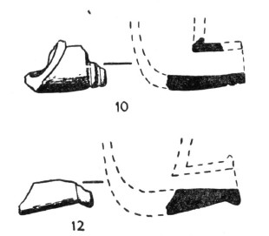
Figure 2.1: Profiles of round-base pipes (Ozanne 1962)

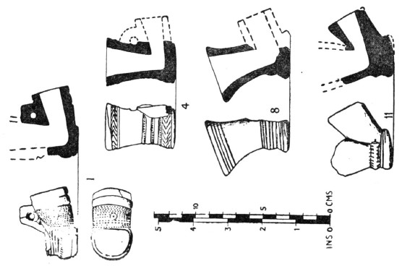
Figure 2.2: Profiles of flat-based pipes (Ozanne 1962).
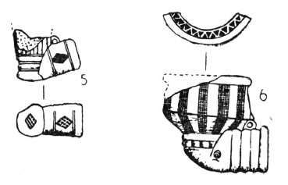
Figure 2.3: Profiles of square-shaped and cup-shaped pipes (Ozanne 1962)

Although Ozanne’s analysis provided a wider view of the types of pipes distributed across the Accra area of Ghana, there are some inherent limitations with his typologies. For example, he acknowledged that the distinctions between pipes in his categories are not clear-cut, as there are overlaps of pipe forms that were difficult to assign precisely to a single category. Also, Ozanne relied on datable artifacts like the Rhenish stoneware to date the deposits in which the pipes in the first group were found. The accuracy of the dates he provided depends on the assumption that the pipes and the stoneware were deposited around the same time. He acknowledged that the refuse mound may have been disturbed. While pipes from undisturbed contexts offered some level of precision in dating, those from disturbed contexts made the establishment of exact timelines challenging.
Until the early 2000s, research on tobacco pipes seems to have been more prominent in Ghana than in other surrounding areas in West Africa (Wesler 1998). McIntosh and colleagues (2003) provide a detailed analysis of tobacco pipes excavated in Jenne, Mali. Their study examined over 300 pipe fragments spanning a 300-year sequence (seventeenth to nineteenth century). In the assemblage that was examined, there were no imported (European) pipes, as all of them appeared to be African-made. Employing a descriptive approach, the researchers attempted to re-evaluate tobacco pipe chronologies, comparing the pipes in their assemblage with those from other West African sites such as Ghana. The study further elucidates the socio-economic dynamics reflected in the pipe styles, including the probable motivations for changes in pipe styles. Based on the observation of the pipes, including the contexts from which they were recovered, the authors concluded that the zenith of pipe smoking was the seventeenth century. This popularity is also reflected in the elaborate designs observable on pipes belonging to that period. However, the nineteenth-century pipes were minimally decorated. According to McIntosh and her colleague, the period was a time when Islamic revolutionist Seku Amadu banned smoking. Given this situation, skilled specialists became scarce as local pipe-making industries declined. As a result, pipes made by non-specialists were reflected in the haphazard decorations.
McIntosh et al. (2003) initially grouped their pipes according to surface color. This grouping resulted in four categories of pipes: red, white, bichrome, and self-slipped. Red pipes are those that have a red slip applied overall, usually grounded hematite. The white category exhibits pipes with a highly burnished surface, which contrasts with the paste color. The bichrome category consists of pipes with red slips that contrast with the paste color. The self-slipped category consists of pipes with the same surface color as the paste and unslipped pipes that were highly burnished.
Subsequent categorization was based on individual pipe segments: stem, bowl, and base, with morphological and decorative characteristics being the basis of their description. McIntosh et al. (2003) identified three types of stems: four-sided, round, and polygonal. The four-sided stems (Figure 2.4) were identified as exhibiting unique decorative motifs: stamped, comb-impressed, incised, and punctate designs. Decoration was less frequent on round stems, with only stamped and comb-impressed designs recorded. The polygonal stems, which are very few, have Y-shaped comb-impressed designs. While the bowls were mostly fragmentary, based on their rim form, three major bowl types were identified: rounded, cylindrical/conical, and composite (Figure 2.5). The major decorative motifs on the bowls are impressed and incised designs. Lastly, single and double-angled bases were recorded (Figure 2.6). Single-angled pipe bases are described as pipes where the underside of the stem and the base form a continuous surface. On the other hand, a base is determined as double-angled if the bottom of the stem joins the bowl or base at a higher point and forms a discontinuous surface with the bottom of the base (McIntosh et al., 2003:189). The single-angled base comprises both a flat ring (i.e., flat circular bottom) base and a flared pedestal base, while a flared pedestal base is most prominent for the double-angled bases. The basal
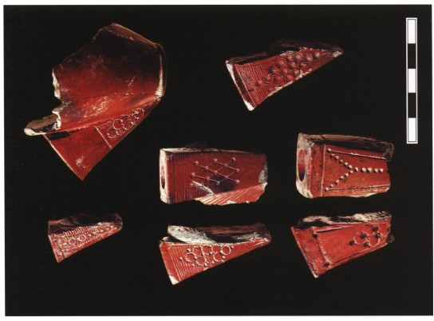
Figure 2.4: Four-sided stem (McIntosh et al., 2003)
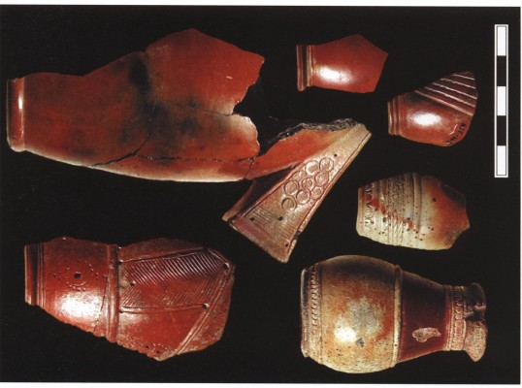
Figure 2.5: Rounded Bowls (McIntosh et al., 2003)

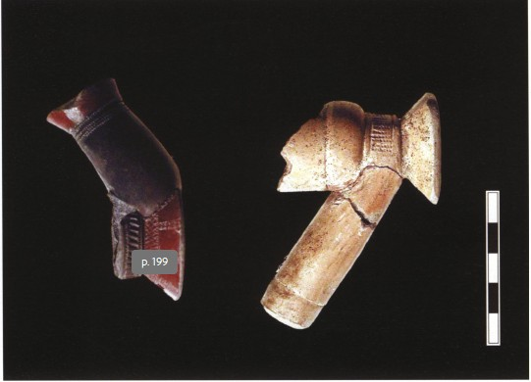
Figure 2.6: Single angle base (left) and double angle base (right) (McIntosh et al., 2003).

decorations include diagonal comb/incisions and stamp/comb impressions.
These morphological and decorative attributes allowed McIntosh et al. to distinguish between earlier (seventeenth–early eighteenth century) and later (late eighteenth-nineteenth century) assemblages. The earlier assemblage is more diverse, featuring round and polygonal bichrome stems, a variety of bowl forms, and pedestal bases. The later assemblage featured well-made, red-slipped pipes.
The descriptive analysis of pipes by McIntosh et al., based on surface color, morphology, and decorations, was indeed thorough. Given that there is no established pipe typology for Jenne, their analysis was primarily about identifying trends in individual pipe attributes. However, direct comparisons of Jenne pipes with pipe assemblages from other West African sites might be challenging.
A similar multivariate approach used by McIntosh et al in their analysis of the Jenne pipe assemblage was employed by Gijanto (2017) in her study of the Niumi pipe assemblage from Gambia. In contrast to the Jenne assemblage, the Niumi pipe assemblage comprises red-clay tobacco pipes. As a result, the pipes could not be grouped into different surface color
categories. Instead, the initial categories identified by Gijanto are non-footed and pedestal (footed) pipes, given that these pipe forms dominate most West African pipe assemblages. In the Niumi assemblage, the former is more prevalent than the latter in contrast to other parts of West Africa, where pedestal forms dominate. While pedestal pipes were found in earlier archaeological deposits in Ghana and Mali, this is not the case for the Niumi assemblage. Non-footed pipes were found in earlier deposits (seventeenth century) and persisted throughout the eighteenth century. Pedestal pipes, on the other hand, appeared in the mid-eighteenth century and persisted through the early nineteenth century (Gijanto 2017:143).
In the non-footed category, Gijanto identified eight distinct non-footed pipe styles, and in the pedestal category, she recorded six pedestal pipe forms. Beyond these initial categories, she then focused on the morphological and decorative attributes of the pipe stem and bowl elements. She identified seventeen stem forms, with the bulk of them associated with non-footed pipes. Pipe bowl fragments outnumbered other pipe elements in the assemblage. Gijanto noted that the bowl shapes include rounded, cylindrical, flared cylindrical, and rounded cylindrical, all of which are associated with non-footed pipes. Rounded-shaped bowls are also associated with pedestal pipes. Decorative motifs were also observed on non-footed and footed pipes. A range of designs, such as banded or parallel rings, were identified on the stems associated with the non-footed pipes. There were also impressed circles forming a “V” on the stem. Gijanto compared this design with the Y-shaped decorations identified by McIntosh et al. in the Jenne pipe assemblage (Figure 2.7). On the stems and bowls of footed pipes, Gijanto noted such decorations as stamped circle impressions, combed/stamped impressions, and varying stamped row designs.
While Gijanto’s typological analysis provides a framework for understanding smoking pipes, there are a few inherent limitations. A broad distinction based on the presence or absence of a pedestal is helpful in identifying regional trends, but this might obscure finer distinctions within these categories. Also, the author acknowledged that the pipes in the
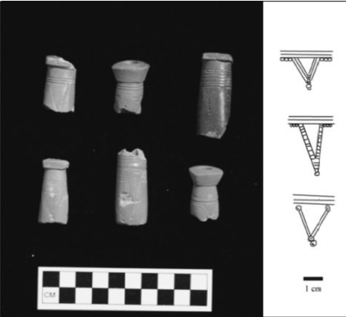
Figure 2.7: V-shaped stem designs (Gijanto 2017).
assemblage are mostly fragmentary. The implication of this is that some of the very fragmented pipe samples could not be decisively categorized. Also, the prevalence of non-footed pipes in the Niumi assemblage contrasts with those from Ghana and Mali. As a result of this regional difference, direct comparative analysis using the typologies for both areas presented challenges.
In the Gold Coast hinterlands, specifically on the Banda Hills, Stahl (2007) examined how artifacts are reflections of the everyday activities of a people, particularly how transatlantic entanglements impacted quotidian activities. Among the artifacts that she examined were locally made tobacco pipes. Her study is unique in that it went beyond descriptive analysis to employing scientific analytical techniques, in this case, instrumental neutron activation analysis (INAA). According to Stahl, data from INAA suggests that local pipes were produced in multiple locations throughout the region. She observed that the pipes were well made, indicating that skilled potters made them, while their diversity points to the fact that the pipes were a medium of social display. INAA data further suggests that the pipes were made from different clay sources. This diversity of sources, according to the author, is the case with ceramic wares that were also analyzed with INAA. In essence, the chemical patterning identified with smoking pipes paralleled that of pottery in the region.
Another study that has contributed to the understanding of clay tobacco pipes is the Upper Osun Archaeological project by Akinwumi Ogundiran. This project, launched in the early 2000s, has shed light on the relevance of pipes and further enriched the literature on the impact of Atlantic entanglement in the domestic lives of people inhabiting the West African hinterlands (Ogundiran 2012). At Ede-Ile, tobacco pipes were found in different domestic contexts across the settlement. In addition, the decorative motifs on the pipes did not match those on the pottery recovered in the area. As a result, Ogundiran (2009) concludes that the pipes may have been procured from outside the settlement. This, however, remains to be ascertained.

Theoretical Framework
My research fits into the theoretical framework of materiality. We live in a material world. At its core, materiality is grounded in understanding the social and physical actions of things on people (Miller 2005; Knappett 2014; Cooney 2016). The proponents of materiality are of the view that people and objects have a mutual relationship (Miller 2005; Knappett 2014). In this case, objects are not passive but are actively involved in shaping and transforming human social life, experiences, behavior, and identities. So, in essence, material culture shapes and is shaped by human activities. The foregoing resonates with Ian Hodder’s concept of entanglement, which similarly explores the deep connections between people and things (Hodder 2011). According to Hodder, people and objects should not be treated as separate entities, but both should be viewed as interdependent. Our focus should be on how humans depend on things and vice versa, as well as how things also depend on other things. He frames this interdependence along a spectrum from affordances to constraints, by which he means that things allow us to do some things and keep us from doing others.
Materiality also resonates with agency. Scholars like Wobst (2000) are of the view that non-human entities have the capabilities of acting upon people. The emphasis here is that humans are not the only entities with agency but that objects also possess a form of agency. While non-human entities may lack intentions unlike humans, their agency, however, lies in their properties and, thus, they shape and influence human social dynamics. While the concept of materiality is still evolving, the message is clear. Aside from the description of materials, proper acknowledgement needs to be given to the reciprocal and active engagement between people and objects, especially the social significance and ramifications of such entanglement (Van Dyke 2015; Cooney 2016).
How, then, does materiality resonate with tobacco and the paraphernalia of smoking in Atlantic West Africa?
Following its introduction in the late 1500s, tobacco gained rapid and widespread popularity in West Africa due to its addictive nature, transforming the socioeconomic, political, and cultural landscapes of West African societies. Aside from being a valuable trade commodity, tobacco became a valuable legal tender for the exchange of goods, including slaves (Handler 2009; Duvall 2017). Brazilian tobacco (Ogundiran 2020) primarily financed the slave trade in the Bight of Benin, such that by the middle Atlantic period, enslaved Africans were preferred over gold in exchange for this molasses-treated tobacco. In addition to financing the purchase of enslaved people, tobacco played a crucial role in the Middle Passage, as some of the plants were distributed to captives on slave vessels bound for the New World (Handler 2009). The tobacco was consumed with European-manufactured pipes, periodically distributed to the captives. According to Handler (2009), the motivation behind the distribution of tobacco and smoking pipes was to pacify the captives and prevent them from revolting. Of course, tobacco and pipes were not the only items, as games were allowed aboard the ships.
Agricultural practices in West Africa also became transformed through the cultivation of tobacco. For instance, it was reported that in the first decade of the seventeenth century, in Sierra Leone, tobacco was planted around almost every house (Laufer et al. 1930; Duco 2006), primarily by women. Most importantly for this study, the introduction of this plant facilitated the production and distribution of African-produced clay smoking pipes.
European observers during the Atlantic age reported that West Africans became addicted to tobacco upon its introduction. This addictiveness crossed gender and age boundaries with reports confirming that women, men, the aged, and even children consumed it (Laufer et al. 1930; Dunhill 1969). Pipe smoking alone does not capture the heavy consumption of tobacco by West Africans, given that for every gram of tobacco smoked, possibly twenty grams were either chewed or snuffed (Ogundiran 2020:295). Who, then, could use smoking pipes? In Yorubaland, the geographical focus of this thesis, smoking of tobacco was gender-restricted as this act was equated with masculinity. In addition, sculptural works of the seventeenth through nineteenth centuries in Yorubaland are replete with depictions of adult males smoking tobacco pipes. While the aforementioned further affirms the patricentric nature of smoking, historical accounts suggest that women of higher social ranking were exempted from such restrictions and, by their status, could engage in the patricentric mode of tobacco consumption (Ogundiran, 2020:295). Conversely, chewing and snuffing were practiced by both men and women, irrespective of social ranking.
The foregoing underscores the fact that tobacco and the paraphernalia of smoking acted as markers of gendered identity. In addition, pipe smoking also served as a marker of social hierarchy and authority in Yorubaland. Political officeholders such as kings, chiefs, and other dignitaries were reported to never go for public outings and ceremonies without their smoking paraphernalia. With tobacco and pipes being one of the most versatile commodities of the Atlantic age, this public act of leisure allowed these men of higher social rank to publicly display their wealth and class and also exert their authority (Ogundiran 2020). A similar occurrence was noted in Ghana among eighteenth-century ruling chiefs of Ada (Vivian 2005). This account further corroborates the fact that the public display of the act of smoking was commonplace in the political life of dignitaries.
There is also a religious dimension to pipe smoking. In Cameroon, chiefs who were officiating as priests engaged in the ceremonial smoking of elaborately decorated large smoking pipes, particularly during the ceremony of feeding the ancestral ghosts (Laufer et al. 1930). The use of elaborate pipes suggests that these pipes were specifically reserved for chiefs, affirming their authority and also establishing a linkage between political leadership and religious rites. In Yorubaland, the Èṣù deity, also known as Elegba, Legba, Exu, or Eleggua (Falola 2013) in the African diaspora, is associated with smoking. This Òrìṣà serves multiple roles in the Yoruba religious space, such as guarding city gates and markets and acting as an intermediary between other Òrìṣàs and their devotees (Ogundiran 2024). In the Atlantic Age, Èṣù became associated with tobacco smoking with numerous sculptural images depicting the Òrìṣà, usually with smoking pipes. In addition, there is an accompanying salutation that praises Èṣù as he who wakes up and spends the entire day engaging in the leisure act of smoking tobacco (Ogundiran 2024), underscoring the sacredness of tobacco smoking during the Atlantic age.
DeCorse (2001), in his study of Elmina, Ghana, identified a fragment of an African-produced smoking pipe in an eighteenth-century burial. This practice of using tobacco pipes as grave goods has been identified in North America. At the Newton Plantation in Barbados, an African-styled smoking pipe was found interred with an older individual believed to be a diviner/healer (Handler 1997). The pipe is believed to be serving a symbolic purpose. This conclusion arose due to other burial goods found associated with the buried individual, such as copper alloy bracelets and a necklace made with drilled canine teeth, fish vertebrae, cowrie shell and glass beads, and a carnelian bead, further confirming that the deceased must have been a revered member of the community when he was alive. Handler suggests he was a conjurer or an Obeah man (someone who intervened with the spirit world). Since the discovery made at the Newton Plantation cemetery, other burials of Africans or African Americans have been found in North America and the Caribbean, containing white ball clay pipes (Brown 2016). Notable mentions include the Patuxent Plantation, the New York African Burial Ground, Kingsmill Plantation, Bransby Plantation, and Seville Plantation in Maryland, New York, Virginia, Montserrat, and Jamaica, respectively (Brown 2016). Since this practice was uncommon among Europeans, given that archaeologists rarely encounter smoking pipes in European burials, Brown (2016) argues that the placement of pipes in African diasporic burial is a practice influenced by African cultural beliefs and practices, although their significance and meanings may vary. The connections between the functional role of pipes in burials both in West African, North American, and Caribbean contexts remain to be addressed. However, these lines of evidence show how the introduction of tobacco and the paraphernalia of smoking transformed the ritual space.
In West Africa, pottery production has been associated with women (Agbaje-Williams 1995; DeCorse 2001; Stahl 2002; Stahl 2007; Gokee 2013; Gijanto 2017; Ogiogwa 2017; Ogundiran 2020). Since these were made with clay, one would assume the same of clay smoking pipes. While this remains contentious, DeCorse (2001) reported that among the Akan people of Ghana, the production of clay tobacco pipes is restricted to men. However, in Dahomey, locally produced pipes were a monopoly of palace women (Monroe and Janzen 2014). These specialist craftswomen resided within the royal palace, serving as a source of labor and production to the Dahomey king (Monroe and Janzen 2014:310). Aside from smoking pipes, they engaged in the production of other commodities such as pottery, mats, and textiles.
The foregoing summary, based on historical accounts and archaeological evidence, show that objects are capable of shaping human social life, behavior, and experiences, just as the proponents of materiality proposed.
To better understand materiality, I use attribute analysis of the pipes alongside archaeometric data. Attribute analysis is the preferred approach in this study for two reasons: First, the samples are in fragmentary condition. Second, the sample size is small. As a result, the focus was on the individual pipe segments (stem, base, and bowl), like McIntosh et al (2003) in their analysis of the Jenne pipe assemblage. Also, in the study of Chesapeake pipes in the Eastern United States, Agbe-Davies (2015) favours attribute analysis over typological analysis. She argues that the latter is hierarchical while the former is non-hierarchical, that is, no attribute (e.g., shape) is thought to be more significant than another. Most importantly, when dealing with fragmentary samples, attribute analysis allows the researcher the freedom to include as many variables (attributes) as possible during analysis.
That being said, other advocates of materiality (Jones 2004; Rodriguez-Corral 2017) propose that the exploration of the physical and chemical properties of material culture through archaeometry offers a unique opportunity to further enrich our understanding of the social life of people. Therefore, examining the elemental compositions of tobacco pipes can provide insight into the production and distribution of pipes in the Yoruba interior.
Theoretically, this study also fits into the frontier studies discourse, considering the historical dynamics that shaped the development of Oyo-Ile and the foundation of Ede-Ile and Osogbo.
African societies before the colonial era had different ways of demarcating boundaries by making use of rivers, valleys, hills, and other topographical features (Usman 2012). Due to various social, economic, political, and environmental dynamics in traditional African societies, people have had to migrate, abandoning one settlement and founding/settling in another. The foregoing contributed to the creation of frontier settlements, that is, a space where different cultures overlap considerably (Usman 2012:5). Three types of frontiers are identified to have been prevalent in precolonial Africa: frontiers of contact, frontiers of separation, and frontiers of transition (Anene 1971 in Usman 2012:8). Frontiers of contact constitute a situation whereby people of distinct political and cultural backgrounds settled in adjacent territories and operated as neighbors. Frontiers of separation developed where societies deliberately separate themselves by using physical topographic features such as forests, rivers, and mountains to create buffer zones. Frontiers of transition are where distinct cultures overlap, such that it is impossible to maintain a clear boundary between the sociopolitical units.
Igor Kopytoff has been credited with attempting a comprehensive conceptualization of the frontier within the context of Africa. Having studied traditional African societies, he conceptualized the “internal African frontier,” describing this as a process whereby larger polities are responsible for establishing smaller polities at the frontier, often through a demographic shift (Kopytoff 1987). This model fits the foundation of Ede-Ile, as it was established by the political authorities of the Oyo-Ile, with elements of the population of Oyo being moved into the frontier zone to settle the town of Ede.
Kopytoff further presents the frontier as a geographical setting for the reproduction and replication of socioeconomic and political structures of the metropoles. In other words, the frontiers are socially produced by the core and are essentially offshoots of the core. Although valid, this proposition has, been challenged and described as being too rigid and unilinear, as it ignores the agency of the frontier while also underestimating the complexity that is often associated with the frontier (Parker 2006; Usman 2012; Ogundiran 2014). While the historical dynamic that facilitated the establishment of Ede-Ile in the frontier zone fits Kopytoff’s core-periphery model, the transformation that the town underwent through craft specialization and trade, as evident in the archaeological record, suggests that Kopytoff’s model did not acknowledge the transformational agency of Ede-Ile as a frontier settlement. This agency points to the shortcomings of his model pertaining to Ede-Ile. Similarly, archaeological data recovered from Osogbo strongly indicate that the town was a dynamic formative settlement whose material life, characterized by diversity, experimentation, and newness, was not a mere offshoot of the metropolis (Ogundiran 2014).

CHAPTER THREE
METHODOLOGY

Materials
In this study, I analyzed 65 clay tobacco pipe fragments, 50 of which came from Ede-Ile, 10 from Osogbo, and the remaining 5 samples from Oyo-Ile (Old Oyo). The pipes from Ede-Ile and Osogbo were carefully selected from the Upper Osun archaeological investigations initiated from 2004 to 2009, while the Oyo-Ile samples came from Mejiro and Bara areas of Old Oyo. For context, the pipes from Ede-Ile were excavated from Locus B (imperial governor’s quarters), C (pottery-making area), and F (iron-making area). These samples were chosen so that they could be representative of the entire site. For Osogbo, ten samples were selected from (refuse) Mound A of the site. Only 30 out of 50 Ede-Ile samples were selected for the chemical analysis.

Methods
I employed both descriptive and chemical analyses in this study. I conducted the descriptive analysis in the Material History Laboratory in the History Department of Northwestern University, Evanston, Illinois, where the samples are housed. The analysis started with the identification of the various pipe parts since they are all in fragmentary condition.
I draw from studies conducted by Ogundiran (2002), McIntosh et al. (2003), Gokee (2012), and Gijanto (2017) to describe my pipe assemblages on the basis of stem, bowl, and basal morphologies, given that these are the parts that make a complete clay smoking pipe. Some pipes were nearly complete, meaning that despite being fragmentary, they have the presence of two parts of the pipe, i.e., base/stem, or base/bowl, or the three parts of the pipe present, i.e., base/bowl/stem. All attributes were recorded in an Excel spreadsheet. Recording multiple variables in a standardized way is crucial in establishing variations and similarities within the pipe assemblages across the three sites.
Based on visual observation, all pipe samples (from Oyo-Ile, Osogbo, and Ede-Ile) appear to be African-produced, i.e., a two-piece type, whereby smoke is drawn through a long, hollow reed inserted into the pipe stem socket (Gijanto 2017; McIntosh et al. 2003; Philips 1983; Shaw 1960). Studies conducted by Ozanne (1962, 1969), Kelly (2001), McIntosh et al (2003), Gokee (2012), Gijanto (2017) in Ghana, Benin, Mali, Senegal, and Gambia, respectively, suggest a regional trend of two forms of pipes – pedestal (footed) and non-pedestal (non-footed) pipes, with both also being two-piece pipes. However, in the assemblages I analyzed, the pipe fragments for which bases are present are characterized by pedestal bases. It is thus impossible to group the pipe samples into pedestal and non-pedestal pipes.
Other attributes that I considered as potentially demonstrating meaningful variation include stem (shape, diameter, orifice, length, thickness, and angle), bowl (shape, diameter, height, thickness), and base (shape, diameter, and height), all measured with the aid of a digital caliper. The shapes of the pipe parts, however, were determined through visual observation. Again, following McIntosh, Ogundiran, Gokee, and Gijanto, metric measurements were recorded in centimeters. However, not all the measurements could be taken, given the fragmentary conditions of certain pipe parts. In addition, other variables that were recorded include surface treatments such as decorations (where present) and slipping.
I also visually inspected the paste of each pipe fragment. In this case, I used the Munsell color chart to determine the paste color. From close observation and with the aid of a magnifying lens, I was able to identify other paste attributes, particularly inclusions (non-plastic, naturally occurring constituents of the clay). The inclusions identifiable in this case were mostly quartz sand. Depending on the size of this inclusion, the paste attributes range from fine to medium. These data are compiled in tables in Appendix III. In Chapter 4, I summarize the primary data trends.
The next step in my descriptive analysis was visual documentation. In this case, I made use of a LED copy stand setup (Figure 3.1) and an iPhone 14Plus mobile device. The former provided adequate light for photography, and the latter facilitated the taking of high-quality photographs of smoking pipes.

Chemical Analysis
To complement the atrribute analysis of the pipes, the materials were then subjected to archaeometric (chemical) analyses to address the research questions raised, which include understanding the chemical variations of the samples across the three sites and testing the reliability of Portable X-ray Fluorescence (pXRF) and Laser Ablation Inductively Coupled Plasma Mass Spectrometry (LA-ICP-MS). All analyses were conducted in the Elemental Analysis Facility (EAF), housed in the Field Museum, Chicago, Illinois. Using a single laboratory ensures consistency of results, and in the event of errors, allows the source to be easily traced and addressed
Elemental analysis of ceramics can be done using various techniques, including but not limited to Instrumental Neutron Activation Analysis (INAA), Atomic Absorption Spectroscopy (AAS), Optical Emission Spectroscopy (OES), X-Ray Fluorescence (XRF), Portable X-Ray Fluorescence (pXRF), and various Inductively Coupled Plasma (ICP) techniques (Price and Burton 2011; Fricker and Gunther 2016; Shortland and Degryse 2020; Dussubieux 2023). Of these various techniques, three, according to Dussubieux (2023) are often used to analyze archaeological inorganic materials: pXRF, INAA, and LA-ICP-MS. What, then, justifies the use of LA-ICP-MS and pXRF in this study?

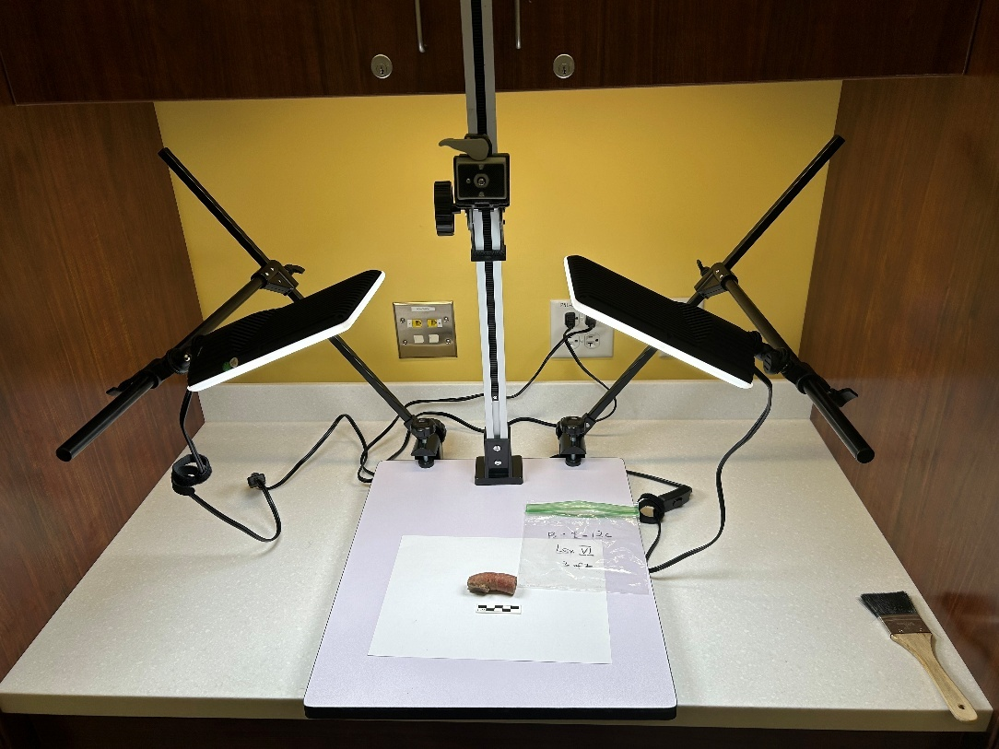
Figure 3.1: LED Stand

The fact that pXRF is non-destructive has been particularly attractive to archaeologists (Liritzis and Zacharias 2011; Shackley 2014) and was an important factor in my decision to use this technique in the study. Other factors, such as portability, non-invasive
capability, minimal preparation of samples, speed, ease of usage, and cost-effectiveness, as highlighted by Shackley (2011, 2014) and Liritzis and Zacharias (2011) were also crucial in the choice of pXRF as an analytical technique for this study. More importantly, it is capable of detecting major, minor, and trace chemical elements, although the limits of detection are fairly high for some elements that cannot be detected in ceramics (Liritzis and Zacharias 2011). Of course, it has certain caveats. Since pXRF does not require the destruction of artifacts, the elements that are detectable are usually limited.
On the other hand, LA-ICP-MS can detect a large amount of chemical elements without destroying any aspect of the sample, making it an important invention for bulk compositional analysis (Dussubieux et al. 2007; Golitko and Dussubieux 2016). In essence, it can accurately detect and measure over 50 elements at low concentrations. In addition, it can analyze ceramic surface treatments, as well as paste and temper compositions. LA-ICP-MS works through the following steps: the laser removes (ablates) microscopic quantities of materials from the objects being analyzed. The plasma then vaporizes, atomizes, and ionizes the ablated materials (Fricker and Gunther 2016). Helium, that is, the gas carrier, transports the ablated materials to the Mass Spectrometer (MS) through an interface. The MS separates the ions based on their mass-to-charge ratios. And a detector quantifies the different elements present in the ablated material (Dussubieux et al., 2007). This microscopic removal of materials underscores why LA-ICP-MS is regarded as being almost non-destructive. The caveats to this analytical technique are that it is cost-intensive and minimally destructive.

Methods of Elemental Data Acquisition
Before analysis, I used all the available samples from Osogbo and Oyo-Ile and randomly selected 30 pipe fragments from Ede-Ile. The tobacco pipes selected for chemical analyses were each assigned lab names and numbers. EDI001-030 for Ede-Ile, OSG001-010 for Osogbo, and OYL001-005 for Oyo-Ile. This part of my analysis was done under the guidance of Laure Dussubieux, the Senior Research Scientist of the Elemental Analysis Facility of the Field Museum, Chicago.

pXRF
The pXRF analyzer used was the Niton XL3t GOLDD+ made by the Thermo Scientific Company. Although pXRF analyzers are moveable due to their portability, the Niton analyzer used in this case was placed on a desk with a leaded glass cubicle (box) mounted on top, acting as a shield to protect the user against radiation (Figure 3.2). The samples only had to be inserted in the glass chamber and then placed on the aperture for it to be analyzed. Due to the size, form, and fragmentary condition of the tobacco pipes, some would not sit perfectly on the aperture. In this situation, adhesive putty was used to support the artifact.
The analyzer's central processing unit (CPU) was used to commence operation (Figure 3.3). First, a systems check was done to ensure that the X-ray generation and sample detector were in perfect working condition. Since pXRF interacts differently with different materials, the next step was to select the analytical mode, in which case, “soil mode” and “test all geo” were selected. These options are specifically for samples containing light elements such as silica and aluminum that are major constituents of clay-based samples like ceramics.

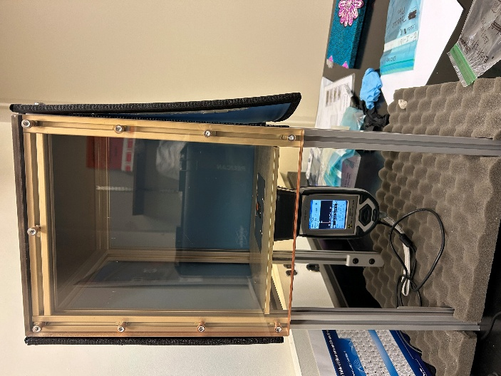

Figure 3.2: pXRF analyzer placed in a cubicle

Figure 3.3: pXRF CPU

Before analysis could be done, I entered the sample names into the analyzer. This was done directly on the touch screen display of the pXRF and on a computer connected to the pXRF. For each pipe sample, I analyzed both the paste and the pigment (tobacco pipe surface). To prevent complications, during the data entry, pigment was represented as P and paste as C (clay), i.e., EDI001P, EDI001C. Each analysis ran for a duration of 180 seconds. This interval was used because it is the default parameter that the manufacturer of the instrument defined as best for analysis. Since the analyzer has been used to analyze numerous materials, ensuring that my samples had unique labels (names) made it easy to export the data from the instrument after the analysis.
The extracted data from the analyzer recorded the following 30 elements: Mo, Zr, Y, Sr, U, Rb, Th, Pb, As, Hg, Zn, Cu, Ni, Co, Fe, Mn, Cr, V, Ti, Ca, K, S, Ba, Nb, Bi, Al, P, Si, Cl, Mg. Of these 30 elements, Mo, U, Th, Hg, Co, Bi, Cl, As, and Mg were below limits of detection (<LOD) in many of the samples and had to be removed from the dataset. With this done, the datasheet was ready for statistical analysis.

LA-ICP-MS
For the LA-ICP-MS analysis, I used the ESL NWR213 Laser Ablation System connected to a Thermo ICAP Q Mass Spectrometer (Figure 3.4). The method of data acquisition with LA-ICP-MS differs from pXRF. In this case, the samples were ablated in batches. To do this, pipe samples had to be placed carefully so that they were leveled in the laser cell. Level placement ensures that the samples are ablated evenly, thereby reducing distortions and errors. Adhesive putties were used to ensure the stability of the samples in the laser cell. A challenge that was encountered during this process was that some of the clay pipe samples did not lay flat, while others did not fit into the laser cell. In these cases, with the aid of a tile nipper, tiny bits of samples were chipped off some of the larger clay pipe fragments that would not fit into the laser cell. All the samples, including the tiny bits that
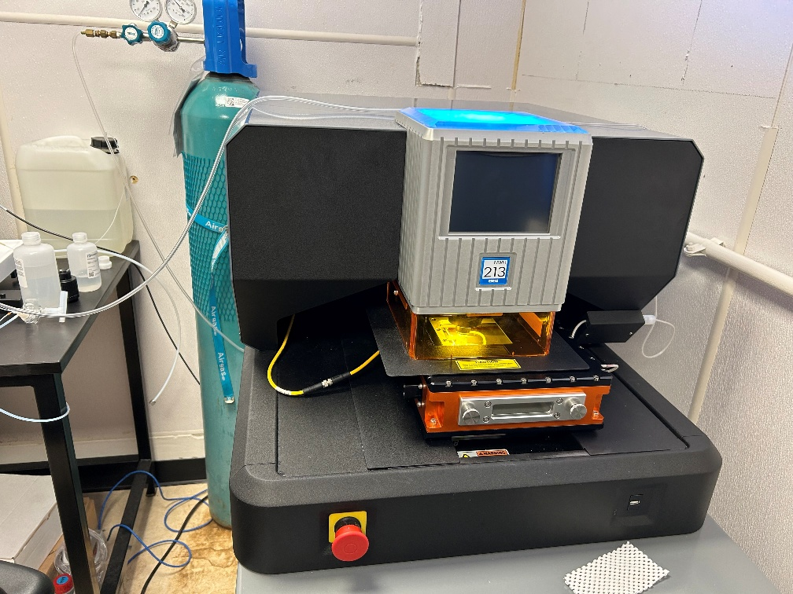
Figure 3.4: ESL NWR213 Laser Ablation System
were chipped off, were arranged on adhesive putties to ensure their stability (Figure 3.5). With the samples prepared, three reference standards were also arranged in the laser cell. They include NIST 610, NIST 679 (also called Brick Clay), and Ohio Red. NIST 610 (named after its source, the National Institute of Standards and Technology) is a glass standard, while the other two are clay standards. NIST 610 and Brick Clay are external reference materials that are used to obtain quantitative data, while Ohio Red was measured to ensure quality control, precision, and accuracy. The laser cell containing the pipe samples and reference materials was then placed in the laser ablation chamber for ablation to commence (Figure 3.6). Before ablation could commence, it was necessary to purge the laser chamber to push air out and replace it with Helium (He) to prevent the plasma from being blown out while the chamber is connected to the plasma.
Two computers, an ICP-MS setup, and a Laser setup, were integrated with the LA-ICP-MS instrument and were used to run the analysis. The laser setup allowed me to visualize the laser cell and locate the samples for ablation (Figure 3.7). Because clay is
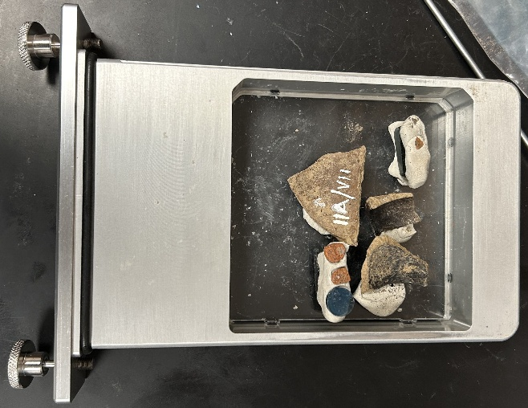
Figure 3.5: Pipe samples arranged in the laser cell.
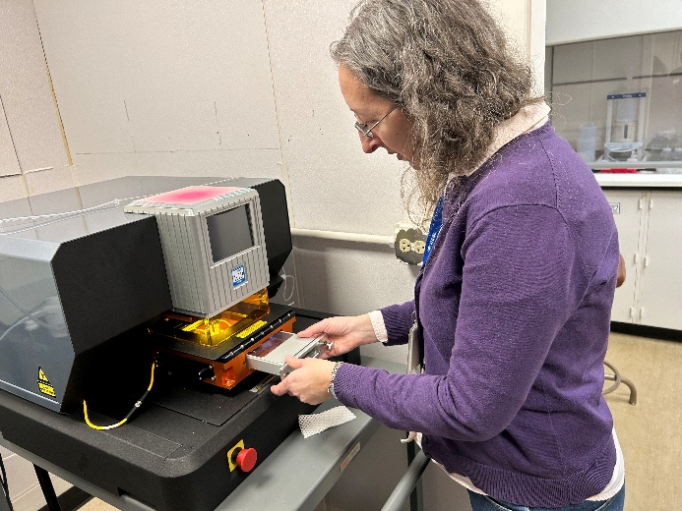
Figure 3.6: The laser cell being inserted into the laser chamber.
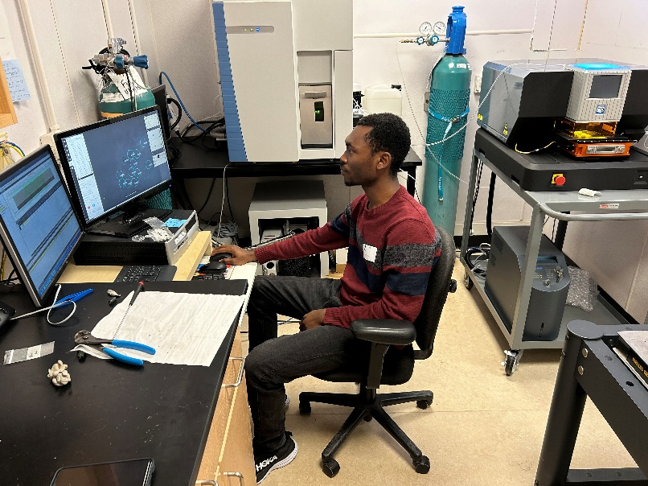

Figure 3.7: Ablation being performed using the laser ablation set up

heterogeneous, ablating as many spots as possible results in a measurement that is more representative of the elemental compositions. I ablated each sample in a batch ten times while being careful not to ablate the same spot (Figure 3.8). The reference materials were each ablated only five times per batch. At a laser frequency of 20Hz, the pipe samples were ablated with a laser beam of 70 micrometers in diameter per spot. Once the materials had been ablated, a menu for “run” on the ICP-MS setup was clicked to run the samples. Given the number of samples (5) per batch, it took roughly an hour to run a batch. Like pXRF, the data was exported and downloaded as Excel files.
The analysis from LA-ICP-MS recorded 55 chemical elements: Si, Na, Mg, Al, P, K, Ca, Mn, Fe, Ti, Pb, Ba, Li, Be, B, Sc, V, Cr, Ni, Co, Cu, Zn, As, Rb, Sr, Zr, Nb, Ag, In, Sn, Sb, Cs, La, Ce, Pr, Ta, Au, Y, Bi, U, W, Mo, Nd, Sm, Eu, Gd, Tb, Dy, Ho, Er, Tm, Yb, Lu, Hf, Th. Not all of these elements are considered for further analysis as some had to be removed. For example, the Elemental Analysis Facility of the Chicago Museum often analyzes copper-based artifacts, which, despite regular cleaning, could potentially lead to copper contamination, making it difficult to accurately measure low quantities of these elements in clay artifacts (Dussubieux 2023). Certain elements are often poorly measured in clay artifacts due to their low concentrations. On the basis of these two factors, I removed the following elements: Cu, Ag, In, Bi, As, Au, Pb, and Sb from the dataset.
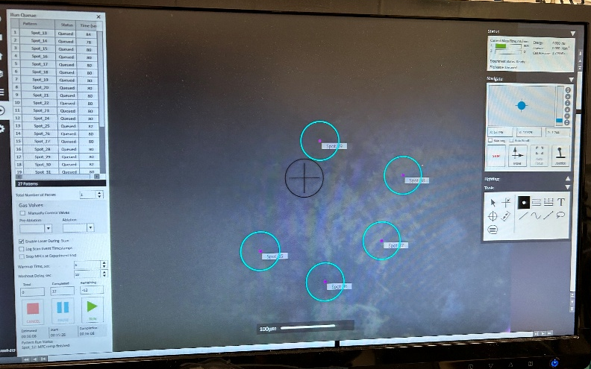
Figure 3.8: Ablation spots

Statistical Analysis
Once the data were collected for both pXRF and LA-ICP-MS, I used Principal Component Analysis (PCA) to interpret it. According to Liritzis and Zacharias (2011) PCA is useful for analyzing multivariate (elemental) data, as well as investigating and visualizing the structure of the data. PCA is a dimensionality reduction tool that looks for a way to simplify the multivariate data (Carlson 2017). In essence, it is an exploratory statistical tool that summarizes the variables (elemental compositions) and observations (samples) in a reduced number of dimensions.
While there are different software packages for performing PCA, for this analysis, I used RStudio. Before performing PCA, it is customary to standardize one’s data. This standardization is a form of data transformation. Although the elements in my dataset are recorded in ppm (parts per million), each element has varying values, some greater than others. Therefore, using the scale function in R software, I standardized my data. According to Baxter (2015), scaling helps to ensure that all variables (elements) are treated equally. After this step, my data was ready for PCA.
Following the application of PCA, there will be many PCs (principal components), representative of every variable in the dataset. To visualize the data, it is conventional to plot the first two PCs (Carlson 2017) that retain the most variance in the dataset. This will produce a two-dimensional biplot, displaying both variables and observations. With this biplot, one can visually identify observations that are similar and different from one another. Most importantly, the biplot will illustrate the combination of variables (elements) that are responsible for such similarities and differences. As an exploratory statistical tool, PCA helps to visualize patterns and clusters of similar elemental compositions in a dataset (Baxter 1995, 2015). This could suggest, for instance, whether there are different source materials and production sites (groups) for the smoking pipes.
While PCA allows for visualizing the relationship between variables and observations, it cannot, on its own, group the observations into clusters. Cluster analysis is a technique that is useful for combining observations into groups (clusters) based on similar variables (Carlson 2017). Although there are different approaches that can be used, for this research, I used the hierarchical (agglomerative) clustering method, given that this approach is the most widely used method (Aldenderfer 1982; Baxter 2015; Carlson 2017). I then used the NbClust package in R to predict the optimal number of clusters. This method of cluster validation provides indices for 30 methods of determining the optimal number of clusters in a dataset (Carlson 2017:329). Having determined the optimal number of clusters, hierarchical clusters are then represented by a dendrogram (i.e., a tree-like graph) to visualize the cluster assignments in the dataset. And then to further cross-validate my clusters, I turned to linear discriminant analysis (LDA). Based on the hierarchical cluster analysis, LDA looks for the best-fitting line that best separates groups of observations based on variable similarity (Carlson 2017), ensuring that the clusters are well-separated.

CHAPTER FOUR
RESULTS AND DISCUSSION
In this chapter, I present the results of both the descriptive analysis and the archaeometric analyses.

Descriptive Analysis
Based on visual observation, all but two of the pipe samples (from Oyo-Ile, Osogbo, and Ede-Ile) appear to be African-produced, i.e., a two-piece type, whereby smoke is drawn through a long, hollow reed inserted into the pipe stem socket. The other two are European-made. Overall, there were 65 pipe samples, 50, 10, and 5 from Ede-Ile, Osogbo, and Oyo-Ile, respectively. I treated every pipe fragment individually, identifying them based on the parts that were present. In this regard, I identified stem, base, and bowl pipe fragments. There were also near complete pipes, as I mentioned in Chapter 3, with the presence of a bowl and stem, a bowl and base, or a combination of stem, bowl, and base (Table 4.1).
Stem
Thirteen stem fragments were identified in the pipe assemblages. I recorded attributes including shape, surface treatment, and decoration of each fragment. Based on appearance, two morphological attributes are identifiable: round and bevel-shaped stems. The former
Table 4.1: Distribution of Pipe Fragments by Site
Site | Stem | Bowl | Base | Near Complete | Total
Oyo-Ile | 2 | 2 | 1 | - | 5
Osogbo | 5 | 2 | 2 | 1 | 10
Ede-Ile | 6 | 23 | 9 | 12 | 50
Total | 13 | 27 | 12 | 13 | 65

indicates stems without any sharp angle, and the latter, also without angle but with slopes on either side (Figures 4.1 & 4.2). The stem fragments from both Oyo-Ile and Osogbo are round, while those from Ede-Ile comprise both round and bevel-shaped stems. Due to their fragmentary condition, not all could be measured to ascertain their length, but the few complete stems that were measured range from 4 cm to 5cm in length. The orifice, i.e., stem bore, ranged from 1 cm to 1.2 cm. There appear to be slips on the surface of the majority of the pipe stems. Slip is liquid clay applied to the surface of the pipe before firing, resulting in a different color from unslipped pipes and a smooth, fine surface texture. Slips identified in this case are of two types: red and dark red. Oyo-Ile pipe stems are all red-slipped, but pipe stem samples from Osogbo and Ede-Ile are comprised of red and dark-red slips. In addition to slipping, burnishing was present in two Osogbo pipe stems. The surfaces of these two stems appear really smooth, suggesting that a pebble may have been used to polish the stem surface to achieve such smoothness.
Table 4.2 summarizes information relating to decoration. Although two pipe stems (from Osogbo) are plain, the other pipe stems exhibit majorly incised and carved roulette decorations. The former may have been created using sharp objects, engraved onto the surface of the pipe stems to create geometric lines. Carved roulette, on the other hand, must have been created by using textured rollers, impressed on the surface of the pipe stems to create geometric motifs. Pipe stems from Ede-Ile and Osogbo exhibit these decorative techniques.
Base
Across the three sites, 12 base fragments were identified. In terms of basal morphology, round and rectangular-shaped bases are observable (Figures 4.3 & 4.4). The round-shaped bases have no angle, while the rectangular-shaped bases have four angles with a pyramidal-like appearance. The pipe bases all appear to be pedestals, given that they are
Table 4.2: Decorative Techniques on Pipe Stem Fragments.
Site | Incision | Plain | Carved Roulette | Total
Oyo-Ile | 1 | - | 1 | 2
Osogbo | 3 | 2 | - | 5
Ede-Ile | 3 | - | 3 | 6
Total | 7 | 2 | 4 | 13
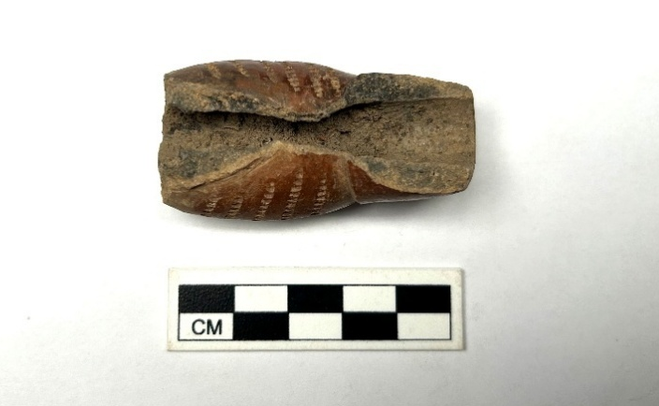
Figure 4.1: bevel-shaped stem with rows of carved roulette decoration

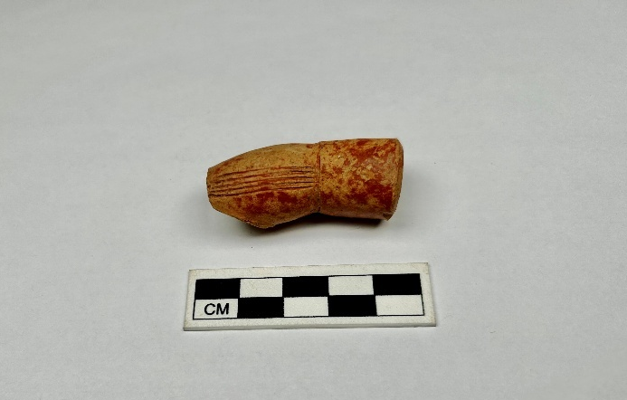
Figure 4.2: Round red-slipped pipe stem designed with horizontal incisions.
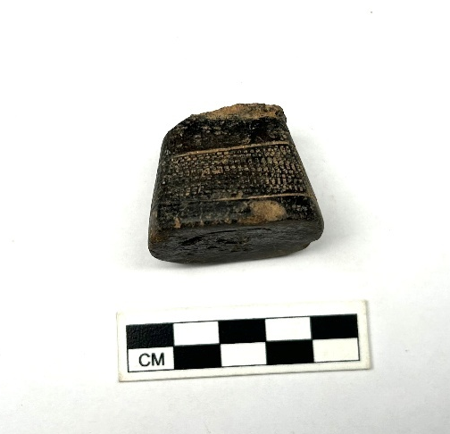

Figure 4.3: Pedestal base with rouletted impression
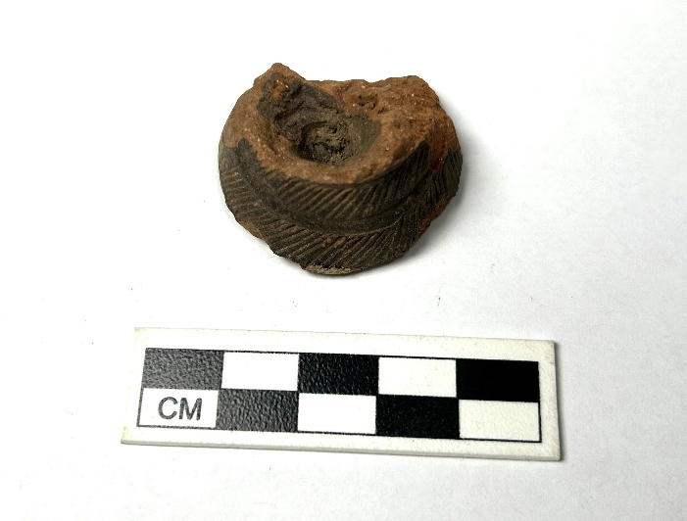
Figure 4.4: dark red slipped pedestal with double rows of vertical incisions

raised. The height ranges from 1.5 cm to 2 cm, and the diameter from 2.6 cm to 4cm. Like the stem fragments, evidence of slipping is obvious, with the slips ranging from red to dark-red. The decorative techniques range from carved roulette to dot punctate, and incision. The punctate, in this case, may have been created by puncturing the surface of the pipe base to create dotted motifs.
Also noticeable are perforations directly below the pipe base. These perforations, based on visual observation, are either slashed (similar to incised) or punctured, creating a hole directly beneath the pipe base. These particular basal attributes were not reported in pipe assemblages from Ghana, Mali, and Gambia, examined by Ozanne (1962), McIntosh et al. (2003), and Gijanto (2017), respectively. While McIntosh et al. reported basal perforations in their assemblage, the perforations were on the base facing the stem in the opposite direction. Two of the base fragments were too fragmentary to determine their perforation style. Furthermore, the pedestals all show evidence of abrasions (use-wear), indicating that they were used on a regular basis. Tables 4.3, 4.4, & 4.5 show the descriptions of pipe bases by sites.
Bowl
Twenty-seven pipe bowl fragments were found across the three sites. One of them is part of a white ball clay, European-made pipe, molded with a basket and rope motif (Figure 4.5). This conclusion is made on the basis of the fact that white clay was used in producing this pipe and this is a common decorative technique on eighteenth to early twentieth century European pipes. This pipe belonged to the Ede-Ile assemblage. The remaining pipe bowl fragments are mostly red-slipped, with two fragments that were black-slipped. Due to the fragmentary nature of the pipes, it is difficult to ascertain their shape, but round-shaped bowls seem to dominate. Undecorated pipe bowls are categorized as plain. The decorated ones, on the other hand, are represented by incised, impressed, and rouletted decorative techniques
Table 4.3: Base Forms by Site.
Site | Round | Rectangular | Total
Oyo-Ile | 1 | - | 1
Osogbo | 2 | - | 2
Ede-Ile | 6 | 3 | 9
Total | 9 | 3 | 12

Table 4.4: Decorative Techniques on Base Fragments by Site
Site | Carved roulette | Dot punctate | Incision | plain | Total
Oyo-Ile | 1 | - |  |  | 1
Osogbo | - | - | 1 | 1 | 2
Ede-Ile | 7 | 1 |  | 1 | 9
Total | 8 | 1 | 1 | 2 | 12

Table 4.5: Perforation Types on Base Fragments by Site.
Site | Slashed | Punctured | Total
Oyo-Ile | 1 | - | 1
Osogbo | - | 1 | 1
Ede-Ile | 3 | 5 | 8
Total | 4 | 6 | 10

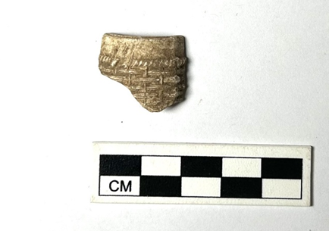
Figure 4.5: Ball clay pipe bowl fragment with basket and rope motif.

(Figures 4.6 & 4.7). A distinct decoration observable is the zoomorphic motif (ram-head-shaped motif) on the body of one pipe bowl. Aside from body decorations, some of the bowl fragments exhibit toothed and fingernail impressions directly on the lip of the bowls.
Near Complete
I grouped 13 pipe samples that have the presence of two or three parts of the pipe as near complete pipes (Table 4.6). One appears to be European-made, from the Ede-Ile pipe assemblage. This European-made pipe had only the base (pedestal) and bowl present and was decorated with multiple vertical incisions (Figures 4.8 & 4.9). The bowl measures 1.8 cm and the base 0.5 cm.
Aside from this specimen, there is also a West African-made near-complete bowl with a zoomorphic design (owl-shaped motif). The bowl shape tends to be mostly round, and the (pedestal) base shape ranges from round to rectangular, with heights ranging from 4cm to 5cm. With the base, the height of the pipes ranges from 5 cm to 6 cm. The pipe stems (for near-complete with stems present) are also rounded and beveled, with stem-body angles ranging from 45 to 60 degrees. The latter confirms that the stem-body orientation is acute. Slips range from red to dark red, and the decorative techniques most common are incisions and carved roulette (Figures 4.10, 4.11, & 4.12).

Chemical Analysis

LA-ICP-MS Statistical Analysis
LA-ICP-MS analysis of the clay tobacco pipe samples recorded 55 chemical elements, of which 8 were removed before performing statistical analysis. The remaining 47 comprise major, trace, and rare earth elements. The data were uploaded into the R program, and PCA was performed. Since PCA is a dimensionality reduction statistical tool, it finds the best possible dimensional representation of the correlation or covariance structure in multivariate data. In this case, the greatest amount of variance will be preserved in the first
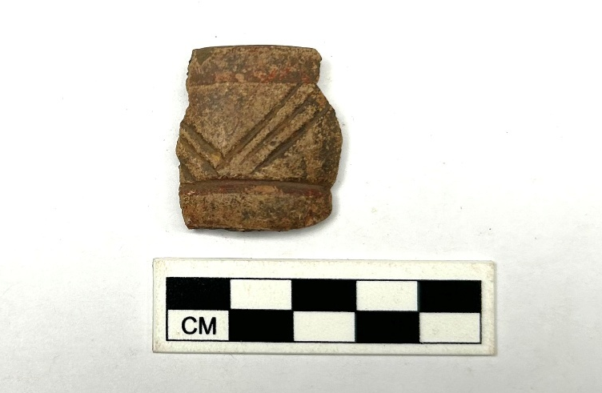
Figure 4.6: Bowl fragment with V-shaped incisions.
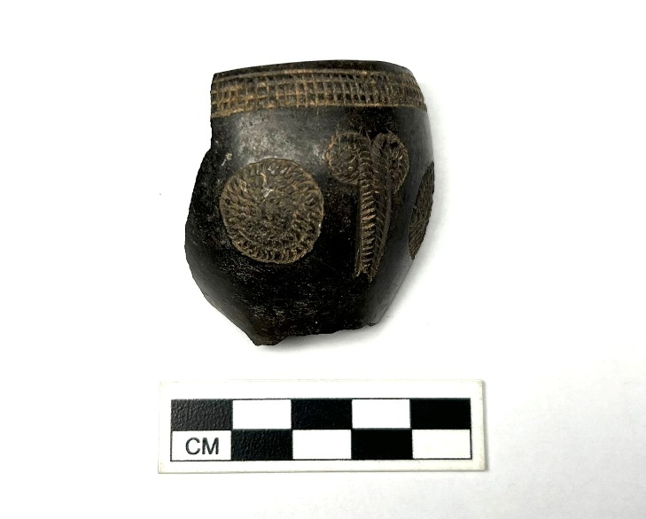
Figure 4.7: Black-slipped bowl fragment with ram-head and round motifs.

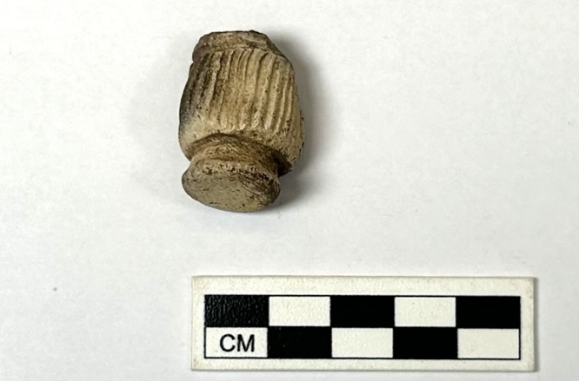
Figure 4.8: European-made pipe bowl/base exterior.
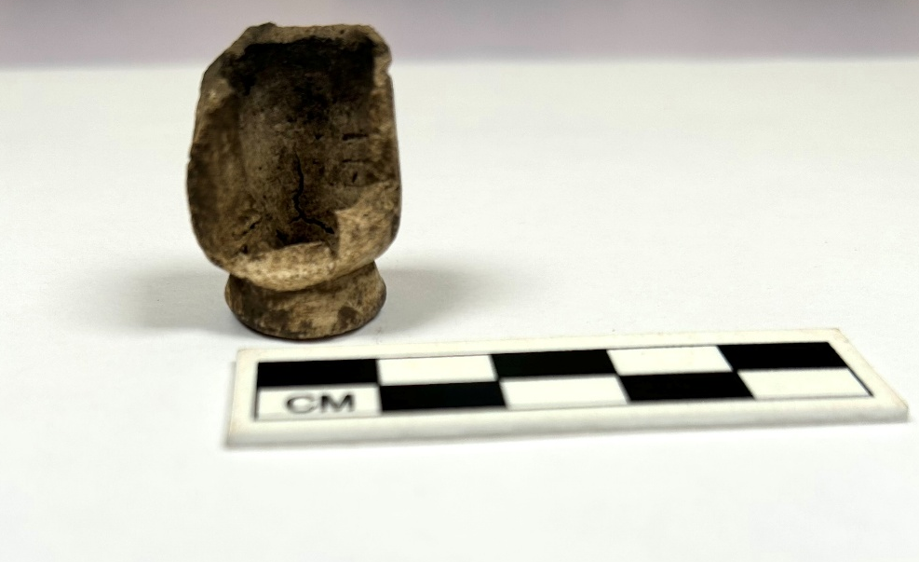
Figure 4.9: European-made pipe bowl/base interior.

Table 4.6: Near Complete Pipe Fragments by Site
Site | Base/Bowl | Base/Stem | Bowl/Base/Stem | Total
Oyo-Ile | - | - | - | -
Osogbo | 1 | - | - | 1
Ede-Ile | 4 | 4 | 4 | 12
Total | 5 | 4 | 4 | 13

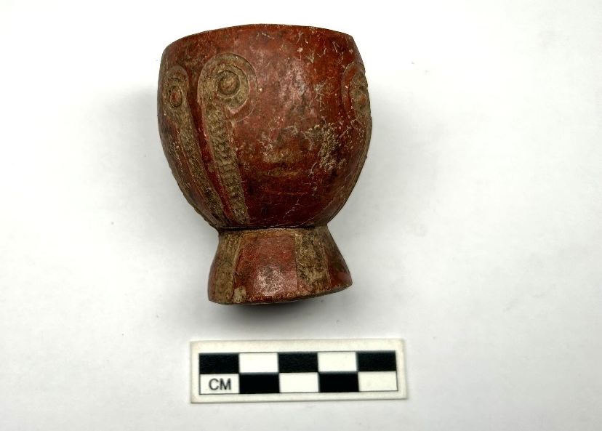
Figure 4.10: Red-slipped Bowl/Base fragment with owl-like impression.

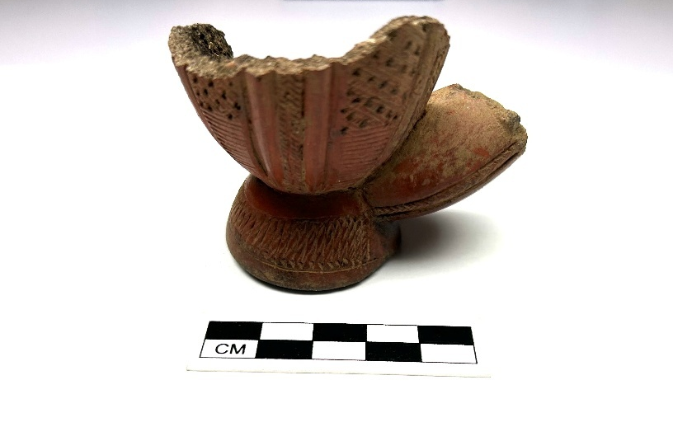
Figure 4.11: Near complete pipe with a combination of incised, dot punctate designs

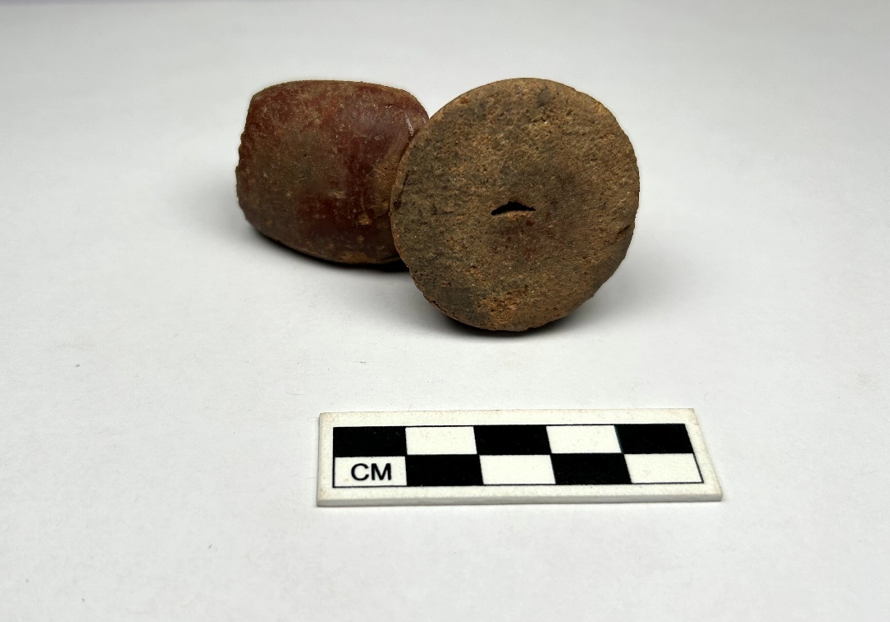
Figure 4.12: Slashed basal perforation

principal axis. However, to visualize both the observation and the variables, the first two PCs are commonly used. However, if one wants to create a three-dimensional plot, then more than two PCs are required. As is the case of my analysis, the first two PCs account for a 58% variance of my entire data. To visualize how much variance is preserved, one can do a scree plot as well (Figures 4.13 & 4.14).
A biplot, i.e., a two-dimensional graph representing the first two axes, was plotted to visualize the relationship between observations and variables (Figure 4.15). To interpret/read a PCA biplot, the observations are displayed in black while the variables are displayed in red. From the origin of the biplot, variate vectors pointing in the same direction like Iron (Fe) and Nickel (Ni) are positively correlated. This means that both elements tend to increase and decrease together. Conversely, variate vectors pointing in opposite directions like Strontium (Sr), will be interpreted as having a negative correlation to Iron and Nickel. This means that as Iron and Nickel increase, Strontium tends to decrease.
Another advantage of creating a biplot is that it helps to identify clusters or groups (of observations) by displaying the elements that contribute to such clusters. A cluster or group in this context means a collection of observations that have similar elemental compositions. From the biplot, three groups can be identified. One group of samples observably correlated to trace elements, the second to major oxides like Aluminum (Al), Silicon (Si), and Sodium (Na), and the third to a combination of major and trace elements such as Iron (Fe), Manganese (Mn), Nickel (Ni), and Vanadium (V).
While it may seem like the clusters are being assigned arbitrarily, a way to do cluster assignment in R is by performing cluster analysis. As I mentioned in the third chapter, hierarchical cluster analysis is the method that was used in this case. To ensure proper cluster assignment, PCs 1 to 14 were used as these axes combined have a 96% variance preserved
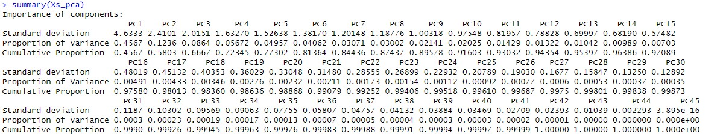
Figure 4.13: summary of PCs

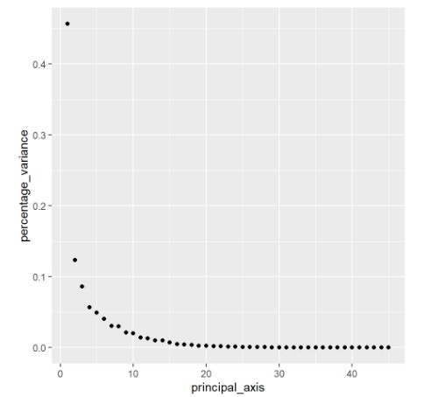
Figure 4.14: Scree plot showing the percentage of variance preserved in the LA-ICP-MS data.
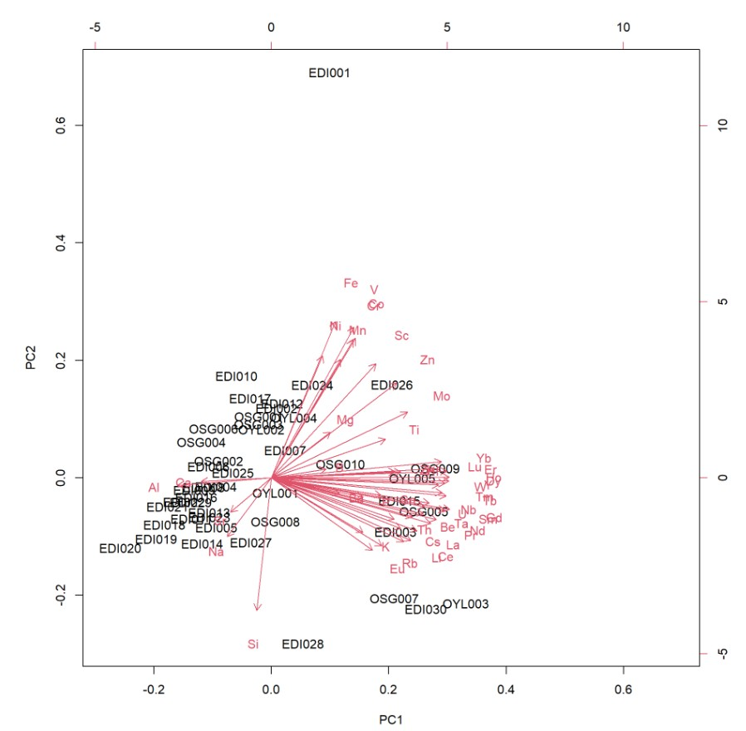
Figure 4.15: PCA biplot displaying observations and variables in the LA-ICP-MS data.

of the entire dataset. To check for the optimal number of clusters, the NbClust package on R was initiated. The optimal number of clusters was ascertained to be three. On this basis, a dendrogram was plotted to visualize this cluster assignment (Figure 4.16).
After performing hierarchical clustering, there was a need to validate the cluster separation. In this case, Linear Discriminant Analysis (LDA) was performed, taking into consideration the already assigned clusters. This analysis separated my observations into three clusters (Figure 4.17). Cluster 1, shown in red, comprises samples that are rich in Yb, Er, Lu, Ho, Dy, Y, W, Tm, Tb, Nb, U, Ta, Sm, Gd, Nd, Pr, Be, La, Ce, Li, Cs, Th, Rb, Eu, K, Ba, P, Sn, Zr, Hf, Cluster 2, shown in green, comprises pipe samples that are rich in B, Ti, Mo, Mg, Zn, Sc, Mn, Ni, Cr, Co, V, Fe, and Cluster 3, shown in blue, is composed of pipes that are rich in Ca, Al, Na, Si, and Sr.
To check the reliability of the cluster separation obtained using LDA, I performed cross-validation. This was done not only to ascertain the accuracy and stability of cluster separation but to check whether certain observations have been misclassified into a particular cluster. The cross-validation technique employed in this case is the Leave One Out Cross-Validation (LOOCV). To visualize the output of cross-validation, a confusion matrix is used (Figure 4.18). To further evaluate the cross-validation, a percentage of the accurately assigned clusters can be computed.
Based on the cross-validation that was performed, it appears that 84% of the observations were accurately assigned to their clusters, while 16% were not. The observations that were misclassified include EDI001, EDI006, EDI024, EDI029, OSG002, OSG006, and OSG007 (Tables 4.7, 4.8 & 4.9). EDI001, EDI024, and OSG007, which have been assigned to Cluster 1 following LDA, are now predicted to belong to Cluster 2. EDI006, EDI029, and OSG006 are predicted to belong to Cluster 3.
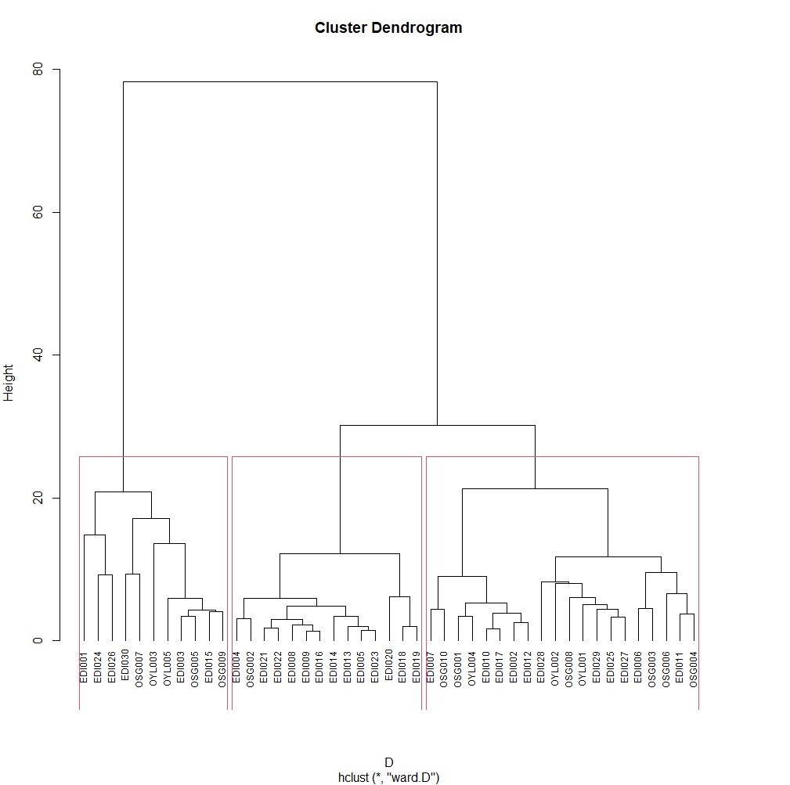
Figure 4.16: Dendrogram showing clusters of observations in the LA-ICP-MS data.

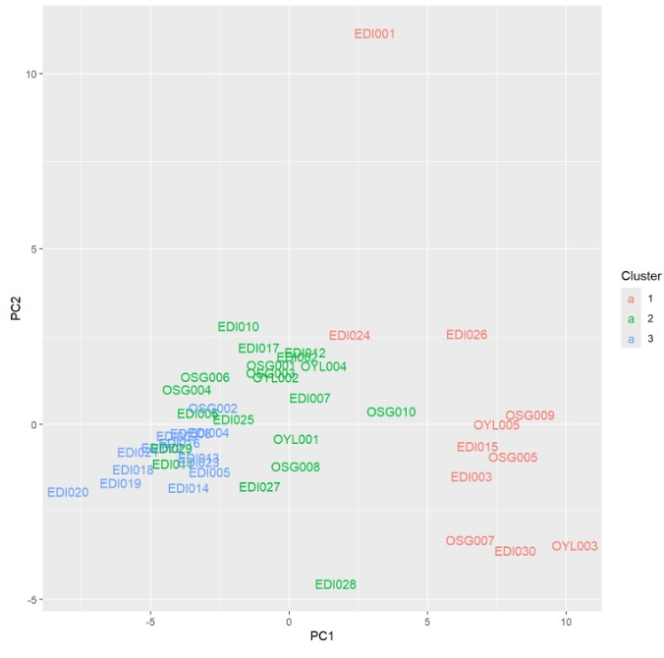
Figure 4.17: Ggplot of cluster assignments in the LA-ICP-MS data.

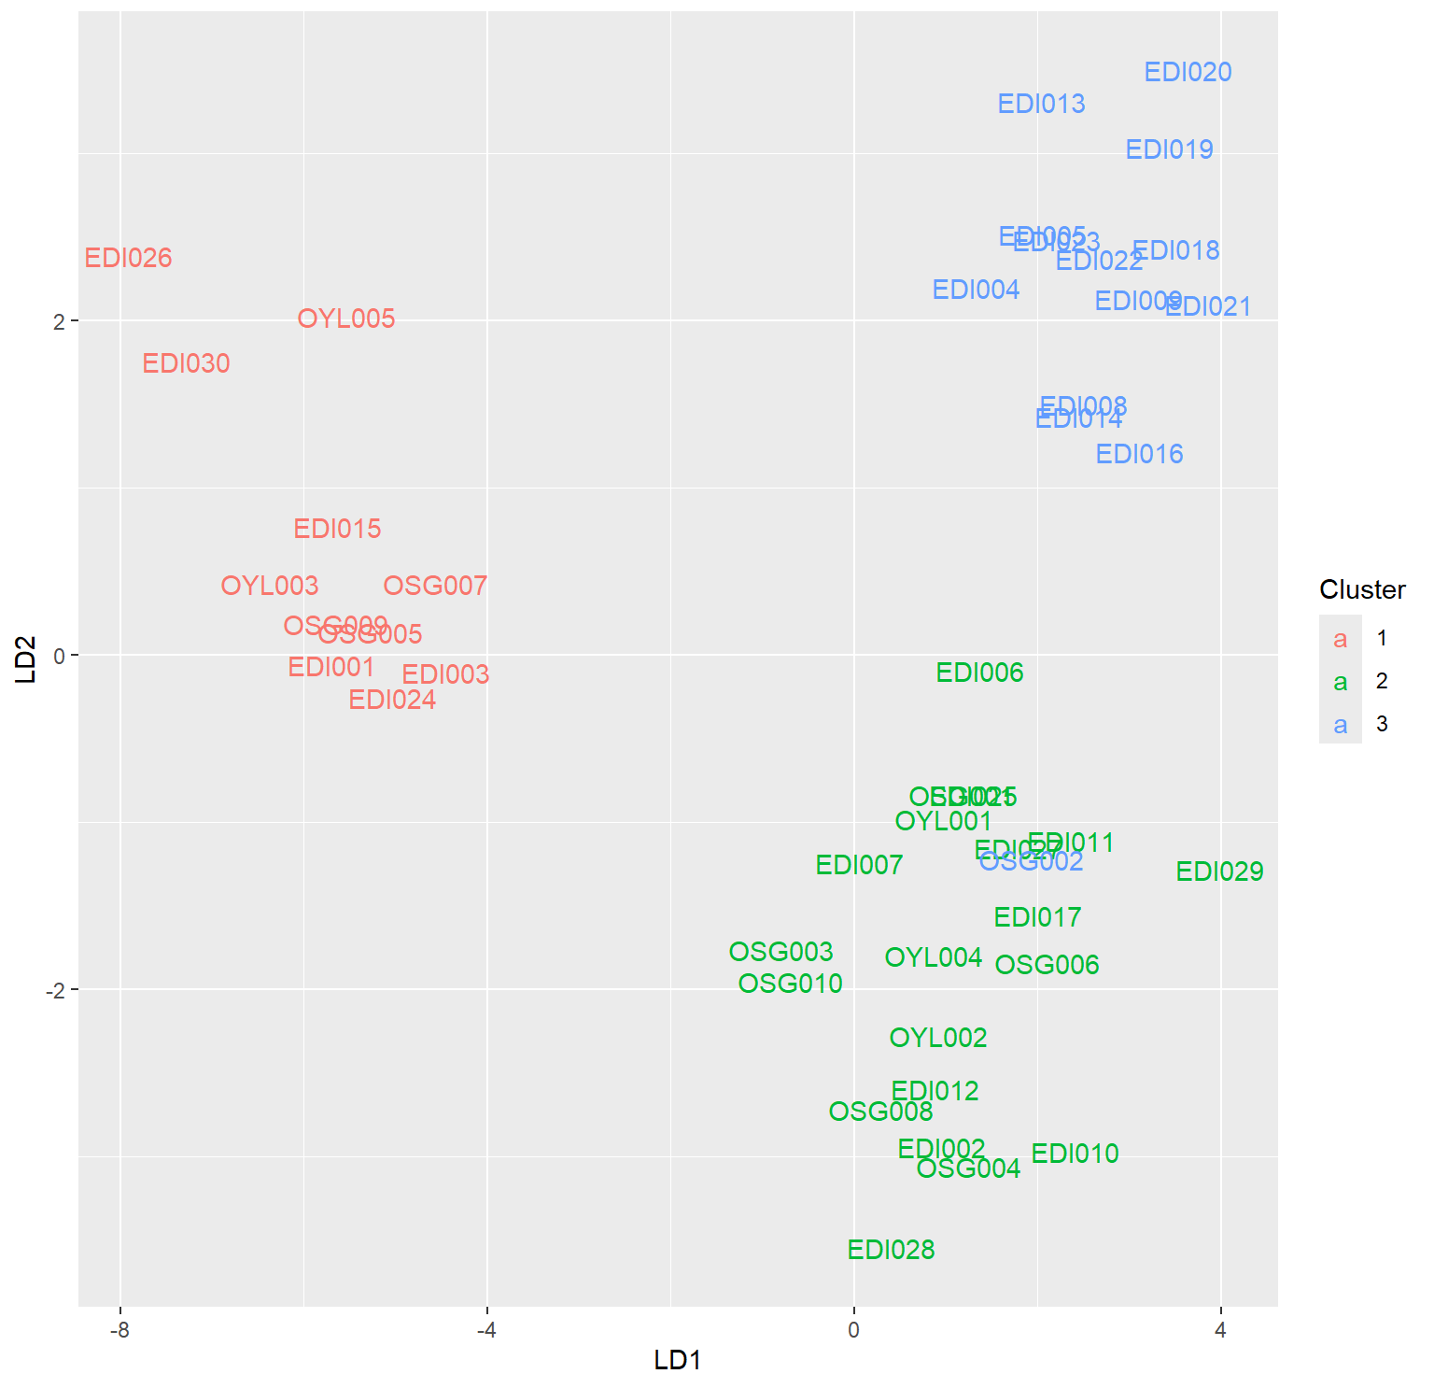
Figure 4.18: LDA plot of the LA-ICP-MS data showing well-separated clusters.

Table 4.7: Table showing misclassified observations in the LA-ICP-MS data.
Sample | Group | Predict | X1 | X2 | X3 | LD1 | LD2
EDI001 | 1 | 2 | 3.785187e-34 | 1.0000000 | 6.736675e-25 | -5.061215 | -0.3731587
EDI006 | 2 | 3 | 3.964370e-11 | 0.0313502 | 9.686498e-01 | 2.004923 | -0.4050439
EDI024 | 1 | 2 | 1.252482e-25 | 1.0000000 | 1.834526e-12 | -4.407443 | -0.5674859
EDI029 | 2 | 3 | 2.775810e-27 | 0.1725890 | 8.274110e-01 | 4.616954 | -1.5994350
OSG002 | 3 | 2 | 5.143546e-14 | 0.9999915 | 8.475506e-06 | 2.560522 | -1.5353102
OSG006 | 2 | 3 | 9.279573e-21 | 0.2794334 | 7.205666e-01 | 2.734845 | -2.1543788
OSG007 | 1 | 2 | 1.689561e-03 | 0.9977410 | 5.694736e-04 | -3.939034 | 0.1129843
Table 4.8: Table showing cluster membership with 84% Accuracy.
 | Group 1 | Group 2 | Group 3 | Total
Ede-Ile | 6 | 13 | 11 | 30
Osogbo | 3 | 1 | 6 | 10
Oyo-Ile | 2 | - | 3 | 5
Total | 11 | 14 | 20 | 45

Table 4.9: Table showing pipes arranged into predicted groups.
 | Group 1 | Group 2 | Group 3 | Total
Ede-Ile | 4 | 13 | 13 | 30
Osogbo | 2 | 2 | 6 | 10
Oyo-Ile | 2 | - | 3 | 5
Total | 8 | 15 | 20 | 45

To conclude, it appears that there are three different material sources for the clay pipes under study. In essence, there are three production groups or centers of production. While the
sample sizes across the three sites are uneven, Ede-Ile, with the largest number of samples, is represented in all the production groups. Osogbo follows closely by also being represented in all the production groups. Oyo-Ile, however, is only represented in groups 1 and 3. Given the small size of the Oyo-Ile samples, it is difficult to ascertain whether Oyo-Ile pipes are only restricted to groups 1 and 3.

PXRF Paste Analysis
Like LA-ICP-MS, PCA, hierarchical clustering, and LDA were performed on the pXRF data of the pipe paste. Unlike LA-ICP-MS, only about 48% variance was preserved in the first two principal axes (Figure 4.19). A biplot of the first two principal components displays clusters of observations (Figure 4.20). Some observations, for instance, cluster toward positively correlated variables of S, P, and Ca. Another group is driven by a correlation of such elements as V, Th, Cr, Pb, Fe, Y, Nb.
To group the observations into their clusters, hierarchical clustering was performed, following a validation of clusters using the NbClust package on R, a dendrogram with three clusters of observations was generated (Figure 4.21). To further evaluate the cluster assignments and ensure that they are well separated, I performed LDA. This returned a plot of three well-separated groups of observations (Figure 4.22). Further evaluation of LDA suggest that 89% of observations are adequately grouped into their respective clusters, while five observations (Tables 4.10, 4.11& 4.12) were misclassified accounting for the remaining 11%.
To conclude, three clusters suggesting three production groups emerged from this analysis. Cluster 1, shown in red, comprises samples that are rich in Zr, Rb, Ba, Cu, Zn, Mn, P, S, Cluster 2, shown in green, comprises pipe samples that are rich in Ni, Ca and moderately

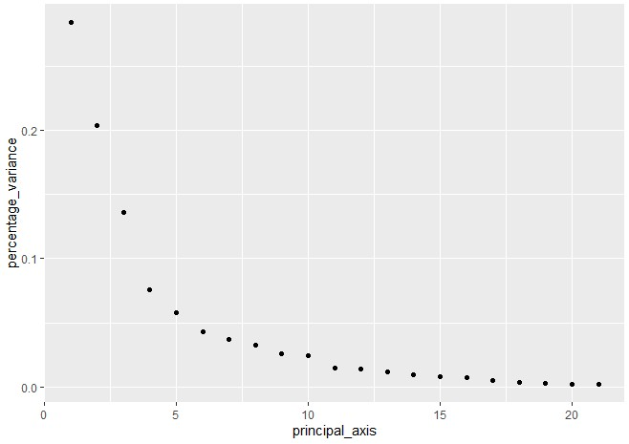
Figure 4.19: Scree plot showing the percentage of variance preserved in the pXRF paste data.

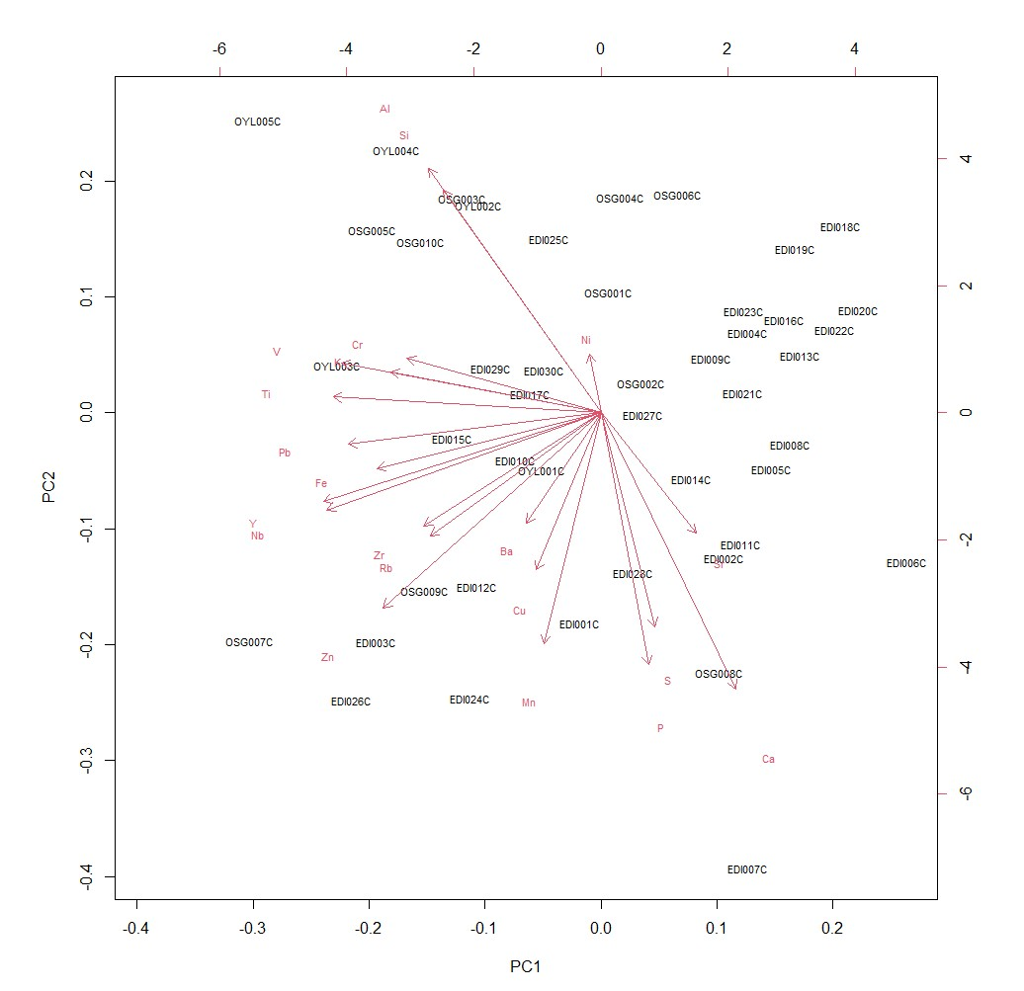
Figure 4.20: PCA biplot displaying observations and variables in the pXRF paste data.
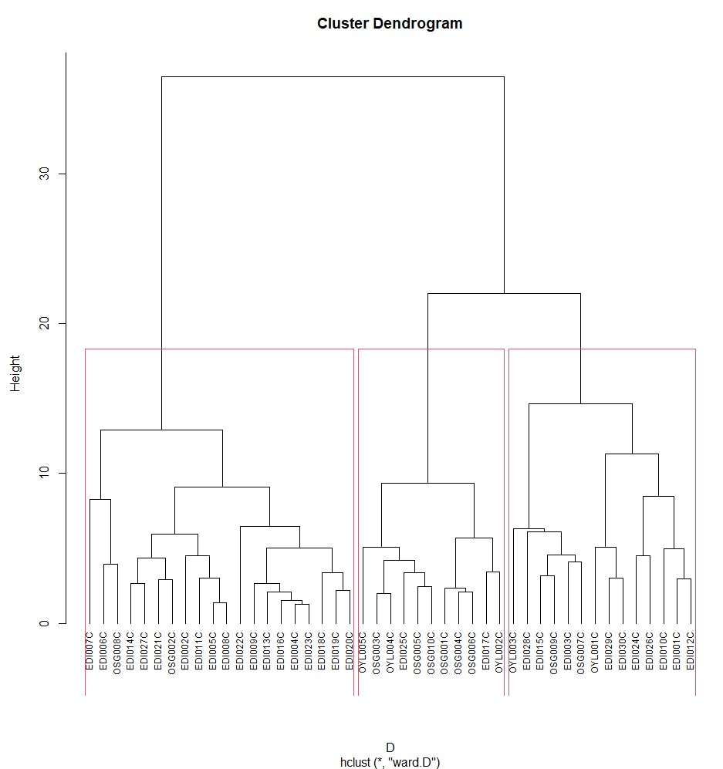
Figure 4.21: Dendrogram showing clusters of observations in the pXRF paste data.

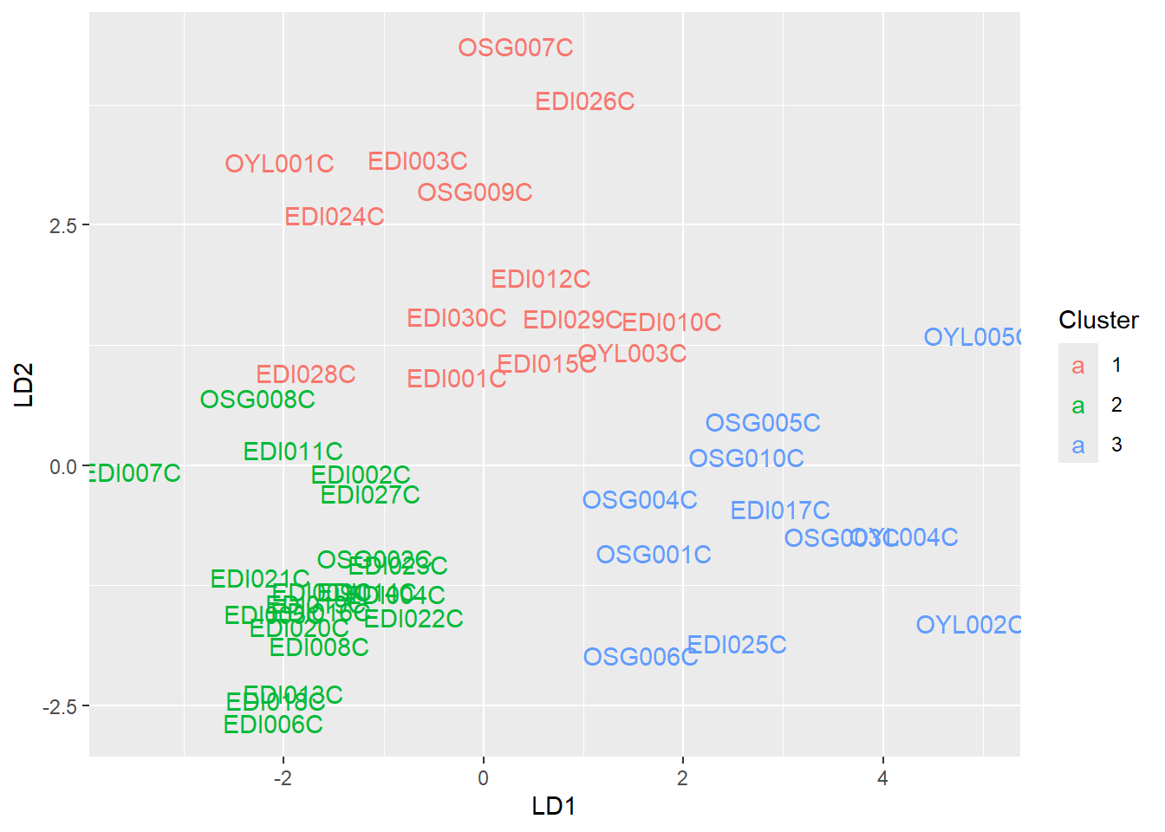
Figure 4.22: LDA plot of the pXRF paste data showing well-separated clusters.

Table 4.10: Table showing misclassified observations in the pXRF paste data.
Sample | Group | Predict | X1 | X2 | LD1
EDI024C | 1 | 2 | 3.703417e-01 | 0.6296583 | -0.9309203
EDI028C | 1 | 2 | 9.151415e-05 | 0.9999085 | 0.4206155
OSG006C | 1 | 2 | 2.546512e-01 | 0.7453488 | 0.0296351
OSG008C | 2 | 1 | 8.165292e-01 | 0.1834708 | 0.9534296
OYL001C | 1 | 2 | 2.077898e-01 | 0.7922102 | -0.9156010

Table 4.11: Table showing cluster membership of pXRF paste data with 89% Accuracy.
 | Group 1 | Group 2 | Group 3 | Total
Ede-Ile | 10 | 18 | 2 | 30
Osogbo | 2 | 2 | 6 | 10
Oyo-Ile | 2 | - | 3 | 5
Total | 14 | 20 | 11 | 45

Table 4.12: Table showing pipes arranged according to the predicted groups
 | Group 1 | Group 2 | Group 3 | Total
Ede-Ile | 7 | 20 | 3 | 30
Osogbo | 1 | 3 | 6 | 10
Oyo-Ile | 1 | - | 4 | 5
Total | 9 | 23 | 13 | 45

rich in P, S, Sr, and Cluster 3, shown in blue, is composed of pipes that are rich in Al, Si, V, Cr, Ti, Pb, Fe, Y, Nb, and K.
From the above tables, it is clear that the clusters from pXRF are not grouped the same way as those from LA-ICP-MS. However, they have a similar structure, in that both suggest with accuracy that there are three distinct production groups from which the pipe samples were sourced. Another similarity in structure is that Oyo-Ile samples belong to two groups (1 and 3), as they are not represented across all three groups, just as seen in the LA-ICP-MS data. To be able to address this discrepancy, a more representative sample size from Oyo-Ile and even Osogbo is required.

pXRF Analysis of Pipe Pigment
PXRF was also used to analyze the surface of the clay pipes to study the surface treatment (i.e., the slips). Following the same statistical steps as highlighted for LA-ICP-MS, PCA was performed. The first two PCs only account for about 40% of the entire dataset. Regardless, a biplot was generated showing positive and negative loadings. To check for clusters, the NbClust package was loaded in R while using the first ten PCs, given that they explain over 90% variance. However, the optimum number of clusters based on this package is 15, which seems chaotic, possibly due to too many correlated variables. It appears that there is overclustering of observations (Figures 4.23 & 4.24).
The discrepancy between the results for pipe paste and pigment could be an indicator that different clays may have been used to make the slips applied on the pipe surface.

Discussion
Tobacco and the paraphernalia of smoking were introduced into West Africa in the late sixteenth century, and from the seventeenth century, the plant and its consumption became widespread, transforming the everyday socioeconomic and political engagements of people on the West African coast and in the interior. While tobacco has been observed to be
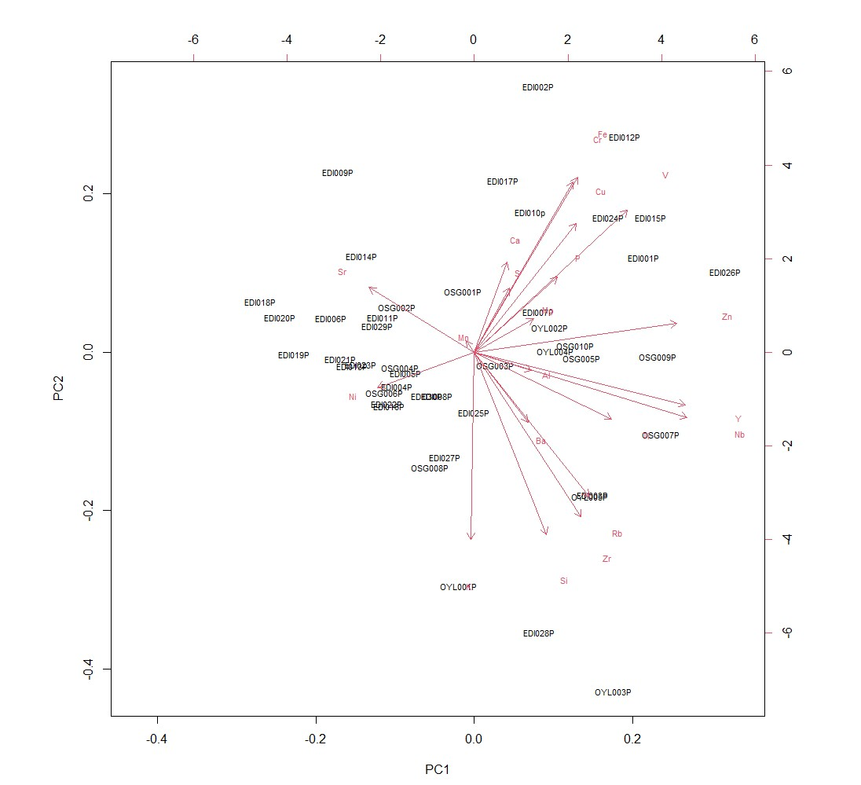
Figure 4.23: PCA biplot displaying observations and variables in the pXRF pigment data.

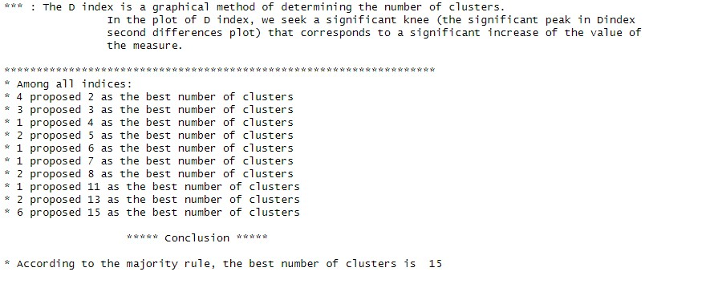
Figure 4.24: Image showing the best number of clusters in the pXRF pigment data.
consumed in various ways, such as snuffing and chewing, clay pipes have afforded archaeologists the opportunity to materially engage with the culture of smoking in West Africa. The preponderance of European-made smoking pipes in the lower deposits of Coastal West African sites such as Elmina is an indicator of early pipe smoking in the African subregion (DeCorse 2001). In response, African-produced pipes developed as well (Kelley 2001). These are stem-socket pipes that require the insertion of a long wooden reed in the stem-socket. Eighteenth-century European observers have been quoted by West African researchers (Hill 1976; Gijanto 2017) to have described the reeds to be usually from 5ft to 6ft long. The stems were made to be long, possibly to allow the smoker to sit comfortably and enjoy the psychostimulant while the pipe is rested on the ground. Given that the reeds are
organic materials, to date, none has been found preserved in an archaeological context in West Africa. Aside from the morphological characteristics of African-produced pipes, Gijanto (2017) reports that among the Mande people of the Senegambia, clay pipe production as well as metal working and leatherworking were the preoccupation of men while were women associated with pottery production. A similar scenario is recorded among the Akan people of Ghana, with pipe production observed to be an engagement restricted to the male gender, while in Dahomey, women in the palace made pipes (DeCorse 2001; Monroe and Janzen 2014). In these three areas, although the gender of the producers varied, it is clear that West Africans were making their own smoking pipes.
In the Yoruba interior, the clay smoking pipes analyzed for this study have benefited from, as well as corroborated and contributed to, the previous and ongoing studies of the culture of smoking in West Africa. Of the 65 pipe fragments analyzed across Oyo-Ile, Osogbo, and Ede-Ile, all but two are African-made. The non-African pipes were found in the Governor’s quarters of Ede-Ile. These pipes are European. Although the presence of pipes in the Yoruba interior already establishes the deep entanglement of Yorubaland with the Atlantic trade, the presence of European-made pipes also points to the fact that Ede-Ile was actively involved in the booming Atlantic trade. Since only a few European-made pipes are present in comparison with the African-produced ones, the question arises as to what role they played. Since the elite already had access to African-made pipes, what use were the European-made pipes put to? Were these used on special occasions? From the seventeenth and eighteenth centuries in Elmina, European-made pipes outnumbered locally produced pipes. Given that this was a coastal site, this is not surprising. In the Savi area of Benin, Kelly (2001) also reported that locally made pipes coexisted alongside European pipes. While the presence of such imported pipes at Ede-Ile is not random, it is interesting to see such pipes in the interior.
On the basis of the descriptive analysis, it is clear that there are overlaps between the 63 (African-made) smoking pipes across Oyo-Ile, Osogbo, and Ede-Ile. The stems, bowls, and bases all share similarities. Across the three sites, round-shaped pipe stems are common, although bevel-shaped ones also appeared in the Ede-Ile assemblage. Likewise, it is also observable that red-slipping is common, although, given that the samples from Ede-Ile outnumber those from the other sites, dark-red slipping was also preferred.
The feature that stands out the most is the base. It is interesting to see that footed (pedestal) bases are a common occurrence in the assemblages across the three sites. This feature is a confirmation that, temporally, Yorubaland was not left out in the regional tobacco smoking trend. Footed pipes have been reported in Ghana, Benin, and Mali to be the earliest adaptation of pipes in West Africa, dating to the seventeenth and eighteenth centuries. The essence of attaching a pedestal base to the pipes meant that the pipes could be rested on the ground, and tobacco smoking could be enjoyed comfortably by the smoker while seated. This feature, coupled with the long reed stem attached to its stem socket, could also make it possible for more than one person to engage in the act of smoking. In essence, communal smoking may have underscored the production of pedestal pipes. At Jenne, Mali, non-footed pipes were found in great quantity in later deposits dating to the eighteenth and nineteenth centuries, with a significant amount of footed pipes in earlier deposits dating to the seventeenth and eighteenth centuries. This means that the style of smoking changed, from smoking while seated to clenching the pipes between the teeth. In the Yoruba interior, the presence of (rectangular and rounded) pedestal pipes means that the performative act of smoking (where the smoker is seated while enjoying the psychostimulant) may have persisted until the nineteenth century. The abrasions beneath the pedestals also suggest that the pipes were used on a regular basis. That said, a common morphological trait identifiable below the pipe base across all three sites is basal perforation. It is quite unclear whether this was supposed to fulfil an aesthetic purpose or if this trait was supposed to be functional. The perforations may have served the purpose of hanging holes or perhaps as openings in which strings could be attached to carry two or three pipes together at a time. But these are just speculations. From the foregoing, however, it is certain that the style of smoking across the three sites was the performative type, where the pipe was set on the ground to be enjoyed by one or a collective of two or more people.
Rounded stem seems to be common across the three sites, although at Ede-Ile, bevel-shaped stems are also common, with incised, rouletted, and punctate motifs. It is unclear whether there is a temporal dimension to this variation. The comparative samples from Oyo-Ile and Osogbo are very small, so it is difficult to establish whether bevel-shaped stems may have been common there as well.
The decorative techniques identified across the three sites can be grouped into incised, rouletted, impressed, and punctates. However, the motifs varied, ranging from vertical and horizontal incisions to V-shaped incisions and chevron-shaped designs. The impressed and rouletted techniques involved the use of textured material, such as carved wooden objects, to make zoomorphic designs, and other kinds of geometric designs on the surface of the pipes. A very common motif identifiable on the (rounded) stems across the three sites, for instance, is a preference for four horizontal incisions on both sides of the pipe stems (Figure 4.25). This is quite interesting given that among the Yoruba people, Abaja – a four-striped horizontal scarification mark on the cheeks is common and is associated with lineage and ethnic affiliation (Ojo and Saibu 2018). Additionally, the facial mark also served the purpose of beautification, and even for demonstrating social class, distinguishing the elites from the commoners (Fadehan and Barber 2021). As this is just one possible explanation for the presence of that motif, the representation of such stripes on both sides of the rounded pipe stems does not tell us exactly where the pipes came from. As with other decorative designs on the pipes, these horizontal incised stripes may have served as identity and social markers, or mere beautification.
A striking motif identifiable on pipe bowls is representative of animals, i.e., a ram and an owl. These motifs are only accounted for in the Ede-Ile pipe assemblage. The functionality of these motifs is yet to be ascertained, but given the context (Governor’s quarter) in which they are found, it can be speculated that these are special pipes and may have been used on special occasions by the Ede-Ile ruling elite. Zoomorphic designs in this case may be
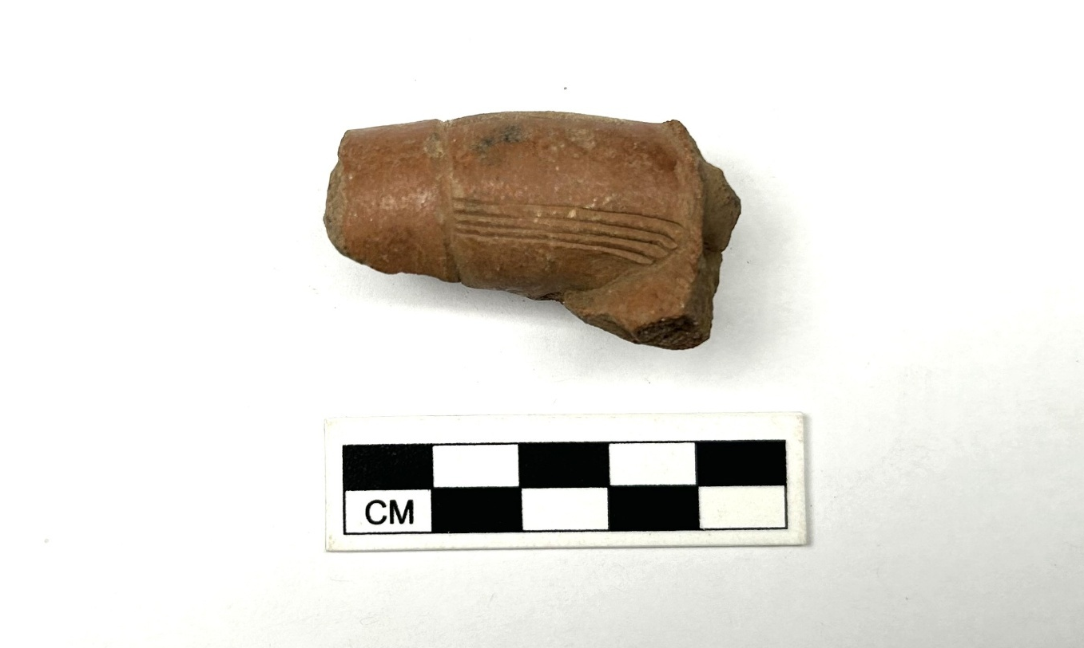
Figure 4.25: Round stem with four horizontal incisions on either sides.
symbolic, with layers of meanings embedded. For instance, Ram is an important sacrificial animal among the worshippers of such deities as Ogun, the god of iron, and Sango, the god of thunder (Olusola 2005). Ram holds a significant religious value in Yorubaland, and given that these deities are fond of the animal, it is often used by their worshippers to appease them. Again, this is speculative given that it is not certain whether the pipes were produced locally in Ede-Ile.
The consistency in the morphological attributes of the smoking pipes indicates that pipe production may have been standardized across the three sites, but does not confirm whether smoking pipes were produced independently in each area. It also does not confirm whether the Ede-Ile population was relying on Oyo-Ile or even Osogbo for their supply of smoking pipes, nor does it confirm whether Oyo-Ile was depending on its colony (Ede-Ile) and province (Osogbo) for smoking pipes, given the strategic location of both (latter) sites at the intersection between the savanna and the coast.
One of the motivations behind this study was to attempt to understand whether tobacco pipe production was part of the specialized crafts production that was ongoing at Ede-Ile. Earlier work confirmed that the residents of Ede-Ile took with them the knowledge of pottery production after departing Oyo-Ile to settle the town. Therefore, the majority of the pottery was produced locally in styles and forms that were similar to those being produced in the metropolis. By comparing Ede-Ile pipe samples with Oyo-Ile and Osogbo, I hoped to establish whether a similar process of knowledge transfer occurred with tobacco pipes. Based on visual descriptions of the pipes across the three sites, it cannot be established decisively whether Ede-Ile residents were relying on the metropolis or the neighbouring town (Osogbo) for pipes, although the similarities in the pipe forms do indicate an overlap. However, due to the fragmentary nature of the pipe samples, including the small size of comparative samples to Ede-Ile’s relatively significant size, it is difficult to address this question.
To attempt to address the gap stated above, I also analyzed the chemistry of the clay pipes. This is in a bid to address the second research question: What are the variations/similarities in the elemental compositions of pipes from Ede-Ile, Osogbo, and Oyo?
LA-ICP-MS and pXRF were used to analyze the clay matrix of the smoking pipes across the three sites, and pXRF was also used to evaluate differences in slips. Archaeometric analysis is not a new development in the study of artifacts in the Yoruba interior. Ogundiran (2009) employed INAA to study Ede-Ile pottery. This analysis confirmed that pottery production was part of the craft specialization of the Ede-Ile population (Ogundiran 2009). A similar analysis was conducted on glass beads recovered in Osogbo (Ogundiran 2014a), which also confirmed that glass bead production was ongoing in the area. Likewise, in the Banda area of Ghana, Stahl (2007) used INAA to study pipes. This study identified five clay sources across the area, confirming that African-made pipes were being produced locally across five locations within the study area. Despite being a really efficient tool for provenance analysis, INAA is destructive as it involves the grinding up of artifacts into powdery form during sample preparation before the material is analyzed (Dussubieux 2023). However, due to the non-invasiveness of pXRF and the minimally-invasive nature of LA-ICP-MS, these two formed the basis of the chemical analysis of this study.
Studies on the use of LA-ICP-MS demonstrate that this method of analysis is capable of measuring a wide range of elements. Given the heterogeneity of ceramic (as is the case with clay pipes), multiple spots were ablated to obtain a representative composition of each sample. The elements that returned from this analysis numbered 55, comprising major and minor oxides, trace, and rare earth elements. Rare earth elements have been deemed particularly useful in analyzing ceramics (Speakman and Neff 2005; Dussubieux 2023). The statistical analysis that followed suggested that the 45 pipe samples analyzed were from three different clay sources, meaning that the pipes, wherever they were made, were produced in three different locations. Cluster 1, which comprises a combination of 11 samples from across the three sites, came from a location with clay rich in trace (Ba, Be, Cs, Hf, Li, Nb, Rb, Sn, Ta, Th, U, W, Y, Zr) and rare earth elements (Ce, Dy, Er, Gd, Ho, La, Lu, Nd, Pr, Sm, Tb, Tm, and Yb). Cluster 2 comprises 14 samples, mostly from Ede-Ile and Osogbo, which came from a location with a clay source rich in major (Fe, Mg), minor (Mn, Ti, Cr, Zn), and trace elements (B, Co, Ni, V, Mo, Sc). Cluster 3, with an impressive combination of 20 samples (across all sites), indicates a production location with a clay source rich in major elements (Al, Ca, Na, Si).
From the foregoing, it is still not clear whether smoking pipes were a localized invention at Ede-Ile. If the pipes from the three sites have independent clusters based on the statistical analysis, this would suggest that perhaps pipe production was going on independently in each area or that they each were sourcing pipes from different locations. Given that this was not the case, one thing is clear from this study: smoking pipes traveled between Ede-Ile, Osogbo, and Oyo-Ile from the seventeenth to the nineteenth centuries, and there were three centers of production.
The last research question that I hoped to address is whether pXRF can provide similar results as LA-ICP-MS, such that if one cannot afford to do the latter, one can confidently rely on the former. Three distinct clusters result from the statistical analysis of the pXRF pipe paste data, similar in structure to the LA-ICP-MS result. This confirms that the pipes were coming from three different production centers. However, cluster membership of the pipe samples with pXRF is different than those from LA-ICP-MS. What is the reason for this discrepancy? First, pXRF is not sensitive to rare earth elements (REEs). Only major and trace elements were obtained from the analysis of the pipe samples across the three sites. The presence or absence of REEs may have been crucial in the differences in cluster memberships of the pipe samples with both archaeometric methods. In addition, the LA-ICP-MS data analyzed contained 47 variables (elements) as opposed to pXRF’s 30 variables. This may have also contributed to the differences in cluster assignments in both methods. Another plausible explanation is the mechanism of detection for both methods. LA-ICP-MS physically removes microscopic materials from the samples that are then ionized by the plasma before being analyzed by a mass spectrometer. This mechanism offers higher precision and accuracy in detecting major, minor, trace, and rare earth elements. On the other hand, pXRF emits X-rays on the exposed surface of the sample being analyzed. Since pXRF is sensitive to the sample surface, it does not offer detection as precise as LA-ICP-MS. This may have influenced the differences in grouping in both datasets.
So, to address the viability of LA-ICP-MS and pXRF, it is clear from this study that both are unique. The former provides high-resolution chemical signatures, and is sensitive to various (major, trace, and rare earth) elements that can be used in understanding the chemical variations of ceramic artifacts. pXRF, on the other hand, despite its merits in simplicity, portability, non-invasiveness, and cost-effectiveness offers lower precision trace elements and low sensitivity for rare earth elements. However, if one is attempting to understand chemical variations of clay pipes and potentially address questions surrounding provenance, the capability of LA-ICP-MS to obtain bulk chemical compositions comes in handy, making it the most suitable method of the two.

CHAPTER FIVE
CONCLUSION
This study on smoking pipes was conceived with a view to contributing to the broader discourse on the transformations of West African societies during the Atlantic age. Tobacco and the paraphernalia of smoking, upon their introduction into the region, played an important role in the socioeconomic transformation that West African societies underwent. Tobacco became an important crop that even became legal tender, used in the procurement of slaves. In addition, the introduction of this endemic plant into the African region tested the creative ingenuity of West Africans, as pipes with unique styles and forms were manufactured. These pipes would then serve purposes beyond mere smoking. They became important items of ritual, class, and identity markers, transforming the everyday life of people in Atlantic West African societies.
Yorubaland was significantly transformed during the Atlantic era. Oyo-Ile developed into a powerful polity because of its deep entanglement with the Atlantic economy. An important strategy that helped Oyo secure her hegemony over Yorubaland was colonization. This strategy led to the establishment of a colony, Ede-Ile in the periphery, so as to allow the authorities of Oyo-Ile to gain control of trade routes. Amidst climatic constraints and social strife, Osogbo emerged in the periphery as well, with people across Yorubaland moving into the area because of its strategic location and accessibility to water. Following the rise of Oyo into an imperial superpower, Osogbo became one of its provinces. Examining the material life of such frontier settlements as Ede-Ile and Osogbo has allowed for the understanding of how people on the fringes navigated their everyday life as well as how they transformed internally through craft specialization, organization, and trade. This study hoped to contribute to the ongoing discourse of metropole-periphery entanglement by examining an important facet of the quotidian life of people in the Yoruba interior, tobacco smoking.
Studies on Ede-Ile and Osogbo have already established that residents of both areas comprised people of different economic stations. There were, for instance, potters, blacksmiths, traders, and glass bead makers. Their skills allowed for the production of utilitarian goods such as pottery, iron tools, glass beads, and so on. This study attempted to assess whether they also produced clay tobacco pipes. The study of Ede-Ile pottery, for instance, confirmed that the craft was ongoing independently in the area, with ceramics produced in a similar fashion to those from the metropolis. It was against this backdrop that this comparative study was conceived.
A descriptive analysis was conducted to compare smoking pipes from across Ede-Ile, Oyo-Ile, and Osogbo. Given that there is no established pipe typology for the area, this study relied on studies on pipes that have been done in other areas to describe the Ede-Ile, Oyo-Ile, and Osogbo pipe assemblage. This analysis did suggest that there were commonalities in the smoking pipes across the three sites, but I could not establish whether local production of pipes was being undertaken across the areas.
Chemical analysis was the next step, using LA-ICP-MS and pXRF to examine the chemical compositions of the samples. The result of the LA-ICP-MS analysis of the pipe clay matrix did not establish whether the materials were part of the craft specialization that was going on in the study areas. The method suggests that the smoking pipes across the three sites were sourced from three production centers, with pipes from each source present at each site. Given the overlap in the production centers, I concluded that pipes were being transported across Ede-Ile, Oyo-Ile, and Osogbo from the seventeenth to the nineteenth centuries. pXRF analysis of the paste of the same pipe samples also suggests that pipes were procured from three different sources, but the cluster memberships of the samples were different from those of LA-ICP-MS. This is not to suggest that the result was invalid. The reason for these differences can be attributed to the differences in the mechanisms of detection in both methods which may have influenced the discrepancy encountered in the results of both methods.
Is pXRF then a useful substitute for LA-ICP-MS? Based on this study, it could be a partial substitute but not a total replacement for LA-ICP-MS when analyzing clay-based materials. It can be efficient when used as a complementary tool to a high-power analytical method like LA-ICP-MS, as in this study. I make this assertion due to the fact that pXRF is non-destructive and can be a useful exploratory chemical analytical method when dealing with museum and legacy collections. Also, if one is dealing with a large assemblage, it can be a useful, quick, and relatively cheap exploratory chemical analytical method compared to LA-ICP-MS. However, for a comprehensive chemical fingerprint of clay-based materials like smoking pipes, LA-ICP-MS is the best bet.

Recommendations
One of the next steps for provenance analysis for pipe smoking in the Yoruba interior will be to collect and chemically analyze clay samples from the three sites and compare the results with those obtained from the clay pipes. Matches between clays and finished pipes can help understand whether smoking pipes were being produced locally in any of the three sites. And if there are no matches, then this would mean that the pipes were being sourced from outside the three sites. Mineralogical techniques such as X-Ray Diffraction and petrography are also avenues that can be employed to enrich provenance analysis. These methods can also offer insight into the production processes of the pipes, such as firing techniques.
Secondly, smoking pipes have always been associated with tobacco. While this is the case, based on textual evidence and observations by European traders, it would be useful to test this assertion by conducting residue analysis. Such analysis will provide insight into other plants that may have been consumed with clay pipes aside from tobacco.
Without a doubt, a considerable sample size is required for a more robust study and understanding of smoking in the Yoruba interior and beyond. Given the inter-site comparative analysis, like this study, 30-50 tobacco pipe samples per site would be a good start.

LIST OF REFERENCES
Agbaje-Williams, Babatunde
1983 A Contribution to the Archaeology of Old Oyo. Doctoral Dissertation, Department of Archaeology, University of Ibadan, Nigeria.
1995 Archaeological Investigation of Itagunmodi Potsherd Pavement Site, Ijesaland, Osun State, Nigeria: 1991-1992 Season. IFRA-Nigeria, Ibadan. http://books.openedition.org/ifra/3655.
Agbe-Davies, Anna S
2015 Tobacco, Pipes, and Race in Colonial Virginia: Little Tubes of Mighty Power. Left Coast Press, Walnut Creek, CA.
Agiri, Babatunde A.
1975 Early Oyo History Reconsidered. History in Africa 2:1–16.
Akintoye, Stephen A.
2010 A History of the Yoruba People. Amalion Publishing, Dakar, Senegal.
Aldenderfer, Mark S.
1982 Methods of Cluster Validation for Archaeology. World Archaeology 14(1):61–72.
Baxter, Mike J.
1995 Standardization and Transformation in Principal Component Analysis, with Applications to Archaeometry. Journal of the Royal Statistical Society 44(4):513–527.
2015 Exploratory Multivariate Analysis in Archaeology. Percheron Press, Clinton Corners, New York, NY.
Blench, Roger
2018 The Translocation of Useful Trees in African Prehistory. In Plants and People in the African Past, Anna Maria Mercuri, A. Catherine D’Andrea, Rita Fornaciari, and Alexa Höhn, editors, pp. 177–193. Springer International Publishing, Cham, Switzerland.
Blench, Roger, and Mallam Dendo
2007 The Intertwined History of the Silk-Cotton and Baobab. In Fields of Change: Progress in African Archaeobotany, Rene Cappers, editor, pp. 1–19. Barkhuis, Eelde, The Netherlands.
Brown, Brittany
2016 Reexamining English Clay Pipes in Captive African Burials on the Island of Barbados. Journal of African Diaspora Archaeology and Heritage 5(3):245–262.
Carlson, David L.
2017 Quantitative Methods in Archaeology Using R. Cambridge University Press, Cambridge, UK.
Cole, Gibril R.
2004 Liberated Slaves and Islam in Nineteenth-Century West Africa. In The Yoruba Diaspora in the Atlantic World, Toyin Falola and Matt D. Childs, editors, pp. 383–400. Indiana University Press, Indianapolis, IN.
Cooney, Gabriel
2016 Material Culture. In The Oxford Handbook of Archaeological Theory, Andrew Gardner, Mark Lake, and Ulrike Sommer, editors, pp. 1-29. Oxford University Press, Oxford, UK.
DeCorse, Christopher R.
2001a An Archaeology of Elmina: Africans and Europeans on the Gold Coast, 1400-1900. Smithsonian Institution Press, Washington, DC.
2001b Introduction. In West Africa during the Atlantic Slave Trade: Archaeological Perspectives, Christopher R. DeCorse, editor, pp. 1–13. Leicester University Press, London, UK.
2013 Postcolonial or Not? West Africa in the Pre-Atlantic and Atlantic Worlds. IFRA-Nigeria, Ibadan. https://books.openedition.org/ifra/1517.
Duco, Don
2006 Amsterdam Pipe Museum - Article Tobacco Pipes Representing Proverbs of the Asante. https://pipemuseum.nl/en/article/spreekwoordelijke-ashantipijpen. Accessed 2 August 2024.
Dunhill, Alfred
1969 The Pipe Book: The Classic Volume on Pipes and Pipe Smoking. The Macmillan Company, Toronto, ON.
Dussubieux, Laure
2023 LA-ICP-MS Analysis of Andean Ceramics: Comparability and Data Correction for Datasets Acquired over Almost Two Decades. Journal of Archaeological Science. 48:1–7.
Dussubieux, Laure, Mark Golitko, Patrick Ryan Williams, and Robert J. Speakman
2007 Laser Ablation-Inductively Coupled Plasma-Mass Spectrometry Analysis Applied to the Characterization of Peruvian Wari Ceramics. Archaeological Chemistry: Analytical Techniques and Archaeological Interpretation 968:349–363.
Duvall, Chris S.
2017 Cannabis and Tobacco in Precolonial and Colonial Africa. In Oxford Research Encyclopedia of African History, Thomas Spear, editor, pp. 1-32. Oxford University Press, Oxford, UK.
Fadehan, Olukemi, A., and Olatunde Barber O.
2021 Documenting Genealogies: A Semiological Study of Tribal-Facial Marks and Lineage Networks of the Yoruba of Southwest Nigeria. In Everyday Documentation, Tim Gorichanaz and Ann Graf M., editors, pp. 520–555. John Hopkins University Press, Baltimore, MD.
Falola, Toyin, editor,
2013 Èṣù: Yoruba God, Power, and the Imaginative Frontiers. Carolina Academic Press, Durham, NC.
Fricker, Mattias B., and Detlef Gunther
2016 Instrumentation, Fundamentals, and Applications of Laser Ablation-Inductively Coupled Plasma-Mass Spectrometry. In Recent Advances in Laser Ablation ICP-MS for Archaeology, Laure Dussubieux, Mark Golitko, and Bernard Gratuze, editors, pp. 1–22. Springer Berlin Heidelberg, New York, NY.
Gijanto, Liza
2017 The Life of Trade: Events and Happenings in Niumi’s Atlantic Center. Routledge Studies in Archaeology. Routledge, New York, NY.
Gokee, Cameron D.
2012 Daily Life in the Land of Bambuk: An Archaeological Study of Political Economy at Diouboye, Senegal. Doctoral Dissertation, Department of Anthropology, University of Michigan, Ann Arbor.
2013 Daily Life in the Land of Bambuk: An Archaeological Study of Political Economy at Diouboye, Senegal. Azania: Archaeological Research in Africa 48(4):547–548.
Golitko, Mark, and Laure Dussubieux
2016 Inductively Coupled Plasma-Mass Spectrometry (ICP-MS) and Laser Ablation Inductively Coupled Plasma-Mass Spectrometry (LA-ICP-MS). In The Oxford Handbook of Archaeological Ceramic Analysis, Alice Hunt, editor, pp. 398–423. Oxford University Press, Oxford, UK.
Handler, Jerome
1997 An African-Type Healer/Diviner and His Grave Goods: A Burial from a Plantation Slave Cemetery in Barbados, West Indies. International Journal of Historical Archaeology 1(2):91–130.
Handler, Jerome S
2008 Aspects of the Atlantic Slave Trade: Smoking Pipes, Tobacco, and the Middle Passage. African Diaspora Archaeology Newsletter 11(2):1-12.
Handler, Jerome S.
2009 The Middle Passage and the Material Culture of Captive Africans. Slavery & Abolition 30(1):1–26.
Haour, Anne, and Annalisa Christie
2019 Cowries in the Archaeology of West Africa: The Present Picture. Azania: Archaeological Research in Africa 54(3):287–321.
Hodder, Ian
2011 Human-Thing Entanglement: Towards an Integrated Archaeological Perspective. Journal of the Royal Anthropological Institute 17(1):154–177.
Jones, A
2004 Archaeometry and Materiality: Materials-Based Analysis in Theory and Practice. Archaeometry 46(3):327–338.
Kelly, Kenneth G.
2001 Change and Continuity in Coastal Benin. In West Africa during the Atlantic Slave Trade: Archaeological Perspectives, Christopher R. DeCorse, editor, pp. 81–100. Leicester University Press, New York, NY.
Knappett, Carl
2014 Materiality in Archaeological Theory. In Encyclopedia of Global Archaeology, Claire Smith, editor, pp. 4700–4708. Springer, New York, NY.
Kopytoff, Igor
1987 The Internal African Frontier: The Making of African Political Culture. In The African Frontier: The Reproduction of Traditional African Societies, Igor Kopytoff, editor, pp. 3–84. Indiana University Press, Bloomington, IN.
Laufer, Berthold, Wilfrid D Hambly, and Ralph Linton
1930 Tobacco and Its Use in Africa. Anthropology Leaflet 29. Field Museum of Natural History, Chicago, IL.
Law, Robin
1977 The Oyo Empire, c.1600-c.1836: A West African Imperialism in the Era of the Atlantic Slave Trade. Clarendon Press, Oxford, UK.
Liritzis, Ioannis, and Nikolaos Zacharias
2011 Portable XRF of Archaeological Artifacts: Current Research, Potentials and Limitations. In X-Ray Fluorescence Spectrometry (XRF) in Geoarchaeology, M. Steven Shackley, editor, pp. 109–142. Springer, New York, NY.
McIntosh, Susanne, R. J McIntosh, and H. Bocoum
2003 Tobacco Pipes from Excavations at the Museum Site, Jenne, Mali. Journal of African Archaeology 1:171–199.
Miller, Daniel
2005 Materiality: An Introduction. In Materiality, Daniel Miller, editor, pp. 1–50. Duke University Press, Durham, NC.
Monroe, J. Cameron, and Anneke Janzen
2014 The Dahomean Feast: Royal Women, Private Politics, and Culinary Practices in Atlantic West Africa. African Archaeological Review 31(2):299–337.
Ogiogwa, Joan-Mary
2017 Old Oyo or Ijebu-Oyo Pottery: The Vessels of Oke-Eri. Africology: The Journal of Pan African Studies 10(9):170–187.
Ogundiran, Akinwumi
2002 Archaeology and History in Ìlàrè District (Central Yorubaland, Nigeria) 1200-1900 A.D. University of Michigan Press, Ann Arbor, MI.
2007 Living in the Shadow of the Atlantic World: History and Material Life in a Yoruba-Edo Hinterland, ca. 1600-1750. In Archaeology of Atlantic Africa and the African Diaspora, Akinwumi Ogundiran and Toyin Falola, editors, pp. 77–99. Indiana University Press, Bloomington, IN.
2009 Material Life and Domestic Economy in a Frontier of the Oyo Empire During the Mid-Atlantic Age. The International Journal of African Historical Studies 42(3):351–385.
2012 The Formation of an Oyo Imperial Colony during the Atlantic Age. In Power and Landscape in Atlantic West Africa: Archaeological Perspectives, J. Cameron Monroe and Akinwumi Ogundiran, editors, pp. 222–252. Cambridge University Press, New York, NY.
2014a The Making of an Internal Frontier Settlement: Archaeology and Historical Process in Osun Grove (Nigeria), Seventeenth to Eighteenth Centuries. The African Archaeological Review 31(1):1–24.
2014b The Osun-Osogbo Grove as a Social Common and an Uncommon Ground: An Analysis of Patrimonial Patronage in Postcolonial Nigeria. International Journal of Cultural Property 21(2):173–198.
2020 The Yoruba: A New History. Indiana University Press, Bloomington, IN.
2024 Yorùbá Indigenous Religion. Oxford Research Encyclopedia of African History. Thomas Spear, editor, pp. 1-30, Oxford University Press, Oxford, UK.
Ogundiran, Akinwumi, and Toyin Falola
2007 Pathways in the Archaeology of Transatlantic Africa. In Archaeology of Atlantic Africa and the African Diaspora, Akinwumi Ogundiran and Toyin Falola, editors, pp. 3–45. Blacks in the diaspora. Indiana University Press, Bloomington, IN.
Ogundiran, Akinwumi, and Paula V. Saunders
2011 Potters’ Marks and Social Relations of Ceramic Distribution in the Oyo Empire. Azania: Archaeological Research in Africa 46(3):317–335.
Ogundiran, Akinwumi, and Babatunde Agbaje-Williams
2017 Ancient Polities: Archaeological Survey in a Metropolis and Its Colony. In Field Manual for African Archaeology, Alexandre Livingstone Smith, Els Cornelissen, Olivier P Gosselain, and Scott McEachern, editors, pp. 69–75. Royal Museum for Central Africa, Tervuren, Belgium.
Ogunnaike, Ayodeji
2022 Precolonial Yoruba States. In Oxford Research Encyclopedia of African History, Thomas Spear, editor, pp. 1-28, Oxford University Press, Oxford, UK. https://oxfordre.com/africanhistory/view/10.1093/acrefore/9780190277734.001.0001/acrefore-9780190277734-e-718. Accessed 25 March 2025.
Ojo, Oluranti Edward, and Israel Abayomi Saibu
2018 Understanding the Socio-Cultural Identity of the Yoruba in Nigeria: Reassessing Cicatrix as Facial Marks, Scarification and Tattoo. Journal of the Historical Society of Nigeria 27:145–163.
Olusola, Ajibade George
2005 Animals in the Traditional Worldview of the Yorùbá. Folklore: Electronic Journal of Folklore 30:155–172.
Ozanne, Paul
1962 Notes on the Early Historic Archaeology of Accra. Transactions of the Historical Society of Ghana 6:51–70.
1969 The Diffusion of Smoking in West Africa. Odu 11:29–42.
Parker, Bradley J.
2006 Toward an Understanding of Borderland Processes. American Antiquity 71(1):77–100.
Philips, John Edward
1983 African Smoking and Pipes. The Journal of African History 24(3):303–319.
Price, T. Douglas, and James H. Burton
2011 An Introduction to Archaeological Chemistry. Springer, New York, NY.
Rodriguez-Corral, Javier
2017 Entangled Worlds: Materiality, Archaeometry and Mediterranean-Atlantic Identities In Western Iberia. Mediterranean Archaeology and Archaeometry 17(1):159–178.
Shackley, M. Steven
2011 X-Ray Fluorescence Spectrometry in Twenty-First Century Archaeology. In X-Ray Fluorescence Spectrometry (XRF) in Geoarchaeology, M. Steven Shackley, editor, pp. 1–6. Springer, New York, NY.
2014 X-Ray Fluorescence (XRF): Applications in Archaeology. In Encyclopedia of Global Archaeology, Claire Smith, editor, pp. 7933–7938. Springer, New York, NY.
Shaw, Thurstan
1960 Early Smoking Pipes: In Africa, Europe, and America. The Journal of the Royal Anthropological Institute of Great Britain and Ireland 90(2):272.
Shortland, Andrew J., and Patrick Degryse
2020 Ceramics. In Archaeological Science: An Introduction, Kate Britton and Michael P. Richards, editors, pp. 335–346. Cambridge University Press, Cambridge, UK.
Soper, Robert, and Patrick Darling
1980 The Walls of Old Oyo. West African Journal of Archaeology 10:61–81.
Speakman, Robert J., and Hector Neff, editors,
2005 Laser Ablation ICP-MS in Archaeological Research. University of New Mexico Press, Albuquerque, NM.
Stahl, Ann Brower
2002 Colonial Entanglements and the Practices of Taste: An Alternative to Logocentric Approaches. American Anthropologist 104(3):827–845.
2007 Entangled Lives: The Archaeology of Daily Life in the Gold Coast Hinterlands, AD 1400-1900. In Archaeology of Atlantic Africa and the African Diaspora, Akinwumi Ogundiran and Toyin Falola, editors, pp. 49–76. Blacks in the diaspora. Indiana University Press, Bloomington, IN.
Usman, Aribidesi A
2016 Enclosures of Northern Yorubaland, Nigeria. In African Indigenous Knowledge and the Sciences, Gloria Emeagwali and Edward Shizha, editors, pp. 153–158. Sense Publishers, Rotterdam.
Usman, Aribidesi Adisa
2012 The Yoruba Frontier: A Regional History of Community Formation, Experience, and Changes in West Africa. Carolina Academic Press, Durham, N.C.
Usman, Aribidesi, and Toyin Falola
2019 The Yoruba from Prehistory to the Present. Cambridge University Press, Cambridge, UK.
Van Dyke, Ruth M
2015 Practicing Materiality. The University of Arizona Press, Tucson, AZ.
Vivian, Brian
2005 On Tobacco Pipes in Asante. Journal Des Africanistes 75(2):87–95.
Willett, Frank
1960 Investigation at Old Oyo, 1956-57: An Interim Report. Journal of the Historical Society of Nigeria 2(1):59–77.
Wobst, H. Martin
2000 Agency in (Spite of) Material Culture. In Agency in Archaeology, Marcia-Anne Dobres and John Robb, editors, pp. 40–50. Routledge, New York, NY.

APPENDIX I: LA-ICP-MS Data
Table 6.1: Table showing LA-ICP-MS pipe samples
Lab # | Site | Context | Pipe Part | Slip | Decoration | Compositional Group
EDI001 | Ede-Ile | BI-11/II | Base | Dark Red | Carved Roulette | 1
EDI002 | Ede-Ile | BI-11/VII | Stem | Dark Red | Incised | 2
EDI003 | Ede-Ile | BI-11/VIII | Bowl | Red | Plain | 1
EDI004 | Ede-Ile | BI-10/VII | Base | Red | Dot Punctate | 3
EDI005 | Ede-Ile | BI-11A/VIII | Bowl | Red | Carved Roulette | 3
EDI006 | Ede-Ile | BI-10/VIII | Stem | Dark Red | Incised | 2
EDI007 | Ede-Ile | BI-10/IX | Base/Stem | Red | Carved Roulette | 2
EDI008 | Ede-Ile | BI-10/XI | Bowl | Red | Carved Roulette | 3
EDI009 | Ede-Ile | BI-10/X | Bowl | Red | Roulette + Punctate | 3
EDI010 | Ede-Ile | BI-11A/VIII | Bowl | Red | Carved Roulette | 2

Table 6.1: Continued
EDI011 | Ede-Ile | BI-11/V | Bowl | Red | Carved Roulette | 2
EDI012 | Ede-Ile | BI-11A/V | Base | Dark Red | Carved Roulette | 2
EDI013 | Ede-Ile | BI-11A/X | Bowl | Red | Carved Roulette | 3
EDI014 | Ede-Ile | BI-12C/VI | Stem | Red | Carved Roulette | 3
EDI015 | Ede-Ile | BI-12C/IX | Bowl | Black | Zoomorphic (Ram) | 1
 | Ede-Ile | BI-14A/VIII | Bowl | Red | Carved Roulette | 3

Table 6.1: Continued
EDI017 | Ede-Ile | BI-14A/X | Bowl/Base | Red | Carved Roulette | 2
EDI018 | Ede-Ile | BI-14A/X | Bowl | Red | Carved Roulette | 3
EDI019 | Ede-Ile | BI-14A/X | Bowl | Red | Carved Roulette | 3
EDI020 | Ede-Ile | BI-14A/X | Bowl/Base/Stem | Dark Red | Carved Roulette | 3
EDI021 | Ede-Ile | BI-15/VII | Base | Red | Carved Roulette | 3
EDI022 | Ede-Ile | BI-15/X | Base | Red | Carved Roulette | 3
EDI023 | Ede-Ile | BI-21/VII | Bowl/Base | Red | Bowl: Zoomorphic (Owl)  Base: Carved Roulette | 3
EDI024 | Ede-Ile | BI-21/IX | Bowl/Base/Stem | Red | Bowl + Stem: Incised  Base: Carved Roulette | 1
EDI025 | Ede-Ile | C-1A/II | Bowl/Base/Stem | Red | Bowl: Carved Roulette  Base: Plain | 2
Table 6.1: Continued
EDI026 | Ede-Ile | E-2A/II | Base | Red | Plain | 1
EDI027 | Ede-Ile | F-4/II | Stem | Red | Incised | 2
EDI028 | Ede-Ile | F-24E/II | Bowl | Red | Incised | 2
EDI029 | Ede-Ile | F-4C/III | Stem | Red | Incised | 2
EDI030 | Ede-Ile | BI-10/X | Bowl/Base | Red | Carved Roulette + Incision | 1

Table 6.1: Continued
OSG001 | Osogbo | N24E56/V | Bowl/Base | Black | Incised | 2
OSG002 | Osogbo | N20E58/III | Stem | Dark Red | Plain And Highly Burnished | 3
OSG003 | Osogbo | N23E58/II | Base | Black | Incised | 2
OSG004 | Osogbo | N24E53/II | Stem | Black | Incised | 2
OSG005 | Osogbo | N24E53/II | Base | Red | Plain | 1
OSG006 | Osogbo | N24E58/V | Stem | Black | Incised | 2
OSG007 | Osogbo | N25E56/IV | Stem | Red | Plain | 1
OSG008 | Osogbo | N25E58/V | Bowl | Black | Incised | 2
OSG009 | Osogbo | N25E59/III-2 | Bowl | Red | Incised | 1
OSG010 | Osogbo | N28E53/III | Stem | Red | Incised | 2
OYL001 | Oyo-Ile | S279W2 | Stem | Red | Incised | 2
OYL002 | Oyo-Ile | S2W22-EXT4/2 | Base | Red | Carved Roulette | 2
OYL003 | Oyo-Ile | S2W22-EXT5/1 | Bowl |  | Incised | 1
OYL004 | Oyo-Ile | S9-W8/I | Bowl | Red | Carved Roulette | 2
OYL005 | Oyo-Ile | S9W8/IV | Stem | Red | Carved Roulette | 1

Table 6.1: Continued
Principal Components | Standard Deviation | Proportion of Variance | Cumulative Proportion
PC1 | 4.6333 | 0.4567 | 0.4567
PC2 | 2.4101 | 0.1236 | 0.5803
PC3 | 2.0151 | 0.0864 | 0.6667
PC4 | 1.6327 | 0.05672 | 0.72345
PC5 | 1.52638 | 0.04957 | 0.77302
PC6 | 1.3817 | 0.04062 | 0.81364
PC7 | 1.20148 | 0.03071 | 0.84436
PC8 | 1.18776 | 0.03002 | 0.87437
PC9 | 1.00318 | 0.02141 | 0.89578
PC10 | 0.97548 | 0.02025 | 0.91603
PC11 | 0.81957 | 0.01429 | 0.93032
PC12 | 0.78828 | 0.01322 | 0.94354
PC13 | 0.69997 | 0.01042 | 0.95397
PC14 | 0.6819 | 0.00989 | 0.96386
PC15 | 0.57482 | 0.00703 | 0.97089
PC16 | 0.48019 | 0.00491 | 0.9758

Table 6.1: Continued
PC17 | 0.45132 | 0.00433 | 0.98013
PC18 | 0.40353 | 0.00346 | 0.9836
PC19 | 0.36029 | 0.00276 | 0.98636
PC20 | 0.33048 | 0.00232 | 0.98868
PC21 | 0.3148 | 0.00211 | 0.99079
PC22 | 0.28555 | 0.00173 | 0.99252
PC23 | 0.26899 | 0.00154 | 0.99406
PC24 | 0.22932 | 0.00112 | 0.99518
PC25 | 0.20789 | 0.00092 | 0.9961
PC26 | 0.1903 | 0.00077 | 0.99687
PC27 | 0.1677 | 0.0006 | 0.9975
PC28 | 0.15847 | 0.00053 | 0.99801
PC29 | 0.1325 | 0.00037 | 0.99838
PC30 | 0.12892 | 0.00035 | 0.99873
PC31 | 0.1187 | 0.0003 | 0.999
PC32 | 0.10302 | 0.00023 | 0.99926
PC33 | 0.09569 | 0.00019 | 0.99945
PC34 | 0.09063 | 0.00017 | 0.99963

Table 6.1: Continued
PC35 | 0.07755 | 0.00013 | 0.99976
PC36 | 0.05807 | 0.00007 | 0.99983
PC37 | 0.04757 | 0.00005 | 0.99988
PC38 | 0.04132 | 0.00004 | 0.99991
PC39 | 0.03884 | 0.00003 | 0.99994
PC40 | 0.03469 | 0.00003 | 0.99997
PC41 | 0.02709 | 0.00002 | 0.99999
PC42 | 0.02393 | 0.00001 | 1.000000
PC43 | 0.01039 | 0.00000 | 1.000000
PC44 | 0.002293 | 0.00000 | 1.000000
PC45 | 3.895e-16 | 0.000e+00 | 1.000e+00

APPENDIX II: pXRF Paste Data
Table 6.2: Table showing pXRF pipe paste samples
Lab # | Site | Context | Pipe Part | Slip | Decoration | Compositional Group
EDI001C | Ede-Ile | BI-11/II | Base | Dark Red | Carved Roulette | 1
EDI002C | Ede-Ile | BI-11/VII | Stem | Dark Red | Incised | 2
EDI003C | Ede-Ile | BI-11/VIII | Bowl | Red | Plain | 1
EDI004C | Ede-Ile | BI-10/VII | Base | Red | Dot Punctate | 2
EDI005C | Ede-Ile | BI-11A/VIII | Bowl | Red | Carved Roulette | 2
EDI006C | Ede-Ile | BI-10/VIII | Stem | Dark Red | Incised | 2
EDI007C | Ede-Ile | BI-10/IX | Base/Stem | Red | Carved Roulette | 2
EDI008C | Ede-Ile | BI-10/XI | Bowl | Red | Carved Roulette | 2
EDI009C | Ede-Ile | BI-10/X | Bowl | Red | Roulette + Punctate | 2
EDI010C | Ede-Ile | BI-11A/VIII | Bowl | Red | Carved Roulette | 1

Table 6.2: Continued
EDI011C | Ede-Ile | BI-11/V | Bowl | Red | Carved Roulette | 2
EDI012C | Ede-Ile | BI-11A/V | Base | Dark Red | Carved Roulette | 1
EDI013C | Ede-Ile | BI-11A/X | Bowl | Red | Carved Roulette | 2
EDI014C | Ede-Ile | BI-12C/VI | Stem | Red | Carved Roulette | 2
EDI015C | Ede-Ile | BI-12C/IX | Bowl | Black | Zoomorphic (Ram) | 1
EDI016C | Ede-Ile | BI-14A/VIII | Bowl | Red | Carved Roulette | 2
EDI017C | Ede-Ile | BI-14A/X | Bowl/Base | Red | Carved Roulette | 3

Table 6.2: Continued
EDI018C | Ede-Ile | BI-14A/X | Bowl | Red | Carved roulette | 2
EDI019C | Ede-Ile | BI-14A/X | Bowl | Red | Carved roulette | 2
EDI020C | Ede-Ile | BI-14A/X | Bowl/Base/Stem | Dark Red | Carved roulette | 2
EDI021C | Ede-Ile | BI-15/VII | Base | Red | Carved roulette | 2
EDI022C | Ede-Ile | BI-15/X | Base | Red | Carved roulette | 2
EDI023C | Ede-Ile | BI-21/VII | Bowl/Base | Red | Bowl: Zoomorphic (owl)  Base: Carved roulette | 2
EDI024C | Ede-Ile | BI-21/IX | Bowl/Base/Stem | Red | Bowl + Stem: Incised  Base: Carved roulette | 1
EDI025C | Ede-Ile | C-1A/II | Bowl/Base/Stem | Red | Bowl: Carved roulette  Base: Plain | 3
EDI026C | Ede-Ile | E-2A/II | Base | Red | plain | 1
EDI027C | Ede-Ile | F-4/II | Stem | Red | Incised | 2
Table 6.2: Continued
EDI028C | Ede-Ile | F-24E/II | Bowl | Red | Incised | 1
EDI029C | Ede-Ile | F-4C/III | Stem | Red | incised | 1
EDI030C | Ede-Ile | BI-10/X* | Bowl/Base | Red | Carved roulette + incision | 1
OSG001C | Osogbo | N24E56/V | Bowl/Base | Black | incised | 3

Table 6.2: Continued
OSG002C | Osogbo | N20E58/III | Stem | Dark Red | Plain and highly burnished | 2
OSG003C | Osogbo | N23E58/II | Base | Black | Incised | 3
OSG004C | Osogbo | N24E53/II | Stem | Black | Incised | 3
OSG005C | Osogbo | N24E53/II | Base | Red | Plain | 3
OSG006C | Osogbo | N24E58/V | Stem | Black | Incised | 3
OSG007C | Osogbo | N25E56/IV | Stem | Red | Plain | 1
OSG008C | Osogbo | N25E58/V | Bowl | Black | Incised | 2
OSG009C | Osogbo | N25E59/III-2 | Bowl | Red | Incised | 1
OSG010C | Osogbo | N28E53/III | Stem | Red | Incised | 3
OYL001C | Oyo-Ile | S279W2 | Stem | Red | Incised | 1
OYL002C | Oyo-Ile | S2W22-EXT4/2 | Base | Red | Carved Roulette | 3
OYL003C | Oyo-Ile | S2W22-EXT5/1 | Bowl |  | Incised | 1
OYL004C | Oyo-Ile | S9-W8/I | Bowl | Red | Carved Roulette | 3
OYL005C | Oyo-Ile | S9W8/IV | Stem | Red | Carved Roulette | 3

Table 6.2: Continued
Principal Components | Standard Deviation | Proportion of Variance | Cumulative Proportion
PC1 | 2.4441 | 0.2845 | 0.2845
PC2 | 2.0675 | 0.2035 | 0.488
PC3 | 1.6885 | 0.1358 | 0.6238
PC4 | 1.26127 | 0.07575 | 0.69953
PC5 | 1.09965 | 0.05758 | 0.75711
PC6 | 0.95396 | 0.04334 | 0.80045
PC7 | 0.88479 | 0.03728 | 0.83772
PC8 | 0.82536 | 0.03244 | 0.87016
PC9 | 0.73641 | 0.02582 | 0.89599
PC10 | 0.714 | 0.02428 | 0.92026
PC11 | 0.55287 | 0.01456 | 0.93482
PC12 | 0.53555 | 0.01366 | 0.94848
PC13 | 0.4892 | 0.0114 | 0.9599
PC14 | 0.4467 | 0.0095 | 0.9694
PC15 | 0.41422 | 0.00817 | 0.97754
PC16 | 0.39013 | 0.00725 | 0.98479

Table 6.2: Continued
PC17 | 0.32053 | 0.00489 | 0.98968
PC18 | 0.2657 | 0.00336 | 0.99305
PC19 | 0.2422 | 0.00279 | 0.99584
PC20 | 0.21268 | 0.00215 | 0.99799
PC21 | 0.20535 | 0.00201 | 1.00000

APPENDIX III: Summary of Pipe Attributes
Table 6.3: Table showing pipe samples and context
Lab # | Site | Context | locus | Pipe Part | Slip | Decoration | Paste Attributes
EDI001 | Ede-Ile | BI-11/II | B | Base | Dark Red | Carved Roulette | Fine
EDI002 | Ede-Ile | BI-11/VII | B | Stem | Dark Red | Incised | Fine
EDI003 | Ede-Ile | BI-11/VIII | B | Bowl | Red | Plain | Fine
EDI004 | Ede-Ile | BI-10/VII | B | Base | Red | Dot Punctate | Fine
EDI005 | Ede-Ile | BI-11A/VIII | B | Bowl | Red | Carved Roulette | Fine
EDI006 | Ede-Ile | BI-10/VIII | B | Stem | Dark Red | Incised | Fine
EDI007 | Ede-Ile | BI-10/IX | B | Base/Stem | Red | Carved Roulette | Medium
EDI008 | Ede-Ile | BI-10/XI | B | Bowl | Red | Carved Roulette | Fine
EDI009 | Ede-Ile | BI-10/X | B | Bowl | Red | Roulette + Punctate | Fine

Table 6.3: Continued
EDI010 | Ede-Ile | BI-11A/VIII | B | Bowl | Red | Carved Roulette | Fine
EDI011 | Ede-Ile | BI-11/V | B | Bowl | Red | Carved Roulette | Fine
EDI012 | Ede-Ile | BI-11A/V | B | Base | Dark Red | Carved Roulette | Fine
EDI013 | Ede-Ile | BI-11A/X | B | Bowl | Red | Carved Roulette | Medium
EDI014 | Ede-Ile | BI-12C/VI | B | Stem | Red | Carved Roulette | Fine
EDI015 | Ede-Ile | BI-12C/IX | B | Bowl | Black | Zoomorphic (Ram) | Fine
EDI016 | Ede-Ile | BI-14A/VIII | B | Bowl | Red | Carved Roulette | Fine
EDI017 | Ede-Ile | BI-14A/X | B | Bowl/Base | Red | Carved Roulette | Fine
EDI018 | Ede-Ile | BI-14A/X | B | Bowl | Red | Carved Roulette | Medium
EDI019 | Ede-Ile | BI-14A/X | B | Bowl | Red | Carved Roulette | Medium

Table 6.3: Continued
EDI020 | Ede-Ile | BI-14A/X | B | Bowl/Base/Stem | Dark Red | Carved Roulette | Medium
EDI021 | Ede-Ile | BI-15/VII | B | Base | Red | Carved Roulette | Fine
EDI022 | Ede-Ile | BI-15/X | B | Base | Red | Carved Roulette | Medium
EDI023 | Ede-Ile | BI-21/VII | B | Bowl/Base | Red | Bowl: Zoomorphic (Owl)  Base: Carved Roulette | Fine
EDI024 | Ede-Ile | BI-21/IX | B | Bowl/Base/Stem | Red | Bowl + Stem: Incised  Base: Carved Roulette | Fine

Table 6.3: Continued
EDI025 | Ede-Ile | C-1A/II | C | Bowl/Base/Stem | red | Bowl: Carved roulette  Base: Plain | Fine
EDI026 | Ede-Ile | E-2A/II | E | base | red | plain | medium
EDI027 | Ede-Ile | F-4/II | F | stem | red | Incised | Fine
EDI028 | Ede-Ile | F-24E/II | F | bowl | red | incised | Fine
EDI029 | Ede-Ile | F-4C/III | F | stem | red | incised | Fine
EDI030 | Ede-Ile | BI-10/X* | B | Bowl/Base | red | Carved roulette + incision | medium
OSG001 | Osogbo | N24E56/V | Mound A | Bowl/base | black | incised | medium
OSG002 | Osogbo | N20E58/III | Mound A | stem | Dark red | Plain and highly burnished | Fine
OSG003 | Osogbo | N23E58/II | Mound A | base | black | Incised | fine
OSG004 | Osogbo | N24E53/II | Mound A | stem | black | Incised | medium

Table 6.3: Continued
OSG005 | Osogbo | N24E53/II | Mound A | base | red | plain | fine
OSG006 | Osogbo | N24E58/V | Mound A | stem | black | incised | medium
OSG007 | Osogbo | N25E56/IV | Mound A | stem | red | plain | fine
OSG008 | Osogbo | N25E58/V | Mound A | bowl | black | Incised | Fine
OSG009 | Osogbo | N25E59/III-2 | Mound A | bowl | Red | incised | Fine
OSG010 | Osogbo | N28E53/III | Mound A | stem | red | incised | Fine
OYL001 | Oyo-Ile | S279W2 | Bara | stem | red | Incised | Fine
OYL002 | Oyo-Ile | S2W22-EXT4/2 | Mejiro | base | red | Carved roulette | medium
OYL003 | Oyo-Ile | S2W22-EXT5/1 | Mejiro | bowl |  | Incised | Fine
OYL004 | Oyo-Ile | S9-W8/I | Mejiro | bowl | red | Carved roulette | Fine
OYL005 | Oyo-Ile | S9W8/IV | Mejiro | stem | red | Carved roulette | Fine

VITA
Farouk Adedeji Ajibade was born and raised in southwestern Nigeria. He attended the University of Ibadan, where he received a B.A. in Archaeology. During his undergraduate studies at Ibadan, he participated in field schools as a student archaeologist, and after completing his first degree, he became involved in archaeological projects throughout southwestern Nigeria. He briefly taught high school history before moving to Tennessee to pursue an M.A. in Anthropology. His research broadly focuses on how societies in West Africa were transformed during the Atlantic Age.

