To the Graduate Council:

I am submitting herewith a dissertation written by Stephen Todd Pittman entitled “Analysis of ²⁶Al + p elastic and inelastic scattering reactions and Galactic abundances of ²⁶Al.” I have examined the final electronic copy of this dissertation for form and content and recommend that it be accepted in partial fulfillment of the requirements for the degree of Doctor of Philosophy, with a major in Physics.

Katherine Grzywacz-Jones
______________________________
Major Professor

We have read this dissertation and recommend its acceptance:

Daniel Bardayan
______________________________

Michael Guidry
______________________________

Thomas Papenbrock
______________________________

Lawrence Townsend
______________________________

Accepted for the Council

______________________________
Carolyn R. Hodges
Vice Provost and Dean of the Graduate School

Analysis of ²⁶Al + p elastic and inelastic
scattering reactions
and Galactic abundances of ²⁶Al

A Dissertation
Presented for the
Doctor of Philosophy
Degree
The University of Tennessee, Knoxville

Stephen Todd Pittman
December 2011

Copyright © 2011 by Stephen Todd Pittman

All rights reserved.

DEDICATION
This dissertation is dedicated to my family- to my wife Amanda, who has been my foundation and my best friend for 11 years; and to my sons Garrett and Alex, who have been so patient and understanding when work had to come before play. It is also dedicated to my parents, who wondered if I would ever be out of school and only wished for my happiness. My only regret is it was not soon enough for my dad to see me finish. I love you all!

ACKNOWLEDGEMENTS
I have so many people to thank for helping me get here! First and foremost I would like to thank my mentor Dan Bardayan for all of his guidance and seemingly-endless patience. If not for having kids of his own, I am not sure he could have put up with me for as long as he did. I would like to thank my advisor Kate Jones for her frankness and her support. If she had not told me that my first draft was “bad, really bad” it may not have turned out as well as it did. I am also grateful to the rest of my committee - Mike Guidry, Thomas Papenbrock, and Larry Townsend, who stuck with me to the end, even after my original experiment with a ¹⁸F beam abruptly died.
I owe a debt of gratitude to the members of the experimental nuclear astrophysics group at ORNL, a.k.a. the Astroboyz, who were instrumental in helping me prepare for and run this experiment – Andy (Korean Chicken) Chae, Kelly (All That and a Bag of) Chipps, Ray (Dr. Dwuck) Kozub, Catalin (Cheddar Cheese) Matei, Milan (Snakes in My Office) Matos, Brian (The Commish) Moazen, (Sweet) Caroline Nesaraja, Patrick (P-Diddy) O’Malley, Steve (Too Tall) Pain, Peter (Spiderman) Parker, Bill (Matches) Peters, John (Dr. Multi) Shriner, Jr., and Michael (Ninja) Smith, who was always happy to answer questions and did so slowly for my benefit.
Special thanks also goes out to Dan Stracener, who took the time to thoroughly explain beam development to me, Martha Meigs, who walked me through parts of the beamline, explaining areas, and the rest of the HRIBF operations staff, who made this experiment possible.
I would like to thank my friends at work for their encouragement – Eric (Vinyl Head) Lingerfelt, Ron (Comins and) Goins, Charlie (Charlo) Rasco, Jeff (Bayou) Blackmon, Meredith (Nola Girl) Howard, Remi (Big Daddy) Adekola, Andrew (Not My Office) Ratkiewicz, Irena (Swing-Dancin’) Spassova, Brett (Favre Peyton) Manning, Steven (Are They All This Tall?) Hardy, Tony (ASICS) Ahn, Andrew (Nielsen) Ayres, and Kyle (That Man’s the) Schmitt. Let this be encouragement in return for those of you who have not yet finished. If I can do it, you can do it!
I would also like to thank Robert Grzywacz for his friendship and for introducing me to my advisor and to my mentor. None of this would have come to pass without that chance conversation.
Lastly, I want to thank my good friend Robert Burckhalter, who taught me Botany at LSU a lifetime ago, and who pestered me without fail to just start writing – anything! Thanks to him, the words “Don’t get it right! Get it written!” will forever be engrained in my mind. Here’s to getting it right as well as written!

“So long, and thanks for all the fish!” – Douglas Adams

ABSTRACT
²⁶Al(p,p)²⁶Al and ²⁶Al(p,p’)²⁶Al* scattering reactions were performed at the Holifield Radioactive Ion Beam Facility (HRIBF) at the Oak Ridge National Laboratory (ORNL). The purpose of the elastic scattering study was to determine properties of previously uncharacterized ²⁷Si levels above the proton threshold in the energy range E(c.m.) ~ 0.5 - 1.5 MeV and to calculate reaction rates for the ²⁶Al(p,γ[gamma])²⁷Si reaction that destroys ²⁶Al. The inelastic scattering reaction was also evaluated to investigate the reaction that produces the metastable state of ²⁶Al at E(c.m.) = 228 keV, which would in turn destroy ²⁶Al in the stellar environment.
Pure ²⁶Al beams (E(beam) = 13 - 41 MeV) with intensities of ~2*10⁶ ²⁶Al/s bombarded a thin polypropylene target of 46 μ[micro]g/cm² thickness for 7 days. Scattered protons were detected in the Silicon Detector Array (SIDAR), covering laboratory angles 18 to 41 degrees. Background events were rejected by detecting these protons in coincidence with recoiled ²⁶Al particles in an ionization chamber, and proton yields were measured at 45 energies from E(c.m.) = 0.49 - 1.53 MeV. A thick 2.4 mg/cm² polypropylene target was also bombarded with a 32 MeV ²⁶Al beam for 1.5 days for comparison with thin-target excitation functions.
Little evidence for the inelastic scattering reaction was observed, indicating that this is not a significant destruction pathway. For the first time, however, an upper limit for the cross section of this reaction was estimated, and it has been set at 5*10⁻² barns. The first upper limits were also established for possible resonances of the elastic scattering reaction with angular momentum transfers up to L = 3 that were not directly observed by this study. Thin-target elastic scattering data suggested a potential resonance at E(r) = 544 keV, which had not been previously observed, with (9/2, 11/2)+ spin and proton width Γ_{p}[Gamma_p] ≤ 1 keV. Thick-target analysis appeared to confirm this result. An upper limit for the strength of this resonance was estimated to be 1.4*10⁻⁵ keV or 1.6*10⁻⁵ keV for a 9/2+ or 11/2+ state, respectively, moderately increasing the total ²⁶Al(p,γ[gamma])²⁷Si resonant reaction rate at supernova temperatures.

TABLE OF CONTENTS

Stellar Evolution 1

Star Formation 1

The Main Sequence 1

Post – Main Sequence Evolution 5

Close Binary Systems 8

Nova Explosions 12

Nova Nuclei and Emission Lines 15

Supernovae 16

Galactic ²⁶Al 19

Discovery of the ²⁶Al Decay Line 19

Other Observations 20

Nucleosynthesis of ²⁶Al 27

Sources of ²⁶Al Production 29

Supernovae 29

Novae 31

Asymptotic Giant Branch and Wolf-Rayet Stars 35

Nuclear Reactions 40

Nonresonant Nuclear Reactions 40

Resonant-Wing Nuclear Reactions 45

Resonant Nuclear Reactions 46

Resonances and Reaction Rates of ²⁶Al(p,γ)²⁷Si 48

The Experiment 53

Targets 53

Silicon Detectors 57

Ionization Chamber 67

Electronics 72

²⁷Al Pilot Beam 79

²⁶Al Beam 82

Alpha Source Calibration 84

Analysis and Results 87

The Alpha Source Calibration 87

Solid Angle Calculations 87

Target Thickness Measurements 88

The Inelastic Scattering Reaction 88

The Elastic Scattering Reaction 91

Thin Polypropylene Target Analysis 91

Upper Limits on Proton Widths of Resonances 92

A Possible Resonance 99

Thick Polypropylene Target Analysis 99

Reaction Rate of the Possible Resonance 110

Conclusion 118

Bibliography 121

Vita 127

LIST OF TABLES
- (part 1) Known and suspected excited states of ²⁷Si. Resonance strengths are directly measured unless stated otherwise. References are listed at the bottom of the table 49
- (continued) Known and suspected excited states of ²⁷Si. References are listed at the bottom of the table 50
- Properties of the YY1 silicon detector manufactured by Micron Semiconductors, Ltd 60
- Upper limits on proton widths of resonances not directly observed in this study. The energy range of this experiment was divided into five 200 keV-wide regions and a theoretical resonance placed at the center of each region predicted the upper limit for a resonance of a given spin in that region 96
- ²⁷Si states near the proposed resonance at E_{x} = 8008 keV are poorly characterized. Mirror analogs in ²⁷Al were used to estimate the gamma widths of these states and the resonance 112
- ²⁷Si states near the proposed resonance at E_{x} = 8008 keV are poorly characterized. Mirror analogs in ²⁷Al were used to estimate the gamma widths of these states and the resonance 112

LIST OF FIGURES
- The Hertzsprung-Russell Diagram. Main sequence stars burn hydrogen in their cores and appear along the S-shaped curve in the middle of this diagram. Figure taken from Ref. [NASA] 2
- The three branches of the PP chain. Q-values and percentage of contribution to solar energy production are given. Figure taken from Ref. [Gui09] 4
- Onion-like structure of a massive star. Figure taken from Ref. [Ham11] 7
- Structure of a binary system. Figure taken from Ref. [Gui09] 9
- Classifications of binary star systems. Figure taken from Ref. [Gui09] 11
- An illustration of the hot- and cold- CNO cycles. A proton capture onto ¹³N initiates the breakout to the hot-CNO cycle and produces ¹⁴O. This nucleus β-decays to ¹⁴N which continues the cycle through the CNO reactions. Figure taken from Ref. [Gui09] 14
- (a-c) COMPTEL data were used to generate Maximum-Likelihood maps of the Galaxy in different energy bands: (a) energy band 1.5 – 1.7 MeV; (b) energy band 1.7 – 1.9 MeV; (c) energy band 1.9 – 2.1 MeV. Figure taken from Ref. [Die95] 23
- Galactic map of the 1.809 MeV decay line generated by the Maximum-Entropy method with INTEGRAL data. Figure taken from Ref. [Die95] 25
- Galactic map of the ²⁶Al 1.809 MeV decay line generated from data collected over 5 years by the INTEGRAL spacecraft. Figure taken from Ref. [Wan09] 26
- Production and destruction pathways for the ground and metastable states of ²⁶Al. Figure taken from Ref. [Pra96] 28
- The ²⁵Mg(p,γ)²⁶Al reaction rate from all known resonances compared to the ²⁶Al(p,γ)²⁷Si rate for only two resonances at 277 and 376 keV. Figure taken from Ref. [Wan89] 36
- Abundance ratio of ²⁶Al/²⁷Al versus the fraction of burnt hydrogen for a constant density of 100 g/cm³ and constant temperature, indicated on the curves in units of 10⁹ K. The solid and dashed curves correspond to upper and lower limits of the ratio, respectively, based upon uncertainties in the production and destruction reactions. Figure taken from Ref. [Ili90] 38
- Illustration of the Gamow window between the decreasing Maxwell-Boltzmann distribution and the increasing barrier penetration curve. Figure taken from Ref. [Gui09] 44
- Plot of resonant reaction rates at stellar temperatures for known resonances in the ²⁶Al(p,γ)²⁷Si reaction. Individual curves are labeled by the resonance energy in keV from Table 3.1 52
- An illustration of the target chamber and gas ionization chamber used in this experiment. A beam of ²⁶Al bombarded a polypropylene target. Scattered protons were detected in SIDAR in coincidence with scattered ²⁶Al in the ion chamber. A 1 cm blocker was inserted in front of the ion chamber to prevent the primary beam from entering the chamber 54
- A picture of the two target ladders used in this experiment 55
- The inside of the target chamber with SIDAR removed 56
- Polypropylene targets were made from an industrial roll of polypropylene manufactured by Exxon Chemicals. Material was heated and stretched before gluing to target frames 58
- YY1 silicon detectors manufactured by Micron Semiconductors, Ltd. were used in this experiment. The front face is p-type, and the rear face is n-type. Figure taken from Ref. [Moa09] 60
- Typical band structure for electron energies in insulators and semiconductors. Figure taken from Ref. [Kno00]. The actual band gap in silicon semiconductors varies somewhat from this ideal case 61
- The Silicon Detector Array (SIDAR) consists of eight YY1 silicon detectors. This array was assembled to detect protons scattered out of the polypropylene target by the ²⁶Al beam 66
- Range versus Particle Energy curves for different charged particles in silicon. Figure taken from Ref. [Kno00] 68
- The interior of the target chamber showing SIDAR and the two target ladders. The 12” diameter stainless steel plate was removed from the upstream target ladder for the picture. Polypropylene targets used in this experiment were mounted on the downstream ladder 69
- Diagram of the inside of the isobutane-filled ionization chamber. Once an electron-ion pair is formed, the positively-charged ion migrates toward the cathode, while the electron moves toward the anodes. The detection current develops once the electron passes through the Frisch grid located ~ 1 cm in front of the anodes. The carbon foil/micro channel plate detector shown in the figure was not used in this experiment 70
- A plot of ΔE versus E for particles entering the ion chamber when a 17 MeV ²⁶Al beam strikes a 46 μg/cm² polypropylene target. The Bethe formula (Equation 4.3) describes the stopping power as a function of particle energy 73
- A schematic of the electronics configuration for this experiment 74
- A comparison a pulses along the signal processing chain. Figure taken from Ref. [Kno00] 76
- Protons detected in SIDAR with and without a time-to-amplitude converter (TAC). The spectrum on the right uses a TAC to limit detections to those in coincidence with a signal in the ion chamber 78
- An illustration of the Holifield Radioactive Ion Beam Facility (HRIBF). This experiment did not require the Oak Ridge Isochronous Cyclotron (ORIC) nor the uranium-carbide production target. It used a batch-mode beam of ²⁶Al produced directly from a negative-ion source. Figure taken from Ref. [HRIBF] 80
- Production of the batch-mode beams used in this experiment began with the mixing and heating of powders in the sputter cathodes of the Cs-sputter ion source. Figure taken from Ref. [Cha06] 81
- The batch of ²⁶Al obtained from Yale University arrived in a vial in which all liquid had evaporated 83
- A surface barrier detector was mounted in the target chamber at the end of the experiment to measure target thicknesses with an ²⁴¹Am alpha source 86
- A spectrum of proton counts versus Q-value + 3000 keV. These data were collected when a 15 MeV ²⁶Al beam bombarded the 46 μg/cm² thin polypropylene target. This is the only energy at which inelastic protons were observed 90
- Thin-target data excitation functions compared to Rutherford scattering in the energy range E_{c.m.} = 0.49 – 1.53 MeV 93
- Excitation functions for 7/2⁺ resonances at E_{c.m .}= 0.6 and 1.2 MeV compared to Rutherford scattering in strip 7 of SIDAR at θ_{lab} = 28.73º 98
- Thin-target data excitation functions of Figure 5.2 compared to Rutherford scattering in the energy range E_{c.m.} = 0.49 – 1.53 MeV. Circled is a small but persistent deviation near E_{c.m.} = 550 keV 100
- A contour plot of SIDAR strip vs. E_{c.m.} vs. proton yield (Y) in SIDAR. Apparent below 0.55 MeV in most strips is a region of lower proton yield sandwiched between regions of higher proton yields, suggesting a resonant energy in the elastic scattering reaction 101
- A contour plot of SIDAR strip vs. E_{c.m.} vs. dY/dE in SIDAR. Below 0.55 MeV in most strips is a region of zero or positive change saddling a region of negative change, suggesting a resonance in the elastic scattering reaction 102
- (a) The excitation function for thin-target data from strip 6 of SIDAR at θ_{lab} = 27.24° is compared to Rutherford scattering and the excitation functions for a 9/2⁺ and 11/2⁺ resonance at 544 keV. (b) Strip 10 data of SIDAR at θ_{lab} = 32.93° compared to Rutherford scattering and excitation functions for 7/2⁺ and 15/2⁺ resonances at 544 keV 103
- Raw proton counts in strip 12 of SIDAR (θ_{lab} = 35.53º) collected with the 2.4 mg/cm² polypropylene target 105
- Proton peak in strip 10 of SIDAR at θ_{lab} = 32.93° when a 32 MeV ²⁶Al beam struck the thin polypropylene target. The channel of the centroid for this peak determined the energy/channel calibration of strip 10 for the thick-target analysis 106
- Shown for strip 8 of SIDAR (θ_{lab} = 30.17º), a polynomial fit determined the relationship between the final proton energy detected in SIDAR and the initial proton energy within the thick target 108
- Thick-target spectra of strips 4 and 7 in SIDAR at θ_{lab} = 24.15° and θ_{lab} = 28.73°, respectively, fitted with a 9/2⁺ and 11/2⁺ resonance at 544 keV. The Rutherford scattering curve is also shown for comparison 109
- ²⁶Al(p,γ)²⁷Si resonant reaction rates up to T = 1 GK with a possible 9/2⁺ resonance at 544 keV added. The total rate is a sum of all individual resonant rates 116
- A ratio of the total resonant reaction rate for the ²⁶Al(p,γ)²⁷Si reaction with and without the proposed resonance at 544 keV up to T = 2 GK 117
CHAPTER 1 – Stellar Evolution
1.1 Star Formation
Astronomers estimate there are more than 100 billion stars in our Galaxy and that billions of galaxies exist in the Universe. Most of these stars began life as a protostar within a dark nebula. Dark nebulae are dense regions within giant molecular clouds (GMC’s) that contain enormous amounts of hydrogen. These clouds span 15 - 100 parsecs (pc) [1 pc = 3.26 light years (ly)] and typically contain 10⁵ – 2*10⁶ solar masses (M⦿) of material. Gravitational attraction of the particles within these regions forms clumps of gas, called protostars, which cannot be supported by the low pressure of the environment and begin to contract. As a protostar contracts, gravitational energy is converted into thermal energy and the protostar begins to heat up. This process is called Kelvin-Helmholtz contraction and lasts approximately 10⁷ years for a solar mass star like our Sun. Once the interior temperature reaches a few million Kelvin (K), thermonuclear reactions begin to occur rapidly and power the star. [Fre02,Gui09]

1.2 The Main Sequence
Ninety percent of all stars are powered by the conversion of hydrogen (H) to helium (He) in the core and are referred to as Main Sequence stars [Fre02,Car96]. A graphic illustration of these stars compared to other stars in the sky was devised by Hertzsprung and Russell in the early 20th century. This Hertzsprung-Russell (HR) diagram appears in Figure 1.1 and plots a star’s luminosity or absolute magnitude against

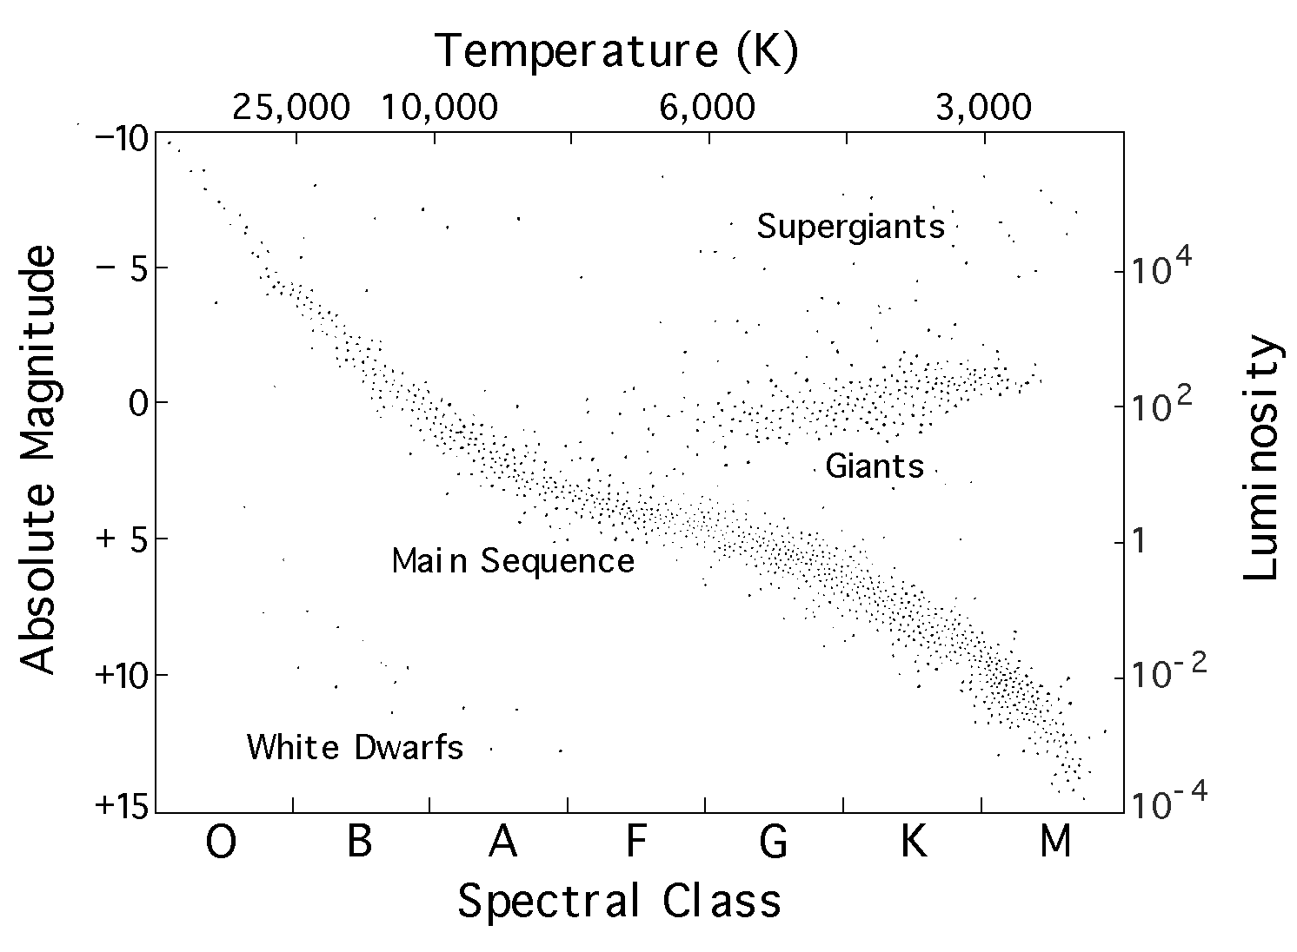

Figure 1.1: The Hertzsprung-Russell Diagram. Main sequence stars burn hydrogen in their cores and appear along the S-shaped curve in the middle of this diagram. Figure taken from Ref. [NASA].

its spectral type or surface temperature. Main sequence stars appear along the S-shaped curve across the middle of this diagram.
Depending upon the star’s mass and internal temperature, the conversion of H to He is accomplished through the Proton-Proton (PP) chain or the Carbon-Nitrogen-Oxygen (CNO) cycle, assuming some initial population of CNO nuclei. Stars of about 1 solar mass or less predominantly produce He through the PP chain, which actually consists of 3 chains. An illustration of the PP chain appears in Figure 1.2. For a 1 M⦿ star like our Sun, the PP-I chain is by far the most effective and accounts for about 85% of the He created in the PP chains. The first step is the fusion of two protons to create deuterium and is the rate-limiting step, with a time frame of about 10⁹ years. The PP-II and PP-III chains offer alternative pathways for the creation of He using isotopes of lithium, beryllium, and boron. The PP chain is actually a rather inefficient means of generating energy from the fusion of H to He with only about 0.7% of the initial rest mass of H converted into energy. [Fre02,Car96,Gui09]
The CNO cycle is the primary pathway of helium production for stars more massive than about 1 M⦿. Carbon, nitrogen, and oxygen serve as catalysts for the conversion of 4 protons into a ⁴He atom. This cycle is more temperature-dependent than the PP chain and far more efficient for energy production in stars more massive than our Sun [Gui09,Car96]. For the CNO cycle to predominate, it is necessary that sufficient numbers of carbon, nitrogen, and oxygen nuclei have already been produced in the star, but less massive stars do not have high enough core temperatures or densities for this to be the case. In a 1 M⦿ star like our Sun the PP chain is the dominant source of energy production, but the CNO cycle does still contribute. Detailed calculations suggest that

Figure 1.2: The three branches of the PP chain. Q-values and percentage of contribution to solar energy production are given. Figure taken from Ref. [Gui09].

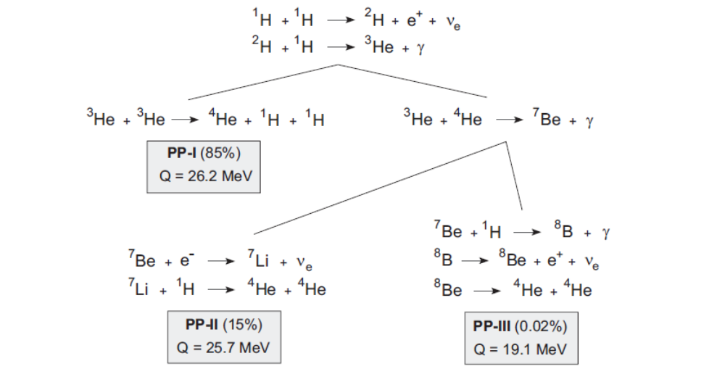
98.4% of the energy produced in our Sun is from the PP chain and about 1.6% is from the CNO cycle [Gui09].
A star will remain on the Main Sequence as long as it burns hydrogen in its core. The main sequence lifetime is inversely proportional to its mass (τ M^{-2.5}) [Fre02,Car96]. Our Sun is expected to have a main sequence lifetime of about 10 billion years, but a 25 M⦿ star will remain on the main sequence for only about 3 million years [Fre02]. The more massive star has a higher core temperature which allows nuclear reactions to progress at a much higher rate. In a shorter period of time, it burns through its hydrogen fuel and leaves the Main Sequence.

1.3 Post - Main Sequence Evolution
Once hydrogen has been exhausted in the core, gravitational collapse is no longer opposed by the outward pressure from hydrogen burning, and the core contracts. This increases the density and temperature of the core and the surrounding region, and hydrogen burning continues in a shell around the core, causing the outer layers to expand and the star to shine with greater luminosity. As the star continues to expand, the density and temperature of the outer layers decrease until the star glows with a reddish color and enters the red giant phase of evolution. As hydrogen shell burning continues, the helium ash continues to fall onto the core, increasing its mass and spurring further contraction. Once the temperature of the core reaches about 100 million Kelvin, core helium burning begins [Fre02]. The onset of this process differs slightly for stars below and above 2 - 3 M⦿ with a thermonuclear runaway under degenerate conditions and a helium flash in low-mass stars [Fre02,Gui09]. The fusion of three helium nuclei to produce a carbon nucleus is called the triple-alpha process. It begins with the joining of two ⁴He nuclei to form ⁸Be, which is unstable, but the high density of the core makes it possible for a third ⁴He nucleus to combine before the beryllium decays, producing ¹²C and a gamma particle. Addition of another alpha particle releases more energy and produces ¹⁶O. These stars are called horizontal branch stars because their tracks move horizontally across the H-R diagram, increasing in surface temperature but maintaining a constant luminosity. [Fre02,Car96,Gui09]
Once core helium burning ceases, the cycle repeats with contraction and heating of the core and the burning of helium and hydrogen in surrounding shells. The star becomes an asymptotic giant branch (AGB) star, so named because it moves asymptotically up and to the right on the H-R diagram, decreasing in temperature and increasing in luminosity. Asymptotic giant branch stars that are less than about 4 - 5 M⦿ do not have sufficient mass to contract and heat their cores enough to burn carbon. Bursts in luminosity eventually eject their outer layers into space as planetary nebulae and leave behind cooling carbon-oxygen (CO) cores called CO white dwarfs. Stars slightly more massive will achieve high enough temperatures to burn carbon as their final fuel but nothing further. They eject planetary nebulae and create oxygen-neon-magnesium (ONeMg) white dwarfs. If a star has greater than about 8 M⦿, however, the cycle of burning more massive fuels in the core will continue as the star progresses through oxygen, neon, magnesium, and silicon. With each stage of burning, the previously-burned fuel in the core continues to burn in a surrounding shell, until the star develops an onion-like structure with each shell burning a progressively less massive fuel toward the surface as shown in Figure 1.3. An iron core finally forms with the burning of

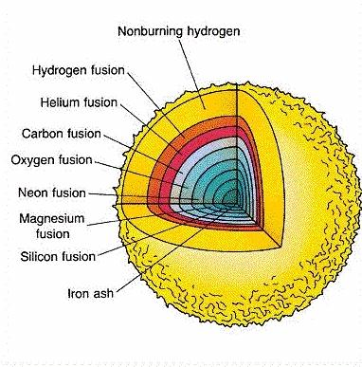

Figure 1.3: Onion-like structure of a massive star. Figure taken from Ref. [Ham11].

silicon. The core is then inert because the iron group has the highest binding energy per nucleon, making it the most stable nucleus. Whereas fusion reactions on the lighter nuclei were self-sustaining exothermic reactions that powered the star, additional fusion reactions on the iron nucleus would require an input of energy to overcome the strong Coulomb repulsion between protons. Thus, nuclear fusion reactions only continue on lighter nuclei in shells surrounding the core.
As the core contracts to stimulate further burning, the core reaches nuclear density, rebounds, and sends a shock wave out toward the surface. Lower densities in the outer regions accelerate the shock wave, compressing gases and heating them enough to create nuclei with masses greater than iron. These nuclei are created during the rapid neutron capture process (r-process) in which a high-density neutron flux impinges on seed nuclei, producing heavier nuclei. As the shock wave approaches the surface, the outer layers of the star begin to lift away from the core, and a torrent of light is released in a supernova event. If a core still remains it is now a neutron star or a black hole, depending on its mass. [Fre02,Car96,Gui09]

1.4 Close Binary Star Systems
Observations suggest that more than half of the “stars” in the sky are binary star systems with each star orbiting the common center of mass of the system [Gui09]. Illustrated in Figure 1.4, each star is surrounded by a tear-drop shaped region called a Roche lobe representing a gravitational equipotential surface around the star. Within this region material is gravitationally bound to the star. The Inner Lagrange Point (L₁) is a saddle between the two potential wells where the Roche lobes join. A particle from the
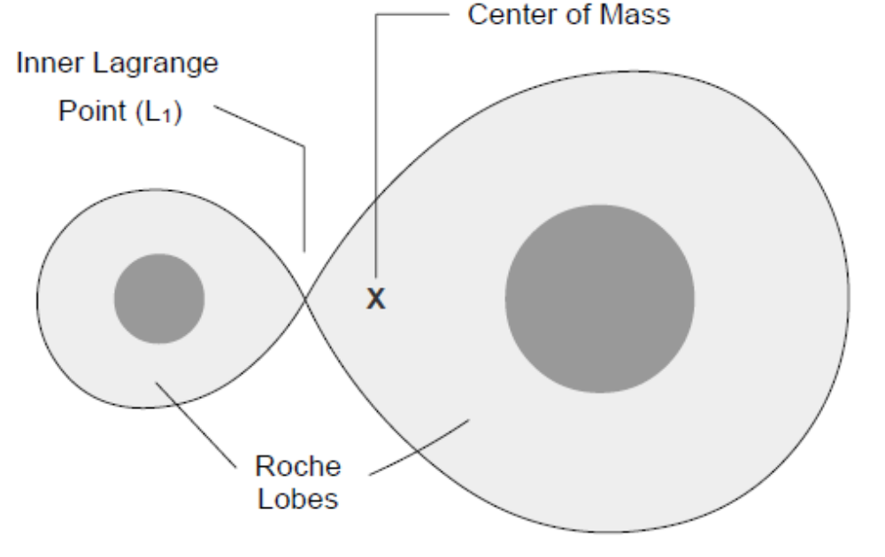

Figure 1.4: Structure of a binary system. Figure taken from Ref. [Gui09].

Roche lobe of one star that crosses this point will then become gravitationally bound to the companion star. The L₁ Point is an equipotential between the two stars and generally does not coincide with the center of mass of the system. [Car96,Fre02,Gui09]
Binary systems are classified by the degree to which its members fill their Roche lobes (Figure 1.5). A “detached binary” contains two stars well within their Roche lobes. Mass transfer is unlikely without strong stellar winds, and each star evolves nearly independently [Car96]. A “semidetached binary” is a binary with one star that fills its Roche lobe and one star that does not. Matter can stream across the Inner Lagrange Point from the more massive star to the less massive companion, often seen as an orbiting accretion disk spiraling down to the surface. A “contact binary” corresponds to a system in which both stars fill their Roche lobes. A dumbbell-shaped equipotential surface surrounds the system, and the two stars share a common atmosphere. The classification is not absolute, however. As the companion stars evolve, their interaction may change, classifying the system in a different category. [Car96,Fre02,Gui09]
Matter accretion in a binary system can play an important role in the creation of nuclei. If the accreting companion is a white dwarf, the fresh influx of matter will provide new life. If novae begin to occur or a supernova develops, the binary system will become a site for nuclear reactions that would never occur during the evolution of an individual star.

Figure 1.5: Classifications of binary star systems. Figure taken from Ref. [Gui09].
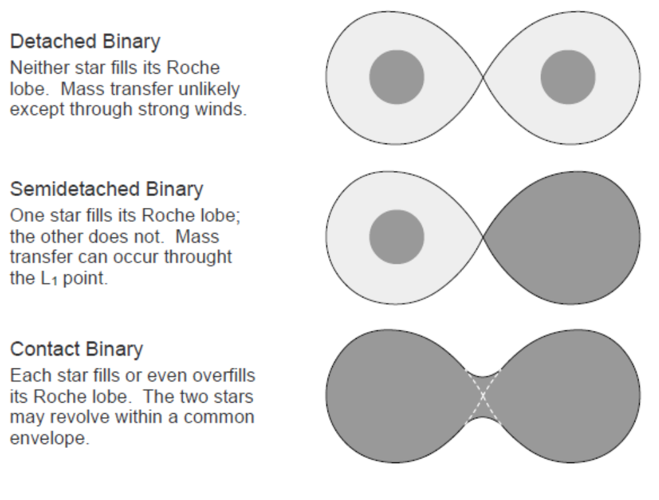
1.5 Nova Explosions
Classical novae are recurring explosions resulting from thermonuclear burning on the surface of a white dwarf star in a close binary system. The white dwarf, having divested its entire atmosphere, has reached the end of its stellar evolution and is nothing but a cooling, degenerate core consisting mostly of helium, carbon and oxygen (CO) or oxygen, neon, and magnesium (ONeMg) [Wie98]. Its binary companion continues to evolve along the main sequence and through the post-main-sequence phases. Once the outer layers of the companion star begin to overflow its Roche lobe, hydrogen-rich material is dumped onto the surface of the white dwarf at a rate of 10⁻¹⁰ - 10⁻⁸ M⦿/yr [Gom98,Her99]. This would most likely occur when the companion reaches the red giant stage of evolution, but the mass transfer may also result from strong stellar winds on the companion star [Fre02,Car96]. As more mass settles on top of it, the accreted hydrogen is compressed, and the temperature begins to rise in the shell. Turbulent mixing at the base of this layer enriches the accreted shell with material from the white dwarf, and once 10⁻⁴ - 10⁻⁵ M⦿ of hydrogen has accumulated and the temperature in this region reaches about 10⁷ Kelvin, hydrogen burning is initiated by the CNO cycle [Lei87,Wie98,Coc00]. As matter continues to fall onto the white dwarf, the base of the shell becomes so compressed that the electrons become degenerate [Car96]. A thermonuclear runaway results as the temperature in the shell continues to rise due to the compression from above and the energy-release from reactions, but the degeneracy does not allow the pressure to increase and the shell to expand [Lei87]. As the temperature continues to rise, the hot-CNO cycle replaces the “cold-” CNO cycle as the energy-generating mechanism [Gui09,Ver97]. The cycles differ by the reaction on the ¹³N nucleus in the cycle. In the high-temperature environment of a nova explosion, ¹³N captures a proton much more quickly than it beta-decays [Gui09]. This creates ¹⁴O, which initiates the breakout into the hot-CNO cycle [Gui09,Ver97]. The reaction is highly temperature-dependent due to the Coloumb barrier faced by the incoming proton and does not compete favorably with beta-decay at lower temperatures characteristic of main sequence hydrogen burning [Gui09]. A beta-decay to ¹⁴N continues progression through the elements of the CNO cycle. The hot- and cold-CNO cycles and pertinent reaction times are illustrated in Figure 1.6. The characteristic time for a cycle is determined by the longest half-life of the radioactive nuclei within it [Ver97]. Beta-decay of ¹³N (t_{1/2} = 10 min) sets the time for the cold-CNO cycle, but the longest reaction in the hot-CNO cycle is five times smaller with the beta-decay of ¹⁵O to ¹⁵N (t_{1/2} = 2 min) [Gui09,Ver97]. Thus, the rate of energy generation in the hot CNO cycle is about five times greater than in the cold CNO cycle [Ver97]. Hydrogen continues to burn at a fierce rate in the hot CNO cycle until the degeneracy is lifted around 10⁸ K [Car96]. A burst of energy is then released, expelling material into space. This is the nova explosion, and may be as bright as 10⁵ L⦿ [Fre02].
Based upon accretion rates of 10⁻⁸ - 10⁻¹⁰ M⦿/yr, it takes approximately 10⁴ - 10⁶ years for a white dwarf to accumulate another 10⁻⁴ M⦿ surface layer once a nova occurs [Car96,Gom98,Her99]. Estimates for novae occurrence in the Galaxy range from 11 - 260/yr, with most researchers favoring a range of 35 – 50. Perhaps one-third of these occur on ONeMg white dwarfs [Har99].

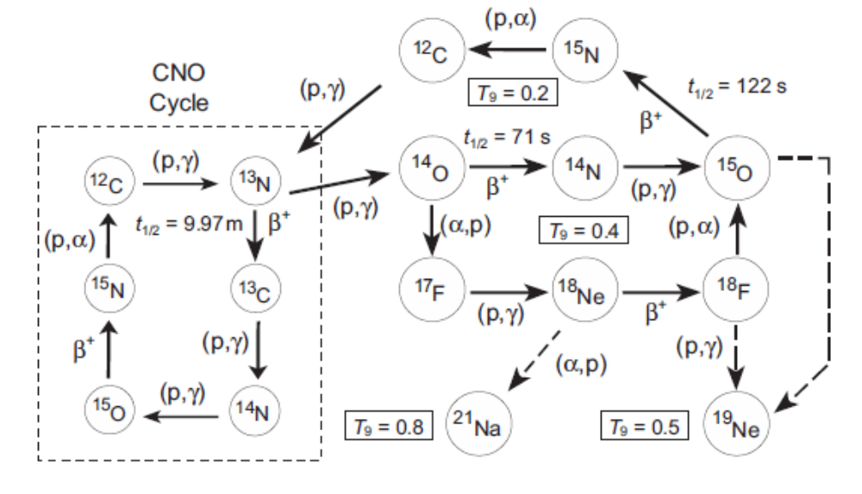

Figure 1.6: An illustration of the hot- and cold- CNO cycles. A proton capture onto ¹³N initiates the breakout to the hot-CNO cycle and produces ¹⁴O. This nucleus β-decays to ¹⁴N which continues the cycle through the CNO reactions. Figure taken from Ref. [Gui09].

1.6 Nova Nuclei and Emission Lines
During the nova, convection heats the envelope and mixes upward the proton-rich nuclei produced by the hot-CNO cycle and rapid-proton capture reactions (rp-process) occurring at these temperatures [Wal81]. Beta decay of ¹⁴O, ¹⁵O, and ¹⁷F is responsible for the torrent of photons that accelerates the outer portions of the envelope into space [Lei87,Gom98]. Longer-lived radioactive species are appealing targets for gamma-ray observations and include ¹³N (τ = 862 sec) and ¹⁸F (τ = 158 min), with the addition of ⁷Be (τ = 77 d) in CO novae and ²²Na (τ = 3.75 yr) and ²⁶Al (τ = 1.04*10⁶ yr) in ONeMg novae [Gom98]. Short-lived ¹³N is the first to decay. The photon flux from the annihilation of its positrons crests about 1 hour after peak temperature ((1 – 4)*10⁸ K); however, the envelope is still opaque at this time and few of these photons escape [Wie98,Her01]. The other nuclei, however, have lifetimes long enough to be transported to the outer layers before decaying and may be detected [Har99].
Models predict that the strongest emission line to emerge from novae will occur at 511 keV. It should appear 5 - 6 hours after peak temperature, and reach its maximum 1 - 2 hours later. Because ¹³N decays before the envelope is transparent to photon escape, it is the annihilation of positrons created during ¹⁸F decay that is primarily responsible for this flux. This line would appear within a background continuum that extends down to 20 keV (CO novae) or 30 keV (ONeMg novae), where photoelectric absorption has a large cross-section. ¹⁸F is also responsible for this continuum.
The medium-lived beta-unstable isotopes ⁷Be and ²²Na are also prime targets for gamma detection. ⁷Be is a product of CO novae, where it is produced by the ³He(α,γ)⁷Be reaction [Her96]. Efficient destruction of ³He in ONeMg novae prevents significant production of ⁷Be in these environments. It decays to ⁷Li through an electron capture, emitting a photon of 478 keV, and a spectral line at this energy is expected in these novae. ²²Na is created in ONeMg novae and emits a positron and a photon of 1275 keV upon decay. It may be possible to observe this line in the spectra of these novae. Observation of the 478 keV line and the 1275 keV would allow astronomers to discriminate between CO and ONeMg novae. [Gom98,Her99]
²⁶Al is the longest-lived radioactive isotope produced in novae, and it is confined to ONeMg novae. Ninety-seven percent of the time the ground state will decay to the first excited state of ²⁶Mg through a beta-decay or electron capture [CESR]. During the subsequent de-excitation, a 1.809 MeV photon is released. Because the lifetime of this species far exceeds the time between subsequent nova events, it would not be possible to detect this line in the spectra of individual novae, which serve only to enrich the Galactic content of this nucleus. [Gom98,Her99]
With the exception of ²⁶Al, computer models have been able to predict the time of appearance and magnitude of these spectral lines in individual novae. To date, however, definitive observation has been elusive [Gom98,Her99].

1.7 Supernovae
Supernovae are classified by characteristics of their spectra at the time of maximum luminosity. Type II supernovae have strong hydrogen emission lines in their spectra and Type I do not. Type I supernova are further divided into Type Ia if the spectrum exhibits a strong Si II absorption line, Type Ib if there is no ionized silicon line but a strong He I absorption line, and Type Ic if both lines are absent. Types Ib, Ic, and II supernovae have been observed in spiral galaxies near sites of recent star formation, but Type Ia supernova have been observed in all types of galaxies, including elliptical galaxies with little evidence of recent star formation, suggesting a different origin for these two groups of supernovae. Astronomers suspect that Types Ib, Ic, and II supernovae are the result of core collapse in massive stars with the extent of atmospheric loss determining the classification. According to theory, Type II supernovae occur in stars that still have a hydrogen-burning shell; Type Ib supernovae occur in stars that have lost their hydrogen shell but retain their helium-burning shell; and Type Ic supernovae occur in stars that have lost both of these outer shells. Type Ia supernovae, however, are thought to result from the explosion of a white dwarf in a close binary system. [Car96,Fre02,Gui09]
White dwarfs are inert stars supported by degenerate electron pressure, and there is an upper limit to the mass this degenerate pressure can support. The Chandrasekhar limit for the maximum mass a white dwarf can maintain is about 1.44 M⦿. As the mass of the accreting white dwarf approaches the Chandrasekhar limit, the temperature of the core increases and carbon burning begins. Because the core is degenerate, the increasing temperature does not cause the core to expand, and a thermonuclear runaway develops much like it does in a nova. In this case, however, the temperatures are much higher and the reactions are not confined to a thin layer on the surface of the white dwarf, but occur throughout the core. The ever-increasing temperature causes nuclear reactions to occur at a fierce rate, burning through carbon, then oxygen, then all products produced by these fuels [Gui09]. In less than a second the entire white dwarf is ablaze, achieving a temperature as high as 10¹⁰ K and a density on the order of 10⁹ g/cm³ [Gui09]. Once the degeneracy is lifted, the outer layers blast into space at speeds exceeding 10⁴ km/s, and the white dwarf blows itself apart [Car96].
The handful of isotopic species that were initially present in the core of the white dwarf increases to nearly five hundred species during the thermonuclear runaway [Gui09]. Silicon, the crux of Type Ia identification, is created during the carbon-burning stage [Fre02]. A significant population of iron group nuclei is also produced during the event, and it is believed that Type Ia supernovae are the primary source for these elements in the interstellar medium [Car96,Fre02,Gui09].

CHAPTER 2 – Galactic ²⁶Al
2.1 Discovery of the ²⁶Al Decay Line
The first cosmic radioactive nucleus to be identified by gamma-ray astronomy was ²⁶Al in 1982 [Mah82]. Launched in September 1979, the HEAO C-1 gamma-ray spectroscopy experiment onboard the third High Energy Astronomy Observatory (HEAO-3) spacecraft consisted of four coaxial high-purity germanium detectors in an active anticoincidence CsI shield designed to suppress background events, and it performed a survey of gamma-ray point sources in the Galactic plane during two 2-week periods in the Fall of 1979 and the Spring of 1980 [Mah82,Mah84].
Astronomers had predicted the production of ²⁶Al in novae and supernovae would result in a diffuse emission of the 1.809 MeV gamma-ray associated with its decay because the mean lifetime of ²⁶Al is considerably longer than the time between subsequent stellar events [Pra96]. This gamma-ray is emitted after ²⁶Al beta-decays to the first excited state of ²⁶Mg at 1.809 MeV and subsequently de-excites to ground [Pra96]. Analysis of the data revealed that the high energy resolution of the germanium detectors (3.3 keV FWHM at 1.809 MeV) allowed for the positive identification of the 1.809 MeV emission line from the direction of the Galactic center [Mah84]. When the data were fit to a model for the Galactic distribution of high-energy (> 70 MeV) gamma rays associated with supernova remnants, detection at a 4.7σ level of confidence was confirmed, compared to 2.2σ detection if a point source was assumed, suggesting an extended source of ²⁶Al in the direction of the Galactic center, not a point source. The measured line flux was (4.8 ± 1.0)*10⁻⁴ photons/cm²/s/rad. Assuming a steady-state of ²⁶Al in the Galaxy with the production rate equaling the destruction rate, the amount of decaying ²⁶Al was estimated to be dM/dt ~ 3 M⦿/Myr [Mah84].
Because the lifetime of ²⁶Al (τ = 1.04*10⁶ years) is significantly less than the age of our Galaxy, this identification confirmed that active nucleosynthesis is still occurring in the Galaxy. The poor angular resolution of the HEAO C-1 instrument and the low signal to background ratio, however, did not allow a spatial distribution of this nucleus to be constructed [Mah84].

2.2 Other Observations
Following the detection of the 1.809 MeV gamma decay line from the region of the Galactic center, numerous balloon and spacecraft experiments in the 1980’s attempted to confirm this discovery and identify the source.
The Gamma Ray Spectrometer aboard the Solar Maximum Mission (SMM) spacecraft operated from 1981 to 1990 and consisted of 7 NaI scintillation detectors surrounded by a CsI anticoincidence shield [Pra96]. Launched to primarily study the Sun, annual transits across the Galactic center region, coupled with a high signal to background ratio, provided confirmation of the 1.8 MeV emissions from this direction. The aperture of this instrument, however, was four-times larger than that of HEAO-3 experiment, and no spatial information could be derived from its data.
Sandia National Laboratories and AT&T Bell Laboratories collaborated on a balloon instrument consisting of a large Ge detector surrounded by an active anticoincidence NaI shield [Pra96]. Data were collected from four flights spanning the late 1970’s and early 1980’s, and a flux of (1.3 ± 0.9)*10⁻⁴ photons/cm²/s was derived for a point source in the Galactic center and ${3.9(}_{-1.7}^{+2.0})$*10⁻⁴ photons/cm²/s/rad for an extended source based upon the distribution of supernovae. The final flight was in 1984 and carried an instrument with a larger aperture and measured a larger flux. For this reason it was argued that the source was likely extended, rather than point-like, but no further spatial information could be derived. The level of confidence was 2σ.
The Max Planck Institute for Extraterrestrial Physics in Garching (MPE) launched a balloon-borne Compton telescope in 1982 that recorded data for a mere 4.5 hours [Pra96]. Consisting of two detector planes surrounded by an active shield of thin plastic scintillator, a photon Compton scatters in the upper layer of liquid scintillator detectors and is absorbed in the lower layer of NaI scintillation detectors. A projected image of the data in 1987 represented the first direct imaging attempt of the ²⁶Al source, but low statistics resulted in poor spatial resolution and an image similar to that for a point source in the Galactic center, providing only weak constraints for emission along the Galactic plane.
The Gamma Ray Imaging Spectrometer (GRIS) was a balloon-borne instrument consisting of seven high-purity n-type coaxial Ge detectors surrounded by a NaI shield [Pra96]. Analysis of data from the 1988 flight detected the 1.809 MeV line during designated scannings at 0° and 335° Galactic longitudes with 2.5σ and 1.7σ levels of confidence, respectively. The ratio of fluxes was interpreted as evidence for a diffuse source.
Rounding out the decade, HEXAGONE was launched in May 1989 by a collaboration of French and American scientists [Pra96]. It was a balloon instrument consisting of 12 Ge detectors surrounded by a BGO/CsI active shield. Although a line was detected at 1.809 MeV with a 3.9 keV width, background suppression was difficult because an instrumental contamination line also appeared at this energy due to atmospheric neutrons reacting with material within the Ge detectors. The total significance of this line was only 2σ with a point source flux of (1.9 ± 0.9)*10⁻⁴ photons/cm²/s.
Two years later, in April 1991, NASA launched the OSSE scintillation-detector and the COMPTEL imaging telescope aboard the Compton Gamma-Ray Observatory (CGRO) [Die95]. The design of COMTEL was similar to that of MPE, with increased energy and angular resolutions of 8% and 3.8º (FWHM) at 1.8 MeV, respectively, and in November 1992 it succeeded in completing the first all-sky survey of the Galaxy. The 1.809 MeV line was clearly visible in the spectrum of the Galactic center region. Imaging analysis began with the binning of the three-dimensional data space into 200 keV wide energy bands. The data were then filtered through two image-generation algorithms with each using a different background modeling method. The Maximum-Likelihood method considered three energy ranges (1.5 – 1.7 MeV, 1.7 – 1.9 MeV, and 1.9 – 2.1 MeV) and determined the likelihood of a point source in each band with energy above instrumental background. It plotted contours of total emission above 1σ. The 1.7 - 1.9 MeV band is centered on the 1.8 MeV line, which presumably dominates the signal in this band. Maps generated by the Maximum-Likelihood method are shown in Figure 2.1a-c. These images were contrasted with one created by the Maximum-Entropy method. This method built 1.8 MeV sky intensity distributions of increasing detail over a series of iterations, with each distribution tested against the data and influencing the

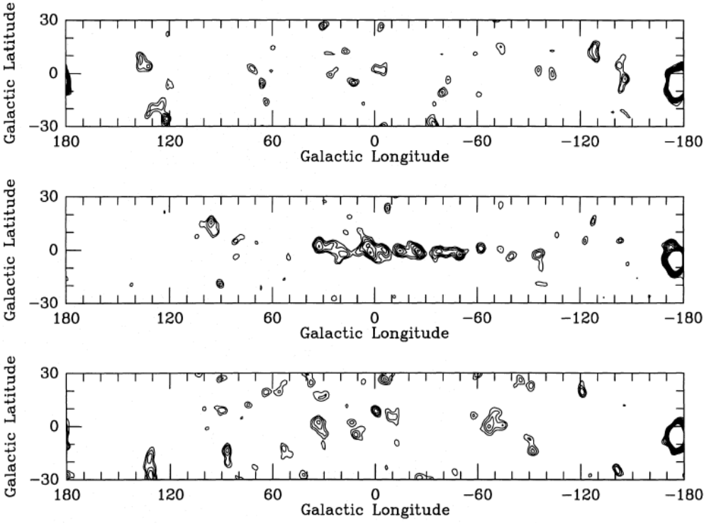

Figure 2.1a-c: COMPTEL data were used to generate Maximum-Likelihood maps of the Galaxy in different energy bands: (a) energy band 1.5 – 1.7 MeV; (b) energy band 1.7 – 1.9 MeV; (c) energy band 1.9 – 2.1 MeV. Figure taken from Ref. [Die95].

parameters of the next iteration. Unlike the former method, the background model of this method explicitly subtracted the continuum emission. The Galactic map generated by the Maximum-Entropy method is shown in Figure 2.2. Though each algorithm worked on different principles, similar images were constructed and it was immediately apparent that emission of the 1.809 MeV line is not uniformly distributed throughout the Galaxy. Rather, it appears to be confined to the plane of the Galaxy with pronounced emission from near the Galactic center and from several smaller satellite locations. These images are noteworthy as they represent the first extended emission maps of the Galaxy.
These observations were confirmed by the INTEGRAL spacecraft. Launched by the European Space Agency in October 2002, the International Gamma-Ray Astrophysics Laboratory (INTEGRAL) is a collaboration between the United States and Europe [Wan09]. Aboard this spacecraft is the SPI spectrometer consisting of 19 Ge detectors sensitive to gamma-rays between 15 keV and 8 MeV, actively shielded by a BGO anti-coincidence shield [Wan09]. With angular and energy resolutions of 2.8º and 3 keV (FWHM) at 1.8 MeV, respectively, SPI is more sensitive than any previously-launched gamma-ray observatory [Wan90]. Analysis of the first 1.5 years of data confirmed the presence of a narrow (FWHM < 2.8 keV, 2σ) 1.8 MeV line (16σ) with a flux of (3.3 ± 0.4)*10⁻⁴ photons/cm²/s/rad from the inner Galaxy. Once a three-dimensional model was constructed, the total flux suggested the decay of 2.8 ± 0.8 M⦿ of ²⁶Al in the entire Galaxy [Die06]. Further analysis with 5 years of SPI data refined these calculations and allowed for construction of a sky map of ²⁶Al sources in the Galaxy (Figure 2.3) [Wan09]. The intensity distribution resembles that of the COMPTEL data with a large

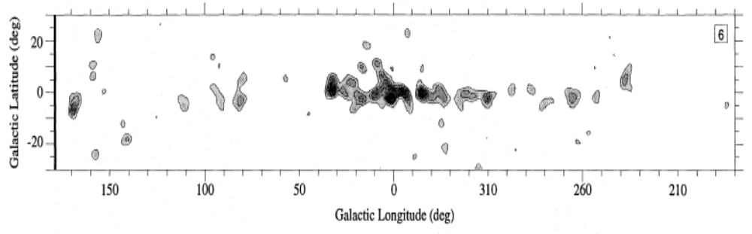

Figure 2.2: Galactic map of the 1.809 MeV decay line generated by the Maximum-Entropy method with INTEGRAL data. Figure taken from Ref. [Die95].

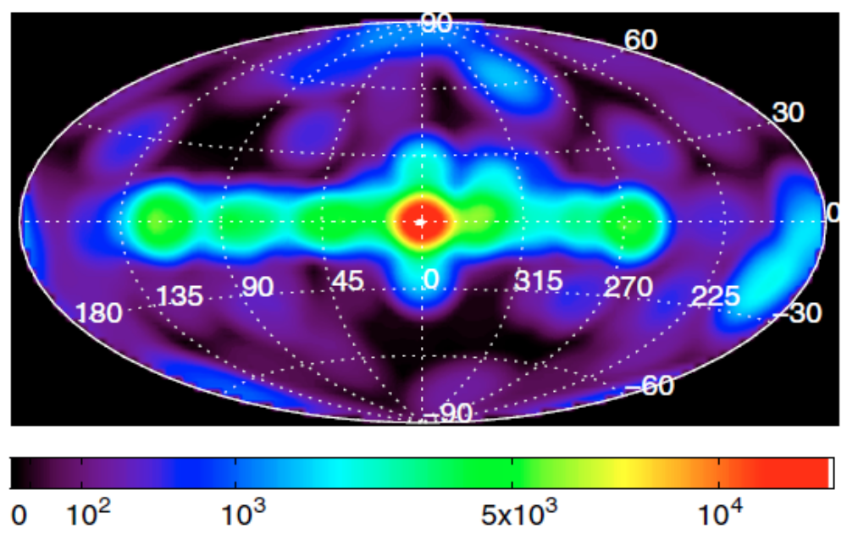

Figure 2.3: Galactic map of the ²⁶Al 1.809 MeV decay line generated from data collected over 5 years by the INTEGRAL spacecraft. Figure taken from Ref. [Wan09].
flux from the Galactic center region and several satellite locations [Wan09]. After the removal of systematic uncertainties, the 1.8 MeV line width was constrained to < 1.3 keV (2σ), corresponding to a velocity of 160 km/s attributed to Galactic rotation and turbulence in the source environments [Wan09]. The flux from the inner Galaxy was also calculated to be (2.9 ± 0.2)*10⁻⁴ photons/cm²/s/rad, which was translated to the decay of 2.7 ± 0.7 M⦿ of ²⁶Al in the Galaxy as a whole [Wan09].

2.3 Nucleosynthesis of ²⁶Al
In astrophysical environments, ²⁶Al is primarily produced by a proton capture onto a ²⁵Mg nucleus in the ²⁵Mg(p,γ)²⁶Al reaction. It is destroyed at low temperatures (T ≤ 5*10⁷ K) by beta-decay to ²⁶Mg and at high temperatures by the ²⁶Al(p,γ)²⁷Si reaction. A diagram of these reactions, as well as reactions relevant to its production and destruction in particular environments, appears in Figure 2.4. The bottom-half of this reaction pathway diagram illustrates the Mg-Al cycle that was traditionally thought to account for ²⁶Al production in low-temperature proton-rich environments, with the ²⁷Al(p,α)²⁴Mg reaction providing return flow to the cycle [Buc84]. An investigation of this reaction, however, revealed that the ²⁷Al(p,α)²⁴Mg reaction rate is significantly lower than that of the ²⁷Al(p,γ)²⁸Si reaction and that a Mg-Al cycle does not exist “in any realistic astrophysical scenario” [Tim88].
In a low-temperature environment, the half-life of the ²⁶Al ground state (J^{π} = 5⁺) is 7.2*10⁵ years. This nucleus will decay to the first excited state of ²⁶Mg at 1.809 MeV through the process of beta-decay or electron capture with branching ratios of 82% or 15%, respectively [CESR]. Once this occurs, the excited state of ²⁶Mg quickly de-excites

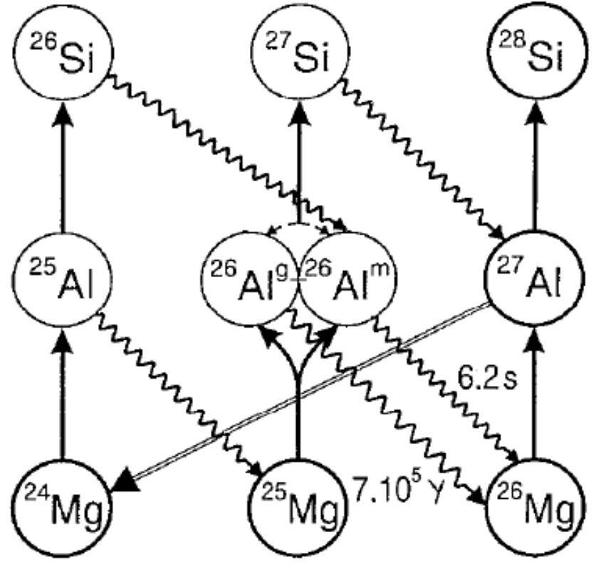

Figure 2.4: Production and destruction pathways for the ground and metastable states of ²⁶Al. Figure taken from Ref. [Pra96].

to the ground state of ²⁶Mg, emitting the signature 1.809 MeV photon characteristic of ²⁶Al decay.
The first excited state of ²⁶Al at 228 keV (J^{π} = 0⁺) is a metastable state with a significantly shorter half-life than the ground state of 6.35 s. Due to the large spin difference between the metastable and ground states of ²⁶Al, the direct M5 electromagnetic transition to ground is much slower than beta-decay of the metastable state to the ground state of ²⁶Mg [Dei09]. Because the decay circumvents passage through the first excited state of ²⁶Mg, a 1.8 MeV photon is not produced, making it difficult to estimate the true abundance of ²⁶Al in the Galaxy. The metastable state is produced and destroyed by the same reactions as the ground state, with additional production from the beta-decay of ²⁶Si in high-temperature environments.

2.4 Sources of ²⁶Al Production
Several candidates have emerged as potential sources for ²⁶Al production. These include supernovae, novae, AGB stars, and Wolf-Rayet stars. There has been much debate whether one site is more favorable than another. It is possible that one or all contribute to the Galactic abundance of this nucleus. For this reason it is important to determine the ²⁶Al(p,γ)²⁷Si rate over a large temperature range to diagnose model predictions.

2.4.1 Supernovae
Speculation about the site of ²⁶Al production preceded discovery of the 1.809 MeV line by HEAO-3. Analysis of Ca-Al-rich inclusions from the Allende meteorite in the 1970’s revealed terrestrial abundances of ²⁴Mg and ²⁵Mg but large excesses of ²⁶Mg [Lee76,Lee77]. A correlation between ²⁶Mg/²⁴Mg and ²⁷Al/²⁴Mg indicate that these excesses were the result of ²⁶Al beta-decay [Lee76,Lee77]. Calculations of initial abundances of ²⁶Al suggested a nucleosythetic event immediately before condensation or during formation of the solar system [Lee76,Lee77]. It was soon postulated that a nearby supernova was responsible for injecting ²⁶Al into the presolar cloud and may even have triggered its collapse to form the solar system [Cam77,Tru78]. Support rapidly grew for supernovae as primary sources of ²⁶Al production [Buc84].
Stars that produce Type Ib, Ic, and II supernovae have initial masses of about 10 – 35 M⦿ [Pra96,Lim06]. Models predict the production of ²⁶Al from the ²⁵Mg(p,γ) reaction in several environments during the evolution of these stars to the supernova stage [Pra96,Lim06]. Production begins in the hydrogen-burning core shortly after the star settles on the main sequence [Lim06]. Initial abundances of ²⁵Mg provide the foundation for this reaction [Lim06]. With central temperatures T ≥ 30*10⁶ K, this ²⁵Mg may be produced through a series of (p,γ) reactions that link the CNO cycle with the Ne-Na cycle and Mg-Al chain [Lim06,Pra96,Rol88]. Depending on the mass of the star, a maximum ²⁶Al mass fraction is achieved within the first million years or so of core hydrogen-burning, followed by decline due to beta-decay [Lim06]. As the core burns through higher-mass fuels, ²⁶Al production may continue in the hydrogen-burning shell if still present, but the overall contribution from this site is less than about 15% of the total yield produced by the star [Pra96].
Substantially more ²⁶Al is produced in the convective carbon and neon shells surrounding the cores of these stars and white dwarfs evolving into Type Ia supernovae. Upon burning through silicon-stores in the core, a strong contraction and heating of these shells spurs the production of ²⁶Al [Pra96,Lim06]. The helium-burning chain ¹⁴N(α,γ)¹⁸F(β+)¹⁸O(α,γ)²²Ne(α,n)²⁵Mg provides the seed nucleus for ²⁶Al in the carbon shell, while ²⁵Mg in the neon shell is that which was left unburned by the carbon burning [Tru78,Lim06]. In these high-temperature environments, large amounts of neutrons are produced by the ¹³C(α,n) and ²²Ne(α,n) reactions, which contribute to the primary mode of destruction of ²⁶Al through (n,p) and (n,α) reactions [Pra96, Lim06]. Convection in these shells is essential to the production and preservation of ²⁶Al. It is necessary for the cycling of ²⁵Mg and protons into these shells and the transport of ²⁶Al out of the shells to cooler, diffuse regions where it survives longer.
Finally, considerable amounts of ²⁶Al are produced during explosive carbon and neon burning when the shock wave passes through these shells, catapulting the temperature above 2*10⁹ K [Pra96,Lim06]. The ²⁵Mg is now primarily provided by the (n,γ) capture reaction on the ²⁴Mg produced during carbon and neon burning [Lim06]. It is this final bout of explosive burning that produces the vast amount of ²⁶Al during the entire supernova evolution [Lim06]. As the star blows itself apart, it serves to enrich the Galactic abundance of this nucleus.

2.4.2 Novae
In their historical paper announcing discovery of the 1.809 MeV line by the HEAO-3 spacecraft, Mahoney et al (1982) discuss the potential for a supernova and/or nova source for ²⁶Al. Shortly thereafter, Clayton (1984) responded with an intriguing discussion on the merits of this proposal. He first noted that early calculations for supernova contributions to Galactic ²⁶Al abundances mistakenly chose the mass of the entire Galaxy for the analysis, rather than the smaller mass of the interstellar medium [Woo80,Cla84]. This correction reduced supernovae production of ²⁶Al two orders of magnitude, far below that indicated by the flux observed by HEAO-3 [Cla84]. Additionally, for supernovae to produce the observed flux of ²⁶Al decay photons, there would be an overproduction of ²⁷Al, exceeding observed Galactic abundances of this nucleus [Cla84]. Finally, a large flux of 1.16 MeV photons from the decay of ⁴⁴Ti would accompany the 1.809 MeV flux, and be 15 times greater, if supernovae were the source, but a strong line at this energy was not observed by Mahoney et al (1982) [Cla84]. Based upon these arguments, it was concluded that the most reasonable source of ²⁶Al production is the nova, citing an earlier calculation that 1.2 M⦿ of ²⁶Al could be produced by these sources every 10⁶ years [Woo80,Cla84].
Of the two classes of novae, CO and ONeMg, it is the latter, with an abundance of ²⁴Mg and ²⁵Mg, which is the likely source of ²⁶Al [Nof91]. Under the explosive hydrogen-burning conditions of a nova explosion with a timescale on the order of τ ~ 10² s, ²⁴Mg is able to contribute to ²⁶Al production through the Mg-Al chain via the reaction sequence ²⁴Mg(p,γ)²⁵Al(β⁺ν_{e})²⁵Mg(p,γ)²⁶Al [Pra96,Dei09]. During the final reaction, proton-capture on ²⁵Mg may produce the ground state or metastable state of ²⁶Al [Dei09]. Because the peak temperature is as high as (0.1 - 0.4)*10⁹ K the ²⁵Al(p,γ)²⁶Si reaction competes with the beta-decay of ²⁵Al in the Mg-Al chain [Nof91,Dei09]. This may lead to a breakout from the Mg-Al chain if ²⁶Si captures another proton, or the production of the metastable state if it beta-decays through the reaction ²⁶Si(β⁺ν_{e})²⁶Al^{m} [Nof91,Dei09]. A consequence of these events is the cultivation of an ²⁶Al^{m} population that cannot be observed by gamma-ray astronomy, hindering the development of a complete model of ²⁶Al production. The destruction of ²⁶Al in these conditions is primarily by the ²⁶Al(p,γ)²⁷Si reaction [Jos01].
Traditionally, it was believed that an ONeMg nova originated in a binary system on the surface of an accreting white dwarf with a mass 1.25 M⦿ ≤ M_{WD} ≤ 1.44 M⦿, where the upper limit is the Chandrasekhar mass, and that these white dwarfs evolved from main sequence stars of about M ~ 8 - 11 M⦿ [Pra96]. Smaller white dwarfs of mass M_{WD} < 1.25 M⦿ are thought to evolve from main sequence stars of mass M < 6 - 7 M⦿ and produce CO novae, which do not attain high enough temperatures during the thermonuclear runaway to break out of the CNO cycle and enter the Mg-Al chain [Pra96,Jos97].
A study by Nofar et al. (1991) suggested that up to 5 M⦿ of ²⁶Al could be produced per galaxy if 30% of all novae are enriched with O, Ne, and Mg and there is adequate mixing to cycle these elements from the core to the accreting envelope. Their model was based upon observations of the recurrent nova U Sco, with an estimated mass of 1.35 M⦿ and an accretion rate of 1.1*10⁻⁶ M⦿/yr [Nof91]. The peak temperature range for novae is 0.1 ≤ T_{peak, GK} ≤ 0.4, with the typical temperature of ONeMg novae expected at the high end of this range, but their model suggested the optimal temperature for producing ²⁶Al in ONeMg novae was 0.17*10⁹ K [Nof91]. There results were perplexing, but most of the ²⁶Al seemed to be destroyed by proton transfer reactions at temperatures T ≥ 0.25 GK associated with the massive white dwarfs thought to produce ONeMg novae [Nof91,Sha94].
Deepening this conundrum, it was known that the massive white dwarfs thought to produce ONeMg novae required smaller accreted envelopes to trigger the thermonuclear runaways on their surfaces than did less massive white dwarfs, and as a result, ejected less mass after the explosion than did smaller novae with larger accreted envelopes [Sha94,Sha94b,Jos97]. Due to their higher surface gravities and larger pressures, it was estimated that only 10⁻⁷ M⦿ of accreted mass was necessary to trigger the runaway on a white dwarf of M_{WD} = 1.4 M⦿, whereas 10⁻³ M⦿ were required for M_{WD} = 0.2 M⦿ [Pra96]. To attain the 5 M⦿ prediction, an ONeMg white dwarf would have to have the low peak temperature and high-mass ejection rate characteristic of low-mass white dwarfs. In fact, a comparison of observational data for six ONeMg novae actually suggested an average white dwarf mass of M_{WD} ~ 1.0 M⦿ and ejected shells of mass M ~ 10⁻⁴ - 10⁻⁵ M⦿, at odds with expected values for massive ONeMg novae white dwarfs [Sha94]. Based upon these findings, calculations suggest that the proposed 5 M⦿ of ²⁶Al from ONeMg novae can be provided by low-mass white dwarfs [Nof91,Sha94], though some computer models predict their contribution to be an order of magnitude lower [Jos97].
A proposal for the evolution of a low-mass ONeMg nova emerged from simulations that suggest an initial accretion at a high rate (10⁻⁴ M⦿/yr) will result in nonexplosive hydrogen burning on the surface of the white dwarf [Sha94b]. A series of mild flashes can then burn the helium to ²⁰Ne and ²⁴Mg with little mass-ejection. A lower accretion rate (10⁻⁹ - 10⁻¹¹ M⦿/yr) later in the cycle would then deposit a H-rich layer on top of the ONeMg-rich layer that mixes into it [Sha94b]. The ensuing thermonuclear runaway can then produce the observed ONeMg nova [Sha94b]. It may be that low- and high-mass white dwarfs both contribute to the production of ²⁶Al in the form of ONeMg novae [Sta01].

2.4.3 Asymptotic Giant Branch and Wolf-Rayet Stars
²⁶Al production has also been proposed in the low-temperature non-explosive H-burning conditions characteristic of asymptotic giant branch (AGB; T = (5 – 9)*10⁷ K) and Wolf-Rayet (WR; T = (3.5 - 7)*10⁷ K) stars [Cha86]. At these temperatures the ²⁴Mg(p,γ)²⁵Al reaction is not fast enough to contribute to the ²⁶Al population, which is solely created by proton captures onto ²⁵Mg [Pra96]. Destruction is primarily by beta-decay for temperatures T < 5*10⁷ K and by ²⁶Al(p,γ)²⁷Si at greater temperatures [Pra96,Lim06]. A study supporting these proposed sites compared the resonant reaction rates for ²⁶Al(p,γ)²⁷Si and ²⁵Mg(p,γ)²⁶Al. A resonant reaction is a reaction between two particles that occurs at a resonant energy where the cross section of the reaction is orders of magnitude higher than it is at nonresonant energies. Based on resonant reaction rates, this study concluded that excess ²⁶Al is simply not produced at temperatures above 13*10⁷ K [Wan89]. It is apparent from Figure 2.5 that ²⁶Al is destroyed in the ²⁶Al(p,γ) reaction at nearly the same rate as it is created in the ²⁵Mg(p,γ) reaction when only two resonances are considered in the destruction reaction but all resonances are considered in the production reaction. It was also determined that if one of the three uncharacterized low-energy resonances of the ²⁶Al(p,γ)²⁷Si reaction at 69, 93, and 125 keV above the proton threshold is an ℓ = 0 resonance, then there is no excess ²⁶Al production for temperatures above 6*10⁷ K [Wan89]. In fact, recently the resonance at 126.7 keV was determined to be a 9/2⁺ state (i.e., an ℓ = 0 resonance) [Lot09].

Figure 2.5: The ²⁵Mg(p,γ)²⁶Al reaction rate from all known resonances compared to the ²⁶Al(p,γ)²⁷Si rate for only two resonances at 277 and 376 keV. Figure taken from Ref. [Wan89].
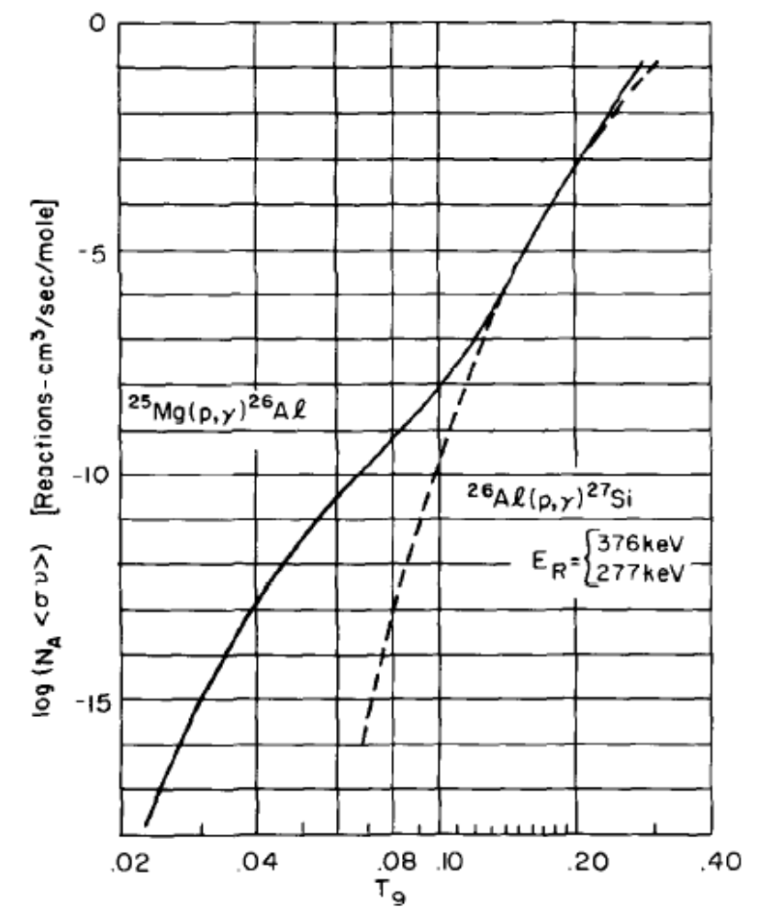
Further support for these low-temperature sites can be found in Figure 2.6. A high ²⁶Al/²⁷Al ratio is observed for T ≤ 0.06*10⁹ K, where the temperatures and timescales are not high enough and long enough for the (p,α) and beta-decay reactions to appreciably destroy ²⁶Al [Ili90]. At higher temperatures the ratio achieves a rapid maximum, followed by a significant decline associated with the nearly complete destruction of ²⁶Al by the ²⁶Al(p,γ)²⁷Si reaction [Ili90].
AGB stars are low- to intermediate-mass stars (M ≤ 9 M⦿) with a hydrogen envelope surrounding hydrogen and helium-burning shells above a carbon-oxygen core [Pra96]. Thermal pulses in the helium-burning shell produce ²⁵Mg through the ²²Ne(α,n)²⁵Mg reaction, which is mixed up into the hydrogen-burning shell and envelope [Cha86,Cha93]. The hydrogen shell is the primary site for ²⁶Al production by a proton capture onto ²⁵Mg. If the AGB star has mass M > 5 M⦿, however, temperatures in the base of the convective hydrogen envelope can climb high enough (T > 5*10⁷ K) for ²⁶Al to also be produced in this region by the hot-bottom burning process [Cha93,Pra96]. The mechanism is the same as that in the H-burning shell- ²⁵Mg is mixed up between pulses in the He-shell and captures a proton.
Wolf-Rayet stars are typically massive (M > 25 M⦿) main sequence stars characterized by strong stellar winds [Pra96]. The strength of the radiative force on the envelope is determined by the abundance of metallic ions (Z) in the star [Pra96]. In astrophysical terms, a “metal” is any species with a higher proton number than helium. A star with the metallicity of our Sun, Z ~ Z⦿, can become a WR star if its mass M ~ 40 M⦿, while a star with an initial mass as low as 1 M⦿ can become a WR star with a
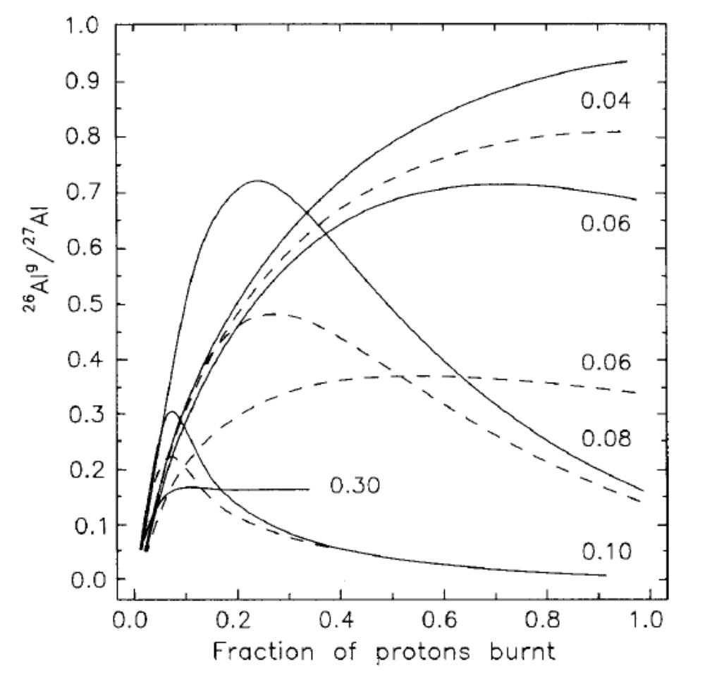

Figure 2.6: Abundance ratio of ²⁶Al/²⁷Al versus the fraction of burnt hydrogen for a constant density of 100 g/cm³ and constant temperature, indicated on the curves in units of 10⁹ K. The solid and dashed curves correspond to upper and lower limits of the ratio, respectively, based upon uncertainties in the production and destruction reactions. Figure taken from Ref. [Ili90].

metallicity Z ~ 2 Z⦿ [Pra96]. Such a scenario can occur in the inner Galaxy where the abundance of metals is much higher. Mass-loss can be as high as 10⁻⁴ M⦿/yr [Pra96].
Eventually the hydrogen envelope is stripped off and products of the convective hydrogen core appear at the surface. The core temperature (T = (35 – 70)*10⁶ K) is high enough for a link to develop between the CNO cycle and the Ne-Na cycle and Mg-Al chain [Ili90,Pra96]. In this way, ²⁶Al production develops in the core. ²⁶Al is primarily destroyed by beta-decay in the low-mass WR stars and the (p,γ) reaction above T ~ 50*10⁶ K [Pra96]. Depending upon the extent of convection in the core and the rate of mass-loss, ²⁶Al may cycle to the surface and get ejected before being destroyed. If the WR star is massive enough to develop core He-burning, neutrons released from the ¹³C(α,n)¹⁶O reaction destroy any ²⁶Al left in the core through ²⁶Al(n,α)²³Na and ²⁶Al(n,p)²⁶Mg reactions, but ²⁶Al will continue to be ejected from the surface until the products of He-burning appear there [Pra96,Lim06]. Because ²⁶Al production is proportional to the amount of ²⁵Mg available, the initial metallicity of the star determines the abundance of ²⁶Al produced. The metallicity also directly affects the solar winds and the degree of mass-loss. Hence, a WR star with a high metallicity will produce more ²⁶Al that will be ejected into the ISM than one with less metallicity. In fact, the inner Galaxy has a larger average metallicity than the solar neighborhood and may be a prime location for ²⁶Al produced by WR stars [Pra96]. It is predicted that a WR with mass 40 < M/M⦿ < 120 and solar metallicity will eject 10⁻⁵ - 10⁻⁴ M⦿ of ²⁶Al into the ISM during its average lifetime of ~ 5*10⁵ years, and this would certainly be higher in the high-metallicity environment of the inner Galaxy [Pra96].

CHAPTER 3 – Nuclear Reactions
Given information about a stellar environment, it is possible to describe the physics of nuclear reactions within that environment. This chapter will examine how particles interact under those conditions and is drawn from discussions in [Cla83] and [Gui09].

3.1 Nonresonant Nuclear Reactions
The probability of two particles participating in a nuclear reaction is described by the cross section of the reaction and is commonly expressed in units of “barn” (10⁻²⁴ cm²). The cross section is given by:
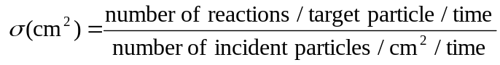 (3.1)
and can be used to calculate a reaction rate for the particles. By expressing the number of particles in terms of a density per unit volume, N₁ and N₂, the flux of incoming particle 1 is v*N₁, where v is the relative velocity between particles 1 and 2. As such, the reaction rate is:
r_{1,2} = σ(v)vN₁N₂ (3.2)
The velocity of all the particles of type 1, however, is not exactly v. There is a Maxwell-Boltzmann distribution of relative velocities, φ(v), which gives the probability that the relative velocity between a pair of particles is v within the range dv. Under these circumstances, the total reaction rate per unit volume is:
r_{1,2} = (1+δ₁₂)⁻¹N₁N₂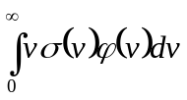 = (1+δ₁₂)⁻¹N₁N₂<σv>
= (1+δ₁₂)⁻¹N₁N₂*4π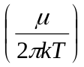^{3/2}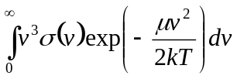, (3.3)
where = 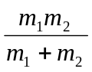 (3.4)
is the reduced mass and the Kronecker delta has been introduced to avoid counting particle pairs twice if particles 1 and 2 are the same type. Rewriting the velocity distribution as a normalized energy distribution,
φ(v)dv = ψ(E)dE = $\frac{2}{\sqrt{π}}\frac{E^{1/2}}{{(kT)}^{3/2}}exp\left(-\frac{E}{kT}\right)dE$ , (3.5)
the reaction rate per pair of particles becomes:
λ = <σv> = $\int_{0}^{∞}{σ\left(E\right)v\left(E\right)ψ\left(E\right)dE}$ . (3.6)
Solving the reaction rate equation becomes a matter of determining the value of the nuclear cross section, σ.
Semiclassically, a reaction will not occur unless two interacting particles overcome the repulsive Coloumb barrier that separates them:
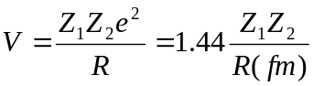 MeV (3.7)
where Z₁ and Z₂ are the atomic numbers of the interacting particles and their separation distance is given by:
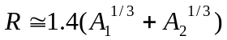 fm (3.8)
with A₁ and A₂ the atomic mass numbers of particles 1 and 2, respectively. Gamow first showed that the probability of penetrating the barrier is inversely proportional to an exponential function of the atomic numbers,
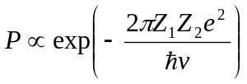 (3.9)
It is also known that the interaction between two particles is proportional to the de Broglie wavelength, which is inversely proportional to the energy. For these reasons, the cross section is generally written as a product of these two terms and the astrophysical S-factor:
(E) = 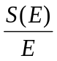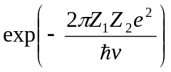 = 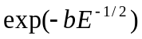, (3.10)
where b = 31.28Z₁Z₂A^{1/2} kev^{1/2} (3.11)
and A = 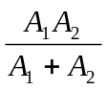 (3.12)
is the reduced atomic weight. The cross section itself tends to be a rapidly decreasing function at low energy because of the rapidly dropping penetrability, but the S-factor is a slowly varying, almost constant function over a limited energy range that allows extrapolation to the low energies of stellar environments.
Writing the reaction rate per pair of particles in terms of energy and using the expression for the cross section above, the equation takes on the form:
λ = <σv> = 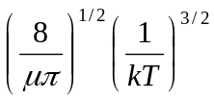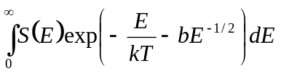 (3.13)
The exponential in the integrand is the product of the Maxwellian distribution, which vanishes at high energies, and the penetration factor, which vanishes at low energies. The result is a sharply peaked function called the “Gamow peak” that has a maximum at energy
E₀ = 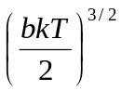= 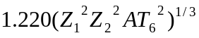 keV (3.14)
with the temperature (T₆) measured in millions of Kelvin. This is known as “the most effective energy for thermonuclear reactions” and is illustrated in Figure 3.1. It is possible to approximate the value of this integral by replacing S(E) with S₀, its value at E = E₀, and replacing the exponential with a Gaussian of similar size and shape. The result for the reaction rate per pair of particles is:
λ = e^{-τ} S₀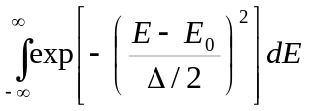
= 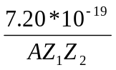S₀ (keV barns) τ²e^{-τ} cm³/sec (3.15)
where τ = 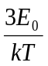 (3.16)
and Δ = 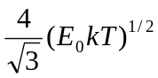 = 0.75(Z₁²Z₂²AT₆⁵)^{1/6} keV (3.17)
is the full width at half maximum.
The reaction rate can also be written in terms of the local density through the relation
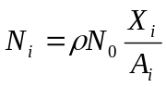 (3.18)
where N₀ is Avogadro’s number and X_{i} is the fraction by mass of species i. Adding corrections for the approximation of S(E) with the constant S₀ and the exponential with a Gaussian, the total nonresonant reaction rate for particles 1 and 2 then becomes:
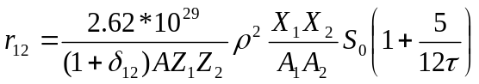τ²e^{-τ} cm⁻³sec⁻¹ (3.19)
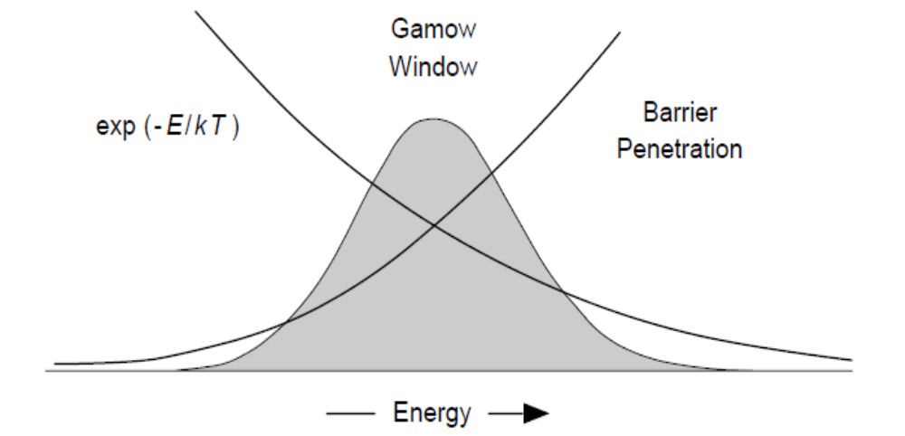

Figure 3.1: Illustration of the Gamow window between the decreasing Maxwell-Boltzmann distribution and the increasing barrier penetration curve. Figure taken from Ref. [Gui09].
where S₀ = S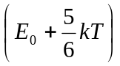 keV barns. (3.20)

3.2 Resonant-Wing Nuclear Reactions
A reaction resonance occurs when the center of mass energy of the interacting particles coincides with the energy of a quasistationary state of the compound nucleus. Many nonresonant reactions actually occur in the wings of broad s-wave resonances where there is no relative angular momentum between the interacting particles and penetration factors are small. The probability of a compound nucleus forming with a particular energy E is:
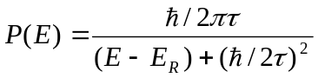 (3.21)
where τ is the mean-lifetime of the state. The width of the state
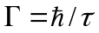 (3.22)
is a sum of the partial widths for all particles that can form the state or particles to which the state can decay upon breakup. The probability of the state forming or decaying by a particular channel is proportional to the partial width of that channel. For a reaction to occur, rather than an elastic scattering event, the incoming and outgoing channels must be different, and the maximum reaction cross section is
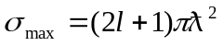 (3.23)
As such, the reaction cross section for the ℓ^{th} partial wave of a reaction with incoming particle 1 and outgoing particle 2 is given by the Breit-Wigner formula:
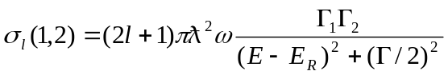 (3.24)
with 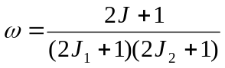 (3.25)
and J, J₁, and J₂ the spins of the resonance, incoming, and outgoing particles, respectively. This cross section can be used to calculate nonresonant reaction rates in the wings of resonances.

3.3 Resonant Nuclear Reactions
In the vicinity of a resonant state, the cross section for a nuclear reaction will be orders of magnitude higher. Resonances within the range of effective stellar energies tend to have narrow widths due to the low-energy nature of the environment. Because penetration factors are high relative to the energy of particles, incident-particle widths are reduced. It is the narrowness of the resonance near E₀ which makes it possible to simplify the integral in Equation 3.6. The functions ψ(E), v(E), and 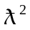 will change little over the small energy range of Γ and can be approximated by their values at the resonance. In this way:
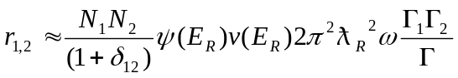 (3.26)
Rewriting the velocity in terms of the energy and inserting Equation 3.5 for the wave function:
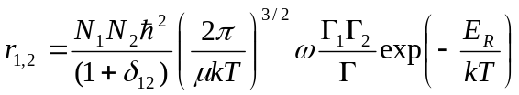
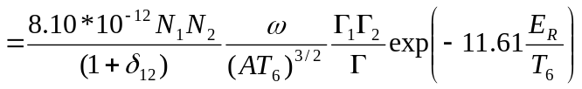 cm⁻³ sec⁻¹ (3.27)
where E_{R} and Γ are in units of keV.
Written in terms of the mass fraction of particles 1 and 2, the reaction rate becomes:
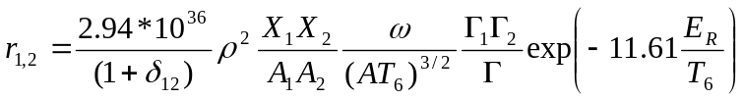 cm⁻³ sec⁻¹ (3.28)
If the density of resonances is high, most reactions will be resonant. In this case a sum over the resonances in the compound nucleus is necessary, and the reaction rate per pair of particles is:
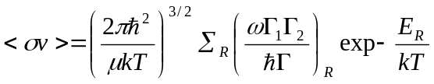 (3.29)
There are two limiting cases worth mentioning for the reaction rate equation. If a resonance has only two reaction channels such that Γ = Γ₁ + Γ₂ and the partial width of one channel is vastly larger than the other, such that it dominates the true width of the resonance, the ratio 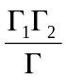 can be reduced. Low-energy resonances often have partial widths where Γ₂ >> Γ₁ because penetration factors reduce the incident-particle width far below the natural width of the state. In this case the decay width will dominate the total width of the state, and a reaction will occur much more frequently than a scattering event. Under these circumstances, → and the reaction rate does not depend upon the partial width of particle 2. The opposite scenario occurs when Γ₁ >> Γ₂, and the compound nucleus consistently decays by the reemission of the incident particle. Here → 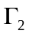 and the reaction rate is independent of the particle 1 partial width.

3.4 Resonances and Reaction Rates of ²⁶Al(p,γ)²⁷Si
Resonances of the ²⁶Al(p,γ)²⁷Si reaction correspond to excited states of the ²⁷Si nucleus. Experiments have glimpsed or suspected many states for this nucleus, but few have been characterized. A list of identified and tentative excited states of ²⁷Si above the proton threshold up to 1.5 MeV appears in Table 3.1. Resonance strengths for some levels have been directly measured, while others have been inferred and upper limits established. The resonance strength is a product of the ω and Γ terms in the resonant reaction rate equations above and depends upon the spins and widths of the interacting particles and the resonant state, respectively. When more than one measurement appeared in the literature, a weighted average for the resonance strength was calculated.
Direct measurements of resonance strengths were recorded by Buchmann et al. (1984) and Vogelaar (1989) with a proton beam impinging on an ²⁶Al target and by Ruiz et al. (2006) with an ²⁶Al beam bombarding a hydrogen-gas target. In each of these studies excited states of ²⁷Si were populated, and resonance strengths were calculated from the gamma-decay schemes of these states. Upper limits for inferred resonances were calculated by Vogelaar (1989) in his ²⁶Al(p,γ)²⁷Si analysis and by Vogelaar et al. (1996) and Lotay et al. (2009) during ²⁶Al(³He,d)²⁷Si and ¹²C(¹⁶O,n)²⁷Si experiments, respectively. Vogelaar (1989) and Lotay et al. (2009) established upper limits by monitoring the gamma-decay schemes of ²⁷Si excited states, and Vogelaar et al. (1996) examined the angular distributions of deuteron excitation functions.

Table 3.1 (part 1): Known and suspected excited states of ²⁷Si. Resonance strengths are directly measured unless stated otherwise. References are listed at the bottom of the table.

E_level | E_res | Spin | Strength (keV) | Uncertainty (keV) | Ref.
7469.0(6) | 6.0 | 5/2+
7531.3(7) | 68.3 | 5/2+ | ≤ 2.32E-17† |  | A
7557(3) | 94.0
7589.7(8) | 126.7 | 9/2+ | ≤ 5.9E-12† |  | C
7651.6(3) | 188.6 | 11/2+ | 4.3E-08 | 6.E-09 | B, D
7693.8(9) | 230.8 | 5/2+ | ≤ 1.E-08† |  | D
7704.3(2) | 241.3 | 7/2+ | 1.0E-08 | 5.E-09 | D
7739.3(4) | 276.3 | 9/2+ | 3.0E-06 | 3.E-07 | D, E
7794.8(19) | 331.8 | 7/2+
7831.5(4) | 368.5 | 9/2- | 6.8E-05 | 7.E-06 | D, E
7837.6(2) | 374.6 | 1/2+
7899.0(8) | 436.0 | 5/2+
7909.1(7) | 446.1 | 3/2+
7966.3(8) | 503.3 | 5/2+
8031.5(11) | 568.5 | 5/2+
8069.6(30) | 606.6 | 3/2-
8139.0(6) | 676.0 | (1/2)
8157(2) | 694.0 | (7/2-13/2) | 6.5E-05 | 9.E-06 | D, E
8168.2(20) | 705.2 | 11/2+ | 2.6E-05 | 4.E-06 | D, E
8176(3) | 713.0
8183.5(4) | 720.5 | 3/2-
8199.8(7) | 736.8 | (1/2,5/2)
8209.0(22) | 746.0 | 7/2- | 2.06E-04 | 3.1E-05 | D
8226(3) | 763.0 | 7/2+ | 4.4E-05 | 6.E-06 | D, E
8299(5) | 831.0 | (7/2-13/2)+ | 5.0E-05 | 6.E-06 | D, E
8318(3) | 860.0 | (1/2,3/2)+
8344.5(10) | 881.5 | (7/2)
8358(2) | 895.0 | (3/2-9/2)+ | 4.0E-05 | 8.E-06 | D, E
8375.5(9) | 912.5
8451(2) | 988 | (1/2,3/2)+

E_level | E_res | Spin | Strength (keV) | Uncertainty (keV) | Ref.
8486(3) | 1023
8523(3) | 1060
8545(3) | 1082
8586(3) | 1123
8671(3) | 1208
8724(4) | 1261
8777(5) | 1314
8782(4) | 1319
8822(5) | 1359
8864(3) | 1401
8872(5) | 1409
8931(4) | 1468
8984(3) | 1521

Table 3.1 (continued): Known and suspected excited states of ²⁷Si. References are listed at the bottom of the table.

Based upon values in Table 3.1, a plot of resonant reaction rates at temperatures relevant to most stars appears in Figure 3.2. Table 3.1, however, remains largely incomplete. Until additional properties can be determined for uncharacterized resonances, their contributions to the total ²⁶Al(p,γ)²⁷Si resonant reaction rate in stellar environments will remain unknown.

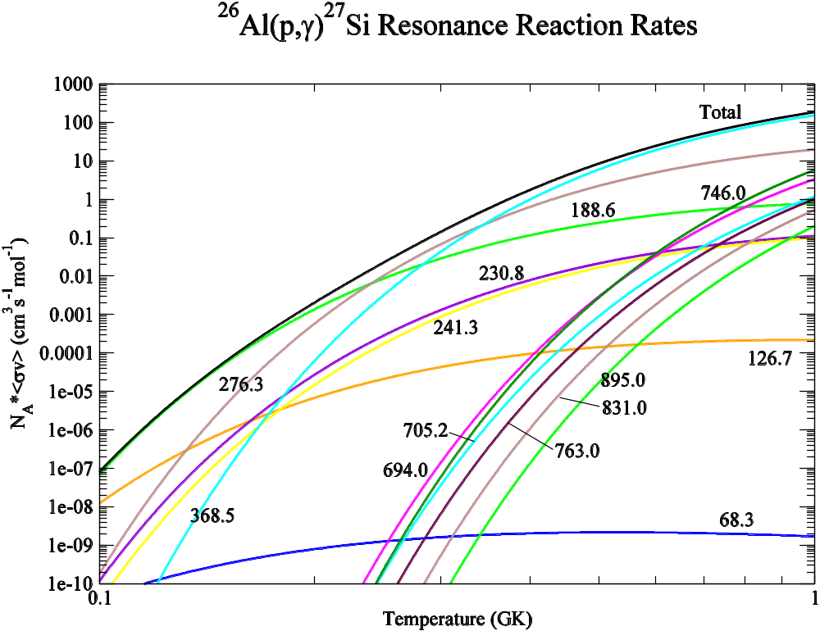
Figure 3.2: Plot of resonant reaction rates at stellar temperatures for known resonances in the ²⁶Al(p,γ)²⁷Si reaction. Individual curves are labeled by the resonance energy in keV from Table 3.1.

CHAPTER 4 – The Experiment
To reduce uncertainties in the ²⁶Al(p,γ)²⁷Si reaction, an ²⁶Al(p,p)²⁶Al elastic scattering experiment was performed in inverse kinematics at the Holifield Radioactive Ion Beam Facility (HRIBF) at the Oak Ridge National Laboratory (ORNL) in an attempt to characterize unknown resonances above the proton threshold in the energy range E_{cm} ~ 0.5 - 1.5 MeV. Evidence for the ²⁶Al(p,p’)²⁶Al* inelastic scattering reaction was also searched for to determine possible leakage to the metastable state of ²⁶Al at E_{cm} = 228 keV. An illustration of the experimental setup appears in Figure 4.1. A beam of ²⁶Al bombarded a polypropylene target, and scattered protons were detected in the Silicon Detector Array (SIDAR) in coincidence with beam scattered into a gas-filled ionization chamber.

4.1 Targets
Two target ladders were mounted in the target chamber, as shown in Figure 4.2. Mounted on the upstream ladder was an ²⁴¹Am alpha source for testing electronics and measuring solid angle, a 7 mm hole to tune the beam into the ion chamber, and a phosphor for tuning the beam at the target location. This phosphor glows at the location where energetic beam particles deposit energy, which allows the size and shape of the beam on target to be optimized for the experiment. This ladder was mounted within a vertical stainless steel track designed to block alpha emission from ²⁴¹Am during the experiment. A 12-inch diameter stainless steel plate (Figure 4.3) was also mounted onto this track to block any halo beam particles from directly hitting the SIDAR detectors

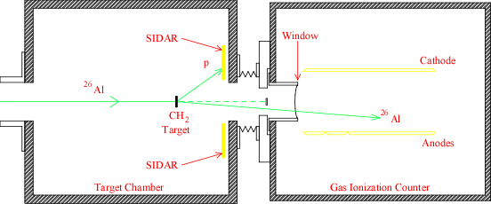

Figure 4.1: An illustration of the target chamber and gas ionization chamber used in this experiment. A beam of ²⁶Al bombarded a polypropylene target. Scattered protons were detected in SIDAR in coincidence with scattered ²⁶Al in the ion chamber. A 1 cm blocker was inserted in front of the ion chamber to prevent the primary beam from entering the chamber.

Figure 4.2: A picture of the two target ladders used in this experiment.

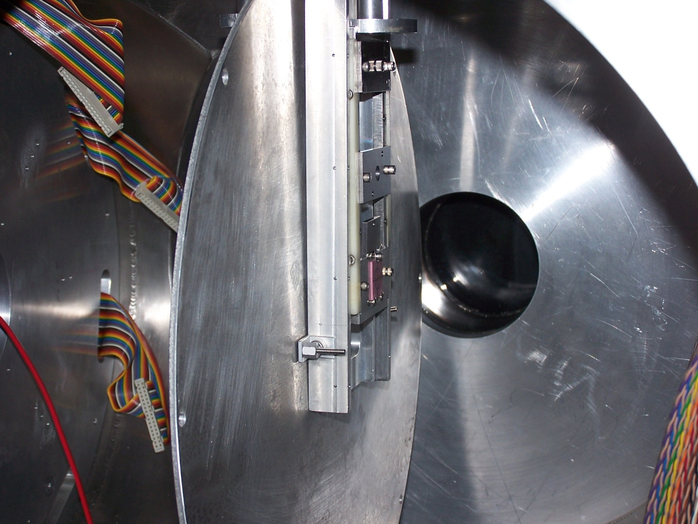
Figure 4.3: The inside of the target chamber with SIDAR removed.
without first going through the experimental target. The downstream ladder held all targets for the experiment. Three polypropylene targets approximately 46 μg/cm² were mounted to ensure extra targets were available should individual targets be damaged during the course of the experiment. Also mounted on the downstream target ladder was a ¾ inch hole and a 20 μg/cm² carbon / 100 μg/cm² gold foil to provide Rutherford scattering data for normalization of experimental data. This hole and carbon-gold foil were removed on Day 7 of the experiment and replaced with two 2.4 mg/cm² polypropylene targets to construct an excitation function with thick-target data for comparison with the thin-target data.
The targets were made from a 21”-wide commercial roll of polypropylene manufactured by Exxon Chemicals. A square of material was cut from this roll and stretched across a 14”-wide (12” inner diameter) stainless steel ring and screwed down. This ring was placed atop a cylindrical heating element heated to 165°C and as the ring of polypropylene began to stretch, it was pressed down the length of the cylinder to achieve the desired thickness (see Figure 4.4). The top ring, with the stretched polypropylene, was then cut from the rest of the polypropylene square stretched down the side of the cylinder, and target frames were glued to it. After the glue dried, target thicknesses were measured with an ²⁴¹Am alpha source described below. Previous measurements at ORNL had shown the foils to be composed of CH₂ with a carbon/hydrogen ratio of 1.8.

4.2 Silicon Detectors
The detectors used in this experiment were YY1 silicon detectors manufactured by Micron Semiconductors, Ltd. The front side is a boron-doped p-type semiconductor

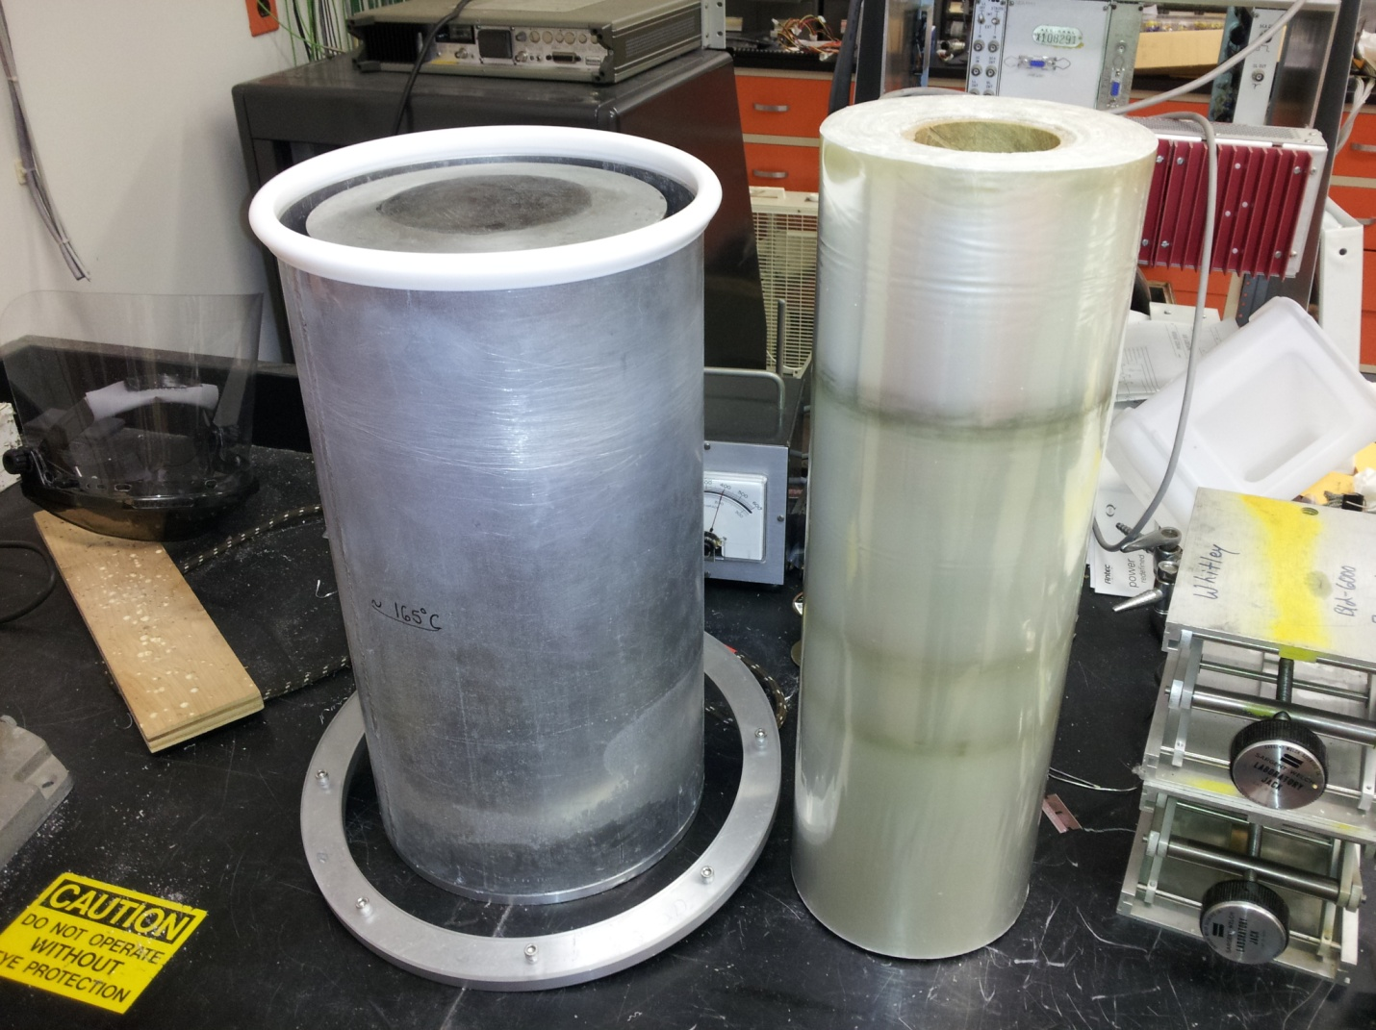

Figure 4.4: Polypropylene targets were made from an industrial roll of polypropylene manufactured by Exxon Chemicals. Material was heated and stretched before gluing to target frames.
divided into 16 annular strips 0.5 cm wide, and the back side is a single n-type pad. Figure 4.5 shows the structure of these detectors, and their characteristics are listed in Table 4.1.
A pure, or intrinsic, silicon semiconductor consists of a periodic crystalline lattice that is characterized by allowed energy bands for electrons in the material. In the absence of thermal excitation, electrons are bound to the atoms that make up the lattice sites and participate in covalent bonds that join the silicon atoms together. These electrons fill their lowest energy band, and this is called the valence band. Above the valence band in energy is the conduction band which is separated from the valence band by the bandgap. A comparison of the structure of an insulator and a semiconductor is shown in Figure 4.6. The two are similar, but the bandgap in the semiconductor is smaller, increasing the possibility for an electron to traverse the gap.
An electron in silicon becomes ionized from its lattice atom when it absorbs about 3 eV of energy. If the absorbed energy is about 1 eV higher, it will have enough energy to cross the bandgap and enter the conduction band, where it is free to move through the solid. When an electron moves into the conduction band, it leaves behind a vacancy called a hole in the valence band. Once an electron-hole pair forms, each member can be induced to move under the influence of an electric field, which creates a current within the material. In the absence of an electric field, thermally created electron-hole pairs tend to recombine and an equilibrium is established with the concentration of pairs proportional to the rate of formation.
When a semiconductor is used as a radiation detector, passage of a charged particle through the medium ionizes electrons along its path and creates a trail of

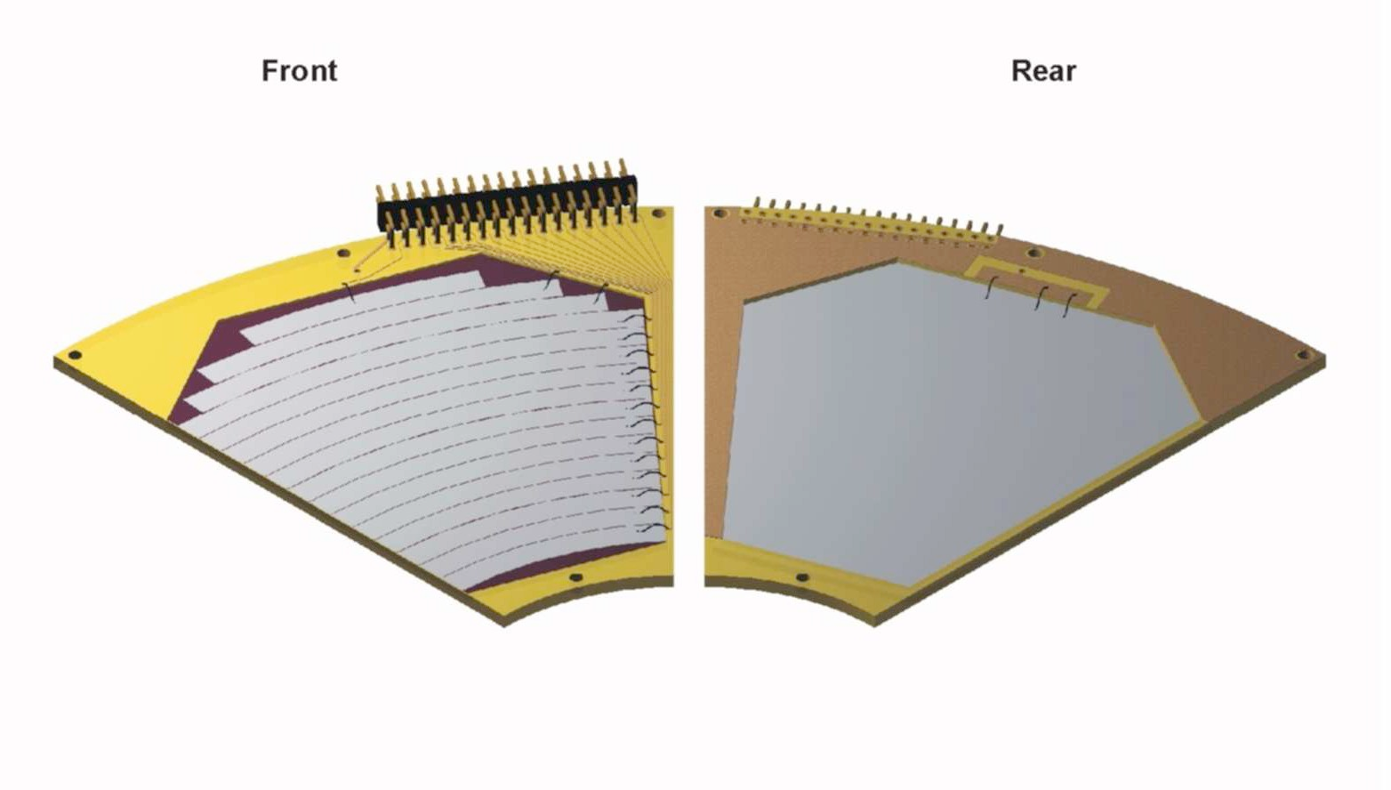

Figure 4.5: YY1 silicon detectors manufactured by Micron Semiconductors, Ltd. were used in this experiment. The front face is p-type, and the rear face is n-type. Figure taken from Ref. [Moa09].

Table 4.1: Properties of the YY1 silicon detector manufactured by Micron Semiconductors, Ltd.

Active Inner Dimensions | 50 mm
Active Outer Dimensions | 130 mm
No. of Junction Elements | 16
No. of Ohmic Elements | 1
Active Area | 29 cm²
No. of Sectors | 16
Sector Subtends | 45°
Detector Edge Surround | 0.5 mm
Junction Pitch | 5 mm
Thickness | 500 μm or 1000 μm
Thickness Tolerance | ± 15 μm
Thickness Uniformity | ± 5 μm
Full Depletion (FD) | 30 V typ, 50 V max
Operating Voltage | FD to FD+30 V
Breakdown Voltage (10 μA) | > 2*FD
Element Capacitance | 50 pF
Current | 20 nA typ, 100 nA max
Pulse Response Time | 10 ns typ

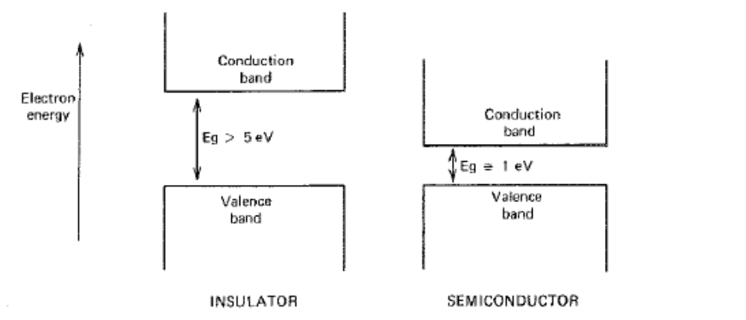

Figure 4.6: Typical band structure for electron energies in insulators and semiconductors. Figure taken from Ref. [Kno00]. The actual band gap in silicon semiconductors varies somewhat from this ideal case.

electron-hole pairs that can be collected with an electric field. Once an electric field is applied to the semiconductor, the electron moves in the direction opposite the field vector, and the hole behaves like a positive charge moving in the same direction as the electric field. The observed current in a semiconductor is a combination of the current due to the moving electrons and that due to the holes. Drift velocities of the electron and hole are proportional to the magnitude of the electric field and are given by Equation 4.1:
$v_{e}= μ_{e}ℇ$ (4.1)
$v_{h}= μ_{h}ℇ$
where μ_{e,h} is the mobility of the electron and hole in the material. The mobility of the electron and hole is temperature-dependent and are roughly of the same order. At 300 K the mobility of the electron and hole in silicon is 1350 cm²/V·s and 480 cm²/V·s, respectively. Semiconductor detectors are typically operated with electric fields high enough to saturate drift velocities of the charge carriers. Maximum velocities are on the order of 10⁷cm/s, resulting in collection times on the order of nanoseconds.
Intrinsic silicon semiconductors are composed entirely of pure silicon but are only theoretical, as it is impossible to exclude all impurities during the manufacturing process. It is common practice, however, to induce a semiconductor to be p-type or n-type by doping it with a different atom. In such a case, an impurity atom is introduced into the lattice on the order of a few parts per million during the growing process. Throughout most of the lattice, the structure is that of the intrinsic semiconductor. Silicon is a tetravalent atom. It has 4 valence electrons that allow it to covalently bond with its four nearest neighbors.
In a p-type semiconductor a small number of the silicon atoms are replaced by an acceptor impurity which is a trivalent atom, such as boron, that possesses only 3 valence electrons. This is the case for the p-type face of the detectors used in this experiment. The boron bonds with 3 of its 4 neighboring silicon atoms, but one of the silicon neighbors is left with an unsaturated covalent bond which creates a hole in the lattice.
During the production of an electron-hole pair, electrons and holes are created in equal numbers, and this process accounts for all charge carriers in an intrinsic semiconductor. Doping the material with acceptor impurities greatly increases the number of holes over the intrinsic number, such that the number of holes is completely dominated by the concentration of acceptors. These holes also recombine with electrons created within the material, decreasing the electron count, and tipping the equilibrium heavily toward the number of holes. The product of electron number and hole number, however, remains consistent with that for the intrinsic material: n∙p = n_{i}∙p_{i}, where i denotes the intrinsic count. For room-temperature silicon, intrinsic carrier densities are about 10¹⁰/cm³, giving a product on the order of 10²⁰/cm³. Thus, a p-type material with an acceptor impurity concentration of 10¹⁷ atoms/cm³ would have approximately 10¹⁷ holes/cm³ and 10³ electrons/cm³ at equilibrium. In p-type materials electrons are the minority carrier, and holes are the majority carrier and dominate the electrical conductivity.
Electrons are the majority carrier in n-type semiconductors, and holes are the minority carrier. N-type materials are created by doping the crystal with a donor impurity, such as pentavalent phosphorus. Phosphorus has 5 valence electrons but can only form 4 covalent bonds with the surrounding silicon atoms, leaving 1 electron loosely bound to the impurity atom. The concentration of electrons in this material is dependent upon the concentration of the donor impurity. Electrons far outnumber holes in n-type semiconductors, but the product obeys the n∙p relation above for intrinsic materials.
The silicon detectors used in this experiment consist of a p-type material bonded to an n-type material. The junction represents steep density gradients for the electrons on the n-side and the holes on the p-side. To balance this gradient, each charge carrier diffuses from the side of high concentration to that of low concentration. Electrons diffuse away from the n-side, leaving behind immobile positive charges on the ionized donor impurities, and recombine with holes on the acceptor impurities on the p-side. Likewise, holes on the p-side diffuse into the n-side and leave behind the immobile negative charges on acceptor impurities that have picked up an extra electron. In this way a negative space charge builds up on the p-side of the junction and a positive space charge builds up on the n-side. The result is the build-up of an electric field until a steady-state charge distribution is established and there is no further net diffusion across the junction. This region is called the “depletion region” because the only significant charges remaining are the immobile positive and negative charges on the ionized donor and filled acceptor impurities. The electric field causes any electrons and holes created in this region to be swept back into the n- and p-sides of the junction, respectively.
Left to its own devices, a p-n junction in a silicon detector will separate charge and develop a depletion region; however, the strength of the resulting electric field is not great enough to move all newly-created charges out of the region fast enough to avoid recombination. To capitalize on the physical nature of the junction, the silicon detector is reverse-biased. Applying a negative voltage to the p-side of the detector accentuates the potential difference across the junction. According to Poisson’s equation (4.2),
$∇^{2}φ= - \frac{ρ}{ϵ}$ , (4.2)
where φ is the potential, ρ is the charge density, and ϵ is the dielectric constant, an increase in the potential will increase the charge density, and the result is an expansion of the depletion region deeper into the p- and n-sides of the detector. At a high enough reverse-bias voltage the volume of the depletion region extends to the full thickness of the detector and the detector is “fully depleted”. At this point any charged particle that enters the detector will create electron-hole pairs along its length until it is stopped within the detector, and currents created by the migration of these electrons and holes to the terminals of the detector are integrated to determine the energy of the particle striking the detector.
Micron Semiconductors recommends a bias voltage of 30 V for the YY1 detector; however, the precise voltage required was determined with the ²⁴¹Am alpha source in the target chamber with the detectors. An oscilloscope was connected in turn to each of the detector amplifiers, and the bias was raised until the size of the pulse peak from the detector no longer increased. At this point the detector should be fully depleted. To confirm this voltage, the detectors were then mounted backwards so the peak was recorded by the n-side of the detectors and the process of increasing the bias was repeated.
For the purposes of this experiment, six 1000 μm YY1 silicon detectors and two 500 μm detectors were assembled into an azimuthal Silicon Detector Array (SIDAR) in a “flat” configuration (Figure 4.7). Detectors were chosen based upon the thickness required to stop protons scattered from the target by ²⁶Al beams used in this study. The most energetic protons were detected at the smallest angle of SIDAR, and a 41 MeV ²⁶Al beam scatters 5.25 MeV protons at this angle. The stopping power (or “specific energy loss”) of a charged particle in an absorber is given by the Bethe formula:
$-\frac{dE}{dx}= \frac{4πe^{4}z^{2}}{m_{o}v^{2}}NZ\left[ln\frac{2m_{o}v^{2}}{I}-\ln\left(1- \frac{v^{2}}{c^{2}}\right)- \frac{v^{2}}{c^{2}}\right]$ (4.3)
where v and z are the velocity and proton number of the incident particle, N and Z are the number density and atomic number of the absorber atoms, m₀ is the electron rest mass, e is the electronic charge, and I is the average excitation and ionization potential of the absorber. A plot of particle range versus energy for different charged particles in silicon
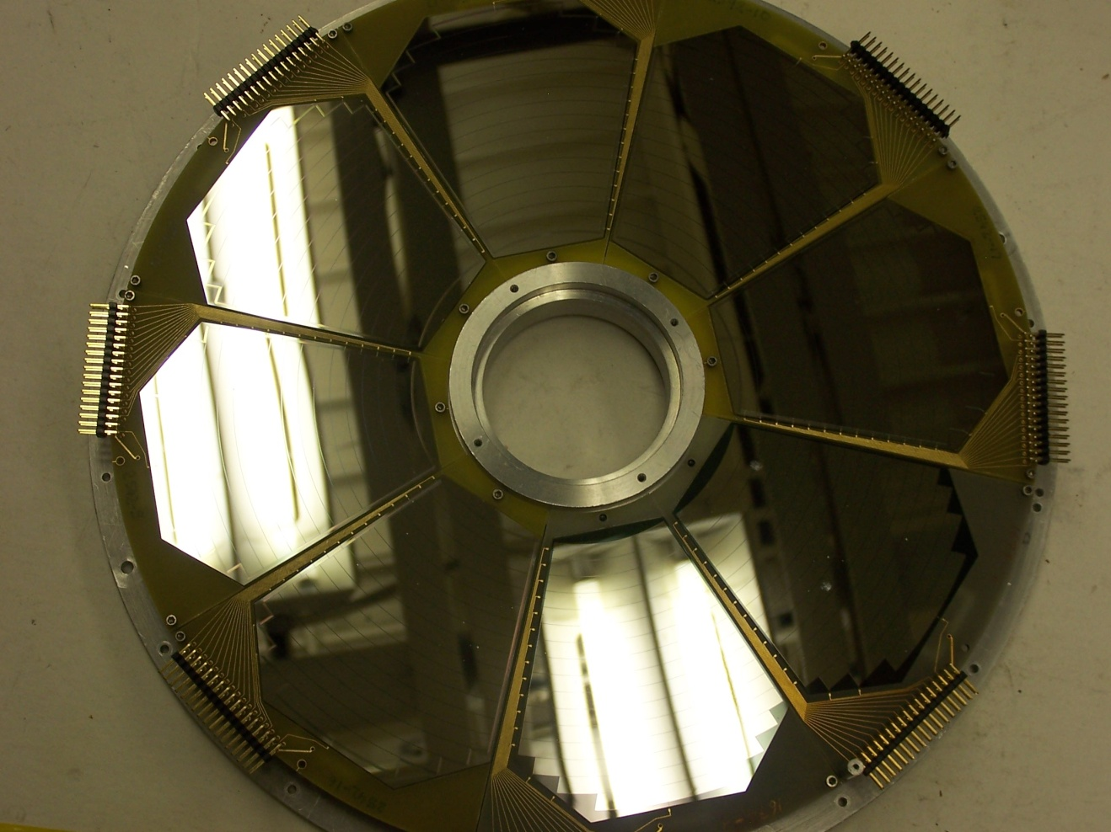

Figure 4.7: The Silicon Detector Array (SIDAR) consists of eight YY1 silicon detectors. This array was assembled to detect protons scattered out of the polypropylene target by the ²⁶Al beam.
appears in Figure 4.8. Based upon this graph, it appears that a 500 μm-thick silicon detector would stop protons with energy as high as 8 MeV, which is more than sufficient for this experiment.
After the detectors were diode-tested to ensure that all strips were connected properly, SIDAR was mounted 0.856 inches from the back flange of the target chamber and 5.569 inches downstream of the downstream target ladder (Figure 4.9). Centered on the beam axis, the purpose of SIDAR was to detect protons scattered out of the target at 18 - 41 degrees in the lab frame.

4.3 Ionization Chamber
An isobutane-filled ionization chamber, or “ion counter”, was placed downstream of the target chamber to detect scattered ²⁶Al particles in coincidence with protons scattered into SIDAR. Isobutane was the chosen gas because of its low ionization energy. Particles entered the ion chamber through a Mylar window separating it from the target chamber, allowing about 10 Torr of isobutane to remain in the ion chamber while the target chamber is under vacuum. This window was thick enough to contain the isobutane within the ion chamber, but thin enough for particles to penetrate. An illustration of the interior of this chamber appears in Figure 4.10.
When an ²⁶Al particle enters the ion chamber, it begins to slow down by transferring energy to the isobutane gas. If the energy transferred to a particular gas molecule is greater than the ionization energy of the gas, an electron-ion pair is created. Isobutane has a first-ionization energy of about 10.7 eV; however, other interactions occur, such as electron excitation, which reduce the number of ionizations. Accounting
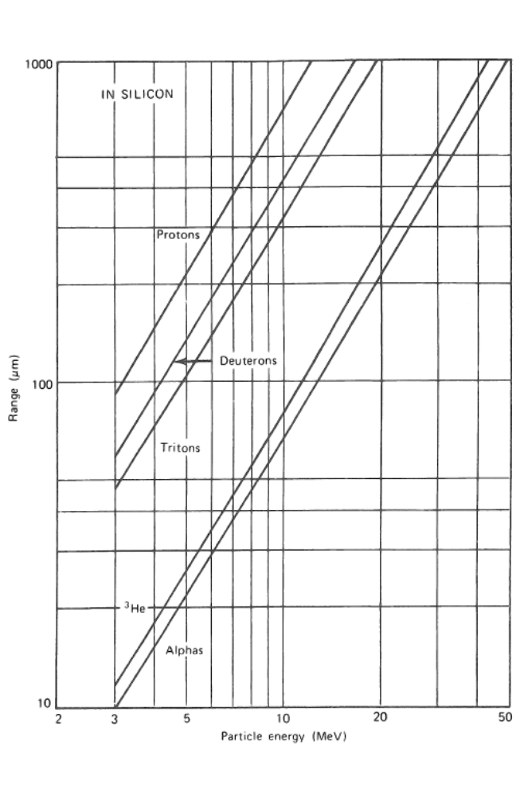

Figure 4.8: Range versus Particle Energy curves for different charged particles in silicon. Figure taken from Ref. [Kno00].

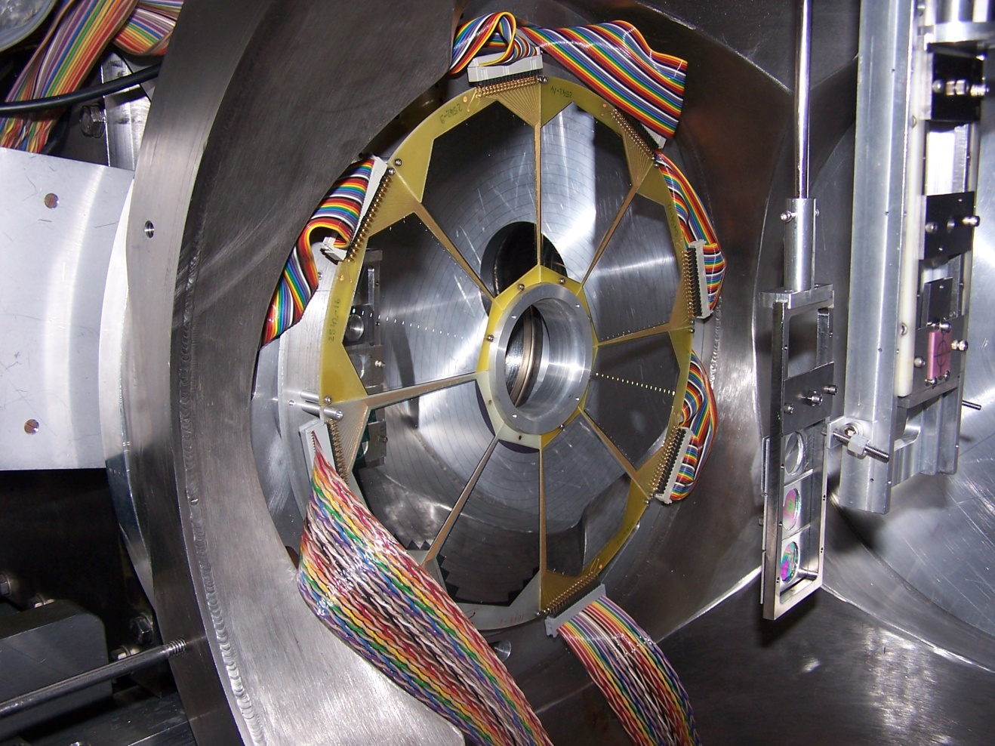
Figure 4.9: The interior of the target chamber showing SIDAR and the two target ladders. The 12” diameter stainless steel plate was removed from the upstream target ladder for the picture. Polypropylene targets used in this experiment were mounted on the downstream ladder.

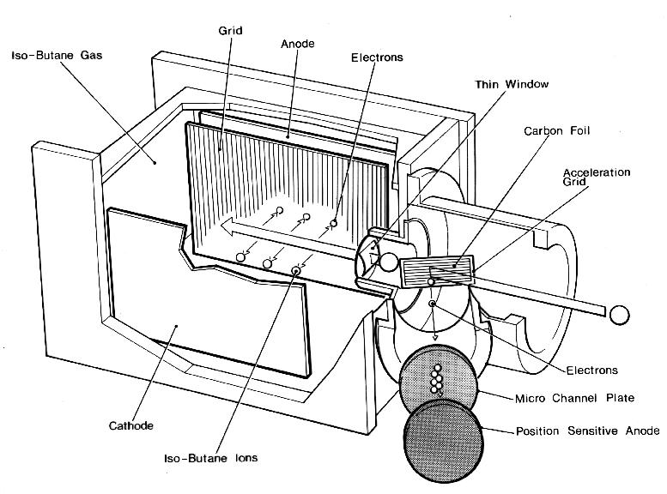

Figure 4.10: Diagram of the inside of the isobutane-filled ionization chamber. Once an electron-ion pair is formed, the positively-charged ion migrates toward the cathode, while the electron moves toward the anodes. The detection current develops once the electron passes through the Frisch grid located ~ 1 cm in front of the anodes. The carbon foil/micro channel plate detector shown in the figure was not used in this experiment.
for this, the average energy lost by the incident particle is a function of the interacting species and the energy, and typical values are 25 - 35 eV/ion pair created. This process serves to create many electron-ion pairs along the path of the ²⁶Al particle.
To prevent recombination, the ion pairs are swept to opposite sides of the ion chamber by an electric field. This field is generated by the cathode and anodes parallel to the path of the beam within the chamber and the Frisch grid between them. The Frisch grid is located about 1 cm in front of the anodes and maintains an intermediate potential between the two electrodes. Its purpose is to remove the dependence of the pulse amplitude on the position of the gas-particle interaction within the ion chamber. When an incident particle enters the ion chamber, an ion pair is created in the region between the cathode and the Frisch grid. The positive ion is attracted to the cathode side of the chamber, and the electron moves toward the grid and the anode side. The drift velocity of the ion pair is proportional to the electric field and is given by Equation 4.4:
$v= \frac{μℇ}{P}$ (4.4)
where v is the drift velocity, μ is the mobility, ℇ is the electric field strength, and P is the gas pressure. During this experiment the isobutane pressure within the ion chamber varied from 7.5 - 10 Torr and depended upon beam energy.
Owing to its much smaller mass, the electron mobility is typically 1000 times greater than that for the positive ion. This results in electron collection times on the order of microseconds, compared to milliseconds for the ion. For this reason, the signal pulse created by ionizing radiation in the ion chamber derives solely from the electron current within the chamber. As electrons pass through the Frisch grid and the grid-anode voltage begins to drop, a signal pulse begins to develop. The amplitude of this pulse continues to rise until the electrons are collected at the anode, and the maximum of this signal voltage is proportional to the total number of electrons collected from the ion pairs produced.
The inside of the ion chamber has 3 anodes of length 5 cm, 5 cm, and 20 cm, respectively. The first two anodes serve as an energy-loss, ΔE, detector and monitor the region in which the incident particle is slowing. The third anode is within the region where the particle is stopped and functions as a residual energy, E, detector. A plot of ΔE vs. E reveals the character of the incident particles. An example of the ion chamber spectrum with a 17 MeV ²⁶Al beam appears in Figure 4.11. It is apparent from this spectrum, that there are two groups of particles entering the chamber. The group on the left is ²⁶Al scattered off hydrogen in the target, and on the right is ²⁶Al scattered off carbon in the target. The ²⁶Al scattered off the carbon has a greater energy entering the ionization counter and thus sits to the right on the plot.
Immediately upstream from the ion chamber window was the ion chamber ladder, on which were mounted three objects. On the upper-most rung of this ladder was mounted a 4 mm hole to allow beam-tuning into the ion chamber. An aluminum beam blocker 1.5 cm in diameter was mounted on the second rung to prevent unscattered beam from entering the ion chamber during the experiment, and a 1 cm aluminum blocker was mounted on the third rung.

4.4 Electronics
A schematic of the electronics configuration for this experiment appears in Figure 4.12. Signal pulses from SIDAR and the ion chamber are very small and require amplification before digitization. Signals from each of the 8 SIDAR wedges and the ion

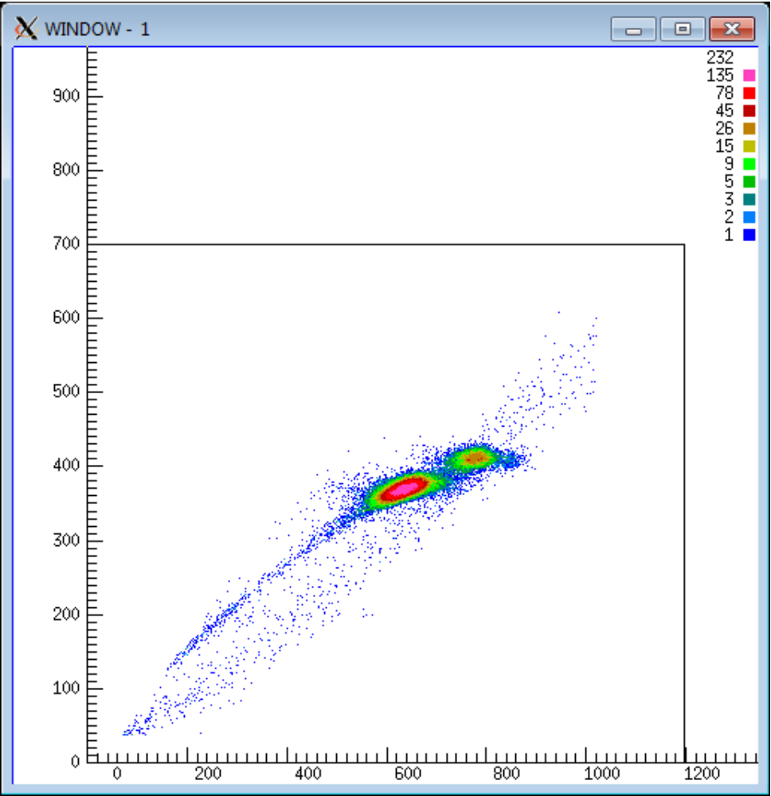

¹H(²⁶Al,²⁶Al)

¹²C(²⁶Al,²⁶Al)

ΔE
(channel)

E (channel)

Figure 4.11: A plot of ΔE versus E for particles entering the ion chamber when a 17 MeV ²⁶Al beam strikes a 46 μg/cm² polypropylene target. The Bethe formula (Equation 4.3) describes the stopping power as a function of particle energy.

Figure 4.12: A schematic of the electronics configuration for this experiment.
counter were first amplified by charge-sensitive preamplifiers. To reduce the capacitance introduced by long interconnecting cables and maximize the signal-to-noise ratio, the preamplifier boxes housing the preamplifier chips were mounted directly on the outside of the target and ion chambers. The output signal from the preamplifier is a linear tail pulse with amplitude proportional to the amplitude of the linear charge pulse from the detector. It has a short rise time consistent with the charge-collection time of the detector and a long decay time of about 50 – 100 μs to ensure that complete charge collection occurred. The output pulses from the preamplifiers, however, have amplitudes of only a few tens or hundreds of millivolts and are too small to be measured directly. The long tails also make these signals susceptible to pile-up with the potential for data-loss and deadtimes at high counting rates (> 10⁴ pps). For this reason the linear tail pulses from the preamplifiers were routed to shaping amplifiers that shape and amplify the linear pulse 1000-fold. The basic information about the amount of charge created in the detector is relayed by the maximum amplitude of the linear tail pulse of the preamplifier. The shaping amplifier preserves this information, while also eliminating the long decay tails of the preamplifier pulses. Figure 4.13 illustrates the differences between signals generated by the detectors, preamplifiers, and amplifiers.
Once the shaping amplifiers of SIDAR and the ion chamber processed the incoming linear tail pulse, two different branches are produced. One branch transmitted the linear analog signal to an analog-to-digital converter (ADC), while the other branch was used to create a logic signal to prepare the pulse-processing system for digitization of the amplitude. The logic signals (indicating the presence of a new event) from SIDAR and the ion chamber were generated by single-channel analyzer (SCA) differential discriminators. The SCA discriminator for the SIDAR signal is a leading edge discriminator built directly into the shaping amplifier module manufactured by Rutherford Appleton Laboratory. The SCA discriminator establishes a voltage window with an upper and lower limit and generates a logic output pulse when the amplitude of the incoming shaped linear pulse is within this window. For this experiment the upper limit of the SCA was set to its maximum value, and the lower limit was set to a value just above the noise threshold.
After leaving the shaping amplifier, the SIDAR logic signal had to be converted by a NIM-ECL-NIM module from the Emitter Coupled Logic (ECL) format that is output

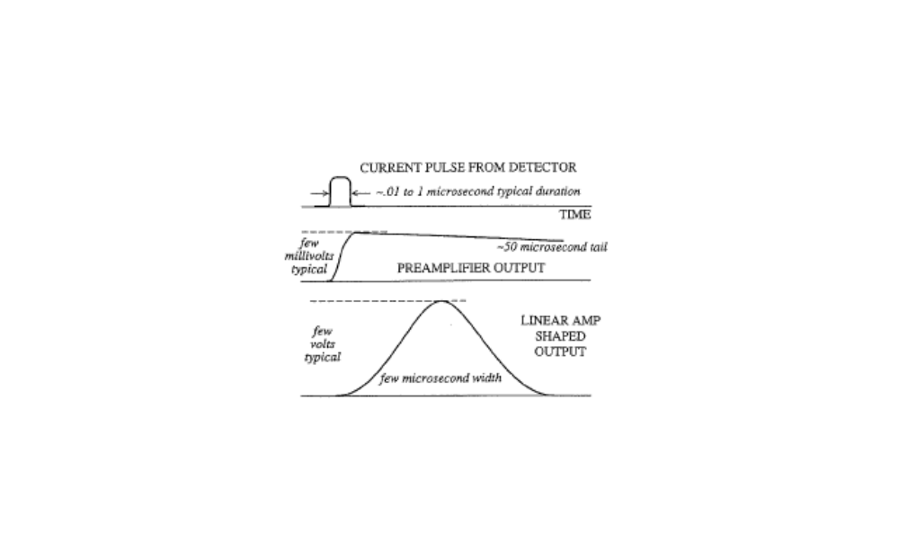

Figure 4.13: A comparison a pulses along the signal processing chain. Figure taken from Ref. [Kno00].

by the amplifier to the Nuclear Instrument Module (NIM) format used by the rest of the pulse-processing system. The SIDAR and ion chamber logic signals produced by the SCA discriminators were then fanned out. In one branch, each logic signal was used to establish an ADC gate. The gate is a switch that enables the ADC to digitize the peak voltage signal observed during the time the gate was true. This gate was opened by either the logic signal from SIDAR or by one out of every 2⁸ logic signals from the ion counter. This prescaling was necessary to prevent the system from being overrun with events. The width of the gate (~ 4 μs) was set slightly larger than the width of the linear pulses.
The other branch of the SIDAR and ion chamber logic signals was delivered to a time-to-amplitude converter (TAC). This device output a linear shaped pulse with an amplitude proportional to the time elapsed between a SIDAR start trigger and a delayed ion chamber stop trigger. The purpose was to identify events that had a tight time correlation between detection in SIDAR and the ion counter (i.e., coincident events). The usefulness of this method is apparent in Figure 4.14, which shows a raw-data spectrum in SIDAR with and without the TAC signal. For the purposes of this experiment, the full scale height of the TAC was set to 4 μs.
The ADC gate determined when an ADC would receive a linear analog signal from SIDAR, the ion chamber, or the TAC. Once the linear analog pulse reached the ADC, the peak height observed was converted to a digital number for storage and histogramming by the data acquisition computer.

Figure 4.14: Protons detected in SIDAR with and without a time-to-amplitude converter (TAC). The spectrum on the right uses a TAC to limit detections to those in coincidence with a signal in the ion chamber.

4.5 ²⁷Al Pilot Beam
An illustration of the Holifield Radioactive Ion Beam Facility appears in Figure 4.15. Prior to conducting the ²⁶Al + p experiments, a 15 MeV pilot beam of ²⁷Al was provided by the HRIBF operators to test the electronics and experimental configuration. The beam was a batch-mode beam, which was produced without the Oak Ridge Isochronous Cyclotron (ORIC) and production target illustrated in Figure 4.15. It was produced directly from a negative-ion source. Stable aluminum oxide (Al₂O₃) powder was mixed with loose copper powder and pressed into sputter cathodes that fit into the multi-sample target wheel of the Cs-sputter ion source (Figure 4.16). One by one the cathodes were rotated into the sputter source for bombardment with Cs ions. Inside the source the Cs ions were vaporized by an oven and accelerated by a 4.5 keV potential toward the cathode material. The reaction between the Al₂O₃ and the cesium ions sputtered aluminum oxide anion (AlO⁻) from the cathode that was collected from the source with an electrode.
Once the anion emerged from the source, it was formed into a beam and sent through a mass separator, which selected for the A = 43 ²⁷AlO⁻ molecule. The beam was then transmitted through an isobar separator and injected into the 25 MV tandem electrostatic accelerator. The charge of the beam at this stage was important because the tandem accelerator can only accelerate negative ions. At the base of the tandem the beam of negative ions was accelerated toward a terminal at the top of the tower, where it passed through a stripper foil that removed the oxygen and several electrons. Now a positively charged beam of ²⁷Al, the beam was accelerated down the other side of the tandem and delivered to the experiment room after passing through an energy-analyzing magnet.

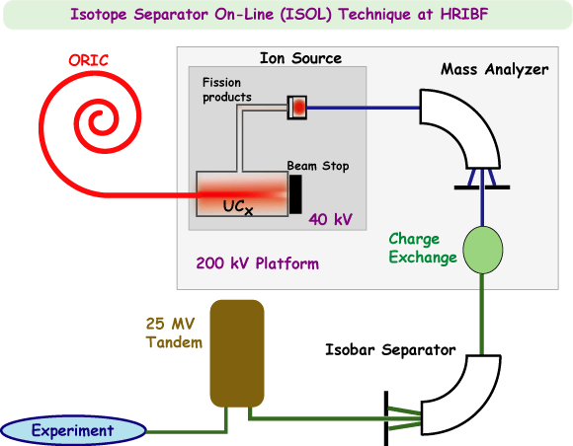
Figure 4.15: An illustration of the Holifield Radioactive Ion Beam Facility (HRIBF). This experiment did not require the Oak Ridge Isochronous Cyclotron (ORIC) nor the uranium-carbide production target. It used a batch-mode beam of ²⁶Al produced directly from a negative-ion source. Figure taken from Ref. [HRIBF].

Figure 4.16: Production of the batch-mode beams used in this experiment began with the mixing and heating of powders in the sputter cathodes of the Cs-sputter ion source. Figure taken from Ref. [Cha06].

During this initializing phase, there were actually two separate beams of ²⁷Al provided. The first beam was created on and sent from the Stable Injector, from which stable beams are produced. This beam was high-intensity and allowed the operators to tune the magnets for ²⁷Al through the tandem and all the way to the experiment room. Once the tandem was tuned for this beam, a second ²⁷Al beam was produced on and sent from the Radioactive Ion Beam (RIB) platform. Magnets between the RIB platform and the tandem were tuned for this beam so that the complete beam line from the RIB platform to the experiment room was configured for ²⁷Al.
The ²⁷Al beam was initially tuned onto the phosphor on the upstream ladder of the target chamber. Knowing that the intensity of the ²⁶Al beam used in the experiment will not be high enough to observe on the phosphor but will have to be tuned into the ion chamber, this procedure was tested with the ²⁷Al beam through the 4 mm hole on the ion counter ladder. The 1 cm blocker was inserted into the beam line and confirmed that it was large enough to stop the unscattered beam, and this size was chosen to prevent the blocking of forward recoils from which scattered protons were detected by SIDAR. All electronics were tested, and once everything was running smoothly, the beam was switched to ²⁶Al.

4.6 ²⁶Al Beam
A batch-mode beam of pure ²⁶Al was provided by the Holifield Radioactive Ion Beam Facility (HRIBF) for this study. A dry sample containing 6.6 μg of ²⁶Al atoms was obtained from Yale University (Figure 4.17). It was extracted from LAMPF beam-stop material by Ralph Kavanagh and Bruce Vogelaar. This sample was dissolved in HCl, and its activity was measured at 0.122 μCi. Roughly 10% of the solution was used in the experiment by drying to a powder and then reconstituting in 3-4 drops of HCl. This was mixed with loose copper powder in the sputter cathode and heated to oxidize the aluminum and dry the sample. After cooling, it was pressed into a pellet and reheated to center in the cathode and further dry. It was then placed in the target wheel of the Cs-sputter ion source on the RIB platform to produce an ²⁶Al beam by the same process described above for the ²⁷Al beam. In this case, the aluminum oxide anion produced is a carrier for the ²⁶Al isotope, and the mass separator selected for the A = 42 ²⁶AlO⁻. The tandem was tuned to transmit charge state 2⁺, and at the apex terminal the oxide molecule was broken up and electrons stripped from the Al to produce a beam of ²⁶Al²⁺ for the experiment. Beam intensities of ~2*10⁶ ²⁶Al/s were achieved by this method.

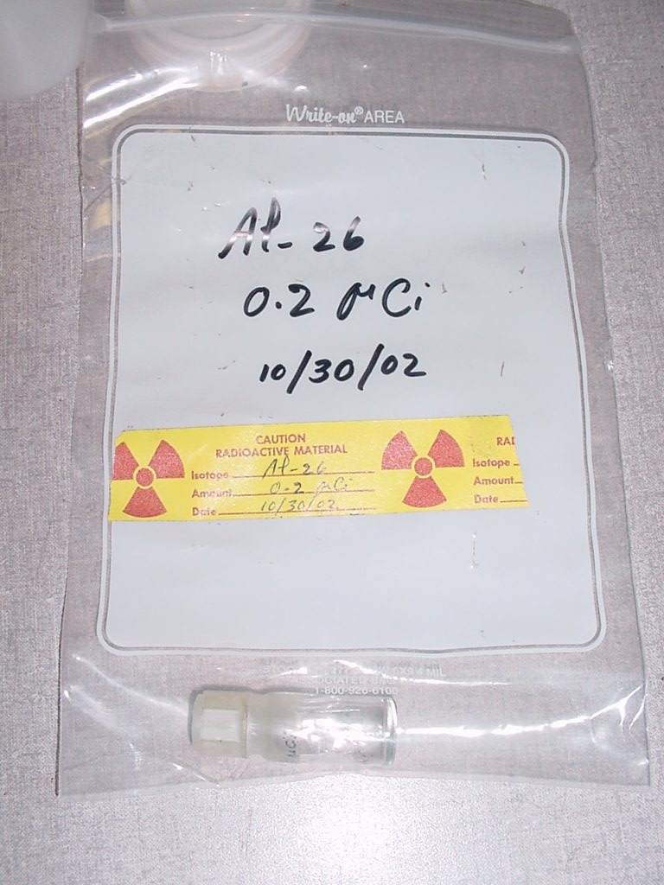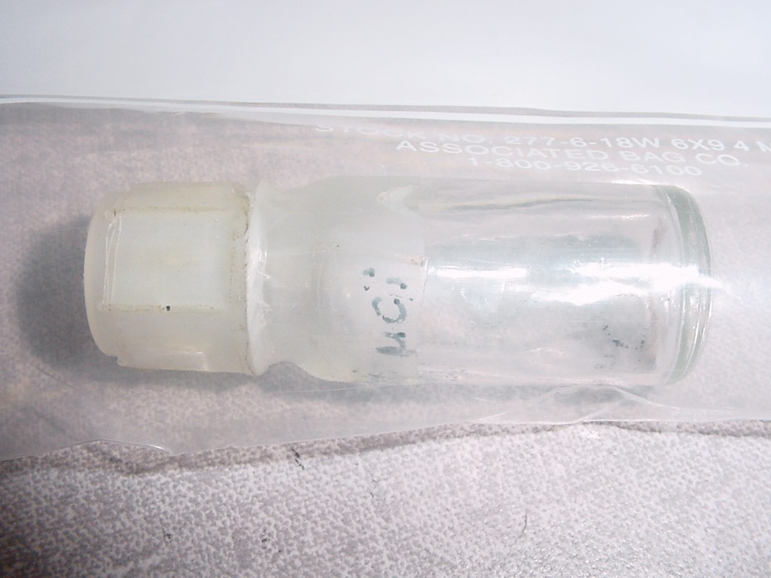

Figure 4.17: The batch of ²⁶Al obtained from Yale University arrived in a vial in which all liquid had evaporated.
An investigation of the elastic and inelastic ²⁶Al + p scattering reactions was performed using these ²⁶Al beams to bombard a 46 μg/cm² polypropylene target with beam energies E_{lab} = 13 - 41 MeV (E_{cm} = 0.49 - 1.53 MeV). This was accomplished through 45 energy steps and encompassed seven days of study. During the course of the experiment, preliminary calculations of the proton to aluminum yield detected in SIDAR were performed. On Day 5 of the experiment, after data were recorded for the reaction with a 41 MeV ²⁶Al beam, the beam energy was reduced to 13.5 MeV to cycle back through beam energies located between those already explored. An additional 1.5 days were then devoted to an investigation of a 32 MeV ²⁶Al beam impinging on a thick 2.4 mg/cm² polypropylene target to obtain an excitation function for this reaction in one measurement. The thickness of this target was chosen to ensure that the beam would stop within the target. Calculations suggested that this occurred approximately 70% through the target.

4.7 Alpha Source Calibration
At the conclusion of the experiment, a calibrated ²⁴⁴Cm alpha source was placed on the downstream ladder of the target chamber at the location of reaction targets, and data were collected with SIDAR for solid angle calculations. This alpha source was then removed so the ²⁴¹Am alpha source located on the upstream target ladder could measure the thickness of targets on the downstream ladder. To accomplish this SIDAR was removed from the chamber and replaced with a surface barrier detector, which has a thin gold layer above an oxidized and etched surface (shown in Figure 4.18). This detector has a thin entrance window and high sensitivity. Measurements were taken with and without the target between the alpha source and the detector for the two thin and one thick targets used in the experiment.

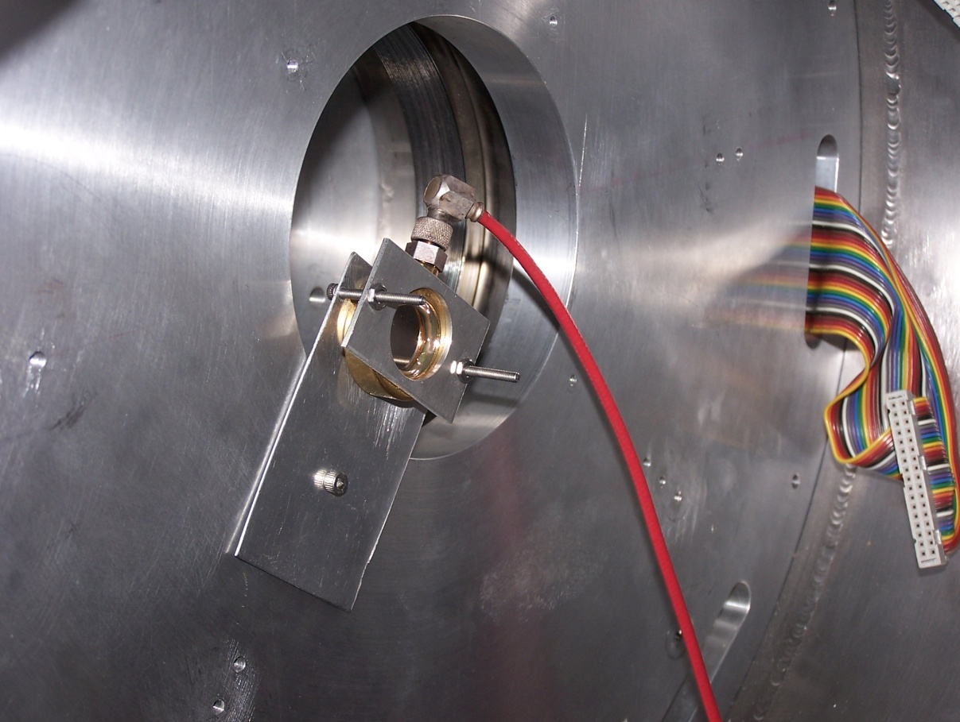
Figure 4.18: A surface barrier detector was mounted in the target chamber at the end of the experiment to measure target thicknesses with an ²⁴¹Am alpha source.

CHAPTER 5 – Analysis and Results
5.1 Alpha Source Calibrations
5.1.1 Solid Angle Calculations
A calibrated alpha source was used to determine the solid angle coverage of the detectors. The activity of the calibrated ²⁴⁴Cm alpha source at the time of data collection was determined using the equation:
$A=A_{o}e^{-\frac{Δt}{τ}}$ (5.1)
where A_{o} was the initial activity, A was the activity after some time ∆t, and τ is the lifetime. ²⁴⁴Cm has a lifetime of 26.1 years and an alpha-decay branching ratio of 100%, primarily releasing an alpha particle of 5.8 MeV. Based upon calculations and previous calibrations, the activity at the time of data collection was 3079.4 α/s into 4π. SIDAR data were recorded with the ²⁴⁴Cm source in the chamber for 1461 seconds and a total release of 4.5*10⁶ alpha particles occurred during this time. The observed number of detections at each angle of SIDAR was then used to calculate the solid angle per strip of the detector by the relation:
$∆Ω_{strip}=\frac{N_{strip}}{α_{total}}*4π$. (5.2)
The relative solid angle among all strips in SIDAR could then be calculated for the purposes of constructing angular distribution fits to the data.

5.1.2 Target Thickness Measurements
Target thicknesses were measured before and after the experiment to determine the amount of energy lost by the beam, ejectile and recoil within the target and the expected energy of these particles when detected by SIDAR. This was accomplished with a calibrated ²⁴¹Am alpha source that primarily emits an alpha particle with an energy of 5.5 MeV. Based upon the channel in which the alpha peak appears in the surface barrier detector spectrum, it is possible to define an energy-to-channel calibration for the spectrum. Comparing the channel number for the peak with and without the target in between the source and detector, the amount of energy lost in each target was determined. With the use of the FORTRAN code STOPIT, it was then possible to calculate the target thicknesses. STOPIT uses the Bethe formula in Equation 4.3 to calculate how much energy a nucleus will lose in a given medium, based upon characteristics of that medium and the initial energy of the nucleus. With knowledge of the energy lost in each target, several iterations of STOPIT revealed the thickness of each target required to deplete that energy. In this way the thin- and thick-targets used in this experiment were confirmed to have thicknesses of (46 ± 5) μg/cm² and (2.4 ± 0.2) mg/cm², respectively.

5.2 The Inelastic Scattering Reaction
Evidence for the inelastic proton scattering reaction was searched for in the thin-polypropylene target data. Once all detector strips for SIDAR were gain-matched, spectra from each angle were summed to produce a single spectrum of total detector counts for each beam-energy run. Data from all angles were then converted to plot counts as a function of Q-value to distinguish elastically scattered protons from the Q = 0 reaction from protons inelastically scattered from the Q = -228 keV reaction that produces the metastable state of ²⁶Al. Figure 5.1 illustrates the utility of this method for data collected from a 15 MeV ²⁶Al beam bombarding the 46 μg/cm² thin polypropylene target. While there was evidence for inelastic scattering in the first run at 15 MeV, the evidence was not consistent from energy to energy and angle to angle. Because of this, upper limits on the inelastic cross section were extracted instead of absolute values.
The differential Rutherford cross section for a reaction is given by Equation 5.3:
$\frac{dσ}{dΩ}$ _{Ruth} = $\frac{Z_{1}^{2}Z_{2}^{2}e^{4}}{16E^{2}}\frac{1}{\sin^{4}\left(\frac{θ}{2}\right)}$ (5.3)
where Z is the proton number of each reacting particle, e² is the square of the electronic charge and equal to 1.44 fm∙MeV, and E and θ are the energy and angle of the reaction in the center-of-mass frame, respectively.
The observed reaction yields are related to the differential cross section, beam current, and detector solid angle coverage:
N_{p’} = I · ρ · $\frac{dσ}{dΩ}$_{p’} · ΔΩ_{p’, strip} (5.4)
N_{p} = I · ρ · $\frac{dσ}{dΩ}$_{p} · ΔΩ_{p, strip}
where N_{p’,p} is the proton yield of the inelastic and elastic reactions, respectively; I is the beam current, ρ is the target density, $\frac{dσ}{dΩ}$_{p’,p} is the differential cross section of the inelastic and elastic reactions in the center-of-mass frame, respectively; and ΔΩ_{p’,p,strip} is the solid angle of a strip of SIDAR in the center-of-mass frame for the inelastic and elastic reactions, respectively.

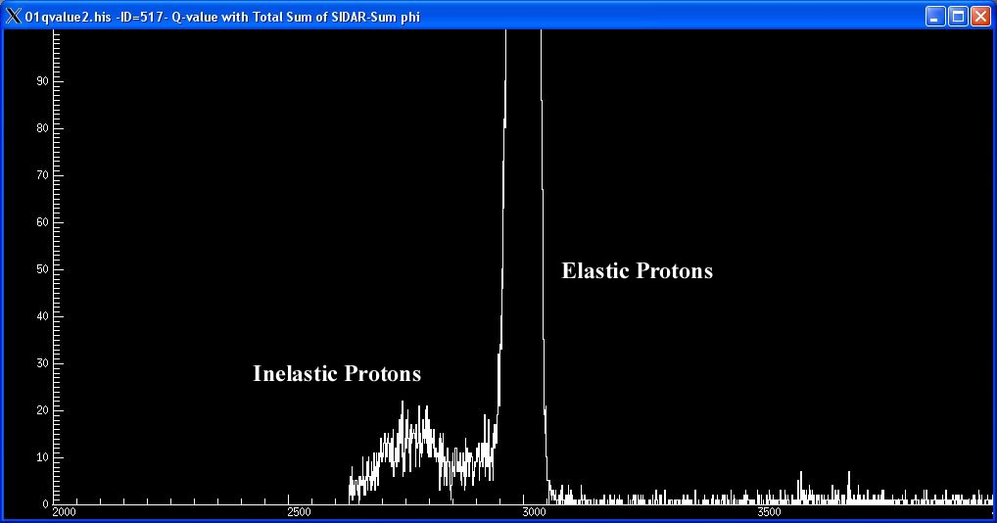
Figure 5.1: A spectrum of proton counts versus Q-value + 3000 keV. These data were collected when a 15 MeV ²⁶Al beam bombarded the 46 μg/cm² thin polypropylene target. This is the only energy at which inelastic protons were observed.

Taking a ratio of Equations 5.4, the beam currents and target densities cancel, and the differential cross section of the inelastic reaction is proportional to that of the elastic reaction:
$\frac{dσ}{dΩ}$_{p’} = $\frac{N(p’)}{N(p)}∙\frac{∆Ω(p)}{∆Ω(p’)}∙\frac{dσ}{dΩ}$_{p} = $\frac{N(p’)}{N(p)}∙\frac{Jac(p)}{Jac(p^{'})}∙\frac{dσ}{dΩ}$_{p} (5.5)
where solid angles in the center-of-mass frame have been rewritten in terms of solid angles in the laboratory frame multiplied by their Jacobians. Lab-frame values cancel, and the inelastic differential cross section can be written as a function of the elastic cross section and ratios of proton yields and Jacobians. The differential cross section was then integrated over all angles to determine a total cross section for the inelastic reaction.
Based upon this analysis and the data collected, the upper limit for the inelastic reaction cross section in the energy range explored was estimated to be ~ 5*10⁻² barns, which would make this reaction channel insignificant as far as astrophysical implications. This measurement represents the first constraint on the inelastic reaction that would deplete ²⁶Al in the stellar environment.

5.3 The Elastic Scattering Reaction
5.3.1 Thin Polypropylene Target Analysis
The search for resonances in the ²⁶Al + p elastic reaction on thin targets began with the construction of excitation functions for each of the 16 polar angles covered by SIDAR. The excitation function is a plot of the proton yield versus center-of-mass energy for each strip of SIDAR. Yields for protons scattered out of the target and into SIDAR were determined from detected proton counts in each strip of SIDAR. The ²⁶Al + p reaction was assumed to occur at the center of the thin targets, and STOPIT revealed that energy-loss for the beam through the front half of the target was about 0.5 MeV, regardless of beam energy, and the energy-loss for the out-going proton through the back half of the target was about 2 keV at each energy. In this way, center-of-mass energies for proton yields at each angle of SIDAR were determined, and they were corrected systematically for hydrogen-loss in the target over time.
Proton yields were then normalized for the amount of beam put on target. This was accomplished by examining the number of ²⁶Al counts detected at the smallest angle of SIDAR after scattering off carbon in the target. Scattered aluminum was detected in the bottom six strips of SIDAR, but counts from strip 1 were used to normalize proton yields because it can be assumed that Rutherford scattering produced the most forward-directed particles.
Figure 5.2 plots excitation functions for the 14 lowest strips of SIDAR and compares them to Rutherford scattering at these angles. Strips 15 and 16 were excluded because of low statistics due to the small solid angle coverage of the outer strips.

5.3.2 Upper Limits on Proton Widths of Resonances
Survey of the 14 excitation functions in Figure 5.2 revealed that data for the most part followed Rutherford scattering of charged particles. Upper limits were therefore established for proton widths of unobserved resonances in the energy range E_{cm} = 0.5 - 1.5 MeV. Many resonances are thought to exist in this energy range (Table 3.1), and thus these first constraints on their strengths are useful. To this end the energy range was divided into five regions 200 keV wide, and the upper limit was determined for the

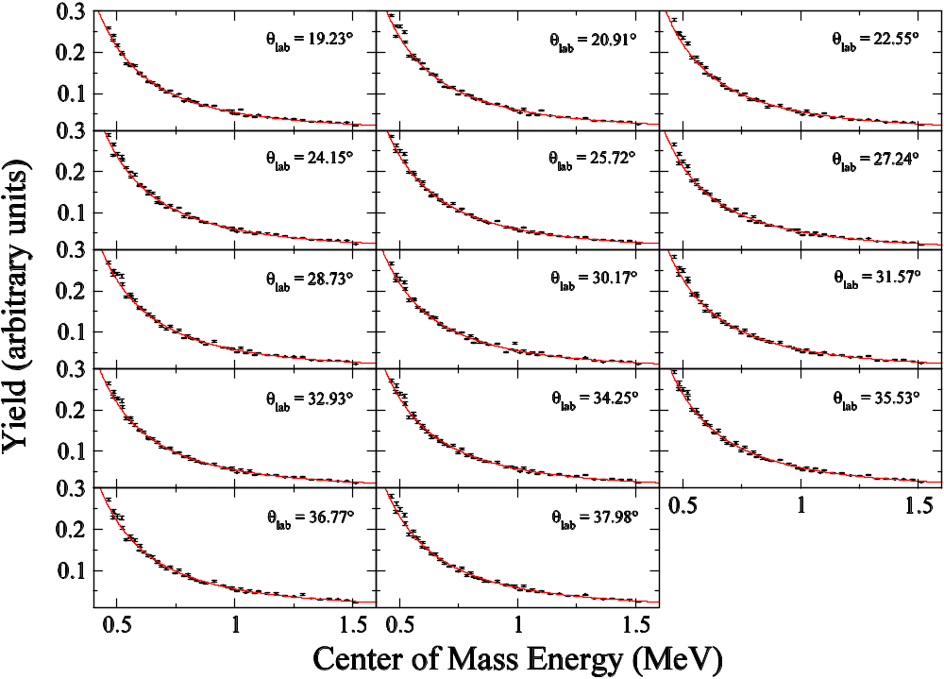
Figure 5.2: Thin-target data excitation functions compared to Rutherford scattering in the energy range E_{c.m.} = 0.49 – 1.53 MeV.
proton width of a possible resonance within each of these small ranges of energy if no other resonance was present.
Resonances were individually considered at the center of these regions at E_{cm} = 0.6, 0.8, 1.0, 1.2, and 1.4 MeV. A reaction between the 5⁺ ²⁶Al nucleus and the 1/2⁺ proton produces channel spins 9/2⁺ and 11/2⁺, and angular momentum transfers up to ℓ = 3 were considered. In addition to statistical uncertainties, a systematic uncertainty of ~7% was estimated for this experiment by comparing yields between runs at the same energy. This systematic error was combined with the statistical error of each data point.
For the purposes of this evaluation, the FORTRAN R-matrix code MULTI was utilized [Nel85]. R-matrix theory describes resonant reaction cross sections and accounts for the interference effects of neighboring resonances and interference between the resonant and Rutherford cross sections. MULTI was designed to analyze proton resonance scattering from non-zero spin targets when experiments are performed in forward kinematics using a proton beam. The ²⁶Al + p experiment at the Holifield Radioactive Ion Beam Facility was conducted in inverse kinematics with the heavier ²⁶Al nucleus providing the momentum for the reaction with the stationary proton target; therefore, energies and angles from the inverse kinematics experiment had to be converted to values for a forward kinematics experiment with a proton beam impinging on a stationary ²⁶Al target. Energies were converted from the laboratory frame to the center-of-mass frame:
$E_{cm}\left(Al\right)= \frac{m_{p}}{m_{Al}+m_{p}}*E_{lab}\left(Al\right)$ (5.6)
and then to proton energies:
$E\left(p\right)= \frac{m_{p}+m_{Al}}{m_{Al}}*E_{cm}\left(Al\right).$ (5.7)
Outgoing proton angles were converted from the lab frame to the center-of-mass frame with the equation for elastic scattering in inverse kinematics [Cos94]:
$θ_{cm}=180°-2θ_{lab}$ (5.8)
and then to the proton’s frame:
$\cos{θ(p)=\frac{\cos{θ_{cm}+\frac{m_{p}}{m_{Al}}}}{\sqrt{1+\frac{{m_{p}}^{2}}{{m_{Al}}^{2}}+2\frac{m_{p}}{m_{Al}}cos}θ_{cm}}}$ . (5.9)
At each of the 5 energies considered, MULTI was compiled with resonance spins ranging from 3/2⁻ to 17/2⁻, accounting for ℓ-transfers up to 3. During each iteration the width of the resonance was increased until a χ²-test revealed a significant deviation from the Rutherford curve at the 99% level of confidence. With one degree of freedom and 99% confidence, the value required was ∆χ² = 6.63 [Pre92]. Based upon this analysis a table was constructed of upper limits for proton widths dependent upon the spin of the resonance in this energy range (Table 5.1). The table shows a general trend of proton width upper limits increasing with resonance energy. The χ²-test was most sensitive at lower energies where the cross section is higher and counting statistics greater. For this reason upper limits for proton widths of low-energy resonances are dramatically smaller than for the higher-energy resonances, which were calculated from data measured at higher energies where the yield was less.
Upper limits calculated from the χ²-test were also influenced by the shapes of the curves compared during the test. The measured excitation function was compared to MULTI calculations for a given resonance energy and spin. The data generally follow

Table 5.1: Upper limits on proton widths of resonances not directly observed in this study. The energy range of this experiment was divided into five 200 keV-wide regions and a theoretical resonance placed at the center of each region predicted the upper limit for a resonance of a given spin in that region.
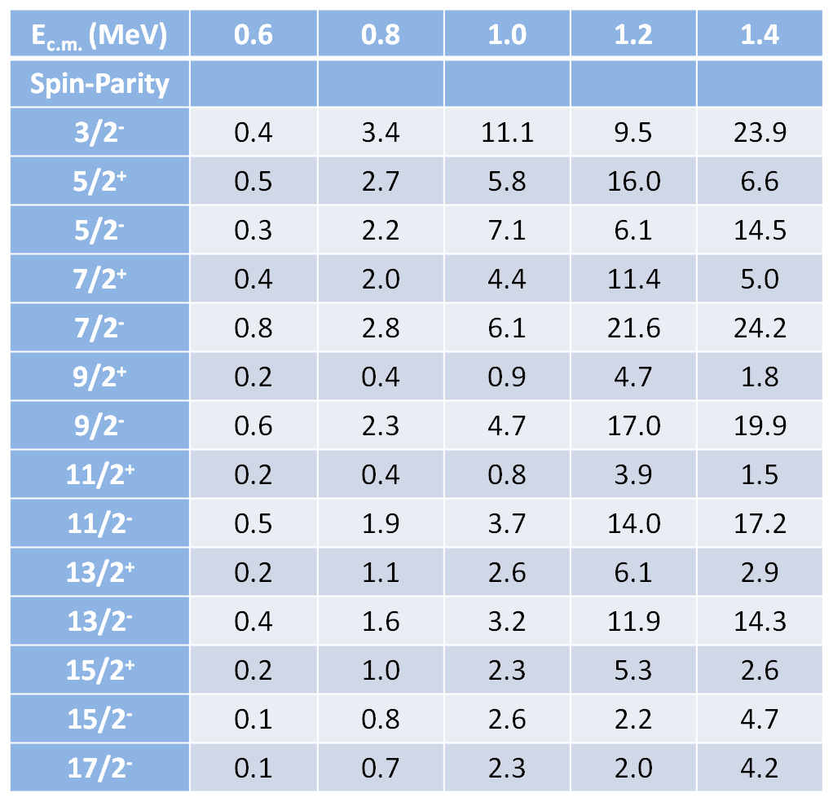
Resonance Proton Widths (keV)

Resonance Proton Widths (keV)

the Rutherford scattering curve, and resonance excitation functions from MULTI do so as well up to the energy of the resonance. At energies above the resonance energy, however, the calculations begin to deviate from the Rutherford curve because the resonance widths increase with the penetrability. Figure 5.3 illustrates this effect when fictitious 7/2⁺ resonances at E_{c.m.} = 0.6 and 1.2 MeV are compared to data. The 0.6 MeV resonance curve is significantly larger than the Rutherford curve at high energies because of this effect, but the data from this experiment is mostly below the energy of the 1.2 MeV resonance. Thus, the impact on the extracted upper limits for this resonance is less, and proton width upper limits are larger at this energy. Also worth noting is that the calculated scattering anomalies of the resonances appear in Figure 5.3 to be comparable, but the resonance widths used to construct these plots were 10 keV and 50 keV for the 0.6 MeV curve and the 1.2 MeV curve, respectively. A much larger width was required for the 1.2 MeV resonance to achieve a similar effect between the low and high resonances in the figure. For all of these reasons, the extracted upper limits are generally lower for the lower-energy resonances.
While upper limits for the proton widths did generally increase with energy, the behavior is not completely smooth and continuous. This is in part due to the absence of a smooth and continuous change in the data from energy to energy. In particular, column 4 of Table 5.1 established upper limits for a resonance at 1.2 MeV. For many spins this width did not fall between the neighboring upper limits for the spin states at 1.0 and 1.4 MeV. This effect may have resulted from a single data point near 1.3 MeV where the yield is higher than that along the Rutherford curve at a number of angles measured (see Figure 5.2). The effect was not strong enough, however, nor apparent at neighboring

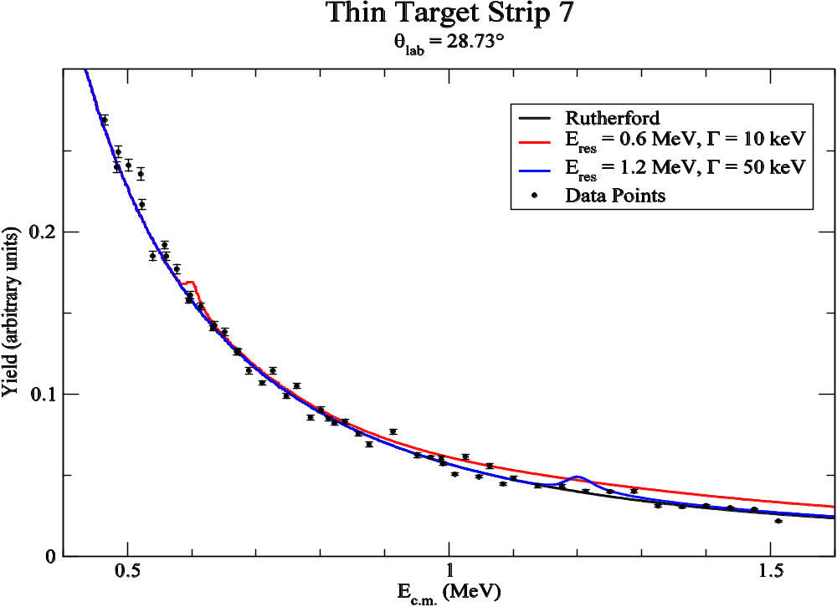

Figure 5.3: Excitation functions for 7/2⁺ resonances at E_{c.m.} = 0.6 and 1.2 MeV compared to Rutherford scattering in strip 7 of SIDAR at θ_{lab} = 28.73°.

energies, to suggest the possibility of a new resonance at this energy.

5.3.3 A Possible Resonance
Closer inspection of the 14 excitation functions in Figure 5.2 revealed what appeared to be a small but persistent deviation from Rutherford scattering at each angle near E_{c.m.} = 550 keV (see Figure 5.4). Furthermore, examination of 3-dimensional contour plots of SIDAR strip vs. E_{c.m.} vs. proton yield (Y) in SIDAR (Figure 5.5) and SIDAR strip vs. E_{c.m.} vs. dY/dE (Figure 5.6) also suggests an anomaly at this energy.
The MULTI code was used to investigate the possibility of a resonance. After several iterations in which input resonance spin, width, and energy were varied, an output resonance excitation function was fit to the data. Based upon this analysis, the best visual fit to the data suggested a possible resonance in this reaction at E_{c.m.} = 544 keV with either a 9/2⁺ or 11/2⁺ spin-parity assignment, consistent with s-wave scattering, and a proton width upper limit of Γ_{p} = 1 keV. A local χ²-test, however, suggested the width may be as low as 0.2 keV. Figure 5.7 illustrates a (9/2⁺, 11/2⁺) resonance fit to the data in strip 6 of SIDAR, compared to a fit with a 7/2⁺ or 15/2⁺ resonance in strip 10 of SIDAR, which was rejected.

5.3.4 Thick Polypropylene Target Analysis
A separate experiment to corroborate the appearance of any resonances in the thin-target data was performed. In this “thick-target” experiment, the ²⁶Al was slowed and stopped in the 2.4 mg/cm² polypropylene target. Protons emerging from a reaction in
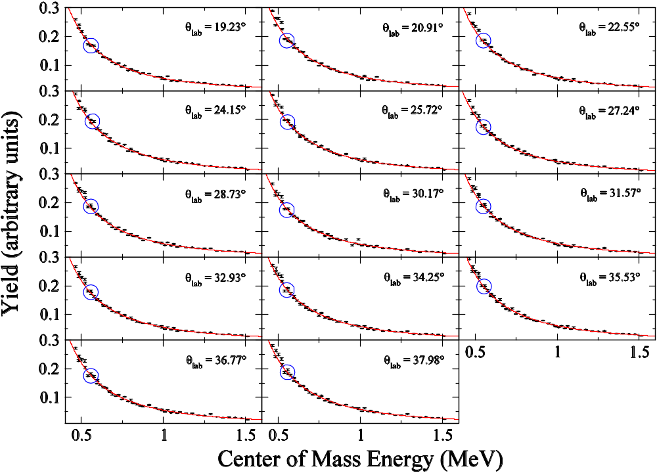

Figure 5.4: Thin-target data excitation functions of Figure 5.2 compared to Rutherford scattering in the energy range E_{c.m.} = 0.49 – 1.53 MeV. Circled is a small but persistent deviation near E_{c.m.} = 550 keV.

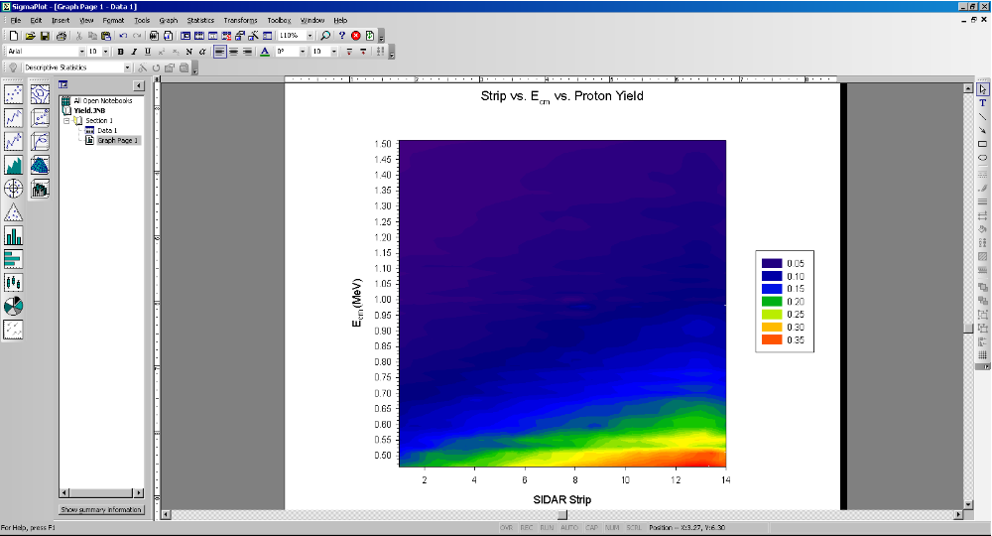

Figure 5.5: A contour plot of SIDAR strip vs. E_{c.m.} vs. proton yield (Y) in SIDAR. Apparent below 0.55 MeV in most strips is a region of lower proton yield sandwiched between regions of higher proton yields, suggesting a resonant energy in the elastic scattering reaction.

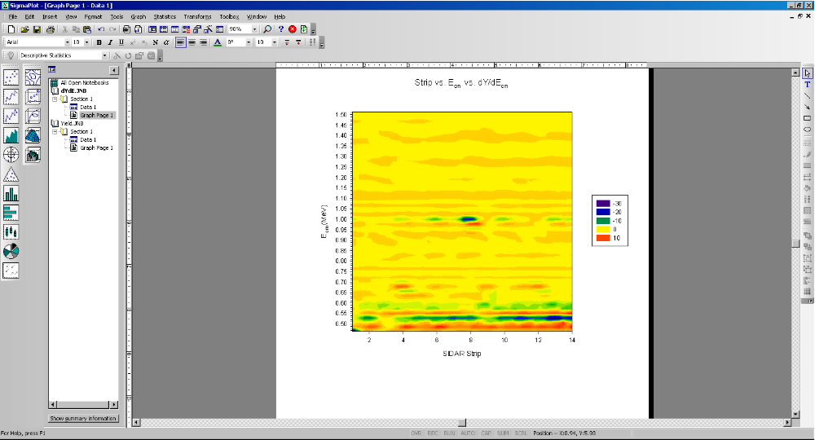
Figure 5.6: A contour plot of SIDAR strip vs. E_{c.m.} vs. dY/dE in SIDAR. Below 0.55 MeV in most strips is a region of zero or positive change saddling a region of negative change, suggesting a resonance in the elastic scattering reaction.

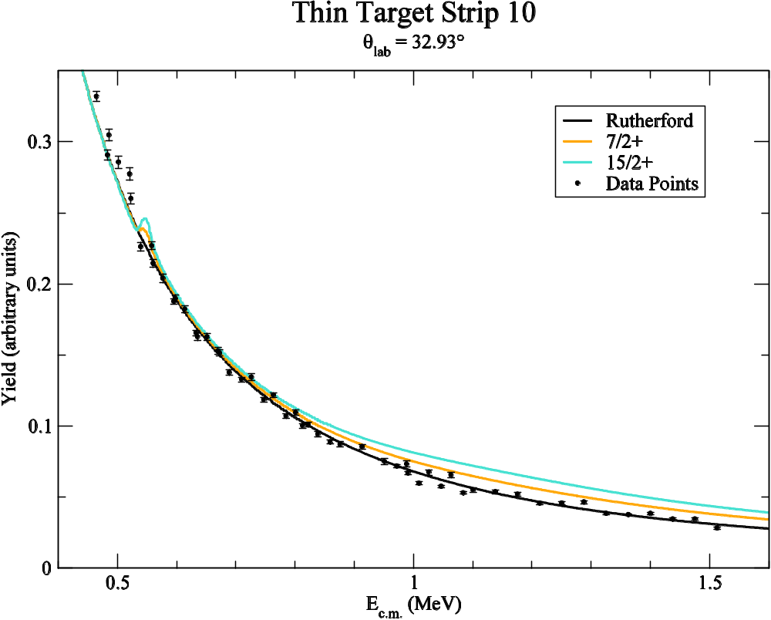
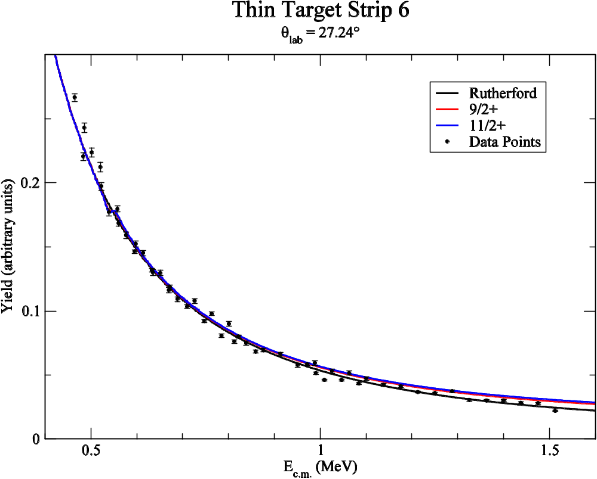
Figure 5.7: (a) The excitation function for thin-target data from strip 6 of SIDAR at θ_{lab} = 27.24° is compared to Rutherford scattering and the excitation functions for a 9/2⁺ and 11/2⁺ resonance at 544 keV. (b) Strip 10 data of SIDAR at θ_{lab} = 32.93° compared to Rutherford scattering and excitation functions for 7/2⁺ and 15/2⁺ resonances at 544 keV.
the thick target exhibit a much broader range of energies than do protons from the thin target.
Figure 5.8 shows the raw proton spectrum of the thick target for strip 12 of SIDAR. There is a spread in proton energies of more than 3.6 MeV when the 32 MeV ²⁶Al beam strikes the thick polypropylene target, depending upon the location of the reaction within the target. The observed proton energy spectrum has a one-to-one correspondence with the center of mass energy at which the reaction occurred. Since all energies are measured simultaneously, the shape of the proton energy spectrum gives a measure of what the proton elastic scattering excitation function looks like. A disadvantage, however, is that uncertainties in the detector calibration and target energy-loss directly impact the inferred energies of observed resonances.
For a given strip the energy calibration was extracted from protons scattered by a 32 MeV beam on the thin target (Figure 5.9). Measuring the channel in which the centroid of the proton peak is recorded in that spectrum and calculating the energy of the proton that strikes the SIDAR strip in that reaction after correcting for energy-loss in the target, it is possible to determine the amount of energy per channel in the spectrum. Compiling the data from the thick-target runs with the same gain coefficients used for the thin-target run then applies the same energy-to-channel calibration to the spectra of the thick-target data. For the 14 strips examined, the energy-to-channel ratio was about 5 keV per channel in the laboratory frame.
This energy calibration defines the spectra in terms of the final proton energy when it strikes the SIDAR detectors. To determine the initial proton energy immediately after the reaction in the thick target it was first necessary to determine the maximum

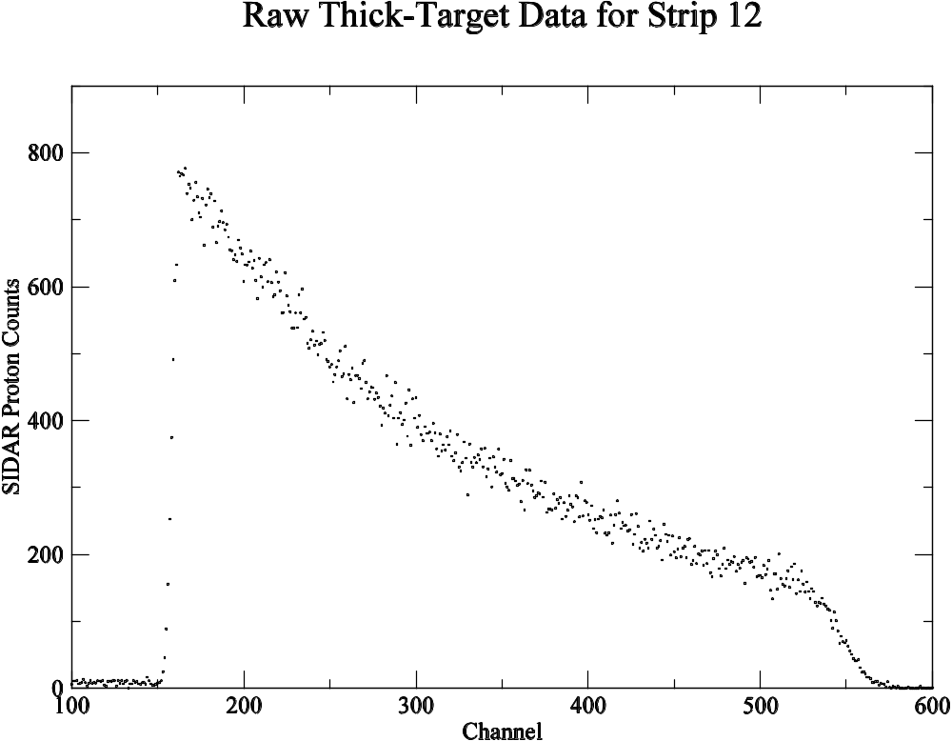
Figure 5.8: Raw proton counts in strip 12 of SIDAR (θ_{lab} = 35.53º) collected with the 2.4 mg/cm² polypropylene target.

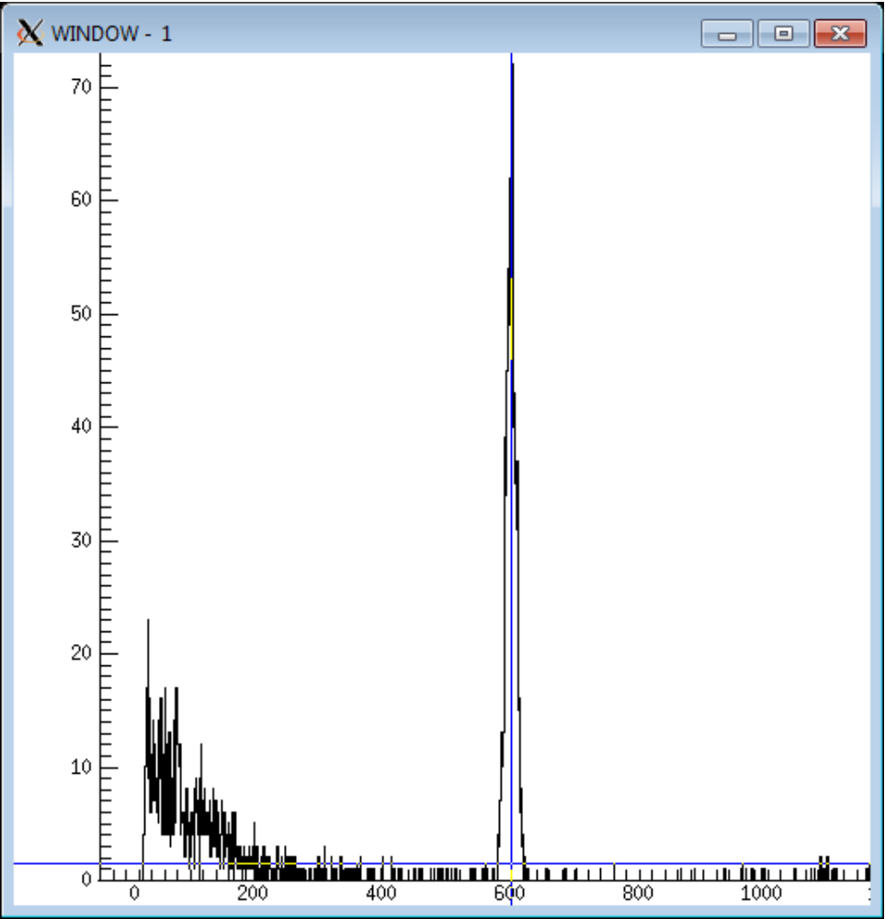
Figure 5.9: Proton peak in strip 10 of SIDAR at θ_{lab} = 32.93° when a 32 MeV ²⁶Al beam struck the thin polypropylene target. The channel of the centroid for this peak determined the energy/channel calibration of strip 10 for the thick-target analysis.
Counts
Channel

distance within the target that a reaction could occur in which a proton would have enough energy to transverse the remainder of the target. For this purpose the codes STOPIT and RELKIN were used. STOPIT was described above and calculates particle energy-loss within a given medium, and RELKIN is a kinematics code that calculates the
energy of a particle recoiling at a given angle after a specific reaction has occurred. Based upon these calculations, a reaction must occur within about the first half of the target for the proton to escape the target. The front region of the target was then divided into seven equally-spaced steps at which the reaction could occur. At each of these locations the energy of the ²⁶Al beam and the initial energy of the scattered proton were determined. It was also determined what the final energy of the proton would be at the SIDAR detector after traversing the remainder of the target. A plot was then constructed of the proton’s initial energy vs. its final energy, and a curve was fit to these data points so proton energies that fell between these seven points could be extrapolated. An example of this method for strip 8 is shown in Figure 5.10. With the thick-target spectrum now a function of initial proton energy it was straightforward to convert this energy to the center-of-mass frame using the equation provided by Coszach et al. in their analysis of resonant scattering on a hydrogen target [Cos94]:
$E_{cm}=E_{p}\frac{A+1}{4A}\frac{1}{\cos^{2}θ_{lab}}$ (5.10)
Once the thick-target spectra were defined in terms of center-of-mass energy, the data were binned into groups of 3 keV to better visualize the results. It was then possible to identify the region where the potential resonance had appeared in the thin-target data and determine whether the excitation functions that fit the thin-target data also fit the thick-target data. Figure 5.11 shows thick-target spectra for SIDAR strips 4 and 7 at θ_{lab}

Figure 5.10: Shown for strip 8 of SIDAR (θ_{lab} = 30.17º), a polynomial fit determined the relationship between the final proton energy detected in SIDAR and the initial proton energy within the thick target.
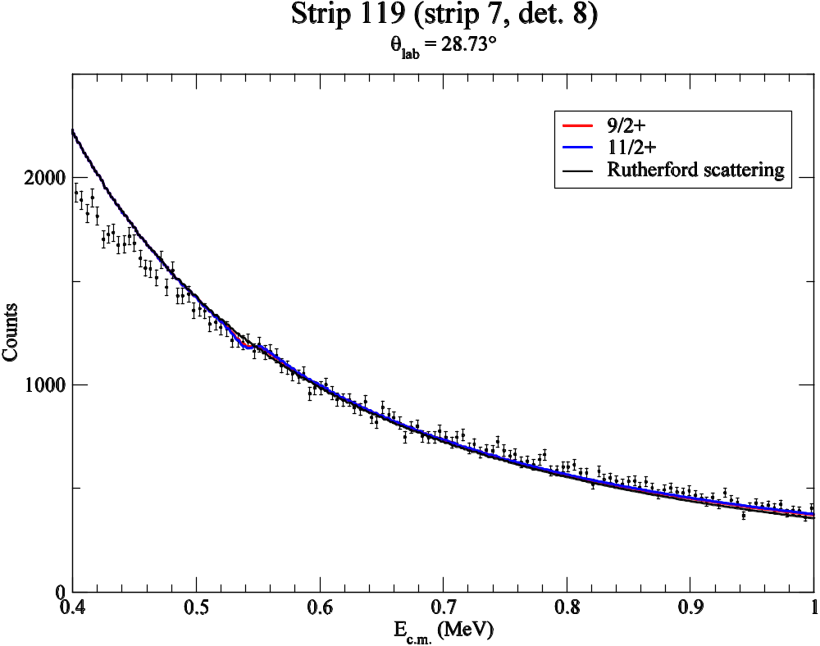
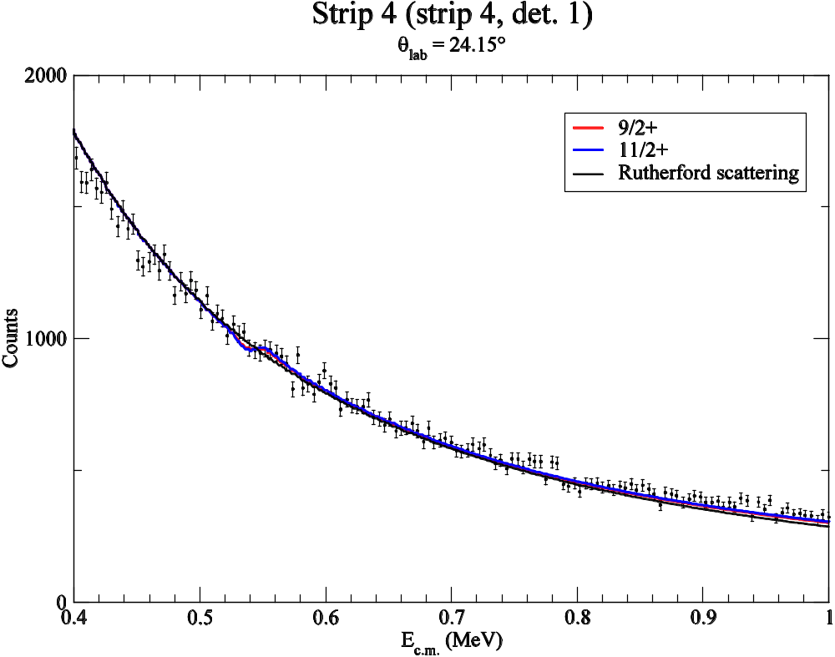
Figure 5.11: Thick-target spectra of strips 4 and 7 in SIDAR at θ_{lab} = 24.15° and θ_{lab} = 28.73°, respectively, fitted with a 9/2⁺ and 11/2⁺ resonance at 544 keV. The Rutherford scattering curve is also shown for comparison.
= 24.15º and θ_{lab} = 28.73º, respectively, fitted with 9/2⁺ and 11/2⁺ resonance curves.
Examination of each of the 14 spectra suggests that there may be a newly-observed 9/2⁺ or 11/2⁺ resonance at E_{c.m.} = 544 keV with a proton width Γ_{p} ≤ 1 keV. As with thin-target spectra, there was no consistent deviation from Rutherford scattering at any other energy among all angles measured with the thick target.

5.3.5 Reaction Rate of the Possible Resonance
A plot of reaction rates for known resonances in the ²⁶Al(p,γ)²⁷Si reaction appeared in Figure 3.2. Before the reaction rate for a resonance at 544 keV could be calculated and compared to rates in this plot, its resonance strength (ωγ) had to be estimated. This product is a function of the ω and Γ terms in Equation 3.27 for resonant reaction rates, where
$ω= \frac{(2J+1)}{\left(2J_{1}+ 1\right)(2J_{2}+ 1)}$ and $γ= \frac{Γ_{1}Γ_{2}}{Γ}$. (5.11)
J, J₁, and J₂ are the spins of the resonance and incoming particles, respectively. Γ₁ and Γ₂ are the partial widths of the resonance, and Γ is the full width, which is a sum of the partial widths.
Only the upper limit of the proton width was determined by the MULTI analysis. To calculate the full width and resonance strength, the gamma width (Γ_{γ}) also needed to be estimated. To establish an order of magnitude estimate for the gamma width of the new resonance, information was sought from nearby states of the same spin and parity. The potential resonance has an excitation energy of 8008 keV. A survey of ²⁷Si levels in this region revealed two 9/2⁺ levels, but the half-lives and gamma partial widths have not been measured. Fortunately, these levels have suspected mirror states in ²⁷Al with well-characterized values. Based upon gamma-decay schemes, it appears that ²⁷Si states at 7589 keV and 7741 keV are mirror analogs of the 9/2⁺ 7806 keV and 7660 keV states in ²⁷Al, respectively [Buc84,Lot09]. Characteristics of these states appear in Tables 5.2 and 5.3. Due to isospin symmetry, B-values or “reduced transition probabilities” for the gamma-decay of a state to a particular branch are expected to be the same for mirror analog states. Therefore, B-values were calculated for the ²⁷Al mirror states to determine gamma partial widths of the ²⁷Si states at 7589 keV and 7741 keV, which were summed to give total gamma widths for these states.
The transition probability or decay constant of an excited state (λ) relates the decay rate of the state to the number of radioactive nuclei present:
$\frac{dN}{dt}= -λN\left(t\right).$ (5.12)
It is inversely proportional to the half-life and lifetime of the state by the relation:
$λ= \frac{\ln{2}}{t_{1/2}}= \frac{1}{τ}$ (5.13)
and it is proportional to the natural line width (Γ) of the state by the Heisenberg uncertainty principle:
$Γ= \frac{ℏ}{τ}= ℏλ$ (5.14)
with ℏ = 6.6*10⁻²² MeV∙s. If the initial state can decay to several final states, the total transition probability of the initial state is a sum of the individual transition probabilities to each of the final states, such that:
$λ= \sum{λ(i)}$. (5.15)
Electromagnetic transitions that release γ-rays occur when a nucleus interacts with

Tables 5.2 and 5.3: ²⁷Si states near the proposed resonance at E_{x} = 8008 keV are poorly characterized. Mirror analogs in ²⁷Al were used to estimate the gamma widths of these states and the resonance.

²⁷Al E_{level} | J^{π} | t_{1/2} | E_{γ} | I_{γ} | Final Level
7660 | 9/2⁺ | 13 fs | 2160 | 17 | 5499.8 11/2⁺
 |  |  | 3079 | 52 | 4580.0 7/2⁺
 |  |  | 3149 | 79 | 4510.3 11/2⁺
 |  |  | 4655 | 97 | 3004.2 9/2⁺
 |  |  | 5448 | 100 | 2212.0 7/2⁺
7806 | 9/2⁺ | 18 fs | 3225 | 42 | 4580.0 7/2⁺
 |  |  | 3295 | 25 | 4510.3 11/2⁺
 |  |  | 5594 | 100 | 2212.0 7/2⁺

²⁷Si E_{level} | J^{π} | t_{1/2} | E_{γ} | I_{γ} | Final Level
7741 | 9/2⁺ |  | 2425 |  | 5316 ≥3/2⁺
 |  |  | 2458 |  | 5283 11/2⁺
 |  |  | 3294 |  | 4447 11/2⁺
 |  |  | 4831 |  | 2910 9/2⁺
 |  |  | 5578 |  | 2163 7/2⁺
7589 | 9/2⁺ |  | 3114 |  | 4475 7/2⁺
 |  |  | 3142 |  | 4447 11/2⁺
 |  |  | 5426 |  | 2163 7/2⁺

an external electromagnetic field. The nucleus is comprised of nucleons that contain magnetic dipole moments and protons that carry electric charge. When the charge distribution interacts with the external field, electric transitions (E) occur in the nucleus. When the magnetic dipoles or the magnetism generated by orbital proton motion interact with the field, magnetic transitions (M) occur. Multipole expansion of the external field yields electric (EL) and magnetic (ML) multipole transitions of higher order, where L is the order of the multipole, but the lowest order multipole generally dominates the transition. After expansion, the transition probability λ is a function of the multipole order and the reduced transition probability B:
$λ\left(σL\right)= \frac{8π\left(L + 1\right)}{{L\left[\left(2L + 1\right)‼\right]}^{2}}\frac{k^{2L+1}}{ℏ}B(σL)$ (5.16)
where σ = E or M to represent electric or magnetic radiation.
The type of transition allowed is governed by parity and angular momentum selection rules. The order of the multipole transition depends upon the parity of the initial and final states, and the relation ensures that the same order transition does not occur between electric and magnetic components.
$π_{i}π_{f}= {(-1)}^{L}$ for EL $π_{i}π_{f}= {(-1)}^{L+1}$ for ML (5.17)
The angular momentum of the final state is determined by that of the initial state and the order of the multipole transition:
$\left|J_{f}- J_{i}\right| ≤ L ≤ J_{f}+ J_{i}$ (5.18)
If EL and M(L+1) transitions are both allowed by selection rules, EL usually dominates the transition by a large magnitude; however, if both ML and E(L+1) transitions are allowed, the transition rates tend to be competitive.
Gamma partial widths were calculated for each decay channel of the ²⁷Al mirror analogs, and Equation 5.14 determined transition probabilities for these channels. For each decay, parity selection rules in (5.17) revealed the lowest order multipole transitions allowed were M1 and E2. Since transition rates for these modes can be competitive, B(M1) and B(E2) were both calculated for each decay using Equation 5.16. Transition probabilities for these multipoles are:
$λ\left(M1\right)= 1.76*{10}^{13} E_{γ}^{3} B(M1)$ (5.19)
$λ\left(E2\right)=1.23*{10}^{9} E_{γ}^{5} B(E2)$
where E_{γ} is in MeV, B(EL) is in units of e²fm^{2L} and B(ML) is in units of μ²_{N}fm^{(2L-2)}.
Once B-values were calculated for transitions in the ²⁷Al mirrors, the process was reversed using characteristics of the transitions in the ²⁷Si states. Assuming that B-values remained the same for transitions in mirror nuclei, these B-values determined transition probabilities for the ²⁷Si states using Equation 5.19, with the γ-ray energies for transitions in that nucleus. Gamma partial widths for each of these decays were then calculated from Equation 5.14 and summed to give total gamma widths for these levels. Gamma widths calculated from M1 and E2 transitions were similar, and an average of the two was taken for the total width of these states. Based upon these calculations, Γ_{γ} for the ²⁷Si states at E_{x} = 7589 keV and E_{x} = 7741 keV is 2.22*10⁻⁵ keV and 3.74*10⁻⁵ keV, respectively. These widths were then averaged for an estimate of Γ_{γ} for the possible resonance at 544 keV, and a value of 3.0*10⁻⁵ keV was adopted.
The resonance strength for the 544 keV state was calculated using Equation 5.11. The total width of the state is a sum of the gamma width and the proton width, which vastly dominates it. In the calculation of γ using Equation 5.11, Γ_{p} and Γ cancel out, and the value is determined solely by Γ_{γ}. After entering values for angular momentum, the resonance strength of the state was estimated to be 1.4*10⁻⁵ keV if the state is 9/2⁺ and 1.6*10⁻⁵ keV if the state is 11/2⁺. A plot of ²⁶Al(p,γ)²⁷Si resonant reaction rates with the proposed resonance appears in Figure 5.12. A ratio of the total resonant reaction rate with and without a resonance with these characteristics appears in Figure 5.13.
If it exists, Figure 5.13 suggests that the new 544 keV resonance does marginally increase the total resonant reaction rate at temperatures characteristic of explosive stellar environments. The total rate begins to gradually increase around T = 0.2 GK. At about T = 0.73 GK, the total rate increases 1%, and by the time the temperature reaches T = 2 GK, the total rate increases more than 4%.

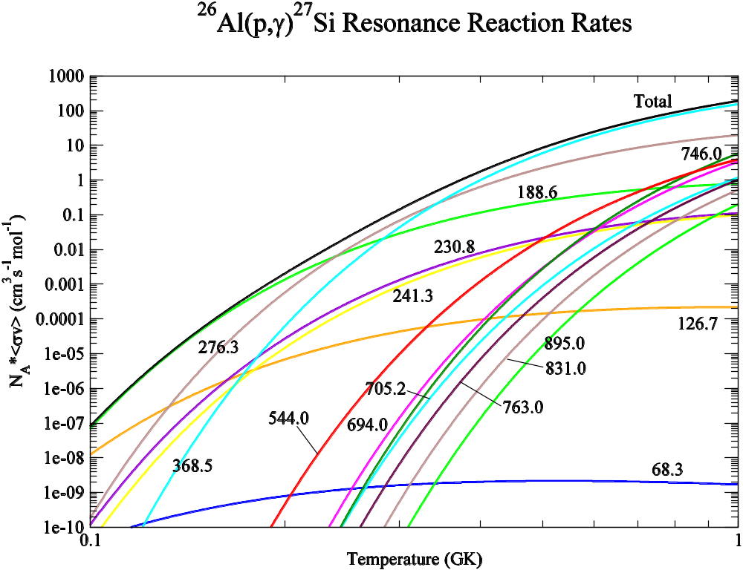

Figure 5.12: ²⁶Al(p,γ)²⁷Si resonant reaction rates up to T = 1 GK with a possible 9/2⁺ resonance at 544 keV added. The total rate is a sum of all individual resonant rates.

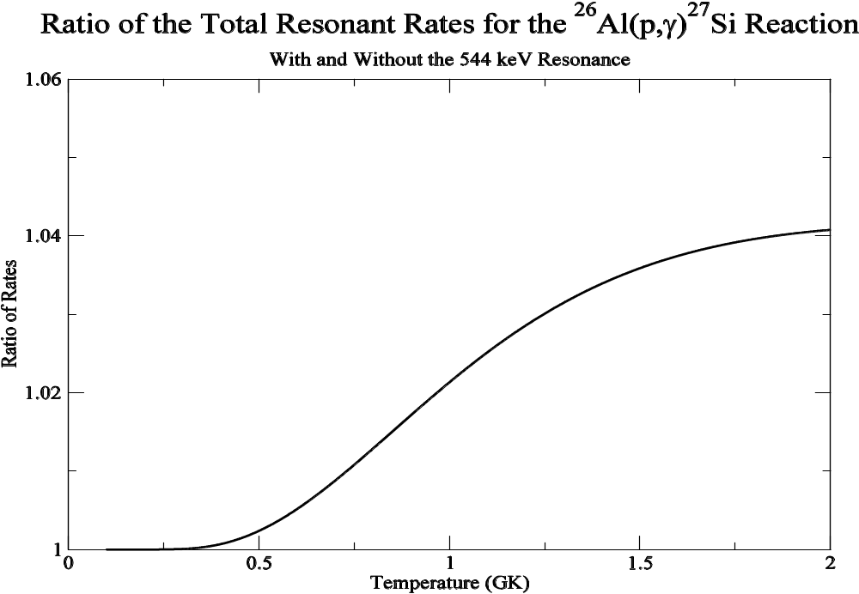

Figure 5.13: A ratio of the total resonant reaction rate for the ²⁶Al(p,γ)²⁷Si reaction with and without the proposed resonance at 544 keV up to T = 2 GK.

CHAPTER 6 – Conclusion
Identification of the 1.809 MeV decay line of Galactic ²⁶Al by the HEAO-3 satellite prompted wide-spread interest in this nucleus. The flux of this radiation suggested the decay of ~ 3 M⦿ of ²⁶Al in the Galaxy. Four astrophysical sites have been suggested as the primary source of this ²⁶Al – novae, supernovae, asymptotic giant branch stars, and Wolf-Rayet stars. The physical conditions in these astrophysical objects are quite different and thus the reactions that create and destroy ²⁶Al must be known over a large temperature range.
Pinning down the true source of Galactic ²⁶Al is difficult, in part, due to uncertainties in the ²⁶Al(p,γ)²⁷Si and ²⁶Al(p,p’)²⁶Al* reactions. To investigate these reactions ²⁶Al(p,p)²⁶Al elastic scattering and ²⁶Al(p,p’)²⁶Al* inelastic scattering reactions were studied in inverse kinematics at the Holifield Radioactive Ion Beam Facility at the Oak Ridge National Laboratory. Pure batch-mode beams of ²⁶Al ranging in energy from E_{beam} = 13 - 41 MeV bombarded a thin polypropylene target for 7 days to search for resonances in these reactions in the energy range E_{c.m.} = ~ 0.5 – 1.5 MeV. A 32 MeV ²⁶Al beam was then used to bombard a thick polypropylene target for 1.5 days to obtain an overall image of the excitation function for the elastic scattering reaction.
The ²⁶Al(p,p’)²⁶Al* inelastic scattering experiment was studied to examine the cross section of the reaction that produces the metastable state of ²⁶Al whose decay would not produce 1.8 MeV gamma rays. Inelastically scattered protons were not consistently detected in the Silicon Detector Array (SIDAR), indicating that this is not a significant destruction pathway for ²⁶Al. For the first time, however, an upper limit for the cross section of this reaction was calculated, and it was estimated to be 5*10⁻² barns.
Normalized yields of protons elastically scattered from the target into SIDAR for the most part followed the Rutherford scattering curve. It was possible, however, to establish upper limits for the first time on proton widths for resonances up to ℓ = 3 in this energy range which were not directly observed.
The only hint of a resonance was observed at E_{c.m.} = 544 keV. This anomaly appeared to be consistent with an s-wave resonance with (9/2, 11/2)⁺ spin and a maximum proton width Γ_{p} ≤ 1 keV. Thick-target data analysis also revealed a perturbation from Rutherford scattering at this energy. An estimate of the gamma width was achieved by examining partial widths of neighboring 9/2⁺ states in the ²⁷Si nucleus and their mirror states in ²⁷Al. A gamma width Γ_{γ} = 3.0*10⁻⁵ keV was adopted, and an upper limit for the strength of this potential resonance was calculated. Depending upon its spin, its strength was estimated to be ωγ ≤ 1.4*10⁻⁵ keV or ωγ ≤ 1.6*10⁻⁵ keV for a 9/2⁺ or 11/2⁺ state, respectively. Calculation of the resonant reaction rate for the ²⁶Al(p,γ)²⁷Si reaction indicated that a resonance at this energy with these characteristics would only moderately increase the total resonant reaction rate in the explosive environments of supernovae.
While this measurement has placed significant constraints on the astrophysical ²⁶Al(p,γ)²⁷Si and ²⁶Al(p,p’)²⁶Al* reaction rates, uncertainties still remain that could not be addressed with this study. The primary uncertainty in the ²⁶Al(p,γ)²⁷Si reaction is the unknown proton widths of resonances below 500 keV. As beams are not intense enough to measure the (p,γ) rate directly for these resonances, the next best option will be to study proton-transfer reactions populating the ²⁷Si states of interest. It is hoped that once a new He gas-jet target is built at the HRIBF, the proton-transfer reaction (³He,d) can be measured with ²⁶Al beams to resolve this remaining uncertainty.

BIBLIOGRAPHY

[Ben92] C.L. Bennett, G.F. Smoot, G. Hinshaw, E.L. Wright, A. Kogut, G. de
Amici, S.S. Meyer, R. Weiss, D.T. Wilkinson, S. Gulkis, M.
Janssen, N.W. Boggess, E.S. Cheng, M.G. Hauser, T. Kelsall, J.C.
Mather, S.H. Moseley, Jr., T.L. Murdock and R.F. Silverberg,
Astroph. J. 396, L7 (1992).
[Buc84] L. Buchmann, M. Hilgemeier, A. Krauss, A. Redder, C. Rolfs and H.P.
Trautvetter, Nuc. Phys. A 415, 93 (1984).
[Cam77] A.G.W. Cameron and J.W. Truran, Icarus 30, 447 (1977).
[Car96] B.W. Carroll and D.A. Ostlie, An Introduction to Modern Astrophysics
(Addison Wesley Publishing Company, New York, 1996).
[CESR] http://www.cesr.fr/~jurgen/al26/al26.html.
[Cha86] A.E. Champagne and A.B. McDonald, Nuc. Phys. A 451, 498 (1986).
[Cha93] A.E. Champagne, B.A. Brown and R. Sherr, Nuc. Phys. A 556, 123
(1993).
[Cla83] D.D. Clayton, Principles of Stellar Evolution and Nucleosynthesis (The
University of Chicago Press, Chicago, 1983).
[Cla84] D.D. Clayton, Astroph. J. 280, 144 (1984).
[Coc00] A. Coc, M. Hernanz, J. Jose and J.P. Thibaud, Astron. Astroph. 357, 561
(2000).
[Cos94] R. Coszach, T. Delbar, W. Galster, P. Leleux, I. Licot, E. Lienard,
P. Lipnik, C. Michotte, A. Ninane, J. Vervier, C.R. Bain,
T. Davinson, R.D. Page, A.C. Shotter, P.J. Woods, D. Baye,
F. Binon, P. Descouvemont, P. Duhamel, J. Vanhorenbeeck,
M. Vincke, P. Decrock, M. Huyse, P. Van Duppen,
G. Vancraeynest and F.C. Barker, Phys. Rev. C 50, 1695 (1994).
[Dei09] C.M. Deibel, J.A. Clark, R. Lewis, A. Parikh, P.D. Parker and C. Wrede,
Phys. Rev. C 80, 035806 (2009).
[Die06] R. Diehl, H. Halloin, K. Kretschmer, G.G. Lichti, V. Schonfelder,
A.W. Strong, A. von Kienlin, W. Wang, P. Jean, J. Knodlseder,
J.P. Roques, G. Weidenspointner, S. Schanne, D.H. Hartmann,
C. Winkler and C. Wunderer, Nature 439, 45 (2006).
[Die95] R. Diehl, C. Dupraz, K. Bennett, H. Bloemen, W. Hermsen, J. Knodlseder,
G. Lichti, D. Morris, J. Ryan, V. Schonfelder, H. Steinle, A.
Strong, B. Swanenburg, M. Varendorff and C. Winkler, Astron.
Astroph. 298, 445 (1995).
[End98] P.M. Endt, Nuc. Phys. A 633, 1 (1998).
[Fre02] R.A. Freedman and W.J. Kaufmann III, Universe, Sixth Edition (W.H.
Freeman and Company, New York, 2002).
[Gom98] J. Gomez-Gomar, M. Hernanz, J. Jose and J. Isern, Mon. Not. R. Astron.
Soc. 296, 913 (1998).
[Gui09] M.W. Guidry, Theoretical Astrophysics, unpublished.
[Ham11] http://www.das.uchile.cl/~mhamuy/stars.html
[Har99] M.J. Harris, J.E. Naya, B.J. Teegarden, T.L. Cline, N. Gehrels, D.M.
Palmer, R. Ramaty and H. Seifert, Astroph. J. 522, 424 (1999).
[Her96] M. Hernanz, J. Jose, A. Coc and J. Isern, Astroph. J. 465, L27 (1996).

[Her99] M. Hernanz, J. Jose, A. Coc, J. Gomez-Gomar and J. Isern, Astroph. J.
526, L97 (1999).
[Her01] M. Hernanz, J. Gomez-Gomar, J. Jose and A. Coc, astro-ph/0103420
(2001).
[HRIBF] http://www.phy.ornl.gov/hribf/misc/whatishribf.shtml
[Ili90] C. Iliadis, T. Schange, C. Rolfs, U. Schroder, E. Somorjai, H.P.
Trautvetter, K. Wolke, P.M. Endt, S.W. Kikstra, A.E. Champagne,
M. Arnould and G. Paulus, Nuc. Phys. A 512, 509 (1990).
[Jos01] J. Jose, M. Hernanz and A. Coc, Nuc. Phys. A 688, 118c (2001).
[Jos97] J. Jose, M. Hernanz and A. Coc, Astroph. J. 479, L55 (1997).
[Kno99] J. Knodlseder, K. Bennett, H. Bloemen, R. Diehl, W. Hermsen, U.
Oberlack, J. Ryan, V. Schonfelder and P. von Ballmoos, Astron.
Astroph. 344, 68 (1999).
[Lee76] T. Lee, D.A. Papanastassiou and G.J. Wasserburg, Geoph. Res. Lett. 3,
109 (1976).
[Lee77] T. Lee, D.A. Papanastassiou and G.J. Wasserburg, Astroph. J. 211, L107
(1977).
[Lei87] M.D. Leising and D.D. Clayton, Astroph. J. 323, 159 (1987).
[Lim06] M. Limongi and A. Chieffi, Astroph. J. 647, 483 (2006).
[Lot09] G. Lotay, P.J. Woods, D. Seweryniak, M.P. Carpenter, R.V.F. Janssens
and S. Zhu, Phys. Rev. Lett. 102, 162502 (2009).
[Lot09b] G. Lotay, P.J. Woods, D. Seweryniak, M.P. Carpenter, R.V.F. Janssens
and S. Zhu, Phys. Rev. C 80, 055802 (2009).
[Mah82] W.A. Mahoney, J.C. Ling, A.S. Jacobson and R.E. Lingenfelter, Astroph.
J. 262, 742 (1982).
[Mah84] W.A. Mahoney, J.C. Ling, W.A. Wheaton and A.S. Jacobson, Astroph. J.
286, 578 (1984).
[Moa09] B.H. Moazen, Development and implementation of a new technique to
study (p,α) reactions relevant to nucleosynthesis in binary systems,
Ph.D. thesis, University of Tennessee, Knoxville, 2009.
[NASA] http://imagine.gsfc.nasa.gov/docs/teachers/lifecycles/Image31.gif
[Nel85] R.O. Nelson, E.G. Bilpuch and G.E. Mitchell, Nucl. Instr. Meth. Phys.
Res. A 236, 128 (1985).
[Nof91] I. Nofar, G. Shaviv and S. Starrfield, Astroph. J. 369, 440 (1991).
[Pra96] N. Prantzos and R. Diehl, Phys. Rep. 276, 1 (1996).
[Pre92] W.H. Press, S.A. Teukolsky, W.T. Vetterling and B.P. Flannery,
Numerical Recipes in Fortran: The Art of Scientific Computing
(Cambridge University Press, New York, 1992).
[Rol88] C.E. Rolfs and W.S. Rodney, Cauldrons in the Cosmos (The University of
Chicago Press, Chicago, 1988).
[Rui06] C. Ruiz, A. Parikh, J. Jose, L. Buchmann, J.A. Caggiano, A.A. Chen,
J.A. Clark, H. Crawford, B. Davids, J.M. D’Auria, C. Davis,
C. Deibel, L. Erikson, L. Fogarty, D. Frekers, U. Greife,
A. Hussein, D.A. Hutcheon, M. Huyse, C. Jewett, A.M. Laird,
R. Lewis, P. Mumby-Croft, A. Olin, D.F. Ottewell, C.V. Ouellet,
P. Parker, J. Pearson, G. Ruprecht, M. Trinczek, C. Vockenhuber
and C. Wrede, Phys. Rev. Lett. 96, 252501 (2006).
[Sha94] M.M. Shara, Astron. J. 107, 1546 (1994).
[Sha94b] M.M. Shara and D. Prialnik, Astron. J. 107, 1542 (1994).
[Sta01] S. Starrfield, C. Iliadis, J.W. Truran, M. Wiescher and W.M. Sparks, Nuc.
Phys. A 688, 110c (2001).
[Tim88] R. Timmermann, H.W. Becker, C. Rolfs, U. Schroder and H.P
Trautvetter, Nuc. Phys. A 477, 105 (1988).
[Tru78] J.W. Truran and A.G.W. Cameron, Astroph. J. 219, 226 (1978).
[Ver97] J. Vervier, Europh. News 28, 25 (1997).
[Vog89] R.B. Vogelaar, The ²⁶Al(p,γ)²⁷Si reaction: stellar origins of galactic ²⁶Al,
Ph.D. thesis, California Institute of Technology, 1989.
[Vog96] R.B. Vogelaar, L.W. Mitchell, R.W. Kavanagh, A.E. Champagne,
P.V. Magnus, M.S. Smith, A.J. Howard, P.D. Parker and
H.A. O’Brien, Phys. Rev. C 53, 1945 (1996).
[Wan09] W. Wang, M.G. Lang, R. Diehl, H. Halloin, P. Jean, J. Knodlseder,
K. Kretschmer, P. Martin, J.P. Roques, A.W. Strong, C. Winkler
and X.L. Zhang, Astron. Astroph. 496, 713 (2009).
[Wan89] T.F. Wang, A.E. Champagne, J.D. Hadden, P.V. Magnus, M.S. Smith,
A.J. Howard and P.D. Parker, Nuc. Phys. A 499, 546 (1989).
[Wal81] R.K. Wallace and S.E. Woosley, Astroph. J. Supp. Ser. 45, 389 (1981).
[Wie98] M. Wiescher, H. Schatz and A.E. Champagne, Phil. Trans. R. Soc. Lond.
A 356, 2105 (1998).

VITA
Stephen Todd Pittman was born in New Orleans, Louisiana on October 5, 1973, a stone’s throw away from the Superdome. A devoted fan of the New Orleans Saints, he never wore a bag on his head to a Saints game in the 1980’s. He graduated with College Honors from Louisiana State University in 1995 with Bachelor’s degrees in Zoology and Poultry Science and a minor degree in Microbiology. Eight years later, disillusioned with his career path, he returned to school to study Physics. He entered the Physics graduate curriculum at the University of Tennessee at Knoxville in the fall of 2005 and successfully defended his dissertation on October 21, 2011. He will graduate with his Ph.D. in Physics in December 2011.

