EXPLORING THE CONSEQUENCES OF SHOPPER-FACING TECHNOLOGIES: THEIR EFFECT ON SHOPPER EXPERIENCES AND SHOPPING OUTCOMES

A Dissertation Presented for the
Doctor of Philosophy
Degree
The University of Tennessee, Knoxville

Brian Ijams Spaid
August 2014

Copyright © 2014 by Brian Ijams Spaid
All rights reserved.
DEDICATION

For my wife, Jennifer. This is the culmination of a long journey; thank you for believing that it was always the right decision. What had the potential to stress a marriage, only made ours stronger. I’m glad we’re in this together. For my kids, Nick and Katie. Your potential inspires me, your creativity enthralls me, and your love enriches me.
ACKNOWLEDGEMENTS

One doesn’t begin a challenge as large as a Ph.D. without a lot support and encouragement and I am exceedingly grateful for all that I found at The University of Tennessee. To the faculty of Department of Marketing and Supply Chain Management, I offer a very sincere thank you. I consider you all mentors, and more importantly, friends. To Dr. David Schumann, you are the very exemplar of the teacher/scholar. Thank you for your patience, guidance, and wisdom. To Dr. Charlie Noble, a fellow geek at heart and a formidable scholar. It has been a privilege being able to tap into your experience and eye for detail. To Dr. Ann Fairhurst, thank you for your time and expertise. You are my retailing go to scholar. To Dr. Ernie Cadotte, your immeasurable help with measure development made my life a lot easier. To Dr. Pratibha Dabholkar, your advice and mentoring were a formative part of my Ph.D. experience. To Dr. Tom Mentzer, you set a high bar and for that I will always be grateful. You will be missed. And, finally, a special thank you to Dr. Dan Flint, my dissertation committee chair, whose boundless energy and steadfast encouragement serve as the best possible model. It has been a pleasure getting to know you throughout my MBA and PhD journeys.
I also have many thanks for my friends within the marketing PhD program including Marcel Zondag, Chris Koch, Anton Fenik, Adam Powell, Matt Shaner, Nawar Chakar, and especially my officemate and confidant, Carol Esmark. Thank you all for the help, the laughs, and the encouragement.
I would also like to thank my family. To my parents, Mary Gallant, David Spaid, and Marcia Spaid, your support and encouragement made the whole process a lot easier. To my mother-in-law, Juanita Bryden, I always relish our great conversations. And to my brother, Scott Spaid, who always has a laugh and a drink to offer, though not necessarily in that order.
Finally, thanks are also due to my corporate sponsor, without whom none of this research would have been possible.

ABSTRACT

Just as technology has influenced nearly every facet of the modern consumer’s life, it is also significantly changing how those consumers shop and how it influences their purchase decisions. Understanding how technology impacts these shoppers within the retail environment is crucial for retail managers who are expected to deploy and manage these sources of continuous change.
The purpose of this dissertation is to explore the phenomenon of shoppers experiencing technology in the retail environment. Specifically, our primary goal is to understand how shopper-facing technologies impact shoppers’ experiences and behaviors and subsequently affect outcome variables that matter to retailers. To that end, this dissertation includes two studies, an ethnography and survey, each with specific objectives designed to illuminate an increasingly common, yet under-researched phenomenon.
The first study is an ethnography of shoppers in an office supply retailer context. In this study we explored emergent themes of shopper-facing technology use and how they affected shopper behaviors, perceptions, and strategies. A service channel decision tree was developed to explain the series of technology use decisions that shoppers made as they negotiated the shopping task and a framework of retail technology experience was created to explain the phenomenon, its consequences, the shopper dispositional traits that impact those consequences, and the strategies that shoppers employ as a result.
The second study is a survey of shoppers designed to test a model of technology-induced shopper ambivalence. Measures were developed and tested from technology paradox theory to expose how technology engagement and technology readiness are associated with technology-induced shopper ambivalence and how this ambivalence drives surprising changes to hedonic and utilitarian shopping values.
Contributions to theory, managerial implications, and future research opportunities are discussed within each study and a convergence of findings provides insights across both studies.
TABLE OF CONTENTS

Chapter 1 – Introduction to Dissertation 1
Technology in Retail 3
Evolution of In-Store Technologies 5
Shopper-Facing Technologies 7
Self-service Technologies 8
Mobile Internet Devices 10
Mobile Internet Device Evolution 10
Mobile Internet Devices Defined 11
MID Popularity 13
In-Store MID Use 14
MID Use Drivers 16
MID Use Behaviors 17
Shopper-Facing Technologies Defined 19
Technology Idealization & Tensions 20
Shopper Marketing 23
A Need for More Insight 24
Theoretical Justification 26
Research Objectives & Questions 28
Chapter 2 – Literature Review 30
Innovation Diffusion and Technology Adoption 30
In-Store Technology Engagement 33
Perceptual Factors 34
Easy-to-use & Usefulness 34
Enjoyment 35
Predictability & Controllability 36
Functional Attributes 37
Interactivity 37
Mobility 39
Ownership 39
Internet Accessibility 40
Technology Paradoxes 41
Technology Paradox Dimensions 44
Ambivalence 47
Technology Readiness 49
Customer Value Theory 52
Customer Value Defined 52
Creation of Customer Value 53
Customer Value Determination 54
Attributes 56
Consequences 56
Desired End States 57
Shopper Value 58
Environmental Theories 59
Environmental Influence on Individual Behaviors 60
Atmospherics and Situational Variables 63
Servicescapes 67
Highly Experiential Service Environments 68
chapter 3 – ethnography 73
Methodology 74
Ethnography 74
Study Context 76
Sampling and Description of Participants 77
Data Collection 78
Shopper Observations 79
Depth Interviews 84
Non-Shopper Observational Data 85
Data Analysis 85
Coding 86
Troping 87
Trustworthiness of Ethnographic Data 87
Credibility 88
Transferability 90
Dependability 91
Confirmability 92
Integrity 93
Findings 94
Data Collection 94
Trustworthiness 96
Sample 98
Experiencing Technology in the Retail Environment 100
Context 102
Goal Setting and Service Channel Choice 103
Technology Use Behaviors 117
Motivators 119
Demotivators 121
Moderating Factors 123
Technology Expectations 123
Technology Fluency 133
Consequences 140
Distrust 141
Betrayal 142
Guilt 144
Confusion 146
Ambivalence 148
Health Concerns 154
Interpreting the Retailer 156
Shopper Strategies 169
Conscientiousness 169
Play 178
Technology Enhanced Service 184
Discussion 187
Managerial Implications 187
Theoretical Contributions 190
Limitations 193
Future Research Implications 193
Chapter 4 – Survey 196
Methodology 196
A Model of Technology-Induced Shopper Ambivalence 196
Hypothesis Development 198
Research Design 201
Sample 202
Data Collection 202
Construct Measurement 203
Technology Engagement 203
Technology Readiness 204
Technology-Induced Shopping Ambivalence 204
Shopping Value 207
Measures Pre-Test 207
Technology Engagement 208
Technology-Induced Shopping Ambivalence 213
Findings 215
Data Screening 216
Sample 219
Preliminary Analysis 222
Technology Engagement 222
Technology Readiness 224
Technology-Induced Shopping Ambivalence, Utilitarian Shopping Value & Hedonic Shopping Value 225
Measurement Model (Confirmatory Factor Analysis) 228
Common Method Variance 237
Structural Model 239
Mediation 243
Findings 244
Discussion 247
Theoretical Contributions 247
Managerial Implications 249
Limitations 250
Future Research Implications 251
Chapter 5 – Convergence of Findings 254
Summary of Ethnography Findings 254
Summary of Survey Findings 255
Convergence of Findings 256
The Dark Side of Retail Technology 256
Technology-Enhanced Service 258
Symbolism 259
Research Streams 260
Managerial and Operational Impacts of In-Store and Consumer Technologies 260
The Shopper’s Role in Driving Retailer Innovation 261
The Boundary Spanning Role of In-store Technologies 261
Concluding Remarks 262
References 263
Appendices 293
Appendix A – Shopper Intercept Script 294
Appendix B – Interview Guide 295
Appendix C – In-Store Assistive Technologies 297
Appendix D – Qualitative Study Participants 300
Appendix E – Measurement Items 307
Technology Engagement 307
Technology Readiness 308
Ambivalence 311
Shopping Value 313
Appendix F – Descriptive Statistics 314
VITA 316

LIST OF TABLES

Table 1 - Waves of Marketing Intelligence 6
Table 2 - Ambivalence: Similarity and Intensity Components Calculated 206
Table 3 – Pre-Test Factor Loadings of Technology Engagement Items 210
Table 4 – Pre-Test Factor Loadings of Revised Technology Engagement Items 212
Table 5 – Pre-Test Factor Loadings of Ambivalence, HSV, and USV Items 215
Table 6 - Factor Loadings of Technology Engagement Items 224
Table 7 - Factor Loadings of Technology Readiness Items 226
Table 8 - Factor Loadings of Ambivalence, HSV, and USV Items 227
Table 9 - Initial Measurement Fit 230
Table 10 - Initial Measurement Model Modification Indices 231
Table 11 - Measurement Model 2 Fit 232
Table 12 - Measurement Model 3 Fit 234
Table 13 - Model 3 Convergent and Discriminant Validity Measures 235
Table 14 - Model 4 Convergent and Discriminant Validity Measures 236
Table 15 - Measurement Model 4 Fit 237
Table 16 - Regression Weights of Initial Structural Model 240
Table 17 - Initial Structural Model Fit 241
Table 18 - Standardized Regression Weights of Final SEM 242
Table 19 - Structural Model 2 Fit 242
Table 20 - R-Square Values of Final SEM 242

LIST OF FIGURES

Figure 1 - Categories and Examples of SSTs in Use 9
Figure 2 - Framework of Technology Paradoxes 43
Figure 3 - Triangle and Pyramid Models of Services Marketing 50
Figure 4 - SOR Framework 64
Figure 5 - Servicescapes 69
Figure 6 - Participant Age Ranges 99
Figure 7 - Participant Education Ranges 99
Figure 8 - Participant Income Ranges 99
Figure 9 - Participant Ethnicities 100
Figure 10 - Framework of Retail Technology Experience 101
Figure 11 - Goal Setting and Goal Pursuit in Consumer Behavior 104
Figure 12 - Service Channel Decision Tree 107
Figure 13 - A Model of Technology-Induced Shopper Ambivalence 197
Figure 14 - Age Distribution of Sample 220
Figure 15 - Education Distribution of Sample 221
Figure 16 - Income Distribution of Sample 221
Figure 17 - Initial Measurement Model Loadings 229
Figure 18 - Measurement Model 2 232
Figure 19 - Measurement Model 3 233
Figure 20 - Measurement Model 4 236
Figure 21 - Initial Structural Model 240
Figure 22 - Final Structural Model 241
Figure 23 - Final Model Hypotheses Results 245

Chapter 1 – Introduction to Dissertation
One look around a modern retail environment and you’ll likely notice a familiar trend: the inexorable insinuation of technology. Just as technology has influenced nearly every facet of the modern consumer’s life, it is also significantly changing how consumers shop and what influences their purchase decisions. While it is true that much of modern retail—the product displays, aisle organization, and task flow—would seem familiar to shoppers from fifty years ago, significant changes to retail are predicted for the near future as retailers try to replicate the success of online retailing strategies (Ross 2011). In fact, not all changes may benefit shoppers or retailers.
What in the past has been a slow but steady adoption of technology in the retail environment has transformed into retailers pursuing technology adoption as quickly as possible for fear of falling behind competitively. Industry research reveals that IT-related expenditures for retail are among the highest of any industry and will exceed $20B by 2014 (ABI Research 2010) with self-service technologies (SSTs) encompassing a significant portion of these investments at $5.8B by 2013 (Rajagopalan 2010). Indeed, technology now occupies a central focus in many retailers’ strategies for improving firm performance and engaging with increasingly savvy customers.
Retailers also must contend with the fact that the nature of the technologies that permeate the retail environment is changing. Shoppers accustomed to existing self-service technologies such as self-service checkout kiosks can now interact with displays that bring products to life (Manninen 2010), interactive dressing room mirrors that provide more detailed product information (Cartner-Morley 2012), shopping carts with integrated digital features and more (Steel 2010). Additionally, shoppers are bringing their own mobile technologies (i.e., smartphones and tablet computers) into stores, creating new opportunities and challenges for retailers (Spaid and Flint 2014).
The use of these technologies does not always lead to positive shopper experiences, however. Technological innovations can often negatively influence their users despite other positive benefits they may bring. The same self-checkout machine that provides the freedom from interaction with service employees often requires more individual effort, concentration, and time. Smartphones give shoppers the ability to engage friends and family at any time in shopping tasks, but this leads to a simultaneous disengagement of the shopper from the retail environment and frontline employee assistance. Additionally, not all shoppers are equally ready to accept technology into their lives, so forcing shoppers to use some forms of in-store technologies can have negative repercussions (Reinders, Dabholkar, and Frambach 2008).
In the world of shopper marketing—a key focus of consumer goods marketers and retailers since 2004—technology plays a vital role in attracting and retaining customers. Yet the role of technology along the path-to-purchase—from shoppers’ perspectives as well as the effectiveness of certain technologies from a marketer’s perspective—is largely unknown. Many retailers look to technology to help them gain new customers, but seem to be taking it on faith rather than knowing exactly how to accomplish it (Rosenblum and Rowen 2012a). Given the importance of these investments and technology’s increasing role at the center of shoppers’ experiences, it is critically important to understand how these technologies impact the shopper in ways that generate a positive return on this investment. Retailers and brands are flying somewhat blind and scholars have yet to address some of the detailed questions to which brands and retailers need answers. This dissertation aims to lay out a program of research within this area and begin to address some of these issues.
This dissertation investigates the use of technologies within the retail environment and how these technologies contribute to shoppers’ overall shopping experiences and how technology drives outcome variables of interest to retailers. Chapter One provides an overview of the phenomenon, outlines the theoretical justification for this dissertation, and introduces a number of research objectives and specific questions. Chapter Two goes into depth on the theoretical justifications introduced in Chapter One by providing a literature review of related phenomena, theories, and extant research that provide more insight. Chapter Three describes the two studies designed to address the research objectives and questions introduced in Chapter One. Chapter Four includes the results of the qualitative and quantitative studies. Finally, Chapter Five is a convergence of the findings of the qualitative and quantitative studies and a discussion of their impact.

Technology in Retail
In the past, retailers were slow to adopt new technologies. Among the reasons given for this were the complexity of the retailing business, maintaining smooth operations, lack of resources to handle the additional workload created, and a general shortage of senior leadership willing to take on the risks of deploying new technologies (Brick Meets Click 2012). Many industry and media reports have given examples of the slowness with which retailers have embraced specific technologies in the past. Among these examples were radio frequency identification (RFID) (Deloitte 2004), safer payment technologies (Ladendorf 2010), mobile payments (Hiiemaa 2012), digital signage (Platt 2012). However, recent growth in consumer mobile technology use, the impact of social media, and the “increased discipline with which suppliers go to market” (Brick Meets Click 2012) have created a situation where retailers must innovate with new technologies or find themselves competitively vulnerable.
Retailers are increasingly seeing the importance of integrating new technologies. The top three uses of technologies within the retail environment are to “maintain and/or improve the customer experience,” “put actionable information in the hands of managers,” and “help the company win new customers and retain current customers” (Rosenblum and Rowen 2012a). Of these three, two directly affect the customer.
And retailers seem to be acting. The retail sector will be increasing its IT-related expenditures 4 percent, to an overall level exceeded only by the insurance and healthcare industries (Sterneckert and Suleski 2012). This underscores the tremendous growth of technology adoption this sector will see in the next few years.
But it is not clear that retailers know which technologies they should be adopting. In the rush to appear technologically adept and not appear vulnerable to competitors, retailers may be adopting technology without the insight of their potential effects. Retailers may also feel overly confident in adopting new technologies based on the success of in-store technology deployments that have helped them build useful marketing intelligence insights into shopper behaviors. These technologies include tracking the shopper as they navigate through the store to calculate category dwell times and shopping paths, shelf level eye-tracking systems to determine which products or point-of-purchase systems engage the shopper, and customer relationship management systems that track customer purchases so retailers can better target promotions and store offerings. Given the fact that shoppers have little engagement with these technologies, their behavior is likely minimally affected when retailers deploy them. Recent innovations, however, move retailers and shoppers beyond these technologies and make the shopper the center of the technology experience. Very little is known about how these shopper-facing technologies are affecting shoppers’ behaviors, perceptions, and attitudes—effects that have direct retailer impact.
Next we look at how the use of technology has evolved in the retail environment and where it is likely headed.

Evolution of In-Store Technologies
Burke (2006) mapped out the three ‘waves’ of marketing intelligence enabled by the evolution of retail technologies over the years (see Table 1). Each wave can be distinguished by enabling technologies, casual variables, and performance measures. Under the first wave, technologies such as universal product codes (UPCs) and barcode scanning were adopted to provide real-time product purchase data. This data was used to assist inventory management, theft prevention, and, most importantly, store productivity. This wave also paved the way for market research firms such as A.C. Nielsen to create syndicated research services that eventually led to brand and category management.
The second wave occurred when these same systems were used to fill data warehouses with individual consumer purchase behavior data. Many retailers started customer loyalty programs, collecting customers’ purchasing habits, storing this data, and then mining it for demographic and behavior insights combined with other public and private sources of data to create a more complete picture of its customers. Just as the first wave led the way for syndicated marketing research firms, this wave created new markets for data warehousing and data mining offerings and customer relationship management (CRM) systems. Later, as these systems were used in conjunction with customer data, customized promotions and product and category insights were made possible.
Retailers currently find themselves swept up in the third wave of marketing intelligence. This wave gives marketers the tools to help measure the effects of the retail environment on the customer and how they manage their shopping tasks. This wave closely resembles the advances online retailers have made with tracking shoppers on their websites, but within the physical environment. Cameras, sensors, and racks of computers capture the movements of customers as they make their way through the store making purchase decisions and filling their carts.

Table 1 - Waves of Marketing Intelligence (Burke 2006)
 | Wave I | Wave II | Wave III
 | Brand and category management | Customer relationship management | Customer Experience management
Enabling technologies | UPC barcode scanning | Customer loyalty cards, credit/debit cards | Real-time customer tracking (RFID, GPS, video, clickstream, portable shopping devices)
Causal variables | Product assortment  Shelf space  Price  Promotions  Displays  Feature Advertising | Wave I, plus:  Customer attributes (geodemographics)  Purchase history  Targeted promotion | Wave II, plus:  Store layout  Store atmosphere  Navigational aids  Product adjacencies  Service levels  Queues/crowding  In-store events
Performance measures | Sales  Market share  Gross Margin  Sales/square foot  Turn rate  GMROII | Customer retention  Customer loyalty  Share of customer  Lifetime value  ROC curves | Store traffic  Shopping path  Aisle penetration  Dwell time  Product interaction  Conversion rate

These technologies give us a sense of how retailers have evolved their approach to technology and how that technology has helped them form their strategies. Now we look beyond these marketing intelligence technologies and study the technologies that shoppers have direct interaction with and how these technologies are changing the in-store experience.

Shopper-Facing Technologies
While market intelligence technologies are designed to operate silently and invisibly in the background gathering valuable information about shoppers’ behaviors, other technologies put the shopper at the center of the technology experience and likely exert a significant influence on shoppers’ behaviors and their shopping outcomes. These technologies facilitate the shopper’s active collaboration in the service encounter.
Initially, retailers deployed many of these technologies as a cost-saving measure. For example, bank self-checkout kiosks obviated the need for multiple frontline employees by having the shopper complete the transaction unassisted. Increasingly, organizations introduce these technologies to boost customer satisfaction and loyalty and to reach new customer segments (Bitner et al. 2002).
But more recent technologies have changed things. Many shoppers are now interacting with in-store technologies not for efficiency or to avoid interacting with store employees, but to accomplish things that sales staff cannot help shoppers accomplish. We have entered a new phase of in-store technology deployment where an unprecedented level of intimacy between the shopper and technology exists, especially in the case of shoppers using their own personal technology devices. This is a relatively new phenomenon that expands existing conceptions of in-store technologies and necessitates a closer look at the technologies that comprise shopper-facing technologies. These include self-service technologies, mobile Internet devices, and others.

Self-service Technologies
Self-service technologies (SSTs) are devices that allow consumers to accomplish a variety of service-related tasks without the need for service personnel intervention. By their very nature, SSTs are interactive; shoppers must interact with them to complete the service experience. Meuter et al (2000) provide an exhaustive list of self-service technologies (see Figure 1) categorized by the various interfaces that are used to access these technologies combined with a number of purpose categories. From this we can see that SSTs can be built on a variety of technology platforms including telephone/interactive voice responses systems, online, interactive kiosks, and video-based systems (now largely obsolete). These technologies allow shoppers to perform a number of tasks related to customer service, transactions, and self-help. For example, airline check-in kiosks allow travelers to execute customer service activities on their own to bypass busy airport ticket counters, retail self-checkout systems allow shoppers to complete financial transactions without assistance, and interactive kiosks can provide in-store self-help activities such as wayfinding or product location without the need for employee assistance.

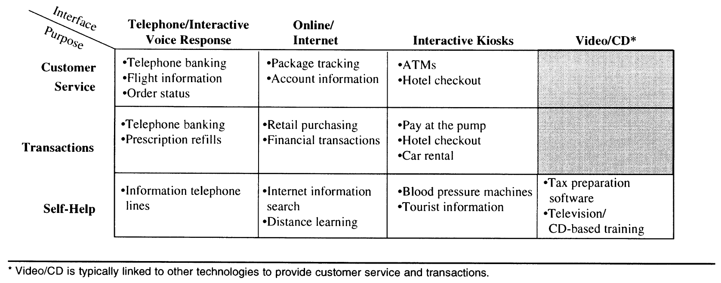
Figure 1 - Categories and Examples of SSTs in Use (Meuter et al. 2000)

But in the intervening years since Meuter et al’s framework was developed, significant changes have occurred with regard to self-service technologies. Specifically, the ability for shoppers to utilize their own technology devices in the course of shopping is a new phenomenon that has already significantly affected retailer strategies. While these new technologies do not necessarily change the scope of this existing framework—the Internet after all being one of the SST interfaces included in the framework—mobile Internet devices (MIDs) are a significantly different vehicle for self-service than any other technology. As this dissertation is concerned with shoppers’ use of technology devices within the retail environment, it is necessary to further explore the MIDs and how shoppers are using them. Because MIDs have yet to receive much research attention, we provide significant detail on MIDs, their historical evolution, popularity, in-store uses, use drivers, and use behaviors.

Mobile Internet Devices
As previously mentioned, consumers are increasingly utilizing their own technology devices during service encounters. Retailers also understand the importance of providing tools that consumers can use on their already familiar devices (Rosenblum and Rowen 2012a). To better understand the role that these personal technologies play during these encounters, it’s necessary to understand how these devices evolved, the distinct features that define them, and the reasons for and extent of their popularity.

Mobile Internet Device Evolution
As the technology necessary to allow pocket-sized computers emerged, consumer electronic devices were developed that could assist consumers with their personal and business affairs. These devices were known by a few labels including personal information managers (PIMs) and later personal digital assistants (PDAs). PIMs and PDAs earned modest success with consumers and popularized the idea of carrying around small multi-purpose computers. Unfortunately, these devices had limited ability to communicate, requiring users to carry a separate mobile phone for that purpose. This inconvenience did not go unnoticed. Manufacturers worked to converge the functionality of mobile phones and PDAs into a single device that would meet consumer communication and information management needs. Thus the smartphone was born.
Smartphones have proven exceptionally popular: their adoption rate is four times that of ‘feature phones’ (i.e., standard phones with no or limited Internet connectivity) (IDC 2011) and smartphone ownership recently surpassed that of feature phones (Arico 2012). Additionally, smartphones sales are projected to exceed that of personal computers in 2012 (Meeker, Devitt, and Wu 2010) with projected sales of 650 million devices in 2012 (GfK Group 2012). Whereas smartphones represent the first widely adopted example of MIDs, MIDs are not limited to this specific device type.

Mobile Internet Devices Defined
As the popularity of smartphones spread, manufacturers began to extend the smartphone concept by creating devices that had all the functionality of a smartphone but lacked a cellular baseband chip for voice communication. For example, Apple released a multi-purpose handheld device, the iPod Touch (essentially a phone-less version of the iPhone), only three months after the iPhone’s original release. Similarly, manufacturers built tablet computers with functionality identical to these multi-purpose handhelds, but with larger screen sizes. Though smartphones, multi-purpose handhelds, and tablet computers seem distinct, they each share necessary criteria that define them all as MIDs.

Mobile
First and foremost, MIDs are mobile. These devices are used by consumers in a wide range of environments (D. Johnson 2011)—in the car, on the street, in the home—and their functionality is not generally limited by where they are physically used. MIDs are also designed to be carried on or close to the body. Manufacturers are constantly striving to limit the weight and increase the battery life of these devices because they are so often used on the go. MIDs are often small and thin enough to be carried in a pocket or small bag and thus would be convenient for frequent use.
MIDs are also self-contained. They include a built-in keyboard and/or touchscreen interface and do not require any external accessories to control (e.g., computer mouse, keyboard, etc.). Laptop or notebook-style computers, given their general bulkiness and the fact that they are designed to be used while seated, are not considered MIDs. MIDs also do not require a wired connection to the Internet; their built-in wireless Internet capabilities contributing to their mobile nature.

Internet-Enabled
While it is conceivable that a device without Internet accessibility could be used to assist a consumer in the retail environment (e.g., a calculator function), this dissertation focuses only on Internet-enabled mobile devices. Internet-enabled devices differ from non-Internet devices in that they give consumers access to virtually unlimited amounts of product-related data and the ability to connect with others via social networks and other communication channels. This transforms not only the nature of service encounters (Hogg, Laing, and Winkelman 2003), but also how consumers perceive the shopping environment (Houliez 2010). Additionally, these changes may usher in a new era of ubiquitous commerce, or “U-commerce,” where universal access to the Internet “represents a major transformation of the business and marketing landscape” (Watson et al. 2002 p. 344).
An Internet-enabled device does not necessarily require a ubiquitous connection to the Internet, however. While some devices may include cellular data features that allow Internet connectivity through second, third, and forth generation data networks, some devices need only a Wi-Fi access point. Retailers are increasingly providing Internet access for their customers via store-deployed Wi-Fi systems (Gupta 2011) while also using the granular data generated by these systems to track customer shopping patterns and in-store behaviors (Henn 2012).

Multi-Purpose
Technological devices are rarely single-function devices anymore (Fox 2011). A digital camera purchased today will likely have video camera capabilities. Portable gaming devices have the ability to play Hollywood movies. Even in-car navigation systems have begun to incorporate audio storage and playback functionality. As digital consumable media rapidly replace their physical world antecedents (e.g., paper-based books, CDs, DVDs, etc.), these media become compatible with a wide range of digital devices. This compatibility and drive for multi-purpose devices represents the trend of convergence of which MIDs are a clear example. These devices often combine telephony with music playback, camera and video functions, GPS location awareness, web browsing and any number of other uses. Because MIDs are essentially handheld multi-purpose computers, their functionality is often extensible via operating system upgrades or the addition of third-party software applications.

MID Popularity
By 2015, smartphones and tablets “will represent 90 percent of new growth in the world’s device sales” (Fei 2012). A number of simultaneous phenomena aligned to help ensure the wide adoption and popularity of MIDs. First, mobile Internet connectivity, specifically third and forth generation mobile Internet access, is widely available. The major US wireless carriers “possess licenses for nearly every major market, with a combined subscription base in excess of 260 million people” (Schmidt 2012).
Second, the global recession has prompted changes to consumption patterns. Many families have cut back on their expenses by eliminating redundant services. Landline telephone service has been particularly vulnerable to this phenomenon. Consumers are canceling their wired telephone service and are choosing to use only wireless service. In fact, the percentage of households with only wireless communication access increased from 10.5% in 2006 to 31.6% in 2011 (Schmidt 2012). While these figures include all mobile phones, feature phones represent a declining share (Meeker, Devitt, and Wu 2010).
Third, a burgeoning marketplace of third-party software applications has emerged. Not only do consumers have the ability to view and interact with the worldwide web from their mobile devices, smartphone manufacturers and operating system providers have created application clearinghouses that consumers can use to download applications that extend device functionality. For example, Apple’s App Store houses hundreds of thousands of gaming, social networking, shopping, and other applications.
Finally, interoperability drives MID popularity. MIDs have grown in popularity because their primary functionalities—web browsing, text messaging, and voice communications—are based on standards that ensure seamless integration and communication with like devices. This provides a positive argument that consumers may use to drive purchase: the device will be compatible with those used by friends and family thus insuring ease of communication and greater social acceptance.

In-Store MID Use
Given the popularity of MIDs and their ability to assist consumers in any number of ways, it’s not surprising that consumers incorporate MIDs into shopping tasks. A recent survey found that 67 percent of smartphone owners under 35 use a smartphone while shopping and of these, 49 percent were specifically engaged in shopping related activities (Ali, E. Wong, and Subramanyam 2010). Third-party application developers have created a number of applications specifically designed to help shoppers make more informed in-store decisions. These applications include barcode scanning apps that return product pricing and availability information, product comparison apps that allow shoppers to view detailed product information, couponing apps that provide access to manufacturer and retailer coupons for use in-store, and even loyalty card organization apps that free shoppers from having to carry countless loyalty club membership cards.
Despite the significant and growing use of MIDs in the retail environment, limited research exists on the phenomenon. What limited research does exist includes a phenomenological investigation of the lived experiences of shoppers engaging in the practice (Spaid and Flint 2014); a study of how shoppers perceive space when they are simultaneously in-store and online (Houliez 2010); a study showing that recognition between in-store and online price discrepancies can affect shoppers’ evaluation of the retailer’s price competence, their trust in the retailer, and repatronage (Broeckelmann and Groeppel-Klein 2008); a structural equation model of the relationship between online shopping and in-store shopping (Farag et al. 2007); an experiment manipulating product attractiveness to enhance shoppers’ consideration sets through mobile devices (van der Heijden 2006); and an experiment demonstrating that perceived usefulness of a mobile recommendation agent “influences product purchases, predicts usage intentions and store preferences of consumers” (Kowatsch and Maass 2010 p. 697).
Now we turn to the actual in-store behaviors that shoppers engage in with their MIDs and what factors drive these behaviors.

MID Use Drivers
Fundamentally, the use of MIDs in the retail environment reflects the larger phenomenon of consumers bonding with their personal electronic devices (Rader 2009) and using them virtually everywhere (D. Johnson 2011). Texting friends, checking email, updating social networks and other online activities have become embedded in new social norms and the retail environment is just another place where these activities occur. This trend is further supported by MID adoption rates outpacing all other technologies (Melloy 2010).
In-store MID use is also driven by extrinsic and intrinsic shopping motivations. Spaid and Flint (2014) conducted a phenomenological study of consumers that use MIDs during their shopping activities and uncovered a number of themes that underscore the broad nature of many of the activities. Extrinsic motivators included economics, a desire for product information, and a desire for trust. The recent recession has forced many shoppers to change their buying behaviors to help stretch their budgets. Shoppers are using MIDs for deal-seeking (e.g., couponing, bargain hunting, etc.) and limiting (e.g., cutting back, buying generic, etc.) behaviors. Shoppers are also supplementing the limited information they find in-store with online product information. MIDs have also helped shoppers leverage more trusted sources of information while in-store by consulting online professional and consumer product reviews.
Intrinsic motivators included a need for security and a desire for empowerment. Shoppers often use their MIDs to feel more certain with their purchases and protecting their families and finances by making more informed purchases. Participants interviewed communicated a high level of confidence in the products they purchased with the assistance of their MIDs and an accompanying reduction in post-purchase buyer’s remorse. Shoppers also used MIDs as an empowering mechanism. MIDs are often used to assist with price negotiations and to ensure fair pricing. Other shoppers use MIDs in the service encounter to reduce the potential of being taken advantage of by sales agents who might otherwise have more information.

MID Use Behaviors
In-store MID use behavior can be categorized into social management and shopping management activities (Spaid and Flint 2014). Social management activities include communicating with others, shopping for others, assessing the subjective norms of products considered for purchase, and shopping with others virtually. Shopping management activities are those where the shopper uses the device to help assist with the shopping task, from looking up product information to actual product purchase. Within these broad categories, shoppers perform a wide variety of tasks. A recent industry report (GS1 MobileCom 2010) outlined a broad list applications where shoppers may leverage their MID:
Extended Packaging – using the MID to display product information beyond the physical packaging. Shoppers might use a mobile web browser to visit a manufacturer’s website or scan a product barcode with a dedicated application. A wide variety of third-party mobile software applications exist for this purpose. Retailers and manufacturers are also beginning to support supplementary scanning codes such as Quick Response (QR) codes.
Coupons – using the MID to manage manufacturer or retailer coupons. Shoppers can send a keyword via Short Message Service (SMS) to receive coupons. Barcodes can be provided through email or SMS to be used at checkout. Shoppers can use software applications that link electronic coupons with their loyalty accounts and have the discount automatically applied to their bill upon checkout.
Loyalty – storing loyalty account details and reward point balances. A variety of mobile applications exist that allow shoppers to load all their loyalty account details dispense with their physical loyalty cards.
Advertising & Promotions – a wide variety of promotion-driven activities facilitated by MIDs including real-time discount announcements, digital weekly circulars, and mobile advertising.
Payment – mobile payments systems including Google Wallet and Square allow shoppers to pay with their MID.
Self-scanning & Self-checkout – shoppers can control the entire checkout experience by scanning the products they wish to purchase and purchasing the products with a mobile payment solution or a dedicated, store-specific solution such as Apple’s EasyPay service.
Store Location – using the built-in global positioning satellite (GPS) functionality to locate retailers.
In-Store Navigation – MIDs provide a number of useful ways to help shoppers navigate the retail environment from simply providing an image of the store floorplan to real-time, interactive in-store positioning and wayfinding, .
Shopping Lists – with many shoppers economically motivated to reduce their discretionary impulse purchases, shoppers have turned to software to help them manage their shopping lists.
Mobile eCommerce – in some instances shoppers may decide to purchase from online retailers while in the retail environment (i.e., see ‘showrooming’ below). This can be facilitated by standard retailer websites, mobile-optimized websites, or retailer-specific mobile retail applications.

One use of MIDs in the retail environment that has received much industry attention is a phenomenon known as ‘showrooming’ (Zimmerman 2012). Showrooming occurs when shoppers visit a retailer location to view products, but utilize their MIDs to determine the lowest available price and then purchase the product online, often without leaving the store. This behavior is a form of ‘free-riding,’ where customers “use information and services from a full-service retail store to allow for later purchase from limited-service stores” (Singley and M. R. Williams 1995 p. 64). Free-riding occurs when shoppers “employ more than one channel within a single transaction” (Van Baal and Dach 2005 p. 75) and when “all the presale activities needed to sell a product can be conducted separately from the actual sale of the product” (Shin 2006 p. 23). Free-riding is engaged in by 20 percent of shoppers (Van Baal and Dach 2005), negatively impacts sales personnel productivity (Singley and M. R. Williams 1995), and differs among shoppers with differing marketplace interaction styles (Burns 2007). It’s easy to see why retailers would be wary of such practices. Retailers bear the overhead costs of maintaining a sales floor stocked with product and must pay the salaries of frontline employees, but they lose the sale to an online entity who has neither of these obligations and can thus offer the product at a lower price.

Shopper-Facing Technologies Defined
Although SSTs and MIDs occupy central roles as forms of shopper-facing technologies, there are others. For example, digital signage is commonly deployed in retail environments, yet digital signage typically lacks the features that would categorize them as self-service technologies (i.e., performance of a specific service-related function), though they do provide useful functionality (e.g., product information, way finding, etc.). Because we were interested in the holistic in-store technology experiences of shoppers, we see SSTs and digital signage as one group of technologies. Therefore, we refer to all the technologies that retailers make available to shoppers as in-store assistive technologies (ISADs). Therefore, shopper-facing technologies incorporate ISADs and MIDs.
As shopper-facing technologies are used more widely in-store and shopper practices such as showrooming become more pervasive, these technologies can end up being both a help and a hindrance for shoppers (e.g., both assisting the shopper and alienating them from the retailer). Given the historical perspective on the evolution of various technologies impacting shoppers provided here, we must turn to intriguing questions of how this technology actually affects human actors. For this we move into the literature bases of psychology, social psychology, and anthropology to examine how technology idealization may lead us to look at technology through rose-colored glasses and ignore other negative ramifications.

Technology Idealization & Tensions
We are constantly bombarded with stories of how the latest technologies will help make our lives easier or more convenient. The marketing of MIDs serves as an apt example. Commercials promise to connect us with family and friends wherever we are, make all of our personal information available at all times, and allow us to shop from anywhere. But there is a problem with how technology innovations such as MIDs are marketed. Technology is marketed in idealized terms that create cultural standards of personal efficiency and achievement that may be difficult for some consumers to realize (C. J. Thompson 1994). This creates a disconnect between the cultural ideals of technology as a vehicle for positive change and the realities that consumers face when technology is put into practice. Thus, a tension exists between what is expected and what is achieved.
This idealization of technology is a reflection of Western ‘technocratic’ meanings that are closely associated with an industrialized, technological society (C. J. Thompson 1994). The “idolization of efficiency, the desire for complete control over the environment (and the self), and an incessant quest for increased technical capabilities (power)” (C. J. Thompson 1994 p. 106) fuel our desire for technology products. Unfortunately, when modern Western consumers espouse technocratic ideals, they may blame technology shortcomings on personal inadequacy rather than features or limitations imposed by the technology. This exemplifies the tensions at work.
Two recently identified phenomena underscore how reliance on technology can have a detrimental effect on their users. Nomophobia (as in ‘no-mobile-phobia’) is an increase in discomfort or anxiety due to being out of contact with one’s mobile phone (Platzer et al. 2010). In a recent survey, 66 percent of 1,000 individuals surveyed in the United Kingdom suffered from nomophobia and this number rises to 77 percent for individuals 18–24 years old (Netburn 2012). The very technology that gives us the freedom to be anywhere without worry of being disconnected, creates a dependence that can paralyze us.
Another dependence that stems from personal technology use is FOMO or the ‘fear of missing out.’ Our constant connection to social networks provides a stream of alternate realities that we can see ourselves participating in and this makes us question our current choices (Wortham 2011). These two phenomena provide a glimpse of how technologies that provide benefits to their users can also generate concomitant tensions. All too often though, these benefits are ‘oversold’ through the idealization of technology.
Research on innovation also reflects the idealization of technology. Rogers and Shoemaker (1971) identified a pro-innovation bias of diffusion research. This bias indicates that innovations “should be diffused and adopted by all members of a social system, that it should be diffused more rapidly, and that the innovation should be neither re-invented nor rejected” (E. M. Rogers 2003 p. 92). The pro-innovation bias limits understanding of diffusion of innovations, which leads researchers “to ignore the study of ignorance about innovations, to underemphasize the rejection or discontinuance of innovations, to overlook re-invention, and to fail to study anti-diffusion programs designed to prevent the diffusion of ‘bad’ innovations” (p. 92). To this list should be added failing to understand the negative ramifications of already diffused innovations.
When technology devices are idealized in media and research, retailers and shoppers may not be aware of their potential to negatively influence the shopping experience or shopping decisions. Technology can give shoppers unprecedented levels of control over their shopping experiences, but technology can also cause problems for shoppers that may result in a less-than-favorable shopping experiences.
While technology manufacturers might take a variety of paths to market new innovations to consumers, one strategy in particular is a motivating force for both retailers and brand manufacturers in the retail environment: shopper marketing.

Shopper Marketing
Shopper marketing is about driving awareness and loyalty both to the brand and retailer along the entire path-to-purchase. This is accomplished through shopper marketing’s influence on shopper decision-making. With over half of shoppers’ decisions made in-store (Inman, Winer, and Ferraro 2009)—some sources putting that number as high as 76 percent (POPAI 2012)—being able to influence shoppers while they are in active ‘shopping mode’ in the store can be a huge boon to retailers and brand manufacturers. Influencing these decisions is the impetus behind the active collaboration that takes place between brand manufacturers and retailers. But influencing shoppers’ decisions requires important insight into their activities to better understand their preferences and motivations. These insights are most often captured in the store where shoppers’ activities are on display, but individuals can be in ‘shopping mode’ even when they are not in the store.
Deloitte, an industry market research firm, defined shopper marketing as “all marketing stimuli, developed based on a deep understanding of shopper behavior, designed to build brand equity, engage the shopper (i.e., a consumer in ‘shopping mode’) and lead him/her to make a purchase” (2009 p. 1). What this definition lacks is specificity regarding where these marketing stimuli or activities take place.
More recent conceptualizations of shopper marketing combine these in-store marketing efforts with the idea of influencing the shopper anywhere along the path-to-purchase. Shopper marketing is now seen as “the planning and execution of all marketing activities that influence a shopper along, and beyond, the entire path-to-purchase, from the point at which the motivation to shop first emerges through to purchase, consumption, repurchase, and recommendation” (Shankar 2011). Thus, shopper marketing encompasses those shopper activities that occur in a variety of locations, which include at home, on the go, and in the store (GMABooz & Company 2010).
Shopper marketing has proven a popular strategy among retailers and brand manufacturers. Eighty-three percent of consumer packaged goods manufacturers plan to increase their investments in shopper marketing over the next three years and 55 percent rank shopper marketing as their number one investment (GMABooz & Company 2010). Retailers’ investments in shopper marketing are primarily with the technologies used to generate shopper insights (e.g., shopper tracking systems, customer relationship management systems, etc.) and these investments are expected to grow significantly within the next few years (ABI Research 2010; Rajagopalan 2010). The insights generated are then shared with or sold to manufacturers. Because many of these insight-generating technologies are largely transparent to shoppers, they are unlikely to directly affect shoppers behaviors, hence the importance of a full understanding of the effect of all shopper-facing technologies.
Next we address the extent that shopper-facing technologies are woven into the fabric of the retail environment and identify areas were more insight is needed.

A Need for More Insight
Meuter et al (2000) investigated consumer sources of satisfaction and dissatisfaction with a variety of self-service technologies (SSTs) including telephone and interactive voice response systems, Internet-based systems (e.g., package tracking, retail purchasing, information search), interactive kiosks (e.g., ATMs, pay at the pump systems, blood pressure machines), and others. The authors used the critical incident technique to gather memorable SST-based service encounters from participants. The results showed that, among satisfying incidents, SSTs were found to save time (30%), work reliably (21%), be easy to use (16%), and provide convenient access (8%). Of the dissatisfying factors, SSTs failed due to hardware failures (43%), poor service design (19%), poor technology design (17%), and process failure (17%). While insightful, this research does not address why and how consumers wish to adopt and use technology in the retail environment.
Burke (2002) conducted a national survey to addresses this oversight. The results showed that technology was seen more as a means, not an end in itself and that “it is not the technology per se but how it is used to create value for customers that will determine its success” (p. 427). Specifically, technology needs to be optimized for the consumer’s shopping style, stage of the decision process, type of product shopped for, and the shopper’s current need state. Since Burke’s research, matters are further complicated by a need for an updated understanding of how pervasive technologies such as MIDs are affecting the shopping experience.
Recent industry research (Rosenblum and Rowen 2012a) has also shown that below average performing retailers tend to take a blind optimism approach to in-store technology integration: “they do not know what technologies would best serve customers in their stores, but assume any technology must be better than what they have now” (Rosenblum and Rowen 2012a). Vulnerable retailers facing increased competition and a challenging economy risk costly and misguided deployments if technology decisions are not carefully considered.
These insights should give retailers pause. Rather than taking a no-holds-barred approach to technology integration and deployment, retailers should instead stop to assess the effects of these technologies. Critical questions that have yet to be asked and answered apparently include:
- Is more technology in retail necessarily better?
- What is the right amount and mix of technology that most benefits the store and the shopper?
- How should we deploy these systems? Where should they be located and what should they look like?
- Do in-store and consumer-owned technologies provide similar utilities?

But to answer these questions we first need to ask:
- What are the effects of various technologies and a technology-infused environment on shoppers and what do these mean to the shopper and their shopping experience?

Answering this question also allowed us to determine what impacts important retailer variables.

Theoretical Justification
In order to examine how in-store technology use and its potential negative ramifications affect important retailer variables, several theories and research streams need to be investigated.
Whether a shopper chooses to engage with technology while they shop is likely heavily influenced by the various perceptual factors and functional attributes that influence adoption of these technologies. Existing research on technology adoption and self-service technology were explored to understand what we already know about technology attributes that motivate shopper-facing technology engagement.
As shoppers engage with technology they faced the paradoxes that arise from technology usage (Mick and Fournier 1998). These paradoxes were systematically evaluated for relevance in the shopping context. Where shoppers face the positive and negative ramifications of technology use, ambivalent feelings towards the technology were likely to result. Understanding attitudinal ambivalence (M. M. Thompson and Zanna 1995) may shed light on the dualistic nature of technologies.
Regardless of motivation or effects of ambivalence, the individual disposition of shoppers can vary greatly. Not all shoppers are equally ready or willing to use technology. Technology readiness (Parasuraman 2000) is investigated as a possible factor contributing to shoppers’ ambivalent feelings towards in-store technologies and ultimately their effect on shopping outcomes. Positive (optimism and innovativeness) and negative (discomfort and insecurity) shopper technology orientation tensions are likely playing a significant role.
Customer value theory (Woodruff 1997) is used to explain the benefits that shoppers derive from their shopping activities. Specifically, the effect on utilitarian and hedonic shopping value (M. A. Jones, Reynolds, and Arnold 2006) were examined as a consequence of ambivalent emotions generated by in-store technology usage.
Finally, theories related to the effects of environments on individuals were considered (Bell and Sundstrom 1997). The literature on servicescapes (Bitner 1992; Sherry 1998) as well as a more recent retail phenomenon, the themed flagship brand store (Kozinets et al. 2002), were explored.
These theories are investigated and discussed in the next chapter and their ability to contribute to the study of technology use in the retail environment are examined.

Research Objectives & Questions
The primary goal of this dissertation is to understand how shopper-facing technologies can impact shoppers’ experiences and behaviors and subsequently affect the outcome variables that matter to retailers. To that end, there were two objectives, each with specific research questions, that were addressed to better understand the phenomenon and its impact. These objectives were: 1) understand how shopper-facing technologies affect shopper behaviors, perceptions, and attitudes within a retail environment, and 2) reveal how technology affects evaluations of the shopping experience.
The following questions help address each of these objectives:
Questions for objective 1 (Understand how shopper-facing technologies affect shopper behaviors, perceptions, and attitudes within a retail environment):
- Why and how are shoppers using technologies while shopping?
- Which technologies serve what purposes along the path-to-purchase from the shopper’s perspective?
- How do technological environments impact the shopper?
Questions for objective 2 (Reveal how technology affects evaluations of the shopping experience):
  - What are the consequences of increased technology use by shoppers?
  - How does technology paradox-induced ambivalence impact the shopper’s experience?
  - What role does a shopper’s level of technology readiness play?

Chapter Two builds a foundation for our studies by diving deeper into relevant theoretical bases and empirical work to showcase what is currently known about interactions with technology and technological environments. In particular, Chapter Two provides insights into technological paradoxes, relevant dispositional constructs, customer and shopper value, and environmental factors.

Chapter 2 – Literature Review
This chapter builds on the foundation set in Chapter One by addressing several critical theoretical aspects of human-technology interface as they relate to shopping. Before diving into these theoretical aspects, the next section provides important details to orient the reader to innovation diffusion, technology adoption, and existing research on in-store technologies and an important gap in the literature created by the evolution of these technologies.

Innovation Diffusion and Technology Adoption
This dissertation seeks to address the outcomes of consumers interacting with technology while they were in shopping mode. A discussion of shoppers and technology must first begin with an understanding of what technology innovations are. Rogers (2003) synthesized previous work on the subject of diffusion and developed a theory of the adoption of innovations, which he termed Diffusion of Innovations. Rogers defined diffusion as the “process by which an innovation is communicated through certain channels over time among the members of a social system” (p. 11), thus outlining the four main elements of diffusion: the innovation, communication channels, time, and social system. Because diffusion is a social process and operates on the societal level, Rogers’ work is limited in its ability to explain the how innovations are accepted by individuals. Rogers’ theory does, however, provide necessary definitions that delineate what technology innovations are and how they may operate.
An innovation is “an idea, practice, or object that is perceived as new by an individual or other unit of adoption” (E. M. Rogers 2003 p. 12). Whereas the term innovation can be used to describe subjects as varied as seatbelt usage or a political philosophy, for our purposes we were concerned with object innovations, or technologies. Rogers defines technology as a “design for instrumental action that reduces the uncertainty in the cause-effect relationships involved in achieving a desired outcome” (p. 12). Specifically, we were concerned with technology as a combination of hardware and software elements used to achieve some goal. Rogers defines hardware as a “tool that embodies the technology as a material or physical object,” and software is the “information base for the tool” (p. 12). Thus, in this dissertation, technology is defined as a physical object with an underlying programmable information base. Though perhaps more restrictive, this definition still represents a huge number of technologies that shoppers are routinely exposed to.
While Rogers’ innovation diffusion theory operates at a societal level, technology adoption operates differently at an individual level. Davis (1985) created the technology acceptance (TAM) model to explicate individual adoption of technologies within a business context. This model was based largely on the theory of reasoned action (TRA) (Fishbein and Ajzen 1975), which helps predict the consequences of intended behaviors. Specifically, TRA demonstrates that an individual’s behavioral intention (BI) to perform a behavior directly influences his or her performance of that behavior. Additionally, BI is determined by an individual’s attitude (A) and subjective norm (SN) toward the behavior. As with the TRA, TAM postulates that technology acceptance is governed by behavioral intentions. Specifically, TAM uses perceived usefulness and ease-of-use as the primary motivators of attitudes towards a technology and their subsequent use.
In the business context, however, the acceptance of technology may not be completely volitional. More often than not employees have their technology choices dictated to them. Consumers, on the other hand, usually have a choice of whether to use of a particular technology and their consumption choices are often driven by emotions (Havlena, and Holbrook 1986). This difference materializes in the form of a hedonic dimension with regard to technology acceptance (Dabholkar 1994). Consumers often adopt and use products for emotionally arousing reasons, what Hirschman and Holbrook (1982) describe as the “multi-sensory, fantasy and emotive aspects of one’s experience with products.” Bruner and Kumar (2005) built on TAM and extended it to a general consumer context and use it to explain consumer acceptance of handheld Internet devices (c-TAM). They found that while perceived usefulness is a factor that contributes to the acceptance of Internet-enabled devices, ‘fun,’ or the device’s hedonic qualities, is a better predictor.
The usefulness, ease-of-use, and hedonic variables of c-TAM help explain the intrinsic perceptual qualities of a technology product that might drive adoption, but there are also external factors at work. Network externalities, “positive external consumption benefits” (Katz 1986), make the adoption of a particular technology more worthwhile for the consumer because the product leverages the network effects of features that are attractive to a wide audience. For example, smartphones have grown popular because their primary functionalities—web browsing, text messaging, and voice communications—are based on standards that ensure interoperability with like devices.
Finally, Parasuraman and Colby (2001) explain that “consumer behaviors associated with cutting-edge technology and conventional offerings differ significantly” and firms that wish to successfully market technology products must have a firm grasp of consumers’ attitudes towards technology and how those attitudes may vary across consumer segments. The authors identified a number of technology customer types according to their attitudes toward technology: Explorers are confident with technology and their ability to make technology work for them; Pioneers need reassuring and have average fears with regard to technology; Skeptics are less enthusiastic, but they believe technology provides convenience and efficiency; Paranoids are less innovative and have inhibitions which hold them back from technology; and Laggards are the least likely to adopt a new technology, sometimes only if forced to. Dabholkar (1992) found that attitudes toward computerized products in general carry over to attitudes towards using a new technology-based self-service option within the retail environment. Thus, the attitudes functioning within the various technology customer types identified by Parasuraman and Colby (2001) are likely present within the retail environment as well.

In-Store Technology Engagement
The benefits of technology within the service environment are well known. Specifically, technology has the ability to help customize service offerings, recover from service failure, and spontaneously delight customers (Bitner, Brown, and Meuter 2000). While there is a significant amount of extant research on in-store technology use, most have two main limitations. One, the vast majority of studies have looked only at self-service technologies (SSTs) and two, research on the motivating factors for SST use primarily look at the perceptual factors of those technologies. Relative to the former, this dissertation takes a broader view of technology within the retail environment and includes all shopper-facing technologies including self-service technologies and others including digital signage and mobile Internet device (MID) use. Since this dissertation is taking a broader view of technology in the retail environment, it’s necessary to look beyond the research that just predicts SST use and begin the task of laying out how individual technologies used in-store may differ from each other.
The next section reviews some of the perceptual factors of in-store technologies that have been addressed in research to date. Then I outlined the functional attributes that an expanded view of in-store shopper-facing technology necessitates.

Perceptual Factors
Perceptual factors are the differences that individuals perceive based on the use of specific technologies. For example, individuals may perceive certain technologies as having higher or lower levels of usefulness based on their interactions with the technology. It is critical to understand perceptual factors because they drive the adoption of technologies and their continued acceptance by shoppers.
Thus far, research into perceptual factors falls into three categories: ease-of-use and usefulness, enjoyment, and predictability and control.

Easy-to-use & Usefulness
Previous research suggests that perceived ease-of-use and perceived usefulness are two important determinants driving individuals to accept or reject certain technologies. Davis (1989) introduced these two factors to explain why certain technologies were accepted more readily than others. Davis based his technology acceptance research on a number of theoretical bases including self-efficacy theory and the cost-benefit paradigm.
Bandura’s self-efficacy theory (1982) supports the notion of ease-of-use as a judgment of “how well one can execute a course of action required to deal with prospective situations” (p. 122). These judgments are “theorized to function as proximal determinants of behavior” (Davis 1989). Bandura separates the idea of self-efficacy from outcome judgments, which he sees as the extent to which a successfully executed behavior is linked to a valued outcome. In technological terms, this means the extent of usefulness a technology is thought to have.
The cost-benefit paradigm stems from behavioral decision research (Payne, Bettman, and E. J. Johnson 1992). This research helps explain individuals’ decision-making strategies in terms of the cognitive trade-offs between the effort to execute the strategy and the quality of the resulting decision. Davis equates this subjective decision-making performance with his usefulness construct.
While perceived ease-of-use and perceived usefulness have been studied extensively in general technology acceptance contexts (Davis 1985; 1989), it has also garnered much attention within self-service technology research within the retail context. Curran and Meuter (2005) developed a model of SST adoption within the banking context and found that interfaces used for the SST (telephone, Internet, kiosk) display clear differences with regard to the antecedents driving attitudes and intentions to use. They also found that ease-of-use and usefulness were a critical factor in an SST’s general acceptance. Ease-of-use has also been found to be a predictor of positive attitudes towards technology-based self-service (Dabholkar 1994; Dabholkar and Bagozzi 2002). Usefulness, appropriate for situations in which the individual owns the technology, was replaced with “performance” for the technology-based self-service context. This reflects the “did its job” emergent theme captured by Meuter et al (2000).

Enjoyment
Along with ease-of-use and usefulness, enjoyment or fun was also shown to be a significant predictor of technology acceptance (Davis, Bagozzi, and Warshaw 1992). In the retail context, enjoyment has also been shown to predict positive attitudes toward technology-based self-service (Dabholkar 1994; Dabholkar and Bagozzi 2002).
Experiences of flow—“the state in which people are so intensely involved in an activity that nothing else seems to matter, the experience itself is so enjoyable that people will do it even at a great cost, for the sheer sake of doing it” (Csikszentmihalyi 1991)—have also been shown to positively influence the hedonic value of shopping experiences (Senecal, Gharbi, and Nantel 2002) and the use of information technology (Pilke 2004).

Predictability & Controllability
Though less thoroughly researched than ease-of-use, usefulness, and enjoyment; predictability and controllability have been shown to significantly contribute to perceived risk, perceived value and purchase intention when using self-service technologies (Lee and Allaway 2002). Predictability is the extent to which unexpected aspects of SST use are reduced and controllability is a potential adopters’ belief that they have the ability to change the nature of their involvement with the self-service technology.
This research has revealed that individuals use a variety of perceptual factors to evaluate technology innovations including self-service technologies. It also draws on theories of technology acceptance (Davis 1985; Davis, Bagozzi, and Warshaw 1989; 1992), self-efficacy (Bandura 1982), and flow (Csikszentmihalyi 1991) to partially explain what drives individuals to interact with new technologies.
While perceptual factors provide valuable insight into the effects of technologies on individuals, the changing nature of technologies within the retail environment necessitate a closer look at the variety of functionality present in these technologies and how they may differentially affect the shopper. For this we must explore functional attributes.

Functional Attributes
Functional attributes refer to the specific features of a technology that may dictate how a technology is used. To date, most research on technologies within the retail environment has focused on large, stationary kiosks owned by the retailer with specific operational parameters. Given the widespread use of mobile technologies by shoppers and the provision of mobile and Internet accessible technologies by retailers, it is likely that these new technology characteristics are affecting the shopper in new ways. These functional attributes are a new and important variable to consider as shoppers interact with technologies in the retail environment because they affect how the shopper uses the technology, where they use it in the store, how they evaluate the information they retrieve from the technology, and how much they use the technology.
Based on the recent changes to in-store technologies, these functional attributes can be categorized into four areas: interactivity, mobility, ownership, and Internet accessibility.

Interactivity
An important thing to consider is that not all technologies within the retail environment are necessarily interactive, digital signage being one common example. But in order to understand what is and is not interactive, it is critical to understand how interactivity is defined and how the individual elements of this definition affect the shopper’s experience with technology.
According to Liu (2002), a technology that is said to be interactive must have three crucial elements: active control, two-way communications, and synchronicity.
Active control is the “voluntary and instrumental action that directly influences the controller’s experience” (p. 54). In other words, the individual provides an ‘input’ into the device, be it scanning a product or pushing a button, and this input serves the instrumental purpose of initiating the exchange of communication between the shopper and retailer or brand manufacturer.
Two-way communication is the “ability for reciprocal communications between companies and users, and users and users” (p. 55). Traditional media (e.g., print, television, radio) have been effective at transmitting information to the consumer, but consumers are not able to provide feedback through those same media. Many retailers provide mechanisms for two-way communication through the networked capabilities and dedicated hardware interfaces of various in-store technologies. For example, it is common to see shelf-based screens that feature buttons allowing the shopper to initiate interactivity. In essence, the shopper communicates his or her intention to view the video demo by pressing the button and the video display handles the communication from the retailer to the shopper. The communication is mediated by the device (Walther 1996).
Synchronicity is the “degree to which users’ input into a communication and the response they receive from the communication are simultaneous” (Liu and Shrum 2002). This criterion means that feedback resulting from an input is immediate. Technologies that provide feedback after a delay significant enough for the user to lose interest in the communication would provide little value.
From the shopper’s perspective, interaction with an in-store technology takes the form of shoppers acting on the technology, their actions driving communication with the retailer or brand manufacturer mediated by the technology and resulting feedback being immediate.

Mobility
Typically, shopping-facing technologies are anchored in a specific location within the store. For example, self-checkout systems are located at the front of the store and are fixed in place. MIDs and other technologies such as ‘smart’ shopping carts and gift registry scanners, however, travel with the shopper allowing for greater flexibility of use. This mobility of use affords the shopper much greater latitude in terms of where he or she can utilize the device within the retail environment. With this greater flexibility of use, more opportunities to use these mobile technologies while shopping are available.

Ownership
As recent industry reports on the ‘showrooming’ phenomenon will attest, shoppers are bringing their MIDs into the retail environment and using them to great effect as a shopping aide (Zimmerman 2012). An important distinction of MIDs is that the shopper furnishes the device and is thus most likely the person who owns it. With regard to mobile technologies such as smartphones and tablet computers, ownership infers two likelihoods: the device will likely be customized to the shopper’s preferences including any applications the individual might utilize for the purpose of shopping and the shopper will likely have a higher level of familiarity with his or her MID than a retailer-provided technology and thus would be able to use it more effectively. This underscores the fact that individuals have been shown to evaluate objects more favorably due to mere ownership of that object (Beggan 1992). In the case of technology devices used by individuals while shopping, this increased favorability may equate to more engagement than retailer-furnished technology. Ownership may also mean that the information retrieved on the device may be deemed more favorable and thus more trustworthy.

Internet Accessibility
The Internet has made a significant impact on consumer information search habits (Peterson and Merino 2003). Research has shown that access to the Internet increases information search behaviors due to reduced information search costs (Jepsen 2007). This is relevant for consumers that utilize the Internet for e-commerce transactions on traditional computers, but is equally relevant to shoppers with MIDs. Given the current shopper trend of using personal MIDs during the shopping task, the importance of the Internet to shoppers and its relevance with regard to information search behaviors is difficult to overstate. It should also be mentioned that Internet accessibility is relevant in this context only from the shopper’s perspective. Technologies such as digital signage routinely have the ability to access the Internet for periodic content updates, but shoppers typically cannot utilize these devices to access the Internet.
Understanding these functional attributes makes us cognizant of the range of technologies that the modern shopper may routinely be exposed to. As shoppers explore and engage with modern retail environments these technologies have the potential to change the nature of the shopping experience.
If we step back and look at the research in this area we can conclude that perceptual factors provide important motivators for the use of technologies and that these motivators are equally relevant within the retail environment. We also know that certain functional attributes of technologies that are routinely used within the retail environment necessitate a more granular approach to studying in-store technologies. This insight helps but does not get us as far as we need to go. Specifically, we also need to investigate the effects that technologies can have on individuals and examine what really happens when human actors engage with technology, and in particular, what happens to them cognitively and emotionally. One thing we know is that technology can create a form of confusion, dilemma or ‘paradox.’ In fact, this phenomenon is known as technology paradox.

Technology Paradoxes
Paradoxes are confusing. They are statements or situations that might at first seem contradictory such as a device designed to be helpful being described as harmful. Paradoxes require us to “live with simultaneous opposites” (Handy 1994). A paradoxical phenomenon may be both positive and negative or beneficial and detrimental, highlighting their enigmatic nature. They consist of “two contrary or even contradictory propositions to which we are led by apparently sound arguments” (Van Heijenoort 1972). When individually evaluated, each statement is indisputably true, but taken together they appear contradictory. We should care about paradoxes in marketing and specifically consumer behavior because whether or not consumers perceive marketing stimuli as paradoxes may partially explain unintuitive behaviors or behaviors previously thought of as anomalies.
Yet there has been strikingly limited research into the role that paradoxes play within marketing and consumer phenomena or even the kinds of paradoxes consumers face or self-generate. This is likely because theory building is inherently difficult when traditional theory construction requires internal consistency among phenomena. Inconsistencies are either explained away or ignored, and contradictions are avoided. When building theory from paradoxical phenomena, theories are not seen as statements of supreme truth, but alternative takes on reality that may provide insight in their own right. Thus, “social science loses an important resource for theory development if the incompatible or inconsistent theses which inevitably arise…are ignored or are eliminated” (Poole and van de Ven 1989)
Our postmodern age has been defined by paradox (Brown 1995; Kilduff and Mehra 1997). We are blessed with more choice than at any other time in the past, yet we struggle to make decisions as we are faced with the demotivating realities of those choices (Iyengar and Lepper 2000). We seek to maximize our options, but feel less satisfied when we succeed (Iyengar, Wells, and Schwartz 2006). We relish our privacy and rail against its violations, yet freely provide our most personal details on the Internet (Norberg, D. R. Horne, and D. A. Horne 2007).
As technology becomes more prevalent within the retail environment and shoppers continue to utilize their own MIDs during the shopping experience, the interactions with these technologies and the effect they have on the shopper become more important. Despite technology idealization in marketing messages (C. J. Thompson 1994) and research orientations (E. M. Rogers and Shoemaker 1971), most consumers recognize that technology use can have negative ramifications. Unfortunately, there has been scant research done to date on the negative ramifications technology products may have on shoppers and how those effects might be affecting shopping experiences. The research that does exist includes the ramifications of forcing customers to use self-service technologies (Reinders, Dabholkar, and Frambach 2008), the negative effects of store crowding and self-consciousness on self-service technology usage (Dabholkar and Bagozzi 2002), and waiting time to use self-service technologies (Dabholkar 1996). Except for studies investigating the operational failure of technologies (Dabholkar and Spaid 2012; Meuter et al. 2000), most of the negative ramifications of technology use stem from situational factors, not the technology itself.
Mick and Fournier (1998) developed a framework that helps us with this dilemma. In an effort to explore the paradoxical nature of technology products, they conducted a multi-method, multi-product qualitative study resulting in a conceptual framework that synthesized the concepts of “paradox, emotions, and coping strategies within the domain of technological consumer products” (1998 p. 123). Their framework is broad and helps expose the role that paradoxes play within the everyday life of the consumer (see Figure 2).

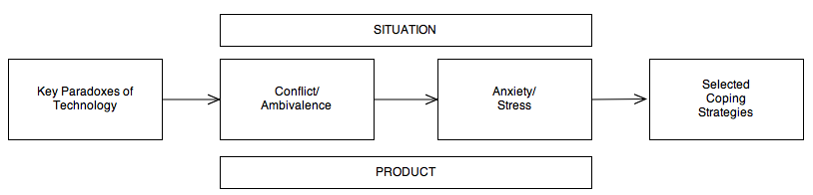
Figure 2 - Framework of Technology Paradoxes (Mick and Fournier 1998)

There are four important aspects of the Mick and Fournier framework useful for our purposes. One, the paradoxes they observed operate on a number of dimensions, which in turn operate across a spectrum of abstractness. Two, these dimensions of paradox lead to ambivalent emotions in the consumer. Three, conflict and ambivalence lead to anxiety and stress. And finally, anxiety and stress lead to select coping strategies, each of which is tailored to the specific paradox experienced. The framework infers the use of a number of technology products within a variety of use situations.

Technology Paradox Dimensions
Mick and Fournier (1998) asked their research subjects to complete a variety of sentences designed to elicit evidence of their experiences with technology products. The sentence completions revealed the research subject’s sensitivity to technology paradoxes. Specifically, Mick and Fournier identified eight central paradoxes of technology. Each paradox consists of two diametrically opposed emotions that technology use seems to initiate. We describe each of the eight here.
Control/Chaos and Freedom/Enslavement were the most often mentioned paradoxes. “From computers to washing machines, technological products are often positioned as facilitating control and freedom of activities. Yet these same technologies can also breed the opposite conditions of upheaval and dependency” (Mick and Fournier 1998 p. 128). These paradoxes have been identified in earlier research as well (C. J. Thompson 1994). Control/Chaos is defined as technology’s ability to facilitate regulation or order and its ability to lead to upheaval or disorder. Freedom/enslavement is defined as technology’s ability to facilitate independence or fewer restrictions and its ability to lead to dependence or more restrictions. Both of these dimensions are applicable to the context of shoppers utilizing technology within the retail environment. Many of the technologies available for use in the retail environment are designed to give the shopper greater control and the freedom to be independent of service personnel during the shopping experience. At the same time, however, in-store technologies may cause upheaval and dependency by making the shopper feel overwhelmed with options or product choices.
The New/Obsolete paradox was used by research subjects to describe the frustration they found with the never-ending pace of technology advancement and how a brand new technology may seem old the next day. This paradox relates to the consumer’s ownership of the product and the positive and negative ramifications of that ownership.
The Competence/Incompetence paradox reflects the fear of technological complexity that many consumers have of technology. Shoppers that have little experience with in-store technology use may feel a certain level of comfort with that technology use, but this may dissolve rapidly as poor technology design or complex information make overwhelming demands on the shopper.
The Efficiency/Inefficiency paradox describes technology’s ability to both save and waste time. As shoppers navigate the retail environment and engage with technologies for a variety of reasons, shoppers likely experience instances where the technology is a help as well as hindrance for their shopping task. Because technologies are often marketed for their ability to make a task more efficient or easier on the consumer, shoppers were expected to be sensitive to this paradox as they encounter technologies in the retail environment intended to assist the shopper, but fall short. Any failures of efficiency were expected to be memorable for the shopper.
The Fulfills Needs/Creates Needs paradox reflects the tension that exists when technology may meet needs, but creates new ones at the same time. Mick and Fournier describe this paradox as being subtle with regard to possessions in everyday life, but as shoppers engage with technology to fulfill shopping needs, there are situations where this paradox might become salient. Take product information for instance: when shoppers are considering a product for purchase, having an Internet accessible technology device can create the need for more information about products under consideration when previous, technology-less shopping strategies would not have created that need. Spaid and Flint (2014), in a qualitative study of shoppers that utilized mobile Internet devices, show that some shoppers often feel guilty when they fail to use the technology they have to its upmost to get the best deal possible.
The Assimilation/Isolation paradox reflects the ability of technology to make us feel both socially connected and detached. In the shopping context, technology can connect shoppers with their friends and family as they shop. But at the same time technology has the ability to isolate us as shoppers as we engage with devices instead of sales staff.
Finally, the Engaging/Disengaging paradox reflects technology’s ability to mediate our activities to the point where skills or expertise may be depleted. As shoppers engage with technologies to execute shopping tasks, their reliance on technology grows and this reliance may reduce their ability to shop without the technology. For example, the joy and exhilaration that shoppers may feel as they search for discount goods or use a stack of coupons to reduce a checkout total would be lost as mobile technologies help find the best price for the shopper and coupon management apps often automatically apply coupons without shopper intervention.
So, it seems that technology paradoxes provide a number of dimensions with both beneficial and detrimental aspects. These paradoxes have the capacity to affect shoppers’ feelings of control and freedom, their competence and efficiency in the shopping task, the fulfillment of their needs, and their relationship with the retailer and others. Understanding this nature of technology, especially within the retail environment, may help us explain shopping behaviors that relate to shoppers interacting with various technologies.
As these paradoxes are encountered by shoppers through in-store technology use and they experience positively and negatively valenced attitudes, ambivalence is the result.

Ambivalence
While considerable attention has been paid to research on attitudes within psychology (Eagly and Chaiken 1993; Fishbein and Ajzen 1975) and to some extent within the technology-based self-service literature (Dabholkar and Bagozzi 2002), less has been paid to the subject of attitudinal ambivalence and its consequences. Attitudinal ambivalence is the experience of simultaneously holding opposing attitudes toward an object or activity. Traditionally, the psychological literature views attitudes as univalent. Individuals are seen as holding only positive, negative, or neutral attitudes toward objects and that these attitudes exist on opposite ends of a bipolar scale (Green, Goldman, and Salovey 1993). More recent research takes the opposite perspective. In other words, attitudinal valence exists as two independent points on two separate scales of positive and negative (Cacioppo and Berntson 1994; Cacioppo, Gardner, and Berntson 1997; Larsen and McGraw 2011).
A related subject, emotional ambivalence or mixed emotions, has received some attention within the consumer behavior and psychology literature (Rafaeli, G. M. Rogers, and Revelle 2007; P. Williams and Aaker 2002). Like attitudinal ambivalence, mixed emotions deal with understanding something that can be experienced both positively and negatively simultaneously. Where they differ, however, is that mixed emotions focus on the simultaneous experience of conflicting emotions (e.g., feeling happy and sad) while attitudinal ambivalence deals with the simultaneous experience of positive and negative evaluations of an attitude object (e.g., loving caramel, but hating how sticky it is). However, both have parallels with cognitive-dissonance theory (Festinger 1957). Like cognitive dissonance, attitudinal ambivalence and mixed emotions are considered troubling, disharmonious states that are counter to an individual’s normal desire for consistency (Cacioppo, Gardner, and Berntson 1997; Priester and petty 1996). Emotional ambivalence has been shown to negatively affect attitudes by nature of the disharmonious state it creates in individuals (P. Williams and Aaker 2002), which supports the main tenant of Cognitive-Dissonace Theory (Festinger 1957): individuals are motivated to reduce conflicting cognitive states.
Individuals vary with respect to their tolerance of ambivalence as well. Williams and Aaker (2002) provide one of the few studies that investigates individual differences with respect to ambivalence, in this instance affective ambivalence or mixed emotions. They found that older individuals and individuals from Eastern cultures have a higher propensity to accept duality, meaning that these individuals do not feel the psychological stress associated with disharmonious emotions as acutely has individuals with lower propensity to accept duality (i.e., younger individuals from Western cultures).
While attitudinal ambivalence is a cognitive operation and mixed emotions a form of affect, research points to the conclusion that they are inextricably linked (Zajonc 1980). To some degree, understanding the role that emotions play can help us understand attitudes and, by extension, affective ambivalence and attitudinal ambivalence.
Emotions play an important role in consumption activities (Havlena, and Holbrook 1986). Research in hedonic consumption activities in particular, which include shopping, have been the focus of considerable research in the past 30 years (Arnold and Reynolds 2003; Babin, Darden, and Griffin 1994; M. A. Jones, Reynolds, and Arnold 2006). Thus understanding how ambivalence may play a role within shopping activities provides valuable insights to this stream of research.
Thus far, we have a few new lenses through which to view shopper-facing technology engagement, specifically technological paradoxes and ambivalence. A shopper that engages with shopper-facing technology in the retail environment may experience ambivalent attitudes as a result of technological paradox and this attitudinal ambivalence may negatively impact the shopper’s experience and the value they derive from that experience. But this doesn't tell the entire story. Shoppers’ behaviors might also be influenced by their state of readiness to engage technology in the first place. Some additional research helps us unravel this aspect.

Technology Readiness
As a direct result of Mick and Fournier’s (1998) identification and outline of technology paradoxes, Parasuraman (2000) developed a technology readiness index scale (TRI) to measure an individual’s “propensity to embrace and use new technology for accomplishing goals in home life and at work.” This definition also includes the retail environment, a transitional space where consumers may find it increasingly difficult to avoid the use of technology. The development of the TRI stemmed from the lack of scholarly research pertaining to people’s readiness to use technology-based self-service systems (TBSS), which at the time was becoming a popular method for retailers to lower costs and boost the bottom line. Despite the fact that many retailers are now looking past simply deploying TBSS systems to increase their bottom line and are now investigating ways to differentiate their service encounters with better customer access to information and customer-centric processes (Rosenblum and Rowen 2012a), technology remains a critically important tool in the retailer’s toolbox.
The importance of technology is equally salient for goods-based retailers as it is for service-based retailers (Parasuraman 2000). As Vargo and Lusch (2004) argue, goods are really distribution mechanisms for the provision of services, thus fundamentally, products are services. And at the store level, most goods-based retailers “now view themselves primarily as services, with the offered good being an important part of the service (rather than the service being an augmentation of the physical good)” (Rust 1998). Thus, goods-based retailers have as much to gain from understanding how customers use and relate to technology as service-based firms.
Building on Kotler’s (1994) conception of services marketing as a triangle of relationships between company, employee and customer, Parasuraman (1996) added the dimension of technology as a phenomenon that binds the three marketing players together into a three-dimensional pyramid with technology at the center that introduces three new links—customer-technology, employee-technology, and company-technology—that need to be managed and mastered as part of a modern retail operation (see Figure 3). Focusing on the customer-technology link, Parasuraman (2000) created the TRI to directly address a number of important questions including: How ready are people to embrace and effectively use new technologies? And What are the primary determinants of technology readiness? The answers to these questions are equally salient to understanding how and why shoppers use technology.

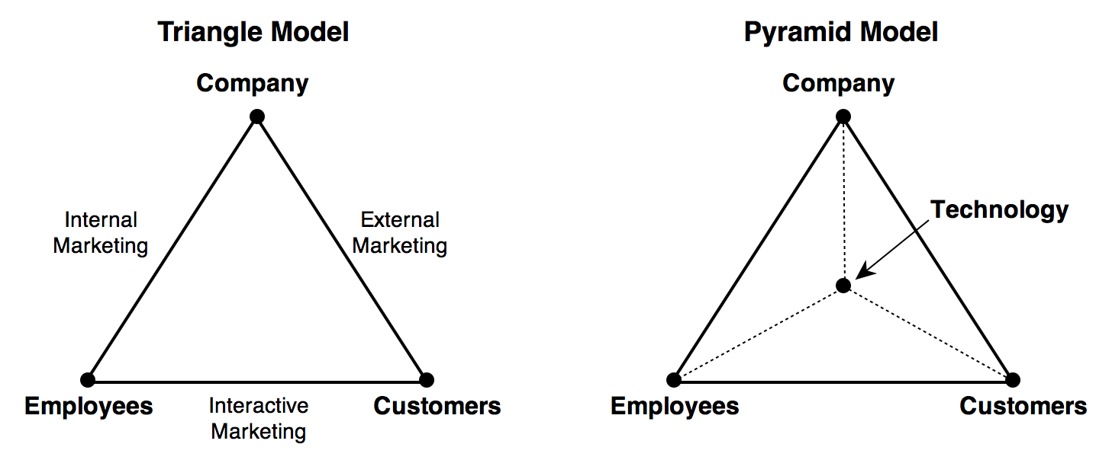
Figure 3 - Triangle and Pyramid Models of Services Marketing (Parasuraman 2000)
Fundamentally, “a combination of positive and negative feelings about technology underlies the domain of technology readiness” (Parasuraman 2000 p. 309). The qualitative work of Mick and Fournier (1998) served as a guide for the development of the TRI by providing positive and negative product experience domains that either make an individual inclined or disinclined to use technology. The TRI is comprised of 26 questions from four subscales that measure a variety of the positive and negative themes of technology usage. On the positive side, optimism appraises an individual’s feelings about whether technology offers “increased control, flexibility, and efficiency in their lives” and innovativeness measures an individual’s propensity to be a “technology pioneer and thought leader.” On the negative side, discomfort is a “perceived lack of control over technology and a feeling of being overwhelmed by it” and insecurity is the “distrust of technology and the skepticism about its ability to work properly” (Parasuraman 2000 p. 311). When these measures were used to evaluate consumers, a significant correlation was found between the TRI score and the use of high-technology products and services. Thus, the scales were shown to be reliable predictors of technology consumption behaviors.
To evaluate the construct validity of overall scale, three sets of questions were developed that measure an individual’s perceptions of technology-based products and services. Ownership and access as well as actual use of a variety of products ranging in depth of technological sophistication were measured. In addition, a number of futuristic technologies were described and the perceived desirability of engaging with these technologies was measured. The results showed that there were consistent correlations between an individual’s TRI score and their current engagement with and future interest in technology products, thus revealing a consistent pattern of results that lend further confidence in the TRI. Ultimately, an overall technology readiness index score is generated by averaging the scores of the optimism and innovativeness scales with the reversed scores for discomfort and insecurity.
A number of research studies have also shown the TRI useful for a variety of purposes. Specifically, the TRI has been shown to be an influencer of customer satisfaction and behavioral intentions with self-service technologies (Lin and Hsieh 2007) and it is a predictor of the importance of usability of technology products (Massey, Khatri, and Ramesh 2005).
While technology paradoxes, ambivalence, and technological readiness may help us understand what happens to shoppers as they engage technology, it doesn't explain entirely why shoppers may like or dislike any particular technology or where the technology-interaction experience fits within the entire gestalt of a shopping experience. For this we turn to customer value theory.

Customer Value Theory

Customer Value Defined
As Woodruff (1997) points out, customer value can have two meanings: the value of the customer to a business and the value that a customer finds in a product or service. In the context of this dissertation, we were concerned with the latter.
Early marketing thought rooted in economics, saw customer value as a bundle of utilities (Bass and Wilkie 1973). Specifically, value was seen as providing the customer form utility (the actual product and its features), place utility (making the product easier to obtain logistically), time utility (providing the product when it’s needed), and possession utility (transacting). But Holbrook (1999) rejected as illegitimate the economic notions of utilitarian value and their attendant assumptions. Instead, he saw customer value as an “interactive relativistic preference experience.” Customer value reflects the preference an individual has for something over something else, but the value itself does not reside within the product or service, but within the experience of interaction with the product or service. Consumer value is also relative to the consumer. It can only be compared to the value that an individual places on some other object and not the value someone else has for that object; it is personal and subject to individual likings and dislikings.
Fundamentally, customer value is a demand-side concept (Peteraf and Bergen 2003); it is determined by the customer’s use of the final product or service. The product or service can only propose value. Value is a by-product of the interaction experience, it is not embedded within the product or service itself (Vargo and Lusch 2004). This customer-centric viewpoint of value is nicely summarized by Woodruff’s (Woodruff 1997) definition: “Customer value is a customer’s perceived preference for and evaluation of those product attributes, attribute performances, and consequences arising from use that facilitate (or block) achieving the customer’s goals and purposes in use situations.”

Creation of Customer Value
The earliest scholars of marketing recognized that the principle concern of marketing and advertising was the creation of value (Moriarty 1923). To this day, this notion is still reflected in the official definition of marketing from the American Marketing Association (2007):
Marketing is the activity, set of institutions, and processes for creating, communicating, delivering, and exchanging offerings that have value for customers, clients, partners, and society at large.
The goods dominant view that holds that value is embedded in the product through its included bundle of economic utilities (Bass and Wilkie 1973) has given way to a more nuanced view. Because people buy things not for what they are, but what they mean (Bagozzi 1975; Levy 1959), value is generated through use, not as an attribute of the product or service to be consumed.
A newer dominant logic of marketing holds that products and services are actually bundled knowledge (operant resources) that do not have value per se, but only propose value that is co-created by the consumer (Vargo and Lusch 2004). This conception of value builds on the insights generated by research that conceives of marketing as a “continual social and economic process in which operant resources are paramount” (Vargo and Lusch 2004 p. 3). The success of firms is thus viewed as a test of value propositions made by firms through increased market orientation (Kohli and Jaworski 1990; Narver and Slater 1989) and a focus on superior customer value through marketing intelligence generation (Slater and Narver 2000).

Customer Value Determination
To understand how customer value is determined, it’s necessary to explore the more basic concern of human values. Rokeach (1973) developed one of the most widely cited frameworks for studying values. He conceived of values as “enduring beliefs concerning modes of conduct and end states of human existence that are personally and socially desirable” (Bagozzi and Dabholkar 1994 p. 334). In his framework, two classes of values were proposed: terminal and instrumental. Terminal values, or desirable end states of existence, were rank ordered using 18 adjectives (e.g., wisdom, equality, happiness, etc.). These represent the goals that individuals hope to achieve in their lifetimes. Instrumental values are the modes of behavior used to achieve the terminal values (e.g., courage, honesty, logic, etc.). Through Rokeach’s work we understand that a person’s terminal values (goals) and instrumental values (behaviors to achieve those goals) help explain and translate to universal psychological needs. Rokeach also demonstrated that terminal values (and their associated instrumental values) could be rank ordered in importance. These insights helped pave the way for future research on consumer values.
Building on Rokeach’s model, Gutman (1982) developed the means-end chain model to link perceived product attributes to consumer values. The means-end chain offers marketing managers “a way to position products by associating means (the physical aspects of products) with advertising that seeks to tie the consumption of products to the achievement of desired ends (valued states)” (p. 60). His means-end model is based on four assumptions of consumer behavior: (1) values guide choice patterns, (2) people cope with overwhelming choice by grouping products into sets or classes to reduce choice complexity, (3) all consumer actions have consequences (which are often unique), and (4) consumers associate specific consequences with specific actions.
While the means-end model was designed to describe how consumers “categorize information about products in memory” (Woodruff 1997 p. 142), Woodruff and Gardial (1996) adapted it to encapsulate the essence of customer value through their Customer Value Hierarchy (CVH).
A customer value hierarchy (CVH) is a representation of what an individual values in a product, service, or experience using increasing levels of abstraction. The levels are attributes, consequences, and desired end states.

Attributes
At the most concrete level are attributes. Attributes represent “what the product/service is, its features, and its component parts or activities” (Woodruff and Gardial 1996 p. 64). From a customer’s perspective, attributes are used to describe the product or service. A product such as a laptop computer might be described as having “a 5GHz processor, 4GB RAM, a 500GB hard drive” or a car wash service might include “pre-wash, wax, and hand dry.” Attributes are often “defined objectively, and there may be multiple attributes and bundles of attributes that comprise a particular product or service” (p. 64).

Consequences
At one level higher in abstraction than attributes are consequences. Consequences comprise the subjective determination of the product or service through use. They are “what the product does for the user, the outcomes (desired and undesired)” (p. 65). Consequences are typically how the consumer would describe the experience of a product or service. Someone using a new, faster laptop might describe the experience as: “It felt faster. I could get my work done more quickly.” A service experience might be described as “thorough, courteous, and efficient.” “While attributes describe the product, consequences are the results and experience that accrue to the customer as a result of product consumption and possession” (p. 66). Thus, consequences are subjective and internal to the customer.

Desired End States
At the highest level of abstraction and the top of the hierarchy are desired end states. Desired end states represent the “user’s core values, purposes, and goals” (p. 69). Desired end states are the ultimate ends served by the product or service experience. A desired end state achieved through product use or a service experience might reflect feelings of pleasure, freedom, security, etc.—those terminal values described by Rokeach (1973).
There are a few things to consider with regard to Customer Value Hierarchies. First, there is no single CVH for a product or service. Because value is determined through use or experience it is specific to the individual. Second, individuals may derive widely differing values from the same products or services. Third, while the abstraction at each level of the hierarchy may increase as we move from attributes to consequences and finally desired end states, stability increases as well. Desired end states or terminal values are among the most stable traits that individuals possess (Rokeach and Ball-Rokeach 1989). They tend to be dictated by culture and change very slowly. Consequences—or in Rokeach’s terms, instrumental values—are less stable than desired end states. While our desired end states may serve as somewhat fixed goals, the means with which we achieve those goals are more flexible. We may desire overall happiness, but there are many routes we can take to get there. Finally, the continually changing nature of products and services in the market mean that attributes are the least stable level of the value hierarchy.
CVHs are a key component of customer value determination, the identification of what customers want or value (Woodruff and Gardial 1996). Managers that focus solely on product or service attributes to address what they have determined their customers desire likely find themselves perpetually readjusting their strategies. Focusing higher on the CVH, however, provides a more stable footing for management decisions that likely have a greater long-term impact. These same considerations are made by retailers hoping to connect with and engage shoppers.

Shopper Value
While customer value is an important consideration for retailers, retailers need to think in more nuanced terms. More precisely, retailers are best served knowing that shoppers and customers are not equivalent. Customers are active buyers from the retailer through any channel, but shoppers are not necessarily customers. It is quite possible for someone to shop with a retailer without being a customer (i.e., browsing but not buying). Additionally, given the fact that attracting new customers has taken on critical importance for many retailers dealing with increasingly savvy shoppers (Twentyman 2012), this distinction takes on new importance.
With distinction between customer and shopper then, we must address the distinctions between customer value and shopper value. While customer value presupposes an interaction with a product or the consumption of a service, shopper value has no such assumption. Shopper value is concerned with the outcome of a shopping experience, which may or may not culminate in a purchase. Zeithaml (1988) considers value in the shopping context to be determined by “all factors, both qualitative and quantitative, subjective and objective, that make up the complete shopping experience” (p. 13). Jones (2012) defines shopper value more precisely as “the shopper’s perception of their desired outcome for a specific shopping occasion through the engagement of a product, brand, retailer, channel, and store location in combination, toward a purchase solution of an identified need.” Shopper value then is influenced by many elements interacting including the store environment and the elements within it. Thus shopper-facing technologies, with their visible role in the retail environment, function in the co-creation of shopper value (Vargo and Lusch 2004; 2007).
It is also important for retailers to realize there are two types of shopping value: utilitarian and hedonic (Babin, Darden, and Griffin 1994; M. A. Jones, Reynolds, and Arnold 2006). Utilitarian shopping value, reflecting the task-based and goal-oriented nature of utilitarian shopping (Bridges and Florsheim 2008), deals with the “acquisition of products and/or information in an efficient manner and can be viewed as reflecting a more task-oriented, cognitive, and non-emotional outcome of shopping” (M. A. Jones, Reynolds, and Arnold 2006 p. 974). Hedonic shopping, on the other hand, “reflects the value received from the multisensory, fantasy and emotive aspects of the shopping experience” (p. 974). How shoppers utilize shopper-facing technologies during the shopping task may influence the type of shopper value derived from the experience.

Environmental Theories
With many retailers focusing on the use of technology within their service environments, a more fundamental question needs to be addressed: How do environments, specifically retail environments, affect shopper behavior?
This question can be addressed at multiple levels. First, we look at how environments in general have the capacity to influence behaviors. Second, we look at how atmospheric and situational variables operate with respect to shopper behavior. Third, we look at service environments holistically and the concept of the servicescape. Finally, we explore research on highly experiential service environments and their relationship to technology-infused environments.

Environmental Influence on Individual Behaviors
For over 30 years a branch of psychology has focused on the relationship between environments and individuals. “Environmental psychology is the study of human behavior as it is influenced by and occurs within an environment” (Derjabo and Yasvin 1997 p. 392). From a retail perspective, environmental psychology is the basis for understanding how a retail environment may affect shopper behavior. Within environmental psychology, there is a dominant assumption that the environment and corresponding behavior “interact in ways that cannot be fully appreciated unless the setting is studied as a whole” (Bell and Sundstrom 1997 p. 376); the individual and the environment are a single system and to study them independently would not yield meaningful results. Thus, the study of the shopper within the retail environment from an environmental psychology perspective was most meaningful when approached holistically.
Bell and Sundstrom (1997) outline a number of theoretical perspectives within environmental psychology that can be used to evaluate behaviors holistically. Of the perspectives they describe, adaptation, stress, adaptation level, and overload are most likely to be encountered by shoppers.
Adaptation refers to the changes that individuals and/or environments must undergo to allow for the continued presence of the individual. This is most often seen in environments where individuals must deal with restricted space, noise, lack of privacy, and other variables. In the context of technology-infused environments, the researcher needs to be cognizant of technological stress that may challenge the shopper as he or she shops. Stress refers to those elements within the environment that challenge the individual’s ability to adapt. This could be unwanted visual or audio “noise” from the digital displays, technological devices causing obstructions to in-store shopping patterns through positioning or shopper crowding, the mere presence of technologies, etc. Understanding what in-store variables shoppers perceive they must adapt to and how they adapt to them (e.g., changing shopping paths, using technology instead of engaging with sales staff) provided important insights. Individuals also have an optimal adaptation level for different forms of environmental stimulation (Wohlwill 1974). For shoppers exposed to environments that fall outside this optimal level, additional stress may be encountered.
A related model in environmental psychology pulls from cognitive processing and information overload theories. Overload assumes that individuals have a limited ability to deal with external stimuli and when too much information or stimulus is present we focus on the most important or relevant environmental cues and ‘tune out’ competing cues (Eppler and Mengis 2004). As retailers begin to integrate more technologies in the retail environment, shoppers may exhibit the symptoms of information overload. Eppler and Mengis (2004) provide an exhaustive list of these symptoms, many of which may be operating in the retail environment including limited information search and retrieval strategies, arbitrary information analysis and organization, suboptimal decisions, and strenuous personal situations.
Finally, certain environments may also lead to behavior constraints, or the suppression of specific individual activities. Certain characteristics of an environment may lead to an individual’s lack of perceived control and this in turn results in subsequent attempts to restore control. Learned helplessness may result if these attempts at restoring control are unsuccessful. For a shopper who is uncomfortable with technology, forced use of technology or pervasive technologies that affect the shopper’s experience may result in behavior constraints.
Environmental psychologists also see individual behaviors dictated by two opposing forms of behavior: approach and avoidance (Mehrabian and Russell 1974). These behaviors have four dimensions:
- Stay – the physical desire to stay (approach) or leave (avoidance) the environment.
- Explore – the desire or willingness to explore one’s surroundings (approach) versus the desire to avoid an environment (avoidance).
- Affiliate – the desire or willingness to communicate with others (approach) or ignore others (avoidance).
- Work – the level of enhancement (approach) or hindrance (avoidance) of satisfaction with task performances.
Within a retail context, these dimensions would likely be associated with (1) patronage intentions, (2) browsing versus targeted shopping, (3) interaction with versus ignoring staff, (4) repeat-shopping frequency.
In a test of Mehrabian and Russell’s (1974) model within the retail setting, Donovan and Rossiter (1982) found that store atmosphere is “represented psychologically by consumers in terms of two major emotional states—pleasure and arousal—and that these two emotional states are significant mediators of intended shopping behaviors within the store” (p. 34). These intended shopping behaviors were “enjoyment of shopping in the store, time spent browsing and exploring the store’s offerings, willingness to talk to sales personnel, tendency to spend more money than originally planned, and likelihood of returning to the store (future patronage)” (p. 56).
Within the service literature, the idea that the service environment can affect shoppers’ behavior has been supported by numerous studies. By far the majority of these studies have focused on atmospherics and situational variables.

Atmospherics and Situational Variables
Kotler (1973) was one of the first marketing researchers to acknowledge that buyer’s react to the “total product,” not just the tangible product. What this means is that the variables that correspond to the selling of products also contribute significantly to the buyer’s experience and thus influence shopping behaviors; the product is just one element. Kotler coined the term “atmospherics” to describe how our senses impact our shopping experiences and defined it as the “conscious designing of space to create certain effects in buyers” (p. 50). Additionally, Kotler outlined a number of research propositions that underscore the importance of atmospherics. Of these, his first has been the most impactful in terms of driving future research: “Atmospherics is a relevant marketing tool mainly in situations (a) where the product is purchased or consumed; and (b) where the seller has design options” (Kotler 1973).
Kotler’s work led to new thinking about what comprises a “situation” and how marketers can leverage them to influence the consumer. Belk (1975) was first to address situational variables and their ability to affect consumer behavioral acts. Situational variables, by definition, are bound to a specific time and space. They represent “momentary encounters with those elements of the total environment which are available to the individual at a particular time” (Belk 1975 p. 157). Belk (1975) built on the stimulus-organism-response (SOR) framework (Woodworth 1927) to further our ability to explain consumer behavior as contextualized within a specific situation (see Figure 4).

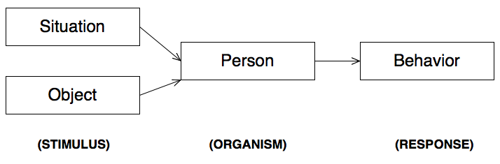
Figure 4 - SOR Framework (Belk 1975)

A specific consumer situation is comprised of “all those factors particular to a time and place of observation which do not follow from a knowledge of personal (intra-individual) and stimulus (choice alternative) attributes and which have a demonstrable and systematic effect on current behavior” (Belk 1976 p. 158). Addressing what he saw as an unsatisfying attempt to develop comprehensive situational descriptors by Merhrabian and Russell (1974), Belk outlined his factors into five groups of situational characteristics, which are consistent with a holistic definition of situation (Belk 1975):
- Physical Surroundings are the most readily apparent features of a situation. These features include geographical and institutional location, decor, sounds, aromas, lighting, weather, and visible configurations of merchandise or other material surrounding the stimulus object.
- Social Surroundings provide additional depth to a description of a situation. Other persons present, their characteristics, their apparent roles, and interpersonal interactions occurring are potentially relevant examples.
- Temporal Perspective is a dimension of situations that may be specified in units ranging from time of day to season of the year. Time may also be measured relative to some past or future event for the situational participant. This allows conceptions such as time since last purchase, time since or until meals or payday, and time constraints imposed by prior or standing commitments.
- Task Definition features of a situation include an intent or requirement to select, shop for, or obtain information about a general or specific purchase. In addition, task may reflect different buyer and user roles anticipated by the individual. For instance, a person shopping for a small appliance as a wedding gift for a friend is in a different situation than he would be in shopping for a small appliance for personal use.
- Antecedent States make up a final group of features that characterize a situation. These are momentary moods (such as acute anxiety, pleasantness, hostility, and excitation) or momentary conditions (such as cash on hand, fatigue, and illness) rather than chronic individual traits. These conditions are further stipulated to be immediately antecedent to the current situation in order to distinguish states of the individual that result from the situation. For instance, a person may select a certain motion picture because he feels depressed (an antecedent state and a part of the choice situation), but the fact that the movie causes him to feel happier is a response to the consumption situation. This altered state may then become antecedent for behavior in the next choice situation encountered, such as passing a street vendor on the way out of the theater.
While Belk’s model provides useful insight into those factors that comprise a situation and how those situational variables may affect the consumer, it includes some factors that are difficult to test (temporal perspective, task definition, and antecedent states). Atmospherics research (i.e., research that focuses specifically on manipulable elements within the retail environment and how these affect the shopper) has been a more productive area within marketing and retail literature as it has focused more on variables within the direct control of the retailer.
To date, Turley and Milliman (2000) provide the most exhaustive synthesis of research on atmospherics. They examined fifty-seven empirical studies to arrive at a list of experimentally manipulated atmospheric variables that have been empirically tested in the marketing and retail literature. They then divided these atmospheric variables into five broad categories according to previous research. These categories, each with variables that have been researched, are exterior (store front, marquee, entrances, display windows, building architecture, parking, and surrounding area); general interior (flooring/carpeting, lighting, scent, sounds, temperature, cleanliness, fixtures, wall coverings, and cash register placement); store layout (floor space allocation, product groupings, traffic flow, department locations, and allocations within departments); interior displays (product displays, racks and cases, posters, signs, cards, and wall decorations); and human variables (crowding, customer characteristics, employee characteristics, and employee uniforms).
Whereas Turley and Milliman’s efforts codifying atmospheric variables and their effects on shoppers is exhaustive, the research to date has focused on investigating atmospheric variables independently and not in the holistic manner that environmental psychologists have determined is necessary to provide meaningful insights (Bell and Sundstrom 1997). Bitner (1992) addressed this shortcoming by integrating theories and empirical findings from a number of diverse disciplines to build a conceptual framework that describes how manmade, physical surroundings have the ability to affect both consumers and frontline service employees. Bitner calls this environment the servicescape.

Servicescapes
While the retail environment has been shown to influence an array of consumer behaviors, a lack of empirical research and theoretical frameworks addressing the role of physical surroundings in consumption settings have inhibited a broader understanding of the effects of the many facets of the service environment. Bitner (1992), confronting this absence, developed both a typology of service environments and a conceptual framework of environment-user relationships in service organizations building on theoretical perspectives from environmental psychology, marketing, organizational behavior and other fields.
As Bitner points out, approach and avoidance behaviors (Donovan and Rossiter 1982; Mehrabian and Russell 1974) facilitated by the service environment have a high level of influence on the success (or failure) of shoppers’ ability to achieve their goals. This underscores an important aspect of the servicescape: the first step in the design of a servicescape is to “identify desirable customer and/or employee behaviors and the strategic goals that the organization hopes to advance through its physical facility” (Bitner 1992 p. 62). Thus the servicescape is not only crucial for facilitating the achievement of shoppers’ goals, but also the organizational and marketing goals of the retailer.
The servicescape also serves as a “visual metaphor” for a retailer’s complete offering and it acts “as a package, similar to a product’s package, by conveying a total image and suggesting the potential usage and relative quality of the service” (p. 67). Thus, the image that the retailer projects through all aspects of the retail environment, including the deployment and use of technology, also affects the shopper’s perception of the retailer.
Bitner’s servicescape typology and framework stimulated a great deal of research on the impact that the service environment has on the shopper and its role in achieving organizational goals. Servicescapes have been shown to reflect quality (Reimer and Kuehn 2005), impact loyalty intentions (Harris and Ezeh 2008), impact how welcome disabled shoppers feel (Baker, Holland, and Kaufman-Scarborough 2007), and used as a tool to build long-lasting relationships with consumer (Babin and Attaway 2000).
Later research extended the servicescapes concept to include thematic elements that play a part in defining how the servicescape is perceived. These servicescapes reflect a new breed of highly experiential service environments.

Highly Experiential Service Environments
Retailers have long understood the value of using the retail environment as a mechanism for creating impressive customer experiences. “Consumption palaces” (Benson 1979; Kotler 1973) from the mid-1800s such as Harrods in London or Marshall Field’s in Chicago were world famous for their extravagant service environments. As modern retailers are challenged to attract increasingly sophisticated shoppers, recent trends in retail design show that retail environments designed to impress and entertain may be old, but they have certainly not been forgotten. In fact, a variety of these types of environments have been identified.
Sherry (1998) expanded on Bitner’s servicescape work to create a thematic typology of servicescapes along two dialectical dimensions (see Figure 5). The first dimension concerns the tractability or malleability of the marketplace. At one end is the natural environment, the found or preexisting surroundings; at the other end, the cultural environment, what is designed and built. Moving from the natural to cultural on this dimension, marketplaces become more malleable and adaptable. The other dimension is defined by the tangibleness of the marketplace. At one end, the material and physical; at the other, the ethereal or metaphysical. Moving from the physical to ethereal on this dimension, marketplaces transform from place to non-place, somewhere to nowhere.

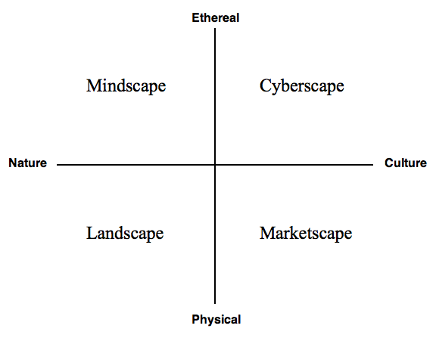
Figure 5 - Servicescapes (Sherry 1998)

When thinking about these two dimensions as overlapping—one horizontally, the other vertically— a matrix of four cells can be envisioned: natural-physical, cultural-physical, cultural-ethereal, and natural-ethereal. Each cell can be defined in terms of different servicescape types (see Kozinets et al. 2002 for examples of each):
- Landscape (natural-physical) – wilderness and outdoor servicescapes;
- Marketscape (cultural-physical) – created spaces, buildings, evocation of foreign cultures;
- Cyberscape (cultural-ethereal) – information and communications technology; virtual communities;
- Mindscape (natural-ethereal) – abstract concepts, fantasy, and spirituality.
The important thing to take away from these different servicescapes is the importance of the theme underpinning each. For example, the landscape theme of a river rafting servicescape creates a narrative that is central to its evaluation by its participants (Arnould and Price 1993). In many instances, these themed servicescapes also facilitate hedonic experiences with entertainment facets playing a contributing role (Kozinets et al. 2002).
Entertainment has also asserted itself in nearly all facets of the economy (Wolf 1999), with shopping transformed from a mundane activity to something part entertainment, part consumer activity, what Wolf (1999) terms ‘shoppertainment.’ The service environments that attract shoppers looking for entertaining experiences must engage shoppers by paying “ever more detailed attention to esthetics and to the processes by which consumers make meaning out their physical experience of place” (Kozinets et al. 2002 p. 17). This reflects a shift in thinking from an information processing model of consumption practices to an experiential model concerned with the pursuit of “fantasies, feelings, and fun” (Holbrook and Hirschman 1982).
The retail trend that most embodies themed servicescapes and shopper entertainment is the themed flagship brand store (Kozinets et al. 2002). These servicescapes are designed to build or reinforce the brand image through “communicative staging” (Arnould, Price, and Tierney 1998) in an entertainment-oriented environment.
Take, for example, a recently opened AT&T flagship brand store in the heart of Chicago. What makes this particular store interesting is that the predominant theme of this retail environment is technology. The store features over 100 digital displays; an 18 foot tall “Connect Wall” that projects product information, corporate information, and branding to shoppers both inside and outside the store; interactive tables; and sales staff with mobile point-of-sale tablet computers (Gurman 2012). The technology on display by far surpasses any other communication services provider’s retail environment.
But this example does not fall neatly within Sherry’s (1998) servicescape matrix. As technologies—especially personal technologies such as mobile Internet devices—pervade the retail environment, shoppers are increasingly both in-store and online simultaneously (Houliez 2010), interacting with both marketscape and cyberscape. While not all technology-infused retail environments are necessarily flagship brand stores, many leverage technology for both entertainment and branding purposes.
So where does this leave us? It seems that we know that shoppers may experience paradoxes as they engage technologies along the path-to-purchase, that they may feel ambivalent towards some of that technology, that their level of technology readiness affects their experience with technology, that those experiences may make them value their shopping experiences more or less, and that the retail environment contributes to shopping outcomes. But in truth, we’re stretching these concepts into the shopping context and don't really know. Yet, as stated in Chapter One, numerous retailers and brands are adopting technology at a breakneck pace, acting on the assumption that more technology is better. We were left with a level of apprehension after reviewing the extant research that perhaps we should slow down and explore this deeper, which leads us to the need to address the objectives that we set out in Chapter One. First, to better understand the role that technology plays in the shopper’s in-store shopping experience and second, how technologies impact shopping outcomes.
Our first research objective called for an inductive, theory-building study that explored the shopper’s experiences within technology-infused retail environments. Our second research objective called for a test of the Mick and Fournier framework adapted to this context. This dissertation aims to address both objectives through two studies. In Chapter Three we present the methodology and findings of the former through a qualitative ethnography. Chapter Four addresses the latter by presenting the methodology and findings of a model-testing survey.

chapter 3 – ethnography
Study one is an inductive, qualitative investigation with the goal of discovering behaviors that occur in natural settings (Ross 2011). Within this context, qualitative research methodologies help uncover the meaning that research participants ascribe to experiences and build an understanding of an experienced phenomena from the point of view of the participant. Ethnographic and other forms of qualitative inquiry are well entrenched within the marketing discipline (Arnould and C. J. Thompson 2005; Arnould and Wallendorf 1994; C. J. Thompson, Locander, and Pollio 1989).
In this study, the focus of this qualitative inquiry was on the experience of the shopper in a technology-infused environment. Given the lack of theory and extant research on this topic, the need to describe this phenomenon and develop theory around it, and the inability of quantitative methods to address this phenomenon, a qualitative approach was most appropriate to build new knowledge in this area. To achieve this, we needed to understand the retail environment from the shopper’s perspective. The best qualitative research approach suitable for this study was ethnography and the following research objective and questions were addressed via this qualitative study:
Objective: Understand how shopper-facing technologies affect shopper behaviors, perceptions, and attitudes within a retail environment:
- Why and how are shoppers using technologies while shopping?
- Which technologies serve what purposes along the path-to-purchase from the shopper’s perspective?
- How do technological environments impact the shopper?

Methodology

Ethnography
Ethnography is a qualitative research methodology originating from anthropology. Its goal is to provide “thick descriptions” (Geertz 1973; Ross 2011) of the activities of groups or cultures. Ethnography can be “any full or partial description of a group (ethono – group, graphy – description), as a means of identifying common threads” (Goulding 2005 p. 299). Ethnography has few limitations in terms of the ways that cultural groups may be defined for the purposes of description (Boyle 1994). In marketing, however, ethnographies of consumption groups are the norm. Defining groups by the similarities of their consumption experiences or consumption interests is very common. Indeed, a broad spectrum of research within marketing exists which sheds light on consumer groups including the consumption of high-risk leisure activities (Celsi, Rose, and Leigh 1993), brand communities (McAlexander, Schouten, and Koenig 2002), consumption rituals (Wallendorf and Arnould 1991), consumer acculturation (Peñaloza 1994), extraordinary service encounters (Arnould and Price 1993), and many others.
Ethnography has a number of defining characteristics that make it a unique method of knowledge discovery. Arnould (1994) outlines a number of features of ethnography that differentiate it from other methods of knowledge generation. One, “ethnography gives primacy to systematic data collection and recording of human action in natural settings” (p. 485). The patterns of social action that the ethnographer seeks to reveal are deeply ingrained within specific cultural settings. The ethnographer must go to the setting; the setting will not come to the ethnographer. Two, it “involves extended, experiential participation by the researcher in a specific cultural context, referred to as participant observation” (p. 485). To best observe the phenomenon in question, the ethnographer must be immersed in the same experiences as the participants, thus increasing the likelihood of exposure to defining moments in consumption experiences or revelatory incidents. These revelatory incidents are critical moments that “stimulate real-time interpretative insights and launch systematic analysis of additional data” (p. 485) by the ethnographer. Third, “ethnography produces interpretations of behaviors that the persons studied and the intended audience find credible” (p. 485). The subjects of ethnographies rarely view their experiences through the dispassionate, analytical lens that academic researchers often wield. Any interpretation of a cultural consumption experience should seem both credible and trustworthy to the subjects of the ethnography. Finally, ethnographies should incorporate “multiple sources of data…to generate varying perspectives on the behaviors and context of interest” (p. 485). This is in direct contrast to the positivistic perspective, where multiple sources of data are used to achieve a convergence of findings in the manner of Campbell and Fiske’s (1959) multi-trait, multi-method matrix.
Ethnographic research provides the ability to understand the shopper’s experience from a more holistic perspective (Bell and Sundstrom 1997; Healy et al. 2007). Much of research that investigates the retail environment tends to focus on individual atmospheric variables and how these may affect the shopping experience (Turley and Milliman 2000). Few studies try to capture the experience of the shopper in the retail environment, how they perceive it, and what it means to them.
One study that is relevant both in terms of its use of ethnographic methods and its pertinence to the present research is a study of themed flagship brand stores (Kozinets et al. 2002). The authors used a long-term ethnographic field study to understand how retail brands utilize highly-engaging retail environments to connect with customers. One interesting futuristic theme that the authors develop is the idea of cyberscape themed brand stores. This article is one of the first to discuss the hybridization of online and physical retail, though more from the perspective of making an “at-home e-commerce expedition more like a ‘real’ shopping trip” (p. 26). It’s clear though that some retailers have embraced this hybridization by encouraging shoppers to utilize technologies that bring the Internet into the retail environment. Shoppers that utilize Internet-accessible technologies while they shop exist within customized lived spaces where online and offline experiences are interwoven (Houliez 2010). This creates a unique experience for the shopper that has received very limited attention in academic research.
This qualitative study examined shoppers as they engage with technologies in the retail environment. These technologies may or may not have the ability to connect to the Internet, but each is capable of changing the shopper’s perspective of the shopping experience as the shopper engages with these technologies and experiences a technology-infused retail environment.

Study Context
As we were concerned with the effects of technology on the shopper’s retail experience, our observation of shoppers needs to take place within a retail environment. Observing and speaking with shoppers in this natural setting maximized the opportunity to view shopper-technology interactions and potentially valuable spontaneous behaviors.
The retail environment that was used as the backdrop for this study was a national office supply retailer. This retailer was in the process of opening new stores and upgrading a number of current stores to include new technologies designed to attract, assist, and inform shoppers including digital signage (in-store promotion and wayfinding), interactive displays, and other devices to create a more technologically rich environment.

Sampling and Description of Participants
Participants were enlisted during three data collection periods. According to Arnould (1994), effective market-oriented ethnographic data interpretation begins with an effective data sampling plan. An effective data sampling plan incorporates three important facets. One, observation should occur across multiple consumption units. For this dissertation that means that shoppers were observed interacting with as many in-store technologies as possible. Two, within those consumption units, the behaviors demonstrated were captured. Shoppers may interact with the same technologies in widely varying ways. For each technology, it was important to capture the widest range of behaviors. Three, multiple forms of data collection were used. In order to ensure that maximum diversity of technology interaction was captured, this study used multiple forms of data collection.
An effort was made to ensure that a wide variety of shoppers were represented in this study. Shoppers of varying age, gender, and ethnicity were enlisted. In addition, sampling took place during a variety of times of day and days of the week to insure another layer of shopper diversity. A snowballing approach was used where the researcher requested additional potential participants from existing study participants. Further, theoretical sampling (Glaser 1978), an emergent process by which further research directions unfold based on collected data and insights generated by its analysis, was used. For example, existing study participants were helpful in suggesting future observation locations based on their past experience as shoppers.
In order to better understand the effects that a technology-infused retail environment could have on the shopper, it was necessary to evaluate the baseline experiences of shoppers in similar, but less technology-infused environments. We interviewed and observed shoppers with experience in a store with a similar layout to the new technology-infused store and who were demographically equivalent to shoppers in the new location. Thus, we interviewed and observed shoppers in at least one current retail format location in addition to the new technology-infused location.
Data was collected for five days at a retail location with shopper demographics that were similar to the other two locations. The first location served in the capacity as ‘control’ store from the standpoint that this store had not undergone a technology upgrade. This allowed us to compare shopper behaviors and comments from a standard store to one with significant technology upgrades. We planned on enlisting forty shoppers at the control location and approximately two hundred between the two technology-infused retail locations. The large number of participants was necessary to ensure the saturation of emergent themes. All participants received an incentive for participation in the study.

Data Collection
Ethnographic data can be collected in several ways. For example, observation itself can be both participative and non-participative. Participant observation is “extended, experiential participation by the researcher in a specific cultural context” (Arnould and Wallendorf 1994). With it, the researcher embeds himself into the culture in question, effectively becoming a member so they become privy to the inner workings of the culture and are granted “backstage” access (Goffman 1959). Participant observation gives the researcher access to complex behavioral details of consumption, group decision-making heuristics, and cultural consumption norms and values.
In non-participant observation, the researcher “observes and records naturalistic behavior but does not become a part of unfolding events” (Arnould and Wallendorf 1994). This is sufficient for circumstances where the researcher does not need to become immersed in the phenomenon to extrapolate useful information through observation. Non-participant observation is also useful when recording the behaviors of small groups. Industry has utilized non-participant observation to much success. For example, Gillette is well-known for having a lab space for men and woman to shave using Gillette’s products and have their actions and opinions recorded (Abelson 2009). These observational settings provide relevant information to brand manufacturers that they can use to improve their products and relationships with customers. Retailers have also benefitted from similar ethnographic studies.
Realistically, however, the distinction between participant and non-participant observation is not cut and dry. Rather there are levels of participation that can be employed to great effect without having to rely on strict participation or non-participation techniques. In retail ethnographies there are a number of techniques that can be used to observe and record individual shopper’s interactions with technology while they shop. Healy et al. (2007) outline a number of techniques that employ varying levels of participation. Each is described along with its benefits and drawbacks below.

Shopper Observations
Mystery shopping gives the researcher the opportunity to covertly observe shoppers while they interact with the store. Traditionally, mystery shopping entails a retailer or associated firm hiring consumers to serve as agents who shop at specific retail locations to gauge the quality of the shopping experience and/or verify any expectations set by the retailer through any promotions or branding efforts. This same technique can be used to study the shopper unobtrusively instead of the retailer and its employees.
The primary benefits of the mystery shopper technique are the assurance that the shopper behaved naturally and thus there is more confidence in the authenticity of the observed behaviors and there is heightened realism as the researcher observes the reactions of the shopper firsthand. Unfortunately, being a form of deception, mystery shopping has drawn criticism for pushing ethical boundaries (Ng Kwet Shing and Spence 2002).
Stafford and Stafford (1993) outline a number of instances in which covert techniques may be used ethically. Specifically, when the type of information sought is of overriding public importance, when alternate techniques would not be able to provide comparably accurate and reliable information, and any deception would not put innocent people at risk. While mystery shopping might provide useful information in the context of this study, our desire to interview subjects would necessitate the admission of our deception. This would likely break the trust with the shopper to the degree that further interaction would be broken off or any data collected would be compromised.
Interviewing sales personnel is another technique that can be used to understand the shopper’s in-store actions. Sales personnel are often in the best position to know what shoppers do within the store. Interviewing them to uncover the patterns of shopper behavior may often be the quickest and least expensive (in terms of time and energy) method of data collection. Interviewing sales personnel has the benefits of limiting any intrusions into the shopper’s experiences, it helps the researcher triangulate the resulting themes or patterns of experience taking place in the retail environment, and the researcher can also access additional information about the goings-on in the retail environment that cannot be achieved any other way. Unfortunately, sales personnel are likely not trained in qualitative research techniques so their take on what shoppers are doing may be off base or worse, biased. Sales personnel may also question the nature of the research and be suspicious of the researcher’s motives and either provide the information that they believe the researcher wants to hear (social acceptability bias) or they may change their interactions with shoppers. Ultimately, this method of ethnographic data collection is only partially appropriate for this study as the actions of the shoppers need to be observed first hand to record the specific type of technology engaged with and the shopper’s thoughts on what that technology added or detracted (or both) from the shopping experience. Sales personnel were not be officially interviewed per se, but we attempted to utilize their insights on shoppers. That said, sales personnel are a part of the environment in which shoppers engage and therefore could not be ignored.
Informant video diaries involve the research participant recording his or her thoughts about in-store experiences, usually at home, without the intrusions of the researcher. These recordings are usually longitudinal, which allow the researcher to capture variability in experiences and shopper’s perceptions over time. This method gives access to the inner thoughts and insights of the shopper with minimal interference from the researcher and allows the participant to recall experiences without the potentially biasing effects of an interview. The downsides to this method of capturing shoppers’ perceptions of the shopping experience are that it relies on the shopper to accurately recall the experience, shoppers may choose not to discuss topics relevant to the research in question, they may ‘perform’ for the camera, the impression of the holistic retail experience may be lost due to the change of settings, and unconscious behaviors are not captured. This method is unsuitable because it would separate the shopper from the retail environment and the perceptions of the holistic experience we seek to capture. This separation would likely reduce the accuracy of their recalled shopping experiences, specifically both their overt and unconscious use of technology during shopping.
Finally, accompanied shopping, otherwise known as shop-alongs, consists of the researcher accompanying the shopper while they go about the business of shopping and giving the researcher the opportunity to ask questions and clarify behaviors. The primary benefits of the technique are that it allows for the real-time observation of a shopping event in a variety of contexts; the researcher has more immediate access to and closer insights of shoppers’ behaviors, thoughts, and feelings; and behaviors and reactions can be immediately clarified so important details were acknowledged and recorded.
This study incorporated a number of techniques to insure the broadest range of behavioral constellations were captured, a hallmark of ethnographic studies. By using multiple data collection mechanisms, gaps that could form due to over-reliance on a single form of data collection were ameliorated, a practice endorsed in multiple qualitative research traditions (Arnould and Wallendorf 1994; Denzin and Lincoln 1998; Glaser and Strauss 1967). Specifically, this study utilized accompanied shopping, verbal participant reports, and participant interviews.
As described above, accompanied shopping was used to observe the shopper as he or she went about the shopping task. Specifically, the researcher walked along with the shopper and engaged the shopper only when a specific behavior needed clarification. While accompanying the shopper, the researcher recorded behaviors, interactions, and other details utilizing a series of shorthand codes to ensure speed and accuracy. These were recorded in field notes for later interpretation. Additionally, the shopper was given the choice of two accompanied shopping methods: Lag behind and clarify later or shop side-by-side and discuss. For shoppers that required more privacy or feel self-conscious, lag behind and clarify later allowed the researcher to observe the shopper, make note of important interactions or activities and make clarifications on these activities and behaviors later. Alternatively, shoppers could shop side-be-side and discuss their shopping activities with the researchers as they shopped. Additionally, shoppers were asked for permission to have their shopping activities video recorded for later analysis.
Verbal participant reports are a means by which the participant communicates what they are thinking as they go about the shopping task. Typically, the participant would talk into an audio recording device and “think out loud.” In other words, the shopper articulates his or her thoughts verbally while shopping. Verbal reports allow researchers to sample phenomena that are “inherently elusive and difficult to study” (Hollan 2001). Further, these recordings are later transcribed and their contents analyzed with interpretive methods (see Data Analysis below) providing an important source for shopper perceptions and meaning. In this study, to reduce the cognitive load on the shopper, the researcher held the audio-video recording device and prompted the shopper to verbalize their thoughts when the shopper needed reminding.
Finally, the participant interview was used to specifically address the meaning behind certain shopper actions, the shopper’s perception of the shopping experience and how technology impacted his or her shopping experience, and other pertinent topics that could not be gleaned from observing the shopper during accompanied shopping or from the verbal participant reports.
Below is an outline describing the typical interactions with a participant that took place.
- Shoppers, intercepted at the store entrance, were given a brief orientation and told that the researcher will accompany him or her while shopping and record his or her verbalized thoughts.
- The researcher accompanied shoppers during the shopping task and video recorded the shopping task while reminding the shopper to verbalize their thoughts as they shop.
- After the shopping task was completed, the researcher asked the shopper a number of questions from an interview guide.
- Shopper received incentive for participation.

Depth Interviews
Ethnographies involve more than observation and casual interviews along the way. Depth interviews were employed post-shopping trip. Interviews can be often catalyzed by an observed behavior on which the researcher wishes to gain insights. They can also be deeper and longer conversations with members of the micro-culture under study. In these instances it is helpful to drawn upon techniques such as the grand tour interviewing technique (Spradley 1979), phenomenological interviews (C. J. Thompson, Locander, and Pollio 1989) and long interview guidelines (McCracken and McCracken 1988).
In this study, shoppers who agreed to participate engaged in a brief interview prior to their shopping trip to discuss general motivations for shopping at the target store and overall perceptions, and to collect demographic information. This pre-interview did not cover technology issues however, so as to avoid any biasing effects. Following the shop-along experience, a depth interview took place to probe the specific shopping experience. In this interview, technology interactions were probed as well as other experiences with technology in retail environments the participant may have had and be able to recall.

Non-Shopper Observational Data
In addition to observing shoppers as they interacted with technology, sales personnel, and other shoppers, data was collected about the environment itself. Planograms were captured to make note of numerous environmental factors, but primarily the extent of technology within the store. This was done for the store location from which current shoppers were drawn as well as the new store location. Anything deemed relevant for the study context was captured. Images (photographs) documented many aspects of the store environment especially shopper-facing technologies.

Data Analysis
Analysis in ethnography is an emergent and ongoing process, without a specific stage or form. “Analysis takes place throughout any ethnographic endeavor, from the selection of the problem to the final stages of writing” (Fetterman 2003 p. 110). In essence, ethnographic data analysis occurs in the field as observation and interviews occur and thoughts are recorded in field guides and codes are used to record behaviors and themes. Analysis also occurs when the researcher exits the field, when triangulation of data and identification of patterns across the many forms of data collection occur. Finally, analysis continues during the writing process when insights crystallize and patterns of behavior form a story that provides value to the reader.
Given the variety of methods used to collect ethnographic data and the fact that data analysis occured throughout the ethnographic process, an ethnographic we relied on mechanisms to store and retrieve these important data. The primary methods used were coding and troping.

Coding
Codes are shorthand notations for specific behaviors that occur across the sample within the ethnographic study. Codes are created as the researcher recognizes important behaviors or participant thoughts and moves to record these during data collection. The ethnographer can also create codes as he or she reads the field notes or transcripts of interviews (i.e., the data) and “notices recurring word usage, phrases, complex behavioral sequences, or meanings” (Arnould and Wallendorf 1994 p. 498). Codes do not solely mark the recurrence of these things in emic language, however; codes serve as the basis for a broader interpretation that links these codes across data collected by different means. In other words, codes are used to build constructs ‘thickened’ by triangulation across multiple forms of data collection (Fetterman 2003). Often these patterns are a result of a comparison of these data sources where convergence in meaning is found, but also where divergence can be used to expand meaning.
All depth interviews were video recorded and transcribed verbatim. The verbatim transcripts were interpreted and coded using a qualitative data analysis software package. Codes were explored and collapsed where appropriate into what may be referred to as themes in phenomenology or categories in grounded theory research. These categories augment detailed descriptions of behaviors, perceptions, and meaning and they served to provide holistic insight into the group and its individual members. That said, this study was primarily interested in shoppers’ engagement with technology. Given the literature that led to the development of our model being tested in Study Two, interpretation was careful to note tensions and paradoxes created by technology as freely described by shoppers as well as coping strategies shoppers use.

Troping
A set of behaviors can often have co-constituting meaning for individuals. This synergy between behaviors is known as a “quality space” (Arnould and Wallendorf 1994). Ethnography “presumes that important cultural values or meanings are expressed by several behaviors in a quality space” (Arnould and Wallendorf 1994). Thus, linking behaviors becomes a crucial component of the data analysis process in ethnography. This process is known as troping.
In troping, rather than merely determining if a code may be assigned to an additional behavior, meaningful symbolic links between codes—tropes—are used to determine whether there are “systematic relations of contrast and association among behaviors” (Arnould and Wallendorf 1994). This process essentially turns codes into constructs (embodied identifiable themes).
It is the combination of coding and troping that creates “richly textured interpretation” that Geertz (1973) had in mind when he coined the term “thick description.”

Trustworthiness of Ethnographic Data
A number of criteria can be evoked to determine the trustworthiness of qualitatively captured naturalistic data (Lincoln and Guba 1985; Wallendorf and Belk 1989). These vary significantly from the traditional positivistic criteria of internal validity, external validity, reliability and objectivity. These naturalistic criteria are credibility, transferability, dependability, confirmability, and integrity.

Credibility
Lincoln and Guba (1985) provide a number of techniques to ensure credibility of naturalistic research findings. One, researchers should engage in credibility producing activities. These include prolonged exposure to the subject of study, persistent observation, and triangulation. From the perspective of this dissertation, sufficient exposure means that the phenomenon in question (shoppers’ engagement with technology in a technology-infused environment) was viewed first hand to a degree that the “culture” of shoppers within these environments is experienced and learned from a wide variety of perspectives and contextual factors. Persistent observation “is to identify those characteristics and elements in the situation that are most relevant to the problem or issue being pursued and focusing on them in detail” (Lincoln and Guba 1985). Breadth of understanding is achieved through prolonged observation, depth is achieved through persistent engagement. Finally, triangulation helps build a deeper understanding of the phenomenon by using multiple and distinct sources, methods, and investigators. Triangulation by source means that “multiple copies of one type of source (such as interview respondents) or different sources of the same information (for example, verifying an interview respondent’s recollections about what happened at a board meeting by consulting the official minutes of that meeting” (Lincoln and Guba 1985). Triangulation by method encompasses the use of different data gathering methods (e.g., observation, interviews, questionnaire, etc.) to capture the breadth and depth of the phenomenon via different means. Different investigators can also be enlisted to ensure a higher level of credibility with the interpretation of the study findings.
Two, peer debriefing serves as an external check on the inquiry process. Peer debriefing is “exposing oneself to a disinterested peer in a manner paralleling an analytic session and for the purpose of exploring aspects of the inquiry that might otherwise remain only implicit within the inquirer’s mind” (Lincoln and Guba 1985). Essentially, it is the interaction with a dispassionate third-party playing the devil’s advocate role to insure that the researcher’s biases are exposed and bases for interpretation fully understood. The peer debriefing also provides an early outlet for the researcher to think through hypotheses and/or themes that emerge from the findings and allow the peer to provide early feedback that may help steer the future direction of the research. Finally, peer debriefing provides an opportunity for the researcher to connect with someone else during the lonely process of data collection and serve as a sounding board to help defuse negative emotions that may impede successful research.
Three, negative case analysis is a process by which the researcher casts a critical eye toward the emergent hypotheses and refines them so they include all observed examples without exception. It “eliminates all ‘outliers’ and all exceptions by continually revising the hypothesis at issue until the ‘fit’ is perfect” (Lincoln and Guba 1985). This is especially helpful when defining cultural activities so only those activities that are universal are included. Perfect fit, however, is too difficult a hurdle to clear (Wallendorf and Belk 1989). Negative cases at the very least do help researchers stay cognizant of additional factors affecting their hypotheses.
Four, referential adequacy entails the earmarking of a portion of the research data for others to use as a means to verify the results or hypotheses drawn from the larger study. In its original intent, referential adequacy was to be data of electronic form such as video footage, but there are no requirements as such. This approach to establishing credibility has a major downside in that ethnographic data is often expensive in terms of time and energy (and often funds) to gather and setting aside data for this specific purpose may be too difficult for the researcher. Second, as researchers do not gather data with representativeness in mind, the data sharing for referential adequacy may be difficult to establish as representative of the data from the larger study.
Finally, member checks is the process by which “data, analytic categories, interpretations, and conclusions are tested with members of those stakeholding groups from whom the data were originally collected” (Lincoln and Guba 1985). It allows the researcher to verify the intent of the participants actions and words, it gives the participant the opportunity to correct any errors or misconceptions of interpretation, it may stimulate additional insight on the part of the participant, it puts the participant on record with respect to the correctness of the results, it provides the researcher the opportunity to summarize their findings, and finally, it gives the participant an opportunity to assess the overall accuracy of the findings (Lincoln and Guba 1985).

Transferability
Wallendorf and Belk (1989) provide a critique of Lincoln and Guba’s direction on the issue of transferability by describing their approach as “too facile” and only suitable for in-depth descriptive ethnographies of a single site. Wallendorf and Belk do not, however, offer additional direction to help the ethnographic researcher who seeks to create insights that are stable across research contexts. The three techniques Wallendorf and Belk (1989) suggest—and which were utilized for the “Consumer Behavior Odyssey” studies (Belk, Wallendorf, and Sherry 1989)—are triangulation across sites through purposive sampling, seeking limiting exceptions, and emergent design.
With triangulation across sites through purposive sampling, Wallendorf and Belk (1989) describe visiting multiple similar locations where the phenomenon in question could be viewed under different contexts. The locations were also visited at different times of day, different days of the week, and in three different months to incorporate as much variation in the findings as possible. The variation serves to build an overall understanding of the phenomenon, by focusing the research on “explanatory concepts rather than merely on producing thick descriptions of particular sites” (Wallendorf and Belk 1989).
By seeking limiting exceptions the researcher is able to define the bounds of the phenomenon and build an understanding of why the phenomenon in question exists in some circumstances but not in others. Such understanding will often lead to further data gathering at additional sites to test the predicted boundaries of the phenomenon.
Finally, emergent design infers the “continual refinement” of the methods used to gather data and the sensitivity to the variability of the contexts within which the phenomenon occurs. By its very nature, emergent design occurs as a result of being open to new paths of knowledge discovery and not following an overly strict prescription for data gathering.

Dependability
Lincoln and Guba (1985) suggest a number of techniques to enhance the dependability of ethnographic research. Among these, they give the dependability audit the most attention. Under this audit process, an external auditor is enlisted to review the data and associated inferences to determine dependability. Wallendorf (1989), however, points out that the dependability audit, while useful for confirmability, falls short of the mark with regards to dependability because the audit fails to “address the issue of change over time” (p. 11).
To address this limitation, Wallendorf recommends a longitudinal approach by making observations over time and fully explaining any changes that may be evidenced. This does not preclude periodic interpretations and write-ups of the ethnographic data, but is “meant to temper the cross-sectional bias inherent in social science research” (p. 11).

Confirmability
Lincoln and Guba (1985) ask, “How can one establish the degree to which the findings of an inquiry are determined by the subjects (respondents) and conditions of the inquiry and not by the biases, motivations, interests, or perspectives of the inquirer?” Confirmability seeks to address this question. Wallendorf, while largely agreeing with Lincoln and Guba’s advice on confirmability, provides three techniques for achieving adequate confirmability: triangulation, reflexive journals, and the confirmability audit.
Triangulation concerns the use of multiple research team members for data collection. Given that it would be extremely unlikely for two researchers to share the same biases, having multiple researchers from a variety of backgrounds and of both genders provides the best chance of confirmability if the researchers arrive at the same conclusions independently. Triangulation of this sort provides “intersubjective certifiability of findings” (Wallendorf and Belk 1989).
Reflexive journals are kept by ethnographic researchers for them to “reflect on, tentatively interpret, and plan data collection” (Wallendorf and Belk 1989). The reason that ethnographic researchers should keep these reflexive documents is so that they may record their thoughts and feelings similar to a personal diary, which will allow them to reflect both on what they are learning in the study and what is happening to them personally. The reflexive journals should not be confused with fieldnotes. While the fieldnotes capture the nuances of the study activities and subject behaviors, a reflexive journal is intended to only capture the thoughts of the researcher as they navigate the ethnographic research process.
Finally, a confirmability audit provides a mechanism for an outside judge to determine if the researcher has presented an accurate picture of the phenomenon or if they are projecting their own biases or misguided interpretations by seeing things in the data that are not there. In a confirmability audit the artifacts of the ethnographic study are assessed and compared to the early write-ups from the researchers. The artifacts may include verbatims of interviews, photographic or videographic material, fieldnotes, or any other materials collected for later interpretation. The confirmability audit is particularly effective for smaller scale projects where the material to review is more manageable and a question as to the length of ethnographic engagement is called into question. Very large ethnographic studies would likely generate an unrealistically large amount of data and artifacts that would be too costly to review.

Integrity
Wallendorf (1989) extended Lincoln and Guba’s (1985) trustworthiness framework by providing one additional measure: integrity. Integrity concerns the authenticity of the data and associated interpretations, the data is free from “lies, evasions, misinformation, or misrepresentations” (Wallendorf and Belk 1989 p. 2) by participants. As with dependability and confirmability, there are a number of measures that can be taken to insure that the integrity of the underlying data and the resulting interpretations are true to the subjects. One, the researchers need to build trust and rapport with the research participants through prolonged engagement. Participants that do not trust investigators are far less likely to be truthful—much less cooperative—which will likely result in questionable data. Two, multiple sources, methods, and researchers should be used to triangulate the phenomenon. Cross-checking the findings between participants (sources), the methods used to gather the data (for example observation vs. interviews), and the fieldnotes and reflexive journals of the researchers is a necessary step to ensure the integrity of the ethnographic process and its results. Three, researchers should be well versed in good interviewing techniques. Questions should be tailored to the participant and ideally contextualized to any observations made of the same participant. The interview should not assume knowledge as participants may often assume an understanding of certain facts. Planned naïveté can be a useful tactic for the interviewer to employ to guard against these assumptions.

Findings
This section includes the findings from our ethnographic study of shoppers that engage with technologies in the retail environment. The careful study of in-store shopper behaviors and the interpreted shopper interviews resulted in a wide-ranging framework of retail technology behaviors with corresponding dispositional variables, technology use consequences and resulting shopper strategies. Along with the retail technology experience framework, we also explore the goal setting activities and issues of service channel choice that shoppers are faced with in increasingly technology-infused environments.
Before we explore the framework however, we first explain our data collection procedures, how we determined the trustworthiness of our data, and describe the sample of participants that engaged with our study.

Data Collection
Shoppers were intercepted as they entered the store and asked if they would like to participate in in-store research and were offered a $25 retailer-branded gift card as incentive (see Appendix A - Intercept Script). Our procedure is similar to those of previous ethnographic studies (POPAI 2012). Shoppers that agreed to participant were given detailed information on the nature and scope of the research, though not the specific area of interest (see Appendix B – Interview Guide).
Participants were video and audio recorded as they shopped (shop-alongs) and questions were periodically asked to clarify behaviors or statements. After the shop-alongs, participants were interviewed. All interviews were audio recorded and then later transcribed for text analysis. Data collection took 32 days over a period of 13 weeks (late January through early May 2013). Shop-alongs and interviews were conducted with a total of 270 shoppers at three locations.
Data were collected at three locations within New York City, all within Manhattan. The choice of locations was dictated by the fact that two of these locations were the only locations that this retailer had installed a large number of ISADs. The first location in West Greenwich Village had not been renovated with new ISADs and it had a limited complement of technologies, some of which were not functioning. By doing shop-alongs, observations, and interviews with shoppers at this location we would be able to compare levels of technology use with stores that had significantly more ISADs installed. Collecting data at this location also had the side benefit of providing some insight into how shoppers felt about the non-functioning state (i.e., broken, missing, or non-functioning) of the limited technologies deployed within this store and the retailers that are supposed to be maintaining them. The first 46 shop-alongs and interviews were conducted at this location over 5 days.
The second location was in Kips Bay NYC. This was a brand new location for the retailer and featured all new technology within the store, many of which the retailer was testing for the first time (e.g., product category-specific shopping aides and dedicated brand sponsorship kiosks) (see Appendix C for a list of technologies at this location). This location served a family-heavy shopping audience due to its residentially dense proximity. A total of 129 shop-alongs and interviews were conducted at this location over 17 days.
The third and final location for data collection was Mid-town Manhattan just steps from the New York Public Library. Nearly the exact same ISADs were installed at this location as at Kips Bay. The only differences were two large touchscreens, one a category-specific product search kiosk, the other a brand-sponsored product search kiosk. This location was by far the busiest location primarily due to its proximity to many businesses and office buildings. The majority of shoppers were business people with specific product needs. The remaining 95 shop-alongs and interviews were conducted at this location over 10 days.
Along with ensuring that we collected data in the right locations for the right reasons, we next needed to ensure the trustworthiness of our data, an important step in qualitative research.

Trustworthiness
Unlike quantitative data where reliability and other measures can be calculated to determine the quality of one’s data, qualitative data must take another route. We followed the prescriptions of Lincoln and Guba (1985) and Wallendorf and Belk (1989) to ensure our data were trustworthy along five dimensions: credibility, transferability, dependability, confirmability, and integrity.
Credibility of our data was ensured through a number of activities and checks. One, sufficient exposure to the phenomenon and persistent observation was ensured by observing, interviewing, and completing shop-alongs over a three month period at three separate retail locations with a demographically varied set of participates. We also engaged in triangulation by source by collected data via a variety of methods including observation of non-participants, shop-alongs with participants, interviews with participants, video recording interviews and shop-alongs, and collection of any other relevant in-store evidence related to the phenomenon including photography. While perhaps not strictly disinterested parties, a representative of the partnering retailer and a senior faculty member served as an external check (peer debriefing) on the inquiry process by being a sounding board for emergent themes and a source of early feedback to steer the direction of research.
Transferability was achieved by following Wallendorf and Belk’s (1989) advice by triangulating across sites through purposive sampling, seeking limiting exceptions, and allowing for emergent design. First, we observed the phenomenon of interest at a number of retail locations that served a variety of clientele, though each had a distinct focus (higher education students, families, and business customers). Collecting data among these different customer bases allowed us to test the boundaries of the phenomenon as well. Emergent design was also an important consideration of transferability because it allowed for the continual refinement of our methods to keep us open to new avenues for discovering insights. For example, when we became aware that shoppers were largely ignoring ISADs, we adapted our data collection methods to have research participants interact with the devices after their interview.
Dependability was achieved by having our participants reflect on previous experiences in similar retail situations and how those may have been similar or different than the present shopping experience.
Confirmability is perhaps the most difficult to establish within our ethnography as we did not have the opportunity to follow-up with research participants to gauge their reactions to the emergent themes. Also, given the size of our study, a confirmability audit was unrealistic due to the burden and cost it would incur.
Finally, integrity means that the data is free of “lies, evasions, misinformation, or misrepresentations” (Wallendorf and Belk 1989 p. 2) from participants. This was accomplished by building a rapport with shoppers by acting friendly, non-threatening, and professional; cross checking the results of our interviews with what we observed in shop-alongs and purposive in-store assistive technology engagement on the part of the shopper; and finally treating the shoppers as experts of their own subject matter and exhibiting “planned naïveté” so shoppers provided detailed responses.
Next we describe the shoppers that served as our rich source of qualitative data.

Sample
We completed shop-alongs and post-shop interviews with 270 shoppers. In addition, a number of insights were gained by observing additional shoppers while they interacted with technologies within the retail environment. Of the 270 shoppers that participated, gender was fairly evenly divided between males (55%, 149 participants) and females (45%, 121 participants). A variety of age ranges in the sample were well represented with 25-34 and 45-54 ranges the most prevalent (see Figure 6). Participants were also well educated with the vast majority (> 75%) having completed a four-year degree or greater (see Figure 7). Participants were mostly evenly divided between income ranges (see Figure 8). Caucasians constituted the majority of the sample (see Figure 9). A complete list of study participants is included in Appendix D.
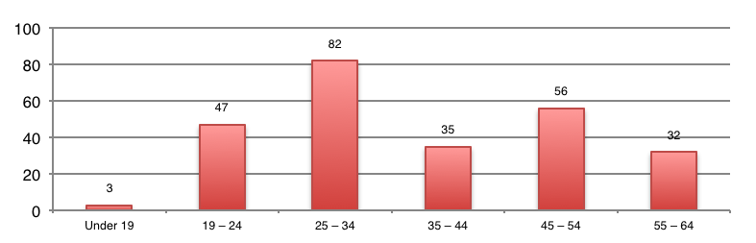
Figure 6 - Participant Age Ranges

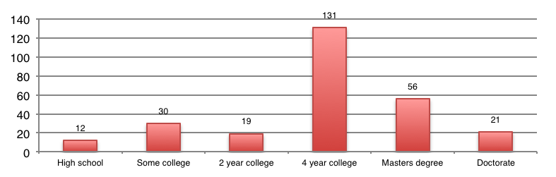
Figure 7 - Participant Education Ranges

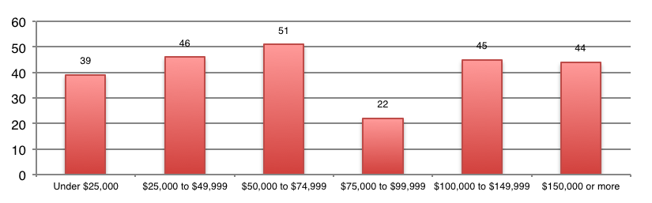
Figure 8 - Participant Income Ranges
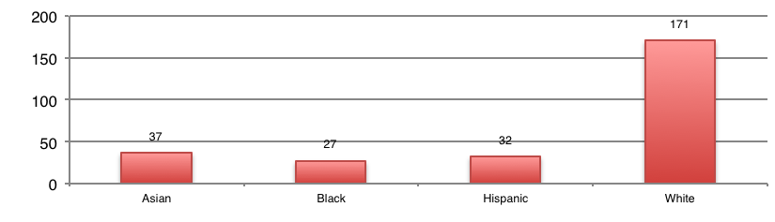
Figure 9 - Participant Ethnicities

Additionally, non-participant data were collected at the Kips Bay and Mid-town locations. Collection consisted of noting the gender, ethnicity, and approximate age of shoppers that declined participation in the study. Of the 1131 shoppers that were intercepted at these two locations, 224 (20%) agreed to participate. There were some differences in gender and ethnicity between those who participated and those who did not. A greater percentage of Caucasian males participated (34.5%) versus those that declined (27%). This was partially reflected in the fact that the percentage of males participating in the study was larger (55%) than the percentage of males in the group that did not participate (50%). Any other differences in participation rate among ethnicities were three percent or less. Age ranges between participants and non-participants were roughly equivalent.

Experiencing Technology in the Retail Environment
After completing 270 shop-alongs and interviews with participants—and observing many other shoppers—it became clear that shoppers’ relationships with technology are complex and varied. Reactions to ISADs varied from full embrace to outright rejection. In addition, shoppers’ feelings about and uses of MIDs were surprisingly varied and informative.
In order to communicate the broad spectrum of uses and consequences of experiences with in-store assistive and MID technologies within the retail environment, we developed a comprehensive framework (see Figure 10). This framework communicates the interconnected process of how shoppers utilize and are affected by technology and the nature of technology and its effects on shoppers’ reactions, behaviors and ultimately their shopping strategies.

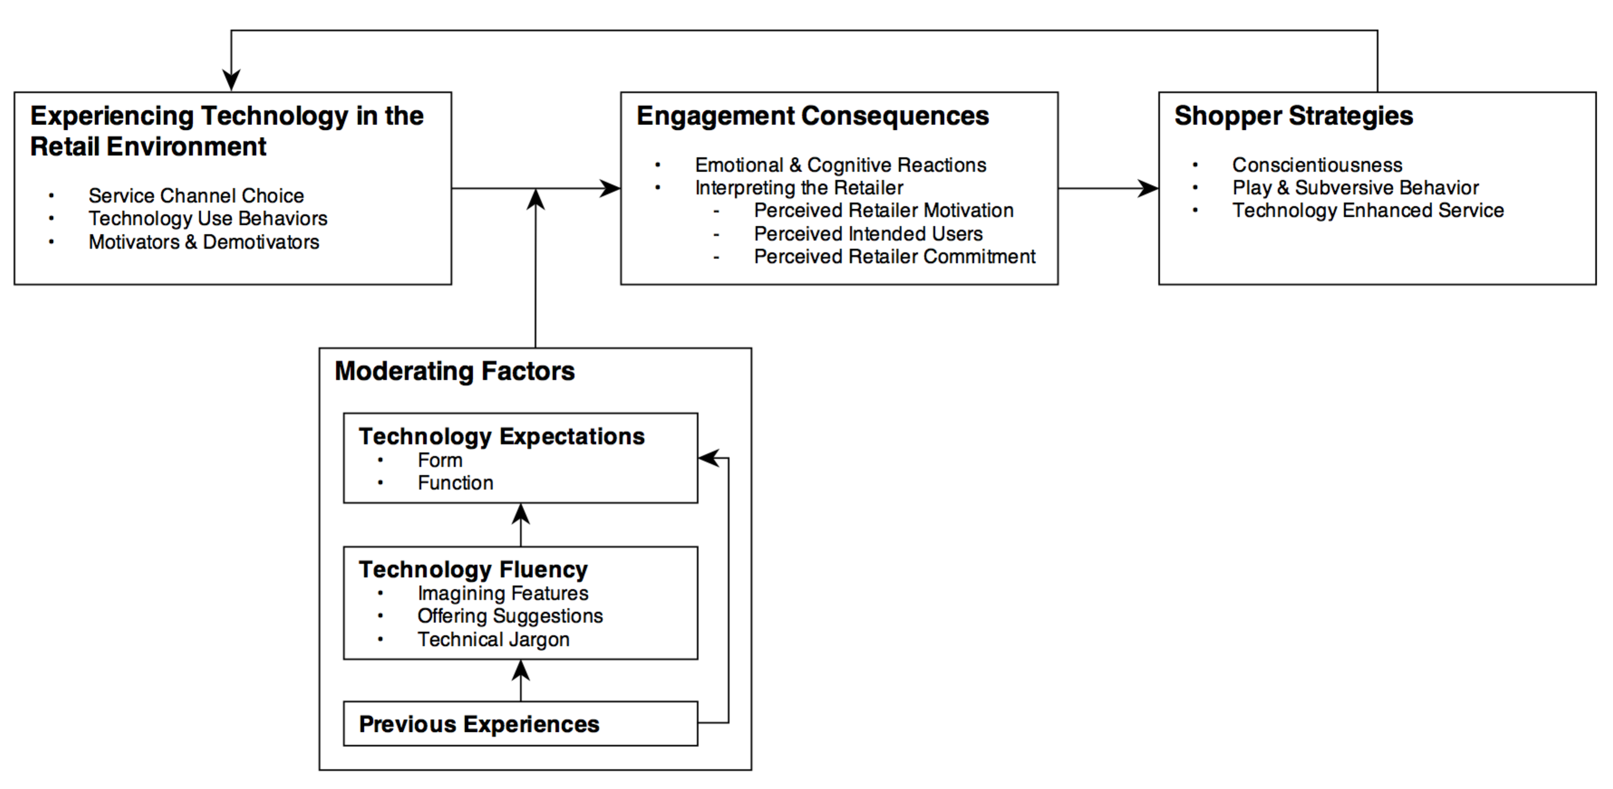
Figure 10 - Framework of Retail Technology Experience

First, we examine facets of the core phenomenon, experiencing technology in the retail environment, and explore how shopping goals are set and what service channel choices shoppers make. We also describe the specific technology use behaviors we observed and the motivators and demotivators behind shoppers’ use of technology to assist shopping.
Moderating factors are then evaluated. We look at how expectations of technology form and function informs the shopper and how shoppers’ fluency with technology may play a part in their evaluation and use of shopper-facing technologies. We also look at how previous technology experiences within the retail environment may impact both their expectations of these technologies and the shopper’s technology fluency.
Experiencing technology in the retail environment also has direct consequences on the emotional, cognitive and even physical well-being of the shopper. We examine how experiencing technology impacts these factors and also the direct consequences on the shopping endeavor and how the shopper interprets the motives and commitment of the retailer through their deployment of these technologies.
Finally, we examine how experiencing technology in the retail environment and its consequences lead to new shopping strategies and in-store behaviors. The emotions that result as a consequence of shoppers experiencing these technologies in the retail environment have the ability to affect how shoppers decide to behave.
As you read the pages that follow, verbatim passages from the primary investigator (interviewer) and study participant (shopper) are noted. Passages beginning with “I” indicate interviewer and passages beginning with “P” are the participant. A number following the “P” indicates the specific participant listed in our master list of participants (see Appendix D).
First, we address the context of this study and communicate the limitations under which we were operating.

Context
It’s important to understand that all of the data collected falls into a specific retail context. In this study the context is a national office supply retailer. There were also technological factors not under direct control of the shopper that contributed to the specific context of this study. For example, the study looked at how shoppers interacted with specific types of ISADs and mobile Internet devices (shopper-owned technologies). These technologies reflect a specific moment in time given the dynamic nature of technology, but the insights arrived at in this study should apply to any technology encountered within the retail environment. We seek to arrive at cultural norms operating with the retail environment when shoppers experience in-store assistive and mobile Internet device technologies.

Goal Setting and Service Channel Choice
At its heart, shopping is a goal-directed activity. Shoppers typically enter the retail environment with some idea of a shopping goal (e.g., a new printer) and their actions within the store are directed towards that end. With shopping or any other goal-directed behavior, the first step taken is goal setting. According to Bagozzi and Dholakia (1999 p. 19), goal setting involves “decision making processes in which, figuratively, the consumer addresses two broad questions: ‘What are the goals I can pursue, and why do I want or not want to pursue them?’” Bagozzi and Dholakia developed a process that shows what hypothetical questions the consumer asks themselves at each stage of goal setting and pursuit (see Figure 11). This diagram is a useful tool for looking at the decision points that consumers face as they strive towards goals.
Following the shopper through Bagozzi and Dholakia’s entire goal setting and striving process is not, however, within the scope of this dissertation. We want to understand how technology may guide early goal formation decisions and how technology impacts the shopping experience, not how shoppers gauge their progress towards goals and whether they achieve their goals. Thus we follow the Bagozzi and Dholakia diagram for the first few steps as it helps us illuminate our subject.
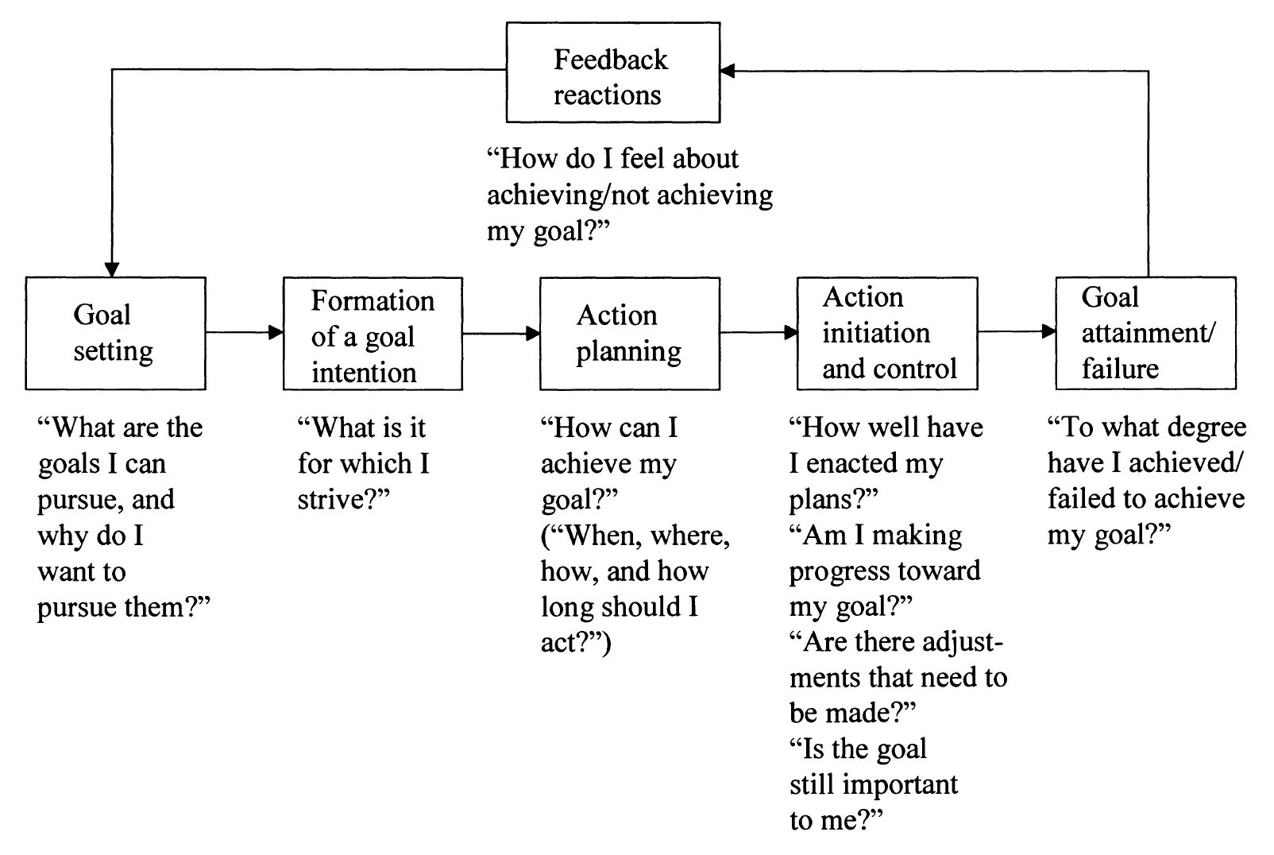
Figure 11 - Goal Setting and Goal Pursuit in Consumer Behavior (Bagozzi and Dholakia 1999)

We begin with goal setting and its associated questions, What are the goals I can pursue, and why do I want or not want to pursue them?). As Bagozzi and Dholakia (1999) state, “goals are activated either externally, such as when the context presents opportunities or imposes imperatives, or internally, such as when the consumer constructs a goal schema or chooses from among self-generated alternatives” (p. 20). Thus, goal pursuit is intrinsically or extrinsically made salient to the individual through a need or desire and the individual starts the process of acting on it. Salience in this context is created in three ways. One, a need may be a “habitual goal-directed consumer behavior” (p. 20). These are automatically performed responses to learned cues or subconscious processes which are often the result of classical or operant conditioning. Two, goal pursuit can initiate via impulsive acts. These are acts that arouse some need and occur without prior planning. Finally, goal pursuit can also be volitional, or initiated via deliberate acts of will. Bagozzi and Dholakia’s framework is based on volitional goal pursuit and continues the goal pursuit process by the individual asking “What is it for which I strive?” Thus far, we have an individual who willfully initiates a goal pursuit based on a need.
The next step is to address how a goal is pursued via implementation intentions, or what the individual intends when a specific situation is encountered (Gollwitzer 1996). At this stage, individuals ask themselves, “How can I achieve my goal?” and shoppers determine the ‘when, where, how and how long’ of their shopping. For the purposes of this dissertation, when and how long were not addressed. Where and how, however, are impacted by technology in subtle, but significant ways. Next we take a look at how service channel choice and its associated technologies is impacted by these decisions.

Service Channel Choice
The retail landscape has changed substantially in the last twenty years. Long gone are the days when shopping meant you had to leave the comfort of your own home and venture out to the local shopping center with the rest of your shopping compatriots. In fact anymore, shopping in a brick-n-mortar retailer does not necessarily mean that you’re shopping with the brick-n-mortar retailer. Technologies such as eCommerce (web-based retailing) and mCommerce (mobile Intenet-based retailing) have changed the very face of retailing. It has been projected that by 2017 60 percent of US retail sales will in some way incorporate the Internet, either as source of transaction or as a vehicle for product research (Dusto 2013).
While eCommerce behemoths such as Amazon have grabbed headlines and more than a few online transactions, brick-n-mortar retailers have not stood still. They have developed their own eCommerce websites alongside their brick-n-mortar operations and countless retailer mobile apps have flooded mobile application marketplaces such as Apple’s App Store. They have also started providing ISADs within their retail locations in hopes of attracting customers looking for innovative shopping experiences and as an alternative to in-store MID use (e.g., ‘showrooming’).
What all this means is that the modern shopper now has a number of service channel decisions he or she didn’t face just a few short years ago. Through our numerous interviews, it became apparent that shoppers are making a number of decisions that impact their shopping trip in significant ways. These decisions address the key question—and Bagozzi and Dholakia’s third process step—“How can I achieve my goal?”
We developed a decision tree that outlines the service channel choices that shoppers face when they incorporate technology into their shopping (see Figure 12). Each level of the decision tree represents a decision made by the shopper with some choices (e.g., in-store) leading to further choices. The two boxes at each level of the decision tree represent a choice with the arrows between them representing the tensions cultivated by the relative strengths of each choice (the bullet items in each box).
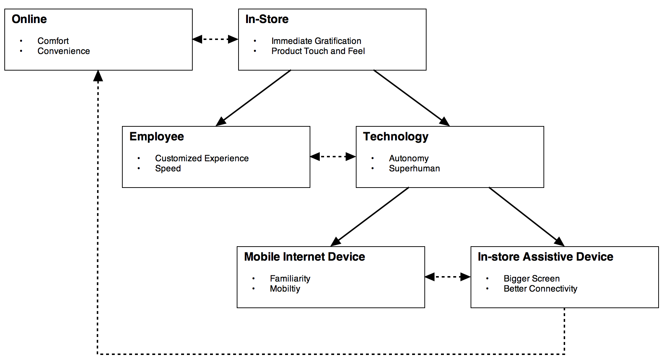
Figure 12 - Service Channel Decision Tree

Online vs In-store
The first decision facing modern shoppers is where the shopping will take place. While online retailing accounts for only 5.2 percent of all US retail sales (Thomas, Davie, and Weidenhamer 2013), it is growing at a steady and impressive rate. Shoppers are increasingly turning to online retailers to complete their shopping transactions. This is also the first technology-bound decision the shopper must make. Will they utilize their home or work computer to complete their shopping or will they physically travel to a retail location to do it in person? It should be mentioned too that when shoppers spoke of “online” shopping they were typically referring to shopping on a personal computer; a desktop or laptop computer associated with home or work. Only infrequently was online shopping conflated with shopping on one’s mobile Internet device.
As this dissertation is focused on shoppers experiencing technology within the retail environment, our data comprises conversations with shoppers that already made the decision to enter the brick-n-mortar retail realm. Thus, our data may be biased towards shoppers that look more favorably upon the physical retail environment. In this study, however, many shoppers expressed their preference for online shopping and only found themselves in the physical retail environment due to specific circumstances. This highlights an important point with regard to the service channel choices that shoppers must make: how are they weighing the relative strengths of each choice to answer Bagozzi and Dholakia’s question, “How can I achieve my goal?”
At the highest level of the decision tree, shoppers decide if they are going to shop online or within the in-store retail environment. The most commonly mentioned advantage to shopping online was comfort. Online shopping is something that can be done from wherever it’s most convenient to shoppers.
P [95]: Because it's more comfortable and I have children, and so, I'd rather have to attend to their needs while I'm at home instead of being here doing it at the store.
—
P [148]: Yeah, because online shopping, there is kind of two key components to it that make it so great. One, you can do it from anywhere. So I can do it at home, I could do it at work, I can do it anywhere I want. That's what's great about it. That's why stores like this... it's a lot more difficult for them to survive. That's the first thing.
The second thing is that I can comparison shop quickly. So I don't have to worry about going to [this retailer] and then off to Office Depot and going to … I can just comparison shop every place easy. And I know that, by and large, I'm probably getting a pretty good deal and I don't need to do anything, I don't have to actually walk into a physical store.
—
P [122]: …the sales person was very clear in letting me know that there were two places for the pens, and I went to both places. When I could not see what I wanted, then there was little point in then going to a third place [the kiosk] and saying, “I can go online” because this [gestures towards kiosk] I can do at home, and unfortunately I still can't do the thing that I want to do, which is hold it and feel it. Is it heavy? Is it light? Is it made of plastic? And I can't browse online [here] in the same way that you browse at home, online. You're in your underwear, you've got all the time in the world, you've got a drink; you'll go out, you'll read the news, you'll come back. Here, it's an environment where I'm standing up; I'm not going to be doing that.
This last passage underscores the relative advantages that many shoppers see between shopping online or in-store. Online provides comfort and convenience; shoppers can spend as much time as they like in their own environment free of distractions they might encounter being in public. But being in-store allows them to physically see and touch the product…but only if it is in stock. And in-stock products were related to another commonly mentioned advantage of shopping in-store: immediate gratification of a pressing need.
P [203]: …if I'm going to price check, I do that already at home. I'm not going to the store and …If I'm already going out, I'm going out.
I: So you already know…
P: You see, I'm going out with a purpose.
I: …that the prices at that particular retailer are going to be okay?
P: Yeah and I'm going for that purpose, I need it … Usually I need it at that moment. If I don't need it, then I'm not going to go out to the store. If I need it in three days, I'd probably buy it online or something.
—
P [211]: So this is going with the website, why do I need this? I can just do it on my computer at my home. I don't know, that's just me. If I made the effort to come to the store, it was because I needed something specifically at that moment.
Another shopper—who just happened to also work in a retailer selling remote control helicopters among other hobby products—demonstrated that immediacy of access to product is also inextricably related to impulse purchases and the importance of being able to see and touch the product.
P [186]: But the thing is, nothing will ever replace instant gratification, that's my opinion. Especially with the stuff that you don't think that you need until you see it, that's where we're kinda big with the hobby shoppers. Yeah you can get it online, but you would never know it existed unless you saw it flying around inside of a store.
I don't think anything will ever replace instant gratification, because you can never have it the same day on the internet and you can't hold it in your hand in the internet.
Stuff like this, I would've gone crazy if I had to wait 2 days for it to be delivered.
After the online/in-store decision is made—and again we observed and interviewed shoppers that already made the decision to come to the store—their next decision is whether they want to incorporate technology into their in-store experience or utilize the employees that are there to provide service.

Employee vs. Technology
The employee vs. technology decision for shoppers came down to two key benefits on each side. Shoppers saw the employee having the ability to give them a customize shopping experience and providing faster service, while they also saw technology providing autonomy for the shopper and giving them access to ‘superhuman’ powers.
Many of our shoppers saw working with an employee as the best way to get a custom tailored shopping experience. This was important when finding specific products presented a challenge for shoppers especially in large stores with huge product selections.
P [155]: For me, the biggest draw of going to the retail store is being able to talk to the people face to face and ask questions and have them respond to me instead of having something that's really mechanical and the same for everyone. I feel if I were to just have that, I'd just go online and … I think they have the same experience. I think there’s stuff that has value in coming to the store. I mean, I could ask the guy questions. There are three things I asked him before buying this computer. I probably would have to spend 15 minutes googling or …
Maybe I will find the right answers whereas he can tailor his answers exactly for me, right? So, there is value in that. It's worth taking the trip out. I think, for me, like the touchscreen is not as appealing.
—
P [236]: Just personally, again, I would rather deal with people who can go to the back, actually physically make sure that the things are there or not. For example with the binders, they only had a certain amount for a certain color, they went and looked for it, whereas I don't know if the kiosk would have told me the same information, and then he helps me carry it to the register, which the kiosk doesn't do obviously, and ring it up, pack it up for me, and I'm done. Looking at the kiosk, I think it would be an extra step because I'd have to ask anyway for help for this kind of quantity.
What went hand-in-hand with the customized service experience was the speed benefits that were often the result. Because we collected data in an utilitarian shopping environment, efficiency was highly valued by shoppers.
I: Is that ever a state of mind of yours though, when you come into a store, that you want to interact with technology and just don't want to talk to anybody today?
P [181]: No, I mean I really don't want to deal with technology when I'm actually physically in the store.
I: Okay, so you would rather have a sales associate there?
P: Absolutely, absolutely. Look here's what I would have had to have done; I would have had to find this machine, I would have had to go through it and figure out, 'Okay files, manila folders.' Well is it listed as manila folders? Is it listed as files? Do I have to go through a filing program to look at all my filing options? Instead of, “Hey buddy, where are your manila folders?” That [kiosk] is not saving me time.
—
P [148]: I don't know that I see it as a replacement of a person and here's why: simplicity is the key to it all, right? My goal is, how can I get what I want as quickly as possible. And asking a person typically is faster than using a machine. And so the more information there is, first of all the more turned off I am, I'm like, “Oh no, I have to navigate through stuff. Am I going to have to …” So I like really great simplicity is so, so important, so at the moment I really don't look at these things, because it's way faster for me to say “Hey, I need X, do you know where it is?”
On the other side, shoppers also valued the benefits of shopper-facing technologies. One oft-mentioned benefit was the ability of the shopper to work on his or her own without having to engage a store employee. Sometimes the reasoning seemed to be related to self-efficacy as in the following two passages.
P [156]: I think it's nice, I think especially for people in my generation who do walk around with smart phones, we tend to like to check prices and information out for ourselves rather than be told something.
—
I: Would you be more comfortable using something like this or talking to a sales associate?
P [261]: Usually using this, because sometimes I just prefer to just come here and do my own thing.
For other shoppers, the desire for autonomy was related to the avoidance of social obligation that may form when a shopper asks something of a store employee.
P [252]: I tend to look for a specific book and I tend to do it myself, because to get a human being is almost like asking them for a favor and it takes them longer than I would do it myself. I may know the name of the book, not the author and vice-versa, so I prefer to do the searching myself.
When shoppers spoke of shopper-facing technologies they tended to speak in terms relative to the performance of humans. In this way, these technologies were seen as performing tasks in superhuman ways. Technologies have the benefit of being able to store and retrieve vast quantities of information with relative ease and it was this quality of superhuman ‘knowledge’ that attracted many shoppers.
P [185]: …if I compare that [kiosk] to the human being, I'd probably get faster, more accurate information because I really don't expect that person would need to know every detail about every piece of information…
And of course these same qualities of technology apply outside of the retail setting as well.
P [124]: There is so much information. My granddaughter Lizzie, she's 16, she lives in Pennsylvania and she has so much information, when she goes in there [smartphone], it's unbelievable. When I told her that my cousin lives in Pennsylvania, she just types in their name. You can get the address, the phone number, you get all the stuff. This is unbelievable.
And not just knowledge, but better memory. In other words the information that shopper-facing technologies have can be updated quickly and kept in a state that is perpetually relevant to shoppers. For example, constantly up-to-date product location and inventory information.
P [183]: I feel like computers or a kiosk in the store has, for lack of better words, a better memory of where things are and can provide you an accurate inventory of how many items are in stores. So yeah, I'm definitely comfortable using that.
But of course shopper-facing technologies are not human at all and are not subject to the vicissitudes that we humans face (e.g., moods). These technologies perform their tasks the same from day to day without variability or complaint. Technology, as one shopper put it, is “always on.”
P [197]: Because the technology is always on, like the young lady when I walked in she was kind of looking in the other direction and then she realized I came in and she was like, “Oh, hello!” So sometimes the technology adds because the technology is always on. When you depend just on the sales people, they're not always on.
If a shopper at this point has decided to engage with shopper-facing technologies in-store, they now face one last decision: should they use their mobile Internet device or the store’s ISAD.

Mobile Internet Device vs In-store Assistive Device
With the average smartphone owner having installed 33 apps on their phone (Google 2013), smartphone users have grown comfortable with both the smartphone’s operating system and presumably a number of third-party applications. In a recent survey, 25 percent of respondents had downloaded a retailer-branded app. Of those, 45 percent said the app caused them to visit the retail location more often and 40 percent indicated that they buy more products and services from the store/brand (ABIresearch 2011). MIDs and their apps provide a compelling and attractive substitute to ISADs. With the time that smartphone users invest learning their devices and associated apps, a key benefit of shoppers using their own mobile Internet devices within the retail environment is the familiarity that they have built up with these devices over time.
I: Why is your phone more appealing, or why is this [kiosk] less appealing?
P [219]: I don't know because it is my phone. I know how to use it. It could be the same, but I'm not going to want to come over here when I can just stand in front of a printer and use my phone.
—
I: Let's say you have a smart phone app, like [the retailer’s] app for example. And it has a certain set of functionality and you have the same exact functionality on an in-store kiosk. Which one would you rather use?
P [191]: The app on my phone because I'm more familiar and more comfortable with it and I don’t have to be tied up to one particular spot. I could just navigate my way around the store while using an app.
In addition to the previous passages outlining the familiarity that the shopper has with his or her own MID over ISADs, we can see that value is also based in the ability to be mobile within the store. ISADs, with a few exceptions, are always rooted to a particular position in the store. They usually comprise a large screen that requires an anchoring element and they are typically much heavier than tablet-based computers. The mobile nature of MIDs allows them to be used anywhere within the retail environment and provide information at the exact place and moment it’s needed.
P [28]: …unless the kiosk will, I don't know, show me on my mobile where is the aisle and will direct me, there is room for mistakes if the kiosk is stationed in one place. It doesn't go with me.

ISADs on the other hand do provide some advantageous aspects relative to MIDs. The features expressed by shoppers were hardware feature-related. For some shoppers that meant they were trying to find the “bright side” of devices that largely did not resonate with them, for others it was a genuine selling point.
The first beneficial feature to ISADs was the larger screen relative to mobile Internet devices. One might think this would be directly related to eyesight issues related to age—which was certainly the case with at least one shopper—but only 22 percent (2 of 9) of shoppers that mentioned this advantage were 45 years old or older.

I: As a hypothetical, you have the app on your phone already. You used it, you liked it. You see that there's a touch screen in the store that has the exact same functionality, which would you rather interact with?
P [197]: I'll interact with the touch screen at the store because it's a bigger screen, I like the bigger screen to see the colors and the quality and the detail of the product.
—
I: Let's say the functionality is the same for both, which would you rather engage with?
P [188]: I would rather engage with something bigger simply because I'm an old guy with presbyopia; for those of you who do not know what that means, my eyes don't work so well. And looking at the bigger screen is always preferable. I carry a very large smart phone for exactly that reason.
Even with excellent mobile network coverage within retail stores or freely provided WiFi access, connectivity can be a significant issue for some shoppers. ISADs, being non-mobile, typically have wired connections to the Internet, which will almost always perform better than wireless networks. This advantage was mentioned by a number of shoppers.
P [258]: Sometimes the Wi-Fi is kind of slow so it's convenient to do it [on the kiosk]. And plus you have all the information here anyway, so you needn't look through a website or all that.
Lastly, it should be mentioned that shoppers faced one extra tension: those that used ISADs often grew frustrated and compared their experience negatively to what they could accomplish on their own at home. In other words, many shoppers that used ISADs ended up thinking that making the decision to online shop from home was preferable to their experience in-store. In fact, a number of shoppers mentioned that they had had experiences in the past so were so poor with ISADs that they ended up leaving the store and returning home to shop online in comfort. This is a feedback mechanism that we did not anticipate (represented by the dotted line from ISADs to Online in our figure). The advantages of ISADs disappeared for many shoppers when they compared the ISAD experience to their ‘usual’ online experience. Certainly not a ringing endorsement on ISAD state-of-the-art.
P [148]: Here is my experience of in-store online shopping; they're not designing … This isn't designed for that experience. It's not in my home, so it's not wherever I want it to be, it's not comfortable. Right at home I can sit on my couch for hours and comparison shop if I want to do. So it's not comfortable, first of all; and second of all, I can't comparison shop at [in the retail store]. I'm in [this retailer’s] store, [they] want me to buy [their] product. They don't want me to buy it from Amazon. That's not an option they're hoping for. So I feel uncomfortable. If they say “Why didn't you just buy it online?” What I want to say is “No, I want to go home and find out if I can get it cheaper on Amazon or somebody else and get a coupon that will make my whole … Make it cheaper for me.” And yes, I would have to wait two days, but that's a price I'm willing to pay for the comfort.

Technology Use Behaviors
In this study the core phenomenon of interest is shoppers experiencing technology within the retail environment. To this end, there were a number of behaviors that were observed during the shop-alongs and also addressed during interviews. Unfortunately, one major issue was the fact that many shoppers were not noticing the ISADs so it was difficult to witness their extemporaneous reactions. After it became obvious that deployment decisions the retailer made with regard to design and placement of the ISADs were preventing shoppers from noticing the devices, we had many shoppers interact with the devices after the post-shop interviews. Unfortunately, the artificiality of these encounters limited any insight into how the process of interacting with the ISADs plays out (e.g., approach, investigation, discovery, etc.). That being said, we gained many insights into how shoppers interacted with the devices and their expectations of functionality and form. We also encountered many shoppers that were utilizing MIDs of their own accord, which contributed numerous useful insights.
The behaviors we observed as shoppers utilized ISADs included ordering out-of-stock product, product search, comparing products, ordering copies, checking loyalty accounts, and looking up produce reviews. Unfortunately, this pales in comparison to the list of behaviors that shoppers tried to accomplish with the technologies. An important point is that shoppers’ technology use behaviors in the retail environment are dictated partially by the retailer. As retailers design and deploy ISADs, they determine what functionality these devices have, which in turn dictates the range of uses that these devices have for the shopper. This in part explains why the technology use behaviors observed during this ethnography were far more prevalent and creative with MIDs than with ISADs.
Shoppers observed using MIDs displayed a dizzying array of behaviors. The expected behaviors were observed including barcode scanning, product lookups, online review lookups, and a variety of socially related behaviors including talking on the phone and texting, but what surprised us were some of the more uncommon uses of their devices related to shopping. Among these were checking finances and transferring funds to pay for shopping, checking store inventory, querying social networks for product purchase advice, and counting calories and checking ingredients of products.
One behavior in particular—using the MID as a memory capture device—was particularly interesting. Shoppers used their devices as a backup for their memory. When purchasing a particular product wasn’t convenient, usually due to time or money, some shoppers would pull out their smartphones and take a picture of the product to help them remember later.
P [179]: Usually, what I do, instead of keeping a list or something that I like, I snap a picture. That way it stays in my phone and I don't have to put it … I have the visual. Let's say, I just walked by this nice place where I saw a watch, whatever the case may be; I just snap a picture with the price, then if the price is fine, I'll go back and buy it. Or if the price is little high, I'll actually go research and see if I can get it, maybe Amazon is much as cheaper. I do a lot of that in bookstores, actually.
But they didn’t just take pictures when they were in-store. Shoppers also took pictures of products they already owned to make remembering them easier when they needed to be repurchased as this shopper did when she needed to remember the product number of a printer ink cartridge.
P [60]: I took a picture of the ink cartridges and then when I got here to look at the number and everything. So I knew I was buying the right thing.

Shoppers using their MIDs in creative ways provides more evidence to support the idea that consumers have fully integrated technology into their daily lives (Rader 2009). Other recent research has shown that shoppers incorporate MIDs as shopping management and social management devices and in those circumstances where those two uses overlap, hedonic shopping experiences materialize (Spaid and Flint 2014).
Shopper behaviors are, however, just one facet of what is involved in the experiencing of technology in the retail environment. Next we discuss shoppers’ cognitive and affective motivators and demotivators behind the use of these technologies. We also reveal that shoppers interpret the actions of the retailer, which in turn colors the shopper’s perception of the retailer.

Motivators
Shoppers expressed a number of motivations for utilizing ISADs. These motivators were the perceived consequences of shopper-facing technologies that impelled their use. These motivators help induce the shoppers toward sustaining goal-directed activities.
One reason shoppers gave for engaging with the ISADs was to reduce effort. Shoppers perceived these devices as mechanisms to reduce the work that they need to put into shopping. For example, if a shopper is looking for a specific product often it is easy for them to query a kiosk to determine if the store carries that specific product.

P [147]: If I'm looking for something bizarre like Quink [an ink refill], I can just go [to a kiosk] and just search through the whole store, whether or not it's there because it's a hassle to walk around for awhile.
Shoppers also mentioned that utilizing technology in-store gave them access to useful repositories of information. This applied to shoppers using MIDs as well as shoppers using ISADs.
I: Any other thoughts on that [kiosk], in terms of … Would it matter the size of the store or the type of store whether you would have those feelings or not?
P [253]: Yes, in a Best Buy store where I'm shopping for a technology, I have no issue doing research in the store, looking up on C-Net and thing like that, to see what the customer reviews are, because they don't have those in the store and I feel for such a large purchase, I need to do more research in the store.
Crowded stores also provided motivation to use technology in the retail environment. The busier the store became, the more difficult it was for the shopper to find a sales associate to help them.
P [226]: Well I think the big thing for me, I don't necessarily want to have to wait for the customer service rep. If I'm in the store and I don't see something that I want but I know they have it online, I want to just be able to go to a kiosk and order it straight from there without having to wait for a customer service rep or something like that. I think that would be a big thing. I don't often order online from {this retailer}. Generally, I just pop in to [this retailer] and then hop around from where I work. If they have a ship-to-store feature, that would be really handy.
When shoppers had a pressing need for a product, they expressed their willingness to use ISADs. The devices were perceived as facilitating faster access to product information and speedy checkout. While this might not be the case in all instances, the devices were perceived as having those advantages.
P [65]: I would usually use the computer if it was an immediate purchase and a problem that needed to be solved.
Finally, some shoppers revealed that ISADs allow them to maintain a more comfortable social distance from sales associates. This often happens for a few reasons: one, shoppers who were introverted and felt an intrinsic need to avoid unwanted social contact, and two, sales associates who tended to use overt or ‘pushy’ sales tactics were avoided by many shoppers and ISADs gave them an avenue to seek service without sales pressure.
P [233]: It makes it easier for people to view more items and hope to come across something that you may need and some people don't like to be bothered by salesmen at times. You have people that are extroverted or introvert and myself, if I could go to a kiosk and be able to find it myself, I like that. Basically because I get a little flustered or impatient sometimes and it's not the salesmen's fault it's just my overall demeanor. I think it helps a lot of people. Some people would like the personal touch, others, they like to go and grab. I'm usually the one that likes to go and grab because I already know what I want, what I'm looking for, and once I know it's here then I'll ask a person where I can find it.

Demotivators
There were also factors that dissuaded shoppers from using shopper-facing technologies. These demotivators were the perceived consequences of shopper-facing technologies that impeded their use.
Shopping is often considered work by many shoppers, especially those that are utilitarian motivated. When these motivated individuals enter the retail environment, it’s likely they may view the deployed ISADs as another object that will add work to an already burdensome process.
P [25]: …being ecologically minded I was happy that my computer was made of aluminum. It is interesting because when you do that it opens up can of worms. So, then instead of just looking for braces I go back to the other more expensive items with that in mind. And that's kind of why the kiosks make me a little reticent because I feel like it's just gonna make me think of a whole lot more variables before I make my purchase and get the hell out of there.
—
P [25]: I feel like if I go up to them I would just lose me. I feel like it would add 20 mins to my [visit]. Shave off 20 min that I have of my time. Unless it was something that I was really interested about. Something like that's very expensive like for example in [retailer] if there were indeed like a desktop printer or a tablet for example and I've been looking for those for a while I would definitely use it. Or a computer, something that costs a lot of money that I was planning to spend.
For other shoppers the familiar computer screen, keyboard and mouse recall long days working at a desk and make the ISADs unappealing. And it wasn’t just ISADs either. For work weary shoppers, MIDs were also an unattractive prospect.
P [211]: They're trying to take away people; they're trying to take away the interaction. I don't want to talk to a phone when I need to talk to the bank manager, I don't want to touch that [kiosk] when I want to shop. I want to ask you where can I find x, y and z. I do this all day, I sit on a computer. I don't want to touch the computer when I come. I don't know, I wouldn't want to use it…
---
P [93]: I'm on a computer all day. The last thing I want to do is look at a tiny or mini computer, does that make sense? That's probably why I don't use a smart phone to help me shop or what not.
Personal privacy and security were also demotivating subjects brought up by shoppers. With privacy data hacks and government snooping capturing headlines, its no wonder that privacy and security concerns would become an issue in the retail environment.
P [101]: …also with the iPhones, it's like a super invasion of privacy too. I mean they can track all the stuff that you do, that's nuts. This woman, actually who works for me, [her] brother is into tech. He's part of a company that's very successful with that security software. She said she would never do WiFi. Everything's hard-wired because it's so easy to crack all that stuff. I just saw a headline, this story about, maybe I think it was Wall Street Journal? About how there is a greater risk of hacking and loss of data…with the migration to mobile devices…of security risks? Well, yeah!…[so I don’t] use it to shop.
Related to personal privacy and security is the feeling of being secure in one’s surroundings. Whereas many shoppers found the retailer’s decision to integrate ISADs within the product shelving annoying, for others it was a source of comfort. Free-standing or standalone kiosks were seen as contributing to a shopper’s sense of feeling personally exposed in the retail environment.
P [149]: …I like the fact that it's just in the shelf, because I feel with those standalone things, it's more like a scene to go up to it and start using it with all these buttons. Whereas this, you can just be looking for something and then just suddenly touch it and be looking at stuff without kind of being off to the side on this standalone kiosk.

Moderating Factors
When we acknowledge that each shopper is unique, with their own set of skills and preferences, we begin to understand that these unique qualities may impact the shopper’s experiences with technology within the retail environment in distinct ways. To that end, in this section we investigate a number of factors that may or may not stem from shoppers’ previous experiences with retail technologies and we look at how these factors might impact shoppers’ experiences and the consequences associated with those experiences.

Technology Expectations
It became clear during shop-alongs and interviews that shoppers bring with them a set of expectations regarding retail technologies. These expectations informed how shoppers interacted with the devices, how shoppers evaluated their usefulness, and how shoppers determined their level of satisfaction with their experience. Shoppers showed a wide range of expectations of ISADs, which can be categorized into two types: functional expectations and form expectations.

Functional Expectations
Shoppers had clear expectations of the features and performance levels that ISADs should have. What became clear in our data collection was how often these expectations were not met. Shoppers were consistently communicating the deficiencies of ISADs they encountered. Many of these deficiencies were related to performance.
Shoppers expect a certain level of performance from in-store devices. Relatively new ISADs that respond slowly or have inferior Internet connections leave a poor impression with shoppers.
P [192]: I want it to work fast and if it's a new sort of kiosk I kind of expect it to be fast.
—
P [148]: …in the ‘i’ everything world, this [kiosk] moving quickly is actually really important because it gets especially frustrating when things are slow.
This ‘i’ everything world sets up many expectations for shoppers based on their interactions with their own technology devices. As smartphones and tablet computers begin to supplant personal computers as the most sought after personal technology devices, the features and interaction models used with these devices are beginning to set consumers’ expectations regarding their interactions with other computing devices.
P [128]: Everybody has a tablet now and it's just bam, bam, bam, bam. This thing [kiosk] needs to work fast. That's what everybody's used to now.
—
P [129]: …my goddaughter, when we're watching TV, if I pause it for any reason, sometimes she goes up to the screen and tries to slide it, that's where technology's at now. People expect it to be a touch screen at this point. I'm sure there will always be keyboards, but I'm sure everything is going to be a talking tablet within 5 years.
—
P [148]: Places like Apple set the standard for speed, level of consistency and how things perform. And I think a lot of us look at Apple as a standard for that, especially for those of us who are younger; but even frankly, for people who are older like my parents; they're now in their sixties and they have an iPad, they have an Apple computer, they have iPods and they look at Apple as the standard, which is extraordinary to me, because it's like “Wow!”, these guys really…I think these guys have a lot of consistency. They consistently deliver products that perform at very high levels and I know what I get. What I pay for, I get in return.
These personal touchscreen-based technologies were likely a key factor in the retailer’s decision to employ touchscreens for their ISADs. As we observed shoppers interacting with ISADs, it became clear that the touchscreen technology that the retailer decided to utilize was falling short of shopper expectations. When interacting with the touch screens, numerous shoppers were having difficulties getting the device to register their finger taps due to its lack of sensitivity, which in turn jeopardized the utility of the device.
P [154]: These kinds of things, I feel like if you're not getting what you need quickly, it takes away from how useful they are, if that makes sense. If I'm getting annoyed with the sensitivity, if it keeps clicking on things I don't want to click on or I'm not sure how to use the menus. Then if it's not user friendly, I'm not going to use it, bottom line.
—
P [147]: It's not as responsive as an iPhone…
In some instances, the in-store assistive technology created confusion based on the technology employed and its uncommon use. One example in particular was representative of the confusion generated. The retailer had installed two touchscreen kiosks and each had a laser scanner underneath the screen. When asking shoppers what functionality they expected the device to have, they invariably mentioned that it was for scanning product barcodes. Barcode scanning stations are a common technology found in grocery stores and mass merchandisers. The shopper finds a product that they’d like to know more about and holds the product barcode under the laser. Typically most devices provide at least the name and price of the product. However, in this case the retailer had employed the barcode scanner only for the purpose of scanning the shopper’s loyalty card. A shopper could scan their card and receive information about previous printer ink or toner purchases. Though the scanner displayed verbiage as to its intended purpose, the laser at the bottom of the device spoke louder. For shoppers used to the more standard barcode scanning functionality, being presented with a device that displays the familiar hardware component (a laser scanner and screen) sets an expectation for its functionality.
I: What was your expectation of actually seeing a laser there?
P [129]: I thought a price and the product was going to come up, maybe like have reviews even … If you can scan an item and it would take you to a hyperlink that shows you a picture of the product and reviews on it.
With these functional expectations, previous experience in other retail environments seems to be the key. As shoppers interact with technologies such as product information barcode scanners and these become commonplace in a variety of different retail formats, these interaction experiences color how the shopper sees technologies when they interface with them later. In other words, commonly deployed functionality becomes virtually compulsory for retailers in order to avoid disappointment, confusion, and frustration in the shopper.

Form Expectations
Form expectations comprise the physical factors that define the in-store assistive technology. Shoppers had clear expectations of where the devices should be located, what they should look like, and how signage and other means should be used to draw attention to them.
One challenge we had when collecting data was the fact that shoppers just weren’t seeing the ISADs. In many cases the devices were tucked away in shelves next to product and they were often confused for advertising, if they were noticed at all.
P [224]: No, I didn't notice it. I did not see that. I literally thought it was just a sign. Just advertising.
Because so few shoppers were noticing the technologies and it was going to be rather difficult getting their thoughts on the devices without them interacting with them, we decided to tell the shoppers about the devices. In many cases even this didn’t help. We would tell a shopper that the device was located in a general area only to watch as the shopper grew impatient because they still couldn’t locate it.
And we observed something else. When we told shoppers about the technology and its approximate location, we noticed where the shopper began to look. Instead of looking up at the shelves where the devices were located, they often looked closer to the floor. They expected to find the kiosk as a free standing unit mounted on the floor and they also assumed that the retailer would give the device more prime real estate at the end of an aisle where it would be more visible to the shopper.
P [174]: I had no idea it was there. It's a waste of space and waste of money to have that kind of like…I would have never seen it. No, that should be free standing, right where this paper is.
I: Why do you think free standing?
P: People will see it more. Yeah, get a pole, 5 dollar pole. Put it in the middle with a heavy [base]. Maybe with a bigger frame around it? Brighter colors? If you want people to use it, if you want to just … I had no idea it was there.
---
P [161]: It seems to me that if they want people to use these things that having one at the end of each aisle that makes, ya know...helps them find stuff, helps people find stuff or things like that, that might be more useful than...it's kind of hidden between toilet paper and napkins.
Sometimes even freestanding kiosks went unnoticed by shoppers because design elements were poorly executed or its proximity to other electronic products confused its purpose.
I: So you mentioned the in-store kiosk. Do you know if [this retailer] has an in-store kiosk for ordering online?
P [226]: I don't believe that they do. If they do, I haven't seen any at the other ones they I've been at.
I: Would it surprise you if I told you you're standing right in front of it?
P: It would. Darn it! Okay, so there you go. That is a good thing. Yea [retailer]! Sorry for not noticing that a little bit more.
I: Well, I wouldn't say it's your fault for not noticing.
P: Well I think if this were my store and I could change signage, I would probably make this a little bit more obvious. The red sinks in, especially the red on red with the logo and I think particularly with where this piece is located, there's software, there's mp3 players, there's phones, there’s enough hardware up here that you could conceivably walk past this and think it's just a display of something they have on sale.
When shoppers did notice some of the ISADs on their own, the device’s appearance sometimes became an impediment to its use. Some shoppers assumed it was for employee use because of its unsophisticated design.
P [195]: I didn't actually use this one… For example the location of this one and maybe the look of it, kind of gives me the impression that it's …more of a tool for the sales associate to use; but also that might have something to do with my experience…
As with functional expectations, previous experience plays an important role with form expectations. As shoppers interact with ISADs within other retail environments, the placement and design of these systems eventually become standardized in the shoppers mind. When the shopper then encounters deployments that are inconsistent with the standard this becomes a barrier to the short-term use and long-term adoption of this technology.

Consistency and Expectancy
Given the expectations of both function and form that shoppers enter the store with, how does this affect their appraisal of and willingness to use the ISADs they encounter? Adaptation level theory is a good starting point.
Adaptation level theory (Helson 1964) posits a stimulus is perceived relative to an internalized standard. The standard is formed based on the perceptions of the subject—in our case the shopper—and the standard drives subsequent evaluations of stimuli. The standard is a loose point around which small deviations, positive or negative, are tied to the original evaluation. Large perceived changes, however, will change the adaptation level, which will modify the subject’s evaluation. This theory was later adapted to the study of consumer satisfaction resulting in the expectancy disconfirmation theory (Cadotte, Woodruff, and Jenkins 1987; Oliver 1980; 1977; Spreng, MacKenzie, and Olshavsky 1996).
The expectancy disconfirmation theory compares an expected level of performance with the perceived level of performance received. Comparing the two, the expectation is either disconfirmed from a negative standpoint (performance was not as good as expected) or positive standpoint (the performance was better than expected). This disconfirmation is subsequently linked to measures of satisfaction for the product or experience evaluated. As shoppers evaluated the ISADs, their expectations were evaluated against the perceived performance (function and form) of the technologies they encountered and, in the case of the majority of shoppers, found them wanting.
One explanation for why many shoppers were unimpressed with the ISADs they encountered was the fact that some of them functioned inconsistently with similar technologies the shopper had previously encountered. This can be psychologically troublesome. Decades of psychological research rest on a basic premise: individuals prefer that newly encountered information be consistent with previous experience. This premise serves as the basis for many important psychological theories and is known as the cognitive consistency principle. Chief among the cognitive consistency theories is cognitive dissonance theory (Festinger 1957).
Cognitive dissonance theory rests on three underlying points. One, as an individual encounters new information or cognitive elements (perceptions, thoughts, opinions, etc.) this can lead to incompatible interrelationships between new and pre-existing elements resulting in an internal dissonance. Two, the existence of dissonance creates motivation to reduce the dissonance. Three, actions taken to reduce dissonance include behavioral or cognitive changes. In other words, when an individual encounters something that is incompatible with previous experience, the tension that arises from this will drive the individual to either change their thinking about the object of cognition or their behavior toward the object.
What Festinger’s work leaves out, however, is the role of affect. Rosenberg’s (1968) affective-cognitive approach addresses this by suggesting that “positive affect towards an object tends to be accompanied by a cognitive belief that the object will promote attainment of positive values and block negative values (and vice versa)” (Fletcher 2011). Both Festinger’s and Rosenberg’s work help us understand there is more at work in the retail environment than initially assumed.
Returning to our shoppers, they demonstrated prior cognitive and affective orientations toward ISADs and this affected their appraisals of new encounters. Past experiences with personal technologies (e.g., touchscreen tablet computers) and technology interactions within other retail environments created cognitive and affective orientations that were tested when new experiences were made salient. When these new experiences were discordant with existing cognitive and affective orientations, the tensions that arose were ameliorated through either avoiding the source of dissonance (behavioral change) or altering one’s thoughts on the source (cognitive change). Our shopper that misinterpreted the presence of the laser scanner to mean that the device would provide product information if a product barcode was scanned had the choice to ignore the tension that was created by avoiding the device in the future, or changing his beliefs about what the presence of a laser scanner means. The former is undesirable to the retailer because if shoppers’ views on laser scanners were typically similar, no one would use the device and its deployment would be a wasted expense. The latter is equally untenable because the retailer is now requiring the shopper to maintain information about atypical technology deployments that substitutes the pre-existing meaning of the laser scanner with something incongruous rather than amending the pre-existing meaning. In other words, the laser scanner could have both provided product information and customer loyalty details, which would certainly aid adoption.
Existing models of technology adoption such as the technology acceptance model (Davis 1985; Davis, Bagozzi, and Warshaw 1992; Venkatesh et al. 2003; Venkatesh and Davis 2000) and diffusion of innovations (E. M. Rogers 2003), however, do not take into account a standard of comparison that may result from previous experience. Many technology acceptance theories originate from a time when the issues surrounding acceptance of technology were novel and most individuals had little if any previous exposure. Times have certainly changed. Technology is unavoidable and we interface with it at nearly even point of our day. This gap that exists in the technology acceptance literature may benefit from a closer look at customer satisfaction/dissatisfaction literature, specifically an addition to the expectancy disconfirmation theory.
Cadotte, Woodruff and Jenkins (1987) amended the expectancy disconfirmation theory by including experience-based norms as an alternate predictor. Experience-based norms differ from expectancy in that “(1) they reflect desired performance in meeting needs/wants and (2) they are constrained by the performance consumers believe is possible as indicated by the performance of known brands” (p. 306). Ultimately, the authors found that expectations cannot be ruled out as a standard of comparison, but that experience-based norms appear to “offer an alternative for examining how consumers form disconfirmation beliefs and satisfaction feelings” (p. 313). The expectations that shoppers seemed to be communicating may be more complex and rooted in desired performance and the previous experience with similar technologies.
As retailers integrate technology in their stores, it’s important for them to realize that they are not an island unto themselves. Shoppers bring functional and form expectations with them and this plays an important role in their evaluation of the technology and ultimately their evaluation of the shopping trip. Retailers need to keep in mind tacit technology standards that may have been set by other retailers and how these standards may be setting expectations for their shoppers.

Technology Fluency

Another emergent theme of this ethnography was how sophisticated many of the shoppers were with regard to their usage and expectations of technology. We believe this is a direct result of both the overall ubiquity of technology in our everyday lives and “digital natives” (individuals that have utilized technology from an early age and are comfortable integrating it into the daily lives) (Palfrey and Gasser 2013) now playing a larger role in shopping.
P [148]: I'm 31. My generation and younger likes to interact with technology. We're good at it. We a have a pretty high bar for its performance and function. I don't fall in this category, but I know enough people my age and younger that, not only do they interact with these things, they know how to make them better, they write the code and stuff.
Conversely, older shoppers expressed their frustration with the ubiquity of technology by mentioning that they feel disadvantaged and left out in comparison to more technologically fluent shoppers and the dependance that springs from it.
I: Do you feel like it puts you at a disadvantage at all?
P [243]: In a way, yes.
I: Tell me more about that.
P: Because I'm old fashioned, I'm not into that yet. Today, everyone is into the computer. It really puts me behind because I know … Somehow I have to force myself that I have to learn it like everybody else does. So I have to say, no choice.
I: Do you feel like you're missing out?
P: Yes, in a way yes. Like I said, you have to learn it because technology is everywhere. We are going to depend on that mostly.
The reliance on technology for shopping has its downsides for technology fluent shoppers as well. As shoppers utilize multiple channels to educate themselves on products and offerings, these additional channels (e.g., eCommerce websites, shopping-specific smartphone apps, etc.) begin to distort the shopper’s view of the product.
P [135]: I think there's definitely even times when I felt much better about a product viewing it, kind of online and probably it's most pristine and choice reviews for that product have been selected I assume a lot of times. Because I do feel a bit of buyers remorse, if you will. I would say that yes, there's a disconnect between the actual quality of the product that I see in the store and the way that I envision it prior to going to the store.
I: That's interesting; so are you saying that when you are doing your research online, you see it online, you're seeing it in that kind of sanitized, pristine format; perfect photography and everything and then when you get to the store it's kind of a letdown?
P: It's a letdown in a sense that it doesn't match the reality that I had created in my head. If I guess if I have a better ability to judge what something was like in real life and remove the gloss and the shininess of the how it was constructed to be sold to me, then I would probably … have less of a letdown.
Going into this research we wanted to ensure that we were sensitive to existing theories related to technology and the shoppers use thereof. With this in mind, we made sure that we remained cognizant of theories of technology readiness and adoption and how those might reflect how shoppers currently view and engage with technology. What became clear to us was the fact that regardless of the level of fluency with technology, it is a subject that shoppers are thinking about; they just need someone to talk to about it.

P [51]: By the way, I actually think about these things regularly, I rarely ever have anyone to talk to about them though.

Next we look at the various ways that shoppers display their fluency with technology. One, shoppers offered suggestions on how to improve the technology experience. Two, they also imagined useful and interesting features. And three, their language communicated a certain comfort and sophistication with regard to technology through their use of technical jargon.

Offering Suggestions
Because shoppers bring their experiences with previous technologies and other retail environments with them, shoppers are able to compare what they see and offer suggestions for improvement based on the exemplars from their memory.
Many of the suggestions stemmed from the fact that shoppers had a difficult time even finding ISADs within the store. At one point in the data collection we challenged shoppers to find a category-specific kiosk within an area of the store. In general, the placement of the devices within the store was so poor that shoppers could not even find them even after they were told generally where to look for them. One shopper in particular took nearly two minutes to finally spot the kiosk and her reaction was full of suggestions for improving the placement.
P [174]: I had no idea it was there. It's a waste of space and waste of money to have that kind of like that…I would have never seen it. No, that should be free standing, right where this paper is.
I: Why do you think free standing?
P: People will see it more. Yeah, get a pole, 5 dollar pole. Put it in the middle with a heavy [base]. Maybe with a bigger frame around it? Brighter colors? If you want people to use it, if you want to just … I had no idea it was there.
Other suggestions directly addressed the fact that so few shoppers were noticing the technologies within the store. Some attributed this to the device’s relatively small screen, lack of supporting signage, and dull, dark colors. The overall point is that the shoppers were sophisticated with how they offered suggestions and many of the suggestions that they did offer, coincidentally, have already been implemented by the retailer. One specific suggestion that was offered repeatedly was moving the devices away from products (many of the devices were nested in-between product on the shelf).
P [154]: This is right next to all these other things, all these other products. I think if I was going to really see this, it will be more like a kiosk or something. Maybe like at the end of an aisle. Because this to me is just kind of … it just blends in too much. I wouldn't even have noticed it probably had you not pointed it out.
Other shoppers questioned the limited number of devices, suggesting that more be added and then all moved to the front of the store.
P [190]: …this could be exactly the same thing, eight of them over there and I might be more inclined to use it because of the way it's presented to me. It's central, it's easy to use, it's not hidden anywhere.
Additionally, shoppers demonstrated some knowledge of the importance of sight lines when it comes to attracting the shopper’s attention as they enter the retail environment.
P [125]: I’d probably put it over here so at least the person can see [it] when they walk in. Why would you put it here?
Suggestions were not limited to the physical location of the technology or its design. Shoppers also gave suggestions regarding how the device software functioned.
P [110]: As a quick feedback, I think this is designed very badly, to be fair. They should have at least a free-format search here. By item number, as a buyer, how would I know what number it is? That's a very technical thing. There is nothing that allows me to input something and this is not very intuitive, it's too linear and sequential. If I am looking for one item out of these thousand listings of audio and multimedia, I don't know where to look for it

Imagining Features
At some points, suggestions from shoppers took on a more creative tone. Shoppers described features that would be useful, but don’t actually exist within any retail environment that we know of.
Some of the ideas are logical progressions of the technologies that we currently see in smartphone apps. A retailer that adopted the following idea would be breaking new ground, but probably because they would be giving competitors in-store exposure rather than overcoming any technical hurdle.
P [266]: And those kiosks are great but the one thing that they generally don't give, which would be great if [this retailer] could give, is comparison shopping. I mean, the reason why people bring their smartphones into stores is to comparison shop. To see what other retailers are going to offer for the same thing. Getting more information about what I want to buy can be helpful but generally, I usually know exactly what I want when I go in and I know all about it. So it's not so much like a knowledge base of the product, do I like a little how-to guide or something. When I'm using rich media to try and figure something out, it's always a price thing. So if [this retailer] could, if they had a program where you show us another store, we'll match it that would be great.
And shoppers expressed little patience for ISADs that lacked features that they thought were obvious omissions.
P [66]: It would be kind of nice to be able to sort alphabetically and by rating. Like why only one criteria? I mean in this day and age, these are all databases. Why can't you?
Expectations of deeper connections between the shopper, his or her MID, and the retailer, were also among the features imagined by shoppers. This echoes the industry-wide omni-channel movement for integration of product, inventory, and customer information that promises greater access of information for customers (Rosenblum and Kilcourse 2013).
P [33]: …it would be great if there was maybe a particular app for the individual stores where you can create a checklist of all the things that you wanted to get, and find out whether that store has it. When you walk into the store if you can have a sense with the stores. That would be great.
Shoppers even imagined extensive changes to how retailers operate and how retail locations will function. The following passage from a 55-64 year old male shows how different generations have different relationships with retail and how retail may have to evolve to keep up with those changes.
P [190]: I thought about what would be interesting, is to have a store like this, a third the size, on the front of a warehouse where your same day deliveries are going out of, and somebody who actually wants to touch, feel and for the most part people don't any longer…I’m in my mid 50's and my kids certainly don't need to touch or see or look at anything or check its ergonomics before they buy. They buy things and then they return them, if they don't work. I think there will be a generation that that goes a little bit south on. When my generation ages out, that'll be people your age and younger, who don't care about that touchy-feely thing and you might have to have a small brick and mortar for the small population segment that does it, and the rest will be just warehousing to get your same day stuff out and more and more immersive experiences online.
These newly imagined features were far from the only ones we heard from shoppers; they were just representative of the sophisticated thinking that many of the shoppers we interviewed were engaged in. Below are some additional features that shoppers imagined, which gives a broad picture of the creativity of the modern shopper and how seriously shoppers take their use of shopper-related technologies.
- Toggle products on/off based on whether they are in-stock or not
- Highlighting products new to the store
- Show how well a product is selling
- Alerting customer service from kiosk
- Access to the retailer’s weekly circular in digital form
- A map of the store where it will tell you specifically where searched for products are located
- Interactive systems that ask you targeted questions to determine what specific product you need

Technical Jargon
As technology plays an increasingly important role in consumers’ lives, the by-product is increased sensitivity to the language used by the technology fluent. We found quite a few shoppers that mentioned interaction design phrases that ten years ago, while in use by those in the field, were not common words spoken by consumers. The ubiquity of technology and the important role it now plays in our lives has changed this. Our daily frustrations with software and hardware necessitate the language to express our frustrations and seek understanding with others. With technology jobs currently one of the highest areas of job growth (Lippman 2013), the use of technical jargon in everyday situations such as shopping will likely grow.
‘User friendly’ was a phrase heard often in our interviews. Shoppers had distinct feelings on what constituted ‘user-friendliness’ and they tended to have little patience for systems that didn’t met their criteria or seemed similar to disappointing experiences they have had in the past.
P: I don't know, stores that I've been in before that have this ‘accessible technology for you to search with’ I always feel like I don't like the way they're … I don't find that they’re as user-friendly as people think they are, so I don't use them. The only time recently, where I did use one, I was in Pier One, actually. And they had something like that too. It was like “Explore the collection…” and I tried to look at it, but I just felt it was just disjointed and just a pain, so I was like, “I'll look at it online.”
Another shopper had such high expectations that he pulled from popular culture to make a point on where user-friendliness needs to be before wider adoption of ISADs will take place.
P [190]: That's not user-friendly yet. Until we arrive at “computer earl grey tea”, until we arrive at Captain Jean-Luc Piccard, that's not going to work. Because you have people that will come in [with] variable levels of expertise [to] one of these things and first of all, if I'm coming in…I have a luxury of time but they don't normally do that; if I'm coming in to grab something, I don't have a luxury of time to figure out how your system interfaces, how user-friendly is it, or even play with it? I’m going to say “Hey, where are the wireless keyboards? So until this becomes some sort of a 3D animatronics, then I say, “Where's the wireless keyboard?” “They're, over there” (Robot voice). Until that happens, it's probably not going to be full compliance or even near full compliance in there. It's a step, but it's a klugy step, it's not something that inspires confidence and/or trust.
Later in our interview, the same participant described the ideal experience for the shopper and the process of in-store assistive technology adoption.
P [190]: …people used to stand in line to buy train tickets. Now when you go into the train station there's a whole series of automated kiosks. Well sometimes you have to wait in line, but people have acquired comfort with that technology, they prefer to go there than to wait for the human element. So, I think if you have a wall of these instead of one, and some human who greets human beings as they come in and say, “It's busy right now, we'll be able to help you; but if you want immediate response, just go to the wall, there's a bunch of kiosks there, you can punch in what you want.” That's acknowledging the user-imperative. I walk in the door, I don't want to be asked to input stuff, I want to get my wireless keyboard.
This is a very sophisticated way to look at the relationship between the shopper and the technology and how the retailer needs to approach the intersection of both.
Next we explore how the experiencing of technology in the retail environment and moderating factors lead to emotional and cognitive reactions within the shopper.

Consequences
What became clear to us as we interviewed shoppers is that engagement with technology in the retail environment brings with it a variety of consequences, both emotional and cognitive. We were surprised at the breadth of emotions that ISADs and mobile Internet devices instilled, but also surprised at how many were rooted in negative or pessimistic reactions.
Among the emotional consequences we found were distrust, betrayal, guilt, confusion, and ambivalence. More cognitively oriented consequences included health concerns and how the shopper interprets the retailer’s motivation for deploying the devices, their intended users, and their depth of commitment to ISADs.

Distrust
Distrust of ISADs was another commonly expressed emotion. Shoppers expressed a variety of reasons for not trusting ISADs and many of their reasons were from direct, past experience engaging with technologies at our subject retailer and other retailers.
In our study, many shoppers felt that they couldn’t trust the information that they were receiving on ISADs. This distrust stemmed from experiences where what was displayed on the device did not jibe with reality.
P [231]: Right, and also sometimes there's a kiosk at Barnes & Noble, there's a self-service. I search for books and they say it's out of stock when it's actually in stock. I've had experiences like that before. The kiosk might not be updated, as to whether the book is in stock or not; whereas an associate, they'll actually go in the back and check it if they have extra copy.
Shoppers also harbored some apprehension related to the trustworthiness of kiosk-based information. A number of shoppers mentioned that the posted reviews on ISADs were not as trustworthy as online reviews presumably because the retailer might be trying to protect the reputations of manufacturers’ products. Product reviews appearing on online retailer websites such as Amazon were looked at more favorably.
P [104]: There's always an assumption when it’s [retailer’s website] information that they can have all positive comments about every product. So that little cloud will always be looming there.
—
P [92]: I'd like some unbiased information. I'm not sure if there is an agenda behind the information that's on [the kiosk]. If it's presented in a certain way, it's going to probably influence your decision as opposed to online. If you go to Amazon, you're reading unbiased reviews from different customers. I'll hear more customer satisfaction based on what other people's experiences are...
Distrust also stemmed from previous experience with unreliable computer hardware. As this shopper expresses, there is virtually no tolerance for ISADs that are broken or do not function as intended. A poorly performing system is worse than no system and will likely have a large negative impact on the shopper.
P [263]: …if [the kiosk is] spot-on and it's always right, it's always correct, they're moving in the right direction; customers will be happy with that and everything. But the second it starts having glitches and errors, not only would the customers not be happy, but they'll wish the computer was never there. They moved a step forward, but then they just moved 2-3 steps back…they won’t ever touch technology again to help them shop.
Finally, showrooming was seen as a reaction to dubious pricing and lack of adequate price-matching policies. The following shopper remarked that showrooming behavior would likely diminish as retailers adopt price matching policies and reduce the difficulty of evoking them.
P [266]: Well like I said, if there's an offer of ‘we'll match another store,’ ‘we'll match a coupon,’ ‘we'll match et cetera,’ and if that's part of the experience then that would probably stop it dead. People would just become accustomed to a culture of trust. You know, you come in and you'd go ok great. All I need to do is tap this and it tells me what another place is offering. I know that it's about the same thing so I'll buy it here.

Betrayal
Perhaps the strongest emotional reaction we encountered from shoppers was a sense of betrayal. This occurred when shoppers felt that their role as an in-store shopper was being manipulated as was the case when shoppers felt that technology was being used as a way to cut back on service staff and stealthily change the traditional mode of service delivery.
In the following case, the shopper had specifically chosen not to shop online, so he came to the retail location to benefit from the service staff. When this shopper sees the in-store assistive technology it represents far more to him than an innocuous device. To him if represents a method for the retailer to manipulate the shopper into being more easily managed.
P [190]: It's funny because you'll go home and then you'll use the same machine to make a consumer decision. When you walk in to the store and they direct you to one of these machines, you feel betrayed because you made a decision to leave your home and go to a retail establishment, you expect human service or a higher level of service than you can get by clicking and then enlarging a picture. So, you're pissed off when you get one of these [kiosk] …You're asking me to do what I've chosen not to do in order to expedite the experience that I had hoped to be different.
For this shopper, not only is the shopping experience diminished from expectations, but he feels that the retailer is using technology to change what coming into the physical retail environment means. Our traditional sense of shopping has been defined by retailers helping us as shoppers and receiving our payment in return. Some shoppers feel that this equation has started to change where payment is not the only benefit that retailers expect from shoppers.
As mentioned in the technological fluency section earlier, shoppers are anticipating the use of in-store technologies that gather information from shoppers on desired products, shopping patterns, and other important factors that can be used to better understand the shopper and drive sales. But what happens when the shopper feels that the retailer is beginning to overstep their bounds and the equation is out of balance and now favoring the retailer? The following shopper expresses this circumstance.
P [215]: So it's more efficient and better for [the retailer], but I think it's less efficient for me. Much easier to talk to somebody that's knowledgeable. Key: knowledgable. If they don't know, then I'm going to waste my time. Assuming this [kiosk] always knows, I won't waste my time but then, assuming I [don’t] ask it the right questions, maybe it will waste my time.
I: A couple of things here. There's an expectation that you have to be very accurate with your interaction with it to get the right information out of it and two, that you're interacting with this and you're essentially helping [the retailer]? If this is what I'm hearing: you’re helping [the retailer] at that point, [the retailer] is not helping you?
P: I think I'm helping [the retailer] more than [the retailer] is helping me.
If shoppers view ISADs as a method for the retailer to get more value from the shopper rather than providing a higher level of service to the shopper, retailers should not be surprised when lack of adoption of these technologies is the result. And since many of these technology deployments come at a very high capital and opportunity cost, this may further weaken already struggling brick and mortar retailers.

Guilt
Guilt was a surprising emotion to encounter in the context of our study. Why would shoppers express guilt while in the retail environment? The answer lies with how they were doing their shopping. In fact, many of our shoppers were not only shopping at our subject retail environment, but they were also shopping online at the same time. They were ‘showrooming.’
When shoppers showroom, they take advantage of the retailer’s showroom to learn about and, most importantly, see and touch products in person, but often leave that environment without purchasing the product of interest and turn to online sources to fulfill their needs.
Showrooming has been a real challenge for brick-and-mortar retailers who have seen profits challenged by this difficult to control phenomenon (Zimmerman 2012). Industry reports put the number of shoppers that use mobile device in-store to help them shop at 44 percent (Monteleone and Wolferseberger 2012). Media sources have run countless articles about the ‘unfairness’ of this consumer practice and these messages have likely sunk in for many shoppers.
A number of shoppers interviewed expressed guilt about using their smartphones within the retail environment for a number of reasons (these are covered in detail under Shopper Strategies: Conscientiousness, a behavioral response to guilt). Interestingly, retailers’ attitudes towards showrooming have done an abrupt about-face in the last two years. Category leading retailers have ‘seen the light’ with regard to showrooming and they are beginning to tolerate and even embrace the practice. Best Buy recently ran a number of advertisements that highlighted the retailer as an excellent place to do showrooming for the holiday season (Zmuda 2013).
Why the about face? Retailers such as Best Buy know that this prevalent behavior is already mainstream and fighting showrooming would be like trying to hold back the tide. One could argue they are making the best of a bad situation by embracing something that is inevitable, but they are also operating on newly reported data that shows that showrooming is not the horror it was once made out to be. In fact, when shoppers use MIDs to help them shop, 48 percent are more likely to purchase products in-store regardless of online pricing, 60 percent are more likely to buy in-store when they find product information on their MID, and shoppers are equally likely to use the retailer’s website for online information as they are to use a competitor’s (Quint, D. Rogers, and Ferguson 2013). Not the dire conditions once thought.
But have shoppers received this ‘kinder, gentler’ message from retailers about their stance on showrooming? From our interviews, it doesn’t appear that way. While there were plenty of shoppers that would continue to showroom whatever retailers and the media had to say about its ethics or negative affects on retailers, there were also a number of shoppers who were sensitive to these early messages from retailers and took them to heart. These were the shoppers that avoided using their phone in-store for fear of aggravating sales staff and who wouldn’t even entertain the idea of using their smartphone to pricecheck a product in a small, locally-owned retailer.
It would also be easy to see how shoppers might feel confused by these mixed messages from retailers. First they are vilified for using their devices to help them shop and now they are forgiven and in some cases even encouraged.

Confusion
ISADs were also the source of confusion for shoppers and confusion materialized at many levels of interaction between the technology and shopper. Shoppers were often confused with the operation of the devices and also confused by the motivation of retailers for their deployment.
At the most fundamental level there was confusion surrounding ISADs. Some shoppers did not understand the retailer’s intentions behind the technology, which ended up causing the shopper to question the very meaning of the devices. When confronted with a kiosk that allows the shopper to purchase product from the retailer’s online channel, the very nature of the device and its purpose in the store came into question. The shopper was trying to determine whether the retailer was using the device to communicate online product availability or to merely signal that the retail had a retail channel that could be used.
P [122]: I don't know what you're trying to do, are you trying to tell me that you have it [the product] online? Or are you just trying to tell me that you have an online? Okay, fine. You can tell me that you have an online without having me do this [use device]; you just tell me you have it online. But if the intent is for me to actually buy this thing here, which I don't know because it was out of stock, so I don't know what the next cues would have been. If you wanted me to buy it here, there's no way I'm going to do it, but then again, there is a cart, so you probably do. I don't want to buy it, not tonight. I'm not going to sit here in front of God's glory and start typing in my credit card.
Confusion also resulted from use of ISADs. Often the confusion was the result of using the kiosk and finding the results inaccurate or misleading.
P [112]: I like it except that [on the kiosk] it says they don't have any of these things here and they actually do have two. I don't know whether they're leftovers or what? Then I wonder if that means they're not going to have them in store anymore.
For other shoppers the confusion arose from the over-abundance of information available. Technology transformed from help to hinderance and its usefulness was greatly diminished when the amount of information provided to shopper was overwhelming. In essence, the shoppers were ‘overloaded’ with information.
Information overload “refers to the fact that there are finite limits to the ability of human beings to assimilate and process information during any given unit of time. Once these limits are surpassed, the system is said to be ‘overloaded’ and human performance (including decision making) becomes confused, less accurate, and less effective” (Jacoby 1977 p. 569). This was the case with a pair of shoppers that were interviewed in tandem.
I: Since you use your mobile device to communicate with him to get the information about the particular product, you’d probably bypass something like this [kiosk]?
P1 [88]: I think I would. Yeah, I wouldn't even bother because I think it's kind of confusing, it's just too much.
P2 [89]: There's just too much information.
P1: Just too much.
The intended audience for ISADs also created confusion. Younger shoppers—the most technology-adept shoppers (Palfrey and Gasser 2013)—typically carry mobile technologies with them (e.g., smartphones, tablets, etc.) and older shoppers tend to be more fearful of technology (Marquié, Jourdan-Boddaert, and Huet 2002). So who is the in-store assistive technology designed to assist?
P [130]: I don't know who would use this [kiosk]. Because here's why I question it: I think an older generation would not feel comfortable using this technology, but a younger user would have a smart phone to be able to use the phone and look for it online. They may not necessarily look on here [kiosk] like…It’s another step. Every time we add another layer to it, it becomes more difficult to use in some sense and I think [for] the younger the person…each additional step is a deterrent to using that technology.
And ironically, one shopper pegged the intended user of these systems as confused people themselves.
I: What type of person do you think this is designed to help?
P [133]: I don't know … Confused people? I mean, shoppers that don't know what they're looking for, I guess …
Confusion is an important emotion for retailers to address. Research has shown that it can have potentially damaging effects on the consumer’s relationship with products and service (Mitchell and Papavassiliou 1999 p. 320). This would be applicable to the devices they interact with in execution of that service. Specifically, confusion can “result in potential misuse of a product, which can lead to consumer dissatisfaction, lower repeat sales, more returned products, reduced customer loyalty and poorer brand image” (p. 320).

Ambivalence
Upon entering the retail environment, we had a number of theories that we wanted to keep on the lookout for to see if they were relevant to our context. One of these theories was paradoxes of technology (Mick and Fournier 1998). This theory states that as individuals interact with technology devices they often encounter ambivalent emotions which are a by-product of the fact that technologies are complex products with the capacity for both positive and negative ramifications.
In the retail environment, we are encountering technologies at an ever-increasing rate. Not only are we armed with our own MIDs, but digital displays, kiosks, self-checkout systems and other ISADs are shaping our in-store experiences like never before. But do these technologies have the same paradoxical effect on shoppers that consumer technologies have on them in more typical consumption environments (i.e., home, work, etc.)?
Of the eight dimensions of technology paradox that Mick and Fournier outline in their study, we found evidence to support at least three at work in the retail environment: efficiency/inefficiency, control/chaos, isolation/assimilation, and fulfills needs/creates needs.

Efficiency/Inefficiency
Mick and Fournier (1998 p. 130) explain that “technological products not only save time but can also consume time, at minimum requiring new time commitments that consumers do not realize until after they have tried or owned the technology.” We found this an accurate description of shoppers’ engagement with ISADs as well. Time and again, shoppers engaged with technology only to be frustrated that it was not helping them in the way they had anticipated. A typical interaction with ISADs involved the shopper approaching the device, spending a few moments familiarizing him or herself on its capabilities, growing frustrated with its operation, and then giving up. Frustration was a common side effect of shoppers interacting with ISADs.
P [41]: I use self-checkout but I think it's really very frustrating.
I: Okay. Tell me bit about that.
P: Yeah. I think it ends up being slower usually. I think they're always too sensitive. And the whole point is to be faster but I find it more frustrating.
We heard a number of allusions to speed: speeding things up, slowing down, etc. It became clear that many of the frustrations with using technology were their tacit promise of speeding up the shopper’s task whether it be finding a product, checking out, or some other task and their failure to deliver on those promises. Thus a “speeding up/slowing down” paradox became apparent. This, however, paralleled Mick and Fournier’s efficiency/inefficiency paradox.
P [46]: …you'll go to like CVS or something like that and one of the machines will be down or they will be difficult use. So, it kind of defeats the purpose of speeding things up if it's down and it causes a bottleneck and I still have to go to the register or I have to call over an employee who could be helping the customer and develop more sales or whatever. And they have to come fix it or show me how to do it. And just to kind of add to what I was saying about how they are used in the wrong place. Here in store where there are infinite options the speeding things up there is no real way to do it. I think it should be dedicated more to things that are already naturally fast. So like…that's why I think fast food is a great place for it because the options are limited. So you don't have…you have less room for error where the user as well as the system itself as well as the employees who were to be teaching people how to use it and then on top of that like the whole point of fast food is that I get in, I get out.
This shopper is making the point that if a retailer’s overall purpose is to serve the customer quickly—as is the case with fast food—then the technology incorporated into this environment should be tuned to accomplish this goal. One could also make the case for a retailer in a category such as office supplies. The customers in this environment—as evidenced by the shoppers we spoke to and the retailer’s own research—are primarily driven by utilitarian motivations: they have a specific product need they wish to fulfill and then leave. The technology deployed in these environments should be tuned to accomplishing the primary goal of its shoppers: evaluating and locating products quickly.
But these relatively straightforward goals have proved elusive for many retailers. A recent survey found that 84 percent of shoppers admitted to needing assistance when using a self-checkout system (Berthiaume 2013). We found similar outcomes with the shoppers we interviewed.
P [181]: Look, here's what I would have had to have done; I would have had to find this machine, I would have had to go through it and figure out, 'Okay files, manila folders.' Well is it listed as manila folders? Is it listed as files? Do I have to go through a filing program to look at all my filing options? Instead of, “Hey buddy, where are your manila folders?” That [kiosk] is not saving me time.
I think technology is at a point now where we've created so much stuff now technologically, that we think that it's faster, that we think that it's easier and a lot of times it's not, and that was a perfect example, “Where are the manila folders?”
We tend to expect technology to save us time and take for granted that this is reason for being accessible to shoppers in the first place. When we find this isn’t the case—or at least that the technology isn’t delivering on its promise—we become frustrated.

Control/Chaos
We often think of technology as projecting order onto our activities—our DVRs record our favorite shows, stopwatches time our sporting events, timers tell us how long we have left on that pot roast in the oven—but technology equally has the capacity to throw our activities into disarray. These technologies we use to control or guide our activities “reveal their own willful personalities—provoking chaos” (Mick and Fournier 1998 p. 129). We tend to see technology as the sentient entities that have the ability to wrest control from us, whether it be forcing us to learn new ways of working or reallocating our time to meet its demands.
P [233]: We have all these gadgets to make life easier yet we don't have enough time in the day. Before we had all this, I remember when I was a kid we had black and white TV set and 9 channels, no cable, no DVD …only AM radio, and I found that you accomplished more.
Shoppers also acknowledged the general disruption that technology can create in a variety of settings; that the machines, while designed to help the individual, often become troublesome and simple interactions may end up complex and irritating.
I: Do you have any experience using a machine in retail environment that wasn't working right?
P [244]: Yes, absolutely; sure. It doesn't have to be retail. It could be an airport, could be anywhere. You're using it to make your experience better and it makes it worse.
What tends to irritate shoppers most is that technologies seem to have their own agenda or ‘willful personality’ which often rears its head at the most inopportune time.
P [203]: I noticed there was a QR code on the back of what I was purchasing, so just out of curiosity, I scanned it with my phone and it brought up a video…[now] my phone is dying so I couldn't even look.
An overall theme we noticed with shoppers and their interactions with ISADs was the idea that while the devices help facilitate certain behaviors (looking up product information, checking prices, etc.) they also dictate the ways in which the shopper is allowed to interact with them. Suddenly a simple search for a product becomes a ten-minute lesson in new interaction design methods. A shopper’s straightforward request for a product sheet printout from a kiosk becomes a wild goose chase as the location of the printer is unknown to the shopper and directions to it are vague.

Fulfills Needs/Creates Needs
Mick and Fournier discuss how macro technologies such as nuclear power helps fulfill our need for inexpensive energy while at the same time creating a need to dispose of the dangerous waste it generates. This same yin-yang of positive and negative, while subtle, is also at play within the retail environment. A number of shoppers mentioned that the same technologies that were helping us be smart about shopping (comparing prices, finding product information) were also creating situations where we may spend more than we had anticipated. ISADs go beyond helping us identify the products to help fulfill our needs and they show us new ‘needs’ we didn’t know we had.

P [238]: Sometimes if you have a kiosk and you want to research an item, you're more likely to do more research than you want and you might end up buying more than you need. Sometimes when you actually find a physical associate there, you don't always want to take up 10-15 minutes of his time. When you have a kiosk, technological booth there, to do your research, you're going to end up probably looking for more than you actually want to and maybe end up even buying more than you actually planned to.
You know, you've got the time on your hands, the booth is there, it's not rushing to go any place. When you have an associate, sometimes there are three or four people waiting to grab him. Maybe he needs to do something else in the store. So with an actual booth, it gives a customer more time to do the research and maybe evaluate more options and et cetera.
I: You were saying a few minutes ago that you saw these systems as beneficial, but that doesn't necessarily sound like it may always be beneficial.
P: Oh you might end up spending more than you want, right; but every person has to come in knowing what he wants to buy and we all sometimes buy more than we need, it's just how it is.
Shoppers also imbue with ISADs with agency, seeing them as willful entities with their own motives.
I: …what about the technology in the store that's designed to help you shop, like the displays, the kiosks that sort of thing?
P [11]: I feel like they don't really help me because I know where I'm going and I know what I want. And I feel that those things are trying to get me to buy more things so I tend not to look at them as much.

Health Concerns
Health concerns were a cognitive consequence of in-store technology use we did not anticipate, though in hindsight seems obvious. Had our data not been collected in the heart of the winter influenza season, we may never have heard shoppers express their apprehension about interacting with ISADs due to health concerns.
It seems the one feature most ISADs have that will help drive their quick adoption is also the feature that may help spread disease: the touchscreen. A number of shoppers mentioned their concerns about touching a communal piece of technology when so many people were ill. Surprisingly, the retailer did not provide any sort of antibacterial measures for shoppers nor did it periodically wipe down the touchscreen displays. This was all the more surprising given the fact that at least one of our data collection environments had sanitizing hand gel available for employees working behind the counter, presumably due to social contact and handling currency (known carriers of disease).
Sometimes thoughts of germs and disease prevented shoppers from engaging with ISADs.
P [214]: It's rarely will I go and actually get on this thing myself, simply because of health reason; germs and things like that; but I don't want to go scouring around looking for things, and plugging in numbers, I just don't have the time for that.
Other shoppers knew the risks but decided to engage with ISADs anyway.
P [51]: I also even think that I might get sick if I keep touching things.
I: Tell me a little more about that.
P: What, getting sick by touching things?
I: Yes.
P: I mean, I have some imagination there are germs on these things and other people are coming in and touching them. I don't know, it's flu season. It doesn't really stop me though, but I am someone who may consider the idea of washing their hands when they get out of here; but I have a tendency to fiddle with my glasses and stuff like that, so that's already … Oh shoot.
Shoppers understood the limitations of the technologies that retailers deploy. For example, some shoppers understood that the use of gloves—due to winter needs or health prevention—would not be possible given the type of touchscreen employed. Unfortunately, retailers were oblivious to the underlying reasons why shoppers might want to wear gloves.
P [214]: …people aren't really clean. If you have gloves on, you wouldn't be able to use it unless you have special gloves. I could see that being a problem. I guess, a bottle of antibacterial over here wouldn't be a bad idea.
This just underscores how important it is to engage with shoppers when deploying any new features or technologies in the retail environment. The retail environment is a complex social environment with many opportunities to both delight and disgust shoppers. Had the retailer done interviews with shoppers at the same time of year, they likely would have encountered shoppers with similar health concerns and learned of the need to provide some sort of sanitizing solution for users of these devices. Adding a hand sanitizer next to each in-store assistive device would have been trivially simple and inexpensive.
Spreading germs through touch was not the only health concern that came up during our interviews. One shopper expressed a general wariness towards technology and when pressed we understood why.
P [50]: I don't want to be carrying a lot of stuff. Another electronic device, as much as I may love it, I don't want to carry it…Also, I have a pacemaker, I'm concerned that there may be some magnetic stuff that goes on.
I: Interesting, okay.
P: I don't know about it, I haven't encountered yet, but I would not put a cellphone next to my heart; and I wouldn't put anything next to my heart.
I: But anything in the store? That's not a concern?
P: I don't think, no; it's not supposed to be. I mean, in the old days they said to stay away from microwaves. If I knew there's a microwave device, I would stay away from it, but you can get reasonable close, but you can’t be right up against it.
While the threat of electromagnetic interference with medical devices is likely infinitesimal, the fact that some shoppers enter the retail environment with this burden and it affects their everyday experiences paints a more detailed and nuanced picture of shoppers’ interactions with technology.

Interpreting the Retailer
Another cognitive consequence of experiencing technology in the retail environment is what shoppers thought about the retailer and how their perception of the retailer was influenced by the interaction with ISADs.
We asked the shoppers to step outside their role as a shopper for a moment and provide some insight into their perceptions of the retailer. Specifically, we wanted them to tell us what they believed was the retailer’s motivation for installing ISADs and who they believed the intended users of the technologies were. In addition, a topic that organically emerged from the interviews was the level of commitment towards in-store technologies that shoppers perceived from the retailer.

Perceived Retailer Motivation
When shoppers were asked the question, “What do you think the retailer’s motivation was for installing these devices?” the answer fell into one of two categories. Either the shoppers believed the device was primarily there to benefit them, or it was there to benefit the retailer.
Shoppers who believed the devices where there to benefit them expressed overall optimistic assessments of the technologies and their associated features. For example, the most common response was that the devices were deployed to make shopping easier and/or more efficient for the shopper. This seemed especially important for shoppers who feared that a busy retail environment would impair the utilitarian nature of their visit.
I: What do you think [the retailer’s] motivation is for putting in these types of systems?
P [228]: I think to give some kind of efficiency.
I: How so? What type of efficiency?
P: Oh, because if I can just breeze in and breeze out at one stop, check what I want, see if it's available or not, especially when the store is busy. That would be a great, great tool to use.
I: So you see this as enhancing …
P: Efficiency and effectiveness; customer service.
Many shoppers also saw the devices as a way to connect the online experience with the in-store experience, specifically helping shoppers that are most familiar with finding products with this retailer online find those same products in-store. For the retailer, finding ways to connect online with in-store is something that will become increasingly important given the industry-wide movement to adopt omni-channel strategies (Elliott 2013).
I: What do you think the motivation is behind having systems like these in the store? What do you think [this retailer is] thinking about?
P [216]: I think most people now interact with ordering their office supplies through online because it's so convenient, but this is comfortable for people, they can remember what they had … Like for me, I know where stuff is online but I don't know where it is in the store half the time; so that might be a comfortable interface for most people.
Shoppers also expressed the imperfect but useful nature of these technologies by explaining how these systems can ensure shoppers still get help when it’s needed even when the retail environment is busy or as a complement to a less knowledgable sales associate.
P [262]: Well I guess particularly people who are faster to use technology to look things up than people who would rather speak to an associate.
Or let us say sometimes you need to know something right now and there are just no associates available or the associate does not know because they do not know everything.
I think that it is helpful to people who need an answer to something and there is no associate to answer the question for them. You have this. Impersonal but helpful information.
—
P [185]: If I compare [the kiosk] to the human being, I'd probably get faster, more accurate information because I really don't expect that person would need to know every detail about every piece of information, so if you complement the two.
I: So you don't necessarily see this as a replacement for the...
P: No, no, no; but it should provide me with more detailed information on a range of specifics, right?
Unfortunately most shoppers saw ISADs as a mechanism to make things more efficient and/or more profitable for the retailer, which would in part explain the surprisingly low number of users we observed using ISADs of their own accord.
At the most innocuous level, some shoppers saw the technologies as a way for retailers to attract younger customers. Presumably these shoppers see the “digital native” generation (Palfrey and Gasser 2013) as a cohort that needs technology as part of their retail experience and if retailers don’t accede to these market demands they risk falling out of favor.
P [246]: I feel like with stuff like this…We're more a technology society now and with that whole touchscreen system now, they're trying to get the younger kids involved because the younger generation pretty much is going to be nothing but touchscreens in the future…
True or not, this may explain some of the trends that shoppers are seeing across a range of retailers.
P [255]: …I feel like there is a big push for all companies to have these kinds of things now.
By far the most commonly heard answer to the retailer motivation question was its use as a staff reduction tool. Replacing human workers with technology has been a refrain in many industries through the ages. Our word for sabotage derives from French workers who would throw their wooden shoes, or sabots, into mechanical equipment as a protest against the displacement of workers by machinery (Carlopio 2011). From the shopper’s perspective, the encroachment of technology into the retail realm is seen as a moneysaving and efficiency-driven act that displaces sales associates with their less-helpful digital counterparts.
P [129]: But still, I mean, you have everything you need; specs and details all the way down. It's almost like you're phasing out your staff, which is not, I think not a good thing. But definitely, where a lot of businesses are headed.
---
P [181]: So one of the things that concerns me is that employees are going to be replaced by Internet information and then you have to sift through everything to get a simple answer like, “Where are the files?”
I: Do you think that's a motivation for putting in a lot of the technology in the stores?
P: I think for storefronts, I don't use it. If I'm at a store, I want the person.
I: Do you think they're motivated to put in the devices so they don't have to hire another person?
P: I would imagine that that's probably what the bigheads are thinking, and I think that's rude. If I've taken the time to actually bring my body to a store, give me a body to help me.
This perceived retailer motivation also has negative ramifications for how the shopper may feel about interacting with the devices as well.
P [220]: I would be remorseful to think that by using this I had displaced a sales person, because as was evident today, I needed to use a sales person and she was most helpful, again, not only to find the product, but also to find it at another location.
I: You just said that you would feel remorse if you would be displacing a sales person, so do you think you engaging with these systems is going to drive those cuts and overhead-reducing?
P: Very well could. That is an observation that I personally feel could be a by-product of it, maybe not.
Other shoppers had similar impressions of the retailer’s motives, but with a bit more positive spin. Some shoppers viewed the infusion of technology in the retail environment as a way to become more efficient by cutting back on unnecessary overhead…
P [215]: Sure, I think technology goes hand in hand with making things more efficient. [This retailer] wants to be more efficient because they don't want to have pay overhead, have people standing around, if you could do something automatically and be more efficient.
...or making the shopper more self-sufficient, which of course has the useful flip-side of being more efficient for the retailer.
P [213]: I think that for the most part, not just [this retailer], but a lot of companies are trying to get the customers to help themselves instead of going to a [sales associate]. Make them self-sufficient.

While the vast majority of responses fell into one of the two categories mentioned—with benefiting the retailer far out-numbering benefiting the shopper—some shoppers showed a surprising level of sophistication regarding technology’s dual role of supporting the shopper and the retailer. The following passage not only shows that the shopper is thinking of the device in terms of mutual benefit for the retailer and the shopper, but the features he suggests are excellent ideas that no retailer to our knowledge has implemented.
P [232]: From a marketing point of view, I think it's to engage the customer, and get some interaction going. Also get data, what can't [the shopper] find, what they are looking for and presumably that data [the retailer] will then use in determining future store layouts or stocking or whatever.
Similarly, another shopper understood that grabbing the shopper’s attention can benefit both the shopper and the retailer. If the shopper leaves the retail environment frustrated that the retailer did not have a product in inventory or it couldn’t be found, ISADs provide an excellent ‘last chance’ mechanism.
I: What’s the retailer’s motivation behind having this in the store?
P [226]: Like I said, that for more and more [retailer locations]—particularly in urban areas where the real estate is very prime—it's tough to justify the rent if you're not turning over a lot of [product]. You can have a much wider variety actually online, so if someone comes in and says, “Oh I was looking for X but I don't see it here” it's another way to grab them, “Wait, we do have that and we can have that shipped here for you.”
And I think again with better signage, that's something, particularly as we're on a second story landing, it would stop someone from immediately just walking out the door and saying, “They don't have it at all.” It's that one last chance to grab somebody and bring them back to keep with your brand.

Perceived Intended Users
Understanding who shoppers believed ISADs were designed to help is also important. Putting aside issues of whether a shopper sees value in a specific in-store assistive device, if shoppers can identify with the type of person that they believe the devices were intended for, it’s plausible that the shoppers would more disposed to use the equipment.
So who did shopper believe the devices were intended for? To get at this answer, we asked shoppers, “Who do you think [the device] was designed to help?” We received a number of interesting responses to these questions, but what struck us was the sheer inconsistency of the answers. Some felt that the devices were intended for casual shoppers.
P [192]: Maybe someone that's just casually shopping. Maybe they have some time to spare or they know they're in the market for a printer or something and they want to be able to compare, and have all the facts laid out, that way instead of looking from printer to printer, I think as a reference tool it's probably a good idea. I won't say casual shopper, but some of them have more time to browse and shop in the traditional sense.
Others felt that the target user was someone who was motivated by time constraints. They envisioned a person who was looking to complete the transaction as quickly as possible, perhaps a frequent buyer.
I: Who do you think this is designed to help?
P [176]: I'd say the true New Yorker. The one who is rapid-paced. Needs to get in and get out…I’m here. I want to see it . I’m looking for this. Out and about.
—
P [171]: People that wanted something done fast or people like come here … I guess the frequent buyer. A person that knows what they need and knows what they want, they want to get it done and get it fast. I guess it got multiple purposes though, if you want to do … It just gives you options and variety.
A number of shoppers also viewed ISADs as a method to avoid interacting with sales associates, a trait in common with some users of MIDs in the retail environment (Spaid and Flint 2014).
P [194]: People that maybe don't like talking to associates, sort of being bothered on the floor.
Most interestingly, a number of shoppers interviewed perceived that the motivation to put these devices in the store was for the benefit of shoppers that did not have a MID. This not only reflects the importance that shoppers place on MIDs, but how they see retailers reacting to the in-store MID use phenomenon.
P [256]: I think it's probably for the non-mobile phone crowd, for those who don't have the experience, it's adequate for them to get the information they're looking for, in their experience in shopping in [this retailer].
Still others couldn’t see any audience for the devices. Some shoppers’ negative evaluation of the device’s user experience left them wondering who would use such devices. In fact, one shopper felt the requirement to use product ID codes for searching specific products was unrealistic not only for the shopper, but for the sales associate as well.
P [110]: I think I'll be a little bit brutal, I don't think it would be useful for anyone, because… to be honest, it's poorly designed. I don't know who it will be useful for, because if I'm an in-store rep, even then knowing this item number is not an easy one…I mean there are, I don't know, maybe multiple thousands of different SKUs here in the store. How would I remember item numbers for each one of them? I won’t…Frankly, this is not useful.
Many shoppers mentioned that ISADs would suit older shoppers presumably because they seemed less likely to carry a MID, while others viewed the devices as suitable for an older, yet technologically apt audience.
P [148]: For anybody who is older … This is not for the technology inept. And as you start to move into an older population, how apt and inept they are starts to vary pretty tremendously. From people who so know what they're doing to people who have no idea what they're doing. This is not for the technology inept, they will literally, I think, just walk by it, and/or be like “Ah! That technology doesn’t work for me!” And the technology apt will keep comparing it to better products.
---
P [229]: I would say probably someone who is older…They didn't grow up with. Someone like myself who has been tossed into a technology atmosphere and had to learn it and I am forced to deal with iPhones, computers, and laptops and iPads and all that stuff. We know this stuff down pat. We could do without it, but I save it for someone who is not really familiar to make things easier for him. I do not know. I could be wrong and I could be hitting a wrong demographic in my mind. For me I don't necessarily rush to one of those things.
However, other shoppers perceived the device’s intended users as younger customers; those familiar and comfortable with technology.
P [157]: …my grandma probably wouldn't use this because she probably doesn't know how to do this. It's probably for people that know how to use touchscreens and are tech savvy, so maybe like young people.
---
P [120]: Again, somebody in their 20s and 30s and teens. I think my son would gravitate to this, I just want to ask a person and just want to get it over with, or somebody who is just out shopping, and during the day I'm not out shopping.
So we end up with a Catch-22 situation. These devices are viewed as being intended for shoppers who are comfortable with technology, but younger shoppers presume it’s for older shoppers because the younger shoppers rely on their smartphones, while older shoppers think the devices are for younger shoppers since they assume younger shoppers are more comfortable with newer technologies. Of the shoppers who perceived the retailer’s intended shopper as younger, 69% were aged 45 or older, while for those who perceived the retailer’s intended shopper as older, 60% were aged 34 or younger.
What does this mean? It means that some shoppers are not identifying with many ISADs as they are currently designed and deployed. Younger shoppers don’t see themselves using the devices, most likely because they never leave home without their MID. And older shoppers think the devices are for younger shoppers and they would rather just talk with a sales associate.
So while a retailer may intend on targeting as broad a market demographic as possible to use ISADs, interview participants viewed older, technology literate shoppers as the most likely user. Unfortunately this is a rather limited audience.
P [156]: …maybe somebody that is like slightly older…I could see my dad probably finding this really useful. Maybe somebody that doesn't have a smart phone yet too.
One shopper may have said it best:
P [132]: But I think the people who designed these things got to understand that younger people were brought up with this kind of technology; older people, they got to figure it out as they go along. Like with my computer at home, the only I thing I really know are the things that I've learned; trial and error over the last couple of years of running that damn thing. It will probably do ten times more than I ever do with it, right?
This speaks to the importance of considering ones audience when these devices are deployed in the retail environment. Shoppers also interpreted the care and attention to detail of the deployed devices as evidence of a commitment to the technologies they are deploying.

Perceived Retailer Commitment to Technology
As shoppers articulated their perceptions of the retailer’s intended users of in-store assistive technology and their motivations for deploying said technology, an interesting development occurred: a number of shoppers spoke about the retailers commitment to technology.
How the shopper perceives the retailer’s commitment to technology is important because it determines whether the shopper views the retailer’s investments as worthwhile and the depth with which the retailer is concerned with helping the shopper with their task.
On the positive end of the spectrum, shoppers expressed that the deployed technologies tended to make the retailer look current, up-to-date with the times.
P [214]: I think everybody is doing something; they have to branch out. You can't stay the same way for so long. I was walking down on 59th street by an optical shop, and they have a screen that you could try on glasses and see that … Again cool, funky, whatever but I'm just not into it. I mean, it's something that's hip and now, and I think that's what stores like [this retailer] are trying to do, they're trying to bring people into the store.
—
P [183]: I think it just makes them look up-to-date, like they have the technology available and they're up … It's modern.
In most interviews however, if commitment came up it was because shoppers were finding the retailer’s efforts lacking. Though not all retailers that deploy ISADs would necessarily encounter these perceptions from shoppers, it’s important to understand how shortcomings in technology deployments might impact those perceptions. In general, poor perceptions stemmed from malfunctioning equipment, poor usability, and limited usefulness.
P [232]: My overall impression now is, don't bother having something out here if it is not functioning. I'm mildly irritated because I was interested, I've got the error page up, it doesn't do much for [this retailer’s] image. If you're looking to be cutting edge and innovative, have everything working.
---
P [226]: It is frustrating because it makes me think you're not really supportive of educators, and I would think that's the main base in terms of customers. But it just means this wasn't thought out, to put this in a store and have items that aren't available in the store, I mean, have some other options. If I find 1 out of 3 or 1 out of 4 is not available, but to have the only one not available? … It just doesn't seem to be thought through.
Some shoppers believed that retailers were not fully investing themselves in the task of integrating equipment and using technology to appreciably improve the shopper’s experience.
I: What do you think the motivation is for retailers like [this retailer] to put in these touch screen systems?
P [217]: Probably just to stay up with times, I'd say. Trying to be like “Oh we're …”
I: Look current?
P: Yeah, “We have iPads, we have like this.” I don't know.
I: Part of that “stay up with times,” like you said, there's kind of an inference there that it may be a little bit of window dressing.
P: Yes, exactly. It's how it kind of feels. It's not something like, “Oh my God, I need that.” It's kind of like, “Oh, look touch screen, we're cool too!” Something like that.
I: Making [this retailer] look up-to-date, what do you think in terms of their commitment to technology?
P: It's possible. It's like saying, “We're here to stay, we're here with technology.” You know what I mean? I think they have to utilize it a little bit better. Kind of like an Apple store, you walk into an Apple store and then you want to check out and they pull out their [mobile device]… They swipe your credit card and you're on your way. They email you your receipt. See, I think it's a good utilization of technology because you don't have to go a line, you don't have to wait in line. That's definitely good utilization.
When retailers move forward with technology deployments that have not been completely thought through, they risk more than just their capital investments. They risk the very customers they hope to attract.
P [263]: I am a very big believer in not putting something out until it's absolutely perfect. I understand the rush to try to get it out there and see how it's going to work and test it but you have to realize you're risking …
I: Do you feel there's a bit of that going on? Of rushing technology in the retail environment?
P: As far as the world? Absolutely, yeah. And I think it's hurting the stores that have it. If there are glitches, absolutely. Because they don't realize, they're gambling with customers. They're gambling with me, that's for sure.
—
P [190]: Well, I think something like that [kiosk] does indicate an evolving commitment with the technology. This is hidden over in a corner. "This is it, we're dabbling." That's "We're in the stream." Again, it's a psychological benchmark when somebody comes in, “Yeah, I do not want to be part of your test group.”
Finally, poor technology deployments also communicated missed opportunities. In one case, digital signage with a traditional push marketing message represented a missed opportunity to deepen the relationship with the shopper. Technology savvy shoppers see these lackadaisical technology efforts and hold them in stark contrast to the exemplars they hold in high esteem.
P [218]: There's got to be some sort of engagement point to the screen and I'm not seeing any of that.
I: Give me an example.
P: A store promotion or maybe there is a mobile app that they can be promoting. Some value add, whether you are part of, I think they call their … Not the preferred customer, but their VIP … Encouraging that, why you should join. They want to capture that customer information so that they can be pushing content through these other avenues to get that traffic. Whether it's on the Internet or whether it's here in the store. They're not capturing any information. I mean granted, they have my credit card, so they have my credit card information. They can maybe use that, but they are not leveraging that digital signage in a way to get feedback, kind of like you are getting right now. Potentially I could have come into the store found what I was looking for and left and they would have gotten a sale but what would they have gotten in a long term?
I: They haven't built any part of the relationship?
P: No relationship there, so I find digital signage as a tool to bridge that gap in a way.
I: To bridge that gap from being just an anonymous customer to being a full-fledged loyal customer?
P: Ya. And use it. Potentially what I see happening is … And this is starting to happen with some technologies, is you're coming here with your smartphone and you are, let's say you are a part of their [retailer] reward program. As soon as you come in…the store knows that you are here and boom they should have one of their sales people come up to you. They can know who you are, “Hey Mr. Smith what can we do for you today?” That kind of technology. They're starting to do that at Starbucks or at least at some coffee shops and what not or where they're using a point of sales systems and smartphone technology to start to bridge that relationship.

Shopper Strategies
Interacting with technologies in the retail environment impacted shoppers in a variety of ways. Many shoppers entered the store with a shopping strategy (e.g., navigating up and down the aisles finding products of interests or waiting for a sales associate to greet them so they could enlist them as their personal shopping assistant), what we found from this research is that shoppers also formulated new strategies or behaviors as a direct result of interacting with the technology.

Conscientiousness
Webster and Lusch (2013) called for a broader movement to raise the consciousness of the marketing discipline from focusing on immediate problems and short-term financial performance to instead taking a bigger picture approach and focusing on long-term issues that affect society. They call for a “recommitment of marketing to its fundamental purpose in society, which is improving the standard of living for all citizens by co-creating value at all levels within a socio-economic system” (p. 389). Webster and Lusch are building on earlier work where they call for all enterprises to “strive to be an effective and efficient service support system for helping all stakeholders, beginning with the customer, become effective and efficient in value creation” (Lusch and Webster 2011 p. 129). Underlying both works is an expanded role of the consumer as a value co-creator that is a foundational premise of service dominant logic (Vargo and Lusch 2004; 2007).
With service dominant logic, the role of customer (or shopper) changes from being the mere recipient of goods and the object of marketing efforts, to the coproducer of a service with whom the marketer interacts to co-create the value of the product. Webster and Lusch (2013) also introduce the concept of citizen-consumers, the idea that consumers are “actors in relationships with multiple partners in the co-creation of value at all levels within the socio-economic system” (p. 129).
In fact, we see some evidence in our interviews that shoppers are behaving in ways that reflect Webster and Lusch’s views. Many shoppers that were interviewed expressed concerns well beyond their role as shopper/consumer by bringing up issues related to social relationships and the role that they had in keeping retailers viable for the broader community. We refer to this trait as conscientiousness because like the psychological personality trait of conscientiousness (Costa and McCrae 1992), shoppers were displaying specific behaviors and orientations such as an alignment to act on one’s conscience, a desire for self-regulation, and acting “responsible, dependable, persistent and achievement-oriented” (Barrick and Mount 1993).
Shopper conscientiousness can also be viewed as a coping strategy (Duhachek 2005; Lazarus and Folkman 1984). As shoppers evaluate the resources and skills at their disposal with their broader role as citizen-consumer, tensions between these two are instigating negative emotions that the shopper must process. One emotion in particular, guilt, was mentioned by many shoppers. Guilt seemed to be a common by-product of the use of MIDs to find more favorable product pricing. As these shoppers experienced guilt, they seemed to cope with the negative emotions generated by acting conscientiously. Duhachek’s (2005) multidimensional hierarchical model of consumer coping shows how an emotional antecedent—in this case guilt—can lead to one of three coping behaviors. These coping strategies are active coping, where the individual focuses on the problem at hand, generates a plan of action, thinks rationally or thinks positively about the situation; expressive coping where the individual does emotional venting, seeks instrumental support, or seeks emotional support; and avoidance coping where the individual avoids the situation or operates in denial of the situation. These coping mechanisms in turn lead to “coping’s ultimate aim, the subsequent amelioration of stress” (p. 49).
We then covered some of the emergent themes that reflect this conscientiousness. As was be apparent in a number of these themes, guilt was the antecedent emotion which led to the various coping behaviors.

Supporting Local Businesses
For some shoppers the convenience of online shopping comes with a tangible cost. Shoppers often expressed remorse at losing local retail stores, a situation that they thought was the direct result of supporting online competition. Case in point, one of the three locations where data was collected for this dissertation was at a location that had previously been a Borders bookstore. Borders was, among other reasons, a victim of Internet book sale competition. It liquidated all of its retail locations in mid-2011 (Spector and Trantenberg 2011).
Losing a large, popular bookstore was likely a fresh wound for some shoppers. One shopper in particular expressed his reticence to use his MID in the retail context for price comparisons specifically because of the challenges that retailers, specifically booksellers, are facing. This shopper copes with this situation by avoiding the use of his MID despite the fact he could likely find better competitive pricing.
P[247]: Sure, one natural place [to use MIDs while shopping] would be like a bookshop, but I always feel too guilty to look up what the price would be online.
I: Really? Tell me about that, the guilt aspect.
P: Generally, if I'm going to buy something like a book locally, it's because I want it now and I don't want to have to wait two to four days for something, but I know that I can save 20% or more buying it online and save on tax, but yeah, I'm feeling really guilty about …
I: What is it you're feeling guilty about?
P: Well basically, I can go locally for the convenience point and that's why you would pay the premium, but sort of cross-referencing on shopping in the store, only then to go buy it online just seems like really, like kind of a [shakes head with disapproving look]… Especially in a bookshop, given the constraints publishing is under.
For other shoppers, in-store MID use (showrooming) sends a signal of disloyalty to the retailer, especially smaller local retailers. Again, avoidance is used as a coping strategy.
I: You've mentioned a Best Buy scenario, and so you're shopping for maybe a slightly bigger ticket item and you're doing research. What if you were in a smaller local retailer like Mom & Pop sort of retailer, how would you feel then [about using your MID]?
P [253]: That would make me feel really bad, because I feel like I'll pay whatever at a Mom & Pop shop rather than a large corporate shop, just because I know that's their livelihood. That, to me, would be wrong, I think, trying to get something at a different price or just … I don't know it just feels like a loyalty thing. Also the world that I work in, I kind of want to give back to the community because so many other corporations are buying them out or this is their livelihood, so I need to be able to give back to them. That's important to me.
Some shoppers also wanted to safeguard the presence of their conveniently local stores by ensuring their stores get credit for transactions. This in-turn may drive technology use strategies as shoppers decide when to utilize omni-channel kiosks or shop via mobile apps. The shopper’s knowledge that credit for transactions matters to retailers demonstrates the increasing sophistication of the shopper and is an example of new technology-related shopping factors of which they are cognizant.
P [161]: …the store should get the credit for the sale, but I don't know who [this kiosk] would be directed toward.
I: You say the store should get credit for the sale?
P: Sure.
I: Tell me a little bit more about that.
P: Well, I'm here, I'm local, I'm across the street, so I live across the street so I come here. I definitely want to support the local store because I like having the store here. I like Cindy [sales associate], she helps me. She's the one I go to for print and stuff. She's able to give me a price breaks, so that [the price] is the same whether I go online or come in the store. I think that would be kind of key.
I: So, do you think in terms of the store getting credit for …
P: My sale.
I: Your sale. Is that opposed to online getting the credit?
P: Correct.
I: Like [this retailer’s] corporate getting credit as opposed to the store?
P: Yeah, absolutely. Yeah. Especially if I pick it up there.
I: Is that important to you?
P: Yeah, it is.
I: Okay. Are you feeling like you're rewarding the store?
P: I do. I definitely have an attachment to the store. Because it's … I mean, they've only been open for like a month or two. When I saw it from across the street that it was coming in, I was … It's dramatically more convenient to come here than any of the other stores.

Avoiding Social Transgressions & Confrontations
MID use in the store reminds some shoppers of their social obligations to the people that work in the stores. In the exchange below you can see how the shopper took up an avoidance coping mechanism by using her MID outside the retail environment to avoid the judging she felt she would encounter by offending employees in the store.
P [253]: Yeah, usually if I don't find it in the store, as soon as I leave, I'll just go outside and research where I can find it online…
I: Why go outside, just curious, instead of using it in the store?
P: It's just because I feel like I'm going to offend the people in the store.
I: Really?
P: Yeah, it's just really an awkward thing, I guess…I feel bad, if you're inside you have to be loyal to the store, I know that's strange. If I leave the store … I feel like I'm being weird inside the store, like it's a secret or I'm trying to get a better … Like I'm trying to be too cheap or something, by doing too much research in the store.
I: Do you have a perception that the people in the store …
P: Are judging?
I: They're judging? That they know what you're doing?
P: Yes, of course.
For some shoppers MIDs allow them to avoid social confrontations, as when a price is haggled. The device allows them to attain the best price without resorting to what they feel are poor consumer practices. In this case the solution is not to avoid using the MID in-store, but to use it to avoid confrontation. Haggling in this instance causes the discomfort (stress) for the shopper, which is ameliorated through the active use of the MID.
P [192]: I think we've gotten used to 'name your our own price' kind of things, where you can, in a sense, get the best price. And I don't like haggling, I don't like doing face to face; but I feel like if I do it with my smart phone or on a computer or something then I'm doing the same thing I just don't have to feel bad about doing it. When I go to a place, I see that it's $7.99, I'm not going to argue that, but if I have a smart phone or something and that's $7.99 but it's also listed in one at $6.99, then you're kind of getting the same end result without having to feel like you're haggling.
I: The haggling thing, is there guilt around that thing at all?
P: Yeah, I mean some people don't feel that at all. Some people feel like it's your right as a consumer to get the price that you want. I've never been like that. I'm assuming you create a price. Well there are instances where you see something and you're like, “That's just crazy overpriced” then I'll probably venture somewhere else to find that; but just normal everyday stuff, some people will haggle on that as far as they can go. I don't know, I kind of think that's not good consumer practices.
By avoiding social transgressions, shoppers were also tacitly expressing their loyalty for the retailer or its sales associates. Some shoppers expressed this more directly.

Loyalty to Relationships
In many interviews shoppers communicated the importance of some form of personal relationship they had with the retailer. These relationships were not always necessarily with the retail brand, but with specific store locations, individual sales associates, and even the technologies utilized. Again, using a MID in-store to help with price comparisons became the source of friction for some shoppers. These shoppers did not wish to jeopardize the relationships that they have cultivated over time. In the following example, the shopper expressed his loyalty to a specific sales associate to explain why he would avoid using his MID in-store:
P [248]: Sometimes in a large store like this, you might have a sales associate who you become a little bit more personal. Because that person is always available, because of that person reaching out to you, or how that person treats you when you get in the store, you might feel a little bit more compelled to come here. “You know what, let me go because there is this person here because he's always helpful or always gave me a good advice or whatever.” I think that relationship is important for me as a shopper…
Frequency of store visit also seemed to play a role in the loyalty to a particular retailer. The shopper had likely built relationships with the sales associates at this particular retail location and he feared testing the relationship by using his MID in-store.
I: Let's say you're at a store and you're looking at a product and you can find it maybe 15-20% cheaper online. Would you feel guilty about buying it online [with MID] in that instance?
P [186]: If it's a place like this where I frequent, I would feel guilty…because there's a certain amount of loyalty when you're right next door to each other and you're getting stuff here a lot. If it's somewhere I've never been before and I don't really know how they run things, then I wouldn't feel guilty.
Relationships also extended to the technology itself. In this instance the shopper mentioned that they would not feel guilty using a MID in-store if they were using that retailer’s dedicated app. The shopper coped with the feeling of guilt not by avoiding the use of the MID, but by utilizing the retailer’s app, therefore keeping it within the relationship.
P [247]: [If] I use the [retailer’s] app in [this retailer], there's no reason to feel guilty because you're all inside of their system; but if you're comparison-shopping with a competitor, I suppose the feelings are more complicated.

These complicated, and complex, feelings are driving how shoppers interact with technology and how they chose when it is appropriate for their use. But the personal relationships that shoppers build with the sales associates are often distinct from the relationship with the retailer (Beatty et al. 1996) and even these relationships are not inviolable.

Responsibility to Self
Shoppers expressed a responsibility to themselves when they felt that a transaction might put them at a disadvantage. The guilt associated with using MIDs in-store took a back seat when expensive or high involvement products were being considered.
I: So when you use technology while you're shopping, tell me about kind of the emotions that you're feeling when you're doing that. Does it make you feel in any particular way?
P [186]: I would say if I'm going from like price-to-price, I'd feel almost a little guilty if somebody were to see me doing it. But if it's something that … If it's a big purchase and I'm investing a lot of money into it, then I think it's my responsibility to kind of see what the value is I'm getting out of it. If I we're purchasing a computer or something large, I wouldn't feel guilty.
I: You said responsibility. Tell me a little bit more about that.
P: It's my responsibility not to spend almost 30% more on a product because I didn't check somewhere else and see what the actual value of that product is. If I'm getting a laptop and then I went home and found that there's someone else [who] got the same laptop and if it was a $100 less than me, then it's my fault for going to the first place.
I: When you say responsibility, what are you responsible to?
P: I'm responsible to myself for not throwing money away just because I didn't feel like spending an extra little amount of time to do research.
For some shoppers, using their MID is directly related to the challenges associated with the current economic conditions and the advantages gained through their use.
P [248]: No, because I guess now coming into this era, you are looking to save as much as you can with these times. You're not going to say, “Well, you know what, I'm here, I should not be doing that and say, leave and go to another retailer because it's cheaper.” I really don't feel that guilt in that sense, even though I'm an avid shopper at this store. But I still have to look on my personal side. That's for myself, at that point.
The following example also demonstrates how shoppers are willing to provide mechanisms for the retailer to execute to prevent the emotions antecedent to those situations requiring coping strategies. In other words, the shopper wanted the retailer to obviate the need for him to use his MID in-store by providing the information he would normally use his MID to look up, therefore freeing him of his guilt.
P [155]: If there's a substantive difference…still, I mean, it just can't justify the payment premium. There’s definitely some guilt in [using MID in-store], but I just feel like as a shopper I want to know that I'm getting the best deal. I think one thing that they can help me is post the reviews of the products. I know Best Buy started doing this. Basically, based on 200 user reviews, this is 3.9 stars out of 5. Something like that. That helps. Two, it's just … If you put signs in the store that said, “Price matched to Amazon,” then there's no reason for me to have to go look for…I mean that could be one way. But, if it's, let's say, its $25 more, I'd be fine with buying electronics at a retailer, but, if it's like $100 or more, it gets to the point where I feel like, even though I'm guilty, I feel guilty; it's not enough for me to make me want to buy the product.

Play
The two forms of value that shoppers receive from the shopping experience are utilitarian value and hedonic value (Babin, Darden, and Griffin 1994). In our interviews and observations, shoppers routinely verified these two forms by expressing their motives for the shopping trip and through the behaviors they demonstrated.
Utilitarian value is typically described as rational, task-related, and focused (Batra and Ahtola 1991; Sherry 1990). Shoppers typically used phrases such as “on a mission” or “get in and out” when talking about their shopping trips. Their goal was to find the product they were looking for and leave the store as quickly as they could. For many, shopping was a task to be streamlined and minimized, a necessary evil to be dealt with, not enjoyed.
P [171]: It's another thing you have to add to your day and like the ultimate goal is to get it done so you can get home, if that's what you want to do. There are rare times when I feel like I'm actually shopping just to shop. I don't window shop … I just get it done. Get in, get out, and let's do something else.

The office supply retail context also seemed to compound the desire to complete the shopping trip expeditiously.
P [166]: This is a place that you don't necessarily come to browse…I don't consider [this retailer] like a leisure thing where you will go hang out and shop.
I: So, when you walked in the door …
P: I had a mission.
For some shoppers, ISADs are an impediment to the shopping task. In this shopper’s words, simplicity is paramount and dealing with technology gets in the way of her goal, which is to quickly purchase the desired product.
P [148]: I don't know that I see [in-store assistive technology] as a replacement of a person and here's why: simplicity is the key to it all, right? My goal is, how can I get what I want as quickly as possible. And asking a person typically is faster than using a machine. And so the more information there is, first of all the more turned off I am. I'm like, “Oh no, I have to navigate through stuff. Am I going to have to …” So I like really great simplicity. It’s so, so important. So at the moment I really don't look at these things, because it's way faster for me to say “Hey, I need X, do you know where it is?”
But by no means did all shoppers express these feelings. Some shoppers, albeit a minority, looked at the office supply retailer format as a source of hedonic pleasure; a place to browse for inspiration or to consider the possibilities that office supplies afford.
P: I'm the type of shopper I like to browse and see products. So, if anything I needed I would have asked and then they’re normally helpful.
I: Tell me a little bit more about that. So, is browsing in office supplies something you enjoy to…
P: That's what I enjoy doing.
As well, a subset of hedonic shoppers use the office supply retail environment as a source to stay abreast of technology innovations.
I: Do you like browsing in office supply stores?
P [85]: Yes, particularly computers because of the changes. I find if you don't keep up with it, it leaves you behind and if you don't read on it, or just keeping occasionally … Of course, I see reviews on certain products that I know have just been released and have read up a bit on them. Then I come and see whether [this retailer] has them, just to check them physically. I think sometimes, no matter what you see on the internet, you really physically need … To me, I don't know, I like just to have a look at it and see what it is…
But when we interviewed shoppers about their behaviors and observed shoppers interacting with ISADs and their own MIDs, we noticed hedonic-related activities at levels greater than what would have been expected relative to shoppers not engaged with technology. In other words, technology seems to have a way of taking utilitarian-oriented shoppers and adding a new hedonic dimension to their activities. The two hedonic-related behaviors that we documented were fun seeking and mischievousness.
Technology has the unique ability to transform routine utilitarian shopping experiences into unique hedonic experiences. Retailers just need to figure out how their shoppers interact with technology, what they expect from it, and how it impacts their overall experiences. No easy feat.

Fun Seeking
The novelty of some ISADs including touchscreen kiosks and digital displays compelled a number of shoppers to interact with these devices in a hedonically exploratory manner. Often these shoppers were acting on their own curiosity to familiarize themselves with the most recent in-store technologies. A number of shoppers expressed that they likely would have explored the in-store technologies if the location or design of the technology had not hidden them from view. Unfortunately for this retailer, their ISADs often went without notice. But when shown the devices during their post-shop interview, shoppers expressed this common reaction.
I: [The kiosk] didn't pop out to you at all?
P [65]: It didn't pop out, because I'm one of these types that once I see it, I want to play with it and I'm going to stay there and try to figure it out, and how does it work because I'm pretty fast once I know there is a piece of technology, but I totally didn't see it.
Other shoppers felt that technology allowed them to behave competitively with others as if a playing form of game.
I: You said you feel like you won. Tell me a little bit more about that.
P [186]: Like a game, you go around, you price shop and then when you get to be that friend, I just got a laptop a $100 cheaper and someone else just paid a $100 more. You can buy something else with that price difference.
I: Do you think there's a competitive aspect to it? You feel you won then …
P: Yeah, for sure; I think that's the whole reason I have that little app, to see if I can save a little bit of money on the big stuff.
The most common use of technology for hedonic purposes was as a time killer. Shoppers that found themselves waiting in line often brought out their MIDs to play games or check in with social networks.
P [81]: Well, I was standing there waiting, and everything feels much longer if you're just standing there. I know if I pick up my iPhone, I can check my e-mail. If I'm someplace where it's a long wait, I could read a book or a magazine on it, so that's what I was doing. Then I did use the iPhone again because the cashier was insisting that I had received e-mails giving me these rewards that they talk about, so I used my phone to do a search; had I ever received e-mail from [this retailer], which I hadn't.
The point though is while a shopper within a primarily utilitarian shopping environment may be compelled to engage with in-store technologies—or even their own—in playful ways, this does not necessarily mean that the shopper is projecting hedonic value on to the shopping experience. Further research would need to be completed to determine this. What it does mean is shoppers are bringing their technology-arbitrated personal and social activities within the retail environment for better or worse.

Mischievousness
In some cases, a shopper’s playfulness turned mischievous. As we encounter more self-service checkout systems, automated kiosks, and other ISADs, some shoppers respond by testing the bounds and fault-tolerance of these systems. A retired female shopper recounts her experiences with a self-checkout system where she purposefully confuses the system so an attendant is called over.
P [22]: …when I get really bored and when I have a lot of time I do try to confound the machine and it's very easy.
I: Yeah? That's interesting.
P: You move the thing from where it is supposed to be to the other side and it's like making wrong directions in the GPS.
I: So, you just said you've done that on purpose before?
P: Yes. Sometimes I've done it on purpose just to see what happens.
I: Tell me a little bit more about that. Just to see what happens or…?
P: Yeah.
I: Okay. And what's typically the reaction? Machine just freezes up on you or…?
P: No. It calls over a service person.
I: Oh, okay. Interesting. And so are they typically able to rectify the problem?
P: Oh yeah.
Perhaps some behaviors, such as the woman who purposefully sabotaged the self-checkout system, are the result of an unwelcome encroachment of technology into areas where some shoppers wish they wouldn’t appear. An older shopper that makes a system error just so an attendant is forced to provide personal service speaks to the complexity of the relationship that some individuals have with technology and its unstoppable intrusion into everyday life.
The following is another apt example of how technology can facilitate new fun-seeking and mischievous behaviors. Within a span of seven minutes we witnessed a series of eye-opening interactions with ISADs. The particular store where this incident took place had a small vestibule area where a large, 65-inch LCD touchscreen display was installed. This touchscreen normally displayed a map of New York City showing all of the locations of this retailer. When separate locations were touched on the display, detailed information on each store including contact information and location were displayed. The touchscreen was often turned off at the end of the day to conserve energy and in this instance someone neglected to turn the unit on the next day until 11:41AM. When turned on, it became immediately apparent that a shopper had figured out how to quit the running map application and open up a drawing application. The shopper scrawled out their own custom message. Fortunately, the message was innocuous.
Four minutes later (11:45AM), we observed a mother and daughter playfully interacting with the touchscreen. It was immediately apparent the touchscreen was novel for both of them based on how they were exploring the functionality of the system and the laughter that could be heard from the vestibule. Finally, after another three minutes (11:48AM) a young boy stops in front of the screen. Within seconds he manages to switch signal inputs on the display causing the touchscreen to go black and requiring the store employees to figure out how to undo the change, something they were not trained to do. Rather than waste time trying to figure out how to fix the display, it sat deactivated until the store manager fixed it some time later.
Technology meant to be touched—especially technology on conspicuous display—will get touched. The good news is shoppers are increasingly comfortable interacting with technology. As younger generations—so-called “Digital Natives” (Palfrey and Gasser 2013)—evolve into shoppers, their comfort with technology and positive attitudes towards its use follows them into the retail environment. The bad news is these interactions are often not within the retailer’s control and they are increasingly sophisticated. In our observations, shoppers were constantly pushing the limits of the installed technology and often became frustrated when their expectations exceeded the reality.
As retailers embrace the entertainment aspect of the retail environment (Kim 2001), it’s clear that technology offers one avenue for this.

Technology Enhanced Service
Extant service technology literature focuses on one of two types: self-service technologies (Meuter et al. 2000) where shoppers initiate and execute service via a technology-based self-service channel or salesforce automation technology (SFA) (Speier and Venkatesh 2002) for the exclusive use of the sales person. What we found in our in-store interviews and observations is that there is a third way.
Technology-enhanced service (TES) is a middle path that combines the assistance of sales associates with the SSTs that shoppers have typically used alone in the past. Employees are there to guide shoppers and provide assistance with the technology while also helping make the connection between what is on-screen with what is in-store. Whereas TES was not an activity we witnessed often—a sales associate working with a shopper at an ISAD—shoppers alluded to a number of points that are a portent of future retail technology strategy and shopper technology usage.
So what were those points? One, in retail environments where a wide range of products are sold, the selection of products and the range of features would be a challenge for any sales associate to memorize. ISADs can function as a knowledge repository available to both the shopper and the sales associate. ISADs would double as salesforce automation systems (SFA), which typically provide faster access to product information (Taylor 1993).
P [266]: I think that there are certainly consumers who'll come in and they'll want to know that and maybe if the store is busy and they can't get a sales associate to come in and educate them, this would be a quick way of doing it. And also it will help the sales staff out as well. Cause they wouldn't have to be specialized in everything.
—
I: Okay so do you see this as a good addition in terms of helping customers gain access to more knowledge than maybe a sales associate might have?
P [261]: In can be an addition, it can be a replacement. I mean in many cases. I think some; maybe some old ladies won't be comfortable using this. So they prefer to engage with [employees]. But even if a person doesn't know, if I worked here and I didn't know like the particular [answer], I would probably come here and try to figure it out with the customer. So it can be an addition, it can be a replacement.
Two, for shoppers that are uncomfortable with technology or are concerned about the learning curve of an unfamiliar device, having a sales associate available to help the shopper reduces anxiety.
P [204]: If something goes wrong especially, it's one thing for that 19-24 age bracket where we had this when we were two. It's something else if our parents stop in here looking for stuff. Being assured that there's someone to physically help and someone who is well-versed in this technology that sometimes gets in my hand, creates a better shopping experience.
Three, as shoppers interact with technology instead of retail employees, the limitations of those technologies stand is sharp relief from the custom service one would receive from a person. One frustration for shoppers is that technology doesn’t have judgment. When encountering an issue such as incorrect product or inventory information, typical in-store assistive systems give the shopper no second line of defense. Take, for example, a shopper who encounters incorrect inventory information.
I: What about having a sales associate essentially bring you to one of those kiosks and walk you through some things? How do you feel about it?
P [231]: If a sales associate can walk me through it, that's fine by me. As long as he is walking me through it and I'm not doing it on my own.
I: So as long as you aren't just left you to your own devices.
P: Right, and also sometimes…there's a kiosk at Barnes & Noble, that’s a self-service. I search for books and they say it's out of stock when it's actually in stock. I've had experiences like that before. The kiosk might not be updated as to whether the book is in stock or not; whereas an associate, they'll actually go in the back and check it if they have an extra copy. The little differences like that.
Judgment also comes into play when the shopper is forced to make a choice that he or she is uncomfortable with because they are not as familiar with the retailer’s products as a sales associate might be. A shopper may feel a higher risk liability making a purchase in this circumstance because the technology does not know them or their preference like a familiar sales associate might.
P [222]: I think it is the liability of where I am putting my risk and my trust. If the employee is making a purchase for me and they mess up, then I can say, “Wait, hold on. This employee did that for me, I want a refund or I want a different product.” And I can also…maybe if I am looking for these folders. Where it didn’t have the texture I wanted. I can say, “I am looking for this texture.” And they say, “You know what, I know you. I know what you want. We don’t have it in the store.” So they can do it. Rather than I’m looking at the screen myself and doing it and I’m like, “Is that what I really want? I do not know, I am not quite sure.” I make the purchase. If I am unhappy, I have to sit with the fact it is my mistake. Whereas I would rather place the blame on the store employee, get a refund, or get the product that I want later on.
Four, partnering sales associates with ISADs sends a stronger message to shoppers that the technologies deployed in the store are not strictly intended to replace sales associates leaving shoppers on their own. We asked one shopper who felt the retailer was primarily motivated to deploy ISADs as a cost and labor-saving measure if there was a way for the retailer to communicate that the machines were actually deployed for other reasons.
I: How would they be able to communicate that that is not the primary reason why this is in here? That there are other reasons for this being in here.
P [222]: Have a person standing right here. Like a designated staff person to get people until the culture is established in [this retailer]; that you've got this great machine you can use. I would say if someone is standing here, I couldn’t find my folders, they talk to me and say, “You know what, we do not have them here but we can actually get it for you" Even if they walk me over to the person standing here. And they can say let me walk you through to the process and they teach me. That’s a little more comforting. It is very hard to say to someone, "no actually I do not have the time. I am actually going to not have you do your job. I am going to go back and do your job at my office later on when I have more time.”
Someone may say, “You know I really do not have the time to go through this. I might come back later.” But I think more people, if you’re talking to [a sales associate] being comforting and walking through the system, they might go through with it a bit more. And they do a pitch may be as they are going, "Oh the reason we have this is because we found that…"
…It has got to be something larger that just you have a machine here with a sign because we all know how those get used, they just sit there.
With typical sales force automation (SFA) deployments failing at a rate of 55-80% (Bush, J. B. Moore, and Rocco 2005), having in-store systems designed to help a variety of retail stakeholders makes sense. It also makes sense for the store to embrace a teaching role as a new culture of technology use is established within the retail environment.

Discussion

Managerial Implications
This study has several important ramifications for retail managers. One, retailers need to realize that modern shoppers place the in-store experience within a hierarchy of service channels. Before the shopper even interacts with technology in the retail environment a series of decisions have already been made by the technology savvy shopper that impacts the efforts that retailers make to encourage the use of in-store assistive devices. For instance, a shopper who might normally have purchased an item online is motivated by a pressing need to shop at a retail location. If that shopper, now in the retail environment, is frustrated by a poor technology experience within the store, he or she may resort to leaving the store, returning home to complete the shopping trip online—potentially with a competitor. This technology interaction feedback loop was mentioned by participants frequently. Retailers would be wise to integrate their online and in-store technology experiences to serve demand consistently across service channels and provide useful, actionable information to prevent frustrating the shopper regardless of service channel chosen. Maintaining up-to-date inventory totals online and on ISADs is one small example that could have positive ramifications. Retailers must also be aware that the advantages that shoppers see in interacting with sales staff—namely a customized experience and speed—are not being sufficiently replicated with in-store technologies. If issues surrounding deployment of ISADs (e.g., poor placement) are not rectified then adoption of in-store technologies will likely falter. Finally, retailers must also realize that their ISADs are judged relative to their mobile smartphone applications. Many shoppers expressed dismay that ISADs did not have the same level of functionality and currency of information as the retailer’s own mobile smartphone application; this only exacerbated the problem of shoppers shunning ISADs. Retailers would be wise to ensure that technology functionality and information are consistent across all shopper-facing technologies.
Two, shoppers interpret retailer’s motives through the in-store technology decisions that retailers make. While a retailer’s motives for integrating technology into the retail environment may be pure, for some shoppers these technologies may represent a retailer attempting to phase out the human touch for a less expensive, easier to control solution. Retailers need to communicate that these ISADs are designed to enhance the shopping experiences instead of merely saving money. This could be accomplished by having sales staff available as shoppers enter the store and offering the in-store assistive technology as an alternate method of in-store shopping or conversely providing a call button on the in-store assistive technology itself as an ‘escape valve’ for shoppers that are frustrated with their technology experience. Shoppers also judge a retailer’s commitment to in-store technologies. Malfunctioning equipment or a poorly designed user experience do not communicate a serious commitment to the shopper’s technology experience. It’s not enough for the retailer to look like they’re integrating useful features, the features and technologies must be truly useful. Finally, there was much confusion among study participants about who exactly these ISADs were designed to help. Older shoppers inferred that the technologies were for younger, savvier shoppers. Younger shoppers inferred they were for older, MID-less shoppers. Retailers must do a better job of not only articulating who might benefit from the use of these technologies, but also provide functionality that would be attractive to both audiences. For older shoppers and those without smartphones, access to detailed product information with the ability to print or forward said information to an email address would likely be a useful. For younger shoppers, integration with MIDs or in-store contextual product information provided via wireless technologies might be enough to spur use.
Three, shoppers enter the retail environment with sophisticated expectations regarding the technologies they encounter and also those they expect to see. As shoppers adopt personal technologies, the shortcomings of the technologies they encounter in the retail environment stand in sharp relief. The rate of innovation in MID technologies seems to be far outpacing ISADs. Retailers would likely benefit from adopting the best features from MID apps and providing them to shoppers via ISADs. A retailer truly confident of their offerings and prices would likely be harmed little by providing cross-retailer price comparisons, something shoppers routinely do on their phones. This would also provide useful information regarding which products instigate the most price and product comparisons and possibly help retailers predict demand. Shoppers also expressed expectations regarding how ISADs should look and where they should be located within the retail environment. Hiding kiosks within shelves or placing them at such a height that shorter shoppers have trouble seeing them much less interacting with them does no one any good. Many shoppers mentioned that ISADs should be within line-of-sight as shoppers enter the store and that while having device content matched specifically to its store section is useful, every device should also be able to access the full catalog of store information.
In an attempt to look modern and provide shoppers with tools that retailers think shoppers are looking for, many have ended up frustrating shoppers with incomplete or poorly thought out technologies. If retailers think about ISADs within the context of the devices that shoppers already carry, carefully consider how shoppers may interpret their motivations for deploying the technologies and their commitment to supporting and improving those technologies over time, and also consider the level of expectations of functionality and form expressed by shoppers, then retailers will likely start deploying not only better, more useful technologies, but also systems that excite and encourage shopper use.

Theoretical Contributions
As the underlying goal of ethnography is to understand the cultural forces at work within a given environment or among a group of individuals, the goal of this research was to understand how technology impacts the shopper’s experience within the retail environment, the consequences of those experiences, and if there is an underlying norm to these experiences and consequences. Specifically, this research contributes insight into how technology impacts the behavioral, emotional, interpretative, and problem-solving practices of the modern, technology-armed shopper within a unique social space. Thus we illuminate the sociocultural processes and structures related to a distinct marketplace culture (Arnould and C. J. Thompson 2005).
Due to the dearth of research in marketing related to the experiences of shoppers that utilize technology for the in-store shopping task, the primary goal of this research, therefore, was to develop an overall framework to build an understanding of how shopper-facing technology engagement impacts shoppers’ experiences within the retail environment. The results of this research provide several important contributions.
First, this study shows that the consequences of shopper-facing technologies within the retail environment are not always positive. In fact, the most powerful emotions communicated by our research participants after engaging with technology were negative in affect (distrust, betrayal, guilt, confusion). Existing research has linked emotion to specific retail context (Machleit and Eroglu 2000), but this study confirms that retail technologies create another important contextual variable with the potential to extend existing theory. Machleit and Eroglu (2000 p. 110) showed that as store atmospheres digressed from what shoppers expected, shoppers were more likely to feel negatively valenced emotions. Similarly, this study shows that the pervasiveness of shopper-facing technologies has led to shoppers developing expectations surrounding the devices they use during the shopping task and how those interactions lead to valenced encounters. Most interesting is how ambivalence also played a role within in-store technology encounters both validating a theory of technology paradox (Mick and Fournier 1998) and extending it to a new context.
Second, our results also provide evidence of an additional mechanism that shoppers may use to gauge service quality. The most popular measure of general service quality, SERVQUAL (Parasuraman, Zeithaml, and Berry 1988 p. 23), provides five dimensions of service quality: 1) tangibility, the physical facilities and equipment of retailer and appearance of personnel; 2) reliability, the ability to perform the promised service dependably and accurately; 3) responsiveness, the willingness to help customers and provide prompt services; 4) assurance, the knowledge and courtesy of employees and their ability to inspire trust and confidence; and 5) empathy, the caring and individualized attention the firm provides its customers. Dabholkar, Thorne and Rentz (1996) created a revised SERVQUAL scale designed specifically for the retail environment incorporating fixes to shortcomings identified in numerous SERVQUAL study replications. While both SERVQUAL and Dabholkar, Thorpe and Rentz’s (1996) scale account for physical factors—which would presumably include in-store technologies—neither account for how a retailer or service provider maintains these technologies and the appropriateness or usefulness of their functionality. This study shows that shoppers interpreted the retailer’s motivation for deploying in-store technologies and the retailer’s commitment to said technology. Given the strong reactions that many shoppers had to these in-store technologies (distrust, confusion and betrayal among them) and the growing prevalence of their use in stores, its likely that these reactions would impact a shopper’s determination of the quality of the service experience.
Third, our study builds on the ideas of Webster and Lusch (2013) by showing that shoppers view their role not as cogs in a purchase/consumption mechanism, but rather as a citizen-consumer saddled with a conscience, thus striving to make informed decisions that empower the individual and culture. We saw that shoppers engage in a hierarchical service channel choice framework that speaks to the increasing complexity of the role that shoppers play in the creation of their shopping experiences. We also saw evidence that shoppers are co-creators of the value that they receive from their shopping experiences (Vargo and Lusch 2004; 2007) through their in-store technology use behaviors and shopping strategies. This helps address the gap in our knowledge of how individuals engage in the co-creation of value (Woodruff and Flint 2006).
Lastly, this study establishes a foundation for future research. By exploring the impact that technology has on shoppers within the retail environment, we expose those areas most useful for retailers to concentrate their future service and/or technology developments. We now explore some of the limitations of this study and then take a look at some potential areas for future research.

Limitations
The primary limitations of our study were context and generalizability. As we interviewed and observed shoppers of an office supply retailer, the highly utilitarian nature of this retail context may have affected how shoppers engaged with technology and the effects that technology had on them. In other words, a highly experiential retail or service environment that focuses on entertaining or amusing shoppers may provide a different result.
The subject retail environments were also located in a large metropolitan area. While every attempt was made to ensure that the participants were demographically diverse, it is possible that the results of the study may not hold for non-metropolitan areas. This may limit the study’s generalizability.
Despite these possible limitations, the results of this study provide useful implications into a number of practical areas and opportunities for further research.

Future Research Implications
This study has revealed many potential future research directions related to the use and adoption of technologies with the retail environment. One, this study has shown that unexplored dispositional variables may play a moderating role in the shopper’s use of ISADs. Specifically, previous experience has yet to be considered as a predictor of a shopper’s use of ISADs. Our data show that shoppers use previous experience to form expectations of these technologies. While existing studies have linked previous experience with technology adoption in general (G. C. Moore and Benbasat 1996; Venkatesh et al. 2003), none have looked at the unique context of the retail environment. Taking Cadotte, Woodruff and Jenkins (1987) as a starting point, future research could take the concept of experience-based norms and test how they apply to shoppers’ adoption of ISADs. The growing sophistication of shoppers has also elevated their expectations of technology and understanding how these expectations translate into levels of in-store assistive technology usage and their satisfaction levels with those interactions is needed. The present study revealed that shoppers had clear ideas for where these technologies should be located and how they should look. An empirical investigation of in-store assistive technology placement within the retail environment and their various forms would be informative and valuable for retail managers looking to make every in-store capital expense go as far as possible. Shoppers also communicated their expectations of how ISADs should function. Because a gap currently exists between the functionality that a large number of shoppers carry around with them on MIDs and the ISADs deployed by retailers, understanding how the discrepancies or uniformity between these two technology types effect the shopping process or the shopper’s intentions or actual purchase patterns is also a worthy endeavor.
Two, we also need to better understand how in-store technologies are shaping the meaning of shopping experiences for shoppers. While there has been some research done in this area (see Spaid and Flint 2014), we have little knowledge of how retailer provided technologies impact the meaning making process for shoppers. This study was focused on the consequences of shopper-facing technologies as observed and perceived through interviews. Similarly, future research could utilize the underlying premises of symbolic interactionism (Blumer 1986) to understand the meaning these technologies hold for shoppers based on how they interact with them, how this meaning changes based on interactions with other shoppers and sales staff, and the underlying interpretive process that shoppers use to deal with the situations, people, and technologies they may encounter.
Finally, a similar investigation focused on a predominantly hedonic retail environment would serve multiple purposes. We would be able to understand what aspects of in-store technology engagement are specific or universal to specific retail formats. For example, this study showed specific shopping strategies that shoppers adopted (e.g., conscientiousness and play) under a utilitarian context, but we do not know if these or other shopping strategies are operating under a predominantly hedonic environment. It would also address Wallendorf’s (1989) prescription to triangulate across sites/contexts for further generalizability of observed behaviors and their consequences.

Chapter 4 – Survey
The second objective of this dissertation is concerned with understanding how technology affects shopping outcomes. Given the potential paradoxical effects of technology usage and the dispositional factors likely at play outlined in Chapter Two, this study requires an empirical approach that can be analyzed with statistical methods.
This section presents a model of technology-induced shopper ambivalence and outlines the various constructs that play a part in a shopper’s evaluation of a shopping experience within a technology-infused environment. The constructs employed in this study were developed from theoretical evidence in extant literature presented in Chapter Two.
Our research objective was to reveal how technology affects evaluations of the shopping experience. This was accomplished by addressing three research questions:
  - What are the consequences of increased technology use by shoppers?
  - How does technology paradox-induced ambivalence impact the shopper’s experience?
  - What role does a shopper’s level of technology readiness play?

Methodology

A Model of Technology-Induced Shopper Ambivalence
This model of technology-induced shopper ambivalence (see Figure 13) is built from extant theories as a logical progression of what the shopper might experience in the retail environment after engagement with shopper-facing technologies. The model theorizes that after shoppers engage with shopper-facing technologies they will experience attitudinal ambivalence towards various dimensions of shopping moderated by their personal level of technology readiness. This ambivalence subsequently reduces the value that the shopper receives from the shopping experience across two dimensions, utilitarian and hedonic.
The Mick and Fournier framework (see Figure 2) places technology paradoxes and ambivalence within a progression of experiences. These experiences show technology paradoxes leading to ambivalence, which leads to anxiety/stress, and finally anxiety/stress leading to selected coping strategies.
Coping strategies were not investigated within this research as we were interested in understanding the effects of technology-induced shopping ambivalence, not strategies helpful in reducing that ambivalence and its associated stress. The dimensions of paradox and the ambivalence they generate were our primary interest.

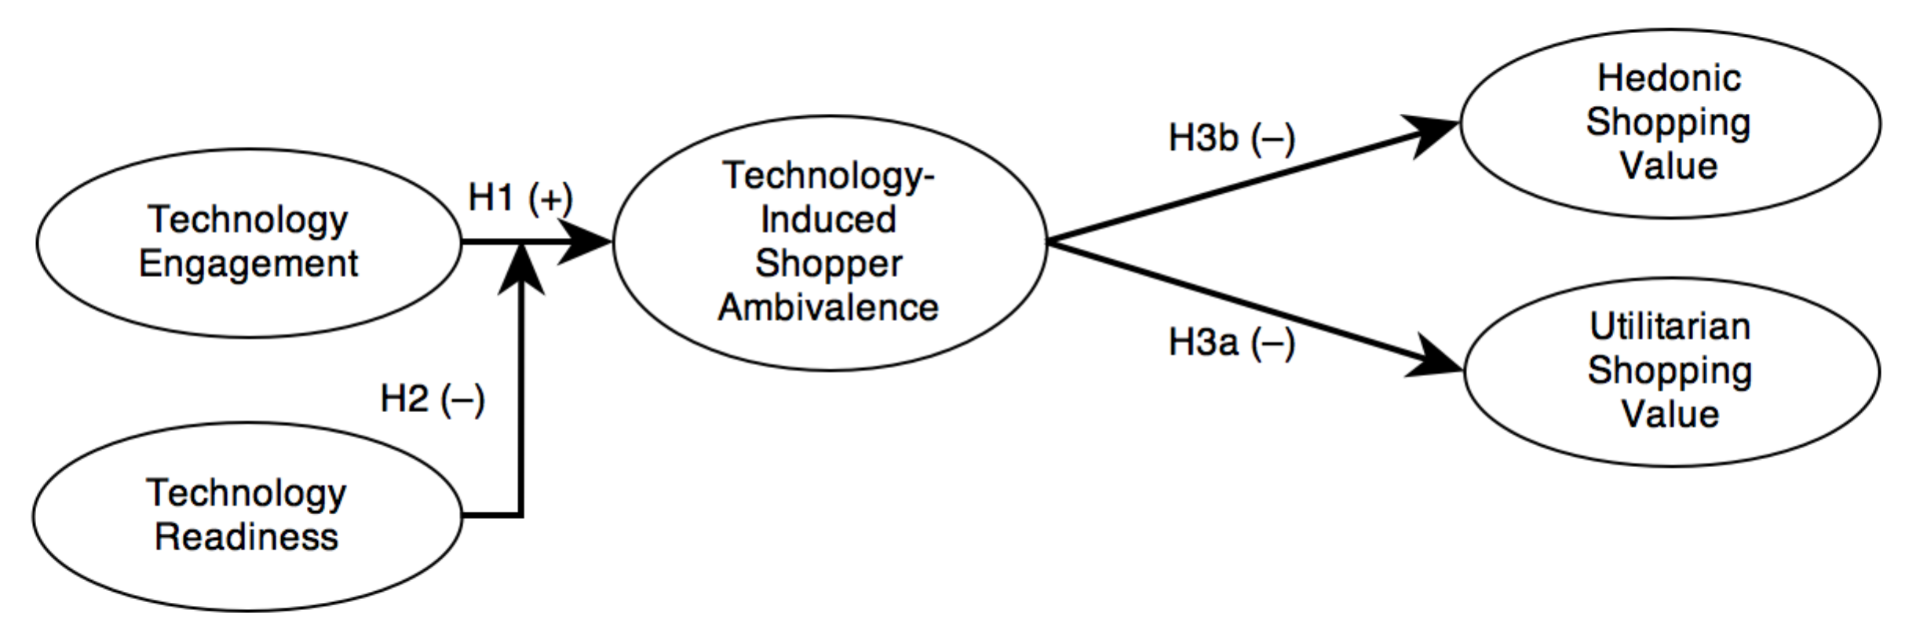
Figure 13 - A Model of Technology-Induced Shopper Ambivalence

Hypothesis Development
While some have argued that the very nature of technology itself embodies ambivalence (Feenberg 1990), this dissertation is more concerned with the attitudinal ambivalence that results from interactions with technology (Mick and Fournier 1998). Mick and Fournier’s (1998) framework of technology paradoxes (see Figure 2) provides eight dimensions of paradox. Each of these dimensions can be applied to the scenario of a shopper engaging with technology. Some dimensions, however, proved more impactful than others. Mick and Fournier arrange these dimensions along a spectrum of abstractness—with control/chaos the least abstract and engaging/disengaging the most abstract—but it is unclear if the effects of technology use and exposure by the shopper contributed to felt ambivalence at levels reflecting this same spectrum. That is, it is unclear whether the shopper felt more control/chaos ambivalence as opposed to engaging/disengaging ambivalence. It should also be noted that one dimension, new/obsolete, is the only dimension that is specific to the technology itself and not potentially reflective of the activity that the technology facilitates. As such, this dimension was not included in the model.
As demonstrated by Mick and Founier’s (1998) framework, as shoppers experience various technologies, they will also encounter the technological paradoxes associated with these technologies. Hence, shoppers that engage with technologies in the retail environment were likely to experience the paradoxes associated with the use of shopper-facing technologies and the ambivalence that results. Shoppers also face the confusing results of retailers that are trying to innovate with new in-store technologies while maintaining existing technology that is holding back new technology deployments (Rosenblum and Rowen 2012b). Additionally, the feelings of ambivalence encountered by Mick and Fournier’s participants were not just directed at the technologies themselves, but also the activities that the technologies facilitated. For example, one participant reflected on the enhanced feelings of competence he felt in his writing tasks after adopting a word processor, but also his loss of insight into the task when the way the technology functions becomes a “mystery” (p. 130). It follows then that the ambivalence that shoppers feel as a result of technology engagement will be directed toward the activities that the technology facilitates, namely the shopping task. As a consequence, shoppers will demonstrate increased ambivalence along the paradoxical dimensions directed at the shopping task. Thus,
H1: The greater the level of technology engagement, the greater the level of ambivalence toward the shopping task.
Technology readiness (Parasuraman 2000), a dispositional variable, measures the positive (optimism and innovativeness) and negative (discomfort and insecurity) mental enablers and disablers that individuals have toward the use of technology to accomplish goals. Because technology readiness reflects one’s propensity to use technology to accomplish goals, it stands to reason that those higher in technology readiness would see more benefit in utilizing technology to achieve those goals.
It should also be noted that Mick and Fournier’s (1998) eight technology paradox dimensions underlie the measures at the heart of Parasuraman’s (2000) technology readiness index (TRI). Because the TRI measures an individual’s positive and negative orientations toward utilizing technology to accomplish goals and combines these into a single index score, those shoppers with a high technology readiness index score will by definition demonstrate less ambivalent feelings. Thus,
H2: With greater technology readiness, the negative relationship between shoppers’ technology engagement and ambivalence toward the shopping task is attenuated.

As Mick and Fournier note, “the clash and doubt associated with inevasible opposite states is upsetting, if not traumatic…and the conflict and ambivalence precipitated by paradoxes lead, in turn to anxiety and stress” (p. 125). As shoppers engage with various technologies in the retail environment the ambivalence felt will manifest as increased stress. Maes, Vingerhoets and Heck (1987) define stress as “a state of imbalance within a person, elicited by an actual or perceived disparity between environmental demands and the person’s capacity to cope with these demands” (p. 567). This definition implies that stress can be a response to a situational cue, for example a shopper-facing technology that causes problems during the shopping task. This dissertation does not explore the coping mechanisms that can be used to ameliorate stress as shown in the Mick and Fournier model, but we were concerned with how the ambivalence-induced stress that results from technology use may negatively impact shopping value.
Because situational factors—such as engagement with a technology device—can impede goal attainment (Dawson, Bloch, and Ridgway 2002), a shopper focused on shopping as efficiently as possible (utilitarian shopping motive) or someone using shopping as a stress-relieving distraction (hedonic shopping motive) may find his or her shopping experience affected by distractions such as interactions with technology and the ambivalence-induced stressors that come with them. Shoppers may find their shopping experiences mediated by engagement with technologies within the retail environment. In addition, transient emotional reactions have been shown to moderate the relationship between shopping motives and shopping outcomes (Dawson, Bloch, and Ridgway 2002), which lends credence to the mediating role that ambivalence plays as a reaction to technology engagement.
Dawson, Bloch, and Ridgway (2002) demonstrated that shopping motives affect retail outcomes through emotional reactions. As shoppers experience ambivalence—and the stress associated with it—these emotional reactions will affect retail outcomes for the shopper. The most immediate shopping outcome for the shopper is the value that the shopper attributes to the shopping experience. Thus,
H3a: The greater the level of technology-induced shopper ambivalence experienced by the shopper, the less utilitarian value the shopper will place on the shopping experience.
H3b: The greater the level of technology-induced shopper ambivalence experienced by the shopper, the less hedonic value the shopper will place on the shopping experience.

Research Design
Study two utilized a survey to realize the second objective of this dissertation. Where study one was intended to develop an understanding of shoppers’ perceptions of technology-infused retail environments, study two is designed to test the model introduced here across a larger sample.
Specifically, this study tested the aforementioned model of technology-induced shopper ambivalence through structural equation modeling (SEM). SEM provides two attractive features: 1) it gives ability to model complex interrelations between constructs, and 2) it is designed to accommodate multi-item scales and the measurement error associated with unobservable constructs. SEM “makes a clear distinction between unobserved theoretical constructs and fallible, empirical measures. It is based on the partial interpretation philosophy, which advocates a doctrine of multiple operationalizations of the underlying construct by individually imperfect but collectively reliable and valid measures” (Steenkamp and Baumgartner 2000 p. 196). Steenkamp and Baumgartner (2000) described the three central premises that guide research executed with SEM. One, because no single measure can capture the full meaning of an underlying construct, SEM requires multiple measures that work together to provide a fuller measure of meaningfulness and validity. Two, SEM embraces the inevitable measurement error that contaminates construct measures. Three, SEM’s focus is explaining phenomena rather than the prediction of specific outcome variables.
Finally, utilizing a survey-based approach permitted this study to adapt and extend previous measures while also being the best approach to investigate our second research objective.

Sample
Respondents included shoppers of a national office retailer at a newly opened, technology-infused retail location. The particular retail location that shoppers were drawn from was located in business and residential area of New York City. Gender, age, and ethnicity were well represented ensuring maximum variability.

Data Collection
After the shopper made his or her purchase from the retailer, the receipt accompanying the purchase included an invitation to an online-based survey. Upon visiting the URL included with the invitation, the survey participant was required to consent to the conditions of the participation of the survey. All participants were given the option to receive an incentive ($10 off a $10 purchase) at the completion of the survey. The participant’s Internet protocol address was anonymously captured and a web browser cookie was activated to prevent the participant from taking the survey multiple times and receiving multiple incentives.

Construct Measurement
Our study contained a mix of newly created measures and those adapted from literature. In this section we highlight the nature of each. All measures can be found in Appendix E.

Technology Engagement
To measure the level of technology engagement within shopping experiences, participants were asked to recollect which technology devices they used while shopping. To assist them in their recall, photographs of all shopper-facing technologies appeared in the survey. For each technology that they recalled using (interactive) or watching (non-interactive) there was a series of measures designed to determine the level of engagement the shopper had with each technology. Measures of technology engagement were adapted from the User Engagement Scale (2010). The original items were designed to measure the level of technology engagement with an e-commerce website and, where necessary, measure wording was changed for the shopper-facing technologies in the retail environment context. Items were organized into six categories and reliabilities from their original development were included (O'Brien and Toms 2010): focused attention (α = .90), perceived usability (α = .88), aesthetics (α = .89), endurability (α = .84), novelty (α = .73), and involvement (α = .72). The results of these six sub-scales were combined into an overall index of technology engagement by averaging the components together and also including whether or not the participant noticed the technology while he or she was in-store, thus it served as an overall measure of engagement.

Technology Readiness
Measures for technology readiness were taken directly from the Technology Readiness Index (Parasuraman 2000). Measures were arranged in two positive and two negative component subscales. The positive were optimism (α = .81) and innovativeness (α = .80). The two negative were discomfort (α = .75) and insecurity (α = .74). The results of these four subscales were combined into an overall index score by reverse coding the scores for discomfort and insecurity and then averaging the scores of the four components together.

Technology-Induced Shopping Ambivalence
Measures of ambivalence stem from the attitude literature. Thompson, Zanna, and Griffin (1995) provide an in-depth investigation of ambivalence and the methods available to measure it. To determine an objective measure of ambivalence required either a mathematical transformation of two distinct sets of positively and negatively valenced items or a set of carefully articulated items that measure both valences simultaneously. We look first at the former method.
Thompson, Zanna, and Griffin (1995) recommend a method of calculating ambivalence through two necessary and sufficient conditions: similarity and intensity. Similarity is whether the magnitude of each of the ambivalence measure’s dimensions is similar in terms of their scores (i.e., both have responses on the highest or lowest ends of the answer spectrum). For example, a person who scores high on both measures would experience more internal conflict and ambivalence than a person who scored high on the positive attitude and low on the negative. Intensity is the other condition. Holding similarity constant, a person who scores high on both attitude measures is more likely to experience ambivalence than someone who scores low on both (Hass et al. 1991). At its most basic level then, ambivalence is determined by combining two separate measures into one score. We refer to this method of measuring ambivalence as “split” ambivalence, as the positive and negative dimensions are split between two sets of measures and then later combined into one score.
To combine these two measures, a mathematical formula is applied. Thompson, Zanna and Griffin (1995) tested a number of equations and found that the Griffin equation had “superior predictive power” (p. 375) (see Equation 1). Given scores of 1–4 for both positive (P) and negative (N) attitude measures, an ambivalence score was determined by subtracting the absolute value of the positive score from the negative score and then subtracting this from the average of these same two scores. What resulted was a number that represented the level of ambivalence of an individual taking into account both similarity and intensity across positive and negative items.

Equation 1
Ambivalence Calculation
(P + N)/2 - |P - N|

The range of resulting similarity and intensity scores is shown in Table 2. If, for example, a respondent evaluated the positive dimension at 4, while the negative dimension was evaluated at 3, after applying the equation above the resulting split ambivalence score would be 2.5.

Table 2 - Ambivalence: Similarity and Intensity Components Calculated
 | Positive Component
Negative Component | 1 | 2 | 3 | 4
1 | 1.0 | .5 | 0 | -.5
2 | .5 | 2.0 | 1.5 | 1.0
3 | 0 | 1.5 | 3.0 | 2.5
4 | -.5 | 1.0 | 2.5 | 4.0

The other method of measuring ambivalence is through the ‘direct’ method. A direct test of ambivalence takes the approach of directly assessing attitudinal ambivalence by embedding both positive and negative attitudes towards an attitude object within a single measure. For example, a Likert-like item might state, “when I used technology while I shopped I had more control over my shopping, but at the same time I was not comfortable because I had to do some things differently” (see Appendix E for all the direct ambivalence measures used).
While much effort has been expended developing more accurate equations to translate separate positive and negative ambivalence scores into a more accurate index (Breckler 1994; Kaplan 1972), evidence still shows—and researchers admit—that the self-reported direct method of measuring ambivalence is still a “gold standard” (M. M. Thompson and Zanna 1995 p. 371). Because the direct method “gets at the phenomenal experience of ambivalence, whereas the split method gets at the underlying structure of the ambivalence” (Zanna 2014) and as we were only concerned that the participant experiences ambivalence and were not necessarily concerned with the underlying structure, we used the “gold standard” and measured ambivalence using the direct method.

Shopping Value
Measures for hedonic and utilitarian shopping value were taken directly from Babin, Darden and Griffin (1994). Measures for hedonic shopping value constituted eleven items (α = .94) and utilitarian shopping value constitute four items (α = .80) (see Appendix E - Measurement Items).
A pre-test each of our construct measures was completed to ensure their suitability for our final data collection.

Measures Pre-Test
A pre-test of measurement items was executed with a panel of shoppers that had recently visited our partner office supply retailer. This panel was composed of shoppers that had previously signed up to provide feedback to the retailer in exchange for program benefits. The shoppers were not directly incentivized for the pre-test.
The purpose of the pre-test was to test the survey items for validity and reliability before deploying the measures in the final survey. This section outlines the steps taken to determine the suitability of specific measures for the final study and any steps taken to improve expected results from the final study. All items for technology engagement and technology-induced shopper ambivalence were tested as these were either new measures or highly adapted from literature. Hedonic shopping value, utilitarian shopping value, and technology readiness index items were not tested at this stage as these items had been previously validated (Babin, Darden, and Griffin 1994; Parasuraman 2000). All data were analyzed with SPSS 20.

Technology Engagement
Technology engagement in this study was represented by an overall index score that communicates the overall level of engagement that a participant had with all technologies in the retail environment. Because it was the only scale in this study adapted from an existing scale, it was necessary to determine if the wording changes made to the original scale items to fit the context of this study changed the factor loadings and if the context of the study itself obviated the need for any of the included scale dimensions. Unfortunately we cannot determine the reliability of our measures if we combine all of the engagement scores of each technology type into a single overall index score. Therefore, we focused on one technology in particular because we could compare scores for that technology across participants to determine reliability and factor loading. We chose mobile Internet devices (MIDs) because it was the one technology that was most often used by participants (n = 216).
All technology engagement measure results pertaining to MID use were subjected to an exploratory factor analysis in SPSS. We utilized principal axis factoring as our factor extraction method and Promax rotation with Kaiser normalization to converge loadings. In the results below, small cross-loading coefficients below .25 were suppressed and results were sorted by size to aid legibility.
The results of this EFA are below (see Table 3). The data demonstrate mediocre factorability (KMO = .628, Bartlett’s Test of Sphericity p = .000) and many of the factors display significant cross-loading.
The extent of the cross-loadings necessitated a re-evaluation of the measures to determine their applicability across both in-store assistive devices and MIDs and whether the adaptation of the original measures has negatively impacted the results.

Perceived Usability & Endurability
The items for perceived usability (PU) cross-loaded heavily with items for endurability (ED). A closer look at the perceived usability items (see Appendix E - Technology Engagement Measures) reveal that they were really measuring an emotional reflection on the experience (i.e., how the participant felt while interacting with the technology), which could easily conflate with the participant’s feelings of success with the interaction that endurability attempts to measure. This would explain the heavy cross-loading. For this reason endurability items were excluded from the final survey.
Additionally, items seven (“I felt in control of my experience with this technology”) and eight (“I could not do some of the things I needed to do on this technology” reverse coded) were measuring perceived control and were unrelated to the other items and were therefore marked for removal from the final survey.
A test of reliability for perceived usability was acceptable (α = .887), but when the above items were removed from the reliability analysis, results improved (α = .910).

Table 3 – Pre-Test Factor Loadings of Technology Engagement Items
 | Factor
 | 1 | 2 | 3 | 4 | 5 | 6
PU_2 | -.920
PU_5 | -.892
ED_1 | .839
ED_5 | .836
ED_3 | .831
PU_1 | -.761
ED_2 | .751
PU_6 | -.681
ED_4 | .661
PU_3 | -.655 |  |  |  |  | .458
PU_4 | -.516 |  | -.406 |  |  | .417
TV_3 | .473 |  |  | .434
PU_7 | -.422
FA_4 |  | .928
FA_3 |  | .873
FA_2 |  | .852
FA_5 |  | .846
FA_1 |  | .836
AE_5 |  |  | .824
AE_2 |  |  | .824
IN_3 |  |  | .720
AE_3 |  |  | .694
IN_2 |  |  | .492 | .455
IN_1 |  |  | .383
NV_2 |  |  |  | .920
NV_4 |  |  |  | .896
AE_6 |  |  |  |  | .809
AE_4 |  |  |  |  | .757
AE_1 |  |  |  |  | .639
PU_8 |  |  |  |  |  | .576
NV_1 | .331 | .275 |  |  | .257 | .333

Focused Attention
Focused Attention did not need any intervention as it had strong loadings with no appreciable cross-loadings with other factors. Additionally, a test of reliability demonstrated very good results (α = .936).

Aesthetics & Involvement
Aesthetics (AE) items were cross-loading with involvement (IN) items. This likely happened because the items for aesthetics and involvement may both be interpreted as asking about the hedonic nature of the interaction with the technology. Also, involvement comprised only 3.108% of the variance in the original study with loadings that ranged from 0.50 to 0.75. For these reasons, involvement was removed from the final survey.
Within the aesthetic measure, item six (“I liked the sound/music used on this technology”) was also removed as some technologies in our final study did not have an audio component. Additionally, a test of reliability for aesthetics was acceptable (α = .898), but slightly improved when item six was removed (α = .900). Item six of the aesthetics factor was therefore removed.

Novelty
Items for novelty (NV) were not loading well together and were cross-loading with a variety of other constructs. A closer inspection revealed that items for novelty were actually reflecting a number of distinct concepts including technology newness and interest and/or curiosity toward technology, which would explain the lack of factor cohesiveness. Also, novelty does not apply to shopper-owned technology (i.e., mobile Internet devices) as the shopper would already be familiar with their own device. Lastly, novelty comprised only 3.47% of the variance in the original study with mediocre loadings of 0.518 to 0.650 (O'Brien and Toms 2010). For these reasons, novelty items were removed from the final survey.

Table 4 – Pre-Test Factor Loadings of Revised Technology Engagement Items
 | Factor
 | 1 | 2 | 3
FA_4 | .901
FA_2 | .880
FA_1 | .866
FA_5 | .852
FA_3 | .828
PU_5 |  | .930
PU_3 |  | .905
PU_1 |  | .836
PU_2 |  | .687
PU_6 |  | .638
PU_4 |  | .626
AE_2 |  |  | .931
AE_3 |  |  | .909
AE_5 |  |  | .869
AE_4 |  |  | .667
AE_1 |  |  | .661

Scale Revision Results
After removing the above constructs (endurability, novelty, and involvement) and the problem items identified above, the resulting EFA provided much cleaner results (KMO = .782, Bartlett’s Test of Sphericity p = .000) (see Table 4).
The resulting factor loadings were on the whole strong and gave us better convergent and discriminant validity. Convergent validity was assessed by comparing the factor loadings. With a sample size of 310 we would need at least a loading of .35 for each item of a factor, which we have. Discriminant validity was assessed by determining whether or not an item is loading on a single factor and to compare the factor correlation matrix to make sure that factors correlate by less than 0.7. All of our items meet these criteria as well.

Technology-Induced Shopping Ambivalence
Because technology-induced shopper ambivalence is conceptualized as a first order construct we must evaluate its items with unrelated items to assess its construct validity. Therefore, we combined items from technology-induced shopper ambivalence, utilitarian shopping value, and hedonic shopping value to assess convergent validity and discriminant validity through exploratory factor analysis.
First, all constructs were tested for reliability across measurement items. The direct measures of technology-induced shopping ambivalence (AMB) (α = .823), hedonic shopping value (HSV) (α = .882), and utilitarian shopping value (USV) (α = .876) all displayed adequate reliability. Next, AMB, USV, and HSV items were subjected to an exploratory factor analysis in SPSS. We utilized principal axis factoring as our factor extraction method and Promax rotation to converge our loadings to assess convergent and discriminant validity. In the results below, small cross-loading coefficients below .35 were suppressed and results were sorted by size to aid legibility.
The results of this EFA below (see Table 5 – Pre-Test Factor Loadings of Ambivalence, HSV, and USV Items) show the data demonstrate adequate factorability (KMO = .794, Bartlett’s Test of Sphericity p = .000), however there were a few exceptions to note. HSV_7 is loading very weakly on its factor, this item also has the lowest level of communality within the scale (0.41), and the cross loading is less than .2 from its intended factor loading. When Cronbach’s alpha was calculated on HSV results were strong (α = .882), but improve when HSV7 is excluded (α = .899). We will therefore exclude HSV7 from our final survey. Some items of AMB were also loading weakly, but since the absence of these AMB items did not improve reliability of its scale we left them in the final survey and assessed any further weaknesses with the measurement model.

Table 5 – Pre-Test Factor Loadings of Ambivalence, HSV, and USV Items
 | Factor
 | 1 | 2 | 3
HSV4 | .858
HSV5 | .839
HSV1 | .819
HSV3 | .794
HSV6 | .787
HSV2 | .617
HSV7 | .432
AMB4 |  | .703
AMB7 |  | .677
AMB1 |  | .674
AMB2 |  | .666
AMB6 |  | .647
AMB5 |  | .610
AMB3 |  | .575
USV4 |  |  | .828
USV1 |  |  | .810
USV3 |  |  | .770
USV2 |  |  | .681

Findings
The proposed research model (see Figure 13) and hypotheses were tested using structural equation modeling (SEM). The two-step approach prescribed by Anderson and Gerbing (1988) was used to 1) evaluate the measurement model via confirmatory factor analysis to ensure that our measures were appropriate for our constructs and 2) a structural model was used to test the causal relationships between those constructs and to determine the fit of our model. Our findings offer a unique perspective on the role of technology and how it shapes the value-based consequences of shopping encounters. Specifically, we found that higher levels of engagement with shopper-facing technologies were associated with increased levels of technology-induced shopper ambivalence and increased levels of utilitarian shopping value. Technology readiness, while not moderating the effects of technology engagement on ambivalence, had a significant direct effect on ambivalence and hedonic shopping value. And finally, contrary to expectations, we found that technology-induced shopping ambivalence was associated with an increase in hedonic shopping value while at the same time adversely affecting utilitarian shopping value.
Before the two-step SEM process could begin, a few tasks needed to be performed. First, the data was screened to ensure its suitability for analysis, the sample is described in detail, and a preliminary analysis was completed to probe for any problems in measures not caught with the pre-test. The two-step process was then completed: one, measurement model fit was determined with a confirmatory factor analysis and a lack of common method variance was confirmed. Two, the causal structural model and mediation tests were assessed, and, the findings were reported.

Data Screening
The first step in the analysis of our data is ensuring the necessary quality. The final survey data were screened to ensure that all responses were complete and that no ineligible survey responses were included. The survey had 771 initial responses, which was the starting point for data screening.
Because the online data collection system we utilized (Qualtrics) was set to force responses for all survey questions (except any open-ended, qualitative questions), the only records with incomplete data were those where the participant abandoned the survey while in progress. Therefore, all unfinished surveys were removed leaving only fully completed responses. Because of this, data imputation was not necessary. This step removed 235 responses leaving a total of 536.
Responses were excluded where participants acknowledged that they had participated in the in-store shop alongs and interviews from our in-store qualitative study. In-store shop-along and interview participants would be primed with knowledge of the study’s true nature, which we wanted to avoid. To ensure truthful responses, language was included to notify participants that acknowledging that they had taken part in the qualitative study would not preclude the survey respondent from receiving the study incentive. This step removed 47 responses leaving 489.
Responses from participants who did not take the study seriously or who were unengaged when they responded were eliminated. This included responses that showed no deviation from the mean on the technology readiness index measures, which meant that the participant answered all questions on the TRI scale the same—even reverse-coded items. TRI was chosen because half of the measures are negatively phrased and no deviation in responses across both positively and negatively worded measures would be unrealistic as the same answers on all items would show a lack of credibility in responses. This step removed an additional 470 responses.
Whether shoppers noticed a piece of technology in the store counted towards their technology engagement score. Without skewing the results by having someone who viewed a large number of technologies but didn’t actually interact with or watch them, the decision was made to weight each in-store assistive technology as 1/13th of a point (.076923) so the most that could be added to a technology engagement index score by a shopper merely noticing all technologies was 1 (1/13th of a point for all 13 technologies). Those respondents that noticed no in-store assistive devices (ISADs) while shopping were removed from the dataset, leaving a final sample size of 310 responses.
To ensure the remaining sample size was sufficient for this study, a sample size calculator was used (Soper 2014) that provided the minimum sample size necessary given the complexity of the structural equation model. This calculator was powered by equations specifically for structural equation models that provide the lower bounds necessary (Christopher Westland 2010). When accounting for a small anticipated effect size (0.15), a conventional level of power (80%) (Cohen 1988), and a standard probability level (0.05), we required a minimum sample size of 201 to detect the effect, a minimum sample size of 100 for the model structure, and recommended minimum sample size of 201. Our final sample size of 310 was sufficient.
Because parametric statistical procedures are predicated on the assumption of normality of data, skewness and kurtosis statistics were generated for all latent variable items along with their accompanying standard errors. To determine whether the levels of skewness and kurtosis were acceptable, skewness and kurtosis scores were compared to their standard errors. As long as the absolute value of the skewness or kurtosis score was less than three times its standard error, the data display sufficient normality (Tabachnick and Fiddell 1995). This was the case for all the latent variable items with a few exceptions. One, all four utilitarian shopping value (USV) items displayed signs of negative skewness. This is likely because the retail context was a highly utilitarian shopping environment (i.e., office supplies). Two, many of the technology readiness Optimism items showed signs of skewness, however each had significantly less than two standard errors of skewness, which indicates minimal effect. Finally, technology engagement displayed significant positive skewness and kurtosis. The skewness was the result of a large number of participants that only had limited interactions with the in-store assistive and mobile Internet devices. Among the limited interactions, most occurred at the low end of the range creating a leptokurtic distribution in the data.
Besides the technology readiness index, technology engagement was the only variable that needed be calculated in our study. The survey had a series of seventeen questions that were asked about each technology in the retail environment. The first question was whether the participant remembered noticing the technology in question and the other sixteen were the technology engagement measures (see Appendix E for measurement items). Participants were then asked which of the thirteen ISADs as well as their own mobile Internet device (MID) they “used or actively watched while shopping.” Because some participants may have noticed a technology but not necessarily engaged with it, this two-step (Did you notice/Did you engage) process is needed. If a participant engaged with every technology and answered ‘strongly agree’ to all technology engagement items, he or she would be assigned 70 points (14 technologies multiplied by a 5 point Technology Engagement index for each), plus 1/13th of a point for noticing each of the 13 in-store technologies for a total of 71 points.
With a sample size and data quality found sufficient for analysis, sample details were gathered.

Sample
A descriptive analysis of the data was completed so we could ensure that the sample was demographically diverse. The survey was active for the entire month of February 2013 at the Kips Bay location in New York City. Because the retailer gathers its transaction data weekly starting on Sundays, February 1 and 2 (a Friday and Saturday) were not included in the transaction data, but March 1 and 2 were. We had no reason to believe that February 1 and 2 were appreciably different than March 1 and 2 as both sets of days were a Friday and Saturday during non-holiday periods. During the 28 day time period, the Kips Bay location had a total of 9489 transactions. The initial response rate from all 771 participants was 8.12%. This compared favorably to a response rate of 7.4% for an earlier promotion by the retailer.
The final screened sample of 310 participants was 60.6% male. 52.3% of our sample was first time visitors to the Kips Bay store location, which is unsurprising given the location had recently opened. Those aged 25 to 54 made up 85.2% of the overall sample, which reflected the retailer’s business goods orientation (see Figure 14). Participants with some form of college degree made up 79.9% of the sample, which also reflected the business goods orientation of the retailer and educational levels within a highly populated and expensive urban environment (see Figure 15). Finally, the income spread of respondents reflected education levels as higher incomes were more prominent (see Figure 16).

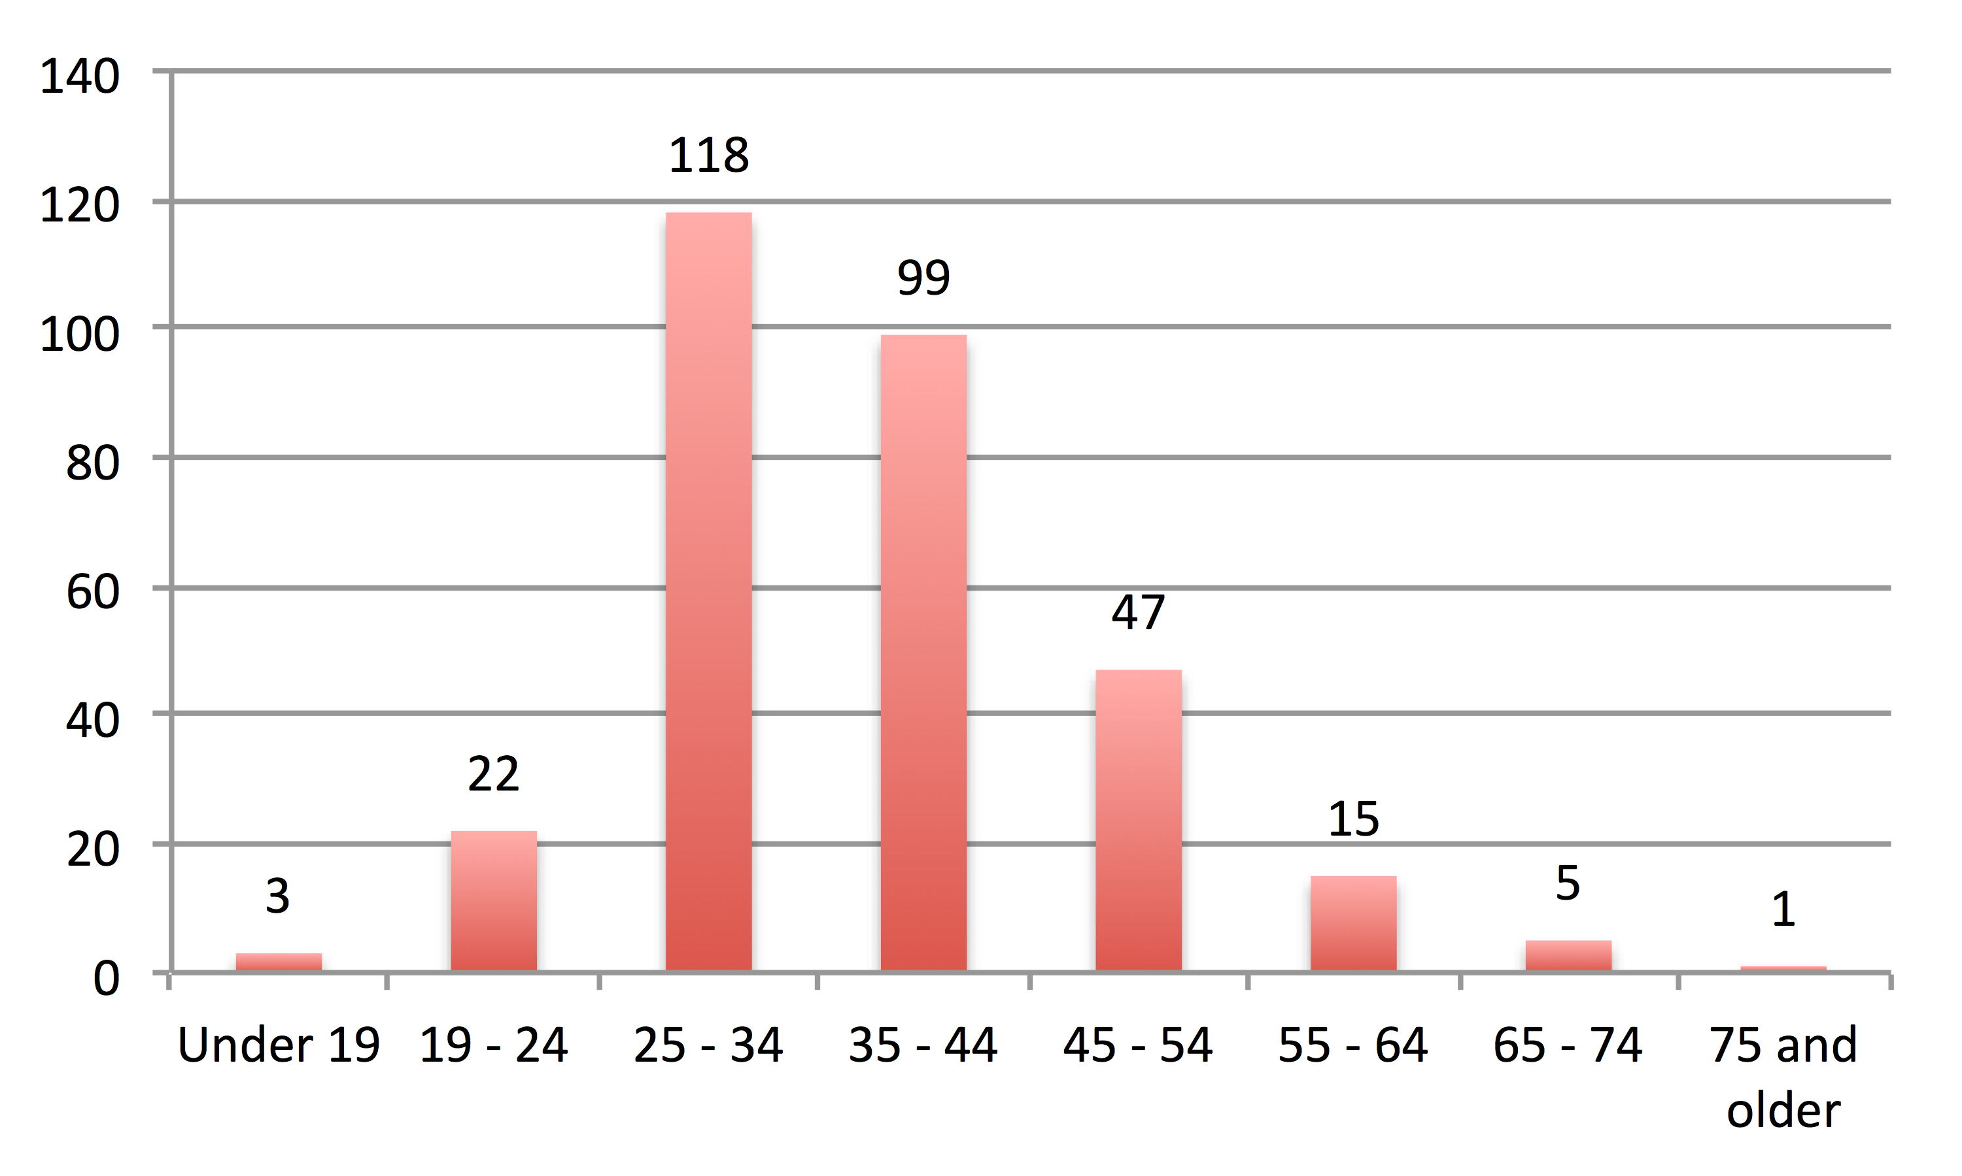
Figure 14 - Age Distribution of Sample
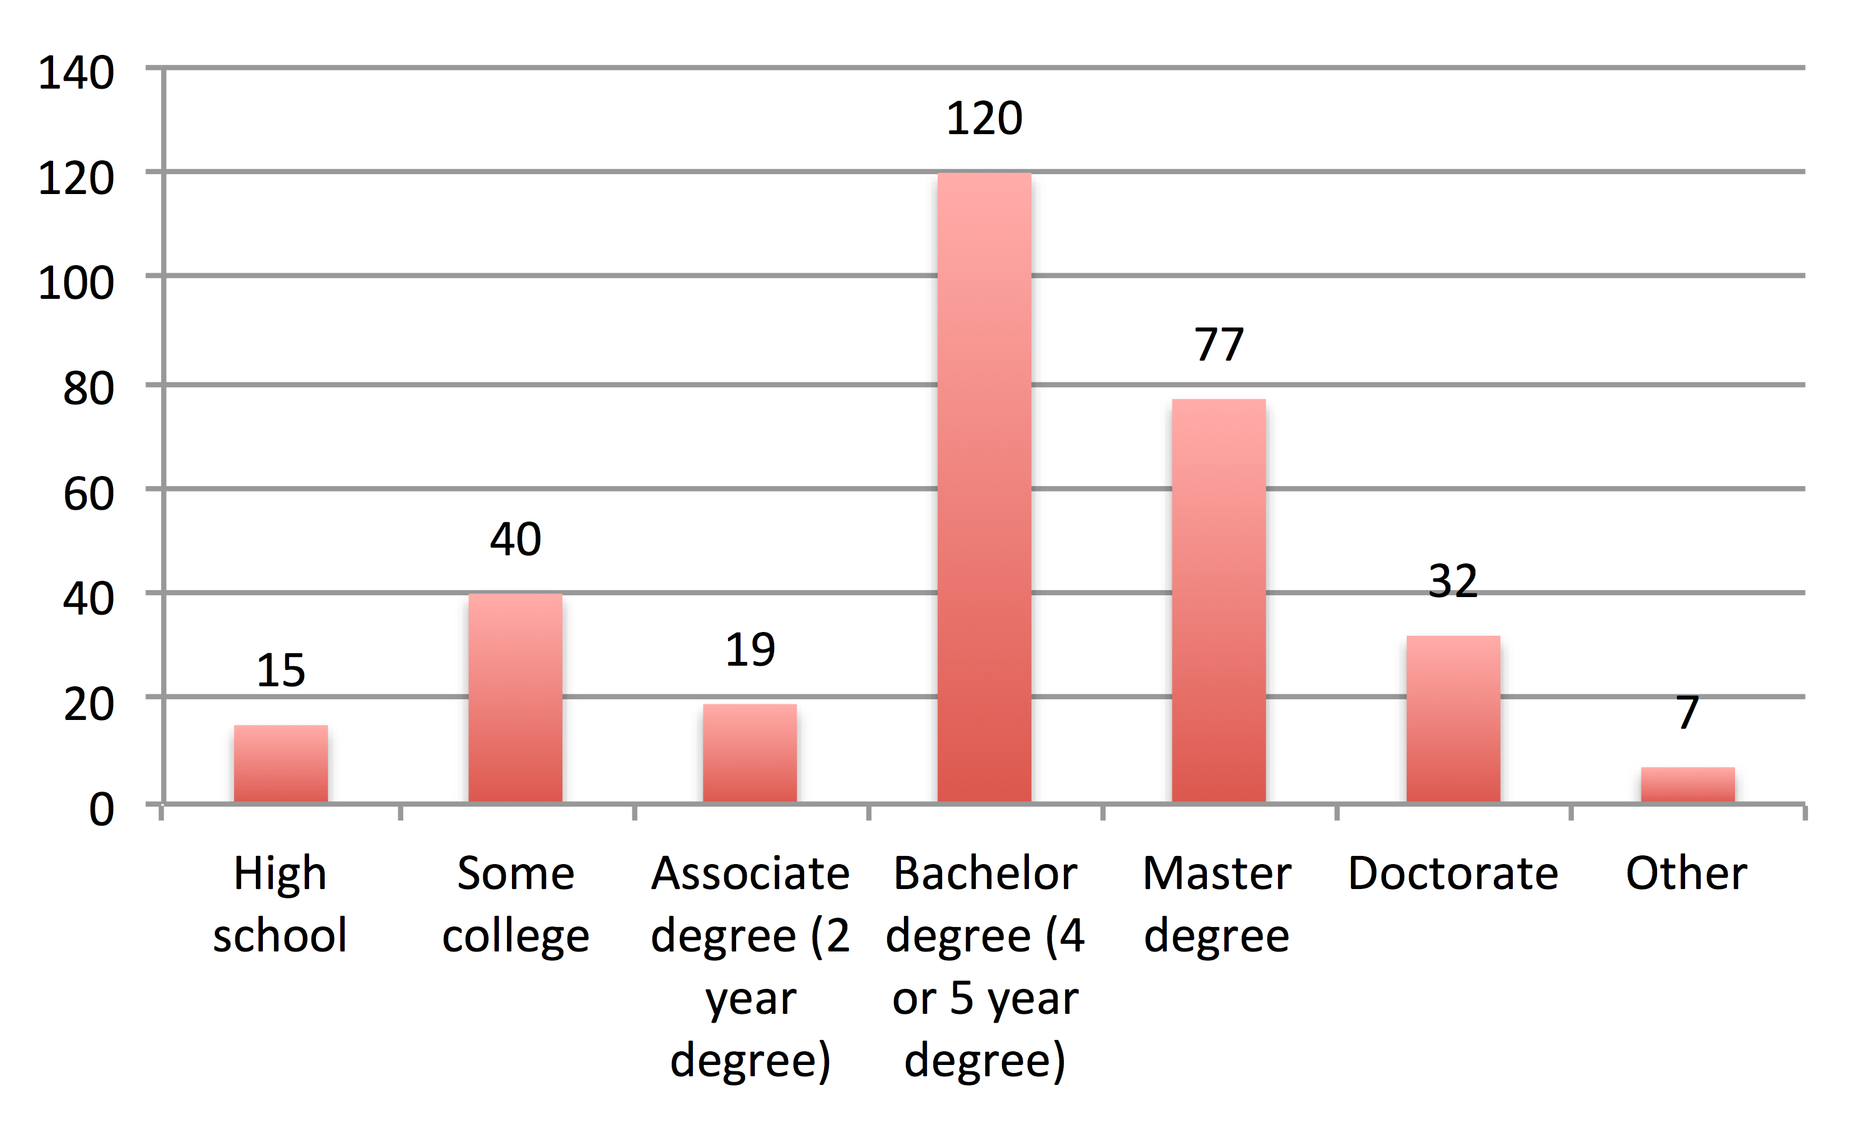
Figure 15 - Education Distribution of Sample

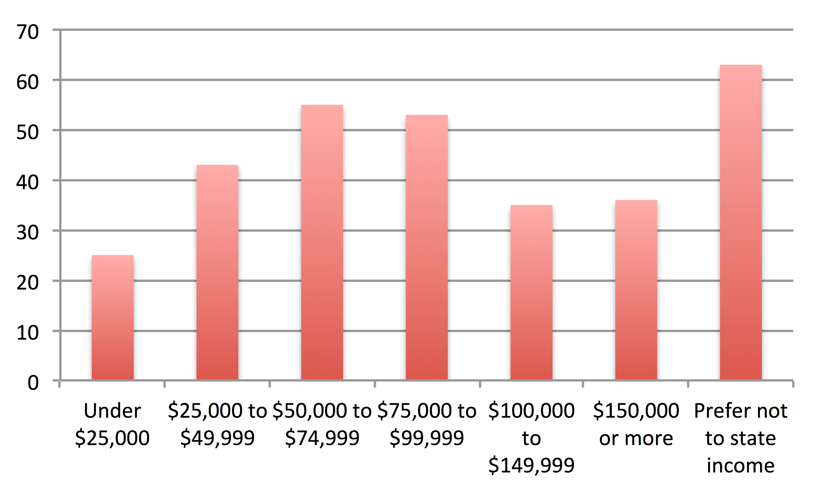
Figure 16 - Income Distribution of Sample

With a demographically diverse sample established, an exploratory factor analysis was the next step.

Preliminary Analysis
Descriptive statistics for all measurement items were calculated and results are shown in Appendix F. The minimum values, maximum values, means, and standard deviations were calculated for all items across all study constructs. Mean values ranged from 2.61 to 4.13 on 5-point Likert-like scales. Standard deviations ranged from 0.660 to 1.22. Having established that means and standard deviations for all variable items were within expected ranges, dimensionality of latent constructs were tested through exploratory factor analysis.
All latent constructs were subjected to exploratory factor analysis (EFA) to verify that results from the measures pre-test were holding firm and to uncover any flaws in the measurement items that can be used as additional criteria when evaluating items within the measurement model. All EFA tests done on the final data set utilized principal axis factoring (PAF). An advantage of PAF is that it can be effective with non-normal datasets (Fabrigar et al. 1999), which means the small amount of non-normality in our data should not be a issue. As well, an oblique form of factor rotation was used (Promax) rather than an orthogonal rotation method (e.g., Varimax) as any unforeseen intercorrelation among factors becomes a non-issue (Gorsuch 1997).

Technology Engagement
As with technology engagement in the study pre-test, technology engagement was represented by an overall index score that tapped into the overall level of engagement that a participant had with all technologies in the retail environment. Again, we looked at the most commonly used technology in the retail environment, MIDs, to determine the reliability and factor dimensions of the items.
All technology engagement measure results pertaining to MID use were subjected to an exploratory factor analysis in SPSS. In the results below (see Table 6), small cross-loading coefficients below 0.35 were suppressed, extraction was set to three factors (Aesthetics, Perceived Utility and Focused Attention), and results were sorted by size to aid legibility. The data demonstrate strong factorability (KMO = .892, Bartlett’s Test of Sphericity p = .000) and the majority of Focused Attention (FA), Perceived Utility (PU), and Aesthetics (AE) items converged well on their expected factors. The only exception were items PU2 and PU6, which loaded with aesthetics items.
Reliability scores were strong for Focused Attention (α = .848) and Aesthetics (α = .810). Perceived Utility reliability was weaker (α = .706). However, when Cronbach’s Alpha was calculated after dropping items PU2 and PU6—those items loading with Aesthetics in the EFA—reliability increased substantially (α = .870).
An overall technology engagement index score was calculated because the total exposure to technology was more a concern than exposure to specific technologies. Normally, each measurement item for this scale would be represented in the structural equation measurement model to determine which items contribute or detract from overall model fit. Unfortunately, this approach did not work with technology engagement as its scale items are repeated for each of the up to 14 devices with which participants engaged (13 ISADs plus MID) and the sample size of any one technology (save MIDs) was too small to provide any accurate statistical inferences. Therefore, items PU2 and PU6 of perceived utility were removed prior to the calculation of the overall technology engagement index.

Table 6 - Factor Loadings of Technology Engagement Items
 | Factor
 | 1 | 2 | 3
AE3 | .772
AE5 | .748
AE4 | .691
AE2 | .637
PU6 | .622
AE1 | .602
AE6 | .531
PU2 | .522
PU3 |  | .853
PU4 |  | .835
PU1 |  | .743
PU5 |  | .600
FA2 |  |  | .807
FA1 |  |  | .786
FA4 |  |  | .745
FA3 |  |  | .641
FA5 |  |  | .508

Technology Readiness
Next, technology readiness index items were analyzed for reliability and validity. Each of the dimensions demonstrated strong reliability (Optimism, α = .888; Innovativeness, α = .863; Discomfort, α = .858; Insecurity, α = .834). For the factor analysis, small cross-loading coefficients under 0.35 were suppressed, extraction was set to four factors (Optimism, Innovation, Discomfort, and Insecurity) and results were sorted by size to aid legibility. The data demonstrated strong factorability (KMO = .883, Bartlett’s Test of Sphericity p = .000) but with moderate to poor item factor loadings (see Table 7).
The results indicated borderline acceptable loading scores with only one item cross-loading between innovation and discomfort. On the whole the measures performed well and demonstrated sufficient convergent and discriminate validity among measures. As there were no items negatively impacting reliability on any of the TRI dimensions, the index score was computed per the procedures prescribed by Parasuraman (2000 p. 318): “The overall TRI score for each respondent [is] obtained by averaging the scores on the four components (after reverse coding the scores on the discomfort and insecurity components).”

Technology-Induced Shopping Ambivalence, Utilitarian Shopping Value & Hedonic Shopping Value
As with the pre-test data, technology-induced shopping ambivalence (AMB), utilitarian shopping value (USV), and hedonic shopping value (HSV) were combined in an exploratory factor analysis to determine sufficient convergent and discriminant validity. The results of this EFA are in Table 8 below.

Table 7 - Factor Loadings of Technology Readiness Items
 | Factor
 | 1 | 2 | 3 | 4
OPT8 | .764
OPT3 | .695
OPT2 | .691
OPT5 | .664
OPT1 | .664
OPT7 | .641
OPT9 | .635
OPT10 | .573
OPT6 | .564
OPT4 | .547
DIS6 |  | .736
DIS1 |  | .728
DIS2 |  | .682
DIS4 |  | .677
DIS3 |  | .673
DIS10 |  | .577
DIS8 |  | .561
DIS5 |  | .549
DIS7 |  | .512
DIS9 |  | .404
INNO2 |  | -.319 | .310
INNO1 |  |  | .784
INNO7 |  |  | .778
INNO4 |  |  | .761
INNO3 |  |  | .760
INNO5 |  |  | .689
INNO6 |  |  | .668
INSC4 |  |  |  | .668
INSC3 |  |  |  | .648
INSC5 |  |  |  | .647
INSC6 |  |  |  | .641
INSC1 |  |  |  | .619
INSC7 |  |  |  | .588
INSC9 |  |  |  | .583
INSC2 |  |  |  | .551
INSC8 |  |  |  | .385

Ambivalence item loadings varied from relatively weak to strong with strong reliability (α = .867). Hedonic shopping value loadings were poor to strong with adequate reliability (α = .752). HSV7 was performing particularly poorly and as such was removed from the model. Finally, utilitarian shopping value displayed moderate to weak loadings with relatively week reliability (α = .693).
The weak reliabilities of USV and HSV showed improvement when items were eliminated. However, we left these measures intact for our measurement model as we were better able to assess what items should be removed at that stage.

Table 8 - Factor Loadings of Ambivalence, HSV, and USV Items
 | Factor
 | 1 | 2 | 3
AMB1 | .820
AMB3 | .819
AMB4 | .802
AMB7 | .755
AMB2 | .685
AMB5 | .570
AMB6 | .535
HSV4 |  | .851
HSV3 |  | .847
HSV1 |  | .728
HSV5 |  | .699
HSV6 |  | .696
HSV2 |  | .672
USV1 |  |  | .687
USV4 |  |  | .633
USV3 |  |  | .602
USV2 |  |  | .515
HSV7 |  |  | .367

Measurement Model (Confirmatory Factor Analysis)
For the first part of the two-part analysis process (Anderson and Gerbing 1988), latent variables were placed in a measurement model to assess model fit. Technology Readiness Index and Technology Engagement Index variables appeared as observed variables in the model because they were calculated composite variables. Technology-induced shopping ambivalence, utilitarian shopping value, and hedonic shopping value each had its associated items in the model minus those eliminated through the earlier EFA.
The first step was to assess the model fit of the initial measurement model (see Figure 17). Initial item loadings showed some interesting results. First, we sew an issue with the utilitarian shopping value items. Items USV2 and USV4 loaded well, while USV1 and USV3 loaded poorly. This is consistent with the inferior results in our EFA, but gave us clearer guidance as to which items needed to be removed to improve model fit. Item loadings for hedonic shopping value and technology-induced shopping ambivalence were moderately strong with some weaker items that warranted a closer look.

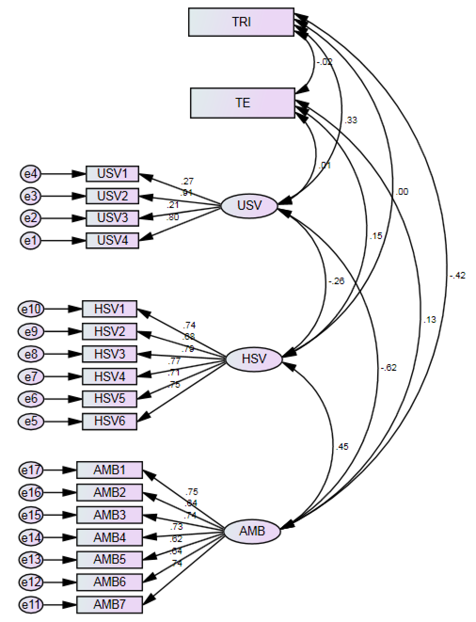
Figure 17 - Initial Measurement Model Loadings

Model fit for all of our model testing was assessed by comparing results to widely accepted threshold levels established in Hair et al. (2009). As we can see in Table 9, our initial measurement fit esults showed promise, but overall fit was fairly weak. The CMIN value was adequate, but the p-value for our model did not meet its threshold, likely due to the larger sample size of the data. Moving on to the other model fit measures, CFI is unacceptable, as is GFI. While AGFI and SRMR are moderately acceptable, RMSEA and PCLOSE are clearly unacceptable. Overall this was a poor performing model.

Table 9 - Initial Measurement Fit
Measure | Threshold (Hair et al. 2010) | Model 1 Fit
Chi-square/df (cmin/df) | < 3 good; < 5 sometimes permissible | 2.770
p-value for the model | > .05 | .000
CFI | > .95 great; > .90 traditional | .893
GFI | > .95 | .882
AGFI | > .80 | .844
SRMR | < .09 | .072
RMSEA | < .05 good; .05 - .10 moderate> .10 bad | .076
PCLOSE | > .05 | .000

Modification indices of our model were then analyzed for covariances between latent variable error terms (see Table 10). Only those covariances between error terms and those within the same latent variable could be addressed. Given this, the candidate relationship with the highest covariance that needed to be addressed was between error terms e2 and e4 within utilitarian shopping value items USV1 and USV3. The only other relationship that required covariation of error terms within our measurement model was between e14 and e17 of the technology-induced shopping ambivalence latent variable items AMB1 and AMB4.
With these changes made, model fit was reassessed (see Figure 18). The results (see Table 11) were clearly better than the first model; all measures were improved. CFI, GFI, RMSEA, and PCLOSE were borderline however, while SRMR and AGFI met their thresholds. The model could still be improved.

Table 10 - Initial Measurement Model Modification Indices
 |  |  | Modification Index | Par Change
e15 | <--> | Hedonic | 5.281 | -.059
e15 | <--> | e16 | 4.029 | .059
e14 | <--> | e17 | 12.459 | .097
e13 | <--> | TRI | 4.335 | .034
e13 | <--> | Hedonic | 9.229 | .083
e12 | <--> | Ambiv | 5.213 | -.057
e12 | <--> | Hedonic | 8.483 | .085
e12 | <--> | Utilitarian | 5.043 | -.084
e12 | <--> | e14 | 7.996 | -.086
e8 | <--> | e15 | 5.319 | -.050
e8 | <--> | e12 | 7.194 | .067
e7 | <--> | e15 | 5.090 | -.053
e6 | <--> | e8 | 4.581 | -.048
e5 | <--> | Ambiv | 4.464 | .045
e5 | <--> | e11 | 6.867 | .069
e5 | <--> | e6 | 6.815 | .069
e4 | <--> | Ambiv | 7.107 | .062
e4 | <--> | Hedonic | 16.244 | .109
e4 | <--> | Utilitarian | 8.725 | .103
e3 | <--> | e10 | 5.972 | -.066
e3 | <--> | e9 | 6.346 | .077
e2 | <--> | Hedonic | 14.432 | .111
e2 | <--> | Utilitarian | 4.585 | .080
e2 | <--> | e10 | 11.358 | .094
e2 | <--> | e4 | 109.187 | .331
e1 | <--> | e10 | 6.066 | .073
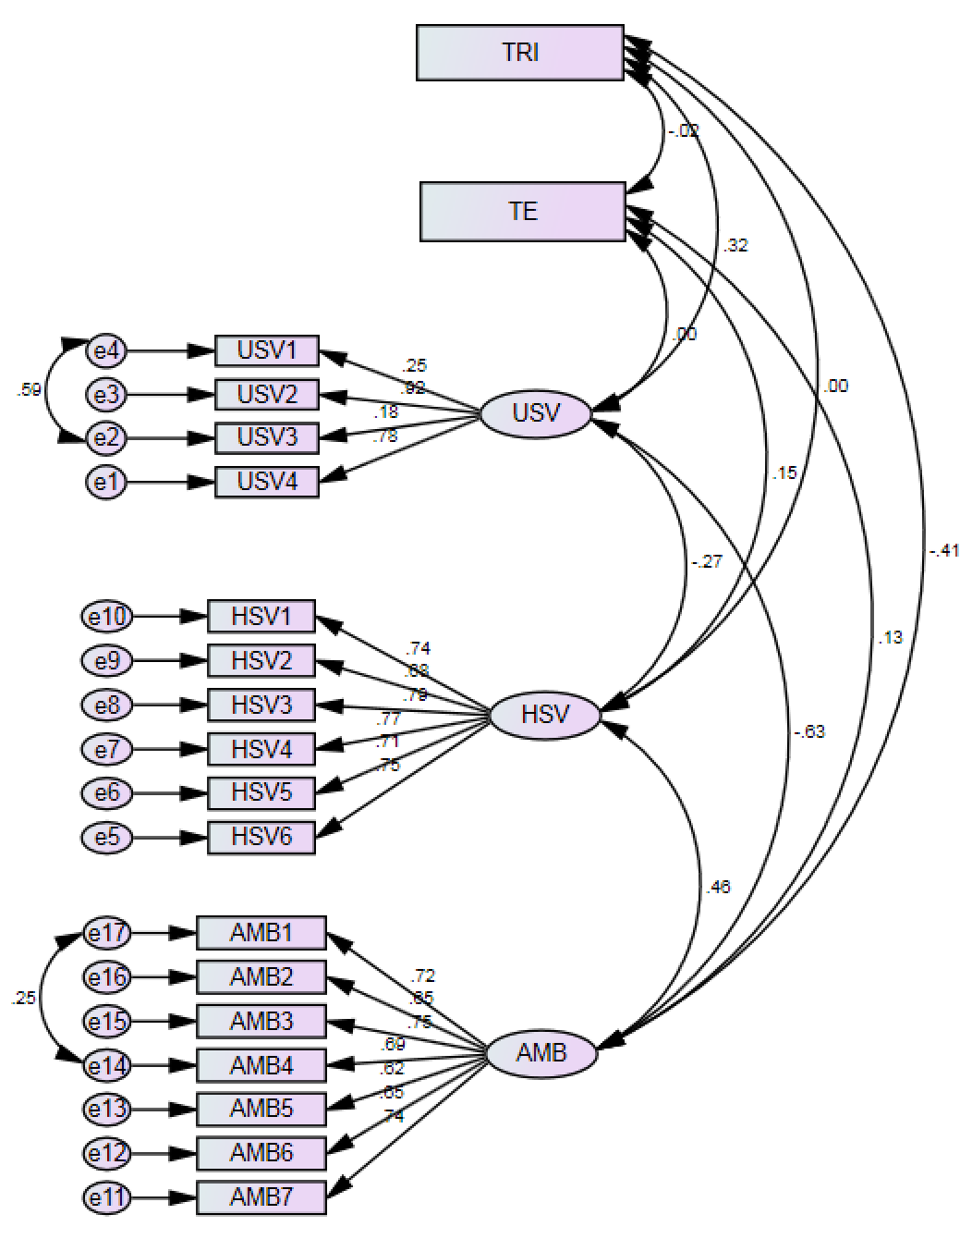
Figure 18 - Measurement Model 2

Table 11 - Measurement Model 2 Fit
Measure | Threshold (Hair et al. 2010) | Model 1 Fit | Model 2 Fit
Chi-square/df (cmin/df) | < 3 good; < 5 sometimes permissible | 2.770 | 1.767
p-value for the model | > .05 | .000 | .000
CFI | > .95 great; > .90 traditional | .893 | .954
GFI | > .95 | .882 | .921
AGFI | > .80 | .844 | .894
SRMR | < .09 | .072 | .067
RMSEA | < .05 good; .05 - .10 moderate> .10 bad | .076 | .050
PCLOSE | > .05 | .000 | .499
Next, residuals were assessed to determine where discrepancies between the proposed model and estimated model lie. A review of the standardized residual covariances revealed that USV1 and USV3 highly covaried. SEM does not allow for the covariance of measurement items in the measurement model, so given the high level of covariance between these items and their poor item loading in the EFA, these items were removed from the model (see Figure 19). In addition, some other items showed high covariances, but we refrained from making any further changes until these most recent changes were assessed.

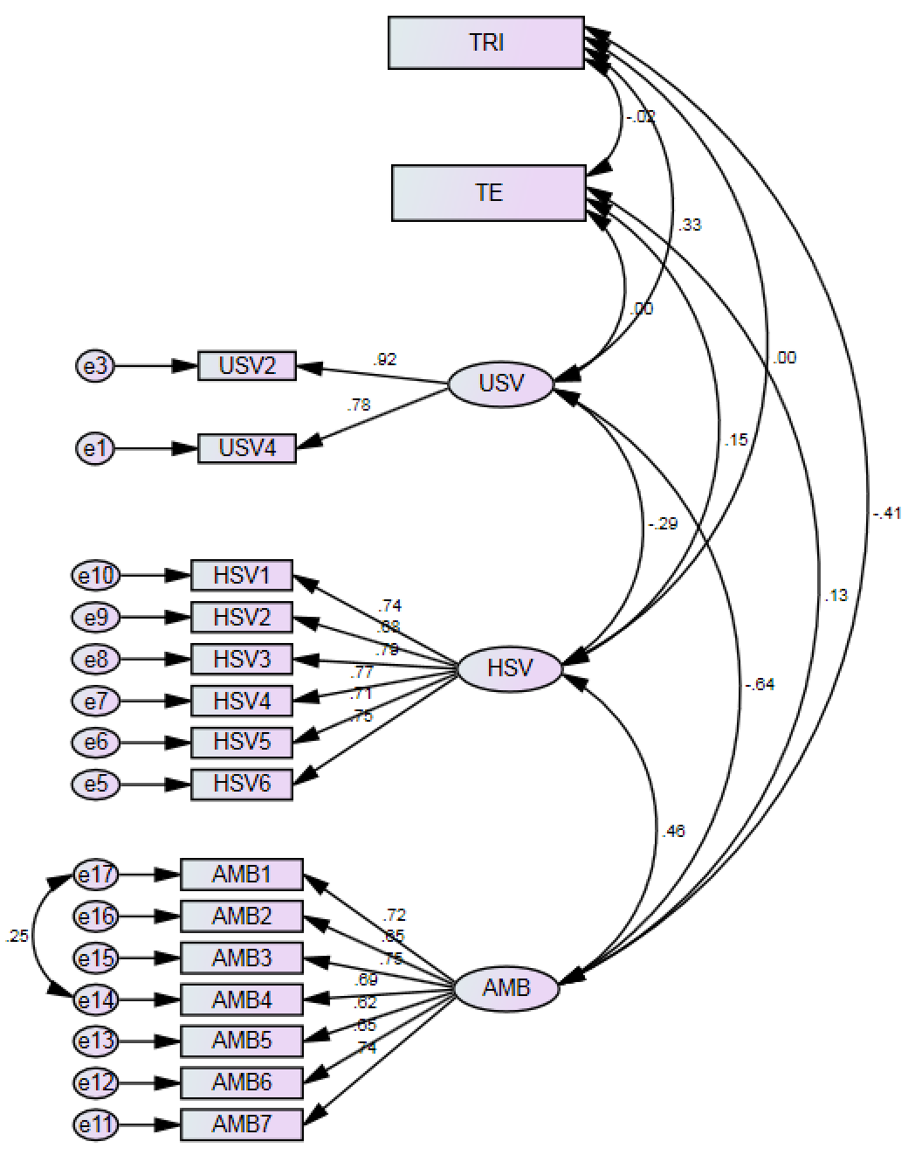
Figure 19 - Measurement Model 3
The results of our third model showed significant improvement (see Table 12). All measures were improved and surpassed the desired threshold levels.

Table 12 - Measurement Model 3 Fit
Measure | Threshold (Hair et al. 2010) | Model 1 Fit | Model 2 Fit | Model 3 Fit
Chi-square/df (cmin/df) | < 3 good; < 5 sometimes permissible | 2.770 | 1.767 | 1.594
p-value for the model | > .05 | .000 | .000 | .000
CFI | > .95 great; > .90 traditional | .893 | .954 | .970
GFI | > .95 | .882 | .921 | .936
AGFI | > .80 | .844 | .894 | .911
SRMR | < .09 | .072 | .067 | .053
RMSEA | < .05 good; .05 - .10 moderate> .10 bad | .076 | .050 | .044
PCLOSE | > .05 | .000 | .499 | .793

Next we verified that the reliability, convergent validity, and discriminant validity of our model were adequate. Consulting Hair et al. (2009), reliability is established by ensuring that composite reliability (CR) is greater than 0.70. Convergent validity is established by ensuring that composite reliability is greater than average variance extracted (AVE) and AVE is greater than 0.5. Finally, discriminant validity is established by ensuring that maximum shared variance (MSV) is less than AVE, and average shared variance (ASV) is also less than AVE.
AVE for technology-induced shopping ambivalence did not meet the criteria for convergent validity (see Table 13). A closer look at item loadings for ambivalence in the measurement revealed a few poor loading items. Removing the two lowest loading items on this factor and recalculating reliability and validity measures (see Table 14) to create Model 4 (see Figure 20), resulted in an overall reliability of ambivalence decrease, yet acceptable reliability, convergent validity, and discriminant validity. The measurement model fit of Model 4 was thus significantly improved (see Table 15).

Table 13 - Model 3 Convergent and Discriminant Validity Measures
 | CR | AVE | MSV | ASV
HSV | 0.880 | 0.551 | 0.214 | 0.148
USV | 0.845 | 0.733 | 0.402 | 0.241
Ambivalence | 0.864 | 0.478 | 0.402 | 0.308

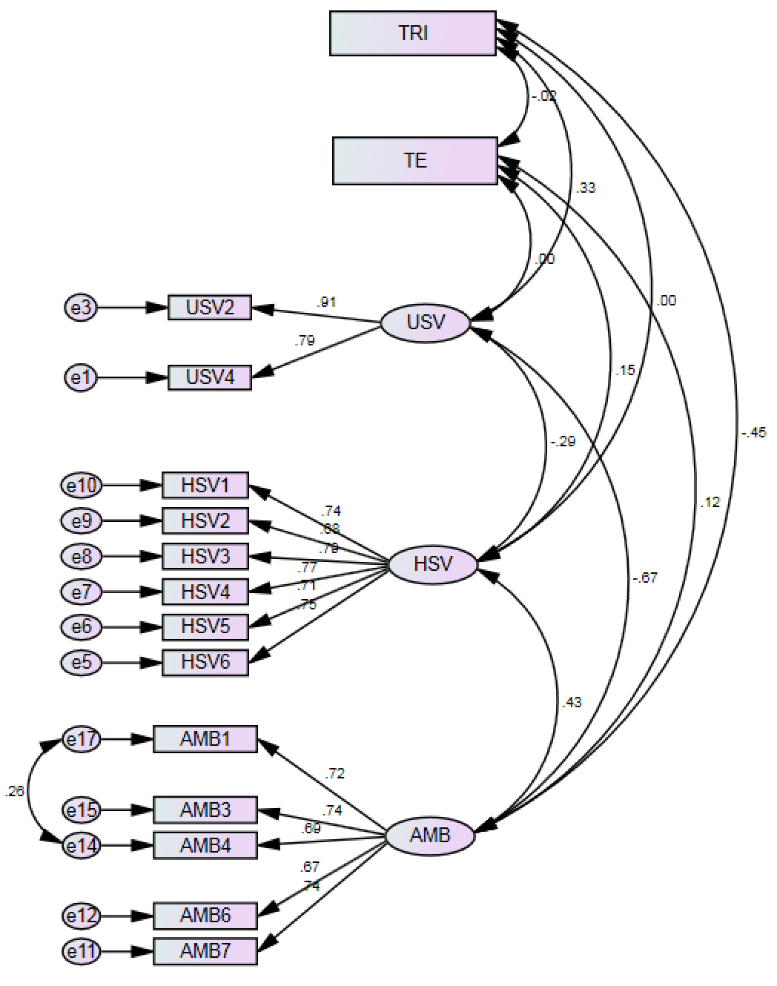
Figure 20 - Measurement Model 4

Table 14 - Model 4 Convergent and Discriminant Validity Measures
 | CR | AVE | MSV | ASV
HSV | 0.880 | 0.551 | 0.184 | 0.133
USV | 0.842 | 0.728 | 0.441 | 0.261
Ambivalence | 0.836 | 0.506 | 0.441 | 0.312

Table 15 - Measurement Model 4 Fit
Measure | Threshold (Hair et al. 2010) | Model 1 Fit | Model 2 Fit | Model 3 Fit | Model 4 Fit
Chi-square/df (cmin/df) | < 3 good; < 5 sometimes permissible | 2.770 | 1.767 | 1.594 | 1.554
p-value for the model | > .05 | .000 | .000 | .000 | .001
CFI | > .95 great; > .90 traditional | .893 | .954 | .970 | .976
GFI | > .95 | .882 | .921 | .936 | .947
AGFI | > .80 | .844 | .894 | .911 | .922
SRMR | < .09 | .072 | .067 | .053 | .051
RMSEA | < .05 good; .05 - .10 moderate> .10 bad | .076 | .050 | .044 | .042
PCLOSE | > .05 | .000 | .499 | .793 | .806

With a measurement model with adequate fit, our next step was ensuring no biases inherent in our data collection were present. For this, we tested for common method variance.

Common Method Variance
Common method variance (CMV) is the variance in a dataset that is “attributable to the measurement method rather than to the constructs the measures represent” (Podsakoff et al. 2003 p. 879). Common method biases are one of the leading sources of measurement error and they threaten the validity of conclusions of measurement items. Therefore eliminating common method variance as a source of significant variance in a dataset can go a long way towards ensuring against rival explanations for the observed correlation between measures.
In the past, researchers utilized the Harmon’s single factor test to determine whether CMV was an issue with a dataset. With this method, an unrotated exploratory factor analysis is generated forcing the items to load on a single factor. The amount of variance in the data explained by this single factor is supposed to give guidance as to the level of CMV present; a value over .5 is supposed to indicate a high level of CMV. Unfortunately, as Podsakoff et al. (2003 p. 879) mention:
If only one factor emerges from the factor analysis and this factor accounts for all of the variance in the items, it might be reasonable to conclude that common method variance is a major problem (although one could also conclude that the measures of the constructs lacked discriminant validity, were correlated because of a causal relationship, or both). However, in our experience, it is unlikely that a one-factor model will fit the data. It is much more likely that multiple factors will emerge from the factor analysis, and, contrary to what some have said, this is not evidence that the measures are free of common method variance. Indeed, if it were, then it would mean that common method variance would have to completely account for the covariances among the items for it to be regarded as a problem in a particular study.
Nevertheless, a Harmon’s single factor test was performed and the measures did not coalesce into a single factor, which suggested that common method variance might not be an issue. But more work was required to be sure.
As a second test, the wording used in our measurement items were evaluated to look for semantic overlap as prescribed by Podsakoff and Organ (1986). No obvious overlap between the wording of items from different factors was found, which was additional evidence for limited CMV.
Finally, Podsakoff et al. (2003) provide another technique for determining CMV through additional statistical operations. In this method, a common latent factor (CLF) is created within the measurement model and is regressed on every latent variable item in the model. The standardized regression weights for these items are captured and then compared to the same standardized regression weights for the latent variable items without the CLF present. We then calculate the difference between these weights to determine if the presence of the CLF ‘robs’ each item of a notable amount of regression weight. If the difference between the CLF and non-CLF regression weights is greater that .2, CMV may be an issue for that item. Fortunately, analysis showed that all standardized regression weight were insignificant save one. The only item with a large regression weight delta was HSV3 on hedonic shopping value. As this weight was borderline at .202, we felt comfortable moving on.
Given the procedures and their results, we determined that common method variance was not an issue with our data.

Structural Model
Given an acceptable measurement model and lack of common method variance, the structural equation model was developed to test the hypothesized relationships. For the structural model, the data were standardized and imputed into composite variables.
First, the data were assessed for multivariate assumptions of linearity and multicollinearity. To test for linearity each relationship pair in the model was tested with curve estimation regression. For most regressions a linear equation described the data best (largest F value) and for those where a linear equation was not the best explanation, there were insignificant findings. In other words, of all the significant relationships found with curve estimation, all were sufficiently linear to be tested with a covariance-based structural equation modeling algorithm.
Multicollinearity was tested using a linear regression on the exogenous variables (TRI and TE) with collinearity diagnostics active. Results showed a variance inflation factor (VIF) of 1.02. A VIF result of less that 3 indicates no multicollinearity, therefore our exogenous variables do not suffer from multicollinearity.
Next we formulate our structural model. The first step in the formulation of the structural model was to include all the variables and paths hypothesized (see Figure 21). The results of this model are found in Table 16 and model fit values are found in Table 17.
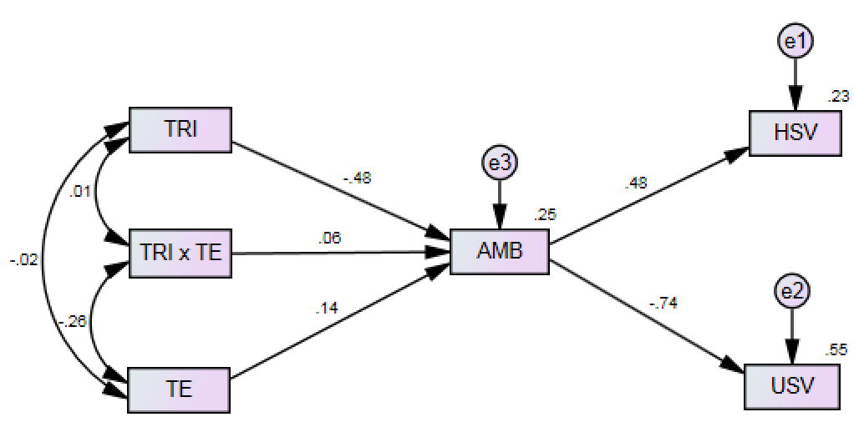
Figure 21 - Initial Structural Model

Table 16 - Regression Weights of Initial Structural Model
 |  |  | Estimate | S.E. | C.R. | P
TRI | → | AMB | -.480 | .049 | -9.749 | ***
TE | → | AMB | .140 | .051 | 2.736 | .006
TRI x TE | → | AMB | .069 | .058 | 1.182 | .237
AMB | → | HSV | .478 | .050 | 9.575 | ***
AMB | → | USV | -.745 | .038 | -19.610 | ***
*** Significant at p < .001

Table 17 - Initial Structural Model Fit
Measure | Threshold (Hair et al. 2010) | Initial SEM
Chi-square/df (cmin/df) | < 3 good; < 5 sometimes permissible | 5.895
p-value for the model | > .05 | .000
CFI | > .95 great; > .90 traditional | .927
GFI | > .95 | .959
AGFI | > .80 | .877
SRMR | < .09 | .060
RMSEA | < .05 good; .05 - .10 moderate> .10 bad | .126
PCLOSE | > .05 | .000

The majority of the regressions in this model were supported, but most notably the interaction term was not significant. A revised structural model that omits the interaction term (SEM 2) and moderator variable (because we did not hypothesize the direct effect) (see Figure 22) and its results (see Table 18) now show all significant regressions. This model shows a substantial improvement and represents the final structural model for our study (see Table 19).

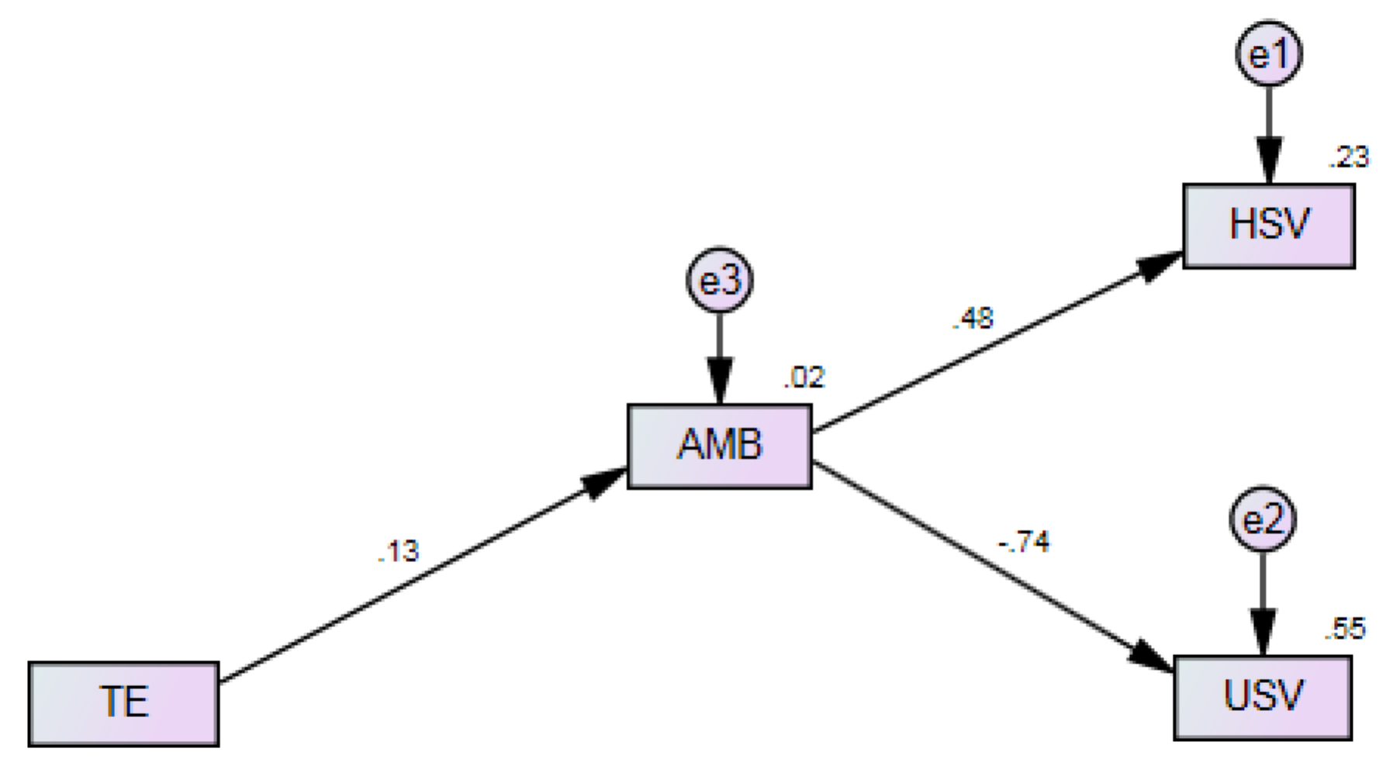
Figure 22 - Final Structural Model

Table 18 - Standardized Regression Weights of Final SEM
 |  |  | Estimate | S.E. | C.R. | P
TE | → | AMB | .132 | .056 | 2.333 | .020
AMB | → | HSV | .478 | .050 | 9.575 | ***
AMB | → | USV | -.745 | .038 | -19.610 | ***
*** Significant at p < .001

Table 19 - Structural Model 2 Fit
Measure | Threshold (Hair et al. 2010) | Initial SEM Fit | Final SEM Fit
Chi-square/df (cmin/df) | < 3 good; < 5 sometimes permissible | 5.895 | 3.947
p-value for the model | > .05 | .000 | .008
CFI | > .95 great; > .90 traditional | .927 | .974
GFI | > .95 | .959 | .981
AGFI | > .80 | .877 | .935
SRMR | < .09 | .060 | .046
RMSEA | < .05 good; .05 - .10 moderate; > .10 bad | .126 | .098
PCLOSE | > .05 | .000 | .069

Having arrived at a well-fitting model, R-square values were calculated to determine the proportion of total variance explained by each variable (see Table 20).

Table 20 - R-Square Values of Final SEM
Construct | R Square
AMB | .017
HSV | .229
USV | .554

Mediation
Because our hypothesized model contained a mediating variable (technology-induced shopping ambivalence), a test for mediation was required. We measured mediation using the Preacher and Hayes (2008) method of assessing mediation through bootstrapping and interpreting the generated indirect effects. This method has gained popularity in the social sciences. Zhao et al (2010) outline a number of important reasons for abandoning the Baron and Kenney approach for the Preacher and Hayes method. Chief among these reasons is the fact that Baron and Kenney approach requires a significant direct effect to establish mediation, which Zhao et al show is actually not necessary. Also, the reporting of “full mediation” or “partial mediation” espoused by Barron and Kenney, masks the potential benefits to sciences that could lurk within a “partial mediation” direct effect due to the possible hidden mediators.
As per Preacher and Hayes (2008), we used the INDIRECT plugin for SPSS to simultaneously regress all required paths to determine mediation. First, we analyzed the mediation relationship between technology engagement, technology-induced shopping ambivalence, and hedonic shopping value (TE → AMB → HSV) and then tested the mediation relationship to utilitarian shopping value (TE → AMB → USV).
For the first test of mediation (TE → AMB → HSV), we found the mean indirect effect from the bootstrap analysis was positive and significant (a x b = .0043), with a 95% confidence interval excluding zero (.0006 to .0092). In the indirect path, a unit increase in TE increased AMB by a = .0170 units; b = .2529, so holding constant TE, a unit increase in AMB increased HSV by .2529 units on a scale of 0 to 1. The direct effect c (.0128) was also significant (p = .0469); holding AMB constant, a unit increase of TE increases HSV by 0.0128. Since a x b x c is positive, this is complementary mediation.
For the second test of mediation (TE → AMB → USV), we found the mean indirect effect from the bootstrap analysis was positive and significant (a x b = .0069), with a 95% confidence interval excluding zero ( -.0138 to -.0010). In the indirect path, a unit increase in TE increased AMB by a = .0170 units; b = -.4058, so holding constant TE, a unit increase in AMB decreases USV by .4058 units on a scale of 0 to 1. The direct effect c was not significant. Because the “only requirement for mediation is that the indirect effect a x b be significant” (Zhao, Lynch, and Chen 2010 p. 205), we still have mediation. Since a x b x c was negative, this is competitive mediation. If we had used the Baron and Kenney approach, the lack of significance for the direct effect (c´) would have eliminated the possibility of mediation.
Given the general weakness of the mediation effects, however, it does not appear that the relationship between technology engagement and hedonic shopping value or utilitarian shopping value are appreciably mediated by technology-induced shopping ambivalence.
Next we interpret the results of our model fit tests through the lens of our hypotheses.

Findings
Below are the findings of our structural equation model and how they translate into support or rejection of our study hypotheses. The results of our final model are presented in Figure 23.
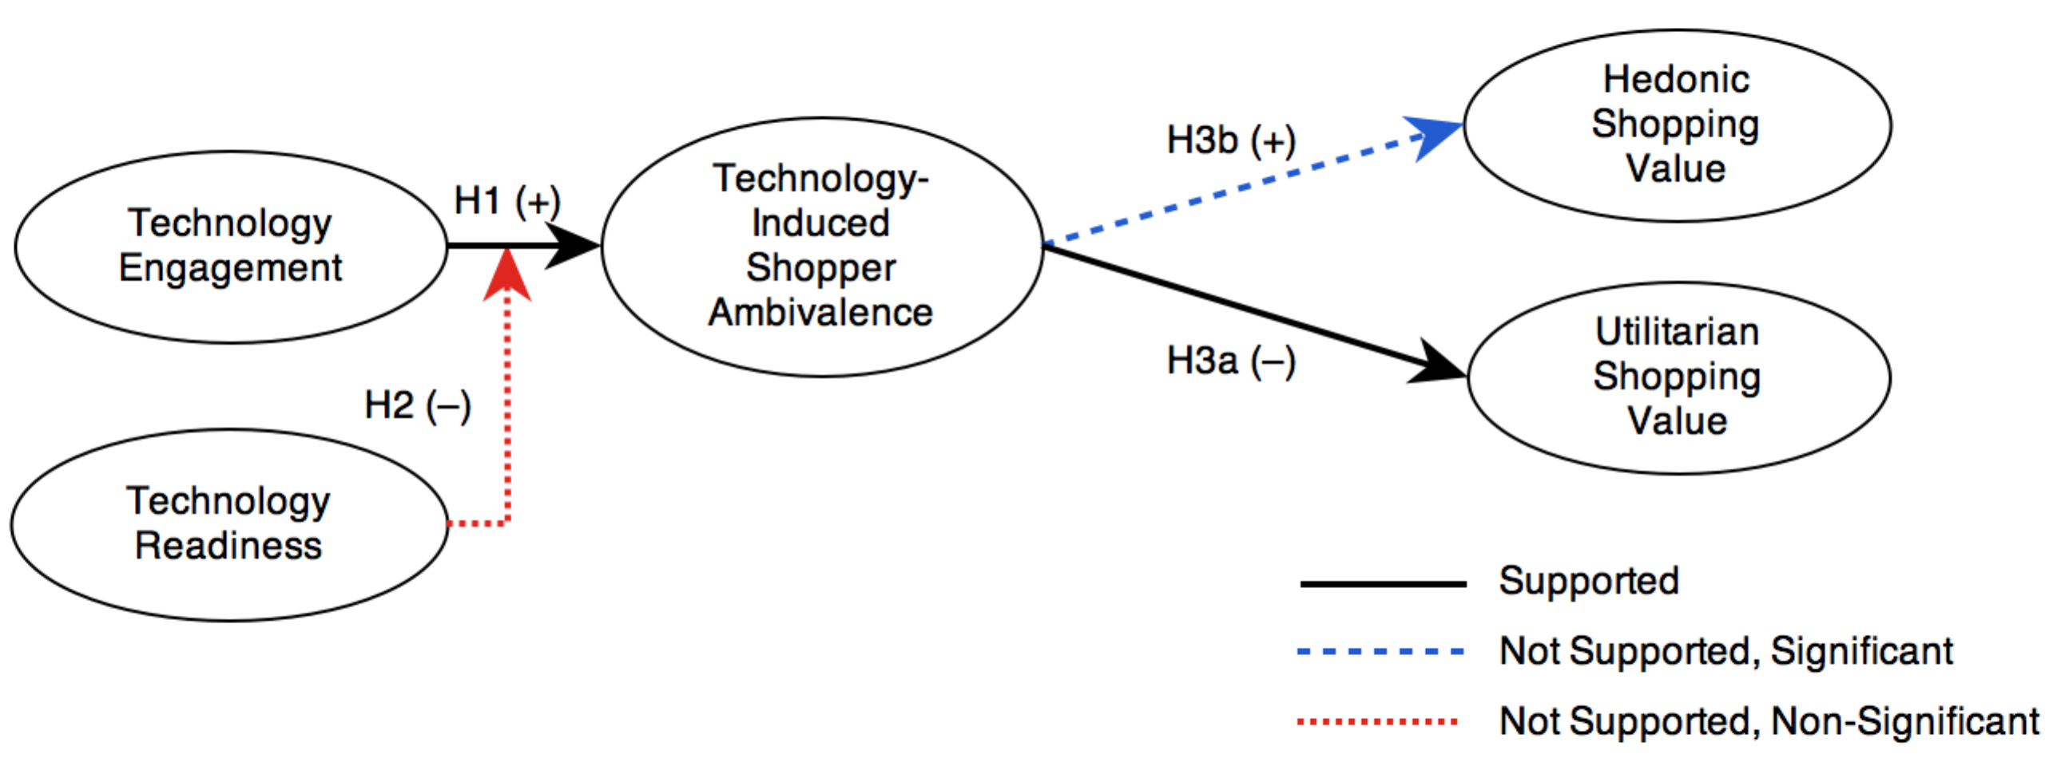
Figure 23 - Final Model Hypotheses Results

Hypothesis 1—the greater the level of technology engagement, the greater the level of technology-induced shopping ambivalence—was supported (β = .132, p = .020). This shows that as our shoppers engaged with technology in increasing amounts, their ambivalent attitudes towards the shopping task increased. However, the R-square values show that while the relationship between technology engagement (TE) and technology-induced shopper ambivalence (AMB) was significant, its effect on AMB was quite small (R² = .017, p = .020). This tells us that given the measurement scale we used, technology engagement is not a strong predictor of technology-induced shopper ambivalence.
Hypothesis 2—with greater technology readiness, the negative relationship between shoppers’ technology engagement and technology-induced shopping ambivalence is attenuated—was not supported. Given existing literature, this result was surprising. Technology readiness has been shown to moderate attitudes toward technology (Berger 2009), technology-related beliefs (Yousafzai and Yani-de-Soriano 2012), purchase intentions (Ranaweera, Bansal, and McDougall 2008), and even used at the firm level to moderate retailer operational effectiveness (Richey, Tokman, and Skinner 2008) and company performance (Kuo 2013). So why did it seemingly have no effect on technology-induced shopping ambivalence? Given that we only included those individuals who actually engaged with technology—even no more than a glance—we were concerned that the sample was heavily skewed toward individuals higher in technology readiness; this was not the case. There was only a slight negative skew in the sample (M = 3.22, SD = .44) with the value for skewness (.434) only slightly more that three times the standard error of skewness (.138). Also, the technology-induced shopper ambivalence measures could not have biased the TRI responses either as AMB items were asked after TRI. It may be the case that issues with the technology engagement measure effectively reduced the usefulness of TRI as a moderator or that TRI is more effective as a direct predictor of attitudes rather than impacting how a shopper makes technology use decisions.
Hypothesis 3a—the greater the level of technology-induced shopping ambivalence experienced by the shopper, the less utilitarian value the shopper will place on the shopping experience—was supported (β = -.745, p = .000). This shows that as shoppers experience the ambivalence associated with engaging with technology that the goal directed tasks they sought to accomplish were diminished.
Hypothesis 3b—the greater the level of technology-induced shopping ambivalence experienced by the shopper, the less hedonic value the shopper will place on the shopping experience—was not supported. While this hypothesis was not supported, the relationship between technology-induced shopping ambivalence and hedonic shopping value was significant, but in the opposite direction. Why would an increase in technology-induced shopping ambivalence result in an increase in hedonic shopping value rather than a decrease? One explanation could be related to stress. As Mick and Fournier (1998) have shown, technology paradox results in felt stress by the individual. Individuals then utilize coping mechanisms to ameliorate the effects of this stress (Duhachek 2005; Lazarus and Folkman 1984). It is conceivable that an individual engaging with a shopper-facing technology might see the advantages of utilizing the system, but is nevertheless frustrated by the experience—a recipe for ambivalence. This would result in a coping strategy to reduce the felt stress.
One commonly used coping strategy is avoidance. Duhachek (2005 p. 45), in creating a multidimensional hierarchical framework of coping strategies, measured the avoidance coping strategy by asking questions related to changing one’s focus (“Try to take my mind off of it by doing other things,” “Distract myself to avoid thinking about it,” “Avoid thinking about it,” “Find satisfaction in other things”). Given the frustrating experiences many individuals encountered in our qualitative study, avoiding utilitarian functionality frustrations and instead focusing on the hedonic elements of these technologies would make sense. For many, shopper-facing technologies are new and interesting and playing with them may provide more benefit than their intended use in their current incarnation; ‘enjoyment’ after all being a significant predictor of technology acceptance (Dabholkar 1994; Dabholkar and Bagozzi 2002; Davis, Bagozzi, and Warshaw 1992). Thus, hedonic behaviors may serve as a stress relieving coping strategy for shoppers, which in turn may increase the hedonic shopping value of their shopping experience.

Discussion

Theoretical Contributions
This study makes a number of theoretical contributions. One, it contributes to customer value theory by exposing how shopper-facing technologies may affect the value creation process. Woodruff (1997) described a number of inputs that can be used in determining what a customer (or shopper) values in a service encounter, part of what he called the customer value determination (CVD) process. This study exposes how shopper-facing technologies can have a significant impact on both utilitarian and hedonic shopping value and thus function as inputs into the CVD process.
Two, it also contributes to technology adoption research. Previous research has shown that non-volitional engagement with service technologies can lead to negative attitudes toward both the technology and the service provider (Reinders, Dabholkar, and Frambach 2008), but our study shows that the attitudes that result from volitional technology engagement within the retail environment can be as complex. This provides intriguing evidence that current technology adoption research falls short of explaining the complex mental processes individuals engage in as they interact with technology.
Three, we also advance research on technology paradox and ambivalence. By showing that shopper-facing technologies are fraught with the same paradox-inducing issues as technologies from other facets of life, we expose another context for studying the complex nature of technology. Additionally, Mick and Fournier (1998) showed that ambivalence results from paradox-inducing interactions with technology along a number of important dimensions, which we operationalized to create the first scale that measures the phenomenological experience of technology-induced ambivalence. Not only have we shown that the retail environment is rife with paradox-inducing technology, but we have also shown that the effects of ambivalence can be unpredictable as when it differentially affects utilitarian and hedonic shopping value.
Next we look at the implications this study has for those managing and strategizing within the retail realm.

Managerial Implications
This study has a number of implications that could benefit managers as they deal with an increasingly complex retail environment. One, understanding the impact that technology and technology-induced ambivalence can have on the value that shoppers place on the retail experience is an important takeaway. Managers should be aware that technology engagement metrics and the integration of data from digital shopping touch points provide an excellent source of information that managers could use to take meaningful value-creation actions for shoppers such as leveraging those opportunities to connect with shoppers at higher levels of the customer value hierarchy (Woodruff and Gardial 1996). The integration of these technologies could also serve as an important mechanism for predicting customer desired value change (Flint, Woodruff, and Gardial 2002). Because in-store technologies have the ability to interact with shoppers directly and in real-time, managers might want to measure what shoppers value in the shopping encounter through built-in mechanisms.
This study also showed that ambivalence is a real phenomenon in the retail environment. So how should managers deal with shopper ambivalence? Eliminating ambivalence should not be the goal. The absence of ambivalence is not necessarily positive affect. It could just as easily be negative affect, or worse, indifference. Managers should strive—as they always should—to improve service and the technologies they deploy, but with the realization that the imperfections of their deployed systems may result in ambivalence that could have unpredictable attitude, intention, and behavioral ramifications. Much research on the shopper’s behavior within the retail environment is rooted in the attitude/intention paradigm furthered by the theory of reasoned action (Fishbein and Ajzen 1975) and theory of planned behavior (Ajzen 1991). Both these theories show that a positive attitude towards an object is associated with higher behavioral intentions (e.g., a positive attitude toward self-service technologies results in a higher intention to use). Even a brief conversation with a retail manager would show, however, that intentions do not necessarily translate into desired behavior (J. K. Wong and Sheth 1985). This study shows that approaching shoppers as complex social beings and studying their attitudes with post-modern methods reveals a more complex process that may provide insight into why behaviors often do not align with intentions, which would be extremely important to retail managers.

Limitations
This study had a number of limitations that need to be kept in mind when interpreting its findings. One, we had no mechanism to measure non-response bias. Shopper privacy was an important consideration for our corporate research partner, therefore we were not allowed to query non-participating customers for contact information to later determine if there was any difference between those shoppers that responded to our survey and those that did not (Flint and Mentzer 1997). Also, because study participants were invited to participate through the use of an invitation printed on the bottom of all register receipts, shoppers shared the common experience of making a purchase at the subject store. While it is possible that there could be a difference between those shoppers that made a purchase and those that did not, we considered this unlikely and the additional expense required to handout separate non-purchase invitations was deemed unnecessary. Therefore, we were unable to determine if there was a potential bias in our data between participants that made a purchase and those that did not. Ultimately, our participation demographics were varied enough and sample size large enough that any fears of non-response or purchase bias were likely unwarranted.
Two, while we gathered data on the level of ambivalence that a shopper felt as a result of engaging with technology during the shopping task, we did not take baseline measures of participants’ general sense of ambivalence towards shopping. There are likely some individuals that feel both positive and negative affect towards the shopping task and this study does not distinguish between those shoppers already high in general shopping ambivalence levels and those with low levels. It is possible that those high in ambivalence to shopping in general would exhibit higher amounts of ambivalence towards specific technology-facilitated shopping tasks.
Three, our study context is limited to a utilitarian shopping environment. Whereas technological advances would seem to be a benefit regardless of retail context, a retail environment that is focused on fun and entertainment may have an advantage over utilitarian focused environments. Hedonic environments are primarily focused on creating engaging experiences rather than eliminating effort and as such the nature of engagement with technology may shift from ‘getting things done’ to ‘pleasurable distraction.’ The mindset of the shopper and his or her willingness to engage with technology may also be distinct between the two retail environment types.
Some of these limitations also expose opportunities for future research that may extend our findings or impact other research streams.

Future Research Implications
Future research will clarify and expand some of the concepts investigated in this study. It was clear that technology engagement did not have the effect on technology-induced shopping ambivalence that we expected. By studying engagement across a wide variety of shopper-facing technologies, we were in essence testing quantity effects of engagement on ambivalence rather than quality. Future research could enlist variables from the technology acceptance model (Davis 1985) such as perceived ease-of-use and perceived usefulness to test whether ambivalence can be predicted more reliably through those variables. As well, we could test technology readiness again, but as a direct predictor of ambivalence rather than as a moderator of engagement.
Because our study focused only on those shoppers that made an in-store purchase, a future study could determine whether actual purchase makes a difference to a shopper’s feeling of successful engagement with shopper-facing technologies and how that could also impact shopping value. Purchases made on an in-store assistive device or through mobile commerce on the shopper’s own MID could also be a fruitful avenue for future research. We have little knowledge of how shopping on devices within a retail environment impacts shoppers differently than doing the same shopping within the home, work, or on the go.
Study context is also an avenue for future discovery. Future research could replicate this study within a hedonic environment resulting in a bigger picture of the phenomenon and expanding our knowledge of highly experiential retail experiences (Kozinets et al. 2002) and multichannel multimedia retailing (Dholakia et al. 2010).
This study looked at how technology-induced shopper ambivalence impacted the retail experience, but not overall ambivalence towards shopping. This is an interesting avenue for future research as general ambivalence towards shopping would likely color many aspects of the shopping experience as well as the value of the shopping experience that the shopper co-creates with the retailer (Woodruff and Flint 2006). From a technology perspective it would be interesting to see if general ambivalence towards shopping could be changed with the engagement of shopper-facing technologies.
Finally, we used Mick and Fournier’s (1998) paradoxes of technology to develop our measures of technology-induced shopping ambivalence, but we treated the results of technology engagement in aggregate rather than individually. Future research could explore which shopper facing technologies have a more significant impact on a shopper’s technology-induced ambivalence and what particular features of said technology may lead to positive or negative attributions. Our adaptation of existing measures for technology engagement exposed some weaknesses that could also be addressed with future measurement development.

Chapter 5 – Convergence of Findings

Summary of Ethnography Findings
The ethnography of shoppers’ experiences within a technology-infused retail environment revealed that technology plays a significant role in shaping a shopper’s experience within the retail environment. At the broadest level, the presence of and engagement with technology had emotional and cognitive consequences for the shopper, led to new shopper strategies, and exposed shopper traits that seemed to moderate those experiences.
Our first surprise was the extent to which technology mediated experiences within the retail environment. How shoppers approached the shopping task was largely dictated by the technology decisions they made along the path-to-purchase. An early decision to enter the physical retail domain did not necessarily mean that the shopper would be interacting with sales staff or the retailer’s in-store assistive devices. This study revealed that shoppers engage in a hierarchy of choices. From the choice of whether to shop online or in-store, to the choice of whether to utilize sales staff or go it alone with technology, to finally deciding whether to use the retailer’s technology or the shopper’s own mobile Internet device, these choices shaped the shopper’s experience from the moment they entered the store.
The extent to which technology stimulated emotional and cognitive reactions and other consequences was also surprising. Powerful emotions such as distrust, betrayal, guilt, confusion, and ambivalence were the result of shoppers engaging with—and sometimes just thinking about—technologies in the retail environment. Technology also served as a touchstone for shoppers who tried to glean the motivations of retailers’ deploying these technologies, retailers’ level of commitment to the technology and to the shopper, and who the intended users of the technologies were. We also learned that there were moderating factors that impacted these consequences.
The moderating factors included the expectations that shoppers had of the technology they encountered and the level of fluency that shoppers had with technology. Expectations included the form (placement, hardware design, and user interface design) and function (performance, responsiveness, and features) of in-store assistive devices. In addition, shoppers displayed a surprising fluency with technology through their use of technical jargon, the suggestions they offered to improve feature flaws and omissions, and the creativity they displayed by offering up ideas for new technology features.
Finally, technology experiences in the retail environment, moderating factors, and consequences of technology engagement coalesced into novel shopping strategies relevant to both the shopper and retailer. These strategies included shopper conscientiousness, play, and technology-enhanced service.

Summary of Survey Findings
The survey tested a model proposed through the integration of existing theory on technology paradox and shopper value. The findings supported the hypotheses that engagement with shopper-facing technology leads to increased technology-induced shopper ambivalence and that ambivalence leads to diminished utilitarian shopping value. Surprisingly, greater ambivalence lead to increased hedonic shopping value rather than decreased as expected and technology readiness did not moderate the relationship between technology engagement and technology-induced shopper ambivalence.
The results of this study lead to some interesting and unexpected insights. One, though technology readiness was strongly negatively associated with technology-induced shopper ambivalence though a direct effect, it did not serve a moderating role. This contradicts earlier research that shows that technology readiness plays both a direct and moderating role (Lin and Chang 2011).
Two, an increase in technology-induced shopper ambivalence was associated with an increase in hedonic shopping value. Not only was this opposite our hypotheses, on its face it seemed to defy logic. However, existing research on shopping experiences showed that shoppers routinely turn to hedonic experiences during the shopping task and for those dealing with technology-induced shopping ambivalence and its accompanying stress, this does begin to make sense.
Finally, the effect of technology engagement on utilitarian shopping value, though significant, was much smaller than one might expect. This likely reflects the mediocre technology deployments in our study context and their failure to meaningfully connect with shoppers.

Convergence of Findings
In this section we examine the results of the qualitative and quantitative studies to find insight where these outcomes converge.

The Dark Side of Retail Technology
Perhaps the most prominent theme evident in our two studies was the idea that technology within the retail environment has a potential dark side. Technology had the power to elicit strong emotions in shoppers such as guilt and betrayal. For many of these shoppers, it was not interacting with the devices and getting put off by poor user experience encounters that drove the emotional reactions. Many had strong emotional reactions to the mere presence of these devices. While one person may have seen an in-store technology as a helpful, time-saving device thoughtfully provided by the retailer, another might have seen it as a purposeful degradation in service quality by a profit-motivated retailer intent on eliminating service personnel.
The ethnography also revealed that shopper-facing technologies had the ability to bring out the dark side in shoppers as well. As some shoppers were confronted with technology in the store, they tested device limits or worked to undermine device operation. These mischievous behaviors highlight the range of reactions to technology: some of them a revolt against change, some a challenge to the shopper’s technology skills.
This potential dark side was also apparent in the survey. The ambivalence that arises from the use of shopper-facing technologies had a surprising effect on the value that shoppers derive from the shopping experience. While ambivalence did increase hedonic shopping value—likely due to shoppers focusing on the novelty of the technology—it also had negative ramifications for shoppers, reducing utilitarian shopping value. For in-store assistive technologies designed to help shoppers, a decrease in utilitarian value is a meaningful misstep; for many of these technologies the whole point is to assist the shopper with goal-oriented activities. For retailers it’s important to know not just that the technology was enjoyable, but did it help the shopper with his or her task? Are retailers’ measures of satisfaction taking this into account?
As technologies find their way into more corners of our lives, another potential dark side will be feelings of intrusion that consumers will feel as technology takes the place of humans in more service encounters. A trip to any Chili’s restaurant will now include a dedicated miniature tabletop touchscreen kiosk designed to help you order your food and drink, play games, and pay your bill. This will likely affect the dynamic between servers and their customers, but understanding how that dynamic impacts the customer’s perception of the service encounter and the frontline employee’s job satisfaction among other factors is currently unknown.

Technology-Enhanced Service
As highlighted in the ethnographic study, technology-enhanced service is a potential third path that retailers can take when providing technology for the shopper. Instead of installing the technology and leaving the shopper to figure out how it works, retailers should embrace the role of teacher and help shoppers use these devices. Many of the technologies within retail are new and there hasn’t been a standard of interaction design established for these devices. Norms of desktop computer or personal mobile technologies may not apply for a large touchscreen device in a public environment.
The lack of utilitarian shopping value measured after the use of current in-store technologies speaks to the failures of these deployed technologies. Unfortunately, that’s when these devices are used at all; our ethnography revealed that many shoppers just didn’t see these devices or failed to see their purpose. This means that the ‘deployed everywhere’ model some retailers are experimenting with may not be the right model. One or two centrally located and feature-rich devices will probably be far more successful than many, limited feature systems deployed all over the store. As so many shoppers in the ethnography made clear, they have mobile Internet devices and if they need to know something in the middle of the aisle, than that is the device they’re most likely to use. Newer, feature-rich devices, however, may require help be given to shoppers who will likely not be familiar with their functionality. They will also need to be designed to serve the double-purpose of helping the shopper and the employee, but without seeming like a device made specifically for the employee.
We should take note of the positive effect of ambivalence on hedonic shopping value. Shoppers want memorable experiences and devices that provide those positive experiences will have a positive effect on shopper outcome variables. Devices that provide an experience at the expense of helping the shopper with the shopping task are no friend of the shopper or the retailer.

Symbolism
Regardless of the shopper’s feelings toward technology in the retail environment, it was clear that technology symbolized something bigger. For some shoppers it represented progress and the future. For others it served as a reminder that all facets of life were subject to change, sometimes for the worse.
Comparing the results from each study, shopper-facing technologies had both positive and negative impacts on shoppers. The survey revealed that technology-induced shopping ambivalence had resulted in negative utilitarian shopping value, yet positive hedonic shopping value. This somewhat mirrors what we saw in our ethnography. The devices had a positive impact on shoppers due to their novelty, but their ultimate usefulness was called into question more than once.
So what meaning do we infer that shoppers ascribe to these devices given the mixed attitudes they have for them? Because we create meaning through interaction and we act towards things based on the meaning that they have for us (Blumer 1986), it’s disturbing to think that these interactions with technology may be formative from the shoppers point of view. The meaning that they ascribe to these devices may become so tied to the paradoxical outcomes of their initial use that they may be deemed something novel or innovative, but not something to seriously consider using to accomplish shopping goals. This undermines the purpose for deploying these devices from the retailer’s perspective. While it is important to make sure that shopper-facing technologies create a positive experience through their use, retailers would be wise to ensure that the devices are actually helping shoppers accomplish their shopping goals. This would likely go a long way towards shopper-facing technologies becoming a symbol of autonomy and efficiency, rather than window dressing.

Research Streams
The insights revealed in this dissertation provide fertile new ground for a number of future research streams. We explore these research streams and pose a number of important questions that could be addressed by each.

Managerial and Operational Impacts of In-Store and Consumer Technologies
The proliferation of technology in the retail environment—from both the retailer and shopper—presents many challenges. Among these, technology’s impact on operational processes and service encounters is especially important. These technologies fundamentally change how retailers do business and interact with their shoppers. Research questions worthy of investigation include: What role do in-store technologies and mobile Internet technologies play in aligning marketing and retail channels? How do organizations decide what technologies to deploy in the retail environment and what are their key performance indicators? And How do retailers evolve in-store assistive technologies as cultural technology norms shift?

The Shopper’s Role in Driving Retailer Innovation
The one phenomenon that has generated the most controversy within the retail realm in the last few years is ‘showrooming.’ Shoppers have done more to introduce technology in the retail environment than any corporate technology supplier could ever dream of accomplishing. And yet it’s unclear whether retailers are using this lesson to help guide their future technology strategies. Important questions to be answered include: How are consumer technologies impacting the design and deployment of in-store assistive technologies? How can retailers utilize shopper usage data to improve technology experiences? And How do retailers keep pace with shifts in shoppers’ desired values through technology?

The Boundary Spanning Role of In-store Technologies
As technologies continue to take on more functionality and greater presence within the retail environment, these devices may end up the sole contact with the firm for many shoppers. While online retailers have dealt with the same situation for years, engaging with technology within the retail environment may offer advantages we don’t yet understand. Extending online relationships to in-store technologies could present unique opportunities for retailers that are shifting from online-only to brick-and-mortar. Important questions to be answered include: Do shoppers perceive a greater level of service when engaging with in-store assistive technologies rather than standard websites? What is the optimal ratio of employee/technology interaction across store categories, shopper demographics, and technology types? And How is the sales process impacted when frontline employees adopt popular mobile Internet technologies?

Concluding Remarks
With this dissertation we sought to understand how shopper-facing technologies affect shopper behaviors, perceptions, and attitudes within the retail environment and how these technologies affect evaluations of the shopping experience. We have shown that experiencing technology in the retail environment is a complex social process consisting of goal setting and striving and service channel choice behaviors that result in emotional and cognitive reactions that help shoppers formulate shopping strategies. In addition, shopper dispositional traits were found to impact technology experiences through expectations of technology and technology fluency. We also found that technology-induced shopper ambivalence had a surprising impact on shopping value.
Additionally, we exposed a number of important findings that resulted from converging the results of both the qualitative and quantitative studies. These and other insights from our studies were also instrumental in revealing future research streams that have the potential to provide insight into our phenomenon of study and many others.

References

Abelson, Jenn (2009), “Gillette sharpens its focus on women,” The Boston Globe, (accessed January 4, 2009), [available at http://www.boston.com/business/articles/2009/01/04/gillette_sharpens_its_focus_on_women/?page=full].
ABI Research (2010), “Spending on Retail Technology Systems Will Exceed $20 Billion in 2014,” ABI Research, (accessed July 30, 2012), [available at http://www.abiresearch.com/press/1628-Spending+on+Retail+Technology+Systems+Will+Exceed+$20+Billion+in+2014].
ABIresearch (2011), “45% of Smartphone Users with a Retailer-Branded App Visit the Retailer’s Store More Often, According to ABI Research’s Technology Barometer,” abiresearch.com, New York: ABIresearch.
Ajzen, Icek (1991), “The theory of planned behavior,” Organizational behavior and human decision processes, 50(2), 179–211.
Ali, Ashmeed, Edwin Wong, and Radha Subramanyam (2010), “Mobile Shopping Framework,” Nielsen Yahoo, 1–47.
American Marketing Association (2007), Definition of Marketing - American Marketing Association, marketingpower.com, American Marketing Association.
Anderson, James C, and David W Gerbing (1988), “Structural equation modeling in practice: A review and recommended two-step approach.,” Psychological Bulletin, 103(3), 411–23.
Arico, Joe (2012), “Smartphones Surge on 4G Growth, Surpass Feature Phones - Mobiledia,” mobilediacom, (accessed April 28, 2012), [available at http://www.mobiledia.com/news/130711.html].
Arnold, Mark J, and Kristy E Reynolds (2003), “Hedonic shopping motivations,” Journal of Retailing, 79(2), 77–95.
Arnould, Eric J, and C.J. Thompson (2005), “Consumer culture theory (CCT): Twenty years of research,” Journal of Consumer Research, 31(4), 868–82.
Arnould, Eric J, and L L Price (1993), “River magic: Extraordinary experience and the extended service encounter,” Journal of Consumer Research, 24–45.
Arnould, Eric J, and M. Wallendorf (1994), “Market-oriented ethnography: interpretation building and marketing strategy formulation,” Journal of Marketing Research, 31(4), 484–504.
Arnould, Eric J, Linda L Price, and Patrick Tierney (1998), “Communicative Staging of the Wilderness Servicescape,” The Service Industries Journal, 18(3), 90–115.
Babin, Barry J., and Jill S Attaway (2000), “Atmospheric Affect as a Tool for Creating Value and Gaining Share of Customer,” Journal of Business Research, 49(2), 91–99.
Babin, Barry J., William R. Darden, and Mitch Griffin (1994), “Work and/or fun: measuring hedonic and utilitarian shopping value,” Journal of Consumer Research, 20(4), 644–56.
Bagozzi, Richard P (1975), “Marketing as exchange,” Journal of Marketing, 32–39.
Bagozzi, Richard P, and Pratibha A Dabholkar (1994), “Consumer recycling goals and their effect on decisions to recycle: A means-end chain analysis,” Psychology and Marketing, 11(4), 313–40.
Bagozzi, Richard P, and Utpal Dholakia (1999), “Goal Setting and Goal Striving in Consumer Behavior,” Journal of Marketing, 63, 19–32.
Baker, Stacey Menzel, Jonna Holland, and Carol Kaufman-Scarborough (2007), “How consumers with disabilities perceive ‘welcome’ in retail servicescapes: a critical incident study,” Journal of Services Marketing, 21(3), 160–73.
Bandura, Albert (1982), “Self-efficacy mechanism in human agency.,” American psychologist, 37(2), 122–47.
Barrick, Murray R, and Michael K Mount (1993), “Autonomy as a moderator of the relationships between the Big Five personality dimensions and job performance.,” Journal of applied psychology, 78(1), 111–18.
Bass, Frank Myron, and William L Wilkie (1973), “A Comparative Analysis of Attitudinal Predictions of Brand Preference,” Journal of Marketing Research, 10(3), 262–69.
Batra, Rajeev, and Olli T Ahtola (1991), “Measuring the hedonic and utilitarian sources of consumer attitudes,” Marketing Letters, 2(2), 159–70.
Beatty, Sharon E, Morris Mayer, James E Coleman, Kristy Ellis Reynolds, and Jungki Lee (1996), “Customer-sales associate retail relationships,” Journal of Retailing, 72(3), 223–47.
Beggan, J K (1992), “On the social nature of nonsocial perception: The mere ownership effect.,” Journal of personality and social psychology, 62(2), 229.
Belk, Russell W (1975), “Situational variables and consumer behavior,” Journal of Consumer Research, 157–64.
Belk, Russell W (1976), “Situational Mediation and Consumer Behavior: A Reply,” Journal of Consumer Research, 3(3), 175–77.
Belk, Russell W, M. Wallendorf, and J F Sherry Jr (1989), “The sacred and the profane in consumer behavior: Theodicy on the odyssey,” Journal of Consumer Research, 1–38.
Bell, Paul A, and Eric D Sundstrom (1997), “Environmental Psychology,” in Evolution and Current Status, D. F. Halpern and A. E. Voiskounsky, eds., Oxford: Oxford University Press, 373–90.
Benson, Susan Porter (1979), “Palace of Consumption and Machine for Selling: The American Department Store, 1880-1940,” Radical History Review, 199–221.
Berger, Sven C (2009), “Self-service technology for sales purposes in branch banking: The impact of personality and relationship on customer adoption,” International Journal of Bank Marketing, 27(7), 488–505.
Berthiaume, Dan (2013), “Survey results show shopper frustration with self-service checkouts,” Chain Store Age, (accessed January 24, 2014), [available at http://www.chainstoreage.com/article/survey-results-show-shopper-frustration-self-service-checkouts].
Bitner, Mary Jo (1992), “Servicescapes: the impact of physical surroundings on customers and employees,” Journal of Marketing, 57–71.
Bitner, Mary Jo, Amy L Ostrom, Matthew L Meuter, and J A Clancy (2002), “Implementing Successful Self-Service Technologies [and Executive Commentary],” The Academy of Management Executive (1993-2005), 96–109.
Bitner, Mary Jo, Stephen W Brown, and Matthew L Meuter (2000), “Technology Infusion in Service Encounters,” Journal of the Academy of Marketing Science, 28(1), 138–49.
Blumer, Herbert (1986), Symbolic Interactionism, Univ of California Press.
Boyle, J S (1994), “Styles of Ethnography,” in Critical Issues in Qualitative Research Methods, J. M. Morse, ed., Thousand Oaks, CA: Sage Publications, Inc.
Breckler, S J (1994), “A Comparison of Numerical Indexes for Measuring Attitude Ambivalence,” Educational and Psychological Measurement, 54(2), 350–65.
Brick Meets Click (2012), “What will it take for retailers to adopt new technology faster?,” (accessed April 26, 2012), [available at http://www.brickmeetsclick.com/what-will-it-take-for-retailers-to-adopt-new-technology-faster-].
Bridges, Eileen, and Renée Florsheim (2008), “Hedonic and utilitarian shopping goals: The online experience,” Journal of Business Research, 61(4), 309–14.
Broeckelmann, Philipp, and Andrea Groeppel-Klein (2008), “Usage of mobile price comparison sites at the point of sale and its influence on consumers' shopping behaviour,” The International Review of Retail, Distribution and Consumer Research, 18(2), 149–66.
Brown, Stephen W (1995), Postmodern marketing, London: Routledge.
Bruner, Gordon C, II, and Anand Kumar (2005), “Explaining consumer acceptance of handheld Internet devices,” Journal of Business Research, 58(5), 553–58.
Burke, Raymond R (2002), “Technology and the Customer Interface: What Consumers Want in the Physical and Virtual Store,” Journal of the Academy of Marketing Science, 30(4), 411–32.
Burke, Raymond R (2006), Retailing in the 21st Century, (M. Krafft and M. K. Mantrala, eds.), Berlin/Heidelberg: Springer-Verlag, 113–25.
Burns, Daniel J, and undefined author (2007), “Marketplace Interaction Styles and Consumer Free-Riding,” Services Marketing Quarterly, 28(4), 35–48.
Bush, Alan J, Jarvis B Moore, and Rich Rocco (2005), “Understanding sales force automation outcomes: A managerial perspective,” Technology and the Sales Force, 34(4), 369–77.
Cacioppo, John T, and Gary G Berntson (1994), “Relationship Between Attitudes And Evaluative Space: A Critical Review, With Emphasis On The Separability Of Positive And Negative Substrates,” Psychological Bulletin, (accessed August 11, 2012), [available at http://scholar.google.com.proxy.lib.utk.edu:90/scholar?q=Cacioppo%2C+J.+T.%2C+%26+Berntson%2C+G.+G.+%281994%29.+Relationship+between+attitudes+and+evaluative+space%3A+A+critical+review%2C+with+emphasis+on+the+separa-+bility+of+positive+and+negative+substrates&btnG=&hl=en&as_sdt=0%2C43].
Cacioppo, John T, Wendi L Gardner, and Gary G Berntson (1997), “Beyond Bipolar Conceptualizations and Measures: The Case of Attitudes and Evaluative Space,” Personality and Social Psychology Review, 1(1), 3–25.
Cadotte, Ernest R, Robert B Woodruff, and Roger L Jenkins (1987), “Expectations and Norms in Models of Consumer Satisfaction,” Journal of Marketing Research, 24(3), 305–14.
Campbell, D T, and D W Fiske (1959), “Convergent and discriminant validation by the multitrait-multimethod matrix,” Psychological Bulletin, 56(2), 81.
Carlopio, Jim (2011), “A history of social psychological reactions to new technology,” Journal of Occupational Psychology, 61(1), 67–77.
Cartner-Morley, Jess (2012), “Burberry designs flagship London shop to resemble its website,” The Guardian, (accessed September 29, 2012), [available at http://www.guardian.co.uk/fashion/2012/sep/12/burberry-london-shop-website].
Celsi, R L, R L Rose, and T W Leigh (1993), “An exploration of high-risk leisure consumption through skydiving,” Journal of Consumer Research, 1–23.
Christopher Westland, J (2010), “Lower bounds on sample size in structural equation modeling,” Electronic Commerce Research and Applications, 9(6), 476–87.
Cohen, Jacob (1988), Statistical power analysis for the behavioral sciences, Hillsdale, NJ: Lawrence Earlbaum Associates.
Costa, Paul T, and Robert R McCrae (1992), Revised NEO Personality Inventory (NEO PI-R) and NEP Five-factor Inventory (NEO-FFI).
Csikszentmihalyi, Mihaly (Ed.) (1991), Flow: The Psychology of Optimal Experience, New York: Harper Perennial.
Curran, James M, and Matthew L Meuter (2005), “Self-service technology adoption: comparing three technologies,” Journal of Services Marketing, 19(2), 103–13.
Dabholkar, Pratibha A (1992), “Role of affect and need for interaction in on-site service encounters,” Advances in Consumer Research.
Dabholkar, Pratibha A (1994), “Incorporating choice into an attitudinal framework: analyzing models of mental comparison processes,” Journal of Consumer Research, 21(1), 100–118.
Dabholkar, Pratibha A (1996), “Consumer evaluations of new technology-based self-service options: an investigation of alternative models of service quality,” International Journal of Research in Marketing, 13(1), 29–51.
Dabholkar, Pratibha A, and B I Spaid (2012), “Service failure and recovery in using technology-based self-service: effects on user attributions and satisfaction,” The Service Industries Journal.
Dabholkar, Pratibha A, and Richard P Bagozzi (2002), “An Attitudinal Model of Technology-Based Self-Service: Moderating Effects of Consumer Traits and Situational Factors,” Journal of the Academy of Marketing Science, 30(3), 184–201.
Dabholkar, Pratibha A, Dayle I Thorpe, and Joseph O Rentz (1996), “A measure of service quality for retail stores: Scale development and validation,” Journal of the Academy of Marketing Science, 24(1), 3–16.
Davis, Fred D (1985), A technology acceptance model for empirically testing new end-user information systems: Theory and results, Cambridge, MA: Massachusetts Institute of Technology , Sloan School of Management.
Davis, Fred D (1989), “Perceived usefulness, perceived ease of use, and user acceptance of information technology,” MIS Quarterly, 319–40.
Davis, Fred D, Richard P Bagozzi, and Paul R Warshaw (1989), “User Acceptance of Computer Technology: A Comparison of Two Theoretical Models,” Management science, 35(8), 982–1003.
Davis, Fred D, Richard P Bagozzi, and Paul R Warshaw (1992), “Extrinsic and Intrinsic Motivation to Use Computers in the Workplace,” Journal of Applied Social Psychology, 22(14), 1111–32.
Dawson, S, Peter H Bloch, and N M Ridgway (2002), “Shopping motives, emotional states, and retail outcomes,” The Environments of Retailing. London: Routledge, 65–81.
Deloitte (2004), “RFID: How Far, How Fast: A View From the Rest of the World,” Deloitte, 1–10.
Deloitte (2009), “Shopper Marketing,” Deloitte, 1–4.
Denzin, Norman K, and Yvonna S Lincoln (1998), “Introduction: Entering the Field of qualitative Research,” in The Landscape of Qualitative Research, Thousand Oaks, CA: SAGE Publications.
Derjabo, S, and Vitold Yasvin (1997), “Environmental and «Green» Psychology in the Former Soviet Union,” States of Mind: American and Post-Soviet Perspectives on Contemporary Issues in Psychology. New York-Oxford, 391–405.
Dholakia, Utpal M, Barbara E Kahn, Randy Reeves, Aric Rindfleisch, David Stewart, and Earl Taylor (2010), “Consumer Behavior in a Multichannel, Multimedia Retailing Environment,” INTMAR, 24(2), 86–95.
Donovan, Robert J, and John R Rossiter (1982), “Store Atmosphere: An Environmental Psychology Approach.,” Journal of Retailing, 58(1), 34.
Duhachek, A (2005), “Coping: A Multidimensional, Hierarchical Framework of Responses to Stressful Consumption Episodes,” Journal of Consumer Research, 32(1), 41–53.
Dusto, Amy (2013), “E-Commerce Sales - 60% of U.S. retail sales will involve the web by 2017,” Internet Retailer, (accessed January 28, 2014), [available at http://www.internetretailer.com/2013/10/30/60-us-retail-sales-will-involve-web-2017].
Eagly, Alice H, and Shelly Chaiken (1993), The Psychology of Attitudes, psycnet.apa.org, Harcourt Brace Jovanovich College Publishers.
Elliott, Paul (2013), “Omni-Channel Is Coming: Agencies Need to Shift Gears Fast,” Ad Age, (accessed January 16, 2014), [available at http://adage.com/article/agency-viewpoint/omni-channel-coming-agencies-shift-gears-fast/242206/].
Eppler, Martin J, and Jeanne Mengis (2004), “The Concept of Information Overload: A Review of Literature from Organization Science, Accounting, Marketing, MIS, and Related Disciplines,” The Information Society, 20(5), 325–44.
Fabrigar, Leandre R, Duane T Wegener, Robert C MacCallum, and Erin J Strahan (1999), “Evaluating the use of exploratory factor analysis in psychological research.,” Psychological Methods, 4(3), 272–99.
Farag, Sendy, Tim Schwanen, Martin Dijst, and Jan Faber (2007), “Shopping online and/or in-store? A structural equation model of the relationships between e-shopping and in-store shopping,” Transportation Research Part A: Policy and Practice, 41(2), 125–41.
Feenberg, Andrew (1990), “The Ambivalence of Technology,” Sociological Perspectives, 33(1), 35–50.
Fei, Liang (2012), “Mobile app market set for increased growth: Gartner,” globaltimes.cn, (accessed May 16, 2012), [available at http://www.globaltimes.cn/NEWS/tabid/99/ID/692610/Mobile-app-market-set-for-increased-growth-Gartner.aspx].
Festinger, Leon (1957), A Theory of Cognitive Dissonance, Stanford, California: Stanford University Press.
Fetterman, David M (2003), “Finding Your Way Through the Forest: Analysis,” 1–10.
Fishbein, M, and I Ajzen (1975), Belief, Attitude, Intention and Behaviour: An Introduction to Theory and Research, Reading MA AddisonWesley, Addison-Wesley.
Fletcher, Jesse Bradford (2011), A Revised Theory of Cognitive Consistency, Proquest, UMI Dissertation Publishing.
Flint, Daniel J, and John T Mentzer (1997), “Validity in logistics research,” Journal of Business Logistics.
Flint, Daniel J, Robert B Woodruff, and Sarah Fisher Gardial (2002), “Exploring the Phenomenon of Customers' Desired Value Change in a Business-to-Business Context,” Journal of Marketing, 66(4), 102–17.
Fox, Steve (2011), “Is the Single-Function Device Doomed?,” pcworld.com, (accessed April 26, 2012), [available at http://www.pcworld.com/article/226106/is_the_singlefunction_device_doomed.html].
Geertz, Clifford (1973), The Interpretation of Culture, 1–15.
GfK Group (2012), “Smartphones boost mobile market worldwide,” GfK Group, (accessed September 20, 2012), [available at http://www.gfk.com/group/press_information/press_releases/010225/index.en.html].
Glaser, B G (1978), Theoretical sensitivity: Advances in the methodology of grounded theory, Sociology Press.
Glaser, B G, and Anselm Strauss (1967), The Discovery of Grounded Theory, Chicago: Aldine Publication Co.
GMA, Booz & Company (2010), “Shopping Marketing 4.0,” GMA - Booz & Co., 1–32.
Goffman, Erving (1959), The presentation of self in everyday life, Woodstock, NY: The Overlook Press.
Gollwitzer, Peter M (1996), “Action Phases and Mind-Sets,” in Handbook of motivation and cognition, E. T. Higgins and R. M. Sorrentino, eds., New York: The Guilford Press, 683.
Google (2013), “Our Mobile Planet,” Google, (accessed January 29, 2014), [available at http://www.thinkwithgoogle.com/mobileplanet/en/].
Gorsuch, Richard L (1997), “Exploratory Factor Analysis: Its Role in Item Analysis,” Journal of Personality Assessment, 68(3), 532–60.
Goulding, Christina (2005), “Grounded theory, ethnography and phenomenology: A comparative analysis of three qualitative strategies for marketing research,” European Journal of Marketing, 39(3/4), 294–308.
Green, Donald P, Susan L Goldman, and Peter Salovey (1993), “Measurement error masks bipolarity in affect ratings.,” Journal of personality and social psychology, 64(6), 1029–41.
GS1 MobileCom (2010), “Mobile in Retail,” GS1 MobileCom, 1–34.
Gupta, Ajay Kumar (2011), “10 Wi-Fi trends to watch for in 2012,” informationweekin, (accessed April 26, 2012), [available at http://www.informationweek.in/Internet/11-12-27/10_Wi-Fi_trends_to_watch_for_in_2012.aspx].
Gurman, Mark (2012), “AT&T announces 10,000 square foot Chicago flagship store with advanced displays, biometric security (plus photos of new iPad POS system),” 9to5Mac, (accessed August 30, 2012), [available at http://9to5mac.com/2012/08/29/att-announces-10000-square-foot-chicago-flagship-store-with-advanced-displays-biometric-security-plus-photos-of-new-ipad-pos-system/].
Gutman, J (1982), “A means-end chain model based on consumer categorization processes,” Journal of Marketing, 60–72.
Hair, Joe F, W C Black, Barry J. Babin, and R Anderson (2009), Multivariant Data Analysis, Upper Saddle River, NJ: Prentice-Hall, Inc.
Handy, C. (1994), The age of paradox, Harvard Business Press.
Harris, Lloyd C, and Chris Ezeh (2008), “Servicescape and loyalty intentions: an empirical investigation,” European Journal of Marketing, 42(3/4), 390–422.
Hass, R G, I Katz, N Rizzo, J Bailey, and D Eisenstadt (1991), “Cross-Racial Appraisal as Related to Attitude Ambivalence and Cognitive Complexity,” Personality and Social Psychology Bulletin, 17(1), 83–92.
Healy, M.J., Michael B Beverland, H. Oppewal, and S. Sands (2007), “Understanding retail experiences-the case for ethnography,” International Journal of Market Research, 49(6), 751.
Helson, Harry (1964), “Adaptation-level theory.,” in Psychology: A Study of a Science, S. Koch, ed., New York: McGraw-Hill.
Henn, Steve (2012), “To Keep Customers, Brick-And-Mortar Stores Look To Smartphones : All Tech Considered : NPR,” npr.org, (accessed September 24, 2012), [available at http://www.npr.org/blogs/alltechconsidered/2012/03/27/149463201/to-keep-customers-brick-and-mortar-stores-look-to-smartphones].
Hiiemaa, Kris (2012), “Why mobile payments still haven’t revolutionized retail | VentureBeat,” venturebeat.com, (accessed May 16, 2012), [available at http://venturebeat.com/2012/01/25/why-mobile-payments-still-havent-revolutionized-retail/].
Hirschman, Elizabeth C (1982), “Hedonic consumption: emerging concepts, methods and propositions,” Journal of Marketing.
Hogg, Gillian, Angus Laing, and Dan Winkelman (2003), “The professional service encounter in the age of the Internet: an exploratory study,” Journal of Services Marketing, 17(5), 476–94.
Holbrook, Morris B (1999), Consumer Value, Psychology Press.
Holbrook, Morris B, and Elizabeth C Hirschman (1982), “The Experiential Aspects of Consumption: Consumer Fantasies, Feelings, and Fun,” Journal of Consumer Research, 9(2), 132–40.
Hollan, Douglas (2001), “Developments in person-centered ethnography,” in The Psychology of Cultural Experience, C. C. Moore and H. F. Mattews, eds., Cambridge: Cambridge Univ Press.
Houliez, C (2010), “When non-store meets in-store: mobile communications technology, servicescapes, and the production of servicespace,” Journal of Customer Behaviour.
IDC (2011), “Worldwide Quarterly Mobile Phone Tracker,” idc.com, Framingham, MA: IDC, 2.
Inman, J Jeffrey, R.S. Winer, and R. Ferraro (2009), “The Interplay Among Category Characteristics, Customer Characteristics, And Customer Activities On In-Store Decision Making,” Journal of Marketing, 73(5), 19–29.
Iyengar, Sheena S, and M R Lepper (2000), “When choice is demotivating: Can one desire too much of a good thing?,” Journal of personality and social psychology, 79(6), 143–50.
Iyengar, Sheena S, R E Wells, and B Schwartz (2006), “Doing Better but Feeling Worse: Looking for the ‘Best’ Job Undermines Satisfaction,” Psychological Science, 17(2), 143–50.
Jacoby, Jacob (1977), “Information Load and Decision Quality: Some Contested Issues,” Journal of Marketing Research, 14(4), 569–73.
Jamieson, D W (1988), “The influence of value conflicts on attitudinal ambivalence,” Montreal.
Jepsen, Anna Lund (2007), “Factors affecting consumer use of the Internet for information search,” Journal of Interactive Marketing, 21(3), 21–34.
Johnson, Derek (2011), “Where Are Smartphones Being Used?,” tatangocom, (accessed April 21, 2012), [available at http://www.tatango.com/blog/where-are-smartphones-being-used-infographic/].
Jones, Michael A, Kristy E Reynolds, and Mark J Arnold (2006), “Hedonic and utilitarian shopping value: Investigating differential effects on retail outcomes,” Journal of Business Research, 59(9), 974–81.
Jones, Robert (2012), Shopper Value: A Framework and Examination of the Impact of Importance, Shopping Context and Shopping Social Situation, Knoxville, TN: University of Tennessee, 1–410.
Kaplan, Kalman J (1972), “On the ambivalence-indifference problem in attitude theory and measurement: A suggested modification of the semantic differential technique.,” Psychological Bulletin, 77(5), 361–72.
Katz, ML (1986), “Technology adoption in the presence of network externalities,” The journal of political economy.
Kilduff, M., and A. Mehra (1997), “Postmodernism and organizational research,” Academy of Management Review, 453–81.
Kim, Youn Kyung (2001), “Experiential retailing:an interdisciplinary approach to success in domestic and international retailing,” Journal of Retailing and Consumer Services, 8(5), 287–89.
Kohli, A K, and B J Jaworski (1990), “Market orientation: the construct, research propositions, and managerial implications,” Journal of Marketing, 1–18.
Kotler, Philip (1973), “Atmospherics as a marketing tool,” Journal of Retailing, (accessed September 10, 2012), [available at http://scholar.google.com/scholar?cluster=13884790676016968922&hl=en&as_sdt=0,43&as_ylo=1917&as_yhi=1973].
Kotler, Philip (1994), Marketing Management: Analysis, Planning, Implementation, and Control, Englewood Cliffs, NJ: Prentice Hall.
Kowatsch, Tobias, and Wolfgang Maass (2010), “In-store consumer behavior: How mobile recommendation agents influence usage intentions, product purchases, and store preferences,” Computers in Human Behavior, 26(4), 697–704.
Kozinets, R V, J F Sherry, B DeBerry-Spence, A Duhachek, K Nuttavuthisit, and D Storm (2002), “Themed flagship brand stores in the new millennium: theory, practice, prospects,” Journal of Retailing, 78(1), 17–29.
Kuo, Yen-Lin (2013), “Technology readiness as moderator for construction company performance,” Industrial Management & Data Systems, 113(4), 558–72.
Ladendorf, Kirk (2010), “U.S. has been slow to adopt safer credit card technology,” statesman.com, (accessed April 26, 2012), [available at http://www.statesman.com/business/technology/u-s-has-been-slow-to-adopt-safer-899136.html?printArticle=y].
Larsen, Jeff T, and A Peter McGraw (2011), “Further evidence for mixed emotions.,” Journal of personality and social psychology, 100(6), 1095–1110.
Lazarus, R S, and S Folkman (1984), Stress, Appraisal, and Coping - Richard S. Lazarus, PhD, Susan Folkman, PhD - Google Books, Springer Publishing Company.
Lee, Jungki, and Arthur Allaway (2002), “Effects of personal control on adoption of self-service technology innovations,” Journal of Services Marketing, 16(6), 553–72.
Levy, Sidney (1959), “Symbols for Sale,” Harvard Business Review.
Lin, J.S.C., and P.L. Hsieh (2007), “The influence of technology readiness on satisfaction and behavioral intentions toward self-service technologies,” Computers in Human Behavior, 23(3), 1597–1615.
Lin, Jiun-Sheng Chris, and Hsing-Chi Chang (2011), “The role of technology readiness in self-service technology acceptance,” Managing Service Quality, 21(4), 424–44.
Lincoln, Yvonna S, and Egon G Guba (1985), Designing A Naturalistic Inquiry, Sage Publications Ltd, 1–15.
Lippman, Daniel (2013), “Where Job Growth Will Come Over This Decade,” Wall Street Journal, (accessed January 10, 2014), [available at http://webcache.googleusercontent.com/search?q=cache:4JJ8xD6SoPoJ:online.wsj.com/news/articles/SB10001424127887324463604579040891474392908+&cd=1&hl=en&ct=clnk&gl=us&client=safari].
Liu, Y, and L J Shrum (2002), “What is interactivity and is it always such a good thing? Implications of definition, person, and situation for the influence of interactivity on advertising effectiveness,” Journal of advertising, 53–64.
Lusch, R.F., and F E Webster (2011), “A Stakeholder-Unifying, Cocreation Philosophy for Marketing,” Journal of Macromarketing, 31(2), 129–34.
Machleit, Karen A, and Sevgin A Eroglu (2000), “Describing and Measuring Emotional Response to Shopping Experience,” Journal of Business Research, 49(2), 101–11.
Maes, S, A Vingerhoets, and G Van Heck (1987), “The study of stress and disease: Some developments and requirements,” Social Science & Medicine, 25(6), 567–78.
Manninen, JP (2010), “Metaio helps Lego market toys with augmented reality kiosks | VentureBeat,” venturebeat.com, (accessed May 16, 2012), [available at http://venturebeat.com/2010/04/21/metaios-augmented-reality-for-lego/].
Marquié, J C, L Jourdan-Boddaert, and N Huet (2002), “Do older adults underestimate their actual computer knowledge?,” Behaviour & Information Technology, 21(4), 273–80.
Massey, A P, V Khatri, and V Ramesh (2005), “From the Web to the Wireless Web: Technology Readiness and Usability,” IEEE, 1–10.
McAlexander, J H, J W Schouten, and H F Koenig (2002), “Building brand community,” Journal of Marketing, 38–54.
McCracken, Grant, and Grant David McCracken (1988), The Long Interview, Sage Publications, Incorporated.
Meeker, Mary, Scott Devitt, and Liang Wu (2010), “Internet Trends,” google.com, New York: Morgan Stanley.
Mehrabian, Albert, and James A Russell (1974), An approach to environmental psychology., scholar.google.com.proxy.lib.utk.edu, The MIT Press.
Melloy, John (2010), “CNBC's Fast Money : iPad Adoption Rate Fastest Ever, Passing DVD Player - CNBC,” CNBC, (accessed April 12, 2012), [available at http://www.cnbc.com/id/39501308/iPad_Adoption_Rate_Fastest_Ever_Passing_DVD_Player].
Meuter, Matthew L, Amy L Ostrom, Robert Roundtree, and Mary Jo Bitner (2000), “Self-service technologies: understanding customer satisfaction with technology-based service encounters,” Journal of Marketing, 50–64.
Mick, David Glen, and Susan Fournier (1998), “Paradoxes of technology: Consumer cognizance, emotions, and coping strategies,” Journal of Consumer Research, 25(2), 123–43.
Mitchell, Vincent-Wayne, and Vassilios Papavassiliou (1999), “Marketing causes and implications of consumer confusion,” Journal of Product & Brand Management, 8(4), 319–42.
Monteleone, J Patrick, and Jesse Wolferseberger (2012), “Showrooming & the Price of Keeping Buyers In-Store,” GroupM Next, 1–6.
Moore, G C, and I Benbasat (1996), “Integrating Diffusion of Innovations and Theory of Reasoned Action models to predict utilization of information technology by end-users,” in scholar.google.com.proxy.lib.utk.edu, K. Kautz, ed., Boston, MA: Springer US, 132–46.
Moriarty, W D (1923), The economics of marketing and advertising, New York: Harper & Brothers.
Narver, John C, and Stanley F Slater (1989), The effect of market orientation on business profitability.
Netburn, Deborah (2012), “Nomophobia -- fear of being without your phone -- is on the rise - latimes.com,” Los Angeles Times, (accessed April 26, 2012), [available at http://www.latimes.com/business/technology/la-fi-tn-nomophobia-on-the-rise-20120216,0,2865154.story].
Ng Kwet Shing, Michelle, and Laura J Spence (2002), “Investigating the limits of competitive intelligence gathering: is mystery shopping ethical?,” Journal of Personality, 11(4), 343–53.
Norberg, Patricia A, Daniel R Horne, and David A Horne (2007), “The Privacy Paradox: Personal Information Disclosure Intentions versus Behaviors,” Journal of Consumer Affairs, 41(1), 100–126.
O'Brien, H L, and E G Toms (2010), “The development and evaluation of a survey to measure user engagement,” Journal of the American Society for Information Science and Technology, 61(1), 50–69.
Oliver, R L (1980), “A cognitive model of the antecedents and consequences of satisfaction decisions,” Journal of Marketing Research.
Oliver, Richard L (1977), “Effect of expectation and disconfirmation on postexposure product evaluations: An alternative interpretation.,” Journal of applied psychology, 62(4), 480–86.
Palfrey, John G, and Urs Gasser (2013), Born Digital, Basic Books.
Parasuraman, A (1996), Understanding and Leveraging the Role of Customer Service in External, Interactive and Internal Marketing, Frontiers in Services Conference.
Parasuraman, A (2000), “Technology Readiness Index (TRI): A Multiple-Item Scale to Measure Readiness to Embrace New Technologies,” Journal of Service Research, 2(4), 307–20.
Parasuraman, A, and C L Colby (2001), Techno-ready marketing: how and why your customers adopt technology, New York: The Free Press.
Parasuraman, A, Valarie A Zeithaml, and Leonard L Berry (1988), “Servqual,” Journal of Retailing, 64(1), 12–37.
Payne, J W, James R Bettman, and E J Johnson (1992), “Behavioral decision research: A constructive processing perspective,” Annual review of psychology, 43(1), 87–131.
Peñaloza, Lisa (1994), “Atravesando Fronteras/Border Crossings: A Critical Ethnographic Exploration of the Consumer Acculturation of Mexican Immigrants,” Journal of Consumer Research, 21(1), 32–54.
Peteraf, Margaret A, and Mark E Bergen (2003), “Scanning dynamic competitive landscapes: a market-based and resource-based framework,” Strategic Management Journal, 24(10), 1027–41.
Peterson, Robert A, and Maria C Merino (2003), “Consumer information search behavior and the internet,” Psychology and Marketing, 20(2), 99–121.
Pilke, E M (2004), “Flow experiences in information technology use,” International journal of human-computer studies, 61(3), 347–57.
Platt, Steven Keith (2012), “Challenges Facing Retail Adoption of Digital Signage,” Platt Retail Institute, 1–3.
Platzer, Elisabeth, Otto Petrovic, Wolf Rauch, and Martina Brunnhofer (2010), “Causes and Consequences of Mobile Phone's Indispensability for Everyday Life,” IEEE, 251–57.
Podsakoff, Philip M, and Dennis W Organ (1986), “Self-reports in organizational research: Problems and prospects.”
Podsakoff, Philip M, Scott B MacKenzie, Jeong-Yeon Lee, and Nathan P Podsakoff (2003), “Common method biases in behavioral research: a critical review of the literature and recommended remedies.,” Journal of applied psychology, 88(5), 879.
Poole, Marshall Scott, and Andrew H. van de Ven (1989), “Using Paradox to Build Management and Organization Theories,” Academy of Management Review, 14(4).
POPAI (2012), “2012 Shopper Engagement Study,” google.com, Point of Purchase Advertising International.
Preacher, Kristopher J, and Andrew F Hayes (2008), “Asymptotic and resampling strategies for assessing and comparing indirect effects in multiple mediator models,” Behavior Research Methods, 40(3), 879–91.
Priester, J R, and R E petty (1996), “The gradual threshold model of ambivalence: Relating the positive and negative bases of attitudes to subjective ambivalence.,” Journal of personality and social psychology, 71(3), 431.
Quint, Matthew, David Rogers, and Rick Ferguson (2013), “Showrooming and the Rise of the Mobile-Assisted Shopper,” AIMIA / Columbia Business School, (accessed January 24, 2014), [available at https://www4.gsb.columbia.edu/filemgr?file_id=7313935].
Rader, Charles Scott (2009), Toward a Theory of Consumer Interaction With Mobile Technology Devices, 1–349.
Rafaeli, E, G M Rogers, and W Revelle (2007), “Affective Synchrony: Individual Differences in Mixed Emotions,” Personality and Social Psychology Bulletin, 33(7), 915–32.
Rajagopalan, Meera (2010), “Success with Self-Serve Kiosks | Specialty Retail Report,” Specialty Retail Report, (accessed July 26, 2012), [available at http://specialtyretail.com/issue/2010/01/retail_products/success_with_self_serve_kiosks/].
Ranaweera, Chatura, Harvir Bansal, and Gordon McDougall (2008), “Web site satisfaction and purchase intentions: Impact of personality characteristics during initial web site visit,” Managing Service Quality, 18(4), 329–48.
Reimer, Anja, and Richard Kuehn (2005), “The impact of servicescape on quality perception,” European Journal of Marketing, 39(7/8), 785–808.
Reinders, M J, Pratibha A Dabholkar, and R T Frambach (2008), “Consequences of Forcing Consumers to Use Technology-Based Self-Service,” Journal of Service Research, 11(2), 107–23.
Richey, R Glenn, Jr., Mert Tokman, and Lauren R Skinner (2008), “Exploring collaborative technology utilization in retailer–supplier performance,” Journal of Business Research, 61(8), 842–49.
Rogers, Everett M (2003), Diffusion of Innovations, New York: The Free Press.
Rogers, Everett M, and F Floyd Shoemaker (1971), Communication of Innovations, New York: The Free Press.
Rokeach, Milton (1973), The nature of human values., Free Press.
Rokeach, Milton, and Sandra J Ball-Rokeach (1989), “Stability and change in American value priorities, 1968–1981.,” American psychologist, 44(5), 775–84.
Rosenberg, Milton J (1968), “Hedonism, inauthenticity, and other goads toward expansion of a consistency theory,” Theories of cognitive consistency: A sourcebook, 73–111.
Rosenblum, Paula, and Brian Kilcourse (2013), “Omni-Channel 2013: The Long Road to Adoption,” rsrresearch.com, Retail Systems Research.
Rosenblum, Paula, and Steve Rowen (2012a), “The 2012 Retail Store: In Transition,” Retail Systems Research, 1–27.
Rosenblum, Paula, and Steve Rowen (2012b), “Optimizing Assortments to Reinvigorate Retail:Benchmark Report 2012,” Retail Systems Research, 1–31.
Ross, John (2011), “Retail technology and the evolving shopper,” google.com, Shopper Sciences.
Rust, R (1998), “What Is the Domain of Service Research?,” Journal of Service Research, 1(2), 107–7.
Schmidt, Dale (2012), “Wireless Telecommunications Carriers in the US,” IBISWorld, 1–45.
Senecal, Sylvain, Jamel-Edine Gharbi, and Jacques Nantel (2002), “The Influence of Flow on Hedonic and Utilitarian Shopping Values,” Advances in Consumer Research, 29.
Shankar, Venkatesh (2011), Shopper Marketing, Cambridge, Massachusetts: Marketing Science Institute.
Sherry, John F (1998), ServiceScapes - The Concept of Place in Contemporary Markets, (J. F. Sherry, ed.), Chicago: NTC Business Books.
Sherry, John F, Jr (1990), “Dealers and dealing in a periodic market: informal retailing in ethnographic perspective,” Journal of Retailing, 66(2), 174–200.
Shin, J (2006), “How Does Free Riding on Customer Service Affect Competition?,” Marketing Science.
Singley, R.B., and M.R. Williams (1995), “Free riding in retail stores: An investigation of its perceived prevalence and costs,” Journal of Marketing Theory and Practice, 64–74.
Slater, S F, and J C Narver (2000), “Intelligence Generation and Superior Customer Value,” Journal of the Academy of Marketing Science, 28(1), 120–27.
Soper, Daniel (2014), “A-priori Sample Size Calculator for Structural Equation Models,” Daniel Soper [available at http://www.danielsoper.com/statcalc3/calc.aspx?id=89].
Spaid, Brian, and Daniel J Flint (2014), “The Meaning of Shopping Experiences Augmented By Mobile Internet Devices,” Journal of Marketing Theory and Practice, 22(1), 73–90.
Spector, Mike, and Jeffrey A Trantenberg (2011), “Borders Forced to Liquidate, Close All Stores,” Wall Street Journal, (accessed January 1, 2014), [available at http://online.wsj.com/news/articles/SB10001424052702303661904576454353768550280].
Speier, Cheri, and Viswanath Venkatesh (2002), “The Hidden Minefields in the Adoption of Sales Force Automation Technologies,” Journal of Marketing, 66(3), 98–111.
Spradley, James P (1979), The Ethnographic Interwiew.
Spreng, Richard A, Scott B MacKenzie, and Richard W Olshavsky (1996), “A reexamination of the determinants of consumer satisfaction,” Journal of Marketing, 15–32.
Stafford, Maria R, and Thomas F Stafford (1993), “Participant observation and the pursuit of truth: Methodological and ethical considerations,” Journal of the Market Research Society, 35(1).
Steel, Emily (2010), “Luring Shoppers to Stores,” Wall Street Journal, (accessed July 27, 2012), [available at http://online.wsj.com/article/SB10001424052748704540904575451841980063132.html].
Steenkamp, Jan-Benedict E M, and Hans Baumgartner (2000), “On the use of structural equation models for marketing modeling,” International Journal of Research in Marketing, 17(2-3), 195–202.
Sterneckert, Kevin, and Janet Suleski (2012), “Industry Retail Event Shows Technology Adoption Is Next Challenge,” Gartner, 1–3.
Tabachnick, B G, and L S Fiddell (1995), Using multivariate statistics, Pearson.
Taylor, Thayer C (1993), “Computers bring quick return,” Sales & marketing management, 145(11), 22–25.
Thomas, Ian, William Davie, and Deanna Weidenhamer (2013), “Quarterly Retail E-Commerce Sales 3Rd Quarter 2013,” U.S. Census Bureau, Department of Commerce, (accessed January 28, 2014), [available at https://www.census.gov/retail/mrts/www/data/pdf/ec_current.pdf].
Thompson, C.J., W.B. Locander, and H.R. Pollio (1989), “Putting consumer experience back into consumer research: The philosophy and method of existential-phenomenology,” Journal of Consumer Research, 133–46.
Thompson, Craig J (1994), “Unfulfilled Promises And Personal Confessions: A Postpositivist Inquiry Into The Idealized And Experienced Meanings Of Consumer Technology,” Advances in Consumer Research, 21.
Thompson, M M, and M P Zanna (1995), “Let's not be indifferent about (attitudinal) ambivalence.,” in Attitude Strength: Antecedents and Consequences, R. E. Petty and J. A. Krosnick, eds., Mahwah, New Jersey: Lawrence Erlbaum Associates, Inc., 510.
Turley, L W, and Ronald E Milliman (2000), “Atmospheric Effects on Shopping Behavior,” Journal of Business Research, 49(2), 193–211.
Twentyman, Jessica (2012), “New customers: Retailers experiment on ways to win loyalty,” Financial Times, (accessed September 25, 2012).
undefined author, William J Havlena, and Morris B Holbrook (1986), “The varieties of consumption experience: comparing two typologies of emotion in consumer behavior,” Journal of Consumer Research, 394–404.
Van Baal, Sebastian, and Christian Dach (2005), “Free riding and customer retention across retailers' channels,” Journal of Interactive Marketing, 19(2), 75–85.
van der Heijden, Hans (2006), “Mobile decision support for in-store purchase decisions,” Decision Support Systems, 42(2), 656–63.
Van Heijenoort, J. (1972), Logical paradoxes, The encyclopedia of philosophy, 45–51.
Vargo, S.L., and R.F. Lusch (2004), “Evolving to a new dominant logic for marketing,” Journal of Marketing, 68(January), 1–17.
Vargo, Stephen L, and Robert F Lusch (2007), “Service-dominant logic: continuing the evolution,” Journal of the Academy of Marketing Science, 36(1), 1–10.
Venkatesh, V., M.G. Morris, G.B. Davis, and Fred D Davis (2003), “User acceptance of information technology: Toward a unified view,” MIS Quarterly, 425–78.
Venkatesh, Viswanath, and Fred D Davis (2000), “A Theoretical Extension of the Technology Acceptance Model: Four Longitudinal Field Studies,” pubsonline.informs.org.proxy.lib.utk.edu.
Wallendorf, M., and Russell W Belk (1989), “Assessing Trustworthiness in Naturalistic Consumer Research by Melanie Wallendorf and Russell W. Belk,” Interpretive consumer research, 69–84.
Wallendorf, Melanie, and Eric J Arnould (1991), “‘We Gather Together’: Consumption Rituals of Thanksgiving Day,” Journal of Consumer Research, 18(1), 13–31.
Walther, J B (1996), “Computer-Mediated Communication: Impersonal, Interpersonal, and Hyperpersonal Interaction,” Communication Research, 23(1), 3–43.
Watson, R T, L F Pitt, P Berthon, and George M Zinkhan (2002), “U-Commerce: Expanding the Universe of Marketing,” Journal of the Academy of Marketing Science, 30(4), 333–47.
Webster, Frederick E, and Robert F Lusch (2013), “Elevating marketing: marketing is dead! Long live marketing!,” Journal of the Academy of Marketing Science, 41(4), 389–99.
Williams, Patti, and Jennifer L Aaker (2002), “Can Mixed Emotions Peacefully Coexist?,” Journal of Consumer Research, 28(4), 636–49.
Wohlwill, Joachim F (1974), “Human adaptation to levels of environmental stimulation,” Human Ecology, 2(2), 127–47.
Wolf, Michael J (1999), The entertainment economy: How mega-media forces are transforming our lives, New York: Random House.
Wong, John K, and Jagdish N. Sheth (1985), “Explaining Intention-Behavior Discrepancy—A Paradigm ,” Association for Consumer Research, (E. C. Hirschman and M. B. Holbrook, eds.), Provo, UT, (accessed May 6, 2014), [available at http://www.acrwebsite.org/search/view-conference-proceedings.aspx?Id=6419].
Woodruff, R B (1997), “Customer value: the next source for competitive advantage,” Journal of the Academy of Marketing Science, 25(2), 139–53.
Woodruff, Robert B, and Daniel J Flint (2006), “Marketing’s service-dominant logic and customer value,” The service-dominant logic of marketing: Dialog, debate, and directions, 183–95.
Woodruff, Robert B, and Sarah F Gardial (1996), Know Your Customer, Malden, MA: Blackwell Business.
Woodworth, R S (1927), “‘ Gestalt’ Psychology and the Concept of Reaction Stages,” The American Journal of Psychology, 39(1/4), 62–69.
Wortham, Jenna (2011), “How Social Media Can Induce Feelings of ‘Missing Out’ - NYTimes.com,” New York Times, (accessed April 26, 2012), [available at http://www.nytimes.com/2011/04/10/business/10ping.html?_r=1].
Yousafzai, Shumaila, and Mirella Yani-de-Soriano (2012), “Understanding customer-specific factors underpinning internet banking adoption,” International Journal of Bank Marketing, 30(1), 60–81.
Zajonc, R B (1980), “Feeling and thinking: Preferences need no inferences.,” American psychologist, 35(2), 151.
Zanna, Mark P (2014), “Personal Communication.”
Zeithaml, Valarie A (1988), “Consumer Perceptions of Price, Quality, and Value: A Means-End Model and Synthesis of Evidence,” Journal of Marketing, 52(3), 2–22.
Zhao, Xinshu, John G Lynch Jr, and Qimei Chen (2010), “Reconsidering Baron and Kenny: Myths and Truths about Mediation Analysis,” Journal of Consumer Research, 37(2), 197–206.
Zimmerman, Ann (2012), “Showdown Over ‘Showrooming’,” Wall Street Journal, (accessed April 20, 2012), [available at http://online.wsj.com/article/SB10001424052970204624204577177242516227440.html].
Zmuda, Natalie (2013), “Best Buy Tries to Co-Opt ‘Showrooming’ This Holiday Season,” Ad Age, (accessed January 24, 2014), [available at http://adage.com/article/cmo-strategy/buy-embraces-showrooming/244993/].

Appendices

Appendix A – Shopper Intercept Script
Hi! We’re giving out $25 gift cards if you’d like to participant in some in-store research.

<<Shopper expresses interest>>

So we’re studying the shopping behaviors of individuals in the retail environment, which means we’re video taping people as they shop in the store. The only thing you would need to do differently as a shopper is tell me what you’re thinking as you shop.

There are a few questions before you shop, a few after you shop and if you purchase anything I’ll need a snapshot of your receipt, though you’re not required to purchase anything.

Does that sounds OK?

<<Complete brief pre-shop interview with shopper>>

<<Have shopper sign Informed Consent Form and complete demographic information form>>

Please shop as you normally would and feel free to consult a sales associate or your smartphone if you normally do that. I’ll be right behind you.

Appendix B – Interview Guide
Thank you for agreeing to participant in this research. First, I would like to start by giving you a brief overview of this research project. I am investigating how shoppers make use of the retail environment and the activities they engage in while they shop. This is a study being run by the University of Tennessee and sponsored by this retailer. This retailer is interested in understanding how the store affects what you do and what you think of the shopping experience. I’d like this to be an informal, open conversation. There are no right or wrong answers. I’m here to listen to your experiences, ideas, opinions, and perceptions as a consumer.

Housekeeping
- Data storage and destruction
- Confidentiality
- Right to end interview at any time
- Informed consent for interview (signature)
- Informed consent for video recording interview (verbal, recorded)

Demographics
- Name
- Age
- Employment

Pre-Shopping Interview Questions
- Did you bring a shopping list today?
- How often do you shop at this store?
- Tell me what you think about the retailer? About the store?
- How often do you seek out help from the employees here?
- Are the employees helpful?
- Do you get help from anyone or anything else while you shop?
- What do you like about shopping in this store/retailer?

Wrap-up
Thank you for agreeing to participant. This concludes the pre-shopping portion of your involvement in this study. Next you will go about your shopping and will be accompanied by a researcher recording your actions and your thoughts. Please go about your shopping as you normally would, even if that includes talking to employees, using your smartphone, using in-store technologies, shopping from a list, etc. Following your shopping, I have a few more questions to ask.

Post-Shopping Interview Questions
- What do you think of this retailer? Of the store?
- What could this retailer do to make shopping here better?
- Was there anything or anyone that you feel helped you during your shopping today?
- Overrall, how would you describe your shopping experience today?
- What did you think about the technology in the store? Did you interact with any of it?
- Which technologies did you observe?
- Does the technology fit with the category it was placed within?
- Did they get everything on their list?
- Did you buy other things that weren’t on your shopping list? Was this the result of a technology interaction?
- Overall, did technology help or not?
- Does the technology affect your overall impression of [this retailer]?

Wrap-up
Thank you so much for sharing your thoughts and experiences today. I learned a lot from our conversation. Is there anything else that I should know that we havenʼt covered today? Do you mind if I contact you again if I have any follow-up questions? If you think of anything else, please feel free to contact me.

Appendix C – In-Store Assistive Technologies
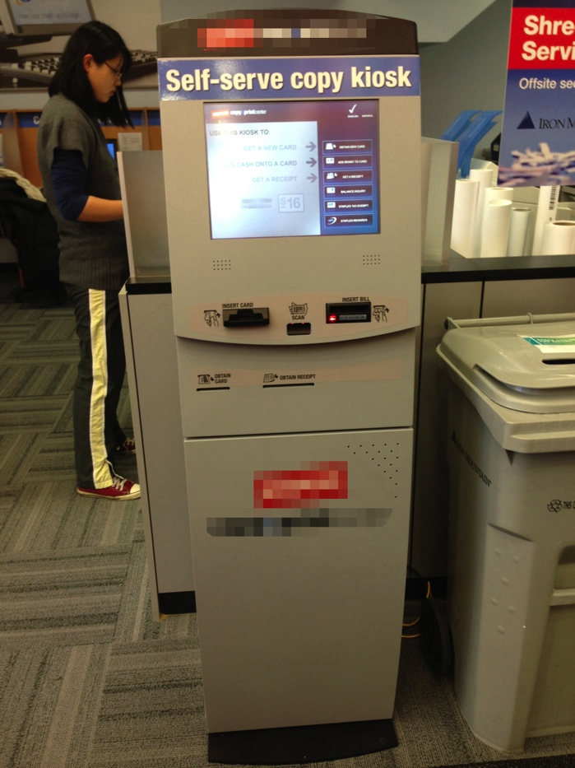 | 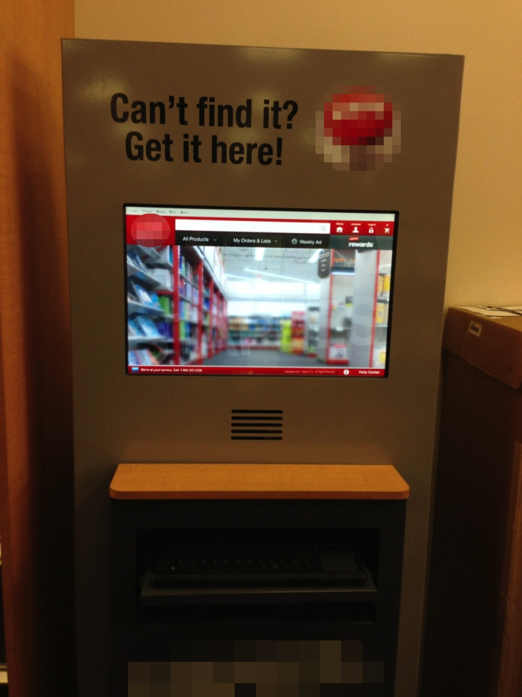
Self-serve copy kiosk | Search kiosk (Left of checkout counter)
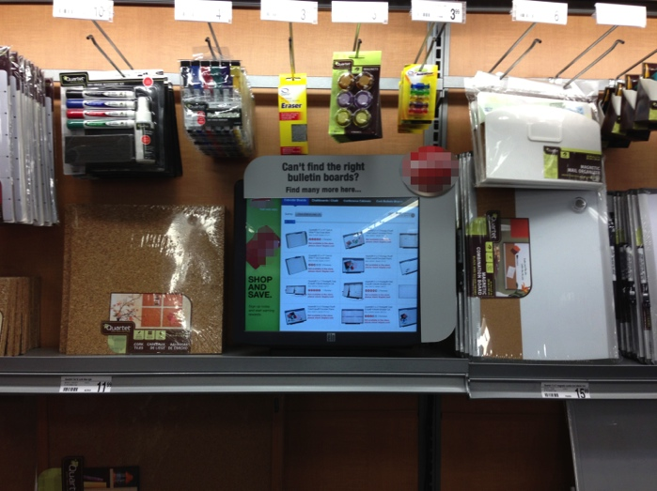 | 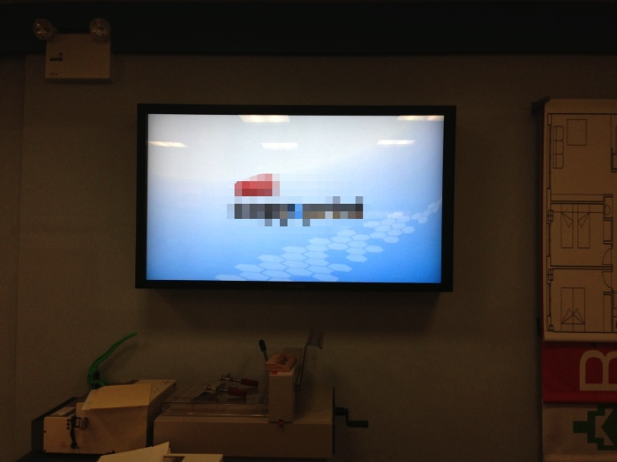
Bulletin boards kiosk (Bulletin boards section) | Copy center electronic display
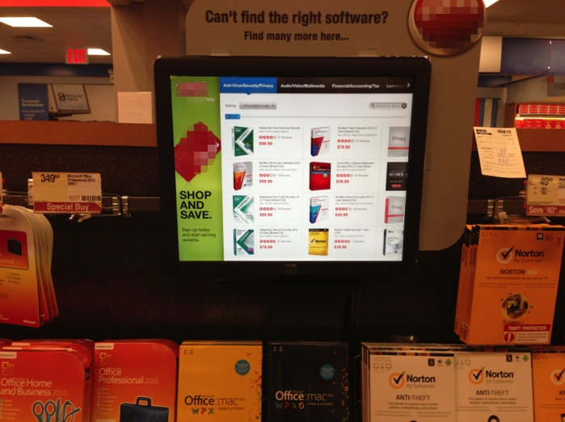 | 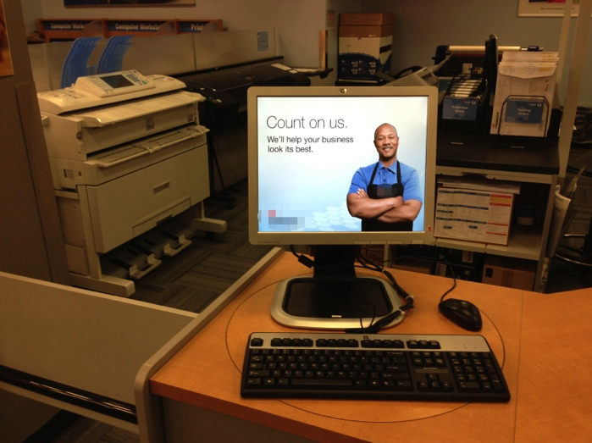
Software kiosk (Software section) | Copy center workstation
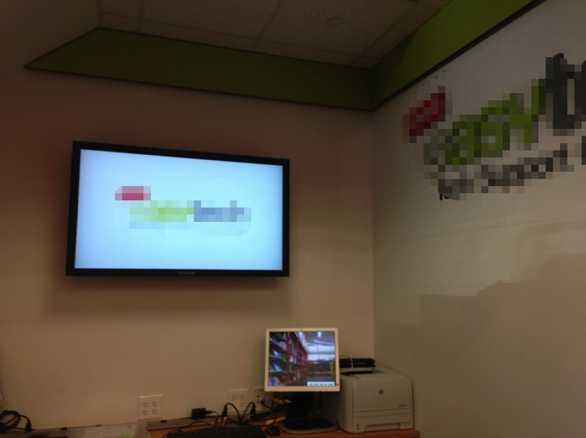 | 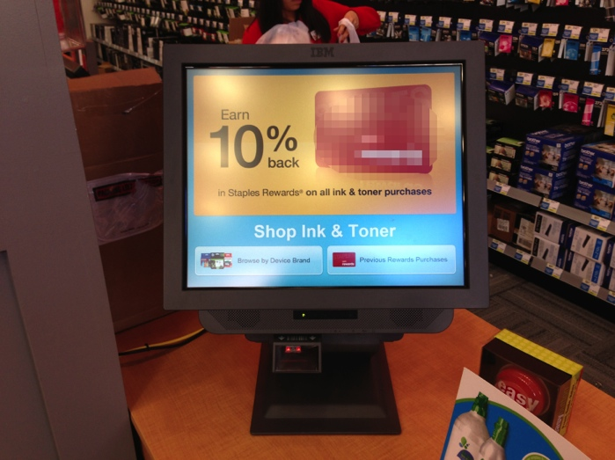
Electronic display (Easy Tech Center) | Loyalty counter kiosk (on right side of checkout counter)
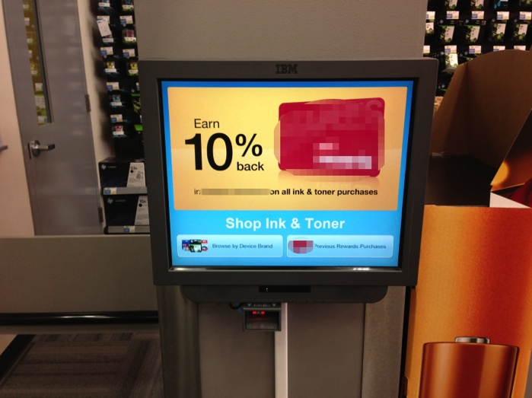 | 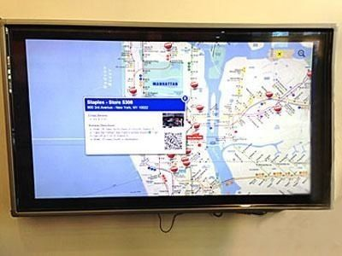
Loyalty kiosk (on left side of checkout counter) | Store location interactive display (Entrance vestibule)
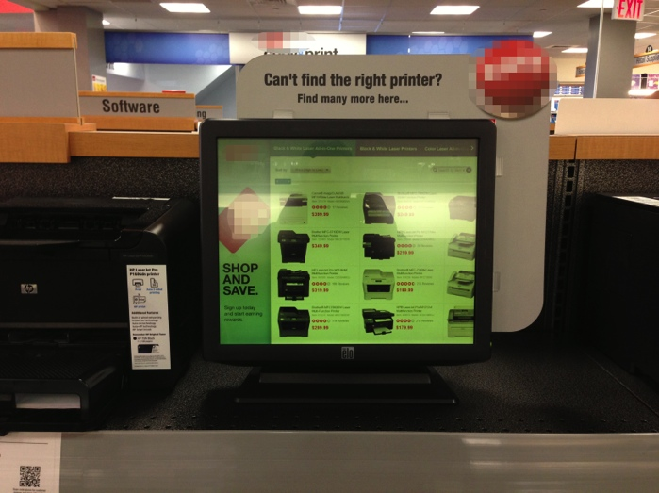 | 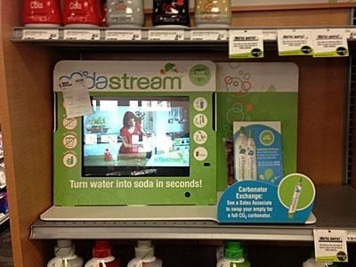
Printer kiosk (Printer section) | Sodastream electronic display (aisle end-cap)
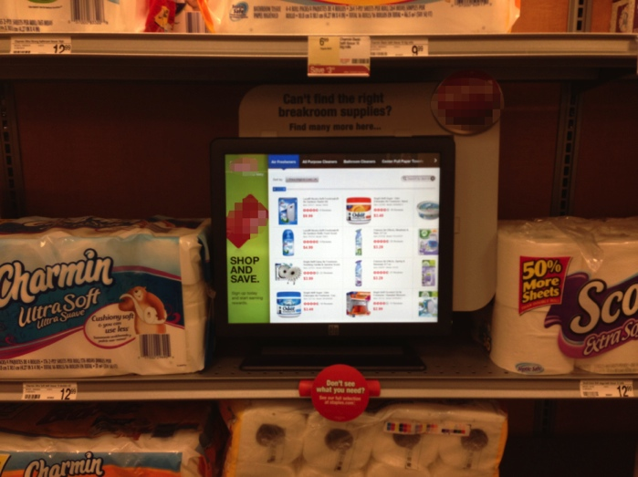
Breakroom supplies kiosk (Breakroom products section)

Appendix D – Qualitative Study Participants
Participant Number | Vocation | Gender | Age Range | Education Level Attained | Income Range
1 | Student | Male | 19 - 24 | 4 year college | Under $25,000
2 | Student | Male | 19 - 24 | Some college | Under $25,000
3 | Real Estate Sales Person | Male | 35 - 44 | Some college | $75,000 to $99,999
4 | Student | Female | 25 - 34 | Master degree | Under $25,000
5 | Student | Male | 19 - 24 | Some college | Under $25,000
6 | Student | Male | 25 - 34 | 4 year college | Under $25,000
7 | Student | Female | 25 - 34 | Master degree | Unstated
8 | Sales Specialist | Female | 19 - 24 | 4 year college | $150,000 or more
9 | Post Production | Male | 25 - 34 | Some college | $25,000 to $49,999
10 | Accounting | Male | 35 - 44 | 4 year college | $50,000 to $74,999
11 | Student | Female | Under 19 | Some college | Under $25,000
12 | Real Estate Agent | Male | 25 - 34 | 4 year college | $50,000 to $74,999
13 | Video Producer | Female | 19 - 24 | 4 year college | $25,000 to $49,999
14 | Design Assistant | Male | 25 - 34 | 4 year college | $150,000 or more
15 | Registered Nurse | Female | 19 - 24 | 4 year college | Unstated
16 | Student | Female | 19 - 24 | 4 year college | Under $25,000
17 | Social worker / program coordinator | Female | 25 - 34 | Master degree | $50,000 to $74,999
18 | Student | Female | 19 - 24 | 4 year college | Under $25,000
19 | Student | Female | 25 - 34 | 4 year college | Under $25,000
20 | Student | Male | 19 - 24 | Some college | Under $25,000
21 | Psychotherapist | Male | 55 - 64 | Doctorate | $75,000 to $99,999
22 | Professor | Female | 55 - 64 | Doctorate | $75,000 to $99,999
23 | Actor / Artistic Associate / Nanny | Female | 25 - 34 | 4 year college | $50,000 to $74,999
24 | Security Guard | Female | 45 - 54 | 2 year college | $25,000 to $49,999
25 | Actor / Performer | Female | 25 - 34 | 4 year college | Under $25,000
26 | Retail service | Male | 19 - 24 | 2 year college | $25,000 to $49,999
27 | Education Administration | Male | 25 - 34 | Master degree | $25,000 to $49,999
28 | Software Engineer | Male | 35 - 44 | 4 year college | $50,000 to $74,999
29 | Business Owner | Male | 45 - 54 | High School | Under $25,000
30 | Event planner | Female | 45 - 54 | 4 year college | Unstated
31 | Cartoonist / Writer | Male | 55 - 64 | Some college | $25,000 to $49,999
32 | Finance | Male | 25 - 34 | Master degree | $100,000 to $149,999
33 | Student | Male | 19 - 24 | Some college | Under $25,000
34 | Customer service | Female | 35 - 44 | 4 year college | $50,000 to $74,999
35 | Event marketing | Female | 45 - 54 | 4 year college | $100,000 to $149,999
36 | Student | Male | 19 - 24 | 2 year college | Under $25,000
37 | Student | Male | 19 - 24 | Some college | Under $25,000
38 | Student | Female | 19 - 24 | 4 year college | Under $25,000
39 | Production coordinator | Female | 19 - 24 | 4 year college | $25,000 to $49,999
40 | Student | Male | 19 - 24 | Some college | Unstated
41 | Student | Male | 19 - 24 | 4 year college | Unstated
42 | Peer Educator | Male | 55 - 64 | 2 year college | Under $25,000
43 | Student | Female | 19 - 24 | Some college | Under $25,000
44 | Student | Female | 19 - 24 | 4 year college | Under $25,000
45 | Energy Management & Acting | Male | 55 - 64 | 4 year college | $75,000 to $99,999
46 | DJ | Male | 25 - 34 | 4 year college | $100,000 to $149,999
47 | Internet marketing | Male | 55 - 64 | Master degree | $100,000 to $149,999
48 | Retired | Male | 65 - 74 | 4 year college | $150,000 or more
49 | Administrative Assistant | Female | 45 - 54 | 4 year college | $50,000 to $74,999
50 | Writes musicals | Male | 65 - 74 | 4 year college | $25,000 to $49,999
51 | Financial advisor | Male | 25 - 34 | Master degree | $100,000 to $149,999
52 | Mental health worker | Male | 35 - 44 | 4 year college | $50,000 to $74,999
53 | Student | Female | 19 - 24 | 4 year college | Unstated
54 | Registered Nurse | Female | 65 - 74 | Master degree | $75,000 to $99,999
55 | Physician | Male | 35 - 44 | Doctorate | $150,000 or more
56 | Non-profit management | Female | 55 - 64 | 4 year college | Unstated
57 | Real estate broker | Female | 55 - 64 | Master degree | $150,000 or more
58 | Student | Female | Under 19 | High School | Unstated
59 | Administrative Assistant | Female | 45 - 54 | 4 year college | $25,000 to $49,999
60 | Interior Design | Female | 25 - 34 | 4 year college | $50,000 to $74,999
61 | Student | Female | 19 - 24 | 4 year college | Under $25,000
62 | Unemployed | Male | 25 - 34 | 4 year college | Unstated
63 | Nurse | Female | 55 - 64 | 4 year college | $75,000 to $99,999
64 | Property Manager | Male | 45 - 54 | 4 year college | $100,000 to $149,999
65 | Sales | Female | 45 - 54 | Master degree | $50,000 to $74,999
66 | Physician | Male | 55 - 64 | Doctorate | $150,000 or more
67 | Small Business Owner | Male | 35 - 44 | 4 year college | $50,000 to $74,999
68 | Chef | Female | 45 - 54 | 4 year college | $50,000 to $74,999
69 | Social Policy Research Assistant | Female | 45 - 54 | 4 year college | Under $25,000
70 | Accountant | Female | 45 - 54 | 4 year college | $50,000 to $74,999
71 | Investigator | Female | 55 - 64 | 4 year college | $25,000 to $49,999
72 | Surgeon | Male | 35 - 44 | Doctorate | $50,000 to $74,999
73 | Waiter | Male | 25 - 34 | 4 year college | $25,000 to $49,999
74 | Network Engineer | Male | 45 - 54 | 2 year college | $50,000 to $74,999
75 | Cashier | Female | 25 - 34 | High School | $25,000 to $49,999
76 | Treasury | Male | 25 - 34 | 2 year college | $50,000 to $74,999
77 | Scientist | Male | 45 - 54 | Doctorate | $100,000 to $149,999
78 | Buyer | Female | 45 - 54 | 4 year college | $100,000 to $149,999
79 | Lawyer | Male | 25 - 34 | Doctorate | $100,000 to $149,999
80 | Retired | Female | 55 - 64 | Master degree | $100,000 to $149,999
81 | Attorney (semi-retired) | Female | 65 - 74 | Doctorate | $100,000 to $149,999
82 | Retired | Female | 55 - 64 | 4 year college | Unstated
83 | Secretary | Female | 45 - 54 | 2 year college | $25,000 to $49,999
84 | Surgical Coordinator | Female | 45 - 54 | 2 year college | $25,000 to $49,999
85 | Architect | Male | 65 - 74 | 4 year college | $50,000 to $74,999
86 | Food Sales | Male | 55 - 64 | Master degree | $150,000 or more
87 | Sales | Male | 19 - 24 | 2 year college | $25,000 to $49,999
88 | Finance | Male | 25 - 34 | Master degree | $150,000 or more
89 | Student / Medical Assistant | Female | 19 - 24 | Master degree | $25,000 to $49,999
90 | Teacher | Female | 35 - 44 | Master degree | $75,000 to $99,999
91 | Retired | Male | 65 - 74 | Doctorate | $25,000 to $49,999
92 | Physical Therapist | Female | 19 - 24 | Master degree | $50,000 to $74,999
93 | Graphic designer | Female | 25 - 34 | 4 year college | $25,000 to $49,999
94 | Buyer | Female | 45 - 54 | 4 year college | $150,000 or more
95 | Teacher | Male | 35 - 44 | Master degree | $100,000 to $149,999
96 | Real estate broker | Female | 35 - 44 | Some college | $100,000 to $149,999
97 | Dental hygientist | Male | 35 - 44 | 4 year college | $50,000 to $74,999
98 | Forensic photographer | Female | 35 - 44 | Master degree | $25,000 to $49,999
99 | Finance | Male | 25 - 34 | 4 year college | $150,000 or more
100 | Research | Male | 45 - 54 | Master degree | Unstated
101 | News editor | Male | 55 - 64 | 4 year college | $150,000 or more
102 | Student | Female | 25 - 34 | Doctorate | Under $25,000
103 | Account clerk | Male | 45 - 54 | High School | $25,000 to $49,999
104 | Graduate student | Male | 25 - 34 | 4 year college | Unstated
105 | Pharmacist | Male | 45 - 54 | 4 year college | $100,000 to $149,999
106 | Dentist | Female | 35 - 44 | Doctorate | $75,000 to $99,999
107 | Attorney | Male | 65 - 74 | Doctorate | $100,000 to $149,999
108 | Unemployed | Female | 65 - 74 | High School | Under $25,000
109 | Educator | Male | 45 - 54 | Doctorate | $25,000 to $49,999
110 | Venture capitalist | Male | 35 - 44 | Master degree | $150,000 or more
111 | Medical student | Female | 25 - 34 | Doctorate | $50,000 to $74,999
112 | Registered Nurse | Female | 55 - 64 | Master degree | $100,000 to $149,999
113 | Model | Female | 25 - 34 | High School | $150,000 or more
114 | Sales | Male | 45 - 54 | Some college | $100,000 to $149,999
115 | Elevator mechanic | Male | 35 - 44 | 2 year college | $100,000 to $149,999
116 | Unstated | Male | 45 - 54 | Master degree | $150,000 or more
117 | Art Director | Male | 45 - 54 | Master degree | $75,000 to $99,999
118 | Legal | Female | 45 - 54 | Doctorate | Unstated
119 | Accounting | Male | 45 - 54 | High School | $50,000 to $74,999
120 | Development | Female | 55 - 64 | 4 year college | $150,000 or more
121 | Bookkeeper | Female | 55 - 64 | Some college | Under $25,000
122 | Finance | Male | 45 - 54 | Master degree | $150,000 or more
123 | Entertainment | Female | 19 - 24 | Some college | $100,000 to $149,999
124 | Retired | Male | 65 - 74 | High School | Under $25,000
125 | Physician | Male | 25 - 34 | Doctorate | $75,000 to $99,999
126 | Teacher | Male | 35 - 44 | Master degree | $100,000 to $149,999
127 | Health Care | Male | 45 - 54 | High School | $50,000 to $74,999
128 | Appraiser | Male | 35 - 44 | Some college | $100,000 to $149,999
129 | Bartender / Restaurant Consultant | Male | 35 - 44 | Other | $50,000 to $74,999
130 | Equity Trader | Male | 25 - 34 | Master degree | $100,000 to $149,999
131 | Security Officer | Male | 25 - 34 | 4 year college | $50,000 to $74,999
132 | Retired | Male | 65 - 74 | 4 year college | $150,000 or more
133 | Retired | Male | 65 - 74 | 4 year college | $50,000 to $74,999
134 | Postal Service | Female | 45 - 54 | Some college | $50,000 to $74,999
135 | Graduate Student | Male | 25 - 34 | Doctorate | $25,000 to $49,999
136 | Attorney | Male | 35 - 44 | Doctorate | $100,000 to $149,999
137 | Production manager | Female | 45 - 54 | 4 year college | $75,000 to $99,999
138 | Student | Male | 25 - 34 | 4 year college | Unstated
139 | Actor | Male | 25 - 34 | Master degree | $25,000 to $49,999
140 | Consultant | Female | 25 - 34 | 4 year college | $150,000 or more
141 | Project coordinator - media specialist | Female | 19 - 24 | 4 year college | $25,000 to $49,999
142 | Purchasing agent | Male | 25 - 34 | 4 year college | $25,000 to $49,999
143 | Real estate | Male | 25 - 34 | 4 year college | $75,000 to $99,999
144 | Psychoanalyst | Female | 55 - 64 | Doctorate | $100,000 to $149,999
145 | Physician | Male | 45 - 54 | Doctorate | $150,000 or more
146 | Wax & Striper | Male | 45 - 54 | 2 year college | $50,000 to $74,999
147 | Project Manager | Male | 19 - 24 | 4 year college | $50,000 to $74,999
148 | Financial services | Female | 25 - 34 | 4 year college | Unstated
149 | Student | Male | 19 - 24 | 4 year college | Under $25,000
150 | Teacher | Male | 45 - 54 | Master degree | Unstated
151 | Building Superintendent | Male | 45 - 54 | High School | $50,000 to $74,999
152 | Unstated | Male | 25 - 34 | Some college | Unstated
153 | MD/Phd Student | Female | 19 - 24 | 4 year college | $25,000 to $49,999
154 | Student | Female | 25 - 34 | Master degree | Under $25,000
155 | Consultant | Male | 19 - 24 | 4 year college | $100,000 to $149,999
156 | Advertising | Female | 25 - 34 | 4 year college | $50,000 to $74,999
157 | Program Coordinator | Female | 19 - 24 | 4 year college | $25,000 to $49,999
158 | School teacher | Female | 55 - 64 | Master degree | $50,000 to $74,999
159 | Retired | Male | 65 - 74 | Master degree | Unstated
160 | Oil & Gas Consulting | Male | 25 - 34 | 4 year college | $150,000 or more
161 | CEO, Surgical Device Company | Male | 35 - 44 | Master degree | $150,000 or more
162 | Law | Male | 25 - 34 | Master degree | $150,000 or more
163 | Administrative Assistant | Female | 35 - 44 | 4 year college | $50,000 to $74,999
164 | Dental Student | Male | 25 - 34 | Doctorate | Under $25,000
165 | Film/Dance/Gardner/Landscaping | Male | 45 - 54 | 4 year college | $25,000 to $49,999
166 | Designer | Female | 55 - 64 | 4 year college | $50,000 to $74,999
167 | Teacher | Female | 25 - 34 | Master degree | $50,000 to $74,999
168 | Photographer/Artist | Female | 25 - 34 | Master degree | $50,000 to $74,999
169 | Art Advisor | Female | 55 - 64 | 4 year college | $75,000 to $99,999
170 | Photographer/Teacher | Female | 25 - 34 | Master degree | $50,000 to $74,999
171 | Special Ed Teacher | Male | 25 - 34 | 4 year college | $25,000 to $49,999
172 | Fitness | Female | 45 - 54 | 4 year college | $150,000 or more
173 | Athletics Department Administrator | Male | 25 - 34 | Master degree | $25,000 to $49,999
174 | Stay at home mom | Female | 35 - 44 | 4 year college | $100,000 to $149,999
175 | Multi Unit Restaurant Manager | Male | 45 - 54 | 4 year college | $100,000 to $149,999
176 | Finance | Male | 35 - 44 | 4 year college | $100,000 to $149,999
177 | Technical writer | Male | 55 - 64 | 4 year college | $100,000 to $149,999
178 | Portfolio Manager | Male | 25 - 34 | 4 year college | $150,000 or more
179 | Marketing | Female | 25 - 34 | 4 year college | $150,000 or more
180 | Director of Finance Non-Profit | Female | 45 - 54 | Master degree | $150,000 or more
181 | Producer | Male | 45 - 54 | 4 year college | $150,000 or more
182 | Consultant | Male | 35 - 44 | Master degree | $150,000 or more
183 | Receptionist | Female | 19 - 24 | Some college | $25,000 to $49,999
184 | Lawyer | Female | 19 - 24 | Master degree | $150,000 or more
185 | Education Consultant | Female | 65 - 74 | 4 year college | $100,000 to $149,999
186 | Technician | Male | 19 - 24 | 2 year college | $25,000 to $49,999
187 | Engineer | Male | 45 - 54 | 4 year college | $150,000 or more
188 | Work in a bank | Male | 55 - 64 | 2 year college | $75,000 to $99,999
189 | Assistant Buying | Female | 19 - 24 | 4 year college | $50,000 to $74,999
190 | Media Sales | Male | 55 - 64 | 4 year college | $150,000 or more
191 | Project Manager | Male | 25 - 34 | Master degree | $150,000 or more
192 | Video Production | Male | 25 - 34 | 4 year college | $75,000 to $99,999
193 | Meeting Planner | Female | 25 - 34 | 4 year college | $75,000 to $99,999
194 | Student & Intern @ Y&R | Female | 19 - 24 | 4 year college | Under $25,000
195 | Media Access (Close Captioner) | Male | 25 - 34 | 4 year college | $25,000 to $49,999
196 | Fashion Marketing/Sales | Female | 45 - 54 | 4 year college | Under $25,000
197 | Account Executive | Female | 35 - 44 | Master degree | $50,000 to $74,999
198 | Finance | Male | 35 - 44 | Master degree | $150,000 or more
199 | Real Estate Finance | Female | 25 - 34 | 4 year college | $150,000 or more
200 | Pastry Chef | Female | 19 - 24 | 4 year college | $25,000 to $49,999
201 | Photographer | Male | 19 - 24 | 4 year college | $50,000 to $74,999
202 | Communications consultant | Male | 65 - 74 | 4 year college | Unstated
203 | Volunteer coordinator at a charity | Female | 19 - 24 | Some college | Under $25,000
204 | Commercial music composer | Male | 19 - 24 | 4 year college | Under $25,000
205 | Photography | Female | 35 - 44 | 4 year college | $75,000 to $99,999
206 | Student | Male | Under 19 | High School | Under $25,000
207 | Accountant | Female | 55 - 64 | Some college | $100,000 to $149,999
208 | Student | Female | 25 - 34 | Some college | Unstated
209 | Sales | Male | 25 - 34 | 4 year college | Unstated
210 | Security / Student | Male | 25 - 34 | 4 year college | Under $25,000
211 | Fashion production for Lord & Taylor | Female | 25 - 34 | 4 year college | $150,000 or more
212 | Accounts Receivable Manager | Female | 35 - 44 | 2 year college | $50,000 to $74,999
213 | Housewife | Female | 55 - 64 | 4 year college | $100,000 to $149,999
214 | Work | Male | 45 - 54 | 4 year college | $50,000 to $74,999
215 | Analyst | Male | 45 - 54 | 4 year college | $100,000 to $149,999
216 | Finance | Female | 25 - 34 | 4 year college | $100,000 to $149,999
217 | Photographer | Male | 25 - 34 | 4 year college | $50,000 to $74,999
218 | Digital Signage | Male | 45 - 54 | 4 year college | $100,000 to $149,999
219 | Operations Management | Female | 25 - 34 | 4 year college | $150,000 or more
220 | Public Health Professional | Male | 45 - 54 | 4 year college | $150,000 or more
221 | Graphic designer | Male | 19 - 24 | Some college | $25,000 to $49,999
222 | Management Consultant | Female | 25 - 34 | Master degree | $50,000 to $74,999
223 | Retired | Male | 65 - 74 | 4 year college | $75,000 to $99,999
224 | Analyst | Male | 25 - 34 | 4 year college | $75,000 to $99,999
225 | Self-employed | Female | 35 - 44 | 4 year college | $100,000 to $149,999
226 | Event manager | Female | 35 - 44 | 4 year college | $100,000 to $149,999
227 | Development of Learning Space | Male | 55 - 64 | Master degree | $100,000 to $149,999
228 | Consultant (IT) | Male | 45 - 54 | Master degree | $75,000 to $99,999
229 | Beer salesman for Sam Adams | Male | 19 - 24 | 4 year college | $50,000 to $74,999
230 | Wealth Manager | Male | 45 - 54 | Master degree | $150,000 or more
231 | Manager at Bank | Male | 25 - 34 | 4 year college | $100,000 to $149,999
232 | Retired | Female | 55 - 64 | Master degree | $150,000 or more
233 | Graphic design | Male | 45 - 54 | High School | $50,000 to $74,999
234 | Project coordinator | Female | 25 - 34 | 4 year college | $75,000 to $99,999
235 | Employment specialist | Female | 25 - 34 | 4 year college | $25,000 to $49,999
236 | Coordinator for Non-Profit | Female | 25 - 34 | 4 year college | $25,000 to $49,999
237 | Litigation Support | Male | 35 - 44 | 4 year college | $100,000 to $149,999
238 | Tax Manager | Male | 35 - 44 | Master degree | $150,000 or more
239 | Administrator | Female | 45 - 54 | Master degree | $50,000 to $74,999
240 | Sales Manager | Male | 35 - 44 | 4 year college | $100,000 to $149,999
241 | Self-employed | Female | 45 - 54 | Master degree | Unstated
242 | Manager @ Lord & Taylor / Make-up Artist | Female | 25 - 34 | 4 year college | $50,000 to $74,999
243 | Self-employed | Female | 45 - 54 | Some college | Under $25,000
244 | Recruiting | Male | 55 - 64 | 4 year college | $150,000 or more
245 | Hospitality | Male | 25 - 34 | 2 year college | $50,000 to $74,999
246 | Intern at law firm | Male | 25 - 34 | Some college | $25,000 to $49,999
247 | Administrative - international education | Male | 25 - 34 | Master degree | $100,000 to $149,999
248 | Records coordination | Male | 45 - 54 | Some college | $25,000 to $49,999
249 | Account Associate | Female | 45 - 54 | 4 year college | $25,000 to $49,999
250 | Property Management | Male | 25 - 34 | Some college | $25,000 to $49,999
251 | Print operator | Male | 45 - 54 | Some college | $75,000 to $99,999
252 | Software consultant | Male | 55 - 64 | Master degree | $150,000 or more
253 | Executive Director for Non-Profit | Female | 25 - 34 | Master degree | $100,000 to $149,999
254 | Business owner (Wellness Center) | Female | 45 - 54 | Master degree | $150,000 or more
255 | Production Assistant for My Tupelo Entertainment | Female | 19 - 24 | 4 year college | $25,000 to $49,999
256 | Web Developer | Male | 25 - 34 | Master degree | $50,000 to $74,999
257 | Social Work / Student | Female | 19 - 24 | Some college | $25,000 to $49,999
258 | Financial Analyst | Male | 25 - 34 | 4 year college | $50,000 to $74,999
259 | Administrative Assistant | Female | 25 - 34 | 2 year college | $25,000 to $49,999
260 | Executive | Female | 55 - 64 | 4 year college | Unstated
261 | Teacher | Female | 25 - 34 | 4 year college | Under $25,000
262 | Customer Service Manager | Female | 25 - 34 | 4 year college | $25,000 to $49,999
263 | Wholesale diamonds and jewelry | Male | 25 - 34 | 2 year college | $100,000 to $149,999
264 | Photographer | Male | 45 - 54 | 4 year college | Unstated
265 | FDNY | Male | 19 - 24 | 4 year college | $25,000 to $49,999
266 | Designer | Male | 35 - 44 | 4 year college | $100,000 to $149,999
267 | Photographer | Male | 19 - 24 | 2 year college | Under $25,000
268 | CSR | Male | 25 - 34 | 2 year college | Under $25,000
269 | Paralegal | Female | 19 - 24 | 4 year college | $150,000 or more
270 | Inhouse Messenger | Male | 25 - 34 | Some college | Under $25,000

Appendix E – Measurement Items

Technology Engagement
All items adapted from O’Brien and Toms 2010. Items marketed with an asterisk (*) were removed from the final survey.
Focused Attention
- FA1 - I lost myself in the experience of using this technology.
- FA2 - I was so involved in using this technology that I lost track of time.
- FA3 - I blocked out things around me when I was using this technology.
- FA4 - When I was using this technology, I lost track of the world around me.
- FA5 - The time I spent using this technology just slipped away.
Perceived Usability
- PU1 - I felt frustrated while using this technology
- PU2 - I found this technology easy to use.
- PU3 - I felt annoyed while using this technology.
- PU4 - I felt discouraged while using this technology.
- PU5 - Using this technology was mentally tiring.
- PU6 - This technology experience was relaxing.
- *PU7 - I felt in control of my experience with this technology.
- *PU8 - I could not do some of the things I needed to do on this technology.
Aesthetics
- AE1 - The look of this technology made me want to use it.
- AE2 - This technology was visually appealing.
- AE3 - I liked the graphics used on this technology.
- AE4 - I used this technology because it was visually interesting.
- AE5 - The layout of graphics on this technology was pleasing.
- *AE6 - I liked the sound/music used on this technology.
Endurability
- *ED1 - Using this technology was worthwhile.
- *ED2 - I consider my experience with this technology a success.
- *ED3 - The experience with this technology worked out the way I expected.
- *ED4 - My experience with this technology was rewarding.
- *ED5 - I would recommend using this technology to my friends and family.
Novelty
- *NV1 - The newness of the technology made me want to use it.
- *NV2 - The content of the technology made me curious.
- *NV3 - I was interested in using this technology.
- *NV4 - I was curious to use this technology.
Involvement
- *IN1 - I was really drawn into using this technology.
- *IN2 - I felt involved in using this technology.
- *IN3 - It was fun using this technology.

Technology Readiness
All measures are 5-point Likert items from Parasuraman 2000.
Optimism
- Technology gives people more control over their daily lives.
- Products and services that use the newest technologies are much more convenient to use.
- You like the idea of doing business via computers because you are not limited to regular business hours.
- You prefer to use the most advanced technology available.
- You like computer programs that allow you to tailor things to fit your own needs.
- Technology makes you more efficient in your occupation.
- You find new technologies to be mentally stimulating.
- Technology gives you more freedom of mobility.
- Learning about technology can be as rewarding as the technology itself.
- You feel confident that machines will follow through with what you instructed them to do.
Innovativeness
- Other people come to you for advice on new technologies.
- It seems your friends are learning more about the newest technologies than you are. [reverse scored]
- In general, you are among the first in your circle of friends to acquire new technology when it appears.
- You can usually figure out new high-tech products and services without help from others.
- You keep up with the latest technological developments in your areas of interest.
- You enjoy the challenge of figuring out high-tech gadgets.
- You find you have fewer problems than other people in making technology work for you.
Discomfort
- Technical support lines are not helpful because they don’t explain things in terms you understand.
- Sometimes you think that technology systems are not designed for use by ordinary people.
- There is no such thing as a manual for a high-tech product or service that’s written in plain language.
- When you get technical support from a provider of a high-tech product or service, you sometimes feel as if you are being taken advantage of
- by someone who knows more than you do.
- If you buy a high-tech product or service, you prefer to have the basic model over one with a lot of extra features.
- It is embarrassing when you have trouble with a high-tech gadget while people are watching.
- There should be caution in replacing important people-tasks with technology because new technology can breakdown or get disconnected.
- Many new technologies have health or safety risks that are not discovered until after people have used them.
- New technology makes it too easy for governments and companies to spy on people.
- Technology always seems to fail at the worst possible time.
Insecurity
- You do not consider it safe giving out a credit card number over a computer.
- You do not consider it safe to do any kind of financial business online.
- You worry that information you send over the Internet will be seen by other people.
- You do not feel confident doing business with a place that can only be reached online.
- Any business transaction you do electronically should be confirmed later with something in writing.
- Whenever something gets automated, you need to check carefully that the machine or computer is not making mistakes.
- The human touch is very important when doing business with a company.
- When you call a business, you prefer to talk to a person rather than a machine.
- If you provide information to a machine or over the Internet, you can never be sure it really gets to the right place.

Ambivalence
Each direct ambivalence question includes three 5-point differential items with values from 1 to 5. Each item is anchored by “Clearly does not describe my feelings” (1) to “Clearly describes my feelings” (5). Direct ambivalence measures are influenced by Jamieson (1988).

Direct Measures of Ambivalence
When I used technology while I shopped...
- ...I had more control over my shopping, but at the same time I was not comfortable because I had to do some things differently.
- ...I had less need for assistance, but at the same time I felt more dependent on the technology than normal.
- ...I felt like an expert shopper, but at the same time I felt somewhat inexperienced.
- ...I felt more efficient in my shopping, but at the same time I felt like more work was created for me.
- ...I felt my shopping needs were being fulfilled, but at the same time I was aware of new needs I did not have before.
- ...I felt more connected to other people, but at the same time I felt somewhat on my own.
- ...I could concentrate better on my shopping, but at the same time I encountered disruptions I would not normally have.

Shopping Value
All measures are 5-point Likert items. All items marked with an asterisk are reverse coded.
Utilitarian Shopping Value
- I accomplished just what I wanted to on this shopping trip.
- I couldn't buy what I really needed.*
- While shopping, I found just the item (s) I was looking for.
- I was disappointed because I had to go to another store (s) to complete my shopping.*

Hedonic Shopping Value
- This shopping trip was truly a joy.
- I continued to shop not because I had to, but because I wanted to.
- Compared to other things I could have done, the time spent shopping was truly enjoyable.
- I enjoyed this shopping trip for its own sake, not just for the items I may have purchased.
- During the trip, I felt the excitement of the hunt.
- While shopping, I felt a sense of adventure.
- This shopping trip was not a very nice time out.

Appendix F – Descriptive Statistics
Construct | Item | Min | Max | Mean | SD
Technology Engagement | FA1 | 1 | 5 | 3.01 | .856
Technology Engagement | FA2 | 1 | 5 | 3.02 | .944
Technology Engagement | FA3 | 1 | 5 | 3.22 | .986
Technology Engagement | FA4 | 1 | 5 | 3.03 | .939
Technology Engagement | FA5 | 1 | 5 | 3.17 | .864
Technology Engagement | PU1 | 1 | 5 | 3.48 | .860
Technology Engagement | PU2 | 1 | 5 | 3.77 | .660
Technology Engagement | PU3 | 1 | 5 | 3.22 | 1.022
Technology Engagement | PU4 | 1 | 5 | 3.27 | 1.076
Technology Engagement | PU5 | 1 | 5 | 3.15 | .964
Technology Engagement | PU6 | 1 | 5 | 3.47 | .755
Technology Engagement | AE1 | 1 | 5 | 3.61 | .704
Technology Engagement | AE2 | 1 | 5 | 3.65 | .697
Technology Engagement | AE3 | 2 | 5 | 3.67 | .685
Technology Engagement | AE4 | 1 | 5 | 3.60 | .740
Technology Engagement | AE5 | 1 | 5 | 3.64 | .692
Technology Readiness | OPT1 | 1 | 5 | 3.86 | .881
Technology Readiness | OPT2 | 1 | 5 | 3.80 | .874
Technology Readiness | OPT3 | 1 | 5 | 3.95 | .927
Technology Readiness | OPT4 | 1 | 5 | 3.78 | .905
Technology Readiness | OPT5 | 1 | 5 | 3.98 | .842
Technology Readiness | OPT6 | 1 | 5 | 4.13 | .809
Technology Readiness | OPT7 | 1 | 5 | 3.88 | .930
Technology Readiness | OPT8 | 1 | 5 | 4.08 | .843
Technology Readiness | OPT9 | 1 | 5 | 3.90 | .885
Technology Readiness | OPT10 | 1 | 5 | 3.76 | .866
Technology Readiness | INNO1 | 1 | 5 | 3.61 | 1.079
Technology Readiness | INNO2 | 1 | 5 | 2.96 | 1.130
Technology Readiness | INNO3 | 1 | 5 | 3.34 | 1.146
Technology Readiness | INNO4 | 1 | 5 | 3.74 | 1.024
Technology Readiness | INNO5 | 1 | 5 | 3.76 | .976
Technology Readiness | INNO6 | 1 | 5 | 3.73 | 1.038
Technology Readiness | INNO7 | 1 | 5 | 3.71 | .994
Technology Readiness | DIS1 | 1 | 5 | 3.06 | 1.087
Technology Readiness | DIS2 | 1 | 5 | 3.02 | 1.107
Technology Readiness | DIS3 | 1 | 5 | 3.19 | 1.125
Technology Readiness | DIS4 | 1 | 5 | 2.90 | 1.106
Technology Readiness | DIS5 | 1 | 5 | 3.05 | 1.075
Technology Readiness | DIS6 | 1 | 5 | 3.15 | 1.170
Technology Readiness | DIS7 | 1 | 5 | 3.48 | 1.010
Technology Readiness | DIS8 | 1 | 5 | 3.25 | 1.033
Technology Readiness | DIS9 | 1 | 5 | 3.49 | 1.033
Technology Readiness | DIS10 | 1 | 5 | 3.22 | 1.034
Technology Readiness | INSC1 | 1 | 5 | 2.85 | 1.201
Technology Readiness | INSC2 | 1 | 5 | 2.61 | 1.220
Technology Readiness | INSC3 | 1 | 5 | 3.46 | 1.029
Technology Readiness | INSC4 | 1 | 5 | 3.25 | 1.207
Technology Readiness | INSC5 | 1 | 5 | 3.44 | 1.169
Technology Readiness | INSC6 | 1 | 5 | 3.50 | .994
Technology Readiness | INSC7 | 1 | 5 | 3.77 | 1.042
Technology Readiness | INSC8 | 1 | 5 | 4.04 | 1.028
Technology Readiness | INSC9 | 1 | 5 | 3.16 | 1.159
Technology-Induced Shopping Ambivalence | AMB1 | 1 | 5 | 3.19 | .995
Technology-Induced Shopping Ambivalence | AMB2 | 1 | 5 | 3.45 | .967
Technology-Induced Shopping Ambivalence | AMB3 | 1 | 5 | 3.15 | .939
Technology-Induced Shopping Ambivalence | AMB4 | 1 | 5 | 3.30 | .946
Technology-Induced Shopping Ambivalence | AMB5 | 1 | 5 | 3.42 | .884
Technology-Induced Shopping Ambivalence | AMB6 | 1 | 5 | 3.15 | .976
Technology-Induced Shopping Ambivalence | AMB7 | 1 | 5 | 3.14 | .968
Utilitarian Shopping Value | USV1 | 1 | 5 | 4.00 | .744
Utilitarian Shopping Value | USV2 | 1 | 5 | 3.43 | 1.163
Utilitarian Shopping Value | USV3 | 1 | 5 | 3.86 | .790
Utilitarian Shopping Value | USV4 | 1 | 5 | 3.50 | 1.198
Utilitarian Shopping Value | HSV2 | 1 | 5 | 3.47 | .934
Utilitarian Shopping Value | HSV3 | 1 | 5 | 3.54 | .834
Utilitarian Shopping Value | HSV4 | 1 | 5 | 3.50 | .869
Utilitarian Shopping Value | HSV5 | 1 | 5 | 3.46 | .947
Utilitarian Shopping Value | HSV6 | 1 | 5 | 3.37 | .929
Utilitarian Shopping Value | HSV7 | 1 | 5 | 3.24 | 1.139

VITA
Brian Ijams Spaid holds a Bachelor of Music in Theory and Composition from the University of the Pacific and a Master of Business Administration in Marketing from The University of Tennessee, Knoxville. Prior to returning to graduate school to complete the Ph.D. degree, Brian held several professional positions including vice president and creative director at Mediapulse in Knoxville, TN; Senior IT Project Manager at Adaptec, CA; and Senior Internet Marketing Executive at HSR, in Cincinnati, OH.
Brian’s research focuses on services marketing with a special emphasis on the role of in-store and mobile technologies and their impact on the brick-and-mortar and online retail realms. His work has been published in the Journal of Marketing Theory and Practice; The International Review of Retailing, Distribution and Consumer Research; and The Service Industries Journal. His work has also been presented at numerous conferences included the Society of Marketing Advances, the European Institute of Retailing and Service Sciences, and the International Academy of Business and Public Administration Disciplines.
In June 2014, Brian completed the requirements for the Ph.D. degree in Business Administration with a major in Marketing at The University of Tennessee, Knoxville. He is currently employed as an Assistant Professor of Marketing at Marquette University in Milwaukee, Wisconsin.

