Plant neighbor interactions of a native goldenrod impact abundance and composition of pollinator communities
EEB Honors Thesis

Emma Kruse
Advisor: Jen Schweitzer
Graduate mentor: Sophia Turner
Additional Committee Members: Laura Russo, Jim Fordyce

Abstract
Given recent global pollinator declines and large-scale changes in plant communities, plant-pollinator interactions are quickly becoming a very important subject area in ecology. While it is generally assumed that increases in plant community diversity and pollinator community diversity go hand-in-hand, variation in pollination network dynamics may mean that different patterns emerge based on the individual systems involved. To test the effects of plant competition on the floral traits and pollinator communities of Solidago altissima, a native goldenrod, I carried out a field experiment based on an existing common garden experiment where S. altissima was planted in monocultures, as well as in combination with two other species, the thistle Cirsium discolor and the yarrow Achillea millefolium in either two or three species plots. I carried out weekly samples of pollinators and floral traits of S. altissima over six weeks in October and November and analyzed the resulting data for effects of plant neighbor on floral density, pollinator abundance, richness, diversity, and community composition. While there was no correlation between inflorescence dimensions and amounts of pollinator visitation, abundance varied significantly between plant neighborhoods (whether S. altissima was planted with itself, C. discolor, A. millefolium, or both). Overall, pollinator abundance was highest in monoculture communities, and pollinator community composition was significantly different in monoculture.

Keywords: competition, plant-pollinator interactions, pollination networks, pollinator diversity

Introduction
Many pollinating arthropod, bird, and mammal species are exhibiting alarming losses which can have devastating consequences for the ecosystem service of pollination (Rhodes 2018, Regan et. al. 2015). High rates of pollinator decline are shown to be caused by many things, including habitat loss and fragmentation (due to agriculture and urban development), pollution, and global climate change (Ramos-Jiliberto & Vázquez 2020). Bees, some of the most economically important pollinators, are threatened by decreased floral diversity, limited nesting habitat, exposure to agricultural chemicals such as pesticides (especially neonicotinoids), and parasites like varroa mites and Israeli acute paralysis virus (Rhodes 2018). The combined effects of these factors exacerbate pollinator decline (Potts et. al. 2010). All these threats currently contribute to Colony Collapse Disorder (CCD) in the European honeybee, Apis mellifera, which then impacts global crop production (Rhodes 2018).
Changes in plant communities can impact pollinator visitation in several ways. Plant populations affected by increased herbivory pressure often evolve traits that can affect pollination networks in both positive and negative ways, such as increased toxic metabolites or changes in floral structure (McPeek et. al. 2022). Introductions of new plant species in a community can also have significant negative effects on network structure, especially if the plant fills a generalist niche (Russo et. al. 2014, Trøjelsgaard et. al. 2019). In fragmented habitats, plant community declines and pollinator community declines feed into each other. A longer time spent foraging or between visitation events leads to reduced plant fitness, which leads to even less visitation, creating a cycle (Andrieu et. al. 2009). Previous work has shown positive relationships between plant diversity and pollinator diversity, while others suggest that floral traits and co-flowering neighbors can determine richness and diversity of pollinators (Crutsinger et. al. 2006, Gerner & Sargent 2022, Lázaro et. al. 2009).
Pollinator declines are not only important because of the inherent value of pollinators, but also because of the important role pollinators play in agricultural and non-agricultural systems alike. Thirty-five percent of global food crops including 87 leading crop species are pollinated by animals, and non-agricultural systems benefit as pollinators increase seed set in plants, which leads to more biomass available for granivores (Klein et. al. 2007, Hoehn et. al. 2008). When losses in pollinator species occur, declines in specialist plants that rely on them tend to follow, as do changes in the above and belowground network of plants and soils (Rhodes 2018). In addition, plants which may not be currently threatened may become so because of limited reproductive success; pollen limitation from decreases in pollinator abundance, richness, and diversity has significant negative impacts on plants’ reproductive abilities (Thomann et. al. 2013, Gomez et. al. 2010). Decreased pollinator species richness may also result in an overabundance of a few tolerant plant species (Ramos-Jiliberto & Vázquez 2020). On the other hand, plant population size correlates positively with pollinator richness, and manipulation of populations to promote increased pollinator species richness results in higher plant species richness (Fontaine et. al. 2005).
Plant-pollinator networks on any given plant species (i.e., pollination network) are difficult to quantify, and even more difficult to fully explain due to the sheer number of pollinating species involved. Across the globe, there are over 200,000 species of insect pollinators for ~390,000 species of flowering plants and roughly 87.5 percent of angiosperm species depend on animal pollination. Many of these plant species are important agricultural products, including staples such as coffee and chocolate (Weiner et. al. 2014). Without insect and animal pollination, production of the top 12 percent of global crops would decline up to 90 percent (IPBES). In any given ecosystem, pollinator species may be interacting with several plant species, making plant community composition and the identity of neighbors an important driver of pollinator richness, abundance, and diversity. Variation in plant competition from neighbors may also reduce floral traits and alter pollinator communities.
Coexistence between neighboring plant species frequently results in direct resource competition. However, the true extent of the ecological relationships between neighboring plant species are often more complicated. In addition to competition for water, light, and nutrients, coexistence can have indirect effects on fitness of both species via floral trait composition and pollination. This is relevant in fields like invasion biology, where non-native plants can indirectly interact with native plants and potentially reduce their fitness. Invading plants may unintentionally suppress native plants by outcompeting them for pollinator visitation, reducing the number of visits per plant in populations with diverse species groups or high density (Goodell & Parker 2017, Weiner et. al. 2014). However, other studies suggest that increased floral diversity might bring in a greater diversity of pollinators (Genung et. al. 2012). Plant competition can reduce floral resources that would result in reduced pollinator visitation. For example, belowground competition has negative impacts on time to flowering and floral attractiveness traits like inflorescence size, which thereby negatively impact pollinator visit times and lengths, and these effects increase as competition strength increases (Flacher et. al. 2017, 2020). Competition can also decrease nectar production and quality of nectar, which thereby changes pollinator behavior as well as community structure (Baude et. al. 2011).
In this study, I used a large-scale experiment (Turner, in prep) that was designed to determine the role of plant competitive interactions, as well as increasing plant richness, on plant resource allocation to examine the role of different mixtures of plant neighbors on pollinator visitation. I assessed the effects of varying plant neighbors on the flowering period, floral density, and pollinator community of a native goldenrod, Solidago altissima, to test two opposing hypotheses. I predicted that higher plant species richness could result in higher pollinator richness, abundance and diversity and a more significant difference in community composition, while lower plant richness would lead to reduced pollinator richness, abundance and diversity. In this case, higher plant competition due to neighbors in the same niche (intraspecific competition) could reduce the number of flowers or floral traits per plant and thus reduce pollinators. Alternatively, closer plant proximity in monocultures of S. altissima may make them an easier target for pollinators; in this case, higher plant species richness would lead to a lower diversity of predominantly common species.

Methods
To test these hypotheses, I used an established common garden experiment at the University of Tennessee. In May 2021, S. altissima plants were grown in pots with four combinations of neighbors: S. altissima grown in monoculture, S. altissima grown with Cirsium discolor (a native species with a similar niche), S. altissima grown with Achillea millefolium (a non-native ornamental), and S. altissima which was grown with both neighbor species (Figure 1). These species are closely related to the focal species, and they host similar pollinator species. Seeds from both native species (S. altissima and C. discolor) were collected from the same field site in Oak Ridge, TN. Each pot had equal total plant density, but the number of S. altissima plants varied. We made use of a subset of the total experiment, and sampled 55 S. altissima individuals, grown in 21 pots that had different neighbors (see Table 1 for species combinations). To calculate floral density, we measured plant height and inflorescence dimensions for each S. altissima individual at the end of the blooming period.
After the plants reached maturity and began flowering, weekly sampling of the S. altissima pollinator community for all pots was undertaken. Sampling efforts occurred once per week from early October through early November on sunny days with low wind. On each sampling day, I recorded which S. altissima individuals were blooming and which were not. For the blooming individuals, I roughly estimated the phenology stage (i.e., early bloom, full bloom, late bloom). Five-minute visitation surveys were performed at the pot level instead of the individual level for two reasons; to save time and because phenology of blooming plants was inconsistent. The pots were sampled in a different order each week to avoid differences in community based on time of day. All pollinators visiting each focal S. altissima were collected using a handheld insect vacuum and stored in a -20 freezer until assessment, at which point they were counted, pinned, and identified to the lowest taxonomic level possible; most were identified to genus or species level, though some could only be identified to order or family. The richness and abundance of S. altissima pollinators were recorded per pot per week.
To test if plant neighbor alters S. altissima pollinator visitation, I built two generalized linear models (GLMs) with a Poisson distribution, with the dependent variables being richness and abundance respectively, and the independent variable for both being plant neighbor. I ran an Anova on each GLM, thereafter using Dunnett’s test to compare pollinator visitation to each of the other pots. The process was repeated for pollinator abundance and pollinator species richness. To test if plant neighbor alters pollinator diversity using the Shannon-Weiner index of diversity, I ran an Anova on a linear model and used Dunnett’s post-hoc analysis. To test if S. altissima's pollinator community shifted based on who S. altissima was planted with, I took a multivariate approach, and conducted a redundancy analysis (RDA). Analysis was performed in R (R Core Team, 2021) using the following packages: vegan (Oksanen et. al. 2020), car (Fox & Weisberg 2019), tidyverse (Wickham et. al. 2019), hrbrthemes (Rudis 2020), viridis (Garnier et. al. 2021), ggplot2 (Wickham 2016), dplyr (Wickham et. al. 2022), tidyr (Wickham & Girlich 2022), and multcomp (Hothorn et. al. 2008).
Results
In contrast to the hypotheses, I found that neighbors growing with the focal S. altissima did not influence floral traits, pollinator abundance, richness, or diversity, however, it did affect pollinator composition visiting S. altissima flowers.
Plant height varied from a minimum of 90.03 cm to a maximum of 167.70 cm, with a mean of 129.79 cm. Inflorescence length varied from 32.77 cm to 137.15 cm, with a mean of 76.03 cm. Plant neighbor did not have a significant impact on plant height (F=1.059, Pr>F=0.3939), inflorescence length (F=0.8897, Pr>F= 0.4676), or floral density (F=1.043, Pr>F=0.4003.
Over the six-week sampling period, 294 individuals were collected throughout the blooming period. Number of individuals collected per pot ranged from 1 to 31, with an average of approximately 14. Overall, plant neighbor significantly altered pollinator abundance (P=1.821e-07). S. altissima had significantly more pollinators when planted in monoculture, with a mean of 23 individuals per pot (Figure 2).
There were 21 unique pollinator taxa collected during surveys, across all four plant-neighbor combinations, with the most common being Lasioglossum sp. (Apidae) followed by Bombus impatiens (Apidae). Plant neighbor did not have an overall impact on mean species richness (P=0.1573) or on pollinator diversity (F=1.1.1894, Pr>F=0.3452) (Figures 3, 4). Overall, the focal S. altissima was visited by an average of approximately 6 arthropod species. To see a total breakdown of pollinator species by plot, see Table 2.
When planted in monoculture, S. altissima has a significantly different pollinator composition compared to species mixes. Overall, plant neighbor explains 17.4% of the variation in the pollinator community of the focal S. altissima.
Discussion
Overall, I found that the composition and abundance of pollinators (but not richness or diversity) was different when the focal species S. altissima was grown with other S. altissima and not more or different plant species. These data suggest that increased plant species richness, nor plant competitor interactions, does not always lead to changes in floral traits or pollinators. Instead, floral traits and co-flowering abundance may be more important predictors of richness and diversity of pollinator communities. Research suggests that increased floral diversity may result in increased stability of pollinator communities, but not necessarily diversity (Lázaro et. al. 2009). However, in the context of this experiment, increased intraspecific competition has more impact than interspecific competition. Bees are known to seek out plants with higher floral density as it reduces the energy expenditure for resources (Bergamo et. al. 2020). Few studies have investigated how the interaction between floral density and floral community composition affects selection by pollinators (Eisen et. al. 2020), but plant species and genotypic richness have been found to increase pollinator visitation in several cases (Ebeling et. al. 2008, Genung et. al. 2012, Lázaro et. al. 2009, Gerner & Sargent 2022). This contrasts with my results, which find that pollinator richness and diversity stay constant with increasing plant community diversity, while abundance decreases with increasing diversity. Potential causes for this lack of difference include a lack of other species flowering during the fall, which suggests a floral abundance issue rather than a competition issue. Floral abundance does correlate strongly with pollinator visitation rates, which may explain why S. altissima in monoculture yielded more pollinators (Fowler et. al. 2016). Alternatively, S. altissima’s neighbor species compete less for soil resources than S. altissima in monoculture, meaning intraspecific competition could have a larger effect on plant resource allocation (Fornoff et. al. 2016).
These results have broader applications when it comes to how we manage land to prevent decline of native pollinators and honeybees alike. Increased pollinator abundance without the presence of competition suggests that managers should take action to remove invasive species (especially non-flowering ones) in order to promote the growth and reproductive success of native flowering plants. In areas with little to no remaining native plant species biodiversity, such as highly disturbed or urban areas, installation of gardens and natural plots is generally considered an effective method to bring in pollinators (Daniels et. al. 2020). In addition to reducing competition from invasive species that are already present, managers should also consider whether their land use may unintentionally facilitate the introduction and spread of new non-native invasives.
Another significant aspect of our results was the difference in pollinator community composition in S. altissima monoculture versus all other combinations. When planted in monoculture, S. altissima had more representation from pollinators in the genus Polistes (a group of paper wasps), the family Syrphidae (hoverflies), and other species of the order Diptera (flies), as well as many Lasioglossum bees and Bombus impatiens. Solidago altissima flowers late into fall which makes the species ecologically important in local ecosystems because it provides resources and visitation opportunities to pollinators after most other plants have died back (S. altissima individuals flowered well into November). Bumblebees (particularly males, which were found at a higher rate than females on my plants) are important pollinators for late-blooming plants, so it is no surprise they were found in high amounts across the experiment (Ogilvie & Thompson 2015).
Overall, the data gave clearer support for the hypothesis that proposes decreases in pollinator abundance and significant changes in pollinator community composition with increases in plant community diversity. The rest of the hypothesis - that richness and diversity also decrease with increases in plant species richness - is unsupported, as richness and diversity did not change.
Acknowledgements
I’d like to thank Jennifer Schweitzer, my academic advisor, for assisting me with my research and being an amazing mentor in general. Sophia Turner, one of Dr. Schweitzer’s graduate students, played an integral role in experiment design and setup, so I thank her for that as well.
I’d also like to extend my gratitude to Laura Russo and her graduate students for assisting me with insect processing and identification, Jeff Martin of the Fred Norris Greenhouse for allowing me to use storage space in the headhouse, and Jim Fordyce for agreeing to be a member of my committee and giving direction on statistical analysis.
Finally, I’d like to thank all the members of the B-K-S Lab Group (especially Alivia Nytko, Caitlyn Barnes, and Ashlynn Hord) for providing me with feedback and support.

Tables and Figures
Figure 1. Study design showing manipulation of plant neighbor on the focal species S. altissima. S. altissima is either planted with other S. altissima, with Cirsium discolor, Achillea millefolium or all three species; all pots contained equal plant densities.
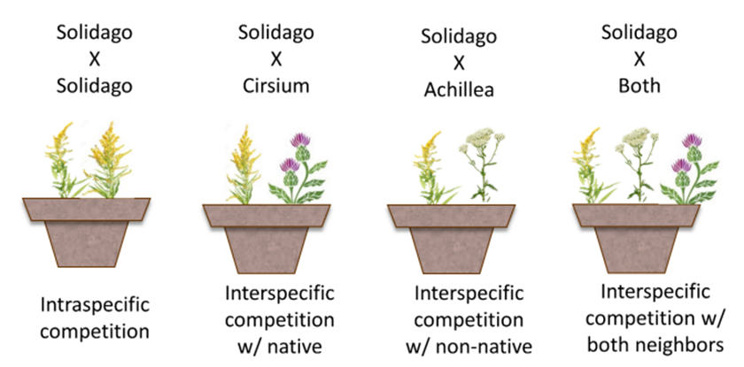

Table 1: Planting combinations of focal S. altissima.
 | Plant combinations
 | S. altissima monoculture | S. altissima with C. discolor | S. altissima with A. millefolium | S. altissima with A. millefolium and C. discolor | Total
# of pots | 3 | 5 | 5 | 8 | 21
# of S. altissima individuals per pot | 3 | 3 | 3 | 2
Total # of individuals | 9 | 15 | 15 | 16 | 55

Figure 2. The focal S. altissima had significantly more pollinators in monoculture than with more or different plant neighbors.
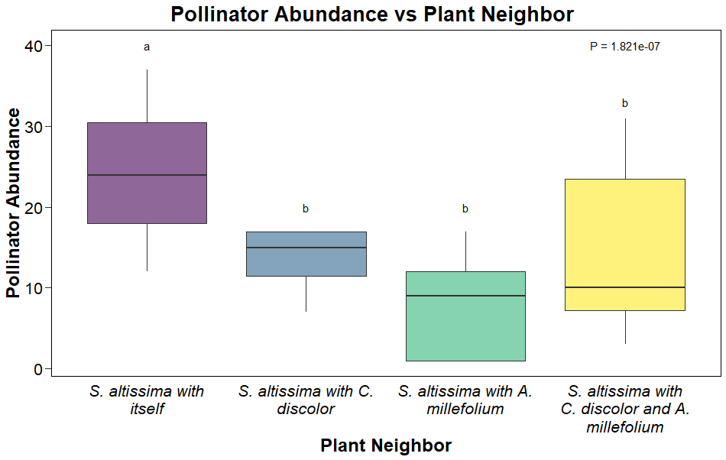

Figure 3. The focal S. altissima did not differ in pollinator richness with more or different plant neighbors
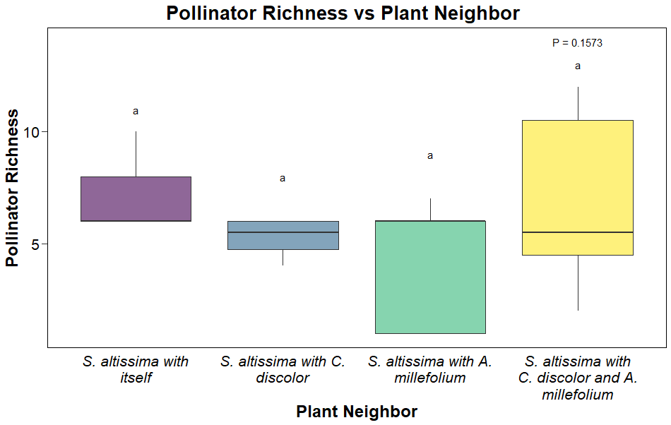

Figure 4. The focal S. altissima did not attract more diverse pollinators when grown with more or different plant neighbors
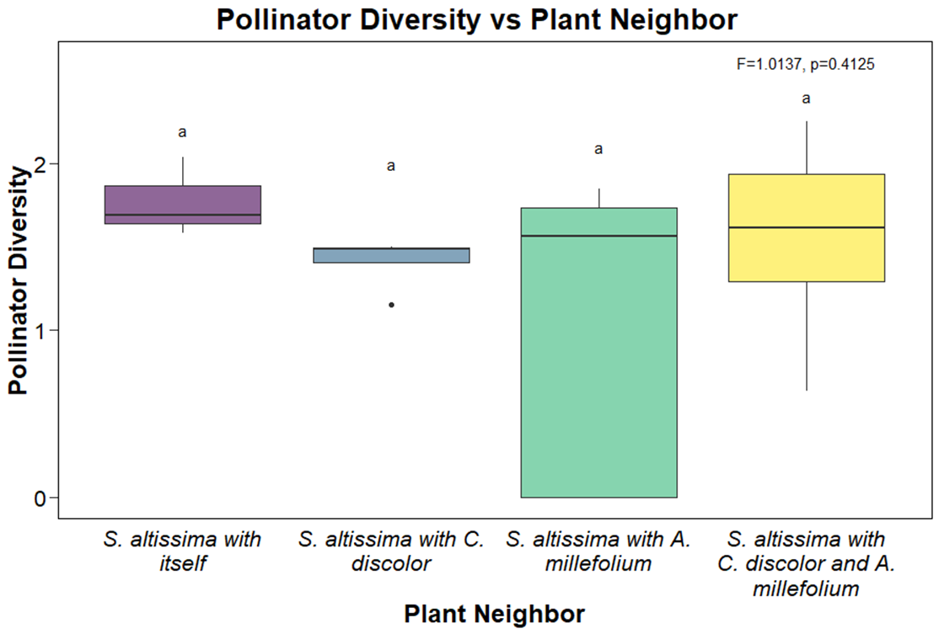

Table 2: The number of each pollinator species collected by host plant neighbor.
 | S. altissima monoculture | S. altissima with C. discolor | S. altissima with A. millefolium | S. altissima with A. millefolium and C. discolor | Grand Total
Apis mellifera | 7 | 7 | 6 | 14 | 34
Atteva aurea | 1 |  |  |  | 1
Bombus impatiens | 11 | 6 | 9 | 16 | 42
Chrysidoidea |  |  |  | 1 | 1
Coccinelidae |  |  | 1 | 1 | 2
Coleoptera |  |  |  | 2 | 2
Ctenucha virginica |  |  | 1 |  | 1
Diabrotica undecimpunctata | 1 |  |  | 1 | 2
Diptera | 7 |  | 3 | 10 | 20
Eremnophila sp. |  |  |  | 1 | 1
Eumenes sp. |  | 1 |  | 2 | 3
Hemiptera | 3 | 2 | 5 | 10 | 20
Ichneumonidae |  | 1 |  | 1 | 2
Lasioglossum sp. | 25 | 23 | 9 | 33 | 90
Megachile sp. |  |  |  | 1 | 1
Mellisodes sp. | 1 |  |  |  | 1
Polistes sp. | 7 | 3 | 3 | 5 | 18
Syrphidae | 7 | 5 | 1 | 19 | 32
Tachinidae |  |  |  | 1 | 1
Tephritidae |  | 4 | 3 | 7 | 14
Xylocopa virginica | 3 | 1 |  | 2 | 6
Grand Total | 73 | 53 | 41 | 127 | 294

Figure 5. The focal species of S. altissima attracted a significantly different pollinator community composition when planted with other S. altissima than when planted with more or different plant neighbors. Plant neighbor predicted 17.4 percent of variation in the pollinator community. S. altissima monocultures are represented with yellow circles and the S-S ellipse, S. altissima with C. discolor is represented with light blue circles and the S-C ellipse, S. altissima with A. millefolium is represented with green circles and the S-A ellipse, and S. altissima with both neighbor species is represented with purple circles and the S-C-A ellipse.
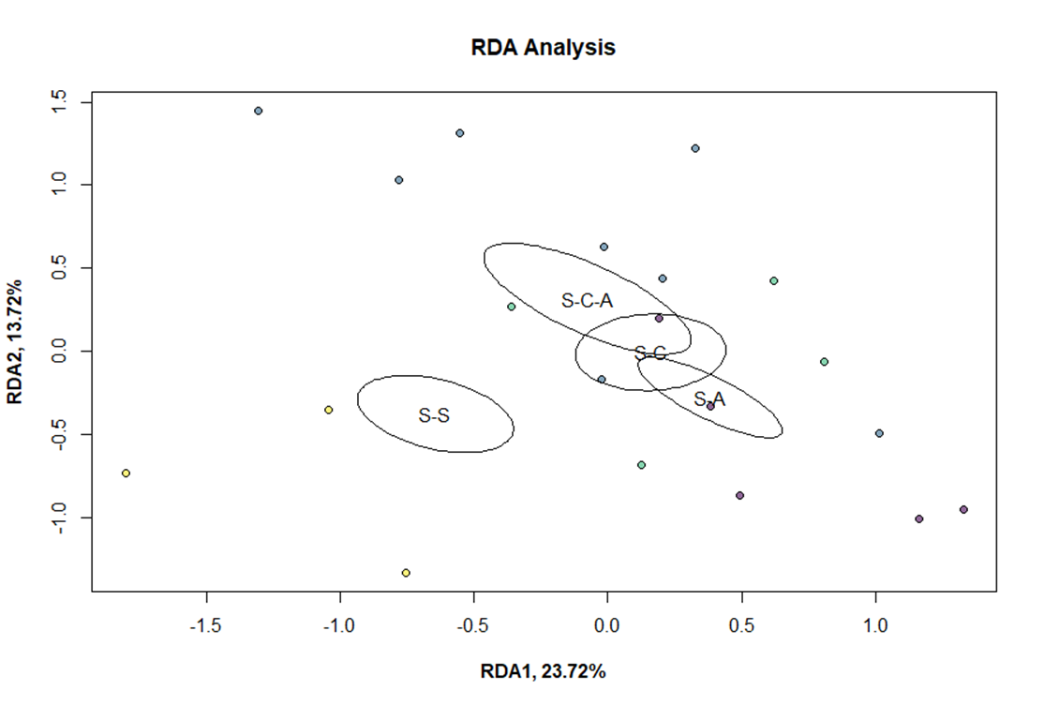

References
Andrieu, E., Dornier, A., Rouifed, S., Schatz, B., & Cheptou, P.-O. (2009). The town Crepis and the country Crepis: How does fragmentation affect a plant–pollinator interaction? Acta Oecologica, 35(1), 1–7. https://doi.org/10.1016/j.actao.2008.07.002
Baude, M., Leloup, J., Suchail, S., Allard, B., Benest, D., Mériguet, J., Nunan, N., Dajoz, I., & Raynaud, X. (2011). Litter inputs and plant interactions affect nectar sugar content. Journal of Ecology, 99(3), 828–837. https://doi.org/10.1111/j.1365-2745.2011.01793.x
Bergamo, P.J., Susin Streher, N., Traveset, A., Wolowski, M. and Sazima, M. (2020), Pollination outcomes reveal negative density-dependence coupled with interspecific facilitation among plants. Ecol Lett, 23: 129-139. https://doi.org/10.1111/ele.13415
Crutsinger, G. M. (2006). Plant Genotypic Diversity Predicts Community Structure and Governs an Ecosystem Process. Science, 313(5789), 966–968. https://doi.org/10.1126/SCIENCE.1128326
Daniels, Jedamski, J., Ottermanns, R., & Ross-Nickoll, M. (2020). A “plan bee” for cities: Pollinator diversity and plant-pollinator interactions in urban green spaces. PloS One, 15(7), e0235492–e0235492. https://doi.org/10.1371/journal.pone.0235492
Ebeling, A., Klein, A.-M., Schumacher, J., Weisser, W. W., & Tscharntke, T. (2008). How does plant richness affect pollinator richness and temporal stability of flower visits? Oikos, 117(12), 1808–1815. https://doi.org/10.1111/j.1600-0706.2008.16819.x
Eisen, K.E., Wruck, A.C. and Geber, M.A. (2020), Floral density and co-occurring congeners alter patterns of selection in annual plant communities*. Evolution, 74: 1682-1698. https://doi.org/10.1111/evo.13960
Flacher, F., Hansart, A., Motard, E., Fofana, A. M., Vincent, O., Geslin, B., Dajoz, I., & Raynaud, X. (2017). Does competition with wind-pollinated species alter Echium plantagineum’s attractiveness to a common pollinator Bombus terrestris? Ecological Entomology, 42(5), 617–628. https://doi.org/10.1111/een.12426
Flacher, F., Raynaud, X., Hansart, A., Geslin, B., Motard, E., Verstraet, S., Bataille, M., & Dajoz, I. (2020). Below-ground competition alters attractiveness of an insect-pollinated plant to pollinators. AoB PLANTS, 12(4), plaa022. https://doi.org/10.1093/aobpla/plaa022
Fontaine, C., Dajoz, I., Meriguet, J., & Loreau, M. (2005). Functional Diversity of Plant–Pollinator Interaction Webs Enhances the Persistence of Plant Communities. PLOS Biology, 4(1), e1. https://doi.org/10.1371/journal.pbio.0040001
Fornoff, F., Klein, A.-M., Hartig, F., Benadi, G., Venjakob, C., Schaefer, H. M., & Ebeling, A. (2017). Functional flower traits and their diversity drive pollinator visitation. Oikos, 126(7), 1020–1030. https://doi.org/10.1111/oik.03869
Fowler, R. E., Rotheray, E. L., & Goulson, D. (2016). Floral abundance and resource quality influence pollinator choice. Insect Conservation and Diversity, 9(6), 481–494. https://doi.org/10.1111/icad.12197
Fox, John, Sanford Weisberg (2019). An {R} Companion to Applied Regression, Third Edition. Thousand Oaks CA: Sage. URL: https://socialsciences.mcmaster.ca/jfox/Books/Companion/
Garnier, Simon, Noam Ross, Robert Rudis, Antônio P. Camargo, Marco Sciaini, and Cédric Schere (2021). Rvision - Colorblind-Friendly Color Maps for R. R package version 0.6.2.
Genung, M. A., Bailey, J. K., & Schweitzer, J. A. (2012). Welcome to the neighbourhood: interspecific genotype by genotype interactions in Solidago influence above- and belowground biomass and associated communities. Ecology letters, 15(1), 65–73. https://doi.org/10.1111/j.1461-0248.2011.01710.x
Gerner Eden E., Sargent, Risa D. (2022) Local plant richness predicts bee abundance and diversity in a study of urban residential yards. Basic and Applied Ecology, 58, 64-73. https://doi.org/10.1016/j.baae.2021.11.004.
Gómez, J. M., Abdelaziz, M., Lorite, J., Jesús Muñoz-Pajares, A., & Perfectti, F. (2010). Changes in pollinator fauna cause spatial variation in pollen limitation. Journal of Ecology, 98(5), 1243–1252. https://doi.org/10.1111/j.1365-2745.2010.01691.x
Goodell, K., & Parker, I. M. (2017). Invasion of a dominant floral resource: effects on the floral community and pollination of native plants. Ecology, 98(1), 57–69. https://doi.org/10.1002/ecy.1639
Hoehn, P., Tscharntke, T., Tylianakis, J. M., & Steffan-Dewenter, I. (2008). Functional group diversity of bee pollinators increases crop yield. Proceedings. Biological Sciences, 275(1648), 2283–2291. https://doi.org/10.1098/rspb.2008.0405
Hothorn, Torsten, Frank Bretz and Peter Westfall (2008). Simultaneous Inference in General Parametric Models. Biometrical Journal 50(3), 346--363.
Klein, A.-M., Vaissière, B. E., Cane, J. H., Steffan-Dewenter, I., Cunningham, S. A., Kremen, C., & Tscharntke, T. (2007). Importance of pollinators in changing landscapes for world crops. Proceedings of the Royal Society B: Biological Sciences, 274(1608), 303–313. https://doi.org/10.1098/rspb.2006.3721
Lázaro, A., Lundgren, R., & Totland, Ø. (2009). Co-Flowering Neighbors Influence the Diversity and Identity of Pollinator Groups Visiting Plant Species. Oikos, 118(5), 691–702. http://www.jstor.org/stable/40235375
McPeek, S. J., Bronstein, J. L., & McPeek, M. A. (n.d.). Eco-evolutionary feedbacks among pollinators, herbivores, and their plant resources. Evolution, n/a(n/a). https://doi.org/10.1111/evo.14492
Ogilvie, J. E., & Thomson, J. D. (2015). Male bumble bees are important pollinators of a late-blooming plant. Arthropod-Plant Interactions, 9(2), 205–213. https://doi.org/10.1007/s11829-015-9368-x.
Oksanen, J. F. Guillaume Blanchet, Michael Friendly, Roeland Kindt, Pierre Legendre, Dan McGlinn, Peter R. Minchin, R. B. O'Hara, Gavin L. Simpson, Peter Solymos, M. Henry H. Stevens, Szoecs, Eduard, Helene Wagner (2020). vegan: Community Ecology Package. R package version 2.5-7. https://CRAN.R-project.org/package=vegan
Potts, Simon G., Jacobus C. Biesmeijer, Claire Kremen, Peter Neumann, Oliver Schweiger, William E. Kunin. (2010). Global pollinator declines: trends, impacts and drivers. Trends in Ecology & Evolution, 25(6), 345-353. https://doi.org/10.1016/j.tree.2010.01.007
R Core Team (2021). R: A language and environment for statistical computing. R Foundation for Statistical Computing, Vienna, Austria. URL https://www.R-project.org/.
Ramos‐Jiliberto, Moisset de Espanés, P., & Vázquez, D. P. (2020). Pollinator declines and the stability of plant–pollinator networks. Ecosphere (Washington, D.C), 11(4). https://doi.org/10.1002/ecs2.3069
Regan, E. C., Santini, L., Ingwall-King, L., Hoffmann, M., Rondinini, C., Symes, A., Taylor, J., & Butchart, S. H. M. (2015). Global Trends in the Status of Bird and Mammal Pollinators. Conservation Letters, 8(6), 397–403. https://doi.org/10.1111/conl.12162
Rhodes. (2018). Pollinator decline – an ecological calamity in the making? Science Progress (1916), 101(2), 121–160. https://doi.org/10.3184/003685018X15202512854527
Rudis, Bob (2020). hrbrthemes: Additional Themes, Theme Components and Utilities for 'ggplot2'. R package version 0.8.0. https://CRAN.R-project.org/package=hrbrthemes
Russo, L., Memmott, J., Montoya, D., Shea, K. and Buckley, Y.M. (2014). Patterns of introduced species interactions affect multiple aspects of network structure in plant–pollinator communities. Ecology, 95(10), 2953-2963. https://doi.org/10.1890/13-2229.1
Secretariat. (2018, June 26). Assessment Report on Pollinators, Pollination and Food Production. IPBES Secretariat. https://ipbes.net/assessment-reports/pollinators
Thomann, Imbert, E., Devaux, C., & Cheptou, P.-O. (2013). Flowering plants under global pollinator decline. Trends in Plant Science, 18(7), 353–359. https://doi.org/10.1016/j.tplants.2013.04.002
Trøjelsgaard, K., Heleno, R. and Traveset, A. (2019). Native and alien flower visitors differ in partner fidelity and network integration. Ecology Letters, 22, 1264-1273. https://doi.org/10.1111/ele.13287
Weiner, Werner, M., Linsenmair, K. E., & Blüthgen, N. (2014). Land-use impacts on plant-pollinator networks: interaction strength and specialization predict pollinator declines. Ecology (Durham), 95(2), 466–474. https://doi.org/10.1890/13-0436.1
Wickham et. al., (2019). Welcome to the tidyverse. Journal of Open Source Software, 4(43), 1686, https://doi.org/10.21105/joss.01686
Wickham, H. ggplot2: Elegant Graphics for Data Analysis. Springer-Verlag New York, 2016.
Wickham, Hadley, Maximilian Girlich (2022). tidyr: Tidy Messy Data. R package version 1.2.0. https://CRAN.R-project.org/package=tidyr
Wickham, Hadley, Romain François, Lionel Henry and Kirill Müller (2022). dplyr: A Grammar of Data Manipulation. R package version 1.0.8. https://CRAN.R-project.org/package=dplyr

