To the Graduate Council:

I am submitting herewith a thesis written by Zachary Pentecost entitled “String Quartet” I have examined the final electronic copy of this thesis for form and content and recommend that it be accepted in partial fulfillment of the requirements for the degree of Master of Music, with a major in Music.

Kenneth A. Jacobs, Major Professor

We have read this thesis
and recommend its acceptance:

Brendan McConville

Keith McClelland

Accepted for the Council:

Carolyn R. Hodges
Vice Provost and Dean of the Graduate School

(Original signatures are on file with official student records.)

String Quartet

A Thesis Presented for the
Master of Music
Degree
The University of Tennessee, Knoxville

Zachary Pentecost
March 2014

Copyright © 2014 by Zachary Pentecost
All rights reserved.

ACKNOWLEDGEMENTS

The completion of this work could not have been possible without the assistance of various individuals. First and foremost Dr. Kenneth Jacobs, donating much of his “mountain time” to read, reread, eat M&Ms, edit, and then reread, this paper would not exist the way it does today. Next, I would like to thank the other members of my master’s committee, Dr. Brendan McConville and Keith McClelland.
Next, I would like to thank Nick Powell for all his candid feedback and help with revisions throughout this entire process. Finally, I would like to thank my colleagues at the University of Tennessee – Knoxville for their time and comments as we rambled about my thesis amongst other things over food.

ABSTRACT

String Quartet is a work scored for standard string quartet, consisting of two violins, viola, and cello. The composition was completed in early August 2013, and was written in part to fulfill the requirements for the Masters of Music degree with a concentration in composition. The primary purpose of this thesis is to highlight various aspects of String Quartet and then offer comparisons between it and multiple works from the twentieth century centering on various musical elements such as; form, melody, harmony, rhythm, and texture.

TABLE OF CONTENTS

Chapter Page

CHAPTER I: Introduction 1
CHAPTER II: Form 2 Movement 1 2
Movement 2 4
Movement 3 5
Movement 4 7
CHAPTER III: Melody 12
CHAPTER IV: Harmony 17
CHAPTER V:Rhythm 30
CHAPTER VI: Texture 32
Biblography 37
APPENDICES 39
Appendix A: String Quartet Audio Recording 40
Appendix B: String Quartet by Zack Pentecost 41o
Vita 73

LIST OF TABLES AND FIGURES

Tables / Figures Page

Table 2.1: Barber – Piano Sonata, Op. 26: 1st Movement: “Formal Outline 6
Table 2.2: Pentecost – String Quartet: 1st Movement: “Formal Outline” 6
Table 2.3: Bartók – String Quartet No. 5: 1st Movement: “Formal Outline” 6
Table 2.4: Pentecost – String Quartet: 1st Movement: “Formal Outline of Tempo 6
Table 2.5 Pentecost – String Quartet: 2nd Movement: “Formal Outline” 5
Table 2.6 Pentecost – String Quartet: 3rd Movement: “Formal Outline” 10
Table 2.7 Pentecost – String Quartet: 4th Movement: “Formal Outline” 10
Figure 3.1 Pentecost – String Quartet: 3rd Movement: mm. 1-5 12
Figure 3.2 Pentecost – String Quartet: 3rd Movement: mm. 36-40 12
Figure 3.3 Pentecost – String Quartet: 3rd Movement: mm. 62-69 13
Figure 3.4 Pentecost – String Quartet: 4th Movement: mm. 83-85 13
Figure 3.5 Pentecost – String Quartet: 4th Movement: mm. 104-105 14
Figure 3.6 Pentecost – String Quartet: 4th Movement: mm. 119-123 15
Figure 3.7 Stravinsky – Rite of Spring: “The Augurs of Spring” mm. 8-9 15
Figure 3.8 Stravinsky – Rite of Spring: “The Augurs of Spring” mm. 14-20 16
Figure 4.1 Pentecost – String Quartet: 2nd Movement: mm. 40-53 18
Figure 4.2 Pentecost – String Quartet: 4th Movement: mm. 40-46 19
Figure 4.3 Pentecost – String Quartet: 2nd Movement: mm. 1-3 20
Figure 4.4 Ginastera – String Quartet no. 1: 3rd Movement mm. 1-3 21
Figure 4.5 Pentecost – String Quartet: 4th Movement: mm. 44-46 21
Figure 4.6 Dello Joio – Suite for piano: I. mm. 15-16 22
Figure 4.7 Hindemith – Symphony: Mathis der Maler “Grablegung” mm. 1-3 23
Figure 4.8 Mompou – Scénes D’enfants: “Gris Dans La Rur” 23
Figure 4.9 Pentecost – String Quartet: 4th Movement: mm. 100-101 24
Figure 4.10 Mompou – Impresiones Intimas: II. mm. 1-2 25
Figure 4.11 Mompou – Impresiones Intimas: Påjaro Triste. mm. 9-10 25
Figure 4.12 Pentecost – String Quartet: 1st Movement: mm. 149-150 26
Figure 4.13 Dello Joio – Suite for piano: I. mm. 1-2 26
Figure 4.14 Prokofiev – Visons fugitives: 1. mm. 22-24 27
Figure 4.15 Pentecost – String Quartet: 2nd Movement: mm. 12-15 28
Figure 4.16 Pentecost – String Quartet: 3rd Movement: mm. 48-49 29
Figure 5.1 Pentecost – String Quartet: 4th Movement: mm. 70-71 30
Figure 5.2 Stravinsky – Rite of Spring: “The Augurs of Spring” mm. 1-7 31
Figure 6.1 Ginastera - String Quartet no. 1: 3rd Movement mm. 1-3. 33
Figure 6.2 Poulenc – Sarabande. mm. 24-28 33
Figure 6.3 Poulenc – Sarabande. mm. 25 “Implied resolution” 34
Figure 6.4 Pentecost – String Quartet: 4th Movement: mm. 10-14 34
Figure 6.5 Pentecost – String Quartet: 2nd Movement: mm. 54 35
Figure 6.6 Pentecost – String Quartet: 4th Movement: mm. 96-98 35
Figure 6.7 Pentecost – String Quartet: 3rd Movement: mm. 27-37 36
CHAPTER I: Introduction
The string quartet has been a staple of a composer’s portfolio since the day of Joseph Haydn. Within the twentieth century several composers, such as: Leo Brouwer, György Ligeti, Benjamin Britten, Arnold Schoenberg, Heitor Villa-Lobos, and Dmitri Shostakovich have contributed numerous string quartets. Simply listening to these composers’ works many harmonic, melodic, rhythmic, and formal characteristics can be identified unique to a specific composer. The string quartet offers a snapshot of a composer’s unique musical language and can be used to showcase development or change in language through multiple entries in the genre.
The primary purpose of this thesis is to highlight aspects of my first string quartet, simply titled, String Quartet, and offers comparisons between it and other works from the twentieth century. Chapter two will focus on the formal characteristic of each movement with comparisons to composer such as: Samuel Barber, Béla Bartók, Frederic Mompou, Astor Piazzolla, and others. Chapter three will look at melody in terms of combinations of themes, and melodic layering. Chapter four, Harmony, will discuss the use of Pandiatonicism, Quartal and Quintal chords, and key changes at cadences. Chapter five will briefly touch on the rhythmic characterizes of String Quartet. Texture will be covered in chapter six looking at “open-string guitar chords” and how they are achieved in the string quartet setting as well as the topic of textural changes through planing. This study will be done as a means to place String Quartet in context with works from other composers of the twentieth century and provide a dissection of my current musical language
CHAPTER II: Form
The formal designs of each of the four movements of String Quartet resemble traditional musical forms. However, these existing forms simply act as a place for departure with changes made to their formal outline. The first movement takes root with traditional sonata-allegro form, but with noted changes to the recapitulation and coda. The second movement appears as simple ternary form incorporating a false recap during its middle section. The third movement presents similar expectations to that of a double fugue due to its treatment of themes. The fourth movement takes the shape of a sonata-rondo. A reoccurring theme is shorted and shorted after each appearance following a soloistic episode from an individual performer. Most of these movements do not simply fall into the form they are labeled as and each will be discussed individually in their own section during this chapter. Formal comparisons for each movement will be made to works from composers of the twentieth century to show modifications made to form.
Movement 1

The first movement in String Quartet follows a modified sonata-allegro. However, changes are made within the form that differs significantly from the classical sonata-allegro form. The first movement of String Quartet, for example, abandons the traditional closing group at the end of the exposition in lieu of a third theme group. Also, the recapitulation is a mirrored version of the exposition; with some material from the development section restated within the coda. Formal comparisons between this movement and works by Samuel Barber and Béla Bartók will be shown to demonstrate modifications to sonata-allegro form.
Samuel Barber: Piano Sonata – Op. 26
The first movement of Samuel Barber’s Piano Sonata – Op. 26 (1949) follows very closely to traditional sonata-allegro form. However, one thing Barber does in this movement that is unusual is his restatement of material from the development section within the coda. Table 2.1 (page 6) shows a formal outline of Barber’s work. It can be seen that Barber restates material from the development section then proceeds to draw the piece into its final cadential section. Barber reemphasizes the material that could be seen as the climactic section of the piece by restating it again just before the movement comes to a close.
Similarly, in String Quartet, material from the development section is placed within the coda. This is used as a way to restate part of the climatic section from the development. Unlike Barber’s work, in String Quartet the material is fragmented as a means to offer continuous development until the final cadence is reached. Barber simply moves to different material to a different key just before closing out his movement. Table 2.2 shows a formal outline of the 1st movement of String Quartet.
Béla Bartók: String Quartet No. 5
In the first movement of Béla Bartók’s String Quartet No. 5 (1934), Bartók’ presents a modified sonata-allegro form in which a mirrored recapitulation is utilized. A comparison between the exposition and recapitulation of this movement shows a mirrored version of the subject groups pivoting over the development section. By mirroring the exposition, Bartók creates structural distance between the appearances of the first subject group in the exposition, labeled as “A,” and its later restatement in the recapitulation. Table 2.3 shows a formal outline of the 1st movement of Bartók’s String Quartet No. 5
In String Quartet, the recapitulation is also mirrored, not as a means to create space between themes, but tempo markings. Table 2.4 shows a formal outline of the tempo markings in the first movement of String Quartet. Flipping the tempo marks aids in connecting the recapitulation to the coda through a consistent metric tempo marking.

While not in a strict version of sonata-allegro form, the first movement of String Quartet works to combine different formal elements introduced in the twentieth century into one simple form. The careful structuring of each individual section was done to allow for the restatement of material from the development section during the coda at the original and fastest tempo used in the movement.
Movement 2

The form of the second movement of String Quartet deviates from a simple ternary form. However, one notable change made is the appearance of a smaller A` section within the larger B middle section. A comparison to a work by Frederic Mompou can be made due to similarities with A section material being incorporated in the middle section of this small form.
Frederic Mompou: “Gris Dans La Rur” (Grey Street)
In Frederic Mompou’s collection of small piano pieces entitled, Scénes D’enfants (Children’s Scenes) (1915-18), the work “Gris Dans La Rur” (Grey Street) presents a short programmatic street call in which part of the ostinato material from the A section is used in the B section to bridge the tempo of the two sections together. However, towards the end of the middle section Mompou begins to remove parts of the ostinato in order to slow the continual rhythmic drive of the piece, leading to the return of the A section.
This is the opposite effect used in the second movement of String Quartet. The false recapitulation of A section material is used to facilitate an increase in rhythmic drive, leading into the gradual tempo increases found within the middle section. The false recap helps hide a slight increase in tempo during the second half of the B section as well as provides contrast before the climax of the movement. Table 2.5 shows a formal outline of the second movement of String Quartet with tempo indications.
A | B |  |  | A`
1-21  q.= 46 | 22-28  q = 50 | False A  29-32  q.= 46 | 32-43  q = 56 | 43-57  q.= 46
Table 2.5 Pentecost – String Quartet: 2nd Movement: “Formal Outline”

The ostinato used by Mompou in the A section of his “Gris Dans La Rur” works to connect the sections of the piece together. By gradually removing parts of the ostinato during the B section, Mompou slows down the tempo in preparation for the return to the A section. The opposite of this idea is carried on in the second movement of String Quartet. The reappearance of the A section during the middle section helps to increase the tempo of the overall movement just before the climax.
Movement 3
The third movement of String Quartet takes the formal outline of a double fugue. However, both of the subjects used within the movement are not equal; much more
Exposition |  |  |  |  | Development |  |  | Recapitulation | Coda
1-50 |  |  |  |  | 51-109 |  |  | 110-148 | 149-166
Primary  Subject  1-8 | Trans.  9-22 | Secondary  Subject  23-31 | Trans  32-34 | Closing  35-50 | A  51-74 | B  75-85 | C  86-109 |  | B`  149-157 | Trans  156-159 | Closing  160-166
Table 2.1: Barber – Piano Sonata, Op. 26: 1st Movement: “Formal Outline

Exposition |  |  |  | Development |  |  | Recapitulation |  |  |  | Coda
1-42 |  |  |  | 43-91 |  |  | 92-131 |  |  |  | 132-153
Theme  1  1-10 | Trans.  11-19 | Theme  2  20-31 | Theme  3  32-43 | A  43-56 | B  57-73 | C  74-91 | Theme  3  92-102 | Theme  2  103-113 | Theme  1  114-123 | Trans.  124-131 | C`  132-150 | Final  Cadence  150-153
Table 2.2: Pentecost – String Quartet: 1st Movement: “Formal Outline”

Exposition |  |  |  | Development | Recapitulation |  |  | Coda
1-58 |  |  |  | 59-132 | 132-176 |  |  | 177-218
A  1-14 | Trans.  14-24 | B  24-44 | C  44-58 |  | C`  132-146 | B`  146-159 | A`  159-176 | A`
Table 2.3: Bartók – String Quartet No. 5: 1st Movement: “Formal Outline”

Exposition |  |  | Development | Recapitulation |  |  | Coda
1-18 | 19-31 | 32-42 | 43-91 | 92-102 | 103-113 | 114-131 | 132-153
q = 135 | q = 92 | q = 120 | q = 135 | q = 120 | q = 92 | q = 135 | q = 135
Table 2.4: Pentecost – String Quartet: 1st Movement: “Formal Outline of Temp Marking
emphasis is placed on the first subject. The appearance of the second subject acts more like a second section rather than its own independent exposition. Like in a double fugue, both subjects come together and sound simultaneously. Eventually, the subjects are combined into one theme until the coda and final cadence of the movement are reached. This example will be discussed later in the chapter on melody. Comparisons of this movement can be made with the double fugues of Dmitri Shostakovich and Astor Piazzolla’s Fugata.
Dimitir Shostakovich: Prelude and Fugue No. 4 and No. 24
In Shostakovich’s 24 Preludes and fugues opus 87 (1950-51), two double fugues are included. The subjects of both double fugues (No.4 E minor and No. 24 D minor) are compared frequently. Both first subjects are theme with larger note values presented at a slower tempo, and both second subjects are themes with smaller note values presented at a faster tempo. This is a way to draw emphasis back to the first subject when it reappears later in the piece at a faster tempo.
Similarly in the third movement of String Quartet, the first subject is very declamatory and is presented at a slower tempo. The second subject features smaller note values and a faster tempo. This acts as a way to build tension until the first subject reappears at the faster tempo. Like Shostakovich, as the first theme reappears, the declamatory nature of the subject acts as a way to signal the appearance of the new section. Table 2.6 shows a formal outline of the third movement of String Quartet detailing the appearance of subjects and how they are used.

Astor Piazzolla: Fugata
In Fugata (1969) by Astor Piazzolla, the opening section presents the subject in all four voices, establishing the independence of each line. Once the exposition of the subject is completed, the piece moves into a less contrapuntal section. The term fugata means a fugue within a larger form, and this is to the case with Piazzolla’s piece. After the presentation of the subject, the texture changes into a more homophonic writing that continues throughout the piece. Similarly, in String Quartet, the first section presents a more contrapuntal fugal section that then moves into another less linear independent and more homophonic second subject area.

This movement is not necessarily a fugata or a double Fugue for that matter. Due to the reappearance and combination of the first subject later in the piece with the second, less independent, subject a hybrid form is created. The third movement of String Quartet is a formal merge between a fugata and a double fugue.
Movement 4

The form of the final movement of String Quartet could be labeled as a modified sonata-rondo. The appearance of two development sections facilitates the sonata aspect despite the absence of a recapitulation. The blurring of transitions between the A sections and the episodes creates continuity. Certain rhythmic ideas are presented throughout the movement with no real break in tempo. The two episodes work in such a way as to allow for soloistic writing for each instrumentalist and also provide themes for the development sections. From a formal prospective, the A sections become progressively smaller and smaller as the movement goes on, eventually resulting in the simple statement of a theme taken from the A section. The decrease of the length of each section can be seen through a formal outline shown in Table 2.7. Using a rondo related form as the final movement warrants a comparison to numerous string quartets, in particular Schoenberg’s String Quartet No.3 (1927).
Arnold Schoenberg: String Quartet No. 3
In the fourth movement, Schoenberg uses the sonata rondo form despite heavily altering the material in the recapitulation. However, Schoenberg does follow tradition by beginning the development section with a statement of the theme from the opening of the movement. Also, Schoenberg draws attention to this development section by using a fermata to stop the motion of the ensemble.
Similar to the fourth movement of Schoenberg’s third string quartet, the fourth movement of String Quartet begins the development section with material from the opening. After this, the section develops material from the A section as well as prominent themes from the first two episodes. Unlike Schoenberg, the connecting material from episode two and the development is allowed to merge due to the absence of a pause. Rather then following the sonata-rondo form of A – B – A – C – A – B – A as seen in Schoenberg’s piece. (Where A is restated before entering the development section.) String Quartet is more typical of a standard sonata-allegro form. The themes are stated, the exposition closes and then the pieces moves into the development section.
After the first development section, the reappearance of the A section is reduced to just a single theme. The following sections include two more episodes spaced around statements of a shortened A theme. The second development section offers development of the A theme as well as themes from the third and fourth episodes. This second
Subject 1 | Subject 2 | Sequence | Climax and Release | Both Subjects | Coda and Cadence
1-31 | 32-47 | 48-49 | 50-61 | 62-71 | 72-83
Table 2.6: Pentecost – String Quartet: 3rd Movement: “Formal Outline”

A | Ep. 1 | A` | Ep. 2 | Dev. | A` | Ep. 3 | A` | Ep. 4 | A` | Dev. | Trans. | Coda
1-17 | 18-32 | 33-42 | 43-60 | 61-78 | 79-82 | 83-98 | 99-102 | 103-108 | 109-110 | 111-119 | 120-125 | 126-133
Table 2.7: Pentecost – String Quartet: 4th Movement: “Formal Outline
development section connects to a transitional section that moves the piece to the coda. This coda, for the most part, is the most like the opening of the movement and could be seen as a heavily modified recapitulation.

The final movement of String Quartet offers a heavily modified sonata-rondo with episodic sections to allow for each instrument to have individual soloistic parts. This is done to provide themes for use in the development sections later in the piece, as well as a way to shorten the reoccurring A theme throughout the movement.
CHAPTER III: Melody
Melody in String Quartet is for the most part simple and straightforward, however, there are a few notable exceptions of more complex melodic usage. For example, multiple themes and motives could be combined later in a movement after their initial appearance, offering a much larger theme than previously stated. This can be easily identified in the later end of the third movement of String Quartet. On top of combining themes the other topic to be discussed in this chapter is melodic layering or the superimposing of melodies on top of one another, which makes a prominent appearance in the fourth movement of String Quartet.
Combination of Motives and Themes
In the third movement of String Quartet, both of the two main themes are eventually combined together towards the end of the movement. To illustrate this both themes will be shown individually then together. The first theme, shown in Figure 3.1, appears in the cello.
Figure 3.1 Pentecost – String Quartet: 3rd Movement: mm. 1-5
The second theme is shown in Figure 3.2.
Figure 3.2 Pentecost – String Quartet: 3rd Movement: mm. 36-40
Later in the movement, both of these themes are combined and presented in the cello. This is shown in Figure 3.3.
Figure 3.3 Pentecost – String Quartet: 3rd Movement: mm. 62-69
The second theme is found in measure 62-65 while measures 66-69 is an inverted version of the first theme. This is one of the most extreme case of the combining of thematic material found in String Quartet.
Melodic Layering
The combination of themes eventually leads to melodic layering or the superimposing of one melody on top of one another. This has a prominent appearance in the fourth movement of String Quartet. During the second development and transition section, measures 83-86, the first violin presents a combination of several melodic fragments already introduced in the movement, shown in Figure 3.4.
Figure 3.4 Pentecost – String Quartet: 4th Movement: mm. 83-85

Next, at measure 104, the cello presents a series of melodic ideas, Figure 3.5, that has also already heard previously in the movement.
Figure 3.5 Pentecost – String Quartet: 4th Movement: mm. 104-105

These ideas then are layered during the development’s transitional section towards the end of the piece. Figure 3.6 shows the first violin with an altered version of measure 85, which is then picked up by the second violin. The cello offers the same melodic idea from Figure 3.5, but using the new pitch collection. Interspersed between the other instruments are rhythmic ideas that have already been used within the movement.
Figure 3.6 Pentecost – String Quartet: 4th Movement: mm. 119-123

The concept of melodic layering can be found in the works of Igor Stravinsky. In Rite of Spring, “Augurs of Spring,” multiple ostinatos are established, but the English horn presents a short one bar phrase, Figure 3.7, that is utilized throughout the movement.
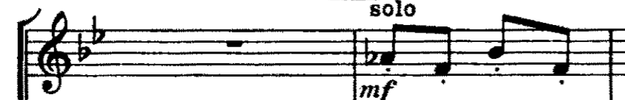
Figure 3.7 Stravinsky - Rite of Spring: “The Augurs of Spring” mm. 8-9

Figure 3.8 shows how this short phrase disappears as early as measure 13, but finds its way back at measure 17 (rehearsal 15) when multiple new ideas are layered with it.
Figure 3.8 Stravinsky - Rite of Spring: “The Augurs of Spring” mm. 14-20

As melodic ideas migrate from one group of instruments to another, the phrase in the English horn remains constant as old and new ideas are placed on top of and underneath it in other instruments.
CHAPTER IV: Harmony
In String Quartet, harmony is built with Pandiatonicism and quartal and quintal chord usage. This also incorporates the use of planing or parallel voice movement, which in turns leads to key or sectional changes at cadences. This makes identifying specific keys or pitch centers problematic. In order to explain this, each topic will be discussed individually.
Pandiatonicism
Much of the harmonic usage in String Quartet falls into the category of pandiatonicism. Melodies seem to wander through keys with only the voice leading providing some direction. One example of a work using pandiatonicism from a composer in the twentieth century is John Adams’ China Gates (1977). In China Gates, the pitch collections change, while the tonic is retained. This is used to highlight modal changes in the pitch collection, for example changing from Mixolydian to Aeolian. This, for instance, creates a change in the pitches used by adding an additional two flats to the overall key signature, such as from A Mixolydian (two sharps) to A Aeolian (zero sharps). As mentioned earlier, the pitch collections used in China Gate are mostly centered on a pitch. Then, through modal changes, the pitch collections change while the tonic is retained. For the most part, this is the exact opposite of what is done in String Quartet.
Looking at an example from the second movement of String Quartet, Figure 4.1, measure 43 establishes an E Dorian pitch collection. However, due to the descending line in the cello, a C sharp Mixolydian collection is present at measure 47 and F sharp major at 51.
Figure 4.1 Pentecost – String Quartet: 2nd Movement: mm. 40-53

An easier way to look at this is though the transition of the order of sharps. The E Dorian collection uses two sharps, and the C sharp Mixolydian / F sharp major collection uses six sharps. By adding three sharps to the pitch collection, similar motion from the tonic to the submediant is accomplished, but through linear motion rather then functional harmonic preparation.
Another example of this occurs in the fourth movement. Figure 4.2 shows measure 40 with no accidentals used, suggesting C major, though it is not. In measure 42, the pitch collection moves to incorporate four flats or D flat Lydian.
Figure 4.2 Pentecost – String Quartet: 4th Movement: mm. 40-46
This D flat Lydian then transitions into A flat major, and so on. In short, the way John Adams’ pitch collections change modally around a pitch is the opposite in String Quartet where pitch collections remain constant while pitch centers and chords change.
Quartal and Quintal Usages
In String Quartet, fourths and fifths are stacked in order to support the melody and the accompaniment. The stacking of these intervals allows for harmonic comparisons to the works of composers such as Alberto Ginastera, Norman Dello Joio, Paul Hindemith, and Fredrico Mompou.
Fourths and fifths provide much of the harmonic anchoring found in String Quartet. This is a prominent feature in the second movement where a bed of sound is created through the stacking of fifths, shown in Figure 4.3. These fifths are staggered upon their entrances in order to continually draw attention to the interval. As the melody enters, a fifth higher than the accompaniment, it continues to emphasize the interval of a fifth through its leaps.
Figure 4.3 Pentecost – String Quartet: 2nd Movement: mm. 1-3

This staggering of voices is very similar to the opening to Ginastera’s String Quartet no. 1(1948), shown in Figure 4.4. This is done to emphasis a specific set of intervals and will be discussed in a later chapter on texture, but bares similarities to the accompaniment in Figure 4.3.
Figure 4.4 Ginastera - String Quartet no. 1: 3rd Movement mm. 1-3
(Reconstructed from parts)

Looking at an example of quartal harmony, Figure 4.5 shows the fourth movement of String Quartet where the melody is accompanied by the continual use of stacked fourths.
Figure 4.5 Pentecost – String Quartet: 4th Movement: mm. 44-46

This is very similar to the technique that Norman Dello Joio uses throughout the first movement of his Suite for piano. Figure 4.6 shows, Dello Joio’s use of stacked fourths to accompany a melody, presented beneath the harmony.
Figure 4.6 Dello Joio – Suite for piano: I. mm. 15-16

Another comparison for String Quartet can be made to the opening of the second movement of Paul Hindemith’s Symphony: Mathis der Mahler. In this example, Figure 4.7, the melody is introduced in the first violin while the second violin offers support though parallel fourths. The viola moves in contrary motion away from the second violin in order to create the desired intervallic relationships between the violin and cello in measure 3.

Figure 4.7 Hindemith – Symphony: Mathis der Maler “Grablegung” mm. 1-3

Moving on and looking at Fredric Mompou’s “Gris Dans La Rur,” Figure 4. 8 shows a melody harmonized entirely by fourths.
Figure 4.8 Mompou – Scénes D’enfants: “Gris Dans La Rur”

This is similar to the harmonization used in the fourth movement of String Quartet. Figure 4.9 shows a melody accompanied by multiple voices, resulting in a series of stacked fourths.
Figure 4.9 Pentecost – String Quartet: 4th Movement: mm. 100-101

Planing
Planing or parallel voice movement is another one of the prominent harmonic devices employed within String Quartet. Melodic support is generated through the use of diatonic parallel motion. Examples of this can be seen in works of Fredrico Mompou shown in Figures 4.10 and 4.11.
Figure 4.10 Mompou – Impresiones Intimas: II. mm. 1-2

Figure 4.11 Mompou – Impresiones Intimas: Påjaro Triste. mm. 9-10

These examples shows that the voices remain intervallically locked, while the specific quality, of the intervals changes due to the chosen tonal pallet. Similarly, in String Quartet much of the cadential motion is created this way. The final few bars and the cadence of Figure4.12 bear a striking resemblance to the examples provided from Mompou.
Figure 4.12 Pentecost – String Quartet: 1st Movement: mm. 149-150

One other way planing is utilized in String Quartet is through the pairing of similar motion rather than complete parallel motion. This idea can be found in the first movement of the Norman Dello Joio’s Suite for Piano, shown in Figure 4.13.
Figure 4.13 Dello Joio - Suite for piano: I. mm. 1-2

In the opening of this piece, two different sets of fourths move in contrary motion, until a point is reached where both come together on a shared pitch to form one complete chord of stacked fourths between the two pairs of voices. This example will be compared with String Quartet in the up coming section.
Key or Sectional Changes at Cadences
Changes in key occur through the linear motion within the voices. This occurs with the help of diatonic planing or parallel motion that uses just the intervals of a certain pitch collection rather than exact intervallic relationships. The movement towards other keys or pitch collections occurs when the different voices simply move stepwise into the new key area. One such example of this can be seen in Sergei Prokofiev’s Visions fugitives no. 1, shown in Figure 4.14.
Figure 4.14 Prokofiev – Visons fugitives: 1. mm. 22-24

In this example, Prokofiev uses planing as a way to transition from B flat minor to D minor. Figure 4.15 shows a similar example occurring in the second movement of String Quartet.
Figure 4.15 Pentecost – String Quartet: 2nd Movement: mm. 12-15

Looking at this short example, the upper two voices pair off to create the interval of a fourth, while the lower two create a perfect fourth as well. Both pairs of voices move in contrary motion into measure 14 where a chord is then built entirely from stacked fourths, similar to the Dello Joio example from Figure 4.13. The contrary motion between the upper two and lower two voices is what is used to facilitate a change in key for the following section. The new tonal palette is then reinforced through parallel motion between all voices.
This pairing of voices in contrary motion is also used in the third movement of String Quartet at a more climatic moment. Figure 4.16 shows the build up to the return of the first subject in measure 50. The voices come together to create an inverted chord based on fourths or fifths on the downbeat of measure 50.
Figure 4.16 Pentecost – String Quartet: 3rd Movement: mm. 48-49
Due to the doubling in lower voices, the motion to create a fourth chord is limited to only three different pitches. This is because the following statement of the first subject is orchestrated to allow for a much more noticeable presentation. While not necessarily a significant change in key, this contrary motion does signals the beginning of a new section.

CHAPTER V: Rhythm
While most of the rhythms used in String Quartet are very traditional, there are a few notable examples that show influence from certain composers. These examples are the tango or milonga rhythmic groupings found in the music of Astor Piazzolla and the unexpected rhythmic accents used in the works of Igor Stravinsky.
One of these instances of rhythmic influence occurs within the fourth movement of String Quartet. During many of the soloistic episodes, outlined in Table 2.7, the use of a tango / milonga rhythmic grouping (3+3+2), a prominent feature in the works of Astor Piazzolla, is used ether in the melody, accompaniment, or both and bears mentioning.
A second example of rhythmic influence occurs within the fourth movement of String Quartet. During the first development section, specifically measures 70-72, Figure 5.1; unexpected rhythmic accents are created through the use of dynamics and articulations.
Figure 5.1 Pentecost – String Quartet: 4th Movement: mm. 70-71

This is a striking resemblance to the unexpected rhythmic accents found in Igor Stravinsky’s Rite of Spring shown in Figure 5.2.
Figure 5.2 Stravinsky – Rite of Spring: “The Augurs of Spring” mm. 1-7

CHAPTER VI: Texture
Two prominent textural ideas can be found in String Quartet. First is the use of “Open String Guitar chords,” a textural idea that is also found in Alberto Ginastera’s String Quartet no 1. This will be paired with Francis Poulenc’s Sarabande for guitar to help illustrate the use of open strings to create a sustained chord. The second idea used in String Quartet is textural transformations due to planing and will be briefly discussed. This describes how polyphony transforms into homophony at various points within the piece due to the loss of independence within the multiple lines.

“Open String Sustained Guitar Chords”
This term comes from the concept of multiple voices overlapping in order to form a certain harmony as they do when pitches on a guitar ring over one another when arpeggiated. Also, due to the nature of the guitar’s standard tuning, the strongest intervallic relationship between open strings is a perfect fourth with the exception of one third.
This effect can be seen in the third movement of Alberto Ginastera’s String Quartet no 1. Ginastera uses the exact pitches of the open strings of the guitar and apeggiates them to create a chord dominated by fourths.

Figure 6.1 Ginastera - String Quartet no. 1: 3rd Movement mm. 1-3
(Reconstructed from parts)

This effect is also used in Francis Poulenc’s solo guitar work Sarabande. Poulenc uses the arpeggiated open strings of the guitar melodically and harmonically as a means to create motion that is then halted harmonically by the resolution of the open strings. The following example shows how Poulenc incorporated this into his work:

Figure 6.2 Poulenc – Sarabande. mm. 24-28

Due to Poulenc’s consistent use of three voice chords within this work, a resolution to an F sharp in an inner voice in measure 25, shown in Figure 6.3, can be assumed.
Figure 6.3 Poulenc – Sarabande. mm. 25 “Implied resolution”

In the fourth movement of String Quartet, a synthesis of Ginastera’s and Poulenc’s approaches to “open string guitar chords” is utilized. Intervals, usually of a fourth, are used melodically and harmonically as they are sustained on top of one another.
Figure 6.4 Pentecost – String Quartet: 4th Movement: mm. 10-14

In measure 10, the upper three voices stagger their entrances, creating a chord build on fourths that is then resolved to another chord comprised of fourths. This occurs again in measure 12, but this time the voices do not enter in ascending order. Instead the inner voices are completed first.
Similarly, this occurs in the second movement of String Quartet, Figure 6.5, where staggered sustained voices create a chord to accompany the upper melody.
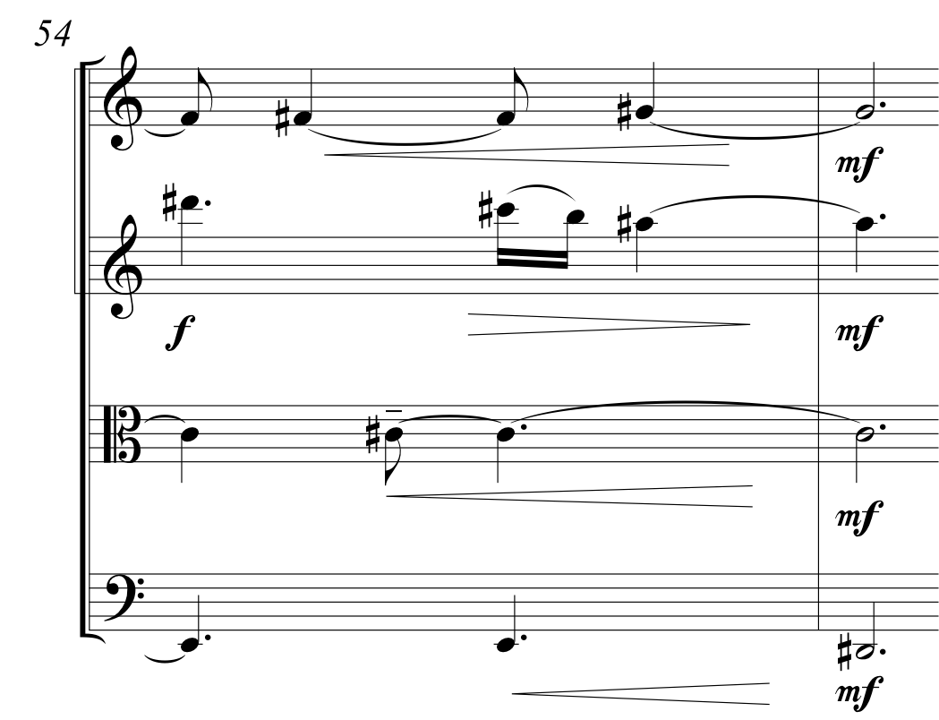
Figure 6.5 Pentecost – String Quartet: 2nd Movement: mm. 54
The last example of this textural idea, Figure 6.6, shows how this effect is used melodically.
Figure 6.6 Pentecost – String Quartet: 4th Movement: mm. 96-98
The continual staggering of the upper three voices acts as a way to propel each line forward towards measure 98. Note values decreases, the lines synchronize moving towards the downbeat of measure 99.
Textural transformations due to planing
Due to the requisite parallel motion in planing, voices begin to lose their independence and become more homophonic. The linear nature of each voice in String Quartet plays a big part in creating polyphony. But through planing, much of this polyphony is lost, causing the texture to seem more homophonic as the voices begin to pair up and lose their independence.
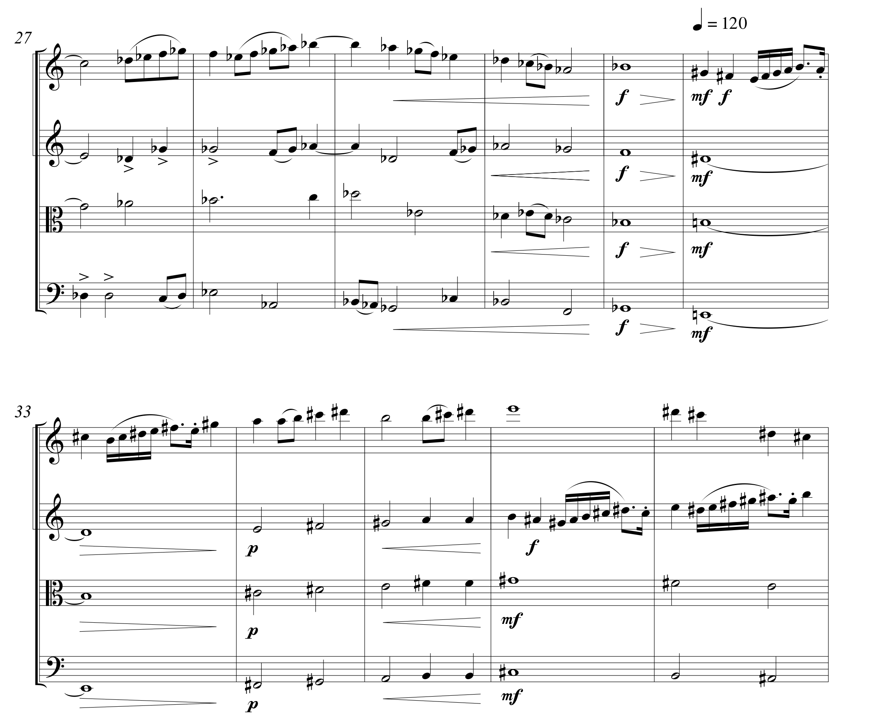
Figure 6.7 Pentecost – String Quartet: 3rd Movement: mm. 27-37
In the beginning of this passage, all four voices are to some extent independent of one another. However, as the example moves to measure 30 – 31, the voices begin to join together and the independence of each line becomes less and less.

BibLIoGRAPHY

BibLIoGRAPHY

Barber, Samuel. Sonata for Piano. New York: G.Schirmer, 1950.

Bartók, Béla. Fifth String Quartet. London: Boosey & Hawkes, 1936.

Dello Joio, Norman. Piano Music: [selected works]. New Yrok: G. Schirmer, 2007.

Ginastera, Alberto. 1er [i.e. Primer] cuarteto de cuerdas; Op. 20. Buenos Aires: Barry, 1960.

Hindemith, Paul. Mathis der Mahler (1934): Symphony for Orcestra. London: Eulenburg, 1984.

Jones, Evan Allan.ed. Intimate Voices: The Twentieth-Century String Quartet. 2 vols. Rochester, NY: University of Rochester Press, 2009.

Mompou, Frederic. Piano-album pour piano. Paris: Éditions Salabert, 1989.

Mompou, Frederico. Impresiones Intimas. Madrid: Unión Musical Española, 1920

Piazzolla, Astor. Fugata per quintetto (pianoforte, bandoneon, violino, chitarra el., contrabasso). Lipomo, Italy : A. Pagani s.r.l. edizioni musicali, 1977.

Poulenc, Francis. Sarabande for Guitar. London: G. Ricord, 1961

Prokofiev, Sergey, Mimoletnosti = Visions fugitives : op. 22 : (1915-1917). Sankt-Peterburg: Izd-vo "Kompozitor", 1998

Rosen, Lawrence. ed., American contemporary masters: a collection of works for piano. New York, NY: G.Schrimer, 1995

Schoenberg, Arnold. String Quartet No 3, Op. 30. Vienna: Universal Edition, 1927.

Shostakovich, Dmitriĭ Dmitrievich. 24 preludes and fugues, opus 87. New York: MCA Music, 1973.

Stravinsky, Igor. The Rite of Spring in Full Score. New York: Dover, 1989.

APPENDIX

APPENDIX A

APPENDIX B
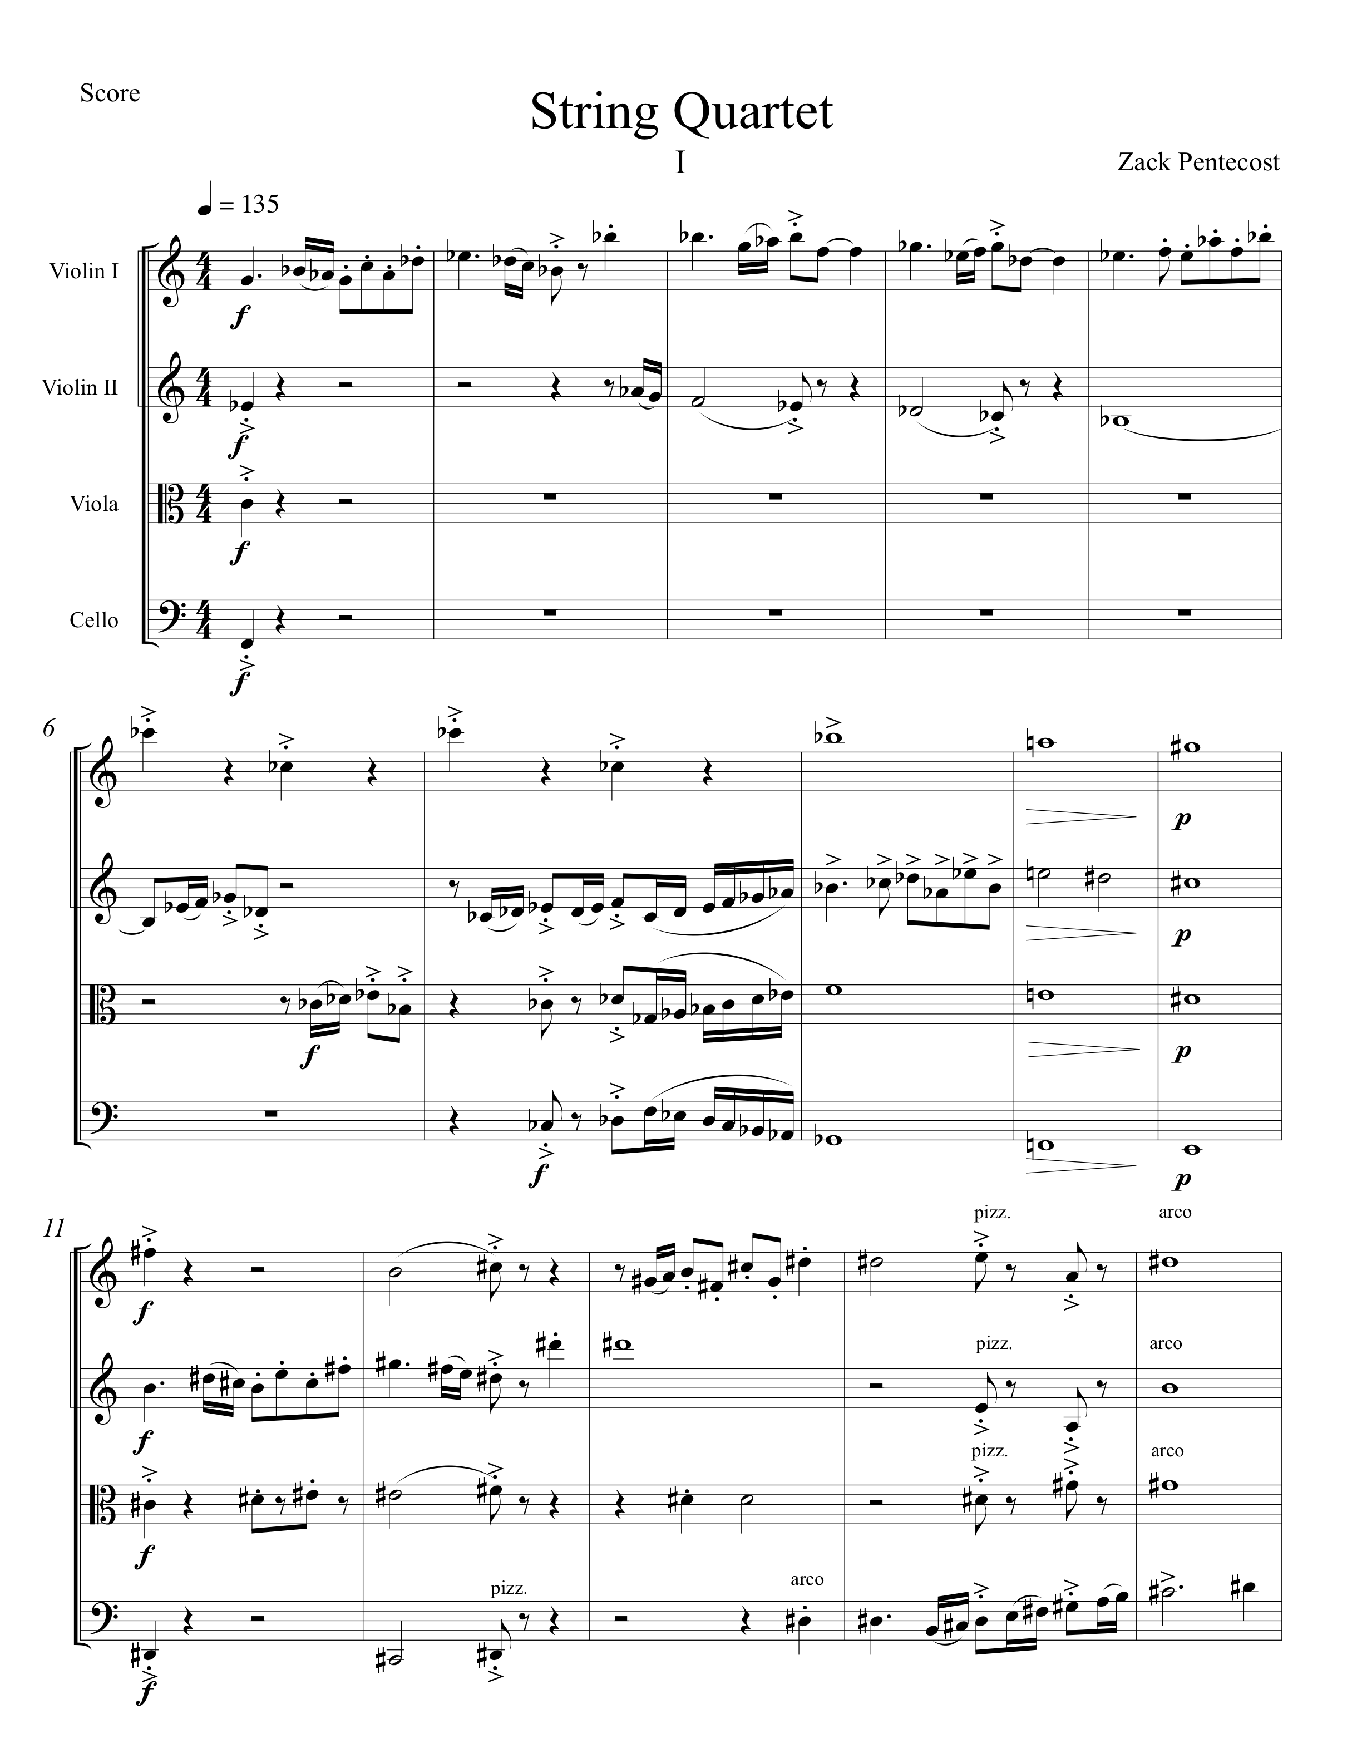

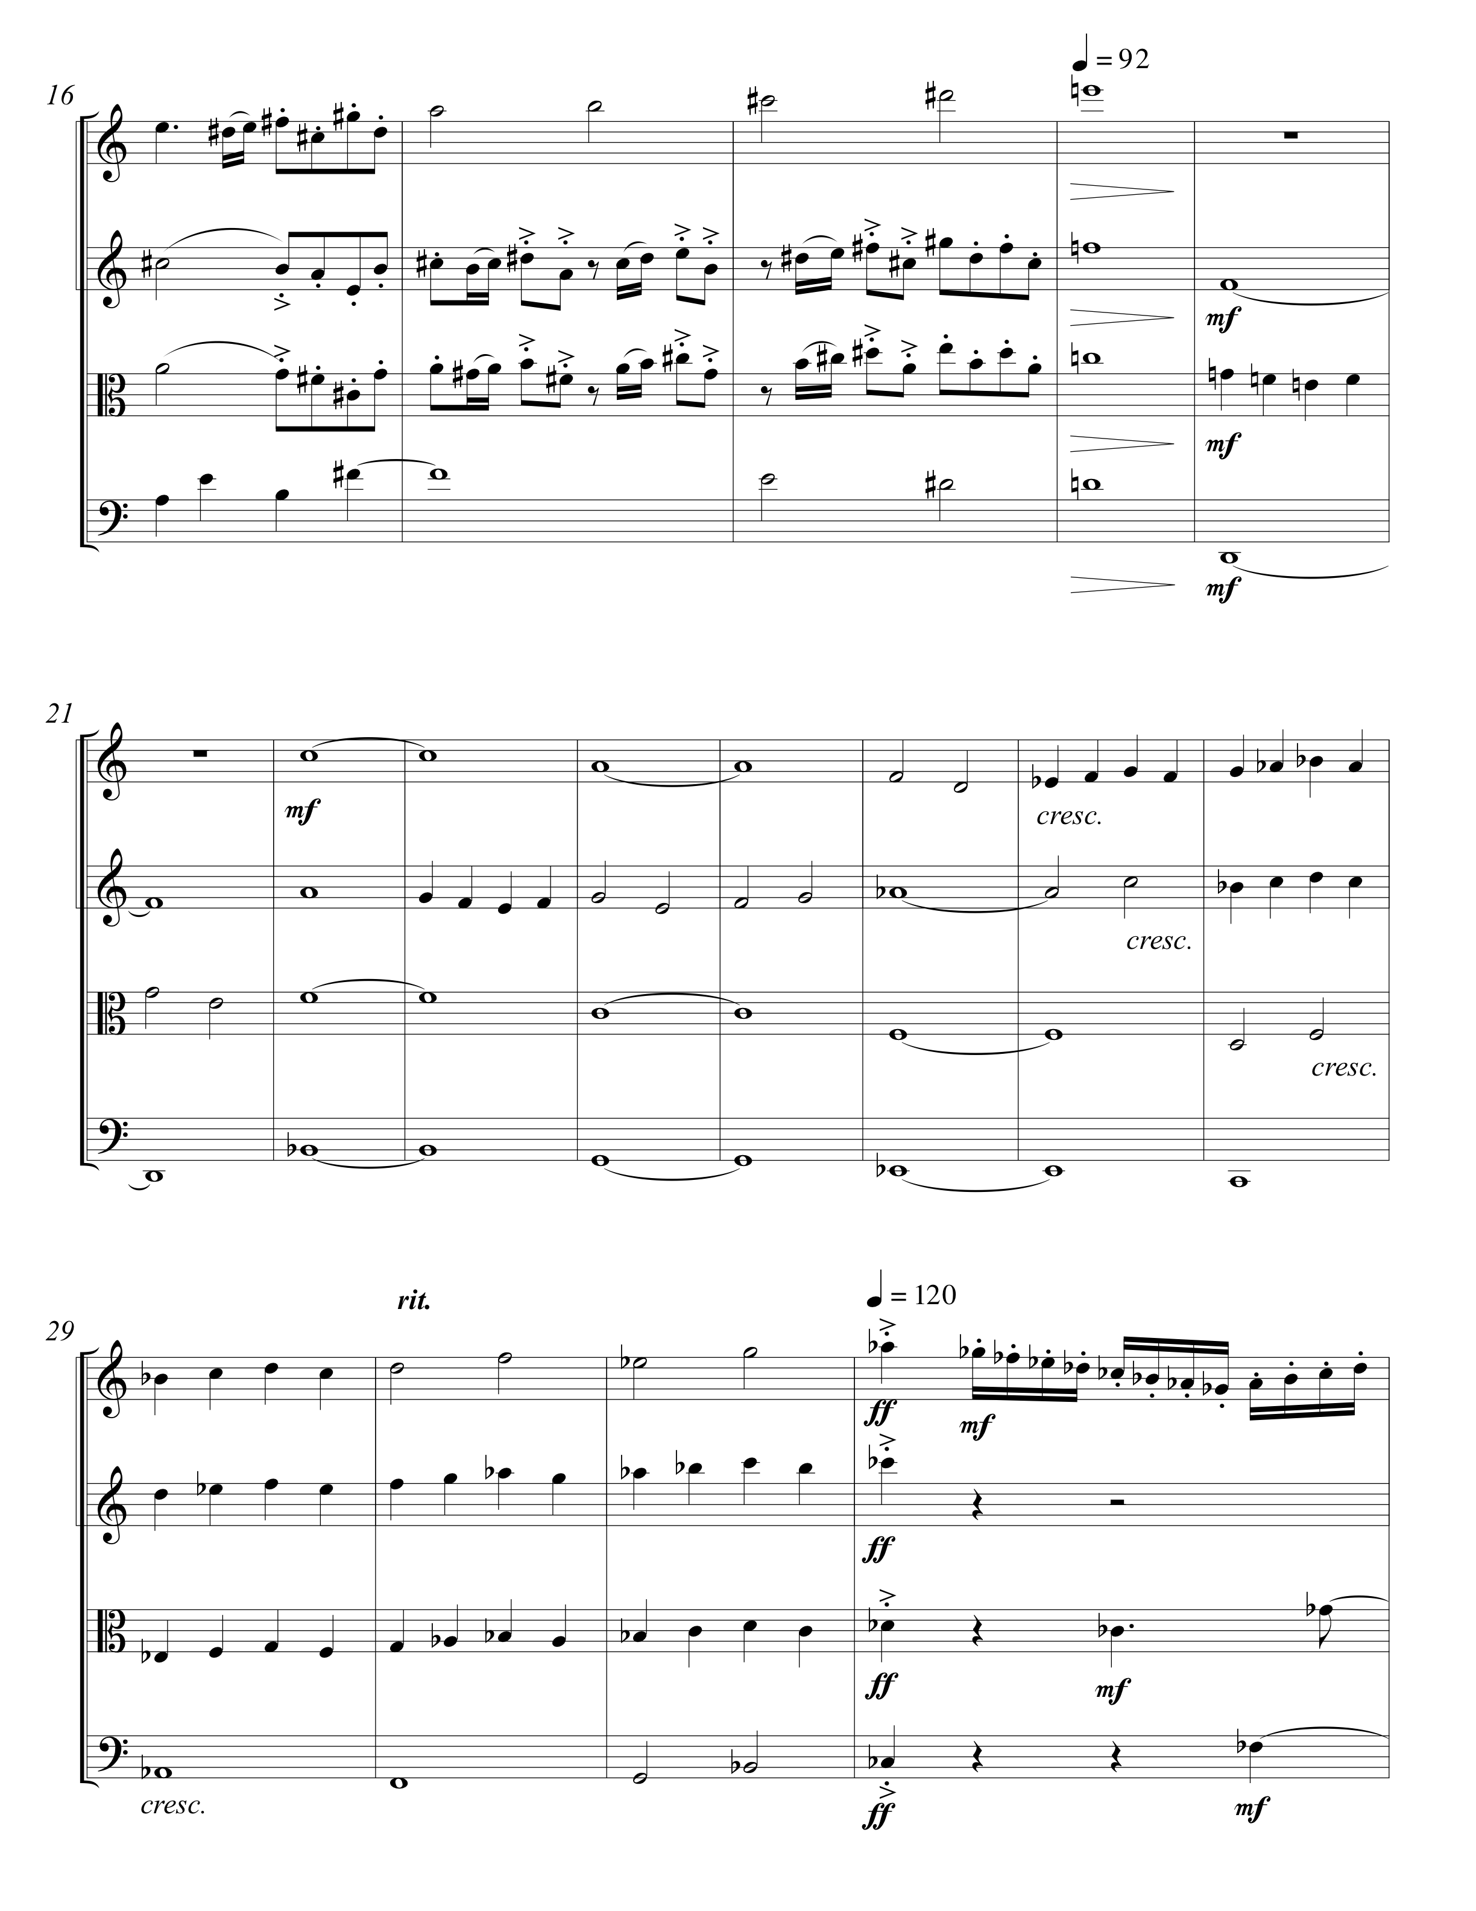

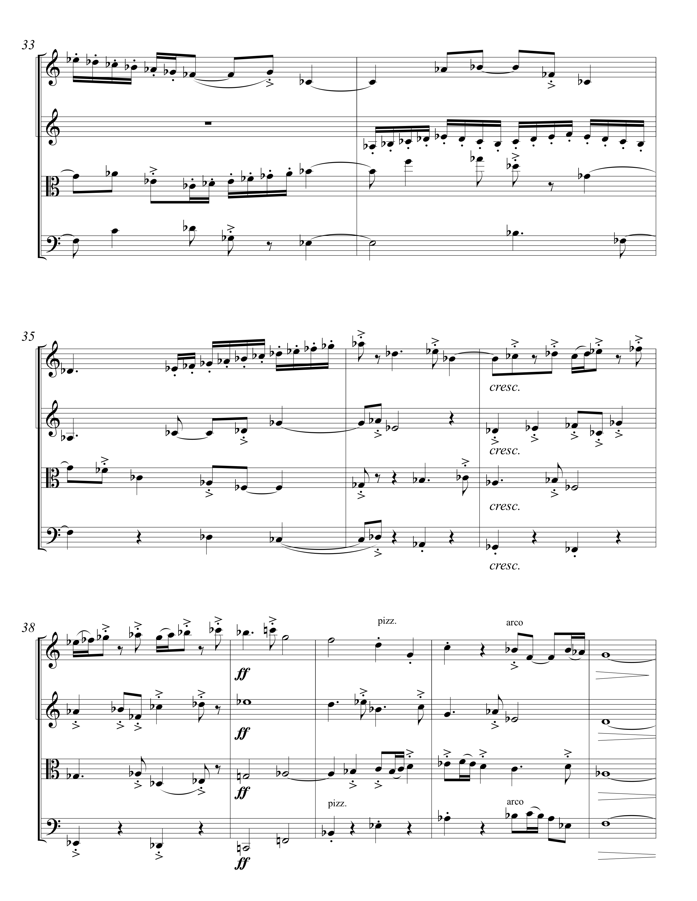

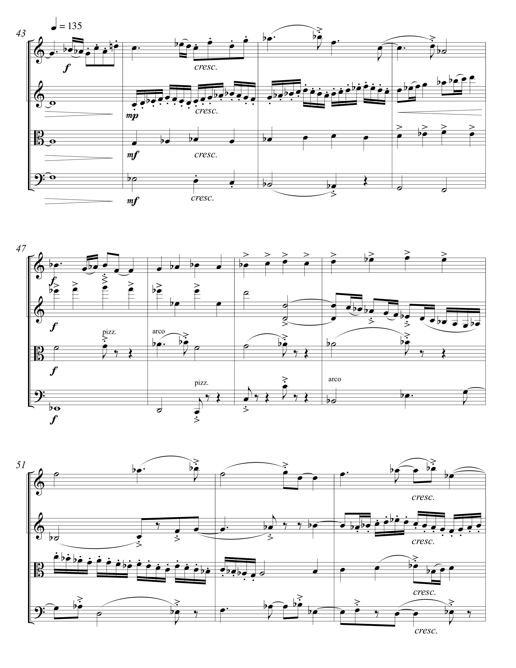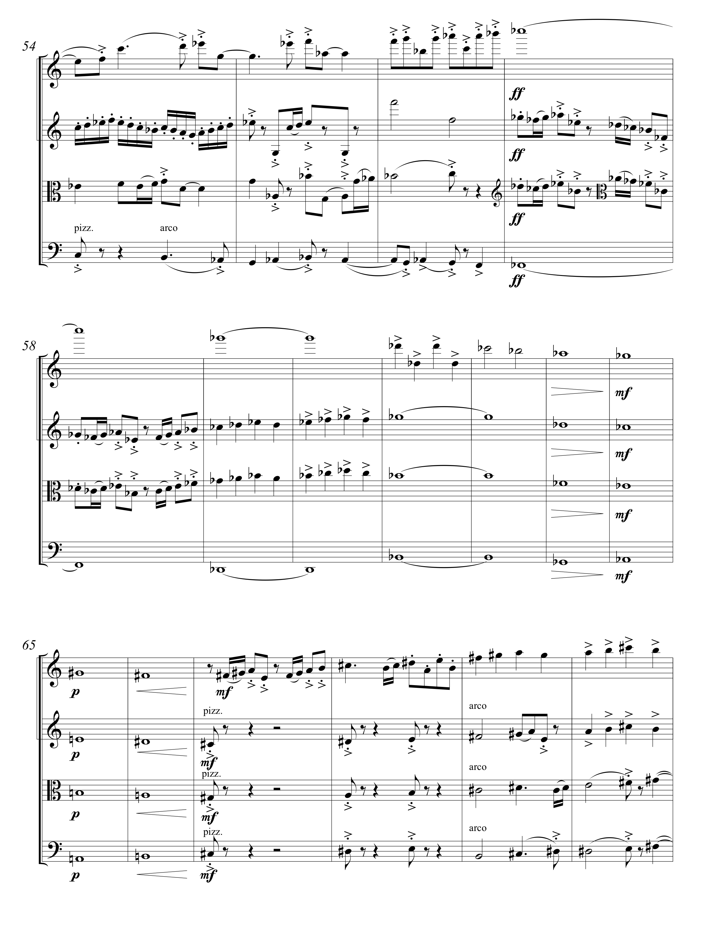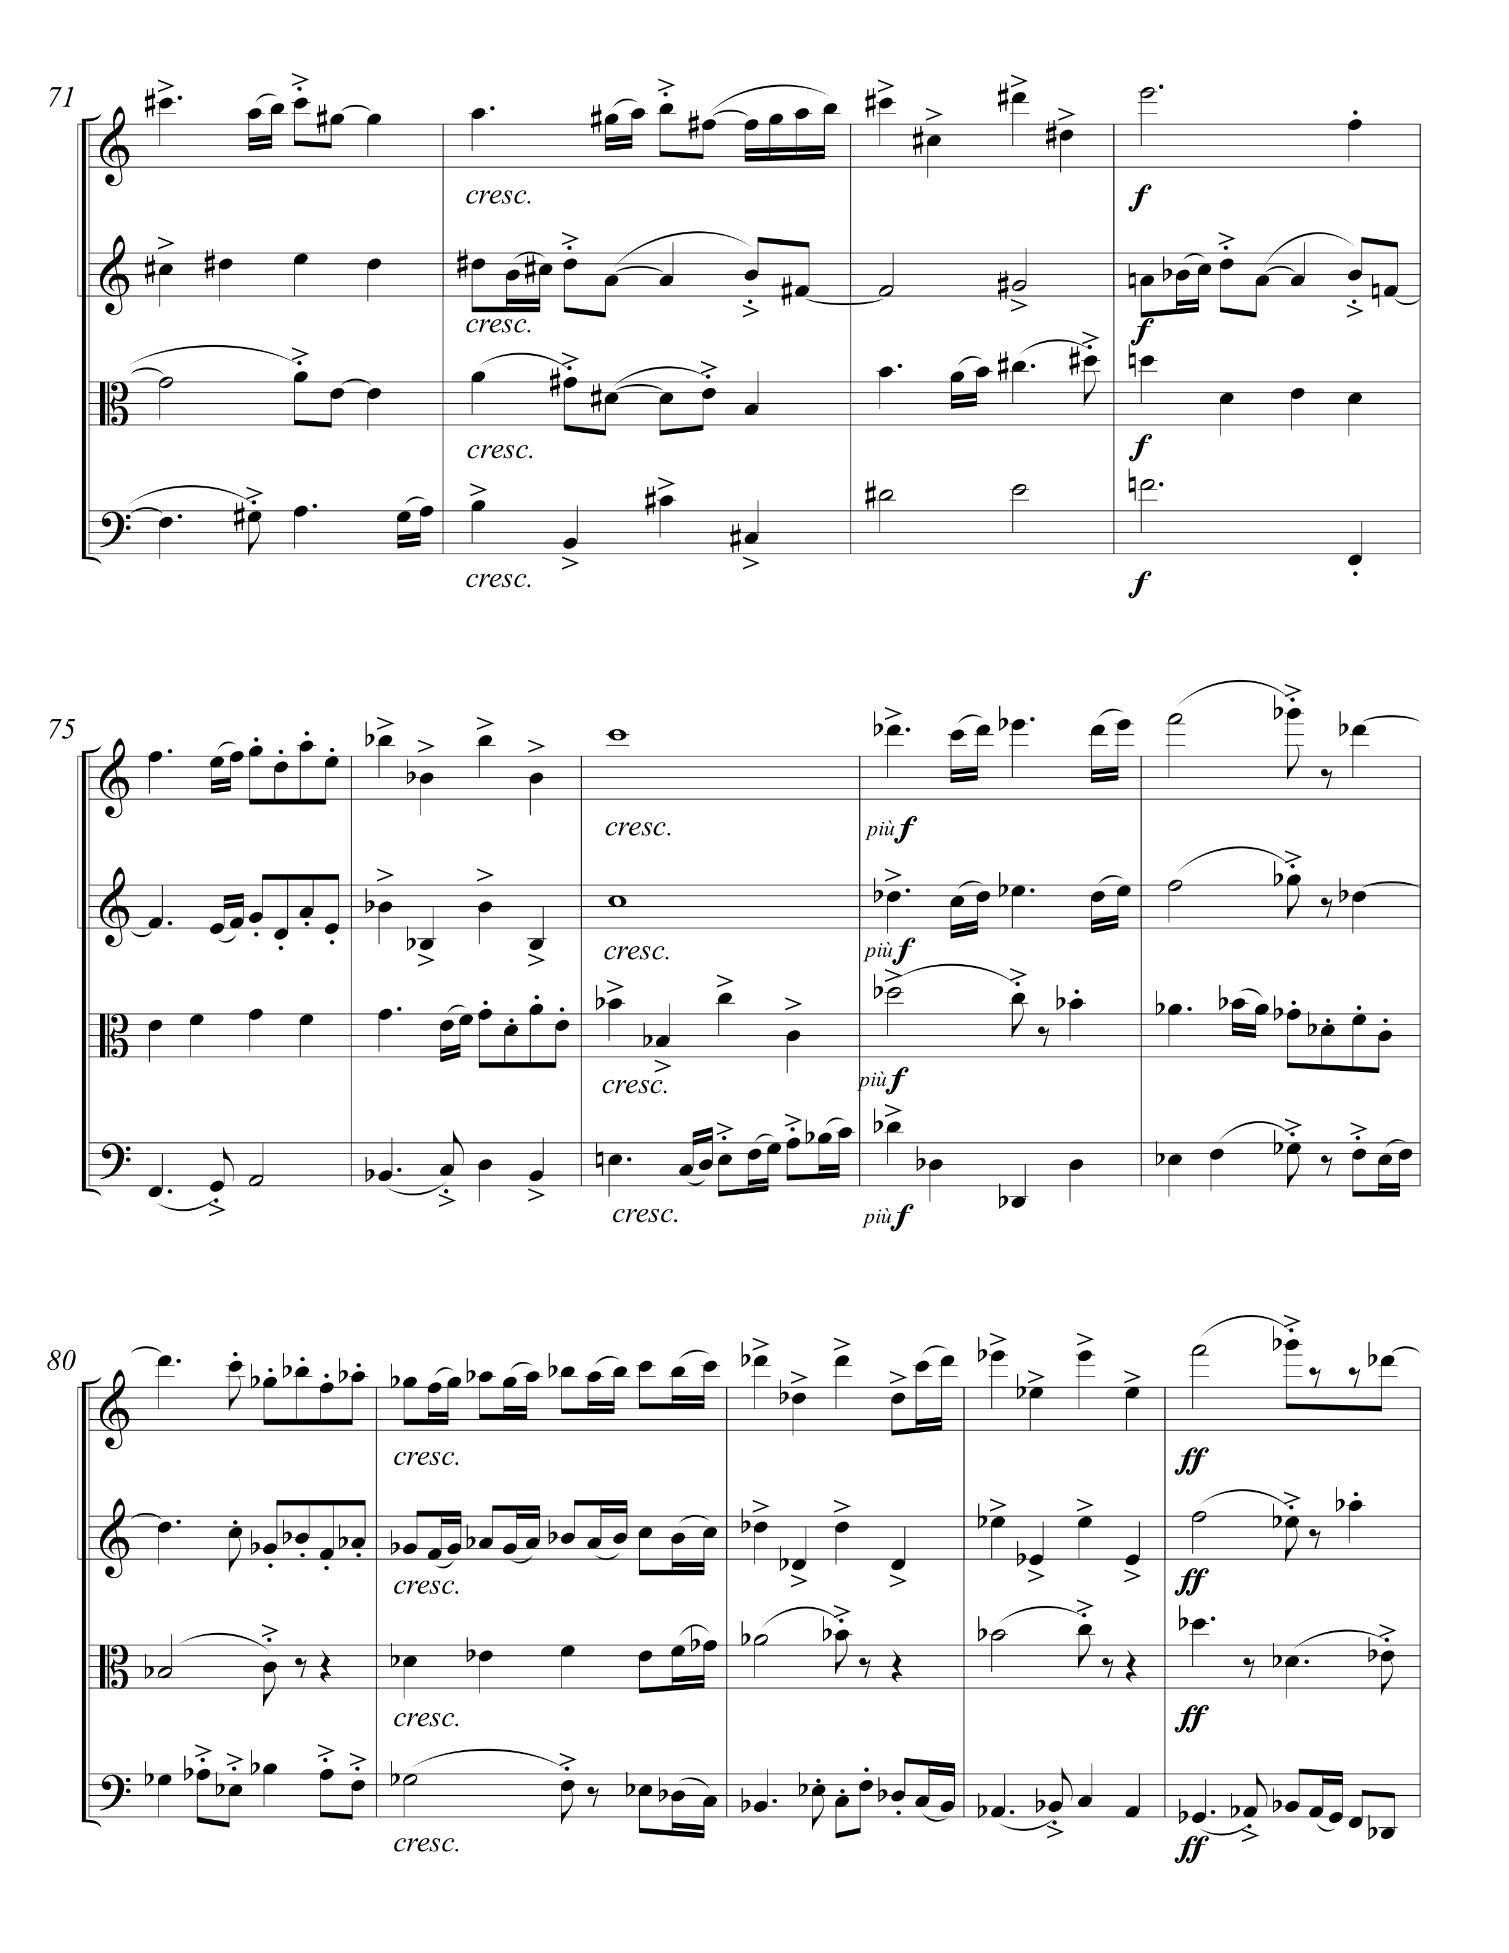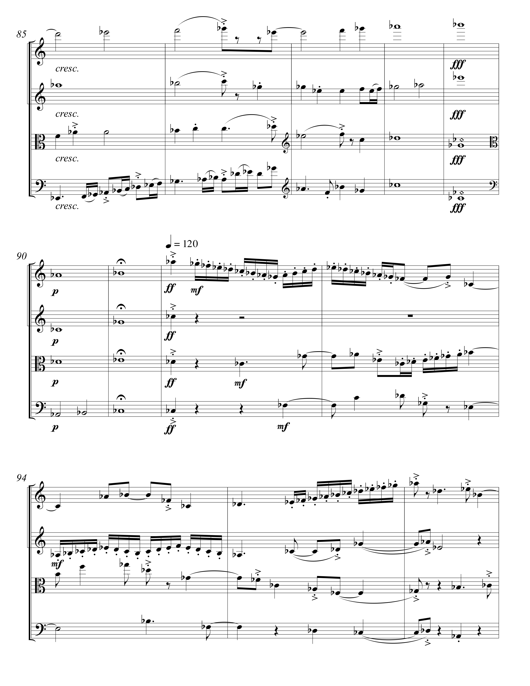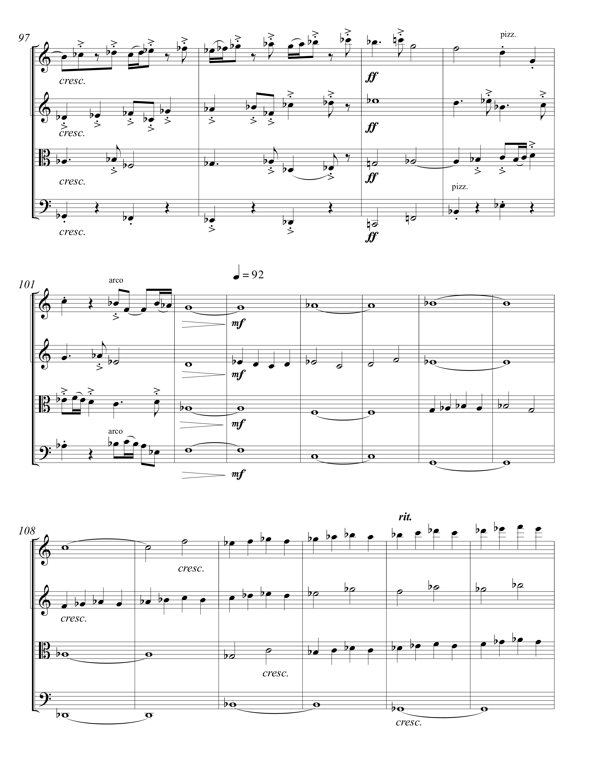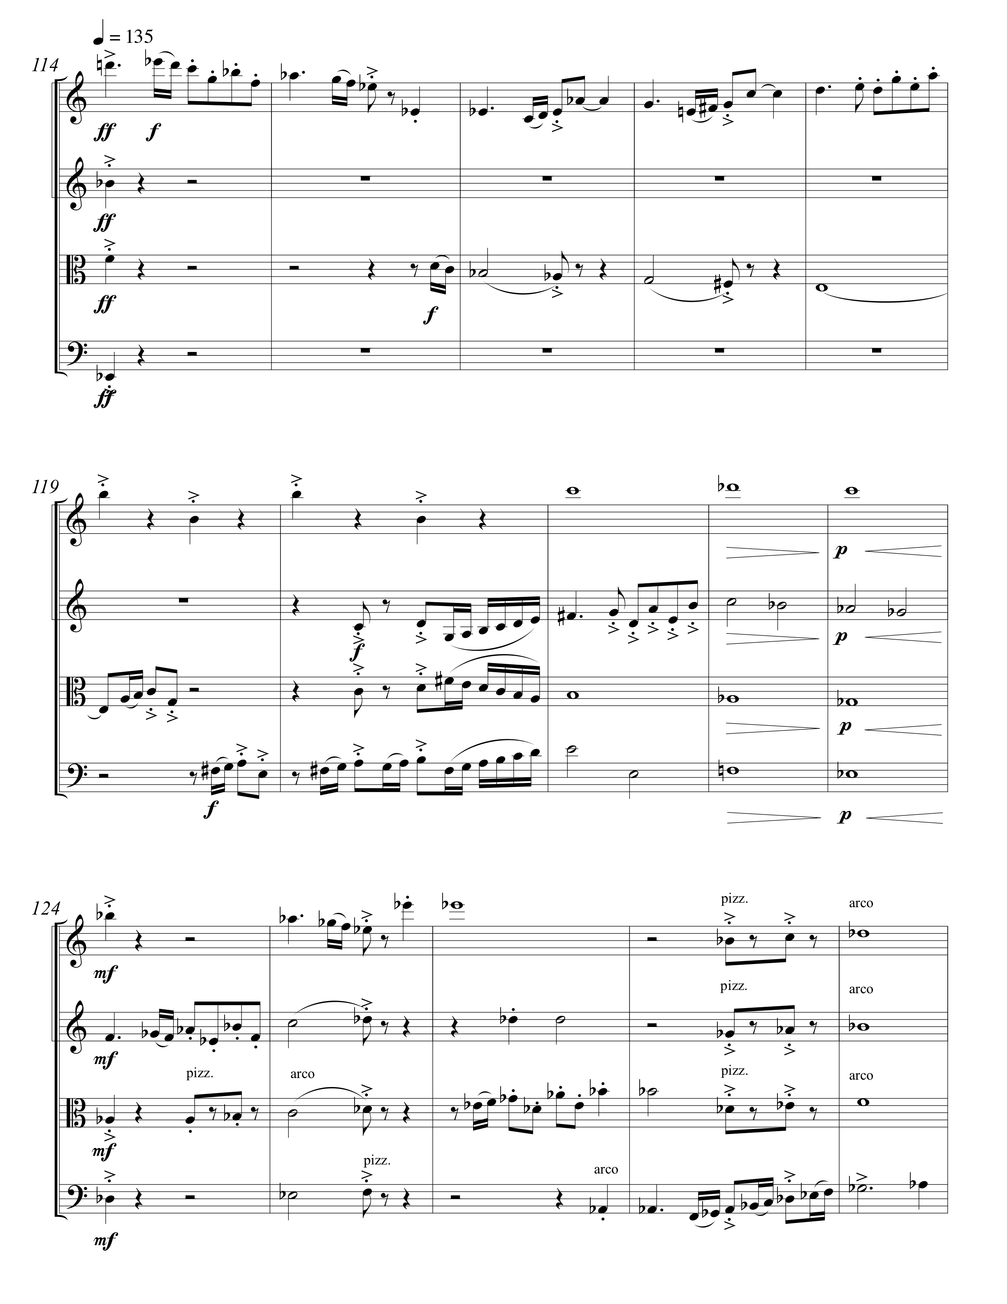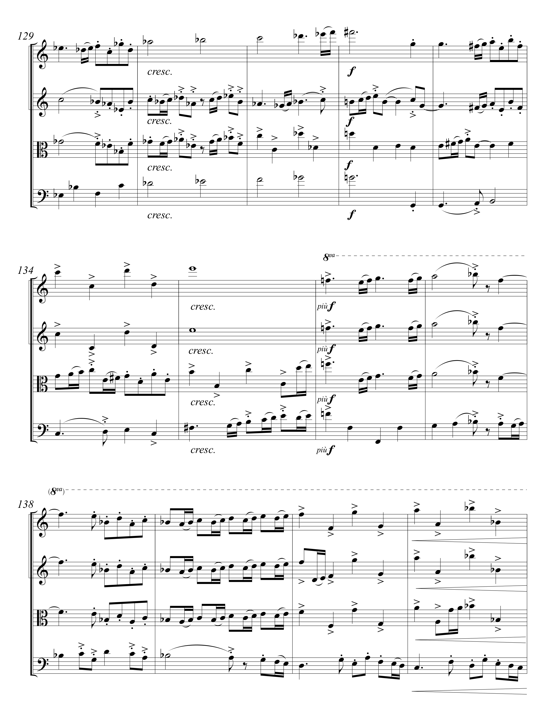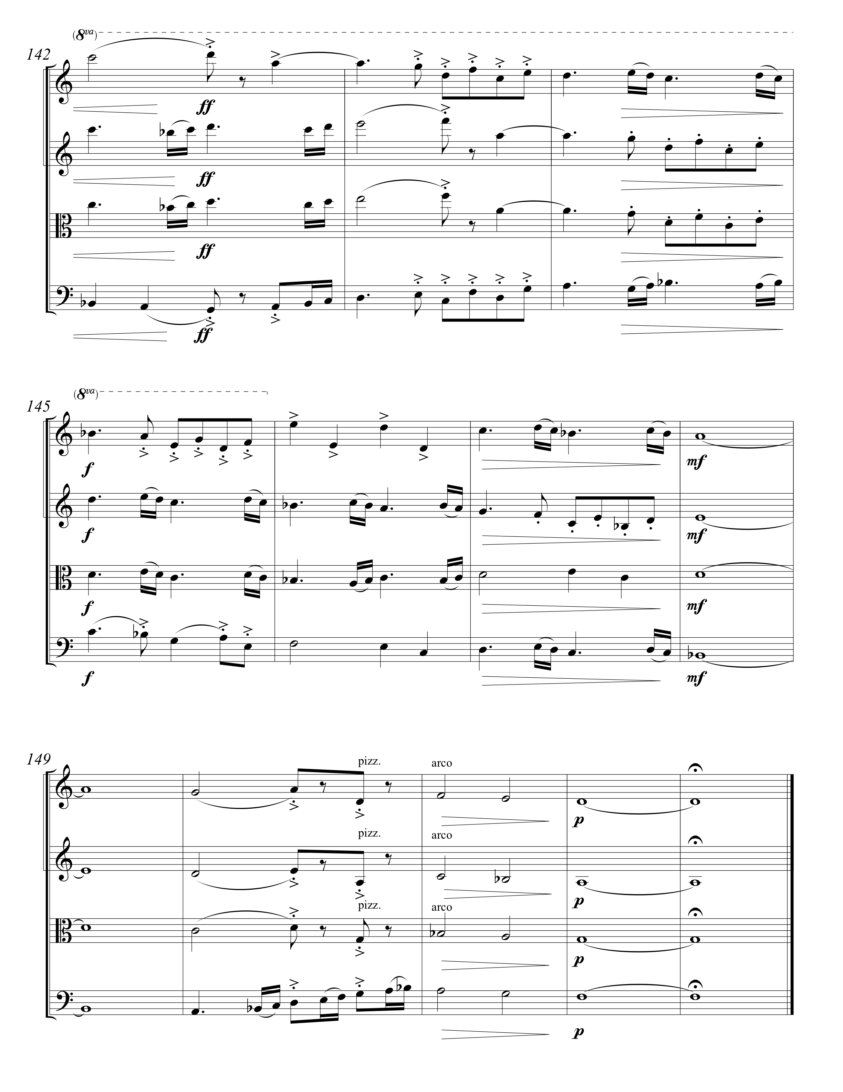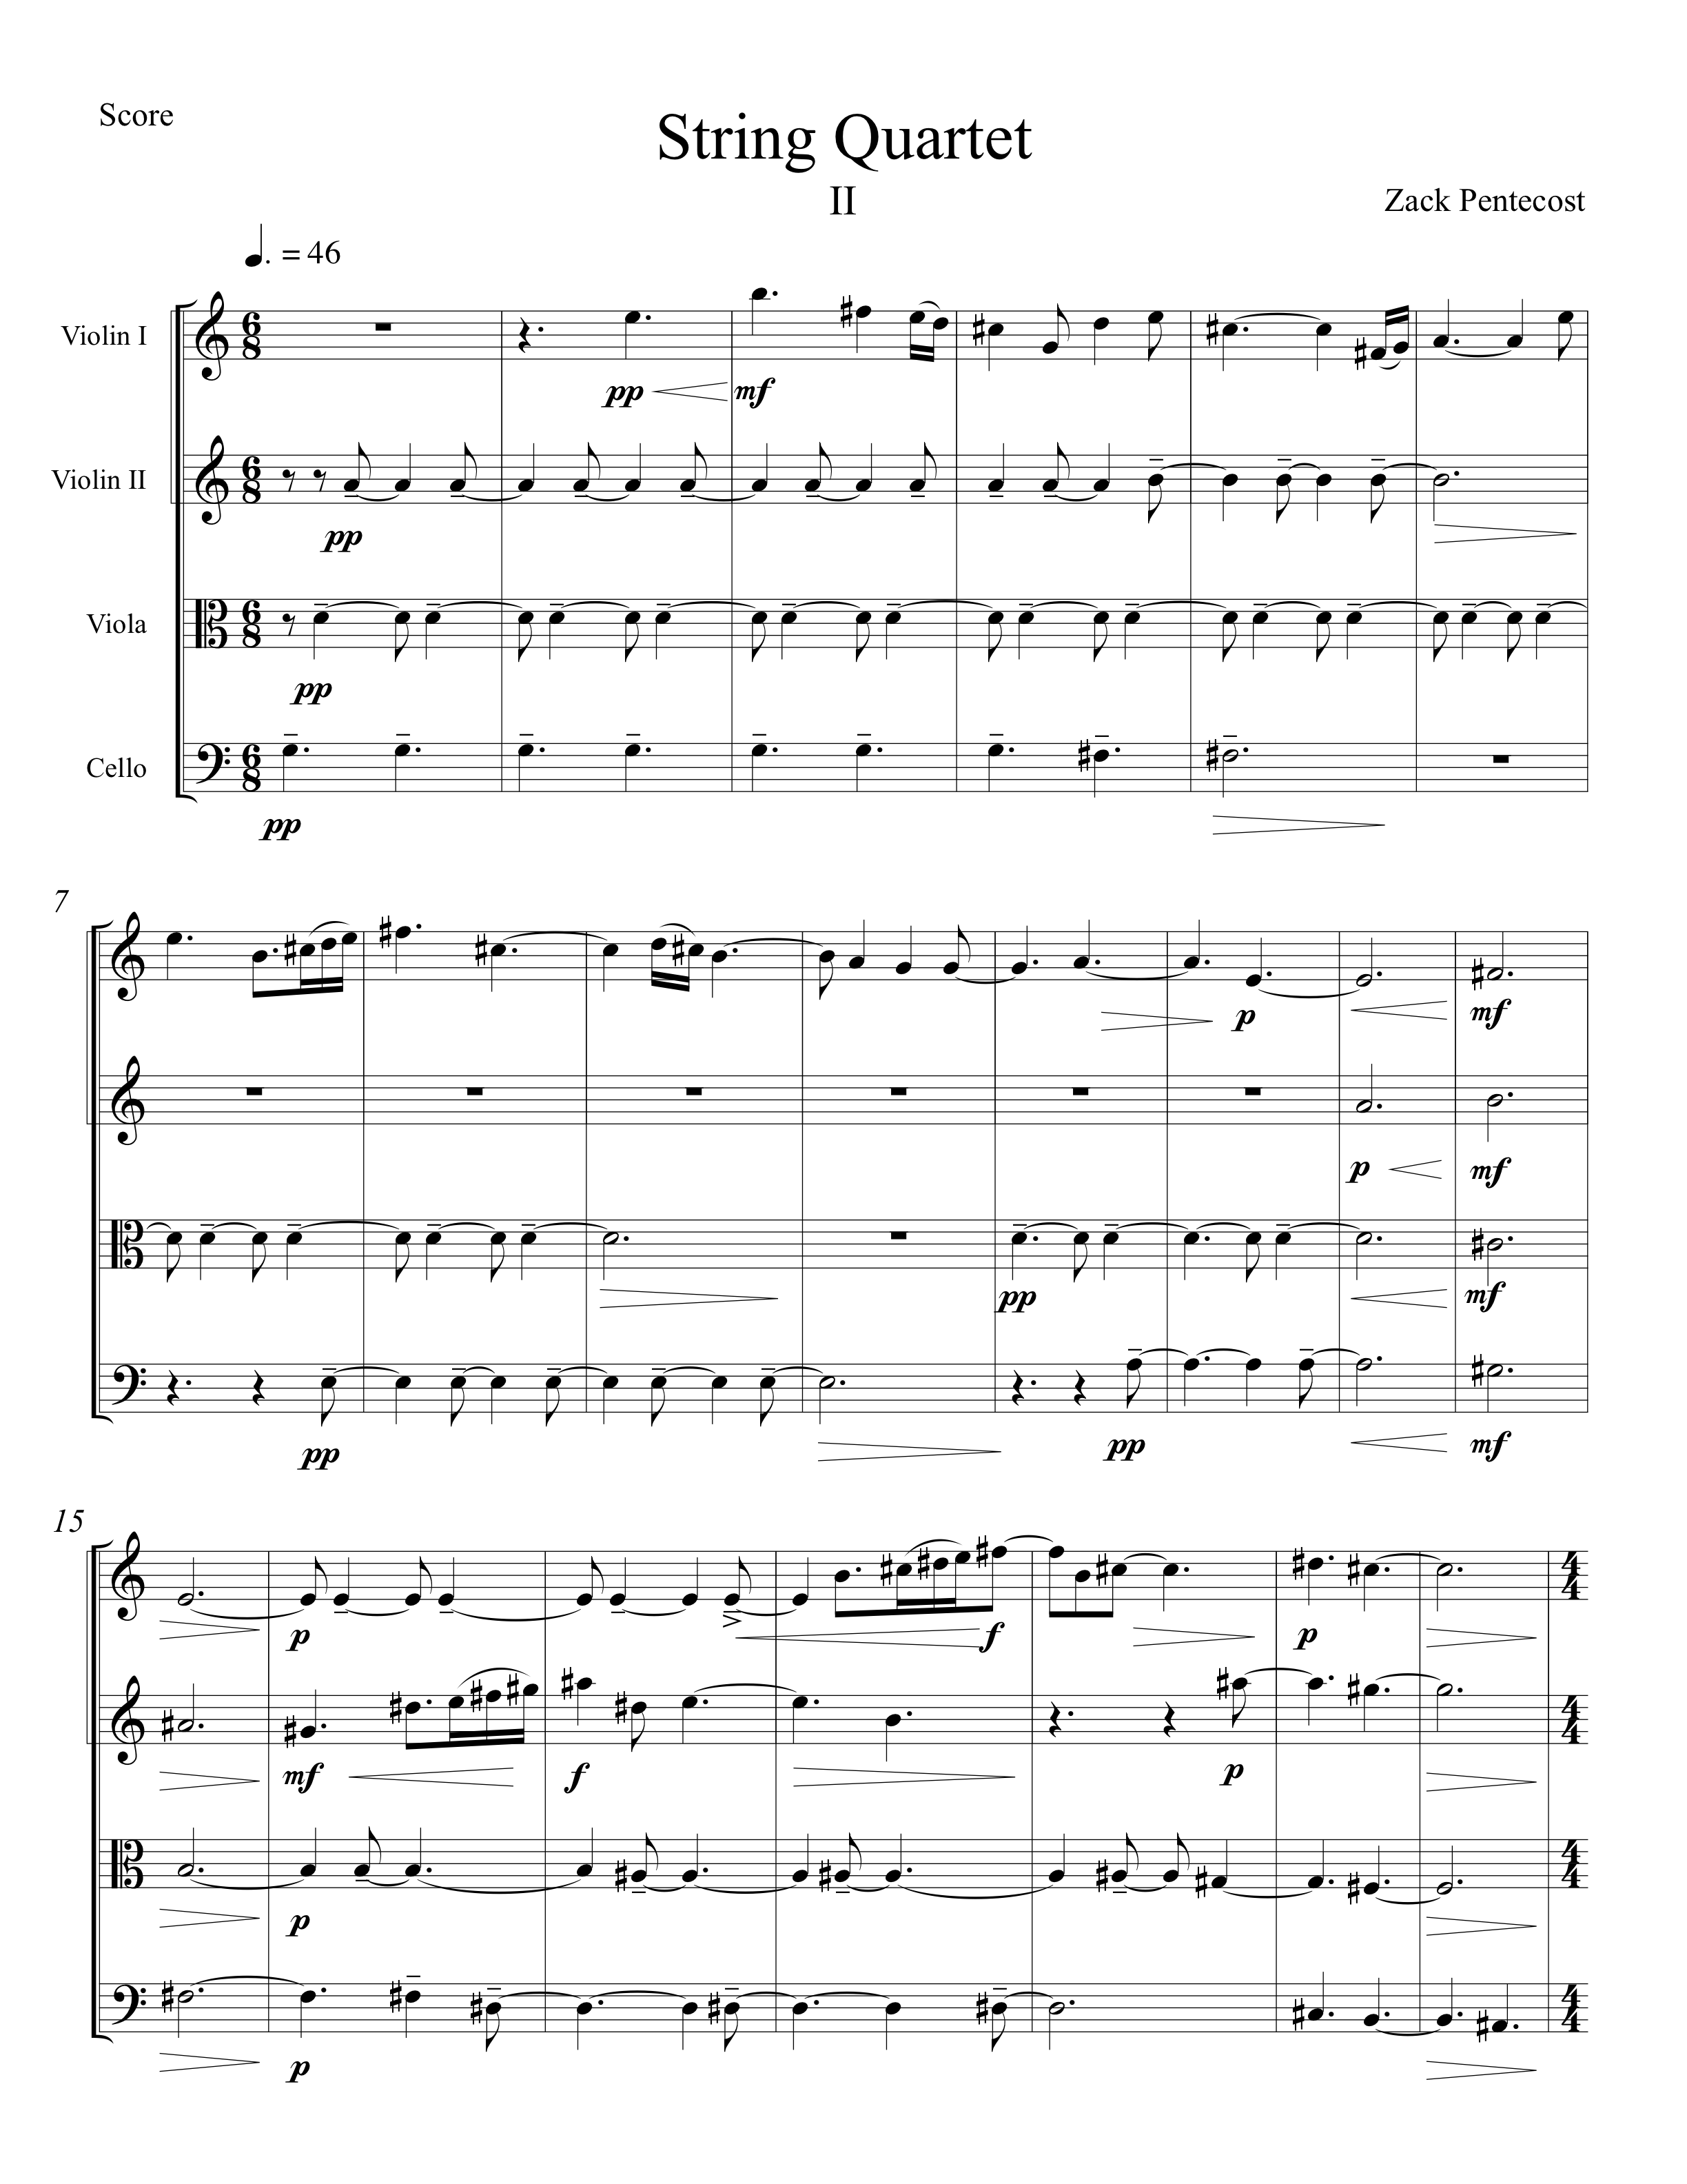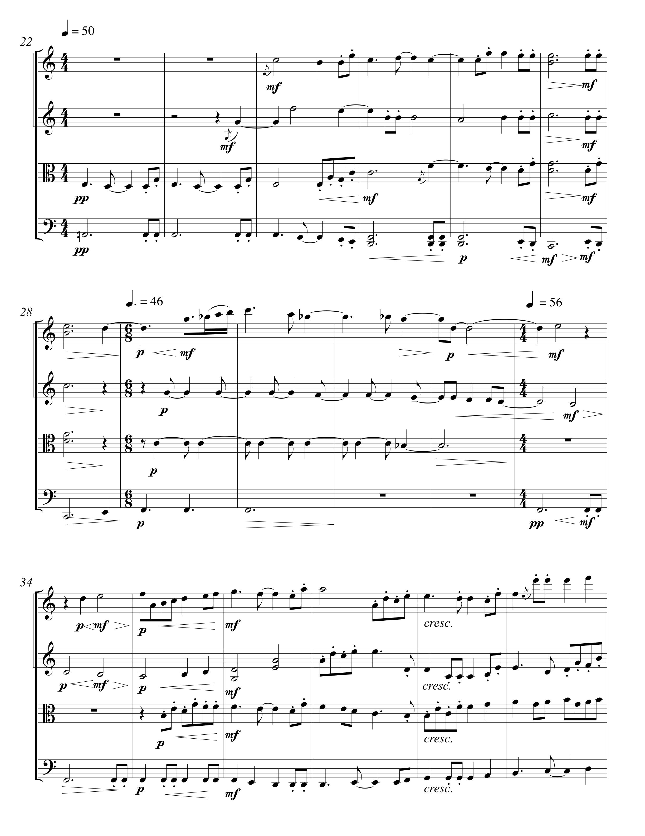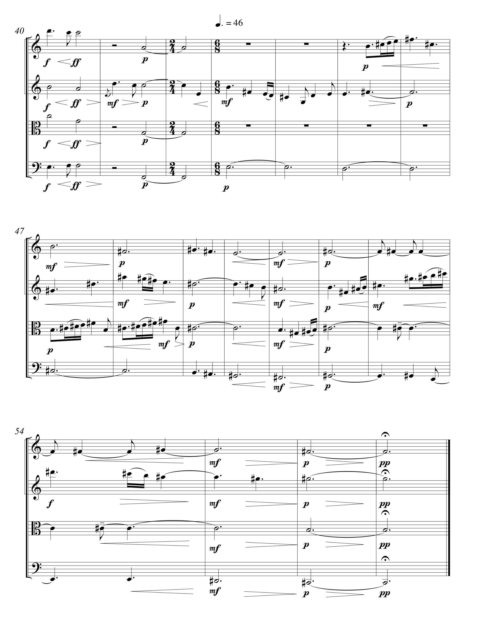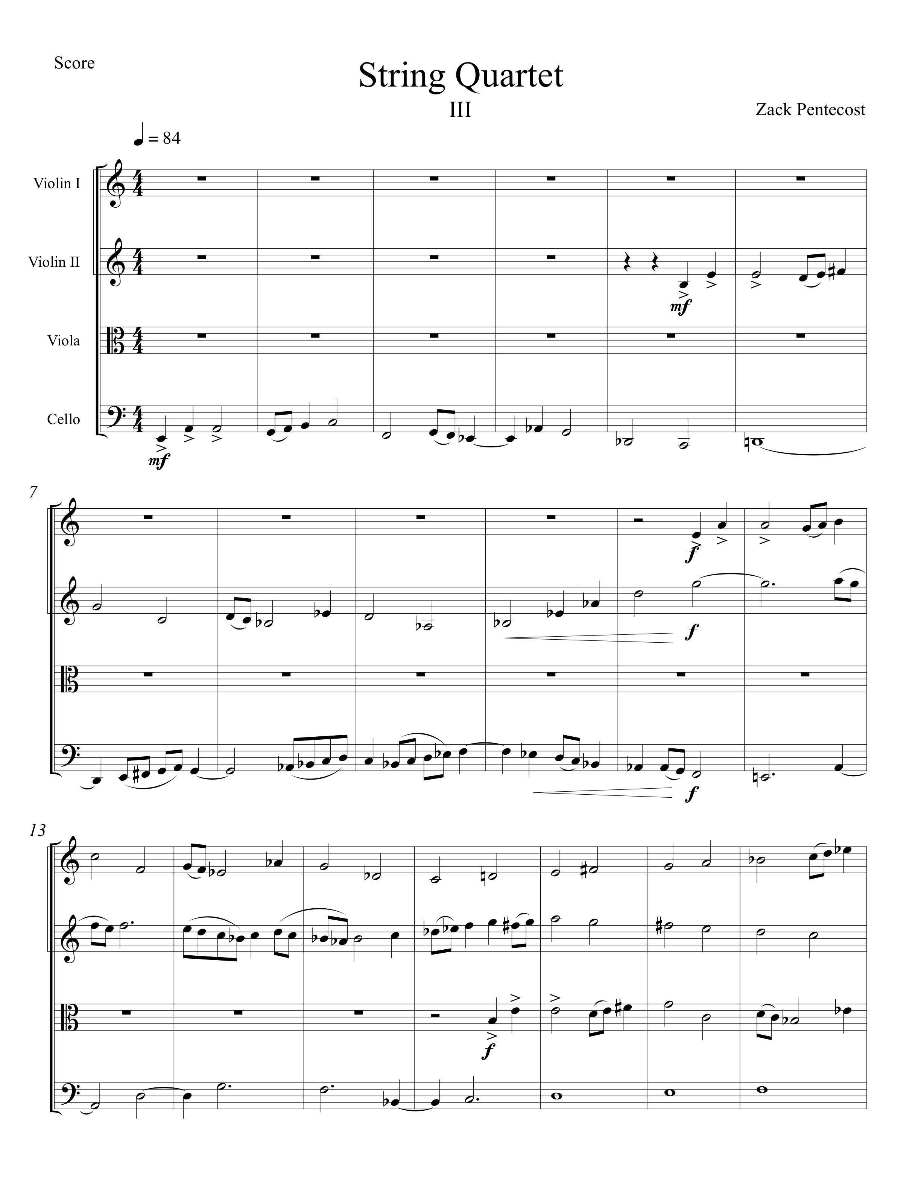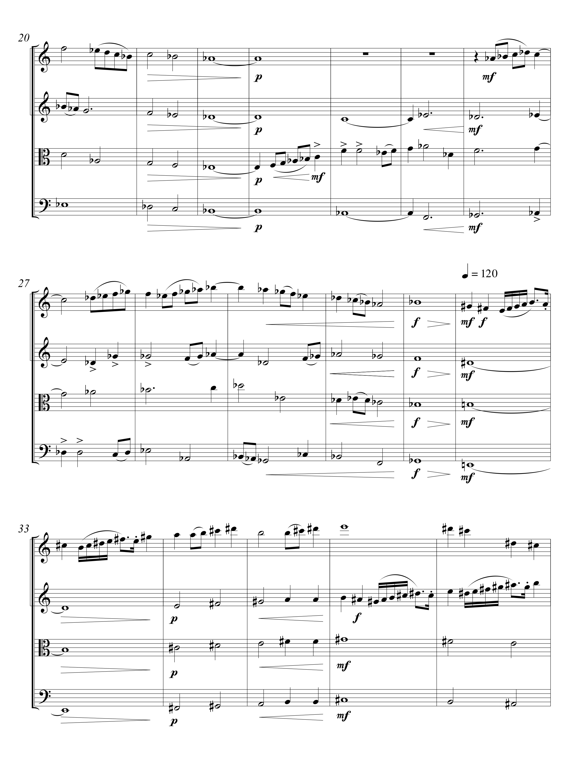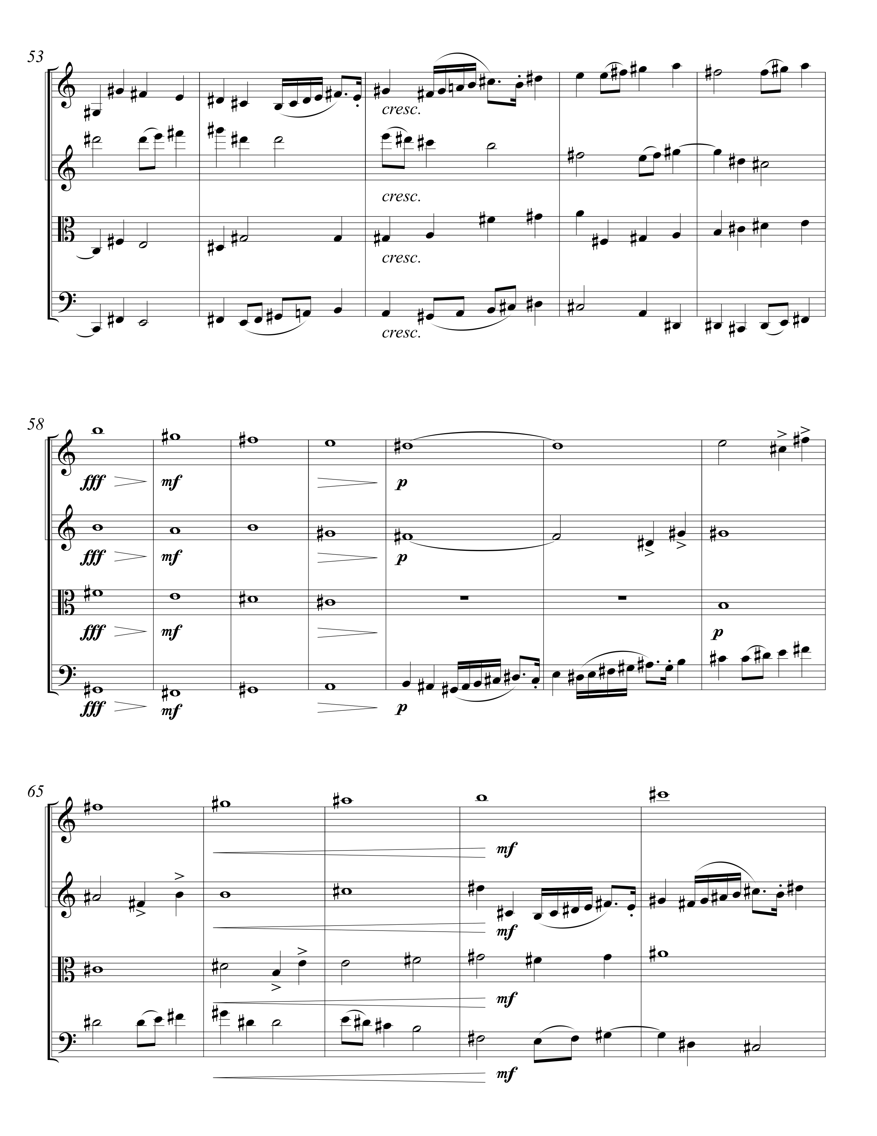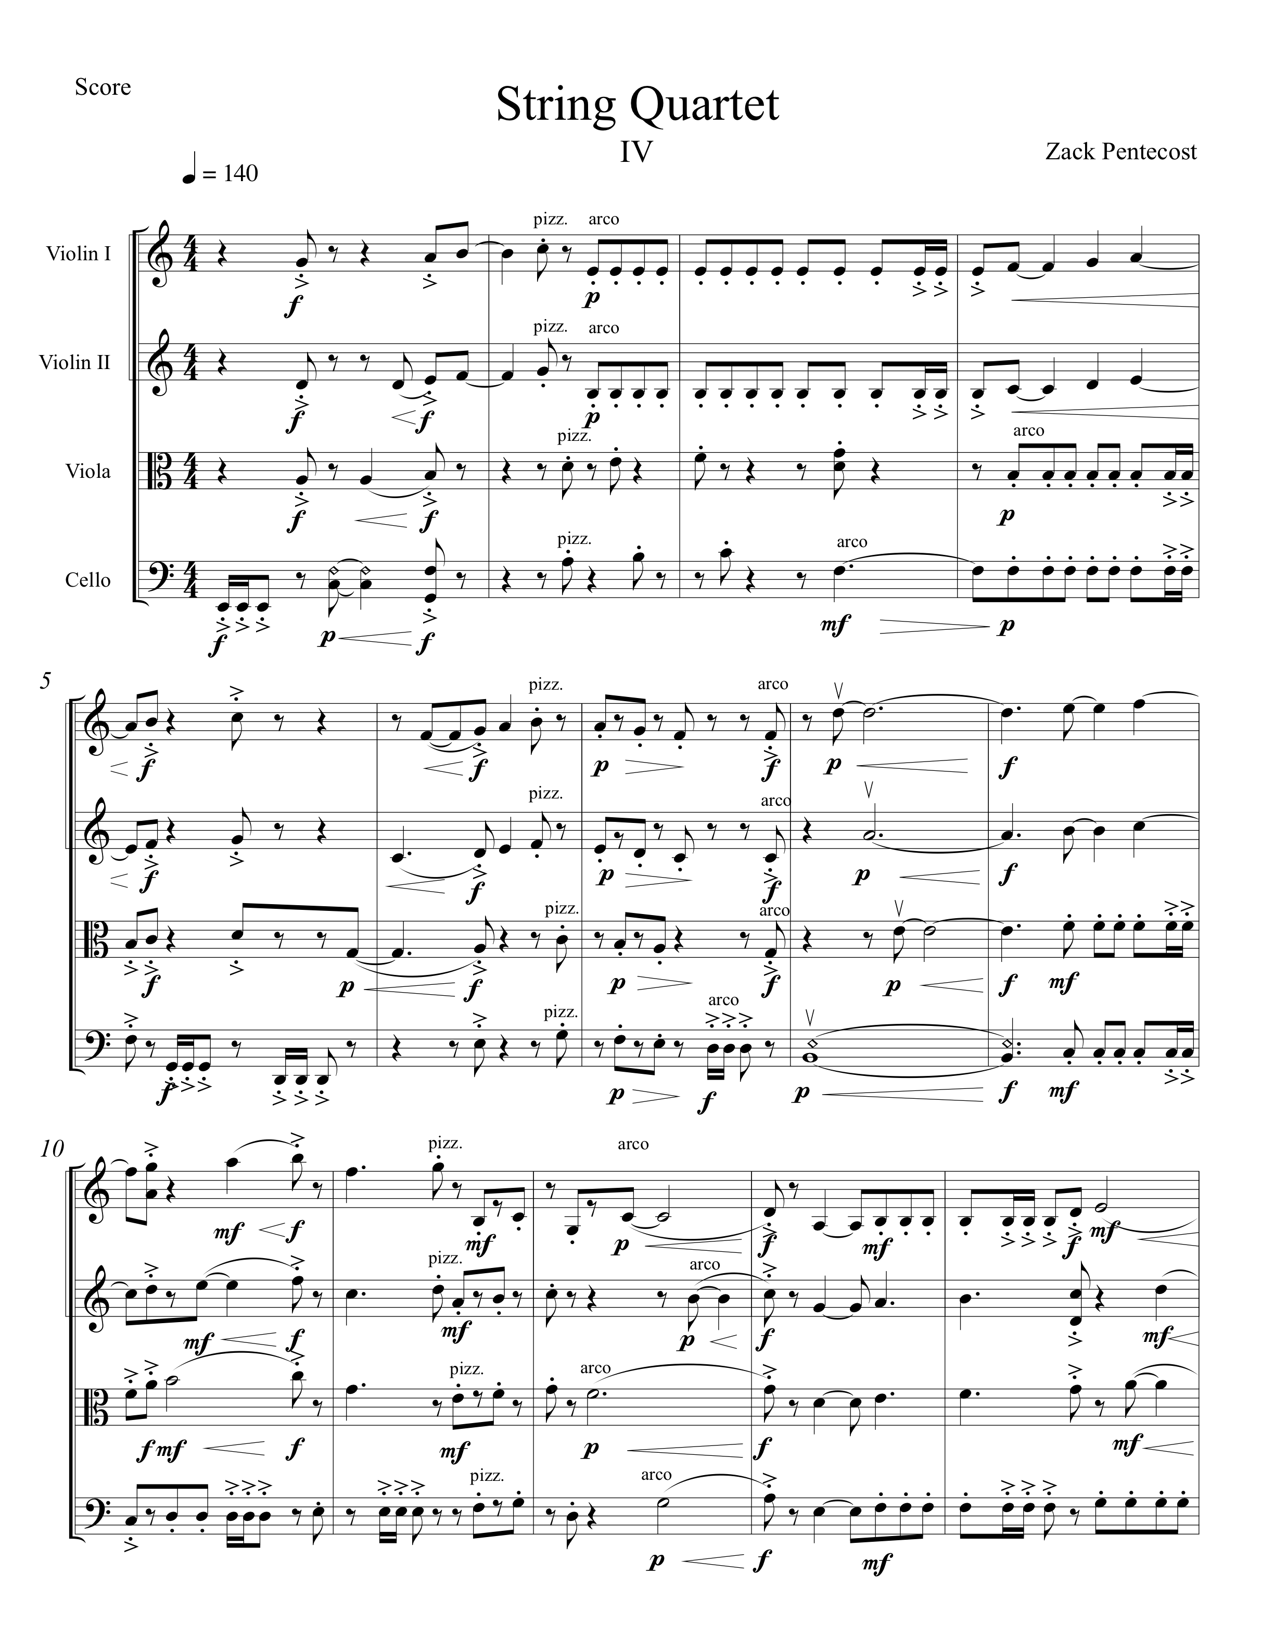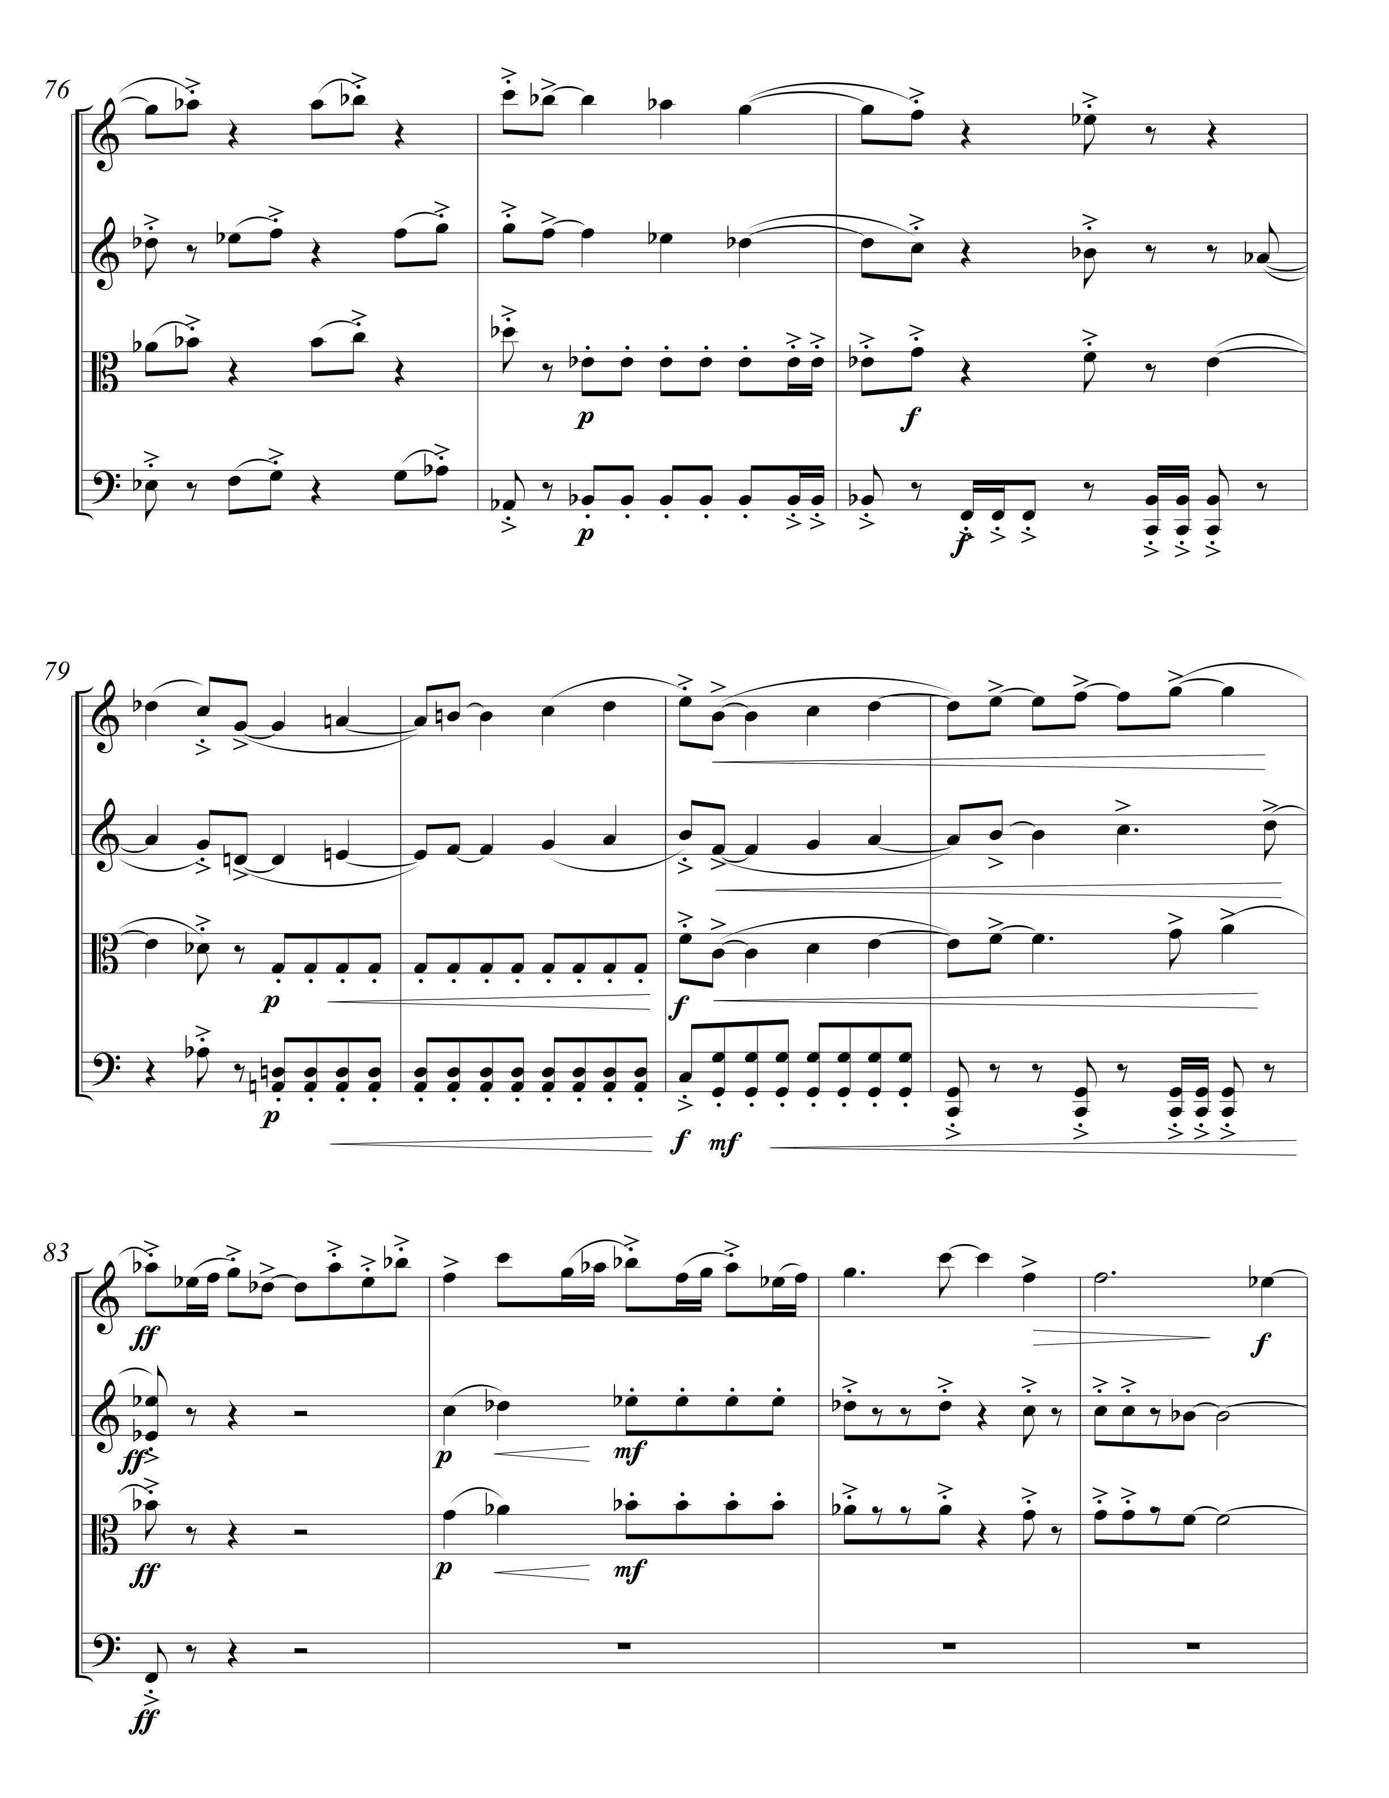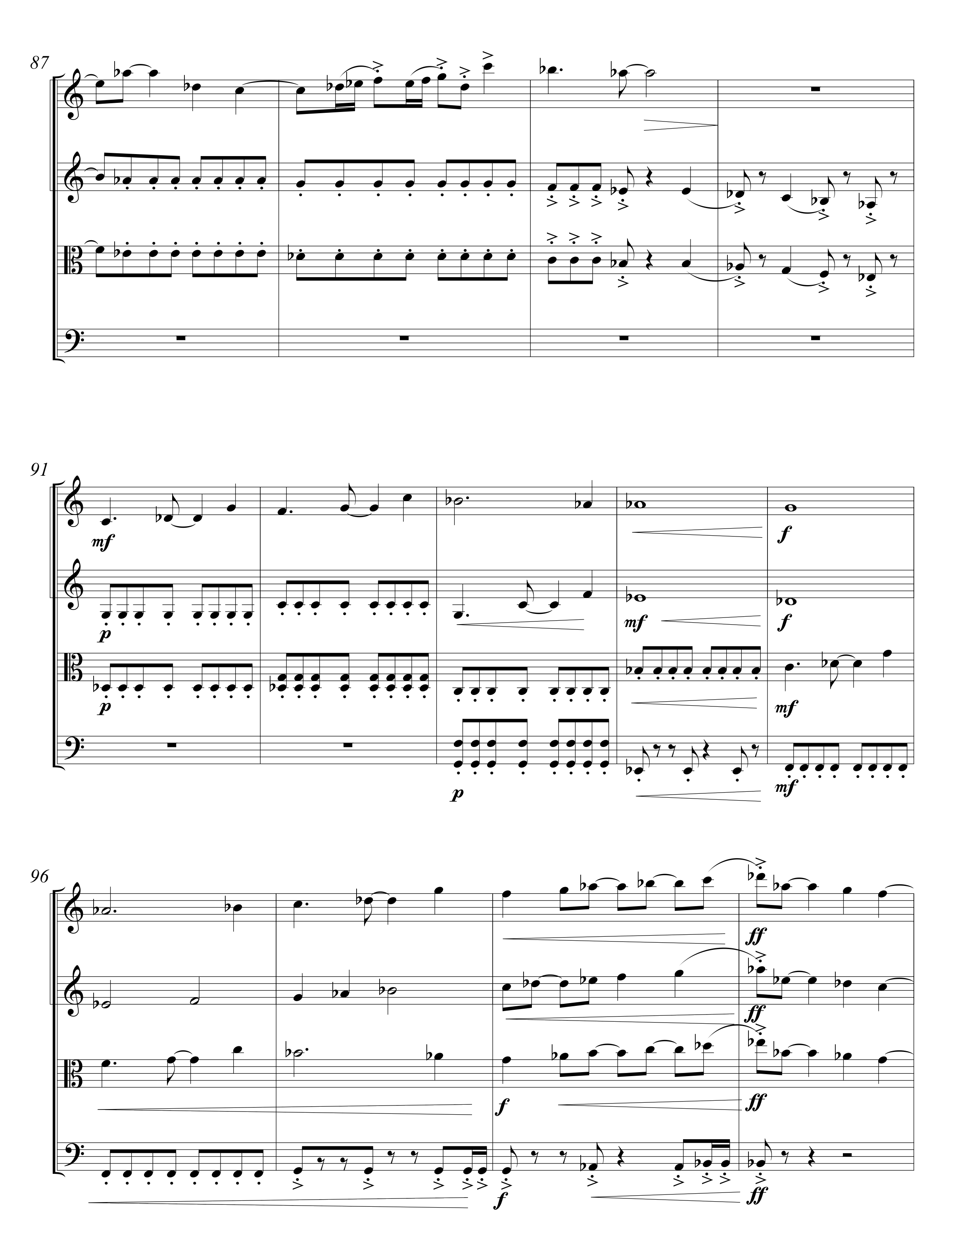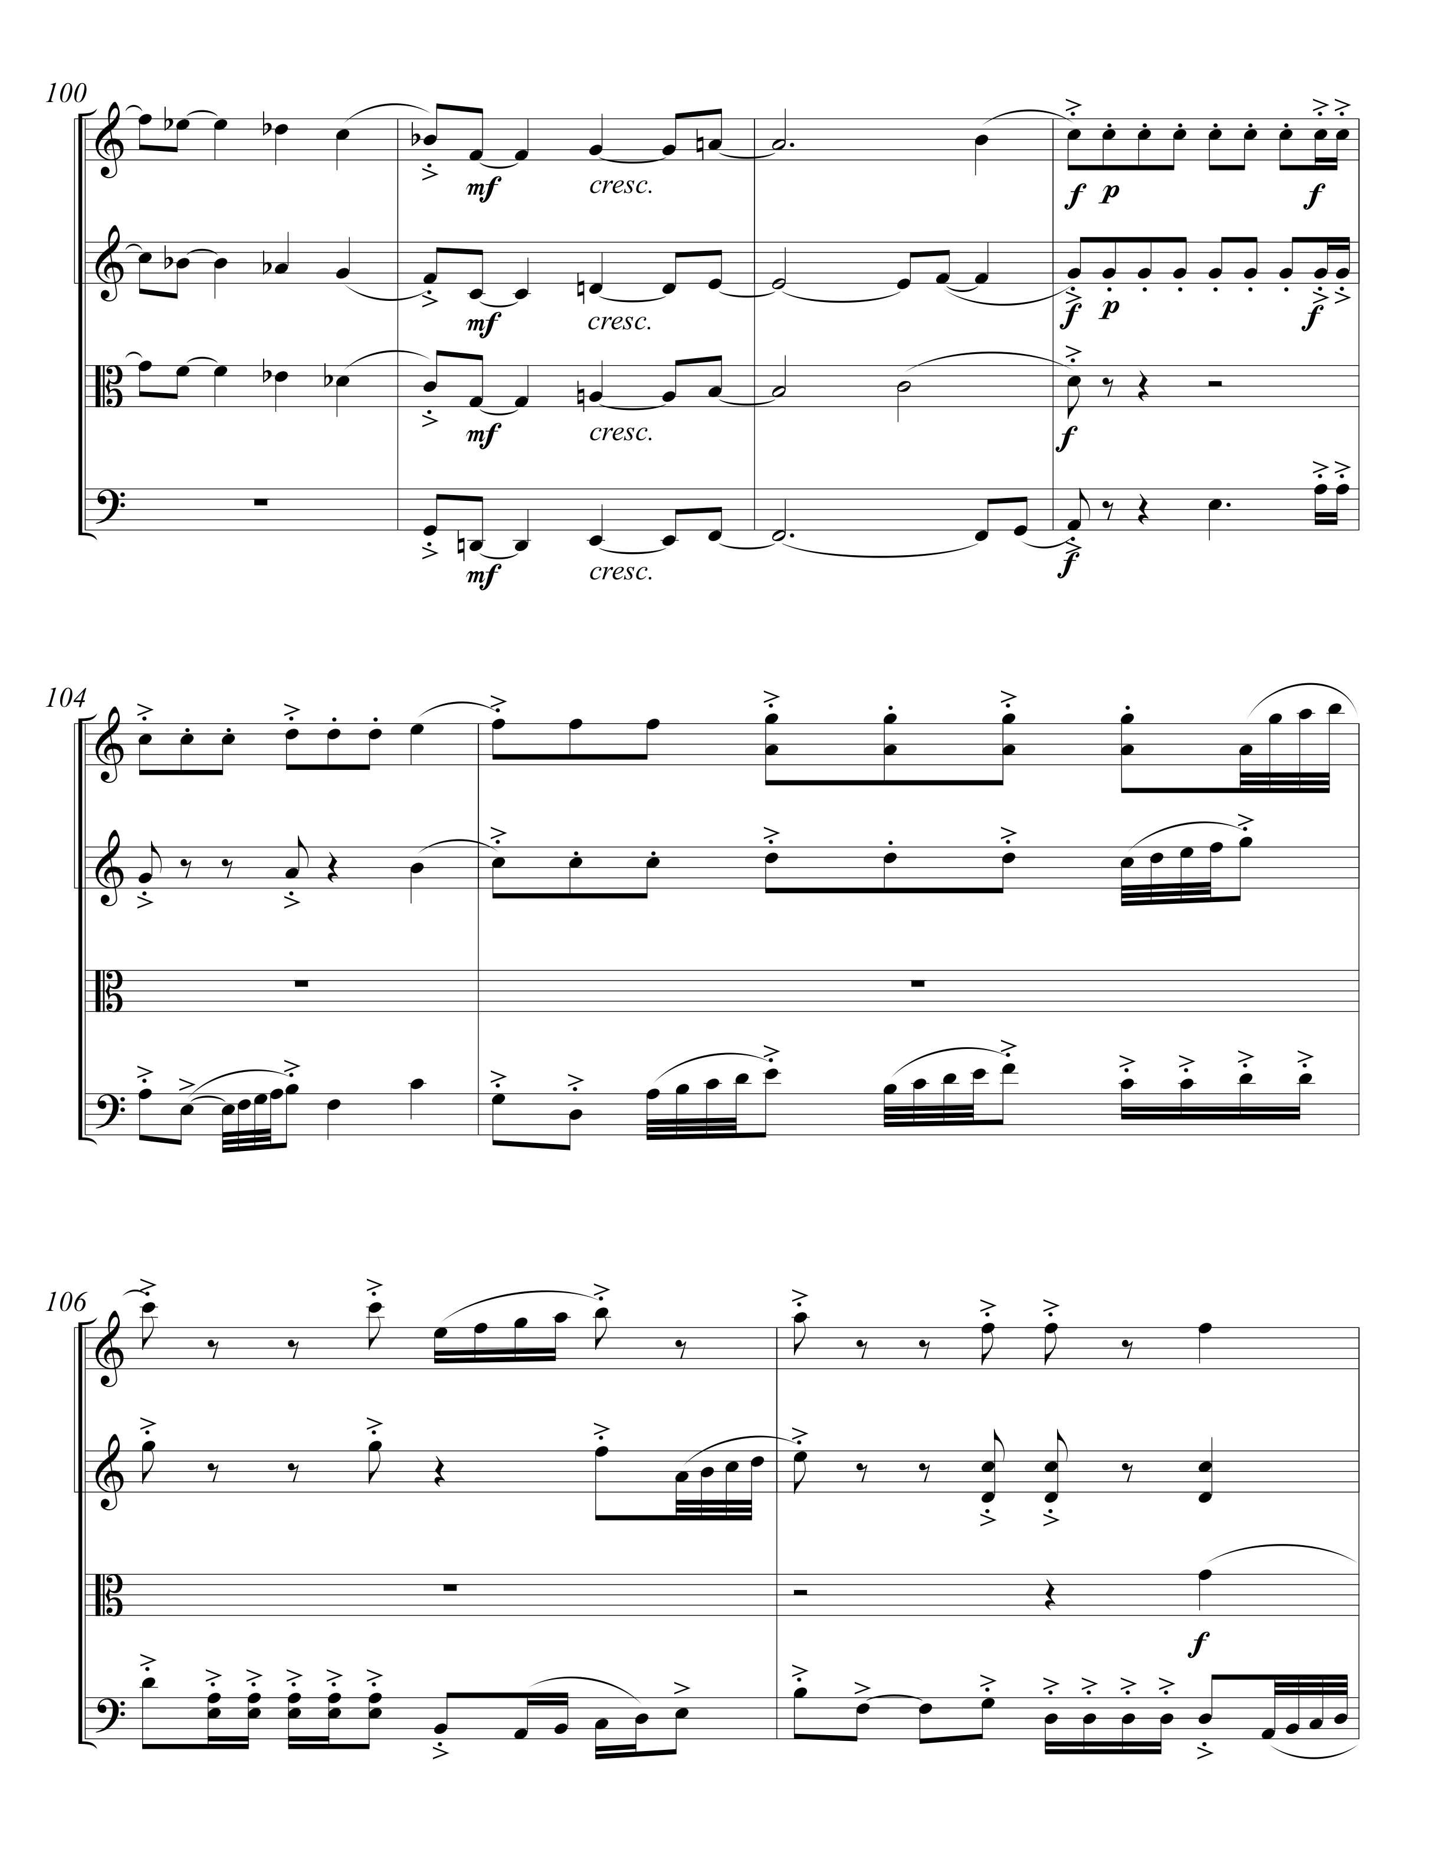
Vita

Originally from Springfield, Tennessee, Zachary Pentecost (b. 1990) is currently a graduate student pursuing his Master’s of Music in composition at the University of Tennessee – Knoxville, where he is a student of Dr. Kenneth A. Jacobs. Before going to Knoxville, Zachary earned his Bachelor’s degree in music with emphasis in composition at Austin Peay State University in Clarksville, TN. While at Austin Peay, Zachary studied composition under Dr. Jeffrey N. Wood and classical guitar under Roger Hudson and Dr. Stanley Yates.

Béla Bartók, String Quartet No. 5 (London: Boosey & Hawkes, 1939) 27.

