Tax Policy and Entrepreneurship

A Dissertation Presented for the

Doctor of Philosophy

Degree

The University of Tennessee, Knoxville

Xiaowen Liu

August 2014

Copyright © 2014 by Xiaowen Liu.
All rights reserved.

ACKNOWLEDGEMENTS

My deepest and most sincere gratitude goes to my advisor, Don Bruce, for his fundamental role in my doctoral work. He provided me with every bit of guidance, assistance, and expertise throughout my research. This dissertation is possible only because of the unconditional support provided by Don. He has been an absolutely wonderful advisor and mentor. I consider myself very fortunate to have the opportunity to do my doctoral program under his guidance. In addition to our academic collaboration, I greatly value the close personal rapport that Don and I have forged over the years. I could not imagine a better advisor.

I thank the remainder of my committee, Matthew Murray, Mohammed Mohsin, and Russell Crook for insightful comments and questions. I am very grateful for their time and valuable feedback on a preliminary version of this dissertation. In addition, I have received exceptional encouragement and assistance from the staff in the Center for Business and Economic Research. I greatly appreciate the aid, support, and friendship from my coworkers at CBER: Vickie Cunningham, Betty Drinnen, Joan Snoderly and Brian Douglas.

I consider myself very fortunately to share my doctoral study with my fellow graduate students at Tennessee. I would not have completed the journey without my great friends Julianna Butler, Nicholas Busko, and Jilleah Welch. I thank Melanie Cozad for her friendship and her willingness to share in the experiences of the job market.

Finally, I would like to thank the family and friends who made this work more enjoyable. My parents, Wenhua Liu and Shiying Li, have always believed in me, although they are always confused why it takes a person five years to write a paper. I thank my husband, Kai Yang, for understanding my frustration and his unconditional support.

ABSTRACT

Small businesses and the entrepreneurial spirit are among the driving forces in economic growth and development in the United States. The US governments (both federal and state) have long been aware of the importance of entrepreneurship, and many policies are directed toward helping small businesses. However, whether such policies give rise to expected behavioral responses from small businesses remains inconclusive. This dissertation looks into the behavioral response of self-employed filers to individual income tax and the impact of state and federal tax policies on entrepreneurship. In the first chapter, we examine taxpayers’ behavioral response to the Alternative Minimum Tax (AMT). We find strong evidence that taxpayers, especially self-employed individuals, appear to manipulate their incomes to avoid the AMT. We also find suggestive evidence that the notch created by the AMT generates both a real response and an evasion response. These results have important policy implications for the AMT design and for the evaluation of the welfare loss from taxation of small businesses. The second chapter examines the effect of state tax policies on entrepreneurial activity. This paper contributes to the literature in several important ways: first, we explore dynamic specifications to capture inherent time trends among entrepreneurial performance. Second, we consider a number of intensive-margin measures of state nonfarm proprietors’ success. Our paper is the first to use nonfarm proprietors’ income as a direct measure of entrepreneurial success at the state level. We investigate several measures of small business performance derived from nonfarm proprietors’ income and employment data. Third, we extend the earlier research by including a longer panel (1978-2009) of state data. Despite these innovations, our empirical results echo the recent studies in this area and suggest that most of the highly-visible state tax policies do not have statistically significant impacts on entrepreneurial performance. The last chapter uses time series analysis to explore the effect of federal tax policies on entrepreneurial performance and whether the effect is heterogeneous across different stages of the business cycle. We do not find that tax policy affects the small businesses sector differently between economic ups and downs.

TABLE OF CONTENTS

INTRODUCTION 1
CHAPTER I TAX EVASION AND SELF-EMPLOYMENT IN THE US: A LOOK AT THE ALTERNATIVE MINIMUM TAX 3
Abstract 4
I. Introduction 5
II. Literature Review 7
III. Data and Evidence of Behavioral Response to the AMT 8
IV. Misreporting or Real Activity Response? 12
IV. Discussion and Conclusions 17
References 19
CHAPTER II STATE TAX POLICY AND ENTREPRENEURSHIP 20
Abstract 21
I. Introduction 22
II. Empirical Specification and Data 26
2.1 Arellano-Bond Estimation 26
2.2 Entrepreneurship Measures 27
2.3 Data Description and Explanatory Variables 30
III. Results and Discussion 34
3.1 Effects of State Tax Rates and Rules on Entrepreneurship 34
3.2 Effects of Economic and Demographic Variables on Entrepreneurship 35
3.3 A Note on the Importance of Dynamic Estimation 36
3.4 Sensitivity Analysis 39
IV. Conclusion 39
References 41
CHAPTER III TAX POLICY, ENTREPRENEURSHIP, AND BUSINESS CYCLES 44
Abstract 45
I. Introduction 46
II. Empirical Strategy and Data 48
2.1 Entrepreneurial Measures and Explanatory Variables 48
2.2 Unit Root Tests and Cointegration Analysis 51
2.3 Ordinary Least Squares (OLS) Regression Results 52
2.4 Vector Error Correction Model (VECM) Results 55
2.5 Sensitivity Analyses 56
III. Conclusion 58
References 60
CONCLUSION 62
APPENDIX 63
Appendix A 64
Appendix B 80
Appendix C 90
VITA 108

LIST OF TABLES

Table A. 1 Test for Breaks in the Estimated Density of the AMT Gap, 1994-2002. 74
Table A. 2 Summary Statistics of the Self-Employed and Wage Earners. 75
Table A. 3 Regression on Response to AMT Gap (All Self-employed). 76
Table A. 4 Regression on Response to AMT Gap (Schedule C Filers only). 77
Table A. 5 Regression on Response to AMT Gap (20% Self-employment Income). 78
Table A. 6 Regression on Response to AMT Gap (Interest Paid Ratios). 79

Table B. 1 State Nonfarm Proprietors’ Income. 81
Table B. 2 State Nonfarm Proprietors’ Employment and Productivity. 82
Table B. 3 Variable Definitions and Means. 83
Table B. 4 Arellano-Bond Estimates. 84
Table B. 5 Arellano-Bover/Blundell-Bond Estimates. 85
Table B. 6 Comparison to Bruce and Deskins (2012). 86
Table B. 7 Arellano-Bond Estimates (Exclude the Great Recession 2008-2009). 87
Table B. 8 Arellano-Bond Estimates (Exclude Alaska and Hawaii). 88
Table B. 9 Arellano-Bond Estimates (Lagged Control Variables). 89

Table C.1 Data Definitions 93
Table C.2 Summary Statistics, 1969-2012 94
Table C.3 Unit Root Tests 94
Table C.4 Multiple Cointegration Test Results 96
Table C.5 Bivariate Cointegration Test Results 97
Table C.6 Time Series Multivariate OLS Regression Results, 1969-2012 98
Table C.7 Vector Error Correction Model (VECM) Results, 1969-2012 100
Table C. 8 Time Series Multivariate OLS Regression Results (Use GDP Growth Rate as an Indicator for the Business Cycle). 103
Table C. 9 Time Series Multivariate OLS Regression Results (Use Unemployment Rate as an Indicator for the Business Cycle). 105
Table C. 10 Comparison to Bruce and Mohsin (2006). 107

LIST OF FIGURES
Figure A. 1 Kernel Density of AMT Gap, 1994-2002. 64
Figure A. 2 McCrary Test of Estimated Density of AMT Gap ($0), 1994-2002. 65
Figure A. 3 McCrary Test of Estimated Density of AMT Gap (-$1,200), 1994-2002. 66
Figure A. 4 McCrary Test of Estimating Density of AMT Gap (-$3,600), 1994-2002. 67
Figure A. 5 The AMT Gap by Self-employment Status (Broad Definition). 68
Figure A. 6 The AMT Gap by Self-employment Status(Narrower Definition). 69
Figure A. 7 The AMT Gap by Self-employment Status (The Narrowest Definition). 70
Figure A. 8 The AMT Gap by Self-employment Status (Schedule C). 71
Figure A. 9 The AMT Gap by Self-employment Status (Schedule E). 72
Figure A. 10 The AMT Gap by Self-employment Status (Schedule F). 73

Figure B. 1 U.S. Nonfarm Proprietors’ Income, Employment and Productivity. 80

Figure C. 1 Nonfarm Proprietors’ Income and Employment 1969-2012 90
Figure C. 2 NFPI as a Share of Total Income, NFPE as a Share of Total Employment, and Nonfarm Proprietors’ Productivity 91
Figure C. 3 Statutory Tax Rates 1969-2012 92

INTRODUCTION

Entrepreneurship has been a primary driving force behind economic growth. Given the importance of entrepreneurship, the federal and state governments have a long history of using tax policy to promote entrepreneurship as part of a broader economic development mission. However, the past literature found mixed results on the effect of tax policy on entrepreneurship.

This dissertation examines the effects of federal and state tax policies on various measures of entrepreneurship. The first chapter looks into taxpayers’ behavioral responses to the Alternative Minimum Tax (AMT). We find convincing evidence that taxpayers, especially self-employed individuals, appear to manipulate their incomes to avoid the AMT. We also find suggestive evidence that the notch created by the AMT generates both a real response and an evasion response. The self-employed act more aggressively than wage earners to avoid the AMT.

The second chapter examines the effect of state tax policy on entrepreneurial performance. We consider a number of intensive-margin measures of state nonfarm proprietors’ success. Our paper is the first to use nonfarm proprietors’ income as a direct measure of entrepreneurial success at the state level. Additionally, we explore dynamic specifications (Arellano-Bond Estimation) to capture the inherent time trends of entrepreneurial performance. We find that state tax policies do not have much impact on entrepreneurial success.

The third chapter uses time series analysis to explore the effect of federal tax policy on entrepreneurial performance and examines whether or not this effect is heterogeneous across different stages of the business cycle. Following chapter 2, it also uses nonfarm proprietors’ income and a series of income-based measures to directly measure entrepreneurship. The standard time series analysis (Ordinary Least Squares Regression) shows federal tax policies have statistically significant but economically small effects on the level of entrepreneurship. Further Vector Error Correction Models (VECM) reveal that the changes in tax rates also affect the changes in entrepreneurship.

Taken together, the results indicate that at the individual level, federal tax policy can generate large incentives for taxpayers to change their behavior, especially for the self-employed. Most of the behavior change comes from tax-based misreporting. At an aggregate level, the effect of federal tax policy on entrepreneurship is very limited. State tax policies do not have significant effect on entrepreneurial success.
This dissertation makes several important contributions to the literature and has important policy implications. Most of the prior studies have focused on extensive-margin of entrepreneurial activity, such as the entry and exit of small businesses. The extensive margin is important, but entrepreneurial performance on the intensive margin may be more relevant to policy than extensive-margin counts of entrepreneurs or small businesses. It is the enduring small and innovative firms that create a steady stream of jobs and generate economic spillovers over a longer period of time. We use a comprehensive set of measures to capture the intensive margin of small businesses, and we find tax policy has very limited effect on the intensive margin. It suggests that even though a pro-small-business tax policy may create more entrepreneurs, it does not help improving the performance of entrepreneurship.

CHAPTER I
TAX EVASION AND SELF-EMPLOYMENT IN THE US: A LOOK AT THE ALTERNATIVE MINIMUM TAX

Abstract

Originally designed to target high-income households, the Alternative Minimum Tax (AMT) for individuals is a separate income tax system that operates in parallel to the regular income tax. Using Individual Public Use Tax Files for 1994-2002, this paper is the first to look into individuals’ income-reporting behavior in response to the AMT. We find strong evidence that taxpayers, especially self-employed individuals, appear to manipulate their incomes to avoid the AMT. We also find suggestive evidence that the notch created by the AMT generates both a real response and an evasion response. The self-employed act more aggressively than wage earners to avoid the AMT. Specifically, we find evidence suggesting that the self-employed are likely to increase the ratio of certain tax deductible consumption to their income as they approach the AMT threshold. This is suggestive evidence that they underreport their taxable income as they move closer to the AMT threshold. We also find the Schedule C filers may increase their business expenses in order to avoid the AMT. These results have important policy implications for the AMT design and for the evaluation of the welfare loss from taxation of small businesses.

Keywords: Alternative minimum tax; Self-employed; Tax evasion; Labor response
JEL Classification Numbers: H2, H24, H26

I. Introduction
The alternative minimum tax (AMT) for individuals is a separate system of income taxation that operates in parallel to the regular income tax. Taxpayers who may be affected by the AMT must recalculate their taxes using rules about income and deductions different from those that apply to regular income tax. If they owe more under the AMT than they would under regular income tax, they pay the AMT amount. In other words, the AMT can be viewed as an additional tax levied on taxpayers whose regular tax is found to be too low relative to their income.

Although Congress originally enacted the AMT to ensure that high income individuals pay at least a minimum amount of tax each year, it now affects more tax filers in the middle income classes. One reason for the expansion of AMT is that unlike the regular tax system, the AMT tax brackets are not indexed for inflation. In addition, the tax cuts passed during the early 2000s exacerbate the AMT problem because they reduce regular income taxes without a corresponding permanent reduction in the AMT (Lim et. al., 2009). The tax cuts and lack of indexation combine to push millions of taxpayers onto the AMT. A total of 27 percent of households that paid the AMT in 2008 had adjusted gross income of $200,000 or less (Bryan, 2009).

Every year taxpayers need to consider if they need to pay the AMT. The IRS web site provides the AMT assistant to help taxpayers determine whether they may be subject to the AMT. If the results show someone might owe the AMT, he may need to complete Form 6251 to find out if he owes the AMT and how much he owes. And if this person triggers the AMT, his average tax rate might go up, sometimes substantially. The AMT system brings additional administrative burden to taxpayers.

This paper exploits the parallel structure of the regular income tax and the AMT to investigate a series of questions: First, do households manipulate their incomes in order to avoid the AMT as they move toward the AMT threshold? If bunching is found, is there any difference between self-employed individuals and wage earners? More importantly, does the behavioral response come from misreporting or real activity change?

Studying the effect of taxes on economic behavior is important. First, the behavioral response of taxpayers affects the tax revenue. Second, it affects economic efficiency or deadweight loss (Feldstein, 2008). This paper follows in the spirit of Saez (2010), who examined bunching of kink points created by the EITC. It is the first to study potential bunching behavior created by the AMT at the top end of the income distribution, and whether such bunching behavior is driven by misreporting or real activity change. The results have important policy implications. If a behavioral response is found and it is mainly driven by misreporting, the welfare loss are the tax revenue loss and the costs of tax planning. However, if the response is driven by both misreporting and real activity change, the total deadweight loss is substantially greater than under the first assumption. Additional deadweight loss occurs because households adjusted their labor supply or other activities to avoid higher tax. The deadweight loss from both misreporting and real activity change is larger than that from misreporting only.

To analyze how households respond to the AMT, we use the IRS Individual Public Use Tax Files for 1994–2002. These files contain the information directly from a large sample of individual tax returns. We limit our analysis to those who filed Form 6251 and calculate each person’s gap between the regular income tax and the AMT, which we call the AMT gap. Then we plot histograms of the AMT gap and find evidence that suggests that taxpayers manipulate their income just below the AMT threshold. A formal test (McCrary, 2008) provides evidence that bunching exists. We further explore the difference between self-employed individuals and wage earners. We find the bunching created by self-employed individuals locates further away from the AMT threshold than the bunching created by wage earners, which suggests that the self-employed act more aggressively to avoid the AMT. To explore potential causes of the bunching, we use a consumption-based method (Pissarides and Weber, 1989) to estimate whether the bunching is created by misreporting or real activity response. We find suggestive evidence of both a real response and misreporting.

II. Literature Review
Some of the most related studies on the self-employed’s behavioral response to the US income tax schedule focuses on the lower end of income distribution. Using tax return data, Saez (2010) found clear evidence of bunching at the first kink created by the EITC, and the bunching was solely concentrated among self-employed taxpayers. However, it was unclear whether the bunching represents changes in real labor supply or misreporting. Kuka (2013) took advantage of a natural experiment (1993 EITC expansion) to exploit the mechanism underlying the different bunching behaviors. He assumed people truthfully revealed their income in survey data, and compared estimates of labor supply effects from survey data (the March Current Population Survey) and the Public Use Tax File data. He concluded that the bunching behavior found in Saez (2010) was mainly driven by tax noncompliance (i.e. tax evasion).

Some related studies looked at behavioral responses to government programs. Ramnath (2013) used Public Use Tax Files to test whether taxpayers bunch their income at the notch created by the Saver’s Credit. She found strong evidence that bunching occurs in response to the credit. In addition, she found that the credit failed to increase savings among low and middle income taxpayers. Some studies examined behavioral responses to foreign tax regimes. Chetty et. al. (2009) used tax return data from Denmark and found that bunching occurred when the top rate started to apply. However, they did not find much evidence of bunching at lower kink points. Kleven and Waseem (2011) used tax return data in Pakistan to find bunching behavior at different notch points. They found larger and sharp bunching for the self-employed alongside much smaller bunching among wage earners. They attributed the bunching for wage earners to real labor responses. The sharper bunching for the self-employed was created by tax evasion in addition to real labor responses.

To our knowledge, no study has examined the behavioral response to the AMT. This study is among the first to explore the bunching behavior when taxpayers approach the AMT threshold.

III. Data and Evidence of Behavioral Response to the AMT
Compared to the regular income tax, the AMT defines income differently, imposes different tax rates and allows different deductions, exemptions and credits (Lim et. al., 2009). Whether a taxpayer is subject to the AMT depends on various aspects of his tax return, such as the number of dependents, state tax level, and filing status. In general, the AMT imposes a higher rate of tax on the marginal income than the regular tax does. Since there is no third party reporting, self-employed taxpayers have more opportunity to move their incomes below the level where they might trigger the AMT. The resulting discontinuity in an individual/household's tax liability fosters a strong incentive to forgo that extra dollar of income, either by altering real activity or by misreporting income. Unlike nonlinearities brought by the tax brackets in the regular tax system, the jump from the regular tax to the AMT gives taxpayers a stronger reason to manipulate their income and tax deductions.

This paper uses the Individual Public Use Tax Files for 1994-2002. We concatenate yearly data into one pooled cross-sectional dataset. The Public Use Tax Files are an annual cross-section of tax returns available since 1960. The files are rich in income information drawn directly from tax returns. Since the AMT is set to target high income taxpayers, the fact that the Public Use Tax Files over-sample wealthy individuals or individuals with business income makes it a good dataset to study the bunching behaviors (Ramnath, 2013), especially the behaviors of self-employed individuals near the AMT threshold.

If a taxpayer is likely to owe the AMT, he is likely to work through tax Form 6251 to determine if he actually owes the AMT and how much he owes. We limit our sample to those who filed Form 6251, which yields a sample size of 120,488 returns. Those taxpayers who work through Form 6251 are arguably more informed about the AMT structure than those who do not file the form, and they are more likely to manipulate their incomes to avoid the AMT liabilities. In addition, these people are most likely at the margin of filing the AMT. Therefore, what we estimated can be interpreted as an upper bound of the behavioral response to the AMT. In addition, the results presented here are all suggestive evidence because the data are pooled cross-section.

Previous studies have used histograms of Adjusted Gross Income (AGI) to find kink or notch points. Saez (2010) plotted histograms of the distribution of AGI with small bins and checked whether spikes appeared at kink points brought by the Earned Income Tax Credit (EITC). Ramnath (2013) used normalized AGI to produce the histogram and found the notch point in response to the Saver's Credit. Unlike prior studies, one of the challenges of detecting bunching behaviors brought by the AMT is that there is no clear population cutoff to trigger the AMT. Unlike EITC and Saver's Credit, every taxpayer's AMT liability is different even with the same amount of AGI. One's AMT liability depends not only on his AGI, but also on his filing status, state and local taxes, and number of personal exemptions, etc. The complicated tax structure makes it impossible to find the bunching just by plotting the AGI distribution.

To detect any discontinuity in the AMT, this paper creatively plots histograms and density distributions using an AMT gap concept. We define the AMT gap as the difference between the AMT liability and the regular tax liability. First, we calculated each person’s AMT liability based on his tax return information on Form 1040 and Form 6251. Then we subtracted his regular tax liability from his projected AMT liability to calculate the gap. The AMT gap is positive if one's AMT exceeds his regular tax. Because bunching is most likely to be observed at the margin, we drop the taxpayers whose tax gaps are extremely high or extremely low. Our sample is limited to those within $30,000 of their individual-specific AMT thresholds.

Since the AMT's rules are known ahead of time and tax returns for the self-employed are not based on third-party reporting, taxpayers (especially the self-employed) may bunch their AGIs just below the threshold where the AMT will take effect. If there is a bunching in the AGI distribution, there will be a corresponding bunching in the tax liability distribution. Figure A.1 shows the kernel density estimate of the AMT gap for 1994-2002 as the solid line. The graph overlays a histogram of the actual data.

There are three interesting results in the graph. First, we observe taxpayers bunching just below the threshold at which the AMT exceeds the regular income tax. In addition, there is a sharp notch around -$3,600. There also appears to be a dip in the distribution around -$1,200. Although the kernel density graph provides clear evidence of bunching, we perform a more formal test for a break in the density. McCrary (2008) developed a test for detecting manipulation of a running variable in the context of regression discontinuity (RD) estimation. A running variable is what a policy is based on. In this paper, whether a person should pay the AMT depends on his AMT gap. In our case, the AMT gap is the running variable. Assuming the distribution of the AMT gap would be continuous in the absence of the AMT, a break in the estimated density would indicate manipulation of the running variable. In a RD design, bunching in the running variable has the potential to be problematic (Ramnath 2013). But in this paper, bunching serves as evidence of a behavioral response to the policy.

The McCrary Test first creates an under-smoothed histogram where no one bin contains points both to the left and to the right of the break. Then it uses local linear regression to smooth the histogram and provide an estimate of the density of the AMT gap. These two steps provide visual evidence for whether a break exists in the data. Following McCrary (2008) and Ramnath (2013), the test statistic for estimating the break is derived by taking the log differences in distribution of the AMT gap variable at the notch, given by $\hat{θ}=ln{\hat{f}}^{+}-ln{\hat{f}}^{-}$. $ln{\hat{f}}^{+}$ is the log of the distribution of the AMT gap on the right of the break. $ln{\hat{f}}^{-}$ is the log of the distribution of the AMT gap on the left of the break. The statistic $\hat{θ}$ measures the difference in the density at the notch between left hand side and right hand side. The null hypothesis is that $\hat{θ}$is zero at the notch, which indicates no bunching occurred. Figures A.2–A.4 show graphical results of the test. Table A.1 gives the numeric results from the break tests and indicates all three breaks (-$3,600, -$1,200 and $0) are significant in the distribution of the tax gap variable.

The main finding from the density graph is that there is a small bunching around the AMT threshold and a sharp bunching around -$3,600 combined with a drop in the density around -$1,200. This provides clear evidence of a response to the tax structure. In addition, the McCrary tests show that the density is always higher at the side that is further away from the AMT triggering point, which indicates that taxpayers try to manipulate their income to avoid the AMT.

Given that bunching does exist in the data, we next explore the difference between the self-employed individuals and the wage earners. For the purpose of this paper, we have a broad definition of self-employment. A person is treated as self-employed if any of his income/losses comes from schedule C, schedule E or schedule F. A wage earner is one who has no schedule C, E or F income. Detailed summary statistics of these two groups are presented in Table A.2. The self-employed have higher medians of AGI, the AMT liability and the regular tax liability. However, there is a lower percentage of the self-employed paying the AMT (23 percent) than that of wage earners (27 percent)

Figure A.5 presents a histogram of all self-employed individuals overlayed by a histogram of all wage earners in 1994-2002. We notice two main differences between self-employed individuals and wage earners. The mass of the distribution of self-employed individuals is to the left of zero (the regular tax side). It suggests that the self-employed act more aggressively to avoid the AMT. We observe that wage earners also manipulate their income around zero, which suggests possible changes in real activity.

We further explore two narrower definitions of self-employment: taxpayers with at least 10 percent of their income/losses from Schedule C, E or F and those with at least 20 percent of their income/loss from Schedule C, E or F. Figure A.6 presents a histogram of the self-employed with at least 10 percent of their income from Schedule C, E or F, overlayed by a histogram of the rest of the sample. We observe the similar result that the self-employed appear to act more aggressively to avoid the AMT. Next we define self-employment as having at least 20 percent of one’s income from Schedule C, E or F. The overlayed histograms (Figure A.7) show the same conclusion as Figures A.5 and A.6.

Next we look into comparisons of separate schedule filers (Figures A.8 – A.10). The results are similar to previous figures. More mass of the distributions of Schedule C filers, Schedule E filers, and Schedule F filers are located to the left of zero. All three groups have sharper notches than those in the comparison group.

There are several explanations to the different behavioral responses between wage earners and the self-employed. On the intensive margin, the self-employed have greater flexibility to choose hours of work and intensity of work. On the extensive margin, they have larger labor supply flexibility (choose whether to work or not) than wage earners. In addition, wage earners and the self-employed might have different tax noncompliance behavior. Earnings from self-employment are easier to underreport to the tax authority (Kuka, 2013). Therefore the self-employed can take more aggressive actions to avoid the AMT. For example, the Schedule C filers can reduce their tax liabilities by overreporting business expenses. Since wage income is third-party reported and therefore difficult to underreport without being detected (Kleven and Waseem, 2011), the bunching in the distribution of wage income may be attributed to real response. However, wage earners could manipulate some of their itemized deductions, so the bunching could also mean some misreporting. We turn to this next.

IV. Misreporting or Real Activity Response?
Given that we have found clear evidence of bunching, the next question is whether it is driven by misreporting or real responses. Pissarides and Weber (1989) pioneered an expenditure-based approach to estimating taxpayer compliance. They estimated food expenditure equations conditional on household characteristics and reported income. The idea is assuming that self-employed households have the same preferences regarding food as wage earners and wage earners truthfully reveal their income, differences by employment status in the estimated relationship between reported income and food expenditures may be attributed to underreporting of income by the self-employed. One key assumption of the PW method is that the reporting of expenditure on some items by all groups is accurate.

Since food consumption information is not available in the tax return data, we creatively look at certain itemized deductions on the Schedule A and treat them as “tax-based consumption” items. Interest paid is one example, and it mainly includes two parts: home mortgage interest paid and investment interest paid. Since both of them are subject to third-party reporting, it is perhaps safe to assume that taxpayers truthfully reveal their consumption on these items. Another consumption item we look at is property tax paid. The analogy of using property tax is similar to the use of interest paid. We also consider charitable donations as one of the consumption items (Feldman and Slemrod, 2007). However, it should be pointed out that charitable donations can be easily manipulated or misreported by taxpayers. We consider all three ratios of tax-based consumption to total income (interest paid ratio, property tax ratio and charitable donations ratio). The estimated equation is as follows:

$$\ln\left(\frac{C_{i,j}}{Total Income}\right)=β_{1}{*AMT Gap}_{i,j}+β_{2}{*Self Employed}_{i,j}+β_{3}*{AMT Payers}_{i,j}$$
$$+{[β}_{4}{*AMT Gap}_{i,j}*{Self Employed}_{i,j}]+{[β}_{5}{*Self Employed}_{i,j}*{AMT Payers}_{i,j}]$$
$$+{[β}_{6}{*AMT Gap}_{i,j}*{AMT Payers}_{i,j}]$$
$$+[β_{7}*{{AMT Gap}_{i,j}*Self Employed}_{i,j}*{AMT Payers}_{i,j}]+{γ_{i,j}*Z}_{i,j}+{Year}_{j}+ε_{i,j}$$

We use log-level regression to capture the nonlinearity between the AMT gap and the ratios of tax-based consumption to total income. $C_{i,j}$ represents one of the three tax-based consumption items. As defined in the previous section,${AMT Gap}_{i,j}$ is the difference between a person’s AMT and regular tax.

The main interest of this equation is $β_{1}$, which captures the relationship between tax-based consumption ratios and the AMT gap. Since it might change once taxpayers cross the AMT threshold, we include a dummy ${AMT Payers}_{i,j}$ which equals one if a person’s projected AMT is greater than the regular tax. We also use their interaction term ${[AMT Gap}_{i,j}*{AMT Payers}_{i,j}]$ to allow the effects of the AMT gap to differ between the two sides of the AMT threshold.

To account for the different responses to the AMT gap between the self-employed and wage earners, we include a dummy ${Self Employed}_{i,j}$ which equals one if a person has any income/loss from Schedule C, E or F. In addition, we use the interaction term ${[AMT Gap}_{i,j}*{Self Employed}_{i,j}]$, which allows the AMT gap to affect consumption ratios differently between the self-employed and wage earners. We use a three-way interaction term $[{{AMT Gap}_{i,j}*Self Employed}_{i,j}*{AMT Payers}_{i,j}]$ to capture the effect of AMT gap when a taxpayer is self-employed and pays the AMT. $Z_{i,j}$ represents a series of economic controls, and ${Year}_{j}$ is a series of dummies representing the filing year. $ϵ_{i,j}$ is the error term.

Following a similar strategy to the PW method, we test the following assumption. Consumption on housing is considered a fairly stable portion of one’s income. It is unlikely someone would change his housing consumption according to his tax schedule on a yearly basis. A change in housing consumption should be a good indicator that there is a real activity change/labor supply change in this household. Recall that we define the dependent variables as the ratio of one’s tax-based consumption (i.e., consumption on housing or charitable donations) to his total income. If there is no misreporting (i.e., only change in real activity), the ratio should exhibit a stable pattern as individuals get closer to the AMT threshold, all else equal. However, if we observe the ratio changes as one moves closer to the AMT threshold, we can point that as suggestive evidence that taxpayers manipulate their income according to the tax schedule. The results are presented in Table A.3.

The AMT gap measures the individual specific distance to the point of triggering the AMT. Results show that we reject the null hypothesis that there is no misreporting. As taxpayers move closer to the AMT triggering point, all three ratios of their consumption to income increase. Specifically, when the AMT gap increases by $1,000, the ratio of interest paid to one’s income increases approximately by 0.01 percent. The ratio of his property tax paid to total income increases by 0.02 percent and the ratio of his charitable donation to total income increases by 0.01 percent. Once they pass the AMT threshold, the ratio of interest paid to one’s total income decreases as they move away from the threshold. These provide suggestive evidence that taxpayers underreport their taxable income to avoid the AMT, especially when they are about to trigger the AMT.

The self-employed start at a higher level of consumption ratio. Their ratio of interest paid to total income is 0.05 percent higher than the wage earners’. The ratio of charitable donations to total income is 0.26 percent higher than the wage earners’. According to the PW theory, if one’s source of income is unrelated to his expenditure, any difference in the relationship between the expenditure ratio and the source of income can be attributed to (relative) underreporting by the individual. Our results are suggestive evidence that the self-employed relatively underreport more income or overreport more consumption, compared to wage earners. This is consistent with the findings by previous studies that the self-employed are likely to misreport (Feldman and Slemrod, 2007; Kleven and Waseem, 2011). However, it should be pointed out that it is possible that the self-employed have different preferences over these tax consumptions from the wage earners. For instance, some self-employed people may work at home and therefore prefer to invest more in the house for a larger work space.

We use case studies to better illustrate the difference between the self-employed and wage earners’ behaviors. The first case is a wage earner with a 20 percent interest paid ratio and an AMT gap of -$10,000, which means he is $10,000 away from the AMT triggering point. When he moves from -$10,000 to the AMT threshold ($0), his interest paid ratio increases from 20 percent to 20.1 percent. Once he triggers the AMT, his interest paid ratio begins to decrease. If he moves from the AMT threshold ($0) to $10,000, his ratio will decrease from 20.1 percent to 18.4 percent. The second case is a self-employed taxpayer. All else equal, the self-employed who locates at -$10,000 has a slightly higher interest paid ratio (20.054 percent). As he moves from -$10,000 to the AMT threshold, his ratio increases from 20.054 percent to 20.114 percent. Similar to wage earner, his ratio also begins to decrease after he crosses the trigger point. By calculation, his interest ratio is 18.69 percent when he pays $10,000 of AMT.

To sum up, the self-employed have higher levels of tax-based consumption ratios, but they do not change these ratios as aggressively as is shown in the previous histograms. We attribute this to the following possibilities. Being self-employed gives taxpayers more evasion opportunities. For instance, the taxpayers who file Schedule C could either over-report business expenses or underreport business income on Schedule C. If that is the case, they do not need to aggressively move these three tax-based consumption ratios. To check our hypothesis, we run the regression on Schedule C filers only (Table A.4). The results show that Schedule C filers do increase the ratio of business expense to business income (i.e. gross income on Schedule C) when they move toward the AMT threshold. When they move $1,000 closer to the AMT threshold, their business expense ratios increase by 0.02 percent. This suggests that Schedule C filers try to avoid the AMT either by over-reporting business expenses or by underreporting business income. Once they pass the AMT threshold, there is no effect of further changes in the AMT gap on the business expenditure ratio.

Other controls include the filers’ marginal tax rate, total number of exemptions, filing status, and age. Marginal tax rate is the effective federal marginal tax rate. In general, research finds that tax code creates incentives to consume more housing and to donate (Glaeser and Shapiro, 2003; Feldman and Slemrod, 2007). Contrary to previous literature, we find that a one-percentage-point increase in the marginal tax rate leads to a decrease in the interest paid ratio of 5.387 percent, a decrease in the property tax ratio of 3.725 percent and a decrease in the charitable donations ratio of 3.468 percent.

The coefficient on married and filing jointly taxpayers suggests that married couples have lower ratios of interest paid to their total income. Echoing Feldman and Slemrod (2007), we find evidence that married couples tend to give more than other households. Their ratio of charitable donations to total income is 0.116 percent higher than other filing groups.

Our results show that more exemptions lead to higher ratios of all three expenditures to total income. The results are different from what Feldman and Slemrod (2007) have found. They found more exemptions are associated with lower levels of charitable donations. Taxpayers who are 65 years old and older tend to have a lower interest paid ratio, but a higher property tax ratio and a charitable donation ratio.

The main regression (Table A.3) uses a broad definition of self-employment. To check the robustness of our results, we run an additional regression with a narrower definition of self-employment. We examine the self-employed with at least 20 percent of their income from Schedule C, E or F. It turns out that the results are robust (Table A.5). We observe the same pattern of changes in all three tax-based consumption ratios along the AMT gap.

Since our sample is a pooled cross-section of data over several years, we run regressions for each year separately to check if the behavioral responses to the AMT are different across years (Table A.6). Overall the results are robust. We find taxpayers change interest paid ratio as they move along the AMT gap in most years, except for Years 1994 and 1996. We attribute this to different environments for regular tax and AMT. For instance, in some years AMT parameters were not known until the end of the year. If that is the case, taxpayers can only avoid the AMT/reduce their tax liabilities by misreporting. In contrast, if a taxpayer knows the AMT parameters in advance, he might be able to adjust some of his household consumption or labor supply to avoid triggering the AMT.

IV. Discussion and Conclusions
The Alternative Minimum Tax is an important part of the US income tax system. It is an important revenue source for the federal government and affects millions of households every year. Using Public Use Files from 1994 to 2002, this paper presents for the first time evidence on behavioral responses to the AMT. We find clear and significant behavioral responses to the AMT threshold. The peculiar part of the AMT is that every taxpayer’s AMT liability is different. We add to the literature by using the AMT gap concept to plot the behavioral response to the AMT. Specifically, we project each taxpayer’s AMT liability based on their tax return and calculate the difference between their AMT liability and regular tax liability (i.e. the AMT gap). The AMT presents a large economic incentive to bunch and we find that individuals indeed respond. The evidence of bunching is strong, with a statistically significant break in the density of the AMT gap at the notch (as seen in the McCrary test). In addition, we explore the difference between the self-employed and wage earners, and find the self-employed act more aggressively to avoid the AMT. Wage earners also bunch their income around the AMT threshold, which suggests possible real activity change. Higher tax rates discourage people from earning income.

We further investigate the question of whether such bunching behavior is caused by real responses or just misreporting in tax returns. Following the classic PW method, we take advantage of the relationship between tax-based consumption ratios and the distance to the AMT threshold. We find evidence that taxpayers might underreport their income as they move toward the AMT threshold. The self-employed have more opportunities than wage earners to avoid the AMT. Results from a restricted sample (Schedule C filers only) show that the Schedule C filers are likely to either underreport their business income or over-report their business expenses to avoid the AMT.

Overall, the findings suggest that the bunching created by the AMT comes from both real responses and misreporting. It has important policy implications. First, underreporting among the self-employed suggests revenue losses. Second, evidence suggests that the AMT has an impact on taxpayers’ real activity. This real response is what policy makers need to pay attention to. If people change their activities according the tax schedule, then there is economic distortion to the economy, in addition to tax revenue loss. Future work could continue to explore the causal impact of the AMT on taxpayer’s behavioral response if panel data becomes available.

References
Bryan, Justin, 2009. Individual Tax Returns, 2008. Statistics of Income Bulletin.

Chetty, Raj, John N. Friedman, Tore Olsen, and Luigi Pistaferri, 2011. “Adjustment Costs, Firm Responses, and Micro vs. Macro Labor Supply Elasticities: Evidence from Danish Tax Records.” The Quarterly Journal of Economics 126(2), 749–804.

Feenberg, Daniel R., and James M. Poterba, 2004. “The Alternative Minimum Tax and Effective Marginal Tax Rates.” National Tax Journal 57(2), 407–427.

Feldman, Naomi E. and Joel Slemrod, 2007. “Estimating Tax noncompliance with Evidence from Unaudited Tax Returns.” The Economic Journal 117(March), 327–352.

Glaeser, Edward L., and Jesse M. Shapiro, 2003. “The Benefits of the Home Mortgage Interest Deduction.” Tax Policy and the Economy 17, 37–82.

Kleven, Henrik J. and Mazhar Waseem, 2013. “Using Notches to Uncover Optimization Frictions and Structural Elasticities: Theory and Evidence from Pakistan.” Quarterly Journal of Economics 128(2), 669–723.

Kuka, Elira, 2013. “EITC and the Self-employed: Real or Reporting Effects?” Public Finance Review August.

Lim, Katherine, Jeff Rohaly, 2009. “The Individual Alternative Minimum Tax: Historical Data and Projections.” Urban-Brookings Tax Policy Center Working Paper (October). Urban-Brookings Tax Policy Center, Washington DC.

McCrary, Justin, 2008. “Manipulation of the Running Variable in the Regression Discontinuity Design: A Density Test.” Journal of Econometrics 142 (2), 698–714.

Pissarides, Cristopher A., and Guglielmo Weber, 1989. “An Expenditure-Based Estimate of Britain’s Black Economy.” Journal of Public Economics 39(1), 17–32.

Ramnath, Shanthi, 2013. “Taxpayers’ Responses to Tax-based Incentives for Retirement Savings: Evidence from the Saver’s Credit Notch.” Journal of Public Economics 101(2013), 77–93.

Saez, Emmanuel, 2010. “Do Taxpayers Bunch at Kink Points?” American Economic Journal: Economic Policy 2 (3), 180–212.

CHAPTER II
STATE TAX POLICY AND ENTREPRENEURSHIP

Abstract
The interplay between tax policy and entrepreneurial activity has been a popular topic of political discourse, especially among state-level policymakers, with the promotion of small business start-ups and success being a key policy goal. The effect of state policy on entrepreneurship has also been the focus in the most recent empirical economics literature. We expand upon that literature in several important ways. First, while most of the recent studies have relied upon conventional fixed effects regression models, we argue that such an approach misses the inherent trends in both tax policies and small business outcomes within states over time. We explore dynamic specifications to capture those trends. Second, while most of the prior research has focused on extensive-margin indicators of small business activity (e.g., self-employment rates or counts of small businesses), we consider a number of intensive-margin measures of state nonfarm proprietors’ success. This is based on our assumption that entrepreneurial sustainability and performance following the initial start-up are more important from a policy perspective than simple counts of small businesses. Our paper is the first to use nonfarm proprietors’ income as a direct measure of entrepreneurial success at the state level. We investigate several measures of small business performance derived from nonfarm proprietors’ income and employment data, including a measure of productivity (i.e. nonfarm proprietors’ income per employed person). Third, we extend the earlier research by including a longer panel (1978-2009) of state data. Despite these innovations, our empirical results echo the recent studies in this area and suggest that most of the highly-visible state tax policies do not have statistically significant impacts on entrepreneurial performance.

Keywords: State tax policy; Small business; Entrepreneurship; Arellano-Bond Estimation
JEL Classification Numbers: H2, H7, L26

I. Introduction
Entrepreneurship has been a primary driving force behind employment creation, innovation, and economic growth. Innovative entrepreneurial activities not only generate income for successful firms and individuals, but can also create positive spillovers to state and local economies. State governments have a long history of using tax policy to promote entrepreneurship as part of a broader economic development mission. Until recently, most of these attempts have focused on cutting business taxes, such as the state corporate tax, in order to boost economic growth and job creation. Over the past several years, however, a growing number of elected officials and business organizations have called for cuts in state personal income taxes to benefit entrepreneurs who earn pass-through income (Mazerov, 2013). Recent tax policy debates in Kansas, Nebraska and Louisiana have touted a shift in tax policy away from income taxes and toward sales taxes, hoping such reforms would bring businesses and jobs to their states and lower the compliance costs associated with income taxes. The critical question that remains unanswered is whether such policy changes would give rise to the desired behavioral responses. Since entrepreneurship has such important effects on the economy, it is important to understand the influence of public policies such as personal and corporate income taxation on entrepreneurial activity. Estimated parameters can be used to guide policy design if a non-zero effect can be determined. If the empirical evidence indicates that taxes have small or inconsequential effects on small businesses, then using tax policy to promote entrepreneurial activity would be unproductive.

The impact of taxes on business activity has received considerable attention in the literature, but virtually all of the prior studies have focused on extensive-margin measures such as business locations, the number of small firm births, or variants of self-employment rates. Bartik (1985), for example, found that a ten percent increase in a state’s corporate income or property tax rate caused a one to three percent decline in the number of new plants. Wasylenko (1997) provided a review of the literature and concluded that taxes had statistically significant but quantitatively small effects on interregional location behavior with larger impacts at the intraregional level. Although these studies shed some light on the interaction between state tax policies and business decisions, they may be less relevant to entrepreneurial activity. First, if smaller businesses are less mobile than larger firms (e.g. because of family ties or business linkages to local markets), they are perhaps less likely to respond to state differences in tax policies. Further, most states have focused their tax incentive programs on larger manufacturing and headquarters firms rather than small businesses and entrepreneurs (Bruce and Deskins, 2012).

Only a few studies have used state-level time series or panel data to investigate the impact of policy on small businesses, but most have found that state-level tax policies have significant effects on a variety of measures of entrepreneurial activity. Bartik (1989) investigated detailed tax information and showed that higher property taxes, corporate taxes, and sales taxes on equipment negatively impacted small business start-ups. On the other hand, Carlton (1979) found no strong evidence that local taxes influenced the number of firm births. Georgellis and Wall (2002) used panel regression to examine the various determinants of state-level entrepreneurship. They found that bankruptcy exemptions, corporate tax rates, and the level of the minimum wage all affected a state’s rate of entrepreneurship. Further, they found that the maximum marginal tax rate exerted a U-shaped effect on the number of nonfarm sole proprietors as a share of the working-age population. Bruce and Deskins (2012) used a 50-state panel from 1989 through 2002 and found that higher top individual income tax rates, higher sales tax rates and the existence of a state-level estate, inheritance, or gift tax all tended to slightly reduce a state’s share of the national entrepreneurial stock as measured by the share of individuals reporting Schedule C income.

These papers all provide important insights into the interaction between tax policies and entrepreneurship, and they present two important avenues for extension and potential improvement. First, most of the recent empirical research in this area has relied upon traditional fixed effects panel regression models. When considering entrepreneurial outcomes, it is important to account for the fact that outcomes in the previous periods could inherently affect outcomes in the current time period. This inertia in entrepreneurial activity, which we document in this paper, may result from such things as incomplete labor mobility (or other labor-market friction) or clientele loyalty. In panel data settings, it is important to control for entrepreneurial performance in previous periods because small firms who are successful today are more likely to be successful in the future. State-level observations are thus potentially correlated over time.

The consideration of the previous outcome as an explanatory variable raises the possibility of an endogeneity problem in a traditional panel regression. Fortunately, dynamic panel estimators are available to address this issue. We explore two different dynamic panel estimators proposed by Arellano and Bond (1991) and Arellano and Bover (1995). These are consistent and efficient estimators because instruments for endogenous explanatory variables are generated from variables already specified within the model. These specifications eliminate any unobservable time-invariant state effects and temporal effects that may systematically affect small businesses.

Second, most of the prior studies have focused on extensive-margin measures of entrepreneurial activity, such as self-employment rates, counts of federal income tax returns with a Schedule C for small business income, or counts of small firms or establishments. One potential shortcoming of these measures is traditional measurement error. Specifically, many self-employed individuals or Schedule C filers are not truly entrepreneurial, and many entrepreneurs do not classify themselves as self-employed or file a Schedule C (Bruce and Deskins, 2012). Moreover, the birth of a new firm or establishment does not necessarily signify an increase in entrepreneurial activity. These measures also do not capture potentially more important aspects of entrepreneurial performance, such as firm sustainability and growth. As is well known, small businesses start and fail at significantly high rates. An estimated 650,000 new employer-owned businesses were started and 565,000 went out of business in 2006 (Conte et al., 2012). Similar small-firm birth and death rates are observed each year.

The birth of a new small business is important, but state policy makers are probably more concerned with enduring small and innovative firms that create a steady stream of jobs and generate economic spillovers over a longer period of time. Indeed, entrepreneurial performance on the intensive margin may be more relevant to state policy than extensive-margin counts of entrepreneurs or small businesses, especially given the relative short life-span of new small firms. Kane (2010) shows, unsurprisingly, that small business survivors usually create more net jobs than start-ups.

To our knowledge, little research has been undertaken on the impact of taxes on levels of entrepreneurial income or entrepreneurial performance. We attempt to extend the prior literature by considering several alternative measures of entrepreneurial performance derived from reported nonfarm proprietors’ income (NFPI) at the state level. We also consider indicators of nonfarm proprietors’ employment (NFPE) in an effort to compare our results to the prior literature. Finally, we are the first in this literature to consider entrepreneurial productivity, which we measure by dividing NFPI by NFPE.

In addition to these two main contributions, we expand the set of tax policy variables in our model and also extend the time period under investigation. Specifically, we start with the specification used by Bruce and Deskins (2012), but we add an indicator for whether the state government offered a tax amnesty program in each year. Our state panel spans the years from 1978 through 2009. While the nonfarm proprietors’ income data are available as far back as 1929, few of our desired covariates are available in a systematic fashion for all states prior to the 1970s.

To summarize our results, we find that state tax policies do not have quantitatively important effects on most of the entrepreneurial performance and productivity measures. The state tax policies are only statistically significant in static specifications that do not allow for past periods of performance to influence the present period, echoing much of the previous literature. In dynamic specifications that account for this trend in performance, the state tax policies do not have significant impacts. A step by step comparison with the prior literature shows that the main difference comes from the difference in estimation methods (i.e., using the Arellano-Bond estimator). Our results suggest that states that are interested in promoting entrepreneurial success should turn their focus away from ineffective tax policy options toward more general efforts to improve the business climate by reducing crime or unemployment rates, or increasing expenditures on public services including education.

II. Empirical Specification and Data

2.1 Arellano-Bond Estimation
Both panels of Figure 1 provide visual support for our use of dynamic panel estimation methods. In Panel 1, total nonfarm proprietors’ income (NFPI) and employment (NFPE) both demonstrate long-run upward trends. While NFPI displays more volatility in recessionary periods, the year-to-year inertia in both series is evident. Similar trends are observed in both series as shares of total income or employment, respectively, as shown in Panel 2 of Figure B.1. The nonfarm productivity series in Panel 2 appears to move more closely with NFPI, but with greater apparent volatility over time. In all cases, the underlying trends are clearly observable in the national data.

We choose the Arellano-Bond (AB) (1991) estimator as our baseline functional form in order to account for these underlying trends in the data. The main specification takes on the following form:
$$Y_{i,t}=γ_{1}Y_{i,t-1}+γ_{2}Y_{i,t-2}+X_{i,t}β+Z_{i,t}δ+α_{i}+τ_{t}+ϵ_{i,t} ,$$

where $Y_{i,t}$ is the nonfarm proprietors’ outcome of interest in state $i$ at time $t$ and $Y_{i,t-k}$ is the kth lag of that outcome. The vector $X_{i,t}$ includes measures of the state policy environment, while the vector $Z_{i,t}$includes several characteristics of the state economic and demographic environment. The parameter $α_{i}$ is a state-level fixed effect, $τ_{t}$ is a year fixed effect, and $ϵ_{i,t}$ is a well-behaved error term.

Inclusion of the first and second lags of the dependent variable ($Y_{i,t-1}$ and $Y_{i,t-2}$) causes endogeneity issues for the within estimator used by a traditional fixed effect specification, as these terms introduce correlations with $α_{i}$, the state fixed effect. The usual approach to solving this problem is through instrumental variables (IV), which is also the approach within the AB estimator. The important element of AB estimation is that it does not require instruments from some external source. The model is transformed into first differences, thereby eliminating the state-specific effects from the model. The first difference model is:
$${∆Y}_{i,t}=γ_{1}{∆Y}_{i,t-1}+γ_{2}{∆Y}_{i,t-2}+{∆X}_{i,t}β+{∆Z}_{i,t}δ+{∆τ}_{t}+∆ϵ_{i,t} ,$$

The AB estimator then instruments for the lag of the dependent variable in the first difference model with other lagged values of the dependent variable to obtain consistent estimates. If time T is large, many instruments are available. However, if too many instrument variables are used, asymptotic theory provides a poor finite sample approximation to the distribution of the estimator (Cameron and Trivedi, 2009). Therefore we set the maximum number of lags of the dependent variable that can be used as instruments to 3. ${∆X}_{i,t}$s are assumed to be exogenous and are used as instruments for themselves.

We also present results from the Arellano-Bover/Blundell-Bond (ABBB) (Arellano and Bond, 1995, and Blundell and Bond, 1998) approach as a robustness check. It is similar to the AB estimator except that it imposes additional restrictions on which lagged differences of the dependent variable are used. In other words, it uses lagged difference as well as lagged levels of dependent variables as instruments. When the autoregressive process is too persistent, the ABBB estimator performs better. The results show that the ABBB estimation provides similar evidence regarding the statistical significance of our variables of interest.

2.2 Entrepreneurship Measures
We measure entrepreneurial performance by relying on published state-level data on nonfarm proprietors’ income and employment. Following many of the recent studies, we experiment with several different measures in order to provide a broader picture of the impact of tax policies on entrepreneurial performance broadly defined. First, based on data from the Bureau of Economic Analysis (BEA), we consider nonfarm proprietors’ employment (NFPE) in a state as a share of total nonfarm employment in that state. This is closest in spirit to the self-employment rates and similar measures that have figured prominently in the prior literature. In an effort to consider both the level and location of entrepreneurial activity, we also consider state NFPE as a share of national NFPE. The first measure is intended to capture the within-state variations of employment, while the latter is better able to account for across-state variation. Both provide an opportunity to compare our results to those in the most recent empirical studies, which is important in assessing the importance of our methodological contributions in this paper.

Next, we consider nonfarm proprietors’ income, both in per capita terms and as a share of total state personal income. National estimates of the income of nonfarm sole proprietorships and partnerships are based on tabulations of Internal Revenue Service (IRS) tax returns: net profit or loss reported on Schedule C of Form 1040 for sole proprietorships, ordinary business income from Form 1065 for partnerships, and net rental real estate income from Schedule K of Form 1065. Because these data do not always reflect the income earned from current production and because they are incomplete, the estimates also include several major adjustments (Bureau of Economic Analysis, 2009). As with our employment measures, we also examine state NFPI as a share of national NFPI in order to assess locational effects. We are not aware of any prior study that has examined state-level nonfarm proprietors’ income in an empirical test of the importance of state-level tax policies and other factors for entrepreneurial success. We push this contribution a step further by also examining nonfarm proprietors’ productivity, or NFPI divided by NFPE. This provides a measure of income per employee that more accurately captures the entrepreneurial success that policymakers are presumably primarily interested in supporting.

There are three possible channels the change in entrepreneurship might come from. First is the change through switching between wage earners and the self-employed. Second is the change through small businesses relocating across state borders. Third is the change from people switching from being unemployed to self-employment. Our measures of entrepreneurship and explanatory controls cover all three channels. Both measures of NFPI as a share of state total personal income and NFPE as a share of state total employment capture the first channel that people switch between wage earning jobs and self-employment. The state share of national NFPI and NFPE capture the second channel that small businesses relocate across state border. The third channel is captured by including unemployment rate as a control in our regression.

These measures reflect very different but perhaps equally important and complementary aspects of entrepreneurial performance. Table 1 presents data for our nonfarm proprietors’ income measures for all states in 1978 and 2009, where all financial variables have been inflated to 2009 dollars. All but seven states saw increased NFPI per capita during our period of analysis, among which Connecticut, Massachusetts, and New Jersey grew the most. By 2009, Connecticut, New York and Texas had the highest levels of NFPI per capita, all in excess of $4,000. As shown in Columns 3 and 4 of Table B.1, NFPI is generally on the order of five to eleven percent of total personal income in a state. The shares have declined over time in most states, although some of this is probably driven by the recession at the end of our period of analysis. Columns 5 and 6 of Table B.1 show the state-specific shares of total national NFPI. These shares have eroded over time in most (31) states. Nevada, Arizona and Delaware experienced the largest percentage gains in their shares of the national total, while Iowa, West Virginia and Kentucky experienced the largest percentage declines.

Table B.2 presents similar data for nonfarm proprietors’ employment and productivity. An interesting fact from Columns 1 and 2 is that NFPE has grown as a share of total state employment in all states during our period of analysis. The NFPE shares of total state employment generally ranged from nine to seventeen percent in 1979, but ranged from 16 to 24 percent in 2009. While some of this growth may have been recession-related (e.g., if some displaced workers became nonfarm proprietors), the longer-term national trend has been positive as shown in Figure B.1 above. State-specific shares of the national NFPE, shown in Columns 3 and 4 of Table B.2, have been relatively stable over time. Alongside the more volatile income shares in Table B.1, this suggests—unsurprisingly—that the most mobile entrepreneurs may have been the highest-income ones. Columns 5 and 6 of Table B.2 reveal an interesting downward trend in nonfarm proprietors’ productivity over time in all states. This is driven primarily by the surge in NFPE alongside relatively stagnant NFPI, especially during the latter part of our time period. Further, the large drop between the two endpoints masks substantial volatility in both directions between those two years, as reflected in the national data in Figure B.1.

2.3 Data Description and Explanatory Variables
Our primary focus is on the influence of state tax policy variables, which can affect entrepreneurial performance by affecting the absolute profitability of entrepreneurial ventures as well as the relative profitability compared to wage employment or corporate status. Following Bruce and Deskins (2012), we include the state sales tax rate, the top marginal state personal income tax (PIT) rate, and the top marginal state corporate income tax (CIT) rate. We discuss each of these in turn before describing our other control variables.

It is well known that the sales tax distorts business purchases (Viard, 2010), including distortions in business location, capital-labor ratios, and taxable purchase decisions. As sales tax bases have eroded in recent years, states have responded by raising sales tax rates (Bruce and Fox, 2000). The extent to which this impacts small business performance depends on the ability to pass the sales tax burden forward to consumers as well as the competitiveness of final goods markets. For example, if the sales tax on office equipment used in production is passed forward to consumers through higher prices on final goods, which are then taxed again at the point of sale, small business performance can suffer if the final good market is highly competitive. In less-competitive final goods markets where demands might also be less elastic, the ability to shift the sales tax burden forward to consumers is greater and sales tax rates have less of an impact on small business performance. While Bruce and Deskins (2012) found no impact of sales tax rates on self-employment rates, Bartik (1989) found a negative effect on start-ups.

Personal income taxes (PIT) can also affect entrepreneurial activity in various ways, as documented in the prior literature. Theory suggests two conflicting effects with a reduction in the marginal tax rate (Rosen et al., 2000). With a lower PIT rate, there is an increased reward for effort devoted to the enterprise. One would assume proprietors would increase their effort under such circumstances. At the same time, however, the old level of effort translates into greater after-tax profits. The proprietors may be tempted to increase their utility by decreasing their work hours and consuming more leisure. The net effect is ambiguous. Besides the traditional income and substitution effects, when considering the effects of the policy environment on entrepreneurship, the general consensus is that higher tax rates could also insure against risk if rates are progressive and loss offset provisions are available (Domar and Musgrave, 1944).
Further, when the PIT rate increases, there is an effect on the extensive margin when more people switch from wage and salary jobs to self-employment to avoid or evade high tax payments. There is also an effect on the intensive margin. Small businesses have greater opportunities to under- or over-report their income in response to changes in PIT rates. While several studies have found a positive relationship between personal income tax rates and aggregate rates of entrepreneurship (e.g., Long, 1982; Evans and Leighton, 1989; Blau, 1987; Parker, 1996; Bruce and Mohsin, 2006), most have used static models. More recent surveys have concluded that tax policy has fundamentally ambiguous theoretical effects on entrepreneurial activity (Bruce and Mohsin, 2006). The various possible opposing effects may have contributed as well to the lack of an empirical consensus regarding the effect of PIT rates on entrepreneurial activity (Gurley-Calvez and Bruce, 2013).

The effect of the corporate income tax (CIT) rate on investment and entrepreneurship is one of the central questions in public finance. The CIT rate can affect the organizational form of small businesses (Luna and Murray, 2010). If CIT rates are lower than PIT rates, the tax system provides a net subsidy to risk-taking (Cullen and Gordon, 2006). This net subsidy arises because an entrepreneur facing losses would prefer to face PIT rates so that the deduction of the losses against other income would have greater tax-reducing value. If CIT rates are higher than PIT rates, new businesses might choose to organize as unincorporated sole proprietorships to reduce taxes (Gordon and Slemrod, 2000). At the same time, high CIT rates could indicate that a state prefers to shift relatively more of its tax burden onto businesses (Bruce and Deskins, 2012), which can discourage small business activity. As with the PIT rate, the net impact of the CIT rate on entrepreneurial performance is fundamentally ambiguous.

Like Bruce and Deskins (2012), we include a variety of other features of state tax portfolios in our empirical models. First, we include the sales factor weight in each state’s CIT apportionment formula (used to apportion multi-state firms’ income among the states in which they have a taxable presence). States traditionally used a three-factor formula with equal weight on sales, payroll, and property, but many states have opted to increase the weight on sales in order to reduce the tax burden on in-state factors of production (Luna and Murray, 2010). Thus, higher sales factor weights might be associated with more entrepreneurial activity within a state’s borders (Bruce and Deskins, 2012).

We also account for the presence of tax amnesty programs, which are limited-time opportunities for taxpayers to pay overdue taxes in exchange for forgiveness of tax penalties. The Internal Revenue Service has identified small businesses and sole proprietorships as the largest contributor to the tax gap (Black, et al., 2012). By providing amnesty, the state gives small businesses (as well as other taxpayers, depending on the amnesty regime) a convenient option if they have fallen behind or cheated on prior tax responsibilities. However, the possibility of a future amnesty may offer small businesses incentives for greater current tax evasion.

We include a measure of per capita state government spending as a proxy for the overall level of public services. Theory suggests that government expenditures have direct and indirect effects on small businesses. The expenditure may be delivered as a direct subsidy to local entrepreneurial activity, or it could provide indirect benefits in the form of more complete infrastructure or better education, both of which may improve opportunities for entrepreneurial success. Total expenditures can also proxy for the overall tax burden in a state, which can be a deterrent to small business performance as discussed above.

Non-tax explanatory variables include the following measures of the state economic environment: the unemployment rate, the rate of nonfarm job growth, and the share of gross state product (GSP) in the agricultural and manufacturing sectors. These variables can be interpreted in many ways. For example, the unemployment rate can be interpreted as a measure of the health of a state’s economy, and also can be interpreted as an indicator of the number of people with limited opportunities for wage-and-salary employment who might be pushed into self-employment (Georgellis and Wall, 2002; Parker, 1996).
We also include the following state demographic variables: population density, the percent of the population older than age 64, the property crime rate, and the female percentage of total population. Higher population density indicates more abundant small business clientele or more competitive markets. Most studies of self-employment and entrepreneurship indicate that the self-employed are significantly older than the wage-employed (Shane, 1996). Other research has suggested that those in or near retirement are more likely to become entrepreneurs (Cahill, Giandrea, and Quinn, 2013). Older people might be familiar with the industry and have more experience, or they may have more available sources of funding than other age groups to start the business. In addition, time in the labor force allows a person to develop a personal reputation and good will. This reputation is important to draw clientele from among the customers of previous employers, which is an important source of customers for new businesses (Aronson, 1991).

Names, definitions, and means are provided for all variables for 1978 and 2009 in Table B.3. Tax trends worth highlighting include the growth in sales and top CIT tax rates alongside a decline in the average top PIT rate, and the large increase in the sales factor weight in CIT apportionment formulas. Specifically speaking, 38 out of 50 states have raised their sales tax rate from 1978 to 2009. California increased its sales tax rate from 4.75% to 8.25%, which was the highest sales tax rate in the country. Idaho and Iowa were among the states with highest growth rate of sales tax rate. They doubled the rate from 3% to 6%. Top CIT rate has a similar time trend. 29 states raised their top CIT rate, among which Indiana almost tripled its CIT rate from 3% to 8.5%. Moreover, more than 30 states increased their CIT apportionment formula. Top PIT rate dropped in 21 states. Alaska experienced the most dramatic change. It eliminated state PIT in 1980, and the top PIT rate before that was 14.5%. In the meanwhile, 13 states raised their top PIT rate, and 16 states kept their top PIT rate the same since 1978. For the non-tax variables, we observe a recession-related increase in the average unemployment rate, the aging of the population, and the decline in the agricultural and manufacturing shares of GSP.

III. Results and Discussion

3.1 Effects of State Tax Rates and Rules on Entrepreneurship
Arellano-Bond regressions of state entrepreneurial outcomes on statutory tax rates, other indicators of state tax policies, and the full set of non-tax controls are provided in Table B.4; these are our baseline specifications for discussion. Arellano-Bover/Blundell-Bond results are presented in Table B.5 for comparison purposes. Following a discussion of the dynamic panel results, we then provide a step-by-step comparison to earlier results from the literature that have been derived from traditional fixed effects models. Due to the underlying trends in the data and semi-durability of entrepreneurial performance, the dynamic specifications in Tables B.4 and B.5 more accurately capture the underlying data generating process by allowing for lags of the dependent variables to be considered as explanatory variables within the model. Two lags of the dependent variables were necessary in order to remove higher-order serial correlation; test statistics for second-order autocorrelation and higher failed to reject the null hypothesis that there is no serial correlation in the error terms.

To summarize the AB results in Table B.4, we find that state tax policies generally have no statistically significant effects on any of our measures of entrepreneurial performance. There are some differences between our AB results in Table B.4 and our ABBB results in Table B.5, however. Specifically, in Table B.5, we find that higher sales tax rates and lower top CIT rates are positively associated with entrepreneurial productivity (Column 6) and higher top PIT rates negatively affect state shares of national NFPE (Column 5). These significant results are isolated, however, and not robust to alternative specifications.

The results also show that capturing the long-run trends in entrepreneurial outcomes is important for correct inference into the effects of state tax policies, as the lags of the dependent variables are always statistically significant predictors. While our main tax rate results echo those of Bruce and Deskins (2012), they are not consistent with other results in the prior literature. This could be based on our intensive-margin focus on entrepreneurial performance, or it could also be driven by our use of a dynamic specification. We return to this discussion below.

Our results reveal very few tax policy options for fostering greater entrepreneurial success. Consistent with Bruce and Deskins (2012), we find that states with higher sales factor weights in the CIT apportionment formula tend to have slightly lower NFPI per capita (Column 1), and consequently lower entrepreneurial productivity (Column 6). These negative effects, along with the statistically insignificant effects of the sales factor weight in other specifications, reveals the general notion that higher sales factor weights are generally intended to favor larger in-state businesses. Similar results are not found, however, in the ABBB models in Table B.5. Another potentially-important policy variable is the state government expenditures per capita, which has a significant and positive impact on entrepreneurial productivity (Column 6 of Table B.4). This suggests that that such things as infrastructure, schools, and public safety can be more important contributors to entrepreneurial success than tax cuts. This result does not hold up in the ABBB results in Table B.5, however, where expenditures are actually found to have no effect on productivity (Column 6) and a slightly negative effect on NFPE as a share of total employment (Column 4). We look forward to exploring the differential impact of various specific categories of spending in future research.

Looking briefly at the results in Columns 3 and 5 of Table B.4, we find that state policies also do not appear to have significant impacts on the location of entrepreneurial activity as measured by state shares of national NFPI or NFPE. The only exception to this is seen in Column 5 of Table B.5, where the top PIT rate is found to have a small negative effect on state shares of national NFPE. This echoes the finding of Dahl and Sorenson (2012) that small businesses are not particularly mobile. Many small businesses may be tied to location because of family or other non-entrepreneurial employment.

3.2 Effects of Economic and Demographic Variables on Entrepreneurship
Consistent with Georgellis and Wall (2006) and Bruce and Deskins (2012), we find that a higher unemployment rate is associated with more entrepreneurial income and employment as a share of a state’s total income and employment. The result is not surprising, since more unemployment might signal the loss of non-entrepreneurial income or labor in the denominator of these state shares. It might also be driven by shifts from wage jobs into the entrepreneurial sector. Interestingly, as revealed by the relative magnitudes of the unemployment rate coefficients in Columns 2 and 4 and the significant negative impact of the unemployment rate on entrepreneurial productivity in Column 6, the effect on NFPE exceeds that on NFPI. One possible explanation is that a higher unemployment rate might drive new less-productive labor to the entrepreneurial sector.

States with older populations (i.e., with more residents over age 64) tend to have lower NFPE as a share of total employment (Column 4), but also higher entrepreneurial productivity (Column 6). These results, which are not supported in Table B.5, run counter to most studies of self-employment and entrepreneurship, which indicate that the self-employed are significantly older than the wage employed (e.g., Shane, 1996). Nonfarm job growth is unsurprisingly associated with more NFPI per capita, higher state shares of national NFPI, and more NFPE as a share of total employment. At the same time, stronger job growth means lower entrepreneurial productivity. We also find that states with higher property crime rates tend to have lower NFPI per capita. Higher population density is positively associated with the NFPE share of total state employment.

State industrial structure is also an important determinant of state entrepreneurial activity in the expected direction. Specifically, we find that states with more dependence on manufacturing (as measured by the share of GSP) tend to have lower NFPI per capita and as a share of total state income, and also NFPE as a share of total employment. We suspect that this is driven by the availability of more and better jobs in manufacturing, which might keep some potential entrepreneurs from starting new businesses. Finally, we also find that states with larger shares of their GSP in the agriculture sector tend to have lower NFPI as a share of total income, as expected.

3.3 A Note on the Importance of Dynamic Estimation
Comparing our results to those in the prior literature is difficult because we have made more than one major departure from earlier empirical studies. We have relied on dynamic panel regression, and have also used intensive-margin measures of entrepreneurial performance while also expanding the list of control variables and the time period of analysis. In order to learn more about the importance of dynamic estimation in this literature, we now present a series of estimates that are intended to provide the closest possible comparison to the most recent study in this literature. Specifically, we begin with results from Bruce and Deskins (2012), who estimated fixed effect models using a 50-state panel of tax policy information from 1989 through 2002. One of their outcome measures—sole proprietor employment as a share of total employment—is very similar to our measure of NFPE as a share of total state employment.

We begin by showing the Bruce and Deskins (2012) results in Column 1 of Table B.6. In Column 2, we provide our AB results from Column 4 of Table B.4. The use of a common dependent variable for this exercise reduces the number of differences between these two columns to our use of (1) dynamic estimation, (2) more control variables, and (3) more years. In Column 3 of Table B.6, we remove all three of these changes in an attempt to simply replicate the Bruce and Deskins (2012) results. Our results are indeed very similar, with any noticeable differences being attributed to revisions to the data being used.

In Columns 4 through 7, we make one change at a time in order to determine the effects of each improvement over the prior work. Starting with Column 4, we see that simply adding new control variables generates statistical significance that was not present in the replication in Column 3. A similar result emerges in Column 5 when we use the Bruce and Deskins specification but add more years of data. If we had just updated their study with new data and more years, we would have gotten significant results on some of the tax variables.

Our use of a dynamic estimation strategy is not solely responsible for the loss of statistical significance, however, as significance patterns are also affected when we use the Bruce and Deskins specification and time period but estimate an AB model instead of their fixed effects model. In other words, if Bruce and Deskins would have used the AB method, they would have concluded that higher top PIT rates have a positive impact on entrepreneurial employment as a share of total employment. This suggests that the more recent years of data—from 2003 through 2009—are what drive the importance of using dynamic estimation.

3.4 Sensitivity Analysis
We perform a series of sensitivity analysis to check the robustness of our results. In order to test if the results are robust to potential variations in the Great Recession (2008-2009), we exclude this time period from the regression (Table B.7). We also run a separate regression excluding Alaska and Hawaii to rule out potential influence from outliers (Table B.8). Both regressions show similar results as our main regression. None of the state tax policies has significant effect on small businesses’ activity.

Next, we use lagged tax variables in Arellano-Bond estimation (Table B.9). The results are very similar. Most of the tax variables have no effect on small businesses’ outcome, except very small economic effect from sales tax and personal income tax. Results show that with 1 percentage point increase in state sales tax rate, nonfarm proprietors’ income per capita decreases by 40 cents. When top state personal income tax rate increases by 1 percentage point, nonfarm proprietors’ employment share in a state decreases by 0.02 percent. Overall, the sensitivity analyses confirm the robustness of our results.

IV. Conclusion
This paper uses state-level panel data from 1978 to 2009 to examine the relationship between state tax policies and entrepreneurial performance. The estimation strategies in the earlier literature have neglected to account for the underlying trends in entrepreneurial outcomes. We take advantage of Arellano-Bond dynamic estimators and also explore several new measures of entrepreneurial success. Our results indicate that most state tax policies do not have statistically significant effects on aggregate entrepreneurial income, employment, or productivity. Compared to the prior literature, these results suggest that tax policy may have more meaningful impacts on the extensive (i.e., participation) margin rather than intensive (i.e., success) margin. These results are important in the design of state tax policy, especially in light of the recent debate over eliminating the personal income tax—either in total or on pass-through income—in some states. Unless participation alone is an important and desired outcome, there is no meaningful role for tax policy.
While the results indicate that tax policies are probably not the best choice for state governments interested in engineering improvements in entrepreneurial outcomes, a few non- tax policy instruments emerge as possible candidates. For example, states can and should work to reduce property crime rates, as lower crime translates into better entrepreneurial success in our models. In general it would appear that a stronger business climate is an important ingredient to the success of small businesses. States should also continue to work to improve overall economic growth as our results show that lower unemployment rates and higher rates of employment growth are strongly associated with better entrepreneurial success. A strong economy helps drive entrepreneurial success.

References

Arellano, Manuel, and Stephen Bond, 1991. “Some Tests of Specification for Panel Data: Monte Carlo Evidence and an Application to Employment Equations.” The Review of Economic Studies 58 (2), 277–297.

Arellano, Manuel, and Olympia Bover, 1995. “Another Look at the Instrumental Variable Estimation of Error-Components Models.” Journal of econometrics 68 (1), 29–51.

Aronson, Robert L., 1991. “Self-Employment: A Labor Market Perspective.” Journal of Economic Literature 30(3), 1521–1523.

Bartik, Timothy J., 1985. “Business Location Decisions in the United States: Estimates of the Effects of Unionization, Taxes, and Other Characteristics of States.” Journal of Business and Economic Statistics 3 (1), 14–22.

Bartik, Timothy J., 1989. “Small Business Start-Ups in the United States: Estimates of the Effects of Characteristics of States." Southern Economic Journal 55(4), 1004–1018.

Black, Theodore, Kim Bloomquist, Edward Emblom, Andrew Johns, Alan Plumley, and Esmeralda Stuk, 2012. “Federal Tax Compliance Research: Tax Year 2006 Tax Gap Estimation.” Internal Revenue Service Research, Analysis & Statistics Working Paper. Internal Revenue Service Office of Research, Washington, DC.

Blau, David M., 1987. “A Time-Series Analysis of Self-Employment in the United States.” The Journal of Political Economy 95 (3), 445–467.

Blundell, Richard, and Stephen Bond, 1998. “Initial Conditions and Moment Restrictions in Dynamic Panel Data Models.” Journal of Econometrics 87(1): 115–143.

Bruce, Donald, and John Deskins, 2012. “Can State Tax Policies be Used to Promote Entrepreneurial Activity?” Small Business Economics 38 (4), 375–397.

Bruce, Donald, and William Fox, 2000. “E-Commerce in the Context of Declining State Sales Tax Bases.” National Tax Journal 53(4), 1371–1388.

Bruce, Donald, and Mohammed Mohsin, 2006. “Tax Policy and Entrepreneurship: New Time Series Evidence. ” Small Business Economics 26 (5), 409–425.

Bureau of Economic Analysis, 2009. State personal income and employment methodology. Bureau of Economic Analysis, Washington, DC.

Cahill, Kevin E., Michael D. Giandrea, and Joseph F. Quinn, 2013. “New Evidence on Self-Employment Transitions among Older Americans with Career Jobs.” U.S. Bureau of Lbor Statistics Working Paper Series No. 463. U.S. Department of Labor, Bureau of Labor Statistics, Washington, DC.

Cameron, Adrian Colin, and Pravin K. Trivedi, 2009. “Microeconometrics using stata.” Vol. 5. College Station, TX: Stata Press, 2009.

Carlton, Dennis W., 1979. “Why New Firms Locate Where They Do: An Econometric Model.” In Wheaton, William (ed.), Interregional Movements and Regional Growth, 13–50. Urban Institute, Washington, DC.

Conte, Christopher, Albert R. Karr, George Clack, Kathleen E. Hug, and US Department of State, Office of International Information Programs, 2012. “Outline of the US Economy.” US Department of State, Office of International Information Programs, Washington, DC.

Cullen, Julie B., and Roger Gordon, 2006. “Tax Reform and Entrepreneurial Activity.” In Poterba, James M. (ed.), Tax Policy and the Economy, Volume 20, 41–72. National Bureau of Economic Research, Cambridge, MA.

Dahl, Michael S., and Olav Sorenson, 2012. “Home Sweet Home: Entrepreneurs’ Location Choices and the Performance of their Ventures.” Management Science 58 (6), 1059–1071.

Domar, Evsey D., and Richard A. Musgrave, 1944. “Proportional Income Taxation and Risk-Taking.” The Quarterly Journal of Economics 58 (3), 388–422.

Evans, David S., and Linda S. Leighton, 1989. “Some Empirical Aspects of Entrepreneurship.” The American Economic Review 79 (3), 519–535.

Georgellis, Yannis, and Howard J. Wall, 2002. “Entrepreneurship and the Policy Environment.” Federal Reserve Bank of St. Louis Working Paper Series 2002-019. Federal Reserve Bank of St. Louis, St. Louis, MO.

Gordon, Roger H., and Joel Slemrod, 2000. “Are ‘Real’ Responses to Taxes Simply Income Shifting between Corporate and Personal Tax Bases?” NBER Working Paper No. 6576. National Bureau of Economic Research, Cambridge, MA.

Gurley-Calvez, Tami, and Donald Bruce, 2013. “Do Tax Rate Cuts Encourage Entrepreneurial Entry?” Journal of Entrepreneurship and Public Policy 2(2), 178–202.

Kane, Tim, 2010. “The Importance of Startups in Job Creation and Job Destruction.” Kauffman Foundation Research Series: Firm Formation and Economic Growth. Ewing Marion Kauffman Foundation, Kansas City, MO.

Long, James E., 1982. “Income Taxation and the Allocation of Market Labor.” Journal of Labor Research 3 (3), 259–276.

Luna, LeAnn, and Matthew N. Murray, 2010. “The Effects of State Tax Structure on Business Organizational Form.” National Tax Journal 63 (2), 995–1022.

Mazerov, Michael, 2013. “Cutting State Personal Income Taxes Won’t Help Small Businesses Create Jobs and May Harm State Economies.” Center on Budget and Policy Priorities, Washington, DC.

Parker, Simon C., 1996. “A Time Series Model of Self-Employment under Uncertainty.” Economica, 459–475.

Roodman, David, 2009. “How to Do xtabond2: An Introduction to Difference and System GMM in Stata.” The Stata Journal 9(1), 86-136.

Rosen, H., Carroll, R., Holtz-Eakin, D., and Rider, M. (2000). “Personal Income Taxes and the Growth of Small Firms.” NBER Working Paper Series No. 7980. National Bureau of Economic Research, Cambridge, MA.

Saez, Emmanuel, 2010. “Do Taxpayers Bunch at Kink Points?” American Economic Journal: Economic Policy 2, 180–212.

Shane, Scott, 1996. “Explaining Variation in Rates of Entrepreneurship in the United States: 1899-1988.” Journal of Management 22 (5), 747–781.

Viard, Alan D., 2010. “Sales Taxation of Business Purchases: A Tax Policy Distortion.” State Tax Notes 56(12), 967–73.

Wasylenko, Michael, 1997. “Taxation and Economic Development: the State of the Economic Literature.” New England Economic Review 72, 37–52.

CHAPTER III
TAX POLICY, ENTREPRENEURSHIP, AND BUSINESS CYCLES

Abstract
This chapter uses time series analysis to explore the effect of federal tax policy on entrepreneurial performance. We examine whether the effect is heterogeneous across different phases of the business cycle, which has not yet been explored in the literature. Indeed, we find evidence that tax policy does affect the small business sector differently during the economic ups and downs. Additionally, we use nonfarm proprietor’s income as a direct measure of entrepreneurial success and we investigate several measures of small business performance derived from nonfarm proprietors’ income and employment data, including a measure of productivity (i.e. nonfarm proprietors’ income per employed person). This paper extends the earlier research by including the most recent years until 2012. Our standard time series model shows that federal tax policy does affect entrepreneurial performance, but the effects are very small. Further analysis using the Vector Error Correction Model (VECM) reveals that changes to the federal tax policy affect changes in entrepreneurship.

Keywords: Federal tax policy; Small business; Business cycles
JEL Classification Numbers: H2, H7

I. Introduction
As discussed broadly in Chapter 2, state tax policies have little impact on entrepreneurial performance and productivity. This chapter explores the effect of federal tax policy on small businesses. Have the federal tax policies affected entrepreneurial performance and productivity? In addition, have the effects changed across different phases of the business cycle?

Compared to state tax policies, tax rates at the federal level exhibit a more volatile pattern. Previous time-series literature examining the effect of federal tax policy on small businesses has found that the federal tax rates (e.g. the personal income tax rate, corporate income tax rate and the capital gains tax rate) affect the small business sector. Blau (1987) used time series data to study self-employment in the US. He found higher marginal tax rates in the upper income brackets had a positive effect on self-employment. However, the estimation method he used did not account for the orders of integration, which could possibly generate spurious results (Granger, 1986). Parker (1996) improved the estimation technique by exploiting cointegration analysis. He used United Kingdom time series data and found higher marginal tax rates encouraged self-employment. More recent studies found statistically significant but economically small effects of the federal tax policy. Bruce and Mohsin (2006) extended the literature by considering a more complete set of tax policies and using more recent data and modern econometrics techniques. They found most of the federal taxes had significant but small effects on self-employment activity. Other related studies used cross-sectional or panel data to examine the relationship between federal tax policies and small businesses. Results from these studies were less conclusive, and some of them focused on tax policies at the state level (Gentry and Hubbard, 2000; Bruce and Deskins, 2012).

Besides the significant amount of research on if and how much tax policy can influence entrepreneurial activity, the relationship between entrepreneurship and the business cycle also received considerable attention. In theory, entrepreneurship could either be anti- or pro-cyclical (Congregado et. al., 2012). During business downturns, unemployed or laid-off workers were pushed into self-employment because of the weak labor market. In addition, Francois and Lloyd-Ellis (2003) stated that if entrepreneurs could separate production and sales, they would have incentives to enter during recessions. In other words, entrepreneurs would do best if they could do research and development when the cost was low (recession) and sold when demand was high (boom). Koellinger and Thurik (2012) used a cross-country panel of 22 OECD countries for the period 1972 to 2007, and found the entrepreneurial cycle was positively affected by the national unemployment rate. Constant and Zimmermann (2004) used micro data from Germany and found unemployment rates drove people into self-employment. Fairlie (2013) found similar results using the US data. He found higher local unemployment rates increased the probability that individuals started businesses.

Other studies found pro-cyclical relationships between self-employment and the business cycle. Rampini (2004) suggested that more agents became entrepreneurs when productivity was high (boom), because agents were more willing to bear risk. Blanchflower (2000) examined OECD countries and found negative relationships between the self-employment rate and the unemployment rate. Besides the pro- and anti- cycle relationships, some research argued that small businesses were less sensitive to the business cycle than wage and salary employment (Yu et al. 2014).

Most of the prior studies focused on extensive-margin measures of entrepreneurial activity, such as entrepreneurial entry and exit (Gurley-Calvez and Bruce, 2013) or self-employment rates (Bruce and Mohsin, 2006). This paper is the first time series study to look at the intensive margin of small businesses. We use a number of intensive-margin measures of nonfarm proprietors’ success. Specifically, we use nonfarm proprietors’ income (NFPI) as a direct measure of small businesses success. We also consider nonfarm proprietors’ employment (NFPE) to compare with previous literature. Moreover, we use nonfarm proprietors’ productivity (i.e., NFPI divided by NFPE) to capture the efficiency of the small businesses. We also explore if the effects of federal tax policy vary across different stages of the business cycle. Not only do we examine the effect of federal tax on entrepreneurship, we also look into the effect of the change of tax rates on the change of entrepreneurship through Vector Error Correction Models (VECM). Additionally, we consider the most recent years until 2012. No time series study has yet been able to make use of the variation in tax policy brought by tax cuts in the early 2000s.

II. Empirical Strategy and Data

2.1 Entrepreneurial Measures and Explanatory Variables
Following Chapter 2, we use nonfarm proprietors’ income (NFPI) as a direct measure of small businesses’ success. As discussed broadly in Chapter 2, there are several advantages of using NFPI as a measure of entrepreneurship. We constructed time series data from 1969 to 2012 using data from the Bureau of Economic Analysis (BEA). Similar to Chapter 2, we consider four measures of entrepreneurship: nonfarm proprietors’ income per capita and as a share of total national personal income, nonfarm proprietors’ employment (NFPE) as a share of total nonfarm employment in the US and nonfarm proprietors’ productivity, or NFPI divided by NFPE. All four measures are similar to those in Chapter 2, but focus on the national level.

Figure 1 presents the time trends of NFPI and NFPE from 1969 to 2012, overlayed with dashed lines representing troughs of the business cycle. NFPE exhibits a stable upward trend over time. NFPI also has an upward time trend, but it seems to be more sensitive to the business cycle. Low points on the NFPI line are corresponding to troughs in the business cycle. Figure 2 presents the time trends of NFPI share, NFPE share and productivity. Both NFPI share and NFPE share show steady upward trends, while NFPI share is more sensitive to business cycle. Productivity is substantially more volatile over time.

Our primary focus is the effect of federal tax policy variables and their interaction with the business cycle. Following Bruce and Mohsin (2006), we include the top personal income tax rate, corporate income tax rate, payroll tax rate, capital gains tax rate and estate tax exemption. We also consider the prime rate and government expenditure. Since most of the discussion on tax variables resembles those in Chapter 2, we only discuss each of them briefly.

Personal income tax (PIT) can influence small businesses in various ways. In theory, the effect of PIT on entrepreneurship is ambiguous. First, an increase in the PIT rate reduces after-tax income, which discourages entrepreneurship. However, due to the fact that the US tax code is progressive, small businesses can deduct business losses to reduce the total tax. This loss-offset provision encourages small businesses and provides insurance against risk (Domar and Musgrave, 1944). Moreover, small business income is not subject to third-party reporting. Being self-employed brings more tax evasion opportunities than working at a wage and salary job.

The corporate income tax (CIT) can affect the organizational form of small businesses (Luna and Murray, 2010). If CIT rates are higher than PIT rates, new businesses might choose to organize as unincorporated sole proprietorships to reduce taxes (Gordon and Slemrod, 2000). Therefore, an increase in CIT rate is expected to increase entrepreneurial employment. Payroll tax on self-employed income started in 1951. It rose steadily from 2.25 percent to 15.30 percent. Payroll tax accounts for a significant part of small businesses’ tax burden. Not only does the self-employed need to pay the employer part of the Social Security and Medicare taxes, but they also need to pay the employee part of the taxes. Raising payroll tax rate might decrease both income and employment in the small business sector. Capital gains tax affects both venture capital on start-up firms and the behavior of entrepreneurship (Poterba, 1989). Reduction in capital gains tax can boost venture capital, as well as the demand for venture funds from entrepreneurs.

Figure 2 shows time series plots for four key federal tax rate measures: the top marginal income tax rate, the top corporate income tax rate, the top capital gains tax rate and the payroll tax rate. Despite a small increase in the early 1990s, the top personal income tax rate exhibits a downward time trend. The top corporate income tax rate exhibits a stable downward trend. The payroll tax rate has a steady upward trend over time, although the change is not substantial. The top capital gains tax rate increased in the early 1970s and 1980s, but it has been trending downward since then.

The estate tax reduces the return to savings, increases the cost of capital and reduces investment. Holtz-Eakin (1999) estimated that the estate tax reduced annual investment by entrepreneurship by 2–6 percent. However, other study suggested that the effect of the estate tax on entrepreneurship was very small (Poterba, 1997). We measure the burden of the estate tax using the exemption amount. The prime rate can be used to measure the cost of small business loans. Many small business loans are also indexed to the prime rate. Government investment expenditure includes gross investment in structures, equipment and intellectual property (software, R&D) at the federal level.

Most of the previous studies use the unemployment rate as an indicator for the business cycle (Constant and Zimmermann, 2004; Fairlie, 2011; Yu et al., 2014). We argue that although the unemployment rate captures important features in the labor market, there are more factors determining the business cycle. We use the National Bureau of Economic Research (NBER)’s business cycle by creating a dummy for years when the economy is in a recession. The NBER publishes the US business cycle expansions and contractions (recessions) on its website. It defines peaks and troughs in economic activity by examining the behavior of various measures of broad activity: real GDP measured on the production and income sides, economy-wide employment, and real income. It also considers indicators that do not cover the entire economy, such as real sales and the Federal Reserve’s index of industrial production (IP) (NBER, 2014). We also consider the interaction terms between tax policy and the business cycle to allow tax to affect on entrepreneurial performance to vary across the different stages of the business cycle.

We include the Earned Income Tax Credit (EITC) to capture the safety net effect on entrepreneurship. Specifically, the EITC benefit is measured by the minimum income for maximum credit of a representative household. Following the earlier literature, we include other economic controls such as real GDP growth rate, real minimum wage rate, stock of wealth, percent of population 65 years old and older, percent of population with a high school degree and number of work stoppages involving 1000 or more workers. Detailed data definitions are in Table C.1.

Table C.2 presents summary statistics of 1969 and 2012, where all financial variables have been inflated to 2009 dollars. Both nonfarm proprietors’ income per capita and income as share of total personal income in the US increased from 1969 to 2012. Nonfarm proprietors’ employment as a share of total nonfarm employment in the US doubled from 1969 to 2012.

2.2 Unit Root Tests and Cointegration Analysis
Before we explore any possible relationships between tax policies and entrepreneurship, we need to examine detailed properties of the variables. First we look at the stationarity of the data. If our variables are not stationary, the standard assumptions for asymptotic analysis will not be valid. We start with standard unit root tests. We employ the modified Dickey-Fuller t test (DF-GLS), Phillips-Perron (PP) test, and Kwiatkowsi-Phillips-Schmidt-Shin (KPSS) test for unit root testing. These tests are standard in the literature and hence a detailed discussion is omitted. Detailed test results are in Table C.3. Columns 2 and 3 contain results from DF-GLS and PP test. Optimal number of lags is determined by Shwarz’s (SBC) criterion. Test results for most variables do not reject the null hypothesis of non-stationary in levels while rejecting the null in first differences at the 10% level. Columns 4 to 7 contain results from KPSS tests. The null hypothesis of KPSS tests is stationarity. Test results for all variables reject the null of stationarity. Overall, unit root tests show evidence of non-stationarity of order one (I(1)).

Next we need to examine if cointegration exists in the data. If there is no cointegration, the Vector Error Correction Model (VECM) is not required, and we should use a first-difference model to examine the relationship between tax policy and entrepreneurship. However, if cointegration exists, in addition to traditional Ordinary Least Squares (OLS) model, we need the VECM in order to evaluate the long run properties of the cointegrated series. In other words, the VECM is used to examine the impact of changes in tax rates on the changes in entrepreneurship.

Cointegration typically refers to a linear combination of non-stationary variables. Even though a set of variables is non-stationary, a linear combination of them might be stationary. Such variables are said to be cointegrated. We consider four sets of possible cointegrations, one set for each measure of entrepreneurship. The controls are top personal income tax rate, top corporate income tax rate, payroll tax rate, top capital gains tax rate, and estate tax. The results from cointegration tests are in Table C.4. Panel A is trace test, and Panel B is minimizing information criterion test (Hannan and Quinn information criterion, HQIC). To sum up, we find strong evidence of cointegration. For each of the four entrepreneurship measures, both tests reject the null hypothesis of zero cointegrating vectors. In fact, the test results suggest there are at least two stable relationships between each our measures of entrepreneurship and tax policies, in the presence of other important economic variables (government expenditure and the prime rate).

Following Bruce and Mohsin (2006), we perform bivariate cointegration tests to get more directly at the extent to which entrepreneurial activity is affected by tax policies. We find strong evidence that all tax rates are cointegrated with all four entrepreneurial measures, as shown in Table C.5. It suggests that all taxes and entrepreneurial performance have stable long run relationships.

Overall, the tests suggest that our variables are I(1) and cointegrated. Therefore, we use both OLS regression and VECM to examine the effects of tax policies on entrepreneurship.

2.3 Ordinary Least Squares (OLS) Regression Results
We start with a standard time series OLS regression approach. Dependent variables are four measures of entrepreneurship: NFPI per capita, NFPI as a share of total income in the US, NFPE as a share of total nonfarm employment in the US, and nonfarm proprietors’ productivity. Our set of tax variables includes the top personal income, corporate income, payroll, capital gains, and estate tax. We also include interaction terms between tax variables and the business cycle. We hope to capture the heterogeneous effects of policy across the business cycle through the interaction terms. The regression equation is:
$$Y_{t}=βX_{t}+γD_{t}+δX_{t}*D_{t}+θZ_{t}+ϵ_{t}$$
$Y_{t}$ is a vector of four measures of entrepreneurship at time $t$. $X_{t}$ is a vector of tax variables plus the prime rate and the federal expenditure. $D_{t}$ is a dummy which equals one if the economy is in a recession. $Z_{t}$ is a set of economic controls. $ϵ_{t}$ is the error term.

Before estimating standard OLS, we need to examine possible heteroskedasticity and serial correlation. The Breusch-Pagan tests for heteroskedasticity do not reject the null of constant variance, which means heteroskedasticity is not our concern. However, the Breusch-Godfrey LM tests suggest evidence of serial correlation. Therefore, we report Newey-West serial correlation consistent standard errors.

Table C.6 presents a full set of results from multivariate OLS regressions. The results suggest that there are possible policy and macroeconomic variables that can potentially explain the change in entrepreneurial performance. Beginning with the tax variables, we find that a one- percentage-point increase in the top personal income tax rate will increase NFPI per capita by $27.99. It suggests possible tax evasion response from the small businesses when PIT rate goes up. It also increases NFPI as a share of total income by 0.07 percent and productivity only by 44 cents. We also find a one-percentage-point increase in the top PIT rate reduces NFPE as a share of total nonfarm employment by a near-zero percentage (0.007 percent). It means that even with a 100-percentage-point increase in the top PIT rate, NFPE share would only decrease by 0.7 percent. The results are similar to the findings in Bruce and Mohsin (2006). They also find that the top income tax rate has no economically significant effect on entrepreneurial employment. We do not find any difference of the effects of the PIT during different phases of the business cycle. Overall, the influence of the top PIT rate on entrepreneurship is very small.

A one-percentage-point increase in the top corporate income tax rate increases NFPE share by 0.023 percent. The positive coefficient suggests possible substitution between the corporate and incorporate business forms. Small businesses are less likely to stay incorporated when facing an increasing CIT rate. But again, the magnitude is very small. Our results are similar to those in Bruce and Mohsin (2006), who find that there is no significant effect of the top CIT rate on the small businesses’ employment rate. We find that an increase the top CIT rate reduces NFPI per capita, NFPI share and productivity. We do not find any difference of the effects from the CIT across the business cycle.

We find that the top self-employment payroll tax rate has no significant effect on any of the measures of entrepreneurship. Our findings confirm those in Bruce and Mohsin (2006). The top capital gains rate has no effect on any measures of entrepreneurship, but we find that it slightly reduces NFPI share during a recession. In a recession, a one-percentage-point increase in the top capital gains tax rate reduces NFPI share by 0.047 percent.

We find that the estate tax exemption exerts a negative effect on all measures of entrepreneurship except for the employment rate. It is different from the results in Bruce and Mohsin (2006). They used estate tax exclusion for small businesses as a measure of the estate tax burden, and they did not find any statistically significant effect from it. We attribute the difference to the recent time periods we include in our sample. We will return to this next. We further find the estate tax reduces NFPI share and productivity during a recession, and it increases NFPE share.

Previous studies find that the prime rate negatively affects small businesses (Parker, 1996; Bruce and Mohsin, 2006). We find that the prime rate only has a negative effect on entrepreneurship during a recession. The difference between our results and previous studies further emphasizes the importance of distinguishing different stages of the business cycle. The government expenditure and the EITC benefits do not have economically significant effects on small businesses.

The stock of wealth shows positive but economically small effects on four measures of entrepreneurship. Surprisingly, GDP growth rate has no discernible influence on any of our entrepreneurship measures. Consistent with Bruce and Mohsin (2006), we find that an increase of minimum wage reduces NFPE share. An increase in minimum wage could suggest an increase in hiring cost of small businesses, which might lead to a decrease in entrepreneurial employment. There are some interesting findings in labor market characteristics. Contrary to previous studies, we find that an increase in the share of older population (65 years old and older) decreases all measures of entrepreneurship except for employment. Echoing the findings of Bruce and Mohsin (2006), we find that an increase in the share of the population with a high school education reduces all measures of entrepreneurship except for employment.

To summarize the results in Table C.6, we find tax policies do play a role in entrepreneurial activity, but the effects are very small. What is more important, some of them have different effects on small businesses during different stages of the business cycle.

2.4 Vector Error Correction Model (VECM) Results
We continue our analysis using Vector Error Correlation Model (VECM) to explore causal relationships between the changes of tax rates and the changes of entrepreneurship. VECM is a restricted Vector Autoregression (VAR) designed for use with non-stationary series that are known to be conintegrated. It allows the long run behavior of the endogenous variables to converge to their long run equilibrium relationships while allowing a wide range of short run dynamics. For each measure of entrepreneurship, the cointegration equation is:
$$Y_{1,t}=β_{2}Y_{2,t}+…+β_{7}Y_{7,t}+ε_{t}$$

The corresponding VEC model is:
$${∆Y}_{t}={∏(Y_{i,t-1}-\sum_{j≠i}^{6}{β_{j}}Y}_{j,t-1})+Γ{∆Y}_{t-1}{+BZ}_{t}+ϵ_{t}$$
where $Y_{t}={(Y_{1t}, {…, Y}_{kt})}^{'}$ is a $(K ×1)$ vector of endogenous variables (i.e., tax variables plus prime rate and expenditure); ${(Y}_{i,t-1}-\sum_{j≠i}^{6}{β_{j}Y_{j,t-1}})$ are the error correction terms. In long run equilibrium, this term is zero. However, if $Y_{i,t}$ deviate from the long run equilibrium, the error correction term will be nonzero and each variable adjusts to partially restore the equilibrium relation. The parameter matrix ∏ measures the speed of adjustment of the k-th endogenous variable towards the equilibrium. $Z_{t}$ is a vector of exogenous macroeconomic and labor market controls, including interaction terms of tax policy and a dummy for recessions. We estimated four sets of the VECMs with k cointegration relations and one lag. The full results are in Table C.7.

The coefficients of the error-correction terms of tax variables are all significant except for the productivity. The coefficients suggest different speeds of convergence to equilibrium. For instance, the speed of convergence to equilibrium for NFPE share is 0.245 percent. Thus in the short run, NFPE share is adjusted by 0.245 percent of the past year’s deviation from equilibrium. It depicts the stability of the system. One of the coefficients of the error correction terms for the NFPI share is positive, which implies that the system is unstable. It could be due to any disturbance in the system, and divergence from equilibrium will take place. It is consistent with the highly volatile trend of entrepreneurial productivity (Figure C.2).

We find the changes of tax rates do not have much influence on the changes of entrepreneurship. There are only two effects from the changes of taxes. A one-percentage-point increase in the change of the corporate income tax rates reduces the change of NFPI share by 0.1 percent. It means a more volatile corporate income tax rate actually leads to a more stable NFPI share. We attribute it to the possible explanation that the self-employed prefer to stay incorporated when the corporate income tax rates are volatile.

We do not find tax policies influence the changes of entrepreneurial success during a recession. Other than tax variables, the exogenous macroeonomic and labor market conditions also influence the volatility of the small businesses. A one dollar increase in government expenditure decreases the volatility of NFPI per capita by 0.007 percent. The GDP growth rate increases the volatility of NFPI per capita. A one-percentage-point increase in the GDP growth rate increases the change in NFPI per capita by 41 dollars. A larger share of the older population and a larger share of high school graduates both reduce the volatility of NFPE share.

2.5 Sensitivity Analyses
To check the robustness of our results, we run a series of regressions as sensitivity analyses. First, we test some alternative specifications to caputure the business cycle impact (Table C.8 and Table C.9). Recall that in the main regression, we use NBER’s business cycle, and we do not find the effects of tax policies vary across different stages of the business cycle. We consider using GDP growth rate as an indicator for the business cycle. One of the stylized facts in Macroeconomics is that real GDP rises during an expansion and falls during a recession. The OLS regression using GSP growth rate as a measure of the business cycle turns out to have a robust result (Table C.8). The effect of the federal tax rates on entrepreneurial success is economically small. We do not observe difference across different stages of the business cycle either.

Next we measure the business cycle by the unemployment rate. Most of the results are similar to those in the main specification. The effect of taxes on entrepreneurship is small and most of them are indifferent when the unemployment rate changes.

The last part of our sensitivity analyses is to present a series of estimates that are intended to provide the closest possible comparison to previous study by Bruce and Mohsin (2006). We begin with results from Bruce and Mohsin (2006), who estimated standard time series model (OLS) from 1949 to 1999. One of their outcome measures—the number of individual income tax returns with income from a small business as a share of all individual income tax returns—is very similar to our measure of NFPE as a share of total nonfarm employment.

We begin by showing the Bruce and Mohsin (2006) results in Column 1 of Table C.10. In Column 2, we provide our results from Column 3 of Table C.6. In Column 3 of Table C.10, we simply replicate the Bruce and Mohsin (2006) results. However, our employment measure only can date back to 1969. Therefore, Column 3 is a replication using a subset of their data (1969-1999). Our results are very similar, with some differences being attributed to different time period.

In Column 4, we simply used new control variables (i.e., controls for the business cycle). The results are very similar to those in Bruce and Mohsin (2006). In Column 5, we use the Bruce and Mohsin (2006) estimation but add updated data. We find some statistical significance that was not in Bruce and Mohsin (2006). In Column 6, we examine if the results from our main specification are robust to the most recent years (2009-2012). We exclude these years from the regression and find the results did not changed.

To sum up, our results are similar to those in Bruce and Mohsin (2006). However, if we had just updated their study with more years, we would have gotten significant results on some of the tax variables, although the magnitudes are very small. This suggests that the more recent years of data—from 2000 to 2009—are what drive the importance of using the business cycle.

III. Conclusion
This paper explores the effect of federal tax policy on entrepreneurship and the heterogeneity of it over different phases of the business cycle. It extends the time series literature in several ways. First, it examines different effects of tax policy across different phases of the business cycle. Second, it uses new measures of entrepreneurship. We use nonfarm proprietor’s income as a direct measure of entrepreneurial success. Third, we examine the latest years including the tax cuts during the early 2000s.

We start with a series of tests on stationarity and cointegration. The tests suggest evidence of both non-stationarity and cointegration. Therefore we use both the OLS and the VECM. These tests also confirm the existence of stable long-run relationships between tax policy and measures of entrepreneurship.

The OLS results suggest that federal tax policy does affect entrepreneurial performance, but the effects are very small. Most of our results are consistent with earlier literature. But there are some interesting results after we take advantage of the VECM to explore long-run relationships between tax policies and entrepreneurial performance. For example, the OLS results show that an increase in the CIT rate negatively affects entrepreneurial income and productivity. Further VECM analysis shows that an increase in the volatility of the CIT rate can reduce the volatility of NFPI.

To sum it up, we find that federal tax policies do affect entrepreneurial activity, but the effects are very small. The volatility of tax rates does not have much effect on the volatility of entrepreneurial success either. Additionally, we do not find such effects vary across different stages of the business cycle. Our results suggest that the federal tax policy probably is not the best choice to promote entrepreneurial success. There are alternative methods if government wants to engineer changes in small businesses. For instance, an increase in government expenditure leads to higher NFPI per capita. Government could increase spending on infrastructure to help small businesses performance.

References
Blanchflower, David, 2000. “Self-employment in OECD Countries.” Labour Economics 7(5), 471–505.

Blau, David M., 1987. “A Time-Series Analysis of Self-Employment in the United States.” Journal of Political Economy 95(3), 445–467.

Bruce, Donald, and Mohammed Mohsin, 2006. “Tax Policy and Entrepreneurship: New Time Series Evidence.” Small Business Economics 2006(26): 409–425.

Bruce, Donald, and John Deskins, 2012. “Can State Tax Policies be Used to Promote Entrepreneurial Activity?” Small Business Economics 38(4), 375–397.

Bureau of Economic Analysis, 2009. State Personal Income and Employment Methodology. Bureau of Economic Analysis, Washington, DC.

Congregado, Emilio, Antonio A. Golpe, and Simon C. Parker, 2012. “The Dynamics of Entrepreneurship: Hysteresis, Business Cycles and Government Policy.” Empirical Economics (2012)43:1239–1261.

Constant, Amelie, and Klaus Zimmermann, 2004. “Self-employment Dynamics across the Business Cycle: Migrants Versus Natives.” IZA Discussion Paper No. 1386.

Domar, Evsey D., and Richard A. Musgrave, 1944. “Proportional Income Taxation and Risk-Taking.” The Quarterly Journal of Economics 58 (3), 388–422.

Fairlie, Robert W., 2013. “Entrepreneurship, Economic Conditions, and the Great Recession.” Journal of Economic Management Strategy 22(2), 07–231.

Francois, Patrick, and Huw Lloyd-Ellis, 2003. “Animal Spirits Through Creative Destruction.” American Economic Review 93(3): 530–550.

Gentry, William M., and R. Glenn Hubbard, 2000. “Tax Policy and Entrepreneurial Entry”, American Economic Review 90(May), 283–287.

Granger, C.W.J., 1986. “Developments in the Study of Cointegrated Economic Variables.” Oxford Bulletin of Economics and Statistics 48(3), 213–228.

Gurley-Calvez, Tami, and Donald Bruce, 2013. “Do Tax Rate Cuts Encourage Entrepreneurial Entry?” Journal of Entrepreneurship and Public Policy 2(2), 178–202.

Holtz-Eakin, Douglas, 1999. “The Death Tax: Investments, Employment, and Entrepreneurs”, State Tax Notes (August 2): 782–792.

Koellinger, Philipp D., and A. Roy Thurik, 2012. “Entrepreneurship and the Business Cycle.” Review of Economics and Statistics 94(4), 1143–1156.

Parker, Simon C., 1996. “A Time Series Model of Self-Employment under Uncertainty.” Economica 63(August), 459–475.

Poterba, James M., 1997. “The Estate Tax and After-Tax Investment Returns.” National Bureau of Economic Research Working Paper No. 6337 (December, 1997).

Rampini, Adriano A., 2004. “Entrepreneurial Activity, Risk, and the Business Cycle.” Journal of Monetary Economics 51(2004), 555–573.

The National Bureau of Economic Research (NBER), 2014. “US Business Cycle Expansions and Contractions.” The National Bureau of Economic Research, accessed on July 5th 2014 at
www.nber.org/cycles/US_Business_Cycle_Expansions_and_Contractions_20120423.pdf

Yu, Li, Peter F. Orazem, and Robert W. Jolly, 2014. “Entrepreneurship over the Business Cycle.” Economics Letters 122(2014), 105–110.

CONCLUSION

This dissertation looks into the effects of tax policy on entrepreneurship at the individual, state and the federal levels. The result suggests that tax policy does not have effect on the intensive margin of small businesses. At the individual level, most of the behavioral change is caused by tax-based misreporting. At the state level, tax policy does not have much effect on entrepreneurial performance. At the federal level, tax policy hasstatistically significant but economically small effects.

The policy implication of our results is that tax policy is probably not the best choice for governments to alter entrepreneurial outcome. Even some pro-entrepreneurship tax policies might encourage the entry into small businesses, they do not improve the performance of the entrepreneurship. And policy makers and economists probably should be more concerned with performance instead of numbers of small businesses. In the end, it is the enduring small and innovative firms that create a steady stream of jobs and generate economic spillovers over a longer period of time.

Further study could continue to explore the causal relationship between the AMT and taxpayers’ behavioral response, if panel data is available. At the state level, spatial factors could be considered into the panel dynamic estimation.

APPENDIX

Appendix A
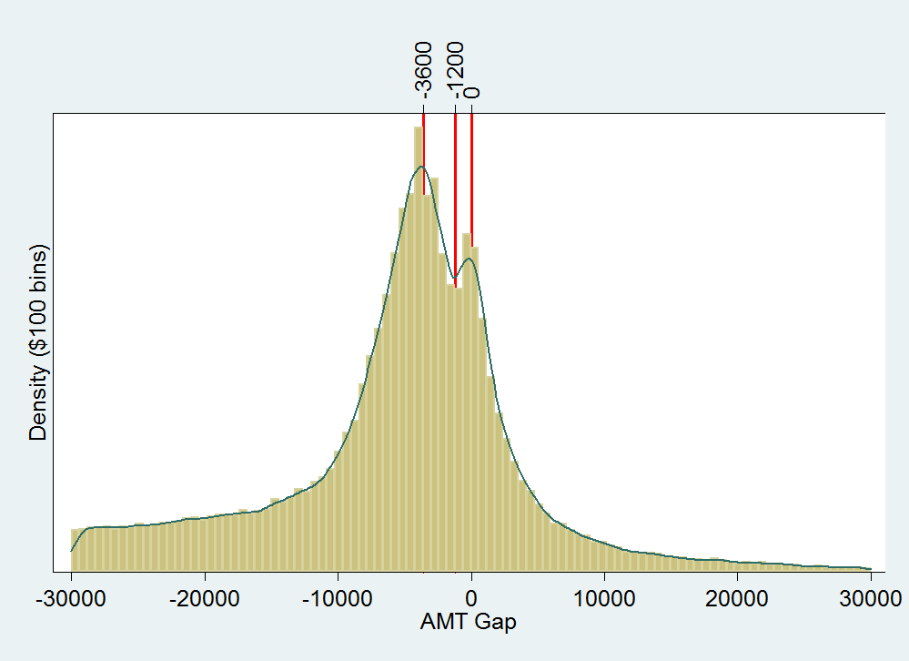
Note: The solid line represents the kernel density estimate for the tax gap distribution.
Figure A. 1 Kernel Density of AMT Gap, 1994-2002.

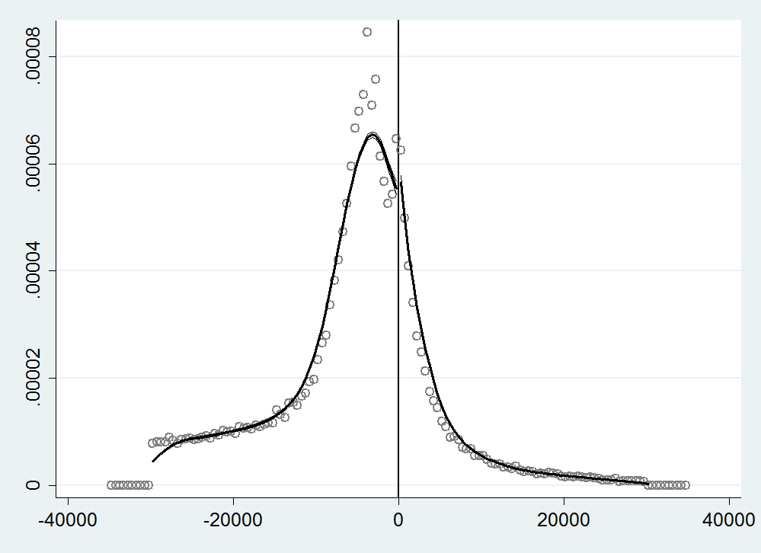

Figure A. 2 McCrary Test of Estimated Density of AMT Gap ($0), 1994-2002.

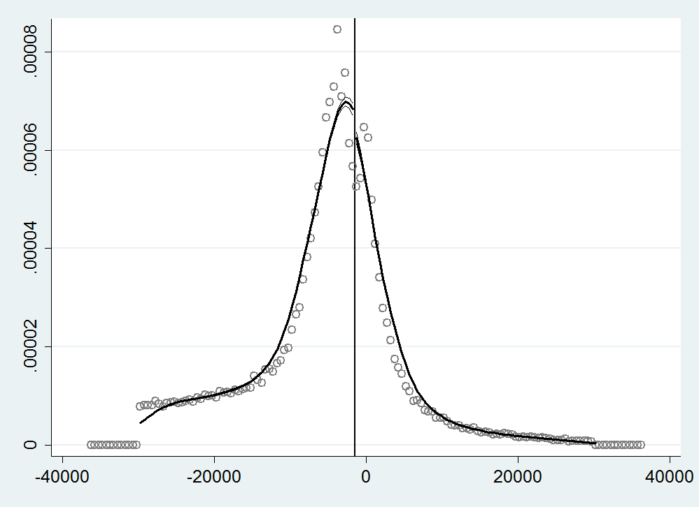
Figure A. 3 McCrary Test of Estimated Density of AMT Gap (-$1,200), 1994-2002.

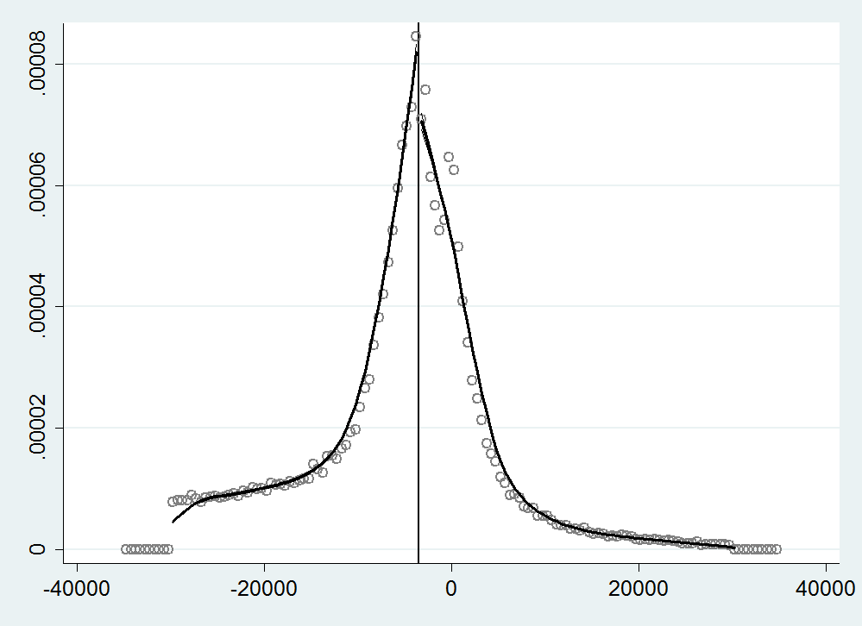
Figure A. 4 McCrary Test of Estimating Density of AMT Gap (-$3,600), 1994-2002.

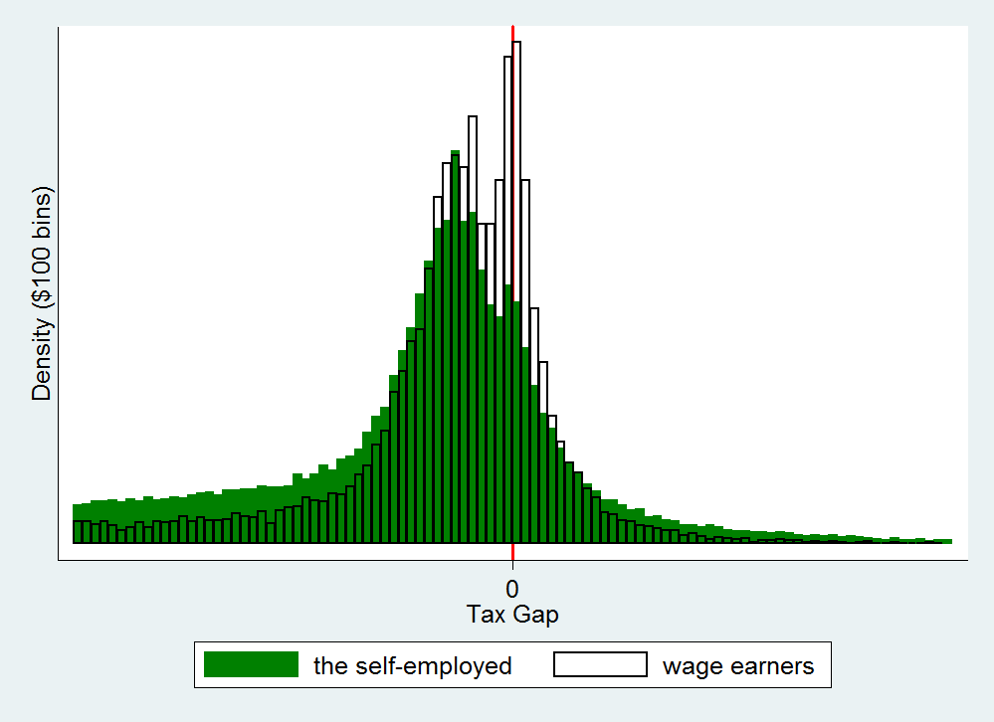
Figure A. 5 The AMT Gap by Self-employment Status (Broad Definition).

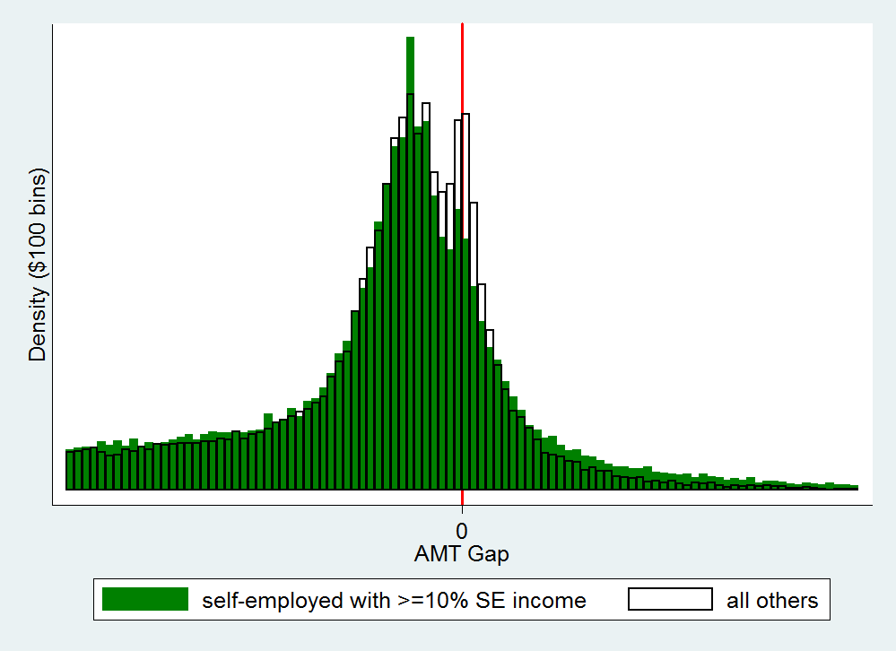
Figure A. 6 The AMT Gap by Self-employment Status (Narrower Definition).

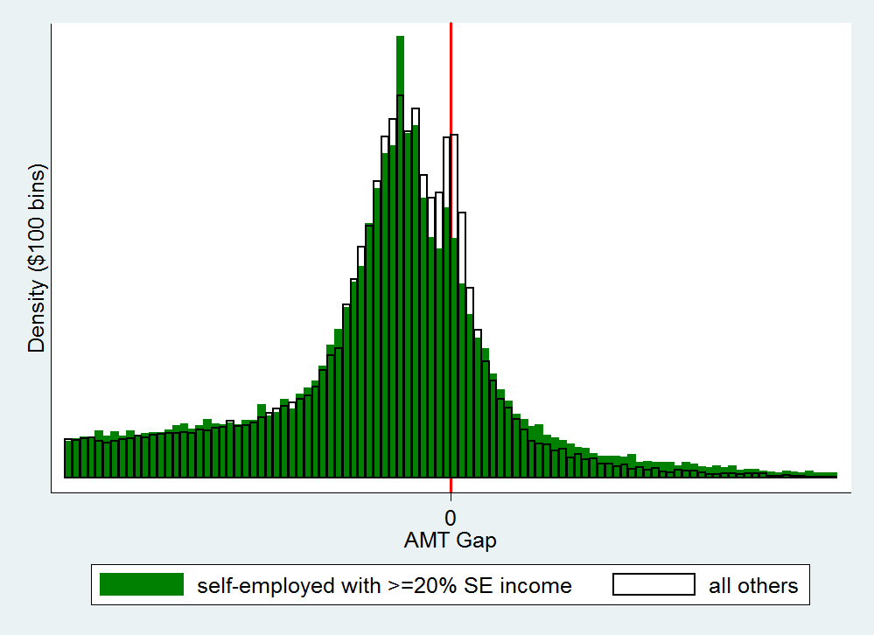
Figure A. 7 The AMT Gap by Self-employment Status (The Narrowest Definition).

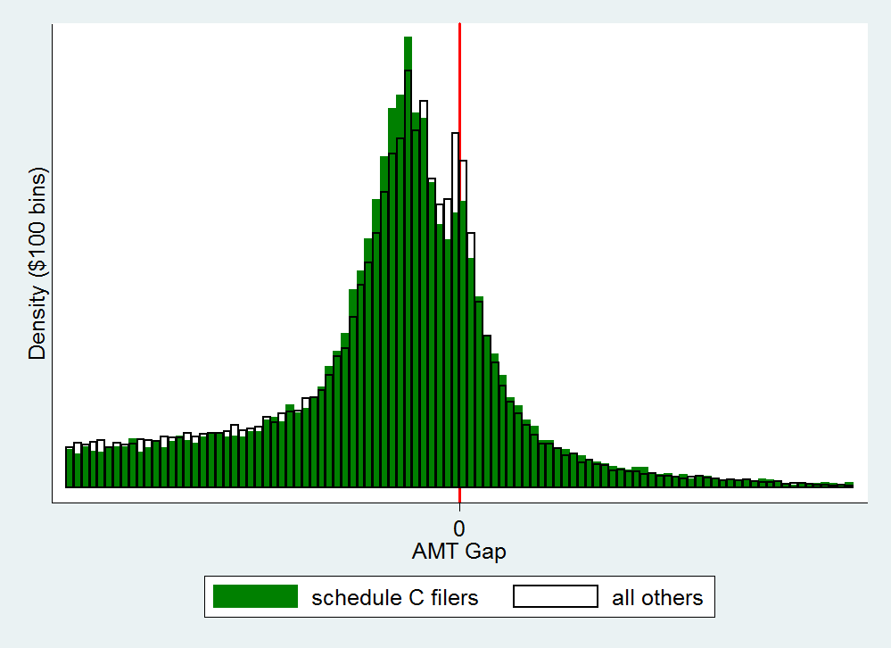
Figure A. 8 The AMT Gap by Self-employment Status (Schedule C).

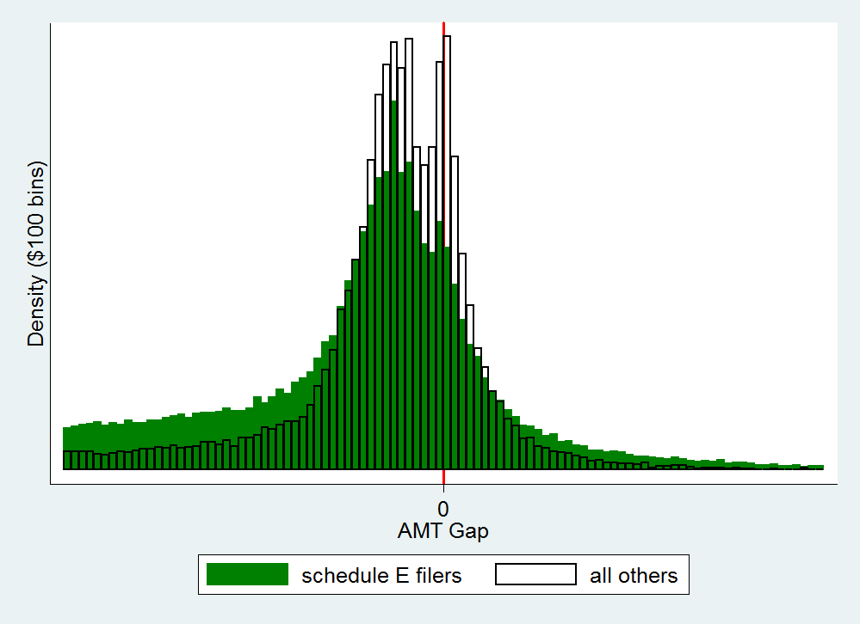
Figure A. 9 The AMT Gap by Self-employment Status (Schedule E).

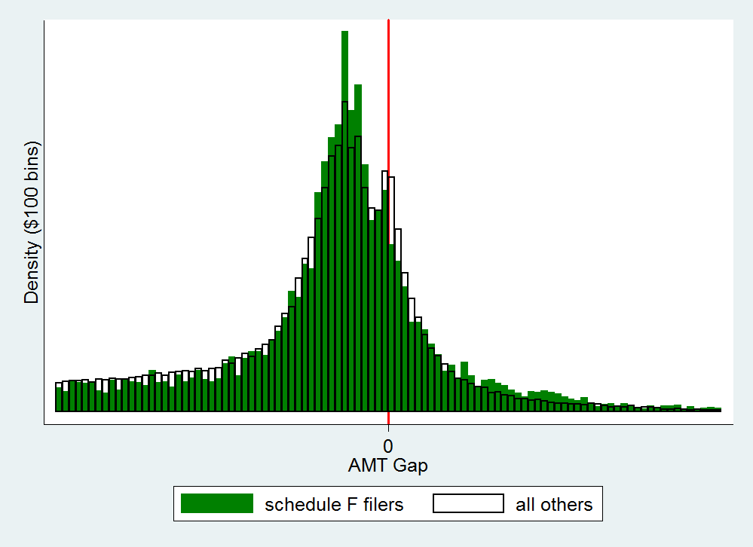
Figure A. 10 The AMT Gap by Self-employment Status (Schedule F).

Table A. 1 Test for Breaks in the Estimated Density of the AMT Gap, 1994-2002.
 | Test 1 (0) | Test 2 (–$1200) | Test 3 (–$3600)
$$\hat{θ}$$ | 0.104*** | –0.048*** | –0.167***
 | (0.106) | (0.014) | (0.015)
binsize | 500 | 500 | 500
bandwidth | 4892.5 | 6046.0 | 4751.6
Notes: *** indicates 1% statistical significance.

Table A. 2 Summary Statistics of the Self-Employed and Wage Earners.
Variable | Self-Employed | Wage Earners
Adjusted Gross Income (median) | 255,105.3 | 168,427.9
AMT Liability (median) | 40,813.17 | 16,377.75
Regular Tax Liability (median) | 41,190 | 19,190
Single (=1 if filed as single) | 0.14 | 0.27
Head of Household (=1 if filed as head of household) | 0.02 | 0.04
Married Filing Jointly (=1 if filed jointly) | 0.81 | 0.66
Married Filing Separately(=1 if filed separately) | 0.02 | 0.03
Total Number of Exemptions | 2.72 | 2.52
State and Local Tax (median) | 9,023.1 | 2,552.0
AMT Gap (median) | –4,302.8 | –2,887.4
% Pay AMT | 0.23 | 0.27
Sample Size | 100,198 | 20,290

Table A. 3 Regression on Response to AMT Gap (All Self-employed).
Variable | ln(Interest Paid Ratio) | ln(Property Tax Ratio) | ln(Charitable Donation Raio)
AMT Gap | 0.00001*** | 0.00002*** | 0.00001***
 | (0.000003) | (0.000002) | (0.000003)
The Self–employed | 0.054* | 0.031 | 0.268***
 | (0.030) | (0.019) | (0.029)
The Self–employed *AMT Gap | 0.000005* | –0.0000008 | –0.000007***
 | (0.000003) | (0.000002) | (0.000003)
AMT Payers | –1.417*** | –0.902*** | –0.865***
 | (0.050) | (0.031) | (0.046)
AMT Payers*AMT Gap | –0.00003*** | –0.00001*** | 0.000004
 | (0.000007) | (0.000004) | (0.000006)
The Self-employed*AMT Payers | 0.094* | 0.180*** | –0.006
 | (0.049) | (0.031) | (0.046)
The Self-employed*AMT*AMT Gap | 0.00002** | 0.000003 | 0.00002***
 | (0.000007) | (0.000004) | (0.000006)
Marginal Tax Rate | –5.387*** | –3.725*** | –3.468***
 | (0.079) | (0.051) | (0.074)
Total Number of Exemption | 0.080*** | 0.007* | 0.060***
 | (0.005) | (0.003) | (0.005)
Married and File Jointly | –0.062*** | 0.048*** | 0.116***
 | (0.018) | (0.011) | (0.016)
Age 65 and Above | –0.694*** | 0.117*** |  | 0.597***
 | (0.017) | (0.009) |  | (0.014)
Sample Size | 79,594 | 89,657 |  | 91,037
Notes: *** , **, *indicates 1% , 5% and 10% statistical significance respectively.

Table A. 4 Regression on Response to AMT Gap (Schedule C Filers only).
Variable | ln(Business Expense Ratio)
AMT Gap | 0.00002***
 | (0.000002)
AMT Payers | –0.062
 | (0.056)
AMT Gap*AMT Payers | –0.00002***
 | (0.000004)
Marginal Tax Rate | –0.875***
 | (0.163)
Total Number of Exemption | 0.023**
 | (0.010)
Married and File Jointly | –0.145***
 | (0.038)
Age 65 and Above | –0.064**
 | (0.034)
Sample Size | 23,320
Notes: *** , **, *indicates 1% , 5% and 10% statistical significance respectively.

Table A. 5 Regression on Response to AMT Gap (20% Self-employment Income).
Variable | ln(Interests Paid Ratio) | ln(Property Tax Ratio) | ln(Charitable Donation Raio)
AMT Gap | 0.00002*** | 0.00003*** | 0.000007***
 | (0.000001) | (0.000001) | (0.000001)
The Self–employed | 0.410*** | 0.303*** | 0.405***
 | (0.020) | (0.013) | (0.019)
The Self–employed *AMT Gap | –0.000002 | –0.000002 | –0.000008***
 | (0.000002) | (0.000001) | (0.000002)
AMT Payers | –1.236*** | –0.687*** | –0.800***
 | (0.033) | (0.021) | (0.030)
AMT Payers*AMT Gap | –0.00002*** | –0.00001*** | 0.00002***
 | (0.000003) | (0.000002) | (0.000003)
The Self-employed*AMT Payers | –0.130*** | –0.101*** | –0.1000**
 | (0.037) | (0.023) | (0.034)
The Self-employed*AMT*AMT Gap | 0.00002*** | 0.0000003 | 0.00001***
 | (0.000004) | (0.000003) | (0.000004)
Marginal Tax Rate | –5.253*** | –3.662*** | –3.387***
 | (0.079) | (0.050) | (0.074)
Total Number of Exemption | 0.075*** | 0.003 | 0.054***
 | (0.005) | (0.003) | (0.005)
Married and File Jointly | –0.061*** | 0.050*** | 0.132***
 | (0.018) | (0.011) | (0.016)
Age 65 and Above | –0.672*** | 0.138*** | 0.632***
 | (0.016) | (0.009) | (0.014)
Sample Size | 79,594 | 89,657 | 91,037
Notes: *** , **, *indicates 1% , 5% and 10% statistical significance respectively.

Table A. 6 Regressions on Response to AMT Gap (Interest Paid Ratios).
Variable | Year 1994 | Year 1995 | Year 1996 | Year 1997 | Year 1998 | Year 1999 | Year 2000 | Year 2001 | Year 2002
AMT Gap | 0.00001 | 0.00002** | 0.000004 | 0.00002* | 0.00002** | 0.00003*** | 0.00003*** | –0.000003 | 0.00002***
 | (0.00001) | (0.000009) | (0.000007) | (0.000009) | (0.00001) | (0.00001) | (0.00001) | (0.00001) | (0.00001)
The Self–employed | 0.029 | 0.020 | 0.133 | –0.032 | –0.077 | –0.051 | –0.038 | 0.251*** | –0.112
 | (0.121) | (0.104) | (0.071) | (0.106) | (0.111) | (0.108) | (0.095) | (0.064) | (0.087)
The Self–employed *  AMT Gap | 0.00001 | 0.00000 | 0.00001 | 0.000001 | 0.000001 | –0.00001 | –0.00001 | 0.00002* | –0.0000001
 | (0.00001) | (0.00001) | (0.00001) | (0.00001) | (0.00001) | (0.00001) | (0.00001) | (0.00001) | (0.00001)
AMT Payers | –1.547*** | –1.237*** | –1.257*** | –1.415*** | –1.220*** | –0.928*** | –1.220*** | –1.465*** | –1.791***
 | (0.206) | (0.201) | (0.149) | (0.209) | (0.212) | (0.195) | (0.166) | (0.100) | (0.109)
AMT Payers*AMT Gap | –0.00001 | –0.0001*** | –0.00003 | –0.00005 | –0.00004 | –0.00005* | –0.00003 | 0.000001 | –0.00003*
 | (0.00003) | (0.00003) | (0.00003) | (0.00003) | (0.00003) | (0.00003) | (0.00002) | (0.00001) | (0.00001)
The Self-employed*  AMT Payers | 0.327 | 0.111 | 0.078 | 0.139 | 0.182 | 0.051 | 0.097 | –0.024 | 0.179
 | (0.203) | (0.196) | (0.143) | (0.207) | (0.208) | (0.190) | (0.159) | (0.104) | (0.109)
The Self-employed*AMT*AMT Gap | –0.00001 | 0.00009** | 0.00004 | 0.00005 | 0.00004 | 0.00006* | 0.00003 | –0.00001 | 0.00002
 | (0.00003) | (0.00003) | (0.00003) | (0.00003) | (0.00003) | (0.00003) | (0.00002) | (0.00001) | (0.00002)
Marginal Tax Rate | –5.006*** | –4.914*** | –5.017*** | –5.375*** | –4.875*** | –3.920*** | –4.876*** | –5.858*** | –6.043***
 | (0.287) | (0.282) | (0.273) | (0.295) | (0.303) | (0.290) | (0.269) | (0.159) | (0.168)
Total Number of Exemption | 0.075*** | 0.094*** | 0.053*** | 0.075*** | 0.082*** | 0.115*** | 0.100*** | 0.060*** | 0.079***
 | (0.015) | (0.014) | (0.014) | (0.016) | (0.017) | (0.017) | (0.016) | (0.013) | (0.013)
Married and File Jointly | –0.064 | –0.131* | 0.003 | –0.087 | 0.037 | –0.044 | –0.117* | 0.022 | –0.181***
 | (0.056) | (0.055) | (0.054) | (0.060) | (0.060) | (0.059) | (0.054) | (0.045) | (0.046)
Age 65 and Above | –0.771*** | –0.731*** | –0.617*** | –0.891*** | –0.744*** | –0.696*** | –0.678*** | –0.568*** | –0.648***
 | (0.052) | (0.051) | (0.054) | (0.056) | (0.056) | (0.054) | (0.047) | (0.042) | (0.042)
Sample Size | 7684 | 8100 | 8244 | 6913 | 7788 | 8383 | 10172 | 11287 | 11023
Notes: *** , **, *indicates 1% , 5% and 10% statistical significance respectively.

Appendix B
Panel 1: Nonfarm Proprietors’ Income and Employment
Panel 2: NFPI as a Share of Total Income, NFPE as a Share of Total Employment, and Nonfarm Proprietors’ Productivity.
Figure B. 1 U.S. Nonfarm Proprietors’ Income, Employment and Productivity.

Table B. 1 State Nonfarm Proprietors’ Income.
 | Nonfarm Proprietors’ Income
State | Per Capita |  | As a Share of Total Personal Income |  | State’s Share of National Nonfarm Proprietors’ Income
State | 1978 | 2009 | 1978 | 2009 | 1978 | 2009
Alabama | 1542 | 2207 | 0.072 | 0.066 | 0.012 | 0.012
Alaska | 3844 | 3747 | 0.094 | 0.087 | 0.003 | 0.003
Arizona | 1903 | 2275 | 0.077 | 0.068 | 0.010 | 0.017
Arkansas | 1930 | 1933 | 0.091 | 0.060 | 0.009 | 0.006
California | 2933 | 3515 | 0.093 | 0.083 | 0.139 | 0.145
Colorado | 2784 | 3833 | 0.100 | 0.092 | 0.016 | 0.021
Connecticut | 2231 | 4796 | 0.070 | 0.087 | 0.014 | 0.019
Delaware | 1952 | 2569 | 0.068 | 0.064 | 0.002 | 0.003
Florida | 1994 | 2011 | 0.077 | 0.052 | 0.038 | 0.042
Georgia | 1763 | 2398 | 0.077 | 0.071 | 0.019 | 0.026
Hawaii | 1718 | 2419 | 0.057 | 0.058 | 0.003 | 0.003
Idaho | 2777 | 2711 | 0.116 | 0.086 | 0.005 | 0.005
Illinois | 2260 | 2718 | 0.074 | 0.065 | 0.053 | 0.039
Indiana | 1833 | 1997 | 0.070 | 0.059 | 0.021 | 0.014
Iowa | 2431 | 2487 | 0.088 | 0.066 | 0.015 | 0.008
Kansas | 2525 | 2666 | 0.096 | 0.068 | 0.012 | 0.008
Kentucky | 2037 | 1876 | 0.092 | 0.058 | 0.015 | 0.009
Louisiana | 1933 | 2783 | 0.085 | 0.074 | 0.016 | 0.014
Maine | 2050 | 2690 | 0.093 | 0.074 | 0.005 | 0.004
Maryland | 1658 | 2884 | 0.055 | 0.060 | 0.014 | 0.018
Massachusetts | 1859 | 3628 | 0.067 | 0.073 | 0.022 | 0.027
Michigan | 1637 | 1918 | 0.057 | 0.056 | 0.031 | 0.021
Minnesota | 1953 | 2512 | 0.071 | 0.060 | 0.016 | 0.015
Mississippi | 1717 | 2029 | 0.090 | 0.067 | 0.009 | 0.007
Missouri | 2123 | 2825 | 0.084 | 0.079 | 0.021 | 0.019
Montana | 2969 | 2721 | 0.118 | 0.078 | 0.005 | 0.003
Nebraska | 2524 | 2840 | 0.096 | 0.072 | 0.008 | 0.006
Nevada | 2558 | 2527 | 0.080 | 0.067 | 0.004 | 0.007
New Hampshire | 2022 | 3564 | 0.079 | 0.084 | 0.004 | 0.005
New Jersey | 2077 | 3867 | 0.067 | 0.077 | 0.032 | 0.038
New Mexico | 1883 | 1866 | 0.083 | 0.056 | 0.005 | 0.004
New York | 2373 | 4184 | 0.081 | 0.090 | 0.087 | 0.091
North Carolina | 1582 | 2071 | 0.072 | 0.060 | 0.019 | 0.022
North Dakota | 2516 | 2706 | 0.095 | 0.066 | 0.003 | 0.002
Ohio | 1785 | 2268 | 0.065 | 0.064 | 0.040 | 0.029
Oklahoma | 2765 | 2879 | 0.115 | 0.080 | 0.017 | 0.012
Oregon | 2612 | 2525 | 0.095 | 0.070 | 0.014 | 0.011
Pennsylvania | 2236 | 2870 | 0.082 | 0.071 | 0.055 | 0.040
Rhode Island | 1535 | 2477 | 0.061 | 0.060 | 0.003 | 0.003
South Carolina | 1387 | 1791 | 0.067 | 0.055 | 0.009 | 0.009
South Dakota | 2721 | 2813 | 0.113 | 0.074 | 0.004 | 0.003
Tennessee | 2070 | 3734 | 0.092 | 0.109 | 0.019 | 0.026
Texas | 2776 | 4066 | 0.107 | 0.105 | 0.078 | 0.112
Utah | 2091 | 2443 | 0.090 | 0.077 | 0.006 | 0.008
Vermont | 2196 | 2750 | 0.096 | 0.070 | 0.002 | 0.002
Virginia | 1728 | 2344 | 0.065 | 0.053 | 0.019 | 0.021
Washington | 2459 | 2961 | 0.085 | 0.069 | 0.020 | 0.022
West Virginia | 1675 | 1851 | 0.076 | 0.058 | 0.007 | 0.004
Wisconsin | 1812 | 2233 | 0.067 | 0.060 | 0.017 | 0.014
Wyoming | 3750 | 3491 | 0.122 | 0.072 | 0.003 | 0.002
Table B. 2 State Nonfarm Proprietors’ Employment and Productivity.
State | Nonfarm Proprietors’ Employment Share of Total Employment |  | State’s Share of National Nonfarm Proprietors’ Employment |  | Nonfarm Proprietors’ Productivity (income/employment)
State | 1978 | 2009 | 1978 | 2009 | 1978 | 2009
Alabama | 0.105 | 0.195 | 0.014 | 0.014 | 32,911 | 21,171
Alaska | 0.169 | 0.209 | 0.003 | 0.003 | 38,713 | 28,132
Arizona | 0.128 | 0.215 | 0.012 | 0.020 | 32,439 | 21,555
Arkansas | 0.137 | 0.179 | 0.011 | 0.008 | 31,010 | 20,206
California | 0.131 | 0.232 | 0.121 | 0.130 | 43,293 | 28,159
Colorado | 0.152 | 0.240 | 0.018 | 0.021 | 33,684 | 25,332
Connecticut | 0.113 | 0.224 | 0.014 | 0.014 | 37,897 | 34,253
Delaware | 0.090 | 0.185 | 0.002 | 0.003 | 42,474 | 23,130
Florida | 0.146 | 0.226 | 0.048 | 0.063 | 29,229 | 16,664
Georgia | 0.110 | 0.222 | 0.023 | 0.033 | 32,334 | 19,980
Hawaii | 0.102 | 0.193 | 0.004 | 0.005 | 29,598 | 19,443
Idaho | 0.147 | 0.236 | 0.005 | 0.006 | 37,474 | 20,121
Illinois | 0.104 | 0.189 | 0.047 | 0.039 | 42,994 | 25,433
Indiana | 0.108 | 0.168 | 0.022 | 0.017 | 34,856 | 21,647
Iowa | 0.122 | 0.173 | 0.014 | 0.010 | 38,286 | 22,021
Kansas | 0.142 | 0.184 | 0.014 | 0.009 | 33,192 | 22,515
Kentucky | 0.125 | 0.167 | 0.016 | 0.011 | 35,773 | 20,691
Louisiana | 0.109 | 0.207 | 0.016 | 0.015 | 39,114 | 23,627
Maine | 0.147 | 0.226 | 0.006 | 0.005 | 29,261 | 19,524
Maryland | 0.097 | 0.211 | 0.015 | 0.020 | 35,611 | 23,091
Massachusetts | 0.107 | 0.196 | 0.025 | 0.023 | 33,536 | 29,622
Michigan | 0.097 | 0.205 | 0.032 | 0.029 | 37,196 | 18,518
Minnesota | 0.108 | 0.184 | 0.018 | 0.018 | 34,057 | 20,942
Mississippi | 0.112 | 0.189 | 0.010 | 0.008 | 34,754 | 21,203
Missouri | 0.120 | 0.182 | 0.024 | 0.018 | 34,400 | 26,405
Montana | 0.166 | 0.239 | 0.005 | 0.004 | 35,924 | 17,773
Nebraska | 0.135 | 0.175 | 0.009 | 0.006 | 34,290 | 23,814
Nevada | 0.111 | 0.215 | 0.004 | 0.009 | 38,508 | 20,468
New HHassHampHampshire | 0.133 | 0.220 | 0.005 | 0.005 | 30,346 | 26,113
New Jersey | 0.104 | 0.205 | 0.028 | 0.029 | 42,324 | 32,915
New Mexico | 0.118 | 0.191 | 0.005 | 0.006 | 34,898 | 18,295
New York | 0.109 | 0.200 | 0.071 | 0.062 | 45,992 | 37,381
North Carolina | 0.106 | 0.194 | 0.024 | 0.029 | 29,085 | 19,101
North Dakota | 0.128 | 0.167 | 0.003 | 0.002 | 37,061 | 21,216
Ohio | 0.106 | 0.182 | 0.043 | 0.033 | 35,032 | 22,201
Oklahoma | 0.151 | 0.204 | 0.017 | 0.012 | 37,293 | 24,289
Oregon | 0.146 | 0.210 | 0.015 | 0.013 | 34,757 | 20,846
Pennsylvania | 0.106 | 0.176 | 0.046 | 0.035 | 45,197 | 28,886
Rhode Island | 0.102 | 0.185 | 0.004 | 0.003 | 30,292 | 24,056
South Carolina | 0.098 | 0.213 | 0.011 | 0.015 | 29,396 | 15,597
South Dakota | 0.144 | 0.189 | 0.004 | 0.003 | 36,660 | 21,785
Tennessee | 0.118 | 0.210 | 0.020 | 0.021 | 35,363 | 31,578
Texas | 0.132 | 0.225 | 0.071 | 0.090 | 41,126 | 31,449
Utah | 0.121 | 0.228 | 0.006 | 0.011 | 36,215 | 18,230
Vermont | 0.146 | 0.242 | 0.003 | 0.003 | 29,713 | 16,913
Virginia | 0.112 | 0.177 | 0.024 | 0.024 | 30,027 | 21,960
Washington | 0.130 | 0.193 | 0.020 | 0.021 | 38,020 | 26,712
West Virginia | 0.105 | 0.162 | 0.006 | 0.004 | 39,459 | 22,922
Wisconsin | 0.112 | 0.168 | 0.021 | 0.016 | 31,686 | 21,722
Wyoming | 0.140 | 0.215 | 0.003 | 0.002 | 46,492 | 22,767

Table B. 3 Variable Definitions and Means.
Variable | Definition | 1978 | 2009
NFPI | Nonfarm proprietors’ income ($1,000s) | 9,666,381 | 17,900,000
NFPI per capita | Nonfarm proprietors’ income per capita | 2189 | 2745
NFPI as a share of total income | Nonfarm proprietors’ income as a share of total income in a state (%) | 8.36 | 7.06
State share of national NFPI | Nonfarm proprietors’ income as state share of national NFPI (%) | 2 | 2
NFPE | Nonfarm proprietors’ employment (in thousands) | 256,572 | 708,628
NFPE as a share of total employment | Nonfarm proprietors’ employment as a share of total employment in a state (%) | 12.21 | 20.05
State share of national NFPE | Nonfarm proprietors’ employment as state share of national NFPE (%) | 2 | 2
Nonfarm proprietors’ productivity | NFPI divided by NFPE ($1,000s) | 35784 | 23247
Sales tax rate | Maximum state sales tax rate (%) | 3.54 | 5.07
Top PIT rate | Maximum personal income tax rate (%) | 6.9 | 5.47
Top CIT rate | Maximum corporate income tax rate (%) | 5.95 | 6.56
Expenditures per capita | State general expenditures per capita ($1,000s) | 2.88 | 5.55
Sales factor weight | Sales factor apportionment (%) | 32.3 | 57.2
Unemployment rate | State unemployment rate (%) | 5.62 | 8.45
Age > 64 | Percent of population aged older than 64 (%) | 10.72 | 13.16
Crime rate | Property crime, rate per 100,000 inhabitants | 4.39 | 2.94
Female percentage | Female percent of total population (%) | 51.02 | 50.58
Nonfarm job growth | Annual percentage growth in total nonfarm employment (%) | 5.72 | -4.18
Agriculture share of GSP | Agricultural share of Gross State Product (%) | 3.9 | 1.61
Manufacturing share of GSP | Manufacturing share of Gross State Product (%) | 20.91 | 11.1
Population density | State population density (people per square mile) | 153 | 193
Amnesty | =1 if state has an amnesty | 0 | 0.14

Table B. 4 Arellano-Bond Estimates.

 | Nonfarm Proprietors’ Income |  |  | Nonfarm Proprietors’ Employment |  | Nonfarm Proprietors’  Productivity
 | Per Capita | As a Share of Total Income | State Share of National NFPI | As a Share of Total Employment | State Share of National NFPE
Sales tax rate | –0.009 | 0.009 | –0.017 | –0.019 | 0.004 |  | –0.052
 | (0.016) | (0.042) | (0.014) | (0.016) | (0.024) |  | (0.193)
Top PIT rate | 0.006 | 0.028 | –0.001 | 0.001 | –0.005 |  | –0.030
 | (0.011) | (0.029) | (0.006) | (0.012) | (0.004) |  | (0.138)
Top CIT rate | –0.009 | –0.020 | 0.007 | –0.004 | –0.003 |  | –0.173
 | (0.019) | (0.047) | (0.047) | (0.012) | (0.005) |  | (0.188)
Expenditures per capita | 0.051 | 0.104 | 0.044 | 0.063 | 0.0004 |  | 0.760***
 | (0.045) | (0.077) | (0.032) | (0.050) | (0.016) |  | (0.186)
Sales factor weight | –0.001* | –0.001 | 0.0002 | 0.001 | –0.0002 |  | –0.011**
 | (0.001) | (0.001) | (0.001) | (0.001) | (0.0002) |  | (0.005)
Unemployment rate | 0.008 | 0.086*** | 0.002 | 0.123*** | 0.006 |  | –0.130*
 | (0.007) | (0.024) | (0.014) | (0.016) | (0.005) |  | (0.071)
Age > 64 | 0.022 | –0.002 | 0.074 | –0.109** | 0.010 |  | 0.886*
 | (0.037) | (0.106) | (0.088) | (0.054) | (0.035) |  | (0.497)
Amnesty | 0.009 | 0.082 | 0.014 | –0.009 | –0.010 |  | 0.227
 | (0.023) | (0.069) | (0.032) | (0.018) | (0.007) |  | (0.259)
Amnesty count | 0.008 | –0.020 | 0.007 | –0.007 | –0.011 |  | –0.060
 | (0.014) | (0.040) | (0.045) | (0.024) | (0.008) |  | (0.177)
Crime rate | –0.077** | –0.072 | –0.022 | 0.039 | 0.029 |  | –0.402
 | (0.033) | (0.070) | (0.133) | (0.030) | (0.020) |  | (0.305)
Female percentage | 0.184** | 0.117 | –0.367* | –0.046 | –0.115 |  | 0.172
 | (0.084) | (0.177) | (0.199) | (0.070) | (0.114) |  | (0.725)
Agriculture share of GSP | 0.013 | –0.096*** | –0.0001 | –0.008 | –0.005 |  | 0.152**
 | (0.009) | (0.030) | (0.009) | (0.008) | (0.003) |  | (0.077)
Manufacturing share of GSP | –0.009** | –0.025** | –0.007 | –0.013*** | –0.001 |  | –0.045
 | (0.004) | (0.011) | (0.004) | (0.005) | (0.002) |  | (0.043)
Nonfarm job growth | 0.002* | 0.004 | 0.002** | 0.117*** | 0.015 |  | –0.202***
 | (0.001) | (0.003) | (0.001) | (0.003) | (0.003) |  | (0.019)
Population density | 0.001 | 0.004 | 0.001 | 0.004** | 0.0004 |  | –0.024
 | (0.001) | (0.004) | (0.004) | (0.002) | (0.001) |  | (0.025)
L1 | 0.621*** | 0.547*** | 0.516*** | 0.911*** | 0.679*** |  | 0.729***
 | (0.114) | (0.084) | (0.134) | (0.026) | (0.160) |  | (0.054)
L2 | –0.040 | –0.038 | –0.048 | –0.045*** | 0.081*** |  | –0.082***
 | (0.038) | (0.032) | (0.052) | (0.017) | (0.016) |  | (0.023)
Table B. 5 Arellano-Bover/Blundell-Bond Estimates.
 | Nonfarm Proprietors’ Income |  |  | Nonfarm Proprietors’ Employment |  | Nonfarm Proprietors’  Productivity
 | Per Capita | As a Share of Total Income | State Share of National NFPI | Per Capita | As a Share of Total Income | State Share of National NFPI
Sales tax rate | –0.008 | –0.045 | 0.055 | –0.038* | –0.00002 |  | 0.330**
 | (0.020) | (0.049) | (0.044) | (0.023) | (0.010) |  | (0.165)
Top PIT rate | –0.006 | 0.0003 | 0.003 | –0.008 | –0.009** |  | –0.100
 | (0.011) | (0.031) | (0.012) | (0.010) | (0.004) |  | (0.135)
Top CIT rate | –0.024 | –0.031 | 0.023 | –0.010 | –0.0002 |  | –0.314**
 | (0.018) | (0.040) | (0.016) | (0.012) | (0.004) |  | (0.153)
Expenditures per capita | 0.049 | 0.074 | –0.089 | –0.033* | –0.009 |  | 0.466
 | (0.035) | (0.064) | (0.081) | (0.018) | (0.011) |  | (0.519)
Sales factor weight | 0.00004 | 0.002 | 0.002 | 0.001 | –0.0005 |  | –0.006
 | (0.001) | (0.002) | (0.002) | (0.001) | (0.0004) |  | (0.006)
Unemployment rate | 0.007 | 0.078*** | –0.021 | 0.116*** | 0.010 |  | –0.174**
 | (0.007) | (0.025) | (0.020) | (0.015) | (0.008) |  | (0.081)
Age > 64 | 0.040 | –0.059 | 0.084 | 0.042* | 0.014 |  | 0.421
 | (0.035) | (0.069) | (0.093) | (0.024) | (0.015) |  | (0.381)
Amnesty | 0.033 | 0.127 | 0.038 | –0.007 | –0.028** |  | 0.282
 | (0.030) | (0.083) | (0.033) | (0.018) | (0.012) |  | (0.296)
Amnesty count | –0.025 | –0.071 | 0.023 | 0.003 | 0.013 |  | –0.145
 | (0.026) | (0.058) | (0.042) | (0.023) | (0.009) |  | (0.236)
Crime rate | –0.051*** | –0.103* | 0.121*** | 0.007 | 0.026 |  | 0.002
 | (0.018) | (0.059) | (0.042) | (0.028) | (0.022) |  | (0.259)
Female percentage | –0.038 | 0.132 | –0.230 | –0.016 | –0.041 |  | 0.265
 | (0.083) | (0.150) | (0.189) | (0.068) | (0.049) |  | (0.821)
Agriculture share of GSP | 0.014 | –0.088*** | –0.007 | 0.012 | –0.005 |  | 0.107
 | (0.011) | (0.027) | (0.010) | (0.013) | (0.004) |  | (0.089)
Manufacturing share of GSP | –0.012** | –0.029*** | –0.005 | –0.017*** | –0.001 |  | –0.032
 | (0.005) | (0.010) | (0.007) | (0.007) | (0.005) |  | (0.047)
Nonfarm job growth | 0.003** | 0.004 | 0.005** | 0.122*** | 0.020*** |  | –0.219***
 | (0.001) | (0.004) | (0.003) | (0.003) | (0.004) |  | (0.021)
Population density | 0.001** | –0.0004 | 0.001 | 0.0004* | 0.0001 |  | 0.010**
 | (0.0005) | (0.0004) | (0.001) | (0.0002) | (0.0002) |  | (0.004)
L1 | 0.825*** | 0.769*** | 0.828*** | 1.016*** | 0.907*** |  | 0.824***
 | (0.087) | (0.061) | (0.081) | (0.022) | (0.039) |  | (0.052)
L2 | 0.001 | 0.004 | 0.129** | –0.067*** | 0.093** |  | –0.062**
 | (0.057) | (0.049) | (0.070) | (0.018) | (0.041) |  | (0.028)
Table B. 6 Comparison to Bruce and Deskins (2012).
Employment stock | Bruce and Deskins (2012) | Arellano-Bond | Simple Replication | Simple Replication and Different Controls | Simple Replication and Different Time | Simple Replication and Arellano-Bond | Simple Replication and Different Controls and Time
Sales tax rate | –0.015 | 0.004 | 0.043 | 0.019 | –0.216*** | –0.046 | –0.161***
 | (0.016) | (0.024) | (0.066) | (0.067) | (0.051) | (0.100) | (0.050)
Top PIT rate | –0.017*** | –0.005 | –0.015 | –0.023 | –0.010 | 0.117*** | 0.0004
 | (0.008) | (0.004) | (0.024) | (0.025) | (0.015) | (0.036) | (0.016)
Top CIT rate | 0.0002 | –0.003 | –0.079** | –0.086*** | –0.062** | 0.002 | –0.043
 | (0.006) | (0.005) | (0.032) | (0.032) | (0.031) | (0.023) | (0.027)
Expenditures per capita | –0.079*** | 0.0004 | 0.051 | 0.096 | 0.038 | 0.003 | 0.116**
 | (0.031) | (0.016) | (0.066) | (0.068) | (0.058) | (0.088) | (0.055)
Sales factor weight | –0.001* | –0.0002 | 0.003 | 0.004*** | 0.002 | 0.008** | 0.011***
 | (0.0004) | (0.0002) | (0.002) | (0.002) | (0.002) | (0.003) | (0.002)
Unemployment rate | 0.009* | 0.006 | 0.220*** | 0.213*** | 0.199*** | 0.197*** | 0.285***
 | (0.006) | (0.005) | (0.030) | (0.031) | (0.025) | (0.050) | (0.022)
Population density | 0.002* | 0.0004 | 0.014*** | 0.016*** | 0.006*** | 0.017*** | 0.017***
 | (0.001) | (0.001) | (0.002) | (0.003) | (0.002) | (0.007) | (0.002)
Agriculture share of GSP | –0.005 | –0.005 | 0.136*** | 0.127*** | 0.228*** | 0.009 | 0.209***
 | (0.004) | (0.003) | (0.029) | (0.030) | (0.027) | (0.043) | (0.028)
Manufacturing share of GSP | 0.005*** | –0.001 | 0.003 | 0.006 | 0.004 | –0.001 | 0.0003
 | (0.004) | (0.002) | (0.011) | (0.011) | (0.010) | (0.015) | (0.010)
Nonfarm job growth | –0.004 | 0.015 | –0.084*** | –0.098*** | –0.108*** | 0.027 | 0.040***
 | (0.003) | (0.003) | (0.017) | (0.018) | (0.015) | (0.020) | (0.007)
Sample Size | 700 | 1450 | 700 | 700 | 1150 | 700 | 1500
Note: *, **, *** Indicate statistical significance at the 10%, 5%, and 1% levels respectively.

Table B. 7 Arellano-Bond Estimates (Exclude the Great Recession 2008-2009).

 |  | Nonfarm Proprietors’ Income |  |  | Nonfarm Proprietors’ Employment |  | Nonfarm Proprietors’  Productivity
 |  | Per Capita | As a Share of Total Income | State Share of National NFPI | As a Share of Total Employment | State Share of National NFPE
 | Sales tax rate | –0.031* | –0.056 | 0.000 | –0.030 | 0.014 |  | –0.232
 |  | (0.014) | (0.045) | (0.020) | (0.019) | (0.026) |  | (0.193)
 | Top PIT rate | 0.005 | 0.018 | –0.006 | 0.004 | –0.005 |  | –0.031
 |  | (0.011) | (0.029) | (0.008) | (0.011) | (0.005) |  | (0.134)
 | Top CIT rate | –0.029* | –0.068 | –0.031 | –0.011 | –0.005 |  | –0.360*
 |  | (0.012) | (0.040) | (0.032) | (0.015) | (0.007) |  | (0.174)
 | Expenditures per capita | 0.047 | 0.117 | 0.025* | 0.059 | 0.000 |  | 0.666**
 |  | (0.049) | (0.062) | (0.013) | (0.046) | (0.015) |  | (0.246)
 | Sales factor weight | –0.001 | –0.001 | 0.000 | 0.001 | 0.000 |  | –0.014*
 |  | (0.000) | (0.001) | (0.001) | (0.001) | (0.000) |  | (0.006)
 | Unemployment rate | 0.006 | 0.078** | 0.006 | 0.115*** | 0.008 |  | –0.136*
 |  | (0.007) | (0.026) | (0.018) | (0.018) | (0.005) |  | (0.068)
 | Age > 64 | –0.013 | 0.003 | 0.047 | –0.129* | 0.006 |  | 0.454
 |  | (0.038) | (0.097) | (0.083) | (0.053) | (0.032) |  | (0.515)
 | Amnesty | –0.017 | –0.009 | 0.007 | –0.017 | –0.013 |  | –0.084
 |  | (0.018) | (0.046) | (0.017) | (0.017) | (0.011) |  | (0.217)
 | Amnesty count | 0.010 | 0.001 | 0.008 | –0.003 | –0.012 |  | 0.025
 |  | (0.011) | (0.033) | (0.030) | (0.025) | (0.008) |  | (0.148)
 | Crime rate | –0.064* | –0.054 | –0.016 | 0.049 | 0.028 |  | –0.186
 |  | (0.029) | (0.064) | (0.130) | (0.030) | (0.019) |  | (0.268)
 | Female percentage | 0.189* | 0.061 | –0.306 | –0.037 | –0.124 |  | –0.213
 |  | (0.079) | (0.156) | (0.182) | (0.077) | (0.123) |  | (0.719)
 | Agriculture share of GSP | 0.014 | –0.092** | 0.000 | –0.005 | –0.004 |  | 0.149*
 |  | (0.009) | (0.029) | (0.007) | (0.008) | (0.003) |  | (0.071)
 | Manufacturing share of GSP | –0.004 | –0.020 | –0.006 | –0.014* | –0.001 |  | –0.058
 |  | (0.003) | (0.011) | (0.005) | (0.006) | (0.001) |  | (0.042)
 | Nonfarm job growth | 0.002 | 0.003 | 0.001 | 0.118*** | 0.015*** |  | –0.196***
 |  | (0.001) | (0.003) | (0.001) | (0.003) | (0.003) |  | (0.019)
 | Population density | 0.001 | 0.002 | 0.002 | 0.004 | 0.001 |  | –0.025
 |  | (0.002) | (0.005) | (0.004) | (0.002) | (0.001) |  | (0.027)
 | L1 | 0.580*** | 0.490*** | 0.560*** | 0.656*** | 0.679*** |  | 0.565***
 |  | (0.082) | (0.075) | (0.026) | (0.170) | (0.160) |  | (0.061)
 | L2 | –0.006 | 0.050 | –0.049 | –0.066*** | 0.081*** |  | –0.101***
 |  | (0.032) | (0.030) | (0.017) | (0.014) | (0.016) |  | (0.440)
Table B. 8 Arellano-Bond Estimates (Exclude Alaska and Hawaii).

 | Nonfarm Proprietors’ Income |  |  | Nonfarm Proprietors’ Employment |  | Nonfarm Proprietors’  Productivity
 | Per Capita | As a Share of Total Income | State Share of National NFPI | As a Share of Total Employment | State Share of National NFPE
Sales tax rate | –0.002 | 0.034 | –0.020 | –0.025 | 0.004 |  | –0.057
 | (0.016) | (0.041) | (0.016) | (0.017) | (0.024) |  | (0.197)
Top PIT rate | –0.004 | 0.000 | –0.006 | –0.013 | –0.006 |  | –0.192
 | (0.008) | (0.023) | (0.005) | (0.007) | (0.005) |  | (0.112)
Top CIT rate | –0.005 | –0.009 | 0.011 | 0.009 | –0.002 |  | –0.108
 | (0.019) | (0.047) | (0.047) | (0.007) | (0.004) |  | (0.175)
Expenditures per capita | 0.009 | 0.005 | 0.044 | 0.100*** | 0.000 |  | 0.730*
 | (0.035) | (0.086) | (0.041) | (0.030) | (0.020) |  | (0.341)
Sales factor weight | –0.001 | –0.001 | 0.000 | 0.001 | 0.000 |  | –0.010*
 | (0.001) | (0.001) | (0.001) | (0.001) | (0.000) |  | (0.005)
Unemployment rate | 0.013 | 0.083*** | 0.003 | 0.109*** | 0.006 |  | –0.086
 | (0.007) | (0.024) | (0.016) | (0.013) | (0.005) |  | (0.079)
Age > 64 | 0.047 | 0.081 | 0.084 | –0.101 | –0.004 |  | 1.208*
 | (0.032) | (0.110) | (0.088) | (0.053) | (0.031) |  | (0.535)
Amnesty | 0.009 | 0.080 | 0.014 | –0.006 | –0.011 |  | 0.187
 | (0.024) | (0.067) | (0.032) | (0.018) | (0.008) |  | (0.261)
Amnesty count | 0.011 | –0.013 | 0.011 | 0.005 | –0.009 |  | 0.002
 | (0.013) | (0.040) | (0.044) | (0.023) | (0.008) |  | (0.179)
Crime rate | –0.120*** | –0.122 | 0.025 | 0.045 | 0.026 |  | –0.656*
 | (0.028) | (0.065) | (0.149) | (0.034) | (0.018) |  | (0.276)
Female percentage | 0.074 | –0.091 | 0.465* | –0.104 | –0.149 |  | –0.458
 | (0.091) | (0.183) | (0.215) | (0.066) | (0.138) |  | (0.852)
Agriculture share of GSP | 0.002 | –0.118*** | 0.002 | –0.010 | –0.005 |  | 0.067
 | (0.004) | (0.018) | (0.009) | (0.008) | (0.003) |  | (0.045)
Manufacturing share of GSP | –0.010* | –0.0255* | 0.007 | –0.016*** | –0.001 |  | –0.060
 | (0.004) | (0.011) | (0.004) | (0.005) | (0.002) |  | (0.043)
Nonfarm job growth | 0.002 | 0.005 | 0.002* | 0.116*** | 0.016*** |  | –0.204***
 | (0.001) | (0.003) | (0.001) | (0.003) | (0.004) |  | (0.020)
Population density | 0.001 | 0.004 | 0.001 | 0.005* | 0.000 |  | –0.016
 | (0.001) | (0.005) | (0.004) | (0.003) | (0.001) |  | (0.025)
L1 | 0.682*** | 0.495*** | 0.508*** | 0.903*** | 0.691*** |  | 0.732***
 | (0.123) | (0.090) | (0.131) | (0.026) | (0.148) |  | (0.056)
L2 | –0.040 | –0.046 | –0.051 | –0.032*** | 0.074*** |  | –0.086***
 | (0.047) | (0.035) | (0.054) | (0.010) | (0.016) |  | (0.026)

Table B. 9 Arellano-Bond Estimates (Lagged Control Variables).

 | Nonfarm Proprietors’ Income |  |  | Nonfarm Proprietors’ Employment |  | Nonfarm Proprietors’  Productivity
 | Per Capita | As a Share of Total Income | State Share of National NFPI | As a Share of Total Employment | State Share of National NFPE
Sales tax rate | –0.040*** | –0.045 | –0.002 | –0.018 | –0.026 |  | –0.292*
 | (0.008) | (0.032) | (0.013) | (0.021) | (0.016) |  | (0.130)
Top PIT rate | –0.011 | 0.002 | –0.004 | –0.023*** | 0.009* |  | –0.169
 | (0.006) | (0.024) | (0.010) | (0.005) | (0.005) |  | (0.088)
Top CIT rate | 0.0001 | –0.035 | –0.021 | –0.003 | –0.009 |  | –0.072
 | (0.011) | (0.032) | (0.034) | (0.009) | (0.011) |  | (0.181)
Expenditures per capita | 0.046 | 0.100 | 0.043 | 0.048 | 0.004 |  | 0.732***
 | (0.038) | (0.062) | (0.030) | (0.050) | (0.014) |  | (0.129)
Sales factor weight | –0.0003 | 0.0007 | 0.0003 | –0.0001 | –0.0003 |  | –0.0033
 | (0.0006) | (0.001) | (0.001) | (0.0008) | (0.0005) |  | (0.0056)
Unemployment rate | 0.005 | 0.088*** | 0.0002 | 0.121*** | 0.007 |  | –0.153*
 | (0.008) | (0.024) | (0.013) | (0.017) | (0.006) |  | (0.077)
Age > 64 | 0.041 | 0.019 | 0.076 | –0.101* | 0.005 |  | 0.958*
 | (0.037) | (0.096) | (0.089) | (0.051) | (0.033) |  | (0.486)
Amnesty | 0.010 | 0.086 | 0.013 | –0.012 | –0.011 |  | 0.240
 | (0.023) | (0.070) | (0.035) | (0.018) | (0.008) |  | (0.256)
Amnesty count | 0.011 | –0.018 | 0.011 | –0.002 | –0.011 |  | –0.061
 | (0.014) | (0.041) | (0.050) | (0.023) | (0.009) |  | (0.176)
Crime rate | –0.072* | –0.075 | –0.019 | 0.034 | 0.027 |  | –0.381
 | (0.035) | (0.065) | (0.135) | (0.030) | (0.019) |  | (0.295)
Female percentage | 0.167* | 0.114 | –0.348 | –0.064 | –0.103 |  | 0.176
 | (0.083) | (0.158) | (0.192) | (0.061) | (0.108) |  | (0.681)
Agriculture share of GSP | 0.015 | –0.090** | 0.001 | –0.006 | –0.004 |  | 0.164*
 | (0.010) | (0.034) | (0.010) | (0.008) | (0.003) |  | (0.069)
Manufacturing share of GSP | –0.009* | –0.025* | –0.007 | –0.014** | –0.001 |  | 0.040
 | (0.004) | (0.011) | (0.005) | (0.005) | (0.001) |  | (0.045)
Nonfarm job growth | 0.002 | 0.004 | 0.002 | 0.117*** | 0.015*** |  | 0.207***
 | (0.001) | (0.003) | (0.001) | (0.003) | (0.003) |  | (0.019)
Population density | 0.001 | 0.004 | 0.001 | 0.005 | 0.0004 |  | 0.024
 | (0.002) | (0.004) | (0.004) | (0.002) | (0.001) |  | (0.026)
L1 | 0.624*** | 0.538*** | 0.513*** | 0.913*** | 0.683*** |  | 0.726***
 | (0.112) | (0.085)) | (0.138) | (0.026) | (0.143) |  | (0.053)
L2 | –0.043 | –0.038 | –0.047 | –0.041*** | 0.077*** |  | –0.088***
 | (0.038) | (0.032) | (0.050) | (0.017) | (0.016) |  | (0.024)

Appendix C
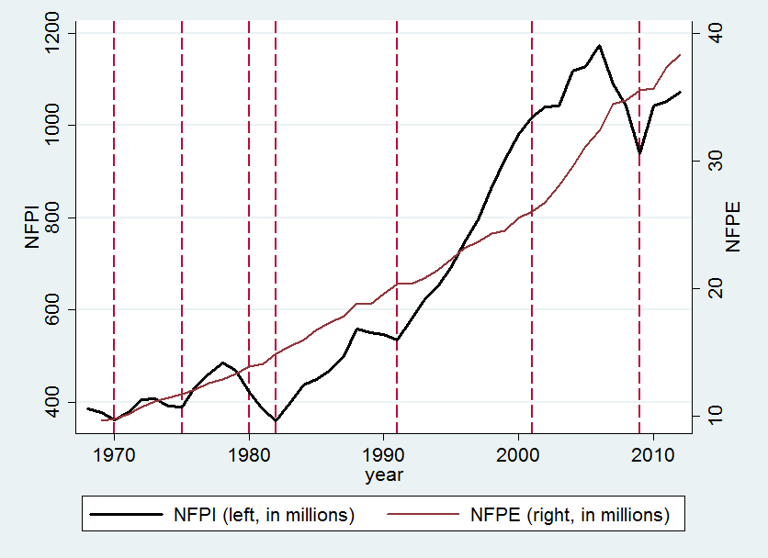
Note: Dashed lines represent troughs of business cycles.
Figure C. 1 Nonfarm Proprietors’ Income and Employment 1969-2012.

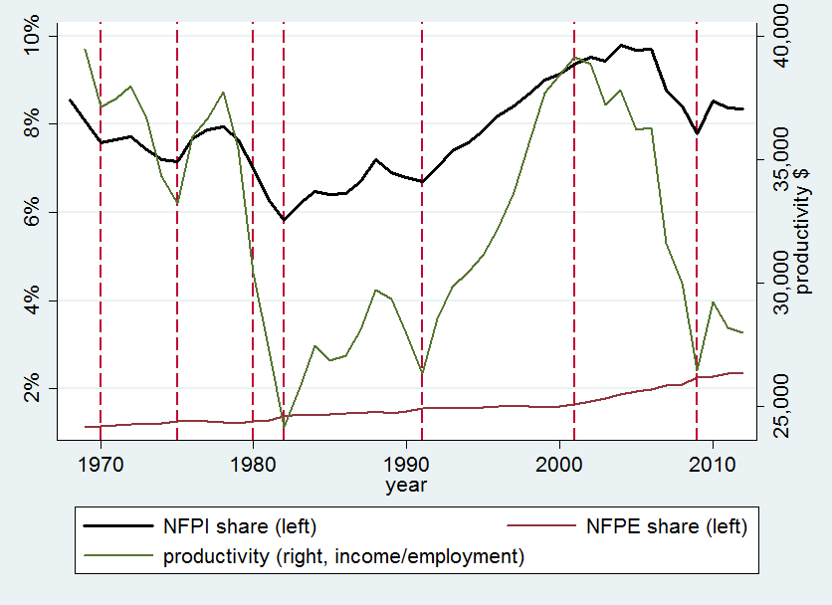
Note: Dashed lines represent troughs of business cycles.
Figure C. 2 NFPI as a Share of Total Income, NFPE as a Share of Total Employment, and Nonfarm Proprietors’ Productivity.

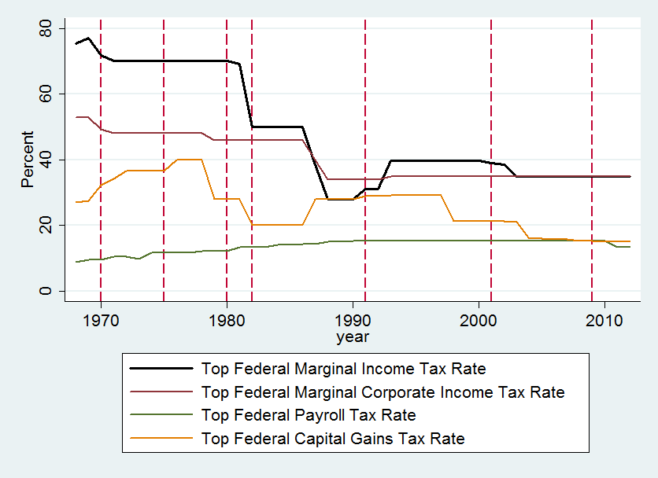
Note: Dashed lines represent troughs of business cycles.
Figure C. 3 Statutory Tax Rates 1969-2012.

Table C.1 Data Definitions
Variable | Definition
Nonfarm proprietors’ income per capita | Nonfarm proprietors’ income per capita (in thousands $)
Nonfarm proprietors’ income share | Nonfarm proprietors’ income as a share of total national income (%)
Nonfarm proprietors’ employment share | Nonfarm proprietors’ employment as a share of total national employment
Nonfarm proprietors’ productivity | Nonfarm proprietors’ income divided by employment ($)
Top personal income tax rate | Highest US federal personal income tax rate (%)
Top corporate income tax rate | Highest US federal personal capital gains tax rate (%)
WS payroll tax rate | Statutory US federal payroll tax rate on wage-and-salary income (%)
Top capital gains tax rate | Highest US federal personal capital gains tax rate (%)
Estate tax exemption | Estate tax exemption amount
Prime rate | Prime interest rate
Government investment expenditure | Federal government’s expenditure on investment
Real GDP growth rate | Growth rate of Gross domestic product
Unemployment rate | US Unemployment rate
Real minimum wage rate | Value of the US minimum wage
Stock of wealth | Flow of funds of the US ($billions)
Age 65 and older | Percent of population age 65 and over (%)
% High school | Percent of population age 16 and over who have completed high school
Work stoppages | Number of work stoppages involving 1000 workers or more
Contraction | Dummy=1 for years in which the economy is in recession

Table C.2 Summary Statistics, 1969-2012
Variables | 1969 | 2012
Nonfarm proprietors’ income per capita ($) | 1,865.06 | 3,415.08
Nonfarm proprietors’ income share (%) | 8.1 | 8.3
Nonfarm proprietors’ employment share (%) | 1.1 | 2.4
Nonfarm proprietors’ productivity ($) | 39,457 | 27,974
Top personal income tax rate | 77 | 35
Top corporate income tax rate | 52.8 | 35
SE payroll tax rate | 9.6 | 13.3
Top capital gains tax rate | 27.5 | 15
Estate tax exemption (in millions $) | 0.06 | 5.12
Prime rate | 7.25 | 3.25
Government investment expenditure (in billions $) | 179.43 | 265.44
Real GDP growth rate | 3.04 | 2.70
Unemployment rate | 3.49 | 8.08
Real minimum wage rate | 9.35 | 6.78
Stock of wealth | 65.7 | 6046.3
Age 65 and older | 17.3 | 18.48
% High school | 54 | 87.60
Work stoppages | 412 | 19

Table C.3 Unit Root Tests
Variables | DF-GLS(lag) | PP | KPSS |  |  | KPSS(trend)
 |  |  | L=1 | L=3 | L=1 |  | L=3
A. Levels
Income per capita | –1.827(4) | –1.965 | 2.00 | 1.04 | 0.30 |  | 0.17
Income share | –1.624(4) | –2.254 | 1.07 | 0.57 | 0.33 |  | 0.19
Employment share | –1.120(2) | 0.197 | 2.01 | 1.09 | 0.39 |  | 0.22
Productivity | –1.277(3) | –1.904 | 0.28 | 0.16 | 0.28 |  | 0.16
Top personal income tax rate | –1.612(1) | –1.494 | 1.82 | 0.97 | 0.38 |  | 0.21
Top corporate income tax rate | –1.912(1) | –1.619 | 1.96 | 1.05 | 0.34 |  | 0.20
Top capital gains tax rate | –3.278(3) | –2.748 | 1.45 | 0.79 | 0.12 |  | 0.07
Payroll tax rate | –0.659(7) | 0.198 | 1.77 | 0.95 | 0.54 |  | 0.31
Estate tax exemption | –1.652(9) | 1.125 | 1.39 | 0.81 | 0.35 |  | 0.21
Prime rate | –2.824(1) | –2.404 | 0.77 | 0.47 | 0.25 |  | 0.17
Real minimum wage | –1.410(1) | –2.076 | 1.63 | 0.90 | 0.37 |  | 0.23
Population | –0.898(1) | –1.434 | 2.31 | 1.22 | 0.53 |  | 0.29
GDP growth rate | –3.847(1) | –4.799 | 0.16 | 0.17 | 0.08 |  | 0.09
Unemployment rate | –2.833(1) | –2.560 | 0.17 | 0.11 | 0.18 |  | 0.13
Stock of wealth | –1.830(8) | –4.639 | 0.33 | 0.34 | 0.03 |  | 0.04
% 65 years old | 0.066(1) | –0.399 | 0.60 | 0.33 | 0.55 |  | 0.30
% High school | –1.979(5) | –1.467 | 2.22 | 1.17 | 0.57 |  | 0.31
Work stoppages | –1.287(3) | –1.792 | 1.85 | 1.01 | 0.50 |  | 0.29
EITC benefits | –1.745(4) | –2.081 | 1.95 | 1.06 | 0.36 |  | 0.21
B. First differences
Income per capita | –1.704(3) | –4.753 | 0.15 | 0.13 | 0.13 |  | 0.11
Income share | –1.924(3) | –4.685 | 0.21 | 0.18 | 0.14 |  | 0.12
Employment share | –3.099(1) | –6.155 | 0.71 | 0.49 | 0.15 |  | 0.13
Productivity | –3.349(2) | –4.628 | 0.15 | 0.13 | 0.13 |  | 0.11
Top personal income tax rate | –3.742(1) | –5.634 | 0.16 | 0.16 | 0.07 |  | 0.07
Top capital income tax rate | –4.284(1) | –4.298 | 0.19 | 0.18 | 0.06 |  | 0.06
Top capital gains tax rate | –4.001(1) | –6.207 | 0.12 | 0.11 | 0.07 |  | 0.07
Payroll tax rate | –4.162(1) | –9.885 | 0.86 | 0.82 | 0.05 |  | 0.07
Estate tax exemption | –2.256(8) | –4.807 | 0.61 | 0.52 | 0.14 |  | 0.15
Prime rate | –4.934(3) | –4.288 | 0.10 | 0.12 | 0.03 |  | 0.04
Real minimum wage | –4.662(1) | –6.114 | 0.32 | 0.29 | 0.04 |  | 0.04
Population | –4.068(1) | –6.294 | 0.42 | 0.39 | 0.07 |  | 0.08
GDP growth rate | –1.510(7) | –9.038 | 0.02 | 0.40 | 0.02 |  | 0.04
Unemployment rate | –4.609(1) | –4.471 | 0.07 | 0.09 | 0.07 |  | 0.09
Stock of wealth | 2.660(7) | –7.982 | 0.03 | 0.05 | 0.03 |  | 0.04
% 65 years old | –4.034(1) | –6.547 | 1.55 | 0.96 | 0.03 |  | 0.04
% High school | –5.333(1) | –6.686 | 1.92 | 1.11 | 0.07 |  | 0.09
Work stoppages | –1.875(7) | –10.172 | 0.21 | 0.40 | 0.02 |  | 0.06
EITC benefits | –4.201(1) | –6.869 | 1.95 | 1.06 | 0.05 |  | 0.06

Table C.4 Multiple Cointegration Test Results
 |  | Nonfarm Proprietors’ Income Per Capita | Nonfarm Proprietors’ Income as a share of national personal income | Nonfarm Proprietors’ Employment as a share of national employment | Nonfarm Proprietors’ Productivity
A. Trace tests
Null hypothesis | Alternative hypothesis
r = 0 | r = 1 | 134.257 | 136.867 | 138.338 | 124.217*
r = 1 | r = 2 | 96.156 | 98.903 | 97.008 | 86.685
r = 2 | r = 3 | 63.318* | 65.509* | 65.240* | 57.686
r = 3 | r = 4 | 42.211 | 43.795 | 40.679 | 36.752
r = 4 | r = 5 | 24.121 | 23.890 | 22.237 | 19.649
r = 5 | r = 6 | 11.542 | 10.490 | 9.606 | 7.414
r = 6 | r = 7 | 4.088 | 2.429 | 1.249 | 1.408
B. HQIC minimization
Null hypothesis | Alternative hypothesis
r = 0 | r = 1 | 33.242 | 21.090 | 16.906 | 33.242
r = 1 | r = 2 | 33.157 | 21.008 | 16.738 | 33.157
r = 2 | r = 3 | 33.071* | 20.909* | 16.673 | 33.071*
r = 3 | r = 4 | 33.134 | 20.958 | 16.653* | 33.134
r = 4 | r = 5 | 33.145 | 20.927 | 16.653 | 33.145
r = 5 | r = 6 | 33.161 | 20.923 | 16.666 | 33.161
r = 6 | r = 7 | 33.172 | 20.921 | 16.656 | 33.172
Note: * Indicates significance at the 5% level.
Table C.5 Bivariate Cointegration Test Results
 |  | Tax variables
 |  | PIT | CIT | Payroll tax | Capital tax | Estate tax
Nonfarm proprietors’ income per capita and tax variables
A. Trace tests
Null hypothesis | Alternative hypothesis
r = 0 | r = 1 | 5.55* | 8.78* | 12.97* | 6.19* | 7.70*
r = 1 | r = 2 | 1.55 | 1.71 | 4.34 | 0.18 | 0.11
B. HQIC minimization
Null hypothesis | Alternative hypothesis
r = 0 | r = 1 | 18.65* | 16.44* | 14.47 | 18.14* | 13.26*
r = 1 | r = 2 | 18.75 | 16.70 | 14.45* | 18.19 | 13.27
Nonfarm proprietors’ income share and tax variables
A. Trace tests
Null hypothesis | Alternative hypothesis
r = 0 | r = 1 | 6.54* | 9.64* | 11.45* | 5.13* | 6.13*
r = 1 | r = 2 | 2.35 | 2.77 | 5.30 | 0.58 | 0.34
B. HQIC minimization
Null hypothesis | Alternative hypothesis
r = 0 | r = 1 | 6.56* | 4.38* | 2.35* | 6.09* | 1.33*
r = 1 | r = 2 | 6.64 | 4.40 | 2.40 | 6.17 | 1.38
Nonfarm proprietors’ employment share and tax variables
A. Trace tests
Null hypothesis | Alternative hypothesis
r = 0 | r = 1 | 10.41* | 8.65* | 25.66 | 13.13* | 9.05*
r = 1 | r = 2 | 2.07 | 2.71 | 0.42* | 2.81 | 0.57
B. HQIC minimization
Null hypothesis | Alternative hypothesis
r = 0 | r = 1 | 2.19 | –0.19* | –1.95 | 1.62 | –3.12
r = 1 | r = 2 | 2.18* | –0.14 | –2.36* | 1.56* | –3.15*
Nonfarm proprietors’ productivity and tax variables
A. Trace tests
Null hypothesis | Alternative hypothesis
r = 0 | r = 1 | 6.87* | 7.02* | 10.02* | 5.36* | 6.20*
r = 1 | r = 2 | 2.21 | 1.97 | 2.86 | 1.25 | 1.31
B. HQIC minimization
Null hypothesis | Alternative hypothesis
r = 0 | r = 1 | 9.91* | 7.57* | 5.77* | 9.34* | 4.74*
r = 1 | r = 2 | 9.99 | 7.64 | 5.79 | 9.43 | 4.81
Note: * Indicates significance at the 5% level.
Table C.6 Time Series Multivariate OLS Regression Results, 1969-2012
Variable | Nonfarm proprietors’ income per capita | Nonfarm proprietors’ income as a share of total income | Nonfarm proprietors’ employment as a share of total employment | Nonfarm proprietors’ productivity
Top personal income tax rate | 27.990** | 0.071*** | –0.007** | 0.444***
 | (11.410) | (0.024) | (0.003) | (0.143)
Top personal income tax rate * recession | –19.770 | –0.015 | 0.00001 | –0.186
 | (17.720) | (0.038) | (0.004) | (0.214)
Top corporate income tax rate | –74.570** | –0.178*** | 0.023*** | –1.275***
 | (29.770) | (0.062) | (0.008) | (0.375)
Top corporate income tax rate * recession | 53.990 | 0.079 | 0.001 | 0.607
 | (45.160) | (0.099) | (0.008) | (0.482)
SE payroll tax rate | –47.200 | –0.035 | –0.006 | –0.604
 | (41.930) | (0.083) | (0.013) | (0.471)
SE payroll tax rate * recession | 53.240 | 0.042 | 0.013 | 0.429
 | (75.530) | (0.167) | (0.015) | (0.759)
Top capital gains tax rate | 1.836 | 0.015 | 0.002 | 0.025
 | (10.610) | (0.020) | (0.003) | (0.153)
Top capital gains tax rate * recession | –6.937 | –0.047* | 0.006 | –0.222
 | (12.060) | (0.026) | (0.004) | (0.156)
Estate tax exemption | –312.000*** | –0.569*** | 0.068** | –3.152**
 | (86.760) | (0.195) | (0.031) | (1.215)
Estate tax exemption * recession | –186.000 | –0.809*** | 0.082* | –3.441*
 | (121.500) | (0.271) | (0.044) | (1.709)
Prime rate | 27.690* | 0.038 | –0.004 | 0.148
 | (13.920) | (0.032) | (0.005) | (0.186)
Prime rate * recession | –47.630** | –0.147*** | 0.008 | –0.769***
 | (19.350) | (0.046) | (0.008) | (0.268)
Expenditure | 3.863** | 0.006 | –0.0004 | 0.042*
 | (1.764) | (0.004) | (0.001) | (0.021)

Table C.6 Continued
Variable | Nonfarm proprietors’ income per capita | Nonfarm proprietors’ income as a share of total income | Nonfarm proprietors’ employment as a share of total employment | Nonfarm proprietors’ productivity
Expenditure * recession | –2.114 | 0.006 | –0.0004 | –0.001
 | (4.068) | (0.010) | (0.001) | (0.055)
EITC benefit | –0.013 | –0.0001 | 0.00002* | –0.0006*
 | (0.023) | (0.0001) | (0.00001) | (0.0003)
Population | 0.046** | 0.0001* | –0.00001 | 0.0008***
 | (0.019) | (0.00005) | (0.00001) | (0.0003)
GDP growth rate | 35.490 | 0.050 | –0.001 | 0.440*
 | (21.620) | (0.048) | (0.006) | (0.246)
Minimum wage | 36.330 | 0.109 | –0.036* | 1.316
 | (63.610) | (0.140) | (0.021) | (0.880)
Stock of wealth | 0.020*** | 0.00007*** | –0.000003 | 0.0003***
 | (0.007) | (0.00002) | (0.000003) | (0.00009)
% 65 years and older | –161.600*** | –0.311** | 0.030 | –2.011**
 | (55.980) | (0.151) | (0.031) | (0.959)
% High school | –204.800*** | –0.352*** | –0.007 | –1.691**
 | (45.330) | (0.109) | (0.019) | (0.646)
Work stoppages | 0.530 | 0.001 | 0.0001 | 0.004
 | (0.496) | (0.001) | (0.0002) | (0.007)
Recession | –859.200 | –1.487 | –0.417 | –7.158
 | (1940.400) | (4.493) | (0.461) | (19.340)
Time trend | 124.100 | 0.048 | 0.046** | –0.436
 | (74.800) | (0.175) | (0.021) | (1.028)
Constant | –237334.600 | –89.200 | –88.530** | 872.700
 | (141676.000) | (331.900) | (39.290) | (1950.500)
Note: *, **, *** Indicate statistical significance at the 10%, 5%, and 1% levels respectively.

Table C.7 Vector Error Correction Model (VECM) Results, 1969-2012
Variable | ∆(nonfarm proprietors’ income per capita_{t}) | ∆(nonfarm proprietors’ income as a share of total income_{t}) | ∆(nonfarm proprietors’ employment as a share of total employment_{t}) | ∆(nonfarm proprietors’ productivity_{t})
Error correction term 1 | –0.230* | –0.537*** | –0.245** | –0.010
 | (0.124) | (0.144) | (0.118) | (0.074)
Error correction term 2 | 11.371*** | 0.034*** | –0.004**
 | (5.183) | (0.009) | (0.002)
Error correction term 3 |  |  | 0.016***
 |  |  | (0.006)
∆(Income per capita_{t-1}) | –0.419***
 | (0.147)
∆(Income share_{t-1}) |  | –0.235
 |  | (0.178)
∆(Employment share_{t-1}) |  |  | 0.444**
 |  |  | (0.184)
∆(Productivity₋₁) |  |  |  | –0.439***
 |  |  |  | (0.158)
∆(Top personal income tax rate_{t-1}) | –3.404 | –0.005 | –0.001 | 0.053
 | (4.373) | (0.011) | (0.001) | (0.070)
∆(Top corporate income tax rate_{t-1}) | –17.051 | –0.095*** | 0.001 | –0.275
 | (16.618) | (0.038) | (0.004) | (0.251)
∆(SE payroll tax rate_{t-1}) | –14.199 | –0.135 | –0.022 | 0.448
 | (67.334) | (0.152) | (0.013) | (1.259)
∆(Estate tax exemption_{t-1}) | –50.359 | –0.049 | 0.025 | –0.150
 | (95.079) | (0.230) | (0.020) | (1.337)
∆(Prime rate_{t-1}) | 7.849 | 0.016 | 0.007*** | –0.242
 | (13.581) | (0.032) | (0.004) | (0.178)
∆(Top capital gains tax rate_{t-1}) | 2.220 | 0.002 | 0.001 | 0.001
 | (5.063) | (0.012) | (0.001) | (0.088)

Table C.7 Continued
Variable | ∆(nonfarm proprietors’ income per capita_{t}) | ∆(nonfarm proprietors’ income as a share of total income_{t}) | ∆(nonfarm proprietors’ employment as a share of total employment_{t}) | ∆(nonfarm proprietors’ productivity_{t})
Top personal income tax rate * recession | –0.293 | 0.002 | –0.001 | –0.305
 | (8.822) | (0.021) | (0.004) | (0.218)
Top corporate income tax rate * recession | 10.631 | –0.005 | 0.008 | 0.197
 | (26.699) | (0.063) | (0.005) | (0.425)
SE payroll tax rate * recession | 43.852 | 0.097 | –0.009 | 0.540
 | (63.229) | (0.152) | (0.013) | (1.071)
Top capital gains tax rate * recession | –2.630 | 0.018 | 0.004 | 0.195
 | (8.328) | (0.019) | (0.004) | (0.209)
Estate tax exemption * recession | –200.584* | –0.561*** | 0.053 | 2.299
 | (109.491) | (0.274) | (0.046) | (2.729)
Prime rate * recession | –40.500 | –0.098 | 0.004 | 0.081
 | (25.217) | (0.061) | (0.009) | (0.522)
Expenditure | –1.224 | –0.007*** | –0.001*** | –0.007
 | (0.781) | (0.002) | (0.0004) | (0.013)
Expenditure * recession | 1.009 | 0.005 | 0.002*** | –0.130*
 | (3.740) | (0.009) | (0.001) | (0.075)
EITC benefit | –0.015 | 0.00005 | –0.000003 | 0.0001
 | (0.022) | (0.00005) | (0.000004) | (0.0004)
Population | 0.000 | 0.00002 | 0.00001*** | –0.0003
 | (0.015) | (0.00004) | (0.000003) | (0.0002)
GDP growth rate | 40.938*** | 0.055* | –0.016*** | 0.499***
 | (14.069) | (0.033) | (0.003) | (0.209)
Minimum wage | –7.047 | –0.013 | –0.025*** | 0.607
 | (45.628) | (0.096) | (0.009) | (0.692)
Stock of wealth | 0.009 | 0.00002 | 0.000004 | –0.0002
 | (0.009) | (0.00002) | (0.000003) | (0.0002)
Table C.7 Continued
Variable | ∆(nonfarm proprietors’ income per capita_{t}) | ∆(nonfarm proprietors’ income as a share of total income_{t}) | ∆(nonfarm proprietors’ employment as a share of total employment_{t}) | ∆(nonfarm proprietors’ productivity_{t})
% 65 years and older | –89.741* | –0.155 | –0.023** | –0.263
 | (47.718) | (0.110) | (0.010) | (0.585)
% High school | –64.192 | –0.184* | –0.016** | –0.241
 | (41.903) | (0.099) | (0.008) | (0.592)
Work stoppages | 0.939 | 0.003 | –0.0003** | 0.002
 | (0.719) | (0.002) | (0.0001) | (0.009)
Recession | –704.489 | –1.747 | –0.680 | 17.683
 | (2243.440) | (5.333) | (0.438) | (37.116)
Time Trend | 65.572 | 0.135 | –0.015 | 1.173
 | (53.836) | (0.133) | (0.012) | (0.824)
Constant | –124080.200 | –257.565 | 29.319 | –2237.215
 | (102754.000) | (254.466) | (22.206) | (1570.020)
Note: *, **, *** Indicate statistical significance at the 10%, 5%, and 1% levels respectively.

Table C. 8 Time Series Multivariate OLS Regression Results (Use GDP Growth Rate as an Indicator for the Business Cycle).
Variable | Nonfarm proprietors’ income per capita | Nonfarm proprietors’ income as a share of total income | Nonfarm proprietors’ employment as a share of total employment | Nonfarm proprietors’ productivity
Top personal income tax rate | 9.075 | 0.038* | –0.006** | 0.204
 | (7.709) | (0.019) | (0.003) | (0.123)
Top personal income tax rate * GR | 2.757 | 0.007 | –0.0003 | 0.048
 | (4.080) | (0.010) | (0.001) | (0.054)
Top corporate income tax rate | –43.250 | –0.172** | 0.028*** | –1.027**
 | (31.770) | (0.068) | (0.008) | (0.420)
Top corporate income tax rate * GR | –5.299 | –0.006 | 0.00002 | –0.068
 | (8.647) | (0.019) | (0.002) | (0.123)
SE payroll tax rate | –58.960 | –0.116 | 0.018 | –0.968
 | (59.200) | (0.137) | (0.019) | (0.809)
SE payroll tax rate * GR | 7.737 | 0.009 | –0.004 | 0.071
 | (18.050) | (0.041) | (0.006) | (0.284)
Top capital gains tax rate | –12.850 | –0.043 | 0.012** | –0.327
 | (16.820) | (0.037) | (0.005) | (0.230)
Top capital gains tax rate * GR | 2.730 | 0.008 | –0.002 | 0.061
 | (3.730) | (0.008) | (0.001) | (0.055)
Estate tax exemption | –317.200*** | –0.780*** | 0.106*** | –4.033***
 | (98.420) | (0.218) | (0.017) | (1.081)
Estate tax exemption * GR | 10.040 | –0.007 | –0.015 | 0.112
 | (26.820) | (0.066) | (0.009) | (0.452)
Prime rate | –11.270 | –0.053 | 0.010 | –0.500
 | (20.370) | (0.051) | (0.006) | (0.302)
Prime rate * GR | 1.775 | –0.002 | –0.003* | 0.058
 | (6.474) | (0.015) | (0.002) | (0.099)
Expenditure | 0.271 | –0.005 | 0.0001 | –0.024
 | (1.830) | (0.004) | (0.001) | (0.027)

Table C.8 Continued
Variable | Nonfarm proprietors’ income per capita | Nonfarm proprietors’ income as a share of total income | Nonfarm proprietors’ employment as a share of total employment | Nonfarm proprietors’ productivity
Expenditure * GR | 0.651 | 0.004*** | –0.0001 | 0.018
 | (0.587) | (0.001) | (0.0003) | (0.012)
EITC benefit | –0.008 | –0.00002 | 0.00002** | –0.0004
 | (0.039) | (0.0001) | (0.00001) | (0.0005)
Population | 0.050*** | 0.00009*** | –0.00001 | 0.0007***
 | (0.016) | (0.00003) | (0.00001) | (0.0002)
GDP growth rate (GR) | –198.600 | –1.115 | 0.189 | –5.808
 | (481.000) | (1.012) | (0.123) | (6.832)
Minimum wage | 53.150 | 0.324* | –0.035 | 1.971)
 | (80.500) | (0.179) | (0.023) | (1.310
Stock of wealth | 0.020* | 0.00007*** | 0.000005* | 0.0003**
 | (0.011) | (0.00003) | (0.000002) | (0.0001)
% 65 years and older | –132.500** | –0.101 | 0.026 | –1.223
 | (53.780) | (0.151) | (0.019) | (0.752)
% High school | –148.900** | –0.195 | –0.018 | –0.915
 | (67.300) | (0.165) | (0.015) | (0.808)
Work stoppages | 1.149) | 0.003 | –0.00003 | 0.013
 | (0.895 | (0.002) | (0.0002) | (0.012)
Time trend | 66.910) | 0.032 | 0.052** | –0.689
 | (75.070 | (0.152) | (0.023) | (0.980)
Constant | –128119.100 | –55.990 | –100.200** | 1372.900
 | (141550.300) | (285.700) | (42.910) | (1860.000)
Note: *, **, *** Indicate statistical significance at the 10%, 5%, and 1% levels respectively.
Table C. 9 Time Series Multivariate OLS Regression Results (Use Unemployment Rate as an Indicator for the Business Cycle).
Variable | Nonfarm proprietors’ income per capita | Nonfarm proprietors’ income as a share of total income | Nonfarm proprietors’ employment as a share of total employment | Nonfarm proprietors’ productivity
Top personal income tax rate | 108.800* | 0.261* | –0.002 | 1.103
 | (56.500) | (0.149) | (0.013) | (0.655)
Top personal income tax rate * UR | –13.400* | –0.031 | 0.000 | –0.133
 | (7.717) | (0.020) | (0.002) | (0.090)
Top corporate income tax rate | –250.600*** | –0.552** | 0.0003 | –2.340**
 | (93.130) | (0.253) | (0.026) | (1.100)
Top corporate income tax rate * UR | 34.240*** | 0.073** | 0.0005 | 0.323**
 | (12.230) | (0.032) | (0.003) | (0.144)
SE payroll tax rate | 13.800 | –0.110 | –0.062 | 0.729
 | (108.200) | (0.306) | (0.046) | (1.808)
SE payroll tax rate * UR | –0.640 | 0.021 | 0.007 | –0.085
 | (16.520) | (0.046) | (0.007) | (0.234)
Top capital gains tax rate | –17.750 | –0.018 | –0.004 | 0.046
 | (30.740) | (0.074) | (0.008) | (0.405)
Top capital gains tax rate * UR | 3.387 | 0.003 | 0.001 | –0.003
 | (5.355) | (0.013) | (0.002) | (0.068)
Estate tax exemption | –686.000 | –2.111* | 0.215** | –10.270**
 | (405.100) | (1.098) | (0.104) | (4.141)
Estate tax exemption * UR | 82.410* | 0.253** | –0.021** | 1.220***
 | (41.670) | (0.115) | (0.010) | (0.441)
Prime rate | –31.710 | –0.129 | 0.025 | –0.601
 | (67.830) | (0.182) | (0.016) | (0.840)
Prime rate * UR | 0.432 | 0.003 | –0.003* | 0.005
 | (7.891) | (0.023) | (0.002) | (0.100)
Expenditure | 16.030* | 0.055** | 0.001 | 0.161
 | (7.890) | (0.022) | (0.002) | (0.107)

Table C.9 Continued
Variable | Nonfarm proprietors’ income per capita | Nonfarm proprietors’ income as a share of total income | Nonfarm proprietors’ employment as a share of total employment | Nonfarm proprietors’ productivity
Expenditure * UR | –2.205* | –0.008*** | –0.00002 | –0.026
 | (1.058) | (0.003) | (0.0004) | (0.016)
EITC benefit | 0.026 | 0.0001 | –0.00003** | 0.001
 | (0.038) | (0.0001) | (0.00001) | (0.001)
Population | 0.056*** | 0.0001*** | –0.000006 | 0.0008***
 | (0.020) | (0.00004) | (0.000004) | (0.0003)
Unemployment Rate (UR) | –551.600 | –0.668 | –0.068 | –2.931
 | (431.900) | (1.232) | (0.187) | (5.267)
Minimum wage | –12.820 | 0.095 | 0.011 | 0.171
 | (78.290) | (0.204) | (0.025) | (1.152)
Stock of wealth | 0.028*** | 0.00008*** | –0.000001 | 0.0003***
 | (0.009) | (0.00002) | (0.000002) | (0.0001)
% 65 years and older | –117.400* | –0.186 | 0.029 | –1.337
 | (59.010) | (0.139) | (0.021) | (0.785)
% High school | –103.600 | –0.128 | 0.004 | –0.922
 | (97.310) | (0.220) | (0.020) | (1.187)
Work stoppages | –0.033 | –0.0003 | –0.00004 | –0.003
 | (0.468) | (0.001) | (0.0002) | (0.006)
Time trend | –7.621 | –0.161 | 0.039* | –1.402
 | (119.400) | (0.248) | (0.022) | (1.422)
Constant | 16168.900 | 310.400 | –75.300* | 2724.200
 | (227578.200) | (474.500) | (42.030) | (2707.900)
Note: *, **, *** Indicate statistical significance at the 10%, 5%, and 1% levels respectively.

Table C. 10 Comparison to Bruce and Mohsin (2006).
Employment stock | Bruce and Mohsin (2006) | Our Results using Different Controls and Time | Simple  Replication | Simple Replication and Different Controls | Simple Replication and Different Time | Our Results excluding the Great Recession
Top PIT rate | 0.003 | –0.007*** | –0.002** | –0.004 | –0.002 | –0.008**
 | (0.014) | (0.003) | (0.001) | (0.003) | (0.002) | (0.003)
Top capital gains tax rate | –0.091** | 0.002 | –0.0002 | –0.0003 | 0.004** | 0.002
 | (0.020) | (0.003) | (0.001) | (0.002) | (0.002) | (0.003)
Top corporate income tax rate | –0.005 | 0.023*** | 0.0004 | 0.006 | 0.008 | 0.024***
 | (0.033) | (0.008) | (0.001) | (0.008) | (0.006) | (0.008)
SE payroll rate | –0.103 | –0.006 | –0.005 | 0.0006 | –0.017* | –0.026
 | (0.138) | (0.013) | (0.008) | (0.029) | (0.009) | (0.041)
Estate tax | –0.224 | 0.068* | 0.041*** | 0.115 | 0.049*** | 0.116
 | (0.492) | (0.031) | (0.010) | (0.395) | (0.013) | (0.079)
Real minimum wage | –1.233 | –0.036* | –0.004 | –0.0008 | –0.020* | –0.031
 | (0.207) | (0.021) | (0.011) | (0.027) | (0.011) | (0.030)
Real GDP growth rate | 0.054 | –0.001 | –0.004* | –0.007 | 0.001 | –0.0003
 | (0.028) | (0.006) | (0.002) | (0.007) | (0.003) | (0.005)
Stock of wealth | –0.138 | –0.00003 | –0.00004 | –0.00002 | –0.000016 | –0.00004
 | (0.065) | (0.00003) | (0.00007) | (0.000009) | (0.000015) | (0.00003)
Work Stoppages | –0.002 | 0.0001 | –0.00006 | –0.0003 | 0.0002 | 0.0001
 | (0.001) | (0.0002) | (0.00008) | (0.0002) | (0.0002) | (0.0002)
% High school | –0.393 | –0.007 | –0.014* | –0.0008 | –0.030** | 0.0002
 | (0.010) | (0.019) | (0.008) | (0.012) | (0.014) | (0.023)
Sample Size | 50 | 44 | 31 | 44 | 44 | 41

VITA

Xiaowen Liu was born in Zhengzhou, China. She attended elementary school, junior high school, and high school in Zhengzhou, China. Xiaowen received her B.S. in finance from Beijing Foreign Studies University at Beijing, China in 2007. She then entered the Graduate School at the University of Tennessee. She received a M.A. degree in agricultural economics in August 2009 and a doctorate in economics in August 2014.

She multiplies single filers’ AGI by 2, and head of household’s’ AGI by 4/3.
We use the Epanechnikov kernel.
If ${AMT Gap}_{i,j}$ is negative, a higher value indicates that a person moves closer to the AMT threshold. If ${AMT Gap}_{i,j}$ is positive, a higher value indicates that a person moves away from the AMT threshold.
Proprietors’ income is the sum of nonfarm proprietors’ income and farm proprietors’ income, and the former accounts for over 95 percent of the total.
Georgellis and Wall (2006) used the proportion of the working-age population that was classified as nonfarm proprietors, while Bruce and Deskins (2012) used the percentage of all non-farm workers in each state who were sole proprietors. Bruce and Deskins (2012) also explored state shares of national entrepreneurial activity.
Saez (2010) found clear evidence of income adjustments around budget kink points among the self-employed, specifically in the form of over-stated self-employment income to maximize the value of the Earned Income Tax Credit.
We had also hoped to include a measure of tax and non-tax incentive programs in the states, but were unable to find consistent data for a long-enough time period. Prior work has considered basic counts of incentive programs, but it is not clear that such a measure provides meaningful information given that no two programs are alike, either within or across states. Moreover, the mere existence of a program says nothing about its actual use.
The difference is that the measure of employment share in Bruce and Deskins (2012) is obtained by dividing the number of sole proprietors in each state by the total national number of sole proprietors. Our measure of employment share is dividing the total number of nonfarm proprietors’ employment in each state by the total national number of nonfarm proprietors’ employment.
Full reports on sensitivity analysis are available upon request.
Please refer to Chapter 2 for detailed discussions of these measures of entrepreneurship.
We define the representative household as the one adult with one child.
Detailed comparison to Bruce and Mohsin is in Table C. 10.
We get the numbers of cointegrating equations k from the cointegration tests (Table C.4).
We also run robustness checks using lagged terms of the exogenous variables, and the results are robust.
The difference is that the measure of employment share in Bruce and Mohsin (2006) is obtained by dividing the number of individual income tax returns with income from a small business, a farm, a partnership or small business corporations. Our measure of employment share is dividing the total number of nonfarm proprietors’’ employment by the total national number of nonfarm proprietors’’ employment.
Since our measure of entrepreneurial employment only goes back to 1969, the simple replication includes years from 1969 to 1999. Bruce and Mohsin (2006) used years from 1949 to 1999.
Bruce and Mohsin (2006) used estate tax exclusion; we used estate tax exemption.
The scale of our measure is different from that in Bruce and Mohsin (2006).

