Inverse Dynamic Simulation and Analysis of Cycling Modification for Treating Knee Osteoarthritis

A Dissertation Presented for the
Doctorate of Philosophy
Degree
The University of Tennessee, Knoxville

Rachel L. Thompson
May 2017

Copyright © 2017 by Rachel L. Thompson
All rights reserved.
DEDICATION

This dissertation is dedicated to my parents Ann and Brian Thompson, my siblings Nicole Ray and Mathew Thompson. Without their unconditional love and unwavering support this would have not been possible.

ACKNOWLEDGEMENTS

I would like to thank my committee members, Dr. JAM Boulet and Dr. Eric Wade for your invaluable guidance and feedback. They each have added to my education and research. They have made me a better scientist and engineer that without their help I would not be the engineer I am today.
I would like to thank my collaborators Dr. Songning Zhang and Dr. Jacob Gardner who not only collected the data but also allowed me to work with the data. This collaboration taught me a lot over the past few years.
This dissertation would not have been possible if it was not for my advisor, Dr. Jeffrey A. Reinbolt never ending support, supervision and guidance along the way. Not only was he an amazing advisor, he helped me develop as a person and a researcher/engineer.

ABSTRACT (361/350 words)

The long-term goal of this research is to provide a scientific basis for planning, evaluation, and improvement of patient-specific rehabilitation for people with knee osteoarthritis (OA). Knee OA is a deteriorating joint disease affecting 27 million people in the US and current exercise prescriptions may be improved with new knowledge of their effects on joint loads. Cycling rather than other exercise modalities is generally considered an alternative for people with knee OA. If our specific aims are achieved, clinicians would have additional tools related to joint loads for treating people with OA with an increased cycling exercise while controlling progression of OA.
The research objective is to investigate joint loads and muscle forces that are experienced by the knee during cycling. The overall hypothesis is a combination of biomechanical cycling modifications that contribute to a reduction in knee joint loads and altered muscle forces in subjects with and without knee OA during cycling, this may be mitigated with a novel pedal design. Our research group has utilized muscle-actuated patient-specific modeling along with predictive tools using feedback control to help design new rehabilitation strategies aiming to minimize joint limitations.
The principles governing relationships between muscle forces, joint loads, and movements in people with OA have not been uncovered. Determining how to adjust movements to optimize joint loads is difficult because experiments do not account for these loads. Muscle-actuated inverse dynamic simulations provide a scientific framework, in combination with complementing experimental approaches, to estimate important variables and identify cause-and-effect relationships. These activities challenged existing paradigms for exercise prescriptions by including movements specifically designed for decreasing knee joint loads. This work will help bridge gaps that exist between experimental approaches used by physical therapists and the computer simulation approaches used by engineers.
The overall purpose of this research was to discover relationships between muscle forces, joint loads, and cycling and to deliver on this discovery with a plan for OA-friendly cycling modifications and exercise prescriptions. The following objectives were addressed: 1) Determine the effects of lateral pedal wedges and toe-in on joint biomechanics of people during cycling and 2) Examine the potential of optimization to design patient-specific cycling modifications for decreasing knee joint loads.

PREFACE
This dissertation presents three studies conducted using inverse-dynamic simulations of muscle forces, joint contact loads and optimization analyses to develop more effective cycling prescriptions for knee osteoarthritis. Each chapter is writing as a separate technical paper and an overview of the goals and methods employed in each study are provided. Additionally, each chapter provides an in-depth discussion of the study findings and how these findings were used to answer the questions posed. Chapter 6 provides a summary of the results of the four studies in the dissertation and delineates how they were applied to develop better protocols for identifying individuals at risk for osteoarthritis progression.

TABLE OF CONTENTS

Chapter I INTRODUCTION Error! Bookmark not defined.
1.1 Defining Osteoarthritis (OA) Error! Bookmark not defined.
1.1.1 Knee Osteoarthritis Error! Bookmark not defined.
1.1.1 Causes of Osteoarthritis Error! Bookmark not defined.
1.2 Treatment of Osteoarthritis Error! Bookmark not defined.
1.2.1 Modifiable Risk Factors: Weight Management and Physical Activity Error! Bookmark not defined.
1.2.2 Exercise Prescription for OA Error! Bookmark not defined.
1.2.2 Exercise Prescription: Cycling Error! Bookmark not defined.
1.3 Gait Characteristics of Knee Osteoarthritis Error! Bookmark not defined.
1.3.1 Compressive Forces and Internal Abduction Moment Error! Bookmark not defined.
1.3.3 Knee Adduction Moment Error! Bookmark not defined.
1.4 Statement of the Problem Error! Bookmark not defined.
1.4.1 Muscle Forces Error! Bookmark not defined.
1.4.2 Joint Contact Loads Error! Bookmark not defined.
1.5 Preliminary Work Error! Bookmark not defined.
1.5.1 Selection of human subjects and Data collections Error! Bookmark not defined.
1.6 Computational Modeling: Patient-Specific Musculoskeletal Modeling Error! Bookmark not defined.
1.6.1 OpenSim and Musculoskeletal Modeling Software Error! Bookmark not defined.
1.6.2 Biomechanical Models Error! Bookmark not defined.
1.6.3 Development and Analysis of Muscle-Actuated Inverse Dynamic Simulations Error! Bookmark not defined.
1.7 Overview and Specific Studies Error! Bookmark not defined.
1.7.1 Study 1: Pedal Modifications Change Muscle Forces Differently in Osteoarthritis (OA) and Healthy Subjects during Stationary Cycling: Implications for Osteoarthritis Exercise Prescription. Error! Bookmark not defined.
1.7.2 Study 2: Pedal Modifications will Decrease the Joint Contact Loads Differently in Osteoarthritis (OA) and Healthy Subjects during Stationary Cycling. Error! Bookmark not defined.
1.7.3 Study 3: Investigate changes in knee joint loads due to variations in muscle activity during cycling Error! Bookmark not defined.
1.7 References 13
CHAPTER II Pedal Modifications Change Muscle Forces Differently in Individuals with and without Knee Osteoarthritis (OA) during Stationary Cycling: Implications for Osteoarthritis Exercise Rehabilitation. 38
Abstract 39
2.1 Introduction 40
2.2 Methods 41
2.3 Results 46
2.4 Discussion 48
2.5 Acknowledgements 50
2.6 Conflict of Interest 50
2.7 References Error! Bookmark not defined.
CHAPTER III The Second Article 56
Abstract 57
3.1 Introduction 57
3.2 Methods 57
3.3 Results 57
3.4 Discussion 57
3.5 Acknowledgements 57
3.6 Conflict of Interest 57
3.7 References 57
CHAPTER IIII THE Third ARTICLE 58
Abstract 60
4.1 Introduction 61
4.2 Methods 61
4.3 Results 61
4.4 Discussion 61
4.5 Acknowledgements 61
4.6 Conflict of Interest 61
4.7 References 61
Chapter V: CONCLUSION 62
6.1 Significance of Research 62
6.2 Research Innovation 63
6.3 Fundamental Contributions 63
6.4 Summary 63
VITA 72

LIST OF TABLES

Table 1: Descriptive values for 13 subjects with knee OA and 11 age-matched healthy subjects. 42

LIST OF FIGURES

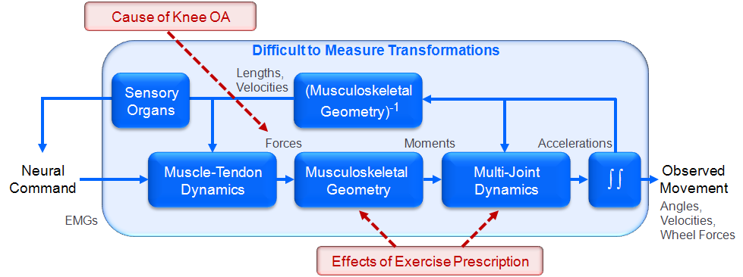Figure 1: Many factors contribute to knee joint loads associated with OA disease progression and disability during movements. The transformations between experimental EMG patterns and coordinated multi-joint movement (shaded region) are complicated. Furthermore, to make exercise prescription decisions, clinicians must predict joint load changes after equipment adjustments. Exercise prescription alters musculoskeletal geometry and multi-joint dynamics, and these changes are not easily measured. The long-term goal of our work is to provide a scientific basis for exercise prescription that reduces harmful knee joint loads. 22
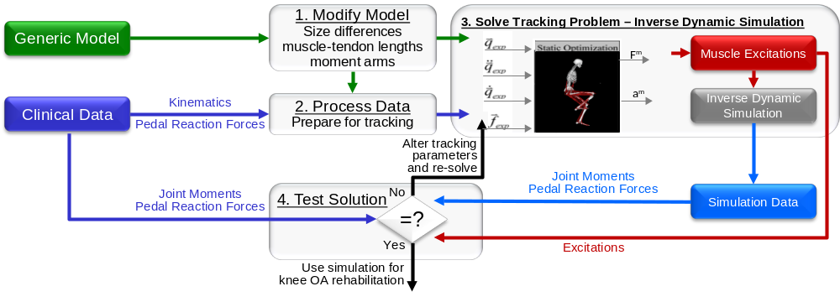Figure 2: Four-step procedure to generate a patient-specific inverse dynamic simulation that reproduces experimental data. 29
Figure 3: Example subject during a) data collection and example b) subject-specific musculoskeletal model for muscle force estimation with the added patella. 44

Definition of Terms

External Knee Adduction Moment

Chapter I INTRODUCTION

1.1 Defining Osteoarthritis (OA)
Over 47.5 million adults in the United States have a physical disability [1], with roughly 8.6 million cases of arthritis being the leading primary cause of physical disability [2]. These patients are commonly left with disabling pain leading to loss of mobility and an overall reduced quality of life [2]. Osteoarthritis (OA) is the most common form of arthritis; it affects millions of people worldwide [2]. OA is a common joint disease that most often affects the aging population. Although it is more common in older people and is viewed as a wear-and-tear disease, it is not accurate to state that the joints are merely eroding. OA is a disease of the entire joint, characterized by breakdown of the cartilage, bony deviations in the effected joint, weakening of tendons and ligaments, and inflammation of the joint.
Although OA can affect any joint in the body, the joints most commonly affected are the weight-bearing joints of the lower extremities, mainly the knees and hips [3]. With OA, the cartilage and bones within a joint begin to break down. These changes usually develop slowly and get worse over time. OA can cause severe joint pain, swelling, and stiffness. In some cases it also causes reduced function and disability; some people are no longer able to carry out activities of daily living and, in some cases, are not able to work. Severe cases may require joint replacement surgery, particularly for the knee or hip joint.

1.1.1 Knee Osteoarthritis
Knee osteoarthritis (OA), is a detrimental, degenerative joint disease that significantly destroys the quality of life [4] for an estimated 27 million people in the United States [5-7]. Knee OA mostly affects the aging population. Of those affected, 37.4% are 60 years of age and older [6, 8]. Roughly one quarter of those with doctor-diagnosed OA reported problems with activities of daily living[5, 9]. OA is characterized by decreased neuromuscular control, weakened lower extremities, and knee joint instability, with symptoms developing slowly over time [10]. Management of OA is a $128 billion industry [5, 7] creating an alarming clinical burden of 36 million patients and 750,000 ambulatory care visits and hospitalizations per year [7] resulting in high socioeconomic costs [11]. OA is a clinical problem with very few treatment options beyond pain management until the disease progresses enough to require invasive and expensive surgery [12].

1.1.1 Causes of Osteoarthritis
Though the causes of OA are not completely understood, there are some common known risk factors including age [13-15], female gender [16-18], muscle weakness [19-21], genetics [14], injury [22], overuse[23, 24] and obesity[13]. OA is a top cause of disability in the aging population. The goal of osteoarthritis treatment is to reduce pain and improve joint function. There is no cure for the disease, but some treatments attempt to slow disease progression before it reaches a more advanced state. Some risk factors are modifiable and can help in alleviating OA joint pain and improve joint function (mobility).

1.2 Treatment of Osteoarthritis
Doctors usually treat OA with a combination of therapies which may include, but are not limited to, the following: physical activity, medications, physical therapy (muscle strengthening), weight loss, supportive devices and, when pain management is no longer an option, surgery. In addition to medical treatment, people with OA can gain confidence in managing their condition with self-management strategies that over the last few decades have proven to reduce pain and disability, so they can pursue the activities important to them. Patients with OA can alleviate their pain and improve joint function by learning and adapting to simple and effective arthritis management strategies aimed towards weight management and increasing physical activity.

1.2.1 Modifiable Risk Factors: Weight Management and Physical Activity
Based on existing evidence, it is crucial for people that are overweight to try to lose weight. Excess weight is detrimental to personal health and speeds progression of OA. Obesity is one of the single most modifiable risk factors in the development and progression of OA. Weight loss has been proven to reduce the debilitating symptoms that OA patients commonly encounter [25-27]. A study that was conducted by Messier et al. [26] demonstrated that for every 1 pound of body mass a person loses, the compressive load across the knee joints is reduced by 4 pounds. Other researchers have noted that weight loss by means of diet and exercise resulted in improvements of joint function, mobility, and reduced (or decreasing) pain [25, 27].
In recent years, the Osteoarthritis Research Society International (OARSI) has created a list of 25 recommendations for the treatment of patients with OA of the hip or knee [28, 29]. These recommendations come from evidence-based research and have been proven to alleviate some of the symptoms of OA. Two of the highly recommended non-pharmacological treatments are regular aerobic muscle-strengthening exercises and weight loss for overweight individuals [28, 29].

1.2.2 Exercise Prescription for OA
Different forms of exercise such as walking and cycling are commonly prescribed by healthcare professionals to reduce potentially harmful knee joint loads and are effective exercise prescriptions for treatment in populations with knee injuries. [30]. Walking modifications have proven to be successful in diminishing knee pain through the use of a toe-in gait or lateral shoe wedges [4, 31].

1.2.2 Exercise Prescription: Cycling
Bicycling allows people to increase their aerobic capacity during exercise without harmful joint loads in the lower extremities as most of the body weight is supported by the seat of the bicycle, relieving the load-bearing joints. One study found that in subjects with OA, low-intensity cycling is as effective as high-intensity cycling for improving joint function, decreasing pain, and increasing aerobic capacity [32, 33]. For subjects with OA, cycling’s health benefits include potentially reduced OA-related loads on the diseased joint tissues. However, there is little scientific evidence of the magnitude and location of these reduced loads on the knee. Despite the fact that cycling remains an integral component of exercise for subjects with OA, the potentially beneficial changes in knee loads and associated muscle forces are not well understood. Therefore, current exercise prescriptions may be improved with new knowledge of their effects on joint loads. This loading plays a crucial role in the progression of joint degeneration and severity of pain during exercise and activities of daily living [4, 34].Therefore, a better understanding of how different cycling movements affect joint loads is necessary for improving rehabilitation strategies.
Many authors have reported on lower-extremity joint kinematics during cycling [35-40]. While cycling motions are relatively similar due to the cyclical nature of cycling, there are differences that exist depending on the pedal cadence, workload, pedal width, seating arrangement, and different manipulations in each paper. These modifications alter the body’s orientation and joint positions, which in turn affect the entire body [41] and change the kinematic configuration such as the joint angles and joint moments by making small adjustments to the cycling orientation. All of these modifications affect human biomechanics, changing the muscle lengths and moment arms and affecting the kinematics in the muscles, which in turn affect the joint contact loads.

1.3 Gait Characteristics of Knee Osteoarthritis
It is vital to understand knee OA gait characteristics because the changes which the OA patient experiences with the adapted OA gait may potentially translate into cycling. Any alteration from the normal body orientations affects the biomechanics and orientation of the joint angles and moments that in return affect the muscle length and joint contact loads. At the time of this writing there are little to no studies that have reported biomechanical variables of people with knee OA during cycling. There are also no studies that have tested both subjects with and without knee OA in the same study. Subjects with knee OA have adapted or different knee kinematics when compared to subjects without knee OA, having decreased or slower walking speeds, less total range-of-motion (ROM) in the affected limb, and an increased knee internal abduction moment (KAM) compared to healthy subjects.

1.3.1 Compressive Forces and Internal Abduction Moment
Peak compressive force acting on the knee joint during walking may be up to approximately 4 times the body weight [26]. This shows that the mechanical loading has the potential to be harshly effect the joint by causing greater knee joint forces during walking. In knee OA populations, joint loads are shown to be about 3 to 3.7 times body weight [26, 42]. Messier et al. [43], studied the knee joint loading of older adults with knee OA. The results of the study showed that in comparison to the matched controls, the knee OA group experienced about a 25% reduction in compressive force across the knee; however, those patients had a decreased or slower walking speed compared to their healthy cohort. Another study reported that medial compartment OA patients encountered 4% higher knee joint reaction forces during walking compared to their matched healthy counterparts [4]. While the differences reported appear to be small, the results suggest a relationship may exist between medial compartment OA and compressive knee joint loads. However, there is no pivotal evidence yet that has appeared in the literature about the relationship between knee OA, muscle forces, and joint contact loads (compressive forces).
It is easy to assume that an increase in compressive joint load has a harmful effect on the knee joint. Additionally, others studies have found that people with knee OA have been successful at lowering the loads on the affected limb in an attempt to reduce the pain during gait [4, 44]. Finally, a study by Chakravarty et al. [45] showed that middle and older aged long-distance runners did not have any change or alteration in OA progression compared to healthy non-runner controls studied over an 18 year period. These findings suggest that the response to joint loading may be reliant on the health of the knee cartilage. It can be argued that chronic compressive loads on the knee joint are not necessarily responsible for the progression of knee OA, but rather they have a large influence on the progression of OA once the disease has been acquired. Other research has shown that obesity is highly associated with incident OA of the hip and knee [46], suggesting that either the increased weight, or some other factor associated with obesity, has a degenerative influence on weight bearing joints.

1.3.3 Knee Adduction Moment
Most patients with OA suffer from the most common form which is medial compartment degeneration and pain, which occurs about 10 times more often than lateral compartment disease. This is likely due to greater medial loading during activities of daily living[47]. Due to this fact, changes in knee kinematics and kinetics associated with knee OA have led to gait adaptations in order to maintain stability, causing a significant increase in the net external knee adduction moment (KAM) [10]. Presence, severity, and progression of medial knee OA has been correlated with the first peak of the net external KAM, which is commonly used as a measure of medial knee loading [11, 42]. The weight bearing or compressive load that is centered on the medial compartment of the knee is produced by the KAM which is opposed by an internal KAM. This moment acts to adduct the knee during stance into a deformity of the knee which alters the joint from normal (neutral) to a more inward angle (or Varus) position[48], a condition that opens the joint space on the lateral aspect of the knee while compressing the medial joint space of the knee. During gait, this mechanical abnormality shifts the mechanical loading from the previously even load on the knee to a medial compartment load which will in turn cause greater joint space narrowing. In gait (walking), there are typically two peaks present in the KAM. The first peak, which is associated with weight acceptance during the stance phase of walking, appears to have the largest influence on the knee OA population[44].
Other studies have found a relationship between the magnitude of KAM and the progression of knee OA [4, 45]. For example, Mundermann et al. [4] performed a gait analysis on 42 patients with bilateral medial compartment knee OA and 42 matched controls. The participants walked in their own shoes at a self-selected pace. The results of the study showed that the patients with more severe knee OA demonstrated about 11% larger first peak KAM compared to their matched counterparts, and about 28% greater than the less severe patients. The authors also reported that even though the walking speeds were self-selected, the speeds were not different between groups, meaning that the differences seen in the KAM cannot be accredited to different walking speed. Shull et al.[47, 49] conducted a study that attempted to reduce the KAM by having knee OA subjects walk in a toe-in foot progression angle. The authors found that this method of walking reduced the first peak KAM by about 11%, but the second peak KAM and the knee flexion moment remained unaffected. This study provided promising results for a simple technique to successfully reduce the KAM during walking, and it may be a potential solution for OA subjects and gait modifications for improvement of the lower limbs. Literature suggests that a relationship of the net external KAM factors has also been shown to be related to the severity and progression of knee OA [4, 45, 48].

1.4 Statement of the Problem
How repetitive motions such as cycling exercise can be modified to achieve beneficial changes in joint loads linked to OA severity and progression is an open question. Exercise prescription based on joint loads is problematic because there is currently no scientific basis for determining how individuals’ exercise prescriptions contribute to joint loads leading to knee OA progression. The muscle tests performed during a physical exam and kinematic, kinetic, and electromyography (EMG) data obtained from clinical motion analysis are not sufficient to identify the biomechanical source of an individual's knee OA progression risk or to predict the consequences of exercise prescription. This limitation exists because transformations from EMG patterns to motion are extremely complex (Figure 1) and effects of exercise prescription on musculoskeletal geometry and multi-joint dynamics are not easily measured in an experiment.
Determining how to adjust exercise movements to optimize joint loads is difficult because experiments do not account for these loads. For decades, experimental approaches have advanced the understanding of neuromuscular control, joint motion, muscle strength, and functional capacity of the human body. Progress is essentially restricted and affected by two factors: 1) important variables (e.g., muscle forces and joint contact loads) are not generally measureable in experiments, and 2) cause-and-effect relationships (e.g., motion contributions to joint loads) are difficult to establish from experiments. A scientific framework is needed, in combination with experiments, to uncover relationships between muscle forces, joint loads, and purposeful movements in people with OA during rehabilitation. Muscle-actuated dynamic simulations provide such a framework and complement experimental approaches by estimating important variables and identifying cause-and-effect relationships. This research challenges existing paradigms for exercise prescriptions by including movements that are specifically designed for decreased knee joint loads. In turn, these activities help bridge the gap between the experimental approaches used by physicians, physical therapists, and rehabilitation scientists and the computer simulation approaches used by engineers, mathematicians, and computer scientists to improve research studies of movement modification and lead to new rehabilitation solutions.
Figure 1: Many factors contribute to knee joint loads associated with OA disease progression and disability during movements. The transformations between experimental EMG patterns and coordinated multi-joint movement (shaded region) are complicated. Furthermore, to make exercise prescription decisions, clinicians must predict joint load changes after equipment adjustments. Exercise prescription alters musculoskeletal geometry and multi-joint dynamics, and these changes are not easily measured. The long-term goal of our work is to provide a scientific basis for exercise prescription that reduces harmful knee joint loads.
This dissertation is transformative because (i) these models and simulations are patient-specific rather than one-size-fits-all and (ii) they combine clinical and engineering approaches with rehabilitation exercise in a comprehensive way that has yet to be done. Efforts to incorporate results of dynamics-based analyses of human movement into clinical practice have important limitations. Most simulations have trusted upon basic or more general models, based on experimental data collection from an inadequate number of adult-sized cadavers. No study before now has used a patient-specific musculoskeletal model, in combination with an inverse dynamic simulation, to assess patients with medial compartment knee OA and to investigate as well as mitigate the magnitude of the muscle forces and joint loads experienced in the lower extremities during stationary cycling. This application of patient-specific models and computer simulations can be used to custom-tailor cycling rehabilitation programs.

1.4.1 Muscle Forces
Although cycling remains an integral component of exercise therapy for individuals with knee OA, the potentially beneficial changes in muscle forces are not well understood. Modified cycling exercises may potentially strengthen muscles to improve mobility while improving biomechanics of the diseased knee joint. However, there is little scientific data characterizing muscle forces in individuals with knee OA during exercise [50, 51]. Therefore, current exercise prescriptions may be substantially improved with new knowledge of how modified cycling affects muscle forces.

1.4.2 Joint Contact Loads
To better treat and understand patients with knee OA in the future, it is necessary to quantify the joint contact loads and how these loads change with cycling modifications. Studying knee loading through computational models is often used with gait analysis to determine musculoskeletal loading in vivo because there is no way to obtain a non-invasive measurement [52]. Knee loading has been previously thought to be a major contributor in the degeneration of articular cartilage associated with the progression of OA, and it has been found that patients exhibit increased knee joint contact loads during gait [53].
There are several studies investigating various gait modifications, but few focus on cycling modifications and far fewer are able to effectively estimate the muscle forces and joint contact loads. Internally rotating and laterally abducting the ankle (altering the foot kinematics) using a cycling pedal modification can potentially reduce the net external KAM in subjects with and without knee OA, though the effect on muscle force and joint contact loads are unknown [47, 49]. Many others have studied the effects of different cycling modifications to reduce the KAM, including toe-in cycling [54], lateral shoe wedges[55], pedal cadence[35, 36, 38, 56, 57], workload[56, 57], and different cycling positioning[41]. However, at the time of this writing there are no studies on the effects of cycling modification and the potential for reduced joint contact loads for subjects with and without knee OA.
Inverse dynamics has traditionally been used to estimate the net joint loads such as the KAM during motion, but this approach is limited because it does not account for muscle forces which may differ even more following cycling modifications. Determining the joint contact loads that account for these muscle forces provides for a better understanding of the joint mechanics and overall musculoskeletal function [52]. By investigating joint contact loads under cycling conditions, these modifications may be better understood for use in early intervention treatment strategies for patients with knee OA.

1.5 Preliminary Work
Preliminary studies have been previously performed [54, 58] with this data, where surrogate measures of OA were examined. Specifically, the peak knee adduction angle and peak internal knee abduction moment (KAM) were calculated in Visual 3D. This study found promising results in which a decrease in the knee abduction moment occurred using the lateral wedge. Another study [54] examined the effects of toe-in pedal modifications and found that the peak knee adduction angles decreased, but the peak KAM did not decrease, for subjects with and without knee OA. This preliminary work indicates a decrease in KAM for lateral pedal wedges rather than toe-in. The muscles forces contributing to knee OA and joint contact loads are unknown.
This previous study led to the working hypothesis for the proposal that pedal wedges and toe-in will reduce knee joint contact loads by changing the distribution of muscle forces in all subjects during cycling. The purpose of this research is to determine the changes in magnitude of the muscle forces and joint contact loads experienced at the knee for subjects with medial compartment knee OA. Additionally, it will allow us to discover relationships between muscle forces, joint loads, and cycling to develop OA-friendly cycling modifications and subject-specific exercise prescriptions.

1.5.1 Selection of human subjects and Data collections
Previous experimental data has been collected [55] at the Biomechanics and Sport Medicine Laboratory on University of Tennessee-Knoxville’s campus from patients (6 male and 7 female) with medial compartment knee OA as well as healthy control subjects (6 male and 5 female). Subjects participated in five different cycling conditions on a stationary bicycle. The conditions varied by adjustments made to custom instrumented pedals to record reaction forces. The five conditions with pedal adjustments included: 1) neutral position, 2) 5° toe-in pedal, 3) 10° toe-in pedal, 4) 5° pedal wedges, and 5) 10° pedal wedges. See Chapters 2, 3 as well as Gardner [58] and Gardner et al. [54] for additional details on the selection of human subjects and the data collection process.

1.6 Computational Modeling: Patient-Specific Musculoskeletal Modeling
Computational modeling of human movement is used to relate various aspects of the human anatomy and physiology to movement. In the last few years and decades, biomechanical models have led to tremendous advances in computer technology that have subsequently prompted greater development of more complex biomechanical models with more accurate and computationally efficient analyses [59, 60]. Through computational modeling, researchers are able to develop subject-specific simulations that relate joint kinematics and kinetics to muscle force production and function. Unlike EMG analysis where muscle activation is linearly related to muscle force, simulations are able to account for the musculotendon properties such as muscle activation and contraction dynamics, force-length and force-velocity relationships, and moment arms analysis to appropriately model non-linear relationships between muscle activation and force production. Such simulations are utilized in investigating the cause-and-effect relationship between joint motion and muscle function [61-65].

1.6.1 OpenSim and Musculoskeletal Modeling Software
Musculoskeletal modeling software programs allow users to select from a bank of models and create subject-specific simulations to explore a variety of research questions. OpenSim is such a software program that provides users with a mathematical and computational modeling framework to analyze everything from designing prosthetic devices and studying how they will function in the body, to assessing the outcomes of surgical procedures like tendon lengthening in cerebral palsy patients. It is unique in that it is user friendly but also allows the user to increase model complexity to answer difficult problems related to human movement.

1.6.2 Biomechanical Models
The biomechanical models and computational tools developed yield broad applications. Numerous studies have been performed to record neuromuscular excitation patterns, understand muscles contraction dynamics, characterize musculoskeletal geometry, and quantify multi-joint movements and kinematics. However, linking the detailed knowledge of these elements of the neuromusculoskeletal system to create an integrated understanding of normal and pathological movement remains a major challenge in the application of biomechanics to a wide range of clinical problems and basic science research.
This study used dynamic simulation to identify the cycling pedal modification parameters that contribute to knee (and other) muscle forces and joint loads related to the pain and disability of individuals with knee OA, and to explain the functional consequences of pedal modifications in decreasing these forces. Patient-specific, muscle-actuated, inverse dynamic simulations were created that reproduced experimentally measured and collected data from both knee OA and healthy cohorts while cycling. The simulations were analyzed to determine how pedal modifications, lateral pedal wedges, and toe-in angles alter foot position and influence knee joint loads for people with and without knee OA. This analysis will clarify the decrease (or increase) in muscle forces and joint loads during modified cycling, and they will enable us to answer the clinically important questions posed in studies 1-3 (Section 1.7). Ultimately, this work will test the utility of simulation-based medicine to identify optimal cycling modifications and facilitate the design of safe, patient-specific exercise prescriptions aiming to increase mobility while decreasing injury for individuals with OA.

1.6.3 Development and Analysis of Muscle-Actuated Inverse Dynamic Simulations
The development of muscle-actuated, inverse dynamic simulations that accurately characterize the movement patterns of individuals with medial compartment knee OA offers tremendous potential to advance the prescription of cycling for these individuals. This study is designed so that many of the scientific objectives can be accomplished by making incremental modifications to the existing dynamic models. Over the past several years, engineers have helped to develop core methodologies and a powerful software framework to create subject-specific inverse dynamic simulations that reproduce experimental data.
OpenSim is used [61] to create, alter, and evaluate models of many different musculoskeletal structures. The procedure for creating and analyzing an inverse dynamic simulation of an individual's movement consists of several steps (Figure 2). Step 1 modifies an existing, generic model of the musculoskeletal system as needed to account for differences in the subject's size and muscle moment-generating capacity. The musculoskeletal geometry of the generic model is scaled based on subject’s data collected from experimental motion capture.

Figure 2: Four-step procedure to generate a patient-specific inverse dynamic simulation that reproduces experimental data.

Step 2 processes the subject's measured kinematics and pedal reaction forces data for "inverse dynamic tracking." An optimal inverse kinematics problem is solved to minimize the distance between markers on the subject and markers on the model.
Step 3 uses inverse dynamics along with kinematics from the previous step and experimental pedal reaction forces to determine the net joint moments.
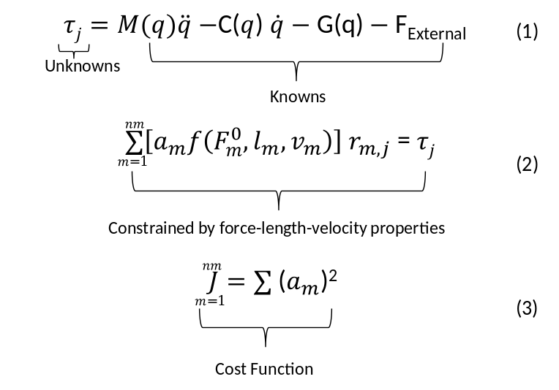
Equations: The static optimizations equations of motion

Step 4, the static optimization tool steps through each time frame of a motion and computes the muscle activations in the model that generate the experimental kinematics. The equations of motion relate the model’s accelerations to the muscle moments applied to the model. The musculoskeletal geometry relates the muscle moments to the muscle forces generating those moments. The muscles contraction dynamics relate the muscle forces due to the muscle activations. The kinetics (Equation.1) necessary to accelerate the model are determined using Newton’s Second Law by treating the skeleton as a set of interconnected rigid-bodies with inertial properties. Where $τ_{j}$ is the set of joint torques,$q$, $\dot{q},$and $\ddot{q}$ are the coordinates, their velocities and accelerations, respectively, M($q$)$\ddot{q}$ is the mass matrix which depends on the coordinates and inertial properties of the model, C(q,$\dot{q}$) is the combination of Coriolis and centrifugal forces which depends on the coordinates and their velocities, G(q) is the gravitational force which depends on the coordinates, and $F_{External}$ is pedal reaction forces applied to the model.
The motion of the model is completely defined by the coordinates, velocities, and accelerations. Consequently, all of the terms on the right-hand side of the equations of motion are known. The remaining set of joint torques ($τ_{j}$) on the left-hand side is unknown. The static optimization tool uses the known motion of the model to solve the equations of motion for the unknown joint torques and is subject to a constraint (Equation.3) while minimizing the cost function (3). Where $nm$ is the number of muscles in the model, $a_{m}$ is the activation level of muscle $m$ at a discrete time step, $F_{m}^{0}$ is its maximum isometric force, $l_{m}$ is its muscle length, and $v_{m}$ is its shortening velocity. The$f\left(F_{m}^{0},l_{m},v_{m}\right)$, is a function of its force-length-velocity surface$,{ r}_{m,j}$ is its moment arm about the ${ j}^{th}$ joint axis, and $τ_{j}$ is the generalized force acting about the${ j}^{th}$ joint axis
Step 5 compares the muscle excitation patterns, joint moments, and pedal reaction forces determined from the simulation to the experimental data to verify that the solution obtained from the tracking algorithm provides a reasonable representation of the subject's movement. A simulation is suitable for analysis if the joint angles and other variables that are not explicitly tracked, such as the joint moments, pedal reaction forces, and muscle excitations, are within ±2 standard deviations of the subject’s measured between-trial variability. If the simulation does not meet these criteria, appropriate adjustments to the tracking parameters are made as has been done in previous published work and Step 4 is repeated.
The simulation is then ready to be used for knee OA rehabilitation purposes during a final step by performing an analysis of the particular patient’s joint loads during cycling. A calculation is made of the resulting forces and moments transferred between consecutive bodies as a result of all loads (including muscle forces) acting at joints of interest (e.g., knee). These resulting forces and moments, often referred to as joint reactions or joint contact loads, are necessary to quantify bone-on-bone forces at the joints. These joint reactions are a first order approximation of the joint loading conditions and are used to assess the subject’s joint loads as others have done for joint implant loads [66] with differing OA severities [67].
This dissertation utilizes high quality experimental motion capture data of individuals (OA and healthy subjects) performing with five different pedal modifications to conduct simulation-based research on muscle forces and joint contact loads while cycling. This research is divided into three different studies introduced in the following section.

1.7 Overview and Specific Studies
Arthritis is the leading cause of physical disability in the U.S. and osteoarthritis (OA) is the most prevalent form of arthritis causing disabling pain and loss of mobility for almost 27 million adults (14% of all aged 25 and older) worldwide. OA costs in the US, Canada, UK, France, and Australia account for 1–2.5% of each country’s gross domestic product. Disability and healthcare costs of OA can be drastically reduced by novel patient-specific intervention programs (e.g. exercise) that benefit people with OA by slowing disease progression and delaying disability. However, there is a significant need for evidence-based prescription targets that directly address joint loads during exercise. Cycling rather than other exercise modalities is generally considered an alternative for people with knee OA, but there is a lack of scientific knowledge characterizing and maximizing the rehabilitation benefits (i.e. reduced joint loads) of cycling for people with knee OA.
The long-term goal of this research is to provide a scientific framework for planning, evaluation, and improvement of patient-specific rehabilitation for individuals with knee OA. Previous studies have shown significant relationships between gait retraining and lower-extremity joint loads. This research group has utilized patient-specific modeling and simulation along with predictive tools using feedback control to design new movements that aim to minimize joint loads for walking and multi-directional sporting movements. Ultimately, no studies have combined cycling biomechanics with computer simulation to investigate optimal exercise prescriptions for individuals with knee OA. The research objective is to investigate how cycling exercise modifications lead to different joint loads in people with knee OA. This study proposes to use a combination of clinical motion analysis, patient-specific musculoskeletal models, muscle-actuated inverse dynamic simulations, and optimization to determine what features and their variations lead to improved joint loads for better exercise prescriptions. The overall hypothesis is that a combination of biomechanical movement features, achieved in part by a novel pedal design, contributes to reduced joint loads in individuals with and without knee OA during cycling. This dissertation proposal will address the following three studies:

1.7.1 Study 1: Pedal Modifications Change Muscle Forces Differently in Osteoarthritis (OA) and Healthy Subjects during Stationary Cycling: Implications for Osteoarthritis Exercise Prescription.
Goal: Answer the question of how muscle forces change for both populations using a novel pedal design to modify foot position during cycling.
- Pedal modifications will cause a change (increase or decrease) in the peak and mean muscle forces compared to the neutral pedal condition for each cohort.
- Peak and mean muscle forces for subjects with knee OA will be different (higher or lower) compared to healthy subjects without knee OA during cycling in each pedal condition.
Methods: Create patient-specific, muscle-actuated, inverse dynamic simulations that reproduce experimentally measured data from both populations during cycling with different pedal modification conditions, and quantify the muscle force estimates.
Significance: This work will demonstrate how pedal modifications alter the healthy and OA muscle forces adversely.

1.7.2 Study 2: Pedal Modifications will Decrease the Joint Contact Loads Differently in Osteoarthritis (OA) and Healthy Subjects during Stationary Cycling.
Goal: Answer the question of how muscle forces found in Study 1 will affect the joint contact loads while cycling in different pedal modifications.
- Pedal modifications will cause a change (increase or decrease) in the peak joint contact load compared to the neutral pedal condition for each cohort.
- Peak joint contact load for subjects with knee OA will be higher compared to healthy subjects without knee OA during cycling in each pedal condition.
Methods: Examine the previously created patient-specific, muscle-actuated, inverse dynamic simulations that reproduce experimentally measured data from both populations during cycling with different pedal modification conditions and compare the joint loads.
Significance: This work will discover how pedal modifications alter the healthy and OA Muscle forces adversely.

1.7.3 Study 3: Investigate changes in knee joint loads due to variations in muscle activity during cycling
Goal: Determine the effect of varied muscle coordination on knee joint loads the potential for a subject to decrease tibiofemoral forces while cycling by adopting a muscle coordination strategy that minimizes the tibiofemoral forces.
Methods: A series of tasks to create a static optimizations framework that will be formulated to reduce knee joint loads by altering weights and muscle activations. Significance: This work will define what muscle activations would achieve optimal (i.e., minimized) knee joint loads.
Together these studies will test the utility of simulation-based medicine to identify optimal pedal condition modifications and facilitate the design of safe, patient-specific exercise prescriptions aiming to increase mobility while decreasing harmful knee joint loads causing pain and disability for individuals with knee OA. They will also aid in determining the roles that muscle forces play in cycling kinematics in the healthy versus the OA cohorts in order to better develop future research for designing more effective patient-specific rehabilitation prescription.

CHAPTER II
Pedal Modifications Change Muscle Forces Differently in Individuals with and without Knee Osteoarthritis (OA) during Stationary Cycling: Implications for Osteoarthritis Exercise Rehabilitation
The student must add a brief explanatory statement at the beginning of each article, stating how the article was revised and/or detailing the student’s involvement in the article. Any co-researchers should be identified and their role clarified as part of this statement.

Abstract
Osteoarthritis (OA) is a severe clinical problem affecting an estimated 27 million adults in the United States with the only clear treatment options being pain management. Cycling is an integral component of exercise for individuals with knee OA, while the muscle forces during cycling remain unknown. Thirteen subjects with knee OA and eleven healthy subjects performed a cycling protocol with a neutral pedal and four pedal modifications (5° lateral wedge, 10° lateral wedge, 5° toe-in and 10° toe-in). Six hundred muscle-actuated inverse dynamic simulations (2 cohorts, 5 conditions, 5 trials in each condition) were performed to estimate muscle force differences between conditions. There were many changes in the mean and peak muscle forces for the subjects with and without knee OA across pedal modifications compared to neutral pedal condition. Subjects with knee OA had 30 (lateral wedge) and 40 (toe-in) significant changes. Healthy subjects had 13 (lateral wedge) and 9 (toe-in) significant changes. For the mean muscle force subjects with knee OA had 33 (lateral wedge) and 43 (toe-in) significant changes. Healthy subjects had 29 (lateral wedge), and had 16 (toe-in) significant changes. In conclusion, this study showed, while cycling in different pedal modifications the subjects with knee OA have a greater effect on their mean and peak muscle forces compared to subjects without knee OA. Toe-in pedal modifications showed to have had a greater impact on the knee OA cohort. Muscles either increased or decreased there forces depending on what joints they spanned.

2.1 Introduction
Osteoarthritis (OA) is a detrimental, degenerative joint disease significantly destroying the quality of life [4] for an estimated 27 million adults in the United States [6]. OA involves the breakdown and wear on the joint cartilage causing pain and disability [68]. Knee OA mostly affects the aging population of those affected 37.4% are 60 years of age and older [6, 8]. Roughly one quarter of those with doctor-diagnosed OA reported problems with activities of daily living[5, 9]. Management of OA is a $128 billion industry [5, 7] created an alarming clinical burden with 36 million and 750,000 ambulatory care visits and hospitalizations per year [7] resulting in high socioeconomic costs [11]. OA is a clinical problem with very few solution options beyond pain management until the disease progresses far enough needing invasive, expensive surgery [12].
There are several different therapies for knee OA: surgical treatments, exercise prescriptions, and movement modifications. Surgical treatments include total knee arthroplasty (TKA) or high tibial osteotomy, which are used when non-invasive options no longer alleviate pain [69-72]. Surgeries are highly invasive and expensive [73] with TKA costs alone exceeding $11 billion [73, 74]. A less invasive and cheaper therapy is exercise prescription (i.e., cycling and walking) [30] to reduce pain and improve joint function [75]. In OA subjects, low-intensity cycling is as effective as high-intensity cycling for decreasing pain, increasing joint function and aerobic capacity [32, 33]. For walking, movement modifications have been extensively studied and successfully reduce pain and joint moments associated with knee OA [4, 31, 76, 77]. However, for cycling, movement modifications have not been studied to the same extent. One study found peak knee abduction moments (KAMs) decreased when using lateral shoe wedges during stationary cycling [58]. Another study found peak knee adduction angles decreased, but peak KAMs did not decrease, for subjects with and without knee OA [54]. These results suggest that movement modifications during cycling alter kinematics and KAM, but the critical role muscles forces play during modified cycling exercise therapy remain unknown.
Cycling remains an integral component of exercise therapy for individuals with knee OA; despite the fact, that potentially beneficial changes in muscle forces are not well understood. Modified cycling exercise may potentially strengthen muscles to improve mobility while improving biomechanics of the diseased knee joint. However, there is little scientific evidence characterizing muscle forces in individuals with knee OA during exercise [50, 51]. Therefore, current exercise prescriptions may be substantially improved with new knowledge of how modified cycling affects muscle forces.
This study used dynamic simulation, in combination with clinical movement analysis, to evaluate the muscle force changes for subjects with knee OA and healthy counterparts during stationary cycling using five different pedal modifications. Our primary goal was to quantify and identify differences in the muscle forces for individuals with and without knee OA. First, we hypothesized that pedal modifications will cause a change (increase or decrease) in the mean and peak muscle forces compared to neutral pedal condition for each cohort. Secondly, we hypothesized that mean and peak muscle forces for subjects with knee OA will be different (higher or lower) compared to healthy subjects without knee OA during cycling in each pedal condition. Identifying muscle force differences between OA and the healthy cohorts will contribute to our understanding and help bridge the gap to improving cycling modifications that allow for patient-specific rehabilitation.

2.2 Methods

2.2.1 Subject Demographics [54]
Thirteen subjects with knee OA (7 female, 6 males | 56.8±5.2 yrs. | 83.2±22.3 kg | 1.75 ±0.14 m | 25.6±3.6$\frac{kg}{m^{2}}$) and 11 healthy subjects without knee OA (5 female, 6 males | 50.0±9.7 yrs. | 80.2±23.1 kg | 1.75 ±0.12 m | 25.9±5.4$\frac{kg}{m^{2}}$), voluntarily participated in this study (Error! Reference source not found.) [54]. Knee OA cohort had medial compartment tibiofemoral OA in at least one of their knees. To be included in this study, subjects had to be men or women between the ages of 50 to 65 years, a BMI of 35 kg/m² or less, and the knee OA cohort had to be radiographically diagnosed with medial compartment knee OA, with or without patella-femoral knee osteoarthritis, by a rheumatologist with a grade 1 to 4 on the Kellgren-Lawrence scale by a rheumatologist. To be excluded from this study, subjects must not have had a lower-extremity joint replacement, an arthroscopic surgery, any intra-articular injections prior to testing, and/or systemic inflammatory arthritis. All subjects were asked to stop pain medication at least 2 days before testing. For more criteria on inclusion and exclusion, please refer to Gardner, et al., 2015, and Gardner, 2013 [54, 58].

2.2.2 Experimental Motion Capture Data Collection [58]
Table 1: Descriptive values for 13 subjects with knee OA and 11 age-matched healthy subjects.
Data type | Subjects with knee OA |  |  | Healthy subjects
Age (yr.) | 56.8 | ± | 5.23 | 50.0 | ± | 9.67
Height (m) | 1.75 | ± | 0.138 | 1.75 | ± | 0.121
Mass (kg) | 83.2 | ± | 22.3 | 80.2 | ± | 23.1
BMI (kg/m²) | 26.6 | ± | 3.61 | 25.9 | ± | 5.36

Participants performed an experimental protocol including warm-up, cycle ergometer fitting, cycling trials, and rest periods. Participants performed 3 minutes of treadmill walking at a self-selected pace, which served as an initial warm-up. Participants were asked to sit on a cycle ergometer where researchers fit it to each subject accordingly by adjusting: seat height, seat depth, and trunk angle. Participants were asked to warm-up on the cycle ergometer for 3 minutes to asses proper positioning and observation of pain levels. Five trials of cycling in each pedal modification condition were performed for 2 minutes each at a pedal cadence of 60 RPM and an 80W workload with rest periods between trials. There were a total of 600 trials, where 24 subjects each performed 5 trials in 5 pedal conditions.
Clinical motion capture analysis was used to record subjects’ movements during the cycling trials. A vicon motion capture analysis (240 Hz) was used to obtain three-dimensional (3D) kinematics during stationary cycling. Participants wore tight fitting spandex shorts and a T-shirt during data collection. To identify joint centers, anatomical markers were placed bilaterally on the 1st and 5th metatarsals, medial and lateral malleoli, medial and lateral epicondyles, left and right greater trochanters, left and right iliac crests, and left and right acromion processes. Semi-rigid thermoplastic shells, each with four non-collinear tracking markers, were attached to the trunk, pelvis, thighs, and shanks using hook and loop wraps. Three individual markers were placed on the posterior and lateral sides of the heel of standard lab shoes (Noveto, Adidas) worn by subjects.
An instrumented cycle ergometer (Excalibur Sport, Lode, and Groningen, Netherlands) was used during testing. The ergometer used a customized bike pedal, which allowed recordings of 3D pedal reaction forces (PRF) and moments using two 3D force sensors (Type 9027C, Kistler, Switzerland) connected with two charge amplifiers (Type 5073A and 5072A, Kistler, Switzerland). Sensors could be placed in either the left or right pedal, depending on the desired limb to be analyzed. A non-instrumented pedal with the same size and mass was used on the opposite side for symmetry and dynamic balancing.

2.2.3 Development and Analysis of Muscle-Actuated Inverse Dynamic Simulations
We created subject-specific models using the generic, full-body musculoskeletal model in OpenSim that contains 10 segments, 23 degrees of freedom, and 92 muscle–tendon actuators (Figure 2). The pelvis position and orientations were defined as 6 degrees of freedom relative to the ground. The head, arms, and torso were represented as one segment and connected to the pelvis by a ball-and-socket joint [78]. The hip was modeled as a ball-and-socket joint [79]. The knee was modeled as a planar joint with tibiofemoral and patellofemoral translational constraints as a function of knee flexion [79]. The ankle and subtalar joints were modeled as separate revolute joints [80]. Each muscle–tendon actuator was modeled as a Hill-type muscle in series with a tendon based on published muscle-tendon parameters [79]. We altered our model further by adding a patella to model the knee so it articulated in contact with the femur, and to allow the muscles to wrap around the patella [81]. The patella functioned to allow the quadriceps forces to act along the patellar ligament. This alteration improved the relationship between knee kinematics and muscle forces beyond the original knee model [79], and it allowed a better estimation of muscle forces.
The procedure for creating and analyzing muscle-actuated inverse dynamic simulation of each individual's movement consisted of a four step procedure. Step 1, we modified an existing, generic model of the musculoskeletal system and scaled it to account for differences in the subject's height, mass properties, and muscle moment-generating capacity due to muscle moment arms (Error! Reference source not found.) [61]. The model was scaled by using the musculoskeletal geometry of the generic model and the marker data collected from experimental motion analysis. Step 2, we used inverse kinematics to solve for the model’s joint angles to minimize errors between experimental and model markers. Step 3, we used inverse dynamics along with kinematics from the previous step and experimental pedal reaction forces to determine the net joint moments. Step 4, we used static optimization [60] to determine the muscle activations and corresponding muscle forces that generate the net joint moments. We chose to use the inverse dynamics approach for our large number of simulations (24 subjects, 5 conditions with 5 trials per condition = 600 trials) needed because this approach is a well-established and computationally efficient method for estimating muscle forces during movement.
Figure 3: Example subject during a) data collection and example b) subject-specific musculoskeletal model for muscle force estimation with the added patella.
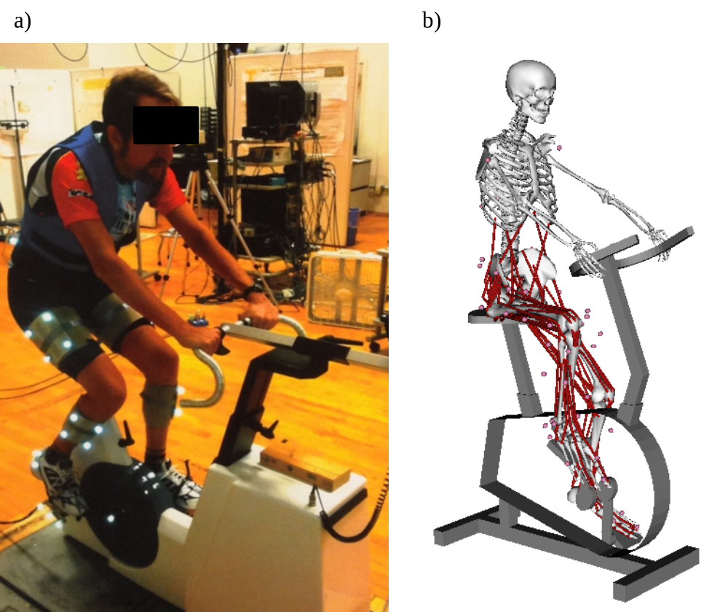

2.2.4 Evaluation of Muscle Forces and Test of Hypotheses
We evaluated our first hypothesis regarding the changes in mean and peak muscle forces within each cohort by conducting a one-way analysis of variance (ANOVA; p<0.01) to detect significant changes between muscle force estimates for each of the 4 pedal modification trials compared to neutral pedal trials for each subject. The Tukey-HSD correction was used for post-hoc pairwise comparison. We evaluated our second hypothesis regarding the differences in mean and peak muscle forces between cohorts by conducting a ANOVA with unequal sample size (p<0.01), to detect significant differences between muscle force estimates for the 13 subjects with knee OA and 11 healthy subjects during each pedal condition. The Tukey-HSD correction was again used for post-hoc comparisons. Heatmaps were created to show significant mean and peak muscle force differences between pedal conditions compared to neutral as well as between cohorts of subjects with and without knee OA.

2.2.5 Validation of Models and Simulation Results [82]
Experimental data was used during each step of the development of the inverse dynamics simulation to validate our models and simulation results. During scaling of the models, the errors between experimental and model markers were examined and model marker positions were adjusted to minimize marker errors. Each marker was placed in the correct location to match the experimental data. Following inverse kinematics, the maximum and root mean square (RMS) marker errors were examined and marker tracking weights were adjusted to reduce, RMS errors. In addition, the resulting hip, knee, and ankle joint angles were examined and compared to those from the Visual 3D motion analysis software and known joint angle data from the literature [83]. Following inverse dynamics, the hip, knee, and ankle net joint moments were examined and compared to those from the Visual 3D motion analysis software and known net joint moment data from the literature [83]. These steps were performed to make sure our model was “good enough” [82] to estimate muscle forces with static optimization. Due to the fact that muscle forces during cycling remain unknown, following static optimization, muscle activations were examined and compared to EMG data from the literature [83] . It is important to note, the data in this study was collected using the same pedal cadence (60 RPM) but a reduced workload (80 W) compared with the data from Neptune, et al., 1997 [83] used during our validation processes.

2.3 Results

2.3.1 Mean and peak Muscle Force Changes Across Conditions
There were many changes in the mean muscle forces for the subjects with and without knee OA across pedal modifications compared to the neutral pedal condition and confirmed our hypothesis that modifications would lead to a change in mean muscle forces (Figure ). Subjects with knee OA had 33 significant (p<0.01) changes (10 for 5°, 23 for 10°), on average, for the lateral wedge conditions. The Gluteus Maximus showed the largest increase of 7% BW. The Soleus showed the largest decrease of 4.5% BW (
Figure a, Figure ). Subjects with knee OA had 43 significant (p<0.01) changes (21 for 5°, 22 for 10°), on average, for the toe-in conditions. The Gluteus Maximus showed the largest increase of 3.5% BW. The Soleus, showed the largest decrease of 12% BW. Healthy subjects had 29 significant (p<0.01) changes (12 for 5°, 17 for 10°), on average, for the lateral wedge conditions. The Vastus Lateralis showed the largest increase of 4.3% BW. The Peroneus Longus showed the largest decrease of 2% BW. Healthy subjects had 16 significant (p<0.01) changes (3 for 5°, 13 for 10°), on average, for the toe-in conditions. The Gluteus Maximus, showed the largest increase of 3% BW (Figure a,
Figure ). The Biceps Femoris Short Head, showed the largest decrease of 1% BW. There were not as many changes in the peak muscle forces for the subjects with and without knee OA across pedal modifications compared to the neutral pedal condition and confirmed our hypothesis that pedal modifications lead to a change in peak muscle forces (Figure ).
3.2 Mean and Peak Muscle Force Differences Between Cohorts
There were many differences in the mean muscle forces for the subjects with knee OA in each pedal condition compared to healthy subjects and confirmed our hypothesis that cohort differences would lead to differences in mean muscle forces (
Figure , left). The neutral pedal condition revealed 22 significant (p<0.01) differences. The Tibialis Posterior, showed the largest positive (OA>healthy) difference of 12% BW. The Gluteus Maximus, showed the largest negative (OA<healthy) difference of 6% BW. The lateral wedge conditions revealed 47 significant (p<0.01) differences (19 for 5°, 28 for 10°). The Tibialis Posterior, showed the largest positive (OA>healthy) difference of 15% BW. The Gluteus Maximus, showed the largest negative (OA<healthy) difference of 10% BW. The toe-in conditions revealed 66 significant (p<0.01) differences (32 for 5°, 34 for 10°). The Tibialis Posterior, showed the largest positive (OA>healthy) difference of 14% BW. The Gluteus Maximus, showed the largest negative (OA<healthy) difference of 9% BW. There were more differences (
Figure , right) in the peak muscle forces for the subjects with knee OA in each pedal condition compared to healthy subjects which, confirmed our hypothesis that cohort differences would lead to differences in peak muscle forces.

2.3.3 Validation of Models and Simulation Results
The models and simulations were validated with experimentally measured data. During scaling of the models, model marker positions adjustments reduced the errors between experimental and model markers below an acceptable threshold (≤ 2 cm). Following inverse kinematics, marker tracking weight adjustments reduced these errors below an acceptable threshold (maximum error ≤ 3 cm and RMS error ≤ 2 cm). In addition, the lower-limb kinematics compared well to those from Visual 3D for this study and published kinematic data [83]. Following inverse dynamics, the lower-limb kinetics compared well to those from Visual 3D and published kinetic data [83]. The muscle activations compared well to published EMG data [83] considering the similarities in pedal cadence and differences in workload (0).

2.4 Discussion
This study examined the muscle force changes for subjects with and without knee OA during stationary cycling using five different pedal conditions; in addition, we confirmed our hypotheses that pedal modifications change the mean and peak muscle forces within cohorts as well as differences exist between the two cohorts. Our findings suggest that subjects with knee OA have a greater potential than healthy subjects to significantly change their muscle forces overall by using pedal modifications. Furthermore, these changes were mostly increases in muscle forces, where toe-in pedal modifications caused the largest changes for subjects with knee OA. We also found subjects with knee OA have muscle force differences during cycling are either significantly lower or higher compared with healthy subjects. In addition, the muscle forces crossing the hip and knee generally showed mostly negative (OA<healthy) differences, but those that span both the knee and ankle (biarticular) and the ankle alone (uniarticular), showed mostly positive (OA>healthy) muscle force differences.
The current study is limited in a few aspects. First, static optimization was used to estimate muscle forces in our simulations rather than dynamic optimization. We chose static optimization due to the large number of simulations needed and the low computational expense associated with this approach. Additionally, Anderson and Pandy (2001), found the results of static and dynamic optimization to be essentially equivalent for estimating in vivo quantities like muscle forces [60]. The absolute magnitude of muscle forces may change if we made different modeling assumptions, our conclusions regarding the relative decrease magnitude of the muscle forces during the pedal modification compared to neutral would not be likely to change considerably because the same assumptions would be used across all cycling simulations. Second, the experimental data collection did not include EMG for our subjects. Even though we did not have EMG data our data was matched to experimentally collected data from neutral cycling in elite male athletes [83]. Lastly, the data was collected with only one instrumented pedal (force plate); this caused us to only analyze one side of the participants. However, this limitation will not alter the results of the analyzed leg, just would allow analysis of the other leg for a comparison for each subject.
Despite these research challenges, our results are consistent with findings of others. For example, our hip knee and ankle joint angles during cycling with a neutral pedal condition were consistent and compared well with previous literature using similar conditions. Muscles activations for our healthy subjects were similar to EMG data from Neptune, et al. [83], with the same pedal cadence of 60 RPM but a higher workload of 120 W compared to our study at 80 W. The hip, knee, and ankle angles [39] and moments [37, 39, 84-86] compared well to previous research for the healthy subjects at various pedal cadences and workloads. The pedal reaction forces compared well noting differences in pedal cadence and work load [84, 87]. Because of these consistencies, we have confidence in our simulations of cycling, without EMG data and the use of static optimization results for our muscle force estimation.
What has not been answered in previous literature until now is the question of whether individuals with and without knee OA have different muscle forces during cycling may change with kinematic modifications. Previous literature focused on elite or competitive athletes [35, 37, 38, 83, 87, 88], while cycling at different pedal cadences and workloads. For example, a Neptune, et al. [89], examined elite male athletes and the effects of pedaling rate and differences seen in the collected EMG. Our study investigated and compared both subjects with and without knee OA and all of elderly subjects were not competitive cyclists. Previous literature has not examined the muscle force changes of knee OA and healthy cohorts with different pedal modifications (lateral wedge and toe-in). These pedal modifications alter change the kinematics, which in turn change joint moments generated by muscle forces. Furthermore, these cycling pedal modifications the muscle lengths and velocities as well as muscle moment arms, which affect muscle force contributions to joint contact loads. This newly found information on muscle forces may help improve rehabilitation strategies targeting muscle strength and joint function.
In conclusion, this study showed exercise rehabilitation involving cycling with different pedal modifications has a greater effect on the mean and peak muscle forces of subjects with knee OA compared to healthy subjects without knee OA. More specifically, toe-in pedal modifications had a greater effect than lateral wedge modifications on subjects with knee OA. The effects on muscle forces causing either an increase or decrease depended on which joint(s) each muscle spanned. Regardless of pedal condition, the subjects with knee OA showed significant muscle force differences compared to healthy subjects, which also depended on which joint(s) each muscle spanned. We have shown how cycling modifications change muscle forces for improving muscle strength during exercise rehabilitation in subjects with knee, but further research is needed to determine the effects of muscle forces on the joint contact loads using cycling modifications. Joint loading plays a crucial role in the progression of joint degeneration and severity of pain during exercise and activities of daily living; therefore, a better understanding of muscle forces and their effects on the joint contact loads is necessary for designing safe and effective exercise rehabilitation therapies.

2.5 Acknowledgements

2.6 Conflict of Interest
None of the authors had any conflict of interest regarding this manuscript.

2.7 Appendix
Figure 4: A muscle force change identity grid showing the significant differences within each cohort in all muscles compared to neutral, for the mean muscle forces. Red indicates an increase compared to neutral, while blue indicates a decrease compared to neutral; the darker the color the greater the decrease or decrease.
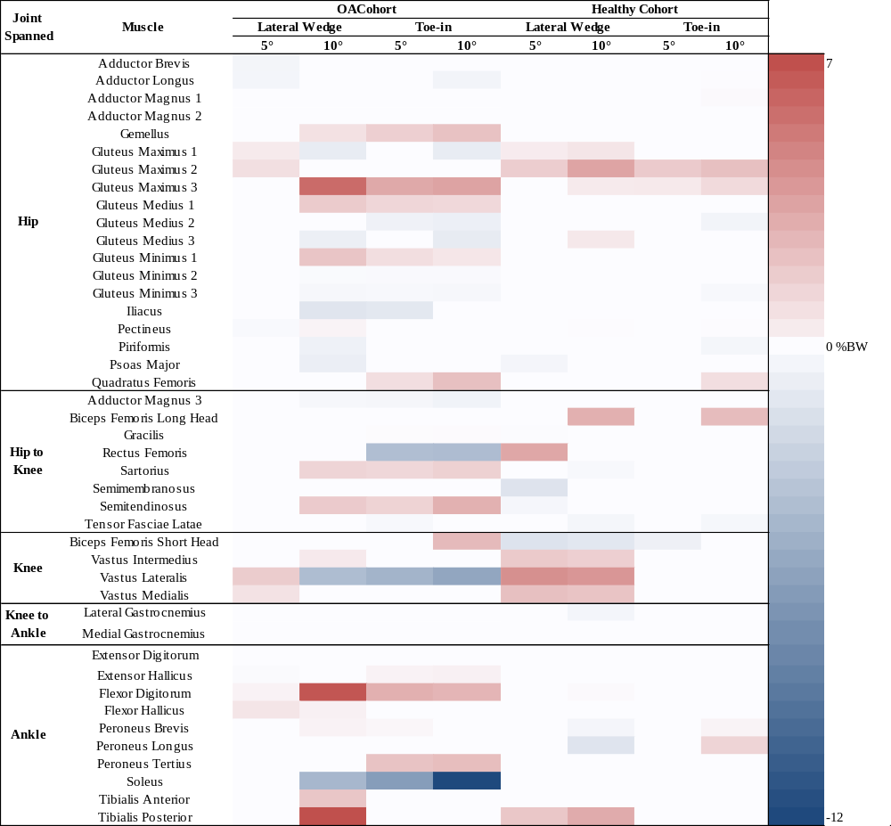
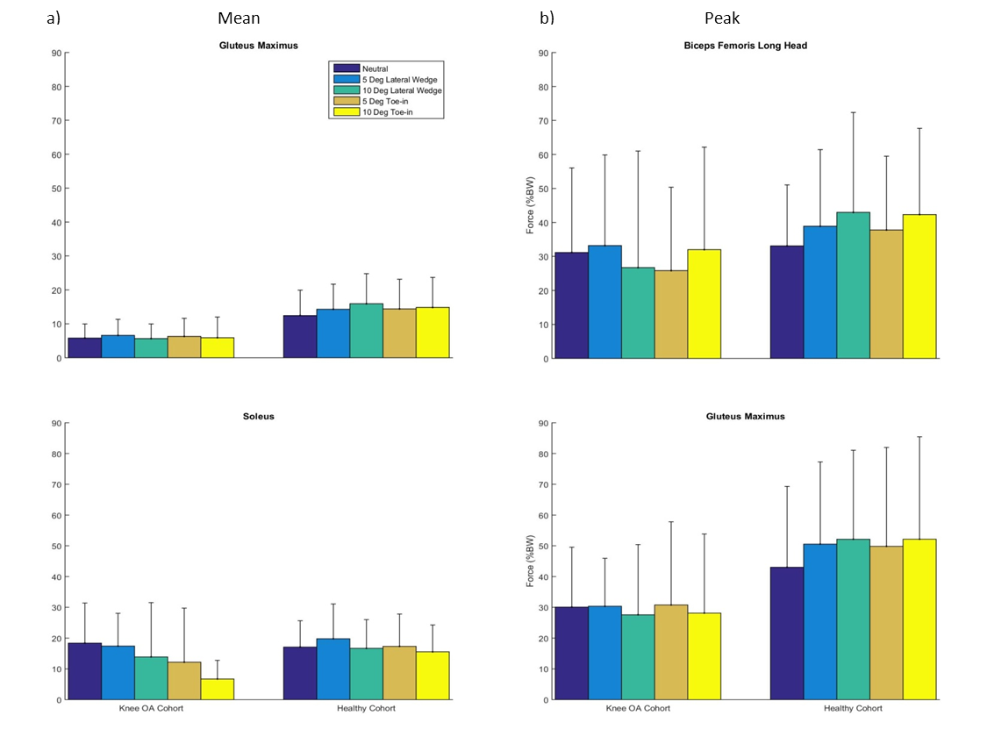
Figure 5: Some of the muscles that showed the most change across the conditions (at least 3 conditions compared to neutral) with a threshold set at greater than 10% BW, observed for a) mean and b) peak muscle forces normalized by %BW.

Figure 6: A muscle force change identity grid showing the significant differences within each cohort in all muscles compared to neutral, for the peak muscle forces. Red indicates an increase compared to neutral, while blue indicates a decrease compared to neutral; the darker the color the greater the decrease or decrease.
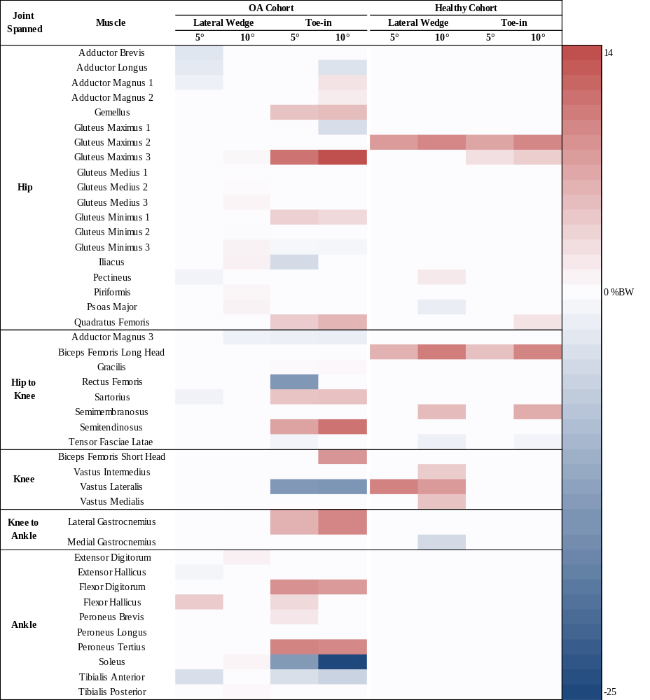
Figure 7: Mean and peak muscle force significant differences between OA (+) and Healthy (-) in all conditions. Red indicates knee OA cohort was greater within that conditions, while blue indicates healthy cohort was higher within that conditions; the darker the color the greater the difference.

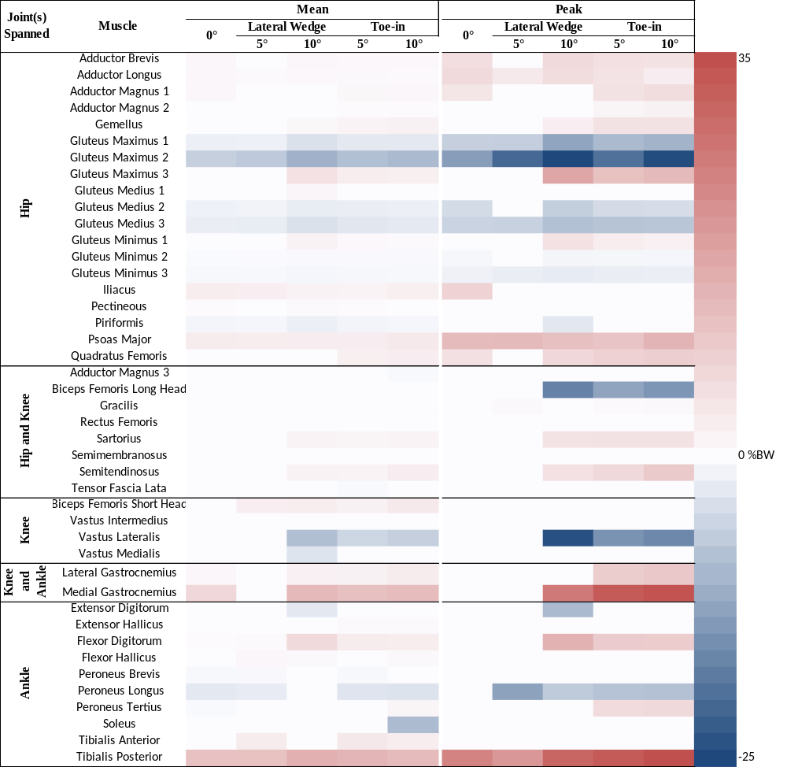

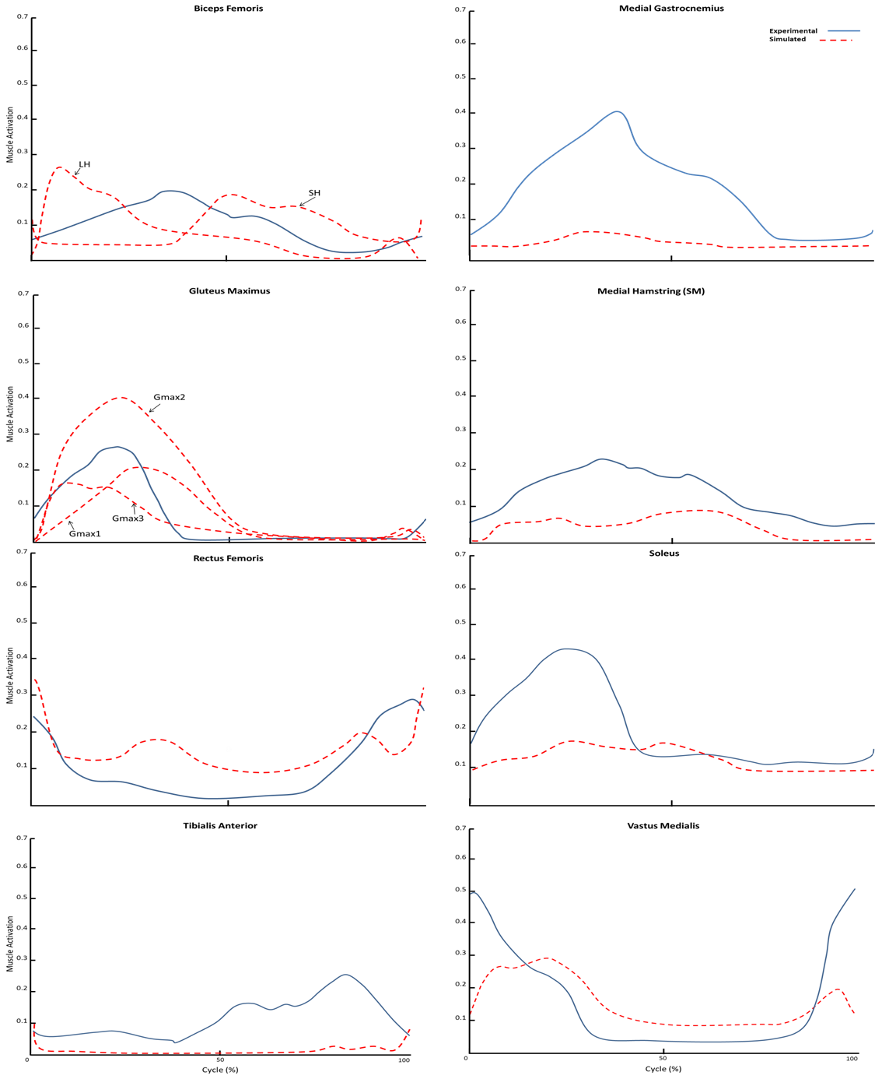
Figure 8: Comparison of muscle activations during cycling with the neutral pedal condition (at 80W and 60 RPM) and EMG from Neptune, et al., 1997 from elite male cyclists (at 127W and 60 RPM).

CHAPTER III
The Second Article
The student must add a brief explanatory statement at the beginning of each article, stating how the article was revised and/or detailing the student’s involvement in the article. Any co-researchers should be identified and their role clarified as part of this statement.

Abstract

3.1 Introduction

3.2 Methods

3.3 Results

3.4 Discussion

3.5 Acknowledgements

3.6 Conflict of Interest

3.7 References

CHAPTER IIII
THE Third ARTICLE

Abstract

4.1 Introduction

4.2 Methods

4.3 Results

4.4 Discussion

4.5 Acknowledgements

4.6 Conflict of Interest

4.7 References

Chapter V: CONCLUSION

6.1 Significance of Research
Knee osteoarthritis (OA), is a detrimental, degenerative joint disease that significantly destroys the quality of life (1) for an estimated 27 million people in the United States (2-4). One common treatment used in current rehabilitation strategies for knee OA is the prescription of exercise (i.e., walking and cycling) (5). Walking modifications have proven to be successful in diminishing knee moments and pain through the use of toe-in gait or lateral shoe wedges (1, 6). In subjects without OA, low-intensity cycling is as effective as high-intensity cycling for improving joint function, decreasing pain, and increasing aerobic capacity (7, 8). For subjects with OA, cycling’s health benefits include potentially reduced OA-related loads on the diseased joint tissues; however, there is little scientific evidence of the magnitude and location of these reduced loads at the knee. Cycling remains an integral component of exercise for subjects with OA; despite the fact, the potentially beneficial changes in knee loads and associated muscle forces are not well understood. Therefore, current exercise prescriptions may be improved with new knowledge of their effects on joint loads. This loading plays a crucial role in the progression of joint degeneration and severity of pain during exercise and activities of daily living (1, 9); therefore, a better understanding of how different cycling movements affect joint loads is necessary for improving rehabilitation strategies. If my aims are achieved, then subjects with OA would directly benefit from increased exercise through cycling while controlling the progression of OA. In addition, this work will allow for clinical professionals to make better decisions related to joint loads of their patients with OA.
The biomechanical models and computational tools developed by my team will find broad application. Numerous studies have been performed to record neuromuscular excitation patterns, understand muscles contraction dynamics, characterize musculoskeletal geometry, and quantified multijoint movements and kinematics. However, linking the detailed knowledge of these elements of the neuromusculoskeletal system to create an integrated understanding of normal and pathological movement remains a major challenge in the application of biomechanics to a wide range of clinical problems and basic science research. The long-term goal of this research is to provide a scientific framework for planning, evaluation, and improvement of patient-specific rehabilitation for individuals with knee OA.
The proposed work will generate new algorithms for solving complex optimization problems, improved methodologies for interpreting the dynamic functions of muscles during movement and a general computational frame work for pursuing further research. The simulations I develop will be implemented in freely available musculoskeletal modeling and simulation software (10) which enables us to share my results with other research groups. Over the past few years, there have been more than 111,330 downloads of models, simulations, and software from the project’s website(see simtk.org/home/OpenSim) with over 19,000 active users of these freely available biomechanics tools. This project will continue this development. Thus, if the aims of this proposed research program were achieved, this work will have a broad impact on the basic studies of neuromuscular biomechanics and for clinical treatment and prevention for the subjects with and without OA.

6.2 Research Innovation

6.3 Fundamental Contributions

6.4 Summary

Appendix

List of References

1. C.D.C, Prevalence and most common causes of disability among adults--United States, 2005. MMWR Morb Mortal Wkly Rep, 2009. 58(16): p. 421-6.
2. Hootman, J.M., Helmick, C.G., Brady, T.J., A public health approach to addressing arthritis in older adults: the most common cause of disability. Am J Public Health, 2012. 102(3): p. 426-33.
3. Lawrence, R.C., et al., Estimates of the prevalence of arthritis and other rheumatic conditions in the United States. Arthritis Rheum, 2008. 58: p. 26-35.
4. Mundermann, A., C.O. Dyrby, and T.P. Andriacchi, Secondary gait changes in patients with medial compartment knee osteoarthritis: increased load at the ankle, knee, and hip during walking. ARTHRITIS & RHEUMATISM, 2005. 59(9): p. 2835-44.
5. Cheng, Y.J., et al., Prevalence of Doctor-Diagnosed Arthritis and Arthritis-Attributable Activity Limitation — United States, 2007–2009. 2010. 59(39): p. 2238-2239.
6. Lawrence, R.C., et al., Estimates of the Prevalence of Arthritis and Other Rheumatic Conditions in the United States. Arthritis & Rheumatism, 2008. 58(1): p. 26-35.
7. Hootman, J.M. and C.G. Helmick, Projections of US prevalence of arthritis and associated activity limitations. ARTHRITIS & RHEUMATISM, 2006. 54(1): p. 226-229.
8. Dillon, C.F., et al., Prevalence of knee osteoarthritis in the United States: arthritis data from the Third National Health and Nutrition Examination Survey 1991–1994. Journal of Rheumatology, 2006. 33(11): p. 2271-2279.
9. Semanik, P., R.W. Chang, and D.D. Dunlop, Aerobic Activity in Prevention & Symptom Control of Osteoarthritis. PM & R: the journal of injury, function, and rehabilitation, 2012. 4(5 0): p. S37-S44.
10. Rozen, D.N. Biomechanical aspects of knee osteoarthritis and AposTherapy. Scientific Approach 2013; Available from: http://apostherapy.com/en/healthcare-professionals/treatment-packages/biomechanical-aspects.
11. Gerbrands, T.A., Pisters, M.F., Vanwanseele, B., Individual selection of gait retraining strategies is essential to optimally reduce medial knee load during gait. Clin Biomech (Bristol, Avon), 2014. 29(7): p. 828-34.
12. Shull, P.B., et al., Muscle force modification strategies are not consistent for gait retraining to reduce the knee adduction moment in individuals with knee osteoarthritis. Journal of Biomechanics, 2015. 48: p. 3163-69.
13. Felson, D.T., et al., Osteoarthritis: new insights. Part 1: the disease and its risk factors. Ann Intern Med, 2000. 133(8): p. 635-46.
14. Felson, D.T., et al., Evidence for a Mendelian gene in a segregation analysis of generalized radiographic osteoarthritis: the Framingham Study. Arthritis & Rheumatism, 1998. 41(6): p. 1064-71.
15. Felson, D.T., The Epidemiology of Knee Osteoarthritis -Results from the Framingham Osteoarthritis Study. Semin Arthritis Rheum 1990. 20: p. 42-50.
16. Nevitt, M.C. and D.T. Felson, Sex hormones and the risk of osteoarthritis in women: Epidemiological evidence. Ann Rheum Dis, 1996. 55: p. 673-6.
17. Srikanth, V.K., et al., A meta-analysis of sex differences prevalence, incidence and severity of osteoarthritis. Osteoarthritis and Cartilage, 2005. 13(9): p. 769-81.
18. Theis, K.A., C.G. Helmick, and J.M. Hootman, Arthritis burden and impact are greater among U.S. women than men: intervention opportunities. Journal of Womens Health, 2007. 16: p. 441-53.
19. Baker, K., et al., Quadriceps weakness and its relationship to tibiofemoral and patellofemoral knee osteoarthritis in Chinese: the Beijing osteoarthritis study. Arthritis Rheum, 2004. 50(6): p. 1815-21.
20. Slemenda, C., et al., Reduced quadriceps strength relative to body weight: a risk factor for knee osteoarthritis in women? Arthritis & Rheumatism, 1998. 41(11): p. 1951-9.
21. Slemenda, C., et al., Quadriceps weakness and osteoarthritis of the knee. Ann Intern Med, 1997. 127: p. 97-104.
22. Lohmander, L.S., et al., High prevalence of knee osteoarthritis, pain, and functional limitations in female soccer players twelve years after anterior cruciate ligament injury. Arthritis & Rheumatism, 2004. 50: p. 3145-52.
23. Felson, D.T., Occupational physical demands, knee bending, and knee osteoarthritis: results from the Framingham Study. Journal of Rheumatology, 1991. 18(10): p. 1587-92.
24. Coggon, D., et al., Occupational activities and osteoarthritis of the knee. Arthritis & Rheumatism, 2000. 43(7): p. 1449-9.
25. Focht, B.C., et al., Exercise, self-efficacy, and mobility performance in overweight and obese older adults with knee osteoarthritis. Arthritis & Rheumatism, 2005. 53: p. 659-65.
26. Messier, S.P., et al., Weight loss reduces knee-joint loads in overweight and obese older adults with knee osteoarthritis. . Arthritis & Rheumatism, 2005b. 52: p. 2026-32.
27. Messier, S.P., Obesity and osteoarthritis: disease genesis and nonpharmacologic weight management. Rheum Dis Clin North Am, 2008. 34(3): p. 713-29.
28. Zhang, W., et al., OARSI recommendations for the management of hip and knee osteoarthritis, Part I: Critical appraisal of existing treatment guidelines and systematic review of current research evidence. OsteoArthritis and Cartilage, 2007. 15: p. 981-1000.
29. Zhang, W., et al., OARSI recommendations for the management of hip and knee osteoarthritis, Part II: OARSI evidence-based, expert consensus guidelines. 2008.
30. Roddy, E., W. Zhang, and M. Doherty, Is gout associated with reduced quality of life? A case-control study. Rheumatology (Oxford), 2007. 46(9): p. 1441-1444.
31. Fregly, B.J., J.A. Reinbolt, and T.L. Chmielewski, Evaluation of a patient-specific cost function to predict the influence of foot path on the knee adduction torque during gait. Computer Methods in Biomechanics and Biomedical Engineering, 2008. 11(1): p. 63-71.
32. Bakker, M.F., et al., Tight control in treatment of rheumatoid arthritis efficacy and feasibility. Ann. Rheum. Dis., 2007. 67: p. 190-195.
33. Mangione, K.K., et al., The effects of high-intensity and low-intensity cycle ergometry in older adults with knee osteoarthritis. J Gerontol A Biol Sci Med Sci., 1999. 54(4): p. 184-90.
34. Akbarshahi, M., et al., Subject-specific evaluation of patellofemoral joint biomechanics during functional activity. Medical Engineering Physics, 2014. 36(9): p. 1122-1133.
35. Ericson, M., On the biomechanics of cycling. A study of joint and muscle load during exercise on the bicycle ergometer. Scand J Rehabil Med Suppl. , 1986. 16: p. 1-43.
36. Ericson, M.O., Mechanical muscular power output and work during ergometer cycling at different work loads and speeds. European Journal of Applied Physiology, 1988. 57: p. 382-7.
37. Ericson, M.O., et al., Power output and work in different muscle groups during ergometer cycling. European Journal of Applied Physiology, 1986. 55: p. 229-235.
38. Ericson, M.O. and R. Nissell, Tibiofemoral joint forces during ergometer cycling. The American Journal of Sports Medicine, 1986. 14(4): p. 285-90.
39. Sanderson, D.J. and A. Black, The effect of prolonged cycling on pedal forces. Journal of Sports Sciences, 2003. 21(3): p. 191-99.
40. Bailey, M.P., F.J. Maillardet, and N. Messenger, Kinematics of cycling in relation to anterior knee pain and patellar tendinitis. J Sport Sci 2003. 21: p. 649-657.
41. Too, D., Biomechanics of Cycling and Factors Affecting Performance. Sports Medicine, 2012. 10(5): p. 286-302.
42. Schipplein, O.D. and T.P. Andriacchi, Interaction between Active and Passive Knee Stabilizers during Levelwalking. . J Orthopaed Res, 1991. 9: p. 113-9.
43. Messier, S.P., et al., Do older adults with knee osteoarthritis place greater loads on the knee during gait? A preliminary study. Arch Phys Med Rehabil, 2005. 86(4): p. 703-9.
44. Miyazaki, T., et al., Dynamic load at baseline can predict radiographic disease progression in medial compartment knee osteoarthritis. Ann Rheum Dis, 2002. 61: p. 617-22.
45. Chakravarty, E.F., et al., Long distance running and knee osteoarthritis - A prospective study. Am J Prev Med, 2008. 35: p. 133-8.
46. Oliveria, S.A., et al., Body weight, body mass index, and incident symptomatic osteoarthritis of the hand, hip, and knee. Epidemiology, 1999. 10: p. 161-6.
47. Shull, P.B., Silder, A., Shultz, R., Dragoo, J.L., Besier, T.F., Delp, S.L., and Cutkosky, M.R., Six-Week Gait Retraining Program reduces Knee Adduction Moment, Reduces Pain, and Improves Function for Individuals with Medial Compartment Knee Osteoarthritis. Journal of Orthopaedic Resarch, 2013. 31: p. 1020-1025.
48. Cerejo, R., et al., The influence of alignment on risk of knee osteoarthritis progression according to baseline stage of disease. Arthritis & Rheumatism, 2002. 46: p. 2332-36.
49. Shull, P.B., Shultz, R., Silder, A., Dragoo, J.L., Besier, T.F., Cutkosky, M.R., Delp, S.L., Toe-in gait reduces the first peak knee adduction moment in patients with medial compartment knee osteoarthritis. Journal of Biomechanics, 2013. 46: p. 122-128.
50. Hurley, M.V., THE ROLE OF MUSCLE WEAKNESS IN THE PATHOGENESIS OF OSTEOARTHRITIS Rheumatic Disease Clinics in north America, 2005. 25(2): p. 283-298.
51. Hurley, M.V., Muscle Dysfunction and Effective Rehabilitation of Knee Osteoarthritis: What We Know and What We Need To Find Out. Arthritis & Rheumatism, 2003. 49(3): p. 444-52.
52. Walter, J.P., Korkmaz, N, Fregly, B.J., Pandy, M.G., Contribution of Tibiofemoral Joint Contact to Net Loads at the Knee in Gait. Journal of Orthopaedic Resarch, 2015. 33(7): p. 1054-60.
53. Baliunas, A.J., Hurwitz, D.E., Ryals, A.B., Karrar, A., Case, J.P., Block, J.A., Andriacchi, T.P., Increased knee joint loads during walking are present in subjects with knee osteoarthritis. Osteoarthritis Cartilage, 2002. 10(7): p. 573-9.
54. Gardner, J.K., et al., Effects of Toe-in Angles on Knee Biomechanics in Cycling of Patients with Medial Knee Osteoarthritis. Clin Biomechanics, 2015. 30: p. 276–282.
55. Gardner, J.K., Effects of Lateral Shoe Wedges and Toe-in Foot Progression Angles on the Biomechanics of Knee Osteoarthritis during Stationary Cycling. PhD diss., University of Tennessee, 2013.: p. 1-186.
56. Kautz, S.A., M.L. Hull, and R.R. Neptune, A Comparison of Muscular Mechanical Energy-Expenditure and Internal Work in Cycling. Journal of Biomechanics, 1994. 27(12): p. 1459-1467.
57. MacIntosh, B.R., R.R. Neptune, and J.F. Horton, Cadence, power, and muscle activation in cycle ergometry. Medicine and Science in Sports and Exercise, 2000. 32(7): p. 1281-1287.
58. Gardner, J., Effects of Lateral Shoe Wedges and Toe-in Foot Progression Angles on the Biomechanics of Knee Osteoarthritis during Stationary Cycling. UTK Doctoral Dissertation, 2013: p. 1-186.
59. Anderson, F.C. and M.G. Pandy, Dynamic optimization of human walking. J Biomech Eng, 2001. 123(5): p. 381-90.
60. Anderson, F.C. and M.G. Pandy, Static and dynamic optimization solutions for gait are practically equivalent. Journal of Biomechanics, 2001. 34(2): p. 153-61.
61. Delp, S.L., et al., OpenSim: open-source software to create and analyze dynamic simulations of movement. IEEE Trans Biomed Eng, 2007. 54(11): p. 1940-50.
62. Thelen, D.G., Adjustment of muscle mechanics model parameters to simulate dynamic contractions in older adults. J Biomech Eng, 2003. 125(1): p. 70-7.
63. Thelen, D.G. and F.C. Anderson, Using computed muscle control to generate forward dynamic simulations of human walking from experimental data. Journal of Biomechanics, 2006. 39(6): p. 1107-15.
64. Thelen, D.G., F.C. Anderson, and S.L. Delp, Generating dynamic simulations of movement using computed muscle control. Journal of Biomechanics, 2003. 36(3): p. 321-8.
65. Hamner, S.R., A. Seth, and S.L. Delp, Muscle contributions to propulsion and support during running. Journal of Biomechanics, 2010. 43(14): p. 2709-16.
66. Bergmann, G., et al., Hip contact forces and gait patterns from routine activities. J Biomech, 2001. 34(7): p. 859-71.
67. Richards, C. and J.S. Higginson, Knee contact force in subjects with symmetrical OA grades: differences between OA severities. J Biomech, 2010. 43(13): p. 2595-600.
68. Peat, G., R. McCarney, and P. Croft, Knee pain and osteoarthritis in older adults: a review of community burden and current use of primary health care. Ann Rheum Dis, 2001. 60: p. 91-7.
69. Aglietti, P. and P.P. Menchetti, Distal femoral varus osteotomy in the valgus osteoarthritic knee. American Journal of Knee Surgery, 2000. 13(2): p. 89-95.
70. Coventry, M.B., D.M. Ilstrup, and S.L. Wallrichs, Proximal tibial osteotomy. A critical long-term study of eighty-seven cases. Journal of Bone and Joint Surgery: American Volume, 1993. 75(2): p. 196-201.
71. Edgerton, B.C., E.M. Mariani, and B.F. Morrey, Distal femoral varus osteotomy for painful genu valgum. A five-to-11 year follow-up study. Clinical Orthopaedics and Related Research, 1993. 288(263-9).
72. Naudie, D., et al., The Insall award. Survivorship of the high tibial valgus osteotomy. A 10- to 22-year follow-up study. Clinical Orthopaedics and Related Research, 1999. 367: p. 18-27.
73. Losina, E., et al., Cost-effectiveness of Total Knee Arthroplasty in the United States: Patient Risk and Hospital Volume. Archives Internal Medicine, 2009. 169(12): p. 1113-22.
74. Bachmeier, C.J., et al., A comparison of outcomes in osteoarthritis patients undergoing total hip and knee replacement surgery. Osteoarthritis and Cartilage, 2001. 9: p. 137-146.
75. Hurley, M.V. and N.E. Walsh, Effectiveness and clinical applicability of integrated rehabilitation programs for knee osteoarthritis. Current Opinion in Rheumatology, 2009. 21: p. 171-6.
76. Hinman, R.S., et al., Lateral Wedges in Knee Osteoarthritis: What Are Their Immediate Clinical and Biomechanical Effects and Can These Predict a Three-Month Clinical Outcome? Arthritis & Rheumatism, 2008. 59(3): p. 408–415.
77. Fregly, B.J., et al., Design of patient-specific gait modifications for knee osteoarthritis rehabilitation. Ieee Transactions on Biomedical Engineering, 2007. 54(9): p. 1687-1695.
78. Anderson, F.C. and M.G. Pandy, A Dynamic Optimization Solution for Vertical Jumping in Three Dimensions. Comput Methods Biomech Biomed Engin, 1999. 2(3): p. 201-231.
79. Delp, S.L., et al., An interactive graphics-based model of the lower extremity to study orthopaedic surgical procedures. IEEE Trans Biomed Eng, 1990. 37(8): p. 757-67.
80. Hoy, M.G., F.E. Zajac, and M.E. Gordon, A musculoskeletal model of the human lower extremity: the effect of muscle, tendon, and moment arm on the moment-angle relationship of musculotendon actuators at the hip, knee, and ankle. Journal of Biomechanics, 1990. 23(2): p. 157-69.
81. DeMers, M.S., S. Pal, and S.L. Delp, Changes in Tibiofemoral Forces due to Variations in Muscle Activity during Walking. Ortho Research Society, 2014: p. 1-8.
82. Hicks, J.L., et al., Is My Model Good Enough? Best Practices for Verification and Validation of Musculoskeletal Models and Simulations of Movement. Journal of Biomechanical Engineering, 2015. 137(2): p. 1-24.
83. Neptune, R.R., S.A. Kautz, and M.L. Hull, The effect of pedaling rate on coordination in cycling. Journal of Biomechanics, 1997. 30(10): p. 1051-1058.
84. Neptune, R.R. and M.L. Hull, Evaluation of performance criteria for simulation of submaximal steady-state cycling using a forward dynamic model. Journal of Biomechanical Engineering-Transactions of the Asme, 1998. 120(3): p. 334-341.
85. Smak, W., R.R. Neptune, and M.L. Hull, The influence of pedaling rate on bilateral asymmetry in cycling. Journal of Biomechanics, 1999. 32(9): p. 899-906.
86. Mornieux, G., et al., Influence of cadence, power output and hypoxia on the joint moment distribution during cycling. Eur J Appl Physiol, 2007. 102: p. 11-18.
87. Neptune, R.R. and M.L. Hull, A theoretical analysis of preferred pedaling rate selection in endurance cycling. Journal of Biomechanics, 1999. 32(4): p. 409-415.
88. Neptune, R.R. and M.L. Hull, Methods for determining hip movement in seated cycling and their effect on kinematics and kinetics. Journal of Applied Biomechanics, 1996. 12(4): p. 493-507.
89. Neptune, R.R., S.A. Kautz, and M.L. Hull, The effect of pedaling rate on coordination in cycling. Journal of Biomechanics, 1997. 30(10): p. 1051-8.

VITA

Rachel L. Thompson was born in Rochester, NY, to the parents of Ann and Brian Thompson. She is the third child of three: Matthew Thompson and Nicole Ray. She grew up and attended elementary through high school in Rochester, NY. After her graduation, Rachel went on to receive her Bachelors of Science degree in 2012 from Slippery Rock University in Health and Environmental Science with a minor in Adapted Physical Activity. After Graduation, Rachel went on to an internship at the Canandaigua Veteran Affairs (VA) Medical Center, where she was introduced to the field of Biomedical Engineering. Then she went on to work for a year in the operating room at the University of Rochester Medical Center as a project assistant and then ultimately a cardiac and vascular implant coordinator. Where her job was to order and receive medical implants for specific surgeries from here her passion in implant, prosthetics and medical devices grew and she ultimately decided to pursue an advanced degree in Biomedical Engineering. In her quest for knowledge and desire to learn in this field of Biomedical Engineering she attended the University of Tennessee where she received her Master’s degree in 2016.

Finally Rachel went on to pursue and ultimately complete a PhD in Biomedical Engineering at the University of Tennessee. She graduated in May 2017 and has accepted a…..

