The Fort Pillow Massacre: The American Civil War in Public Memory
By
Finn Wheeler

A Thesis
Submitted to the Department of History
The University of Tennessee
In Partial Fulfillment of the Requirements
for a Bachelor of Arts with Honors
May 2025
Adviser: Dr. Luke Harlow

Introduction

How does a Civil War massacre remain relevant today? A massacre at a Union fort of little strategic importance led by Confederate General Nathan Bedford Forrest became one of the most important events of the Civil War because of its political and social context. Memory of the event remained contested after the end of the war, and the issues of Fort Pillow and Forrest provide effective examples of how public memory of the Civil War originated and became cemented. Through propaganda, denial, justification, misinformation, and idolization, the Fort Pillow Massacre and the figure of Forrest became a rallying cry during and after the Civil War. Used as a condemnation of Confederate barbarity during the war, blame for the massacre shifted to a criticism of the Democratic party in reconstruction. The battle particularly lingered for Forrest, who was plagued by his involvement in the massacre even after his death.
The Civil War was incited and was fought over the issue of slavery. Debates over slavery had been ongoing for decades before the Civil War, as the addition of new states to the Union upset the delicate balance of slave-holding and free states. Slavery and its industries were the primary source of economic output for the southern states, and the removal of slavery threatened the way of life of many southerners. The emergence of Abraham Lincoln as the republican party candidate only exacerbated the situation. As sectional tensions came to a head in the late 1850s, Lincoln’s rise to the presidency in 1861 triggered the secession of most southern states. The first to secede was South Carolina, specifically citing northern aggression towards the practice of slavery as the defining issue of secession. Similar declarations can be found in the secessionist declarations of Mississippi, Georgia, and Texas, so the defining issue of secession was no mystery to the southern states. Other states, namely Alabama, Louisiana, and Florida joined the confederacy in support of their fellow slave-holding states. Arkansas, Tennessee, North Carolina, and Virginia seceded months afterward, as Unionists loyal to the Federal government made up large sections of those states. Border states, like Missouri, Kentucky, West Virginia, Maryland, and Delaware remained neutral for the most part, being slave-holding states but not voting to leave the Union.
At first, the Union cause had the explicit goal of reunification. The abolition of slavery was not a priority for Abraham Lincoln until it became obvious that the South would not return to the Union peacefully. By 1863, it was clear that the Union war effort needed bolstering. The Northern population had become weary of war against their southern neighbors in a conflict that seemed like it would never end. Recruitment numbers were lagging, and the Lincoln government saw promise in an untapped market: African American soldiers.
Almost a year before the Fort Pillow Massacre in April 1864, the Emancipation Proclamation was issued in January 1863. This document shifted the meaning of the Civil War and the Northern cause. Abraham Lincoln freed all slaves in the Confederate states and included a clause allowing African Americans to join the Union army. The proclamation transformed the conflict into a “holy war on the south” in the name of Black freedom and abolition. Lincoln’s proclamation was extremely radical, even raising the ire of some Union soldiers who would speak out against emancipation. On the other hand, many Northerners supported Black enlistment for strictly pragmatic reasons, suggesting that Black soldiers could take bullets meant for White soldiers. Nevertheless, the Union army formed United States Colored Troops (USCT) units, which served with distinction in the fight for their freedom. USCT units were led by White officers but wholly made up of Black soldiers, unable to reach the rank of officer. By the end of the Civil War, soldiers in USCT units numbered 170,000, about 7% of the Union army. 38-40,000 USCT troops died during the war, sustaining a casualty rate 35% higher than White Union soldiers, despite not fighting for the first 18 months of the war. The introduction of Black troops to the war effort caused an uproar in the South, one that was felt especially by these Black Union soldiers, who often met with more violence than their White counterparts. This violence is evident in multiple engagements during the War, namely the Battle of the Crater, Poison Spring, Saltville, and Fort Pillow. These conflicts were all Union losses with high casualty counts among US Colored Troops. In these battles, captured or wounded Black soldiers were slaughtered by Confederate soldiers in the aftermath or while attempting to surrender. Seeing Black troops on the field sparked fears among Confederates that a Union victory threatened their way of life and enticed them to deal with Black prisoners of war with extreme prejudice.
Fort Pillow was the site of a battle between Confederate forces and a mixed garrison of Black and White Union soldiers. Abandoned by Confederates early in the war because of quickly advancing Union lines, the Fort became a Union communication post that occasionally held large groups of soldiers. In early 1864, a USCT unit and a White unit were moved to the garrison at Fort Pillow in a move that defied higher Union orders. In a spectacle of both Union incompetence and Confederate prejudice, the outnumbered and inexperienced Union garrison was assaulted and massacred by General Nathan Bedford Forrest and his Veteran Confederate forces. After failing to coerce a surrender by threatening “no quarter,” Forrest’s men stormed Pillow’s inner Fortifications and began a cruel slaughter, targeting Black soldiers and Tennessee Unionists, whom they hated in almost equal measure.
The massacre was the subject of great debate during and after the Civil War, used by the Union side as a propaganda campaign and denied by the Confederates. The Northern press urged retaliation and framed the event as a showcase of Confederate brutality. The US government considered and even promised retaliation for the event but eventually settled on using the massacre as a much-needed propaganda campaign for the Union war effort. The Confederate side, including Forrest himself, mounted denial and defense of Confederate actions during the battle. The backlash from the Northern press and government, however, eventually pushed the Confederate government to provide Black soldiers with the same rights as white combatants. Criticism of the Union for allowing the massacre to happen also inspired the US Government to ensure that Black soldiers received the same rights and protections as White soldiers.
Scholarly writing surrounding the Fort Pillow Massacre has been extremely divisive. On one hand, the Congressional Committee on the Conduct of War report created during the war blames the massacre on deliberate Confederate policy carried out by the attackers. The report reeks of Union propaganda and is often criticized for exaggeration on the part of several of the eyewitness testimonies. On the other hand, Ex-Confederates and Pro-Forrest writers commonly portray the high death counts at Fort Pillow as the sole fault of the Union garrison. Pro Forrest accounts of the battle, especially those written by southerners in the late 1800s and early 1900s cite the Congressional report only when it helps their argument and defend the General’s actions with dubious statistics. Although they recognize that unnecessary killing occurred, they attribute these to a desperate and foolish defense of the fort. Pro-Forrest authors of early histories of Fort Pillow have been criticized for making rash conclusions based on little data, like the supposition that the Union soldiers at the Garrison were intoxicated when there is little actual evidence for this. Arguments like this were based heavily on widespread racist ideas of the late 1800s and early 1900s.
Starting in the 1950s, scholars started to favor the interpretation that a massacre did occur. This interpretation gained its footing in the internal military investigation that took place shortly after the battle and before the Congressional Committee Report, which is considered biased by most pro-Forrest writers. Despite this, many modern day scholars continue to view the Congressional Report as a historically valuable source for primary documentation of the Massacre. In combination with other firsthand accounts not included in the Committee report, like that of the surgeon Charles Fitch, the massacre interpretation is considered the most consistent and structurally sound interpretation. In the 1980s, two influential articles published in The Journal of American History by John Cimprich and Robert C. Mainfort Jr. set the record straight on one of the most debated issues regarding whether a massacre occurred, the casualty count. Searching through muster records, Cimprich and Mainfort placed the number of soldiers killed at approximately 47-49% of the Garrison. The more shocking revelation was that the casualty rate for Black soldiers was 64%, while the casualty rate for White soldiers was 31%. This showed a clear targeting of Black soldiers by the Confederates under Forrest. Today, Scholars for the most part agree that Forrest and his commanding officers did not order a massacre but must have known and approved of what would happen when the Confederate troops confronted Black soldiers after a prolonged siege of the Fort.
Scholarly writing surrounding Forrest has been similarly divided. The Forrest biographies, as stated, attempt to justify the General’s actions and frame Forrest as the ideal of a southern gentleman, a trend that began with Jordan and Pryor in 1868, peaked in the late 1800s, and continued into the 1930s. I will be discussing the earlier biographies in more detail in chapter two. In 1931, Andrew Lytle’s Nathan Beford Forrest: And his Critter Company transformed the image of Forrest in southern literature. No longer catering towards a glorified gentlemanly past, Lytle’s work created a functional representation of Forrest that was more contemporary, violent, and outwardly white supremacist. As the 20th century continued, Forrest enjoyed a more light-hearted role in American public memory. One of his famous sayings, “First with the Most” became the subject of advertising campaigns and conjecture about the General’s literacy. More recent scholarly work surrounding Forrest covers his enduring legacy in public memory and his life after the war. Little is known about Forrest’s childhood and early life, leaving authors to make inferences and create self-serving narratives. His involvement with the Ku Klux Klan is purposefully obscured, leading to conflicting views on what his role exactly was. The General’s final years are marked by confusing and seemingly contradictory events, like his speech at a Black organization’s barbeque promoting positive relations between racially divided Americans.
This paper will examine how Fort Pillow was cemented in public consciousness during the Civil War and how its memory evolved in the decades immediately following the war. Observing and engaging with older forms of memorialization helps to contextualize the remnants of the past that linger on in the present day, like Confederate statues and preserved Civil War battlegrounds. It is important to understand these markers and take proper courses of action regarding their place in our public spaces and memory.
One of the most important immediate reactions to Fort Pillow was a call for equal treatment of Black and White soldiers. The Federal government granted equal pay and protections for Black soldiers before the war was over, making it one of the first victories for civil rights in American History. Such a victory would not be forgotten by the newly freed Black population, who sounded the call of “Remember Fort Pillow” during and after the war as an example of Black commitment to the Union and a demonstration of equal ability and sacrifice.
Observation of public memory surrounding General Nathan Bedford Forrest provides a fascinating window into how Civil War memory, particularly Confederate memory, has evolved. Known after the war as a hero and military genius of the Confederacy, the General enjoyed a spotlight in the pantheon of the Lost Cause mythology. His notable involvement in the Ku Klux Klan has sparked debate on all sides about his memorialization and legacy. The specifics of his involvement in the organization are shrouded by intentional mystery, suffice to say that he was instrumental in its leadership and early growth. In Memphis, a statue of Forrest was placed in a park named after the general in 1905. The statue remained in place until 2017 as Protests surrounding Confederate monuments came to a head. During its lengthy stay at the centrally located park in Memphis, now known as Medical District Park, the monument to Forrest represented the civic importance of the Confederate to the White residents of Memphis. The statue also represented violence towards and erasure of Black Memphis. Construction of the Forrest statue in Memphis effectively caps off the first wave of Confederate memorialization, which symbolized a far cry from more modern Confederate memory as it evolved throughout the 20th and 21st century.
Chapter one covers the battle at Fort Pillow and immediate reactions to the Massacre. The conditions leading to the massacre at Fort Pillow will be explored to facilitate understanding of how and why the massacre occurred. The specifics of the Battle at Fort Pillow will be presented, which are vital for understanding how the conflict culminated in a brief yet brutal massacre. Poor judgement, inexperience, and unclear orders compromised the Union defense even before the Confederates stormed the fortifications. Hard War policies pursued by the Union made the garrison enemies to local civilians, who provided knowledge that helped the Confederates gain an upper hand in the assault. The massacre itself was a direct result of racial tension between Confederates and Black Union soldiers, who were targeted more than any other group in the massacre. Immediate responses to the massacre during the war will be covered, specifically press and government reactions in both the North and South. During the war both sides used the massacre to their own ends, either to advocate for or against the Union cause and Black enlistment. The US Government’s congressional report of the massacre and Confederate denial and justification will be examined. Responsibility for the massacre was placed on Forrest, the commander of the Confederate attack on the fort. Backlash from the event forced Forrest and the Confederates, as well as the Union military, to provide African American soldiers with the same protections as White soldiers.
Chapter two explores the post-war relevance of Fort Pillow, Forrest’s life, and the general’s legacy in Memphis. Fort Pillow remained relevant in Black communities but drifted out of mainstream public memory as the 19th century progressed. Fort Pillow experienced a reemergence in the public eye during the presidential election of 1868. Forrest, in his new position as a Tennessee delegate for the Democratic party, drew attention from Northern Republicans and was criticized for his role in the massacre. In the same year, the first biography of Forrest was published, which attempted to clear his name regarding the Fort Pillow Massacre. The biography chapter about Fort Pillow will be analyzed, and brief summaries of other biographies will be provided. Several important moments from Forrest’s post-war life will be covered to provide understanding of the General’s complicated legacy. The most important moments are his killing of a Black plantation worker in 1866, his involvement with the Ku Klux Klan, and his speech at a Black Memphis organization in 1876. Coverage of Forrest’s death will be discussed, as it varied primarily by sectional region. The post-war status and racial climate of Memphis, where Forrest spent much of his post-war life, will be analyzed. Following a period of economic depression and disaster, Memphis became a prominent and racially tense city. The late 19th century in Memphis was marked by racial violence, and White Memphians adopted Forrest as a symbol of the city’s supposed White, militaristic past, present, and future. The Memorial statue dedicated to Forrest was a product of the White supremacy and racial violence that colored Forrest’s legacy, deeply intertwined with the memory of Fort Pillow.

Chapter One: The Fort Pillow Massacre

Fort Pillow was built in 1861 along the Mississippi river because of fears that a Union advance along the Mississippi would disrupt the Confederate war effort. The Fort was named after Gideon Pillow, a wealthy Tennessee Veteran of the Mexican American War. Fort Pillow was constructed using slave labor, and at its peak had roughly 1500 slaves working on the Fort.
Fort Pillow itself had little strategic importance, and did not see much fighting until the massacre. The fort was abandoned early on and became a Union stronghold for the region of West Tennessee. Following Union capture, the fort was deemed out of the way of the main fronts of the war, and soldiers were only periodically stationed at the fort, which served as a communication outpost. As the war progressed, efforts by Secessionist guerilla fighters ramped up in West Tennessee, encouraging the Federal government to enact “hard war policies” that punished residents for guerilla activities. Union soldiers seized secessionist property, mostly food and weapons to assist the war effort, and even despoiled and burned local communities. Most hard war policies ended up contributing to secessionist guerilla activity in the area, fueling enlistment in Confederate Partisan Ranger groups that practiced guerilla warfare under the banner of the Confederate army. In one case, after a Confederate Partisan Ranger unit attacked a Fort Pillow patrol, the 2nd Illinois Cavalry attempted to track down the guerillas, using extreme violence against locals in their search. Confederates charged Federal soldiers with having violated the rules of civilized warfare, and internal criticism following the incident forced Unionists to question how far hard war policies should go. Hard war policies contributed to feelings of resentment among secessionist residents under Fort Pillow’s jurisdiction, civilians who would assist Confederates in the area.
Fort Pillow was a magnet for West Tennessee Unionists and escaped slaves. The latter were employed at the fort as cooks and servants or enlisted into the Union army later in the war. Due to hard war restrictions on trade, Unionist merchants who were unwelcome in the surrounding area did business inside the fort. Fort Pillow became a center for cotton shipping to the North during the war, as sectional industries were split along the lines of war. In early 1863 Abraham Lincoln’s final Emancipation Proclamation liberated most slaves in the country, allowing African Americans to enlist in the Union army under the command of White officers. Black freedom and enlistment raised concern in the south and divides between pro and anti-emancipation Federal soldiers caused tension in the Union army and at Fort Pillow’s first garrison. An account of Union soldiers renouncing Lincoln and the republican party, as well as discouraging runaway slaves from entering the fort can be found in the accounts of the 52nd Indiana, stationed at Fort Pillow in 1863. Meanwhile, pro-emancipation soldiers of the same unit encouraged Black enlistment among fugitive slaves. Some Union soldiers expressed a desire to leave the service, citing that they had not gone to war to free anyone, much less those who they saw as a threat to labor security should the freed slaves migrate north. Debates and altercations between soldiers reflected racial prejudice and White supremacy, beliefs that were commonly held by Confederates and Unionists alike.
In the Confederacy, Black enlistment elicited reactions of fear, disgust, and anger. One account from William Nugent, a Confederate soldier, predicted that the enlistment of Black soldiers would produce “dire results” and a departure from civilized warfare as policies and acts of retribution would continue to mount. Concern over property rights and insurrection loomed large over Southern slaveowners as slaves fled to Union strongholds across the south. The Confederate congress refused to recognize Black soldiers, giving state authorities the decision of whether to return captured ones to their previous owners or execute them as insurrectionists. White officers of Black regiments would also be subject to trial as insurrectionists.
In January 1864, General William T. Sherman ordered Fort Pillow to be abandoned. The presence of Federal soldiers in the area was no longer sustainable. Although the garrison inhibited secessionist guerilla activities, they had no way of permanently stopping them, and Sherman was planning a massive final offensive that would be unaffected by local Confederate activity. The Union abandoned the fort, forcing the closure of civilian business in the area. The only remaining Union presence was a single gunboat called New Era.
In February 1864, the 13th Tennessee Cavalry and the 2nd US Colored Light Artillery were moved to Fort Pillow by General Stephen Hurlbut, an act that violated the standing orders of his superior, General Sherman. The use of Black units in garrisons was common Union practice during the war, as African Americans remained unproven in combat in the eyes of many Northerners. The garrison was under the command of Major Lionel Booth, an experienced commander considered by Hurlbut to be competent and steady. Second in command was Major William Bradford, an inexperienced officer originally from Tennessee. Hurlbut’s later explanation for violating commands by General Sherman was that the fort’s location held strategic control over the river and would facilitate enlistment. Hurlbut was also under pressure from the local treasurer to reopen trade at the fort. Unknown to Unionists in the area, Confederate Major General Nathaniel Bedford Forrest had plans to capture the fort, stating that “they have horses and supplies which we need,” a priority for Forrest’s unit, which subsisted primarily from captured Union supplies.
Forrest had risen to the rank of Major General using military strategy, cunning, and wit, and was known to use psychological tactics against Union forces. Forrest was notorious for inducing Federal garrisons to surrender to inferior Confederate attackers. A common tactic that Forrest used was to threaten “no quarter,” meaning no mercy, to scare Union commanders into surrender. The first encounter between Forrest’s unit and Black Federal troops was an attempted siege at Fort Anderson in Paducah, Kentucky. Knowing that Black troops were present at the garrison, Forrest offered to accept the entire Union force as prisoners, threatening no quarter if the surrender was not achieved. His attempt to produce a surrender failed and he was forced to back down. Two weeks later Forrest and his men attacked Fort Pillow. Some historians credit the encounter with Black troops at Paducah as an inciting incident for the Fort Pillow massacre, but there is no documentation or actions of Forrest that support this supposition.
Before Forrest’s attack, the Union garrison was comprised of roughly equal numbers of White and Black soldiers. Many of the soldiers were former slaves or White southern Unionists from Tennessee, both groups that Confederates detested. Confederate accounts indicate that Black soldiers especially stoked the ire of the Southern soldiers. Confederate Captain Henry Chambers of the 49th North Carolina wrote about a battle at Suffolk, Virginia that “We were nearly exhausted with our long double quick but when told that ‘the hated negroes had been encountered,’ we received as it were renewed vigor and on we pushed.” Some time after the massacre, General Chalmers, Forrest’s second in command gloated about the battle that it was an opportunity to teach “the mongrel garrison of Blacks and renegades a lesson long to be remembered” Most of the Union soldiers also had little or no combat experience. In contrast, Forrest’s unit consisted of seasoned veterans with experience attacking fortified enemies. Except for the failed siege at Paducah, Forrest and his soldiers a had little experience fighting and even encountering Black soldiers in combat before attacking Fort Pillow. Notably, Forrest’s troops had ridden forty miles overnight from Paducah to Fort Pillow to attack the fort by morning. Many were likely irritated and exhausted by the time the battle began.

Forrest’s Assault

On the morning of April 12, 1864, Forrest and his troops caught the garrison by surprise, assisted by local secessionists eager to see the Union presence in the area gone. Confederate forces outnumbered the Federal garrison two to one and quickly forced the Federal soldiers to regroup inside the fort. Major Lionel Booth was shot and killed in the fort by Confederate fire, leaving command of the garrison to the amateur Major William Bradford. After a few minutes of fighting, Forrest requested a surrender and gave the defenders twenty minutes to consider the offer. During the truce, Union soldiers reportedly gloated and taunted the Confederates under the belief that reinforcements were on the way. The account of an unnamed Confederate under the name “Memphis” claims that “The enemy announced their determination not to surrender, and were accordingly defiant and insolent in their demeanor.” Taunting from Black soldiers and southern Unionists in the garrison particularly angered Confederate attackers, already inclined to treat these groups with prejudice. During the twenty-minute truce, Forrest communicated with the remaining command of Fort Pillow, now led by Major Bradford. In Typical Forrest fashion, the general demanded a complete surrender, the alternative being a storming of the fort and threat of no quarter to the garrison. During the truce, Confederate troops under Forrest’s orders advanced stealthily into positions close to the Union defense line, preparing for the event of a continued fight. Determined not to end up a victim of Forrest’s tricks, Bradford and his soldiers decided not to surrender, and even forged the late Major Booth’s signature in response to the surrender request. When fighting resumed, Union lines were caught unaware and quickly breached by the entrenched Confederates.
As chaos gripped the defenders, Union soldiers were forced to fight in desperate hand-to-hand combat. Many of the inexperienced Federal soldiers attempted to surrender individually to the attackers but were indiscriminately killed by Confederates. Seeing this, many attempted to flee via the steep bluff of the Mississippi river behind the fort. Confederate sharp shooters picked off the swimmers in large numbers. Federal soldiers fell to the ground and acted dead to avoid execution. According to a Union surgeon, Confederate soldiers entered a field hospital and brutally killed wounded soldiers, with prejudice toward Black soldiers. According to Union Surgeon Charles Fitch, originally from Iowa, many of the Confederate soldiers were intoxicated, and fired upon prisoners with revolvers. By the time the garrison was retreating down the bluff, Major Bradford and Captain Posten, the next highest ranking soldier, were the only remaining officers. The rest were killed by Confederate sharpshooters even before the final Confederate assault. At first, Major Bradford attempted to surrender, a request that was denied as he was continuously fired upon by Confederates. Bradford next attempted to flee the battle, and after briefly attempting to cross the river ran back to the fort before finally finding a Confederate officer who would accept his surrender. Other Union soldiers were not as lucky, as Confederates positioned on the side of the bluff fired into the retreating groups of soldiers, many of whom were throwing down their weapons as they desperately retreated. In Fitch’s account, he was directed to Forrest, who was occupied directing the aiming of artillery at the New Era. Fitch demanded the protections deserved of a prisoner of war, a request that must have provided Forrest some idea of what was going on. To this Forrest reportedly said: “You are surgeon of a damned Nigger Regiment.” When Fitch replied that he was not, Forrest accused the surgeon of being a “damn Tennessee Yankee then.” Forrest then put Fitch under the charge of a Confederate soldier to ensure that he would not be harmed. This brief exchange reveals some of Forrest’s thought process in the attack on Fort Pillow, especially his supposition that all members of the Garrison were either Black soldiers or Tennessee Unionists, both groups apparently deserving little respect from the General as combatants.
Eventually, Forrest ordered the massacre to end, 15-20 minutes after the start of the final assault. By this time, the inner fort was littered with bodies, described by one Confederate surgeon, Samuel H. Caldwell, as “decidedly the most horrible sight that I have ever witnessed… They sure heaped upon each other.” Achilles V. Clark, in a letter after the fact reported that “Their fort turned out to be a great slaughter pen. Blood, human blood stood about in pools and brains could have been gathered up in any quantity.” Eyewitness testimonies from the Congressional Committee Report record that the killing continued into the night, as the wounded and prisoners were subject to the wrath of Confederate soldiers.
After the dust had settled, it was clear that inordinate killing had indeed taken place. Conflicting accounts of the battle, however, obscure the fine details. Fitch’s testimony implies that Forrest and his officers did not condone or order the massacre, and in fact praises general Chalmers for his protection of the prisoners. Other testimonies, including Confederate accounts, claim that Confederates repeated orders from Forrest himself to give no quarter and to kill captured soldiers. Later accounts from some Union soldiers claimed that Forrest even prevented their executions. Forrest’s second in command, General James Chalmers, admitted the occurrence of a massacre to Northern reporters aboard the Platte Valley, a ship that arrived the next day to collect the wounded. Chalmers blamed the massacre on the fury of Confederate soldiers towards enlisted Black men, claiming that he could not control their actions. Chalmers cited the Confederate law allowing the execution of Black soldiers but stressed that neither he nor Forrest had ordered or condoned the massacre.
Forrest was no stranger to criticism regarding his unorthodox military tactics. Union generals accused Forrest of violating the rules of warfare throughout his career because of his use of psychological tactics. During the twenty-minute truce period at Fort Pillow, Forrest moved soldiers to forward positions around the fort. Forrest garnered criticism for this movement as well as his threats of no quarter should the garrison refuse to surrender. This movement, however, played a deceptively small role in the Confederate victory and ensuing massacre.
The demise of the garrison can be contributed in part to Federal incompetence and poor decision making. Major Lionel Booth, the commanding officer of the garrison, was evidently unaware of the fort’s weaknesses, causing the fatal flaws in the defense strategy previously mentioned. Booth also relied too heavily on his inexperienced garrison and the Fort’s inner defenses. Before the attack on the garrison, Booth had received multiple warnings that Forrest would attempt to capture the fort. One came from an escaped Union captain whose commanding officer had surrendered to Colonel Duckworth under Forrest’s command. He had heard rumors that Forrest planned to attack Fort Pillow, although nothing he had seen on the road convinced him that the rumors were true. Next, a courier in disguise was captured and brought to the fort, where he told Booth about Forrest’s plan to take the fort. Booth did not act upon either source, refusing to request reinforcements or even send a scouting party to confirm the reports. Security within the fort was also poor, and it is likely that there were several Confederate sympathizers within the fort at any given time who assisted Confederates by supplying intelligence to Forrest and his men. Security issues at smaller fortifications were a well-known issue among higher ranking Unionists. General Sherman considered satellite garrisons like the one at Fort Pillow a weakness and a likely target for plundering by Confederates.
The incompetence of General Hurlbut was perhaps the reason the massacre occurred in the first place. Hurlbut’s reasoning for reopening the fort was that he did not want it to fall into the hands of the Confederates, which could disrupt Union supply lines on the Mississippi River. Hurlbut did not consult Sherman in his decision to reopen the fort, instead electing to violate his commander’s orders. Hurlbut understood that defense of the fort could fall upon the inexperienced Major Bradford, and following the massacre, admitted that the death of Major Booth was the immediate cause for the capture of the fort. Additionally, Hurlbut supplied Bradford with limited and imprecise instructions, advising that Booth should maintain the interior defensive works and Bradford the exterior works. Hurlbut advised that Bradford should “seek refuge in the fortification” in event of an attack. Unaware of the importance of the rifle pits and other outer fortifications, Bradford ordered his men to retreat to the inner fort following the initial Confederate assault. Compounding these mistakes was the lack of communication between Hurlbut and the garrison. The general learned of the attack within hours of the fort’s capture and was therefore unable to send any effective reinforcements. Hurlbut was relieved from his duties after Generals Sherman and Ulysses S. Grant found out about the fort’s capture. The total command failure and scattering of the inexperienced Union troops after Confederates stormed the fort’s parapets signaled the final nail in the coffin for the defenders.

Immediate Reactions

The massacre was published throughout the north starting on April 14th, with newspapers printing letters from individuals who visited the fort after the battle and interviews with paroled Federal soldiers at the site. Some republican newspapers urged no quarter for Forrest and his cavalry or promoted retaliation against Confederate prisoners, citing racial injustice and drawing upon abolitionist thought. The Hartford Daily Courant urged against retaliatory measures, blaming the practice of slavery for the massacre and fueling abolitionist fervor. Soldiers clamored for vengeance for the men at Fort Pillow. The Wisconsin Daily Patriot claimed that many Federal officers considered it their duty to “shoot every one of Forrest’s command” and threatened to kill imprisoned members of Forrest’s unit. Several publications, including the Hartford Daily Courant, New York Evening Post, and the New Orleans Tribune criticized the Federal government for their poor defense of the Fort and highlighted calls for equal treatment of Black troops.
In the south, Forrest’s victory was met with high praise. Apparently unaware that the high death counts would raise even questions from contemporaries, Forrest finished his campaign in West Tennessee after the decisive victory at Fort Pillow. He was received well by Southerners, even bragging in one public appearance that the river was dyed red with the blood of Unionists. In a letter to his superior, Leonidas Polk, Forrest wrote regarding Fort Pillow that “The victory was complete, and the loss of the enemy will never be known from the fact that large numbers ran into the river and were shot and drowned.” He ended the letter with the statement that “These facts will demonstrate to the Northern people that the negro soldier cannot cope with Southerners.” Forrest framed the massacre as proof that Black soldiers were incapable of fighting well or receiving respect from fellow soldiers.
After hearing of the extremely negative reports originating from the north, Forrest took a more revisionist standpoint towards Fort Pillow. In Forrest’s report of the battle, he claimed that the Union forces attempted to retreat and regroup at the river instead of fleeing. Forrest expanded on his revisionist account of the battle in his defensive letter, written in response to northern newspapers. He claimed that the Federal forces hopelessly defended Fort Pillow, continuing to fire upon Confederate attackers and attempting to regroup under the covering fire of New Era. A similar letter drafted on April 18 from Forrest’s headquarters under the name “Memphis” was published in democratic newspapers. The letter claimed that Federal troops refused to surrender in the face of overwhelming odds, citing taunting from Union defenders and continued flying of the Federal flag, implying few or no individual attempts to surrender. Other Confederates who either witnessed the battle or heard about it made similar statements, with some excusing the executions of individual surrenderers simply as poor decisions made in the heat of battle.

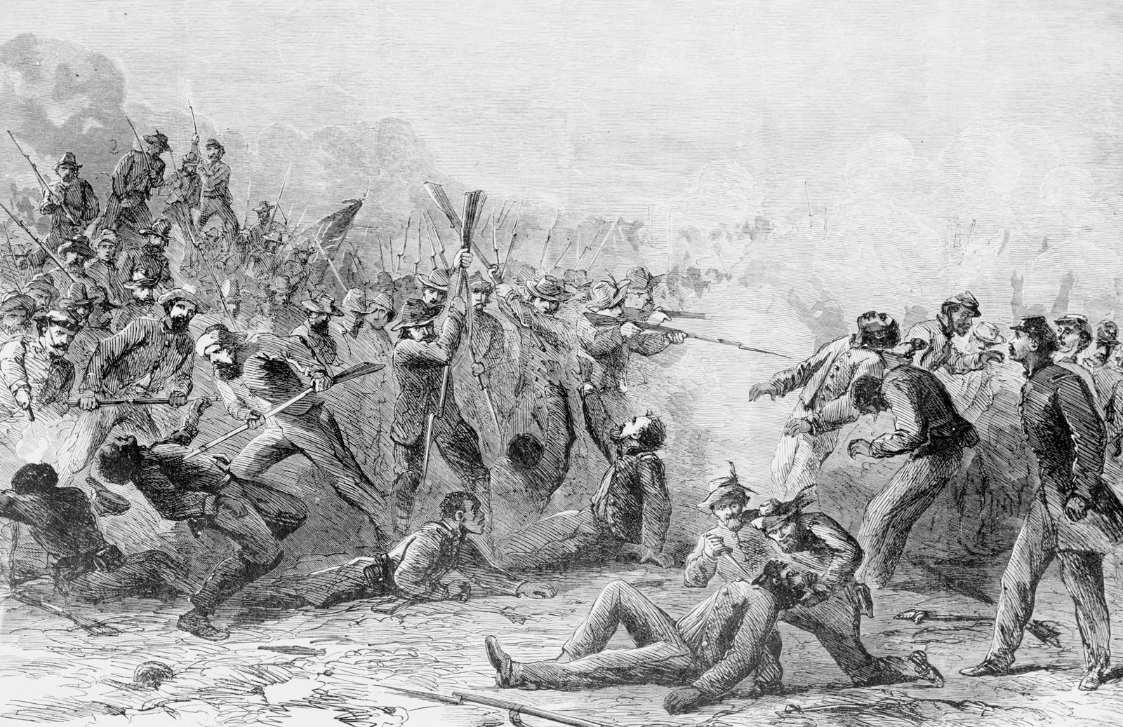
Figure 1: The Massacre at Fort Pillow, 1864
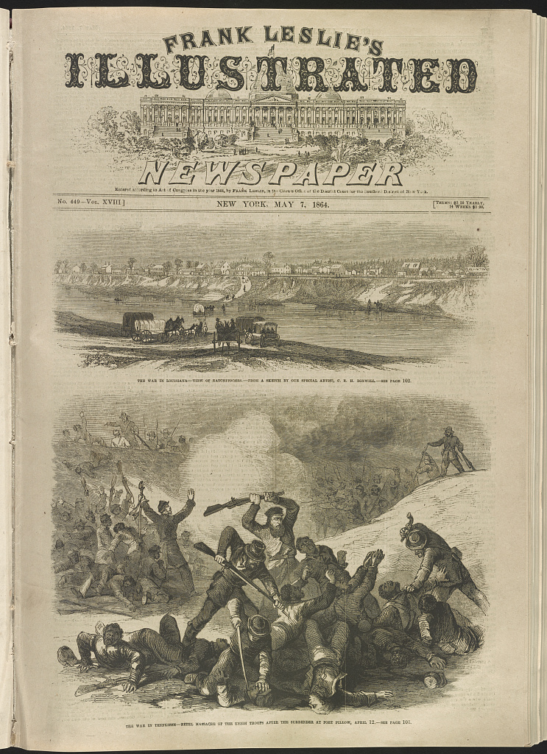
Figure 2, Frank Leslie’s Illustrated Newspaper, rebel massacre of the Union troops after the surrender at Fort Pillow, April 12
Artistic depictions of the massacre portrayed Black soldiers as helpless, unarmed victims and Confederates as a bloodthirsty mob. Figure 1, a lithographic illustration of Fort Pillow, was produced in the weeks immediately following the event, and depicts a brutal massacre carried out by incensed Confederates against helpless Union soldiers. The primary victims of the Confederate wrath are Black soldiers, but White Unionists alike are massacred. The two Confederates murdering a Black soldier in the foreground are particularly devilish, echoing newspaper claims of a “fiendish” massacre. This image was made during the war and sold to Northern civilians, reaching a wide audience. Images like these were meant to rile up the public and sell copies, a widespread medium throughout the Civil War. Figure 2 provides a similar illustration of the massacre, note the attempted surrender of Union soldiers and brutal execution by Confederates.
Facing criticism and conjecture over the Government’s fault in the Massacre, Lincoln gave a speech at the Baltimore Sanitary Fair on April 20th, 1864 taking responsibility for hesitating to protect Black soldiers. He promised to provide Black soldiers the same protections given any soldier of the United States. Lincoln urged against immediate retaliation, advising citizens to hold out for confirmation of the massacre. The responsibility for confirmation fell upon the Committee for the Conduct of War.
The Committee for the Conduct of War was formed early in the war by senators Benjamin F. Wade and Daniel W. Gooch, both abolitionists who sought to intensify the Union war effort and hatred of Southern society. The subcommittee was searching for a cause that would rally the northern people and raise the prestige of the Committee members. The committee had been searching for an event like the Massacre at Fort Pillow, and a lack of Confederate testimony meant that the investigation would have no hope but to be one sided.
The report, published in May 1864, in its first paragraph, announces that “It will appear, from the testimony thus taken, that the atrocities committed, at Fort Pillow were not the result of passions excited by the heat of conflict, but were the results of a policy deliberately decided upon and unhesitatingly announced.” It was the official position of the Committee on the Conduct of War that the Fort Pillow Massacre was the direct result of a Confederate policy to regard African American Union soldiers as property and their White officers as not deserving of the treatment standard for prisoners of war. This is in part true, as there was the Confederate law stating that Black soldiers and their officers could be tried and executed as insurrectionists if captured, mentioned earlier in this chapter. The Committee, however, stretched the facts to rile up Unionists and generate hatred for Confederates. The introduction to the report further dramatizes the event, especially in describing the massacre itself: “Then followed a scene of cruelty and murder without a parallel in civilized warfare, which needed but the tomahawk and scalping-knife to exceed the worst atrocities ever committed by savages… no cruelty which the most fiendish malignity could devise was omitted by these murders.” Hyperbolic statements like these are common in the introduction, and paint a picture of unbridled violence practiced by the Confederate soldiers, especially those under Forrest’s command. There is also mention of the large number of White Tennessee Unionists who were massacred, an inclusion that was intended to stoke the ire of even anti-abolition Unionists.
The congressional report lacks the hallmarks of a thorough, unbiased investigation. It is evident that some details were exaggerated or emphasized to revitalize the Union war effort and paint a brutal picture of the Confederates. The investigators published all witness charges against the Confederates, some appearing more obviously hyperbolic than others. Despite aims to generate outrage and renew support for the Union, the evidence used in the report is considered by historians to be consistent and mostly reliable, aside from some exaggerated testimonies. The report alleged that Confederates violated the truce by moving closer to the fort and during the battle carried out several atrocities: killing hospital patients, burying wounded soldiers, burning buildings containing wounded Union soldiers, continuing to kill prisoners and civilians into the morning, and even nailing one Union officer to a burning building. Despite exaggerations and serious doubt about the officer nailed to the building, these allegations are for the most part accurate. Confederates approached the fort in secret during the truce, and a few civilians reportedly died during the battle. Published reports of soldiers buried alive after the massacre are common. Upon realizing soldiers were alive, however, Confederates for the most part worked to rescue those buried, although some were killed when it was revealed that they were not actually dead. Burning was carried out the day after the massacre, but this was largely due to a hasty retreat during which Confederates set fires at the Fort.
Following publication of the report, several members of congress advised a rule forcing the Confederate army to prevent similar events from happening. Lincoln drafted a plan that threatened retaliation against captured Confederates should they refuse to prevent further massacres like Fort Pillow. Retaliation was debated in Unionist circles, but was ultimately abandoned by President Lincoln because of increasing stalemate by the summer of 1864. In this case, focus on winning the war took priority over pursuing direct retaliation. Lincoln was under additional pressure as he was up for election in 1864 and weary of a retaliatory policy that could fail and place his reelection in jeopardy. Compounding this was the fact that many Northerners remained unsure of Black soldiers and expressed little interest in abolishing slavery. As new bloody campaigns of war crowded the news and racial prejudice remained widespread, the tragic story of Fort Pillow largely disappeared from the newspapers as northerners lost interest. The failure of the Government to act, however, forced soldiers who could not forget the transgression to take retaliation into their own hands.
For Union soldiers, Fort Pillow represented a reason to fight harder than ever. The massacre inspired a rallying cry for Black soldiers of “Remember Fort Pillow!” Many White and Black Union soldiers were inspired to commit atrocities against Confederates in retaliation for Fort Pillow. Testifying to the Congressional Committee on the Conduct of War, General Hurlbut claimed that African American soldiers would be difficult to control following Fort Pillow and a lack of retaliation. He was correct. Shortly after the massacre, the 2nd US Colored Heavy Artillery adopted new resolutions condemning the Confederate actions at Fort Pillow and vowing never to give nor accept quarter. During and after combat, Black soldiers would kill Confederate prisoners, citing vengeance for those who died at Fort Pillow. Cries to remember Fort Pillow and acts of vengeance were met with more violence from the Confederates. The battles of Poison Spring, The Crater, and Plymouth occurred shortly after Fort Pillow and demonstrated patterns of Confederate victory and disproportionate killing of Black soldiers. Anger towards Black soldiers and Unionists in general was amplified by the increasingly desperate plight of the Confederate military and cause.
Despite losing much of its initial steam in the press, the congressional investigation and backlash from the massacre were still felt by the confederacy and even Forrest himself. Southern newspapers printed denials of accusations that anything out of the ordinary occurred at Fort Pillow. It was clear that the attention created by the investigation should be avoided, and that changes in Confederate policy were necessary. Confederates abolished the law allowing execution of Black soldiers as resurrectionists and made a show of sending Black prisoners of war to Prisoner camps, a sign that they were beginning to recognize them as equals, or at least as soldiers. Forrest was said to have personally promised safety to captured troops, attempting to make up for the Fort Pillow events. Confederate justifications and reactions to backlash showed recognition that a racial massacre was something that should not happen, and that soldiers should not be massacred because of their race.
Fort Pillow inspired changes in the Union army as well as the Confederacy. Before the massacre at Fort Pillow, Black soldiers were considered second class soldiers. They received lower pay, no officer commissions, and were granted only a few sergeant positions in the military. After facing criticism following Fort Pillow and The Battle of the Crater, congress approved equal pay for Black soldiers. They also opened officer positions to Black soldiers and changed pension laws to assist their families. The Fort Pillow Massacre was also discussed in congressional decisions about the 13th amendment. Much of this policy change was a response to calls for equal treatment and an attempt to recognize the sacrifices of Black troops in the Union army. The Union continued its hard war policies against the Confederates, and General Sherman launched offensives targeting Forrest and his cavalry, commonly employing Black soldiers who fought with determination and distinction for fear of capture.
By the time the Civil War ended, emancipation had become a primary cause of the Union, and the enlistment and efforts of African American soldiers further cemented the Union cause as a righteous battle for freedom. Fort Pillow and similar massacres proved to be a catalyst for improved treatment and recognition of Black soldiers by both the Union and the Confederacy. The Civil war was fought and won with the help of these African American soldiers, who made up a large portion of the Union military by the end of the war and had higher casualty counts than White soldiers. Fort Pillow served as a wakeup call for those who, like Lincoln, straddled the line between reunion and emancipation or like Forrest, who doubted the ability of Black soldiers to fight and die for the Union. Fort Pillow was one of the first decisive events in the long and continuing fight for African American civil rights. After the war, Forrest and his ilk would continue to haunt the southern Black population, and Fort Pillow would echo through the discourse of public memory for decades to come.

Chapter Two: The Post War Period and “Fort Pillow Forrest”
Following the assassination of President Lincoln on April 15, 1865, Andrew Johnson, Lincoln’s vice president and a southern democrat, became president. At first, radical republicans believed that Johnson’s attitude towards southerners would be more strict than Lincoln’s relaxed policies of readmission to the Union and reconstruction. Instead, Johnson repeatedly vetoed Radical Republican bills introduced by Congress and provided immediate pardons for most Confederates. Johnson’s feud with the Republican Congress set the tone for the rest of the official reconstruction period, which was characterized by failed government initiatives, corruption, poverty, and Southern dismay at radical changes.
It was in this political and social climate that Fort Pillow and the retired Nathan Bedford Forrest still exerted influence on the public. Fort Pillow had remarkable staying power during reconstruction, on one hand gaining a legendary status for Black Americans and on the other becoming the subject of southern denial and intrigue. Forrest’s legacy became intertwined with Fort Pillow as the general sought political activism and business ventures after the war. It was not until his death, however, that he would attain a legendary status in the South.

Reconstruction and the Lost Cause

Following the Union victory in 1865, Americans had to reckon with the last four years of destructive civil war. Southern infrastructure was crippled, having lost the system of slavery that brought economic prosperity and facing the effects of increasingly destructive Union policies during the war. Nearly Every eligible Southern man served in the Confederate military, and many returned to destroyed homes, property confiscated by the Federal Government, or families living in squalor. Immediately following the war, the Federal Government implemented reconstruction policies to help the south recover economically and secure the rights of the newly freed Black population, which now made up a huge portion of the southern population. During reconstruction, a sect of Northern politicians (called carpetbaggers) migrated to the South where they could get in on the ground floor of reconstruction and take advantage of the political vacuum left by disenfranchised whites. Corruption among southern reconstruction governments was rampant, as were high property taxes and government spending. During this time, state debts increased exponentially and southerners suffered the highest property tax to wealth ratios in American history.

At the beginning of reconstruction, Black voters in the south were able to enjoy full voting rights, providing 300,000 votes and securing victory for Ulysses S. Grant in the election of 1868. For Republicans like Grant, retaining Black voters was essential as power could be lost without them. By 1870, Black men in the South had gained full voting rights, a drastic change from the place of African Americans just ten years before. During the reconstruction era, a total of 16 African Americans served in Congress and two served as senators. Radical republican officials like Tennessee’s William Brownlow encouraged Black voting through Union leagues, which raised the ire of ex-confederates who were used to Blacks being subservient and had lost their voting rights at the hands of Brownlow. In reaction, secretive organizations were formed by southerners with the goal of disrupting Union leagues and terrorizing Black voters. The most popular of these was the Ku Klux Klan, an organization formed in Middle Tennessee and led at one point by Nathan Bedford Forrest. The primary concern of Forrest’s Klan was the Tennessee reconstruction government and voting rights for ex-confederates. Harassment of Black southerners was also an activity of the Klan, although this often took the form of costumed night patrols in the Klan’s early days, echoing the night patrols of pre-war times. By 1868, the Klan had grown significantly, and members were known to use more violent tactics against Southern Blacks. Brownlow’s governorship ended in 1869, and his successor opened voting rights to ex-confederates in Tennessee, at which point Forrest seems to have attempted to disband the original Klan.
Southern reactions to African American enfranchisement and White southern disenfranchisement often took violent forms. Racial divides are reflected by race riots of the 1860s, more accurately referred to as massacres, which took place in cities across the south after the Civil War. Events like the 1866 Memphis Race Massacre, during which White mobs led by law enforcement attacked Black residents and destroyed Black communities set the tone for the future of Black communities in the South. The Memphis Massacre caused dismay throughout the country and led to nationwide calls for the adoption of what would become the 14th amendment, which guaranteed citizenship and equal protection under the law of every person born in the United States.
The Memphis race massacre echoed Fort Pillow and other wartime massacres. The primary targets during the Memphis Massacre were Black US soldiers and their families, who had clashed with Memphis law enforcement for months prior to the massacre. One day, tensions came to a boiling point as White law enforcement clashed with Black militia members. The state government placed the militia at nearby Fort Pickering, believing it could prevent violence. Instead, the soldiers were unable to protect their families while police-led White militias burned Black neighborhoods and killed an estimated 46 Black residents. Those who led the massacre never faced prosecution, much like their Confederate counterparts at Fort Pillow. The New Orleans Tribune, referring to a similar race riot in New Orleans, makes a direct comparison to Fort Pillow. “We are tempted to inquire what has become of Gen. N.B. Forrest, the author of that masterpiece of murder from which that of New Orleans was modeled.” The article segues from a report on the massacre to a criticism of Forrest’s presidency at a September 1866 Democratic convention in Philadelphia. Forrest presided over and gave a speech at the convention, the start of the General’s short lived political career as an advocate for President Andrew Johnson’s reelection.
By the 1870s, Northerners had lost interest in the cause of racial equality in the South. Northern business leaders recognized that harsh economic reconstruction policies were hurting the entire country’s economy. Calls for the end of reconstruction from the northern press first appeared in 1870. The New York Tribune, the Commercial & Financial Chronicle, and the Nation urged an end to radical reconstruction policies, which they believed were discouraging capital investment in the South. The Republican Party split in the 1870s between Stalwarts who were allied with Ulysses S. Grant and Republicans who sought to end reconstruction. By 1874, the Stalwarts had lost the majority in the house of representatives. Most carpetbagger candidates were voted out of southern state legislatures by the end of the 1870s.
Southern states, restored to “home rule” passed legislation that segregated train cars and prevented Blacks from participating in politics.
Southerners were glad to see policies of reconstruction fade away. Most southerners, already in extreme poverty, saw the policy of reconstruction and Black suffrage as subjugation. Southerners substituted their actual defeat by the Union with their perceived victory against reconstruction. This fueled the flames of the steadily growing “Lost Cause Narrative,” which attempted to vindicate the South in its failed war to preserve slavery. An article from the Richmond Dispatch published on December 1865 effectively outlines what would become the central tenets of the Lost Cause narrative.
Those who undertook [The Rebellion] were fortified by a sense of rights under the Constitution and a conscientious conviction of the justice of their position…They were overwhelmed by superior numbers and resources, and succumbed after a resistance which vindicated the honesty and sincerity of their intentions.
The Richmond Dispatch article encapsulates the assertions that Confederates fought for the rights conferred to them by the constitution, battled gallantly against overwhelming odds, and the supreme idolization of Confederate war dead. The Lost Cause also gained its footing in the memorialization and idolization of Confederate leadership. High ranking Confederates like Robert E. Lee and Jefferson Davis were the subject of idolization and praise early in the post-war period. Memorialization of Lee and his place as a great general of the lost cause skyrocketed after his death in 1870. Forrest, with his own claim to fame as an extraordinarily successful cavalry officer during the war, generated a cult of idolization of his own. Southern writers and Lost Cause advocates saw him as a representation of strong, southern, White masculinity and of the lost cause in general. Forrest often won battles against Union forces that were more numerous and better supplied, falling right in line with the notion that Confederates only lost because they were outgunned. Because of his lack of formal education and tough childhood conditions, Forrest was seen as a representation of Frontier individualism that came to the defense of the southern homeland. Above all, his instinct for strategy and cavalry maneuvers drew attention from lost cause supporters. Forrest, unlike many of his peers, was uneducated in the ways of military strategy, but became one of the most consistently successful Confederate leaders throughout the war. Observations of this nature are found in obituaries of the General, as well as speeches surrounding the establishment of the Forrest memorial in Memphis in the early 20th century, during which orations consistently highlighted the general’s “untutored genius.” Immediately after the war, however, Forrest did not seek memorialization or even greatness.

Forrest After the War

After the war ended, Forrest was, in his own words, “Wrecked…Completely used up-shot all to pieces, crippled up…a beggar.” Forrest personally supplied his soldiers during the war, had been injured multiple times, and was forced to relinquish much of his land during the war. Despite this, he seemed content to admit defeat and begin the next chapter of his life. Forrest set out to rebuild his fortune on his remaining plantation in Coahoma County, Mississippi. The murder of a Black worker at this plantation in Early 1866, however, placed the former general in controversy just a year after the end of the war. According to employees at Forrest’s plantation, the incident involved a disagreement between a disgruntled worker named Thomas Edwards and Forrest, and ended after Forrest killed Edwards with an axe. The facts of the incident are muddled, the most coherent stories sourced in southern newspapers that undoubtedly aligned with Forrest. The common story is that Edwards had a short temper and was known to abuse his wife, which Forrest attempted to put an end to. Edwards would not listen, and a fight ensued, during which Edwards wounded and almost killed Forrest with a knife. In self-defense, Forrest struck the man in the head with a nearby axe, killing him instantly and saving Edward’s wife. In some accounts the other plantation workers were said to approve of Forrest’s actions, cementing Forrest as the righteous party in the incident. This narrative portrays Forrest as a reasonable figure who defends a Black woman in danger, a narrative that is unique among the tales of Forrest’s life. Contradictory evidence given by the plantation workers wife during Forrest’s trial clouds the truth of the matter, which is perhaps why the murder is left out of most southern writings about Forrest. He was arrested and tried but eventually found not guilty of manslaughter later that year.
Much of Forrest’s energy during this time was spent seeking a presidential pardon from Andrew Johnson. The Johnson administration required ex-confederates who owned more than $20,000 to personally apply to the president for a pardon. Owning enough not to qualify for an immediate pardon, Forrest was confined by military parole to his plantation in Mississippi by the Government. Seeking economic and social freedom, he set out to prove his innocence to Johnson. In one of his many appeals to the president, Forrest wrote that “I am also aware… that I am at this moment regarded in large communities, at the North, with abhorrence, as a detestable monster, ruthless and swift to take life, and guilty of unpardonable crimes in connection with the capture of Fort Pillow on April 12th[,] 1864.” Despite Forrest’s knowledge that he was regarded as the perpetrator of a massacre, he never admitted any wrongdoing for Fort Pillow, and instead discredited the Congressional Report on the massacre, which included eyewitness accounts of the events. Forrest was eventually pardoned in 1868, after supporting Johnson’s bid for reelection. The confinement was particularly annoying to Forrest because it prevented him from traveling for his new railroad business, as well as his more secretive dealings.
Forrest was famously a member of the Ku Klux Klan, and was known in the Klan as the “Grand Wizard,” after his Civil War nickname “Wizard of the Saddle.” Not much is known about Forrest’s role within the organization. What little there is was likely the result of intentional clouding of the truth and fabrication. Whatever his involvement, Forrest apparently received up to one hundred letters a day regarding the Klan and employed a secretary to answer them. As stated in the previous section, the Klan was originally founded to combat Reconstruction policies of William Brownlow in Tennessee. It is suspected that while Forrest traveled to promote his railroad business, he helped spread the influence of the Klan. In 1871, a federal law was passed by President Grant known as the Ku Klux Klan Act. It specifically targeted groups like the Klan that were threatening Black voters. Forrest was called upon to appear before the joint committee in charge of investigating the Ku Klux Klan to give testimony regarding his actions with the Klan. During the hearing, Forrest denied statements credited to him by the press, feigned forgetfulness, and reported what he called “generally known” information about the Klan. At one point, he even claimed that he tried to prevent its formation. Despite his denial, Forrest’s testimony made it obvious that he was aware of the Klan’s innerworkings, and he is reported to have said to a friend afterwards “I have been lying like a gentleman.” In 1869 Forrest is said to have disbanded the Klan, as the restoration of ex-confederate voting rights meant that it was no longer necessary. By this time, the spread and actions of the Klan were already far out of the General’s control, so it is unlikely that his disbanding of the organization meant much besides separating himself from the now unruly organization.
Forrest gave up his position as president of his railroad company in 1874 because of economic issues related to the financial panic of 1873. The last major speech of Forrest’s life was at a Black mutual aid society barbeque in 1875. The mutual aid society was known as the Pole Bearers, a predecessor to the NAACP organized to promote voting rights for southern African Americans. For its 1875 Fourth of July gathering, the Pole Bearers invited a group of prominent White Memphians as speakers. The invited group included Gideon Pillow, the namesake of Fort Pillow, as well as Nathan Bedford Forrest. Before his speech, Forrest made a show of accepting a bouquet of flowers from a Black woman, a moment that was seemingly in stark contrast to his usual manners. In his speech, Forrest advocated for improved relations between White and Black communities and spoke positively of his relations with African Americans. Forrest countered claims of his conduct at Fort Pillow, stating that “I have been in the heat of battle when colored men asked me to protect them…I have placed myself between them and the bullets of my men, and told them they should be kept unharmed.” The Memphis Public Ledger claimed that the event “did more to twine the two races together than any incident since the war.” Forrest’s presence alone at the meeting was the most significant aspect of the speech, and it was reported on favorably in The Sun (Baltimore, Maryland). The General received some backlash in the south for his appearance at the meeting, primarily from ex-confederate organizations who saw the event and his embrace of a Black woman as a stain on Forrest’s legacy.
The Pole Bearers speech seems to put Forrest at odds with the way he was represented by both southerners and northerners in the media. As the final speech the General gave before his death, it left behind a confusing late life for historians of Forrest.

The Election of 1868

The Fort Pillow Massacre and Forrest gained a media spotlight during the election of 1868, between republican Ulysses S. Grant and democrat Horatio Seymour. The Democratic party was made up of a number of ex-confederate delegates, one of whom was Forrest. Forrest had been a staunch supporter of Andrew Johnson and had attended an 1866 convention dedicated to garnering support for the incumbent president. In a surprising turn, the general was nominated as the head of the delegation for Tennessee.
The presence of Forrest and other Confederates at the delegation garnered negative attention from Northern press, and memories of the Fort Pillow Massacre intensified yet again as a rallying cry for Forrest’s political opponents. To Republicans looking to retain power, Forrest represented the worst of the democratic party, an ex-confederate who was extremely popular among Southerners. Publicists in the North set out to defame the party through denunciations of the General. To some publications, Forrest became known simply as “Fort Pillow Forrest,” or “The Butcher Forrest.” An 1868 article in the Daily Iowa State Register covers local anti-union activities of Democrats before criticizing the entire party, “We do not wonder that a party which acknowledges Wade, Hampton, Fort Pillow Forrest, and Guerilla Quantrell as their leaders, should hate the flag of the army which conquered and now has under parole these very leaders.” In a speech published in the New York Herald, Senator Morton of Indiana laments the success of the 1868 Democratic National convention. “None was more successful than General Forrest, of Memphis, the butcher, who had colored soldiers and even children murdered in cold blood after they had surrendered…and no voice here was more powerful than his.”
Illustrator Thomas Nast of Harper’s Weekly was a particular thorn in Forrest’s side. Nast’s illustrations were the most popular of the 1868 political campaigns and depicted Democratic party leaders as Confederate insurrectionists intent on trampling the rights of African Americans.
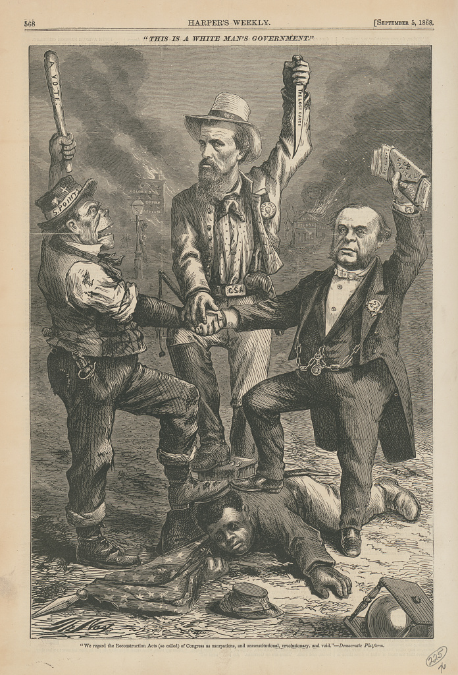
Figure 3, “This is a White Man’s Government”
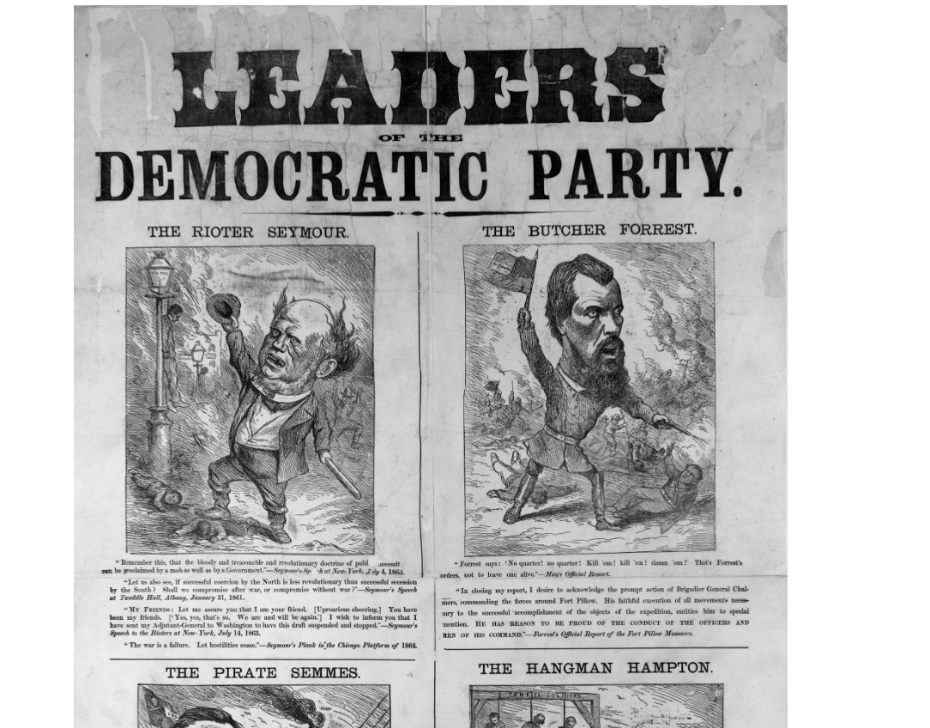
Figure 4, “Leaders of the Democratic Party”
Figure 3 depicts the General alongside an Irish immigrant and a wealthy businessman standing over a defeated Black Union soldier reaching for a ballot box. Forrest brandishes a knife entitled “The Lost Cause” and wears a button reading “Fort Pillow.” Figure 4, another Nast Cartoon, draws attention to the most prominent Democratic leaders, depicting them as violent and anti-union. Nast refers to “The Butcher Forrest,” calling attention to the slaughter at Fort Pillow and the violent nature that the Confederate General would become known for because of the massacre. The caption under Forrest’s picture reads: “Forrest says: No Quarter! no quarter! kill em! kill em! Damn em! That’s Forrest’s orders, not to leave one alive.” Depictions of Forrest as a bloodthirsty savage certainly did not help the General escape from the shadow of Fort Pillow. Forrest initially voiced his support for Andrew Johnson but ended up putting in Tennessee’s vote for Horatio Seymour and Frank Blair. The election of 1868 ended with the victory of Republican candidate Ulysses S. Grant. Perhaps for his support of Johnson early in the election, Forrest finally received his federal pardon. After the election, Forrest would not be the subject of such mass media coverage until after his death.
Despite negative reactions in the north, Forrest remained popular in the south. An account of Forrest’s positive reception as a speaker In Aberdeen, Mississippi in 1868 demonstrates his continued popularity. During the visit, Forrest gave a speech advertising his railroad company. The article in the Memphis Daily Avalanche describes Forrest as “one particularly endeared to our people… the chieftain who checked the vandal at our threshold, and saved all that was saved to our citizens.” Clearly, Forrest retained a special place in the hearts and minds of the southern people. The audience at Aberdeen was “surprised and delighted with his effort, as we had little expected oratory from one whose spurs… had been from hard knocks and physical muscle rather than forensic.” The writer of the article highlights Forrest’s ability to give a well informed and eloquent speech despite his reputation for being relatively uneducated and growing up in difficult circumstances.

Forrest Biographies

In the same year that Forrest’s participation in the election of 1868 generated so much controversy, the first of many Forrest biographies was released. These all took a pro-Forrest stance and devoted entire chapters to clearing the General’s name at the Battle of Fort Pillow. Confederate Officers Thomas Jordan and J.P. Pryor wrote the first biography, and devote two chapters to clearing up the events of the Battle of Fort Pillow. One chapter is a history of depredations committed against West Tennesseans by the garrison of Fort Pillow before the battle. They specifically cite the stealing of valuable items and farm goods from locals, as well as cases of assault of southern women. It is likely that they refer to the “hard war” policies instated by the Union which promoted subsisting from the supplies of Confederate-sympathetic locals. The authors state that local west Tennesseans pleaded for Forrest to end the depredations, and that he decided to do so by attacking the fort’s garrison.
Jordan and Pryor’s description of the battle addresses the criticism directed at Forrest for his conduct. During the twenty-minute truce, Forrest ordered a group of soldiers to take positions closer to the river, a spot from which they were able to pick off fleeing soldiers as they retreated down the river bluff. They had also moved forward to positions directly in front of the Union trench line, a position that allowed them to immediately storm the fort after the truce ended. Forrest received criticism for these maneuvers, with many claiming that it was a violation of the laws of civilized warfare. Jordan and Pryor depict Forrest’s movement of soldiers during the truce period as a military necessity to prevent further Union reinforcements by river. Jordan and Pryor next claim that the garrison had a backup plan to retreat under covering fire of the New Era, a supporting gunboat on the Mississippi River. The New Era did not end up providing covering fire for the supposedly planned retreat, which Jordan and Pryor cite as a prime reason for the massacre. This theory is supported by the account of Captain Marshall of New Era, who claimed that there was a plan between Major Bradford and himself to fire upon the Confederates as they chased the retreating Federals down the bluff. The validity of this claim is debatable, as no other sources have corroborated this account. Historian Bruce Tap points out that if this plan did exist, it was poorly thought out and would have exposed Federal soldiers to the same canister fire. Either way, the defensive lines broke immediately and without plan many surrendered, ran away, or continued fighting.
Jordan and Pryor explain the extraordinarily high amount of Union casualties by citing Insania Belli, or the madness of warfare that is the natural result of such a chaotic assault as the one on Fort Pillow. Jordan and Pryor’s next claim was that all the Union soldiers during the battle were drunk, given access to liquor by their superiors, an explanation of their foolish actions and lack of proper military strategy. Next, Jordan and Pryor describe Forrest and his officer’s reaction to the Massacre, stating that upon finding out about it they stopped it immediately, with only 15 minutes from the end of the truce to the end of fighting. The authors cite a single witness testimony from the Congressional report claiming that Forrest gave orders to stop the killing and threatened to kill one Confederate soldier who refused. Jordan and Pryor deny the massacre but credit any wrongdoing whatsoever during the battle to the incompetence of the Union command as opposed to any fault of Forrest. An extensive list of notes and statistics at the end of the biography only further reflects the pro-Forrest elements at work in this account. A list of captured prisoners from Fort Pillow is included, as well as graphs displaying the dubious statistics used by Jordan and Pryor.
John C. Wyeth in and J. Harvey Mathes wrote the next notable biographies, in 1899 and 1902 respectively. Wyeth was a surgeon personally connected to Forrest, and Mathes was a veteran and Memphis journalist involved in Forrest’s press circles. These biographies covered elements of Forrest’s life before and after the Civil War. Tales of Forrest’s early life framed the general as a classic frontier archetype and especially compassionate to the slaves he bought and sold. Mathes wrote about the killing of Thomas Edwards, claiming that Forrest’s actions were supported by his plantation workers and covered the Pole Bearer’s speech, although in a fashion that mocked the organization. The biographies primarily echoed the Jordan and Pryor formula in writing about Fort Pillow, deflecting blame for high casualty counts away from Forrest and the Confederates and upon the foolish and supposedly intoxicated Union soldiers. Following popular racial theory of the time, Wyeth and Mathes attribute consumption of alcohol to Black soldiers especially. Other than drunkenness, these accounts highlight the lack of formal surrender via lowering the Union flag and the supposed plan of the garrison to retreat and lure attacking Confederates down the bluff where they could be attacked by the New Era. Wyeth blames continued killing after the battle on the either still intoxicated or infuriated Union soldiers, who continued to attack the Confederates after the battle ended. Mathes attempts to disprove allegations of burning soldiers alive by claiming that Confederates in fact attempted to give the soldiers proper funeral pyres, and allegations of burning were misunderstandings and unfair towards these considerate attackers.
Despite denials from Southern writers, the Fort Pillow Massacre remained relevant in Civil War memory, especially among Black southerners who would not forget the bloody incident.

Fort Pillow’s Relevance

Fort Pillow remained important for Black communities, as evidenced by mentions of the massacre and Forrest in Black newspapers. Fort Pillow, for southern Black newspapers, was a deeply resonant example of Black loyalty and sacrifice for the Union during the Civil War. Newspapers like the New Orleans Tribune and the Free Man’s Press of Galveston, Texas invoke the sacrifice and slaughter at Fort Pillow as a reminder of what kind of leaders made up the Democratic Party, specifically mentioning Forrest and other ex-confederates who threatened the freedoms of African Americans. Other articles like those printed by the South Carolina Leader in 1865 and the Huntsville Gazette in 1882 cite Fort Pillow as an example of the plight of African Americans. The article “Where are We Drifting?” in the Huntsville Gazette depicts African Americans as a people aboard a damaged ship in dangerous waters, narrowly escaping the “rocks of Fort Pillow” among other historical injustices. In both contexts, Newspapers mention the Fort Pillow Massacre alongside the battles of Olustee, Port Hudson, and Battery Wagner, other moments during which Black Union soldiers fought and sacrificed with distinction. An early victory for Civil Rights as mentioned in Chapter 1, Fort Pillow continued to resonate with Black audiences into the 20th century, particularly as a call for equal rights.

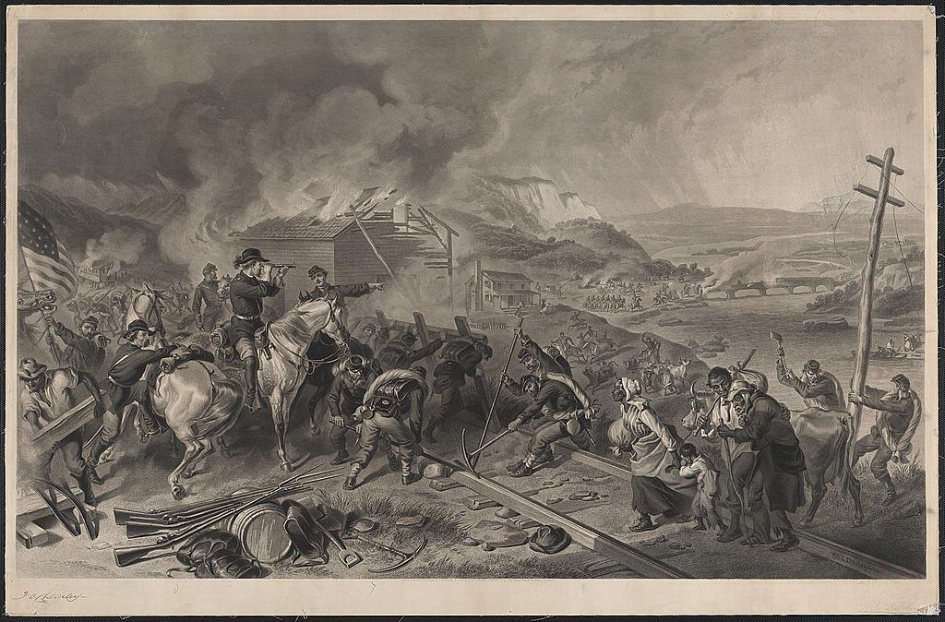
Figure 5, A. H. Ritchie, Sherman’s March to the Sea, 1868
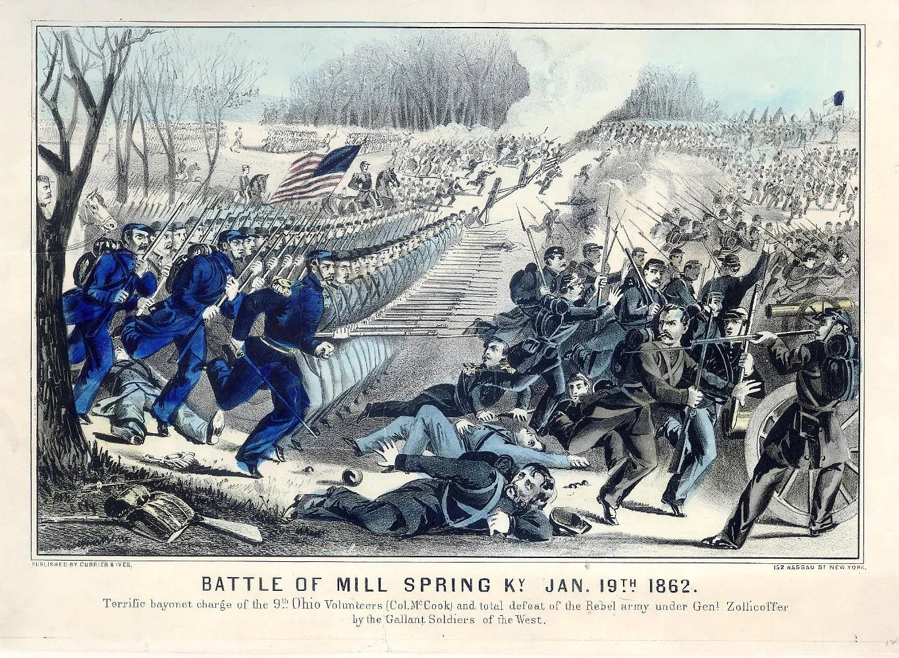
Figure 6 Currier and Ives, Battle of Mill Spring, 1862
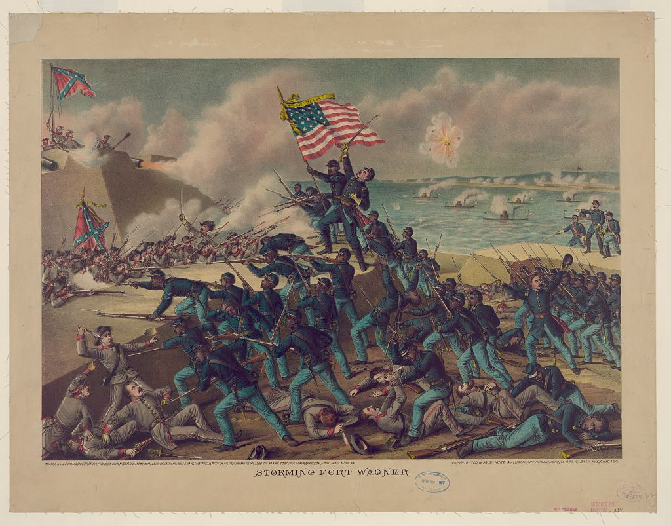
Figure 7 Kurz & Allison, Storming Fort Wagner, 1890
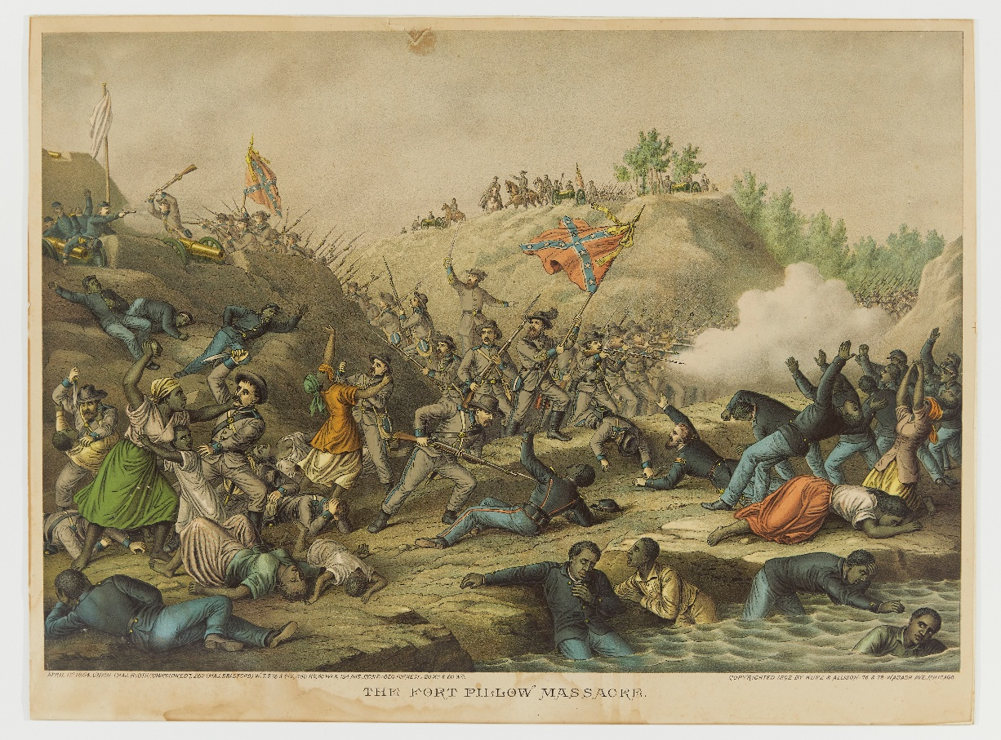
Figure 8, The Fort Pillow Massacre, 1892

The most popular illustration of Fort Pillow was created during reconstruction and captured the public eye almost 30 years after the event. The Lithograph company Kurz & Allison created some of the most detailed and colorful lithographs of the Civil War, many of which are still popular today. They also created the most popular depiction of Fort Pillow. Kurz & Allison was unique in its consistent coverage of Civil War battles involving Black soldiers. Other depictions, like those of Figure 5 and 6, do not show African Americans in combat roles. The Kurz & Allison lithograph The Fort Pillow Massacre (figure 8) was published in 1892, almost thirty years after the battle itself and long after the publication of wartime illustrations like the one mentioned in Chapter 1. Kurz & Allison typically portray Black soldiers in moments of remarkable bravery or sacrifice, like the storming of Fort Wagner (figure 7) and the Battle of Nashville. Their depiction of Fort Pillow is no different.
The lithograph of Fort Pillow highlights the helplessness of Black soldiers and civilians, including women and children, while portraying the brutality of the Confederate attackers. Other details of the print stand out, like the addition of a White flag at the Union fortifications under attack by Confederates, creating a version of the battle in which the Union garrison attempted a surrender that was ignored by the Confederate attackers. Black and White Union soldiers are gunned down by rows of advancing Confederates while a commanding figure on a horse looks down, signaling orders to other men. This figure undoubtedly represents General Forrest, looking on over the massacre with either approval or indifference, a powerful illustration of the Fort Pillow Massacre years after the fact. While there is no way of knowing how popular or influential Kurz & Allison’s print was at the time, it certainly reflects at least in part what audiences wanted and expected from Civil War battle prints.

Forrest of Memphis

On October 29, 1877, Nathan Bedford Forrest died in Memphis. Newspapers across the country reported on the General’s death, and mention of Fort Pillow tended to vary along sectional lines. Southern newspapers, like the Atlanta Constitution, New Orleans Times, and the Times Picayune exemplify how Forrest was depicted in death reports throughout the South. These death notices highlight Forrest’s military career and rarely mention his pre-war occupation as a slave trader. None of these articles mention Fort Pillow, instead reporting on his many successful military campaigns and his uniqueness of uneducated talent and instinct. Northern newspapers, on the other hand, tend to mention the Fort Pillow Massacre by name, and often provide descriptions of the event. The mortuary notice of the Philadelphia inquirer summarizes Forrest’s life before the war, briefly mentioning his slave trade and plantation businesses. The article then goes on to describe the Fort Pillow Massacre, detailing the events that took place before the massacre and describing the event as “one of the most cruel and barbarous scenes of the war.” Other obituaries, like the Wilkes-Barre Leader, take a more neutral and almost praising approach, briefly mentioning Forrest’s slave trading occupation and the Fort Pillow massacre, but devoting much writing to Forrest’s lack of education and use of his superior instinct to win battles.
Forrest spent most of his post-war life in Memphis. After the Civil War, Memphis experienced startling social and political upheaval. During the war, the Black population of Memphis quadrupled, and the loss of suffrage for traditionally powerful upper-class Memphians who fought for the Confederacy meant that Black residents gained more political prominence. Another group that gained political power in Memphis were the Irish, who typically refused to serve the Confederate army during the Civil War. For the first few years after the war, local government officials in Memphis, including the Police force and fire department, were primarily Irish.
Due to a series of post-war economic hardships, Memphis declared bankruptcy in 1878. Months later, the city underwent its worst yellow fever epidemic to date, which caused the emigration of much of Memphis’ white population. Most of the residents who stayed in the city were Black, a rapid demographic change that paved the way for the increasing prestige of Black Memphians and revealed the unstable foundations of the city. In 1879, the city transferred to state control, officially becoming the “Taxing District of Shelby County.” As Memphis began to recover financially, the Black Memphis community became the source of business growth and social reform, cementing itself as a thriving community.
The return of White residents to Memphis in the late 1800s begat a period of racial tension. Extreme actions of racism were common during this period, like the 1892 incident at Thomas Moss’s Black-owned grocery store. A confrontation between a White grocery store owner across the street and Employees of Moss led to clashes with a police officer, after which the owner and his employees were arrested. Moss and his employees were later captured from jail and executed by a White mob, an event that inspired outcry from the Black Memphis community and almost no response from the city itself.
In the context of increasingly violent racial tensions, the White residents of Memphis sought a figure who represented the wealthy slaveowner-dominated past of the city. White Memphis decided that Forrest was the figure necessary to commemorate what they saw as the city’s more righteous past. Forrest, whose public memory had become obscured since his death, was emerging in the 1880s and 1890s as a representation of White supremacy and southern masculinity. Unlike memorialization of other Confederate figures like Robert E. Lee, the memorialization of Forrest was uniquely catered to the needs of White Memphis. As the city regained its White population, economy, and name, memorialization of the general reached new heights. The name Memphis became synonymous with the name Forrest, and neither could be celebrated without celebrating the other.
The Forrest Memorial Association (FMA), formed in the 1890s, represented the perceived military valor of the city of Memphis and Forrest, as well as the rising business class of the city. By 1900, the FMA had raised $14,000 in donations and had influenced the naming of “Bedford Forrest Park” in 1899 by the city parks commission. The park was designed with a statue of Forrest in mind, and the Memphis parks commissioner had deep ties with the Confederate organizations of Memphis and with the FMA. In 1901 Memphis held a reunion to display the city’s economic stability and raise funding for the Forrest memorial statue. During the reunion, orations focused on Forrest’s military career. Speakers highlighted his “untutored genius” in battle and repeated the sentiment that if he had received military training, he would be the “greatest soldier amongst men.”
The monument to Forrest was unveiled in 1905 in the center of Bedford Forrest Park, along with the reburial of Forrest and his wife at the foot of the statue. Orations during the event, much like the reunion, celebrated Forrest’s military genius and civic pride. Speeches glossed over issues like Forrest’s pre-war slave trading practice and his involvement in Ku Klux Klan. Instead, one speaker, a Union Colonel C. A. Stanton, glorified Forrest’s dedication to the Confederacy and “Anglo Saxon valor.” Stanton also highlighted the accomplishments of the men who served under Forrest, claiming that they had gone on to become “Prosperous planters and merchants…eminent physicians, they repaired and rebuilt the wasted towns and farms and homes.” One speaker, a Confederate General George W. Gordon, referred to Forrest as “Tennessee’s, if not America’s greatest, most original and dazzling soldier” Gordon made claims that “Forrest never lost a battle.” Only once did the general acknowledge the massacre at Fort Pillow, only to affirm that it was in fact a fair fight in which the Unionists failed to surrender.
For the White Memphians present, Forrest represented the White, traditionally masculine spirit of the city of Memphis, aspects that were emphasized by the statue itself. The figure of Forrest astride his horse was crafted using measurements from Forrest’s own tailor to ensure accuracy, a design that was unique to Forrest’s statue. There was a desire to replicate the physical traits of Forrest that was unfounded in other Confederate memorials, perhaps because the Forrest memorial also served as the General’s gravesite. The focus on Forrest’s physical characteristics in speeches during the event reflects the desire of White Memphis for a present White hero, a figure that they could relate to and see their ideals in.
The statue depicts a gallant, composed Forrest that seldom seen in depictions of the general, especially after the period of early Confederate memorialization. In years to come, the image of a resolute and calm Forrest would be largely replaced by a figure untethered from Memphis and representative of a more virile, inflammatory Confederacy. Although it was trapped in the past, the Forrest statue continued to serve as a civic figure for White Memphis and an erasure of Black Memphis.
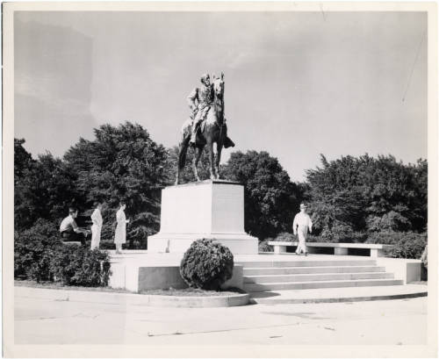
Figure 9, Statue of Forrest in Forrest Park, Memphis, 1950s

Conclusion
Although the Fort Pillow Massacre is much less prominent in modern society, Nathan Bedford Forrest continues to rankle in modern Civil War memory. Observing how the two were viewed in the public eye early on aids understanding of how they are seen today, and Civil War public memory in general. Examining the memory of Fort Pillow provides insight into African American experiences in the Civil War and the post-war period. Observing the development of the memory of Forrest in the late 1800s and early 1900s can help facilitate understanding of how the General became a pillar of the lost cause.
The Massacre at Fort Pillow was the result of a combination of incompetence, racism, luck, and unconventional tactics. The Fort’s garrison, primarily consisting of Black soldiers and Tennessee Unionists sustained an unusually high death count following the unexpected storming of the Fort’s barricades. Eyewitnesses on both sides of the battle reported on the carnage, and reporters rushed to print the story of the massacre.
Press coverage of the event varied by political affiliation, with Unionists claiming that a massacre was carried out by the Confederate commander, Nathan Bedford Forrest, who was well known as a successful cavalry commander. Headlines and Illustrations of the massacre highlight the brutality of Confederate soldiers and the defenselessness of the garrison. Southern newspapers responded, often praising Forrest’s victory or denying the massacre allegations.
Fort Pillow became the most published racial massacre of a Civil War fought over the rights of Black Americans. It was the first of many and received nationwide press attention as well as a full Congressional Report. Converted into a propaganda campaign by the Union, Fort Pillow became a rallying cry for Black and White soldiers alike. Cries of “Remember Fort Pillow!” were met with further retaliation from Confederates as racial killings continued and Black troops were targeted in battle. As Fort Pillow became the most publicized racial massacre of the war, Calls emerged for equal treatment of Black and White Union soldiers, and the Confederacy was forced to reckon with the reality of Black Union soldiers, many of whom had previously been slaves. The Fort Pillow Massacre forced both the Union and the Confederacy to recognize Black soldiers as equal combatants.
After the war, Fort Pillow and Forrest continued to pronounce their effects on public memory. The changing south under reconstruction was forced to grapple with the loss of the war and a large free Black population. The massacres, or Race Riots, of the mid-late 1860s and the rise of the Ku Klux Klan, an organization known for terrorizing Black Southerners and inciting racial violence, were a reaction to increasing Black rights in the south. The Memphis Race Massacre in particular involved Black US Soldiers in a way that mirrored the Fort Pillow Massacre. Consistently throughout the late 1800s and early 1900s, Fort Pillow is brought up alongside coverage of these massacres or mentioned in appeal for equal rights in Black newspapers. For the mainstream White press, however, Fort Pillow only comes up in passing, and primarily when Forrest is the subject.
Throughout his post-war life, Forrest drifted in and out of obscurity. Forrest was arrested and found not guilty of murder after killing a Black plantation worker in Mississippi in 1866. The case was ruled as self-defense but is rarely brought up in Forrest biographies of the time. Forrest was personally involved in the Ku Klux Klan and became the first Grand Wizard of the organization, a leadership role designed specifically for him. The specifics of Forrest’s involvement are obscured, but he was and remains well known as a member and figurehead of the Klan. Coverage of Forrest and Fort Pillow peaked in the mainstream media during the presidential election of 1868, when Forrest was a delegate for the Democratic party in New York. Forrest represented Tennessee, and his appointment as a delegate caused consternation among republicans. Only four years after the massacre, Forrest could not escape the shadow of Fort Pillow, as is evident in political cartoons and articles of the time. The final major public action of Forrest’s life was a speech given at a Black Mutual Aid society in 1875. In a turn of events that shocked Forrest’s admirers and contemporaries, Forrest gave a speech advocating for racial reconciliation and the advancement of African Americans. The speech was his last, and his death in 1877 was covered with predictable sectional bias. Northern newspapers cited Fort Pillow and the General’s pre-war slave trade profession, while Southern newspapers covered Forrest’s wartime exploits and childhood, citing his military genius and notable lack of education.
Forrest spent much of his post-war life in Memphis, a city that underwent rapid change during and after the Civil War. The Black population of Memphis quadrupled during the Civil War, and economic troubles and disease encouraged the flight of much of White Memphis from the city in the late 1870s. Primarily Black Memphis underwent economic and social growth, which fomented racial violence in the 1890s after White residents returned to the city. As White Memphians sought a return to what they saw as their glorious past, they saw in Forrest a symbol of the city’s long standing White dominance. Forrest was a civic representation of White Memphis and Black erasure, and received an impressive, publicly funded statue in Forrest Park, where the General’s remains were reinterred. The statue was revealed in 1905, accompanied by speeches glorifying the General’s “untutored genius” and his dedication to the Confederacy and the Anglo-Saxon race. The statue represents a steady and composed Forrest, one that served the needs of White Memphis, but soon fell out of favor in the lost cause pantheon. The composed military genius Forrest was replaced in the 1930s by a more virile, inflammatory Figure, untethered from Memphis and proud of involvement in the Ku Klux Klan.
The Forrest statue remained a tangible symbol of how violence and White supremacy have marked the histories of Memphis and Forrest, and became the object of protest throughout the 20th century. Protests and calls for removal intensified in the 2000s and during the Black Lives Matter movement. In 2012 Forrest park was renamed Health Sciences park, a reflection of the surrounding area, a hospital and University of Tennessee medical center. This coincided with the changing names of two other Confederate-named parks in Memphis. The widely publicized and unpunished 2015 murder of twelve-year-old Tamir Rice by a police officer in Cleveland Ohio led to an immediate call by Memphis community members to remove the Forrest statue. The Statue was removed by the city of Memphis just two years later in 2017.
Visitors to Memphis today can see the spot where the monument to Forrest used to stand. A new statue, Monuments to Motherhood, placed in 2025 by the city of Memphis now stands in the park, a strong contrast to the commanding and casually racist Forrest. Renamed Medical District Park earlier in the year, the new monument signifies the city’s shift away from its racially violent past and its interest in public art. Text on the paved walkways next to the monument read the slogan “Black Lives Matter”, the only physical reminder of Forrest’s presence in the area and the protests that eventually brought him down.
Visitors can also travel to Fort Pillow, just 90 minutes north of Memphis. The once-battlefield became a Tennessee state park in 1971 amid progressive reforms in historical interpretation. The fort was one of many “sites of shame” that focused on less glorious moments in American history and challenged the Lost Cause Narrative. The site of the fort itself is more of a nature trail with occasional historical markers and a reconstruction of some fort parapets where they would have been during the battle. Changes in the landscape make it hard to imagine that a fort was built there, much less that it was the scene of a gruesome massacre. The interpretive center of the park maintains a centrist viewpoint of the massacre, highlighting high death counts and accusations of massacre, but never outright calling it so. The interpretive center contains lots of information about Black troops in the Civil War and a memorial plaque, as well as paintings of Forrest that appeared out of place in the museum commemorating the massacre he was known for. A video shown in the theater area took an especially centrist approach to the massacre, citing the justifications used by Jordan and Pryor in their writings about Fort Pillow and Forrest. The video cited depredations of the surrounding area and the failed plan to retreat under cover of New Era and highlighted the overexaggerated congressional report of the massacre. However important these factors were to the massacre, the video seemed to strike a middle ground between blaming Forrest and blaming the garrison itself.
Most modern scholars recognize Fort Pillow as a massacre. These scholars attribute the massacre to racial animosity and worsening conditions of the Confederate army. Fuchs credits the massacre as an act of retribution against Southern Unionists, seen as traitors by Confederates, and Black Soldiers. Forrest, as the commander of the Confederate forces at Fort Pillow, remains at fault for the massacre in the eyes of these historians. Whether he knew about the massacre or not, Forrest should have been keeping an eye on his soldiers, and by failing to do so is just as much at fault as if he had ordered the massacre.
Although memory of Forrest is in decline, he remains a pillar of the lost cause mythology and his namesakes remain throughout the South. Streets, Schools, even a national park between Nashville and Memphis still memorialize the General. Hardcore advocates of Forrest and the Confederacy may never go away, but looking at the ways that public memory forms allows us to learn about and make beneficial changes for the future of historic preservation and public memory.

Books

Ashdown, Paul and Caudill, Edward. The Myth of Nathan Bedford Forrest. Rowman & Littlefield, 2005.

Blight, David W. Race and Reunion: The Civil War in American Memory. Harvard University Press, 2001.

Browning, Robert M. Jr. Forrest: The Confederacy’s Relentless Warrior. Brassey’s Inc., 2004

Tap, Bruce. The Fort Pillow Massacre: North, South, and the Status of African Americans in the Civil War Era. Routledge, 2014.

Carney, Court. Reckoning With the Devil: Nathan Bedford Forrest in Myth and Memory. Louisiana State University Press, 2024

Cimprich, John. Fort Pillow, A Civil War Massacre, and Public Memory. Louisiana State University Press, 2005.

Fuchs, Richard L. An Unerring Fire : The Massacre at Fort Pillow. Fairleigh Dickinson University Press, 1994.

Janney, Caroline E. Remembering the Civil War: Reunion and the Limits of Reconciliation. University of North Carolina Press, 2013.

Jordan, Thomas and Pryor, J.P. The Campaigns of Lieut.-Gen. N.B. Forrest: Band of Forrest’s Cavalry. New Orleans; Blelock, 1868.

Leigh, Philip. Southern Reconstruction. Westholme, 2017.

Murray, Jennifer M. On a Great Battlefield: The Making, Management, and Memory of Gettysburg National Military Park, 1933-2013. The University of Tennessee Press, 2014.

Ward, Andrew. River Run Red: The Fort Pillow Massacre in the Civil War. Penguin, 2005.

Wills, Brian Steel. The River Was Dyed with Blood: Nathan Bedford Forrest and Fort Pillow Norman: University of Oklahoma Press, 2014.

Chapters and articles

Neely, Mark E and Holzer, Harold. “Civil War Battle Prints.” In The Union Image : Popular Prints of the Civil War North. Chapel Hill: University of North Carolina Press, 2000.

Andrew L. Slap. “On Duty in Memphis, Fort Pickering’s African American Soldiers.” In Remembering the Memphis Massacre: An American Story, edited by Beverly Greene Bond and Susan Eva O’Donovan University of Georgia Press, 2020.

Davison, Eddy W and Daniel Foxx. “Something Wicked This Way Comes.” in Nathan Bedford Forrest: In Search of the Enigma. Gretna: Pelican Pub. Co., 2007.

“The Hard Reality of Fort Pillow: Interpreting the Massacre of US Colored Troops in 1864” National Park Service, Last updated Sep. 19, 2024 https://www.nps.gov/articles/000/hard-reality-of-fort-pillow.htm

“History at Fort Pillow” Tennessee State Parks https://tnstateparks.com/parks/history/fort-pillow

“Molly Gochman’s ‘Monuments To Motherhood’ Unveiled On Contested Ground In Memphis” published February 21, 2025
https://www.forbes.com/sites/chaddscott/2025/02/21/molly-gochmans-monuments-to-motherhood-unveiled-on-contested-ground-in-memphis/

John Cimprich and Robert C. Mainfort Jr. “The Fort Pillow Massacre: A Statistical Note.” In The Journal of American History 76(3): 830-837. https://www.tn.gov/content/dam/tn/environment/archaeology/documents/staffpubs/arch_Cimprich%20and%20Mianfort%201989.pdf

John Cimprich and Robert C. Mainfort Jr. “Dr. Fitch's Report on the Fort Pillow Massacre.” In Tennessee Historical Quarterly 44(1): 27-39. https://www.tn.gov/content/dam/tn/environment/archaeology/documents/staffpubs/arch_Cimprich%20and%20Mianfort%201985.pdf

John Cimprich and Robert C. Mainfort Jr. “Fort Pillow Revisited: New Evidence about an Old Controversy.” In Civil War History, Volume 28, Number 4, December 1982: 293-306. https://doi.org/10.1353/cwh.1982.0009

Primary Sources

38th Congress, 1st Session, Reports of the Committee on the Conduct of War, Fort Pillow Massacre. Returned Prisoners. May 5, 1864 https://www.gutenberg.org/files/41787/41787-h/41787-h.htm

"A Short Campaign Document." New Orleans Tribune (New Orleans, Louisiana), April 25, 1867: 4. https://infoweb.newsbank.com/apps/readex/doc?p=EANAAA&docref=image/v2%3A12B3C01E490E6BA0%40EANAAA-12BCB9EE11F9D268%402403082-12B8820D07B8A388%403-12DA603023183120%40A%2BShort%2BCampaign%2BDocument.

Bonwill, Charles E. H., Approximately , Artist. The war in Louisiana - view of Natchitoches The war in Tennessee - rebel massacre of the Union troops after the surrender at Fort Pillow, April 12. / From a sketch by our special artist, C.E.H. Bonwill. Fort Pillow Louisiana Natchitoches United States Tennessee, 1864. New York: Frank Leslie, May 7. https://www.loc.gov/item/2015648987/.

"Democratic Meanness!. “ Daily Iowa State Register (Des Moines, Iowa) VII, no. 206, August 28, 1868: [1]. https://infoweb.newsbank.com/apps/readex/doc?p=EANX&docref=image/v2%3A11342FFC36491C28%40EANX-11AC9386452EACE8%402403573-11AC93864FC7E2F0%400-11AC9386941AE578%40Democratic%2BMeanness%2B%2521.

“Declaration of the Immediate Causes Which Induce and Justify The Secession of South Carolina From the Federal Union; And The Ordinance of Secession” South Carolina Convention Evans and Cogwell (1860) https://books.google.com/books?hl=en&lr=&id=MhTVAAAAMAAJ&oi=fnd&pg=PA1&dq=south+carolina+declaration+of+secession&ots=d7iSgr6XS9&sig=5nnTifcS-IfVx2-YfLJ2U6GzLcs#v=onepage&q&f=false

"Encounter between General Forrest and a Negro." Memphis Daily Avalanche (Memphis, Tennessee) Eight, no. 82, April 3, 1866: 2. https://infoweb.newsbank.com/apps/readex/doc?p=EANX&docref=image/v2%3A111FBB5EB75DFEF8%40EANX-11A5E3CCEEA0C480%402402695-11A5E3CD2C416C08%401-11A5E3CD856B5440%40Encounter%2Bbetween%2BGeneral%2BForrest%2Band%2Ba%2BNegro.

"Falsity Exposed. The Kind of Places Held by Colored Government Employes. The Wrongs and Impositions." Cleveland Gazette (Cleveland, Ohio), October 13, 1883: 1. https://infoweb.newsbank.com/apps/readex/doc?p=EANAAA&docref=image/v2%3A12B716FE88B82998%40EANAAA-12CC2D15C5582230%402409097-12CBE5C73A8E7E68%400-12DBB8AF41F217B8%40Falsity%2BExposed.%2BThe%2BKind%2Bof%2BPlaces%2BHeld%2Bby%2BColored%2BGovernment%2BEmployes.%2BThe%2BWrongs%2Band%2BImpositions.

"Forrest as a Delegate.: The Great Cavalry General's Views Respecting the Democratic National Convention." Jun 27, 1868. https://utk.idm.oclc.org/login?url=https://www.proquest.com/historical-newspapers/forrest-as-delegate/docview/494417010/se-2.

"Forrest, the Butcher, a Johnson Man." Daily Iowa State Register (Des Moines, Iowa) V, no. 196, September 2, 1866: [2]. https://infoweb.newsbank.com/apps/readex/doc?p=EANX&docref=image/v2%3A11342FFC36491C28%40EANX-11AE39598F90B9D8%402402847-11AE39599E84F530%401-11AE3959D1BC8AE8%40Forrest%252C%2Bthe%2BButcher%252C%2Ba%2BJohnson%2BMan.

"From Memphis." Wisconsin Daily Patriot (Madison, Wisconsin) 10, no. 91, April 18, 1864: [1]. https://infoweb.newsbank.com/apps/readex/doc?p=EANX&docref=image/v2%3A1134D8B777C5A238%40EANX-11A1B340149F9250%402401980-11A1B3402A1F18A8%400-11A1B3407962F6B8%40From%2BMemphis.

"Gen. Sheridan; Gen. N. B. Forrest; New Orleans." New Orleans Tribune (New Orleans, Louisiana), September 4, 1866: 4.
https://infoweb.newsbank.com/apps/readex/doc?p=EANAAA&docref=image/v2%3A12B3C01E490E6BA0%40EANAAA-12B9C587C15AE4B0%402402849-12B8820C144DE428%403-12DA5BF191D425E0%40%255BGen.%2BSheridan%253B%2BGen.%2BN.%2BB.%2BForrest%253B%2BNew%2BOrleans%255D.

"Hot after Smith." Dallas Morning News (Dallas, Texas), April 30, 1902: 3. https://infoweb.newsbank.com/apps/readex/doc?p=EANX&docref=image/v2%3A0F99DDB671832188%40EANX-1070C89446C496F8%402415870-1070C894971B2170%402-1070C896076CB608%40Hot%2Bafter%2BSmith.

"Inauguration of the Fair at the Maryland Institute-Speech of President Lincoln." Daily Ohio Statesman (Columbus, Ohio) XXXI, no. 254, April 20, 1864: [3]. https://infoweb.newsbank.com/apps/readex/doc?p=EANX&docref=image/v2%3A114748862FA816A8%40EANX-11A89860E3B290A8%402401982-11A8986123BD0470%402-11A8986203791D48%40Inauguration%2Bof%2Bthe%2BFair%2Bat%2Bthe%2BMaryland%2BInstitute-Speech%2Bof%2BPresident%2BLincoln.

"Inauguration of the Baltimore Sanitary Fair. Speech from the President. Colored Soldiers To Be Protected." Hartford Daily Courant (Hartford, Connecticut), April 19, 1864: 3. https://infoweb.newsbank.com/apps/readex/doc?p=EANX&docref=image/v2%3A111FB735D6420B38%40EANX-12EC36DF0A707C40%402401981-12EA9356597A7DD0%402-13083CDDAF7B58CF%40Inauguration%2Bof%2Bthe%2BBaltimore%2BSanitary%2BFair.%2BSpeech%2Bfrom%2Bthe%2BPresident.%2BColored%2BSoldiers%2BTo%2BBe%2BProtected.

"Is It So ?." Free Man's Press (Galveston, Texas), October 24, 1868: 2. https://infoweb.newsbank.com/apps/readex/doc?p=EANAAA&docref=image/v2%3A12B865F3F61FD1D8%40EANAAA-12CC8AC9062447E8%402403630-12CC2CC1F07F3CC8%401-12DD709AE957A610%40Is%2BIt%2BSo%2B%253F.

Kurz & Allison, The Fort Pillow Massacre, 1892. https://nmaahc.si.edu/object/nmaahc_2012.172.22

Kurz & Allison. Storming Fort Wagner, 1890. https://www.loc.gov/item/2012647346/.

"Loyalty and the Freedmen." South Carolina Leader (Charleston, South Carolina), December 23, 1865: 2. https://infoweb.newsbank.com/apps/readex/doc?p=EANAAA&docref=image/v2%3A12B7C6B6028CB1D8%40EANAAA-12CC4728B6580C60%402402594-12CC2CC1D85C9668%401-12E9FB835DF90110%40Loyalty%2Band%2Bthe%2BFreedmen.

Leaders of the Democratic Party: The Rioter Seymour ... The Butcher Forrest ... The Pirate Semmes ... The Hangman Hampton ..., Thomas Nast, 1868
https://www.loc.gov/pictures/item/2008661705/

"M'Kinley In Chicago." Iowa State Bystander (Des Moines, Iowa), October 13, 1899: 1. https://infoweb.newsbank.com/apps/readex/doc?p=EANAAA&docref=image/v2%3A12B7BF3125DAE718%40EANAAA-12CC474D6750B280%402414941-12C106C906B3FCF8%400-12EA3989EB4FE400%40M%2527Kinley%2BIn%2BChicago.

"Mortuary Notice." Philadelphia Inquirer (Philadelphia, Pennsylvania), October 30, 1877: 4. https://infoweb.newsbank.com/apps/readex/doc?p=EANX&docref=image/v2%3A110C9BFA1F116650%40EANX-1125C3A2AE344710%402406923-1125C3A3B2CB5390%406-1125C3A8240511C0%40Mortuary%2BNotice.

"Mortuary Notice." Wilkes-Barre Leader (Wilkes-Barre, Pennsylvania) II, no. 17, November 8, 1877: 1. https://infoweb.newsbank.com/apps/readex/doc?p=EANX&docref=image/v2%3A12F81C6F6AD8477E%40EANX-11583E3529436E48%402406932-11583E3538CF0B88%400-11583E35EB554AD0%40Mortuary%2BNotice.

"Nathan Bedford Forrest Monument, Memphis, Tennessee," Tennessee. Department of Conservation, 1950s, Tennessee Virtual Archive, accessed 2025-05-14 https://teva.contentdm.oclc.org/digital/collection/p15138coll4/id/24

"Nathan Bedford Forrest." New Orleans Times (New Orleans, Louisiana) XIV, no. 7450, October 31, 1877: 4. https://infoweb.newsbank.com/apps/readex/doc?p=EANX&docref=image/v2%3A10FD1C6325FC3670%40EANX-110D30AC45766C18%402406924-110D30ACE2584C20%403-110D30AED484AF80%40Nathan%2BBedford%2BForrest.

“Nathan Bedford Forrest.: Death of the Great Confederate Cavalryman.” The Daily Constitution, October 31, 1877 https://www.proquest.com/hnpatlantaconstitution/docview/494665888/2936494CBA5344BAPQ/4?sourcetype=Historical%20Newspapers

"No Quarter." New Orleans Tribune (New Orleans, Louisiana), September 6, 1864: 1.
https://infoweb.newsbank.com/apps/readex/doc?p=EANAAA&docref=image/v2%3A12B3C01E490E6BA0%40EANAAA-12BC6EFF25EBF260%402402121-12BBC741EA8CDE38%400-12D92DD773BBF908%40No%2BQuarter.

"Political Intelligence. The Presidency. Horatic Seymour's Letter of Acceptances." New York Herald (New York, New York) XXXIII, no. 219, August 6, 1868: 6.
https://infoweb.newsbank.com/apps/readex/doc?p=EANX&docref=image/v2%3A11A050B7B120D3F8%40EANX-1311CEBC0F899D88%402403551-1311CEBC8982EFC0%405-1311CED7C45A4DB8%40Political%2BIntelligence.%2BThe%2BPresidency.%2BHoratic%2BSeymour%2527s%2BLetter%2Bof%2BAcceptances.

Forrest Monument Association. The Forrest monument; its history and dedication; a memorial in art, oratory and literature. [Memphis, Tenn, 1905] Pdf. https://www.loc.gov/item/05030345/.

"The Late Gen. Forrest." Times-Picayune (New Orleans, Louisiana), October 31, 1877: 4. https://infoweb.newsbank.com/apps/readex/doc?p=EANX&docref=image/v2%3A1223BCE5B718A166%40EANX-1226C87A3982BF70%402406924-1224EA89ED31DEB8%403-12490B1EC884E128%40The%2BLate%2BGen.%2BForrest.

"The Memphis and Selma Railroad. Meeting of Its Friends in Aberdeen, Mississippi - Speeches by General." Memphis Daily Avalanche (Memphis, Tennessee) 11, no. 135, October 10, 1868: 1. https://infoweb.newsbank.com/apps/readex/doc?p=EANX&docref=image/v2%3A111FBB5EB75DFEF8%40EANX-11A1A8D70F23DEA8%402403616-11A1A8D723C0B5C0%400-11A1A8D774BB6B90%40The%2BMemphis%2Band%2BSelma%2BRailroad.%2BMeeting%2Bof%2BIts%2BFriends%2Bin%2BAberdeen%252C%2BMississippi%2B-%2BSpeeches%2Bby%2BGeneral.

"The Massacre at Fort Pillow." New York Herald (New York, New York), April 16, 1864: 4. https://infoweb.newsbank.com/apps/readex/doc?p=EANX&docref=image/v2%3A11A050B7B120D3F8%40EANX-128553F0948F3EA0%402401978-128553F19036A668%404-128553F3F6A60D20%40The%2BMassacre%2Bat%2BFort%2BPillow.

"The Massacre at Fort Pillow." Hartford Daily Courant (Hartford, Connecticut), April 16, 1864: 3. https://infoweb.newsbank.com/apps/readex/doc?p=EANX&docref=image/v2%3A111FB735D6420B38%40EANX-12EC36DDEAEC76E0%402401978-12EA935654EA2810%402-1308394CA55DCC2B%40The%2BMassacre%2Bat%2BFort%2BPillow.

“This is a White mans government” Thomas Nast, Harper's weekly, v. 12, 1868 Sept. 5, p. 568.
https://www.loc.gov/item/98513794/

"Very Latest From The North." Richmond Examiner (Richmond, Virginia) XVIII, no. 44, April 20, 1864: [2]. Readex: America's Historical Newspapers. https://infoweb.newsbank.com/apps/readex/doc?p=EANX&docref=image/v2%3A118C86C5EE0B8960%40EANX-13BBDEE0616BB5B8%402401982-13B2F090C75C5E70%401-13C0D1DA5FB14E0E%40Very%2BLatest%2BFrom%2BThe%2BNorth.

"Where Are We Drifting?." Huntsville Gazette (Huntsville, Alabama) III, no. 45, September 23, 1882: 2.
https://infoweb.newsbank.com/apps/readex/doc?p=EANAAA&docref=image/v2%3A12B28392F31992D0%40EANAAA-12C17545A2F77A20%402408712-12C17545B9B86DA0%401-12C1754644578E98%40Where%2BAre%2BWe%2BDrifting%253F.

Other

Plaque, “1866 Memphis Massacre” NAACP Memphis and the National Parks Service

South Carolina Convention, Declaration of the Immediate Causes which Induce and Justify the Secession of South Carolina from the Federal Union; and the Ordinance of Secession, Volume 18 (Evans & Cogswell, printers to the convention, 1860)
Brian Steel Wills, The River Was Dyed Red With Blood: Nathan Bedford Forrest and Fort Pillow (University of Oklahoma Press, 2014), 52.
David W. Blight, Race and Reunion: The Civil War in American Memory (Harvard University Press, 2001), 15.
John Cimprich, Fort Pillow, A Civil War Massacre, and Public Memory (Louisiana State University Press, 2005), 57-58.
Bruce Tap, The Fort Pillow Massacre: North, South and the Status of African Americans in the Civil War Era (Routledge, 2014), 32.
“The Hard Reality of Fort Pillow: Interpreting the Massacre of US Colored Troops in 1864” Fort Pillow, National Park Service, Last updated Sep. 19, 2024 https://www.nps.gov/articles/000/hard-reality-of-fort-pillow.htm
Richard L. Fuchs, An Unerring Fire: The Massacre at Fort Pillow (Fairleigh Dickinson University Press), 131., Cimprich, Fort Pillow, 78. Wills, The River was Dyed With Blood, 10-12. Tap, The Fort Pillow Massacre, 48-49.
John Cimprich and Robert C. Mainfort Jr., “The Fort Pillow Massacre: A Statistical Note,” The Journal of American History 76, no.3 (1989): 832 https://www.tn.gov/content/dam/tn/environment/archaeology/documents/staffpubs/arch_Cimprich%20and%20Mianfort%201989.pdf.
Fuchs, An Unerring Fire, 116-117. Cimprich, Fort Pillow, 111-113.
Fuchs, An Unerring Fire, 116. Tap, The Fort Pillow Massacre, 107
Fuchs, An Unerring Fire, 105.
Cimprich and Mainfort, The Fort Pillow Massacre, 833. Tap, The Fort Pillow Massacre, 119.
Tap, The Fort Pillow Massacre, 112.
Cimprich and Mainfort, The Fort Pillow Massacre, 835-837.
Tap, The Fort Pillow Massacre, 119.
Court Carney, Reckoning With the Devil: Nathan Bedford Forrest in Myth and Memory (Louisiana State University Press, 2024), 81.
Carney, Reckoning With the Devil, 92-93.
Carney, Reckoning With the Devil, 93-98.
Cimprich, Fort Pillow, 7.
Cimprich, Fort Pillow, 50-53.
Cimprich, Fort Pillow, 57-58.
Wills, The River Was Dyed With Blood, 53. Cimprich, Fort Pillow, 57.
William Nugent to “My Darling Nellie,” Okolona, Miss, 15 August, 1863 in My Dear Nellie: The Civil War Letters of William L. Nugent to Eleanor Smith Nugent, ed. William M. Cash and Lucy Somerville Howorth(University Press of Mississippi, 1977), 125, quoted in Wills, The River Was Dyed With Blood, 59.
Cimprich, Fort Pillow, 62. Wills, The River Was Dyed With Blood, 57. Tap, The Fort Pillow Massacre, 71.
Wills, The River Was Dyed With Blood, 53.
Cimprich, Fort Pillow, 70.
Cimprich, Fort Pillow, 74. Forrest Report, April 4, 1864, 608-609, quoted in Wills, The River Was Dyed With Blood, 84.
Wills, The River Was Dyed With Blood, 84.
Cimprich, Fort Pillow, 78. Wills, The River Was Dyed With Blood, 10-12.
Chambers Diary, “Wednesday March the 9th: Affair at Suffolk VA.,” Henry A. Chambers Papers, NCDHA, quoted in Wills, The River Was Dyed With Blood, 10.
Official Records of Civil War Vol. 32, Series 1, Part 1, 623, quoted in Fuchs, An Unerring Fire, 131.
Carney, Reckoning With The Devil, 22.
Report by “Memphis” April 18, 1864, Jackson Tenn., in “Fort Pillow revisited: New Evidence About an Old Controversy,” Civil War History, Vol. 28, No. 4 (1982) ed. John Cimprich, Robert C. Mainfort Jr. (Kent State University Press): 301, https://doi.org/10.1353/cwh.1982.0009.
Cimprich, Fort Pillow, 77-79. Tap, The Fort Pillow Massacre, 52-53,55. Wills, The River Was Dyed With Blood, 103.
Cimprich, Fort Pillow, 82.
John Cimprich and Robert C. Mainfort Jr., “Dr. Fitch’s Report on the Fort Pillow Massacre,” Tennessee Historical Quarterly 44, No. 1 (1985): 37, https://www.tn.gov/content/dam/tn/environment/archaeology/documents/staffpubs/arch_Cimprich%20and%20Mianfort%201985.pdf
Cimprich and Mainfort, Dr. Fitch’s Report on the Fort Pillow Massacre, 31.
Cimprich and Mainfort, Dr. Fitch’s Report on the Fort Pillow Massacre, 36.
Achilles V. Clark to “Dear Sisters,” Camp Near Brownsville, 14 April, 1864, in Cimprich and Mainfort Jr., Fort Pillow: Revisited, 300
Samuel H. Caldwell to “My Dear Darling Wife,” Camp Near Brownsville, 15 April 1864, in Cimprich and Mainfort Jr., Fort Pillow revisited, 299
Fuchs, An Unerring Fire, 65. Cimprich, Fort Pillow, 86.
Cimprich and Mainfort, Dr. Fitch’s Report, 37.
Fuchs, An Unerring Fire, 123-124. Cimprich and Mainfort, Fort Pillow revisited, 299.
Tap, The Fort Pillow Massacre, 61.
Fuchs, An Unerring Fire, 99-100.
"The Massacre at Fort Pillow," Hartford Daily Courant (Hartford, Connecticut), April 16, 1864: 3.
"From Memphis," Wisconsin Daily Patriot (Madison, Wisconsin) April 18, 1864: 1.
"The Massacre at Fort Pillow," New York Herald, April 16, 1864: 4. "Inauguration of the Baltimore Sanitary Fair. Speech from the President. Colored Soldiers To Be Protected," Hartford Daily Courant, April 19, 1864: 3. "No Quarter," New Orleans Tribune, September 6, 1864: 1.
Andrew Ward, River Run Red: The Fort Pillow Massacre in the American Civil War, (Penguin Group, 2005): 282-284.
Tap, The Fort Pillow Massacre, 62-63. Fuchs, An Unerring Fire, 133
Cimprich, Fort Pillow, 102.
Cimprich and Mainfort, Fort Pillow revisited, 301-302.
Cimprich, Fort Pillow, 103.
“The Massacre at Fort Pillow,” Harper’s Weekly, April 30, 1864, Page 284
Bonwill, Charles E. H.,”The war in Tennessee - rebel massacre of the Union troops after the surrender at Fort Pillow,” Frank Leslie’s Illustrated Newspaper, (New York) April 12, 1864. https://www.loc.gov/item/2015648987/.
"The Massacre at Fort Pillow," New York Herald, April 16, 1864: 4.
Neely, Mark E, and Harold Holzer. The Union Image : Popular Prints of the Civil War North. (University of North Carolina Press, 2000): 200
"Inauguration of the Fair at the Maryland Institute-Speech of President Lincoln," Daily Ohio Statesman (Columbus, Ohio) no. 254, April 20, 1864: 3.
Wills, The River Was Dyed With Blood, 150-151.
38th Congress, 1st Session, “Reports of the Committee on the Conduct of the War, Fort Pillow Massacre. Returned Prisoners,” May 5, 1864: 2.
Reports of the Committee on the Conduct of the War, 4-5.
Cimprich, Fort Pillow, 99-101. Fuchs, An Unerring Fire, 104-107. Tap, The Fort Pillow Massacre, 111.
Fuchs, An Unerring Fire, 124.
Tap, The Fort Pillow Massacre, 80.
“History at Fort Pillow” Fort Pillow, Tennessee State Parks, Accessed March 10 2025, https://tnstateparks.com/parks/history/fort-pillow
Tap, The Fort Pillow Massacre, 80-81. Wills, The River Was Dyed With Blood, 132.
Blight, Race and Reunion, 143. Tap, The Fort Pillow Massacre, 80-83.
Tap, The Fort Pillow Massacre, 119.
Tap, The Fort Pillow Massacre, 76.
Cimprich, Fort Pillow, 105.
Cimprich, Fort Pillow, 73.
Cimprich, Fort Pillow, 104.
Tap, The Fort Pillow Massacre, 35-36.
Philip Leigh, Southern Reconstruction, (Westholme Publishing, 2017): 38-41, 46-48.
Caroline Janney, Remembering the Civil War: Reunion and the Limits of Reconciliation, (University of North Carolina Press, 2013): 166. Leigh, Southern Reconstruction, 32-35.
Leigh, Southern Reconstruction, 61-62, 58.
Tap, The Fort Pillow Massacre, 90. Leigh, Southern Reconstruction, 54-55.
Leigh, Southern Reconstruction, 166-171. Robert M. Browning Jr., Forrest, The Confederacy’s Relentless Warrior, (Brassey’s Inc., 2004): 100.
Paul Ashdown and Edward Caudill, The Myth of Nathan Bedford Forrest, (Rowman & Littlefield, 2005): 59.
Browning, Forrest, 99. Ashdown and Caudill, The Myth of Nathan Bedford Forrest, 58.
Carney, Reckoning With the Devil, 52. Davison, Eddy W, and Daniel Foxx. “Something Wicked This Way Comes” in Nathan Bedford Forrest: In Search of the Enigma, (Gretna: Pelican Pub. Co., 2007): 419-420.
Plaque, “1866 Memphis Massacre” NAACP Memphis and the National Parks Service.
Andrew L. Slap, “On Duty in Memphis, Fort Pickering’s African American Soldiers,” in Remembering the Memphis Massacre : An American Story, ed. Beverly Susan Green and Susan Eva O’Donovan, (University of Georgia Press, 2020): 124-135.
"Gen. Sheridan; Gen. N. B. Forrest; New Orleans." New Orleans Tribune, September 4, 1866: 4.
"Forrest, the Butcher, a Johnson Man." Daily Iowa State Register (Des Moines, Iowa) no. 196, September 2, 1866: 2.
Leigh, Southern Reconstruction 127
Ibid. 129
Ibid. 130-132
Janney, Remembering the Civil War, 230-231.
Blight, Race and Reunion, 265.
“The Past and the Present” Richmond Dispatch December 9, 1865
Blight, Race and Reunion, 37-38.
Blight, Race and Reunion, 267-270. Janney, Remembering the Civil War, 167.
Ashdown and Caudill, The Myth of Nathan Bedford Forrest, 86.
Carney, Reckoning With the Devil, 68.
Forrest Testimony, Ku Klux Conspiracy: Report of the Joint Select Committee to Inquire into the condition of Affairs in the late Insurrectionary States, 42nd congress, 2nd session., Sen rpt. No. 41, vol 13, 24, quoted in Browning, Forrest, 97.
Ashdown and Caudill, The Myth of Nathan Bedford Forrest, 55. Browning, Forrest, 97.
"Encounter between General Forrest and a Negro," Memphis Daily Avalanche, no. 82, April 3, 1866: 2.
Carney, Reckoning With the Devil, 53-54.
Ashdown and Caudill, The Myth of Nathan Bedford Forrest, 56.
Leigh, Southern Reconstruction, 41.
Carney, Reckoning With the Devil, 31.
Ibid. 39-43.
Browning, Forrest 99.
Ibid. 102. Davison and Foxx, Nathan Bedford Forrest, 438.
Ashdown and Caudill, The Myth of Nathan Bedford Forrest, 60-64. Carney, Reckoning With the Devil, 44. Leigh, Southern Reconstruction, 173. Browning, Forrest, 103.
Ashdown and Caudill, The Myth of Nathan Bedford Forrest, 63.
Ibid. 63-64.
Memphis Public Ledger, July 13, 1875, quoted in Carney, Reckoning With The Devil, 57.
"An Offering of Peace. General Forrest, of Confederate Fame, Addresses the Colored People," Sun (Baltimore, Maryland) no. 51, July 14, 1875: 3.
Carney, Reckoning With The Devil, 54-59
Ibid. 32. Browning, Forrest, 100.
"Democratic Meanness!" Daily Iowa State Register (Des Moines, Iowa) no. 206, August 28, 1868: 1.
"Political Intelligence. The Presidency. Horatio Seymour's Letter of Acceptances," New York Herald, no. 219, August 6, 1868: 6.
Thomas Nast, “This is a White Man’s Government” Harper's weekly, v. 12, 1868 Sept. 5, p. 568.
Thomas Nast, “Leaders of the Democratic Party” Harper’s Weekly, December 31, 1868
"The Memphis and Selma Railroad. Meeting of Its Friends in Aberdeen, Mississippi - Speeches by General," Memphis Daily Avalanche no. 135, October 10, 1868: 1.
Jordan, Thomas, and J. P Pryor. The Campaigns of Lieut. Gen. N.B. Forrest: Band of Forrest’s Cavalry. (New Orleans ; Blelock, 1868): 438-439.
Tap, The Fort Pillow Massacre, 118.
Jordan and Pryor, The Campaigns of Lieut. Gen. N.B. Forrest, 424-453.
Carney, Reckoning With the Devil, 83-85.
Fuchs, An Unerring Fire, 116-118.
Carney, Reckoning With the Devil, 86.
"Is It So?" Free Man's Press (Galveston, Texas), October 24, 1868: 2. "A Short Campaign Document." New Orleans Tribune (New Orleans, Louisiana), April 25, 1867: 4.
"Loyalty and the Freedmen." South Carolina Leader (Charleston, South Carolina), December 23, 1865: 2. "Where Are We Drifting?" Huntsville Gazette (Huntsville, Alabama) III, no. 45, September 23, 1882: 2.
Ritchie, Alexander Hay, Engraver, and Felix Octavius Carr Darley. “Sherman's march to the sea,” 1868. https://www.loc.gov/item/2003679761/.
Currier & Ives “Battle of Mill Spring, Ky. Jan. 19th. 1862,” New York: Currier & Ives, 1862.
Kurz & Allison. “Storming Fort Wagner” 1890. Chicago https://www.loc.gov/item/2012647346/
Kurz & Allison. “The Fort Pillow Massacre,” 1892
Neely and Holzer, The Union Image, 218.
Wills, The River Was Dyed With Blood, 201.
“Nathan Bedford Forrest: Death of the Great Confederate Cavalryman.” The Daily Constitution, October 31, 1877. "Nathan Bedford Forrest," New Orleans Times, no. 7450, October 31, 1877: 4. "The Late Gen. Forrest," Times-Picayune, October 31, 1877: 4.
"Mortuary Notice." Philadelphia Inquirer, October 30, 1877: 4. "Mortuary Notice." Wilkes-Barre Leader, no. 17, November 8, 1877: 1.
Carney, Reckoning With the Devil, 51-52.
Ibid. 59-62.
Ibid. 62-63.
Ibid. 65.
Ibid. 68.
Forrest Monument Association. The Forrest monument; its history and dedication; a memorial in art, oratory and literature. (Memphis, Tenn, 1905) https://www.loc.gov/item/05030345/.
Forrest Monument 44. "Memphis Unveils Forrest Statue. Monument to Great Confederate Cavalry Leader is Placed." Macon Telegraph (Macon, Georgia), May 17, 1905: 1. https://infoweb.newsbank.com/apps/readex/doc?p=EANX&docref=image/v2%3A11210D409F608820%40EANX-11629D0E2B5E1CA0%402416983-11629D0E407395D8%400-11629D0EF0E741B0%40Memphis%2BUnveils%2BForrest%2BStatue.%2BMonument%2Bto%2BGreat%2BConfederate%2BCavalry%2BLeader%2Bis%2BPlaced.
Carney, Reckoning With the Devil, 73.
"Nathan Bedford Forrest Monument, Memphis, Tennessee," Tennessee Department of Conservation, 1950s, Tennessee Virtual Archive, accessed 2025-05-14. https://teva.contentdm.oclc.org/digital/collection/p15138coll4/id/24
Court Carney, Reckoning With the Devil, 74-76.
Jennifer Murray, On A Great Battlefield: The Making, Management, and Memory of Gettysburg National Military Park, 1933-2013. (The University of Tennessee Press, 2014): 177. Cimprich, Fort Pillow, 121.
See Cimprich, Fort Pillow. Fuchs, An Unerring Fire. Ward, River Run Red.

