Rabies I: Prevention
Zenithson Ng

- Age and vaccination status
  - The minimum age an animal can be given a rabies vaccine is 12 weeks of age, with some counties stipulating 16 weeks.
  - ALL dogs and cats MUST be vaccinated by 6 months of age.
- A dog or cat is not considered “currently vaccinated” until 28 days after the initial vaccine.
- Who can administer rabies vaccination and certificate
  - The state does not specify who is authorized to administer a rabies vaccine. The animal is considered vaccinated if a licensed veterinarian signs the official rabies certificate.
  - A veterinarian is not permitted to sign a rabies certificate that was not given under his or her jurisdiction (no re-writing of certificates done at another clinic)
  - For imported pets, veterinarians should request the ORIGINAL rabies vaccination certificates (and English translations). Veterinarians should strongly recommend that a dog be vaccinated against rabies if:
    - The client is unable to provide the original certificate
    - The certificate comes from an unknown source; or
    - The reported age does not match the physical appearance of the puppy
- Types of rabies vaccines
  - The State of Tennessee recognizes the approved length of all rabies vaccinations as it appears on the label or package insert (e.g., 1 year or 3 years).
  - There is not much difference between the one year and three year rabies vaccines; what differences do exist are proprietary but may only involve higher concentrations of adjuvant in some 3-year vaccines.
- Waivers for rabies vaccination
  - Tennessee has no legal provision that allows veterinarians to exempt, or waiver, the rabies vaccination requirement for a domestic dog or cat.
  - A waiver of rabies vaccination (see the template of the AVMA’s Annual Rabies Vaccination Waiver form) should only be issued when a licensed veterinarian with a valid veterinarian-client-patient relationship with the animal and the appropriate public health authorities concur that the waiver should be issued. The client must be informed that, even if a waiver is issued, the waiver only serves to allow the animal to be properly licensed in compliance with animal control regulations.
  - Antibody titers are not accepted in lieu of rabies vaccination in Tennessee.
  - The Rabies Challenge Fund Charitable Trust will determine the duration of immunity conveyed by rabies vaccines. The goal is to extend the required interval for rabies boosters to 5 and then to 7 years. The Rabies Challenge Fund Charitable Trust is a federally registered 501(c)(3) charitable organization

Rabies II: Exposure
Zenithson Ng
- Prevalence of rabies:
- Across the US and Puerto Rico in 2012, 6162 animals were confirmed rabies positive. Wildlife (5643) made up 92% of the positive population (Raccoons accounted for the majority of all the cases (32%), followed next by bats, skunks, foxes, "other," and rodents and lagomorphs). Cats (257) made up 4.2% of the positive population. Dogs (84) made up 1.4% of the positive population.
- Across Tennessee in 2012, 48 animals were confirmed rabies positive (1 cat, 2 dogs, 2 horses, 2 raccoons, 10 bats, 31 skunks).
- Exposure:
- Classified as bite or non-bite exposure
- Rabies is ONLY present in saliva and nervous tissues
- Contact with blood, urine, or feces does not constitute an exposure
- Management of an animal potentially exposed to a rabid animal
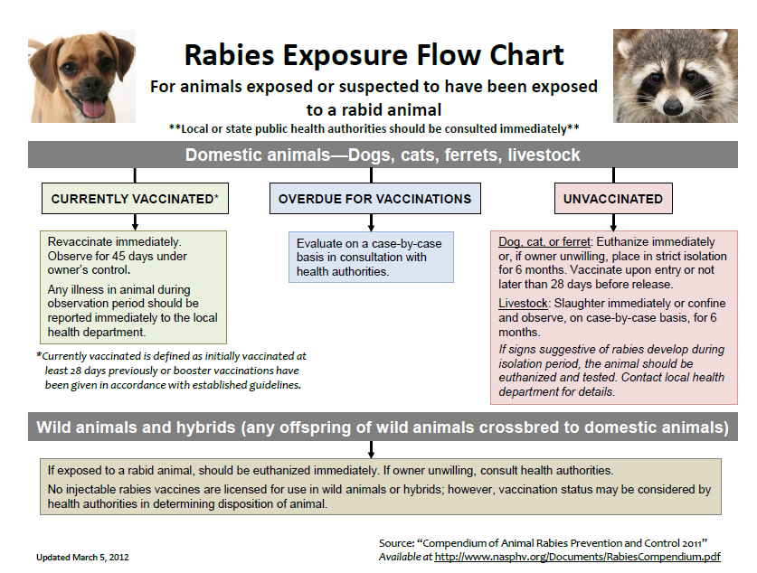

- Management of an animal that bites a human
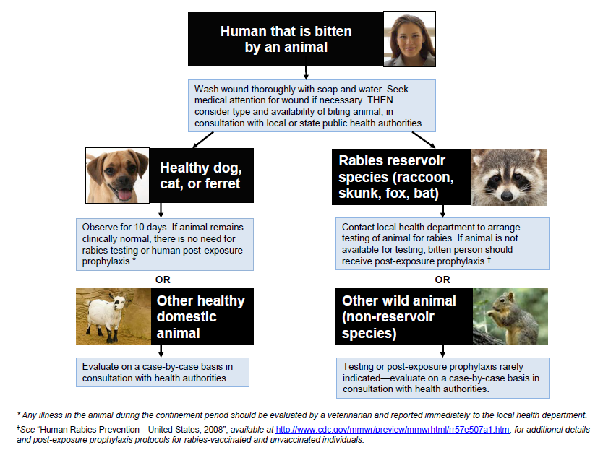
- Post-exposure prophylaxis
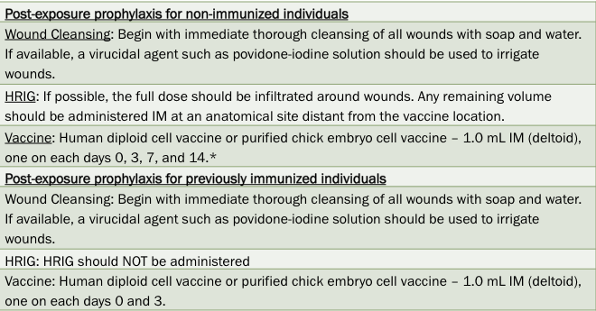

- Testing
  - The Tennessee Department of Health Division of Laboratory services offers rabies testing services free of charge using the direct fluorescent antibody (DFA) test at any of the 3 labs:
  - TDH Laboratory Services- Nashville
ATTN: Rabies Lab
630 Hart Lane, Nashville, TN 37243
Phone: (615) 262-6300
Fax: (615) 262-6393
  - Knoxville Regional Laboratory
ATTN: Rabies Lab
2101 Medical Center Way, Knoxville, TN 37920
Phone: (865) 549-5201
Fax: (865) 549-5199
  - Jackson Regional Laboratory
ATTN: Rabies Lab
295 Summar Drive, Jackson, TN 38301
Phone: (731) 426-0686
Fax: (731) 421-5199

Contacts
Tennessee Dept of Health
425 5th Ave North
Cordell Hull Bldg, 3rd Floor
Nashville, TN 37243
Phone: 615-741-3111
Email: tn.health@tn.gov

Dr. Charles Hatcher
State Veterinarian for Tennessee
Dept of Agriculture
440 Hogan Rd
Nashville, TN 37220
Phone: 615-837-5103
Email: tn.agriculture@tn.gov

References
Brown CM, Conti L, Ettestad P, et al. Compendium of animal rabies prevention and control, 2011. J Am Vet Med Assoc 2011;239:609-617.

Dyer JL, Wallace R, Orciari L, et al. Rabies surveillance in the United States during 2012. J Am Vet Med Assoc 2013;243:805-815.

Tennessee Department of Health. Rabies Control Manual 2012.

