Dominance of Old End Growth is Inherited in Fission Yeast

Julie Rich

May 2, 2015
Das Lab
Maitreyi Das, Bin Wei
The University of Tennessee, Knoxville
Abstract
Schizosaccharomyces pombe, commonly known as fission yeast, is an excellent organism for the study of eukaryotic cell growth and division due to its unicellularity and the ease with which it can be imaged. A wild-type fission yeast cell exhibits bipolar growth until mitosis, after which the cell divides into two identical daughter cells (Figure 1). Growth and division never occur simultaneously. The end of a cell derived from a division site is its new end, and the end that persists from the previous generation is its old end. Immediately after cell division, the old end resumes growth by a process called OETO (Old End Take-Off). After the cell attains a certain size, the new end begins growing by a phenomenon called NETO (New End Take-Off).³ The dominance exhibited by the old end in growth will be further discussed.
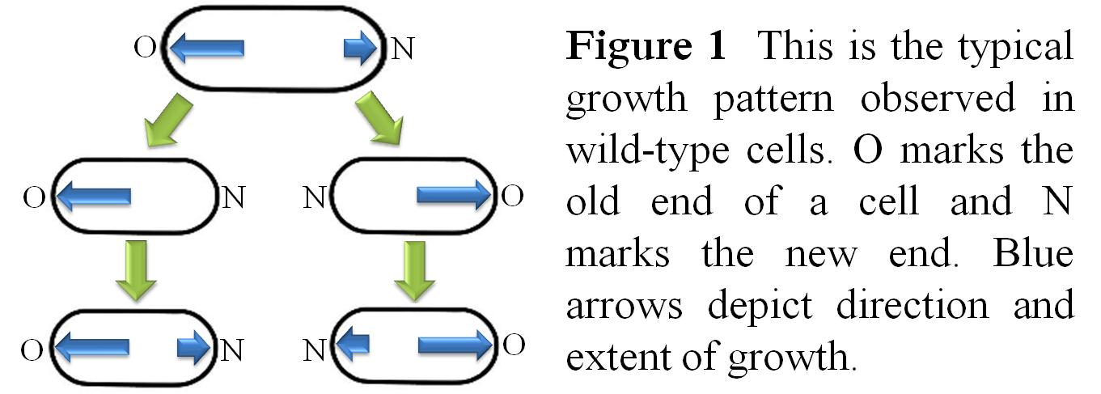
Figure 1 This is the typical growth pattern observed in wild-type fission yeast cells. O marks the old end of a cell and N marks the new end. Blue arrows depict direction and extent of growth.
Cdc42, a small GTPase, is the primary regulator of cell growth and division in eukaryotes. Our recent studies show that the old end and the new end compete with each other for active Cdc42; the old end, which is the dominant end, wins initially. What endows the old end with dominance in this competition is unknown. Cdc42 is activated by the protein Gef1. We observe that gef1 deletion mutants exhibit unique growth patterns. Our data suggests that the old end is dominant only if it grew in the previous generation. This indicates that there exists a memory of growth that determines dominance and is inherited from one generation to the next. Moreover, the degree of dominance is also inherited through the generations.

Introduction
The amount of active Cdc42 in a fission yeast cell oscillates between its two tips (Figure 2), indicating a competition at the tips for Cdc42 activators.¹ The old end is the dominant end and wins this competition. What determines dominance at the old end?
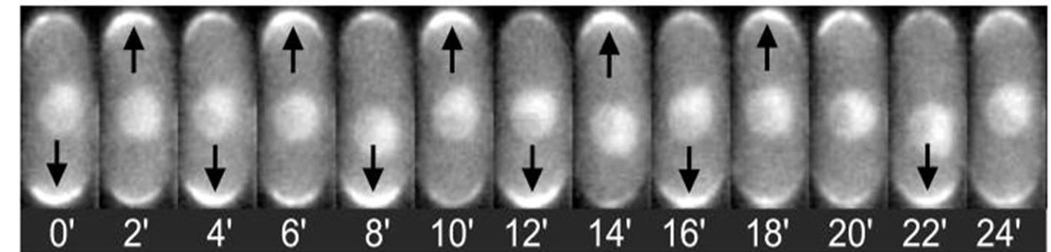
Figure 2 Active Cdc42 oscillates between the tips of a cell.¹
In the past, it has been shown that in monopolar mutants such as tea1Δ or bud6Δ, the end that exhibits growth dominance is the one that also grew in the previous generation.^{2,4} This suggests that dominance of growth is inherited. To further determine the nature of this dominance, we studied growth patterns and division in the gef1Δ mutant. Gef1 is an activator of Cdc42. Cells lacking gef1 have decreased levels of active Cdc42. The gef1Δ strain consists of cells that exhibit both monopolar and bipolar growth, allowing us to compare competition for Cdc42 activators in cells with differing strengths of dominance between their tips.

Materials and Methods
Strains 972 and gef1Δ were used to collect this data. Cells were cultured in liquid yeast extract at 25˚C for several days before imaging. After placing cells on agar, a confocal light microscope was used to collect DIC images every minute for several generations. ImageJ was used to view the images and to collect measurements.

Results and Discussion
The gef1Δ cells exhibited atypical growth patterns compared to wild-type. The progeny of monopolar gef1Δ cells tended 85.7% of the time to consist of a monopolar cell from the old end of the parent and a bipolar cell from the new end of the parent (n=21) (Figure 3).
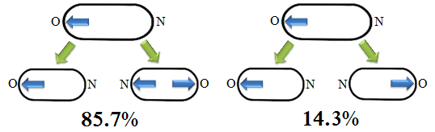
Figure 3 Growth pattern of a monopolar gef1Δ mutant.
Also, the progeny of bipolar gef1Δ cells had an equal chance of giving rise to each set of observed progeny (n=9) (Figure 4).
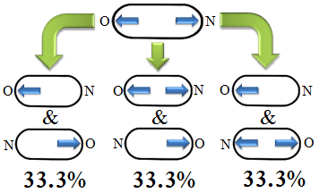
Figure 4 The progeny of bipolar gef1Δ cells have an equal chance of growing in each of the shown combinations.
The strong dominance of the old end of the daughter cell derived from its monopolar parent cell suggests that in order for an end to be dominant in one generation, it needs to have been dominant in the previous generation. This indicates the presence of a memory of growth that exists in the old end, lending it its dominance. The lack of dominance in a bipolar parent cell leads to progeny without any instructions as to dominance, and so grow exhibit random patterns of monopolar and bipolar growth.
Measuring between the tip of the new end of a cell to its birth scars gives the amount of growth the new end has grown at the time of measurement (Figure 5). Using this technique, we found that the daughter cell from its parent's new end exhibited significantly more new end growth (p<0.0001) than the daughter cell from its parent's old end (Table 1). This is in stark contrast to wild-type cells, in which there is no significant difference in the amount of new end growth between sister cells. It is not only the fact of dominance that is inherited through generations, but also the degree of dominance.
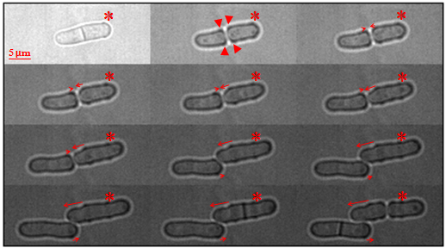
Figure 5 Growth pattern in gef1Δ cells over time, 30 mins/frame. Arrowheads indicate birth scars, which appear on the new end of a cell. The cell marked with an * is derived from the new end of the parent cell, and experiences more new end growth than its sister cell (p<0.0001). Arrows depict direction and extent of growth.

Table 1 New end growth patterns are unique in gef1Δ cells.
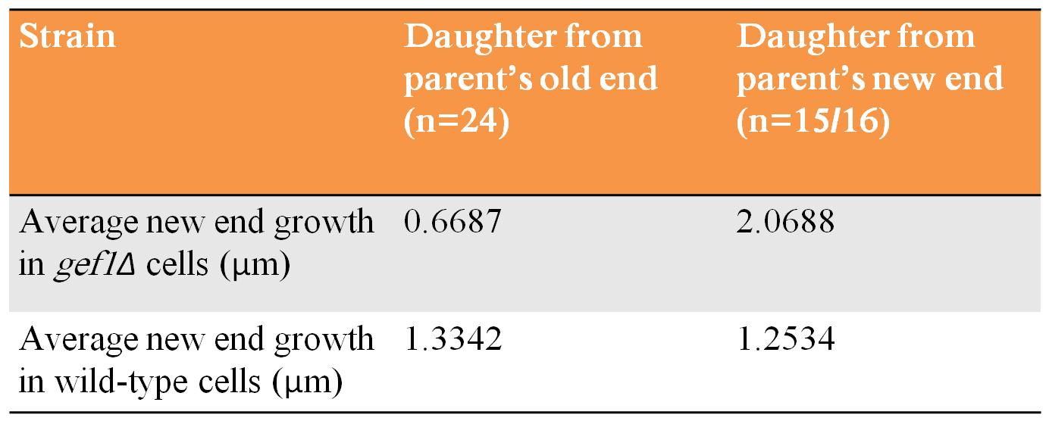

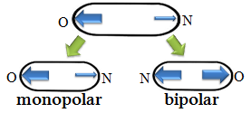
Figure 6 The daughter cell with the "new" old end experiences more new end growth than the daughter cell with the "old" old end.

In a pair of sister cells of which one exhibited monopolar growth and the other bipolar growth, the monopolar sister tended to divide before its bipolar sister approximately two-thirds of the time (Table 2). Considering that a cell only divides once it has attained a certain size, this result is surprising; one would expect the bipolar sister cell to experience more growth and reach that size sooner than its monopolar sister cell.
Table 2 Monopolar sister cells tended to divide before their bipolar sister cells.
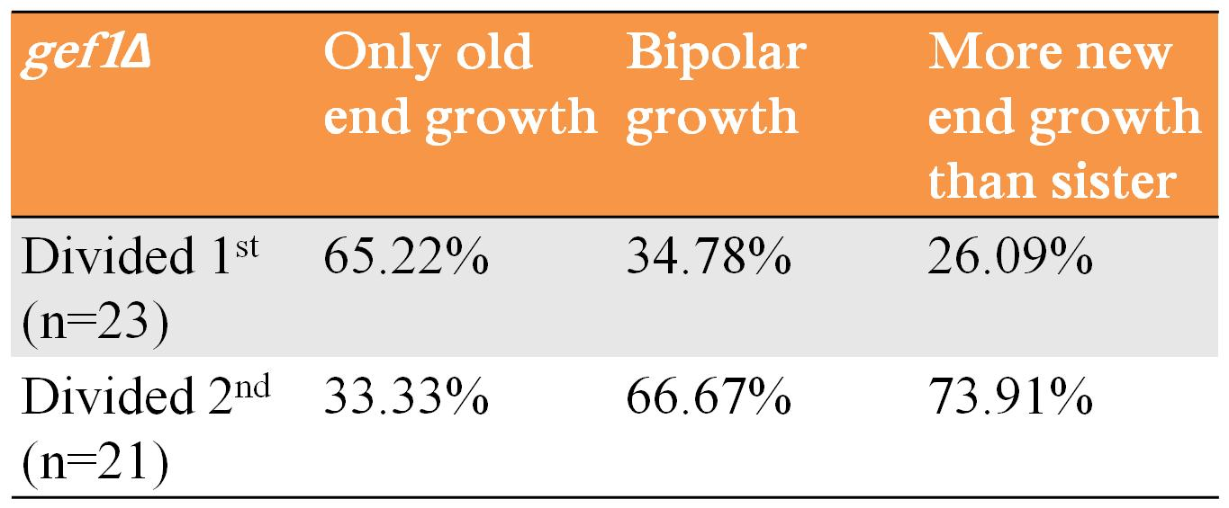

There is also a unique pattern of old end growth among the gef1Δ population. Between two sister cells, one of them exhibits significantly more old end growth than the other (Figure 7). The sister cell that exhibits more old end growth than its sister gives rise to a daughter cell from its old end that itself exhibits more old end growth than its sister cell. The amount of old end growth among progeny of a sister cell that did not exhibit more old end growth than its sister is dependent on their "grandparents'" growth patterns. These results indicate the presence of a gradient that contributes to the memory of growth.

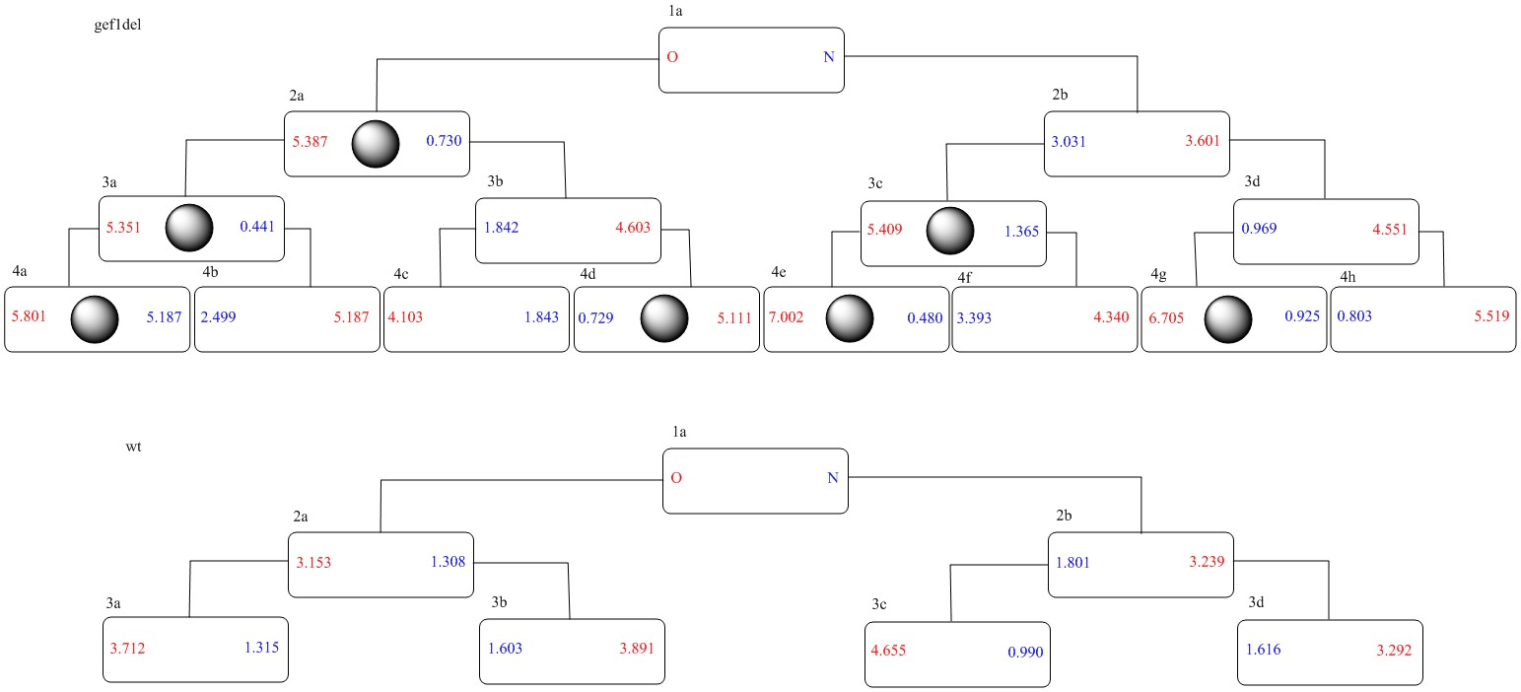
Figure 7 Cell pedigrees for gef1Δ and wild-type. Numbers in red are the average growth in microns for the old end of a particular cell. Numbers in blue are the average growth in microns for the new end of a particular cell. The spheres mark cells that experienced more old end growth than their sister cells. (An enlarged image is included as an additional file.)

Conclusion
Polarity is established when a cell breaks symmetry by initiating growth at a certain pole. What determines this site of cell growth is not clear. Our previous studies have shown that after cell division, growth initiates at the dominant end that attracts activators of Cdc42.¹ In this study we have attempted to elucidate the nature of this growth dominance. Our results show that in gef1Δ cells, the progeny of monopolar cells show growth dominance at the end that grew in the previous generation. The sister cell containing the non-growing end of the parent cell does not show any dominant end and is therefore bipolar. These observations suggest that growth dominance is inherited from one generation to the next. An end that is dominant in one generation will be the dominant end in the next generation. This idea is supported by the fact that the progeny of bipolar gef1Δ mutant cells exhibit random growth patterns because there was no dominance to inherit from the parent cell.
Furthermore, we observe that new end growth is enhanced in cells that derive from the parent’s new (non-dominant) end. Given that there exists a competition between the two ends for growth, our results indicate that the ability to compete for growth at the dominant end depends on the degree of dominance in the previous generation. A cell containing a dominant old end from the previous generation continues to exhibit strong dominance, and, as a result, there is less new end growth in these cells. On the other hand, growth at the new end of a cell that does not contain a dominant end from the previous generation is enhanced. This indicates that the growth dominance inherited by an end not only allows that end to grow first, but also determines its ability to compete with the opposite end. The differential amount of old end growth experienced between sister cells points to a gradient of some kind that contributes to a memory of growth dominance. Collectively, we conclude that there exists some physical memory of growth that imparts dominance to one tip of a cell by attracting more Cdc42 activators. Our current research aims to discover what exactly constitutes this dominance and the mechanism and regulation of its inheritance.

References
- Das, M., Drake, T., & Verde, F. (2012). Oscillatory dynamics of Cdc42 GTPase in the control of polarized growth. Science, 337(6091), 239-243.
- Glynn, J., Lustig, R., Berlin, A., & Chang, F. (2001). Role of bud6p and tea1p in the interaction between actin and microtubules for the establishment of cell polarity in fission yeast. Current Biology, 11(11), 836-845.
- Mitchison, J., & Nurse, P. (1985). Growth in cell length in the fission yeast Schizosaccharomyces pombe. Journal of Cell Science, 75, 357-376.
- Verde, F. (2001). Cell polarity: A tale of two Ts. Current Biology, 11(15), R600-R602.

