The Effect of Plant Source on Lignin-based Polyurethanes

A Thesis Presented for the

Master of Science

Degree

The University of Tennessee, Knoxville

Jason Lang

August 2017

Copyright © 2017 by Jason Lang
All rights reserved.

DEDICATION

This thesis is dedicated to my father, Charles Lang, my mother, Kimberly Lang, and all my friends who supported me during my time in graduate school.

ACKNOWLEDGEMENTS

Thank you all for your help. However, this page is optional.

ABSTRACT
Polymer materials are one of the most vital technologies that we use on a daily basis. Because of this, there is a continuously increasing demand for more polymer materials to introduce new innovative technologies or enhance current ones. Polyurethanes, a type of polymer material, offer a wide range of physical properties and chemical resistance. One pathway that is being pursued in polyurethane research is lignin-based polyurethanes. Lignin is a polymer that is synthesized inside the plant cell wall of softwood, hardwood, and non-wood sources and has shown the ability to be used as a polyol to synthesize polyurethanes. Due to its aromatic nature that is heavily reliant on the plant source, lignin is used to bring structural rigidity to lignin-based polyurethanes. However, research has not been conducted to study how the plant source of lignin affects targeted mechanical properties of lignin-based polyurethanes. Understanding how each plant source influences the targeted mechanical properties would provide a deeper understanding of how to better use lignin as a polyol. To do this, we measured targeted mechanical properties of lignin-based polyurethanes at varying lignin loadings using dynamic mechanical analysis and Shore hardness testing. To explain the mechanical results, differential scanning calorimetry, atomic force microscopy, and scanning electron microscopy were employed to study the morphology of the lignin-based polyurethane samples at select lignin loadings. Furthermore, nuclear magnetic resonance was used to determine the structural information of each lignin in their pure state. Doing so gave insight on the reactive capabilities of each lignin which helped explain the differing morphologies seen based on plant source.

TABLE OF CONTENTS

Chapter 1: Introduction 1
Polyurethanes 2
Synthesis & Structure 3
Structural Influence on Properties 5
Materials & Applications 7
Bio-based Polymer Materials 9
Lignin 10
Chemical & Physical Structure 11
Attraction and Production 13
Extraction Processes 14
Lignin-based Materials & Applications 17
Overview of Thesis 19
Chapter 2: The Effect of Plant Source on Lignin-based Polyurethanes 21
Experimental 22
Dynamic Mechanical Analysis 22
Shore Hardness 24
Differential Scanning Calorimetry 26
³¹Phosphorus Nuclear Magnetic Resonance 28
Scanning Electron Microscopy 30
Atomic Force Microscopy 31
Methods and Materials 33
Synthesis of Lignin-based Polyurethane Samples 33
DMA 35
Shore Hardness 35
DSC 36
³¹P-NMR 36
SEM 38
AFM 38
Results & Discussion 38
References 55
Appendix 69
VITA 77

LIST OF TABLES

Table 1. Tg values obtained from DSC scans of lignin-based PU samples of 20wt%, 40wt% and 60wt% lignin. 45
Table 2. Hydroxyl group type concentrations for each lignin source determined by ³¹P-NMR. 50
Table 3. Calculated OH:NCO ratios for lignin-based PU samples with 20wt%, 40wt%, and 60wt% lignin loadings. 51
Table 4. Peak assignments and their respective hydroxyl group type used for integration of ³¹P-NMR lignin data. 71
Table 5. Storage modulus values obtained via DMA for all lignin-based PU samples. 71
Table 6. Loss modulus values obtained via DMA for all lignin-based PU samples. 71
Table 7. Tan δ values obtained via DMA for all lignin-based PU samples. 72
Table 8. Shore hardness (Type A) values for all lignin-based PU samples. 72

LIST OF FIGURES

Figure 1. Reaction of a polyol (a) with a polyisocyanate (b) to synthesize a polyurethane. 3
Figure 2. Structures of a select few isocyanate compounds and polyol compounds. 4
Figure 3. Representation of non-crosslinked polymer chains (left) and polymer chains that are crosslinked (right). The polymer chains are represented by the blue lines and the crosslinks are represented by the red lines. 5
Figure 4. Scheme of the reaction between an isocyanate group and a urethane linkage to form an allophanate linkage. 7
Figure 5. A theoretical representation of the structure of a lignin molecule (left) and the structures of the monolignol units used to polymerize lignin (right).¹¹⁶ 11
Figure 6. Schematic by Saito et. al. of the production of lignin and materials made from lignin.¹¹⁷ 13
Figure 7. The schematics of the four main extractions processes used to extract lignin from biomass by Laurichesse et. al.¹¹⁸ 15
Figure 8. A typical force curve shown for a material undergoing an oscillatory stress.⁷⁷ 23
Figure 9. A picture of a basic hand-held durometer and how it is operated.¹¹⁹ 25
Figure 10. A scheme of the phosphitylation of lignin hydroxyl groups between 2-chloro-4,4,5,5-tetramethyl-1,3,2-dioxaphospholane (TMDP) and the different lignin hydroxyl groups.¹⁰¹ 28
Figure 11. Diagram of an AFM instrument and contact and tapping modes.¹²⁰ 32
Figure 12. Structure of the TDI-endcapped PPG crosslinker used for the synthesis reaction with the lignin polyols. 34
Figure 13. Storage modulus values of the lignin-based PU samples obtained using DMA. 39
Figure 14. Loss modulus values of the lignin-based PU samples obtained using DMA. 41
Figure 15. Tan δ values of the lignin-based PU samples obtained using DMA. 42
Figure 16. Shore hardness (Type A) results for all lignin-based PU samples. 44
Figure 17. AFM phase images of lignin-based PU samples at 20wt%, 40wt% and 60wt% lignin loading. 47
Figure 18. SEM images of lignin-based PU samples at 20wt%, 40wt% and 60wt% lignin loadings. The scale bar for all SEM images is 10 µm. 48
Figure 20. DSC scans of pure HWLS and lignin-based PU samples synthesized with 20wt%, 40wt%, and 60wt% HWLS. 73
Figure 21. DSC scans of pure SWKL and lignin-based PU samples synthesized with 20wt%, 40wt%, and 60wt% SWKL. 74
Figure 22. DSC scans of pure WSSL and lignin-based PU samples synthesized with 20wt%, 40wt%, and 60wt% WSSL. 75
Figure 23. Examples of 31P-NMR data results for HWLS (top), SWKL (middle), and WSSL (bottom). 76

Chapter 1: Introduction

Over the past few decades polymer materials have become important industrially produced materials on account of their wide range of physical and chemical properties. These polymer materials have found use in a vast array of technologies ranging from wiring, coatings, sports and medical devices to cell phones, houses, automobiles, and planes. Because of this, polymer materials have allowed us to enjoy these technologies and more on a daily basis. However, the demand for new and more elaborate technologies that are more robust than their predecessors will continue to increase. According to Grand View Research, Inc., the polyurethane market was estimated at ~$54 billion in 2015 and is projected to grow to ~$105 billion by the year 2025 due to recent high demands for applications in furniture, automotive, electronic devices, and footwear.¹ Therefore, further research is needed to synthesize and understand new polymer materials that will help allow the advancement of modern technology into the future.

Polyurethanes
Polyurethanes first came onto the scene when they were discovered by Otto Bayer and his colleagues in 1937.² Polyurethanes are known for their wide range of properties including high tensile strength, abrasion resistance, and chemical resistance.^{3,4} These properties, along with others not listed here, are what make polyurethanes an important commercial polymer for use as flexible or rigid foams, solid elastomers, coatings, and adhesives amongst other applications.^{5,6}

Synthesis & Structure
Polyurethanes are polymers that are derived from monomer units joined together by carbamate (urethane) linkages. The most common pathway to synthesize a urethane linkage is to react an isocyanate functional group (R-N=C=O) with a hydroxyl functional group (R-OH). For a polyurethane to successfully be synthesized using this method a polyisocyanate, a compounding containing two or more isocyanate groups per molecule, must react with a polyol, a compound that contains two or more hydroxyl groups per molecule, as shown in Figure 1. In some circumstances, an organic or inorganic catalyst or ultraviolet light is needed for the urethane reaction to take place.⁷ Other pathways have been developed to synthesize non-isocyanate polyurethanes (NIPU) due to the high toxicity of isocyanates that comes with their high reaction rates. These methods include: (1) polyaddition and polycondensation reactions through the use of cyclic carbonates with amines,^{8–10} (2) an AB-type self-polycondensation reaction through the use of acyl halide groups and hydroxyl groups,¹¹ and (3) a self-polycondensation reaction through the use of amide groups and hydroxyl groups with the help of a catalyst.¹²
Figure 1. Reaction of a polyol (a) with a polyisocyanate (b) to synthesize a polyurethane.
The isocyanate is the more reactive group during polyurethane synthesis compared to the hydroxyl group. The majority of isocyanates used today such as toluene-2,4-diisocyanate (TDI), isophorone diisocyanate (IPDI), and 4,4’-methylene diphenyl diisocyanate (MDI) are aromatic in structure while the rest are aliphatic in structure such as hexamethylene diisocyanate (HMDI).^{13–17} Polyols are usually the more flexible of the two components which allows the formation of flexible polyurethane materials and are usually made up of polyesters, polyethers, or glycols such as polyethylene glycol (PEG), 1,4-butanediol, and polypropylene glycol (PPG).^{18–20} The structures of these compounds are seen in Figure 2. The length of the polyol chain also effects the properties of the polyurethane material.^{21,22} Short polyol chains are used to make rigid polyurethanes while longer polyol chains are used to make the polyurethane more elastic and rubbery.
Figure 2. Structures of a select few isocyanate compounds and polyol compounds.

Structural Influence on Properties
The properties of the polyurethane are heavily dependent on the overall structures of the polyisocyanate monomers and polyol monomers used during synthesis. And with the boundaries of human imagination almost limitless, a multitude of polyisocyanates and polyols are readily available to be used for the synthesis of polyurethanes with varying properties. The addition of aromatic monomer units, most often times the polyisocyanate, increases the rigidity of the polyurethane backbone which increases properties such as Young’s modulus. On the contrary, the addition of aliphatic monomer units, most often the polyol, has the opposite affect and allows the polyurethane to have more rubbery characteristics. However, the addition of too many aromatic units can produce a product that is too brittle for use while the addition of too many aliphatic units can produce a product that is too rubbery in character. Therefore, a balance between these two traits must be met for a polyurethane to be useful.
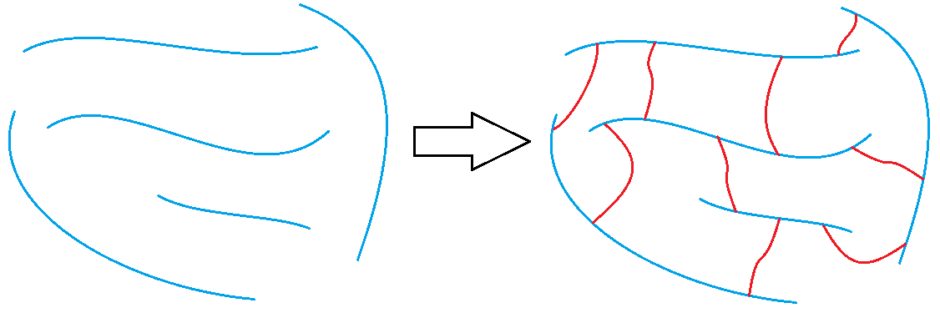
Figure 3. Representation of non-crosslinked polymer chains (left) and polymer chains that are crosslinked (right). The polymer chains are represented by the blue lines and the crosslinks are represented by the red lines.
Another way to increase the structural rigidity of a polyurethane is through cross-linking, as seen in Figure 3, which decreases the molecular freedom of the polymer chains. This decrease in ability for the molecules to freely move increases properties such as tensile modulus and decreases elongation. A polyurethane film that is cross-linked will provide higher chemical and abrasion resistance due to its formation of a tightly packed network. The nature of cross-linking is where two or more linear or branched polymers become linked together by covalent bonds. Cross-linking can occur via chemical reactions when at least one of the monomer units contain three or more reactive sites, addition of additives, or can be brought on through the use of radiation.^{23–25} An example of cross-linking would be the vulcanization of rubber where sulfur is added to natural rubber which forms sulfur bridges between two or more polymer chains.²⁶ The result is a network of cross-linked polymer chains that is stiffer than its non-cross-linked predecessor allowing the rubber to be used in more extreme environments. Another conventional method to employ cross-linking is to use a monomer that contains a level of cross-linking within its own structure. Polyurethanes have another unique way to cross-link by the reaction of an isocyanate with an already formed urethane linkage to create an allophanate linkage, as seen in Figure 4. Even though the positive impacts that cross-linking has on the properties of a polyurethane is attractive there are some setbacks that are brought on by cross-linking. One such setback is that cross-links are, for the most part, irreversible and products that have undergone
cross-linking are hard or impossible to recycle which is a negative trait for commercially used plastics.
Figure 4. Scheme of the reaction between an isocyanate group and a urethane linkage to form an allophanate linkage.

Materials & Applications
With the ability to produce a wide range of properties, polyurethanes have become one of the more sought after polymeric materials leading to an increase in their demand, with approximately 14 million tons being produced in 2011. The majority of polyurethane technology is being used in the formation of flexible or rigid foams, making up over 66% of the polyurethane market. The synthetization of PU foams requires the use of several parts including a polyisocyanate, polyol, catalyst, surfactant, crosslinking agent, and a blowing agent.²⁷ The most typical blowing agent used for PU foam formation is water which produces carbon dioxide (CO₂) when the water reacts with the isocyanate moieties.²⁷ This production of CO₂ is what forms the air gaps within the foam sample called cells. Rigid foams obtain their rigidity through the use of higher cross-linking leading to a more closed cell structure within the foam allowing them to be employed as good insulating materials against temperature and noise.²⁸ Reversely, flexible foams are less crosslinked which provides a larger, open cell structure throughout the foam allowing more air flow throughout the foam, and therefore more flexible.
Elastomers are the second largest category of polyurethane materials produced due to their high abrasion and tear resistance, good long-term dynamic performance, and their ability to be molded into almost any shape.²⁹ Elastomers are crosslinked polymer materials that are soft and deformable under room temperature conditions.³⁰ The most typical examples of an elastomer are the rubber band and vulcanized rubber. Usually elastomers are synthesized by linear monomer units into long polymer chains which are crosslinked during the curing process in ways similar to vulcanized rubber.³⁰ Once fully cured, the long polymer chains re-structure themselves to allocate the applied stress while the cross-links ensure that the elastomer will return back to its original shape.³⁰
Polyurethane coatings and thin films offer high chemical and abrasion resistance ultimately enhancing product appearances and lifespans and are used to shield against corrosion.^{31,32} The production of PU coatings and films typically include a liquid phase where a liquid coating is applied to the surface of an object. This liquid coating is made up of a medium that has dissolved the materials used to synthesize the polyurethane.³¹ After application of the liquid coating, the medium evaporates and chemical curing happens in the form of chemical cross-linking producing a cross-linked polyurethane coating.³¹ These coatings gain their strength against corrosion and abrasion due to the chemical crosslinks formed during the curing process.
Polyurethane adhesives offer very rapid cure rates and the ability to produce strong flexible bonds that are tightly sealed resulting in high peel strength and toughness.^{6,33,34} The chemistry of cross-linking is what gives the PU adhesives their strength qualities. The cross-linking reactions for PU adhesives can occur in a number of ways including: (1) one-step systems that includes a catalyst, (2) a two-part system where a second component is added, and (3) reactions with ambient surroundings such as moisture in the atmosphere.³⁴ Polyurethane adhesives can easily infiltrate porous areas on a substrate due to the low molecular weight of the starting components which helps with their adhesion strength.³⁴ They can also form covalent bonds with active chemical sites found on the material surface they are applied which also further increases their adhesive strength.³⁴

Bio-based Polymer Materials
Over the last decade there has been an increase in interest in deriving polymers from a renewable resource such as trees and plants and other biomasses due to their affinity for the environment and biodegradability.³⁵ This is also due in part to a decline in non-renewable feedstocks such as petrol, but more importantly due to a rise in the desire to preserve Earths ecosystems and places where we live.³⁶ There are available polymers such as polycaprolactone and poly(butylene succinate) that are both characterized as biodegradable polymers even though they are petrochemical based.³⁷ On the other hand, starch, cellulose, and poly(lactic acid) are all made from renewable resources such as biomass and are readily biodegradable.³⁸ Although the ability to biodegrade is very promising what makes these polymers even more desired are their natural occurrence and abundance. And with high availability, the cost to obtain these types of polymers are usually low. This makes bio-based polymers even more attractive to be used as building blocks to synthesize polymer materials that can be used in every-day applications. One bio-based polymer that has recently seen a rise in attraction from scientists and industry is lignin due to its highly aromatic structure and ability to form lignin-based polyurethane materials.

Lignin
As stated in the previous section, one area of polymer materials that has recently seen an increase in interest are bio-based polymers. Due to the wide abundancy and high accessibility of some bio-based polymers, this allows them to be inexpensive to obtain. Lignin is a bio-based polyol that is the second most naturally occurring polymer on Earth, behind cellulose, and makes up 18-35% of wood.³⁹ It is also found in grasses such as wheat straw and switchgrass and other plants such as shrubs from the eucalyptus genus. Lignin is a highly aromatic polymer that is found in the plant cell wall alongside hemicellulose and cellulose fibers. The lignin molecules function as a cementing material amongst the cellulose and hemicellulose and is used as a means to provide structural support to the plant as well as act as a defense mechanism against parasites and diseases.⁴⁰

Chemical & Physical Structure
Although there is no exact definition of the 3D structure of lignin, scientists, aided by recent advancements in its chemistry, have been able to identify the three-main monomer building blocks that make up lignin. The highly aromatic nature of lignin, seen in Figure 5, is due to the enzyme initiated dehydrogenation polymerization and radical coupling reactions of the three basic monomers p-coumaryl alcohol, coniferyl alcohol, and syringyl alcohol.⁴¹ These three cinnamyl alcohols, also called monolignols and whose structures are shown in Figure 5, are very similar in structure consisting of a phenolic ring with an aliphatic side chain attached that includes both an alkene and an alcohol functional group. Where they differ in structure are the number of methoxy groups that are found at each ortho position relative to the phenolic hydroxyl group. These methoxy groups play a key role in the physical characteristics and construction of the lignin molecule.
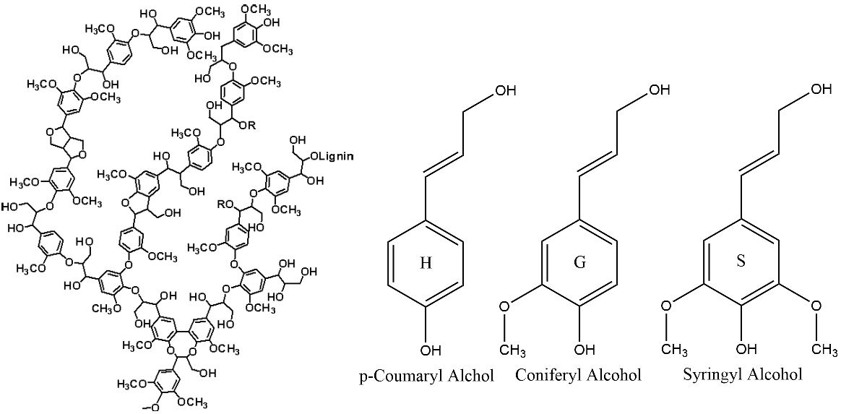
Figure 5. A theoretical representation of the structure of a lignin molecule (left) and the structures of the monolignol units used to polymerize lignin (right).¹¹⁶
The amounts of each monolignol used to form the lignin molecule differs between the types of plants used to extract the lignin. Therefore, lignins can be divided into three classes depending upon their source, namely hardwood, softwood, and grass lignins. Lignins extracted from hardwood sources contain the highest amounts of syringyl alcohol amongst the three classes of lignins with smaller amounts of coniferyl alcohol monolignols. Softwood lignins, also called coniferous or guaiacyl lignins, are solely made up of coniferyl alcohol monolignols. The structure of lignins that are extracted from grasses, also called non-wood lignin, contain a wide range of all three monolignols, however these types of lignins contain the highest amount of p-coumaryl alcohol monolignols compared to the other classes of lignins. As stated previously, it is important to pay attention to which monolignols are used, and overall the source of the lignin, due to their differences in number of methoxy groups. The amount of methoxy groups in the monolignol is important due to the steric hindrance they provide to the phenolic hydroxyl group of the monolignol. This is because the enzyme catalyzed polymerization of the monolignol units heavily targets the two hydroxyl groups connecting the monomers together to form the polymer chain. An increase in steric hindrance leads to a decreased ability for the phenolic site to be used to form a linkage with another monomer which lowers the amount of crosslinking within the overall lignin structure. Due to this understanding of how lignin internal crosslinking works, it is understood that hardwood lignins possess the least internally crosslinked structure amongst all lignin types as hardwood lignins containing the highest amount of syringyl alcohol monolignol units within its structure. Additionally, lignins extracted from grasses, which possess the highest amounts of p-coumaryl alcohol monolignol, have a more internally crosslinked structure compared to the other types of lignins. This internal crosslinking affects not only the lignin molecule but also the properties of lignin-based materials.

Attraction and Production
There are a number of reasons why lignin has gained a lot of attraction in the scientific community to be used to produce polymer materials. One of the largest processes where lignin is extracted from plants is during the chemical pulping processes at paper mills where pulp is made to make paper.⁴² The main product for this process is cellulose to produce paper making lignin a byproduct. Up until recently, lignin was viewed as waste that was only used to serve as fuel to power the boilers used during the paper-making process. In 2010, it was estimated that the paper and pulping industry alone extracted 50 million tons of lignin.⁴³ Biorefineries increase that amount making lignin very economical. With lignin being highly abundant, including an estimated 300 billion tons of lignin available in the biosphere with a steady yearly increase of 20 billion tons, the high availability of lignin and its low economic cost further increases its attraction to be used as a starting material for producing polymer products.⁴⁴
Figure 6. Schematic by Saito et. al. of the production of lignin and materials made from lignin.¹¹⁷

Extraction Processes
Other than the plant source they were extracted from, another important way lignins are classified is by the employed extraction process. There are several extraction processes that allow the separation of lignin from the lignocellulosic material. The most dominant processes used today are the Kraft, organosolv, soda, and sulfite processes, as presented in Figure 7, in which all have an effect on the physical and chemical structure of the extracted lignin. The most widely used chemical pulping process used is the Kraft process and makes up approximately 85% of the total lignin production throughout the world due to it being the preferred process used for paper making.⁴⁵ During this process, the wood is dissolved in an aqueous medium of sodium hydroxide and sodium sulfide and is cooked under pressure at 170°C for a couple hours.⁴² During the cooking process, the hydroxide and hydrosulfide anions react with the lignin and cleaves α-aryl ether and β-aryl ether bonds. This fragments the lignin into smaller particles with lower molecular weights, higher amounts of phenolic hydroxyl groups and can be dissolved in alkaline solutions.^{42,46} During the Kraft process, a small amount of sulfur in the form of thiol groups (-SH) are attached to the lignin due to condensation reactions generated by the anions.⁴⁷ Kraft lignins have found use for a number of applications such as carbon fiber, foams, hermoplastics, resins, and fertilizer and pesticide carriers.^{48–53}
Sulfite pulping is the other pulping process used where lignin is extracted in the form called lignosulfonates due to sulfonic groups (-SO₃⁻) being introduced into the structural network of the lignin molecule.⁵⁴ The sulfite process uses sulfurous acid and its alkali salt versions to extract the lignin from wood chips by breaking α-O-4 ether linkages under high pressure at approximately 150°C.^{47,55} The attached sulfonic groups also cause the lignosulfonate to act as a polyelectrolyte allowing it to be water soluble even though the backbone is composed of a hydrophobic aromatic skeleton. Lignosulfonates contain the highest amounts of sulfur content amongst all types of lignins at approximately 5wt% with a degree of sulfonation per phenylpropanoid unit of 0.4-0.5.⁵⁶ The largest form of use for lignosulfonates is as a chemical dispersant for cement accounting for approximately 50% of total lignosulfonate usage.^{57,58} Additionally, lignosulfonates have found uses for other low-profile applications such as dispersing agents, stabilizers, and binders for animal feed, glues and adhesives, dust control, detergents, and particle board.^{59–62} Although the polydispersity of lignin in general is usually high, lignosulfonates typically have the highest polydispersity amongst all types of lignins which can be an obstacle in material production.⁶³
Figure 7. The schematics of the four main extractions processes used to extract lignin from biomass by Laurichesse et. al.¹¹⁸
The organosolv process is a sulfur free pulping process that uses a mixture of solvents such as methanol, ethanol, acetic acid, formic acid, and peroxiorganic acids to cook the wood chips and separate the lignin from the other wood chip constituents.⁶⁴ During the organosolv process, the lignin becomes solubilized by the solvent, or solvents, used through the acidolytic or alkaline cleavage of aryl ether linkages resulting in an increased number of phenolic functionalities. Due to the use of organic solvents and organic acids as the reactive ingredient, organosolv lignins have no added functionalities like thiols or sulfonic groups found in Kraft lignins and lignosulfonates, respectively. Therefore, these lignins are more structurally similar to the lignin produced within the plant cell wall.⁶⁵ The drawback to using organosolv lignins is the solvents and acids used. The high cost for the organic solvents and acids is an immediate economical drawback. Moreover, the environmental impact these chemicals can have can shift some researchers focus to use other lignins in order to help keep the impact on the environment as low as possible. Although organosolv lignins are limited in their use in adhesives and binders due to having a lower molecular weight, they can still be used in other applications in which Kraft and lignosulfonates are used.⁵⁶
The fourth main pulping process used to extract lignin is the soda process. Like the organosolv process, it is sulfur free and does not include side reactions that add extra functionalities onto the structure of the extracted lignin as is found with the Kraft and lignosulfonate processes. However, the soda process is very close to the Kraft process in terms of chemicals used to break down the lignin, such as alkaline materials without the sodium sulfide, and therefore lignins from both processes are structurally similar. The soda process is mainly used for the cooking of grass sources such as wheat straw, hemp, switchgrass, and bagasse and due to having no sulfur content it is very attractive for polymer applications like those found for Kraft lignins.^{66,67}

Lignin-based Materials & Applications
Recently, the scientific community has seen an increase in research and development of lignin-based products and polymer research. Due to the structure of lignin being highly aromatic, processes have been developed that break down lignin molecules to produce other valuable aromatic chemicals such as benzene, toluene, xylene, styrene, phenols, cyclohexane, aromatic aldehydes, vanillin, and vanillic acid in which some can be used to synthesize other types of polymers like aromatic polyethers, polyesters, polystyrene, etc.^{68,69} Since lignin is a polyol, synthesis techniques have also been used to study the effect lignin incorporation can have on the properties to produce biodegradable polymer materials. Due to the heterogenous nature of lignin and its affinity to aggregate, homogenous blends of lignin with other polymers are hard to come by and usually results in lower mechanical properties when compared to the pure polymer counterpart.^{70–72} However, modification techniques of lignin, such as acetylation and grafting to/from, have been used to disrupt the atomic forces behind lignin aggregation. Doing so provides a more homogenous blend between the lignin and the polymer matrix as well as an increase in physical properties.^{70,72,73}
The highly aromatic structure of lignin and its ability to act as a polyol have made it a desired building block to produce lignin-based polyurethanes. In these instances, the lignin structure adds rigidity to the network increasing the mechanical properties of the resultant polyurethane. Some of the more common lignin-based polyurethane materials are soft or rigid foams, epoxy resins, lignin-grafted-polycaprolactone copolymers, and carbon fiber.^{48,49,67,74} For most systems, it is desired to employ as much lignin into the polyurethane network as possible to further increase targeted properties, use less commercial polyol, improve economics, and to increase the biocompatibility of the material. However, too much lignin incorporated into a system usually leaves the material too brittle to be useful. This is seen with the research done by Saito et. al. who successfully produced a material that was comprised of 80wt% lignin, but was too brittle to use for any testing.⁴⁰ Therefore, a compromise must be found between the amount of lignin content and rubbery content used.

Overview of Thesis
The main goal of this work is to understand the impact that the source of the lignin has on the properties of lignin-based polyurethanes. As previously discussed, lignin is used as a polyol to synthesize lignin-based polyurethane materials with increased targeted properties and biocompatibility.^{14,40,50,75,76} However, it is not well understood how the source of the lignin, in this case hardwood, softwood, and non-wood sources, affects target mechanical properties of the resultant lignin-based polyurethane. We know the source from which lignin is extracted plays a significant role on the structural development of the lignin, primarily the amounts of each monolignol used, and that this influences the internal crosslinking abilities of the lignin structure.
Therefore, we will study how the lignin source parameter affects the properties of the lignin-based polyurethanes. To achieve this goal, we will examine two primary parameters: (1) the lignin used as a polyol which is dependent upon source and (2) the lignin loading in the polyurethane formulation. Changing the lignin source allows us to study and compare the targeted properties of the resultant lignin-based polyurethane samples based on extraction source and the effects it has on the structure of the lignin. By changing the lignin weight percent within the sample, we can probe how the targeted properties change as more lignin is added to the system and compare the differences in terms of lignin source. Another parameter that will be looked at is how the ratio of isocyanate groups to hydroxyl groups plays a role in the properties of the lignin-based polyurethanes. Due to the differing levels of internal crosslinking amongst the three lignin sources, the hydroxyl group number can vary between them. And since hydroxyl groups induce crosslinking, this ratio can provide more information on how the plant source affects targeted mechanical properties of lignin-based polyurethanes. Once more, the morphology of the lignin-based polyurethanes is important in understanding the differences in physical properties between the plant sources. The level of mixing between the two phases, hard/rigid phase and soft/rubbery phase, has a significant impact on the physical properties a material. Therefore, the morphology of the lignin-based polyurethanes will be studied to further explain how the plant source affects targeted mechanical properties.

Chapter 2: Experimental

Dynamic Mechanical Analysis
Dynamic mechanical analysis (DMA) is a widely employed instrumental technique used to investigate and characterize rheological properties of materials including the viscoelastic behaviors of polymer systems.^{77,78} DMA works by applying an oscillatory force to a sample material of known geometry causing the sample to undergo a sinusoidal deformation.⁷⁹ Doing so, the instrument can analyze the materials responses to the applied force.⁸⁰ The amount of deformation the sample undergoes for an applied stress is directly related to its stiffness where samples that are stiffer will deform the least. The oscillatory motion is driven by a force motor and transmitted to the sample via a draft shaft. The motor is set to a selected frequency and the changes in stiffness and damping are measured.⁷⁷
Polymer materials display flow characteristics even when they are considered solid or rigid materials.^{81,82} Since a sinusoidal force is being applied, the resulting strain wave shape depends on the elastic behavior and the viscous behavior of the sample.^{77,80} The two most measured rheological properties while using dynamic mechanical analysis are the storage modulus and the loss modulus. The storage modulus, denoted as E’, is the elastic behavior of a sample and describes how much energy is stored by the material during oscillatory motion.^{83,84} The loss modulus, denoted as E”, is the viscous behavior of the sample and describes the magnitude of energy that is lost to heat and internal friction due to chain slippage caused by molecular rearrangements of the polymer chain.^{83,84} Furthermore, the ratio of the loss modulus to storage modulus, also called damping or tan(δ), indicates how efficient a material is at losing energy due to the molecular rearrangements and internal friction.^{84,85} These moduli are dependent upon temperature and the frequency of the oscillatory force.^{40,86}
The force curve of a sample subjected to a sinusoidal force responds in similar fashion with a sinusoidal nature, as depicted in Figure 8. When a material is fully elastic the response from the material will be fully in-phase with a phase angle of 0°.⁷⁷ However, when a material is fully viscous the material’s response will be fully out-of-phase with a phase angle of 90°.⁷⁷ Since polymer materials are viscoelastic they fall in between these two extremes. Equations 1, 2, and 3 were gathered from an article published by Anwer et. al.⁸⁶ The storage modulus, in-phase component, of a viscoelastic material is calculated using Equation 1 while the loss modulus, out-of-phase component, is calculated using the phase lag between the two sine curves (Equation 2).
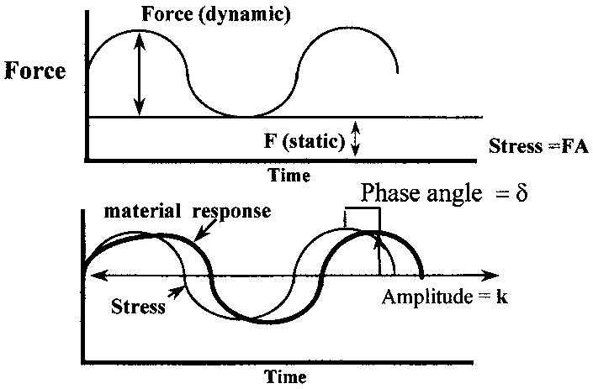
Figure 8. A typical force curve shown for a material undergoing an oscillatory stress.⁷⁷
$$E^{'}=\left(\frac{σ_{°}}{ε_{°}}\right)cosδ (1)$$
$$E"=\left(\frac{σ_{°}}{ε_{°}}\right)sinδ (2)$$
$$tanδ=\frac{E'}{E"} (3)$$
Dynamic mechanical analysis is a prominent instrumental technique that can be used to measure the moduli of the lignin-based polyurethanes that will be synthesized and characterized for the research required for this thesis. Since lignin is a polyol and the plant source of the lignin affects the amount of internal crosslinking within the lignin, both properties will affect the amount of overall crosslinking found within the network of the lignin-based polyurethane. Therefore, DMA will be used to help identify how each plant source affects the moduli of the system and to what capacity they differ between each other.

Shore Hardness
The hardness of a material is the measurement of how resistant a material is to various kinds of permanent shape changes when a constant compressive force is applied.^{87–89} Properties such as stiffness, viscoelasticity, and viscosity affect the hardness of a sample leading to the generalization that hardness is characterized by the strong intermolecular and intramolecular bonds found within the makeup of the material.^{87,89,90} There are multiple scales on which the hardness factor of a material is measured such as Brinell, Rockwell, Shore, and Vickers that differ on how the compression force is applied to the sample.⁸⁹ For the work performed in this thesis, the Shore Hardness scale will be implemented due to its typical use for measuring the hardness of polymer materials.
During Shore Hardness testing, a hand-held or mechanical instrument called a durometer is used to apply a compressive force given from a standardized indenter of known geometry on to the surface of the material being tested.^{89,90} The durometer then measures the hardness of the material from the depth of the indentation made by the indenter through the use of an internal spring mechanism.⁸⁹ The force applied by the durometer must be performed in a consistent manner to obtain dependable results. For Shore Hardness testing, since there is a vast array of application materials that differ in compressive strength there are multiple Types of durometers that can be used. Where these Types differ are the geometry of the indenter as well as the force behind the spring.^{88,89,91} Softer materials such as foams and some rubbers will typically require the use of a Type O-OOO durometer with a spherical indenter while harder rubbers and plastics will require an indenter with a sharp or flat cone point such as found with Types A-D.^{87,89}
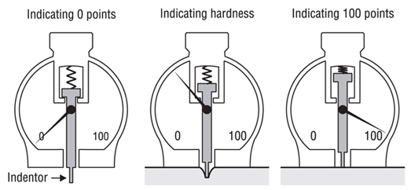
Figure 9. A picture of a basic hand-held durometer and how it is operated.¹¹⁹
Measuring the Shore Hardness of the lignin-based polyurethanes synthesized for the work of this thesis is another way to quantify and compare the targeted mechanical properties based on the plant source of the lignin. As mentioned previously, compressive strength is generally measured and characterized by the molecular bonding that is found within the testing material. Introducing, or increasing, crosslinking is one technique used to affect the hardness of a polymer material. With the addition of lignin to act as a rigid polyol with the ability to induce crosslinking, this instrumental method should help further identify the affect that plant source has on the targeted mechanical properties of the synthesized lignin-based polyurethanes.

Differential Scanning Calorimetry
Differential Scanning Calorimetry (DSC) is the most common thermoanalytical method used for quantitative studies of polymers and their thermal transitions.^{92,93} A DSC instrument calculates the change in heat flow of a polymer sample compared to an inert reference while both are being heated simultaneously.⁹³ The change in heat capacity is measured as a function of temperature and monitored continuously while the heat flow is adjusted to keep both the sample and reference at the same temperature.⁹³ This allows for the finding of two major thermal transition temperatures for polymeric materials: the glass transition temperature, T_{g}, and the crystalline melting temperature, T_{m}. While both of these transitions are critical for the thermal definition of a polymer, the glass transition temperature is more important for this study and, therefore, will be the main topic of consideration for DSC results shown in this thesis.
The T_{g} of a polymer happens when the amorphous domains transition from a hard, glassy state into a more flexible, rubbery state.^{5,30,94} This is due to the rotational, translational, and vibrational energies increasing along with temperature.⁹⁴ As the total energies of the molecules increase there is a certain temperature that is reached, the T_{g}, where long-range segmental motions of the polymer chains begin to occur and significant changes in properties are observed.⁹⁴
Polyurethanes synthesized from a rigid block and a rubbery block will show multiple T_{g}’s with one T_{g} corresponding to the rubbery block and a T_{g} corresponding to the hard block. This is due to phase segregation between the soft block and the hard block due to their thermodynamic incompatibility to each other. The rigidity due to the highly aromatic structure of lignin allows for phase segregation with the rubbery content that is used to synthesize lignin-based polyurethanes. This will result in the lignin-based polyurethanes providing multiple T_{g}’s corresponding to the lignin-dominated phase and the rubber-dominated phase.

³¹Phosphorus Nuclear Magnetic Resonance
Nuclear Magnetic Resonance (NMR) is a common research technique used to exploit the structure of organic compounds.^{95–97} What makes this instrumental method useful is that it is a non-destructive technique that can provide a complete analysis of the overall structure of the sample.⁹⁸ The main isotopes that are most useful to chemists are ¹H, ¹³C, ¹⁹F, and ³¹P.⁹⁹ For the research that this thesis presents, ³¹P-NMR will be used.
Compared to standard ¹H-NMR, ³¹P-NMR is conceptually the same. One of the attractive characteristics of ³¹P-NMR is that, like the ¹H nucleus, the ³¹P nucleus has a ½ nuclear spin allowing spectra to be more easily interpreted.⁹⁹ Also, the gyromagnetic ratio of the ³¹P nucleus is comparatively high at 10.841x10⁷ rads T⁻¹s⁻¹ which is comparable to other high-ratio nuclei such as ¹H (26.7519x10⁷ rads T⁻¹s⁻¹) and ¹³C (6.7283x10⁷ rads T⁻¹s⁻¹).¹⁰⁰ Furthermore, the ³¹P isotope is 100% naturally abundant and the spectral signals for phosphorous-containing compounds are well determined allowing ³¹P-NMR to be a good choice for chemical structure determination.¹⁰⁰
Figure 10. A scheme of the phosphitylation of lignin hydroxyl groups between 2-chloro-4,4,5,5-tetramethyl-1,3,2-dioxaphospholane (TMDP) and the different lignin hydroxyl groups.¹⁰¹
Lignin scientists have used ³¹P-NMR due to its ability to provide good structural data about the lignin molecule with the ability to quantify certain aspects of the structure of the employed lignin.^{101–103} Lignin itself does not contain any phosphorous within its structure, therefore a phosphorous-containing ligand must be attached via a chemical reaction for the method to be useful. One of the most widely used abilities of ³¹P-NMR with lignin is its ability to quantitatively determine the different hydroxyl groups found within the lignin such as aliphatic, carboxylic, guaiacyl, p-hydroxyphenol, and syringyl alcohol units.¹⁰⁴ While ¹H-NMR and ¹³C-NMR, when combined, have shown the ability to quantify all of these hydroxyl groups, ³¹P-NMR has shown the ability to quantify all of these hydroxyl groups together in a relatively shorter timeframe.¹⁰¹ Also, ³¹P-NMR provides better separation and resolution of the hydroxyl signals leading to more precise quantifiable hydroxyl data.¹⁰⁵
Knowing the hydroxyl functional group content plays a prominent role in the identification and definition of the lignin structure providing information that affects the chemical and physical properties of the lignin. Since ³¹P-NMR can provide quantifiable phenolic data it is possible to also obtain a monomer unit ratio for the lignin molecule. This ratio may be able to provide a better justification to the internal crosslinking capabilities of each lignin structure based on plant source. Also, the overall hydroxyl group number of the lignin calculated from the integration of the ³¹P-NMR data can help discern how significant a role the number of hydroxyl groups play in the influence of targeted mechanical properties of the lignin-based polyurethane samples based on plant source.

Scanning Electron Microscopy
Scanning electron microscopy (SEM) is an instrumental microscopy that uses an electron microscope to produce images of samples by using a focused beam of high-energy electrons to scan an area of a solid sample.^{106,107} The electrons that are in the focused electron beam interact with the surface of the sample and provide topographical and conformational information about the sample. This is performed when electrons are accelerated through an electron gun within the electron microscope. The electrons then travel and are focused through a series of lenses before coming in to contact with the sample. These accelerated electrons contain considerable amounts of kinetic energy by the time they come in to contact with the surface of the sample. At this time, the electron-sample interaction dissipates the kinetic energy of each electron and secondary electrons and backscattered electrons are produced.¹⁰⁶ The secondary electrons and backscattered electrons are then detected by a photodetector which then produces a signal. This signal is what is used to generate a two-dimensional image.¹⁰⁶ Back scattered electrons are valuable for imaging the contrast in multiphase samples while secondary electrons are mainly used for obtaining morphological and topographical information of a sample.¹⁰⁸
Scanning electron microscopy is a widely used instrumental microscopy for the study of solid materials, including polymers.^{86,109–111} Very minimal sample preparation is needed and fast data acquisition is normal to obtain SEM images. Furthermore, because of the use of a series of lenses very high-resolution images of features and objects down to the nanometer scale is possible.¹¹² It is also practicable to achieve images showing distinct phase identification contained in multiphase samples and can even be used for crystalline structure analysis and filler/fiber dispersion analysis.¹¹¹

Atomic Force Microscopy
Atomic force microscopy (AFM) is a type of scanning microscopy that is used to attain very high-resolution images and other information of the surface of an array of samples including hard, soft, rubbery, conductive and biological samples.^{111–113} This is performed by using a sharp tip at the end of a small cantilever, typically made from silicon or silicon nitride, a piezoelectric element, a focused laser, and a photodetector. The cantilever is attached to the piezoelectric element and the laser is then focused on to the end of the cantilever.^{111,112} The tip of the cantilever is then lowered and brought in contact with the surface of the sample and begins scanning in very precise movements that are directed by the piezoelectric element. As the tip scans across the surface of the sample in a raster motion the laser is reflected by the cantilever and hits the photodetector which tracks the movement of the laser which captures the surface topography of the sample.^{111,112}
Atomic force microscopy is usually performed in one of three modes: contact mode, non-contact mode, and tapping mode.^{111,112} In this research only tapping mode was used. During tapping mode, the cantilever is oscillated by the piezoelectric element at its natural frequency that is calculated by the AFM instrument and its software. During tapping mode, the tip is not in constant contact with the sample, but instead “taps” the surface of the sample while scanning due to its oscillator motion. Doing so causes less damage to the sample and tip and provides more accurate topographic measurements.¹¹¹
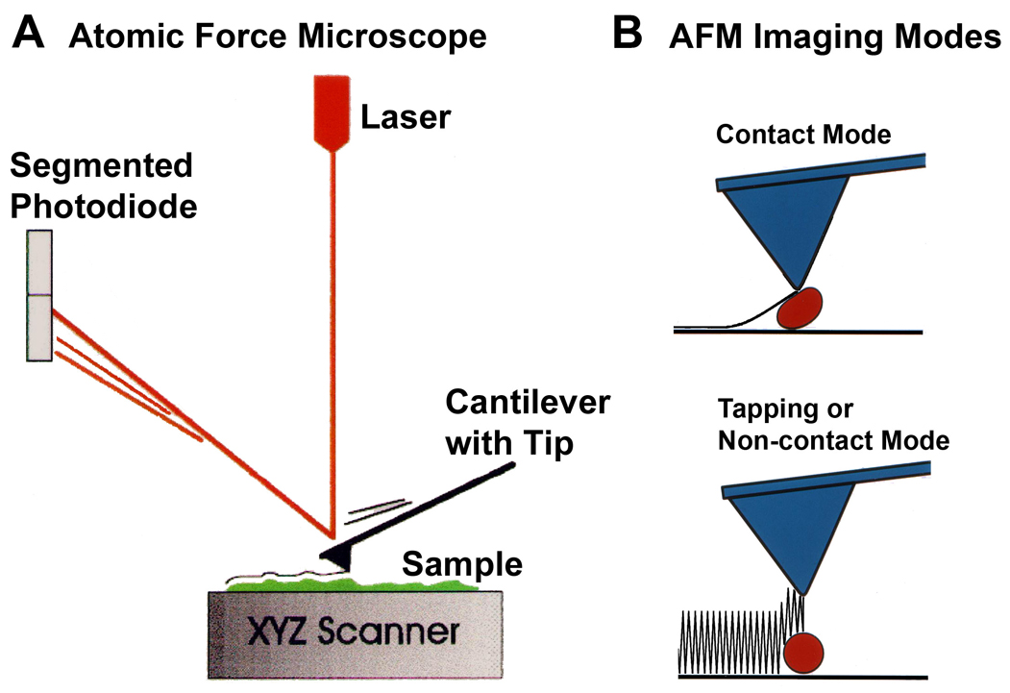
Figure 11. Diagram of an AFM instrument and contact and tapping modes.¹²⁰

Chapter 3: The Effect of Plant Source on Lignin-based Polyurethanes

Methods and Materials

Synthesis of Lignin-based Polyurethane Samples
Three different lignins, each from their own plant source, were used in the work for this thesis: (1) a Kraft processed lignin from a softwood source, a lignosulfonate lignin from a hardwood source, and a soda processed lignin from a wheat straw source. The softwood Kraft lignin (SWKL) was purchased from TCI America. The hardwood lignosulfonate lignin (HWLS) was supplied by Borregaard Lignntech and the wheat straw soda lignin (WSSL), also called Protobind 1000, was supplied by GreenValue LLC. The HWLS and the WSSL were used as received while the SWKL was subjected to an acid wash to further purify the product. The SWKL was purified using the following method. Approximately 10g of SWKL was added to 300mL of 2M hydrochloric acid (HCL) and the SWKL/HCL solution was allowed to stir for 3 hours open at ambient temperature and open to air. The SWKL/HCL solution was then filtered using a fritted funnel with a porosity of 4-5.5 µm to obtain the SWKL particles from the solution. This step was repeated 2 more times and then the SWKL was washed a few times with deionized water to remove any leftover HCL. The SWKL was then placed in a vacuum oven and dried overnight under a vacuum strength of 30 mmHg at 60°C. The dried SWKL powder was then placed in a vial and stored in a desiccator.
Polypropylene glycol (PPG) (M_{N} = 2,300 g/mol) that is end-capped on both ends with toluene-2,4-diisocyanate (TDI) was used as the isocyanate crosslinker during the synthesis with polyol lignin to synthesize lignin-based polyurethane samples. The PPG was kept inside a glove box charged with inert nitrogen gas to help keep the PPG pure and unreacted with any moisture. Before synthesis, the lignin being used was heated and dried under full vacuum over night to remove any moisture content. The lignin was then capped in a vial and transferred to the nitrogen glove box and stored. All steps for the reaction of lignin with TDI-PPG-TDI to synthesize lignin-based polyurethanes were performed in the nitrogen glove box.
Figure 12. Structure of the TDI-endcapped PPG crosslinker used for the synthesis reaction with the lignin polyols.
Two grams of TDI-PPG-TDI was weighed in a 50mL beaker and was allowed to stir mechanically on a hotplate at 100°C for a few minutes. Eight drops of dibutyltin dilaurate (DBTDL) purchased from Sigma-Aldrich was then added as a catalyst and the TDI-PPG-TDI/DBTDL mixture was allowed to mechanically stir at 100°C for 10 minutes to produce a homogenous mixture. An amount of lignin that gave the desired lignin weight percent (wt%) was weighed out into a vial and then added to the TDI-PPG-TDI/DBTDL mixture. The lignin/TDI-PPG-TDI/DBTDL mixture was then allowed to stir on a hotplate at 100°C until the viscosity of the mixture increased. The mixture was then poured into a Teflon® mold and was allowed to cure at room temperature overnight inside the nitrogen glove box. The dimensions for the mold were made for the formation of samples usable with the dual-cantilever set up with the DMA Q800 (TA Instruments) instrument. A variety of lignin contents (20, 30, 40, 50, and 60 wt%) were used to synthesize the lignin-based polyurethanes. A reference PU sample was synthesized using the same method as described for lignin-based PU samples with a hydroxy-terminated PPG (M_{N} = 2,000 g/mol) being used as the polyol.

DMA
Mechanical properties measurements were performed using a DMA Q800 (TA Instruments) using the dual cantilever set up and calibrated using the TA Instruments calibration kit. Samples were made through curing in a Teflon® mold with the dimensions 57 mm x 12.5 mm x 3.5 mm (L x W x H). Sample specimens were then inserted into the DMA set up and were tested at 30°C and 0.1% strain with a frequency of 1 Hz.

Shore Hardness
The Shore hardness values for all lignin-based polyurethane samples were measured according to the ASTM D2240-15 standard procedure with a Type A Model 2000 Durometer made by Rex Gauge Company. Since all lignin-based polyurethane samples did not have a thickness of 6 mm, samples of the same lignin plant source and lignin wt% were plied together which is allowed according to the ASTM D2240-15 procedure. Once plied together, samples were measured in three separate areas along the sample.

DSC
Thermal history measurements were performed using a DSC Q2000 (TA Instruments) and an Indium standard was used for heat flow and temperature calibration. Samples weighing between 5 to 10 mg were cut from DMA samples and weighed using a Cahn C-33 microbalance. The cut sample pieces were then placed in a pre-weighed aluminum standard DSC pan. The samples were heated at a rate of 10°C per minute over the temperature range of -80°C to 150°C in a sample chamber charged with inert nitrogen gas.

³¹P-NMR
Phosphorus-31 nuclear magnetic resonance spectroscopy was used to investigate the hydroxyl group number of the lignin’s used in this work. All lignin samples were dried before use to eliminate any moisture content due to its high reactivity with the phospholane reagent. Approximately 20 mg of an accurately weighed dried lignin sample was added to a 400 µL dimethylformamide/pyridine (1:1, v/v) solution and 200 µL of internal standard solution inside an NMR tube. The internal standard was made by mixing 75 mg cyclohexanol (Sigma-Aldrich, 99%) as a standard with 10.084 g deuterated chloroform (CDCl₃) and 20 mg chromium(III) acetylacetonate used as a relaxation reagent. The sample solution was then derivatized with 100 µL of the phospholane reagent 2-chloro-4,4,5,5-tetramethyl-1,3,2-dioxaphospholane (TMDP) (Sigma-Aldrich, 95%). The sample mixtures were analyzed using a JEOL 400 MHz NMR spectrometer over 128 scans with inverse-gated decoupling, a 90° pulse, and a 25-second pulse delay.
A total of five ³¹P-NMR samples for each lignin source were run to achieve an average hydroxyl group concentration and a standard deviation based on lignin source. Mestrenova software was used to integrate all ³¹P-NMR data and the steps for integration are as follows. The NMR data was apodized with exponential line broadening with a value of 5 Hz and the phase was adjusted. The spectra were referenced to the peak at 132.2 ppm which is associated with the reaction of TMDP with water. The baseline was adjusted using a Bernstein polynomial fit with a parameter of 6. The peaks were then integrated and the ratios calculated with respect to the cyclohexane peak which was given a value of 1. The areas used for integration and their respective hydroxyl group types are given in Table 3 of the Appendix. The following equations were obtained by Olarte et. al. and used to calculate the hydroxyl group type concentration values.¹¹⁴
$$mmol Cyclohexanol=\frac{mass \left(g\right)of Cyclohexanol}{100.158 \frac{g}{mol} Cyclohexanol}×\frac{Cyclohexanol purity}{100}×1000 (4)$$
$$\left[Cyclohexanol\right]=\frac{\left(\frac{mmol Cyclohexanol}{total mass \left(g\right)of ISTD Stock Solution}\right)× mass\left(g\right)of ISTD solution in NMR sample)}{total mass \left(g\right)of NMR sample} (5)$$
$$\frac{I_{i}}{I_{cyclohexanol}}=\frac{integration of spectral region of interest}{integration of Cyclohexanol region} (6)$$
$$\frac{mmol OH}{g Lignin}=\frac{\left(\frac{I_{i}}{I_{Cyclohexanol}}\right)× \left[Cyclohexanol\right] × total mass \left(g\right)of NMR sample}{mass \left(g\right) of Lignin} (7)$$

SEM
The micro-morphology of the lignin-based polyurethane samples were investigated using a Zeiss Auriga 40 field emission scanning electron microscope. Samples were cut from bulk material and were not coated during sample prep. Images were captured using a secondary electron detector lense and a voltage level of 1.00 kV.

AFM
Images of the phase morphology within the lignin-based polyurethane samples were scanned using an Asylum Research MFP-3D Infinity atomic force microscope. Samples were cut from bulk material and were imaged under tapping mode. The cantilevers used were obtained from AppNano and were made from silicon without any coating and had a resonant frequency range of 200 to 400 kHz and a spring constant of 13 to 77 N/m. The AFM images were analyzed using the WSxM 5.0 software.¹¹⁵

Results & Discussion
For the work performed in this thesis, lignin extracted from a hardwood source, a softwood source, and a non-wood source were obtained to study the effects that the plant source of the lignin had on targeted mechanical properties of lignin-based polyurethanes. As previously discussed, the lignin will be used as a polyol and will be reacted with a rubbery cross-linker to synthesize the lignin-based polyurethane samples at multiple lignin loadings. The use of the rubbery cross-linker allows the ability to synthesize samples that are not too brittle to be tested. And by synthesizing lignin-based polyurethane samples at multiple lignin loadings we can track the changes in the targeted mechanical properties as lignin loading increases and compare the results based on plant source.
DMA was used in this study to better understand the influence that lignin source has on targeted mechanical properties of the lignin-based PU samples. Values correlating to the storage modulus, loss modulus, and tan delta were obtained for all lignin-based PU samples. A graph showing the storage modulus values is shown in Figure 13. For further viewing, Table 5, located in the Appendix, gives the values corresponding to storage modulus. It is clear to see from the graph that, for all three lignin sources, the storage modulus value increases with lignin loading. This can be explained through the understanding of the ratio between the rigid material and rubbery material used to synthesize to lignin-based PU. As previously discussed, for this system lignin is used as the rigid polyol component that provides mechanical strength to the system while the PPG is used as the rubbery cross-linker that brings elasticity to the sample. When the ratio between rigid component and rubbery component increases the mechanical stiffness will increase providing a higher storage modulus, as seen with the lignin-based PU samples.
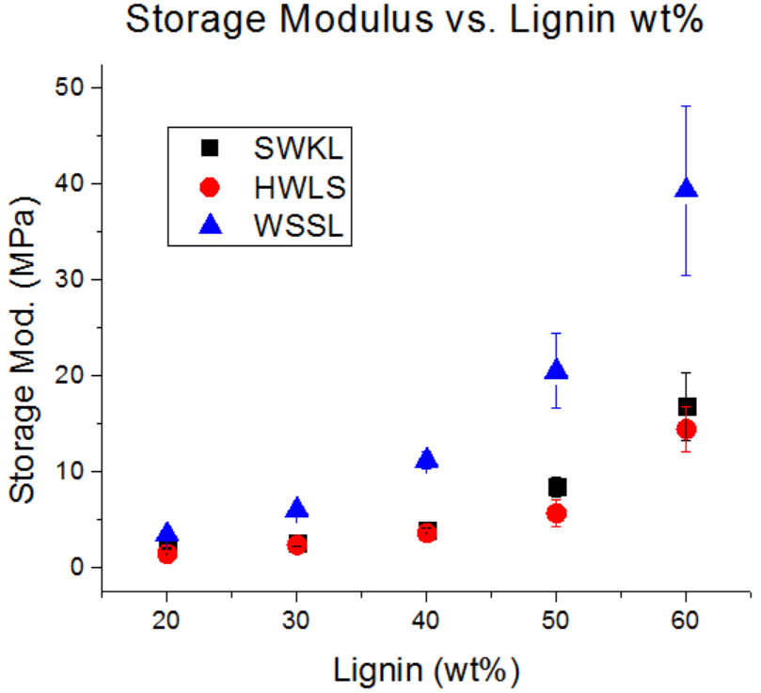
Figure 13. Storage modulus values of the lignin-based PU samples obtained using DMA.
As seen from the graph, the lignin-based PU samples that were synthesized using the WSSL provided the highest storage modulus values at all lignin loadings while the samples synthesized using the HWLS provided the lowest values for storage modulus. The values pertaining to samples synthesized using SWKL and values pertaining to samples synthesized with HWLS provided very similar storage modulus data. At lower lignin loadings (20, 30, and 40 lignin wt%), the difference between the storage modulus values for samples synthesized with HWLS and samples synthesized with SWKL is minimal. However, the difference between storage modulus values increases at higher lignin loadings (50 and 60 lignin wt%). And even though the values for SWKL samples and HWLS samples show very similar storage modulus data, SWKL sample provided higher modulus data than HWLS samples at all lignin loadings.
The values corresponding to the loss modulus and tan delta of the lignin-based PU samples measured via DMA are shown in Figures 14 and 15, respectively. The numerical values are listed in Tables 6 and 7, respectively, which are located in the Appendix. The capability of the lignin-based PU samples to release energy through molecular rearrangement and molecular friction is seen using the loss modulus and tan(δ) values. The same trend is seen with the loss modulus as was seen with the storage modulus when compared to the lignin loading of the sample where the loss modulus increases with lignin loading. Trends in tan(δ) can also be seen for all plant sources. SWKL samples and HWLS samples show a decreasing trend in tan(δ) when lignin loading is increased where as WSSL samples show an increasing trend.
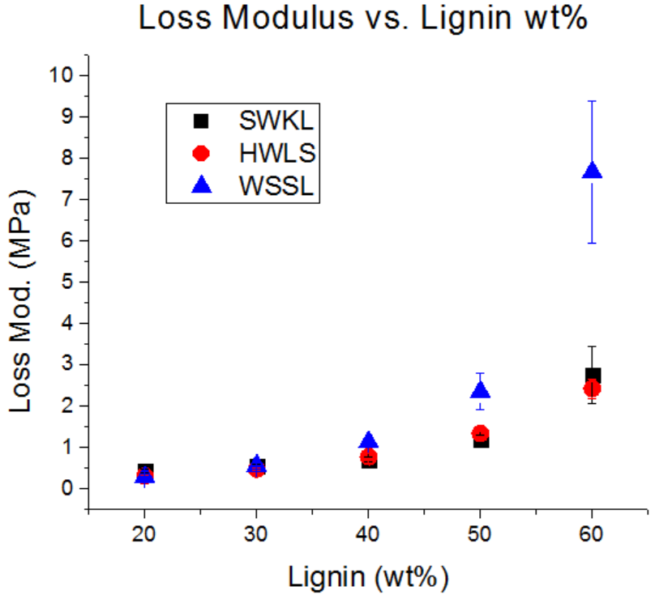
Figure 14. Loss modulus values of the lignin-based PU samples obtained using DMA.
The decreasing trend in tan(δ) for SWKL samples and HWLS samples depicts a material with increasing rigidity as lignin loading increases while the increasing trend for WSSL samples would depict a material with increasing viscous behavior. However, to fully understand the trends in tan(δ) for all three plant sources the loss modulus data must be understood. As previously discussed, the loss modulus of a system is the measurement of the viscous nature of a sample. Therefore, the loss modulus increases with an increase in molecular mobility of the polymer chains making up the material. However, an increase in loss modulus is seen for all plant source types as lignin loading, the rigid component, increases. This trend can be explained as follows. Even though the ratio of the rigid component to rubbery component has a large effect on the loss modulus of a system, it is not the only influencing factor. Energy dissipated as heat due to molecular friction between polymer chains also influences the loss modulus of a system. For lignin-based polyurethane samples this friction comes from higher levels of crosslinking within the material and increases with increased amount of cross-linking. This explains why there is an increasing trend for loss modulus with increased lignin loading. This also explains why WSSL samples show in increasing trend for tan(δ) due to their higher amount of internal cross-linking found in the native WSSL when compared to native SWKL and HWLS.
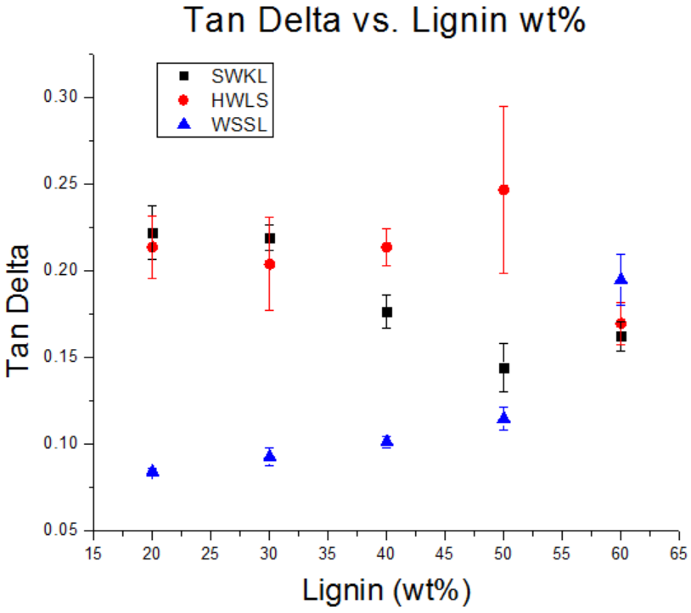
Figure 15. Tan δ values of the lignin-based PU samples obtained using DMA.
Shore hardness (Type A) testing results, depicted in Figure 16, agree with the results obtained via DMA. The numerical values for the graph shown in Figure 16 are listed in Table 8 located in the Appendix. All three lignin sources show an increase in hardness value as lignin loading increases. This is due to the increased amount of rigidity added by the lignin. As previously discussed, the hardness value of a material is dependent upon how a material acts under a compressive force. The rigidity added by the lignin increases the resistance to this compressive force by decreasing the molecular mobility by increasing the amount of cross-linking within the material.
Lignin-based PU samples synthesized using WSSL show a higher Shore hardness rating at all lignin loadings than SWKL samples and HWLS samples. And SWKL samples show a higher Shore hardness rating at all lignin loadings than HWLS samples. This trend is also in agreement with DMA results depicting a more crosslinked material for WSSL samples. At higher lignin loading the hardness values for the WSSL samples deviate from a linear trend and form a curve behavior due to the hardness value reaching the limits of the Type A durometer used for testing. Values that are close to the limits of the durometer used are considered to have more uncertainty and thus explains the curvature shown for the values given at higher lignin loadings for WSSL samples.
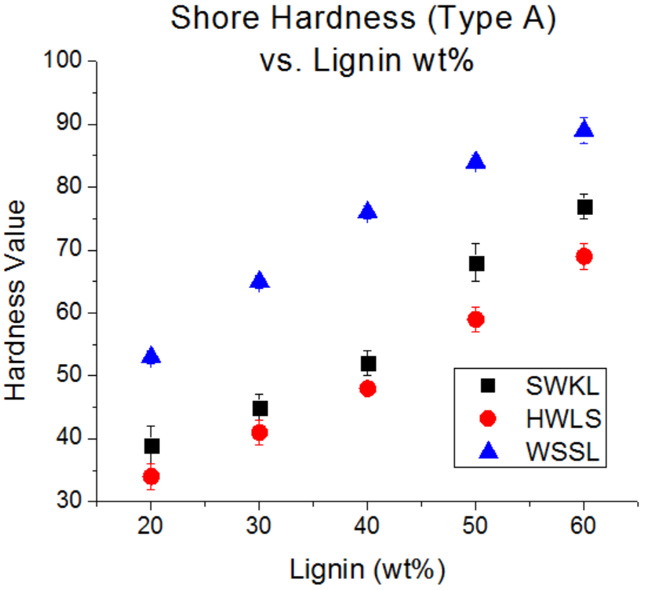
Figure 16. Shore hardness (Type A) results for all lignin-based PU samples.
To fully comprehend the mechanical testing results, it is important to understand what is happening at the nano- and micro-scale as these scales highly influence the mechanical properties of a polymer material. This will allow a more thorough explanation on why the WSSL samples provided higher storage modulus values compared to the SWKL samples and HWLS samples, and vice versa. Atomic Force Microscopy and SEM, along with Differential Scanning Calorimetry, were used to look at the domain morphology of lignin samples with 20wt%, 40wt% and 60wt% lignin loading. Doing so allows the ability to compare phase morphology based on plant source at different lignin loadings.
Table 1. Tg values obtained from DSC scans of lignin-based PU samples of 20wt%, 40wt% and 60wt% lignin.
Sample | T_{g}
Sample | HWLS | SWKL | WSSL
Pure Lignin: | 47 | 91 | 116
20wt% Lignin: | -52 | -52 | -48
40wt% Lignin | -51, 26 | -50 | -45
60wt% Lignin: | -51, 2, 26 | -46 | -42, 10, 110
Pure PPG PU: | -53

Thermal data scans using DSC of pure lignin samples and lignin-based PU samples were obtained. The T_{g} values for select samples are shown in Table 1 and graphs of the correlating scans are in the Appendix. Regarding the T_{g}’s of the pure lignins, the WSSL observes the highest T_{g} while the HWLS observes the lowest T_{g}. This is a result of the differing monolignol content used during lignin synthesis within the plant cell wall, as discussed previously. All lignin-based PU samples showed a multi-domain morphology. This is evidenced by the appearance of one or two T_{g}’s near the T_{g} of the pure components. At low lignin loadings, only one T_{g} is observed for all lignin sources and is associated with the PPG-dominant domain. As lignin loading increases, a second higher T_{g} is observed for HWLS and WSSL samples and is associated with the lignin-dominant domain. Samples synthesized with SWKL did not show an observable second T_{g} due to the faint nature of the T_{g} of the pure SWKL.
Phase images obtained via AFM, shown in Figure 17, and images from SEM, shown in Figure 18, also confirm a multi-domain morphology as described by DSC, and is easily seen in HWLS samples and SWKL samples. For HWLS samples, aggregation is seen in both AFM images and SEM images at all lignin loadings and the aggregates become more abundant as the HWLS loading increases. Compared to HWLS samples, those synthesized with SWKL show more mixing between the domains as seen in the AFM image for the 20wt% SWKL sample. However, aggregation happens at higher SWKL loadings and is seen in the respective SEM images. As the SWKL loading increases, AFM images show the formation of small distinct domains made up of a continuous phase and become more prominent at 60wt% SWKL loading. The WSSL samples show the most mixing between domains at 20wt% lignin loading compared to the other two lignin’s. At higher WSSL loadings, large continuous domains are formed throughout the image and are considerably larger than those found in images of SWKL samples. Areas with a smooth surface and areas with a rough surface are seen in SEM images of higher WSSL loadings depicting the observance of multiple domains formed in the sample. Also seen with the WSSL sample is the absence of aggregated particles and voids between domains suggesting a higher amount of mixing compared to the other lignin sources.
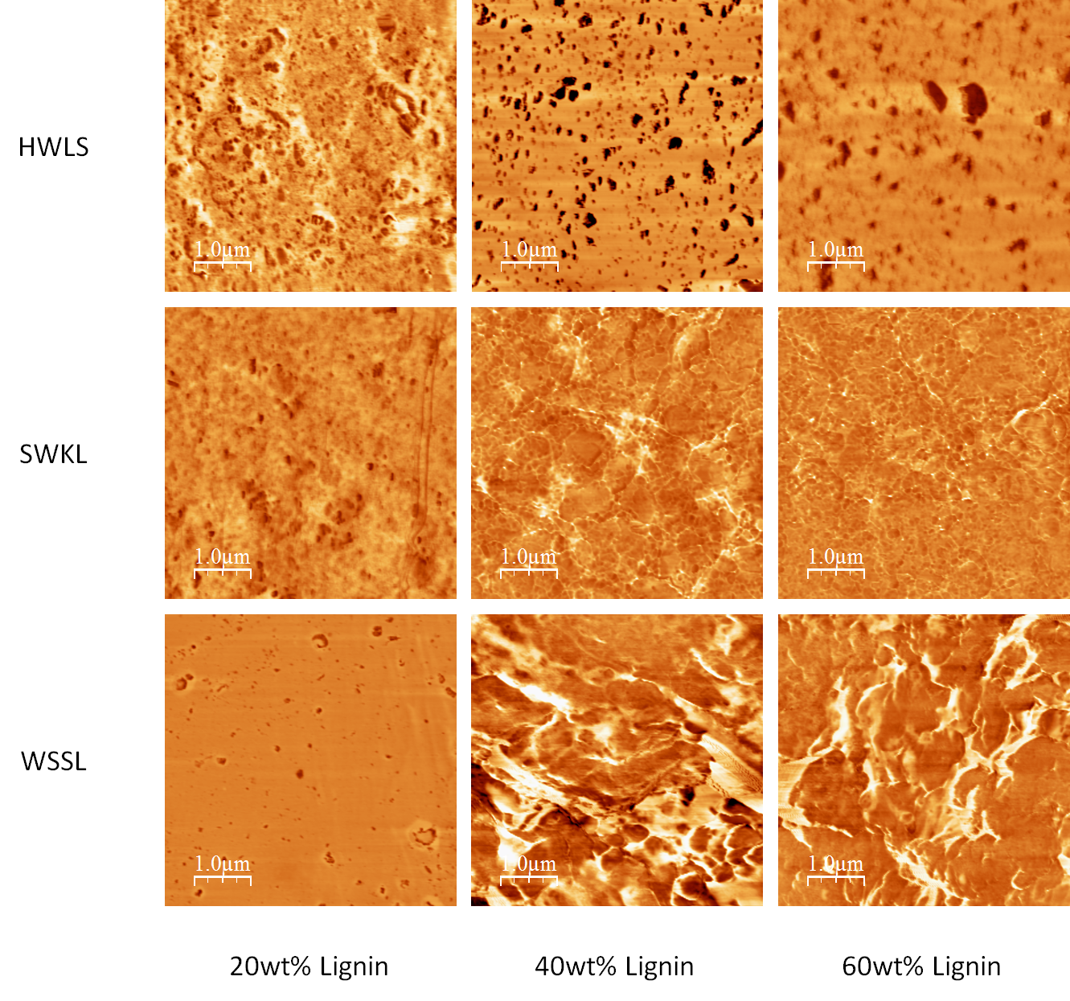
Figure 17. AFM phase images of lignin-based PU samples at 20wt%, 40wt% and 60wt% lignin loading.
As the lignin loading increases for the lignin-based PU, the T_{g} correlating with the PPG-dominant domain increases in temperature in different magnitudes depending on lignin source. At 60wt% HWLS loading, the T_{g} correlating with the PPG-dominant domain is observed at -51°C, a factor of +2°C when compared to the baseline -53°C T_{g} of the pure PU. Larger changes in temperature for the PPG-dominant domain are seen for the other lignin sources. A T_{g} for the PPG-dominant domain is observed at -46°C for the 60wt% SWKL sample and at -42°C for the WSSL sample; a +7°C and a +11°C change in temperature, respectively. The differing increases to the T_{g} of the PPG-dominant domain can be explained by looking at the level of mixing seen in the AFM images and SEM images. As the level of mixing between rigid domains and rubbery domains increases, the T_{g} of the rubbery domain will increase while the T_{g} of the rigid domain will decrease. The formation of large continuous domains found in the WSSL samples along with better adhesion between the domains is what allows for a larger increase in T_{g} for the PPG-dominant domain. The opposite affect is seen in HWLS samples were aggregation is more abundant and voids seen between domains cause less adhesion between these domains. This results in a lower change in T_{g} as seen by the DSC results.
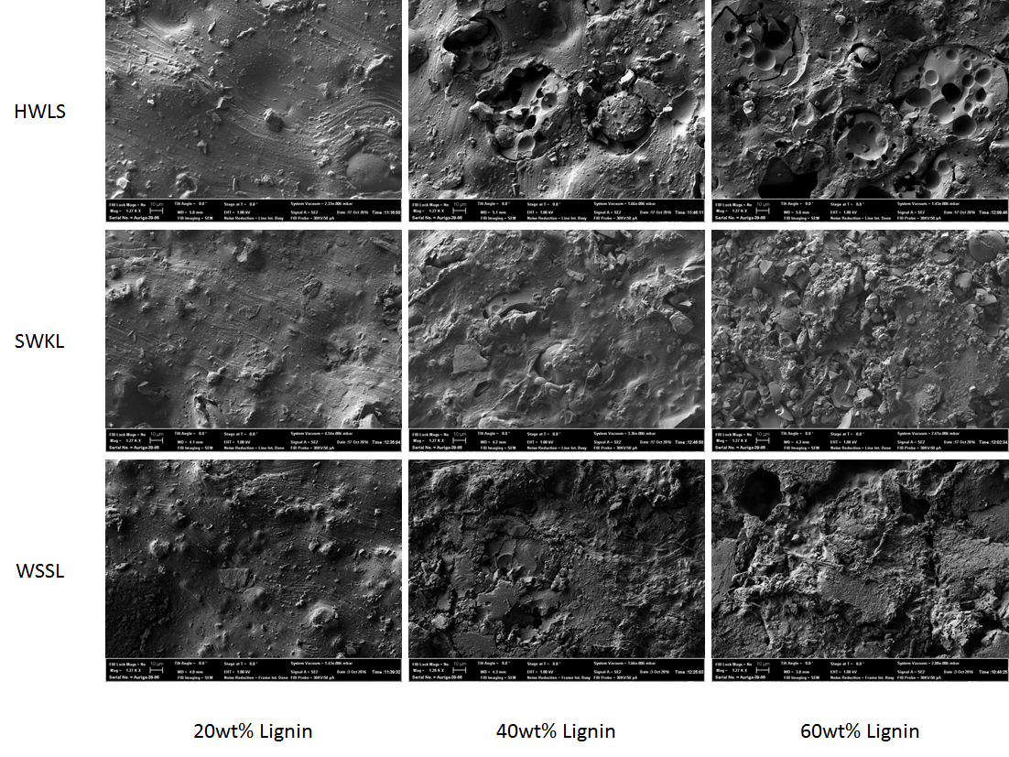
Figure 18. SEM images of lignin-based PU samples at 20wt%, 40wt% and 60wt% lignin loadings. The scale bar for all SEM images is 10 µm.
Results from DSC show that the lignin-based PU samples form a multi-domain morphology with AFM and SEM images showing differing amounts of mixing between the three sources of lignin. The level of mixing between domains correlates with targeted mechanical properties of the lignin-based PU samples. For HWLS samples, the poor level of mixing, shown by aggregation, and voids between aggregates and the surrounding mixture negatively affects the targeted mechanical properties, as seen in the DMA and Shore Hardness data. The opposite affect is seen where WSSL samples showed good adhesion between domains ultimately strengthening the targeted mechanical properties of the sample. This helped in allowing the WSSL samples to provide the highest mechanical testing values.
Further understanding is needed to explain the differing levels of aggregation and adhesion found between the lignin-based PU samples. As discussed earlier, ³¹P-NMR can be used to obtain the hydroxyl group concentration of lignin with the ability to distinguish between hydroxyl group types. Therefore, ³¹P-NMR was used to obtain a better understanding of the structure and reactive capabilities of each lignin source. And by obtaining this knowledge a more thorough explanation is given for why WSSL samples provided higher mechanical properties and HWLS samples provided the lowest.
Table 2. Hydroxyl group type concentrations for each lignin source determined by ³¹P-NMR.
Hydroxyl Group Type | Hydroxyl Group Type Concentration (mmol OH/g Lignin)
Hydroxyl Group Type | HWLS | SWKL | WSSL
Aliphatic: | 5.71 (±0.04) | 1.45 (±0.12) | 1.30 (±0.12)
C₅-condensed: | 0.12 (±0.02) | 0.69 (±0.05) | 0.55 (±0.04)
(S) Syringyl: | 0.35 (±0.01) | - | 0.54 (±0.02)
(G) Guaiacyl: | 0.28 (±0.01) | 1.17 (±0.11) | 0.80 (±0.05)
(H) p-Coumaryl: | - | 0.11 (±0.02) | 0.30 (±0.03)
Carboxylic Acid: | 0.32 (±0.07) | 0.60 (±0.07) | 0.70 (±0.08)
Total: | 6.86 (±0.1) | 4.02 (±0.23) | 4.19 (±0.1)

The integration data obtained using ³¹P-NMR is shown in Table 2 and hydroxyl group to isocyanate group ratios (OH:NCO) are given in Table 3. Examples of ³¹P-NMR data for all three lignin sources are shown in the Appendix. Overall, HWLS contains a higher hydroxyl group concentration while SWKL and WSSL are approximately the same. A ratio between the number of syringyl units and guaiacyl units, called the S/G ratio, can be calculated from the ³¹P-NMR data and can be used to qualitatively understand the reactive capabilities of each lignin. The calculated S/G ratios for the WSSL and the HWLS are 0.68 and 1.25, respectively. An S/G ratio cannot be determined for SWKL since softwood lignins do not contain any syringyl units as seen from NMR data located in the Appendix.
Table 3. Calculated OH:NCO ratios for lignin-based PU samples with 20wt%, 40wt%, and 60wt% lignin loadings.
Lignin Wt% | Lignin Source | OH:NCO Ratio’s
Lignin Wt% | Lignin Source | Total | Aromatic | Aliphatic | Carb. Acid
20 | HWLS | 1.97 | 0.24 | 1.64 | 0.09
20 | SWKL | 1.16 | 0.57 | 0.42 | 0.17
20 | WSSL | 1.20 | 0.63 | 0.37 | 0.20
40 | HWLS | 5.26 | 0.64 | 4.38 | 0.25
40 | SWKL | 3.08 | 1.51 | 1.11 | 0.46
40 | WSSL | 3.21 | 1.68 | 1.00 | 0.54
60 | HWLS | 11.38 | 1.43 | 9.85 | 0.55
60 | SWKL | 6.93 | 3.40 | 2.50 | 1.04
60 | WSSL | 7.23 | 3.78 | 2.24 | 1.21

The S/G ratios show that the HWLS contains a higher presence of syringyl units compared to guaiacyl units whereas the opposite is shown for WSSL and can affect the reactive abilities of the lignin molecule. As discussed earlier, methoxy groups sterically hinder the phenolic hydroxyl group of syringyl and guaiacyl units. With syringyl units containing more methoxy groups, reaction kinetics with the TDI-endcapped PPG are inhibited more so with syringyl phenolics than with guaiacyl phenolics. And reaction kinetics of p-coumaryl phenolics are unhindered due to no steric hindrance from methoxy groups. Therefore, WSSL shows a higher ability to form urethane bonds with phenolics due to having more p-coumaryl units than other lignin sources. Also, aromatic OH:NCO ratios show that aromatic urethane linkages are more favorable with WSSL and with SWKL than with HWLS. This is due to the WSSL and SWKL having a higher aromatic OH:NCO ratio than what is found with HWLS. A ratio greater than one allows for a higher chance of urethane formation with the respective hydroxyl group. With a ratio less than one, isocyanate groups have a greater chance to react with other types of hydroxyl groups. Table 3 shows that the aromatic OH:NCO for WSSL and SWKL is more than double than HWLS while the aliphatic OH:NCO ratio is much greater in HWLS than with WSSL and SWKL. This shows that reactions with aliphatic hydroxyls in HWLS are more likely while reactions with aromatic hydroxyls in WSSL and SWKL are more likely.
With HWLS having a lower ability to form urethane bonds with its phenolic moieties, and the higher reactivity of aliphatic hydroxyl groups compared to phenolics, isocyanate groups are more favorable to react with aliphatic hydroxyl groups. Urethane linkages formed with aliphatic hydroxyl groups are more flexible than those formed with phenolic hydroxyl groups due to the rigid nature of the TDI and phenol. This greater flexibility allows more freedom of movement leading to more phase separation, seen in the AFM and SEM images, between the rubbery PPG chains and the rigid lignin molecules. With more flexible urethane linkages being formed in HWLS samples, lignin molecules can aggregate more efficiently than in samples of the other lignin sources. This leads to a lower degree of mixing between domains in the HWLS samples. Furthermore, the ability to develop more rigid urethane linkages in the WSSL samples allows for less molecular motion leading to more mixing and the appearance of better adhesion between domains.
The allowed reactions within the lignin/PPG framework has direct influence on the mechanical properties of the lignin-based PU samples. The domain adhesion and mixing found in the WSSL, brought on by more rigid urethane linkage formation, produces a more rigid framework increasing the mechanical properties of the WSSL samples beyond those of HWLS samples and SWKL samples. Aggregation of particles and poor domain adhesion leaving voids decreases the continuity of the lignin/PPG framework lowering the mechanical properties of the material. The SWKL samples show better overall mechanical properties than the HWLS samples due SWKL’s higher phenolic nature, as seen by ³¹P-NMR, yet are less rigid than the WSSL samples due to the aggregation that is also found throughout the framework albeit to a lesser extent than HWLS.

References
1. Polyurethane (PU) Market Analysis by Product (Rigid Foam, Flexible Foam, Coatings, Adhesives & Sealants, Elastomers), by End-Use (Furniture & Interiors, Construction, Electronics & Appliances, Automotive, Footwear, Packaging, & Segment Forecasts, 2014-202. Grand View Research 180 (2017). Available at: http://www.grandviewresearch.com/industry-analysis/polyurethane-pu-market. (Accessed: 17th May 2017)
2. Seymour, R. B. & Kauffman, G. B. Polyurethanes: A class of modern versatile materials. J. Chem. Educ. 69, 909 (1992).
3. Sarkar, S. & Adhikari, B. Thermal stability of lignin-hydroxy-terminated polybutadiene copolyurethanes. Polym. Degrad. Stab. 73, 169–175 (2001).
4. Saraf, V. P. & Glasser, W. G. Engineering Plastics From Lignin - III. Structure Property Relationships in Solution Cast Polyurethane Films. J. Appl. Polym. Sci. 29, 1831–1841 (1984).
5. Stevens, M. P. Polymer Chemistry: An Introduction. (Oxford University Press, 1999).
6. Szycher, M. Handbook of Polyurethanes. (CRC Press, 1999).
7. Soto, M., Sebastián, R. M. & Marquet, J. Photochemical activation of extremely weak nucleophiles: Highly fluorinated urethanes and polyurethanes from polyfluoro alcohols. J. Org. Chem. 79, 5019–5027 (2014).
8. Ochiai, B. & Utsuno, T. Non-isocyanate synthesis and application of telechelic polyurethanes via polycondensation of diurethanes obtained from ethylene carbonate and diamines. J. Polym. Sci. Part A Polym. Chem. 51, 525–533 (2013).
9. Tamami, B., Sohn, S. & Wilkes, G. L. Incorporation of carbon dioxide into soybean oil and subsequent preparation and studies of nonisocyanate polyurethane networks. J. Appl. Polym. Sci. 92, 883–891 (2004).
10. Ochiai, B., Sato, S.-I. & Endo, T. Synthesis and properties of polyurethanes bearing urethane moieties in the side chain. J. Polym. Sci. Part A Polym. Chem. 45, 3408–3414 (2007).
11. Palaskar, D. V., Boyer, A., Cloutet, E., Alfos, C. & Cramail, H. Synthesis of Biobased Polyurethane from Oleic and Ricinoleic Acids as the Renewable Resources via the AB-Type Self-Condensation Approach. Biomacromolecules 11, 1202–1211 (2010).
12. Cheng, C. et al. Preparation of Fully Bio-Based UV-Cured Non-Isocyanate Polyurethanes From Ricinoleic Acid. J. Macromol. Sci. Part A 52, 485–491 (2015).
13. Prisacariu, C. Polyurethane Elastomers: from morphology to mechanical aspects. (Springer Science & Business Media, 2011).
14. Chung, H. & Washburn, N. R. Improved lignin polyurethane properties with lewis acid treatment. ACS Appl. Mater. Interfaces 4, 2840–2846 (2012).
15. Zhang, C., Wu, H. & Kessler, M. R. K. High bio-content polyurethane composites with urethane modified lignin as filler. Polym. (United Kingdom) 69, 52–57 (2015).
16. Teo, L.-S., Chen, C.-Y. & Kuo, J.-F. Fourier Transform Infrared Spectroscopy Study on Effects of Temperature on Hydrogen Bonding in Amine-Containing Polyurethanes and Poly(urethane−urea)s. Macromolecules 30, 1793–1799 (1997).
17. Chan-Chan, L. H. et al. Degradation studies on segmented polyurethanes prepared with HMDI, PCL and different chain extenders. Acta Biomater. 6, 2035–2044 (2010).
18. Oprea, S. Dependence of fungal biodegradation of PEG/castor oil-based polyurethane elastomers on the hard-segment structure. Polym. Degrad. Stab. 95, 2396–2404 (2010).
19. Grassie, N. & Zulfiqar, M. Thermal degradation of the polyurethane from 1,4-butanediol and methylene bis(4-phenyl isocyanate). J. Polym. Sci. Polym. Chem. Ed. 16, 1563–1574 (1978).
20. Wen, T.-C., Fang, J.-C., Lin, H.-J. & Yang, C.-H. Characteristics of PPG-based thermoplastic polyurethane doped with lithium perchlorate. J. Appl. Polym. Sci. 82, 389–399 (2001).
21. Bharadwaj, V., Somani, K. & Kansara, S. The Effect of Chain Length of Polyethylene Glycol on Properties of Castor Oil Based. J. Macromol. sci - Pure Appl. Chem. A39, 115–127 (2002).
22. Yoshida, H., Mörck, R., Kringstad, K. P. & Hatakeyama, H. Kraft lignin in polyurethanes. III. Effects of the molecular weight of kraft lignin on the properties of polyurethanes from a kraft lignin polyether triol polymeric MDI system. J. Appl. Polym. Sci. 40, 1819–1832 (1990).
23. Basfar, A. A., Idriss Ali, K. . & Mofti, S. . UV stability and radiation-crosslinking of linear low density polyethylene and low density polyethylene for greenhouse applications. Polym. Degrad. Stab. 82, 229–234 (2003).
24. Dong, W. et al. Novel photocrosslinkable and biodegradable polyester from bio-renewable resource. Polym. Degrad. Stab. 97, 578–583 (2012).
25. Chen, Y. L. & Rånby, B. Photocrosslinking of polyethylene. I. Photoinitiators, crosslinking agent, and reaction kinetics. J. Polym. Sci. Part A Polym. Chem. 27, 4051–4075 (1989).
26. Kruželák, J., Sýkora, R. & Hudec, I. Vulcanization of Rubber Compounds with Peroxide Curing Systems. Rubber Chem. Technol. 90, 60–88 (2017).
27. Mahmood, N., Yuan, Z., Schmidt, J. & Xu, C. Depolymerization of lignins and their applications for the preparation of polyols and rigid polyurethane foams: A review. Renew. Sustain. Energy Rev. 60, 317–329 (2016).
28. Singh, H. & Jain, A. K. Ignition, combustion, toxicity, and fire retardancy of polyurethane foams: A comprehensive review. J. Appl. Polym. Sci. NA-NA (2008). doi:10.1002/app.29131
29. KROL, P. Synthesis methods, chemical structures and phase structures of linear polyurethanes. Properties and applications of linear polyurethanes in polyurethane elastomers, copolymers and ionomers. Prog. Mater. Sci. 52, 915–1015 (2007).
30. Hiemenz, P. L. & Lodge, T. P. Polymer Chemistry. (Taylor & Francis Group, 2007).
31. Meier-Westhues, U. Polyurethanes: Coatings, Adhesives and Sealants. (Vincentz Network, 2007).
32. Chattopadhyay, D. K. & Raju, K. V. S. N. Structural engineering of polyurethane coatings for high performance applications. Prog. Polym. Sci. 32, 352–418 (2007).
33. Engels, H.-W. et al. Polyurethanes: Versatile Materials and Sustainable Problem Solvers for Today’s Challenges. Angew. Chemie Int. Ed. 52, 9422–9441 (2013).
34. Petrie, E. Handbook of Adhesives and Sealants. (McGraw-Hill Education, 2007).
35. Noreen, A., Zia, K. M., Zuber, M., Tabasum, S. & Zahoor, A. F. Bio-based polyurethane: An efficient and environment friendly coating systems: A review. Prog. Org. Coatings 91, 25–32 (2016).
36. Tokiwa, Y., Calabia, B. P., Ugwu, C. U. & Aiba, S. Biodegradability of Plastics. Int. J. Mol. Sci. 10, 3722–3742 (2009).
37. Shibata, M., Inoue, Y. & Miyoshi, M. Mechanical properties, morphology, and crystallization behavior of blends of poly(l-lactide) with poly(butylene succinate-co-l-lactate) and poly(butylene succinate). Polymer (Guildf). 47, 3557–3564 (2006).
38. Mohanty, A. K., Misra, M. & Hinrichsen, G. Biofibres, biodegradable polymers and biocomposites: An overview. Macromol. Mater. Eng. 276–277, 1–24 (2000).
39. Hon, D. N.-S. Chemical Modification of Lignocellulosic Materials. (1995).
40. Saito, T. et al. Development of lignin-based polyurethane thermoplastics. RSC Adv. 3, 21832 (2013).
41. Suhas, Carrott, P. J. M. & Ribeiro Carrott, M. M. L. Lignin - from natural adsorbent to activated carbon: A review. Bioresour. Technol. 98, 2301–2312 (2007).
42. Chakar, F. S. & Ragauskas, A. J. Review of current and future softwood kraft lignin process chemistry. Ind. Crops Prod. 20, 131–141 (2004).
43. Gosselink, R. J. A., de Jong, E., Guran, B. & Abächerli, A. Co-ordination network for lignin—standardisation, production and applications adapted to market requirements (EUROLIGNIN). Ind. Crops Prod. 20, 121–129 (2004).
44. Gregorová, A., Košíková, B. & Moravčík, R. Stabilization effect of lignin in natural rubber. Polym. Degrad. Stab. 91, 229–233 (2006).
45. Tejado, A., Peña, C., Labidi, J., Echeverria, J. M. & Mondragon, I. Physico-chemical characterization of lignins from different sources for use in phenol–formaldehyde resin synthesis. Bioresour. Technol. 98, 1655–1663 (2007).
46. Smook, G. A. Handbook for Pulp and Paper Technologists. 11, (Angus Wilde Publications, 1992).
47. Wang, C., Kelley, S. S. & Venditti, R. A. Lignin-Based Thermoplastic Materials. ChemSusChem 9, 770–783 (2016).
48. Baker, D. A. & Rials, T. G. Recent advances in low-cost carbon fiber manufacture from lignin. J. Appl. Polym. Sci. 130, 713–728 (2013).
49. Li, Y. & Ragauskas, A. J. Kraft Lignin-Based Rigid Polyurethane Foam. J. Wood Chem. Technol. 32, 210–224 (2012).
50. Hilburg, S. L. et al. A universal route towards thermoplastic lignin composites with improved mechanical properties. Polym. (United Kingdom) 55, 995–1003 (2014).
51. El Mansouri, N.-E., Yuan, Q. & Huang, F. Synthesis and characterization of kraft lignin- based epoxy resins. BioResources 6, 2647–2662 (2011).
52. Milczarek, G. Kraft lignin as dispersing agent for carbon nanotubes. J. Electroanal. Chem. 638, 178–181 (2010).
53. Zhang, Y.-H. P. Reviving the carbohydrate economy via multi-product lignocellulose biorefineries. J. Ind. Microbiol. Biotechnol. 35, 367–375 (2008).
54. FAN, J. & ZHAN, H. Optimization of Synthesis of Spherical Lignosulphonate Resin and Its Structure Characterization. Chinese J. Chem. Eng. 16, 407–410 (2008).
55. Qiu, X., Kong, Q., Zhou, M. & Yang, D. Aggregation behavior of sodium lignosulfonate in water solution. J. Phys. Chem. B 114, 15857–15861 (2010).
56. Vishtal, A. & Kraslawski, A. Challenges in industrial applications of technical lignins. BioResources 6, 3547–3568 (2011).
57. Areskogh, D., Li, J., Gellerstedt, G. & Henriksson, G. Structural modification of commercial lignosulphonates through laccase catalysis and ozonolysis. Ind. Crops Prod. 32, 458–466 (2010).
58. Ansari, A. & Pawlik, M. Floatability of chalcopyrite and molybdenite in the presence of lignosulfonates. Part I. Adsorption studies. Miner. Eng. 20, 600–608 (2007).
59. Macias, A. & Goni, S. Characterization of Admixture as Plasticizer or Superplasticizer by Deflocculation Test. ACI Mater. J. 96, 40–46 (1999).
60. Lora, J. in Monomers, Polymers and Composites from Renewable Resources 225–241 (Elsevier, 2008).
61. Saito, T. et al. Methanol fractionation of softwood Kraft lignin: Impact on the lignin properties. ChemSusChem 7, 221–228 (2014).
62. Lora, J. H. & Glasser, W. G. Recent Industrial Applications of Lignin: A Sustainable Alternative to Nonrenewable Materials. J. Polym. Environ. 10, 39–48 (2002).
63. Madad, N., Chebil, L., Charbonnel, C., Ioannou, I. & Ghoul, M. Enzymatic polymerization of sodium lignosulfonates: effect of catalysts, initial molecular weight, and mediators. Can. J. Chem. 91, 220–225 (2013).
64. Xu, F., Sun, J.-X., Sun, R., Fowler, P. & Baird, M. S. Comparative study of organosolv lignins from wheat straw. Ind. Crops Prod. 23, 180–193 (2006).
65. Duval, A. & Lawoko, M. A review on lignin-based polymeric, micro- and nano-structured materials. React. Funct. Polym. 85, 78–96 (2014).
66. Doherty, W. O. S., Mousavioun, P. & Fellows, C. M. Value-adding to cellulosic ethanol: Lignin polymers. Ind. Crops Prod. 33, 259–276 (2011).
67. Laurichesse, S. & Avérous, L. Synthesis, thermal properties, rheological and mechanical behaviors of lignins-grafted-poly(ε-caprolactone). Polym. (United Kingdom) 54, 3882–3890 (2013).
68. Silva, E. A. B. da et al. An integrated process to produce vanillin and lignin-based polyurethanes from Kraft lignin. Chem. Eng. Res. Des. 87, 1276–1292 (2009).
69. Varanasi, P. et al. Survey of renewable chemicals produced from lignocellulosic biomass during ionic liquid pretreatment. Biotechnol. Biofuels 6, 14 (2013).
70. Chung, Y.-L. et al. A Renewable Lignin–Lactide Copolymer and Application in Biobased Composites. ACS Sustain. Chem. Eng. 1, 1231–1238 (2013).
71. Alexy, P., Košı́ková, B. & Podstránska, G. The effect of blending lignin with polyethylene and polypropylene on physical properties. Polymer (Guildf). 41, 4901–4908 (2000).
72. Kadla, J. F. & Kubo, S. Lignin-based polymer blends: Analysis of intermolecular interactions in lignin-synthetic polymer blends. in Composites Part A: Applied Science and Manufacturing 35, 395–400 (2004).
73. Sen, S., Patil, S. & Argyropoulos, D. S. Thermal properties of lignin in copolymers, blends, and composites: a review. Green Chem. 17, 4862–4887 (2015).
74. Zhao, S. & Abu-Omar, M. M. Biobased Epoxy Nanocomposites Derived from Lignin-Based Monomers. Biomacromolecules 150702075936002 (2015). doi:10.1021/acs.biomac.5b00670
75. Li, J., He, Y. & Inoue, Y. Study on Thermal and Mechanical Properties of Biodegradable Blends of Poly([epsi]-caprolactone) and Lignin. Polym J 33, 336–343 (2001).
76. Lee, A. & Deng, Y. Green Polyurethane from Lignin and Soybean Oil through Non-isocyanate Reactions. Eur. Polym. J. 63, 67–73 (2014).
77. Menard, K. Dynamic Mechanical Analysis. (CRC Press, 1999). doi:10.1201/9781420049183
78. Joseph, P., Mathew, G., Joseph, K., Groeninckx, G. & Thomas, S. Dynamic mechanical properties of short sisal fibre reinforced polypropylene composites. Compos. Part A Appl. Sci. Manuf. 34, 275–290 (2003).
79. Wetton, R. E., Marsh, R. D. L. & Van-de-Velde, J. G. Theory and application of dynamic mechanical thermal analysis. Thermochim. Acta 175, 1–11 (1991).
80. Schlesing, W., Buhk, M. & Osterhold, M. Dynamic mechanical analysis in coatings industry. Prog. Org. Coatings 49, 197–208 (2004).
81. Smith, D. E. Single-Polymer Dynamics in Steady Shear Flow. Science (80-. ). 283, 1724–1727 (1999).
82. Ferry, J. D. Viscoelastic Properties of Polymers. Wiley (1980).
83. Jawaid, M., Abdul Khalil, H. P. S., Hassan, A., Dungani, R. & Hadiyane, A. Effect of jute fibre loading on tensile and dynamic mechanical properties of oil palm epoxy composites. Compos. Part B Eng. 45, 619–624 (2013).
84. Costa, C. S. M. F., Fonseca, A. C., Serra, A. C. & Coelho, J. F. J. Dynamic Mechanical Thermal Analysis of Polymer Composites Reinforced with Natural Fibers. Polym. Rev. 56, 362–383 (2016).
85. Zhang, Z., Wang, P. & Wu, J. Dynamic Mechanical Properties of EVA Polymer-Modified Cement Paste at Early Age. Phys. Procedia 25, 305–310 (2012).
86. Anwer, M. A. S., Naguib, H. E., Celzard, A. & Fierro, V. Comparison of the thermal, dynamic mechanical and morphological properties of PLA-Lignin &amp; PLA-Tannin particulate green composites. Compos. Part B Eng. 82, 92–99 (2015).
87. Brown, R. Handbook of Polymer Testing: Physical Methods. (1999).
88. Malzbender, J. Comment on hardness definitions. J. Eur. Ceram. Soc. 23, 1355–1359 (2003).
89. Hermann & Konrad. Hardness Testing : Principles and Applications. ASM International (ASM International, 2011).
90. Mitchell, M. R., Link, R. E., Mix, A. W. & Giacomin, A. J. Standardized Polymer Durometry. J. Test. Eval. 39, 103205 (2011).
91. Brown, R. Handbook of polymer testing: short-term mechanical tests. (Rapra Technology Limited, 2002).
92. Gabbott, P. Principles and applications of thermal analysis. (2008).
93. Gaisford, S., Kett, V. & Haines, P. Principles of Thermal Analysis and Calorimetry. (The Royal Society of Chemistry, 2016).
94. Odian, G. Principles of Polymerization. (John Wiley and Sons, 2004).
95. Kasalo, R. & Busch, M. Quantitative NMR Spectroscopy and Determination of Polymer Microstructure of Ethylene-Styrene and Ethylene-Isobutylene Co -Polymers. Macromol. Symp. 324, 78–81 (2013).
96. Stothers, J. Carbon-13 NMR Spectroscopy: Organic Chemistry, A Series of Monographs, Volume 24. (2012).
97. Cavanaugh, J., Fairbrother, W. J., Palmer, A. G. I., Rance, M. & Skelton, N. J. Protein NMR Spectroscopy: Principles and Practice. (2007).
98. Cheng, L. L., Wu, C., Smith, M. R. & Gonzalez, R. G. Non-destructive quantitation of spermine in human prostate tissue samples using HRMAS 1 H NMR spectroscopy at 9.4 T. FEBS Lett. 494, 112–116 (2001).
99. Atta-ur-Rahman. Nuclear Magnetic Resonance. (Springer US, 1986). doi:10.1007/978-1-4612-4894-1
100. Kuhl, O. Phosphorus-31 NMR Spectroscopy. Phosphorus-31 NMR Spectroscopy: A Concise Introduction for the Synthetic Organic and Organometallic Chemist (Springer Berlin Heidelberg, 2009). doi:10.1007/978-3-540-79118-8
101. Pu, Y., Cao, S. & Ragauskas, A. J. Application of quantitative 31P NMR in biomass lignin and biofuel precursors characterization. Energy Environ. Sci. 4, 3154 (2011).
102. Cateto, C. A. et al. Lignins as macromonomers for polyurethane synthesis: A comparative study on hydroxyl group determination. J. Appl. Polym. Sci. 109, 3008–3017 (2008).
103. Granata, A. & Argyropoulos, D. S. 2-Chloro-4,4,5,5-tetramethyl-1,3,2-dioxaphospholane, a Reagent for the Accurate Determination of the Uncondensed and Condensed Phenolic Moieties in Lignins. J. Agric. Food Chem. 43, 1538–1544 (1995).
104. Ben, H. & Ragauskas, A. J. NMR characterization of pyrolysis oils from kraft lignin. Energy and Fuels 25, 2322–2332 (2011).
105. Gorenstein, D. G. Phosphorous-31 NMR: Principles and Applications. Phosphorous-31 NMR: Principles and Applications (2012). doi:10.1016/C2009-0-02986-9
106. Hawkes, P. & Reimer, L. Scanning Electron Microscopy: Physics of Image Formation and Microanalysis. (Springer Berlin Heidelberg, 2013).
107. Stokes, D. J. Recent advances in electron imaging, image interpretation and applications: environmental scanning electron microscopy. Philos. Trans. R. Soc. A Math. Phys. Eng. Sci. 361, 2771–2787 (2003).
108. Reimer, L. Scanning Electron Microscopy: Physics of Image Formation and Microanalysis. (Springer Berlin Heidelberg, 1998).
109. Lin, H. et al. Conducting polymer composite film incorporated with aligned carbon nanotubes for transparent, flexible and efficient supercapacitor. Sci. Rep. 3, 1353 (2013).
110. Liu, J., Liu, H. F., Deng, L., Liao, B. & Guo, Q. X. Improving aging resistance and mechanical properties of waterborne polyurethanes modified by lignin amines. J. Appl. Polym. Sci. 130, 1736–1742 (2013).
111. Sawyer, L. & Grubb, D. Polymer Microscopy. (Springer Netherlands, 2013).
112. Guo, Q. Polymer Morphology: Principles, Characterization, and Processing. (Wiley, 2016).
113. Meyer, E. Atomic force microscopy. Prog. Surf. Sci. 41, 3–49 (1992).
114. Olarte, M. V et al. Determination of Hydroxyl Groups in Pyrolysis Bio-oils using 31P NMR: Laboratory Analytical Procedure (LAP). (2016). doi:10.2172/1241098
115. Horcas, I. et al. WSXM : A software for scanning probe microscopy and a tool for nanotechnology. Rev. Sci. Instrum. 78, 13705 (2007).
116. Lignoworks. What is Lignin? 2013 Available at: http://www.icfar.ca/lignoworks/content/what-lignin.html.
117. Saito, T. et al. Turning renewable resources into value-added polymer: development of lignin-based thermoplastic. Green Chem. 14, 3295 (2012).
118. Laurichesse, S. & Avérous, L. Chemical modification of lignins: Towards biobased polymers. Prog. Polym. Sci. 39, 1266–1290 (2014).
119. Asker X Durometer. Available at: https://www.checkline.com/product/Asker-Durometer. (Accessed: 8th June 2017)
120. Hansma, H. Research on Biological Atomic Force Microscopy. Available at: http://web.physics.ucsb.edu/~hhansma/biomolecules.htm. (Accessed: 19th June 2017)

Appendix

Table 4. Peak assignments and their respective hydroxyl group type used for integration of ³¹P-NMR lignin data.
Hydroxyl Group Type | Integration Area (ppm)
Aliphatic: | 145.4 – 152.0
C₅-Condensed + Syringyl: | 140.5 – 144.5
Syringyl: | 142.0 – 143.0
Guiacyl: | 138.5 – 140.5
p-Coumaryl: | 137.0 – 138.5
Carboxylic Acid: | 134.6 – 138.0

Table 5. Storage modulus values obtained via DMA for all lignin-based PU samples.
Lignin | Storage Modulus (MPa)
Lignin | 20wt% Lignin | 30wt% Lignin | 40wt% Lignin | 50wt% Lignin | 60wt% Lignin
HWLS | 1.5 (±0.2) | 2.4 (±0.4) | 3.6 (±0.2) | 5.7 (±1.4) | 14.5 (±2.4)
SWKL | 2.0 (±0.1) | 2.6 (±0.3) | 4.0 (±0.2) | 8.4 (±1.0) | 16.8 (±3.5)
WSSL | 3.5 (±0.1) | 6.1 (±0.3) | 11.2 (±0.9) | 20.5 (±3.9) | 39.3 (±8.8)

Table 6. Loss modulus values obtained via DMA for all lignin-based PU samples.
Lignin | Loss Modulus (MPa)
Lignin | 20wt% Lignin | 30wt% Lignin | 40wt% Lignin | 50wt% Lignin | 60wt% Lignin
HWSL | 0.31 (±0.03) | 0.48 (±0.04) | 0.78 (±0.07) | 1.34 (±0.08) | 2.43 (±0.23)
SWKL | 0.44 (±0.04) | 0.56 (±0.05) | 0.70 (±0.06) | 1.21 (±0.10) | 2.77 (±0.69)
WSSL | 0.29 (±0.01) | 0.56 (±0.01) | 1.14 (±0.05) | 2.35 (±0.44) | 7.67 (±1.71)

Table 7. Tan δ values obtained via DMA for all lignin-based PU samples.
Lignin | Tan(δ)
Lignin | 20wt% Lignin | 30wt% Lignin | 40wt% Lignin | 50wt% Lignin | 60wt% Lignin
HWLS | 0.21 (±0.02) | 0.20 (±0.03) | 0.21 (±0.01) | 0.25 (±0.05) | 0.17 (±0.01)
SWKL | 0.22 (±0.02) | 0.22 (±0.01) | 0.18 (±0.01) | 0.14 (±0.01) | 0.16 (±0.01)
WSSL | 0.08 (±0.002) | 0.09 (±0.005) | 0.10 (±0.003) | 0.12 (±0.007) | 0.20 (±0.02)

Table 8. Shore hardness (Type A) values for all lignin-based PU samples.
Lignin | Shore Hardness Value (Type A)
Lignin | 20wt% Lignin | 30wt% Lignin | 40wt% Lignin | 50wt% Lignin | 60wt% Lignin
HWLS | 34 (±2) | 41 (±2) | 48 (±1) | 59 (±2) | 69 (±2)
SWKL | 39 (±3) | 45 (±2) | 52 (±2) | 68 (±3) | 77 (±2)
WSSL | 53 (±1) | 65 (±1) | 76 (±1) | 84 (±1) | 89 (±2)

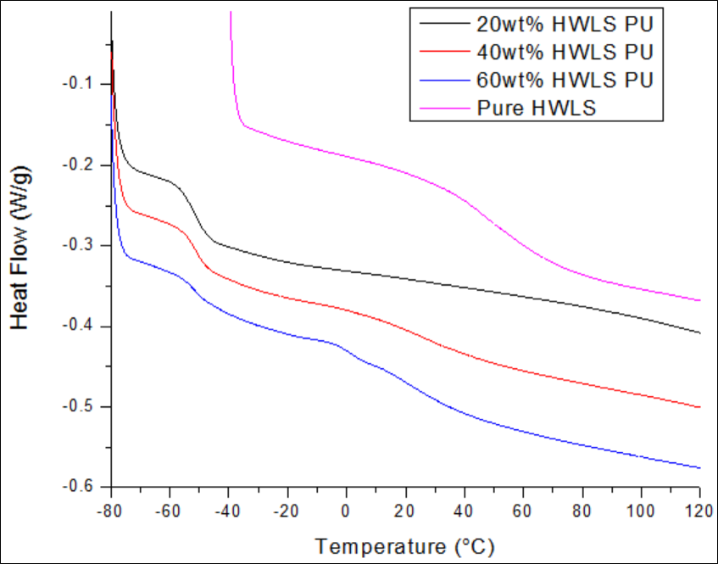
Figure 20. DSC scans of pure HWLS and lignin-based PU samples synthesized with 20wt%, 40wt%, and 60wt% HWLS.

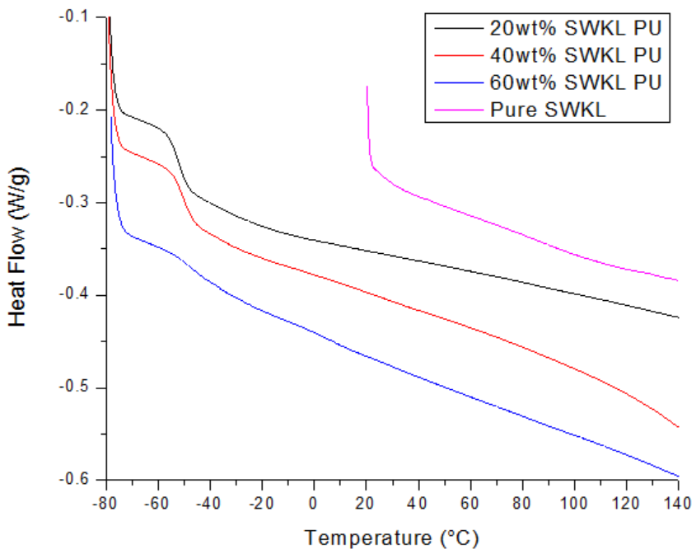
Figure 21. DSC scans of pure SWKL and lignin-based PU samples synthesized with 20wt%, 40wt%, and 60wt% SWKL.
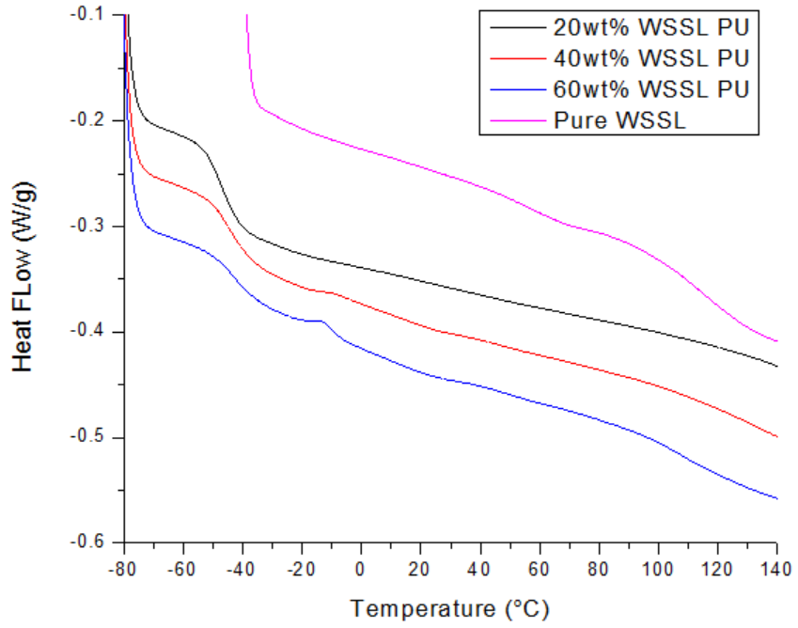
Figure 22. DSC scans of pure WSSL and lignin-based PU samples synthesized with 20wt%, 40wt%, and 60wt% WSSL.
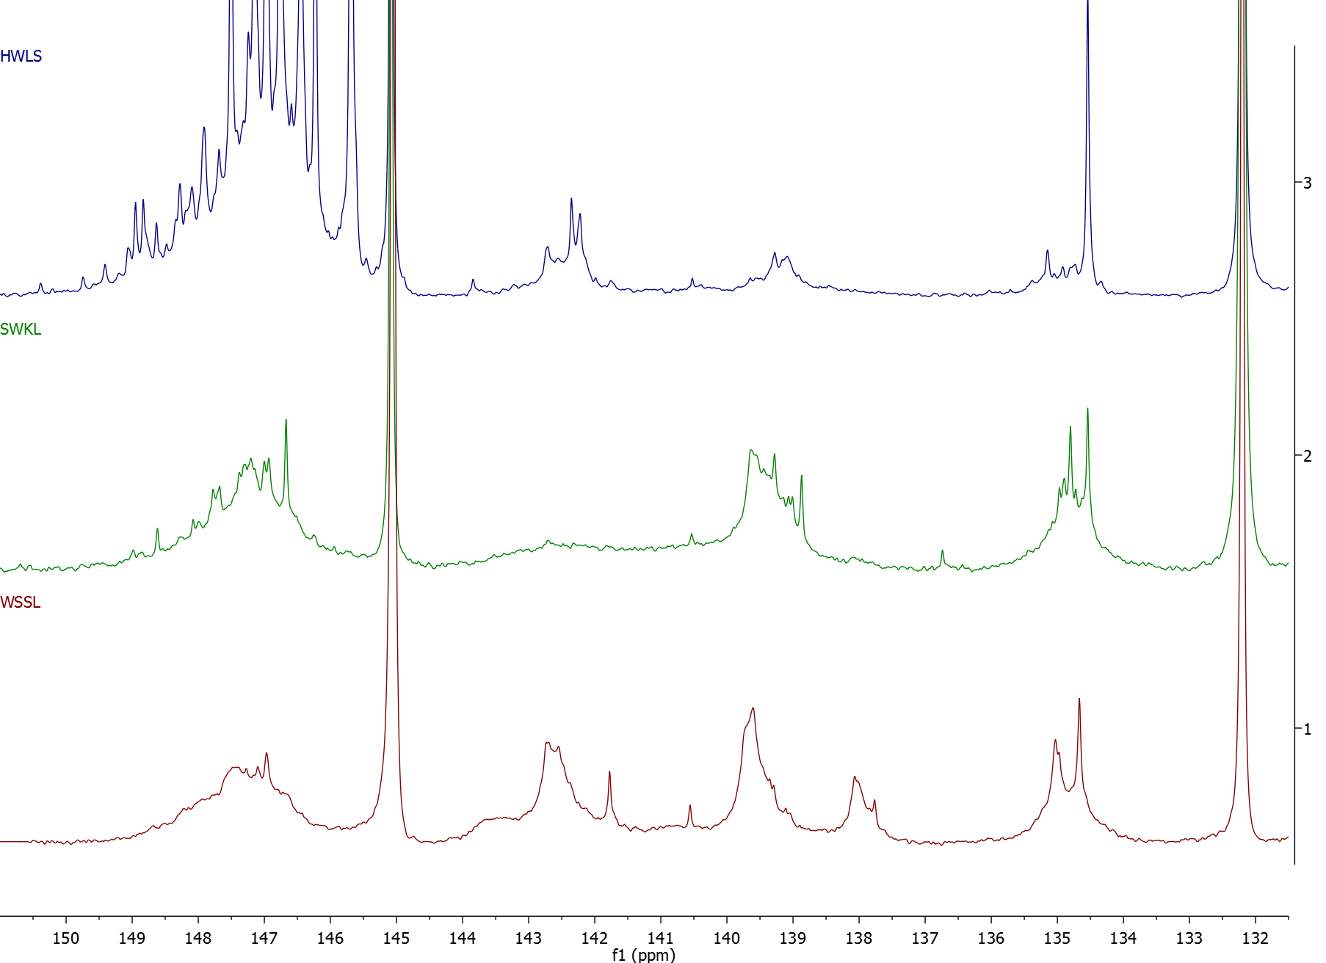
Figure 23. Examples of 31P-NMR data results for HWLS (top), SWKL (middle), and WSSL (bottom).

VITA

Jane X. Doe was born. She wrote a thesis. She graduated. She followed instructions and wrote her vita in third person and paragraph form (as opposed to a resume or CV), which made her thesis consultant very happy. This page is required.

