Reconstruction of Fire History in the National Key Deer Refuge, Monroe County, Florida, U.S.A: The Palmetto Pond Macroscopic Charcoal Record

A Thesis
Presented for the
Master of Science
Degree
The University of Tennessee, Knoxville

Desiree Lynn Kocis
May 2012

Copyright © 2012 by Desiree Kocis
All rights reserved.

ACKNOWLEDGEMENTS

I would like to offer my deepest gratitude to my advisor, Dr. Sally Horn, for all of her guidance and insight with this project and with all of my undergraduate and graduate work. I would like to also thank my other committee members, Dr. Liem Tran and Dr. Henri Grissino-Mayer, for their assistance and support over the last few years. Dr. Tran greatly helped me develop and evolve my quantitative and GIS-related skills. I thank Grant Harley for being a wonderful field partner for this project, as well as Matthew Boehm for his insight and assistance in the lab. Alex Pilote should also be thanked for posing so eloquently for the picture of my thesis site! I am also deeply grateful to many of the students of the Department of Geography for offering both their encouragement and ears whenever I needed it. I would also like to thank the U.S. Fish and Wildlife Service and National Key Deer Refuge for funding the sediment coring and radiocarbon dating for this project, as part of a grant to Sally Horn and Henri Grissino-Mayer. For logistical support and other help, I thank refuge manager Anne Morkill, USFWS staff members Chad Anderson and Phillip Hughes, and former USFWS staff member Joshua Albritton. I thank all of my family, including my wonderful in-laws, for all of their words of encouragement. Absolutely none of this would have been possible without my best friend and husband, James Kocis. Without his culinary skills, I would still be subsisting on cereal and cookies. But most importantly, I thank my sweet little miracle, soon to enter this world. You have been my greatest inspiration of all.
ABSTRACT

The pine rocklands in the Lower Florida Keys are considered endangered because of rises in sea level, urbanization, and human impacts on the natural fire regime. Macroscopic charcoal in a sediment core recovered from Palmetto Pond (24°41’45.15”N, 81°19’43.84”W) in 2010 was examined in contiguous 1-cm intervals to reconstruct Late Holocene fire history. Palmetto Pond is a shallow freshwater solution hole located within the pine rocklands of No Name Key in Monroe County, Florida. Radiocarbon dating of plant material at 247 cm depth in the Palmetto Pond profile indicates the sediment record extends back to ca. 4500 cal yr BP. Charcoal was present in every sample, a finding consistent with results from two similar pine rockland sites on nearby Big Pine Key. The Palmetto Pond charcoal record confirms that the pine rocklands of the Lower Florida Keys are a fire-dependent ecosystem characterized by frequent lightning-induced surface fires. The Palmetto Pond record contains possible evidence of climate- and anthropogenic-related influences on fire history. A large rise in fire activity from 631–329 cal yr BP may be attributed to Native American arrival and activity, drying conditions that began around the onset of the Little Ice Age, or a combination of both. An early 20th century peak in the Palmetto Pond charcoal record may record a major AD 1935 hurricane event. A companion study of tree-ring evidence of fire history on No Name Key confirms this finding and helps document a decline in fire activity coinciding with recent human settlement since the AD 1950s. An increase in the proportion of charcoal from leaf litter between 1661 and 1434 cal yr BP may indicate an interval of heightened hurricane activity.

TABLE OF CONTENTS

CHAPTER 1: INTRODUCTION 1

CHAPTER 2: LITERATURE REVIEW 5

Charcoal as a Proxy for Fire History 5
Macroscopic Charcoal as a Proxy for Local Fires 7
Charcoal Peaks as Indicators for Human Arrival and Impacts 10
Applications of Paleoenvironmental Research to Wildland Conservation 13
Effects of Hurricanes and Tropical Storms on Coastal Pinelands 15
Representation of Hurricane and Tropical Storm Events in Sediment Records 18
Regional Review of Selected Sedimentary Charcoal and Pollen Studies …. ………..20
Paleoenvironmental Studies in Florida 20
Paleoenvironmental Research in the Pine Rocklands of the Florida Keys 22
Paleoenvironmental Research in the Bahamian Pine Rocklands 24
Paleoenvironmental Research in the Circum-Caribbean Region 26

CHAPTER 3: ENVIRONMENTAL AND CULTURAL SETTING 28

Study Area 28
Geological and Physiographic Setting 28
Climate 31
Vegetation 32
Fire Ecology of Pine Rockland Ecosystem 34
Pre-European Settlement 38
European Settlement 41
Present Condition of the Pine Rockland Ecosystem in the Lower Florida Keys 43

CHAPTER 4: METHODS 48

Field Methods 48
Laboratory Methods 52
Radiocarbon Dating 53
Loss-On-Ignition 53
Macroscopic Charcoal Analysis 54

CHAPTER 5: RESULTS 57

Coring Results 57
Stratigraphy of Profile 57
Radiocarbon Dating 58
Loss-On-Ignition 63
The Macroscopic Charcoal Record 63

CHAPTER 6: DISCUSSION 71

What general trends can be determined from the fire history on No Name Key in the Lower Florida Keys using macroscopic charcoal analysis? 71
Do charcoal influx values reveal sudden change or changes in fire activity that could be related to initial human occupation on No Name Key, either by Indigenous populations or by Euro-Americans beginning in the 1800s? 73
How do findings compare with similar sedimentary charcoal work done on Big Pine Key? How do results compare with ongoing dendrochronological work in the Florida Keys?............................................................................................................75
Is there evidence of changes in the fire activity as reflected by charcoal influx during times of known shifts in climate conditions? 77

CHAPTER 7: CONCLUSIONS 81

REFERENCES 84

VITA 98

LIST OF TABLES

Table 5.1 Sediment stratigraphy of the Palmetto Pond Profile 60
Table 5.2 AMS radiocarbon determinations and calibrations for samples from
the Palmetto Pond profile 61
Table 5.3 Peaks in fire record at Palmetto Pond by depth and age 68

LIST OF FIGURES

Figure 2.1 Photo of hurricane damage to pine stands on Big Pine Key 17
Figure 3.1 Map of No Name Key vegetation types 29
Figure 3.2 Example of post-fire resprouting fire adaptation on Big Pine Key 35
Figure 3.3 Chart showing number of fires per year by cause in the Everglades
District between 1981–2009 36
Figure 3.4 Calussa and Tequesta Indian territories in relation to the Florida Keys 40
Figure 4.1 Photograph of core retrieval at Palmetto Pond 49
Figure 4.2 Photograph of Palmetto Pond coring site 50
Figure 4.3 Map of Palmetto Pond in relation to Key Deer Pond and Blue Hole
Wetland 51
Figure 5.1 Photographs of Palmetto Pond sediment core stratigraphy 59
Figure 5.2 Age/Depth diagram for Palmetto Pond 62
Figure 5.3 Loss-On-Ignition results for Palmetto Pond 64
Figure 5.4 Diagram of macroscopic charcoal concentration and influx values for
all size particles, plotted by depth 66
Figure 5.5 Diagram of macroscopic charcoal concentration and influx values for
all size particles, plotted by age 67
Figure 5.6 Diagram highlighting peaks in fire activity in the Palmetto Pond
charcoal record 69
Figure 5.7 Diagram showing all categories of charcoal counted in the Palmetto
Pond samples 70

CHAPTER 1
Introduction

Fire plays a critical role in maintaining many ecosystems. Consequently, understanding the fire regime of an ecosystem is important for properly maintaining and managing wildlands (Neary et al. 1999, Myers 2000, Loehle et al. 2009). Paleoecological studies seek to reconstruct past climate, fire regimes, and vegetation, as well as human influence over time (Sanford and Horn 2000, Brenner et al. 2002), by using charcoal, pollen, tree rings, and other proxies. Ecosystem management relies on the findings of such studies, which provide forestry, ecology, biology, and wildlife personnel with the tools needed for creating strategies directed toward community rehabilitation (Horn 1998, Swetnam et al. 1999, Heyerdahl and Card 2000, Willard et al. 2001). Such studies can reveal vegetation and fire interactions over many years, providing an important perspective for the development of plans for fire management. Prescribed fires are often implemented in an attempt to recreate the “natural” fire regime (Lynch 1941, Main and Richardson 2002).
The pine rockland ecosystem of south Florida is considered globally endangered (Carlson et al. 1993, Snyder 2005). Because of this, pine rocklands are protected within the National Key Deer Refuge (NKDR) under the management of the U.S. Fish and Wildlife Service (USFWS). The pine rocklands are considered endangered because of rises in sea level, urbanization, and human impacts on the natural fire regime (Ross et al. 1994, Bergh and Wisby 1996, Saha et al. 2011). In the Florida Keys, a rise in sea level of 2.4 cm/decade over the last 70 years has caused the pine rocklands to shrink (Ross et al. 1994, Saha et al. 2011). Continuing sea level rise is expected to replace species-rich upland vegetation communities with mangrove communities (Ross et al. 1994).
Fire suppression has also resulted in a shift in species composition, with shade-tolerant, fire-intolerant hardwood species encroaching into the pine rockland ecosystem (Carlson et al. 1993, USFWS 1999, Snyder 2005). Fire in the pine rocklands is a critical component to its survival (Snyder et al. 2005), helping to maintain its floral and faunal species, many of which are now considered threatened or endangered (USFWS 1999, Watts et al. 2008). The USFWS, with NKDR support, is interested in understanding and, where possible, mimicking through management the natural fire regime. They have provided funding for this paleoecological research project as part of their effort to understand fire dynamics over recent centuries and millennia. My study of sedimentary charcoal evidence of fire history on NKDR land on No Name Key will help shape management practices in the pine rockland ecosystem of the Lower Florida Keys.
Variations in charcoal influx over time on No Name Key may also help reveal the timing of initial human occupation of the island. During the establishment of human settlement on oceanic islands, landscape modification using fire for cultivation and forest clearance is common (Burney et al. 1994). Burney et al. (1994) have suggested that a spike in charcoal in lake sediment records can indicate first colonization of island habitats. Not much is known about prehistoric settlement in the Florida Keys. One of the goals of this study is to determine if charcoal influx values reveal any sudden changes that might indicate either Indigenous or Euro-American human arrival on No Name Key.
My thesis reconstructs fire history on No Name based on the macroscopic charcoal records in the sediments of Palmetto Pond. Palmetto Pond (unofficial name) is surrounded by pine rockland vegetation dominated by Florida slash pine (Pinus elliottii var. densa). My study provides a detailed fire history record for No Name Key that adds to a growing body of paleoecological knowledge of the endangered pine rockland ecosystem. Insufficient fire records currently exist for this ecosystem and understanding the fire history is vital to its survival. My work on sedimentary charcoal complements and extends ongoing dendrochronological research in the Lower Florida Keys (Harley et al. 2011, Harley 2012). While fire records from fire-scarred pines could extend back a few centuries, the results of my investigation provide a record of fires over the last ca. 4500 years. My research also complements and extends other studies of fire history from charcoal in ponds on Big Pine Key (Albritton 2009, Malik 2010, Horn unpublished data).
My thesis addresses the following questions:
- What general trends in the fire history can be determined on No Name Key in the Lower Florida Keys using macroscopic charcoal analysis?
- Do charcoal influx values reveal any sudden change or changes in fire activity that could be related to initial human occupation of No Name Key, either by Indigenous populations (timing uncertain) or by Euro-Americans beginning in the 1800s?
- How do findings compare with similar sedimentary charcoal work done on Big Pine Key? How do results compare with ongoing dendrochronological work in the Florida Keys?
- Does evidence exist of changes in fire activity as reflected by charcoal influx during times of known shifts in climate conditions?

My thesis consists of seven chapters. Chapter 2 summarizes previous paleoecological research in Florida and the circum-Caribbean region. Chapter 3 describes the geology, climate, vegetation, and cultural setting of the Lower Florida Keys, with specific details about No Name Key and the surrounding Keys. Chapter 4 reviews the field and laboratory methods used to conduct my analysis of the No Name Key sediments. Chapter 5 presents the results of the macroscopic charcoal analysis. In Chapter 6, I discuss my results and their implications, and how they fit with previous research in the region with respect to fire, climate history, and anthropogenic impacts on the environment. Chapter 7 concludes my thesis by summarizing the results and providing suggestions for future research on No Name Key.

CHAPTER 2
Literature Review

Charcoal as a Proxy for Fire History
Charcoal fragments in lake or wetland sediments can be analyzed to develop long-term records of local and regional fire occurrence (Sanford and Horn 2000, Whitlock and Larsen 2001). Results from charcoal analyses can complement and extend dendrochronological records of past fire events at different temporal and spatial scales (Sanford and Horn 2000, Whitlock and Larsen 2001, Whitlock et al. 2004). Pollen records can provide evidence of vegetation fluctuations related to fire disturbance events (Whitlock and Larsen 2001). Pollen and charcoal records from the same core can reveal links between climate, fire, vegetation, and anthropogenic activity in the past (Whitlock and Larsen 2001).
Charcoal is produced when organic matter incompletely combusts during a fire (Patterson et al. 1987). The production and transport of charcoal into sediments can be affected by the size, duration, severity, and intensity of the fire, as well as by vegetation characteristics and charcoal transport processes (Clark et al. 1998, Whitlock and Larsen 2001). Primary deposition of charcoal during and shortly after a fire event relies on airfall, while secondary deposition occurs during non-fire years from surface run-off and lake-sediment mixing (Whitlock and Larsen 2001). Microscopic and macroscopic charcoal can both be used for paleoenvironmental studies. Macroscopic charcoal (fragments >125 µm diameter) is generally not able to be transported long distances as can microscopic charcoal (<125 µm) (Whitlock and Larsen 2001). Because of this, macroscopic charcoal analyses are better at reconstructing local fire records, while microscopic charcoal analyses are better for regional fires (Sandford and Horn 2000, Whitlock and Larsen 2001).
Microscopic charcoal is often prepared, examined, and quantified on pollen slides using compound microscopes. The point counting method (Clark 1982) is one common method to quantify microscopic charcoal. It is a quick technique that uses several variables, such as volume and mass of the sample, loss-on-ignition data, number of pollen grains, marker spore data, and the number of points applied per field of view, to determine the total area of charcoal per level (Clark 1982). In contrast, macroscopic charcoal is examined under a dissecting scope. Particles in different size fractions >125 µm are separated by gently washing disaggregated sediment through sieves of different mesh sizes. Disaggregation is accomplished using dilute bleach, hydrogen peroxide, or other solutions (Schlachter 2005). Charcoal is often dried after transferring to Petri dishes, and counted with the help of a grid.
Numerous studies in Costa Rica have reconstructed fire histories using macroscopic and microscopic charcoal as proxies (Horn 1989, Horn and Sanford 1992, Horn 1993, Northrop and Horn 1996, League and Horn 2000, Clement and Horn 2001, Anchukaitis and Horn 2005). The first lake sediment cores from Costa Rica were recovered for charcoal analyses in the late 1980s (Horn 1989) from Lago Chirripó (3520 m), near the summit of Cerro Chirripó. Microscopic charcoal was quantified using the point counting technique. The study provided the first direct evidence for fires in the Chirripó highlands of Costa Rica during the prehistoric period, revealing a 4000 year history of high elevation fires that began long before modern human society. Because no evidence exists of Indigenous groups occupying the highlands, the study suggested that lightning-ignited fire is a natural part of the surrounding páramo ecosystem. Horn (1993), League and Horn (2000), and Watson (2010) expanded on the work at Lago Chirripó in studies of microscopic and macroscopic charcoal in glacial lakes in an adjoining valley. Their studies provided evidence of recurrent fire since deglaciation about 10,000 years ago.
Macroscopic and microscopic charcoal records from rainforest at the La Selva Biological Station and the páramo of Cerro Chirripó suggest associations between fire history, short-term El Niño climate events, and long-term climate shifts (Horn and Sanford 1992). Evidence of anthropogenic fire events are also documented in charcoal records from La Selva (Kennedy and Horn 2008). Another study looked at charcoal and pollen records at Laguna Bonilla and Laguna Bonillita. These records provided some of the first evidence of the influence of prehistoric peoples on Costa Rican rainforest environments (Northrop and Horn 1996).

Macroscopic Charcoal as a Proxy for Local Fires
Microscopic charcoal (<125 µm) on pollen slides was the primary proxy used in paleoenvironmental studies up to 20 years ago (Clark 1982, Clark 1984, Patterson et al. 1987), but disadvantages exist when studying charcoal particles of this size (Whitlock and Larson 2001). One significant limitation is that charcoal particles may be fractured during pollen preparation, leading to inaccurate microscopic charcoal counts (Whitlock and Larson 2001). Also, microscopic charcoal particles travel greater distances than macroscopic charcoal, resulting in non-local charcoal input. Several studies show that macroscopic charcoal analyses provide reliable records of local fires (Whitlock and Millspaugh 1996, Clark et al. 1998, Laird and Campbell 2000, Whitlock 2001). This can be attributed to the fact that larger charcoal does not travel as far as microscopic charcoal and, thus, is a more accurate indication of a localized fire.
Macroscopic charcoal from Little Lake on the Oregon coast was used to reconstruct the history of fire for the last 9000 years (Long et al. 1998). The study showed shorter fire intervals during warmer, drier climate conditions (9000–6850 cal yrs BP) and longer fire intervals during periods of cool, humid climate conditions (ca. 6850–2750 cal yrs BP). During the latter conditions, a population increase in fire-sensitive species occurred. The most recent period from ca. 2750 cal yrs BP–present experienced the longest fire intervals, as climate became cooler and wetter. The study suggested that variations in fire frequency are directly related to climate change.
A strong link between changes in climate and variations in fire frequency was revealed by a 17,000-year fire history reconstruction in Yellowstone National Park (Millspaugh et al. 2000). Macroscopic charcoal was quantified from a core recovered at Cygnet Lake. The charcoal record indicated infrequent fires during the late glacial period, followed by a greater frequency during the early Holocene when climate conditions were warmer and drier. Fire frequency decreased after ca. 7000 cal yr BP, when climate became cooler and wetter, and the present fire regime was established in the past 2000 years. The long-term variations in fire frequency were attributed to regional climate changes.
Ohlson and Tryterud (2000) examined the transport of macroscopic charcoal (>500 µm) out of three experimental burn sites in Scandinavia. The authors arranged 704 traps inside and outside the burn areas at varying distances from the fire edge, and then quantified charcoal particle abundance and mass in each trap. Their findings suggested that charcoal particles and charcoal mass decrease sharply with distance from the burn edge. Nearly 90% of the charcoal was captured in the traps within the burn area. Almost no macroscopic charcoal was found in the traps located beyond the burn edge. Macroscopic charcoal >500 µm appeared to be a reliable indicator of local fire occurrence.
Gardner and Whitlock (2001) examined charcoal in near-surface sediment recovered at 36 Oregon lakes within or close to a large, stand-replacing fire that occurred in 1996 (Gardner and Whitlock 2001). Variations in charcoal abundance showed that macroscopic charcoal recorded local fire signals and wind effects on charcoal transportation. The abundance of macroscopic charcoal was greatest in the lakes located within the perimeter of the burn area. Although all sites showed similar charcoal abundance peaks, peaks at burned sites were better defined than at the unburned sites. Other variables that could influence charcoal transportation after a fire event were not statistically significant. These variables included distance of the lake from the fire center, width of riparian vegetation, position of unburned lakes, and maximum adjacent slope. This study further confirmed the relationship between local fire occurrence and macroscopic charcoal peaks.

Charcoal Peaks as Indicators of Human Arrival and Impact

Fluctuations in charcoal abundance are commonly attributed to changes in fire occurrence that result from shifts in precipitation or temperature, variations in sea surface temperature, changes in air surface pressure, or other natural events, such as volcanic eruptions. Recently, studies have begun to examine changes in charcoal concentrations as possible evidence of human arrival to a region (Burney et al. 1994, Kjellmark 1995, Kjellmark 1996, Burney and Burney 2003, Albritton 2009, Bal et al. 2011). Several of these studies compared changes in charcoal abundance with changes in the pollen record to demonstrate that human arrival to a region can be seen using paleoecological data (Kjellmark 1995, Kjellmark 1996, Bal 2011). Studies comparing the paleoecological records with archaeological data are lacking, however, largely because of missing archaeological evidence.
Burney et al. (1994) and Burney and Burney (2003) suggested that peaks in charcoal abundance on oceanic islands can be attributed to human arrival and anthropogenic modifications to the environment. Although no archaeological evidence to back up their conclusions existed and other potential climatic and environmental factors could have been at play, Burney et al. (1994) suggested that a sudden and sustained increase in charcoal concentrations and influx between 5300 and 3200 cal yr BP in a sediment core from Laguna Tortuguero, Puerto Rico, was evidence of human arrival to the island and continued human use of fire. The charcoal record only extended to ca. 7000 cal yr BP, so a longer record is needed to reach this conclusion with greater confidence. Pollen data could provide a test for this hypothesis. Burney and Burney (2003) examined charcoal from sediment cores retrieved from nine sites on Kaua’i in the Hawaiian Islands. They suggested that charcoal increases in some of the records ca. 930 ¹⁴C yr BP indicated human arrival to the island.
Burney et al. (2004) conducted a more comprehensive study that compared archaeological, paleontological, palynological, and paleoecological records from sites throughout the island of Madagascar. All lines of evidence, including the first occurrence of Cannabis/Humulus pollen, first occurrence of human-modified bones of extinct animals, indications of vegetation disturbance, and a large, sudden increase in microscopic charcoal abundance, indicated human arrival on Madagascar about two millennia ago. Although fire was already part of the natural ecosystems on Madagascar, humans affected the fire ecology by increasing the frequency of burning and spreading fire to environments that previously had not supported frequent fires because they were either too wet or too dry.
Kjellmark (1995, 1996) compared charcoal and pollen records of sediments from Church’s Blue Hole on Andros Island, Bahamas. The pollen records indicated a dry period ca. 3200–1500 yr BP on the island in the late Holocene, followed by a period of mesic climate. A sudden rise in charcoal concentration along with a rapid vegetation transition to pinewoods occurred ca. 740 cal yr BP. A dip occurred in charcoal concentration ca. 430 cal yr BP, but charcoal then rose again near the top of the core. These changes in vegetation and charcoal concentration seemed to indicate human arrival followed by human removal ca. 430 cal yr BP (1530 AD) and recolonization ca. 200 years later, although Kjellmark acknowledged the possibility that climatic shifts could also be related. Stork (2006) and West (2007) also considered the possibility that peaks in charcoal records from Abaco Island, The Bahamas ca. 1190 cal yr BP and 1200 ¹⁴C yr BP could indicate human arrival.
Albritton (2009) attempted to associate changes in the charcoal record at a site on Big Pine Key, Florida with human arrival and activity. With scant archaeological or historical evidence of human occupation on the Lower Florida Keys prior to the 1500s, Albritton found making inferences concerning prehistoric human arrival difficult. European settlement of the islands ca. AD 1820 was not shown by microscopic and macroscopic charcoal concentrations and influx or charcoal to pollen ratios. Because charcoal concentrations and influx values reached their lowest levels in the uppermost samples of the macroscopic charcoal record and the charcoal to pollen ratio showed extremely low values, Albritton suggested that modern human occupation may have actually reduced the incidence of wildfires on the island. This could result from fire suppression practices prior to the establishment of the National Key Deer Refuge in 1957. These and other charcoal records of fire history from the Bahamas and Florida Keys are described in greater detail in the regional survey that comes later in this literature review.
A recent study by Bal et al. (2011) used a multi-proxy approach to analyze sediments from a peat bog in the Central Pyrenees in Spain. The intent of this study was not to determine whether human arrival could be inferred from the charcoal and pollen records, but whether changes in anthropogenic use of fire could be seen. This study thus demonstrated other ways in which the charcoal record can be used to make inferences about human activity. The sediment record dated back to 3300 cal yr BP. In this mountainous region, fire has been attributed to human activities, such as slash-and-burn agriculture, metallurgy, and pasturing, since ca. 5150 cal yr BP. The study showed increased fire-promoting human activity during two periods, 2900–2650 cal yr BP and 1850–1550 cal yr BP. These changes may be attributed to humans using fire as a tool for forest clearance and for maintaining open spaces.

Applications of Paleoenvironmental Research to Wildland Conservation
Paleoecological records can help reduce the noise surrounding what is considered “natural” for a particular ecosystem (Willis and Birks 2006). These records can span tens of thousands of years and provide valuable perspectives on the dynamics of modern ecological systems (Willis and Birks 2006). Recommendations for biodiversity conservation efforts concerning biological invasions, wildfire, climate change, and land management have been provided by a number of recent paleoecological studies (Chambers et al. 1999, Willard et al. 2001, Maxwell 2004, Willard et al. 2006, Burney and Burney 2007, Gavin et al. 2007, Willard and Cronin 2007, Albritton 2009).
Conservation policies in the Ratanakiri Province of northeastern Cambodia are based on the assumption that anthropogenic fires have degraded the dense forests, resulting in its present open forest savanna mosaic (Maxwell 2004, Willis and Birks 2006). A recent study by Maxwell (2004) showed that this forest-savanna shift is likely the result of monsoonal activity, and that the frequent, low-intensity human-caused fires actually may be conserving forest cover. This study suggested that current conservation management practices are based on incorrect assumptions regarding fire sources and are at odds with the paleoecological record.
The management plan of Chirripó National Park in Costa Rica aims to prevent fire in the high-elevation treeless páramos, although fires are occasionally started accidentally or used to improve grazing conditions (Horn 1989, Horn 1998). Fires were not considered a natural part of the Chirripó highlands. The first direct evidence of fires in the highlands during the prehistoric period was found through a charcoal record examined by Horn (1989). This study provided evidence that the high-elevation fires are not just disturbances introduced by modern human activity, but have been a part of this ecosystem for at least 4000 years. Horn (1993, 1998) further revealed fire as a long-active component of the Chirripó páramo and provided evidence that páramo vegetation thrives under frequent burning. These findings led Horn (1998) to argue for changes in the conservation practices in Chirripó National Park. She suggested that instead of preventing fire, managers should refocus their efforts on controlling fire size.
Efforts in the Florida Everglades to rehabilitate the natural hydrology and plant communities have recently been made after evidence emerged that human alterations of the natural hydrological regime have degraded native plant communities throughout the ecosystem (Bernhardt et al. 2004, Willard et al. 2006, Willard and Cronin 2007). Pollen analysis of surface samples and sediment cores from several sites in the Everglades and near Florida Bay indicated that marsh and slough plants dominated vegetation communities from ca. BC 50 to AD 1950 (Willard and Weimer 1997, Willard et al. 2001). By AD 1960, these pollen types dropped to their lowest levels, while tree pollen increased in abundance (Willard and Weimer1997, Willard et al. 2001). These records indicated that prior to the onset of modern water management practices, historic human-induced alterations to the natural hydrologic regime caused major changes in vegetation.

Effects of Hurricanes and Tropical Storms on Coastal Pinelands
The first historically recorded hurricane in the Florida Keys occurred in AD 1551, when a hurricane caused the wreck of a Spanish ship (Longshore 2008). In the circum-Caribbean region (which includes the Caribbean Sea, its islands, and the surrounding coasts), nearly every decade since then has recorded hurricane activity (Longshore 2008). Two of the best known hurricanes in the Keys included one in 1622, which resulted in ~550 deaths and the wrecks of at least six ships of the Spanish Terra Firma Fleet, and one in 1733, famous for wrecking 19 of 21 ships of the New Spain Armada (Wilkinson 2011a). Close to 30 hurricanes struck southeastern Florida between 1899 and 1992 (Wilkinson 2011a). Variations in cyclonic activity in the North Atlantic basin (which includes the North Atlantic Ocean, Gulf of Mexico, and the Caribbean Sea) are attributed to shifts in sea surface temperatures and climate phenomenon such as El Niño-Southern Oscillation (ENSO) (Liu and Fearn 2000, Lugo 2000, Goldenberg et al. 2001). Annual hurricane activity has been well above average each year since 1995, except for 1997 (Goldenberg et al. 2001).
Hurricanes are characterized by strong wind and rain (Lugo 2000). They can inflict significant mechanical and ecological damage on coastal ecosystems, resulting in coastal erosion, land subsidence, changes in hydrological properties, flooding, salt deposition through storm surges, wind damage, and alterations to or loss of plant and tree communities (Figure 2.1) (Lugo 2000, Lopez. et al. 2003, Saha et al. 2011). Social damages can also be incurred, with millions of dollars in losses to destruction of property, infrastructure, and life (Lugo 2000). Hurricanes can also affect wildlife populations, resulting in direct mortality and a reduction in species productivity (Lopez et al. 2003).
In 1992, Hurricane Andrew struck southern Florida as a Category 5 hurricane, with wind speeds reaching >200 km/hr. Most likely due to the storm's rapid transit across the region, damage to coral reefs and marsh ecosystems was less than that caused by other Caribbean storms (Tilmant et al. 1994). Platt et al. (2000) examined the effects of this hurricane on large mainland stands of slash pine (Pinus elliottii var. densa) in the Everglades district. Size and density of trees were measured, and damage and mortality were quantified. The resistance of slash pine to hurricane winds was significant. Approximately 73% of the stands suffered no severe damage. Mortality averaged 17–25% shortly after the hurricane, with another 3–7% dying off the following year. In old-growth stands, larger trees were more likely than smaller ones to be damaged and suffer mortality. In second growth stands, the effects were reversed, with a 30–60% increase in hurricane-related mortality occurring. Ross et al. (2006) found that mortality in tropical hardwood hammocks in the upper Florida Keys following Hurricane Andrew was concentrated among larger trees in most upland stands. Above average hurricane

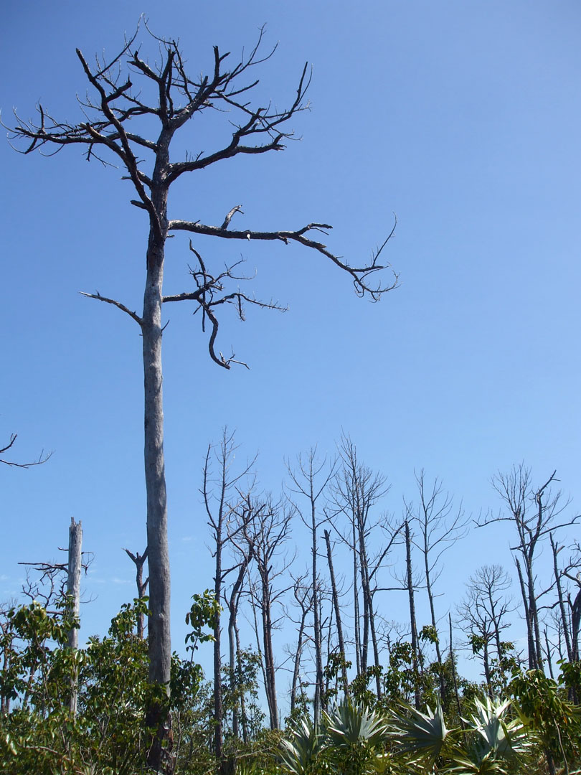
Figure 2.1. Example of damage created by hurricanes to pine rockland communities in the Florida Keys. This photo shows pines killed by the storm surge of Hurricane Wilma in 2005 on Big Pine Key. (National Key Deer Refuge 2010)

mortality was found in early- to mid-successional species, which had been experiencing aggressive growth following anthropogenic clearing.
Lopez et al. (2003) examined the effects of Hurricanes Georges (Category 2) and Irene (Category 1) on the endangered Key deer (Odocoileus virginanus clavium) on Big Pine and No Name Keys in the Florida Keys. During Hurricane Georges, 53 radiomarked deer were located. One of those deer drowned as a direct result of the hurricane. No deaths were reported in the 45 deer located during Hurricane Irene. The study found no significant differences in the average distances traveled by deer per day between hurricane and non-hurricane years. They concluded that mild to moderate hurricanes (Categories 1 and 2) have minimal direct impact on Key deer survival. Stronger hurricanes (≥Category 3) might result in greater impact due to stronger wind and storm surge activity.

Representation of Hurricane and Tropical Storm Events in Sediment Records
High-energy storm surges caused by hurricanes mobilize sand or silt, lift particles over sand barriers (e.g., barrier beach or dune ridges), and deposit them in coastal lakes in a process known as “overwash” (Liu et al. 2008). The overwash sand layer is thinnest near the center of the lake and thickest near the lake margin. Stronger storm surges create thicker and more widespread sand layers (Liu and Fearn 2000). Overwash layers can provide a proxy record for hurricane events extending beyond the historic period (Liu and Fearn 1993, 2000). Visual observation, together with Loss-on-Ignition analysis, is an effective method to detect the presence of overwash sand layers and other lithological changes in lake sediment cores from coastal lakes (Liu and Fearn 2000, Liu et al. 2008).
The defoliation of trees during hurricane events results in layers of leaves, which can be found in sediment cores (Albritton 2009). These layers of increased organic material can provide potential evidence of tropical storm events (Albritton 2009). Whelan and Smith (2006) documented a 30–60 cm thick storm layer deposit left by Hurricane Wilma at a soil monitoring site, which consisted of fine material followed by mangrove leaf matter. At a site along the southwest Florida coast, layers of mangrove leaves covered by sediment deposits documented the Hurricane Wilma storm surge (Smith et al. 2005). Pollen records from lake sediment cores can also indicate the effects of hurricanes on vegetation, such as population expansions and declines (Platt et al. 2000, Liu et al. 2008). Comparison of charcoal and pollen records can also reveal hurricane events, with studies suggesting increased fire activity following major hurricanes (Liu et al. 2003, Liu et al. 2008). Charcoal peaks immediately above thick sand layers suggest the eruption of fires after major hurricane strikes (Liu et al. 2008).
Liu et al. (2008) examined vegetation response to hurricane and fire disturbance interactions over the last 1200 yrs from a Gulf coast lake in Alabama. Overwash sand layers suggested that the coast was struck by category 4 or 5 hurricanes at least twice at ca. 1170 and 860 cal yr BP. The charcoal record indicated that intense fires occurred following both major hurricane events. The pollen record suggested that certain plant populations (Chenopodiaceae and Myrica) expanded due to saltwater intrusion into the marshes, while pine (Pinus) populations declined significantly. The decrease in pine stands was most likely intensified by the occurrence of fire events after each major hurricane. This study suggested that the likelihood of fire increases substantially after a major hurricane, resulting in vegetation changes. Heightened hurricane activity in the Gulf of Mexico since 1995 could result in increased fire hazards in forests along the coast (Liu et al. 2003).

Regional Review of Selected Sedimentary Charcoal and Pollen Studies

Paleoenvironmental Studies in Florida
Several paleoenvironmental studies based on analyses of lake and wetland sediments have been conducted in Florida, but until recently only one study involved the analysis of sedimentary charcoal (Kaplan 2003) outside the Everglades district. Pollen records from several sites across the state were developed from sediment cores in an effort to understand changes in vegetation (Watts and Stuiver 1980, Watts et al. 1992, Grimm et al. 1993, Watts and Hansen 1994, Willard et al. 2006, Albritton 2009). Sediment records from wetlands on mainland Florida provided evidence for climate shifts, changes in fire activity, and shifts in vegetation composition.
A pollen diagram covering the last 24,000 years BP was constructed from a sediment core recovered from Sheeler Lake in north Florida (Watts and Stuiver 1980). It showed pollen from herbs and dry forest taxa being replaced by that of mesic trees after ca. 14,000 ¹⁴C yr BP, indicating an occurrence of wet climate conditions. After 13,000 ¹⁴C yr BP, herbaceous taxa (Ambrosia, Selaginella, Poaceae) and pines (Pinus) expanded and the mesic trees declined. The diagram indicated a transition to drier climate around 11,200 years BP, with modern vegetation and climate conditions becoming established ca. 7200 ¹⁴C yr BP. The pollen record indicated a return to wetter climate conditions at this time, with an increase in Pinus, decrease in Quercus, and the development of bayhead communities and cypress swamps.
The vegetation history of northwest Florida was revealed by a series of pollen diagrams from a sediment core recovered from Camel Lake (Watts et al. 1992). The record from this site documented changes since the late Pleistocene, showing Pinus becoming the dominant pollen type after ca. 29,000 ¹⁴C yr BP. The percentages of Pinus pollen sharply declined between 14,000–12,000 ¹⁴C yr BP, while pollen of deciduous hardwoods, such as Quercus, Fagus, and Carya, increased. The findings at this site at ca. 7500 ¹⁴C yr BP are consistent with those at Sheeler Lake, showing decreasing deciduous hardwood populations and increasing Pinus populations.
Pollen evidence from Lake Tulane in south-central Florida indicated much drier conditions in the southern part of the Florida peninsula during the early to mid-Holocene than in the northern part (Grimm et al. 1993, Watts and Hansen 1994). The Lake Tulane record revealed alternating periods of Pinus and Quercus pollen dominance, with Pinus peaks coinciding with North Atlantic Heinrich events. These events involved periodic flows of large icebergs that broke off from the Laurentide Ice Sheet and traversed the North Atlantic. Wetter climate conditions in the late Holocene were documented by the development of modern wetland and Pinus communities ca. 4600 ¹⁴C yr BP.
Moving further south, pollen records from sediment cores in the Everglades district have been used to reconstruct hydrological changes that resulted from drought and human activity (Willard et al. 2001, Willard and Cronin 2007), and the timing and patterns of tree island development (Willard et al. 2006). Drought episodes, including those associated with the Medieval Warm Period (1150–750 cal yr BP) and the Little Ice Age (400–100 cal yr BP), were seen in the vegetation reconstructions, and coincided with periods of similar dry conditions documented elsewhere in the circum-Caribbean region (Willard et al. 2006, Willard and Conin 2007). Tree island communities developed in response to these drought episodes. The pollen record revealed that initial tree island communities established prior to significant human ecosystem alterations, between 3500–500 cal yr BP.
Kaplan (2003) examined charcoal abundance in a coastal pond on Lignumvitae Key in the Florida Keys using a chemical extraction method (Winkler 1985). Lignumvitae Key is in the upper Florida Keys and does not support pine rockland vegetation. Her study of a ca. 2300 year record from a small mangrove-fringed pond showed percent charcoal by weight that was consistently low throughout the entire core, indicating fire was not a common disturbance on this island. However, a gradual increase in charcoal abundance was present through the record that Kaplan interpreted to indicate increased regional fire frequency over the past 2000 years.

Paleoenvironmental Research in the Pine Rockland Ecosystem of the Florida Keys
Until recently, little was known about the long-term fire history in the Lower Florida Keys. With USFWS funding, a growing body of research is developing. Between 2007 and 2009, laboratory and data analyses on sediment cores recovered from two sites on Big Pine Key in the National Key Deer Refuge were carried out by Sally Horn and several students from the Laboratory of Paleoenvironmental Research, including graduate students Joshua Albritton, Alisa Hass, Maria Caffrey, and Chris Underwood, and undergraduate students Joshua Brown, Charles Batey, and Jeff Malik (Horn 2008, Albritton 2009, Malik 2010, Horn unpublished data). Macroscopic and microscopic charcoal analysis, radiocarbon dating, and pollen analysis were conducted on sediment core samples. Their combined efforts resulted in fire history and vegetation reconstructions from Key Deer Pond (24˚42’29.50”N, 81˚22’36.12”W) and a fire history record from Blue Hole Wetland (24˚42’22.56”N, 81˚22’49.62”W).
Albritton (2009) examined microscopic charcoal, macroscopic charcoal, and pollen assemblages in the sediments of Key Deer Pond, a small freshwater solution hole in the pine rocklands on Big Pine Key. Albritton, Horn, and Ken Orvis collected overlapping sediment core sections and a surface grab sample to investigate late-Holocene fire events, climate, and vegetation changes. Albritton’s results indicated that fire has been a part of the pine rockland ecosystem for a long time, with an increase of fire occurrence around 1200 cal yr BP. Macroscopic charcoal analysis conducted on the upper meter of sediment provided a ca. 400 year record that showed strong evidence for multiple fire events around Key Deer Pond. It also supported interpretations from ecological studies of fire return intervals of 3–7 years in the pine rocklands (Snyder 1991, USFWS 1999). Human influence on fire occurrence appeared to begin ca. 160 years ago, when colonization by European settlers of Big Pine Key took place. Albritton concluded that fires prior to historic human settlement were primarily lightning-induced, although USFWS scientists do not all agree with this interpretation, as the island may have supported Indigenous populations that periodically set fires (S. Horn, personal communication). Despite some debate over the source of prehistoric fires, Albritton’s results indicated that pine rocklands are a fire-dependent ecosystem with a history of frequent surface fires.
While Albritton (2009) only examined macroscopic charcoal in the upper meter of the Key Deer Pond profile, Horn and students (Horn 2008, Malik 2010) analyzed macroscopic charcoal throughout the entire 3.8 meter-long Blue Hole Wetland profile. Blue Hole Wetland is located ca. 500 m west of Key Deer Pond. Combined efforts led to the development of a ca. 2000 yr fire history. As with Key Deer Pond, frequent fires were found over the last two millennia, again indicating that the pine rocklands are a fire-dependent ecosystem.

Paleoenvironmental Research in Bahamian Pine Rocklands
The pine rockland ecosystem exists in only two locations in the world, south Florida and The Bahamas. West (2007) examined microscopic and macroscopic charcoal in lacustrine sediments on Great Abaco Island, The Bahamas. Charcoal recovered at the base of a 2.7 m core from Split Pond was dated to 5830 yr ± 50 ¹⁴C BP. West noted a peak in microscopic and macroscopic charcoal at ca. 1300 ¹⁴C BP, indicating a period of high fire activity. He suggested that increased burning at this time could correspond to the time of human colonization on Great Abaco Island.
West carried out an air-fall charcoal experiment to determine how charcoal was transported and deposited in the pine rocklands on Great Abaco Island. He set out an array of Petri dishes coated with petroleum jelly during a controlled burn to catch charcoal particles of different sizes. He recovered very little macroscopic charcoal (>125 µm) in his experiment. This indicated that low-intensity ground fires in pine rockland vegetation do not result in significant amounts of macroscopic charcoal being deposited through airfall. However, these larger particles can later be moved by surface water flows. On Great Abaco Island, much of this larger charcoal may be trapped in the irregular depressions of the limestone. The generally less-pitted limestone surface in the Florida Keys may allow more of these larger charcoal particles to ultimately reach ponds and end up in sediment records from the Keys.
Paleoecological research on Great Abaco Island by Stork (2006) and on Andros Island by Kjellmark (1995, 1996) appears to back up the estimated date of human arrival by West (2007). Stork (2006) examined charcoal and pollen in lacustrine sediments from West Pond. Her research revealed a potential switch from a high-intensity, low-frequency fire regime to a low-intensity, high-frequency fire regime at ca. 770 cal yr BP. At this same time, the pollen record shows a switch from tropical hardwoods to a Pinus-dominated community. Kjellmark (1996) also noted this shift on Andros Island. These findings could be related to a shift from wet climate conditions to drier climate conditions at ca. 900 cal yr BP, to human activity, or both.
Slayton (2010) examined the pollen record of Emerald Pond, a fresh water solution hole in the pine rocklands of Great Abaco Island, The Bahamas. Pollen assemblages showed pines and palms dominated the record since ca. 8400 cal yr BP. Changes in pollen percentages in the upper meter of the core suggested Emerald Pond experienced a generally drier climate over the last 2000 years. The charcoal record at this site (Horn et al., in prep.) shows the highest microscopic charcoal concentrations occurred in this section of the core as well, suggesting increased fire incidence over the last 2000 years.

Paleoenvironmental Research in the Circum-Caribbean Region
Schlachter (2005) investigated macroscopic charcoal from a sediment core recovered at a site in northwest Costa Rica. His intention was to reconstruct a detailed fire history for the Estero Blanco watershed and compare it with the vegetation record developed through the companion study of pollen assemblages by Arford (2007). His research indicated that from 8000–4000 cal yr BP, Laguna Estero Blanco experienced an increase in fire activity, which contrasts with the decreased fire activity attributed to wetter conditions found in other areas of the circum-Caribbean region. Decreased fire activity in this region occurred between 4000–0 cal yr BP, when drier climate conditions dominated. Previous research suggested that this may be explained by seasonality changes (Higuera-Gundy et al. 1999). Wetter conditions allowed for greater plant productivity during the wet season, providing greater fuel for dry season burns (Higuera-Gundy et al. 1999).
Lane et al. (2009) investigated microscopic charcoal and pollen records from sediment cores recovered from Laguna Castilla and Laguna de Salvador in the Dominican Republic, dating back to ca. 2980 cal yr BP and ca. 2030 cal yr BP. High charcoal concentrations suggested frequent fires in the region during a relatively moist period of the Late Holocene between ca. 2250 and 1520 cal yr BP. Their findings indicated a strong prehistoric human influence on the records from ca. 890–700 cal yr BP, with changes in pollen types and marked increases in charcoal influx at both lakes suggesting deforestation and the establishment of agricultural fields. Their records showed a decline in maize pollen and charcoal influx between ca. 700–350 cal yr BP that is attributed to a period of ecosystem recovery after human abandonment of the two watersheds ca. 700 cal yr BP.

CHAPTER 3
Environmental and Cultural Setting

Study Area
The Florida Keys are a ~200 km long crescent-shaped chain of small limestone islands, stretching southwest from peninsular Florida. My study site, Palmetto Pond (24˚41’45.15”N, 81˚19’43.84”W), is located on No Name Key in the Lower Florida Keys, Monroe County. No Name Key is a very small island of approximately 500 ha. About 15% of the population of the endangered Key deer live on No Name Key (Lopez et al. 2003, Harveson et al. 2007). Another 60% of the population of the species is located on neighboring Big Pine Key (Lopez et al. 2003, Harveson et al. 2007). About 330 ha of No Name Key are protected by the National Key Deer Refuge (NKDR), which is managed by the U.S. Fish and Wildlife Service. NKDR also protects habitats on 25 nearby islands in the Lower Florida Keys. About 65 ha of the refuge on No Name Key are pine rocklands (Figure 3.1). Palmetto Pond is a shallow freshwater pond located within the boundary of NKDR and the pine rocklands (Figure 3.1). The pond has a maximum diameter of about 12 m, and has a surface elevation of ca. 1 m.

Geological and Physiographic Setting
The Florida Keys were an extension of the Florida peninsula until rising sea levels ca. 4000 yrs BP began to submerge the low lying areas between the present islands (Lidz and Shinn 1991). The Keys are composed of two Pleistocene-age rock units, Key Largo

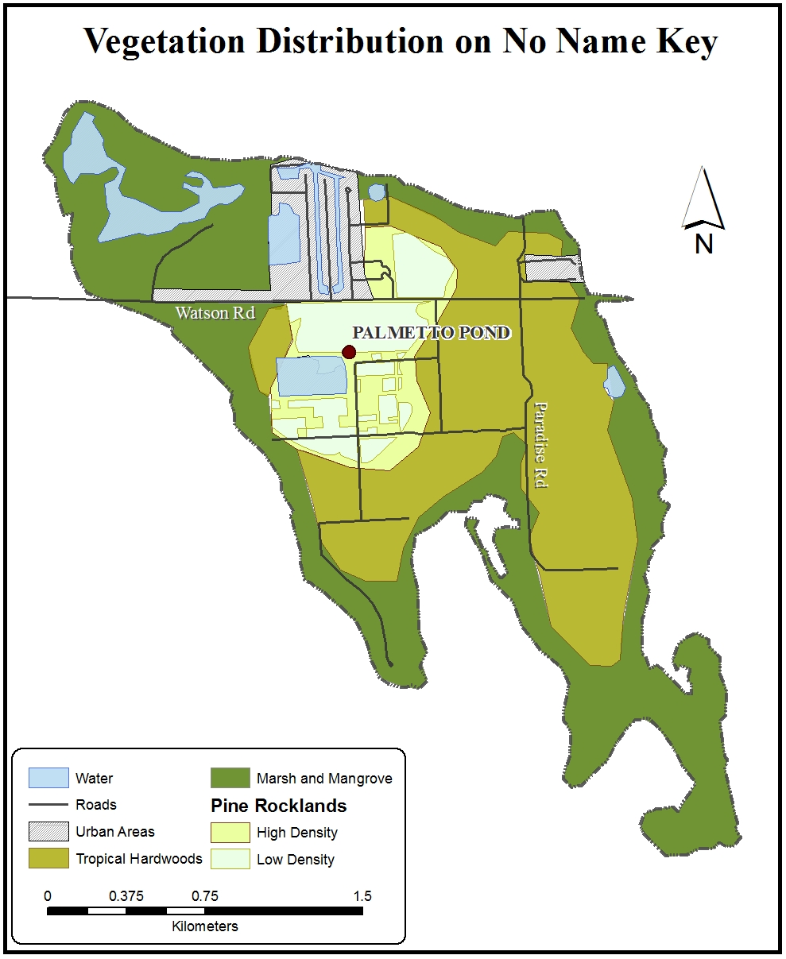
Figure 3.1. Map showing the three main vegetation types on No Name Key: Marsh/ Mangrove, Pine Rocklands, and Tropical Hardwoods. The Pine Rocklands are divided into two sections, high density and low density. The low density sections are areas in which understory vegetation density was reduced by prescribed burning. The areas denoted as “urban” are settled areas. Palmetto Pond is shown to be in the center of the Pine Rockland community. Data from Fish and Wildlife Research Institute website, http://ocean.floridamarine.org/efh_coral/ims/Description_Layers.htm; Map by Desiree Kocis.
Limestone and Miami Limestone (Hoffmeister and Multer 1968). Key Largo Limestone is an elevated coral reef rock and the Miami Limestone is oolitic (Hoffmeister and Multer 1968). Oolitic limestone rock is formed of compacted, egg-shaped deposits of calcium carbonate (Wilkinson 2011b). The Upper and Middle Keys are made up of the former type of limestone, while the Lower Keys consist primarily of the latter (Hoffmeister and Multer 1968, Wilkinson 2011b). Throughout the extent of the Lower Keys, the Miami limestone layer sits on top of Key Largo limestone (Hoffmeister and Multer 1968). Drilling of bedrock on Big Pine Key in the 1960s revealed more than 6 m of oolitic rock overlaying 55 m of Key Largo limestone (Hoffmeister and Multer 1968). Both types of limestone are very porous, although the Key Largo limestone is much more permeable (Ross et al. 1992). While the groundwater of most of the Keys is brackish (Ross et al. 1992), the oolitic limestone in the Lower Keys often holds fresh water (Wilkinson 2011b). Many freshwater solution holes are present on No Name Key (Wilkinson 2011b).
Soils in the Lower Keys are limerock-influenced Entisols (Ish-Shalom et al. 1992), and vary from marl deposits to bare rock of the oolitic limestone (Lopez et al. 2003, Harveson 2007). Soils are often located in rock surface crevices and depressions and are composed of nutrient-poor sand, clayey loam, and organic debris (Synder et al. 1990). Shallow organic soil layers, generally 10 cm or less (Ross et al. 2003), leave little room for rooting space. The soils typically lack strong horizons and are listed in four main categories: fine mineral soils (carbonate mud), coarse mineral soils (carbonate sand), rocky soil, and organic soil (Ross et al. 1992). In the absence of fire, rockland sites will slowly develop deeper, more continuous, and highly organic soil (Ross et al. 1992).
Climate
Climate in the Florida Keys is tropical with hot summers and warm winters (Ross et al. 1992). The average daily temperature recorded at the Key West weather station from 1973–2011 was 25.4 °C (77.8 °F) (U.S. National Climate Data Center 2011). Although temperatures in the Lower Keys have not reached any lower than 8.9°C (48.1°F) since 1973 (Ross et al. 1992, U.S. National Climate Data Center 2011), brief periods of freezing temperatures have occurred in the Upper Keys, closest to the Florida mainland (Ross et al. 1992).
Rainfall is highly seasonal in the Keys, with a very distinct wet-dry cycle (Ross et al. 1992). About 75% of the region’s rainfall occurs during the hurricane and tropical storm season, which begins in late May and extends through October (Multer and Hoffmeister 1968). The storm season peaks between August and October (Obeysekera et al. 1999). Rainfall averages 152.4 cm (60 in) per year (Multer and Hoffmeister 1968), with the Lower Keys typically receiving 89–101.5 cm/yr (Ross et al. 1994). Climate conditions become drier and slightly warmer from the upper Keys to the Lower Keys (Ross et al. 1992). The dry season varies from 6–7 months in length (Multer and Hoffmeister 1968, Snyder et al. 1990). Rainfall events in the dry season are attributed to the passage of cold fronts, which tend to occur during late fall, winter, and early spring (Albritton 2009).
The El Niño-Southern Oscillation (ENSO) is an important influence on tropical storm activity and climate in the Florida Keys. Over the last 130 years, ENSO cycles, which phase between periods of warm and cool sea surface temperatures in the Pacific, have occurred with a periodicity of 3–7 years (Beckage et al. 2003). Although winters are typically dry in this region, warm phase ENSO events (El Niño) produce much greater precipitation during this time (Beckage and Platt 2003; Kwon et al. 2006). Cool phase ENSO events (La Niña), on the other hand, increase the severity of the winter dry season throughout much of Florida (Beckage and Platt 2003, Kwon et al. 2006). The annual likelihood of a major hurricane making landfall in the U.S. is 23% during El Niño events, 63% during La Niña events, and 58% during neutral conditions (Keim et al. 2004). The Caribbean region, which lies south of the Florida Keys, experienced an average of 4.6 hurricanes per year from 1871–1964 (Walker et al. 1991). Several major hurricanes have passed directly over South Florida during the last 100 years, including Donna (1960), Betsy (1965), and Andrew (1992) (Pimm 1994). From 1906–1999, 19 hurricanes passed near to or directly over the Florida Keys (Swanson and Wilkinson 2011).

Vegetation
The Florida Keys are known for their diverse and predominantly tropical flora (Tomlinson 1980), which includes 120 species of woody plants, shrubs, and vines (Synder et al. 1990, Strong and Bancroft 1994). Ross et al. (1992) identified 13 vegetation types in the Keys, including Peaty Mangrove Forest (Ecological Site Unit [ESU] 1), Peaty Mangrove Woodland (ESU 2), Dwarf Mangrove Mudflats (ESU 3), Supratidal Scrub (ESU 4 & 5), Cordgrass Salt Marsh (ESU 6), Freshwater Marsh/Swamp (ESU 7), Transitional Thorn Woodland (ESU 8), Pine Rockland Forest (ESU 9), Low Productivity Rockland Hammock (ESU 10), Medium Productivity Rockland Hammock (ESU 11), High Productivity Rockland hammock (ESU 12), and Coastal Strand Forest (ESU 13). ESUs 1–4 are located at lower elevations (<0.72 m), 5–10 are at medium elevations (0.30–1.32 m), and 11–13 are at high elevations (0.71–3.28 m).
All of the ESUs that Ross et al. (1992) defined, except for ESU 5 and 12, are found in the Lower Florida Keys, with mangrove forests dominating the southernmost Keys (Pimm 1994). Vegetation communities are primarily determined by the frequency of tidal water inundation, soil development, and elevation (Ross et al 1994, Synder et al. 2005). Most do not occur in North America outside of southern Florida and the Keys (Ross et al. 1994, Barrett et al. 2006).
No Name Key is composed of marsh, mangrove, pine rocklands, and tropical hardwood communities (Figure 3.1). The marsh and mangroves are located along the outer edges of the island in lower elevations. The pine rocklands and tropical hardwoods are located further inland at higher elevations. Plant species vary by elevation and vegetation community, with red mangrove (Rhizophora mangle), black mangrove (Avicennia germinans), white mangrove (Laguncularia racemosa), and buttonwood (Conocarpus erecta) dominating areas near sea level (Lopez et al. 2003, Harveson et al. 2007). The hardwoods at higher elevation are dominated by Gumbo limbo (Bursera simaruba) and Jamaican dogwood (Piscidia piscipulaa) (Lopez et al. 2003, Harveson et al. 2007). The pine rocklands are dominated by open, high canopied (7–13 m) South Florida slash pine (Pinus elliottii var. densa). Other important species include palms (Thrinax microcarpa and Coccothrinax argentana) and poisonwood (Metopium toxiferum) (Ross et al. 1992). All of these species are fire-adapted and fire-dependent (e.g., Figure 3.2).
The density of the pine rocklands is directly related to fire frequency, with lower density areas having experienced more recent fires. Most recent fires have occurred through prescription burns. Pine rocklands exist at medium elevations (70–130 cm) in areas of the interior Lower Keys large enough to support shallow fresh water lenses (Ross et al. 1992, Saha et al. 2011). The composition of the understory depends on fire frequency. Pine rocklands that have experienced regular fire events are rich in shrubs, herbs, and grasses (Ross et al. 1992). Without regular fires, a dense, broad-leafed sub-canopy of trees forms within a few decades (Ross et al. 1992). Prescribed fires keep the pine rocklands from transitioning to the tropical hardwood ecosystem (Alexander and Dickson 1972).

Fire Ecology of the Pine Rockland Ecosystem
Although fires can depress plant populations, they also enhance populations of some species through their influence on species composition and community extent (Glitzenstein et al. 1995, Beckage and Stoute 2000). Fire is a critical component in pine rocklands (Snyder et al. 2005), helping to maintain floral and faunal species, many of which are now considered threatened or endangered (USFWS 1999, Watts et al. 2008). Presently, human-ignited fires are the primary source of fire ignition (Figure 3.3).

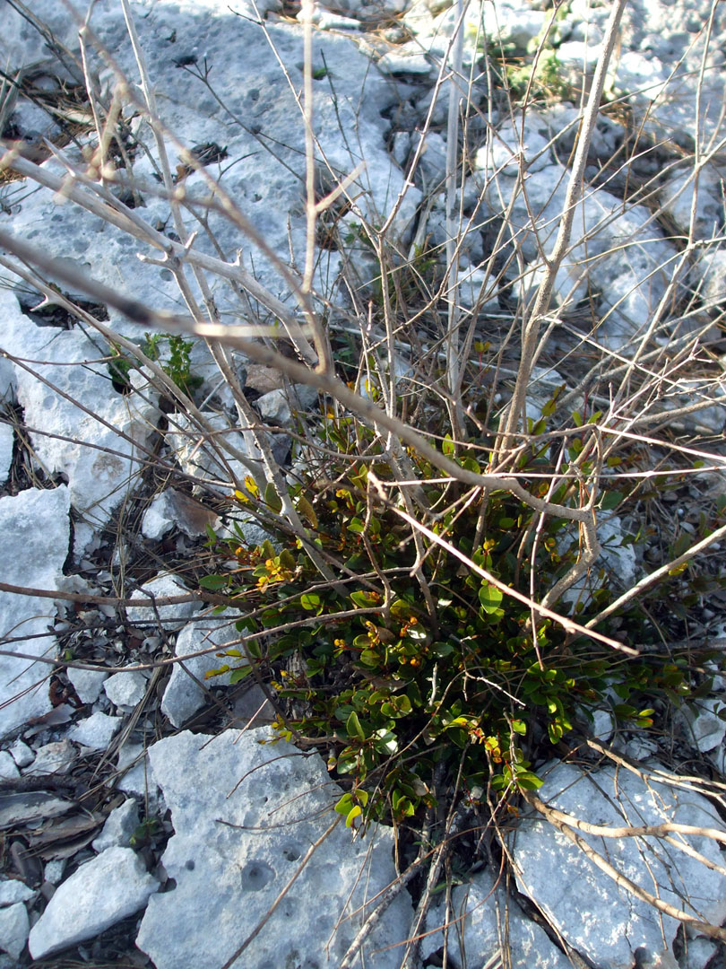
Figure 3.2. Long-stalked stopper (Psidium longipes) resprouting shortly after a prescribed fire on Big Pine Key, Florida.

Figure 3.3. Number of fires/year by cause in the Florida Everglades District between 1981–2009. “Other Human Caused” fires include ignition by children, arson, railroad activity, and other miscellaneous sources. The chart illustrates that most fires over this period have been anthropogenic in nature. The number of lightning-caused fires never exceeds the number of human caused fires in a particular year. This chart does not include data on prescribed fires. (Data: Florida Forest Service website, http://www.floridaforestservice.com/index.html).
Lightning was the source of fire ignition in the pine rocklands prior to anthropogenic influences (Bergh and Wisby 1996, Albritton 2009), with most lightning-caused fires occurring during the thunderstorm-heavy summer/wet season (Myers 2000, Liu and Menges 2005).
To maintain an open understory and sustain mixed-age pine stands requires periodic fire (Alexander 1967, Snyder et al.1990, USFWS 1999, Liu and Menges 2005). Fire suppression in the pine rocklands has resulted in a shift in species composition, with shade-tolerant, fire-sensitive hardwood species encroaching into the ecosystem (Carlson et al. 1993, USFWS 1999, Liu and Menges 2005, Snyder 2005). Prescribed fires have been used to maintain the pine rocklands of the Everglades National Park since the 1960s (National Key Deer Refuge 2010), while the pine rocklands in the NKDR have only been burned sporadically since 1985 (Bergh and Wisby 1996, National Key Deer Refuge 2010). From 1985 to 1992, prescribed burning was conducted in an effort to reduce fuel load (Snyder et al. 2005). No prescribed burning took place from 1993–1997 (Snyder et al. 2005).
A healthy pine rockland forest has a minimal shrub layer (<20% cover) and an open, mix-aged canopy of pines (National Key Deer Refuge 2010). The fire regime of this optimal, early-seral stage pineland involves frequent (3–7 years), low intensity/severity surface fires (National Key Deer Refuge 2010). The pine canopy suffers minimal effects from these regular fire events (Snyder et al. 2005). If the forest does not experience fire for more than seven years, it may develop into a mid-seral stage (National Key Deer Refuge 2010). This stage is characterized by a denser understory, with woody shrubs and palms together covering 20–80% of the surface. If not burned for more than 15 years, the forest will develop into the late-seral stage composed of tall broadleafs and palms (≥80% cover) (National Key Deer Refuge 2010).
Plant species of the Florida Key’s pine rocklands show adaptation to fire (Figure 3.2) (Albritton 2009). Slash pine (Pinus elliottii var. densa), for example, has a thick bark that keeps the living inner bark and cambium protected (Albritton 2009). The cones open best when they are exposed to heat produced during fires (Snyder et al. 1990, Albritton 2009). As a juvenile, it also has a “grass” stage that offers resistance to fire damage (Abrahamson and Abrahamson 1996). Other fire adaptations in the pine rocklands include reprouting, clonal spread, and post-fire seeding (Platt et al. 1988, Snyder et al. 1990, Menges and Kohfeldt 1995, Abrahamson and Abrahamson 1996, Liu and Menges 2005, Snyder et al. 2005).

Pre-European Settlement
Not many specifics are known about prehistoric settlement in the Florida Keys (Douglas 1947, Wilkinson 2011c). Perhaps due to rising sea levels (3–7.5 m), little archaeological material that dates to the Archaic Period (9950–2700 yrs BP) or earlier has been recovered in the Keys (Wilkinson 2011c). It is believed that prehistoric, large-group settlements on the Keys began ca. 3000 yrs BP (McNicoll 1941, Wilkinson 2011c). With Native American arrivals in Florida dating back to 12,000 yrs BP, and back to 5000 yrs BP in the wetland regions (Hann 2003), it is possible that Indigenous people arrived in the Keys earlier than the estimated 3000 yr BP. Evaluations of pottery recovered at a prehistoric village site on Key Largo date the site to around 3550 yr BP.
Archaeological sites have been examined on the Upper and Lower Matecombe Keys, Tea Table Key, Indian Key, and Lignumvitae Key (Goggin 1950), although no radiocarbon dates have been obtained. The two main tribes of the Florida Keys are the Calussa (sometimes called “Caloosa” or “Calusa”) Indians and the Tequesta (also called “Tekesta”) Indians (Goggin 1944, Goggin 1950, Hann 2003). European settlers believed these tribes were allies (Squires 1941), and their populations are estimated to have been 4000–7000 at the time of European arrival (McNicoll 1941). The territory of the Calussa Indians spread along the eastern Gulf Coast down into the Upper Keys, while the Tequesta Indian’s territory spanned from the Biscayne Bay into the Upper Keys (Figure 3.4) (Goggin 1950). A lesser presence by the Jega Indians has also been suggested (Hann 2003). The Jega territory was located north of the Tequesta region, along the Atlantic coast (Hann 2003).
Archaeological investigations of Tequesta sites have also been conducted outside of the Keys, along the Miami River (Hann 2003). Near the mouth of the river on the south bank is a site known as the Miami Circle. This site is made up of midden-filled holes that form a circular pattern ~11.5 m in diameter (Hann 2003). The holes are carved into limestone bedrock. They were most likely carved sometime before 1950 yrs BP (Hann 2003). Associated artifacts show that the Miami Circle was used until ~750 yrs BP, although remains of an animal sacrifice at the site date to only ~300 yrs BP (Hann 2003).

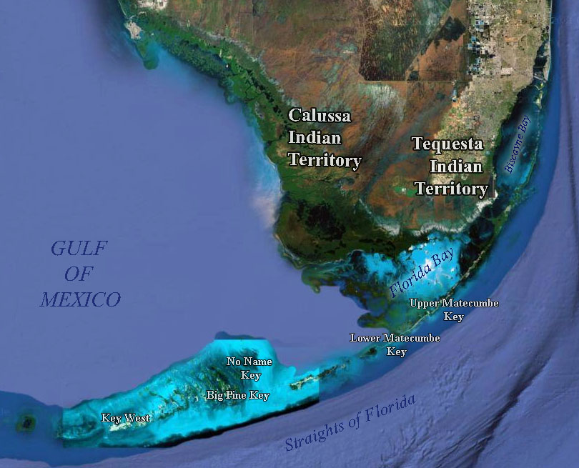
Figure 3.4. General locations of the Calussa (also called, "Caloosa" and "Calusa") Indian and Tequesta (also called, "Tekesta") Indian centers in relation to the Florida Keys. Both of these tribes have been documented in the Keys, primarily in the Upper and Lower Matecumbe Keys (Goggin 1950). Mention of their presence in the Lower Keys was made in the mid-1500s by Hernado de Escalante Fontaneda, who spent years as a Native American captive (Goggin 1950). (Basemap courtesy of Google Maps, 2011).

Historic records by Europeans document Native American presence in the Keys as early as 1551, when Hernando de Escalante Fontaneda noted three settlements (Goggin 1944, Goggin 1950, Hann 2003). These settlements included the Gaurugube, Cuchiyaga, and Tatesta (Goggin 1950, Hann 2003). More sites were indicated between 1571 and 1574 by Juan López de Velasco, such as the Matecumbe site (Hann 2003). In 1573, the Spanish documented an attack on them by the Matecumbe village on the Lower Matecumbe Key (Goggin 1944). Further mention of the Matecumbe site was made in the 1600s by Fontaneda and Bishop Calderón (Goggin 1944). Key West is believed to have been the last refuge of the Calussa Indians before their disappearance from the Keys in 1763. Native Americans not killed through European violence or foreign disease (Squires 1941) are believed to have sought refuge in Cuba at this time (Hann 2003).

European Settlement

European arrival in the Florida Keys began with brief visits by Ponce de Leon in 1513 and 1522 (Goggin 1950). European settlements on Indian Key, Key West, and Key Biscayne began around 1750, after the drop-off in Native American population and the departure of the Spanish (Goggin 1950). The earliest documented colonization on No Name Key was made about 25 years after Florida became a U.S. State in 1845 (Wilkinson 2011d). The 1870 U.S. Census reported 16 occupied households, seven unoccupied homes, and 45 inhabitants (Wilkinson 2011d). All of the heads of household, except for one, were Bahamian immigrants (Wilkinson 2011d). While Key West maintained the largest population in Florida during the 1800s (18,000 residents), the rest of the Lower Keys remained thinly settled (Wilkinson 2011d).
Political unrest in Cuba led to Cuban patriots being marooned on No Name Key in the late 1800s (Wilkinson 2011d). This occupation ended by 1898, during the Spanish American War (Wilkinson 2011d). By the 1910 U.S. Census, only 22 inhabitants remained on No Name Key. Two major hurricanes swept through the region, further damaging population on the island. In 1919, a category 4 hurricane struck the Lower Keys, damaging almost every structure in its path (Barnes 1998, Wilkinson 2011d), killing 287 people (Blake et al. 2011), and causing more than two million dollars in damage in Key West (Fort Lauderdale Daily News 1919). The 1935 category 5 hurricane, also known as the Labor Day Storm, killed 408 people in the Keys (Blake et al. 2011). To date, the 1935 hurricane is the second most intense hurricane to strike the U.S., preceded by Hurricane Camille in 1965 and followed by Hurricane Katrina in 2005 (Blake et al. 2011). It is the eighth deadliest hurricane, while the 1919 hurricane is the twelfth deadliest (Blake et al. 2011). The Labor Day Storm destroyed most of the Upper Keys, although little damage was noted on No Name Key (Wilkinson 2011a, d). The transportation routes out of the Keys were significantly damaged (Wilkinson 2011a, d).
Shortly after the Labor Day Storm, mostly because of the destruction of transportation routes, No Name Key sunk quickly into an uninhabited wildland (Wilkinson 2011d). The island became resident-free for more than 30 years. Because of its lack of residents, No Name Key became a popular stop-over point during the Cuban Revolution, which began in 1959 with General Fidel Castro’s 26th of July Movement overthrowing Cuban President General Fulgencio Batista (Wilkinson 2011d). On December 5, 1962, a bust on an anti-Castro training camp on No Name Key led to the arrest of 13 fighters, 10 of whom were Americans (Miami Herald 1962). This group was led by U.S. Marine Gerald Patrick Hemming (Miami Herald 1962, Wilkinson 2011d). Another raid on Cuban exile “Freedom Fighters” in April of 1963 led to more arrests, followed by an April 20th report by the Key West Citizen newspaper that no further training would be allowed to take place on No Name Key (Wilkinson 2011d).
In 1967, a new bridge between Big Pine Key and No Name Key was opened to the public (Wilkinson 2011d). Two years later, the island was “resettled” by Bob and Ruth Eaken and their two children (Wilkinson 2011d). In 1970, two canals were dug on the island and more than 90 business and residential lots were prepared (Wilkinson 2011d). As of 2009, about 45 homes were occupied on the island (Wilkinson 2011d), although no public electricity or water supply has been established (Wilkinson 2011d).

Present Condition of the Pine Rockland Ecosystem in the Lower Florida Keys
The pine rocklands of South Florida are considered an endangered plant community (Synder et al. 2005). It has been estimated that pine rocklands once covered ca. 65,000 ha in Florida’s Everglades National Park, Big Cypress Preserve, and the Lower Keys (USFWS 1999, Albritton 2009, Harley et al. 2011). Other pine rockland communities are found on four islands in the Bahamas and on the Turks and Caicos, although they are dominated by a different pine species (Pinus caribea var. bahamensis) (National Key Deer Refuge 2010). Human impact on this ecosystem and its natural fire regime has significantly reduced and fragmented the pine rockland habitat by ~90% (O’Brien 1998, Synder et al. 2005, Harley et al. 2011). Globally, 98% of pine rockland communities have been lost because of significant ecological degradation, land-use conversion, and outright destruction (Noss et al. 1995, Bergh and Wisby 1996, Harley et al. 2011). The pinelands of the Lower Keys are also threatened by a sea level rise of ca. 15 cm over the last 70 years (Ross et al. 1994, National Key Deer Refuge 2010), as well as storm surges (National Key Deer Refuge 2010). Because of their coastal proximity and low elevation, pine rocklands of the Keys are losing ground to the rise in sea level at the rate of 2.4 cm per decade (Ross et al. 1994, Saha et al 2011). Currently, less than 1000 ha. of pine rockland communities survive in the Keys (Snyder et al. 2005). In 1957, the National Key Deer Refuge (NKDR) was stabled by the United States Fish and Wildlife Service (USFWS) to conserve and protect pine rocklands and the endangered Key Deer that inhabit them (Lopez et al. 2004).
The pine rocklands in the Florida Keys are home to several federally listed plant and animal species (Coile 2000, Albritton 2009). Threatened and endangered plants include tiny polygala (Polygala smallii), garber’s spurge (Chamaesyce garberi), coastal vervain (Verbena maritima), locustberry (Byrsonima lucida), silver palm (Coccothrinax argentata), cat-tongue (Melanthera parvifolia), deltoid spurge (Chamaesyce deltoidea spp. deltoidea), and more than 10 other species (USFS 1999, Coile 2000, Albritton 2009). Federally listed wildlife species include the Key deer (Odocoileus virginianus clavium), Kirtland’s warbler (Dendroica kirtlandii), ringneck snake (Diadophis punctatus acricus), and the Florida atala butterfly (Eumaus atala) (USFWS 1999). Invasive plant taxa have significantly affected the pine rocklands of South Florida, with at least 277 exotic plant taxa currently documented (USFWS 1999).
One of the most studied of the endangered animal species is the Key deer. They are the smallest subspecies of white-tailed deer in the United States, endemic to the Florida Keys (Lopez et al. 2004). The deer are present on 20–25 islands, mostly within the NKDR boundaries (Lopez et al. 2004). Roughly 75% of their population lives on Big Pine Key and No Name Key (Lopez et al. 2004). Habitat loss and hunting pressure reduced the Key deer population to ca. 25–50 by the late 1940s (USFWS 1999, Lopez et al. 2004). After the 1957 establishment of NKDR, their population bloomed to ca. 200 animals on Big Pine Key and No Name Key over 14 years (Lopez et al. 2004). From 1971– 2001, their population on these two islands increased by 240% (Lopez et al. 2004), although they are still federally listed as endangered. The food sources and browsing habits of the Key Deer are tied to the fire ecology of the pine rocklands (USFWS 1999, Barrett 2004).
The exotic Brazilian-pepper tree (Schinus terebinthifolius) is one of the most invasive plant species that affects the pine rocklands. Significant work regarding exotic plant species control has been initiated in the Florida Keys pine rocklands (USFWS 1999). In the 1990s, the Department of Environmental Protection (DEP) allocated $170,000 to exotic species control in the upland regions of the Florida Keys (USFWS 1999). Seven exotic mammals, ~30 birds, 25 reptile, and four amphibian species have also been introduced to the Lower Keys rocklands, including fire ants (Solenopsis invicta) and armadillo (Dasypus novemcinctus). The USFWS has recognized the problem of exotic animal introductions and hopes to remove them from all natural areas, as well as prevent the entry of domestic pets (USFWS 1999).
Although the NKDR used sporadic prescription fires for fuel reduction purposes starting in 1985, these fires did not take into consideration the natural fire regime or burn seasons of the pine rocklands (Snyder et al. 1990, Albritton 2009). The NKDR has recently begun a more comprehensive fire management program (Snyder et al. 1990, USFWS 1999, Liu and Menges 2005, Albritton 2009). The USFWS and NKDR are interested in tree-ring and sediment-based reconstructions of past fire, as knowledge gained can be applied to future wildland management practices and to the education of Keys residents on the long-term importance of fire in rockland habitats. Charcoal, pollen, and dendrochronological evidence will document long-term vegetation and fire history, which will assist restoration and conservation efforts.
Harley (2012) evaluated the influence of historical fire disturbance and fire management practices on the pine rocklands on Big Pine Key and No Name Key. He identified and dated fire scars from the past 150 years on two stands of south Florida slash pine. His findings indicated that fires burned at 6 year intervals on Big Pine Key and 9 year intervals on No Name Key, with No Name Key experiencing fewer fires. The majority of fires on both islands occurred late in the growing season (July–November).
Harley (2012) also investigated relationships between historical wildfires and climate variability using fire-scar chronologies for the period 1707–2010 from four sites on Big Pine Key. Fires that scarred >50% of the trees occurred during years that were drier than average and that had experienced lower than average El Niño-Southern Oscillation (ENSO) (NIÑO3.4) values one year prior. His findings suggested a link between El Niño Decadal Modulation, which affects winter precipitation amounts, and wildfire. Wetter than average years combined with the positive anomalies of ENSO strengthened by warm phases of the Pacific Decadal Oscillation increased the growth of fine fuels, preconditioning widespread fires.

CHAPTER 4
Methods

Field Methods
In March 2010, Sally Horn, Henri Grissino-Mayer, Grant Harley, and I examined multiple solution holes in the NKDR as possible sediment coring sites. Once deemed appropriate for sampling, a platform was extended over the solution hole, from which we then collected sediment cores using a Colinvaux-Vohnout locking piston corer (Colinvaux et al. 1999, Figure 4.1). Three sites were sampled during this field excursion, unofficially named Coco Plum Pond, Balsa Pond, and Palmetto Pond, resulting in a total of 24 one-meter core sections. At Coco Plum pond, the coring platform rested on the edge of a solution hole in which the modern sediment surface was >1 m below the surrounding rockland. At Balsa and Palmetto Ponds, the platform rested on the damp surface sediment. Neither site was cored in standing water, though Palmetto Pond had a slightly deeper area with standing water to the side of our coring platform.
After careful consideration of each site, I decided to focus my research on the core sections taken from Palmetto Pond on No Name Key (24˚41’45.15”N, 81˚19’43.84”W, Figure 4.2). Balsa Pond yielded the deepest sediment profile, but it may not be reliable because of potentially major site disturbance. Coco Plum Pond is a promising site for paleofire research, but it is very close to sites of previous work at Key Deer Pond and Blue Hole Wetland. I chose Palmetto Pond because I thought it would make a more interesting comparison with the sites on Big Pine Key (Figure 4.3).

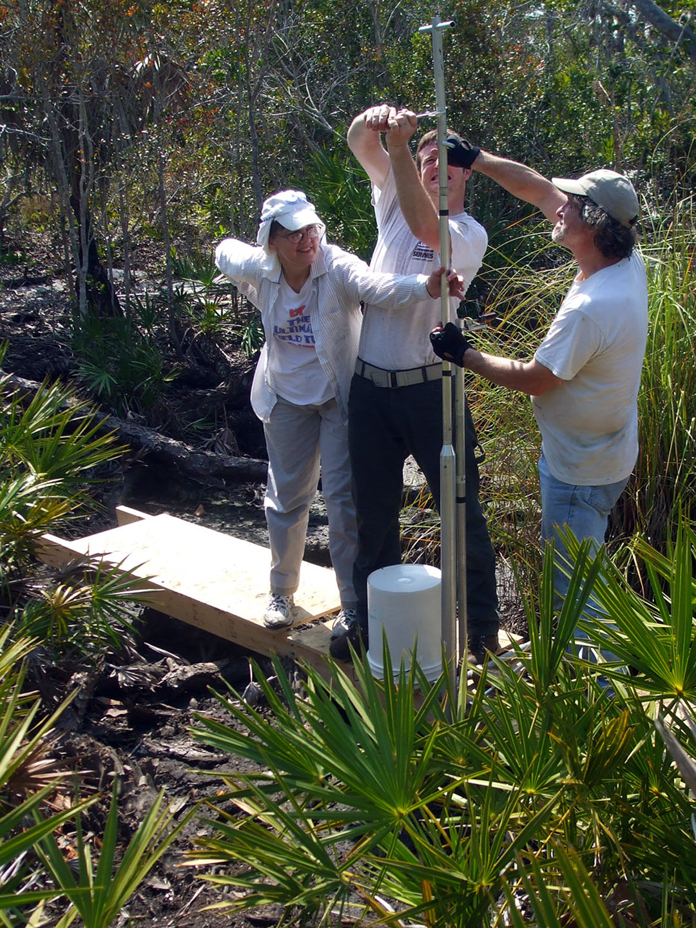
Figure 4.1. A sediment core section being retrieved from Palmetto Pond in March 2010. From left to right are Dr. Sally Horn, Grant Harley, and Dr. Henri Grissino-Mayer.
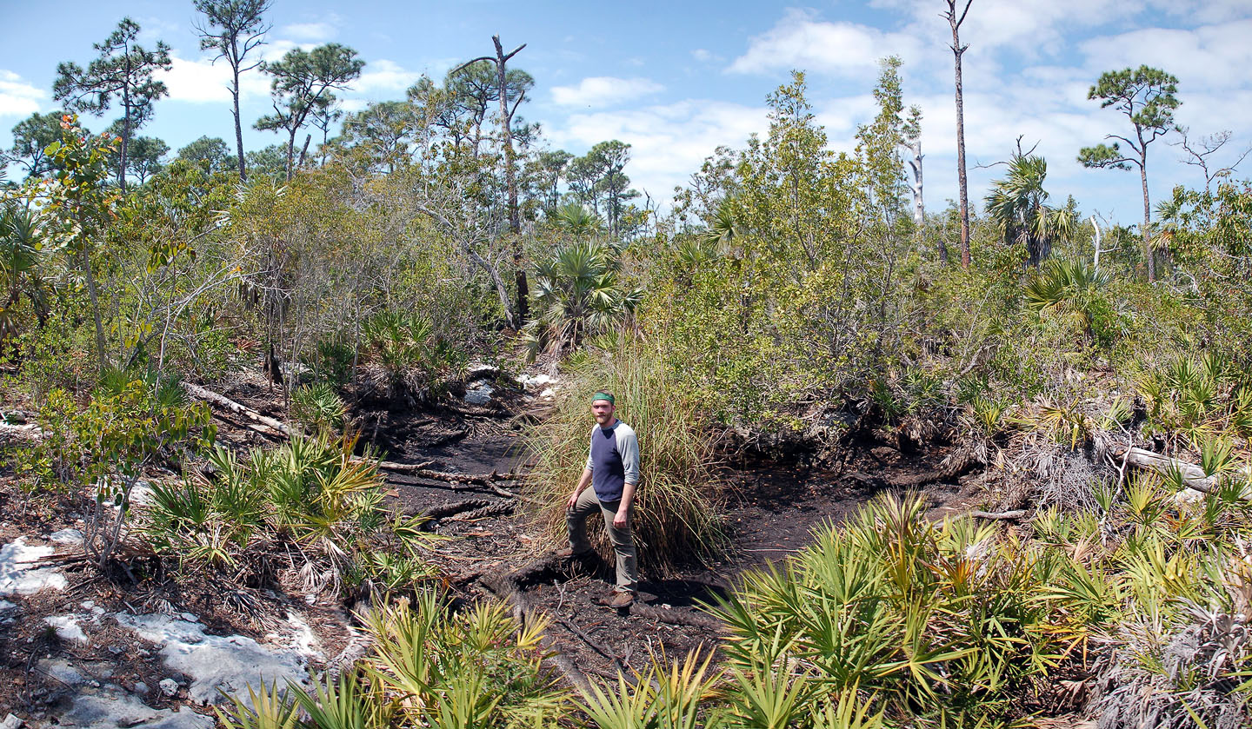
Figure 4.2. Palmetto Pond site on No Name Key (photograph courtesy of Grant Harley, photographer, and Alex Pilote, pictured above).

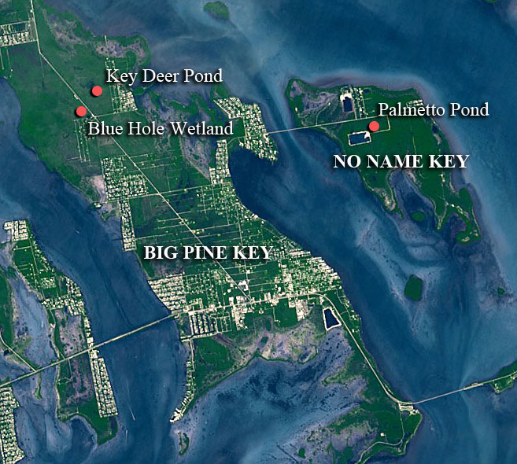
Figure 4.3. Location of Palmetto Pond in relation to the Key Deer Pond and Blue Hole Wetland sites on Big Pine Key. Background satellite image from nasaimages.org; Map by Desiree Kocis.

Laboratory Methods

In July 2010, Matthew Boehm, Sally Horn, and I used a modified router to open the aluminum coring tubes containing the Palmetto Pond core sections. Once each core tube was cut longitudinally, we divided the sediment into two halves using a thin wire. The halves were labeled A, for archive, and B, for sampling. Next, they were photographed and described on core logs in terms of the texture, stratigraphy, and Munsell color. Organic matter concentrations were noted in the core log descriptions.
I sampled the B halves of three successive core sections for macroscopic charcoal at contiguous 1 cm intervals using a brass sampler with a rectangular cutting edge that removes samples with a volume of 4 cm³. I placed each sample in a pre-weighed plastic container, weighed the sample in the container, and added ca 40 ml of 3% hydrogen peroxide (Schlacter and Horn 2010). I left each container in a fume hood for 24 hours. The hydrogen peroxide helped to disaggregate the sample and to slightly bleach some non-charred organic matter, making the charcoal easier to identify, and thereby improving count accuracy. Next, the samples were carefully wet-sieved through 250, 500, and 1000 µm screens using deionized water. Particles retained on each sieve were transferred to a Petri dish and left to dry for 24 hours in a drying oven at approximately 100 ˚C. Once dry, the macroscopic charcoal in each dish was counted under a stereo binocular dissecting scope.

Radiocarbon Dating
S. Horn and I selected larger charcoal fragments and one uncharred plant macrofossil from the Palmetto Pond core sections for AMS radiocarbon dating. The charcoal fragments dated had been pretreated in H₂O₂, sieved, dried, and counted before removal. The macrofossils were dated to determine the chronology of the sediment profile. Analyses were performed by the Center for Applied Isotope Studies at the University of Georgia and by Beta Analytic Laboratory in Miami, Florida. The AMS dates returned were calibrated using CALIB 6.0.2 (Stuiver and Reimer 1993) and the dataset of Reimer et al. (2009). The weighted means of the probability distributions of the calibrated radiocarbon dates were used to create an age-depth model using Microscoft Excel.

Loss-On-Ignition

Adjacent to each 4 cm³ sediment sample for macroscopic charcoal, I removed a 1 cm³ sample for Loss-on-Ignition (LOI) analysis, placed it into a pre-weighed crucible, and weighed the sample and crucible. The LOI samples were then dried at 100 ˚C for 24 hours and reweighed to determine water content. Samples were ignited for one hour at 550 ˚C in a muffle furnace, weighed, and then ignited again for another hour at 1000 ˚C (Dean 1974). Once again they were weighed. This LOI analysis allowed me to estimate the organic, carbonate, and non-carbonate inorganic content of the samples.

Macroscopic Charcoal Analysis
Charcoal was identified based on its characteristic black color and sheen, and by comparison with reference charcoal samples collected at modern burn sites. I classified charred particles into four categories – wood, seed, stem/twig, and leaf. Stem/twig charcoal was differentiated from wood charcoal based on its shape. Stem/twig charcoal was slim, cylindrical, and elongated, while wood charcoal was generally chunky, flatter, and more rectangular with jagged edges. Charcoal counts for each sieve size and each sample were compiled into a spreadsheet and used to produce diagrams indicating fire history trends, possible shifts in climate conditions, and potential Euro-American settlement impacts.
High resolution charcoal records from lakes in boreal and temperate forests are often decomposed into background charcoal and charcoal peaks, with peaks representing fire events (Whitlock and Larsen 2001). Peaks of significance are identified by assigning a threshold value determined by comparing patterns of charcoal peaks in recent sediments with knowledge of historic fires near the site (from written records or tree-ring analyses), through iterative experimentation using different values for thresholds and other variables (Whitlock and Larsen 2001), or by using various statistical methods of peak detection to identify fire episodes in data sets, with fire episodes defined as one or more fires occurring within the sampling resolution of a record (Higuera et al. 2010). None of these methods seem appropriate for identifying fire episodes at Palmetto Pond, where the natural fire regime appears to be much more frequent than in other forests where sedimentary charcoal has been studied. In a recent evaluation of different statistical approaches for decomposing high-resolution charcoal records, Higuera et al. (2010) explained that efforts to identify fire episodes from sedimentary charcoal are most promising when fires are large, burn with high severity, and recur on a time scale about five times the sampling resolution of the charcoal record. Modern circumstances at Palmetto Pond fall short in all three respects. The small size of the island and its upland sector mean that fires are small; from the scarring (but survival) of pines, we know the fires are low rather than high intensity; and based on dendrochronological research (Harley 2012), the average fire recurrence interval in recent decades and centuries has been quite a bit less than the sampling resolution of the Palmetto Pond record, which is ca. 25 years in the top meter.
Thus, the various peak detection methods outlined by Higuera et al. (2010) cannot be used at Palmetto Pond as they are at sites with much longer fire return intervals. Instead, I interpreted the fire record by looking for broader trends in charcoal influx values, which I took to signal periods of greater and lower fire activity rather than particular fire events. I did, however, use a diagram prepared by Higuera et al. (2010) to determine when the number of charcoal fragments in one 1-cm sample was statistically different, at the 99% confidence level, to the number of charcoal fragments in the 1-cm sample taken from the level below. The diagram (Figure 7 in Higuera et al. 2010) displays the minimum required increase in charcoal counts required to separate peak from pre-peak samples as a total number and a proportion. The required increase depends on the level of confidence desired (95% or 99%) and the number of pieces in the smaller, pre-peak sample. Curves in the diagram are created from a test for assessing whether two samples are from the same Poisson distribution. Two lines representing significance levels are shown and presented as absolute counts and percentage increase of the lower count.
I interpolated the required percentage increase in charcoal from the figure in Higuera et al. (2010), and then compared that to the actual percentage increase calculated from the raw charcoal counts in Excel. The required percentage increase necessary to establish a difference at the 99% level varied from ca. 55% for a particle count of 50 pieces to 20% for a particle count of 300 pieces. I considered the samples that met the test to represent peaks in charcoal abundance. However, I use the term “peak” differently than charcoal researchers working at other sites, because I interpreted non-peak samples to also contain evidence of fires. I also looked for sustained intervals of elevated fire activity. Each interval began with an elevated value, or peak, at >99% confidence level. These intervals ended just before the interval in which the charcoal count dropped sharply, to a count significantly lower than the count at the end of the elevated fire activity interval.

CHAPTER 5
Results
Coring Results

Using 1-m long coring tubes, our coring team recovered six sediment core sections from three positions (“holes”) in Palmetto Pond. From Holes 1 and 2, we recovered only incomplete sections of the first meter of sediment. From Hole 3, we recovered three successive 1 meter long core sections and an overlapping, shorter core section near the base. For the first core section, we pushed for one meter but recovered only 77 cm of sediment, either because of compaction or because some sediment did not enter the core tube. In the second core section from 1 to 2 m we recovered 100 cm of sediment, and in the third core section from 2 to 3 m we recovered 99 cm of sediment. The third core section ended on rock. However, by pounding we apparently broke through the rock to recover an additional short core section. Based on field measurements, this fourth core section overlapped the material already recovered by ca. 5 cm, covering the interval from 2.95 to ca. 3.35 m. However, because of some uncertainty about the true degree of overlap of the cores, and time constraints, I did not examine this core section. The macroscopic charcoal and LOI record that I produced for Palmetto Pond is based on the first three core sections.

Stratigraphy of Profile
The profile I examined is 3 m long, but has some gaps. The first, from 77–100 cm, may not be a true gap. As above, the 77% recovery we obtained in this first meter may be due to compaction, with no sediments actually missing. A large section of dark brown to bright, brownish-yellow wood, assumed to be remains of a tree fall, created a gap in the profile from 110–153 cm (Figure 5.1). A smaller section of bright brownish yellow wood spans 192–209 cm in the profile. Three rock intrusions (171–181 cm, 220–227 cm, and 236–256 cm) also exist, and prevented charcoal sampling at those intervals.
From 299–275 cm in Hole 3, the sediment was very wet and rocky, with abundant carbonate (Munsell 2.5 Y 6/4–2 Y 6/4) (Table 5.1). This section was too dense with rock to sample. Between 274 and 165 cm, the sediment was not as wet, but still carbonate-rich and dense with rock fragments (10 YR 2/1–3/2 with 8/2 carbonates) (Table 5.1). Sediment from 164–0 cm was composed of dark, peaty organics (10 YR 2/1) and did not contain as much rock or carbonate (Table 5.1).

Radiocarbon Dating
AMS radiocarbon dating of plant material at 247 cm depth in the Palmetto Pond profile indicates that the record extends from -60 cal yr BP (AD 2010) to 4466 cal yr BP. Three AMS dates on charcoal higher in the profile are in stratigraphic order (Table 5.2). A fourth AMS date (1877 cal yr BP) was obtained for a charcoal piece immediately below a large piece of wood, and appears too young by more than 1000 years (Figure 5.2). This charcoal may have come from charred bark and may represent the time at which the tree fell onto, and sunk into, the sediment of Palmetto Pond. I considered this date unreliable and did not use it in estimating sediment ages.

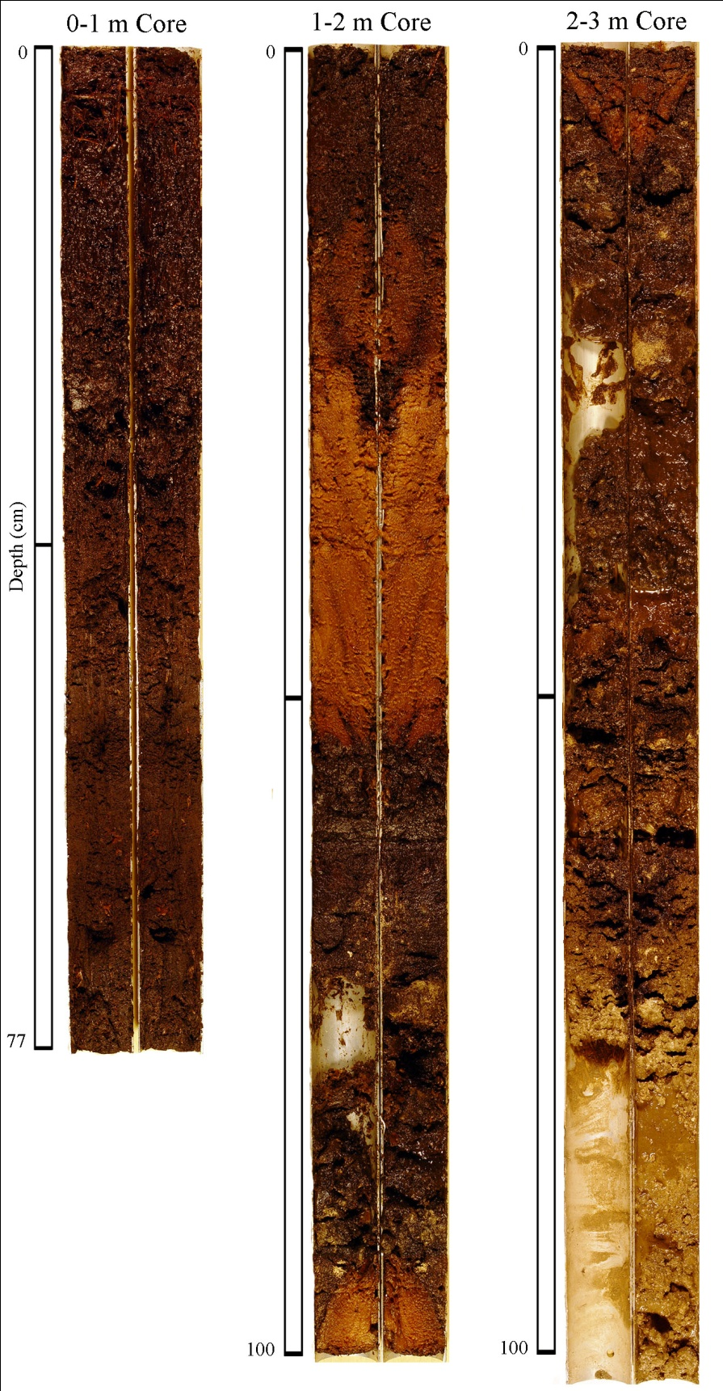
Figure 5.1. Sediment stratigraphy at Palmetto Pond. Core lengths are labeled at the base of each section. Center bars show the mid-points of the core sections. The 2-3 m core appears longer than 100 cm because the sediment was very wet at the base and slid in the core tube.
Table 5.1. Sediment stratigraphy of the Palmetto Pond profile

Depth | Sediment Description | Munsell Colors
0–77 cm | Peaty sediment with | 10 YR 2/1
 | abundant woody debris
77–100 cm | Sediment gap
100–110 cm | Organic-rich sediment | 10 YR 2/1
110–153 cm | Wood, dark brown | Not recorded
 | to bright brownish yellow
153–165 cm | Wet, organic-rich sediment | 10 YR 2/1 to 8/2
 | intermixed with carbonate
 | sediments and rock
165–191 cm | Wet sediment with low organic | 10 YR 2/1 to 8/2
 | content and abundant rock
191–209 cm | Wood, bright brownish yellow | Not recorded
209–263 cm | Mainly low- organic sediment | 10 YR 2/1 to 3/2 with
 | with dense carbonate and | 8/2 carbonate
 | rock debris
263–274 cm | Low-organic sediment with | 10 YR 2/1 to 6/3
 | dense carbonate and rock
 | debris, becoming wetter with
 | depth
274–292 cm | Wet, muddy sediment with | 2.5 Y 6/4
 | dense rock debris
292–299 cm | Very wet, rocky sediment | 2 Y 6/4

Table 5.2. AMS radiocarbon determinations and calibrations for samples from the Palmetto Pond profile.

Lab numberª | Core section  and interval | Depth in profile (cm) | Material dated | δ¹³C (‰) | Uncalibrated ¹⁴C  age (¹⁴C yr BP) | Calibrated age range^{b} ± 2 σ | Area under probability curve | Weighted mean^{c}
UGAMS #9073 | 0–1/72–73 cm | 72.5 | charcoal | –26.5 | 1820±25 | 1823–1698 | 1.000 | 1761
UGAMS #9074 | 1–2/9–10 cm | 109.5 | charcoal | –26.6 | 2350±25 | 2370–2322  2457–2387 | 0.810  0.190 | 2365
β-293749 | 1–2/55 cm | 155.0 | charcoal | –25.6 | 1930±30 | 1947–1820 | 1.000 | 1877
UGAMS #9075 | 2–3/18–19 cm | 218.5 | charcoal | –26.5 | 3670±30 | 4087–3906 | 1.000 | 4006
β-282461 | 2–3/47 cm | 247.0 | plant material | –24.8 | 3990±40 | 4327–4299  4369–4354  4393–4388  4569–4400 | 0.023  0.014  0.003  0.960 | 4466

ªAnalyses were performed by the Center for Applied Isotope Studies at the University of Georgia (UGAMS), and by Beta Analytic Laboratory in Miami, Florida (β)

^{b}Calibrations were calculated using CALIB 6.0.2 (Stuiver and Reimer, 1993) and the dataset of Reimer et al. (2009).

^{c}Weighted mean of the 2 σ calibrated radiocarbon probability distribution.

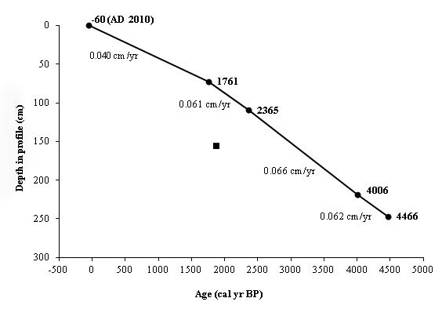
Figure 5.2. Age/depth diagram for the Palmetto Pond sediment profile, showing sedimentation rates. The black square indicates the date exluded from analysis. The cal yr BP ages are the weighted means of the probability distributions of the calibrated ages and coring year (top age value).

Sedimentation rates were fairly consistent through the profile, varying from 0.040 cm/yr to 0.066 cm/yr (Table 5.2). Sedimentation was slowest (0.04 cm/yr) from 1761–
-60 cal yr BP (AD 189–2010) and fastest (0.066 cm/yr) from 4006–2365 cal yr BP
(2056 –415 BCE). Before 1761 cal yr BP, each centimeter of sediment represents ca. 15–16 years of accumulation. After this time, each cm represents ca. 25 years.

Loss-On-Ignition

The loss-on-ignition values at Palmetto Pond closely matched up to the visual stratigraphy of the core (Figure 5.3). Between 258 and 166 cm, the sediment was not very organic (<50% dry weight). Non-carbonate inorganic content and carbonate content were high, with values ranging from 38–68% and 11–33%, respectively. Sediment from 165–0 cm was highly organic (>70% dry weight), with lower non-carbonate inorganic content (<25%) and minimal carbonate content (<3%).

The Macroscopic Charcoal Record
Contiguous sampling of the Palmetto Pond sediment profile revealed that every centimeter of sediment contained charcoal in at least one of the size classes investigated, >1000 µm, 500–999 µm, and 250–499 µm. Charcoal concentrations, expressed as charcoal particles per wet sediment volume, and charcoal influx, expressed as charcoal particle accumulation per cm² per year, showed some variation by size class. Total charcoal concentration and influx values (all particles >250 µm) varied from 4–172.25 particles/cm³ and 0.25–10.67 particles/cm²/yr. Charcoal concentration and influx values
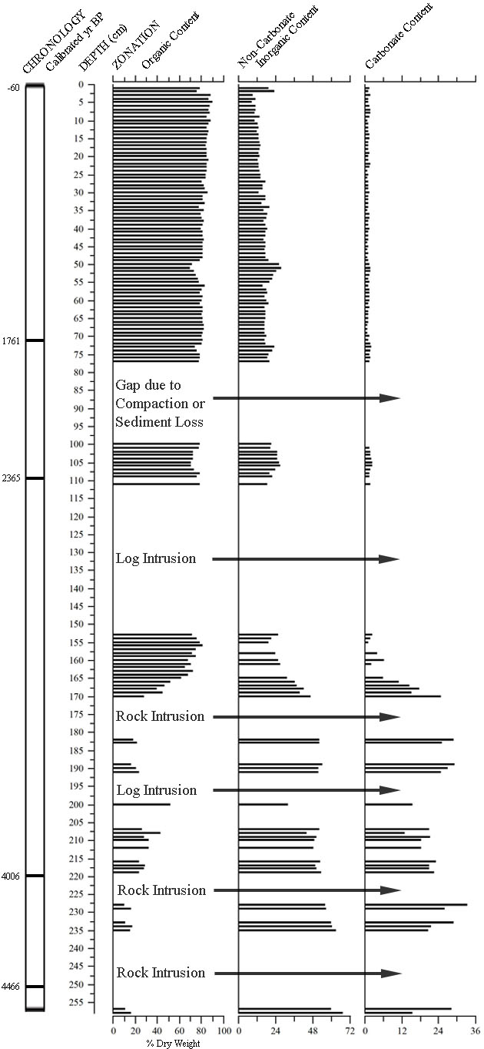
Figure 5.3. Loss-On-Ignition results from Palmetto Pond.
were elevated between 179 and 53 cal yr BP (9–4 cm) (Figures 5.4 and 5.5). They were highest from ca. 631–329 cal yr BP (27–15 cm) (Figures 5.4 and 5.5). High values also occurred from ca. 1794–1736 cal yr BP (74– 71 cm) and from ca. 3268–3208 cal yr BP (169–165 cm). Thirty-three 1-cm intervals were identified as peaks in charcoal abundance based on the percentage increase in charcoal from the sample below (Table 5.3, Figure 5.6).
Wood charcoal accounted for more charcoal than any other category examined (stem/twig, leaf, and seed), with percentages from 4.62–91.43% (Figure 5.7). Stem, twigs, and other elongated charred plant material made up the next highest percentage, varying from 0–83.43%. Charred leaf material made up 1.75–71.88% of the total charcoal count. Seeds were the least dominant charred material, generally accounting for less than 5% of the charred particles tallied, except for a section with abundant charred seeds between 45 and 52.5 cm in the sediment profile.
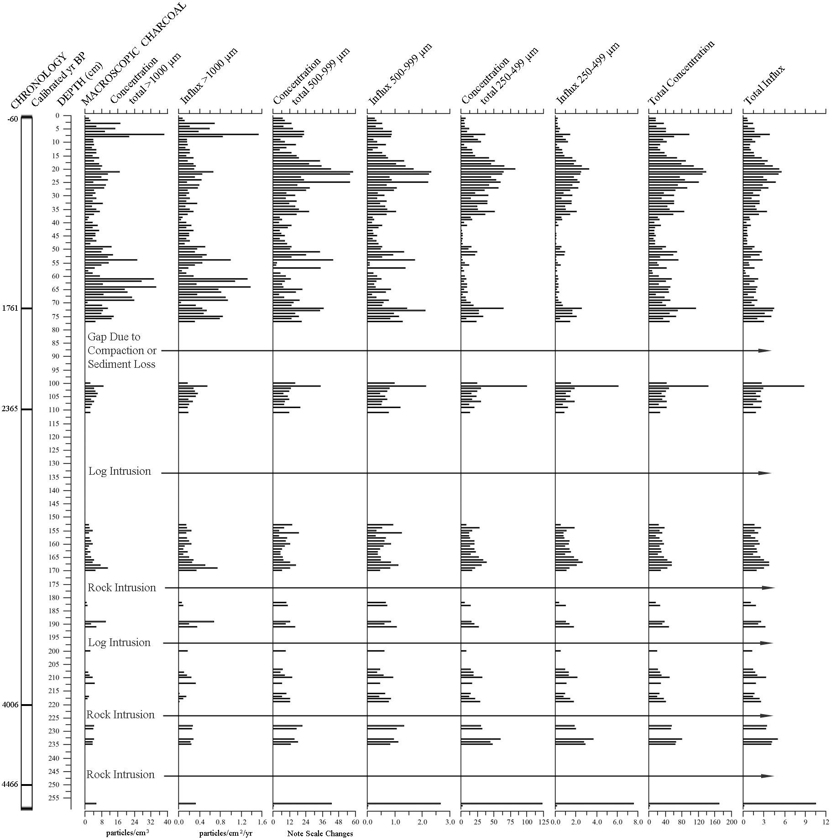

Figure 5.4. Macroscopic charcoal concentration and influx values for all size classes at Palmetto Pond, plotted by depth in profile.

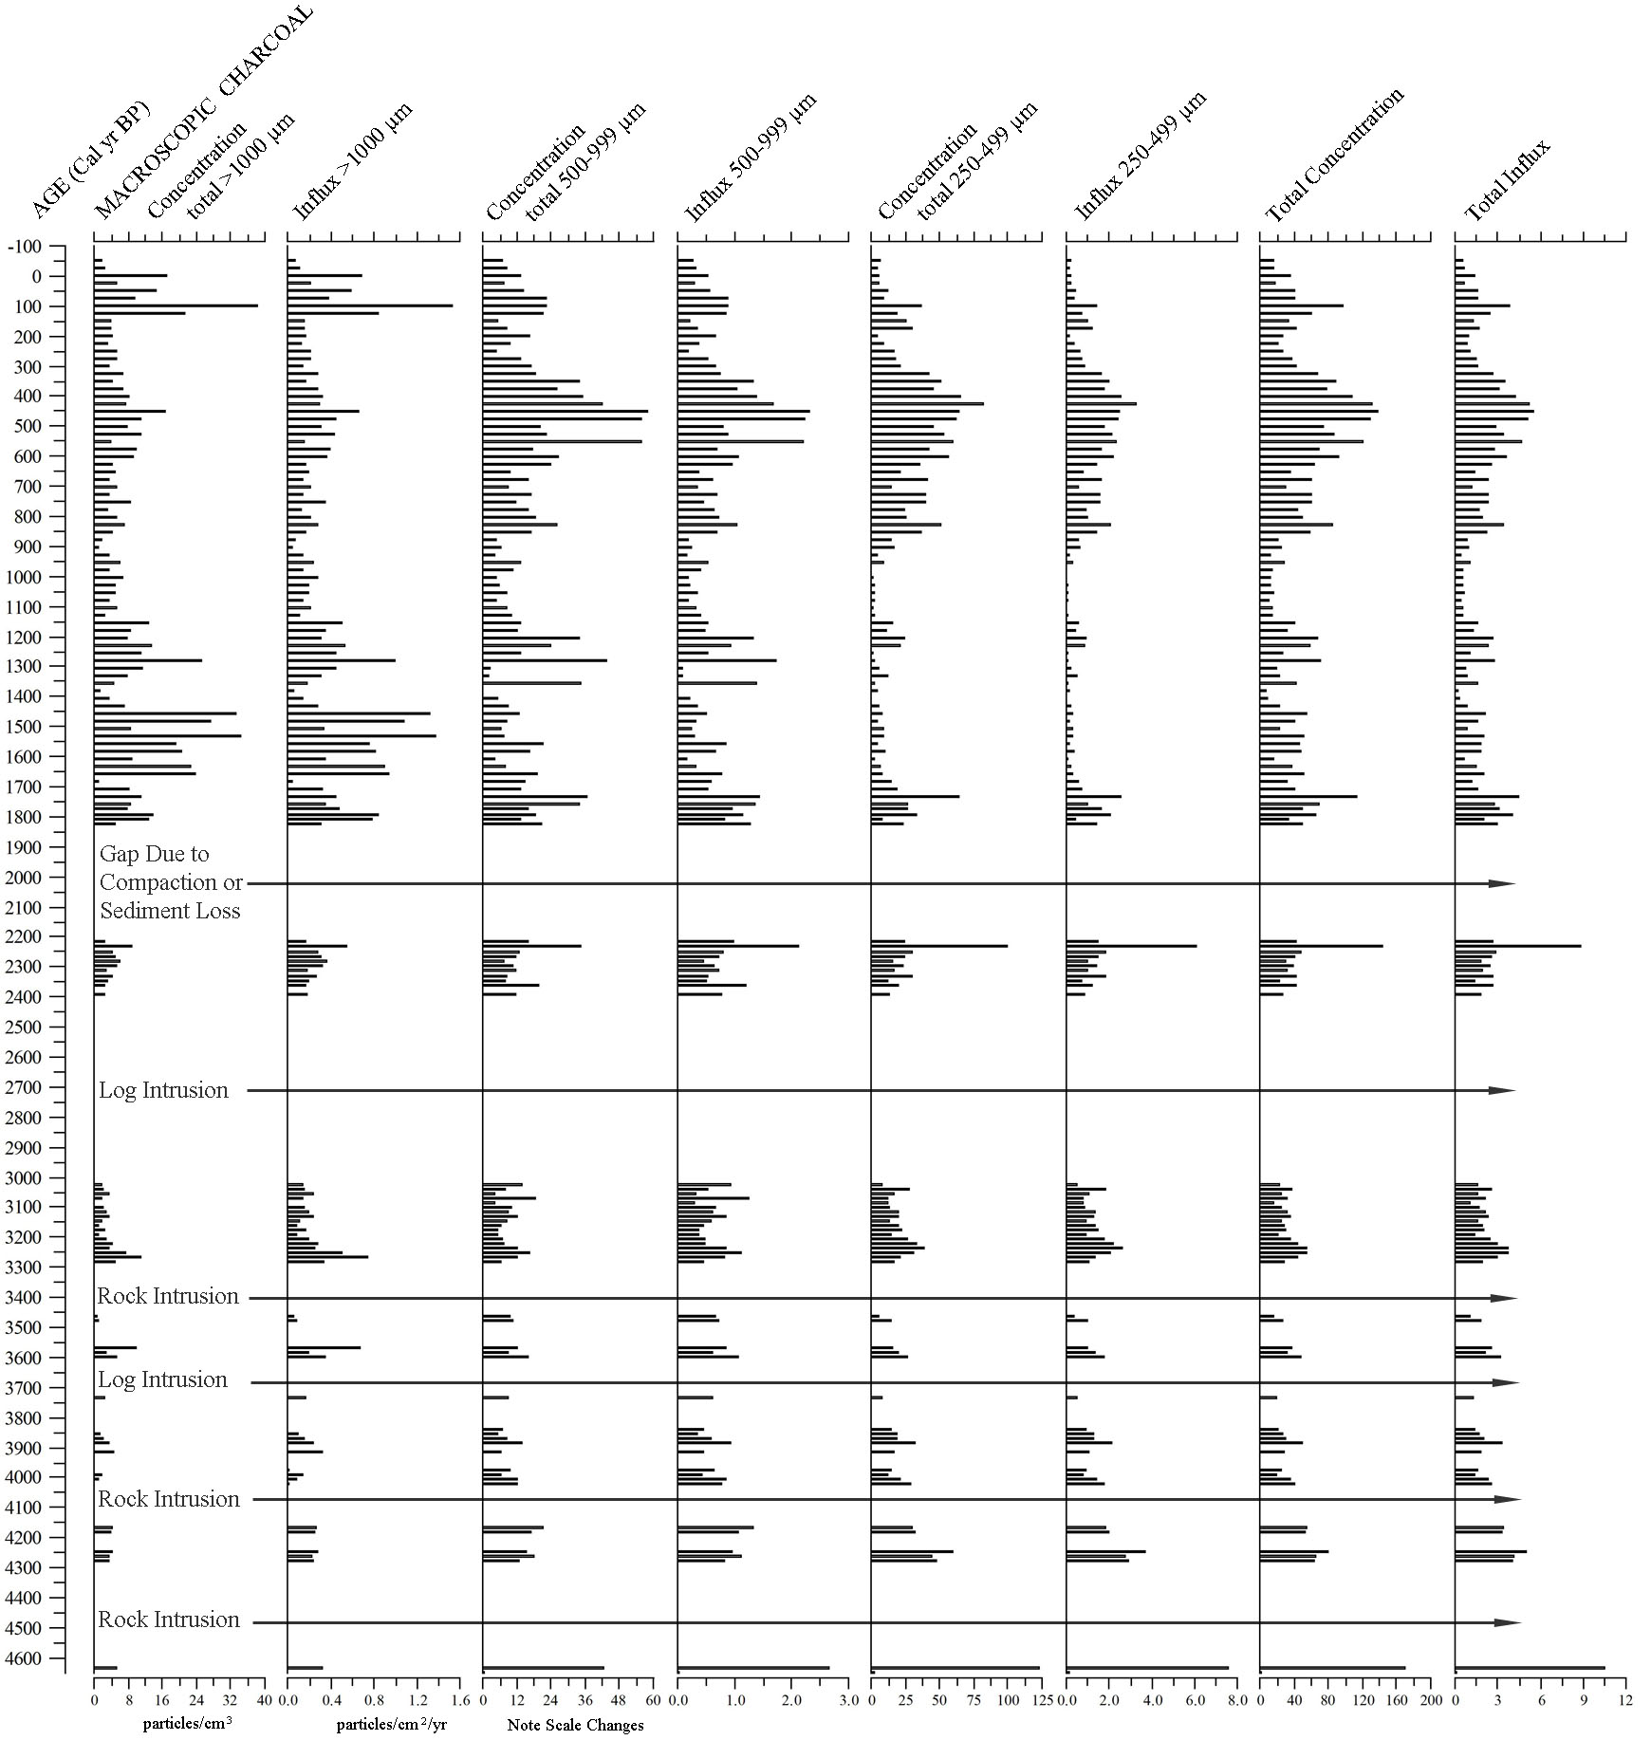

Figure 5.5. Macroscopic charcoal concentration and influx values for all sizes classes at Palmetto Pond, plotted by interpolated age.

Table 5.3. Depth and interpolated age for each sample in the Palmetto Pond record that had statistically more charcoal (99% confidence) than the sample below it, based on values interpolated from Figure 7 in Higuera et al. (2010). These samples were considered charcoal peaks, but at Palmetto Pond samples in between peaks also indicate fires.

Depth (cm) | Age (cal yr BP)
2 | 3
6 | 103
7 | 128
9 | 179
21 | 480
24 | 555
26 | 606
27 | 631
29 | 681
32 | 756
35 | 832
36 | 857
38 | 907
40 | 957
51 | 1234
53 | 1284
56 | 1359
60 | 1460
61 | 1485
65 | 1585
68 | 1661
71 | 1736
72 | 1761
74 | 1794
101 | 2234
103 | 2267
107 | 2332
154 | 3042
156 | 3073
160 | 3133
163 | 3178
169 | 3268
257 | 4635
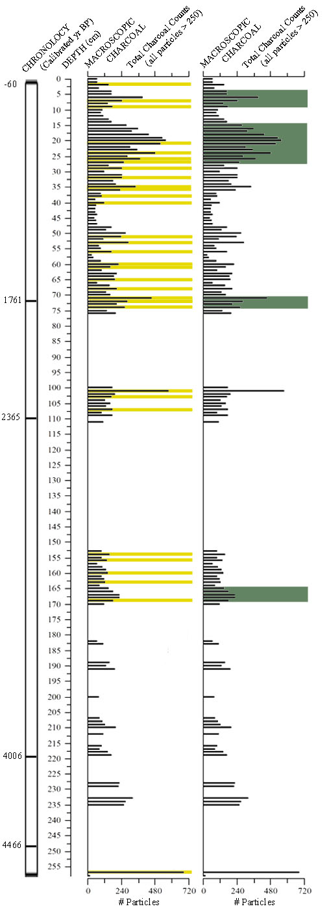
Figure 5.6. Total charcoal counts for Palmetto Pond based on samples of 4 cm³ volume. Yellow highlights show 1-cm samples that had statistically more charcoal than the contiguous sample below (“charcoal peaks” in my terminology; see text and Table 5.3). Green highlights show intervals in which higher charcoal abundance can be seen across multiple samples.
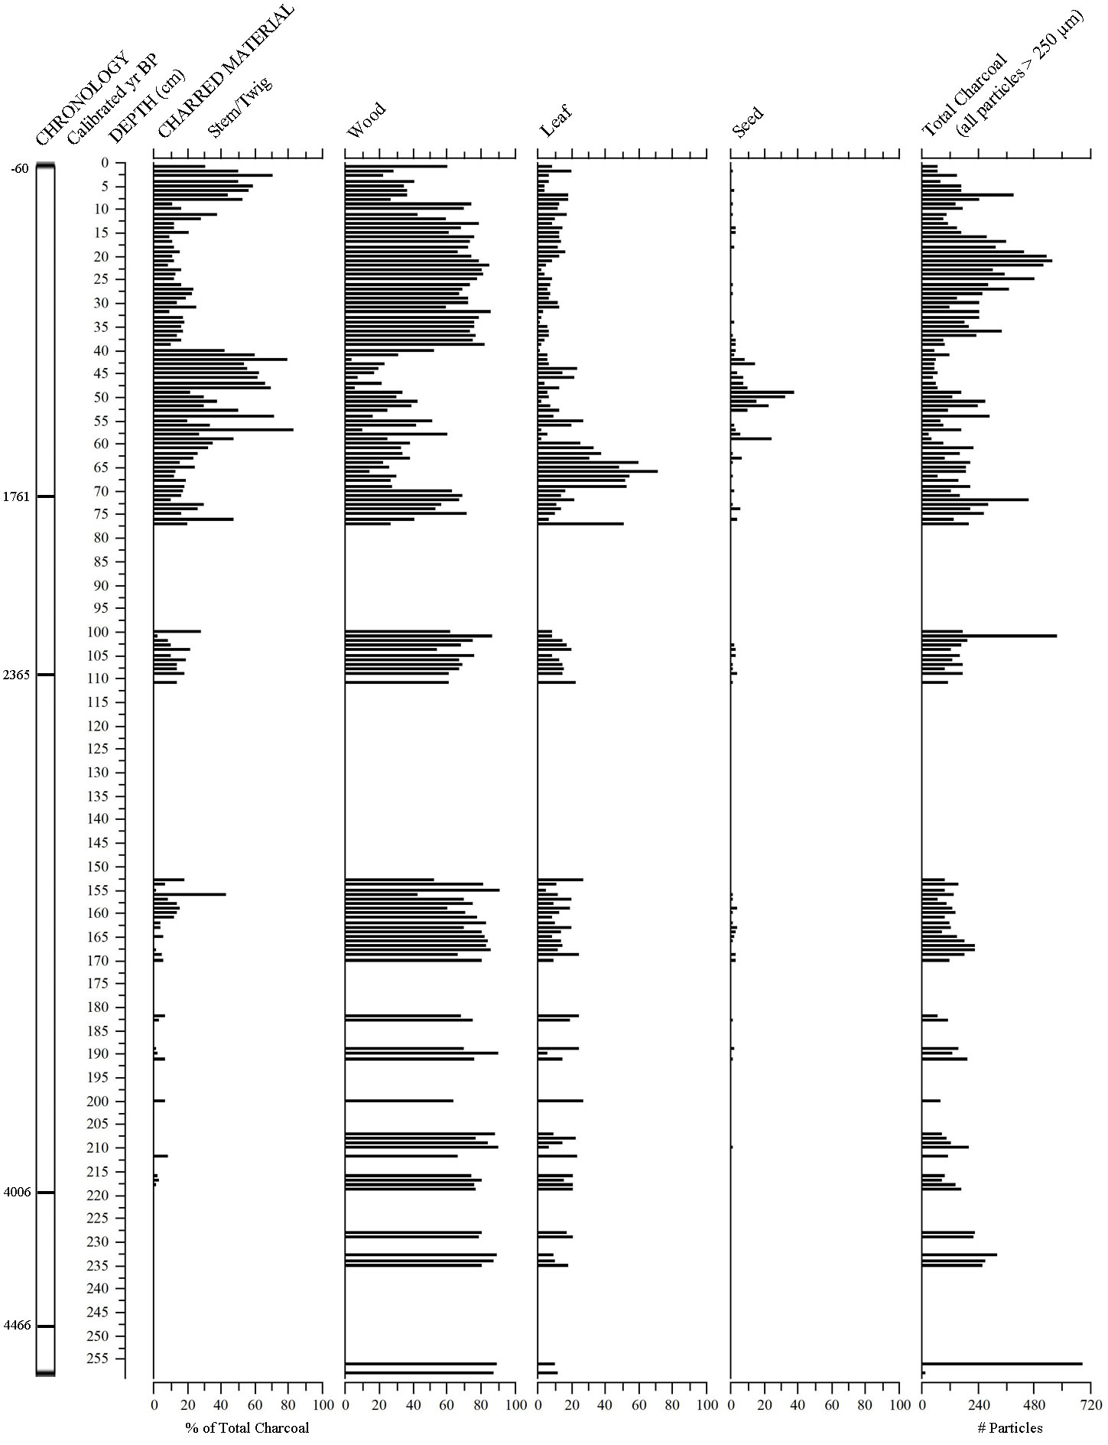
Figure 5.7. Categories of charred material counted as charcoal, including stem/twigs, wood debris, leaf, and seed. Each category is displayed as a percentage of the total charcoal count of all particles >250 µm in each 4 cm³ sample.

CHAPTER 6
Discussion

Macroscopic charcoal in the sediment profile from Palmetto Pond provides a ca. 4500-yr record of fire history in pine rocklands on No Name Key. My results complement and extend previous paleoenvironmental work on fire history in the Lower Florida Keys, indicate long-term presence of fire in the pine rocklands, document potential climate effects on fire dynamics, and reveal potential anthropogenic influences on fire occurrence. Below, I discuss my analysis of the evidence I uncovered regarding the research questions posed in Chapter One.

What general trends can be determined from the fire history on No Name Key in the Lower Florida Keys using macroscopic charcoal analysis?
The Palmetto Pond macroscopic charcoal record shows that fire has been a recurrent element of the rockland ecosystem on No Name Key since at least ca. 4500 cal yr BP. Every contiguous 1-cm section of the profile contained macroscopic charcoal, indicating local fires. The minimum number of charcoal fragments was 16 and the average was 187, attesting to the importance and regularity of fire at the site.
The finding of abundant charcoal throughout the profile is consistent with the interpretation that pine rocklands of the Lower Keys are a fire-dependent ecosystem characterized by frequent surface fires (Snyder et al. 1990, Ross et al. 1994, USFWS 1999, Albritton 2009). Fire return intervals in the pine rocklands are estimated at once every 3–7 years (Snyder 1991, USFWS 1999). Each 1-cm section in the Palmetto Pond profile represents between ca. 15 and 25 yrs, based on my age model. Given this temporal resolution, the Palmetto Pond record does not provide a basis for testing the long-term persistence of a 3–7 year fire return interval. However, the presence of charcoal in each 1-cm section suggests the occurrence of at least one fire every ca. 25 years over the last ca. 1800 years, and every ca. 15 years during the preceding two millennia.
This interpretation is based on the idea that charcoal produced when the vegetation surrounding Palmetto Pond burns is deposited in the pond during or soon after the fire, or falls into a crevice or depression in the rockland surface where it is not available for subsequent transport to the lake. As mentioned previously, researchers who study fire history from lake sediments in ecosystems with long fire-return intervals often use computer programs designed to separate charcoal “peaks” (indicating fires) from “background” charcoal that moves into a lake during fire-free intervals. Because the estimated fire return interval in pine rocklands, compared to the temporal resolution of the Palmetto Pond record, falls far short of the ideal value of 5 (instead the value is about 1/5), this type of analysis is not possible with the Palmetto Pond record. But, the shallow to absent soils of the rockland under conditions of frequent fire, and the abundant pits and crevices in the rockland surface, suggest that there may not be much background charcoal influx. This hypothesis needs to be tested by placing sediment traps in rockland ponds or in some other way monitoring charcoal influx immediately and long after fires.
While it appears inappropriate to recognize peaks in the charcoal record of Palmetto Pond as individual fires, as every 1-cm interval may potentially record a fire, it is possible to use variations in charcoal influx to infer periods of greater or lesser fire activity. I identified 33 levels as charcoal peaks that contained significantly more charcoal than the level below, and visually identified four general intervals of increased fire activity. Several other smaller intervals of increased fire activity can be visually assessed from the charcoal diagram, but, unfortunately, many gaps exist in the fire history record. Some of these inferred intervals of higher fire activity may relate to anthropogenic impacts or shifts in climate.

Do charcoal influx values reveal any sudden change or changes in fire activity that could be related to initial human occupation on No Name Key, either by Indigenous populations or by Euro-Americans beginning the in the 1800s?
Changes in influx values at Palmetto Pond do not definitively reveal initial human arrival on No Name Key, although they do appear to show more recent effects of humans on fire history. The archaeological record in the Keys is scant, but Native American settlement may have begun about 3000 years ago. A long interval of low charcoal followed by a sustained increase may be indicative of human arrival (Burney et al. 1994, Burney and Burney 2003). Several statistical peaks in charcoal occur between ca. 3300 and 3000 cal yr BP, but influx values do not show a sustained increase over previous values. Gaps in the record above and below this interval complicate the detection of a possible signal of human arrival, and with the data at hand there is no reason to attribute fires at this time to a human cause.
Charcoal concentration and influx values are highest from ca. 631–329 cal yr BP (Figure 5.5.). Beginning in the 1500s, historical records by Europeans document Native American presence in the Keys. These dates broadly correspond with the increase in charcoal at this time, so it is possible that this sustained increase in fire activity may be related to indigenous impacts on No Name Key.
No Name Key was settled by Bahamians and others beginning around AD 1870 (80 cal yr BP), and occupied by Cubans in the late 1800s. A large spike (2 adjacent peaks) occurs in the 19th century charcoal record ca. 128 and 103 cal yr BP (AD 1822 and 1847, Figure 5.5), predating the known arrival of settlers. It is possible that this spike could be attributed to human activity, because some nearby islands, such as Key West, experienced settlements ca. AD 1750 (200 cal yr BP). However, neighboring Big Pine Key had minimal human activity (~ 1 occupant) until the 1900s. It does not appear that human settlement on No Name Key had a strong effect on fire activity, and may have actually reduced it.
Human presence on No Name Key reduced sharply following the 1935 Labor Day hurricane and resettlement did not occur until the 1970s. Compared with the previous 1000 years of fire history, the charcoal record takes a large dip beginning shortly after the time of the hurricane event, in the upper two samples of the record. The interpretation of the most recent part of the charcoal record as reflecting fewer widespread fires is consistent with the dendrochronological record of fire history (Harley 2012).

How do findings compare with similar sedimentary charcoal work done on Big Pine Key? How do results compare with ongoing dendrochronological work in the Florida Keys?
Similarities in charcoal records are seen across the three sites on Big Pine Key and No Name Key, with all three records having in common the presence of charcoal in all samples studied. Just as at Palmetto Pond, Blue Hole Wetland and Key Deer Pond have produced microscopic and macroscopic charcoal records revealing a long, constant presence of fire in the Lower Keys. The Blue Hole Wetland record covers ca. 2000 years of fire history, with each centimeter representing ~5 yrs, but was not sampled at high resolution (Malik 2010). The Key Deer Pond charcoal record extends back to 1660 cal yr BP, with each cm of sediment representing from ca. 2.5–10 years of accumulation (Albritton 2009). While the entire profile was sampled for microscopic charcoal, only the upper ca. 1 m was processed for macroscopic charcoal. The record at Palmetto Pond goes much further back in time (ca. 4500 cal yrs BP) than these two sites, extending the evidence for repeated fires through the entire late Holocene. However, the Palmetto Pond record does not have as fine a temporal resolution (15.2–25 yrs/cm).
Of the five distinct peaks found in the microscopic charcoal record of Key Deer Pond (18, 177, 357, 548, and 883 cal yr BP, Albritton 2009), all but one (357 cal yr BP) correspond to times of high macroscopic charcoal influx at Palmetto Pond. Two of the Blue Hole Wetland peaks (Malik 2010) match peaks at both sites. It is important to note that these dates are based on interpolated ages that assume constant sedimentation between AMS-dated core intervals, in some cases with large intervals between dates. Thus, exact correspondence between these records would be unlikely.
The interval of the Palmetto Pond record with the highest charcoal influx values and inferred highest fire activity occurs between ca. 631–329 yr BP, dips to lower values for ca. 100 years, then rises again from ca. 179–53 cal yr BP (Figure 5.5). The rises in activity correspond to times when microscopic charcoal at Key Deer Pond also shows important peaks, and may be attributed to the Little Ice Age, a time recognized to have been drier in south Florida (Willard 2006) and the circum-Caribbean (Hodell et al. 2005).
A strong peak at Palmetto Pond seen shortly before AD 1950 is also evident in the Key Deer Pond microscopic charcoal record (Albritton 2009). The peaks from these two records may be attributed to the two major hurricane events that struck the Florida Keys and its surrounding region in 1919 and 1935. Finally, both the Palmetto Pond and Key Deer Pond records show recent reductions in fire activity. This is likely attributed to fire suppression practices on the currently inhabited islands.
A similar shift in recent fire activity (since AD 1950) was noted in the tree-ring records on Big Pine Key and No Name Key (Harley 2012). Harley (2012) identified 13 widespread fires on Big Pine Key, with only three of those recorded since the establishment of the National Key Deer Refuge in 1957. Those three fire events (AD 1977, 1990, and 2004) are attributed to prescribed burns conducted by fire management personnel. Only two fire events were recorded at No Name Key since the establishment of the refuge (1992 and 2003), both of which were prescribed burns. His findings indicate that after the NKDR establishment, fires became more frequent, but less widespread. Harley also suggested that relatively frequent surface fires prevailed from the 1850s to the 1950s, a time when increased fire activity was noted in the macroscopic charcoal records for Key Deer Pond (ca. 110–40 cal yr BP) and Palmetto Pond (ca. 179–53 cal yr BP). The recent fire history from tree rings shows fewer fires on No Name Key than Big Pine Key, echoing findings from the macroscopic charcoal record, which shows lower charcoal influx at Palmetto Pond than Key Deer Pond.

Is there evidence of changes in the fire activity as reflected by charcoal influx during times of known shifts in climate conditions?
Changes in charcoal influx in the Palmetto Pond record show some relation to known shifts in regional climate conditions, such as during the Medieval Warm Period and Little Ice Age. I interpret fires in the pine rocklands prior to European arrival to have been primarily lightning-induced. Periods of drought can result in greater instances of fire events due to increased drying of fuels, causing them to be more likely to ignite.
Following generally wet conditions in the middle Holocene, regional climate became drier beginning 4000–3000 cal years BP, with a marked drying episode from 2400–1500 cal years BP (Hodell et al. 1991, Hodell et al. 2000, Brenner et al. 2001). Because of the frequency and size of gaps in the charcoal record before 1826 cal yr BP, associations with regional climate conditions are tenuous for portions of the Late Holocene. An increase in fire activity occurred from ca. 1843–1761 cal yr BP and was followed by moderate fire activity until ca. 1183 cal yr BP, around the beginning of the Medieval Warming Period (MWP) (ca. 1150–750 cal yr BP) began. A peak in charcoal ca. 1485 cal yr BP corresponds with a similar peak found in a sediment core from Abaco Island, The Bahamas ca. 1500 cal yr BP (West 2007), suggesting a possible period of regionally high fire activity around this time.
Following the onset of the MWP, a strong decrease in fire activity occurred, with charcoal influx reaching lowest values between 1158–1007 cal yr BP. Having low fire activity when regional climates were generally dry seems contradictory. However, Hodell et al. (2005) identified moist periods within the generally dry interval of the Terminal Classic drought (ca. 1180–850 yr BP). After ca. AD 1050, climate became drier (Hodell et al. 1991). The transition to a drier period can be seen in the Palmetto Pond charcoal record. Fire activity picks up from 1007–731 cal yr BP, coinciding with the driest period of the Terminal Classic drought (Hodell et al. 2005, Richey et al. 2007). The increased fire activity that occurred from 631–329 cal yr BP, and peaked 480 cal yr BP, is likely attributed to the even more extreme drying conditions that began with the Little Ice Age (450–100 yr BP) (Hodell et al. 2005). The 480 cal yr BP peak in fire activity coincides with the onset of that dry period. Another large peak ca. 103 cal yr BP (AD 1847) is seen in the Palmetto Pond charcoal record, as well as in the No Name Key fire record from tree rings (Harley 2012). This increased burning may relate to drier conditions during the Little Ice Age.
Strong wind and rain activity during hurricane events result in a sharp increase in ground leaf litter and other organic debris. This increased fuel load has been linked to large fires along the Gulf of Mexico coast shortly after major hurricane events (Liu et al. 2003, Liu et al. 2008). Evidence of this hurricane-fire correlation may be present in the Palmetto Pond charcoal record. In 1935, the second strongest hurricane to make landfall in U.S. history struck southeastern Florida (Blake et al. 2011, Wilkinson 2011a). The Labor Day Hurricane, as it was called, was a category 5 storm that brought peak wind speeds of 295 km/hr (185 mi/hr) (Blake et al. 2011, Wilkinson 2011a). Higher charcoal influx at Palmetto Pond shortly before AD 1950 (in the 2–3 cm sample) may be attributed to this storm, giving greater credibility to the hurricane-fire correlation argument. The tree-ring record of past fires on No Name Key shows definite evidence of burning near Palmetto Pond in 1936 (Harley 2012). These post-hurricane fire or fires cannot be attributed to human activity on No Name Key because the island was largely uninhabited from 1935–1970. European settlers employed fire suppression techniques until the establishment of NKDR, so it is possible that the abandonment on No Name Key by humans ca. 1935 actually resulted in a larger fire event, or greater increase in fire activity, than would have occurred if they had remained on the island.
Loss-on-ignition analysis is a valuable tool for detecting overwash sand layers and lithological changes in lake sediment cores related to hurricane events (Liu and Fearn 2000, Liu et al. 2008). Thick sections of organic material can indicate the increased leaf litter load that follows major hurricanes (Whelan and Smith 2006, Liu et al. 2008). Charcoal peaks immediately above these thick layers suggest hurricane-related fire events (Liu et al. 2008). A small peak in the proportion of charcoal from leaves in the Palmetto Pond record is not seen in the sample with the charcoal peak I associate with the 1936 fire, but is seen in the sample above.
A large increase in the proportion of charcoal from leaf litter occurred in the record between 1661–1434 cal yr BP. At this time, the proportion of charcoal from wood, stems/twigs, and seeds is low. While four peaks in the charcoal record are seen during this period (1460, 1485, 1585, and 1661), no sustained increase in overall charcoal concentration or influx occurs. Hurricane records are not available from the Florida Keys for this period, but based on studies that show that increased leaf litter follows major hurricanes (Whelan and Smith 2006, Liu et al. 2008), I interpret this increase in charred leaf pieces as possible evidence of heightened hurricane activity. The timing of the increase in charred leaf litter is interesting in that it comes near a time of transition from dry to moist conditions at sites in the circum-Caribbean region (Hodell et al. 2000).

CHAPTER 7

Conclusions

The Palmetto Pond record provides a ca. 4500-year history of fire in pine rocklands on No Name Key, Florida. Macroscopic charcoal was found in every interval of this record and similar records on Big Pine Key, adding weight to previous assertions that pine rocklands are characterized by frequent fires. Fluctuations in the macroscopic charcoal record from Palmetto Pond show some association with climate shifts during the Late Holocene. A powerful 1935 hurricane appears to be shown in the charcoal and tree-ring records at No Name and Big Pine Keys. This finding suggests that future inference concerning hurricane activity in pine rocklands may be made using similar proxy records from lake-sediment profiles. A sustained increase in the proportion of charcoal from leaves in the Palmetto Pond record from 1661–1434 cal yr BP may be indicative of heightened hurricane activity.
It is believed that prehistoric, large-group settlements on the Keys began ca. 3000 yrs BP. Several statistical peaks in charcoal abundance occur between 3300 and 3000 cal yr BP, but equivalent charcoal levels lower in the profile and gaps in the sediment profile after this time lead me to reject the idea that these peaks are related to the initial arrival of Native Americans on No Name Key. A sustained increase in charcoal concentration and influx values ca. 631–329 cal yr BP is more likely to be attributed to indigenous activity, although it may also be attributed to the drying effects of the Little Ice Age. The fire history of No Name Key was not likely affected by non-Indigenous people (e.g. Europeans, Bahamians, Cubans, or Americans) until the 1900s, when the practice of fire suppression appeared to decrease fire occurrence.
That the pine rocklands on No Name Key are considered endangered because of rises in sea level, urbanization, and human impacts on the natural fire regime makes the continuation of this line of fire history research essential for strengthening preservation efforts in the pine rockland communities within the NKDR, as well as in other locations in southern Florida and The Bahamas. These studies offer a long-term perspective on fire history for this endangered ecosystem, information that can help managers develop appropriate land management practices. These studies may also help educate local land owners, many of whom currently do not understand or accept the use of prescribed fires in the region, seeing them as both destructive and a burden.
Pollen analysis of the Palmetto Pond sediments would be useful for showing whether changes in vegetation have occurred on No Name Key, and could complement and strengthen interpretations of the charcoal record at this site. Future research on the 2010 sediment cores from Coco Plum and Balsa ponds on Big Pine Key will help verify some of my interpretations of the macroscopic charcoal record. Additional insights into the fire history of the pine rocklands in the Lower Keys could also be provided by continued sampling of the macroscopic charcoal record at Key Deer Pond. Obtaining more radiocarbon dates at Palmetto Pond will strengthen the chronology of the fire record. Meanwhile, dendrochronological research on fire history on No Name Key confirms the recent downturn in fire activity suggested by the decline in charcoal influx in the uppermost sediments of Palmetto Pond. More effort to link tree-ring and sediment records of fire in the Keys would be worthwhile. The findings from sediment and tree-ring studies can together form a comprehensive body of research that can be used by the USFWS and NKDR to develop management practices in the pine rocklands.

REFERENCES

Abrahamson, W.G. and Abrahamson, C.R. 1996. Effects of fire on long-unburned Florida uplands. Journal of Vegetation Science 7(4): 565–574.

Albritton, J.W. 2009. A 1700-year history of fire and vegetation in pine rocklands of National Key Deer Refuge, Big Pine Key, Florida: Charcoal and pollen evidence from Key Deer Pond. M.S. Thesis, Department of Geography, University of Tennessee, Knoxville.

Alexander, T.R. 1967. A tropical hammock on the Miami (Florida) limestone – a twenty-five year study. Ecology 48(5): 863–867.

Alexander, T.R., and Dickson, J.D. III. 1972. Vegetation changes in the National Key Deer Refuge-II. Quarterly Journal of Florida Academy of Sciences 35: 85–96.

Anchukaitis, K.J. and Horn, S.P. 2005. A 2000 year reconstruction of forest disturbance from southern Pacific Costa Rica. Palaeogeography, Palaeoclimatology, Palaeoecology 221: 35–54.

Arford, M. 2007. Middle to late Holocene environmental change and human impacts in seasonally dry neotropical forest of northwestern Costa Rica: Sedimentary evidence from six lakes. Ph.D. Dissertation, Department of Geography, University of Tennessee, Knoxville.

Bal, M., Pelachs, A., Perez-Obiol, R., Julia, R., and Cunill, R. 2011. Fire history and human activities during the last 3300 cal yr BP in Spain’s Pyrenees: The case of the Estany de Burg. Palaeogeography, Palaeoclimatology, Palaeoecology 300: 179–190.

Barnes, J. 1998. Florida’s Hurricane History. Chapel Hill: UNC Press.

Barrett, M.A. 2004. An analysis of Key Deer herbivory on forest communities in the Lower Florida Keys. Ph.D. Dissertation, Department of Biology, University of South Florida, Tampa.

Barrett, M.A., Stiling, P., and Lopez, R.R. 2006. Long-term changes in plant communities influenced by Key Deer herbivory. Natural Areas Journal 26: 235–243.

Beckage, B. and Stoute, I.J. 2000. The effects of repeated burning on species richness in Florida sandhills: A test of the intermediate disturbance hypothesis. Journal of Vegetation Science 11: 113–122.

Beckage, B. and Platt, W.J. 2003. Predicting severe wildfire years in the Florida Everglades. Frontiers in Ecology and the Environment 1(3): 235–239.

Bergh, C. and Wisby, J. 1996. Fire history of lower Keys pine rocklands. The Nature Conservancy, Florida Keys Initiative, Key West, FL. Pp. 23.

Bernhardt, C.E., Willard, D.A., Marot, M., and Holmes, C.W. 2004. Anthropogenic and natural variation in ridge and slough pollen assemblages. USGS Open File Report OFR 2004–1448: Pp. 47.

Blake, E.S., Landsea, C.W., and Gibney, E.J. 2011. The deadliest, costliest, most intense United States tropical cyclones from 1851–2010 (and other frequently requested hurricane facts). National Weather Service and National Hurricane Center, Miami, Florida: NOAA Technical Memorandum NWS NHC-6. August 2011.

Brenner, M., Hodell, D., Curtis, J., Rosenmeier, M., Binford, M., and Abbott, M. 2001. Abrupt climate change and pre-Columbian cultural collapse. In Markgraf, V. (Ed.), Interhemispheric Climate Linkages. San Diego, California: Academic Press. Pp. 87–103.

Brenner, M., Rosenmeier, M.F., Hodell, D.A., and Curtis, J.H. 2002. Paleolimnology of the Maya Lowlands: Long-term perspective on interactions among climate, environment, and humans. Ancient Mesoamerica 13: 141–157.

Burney, D.A. 1999. Rates, patterns, and processes of landscape transformation and extinction in Madagascar. In MacPhee, R.D.E. (Ed.), Extinctions in Near Time, Kluwer Academic/Plenum Publishers, New York, Pp. 145–164.

Burney, D.A. and Burney, L.P. 2003. Charcoal stratigraphies for Kaua’i and the timing of human arrival. Pacific Science 57(2): 211–226.

Burney, D.A. and Burney, L.P. 2007. Paleoecological and “inter-situ” restoration on Kauaʽi, Hawaii. Frontiers in Ecology and the Environment 5(9): 483–490.

Burney, D.A., Burney, L.P., Godfrey, L.R., Jungers, W.L., Goodman, S.M., Wright, H.T., and Jull, A.J.T. 2004. A chronology for late prehistoric Madagascar. Journal of Human Evolution 47(1–2): 25–63.

Burney, D.A., Burney, L.P., and MacPhee, R.D.E. 1994. Holocene charcoal stratigraphy from Laguna Tortuguero, Puerto Rico, and the timing of human arrival on the island. Journal of Archaeological Science 21: 273–281.

Carlson, P.C., Tanner, G.W., and Humphrey, S.R. 1993. Fire in Key Deer habitat improves, prevents succession, and preserves endemic herbs. Journal of Wildlife Management 57(4): 914–928.

Chambers, F.M., Mauquoy, D., and Todd, P.A. 1999. Recent rise to dominance of Molinia caerulea in environmentally sensitive areas: New perspectives from paleoecological data. Journal of Applied Ecology 36: 719–733.

Clark, R.L. 1982. Point count estimation of charcoal in pollen preparations and thin sections of sediments. Pollen et Spores 24: 523–535.

Clark, R.L. 1984. Effects on charcoal of pollen preparation procedures. Pollen et Spores 26: 559–579.

Clark, J.S., Lynch J., Stocks, B.J., and Goldammer, J.G. 1998. Relationships between charcoal particles in air and sediments in west-central Siberia. Holocene 8(1): 19–29.

Clement, R.M. and Horn, S.P. 2001. Pre-Columbian land-use history in Costa Rica: A 3000 year record of forest clearance, agriculture, and fires from Laguna Zoncho. The Holocene 11(4): 419–426.

Colie, N.C. 2000. Notes on Florida’s endangered and threatened plants. Florida Department of Agriculture and Consumer Services. Bureau of Entomology, Nematology and Plant Pathology, Botany Section 28: 1–122.

Colinvaux, P.A., De Oliveira, P.E., and Moreno, J.E. 1999. Amazon Pollen Manual and Atlas. Amsterdam: Harwood Academic Publishers.

Dean, W.E. 1974. Determination of carbonate and organic-matter in calcareous sediments and sedimentary-rocks by loss on ignition - comparison with other methods. Journal of Sedimentary Petrology 44: 242-248.

Douglas, M. 1947. The Everglades: River of Grass. New York: Rinehart.

Enfield, D.B., Mestas-Nuñez, A.M., and Trimble, P.J. 2001. The Atlantic multidecadal oscillation and its relation to rainfall and river flows in the continental U.S. Geophysical Research Letters 28(10): 2077–2080.

Fort Lauderdale Daily News. Little Damage Done Here By Wind Storm. September 12, 1919.

Gardner, J.J. and Whitlock, C. 2001. Charcoal accumulation following a recent fire in the Cascade Range, northwestern USA, and its relevance for fire-history studies. The Holocene 11(5): 541–549.

Gavin, D.G., Hallett, D.J., Hu, F.S., Lertzman, K.P., Prichard, S.J., Brown, K.J., Lynch, J.A., Bartlein, P., and Peterson, D.L. 2007. Forest fire and climate change in western North America: Insights from sediment charcoal records. Frontiers in Ecology and the Environment 5(9): 499–509.

Glitzenstein, J.S., Platt, W.J., and Streng, D.R. 1995. Effects of fire regime and habitat on tree dynamics in north Florida longleaf pine savannas. Ecological Monographs 65: 441–476.

Goggin, J.M. 1944. Archaeological investigations on the Upper Florida Keys. Tequesta 1(4): 13–35.

Goggin, J.M. 1950. The Indians and the history of the Matecumbe region. Tequesta 1(10): 13–35.

Goldenberg, S.B., Landsea, C.W., Mestas-Nuñez, A.M, and Gray, W.M. 2001. The recent increase in Atlantic hurricane activity: Causes and implications. Science 293: 474–479.

Grimm, E.C., Jacobson, G.L. Jr., Watts, W.A., Hansen, B.C.S., and Maasch, K.A. 1993. A 50,000 year record climate oscillations from Florida and its temporal correlation with Heinrich Events. Science 261: 198–200.

Hann, J.H. 2003. Indians of Central and South Florida, 1513–1763. Gainesville, Florida: University Press of Florida.

Harley, G.L. 2012. Tree growth dynamics, fire history, and climate-fire relationships in pine rocklands of the Florida Keys, U.S.A. Ph.D. Dissertation, Department of Geography, University of Tennessee, Knoxville.

Harley, G. L., Grissino-Mayer, H.D., and Horn, S.P. 2011. The dendrochronology of Pinus elliottii in the Lower Florida Keys: Chronology, development, and climate response. Tree-Ring Research 67(1): 39–50.

Harveson, P.M., Lopez, R.R., Collier, B.A., and Silvy, N.J. 2007. Impacts of urbanization on Florida Key Deer behavior and population dynamics. Biological Conservation 134: 321–331.

Heyerdahl, E.K. and Card, V. 2000. Implications of paleorecords for ecosystem management. Trends in Ecology and Evolution 15(2): 49–50.

Higuera-Gundy, A., Brenner, M., Hodell, D.A., Curtis, J.H., Leyden, B.W., and Binford, M.W. 1999. A 10,300 14C yr record of climate and vegetation change from Haiti. Quaternary Research 52: 159–170.

Higuera, P.E., Gavin, D.G., Barlein, P.J., and Hallett, D.J. 2010. Peak detection in sediment-charcoal records: Impacts of alternative data analysis methods on fire-history interpretations. International Journal of Wildland Fire 19: 996–1014.

Hodell, D.A., Brenner, M., and Curtis, J.H. 2000. Climate change in the northern American tropics and subtropics since the last ice age. In Lentz, D.L. (Ed.). Landscape Transformations in the Precolumbian Americas. Columbia University Press, New York, Pp. 13–38.

Hodell, D.A., Brenner, M., and Curtis. J.H. 2005. Terminal Classic drought in the northern Maya lowlands inferred from multiple sediment cores in Lake Chichancanab (Mexico). Quaternary Science Reviews 24(12–13): 1413–1427.

Hodell, D.A., Curtis, J.H., Jones, G.A., Higuera-Gundy, A., Brenner, M., Binford, M.W., and Dorsey, K.T. 1991. Reconstruction of Caribbean climate change over the past 10,500 years. Nature 352: 790–793.

Hoffmeister, J.E. and Multer, H.G. 1968. Geology and origin of the Florida Keys. Geological Society of America Bulletin 79: 1487–1502.

Horn, S.P. 1989. Prehistoric fires in the Chirripó highlands of Costa Rica: Sedimentary charcoal evidence. Revista de Biologia Tropical 37: 139–148.

Horn, S.P. 1993. Postglacial vegetation and fire history in the Chirripó Páramo of Costa Rica. Quaternary Research 40(1): 107–116.

Horn, S.P. 1998. Fire management and natural landscapes in the Chirripó Páramo, Chirripó National Park, Costa Rica. In Zimmerer, K. and Young, K. (Eds.). From Nature’s Geography. Biogeographical Landscapes and Conservation in Developing Countries. Madison, Wisconsin: University of Wisconsin Press, Pp. 125–146.

Horn, S.P. 2008. Sediment records of fire and vegetation history from solution holes in the National Key Deer Refuge, Monroe County, Florida. Report on Research Funded by the U.S. Fish and Wildlife Service, Submitted to the National Key Deer Refuge, Anne Morkill, Director.

Horn, S.P. and Sanford, R.L. Jr. 1992. Holocene fires in Costa Rica. Biotropica 24(3): 354–361.

Ish-Shalom, N., da Silveira Lobo Sternberg, L., Ross, M., O’Brien, J., and Flynn, L. 1992. Water utilization of tropical hardwood hammocks of the Lower Florida Keys. Oecologia 92(1): 108–112.

Kaplan, S.W. 2003. Peat records of late Holocene climate and sea level change in South Florida. Ph.D. Dissertation, Department of Geography, University of Wisconsin, Madison.

Keim, B.D., Muller, R.A., and Stone, G.W. 2004. Spatial and temporal variability of coastal storms in the North Atlantic Basin. Marine Geology 210: 7–15.

Kjellmark, E. 1995. The effects of Late Holocene climate change and human disturbance on the vegetation and fire history of Andros Island, Bahamas. Ph.D. Dissertation, Department of Botany, Duke University.

Kjellmark, E. 1996. Late Holocene climate change and human disturbance on Andros Island, Bahamas. Journal of Paleolimnology 15: 133–145.

Kwon, H., U. Lall, Y. Moon, A.F. Khalil, and Ahn, H. 2006. Episodic interannual climate oscillations and their influence on season rainfall in the Everglades National Park. Water Resources Research 42: W11404.

Laird, L.D. and Campbell, I.D. 2000. High resolution palaeofire signals from Christina Lake, Alberta: A comparison of the charcoal signals extracted by two different methods. Palaeogeography, Palaeoclimatology, Palaeoecology 164(1–4): 111–123.

Lane, C.S., Horn, S.P., Mora, C.I., and Orvis, K.H. 2009. Late-Holocene paleoenvironmental change at mid-elevation on the Caribbean slope of the Cordillera Central, Dominican Republic: A multi-site, multi-proxy analysis. Quaternary Science Reviews 28(2009): 2239–2260.

League, B.L. 2003. Patterns of recent charcoal accumulation in sediments of a glacial lake in the páramo of Parque Nacional Chirripó, Costa Rica. MS Thesis, Department of Geography, University of Tennessee, Knoxville.

League, B.L. and Horn, S.P. 2000. A 10,000-year record of páramo fires in Costa Rica. Journal of Tropical Ecology 16: 747–752.

Lidz, B.H. and Shinn, E.A. 1991. Paleoshorelines, reefs, and a rising sea: south Florida, U.S.A. Journal of Coastal Research 7(1): 203–229.

Liu, H. and Menges, E.S. 2005. Winter fires promote greater vital rates in the Florida Keys than summer fires. Ecology 86(6): 1483–1495.

Liu, K. and Fearn, M.L. 1993. Lake-sediment record of late Holocene hurricane activities from coastal Alabama. Geology 21: 793–796.

Liu, K. and Fearn, M.L. 2000. Reconstruction of prehistoric landfall frequencies of catastrophic hurricanes in northwestern Florida from lake sediment records. Quaternary Research 54: 238–245.

Liu, K., Lu, H.Y., and Shen, C.M. 2003. Assessing the vulnerability of the Alabama Gulf Coast to intense hurricane strikes and forest fires in the light of long-term climatic changes. In Nigh, Z.H. and Abdullahi, K.K. (Eds.), Current stresses and potential vulnerabilities: implications of glocal change for the Gulf Coast region of the United States. Gulf Coast Climate Change Council and Franklin Press, Baton Rouge, Louisiana, Pp. 223–230.

Liu, K., Lu, H.Y., and Shen, C.M. 2008. A 1200-year proxy record of hurricanes and fires from the Gulf of Mexico coast: Testing the hypothesis of hurricane-fire interactions. Quaternary Research 69: 29–41.

Loehle, C., Wigley, T.B., Schilling, E., Tatum, V., Beebe, J., Vance, E., Van Deusen, P., and Weatherford, P. 2009. Achieving conservation goals in managed forests of the southeastern coastal plain. Environmental Management 44: 1136–1148.

Long, C.J., Whitlock, C., Bartlein, P.J., and Millspaugh, S.H. 1998. A 9000-year fire history from the Oregon Coast Range, based on high–resolution charcoal study. Canadian Journal of Forest Research 28(5): 774–787.

Longshore, D. 2008. Encyclopedia of Hurricanes, Typhoons and Cyclones. Infobase Publishing, New York City, New York.

Lopez, R.R., Silvy, N.J., Labisky, R.F., and Frank, P.A. 2003. Hurricane impacts on Key Deer in the Florida Keys. Journal of Wildlife Management 67(2): 280–288.

Lopez, R.R., Silvy, N.J., Wilkins, R.N., Frank, P.A., Peterson, M.J., and Peterson, M.N. 2004. Habitat-use patterns of Florida Key Deer: Implications of urban development. Journal of Wildlife Management 68(4): 900–908.

Lugo, A.E. 2000. Effects and outcomes of Caribbean hurricanes in a climate change scenario. The Science of the Total Environment 262: 243–251.

Lynch, J.T. 1941. The place of burning in management of the Gulf Coast wildlife Refuges. Journal of Wildlife Management 5(4): 454–457.

Main, M.B. and Richardson, L.W. 2002. Response of wildlife to prescribed fire in southwest Florida pine flatwoods. Wildlife Society Bulletin 30(1): 213–221.

Malik, J. 2010. A long term fire history from sedimentary charcoal in a small wetland on Big Pine Key, Florida, USA. Senior Honors Thesis, Department of Geography, University of Tennessee.

Maxwell, A.L. 2004. Fire regimes in north-eastern Cambodian monsoonal forests, with a 9300-year sediment charcoal record. Journal of Biogeography 31(2): 225–239.

McNicoll, R.E. 1941. The Caloosa Village Tequesta: A Miami of the sixteenth century. Tequesta 1(14): 11–20.

Menges, E.S. and Kohfeldt, N. 1995. Life history strategies of Florida scrub plants in relation to fire. Bulletin Torrey Botanical Club 122: 282–297.

Miami Herald. U.S. Nabs Anti-Castro Fighters- Why? December 5, 1962: 21.

Millspaugh, S.H., Whitlock, C., and Bartlein, P.J. 2000. Variations in fire frequency and climate over the past 17,000 years in central Yellowstone National Park. Geology 28(3): 211–214.

Multer, H.G. and Hoffmeister, J.E. 1968. Subaerial laminated crusts of the Florida Keys. Geological Society of America Bulletin 79: 182–192.

Myers, R.L. 2000. Fire in tropical and subtropical ecosystems. In Brown, J.K. and Smith, J.K. (Eds.), Wildland Fire in Ecosystems: Effects of Fire on Flora. USDA Forest Service Gen. Tech. Rep RMRS–GTR–42. Vol. 2.

National Key Deer Refuge. 2010. Report. National Key Deer Refuge – desired future conditions for fire-maintained habitats. Results and synthesis of a Fire Management and Fire Ecology Expert’s workshop. August 16–17, 2010. Pp. 1–61.

Neary, D.G., Klopatek, C.C., DeBano, L.F., and Ffolliott, P.F. 1999. Fire effects on belowground sustainability: A review and synthesis. Forest Ecology and Management 122: 51–71.

Northrop, L.A. and Horn, S.P. 1996. Pre-Columbian agriculture and forest disturbance in Costa Rica: Palaeoecological evidence from two lowland rainforest lakes. The Holocene 6(3): 289–299.

Noss, R.F., LaRoe, E.T. III, and Scott, J.M. 1995. Endangered ecosystems of the United States: A preliminary assessment of loss and degradation. USDI. NBS. Biological Report 28. Washington, DC.

Obeysekera, J., Browder, J., Hornung, L., and Harwell, M.A. 1999. The natural south Florida system I: Climate, geology, and hydrology. Urban Ecosystems 3: 223–244.
O’Brien, J.J. 1998. The distribution and habitat preferences of rare Galactia species (Fabaceae) and Chamaesyce deltoidea subspecies (Euphorbiaceae) native to southern Florida pine rockland. Natural Areas Journal 18: 209–222.

Ohlson, M. and Tryterud, E. 2000. Interpretation of the charcoal record in forest soils: Forest fires and their production and deposition of macroscopic charcoal. The Holocene 10(4): 519–525.

Patterson, W.A., Edwards, K.J., and Maguire, D.J. 1987. Microscopic charcoal as a fossil indicator of fire. Quaternary Science Reviews 6(1): 3–23.

Platt, W.J., Doren, R.F., and Armentano, T.V. 2000. Effects of Hurricane Andrew on stands of slash pine (Pinus elliottii var. densa) in the everglades region of south Florida (USA). Plant Ecology 146: 43–60.

Platt, W.J., Evans, G.W., and Davis, M.M. 1988. Effects of fire season on flowering of forbs and shrubs in longleaf pine forests. Oecologia (Berl.) 76: 353–363.

Pimm, S.L., Davis, G.E., Loope, L., Roman, C.T., Smith, T.J. III, and Tilmant, J.T. 1994. Hurricane Andrew. BioScience 44(4): 224–229.

Reimer, P. J., Baillie, M. G. L., Bard, E., Bayliss, A., Beck, J. W., Blackwell, P. G., Ramsey, C. B., Buck, C. E., Burr, G. S., Edwards, R. L., Friedrich, M.l; Grootes, P. M., Guilderson, T. P., Hajdas, I., Heaton, T. J., Hogg, A. G., Hughen, K.A., Kaiser, K. F., Kromer, B., McCormac, F. G., Manning, S. W., Reimer, R. W., Richards, D. A., Southon, J. R., Talamo, S., Turney, C. S. M., van der Plicht, J., and Weyhenmeyer, C. E. 2009. IntCal09 and Marine09 radiocarbon age calibration curves, 0–50,000 years cal BP. Radiocarbon 51(4): 1111–1150.

Richey, J.N., Poore, R.Z., Flower, B.P., and Quinn, T.M. 2007. 1400 yr multiproxy record of climate variability from the northern Gulf of Mexico. Geology 35(5): 423–426.

Ross, M.S., Coultas, C., and Hsieh, Y.P. 2003. Soil-productivity relationships and organic matter turnover in dry tropical forests of the Florida Keys. Plant Soil 253: 479–492.

Ross, M.S., O’Brien, J.J., and Flynn, L.J. 1992. Ecological site classification of Florida Keys terrestrial habitats. Biotropica 24(4): 488–502.

Ross, M.S., O’Brien, J.J., and Sternberg, L. 1994. Sea-level rise and the reduction in pine forests in the Florida Keys. Ecological Applications 4(1): 144–156.

Ross, M.S., Ruiz, P.L, Sah, J.P., Reed, D.L., Walters, J., and Meeder, J.F. 2006. Early post-hurricane stand development in fringe mangrove forests of contrasting productivity. Plant Ecology 185: 283–297.

Saha, S., Bradley, K., Ross, M.S., Hughes, P., Wilmers, T., Ruiz, P.L., and Bergh, C. 2011. Hurricane effects on subtropical pine rocklands of the Florida Keys. Climate Change 107: 169–184.

Sanford Jr., R.L. and Horn, S.P. 2000. Holocene rain-forest wilderness: A neotropical perspective on humans as an exotic, invasive species. In McCool, S.F., et al., (Eds.), Wilderness Science in a Time of Change Volume 3: Wilderness as a Place for Scientific Inquiry. U.S. Department of Agriculture Forest Service, Rocky Mountain Research Station, Ogden, Utah, Pp. 168–173.

Schlachter, K.J. 2005. Macroscopic sedimentary charcoal as a proxy for past fire in northwestern Costa Rica. M.S. Thesis, Department of Geography, University of Tennessee, Knoxville.

Schlachter, K.J. and Horn, S.P. 2010. On the use of hydrogen peroxide and replicability in macroscopic charcoal analysis. Journal of Paleolimnology 44: 701–708.

Slayton, I. 2010. A vegetation history from Emerald Pond, Great Abaco Island, The Bahamas, Based on Pollen Analysis. M.S. Thesis, Department of Geography, University of Tennessee, Knoxville.

Smith, T.S. III, Anderson, G.H., and Tiling, G. 2005. A tale of two storms: Surges and sediment deposition from Hurricanes Andrew and Wilma in Florida’s southwest coast mangrove forests. In Science and the Storms: The USGS response to the Hurricanes of 2005, Pp. 169–174.

Snyder, J.R. 1991. Fire regimes in subtropical south Florida. Proceedings Tall Timbers Fire Ecology Conference 17: 303–319.

Snyder, J.R., Herndon, A., and Robertson, W.B. Jr. 1990. South Florida rockland. In Myers, R.L., and Ewel, J.J. (Eds.), Ecosystems of Florida. University of Central Florida Press, Orlando, Florida, Pp. 230–277.

Snyder, R.J., Ross, M.S., Koptur, S., and Sah, J.P. 2005. Developing ecological criteria for prescribed fire in South Florida Pine Rockland ecosystems. USGS Open File Report OF 2006–1062: Southeast Environmental Research Center. Pp. 109.

Squires, K. 1941. Pre-Columbian man in southern Florida. Tequesta 1(1): 39–46.

Strong, A.M., and Bancroft, G.T. 1994. Patterns of deforestation and fragmentation of mangrove and deciduous seasonal forests in the upper Florida Keys. Bulletin of Marine Science 54(3): 795–804.

Stork, A.J. 2006. A paleoecological history of West Pond on Great Abaco Island, The Bahamas, based on pollen and charcoal analyses of lake sediments. M.S. Thesis, Department of Geography, University of Tennessee.

Stuiver, M. and Reimer, P.J. 1993. Extended C-14 database and revised Calib 3.0 C-14 age calibration program. Radiocarbon 35: 215–230.

Swanson, G. and Wilkinson, J. 2011. Florida Keys hurricanes of the last millennium.
http://www.keyshistory.org/hurricanelist.html, accessed November 2011.

Swetnam, T.W., Allen, C.D., and Betancourt, J.L. 1999. Applied historical ecology: Using the past to manage the future. Ecological Applications 9(4): 1189–1206.

Tilmant, J.T., Curry, R.W., Jones, R., Szmant, A., Zieman, J.C., Flora, M., Robblee, M.B., Smith, D., Snow, R.W., and Wanless, H. 1994. Hurricane Andrew’s effects on marine resources. BioScience 44(4): 230–237.

Timmermann, A., Oberhuber, J., Bacher, A., Esch, M., Latif, M., and Roeckner, E. 1999. Increased El Niño frequency in a climate model forced by future greenhouse warming. Nature 398: 694–697.

Tomlinson, P.B. 1980. The biology of trees native to tropical Florida. Harvard University Printing Office, Harvard, Massachusetts. Pp. 480.

Trenberth, K.E. and Shea, D.J. 2006. Atlantic hurricanes and natural variability in 2005. Geophysical Research Letters 33: doi: 10.1029/2006GL026894.

Tudhop, A.W., Chilcott, C.P., McCulloch, M.T., Cook, E.R., Chappell, J., Ellam, R.M., Lea, D.W., Lough, J.M., and Shimmield, G.B. 2001. Variability in the El Niño-Southern Oscillation through a glacial-interglacial cycle. Science 291: 1511–1517.

USFWS (United States Fish and Wildlife Service). 1999. South Florida multi-species recovery plan. Southeast Region U.S. Fish Wildlife Service, Atlanta, Georgia.

U.S. National Climate Data Center. 2011.
http://www.ncdc.noaa.gov/cdo-web/search, accessed November 2011.

Walker, L.R., Lodge, D.J., Brokaw, N.V.L., and Waide, R.B. 1991. An introduction to Hurricanes in the Caribbean. Biotropica 23(4a): 313–316.

Watts, W.A. and Hansen, B.C.S. 1994. Pre-Holocene and Holocene pollen records of vegetation history from the Florida peninsula and their climatic implications. Palaeogeography, Palaeoclimatology, Palaeoecology 109: 163–176.

Watts, W.A., Hansen, B.C.S., and Grimm, E.C. 1992. Camel Lake: a 40,000 yr record of vegetational and forest history from northwest Florida. Ecology 733: 1056–1066.

Watts, D.E., Parker, I.D., Lopez, R.R., Silvy, N.J., and Davis, D.S. 2008. Distribution and abundance of endangered Florida Key Deer on outlying islands. The Journal of Wildlife Management 72: 360–366.

Watts, W.A. and Stuiver, M. 1980. Late Wisconsin climate of northern Florida and the origin of species-rich deciduous forest. Science 210(4467): 325–327.

West, D. 2007. Late Holocene charcoal stratigraphy and modern charcoal deposition in the pine rocklands of Great Abaco Island, the Bahamas. M.S. Thesis, Department of Geography, University of Tennessee.

Whelan, K.R.T. and Smith, T.J. III. 2006. NPS natural resource year in review– 2006: Hurricane Wilma benefits mangrove forests at Everglades National Park.
http://www.nature.nps.gov/YearinReview/YIR2006/02 1.html, accessed November 2011.

Whitlock, C. 2001. Variations in Holocene fire frequency: A view from the western United States. Biology and Environment: Proceedings of the Royal Irish Academy 101B(1-2): 65–77.

Whitlock, C. and Larson, C. 2001. Charcoal as a fire proxy. In Smol, J.P., Birks, H.J.B, and Last, W.M. (Eds.), Tracking Environmental Change Using Lake Sediments. Vol. 3: Terrestrial, Algal, and Siliceous Indicators. Kluwer Academic Publishers, Dordrecht, Netherlands, Pp. 75–97.

Whitlock, C. and Millspaugh, S.H. 1996. Testing the assumptions of fire history studies: An examination of modern charcoal accumulation in Yellowstone National Park, USA. The Holocene 6(1): 7–15.

Whitlock, C., Skinner, C.N., Bartlein, P.J., Minckley, T., and Mohr, J.A. 2004. Comparison of charcoal and tree-ring records in the eastern Klamath Mountains, California, USA. Canadian Journal of Forest Research 34(10): 2110–2121.

Willard, D.A., Bernhardt, C.E., Holmes, C.W., Landacre, B., and Marot, M. 2006. Response of everglades tree islands to environmental change. Ecological Monographs 76(4): 565–583.

Willard, D.A. and Cronin, T.M. 2007. Paleoecology and ecosystem restoration: Case studies from chesapeake bay and the Florida Everglades. Frontiers in Ecology and the Environment 5(9): 491–498.

Willard, D.A. and Weimer, L.M 1997. Palynological census from surface samples in south Florida. U.S. Geological Survey Open-File Report 97-867, Pp. 1–22.

Willard, D.A., Weimer, L.M., and Riegel, W.L. 2001. Pollen assemblages as paleoenvironmental proxies in the Florida Everglades. Review of Paleobotany and Palynology 113: 213–235.

Wilkinson, J. 2011a. Florida Keys Hurricanes of the Last Millennium.
http://www.keyshistory.org/hurricanelist.html, accessed November 2011.

Wilkinson, J. 2011b. Keys Geology.
http://www.keyshistory.org/keysgeology.html, accessed November 2011.

Wilkinson, J. 2011c.Florida’s Historic Indians.
http://www.keyshistory.org/histindians.html, accessed November 2011.

Wilkinson, J. 2011d. History of No Name Key.
http://www.keyshistory.org/NoNameKey-Test.html, accessed April 2011.

Willis, K.J. and Birks, H.J.B. 2006. What is natural? The need for a long-term perspective in biodiversity conservation. Science 24(314): 1261–1265.

Winkler, M.G. 1985. Charcoal analysis for paleoenvironmental interpretation: A chemical assay. Quaternary Research 23: 313–326.

VITA

Desiree Lynn Kocis (Ketteringham) was born in New Orleans, Louisiana (laissez les bons temps rouler!). She received a B.A. in Anthropology and Geography from the University of Tennessee in Knoxville (UTK) in 2003. As an undergraduate, she participated in Rainforest Ecology and Primate Behavior study abroad programs in Costa Rica and Nicaragua. After working for five years as an Archaeologist and GIS Technician at UTK’s Archaeological Research Laboratory, Desiree joined the Geography Department’s graduate program, where she served as a teaching assistant. She received her M.S. in Geography from UTK in May 2012 and was recently accepted into the Environmental Conservation PhD program at UMass Amherst.
Desiree lives in Northampton, Massachusetts with her beloved husband. She also resides with two over-sized, neurotic dogs under the fierce rule of two regal felines. Although the furry critters are less than thrilled about the decreased attention sure to follow, she and her husband are eager to welcome their first child to the world sometime on or around their two year wedding anniversary!

