Genetic Variability for Biomass Yield, Yield Components, and Ethanol Yield among Half-sibs of Switchgrass

A Thesis Presented for the
Master of Science
Degree
The University of Tennessee, Knoxville

Eifion Wyn Hughes
May 2014

Dedication
This thesis is dedicated to my role model, my hero, and my father, Glyn Hughes. Your endless dedication to both your family and work is something I aim to channel in all of my future endeavors. Dad, diolch am bobeth! Caru ti!

Acknowledgements
I would like to thank my mother, Denise Hughes, for her unrivaled support not only during my graduate program but throughout my entire life. I would also like to thank both of my sisters, Eirianwen and Teleri Hughes, for all their support and encouragement.
I would like to thank my major professor, Dr. Fred Allen, for presenting me with this opportunity. His patience and direction kept me on course throughout my master’s program. I would like to also thank my committee members Dr. Hem Bhandari, Dr. Arnold Saxton, and Dr. Dennis West for kindly serving on my master’s committee and guiding my thesis to completion.
I would finally like to thank my graduate student colleagues, hourly workers, and farm crew member, who’s help was the backbone of this research.

Abstract
To develop renewable fuels into an economically feasible alternative to fossil fuels, bioenergy crops will need to progress linearly with technological advancements in biofuel conversion efficiency. This can be accomplished at the field research and development level by continued improvement of selection methodologies to produce superior high biomass yielding switchgrass (Panicum virgatum L.) varieties. The objective of this research was to quantify biomass and ethanol yield performance of F₁ half-sib populations from four parental sources that can be utilized in future selections for switchgrass grown as a bioenergy crop.
The four parental lines used in this study were PI 421999 (AR), PI 607837 (TX), PI 421552 (Cimarron), and Exp. # NSL-2001-1 (OK). The polycross nursery consisted of 14 randomly assigned, seed-derived plants of each parent. Ten half-sib progeny were produced from each of the 14 parent plants for a total of 140 half-sib progeny for each population. The parents and half-sibs were evaluated at the East Tennessee Research and Education Center (ETREC), Holston Unit in Knoxville. Evaluations were based on a fall one-cut biomass system in 2010 – 2011 versus a fall biomass harvest following a spring forage harvest system in 2012 - 2013. Samples of the above ground biomass harvest for each plant were collected every year and analyzed for ethanol production. Agronomic trait ratings (plant height, tiller count, tiller size, leaf angle, leaf width, and bloom score) were conducted either at maturity before harvest or during the growing season.
Overall mean biomass yield was 1.04 kg plant⁻¹ for all populations and years, with average biomass yields among populations ranging from 0.57 to 2.12 kg plant⁻¹.
Panmictic mid-parent heterosis was observed in two of the four years (2011 and 2012) of the study. Within half-sib sub-family genetic variances for 2010, 2011, 2012, and 2013 ranged from 0 to 0.10, 0.61, 0.44, and 0.06 respectively, and within family broad-sense heritability values ranged from 0 to 0.18, 0.38, 0.78, and 0.57. The largest significant correlations between agronomic traits and biomass yield were observed for plant height (r=0.65) and leaf width (r=0.36).
Overall estimated ethanol yield was 0.27 L ethanol plant⁻¹ across years and populations with means ranging from 0.004L to 1.32 L plant⁻¹. Average ethanol yield from cellulose was 144 L Mt⁻¹ DM while 111L Mt⁻¹ DM from hemicellulose. Mean lignin content was 76 g lignin kg DM⁻¹. Separated leaves and stems in 2012 indicated greater ethanol yields from stems than from leaves. The leaves contained higher percentages of cellulose (41-42%) than the stems (40-42%), while the stems were comprised of higher percentages of both hemicellulose (43-44%) and lignin (6.0 – 6.1%) compared to leaves (39% and 3.9-4.1%, respectively).

Table of Contents

Chapter I: Introduction …………………………………………………………………………..1
Chapter II: Literature Review……………………………………………………………………..3
Chapter III: Materials and Methods…………………………………………………………….14
  - Background Information on Plant Material………………………………………….14
  - Sample Harvesting and Processing…………………………………………………..15
  - Ethanol Analysis……………………………………………………………………..16
  - Trait Analysis………………………………………………………………………...17
  - Statistical Analysis…………………………………………………………………...17

Chapter IV: Results and Discussion………………………………………………………..……21
  - Biomass Yield……………………………………………………………………..…21
  - Heterosis…………………………………………………………………………......23
  - Genetic Variation ……………………………………………………………………24
  - Heritability…………………………………………………………………………...25
  - Agronomic Traits………………………………………………………………….…26
  - Trait Correlations to Biomass Yield………………………………………………....27
  - Ethanol Yield………………………………………………………………………...29

Chapter V: Conclusions………………………………………………………………..……..….34
Literature Cited………………………………………………………………………………..…39

Appendix …………………………………………………………………………………...……44

VITA………………………………………………………………………………….…….……75

List of Tables

Table.1. Mean biomass yields (± std. error) for four switchgrass populations located at the East Tennessee Research and Education Center, Holston Unit, Knoxville, TN, 2010-2013…………45
Table.2. Half-sib sub-family biomass yield outliers of populations of PI421999 (AR) and NSL-2001-1 (OKN) versus high-parent values 2010-2012…………………………………………...51
Table.3. Agronomic trait means of biomass yield, plant height, tiller count, tiller size, leaf angle, leaf width, and bloom score among F₁ half-sib populations from 2010-2012…………………...53
Table.4. Phenotypic correlation coefficients among biomass yield and yield components of four switchgrass populations located at the East Tennessee Research and Education Center, Holston Unit, Knoxville, TN, 2010-2012…………………………………………………………………57
Table.5. Phenotypic correlation coefficients among biomass yield and yield components of four switchgrass populations located at the East Tennessee Research and Education Center, Holston Unit, Knoxville, TN, 2011 (one-cut) vs. 2012 (two-cut)………………………………………...58
Table.6. Average constituent concentration in percent of dry matter from harvested biomass from maternal populations from PI421999 (AR), NSL-2001-1 (OKN), Cimarron, SL-93-2001-1 (OKS), and PI607837 (TX) in 2010 – 2013……………………………………………………..59
Table.7. Mean ethanol yields (L plant⁻¹) for four switchgrass populations located at the East Tennessee Research and Education Center, Holston Unit, Knoxville, TN, 2010-2013………...60
Table.8. Mean percentages of ADF, cellulose, NDF, hemicellulose, and lignin in leaves versus stems of four switchgrass populations evaluated at the East Tennessee Research and Education Center (ETREC), Plant Sciences Unit, Knoxville, TN, 2012…………………………………....66
Table.9. Mean biomass yields (± std. error) from leaves and stems for four switchgrass populations located at the East Tennessee Research and Education Center, Holston Unit, Knoxville, TN, 2012……………………………………………………………………………..67
Appendix
Tabe.1A. Populations of F₁ half-sib progeny…………………………………………………….72
Table 2A.Timeline of harvest for the F₁ nursery located at the East Tennessee Research and Education Center, Holston Unit………………………………………………………………….73
Table 3A.Timeline of harvest for the Polycross nursery located at the East Tennessee Research and Education Center, Plant Sciences Unit……………………………………………………....73
Table 4A.Phenotypic trait measurements……………………………………………………......74

List of Figures

Fig.1. Box plots of biomass yields among F₁ half-sib populations of PI421999 (AR), NSL-2001-1 (OKN), Cimarron (OKS), and PI607837 (TX) in 2010, 2011, 2012, and 2013. The 2010 and 2011 values are from a one-cut fall biomass harvest, whereas the 2012 and 2013 values are from a fall biomass harvest following a forage harvest. ……………………………………………....46
Fig.2. Box plots of biomass yields among F₁ half-sib sub-families of PI421999 (AR) in 2010, 2011, 2012, and 2013. The 2010 and 2011 values are from a one-cut fall biomass harvest, whereas the 2012 and 2013 values are from a fall biomass harvest following a forage harvest.
……………………………………………………………………………………………………47
Fig.3. Box plots of biomass yields of F₁ half-sib sub-families of PI421999 (AR), PI607837 (TX), NSL-2001-1 (OKN), and Cimarron (OKS) harvested under a one-cut harvest system, 2010-2011………………………………………………………………………………………………48
Fig.4. Box plots of biomass yields of F₁ half-sib sub-families of PI421999 (AR), PI607837 (TX), NSL-2001-1 (OKN), and Cimarron (OKS) following a spring forage harvest, 2012-2013. …...49
Fig.5.Evaluation of the F₁ half-sib population means for biomass yield with the mid-parent and high-parent means for heterosis under a one-cut (2011) and two-cut [2012 and 2013] harvest system……………………………………………………………………………………………50
Fig.6.Within- and among-family genetic variance estimates for biomass yield of four switchgrass populations located at the East Tennessee Research and Education Center, Holston Unit, Knoxville, TN, 2010-2013……………………………………………………………………….52
Fig.7. Among-family broad-sense heritability estimates for biomass yield of four switchgrass populations located at the East Tennessee Research and Education Center, Holston Unit, Knoxville, TN, 2010-2013……………………………………………………………………….52
Fig.8. Average plant height (cm) among F₁ half-sib populations of PI421999 (AR), NSL-2001-1 (OKN), Cimarron, SL-93-2001-1 (OKS), and PI607837 (TX) from 2010 – 2012……………..54
Fig.9. Box plots of counts among F₁ half-sib populations of PI421999 (AR), NSL-2001-1 (OKN), Cimarron, SL-93-2001-1 (OKS), and PI607837 (TX) in 2010, 2011, and 2012. ……..55
Fig.10. Average tiller size (cm) and leaf width (cm) among F₁ half-sib populations of PI421999 (AR), NSL-2001-1 (OKN), Cimarron, SL-93-2001-1 (OKS), and PI607837 (TX) from 2010 – 2012……………………………………………………………………………………………....56
Fig.11. Average predicted ethanol yield (L Mt⁻¹ DM) from cellulose and hemicellulose harvested under a one- (2010 and 2011) and two-cut system (2012 and 2013) of four switchgrass populations. ……………………………………………………………………………………...61
Fig.12. Box plots of predicted ethanol yields of F₁ half-sib sub-families of PI421999 (AR), PI607837 (TX), NSL-2001-1 (OKN), and Cimarron (OKS) harvested under a one-cut harvest system, 2010-2011 . ……………………………………………………………………………..62
Fig.13. Box plots of predicted ethanol yields of F₁ half-sib sub-families of PI421999 (AR), PI607837 (TX), NSL-2001-1 (OKN), and Cimarron following a spring forage harvest, 2012-2013……………………………………………………………………………………………....63
Fig.14. Box plots of lignin content of F₁ half-sib sub-families of PI421999 (AR), PI607837 (TX), NSL-2001-1 (OKN), and Cimarron (OKS) harvested under a one-cut harvest system, 2010-2011………………………………………………………………………………………..64
Fig.15. Box plots of lignin content of F₁ half-sib sub-families of PI421999 (AR), PI607837 (TX), NSL-2001-1 (OKN), and Cimarron (OKS) following a spring forage harvest, 2012 - 2013……………………………………………………………………………………………....65
Fig.16. Bar graphs of predicted ethanol yield from leaves versus stems of F₁ half-sib sub-families of PI421999 (AR), PI607837 (TX), NSL-2001-1 (OKN), and Cimarron (OKS) following a spring forage harvest in 2012…………………………………………………………………….68
Fig.17. Bar graphs of lignin content from leaves versus stems of F₁ half-sib sub-families of PI421999 (AR), PI607837 (TX), NSL-2001-1 (OKN), and Cimarron (OKS) following a spring forage harvest in 2012……………………………………………………………………………69
Appendix
Fig.1A. Map of the polycross nursery located at the East Tennessee Research and Education Center, Plant Sciences Unit, Knoxville, TN……………………………………………………..71
Fig.2A. Map of the F1 nursery located at the East Tennessee Research and Education Center, Holston Unit, Knoxville, TN…………………………………………………………………….71

Chapter I
Introduction
Following the ‘energy crisis’ resulting from the embargo in 1973, by oil producing and exporting countries (OPEC), the Department of Energy (DOE) and Oak Ridge National Laboratory (ORNL) began researching renewable energy crops in the early 1980’s (Parrish et al, 2012). Switchgrass, a North American native warm-season herbaceous C₄ bunch grass, was chosen as the model species among herbaceous species for future research due to its ability to produce high biomass yields on marginal lands with low inputs (Casler, 2012; Parrish et al, 2012). Though having large amounts of genetic diversity, switchgrass is generally grouped into two ecotypes, lowland and upland. Lowland types grow in more southern regions where it tends to be hotter, while upland varieties grow farther north where the climate tends to be a little colder and drier (Wullschleger, et al., 2010). Of the two ecotypes, the lowland varieties, primarily ‘Alamo’, are the highest yielding and thus the best candidates for renewable energy research in Tennessee and the Southeast (Wullschleger, et al., 2010). Being mainly used as a forage crop prior to the focus as a bioenergy crop, the aims of switchgrass breeding efforts transitioned from nutrient forage quality to low ash, high cellulosic content, and high biomass yield. One of the primary types of fuel that is extracted from switchgrass is known as lignocellulosic ethanol (Qualls, et al., 2012). Research and funding for switchgrass as a renewable energy crop greatly increased in 2007 after the introduction of the Energy Independence and Security Act (EISA) and issuing of the Renewable Fuel Act (RFA) which mandates that by the year 2022, 36 billion gallons of renewable fuel are to be produced in the United States with at least 16 million gallons coming from lignocellulosic sources (Qualls, et al., 2012). With current energy conversion limitations of switchgrass to useable energy, a large amount of switchgrass will need to be grown to meet the demands of this initiative. With the large land allocation needed for future research and development to meet the 16 million gallons goal, it is imperative to utilize switchgrass for as many purposes as possible to maximize its economic efficiency (Parrish and Fike, 2005). This can be accomplished by utilizing switchgrass for both a bioenergy crop and livestock forage, which can be accomplished by implementing a two-cut harvest system. The first cut would be for forage, while the second is for bioenergy production (Parrish and Fike, 2005). Focusing breeding efforts on both high biomass and ethanol yielding ability is a possible solution to potential future land use limitations. With the aid of being able to select plants early in a breeding program for these traits by utilizing highly heritable correlated phenotypic traits, newly developed switchgrass cultivars could be one step closer to meeting the demand by 2022.
The primary objective of this research is to quantify biomass and ethanol yield performance, as well as genetic parameters for yield of F1 half-sib families from four parental sources that can be utilized in future selections for switchgrass grown as a bioenergy crop.

Chapter II
Literature Review
Factors contributing to yield
Switchgrass, in general, takes three years to produce maximum yield. It tends to produce about 30% in the first year, 70% in the second year, and then 100% the third year (Bos and Caligari, 2008). Switchgrass has a wide array of polyploidy with chromosome numbers ranging from 2n = 2x = 18 to 2n = 12x = 108 (Das, et al., 2004). There are two different switchgrass ecotypes which have been designated as upland and lowland that are associated with the cytotypes U and L, based on of chloroplast DNA polymorphisms (Wullschleger, et al., 2010; Missaoui et all. 2005). The upland types are mainly octoploid while the lowland types are tetraploid (Hopkins, et al.,1996; Hultquist et al. 1996). The upland varieties are adapted to north of 34º latitude and lowland types from the deep south up to about 42º latitude (Casler, 2012). The lowland varieties are found in the southern, wet and hot climates while upland varieties are found in northern drier, cooler climates. Between the two ecotypes, lowland varieties, namely ‘Alamo’ and ‘Kanlow’, tend to be the highest biomass yielders (Wullschleger, et al., 2010). Biomass yield can be improved by moving lowland varieties farther north, increasing the plants photoperiod. Though adapted up to 42º latitude, lowland varieties seem to perform the best at about 30º to 34º latitude, while performance tends to decrease if they are moved to far north due to also being very sensitive to temperature and not adapted to the cold climate (Bos and Caligari, 2008). Tennessee is located between 35º and 37º latitude which makes it a favorable location for producing high yields with lowland varieties, especially Alamo types (Bos and Caligari, 2008).
Genotype by environmental interactions are one of the primary factors influencing biomass yield in switchgrass. These interactions tend to influence yield characteristics of different cultivars enough to be inconsistent between years, locations, and different harvest regimes (Casler and Boe, 2003; Fike, et al., 2006; Rose, et al., 2008). Factors such as the amount of rainfall experienced during May, June, and July can also greatly impact the yield of switchgrass varieties such as Alamo (Hallauer, et al., 2010).
Research indicates that both tiller count and leaf morphology also have strong influence on biomass yield (Boe and Lee, 2007; Fike, et al., 2006). Higher tiller count and larger leaves tend to produce the greatest biomass. Stem width is another factor that has shown a positive correlation to biomass yield (Das, et al., 2004). It was also found that when spaced-planted switchgrass plants were selected for low tiller number and high tiller weight, the population produced ~25% more biomass than plants that were selected for high tiller number and low tiller weight (Boe and Beck, 2008). It has further been shown in alfalfa that yield can be increased by focusing on yield per shoot rather than shoots per plant (Smart, et al., 2004). This indicates that though tiller number is correlated to biomass yield, the size of the tillers might be more important than the number. The number of phytomers, which is the node, internode, and leaf, has also been shown to be highly correlated to tiller biomass (Casler and Boe, 2003; Smart, et al., 2004). Positive correlation (r = .45) was also found between the height of the plant and the total plant yield (Das, et al., 2004). Though switchgrass is a hardy grass species, also benefits from supplemental nutrition and 67 kg ha⁻¹ of nitrogen has shown direct responses in yield increase in prior studies versus zero added nitrogen (Hallauer, et al., 2010).
Effects of implementing a two-cut harvest versus a one-cut
One of the original primary uses for switchgrass was as a forage crop, as it is a native prairie grass of North America (Parrish and Fike, 2005). It wasn’t until 1985, that the US Department of Energy began showing interest in using switchgrass as a dedicated energy crop as well as a forage (Parrish and Fike, 2005). Research began to focus on increasing both biomass and forage quality. This can be accomplished through the implementation of multi-cropping systems. It is normally suggested that the first cut of a two-cut system should occur before the plant begins to create a seed head , pre-boot stage (Mitchell and Schmer, 2012), for higher yields, while the second biomass cut should occur after the first killing frost or early November, whichever comes first (Hallauer, et al., 2010). It’s recommended to harvest the forage cut between panicle emergence and post-anthesis to aid in maintaining a longer performance of the crop in a two-cut system (Casler and Boe, 2003). Longer performance could be associated with the translocation of nutrients in the plant back into the soil via the root system. There is data supporting the increase in total biomass yield from an additional summer forage cut versus a one-cut fall biomass harvest system (Parrish and Fike, 2005; Reynolds, et al. 2000; Thomason, et al., 2005). There also is conflicting research which speculates that switchgrass doesn’t have the capability to re-grow enough without added nutrition to compensate for the forage cut, resulting in lower yields than seen with a one-cut system (Sanderson, et al., 1999). Sanderson et al. (1999) suggested that the first cut in a two-cut harvest, harvested in July, accounts for about 60 -80% of the total yield, which can be attributed to the lower re-growth capability of fall harvested switchgrass following a spring/summer forage cut and the reduction in soil nutrients from the forage biomass removal. Lemus et al. (2009) found that a one-cut harvest system was more sustainable than a two-cut system, even with split fertilizer application (100 kg N ha⁻¹) in the southeastern United States. It was observed that over the two years of the study, twice as much N was removed from the system under the two-cut system versus the one-cut. With this being said, even if total yields are comparable between the two harvest regimes, one needs to be concerned about how economically feasible the harvest systems are. Without the use of supplemental nitrogen Parrish and Fike (2005) observed yields decreasing over a 3-6 year study while utilizing a 2-cut system . Ultimately one would need to determine if the economic return on forage harvests can justify the decreased longevity of switchgrass stands and the fertilizer input that would be needed to maintain desired yields (Hallauer, et al., 2010).
Genetic variation and trail heritability in switchgrass
Switchgrass is an obligate out-crosser with a high level of gametophytic self-incompatibility. This results in each population being highly heterogeneous and each genotype possessing high levels of heterozygosity (Parrish and Fike, 2005). Due to these characteristics, switchgrass tends to produce unique local strains, known as landraces, which when grown along with other strains result in creating a diverse gene pool due to the self-incompatibility of the plants and the primary mode of pollination being by wind.
Das et al (2004) observed in a study of three different populations of ~300 half-sib lowland switchgrass families (C₀ – C₃) planted in Oklahoma, that there was a high amount of genetic variability among half-sib families for biomass yield. However, significant difference that was found primarily in the family × block and family × year interactions alludes to the environment having a large influence on the genetic variation (Boe and Lee, 2007; Das, et al., 2004; Rose, et al., 2008). Current and future trait selection schemes must pay rigorous attention to genotype × environment interactions, which currently makes data very location dependent (Parrish and Fike, 2005). In Oklahoma, an analysis of 11 lowland switchgrass families (Alamo, SL C₀, SL-C₁, SL-C₂, SL92-1, SL94-1, NL C₁, NL C₂, NL92-1, and NL94-1) showed significant variation between two yield components, stem-width and leaf blade length, along with significant population × location interactions (Das, et al., 2004). Das et al (2004) also found, across a two location analysis, significant mean variation for individual biomass yield, tiller number per plant, and tiller length (Das, et al., 2004). Bhandari et al. (2010) found large variation in mean dry matter yields among half-sib families grown at two locations (0.74 kg to 1.38 kg). With heterozygous genotypes making up switchgrass populations due to factors mentioned previously, methods such as within-family selection or identification and exploitation of self-compatible accessions are necessary in developing future varieties for production of consistently high yielding progeny (Casler 2010, 2012).
Broad-sense ($h_{B}^{2}$) and Narrow-sense heritability ($h_{n}^{2}$) estimates via progeny-parent regression analysis are common methods plant breeders use to estimate heritability of traits (Rose, et al., 2008). The narrow-sense heritability estimates are specifically important to breeding as they indicate the proportion of the heritable component of genetic variation that is present. There are relatively few heritability studies conducted on switchgrass, but of the studies conducted, heritability for yield is quite low among families (Bhandari, et al., 2010; Das, et al., 2004; Newell and Eberhart, 1961). For a space-planted population of lowland switchgrass, narrow-sense heritability estimates for biomass yield were calculated to be 0.17 and 0.24 based on variation among half-sib families and parent-progeny regression (Bhandari, et al., 2011). In this study, a higher narrow-sense heritability estimate observed via parent-progeny regression. This is similar to other studies, which calculate higher values via parent-progeny regression than from variation among half-sib families, which could be due to environmental correlations from not adjusting for differences among the various environments or to the effect of digenic multigenic genetic interactions controlling the trait expression (Bhandari, et al., 2011; Bhandari, et al., 2010; Newell and Eberhart, 1961). In Nebraska, Newell and Eberhart (1961) calculated a broad-sense heritability estimate of 0.78 for the plant dry matter yield of an upland switchgrass population, whereas Boe and Lee (2007) calculated narrow-sense heritability estimates for two upland populations grown in South Dakota of 0.62 and 0.62. Talbert et al. (1983) estimated that the narrow-sense heritability for dry weight biomass in individual lowland half-sib progeny and on half-sib progeny means were 0.25 and 0.59, which shows higher heritability for among half-sib families than within, though individual plants are subject to high environmental variations, influencing results (Das, et al., 2004). The finding of such variations in the family means, as well as having relative moderate heritability estimates is advantageous in showing that these traits can be improved from selection. In addition, low to moderate heritability for yield in current switchgrass populations could be due utilizing accessions that have only up to recently been subject to natural selection (Casler, 2012). Ultimately, data shows an overall trend for low heritability for dry-matter biomass yield. Future breeding efforts need to focus on isolating germplasm that is highly heritable for yield, or phenotypic based selections could be difficult in switchgrass (Bhandari, et al., 2010).
Trait Correlations in Switchgrass
To aid in developing new cultivars, it is beneficial to have a set of traits that are correlated to yield and can serve as selection criteria in order to choose desired germplasm earlier in the breeding process. Das et al. (2004) found positive significant phenotypic correlations for biomass yield and tiller number per plot (r = 0.68, 0.60 at two locations in OK). It was also found that tiller number had the greatest positive direct effect on biomass yield among space-planted half-sib families from 11 lowland switchgrass populations (Das, et al., 2004). Leaf blade length (r = 0.44) and leaf blade width (r = 0.32) were found to be phenotypically moderately correlated to biomass yield, while stem width was found to be moderately correlated (r =0.50) to the number of tillers per plant (Das et al., 2004). Bhandari et al (2011) found a high significant plant height to stem thickness correlation (r = 0.77) as well as biomass yield to both plant height (r = 0.56) and stem thickness ( r= 0.52). Lemus et al. (2002) also found a high correlation (r = 0.85) between biomass yield and plant height. Das et al (2004) reported that leaf blade length had a positive indirect effect on biomass yield via tiller number per plants. This may indicate that leaf area could play a large role in selection for biomass along with the focus on stem size and plants that produce a high number of tillers.
Switchgrass and Ethanol
Lignocellulosic ethanol is produced from the sugar based polymers located in the plant’s cell wall, mainly cellulose and hemi-cellulose. The breakdown into ethanol is known as fermentation, which in the case of lignocellulosic ethanol feedstocks, involves initial physical or chemical digestion in order for a more efficient final microbial digestion into ethanol (Pfromm, et al. 2010; Faga et al. 2010)). The efficiency of this technology is currently lacking due to the presence of lignin, another more rigid cell wall polymer, which cannot be broken down using the same process. Leaves tend to have less lignin and more cellulose and hemicellulose in comparison to stems, making them easier to process (Piepho, et al., 2008). Recent efforts are also being made to breed and genetically modify varieties to produce more cellulose/hemicellulose and less lignin to increase available ethanol during fermentations (Hallauer, et al., 2010; Fu et al. 2011). In feasibility reports, it is predicted that the high energy lignin by-product of the fermentation process could be used to power a bioenergy plant with a possibility to produce extra energy to sell back to the grid, providing an opportunity to profit from advancing lignin extraction technology (Schmer, et al., 2008). In regards to ethanol production, high ethanol yields tend to correlate with high biomass yields and occurrences such as bad weather patterns and drought, things that would affect biomass yield as well, tend to adversely affect ethanol yield (Schmer, et al., 2008). As switchgrass matures through the growing season, its ash concentration decreases, increasing its biofuel quality in the fall versus harvest in summer (Adler, et al., 2006). Alder et al. (2006) found that by forgoing fall harvest and harvesting in spring, that there was an increase in concentration of cellulose, hemicellulose, and lignin, but there was also an increase in predicted ethanol yield in comparison to a fall harvest. Though having a higher theoretical ethanol yield, increase in undesirable cell-wall polymers could make fall harvest bioprocessing more cost efficient. Storage conditions have also been observed to have an adverse effect on the ethanol composition of harvested biomass, and depending on what method is used, the effect can be increased. Two common methods used for storage are round baling and square baling. Though both have their advantages and disadvantages, neither can control degradation of the harvested material. For covered and uncovered square bales, there was an estimated 7% and 25% respectively decrease in dry matter content over a six month period when stored outside (Mitchell and Schmer, 2012) . For round bales, there was a 5-13% decrease in dry matter from the total initial bale weight when stored uncovered outside and only a 0-2% decrease over 6-12 months when stored inside (Mitchell and Schmer, 2012). There was a 11% decrease in the extractible ethanol found when stored unprotected outside in round bales, but with the introduction of a sulfuric acid pretreatment under conditions predicted to be wet, microbial activity was reduced and a 7% higher ethanol bioconversion efficiency was observed versus untreated switchgrass (Mitchell and Schmer, 2012).
Heterosis in Switchgrass
Heterosis as defined by Hallauer et al., (1988) is, “the hybrid vigor manifested in hybrids and represents the superiority in performance of hybrid progeny compared with their parents.” There are two primary ways of heterosis that can be observed in hybrid progeny, mid-parent heterosis and high-parent heterosis. Panmictic mid-parent heterosis is a phenomenon designated by the difference between the mean performance of a F₁ hybrid progeny versus the average performance between two random mating parental populations (mid-parent value) (Lamkey and Edwards, 1999). Panmictic high-parent heterosis is when progeny performance surpasses the performance of the top performing parent (Vogel and Mitchell, 2008). High-parent heterosis is desired over mid-parent heterosis, because with mid-parent heterosis, the progeny is still not out performing one of the parents (Lamkey and Edwards, 1999). Heterosis has been used in crop production for over a century in cross-pollinated crops such as maize (Zea mays), but research is still uncertain about what causes it (Hallauer et al., 1988). There are several conflicting ideas about what the genetic basis of these effects are. It is understood though, that heterotic effects are associated with non-additive genetic effects (Vogel and Mitchell, 2008). Dominance, over-dominance, and epistatic interactions between non-allelic genes are some of the leading hypothesis attempting to explain hybrid vigor (Lamkey and Edwards, 1999). Heterosis can be found in literature represented as either a percentage above or as a deviation from either mid- or high-parent value. Though percentages are adequate for interpretation of progeny performance, deviations allow for further statistical analysis (Lamkey and Edwards, 1999).
There has been much research conducted concerning heterosis in cross-pollinated crops, where inbreeding is possible, but there is little research available on heterosis in outcrossing, highly self-incompatible species such as switchgrass (Vogel and Mitchell, 2008). Due to its high self-incompatibility, it is very difficult to produce switchgrass inbreds, which has been a successful method for producing heterosis in corn (Hallauer et al., 1988, Lamkey and Edwards, 1999). For successful optimization of hybrid vigor in both allogamous and autogamous species, it is a necessity to identify and establish heterotic groups and document heterotic patterns. Heterotic groups can be described as a group of either genetically similar or dissimilar genotypes from similar or divergent populations that display heterotic responses when crossed with other genetically distinct germplasm groups (Melchinger and Gumber, 1998). A heterotic pattern is found when two heterotic groups have been shown to produce hybrid vigor when crossed together (Hallauer et al., 1988). It was realized in the early 1900’s that parent genotypes needed to be genetically divergent enough to produce a significant amount of heterosis, but that the magnitude of this divergence could also limit the amount of the expression (Hallauer et al., 1988). Martinez-Reyna and Vogel (2008) identified a mid-parent heterotic pattern between crosses of tetraploid upland “Summer” and a synthetic tetraploid lowland “Kanlow” switchgrass varieties in a space planted nursery in eastern Nebraska (Casler, 2012). In another similar study, Vogel and Mitchell (2008) observed high-parent heterosis of 30-38% in F₁ progeny from crosses of tetraploid Summer × Kanlow and Kanlow × Summer. This could indicate that upland and lowland switchgrass cytotypes are evolutionarily genetically divergent and still have allelic complementarity to produce hybrid vigor when crossed, contributed to the accumulation of dominant alleles (Casler, 2012). Martinez-Reyna and Vogel (2008) did not see any heterosis between upland octaploid and lowland tetraploid crosses, which can be contributingto a post-fertilization system in switchgrass which limits the ability of interploidy level gene flow (Casler, 2012). Casler (2012) suggests that the existence of 2n gametes (which are found in several other grass species) could help alleviate the interploidy incompatibility, but these have not yet been identified in switchgrass.
A barrier to crossing upland tetraploid and lowland tetraploids is due to a difference in flowering times between the two ectotypes, which is typically 4-6 weeks (Casler, 2012). Greenhouse propagation can accommodate for this, but for full scale production, it’s advantageous to identify heterotic groups that are able to openly cross-pollinate in order to produce enough seed for commercial sale. Identification of same-ecotype (i.e. tetraploid lowland x tetraploid lowland) switchgrass heterotic groups can aid in alleviating this issue and lower costs associated with greenhouse propagation.

CHAPTER III
Materials and Methods
Background Information on Plant Material
In December of 2006, multiple varieties of switchgrass were planted in a greenhouse at the University of Tennessee Knoxville, for the isolation and selection of entries that represented the highest germination rates and highest seedling vigor. Five of the best preforming populations were then chosen: PI 421999 (AR), PI 422016 (FL), NSL-2001-1 (OKN), ‘Cimmaron’ (SL-93-2001-1) (OKS), and PI 607837 (TX). From these five parental sources, 14 of the earliest germinating and most vigorous seedlings were then chosen from each parental source and transplanted in 2007 to a polycross nursery at the East Tennessee Research and Education Center (ETREC), Plant Sciences Unit (35° 54' 19.67" N, 83° 57' 14.29" W), Knoxville, TN. These were planted in a five row polycross nursery, with 2-4 clones from each parent being represented in a 14 clone row. Seed were then collected from the 14 sub-families of each of the five parental lines. In 2009, 10 F₁ half-sib progeny of each of the 14 sub-families were space planted, 1.2 x1.2 m apart and blocked on the basis of population, at the ETREC Holston Unit in Knoxville, TN (35° 58' 2.31" N, 83° 51' 27.92" W). This gave a total of 140 half-sib progeny for each of the five parental populations, totaling 700 half-sibs at the Holston nursery. Research was conducted from 2010 through 2013 on these switchgrass progeny, with 2010 being the 2nd year of growth and 2013 being the 5th year of growth. Due to poor stands, the PI 422016 (FL) parental population was omitted from this study. In both 2010 and 2011, biomass yields were evaluated for the four parental genotypes at the polycross nursery at the Plant Sciences unit as well as their associated F₁ half-sib progeny located at the Holston Unit under a one-cut harvest regime. The same procedure was conducted in 2012-2013 but instead under a two-cut harvest regime in which a fall biomass harvest followed a spring forage harvest.
Sample Harvesting and Processing
In 2010 and 2011, the polycross nursery at the Plant Sciences Unit and the half-sib F₁ nursery at the Holston Unit were harvested under a one-cut system using a sickle bar mower set at 15 cm high in early November and the weight of each plant was recorded. A hand-grab sample from each plant was gathered, weighed (ranging from 0.91- 2.3 kg wet), dried in a batch oven (Wisconsin Oven Corporation, East Troy, WI, USA) for 24-48 hours at 48.9ºC, and re-weighed to determine moisture content for harvested biomass.
The first cut in 2012, which was a forage cut (not included in this study), occurred 30 May - 4 June, before the plants produced seed heads. The final biomass cut (the focus of this study) was conducted via sickle bar mower and occurred from 7-9 November. The polycross nursery at the Plant Sciences Unit was harvested on 14 November by a sickle bar mower at 15 cm. Each machine harvested plant was weighed to determine the whole plant wet weight. A 10-tiller sample was taken from each plant and weighed to determine the wet weight. Each 10-tiller sample was then dried at 49ºC for 24-48 hours to determine moisture content for harvested biomass. The 10-tillers were separated into stems and leaves and the weight for stems and leaves were recorded.
In 2013, the first forage cut (not included in this study) occurred on 19-20 June, before the plants produced seed heads. The final biomass cut (the focus of this study) was conducted via a Carter Forage Harvester and occurred 1-2 October. Sample processing was conducted as described for the 2010-2011 studies.
The dried samples from 2010/2011/2013 and the separate leaves and stems from 2012 for each plant, were processed through a Wiley Laboratory Mill to pass through a 2-mm screen.
Ethanol Analysis
The ground samples from 2010/2011/2013 and the ground samples of leaves and stems for each plant in 2012 were analyzed by Near Infrared (NIR) spectroscopy (FOSS NIRSystems 6500 Feed & Forage Analyzer with Sample Transport Reflectance Only, FOSS Analytical, Hilleroed, Denmark) to determine the estimated ethanol content for each sample. Cellulose content was derived by taking the ADF (Acid Detergent Fiber) content (ADF = cellulose + lignin) minus the lignin content produced from NIR analysis. Hemicellulose content was derived from subtracting the ADF content from the NDF (Neutral Detergent Fiber) content (NDF = hemicellulose + cellulose + lignin), which was produced from the NIR analysis. Calculating predicted ethanol yield from cellulose and hemicellulose followed the procedure described by Badger (2002), assuming 76 and 90% conversion and recovery efficiency for ethanol yield from cellulose and hemicellulose, respectively. Adding the calculated ethanol content from both cellulose and hemicellulose produced the predicted total ethanol yield for each clone. Conversely, taking the ethanol yield from either cellulose or hemicellulose and dividing it by its dry matter plot weight, the L of ethanol per Mt dry matter was derived. The ethanol data from both leaves and stems for 2012 were individually adjusted to total dry matter yield (DM) based on of their percentage of total biomass yield as follows:
$$Total Sample Weight=Weight of Leaves+Weight of Stems$$
$\% Leaves=\left(\frac{Weight of Leaves}{Total Sample Weight}\right)x 100$ $\% Stems=\left(\frac{Weight of Stems}{Total Sample Weight}\right)x 100$
$\% DM Leaves=DM x (\frac{\%Leaves}{100})$ $\%DM Stems=DM x (\frac{\%Stems}{100} )$
Using these adjusted percentage %DM weights and following the same calculations for theoretical ethanol yield from cellulose and hemicellulose, adding the ethanol values calculated both leaves and stems produced the total projected ethanol content for each clone. The predicted ethanol yield data were analyzed following the same statistical procedure as was used for biomass yield analysis.
Trait Analysis
Tiller counts were taken for each individual plant near maturity for 2010-2012. In addition, plant heights were measured prior to harvest. In 2010 - 2012, stem diameter (below upper-most fully developed node) and leaf width (at middle of upper-most fully developed leaves) were taken in triplicate, on a representative sample (e.g., visually estimated largest, medium, and smallest leaf) of each F₁ half-sib clone. Leaf width, stem diameter, and tiller count were not measured in 2013 due to herbicide damage. Leaf angle was rated on a scale of 1-5 with 1 being ≤ 45º and 5 being ≥ 90º from a vertical stem. Bloom was rated on a scale of 1 – 3 with 1 having very little wax on leaf surface and 3 having high amounts of wax on leaf surface.
Statistical Analysis
Biomass and Ethanol Yield
Statistical analyses were performed using SAS 9.3 (SAS institute, Inc. Cary, NC). The statistical test used was a least significant difference (LSD) mean separation to test for any significant difference among the sample means for within and among the F₁ half-sib families for each year as well as across years.
Phenotypic, Genotypic, and Environmental Variance Estimates
Variance components were estimated on a sub-family and population basis. The calculations were conducted assuming disomic inheritance, linkage equilibrium, no epistasis, and random mating among parental clones (Casler and Brummer, 2008). By utilizing the equation for phenotypic variation,
$σ_{P_{ijk}}^{2}$ = $σ_{G_{ijk}}^{2}$+ $σ_{E_{i}}^{2}$ ,
where $i$ = the $i$^{th} population ($i$ = 1, 2, 3, 4)
$j$ = the $j$^{th} sub-family in the $i$^{th} population ($j$ = 1 through 14)
$k$ = the $k$^{th} F₁ plant within the $j$^{th} sub-family within the $i$^{th} population ($k$ = 1 through 10)
In the case of sub-families
$$σ_{P_{ijk}}^{2}= \frac{ƩX_{ijk }^{2}- \frac{(ƩX_{ijk})^{2}}{m_{k}}}{m_{k}-1}$$
$$σ_{G_{i}}^{2}= σ_{P_{ijk}}^{2}- σ_{E_{i}}^{2}$$
${ σ}_{P}^{2}$ = phenotypic variance as calculated by variation among the of $k$^{th} F₁ plant observations within the $j$^{th} sub-family within the $i$^{th} population
$σ_{G}^{2}$ = genotypic variance as calculated by the difference between the variation among the $k$^{th} F₁ plant observations within the $j$^{th} sub-family within the $i$^{th} population and the variation among plants of the $i$^{th} female parent within a year
$σ_{E_{i}}^{2}$= environmental variance as calculated by variation among plants of the $i$^{th} female parent within a year
$m_{k}$= number of $k$^{th} F₁ plant observations within the $j$^{th} sub-family within the $i$^{th} population
The variance among the 10 F₁ half-sib progeny for each sub-family represented the${ σ}_{P}^{2}$ for each sub-family and the variance among the 140 F₁ half-sib progeny represented the population${ σ}_{P}^{2}$. Comparisons were made among the within-family means and variances as well as among-family means and variances. Similarly,${ σ}_{E}^{2}$ was estimated for 2011-2013 by taking the average variance for biomass yield among the four clonal parental populations bordering the F₁ ETREC Holston Unit nursery as follows:
$$σ_{E}^{2}=\frac{(A+B+C+D)}{4}$$
where A - D represent the variance for biomass yield among each of the four clonal parental gentotypes. Environmental variances for 2010 were calculated by taking a combined average of each of the four parental mean variances at the polycross nursery located at the ETREC Plant Sciences Unit due to clonal parental genotypes not being established in 2010 at the F₁ nursery . Due to the half-sib population being analyzed at only a single location, effects due to G x E interactions cannot be separated from $σ_{G}^{2}$for individual years so these were analyzed as ($σ_{G}^{2}$ + G x E) with the related bias being assumed (Casler, 1982). Re-writing the equation,
($σ_{G}^{2}$+ GxE) = $σ_{P}^{2}$- $σ_{E}^{2}$
the total genetic variation can be found among and within half-sib populations and sub-families. It should be noted that a study conducted over multiple years has the ability to analyze each individual year as a different environment, which can therefore allow one to estimate the G x Y interaction.
Broad-sense Heritability
Broad-sense heritability estimates were calculated based on variance components as follows:
$h_{i}^{2}= \frac{σ_{G}^{2}}{σ_{P}^{2}}$
where $σ_{P}^{2}$ is the value for the total phenotypic variation. Due to the inability to effectively quantify the dominant or epistatic variance effects, there will be an upward bias in broad-sense heritability calculated from variance components (Newell and Eberhart, 1961).
Trait Correlations
Correlation analyses to biomass yield were conducted for 2010 – 2012 for the following yield components: plant height, tiller count, stem size, leaf width, leaf angle and bloom (PROC CORR SAS 9.3, SAS institute, Inc. Cary, NC).
Heterosis
Estimates of mid-parent (MP) and high-parent (HP) heterosis were calculated for each year, as well as over the three years from 2011-2013, using the biomass yield performance data of the Holston parental clones as the basis of comparison to the representative F₁ half-sib families. For 2010, the data from the parents located at the ETREC polycross nursery was used for analysis. Using the following equation,
$$MP=\frac{A+\left(\frac{B+C+D}{3}\right)}{2}$$
where A represents the mean yield for the known female parent and B,C,D represents the average yield performance for the other three contributing male parental clones. The mid-parent value was calculated for each parent, within years 2010-2013 and over years 2011-2013. The half-sib populations and sub-family mean yields were compared to the MP to determine if there were instances of mid-parent heterosis. Instances of high-parent heterosis were determined by comparing the half-sib family and sub-family mean yield data to the largest parental clone mean yield value. The high-parent value (HP) was determined as follows,
$$HP=A>B, C, D$$
where the mean of clonal parental population A is greater than the means of clonal parental populations B,C, and D.

CHAPTER IV
Results and Discussion
Biomass Yield
Overall mean biomass yield was 1.04 ± 0.02 kg plant⁻¹ for all populations and years, with mean biomass yields among populations ranging from 0.57 ± 0.04 to 2.12 ± 0.08 kg plant⁻¹ (Table 1). Years differed significantly for biomass yield within the two harvest systems (P<0.05) with 2011 yielding greater than 2010 and 2012 producing greater biomass than in 2013 (Table1). There was a consistent decrease in mean biomass yield across populations of 53.5% from the one-cut fall biomass yield in 2011 to the fall biomass yield following a spring forage harvest in 2012 (Table 1). This observation is comparable to what Sanderson et al. (1999) observed for a two-cut system, which was the first forage cut accounting for around 60-80% of the total biomass yield. The greatest mean yield was observed in 2011 among the OKN population (2.12 ± 0.01 kg plant⁻¹), under a one-cut harvest system, with 2012 having the second largest mean yield across populations (0.94 ± 0.04 kg plant⁻¹; Table 1). The lowest mean biomass yields over the four years were observed in 2013 (0.26 ± 0.02 kg plant⁻¹), under a two cut system among the OKN population (Table 1). Among-population mean separations were significant (P<0.05) in 2010-2012 between the AR population and the other three parental populations (Table 1). No significant differences were observed among the four populations in 2013 (P>0.05; Table 1). Mean biomass yield per plant for the half- sib populations of TX and OKN over years was, 1.14 ± 0.04 and 1.10 ± 0.04 kg respectively, the means for OKS and AR were 1.09 ± 0.04 and 0.80 ± 0.03 kg respectively (Fig.1). These values are lower than what Bhandari et al. (2011) found among full-sib populations families of lowland switchgrass grown in Oklahoma which had means ranging from 1.32 – 2.18 kg plant⁻¹. Within-family mean separations indicated significant differences (P<0.05) for yield among half-sib sub-families of AR, OKN, and OKS populations in 2010 and 2011, and for TX (2010 only; data not shown). The AR population was consistently the lowest yielding population over years, with the exception of 2013 (Figs.1, 2). Among the half-sib sub-family populations of AR, there appeared to be a few that produced high yielding outliers almost every year (e.g., AR2-6; Fig.2). Two sub-families AR3-8 and AR5-9 generally had low variation within the family and low mean yield (Fig.2). Under a one cut system, OKN had five sub-families that produced high yielding outliers and two sub-families (OKN3-4 and OKN2-13) that had high means and wide distributions (Fig.3). The TX population half-sib sub-families appeared to have consistently yield high and had fairly uniform distributions (Fig.3). Under a biomass harvest following a spring forage harvest, a half-sib sub-family of the AR population (AR1-1) had the largest range of values compared to the half-sib sub-families of the other populations (Fig.4).
The effect of an additional cut lowering fall biomass yields can be dependent on the timing of the forage cut and largely a result of nutrient loss from the added biomass harvest. Boe and Casler (2003) observed that harvesting pre-anthesis can greatly diminish stands and biomass yields over time in a two-harvest system in upland types. The forage cut in this study occurred at pre-boot stage, so it’s likely that it would affect biomass yields in 2012-2013. Vogel et al, 2002, found that first cut removed a large amount of N in a multi-cropping system and Boe and Lee (2007) observed that a single cut used almost a 3rd less nitrogen than what was taken out of the system by a two-cut system, which removed ~50% more nitrogen than was applied. This is likely the primary cause of the reduction in biomass yield seen in the second harvests since no additional N fertilizer was applied following the forage cut. Also, the yield disparity observed in 2013 was likely influenced by an over-application of herbicide earlier in the growing season of that year. Thus, observations based on 2013 would be an unfair representation in comparison to the other years of the study. These results indicate that there are considerable differences within and among the half-sib sub-families for biomass yield in each of the four populations. This is reasonable considering the heterogeneity among plants in each parent source.
Heterosis
Panmictic mid-parent heterosis was not observed over combined years from 2011- 2013 (data not shown), but it was observed in all populations with the exception of the AR population in 2011 and with all four populations expressing it in 2012. These two years, 2011 and 2012, were third and fourth year biomass growth (Fig.5). Martinez-Reyna and Vogel (2008) observed mid-parent heterosis among F₁ space planted hybrids, resulting from crosses of tetraploid upland and lowland ecotypes. The highest amount of mid-parent heterosis was observed in 2012, which was the first year of the two-cut harvest system. High-parent heterosis was also observed in 2012, which has also been observed in other switchgrass research. Vogel and Mitchell (2008) observed high-parent heterosis of 30-38% in sward planted F₁ progeny from tetraploid upland and lowland ecotype crosses. The heterotic patterns, both mid and high, could have been inflated due to outliers within populations that indicated yields of > 4 kg plant⁻¹ (Figs.1, 3, 4). Among the AR population in 2012, when high parent heterosis was observed, there was one half-sib sub-family, AR1-1, that produced a mean yield almost 1.5 fold greater than that of the over years population mean and the year population mean (Fig.2). High performing half-sib sub-families such as this could likely have been a major influence on the other populations means performing superior to the high parent value.
High yielding outliers, observed among populations of AR and OKN (Fig.3), did not maintain constant rankings from year to year (Table 2). Most outliers observed in 2011 exceeded the high parent value in both populations of AR and OKN, and continued to out-perform the high parent in 2012 (Table 2). Trait data among the high parent populations (only available in 2012) showed similar values to what was seen among the half-sib plants, with the largest variations among high-parent and half-sib plant values observed for biomass yield (Table 2). The highest yielding outliers in 2011 (AR2-6 (1) and OKN3-4(1)), both produced values almost 2-fold greater than the high parent for that year (4.6 vs 2.4 kg plant⁻¹, respectively) (Table 2). In 2012, the highest yielding individual plants (AR1-1(4) and OKN2-5(9)) preformed 3-fold greater than the high parent for that year (2.6, 2.3 vs 0.68 kg plant⁻¹, respectively; Table 2). These values indicate parental germplasm sources that are divergent enough to express high-parent heterosis in the F₁ generation, which presents an opportunity for further research to establish same-ecotype heterotic groups. Same-ecotype heterotic groups can alleviate the barriers presented by differences in both plody level and flowering times present in current attempts to produce heterosis via hybridization between upland and lowland switchgrass cytotypes in a cost effective manner.
Genetic Variation
Within half-sib sub-family genetic variances for 2010, 2011, 2012, and 2013 ranged from 0 to 0.10, 0.61, 0.44, and 0.06 respectively (Fig.6). These values are a little larger than other studies have observed. Das et al. (2004) found genetic variances for biomass yield among 11 lowland switchgrass half-sib populations established in Oklahoma, ranging from 0.005 – 0.035. The largest population genetic variances over years were observed in the AR population, which from 2010 – 2013 had variance values of 0.10, 0.61, 0.44, and 0.001 respectively (Fig.6). The smallest population genetic variances over years were observed in OKS, which from 2010 – 2013 was 0, 0.16, 0.25, and 0.06 respectively (Fig.6). Among-year variances were highest in 2011, with max values ranging from 0.16 – 0.61 over the four populations half-sib sub-families, while 2010 had the lowest, with only two non-zero max values of 0.10 and 0.09 for AR and OKN populations (Fig.6). High genetic variance among F₁ generations of switchgrass are expected du e to the high self-incompatibility and thus obligate outcrossing nature of this species, resulting in highly heterozygous parental sources. In this study, the genetic variability was a measure of all additive, dominant, and epistatic effects, likely further contributing to higher genetic variances. Hopkins et al. (1995) observed significant G x E interactions for biomass yield among 28 elite upland and lowland switchgrass populations grown across three states in the Mid-West. Differences in environmental factors between years, such as temperature and rainfall, could explain the broad range of genetic variation observed in this experiment, which has been shown to significantly effect switchgrass populations in other studies (Sanderson et al 1999).
Heritability
As stated previously, the genetic variance measurements included all additive, dominant, and epistatic effects, and due the lack of the model being able to separate additive from non-additive effects, broad-sense heritability must be used. Broad-sense heritability ranges for biomass yield were only non-zero in 2012 among families, with values ranging from 0.36, 0.35, 0.09, and 0.06 for the populations AR, OKN, OKS, and TX respectively (Data not shown). Within-family broad-sense heritability values ranged from a minimum 0 to max values of 0.18, 0.38, 0.78, and 0.57 from 2010, 2011, 2012, and 2013, the two years with greatest estimates, 2012 and 2013, being harvest under a two-cut system (Fig.7). These estimates are similar to what other studies have observed. Talbert et al. (1983) found a narrow-sense heritability estimate of 0.59 for dry biomass yield among lowland switchgrass populations using variance components while Eberhard and Newell (1959) calculated a 0.78 heritability estimate for populations of native accessions collected in Nebraska. Individual population estimates were highest in 2012, which had max values of 0.78, 0.67, 0.66, and 0.61 for AR, OKN, OKS, and TX respectively (Fig.7). The lowest estimates were observed in 2010, which only had 2 non-zero estimates of 0.18 and 0.16 for populations of AR and OKN, respectively (Fig.7). The largest broad-sense heritability estimates over years were observed in the AR population with max values of 0.18, 0.38, 0.78, and 0.17 from 2010 – 2013, while the smallest were observed in the OKS population with max estimates ranging from 0, 0.14, 0.66, and 0.57 for 2010 – 2013, respectively (Fig.7). These values are representative of a mix between fairly uniform sub-families within the populations to sub-families that were highly variable (Figs.3, 4). This further indicates a high amount of heterozygosity among the parental plants, which make it difficult to select plant phenotypically, due to the large variation in how much the phenotype represents the genotype. The broad sense heritability estimates observed were quite large and likely due to the fact that additive as well as non-additive genetic variances are present in the F₁ and the GxE interactions could not be removed. Research by Casler and Boe (2003) observed that yield in switchgrass is a quantitatively inherited trait, subject to the influence of multiple interactions.
Agronomic Traits
Agronomic trait analysis of plant height indicated that an one-cut system produced superior values than under a two-cut, which was found to be the same for biomass yield (Table 3). Plant heights among populations consistently increased from 2010 to 2011 and then decreased in 2012 when a forage cut in spring preceded the fall biomass harvest (Fig.8). The OKS and OKN population produced superior heights under a one-cut system (247 and 242 cm, respectively, P<0.05) with OKS showing the greatest heights under a two-cut system (195 cm, P<0.05; Table 3). Tiller counts ranged from 119 – 151 per plant over the populations with AR producing the least (119, P<0.05; Table 3). Though the AR population produced the fewest tillers each year, in 2011, it produced several taller outliers than observed in the other populations for that year (Fig.9). All of the populations produced more tillers when the fall biomass harvest was preceded by a spring forage cut, possibly due to a response from the additional cut (Fig.9).
Tiller diameters were similar among the populations of AR, OK, and OKS with diameters of 0.46cm, while the TX population produced the smallest tiller diameter of 0.44cm (P<0.05; Table 3). Both the OKN and TX populations had the smallest leaf widths among populations, over years (1.4 cm, P<0.05) while both AR and OKS were the tallest at 1.45 cm (Table 3). Over years, tiller diameters were smaller in 2012 as were leaf widths, decreasing as plant stands matured (Fig.10).
Significant differences were seen among the populations for leaf angle and bloom score (P<0.05; Table 3). The AR population had greater leaf angle (3.9, P<0.05) than the other three populations over years, meaning are more horizontal plant growth was observed, as well as the greatest bloom score (2.5, P<0.05) indicating that it had significantly more of a waxy coating on its leaf surfaces (Table 3).
Trait Correlations to Biomass Yield
Correlations of yield to agronomic traits were performed from 2010-2012. A Pearson correlation analysis showed that all of the agronomic traits studied (height, stem size, stem count, leaf angle, bloom score, and leaf width) were all significantly correlated (P< 0.01) either positively or negatively to biomass yield (Table 4). Height showed the strongest positive correlation to dry biomass yield (r = 0.65) followed by leaf width (r = 0.36; Table 4). Plant height has shown high correlations to biomass yield in other studies. Bhandari et al. (2011) and Lemus et al. (2002) found correlations of r = 0.56 and 0.85 between plant height and biomass yield in switchgrass. Das et al. (2004) observed a correlation of r= 0.32 between leaf width and biomass yield, which is similar to what was observed in this study. Converting the correlation between plant height and biomass yield into a r² value, it can be said that ~42% of the variability in biomass yield can be explained by the variation in plant height. Tiller count and stem size were also positively correlated to yield (r = 0.27, 0.26 respectively; Table 4). The agronomic traits leaf width and height were moderately positively correlated (r = 0.64) to each other as well as were bloom score and stem size (r = 0.30; Table 4). Leaf width and tiller count were moderately negatively correlated (r = -0.40) indicating that increasing tiller count results in a decrease in leaf width (Table 4).
In comparing correlations for 2011 and 2012, which were harvested under a 1-cut and 2-cut system respectively, values did show differences between the years (Table 5). Sanderson et al. (1999), observed a drastic change in cultivar performance rankings between one- and two-cut harvest systems, with few cultivars preforming better in one versus the other for biomass production. In 2011 tiller size was not significantly correlated to yield, but in 2012 a weak positive correlation (r = 0.13, P<0.01) was observed, indicating that switchgrass is likely highly influenced by environmental effects (Table 5). Similarly in 2012, a weak positive correlation between leaf width and yield was observed (r = 0.27, P<0.01) but not in 2011 (Table 5). Between yield traits, there was a significant association (r = 0.34, P<0.01) between tiller diameter and plant height observed in 2011, but not in 2012 as was the case for leaf width and tiller diameter (r = 0.87) observed in 2011, which was a negative association in 2012 (r = -0.18, P<0.01; Table 5).
Based on the observed data, selections based on plant height and leaf width could prove successful in choosing superior biomass yielding progeny. Considering the differences observed between a one-cut system and a two-cut system for both biomass yield (Table 1) and agronomic correlations (Table 5), these selections are best made under a two-cut system, as that was when the more significant correlations among these traits to biomass yield were observed and there was a better reflection of correlations to those that were seen in the over biomass yield correlations estimates (Table 4).
Ethanol Yield
Over years, average cellulose percentage of dry matter ranged from 33.1 – 42.6 % among populations (Table 6). The higher values were observed under a one-cut harvest regime (2010 – 2011; 39.0 – 42.6 %) than under a two-cut harvest regime (2012-2013; 33.1 – 41.8%; Table 6). Hemicellulose averages among populations and years ranged from 34.1 – 41.8% DM, with slightly higher values observed under a two-cut system (Table 6). Lignin ranged from 4.6 – 11.7% DM over populations and years; however, there was almost a 2-fold decrease in lignin content going from a one-cut to a two-cut system (Table 6).
Overall, predicted ethanol yield was 0.27 L plant⁻¹ across populations and years, with the AR population yielding statistically lower (0.24 L plant⁻¹; P ≤0.05) than the other three populations (Table 7). Years differed significantly (P≤0.05) with 2010 and 2012 producing similar yields, 0.22 and 0.25 L plant⁻¹ respectively. The highest predicted ethanol yields were observed in 2011 (0.51 L plant⁻¹; Table 7). Within-year ethanol yields differed among populations in 2011(P≤0.05), with the AR population yielding significantly lower than the other three populations (Table 7).
Average predicted ethanol yield from cellulose was found to be 144 L Mt⁻¹ DM among populations and across years, with significant differences observed among populations and years (P≤0.05; Fig.11). Yields were lower than what Vogel et al. (2011) calculated for theoretical ethanol yield from hexose sugars for a population of Kanlow which was 255 L Mg⁻¹, but their estimate assumed 100% conversion efficiency while the current study assumed 76%. The AR population produced the highest predicted ethanol yields from cellulose over years (146 L Mt⁻¹ DM) while the TX population produced the lowest (142 L Mt⁻¹ DM; Fig.11). Significant differences were observed across all years (P≤0.05), lowest yields were observed in 2013 with highest in 2011, likely due to the implementation of the spring forage harvest (124 and 155 L Mt⁻¹ DM, respectively; Fig.11). The AR population produced the highest predicted ethanol yields all four years but it produced significantly the lowest biomass yield across (Table1); whereas the OKN and OKS did not differ (P>0.05) from each other in any of the four years (Fig.11). The TX population produced the lowest predicted ethanol yield from cellulose each year; however it did not differ from the OKN and OKS populations in 2011 and 2013 (Fig.11).
Average predicted ethanol yields from hemicellulose were statistically lower than that from cellulose (111 and 144 L Mt⁻¹ DM, respectively; Fig.11). These values were similar to a theoretical ethanol yield estimated from pentose sugars found in a study by Vogel et al. (2011) for a population of Kanlow, which was 102 L Mg⁻¹ assuming an 80% conversion efficiency. Predicted ethanol yields from hemicellulose differed significantly among years (P<0.05) and the highest average ethanol yields were observed in 2012and lowest in 2011 (122 and 100 L Mt⁻¹ DM, respectively; Fig.11). Within year differences were significant (P≤0.05) in all years except 2010 (Fig.11). As with cellulose, the TX populations tended to produce the least amount of ethanol from hemicellulose (Fig.11).
Box plots of predicted ethanol yields from biomass harvested under a one-cut harvest system (2010-2011) indicated a similar pattern of high and low yielding half-sib sub-families among all four populations (Fig.12). All four populations produced some outliers around 1.0 + L plant⁻¹ indicating a possibility that some high biomass/ethanol yielding progeny exist within each population (Fig.12). Box plots of predicted ethanol yields of F₁ half-sib sub-families of harvested following a spring forage harvest (2012-2013) presented a similar pattern as what was observed under a one-cut system (Fig.13). With ethanol yield estimates being highly dependent on biomass yields, the large variability for biomass yields observed among and within half-sib sub-families can explain the predicted ethanol values that were obtained. This large genetic variation that existed among the four populations for biomass yield (Fig.6), shows a similar pattern for total ethanol yield in 2010-2013 with large sub-family differences and multiple high yielding outliers (Figs.12,13).
Box plots of lignin content for F₁ half-sib sub-families biomass harvested under a one-cut harvest system showed a large range of values for all four populations (Fig.14). In contrast to cellulose and hemicellulose, there were a large number of low lignin outliers in each population. The AR population appeared to show a more uniform distribution of values, but as seen in Table 5, its dry matter contained a numerically higher percentage of lignin than the other four populations. Due to the limitations of high lignin in the fuel extraction process, high lignin contents will negatively impact the total ethanol yields observed in the AR population (Table 7). Lignin values were almost two-fold lower in biomass harvested following a spring forage harvest (2012-2013), as illustrated by the box of F₁ half-sibs sub-families and there was a more uniform distribution of values than what was seen under a one-cut system (Figs.15,14). This indicates that the additional spring forage harvest decreases variability among half-sib sub-families for lignin content, as was seen with biomass yield (Fig.6).
Stems and leaves were separated in 2012, in order to evaluate relative amounts of cellulose, hemicellulose, and lignin in leaves versus stems. Higher average percentages of cellulose were observed in the leaves versus the stems (range of 40.6 – 45.7% vs. 40.1 – 41.9%, respectively; Table 8); whereas higher values for hemicellulose were observed in the stems versus the leaves (range of 43.1- 44.2% vs. 38.8 – 39.1%, respectively; Table 8). The same was true for lignin concentration in stems vs. leaves (5.9 – 6.0% versus 3.9 – 4.1%, respectively; Table 8). These percentages are contradictory to what has been observed in other studies on lowland switchgrass for cellulose content in the leaves versus stems. The National Renewable Energy Laboratory’s ( NREL) biomass feedstock composition and properties database lists values of 28 and 36 for cellulose percentage in leaves and stems, 24 and 27 for hemicellulose, and 16 and 17 for lignin in leaves and stems respectively for Alamo (Keshwani and Cheng 2009). Total predicted ethanol yield (cellulose + hemicellulose) was found to be statistically higher (P≤0.05) in leaves versus the stems in 2012 (0.16 and 0.08 L ethanol plant⁻¹ respectively; data not shown). Bar graphs of total ethanol yield of F₁ half-sib sub-families harvested following a spring forage harvest in 2012 indicate an average 53% difference between ethanol yield from leaves vs stems (Fig. 16). Highest stem ethanol yields were observed within a TX population half-sib sub-family (TX3-7) (0.26 L ethanol plant⁻¹), while lowest were seen among a half-sib family of OKS (OKS2-1) (0.11 L ethanol plant⁻¹) (Fig.16). Though higher values of cellulose were observed in leaves, the greater ethanol yields observed among the stems are likely a result of an almost two-fold greater stem biomass versus leaf biomass yield (Table 9). This can be attributed to the ~2x difference observed between leaves and stems for ethanol yield (Fig.16). Average yields among families were quite uniform, though high outliers were observed in both the TX and OKS populations (Fig.16). Bar graphs of lignin content of F₁ half-sib sub-families indicated a greater amount of lignin in the stems than the leaves (67% greater; Fig.17). Lowest stem percentages were observed among the OKS population, 59 versus 60 g kg⁻¹ DM observed in the other populations, but these were marginal (Fig.17). These two-fold differences between the lignin content in the leaves versus the stems can also be contributed to the two-fold yield difference between the two as seen in Table 9, though dry matter percentages indicated that the lignin content should be greater in the stems. These results were expected as lignin is an integral cell wall polymer contributing primarily to the rigidity of plants.

CHAPTER V
Conclusions
The objective of this study was to determine average biomass and ethanol yields among four F₁ half-sib populations for their potential as breeding populations for new variety developments.
Overall mean biomass yield was 1.04 ± 0.02 kg plant⁻¹ for all populations and years, with mean biomass yields among populations ranging from 0.57 ± 0.04 to 2.12 ± 0.08 kg plant⁻¹. The greatest end year biomass yields were observed under a one-cut harvest regime versus a two-cut system following a spring forage cut. This could be a result of forage cut timing and resulting nutrient removal. With an additional harvest and harvesting before the plant gets to maturity, the plant doesn’t have the adequate time to allow nutrients to properly translocate, decreasing carbohydrate reserves in the roots and nutritional composition in the soil. Though overall population means were fairly consistent, there was a significant amount of variation within and among half-sib sub-families for biomass yield, which were represented as outliers within the box plots.
Heterosis was not observed over years (2011- 2013). Mid-parent heterosis was observed in both 2011 and 2012, with 2012 showing the highest amount, as well as high-parent heterosis. This could be a result of differing maturity of growth between the parents and the F₁ half-sibs or a result from high performing half-sib sub-family outliers influencing the overall population mean performance. These high yielding half-sib sub-families are important though, because they indicate that the populations are genetically diverse enough that certain parents in the study represent like-type (cytotypes) heterotic groups.
Genetic variances were greatest in the AR population in comparison to the other parental populations and years, while OKS displayed the smallest. The implementation of the forage cut following 2011 appeared to decrease the genetic variance in the subsequent years. The variance estimates in this study were fairly large in comparison to other research, but large variance estimates were expected and are a result of the outcrossing nature of switchgrass due to its high self-incompatibility. The amount observed in the progeny is a result of a highly heterozygous mix of parental germplasm. The genetic variation seen among these populations for biomass yield indicate an opportunity for further improvement through continued breeding methods.
Broad-sense heritability estimates followed a similar pattern as genetic variances did with 2012 displaying the only non-zero estimates among parents and with the AR population showing the highest heritability estimates among populations, over years. The broad sense heritability estimates calculated were quite large in respect to what other research has observed. The implementation of the forage cut appeared to increase the heritability estimates for biomass in subsequent years, which could possibly lead to a more efficient way of selecting high yielding germplasm. This could be tested by selecting populations with the highest heritabilities for yield under a two-cut system and then establish them in F₂ trials and observed the yield patterns of the progeny.
Plant heights were greatest under a one-cut system versus a two-cut. Tiller counts increased with stand maturity and greatly increased following the implementation of the spring forage harvest, possibly due a growth response dude to the early cut. Leaf widths and tiller diameters both decreased under a two-cut harvest system. Height and leaf width showed the strongest positive correlations to yield as did stem count and stem size. Leaf width and stem size were correlated to each other, as was bloom score and stem size. Focusing efforts on selecting for increased height and leaf width could produce high yielding populations. Comparing correlation data between 2011 and 2012 indicated that correlation patterns had changed between years in respect to the overall all patterns, possibly indicating that changing the cutting frequency might have influenced the morphological performance of the populations. Other studies have observed that harvest management can in fact affect cultivar performance.
Overall, predicted ethanol yield was 0.27 L plant⁻¹ across populations and years. Highest ethanol yields were observed in 2011, as were the highest lignin yields, which could lead to a reduction in biomass to ethanol conversion efficiency for that year. Lignin percent of dry matter decreased significantly (~50%) following the implementation of the spring forage harvest, while values for cellulose and hemicellulose remained fairly consistent over years.
Higher ethanol yields were observed from cellulose as a nutrient source than from hemicellulose. Stems and leaves in 2012 indicated higher percentages of cellulose in the leaves and both larger values for hemicellulose and lignin in the stems.
Total predicted ethanol was greater in stems versus leaves, but this could be contributed to a greater stem biomass yield. There was significant variation among the half-sib sub-families for ethanol yield within both leaves and stems. The disparity between the stems and leaves could be contributed to a higher stem biomass weight than leaf biomass. Based on these results, selections focusing on greater leaf biomass yield would be desirable for optimal ethanol fermentation efficiency, as lignin antagonizes lignocellulos ethanol conversion efficiency.
Summary of the populations
The AR population had an average one-cut biomass yield of 1.1 kg plant⁻¹ (0.03 – 4.6 kg plant⁻¹), a two-cut biomass yield average of 0.53 kg plant⁻¹ (0.02 – 2.6 kg plant⁻¹), total average ethanol yield of 0.24 L plant⁻¹ (0.01 – 1.2 L plant⁻¹), an average yield of 145 L ethanol Mt DM⁻¹ (108 – 269 L ethanol Mt DM⁻¹ ) from cellulose and 111 L ethanol Mt DM⁻¹ (54 – 131 L ethanol Mt DM⁻¹) from hemicellulose, and an average lignin concentration of 79 g lignin kg plant⁻¹ (34 – 133 g lignin kg plant⁻¹).
The TX population had an average one-cut biomass yield of 1.6 kg plant⁻¹ (0.02 – 5.2 kg plant⁻¹), a two-cut biomass yield average of 0.65 kg plant⁻¹ (0.02 – 2.1 kg plant⁻¹), total average ethanol yield of 0.29 L plant⁻¹ (0.004 – 1.32 L plant⁻¹), an average yield of 143 L ethanol Mt DM⁻¹ (106 – 172 L ethanol Mt DM⁻¹) from cellulose and 111 L ethanol Mt DM⁻¹ (14 – 131 L ethanol Mt DM⁻¹) from hemicellulose, and an average lignin concentration of 75 g lignin kg plant⁻¹ (32 – 134 g lignin kg plant⁻¹ ) .
The OKN population had an average one-cut biomass yield of 1.5 kg plant⁻¹ (0.01 – 4.6 kg plant⁻¹), a two-cut biomass yield average of 0.61 kg plant⁻¹ (0.002 – 2.3 kg plant⁻¹), total average ethanol yield of 0.28 L plant⁻¹ (0.003 – 1.19 L plant⁻¹), an average yield of 144 L ethanol Mt DM⁻¹ (108 – 167 L ethanol Mt DM⁻¹) from cellulose and 112 L ethanol Mt DM⁻¹ (90 – 134 L ethanol Mt DM⁻¹) from hemicellulose, and an average lignin concentration of 76 g lignin kg plant⁻¹ (33 – 133 g lignin kg plant⁻¹).
The OKS population had an average one-cut biomass yield of 1.5 kg plant⁻¹ (0.08 – 4.1 kg plant⁻¹), a two-cut biomass yield average of 0.65 kg plant⁻¹ (0.02 – 2.0 kg plant⁻¹), total average ethanol yield of 0.28 L plant⁻¹ (0.004 – 1.04 L plant⁻¹), an average yield of 145 L ethanol Mt DM⁻¹ (108 – 264 L ethanol Mt DM⁻¹) from cellulose and 111 L ethanol Mt DM⁻¹ (44 – 134 L ethanol Mt DM⁻¹) from hemicellulose, and an average lignin concentration of 77 g lignin kg plant⁻¹ (33 – 135 g lignin kg plant⁻¹).
Though population biomass and ethanol mean yield were of concern, another focus of this study was to identify sub-family progeny performance, as well as high yielding outliers. Box plots indicated there was a significant amount of variation within and among half –sib sub-families for biomass yield, ethanol yield, cellulose, and hemicellulose content, as well as desired low yielding lignin outliers. This indicates that these plants can further be improved by selection which could accomplished by selecting high yielding AR populations half-sib plants and placing them in a bi-parental crossing nursery with high performing TX population half-sib outliers and then testing F₂ generation progeny for specific combining abilities.

Literature Cited

Badger, P.C. 2002. Ethanol from cellulose: A general review. p. 17–21. In: J. Janick and A. Whipkey (eds.), Trends in new crops and new uses. ASHS Press, Alexandria, VA
Bos, I. and P. Caligari. 2008. Applications of Quantitative Genetic Theory in Plant Breeding. Selection Methods in Plant Breeding. p. 225-287. Springer Netherlands.
Adler, P.R., M.A. Sanderson, A.A. Boateng, P.J. Weimer and H.-J.G. Jung. 2006. Biomass yield and biofuel quality of switchgrass harvested in fall or spring. Agron. J. 98: 1518-1525.
Bhandari, H.S., M.C. Saha and J.H. Bouton. 2010. Genetic Variation in Lowland Switchgrass (Panicum virgatum L.)Sustainable use of Genetic Diversity in Forage and Turf Breeding. p. 67-71. In: C. Huyghe, (ed) Springer Netherlands.

Bhandari, H.S., M.C. Saha, V.A. Fasoula and J.H. Bouton. 2011. Estimation of Genetic Parameters for Biomass Yield in Lowland Switchgrass (Panicum virgatum L.). Crop Sci. 51: 1525-1533.
Bhandari, H.S., M.C. Saha, P.N. Mascia, V.A. Fasoula and J.H. Bouton. 2010. Variation among half-sib families and heritability for biomass yield and other traits in lowland switchgrass (Panicum virgatum L.). Crop Sci. 50: 2355-2363.
Boe, A. and D.L. Beck. 2008. Yield components of biomass in switchgrass. Crop Sci. 48: 1306-1311.
Boe, A. and D.K. Lee. 2007. Genetic variation for biomass production in prairie cordgrass and switchgrass. Crop Sci. 47: 929-934.
Casler, M.D. 1982. Genotype x environment interaction bias to parent-offspring regression heritability estimates. Crop Sci. 22: 540-542.
Casler, M.D. 2012. Switchgrass breeding, genetics, and genomics. p. 29-53. In: Switchgrass A. Monti, (ed) Springer London.

Casler, M.D. and A.R. Boe. 2003. Cultivar x environment interactions in switchgrass. Crop Science 43: 2226-2233.
Casler, M.D. and E.C. Brummer. 2008. Theoretical expected genetic gains for among-and-within-family selection methods in perennial forage crops. Crop Sci. 48: 890-902.
Casler, M. 2010. Changes in mean and genetic variance during two cycles of within-family selection in switchgrass. BioEnergy Research 3(1): 47-54.
Das, M.K., R.G. Fuentes and C.M. Taliaferro. 2004. Genetic variability and trait relationships in switchgrass. Crop Sci. 44: 443-448.
Eberhart, S.A. and L.C. Newell. 1959. Variation in domestic collections of switchgrass (Panicum virgatum L.) Agron. J. 51:613-616.
Faga, B. A., et al. 2010. Ethanol production through simultaneous saccharification and fermentation of switchgrass using Saccharomyces cerevisiae D5A and thermotolerant Kluyveromyces marxianus IMB strains. Bioresource Technology 101(7): 2273-2279.
Fike, J.H., D.J. Parrish, D.D. Wolf, J.A. Balasko, J.T. Green Jr, M. Rasnake. 2006. Long-term yield potential of switchgrass-for-biofuel systems. Biomass and Bioenergy 30: 198-206.
C. Fu, J. R. Mielenz, X. Xiao, Y. Ge, C. Y. Hamilton, M. Rodriguez, F. Chen, M. Foston, A. Ragauskas, J. Bouton, R. A. Dixon, and Z.Wang. 2011. "Genetic manipulation of lignin reduces recalcitrance and improves ethanol production from switchgrass." Proceedings of the National Academy of Sciences.
Hallauer, A.R., Carena, M.J., Miranda Filho, J.B. 1988. Quantitative Genetics in Maize Breeding, 477 Handbook of Plant Breeding 6, DOI 10.1007/978-1-4419-0766-0_10
Hallauer, A., M. Carena and J.B.M. Filho. 2010. Hereditary Variance: Experimental Estimates. Quantitative Genetics in Maize Breeding. Springer New York. p. 169-221.
Hallauer, A., J.B.M. Filho and M. Carena. 2010. Breeding Plans. Quantitative Genetics in Maize Breeding. Springer New York. p. 577-653.
Hallauer, A., J.B.M. Filho and M. Carena. 2010. Hereditary Variance: Mating Designs. Quantitative Genetics in Maize Breeding. Springer New York. p. 81-167.
Hopkins, A.A., K.P. Vogel, and K.J. Moore. 1993. Predicted and realized gains from selection for in vitro dry matter digestibility and forage yield in switchgrass. Crop Sci. 33:253–258.
Hopkins, A.A., K.P. Vogel, K.J. Moore, K.D. Johnson, and I.T. Carlson 1995. Genotype Effects and Genotype by Environment Interactions for Traits of Elite Switchgrass Populations. Crop Sci. 35(1): 125-132.
Hopkins, A.A., C.M. Taliaferro, C.D. Murphy, and D. Christian. 1996. Chromosome number and nuclear DNA content of several switchgrass populations. Crop Sci. 36:1192–1195.
Hultquist, S.J., K.P. Vogel, D.J. Lee, K. Arumuganathan, and S. Kaeppler. 1996. Chloroplast DNA and nuclear DNA content variations among cultivars of switchgrass, Panicum virgatum L. Crop Sci. 36:1049–1052.
Keshwani, D. R. and J. J. Cheng (2009). Switchgrass for bioethanol and other value-added applications: A review. Bioresource Technology 100(4): 1515-1523.
Kiniry, J.R., K.A. Cassida, M.A. Hussey, J.P. Muir, W.R. Ocumpaugh, J.C. Read, et al. 2005. Switchgrass simulation by the ALMANAC model at diverse sites in the southern US. Biomass and Bioenergy 29: 419-425.
Lamkey, K.R., and J.W. Edwards. 1999. Quantitive genetics of heterosis. p. 31–48. In J.G. Coors and S. Pandey (eds.) Genetics and exploitation of heterosis in crops. ASA and CSSA, Madison, WI.
Lemus, R., D.J. Parrish, D.D. Wolf, 2009. Nutrient uptake by “Alamo” switchgrass used as an energy crop. Bioenergy Res. 2: 37-50.
Martinez-Reyna, J. M. and K. P. Vogel 2008. Heterosis in switchgrass: Spaced plants. Crop Sci. 48(4): 1312-1320.
Melchinger, A.E., and R.K. Gumber. 1998. Overview of heterosis and heterotic groups in agronomic crops. p. 29–44. In K.R. Lambey and J.E. Staub (ed.) Concepts and breeding of heterosis in crop plants. CSSA Spec. Publ. 25. CSSA, Madison, WI.

Missaoui, A.M., A.H. Paterson, and J.H. Bouton. 2005. Investigation of genomic organization in switchgrass (Panicum virgatum L.) using DNA markers. Theor. Appl. Genet. 110:1372–1383.

Mitchell, R. and M. Schmer. 2012. Switchgrass Harvest and Storage
Switchgrass. p. 113-127. In: A. Monti, (ed) Springer London.
Newell, L.C. and S.A. Eberhart. 1961. Clone and progeny evaluation in the improvement of switchgrass, Panicum virgatum L.. Crop Sci. 1: 117-121.
Parrish, D.J. and J.H. Fike. 2005. The biology and agronomy of switchgrass for biofuels. Critical Reviews in Plant Sciences 24: 423-459.
Parrish, D.J., Casler, M.D., Monti, A. 2012. Evolution of switchgrass as an energy crop. p. 1-25. In: A. Monti, (ed) Springer London.
Pfromm, P. H. 2010. Bio-butanol vs. bio-ethanol: A technical and economic assessment for corn and switchgrass fermented by yeast or Clostridium acetobutylicum. Biomass and Bioenergy 34(4): 515-524.
Piepho, H.P., J. Möhring, A.E. Melchinger and A. Büchse. 2008. BLUP for phenotypic selection in plant breeding and variety testing. Euphytica 161: 209-228.
Qualls, D.J., K.L. Jensen, C.D. Clark, B.C. English, J.A. Larson and S.T. Yen. 2012. Analysis of factors affecting willingness to produce switchgrass in the southeastern United States. Biomass and Bioenergy 39: 159-167.
Reynolds, J.H., C.L. Walker and M.J. Kirchner. 2000. Nitrogen removal in switchgrass biomass under two harvest systems. Biomass and Bioenergy 19: 281-286.
Robins, J. G. 2012. Variation within accessions of switchgrass germplasm for dry matter yield and forage quality in a semiarid environment. Crop Sci. 52(5): 2253-2261.
Rose, L.W., M.K. Das and C.M. Taliaferro. 2008. Estimation of genetic variability and heritability for biofuel feedstock yield in several populations of switchgrass. Annals of Applied Biology 152: 11-17.
Sanderson, M.A., J.C. Read and R.L. Reed. 1999. Harvest management of switchgrass for biomass feedstock and forage production. Agron. J. 91: 5-10.
Schmer, M.R., K.P. Vogel, R.B. Mitchell and R.K. Perrin. 2008. Net energy of cellulosic ethanol from switchgrass. Proceedings of the National Academy of Sciences 105: 464-469.
Smart, A.J., L.E. Moser and K.P. Vogel. 2004. Morphological characteristics of big bluestem and switchgrass plants divergently selected for seedling tiller number. Crop Sci. 44: 607-613.
Talbert, L.E., D.H. Timothy, J.C. Burns, J.O. Rawlings, and R.H. Moll. 1983. Estimates of genetic parameters in switchgrass. Crop Sci. 23:725-728.
Thomason, W.E., W.R. Raun, G.V. Johnson, C.M. Taliaferro, K.W. Freeman, K.J. Wynn, et al. 2005. Switchgrass response to harvest frequency and time and rate of applied nitrogen. Journal of Plant Nutrition 27: 1199-1226.
Vogel, K.P. and R. B. Mitchell 2008. Heterosis in Switchgrass: Biomass yield in swards. Crop Sci. 48(6): 2159-2164.
Vogel, K.P., J.J. Brejda, D.T. Walters, and D.R. Buston. 2002. Switchgrass biomass production in the midwest USA: Harvest and nitrogen management. Agron. J. 94:413-420.
Vogel, K.P., Dien, B.S., Jung, H.G., Casler, M.D., Masterson, S.D., Mitchel, R.B. 2011. Quantifying actual and theoretical ethanol yields for switchgrass strains using NIRS analyses. bioEnergy research 4(2): 96-110.
Wullschleger, S.D., E.B. Davis, M.E. Borsuk, C.A. Gunderson and L.R. Lynd. 2010. Biomass production in switchgrass across the United States: Database Description and Determinants of Yield. Agron. J. 102: 1158-1168.

Appendix

Table.1. Mean biomass yields (± std. error) for four switchgrass populations located at the East Tennessee Research and Education Center, Holston Unit, Knoxville, TN, 2010-2013.
† Values followed by a common letter within a column are not significantly different as indicated by LSD mean separation at P≤ 0.05.
Mean Yield (kg plant⁻¹)
Populations | Year
Populations | One-cut Biomass |  |  | Biomass following a forage harvest
Populations | 2010 b | 2011 a | Average  2010-2011 a | 2012 a | 2013 b | Average  2012-2013 b
PI421999 (AR) | 0.57 ± 0.04 b | 1.56 ± 0.09 b | 1.06 ± 0.06 | 0.77 ± 0.04 b | 0.28 ± 0.02 a | 0.53 ± 0.03
NSL-2001-1 (OKN) | 0.97 ± 0.05 a | 2.12 ± 0.08 a | 1.54 ± 0.06 | 0.94 ± 0.04 a | 0.26 ± 0.02 a | 0.61 ± 0.03
Cimarron, SL-93-2001-1 (OKS) | 0.96 ± 0.04 a | 2.05 ± 0.07 a | 1.51 ± 0.05 | 0.97 ± 0.04 a | 0.30 ± 0.02 a | 0.65 ± 0.03
PI607837 (TX) | 1.00 ± 0.04 a | 2.07 ± 0.07 a | 1.58 ± 0.05 | 1.00 ± 0.04 a | 0.30 ± 0.02 a | 0.67 ± 0.03
Mean of Parents | 4.4 ± 0.11 a | 1.8 ± 0.21 b | 3.18 ± 0.18 | 0.75 ± 0.08 b | 0.43 ± 0.05 a | 0.63 ± 0.05
‡ Years followed by a common letter are not significantly different as indicated by LSD mean separation at P ≤0.05.

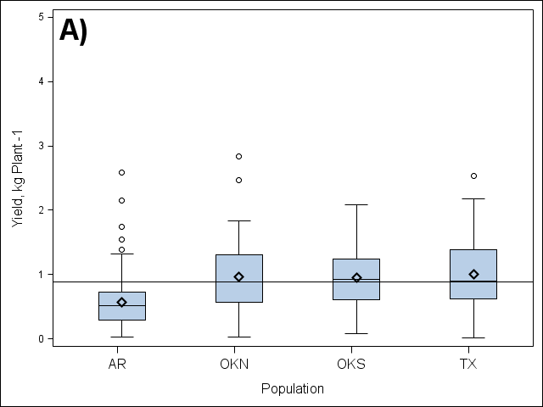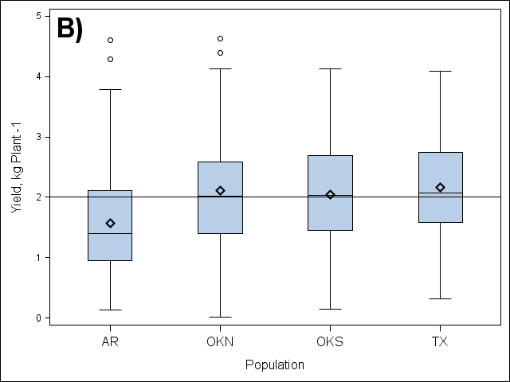
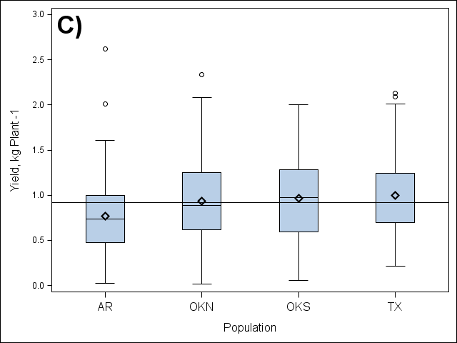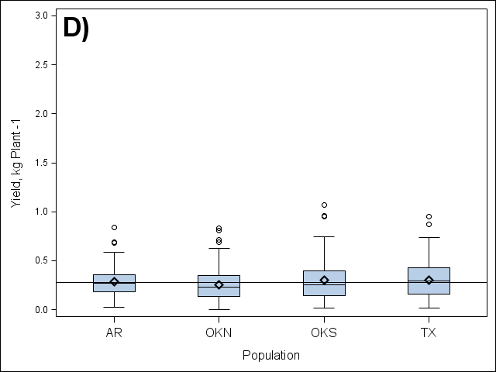
Fig.1. Box plots of biomass yields among F₁ half-sib populations of PI421999 (AR), NSL-2001-1 (OKN), Cimarron (OKS), and PI607837 (TX) in 2010 (A), 2011 (B), 2012 (C), and 2013 (D). The 2010 and 2011 values are from a one-cut fall biomass harvest, whereas the 2012 and 2013 values are from a fall biomass harvest following a forage harvest. Black line indicates mean yield among all populations for the year. Diamonds indicate population mean, lines inside box indicate population median, and circles indicate population outliers.

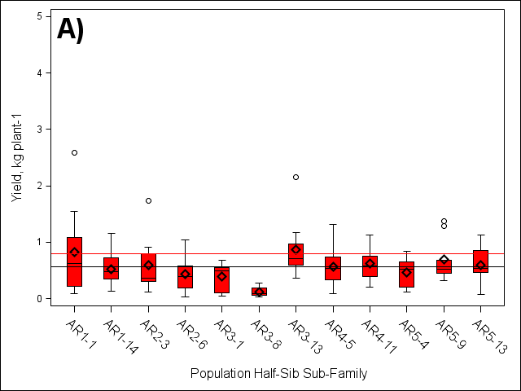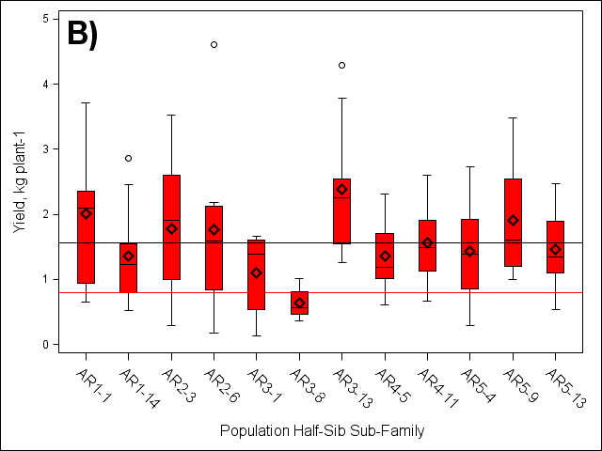
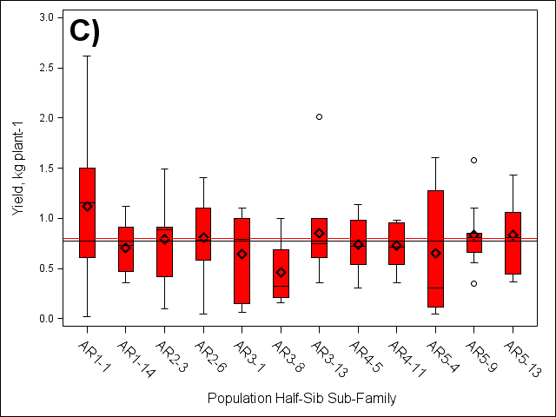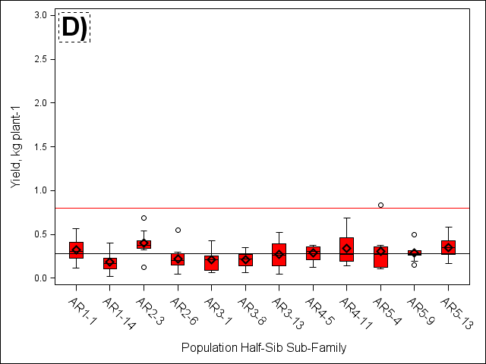
Fig.2. Box plots of biomass yields among F₁ half-sib sub-families of PI421999 (AR) in 2010 (A) (n=116), 2011 (B) (n=113), 2012 (C) (n=113), and 2013 (D) (n=109). The 2010 and 2011 (A and B) values are from a one-cut fall biomass harvest, whereas the 2012 and 2013 values (C and D) are from a fall biomass harvest following a forage harvest. Red line indicates two year population average and black line indicates year population mean. Diamonds indicate half-sib sub-family population mean, lines inside box indicate half-sib sub-family population median, and circles indicate half-sib sub-family population outliers

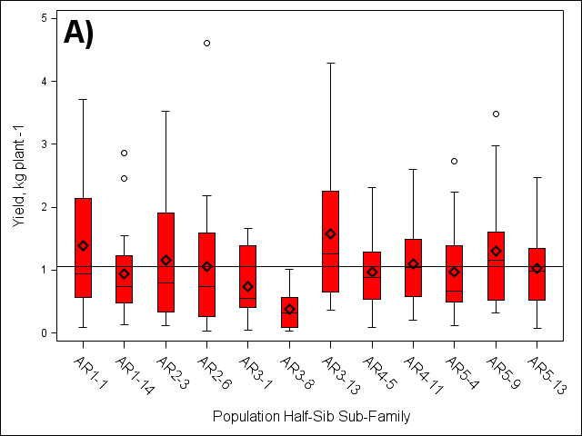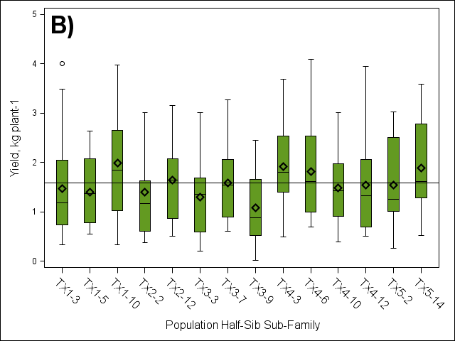
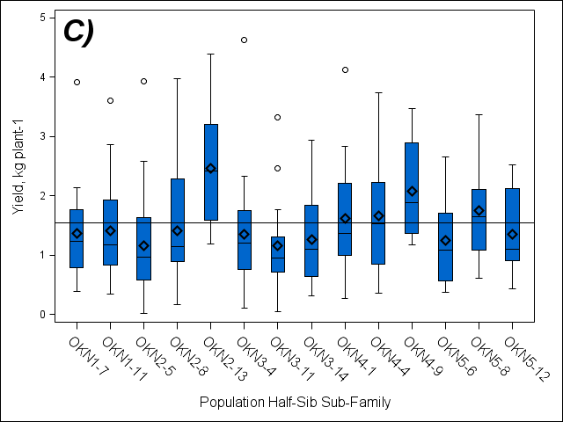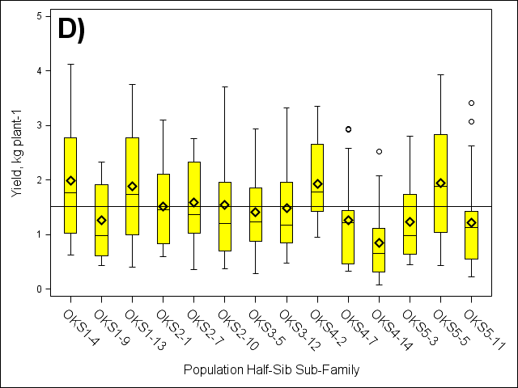
Fig.3. Box plots of biomass yields of F₁ half-sib sub-families of PI421999 (AR) (A) (n=228), PI607837 (TX) (B) (n=277), NSL-2001-1 (OKN) (C) (n=259), and Cimarron (OKS) (D) (n=275) harvested under a one-cut harvest system, 2010-2011. Black line indicates the two year population mean. Diamonds indicate half-sib sub-family population mean, lines inside box indicate half-sib sub-family population median, and circles indicate half-sib sub-family population outliers

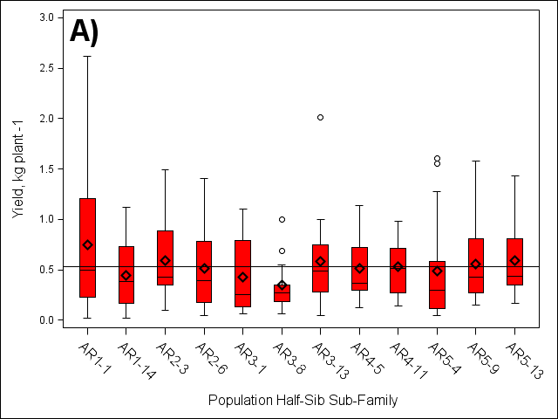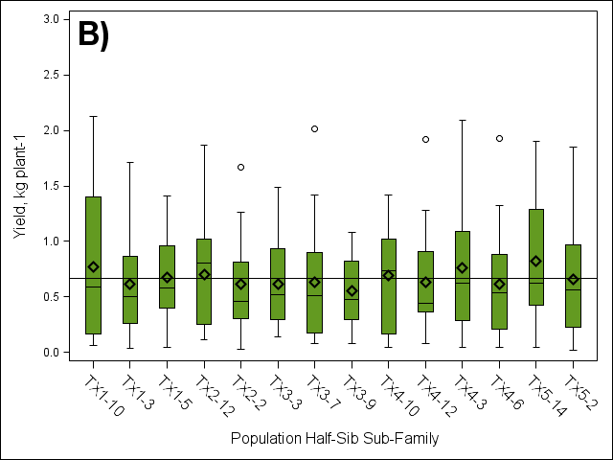
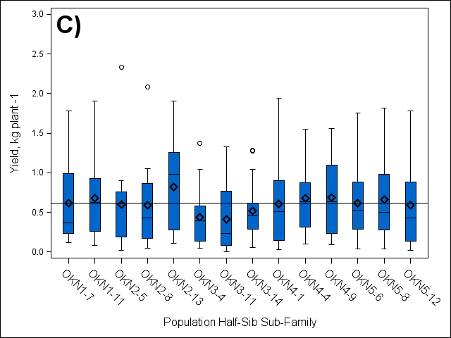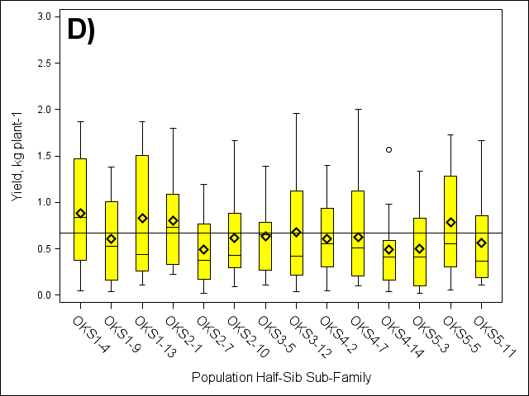
Fig.4. Box plots of biomass yields of F₁ half-sib sub-families of PI421999 (AR) (A) (n=221), PI607837 (TX) (B) (n=264), NSL-2001-1 (OKN) (C) (n=242), and Cimarron (OKS) (D) ( n=256) following a spring forage harvest, 2012-2013 . Black line indicates the two year population mean. Diamonds indicate half-sib sub-family population mean, lines inside box indicate half-sib sub-family population median, and circles indicate half-sib sub-family population outliers

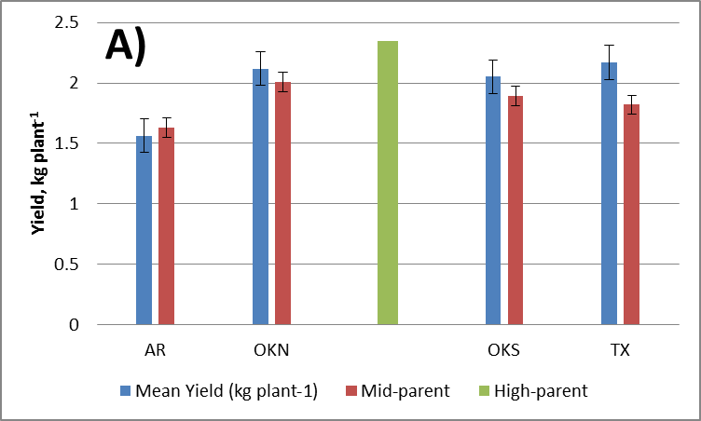
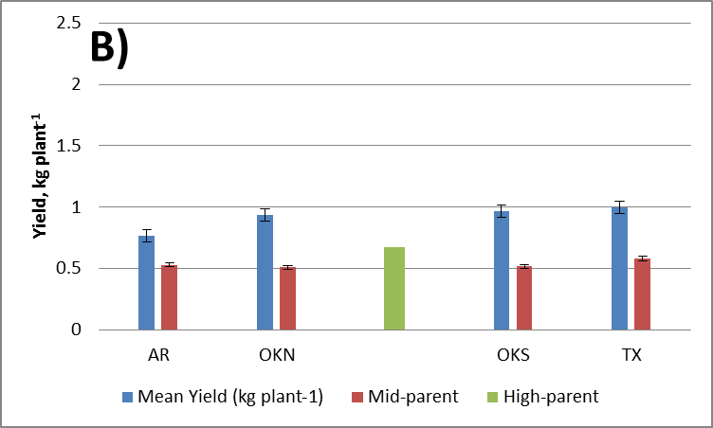
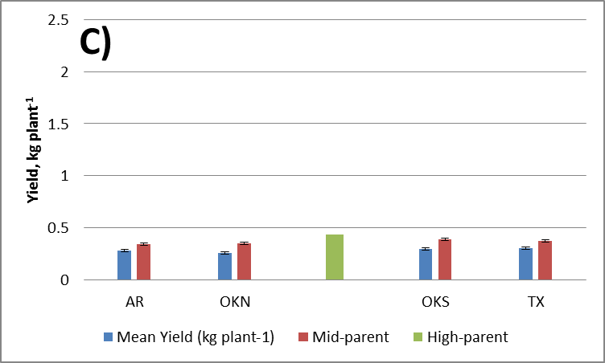
Fig.5.Evaluation of the F₁ half-sib population means for biomass yield with the mid-parent and high-parent means for heterosis under a one-cut (2011)(A) and two-cut [2012 (B) and 2013 (C)] harvest system.

Table.2. Half-sib sub-family biomass yield outliers of populations of PI421999 (AR) and NSL-2001-1 (OKN) versus high-parent values 2011-2012.
Year | Population | Half-Sib | Yield  (kg) |  | Height (cm) |  | Tiller Count |  | Tiller Size (cm) |  | Leaf Width (cm)
Year | Population | Half-Sib | 2011 | 2012 | 2011 | 2012 | 2011 | 2012 | 2011 | 2012 | 2011 | 2012
2011 | NSL-2001-1 (OKN) | High-Parent | 2.4 (0.74-5.85) | 0.47 (0.1- 1.1) | n/a‡ | 74 | n/a | 344 | n/a | 3.6 | n/a | 11
2012 | PI607837 (TX) | High-Parent | 1.79 (0.04-4.1) | 0.68 (0.29- 2.90) | n/a | 76 | n/a | 239 | n/a | 3.6 | n/a | 11
2011 | PI421999 (AR | AR1-1 (3†) | 3.7 | 1.6 | 132 | 77 | 229 | 364 | 4.2 | 3.1 | 18 | 13
2011 | PI421999 (AR | AR1-1 (9) | 3.6 | 1.5 | 104 | 83 | 195 | 399 | 6 | 3.4 | 19 | 11
2011 | PI421999 (AR | AR2-6 (1) | 4.6 | 0.87 | 92 | 81 | 106 | 174 | 4.1 | 3.9 | 15 | 10
2011 | PI421999 (AR | AR3-13 (3) | 3.8 | 0.36 | 98 | 48 | 192 | 155 | 3.8 | 2.7 | 14 | 7
2011 | PI421999 (AR | AR3-13 (5) | 4.3 | 0.74 | 111 | 67 | 99 | 134 | 4.8 | 3.3 | 17 | 9
2011 | NSL-2001-1 (OKN) | OKN2-8 (7) | 4.0 | 0.87 | 109 | 63 | 98 | 175 | 5.5 | 3.4 | 18 | 14
2011 | NSL-2001-1 (OKN) | OKN2-13 (5) | 4.4 | 1.3 | 132 | 92 | 155 | 271 | 6 | 3.8 | 20 | 8.0
2011 | NSL-2001-1 (OKN) | OKN2-13 (8) | 4.1 | 1.1 | 124 | 67 | 261 | 361 | 4.8 | 3.7 | 16 | 10
2011 | NSL-2001-1 (OKN) | OKN3-4 (1) | 4.6 | 1.4 | 100 | 73 | 189 | 308 | 4.8 | 3.5 | 17 | 13
2011 | NSL-2001-1 (OKN) | OKN4-1 (1) | 4.1 | 1.9 | 105 | 80 | 271 | 444 | 5 | 3 | 16 | 9
2012 | PI421999 (AR | AR1-1 (3) | n/a | 1.6 | 92 | 77 | 321 | 364 | 5.0 | 3.1 | 21 | 13
2012 | PI421999 (AR | AR1-1 (4) | 3.7 | 2.6 | 132 | 57 | 229 | 349 | 4.2 | 3.8 | 18 | 9
2012 | PI421999 (AR | AR3-13 (6) | 1.3 | 2.0 | 106 | 80 | 314 | 280 | 4.8 | 3.3 | 18 | 10
2012 | PI421999 (AR | AR5-4 (7) | 2.7 | 1.6 | 114 | 84 | 161 | 241 | 5.1 | 3.8 | 20 | 13
2012 | PI421999 (AR | AR5-9 (5) | 3.5 | 1.6 | 116 | 73 | 176 | 303 | 4.8 | 3.7 | 19 | 10
2012 | NSL-2001-1 (OKN) | OKN1-11 (6) | 3.6 | 1.9 | 112 | 80 | 123 | 292 | 4.9 | 3.7 | 17 | 11
2012 | NSL-2001-1 (OKN) | OKN2-5 (9) | 3.1 | 2.3 | 133 | 76 | 146 | 296 | 6.5 | 3.2 | 19 | 10
2012 | NSL-2001-1 (OKN) | OKN2-8 (4) | 1.6 | 2.1 | 115 | 87 | 208 | 344 | 5.1 | 3.9 | 18 | 13
2012 | NSL-2001-1 (OKN) | OKN2-13 (7) | 3.9 | 1.9 | 118 | 86 | 171 | 330 | 5.0 | 3.9 | 18 | 13
2012 | NSL-2001-1 (OKN) | OKN4-1 (1) | 4.1 | 1.9 | 105 | 80 | 271 | 444 | 5.0 | 3 | 18 | 9

†Number in parenthesis indicates plant location (row) in F₁ nursery.
‡n/a indicates missing plant/data.

Fig.6. Within- and among-family genetic variance estimates for biomass yield of four switchgrass populations located at the East Tennessee Research and Education Center, Holston Unit, Knoxville, TN, 2010-2013.

Fig.7. Among-family broad-sense heritability estimates for biomass yield of four switchgrass populations located at the East Tennessee Research and Education Center, Holston Unit, Knoxville, TN, 2010-2013

Table.3. Agronomic trait means of biomass yield, plant height, tiller count, tiller size, leaf angle, leaf width, and bloom score among F₁ half-sib populations from 2010-2012.
Population | Agronomic Yield Traits
Population | Biomass Yield |  | Plant Height |  | Tiller |  | Leaf |  |  | Bloom Score
Population | 1-cut  (2010-2011) | 2-cut  (2012) | 1-cut  (2010-2011) | 2-cut  (2012) | Count | Size | Angle | Width |  | Bloom Score
Population | kg plant⁻¹ |  | cm |  | number | cm | 1-5 |  | cm | 1-5
PI4219999 (AR) | 1.06 b | 0.53 b | 224.1 c | 185.2 b | 118.8 b | 0.46 a | 3.93 a |  | 1.45 a | 2.52 a
NSL-2001-1 (OKN) | 1.54 a | 0.62 a | 242.3 ab | 185.9 b | 150.1 a | 0.46 a | 2.99 b |  | 1.37 b | 2.21 c
Cimarron (OKS) | 1.51 a | 0.65 a | 247.2 a | 195.2 a | 140.5 a | 0.46 a | 3.09 b |  | 1.45 a | 2.40 b
PI607837 (TX) | 1.58 a | 0.67 a | 239.4 b | 186.5 b | 151.1 a | 0.44 b | 3.05 b |  | 1.40 b | 2.28 c
† Values followed by a common letter within a column are not significantly different as indicated by LSD mean separation at P ≤ 0.05.

Fig.8. Average plant height among F₁ half-sib populations of PI421999 (AR), NSL-2001-1 (OKN), Cimarron, SL-93-2001-1 (OKS), and PI607837 (TX) from 2010 – 2012.

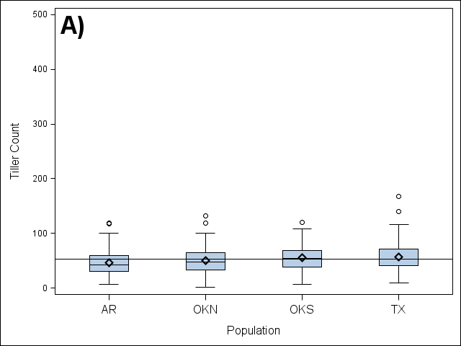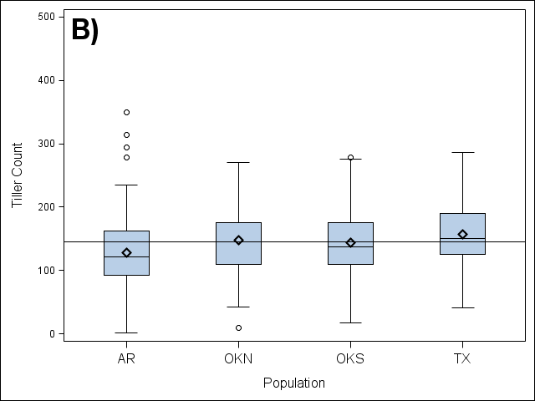
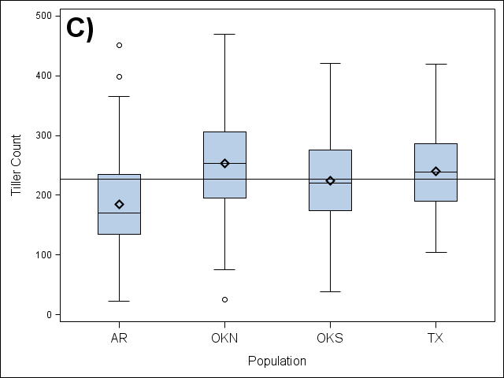
Fig.9. Box plots of tiller counts among F₁ half-sib populations of PI421999 (AR), NSL-2001-1 (OKN), Cimarron, SL-93-2001-1 (OKS), and PI607837 (TX) in 2010 (A), 2011 (B), and 2012 (C). Black line indicates mean yield among all populations for the respective year. Diamonds indicate population mean, lines inside box indicate population median, and circles indicate population outliers

Fig.10. Average tiller size (cm) and leaf width (cm) among F₁ half-sib populations of PI421999 (AR), NSL-2001-1 (OKN), Cimarron, SL-93-2001-1 (OKS), and PI607837 (TX) from 2010 – 2012.

Table.4. Phenotypic correlation coefficients among biomass yield and yield components of four switchgrass populations located at the East Tennessee Research and Education Center, Holston Unit, Knoxville, TN, 2010-2012 (n = 1532-1539).
Traits | Dry Matter Yield |  | Plant Height | Tiller Count | Tiller Diameter | Leaf Angle | Leaf Width
Plant  Height | 0.65‡
Tiller  Count | 0.27‡ |  | -0.08‡
Tiller  Diameter | 0.26‡ |  | 0.03 | -0.05
Leaf  Angle | -0.12‡ |  | 0.05† | -0.29‡ | -0.02
Leaf  Width | 0.36‡ |  | 0.64‡ | -0.40‡ | -0.06† | 0.15‡
Bloom  Score | -0.08‡ |  | -0.03 | -0.24‡ | 0.30‡ | 0.20‡ | 0.02
†Significant at the 0.05 probability level.
‡Significant at the 0.01 probability level.

Table.5. Phenotypic correlation coefficients among biomass yield and yield components of four switchgrass populations located at the East Tennessee Research and Education Center, Holston Unit, Knoxville, TN, 2011 (one-cut) (n = 511-514) vs. 2012 (two-cut) (n = 507-508).
Traits | Dry Matter Yield |  | Plant Height |  | Tiller Count |  | Tiller Diameter |  | Leaf Angle |  | Leaf Width
Year | 2011 | 2012 | 2011 | 2012 | 2011 | 2012 | 2011 | 2012 | 2011 | 2012 | 2011 | 2012
Plant Height | 0.27‡ | 0.47‡
Tiller  Count | 0.44‡ | 0.67‡ | 0.11† | 0.18‡
Tiller  Diam. | -0.03 | 0.13‡ | 0.34‡ | -0.03 | -0.21‡ | -0.12‡
Leaf Angle | -0.19‡ | -0.23‡ | -0.07 | -0.04 | -0.21‡ | -0.28‡ | 0.05 | -0.04
Leaf Width | -0.05 | 0.27‡ | 0.34‡ | 0.17‡ | -0.21‡ | 0.13‡ | 0.87‡ | -0.18‡ | 0.04 | -0.16‡
Bloom Score | -0.08 | 0.01 | -0.16‡ | -0.01 | -0.21‡ | -0.08 | 0.08 | 0.36‡ | 0.11† | -0.31‡ | -0.01 | -0.23‡
†Significant at the 0.05 probability level.
‡Significant at the 0.01 probability level.

Table.6. Average costituent concentration in percent of dry matter from harvested biomass from maternal populations from PI421999 (AR), NSL-2001-1 (OKN), Cimarron, SL-93-2001-1 (OKS), and PI607837 (TX) in 2010 – 2013.
Year | Population | % of Dry Matter
Year | Population | ADF |  |  | Cellulose† |  |  | NDF |  |  |  | Hemicellulose‡ |  |  | Lignin
Year | Population | Min | Max | Avg. | Min | Max | Avg. | Min | Max | Avg. | Min |  | Max | Avg. | Min | Max | Avg.
2010 | AR | 44.6 | 54.0 | 49.0 ± 0.24 | 39.5 | 43.5 | 40.5 ± 0.15 | 82.0 | 93.3 | 88.2 ± 0.23 | 35.1 |  | 43.3 | 39.2 ± 0.18 | 5.45 | 12.3 | 8.5 ± 0.24
2010 | OKN | 39.3 | 53.6 | 48.5 ± 0.27 | 34.1 | 43.6 | 39.9 ± 0.19 | 78.2 | 94.2 | 87.8 ± 0.28 | 35.1 |  | 44.8 | 39.3 ± 0.19 | 5.16 | 11.9 | 8.5 ± 0.23
2010 | OKS | 43.4 | 53.9 | 48.4 ± 0.21 | 34.6 | 42.6 | 39.8 ± 0.15 | 81.4 | 92.8 | 87.5 ± 0.21 | 35.3 |  | 42.5 | 39.1 ± 0.17 | 5.00 | 11.7 | 8.6 ± 0.22
2010 | TX | 42.3 | 53.6 | 47.4 ± 0.25 | 34.0 | 42.2 | 39.0 ± 0.15 | 79.6 | 92.3 | 86.4 ± 0.22 | 35.3 |  | 42.6 | 39.0 ± 0.16 | 5.49 | 11.5 | 8.4 ± 0.22
2011 | AR | 45.9 | 80.2 | 54.3 ± 0.30 | 36.2 | 72.9 | 42.6 ± 0.31 | 79.5 | 98.6 | 89.0 ± 0.23 | 18.4 |  | 37.9 | 34.7 ± 0.19 | 7.31 | 13.3 | 11.7 ± 0.10
2011 | OKN | 50.1 | 58.5 | 53.8 ± 0.17 | 38.6 | 45.4 | 42.1 ± 0.13 | 83.9 | 94.4 | 88.7 ± 0.18 | 32.1 |  | 38.2 | 35.0 ± 0.10 | 9.89 | 13.3 | 11.6 ± 0.10
2011 | OKS | 49.0 | 79.6 | 53.7 ± 0.24 | 38.4 | 71.5 | 42.2 ± 0.24 | 82.7 | 94.8 | 88.0 ± 0.18 | 15.2 |  | 37.5 | 34.2 ± 0.17 | 8.06 | 13.5 | 11.5 ± 0.06
2011 | (TX | 49.9 | 58.2 | 53.3 ± 0.15 | 39.4 | 46.7 | 41.9 ± 0.11 | 56.8 | 92.5 | 87.5 ± 0.29 | 4.90 |  | 38.1 | 34.1 ± 0.25 | 5.22 | 13.4 | 11.5 ± 0.08
2012 | AR | 43.0 | 50.0 | 46.8 ± 0.15 | 39.2 | 44.0 | 41.8 ± 0.12 | 83.4 | 91.9 | 88.2 ± 0.18 | 38.4 |  | 44.3 | 41.4 ± 0.14 | 3.46 | 6.80 | 5.0 ± 0.07
2012 | OKN | 42.3 | 49.6 | 45.9 ± 0.16 | 37.8 | 44.4 | 40.9 ± 0.13 | 83.6 | 92.1 | 87.7 ± 0.18 | 39.3 |  | 45.2 | 41.8 ± 0.12 | 3.81 | 6.41 | 5.0 ± 0.05
2012 | OKS | 41.6 | 49.5 | 46.0 ± 0.14 | 37.8 | 43.5 | 41.1 ± 0.11 | 78.2 | 90.6 | 87.2 ± 0.18 | 38.2 |  | 43.7 | 41.2 ± 0.11 | 3.78 | 6.40 | 5.0 ± 0.06
2012 | TX | 40.9 | 49.6 | 45.3 ± 0.17 | 36.4 | 43.9 | 40.4 ± 0.14 | 80.9 | 90.9 | 86.4 ± 0.22 | 37.6 |  | 44.0 | 41.1 ± 0.13 | 3.64 | 6.39 | 4.9 ± 0.05
2013 | AR | 33.6 | 43.5 | 39.3 ± 0.17 | 29.3 | 37.9 | 34.3 ± 0.18 | 70.6 | 83.9 | 78.0 ± 0.24 | 35.2 |  | 42.6 | 38.7 ± 0.14 | 3.71 | 6.14 | 4.9 ± 0.05
2013 | OKN | 34.2 | 42.8 | 38.1 ± 0.19 | 29.9 | 37.3 | 33.4 ± 0.15 | 69.1 | 83.0 | 76.5 ± 0.25 | 34.8 |  | 42.2 | 38.4 ± 0.14 | 3.25 | 6.09 | 4.7 ± 0.05
2013 | OKS | 32.5 | 43.6 | 38.0 ± 0.17 | 28.6 | 37.5 | 33.3 ± 0.14 | 66.9 | 84.3 | 76.4 ± 0.25 | 34.2 |  | 43.0 | 38.4 ± 0.14 | 3.57 | 6.38 | 4.7 ± 0.05
2013 | TX | 32.5 | 42.8 | 37.7 ± 0.19 | 28.7 | 37.2 | 33.1 ± 0.15 | 66.9 | 83.6 | 75.8 ± 0.31 | 33.2 |  | 43.8 | 38.2 ± 0.18 | 3.22 | 6.08 | 4.6 ± 0.05
†Cellulose = ADF – Lignin
‡Hemicellulose = NDF - ADF

Table.7. Mean ethanol yields (L plant⁻¹) for four switchgrass populations located at the East Tennessee Research and Education Center, Holston Unit, Knoxville, TN, 2010-2013.
Mean† Ethanol Yield (L plant⁻¹)
Populations | Year
Populations | 2010 | 2011 | 2012 | 2013 | Mean
PI421999 (AR) | 0.23 a | 0.41 b | 0.24 a | 0.07 a | 0.24 b
NSL-2001-1 (OKN) | 0.24 a | 0.54 a | 0.24 a | 0.06 a | 0.28 a
Cimarron, SL-93-2001-1 (OKS) | 0.22 a | 0.52 a | 0.25 a | 0.07 a | 0.28 a
PI607837 (TX) | 0.23 a | 0.55 a | 0.26 a | 0.07 a | 0.29 a
Mean (year) | 0.22 b | 0.51 a | 0.25 b | 0.07 c | 0.27 ± 0.01
† Values followed by a common letter within a column are not significantly different as indicated by LSD mean separation at p = 0.05.

One-Cut
Fig.11. Average predicted ethanol yield (L Mt⁻¹ DM) from cellulose and hemicellulose harvested under a one- (2010 and 2011) and two-cut system (2012 and 2013) of four switchgrass populations. Letters represent LSD mean separation values and differences in letters within years, among populations, are significant at P≤ 0.05.

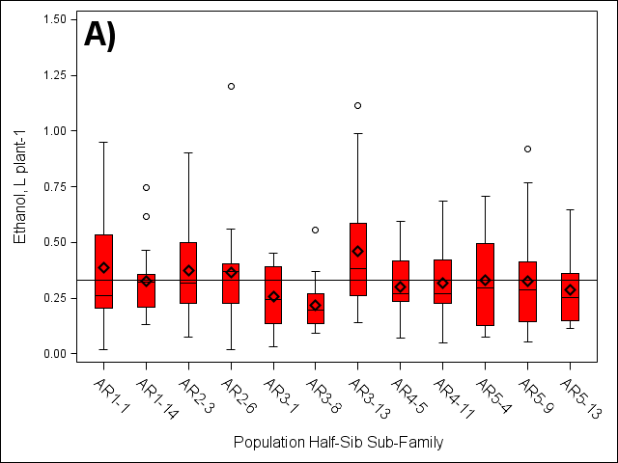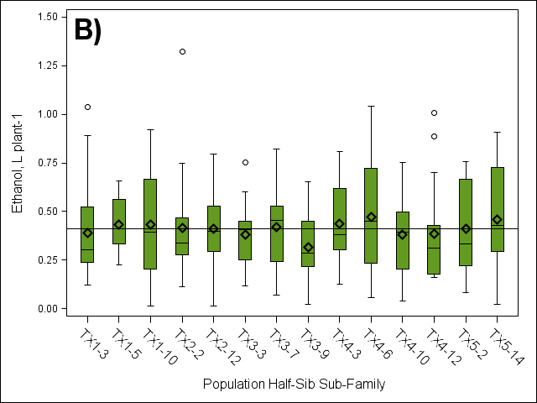
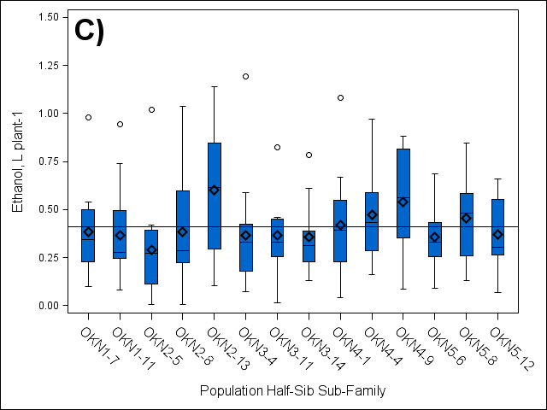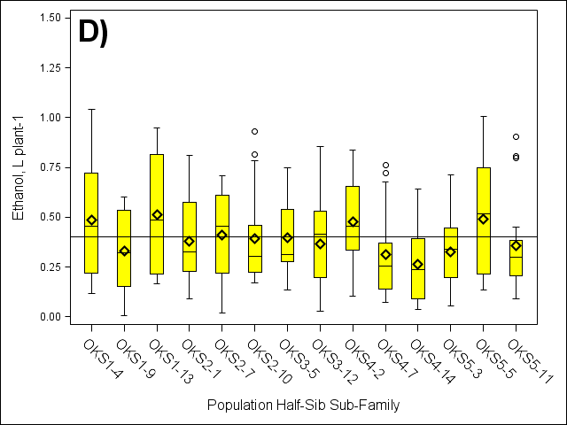
Fig.12. Box plots of predicted ethanol yields of F₁ half-sib sub-families of PI421999 (AR) (A) (n=201), PI607837 (TX) (B) (n=238), NSL-2001-1 (OKN) (C) (n=220), and Cimarron (OKS) (D) (n=247) harvested under a one-cut harvest system, 2010-2011 . Black line indicates two year population mean. Diamonds indicate half-sib sub-family population mean, lines inside box indicate half-sib sub-family population median, and circles indicate half-sib sub-family population outliers

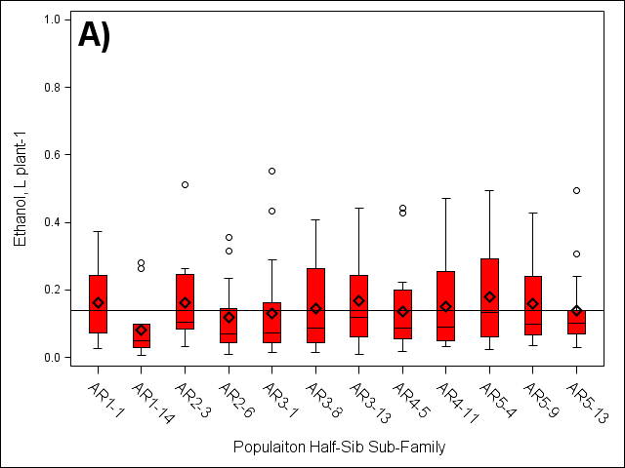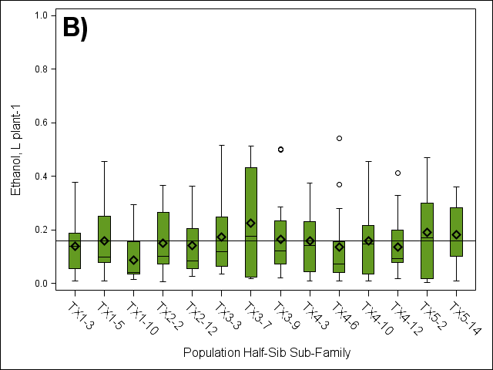
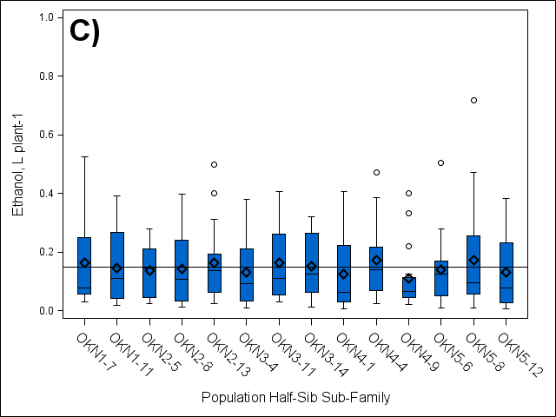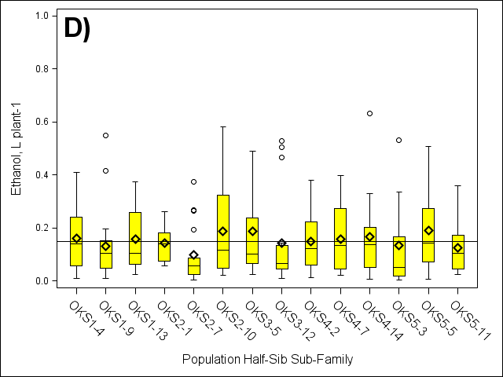
Fig.13. Box plots of predicted ethanol yields of F₁ half-sib sub-families of PI421999 (AR) (A) (n=191), PI607837 (TX) (B) (n=228), NSL-2001-1 (OKN) (C) (n=218), and Cimarron (OKS) (D) (n=229) following a spring forage harvest, 2012-2013. Black line indicates two year population mean. Diamonds indicate half-sib sub-family population mean, lines inside box indicate half-sib sub-family population median, and circles indicate half-sib sub-family population outliers

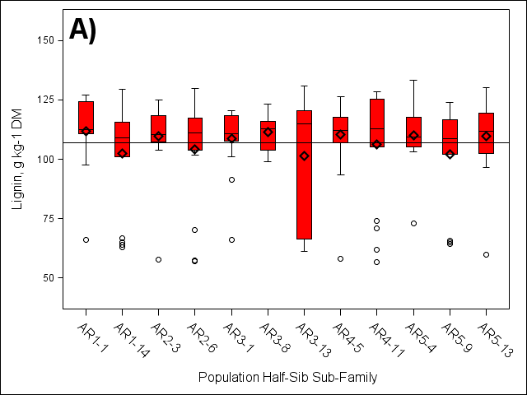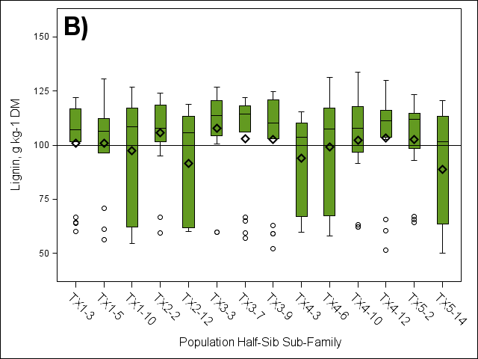
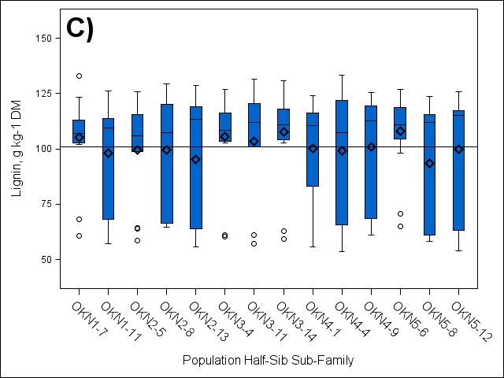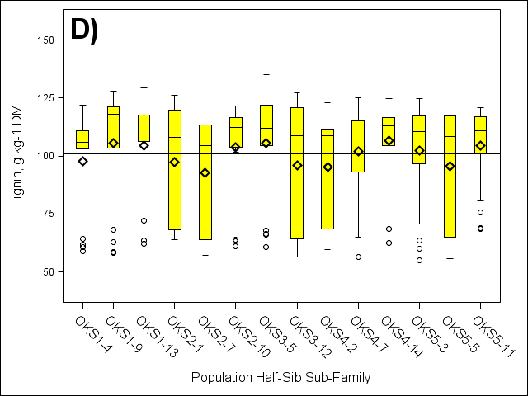
Fig.14. Box plots of lignin content of F₁ half-sib sub-families of PI421999 (AR) (A) (n=201), PI607837 (TX) (B) (n=238), NSL-2001-1 (OKN) (C) (n=220), and Cimarron (OKS) (D) (n=247) harvested under a one-cut harvest system, 2010-2011. Black line indicates two year population mean. Diamonds indicate half-sib sub-family population mean, lines inside box indicate half-sib sub-family population median, and circles indicate half-sib sub-family population outliers

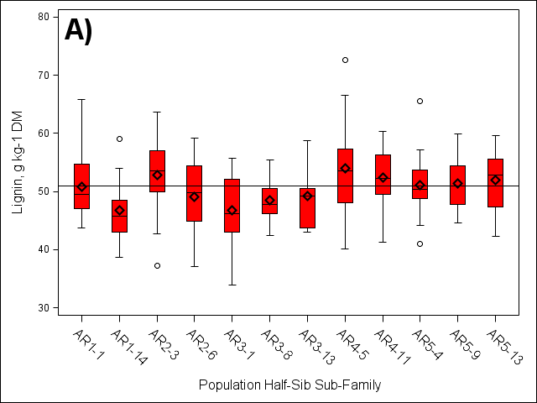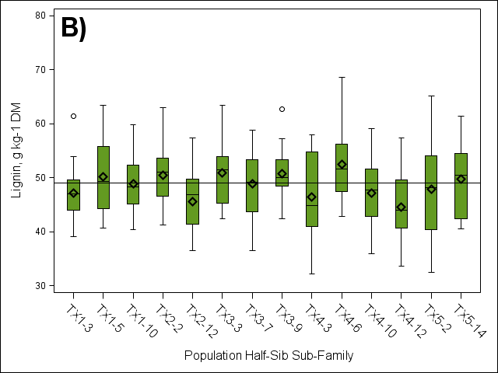
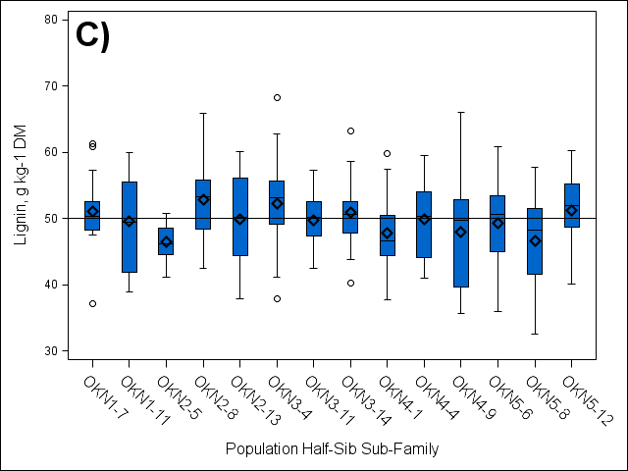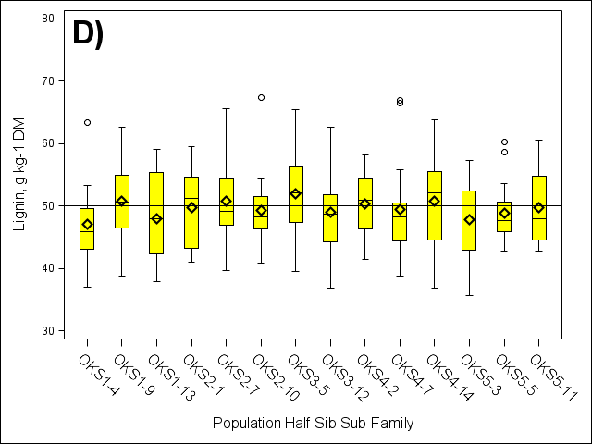
Fig.15. Box plots of lignin content of F₁ half-sib sub-families of PI421999 (AR) (A) (n=191), PI607837 (TX) (B) (n=228), NSL-2001-1 (OKN) (C) (n=218), and Cimarron (OKS) (D) (n=229) following a spring forage harvest, 2012-2013. Black line indicates over years population mean. Diamonds indicate half-sib sub-family population mean, lines inside box indicate half-sib sub-family population median, and circles indicate half-sib sub-family population outliers

Table.8. Mean percentages of ADF, cellulose, NDF, hemicellulose, and lignin in leaves versus stems of four switchgrass populations evaluated at the East Tennessee Research and Education Center (ETREC) , Plant Sciences Unit, Knoxville, TN, 2012.
†Cellulose = ADF – Lignin
‡Hemicellulose = NDF - ADF
Population | Leaves/Stems | % of Dry Matter
Population | Leaves/Stems | ADF |  |  | Cellulose |  |  | NDF |  |  | Hemicellulose‡ |  |  | Lignin
Population | Leaves/Stems | Min | Max | Avg. | Min | Max | Avg. | Min | Max | Avg. | Min | Max | Avg. | Min | Max | Avg.
PI4219999 (AR) | Leaves | 41.9 | 49.1 | 46.1 | 38.4 | 44.9 | 41.9 | 80.1 | 89.4 | 84.8 | 35.0 | 41.6 | 38.8 | 2.34 | 5.82 | 4.1
PI4219999 (AR) | Stems | 43.5 | 51.2 | 47.6 | 38.8 | 44.3 | 41.7 | 86.6 | 96.9 | 91.6 | 39.6 | 48.0 | 44.0 | 4.30 | 7.78 | 5.9
NSL-2001-1 (OKN) | Leaves | 40.2 | 49.0 | 45.2 | 36.9 | 45.0 | 41.2 | 79.2 | 89.7 | 84.6 | 36.1 | 42.4 | 39.4 | 2.29 | 5.11 | 4.0
NSL-2001-1 (OKN) | Stems | 42.8 | 50.5 | 46.7 | 37.9 | 44.4 | 40.7 | 84.8 | 95.1 | 90.9 | 39.5 | 48.4 | 44.2 | 4.83 | 8.03 | 6.1
Cimarron (OKS) | Leaves | 41.2 | 51.6 | 45.6 | 38.0 | 45.7 | 41.6 | 77.6 | 91.0 | 84.6 | 36.0 | 42.5 | 39.1 | 2.59 | 6.62 | 4.0
Cimarron (OKS) | Stems | 41.0 | 50.2 | 46.5 | 36.2 | 43.6 | 40.6 | 83.1 | 94.0 | 89.9 | 39.2 | 47.0 | 43.4 | 4.69 | 7.73 | 5.9
PI607837 (TX) | Leaves | 38.9 | 49.1 | 44.5 | 35.2 | 44.8 | 40.6 | 75.9 | 89.3 | 83.6 | 35.8 | 43.2 | 39.1 | 2.17 | 5.48 | 3.9
PI607837 (TX) | Stems | 41.3 | 50.0 | 46.1 | 36.0 | 43.0 | 40.1 | 83.3 | 95.1 | 89.2 | 39.0 | 47.5 | 43.1 | 4.50 | 7.30 | 6.0
†

Table.9. Mean biomass yields (± std. error) from leaves and stems for four switchgrass populations located at the East Tennessee Research and Education Center, Holston Unit, Knoxville, TN, 2012.
Population | Leaves/Stems | Biomass Yield (kg plant⁻¹)
Population | Leaves/Stems | Min | Max | Avg.
PI4219999 (AR) | Leaves | 0.03 | 0.83 | 0.32 ± 0.02
PI4219999 (AR) | Stems | 0.04 | 1.3 | 0.56 ± 0.03
NSL-2001-1 (OKN) | Leaves | 0.03 | 1.1 | 0.32 ± 0.02
NSL-2001-1 (OKN) | Stems | 0.03 | 1.5 | 0.54 ± 0.03
Cimarron (OKS) | Leaves | 0.01 | 0.84 | 0.30 ± 0.02
Cimarron (OKS) | Stems | 0.01 | 1.6 | 0.61 ± 0.04
PI607837 (TX) | Leaves | 0.01 | 0.93 | 0.34 ± 0.02
PI607837 (TX) | Stems | 0.03 | 1.4 | 0.62 ± 0.03

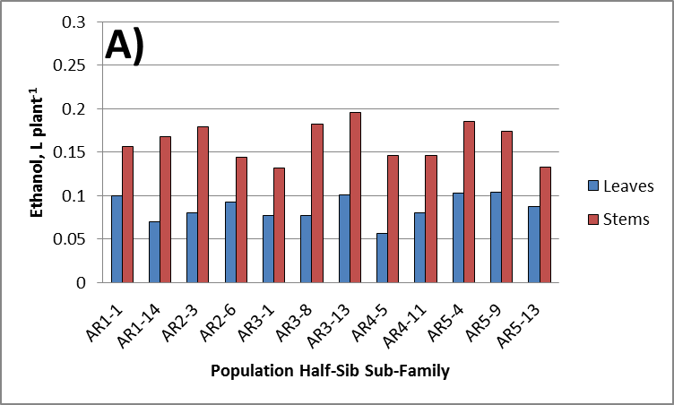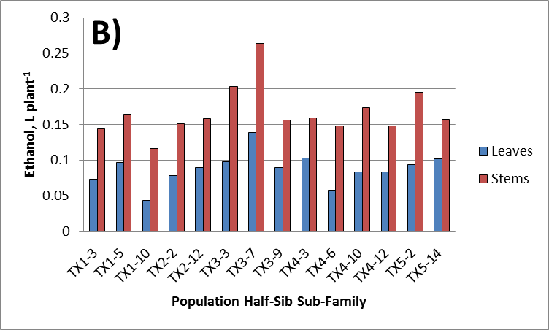
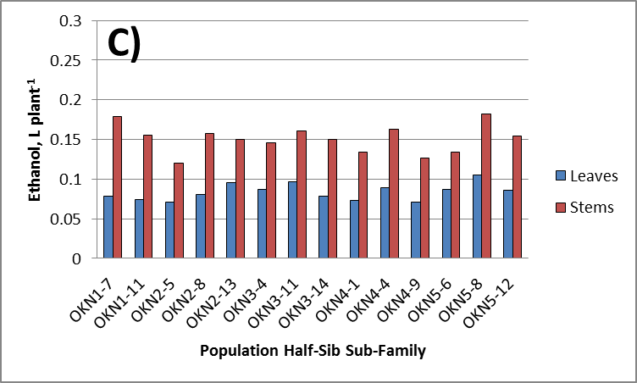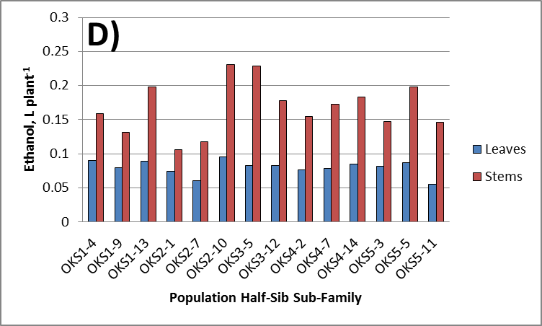
Fig.16. Bar graphs of predicted ethanol yield from leaves versus stems of F₁ half-sib sub-families of PI421999 (AR) (A), PI607837 (TX) (B), NSL-2001-1 (OKN) (C), and Cimarron (OKS) (D) following a spring forage harvest in 2012.

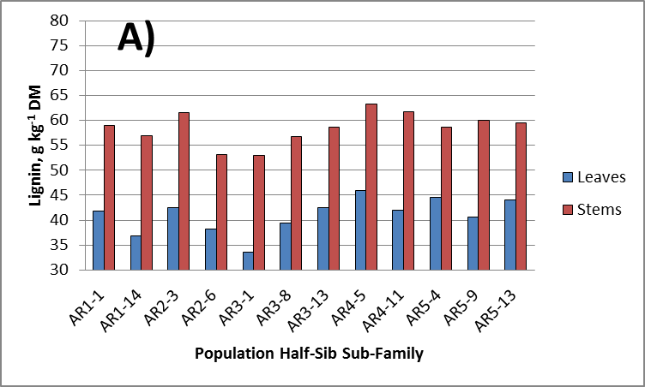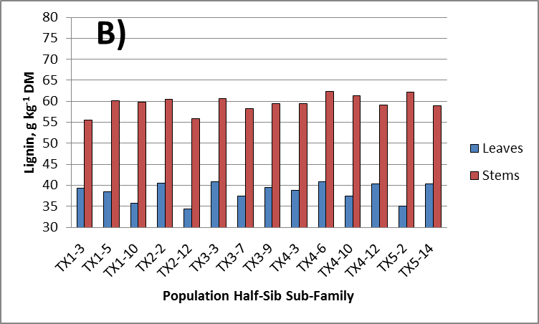
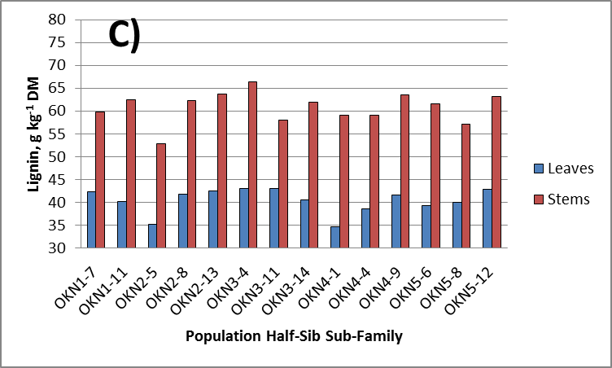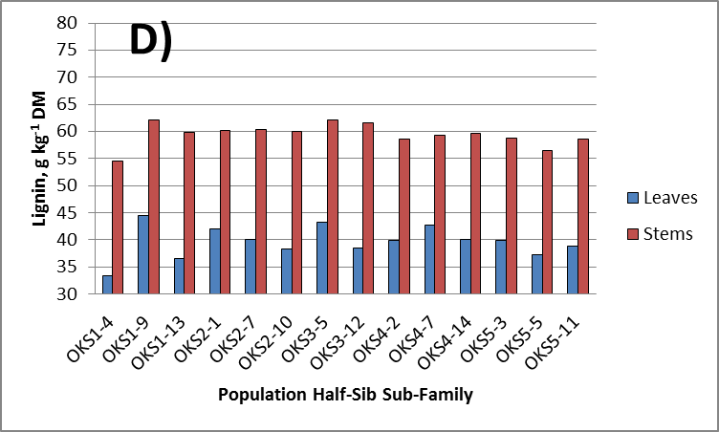
Fig.17. Bar graphs of lignin content from leaves versus stems of F₁ half-sib sub-families of PI421999 (AR) (A), PI607837 (TX) (B), NSL-2001-1 (OKN) (C), and Cimarron (OKS) (D) following a spring forage harvest in 2012.

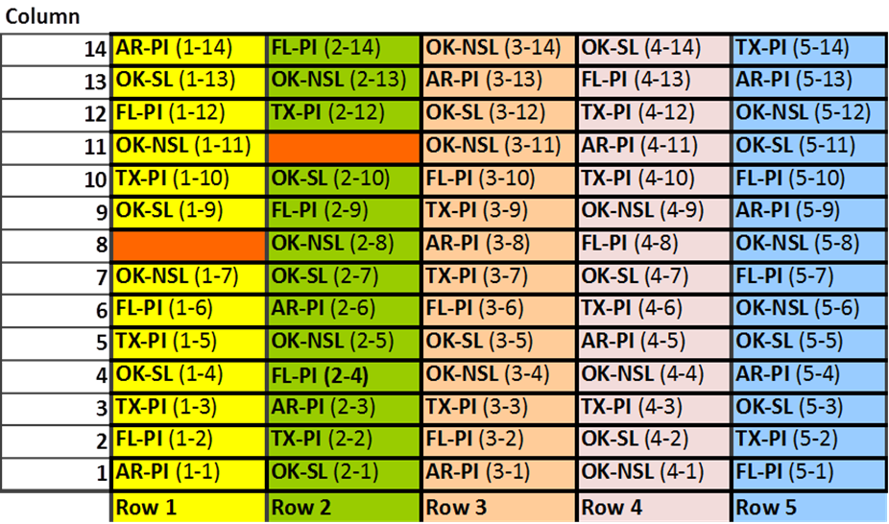
Fig.1A. Map of the polycross nursery located at the East Tennessee Research and Education Center, Plant Sciences Unit, Knoxville, TN.

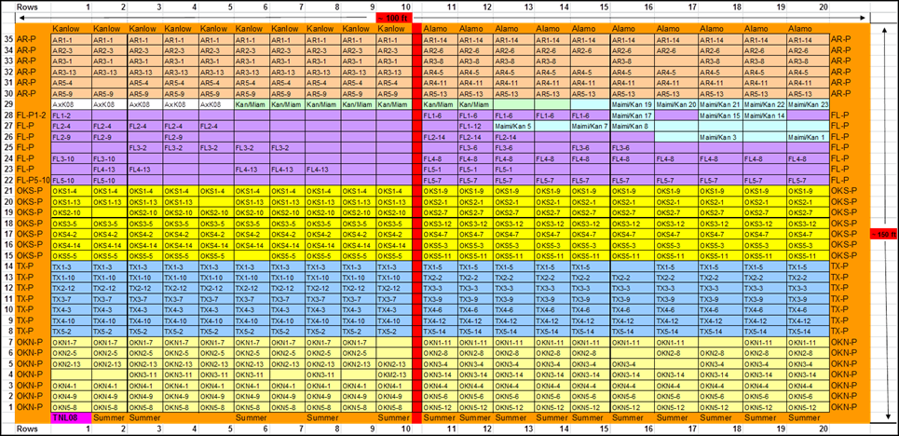
Fig.2A. Map of the F₁ nursery located at the East Tennessee Research and Education Center, Holston Unit, Knoxville, TN.

Table.1A. Populations of F₁ half-sib progeny. Each population is comprised of a single female parent and an open pollinated composite of pollen from male parents.
4 Populations of F₁ Half-sib progeny
Population | Female Parent | Male parent(s)
1* | PI421999 (AR) | - Cimarron  - NSL-2001-1  - PI421999  - PI422016  - PI607837
2* | NSL-2001-1 (OKN) | - Cimarron  - NSL-2001-1  - PI421999  - PI422016  - PI607837
3* | Cimarron, SL-93-2001-1 (OKS) | - Cimarron  - NSL-2001-1  - PI421999  - PI422016  - PI607837
4* | PI607837 (TX) | - Cimarron  - NSL-2001-1  - PI421999  - PI422016  - PI607837

Table.2A. Timeline of harvest for the F₁ nursery located at the East Tennessee Research and Education Center, Holston Unit.
Year | Date | Project Activity
2010 | Early November | One-cut Harvest at maturity
2011 | Early November | One-cut Harvest at maturity
2012 | November 7 - 9 | Biomass cut in 2-cut system
2013 | October 1,2 | Biomass cut in 2 – cut system

Table.3A. Timeline of harvest for the Polycross nursery located at the East Tennessee Research and Education Center, Plant Sciences Unit.
Year | Date | Project Activity
2010 | Early November | One – cut Harvest at maturity
2011 | Early November | One – cut Harvest at maturity
2012 | November 14 | Biomass cut in 2 – cut system
2013 | October 28 | Biomass cut in 2 – cut system

Table.4A. Phenotypic trait measurements.
Traits | Measurement
Tiller Number  Plant Height  Stem Diameter  Leaf Width  Leaf Angle  Bloom  Biomass Yield  Ethanol Yield | Count  cm  cm  cm  1-5 scale: 1 being being ≤ 45º & 5 being being ≥ 90º  1-3 scale: 1 having no visible bloom wax & 3 having high amounts.  Weigh harvested whole plant material at field, and then calculate the moisture content from a representative sample based off of its wet weight versus its dry weight. Biomass yield will be whole plant yield, adjusted for moisture content to find the total dry biomass yield.  Calculated using ethanol compositions obtained through sample analysis via NIR and comparing them to the dry sample weight, which will then be adjusted to the total plant dry yield to find total ethanol yield per plant.

VITA
Eifion Wyn Hughes was born on November 28, 1987, in Tucson, Arizona. He graduated from Science Hill High School in 2006 and began attending Berry College in fall of 2006 and then the University of Tennessee, Knoxville in fall of 2007, where he graduated with a Bachelor of Science degree in Plant Sciences, with a concentration in Bioenergy and a specialty in Chemistry in December 2011. After working as an undergrate research assistant under the supervision of Dr. Fred Allen for 18 months in the Agronomic State Variety Trial laboratory, he began his graduate research assistanceship in the Plant Sciences program at the University of Tennessee in 2012 and he is currently a canidate for a Master of Science degree in Plant Sciences with a concentration in Plant Breeding. He will graduate in May 2014.

