Chapter 6. Proposed 2011 Kisatchie National Forest Model and Conclusions

The analysis results presented within Chapter 4 and 5 warrant the development of a new predictive model for the Kisatchie National Forest. The active US Forest Service Model lacks definition between the high and medium probability zones with respect to Kvamme’s (1988) gain statistic, since the medium probability zone exhibits a slightly higher gain than the high probability zone. The high probability zone accounts for too large of an area to produce a sufficiently high site density, while the medium or indeterminate probability zone covers a smaller and more specific land area—frequently flooded soils. While both the high and medium probability zones produce more sites than expected by chance, there should be a greater proportion of sites in the high probability zone than is currently exhibited. The active Forest model is extremely effective in indicating low probability areas (i.e. upland locales located away from water sources) as it contains an appropriate negative gain statistic. A new model should better demarcate the medium and high probability zones to aid Forest personnel in resource management efforts.
The development process for the new predictive model relied on the analyses conducted within Chapter 5, which explored the environmental correlations between an array of variables and archaeological site location. Several variables were removed from the initial testing due to insignificance or redundancy. For example, stream rank one through nine produced a similar, but less effective relationship to site location than stream permanence, defined as a mapped watercourse with a stream rank value equal to or greater than three. A portion of the remaining significant variables co-varied as they represented similar data. Due to the topography of the region, elevation is directly proportional to the distance from permanent stream or frequently flooded soils. Elevation and slope, both significant factors in settlement patterning, did not convey effectiveness for delimiting probability zones. The significance was better represented by horizontal distance from permanent streams and flooded soils, both of which occurred at lower elevations of less percent slope. With an increase in horizontal distance from a permanent stream or frequently flooded soil, there is generally an increase in slope and elevation as well.
Selecting appropriate variables that displayed significance, while also pertaining to settlement patterning, limited the inclusion of several variables. Distance to road produced the most significant correlation between historic site location and a variable; however, due to the extremely limited sample of historic sites (n = 300) and the large percentage of area a road buffer encompasses, the distance to road variable was not included. This was also partially due to the high median value, which requires an extremely large buffer to maximize effectiveness. A 100-m full buffer around roadways throughout the entire study area only encompassed half of the historic sites (n = 152), while a 50-m full buffer overlapped with roughly under a third (n = 99). If the large sample of unknown archaeological sites was known to contain significantly more historic sites, the inclusion of this buffer may be appropriate. The inclusion of a road buffer to increase the density of prehistoric sites within a high or medium probability zone further compounds the biasing effect that roads represent for site discovery. As neither the historic or prehistoric sites are correctly influenced by road buffer inclusion, distance from roads was not included in model development.
The formative variables within the new predictive model center upon the intersection between soil types and their ability to drain water. Categories of degree of drainage and flooding frequency of soils are closely related and are both produced from the SSURGO soils dataset. Within the analysis of select variables, distance to frequently flooded soils superseded distance to grouped poorly drained soils, suggesting the appropriateness of that category for developing a high probability zone. Theoretically, the ecotones between differently drained soils provide a key environment for both prehistoric and historic peoples to exploit. Proximity to two distinct patches of landscapes increases subsistence diversity for biotic communities and therefore subsistence opportunities. The intersection of frequently flooded soils with non flooded soils is also within proximity to permanent water sources, conferring greater attractiveness for exploitation. As the characteristics of individual locations on the landscape influence settlement, areas conferring greater benefits (e.g. proximity to ecotones, proximity to water, elevation, slope, etc.) will be selected for habitation (Jochim 1976).
Using central place foraging theory, Hollenbach (2010) models the relationship between campsite location and the exploitation of the landscape’s resources. The resource procurement model suggests that foragers select camp site locations in areas where short-term foraging will produce the greatest returns. Areas of ecotones straddling multiple landscape patches provide greater resource diversity and density, which follows with central place foraging theory. Incorporating this theoretical consideration in the formation of zone definitions, the new Kisatchie National Forest Predictive Model assigns high probability to areas that allow for foraging efficiency.
A tripartite probability division that is similar to the 1995 model was selected for the new predictive model so as to facilitate comparison with the active US Forest Service model. Gain statistics serve as the assigning criteria for high, medium, and low probabilities for containing archaeological sites. The gain statistics should follow a pattern of high positive gain for high probability areas, lower positive gain for medium probability areas, and negative gains representing low probability areas.
The modeling technique used to develop the proposed predictive model involved buffering significant variables. An example of the buffering technique for distance to road is displayed within the text for all sites (Table 6.1) and historic sites (Table 6.2). The gain values calculated for the historic sites sample is negative; suggesting that distance to road is not an appropriate variable to formulate a zone for historic sites. This is due to the low number of historic sites recorded on the Kisatchie National Forest relative to the large percentage of area that the buffering of the roadways encompasses. This technique was used for each variable with the increasing of buffering increments ceasing only after a drop in gain was noted. Typically the buffer with the highest gain was selected unless a buffer of similar gain represented considerably less area while containing a high number of sites.

Table 6.1. An Example of the Buffering Strategy and Statistical Evaluation for the Road Variable using All Archaeological Sites.
Variable | Area (m²) | % of Area | Expected Sites | Observed Sites | % Sites | χ2 | Gain
Road Buffer 20 | 209527498 | 8.4 | 59.0 | 341 | 8.6 | 43.2 | 0.02
Road Buffer 30 | 311049157 | 12.5 | 108.0 | 520 | 13.0 | 83.5 | 0.04
Road Buffer 40 | 410318406 | 16.5 | 143.3 | 690 | 17.3 | 110.8 | 0.05
Road Buffer 50 | 507419340 | 20.4 | 200.9 | 828 | 20.8 | 161.5 | 0.02
Road Buffer 60 | 602340962 | 24.2 | 200.9 | 967 | 24.3 | 155.3 | 0.00
Road Buffer 75 | 740418475 | 29.8 | 314.7 | 1120 | 28.1 | 261.0 | -0.06
Road Buffer 100 | 958857109 | 38.6 | 478.5 | 1381 | 34.6 | 411.7 | -0.11
df = 6, α = .05, sig of χ2 ≥ 12.59

Table 6.2. An Example of the Buffering Strategy and Statistical Evaluation for the Road Variable using only Historic Archaeological Sites.
Variable | Area (m²) | % of Area | Expected Sites | Observed Sites | % Sites | χ2 | Gain
Road Buffer 20 | 209527498 | 8.4 | 2.5 | 99 | 2.5 | 0.0 | -2.39
Road Buffer 30 | 311049157 | 12.5 | 2.5 | 99 | 2.5 | 0.0 | -4.04
Road Buffer 40 | 410318406 | 16.5 | 2.5 | 99 | 2.5 | 0.0 | -5.64
Road Buffer 50 | 507419340 | 20.4 | 2.5 | 99 | 2.5 | 0.0 | -7.21
Road Buffer 60 | 602340962 | 24.2 | 2.5 | 99 | 2.5 | 0.0 | -8.75
Road Buffer 75 | 740418475 | 29.8 | 4.2 | 129 | 3.2 | 0.2 | -8.20
Road Buffer 100 | 958857109 | 38.6 | 5.8 | 152 | 3.8 | 0.7 | -9.11
df = 6, α = .05, sig of χ2 ≥ 12.59

The two primary environmental variables considered for the model development include distance to frequently flooded soils and distance to permanent streams as these proved to be extremely significant factors for the location of archaeological sites, especially when compared to randomly sampled background points. The soil intersection between frequently and non-frequently flooded soils was explored with the buffering of the intersection in increasing 10-m increments both internally (towards the flooded soils) and externally (towards non-flooded soils), each conducted independently of the other. A similar buffering technique was utilized for the permanent streams in the study area while being conscious of the need to use datasets extending beyond the study area so as to receive the full buffering of any variable and not a truncated buffer due to a modern abstract boundary. The areas with the highest gain statistic were selected for use within the model. After selection of the high probability zone, additional buffers were conducted radiating from the zone to delimit medium probability zones.
The high probability zone, areas of non-frequently flooded soils located within 100-m of frequently flooded soils, represents a small land area with an abnormally high density of recorded archaeological sites contrasts the large high zone size of the active US Forest Service Model (1995 FPPM). A 100-m buffer extending from the intersection of frequently and non-frequently flooded soils in the direction of well drained soils produced a gain value of 0.51, suggesting its assignment as the high probability zone. The high probability zone covers 14.2 percent of the total study area while encompassing 29.0 percent of all archaeological sites. This buffered area represents a landscape in non-frequently flooded soils within 100-m of frequently flooded soils, allowing for efficient foraging activities within a close proximity to available water. A simple buffer promotes ease of field-use as opposed to a more segmented high probability zone offered by alternative modeling techniques (e.g., the 2010 Fort Polk model, Perez and Bundy 2010)

Table 6.3. Test Statistics for the Probability Zones of the Proposed 2011 Kisatchie National Forest Model for the Entire Study Area and All Archaeological Sites.
Probability Zone | Area (m²) | % of Area | Expected Sites | Observed Sites | % Sites | χ2 | Gain
Zone 1 (High) | 353127618 | 14.2 | 565.9 | 1156 | 29.0 | 615.2 | 0.51
Zone 2 (Medium) | 1000159583 | 40.2 | 1602.9 | 1889 | 47.4 | 51.1 | 0.15
Zone 2 (Low) | 1133802258 | 45.6 | 1817.1 | 941 | 23.6 | 422.4 | -0.93
Total | 2487089459 | 100.0 | 3986.0 | 3986 | 100.0 | 1088.6 | -
df = 2, α = .05, sig of χ2 ≥ 5.99

Table 6.4. Test Statistics for the Probability Zones of the Active U.S. Forest Service Predictive Model for the Entire Study Area and All Archaeological Sites.
Probability Zone | Area (m²) | % of Area | Expected Sites | Observed Sites | % of Sites | χ2 | Gain
Zone 1 (Medium) | 338508668 | 13.6 | 542.1 | 670 | 16.8 | 30.2 | 0.19
Zone 2 (High) | 1363591761 | 54.8 | 2183.9 | 2651 | 66.5 | 99.9 | 0.18
Zone 3 (Low) | 786732525 | 31.6 | 1260.0 | 665 | 16.7 | 281.0 | -0.89
Total | 2488832954 | 100.0 | 3986.0 | 3986 | 100.0 | 411.0 | -
df = 2, α = .05, sig of χ2 ≥ 5.99

The medium probability zone area is comprised of a multitude of factors relating to proximity to both the high probability zone and permanent streams. A 100-m buffer into non-frequently flooded soils from the high probability zone, a 200-m buffer from the intersection of frequently and non-frequently flooded soils towards frequently flooded soils, and a 300-m buffer of permanent streams clipping frequently flooded soils, were UNIONED and then DISSOLVED within ArcGIS to form the medium probability zone. This zone covers 40.2 percent of the total study area while encompassing 47.4 percent of all archaeological sites, resulting in a gain statistic of 0.15. The medium probability zone represents an exploitable landscape slightly less attractive to intense human settlement or activities, but still more utilized than low probability zones. The area contains a significantly higher density of sites per the landscape than expected by chance alone.
The low probability zone is the remainder of the area and is expected to contain a modest number of archaeological sites with respect to the high and medium probability zones. The Low Probability Zone covers the largest swath of land, 45.4 percent of the total study area, while encompassing the lowest percentage of all archaeological sites (23.6 %). The low probability zone exhibits significantly less archaeological sites than expected by chance alone with a gain of – 0.93.
The proposed 2011 Kisatchie National Forest Predictive Model is recommended for use as a singular model for all of the forest districts. Detailed evaluations show the probability zones prove effective within the Caney District as well as within the central cluster area (Tables 6.5 to 6.8). The results of the model performance for each ranger district within the central cluster area indicate effective modeling zones with all maintain an ideal gain progression (Appendix C). In comparison with the model it is replacing, the proposed 2011 Kisatche National Forest Predictive Model greatly exceeds the gains of the active U.S. Forest Service predictive model when considering the ideal distribution and appropriateness of gains.
Table 6.5. Test Statistics for the Probability Zones of the Proposed 2011 Kisatchie National Forest Model for the Central Cluster Study Area and All Archaeological Sites.
Probability Zone | Area (m²) | % of Area | Expected Sites | Observed Sites | % Sites | χ2 | Gain
Zone 1 (High) | 331002554 | 14.1 | 537.5 | 1114 | 29.1 | 618.4 | 0.52
Zone 2 (Medium) | 951287513 | 40.4 | 1544.7 | 1815 | 47.5 | 47.3 | 0.15
Zone 2 (Low) | 1073313185 | 45.6 | 1742.8 | 896 | 23.4 | 411.5 | -0.95
Total | 2355603252 | 100.0 | 3825.0 | 3825 | 100.0 | 1077.2 | -
df = 2, α = .05, sig of χ2 ≥ 5.99

Table 6.6. Test Statistics for the Probability Zones of the Active U.S. Forest Service Predictive Model for the Central Cluster Study Area and All Archaeological Sites.
Probability Zone | Area (m²) | % of Area | Expected Sites | Observed Sites | % of Sites | χ2 | Gain
Zone 1 (Medium) | 300112869 | 12.7 | 487.0 | 638 | 16.7 | 46.8 | 0.24
Zone 2 (High) | 1300364015 | 55.2 | 2110.1 | 2552 | 66.7 | 92.6 | 0.17
Zone 3 (Low) | 756754669 | 32.1 | 1228.0 | 635 | 16.6 | 286.3 | -0.9
Total | 2357231553 | 100.0 | 3825.0 | 3825 | 100.0 | 425.7 | -
df = 2, α = .05, sig of χ2 ≥ 5.99

Table 6.7. Test Statistics for the Probability Zones of the Proposed 2011 Kisatchie National Forest Model for the Caney District Study Area and All Archaeological Sites.
Probability Zone | Area (m²) | % of Area | Expected Sites | Observed Sites | % Sites | χ2 | Gain
Zone 1 (High) | 22125064 | 16.8 | 27.1 | 42 | 26.1 | 8.2 | 0.35
Zone 2 (Medium) | 48872069 | 37.2 | 59.8 | 74 | 46.0 | 3.3 | 0.19
Zone 2 (Low) | 60489074 | 46.0 | 74.1 | 45 | 28.0 | 11.4 | -0.65
Total | 131486208 | 100.0 | 161.0 | 161 | 100.0 | 23.0 | -
df = 2, α = .05, sig of χ2 ≥ 5.99

Table 6.8. Test Statistics for the Probability Zones of the Active U.S. Forest Service Predictive Model for the Caney District Study Area and All Archaeological Sites.
Probability Zone | Area (m²) | % of Area | Expected Sites | Observed Sites | % of Sites | χ2 | Gain
Zone 1 (Medium) | 38395797 | 29.2 | 47.0 | 32 | 19.9 | 4.8 | -0.5
Zone 2 (High) | 63227747 | 48.0 | 77.4 | 99 | 61.5 | 6.1 | 0.2
Zone 3 (Low) | 29977856 | 22.8 | 36.7 | 30 | 18.6 | 1.2 | -0.2
Total | 131601400 | 100.0 | 161.0 | 161 | 100.0 | 12.0 | -
df = 2, α = .05, sig of χ2 ≥ 5.99

The new predictive model for the Kisatchie National Forest consists of three highly statistically significant zones with appropriate gains associated with each (Figures 6.1 to 6.5). The model is defined by the formative variables of distance to frequently flooded soils and distance to permanent stream. The high probability zone is defined as:
- Areas of non-frequently flooded soils located within 100-ms of frequently flooded soils, as defined by the NRCS.
The medium probability zone is defined as:
- Areas of non-frequently flooded soils located within 100-ms of the high probability zone.
- Areas of frequently flooded soils located within 200-ms of non-frequently flooded soils.
- Areas on non-frequently flooded soils located within 300-ms of permanent watercourses.
The low probability zone consists of all other areas defined as:
- Areas of non-frequently flooded soils located more than 200-ms from frequently flooded areas.
- Areas of non-frequently flooded soils located more than 300-ms from permanent watercourses.
- Areas of frequently flooded soils located more than 200-ms from non-frequently flooded soils.

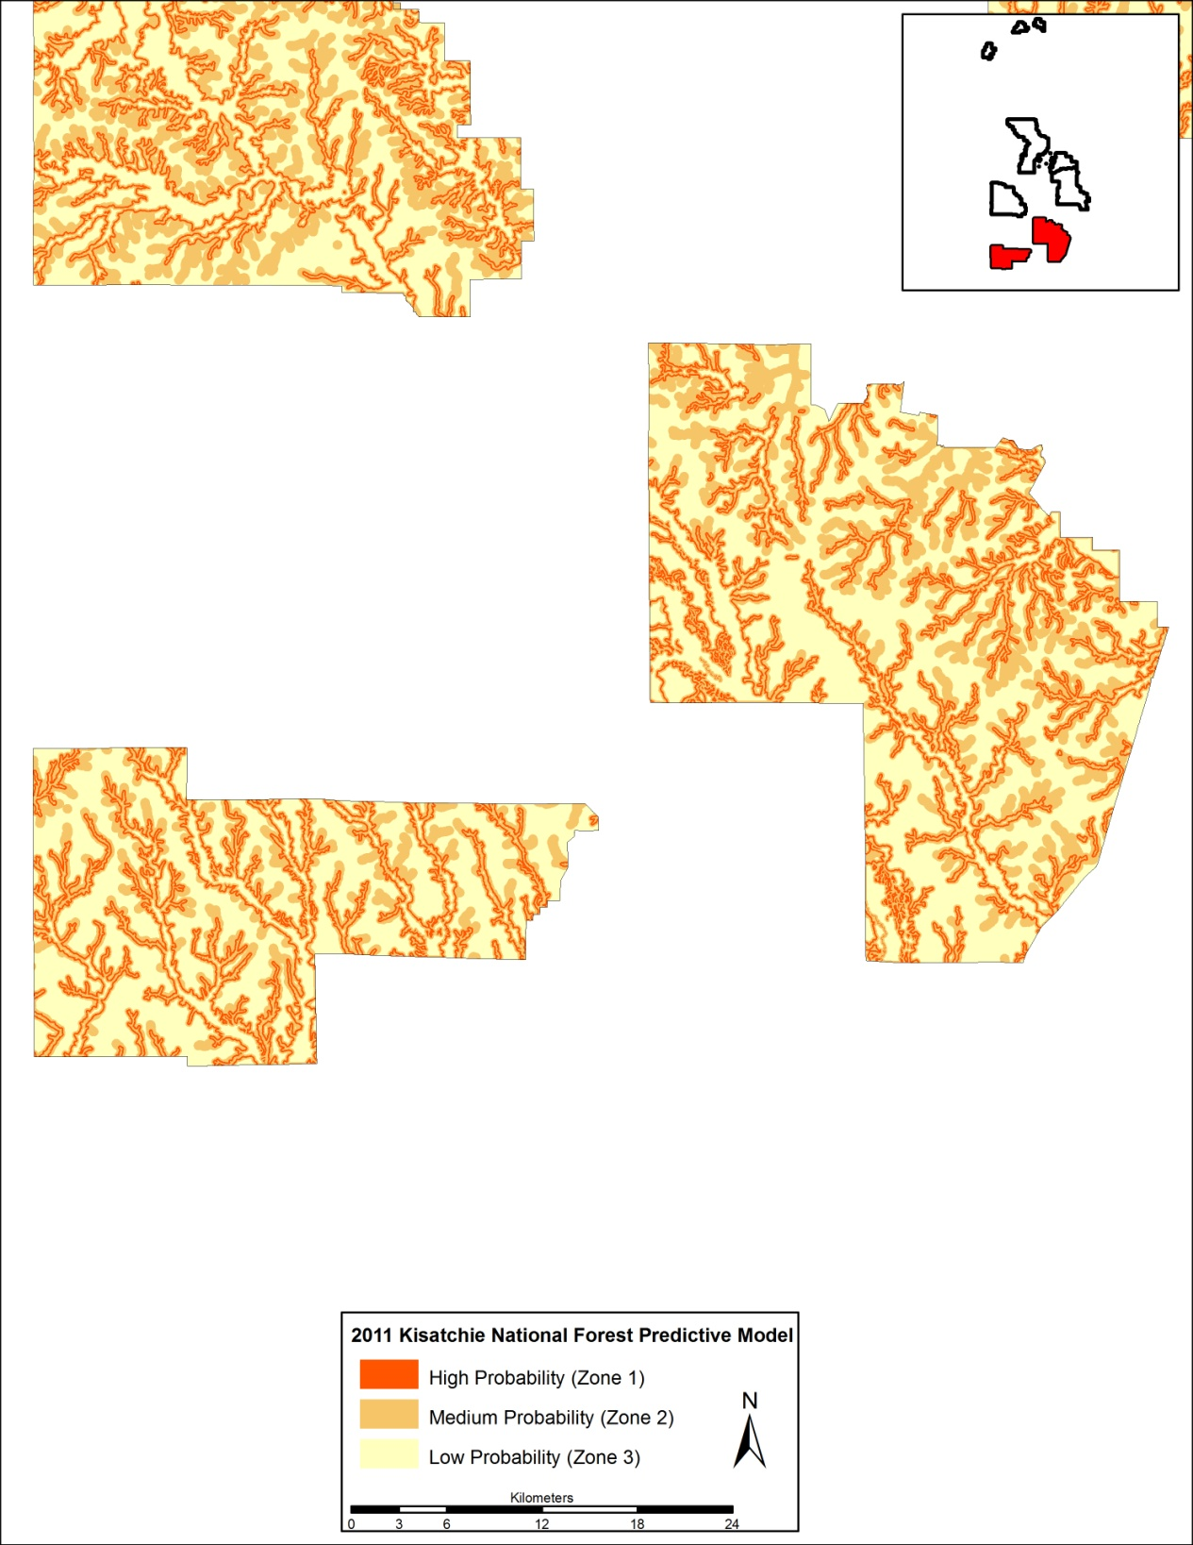
Figure 6.1. The proposed 2011 Kisatchie National Forest predictive model probability Zones for the Calcasieu District.

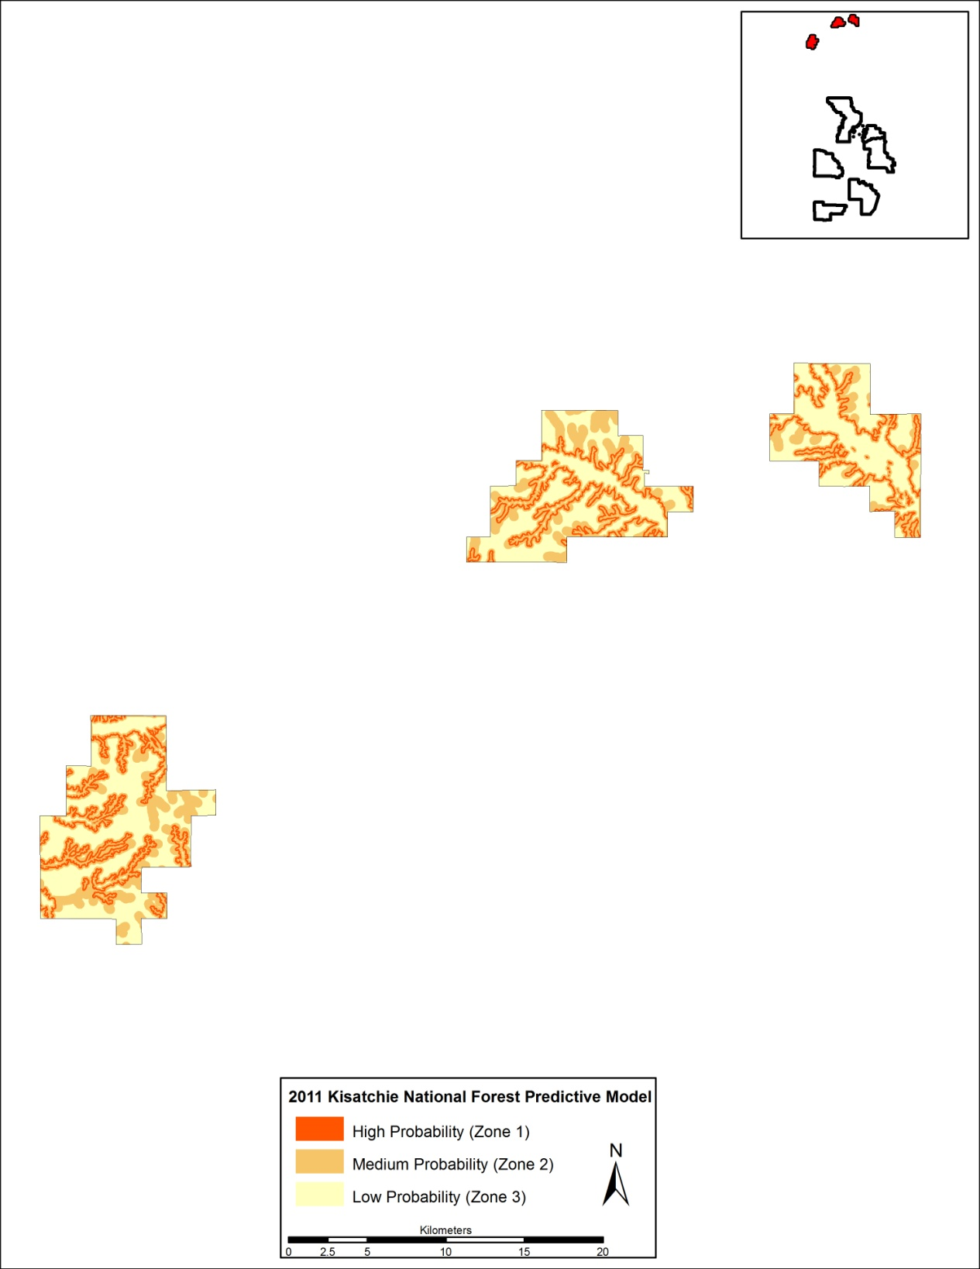
Figure 6.2. The proposed 2011 Kisatchie National Forest predictive model probability zones for the Caney District.

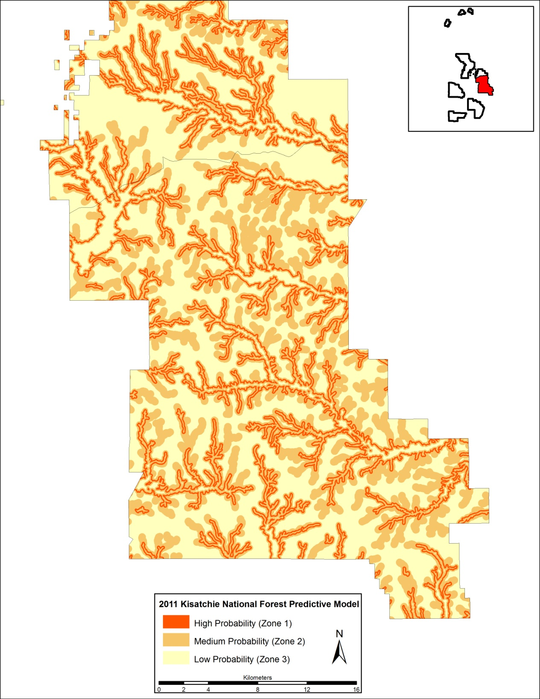
Figure 6.3. The proposed 2011 Kisatchie National Forest predictive model probability zones for the Catahoula District.

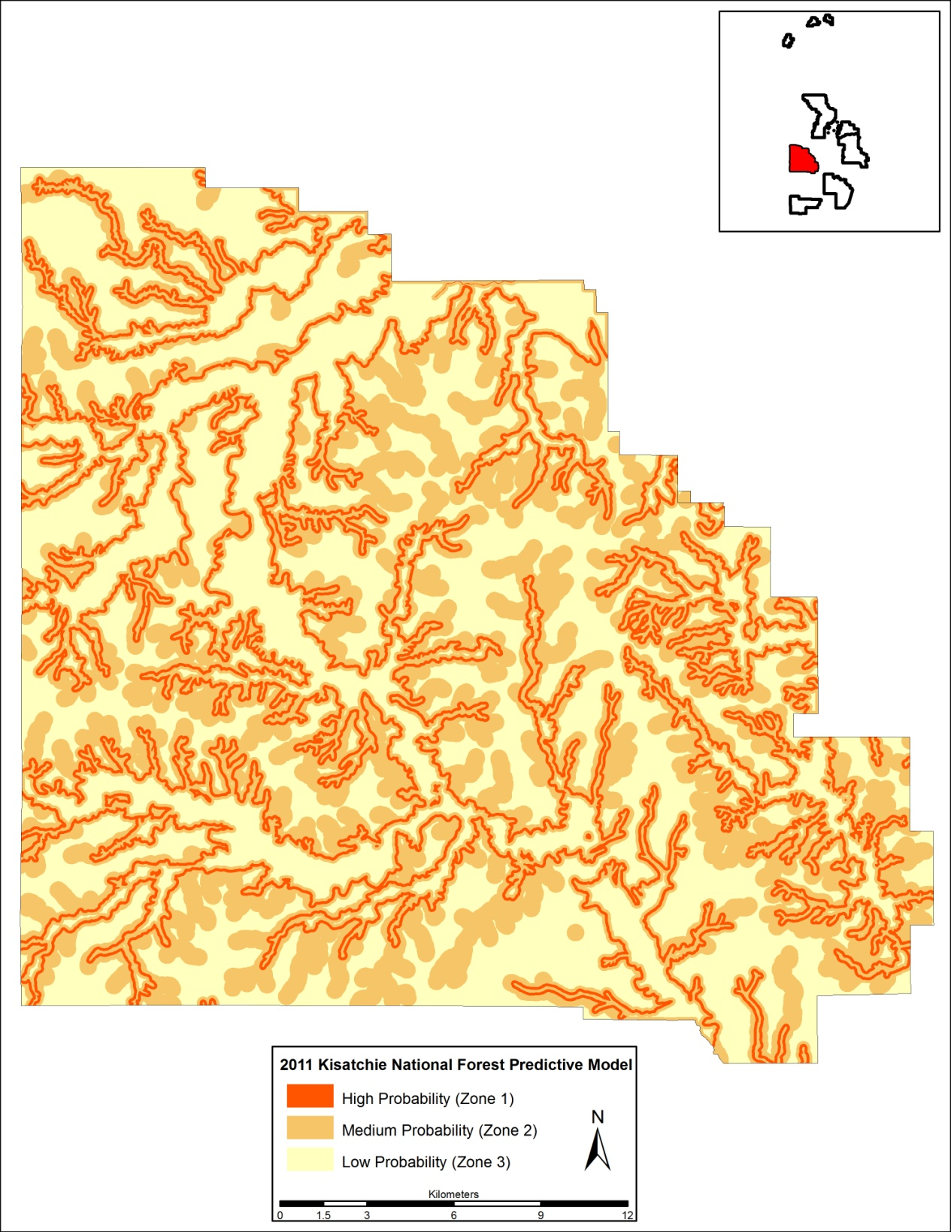
Figure 6.4. The proposed 2011 Kisatchie National Forest predictive model probability zones for the Kisatchie District.

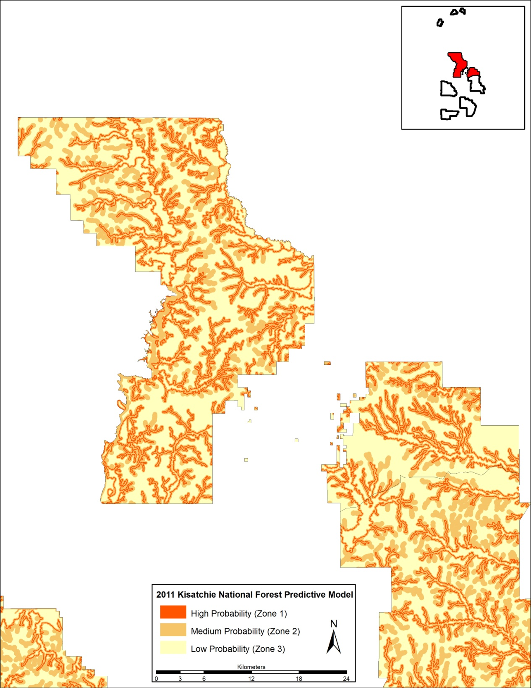
Figure 6.5. The proposed 2011 Kisatchie National Forest predictive model probability zones for the Winn District.

Conclusions and Recommendations

The newly developed and proposed 2011 Kisatchie National Forest predictive model shares many of the same environmental variables as the active US Forest Service Model (1995 FPPM) it is recommended to replace. These variables are shared as they are the most appropriate within the region and represent areas of varying resource offerings, as well as being easily operationalized in the field. The different strategies employed in the formation of each zone separate the models and produce varying levels of effectiveness. The proposed predictive model developed within this thesis has the advantage of being designed with consideration allotted for the larger region while also testing the model with the same dataset used in its construction. Several distinct differences were noted between the 1995 and the newly proposed 2011 Kisatchie National Forest predictive model with the coverage area differences between the high and medium zones most apparent. The differing gain statistics suggest that the new model more efficiently and effectively captures a greater number of archaeological sites relative to the total study area.
Geographically, the proposed 2011 Kisatchie National Forest predictive model appears to control for environmental and topographic variation more effectively as it markedly outperforms the active U.S. Forest Service Model (1995 FPPM) in both the Caney District and central cluster of ranger districts. The increased model performance within the Caney District negates the need for separate models for the Caney District and the clumped ranger districts encompassed within the central cluster area.
While the proposed 2011 Kisatchie National Forest predictive model zones may not be completely obvious in the field—for instance, determining the boundary between frequently and non-frequently flooded soils may prove challenging—it will be simpler to implement than a model that produces very segmented probability zones in a completely unpredictable fashion (e.g. 2010 FPPM, Perez and Bundy 2011). While the adoption of modern technology (i.e. precise in-field GPS devices with GIS capabilities) is becoming more ubiquitous within the field of archaeology, planning transects with tiered sampling intervals proves more complex and prone for in-field error for instances when a predictable buffer-type of zone is not followed.
The 2011 Kisatchie National Forest predictive model significantly outperforms both the active U.S. Forest Service Model (1995 FPPM) as well the recently developed 2010 FPPM (Tables 6.9 to 6.12). Gain statistics illustrate the effectiveness of each model. Since the 2010 FPPM probability zones were only generated over a small area and are difficult to replicate over larger areas, data from this study area were used to evaluate both the 1995 and 2010 Fort Polk predictive models (see Perez and Bundy 2011:253, Table 14.3 for values as used)(Tables 6.9 to 6.11). The utility of the Kisatchie National Forest predictive model was demonstrated over the entire Calcasieu ranger district study area, which includes portions of Fort Polk (Table 6.12). As the 2010 FPPM contains only two zones, the high and medium zones were combined for the 1995 FPPM and the proposed 2011 Kisatchie National Forest predictive model to render the results comparable. Examining the gain statistics as well as the areas and numbers of sites in each zone, the best performance is clearly by the proposed 2011 Kisatchie National Forest predictive model. Interestingly, the gain statistics also indicate that the 1995 FPPM also outperforms the 2010 FPPM, although not as much as the 2011 Kisatchie National Forest predictive model (Tables 6.9 to 6.12).

Table 6.9. Test Statistics for the High (includes Medium) and Low Probability Zones of the 1995 Fort Polk Predictive Model for the 2010 FPPM Study Area Including All Sites.
Probability Zone | Area (m²) | % of Area | Expected Sites | Observed Sites | % of Sites | χ2 | Gain
High (Zone 1+2) | 84352 | 52.3 | 1428.5 | 1789 | 65.5 | 91.0 | 0.20
Low | 77032 | 47.7 | 1304.5 | 944 | 34.5 | 99.6 | -0.38
Total | 161384 | 100.0 | 2733.0 | 2733 | 100.0 | 190.6 | -
df = 2, α = .05, sig of χ2 ≥ 3.84

Table 6.10. Test Statistics for the High and Low Probability Zones of the 2010 Prehistoric Fort Polk Predictive Model for the 2010 FPPM Study Area.
Probability Zone | Area (m²) | % of Area | Expected Sites | Observed Sites | % of Sites | χ2 | Gain
High | 107880 | 85.7 | 1909.1 | 1945.0 | 87.3 | 0.7 | 0.02
Low | 18018 | 14.3 | 318.9 | 283.0 | 12.7 | 4.0 | -0.13
Total | 125898 | 100.0 | 2228.0 | 2228.0 | 100.0 | 4.7 | -
df = 2, α = .05, sig of χ2 ≥ 3.84

Table 6.11. Test Statistics for the High and Low Probability Zones of the 2010 Historic Fort Polk Predictive Model for the 2010 FPPM Study Area.
Probability Zone | Area (m²) | % of Area | Expected Sites | Observed Sites | % of Sites | χ2 | Gain
High | 106639 | 85.5 | 216.4 | 239.0 | 94.5 | 2.4 | 0.09
Low | 18018 | 14.5 | 36.6 | 14.0 | 5.5 | 13.9 | -1.61
Total | 124657 | 100.0 | 253.0 | 253.0 | 100.0 | 16.3 | -
df = 2, α = .05, sig of χ2 ≥ 3.84

Table 6.12. Test Statistics for the High (includes Medium) and Low Probability Zones of the Proposed 2011 Kisatchie National Forest Predictive Model for the Calcasieu District Study Area Including All Sites.
Probability Zone | Area (m²) | % of Area | Expected Sites | Observed Sites | % of Sites | χ2 | Gain
High (and Medium) | 394885272 | 52.5 | 1202.8 | 1768 | 77.2 | 265.5 | 0.32
Low | 356902565 | 47.5 | 1087.2 | 522 | 22.8 | 293.8 | -1.08
Total | 751787837 | 100.0 | 2290.0 | 2290 | 100.0 | 559.3 | -
df = 2, α = .05, sig of χ2 ≥ 3.84

The proposed 2011 predictive model is also recommended to be adopted for the Kisatchie National Forest rather than the 2010 FPPM because it is simpler to implement in the field without excessive patchiness as previously discussed. Even with the common usage of GPS devices capable of displaying GIS layers, the patchy and unfluid nature of the high and low probability zones of alternative models, such as the 2010 Fort Polk predictive model make it challenging to operationalize for archaeological surveys. For these reasons, it is recommended that the US Forest Service adopt the model developed herein for use on its lands.
In addition to recommending that the U.S. Forest Service adopt the proposed 2011 Kisatchie National Forest predictive model, this study also recommends that authorities on the Fort Polk military reservation consider evaluating the proposed 2011 Kisatchie National Forest predictive model against the 1995 and 2010 FPPM over the entire Fort Polk area and, if the results are like those produced in the tests conducted here in Tables 6.9 to 6.12, consider adopting the proposed 2011 Kisatchie National Forest predictive model for the Fort Polk area as well. The data layers for the probability zones in the 2011 Kisatchie National Forest predictive model are easy to generate and use in the field and, the results of this study suggest, have applicability over much of western Louisiana.
Following the tiered sampling intensity strategy recommended by Anderson et al. (1996) for the 1995 Fort Polk Predictive Model, the high (zone 1) and medium (zone 2) probability zones as located on Kisatchie National Forest should receive shovel test pits (STPs) spaced at 30-m intervals along transects spaced 30-m apart, while the low (zone 3) probability zone should receive 50-m interval STPs along 50-m spaced transects. This recommended sampling strategy will intensify survey in areas of higher than expected likelihood for site discovery, while reducing field technician hours spent in low probability areas.
The use of a predictive model creates an incidence of survey bias and therefore, the model tends to become a self-fulfilling prediction. The circular nature of modeling archaeological site location is overcome by its benefits towards managing resources over large tracts of land. The implementation of the proposed 2011 Kisatchie National Forest predictive model, as outlined in this thesis, provides heritage personnel with a guide that will increase both accuracy and efficiency of site discovery, thus aiding Forest Service management efforts in the assessment, protection, and conservation of cultural resources. The proposed 2011 Kisatchie National Forest predictive model utilizes variables in its zone construction that influenced prehistoric and historic settlement patterning beyond just the Kisatchie National Forest. The proposed model may prove a useful tool for the entire state and even the larger region due to its high gain values and ease of implementation.
The proposed 2011 Kisatchie National Forest Predictive Model Zones and study area has been made available to the Kisatchie National Forest in digital form.

