Access beyond geographic accessibility: understanding opportunities to human needs in a physical-virtual world

A Dissertation Presented for the
Doctor of Philosophy
Degree
The University of Tennessee, Knoxville

Jimmy Feng
December 2022

Copyright © 2022 by Jimmy Feng
All rights reserved.

ACKNOWLEDGMENTS
This dissertation and my pursuit of a doctoral degree would not have been possible without my loved ones, especially my mother, Miao, and my late father, Yu. Despite lacking opportunities to pursue higher education, my mother and father imparted in me the importance of education and taught me the values of resilience and perseverance. Through them, I found a love for learning and a calling to make a positive and meaningful difference in the lives of others. Both my parents and my extended family, including many of my uncles, aunts, grandparents, and cousins provided me a nurturing and loving environment to succeed despite being hundreds and thousands of miles away. Words will never suffice to express my deepest gratitude for the sacrifices my family made on my behalf to make this opportunity possible for me.
I also have my girlfriend, June, and her family to thank for making the second half of my program less stressful, especially during Covid-19. Amidst a turbulent time away from home, their warmth, encouragement, and support provided me the motivation to keep going forward. June taught me that life is more than just work and to strive for a healthier balance. She has been my rock these past few years.
My deep appreciation goes out to everyone throughout my educational career, including my advisor, Dr. Shih-Lung, who has supported me in my personal and professional ambitions throughout these past four years. I am eternally grateful to Dr. Shaw for his mentorship and guidance; he took a chance on me and gave me the opportunity to come and learn the process of independent research in Knoxville. Thank you. My committee members, Drs. Wenjun Zhou, Qiusheng Wu, Madhuri Sharma, and Hyun Kim equally and unselfishly shared their deep knowledge with me, and I am thankful for their time and effort on my behalf. I have learned a lot from all of these professors, and each has helped broaden my perspective and deepen my knowledge to improve my research and understanding of the world.
I also wish to thank my professors during my time at SUNY Geneseo who inspired my love for geography and supported me in my graduate school application process: Drs. Jennifer Rogalsky, David Robertson, Randy Kaplan, Seth Cavello, Darrell Norris, Jim Kernan, Steve Tulowiecki, Ren Vasiliev, Colleen Garrity, and David Aagesen. My path towards geography would not have been possible without their teachings and mentorship.

ABSTRACT
Access to basic human needs, such as food and healthcare, is conceptually understood to be comprised of multiple dimensions. However, research in this area has traditionally been explored with spatial accessibility measures that almost exclusively focus on just two dimensions. Namely, the availability of resources, services, and facilities, and the accessibility or ease to which locations of these opportunities can be reached with existing land-use and transport systems under temporal constraints and considering individual characteristics of people. These calculated measures are insufficient in holistically capturing available opportunities as they ignore other components, such as the emergence of virtual space to carry out activities and interactions enabled by modern information and communication technologies (ICT). Human dynamics today exist in a hybrid physical-virtual space, and recent research has highlighted the importance of understanding ICT, individual behavior, local context, social relations, and human perceptions in identifying opportunities available to people. However, there lacks a holistic approach that relates these different aspects to access research. This dissertation addresses this gap by proposing a new conceptual framework for the geography of access for various kinds of human needs, using food access as a case study to illustrate how the proposed framework can be applied to address critical societal issues. An interactive multispace geographic information system (GIS) web application is developed to better understand and visualize individual potential food access based on the conceptual framework. This dissertation contributes to the body of research with a proposed conceptual framework of access to human needs in a hybrid physical-virtual world, the integration of various big and small data sources to reveal information relating to the access of people, and novel development of a multi-space GIS to more accurately analyze and visualize access to opportunities.
TABLE OF CONTENTS
CHAPTER 1. INTRODUCTION 1
1.1. RESEARCH QUESTIONS 3
1.2. RESEARCH OBJECTIVES 4
CHAPTER 2. LITERATURE REVIEW 7
2.1. OVERVIEW OF ACCESSIBILITY DEFINITIONS AND MEASURES 7
2.2. A MULTIDIMENSIONAL DEFINITION OF ACCESS 15
2.3. ACCESS IN HYBRID PHYSICAL-VIRTUAL SPACE 17
2.4. ACCESS ALONG VARIOUS CONCEPTS OF SPACE 20
2.5. FOOD ACCESS AS A CASE STUDY 24
CHAPTER 3. CONCEPTUAL FRAMEWORK FOR ACCESS IN A HYBRID PHYSICAL-VIRTUAL SPACE 31
3.1. CONCEPTUAL FRAMEWORK 31
3.2. EXTENDING DIFFERENT DIMENSIONS OF ACCESS FOR A HYBRID PHYSICAL-VIRTUAL SPACE 33
3.2.1. AVAILABILITY IN HYBRID PHYSICAL-VIRTUAL SPACE 33
3.2.2. ACCESSIBILITY IN HYBRID PHYSICAL-VIRTUAL SPACE 37
3.2.3. ACCOMMODATION IN HYBRID PHYSICAL-VIRTUAL SPACE 41
3.2.4. AFFORDABILITY IN HYBRID PHYSICAL-VIRTUAL SPACE 43
3.2.5. ACCEPTABILITY IN HYBRID PHYSICAL-VIRTUAL SPACE 47
3.3. IMPLEMENTATION CONSIDERATIONS 50
3.3.1. DATA CONSIDERATIONS 50
3.3.2. MEASUREMENT CONSIDERATIONS 51
3.4. SUMMARIZING THE DIMENSIONS OF ACCESS IN HYBRID PHYSICAL-VIRTUAL SPACE 54
CHAPTER 4. METHODOLOGICAL FRAMEWORK 57
4.1. STUDY AREA 57
4.2. DATA AND METHODOLOGY 58
4.2.1. DATASET 1: FOOD STORES IN AND AROUND KNOX COUNTY, TENNESSEE 59
4.2.2. DATASET 2: SOCIOECONOMIC, DEMOGRAPHIC, AND PERCEIVED CHARACTERISTICS OF INDIVIDUALS 77
4.2.3. DATASET 3: INDIVIDUAL TRAJECTORIES AND ACTIVITIES 83
4.2.4. DATASET 4: BLOCK GROUP-LEVEL ESTIMATES OF SOCIOECONOMIC AND DEMOGRAPHIC CHARACTERISTICS IN KNOX COUNTY, TENNESSEE 93
4.3. A PROTOTYPE MULTIDIMENSIONAL MUTLISPACE GIS FOR ACCESS 96
4.3.1. INTERACTIVE PANEL DESCRIPTION 99
4.3.2. ACCESSIBLE OPPORTUNITIES COUNTER 105
CHAPTER 5. CASE STUDIES 106
5.1. CASE STUDY 1: What food opportunities can people access that are nearby an individual as they travel to and visit different places in their daily lives? 106
5.2. CASE STUDY 2: What opportunities may be accessed by an individual and by what modalities, e.g., in person, online, or both? 122
5.3. CASE STUDY 3: What opportunities may be accessed by an individual via their social networks, in other words, what are the second, third, nth-order opportunities accessible to people based on who they know? 129
5.4. CASE STUDY 4: What opportunities are accessible based on an individual’s physical needs and mental preferences? 138
5.5. NOTE ABOUT TOTAL OPPORTUNITIES 145
CHAPTER 6. DISCUSSION AND CONCLUSION 147
6.1. Research Summary 147
6.2. Future Directions 156
REFERENCES 165
APPENDIX 180
APPENDIX 1. OVERVIEW CHART OF ACCESSIBILITY MEASURES 180
VITA 186

LIST OF FIGURES
Figure 1. A conceptual framework for access related to different types of space in physical-virtual space 32
Figure 2. Coherence plot of topics 68
Figure 3. Perplexity plot of topics 68
Figure 4. Topic-word mixtures and proportions when n=6 69
Figure 5. Snapshot of data on socioeconomic, demographic, and perceived characteristics of plausible individuals in Knox County, Tennessee 78
Figure 6. Snapshot of data on individual trajectories of people 84
Figure 7. Screenshot of code for recording activity and travel type of the following row in the trajectory dataset 88
Figure 8. Screenshot of Interactive GIS Platform for Food Access 97
Figure 9. Map overlay to contextualize the total population throughout the study area 100
Figure 10. Opportunities near Person A's (1) Home 110
Figure 11. Opportunities near Person A's Workplace during a two-day period 110
Figure 12. Opportunities near Person A's Workplace during their working hours on Friday 112
Figure 13. Opportunities near Person A as they travel home after church and lunch at a restaurant. Note that the plot on the right looks different than those in the previous two figures due to a slight change in perspective, but the trajectory remains the same. 115
Figure 14. Mexican food stores accessible to A during her non-working hours on a Saturday 115
Figure 15. A lack of opportunities near the home of Person B (3) 117
Figure 16. Population overlay with opportunities accessible to Person B 117
Figure 17. Poverty map overlay on stores that can be accessed by A 119
Figure 18. Opportunities accessible to Person C (5) 124
Figure 19. Opportunities accessible to Person D (27) 127
Figure 20. Opportunities near Person E's (18) Workplace without considering wheelchair accessibility 133
Figure 21. Opportunities accessible to Person E (18) considering wheelchair accessibility 134
Figure 22. First- and Second-order Opportunities accessible to Person E 135
Figure 23. First-, Second-, and Third-order Opportunities accessible to Person E 137
Figure 24. Opportunities accessible to Person H (6) 140
Figure 25. Opportunities that accept SNAP benefits accessible to Person H 141
Figure 26. Opportunities that both accept SNAP benefits and are moderately priced accessible to person H 143

CHAPTER 1. INTRODUCTION
Access to human needs such as food, medical care, education, jobs, and greenspaces are integral for quality of life and well-being. Unequal distribution of services, resources, activities and facilities (hereafter, opportunities) is a social inequality requiring greater attention (Knox, 1980; van Wee, 2016; van Wee & Geurs, 2011). Access is a construct describing whether people can or cannot reach and/or use their desired opportunities but one problem in research and practice is the ambiguity of what access requires. Its meaning is often unclear and without standardized methods and approaches (Handy, 2020; Handy & Niemeier, 1997; E. J. Miller, 2018). Literature is typified by spatial (geographic/physical) accessibility measures focusing on the attractiveness of opportunities and accessibility or ease to which these opportunity locations can be reached with existing land-use and transport systems under temporal constraints and considering individual characteristics of people (Geurs & van Wee, 2004). In this sense, accessibility refers to the ability of people (or ease) to reach desired opportunities. Perhaps, one important reason for the ambiguity in measuring access is the lack of a common conceptual understanding of the factors relevant to the interaction between individuals and the broader system of opportunities that influences access. Penchansky and Thomas (1981) proposed a framework highlighting five interrelated dimensions contributing to individual ability or willingness to use the healthcare system. Availability is the ratio between the volume, diversity, and quality of opportunities and demand by people. Accessibility reflects the ease to which people can overcome the spatial separation between their location and of desired opportunities. Accommodation reflects the appropriateness of the organization of opportunities to accept people with respect to the abilities and willingness of people, e.g., operational hours and parking. Affordability describes the relationship of prices and accepted payment options of opportunities with the capacity and willingness of people to pay. Acceptability refers to the relationship between the perceptions and expectations of people and opportunities—for example, preferences for a particular race, gender, etc. These five dimensions repeatedly emerge in the literature to contexts beyond healthcare and as causal factors influencing procurement of opportunities, suggesting they can be broadened to different human needs.
Despite widespread acknowledgment of access as a multidimensional concept, extant literature is largely premised in physical space with a fixation on the physical locations of people who access opportunities, e.g., customers, patients, job-seekers, etc., and people and entities that are the source of these opportunities, e.g., stores, hospitals, employers, etc., (hereafter, destinations) in Euclidean space with a Cartesian coordinate system. But with increasing use of information and communication technology (ICT), conceptualization and operationalization of spatial accessibility based on static spatial frameworks is insufficient to capture contemporary situations of access and spatiotemporal experiences of people (Kwan, 2007, 2013). ICT advancements foster virtual space (Janelle & Hodge, 2000) which affords greater flexibility and freedom for people to carry out activities and interactions in space-time and fulfill their needs by minimizing various constraints and facilitating new opportunities (Yu & Shaw, 2007, 2008; Shaw & Yu, 2009). This includes the popularization of online shopping, telehealth, telecommuting, and e-learning (van Wee, 2016). ICT transforms contemporary activity-travel behavior and renders core spatial accessibility concepts including proximity, propinquity, and friction of distance less important (Afradi & Nourian, 2020).
Conventional approaches and indicators of accessibility calculated with spatial data are insufficient in holistically and accurately capturing the distribution of available opportunities between people. They ignore important components including ICT, local context, social networks and mental perceptions. Scholars have increasingly argued that the conventional static approach to calculating access to human needs is devoid of recognizing the mobilities of people and their contextual environments as they carry out different activities over space-time beyond places such as home and work (Kwan, 2013; McLafferty, 2020; Ren & Kwan, 2009). Relational aspects including social capital, networks, relationships, and interactions also influence access (Bergmann & O’Sullivan, 2018; Paul et al., 2019; Andris, 2016). Access too is mediated by individual perceptions of the environment and land-use and transport systems (Handy, 2020; Pot et al., 2021; Ryan & Pereira, 2021). Research on food access can be characterized with the same critique. While scholars have explored access beyond spatial accessibility, there lacks a holistic framework relating access to the complexity of diverse human experiences let alone a GIS environment capable of modeling and analyzing access that simultaneously takes into consideration absolute locations, local context, social relations, and human perceptions in a hybrid physical-virtual world.

1.1. RESEARCH QUESTIONS
A few questions arise that guide this dissertation research:
1. What are the relationships between different dimensions of access—availability, accessibility, affordability, accommodation, and acceptability—and various conceptions of space? How and to what extent are different dimensions of access changing in an increasingly physical-virtual world?
2. What types of data can reflect upon people’s contextual environments, relationships and interactions, and mental perceptions related to food access? How can these data be integrated in a GIS to better understand the potential opportunities accessible to people?
3. What space-time GIS and other relevant methods are useful to explore how local context, social relations and mental perceptions shape access to opportunities?
These research questions signify the need to expand conventional understanding of food access in a hybrid physical-virtual world and to develop GIS capable of representing contemporary concepts and handling different human experiences.

1.2. RESEARCH OBJECTIVES
The objectives of this dissertation are:
- To develop a multispace multidimensional conceptual framework of access that synthesizes extant literature on the role of local context, relationships, and perceptions in access.
- To identify appropriate data that can reflect upon people’s local context, relationships, and mental perceptions and be integrated in a GIS for researching individual food access.
- To develop a GIS web application capable of handling multiple data streams reflecting upon people’s access and that can reveal disparities in accessible food opportunities based on people’s mobilities, local context, relationships and interactions, and mental perceptions.
The proposed GIS web application can be used to answer questions such as:
- What opportunities can people visit with sufficient time that are nearby an individual as they travel to and visit different places in their daily lives?
- How can we determine what opportunities may be accessed by an individual and by what modalities, e.g., in person (physically), online (virtually), or both (hybrid)?
- What opportunities may be accessed by an individual via their social networks; in other words, what are the second, third, n-order opportunities accessible to people based on who they know?
- What opportunities are accessible based on an individual’s physical needs and mental preferences?
- What opportunities can people with different socioeconomic and demographic characteristics access?
Thus, this dissertation develops a general multispace and multidimensional conceptual framework of access for various kinds of human needs in a hybrid physical-virtual space with food access as a case study illustrating how the framework can be operationalized. Food access is chosen in this study because of its intrinsic linkage to human existence as a physiological need (Maslow & Green, 1943) and the role of good nutrition in the health and well-being of people. For example, nearly a third of the global population in 2020 lacked access to adequate foods (Food and Agriculture Organization of the United Nations, 2021), with Covid-19 further exacerbating weaknesses in food systems. In the U.S., over one in ten (10.5%) families experience food insecurity, i.e., lack consistent access to sufficient healthy and nutritious food (George & Tomer, 2021; USDA Economic Research Service, 2022). In contrast to white households (7.9%), the rate of food insecurity is disproportionately higher for those who are impoverished (34.9%), in single-mother households (28.7%), and in Latino, Hispanic (15.6%), and Black (19.1%) households. The demonstrable differences in access to food between different groups of people illustrates the need for more disaggregate and nuanced approaches to access that can identify such disparities in access. The next section provides a review of the literature. Section 3 presents the conceptual framework. Section 4 discusses data sources and methodology to clean and integrate the data in a prototype web GIS platform. Section 5 presents four case studies that demonstrate how the GIS can be used to answer different questions related to food access. Finally, Section 6 discusses and summarizes main conclusions.

CHAPTER 2. LITERATURE REVIEW

2.1. OVERVIEW OF ACCESSIBILITY DEFINITIONS AND MEASURES
Accessibility to opportunities for human needs (Maslow & Green, 1943) including food, jobs, health care facilities, and social services is a central focus of much research. Efforts across disciplines (civil engineering, geography, regional science, urban planning, etc.) have highlighted inequitable sociospatial patterns and sought to understand the role of the built environment and individual characteristics with people’s access. The involvement of multiple disciplines and consequently different approaches perhaps leads to what many agree as “a slippery notion … one of those common terms that everyone uses until faced with the problem of defining and measuring it” (Gould, 1969, p. 64). Definitions of a similar flavor in the literature include the “inherent characteristic (or advantage) of a place with respect to overcoming some form of spatially operating source of friction” (Ingram, 1971, p. 101), “potential of opportunities for interaction” (Hansen, 1959, p. 73), “number or density of travel opportunities of particular types within certain time distances or travel-cost ranges from the residential locations of population groups of interest” (Wachs & Kumagai, 1973, p. 441), benefits provided by the transportation and land-use system, often couched in monetary terms (Ben-Akiva & Lerman, 1985), and space-time feasibility based on the spatiotemporal organization of opportunities and transportation networks and/or activity schedule of people, including their unique constraints, time budgets, and travel behaviors (Delafontaine et al., 2011; Kim & Kwan, 2003; Kwan, 2013; Miller, 1991; Neutens et al., 2012; Widener et al., 2013, 2015).
These definitions represent some popular spatial accessibility measures (see Appendix 1 for a chart overview and citations.) Simple distance measures focus on the physical separation between two points or one point to all others and have been operationalized as the Euclidean (straight-line) or network path-based distance between supply and demand location(s). In other words, the time or cost needed to traverse from one location to another, or the physical length between two locations provide a point of comparison for the degree to which opportunities are (not) accessible. Network path-based distances are almost always preferred because they are based on realistic transportation networks that take into consideration physical impediments and barriers (e.g., water bodies, buildings, train lines, etc.). Such measures can further be refined to account for the mode of travel, whether by foot, bike, car, or some form of public transit, and the time of day. They are often employed in research studies that establish time or geographic space as the unit of measurement, treated as (i) proximity: physical distance or travel time to the closest supply location (Ploeg et al., 2012; USDA Economic Research Service, 2019); (ii) diversity: number of opportunity locations within a given time or distance threshold (i.e. service area) (Apparicio et al., 2007; dos Anjos Luis & Cabral, 2016), or (iii) variety: average distance to a specified number n of opportunity locations. Similarly, travel time has been used to assess accessibility to food in the United States (Ploeg et al., 2009; Rhone et al., 2017), cities for rural populations globally (Weiss et al., 2018), hospitals (Bosanac et al., 1976), and other healthcare facilities (Weiss et al., 2020). In proximity and variety distance measures, longer travel times or physical separation would suggest lower accessibility while shorter travel times and physical distances would indicate greater accessibility. Meanwhile, a larger value for diversity would indicate greater availability as there would be more options available. However, it is recognized that the choice of distance measure can significantly impact the obtained results; thus, conclusions may be highly sensitive to the choice of measure of accessibility (Talen & Anselin, 1998a) as well as the method of aggregation, i.e. the selection of the spatial unit of analysis (Apparicio et al., 2017). Choosing only one of these measures does not adequately capture a population’s spatial accessibility to a resource or service, and it is argued that no single simple distance measure can fully describe the geography of accessibility as they may reflect different aspects of opportunities for people to meet their various needs (Apparicio et al., 2007).
The next two exemplify the most popular measures: gravity measures that discount total attractiveness of an area with an impedance factor from an origin point and cumulative opportunities within a specified threshold. Adapted from Newton’s law of gravity, gravity models are used to explain or predict spatial interactions—to measure the interaction between all locations—and have been modified in different ways to measure accessibility, such as in (Dalvi & Martin, 1976; Hansen, 1959; Kwan, 1998; Shen, 1998). Whereas the traditional gravity model measures spatial interactions between all possible pairs of locations, the potential model measures spatial interactions between a single location and all other locations. Hansen was one of the first to adapt the gravity model to study the relationship between the rate of residential development and accessibility to employment in Washington D.C. (Hansen, 1959). He proposed that the accessibility, or attractiveness of opportunities (e.g., jobs), of any individual zone could be obtained by discounting the available opportunities with the difficulty of reaching that zone. A distance decay effect, beta exponent, is often included to reflect varying levels of impedance and the ease to which the transport system facilitates interaction between locations. In other words, the attraction between two locations is proportional to the product of the importance of both locations divided by their distance. Another popular variant is the two-step floating catchment area (2SFCA) method that additionally considers opportunity-to-population ratios, and has been used and further modified to measure accessibility to various health care services (Luo & Wang, 2003; Wang, 2012) and food locations (Chen, 2017). Accessibility is measured by the ratio of service opportunities (e.g., hospitals, grocery stores) to the population, and obtained by first determining the availability at supply locations as ratios of various services to the surrounding population and then these ratios are summed up around each demand location. Results of these gravity measures are relatively easy to understand but in practice are often used for comparison between aggregated units which cannot be used to explain individual access. They further suffer from issues of aggregation and scale such that the unit of analysis would influence the obtained results. Another limitation is the inherent assumption that all people within a geographic unit have equal access to opportunities within the area and that people do not go beyond their local area to obtain the opportunities they desire. In other words, people may not weigh each opportunity the same and many opportunities that people access beyond the borders of their area could be overlooked.
Cumulative opportunity measures assess spatial accessibility as the total amount of opportunities that can be reached from a person or population’s origin location(s) within a particular travel time or distance threshold. See for example: (Wachs & Kumagai, 1973). Implicitly, each potential activity location is weighted the same (i.e., equally), but individuals may consider opportunities differently based on their travel and time preferences. For example, a population’s availability would be contingent upon the number of possible health care facilities that could be reached within half an hour drive for that population’s origin location. The availability of a good or service would increase as the number of opportunities also increases. While a travel impedance, as some form of physical separation or travel time, is used as a threshold in the determination of the available opportunities, the emphasis is given on the sum of potential opportunities and as suggested, provides information about the diversity, or number of stores, available to people. Cumulative opportunity measures however are highly sensitive to the specified cutoff travel distance or time and may thus affect the resulting availability metrics. They are a unique variant of gravity-based measures.
These distance-based, gravity-based, and cumulative opportunity measures belong to a class of location-based measures which measures the number of opportunities that can be reached from a single location, with the assumption that people in an area travel from that location. In contrast, person-based measures model individuals or people with similar characteristics: utility measures estimate the economic benefits (expected maximum utility) an individual would perceive from access to a set of spatially distributed opportunities, and space-time measures based on Hägerstrand (1970)’s time-geography framework that consider the possible areas (activity spaces) one can reach over time given a set of constraints. Utility-based measures (i.e. discrete choice models) enable for more nuanced personal characteristics to be included in the parameterization and assume that people select the opportunity (or alternative as is described in the literature), among many, that provides the maximum utility (Ben-Akiva & Lerman, 1985). These utility-based measures are based on individual choice behavior and often premised on various theories, including Thurston’s random utility theory and Luce’s strict utility theory. The former postulates that the utility of all alternatives are stochastic (random) variables and the chosen alternative has the highest probability with the greatest utility among all others in the choice set (Ben-Akiva & Lerman, 1985). In contrast, the latter postulates that the probability of choosing a choice alternative is equal to the ratio of the utility of that choice alternative to the total utility of all choice alternatives in the choice set. Utility functions often take the form of a multinomial logit model and includes variables for the characteristics of alternatives in the choice set, the attractiveness of each alternative, the travel impedance, and socioeconomic characteristics of people. The logsum of the model is used to define an individual’s accessibility.
In contrast to measures of place accessibility, space-time measures principled on the time-geographic framework by Torsten (Hägerstrand, 1970, 1982) determine geographic accessibility as the feasible opportunities that can be reached given an individual’s sequence of daily activities and under various spatiotemporal constraints. The time geography framework is comprised of various concepts that can help researchers analyze phenomena across absolute space and time. A space-time path is comprised of an individual’s movements and activities across space and over time. Hägerstrand referred to a path beginning from one’s birth and ending with one’s death in one of his earlier papers but, in an analytical framework, a space-time path can be of an interval based on one’s question of interest. This realized path is one of many potential paths within a space-time prism, or the feasible areas that can be reached within a particular window of time and under different capability, coupling, and authoritative constraints. Projecting the space-time prism on to a planar geographic space (i.e. two-dimensional space) provides what is called the potential path area (Kwan, 2004; Lenntorp, 1976). Capability constraints refer to limitations imposed by the biological nature of and skills and resources available to people (e.g., the necessity for rest, food, and water and the ability of the human body to traverse from one location to another). Coupling constraints refer to limitations imposed by the requirement of other entities and/or beings to engage in an activity (e.g., a full-body checkup requires both the physician and patient to be in the same room). Similarly, bundles are groupings of different space-time paths which necessitate that there be multiple entities engaging in the same area. In other words, the actors in a bundle are engaging in the same areas at particular times. Authority constraints refer to the restrictions imposed by those with control, influence and/or power (e.g., a grocery store is only open according to the business hours of 7:00 AM to 11:00 PM). As an extension of this concept, fiats or domains describe the areas under control by an authoritative entity. While Hägerstrand more clearly defines these concepts, he himself admits the fuzzy nature of projects and dioramas given the complexity of the world. Each individual/actor has their own project comprised of their chain of different activities across space and over time towards the completion of their goal(s). Dioramas embody the myriad projects of different actors/individuals and are inclusive of both biotic and abiotic elements in the environment, the heterogeneous nature of the system, and all the contexts in which actors/individuals are situated in. These concepts together form an ontological framework for which researchers across different disciplines can investigate people’s access to various needs at a disaggregate and individual level.
Since Hägerstrand’s seminal work in (1970), many have developed space-time measures to analyze individual accessibility that incorporates different constraints. Bo Lenntorp implemented time geography concepts in his Program Evaluating the Set of Alternative Sample Path (PESASP) computational model that was used to examine the individual accessibility of households to different activities over time in the Vällingby-Bromma area in Sweden (Lenntorp, 1976). Harvey Miller explored how space-time prism constructs could be implemented in a GIS and then used to identify the potential locations available to an individual (i.e. their choice set) relative to various constraints on the individual’s behavior (H. J. Miller, 1991). In a time when computational capabilities were relatively lacking, his work was one of the first to employ time geographic concepts into a GIS to study accessibility. Mei-Po Kwan further developed space-time accessibility measures in a GIS with her study of individual access to urban opportunities for 39 men and 48 women in Columbus, Ohio (Kwan, 1998). Drawing from two datasets, including 1) an activity-travel diary dataset detailing individual activity-travel characteristics, addresses of activity locations, and people’s perceptions of their space and time constraints, and 2) a geographic database of the study area comprised of parcels, Kwan evaluated eighteen different measures of gravity and cumulative opportunity variants and thirteen space-time measures using an algorithm developed in (Kwan & Hong, 1998). The results from her study revealed the differences in spatial patterns between men and women and also between space-time measures compared to conventional measures of gravity and cumulative opportunity. She argued that the conventional gravity-based and cumulative-opportunity measures, while useful as indicators of place accessibility, were comparatively poor in evaluating person-based accessibility, and from her results concluded that space-time measures were more capable of identifying interpersonal differences in accessibility, including along gender and ethnic divides. This is because space-time measures are more attune to individual life situations and social differences along axes of gender, race, class, age, etc. These different types of measures are sensitive and may reflect upon different aspects of accessibility. Thus, space-time measures may more accurately reveal accessibility for different people. Kwan’s work brought to light the implications in social (e.g., gender) differences when using conventional measures of accessibility versus space-time approaches that, respectively, inform location-based and person-based accessibility.
Temporal variations as facility operational hours, time of day (Weber, 2003), time constraints, stochastic travel times (Lee & Miller, 2020), and more have also been integrated in space-time measures to more accurately understand the opportunities accessible to individuals. Weber and Kwan (2003) found that including time due to travel congestion reduced individual accessibility compared to measures without their inclusion. Other scholars have also developed approaches that consider the probability by which individuals can participate in activities at opportunity locations and return to their destination (Chen et al., 2013). Delafontaine et al. (2011) similarly demonstrated how equity of individual accessibility to various urban services is influenced by adapting the operational hours of facilities to different schedules. Chen and Clark (2013) additionally noted that different types of facilities (e.g., with food stores, supermarkets, convenience stores, farmers’ markets, etc.) operate and close at different times.
As suggested in this subsection, recurrent debate in the literature concerns the trade-offs of location- and person-based approaches which are each useful for different types of questions. One major critique of location-based measures is the ignorance of idiosyncratic differences and the assumption of homogeneous aggregated populations reduced to geographic units in static fixed locations. Conventional applications focus mainly on the attractiveness of opportunities and some cost distance between locations and often fall short of capturing heterogeneous preferences and behaviors over space-time. They are, however, generally easier to use and interpret for questions relating to group behaviors and averages. Person-based measures in contrast are more computationally expensive, data intensive and difficult to interpret, but are more apt at accurately modeling and capturing fine-grained individual-level differences and the mobilities of people. (Dis)advantages aside, a general sentiment across these measures emerges whereby the transportation system enables individuals with access to places where they can participate in spatiotemporally distributed activities and exchange information, goods, and services (Miller, 2018).

2.2. A MULTIDIMENSIONAL DEFINITION OF ACCESS
Beyond measurement, an important but less popular focus concerns understanding the causal factors of access. Geurs and van Wee (2004) identify four main theoretical components from different accessibility definitions and measures. The land-use component reflects attractiveness and availability (quantity, quality, diversity) of opportunities, typically operationalized as the size or magnitude of activity locations (e.g., facility area), in relation to the demand for them. The transportation component describes the transport system, expressed as the disutility of an individual to overcome the spatial separation between their origin and desired destination location with some transport mode. The temporal component captures temporal constraints, including the time available for individuals to engage in activities vis-à-vis opening hours of opportunities. The individual component reflects the needs, abilities, and preferences of people contingent upon their personal characteristics (sociodemographic attributes, financial situation, capabilities, attitudes, preferences, context, etc.) Pot et al. (2021) argue that these components hail from a tradition of using calculated indicators based on spatial data and must also consider how people perceive their environment; that the relationship between land-use and transport systems and individual behavior over time is mediated by perceptions. In other words, what people consider to be appropriate and are aware of are also important determinants of access. People have varying physical aptitudes and preferences and thus require different infrastructure (e.g., parking lots, wheelchair accessible ramps) and policies (e.g., mask-wearing mandates) that can accommodate them. Additionally, people value opportunities differently and vary in their capacity and willingness to accept certain wages or afford resources and services. Their attitudes, preferences, and social and cultural contexts also influence what they consider to be acceptable.
These components reflect impediments to access which parallels the theory of five access dimensions by Penchansky and Thomas (1981). Others have inquired into similar dimensions for food access (Caspi, Sorensen, et al., 2012; Widener, 2018) and job access, noting that focusing solely on physical proximity and similar concepts rooted in physical space omits important intervening economic, social, and cultural barriers and facilitators. Despite widespread acknowledgement of access as a multidimensional concept, applied research on access is often assessed with the aforementioned spatial accessibility measures that mainly focus on the availability and accessibility dimensions. Most measurements are based on proximity and connectivity in physical space (Goodchild & Sheppard, 2000). But research finds an inconsistent relationship between the geographical distribution of activity opportunities with individual access (Weber, 2003). Traditional conceptualization and operationalization of spatial accessibility based on static spatial frameworks, fixed locations, and distances are insufficient in capturing contemporary situations of access (Kwan, 2007, 2013).

2.3. ACCESS IN HYBRID PHYSICAL-VIRTUAL SPACE
ICT transforms activity-travel behavior and renders central concepts of spatial accessibility including proximity, propinquity, and friction of distance less important (Afradi & Nourian, 2020). Growing ubiquity in ICT, especially the Internet and mobile devices, introduce a virtual space characterizing the world of data bits and information which complements physical space (Janelle & Hodge, 2000). Telecommunications, the transformation of information as digital signals transmitted via computing devices, enable human activities and interactions to take place remotely and outside of traditional physical space. In contrast to physical space, spatial separation becomes less important as people are less inhibited by travel impedance and can reach opportunities with telecommunications (Shen, 2000). Virtual space enhances access of people, notably with teleactivities including e-grocery, telehealth, e-work, and e-learning (Afradi & Nourian, 2020; van Wee, 2016). The Internet and world wide web permits greater interaction with different communities and has substitution, complementarity, modification, and neutrality effects whereby travel and other activities are performed remotely or with hybrid modes (Mokhtarian, 2002; Kenyon, 2010; Yousefi & Dadashpoor, 2020) and subsequently alters how people perceive their environments (Pot et al., 2021). The ease to which activity locations can be reached then can involve both transportation and telecommunication but requires that people have the appropriate resources (e.g., cars, computers) and skills (e.g., driving ability, technological aptitude). ICT can increase the abilities of people to engage with others and access opportunities previously inaccessible, namely by reducing travel resistance and improving capabilities in virtual space.
Access to ICT is essential for inclusion in an increasingly physical-virtual world (Nemer, 2015; Shaw et al., 2016; Shaw & Sui, 2020; Yu & Shaw, 2007). Widespread movement online of essential activities in daily life during COVID-19 revealed the struggles by many municipalities to support disadvantaged constituents (Chen et al., 2022; Mcclain et al., 2021) and heightens the necessity to understand the digital divide (Lai & Widmar, 2020). The digital divide was first coined in 1995 by the U.S. Commerce Department’s National Telecommunications and Information Association (NTIA) in their report “Falling Through the Net: A Survey of the ‘Have Nots’ in Rural and Urban America” to describe regional differences in ICT access as consumer telecommunications needs shifted from landline to broadband (Fritz & Littmann, 2021). This marked the first instance of the U.S. federal government focused on ameliorating sociospatial inequalities of physical access to computers and the Internet, or first-level digital divide, especially between and within rural and urban communities (National Telecommunications and Information Administration, 1995).
Fifteen years later, the Federal Communications Commission (FCC) released the National Broadband Plan to ensure everyone in the United States has access to broadband capability in the near future. The threshold for broadband in terms of uplink and downlink speeds has changed over time, from 4 megabits per second (mbps)/1 mbps between 2011-2014 to a new standard of 25 mbps/3 mbps since 2015 (Federal Communications Commission, 2012, 2015). With this definition and based on analysis of its Form 477 data on internet service providers reported broadband coverage in census blocks, the FCC reported 14.5 million in the U.S. without broadband access in 2020. But acting FCC chair, Jessica Rosenworcel, acknowledged the figure was an underestimate (Federal Communications Commission, 2020). Manual verification of broadband availability at more than 11,000 addresses suggests instead that more than 42 million do not have access (Busby et al., 2021). Meanwhile, recent reports across academia and business find these speeds to be insufficient in an increasingly physical-virtual world. Multiple people within a household are often required to be simultaneously connected online and only speeds of >= 100 mbps/20 mbps are adequate to meet growing demands moving forward (Farivar, 2021; Fritz & Littmann, 2021). This suggests the gap between the ‘haves’ and ‘have nots’ is even starker than currently understood. The digital divide in the United States is deeply entrenched in its geography and compounds other inequities and historical injustices (Chakravorti, 2021).
While ICT enables more activity for some, their relative infancy and dynamic nature means their effects on access is still uncertain (Shen, 2000). As Couclelis & Getis (2000, p. 19) pose: “How are traditional spatial relations… responding to new conditions of access to goods, services, and information? What new kinds of relations are replacing, complementing, or otherwise affecting traditional spatial relations? What other spatial and non-spatial relations become especially important in the information age?” Most literature on ICT focuses on the impacts to travel behavior with scant discussion on impacts to different components of access as well as limited development of measures and indicators that take into consideration ICT and other forms of spatial interaction it enables (van Wee et al., 2013). Much as Penchansky and Thomas argued in their conceptual framework, access concerns more than just the physical spatial separation of people. Given the changing sociospatial relations brought upon by ICT, access and its different dimensions need to be further conceptualized and evaluated in the contexts of physical, virtual, and hybrid physical-virtual spaces and extend beyond physical proximity measures (Couclelis & Getis, 2000).

2.4. ACCESS ALONG VARIOUS CONCEPTS OF SPACE
Access is conditioned upon the economic, cultural, political, social, psychological, geographic, and other barriers people must overcome (Khan & Bhardwaj, 1994). Humans are varied and influenced by their surrounding environments (e.g., local context) and social dynamics (e.g., laws and regulations, social institutions, social networks). Mental capacities, including feelings, emotions, and perceptions shape what people perceive as (not) acceptable—whether something can(not) be accessed (McQuoid & Dijst, 2012). Notwithstanding, measures of access are only useful if they are consistent with how people perceive and understand their situations (Handy & Niemeier, 1997). Understanding access requires a holistic approach beyond simply determining the areas reachable in physical space-time. Aspects including context, social relations, and perceptions remain relatively understudied by the accessibility research community but need to be considered together to enable the literature to become more mature and increase the societal relevance of analyses (Andris, 2016; Kwan, 2013; McLafferty, 2020; van Wee, 2016).
Geographers have a tradition conceptualizing space to express characteristics of the human experience (Agnew, 2011). Much research conceptualizes access in Newtonian absolute space, the immovable and infinite stage setting within which physical phenomena occur that is often implemented with Euclidean geometry and the Cartesian coordinate system (Goodchild & Sheppard, 2000). For example, conventional location-based measures focus mostly on locations of people, travel, and activities, sometimes including an attractiveness factor of some physical property of opportunities and consider the spatial separation between people and activity locations. One potential problem in conventional research conceptualized in static spatial terms is how contextual units are geographically delineated can lead to erroneous and misleading conclusions about people’s overall accessibility experiences. Studies often focus on just one area, without much investigation into the role of local context and built environment characteristics (van Wee, 2016; Ryan & Pereira, 2021). People are dynamic and constantly move around to undertake different activities and become influenced by different local contexts beyond their residential area. Without care in including all these different contexts, an uncertain geographic context problem can arise “because of the spatial uncertainty in the actual areas that exert contextual influences on the individuals being studied and the temporal uncertainty in the timing and duration in which individuals experienced these contextual influences” (Kwan, 2012, p. 245). Moreover, there are significant differences in physical environments (e.g., climate, transport infrastructure) and cultures between areas so it is often difficult to generalize findings from one area to another (van Wee, 2016). It is not just the absolute locations of people and opportunities themselves that shape access but relative to where people are located and what they are doing at different times. The focus then becomes on the surrounding environment and local context, the relative space of people.
Underlying conventional spatial accessibility measures is the implicit notion that poor access can be ameliorated by adding more opportunity locations and/or improving the ability of people to overcome the friction of distance or time (e.g., increasing public transit frequency, reducing congestion). Critical scholars argue an overemphasis of the built environment may obscure the social, economic, and cultural contexts and processes (e.g., structural inequalities, social networks, social capital) that foreground the complex ways different population groups obtain their different needs as well as the agency of people to overcome their situations (McLafferty, 2020; Reese, 2018). Social exclusion-based perspectives to access attempt to reconcile this critique and emphasize a relational reading and approach which focus on the social and power relationships between individuals, groups, institutions, and places (Kenyon, 2010; van Wee & Geurs, 2011). Cass et al. emphasizes the need to understand social dynamics: “Appreciating the networked nature of social life makes the notion of ‘access’ more complex and less locally focused” (2005, p. 545). Embedding human connections into conventional accessibility measures based upon absolute and relational notions of space can help reveal people’s “reliance on and proclivities toward others as part of [their] social decision-making and spatial behavior” (Andris, 2016, p. 2027). For example, social networks also serve as informal insurance and ameliorate situations of poor accessibility through shared transportation, resource delivery, and resource provisioning at community spaces (Paul et al., 2019) as well as play an important role in the propensity to act and interact (Kwan, 2007). These examples reflect Leibniz’s theory of space composed of topological relationships between objects and events.
Some researchers also consider the subjective experiences shaping access as calculated spatial accessibility measures inadequately capture how people “perceive their potential to participate in spatially dispersed opportunities” (Pot et al., 2021, Abstract). This sentiment echoes Kant (1992, p. 402)’s metaphysical notion of space as “not something objective and real, nor a substance, nor an accident, nor a relation; instead, it is subjective and ideal, and originates from the mind’s nature.” With some exceptions (e.g., utility-based), most accessibility measures assume a homogeneous set of preferences by the studied population. Including human perceptions in accessibility measures is a challenge requiring greater attention (van Wee, 2016) especially because individuals vary in their perception and evaluation of the land-use and transport system, contingent upon their cognitive abilities, experiences, value system, capabilities, and tastes (Miller, 2018). As Morris et al. (1979) and other behavioral geographers in the 1970s and 1980s recognized, people travel because of their desire to participate in activities. The mental experiences of people can complement understanding of access derived from calculated assessments of spatial accessibility measures (Dijst, 2004).
Conceptualizing access beyond the conventional absolute space paradigm enables for a deeper investigation into the complexities of human spatial behavior driven by more than just physical attributes. The space-place (splatial) framework (Shaw & Sui, 2018, 2020) describes four conceptualizations of space paralleling the different aforementioned perspectives in access and spatial accessibility research, summarized below:
- “Absolute space works with absolute locations in space and focuses on questions such as ‘Where are the different objects?’
- Relative space works with relative locations to a fixed or moving object and focuses on questions such as ‘What is around us?’
- Relational space works with relations to other objects and focuses on questions such as ‘What is related to us?’
- Mental space works with the cognitive and mental aspects of space and focuses on questions such as ‘What do people have in mind?’” (Shaw & Sui, 2020, p. 343)
Their framework provides a coherent set of concepts of space to understand access. Researchers have separately considered different access dimensions from the perspective of fixed static locations, local environments, social relations, and human perceptions but we need to consider these perspectives simultaneously in today’s hybrid physical-virtual world.

2.5. FOOD ACCESS AS A CASE STUDY
There is a need to holistically consider multiple spatial perspectives in understanding the food opportunities accessible to people. Extant food access research is often framed around the notion of ‘food deserts,’ or socially distressed areas (e.g., low-income and impoverished neighborhoods) with few affordable and healthy food retail outlets (Furey et al., 2001; Larson et al., 2009). The term emerged in 1995 from a Scottish nutrition task force governmental publication on policies addressing the nutritional needs of low income groups (Cummins & Macintyre, 2002) and has been widely adopted by academics, politicians, and activists.
Both the research community and governmental agencies have proposed several approaches to identify sociospatial disparities in public health and food systems (e.g., food insecurity, gender, racial, and class inequalities in the relationship between the food environment with dietary outcomes) (R. E. Walker et al., 2010). Spatial accessibility to retail food sources is often assessed with density-based measures or food store to population ratios (Apparicio et al., 2007). The Food Access Research Atlas by the United States Department of Agriculture (USDA) [https://www.ers.usda.gov/data-products/food-access-research-atlas/go-to-the-atlas/] is an interactive web GIS platform built upon ArcGIS Server from Environmental Systems Research Inc. (Esri) that exemplifies another common and popular approach to identify areas of low food access (USDA Economic Research Service, 2019). Users can interactively identify census tracts by their poverty and median income level, Euclidean distance to the nearest supermarkets, population residing in group quarters and availability of personal vehicles. Here, a census tract is designated as low access if a certain amount of the population exceeding some threshold level lives farther than a specified distance from the nearest supermarket. GIS-based approaches like that of the USDA’s distance-based measures and areal density-based measures are by far the most popular approach to analyzing food access. Other researchers have sought to improve measures of food access by accounting for multimodal transportation and calculating road network-based distances (e.g., walking, transit, cycling) (Farber et al., 2014; Widener et al., 2015; Wood & Horner, 2016) or using travel time (Hamrick & Hopkins, 2012) and cost distance (LeClair & Aksan, 2014) instead of conventional Euclidean distance.
But despite their popularity in research studies, these conventional spatial accessibility approaches less consistently reveal significant relationships between aspects of the food environment with people’s dietary outcomes compared to other measures and approaches (Caspi, Sorensen, et al., 2012). Most are static and residential location-based and have technical limitations with their assumption of aggregate populations represented as geographic units that are not necessarily representative of the relevant and perceived food environments of individual residents (Chen & Kwan, 2015) and can lead to misleading results. For example, related research on spatial accessibility has found that the spatial unit of analysis can result in non-trivial errors because of issues such as the modifiable areal unit problem (MAUP) (Apparicio et al., 2008, 2017; Hewko et al., 2002) and edge effect (Chen, 2017). MAUP describes two separate but related issues in spatial analysis: 1) the choice of spatial unit can affect the organization of data and interpretation of results and 2) results can differ between different aggregations of spatial units (Openshaw & Taylor, 1979; O’Sullivan & Unwin, 2003). Relatedly, the edge effect describes how the use of an artificial boundary, as in the case of dividing and aggregating people into various spatial units, can affect the interpretation of those closer to the boundary or edge. This issue often occurs when researchers rely on POI data providers to obtain food stores within a given study area but overlook cross-border food access behaviors where people may patronize stores beyond the extent of the study area. Research by the USDA and numerous scholars similarly finds that people can and do frequent food stores that are two or three times as far from their residence as their closest food store and located beyond their residential neighborhoods (Clifton, 2004; Ploeg et al., 2015). Evidently, distance-based and similar measures are insufficient in accurately capturing situations of food access.
Such approaches fail to capture dimensions of access not easily explainable by physical proximity and other similar measures that are important to food procurement, including cultural food preferences, affordability, and store accommodation to residents which are more frequently captured in surveys and interviews. A growing body of qualitative research have sought for a more comprehensive consideration of food exposure and access. Social and cultural scholars explore the structural inequalities influencing food access (e.g., the role of gender, race, and/or class in food provisioning) and how cultural food practices shape the food environment (Reese, 2016, 2018). Behavioral scientists examine how individual perceptions of food environments relate to their food behaviors (Mcgirr & Batterbury, 2016). Studies have emphasized the social dynamics and individual perceptions important in determining which food outlets people access. Interviews with 539 residents in Philadelphia by Cannuscio et al. (2014) found that the criteria for food store selection included financial considerations, feelings of safety, convenience of location, racial/ethnic and class similarity to other shoppers, easy parking, accommodation of disabilities, and avoidance of violence and unsafe locations. In these instances, how people decide on which stores meet their needs requires explicitly acknowledging the differing perceptions people possess and their varied activity spaces (Hillier et al., 2015). These different and valid approaches suggest the environments in which food is accessed are comprised of material and physical, relative, relational, and mental dimensions. This sentiment is mirrored by the definition of ‘food environment’ by a global expert panel on food security as “the physical, economic, political and socio-cultural context in which consumers engage with the food system to make their decisions about acquiring, preparing, and consuming food” (HLPE, 2017, p. 9).
In recent years, some researchers have sought to push beyond conventional spatial accessibility logic and develop new innovative food access approaches to reconcile earlier shortcomings and accommodate a more holistic conceptualization of food access environments. Unlike location-based approaches which assume homogeneity in food preferences and procurement practices, person-based approaches have proven especially fruitful in capturing the complexities of human experiences by including notions of time, mobility, local context, social dynamics, and perception. Modeling food access at the individual level requires acknowledgement of the mobility of people with different modes of available transportation who often travel to different places in their daily lives with different limitations on time use and that social and cultural drivers shape individual food preferences and behaviors (Carolan, 2021; Chen & Kwan, 2015; Shannon & Christian, 2017; Widener et al., 2015). A growing number of studies integrate data collected on travel behaviors which enable researchers to model the activity spaces of individuals and map the different locations and routes they visit and adopt to identify a broader range of spatially accessible food retail outlets beyond those nearby their residential locations (Kestens et al., 2010; Widener et al., 2013, 2015). Despite their usefulness in capturing individual travel behaviors, these studies involved data on a set of limited activity spaces (e.g., travel surveys where data were collected based on the memory recollection of participants which can sometimes be incomplete, and commuting flow data between home and work locations). In turn, other places not captured in these data sources go unrecognized in the construction of individual space-time paths and prisms.
The emergence of fine spatiotemporal data such as GPS traces from mobile phones have been used to more accurately capture the full extent of individual activity spaces and travel routes. For example, Liu et al. (2021) develop a novel application of multi-channel sequence analysis with time use diaries and GPS trajectories to identify joint patterns of individual time use and food procurement practices. Their research provides one approach to understand food-related behaviors in a sequenced space-time context that considers activities related to food access in the context of non-access-related activities as the distribution of time for discretionary activities may vary throughout a day. Many person-based spatiotemporal measures of access are frequently based on the space-time prism from time geography that delimit the areas individuals can visit within the transportation network throughout a day but explicitly account for idiosyncratic differences owing to physical spatiotemporal constraints (Kim & Kwan, 2003; Miller, 1991; Widener et al., 2013). Given information about the time budget and activity patterns of individuals as well as characteristics of the transportation system and possible travel routes, it is possible to model and compare the food accessibility between individuals or to resolve them to another aggregate geographic scale (Horner & Wood, 2014). Relatedly, Chen and Kwan (2012) develop a series of models based on time geography to identify all potential opportunities during individual trip-chaining sequences with multiple flexible/discretionary activities while considering space-time constraints.
Taking a slightly different methodological approach by triangulating GPS traces with interview responses, Shannon (2016) also examined trip-chaining behavior and how low-income individuals in Minnesota purchase food en route to other places. They additionally found that perceived store quality was associated with the economic and racial compositions of the neighborhoods of the residents. Carolan (2021) similarly enlisted research participants throughout rural and urban Colorado and triangulated their GPS traces with interview responses to understand how individuals adopted unique food procurement practices in response to their living situations and rural/urban food environment. These and similar works of research indicate the development of more sophisticated approaches with the growing availability of fine spatiotemporal data. The mixed-methods approaches by both Shannon and Carolan also demonstrate the importance of individual perceptions and social relations to contextualize the unique mobility and travel behaviors of individuals. How people perceive their food environment can be markedly different than assessments with conventional approaches, as demonstrated by Caspi et al. (2012) who found that those who perceived a supermarket nearby, and not actual distance to supermarkets, was correlated with fruit and vegetable consumption among low-income residents in Boston. These approaches interrogating into the social situations and perceptions of individuals are useful in capturing the economic situations and context and time scarcity of individuals as well as the cultural appropriateness, accommodation, and temporal availability of food sources (Chen & Clark, 2013). Large-scale or ‘big’ psychosocial data of individuals (Elwood, 2008; Goodchild, 2007), point of interest databases, and real-time transportation networks and timetables are growing and have potential to enable more nuanced and systematic approaches capturing individual perceptions and social relations that influence access to food. While substantial progress has been made to conceptualize the environments in which food access takes place, the different factors contributing to individual food procurement practices and behaviors, and measuring potential food access, we still lack a modeling framework that can accommodate a holistic conceptualization of food access.
Food access is chosen as a use case for this dissertation because of its vital importance to humanity as a need that supports health and well-being. Yet, a significant portion of the population is afflicted by some issue (e.g., obesity, diabetes, malnourishment, etc.) that could be remedied or solved by access to and consumption of healthy foods. The heterogeneity of the human population lends itself to great variation in how people procure food and differing values and perceptions in what can be accessed. As the extant literature identifies, discussed previously, people may widely differ on what they consider in deciding what stores they visit and can access: the type of food store, shopping mode, expensiveness of options, culturally familiar ingredients, and more. It is thus vitally important to comprehensively understanding the different dimensions that come to prohibit or enable access to food opportunities given the urgency of solving food-related issues that affect humanity. The case of food access can demonstrate how overlooking important dimensions and/or failing to account for all dimensions simultaneously can obstruct a full understanding of potential access to different opportunities. In the worst case, the shortsightedness to focus on just one or two dimensions related to availability and physical proximity, as in many conventional spatial accessibility measures, can obfuscate understanding of food access for different groups of people and produce erroneous results that improperly guide policy. Food access as an example usefully demonstrates how research on access necessitates more holistic approaches.

CHAPTER 3. CONCEPTUAL FRAMEWORK FOR ACCESS IN A HYBRID PHYSICAL-VIRTUAL SPACE

3.1. CONCEPTUAL FRAMEWORK
Figure 1 shows the conceptual map of our framework. Activities and interactions in physical space can influence those in virtual space and vice-versa. The outer-most compartment captures a contemporary hybrid physical-virtual environment in which human dynamics take place with virtual space providing new opportunities and provoking new constraints that reshape existing opportunities and constraints in physical space. What happens in physical space is not independent of what happens in virtual space, and we must consider their dynamics together (Yu & Shaw, 2008). In the decades since the seminal framework of access by Penchansky and Thomas was published, modern ICT and the emergence of virtual space have revolutionized human dynamics which traditional models and conceptualization of accessibility cannot adequately capture (Kwan, 2007). A linkage is made to the access dimensions in the pentagon compartment indicating the fundamental integration of hybrid space in society and its profound effects on different factors contributing to access.
Understanding each access dimension must be inclusive of different forms of human experiences and a multispace perspective provides further understanding into the role of fixed locations (absolute), surrounding environments (relative), relations and interactions (relational), and mental faculties (mental) captured in the ring of spatial dimensions. We center access at the heart of the five access dimensions. In each stage of this map, the environment, access dimensions, and spatial dimensions are linked together and interdependent; understanding access to different human needs requires a holistic perspective. The conceptual framework is useful to studying access to health and medical care, education, jobs, greenspaces, and more.
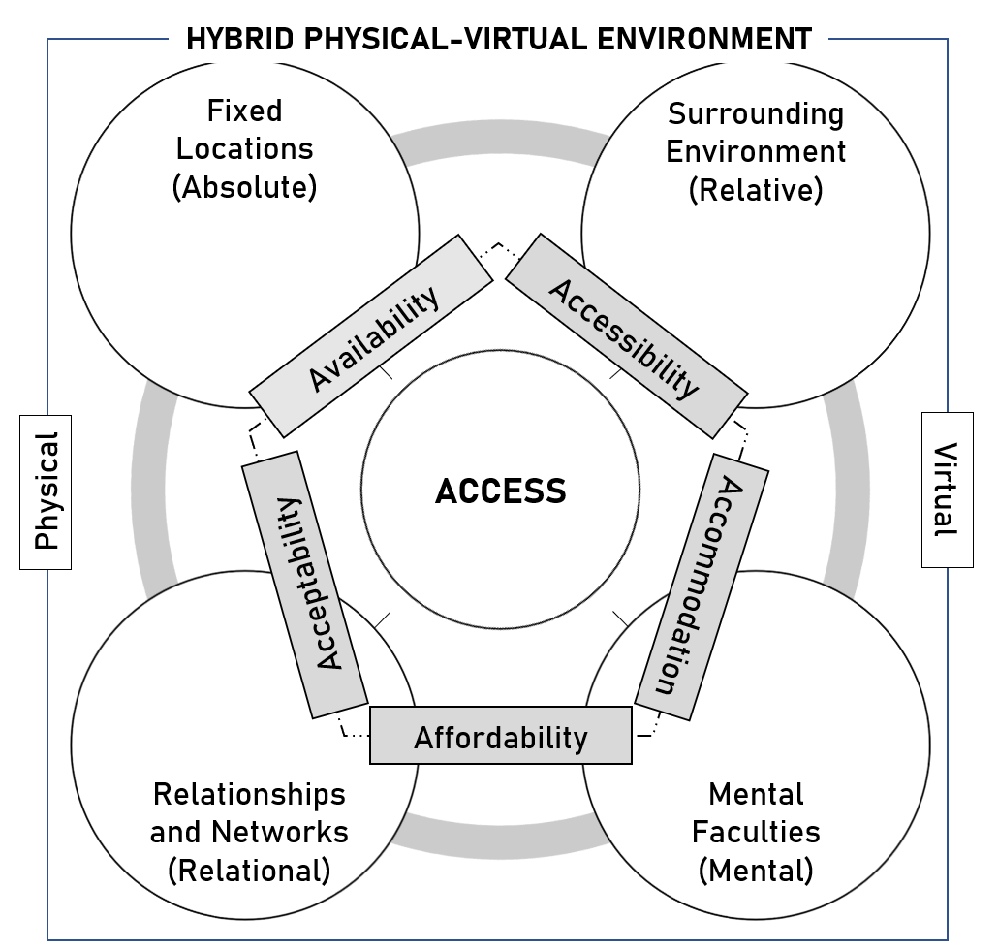
Figure 1. A conceptual framework for access related to different types of space in a hybrid physical-virtual environment

In this dissertation, we use food access as a case study in this section to provide researchers a starting template for applying our conceptual framework to study access to different needs and discuss how each of the five dimensions extended in physical-virtual space and viewed from the four spaces are applicable. At its core are dynamic humans with changing locations over time. This sentiment aligns with our extended access dimensions because opportunities available to people cannot be solely understood by the locations of activities (absolute space) as people are influenced by their local surrounding environments (relative space), relations and interactions (relational space), and mental faculties (mental space). We identify linkages between each extended access dimension with the four spatial dimensions in today’s hybrid physical-virtual space in hopes of shifting the access research paradigm to be human-centric and multispace-oriented.

3.2. EXTENDING DIFFERENT DIMENSIONS OF ACCESS FOR A HYBRID PHYSICAL-VIRTUAL SPACE

3.2.1. AVAILABILITY IN HYBRID PHYSICAL-VIRTUAL SPACE
Conventional measurements including availability often assume the supply and locations of destinations as fixed and static in physical space and that people travel from key locations in their daily life (e.g., home). This absolute space approach is exemplified, for example, with cumulative opportunity measures that count all provider locations within a distance threshold from a centroid of a residential neighborhood (Wachs & Kumagai, 1973). However, humans frequently travel along different routes to various places as they undertake their daily activities (Hu & Downs, 2019; Kwan, 2013) and experience contextual influences from areal units beyond their residential neighborhoods which changes the opportunities they encounter (Chen & Kwan, 2015; Kwan, 2012). This relative space approach emphasizes measurement of available opportunities in the surrounding environment relative to people’s needs and acknowledges that people frequently travel for various purposes; thus, people are frequently exposed to different areas. One example itinerary includes someone dropping children off at school, thereafter, driving along local highways to their workplace, running errands in a shopping mall fifteen minutes away during their lunch break, visiting clients in their downtown office, and then going home. There might not be supermarkets near their exurban home but more near the suburban shopping mall and a few downtown. Moreover, the supply of opportunities fluctuates over time for myriad reasons, including, but not limited to, seasonality, supply chain issues, labor shortages, transport and logistics, processing, and consumer demand (Nijman & Wei, 2020; Widener & Shannon, 2014), e.g., during Covid-19 (OECD, 2020).
A relational space approach to availability considers the social relations and institutions that reduce or increase the supply of opportunities. Competition effects arise from the demand amongst people for limited opportunities (Geurs & van Wee, 2004). For example, supermarkets can only stock as much food as its size permits and supply decreases as demand increases. Research suggests that family, friends, neighbors, and other institutions (e.g., non-profit, charitable organizations) can compensate poor availability by provisioning and sharing services and resources in times of need (Schwartz et al., 2019). Meanwhile, the growing ubiquity of the Internet and digital applications expand the diversity and volume of opportunities in virtual space that can ameliorate a relative or complete dearth in opportunities people could feasibly reach in physical space-time throughout their daily travels (Kenyon, 2010; Ren & Kwan, 2009), especially those in rural and isolated areas (Alford-Teaster et al., 2021). Modern ICT can provide people a larger choice set online (Shen, 1998). With groceries, virtual options include online counterparts of traditional retailers (e.g., Kroger), subscription-based services (e.g., Instacart), social communities (e.g., Facebook Marketplace), and call-based orders. In the case of food access, most of this information except for the last can be obtained from search platforms such as Google and Yelp. A study area may be partitioned into a grid with searches from the center of a cell to obtain the physical and virtual locations of all providers as latitude-longitude pairs and URLs. Understanding the supply of food in these locations then requires food audits that survey the presence and amount of specific foods, and which can be carried out in-person and online.
Similarly, smart technologies improve efficiency of different processes and transportation logistics, and enhance the volume, diversity, and quality of opportunities offered to people. However, inequalities may exist in the provision of virtual-based opportunities whereby organizations exclude services for those in some areas, e.g., Amazon excluding same day-delivery to several minority neighborhoods in major U.S. metros (Ingold & Soper, 2016). For example, we could identify the number of grocery stores with fresh produce within a mile radius of an individual at their home as the number of available opportunities in physical space. Similarly, online searches of a last mile option—such as two-hour delivery, same-day delivery, two-day delivery, etc.—by navigating the delivery options offered by each online grocery store from a location-based Google search could provide another quantifiable metric for the number of available opportunities in virtual space. Measuring availability in virtual space could be comprised of identifying the number of URLs of different online stores in a partitioned area and collecting data on the last mile distribution channels in each partition.
People, however, identify destinations as (not) available based on their knowledge and awareness of services, resources, and facilities (van Wee, 2016), reflecting mental space. While virtual-based options enable a larger selection available to individuals both in the presence of new forms of opportunities (e.g., online delivery) and information sources about the existence and inventory of opportunities in physical space, their use requires awareness (Pot et al., 2021; van Wee, 2016). People have different options available due in part to their technological aptitude, services offered by providers, and knowledge of their existence. A refugee from a developing country living in a new town may not have a fully developed mental map of the different places available to them, let alone possess sufficient technological capabilities. To understand the availability of opportunities, such as food providers, from the perspective of individuals could involve a memory recollection exercise to list the options they are aware of and the degree to which they believe the food supply is sufficient. For virtual options, this can be carried out as questions in a survey such as ‘what are the names of stores you are willing to shop at?’ while for physical options, this can involve a participatory mapping exercise where users identify all stores they visit on an interactive map. Measures of this dimension in physical space could then compare the total number of available and/or recognized options with sufficient healthy food options within a specified distance or time threshold. In virtual space, the opportunity set of available stores perceived by individuals would be reduced to virtual options that match their responses. For example, if an individual answers that they only shop at Kroger, Publix, and Costco, the opportunity set would only include all similarly branded physical stores and their virtual counterpart in the study area.
People additionally have different needs and preferences and may desire a large and diverse choice set (Cheng & Bertolini, 2013). For example, some people may not find convenience stores sufficient as they offer a limited range of items compared to fully stocked supermarkets. One way of measuring these preferences is to include an indicator for the preferences of individuals for different opportunity subtypes. For example, surveys can be carried out to understand the desirability of traditional grocery retailers, convenience stores, farmers’ markets, etc. This could be a binary answer (“yes, I will shop at these types of stores” or “no, I will not shop at these types of stores”) or a scaled answer (“I strongly prefer shopping at this type of store” to “I strongly do not prefer shopping at this type of store.”) The binary answer could be used to reduce the potential opportunity set based on store types while the scaled answer could be used to weight more desirable store types more greatly than less desirable ones. The provision of opportunities can also be restricted and influence people’s behaviors, as exemplified during Covid-19 and ensuing supply chain bottlenecks (Guan et al., 2020). If a person needs x amount of y but the provider will only supply x-n amount, the person may not perceive the provider as able to satisfy their need for y and may thus not be considered available to them. Geographic space alone does not fully capture the opportunities available to people and is differentiated alongside people’s contextual environment, relations enabled by ICT, and mental faculties.

3.2.2. ACCESSIBILITY IN HYBRID PHYSICAL-VIRTUAL SPACE
Generally speaking, accessibility concerns the ease to which people can travel to and the potential for interaction with destinations with attractive opportunities (Miller, 2018) and is typically evaluated with calculated indicators based upon land-use and transport data (Pot et al., 2021). The potential for reaching desired opportunities is additionally mediated by ICT, temporal constraints, social relations, and human perceptions. Conventional location-based measures assume an absolute space perspective in which accessibility is conceived as locational proximity or some close derivative (e.g., gravity measures) and evaluated by the cost distance between the fixed static origin location of people and activity destination(s) with one or multiple travel modes (e.g., drive, bus, walk). A relative space perspective to accessibility acknowledges that people possess different time budgets for travel and activity over space and time. Reaching destinations varies spatiotemporally as people often travel to multiple fixed and non-fixed activity locations throughout a day and chain together different activities which in turn exposes them to various opportunities (Chen & Kwan, 2012; Kwan, 2013; Liu et al., 2021). Some people have rigid schedules that require them to be at certain locations during specific times which means that their time availability varies based on the nature of their activities at different locations (e.g., dropping kids off at school and working in the office between 9-5). Time is not only required to reach opportunity locations but also to meaningfully participate in an activity so their space-time feasibility fluctuates accordingly (Kim & Kwan, 2003). Traveling in physical space may also be disrupted by inconvenient events including traffic congestion, volatile weather, and changes in transit availability (Weber & Kwan, 2002). Travel time consequently varies within and across days (Miller, 2018). Similarly, loading provider websites and apps in virtual space also varies because of an uneven geographic distribution of physical Internet infrastructure (Yu & Shaw, 2007). A tech-savvy New York City resident may have multiple means of available transportation to easily reach supermarkets whereas a farmer in rural Tennessee might not have consistent Internet service nor supermarkets reachable in twenty minutes of driving.
Accessibility from a relational space lens shifts focus to the social norms, relations and institutions that make it more difficult or easy for people to reach their needs. People lacking adequate mobility are often unable to reach various physical locations but shared informal transportation like carpooling, shadow transit, or carsharing arising from social networks (close friends, colleagues, community organizations) can ameliorate their situations (Cass et al., 2005; Clifton, 2004; Paul et al., 2019). Even then, this usually consumes more time and can reduce the space-time feasibility for people to carry out activities. For some people who comply to social norms related to travel behavior, certain travel modes might be out of favor, for example, parents prohibiting children to travel by certain modes or rural folks disdaining transit (Pot et al., 2021). But modern ICT minimizes space-time constraints of physical travel and time allocation for activities as digital devices and the Internet become the means of navigation for people to carry out activities in virtual space. People today have greater flexibility reaching different locations in physical and virtual space with modern ICT restructuring time requirements and permitting both multitasking (e.g., calling to place an order while driving to the physical location of the provider) and activity chaining. The ease to which people are able to carry out activities in virtual space would then be limited by their technological means and capabilities, i.e., adequate Internet connection and skills to make productive use of ICT (Dijst, 2004). Whereas people often perform each stage of an activity in succession in physical space, activities in virtual space can be fragmented or entirely minimized (Dijst, 2004). With grocery delivery, people place orders anytime via mobile apps for home delivery or store pick-up at specified times. The efficiency brought upon by automated systems such as self-checkout removes the necessity to checkout with cashiers in stories. Teleactivities relax the requirement for synchronous and face-to-face interaction at different stages of an activity and can afford significant time savings, making it easier for people to fulfill their needs. On the other hand, structural barriers as restrictions imposed by authorities on areas one can visit at particular times (e.g., Covid-19 lockdowns) and Internet connection speeds (Dijst, 2004) may constrain the ease to which people can reach physical and virtual locations.
Still, a mental space perspective must be considered as different people have different perceptions of time requirements, travel modes, travel resistance, and characteristics of the spatial environment to reach their desired opportunities. In contrast to conventional cumulative opportunity measures which are highly sensitive to the threshold choice, Cascetta et al. (2013) introduced a behavioral indicator that captures perceptions of the value of travel time and found that the model yielded results more closely aligned with the number of visited stores reported by survey participants. Their indicator is essentially a binary value (0 or 1) which indicates whether an opportunity, respectively, can or cannot be visited in a given amount of travel time. However, people also need time for activities, and not just travel, so this indicator should be expanded to also include travel and activity time together. This finding supports recent arguments for also considering perceived (mental) accessibility as people vary in their willingness to spend time for travel and activities (Van Acker et al., 2010). However, the amount of time people are willing to travel and subsequently participate in activities may be different than the amount of time people have available for discretionary activities. People may also incorrectly estimate time required for travel and activity participation and consider a provider to be inaccessible (Pot et al., 2021). These perceptions may be shaped by the travel modes and routes perceived as available to individuals. Vehicular ownership affords greater flexibility scheduling activities and makes it easier to reach destinations compared to someone reliant on public transit (Cass et al., 2005). People who use public transit may often have to account for greater variability and possibility of delays in scheduling. Travel resistance as comfortability, safety, and convenience are consequently perceived differently among people (Pot et al., 2021). One way of measuring such perceptions could involve residents in a participatory mapping activity whereby they color or trace road segments they are willing to travel on in an interactive map. All colored or traced roads would then be the network in which network analyses and subsequently space-time prisms are based upon; in essence, only opportunities along the identified roads can be visited. Another way of measuring perceptions of willingness to travel and participate in activities could involve a survey component whereby individuals are asked about the time they are willing to spend and their preferred shopping modalities. The time value could be used to demarcate space-time prisms that better reflect the perceptions of individuals while the shopping modalities could be used to determine whether or both in-person and online shopping is feasible, and how much time would be required for either. In another example, some might consider any physical travel a hassle and less productive use of their time and favor online activity such that even if a store is a short distance away, they will still favor shopping online. And if reaching a destination requires going through what people perceive as unsafe streets, people might consider it to be inaccessible (Cao et al., 2006).

3.2.3. ACCOMMODATION IN HYBRID PHYSICAL-VIRTUAL SPACE
The establishment of social (e.g., policies, auxiliary services), physical and virtual infrastructure in destinations are important to access as people have different capabilities, time budgets, and preferences for meeting their needs. Approaching accommodation from the perspective of absolute space places importance on the presence (or absence) and organization of physical infrastructure inside and around provider facilities, including but not limited to the location of wheelchair ramps, parking areas, automatic doors, braille signs, restrooms, and wide and even pavements (Grisé et al., 2019; Hagg & El-Geneidy, 2010; Huang et al., 2012). The lack of appropriate infrastructure effectively limits mobility and is a barrier to access, especially for those with physical and visual impairments who require additional features, e.g., wheelchair users requiring wide aisles to move around (Bromley et al., 2007; Schwartz et al., 2019). This sentiment similarly characterizes virtual infrastructure (e.g., online frequently asked questions section, intuitive user experience design) (Garrett, 2010). Without the necessary virtual infrastructure, the virtual needs of people are unable to be supported (Hong et al., 2020). In other words, places that are well designed can mitigate social marginalization and improve access for those physically and technologically challenged.
Context is critical for assessing the relevance of systems established at destinations suggesting a relative space approach to accommodation. People are restricted in their access when their time availability does not align with when destinations are open (Wang et al., 2018; Weber & Kwan, 2002). The temporal fixity (or flexibility) of people relative to destinations leads to differing access over time and between people (Delafontaine et al., 2011). Hours of operation at destinations may not fit the time budget of someone at work on a weekday but be more suitable when they are home on a weekend. But destinations in virtual space as websites and phone services are almost always available except in times of server crashes, internet outages, etc. Even while physical facilities are closed, the virtual counterpart of opportunities in physical space are almost universally open for people to schedule orders anytime or communicate with others. This is especially important to account for those who may not have a traditional schedule and are only available to carry out various activities at specific times, for example, night-shift workers. In some areas, access to specific websites may be restricted, e.g., censorship by governments (Warf, 2011).
Accommodation approached from relational space emphasizes the social infrastructure and new forms of interactions established by destinations. Traditionally, most user-centric activities would involve face-to-face interaction such as an individual asking an employee questions at the helpdesk. Specific forms of virtual communications such as an online app can remove coupling constraints that exist in physical space (Yu & Shaw, 2007). For example, making appointments online does not require another individual to be present from the provider side as people can arrange times through an app that tracks the schedule and capabilities of the provider to fulfill people’s needs in real time. Voice services, apart from voicemail, only require that people converse at the same time. Other modalities such as communicating with online agents enable people in different physical locations to interact and address people’s needs. Thus, asynchronous and remote interactions enabled by telecommunications can accommodate the preferences for different people and increase potential opportunities (Shen, 2000). The presence or absence and structure of these infrastructure and systems shapes people’s perceptions of their appropriateness and whether they accommodate to their needs and preferences, reflecting a mental space approach. People have different abilities—the needs of the older differ than those of the younger generation who are often more technologically proficient and physically abled (Lavieri et al., 2018). Moreover, people possess different values that result in different perceptions of enforced policies (e.g., refusal of mask-wearing). In practice, the presence or absence of physical and virtual infrastructure can be conceived as queries on specific store characteristics to identify more appropriate opportunity sets based on the mental preferences and physical abilities of individuals. For example, a wheelchair-bound individual requires wheelchair ramps and entrances to get around a store. Stores without such infrastructure would not be able to accommodate the needs of the individual and thus they would be not included in the opportunity set of the individual. Understanding how different people perceive the systems in place at destinations is crucial in understanding whether they can accommodate the needs of people; their structure and organization must be at least adequate based on people’s perceptions.

3.2.4. AFFORDABILITY IN HYBRID PHYSICAL-VIRTUAL SPACE
The financial arrangements and willingness of people to overcome all associated costs of opportunities are important to affordability. Cost of living standards vary geographically and people vary in their economic status (Wachs & Kumagai, 1973) which results in differential average income and prices and the ability of people to afford different opportunities. To get to desired activity destinations requires incurring a monetary cost for travel which may be not an insignificant amount of money depending on the travel mode and distance to be overcome. In virtual space, people need to also afford devices and Internet services at sufficient speeds. Understanding these characteristics requires contextualizing people in their local environment and a relative space perspective to affordability. For example, the movement overseas of an auto-manufacturing plant in Detroit, Michigan, subsequently decreases income and purchasing power for many unemployed autoworkers. Elsewhere, a banker living in Chelsea, Manhattan, New York earns higher wages but encounters higher food prices in their affluent neighborhood compared to those of supermarkets in Chinatown. This perspective emphasizes sociospatial heterogeneity; that people have different financial resources, different regions have different economic policies, and the cost of opportunities varies across space. While not easily retrievable currently, including contextual layers of cost-of-living standards, median income, and municipal, state, and federal policies at finer geopolitical scales such as neighborhoods or census blocks could provide additional insight into the economic and fiscal variation across areas. Indices similar to cost-of-living indices could be created to assess how much fresh and healthy food a given amount of money could purchase in each location. This involves understanding wage differences and food audits which could either be carried out in-person or online. For example, how easy is it to earn $100 in w location compared to x location or for y person compared to z person? Then, for w or x location or for y or z person, how much of an average market basket of groceries can $100 buy in a specific store (e.g., Kroger), and how does that compare to another store (e.g., Whole Foods)?
But financial resources of people extend beyond just income. Understanding the different ways in which people rely upon and the processes by which they obtain financial resources and information from different organizations, as well as broader economic situations, requires a relational approach to affordability. Changes in incomes affect consumer expenditure and saving which lead to changes in economic policies; similarly, changes in economic policies affect consumer incomes and result in changes to spending and saving (Notani, 1997). The capabilities of people to afford opportunities are constrained without sufficient funds and/or when destinations are not accepting of their payment options (e.g., places not accepting of cash or governmental subsidies). Consider also how authoritative bodies including governmental entities can impose minimum wages and price mandates (e.g., price floor of milk). In the presence of stringent economic policies and/or absence of self-sufficiency, people may work with other people (e.g., borrowing from friends) and institutions (e.g., loans and assistance from banks, credit unions, insurance agencies, governmental programs, etc.). People also communicate with individuals in their social networks employed at destinations that could provide inside information about deals, tips, and wages (Cannuscio et al., 2014) or work together to develop strategies for reducing cost such as roommates splitting bulk groceries at a store. Modern ICT too can improve the ability of people to afford opportunities by offering more competitive prices (Kim, 2021), expanding people’s knowledge about cost mitigation by enabling price comparisons (Golob & Regan, 2001), and increasing financial capabilities. Interactions in physical and virtual space can together help reduce costs and increase the possibility for people to afford the services and resources they need. Promotions including sales, coupons, and rewards help reduce the cost of opportunities and are now more widespread with virtual communications such as weekly circulars delivered via e-mail. Mobile money options, including e-wallets (e.g., Venmo, Paypal) additionally provide people greater capabilities to carry out transactions in virtual space without requiring the physical exchange of money (Diniz et al., 2011). Other ICT developments, including blockchain and cryptocurrency, and their regulation will likely provoke new changes to affordability yet unknown, including the legality of e-currency as acceptable payment.
Behavioral economists have argued for decades that affordability involves not just the ability to overcome costs (e.g., sufficient financial resources) but also perceived willingness, including attitudes, preferences, motivations, and perceptions of the economic realities of individuals (Katona, 1974, 1975), reflecting a mental space approach to affordability. Despite having significant financial resources, people may not consider some opportunities because of their perceived worthlessness relative to the associated costs or other reasons including frugality. Conversely, while much literature assumes that low-income people and households only access economical opportunities, poor should not automatically be equated with financial inability to overcome costs as installment plans and credit cards can make opportunities more affordable (Notani, 1997). As George Katona, regarded as one of the fathers of behavioral economics, writes, “we shall not assume at the outset that rational behavior exists or that rational behavior constitutes the topic of economic analysis. We shall study economic behavior as we find it” (Katona, 1951, p. 16). In other words, affordability of the same opportunity could be perceived differently between groups of people who adopt various mechanisms to afford opportunities which are largely shaped by intention to access.
Questionnaire surveys following a Likert scale for collecting data on individual consumer behavior with representative samples have been a popular method after World War II (Katona, 1974). In fact, Katona collaborated with Rensis Likert, the eponymous inventor of the popular psychometric scale (Katona & Likert, 1946). The different perceptions of individuals, including their motives, emotions, feelings, attitudes, aspirations, expectations, social values, and more are considered to be constantly changing intervening variables that mediate how individuals respond to different stimuli and consequently result in differing views of affordability. The resulting data can be used to inquire into the relationships between individual financial capabilities, perceptions, and behaviors. For example, a Likert scale can be developed for aggregate and individual affordability, and which is comprised of multiple Likert-type items that asks individuals whether they agree that a particular category of items, such as fruits, are affordable based on different conditions (e.g., branding, current and future income, frugality, etc.). The Likert-type items for each Likert scale can be grouped, summed, and averaged to measure the degree to which affordability is related to different financial and economic conditions perceived by individuals.

3.2.5. ACCEPTABILITY IN HYBRID PHYSICAL-VIRTUAL SPACE
Acceptability captures the degree to which the personal qualities—race/ethnicity, gender, class, language, etc.—of people and destinations are appropriate for each other based on their respective cognitive and emotional responses. Destinations and the opportunities they offer must be morally and culturally appropriate if people are to access them lest they become barriers to access. Physical appearances, ideologies, and personal capabilities, including spoken language, can shape how people perceive and intention to patronize destinations. These social and cultural contexts point to a relational space perspective of acceptability. For instance, a Chinese immigrant may prefer shopping at Chinese supermarkets because of cultural and linguistic familiarity (Wang & Lo, 2007). But it is not enough to only consider individual characteristics as social interactions and environments too have major influence on people’s behaviors and perceptions of the objective characteristics of destinations (Van Acker et al., 2010). Social norms can have vast influence on the opportunities one considers appropriate, for example, the perceived classiness and prestige associated with certain organizations (Sublette & Martin, 2013). Someone talking about their pleasant experience at a new supermarket could result in a favorable perception in the mind of their colleague who then patronizes the location. Modern ICT offer people more and easier opportunities for interaction to exchange information about the characteristics of destinations which can consequently shape attitudes and behaviors (Kenyon et al., 2002). Online platforms can augment people’s understanding of their local environments and opportunities available to them. Crowdsourcing personal opinions online, such as a new immigrant polling their local Facebook group about favorite grocery stores, can shape the perceptions of individuals and their attitudes towards different destinations. These personal opinions could effectively act as ratings, scaled along a one-to-five-star system used by many review platforms, and used to identify a more appropriate opportunity set based on individual preferences for stores above a certain rating level, with more details discussed later. On the other hand, recommendation systems are built to offer suggestions based on their past viewing and shopping history which can consequently narrow the set of opportunities shown to people and reinforce their existing habits (Sublette & Martin, 2013). In turn, both physical and virtual interactions may influence behaviors whereby people patronize particular destinations. The preferences of people and destinations are conditioned by experiences and interactions in both physical and virtual space.
The nexus of the social environment (e.g., norms, close connections, social media), the physical environment, and individual characteristics results in different individual preferences (Van Acker et al., 2010), reflecting a mental space approach to acceptability. In addition to interactions and dissemination of information in physical space, the Internet can introduce and augment new information about destinations and alter people’s mental image of their environment (Golob & Regan, 2001; Pot et al., 2021). Platforms such as Google Maps provide users greater knowledge with navigational information and curated results for people’s destinations and local environments as well as information about provider attributes: location, amenities, safety measures, etc. In this regard, knowledge of a service and the ability for destinations, such as grocery stores, to tailor their services to the needs of its customers and clients, may be influenced by virtual space. This information provides individuals a better understanding of provider characteristics and influences their perceived acceptance. But strategies for how people identify, obtain, and subsequently interpret information can widely vary between individuals who also possess different value systems that reflect unique attitudes and beliefs (Pot et al., 2021). In turn, this leads to different perceptions of the degree to which destinations are considered acceptable. Platforms encourage users to review different places, attach photos and videos, befriend each other, and exchange comments. Ultimately, these online activities and interactions can shape whether people find destinations (not) acceptable.
Platforms like Google Maps and Yelp encourage users to review different POIs, attach photos and videos, add each other as friends and comment on posts. People may have different ratings (sentiments) and priorities (weights) for different aspects (semantics) of their food situation. The reviews and ratings on these platforms provide one avenue for understanding the sentiments of people for different aspects of POIs. Such user-generated information can be harvested for various machine learning tasks, such as natural language processing to understand the associated sentiments and semantics in text reviews. Namely, reviews can be analyzed to understand how people generally perceive providers and their different characteristics. For example, if many reviewers comment about the high quality of fresh food, we could theoretically extract a very positive sentiment for that aspect of the store and reduce the potential opportunity set to stores with a rating above a threshold level (e.g., at least a rating of 4 out of 5). Aspect-based sentiment analysis provides one way of carrying this out by first identifying the semantics and their respective weights in reviews and secondly to parse the sentiments of these semantics. Ratings also follow a similar concept in that they offer a subjective numerical rating that captures how individuals feel about different POIs but usually do not offer a nuanced understanding into the different aspects that people care about. Nonetheless, they can still be a useful parameter. With the premise that not every POI (e.g., grocery store) located within a space-time prism of an individual is part of their opportunity set, a geocomputational approach to cull their potential opportunities could include queries for ratings of different store characteristics above a certain threshold level. Essentially, if a store is perceived poorly (e.g., less than 4 stars) in some or all aspects (e.g., general rating or customer service) that is important to an individual, the store is not included in the opportunity set. This measure of perceived acceptability can thus further distinguish opportunities based on the examined individual’s perceptions.

3.3. IMPLEMENTATION CONSIDERATIONS
But how can these concepts be translated into actionable insights? There are important considerations for implementing the conceptual framework of access for research and application.

3.3.1. DATA CONSIDERATIONS
We need data beyond the typical purview of researchers and practitioners. No dataset is perfect but increasing capabilities in open-source software, cloud computing, parallel processing, and machine learning can be leveraged to enhance data collection and analysis. Data relating to people’s perceptions and ‘objective’ characteristics of land-use and travel systems are increasingly abundant with the emergence of volunteered geographic information, open data portals, review websites, and social media platforms, e.g., POIs, reviews, place details, and routes from Google Maps. Aspect-based sentiment analysis of web-scraped comments could be used to understand the sentiments of people for particular aspects of opportunities such as their sense of place, perceived quality of opportunities, customer service, and social atmosphere. The rapidly-growing data economy of geolocated signals: market baskets and transactions, social media interactions, job listings, mobile phone traces, etc. means that sociospatial behaviors, flows and relations can be more easily captured than before. Qualitative data including travel diaries, surveys and interviews are valuable as data sources are sometimes only representative of particular population groups and there are questions unanswerable simply by retrieving data online. Less native to the domain of most accessibility researchers, neural sensing technologies (e.g., electroencephalography) can be used to understand how people cognitively respond to different stimuli and situations and their subjective understanding of their environments such as safety along travel corridors. The use of humans as sensors to learn more about their social environments (e.g., interactions, broader societal trends) over space-time also looks to be a fruitful endeavor that complement administrative records and digital traces and grounds empirical models (Galesic et al., 2021). Harmonizing these datasets and implementing different concepts specified in the proposed framework requires renewed thinking.

3.3.2. MEASUREMENT CONSIDERATIONS
Firstly, existing accessibility measures are still useful. Methodological improvements will be important and further advance but measures are only appropriate if they “reflect those elements that matter most to residents” (Handy & Niemeier, 1997, p. 1176). The proposed framework includes these elements as individual concepts reflecting upon the spatial contexts that shape the potential opportunities for people in a hybrid physical-virtual world. We need to reconceive the ‘spatial’ in spatial accessibility as a multi-spatial construct whereby we not only focus on spatial separation and derivative concepts (e.g., proximity, propensity, distance decay) in absolute space but also in relative, relational, and mental space. An axiom of access is the notion that travel impedance measures how near or far one point is from another and what the cost of travel would be between them but how ‘near’, ‘far’, and ‘cost’ are defined requires assumptions (Miller, 2018) traditionally based in Newtonian absolute space. But what if we reconsider impedance not just based on travel costs and reconceive these terms in other spaces, such as accessibility also based on topological or perceived nearness/farness? In addition to geographic distance, what about political/economic distance conditioned upon different barriers and restrictions, e.g., opening hours, payment options, mask-wearing policies, etc. (are people allowed to participate in an activity?), or perceived distance (do people feel safe traveling or comfortable navigating online?). The ability for people to meet their needs would then be determined by not just travel behaviors, land-use system, individual characteristics but also environmental, social, institutional, and mental influences and behaviors. Previous research discusses challenges and potential implementation considerations associated with integrating the four spaces in GIS which is a useful starting point (Shaw & Sui, 2020) especially given the extensive body of work on accessibility by GIScientists. The authors provide examples for developing transformations and linkages between absolute, relative, relational, and mental spaces. In the next two sections, a few thoughts are provided to potentially improve different popular measures.
Location-based
While location-based measures by nature reflect aggregate populations, their unique components (depending on the specific measure) can be extended. Location-based measures should go beyond static snapshots in time (and some scholars have already developed time-sensitive location-based measures) and incorporate multiple criteria beyond physical travel impedance and simplistic notions of location attractiveness. For example, cumulative opportunity measures can incorporate multiple criteria beyond a travel cost distance threshold. In the context of food access, we could identify food opportunities for every geographic unit as inexpensive supermarkets and dollar stores that offer quality produce perceived by other reviewers and accept SNAP benefits reachable by public transit at every hour of a day. Equivalent opportunities in virtual space could similarly be obtained with automated scripts crawling the website of every store and retrieving all last-mile ordering options for all origin locations. Gravity measures could recognize distances conceived in other spaces as mentioned previously and include additional attractiveness factors more aligned with people’s preferences.
Person-based
While more data- and computationally-intensive due to its disaggregate nature, the development of space-time measures in the past few decades suggest a momentum towards relative space approaches to access whereby researchers focus on the feasible opportunities, delimited by a set of spatiotemporal constraints, located at different anchor locations in an individual’s daily trajectory. Still, more work can be done to locate relevant opportunities meeting certain criteria within calculated potential path areas (activity spaces). An inexhaustive list of directions come to mind. (1) Integrating the relational aspects of different access dimensions as ‘social flows’ and new topologies of spatial interaction in social-spatial networks that capture movements, communications, and power relationships between people, places, and locations of opportunities (Andris, 2016; Kwan, 2007). For example, space-time measures could also consider the virtual connections between individuals and potential opportunities, which are less bounded by physical travel impedance. Individuals who share some mutual connection can also be topologically connected and their activity spaces linked, and when added with other data layers, we can identify additional opportunities accessible to people and the travel infrastructure that support it. (2) Incorporating mental space as additional attributes representing location attractiveness more closely aligned with the perceptions of people (e.g., refining opportunity set to opportunities in a price range contingent upon the individual’s financial capabilities and preferences) and their mental map of different opportunities using best practices in qualitative GIS. Similarly, utility-based measures are especially attractive in their inherent nature to model individuals’ perceived maximum utility and reflects a mental space approach. Utility-based measures could also incorporate additional explanatory variables reflecting individual elements of the five dimensions of access that people consider to be important in their decision-making process and their perceived value of opportunities.

3.4. SUMMARIZING THE DIMENSIONS OF ACCESS IN HYBRID PHYSICAL-VIRTUAL SPACE
The broader goal in the development of a conceptual framework of access in today’s hybrid physical-virtual space is promoting a holistic approach to understanding access that captures a diversity of today’s human experiences. How the proposed concepts are applied depends on the specific question(s) related to access. Ultimately, the multispace, multidimensional conceptual framework of access in a hybrid physical-virtual space can be a starting point to improve understanding of access in our communities. Extending each access dimension of access in hybrid space from four different conceptualizations of space enables consideration of the particular impacts of modern ICT on opportunities to human needs. We develop new definitions for the access dimensions:
- Availability: presence and diversity of physical and virtual locations containing desired opportunities which are known to and meet the needs of people.
- Accessibility: relationship between the locations of opportunities and people, considering existing land-use and transport systems, individual characteristics, ICT resources, social relations, and perceptions.
- Accommodation: physical, virtual, and social infrastructure and system(s) in place that are appropriate for people.
- Affordability: ability and willingness of people to overcome cost(s) of accessing opportunities with virtual space providing additional mechanisms to finance and/or reduce cost.
- Acceptability: reciprocal relationship between the subjective attitudes and preferences of people and opportunities, shaped partially by social interactions in a hybrid physical-virtual space.
Paralleling the emerging context of society in a hybrid physical-virtual world is growing fervor among the academic community to transition from a mobility-oriented to an accessibility-oriented approach in transportation planning for improved sustainability and quality of life (Handy, 2020). Despite research dating back to the 1950s (Hansen, 1959), there remain major barriers for the adoption and implementation of access in practice because of the absence of a common conceptual understanding. As Neutens et al. (2010) demonstrated in the context of the social equity of urban services provision, how space, time, and behavior are conceptualized results in very different outcomes and articulations of interpersonal differences in both location-based and person-based measures. More than ever, we need a common understanding of what access entails and a serious reconsideration in light of complex social and behavioral changes resulting from increasing technologization across the world.
The conceptual framework articulated is a synthesis of extant scholarship on accessibility concepts contextualized in an increasingly hybrid physical-virtual world. People are central to questions of access; locations and activities are only the desired end-goals for people to meet their various needs. The reflection on each access dimension considered from absolute, relative, relational, and mental space urges us to think more comprehensively and holistically about the different contributing factors to access and to view them as an integrated whole. Access is dynamic, context-specific, driven by relationships and interactions, and perceived differently between individuals. Land use and transport systems, ICT, travel behavior, temporal constraints, social relations, perceptions, and personal characteristics must not be viewed in isolation from each other or else we could seriously overlook the different situations experienced between individuals and places and inaccurately estimate the abilities and opportunities for people to meet their different needs. We envision that our conceptual framework can serve as a common lexicon for which academics and practitioners across disciplines can use to advance adoption of the accessibility paradigm in future planning efforts. Its application would be informed by the objective at hand, whether it be social equity, sustainability, etc. And we hope that this encourages more human-centric and integrated research that can also advance existing methods to understand the inequalities in access between people and regions.

CHAPTER 4. METHODOLOGICAL FRAMEWORK

4.1. STUDY AREA
The study area concerns Knox County, Tennessee, United States of America. Located in the center of the county, Knoxville is especially appropriate for this research as it was the first city in the whole country to establish an official food policy council for ameliorating inequities in food access back on July 1, 1982 (Knoxville-Knox County Food Policy Council, 2021). While the city proper is characterized as urban with a relatively high density of healthy and nutritious food purveyors (e.g., grocery stores and supermarkets), many people live in significant portions of the county where few places provide such foods. The Food Access Research Atlas by the United States Department of Agriculture (USDA) identified over twenty census tracts throughout the county with poor access to fresh, healthy, and affordable food (USDA Economic Research Service, 2019). However, their mapping tool only considers a few characteristics in determining whether a census tract has low access; namely, whether there are a sufficient number of low-income residents who live more than an arbitrary driving or walking distance threshold away from the nearest grocery store. This approach assumes that all individuals within a census tract experience the same situations of food access and that access can only be distinguished between low and non-low (Widener, 2018). As discussed previously, there exists many other factors and dimensions shaping access to food for individuals. But despite some shortcomings, the findings from the atlas should not be entirely overlooked.
Similar to many other regions in the southern United States and cities in Tennessee, Knox County is characterized by automobile-oriented suburbs with a small high-density urban environment in the heart of downtown Knoxville. There is limited public transit in the form of the Knoxville Area Transit bus network throughout the county and trolley system coursing through downtown. Walkability is relatively inferior compared to many larger cities in the United States. In turn, mobility is often dictated by the means of transportation available to individuals. Together with the county’s history in food policy and transportation infrastructure, Knox County presents an interesting setting for research on food access in today’s world.

4.2. DATA AND METHODOLOGY
To carry out this research, a variety of approaches were taken to procure, clean, and manipulate necessary data used to understand the different dimensions of access and ultimately the potential opportunities accessible to individuals. There are four main datasets associated with this dissertation research:
- Food stores within and around (+10 miles beyond the border of) Knox County.
- Individual residents in Knox County and their socioeconomic, demographic, and perceived characteristics.
- Travel trajectories over a two-day (Friday + Saturday) period of the aforementioned individuals.
- 2016-2020 5-Year American Community Survey (ACS) estimates of variables at the block group level related to basic demographics, related to food access, and in the Centers for Disease Control and Prevention (CDC)'s Social Vulnerability Index (Centers for Disease Control and Prevention, 2021).
The second and third datasets (i.e., characteristics of individual residents and their travel patterns) were created at the discretion of the author. After reviewing the purpose of the dissertation and research objectives, it was decided that ‘real’ data of actual residents was not necessary because the broader objective was to develop a prototype GIS for studying food access in a physical-virtual world capable of operationalizing concepts in the proposed framework.
Synthesizing individual profiles that mirror the situations of many disadvantaged peoples in today’s world can still be useful to demonstrate the usefulness of the GIS. Individuals, their socioeconomic, demographic, and perceived characteristics, and their trajectories were created to represent the scenarios and lives of real-world individuals. Different scenarios were envisioned for residents in Knox County, Tennessee, with an emphasis on the lives of disadvantaged peoples, e.g., low-income, minorities, single parents, renters, and those without personal vehicles. While these are not actual people, these synthesized individuals were explicitly included to represent the voices and situations of those who are especially marginalized and likely facing issues with accessing nutritious and healthy food(s) in today's society. Historically, travel and time use diaries, interviews, and public-participatory data collection methods, among many others, have been used to gather such detailed information about individuals, their travel and activity patterns, and unique characteristics. In today’s big data era, it is vitally important to have ‘small data’ that can ground-truth and illuminate on idiosyncrasies often lost in ‘big data’ (Kitchin & Lauriault, 2015).

4.2.1. DATASET 1: FOOD STORES IN AND AROUND KNOX COUNTY, TENNESSEE
What constitutes a food store location is heavily contested in the literature with studies relying on different databases and classification systems (Rose et al., 2009). The USDA considers supermarkets, supercenters, and large grocery stores in their Food Access Research Atlas (USDA Economic Research Service, 2019) but many studies choose only to measure access to supermarkets. But any retail outlet selling food could be considered a food store location, including small grocery stores, specialty food stores, ethnic food marts, farmers markets, convenience stores, and warehouse stores (Larsen & Gilliland, 2009; Rigby et al., 2012; Rose et al., 2009; Sansom & Hannibal, 2021). Accordingly, food opportunities in this research are identified as businesses that sell and market food products to individual consumers as people may obtain food from a wide spectrum of food stores. This sentiment aligns with the concept of perceived availability as individuals may differ in what types of opportunities (stores) they truly consider to be somewhere they can participate in food shopping, whether in-person or online. As opposed to previous approaches that preemptively define opportunities and effectively ignore the needs and preferences of people to differentially weight opportunities, this dissertation adopts the viewpoint that different user groups can make their own sub-selection with queries on locational attributes in the GIS platform discussed later.
Multiple programming scripts written in Python were developed to retrieve information about the locations and characteristics of food opportunities. Broadly, there are two major steps in this process: the first is to identify opportunities and the second is to then retrieve objective and subjective characteristics about these opportunities. Both are obtained to tailor the potential opportunity set of individuals more accurately based on their specific needs and preferences. In the first step, a fishnet where the whole of Knox County was divided into equal-sized cells of 1000 meters was constructed. 1000 meters was chosen to most efficiently execute distance-based searches with Google Maps Places API whereby most areas throughout the county are effectively searched through. Calls to the API made from the center of each cell in the fishnet were made to retrieve all food-related businesses with the keyword term ‘store’ and three different unique Google Maps place types: ‘convenience_store’, ‘grocery’, and ‘wholesale’ that capture all retail food outlets. This was done to ensure that all food-related businesses were obtained as some people rely on gas stations, convenience stores, wholesale clubs, farmers markets, etc. to acquire food. People may have different preferences for the type of food store they shop at owing to other considerations including the ease to which they can reach stores, the windows of time they have available for shopping, the physical and virtual infrastructure that can accommodate their different abilities and needs, the cost of food relative to their financial means, the social atmosphere, and more. Because the data offered by the API is limited to just five reviews for each store and only a few attributes, an additional script was developed leveraging Selenium (Huggins, 2022) and Beautiful Soup (Richardson, 2015) to scrape additional reviews and business attributes not obtainable from the Places API. Together, the attributes of interest for this project include:
General Store Attributes
- Store Name: Name of place of interest (POI)
- Rating: Average user rating of POI
- Price: Price indication of items ranging from 1 to 4 dollar signs, suggested by Google
- Type: General POI type
- Specific Type: POI type by Google
Perceived Store Attributes
- Convenience: Average user rating for store convenience
- Checkout Process: Average user rating for checkout process
- Employees: Average user rating for employees
- Food Quality: Average user rating for quality of food
- Food Variety: Average user rating for variety of food
Service Options
- In-Store Shopping: Whether POI offers in-store shopping
- Online Shopping: Whether POI offers online shopping
- Delivery: Whether POI offers delivery
- Curbside Pickup: Whether POI offers curbside pickup
- Store Pickup: Whether POI offers in-store pickup
- Drive Thru: Whether POI offers drive-thru services
- No-Contact Delivery: Whether POI offers no-contact delivery
- Same-Day Delivery: Whether POI offers same-day delivery
Health and Safety
- Masks Required: Whether POI requires masks
Service
- Great Service: Whether POI has great service based on proprietary Google Maps algorithm
Accessibility
- Wheelchair Accessible: Whether POI is wheelchair accessible
Offerings
- Good for Quick Visit: Whether POI is good for quick visits based on proprietary Google Maps algorithm
- Organic Food: Whether POI offers organic food
- Prepared Food: Whether POI offers prepared food
Payment Options
- Accepts Check: Whether POI accepts check as payment
- Accepts Debit Card: Whether POI accepts debit card as payment
- Accepts NFC Mobile Payment: Whether POI accepts near-field communication (NFC) Mobile Payment
- Accepts SNAP/EBT: Whether POI accepts SNAP/EBT as payment
- Accepts Credit Card: Whether POI accepts credit card as payment
Amenities
- Restroom: Whether POI has restroom(s)
Atmosphere
- LGBTQ+ Friendly: Whether the POI owner has marked their POI as LGBTQ-friendly and/or a Transgender Safe Space
- Family Friendly: Whether the POI owner has marked their POI as family-friendly
Address Details
- Longitude: World Geodetic System 1984 (WGS84) Longitude of place of interest
- Latitude: WGS84 Latitude of place of interest
- Address: Address of place of interest
- Plus Code: Unique identifiers for places around the world developed by Google
These store attributes were specifically retrieved so that they could be considered in relation to individual preferences and abilities as discussed in Dataset 2. The Organic Food and Prepared Food attributes are binary indicators for whether stores offer or do not offer organic and prepared foods. Certain groups of people may prefer these foods which relates to a mental space approach to availability whereby certain stores have or do not have desirable food items. For example, people who are health-conscious may prefer organic foods while those who work long hours and/or on the road and without access to a kitchen may prefer to purchase prepared foods that are relatively less expensive compared to restaurant prices.
The attributes underneath ‘Address Details’ including Longitude, Latitude, and Address provide basic location information for food stores and can be used with Dataset 3 to determine the relative accessibility, or ease to which individuals can physically travel to different opportunities based on their given locations throughout the two-day period. But the emergence of the Internet and Web necessitates understanding of accessibility to virtual-based services as some people may find it easier and/or prefer to shop online. Attributes under ‘Service Options’ additionally provide information about the modalities by which people can obtain food at stores, from in-person store shopping to curbside pickup to online delivery. These attributes are binary indicators which can be used to inform accessibility from a relational space perspective as stores vary in their physical- and virtual-based service options. A store with virtual-based service options means that people with the appropriate technological infrastructure, aptitude, and willingness to use online services expands the ease to which they can reach different stores and ultimately their opportunity set. Conversely, those without the requisite technological infrastructure, aptitude, and willingness do not enjoy the same accessibility to online services and can only reach stores in other ways.
The operational hours of stores for each day of the week were also retrieved to determine a more accurate opportunity set for people based on their different locations throughout a day. As is discussed later, Dataset 3 contains information about the periods of discretionary time when people can freely participate in activities. This can effectively provide context into the how store hours accommodate the different schedules of individuals and suggests a relative space approach to accommodation. The proposed GIS can determine which stores are open throughout the different schedules of individuals. Understanding how the infrastructure established by stores accommodates to the needs of people can also be augmented with the Masks Required, Accessibility, and Restroom attributes. People have different physical needs, and the aforementioned store attributes are especially important to understand for those who are, respectively, immunocompromised and health-conscious, wheelchair-bound, or experience incontinence. The presence or absence of masking policies and physical infrastructure as wheelchair ramps and public restrooms can be treated as binary indicators that either accommodate or do not accommodate the needs and preferences of individuals based on their unique characteristics in Dataset 2. Similarly, the political contention of Covid-19 policies means that some people may favor or disfavor stores based on their masking policies which implies the need for a mental space approach to accommodation.
The Price attribute provides understanding into how inexpensive or expensive a store might be for an average market basket purchase and is useful to understanding how affordable it might be for different people relative to where they are located. Attributes under ‘Payment Options’ additionally capture the viability of different payment options at stores and can also influence the degree to which people can afford food. These attributes are especially useful in identifying the food opportunities for those reliant on specific payment options, such as SNAP benefits, to procure food; if a store does not accept SNAP benefits, it may not necessarily be an affordable opportunity. The emergence and growing adoption of virtual-based money options such as e-wallets also makes it important to include NFC mobile payments as an attribute to delimit the opportunity set for those who prefer to pay with this option. These examples convey a relational space approach to affordability in which institutions such as the USDA provide financial assistance to people to acquire food and where the emergence of financial transactions in virtual space with mobile payments can enhance the ability of people to pay for food.
The Atmosphere attributes reflect upon the social atmosphere of stores and imply a relational and mental space approach to acceptability, with binary indicators of ‘LGBTQ+ Friendly’ and ‘Family Friendly’. These two attributes developed by Google Maps allows businesses to indicate whether a store identifies as being LGBTQ+ and/or family friendly; in this respect, stores signal to people navigating Google Maps that they are accepting and tolerant of gender differences and families. Conversely, people who belong to these identity groups may be more accepting of and more inclined to do their food shopping at these stores. In addition to the store type attributes, Type and Specific Type, discussed earlier, the Store Name attribute provides basic descriptive information about the store name. This attribute can be used in queries to derive a more accurate opportunity set based on the preferences for specific retail store brands such as Publix or Dollar General; in one respect, this is related to a mental space approach to acceptability whereby people harbor biases towards certain stores and may prefer or refuse to shop at specific brands. The Rating attribute similarly captures how people generally perceive stores on a scale of one to five stars. However, this is considered a general store attribute as it does not provide a nuanced understanding of how reviewers perceive different store characteristics; rather, it is an aggregate rating.
Aspect-based sentiment analysis of reviews was additionally carried out to understand how people perceived specific characteristics related to food stores that may not necessarily be captured in the attributes provided by Google Maps. In doing so, this also helps to reveal and understand the different dimensions of access that are important to and perceived by people. If GIS are to be useful to people, they must reflect how people think (Egenhofer & Mark, 1995). These steps can be broken down into:
- Text preprocessing (stopword removal, sentence separation, lower-casing, word tokenization, lemmatization)
- Topic modelling with Latent Dirichlet Allocation (LDA) (Blei et al., 2003); topics were identified based on lowest perplexity score, highest coherence value, and researcher's interpretations of the mixtures of words and their relative proportions in discovered topics
- Sentiment analysis of each topic; the polarity of each topic identified in each review was obtained using TextBlob (Loria et al., 2020) and re-scaled between 1 to 5 in accordance with Google's rating system.
LDA is a generative probabilistic model with the assumption that all documents D are generated from a probabilistic distribution of topics K. Each topic is considered as a probabilistic distribution of words N (or V). In Figure 4 are five sets of words and their respective probabilities in each topic. These words are most representative of the topic in that they have the highest probability of belonging to that topic compared to the corpus of words across all reviews. And a document can broadly be understood as derived from a set of topics comprised of varying compositions of the entire vocabulary or corpus.
Overall, an LDA model resulting in 6 topics was considered optimal based on its relatively highest coherence value, indicated by the peak in Figure 2, relatively low perplexity score of -7.3445 compared to a perplexity value of -8.4379 for 10 topics (Figure 3), and ease of interpretation of the mixture of words and their relative weights in each topic (Figure 4).
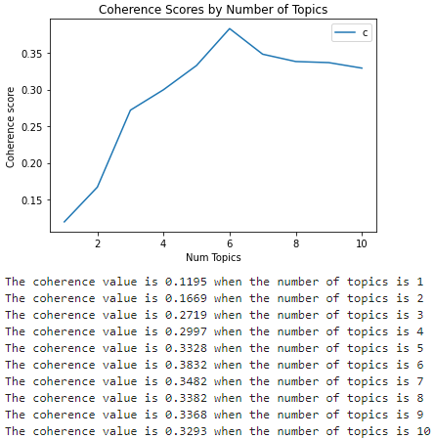
Figure 2. Coherence plot of topics
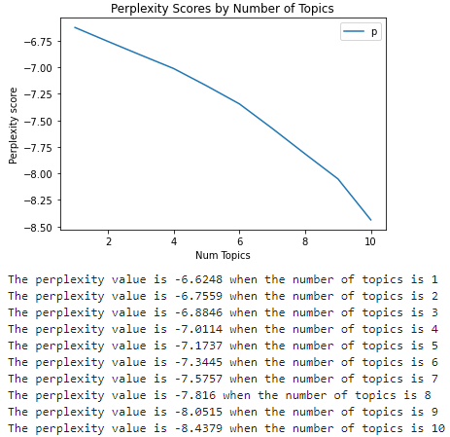
Figure 3. Perplexity plot of topics
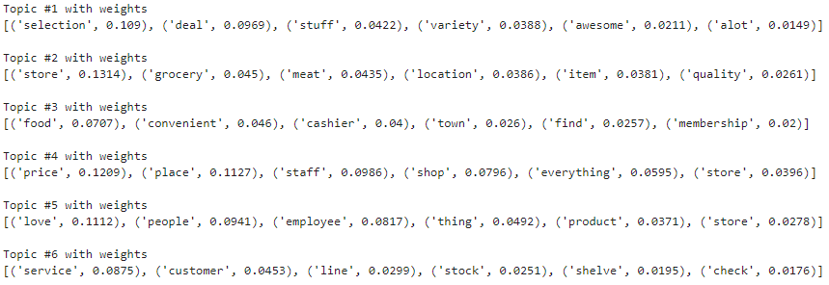
Figure 4. Topic-word mixtures and proportions when n=6

A general workflow to identify and interpret topics based on the probabilities of the top six words and then reviewing the relevant individual sentences in reviews labelled with the topic was applied to all topics. Each sentence in a review is associated to a topic with the greatest probability among the five possible choices. One topic (Topic #4 in Figure 4), price, was omitted in the final table because there is already a price attribute. These five topics as described in the bullet points underneath ‘Perceived Food Attributes’ relate to different aspects of food stores perceived by people that they discussed in reviews (in alphabetical order):
- Checkout Process & Customer Service
- Convenience (Topic #3)
- Employees (Topic #5)
- Food Quality (Topic #2)
- Food Variety (Topic #1)
Four of the six most probable words in Topic #1 in Figure 4 are “selection” (10.9%), “stuff” (4.2%), “variety” (3.9%), “a lot” (1.5%). Examining the associated review sentences for this topic indicates that many people are commenting about the variety of food in stores, so Food Variety is labelled for this topic. For example, reviewers of Tio Conejo, a Mexican grocery store near Fountain City remarked on how “they have some really really nice items in there and incredible variety”, they have “really good food and also fresh avocados, mangos, etc.” and that they “love… the selections.” Another comment was however less favorable, with someone commenting that there was “not as much variety as I had expected.” The semantic of food variety across these reviews is similar but the sentiments for these semantics can also widely vary between people, affirming the concept of mental availability as people may have different preferences for the diversity of available foods that meet their needs.
Topic #2 in Figure 4 relates to a different component of food availability: food quality. “Grocery” (4.5%), “meat” (4.4%) and “quality” (2.6%) are three of the six most probable words in this topic. For example, relevant reviews for the Food City in Clinton, Tennessee were mixed on the quality of food. On one hand, some people commented positively on the “fresh product and meat”, “great fresh vegetables and fruits. The meat department has good meat”, and “great selection of deli and bakery items.” On the other hand, some people did not share the same sentiment, commenting on “yuck[y] meat” and “so sick and tired of the dairy products being expired.” These and other reviews related to the topic of food quality also reflect the concept of mental availability whereby people may hold different sentiments about food quality within and between food stores.
Convenience was identified for Topic #3 in Figure 4 and includes ‘food’ (7.1%), ‘convenient’ (4.6%), and ‘find’ (2.6%) as three of the six most probable words in the topic. This is because reviewers frequently discuss about the convenience factor, such as one reviewer of a review labelled with this topic commenting about one Walmart location as “convenient AF” while another reviewer praises Fresh Market as they “can always count on [F]resh [M]arket for quick dinners… Haven’t found better in [F]arragut.” The semantics of these reviews reflects upon mental accessibility as people openly discuss their perceptions of the ease to which they can obtain food and the time required for food shopping which can vary between stores and individuals.
Reviewers also discussed aspects of store employees beyond customer service (discussed later) and Employees was identified for Topic #5 in Figure 4, with ‘people’ (9.4%) and ‘employees’ (8.2%) as the top two most probable words. This is evidenced in reviews in which people comment about the general attitude of employees, for example with an array of sentiments about how the Kroger on Asheville Highway. One reviewer commented “I love this Kroger. Nice employees”, another thought that “management is very rude”, and someone else “wish[ing] the employees had better attitudes.” This is distinguished from comments about customer service as some employees may not necessarily be customer-facing and many commented on the attitudes and friendliness of employees that do not necessarily stem from customer assistance activities. The reviews on how individuals perceive employees and other people in the stores they visit reflects a relational and mental space approach to acceptability. Food access for many is not simply about the procurement of food but also their experience and social connection to others as they care about qualities of the social atmosphere and environment.
Checkout Process & Customer Service was assigned to Topic #6 in Figure 4 as three of the six most probable words include ‘service’ (8.8%), ‘customer’ (4.5%), and ‘check’ (1.8%). Examining the associated reviews finds that customer service is a topic of concern by many reviewers. Google Maps also provides a similar store attribute, Great Service as mentioned earlier, but it is essentially a binary indicator (either a store is or is not labelled with the attribute) without explanation of how it was determined for stores. The aspect-based sentiment analysis approach used in this research design to identify topics can arguably provide a better justification for the assessment of customer service in different stores. Some comment positively about how the “customer service [was] awesome this morning” or negatively about how “nobody ever answer[s] the phone!” The second comment also indicates the importance of examining access in virtual space with the reviewer wanting to reach out to the store with a phone call. While this is anecdotal and just representative of one opinion, the reviewer appears to be disgruntled with the virtual infrastructure (voice services) established by the store. Other reviews also discuss the checkout process at stores, for example with people lamenting about “long lines, only 2 registers were open. Not a fan of self checkout” and “Bad service[, and] long wait” at the Walmart in Lenoir City. How people perceive and value customer service as well as the virtual communications established by stores evokes the concept of relational accommodation whereby the social, physical, and virtual infrastructure can either impede or enhance the ability of individuals to access food. In this instance, the organization of customer-facing employees and presence/absence of sufficient check-out lanes is a major point of critique for many reviewers and suggests that people value and perceive these store characteristics as important to their food access. People who have never patronized these stores could easily be swayed to shop at other stores where customer service and their checkout process may be subjectively superior, which is tied to a mental space approach to both accommodation and acceptability.
Sentiment analysis of individual sentences using TextBlob in each review was subsequently carried out after topic modeling with LDA to identify the polarity score, or how positively or negatively reviewers felt about a particular component of the food store experience (i.e., one of the topics). Then, all polarity scores for each review sentence were normalized to a scale of 1 to 5 rating with the following formula, with ‘spv’ denoting the polarity value of a given sentence:
Rating = (5 – 1) * ( (spv – minimum(spv)) / (maximum(spv) – minimum(spv)) + 1
These normalized sentiment scores for different aspects of food stores voiced in online reviews can be used to represent one subjective perspective (online reviewers). The derived sentiment-semantic pairs demonstrate a relational and mental approach to acceptability as people may be influenced in their decision to visit stores based on the opinions of others. How people perceive the opinions of others for specific store characteristics that are important to them can be operationalized as queries in a GIS. With numerical ratings, assessing food access can be augmented by delimiting the potential opportunity set to stores above a threshold level for one or more topics as perceived by individuals, and this is discussed later.
It must be noted that online reviews do not reflect the perspectives and opinions of everyone, especially those who are low-income and not connected to the Internet. This means that the comments by reviewers may overlook the unique perceptions of certain groups of people who may be marginalized; what is important to one group may be very different than another group. In fact, many people also do not care to leave reviews regardless of their positive or negative experience. This is an important limitation to be recognized in the design of this research, and caution must be taken when analyzing and interpreting the reviews. Any derivative data and analytical function that requires the use of this data must subsequently be interrogated carefully. In this case, the findings from the semantic and sentiment analysis of reviews should not be treated as the perceptions of the entire population but rather of the online reviewer population; this necessarily excludes the perspectives of those who do not post online reviews for food stores. Moreover, LDA works by essentially finding the most probable words that co-exist in topics that are as dissimilar from each other as possible. With an average sentiment score for each topic discussed by reviewers for stores, even amongst the reviewer population, opinions that are not the most popular (e.g., potential outliers) may be overlooked due to the nature of averages. This does not however mean that the reviews cannot be used to inform how people may perceive food stores; reviews are still useful in capturing the general perspectives of a specific population which could plausibly reflect the perceptions of those who do not post reviews. Confirming or refuting this notion would require identifying the demographic profile of those who are not represented, collecting their opinions about these stores, and comparing these sentiments with the results from the aspect-based sentiment analysis approach.
Food stores were also reclassified into six broad categories. Google Maps provides a unique type for each POI but for simplicity's sake, each food-related POI was reclassified according to a manual classification scheme based on the nomenclature adopted by Google, and manual ground-truthing of stores based on the researcher’s knowledge of the retail food landscape in Knox County. This is because many unique types are infrequent in the dataset and are only classified for one or two stores; moreover, some of them are not entirely accurate as some stores can also be classified as a different type. For example, a few stores such as La Lupita Mexican Store and Restaurant and Maryville Corner Market operate as both a restaurant and retail food store but are classified as, respectively, Mexican restaurant and Lunch restaurant. Searches of reviews and pictures on Google Maps, Yelp, and TripAdvisor were carried out to identify whether stores offered some form of groceries (e.g., fresh vegetables, meat, dairy, etc.). In total, there are seven classes of food stores; the left-hand side are the classes in the GIS while the right-hand side contains the POI types of all stores scraped from Google Maps:
- Ethnic grocery store = Asian grocery store, Cafe, Gourmet grocery store, Mexican grocery store, Mexican restaurant; (e.g., Chinese supermarkets)
- Specialty food store = Butcher Shop, Furniture store, Lunch restaurant, Produce market; (e.g., farmer's markets, butcher shops)
- Discount store = Dollar store, Discount supermarket; (e.g., dollar stores such as Dollar Tree, Save-A-Lot, United Grocery Outlet)
- Convenience store = Gas station, Market, Store; (e.g., gas stations, convenience stores, bodegas such as Weigels)
- Grocery store = Health food store, Supermarket; (e.g., supermarkets, grocery stores such as Kroger, Publix, Food City, etc.)
- Warehouse store = Warehouse club; (e.g., bulk retailers such as Costco and Sam’s Club)
- Department store = Department store; (e.g., Walmart, Target)
Food stores catering to a particular ethnic community such as Asian and Mexican grocery stores were grouped together along with other POI types relating to other ethnic food POIs. Café, gourmet grocery store, and Mexican restaurant belong to this group too as the few POIs with these store type attributes are ethnic food places that at the minimum sell some form of groceries; respectively, they are Holy Land Market, International Delicacies, and La Lupita Mexican Store. Specialty food stores encompass POIs that only market a particular variety of groceries, such as butcher shops and farmers’ markets; and World Market, which offers specialty groceries, is the store with a POI type of furniture store that is included in this grouping. Maryville Corner Market is also included despite being classified by Google as a lunch restaurant because it also offers fresh fruits and vegetables. Discount stores include all dollar stores and discount supermarkets located in more rural, sparsely-populated, and often in low income areas with greater minority populations (Shannon, 2021). Convenience stores are stores with, generally, longer hours of operation that supply a wide range of convenience foods including groceries, frozen foods, fast food, etc. (Jones, 1988) and are the broader group for what Google classifies as gas stations and convenience stores. Grocery stores are traditional grocery retailers that offer a wide range of groceries and kitchen-related items; Earth Fare is included in this grouping and is the only POI with the Health food store type. Warehouse stores are stores that require membership to purchase groceries and other household items while department stores are larger retailers which offer groceries and more.

4.2.2. DATASET 2: SOCIOECONOMIC, DEMOGRAPHIC, AND PERCEIVED CHARACTERISTICS OF INDIVIDUALS
Further understanding the food opportunities accessible to individuals beyond conventional spatial accessibility measures, entrenched in an absolute space approach to the availability and accessibility dimensions, requires more than just the locations of people and places at specific points in time. People have different characteristics and the needs of one person can vastly differ from another person. From this viewpoint, it is important to also integrate various characteristics of people that reveal their attitudes and perceptions of store infrastructure, social environment, and shopping modalities (e.g., preferences for stores with COVID19 precautions, LGBTQ+ friendly environment, and/or store pickup), skills and capabilities (e.g., ability to use online services; access to personal vehicle; possible travel modes), and personal situations (e.g., income, housing type, job). In addition to basic demographic information (e.g., age and sex), these characteristics reflect upon different dimensions of access important to people and can be used in conjunction with Dataset 1 to define opportunity sets more accurately for individuals. This is critical to understanding additional opportunities as well as identifying opportunities in virtual space which are often overlooked in conventional approaches. These characteristics are as follows (Figure 5):
- Person ID (person_id): Unique ID for the individual
- Age (age): Age of the individual
- Sex (sex): Sex of the individual
- Race/Ethnicity (raceethnic): Race/ethnicity of the individual
- Annual Income (incomeyear): Annual income of the individual
- Language (language): Spoken languages by the individual
Figure 5. Snapshot of data on socioeconomic, demographic, and perceived characteristics of plausible individuals in Knox County, Tennessee

- Dietary Preferences (dietarypref): Dietary preferences of the individual
- Digital Literacy (digitallit): Whether the individual has access to computers and internet and is digitally literate or not (yes/no)
- Job (job): Job of the individual
- Housing (housing): Housing situation of the individual
- Household Size (housesize): Size of the household an individual lives in
- Kids at home (kidsathome): Number of kids in the household an individual lives in
- Marital Status (marital): Marital status of the individual
- Travel Modes (travelmode): Feasible travel modes for the individual
- Physical Disability (physical): Any physical disabilities of the individual
- SNAP Benefits (snapbenefit): Whether the individual has Supplemental Nutrition Assistance Program (SNAP) (formerly known as food stamps) benefits
- Cost Preference (cost_pref): Cost preference of the individual in accordance with the 1 to 4 $ rating system by Google
- Other Preferences (other_pref): Any other preferences by the individual
- Description (descript): Description of the person and their current life circumstance(s)
A unique ID (person_id) is specified for each individual and all data types are either text or double. Excluding the descript column, commas are used to separate, if applicable, multiple values of an attribute by an individual. Attributes were included to capture a basic demographic profile of individuals and to additionally contextualize their abilities, needs, and preferences. These attributes can be used to calculate potential opportunity sets more accurately with the abundance of store attributes data presented in Dataset 1. Queries of store attributes based on individual characteristics can effectively be carried out, as discussed later in Section 4.3.
The dietarypref attribute captures any and all dietary preferences of individuals, for example, whether they prefer Mexican ingredients, organic foods, prepared foods, and etc. In other words, this can be treated as an indicator to measure the availability of diverse foods from a mental space approach. For example, the POI type attribute provided by Google Maps lists ethnic-specific grocery stores such as Mexican and Chinese grocery stores and ‘Organic Food’ and ‘Prepared Food’ store attributes can all be used in queries to match the food preferences of individuals with the stores offering the desired foods.
Understanding the feasible travel modes for individuals (travelmode) and their skills with and access to computers and the Internet (digitallit) additionally provides insight to accessibility from a relative and relational space approach. Travel modes can be used to determine the ease to which individuals are able to reach the different food opportunities given their discretionary time budgets at different locations in Dataset 3. People have different means of transportation and those who are low-income and/or physically disabled often lack a personal vehicle to freely travel around, so understanding road networks based on their actual means can help determine more realistic travel and activity participation times at physical stores. Accessibility can also be made easier for those who have access to computers and the Internet and also have the requisite skills and willingness to use online food shopping services. The binary indicator for (digitallit) can be used to capture whether individuals are able to reach and shop at stores online.
An attribute for whether an individual has physical disabilities is captured in (physical), and this understanding can be used to understand how the infrastructure of stores accommodates to the abilities of disabled peoples, capturing an absolute and mental space approach to accommodation. With store attributes for wheelchair ramps, restrooms, and masking policies, opportunity sets for disabled individuals can be delimited to stores with the requisite infrastructure.
Including the annual income of individuals as well as their preferences for store prices, captured by the cost preference characteristic, can help to understand how people with different economic means may afford food at different stores based on their pricing level. With the Price attribute for stores in Dataset 1, queries in a GIS can be carried out to delimit the opportunity set of stores to those in alignment with the cost preference of individuals; for example, if an individual earns a relatively low annual income and thus prefers stores that are inexpensive ($) or moderately priced ($$), the potential opportunity set can easily be reduced to just the stores that sell food at that price level. The snapbenefit column effectively captures a relational space approach to affordability as it is a binary variable indicating whether the individual has or does not have SNAP benefits. The variable can similarly be used to delimit opportunity sets for those reliant on SNAP benefits to just the stores accepting of the payment option.
Altogether, the characteristics of individuals can be considered in light of the attributes of stores to identify opportunities that are acceptable and can potentially be accessed. People of different ages, gender, race/ethnicity, household status, and etc. may possess different cultural beliefs and values that consequently result in disparate opportunity sets of food stores. As demonstrated later in the explanation of the proposed GIS, table queries and filters can be used to identify opportunities for different groups of people based on one or more characteristic. For example, this means that access can be contrasted and compared for people of different economic means and/or of different racial and ethnic backgrounds.
In this dissertation, the demographics of this dataset are as follows, and care must be taken in interpreting the dataset with respect to food access in Knox County. There is a total of fifty-two people in the dataset, with twenty-two (42%) of them being White, ten (19%) being Asian, ten (19%) being Hispanic, nine (17%) being Black, and one (2%) being Middle Eastern. While Middle Eastern is not a recognized racial category by the U.S. Census, the cultural dissimilarities between non-Hispanic Caucasians with ancestry from Europe are markedly different than people with ancestry in the Arabian Peninsula and northern Africa. One individual was included to represent peoples from the Middle East. The median age is 36 while the median annual income is $21,500. Thirty-one (60%) people only speak English while the rest (40%) speak English and/or another language. Twenty-three (44%) individuals are not digitally literate. Thirty-four (65%) only drive while the other eighteen (35%) can walk, bike, and/or take transit. A total of fifteen (29%) people also have access to SNAP benefits. It is understood that the relative proportions of characteristics in the synthetic dataset are not directly proportional to actual demographics in Knox County. Latest estimates by the U.S. Census Bureau indicates that 86% of all residents are White, 9% are Black, 2.5% are Asian, and 5% are Hispanic (U.S. Census Bureau, 2022). In other words, the minority population is over-represented while the majority population is under-represented by 44% amongst the synthesized population compared to the actual population. Similarly, the Census-provided per-capita income is $34,338, which is more than $12,000 greater than the median income of the synthesized population. Moreover, only 10% of residents in Knox County have access to SNAP benefits compared to 30% in the synthetic population. Possession of a computer amongst households is also far greater in reality at 92% and households with broadband Internet subscriptions are also not too far behind at 84.6%. These individuals were deliberately synthesized and created to represent the plights and situations of those in disadvantaged situations. The tendency in the United States is that those who are of lower socioeconomic class face greater difficulties and experience poorer access. So, the synthesized population overrepresents different marginalized groups in order to better understand the different accessibilities amongst these groups of people compared to what is still a sizable group of people who belong to higher socioeconomic classes.

4.2.3. DATASET 3: INDIVIDUAL TRAJECTORIES AND ACTIVITIES
In addition to the table in Figure 5 is another table of individual trajectories for each person where each row corresponds to an individual’s activity location at a specific time (Figure 6):
- Index (index): Unique ID for the trajectories table
- Person ID (person_id): The Person ID associated with the trajectory stop
- Latitude & Longitude (latlon): The latitude and longitude in WGS84 of the location
- Start Time (time): Starting day and time of the activity in m/dd/yyyy h:mm:ss format
- End Time (time_shift): Ending day and time of the activity in m/dd/yyyy h:mm:ss format
- Sequence (sequence): Ordinal numbers for each individual reflecting the sequential order of all their activities
- POI Type (poi_type): The POI type of the current location
- Activity Type (activity_type): The type of activity at the current location and time
- Travel Type (travel_type): The travel mode used to arrive at the current location; ‘stay’ denotes that the individual was already at the location
- Fixed Activity (fixed_activity): Whether the activity at the current location and time is fixed or not fixed (i.e., discretionary)
- Available Time (time_available): The duration in minutes of the entire trajectory stop/activity
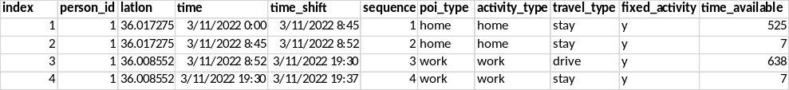
Figure 6. Snapshot of data on individual trajectories of people

The table shown in Figure 6 can be related and linked to the table of socioeconomic, demographic, and perceived characteristics of individuals in Figure 5 with person_id as the common key. This table in Figure 6 is similar to activity-based and travel-based diaries that record the different activities and travels of individuals over a period of time. In this study, a two-day period covering a Friday and Saturday (between March 11, 2022, 12:00 AM and March 12, 2022, 11:59 PM) was adopted to capture some major differences between weekday and weekend behaviors. While this is not completely comprehensive of temporal differences (e.g., seasonality, holidays, etc.), this is a reasonable example that covers some variations in temporal activity and travel patterns. Moreover, the broader purpose of the dissertation concerns the development of a space-time GIS capable of handling multiple streams of data reflecting upon different aspects of human dynamics relevant to access and to identify additional opportunities, not necessarily on the particulars of temporal variation in activity and travel patterns. This dataset is important to understanding the ease to which people can reach different food opportunities based on their locations, routes, and available time for purchasing food and traveling to physical stores or visiting online stores. In other words, knowing the activity and travel behaviors alongside store locations and their respective shopping modalities can enhance understanding of accessibility from a relative and relational space perspective.
Dataset 3, however, only (1) includes the stops people make along their travels throughout the two-day time period and is without connecting edges that reflect routes, (2) does not explicitly reveal the periods of flexible/discretionary time, (3) and just shows the actual travel stops but not the potential areas that could be feasibly reached given their space-time constraints.
To overcome issue one, plausible routes were assigned for individuals based on shortest paths in a multimodal transportation network from each location to the subsequent location in a person’s trajectory. The construction of a network graph was carried out with the assistance of the Python library ‘urbanaccess’ (Blanchard & Waddell, 2017) to compute and integrate together General Transit Feed Specification (GTFS) data and OpenStreetMap (OSM) road networks as a graph. The former is the standard format for public transit data, which is publicly available for Knox County, while the latter contains information on whether roads can be walked, biked, and/or driven on, their directionality, and maximum speed. The nearest transit stop or OSM node (e.g., a point feature defining part of a road) was identified for all locations in the trajectories dataset. Edges are the road segments weighted by the time required to traverse them. Because every subsequent row except for the last contains information about a person’s different visited locations, it is easy to identify every pair of their current and next location. To generate plausible routes between locations, shortest paths were computed with the Python library Pandas Network Analysis (‘pandana’) (Foti et al., 2012). Pandana uses the contraction hierarchies (CH) algorithm (Geisberger et al., 2012) comprised of two phases to speed up the process of finding the shortest path. CH is based on the idea that road networks are hierarchical whereby some intersections are more important (‘higher up’) in the hierarchy than other intersections (e.g., highway junction vs. dead-end junction). In the preprocessing phase, heuristics to compute and save the distance between important junctions, and therefore render other junctions ‘unimportant,’ are used to reduce the overhead and time required to compute the full path distance between junctions. This effectively keeps the search space small and is one advantage over Dijkstra’s algorithm for computing shortest paths. In the query phase, a bidirectional search is carried out from both the starting and target nodes to identify the vertices leading to more important nodes that are between them. Ultimately, the query returns the travel time or distance and the shortest route between two nodes. The output of this is a .csv file ‘Scenarios_Synthetic_Data_Trajectories.csv.’
Solving issue two is simple given that there is information about a person’s fixed activities. The fixed_activity field records whether the given activity is fixed (y) or not (n). Discretionary time periods were identified and calculated based on a person's daily activities -- work, sleep, school, and other similar activities are mandatory/fixed while working out, shopping, etc., are discretionary/flexible activities. To determine the total period(s) of flexible time for each individual, the following algorithm was implemented on the original individual trajectories dataset:
- Record the activity and travel type of the next row in the trajectory dataset in each row as two new fields. Specifically, split data into groups for each individual, shift the index up one period, and record the new fixed_activity and travel_type values as the values for two new fields fa_shift and tt_shift. The Python code is shown in Figure 7.
- Retain only rows for discretionary activities. Specifically, filter all activities/rows where the current or next locations in a person’s trajectory are not fixed (i.e., fixed_activity == ‘n’ or fa_shift == ‘n’.)
- Calculate the total amount of discretionary time in each discretionary time period for each individual. Specifically:
  - For each row/activity:
    - If the current activity is fixed AND the next activity is not fixed: set the available discretionary time to 0, and record the person_id, travel_type, starting time of the person’s discretionary period as the value of time_shift, and starting location as the value of latlon_shift.
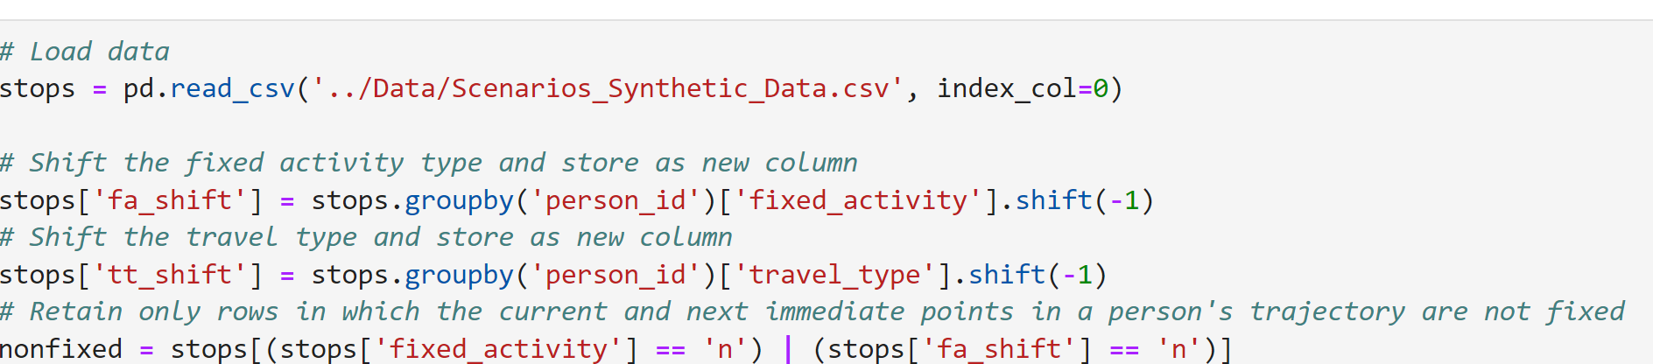
Figure 7. Screenshot of code for recording activity and travel type of the following row in the trajectory dataset

    - Else, if the current activity is not fixed AND the next activity is not fixed: add the value of time_available to the total available discretionary time counter.
    - Else, if the current activity is not fixed AND the next activity is fixed: add the value of time_available to the total available discretionary time counter and record the ending time and location of the person’s discretionary period as the value of free_time_end and latlon_end.
The result is a spreadsheet where each row represents an individual’s discretionary time period complete with details about their location and timestamp at the start and end of that period as well as their mode of transportation. This enables for the calculation of space-time prisms as discussed in the next paragraph.
Determining the possible areas people can visit over time is useful for understanding the opportunities available to people; if the location of a potential opportunity exists within the space-time prism, it can be reached. A space-time prism in the context of food access should be sensitive to not just travel time but also activity participation time, and this directly relates to a relative space approach to accessibility with the recognition of idiosyncratic differences in time budgets to reach activities. But while it is conceptually simple to determine prisms based on an individual’s discretionary time at different points in their daily trajectory, it can be quite computationally intensive to delineate space-time prisms based on the road network (‘network time prism’) especially when the discretionary time increases. An attempt to construct network time prisms for each person’s discretionary time period was nonetheless computed to illustrate the areas where individuals could visit. This was done with the osmnx package to compute travel times across the road network based on each person’s starting location and ending location and preferred modes of transportation. The ‘osmnx’ library developed by Geoff Boeing (2017) simplifies the creation and analysis of street networks from OpenStreetMap. Because people often adopt more than one mode of transportation, it is important to consider individual travel over a multimodal network. Travel times across each road segment were calculated by dividing the length (in meters) by an appropriate travel speed depending on the mode of transportation. For personal vehicles, the maximum road speed was assigned while for walking and biking, a speed of, respectively, 3.5 and 14 miles an hour were assumed. These two figures are close to average gait and cycle commuting speeds determined in past studies (Bohannon & Williams Andrews, 2011; Schleinitz et al., 2017). The travel times for the travel modes were added as separate attributes to a road network dataset. However, some people also use public transit to get to places, but no open-source software exists to model such complex travel networks that fully integrate public transit with street networks. Instead, travel over public transit was determined by calling the Google Maps Directions API (2022) to generate the fastest route between locations.
If the goal is to simply identify potential food opportunities, it may be easier to calculate whether a person has sufficient time to access them. But time is also required to shop for and purchase food depending on the access modality: curbside pickup, in-person shopping, or delivery. The amount of free time available to individuals in turn shapes their food environment (Widener et al., 2013). A study by the mobile commerce platform Rakuten Ready found that the average time for store pickup and curbside pickup from major grocery retailers was, respectively, four minutes and three seconds and five minutes and twenty-one seconds (Manning, 2019). Meanwhile, researchers at the United States Department of Agriculture Economic Research Service found that the average time spent for in-person grocery shopping totaled forty-six minutes (Anekwe & Zeballos, 2019). The dataset of individuals was constructed to recognize different preferences for shopping modality in the population with some people preferring to shop in-person while others preferred pickup or delivery. Overall, the choice of shopping modality affects whether an individual can feasibly travel to and also acquire the food items they desire; each mode requires a different amount of time. Food opportunities can be reached in-person, online, or by both modalities; these are referred to as, respectively, 'physical', 'virtual', and 'hybrid' opportunities.
An algorithm was developed to assess whether each opportunity throughout the study area was accessible during each person’s discretionary period(s) using the multimodal network discussed earlier. The algorithm first identifies the time required for participating in an activity based on the person’s preferences (other_pref); for example, if an individual prefers in-store shopping, it is assumed they will require forty-six minutes (in seconds.) Afterwards, the algorithm identifies the appropriate road network based on the individual’s possible travel modes; for example, if an individual can take transit and walk but is without a personal vehicle, travel time will subsequently be calculated based on average walking speed and public transit schedules along the road network. Then, the shortest time required to travel from a person’s location at the start of their discretionary period to a potential food opportunity is calculated as well as from the food opportunity to the location at the end of their discretionary period. Afterwards, the travel time to and from the food opportunity are summed with the activity participation time. For each individual, given the start of their discretionary time period(s), and for each potential opportunity, if the time required to travel to a potential opportunity AND the time required to participate in food shopping by their preferred modality AND the time required to travel to the location of their next fixed period is equal to or less than their total discretionary time, then the opportunity is physically accessible. If the person has access to a computer and the internet, is also digitally literate (i.e., able and willing to order food online) and the store offers online services (e.g., delivery), then, the store can also be reached online and thus, the opportunity is considered as a hybrid opportunity. In other words:
- If a person can only reach the store physically but is not digitally literate and/or not willing to buy food online, the store is a physical opportunity.
- If a person cannot reach the store physically (e.g., not enough time and/or not willing to buy food in-person) but is willing and able to buy food online, the store is a virtual opportunity.
- If a person can both reach the store physically and online, the store is a hybrid opportunity.
- Otherwise, if a person cannot reach the store in person nor online, the store is not considered an accessible opportunity.
This process can be repeated until all potential opportunities are considered for each individual. The counters at the top-middle of the GIS application shown in Figure 8 reflect the opportunities of all activated/shown individuals.
Accessibility consequently varies between physical, virtual, and hybrid space. All of the considerations described in the data manipulation process to construct plausible travel routes for individuals, calculate their discretionary time periods, and determine the areas individuals can potentially visit raises the importance of considering the dimension from relative, relational, and mental space. People have different time budgets for activities and are often limited by other fixed activities such as work, sleep, and childcare. The fixity of particular activities consequently reduces the amount of discretionary time available to carry out other activities that may not necessarily be as urgent or pressing. It is these time periods where people have greater flexibility to reach different activity locations, whether in-person (in-store shopping), online (online delivery), or both (curbside pickup.) The emergence of online and hybrid shopping options vitally changes how researchers should calculate (food) accessibility as these shopping modalities generally enable people to reduce the time necessary for food procurement, thus expanding their window of accessibility to food stores. This emerging trend of virtual-based services requires a relational space approach to accessibility or else opportunities could be overlooked. However, understanding who is capable of reaching virtual-based food services necessitates knowledge of the perceptions and willingness of individuals to use them, and this recognizes the importance of a mental space approach to accessibility. Individuals widely vary from one another and assuming a homogeneous pattern of behavior may neglect how people can overcome their situations that extend beyond solutions in physical space. As argued earlier in the proposed conceptual framework, accessibility is just one of five dimensions of access but critically highlights how easy or difficult it may be for people to reach food opportunities.

4.2.4. DATASET 4: BLOCK GROUP-LEVEL ESTIMATES OF SOCIOECONOMIC AND DEMOGRAPHIC CHARACTERISTICS IN KNOX COUNTY, TENNESSEE
Local context is important to understanding the food opportunities accessible to different individuals and contextualizing their surrounding environment. Statistics related to basic demographics, social vulnerability, and Supplemental Nutrition and Assistance Program (SNAP) benefit recipients aid in identifying areas that are socially disadvantaged or lacking in economic power. All variables included in the CDC’s Social Vulnerability Index (SVI) were included in accordance with what public health scientists at the CDC consider to be fifteen important variables that reflect human health, and these are numbers 2 to 16 in the following list. Four additional variables for total population, SNAP benefits, no computer and no internet are also included because of their relevance to food access in today’s hybrid physical-virtual space. 2016-2020 5-Year Estimates from the American Community Survey (ACS) were retrieved for all block groups in Knox County, Tennessee, and a script for reproducibility written in R was developed using the tidycensus library (Walker & Herman, 2022). These variables shed light on the different access dimensions and are:
- Total population
- Median income (Median household income in dollars in the past twelve months adjusted for 2020 inflation)
- Poverty (% of all people living at or below the federal poverty line)
- Unemployed (% of all people in the labor force who are unemployed)
- Low formal education (% of all people who are 25 and older without a high-school diploma)
- Senior (% of all people who are 65 and older)
- Youth (% of all people who are age 17 and younger)
- Disabled (% of all households with at least one person with a disability)
- Single-parent households (% of all households with at least one children and either a female or male householder)
- Minority (% of all people who are non-white)
- Poor English speakers (% of all people who speak English less than “well”)
- Multi-unit housing (% of all occupied housing units that have 10 or more units)
- Mobile homes (% of all occupied housing units that are mobile structures)
- Crowded housing (% of occupied housing units with greater than one person per room)
- No vehicles (% of all households without a personal vehicle)
- Group quarters (% of all people living in group quarters)
- SNAP benefits (% of all people with SNAP benefits)
- No computer (% of all people without a computer at home)
- No internet (% of all people without internet at home)
For example, the contextual layer of the population without vehicles reveals areas where the population may have lower adoption of personal vehicle transportation and face more difficulty in reaching places not easily traversed to by car. In car-centric cities like Knoxville, this understanding helps to understand the relative accessibility of people based on what is arguably the most important mode of transportation. But the existence of the Internet means that the last two contextual layers of computer ownership and internet access are also important to understanding the broader structural barriers in navigating virtual space, or relational accessibility to different opportunities. People have different technological capabilities and broadband and 5G internet infrastructure is heterogeneous throughout the United States and across the world (Graham, 2014; Warf, 2011). In the U.S., ACS data for the population without computers and internet at home at the block group and coarser geographic units helps to understand where a relatively large population lacks access to the necessary digital resources and skills for reaching opportunities online. The FCC Broadband Map similarly details where and what type of internet infrastructure is laid across the U.S. (e.g., dial-up, satellite, 25/5 mbps broadband, 100/20 mbps broadband, 5G, etc.) but is currently fraught with accuracy concerns and undergoing major revisions and updates spearheaded by a new task force (Reardon, 2021; Tibken, 2021a, 2021b). Such data, with the necessary improvements, can be used to augment understanding of the characteristics of individuals (Dataset 2) and their capabilities in reaching online stores.
Understanding the median income across an area and where unemployment and poverty are greatest can also help policymakers develop more informed programs to combat food insecurity and ameliorate poor food access stemming from financial and economic considerations. Such information adds context into the financial situations of people within different neighborhoods, or the relative affordability of individuals based on the economic situation of where they live. Map overlays for these three characteristics can help identify relatively lower-income, higher-unemployed, and more impoverished areas that have few inexpensive food opportunities when coupled with user queries of store characteristics (Dataset 1). Other contextual layers from the Census such as the disabled and senior population can be used to inform areas that have higher proportions of these people and may more urgently require special infrastructure that accommodate the physical and mental needs of these populations. Along with the store characteristics dataset, such layers can be tied together visually to understand whether areas with higher proportions of these populations have destinations with the requisite infrastructure, such as wheelchair ramps and parking areas. The minority and English language speakers population layer also help to understand the broader racial and linguistic dynamics throughout the area that can shed light on the perceived acceptability of people for different destinations, especially when store characteristics such as the Ethnic grocery store type are tied in.

4.3. A PROTOTYPE MULTIDIMENSIONAL MUTLISPACE GIS FOR ACCESS
All of these data are integrated into a prototype GIS platform (see Figure 8 for a screenshot) to understand the opportunities accessible to people and to further identify new opportunities often not captured in traditional GIS approaches. With this interactive GIS, users can examine movements over space-time of synthetic people, visualize food opportunities
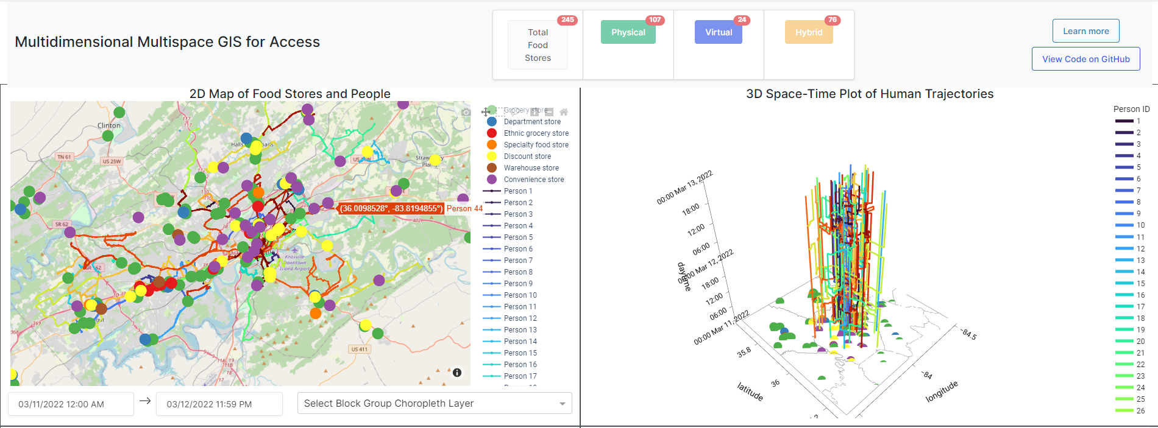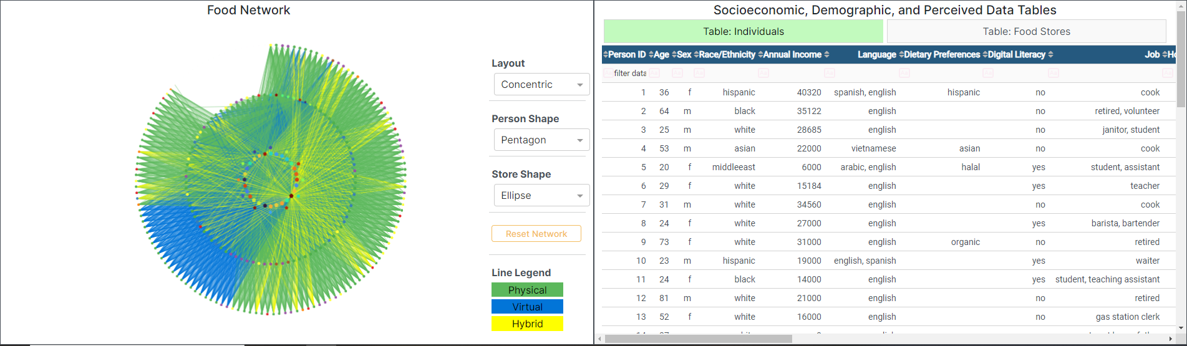
Figure 8. Screenshot of Interactive GIS Platform for Food Access

relative to locations of people and their daily travels, query food stores based on different characteristics perceived as desirable, visualize different census variables depicting social vulnerability and socioeconomic characteristics of block groups in Knox County, Tennessee, and identify the food opportunities accessible to people along different shopping modalities. In other words, the GIS enables explicit consideration of the five dimensions relevant to access that are important to individuals in a hybrid physical-virtual world.
This platform is permanently hosted at the following hyperlink: https://dissertationaccess.herokuapp.com. All front and backend web development and visualization were carried out with the Python libraries dash (Dash Documentation & User Guide | Plotly, 2022), dash-bootstrap-components, dash-cytoscape, and plotly (Plotly Open Source Graphing Library for Python, 2022) while the application is hosted with Heroku using the Heroku Buildpack Geo that installs necessary geographic/GIS libraries. Because the platform has many processes running at once and is hosted on the free version of Heroku, it may take some time (upwards to a minute) for the panels to fully load and update. The platform contains four interlinked panels which depict a different perspective into the food opportunities available to people, inspired by four conceptualizations of space in Shaw and Sui (2021)'s splatial framework and the proposed conceptual framework in this dissertation. While not mutually exclusive from each other, each panel depicts one of the four different spatial dimensions proposed in the conceptual framework to understanding access. Any user interaction in one panel results in synchronized changes across all other panels, and is congruent with the notion that understanding access and its individual five dimensions must be inclusive of different forms of human experiences expressed with a multispace perspective. Colors for each individual and store type are uniform across the 2D Map, 3D Plot, and Food Network.

4.3.1. INTERACTIVE PANEL DESCRIPTION
Upper-Left: 2-D Map of Food Stores and People
An interactive 2-D map depicts all the potential food opportunities accessible by all individuals shown. Food opportunities are colored by a main POI type with a manual classification system described below. Legend interaction is disabled here. Users can zoom in/out and pan the map interface, set the time period, and add contextual layers from the United States Census at the block-group level related to food access and social vulnerability. As discussed earlier, these contextual layers can augment understanding of different dimensions of access. With an assortment of layers related to affordability (median income, unemployment, poverty, and SNAP benefits), users can effectively examine opportunities and their respective store type on a map, providing a better understanding of affordability from a relative space perspective. For example, many low-income peoples frequent discount stores such as Dollar General and Dollar Tree for much of their food procurement. Comparing and contrasting the locations of such stores as in Figure 9, with a yellow color in the GIS, across block groups suggests that discount stores are predominantly located along major road corridors (e.g., Kingston Pike) and in poorer areas throughout Knox County.
This panel reveals an absolute and relative space perspective to availability and accessibility as it shows the absolute locations of all food opportunities as well as individuals throughout the established time period. As discussed later, clicking at a specific location throughout the trajectory of an individual in the 3-D Space-Time Paths of Human Trajectories panel will consequently coerce the 2-D Map to center and zoom-in on the clicked location. The updated view in this map captures the relative availability of food opportunities near the examined location of an individual. The different colors of food opportunities augments
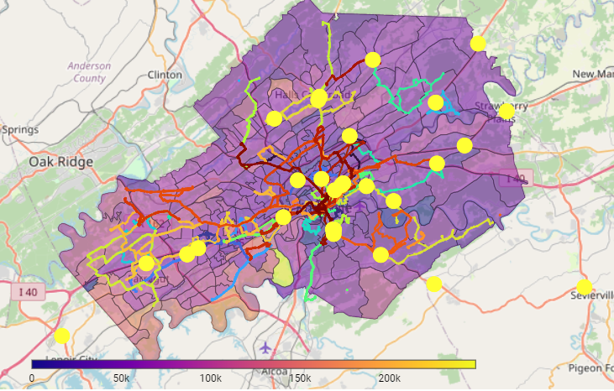
Figure 9. Map overlay to contextualize the total population throughout the study area

understanding of the types of stores throughout the study area when zoomed out and near individuals when zoomed in.
Upper-Right: 3-D Space-Time Paths of Human Trajectories
The interactive 3-D plot illustrates individuals' movements over space (x- + y-axes) and time (z-axis.) This panel is closely intertwined with the absolute and relative space concepts for accessibility whereby users can visually discern the geographic distance of individuals at any given location in their trajectory relative to food opportunities. Including the complete trajectory of individuals provides a dynamic snapshot of the varied schedules and space-time behaviors of individuals whereby their location is not solely defined by their residence. Some people may be stationary at a particular location for hours on end due to work but may carry out more activities during their non-working hours, and this is easily visualized in the panel. The data manipulation process for Dataset 3 pre-emptively calculated the shortest paths based on travel time for every individual between the location at the start of their discretionary time period and all food opportunities, and the panel illustrates the union of opportunity sets for all visualized individuals. All potential food opportunities are similarly shown as colored circles at the bottom of the plot. The legend contains each individual represented with a unique color and their respective ID.
- Clicking once on an individual in the legend removes them from all other panels and renders them inactive in the legend. Clicking once again renders them active and visible in all panels.
- Double-clicking an individual in the legend reduces all individuals shown to just the clicked individual. In other words, all other individuals are rendered inactive. To reset the view and make all individuals visible, simply double-click the legend.
- Clicking at a specific location in the plot will coerce the view of the 2-D Map to focus on the latitude and longitude of that location. In this sense, a relative-space perspective is depicted whereby any nearby food opportunities based on one's given location at a point in time are shown.
These interactive features thus enable comparison of the trajectories and potential food opportunities accessible to individuals.
Lower-Left: Food Network
A food network reflects the relationships (i.e., potential connections) between individuals and stores and with other individuals. In other words, this panel depicts accessibility from a relational space perspective with edges indicating connections between individuals and/or stores, and the colors of these lines representing how they interact together. The different parameter options for layout, person shape, and store shape as discussed in the next few bullet points will alter the aesthetic of the visualization. More unique food opportunities and individuals will result in more visual clutter. It is suggested to try out different layout and shape options in order to identify a suitable network for visualization. One way to reduce clutter is by manually selecting and dragging nodes and edges such that overlaps are minimized.
- Clicking on any node isolates all visible lines to all potential connections to and from that node. For example, clicking on a store will show all individuals who can access that store with line connections depicting the modality of potential access. All clicked and visible nodes are labelled; stores are labelled according to their store name and their Google Plus Code while individuals are labelled according to their unique ID.
- All user clicks of nodes are retained until the Reset Network button is clicked. This helps to explore first, second, ... n-order food opportunities whereby connections between people can be visualized and expanded to visually examine the potential opportunities available to both an individual as well as the individual's first, second, ..., n-order connections.
- Layout: Click any option in the dropdown menu to set the network to a different layout. It is recommended to use the ‘Concentric’ layout for larger datasets of food opportunities and people.
- Person Shape: Click any option in the dropdown menu to set the shape of nodes representing individuals.
- Store Shape: Click any option in the dropdown menu to set the shape of nodes representing stores.
- Reset Network: Click the button to reset the view of the network to the original state.
- Line Legend
- Green lines indicate that the connection between an individual to a store or another individual only exists physically (e.g., a person can only visit a store in-person).
- Blue lines indicate that the connection between an individual to a store or another individual only exists virtually (e.g., a person can only access a grocery store online).
- Yellow lines indicate that the connection between an individual to a store or another individual can exist both physically and virtually (e.g., a person can access a store both in-person or online).
A network representation of individuals and food opportunities with edge colors denoting shopping (individual to store) and interaction (individual to individual) modality is congruent with the notion of accessibility beyond physical proximity. It suggests that accessibility can be viewed as topological distance with connections to individuals potentially enhancing access to opportunities. The ease to which people can reach food opportunities can be measured in terms of their degree of connection to other individuals who may have access to other opportunities, or ‘n-th’ order opportunities with n being an integer representing their degree of connection. The network also expands accessibility to explicitly consider how individuals can adopt other modes of interaction that are not traditionally captured in spatial accessibility measures, for example, the prospect of an individual placing a food order online to be delivered to their home. Blue and yellow edges capture these new forms of interactions while the green edges still maintain conventional spatial accessibility logic whereby opportunities are physically reached.
Lower-Right: Socioeconomic, Demographic, and Perceived Data Tables
This panel includes two interactive tables containing detailed socioeconomic, demographic, and perceived characteristics of people and attributes of food stores which can be queried to subset either or both. Stores can be filtered based on user preferences while individuals can be subset based on their specific attributes. Users can enter queries in the cells in the first row below the header of each table. Traditional mathematical notation can be used, e.g., in the 'Price' for the Food Stores table, if someone only desired cheap stores, they could enter the following query: '=$'; if someone only sought stores with a rating greater than 4.5, they could enter: '>4.5'.
While the function in the panel is simple, its inclusion greatly enhances the ability of researchers to include other dimensions of access often not captured in conventional spatial accessibility measures. As discussed in the descriptions of the datasets earlier, many store attributes and individual characteristics reflect upon different access dimensions that are important to the food procurement process for people (i.e., mental space approach to the five dimensions of access in the context of food). Idiosyncratic differences as unique abilities (e.g., wheelchair-bound), preferences (e.g., wholesale clubs and not convenience stores; Mexican groceries), resources (e.g., SNAP benefits vs. NFC mobile payment) and skills (e.g., technological aptitude) can easily be conceived as queries on store attributes to identify more accurate opportunity sets. The case studies in the next section will demonstrate some potential applications of the proposed conceptual framework to better understand access.

4.3.2. ACCESSIBLE OPPORTUNITIES COUNTER
Potential access is measured by the total number of reachable opportunities which can be differentiated by their modality: in-person (physical), online (virtual), or both (hybrid). Located at the top-middle is a grid of four boxes that tracks the number of accessible opportunities by these modalities. Changes based on user interaction (e.g., subsetting individuals and/or querying stores based on their different characteristics related to the dimensions of access) will subsequently change the number of accessible opportunities shown in the 'Physical', 'Virtual', and 'Hybrid' counters.
- Total Food Stores reflects the total number of food stores in and around the county.
- Physical reflects the total number of accessible food stores that all individuals shown can exclusively reach in person and not online.
- Virtual reflects the total number of accessible food stores that all individuals shown can exclusively reach online and not in person.
- Hybrid reflects the total number of accessible food stores that all individuals shown can reach either in person or online.

CHAPTER 5. CASE STUDIES
The purpose of this chapter is to illustrate specific cases that demonstrate how the proposed GIS interface can help better understand different levels of access to essential opportunities among different population groups. This describes four scenarios of food access that plausibly exist for people of different backgrounds, especially those who are most disadvantaged. To go beyond conventional GIS and its traditional limitations, we show how the space-place framework and relationships in our proposed conceptual framework can be applied to better understand social inequities in food access. In the past, with conventional space-time accessibility analyses, researchers were only able to identify the opportunities available to people as those opportunity locations that could be physically reached given a person’s respective locations over space and time. Essentially, a space-time prism would be derived for each individual based on their self-reported activities in locations at given time periods in a travel diary. This space-time prism would be projected into the potential path area and researchers would use a point-in-polygon overlay to identify where stores intersected the possible areas people could feasibly travel to. Here, we expand upon this analytical approach to consider additional and important factors that mediate potential access to food opportunities for different individuals.

5.1. CASE STUDY 1: What food opportunities can people access that are nearby an individual as they travel to and visit different places in their daily lives?
The first case study explores how the varying mobilities and unique travel patterns of individuals can be used to inform and identify potential food opportunities accessible to them. People have differing accessibilities owing to their available mode(s) of transportation, their different visited locations, and their schedule of fixed and discretionary activities. Altogether, these characteristics influence the opportunities they can visit and obtain desired food from at different points in time. Some research studies place similar emphasis on the relevance of time and the temporal dimension in food accessibility research (Widener, 2018; Widener & Shannon, 2014). They articulate the ways in which food access is premised beyond conventions of geographic distance and spatial proximity but is also shaped by the temporality of the larger food system and mobile nature of individuals. Strictly exploring access as geographic accessibility overlooks other critical aspects, including time use and economic factors. This static approach can in turn obfuscate understanding of the relationship between the geography of healthy food opportunities and health outcomes related to dietary behaviors. Recognizing the importance of time in access, (Farber et al., 2014) use General Transit Feed Specification (GTFS) data from public transit agencies in the Cincinnati, Ohio area to examine the temporal variability of a weekday in public transit access to supermarkets for each census block. Echoing (Widener, 2018) and (Widener & Shannon, 2014)’s sentiments of the need to also include time in studies on access to food, Farber and colleagues found that accessibility to reachable opportunities such as supermarkets via public transit drastically varies over time and few people have consistent access to supermarkets throughout a day. Thus, accessibility is not rooted just in space but as a function of space, time, and the unique travel characteristics of individuals. In this sense, accessibility needs to be considered from a relative space perspective because people often travel to multiple locations throughout a day and the opportunities near different locations are likely to be different. Changes in the locations one visits accordingly changes the types of opportunities that are available to them. This first case study demonstrates how such dimensions of availability, accessibility, and more from different dimensions of space can be understood with the proposed GIS.
The first person in this first case study is a single Hispanic immigrant mother, A, living with two teenagers in east Knoxville in a rental apartment complex who has a personal vehicle to get around the area. Consequently, her mobility is limited to her means of personal vehicular transportation and some walking. As a line cook at a local restaurant, she earns roughly $40,320 before taxes a year while typically working a bit more than 50 hours a week between 9AM and 7:30 PM from Monday to Friday. She does this to save aggressively in hopes of supporting her kids’ college education and to buy a small home in the next few years. In other words, the ease to which A can reach food opportunities is rather difficult during her working hours on the weekdays; A‘s relative accessibility to stores is higher during the weekends compared to the weekdays. She only has basic English comprehension skills and limited use of technology to just calling and messaging on her mobile device which means that virtual-based options to reach online food stores such as grocery delivery and pickup are inaccessible to her. Because of this, her accessibility from a relational space perspective is essentially non-existent compared to someone who is able and willing to use virtual-based services. When shopping for food, she prefers Mexican ingredients.
Given this information about A, how do we assess the total number of opportunities that may potentially be accessed by her at different points in time? As detailed in the methodology chapter, an algorithm was developed to identify all food opportunities that could be reached given the activity and travel behaviors, feasible travel modes, and ability and willingness to use online services by individuals. Because of the computational intensity, the algorithm was run on the entire dataset of individuals to extract results for visualization and interpretation. This algorithm can be conceived as a function to determine the total potential opportunity set for each individual throughout a study period based on their physical means of travel (e.g., driving, walking, transit) and virtual means of interaction (e.g., phone, Internet). Identified opportunities for each individual are obtained by calculating the shortest travel time from the starting location of their discretionary period to a food store and then from the food store to the location at the end of their discretionary period. If the total derived travel time is less than the total discretionary time they have available, it can be considered an opportunity. In other words, the total potential opportunity set for each individual throughout the two-day period was pre-computed.
Figure 10 presents two separate but synchronized maps that visually depict the results of the algorithm: all potential food opportunities that are accessible to A when she is at her home. The home location can be discerned as the portion of the line in the direction of the arrow in the right-hand side 3-D plot that is straight, as A spends the majority of her entire day at home during the two-day period of Friday and Saturday. Clicking on any portion of her trajectory at her home location returns a zoomed-in map centered on the home location in the left-hand side 2-D map. One green point symbol represents a single grocery store near her home. When the focus shifts to another location such as A’s workplace at a local restaurant, pointed to by the black arrow in Figure 11, two grocery stores are returned in the 2-D map. The interactive mapping features (e.g., map panning, clicking trajectory segments, zooming in/out) in both panels enable the quick identification of nearby opportunities at any point in the trajectory of an individual. While the types of stores available to A is the same (only grocery stores), there are more stores at her workplace relative to her home (two versus one) and this indicates that the relative availability of stores for A varies by her given location. This feature to quickly visualize the food opportunities near an individual is useful to compare the opportunities present at any point and time in their travel, not just at ‘important’ locations. Capturing the relative availability of food opportunities of people based on their spatiotemporal travel patterns (relative accessibility) enables the
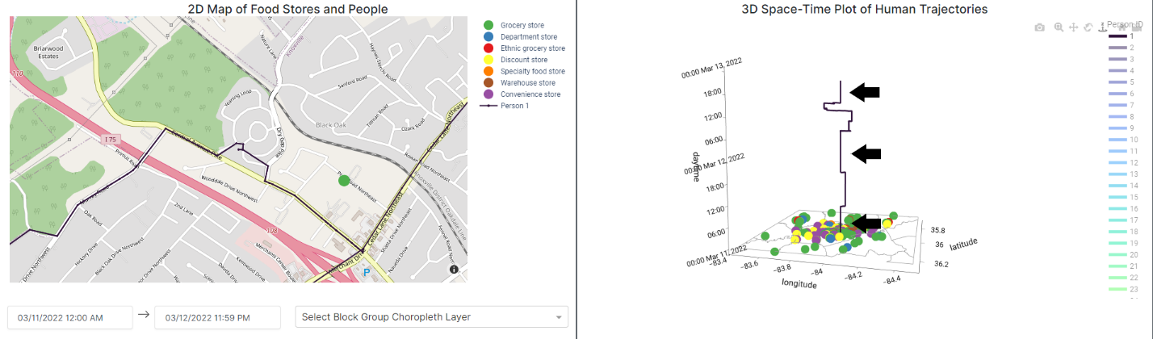
Figure 10. Opportunities near Person A's (1) Home
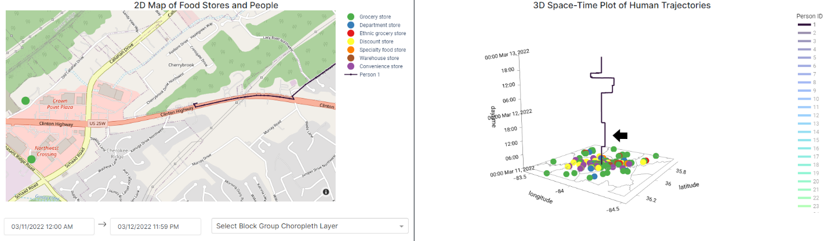
Figure 11. Opportunities near Person A's Workplace during a two-day period

comparison of accessibility to food opportunities relative to all the different locations in the daily trajectory of individuals.
However, the examples shown in Figures 10 and 11 reflect all potential opportunities in the current time extent of a full two-day period. A has much more discretionary time on Saturdays because she has that day off in contrast to Fridays when she works roughly between 9 AM and 7:30 PM. The algorithm used to determine potential food opportunities for individuals considers all periods of time in the time setting widget. Subsequently, it is possible to consider accommodation with a relative space approach—how the operational hours of food opportunities align with the schedules of individuals. Someone working does not have the same flexibility to visit other locations and carry out other activities than someone without an obligation to be somewhere and do something. Setting the time widget to different periods of time such as a smaller time window during the work hours of an individual may mean there are fewer potential opportunities. The adjustment of the time widget leads to a back-end process in the GIS to filter out all opportunities that cannot be reached during the established time period. Because the opportunities that could be potentially accessed by each individual was pre-computed for every period of their discretionary time, the computational burden of the filtering function on the pre-computed results is reduced and enables for quicker visualization.
Figure 12 demonstrates this feature with the time widget set to the time window of the time period when A is working. It shows a lack of potential opportunities, indicated by a lack of point symbols in both the 2D and 3D maps, because A cannot simply leave her workplace to go elsewhere. This is also captured in the accessible opportunities counter where A has access to zero opportunities, indicated by the three 0’s in each of the physical, virtual, and hybrid counters.

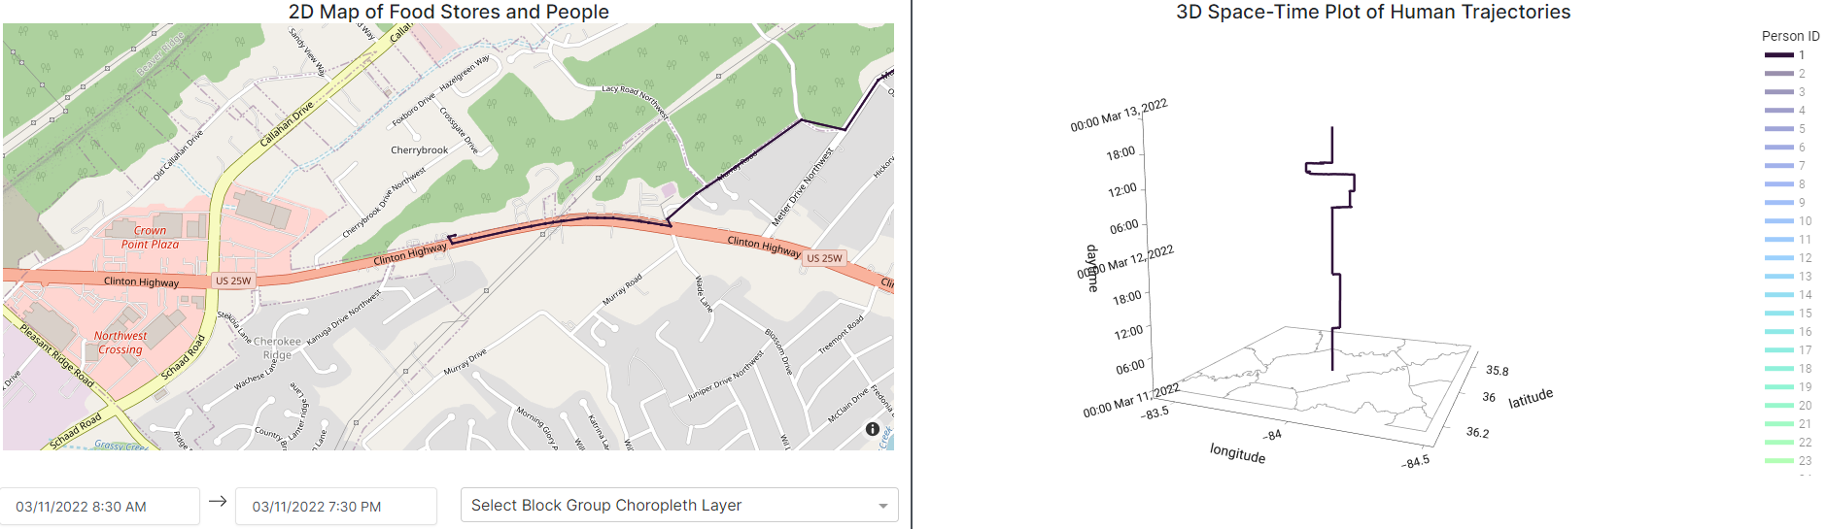
Figure 12. Opportunities near Person A's Workplace during their working hours on Friday

Conversely, when A is off work and does not have any other responsibilities that demand her time at a specific location, she has many more opportunities nearby a road she passes through on her way home from shopping on Saturday. To reflect this time period, the time widget is now set between 11:50 AM and right before midnight (11:59 PM) on Saturday, 03/12/2022. Setting the widget to this time period means the temporal window of focus is reduced. The example imparts the importance of considering the relative availability and accessibility of all locations and routes throughout individual travel itineraries while also considering the flexibility of individuals to carry out discretionary activities, not just assume that they can access stores anytime at ‘main’ locations. This is demonstrated in Figure 13 with one ethnic grocery store, one grocery store, one discount store and one specialty food store near a road A takes on her travels back to her home after attending a church event and eating at a restaurant. The diversity of store types suggests that she has a wider array of stores available to her, but what she considers to be appropriate for her tastes and preferences could potentially render one or more of these store types unavailable. Nonetheless, there are a total of four stores in this area in contrast to just two near her workplace and one near her home. In other words, the relative availability of stores and store types is far greater near a road feature than the ‘major’ locations visited by A. Most studies would overlook and neglect access along these travel corridors because these are areas where people do not necessarily spend much time in and are not considered as anchor/important locations. Because A has a lot of discretionary time for activities, she can potentially visit and buy food from many different food stores near her as she travels throughout the day on Saturday. What is shown in the left-hand side in Figure 13 is just a subset of the many opportunities she can potentially visit. The accessible physical opportunities counter indicates that A can potentially travel to and shop for food at a total of 181 stores and all the point symbols in the right-hand side 3D plot reflect this total opportunity set comprised of all seven store types. A potentially has access to a larger diversity of store types (seven) as well as a larger number of stores during her time off from work on a Saturday compared to during her work-shift.
And because A prefers shopping at Mexican grocery stores, which is grouped into ‘Ethnic grocery store’, her opportunity set is much smaller than what is depicted in Figure 13. Filtering all opportunities to Mexican stores nets just a few grocery stores that are truly accessible to A, as shown in Figure 14. A simple query function to filter the column ‘Specific Type’ to all Mexican stores nets a total of six accessible opportunities. This is drastically fewer than the 181 total potential opportunities that were determined without considering store type. Slightly zooming out of the 2-D map indicates that there is one store, symbolized with a red point, near the road she takes to head home after attending a church event and eating lunch at a restaurant. By considering the unique tastes and preferences of individuals for opportunities such as store type, the GIS demonstrates how availability from a mental space approach, in cohesion with understanding the relative and relational accessibility of individuals and relative accommodation of store hours can also be included to derive opportunity sets aligned with what people have in mind.
In comparison, Person B also has a limited opportunity set because of a lack of a personal vehicle and thus reliance on either public transit or walking, as well as their unique schedule. The difference in travel modes and schedules results in differing accessibilities between A and B. B is a single white man with a GED who works night-time shifts as a janitor for a local bank downtown (Bank of America) making roughly $28,685 a year while attending Tennessee College of Applied Technology during the day to become an electrician. He is originally from south Alabama and relocated to Knoxville because of a lack of job opportunities. B rents a room
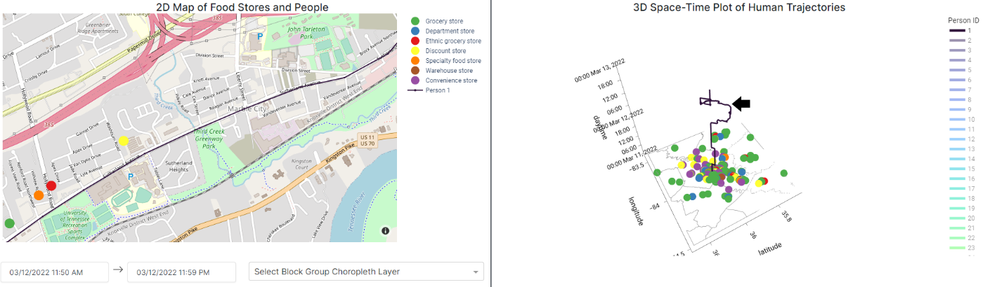
Figure 13. Opportunities near Person A as they travel home after church and lunch at a restaurant. The plot on the right looks different than those in the previous two figures due to a slight change in perspective, but the trajectory remains the same.

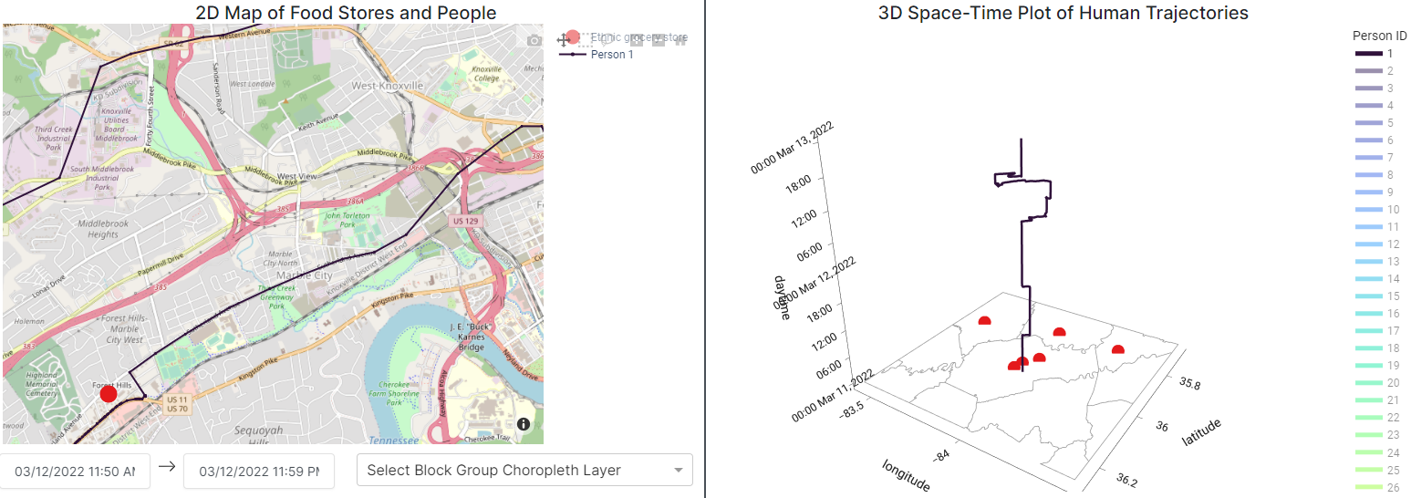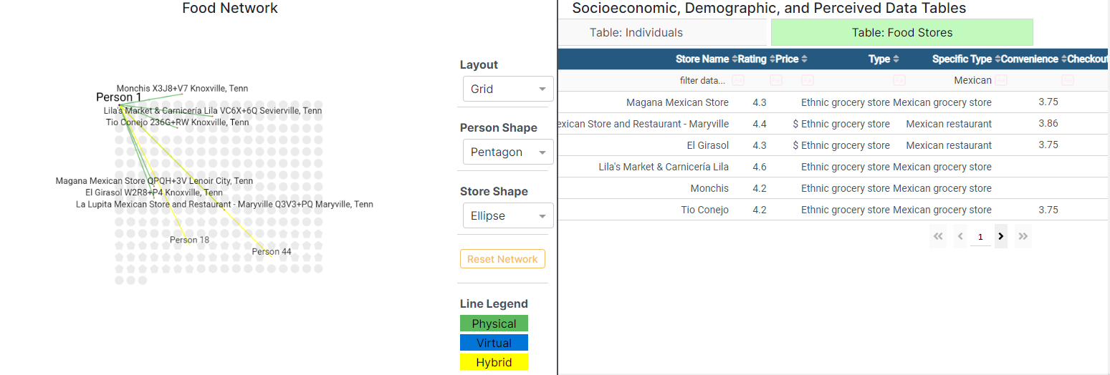
Figure 14. Mexican food stores accessible to A during her non-working hours on a Saturday

in a house in South Knoxville and commutes to work by foot to save money and relies on the Knoxville Area Transit system to get to his college.
As shown in Figure 15, the left-hand side map centered on B’s home is without any point symbols while the right-hand side plot is relatively sparse in point symbols compared to A. This difference is due to both the geography of the area where there are far fewer grocery stores along the Tennessee River and also because B lacks access to a personal vehicle. Further, because B has both educational and work obligations, he has far less discretionary time than A and means that his ability to reach places is limited. Without a personal vehicle and with his rigid schedule, B experiences limitations on the ease to which he can reach different food opportunities. Unlike A who can freely stop at grocery stores along travel corridors after work, B is far more constrained in time and accessibility to physical stores especially because bus transit routes have more infrequent service and getting off a stop just to shop for groceries and then waiting for another bus invokes a huge opportunity cost of time.
Incorporating context with map overlays of local economic, demographic, social, and environmental conditions can also aid in understanding where accessible opportunities are perhaps located in more favorable areas. In one respect, the addition of such map layers helps to consider external factors shaping the ease to which people can reach stores as well as the local environment around stores. This can aid in understanding accessibility from a mental space perspective. Figure 16 shows an overlay of total population by block group in the 2D map with dark purple indicating lower population and bright yellow indicating higher population. The map can be used to inform which stores are located in less densely populated areas in cases where individuals may prefer lower density areas.

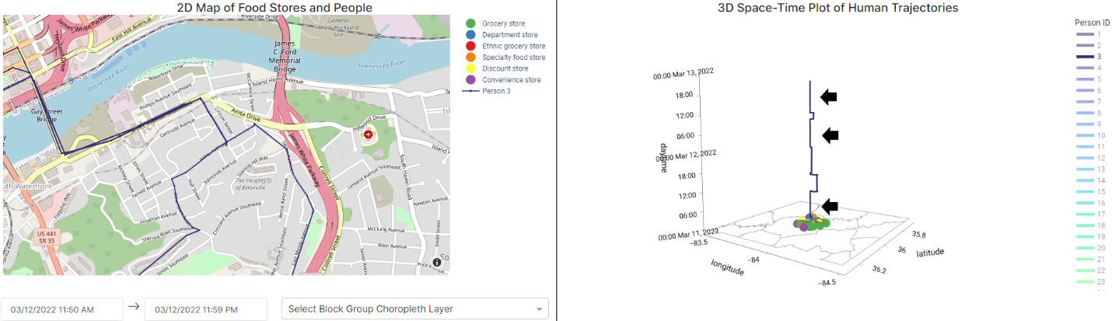
Figure 15. A lack of opportunities near the home of Person B (3)
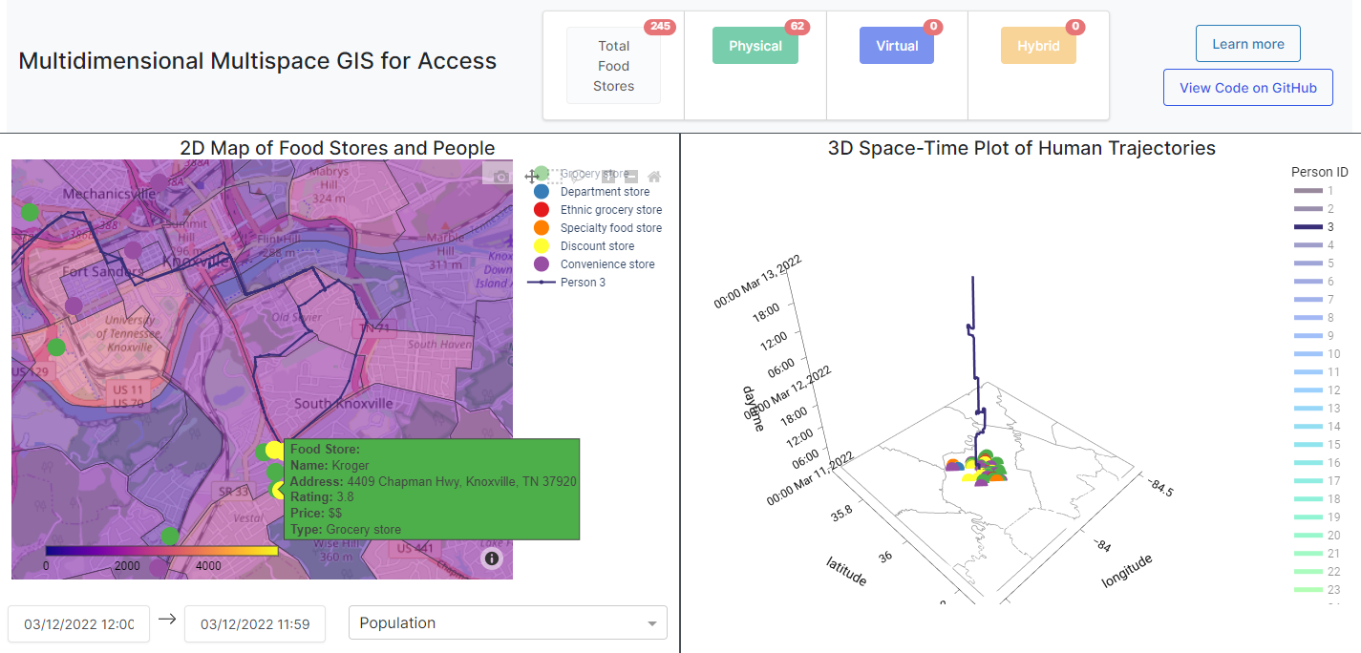
Figure 16. Population overlay with opportunities accessible to Person B

For example, if B is immunocompromised and an introvert who is very concerned about contracting Covid-19 as it would hinder his ability to work and go to school, and desires shopping at food stores in quieter and less trafficked areas (and thus lower potential for disease transmission), the map can help him to understand where stores are located in lower density areas. Foot traffic from providers like SafeGraph and Google Maps could also be integrated as local context to serve a similar purpose for contextualizing store environments. The dropdown in the bottom-right of the panel can be changed to other data layers as well, including a layer on the percentage of people in poverty by block group. Figure 17 illustrates a poverty map overlay on all opportunities that Person A can reach throughout the two-day period. The radius of A’s travels is rather small, mostly spanning North Knoxville, downtown, and Bearden. In this current view, it can be observed that there are a sizable number of (12) discount and (12) convenience stores in the most impoverished block groups, colored in gradients of yellow. While there are twenty-nine red and green point symbols representing grocery stores in the same map, they exist in areas with more purple hues that indicate lower levels of poverty. While more work could be carried out in quantifying the correlation between food stores and area-based socioeconomic characteristics, this exploratory visualization approach affirms the notion of supermarket redlining where, historically, major supermarket chains relocated from low-income and/or minority neighborhoods in the inner city to the suburbs (e.g., Bearden).
This case study illustrates how integrating the mobilities as the unique travel patterns and activity schedule of individuals as well as local conditions help to inform the different food opportunities potentially accessible to them as they go about their daily lives. An assortment of snapshots depicting different locations and time periods in the GPS trajectories of two individuals visually reflect disparities in the number and types of opportunities.
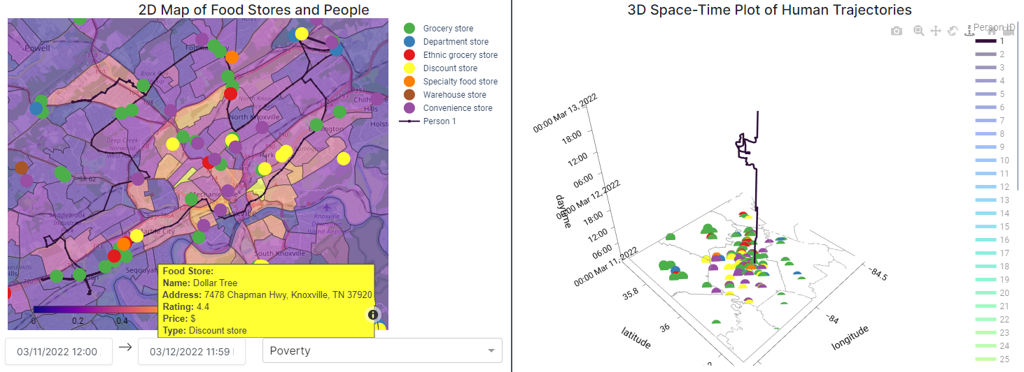
Figure 17. Poverty map overlay on stores that can be accessed by A

The GIS can be used to measure the total number of food opportunities that can potentially be accessed by individuals. Putting aside her preference for Mexican grocery stores, throughout a Saturday where Persons A and B have more flexible schedules, A has access to a total of 181 physical stores they can reach in-person. Meanwhile B has access to just roughly one-third the amount (62 physical stores.) Conventional space-time accessibility measures would mostly end the analysis at this step. Because both are not capable of and willing to use virtual-based services, their access to virtual and hybrid-based services are the same. But where conventional quantitative approaches fall short is in including aspects beyond the physical proximity and temporal organization of individuals and stores, such as the social and cultural preferences of people. An algorithm based on GIS-based geocomputational procedures was developed to pre-compute potential opportunities for every period of discretionary time available to each individual. Pre-computing potential opportunities helps to reduce the computational overload when user interaction is included to further integrate different dimensions beyond conventional spatial accessibility logic. Explicitly recognizing preferences for cultural food ingredients in a query reduced A’s opportunity set to just 6 stores she can reach in person, which is substantially less than 62. Because B has fewer preferences, his opportunity set is now larger than that of A.
In addition, this first case study shows how the web GIS platform can identify the opportunities nearby an individual as they visit different locations throughout a day and contingent upon their schedule and time budget. The use of the prototype GIS demonstrates the contribution of a synchronized multi-space perspective to measure the total number of and visualize the relative availability of food opportunities. Even showing the opportunities near the same locations but at different time intervals can reflect how opportunities are contingent upon one’s time budget and whether they have enough discretionary time to both visit and participate in food shopping and other activities. Accounting for the spatiotemporal behaviors of individuals helps to understand what types of and how many stores are near any location throughout their daily travels, or availability from a relative space approach. Additionally considering individual tastes as a query, as with Person A and her preference for Mexican grocery stores in Figure 14, enables consideration of availability from a mental space approach as people may differ in their values for the type and variety of opportunities. Identifying the stores that could potentially be accessed by individuals also necessitates understanding the relative accessibilities of people based on their feasible travel modes and flexibility of time. The addition of contextual layers can augment understanding of accessibility from a relative and mental space approach to distinguish local environments where physical opportunities are located. It can also help understand how some users may prefer some stores over others due to a number of external factors related to the socioeconomic makeup and physical environment, as shown in Figure 16. From a qualitative perspective, the ability to understand store characteristics (e.g., POI type) throughout the study area either by hovering-over the store symbols in the 2-D map and 3-D plot, as in Figure 17, as well as local area-based socioeconomic and demographic characteristics can help to theorize why some areas may have more or fewer stores that truly meet the different needs of individuals. Moreover, accounting for the opening hours of stores in relation to the schedules of individuals also helps to understand accommodation from a relative space perspective. This first case study thus exemplifies how access to human needs is necessarily a spatiotemporal phenomenon. The next two case studies further discuss how the GIS can also support researchers in understanding other dimensions of access to calculate potential access more accurately for individuals, such as accessibility from a relational and mental space perspective whereby virtual communications and relations can be explicitly considered.

5.2. CASE STUDY 2: What opportunities may be accessed by an individual and by what modalities, e.g., in person, online, or both?
The second case study examines how people can potentially access food opportunities by different shopping modalities. In addition to the mobilities, feasible travel modes, and travel/activity patterns that help to understand relative accessibility of individuals to physical opportunities at their different locations over time, considering the technological aptitudes and preferences of individuals helps to understand the opportunities they can also reach virtually, or relational accessibility. While scholars have developed GIS to model travel and activity patterns in both physical and virtual spaces (Shaw & Yu, 2009; Yu & Shaw, 2008), to the author’s knowledge, no attempt has been made to use such a model to understand access to food and other human needs in a hybrid physical-virtual space.
Analyzing the ease to which individuals can reach stores online can involve a behavioral indicator (digitallit in Dataset 3) for whether someone has access to a device that can connect to the Internet and is capable and willing to use the device to reach online-based services such as grocery delivery. A back-end function in the GIS was developed to identify whether individuals could reach stores online. The function is conceptually simple: for every individual, if they can and are able to use online services (i.e., they have access to ICT, are digitally literate, and willing to use online services), identify and sum up all stores that have online services (based on the ‘Service Options’ variables in Dataset 1). Together with the function/algorithm to calculate shortest paths and feasible physical opportunities discussed in the previous case study, it is possible to identify whether individuals solely have physical or virtual access to a particular store or hybrid access, if they can reach a store both physically and virtually. Thus, this new development also enables quantification of the opportunities that can potentially be accessed by specific modality. From a social equity perspective, these metrics enable comparison of the opportunities for different individuals and can reveal how the digital divide may exacerbate inequalities in the opportunities accessible to people.
This subsection first presents a case study of Person C who is an international female college student from Kuwait living on-campus with a work-study job at UTK and no personal vehicle. As a result, she can only get around by public transit or foot. She has little disposable income and is halal, so most food on-campus is not consumable for her, but she is very capable with technology and computers and is willing to use online services. In other words, her personal physical travel limitations restrict her relative accessibility, or the ease to which she can physically reach different stores, but her ability and willingness to navigate the Internet and order groceries online enhances her accessibility from a relational space perspective. The different characteristics relating to her accessibility are input into the functions to calculate the number of opportunities reachable physically, virtually, or by both modalities.
Figure 18 shows a sizable number of opportunities potentially accessible to C, with access to 64 physical, 54 virtual, and 36 hybrid opportunities. The top-left map indicates that there are two convenience stores and one grocery store near her dorm on campus. Despite her relatively limited travels as demarcated by her nearly straight-line trajectory and small travel radius, the flexible schedule of C as a student and on-campus work-study employee means she can potentially reach and buy food at many stores throughout the county with public transit and by foot. And her technological capabilities further increase the opportunities available to her.
The food network shown in the bottom-left panel indicates with colored lines the modalities by which C can reach these different opportunities, with an associated name and Google PlusCode description.
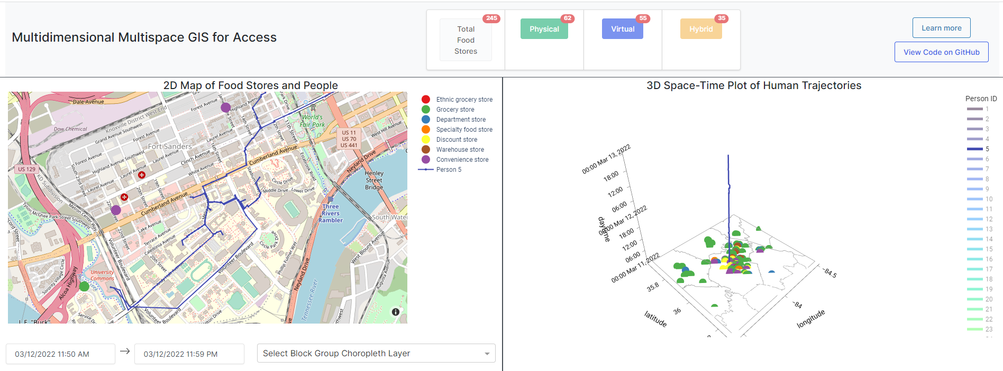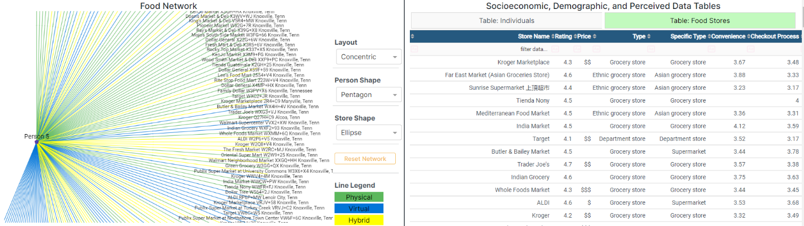
Figure 18. Opportunities accessible to Person C (5)

In contrast to existing approaches which only identify the physical opportunities accessible, this new approach finds a 54% increase in opportunities for C in a two-day period; this was obtained by dividing 54 virtual opportunities by the total number of physically reachable opportunities: 64 physical + 35 hybrid opportunities, 54/(64+35). This means that in total, she potentially has access to a total of 153 opportunities. Even if C was constrained in time, for example if she took more shifts as a work-study employee or was studying more during finals week, the emergence of virtual-based services such as grocery delivery and online app-based shopping means that she and other individuals can spend significantly less time selecting, purchasing, and getting food delivered to wherever she is during the opening hours of stores. This understanding necessarily involves understanding a range of dimensions important to access from different perspectives: the relative accessibility of individuals to reach stores based on their sequence of fixed and discretionary activities, relational accessibility enabled by use of ICT and virtual-based services, and relative accommodation of business hours to the free time of individuals. A cursory overview of the stores in the food network also suggests that the majority of the stores C can physically reach span a range of store types, from traditional grocery stores to convenience stores. Meanwhile, the store names labelled at the end of the blue and yellow line connections suggest that the majority of virtual-based food providers are larger retailers such as Kroger, Aldi, and Target. The network also enables understanding of the availability of different store brands which may be perceived differently between individuals. While not shown, a simple query on store name in the Food Stores Table is able to capture these perceptions which relates to a mental space approach to acceptability. People may associate a certain view of a store brand that they find acceptable or not acceptable, and this would consequently affect the opportunities potentially accessible to them.
But there exists a significant population without sufficient technological capabilities to even navigate the internet, let alone buy groceries online. Figure 19 illustrates how the web GIS looks for person D who is a 56-year-old rural white farmer that owns a small plot of land raising livestock in north Knox County. The left-hand side map shows the only point in time when the farmer is traveling beyond his farm-home and to a Walmart. Despite similar activity patterns with C as both are mostly confined to their home locations, D cannot obtain food through virtual-based mediums, so he only has access to 58 physical stores, which is roughly 38% of the opportunities potentially accessible to C. His inability and willingness to use virtual-based services means that his accessibility from a relational space perspective is effectively null; he has access to a total of zero virtual and hybrid opportunities. The disparity in virtual (C: 54 vs. D: 0) and hybrid (C: 35 vs. D: 0) opportunities is also far greater between C and D. His food network depicts a lack of blue and yellow lines with all potential opportunities indicated by a green line which means he can only access them physically.
Such a difference could be attributed to the difference in their local geographies whereby D lives in a remote and sparsely populated part of the county while C is located in downtown and closer to other parts of the county with more food stores. This explanation is plausible especially because hybrid opportunities are determined as those that can be reached physically and virtually, which means that hybrid opportunities, in the absence of the willingness and capacity to use online-based services, can effectively be considered as physical opportunities. So even if C was not capable of accessibility from a relational space perspective (i.e., not able to use online services to order groceries), she would still have time to travel to and shop for food at the physical locations of the hybrid opportunities which would bring her total number of potentially accessible physical opportunities to 99 (64 physical + 35 hybrid; 170% greater physical
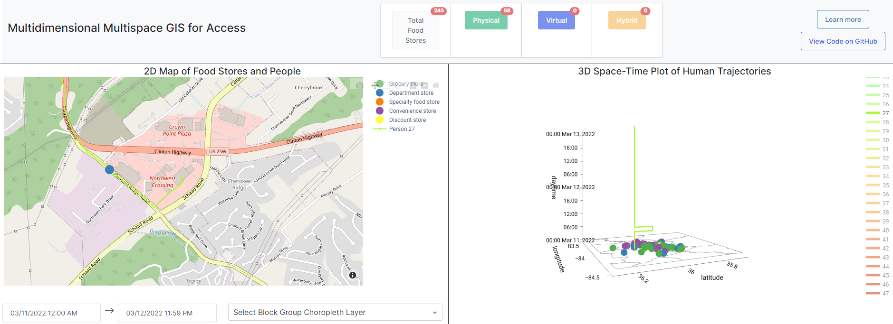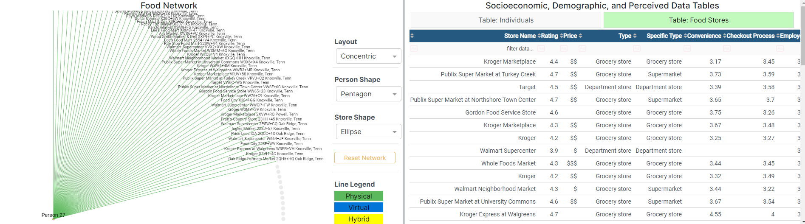
Figure 19. Opportunities accessible to Person D (27)

opportunities than D.) This alone however does not explain the differences in virtual opportunities which means that food access necessarily requires understanding not just the mobilities and spatiotemporal characteristics of individuals but also their capabilities in an increasingly physical-virtual world. The density of stores in the physical landscape could be a reflection of the underlying dynamics of the environment, such as population distribution, which relates to availability from a relative space perspective. It could also be attributed to socioeconomic forces that require a relative space perspective to affordability. Areas will differ in the opportunities they contain owing to a number of external factors such as historical supermarket redlining whereby major chain supermarkets (1) are less inclined to establish a physical location in low-income neighborhoods and/or (2) relocate existing branches to wealthier suburban areas (Eisenhauer, 2001). As the first case study demonstrated, contextual map layers such as total population, median income, and poverty can all be displayed to further identify where stores are located with respect to the underlying demographic and socioeconomic characteristics of the area. Access to food requires new innovative approaches that can differentiate between opportunities reachable by different modalities and subsequently that access and its dimensions be considered from different perspectives of space.
The contribution of the proposed algorithm to analyze and calculate the total number of opportunities in physical, virtual, and hybrid space that can potentially be accessed by each individual is also applicable to other human needs. Notably, the rapid growth and adoption of telehealth prompted by Covid-19 necessitates renewed efforts in understanding access to health and medical care services (Alford-Teaster et al., 2021). Similarly, the massive shift to remote work also requires a shift towards understanding access in a physical-virtual world, and not just a physical world. New and emerging virtual-based services have revolutionized vital and important activities in the daily lives of people. Virtual space has enlarged the total number of potential opportunities for those capable of navigating online but also simultaneously widens the divide between those who are digitally connected and those who are not. In this sense, new inequalities in access to different human needs may be emerging that need greater recognition and understanding. This case study proposes one way to systematically analyze access in a physical-virtual world and heeds the call to consider the social implications of emerging access inequalities rooted in the digital divide.

5.3. CASE STUDY 3: What opportunities may be accessed by an individual via their social networks, in other words, what are the second, third, nth-order opportunities accessible to people based on who they know?
The previous case study demonstrated how the food network can be used to inform the means by which individuals can access different food opportunities. But how can social networks and relationships between individuals and other entities (e.g., stores) also be integrated in spatial analytical approaches to food access? This case study discusses the contribution and exploration of individual social networks to identify second, third, and n-order opportunities. In reality, it is unlikely that people go beyond third-order opportunities, but this GIS has functionality to identify such opportunities. The focus here is on the dimensions of access from a relational space perspective that explicitly considers the institutions, relationships, and other forces that come to influence the food opportunities which people can potentially access.
From an analytical perspective, deriving (food and other) networks involves the construction of a network graph. Conventional quantitative approaches implicitly assume relationships between just people and stores (i.e., that individuals only go to food stores for food). However, people can reach out to others to procure food, such as a mother dropping off groceries to her daughter. Conceptually, relationships can also exist between people. A function to derive a network graph was developed to model these relationships and expand understanding of individual access to opportunities. Following the derivation of physical, virtual, and hybrid opportunities discussed in the previous two case studies, the function creates nodes for all individuals and stores and edges indicating the type of interaction between individual-individual and individual-store. The total number of connections to stores, by modality, for each individual is calculated and stored as attributes displayed in the accessible opportunities counter. This is another back-end process whereby any user interaction such as queries on store attributes or individual characteristics and/or hiding/displaying individuals in the 3D Space-Time Paths panel while prompt the function to run in the background and update the results and visualizations in the GIS once complete. As described next, having this food network can provide a different perspective into how people may procure food. In additional to considering geographic proximity, the network enables analysis of topological proximity and a relational space approach to access whereby relationships and interactions between people and other people are brought to the forefront. This new capability to investigate food access can unearth new opportunities accessible to people by virtue of their relations to others.
Person E is a 41 year-old wheelchair-bound Hispanic woman who drives her own car to get around the county. During the week, she works as a cashier at a Goodwill in Hardin Valley and earns roughly $17,000 a year. These characteristics suggest that E likely experiences different barriers than Persons A, B, C, and D owing to her wheelchair reliance and thus need for stores that have wheelchair accommodations. Understanding access for E consequently requires considering accommodation from an absolute and mental space perspective: which stores have wheelchair entrances that will accommodate E? On the other hand, despite her physical limitation that restricts her opportunity set to only the stores with wheelchair accommodations, E is well-connected with other Hispanic immigrants in the county who can offer to help E by dropping off groceries at the apartment she rents. This means that her social network expands her abilities to access food even considering her physical disability; her accessibility from a relational space perspective is greatly expanded as her friends can help her obtain the food she needs. The previous case study described how the food network could be used to identify the relationships between individuals with food opportunities and this case study additionally demonstrates how the network can be expanded to also model relationships between individuals and subsequently the opportunities they potentially have access to. E is familiar with Person A as well as Person F (ID = 19) while both A and F are friends with Person G (ID = 44). These relationships can be conceived of as a social network whereby E has social ties with A and F who also have social ties with G. This case study will incrementally show first-, second-, and third-order food opportunities accessible to G and how potential access to food opportunities can be incrementally measured by additionally considering the social contacts of individuals.
Figure 20 is a screenshot of the first-order opportunities accessible to E without considering wheelchair accessibility. Despite her handicap and work obligation, E still has time before and after work to shop for food at stores. The top-left map indicates that there are no food stores near her workplace, but the bottom-left food network reveals that E has access to a total of 130 different stores. However, this figure is not accurate as it considers all opportunities to be accessible without accounting for wheelchair accommodations that individuals like E require. This current approach only considers her relative accessibility to stores and accommodation from a relative space approach, or how her periods of discretionary time throughout the two-day period align with when stores are open. A simple query to only show stores with wheelchair infrastructure additionally captures accommodation from an absolute and mental space perspective.
As shown in the bottom-right table in Figure 21, the addition of the query reduces the opportunity set by 8 stores to a total of 122. Without sufficient technological capabilities that enable access to virtual-based food services, E still has a sizable number of food stores she can visit and buy food from, and these can be considered as the first-order opportunities accessible to her. But considering social networks in addition to technological capabilities provides a more complete understanding of how interactions and relationships are able to increase the ease to which individuals can reach opportunities. In other words, having both sources of information can enhance understanding of accessibility from a relational space perspective than just either alone, and can help further identify additional opportunities that can be accessed by people.
Since it is known that E is also connected to A and F, their food networks can also be expanded to visually show the opportunities available to each individual and this is depicted in Figure 22. The yellow lines connecting E with A and F indicate a hybrid connection because they can communicate via phone and text or meet in-person. Because A and F do not require wheelchair accommodations, the query in Figure 21 can be removed to enlarge the opportunity set to all food stores. Neither A nor F possess sufficient technological capabilities to order food online so the feasible opportunity set is still limited to the union of accessible physical stores amongst the three individuals, totaling 181. That means that E has greater accessibility to 59 or 48.3% additional opportunities by virtue of her social ties to A and F. These additional food sources can be considered as second-order opportunities.

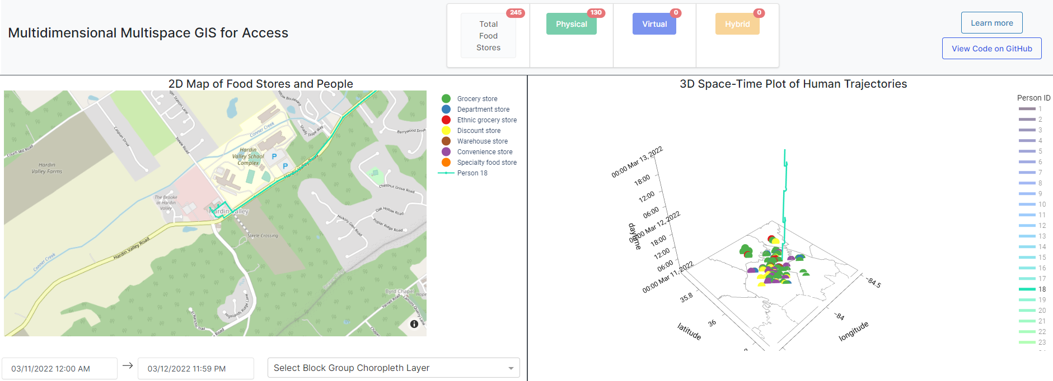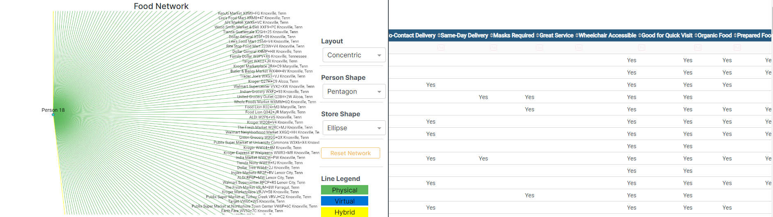
Figure 20. Opportunities near Person E's (18) Workplace without considering wheelchair accessibility
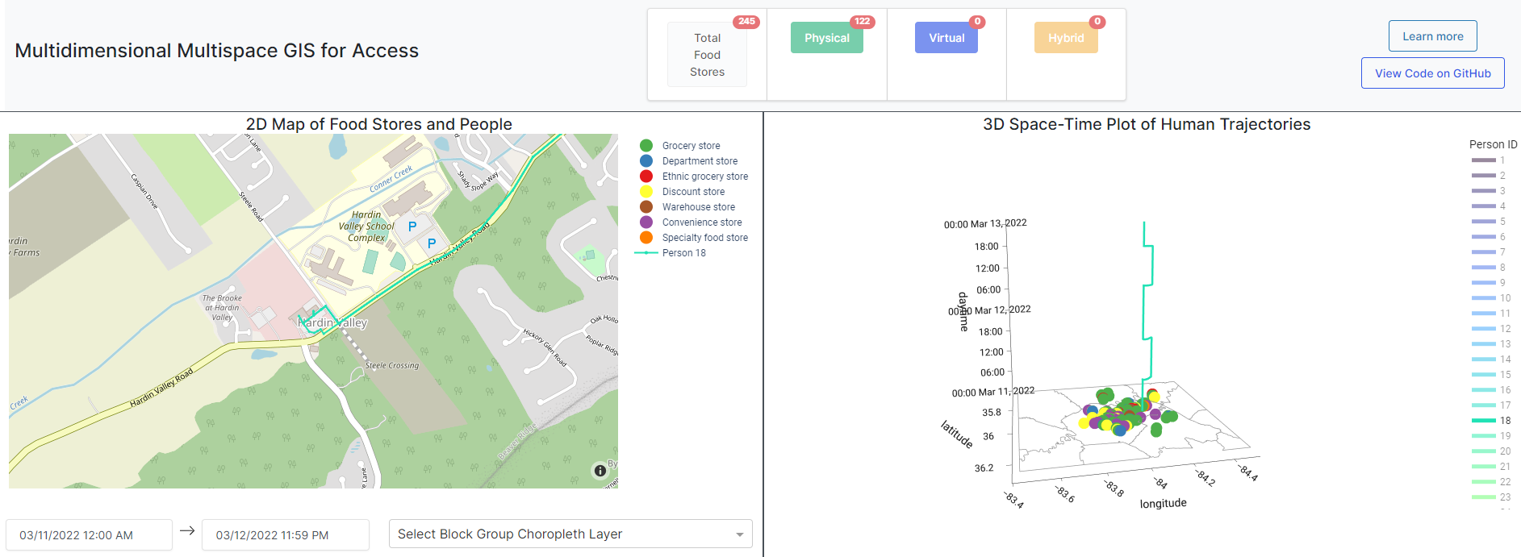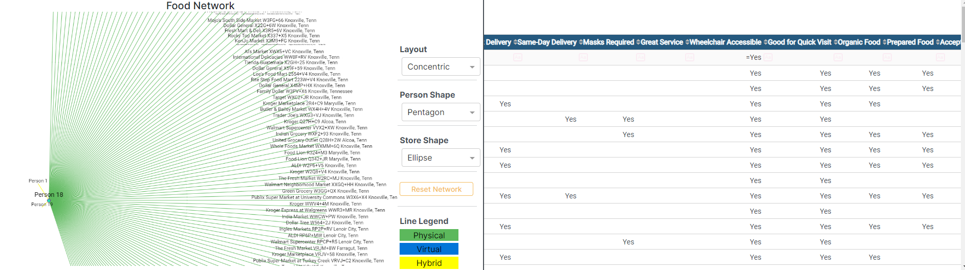
Figure 21. Opportunities accessible to Person E (18) considering wheelchair accessibility
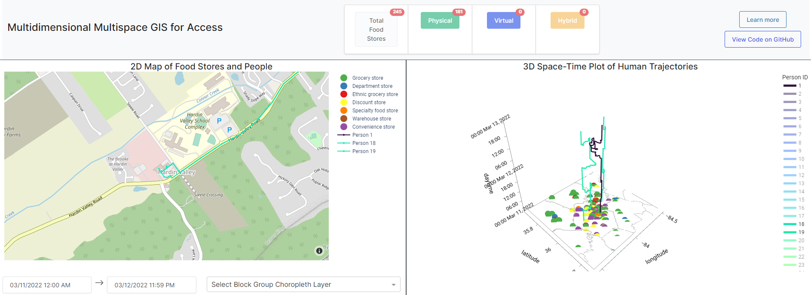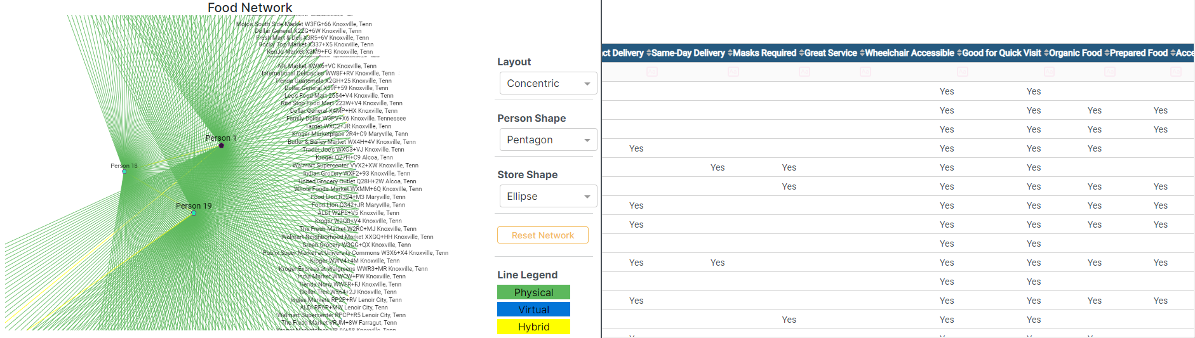
Figure 22. First- and Second-order Opportunities accessible to Person E

This same concept can be extended to the friend of E’s friends, Person G, as is shown in Figure 23. Expanding the food network of G and integrating it into the total opportunity set among A, E, and F nets two additional physical opportunities for a total of 183. These two opportunities can be considered third-order opportunities accessible to E.
This case study demonstrates the realities of social networks where people exchange and distribute food despite a lack of adequate mobility, financial resources, or other extenuating circumstances, and this initial foray into exploring the social networks of individuals can help expand understanding of the food opportunities accessible to people by virtue of their relationships and connections to others, or accessibility from a relational space perspective. And the concept of n-order opportunities can technically be extended into infinity, but caution should of course be used in interpreting these results, hopefully with information on social ties to support such findings as n increases.
While this case study illustrates how people can increase their access to and obtain food from other people, the application of a network graph to discover n-order opportunities can be applied to other contexts. A popular saying with the job market goes “it’s not what you know, but who you know.” Extant scholarship affirms this sentiment on the influential role of networks of interpersonal ties in finding and obtaining employment opportunities (Berg & Kalleberg, 2001). People often use inform channels such as personal contacts to find work. For example, while an individual may not be a direct acquittance of their friend’s friend at a company, the individual may reach out to the mutual friend for an introduction between the individual job seeker and the employed friend. In this example, explicitly recognizing the important role of social networks can help identify additional (food) opportunities not captured in existing spatial accessibility approaches.
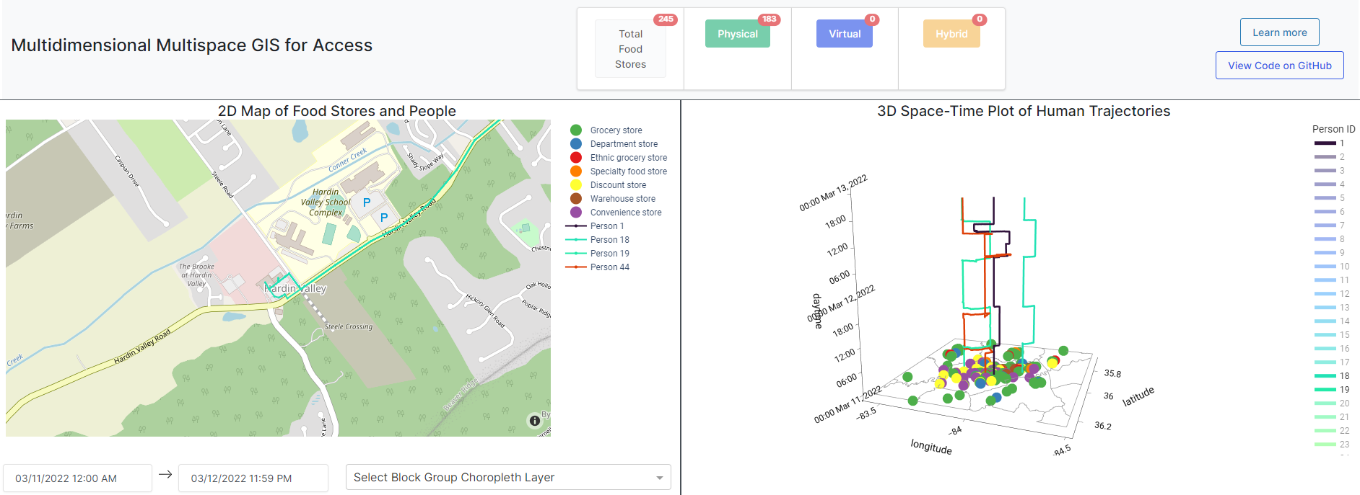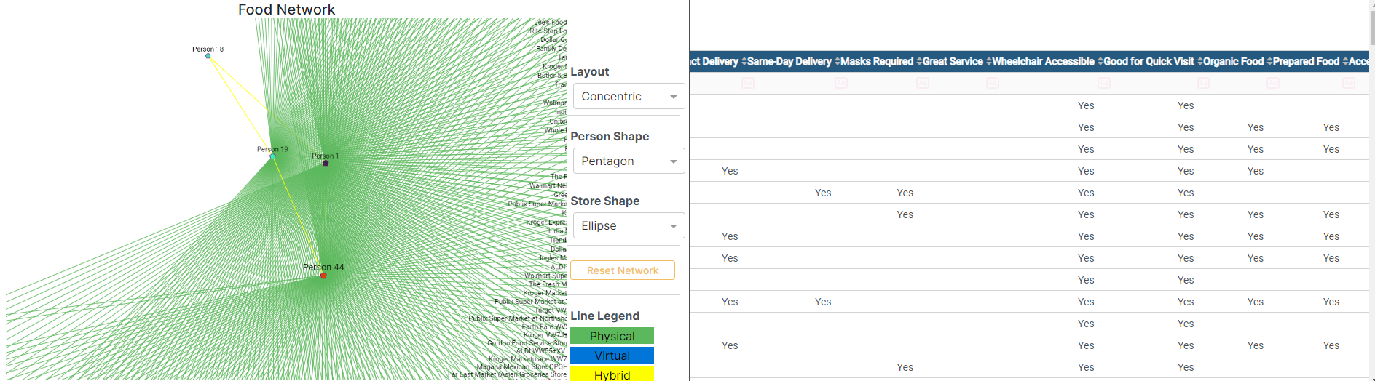
Figure 23. First-, Second-, and Third-order Opportunities accessible to Person E

5.4. CASE STUDY 4: What opportunities are accessible based on an individual’s physical needs and mental preferences?
The previous case study introduced the table query feature to filter results based on specific characteristics, such as the establishment of wheelchair accommodations by stores. Despite its simplicity, such table queries are powerful tools to help understand accessible food opportunities that accommodate the physical needs and mental preferences of individuals. More broadly, table queries are a simple and effective analytical tool to explicitly consider different dimensions of access from different dimensions of space. The growth in objective and subjective data about store characteristics can be used to identify appropriate food opportunities more accurately beyond what can be understood from conventional spatial proximity metrics based in absolute space logic. The population is heterogeneous, and this fact must be reflected in accessibility measures so as to better understand the situations of different disadvantaged peoples.
One example is Person H who is a divorced mother of two and military veteran who finished her Bachelor’s in history and education at UTK but is struggling to find full-time work. Every day, she does not know if she will be teaching the following day and is always ready to take any substitute roles at schools in need. So, her schedule is restricted on the weekdays. She earns around $15,000 a year and receives $400 in SNAP benefits each month while living with her elderly mother and kids in a small home in South Knoxville. Her car was totaled in a recent car crash, so she currently relies on public transit to get around the county. H necessarily requires shopping at stores that accept SNAP benefits but tries to still purchase quality food for her growing toddlers and aging mother despite her meager income. This specific requirement necessitates understanding of affordability from a relative, relational, and mental space perspective as her income is dictated by broader institutional forces (the local education system), food subsidies are provided by a governmental agency (USDA), and her price preference is dictated by her own familial situation and values.
Figure 24 shows a snapshot of the opportunities accessible to H based on her rigid schedule and without any queries. Her limited means of transportation to just public transit and walking coupled with her childcare and teaching obligations means she is constrained in time throughout the two-day period. Thus, the ease to which she can reach stores at many points in time is greatly limited by her myriad obligations and lack of a personal vehicle in car-centric Knox County; her accessibility to stores from a relative space perspective is quite restricted. But we find that she fortunately lives near two grocery stores and a discount store, as shown in the top-left panel, which indicates that the availability of stores from a relative space perspective is not quite as lacking. So while she lacks the mobility to reach many stores physically, the close proximity of three stores to her home means that the availability of stores at a major location in H‘s daily life is decent. Additionally, she is able and willing to order groceries online which further enhances the ease to which she can reach stores online. Despite time limitations, her accessibility to virtual-based food services (one component of accessibility from a relational space perspective) essentially reconciles her poor accessibility from a relative space perspective. In total, this view in Figure 24 finds that H has physical access to 32 food opportunities, virtual access to 70 food opportunities, and hybrid access to 15 food opportunities.
But if her preferences are taken into consideration, her opportunities are far more limited. Figure 25 shows a sizable reduction in the opportunities accessible to H when a query to extract only stores accepting of SNAP benefits is made. She has physical, virtual, and hybrid access to, respectively, 25 (-22%), 62 (-11%), and 13 (-13%) food opportunities.

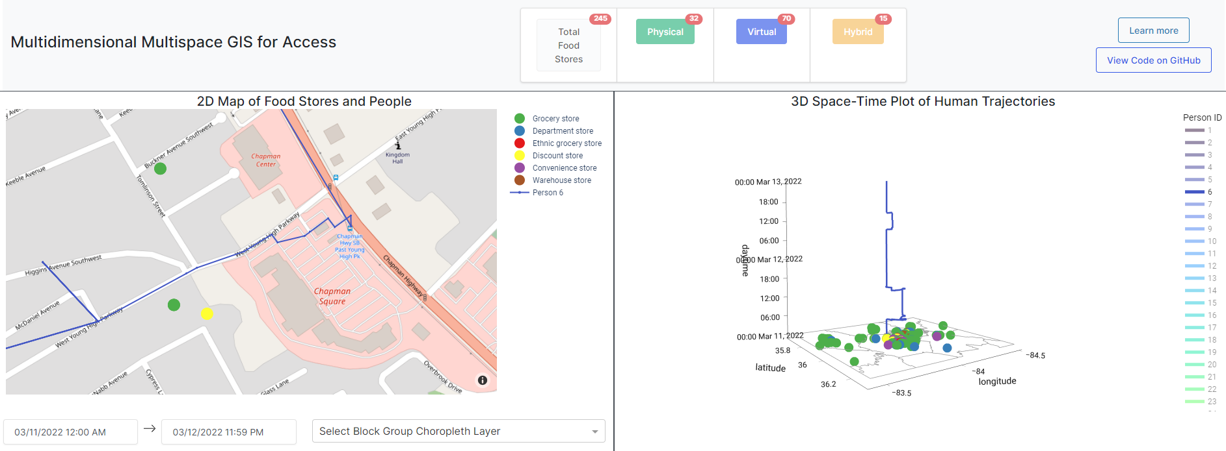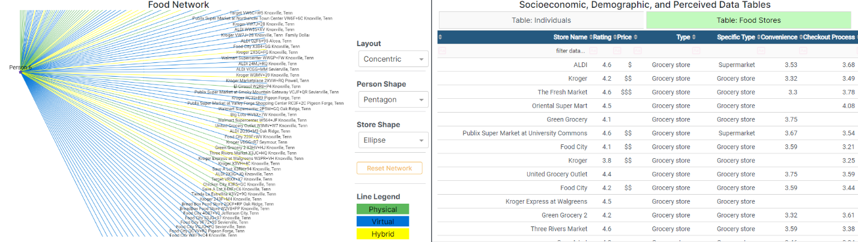
Figure 24. Opportunities accessible to Person H (6)
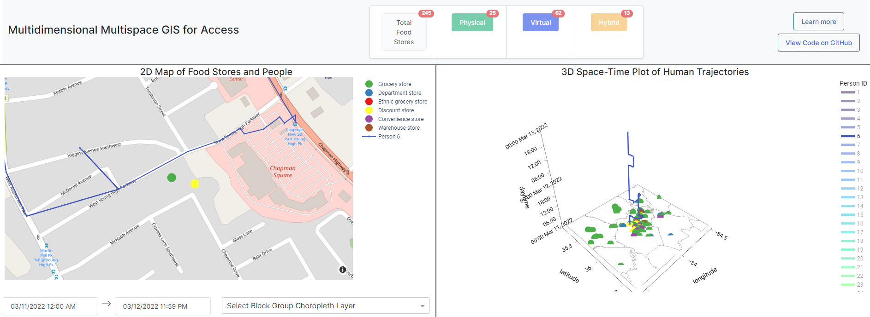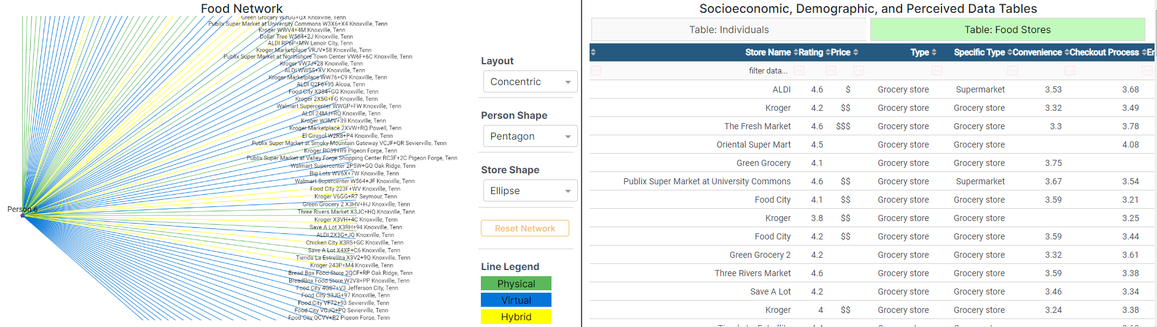
Figure 25. Opportunities that accept SNAP benefits accessible to Person H

The top-left map contains one fewer grocery store near her home, which means that the store does not accept SNAP benefits and was subsequently filtered out. Considering affordability from a relational space perspective suggests the need to look at the acceptable payment options which reduces the availability of stores that meets the needs of H close to her home. For individuals in situations like H and who are reliant on public subsidies, it is very important to consider how subsidies such as SNAP benefits limit the number of opportunities that can be accessed, as is recognized too in the USDA’s Food Access Research Atlas. However, not all stores offer the same quality of products with convenience stores, gas stations, corner stores, dollar stores, etc. often lacking in diversity and availability of fresh and healthy foods, despite their cheap prices (Shannon, 2021). Review of the price attribution provided by Google for all food stores in Knox County finds that those with a single dollar sign are given to the aforementioned store types and minimalist, small, and budget friendly grocery stores such as Aldi. In the case of H, stores at this price point do not offer the quality of foods she desired for her and her family, but she also cannot afford foods that are expensive (e.g., expensive - $$$ and very expensive - $$$$).
This preference can be conceived as an additional query to filter stores that are moderately priced, or attributed with two dollar ($$) signs, as is demonstrated in Figure 26. The figure shows a far smaller potential opportunity set with 0 physical opportunities, 30 virtual opportunities, and 7 hybrid opportunities accessible to H. The discount store near her home is no longer shown in the top-left map after the query. Actively including the preferences and financial circumstances of individuals as queries almost always reduces the opportunity set but helps to produce more accurate accessibility metrics and results that reflect the realities of people from all backgrounds. Here, a query can identify stores that individuals may perceive as affordable.
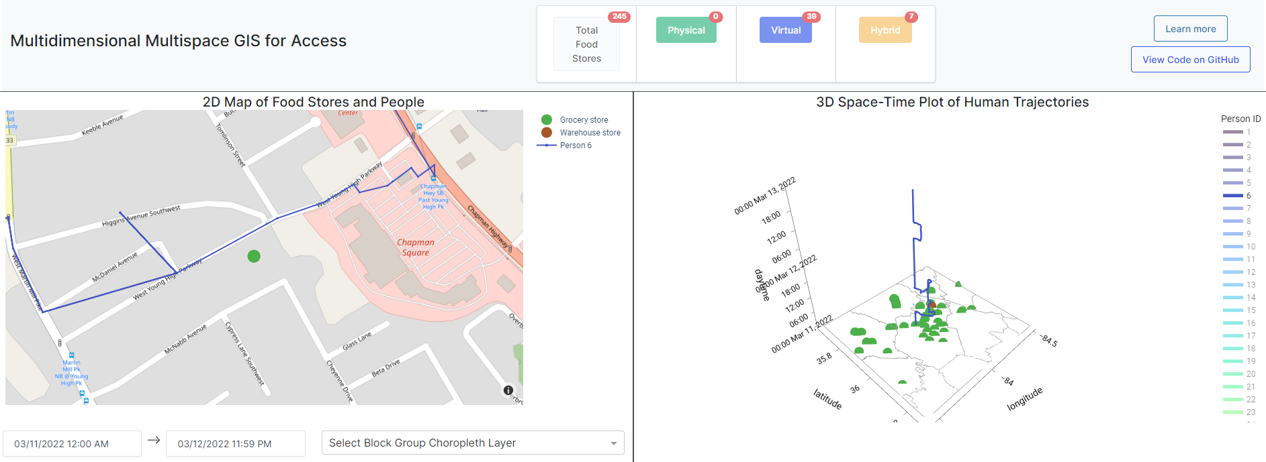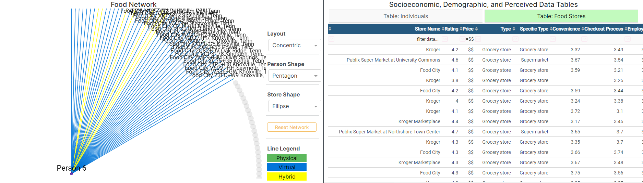
Figure 26. Opportunities that both accept SNAP benefits and are moderately priced accessible to person H

How people value and perceive various attributes of different establishments and businesses is often neglected in conventional spatial accessibility approaches. At best, they consider locational attractiveness as store size (e.g., Huff Model) or some other one-dimensional feature. In reality, humans are complex and can possess widely varying beliefs. This case study contributes to the literature by proposing that access is a multidimensional construct which can be analyzed with simple but effective querying functions on the attributes of potential opportunities. While this case study discussed the importance of the perceived price level of stores, acceptable payment options, and virtual capabilities of individuals, these and many other characteristics are also applicable to access to other human needs. For example, access to educational opportunities is a contentious topic, exemplified with important policies relating to affirmative action in college admissions, the development of charter schools, and lottery-based (in lieu of standardized testing) admissions to specialized high schools. What potential students consider in deciding which school they should study at involves myriad factors that may widely differ across the student (and if applicable, their guardians) population. School quality is important but what students and oftentimes their parents care about may differ based on their socioeconomic background and cultural upbringing. A teenager with two high-income parents is more able to afford private high school tuition than another teenager living in a housing project in the inner city. A college-bound adult may care more about the reputation of a particular program at universities than the physical infrastructure throughout the overall campus (e.g., parking lots, etc.). While not exhaustive, how these capabilities and preferences are captured can be conceived as queries on attributes of potential opportunities (schools, healthcare facilities, greenspaces, employers, etc.) It is then easy to compare the opportunities that can potentially be accessed between individuals or between people of different characteristics.

5.5. NOTE ABOUT TOTAL OPPORTUNITIES
It is important to clarify the scope of this dissertation when it comes to measuring opportunities. As opposed to realized opportunities that reflect the true decisions made by individuals to engage with a location and/or participate in an activity, this dissertation squarely focuses on potential opportunities – solely those in the opportunity space of an individual based on their different preferences and situations. People make particular decisions and choose specific alternatives afterwards based on this set of potential opportunities. Distinguishing between potential and realized opportunities also introduces another important division between the objective and subjective choice set of opportunities for individuals. The objective choice set is comprised of opportunities that can potentially be accessed given physical and virtual abilities and limitations, without including the subjective attitudes and perceptions of individuals (i.e., without considering a mental space approach.) While the objective choice set is likely to differ between individuals, it is derived from objective characteristics of individuals, including but not limited to their available means of transportation, temporal fixity of their schedules, technological capabilities, and more. Conversely, the subjective choice set is delimited based on the mental faculties of individuals: what people feel, think, and reason about. The GIS approach in this dissertation starts with deriving an objective choice set based on the unique travel itineraries and schedules of individuals as well as their ICT capabilities and then introduces how a subjective choice set can be derived with a mental space approach to understanding access. Unless there is a specific reference to the inclusion of mental space in access, opportunities are to be synonymous with potential objective opportunities – those that can potentially be accessed physically or virtually without considering the subjective nature of individuals.
The numbers and statistics mentioned throughout the section and shown in the numerical counter at the top of the GIS platform should not be taken at face value as not every opportunity is truly accessible. The algorithm used to determine access merely calculates whether people have enough discretionary time to both visit and participate in the act of food shopping at every food opportunity. Despite being included in the opportunity set, not every opportunity may be accessible given individual preferences. However, this does not mean that the results should not be trusted. For example, the third and fourth case studies illustrated how the physical capabilities, financial circumstances, and preferences of individuals can be conceived as table queries to reduce the opportunity set. These characteristics represent the different dimensions important to access. Every person has their own set of mental preferences, physical capabilities, and skills. Given the idiosyncratic nature of humans whereby some may weigh some dimensions of access more heavily than others, these characteristics should manually be added as user queries to ultimately arrive at the true feasible opportunity set.
Throughout the four case studies, the total number of physical, virtual, and hybrid opportunities was derived for each individual based on their unique life circumstances. Opportunities for each modality can be viewed and compared in isolation or together. For example, after considering the time constraints and unique spatiotemporal behavior of Person H, her requirement for SNAP payment option, and her preference for moderately priced stores, the GIS found her to have access to a total of 0 physical, 30 virtual, and 7 hybrid food opportunities. There is a huge disparity in the number of virtual-based options in contrast to physical-based options. We could also compare the opportunities between individuals, as in the first and second case studies. As long as these caveats are understood and carried out, the GIS can accurately identify opportunities.

CHAPTER 6. DISCUSSION AND CONCLUSION

6.1. Research Summary
Access to human needs of food, healthcare, jobs, etc. are pervasive social inequalities many researchers and practitioners have worked to understand and resolve. Modern ICT developments including the Internet and Web engender a virtual space that revolutionizes contemporary human dynamics. Teleactivities are increasingly commonplace and replace or complement traditional activities and interactions in physical space. Today’s world exists in a hybrid physical-virtual world, yet existing approaches that seek to understand and measure the causal factors influencing the ability of people to obtain the opportunities they need fail to account for this reality. People consider more than just how far they live or are located from the locations of opportunities especially with the advent of virtual-based services and activities. Traditional approaches to access involving spatial accessibility measures (e.g., physical proximity analyses) based on static spatial frameworks and fixed physical locations inadequately capture the new context of society. This narrow logic has persisted into the popular contemporary concept of ‘food deserts,’ or barren wastelands where people are devoid of access to healthy and nutritious foods. The concept of deserts is hyper-focused on poor geographic accessibility, or long distances between where people live and locations of opportunities and has persisted into other contexts including healthcare (Statz & Evers, 2020; Ying et al., 2022), education (Alexander & Massaro, 2020; Hillman, 2019), and greenspace (Cohen et al., 2016). Consequently, existing GIS approaches to measure access for different groups of people are based on the same faulty logic. Literature emerging in the last decade raises concerns about the oversimplification of food access to physical proximity as that ignores the agency of people beyond spatial characteristics and reductionist perspective that fails to capture how food procurement is mediated also by factors not solely explainable by physical proximity (Widener, 2018).
In response to these critiques on the conceptualization and measurement of potential access, the objectives of this dissertation were to: (1) articulate a multispace multidimensional conceptual framework of access in the context of society in a contemporary hybrid physical-virtual space, (2) identify appropriate small and big data reflecting upon numerous dimensions and how humans experience space that are important to access, and (3) develop a GIS web application that can implement the proposed concepts with the identified data and improve understanding of potential access to different opportunities. Overall, this dissertation contributes to academic knowledge on the concept of access to human needs and with a novel GIS-based approach to measure potential access to opportunities. Specifically, understanding access needs to be contextualized in a hybrid physical-virtual space and metrics must take this into consideration as well as aspects of the local environment, relationships and interactions, and mental perceptions. In order to draw the most accurate conclusions, we must integrate a range of qualitative and quantitative data that can illuminate upon the varied experiences of people and their access. This dissertation additionally adds a methodological approach specific to literature on food access with the demonstration of four related case studies on the relevance and application of the proposed multispace multidimensional conceptual framework to more accurately measure access to food opportunities. Altogether, these developments have important policy implications for access to food and other human needs and aids in understanding the equitability of access for different groups of people based on specific concepts in the proposed framework.
Specifically, to reconcile shortcomings in extant research on the dimensions of access in a physical space, this dissertation situates access in the context of an increasingly physical-virtual space which is articulated in the proposed multispace multidimensional conceptual framework. The framework acknowledges the relationships between five overarching dimensions (availability, accessibility, accommodation, affordability, and acceptability) important to people and four constructs of space (absolute, relative, relational, and mental) that capture different ways people intuit and experience the world (Chapter 3). This framework attempts to unite disparate schools of thought and analytical approaches to access that explicitly recognizes the importance of considering together a number of factors, including the diversity and quantity of opportunities, proximity to opportunities, financial considerations, physical, virtual, and social infrastructure of opportunities, and attitudes about the subjective characteristics of opportunities. A number of isolated perspectives permeate the litany of quantitative and qualitative approaches, such as a prevailing absolute space logic with location-based accessibility measures, relative space logic with space-time accessibility measures, relational space logic with many critical geographers, and mental space logic captured in research on the cognitive processes related to decision making and behavior. This dissertation agrees with these different schools of thought and argues that access is inherently a multispatial phenomenon rooted beyond a single approach. The proposed framework argues that a simplistic understanding of access as simply the opportunities that people can reach based on their activity and travel pattern is not enough. In addition, understanding access also concerns local context, topological relationships and interactions between people, entities, and institutions, and mental awareness and preferences.
But how can these concepts be operationalized and measured? The dissertation additionally identifies and discusses the manipulation of small and big data that represent elements of the different access dimensions. As no single dataset can reveal everything we need to know about the potential opportunities that meet the needs of people, it is important to include a diversity of datasets that reveal the characteristics of opportunities, individuals, and the environments they are situated in. Operationalizing the concepts in the framework required the integration of a range of data including synthetic GPS traces and travel diaries, transportation networks, social networks, objective and subjective business information scraped from public websites, or the ‘Social Web’, and census reports detailing socioeconomic conditions (Chapter 4). An attempt at unifying techniques from transportation geography (transportation network analysis), sociology (social network analysis), time geography (space-time constructs), and GIScience (spatial analysis, map visualization) resulted in a prototype web GIS platform to study food access (Chapters 4 and 5). This GIS is developed to realize the concepts in the framework and improve understanding of the equitability of individual food access by holistically considering the interrelationships between absolute locations, local context, time, mobility, travel and communication, social networks, and perceptions. Back-end analytical functions were developed to differentiate and quantify the total number of potential physical, virtual, and hybrid-based opportunities that could be accessed by individuals. A four-panel interactive visualization tool to display and contextualize opportunities in the local environment of an individual, reveal n-th order opportunities based on social contacts, and explicitly include individual preferences and attitudes was developed to reveal additional opportunities not readily captured and quantified in conventional approaches.
Humans are defined beyond their residential location and additionally shaped by their mobilities and local environment, social networks, and mental faculties. Despite their synthetic nature, the case studies in this dissertation reflect plausible realities for many peoples living in Knox County, Tennessee (Chapter 5). These four case studies illuminate upon some of the most vulnerable and food insecure populations that exist today; households with rural residents (Case Study #2), digitally illiterate persons (Case Study #1 and #2), low-income single mothers (Case Study #1 and #4), racial and ethnic minorities (Case Study #1 and #3), and disabled persons (Case Study #3) (Klesges et al., 2001; Morland et al., 2002; Zenk et al., 2005). Each case study additionally demonstrates the advantages of the prototype GIS system to overcome specific shortcomings in extant approaches to analyzing access.
Similar to person-based space-time measures of accessibility that explicitly consider temporal variability in the activity and travel schedules of individuals with respect to the operational hours of opportunities, the first case study illustrated how the availability and diversity of stores in the local environment varied throughout a two-day period for a single Hispanic immigrant mother. The case study overcomes the limitation imposed by an assumption by many approaches that only consider one store type, such as supermarkets or large retail grocery stores. For approaches that go beyond and consider multiple store types, this case study also describes additional mapping features to identify nearby opportunities of different types at any point throughout the schedules of individuals and to visually overlay relevant contextual layers that aid in understanding the local environments where stores are located and where possible roads are taken. This also contrasts extant approaches that typically only provide the total opportunity set for individuals but not necessarily specific opportunities at any given point in space-time. Overall, this case study illustrates a more localized space-time approach that can reveal more detailed characteristics of the local environment as well as the different opportunities that can potentially be accessed by people.
The second case study extends the notion of space-time access in physical space to a hybrid physical-virtual space, wherein access to the internet and computing devices enlarges the potential opportunity set and enables those capable of using these technologies to more easily attain the opportunities they desire. Accessibility to opportunities is no longer just a question about where they are located in physical space and how far they are from the locations of people (e.g., an absolute space approach to accessibility). Rather, we must also consider how opportunities may be reached in virtual space and how people are able to reach them with new technologies (e.g., a relational space approach to accessibility). Two examples of individuals on either side of the digital divide illustrate the disparities that manifest from this new environment in which society takes place: an international tech-savvy college student with poor physical mobility and a rural farmer with poor virtual mobility. Moreover, these examples detail how poor accessibility in physical space can be ameliorated with good accessibility in virtual space, and why different areas may have more opportunities than others. In contrast to existing approaches that solely account for physical behaviors, the case study discusses how including a behavioral indicator for technological ownership, aptitude, and willingness (i.e., ability to connect virtually) could be used to identify opportunities emerging in virtual space when combined with information about virtual-based options offered by providers of opportunities. Specifically, a back-end function is developed to determine whether an individual can reach opportunities virtually, distinguish between physical-, virtual-, and hybrid-based opportunities, and quantify the total number of these opportunities. This effectively captures accessibility from a relational space perspective in addition to accessibility from a conventional absolute space perspective. Overall, this case study provides an approach to identify and measure opportunities emerging in a hybrid physical-virtual space context.
The third case study further delves into a relational space approach to accessibility (although not limited to just this specific dimension) by considering how individuals can also reach opportunities through individuals in their social networks. By incorporating the social ties of individuals, social networks can be constructed to uncover n-th order opportunities that can potentially be accessed by individuals. Despite poor access when considered from an absolute and relative space perspective (e.g., few grocery stores near the home of, workplace of, and any other location visited by an individual) or also from one angle of a relational space perspective (e.g., technological inaptitude), people can overcome their relatively poor accessibility by relying on those close to them to reach and obtain the opportunities they desire. While this is qualitatively understood in the literature, the case study proposes a novel approach that can model, quantify, and visualize all of these latent opportunities based on social networks. Social relationships can entirely nullify the constraint of individual physical limitations and enlarge the opportunity set accessible to disadvantaged people. Specifically, in this case study, a Hispanic wheelchair-bound woman has access to numerous opportunities beyond those she can physically reach herself because of her ties to other Hispanic individuals living in the area who are not themselves physically impaired. Rather, their potential access to other stores is merely dictated by their own circumstances and space-time flexibility; and altogether, this equates to more potential opportunities for the protagonist.
Considering both the physical needs and mental preferences of individuals is the theme for the fourth case study as the population is heterogeneous with different perceptions and behaviors. For example, what a poor single mother with a volatile job situation considers important when shopping for groceries may vastly contrast that of a gainfully employed and affluent young adult. To this end, a case study of the example single mother demonstrates how queries can be used to more accurately identify opportunities appropriate to her life circumstances and perceptions. In the case of food shopping, acceptance of SNAP benefits, preferences for store type and affordability, and more can be analyzed in addition to considering activity and travel behaviors over time. While querying functions are not new, their implementation in the GIS as queries on attributes of opportunities and people is a useful contribution to modeling individual characteristics. What people have in mind and how their body impacts their physical abilities is critically important to acknowledge, especially as those who are most disadvantaged often require the most assistance and aid.
Each individual presented lived unique lives and faced different but challenging circumstances that resulted in widely varying accessibilities to food. While this is not meant to be an exhaustive exercise into the perilous situations of all residents in the county, the presentation of these case studies is designed to illuminate upon the varied accessibilities to food for individuals of different backgrounds in today’s hybrid physical-virtual world, which existing research does not account for. Accompanying these case studies are demonstrations on how the web GIS platform can be used to answer increasingly complex questions surrounding access. The proposed GIS in the dissertation can be used to demarcate food environments mediated by a myriad of factors, including and beyond physical proximity, for individuals with different socioeconomic characteristics. It can additionally distinguish opportunities between population groups in the ‘right’ and ‘wrong’ side of the digital divide. In addition to the growing recognition for including time use and mobility evoked in person-based space-time measures, explicitly modeling the local context, social networks, and perceptions of people is important in understanding the differing accessibilities for different groups of people. More broadly, the proposed conceptual framework of access and GIS prototype can be usefully applied to other human needs including healthcare, education, jobs, greenspaces, and more. People generally care about the same components: availability and diversity of opportunities, the ease to which they can be reached in-person, online, or through other people, how the infrastructure established by opportunity providers accommodates the physical abilities and mental preferences, cost, and cultural and social values. While certain qualities relating to the different dimensions may be slightly different (e.g., store type in food access vs. facility type in healthcare access) for each specific human need, the overarching framework to holistically consider access as a multidimensional construct is a useful approach to identify potential access for people.
An important contribution for equitable research on access and food policies is in the development of targeted and individualized approaches that go beyond simply identifying areas far away from food retail stores (e.g., USDA’s Food Access Research Atlas). It recognizes the body of literature on the geography of unequal spaces wherein the deprivation of food access experienced in specific areas and by specific individuals occur because of past segregationist policies including supermarket and residential redlining (Eisenhauer, 2001; Shannon, 2021; Zhang & Ghosh. Redlining broadly describes the discriminatory practice to remove or deprive people of service because of the racial/ethnic composition of an area (D’Rozario & Williams, 2005). The removal, relocation, and/or absence of food stores, other businesses, and investment in minority, low-income, and rural and inner-city neighborhoods consequently impacts the availability and diversity of grocery stores and quality and abundance of affordable healthy groceries. Stores that remain comparatively offer fewer fresh foods and often at higher prices. But, the divestment of grocery stores and other resources and services in these neighborhoods has also fomented other inequalities, notably with the lack of broadband service infrastructure leading to one manifestation of the digital divide (Skinner et al., 2021) that persists into further inequalities in accessing online food services (George & Tomer, 2022). The result is that those already disadvantaged often experience the greatest food insecurity, with limited access to affordable and healthful food for a good quality of life. Ultimately, this perpetuates a cycle of disadvantage and poverty where food insecurity begets poor health and economic hardship (Eisenhauer, 2001). This understanding of the relationship between segregation and food access suggests that possible solutions to ameliorate food insecurity and poor access requires more than just establishing more supermarkets in deprived areas. As this dissertation argues, it requires greater investment in internet (e.g., 5G) infrastructure and educational initiatives to teach and familiarize the uninitiated with the requisite technological skills necessary for accessing a variety of services, resources, and activities in today’s hybrid physical-virtual world. It also suggests that improving food access requires understanding the myriad and diverse concerns of people – including, but not limited to, ensuring a diverse mix of opportunity types much as zoning enables government to regulate land use, establishing and investing in micro mobility, walkability, and public transit options, creating opportunities for developing social capital, enabling various financial mechanisms and providing greater subsidies such as SNAP benefits, establishing high standards as guidelines for accessible and inclusive physical, virtual, and social infrastructure, and responding to the different needs of people. Access to food and other human needs is a complex concept that can usefully be broken down into five dimensions and considered in light of four concepts of space that express unique aspects of the human experience.

6.2. Future Directions
The work of this dissertation can still be elaborated further and improved upon. As noted earlier, the proposed GIS is flexible to assess not just access to food but also to other human needs. With a proposed understanding of the causal factors of access, one future direction lies in the further development of measuring access with a multispace GIS.
Future work could look to further unite the person- and location-based dichotomy that dominates accessibility research. While it is understood that person-based approaches more accurately capture individual nuances and behaviors, their complexity means that they are limited in their use for policy and action. The current GIS prototype only enables for investigation of individual-level accessibilities, and methods (e.g., clustering algorithms) could be developed to aggregate groups of people based on common characteristics such as their local geographies, racial/ethnic backgrounds, social relationships, mental preferences, and etcetera. One possibility relates to the method by Lee and Miller (2019) to derive an average space-time prism (ASTP) that represents a visual and geometric summary of multiple individuals and their activity and travel patterns. This proposal would also be an improvement upon conventional location-based approaches that typically use pre-defined administrative geographic units such as census block groups or tracts which overlook the heterogeneity of their populations. Advancing this agenda forward would help to better conceive of and visualize the similarities in different spaces amongst individuals, for example understanding individuals based on their common perceptions of cultural attitudes.
Another promising direction for exploration lies in expanding the analytical approach and inclusion of other data sources to determine virtual and hybrid-based access opportunities. For example, the current conceptualization of opportunities by these modalities is premised upon individual knowledge and willingness to use online services theoretically retrieved from travel diaries. Implementing this conceptualization involved a single behavioral indicator for whether individuals had access to a computing device and the Internet and was capable of and willing to use online services. To expand this relational space approach to assessing accessibility to opportunities, multiple behavioral indicators could be included as some people who have access to an Internet-connected computing device and are technologically-savvy may still refuse to use online services. There could be four indicators for each of access to a computing device, access to the Internet, ability to use online services, and willingness to use online services, and if any of the four are lacking, that means the individual may not have direct access to virtual-based services. Moreover, access to opportunities could also extend beyond the retail landscape and social networks; with food access specifically, pantries, food banks, soup kitchens, faith-based organizations, and online communities (e.g., Reddit’s Random Acts Of subreddit/community) (SadBrunette1999, 2021) can also provide food to those in need. This concept has implications for analytical functions as it requires additional consideration of how such entities are to be included in the 2D Map and 3D Plot (e.g., should one or more new categories of food opportunities be incorporated?) and the Food Network (e.g., should additional sets of nodes be constructed for such opportunities that are not retail-based or other individuals?)
The analytical approach to this dissertation could also be further expanded by going beyond basic quantification of the number of opportunities. To what extent can different indicators to measure access in a hybrid physical-virtual space be developed? Some potential indicators and pathways for research exploration were elaborated upon in Chapter 3. Some questions remain: how can we calculate potential access specific to each type of space? How could we differently calculate access in relational space that provides a deeper understanding beyond the current approach that measures the total number of n-th order opportunities via social networks and/or the additional number of opportunities that can potentially be accessed with ICT resources and capabilities? Similarly, how can we calculate access in mental space beyond queries that subset data?
Moreover, map overlays of contextual layers (e.g., block group socioeconomic and demographic characteristics) that reveal information about local area-based statistics could extend beyond just visual purposes. To expand on this relative space approach, additional functions could be developed to, for example, quantify and output the correlation between one or more area-based characteristics with the number of potential opportunities, and of different types, in the area. In the first case study, an example was provided where areas of low income in Knox County were visually discerned. Subsequently, the total number of each store type in the view of 2D map panel was quantified. A simple function to calculate the correlation between median income (or any other area-based statistic) and number of stores could be developed that would provide an additional quantifiable indicator of the presence of specific store types in relation to the income level (or other demographic/socioeconomic characteristic.) While not integrated in the proposed GIS due to a lack of publicly and easily available data, overlaying characteristics of the physical and social environment beyond the included Census variables in the GIS is also useful in understanding how individuals perceive their local environments and travel routes, and ultimately the ease to which they can reach destinations and activities or accessibility from a mental space approach. Future developments could additionally involve the integration of crime, noise, air quality, weather, and other conditions about the travel environment that people care about in deciding where they want to visit. Currently, most of these data are difficult to come by publicly, but not completely unimaginable, as major companies including Google have already begun to incorporate emissions-friendly routing in their mapping platform and air quality and weather reporting in their weather app. Another example is crime data which can inform where targeted policy interventions may be necessary to increase feelings of safety for people to reach destinations. Some people may willingly adopt longer routes to circumnavigate high-crime areas. Real-time weather and historical climate data can similarly be used to identify route segments in particular areas that experience worse natural events that people are likely to avoid (e.g., more thunderstorms). Emerging features in routing map platforms such as ‘green’ routes that suggest traveling on roads that reduce carbon emissions also exemplify the concept of mental accessibility in which some people may choose to travel longer durations to reach potential activities and destinations in turn for being more environmentally friendly. Some people care about more than just travel time and cost in deciding where to visit and carry out activities, and contextual information can help to qualitatively understand why people may visit such locations.
One possible way of including how individuals consider the local environment could additionally involve the development of map annotation features. Including functions for individuals to highlight, color, label, draw, include graphic symbols, and etc. could be one way to couple together existing mental mapping exercises in the qualitative GIS realm with more traditional quantitative GIS approaches (Pavlovskaya, 2009). The incorporation of additional interactive mapping features that are user-based also enables the creation of additional data for aspects such as perceived neighborhood environment and road safety which are more difficult to come across. For example, users could color-code road segments (e.g., red for will not travel, yellow for will travel if necessary, and green for will travel). The identification of potential opportunities in physical space that could be reached by individuals would only be based on the labelled yellow and green roads. In turn, different stakeholders such as those who are not as well-versed with the particular nuances of GIS can still be involved and their opinions integrated to help better understand how access for people may be hindered because of their perceptions of their local environment. In one respect, this potential expansion of geovisualization features to develop new data can overcome some of the limitations of using online reviews that only reflect the perceptions of those who posted them and help to more accurately identify opportunities based on individual perceptions of the local environment.
The emergence of non-traditional retailers like marketplaces in social media platforms and interactions online can potentially provide additional insight into food access not currently captured in the literature. Online environments such as Facebook Marketplace provide an additional source for people to procure food while social media websites can be a rich source of information to understand specific components of food procurement for different individuals, as demonstrated in the use of reviews from Google Maps. Relying upon reviews from a single source (Google Maps) could neglect the perceptions of those who do not use the platform as well as those who do not post reviews at all. Retrieving reviews from other platforms such as TripAdvisor and Yelp could potentially provide a broader understanding of how people perceive food stores. Moreover, small-data approaches such as surveys and interviews to inquire upon how local residents may perceive the stores in the study area are especially valuable to validate and/or refute the findings stemming from the aspect-based sentiment analysis of reviews used in this dissertation. These sources of data also exist for other opportunities and should be further explored.
In the current iteration of the proposed GIS, the integration of various data and different visualization and analytical functions helps to illuminate upon many concepts in the proposed conceptual framework. Specifically, availability from a relative space approach is understood by assessing the opportunities in the surrounding environment of an individual at any point in their trajectory throughout a day with the zoom-in feature in the 2D Map when a point in the trajectory of an individual is clicked in the 3D Plot. Including user queries on the type of food stores helps to also capture individual preferences for the diversity of opportunities, or a mental space approach to availability. The backbone of the backend function to determine access to opportunities in physical space also necessarily requires the determination of the flexibility of individuals to visit different locations and areas over time, and this captures a relative space approach to accessibility. Recognizing the ability of individuals to use online services to reach opportunities as well as modeling the social relationships between individuals to identify opportunities based on social connections goes beyond and touches upon a relational space approach to accessibility. Determining which opportunities may be accessed in space-time also involves calculating whether people have sufficient time to travel to and carry out activities when stores are open, and this requires a relative space approach to accommodation. Moreover, people with differing physical abilities may need and desire accommodations in the form of different physical infrastructure and this was included as user queries on store characteristics (an absolute and mental space approach to accommodation.) A mental space approach to accommodation was also further explored in the GIS with the inclusion of user queries on the social infrastructure established by providers of opportunities, such as mask-wearing policies. Recognizing that prices and wages may differ by area, map overlays of various socioeconomic characteristics by block-area as well as user queries on store price helps to include a relative and mental space approach to affordability. People not only have different perceptions of the cost of opportunities based on their earnings but may also require specific payment options such as SNAP benefits and mobile wallets, and this was also included as user queries to reflect these concepts related to a relational space approach to affordability. Lastly, the inclusion of reviews to identify latent topics and their associated sentiments by online reviewers as well as store atmospheric features (e.g., family-friendly, LGBTQ+ friendly) as store attributes that can be queried by users relates to both a relational and mental space approach to acceptability. Overall, the proposed GIS captures a number of concepts than span the five dimensions and the four spatial perspectives which can help to better inform the opportunities that can potentially be accessed by people.
Still, the proposed GIS only demonstrates the applicability of some but not all concepts in the proposed conceptual framework. This is not to say that the concepts are invalid, but that additional work could seek to include, for example, competition effects where people potentially visiting the same stores could be competing for the same food items and thus reduce the available supply for other individuals (i.e., a relational space approach to availability). Similarly, the current GIS approach only considers opportunities as stores and not the supply of food within these stores that meet the needs of people, which could also fluctuate due to a number of reasons as articulated in the third section, such as seasonality and labor shortages. Further work could elaborate upon this relative and mental space approach to availability by including, if possible, real-time store inventory in relation to the preferences for specific food items by individuals. And as discussed earlier, with regards to the determination of accessibility from a relational space perspective, additional work could be carried out to identify opportunities offered beyond those in the retail space, if applicable. For example, in the context of food access, community-based organizations and online communities can also provide those in need with food. The emergence of virtual only services, such as those that are subscription-based (e.g., Misfits Market, HelloFresh) may also be used by a small proportion of the population. Similarly, a relational space approach to affordability can both be extended further. How individuals navigate virtual space to reduce costs (e.g., price comparisons or online couponing) is yet to be explored in the current iteration of the GIS. More detailed information about pricing in stores and online as well as individual behaviors related to affordability would be necessary to better understand how people may make it more possible to afford the services and resources they need. Overall, the GIS attempts to reconcile a number of perspectives and account for a number of dimensions important to what people consider to be important in their ability to obtain the opportunities they desire.
Altogether, a multispace multidimensional approach to access suggests acknowledging and explicitly including local context, social ties and virtual relations, and mental perceptions that can help ameliorate access to opportunities not captured in existing approaches. To this end, our approach illuminates upon how researchers and other people involved in devising policy for equitable access need to look beyond accessibility from a simplistic absolute space perspective and the growing shift towards relative space approach. As demonstrated in the case studies, we could seriously overlook and neglect other opportunities that are not necessarily rooted in physical space and based on physical proximity without a multispace multidimensional space approach. A multispace perspective implores us to ask not just where opportunities are located but also what is around us and how does that affect our ability to obtain the opportunities we desire? Additionally, what is related to us and how do our relationships to other individuals and entities potentially contribute to improved access despite our own limitations? And, what aspects of opportunities and their providers do we think and care about? The causal factors of access are numerous and acknowledging how space can be conceptualized in multiple ways to capture the human experience can provide a deeper and more nuanced understanding into these different factors/dimensions. This thinking needs to be included in future developments of access measures, including those that are and are not GIS-based. Ultimately, the hope is that this dissertation encourages more human-centric and integrated research that can also advance understanding of the dimensions important to shaping the ability of people to meet their needs as well as existing methods and techniques to understand the inequities in access.

REFERENCES
Afradi, K., & Nourian, F. (2020). Understanding ICT’s impacts on urban spaces: A qualitative content analysis of literature. GeoJournal. https://doi.org/10.1007/s10708-020-10277-2
Agnew, J. (2011). Space and Place. In D. N. Livingstone (Ed.), The SAGE Handbook of Geographical Knowledge. Sage. https://www.geog.ucla.edu/sites/default/files/users/jagnew/416.pdf
Alexander, M., & Massaro, V. A. (2020). School deserts: Visualizing the death of the neighborhood school. Policy Futures in Education, 18(6), 787–805. https://doi.org/10.1177/1478210320951063
Alford-Teaster, J., Wang, F., Tosteson, A. N. A., & Onega, T. (2021). Incorporating broadband durability in measuring geographic access to health care in the era of telehealth: A case example of the 2-step virtual catchment area (2SVCA) Method. Journal of the American Medical Informatics Association, 28(11), 2526–2530. https://doi.org/10.1093/jamia/ocab149
Andris, C. (2016). Integrating social network data into GISystems. International Journal of Geographical Information Science, 1–23. https://doi.org/10.1080/13658816.2016.1153103
Anekwe, T. D., & Zeballos, E. (2019). Food-Related Time Use: Changes and Demographic Differences (p. 69). https://www.ers.usda.gov/webdocs/publications/95399/eib-213.pdf?v=3329.2
Apparicio, P., Abdelmajid, M., Riva, M., & Shearmur, R. (2008). Comparing alternative approaches to measuring the geographical accessibility of urban health services: Distance types and aggregation-error issues. International Journal of Health Geographics, 7(1), 7. https://doi.org/10.1186/1476-072X-7-7
Apparicio, P., Cloutier, M.-S., & Shearmur, R. (2007). The case of Montréal’s missing food deserts: Evaluation of accessibility to food supermarkets. International Journal of Health Geographics, 6(1), 4. https://doi.org/10.1186/1476-072X-6-4
Apparicio, P., Gelb, J., Dubé, A.-S., Kingham, S., Gauvin, L., & Robitaille, É. (2017). The approaches to measuring the potential spatial access to urban health services revisited: Distance types and aggregation-error issues. International Journal of Health Geographics, 16(1), 32. https://doi.org/10.1186/s12942-017-0105-9
Batty, M. (2009). Accessibility: In Search of a Unified Theory. Environment and Planning B: Planning and Design, 36(2), 191–194. https://doi.org/10.1068/b3602ed
Ben-Akiva, M., & Lerman, S. R. (1985). Discrete Choice Analysis: Theory and Application to Travel Demand. MIT Press.
Berg, I., & Kalleberg, A. L. (Eds.). (2001). Sourcebook of Labor Markets. Springer US. https://doi.org/10.1007/978-1-4615-1225-7
Blanchard, S. D., & Waddell, P. (2017). UrbanAccess: Generalized Methodology for Measuring Regional Accessibility with an Integrated Pedestrian and Transit Network. Transportation Research Record, 2653(1), 35–44. https://doi.org/10.3141/2653-05
Blei, D. M., Ng, A. Y., & Jordan, M. I. (2003). Latent Dirichlet Allocation. Journal of Machine Learning Research, 3, 993–1022. https://jmlr.org/papers/volume3/blei03a/blei03a.pdf
Block, D., & Kouba, J. (2006). A comparison of the availability and affordability of a market basket in two communities in the Chicago area. Public Health Nutrition, 9(7), 837–845. https://doi.org/10.1017/PHN2005924
Boeing, G. (2017). OSMnx: New methods for acquiring, constructing, analyzing, and visualizing complex street networks. Computers, Environment and Urban Systems, 65, 126–139. https://doi.org/10.1016/j.compenvurbsys.2017.05.004
Bohannon, R. W., & Williams Andrews, A. (2011). Normal walking speed: A descriptive meta-analysis. Physiotherapy, 97(3), 182–189. https://doi.org/10.1016/j.physio.2010.12.004
Bosanac, E. M., Parkinson, R. C., & Hall, D. S. (1976). Geographic Access to Hospital Care: A 30-Minute Travel Time Standard. Medical Care, 14(7), 616–623. https://journals.lww.com/lww-medicalcare/Abstract/1976/07000/Geographic_Access_to_Hospital_Care__A_30_Minute.6.aspx
Busby, J., Tanberk, J., & Cooper, T. (2021, October 21). BroadbandNow Estimates Availability for all 50 States; Confirms that More than 42 Million Americans Do Not Have Access to Broadband. BroadbandNow. https://broadbandnow.com/research/fcc-broadband-overreporting-by-state
Cannuscio, C. C., Hillier, A., Karpyn, A., & Glanz, K. (2014). The social dynamics of healthy food shopping and store choice in an urban environment. Social Science & Medicine, 122, 13–20. https://doi.org/10.1016/j.socscimed.2014.10.005
Cao, X., Handy, S. L., & Mokhtarian, P. L. (2006). The Influences of the Built Environment and Residential Self-Selection on Pedestrian Behavior: Evidence from Austin, TX. Transportation, 33(1), 1–20. https://doi.org/10.1007/s11116-005-7027-2
Carolan, M. (2021). Putting food access in its topological place: Thinking in terms of relational becomings when mapping space. Agriculture and Human Values, 38(1), 243–256. https://doi.org/10.1007/s10460-020-10149-y
Cascetta, E., Cartenì, A., & Montanino, M. (2013). A New Measure of Accessibility based on Perceived Opportunities. Procedia - Social and Behavioral Sciences, 87, 117–132. https://doi.org/10.1016/j.sbspro.2013.10.598
Caspi, C. E., Kawachi, I., Subramanian, S. V., Adamkiewicz, G., & Sorensen, G. (2012). The relationship between diet and perceived and objective access to supermarkets among low-income housing residents. Social Science & Medicine, 75(7), 1254–1262. https://doi.org/10.1016/j.socscimed.2012.05.014
Caspi, C. E., Sorensen, G., Subramanian, S. V., & Kawachi, I. (2012). The local food environment and diet: A systematic review. Health & Place, 18(5), 1172–1187. https://doi.org/10.1016/j.healthplace.2012.05.006
Cass, N., Shove, E., & Urry, J. (2005). Social Exclusion, Mobility and Access. The Sociological Review, 53(3), 539–555. https://doi.org/10.1111/j.1467-954X.2005.00565.x
Centers for Disease Control and Prevention. (2021, August 30). SVI At A Glance. Place and Health. https://www.atsdr.cdc.gov/placeandhealth/svi/at-a-glance_svi.html
Chakravorti, B. (2021, July 20). How to Close the Digital Divide in the U.S. Harvard Business Review. https://hbr.org/2021/07/how-to-close-the-digital-divide-in-the-u-s
Chen, B. Y., Li, Q., Wang, D., Shaw, S.-L., Lam, W. H. K., Yuan, H., & Fang, Z. (2013). Reliable Space–Time Prisms Under Travel Time Uncertainty. Annals of the Association of American Geographers, 103(6), 1502–1521. https://doi.org/10.1080/00045608.2013.834236
Chen, C., Dietz, T., Fefferman, N. H., Greig, J., Cetin, K., Robinson, C., Arpan, L., Schweiker, M., Dong, B., Wu, W., Li, Y., Zhou, H., Wu, J., Wen, J., Fu, J. S., Hong, T., Yan, D., Nelson, H., Zhu, Y., … Fu, R. (2022). Extreme events, energy security and equality through micro- and macro-levels: Concepts, challenges and methods. Energy Research & Social Science, 85, 102401. https://doi.org/10.1016/j.erss.2021.102401
Chen, X. (2017). Take the edge off: A hybrid geographic food access measure. Applied Geography, 87, 149–159. https://doi.org/10.1016/j.apgeog.2017.07.013
Chen, X., & Clark, J. (2013). Interactive three-dimensional geovisualization of space–time access to food. Applied Geography, 43, 81–86. https://doi.org/10.1016/j.apgeog.2013.05.012
Chen, X., & Kwan, M.-P. (2012). Choice set formation with multiple flexible activities under space–time constraints. International Journal of Geographical Information Science, 26(5), 941–961. https://doi.org/10.1080/13658816.2011.624520
Chen, X., & Kwan, M.-P. (2015). Contextual Uncertainties, Human Mobility, and Perceived Food Environment: The Uncertain Geographic Context Problem in Food Access Research. American Journal of Public Health, 105(9), 1734–1737. https://doi.org/10.2105/AJPH.2015.302792
Cheng, J., & Bertolini, L. (2013). Measuring urban job accessibility with distance decay, competition and diversity. Journal of Transport Geography, 30, 100–109. https://doi.org/10.1016/j.jtrangeo.2013.03.005
Clifton, K. J. (2004). Mobility Strategies and Food Shopping for Low-Income Families: A Case Study. Journal of Planning Education and Research, 23(4), 402–413. https://doi.org/10.1177/0739456X04264919
Cohen, D. A., Hunter, G., Williamson, S., & Dubowitz, T. (2016). Are Food Deserts Also Play Deserts? Journal of Urban Health : Bulletin of the New York Academy of Medicine, 93(2), 235–243. https://doi.org/10.1007/s11524-015-0024-7
Couclelis, H., & Getis, A. (2000). Conceptualizing and Measuring Accessibility within Physical and Virtual Spaces. In D. G. Janelle & D. C. Hodge (Eds.), Information, Place, and Cyberspace: Issues in Accessibility (pp. 15–20). Springer. https://doi.org/10.1007/978-3-662-04027-0_2
Cummins, S., & Macintyre, S. (2002). “Food deserts”—Evidence and assumption in health policy making. BMJ : British Medical Journal, 325(7361), 436–438. https://www.ncbi.nlm.nih.gov/pmc/articles/PMC1123946/
Dalvi, M. Q., & Martin, K. M. (1976). The measurement of accessibility: Some preliminary results. Transportation, 5(1), 17–42. https://doi.org/10.1007/BF00165245
Dash Documentation & User Guide | Plotly. (2022). Plotly. https://dash.plotly.com/
Delafontaine, M., Neutens, T., Schwanen, T., & Weghe, N. V. de. (2011). The impact of opening hours on the equity of individual space–time accessibility. Computers, Environment and Urban Systems, 35(4), 276–288. https://doi.org/10.1016/j.compenvurbsys.2011.02.005
Dijst, M. (2004). ICTs and Accessibility: An Action Space Perspective on the Impact of New Information and Communication Technologies. In M. Beuthe, V. Himanen, A. Reggiani, & L. Zamparini (Eds.), Transport Developments and Innovations in an Evolving World (pp. 27–46). Springer. https://doi.org/10.1007/978-3-540-24827-9_3
Diniz, E. H., Porto de Albuquerque, J., & Cernev, A. K. (2011). Mobile Money and Payment: A literature review based on academic and practitioner-oriented publications (2001-2011). Proceedings of SIG GlobDev Fourth Annual Workshop. https://citeseerx.ist.psu.edu/viewdoc/download?doi=10.1.1.688.4520&rep=rep1&type=pdf
dos Anjos Luis, A., & Cabral, P. (2016). Geographic accessibility to primary healthcare centers in Mozambique. International Journal for Equity in Health, 15(1), 173. https://doi.org/10.1186/s12939-016-0455-0
D’Rozario, D., & Williams, J. D. (2005). Retail Redlining: Definition, Theory, Typology, and Measurement. Journal of Macromarketing, 25(2), 175–186. https://doi.org/10.1177/0276146705280632
Egenhofer, M. J., & Mark, D. M. (1995). Naive Geography. In A. U. Frank & W. Kuhn (Eds.), Spatial Information Theory A Theoretical Basis for GIS (pp. 1–15). Springer. https://doi.org/10.1007/3-540-60392-1_1
Eisenhauer, E. (2001). In poor health: Supermarket redlining and urban nutrition. GeoJournal, 53, 125–133.
El-Geneidy, A., & Levinson, D. (2011). Place Rank: Valuing Spatial Interactions. Networks and Spatial Economics, 11(4), 643–659. https://doi.org/10.1007/s11067-011-9153-z
Elwood, S. (2008). Volunteered geographic information: Future research directions motivated by critical, participatory, and feminist GIS. GeoJournal, 72(3–4), 173–183. https://doi.org/10.1007/s10708-008-9186-0
F Bromley, R. D., Matthews, D. L., & Thomas, C. J. (2007). City centre accessibility for wheelchair users: The consumer perspective and the planning implications. Cities, 24(3), 229–241. https://doi.org/10.1016/j.cities.2007.01.009
Farber, S., Morang, M. Z., & Widener, M. J. (2014). Temporal variability in transit-based accessibility to supermarkets. Applied Geography, 53, 149–159. https://doi.org/10.1016/j.apgeog.2014.06.012
Farivar, C. (2021, June 17). New federal broadband maps show stark differences in access, affordability. NBC News. https://www.nbcnews.com/tech/tech-news/new-federal-broadband-maps-show-stark-differences-access-affordability-rcna1220
Federal Communications Commission. (2012). Eighth Broadband Progress Report. https://www.fcc.gov/reports-research/reports/broadband-progress-reports/eighth-broadband-progress-report
Federal Communications Commission. (2015). 2015 Broadband Progress Report. https://www.fcc.gov/reports-research/reports/broadband-progress-reports/2015-broadband-progress-report
Federal Communications Commission. (2020). 2020 Broadband Deployment Report (No. 20–50). https://www.fcc.gov/reports-research/reports/broadband-progress-reports/2020-broadband-deployment-report
Food and Agriculture Organization of the United Nations. (2021). The State of Food Security and Nutrition in the World 2021. Www.Fao.Org. https://doi.org/10.4060/CB4474EN
Foti, F., Waddell, P., & Luxen, D. (2012). A Generalized Computational Framework for Accessibility: From the Pedestrian to the Metropolitan Scale. 14.
Friman, M., Lättman, K., & Olsson, L. E. (2020). Public Transport Quality, Safety, and Perceived Accessibility. Sustainability, 12(9), 3563. https://doi.org/10.3390/su12093563
Fritz, J., & Littmann, D. (2021). Broadband for all: Charting a path to economic growth. Deloitte. https://www2.deloitte.com/us/en/pages/consulting/articles/bridging-the-digital-divide-with-broadband-for-all.html
Furey, S., Strugnell, C., & McIlveen, Ms. H. (2001). An investigation of the potential existence of ``food deserts’’ in rural and urban areas of Northern Ireland. Agriculture and Human Values, 18(4), 447–457. https://doi.org/10.1023/A:1015218502547
Galesic, M., Bruine de Bruin, W., Dalege, J., Feld, S. L., Kreuter, F., Olsson, H., Prelec, D., Stein, D. L., & van der Does, T. (2021). Human social sensing is an untapped resource for computational social science. Nature, 595(7866), 214–222. https://doi.org/10.1038/s41586-021-03649-2
Garrett, J. J. (2010). The Elements of User Experience: User-Centered Design for the Web and Beyond. Pearson Education.
Geisberger, R., Sanders, P., Schultes, D., & Vetter, C. (2012). Exact Routing in Large Road Networks Using Contraction Hierarchies. Transportation Science, 46(3), 388–404. https://doi.org/10.1287/trsc.1110.0401
George, C., & Tomer, A. (2021, August 17). Beyond ‘food deserts’: America needs a new approach to mapping food insecurity. Brookings. https://www.brookings.edu/research/beyond-food-deserts-america-needs-a-new-approach-to-mapping-food-insecurity/
George, C., & Tomer, A. (2022). Delivering to deserts: New data reveals the geography of digital access to food in the U.S. The Brookings Institution. https://www.brookings.edu/essay/delivering-to-deserts-new-data-reveals-the-geography-of-digital-access-to-food-in-the-us/
Geurs, K. T., & van Wee, B. (2004). Accessibility evaluation of land-use and transport strategies: Review and research directions. Journal of Transport Geography, 12(2), 127–140. https://doi.org/10.1016/j.jtrangeo.2003.10.005
Golob, T. F., & Regan, A. C. (2001). Impacts of information technology on personal travel and commercial vehicle operations: Research challenges and opportunities. Transportation Research Part C: Emerging Technologies, 9(2), 87–121. https://doi.org/10.1016/S0968-090X(00)00042-5
Goodchild, M. F. (2007). Citizens as sensors: The world of volunteered geography. GeoJournal, 69(4), 211–221. https://doi.org/10.1007/s10708-007-9111-y
Goodchild, M. F., & Sheppard, E. (2000). Foreword. In D. G. Janelle & D. C. Hodge (Eds.), Information, Place, and Cyberspace: Issues in Accessibility (pp. v–vi). Springer-Verlag. https://doi.org/10.1007/978-3-662-04027-0
Google Maps. (2022). Directions API. Google. https://developers.google.com/maps/documentation/directions/overview
Gould, P. R. (1969). Spatial Diffusion, Resource Paper No. 4. https://eric.ed.gov/?id=ED120029
Graham, M. (2014). Internet Geographies: Data Shadows and Digital Divisions of Labour. In Society and the Internet: How Networks of Information and Communication are Changing our Lives (pp. 99–116). Oxford University Press. https://doi.org/10.2139/ssrn.2448222
Grisé, E., Boisjoly, G., Maguire, M., & El-Geneidy, A. (2019). Elevating access: Comparing accessibility to jobs by public transport for individuals with and without a physical disability. Transportation Research Part A: Policy and Practice, 125, 280–293. https://doi.org/10.1016/j.tra.2018.02.017
Guan, D., Wang, D., Hallegatte, S., Davis, S. J., Huo, J., Li, S., Bai, Y., Lei, T., Xue, Q., Coffman, D., Cheng, D., Chen, P., Liang, X., Xu, B., Lu, X., Wang, S., Hubacek, K., & Gong, P. (2020). Global supply-chain effects of COVID-19 control measures. Nature Human Behaviour, 4(6), 577–587. https://doi.org/10.1038/s41562-020-0896-8
Hägerstrand, T. (1970). What about people in regional science? Papers in Regional Science, 24(1), 6–21. https://onlinelibrary.wiley.com/doi/abs/10.1111/j.1435-5597.1970.tb01464.x
Hägerstrand, T. (1982). Diorama, Path and Project. Tijdschrift Voor Economische En Sociale Geografie, 73(6), 323–339. https://doi.org/10.1111/j.1467-9663.1982.tb01647.x
Hagg, M., & El-Geneidy, A. M. (2010). Making the Montreal indoor city accessible to people with disabilities. Transportation Research Board Annual Meeting, Washington D.C., USA. https://tram.mcgill.ca/Research/Publications/Indoor_city_accessible.pdf
Hamrick, K. S., & Hopkins, D. (2012). The time cost of access to food—Distance to the grocery store as measured in minutes. International Journal of Time Use Research, 9(1), 28–58. https://doi.org/10.13085/eIJTUR.9.1.28-58
Handy, S., & Niemeier, D. A. (1997). Measuring Accessibility: An Exploration of Issues and Alternatives. Environment and Planning A: Economy and Space, 29(7), 1175–1194. https://doi.org/10.1068/a291175
Hansen, W. G. (1959). How Accessibility Shapes Land Use. Journal of the American Institute of Planners, 25(2), 73–76. https://doi.org/10.1080/01944365908978307
Hewko, J., Smoyer-Tomic, K. E., & Hodgson, M. J. (2002). Measuring Neighbourhood Spatial Accessibility to Urban Amenities: Does Aggregation Error Matter? Environment and Planning A: Economy and Space, 34(7), 1185–1206. https://doi.org/10.1068/a34171
Hillier, A., Smith, T., Cannuscio, C. C., Karpyn, A., & Glanz, K. (2015). A Discrete Choice Approach to Modeling Food Store Access. Environment and Planning B: Planning and Design, 42(2), 263–278. https://doi.org/10.1068/b39136
Hillier, B., & Hanson, J. (1984). The Social Logic of Space. Cambridge University Press. https://www.cambridge.org/core/books/social-logic-of-space/6B0A078C79A74F0CC615ACD8B250A985
Hillman, N. (2019). Place Matters: A Closer Look at Education Deserts. Third Way. https://www.jstor.org/stable/resrep41709
HLPE. (2017). Nutrition and food systems (p. 152). The High Level Panel of Experts on Food Security and Nutrition.
Hong, Y.-R., Lawrence, J., Williams, D., & Mainous III, A. (2020). Population-Level Interest and Telehealth Capacity of US Hospitals in Response to COVID-19: Cross-Sectional Analysis of Google Search and National Hospital Survey Data. JMIR Public Health and Surveillance, 6(2), e18961. https://doi.org/10.2196/18961
Horner, M. W., & Wood, B. S. (2014). Capturing individuals’ food environments using flexible space-time accessibility measures. Applied Geography, 51, 99–107. https://doi.org/10.1016/j.apgeog.2014.03.007
Hu, Y., & Downs, J. (2019). Measuring and visualizing place-based space-time job accessibility. Journal of Transport Geography, 74, 278–288. https://doi.org/10.1016/j.jtrangeo.2018.12.002
Huang, D. L., Rosenberg, D. E., Simonovich, S. D., & Belza, B. (2012). Food Access Patterns and Barriers among Midlife and Older Adults with Mobility Disabilities. Journal of Aging Research, 2012, 231489. https://doi.org/10.1155/2012/231489
Huggins, J. (2022). Selenium. ThoughtWorks. https://www.selenium.dev/
Ingold, D., & Soper, S. (2016, April 21). Amazon Doesn’t Consider the Race of Its Customers. Should It? Bloomberg.Com. http://www.bloomberg.com/graphics/2016-amazon-same-day/
Ingram, D. R. (1971). The concept of accessibility: A search for an operational form. Regional Studies, 5(2), 101–107. https://doi.org/10.1080/09595237100185131
Janelle, D. G., & Hodge, D. C. (2000). Information, Place, Cyberspace, and Accessibility. In D. G. Janelle & D. C. Hodge (Eds.), Information, Place, and Cyberspace: Issues in Accessibility (pp. 3–11). Springer. https://doi.org/10.1007/978-3-662-04027-0_1
Jones, P. (1988). The geographical development of convenience stores in Britain. Geography, 73(2), 146–148. https://www.jstor.org/stable/40571388
Joseph, A. E., & Bantock, P. R. (1982). Measuring potential physical accessibility to general practitioners in rural areas: A method and case study. Social Science & Medicine, 16(1), 85–90. https://doi.org/10.1016/0277-9536(82)90428-2
Joseph, A. E., & Phillips, D. R. (1984). Accessibility and utilization: Geographical perspectives on health care delivery. Harper & Row. http://www.scopus.com/inward/record.url?scp=0021538772&partnerID=8YFLogxK
Kant, I. (1992). On the Form and Principles of the Sensible and the Intelligble World [Inaugural Dissertation]. In D. Walford & R. Meerbote (Trans.), Theoretical Philosophy: 1755-1770. Cambridge University Press.
Katona, G. (1951). Psychological analysis of economic behavior (pp. ix, 347). McGraw-Hill.
Katona, G. (1974). Psychology and Consumer Economics. Journal of Consumer Research, 1(1), 1–8. https://www.jstor.org/stable/2488948
Katona, G. (1975). Psychological economics (pp. x, 438). Elsevier.
Katona, G., & Likert, R. (1946). Relationship between Consumer Expenditures and Savings: The Contribution of Survey Research. The Review of Economics and Statistics, 28(4), 197–199. https://doi.org/10.2307/1925415
Kenyon, S. (2010). The impacts of Internet use upon activity participation and travel: Results from a longitudinal diary-based panel study. Transportation Research Part C: Emerging Technologies, 18(1), 21–35. https://doi.org/10.1016/j.trc.2009.04.014
Kenyon, S., Lyons, G., & Rafferty, J. (2002). Transport and social exclusion: Investigating the possibility of promoting inclusion through virtual mobility. Journal of Transport Geography, 10(3), 207–219. https://doi.org/10.1016/S0966-6923(02)00012-1
Kestens, Y., Lebel, A., Daniel, M., Thériault, M., & Pampalon, R. (2010). Using experienced activity spaces to measure foodscape exposure. Health & Place, 16(6), 1094–1103. https://doi.org/10.1016/j.healthplace.2010.06.016
Khan, A. A., & Bhardwaj, S. M. (1994). Access to Health Care: A Conceptual Framework and its Relevance to Health Care Planning. Evaluation & the Health Professions, 17(1), 60–76. https://doi.org/10.1177/016327879401700104
Kim, H. (2021). Use of Mobile Grocery Shopping Application: Motivation and Decision-Making Process among South Korean Consumers. Journal of Theoretical and Applied Electronic Commerce Research, 16(7), 2672–2693. https://doi.org/10.3390/jtaer16070147
Kim, H.-M., & Kwan, M.-P. (2003). Space-time accessibility measures: A geocomputational algorithm with a focus on the feasible opportunity set and possible activity duration. Journal of Geographical Systems, 5(1), 71–91. https://doi.org/10.1007/s101090300104
Kitchin, R., & Lauriault, T. P. (2015). Small data in the era of big data. GeoJournal, 80(4), 463–475. https://doi.org/10.1007/s10708-014-9601-7
Klesges, L. M., Pahor, M., Shorr, R. I., Wan, J. Y., Williamson, J. D., & Guralnik, J. M. (2001). Financial difficulty in acquiring food among elderly disabled women: Results from the Women’s Health and Aging Study. American Journal of Public Health, 91(1), 68–75. https://www.ncbi.nlm.nih.gov/pmc/articles/PMC1446516/
Knox, P. L. (1978). The Intraurban Ecology of Primary Medical Care: Patterns of Accessibility and Their Policy Implications. Environment and Planning A: Economy and Space, 10(4), 415–435. https://doi.org/10.1068/a100415
Knoxville-Knox County Food Policy Council. (2021). History – Knoxville-Knox County Food Policy Council. http://www.knoxfood.org/history/
Kwan, M.-P. (1998). Space-Time and Integral Measures of Individual Accessibility: A Comparative Analysis Using a Point-based Framework. Geographical Analysis, 30(3), 191–216. https://doi.org/10.1111/j.1538-4632.1998.tb00396.x
Kwan, M.-P. (2004). GIS Methods in Time-Geographic Research: Geocomputation and Geovisualization of Human Activity Patterns. Geografiska Annaler. Series B, Human Geography, 86(4), 267–280. https://www.jstor.org.proxy.lib.utk.edu:90/stable/3554351
Kwan, M.-P. (2007). Mobile Communications, Social Networks, and Urban Travel: Hypertext as a New Metaphor for Conceptualizing Spatial Interaction. The Professional Geographer, 59(4), 434–446. https://doi.org/10.1111/j.1467-9272.2007.00633.x
Kwan, M.-P. (2012). The Uncertain Geographic Context Problem. Annals of the Association of American Geographers, 102(5), 958–968. https://www.jstor.org/stable/23275570
Kwan, M.-P. (2013). Beyond Space (As We Knew It): Toward Temporally Integrated Geographies of Segregation, Health, and Accessibility. Annals of the Association of American Geographers, 103(5), 1078–1086. https://doi.org/10.1080/00045608.2013.792177
Kwan, M.-P., & Hong, X. D. (1998). Network-based constraints-oriented choice set formation using GIS. Geographical Systems, 5(1–2), 139–162. https://experts.illinois.edu/en/publications/network-based-constraints-oriented-choice-set-formation-using-gis
Lai, J., & Widmar, N. O. (2020). Revisiting the Digital Divide in the COVID‐19 Era. Applied Economic Perspectives and Policy, 10.1002/aepp.13104. https://doi.org/10.1002/aepp.13104
Larsen, K., & Gilliland, J. (2009). A farmers’ market in a food desert: Evaluating impacts on the price and availability of healthy food. Health & Place, 15(4), 1158–1162. https://doi.org/10.1016/j.healthplace.2009.06.007
Larson, N. I., Story, M. T., & Nelson, M. C. (2009). Neighborhood Environments: Disparities in Access to Healthy Foods in the U.S. American Journal of Preventive Medicine, 36(1), 74-81.e10. https://doi.org/10.1016/j.amepre.2008.09.025
Lättman, K., Olsson, L. E., & Friman, M. (2016). Development and test of the Perceived Accessibility Scale (PAC) in public transport. Journal of Transport Geography, 54, 257–263. https://doi.org/10.1016/j.jtrangeo.2016.06.015
Lavieri, P. S., Dai, Q., & Bhat, C. R. (2018). Using virtual accessibility and physical accessibility as joint predictors of activity-travel behavior. Transportation Research Part A: Policy and Practice, 118, 527–544. https://doi.org/10.1016/j.tra.2018.08.042
LeClair, M. S., & Aksan, A.-M. (2014). Redefining the food desert: Combining GIS with direct observation to measure food access. Agriculture and Human Values, 31(4), 537–547. https://doi.org/10.1007/s10460-014-9501-y
Lee, J., & Miller, H. J. (2019). Analyzing collective accessibility using average space-time prisms. Transportation Research Part D: Transport and Environment, 69, 250–264. https://doi.org/10.1016/j.trd.2019.02.004
Lee, J., & Miller, H. J. (2020). Robust accessibility: Measuring accessibility based on travelers’ heterogeneous strategies for managing travel time uncertainty. Journal of Transport Geography, 86, 102747. https://doi.org/10.1016/j.jtrangeo.2020.102747
Lenntorp, B. (1976). Paths in space-time environments: A time-geographic study of movement possibilities of individuals. Royal University of Lund, Deptof Geography.
Liu, B., Widener, M. J., Smith, L. G., Farber, S., Minaker, L. M., Patterson, Z., Larsen, K., & Gilliland, J. (2021). Disentangling Time Use, Food Environment, and Food Behaviors Using Multi-Channel Sequence Analysis. Geographical Analysis, 0, 1–37. https://doi.org/10.1111/gean.12305
Loria, S., Keen, P., Honnibal, M., & Yankovsky, R. (2020). TextBlob: Simplified Text Processing—TextBlob 0.16.0 documentation. https://textblob.readthedocs.io/en/dev/index.html
Luo, W. (2004). Using a GIS-based floating catchment method to assess areas with shortage of physicians. Health & Place, 10(1), 1–11. https://doi.org/10.1016/S1353-8292(02)00067-9
Luo, W., & Qi, Y. (2009). An enhanced two-step floating catchment area (E2SFCA) method for measuring spatial accessibility to primary care physicians. Health & Place, 15(4), 1100–1107. https://doi.org/10.1016/j.healthplace.2009.06.002
Luo, W., & Wang, F. (2003). Measures of Spatial Accessibility to Health Care in a GIS Environment: Synthesis and a Case Study in the Chicago Region. Environment and Planning B: Planning and Design, 30(6), 865–884. https://doi.org/10.1068/b29120
Manning, L. (2019, October 30). H-E-B, Whole Foods have fastest pickup times, study says. Grocery Dive. https://www.grocerydive.com/news/h-e-b-whole-foods-have-fastest-pickup-times-study-says/566152/
Maslow, A. H., & Green, C. D. (1943). A theory of human motivation. Psychological Review, 370–396.
Mcclain, C., Vogels, E. a, Perrin, A., Sechopoulos, S., & Rainie, L. (2021, September 1). The Internet and the Pandemic. Pew Research Center: Internet, Science & Tech. https://www.pewresearch.org/internet/2021/09/01/the-internet-and-the-pandemic/
Mcgirr, H. K., & Batterbury, S. P. J. (2016). Food in the City: Urban Food Geographies and ‘Local’ Food Sourcing in Melbourne and San Diego County. Geographical Research, 54(1), 3–18. https://doi.org/10.1111/1745-5871.12156
McLafferty, S. (2020). Place and quantitative methods: Critical directions in quantitative approaches to health and place. Health & Place, 61, 102232. https://doi.org/10.1016/j.healthplace.2019.102232
McQuoid, J., & Dijst, M. (2012). Bringing emotions to time geography: The case of mobilities of poverty. Journal of Transport Geography, 23, 26–34. https://doi.org/10.1016/j.jtrangeo.2012.03.019
Miller, E. J. (2018). Accessibility: Measurement and application in transportation planning. Transport Reviews, 38(5), 551–555. https://doi.org/10.1080/01441647.2018.1492778
Miller, H. J. (1991). Modelling accessibility using space-time prism concepts within geographical information systems. International Journal of Geographical Information Systems, 5(3), 287–301. https://doi.org/10.1080/02693799108927856
Mokhtarian, P. L. (2002). Telecommunications and Travel: The Case for Complementarity. Journal of Industrial Ecology, 6(2), 43–57. https://doi.org/10.1162/108819802763471771
Morland, K., Wing, S., Diez Roux, A., & Poole, C. (2002). Neighborhood characteristics associated with the location of food stores and food service places. American Journal of Preventive Medicine, 22(1), 23–29. https://doi.org/10.1016/S0749-3797(01)00403-2
Morris, J. M., Dumble, P. L., & Wigan, M. R. (1979). Accessibility indicators for transport planning. Transportation Research Part A: General, 13(2), 91–109. https://doi.org/10.1016/0191-2607(79)90012-8
National Telecommunications and Information Administration. (1995). FALLING THROUGH THE NET: A Survey of the “Have Nots” in Rural and Urban America. National Telecommunications and Information Administration. https://www.ntia.doc.gov/ntiahome/fallingthru.html
Nemer, D. (2015). From Digital Divide to Digital Inclusion and Beyond. The Journal of Community Informatics, 11(1), Article 1. https://doi.org/10.15353/joci.v11i1.2857
Neutens, T., Delafontaine, M., Scott, D. M., & De Maeyer, P. (2012). An analysis of day-to-day variations in individual space–time accessibility. Journal of Transport Geography, 23, 81–91. https://doi.org/10.1016/j.jtrangeo.2012.04.001
Nijman, J., & Wei, Y. D. (2020). Urban inequalities in the 21st century economy. Applied Geography, 117, 102188. https://doi.org/10.1016/j.apgeog.2020.102188
Notani, A. S. (1997). Perceptions of affordability: Their role in predicting purchase intent and purchase. Journal of Economic Psychology, 18(5), 525–546. https://doi.org/10.1016/S0167-4870(97)00022-6
OECD. (2020). Food Supply Chains and COVID-19: Impacts and Policy Lessons (Tackling Coronavirus (COVID-19): Contributing to a Global Effort, p. 11). OECD. https://read.oecd-ilibrary.org/view/?ref=134_134305-ybqvdf0kg9&title=Food-Supply-Chains-and-COVID-19-Impacts-and-policy-lessons&_ga=2.64526696.619228526.1632841845-1499033358.1632841845
Openshaw, S., & Taylor, P. (1979). A million or so correlation coefficients, three experiments on the modifiable areal unit problem. In N. Wrigley (Ed.), Statistical applications in the spatial sciences (pp. 127–144). Pion. https://www-worldcat-org.proxy.lib.utk.edu/title/statistical-applications-in-the-spatial-sciences/oclc/8170391
O’Sullivan, D., & Unwin, D. J. (2003). Geographic Information Analysis (1st ed.). Wiley.
Paul, C. J., Paul, J. E., & Anderson, R. S. (2019). The Local Food Environment and Food Security: The Health Behavior Role of Social Capital. International Journal of Environmental Research and Public Health, 16(24), 5045. https://doi.org/10.3390/ijerph16245045
Pavlovskaya, M. (2009). Non-Quantiative GIS. In M. Cope & S. Elwood (Eds.), Qualitative GIS: A Mixed Methods Approach. SAGE.
Penchansky, R., & Thomas, J. W. (1981). The Concept of Access: Definition and Relationship to Consumer Satisfaction. Medical Care, 19(2), 127–140. https://www.jstor.org.proxy.lib.utk.edu:90/stable/3764310
Ploeg, M. V., Breneman, V., Dutko, P., Williams, R., Snyder, S., Dicken, C., & Kaufman, P. (2012). Access to Affordable and Nutritious Food: Updated Estimates of Distance to Supermarkets Using 2010 Data [Report Summary]. United States Department of Agriculture, Economic Research Service. https://www.ers.usda.gov/webdocs/publications/45032/33844_err143_summary.pdf?v=9280.8
Ploeg, M. V., Breneman, V., Farrigan, T., Hamrick, K., Hopkins, D., Kaufman, P., Lin, B.-H., Nord, M., Smith, T., Williams, R., Kinnison, K., Olander, C., Singh, A., Tuckermanty, E., Krantz-Kent, R., Polen, C., McGowan, H., & Kim, S. (2009). Access to Affordable and Nutritious Food: Measuring and Understanding Food Deserts and Their Consequences (pp. 1–160) [Report to Congress]. United States Department of Agriculture, Economic Research Service. https://www.ers.usda.gov/webdocs/publications/42711/12716_ap036_1_.pdf?v=62.2
Ploeg, M. V., Macino, Lisa, Todd, Jessica E., Clay, Dawn Marie, & Scharadin, Benjamin. (2015). Where Do Americans Usually Shop for Food and How Do They Travel To Get There? Initial Findings From the National Household Food Acquisition and Purchase Survey (EIB-138; p. 27). U.S. Department of Agriculture, Economic Research Service.
Plotly Open Source Graphing Library for Python. (2022). Plotly. https://plotly.com/python/
Pot, F. J., van Wee, B., & Tillema, T. (2021). Perceived accessibility: What it is and why it differs from calculated accessibility measures based on spatial data. Journal of Transport Geography, 94, 103090. https://doi.org/10.1016/j.jtrangeo.2021.103090
Radke, J., & Mu, L. (2000). Spatial Decompositions, Modeling and Mapping Service Regions to Predict Access to Social Programs. Geographic Information Sciences, 6(2), 105–112. https://doi.org/10.1080/10824000009480538
Reardon, M. (2021, February 17). FCC Chair Rosenworcel launches broadband mapping task force. CNET. https://www.cnet.com/tech/mobile/fcc-chair-rosenworcel-launches-broadband-mapping-task-force/
Reese, A. M. (2016). The Roots of Food Inequalities: Beyond the food desert narrative. Southern Foodways Alliance. https://www.southernfoodways.org/the-roots-of-food-inequalities-beyond-the-food-desert-narrative/
Reese, A. M. (2018). “We will not perish; we’re going to keep flourishing”: Race, Food Access, and Geographies of Self‐Reliance. Antipode, 50(2), 407–424. https://doi.org/10.1111/anti.12359
Ren, F., & Kwan, M.-P. (2009). The Impact of Geographic Context on E-Shopping Behavior. Environment and Planning B: Planning and Design, 36(2), 262–278. https://doi.org/10.1068/b34014t
Rhone, A., Ver Ploeg, M., Dicken, C., Williams, R., & Brenemen, V. (2017). Low-Income and Low-Supermarket-Access Census Tracts, 2010-2015 (EIB-165; pp. 1–21). U.S. Department of Agriculture, Economic Research Service. https://www.ers.usda.gov/webdocs/publications/82101/eib-165.pdf?v=42752
Richardson, L. (2015). Beautiful Soup Documentation—Beautiful Soup 4.4.0 documentation. https://beautiful-soup-4.readthedocs.io/en/latest/#
Rigby, S., Leone, A. F., Kim, H., Betterley, C., Johnson, M. A., Kurtz, H., & Lee, J. S. (2012). Food Deserts in Leon County, FL: Disparate Distribution of Supplemental Nutrition Assistance Program–Accepting Stores by Neighborhood Characteristics. Journal of Nutrition Education and Behavior, 44(6), 539–547. https://doi.org/10.1016/j.jneb.2011.06.007
Rodrigue, J.-P. (2020). The Geography of Transport Systems (5th ed.). Routledge. https://doi.org/10.4324/9780429346323
Rose, D., Bodor, J. N., Swalm, C. M., Rice, J. C., Farley, T. A., & Hutchinson, P. L. (2009). Deserts in New Orleans? Illustrations of Urban Food Access and Implications for Policy. School of Public Health and Tropical Medicine, Tulane University.
Ryan, J., & Pereira, R. H. M. (2021). What are we missing when we measure accessibility? Comparing calculated and self-reported accounts among older people. Journal of Transport Geography, 93, 103086. https://doi.org/10.1016/j.jtrangeo.2021.103086
SadBrunette1999. (2021, March 28). Would anyone like to buy a hungry, sad Canadian gal food? I’ll love you forever 🤞🏻 [Reddit Post]. R/Randomactsof. www.reddit.com/r/randomactsof/comments/mfcb0y/would_anyone_like_to_buy_a_hungry_sad_canadian/
Sansom, G., & Hannibal, B. (2021). Disparate access to nutritional food; place, race and equity in the United States. BMC Nutrition, 7(1), 29. https://doi.org/10.1186/s40795-021-00434-2
Schleinitz, K., Petzoldt, T., Franke-Bartholdt, L., Krems, J., & Gehlert, T. (2017). The German Naturalistic Cycling Study – Comparing cycling speed of riders of different e-bikes and conventional bicycles. Safety Science, 92, 290–297. https://doi.org/10.1016/j.ssci.2015.07.027
Schwartz, N., Buliung, R., & Wilson, K. (2019). Disability and food access and insecurity: A scoping review of the literature. Health & Place, 57, 107–121. https://doi.org/10.1016/j.healthplace.2019.03.011
Shannon, J. (2016). Beyond the Supermarket Solution: Linking Food Deserts, Neighborhood Context, and Everyday Mobility. Annals of the American Association of Geographers, 106(1), 186–202. https://doi.org/10.1080/00045608.2015.1095059
Shannon, J. (2021). Dollar Stores, Retailer Redlining, and the Metropolitan Geographies of Precarious Consumption. Annals of the American Association of Geographers, 111(4), 1200–1218. https://doi.org/10.1080/24694452.2020.1775544
Shannon, J., & Christian, W. J. (2017). What is the relationship between food shopping and daily mobility? A relational approach to analysis of food access. GeoJournal, 82(4), 769–785. https://doi.org/10.1007/s10708-016-9716-0
Shaw, S.-L., & Sui, D. (2018). Editorial: GIScience for human dynamics research in a changing world. Transactions in GIS, 22(4), 891–899. https://doi.org/10.1111/tgis.12474
Shaw, S.-L., & Sui, D. (2020). Understanding the New Human Dynamics in Smart Spaces and Places: Toward a Splatial Framework. Annals of the American Association of Geographers, 0(0), 339–348. https://doi.org/10.1080/24694452.2019.1631145
Shaw, S.-L., Tsou, M.-H., & Ye, X. (2016). Editorial: Human dynamics in the mobile and big data era. International Journal of Geographical Information Science, 30(9), 1687–1693. https://doi.org/10.1080/13658816.2016.1164317
Shaw, S.-L., & Yu, H. (2009). A GIS-based time-geographic approach of studying individual activities and interactions in a hybrid physical–virtual space. Journal of Transport Geography, 17(2), 141–149. https://doi.org/10.1016/j.jtrangeo.2008.11.012
Shen, Q. (1998). Spatial technologies, accessibility, and the social construction of urban space. Computers, Environment and Urban Systems, 22(5), 447–464. https://doi.org/10.1016/S0198-9715(98)00039-8
Shen, Q. (2000). Transportation, Telecommunications, and the Changing Geography of Opportunity. In D. G. Janelle & D. C. Hodge (Eds.), Information, Place, and Cyberspace: Issues in Accessibility (pp. 47–72). Springer. https://doi.org/10.1007/978-3-662-04027-0_4
Skinner, B., Levy, H., & Burtch, T. (2021). Digital redlining: The relevance of 20th century housing policy to 21st century broadband access and education. https://doi.org/10.26300/Q9AV-9C93
Statz, M., & Evers, K. (2020). Spatial barriers as moral failings: What rural distance can teach us about women’s health and medical mistrust author names and affiliations. Health & Place, 64, 102396. https://doi.org/10.1016/j.healthplace.2020.102396
Sublette, C. M., & Martin, J. (2013). Let Them Eat Cake, Caviar, Organic, and Whole Foods: American Elitism, White Trash Dinner Parties, and Diet. Studies in Popular Culture, 36(1), 21–44. https://www.jstor.org/stable/23610150
Talen, E., & Anselin, L. (1998a). Assessing Spatial Equity: An Evaluation of Measures of Accessibility to Public Playgrounds. Environment and Planning A: Economy and Space, 30(4), 595–613. https://doi.org/10.1068/a300595
Talen, E., & Anselin, L. (1998b). Assessing Spatial Equity: An Evaluation of Measures of Accessibility to Public Playgrounds. Environment and Planning A: Economy and Space, 30(4), 595–613. https://doi.org/10.1068/a300595
Tibken, S. (2021a, February 19). Millions of Americans can’t get broadband because of the FCC’s faulty map. There’s a fix. CNET. https://www.cnet.com/home/internet/features/millions-of-americans-cant-get-broadband-because-of-a-faulty-fcc-map-theres-a-fix/
Tibken, S. (2021b, February 23). States couldn’t afford to wait for the FCC’s broadband maps to improve. So they didn’t. CNET. https://www.cnet.com/home/internet/features/states-couldnt-afford-to-wait-for-the-fccs-broadband-maps-to-improve-so-they-didnt/
U.S. Census Bureau. (2022). U.S. Census Bureau QuickFacts: Knox County, Tennessee. https://www.census.gov/quickfacts/knoxcountytennessee
USDA Economic Research Service. (2019, October 31). USDA ERS - Documentation. Food Access Research Atlas: Documentation. https://www.ers.usda.gov/data-products/food-access-research-atlas/documentation/
USDA Economic Research Service. (2022, April 22). Definitions of Food Security. https://www.ers.usda.gov/topics/food-nutrition-assistance/food-security-in-the-u-s/definitions-of-food-security/
Van Acker, V., Van Wee, B., & Witlox, F. (2010). When Transport Geography Meets Social Psychology: Toward a Conceptual Model of Travel Behaviour. Transport Reviews, 30(2), 219–240. https://doi.org/10.1080/01441640902943453
van der Vlugt, A.-L., Curl, A., & Scheiner, J. (2022). The influence of travel attitudes on perceived walking accessibility and walking behaviour. Travel Behaviour and Society, 27, 47–56. https://doi.org/10.1016/j.tbs.2021.11.002
van Wee, B. (2016). Accessible accessibility research challenges. Journal of Transport Geography, 51, 9–16. https://doi.org/10.1016/j.jtrangeo.2015.10.018
van Wee, B., & Geurs, K. (2011). Discussing Equity and Social Exclusion in Accessibility Evaluations. European Journal of Transport and Infrastructure Research, 11(4), Article 4. https://doi.org/10.18757/ejtir.2011.11.4.2940
van Wee, B., Geurs, K., & Chorus, C. (2013). Information, communication, travel behavior and accessibility. Journal of Transport and Land Use, 6(3), 1–16. https://doi.org/10.5198/jtlu.v6i3.282
van Wee, B., Hagoort, M., & Annema, J. A. (2001). Accessibility measures with competition. Journal of Transport Geography, 9(3), 199–208. https://doi.org/10.1016/S0966-6923(01)00010-2
Wachs, M., & Kumagai, T. G. (1973). Physical accessibility as a social indicator. Socio-Economic Planning Sciences, 7(5), 437–456. https://econpapers.repec.org/article/eeesoceps/v_3a7_3ay_3a1973_3ai_3a5_3ap_3a437-456.htm
Walker, K., & Herman, M. (2022). tidycensus: Load US Census Boundary and Attribute Data as “tidyverse” and ’sf’-Ready Data Frames (1.2.2.9000) [R]. https://walker-data.com/tidycensus/
Walker, R. E., Keane, C. R., & Burke, J. G. (2010). Disparities and access to healthy food in the United States: A review of food deserts literature. Health & Place, 16(5), 876–884. https://doi.org/10.1016/j.healthplace.2010.04.013
Wang, F. (2000). Modeling Commuting Patterns in Chicago in a GIS Environment: A Job Accessibility Perspective. The Professional Geographer, 52(1), 120–133. https://doi.org/10.1111/0033-0124.00210
Wang, F. (2012). Measurement, Optimization, and Impact of Health Care Accessibility: A Methodological Review. Annals of the Association of American Geographers, 102(5), 1104–1112. https://doi.org/10.1080/00045608.2012.657146
Wang, L., & Lo, L. (2007). Immigrant Grocery-Shopping Behavior: Ethnic Identity versus Accessibility. Environment and Planning A: Economy and Space, 39(3), 684–699. https://doi.org/10.1068/a3833
Wang, S., Wang, M., & Liu, Y. (2021). Access to urban parks: Comparing spatial accessibility measures using three GIS-based approaches. Computers, Environment and Urban Systems, 90, 101713. https://doi.org/10.1016/j.compenvurbsys.2021.101713
Wang, Y., Chen, B. Y., Yuan, H., Wang, D., Lam, W., & Li, Q. (2018). Measuring temporal variation of location-based accessibility using space-time utility perspective. Journal of Transport Geography.
Warf, B. (2011). Geographies of global Internet censorship. GeoJournal, 76(1), 1–23. https://doi.org/10.1007/s10708-010-9393-3
Weber, J. (2003). Individual accessibility and distance from major employment centers: An examination using space-time measures. Journal of Geographical Systems, 5(1), 51–70. https://doi.org/10.1007/s101090300103
Weber, J., & Kwan, M.-P. (2002). Bringing Time Back In: A Study on the Influence of Travel Time Variations and Facility Opening Hours on Individual Accessibility. The Professional Geographer, 54(2), 226–240. https://doi.org/10.1111/0033-0124.00328
Weiss, D. J., Nelson, A., Gibson, H. S., Temperley, W., Peedell, S., Lieber, A., Hancher, M., Poyart, E., Belchior, S., Fullman, N., Mappin, B., Dalrymple, U., Rozier, J., Lucas, T. C. D., Howes, R. E., Tusting, L. S., Kang, S. Y., Cameron, E., Bisanzio, D., … Gething, P. W. (2018). A global map of travel time to cities to assess inequalities in accessibility in 2015. Nature, 553(7688), 333–336. https://doi.org/10.1038/nature25181
Weiss, D. J., Nelson, A., Vargas-Ruiz, C. A., Gligorić, K., Bavadekar, S., Gabrilovich, E., Bertozzi-Villa, A., Rozier, J., Gibson, H. S., Shekel, T., Kamath, C., Lieber, A., Schulman, K., Shao, Y., Qarkaxhija, V., Nandi, A. K., Keddie, S. H., Rumisha, S., Amratia, P., … Gething, P. W. (2020). Global maps of travel time to healthcare facilities. Nature Medicine, 26(12), 1835–1838. https://doi.org/10.1038/s41591-020-1059-1
Widener, M. J. (2018). Spatial access to food: Retiring the food desert metaphor. Physiology & Behavior, 193, 257–260. https://doi.org/10.1016/j.physbeh.2018.02.032
Widener, M. J., Farber, S., Neutens, T., & Horner, M. (2015). Spatiotemporal accessibility to supermarkets using public transit: An interaction potential approach in Cincinnati, Ohio. Journal of Transport Geography, 42, 72–83. https://doi.org/10.1016/j.jtrangeo.2014.11.004
Widener, M. J., Farber, S., Neutens, T., & Horner, M. W. (2013). Using urban commuting data to calculate a spatiotemporal accessibility measure for food environment studies. Health & Place, 21, 1–9. https://doi.org/10.1016/j.healthplace.2013.01.004
Widener, M. J., & Shannon, J. (2014). When are food deserts? Integrating time into research on food accessibility. Health & Place, 30, 1–3. https://doi.org/10.1016/j.healthplace.2014.07.011
Wood, B. S., & Horner, M. W. (2016). Understanding Accessibility to Snap-Accepting Food Store Locations: Disentangling the Roles of Transportation and Socioeconomic Status. Applied Spatial Analysis and Policy, 9(3), 309–327. https://doi.org/10.1007/s12061-015-9138-2
Ying, X., Kahn, P., & Mathis, W. S. (2022). Pharmacy deserts: More than where pharmacies are. Journal of the American Pharmacists Association. https://doi.org/10.1016/j.japh.2022.06.016
Yousefi, Z., & Dadashpoor, H. (2020). How Do ICTs Affect Urban Spatial Structure? A Systematic Literature Review. Journal of Urban Technology, 27(1), 47–65. https://doi.org/10.1080/10630732.2019.1689593
Yu, H., & Shaw, S.-L. (2007). Revisiting Hägerstrand’s time-geographic framework for individual activities in the age of instant access. In H. J. Miller (Ed.), Societies and Cities in the Age of Instant Access (Vol. 88, pp. 103–118). Springer Netherlands. https://doi.org/10.1007/1-4020-5427-0_7
Yu, H., & Shaw, S.-L. (2008). Exploring potential human activities in physical and virtual spaces: A spatio‐temporal GIS approach. International Journal of Geographical Information Science, 22(4), 409–430. https://doi.org/10.1080/13658810701427569
Zenk, S. N., Schulz, A. J., Israel, B. A., James, S. A., Bao, S., & Wilson, M. L. (2005). Neighborhood Racial Composition, Neighborhood Poverty, and the Spatial Accessibility of Supermarkets in Metropolitan Detroit. American Journal of Public Health, 95(4), 660–667. https://doi.org/10.2105/AJPH.2004.042150
Zhang, M., & Ghosh, D. (2016). Spatial Supermarket Redlining and Neighborhood Vulnerability: A Case Study of Hartford, Connecticut. Transactions in GIS : TG, 20(1), 79–100. https://doi.org/10.1111/tgis.12142

APPENDIX

APPENDIX 1. OVERVIEW CHART OF ACCESSIBILITY MEASURES
See next page.
Measure | Concept | Notes | Purpose | Sources | Example Question
Euclidean or Manhattan distance from location of people to an activity location | Proximity measure: Simple distance measures from one location to an opportunity location. | Only considers travel impedance as the as-the-crow-flies or route length distance between the location of people to an opportunity location. Assumes people only visit the nearest opportunity. | Obtain the proximity (separation as physical distance) between a single location of people and an opportunity location. | (Ingram, 1971) | How physically close/far is an opportunity from people? What is the physically nearest opportunity?
Euclidean or Manhattan distance from location of people to all activity locations | Variety measure: Simple distance measures from one location to all opportunity locations. | Only considers travel impedance as the as-the-crow-flies or route length distance between the location of people to all opportunity locations. | Obtain summary statistics of the physical distance between a single location of people and all opportunity locations | (Apparicio et al., 2007) | What is the (weighted average, sum, range of, mode, median, etc.) distance from one's location to n opportunities?
Divide total area of opportunities by total area of geographic unit or sum number of opportunities in a geographic unit. | Density measure: percentage area or total number of opportunities over a geographic area where people reside | Modifiable areal unit problem means that the selection of geographic unit can majorly affect results. | Obtain the density or number of opportunities in an administrative geographic unit. | (Talen & Anselin, 1998b; S. Wang et al., 2021) | How many different opportunities are in an area?
(1a) Multiply the number of opportunities O by the number of possible connections from a node to all other nodes (O-1) to obtain the total number of possible links. (2a) Average degree of all nodes in the entire network. (2b) Diameter d of a graph captures the extent of a graph, measured as the shortest path between the most distant nodes. (3a) Degree of node calculates the total number of links to a node, d. Degrees can be calculated to the dth order by multiplying connectivity matrices. Then, nodal degrees are summed across all connectivity matrices to obtain the total accessibility matrix. (3b) Shimbel Index measures accessibility as the total length of all shortest paths connecting a node to all other nodes in a graph; i.e., unweighted total travel impedance. Its inverse is the closeness/distance centrality. | Primal topological accessibility measures accessibility in an abstracted system of nodes (opportunities, travel stops) and edges (travel segments/arcs representing travel impedance) and focus on the (1) size, and (2) structure of a network, and (3) connections between nodes. | Does not consider travel impedance and instead focuses on topological relations between nodes of people and opportunities. Considers each node to have an equal number of opportunities. | Describe the size and structure of an abstracted network representing nodes as places of people and opportunities and edges representing the connections between them. | (Rodrigue, 2020) | How topologically near/far are people from opportunities? Which nodes are most accessible? …
In a convex space containing street segments, routes are determined by the visibility of the road network structure. Traditionally, other traditional metrics of travel impedance (e.g., cost, metric distance, travel time) were not used but they can be associated with edges. Typically, the depth, or the number of geometric turns, road links to be traversed, visible lines of sight, etc. in unit distances is calculated for each linear physical feature (e.g., street) to all others. The average of depths for all road segments is then normalized to a theoretical minimum and maximum value which results in the integration measure reflecting the reciprocal of accessibility. | Dual topological accessibility measures derived from space syntax theory and focus on how the spatial configuration of street networks affect people's movements; the focus is on the topological and geometric properties of the built environment. Space syntax broadly looks to understand the mutually constructive relations between society and space whereby spaces can be analyzed as street networks of people's choices. Representations as maps and graphs are used to the describe accessibility from one node to all others in which nodes are streets and edges are connections between them. | The assumption is that the most accessible nodes are not necessarily those closest in terms of geometric distance but rather topological turns, or based on cognitive complexity--such as the number of directional changes in a route. All destinations are considered equally attractive and land use is not explicitly considered in conventional space syntax accessibility measures. Focus is on the spatial impedance factors separating different streets and the streets themselves, not so much about opportunities. | Describe the level of connections between street segments at the spatial scale of buildings and streets with the notion being that more connected/accessible street segments are in centers of greatest activity. | (Batty, 2009; B. Hillier & Hanson, 1984) | Which street segments are most accessible? How does the spatial configuration of physical infrastructure (e.g., connectivity of streets) in the built environment affect how people move and interact between places?
Ratio of supply (opportunities) to demand (population) in an area. | Regional availability (Opportunity-to-population ratio) measures; distribution of supply opportunities to demand within an area. | Does not account for complex interactions between supply and demand in other areas external to an area of focus (i.e., people in an area may also reach and obtain opportunities in other areas.) People within a region are assumed to have equal access to the available opportunities. | Obtain the potential opportunities available to people within an area. | (Block & Kouba, 2006; Joseph & Phillips, 1984) | What is the ratio of opportunities to people within an area? How many potential opportunities are available to each person in an area?
Number or density of opportunities within particular times, distances, or costs from the residential locations of people. | Isochrone measure: Cumulative opportunities within a predetermined cost distance threshold. Accessibility increases with increasing number of reachable opportunities. | Does not account for attractiveness of activity locations. Highly sensitive to the specified cutoff travel distance or time and may thus affect the resulting metrics. | Obtain the diversity of opportunities within a predetermined cost distance threshold of a location(s) of people. | (Wachs & Kumagai, 1973) | How many opportunities are reachable given a specified cost distance threshold?
The accessibility, or attractiveness of opportunities (e.g. jobs), of any individual zone could be obtained by discounting the available opportunities with the difficulty of reaching that zone. A distance decay effect, beta exponent, is often included to reflect varying levels of impedance and the ease to which the transport system facilitates interaction between locations. In other words, the attraction between two locations is proportional to the product of the importance of both locations divided by their distance. Later studies after Hansen's article included competition effects (Knox, 1978; Joseph & Bantock, 1982; Shen, 1998; van wee et al., 2001). | Gravity measures; potential of opportunities for interaction. Accessibility increases as impedance decreases between location of opportunities and people. | Need to develop impedance factor; coefficients are typically derived from trip distribution models. | Explain or predict spatial interactions; to measure the interaction between the location of people and all activity locations of opportunities. | (Hansen, 1959; Joseph & Bantock, 1982; Knox, 1978; Shen, 1998; van Wee et al., 2001) | What is the potential for interaction for every location of people to all opportunities?
(1) Create 'floating' catchment areas (e.g. buffers, circles, windows) centered around all populated areas and of a distance radius/length appropriate for residents to travel. Calculate the ratio of opportunities to people inside each buffer area. Essentially, a opportunity-to-population ratio is the level of accessibility is assigned to each populated area under study. (2) Calculate opportunity-to-people ratios within catchment areas of each opportunity location, and the sum of all these ratios of opportunity providers located within a population's catchment area is its level of accessibility. (3) Instead of distance, derive catchment areas based on travel time. (4) Account for distance decay in catchment areas for both opportunities and people; divide each catchment area into subzones of different travel time ranges and assign a Gaussian weight to each subzone (i.e., apply weights for the friction of travel impedance to differentiate travel time zones.) (5) Incorporate a Gaussian weight of each population's demand for an opportunity within a catchment area which results in a total weighted opportunity-to-population ratio for each catchment area around opportunities. (6) Incorporate a modified Huff Model that additionally considers opportunity location attractiveness as the size of the facility. | Floating catchment area (FCA) measures incorporate interactions among supply and attractiveness of opportunities, potential demand for these opportunities by people, and the cost of travel between supply and demand locations. Potential accessibility for each area is a local estimate of the availability of opportunities relative to the demand by people. | Many variants have emerged. (1) Original FCA assumes all opportunities within catchment areas are equally available to the people in those areas. (2) Adding a spatial decomposition scheme (Radke & Mu, 2000) additionally considers how opportunities may also be reached by people in other areas. (3) Two-step FCA (2SFCA) uses travel-time instead of distance to derive catchment areas and assumes people only reach and obtain opportunities located within their catchment areas and that they are equally accessible regardless of travel time (i.e., within a catchment area, distance impedance does not matter); 2SFCA cannot capture spatial interactions between the locations of people and opportunities within catchment areas (Luo & Wang, 2003). (4) Enhanced 2SFCA (E2SFCA) differentiates access within the catchment area (Luo & Qi, 2009) but can overestimate population demand. (5) Three-step FCA (3SFCA) adjusts population demand for opportunities as the probability of selecting an opportunity out of all available opportunities within each catchment area of an opportunity. However, this probability is only based on travel cost. (6) Enhanced three-step floating catchment area (E3SFCA) additionally considers travel impedance and opportunity capacity (e.g., facility area) for the selection probability. | Calculate opportunity to population ratios (1) that consider competition from people in other areas (2) in catchment areas delineated by travel time (3). And consider differences in ratios for different subareas of different travel times within catchment areas (4) while also considering population demand for opportunities as the probability of selecting an opportunity out of all available opportunities based on travel impedance (5) as well as facility size (6). | (Luo, 2004; Luo & Qi, 2009; Luo & Wang, 2003; Radke & Mu, 2000; F. Wang, 2000) | What is the ratio of opportunities reachable by people within an area and travel time threshold while considering competition from people in other areas and size of facilities of opportunities?
Total travel flows between locations; total number of people traveling to an area to reach an opportunity determines that area's accessibility ranking (compared to other areas.) Inspired by Google's PageRank algorithm. | Place rank measures. A destination area has a higher accessibility ranking with higher volumes of people visiting from other areas with high number of opportunities. | Requires actual origin-destination flows. Doesn't take into explicit consideration other components. Considers not just total attractiveness of a place (i.e., total inflow) but also relations from that place to other places. | Retrospective insight into actual flows of people to destination areas with desired opportunities. Consider not just absolute attractiveness of a place (measured as the number of people visiting) but also the relations between a place to other places. | (El-Geneidy & Levinson, 2011) | Which areas have the greatest accessibility based on the total number of people visiting an area and while also considering the relations between that area to all other areas?
The probability of choosing a choice alternative is equal to the ratio of the utility of that choice alternative to the total utility of all choice alternatives in the choice set. Utility functions often take the form of a multinomial logit model and includes variables for the characteristics of alternatives in the choice set, the attractiveness of each alternative, the travel impedance, and socioeconomic characteristics of people. The logsum of the choices in the model is used to define an individual’s access, typically expressed in monetary terms. | Utility-based measures estimate the economic benefits an individual would perceive from access to a set of spatially distributed activities. | Implementation is complex and data-intensive. Based on travel behavior theories that assume people are rational and make choices maximizing net utility. Incorporates heterogeneity in preferences for people in the same area. | Estimate the economic benefits different groups of people would receive from a set of different opportunities, and identify the option providing the greatest monetary value. | (Ben-Akiva & Lerman, 1985) | Which opportunity provides the greatest economic benefit given a set of rational preferences?
Space-time prisms, which can be converted into projected path areas in 2D, delineate the areas people can feasibly reach given their various spatial and temporal constraints. Opportunities are reachable if they intersect the STP or PPA. Additional temporal information about facilities and individual time budget, trip-chaining behavior, and activity patterns are also used to delimit the opportunities accessible to people. | Space-time measures based on Hägerstrand (1970)’s time-geography framework that consider the possible areas (activity spaces) one can reach over time given a set of constraints. | Implementation is complex and data-intensive. More apt at accurately modeling people's mobility and capturing fine-grained time-aware situations. | Consider people's mobility and fixed/non-fixed activity patterns over time as well as the restrictions on their ability to travel to and participate in activties. | (H.-M. Kim & Kwan, 2003; Kwan, 1998, p. 199; H. J. Miller, 1991) | What areas are reachable given an individual's set of spatiotemporal constraints? Which opportunities can people both travel to and participate in given theese constraints?
Triangulate summary statistics of realized accessibility patterns in individuals' daily travels with coding of major themes discussed in semi-structured interviews to understand their motivations and experiences in reaching and participating in different oppportunities. | Relational accessibility that focuses on the circumstances and situations of people to contextualize the opportunities they visit and their accessibility to different places. | Difficult to scale. Coding highly contingent upon researcher; interpretation of interviews may be very different between person to person. | Consider the social relations that shape an individual's realized access and their travel behaviors. | (Carolan, 2021; Shannon & Christian, 2017) | Beyond conventional measurements of accessibility rooted in Euclidean space logic, how can accessibility studied relationally improve understanding of the different processes and actors also in play?
Surveys inquiring into different components (comfort, safety, functionality, etc.) of the transport system and people's travel experiences with items evaluated on a scale between 1 to n. Structural equation modeling is used to analyze the validity of different constructs. | Perceived accessibility captures the subjective experiences and attitudes of people to reach desired opportunities and participate in desired activities; "how easy it is to live a satisfactory life using the transport system" (Lättman et al., 2016) | Difficult to retrieve people's perpceptions. Focus is on perceived aspects of the transport system with little reference to perceptions about other aspects including opportunities. | Consider the different perceived experiences and elements affecting one's accessibility. | (Friman et al., 2020; Lättman et al., 2016; Pot et al., 2021; van der Vlugt et al., 2022) | How do travel attitudes affect perceived accessibility by foot or transit?

VITA
Jimmy Feng was born and raised in Brooklyn, New York. He received a bachelor’s degree in Geography with minors in Asian Studies and Urban Studies from the State University of New York at Geneseo (Geneseo, NY) in 2018 before enrolling in the doctoral program in Geography at the University of Tennessee, Knoxville (UTK) in the Fall of 2018.

