Impacts of global change on plant mating systems and phenology

A Thesis Presented for the
Master of Science
Degree
The University of Tennessee, Knoxville

Alexandra Faidiga
December 2021
DEDICATION
This is my dedication.

ACKNOWLEDGEMENTS
These are my acknowledgements.
ABSTRACT
This is my abstract.

TABLE OF CONTENTS
INTRODUCTION 8
Anthropogenic changes to the environment 8
Effects on species 8
Effects on communities 8
Summary 8
CHAPTER 1 INBREEDING DEPRESSION IN THE NARROW CALIFORNIA ENDEMIC COLLINSIA CORYMBOSA (PLANTAGINACEAE) 9
Abstract 10
Introduction 10
Methods 14
Study system 14
Mating system estimation 15
Experimental Crosses and Tests for Inbreeding Depression 16
Seedling and vegetative traits 16
Floral traits 17
Male fitness: Pollen germination and pollen tube growth 17
Data analysis 18
Results 20
Mating system estimation 20
Inbreeding depression in plant traits across the life cycle 20
Discussion 21
Conclusions 25
References 27
CHAPTER II SHIFTS IN SPRING EPHEMERAL FLOWERING AND FRUITING TIMES IN RESPONSE TO RISING TEMPERATURES IN EASTERN TENNESSEE 33
Abstract 34
Introduction 34
Methods 34
Results 34
Discussion 34
References 34
APPENDIX 35

LIST OF TABLES

LIST OF FIGURES

INTRODUCTION

Anthropogenic changes to the environment

Here I will talk about disturbance and climate warming in the Anthropocene.

Effects on species

Here I will talk about how these changes may affect single plant species.

Effects on communities

Here I will talk about how these changes may affect plant communities.

Summary
Here I will summarize my introduction.

CHAPTER I

INBREEDING DEPRESSION IN THE NARROW CALIFORNIA ENDEMIC COLLINSIA CORYMBOSA (PLANTAGINACEAE)

Abstract
This is my abstract, and I still need to write it.

Introduction
The mating systems of species play critical roles in their response to local ecological and environmental conditions. Mating system determines not only how genetically variable offspring are, but also a species’ ability to set seed in the absence of pollinators or mates (Kalisz et al. 2004, Moeller 2006, Eckert et al. 2010). Despite the fact that inbreeding depression (ID), the reduction in fitness of selfed progeny relative to outcrossed progeny, is expected to disfavor selfing (Lande and Schemske 1985), nearly half of the plant species quantified for outcrossing rates display mixed mating systems, where individuals produce both outcrossed and selfed progeny (Goodwillie et al. 2005, Vogler and Kalisz 2001). Although ID has long been known to negatively affect progeny fitness (Darwin 1876, Charlesworth and Charlesworth 1987, Husband and Schemske 1996, Keller and Waller 2002, Armbruster and Reed 2005), selfing may be maintained in mixed-mating species when the negative fitness consequences of ID for maternal plants are offset by reproductive assurance in the case of insufficient outcross pollen receipt (Lloyd 1992, Kalisz et al. 2004, Moeller 2006). Thus, the particular mating system of a plant population (i.e. selfing, mixed mating, or outcrossing) depends on historical mating patterns that influence the expression of ID as well as the ecological conditions experienced by that population.
Quantifying the magnitude of ID in a plant population can help to understand how its mating system may continue to evolve in the future. Classical theory predicts that a population will maintain outcrossing if ID > 0.5 due to reduced fitness of selfed progeny or evolve toward selfing when ID < 0.5 due to the automatic transmission advantage of self-fertilization (Kimura 1959; Lande and Schemske 1985; Charlesworth and Charlesworth 1987). However, the timing of the expression of ID during an individual’s lifespan provides more useful insight into the population’s mating system history than the magnitude for any one trait alone. In their meta-analysis, Angeloni et al. (2011) found that the magnitude of ID does not differ between self-compatible and self-incompatible species, but that the difference in ID among life history stages was significant in self-compatible species and not significant in self-incompatible species. Their results also aligned with those of other studies finding that the majority of ID is expressed in late life stages (growth and flower production) for primarily selfing species while primarily outcrossing species express the majority of ID either early (seed production) or late (Husband and Schemske 1996, Winn et al. 2011). This is likely due to strong selection against mutations at early life stages that are purged in highly selfing species but are maintained with some level of outcrossing (Husband and Schemske 1996). Additionally, selfing taxa are thought to efficiently purge deleterious recessive alleles over time (Husband and Schemske 1996, Barrett and Charlesworth 1991, but see Winn et al. 2011), although substantial ID may be maintained in selfing taxa if recessive mutations are only mildly deleterious and therefore subject to drift and fixation (Husband and Schemske 1996, Keller and Waller 2002, Lohr & Haag 2015). Thus, if a population experiences changes in the environment (e.g. habitat fragmentation) that affect the amount of inbreeding within a population, the timing of the resulting change in ID within a plant’s life cycle could have different demographic consequences for the population depending on the mating system.
To assess the magnitude of ID within plant populations, researchers typically compare the mean fitness of individuals that experienced different degrees of inbreeding in nature or have been artificially inbred through experimental crosses in controlled conditions. The results of such studies have shown that ID affects a multitude of individual plant traits, including reduced fruit (Kephart et al. 1999, Borba et al. 2001) and seed set (Schemske 1983, Kephart et al. 1999, Severns 2003, Glaettli and Goudet 2006), reduced germination and growth rates, and overall reproductive success (e.g. Wolfe 1993, Mayer et al. 1996, Kephart et al. 1999, Galloway and Etterson 2007, Collin et al. 2009) of inbred relative to outcrossed progeny. However, given that the timing of the expression of ID may depend on a population’s mating system (Kalisz 1989, Husband and Schemske 1996, Winn et al. 2011), accurate estimation of ID requires fitness measurements across an entire plant’s lifespan.
Importantly, while most ID studies have demonstrated low female reproductive success of inbred progeny (e.g. Kalisz 1989, Jóhannsson et al. 1998, Kephart et al. 1999, Hayes et al. 2005, Galloway and Etterson 2007, Mena-Ali et al. 2008), far fewer studies have quantified ID for male fitness traits in plants (reviewed in Losdat et al. 2014). Male fitness is an important component of total reproductive success because pollen traits can significantly affect the number of seeds sired by an individual (Snow and Spira 1991, Jóhannsson et al. 1998, Melser et al. 1999). Further, a substantial portion of a plant’s genome is expressed in pollen grains (Mulcahy et al. 1996), and if deleterious mutations are present in the genome, total plant fitness could be reduced even if ID in female traits is relatively low (Mulcahy 1979) because low fruit or seed set may be due to low pollen fitness. In the few species tested for ID in male traits, inbreeding decreased male fitness through pollen quantity (Carr and Dudash 1995, Hayes et al. 2005), pollen viability (Mayer et al. 1996, Dudash et al. 1997), and pollen tube growth (Snow and Spira 1991, Aizen et al. 1990, Jóhannsson et al. 1998, Melser et al. 1999, Hayes et al. 2005, although see Pélabon et al. 2016 for a discussion of the role of pollen competition in selection). Therefore, to accurately assess the consequences of ID on reproductive success across the life cycle, male fitness needs to be taken into account.
Endemic plant species may be especially sensitive to environmental disturbances that can increase ID and as such are valuable systems in which to investigate ID. Endemic species by definition have limited geographic distributions, specialized habitat preferences (Kruckeberg and Rabinowitz 1985), and can maintain small population sizes (Convention on Biological Diversity 2011, Magurran and Dornelas 2010, Mace et al. 2010, Butchart et al. 2010). Further, many endemic taxa are species of increasing conservation concern and often occur in “biodiversity hotspots,” areas of both high endemism and high vulnerability to disturbance (Myers et al. 2000). Habitats of endemic species commonly face encroachment associated with human disturbance and development (Cincotta et al. 2000), resulting in habitat loss (Wilcove et al. 1998, Brooks et al. 2002, Dirnböck et al. 2011), habitat fragmentation that leads to reduced population sizes (Fischer and Stöcklin 1997, Wilcove et al. 1998) and coincident changes in pollinator visitation rates (Spigler 2009). In addition, altered environmental conditions driven by global climate change (Loarie et al. 2009, Hughes et al. 2003, Thomas et al. 2004, Malcom et al. 2006) can further destabilize endemic populations. Together, these factors call into question how the mating systems of endemic plant species are shaped by ID (Spigler et al. 2010, Spigler et al. 2017) and how they may change in the future in the face of anthropogenic threats.
ID may be commonly expressed in endemic plant populations due to their limited size and isolation (Karron 1987, Paschke et al. 2002). Further, ID in small or highly fragmented endemic populations may increase due to higher rates of mating with relatives (i.e., biparental inbreeding, Ellstrand and Elam 1993), increased heterospecific pollen transfer, a decline in pollinator visitation to small populations that drives increased selfing (Spigler et al. 2010, Knight et al. 2005, Spigler 2018), or combinations of these forces. Likewise, genetic variation may already be reduced in populations of rare or endemic species due to either drift and founder effects, or strong directional selection toward phenotypes best fit to a limited number of habitats (Karron 1987, Aguilar et al. 2008). Because of the demographic (ref) and genetic (Jump & Peñuelas 2006, Keller & Largiader 2003, Aguilar et al. 2008) impacts of habitat changes associated with human disturbance, the timing and magnitude of ID is likely to influence the long-term persistence of many endemic plant populations. Further, ID itself may feed back on the expression of the mating system and be environment-dependent (Cheptou & Donohue 2010, Cheptou & Schoen 2002). Thus, given the complex interplay among a species’ mating system, ID, and drift, understanding the mating system and the magnitude of ID in populations of endemic species will be crucial for their conservation in the face of anthropogenic threats.
Here we present results from a study of ID in the California narrowly endemic species, Collinsia corymbosa (Plantaginaceae). We investigate the effects of mating system and ID on plant traits across the life cycle including measures of both male and female fitness by comparing offspring derived from both self and outcross pollinations. Specifically, for C. corymbosa we ask:

1) What is the degree of selfing in the wild?
2) To what extent does inbreeding depression manifest across seedling, vegetative, and both female and male reproductive life stages?
3) Does inbreeding depression affect the ability of this species to produce offspring through autonomous autogamy?

We expect that C. corymbosa’s fitness will be critically influenced by the interplay of the mating system, inbreeding depression, and the fitness differences of pollen produced by selfed or outcross pollination events.

Methods

Study system
Collinsia corymbosa Herder (Plantaginaceae), round-headed Chinese houses, is a narrow endemic winter annual native to the California coast (Fig. 1). The California Department of Fish and Game assigns C. corymbosa the S1 “Critically Imperiled” ranking at the state level on its Special Plants, Bryophytes, and Lichens List, and it is rare or endangered in California (California Natural Diversity Database 2020). Additionally, as of 2016, this species is known from only 11 populations in five counties in California, and is presumed extirpated from San Franciso county (California Native Plant Society 2020). Confirmed extant populations have a highly restricted distribution: they occur only on coastal dunes with the majority of recent (<20 years) observations occurring in a single location (B. Baldwin, personal communication; Fig. 2).
Flowers of C. corymbosa are arranged on a compact inflorescence (Fig. 1 inset) and flowering at our study site, MacKerricher State Park, occurs from April to June. The bilaterally symmetrical flowers are large (14-22 mm), borne in whorls with 5 to 20 simultaneously open flowers, and are primarily visited by bees (Kalisz, pers. obs.). Each flower can produce up to 12 seeds (S. Kalisz, unpublished data). Like other members of the genus Collinsia, the flowers of C. corymbosa are hermaphroditic, self-compatible, and protandrous, but are capable of high rates autonomous fruit set in the absence of pollinators (83% of C. corymbosa flowers set fruit autonomously in a growth chamber experiment; Kalisz et al. 2012).
For our study, we collected seeds in individual coin envelopes from 29 naturally-pollinated seed families from two large adjacent areas occupied by C. corymbosa on the dunes of MacKerricher State Park, Mendocino County, CA (39° 29’52” N, 123° 47’13” W) in the spring of 2004. We transported these seeds to the lab and stored them at room temperature. In November 2006, we planted the seed families in Sunshine germination mix™, maintained them in growth chambers under 18°C/1°C, 10-h light/14-h dark day/night conditions in a Percival chamber, and kept the soil uniformly moist to induce germination. After the first true leaves developed (early 2007), we transplanted all individuals to 2 ½” pots containing Fafard™ potting mix and placed them in the greenhouse. We harvested a subset of plants from 18 seed families to estimate the mating system of the population. The remaining plants grew to flowering and we used them in the experiments described below.

Mating system estimation
We harvested the aboveground tissue from 5-10 seedlings/family for 18 seed families and stored each sample individually at -80 °C. To extract DNA, we placed samples individually in liquid nitrogen, ground them, and used the CTAB DNA extraction protocol adapted from Doyle & Doyle 1987. We genotyped the progeny using four fluorescently tagged microsatellite markers developed for Collinsia verna (A131, A134, B116, B105) following the published protocols (Dunn et al. 2005). We used multiplex fragment analyses (Applied Biosystem 3730) and allele calling (Genemapper software, Applied Biosystems, Carlsbad, CA, USA) to determine the multi-locus genotypes of each individual progeny.
To calculate the average outcrossing rate of the population, we analyzed the multilocus genotype data with the maximum-likelihood program MLTR (Ritland 1990) with Newton-Raphson iteration. We calculated confidence intervals (95%) as the interval from the 2.5- to 97.5- percentile of the distribution of 1000 replicate bootstrap estimates of the multilocus outcrossing rate estimates (t), with the progeny (family) array as the unit of resampling.

Seedling and vegetative traits
We chose one individual from each of the 29 seed families grown in the growth chamber as described above to produce selfed and outcrossed progeny for inclusion in the ID experiment. On each of these plants, we randomly assigned flowers on the second flowering whorl or higher to self or outcross treatments, marked them with color coding fabric paint, and emasculated them. After 5-6 days to ensure stigmatic receptivity, we performed hand pollinations of the emasculated flowers with either self pollen (taken from another flower of the same plant) or outcross pollen (a mixture of pollen taken from flowers of 4-5 other plants). We then collected the resulting fruits and seeds when mature. Hereafter, we refer to a ‘maternal family’ as the seeds and the resulting plants of a single individual included in this crossing program.
We counted and individually weighed seeds from each fruit per maternal family, and in the summer of 2007 we planted and maintained seeds to germination in the Percival chamber as described above. We randomly chose 2-8 selfed (average = 3.9) and 2-8 outcrossed progeny (average = 4.1) from each maternal family for inclusion in the study. In total, 23 of the 29 families had sufficient progeny to include in the study. To estimate inbreeding depression in early life stages, we scored germination dates three times each week after planting. These resulting seedlings were transplanted into 2 ½” pots containing Fafard ™ potting mix and transferred to the greenhouse for the remainder of the study.
To assess developmental instability predicted to accompany inbreeding (Kalisz 1989, Sherry and Lord 1996, Clarke 1995), we measured trichome density and leaf asymmetry on a single, most recently fully expanded leaf from the third vegetative whorl of each plant. For each leaf collected, we counted the total number of trichomes across the upper surface and took a photograph of the leaf using the Optimus imaging program. From this image, we quantified the total leaf area, and leaf area to the left or right of the midrib. We calculated trichome density as the number of trichomes on the upper leaf surface divided by total leaf area, and leaf asymmetry as the absolute value of the difference between the leaf area to the left vs. right of the midrib. At the conclusion of the experiment, we collected, dried, and weighed the above ground biomass of each plant.

Floral traits
To estimate ID in floral traits, we scored plants weekly for the appearance of flower buds and counted the total number of flowers produced by each plant. To estimate autonomous fruit set per plant, we scored ten flowers along the main stem of each plant for fruit set as a binary trait (1=fruit, 0=no fruit) starting at the 4th floral whorl. Since plants were grown in a pollinator-free greenhouse, any seeds produced were considered to be the product of autonomous selfing. We then collected mature fruits of the ten scored for fruit set and counted the number of seeds per fruit. We used the average seeds per fruit from these ten flowers as an estimate of average autonomous seed set per fruit for each individual. We then calculated total autonomous seed set per individual as: (average autonomous seed set per fruit * total flower production).

Male fitness: Pollen germination and pollen tube growth
To estimate the effect of ID and flower age on the male fitness metric of pollen germinability, we quantified percent pollen germination from selfed and outcrossed progeny using 20 outcross and 18 selfed plants randomly chosen from our study group. From each plant, we collected one newly dehisced anther and one old anther (>7 days old) that was fully dehisced and whose pollen had fallen into the keel of the flower. We then spread pollen from each anther across Petri plates containing BKM growth medium (Kearns and Inouye 1993) and incubated them at 22°C. We quantified percent pollen germination for each individual 15-, 30-, and 120-minutes post-spread by assessing 50-100 pollen grains along a continuous transect across the middle of the plate under a light microscope. We scored each pollen grain on the transect as ‘germinated’ (having a discernible pollen tube) or ‘not germinated’ (having no pollen tube), returning plates to the incubator between sampling points. Percent pollen germinated was calculated as: (# pollen grains with pollen tubes)/(total # pollen grains assessed).
To quantify the effects of ID, flower age and maternal and paternal cross type on pollen tube growth, we performed hand-pollinations using pollen from selfed and outcrossed plants and measured pollen tube growth in the style. Because rates of callose plug formation are correlated with pollen tube growth rate (Snow and Spira 1991) and can differ between self- and outcrossed pollinations (Lush and Clarke 1997, Tupy 1959), we measured inter-callose plug (ICP) distances between sequential callose plugs as a proxy for pollen tube growth rate. First, we emasculated at least two flowers on each of 46 plants (24 outcross, 22 selfed) to prevent autonomous self-fertilization. When the styles of these pollen recipient ‘maternal’ plants were mature, we pollinated them with pollen from one of four pollen cross types: 1) self-pollen from a recently opened flower or 2) outcross-pollen from a recently opened flower or 3) self-pollen an older flower (>7 days old) or 4) outcross-pollen from a recently opened flower. Outcross-pollen was collected from one of 40 pollen donor ‘paternal’ plants (20 outcross, 20 selfed) while self-pollen was collected from flowers of the same plant (103 hand-pollinations total). Four hours after each hand pollination, we collected the styles and fixed them in 70% ethanol. We then digested styles in 1M NaOH for two hours, placed them on microscope slides with 0.5% aniline blue, squashed them, and examined them under a UV light microscope. We measured the first four ICP distances from the stigma end of the style to calculate an average ICP distance, and determined the minimum and maximum ICP distance for each maternal plant and cross type.

Data analysis
We performed all statistical analyses in R (R Core Team 2019). To analyze the effects of inbreeding depression on plant traits across the seedling, vegetative, flowering, and late life stages of the C. corymbosa life cycle, we compared the performance of selfed and outcrossed plants using mixed effects models with family as a random effect and cross type as a fixed effect. The significance of cross type in explaining fitness differences between selfed and outcrossed plants at all life stages (except for initial seed mass) was analyzed using ANCOVA with initial seed mass as a covariate. We checked all variables for meeting ANCOVA assumptions before including them in our analyses and transformed them where appropriate. For variables with non-normal error structures, we utilized generalized linear mixed effects models using the lme4 package (Bates et al. 2015). When analyzing days to germination, days to flowering, and number of flowers, we used a Poisson error structure with a log link function. We modeled autonomous fruiting ability as a binomial variable where 1 represented the condition that a plant set at least one fruit out of ten, and 0 represented the condition that a plant set zero fruits out of ten. Then, we subset the data to include only plants that set at least one seed out of ten fruits to model fruit set, autonomous seed set and estimated total autonomous seed production as normally distributed random variables. To test for the presence of family-level variation in inbreeding depression in individual plant traits (‘VIFLID’, Kelly 2005), we took a model comparison approach by performing Chi-square tests on reduced and full models where reduced models included maternal family as a random intercept effect and full models included family as a random intercept effect and cross type as a random slope effect. To summarize the magnitude of ID across the life cycle, we calculated ID as δ = 1-(W_{s}/W_{o}) where (W_{s} = fitness of selfed individual, W_{o} = fitness of outcrossed individual). Due to differential survival, not all traits were measured on all plants, so we constructed and analyzed separate models for each plant trait.
To analyze the effects of inbreeding depression on the male fitness trait of pollen germination, we used a split-plot ANOVA with pollen age and time as within-subject factors and cross type as a between-subject factor. We treated time as a factor with three levels: 15-, 30-, and 120-minutes. Post-hoc tests were performed to compare pollen germination of selfed and outcrossed plants at each time point and pollen germination at each time point within each cross type with Bonferroni adjustment for multiple comparisons. For the male fitness trait of pollen growth measured as ICP distance with time, we log-transformed ICP data and analyzed it as a normally distributed random variable as described above with both maternal and paternal family as random effects. Pearson Product-Moment Correlations were calculated between pollen traits and floral traits using the cor.test function.

Results

Mating system estimation
The outcrossing rate (t) determined from multi-locus genotype data was 0.79 ± 0.1 SE, indicating that for the sampled year, this C. corymbosa population primarily set seed via outcrossing, and lies at the upper border between mixed mating species and highly outcrossing (Goodwillie et al. 2005; Winn et al. 2011).

Inbreeding depression in plant traits across the life cycle
Seeds produced from self-pollination of plants raised from field-collected seeds were significantly lighter than those produced from outcross pollination (F_{1,30.3} = 4.19, p = 0.05). Model comparison revealed family-level variation in this trait; the model that allowed both the slope and intercept to vary by family explained more variation in the data than the model that allowed the intercept alone to vary (X² = 79.8, df = 1, p = 2.2 x 10⁻¹⁶; Supplemental Table 1, Supplemental Fig. 1). Germination rate was low overall (16% on average) regardless of cross type or seed mass (Table 1). Cross type had no effect on the seedling trait of germination success or any of the three vegetative traits of trichome density, leaf area, or leaf asymmetry (Table 1). Selfed plants had significantly lower total biomass than outcrossed plants at the end of the experiment (F_{1,179.4} = 7.87, p =0.006; Table 1).
Selfed plants produced significantly fewer flowers (X² = 27.75, df = 1, p = 3.59 x 10⁻⁷) and had lower autonomous fruiting ability (X² = 13.74, df = 1, p = 2.10 x 10⁻⁴) than outcrossed plants. For the plants that did set fruit, however, there was no significant difference in autonomous seed set, fruit set, or estimated total autonomous seed production between selfed and outcrossed plants (Table 1).
Maternal cross type had a significant effect on pollen germination (F = 10.10, p = 2.00 x 10⁻³; Table 2); however, post-hoc tests with Bonferroni adjustment for multiple comparisons revealed that pollen germination was not significantly different between selfed and outcrossed plants at any time point at the significance level of p = 0.006. Percent pollen germination increased similarly with time (F = 117.2_{2,211}, p =5.83 x 10⁻³⁵; Fig. 4) and with younger pollen (F = 6.24_{1,211}, p = 0.013; Table 2) for both selfed plants and outcrossed plants. On average, germination of new pollen was 8.6% greater than germination of old pollen (means = 51.5% ± 2.36 SE for new pollen and 42.9% ± 2.77 for old pollen). For ICP distances of pollen on plant stigmas after hand pollinations, neither maternal cross type, paternal cross type, nor pollination cross type had a significant effect on any ICP distance metric (average, minimum or maximum), but paternal cross type did have a marginally significant effect on minimum ICP distance (F_{1,95.5} = 3.47, p = 0.07; Table 2), with self-pollen growing more rapidly than outcrosed pollen. We found no significant correlations between male fitness metrics of pollen germination and ICP distance and seed or fruit set. However, correlation analysis was limited due to the large number of plants that failed to set any fruits (Supplemental Fig. 3), and the fact that we did not measure male fitness traits on all plants, reducing our sample size and our power to detect correlations between male fitness and female reproductive success.
Overall, the magnitude of ID was greatest in autonomous fruiting ability (δ = 0.448) and flower production (δ = 0.225), resulting in selfed plants setting significantly less fruits (and therefore less seeds per plant) and having lower estimated total autonomous seed set overall. ID was lowest in seedling and vegetative traits (-0.003 > δ > 0.210 for seedling and vegetative traits together) and greatest in female reproductive traits (-0.027 > δ > 0.448; Fig. 3). Although selfed seeds were significantly lighter than outcrossed seeds, the magnitude of the difference between selfed and outcrossed plants for initial seed mass was much smaller than that for later life traits (see Supplemental Fig. 2).

Discussion
The population of Collinsia corymbosa investigated is primarily outcrossing and varied in both the timing and the magnitude of inbreeding depression across the life cycle. Our results support those of past studies (Husband and Schemske 1996, Angeloni et al. 2011) finding that primarily mixed mating to outcrossing species typically express the greatest amount of ID in seed/fruit production and reproductive effort (number of flowers). However, despite the fact that C. corymbosa is capable of autogamy, and has been found in a past study to be an efficient autonomous selfer based on fruit set (0.83 ± 0.01 SE, Kalisz et al. 2012), we found that both outcrossed and inbred plants in our study expressed extremely low autonomous fruit set (outcrossed plants = 0.14 ± 0.02 SE, selfed plants = 0.08 ± 0.01 SE). This disparity between studies may relate to differences in which fruits were sampled. Kalisz et. al. (2012) limited fruit collection to the third, fourth and fifth floral whorls on the main stem of the plant while we collected ten randomly selected fruits above the fourth floral whorl. Since flowers on the upper flowering whorls of Collinsia species often fail to set seed putatively due to resource limitation, this difference in the location of the fruits sampled could contribute to the differences in results between studies. Further, our study has a greater sample size than that used in Kalisz et al. 2012 (233 plants measured for autonomous fruit set in this study compared to 8 in Kalisz et al. 2012). Regardless of this disparity, our results demonstrate that inbreeding clearly reduced the ability of plants to produce offspring through autonomous selfing. Although autonomous seed set did not differ between selfed and outcrossed plants when they did set fruit, and selfed and outcrossed seeds did not differ in their germination rates, inbreeding significantly reduced the likelihood that a plant would set at least one fruit out of the ten measured. Further, inefficient autonomous autogamy based on fruit set was not offset by high flower production; selfed plants also produced 23% fewer flowers on average than outcrossed plants. Together, these two factors acted synergistically to greatly reduce the total estimated autonomous seed set of selfed plants; this trait demonstrated the greatest inbreeding depression among all traits (δ = 0.568).
The low rates of autonomous autogamy in C. corymbosa may explain its relatively high outcrossing rate in the field (t = 0.79 ± 0.1 SE). The outcrossing rate of this species is on the lower end of functionally outcrossing (t > 0.8, Goodwillie et al. 2005) and is high for the genus; most Collinsia species fall within the range of outcrossing rates that defines mixed mating (0.2 < t < 0.8), with the average outcrossing rate for the genus being t = 0.48 overall (Kalisz et al. 2012). Given the inefficiency of C. corymbosa plants at autonomous autogamy found in this study, the outcrossing rate observed in this population could reflect higher abortion rates of selfed fruits and seeds or low effectiveness of self-fertilization. Additionally, the outcrossing rate estimated here is greater than that estimated for seeds collected in a different year from the same C. corymbosa population (t = 0.6, Kalisz et al. 2012), indicating that this population may experience annual fluctuations in pollinator availability. All Collinsia species achieve autonomous self-pollination when the style elongates and places the stigma in the vicinity of dehisced anther sacs at the front of the keel petal (developmental protandry; Kalisz et al. 2012, Kalisz et al. 1999). Thus, the outcrossing rate of C. corymbosa in our study likely reflects the outcross pollen deposition by pollinators before self-pollination was achieved.
In contrast to the result that ID decreased female fitness through reduced autonomous autogamy, the result that ID in male fitness traits was less pronounced was surprising. Pollen tube growth rates did not differ among cross types. This was surprising given that the majority of ID studies including male fitness traits have shown reduced pollen performance with inbreeding (reviewed in Losdat et al. 2014). However, while ID in pollen tube growth is expected under conditions of pollen competition, directional selection for traits that enhance pollen competition may not be strong in populations that typically experience pollen limitation of seed production (Mulcahy & Mulcahy 1987). Although we did not measure pollen limitation of C. corymbosa in the field, pollen limitation is widespread in natural plant populations (Knight et al. 2005) and likely contributes to the maintenance of selfing in mixed mating species such as C. corymbosa (Baker 1955, Stebbins 1974, Ashman et al. 2004). Further, while the population examined in this study was relatively large (~1300 plants), it is an isolated population. Because fragmentation (Cunningham 2000, Eckert et al. 2010) is predicted to decrease pollinator visitation and therefore increase inbreeding for mixed-mating plants (Spigler et al. 2010), it is likely that the total fitness of individuals in this population is more strongly limited by outcross pollen receipt than by the competitive ability of pollen. Thus, male traits influencing pollen competition may be less important to overall fitness than traits that influence pollinator attraction in C. corymbosa.
Pollen quantity and quality may be more important than pollen competition in populations where seed production is typically limited by outcross pollen receipt because conspecific pollen grains on the stigma are outnumbered by ovules. Surprisingly, while we found that pollen from selfed plants had greater germinability overall at each time point, the difference between selfed and outcrossed plants decreased with time until germination was approximately equal at 120 minutes. It is unclear why selfed plants may have higher pollen germination rates, and there are no studies to our knowledge showing this same pattern. However, in a study that compared germinability of pollen produced over the floral lifespan in a primarily selfing and primarily outcrossing Collinsia sister species pair, Malagon et al. (2019) found that the selfing species’ pollen germinability declined only slightly with age (17%) compared to the dramatic decline in germinability of the outcrossing species’ pollen (88%). Because outcrossing species allocate more resources to larger, showier, and often more flowers than primarily selfing species (Goodwillie et al. 2010), the male fitness of these outcrossing species may be more resource-limited than that of selfing species. Although Malagon et al. (2019) compared species with different mating systems and our study compared inbred and outbred plants of the same species, resource allocation to male and female reproduction could play a role in the performance of more highly inbred individuals within a single year [cite]. The selfed plants in our study produced significantly fewer flowers than outcrossed plants, so it is possible that they allocated more reproductive resources to male traits, resulting in greater pollen germinability. Additional studies that disentangle the interplay of mating system, pollen limitation, and inbreeding depression in resource allocation to male and female function are needed.
The mating system of C. corymbosa and the resulting expression of ID across the life cycle may play a role in limiting its distribution. Species that are efficient at autonomous selfing are thought to be better adapted for colonizing new habitats because they possess the ability to set seed in the absence of conspecific mates (Baker 1955, Stebbins 1957, Grossenbacher et al. 2014; but see Pannell et al. 2015). This pattern holds true in the genus Collinsia: smaller-flowered species that are more effective autonomous selfers occupy larger ranges and more abiotic niches than their larger-flowered, primarily outcrossing sister species (Randle et al. 2009; Grant and Kalisz 2019). This pattern is also seen for the more selfing sister species of C. corymbosa, C. barstiifolia, which occupies a significantly larger range and habitat types than C. corymbosa (Randle et al. 2009; Grant and Kalisz 2019). However, given the extremely limited distribution of C. corymbosa compared to all other Collinsia species, factors other than mating system are likely at play. The range of C. corymbosa is likely limited by habitat specialization: extant C. corymbosa populations are limited to coastal dunes (CITE). Thus, colonization in this species may be limited by its primarily outcrossing mating system, limited seed dispersal, and the narrow range of suitable habitats that it can establish and grow to flowering in post-dispersal.

Conclusions
Our study points to negative effects of inbreeding depression in this narrow endemic annual species, C. corymbosa. Decreased pollinator service in the wild will likely result in significant inbreeding depression in C. corymbosa. The historic range of C. corymbosa has been reduced to few remaining populations, and it is currently threatened by foot traffic (California Native Plant Society 2020). The further reduction of already small population sizes could increase ID because mildly deleterious alleles are more likely to drift to fixation in smaller populations (Barrett and Kohn 1991, Falconer 1989). Further, because the genetic diversity of a population influences its ability to evolve in response to changing environments (Knight et al. 2018), inbreeding in this population could reduce its capacity to adapt in response to disturbance and climate change in the future. Although small populations tend to have less ID than large populations (Angeloni et al. 2011) and may be more efficient at purging strongly deleterious alleles, large, primarily outcrossing populations that experience recent reductions in size may experience severe reductions in mean fitness overall despite low inbreeding depression due to increased genetic load (Lohr & Haag 2015). Given the low autonomous fruit set in this species even in outcrossed individuals, pollinator service will be important for this species’ persistence. If pollination services decline in the future, the maintenance of genetic diversity within populations could be crucial to the ability of C. corymbosa to persist via evolution toward more efficient selfing. If this species cannot effectively compensate for reduced outcrossing (Eckert et al. 2010) because of low overall autonomous autogamy ability, as suggested by our results, then this population is likely to decline. Further studies that take population history (e.g. size fluctuations) into account when evaluating the relationship between mating system and the expression of ID across the life cycle will be crucial for understanding how other endemic species with few extant populations may be most effectively conserved in the future.

References
Aizen, M. A., Searcy, K. B., & Mulcahy, D. L. (1990). Among‐and within‐flower comparisons of pollen tube growth following self‐and cross‐pollinations in Dianthus chinensis (Caryophyllaceae). American Journal of Botany, 77(5), 671-676.

Baker, H. G. (1955). Self-compatibility and establishment after 'long-distance' dispersal. Evolution, 9(3), 347-349.

Barrett, S. C. H., & Charlesworth, D. (1991). Effects of a change in the level of inbreeding on the genetic load. Nature, 352(6335), 522-524.

Barrett, SCH, LD Harder, and AC Worley. 1996. The comparative biology of pollination and mating in flowering plants. Philosophical Transactions: Biological Sciences 351(1345): 1271-1280.

Bernardell, G, GJ Anderson, TF Stuessy, and DJ Crawford. 2001. A survey of floral traits, breeding systems, floral visitors, and pollination systems of the angiosperms of the Juan Fernandez islands (Chile). Botanical Review 67(3): 255-308.

Bookman, SS. 1983. Effects of pollination timing on fruiting in Asclepias speciosa Torr. (Asclepiadaceae). American Journal of Botany 70(6): 897-905.

Borba, El, J Semir, and GJ Shepherd. 2001. Self-incompatibility, inbreeding depression and crossing potential in five Brazilian Pleurothallis (Orchidaceae) species. Annals of Botany 88(1): 89-99.

Brooks, TM, RA Mittermeier, CG Mittermeier, GAB daFonseca, AB Rylands, WR Konstant, P Flick, J Pilgrim, S Oldfield, G Magin, and C Hilton-Taylor. 2002. Habitat loss and extinction in the hotspots of biodiversity. Conservation Biology 16(4): 909-923.

Bryant, E. H., Meffert, L. M., & McCommas, S. A. (1990). Fitness rebound in serially bottlenecked populations of the house fly. The American Naturalist, 136(4), 542-549.

Butchart, SHM, M Walpole, B Collen, A Van Strien, JPW Scharlemann, et al. 2010. Global biodiversity: Indicators of recent declines. Science 328(5982): 1164-1168.

Byers, DL and DM Waller. 1999. Do plant populations purge their genetic load? Effects of population size and mating history on inbreeding depression. Annual Review of Ecology and Systematics 30: 479-513.

California Natural Diversity Database (CNDDB). September 2020. Special Vascular
Plants, Bryophytes, and Lichens List. California Department of Fish and Wildlife.
Sacramento, CA.

Carr, D. E., & Dudash, M. R. (1995). Inbreeding depression under a competitive regime in Mimulus guttatus: consequences for potential male and female function. Heredity, 75(5), 437-445.

Carr, DE and MR Dudash. 1997. The effects of five generations of enforced selfing on potential male and female function in Mimulus guttatus. Evolution 51(6): 1797-1807.

Charlesworth, D and B Charlesworth. 1987. Inbreeding depression and its evolutionary consequences. Annual Review of Ecology and Systematics 18: 237-268.

Clarke, GM. 1995. Relationships between developmental stability and fitness: application for conservation biology. Conservation Biology 9(1): 18-24.

Collin, CL, L Penet, and JA Shykoff. 2009. Early inbreeding depression in the sexually polymorphic plant Dianthus sylvestris (Caryophyllaceae): effects of selfing and biparental inbreeding among sex morphs. American Journal of Botany 96(12): 2279-2287.

Crnokrak, P and SCH Barrett. 2002. Purging the genetic load: a review of the experimental evidence. Evolution 56(12): 2347-2358.

Dafni, A, and D Firmage. 2000. Pollen viability and longevity: ppractical, ecological and evolutionary implications. Plant Systematics and Evolution 222: 113-132.

Darwin, C. 1876. The effects of cross and self fertilisation in the vegetable kingdom. London: John Murray.

Dirnböck, T., Essl, F., & Rabitsch, W. (2011). Disproportional risk for habitat loss of high‐altitude endemic species under climate change. Global Change Biology, 17(2), 990-996.
Dole, JA. 1992. Reproductive assurance mechanisms in three taxa of the Mimulus guttatus complex (Scrophulariaceae). American Journal of Botany 79(6): 650-659.

Dudash, M. R., Carr, D. E., & Fenster, C. B. (1997). Five generations of enforced selfing and outcrossing in Mimulus guttatus: inbreeding depression variation at the population and family level. Evolution, 51(1), 54-65.

Ellstrand, N. C., & Elam, D. R. (1993). Population genetic consequences of small population size: implications for plant conservation. Annual review of Ecology and Systematics, 24(1), 217-242.

Galloway, LF and JR Etterson. 2007. Inbreeding depression in an autotetraploid herb: a three cohort field study. New Phytologist 173: 383-392.

Glaettli, M and J Goudet. 2006. Variation in the intensity of inbreeding depression among successive life-cycle stages and generations in gynodioecious Silene vulgaris (Caryophyllaceae). Journal of Evolutionary Biology 19(6): 1995-2005.
Goodwillie, C, S Kalisz, and CG Eckert. 2005. The evolutionary enigma of mixed mating systems in plants: Occurrence, theoretical explanations, and empirical evidence. Annual Review of Ecology, Evolution and Systematics 36: 47-49.

Gutterman, Y. (2000). Maternal effects on seeds during development. Seeds: the ecology of regeneration in plant communities, 2, 59-84.

Hayes, CN, JA Winsor, and AG Stephenson. 2005. A comparison of male and female responses to inbreeding in Cucurbita pepo subsp. texana (Cucurbitaceae). American Journal of Botany 92(1): 107-115.

Hughes, L. 2003. Climate change and Australia: trends, projections and impacts. Austral Ecology 28: 423-443.

Husband, BC and DW Schemske. 1996. Evolution of the magnitude and timing of inbreeding depression in plants. Evolution 50(1): 54-70.

Jóhannsson, MH, MJ Gates, and AG Stephenson. 1998. Inbreeding depression affects pollen performance in Cucurbita texana. Journal of Evolutionary Biology 11(5): 579-588.

Johnston, MO and DJ Schoen. 1996. Correlated evolution of self-fertilization and inbreeding depression: an experimental study of nine populations of Amsinckia (Boraginaceae). Evolution 50(4): 1478-1491.

Kalisz, S and DW Vogler. 2003. Benefits of autonomous selfing under unpredictable pollinator environments. Ecology 84(11): 2928-2942.

Kalisz, S. (1989). Fitness consequences of mating system, seed weight, and emergence date in a winter annual, Collinsia verna. Evolution, 43(6), 1263-1272.

Kalisz, S., Randle, A., Chaiffetz, D., Faigeles, M., Butera, A., & Beight, C. (2012). Dichogamy correlates with outcrossing rate and defines the selfing syndrome in the mixed-mating genus Collinsia. Annals of botany, 109(3), 571-582.

Kalisz, S., Vogler, D. W., & Hanley, K. M. (2004). Context-dependent autonomous self-fertilization yields reproductive assurance and mixed mating. Nature, 430(7002), 884-887.

Karron, J. D. (1991). Breeding Systems in Rare Plant Species. Genetics and conservation of rare plants, 87.

Keller, LF and DM Waller. 2002. Inbreeding effects in wild populations. TRENDS in Ecology and Evolution 17(5): 230-241.

Kephart, SR, E Brown, and J Hall. 1999. Inbreeding depression and partial selfing: evolutionary implications of mixed-mating in a coastal endemic, Silene douglasii var. oraria (Caryophyllaceae). Heredity 82(5): 543-554.

Lande, R and DW Schemske. 1985. The evolution of self-fertilization and inbreeding depression in plants. I. Genetic models. Evolution 39(1): 24-40.

Le Deunff, E, A Sauton, and C Dumas. 1993. Effect of ovular receptivity on seed set and fruit development in cucumber (Cucumis sativus L.) Sexual Plant Reproduction 6(2): 139-146.

Lloyd, D. G. (1992). Self-and cross-fertilization in plants. II. The selection of self-fertilization. International journal of plant sciences, 153(3, Part 1), 370-380.

Lloyd, DG and DJ Schoen. 1992. Self- and cross-fertilization in plants. I. Functional dimensions. International Journal of Plant Sciences 153(3): 358-369.

Loarie, SR, BE Carter, K Hayhoe, S McMahon, R Moe, CA Knight, and DD Ackerly. 2009. Climate change and the future of California’s endemic flora. PLOS One 3(6): e2502.

Losdat, S., Chang, S. M., & Reid, J. M. (2014). Inbreeding depression in male gametic performance. Journal of Evolutionary Biology, 27(6), 992-1011.

Lynch, M., Conery, J., & Burger, R. (1995). Mutation accumulation and the extinction of small populations. The American Naturalist, 146(4), 489-518.

Mace, GM, B Collen, RA Fuller, and EH Boakes. 2010. Population and geographic range dynamics: implications for conservation planning. Phil Trans R Soc B 365: 3743-3751.

Magurran, AE and M Dornelas. 2010. Biological diversity in a changing world. Phil Trans R Soc B 365: 3593-3597.

Malcolm, J. R., Liu, C., Neilson, R. P., Hansen, L., & Hannah, L. E. E. (2006). Global warming and extinctions of endemic species from biodiversity hotspots. Conservation biology, 20(2), 538-548.

Mayer, SS, D Charlesworth, and B Meyers. 1996. Inbreeding depression in four populations of Collinsia heterophylla Nutt (Scrophulariaceae). Evolution 50(2): 879-891.

Melser, C, A Bijleveld, and PGL Klinkhamer. 1999. Late-acting inbreeding depression in both male and female function of Echium vulgare (Boraginaceae). Heredity 83: 162-170.

Mena-Ali, JI, L H Keser, and AG Stephenson. 2008. Inbreeding depression in Solanum carolinense (Solanaceae), a species with a plastic self-incompatibility response. BMC Evolutionary Biology 8: 10.
Moeller, D. A. (2006). Geographic structure of pollinator communities, reproductive assurance, and the evolution of self‐pollination. Ecology, 87(6), 1510-1522.

Myers, N., Mittermeier, R. A., Mittermeier, C. G., Da Fonseca, G. A., & Kent, J. (2000). Biodiversity hotspots for conservation priorities. Nature, 403(6772), 853-858.

Palmer, M, J Travis, and J Antonovics. 1989. Temporal mechanisms influencing gender expression and pollen flow within a self-incompatible perennial, Amianthium muscaetoxicum (Liliaceae). Oecologia 78: 231-236.

Pannell, John R., Josh R. Auld, Yaniv Brandvain, Martin Burd, Jeremiah W. Busch, Pierre‐Olivier Cheptou, Jeffrey K. Conner et al. "The scope of Baker's law." New Phytologist 208, no. 3 (2015): 656-667.

Pollen limitation and reproduction varies with population size in experimental populations of Sabatia angularis (Gentianaceae) 2009.
Primack, RB. 1985. Longevity of individual flowers. Annual Review of Ecology and Systematics 16: 15-37.

Quilichini, A, M Debussche, and JD Thompson. 2001. Evidence for local outbreeding depression in the Mediterranean island endemic Anchusa crispa Viv. (Boraginaceae). Heredity 87(2): 190-197.

Randle, A. M., Slyder, J. B., & Kalisz, S. (2009). Can differences in autonomous selfing ability explain differences in range size among sister‐taxa pairs of Collinsia (Plantaginaceae)? An extension of Baker's Law. New Phytologist, 183(3), 618-629.

Roach, D. A., & Wulff, R. D. (1987). Maternal effects in plants. Annual review of ecology and systematics, 18(1), 209-235.

Rosell, P, Sauco VG, and M Herrero. 2006. Pollen germination as affected by pollen age in cherimoya. Scientia Horticulturae 109(1): 97-100.

Schemske, DW. 2983. Breeding system and habitat effects on fitness components in three neotropical Costus (Zingiberaceae). Evolution 37(3): 523-539.

Severns, P. 2003. Inbreeding and small population size reduce seed set in a threatened and fragmented plant species, Lupinus sulphureus ssp. kincaidii. Biological Conservation 110(2): 221-229.

Spigler, R. B. (2018). Small and surrounded: population size and land use intensity interact to determine reliance on autonomous selfing in a monocarpic plant. Annals of botany, 121(3), 513-524.
Spigler, R. B., Hamrick, J. L., & Chang, S. M. (2010). Increased inbreeding but not homozygosity in small populations of Sabatia angularis (Gentianaceae). Plant Systematics and Evolution, 284(3), 131-140.

Spigler, R. B., Theodorou, K., & Chang, S. M. (2017). Inbreeding depression and drift load in small populations at demographic disequilibrium. Evolution, 71(1), 81-94.

Stebbins, G. L. (1957). Self fertilization and population variability in the higher plants. The American Naturalist, 91(861), 337-354.

Stone, JL and AF Motten. 2002. Anther-stigma separation is associated with inbreeding depression in Datura stramonium, a predominantly self-fertilizing annual. Evolution 56(11): 2187-2195.

Thomas, C. D., et al. 2004. Extinction risk from climate change. Nature 427:145–148.

Vogler, DW and S Kalisz. 2001. Sex among the flowers: the distribution of plant mating systems. Evolution 55(1): 202-204.

Wilcove, DS, D Rothstein, J Dubow, A Phillips, and E Losos. 1998. Quantifying threats to imperiled species in the United States: assessing the relative importance of habitat destruction, alien species, pollution, overexploitation, and disease. BioScience 48(8): 607-615.

Wolfe, L. 1993. Inbreeding depression in Hydrophyllum appendiculatum: role of maternal effects, crowding, and parental mating history. 47(2): 374-387.

Wright S . 1931 . Evolution in Mendelian populations. Genetics 16:97- 1 59

Yi, W, SE Law, D McCoy, and HY Wetzstein. 2006. Stigma development and receptivity in almond (Prunus dulcis). Annals of Botany 97: 57-63.

Young, HJ and L Gravitz. 2002. The effects of stigma age on receptivity in Silene alba (Caryophyllaceae). American Journal of Botany 89(8): 1237-1241.

CHAPTER II SHIFTS IN SPRING EPHEMERAL FLOWERING AND FRUITING TIMES IN RESPONSE TO RISING TEMPERATURES IN EASTERN TENNESSEE

Abstract
This is my abstract for chapter 2.

Introduction
This is my intro for chapter 2.

Methods
This is my methods for chapter 2.

Results
This is my results for chapter 2.

Discussion
This is my discussion for chapter 2.

References
This is my references for chapter 2.

APPENDIX

Table 1. Analysis of covariance for effects of cross type on seedling, vegetative and reproductive traits of C. corymbosa with initial seed mass as a covariate. Autonomous fruiting ability was modeled as a binary variable where 1 represents the condition that a plant set at least one fruit out of ten randomly sampled fruits, and 0 represents the condition that a plant set zero fruits out of ten. Fruit set, autonomous seed set, and estimated total autonomous seed production were modeled for plants that set at least one fruit out of ten randomly sampled fruits.
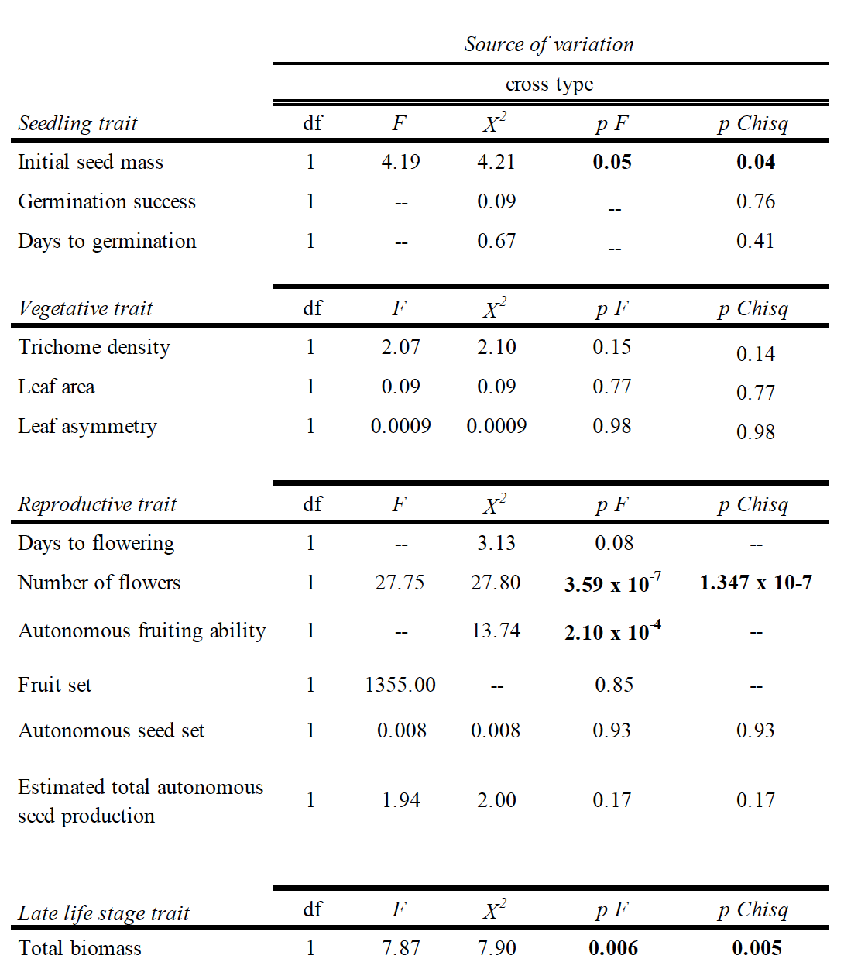
Table 2. Split-plot analysis of variance for the effects of maternal cross type, pollen age, and time on pollen germination and analysis of covariance for the effects of pollination cross type, maternal and parental cross type, and pollen age on male fitness traits. Pollen age and time were treated as within-subjects factors and cross type was treated as a between-subjects factor, and time was a factor with three levels: 15, 30, and 120 minutes. Pollination cross type = pollen from the maternal plant (self-pollination) or from another individual (outcross pollination), maternal/paternal cross type = whether the maternal/paternal plant was the product of a self- or outcross-pollination, and pollen age = pollen came from a newly opened flower or an older flower (open for >7 days).

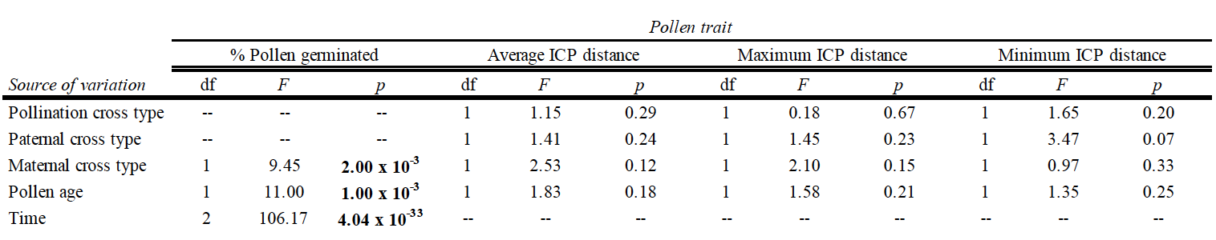

Table 3. Results of model comparisons between full and reduced models for the effects of cross type on seedling, vegetative and reproductive traits of C. corymbosa. Seed mass was included as a covariate in all models, and reduced models had family as a random intercept effect, while full models had cross type as a random slope effect and family as a random intercept effect.
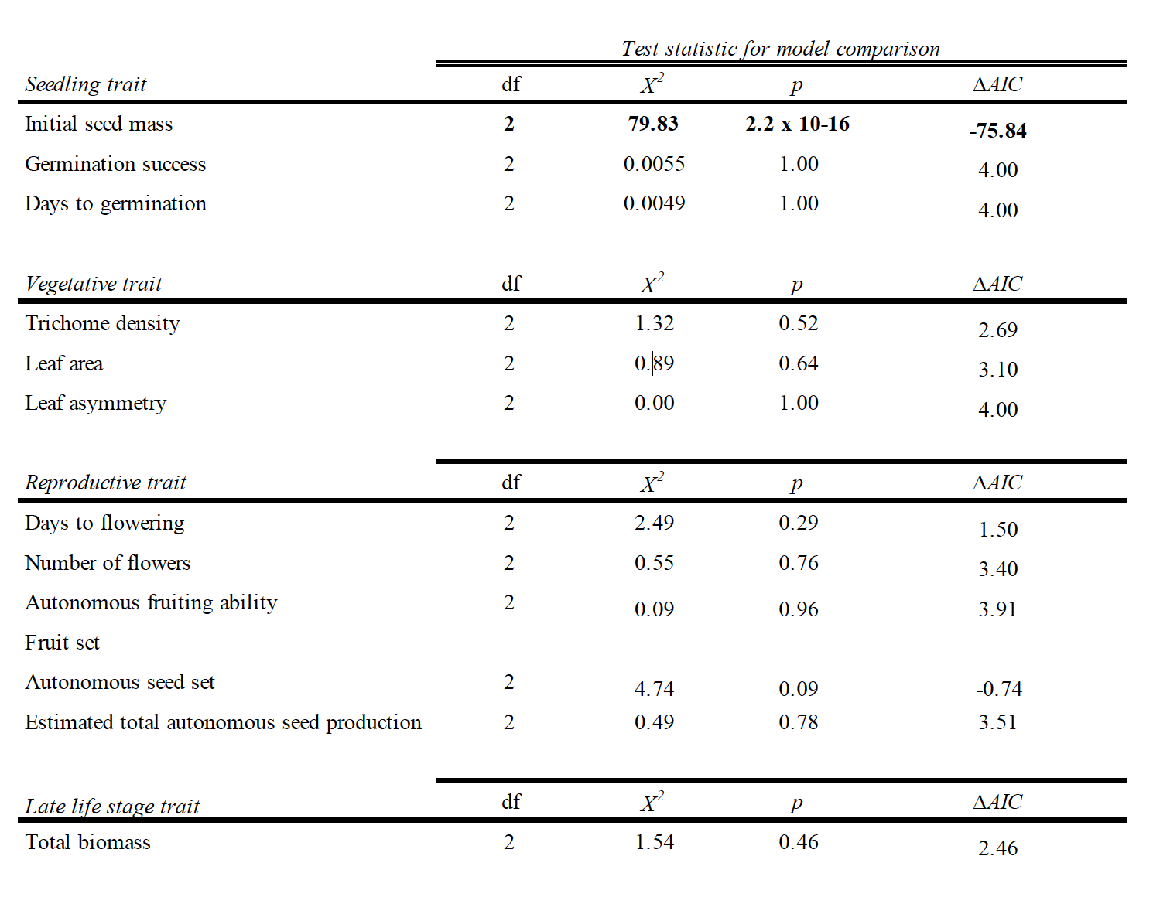

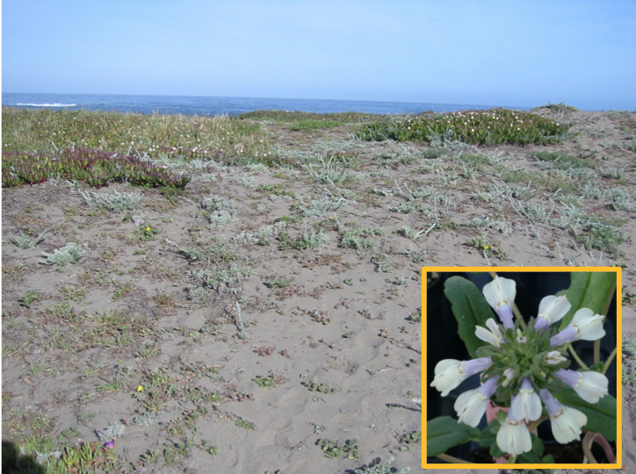
Figure 1. Coastal California dune habitat of Collinsia corymbosa from which seeds were collected at MacKerricher State Park. Inset: C. corymbosa grown in greenhouse.

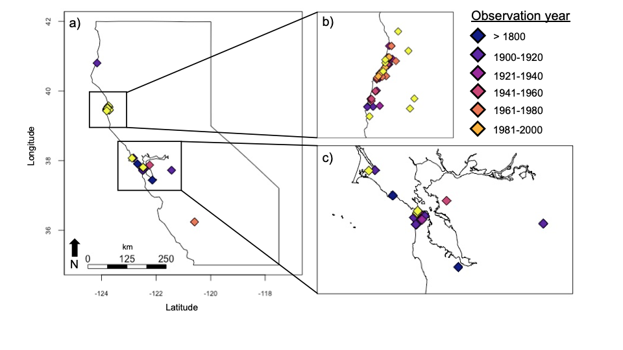Figure 2. Observations of C. corymbosa a) across its entire range, b) in and surrounding MacKerricher State Park, Mendocino County, CA (39° 29’52” N, 123° 47’13” W), and c) in and surrounding the San Francisco Bay area, San Francisco County, CA (37° 46’3’’ N, 122° 24’5’’ W). Observation records were obtained from iNaturalist and the University of California, Berkeley Jepson Herbarium.

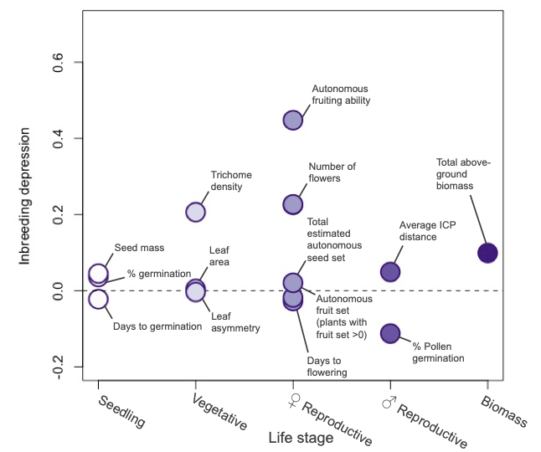

Figure 3. Inbreeding depression across the life cycle of Collinsia corymbosa. For each plant trait measured at a given life stage, inbreeding depression was calculated as δ = 1-Ws/Wo, where Ws = mean fitness of selfed plants and Wo = mean fitness of outcrossed plants. Each point represents an individual plant trait measured in this study.

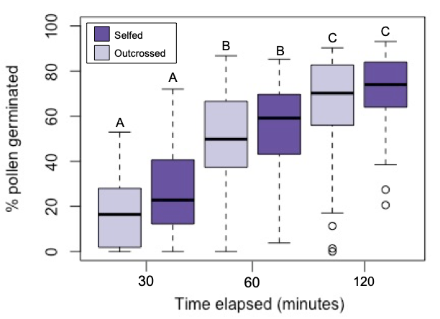
Figure 4. Effect of time and cross type on pollen germination rates for pollen from new flowers in selfed and outcrossed C. corymbosa plants. Older pollen similarly decreased germination rates for both selfed and outcrossed plants (not pictured).

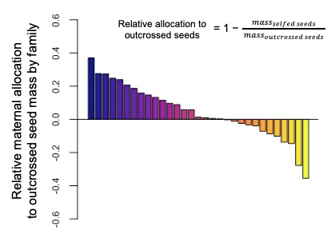
Figure 5. Family level variance in allocation to selfed and outcrossed seed mass in greenhouse experiment with 31 maternal families of C. corymbosa. Each bar represents the relative difference in mass of seeds produced via selfing and via outcrossing within a single maternal family. Positive values indicate that outcrossed seeds had greater mass, while negative values indicate that selfed seeds had greater mass.
Figure 6. Effect of cross type (selfed or outcrossed) on seedling traits a) initial seed mass, b) percent germination, and c) days to germination; vegetative traits d) trichome density, e) leaf area and f) leaf asymmetry; reproductive traits g) days to first flower, h) number of flowers, i) autonomous fruit set (10 randomly sampled fruits), j) autonomous fruit set of plants that set at least one fruit out of the ten sampled, k) autonomous seed set of plants that set at least one fruit out of the ten sampled, l) total estimated autonomous seed production (number of flowers x seed set/fruit) for plants that made at least one fruit out of the ten sampled; and late life trait m) total biomass. Error bars represent mean ± SE.

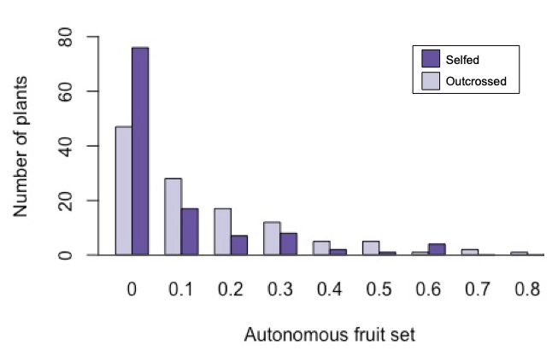
Supplemental Figure 3. Distribution of autonomous fruit set of selfed and outcrossed plants of Collinsia corymbosa.

CONCLUSION
This is my conclusion.

VITA
This is my vita.

