Fault Diagnosis

Via

Univariate Frequency Analysis Monitoring
  - A Novel Technique Applied to a Simulated Integrated Drive Generator

A Thesis
Presented for the
Master of Science Degree
The University of Tennessee, Knoxville

Brian Keith Bailey
December 2011

Copyright© 2010 by Brian Keith Bailey
All rights reserved

DEDICATION
First and foremost, this thesis is dedicated to the strongest, kindest, and wisest person that I know, Miss Annie B. Dreadin, my mother. From the earliest age that I can remember, she has encouraged and inspired me to reach for my highest goals without fear of failure, even amongst the criticism from the ever present cynics in our lives. I only hope that I continue to make her proud and never lose her respect. I thank God for allowing me to be born unto this amazing woman.
Secondly, I would also like dedicate this thesis to the men and women of our armed forces. Let their call to battle be infrequent. However, if they must draw a line and then defend it, then let them do so with the very best technology that we can provide so they may come home to their families and a grateful nation.
Finally, I present this thesis as evidence of observance of my Pledge as an Engineer to use my skills, knowledge, and the principles of science for the benefit of all life, known and unknown.

ACKNOWLEDGMENTS
It has been a long road with many turns and bends, one stop, and two starts before reaching this designation. There are many people that helped, encourage, and supported me in the reaching this mile stone in my educational career. First, I want to thank my mother, to whom this thesis is dedicated. Her love, support, and patience continue to make it possible for me to achieve my goals and dreams. My successes are her successes and I am eternally grateful for her sacrifices.
I wish to express my thanks and gratitude to my advisor and advocate, Dr. J. Wesley Hines. Thank you for the opportunity, the support, the advice, the guidance, and the patience that you have demonstrated over the past two years. The opportunity to be instructed by you and to work with you on this and previous work has opened this fascinating field of engineering science to me. More importantly, I am extremely grateful and forever indebted to you for having confidence in me when I had little in myself.
I want to express my gratitude and respect to Dr. Charlie Moore. First, allow me to thank you for the opportunity and support that enable me to start and continue on this journey so many years ago. My great respect for you inspired me to produce the best work possible. However, that drive for perfection, resulted in failure to complete that original work and for this I am sorry. Never-the-less, upon my return to school, not only did show your support by agreeing to serve on my committee, but you also welcome and encourage me without prejudice. From you, I have learned lessons that I will carry through life and for this I am ever so grateful.
I would like to thank Dr. David Keffer for agreeing to serve on this committee as well. From my first year as a graduate student, he has impressed and inspired me with the knowledgability and enthusiasm that he continually conveyed as one of my instructors. I am grateful for your help and service.
I wish to express my gratitude to Dr. Brian Edwards. It is with his help and advocacy that I have been allowed this opportunity. I appreciate your help and support in petitioning the Graduate School for an extension to complete the requirements for a degree of Master of Science in Chemical Engineering.
I would also like to extend a special thank you to Dr. Jamie Coble. As a fellow research assistant, her participation in this work has been invaluable. Her intellectual and facilitative assistance was implemental in my re-acclimation to academia.
I also wish to thank those entities that have provided financial support during my educational pursuits. I am appreciative to Global Strategic Solutions for the financial support of this work. I would like to thank Hamilton Sundstrand for providing the simulation data used in this work. I would also like to acknowledge the current and continuing support of the Nuclear Regulatory Commission via the "US NRC Graduate Fellowship Program to Promote Diversity in Nuclear Education at the University of Tennessee" administer by Dr. Ivan Maldonado. I would be remiss in showing my appreciation if I did acknowledge the support received from various entities from June 2002 to May 2005.
Finally, I wish to reaffirm my faith and belief in God. I acknowledge his ever-present influence throughout my life that has guided me to this profession in which I take deep pride. By his will, I am an Engineer, and to him I owe solemn obligations to provide responsible stewardship of his creation.

ABSTRACT
The purpose of this research was to develop a fault detection and diagnostic method that would be able to detect and isolate seeded faults in data that was generated from a simulated integrated drive generator. The approach to the solution for this problem is summarized below.
A novel approach for the detection and diagnoses of an anomaly due the occurrence of a fault within a system has been developed. This innovative technique uses specific characteristics of the frequency spectrum of a univariate signal to monitor system health for abnormal behavior due to previously characterized component failure.
A fault detection and diagnostic scheme was developed that used dual heteroassociative kernel regression models. The first of these empirical models estimates selected features from the analytical redundant spectrum characteristic profile of the exciter current using power demand, a stressor, placed on the system as input query. The predicted spectrum features were compared to the actual characteristic features, which resulted in the generation of a residual signal. This signal was then analyzed in order to determine if they were the result of normal system disturbances or a predefined fault. If a fault was detected, the residual signal was passed to the second model, which isolated, and given enough information, identified the specific component of components causing the anomaly.
Two case studies are presented to illustrate the capability to detect, isolate, and identify a system anomaly. As demonstrated, the monitoring of the frequency spectrum of a single variable can provide adequate indication of equipment health. With the availability of the appropriate data, as in the first case, it is possible for the development of three-layer detection and diagnostic systems that provides fault detection, isolation, and identification. A three-layer detection and diagnostic system is essential in the development of more advance health monitoring and prognostic systems. Despite some shortcomings in the simulated data made available for this work, this method is believed to be applicable to data that more realistically captures real-world relationships, including sensor noise and faults that grow with time.

Table of Contents

1 INTRODUCTION 1
1.1 Objectives 3
1.2 Document Structure 5

2 Literature Survey 6
2.1 Literature of Fault Diagnosis Systems 6
2.1.1 Common Terminology Used in Fault Diagnosis.…………………………………………………………………… 6
2.1.2 Fault Detection Methods ……………………………………………………………………………………………………. 7
2.2 Fault Detection and Diagnosis in Aerospace Literature 18
2.2.1 Propulsion, Structural, and Avionic Health Management…………………………………………………… 18
2.2.2 Electrical Generator Health Management………………………………………………………………………….. 20

3 Empirical Modeling Approach 22
3.1 Kernel Regression 23
3.1.1 Step 1 – Distance Calculation…………………………………………………………………………………………….. 24
3.1.2 Step 2 – Similarity Quantification………………………………………………………………………………………. 24
3.1.3 Step 3 – Output Prediction………………………………………………………………………………………………… 25
3.2 Model Initialization 25
3.2.1 Architecture Types…………………………………………………………………………………………………………….. 25
3.2.2 Variable Selection……………………………………………………………………………………………………………… 28
3.3 Model Optimization 29
3.3.1 Kernel Bandwidth………………………………………………………………………………………………………………. 30
3.3.2 Vector Selection………………………………………………………………………………………………………………… 32
3.4 Model Performance Evaluation 34
3.4.1 Accuracy…………………………………………………………………………………………………………………………….35
3.4.2 Sensitivity…………………………………………………………………………………………………………………………..35
3.4.3 Detectability Metrics………………………………………………………………………………………………………….36

4 Simulation Data 39
4.1 Integrated Drive Generator 39
4.2 Discrete IDG Data 41
4.3 IDG Continuous Data from Simulated Flight 44

5 Univariate Monitoring 51
5.1 SUMM: Stressed-based Univariate Monitoring Method 52
5.2 Model Development 54
5.2.1 Data Conditioning……………………………………………………………………………………………………………... 55
5.2.2 Data Partitioning……………………………………………………………………………………………………………….. 55
5.2.3 Variable and Input Selection……………………………………………………………………………………………… 56
5.2.4 SUMM: Application to Discrete IDG Data………………………………………………………………………….. 57
5.2.5 SUMM: Application to Continuous IDG Data…………………………………………………………………….. 64

6 Conclusions 70

7 Future Work 72

LIist of References 74

Appendix: Referenced Figures 78
Vita…………………………………………………………………………………………………………………………………………………..……85

LIST OF FIGURES
Figure 1: Conceptual Prognostic and Health Management System 4
Figure 2: Conceptual Fault Diagnosis System 4
Figure 3A: Model-Base Fault Detection via Output Estimator 12
Figure 3B: Model-Base Fault Detection via System Simulator 13
Figure 4: The General Structure of a Residual Generator 13
Figure 5: Dedicated Structure Residual Set 16
Figure 6: Generalized Structure Residual Set 16
Figure 7: Directional Residual Vector for Fault Isolation 17
Figure 8: Modeling Architectures 26
Figure 9: Effects of Bandwidth Size[38] 31
Figure 10: Illustration of Degraded Modes for Normal Distribution[41] 37
Figure 11: Typical Integrated Drive Generator Cross-Section [46] 40
Figure 12: Simplified Integrated Drive Generator Schematic [46] 40
Figure 13: Exciter Current at 5 kilowatts 42
Figure 14: Average Current Relative to Power and Fault Condition 43
Figure 15: Current Variance Relative to Power and Fault Condition 44
Figure 16: Main Armature Voltage at 5 kilowatt 45
Figure 17: Main Armature Current at 5 kilowatt 46
Figure 18: Flight Exciter Data from the Non-Faulted Flight 48
Figure 19: Main Generator Current Data from the Non-Faulted Flight 48
Figure 20: Main Generator Voltage Data from the Non-Faulted Flight 49
Figure 21: Exciter Data from the Faulted Flight 49
Figure 22: Main Generator Current Data from the Faulted Flight 50
Figure 23: Main Generator Voltage Data from the Faulted Flight 50
Figure 24: Traditional AAKA Monitoring via Error Correction 51
Figure 25: Proposed SUMM Residual Generator Scheme 53
Figure 26: Proposed SUMM Fault Detection/Isolation Scheme 54
Figure 27: Amplitude - Fault Dependence of Open-Circuit Diode 58
Figure 28: Amplitude - Fault Dependence of Exciter Disconnect 59
Figure 29: Fault Dependence of Exciter Disconnect and Open-Circuit Diode 59
Figure 30: Normal Operation Frequency Spectrum Overlay 60
Figure 31: Open-Circuited Diode Operation Frequency Spectrum Overlay 60
Figure 32: Rectifier Disconnection Operation Frequency Spectrum Overlay 61
Figure 33: Identified Peaks 62
Figure 34: Selected Model Features for Open-Circuit Diode 63
Figure 35: Selected Model Features for Exciter Armature Disconnect 63
Figure 36: Selected Model Features for Fault Combination 64
Figure 37: Optimum Bandwidth for Normal Spectrum Feature Model 65
Figure 38: Optimum Bandwidth for Fault Detection and Identification Model 65
Figure 39: Normal Spectrum Feature Model Results 66
Figure 40: Fault Detection and Identification Model Results 66
Figure 41: Frequency Spectra of Exciter Current for Normal and Faulted Operation 67
Figure 42: Monitoring Model Results for Nominal and Faulted Operation 68
Figure 43: Prognostic Concept Module 73

INTRODUCTION
Technology continues to grow exponentially, allowing for new advances in every aspect of human activity. With these advances, the complexification of equipment and processes, herein referred to as systems, has given rise to issues of cost efficiency, availability, reliability, and safety. These issues are obviously important in the operations of nuclear, chemical, and other industrial facilities where major failures or catastrophes often results in substantial damage and lost. Similar importance has been gained in the operation of high-performance ships, submarines, airplanes, space vehicles, transit systems, communication networks, and other structures where safety, mission criticality, and material value are at stake. There is no question that a failure in such advance systems, especially safety-critical systems, can lead to extremely serious consequences in terms of human mortality, environmental impact, and economic loss. Therefore, ever more vigilant maintenance activities are required in order to assure the reliability and continued operation of these crucial systems.
The maintenance activities around these advance systems have historically been preventive in nature, usually utilizing a scheduled-based maintenance (SBM) philosophy. The implementation of this philosophy, however, comes at the expense of availability and cost efficiency. As the costs of these practices continue to increase and the availability of these systems become critical, many organizations are turning to condition-based maintenance (CBM) philosophies has an effective alternative. These philosophies advocate the use of both real-time and historical data to determine the necessity of action allowing for the prioritization of maintenance resources and the optimization of system uptime.
As an example, nuclear power utilities have been exploring monitoring technologies for the purposes of determining equipment condition, specifically sensor operation. Under original licensing requirements, nuclear power plants are required to recalibrate all safety critical instruments at each refueling outage. This calibration requirement gives rise to a couple of concerns that are typical of the SBM philosophy. The first of these concerns is that faulty equipment (sensors in this case) goes undetected between scheduled maintenance raising issues of reliability. The second concern deals with the ineluctable fact that every sensor is not in need of maintenance, and therefore unnecessary costs are incurred by the operator. However, monitoring real-time or near real-time data allows for the detection of faulty equipment. Not only does this potentially improve plant safety and reliability with early detection of faulty equipment before the scheduled outages, it also has brings about direct and indirect cost savings by reducing the amount of unneeded maintenance and the overall length of an outage [1].
With advantages of improved system operation and safety while reducing overall operation cost, the concept of CBM is gaining wider acceptance spurring increase research in its implementation. The increased interest in CBM research has also led to the development of intelligent condition-based maintenance systems (CBMplus). The CBMplus concept approaches turnkey maintenance beginning with the detection and diagnoses of system fault, the determination of system reliability, the requisition of required components, and the scheduling of craft personnel. The detection and diagnostic functionality of such systems is usually, at least conceptually, accomplished by an integrated diagnostics system. With the addition of prognostic functionality, predictions of a system's future health become feasible. This combination of detection, diagnostic, and prognostic functionalities form the basis of what is often referred to as a Prognostic and Health Management (PHM) system. A refined PHM system is the cornerstone of a fully developed CBMplus system.
The importance of PHM development and its role in CBMplus systems can be inferred by the following illustration. The Department of Defense has made PHM and CBMplus implementation a required consideration for any new system via its 5000.2 policy on defense acquisition [2]. The policy states that "program managers shall optimize operational readiness through affordable, integrated, embedded, diagnostics and prognostics, and embedded training and testing, serialized item management, automatic identification technology (AIT), and iterative technology refreshment" [3]. The development of the United States military's Joint Strike Fighter (JSF) is an exemplification of this particular policy.
As PHM systems are the cornerstone of CBMplus systems, fault detection and diagnostics are critical in the development of effective PHM systems. With this in mind, the work presented here does not focus on prognostics, but rather the detection and diagnosis of system faults. Readers interested in current prognostic research and development are referred to Mishra et al [4] for life consumption monitoring, Liao et al [5] for proportional hazards modeling, Lu and Meeker [6] for general degradation path modeling, and Coble [7] for prognostic parameter identification. The component of a PHM system in which this paper gives attention includes: the detection of a system fault, the subsequent isolation of that fault, and to some degree, the identification of said fault.

Objectives
As previously discussed, substantial improvements in maintenance, safety, cost, and overall availability can be made with the incorporation of monitoring, detection, diagnostic and prognostic technologies into health management systems of equipment, processes, and vehicles. As shown in Figure 1, a PHM system is commonly built on several modules which use captured system data to monitor for changes, determine if those changes are due to a fault, diagnose the fault, and then predict the remaining useful life (RUL), time of failure (ToF), or probability of failure (PoF).
As mentioned, this work focuses on the fault detection and diagnosis components of the conceptual PHM system illustrated in Figure 1. Figure 2 summarizes the basic construction of a fault detection and diagnosis system. The first task, which forms the base of the Figure 2 pyramid, is the differentiation of perturbations from disturbances and faults. Once a fault has been detected, it is then isolated by determining the kind, the location, and the time of detection. The capstone of the fault system pyramid is fault identification; whereas, the size and time of onset is determined. However, the importance of this task varies depending on the researcher and his/her interests. Many researchers consider the first two tasks the most important; therefore, defining fault diagnosis as fault detection and isolation (FDI) [8]. Even so, others like Simani et al [9] argues that fault identification is the most important of all fault diagnosis tasks and call for more research to be done in this area. Nevertheless, both considerations are given attention in this paper with the application of the fault diagnosis method presented herein.
The following paper introduces a novel approach for monitoring the frequency spectrum of a single variable for the purposes of symptomatic residual generation, fault detection, and fault diagnostics (i.e., isolation and identification). As a demonstration, this approached is applied to OEM provided, simulated integrated drive generator (IDG) data to illustrate its capability to:
- Extract pre-specified features from a spectral analysis of a single measured variable and via a comparison of the expected and actual features, generate symptomatic residuals.
- Subject these symptomatic residuals to a probabilistic reasoning method to differentiate between system disturbances and actual faults.
- Finally, isolate and identify the specific defect if the hypothesis that the residuals are indeed a symptom of a system fault is true.
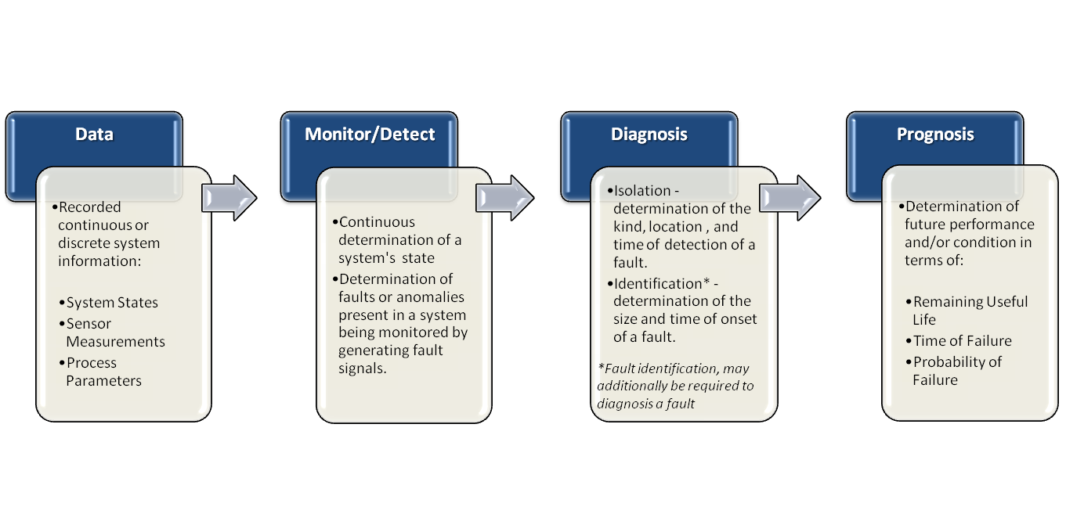
Figure 1: Conceptual Prognostic and Health Management System

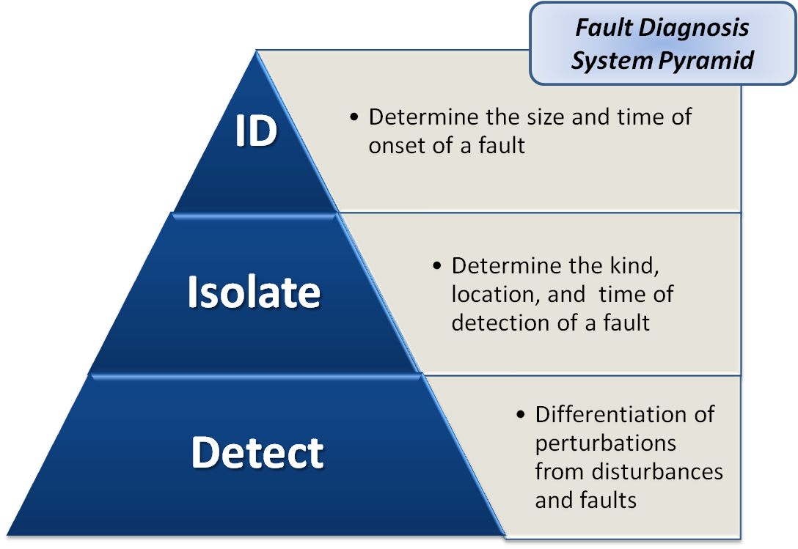
Figure 2: Conceptual Fault Diagnosis System

Document Structure
Hereafter, the following report is organized into six sections. Section 2 presents a two prong literature review. The first subsection discusses the general components of fault detection and diagnostic system and the various methods of implementing the functionality of those components. The second subsection briefly surveys how fault detection and diagnostics has been applied to different systems of a modern aircraft.
Section 3 presents an in-depth review of the modeling method used as the foundation of the technique described in this report. Kernel regression, the non-parametric modeling approach, is first explained. Following this, the initialization of a model, including architecture types and variable selection, is discussed. With a working model initialized, the next topic considered is that of optimization via the selection of the kernel bandwidth, the method of vector section, and the appropriate number of memory vectors. Finally, several commonly used performance metrics are presented for completeness.
Section 4 describes the simulation data that has been used to demonstrate the proposed concept presented in this report. This section also includes a description of the aircraft component, the integrated drive generator, that the data has been simulated.
Section 5 introduces the new concept of building a fault detection and diagnosis system when only a single signal is available. Unlike the approach of the more common traditional empirical models that normally utilities correlated input and output variables, the method presented in this section uses the frequency domain of a single variable alone with selected stress conditions to monitored system health. The development of the models used in the detection and diagnosis is discussed here. Some model development considerations that are more specific to the data has been included here instead of the more general items discussed in Section 3. Models were developed for fault detection and diagnosis systems for each of the two simulated data sets discussed in Section 4. Although several performance metrics are discussed in Section 3, the majority of these metrics were not applicable due to the specific architecture used. The only exception was the accuracy metric. As a result, the performance for not only the models but that of the detection and diagnosis systems are presented graphically.
Section 6 summarizes the work presented in the previous section and presents the drawn conclusions. The final section, Section 7, takes an opportunity to presents some areas of research that should be consider as this method is expanded in future work.

Literature Survey
Obviously an exhaustive survey of the literature on fault diagnosis systems and their applications is beyond the scope of this work. Nevertheless, a review of current literature concerning the two immediate subjects of interest is presented in the following two subsections. First, the subject of what defines a fault diagnostic system, as reference by the literature, is explored by discussing the general implementation of fault detection, isolation, and to some degree, identification. Then a perspectival survey of various applications of fault detection and diagnosis systems to aircraft systems is provided.

Literature of Fault Diagnosis Systems
A fault diagnosis system can be defined as a system that is used to “detect faults and diagnose their location and significance” [10]. A fault diagnosis system consists of the tasks illustrated in Figure 2:
- Fault Detection: Make a determination that either everything is operating within the specified normal range or that something has gone wrong.
- Fault Isolation: Determine the kind and location of the fault, e.g., which component has degraded.
- Fault Identification: Estimate the size, nature, and onset of the fault.
As discussed, the importance of either one of these tasks relative to the other is subjective. The consensus seems to be that fault detection and isolation are almost equally important for any practical diagnostic system. Fault identification, on the other hand, may not be consider as important unless some prognostic determination is required or some reconfiguration action is involved. However, the argument of which tasks are most important is beyond the scope of this paper as are the specific details of implementing either one of them.

Common Terminology Used in Fault Diagnosis
Before continuing with the discussion of fault diagnosis implementation, a review of some commonly used terminology is prudent. Recognizing the difficulty of understanding contributors' goals and hindering the comparison of various approaches due to the inconsistent use of diagnostic terminology, the International Federation of Automatic Control (IFAC) technical committee SAFEPROCESS (Fault Detection, Supervision, and Safety for Technical Process) started an initiative to standardize the definitions for terms used in fault diagnosis. SAFEPROCESS was first created in 1991 as a steering committee within the IFAC due to increasing interest in the field of fault detection and diagnosis, and then became a technical committee in 1993. As a result of the committee's efforts, these terms and their respective definitions are prevalent in the current literature. As such, the following list of terms in Table 1, adopted for use in this paper, is largely consistent with SAFEPROCESS terminology as present in Isermann and Ballé [11].

Fault Detection
According to Isermann [12], the methods for fault detection can be classified on the basis of the following four quantities:
- Measurable Signals
- Nonmeasurable State Variables
- Nonmeasurable Process Parameters
- Nonmeasurable Characteristic Quantities
Over the last several decades, there has been substantial amount of work in the area of process supervision and fault detection for class one; whereas, only a limited amount as been done for the remaining categories. With that in mind, the following section presents brief discussions of those detection methods used for measurable signals.

Single Signal Limit and Trend Checking
The simplest and most frequently used detection methods are often found in those operations that utilized statistical process control and are referred to as limit and trend checking or geometrical analysis [9]. Such methods are restricted to directly checking a single measureable variable for changes in magnitude or trends, and then alarming when a threshold is reached.
Limit checking is applied to an absolute value in which maximum and minimum threshold limits are established for a single measurement signal$z\left(t\right)$. Here, the normal state is defined as:
$z_{min}<z(t)<z_{max}$ (2.1)
Trend checking is similar in form to that of limit checking with the exception being that the method is applied to the trend of a measured signal $\dot{z}\left(t\right)$ such that:
${\dot{z}}_{min}<\dot{z}\left(t\right)<{\dot{z}}_{max}$ (2.2)
Monitoring a measured signal for faults by tracking its change may be advantageous because detection of an anomaly can occur earlier than that of absolute value checking. This advantage is due to the fact that trends permit a certain level of prediction for the measurement's progression. Nonetheless, both limit and trend checking, whilst simple to implement, has serious drawbacks including [10, 12, 13] :
Table 1: Common Fault Diagnosis Terminology
TERM | DEFINITION
Disturbance | An unknown (and uncontrolled) input acting on a system
Fault | A unpermitted deviation of at least one characteristic property or parameter of the system from the acceptable, usual, or standard condition, i.e., a malfunction of a system component
Error | A deviation between a measured or computed value and the true, specified or theoretically correct value
Residual | A fault indicator which is based on a deviation between the measured and model-based values
Symptom | A change in an observable quantity from that which is considered normal behavior, i.e., an observable effect of a fault
Fault  Detection | Indication of the faults present in a system
Fault  Isolation | Determination of the kind, location, and time of detection of a fault—follows fault detection
Fault Identification | Determination of the size and time of onset of a fault—follows fault isolation
Fault  Diagnosis | The indication of a fault and the determination of the kind, location, and time of detection—follows fault detection and includes fault isolation (fault identification, depending on the researcher, may also be included in this definition)
Monitoring | A continuous real-time task of determining the conditions of a physical system, by recording information, recognizing and indication anomalies in the behavior
Isolable Fault | A fault that is distinguishable from other faults using one residual set
Quantitative Model | Use of static and dynamic relations among system variables and parameters in order to describe a system's behavior in quantitative mathematical terms
Qualitative Model | Use of static and dynamic relations among system variables and parameters in order to describe a system's behavior in qualitative terms such as causalities or if-then rules
Diagnostic Model | A set of static or dynamic relations which link specific input variables to specific output variables, i.e., symptoms to their respective faults the faults

- Necessity to have an a priori knowledge of the characteristics of the measurement signals
- Dependency of measurement characteristics on the operating states of the system which, are not known a priori and are subject to change beforehand
- False alarms due to a measurement's sensitive to noise, random input variations, and changes in operating points
- False alarms in other system measurements' due to spillover effects from another single measurement
- Detection of faults usually after the output values have been considerably affected
However, it should be pointed out that prediction modeling of deterministic or stochastic measurements$\hat{z}\left(t\right)$ beyond that of trend analysis can also be employed. This not only reduces or even avoids the fore mention drawbacks, it also allows for the estimation of the time that the threshold may be exceeded. This particular capability provides an operator the opportunity to determine courses of action that could prevent more costly consequences. This philosophy of determining the future state of a system for the purpose of early intervention has led to the introduction of model-based fault detection.
However, it should be pointed out that prediction modeling of deterministic or stochastic measurements$\hat{z}\left(t\right)$ beyond that of trend analysis can also be employed. This not only reduces or even avoids the fore mention drawbacks, it also allows for the estimation of the time that the threshold may be exceeded. This particular capability provides an operator the opportunity to determine courses of action that could prevent more costly consequences. This philosophy of determining the future state of a system for the purpose of early intervention has led to the introduction of model-based fault detection.

Multiple Signals and Consistency Checking
The use of consistency checking of a system's measured values is an established approach of system monitoring that greatly enhances the process of not only fault detection but fault diagnosis as well. The development of such fault detection systems is primarily based on two methods of generating fault indicating symptoms: physical redundancies or functional redundancies.
Hardware (physical) redundancy, consider the traditional approach to fault diagnosis design, uses three or more components for the same function. A deviation in the consistency check of signals from redundant devices initializes a voting logic and switching mechanism to isolate and identify the fault. This type of redundancy is widely used in safety critical systems throughout industry.
Hardware redundancy is effective and very reliable (if identical equipment is used); however, such systems do present some drawbacks. For example, subtle degradations in system behaviors are difficult to detect with hardware redundancies. More significantly, the design of such systems require extra equipment, a larger foot print to accommodate the equipment, and additional maintenance costs which are counterintuitive to modern fault detection-diagnosis research and CBM philosophies [11, 14].
As a result of the decreasing cost of digital hardware and software alone with ever increasing computational power, considerable attention has been and continues to be given to the area of using functional relationships between variables to ‟cross check” each other. Such schemes may roughly divide into two categories, knowledge-base approaches, associated with qualitative, heuristic reasoning models and analytical redundancy approaches that exploits quantifiable, analytical rich information for the development of mathematical and data driven models.
Knowledge-based approaches make use of limited-knowledge to derive heuristic descriptions of a system in the form of qualitative models or rule-based representations. With heuristic models, accuracy is not necessarily governed by the precision in the description or the complexity of the model. In fact, a knowledge-based model developed with a high level of abstraction with less complexity can still produce accurate results. Another advantage with the knowledge-based approach concerns that of measurement precision. The preciseness of measurements is of critical importance for model performance if they are precise in their description. However, increase measurement imprecision can be tolerated by those models developed with a high level of abstraction. Nevertheless, this advantage does have the drawback of being less sensitive in the presence of smaller faults.
Unlike those systems where a knowledge-based approach is appropriate, systems that have substantial amounts of sensor information are well suited for an analytical redundancy approach. Information rich systems can be described by either mathematical or empirical models. The resulting models form the foundation of fault detection and diagnosis schemes based on analytical redundancy. These model-based schemes take advantage of using dissimilar measured values to cross-compare each other, rather than replicating each piece of hardware. The comparison between a measured signal and its estimation, which is generated by a mathematical model of the monitored system or component, is often referred to as consistency checking. The resulting difference is a residual signal$r\left(t\right)$, and is generated in such a way to satisfy the following condition:
$r\left(t\right)=0 ⟺f\left(t\right)=0$ (2.3)
The residual signal of a non-faulted system should be zero valued when the fault signal$f\left(t\right)$ is zero. This is the basis for fault detection [15]. However, due to the presence of noise, modeling error, and other disturbances, the resulting residuals are generally not zero for actual fault free systems. As a result, a fault detection schemes must include the capability to evaluate the generated residual signal in order to differentiate those non-zero values that are due to disturbances and actual faults. Therefore, model-based fault detection can be thought of as a two-stage process: residual generation and decision-making (including residual evaluation) [10, 16, 17]. Figures 3a and 3b illustrate the basic concept of a two stage fault detection scheme via analytical redundancy.

General Structure of Residual Generation
Because residual generation is central to model-based fault diagnosis systems, a variety of methods have been purposed throughout the literature. The key to residual generation for the purposes of fault detection is the creation of residuals that are sensitive to faults and insensitive to disturbances that may produce false alarms. Referring back to the residual generation blocks of Figure 3A and 3B, the redundant signal $\hat{y}\left(t\right),$ is the result of the function${ F}_{1}$, and alone with the actual output measurement signal $y\left(t\right),$ a set of residuals $r\left(t\right)$ is computed by the difference function${ F}_{2}$.
The residual generator block depicted in Figure 3A is referred to as an output estimator. Here, F₁ is a function of both input and output that results in an estimation of a linear function of the output$y\left(t\right)$.
In the case of an open-loop system, F₁ is an input-output description for an actual measurement. F₁ of Figure 3B is referred to as a system simulator in which the actual signal $y(t)$ is not required unlike that of an output estimator. However, the type, be it simulator or estimator, of method used, a residual generator is a linear processor whose input consist of both input and output of the system being monitored.
Figure 4 shows the general structure of a residual generator as depicted by Patton and Chen [10]. The structure is expressed mathematically as:
$r\left(t\right)=H_{x}\left(t\right)x\left(t\right)+H_{y}\left(t\right)y(t)$ (2.4)
The transfer matrices, $H_{x}(t)$ and $H_{y}\left(t\right),$ are achievable using linear systems, and according to the definition via equation 2.3, the residual is designed to be zero for fault-free systems and nonzero in the presence of faults. In order to satisfy this condition, these matrices must satisfy the following constraint:
$H_{x}\left(t\right)+H_{y}\left(t\right)G_{x}\left(t\right)=0$ (2.5)
Equation 2.4 is a generalized representation of all residual generators [10]. The design of the residual generator is simply based upon the selection of the transfer matrices, $H_{x}(t)$ and${ H}_{y}\left(t\right)$, which satisfy Equation 2.5. Therefore, different parameterizations of $H_{x}(t)$ and $H_{y}\left(t\right)$ results in the various methods of residual generation.
As alluded to previously, the generation of residuals is cardinal in analytical based fault diagnosis, and has resulted in a variety of methods found throughout literature. The majority of those methods fall within three classification:
- Parameter estimation [11, 12, 15]
- Parity vector (relation) methods [16]
- Observer based approaches [18-20]
However, the discussion of implementation of these various methods and their appearances in literature is beyond the scope of this paper, and is left for the interested reader to survey.

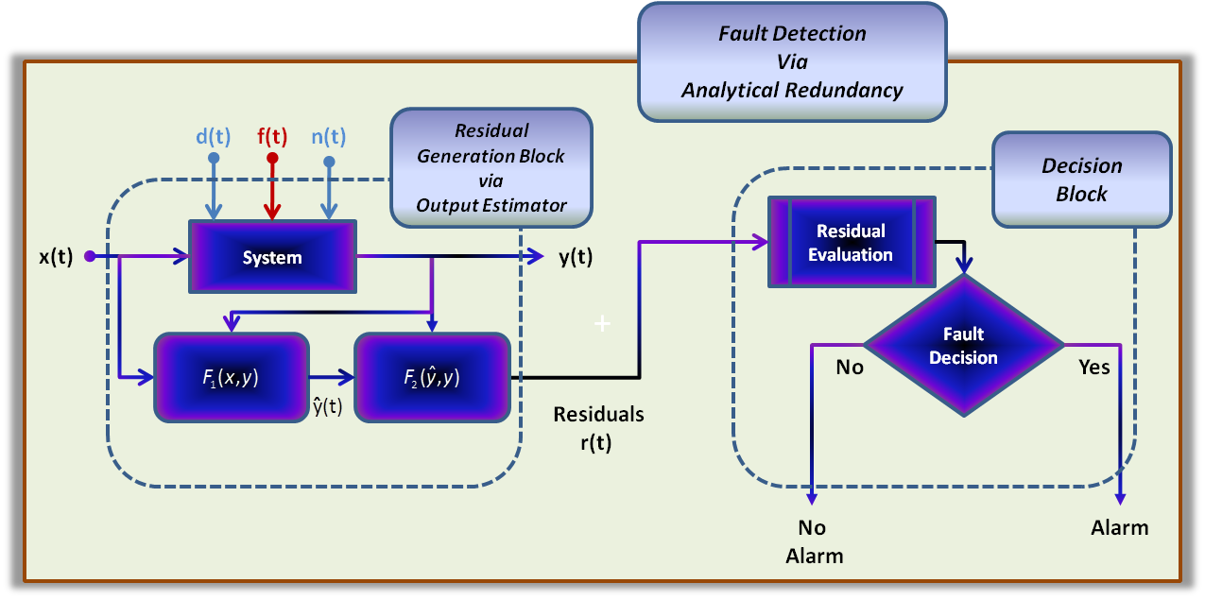
Figure 3A: Model-Base Fault Detection via Output Estimator

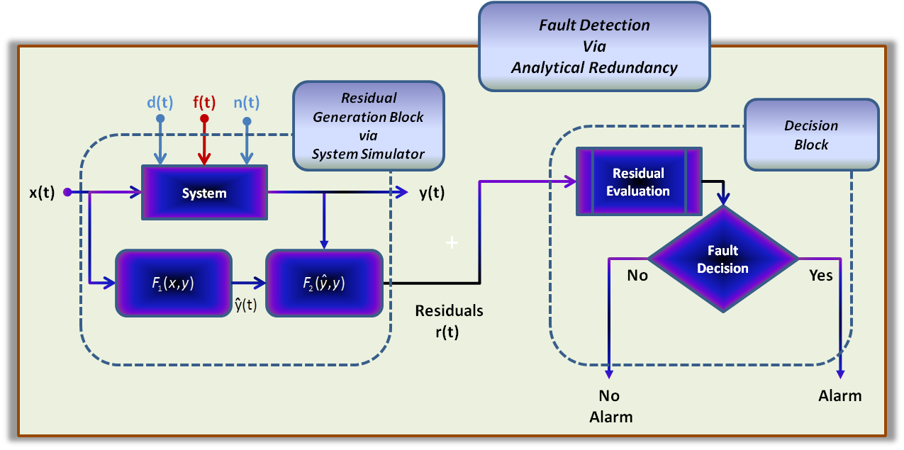
Figure 3B: Model-Base Fault Detection via System Simulator

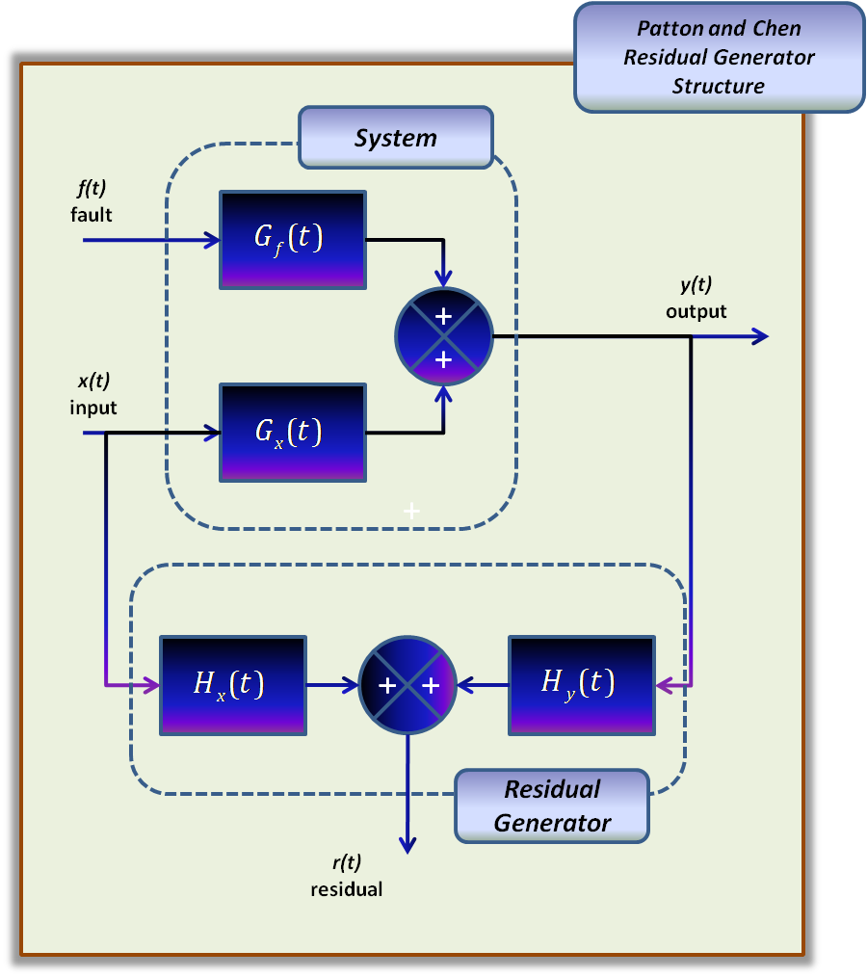
Figure 4: The General Structure of a Residual Generator

Decision Making via Change Detection
With the generalization of a residual generator defined, the realizable creation of quantifiable symptoms is possible as demonstrated from the variety of literature references. Now, the question of the second task of fault detection comes to bear. How are the residual signals evaluated in order to detected subtle changes in system parameters that are indicative of faults? As discussed with limit and trend checking, a decision process could be as simple as a threshold test on the instantaneous values of the moving averages of the parameters, especially in the case of deterministic systems. However, the posed question becomes particularly significant in the presence of noise, disturbances, and other unknown influences. The following discussion focuses on the detection of faults from the resulting symptomatic changes within residual signals of a stochastic system utilizing statistical methods.
Mean and Variance Limit Checking
Simani et al [9] describes one class of detection methods as an extension of the limit checking of instantaneous values. Instead of monitoring the moving averages as in deterministic systems, the changes in the residuals, as referenced to the normal behavioral mean and variance values, are monitored.
Consider a set of residual measurement signals $r\left(t\right)={\left[r_{i}(t)\right]}_{i}^{q}$ — where $i$ is the $i^{th}$ dimension of a q-dimensional space. The mean and variance are given by the following equations respectively:
$μ_{i}=E\left[r_{i}(t)\right]; σ_{i}=\sqrt{E\left[{\left(r_{i}(t)-μ_{i}\right)}^{2}\right]}$ (2.6)
The analytic symptomatic changes are obtained via the following:
$∆r_{i}=E\left[r_{i}(t)-μ_{i}\right]$ (2.7)
Most often, the time instant t represents the unknown time of the fault occurrence, i.e.$, t>t_{f}$. A detection limit is utilized for the separation of normal operation from operational behavior that is the result of some fault. This limit is usually a fixed threshold $∆r_{tol}$ which, is defined as:
$∆r_{tol}=E\left[{ϵσ}_{i}\right], ϵ≥2$ (2.8)
Note that the choice of epsilon$ϵ$is a compromise between the detection of the small faults and false alarms.

Hypothesis Testing via SPRT
Another class of decision methods exploits standard hypothesis testing routines that employ likelihood ratios. Garvey [21] describes two methods that have been historically used for fault detection, cumulative sum (CUSUM) and the sequential probability ratio test (SPRT). For the purpose of change detection, the general implementation of SPRT is discussed in detail.
The sequential probability ratio test is a statistical technique developed by Wald for deciding between two hypotheses $H_{0}$ and $H_{1}$ [22]. For the purposes of this discussion the hypotheses under consideration are:
- $H_{0}$: The system is most likely to be in a fault-free state
- $H_{1}$: The system is most likely to be in a faulted state
Let $r_{n}$ denoted $n$ successive observations of the residual signal$r$. Assume that $P\left(\left\{r_{n}\right\}/H_{i}\right)$ is the probability of observing $\left\{r_{n}\right\}$ given $H_{i}$ is true $\left(i=1, 0\right).$ Then Wald's sequential test of $H_{1}$ against the alternative $H_{0}$ consists of the following general procedure (in logarithmic form) [23].
- Calculate the logarithmic likelihood ratio.
$λ_{n}=ln\frac{P\left(\left\{r_{n}\right\}/H_{1}\right)}{P\left(\left\{r_{n}\right\}/H_{0}\right)}$ (2.9)
- Compare the ratio to a lower (A) and upper (B) bound that are defined by the following equations, respectively.
$A=ln\frac{β}{1-α}$ (2.8) $B=ln\frac{1-β}{α}$ (2.10)
Alpha $(α)$ and beta $(β)$ determines the strength of the test, where
- $α$ is the false alarm probability, i.e., the probability of rejecting $H_{0}$when $H_{0}$ is true
- $β$ is the missed alarm probability, i.e., the probability of accepting $H_{0}$ when $H_{0}$ is true
When $λ_{n }$is less than A, then the null hypothesis is accepted. On the other hand, if $λ_{n}$is greater than B, then the null hypothesis is rejected, and a fault is indicated. However, when $λ_{n}$ greater than A but less than B, then the state is indeterminate.

Fault Isolation
With the successful detection of a fault comes the task of isolating its occurrence. From the definition in Table 1, fault isolation is the determination of the type, the location, and the time of detection. This next section presents two fault isolation procedures, described by Patton and Chen [10, 15], that begin by the passing of the symptomatic signal to residual-based module designed to distinguish specific faults.

Structured Residual Set
The first approach is based on the use of structured sets of residuals. Each residual is designed to be sensitive to a particular fault or subset of faults while remaining insensitive to the remaining faults. There are two schemes employed in designing a structured residual set, dedicated and generalized. The structural scheme is defined by the sensitivity and insensitivity relationship between the residuals and faults. Figures 5 and 6 [10] illustrates dedicated and generalized structured residual diagrams, respectively, for the isolation of three different faults.
The dedicated scheme is the simplest isolable residual structure that allows all faults to be detected simultaneously. However this structure is difficult to implement in practice, and there is normally no design freedom to achieve other desirable performances such as robustness against modeling errors. Whereas the more commonly used scheme is the generalized structured residual set that makes each residual sensitive to all faults but one. In order to make the appropriate fault decision, simple threshold logic may be utilized in either of the two methods.

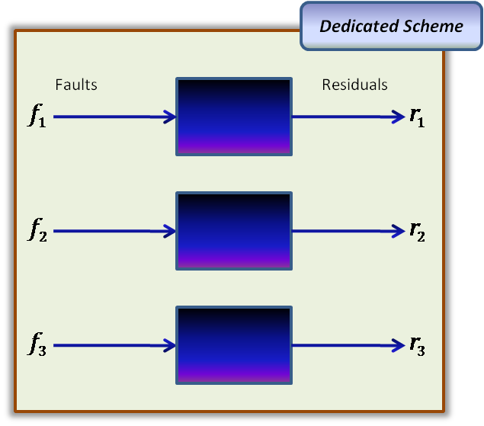
Figure 5: Dedicated Structure Residual Set
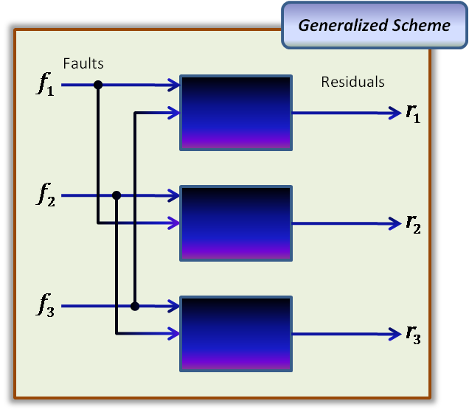
Figure 6: Generalized Structure Residual Set

Fixed Direction Residual Vector
An alternative method of achieving the isolability of faults is through the design of directional residual vectors. As seen in Figure 7, the directional vector$\overset{⃑}{r}$, corresponding to a particular fault, lies in a fixed fault specific subspace of the residual space. The basis for the isolation of a fault is the fault signature subspace$\overset{⃑}{ l}$. The fault signature subspace is determined by defining the effects associated with each unique fault. A fault is isolated by determining which fault signature creates the smallest angle with the fault specified subspace. In Figure 7, for example, the directional vector$\overset{⃑}{r}$ corresponds best with fault signature subspace$\overset{⃑}{ l}\left(f_{1}\right)$ because they obviously create the smallest angle.

Fault Identification
Recall that the importance of fault identification is subjective in the field of fault diagnosis. As the preceding discussions have explained, fault detection and isolation can be achieved relatively easily. However, there has not been much research in the area of fault identification conducted; therefore, literature information is extremely limited.
The previous section presented an introductory discussion for the development of fault detection and diagnosis for measured signals. Traditional fault detection methods via single output signals include limit and trend checking and single measurement analysis. However, most of the attention has been focused on fault diagnosis of multiple signals using residuals, resulting from system redundancy, for detection and isolation functions.
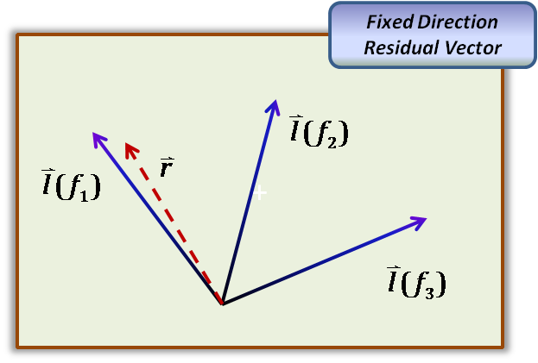
Figure 7: Directional Residual Vector for Fault Isolation

Fault Detection and Diagnosis in Aerospace Literature
The introduction touched on the how the PHM system for the planned JSF is the key component of the CBMplus support system for this weapon platform. The expected benefit of an integrated PHM system on this aircraft and it ability to initiate the autonomic functions as compared to legacy aircraft includes:
- Higher reliability of the aircraft, improving overall readiness
- Near real time assessment of aircraft
- Monitoring of life usage data for components parts
- Reduction in the cost of aircraft maintainability
The JSF program is a unique opportunity for taking advantage of available PHM and CBM technologies. Designers and researchers are mindful that this program involves more than the development of a multi-branch aircraft. It is the development of a new concept that centers on the platform of an intelligent aircraft that encompasses a comprehensive PHM capability that enhances flight safety and deployment readiness by engaging its own automated logistics, which Hess and Fila [24] of the Naval Air Systems Command (NAVAIR) referred to as an Autonomic Logistics (AL) system. The AL system is a CBMplus supportability concept that will enable the health management system (HMS) of the JSF to initialize its own maintenance procedures; therefore, allowing for better utilization and more efficient operation of the aircraft while maintained at lower cost. Since the JSF is currently under development, designers have a unique opportunity to take full advantage of the on-going research and resulting technologies to not only build an intelligent aircraft but to do so with aging aircraft in mind. Even though the engineers of the JSF have the benefit of incorporating a PHM system early on, one of the major goals is to design a system that can be adapted to legacy aircraft. Therefore, the addition of instrumentation or sensors for the purpose of performance evaluation beyond that is currently available is to be avoided.
Various health monitoring, detection, and diagnosis technologies have been developed for aerospace applications. The following section describes some to the ongoing health management research that is currently being conducted in the area of aircraft and aerospace systems.

Propulsion, Structural, and Avionic Health Management
There is and will continue to be substantial research in the health management of aerospace systems. Tolani et al [25] introduces a new algorithm to identify slow time scale anomalies for aircraft gas turbine engines using symbolic dynamics and information theory. Furthermore, they compare this new tool with traditional pattern recognition tools of principal component analysis and artificial neural network. Brotherton et al [26] discusses several of the approaches to the development of monitoring , diagnosis, and prognosis of component failures in turbine engines. The authors present techniques that couple neural nets and automated rule extractors. The resulting integrated approach is then compared to traditional PHM systems.
Munns and Kent [27] talks about the three principal structural degradation modes of commercial and large military aircraft: accidental damage, environmental damage, and fatigue. They present their discussions with specific examples of these degradation mechanisms and their possible causes. A brief explanation of how air carriers are currently developing and implementing structural maintenance programs is included. Finally, the authors present sensor and data management strategies that might be incorporated in a health management system. However, these strategies involve the development of and implementation new sensor technologies on new aircraft that offers little benefit to legacy aircraft.
Vichare and Pecht [2] presents the state-of-practice and the current state-of-research in electronics health management. Their review presents discussion of four current approaches including built-in-test (BIT), use of fuses and canary devices, monitoring and reasoning of failure precursors, and modeling accumulated damage based on measured life-cycle loads. The authors provide good descriptions of each approach alone with their drawbacks. For example, they noted that despite the apparent sophistication of BIT, the approach tends to have either a significant number of false alarms, or missed alarms.
Orsagh et al [28, 29] reports on their work in developing prognostics for avionic systems. They selected two avionics applications, a switch-mode power and a global positioning system (GPS) receiver, to demonstrate the validity of applying prognostics techniques to electrical systems that had been developed for mechanical systems. Both applications were accelerated to failure by exposing them to specific environmental conditions. The GPS was placed into an environmental chamber exposing it to thermal cycling while a principle feature value (PFV) was monitored. From a series of thermal cycling of two different units, the authors were able to develop an equation that predicted the PFV at a given number of cycles. The power supply devices were accelerated to failure by exposing them to extreme electrical and thermal stresses. With this device, the authors reported that diode failure was the resulting failure mechanism, which is indicated by a notable feature in the shape of the power loss curve resembling that of electro-migration.

Electrical Generator Health Management
As previously discussed, aircraft require a substantial amount of electrical power for take-off flight, and landing operations. This power is provided both externally and internally with the integrated drive generators (IDG) being the main on-board power source. The fast and accurate detection and isolation of faults are necessary for the safe and reliable operation of the IDG and the aircraft. Several approaches for fault detection and diagnosis of synchronous generators are described in literature.
Megahed and Malik [30] use an artificial neural network (ANN) to emulate the dynamic behavior of the synchronous generator. The scheme that they present consist of two feed forward neural networks (FNN). Its function is to differentiate between three generator states: normal, external fault, and internal fault. The neural network is trained using various data sets. The first ANN model consists of seven currents with each current having five samples totaling 35 inputs, which are mapped to the three generator states. It is a three-layer FNN with 18 and 10 tan-sigmoid neurons in the first and second hidden layers respectively, and the output layer contains 3 log-sigmoid neurons. A trip-logic module is utilized to alarm when it confirms that the output of the fault detector is either an internal fault or a prolonged external fault. If an internal fault is indicated, then the second ANN model is activated. This logic module is also composed of two parts. The first part is a three-layer ANN that classifies the phases as either faulty or healthy. The first and second layers consisting of fourteen and seven tan-sigmoid neurons respectively and the output layer has three log-sigmoid neurons. The second part of the module is a fault classifier that averages the FNN output.
However, Tantawy et al [31] points out that the use of neural networks requires large, comprehensive data sets to capture different modes of operation, and unless sufficient data is available to cover the range of faults and conditions, then the classifier will be inadequate. Therefore, they present a physical based fault detection approach that focuses on the electrical subsystems. This type of model usually calculates the excitation current mathematically and compares it to the measured exciting current. Tantawy et al expands on the approach by creating a hybrid model that captures the machine transients. Their model successfully simulated both normal and fault conditions and showed that faults were apparent in some signals, like damper winding currents.
A fault in the generator, inter-turn or ground, produces additional flux harmonics in the air gap which can be related to the cause of the fault. The flux is not pure sinusoidal even during normal operation due to the magneto-motive force (mmf) distribution. However under faulty conditions, the flux harmonics in the air gap are detectable due to the increase magnitude in different windings [31].
Several techniques have been proposed that uses these harmonics. Harmonics caused by a fault condition in the field and armature windings are used to classify field and armature inter-turn faults, short-circuited diodes, phase to ground faults, and external faults [32]. Field and armature shorts can be diagnose by using the harmonic generated in the rotor winding [33]. However, the detection of faults due to changes in the harmonic flux of the air gap requires additional sensors, which would be expensive if implemented in legacy aircraft.
As discussed, much work as been performed in the areas of monitoring aerospace system for faults and identifying their cause. Several approaches have been proposed for accomplishing these tasks including neural networks, physics-based models, and protective components like fuses or canary devices. This paper, however, introduces a novel approach for an aircraft generator using an empirical (data-based) model, specifically memory-based kernel regression, and extracted features from the frequency domain of a single measured signal.

Empirical Modeling Approach
Modeling is a fundamental tool used by scientist and engineers from virtually every field to describe relations between observable events or situations. The first models developed, like Newton's Laws, were based on general observations made from the interactions of the environment and are referred to as first-principles models. It is these mathematical models and the physical equations resulting from them that modern science and engineering is based. However, first-principle models are rarely able to incorporate all of the effects an environment may have on a system. Even if highly accurate first-principles models are developed for a system, the models will become obsolete as the system degrades or changes from its original design basis.
However, first-principles models are not the only category of modeling available to modern science and engineering, especially with the aid of computers. Empirical models developed from historical data consisting of parameter measurements collected over the operating range of a system seek to learn the relationships between these recorded measurements to foster better process understanding. With improved understanding of the relationship between operating parameters, the monitoring of a system for the detection and diagnoses of an abnormal event becomes possible. In short, a data-based empirical model's ability to "learn" parametric relationships allows for the development of supervised systems, defined by Isermann [12] as a system that is able to detect, evaluate, and diagnose, the occurrence of faults.
The previous section examined a method that utilizes predictive models to estimate operational parameters, system states, or measured signals. These predictions are compared to nominal values to generate residuals, which are used for system health evaluation. If a fault is detected, the symptomatic residuals are processed to identify patterns that are indicative of prior anomalies. This work seeks to extend the use of data-based models as nominal signal estimators for the purpose of cross checking actual corresponding signals. This cross checking function serves as a way to generate symptomatic residuals that are very similar to traditional residual-based fault detection and diagnosis routines.
The next sections discuss the development of a non-parametric modeling approach using kernel regression, which has been successfully deployed in on-line monitoring applications. First, a general overview of kernel regression is introduced. Following this discussion, various model architectures utilizing this approach are presented. Thirdly, model performance metrics relative to system or process health monitoring are identified. Finally, a brief discussion of model optimization is presented.

Kernel Regression
Kernel Regression (KR) is a non-parametric regression technique that estimates an expected value of a real random variable with respect to a conditional probability distribution. This particular definition seems to be broad and non-specific. Therefore, for the purpose of the work described herein, kernel regression is specifically defined as an empirical modeling technique that utilizes a probability density function alone with historical memory observations to estimated response variables based on a weighted average. This section provides an overview of the KR algorithm as detailed by Garvey [21] beginning with a top-level description of the methodology. Following this, his method of quantifying similarity via distance measures and kernel functions are discussed.
Atkeson et al [34] defines kernel regression as a statistical approach of fitting constants using locally weighted averages of historical, exemplar observations. Garvey [21] details kernel regression via the following example. Consider the case where n observations of an input, X, and an output, Y, has been collected. In order to estimate the output for a given observation of input, the following equation, referred to as the Nardarya-Watson estimator, can be utilized.
$\hat{y}(x)=\frac{\sum_{i=1}^{n}{\left\{K_{h}\left[d_{i}\left(X_{i},x\right)\right]Y_{i}\right\}}}{\sum_{i=1}^{n}{K_{h}\left[d_{i}\left(X_{i},x\right)\right]}}$ (3.0)
where: n is the number of exemplar observations in the KR model
$X_{i}$ and Y_{i} are the $i^{th}$ observation of the input and output exemplars respectively
$x$is a query input
$K_{h}\left[d_{i}\left(X_{i},x\right)\right]$is a similarity function
In order to facilitate the understanding of the mechanics of the Nardarya-Watson estimator, Garvey discusses the steps implemented in KR and relates each step to terms of the estimator. As such, the KR methodology is broken into three steps for a given query of inputs:
- Calculate the distance of the query from each input exemplars.
- Convert the distances to weight, similarities, via a kernel function.
- Determine the output prediction by calculating a weighted average of the output exemplars.
Before discussing each of these steps, it is necessary to clarify the inputs X and outputs Y, which the KR model seeks to imitate. These input and output are observations vectors, which form the memory of the KR model and are often referred to as exemplars. For purposes of discussion, let the input observations consist of p input variables and the output observations consist of m output variables. Therefore, the X input and Y output exemplars make up the memory matrices with dimensions of $n×p$ and$n×m$, respectively.

Step 1 – Distance Calculation
A distance calculation quantifies the proximity of the query to each input exemplar. Although several distance functions may be used, the Euclidean distance, which is also referred to as the L²-norm, is the most common. For a single query input, the Euclidean distance for the $i^{th} 1×1$ exemplar is given by:
$d\left(X_{i}, x\right)=\sqrt{{(X_{i}-x)}^{2}}= X_{i}-x$ (3.1)
When the query is an $1×p$ input vector, the Euclidean distance for the $i^{th}$ exemplar becomes:
$d_{i}\left(X_{i}, x\right)=\sqrt{{(X_{i,1}-x_{1})}^{2}+{(X_{i,2}-x_{2})}^{2}⋯{(X_{i,p}-x_{p})}^{2}}$ (3.2)
where: $X_{i}$ is the $i^{th}$ exemplar observation vector of p process variables
$x$ is the query observation of the p process variable or measures.
The resulting column vector d contains the distance of the query to all of the input exemplar observations. As mentioned, there are several alternative distance functions that may be used. One such alternative is the Adaptive Euclidean distance. This function not only calculates the query distance but it also excludes those queries that lie outside the minimum and maximum input exemplar observations. However, a detail discussion of the Adaptive Euclidean distance function is beyond the scope of this paper, and the interested reader is referred to Garvey and Hines [35].

Step 2 – Similarity Quantification
The $n×1$ vector of distances is then transformed in to a $n×1$ vector of weights via a kernel function in order to quantify the similarity of the query vector to the input exemplar. Although several kernel functions, such as the inverse distance, exponential, absolute exponential, uniform weighting, triangular, biquadratic, and tricube kernel [34] are available, the most commonly used and generally an adequate selection is the Gaussian kernel function. The following equation defines the $i^{th}$ weight corresponding to the $i^{th}$ distance of the $n×1$ distance vector:
${w_{i}= K_{h}\left[d(X_{i},x)\right]}_{i}=\frac{1}{\sqrt{2πh^{2}}}e^{\frac{-d_{i}^{2}}{{2h}^{2}}}$ (3.3)
The result of Equation 3.3 is a column vector of n weights that represent the similarity of the $n×1$ query vector x to each observation vector of the input exemplar. Note that the h term in equation 3.3 refers to the kernel's bandwidth, which can be thought of as a regularization parameter. A more detailed discussion of this parameter is presented in subsection 3.3.1.

Step 3 – Output Prediction
With the final step, the prediction is the sum of the product of the transposed weight vector and the output exemplar $Y$divided by the sum of the weight vector. The following equation generalizes this step:
$\hat{y}\left(x\right)=\frac{\sum_{i=1}^{n}{{(w}_{i}Y_{i})}}{\sum_{i=1}^{n}{w_{i}}}=\frac{w^{T}Y}{\sum_{i=1}^{n}{w_{i}}}$ (3.4)
With each of the KR step described, the similarity function is now mapped to a real number, a weighting coefficient, based on a Gaussian probability density function and the relative distance between queries and historical observations. Substitution of terms has transformed the expression on the right side of equation 3.0 to the generalized weighted-average expression of equation 3.4. The next task is the implementation of equation 3.4 as the core of several data-driven prediction models.

Model Initialization
With the general method of mapping a query to weights presented, attention is now turned to the initialization or format of a specific model. In order to determine the format of a model, it is necessary to determine the architecture type and required variables as illustrated by Figure 8. The following discussion focuses on three architectures, which are utilized by this specific kernel regression methodology, and the optimum selection of predictor and response variables.

Architecture Types
The architectures (inferential, heteroassociative, and autoassociative) are characterized by the number and type of model inputs and outputs. An inferential model (a) uses a query with p input parameters to predict single output parameter. A heteroassociative model (b) illustrates the use of a query with p input parameters to infer m output parameters. Note, however, m may or may not be equal to p, but must be great than one. Finally, an autoassociative model (c) uses a query with p input parameters to predict corrected values of the same query as output values. Garvey [21] describes each of these architectures using the three step kernel regression process discussed in the previous section. Those descriptions are summarized in the following paragraphs.
Furthermore, the same conventions and simplifications utilized by Garvey are also used here, and are as follows:
- The query observation is assumed to be within the training range which allows the application of Euclidean distances as represented by Equations 3.1 and 3.2.
- Noting that the weighted sum of the outputs is normalized by the sum of the weights, Garvey defines the sum of the weights as a scalar via the following:
$a=\sum_{i=1}^{n}{w_{i}}$ (3.5)
- Using the preceding equation and the definition of weights, Equation 3.5, the Nardarya-Watson estimator can be written as:
$\hat{y}\left(x\right)=\frac{\sum_{i=1}^{n}{(w_{i} Y_{i})}1}{a}=\frac{w^{T}Y}{a}$ (3.6)
At this point, the three steps of the KR modeling process are applied relative to each of the three architectures. The first two steps, the distance calculation and the similarity quantification are the same for each of the architectures; therefore, are presented in reference to all three. The third step however, is different for each of the architectures and presented individually for each.
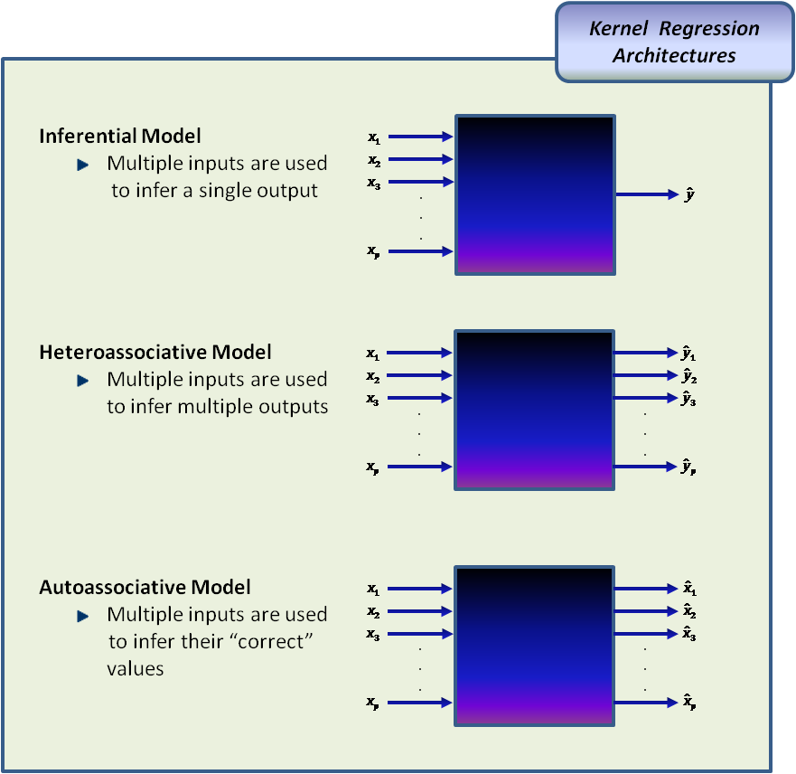
Figure 8: Modeling Architectures
Recall that the first step is the calculation of the distance of query x from each of n exemplar within the memory matrix. The direct application of Equation 3.2 results in the following column vector of n distances.
$d=\left[\begin{matrix}d\left(X_{1},x\right) \\ d\left(X_{2},x\right) \\ ⋮ \\ d(X_{n},x)\end{matrix}\right]$ (3.7)
With the distance vector determined, the next step is its transformation into a column vector of n weights via a kernel function as illustrated by Equation 3.3. As stated, the Gaussian kernel function most commonly used, but several alternatives are available. The following is the column vector of n weights is the resulting similarity quantification.
$w=\left[\begin{matrix}w_{1} \\ w_{2} \\ ⋮ \\ w_{n}\end{matrix}\right]$ (3.8)
Now that the first two steps of the kernel regression methodology are complete, the third and final step of the process, the output estimation, is presented. It is important to understand that although the type and number of expected output parameters is dependent upon the particular architecture, the form of the Nardarya-Watson estimator is valid for all three architectures. In consideration of this, the outputs of each architecture type, respective to its application of Equation 3.6, are briefly discussed.

Inferential Architecture
The inferential architecture uses a $1×p$query, where p represents one or more process variables, to predict a single output value$\hat{y}$. Although inferential KR models most commonly use independent input query values to infer a related, dependent output value, they can be used to estimate a specific input parameter. Nevertheless, this particular architecture produces a single output via the following application of Equation 3.6:
$\hat{y}\left(x\right)=\frac{w^{T}Y}{a}=\frac{1}{a}\sum_{i=1}^{n}{(w_{i} Y_{i})}= \frac{1}{a}\left(w_{1} Y_{1}+w_{2} Y_{2}+⋯+w_{n} Y_{n}\right)$ (3.9)

Heteroassociative Architecture
It follows that if an inferential KR model infers a single output, then it can be adapted to infer multiple outputs. As already discussed this type of model is referred to as a heteroassociative model, and is characterized by its use of a query with p inputs to predict m outputs. Like inferential KR, the outputs of a heteroassociative model may or may not be that of the inputs, but again it is mostly used to predict related dependent values of the input values. Obviously, only the results of this third step differ in the modeling process. That is, given a column vector of n weights, the m output predictions for a heteroassociative KR model are calculated according to the following application of Equation 3.6:
$\hat{y}\left(x\right)=\frac{w^{T}Y}{a}=\frac{1}{a}\left[\sum_{i=1}^{n}{\left(w_{i} Y_{i,1}\right) \sum_{i=1}^{n}{(w_{i} Y_{i,2})} ⋯ \sum_{i=1}^{n}{(w_{i} Y_{i,m})}}\right]$ (3.10)
The $Y_{i,m}$ term of in the above equation is the${ i}^{th}$ exemplar observation of the of the ${ m}^{th}$ exemplar parameter.

Autoassociative Architecture
Finally, an autoassociative KR model is like the heteroassociative model in that it uses a query of multiple input parameters to estimate multiple outputs parameters. However, unlike the heteroassociative model, this particular KR model does not make predictions of related, dependent variables. An autoassociative model is a correction model. This type of model takes a query of p parameters in which one or more of these parameters may be faulted and predicts the expected value of the parameters. In order to achieve this functionality, Equation 3.6 must be modified by replacing the output exemplars Y with the input exemplars X. Therefore, the input exemplars perform the same function as that of output exemplars. These corrected output parameter values are determined by the following version of Equation 3.6:
$\hat{x}\left(x\right)=\frac{w^{T}X}{a}=\frac{1}{a}\left[\sum_{i=1}^{n}{\left(w_{i} X_{i,1}\right) \sum_{i=1}^{n}{(w_{i} X_{i,2})} ⋯ \sum_{i=1}^{n}{(w_{i} X_{i,p})}}\right]$ (3.11)
The $X_{i,p}$ term is the ${ i}^{th}$exemplar observation of the ${ p}^{th}$exemplar variable.

Variable Selection
There are a number of proposed techniques that have been used for the optimal selection of input variables for an inferential model. Examples of such methods include Ordinary Least Square Regression and Least Absolute Shrinkage and Selection Operator Regression (LASSO). However, due to the fact that the problem of variable selection is improperly posed, the success of these and other proposed techniques is limited. Practitioners often find that the various techniques can produce different selection results due to either minor changes within the data or different assumptions that were used to derive a specific methodology. Therefore, practitioners often use very simple correlation methods to determined those variables that are statistically related [36].
Correlation analysis is the most simple and straightforward method used for the selection of predictor variables. In the simplest terms, this analysis identifies those variables having the highest correlation with corresponding response variables. This analysis usually assigns a value indicating the strength of the correlation between two variables in the form of a coefficient. These coefficients range between -1 and 1 which is a measure of how one variable varies with another. The sign of the coefficient indicates the direction in which the variables are correlated with the other.
With correlation analysis, there exists the possibility of selecting a large number of predictors in the presence of many highly correlated variables. Depending on the functionality of a specific model, this tendency of selecting too many predictors can be an advantage or disadvantage. For example, the function of an autoassociative model is to generate responses that are corrected versions of the predictors. In this case, the selection of several highly correlated predictors is advantageous. On the other hand, the selection of several highly correlated predictors for and Inferential or heteroassociative model can be a disadvantage due to the complexity added to the model. Nevertheless, in either case the practitioner can control variable selection by using limiting criterion to defining levels of correlation.
However, one of the more notable disadvantages of using correlation analysis is the methods sensitivity to the presence of outliers and spikes due to random noise within data sets. For example, an analysis of a data set with two independent random noise variables with similarly timed large noise spikes could indicate that these two variables could have a correlation coefficient of over 0.9. Therefore, it is important that the data be inspected and if necessary clean by not only removing outliers and random noise but also by correcting other common problems such as missing data, drifting data, stuck data, collinearity, and sampling rates.

Model Optimization
Previously sections described a three step methodology, which a query in the form of an observation vector with p variables is inputted into a memory-based kernel regression model in order to predict the occurrence of an event within a monitored process. Three architectures types along with the most common and simplest technique for the selection of input variables for which this methodology can be initialized were also presented. With the exception of architecture, the parameters that most significantly impact a model's performance have only been mentioned in passing and therefore require more detailed discussion. The parameters that best optimize a memory-based kernel regression model include the kernel bandwidth and memory vector selection (including selection method and the number of vectors selected.

Kernel Bandwidth
Recall that the kernel function of Equation 3.3 contains an h term that defines the kernel's bandwidth. This term is considered as a modeling regularization parameter because it has a significant effect on the amount of bias and variance associated with the model. One challenge of data model development is to achieve accurate results with minimum bias and variance. Due to inverse affect that bandwidth size has on the bias and variance generated by a model, the practitioner must seek a balance between them while maintaining acceptable accuracy. Therefore, the selection of an appropriate bandwidth is a key part of non-parametric regression fitting.
In the case of kernel regression, the regularization parameter affects the bias and variance relationship by controlling which effective distances are deemed similar [21]. An explanation of how this control is exerted either increasing or decreasing the size of the kernel bandwidth, illustrated by Figure 9, is best presented by Hines [1, 37].
Consider a Gaussian kernel function with a small bandwidth, Plot A of Figure 9. This kernel function generates large weights for those input exemplars that are very near to the query observation. As a result, only a small number of these exemplars significantly influence the model's prediction. Therefore, information contained within the model's memory matrix with greater distances from the query is not utilized in its output estimation. This under utilization decreases the model's capabilities to produce accurate, consistent estimates for those parameters that lie between training states and results in an overall rough input-output relationship.
Next, consider a Gaussian kernel function with a large bandwidth, Plot B of Figure 9. In this case, the larger bandwidth is less specific and assigns significant weights to a larger range of distance values. Therefore, a relatively large number of exemplars would influence the resulting estimation and act to smooth the input-output relationship. Although a smooth input-output relationship is desirable, the use of a kernel bandwidth that is too large would cause the model's predictions to approach the mean value of the exemplar. As a result, the weights become evenly distributed across all the observation instead of being concentrated on a single or handful of data. In this situation, the model’s fit is over smoothed, thus, biasing the solution.
The selection of a kernel bandwidth is a tradeoff between the perceived roughness and smoothness parameters that balances the variance and bias, Plot C of Figure 8. This concept of bias-variance tradeoff leads naturally to the minimization of a prediction error that combines both of these model characteristics. A common measure of prediction error is the mean squared error (MSE). The MSE for a single variable is defined by the following equation [37]:
$MSE= \frac{1}{n}\sum_{i=1}^{n}{{\left[y_{i}-\hat{y}\right]}^{2}}$ (3.12)
where: $n$is the number of test observations
${\hat{y}}_{i}$ is the model prediction of the i^{th} test observation, and
$y_{i }$is the actual value of the i^{th} test observation
MSE is also defined has the sum of a model's variance and bias squared as formulated in the following:
$MSE=Var\left(\hat{y}\right)+{Bias\left(\hat{y}\right)}^{2}$ (3.13)
As a result of Equation 3.13, MSE is a useful criterion for the determination of optimal bandwidth, and thus applied to the work presented herein. MSE, as discussed later, is the most cited performance metric indicating a model’s accuracy. However, unlike the determination of a model's accuracy, the MSE in this case is determined by data sampled from the same set as that used for model training.
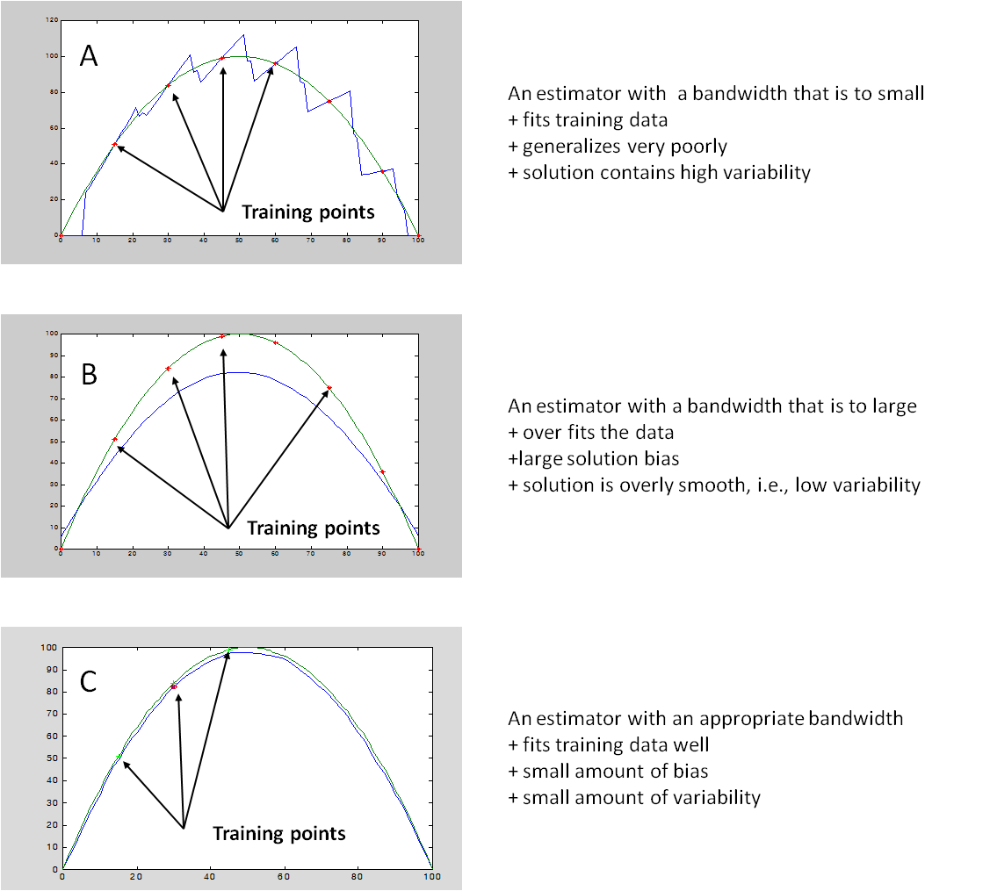
Figure 9: Effects of Bandwidth Size[38]
It should be noted that technically, equation 3.12 includes a weighting term in the summation. However, Härdle [39] concluded that the weight function does not significantly influence the selection of the proper regularization parameter. Therefore the weighting term is often assumed to have a value of one.

Vector Selection
Vector selection is critical in the development of an empirical non-parametric model. As discussed, step 1 of the kernel regression methodology compares a query with historical observations called exemplars or memory vectors by quantifying a distance measure between them. Since a query is compared to each observation within a memory matrix, the computational load for models containing large training data sets can become a hindrance, especially when dealing with near-real-time health management systems. In order to lessen the computational burden of large, complex, memory based models, a subset of observation vectors is chosen from the training set. The following section focuses on the three methods of selecting sets of exemplars and the considerations that affect the number of vectors chosen.

Selection Methods
There are five traditional vector selection methods (min-max, vector ordering, min-max/vector ordering combination, fuzzy c-means clustering, and Adeli-Hung clustering) described by Hines and Garvey [40]. The latter two, fuzzy c-means and Adeli-Hung clustering methods, are relatively new and have not been integrated into commercial monitoring systems [37]. Given this consideration and for the reason that the min-max, vector ordering, and min-max/vector ordering combination is computationally less intensive, only these three methods are discussed for the sake of brevity.
The first of these methods is min-max in which the exemplars are selected via the following procedure. The data matrix is first broken into a series of bands. Second, two vectors, one containing the local minimum and the other containing the maximum, are selected from each band.
The number of bands${ n}_{b}$ is determined via the ratio of the number of exemplar specified n_{m} and divided by twice the number of p variables. The ratio is expressed by the following notation:
$n_{b}=\frac{n_{m}}{2p}$ (3.14)
The above definition can be rationalized by considering the general case of selecting n vectors form a training data matrix with p variables. The number of bands that the data set must be broken into is a function of the number of exemplars that are to be selected from each band. As the name of this selection method implies, the minimum and maximum values of each variable are selected from each band. As a result, 2p vectors, one containing the minimum value and one containing the maximum value, are selected from each band. Therefore, the number of bands needed to select n vectors is equal to the ratio previously defined. It should be noted that the min-max vector selection technique guarantees that the vectors are bound by the training's data's operating range. However, the selected vectors may not sufficiently cover the intermediate values between the local minimum and maximums.
The next selection method is referred to as vector ordering. This method orders the vectors according to some criteria and then periodically samples them until the specified number, n_{m}, of memory vectors is obtained. The criteria for ordering the vectors in this discussion is based on the Euclidean norm N, which is the square root of the sum squares the i^{th} observations of the p variables.
$N=\sqrt{p_{i,1}^{2}+p_{i,2}^{2}+p_{i,3}^{2}+⋯+p_{i,j}^{2}}$ (3.15)
The vectors are then ordered from smallest to largest of the calculated Euclidean norm. The number of sequential sampling steps n_{s} is determined by dividing the total number of vectors n by the number of vectors to be selected n_{m}. The memory vectors are selected by sampling every n_{s} sorted vector. It should be noted that the Euclidean norm is a distance measure of the i^{th} observation from the origin. As a result, a vector ordering based on the Euclidean norm is related to the location of the origin and therefore the data should be mean-centered and scaled to unit-variance before this selection method is applied.
The third selection method is a combination of the min-max and vector ordering methods. The previously discussed selection methods are combined in an effort to select vectors that bound the data operating range (min-max method) and sufficiently span the intermediate values (vector ordering). The two methods are combined via an algorithm consisting of the following two steps. First, vectors are selected according to the min-max vector selection and removed from the data matrix. Then, the remaining vectors are selected using vector ordering. To summarize, 2p vectors are selected via min-max selection with the remaining vectors${(n}_{m}-2p)$ selected by using the vector ordering method.

Number of Memory Vectors
The number of exemplars selected to be used in an empirical model controls the number of operating points that represents the monitored system. Similarity based modeling techniques utilize a query's similarity to historical observations to infer the model's response. It can be seen that the comparison of a query vector to large data set becomes not only cumbersome, but computational expensive. As vector selection is an important consideration for model development, the identification of the appropriate number of memory vectors should also be carefully considered. Too few memory vectors will give a fast run time, but poor overall model performance. On the other hand, too many memory vectors results in improve model performance, but at slower computational speeds. Just as modeling is the result of compromises between model performance and model complexity, the number of memory vector is a compromise between performance and run time. This balance is based on the specific needs of the modeling system.
As with other characteristic optimization, the goal of optimizing the number of exemplars is to minimize model accuracy or uncertainty while an acceptable operational coverage. Both of these objectives are balanced with minimizing model run time.

Model Performance Evaluation
Recall that a supervised system must be able to detect, evaluate, and diagnose the occurrence of faults. At the center of a supervised system, is a predictive model that emulates a monitored system's operation during normal conditions. Therefore, the performance of a predictive model used for purposes of system monitoring must be evaluated and quantified within the context of the following three questions:
- How well does the model predict sensor or process parameter values?
- How does the model respond to faulted inputs values?
- How much degradation within a sensed signal or monitored system must occur before the model is able to detect it?
The following section presents five performance metrics that answers the above questions by quantifying the accuracy, sensitive, and detectability for a given model. It should be noted that these particular metrics are traditionally used to evaluate the performance of an autoassociative model. Hence the models presented herein is based on heteroassociative architecture, the discussed metrics, with the exception of accuracy, are not directly applicable. Nevertheless, a brief review of each metric has been included for completeness.

Accuracy
The first of these metrics quantifies the agreement between the model's estimates and the actual sensor or parameter values given unfaulted input values. As alluded to earlier, the most commonly cited accuracy metric is simply the mean square error. However, for the purpose of quantifying a model's ability to produce predictions both correctly and accurately, this metric should be generated from data that was either sampled before the training and testing data was sampled, or form a different data set all together[41]. Although accuracy is a significant indicator of a model's performance, its ability to monitoring a system for the purpose of fault detection must also be quantified.

Sensitivity

The accuracy of a model quantifies its response to unfaulted input data, but for fault detection systems, a determination of how a model's response to faulted input must also be made. These metrics are generally referred to as sensitivity measures; that is, how sensitive is the model to input data from operations under abnormal conditions. Model sensitivity is simply the change in an output prediction ${\hat{y}}_{i}$produced by a change in the input$x_{i}$:

$S_{i}=\frac{∆{\hat{y}}_{i}}{∆x_{i}}$ (3.16)

The following discussion presents two sensitivity metrics used to quantify the effect of input data from a faulty system.

The auto-sensitivity or robustness metric is the model's ability to make correct output predictions when the corresponding input is incorrect due to some fault. That is, robustness measures how a faulted variable input affects predictions of itself by quantifying the effect of sensor drift[42]. The following expression defines the auto-sensitivity for the i^{th} sensed measurement [37, 41, 42]:

$S_{A_{i}}=\frac{\sum_{k=1}^{N}{\left|\frac{{\hat{x}}_{ki}^{drift}-{\hat{x}}_{ki}}{x_{ki}^{drift}-x_{ki}}\right|}}{N}$ (3.17)
Here, ${\hat{x}}_{i}$ is the unfaulted prediction ${\hat{x}}_{i}^{drift}$is the prediction with a faulted input $x_{i}$is the unfaulted input $x_{i}^{drift}$ is the drifted input and k is the index of the samples that define the operating region. A value of zero is desirable which means that the model is impervious to the input fault. However, as the metric approaches a value of one, the more sensitive to input fault and therefore the prediction tend to follow the fault. In this case, the resulting residual approaches zero leaving fault undetected. When the metric is a non-zero value, and then the sensor fault may be underestimate which may require that the fault tolerance be adjusted.
On the other hand, the cross-sensitivity or spillover metric indicates the effect that faulty input $x_{i }$has on non-corresponding predictions ${\hat{x}}_{j}$of the model. It is similar to the auto-sensitivity metric with the exception that the predicted component, indicated by index j is the unfaulted variable whose cross-sensitivity metric is being calculated [37, 41, 42].

${S_{C}}_{j }=\frac{\sum_{k=1}^{N}{\left|\frac{{\hat{x}}_{kj}^{drift}-{\hat{x}}_{kj}}{x_{ki}^{drift}-x_{ki}}\right|}}{N}$ (3.18)

Detectability Metrics
The detectability metric quantifies the smallest fault that can be detected by an empirical model. Two examples of fault detectability metrics is presented herein. They are the Error Uncertainty Limit Monitoring (EULM) detectability and Sequential Probability Ratio Testing (SPRT) detectability. Both metrics are positive values indicative of the detectability as a percentage of the mean measurement. Although EULM or SPRT is not used in the work presented in this paper, a brief review is to follow.
The EULM detectability indicates the smallest sensor fault detectable by an empirical model and is a function of the prediction uncertainty and the robustness of the model [42]. It can be define by the following equation with units of percentage:
$D_{{EULM}_{i}}=\frac{U_{i}}{E_{i}\left[x\right](1-S_{A,i})}$ (3.19)
Here, $U_{i}$ is sensor $i^{'}s$ 95% confidence interval $E_{i}\left[x\right]$ is it's expected or nominal value, and $S_{A,i}$ is the corresponding auto-sensitivity. Alternatively, the units of the above equation maybe express as percent of span if the $E_{i}\left[x\right]$ term were replaced by the span of the $i^{th}$ sensor [1, 37, 42, 43]. Note that EULM detectability increases as model auto-sensitivity increases resulting in the detection of only large faults.
The SPRT detectability parameter, on the other hand, is an anomaly detection performance metric that determines the smallest detectable faulted process parameter. The general procedure for implementing SPRT has already been provided Section 2.1.2.4 under the title Hypothesis Testing via SPRT and will not be repeated here.
Using this procedure, Hines et al [1, 37, 41] applied SPRT to the generated residuals between an actual measurement and an empirical model's prediction. The residuals are assumed to be normally distributed with a mean of zero and a variance of${ σ}^{2}$, which is the random variation of the measurement. This assumption allows the probability distribution function for the normal model of the residuals to be defined by the following:
$p(x/{H_{0})=\frac{1}{\sqrt{{2πσ}^{2}}}exp\left(-\frac{x^{2}}{{2σ}^{2}}\right)}$ (3.20)
From Equation 3.20 and the preceding description, the two degradation modes illustrated in Figure 10 are readily apparent. A mean shift up (+M) is shown in the first plot; whereas the second plot shows a mean shift down (–M). The random uncertainty is denoted by the spread of the Gaussian function. The SPRT simply determines it the residual sequence is more probably generated from the normal or faulted distributions.
The natural logarithms of the likelihood ratios for the upward and downward mean shifts are given in Table 2. Most implementations of the SPRT algorithm use these ratios are compared to the lower and upper boundaries defined by A and B, respectively, of Equation 2.9. For the interested reader, the derivation of the rations in Table 2 can be found in Humenik[44].
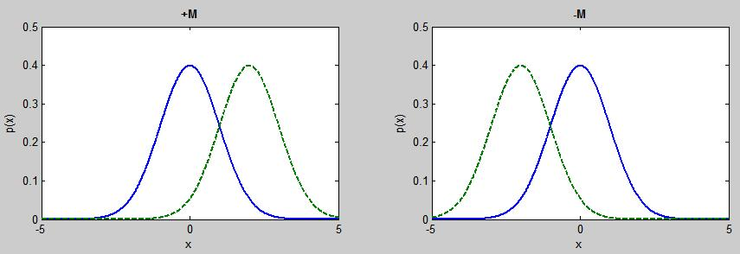
Figure 10: Illustration of Degraded Modes for Normal Distribution[41]

Table 2: Log Likelihood Ratio for Normal Distribution
Degradation Mean M and Variance σ²[41]

Degradation Mode | Log Likelihood Ratio
+M
–M
The size of the change in a sensor due to a fault that can be reliably detected by the SPRT is defined as the magnitude of M. An optimal M value is determined numerically by applying SPRT to unfaulted test data and locating the value that results in a false-alarm probability that is nearest the theoretical false alarm probability. By estimated the optimal M value $\hat{M}$ the following detection performance metric is obtained.
$D_{SPRT}=\frac{\hat{M}}{E\left[x\right]}$ (3.21)

Simulation Data
The data used in this work was provided by Hamilton Sundstrand, an OEM of aerospace products including electric power generation systems. Several data sets were generated from an in-house simulation using Simulink© that was seeded with faults emulating a feeder disconnection and/or open-circuit diodes. Two sets were used in this work and are described in the following subsections. However, since the simulation is proprietary and unavailable, a discussion of it has been omitted.

Integrated Drive Generator
Due to the wide use of electronic flight instrument systems, modern aircraft rely heavily on electrical power systems. The function of the aircraft electrical system is to generate, regulate, and distribute electrical power throughout the aircraft. There are several different power sources that an aircraft may utilize to provide for its electrical needs. These sources include integrated drive generators (IDG), auxiliary power units (APU), ground power unit (GPU), and ram air turbines (RATs). The IDG is driven by an aircraft engine and produces 115 VAC at 400 Hz which is used during normal flight. The APU is similar to the IDG with the exception that it is not engine driven. The APU most often provides power to the aircraft while it is on the ground during maintenance or for engine starting. In some aircraft the APU can be used as a backup power source during flight operation. A GPU is an external AC power source that may only be used with the aircraft on the ground. The final power sources that can be found on a modern aircraft are RATs. These units are used as an emergency power source in case of IDG or APU failure. These power generation systems are vital to the operational safety and readiness of both commercial and military aircraft.
As previously discussed, modern aircraft, private, commercial, and military, have large electrical requirements critical to aircraft take-off, flight, and landing systems. To meet these electrical needs most modern aircraft utilize an IDG. This device is an ultra-lightweight, brushless wound rotor synchronous electrical machine design to supply 400Hz, 3-phase power at 115V to the aircraft bus [45]. Kennett's [45] constant speed drive, CSD, description alone with Batzel's and Swanson's [43] description of an IDG is summarized. A cross-section of a typical Hamilton Sundstrand brushless, synchronous generator is shown in Figure 10. The schematic of Figure 11 provides a simplified illustration of how an IDG operates which is described as follows.
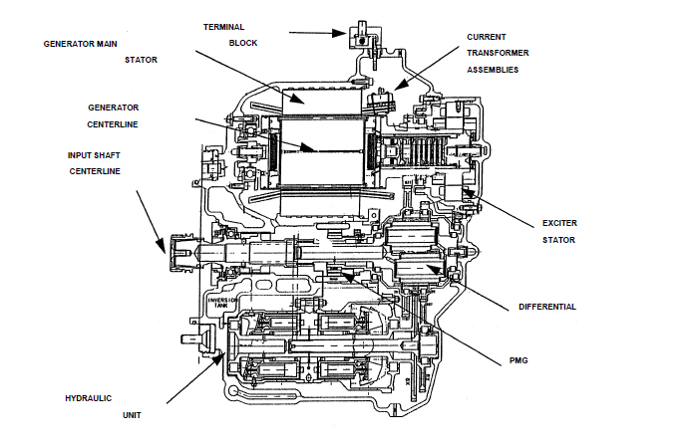

Figure 11: Typical Integrated Drive Generator Cross-Section [46]

Figure 12: Simplified Integrated Drive Generator Schematic [46]

The IDG consist of three constituent machines (an exciter armature, a rectifier, and a main armature) assembled on a common shaft and housed in a common frame. The shaft and housing are connected to the output of a constant speed drive (not shown), CSD, which is attached to the aircraft engine. As one may discern from the name, the CSD differentiates the rotation speed of the aircraft engine so that a constant rotation speed is maintain at the IDG. The first generator of the IDG is the pilot exciter, which is a permanent magnet generator, PMG. The PMG generates a DC current, i_{exc,} which induces a magnetic field (the exciter field). The strength or magnitude of the exciter field is determined by the generate DC current, which is automatically adjusted via a generator control unit, GCU. The constant speed rotation of the 3-phase exciter armature in this magnetic field induces a 3-phase voltage whose amplitude is proportional to the field strength. The induced 3-phase voltage is then converted by the rectifier to a DC current, i_{f}, which induces a second magnetic field. This magnetic field is induced within the main armature which, is a stationary 3-phase armature yielding electrical power flow to the main AC bus.

Discrete IDG Data
The first of the two data sets consist of the following four variables.
- Time (seconds)
- Exciter Field Current (amperes)
- Main Armature Current, each of three phases (amperes)
- Main Armature Voltage, each of three phases (volts)
The data is simulated at three static, balanced loads of 5, 40, and 90 kilowatts, and at each load, the data as a varying degree of either a single fault or combination of faults. The faults are indicative of varying levels of degradation of either a connection failure of an armature feeder lead (Type A), open-circuit within a diode (Type B), or a combination both. The levels of degradation are as follows:
${10}^{-1}Ω:$ No Degradation of feeder leads or circuit
${10}^{-6}Ω:$ Mild Degradation of feeder leads or circuit
${10}^{3} Ω:$ Failure of feeder leads or circuit
There are a total of 27 discrete data sets with 4001 observations and seven trackable signals each. Based on the run time and the number of samples, the calculated sampling frequency is 400025 hertz. Figure 13 shows the resulting data from the simulations with each subplot illustrating the affect of a specific fault or combination of fault has on the current at a loading of 5 kilowatts. That is, subplot 11

Figure 13: Exciter Current at 5 kilowatts

is representative of normal system behavior; whereas, subplot 33 indicates the effect of both faults on the exciter current.
Figure 13 also shows an interesting phenomenon that the effect that the severity of specific fault has on the pattern of the current. When the severity of either the fault due to the feeder connection or open-circuit diode is significantly high, the patterns become constant. This actually makes sense considering that the highest severity level of the particular fault would indicate complete failure of a one of the three feeder connections or one of the six diodes. Also note from the last row of subplots of Figure 13, the Type A fault supersedes that of the Type B fault. Similar phenomenon can be seen from Figures A-1 and A-2, of the exciter current at 40 and 90 kilowatts respectively.
Figures 14 and 15 demonstrate the effects that the power demand and the fault or faults has on the magnitude of the mean and variance of the current from the exciter field. Note that, as expected, when the demand for power increases the average exciter current increases as well. However, it appears that a specific fault or combination of faults has only a small affect, even when the severity of the fault may indicate a complete failure. This small effect is explained by the presence of the GPU which regulates the current from the PMG so that the power output of the generator meets demand even in the presence of the seeded faults. However, there appears to be an effect on variance of the exciter current, but this effect is only significant when one or both faults indicates complete failure.

Figure 14: Average Current Relative to Power and Fault Condition

Figure 15: Current Variance Relative to Power and Fault Condition
Figures 16 and 17, shows the voltage and current measurements from the main armature at 5 kilowatts respectively. As seen, neither of the faults or combination of faults has any affect on the output of these measurements. Once again this can be attributed to the GPU which masks the affects that these faults might how on the IDG power output. Therefore, the use of main armature voltage and current measurements are not indicated as likely trackable signals for these particular faults due to the corrective action of the GPU. Similar observations are noted in plots of other data sets at the 40 and 90 kilowatt loads, Figures A-3 through A-6.

IDG Continuous Data from Simulated Flight
Data generated from two simulations created dynamic profiles of the measurements from the IDG operation during two 100 second simulated flights. One flight, the f-series, is simulated in which no faults occur; whereas, the second flight, the g-series, is simulated in which six seeded faults occur at unknown time instances. Like the previous data, the faults consist of two types, an armature feeder lead disconnection, and a diode open circuit. However, these faults do not occur at different severity levels. Each occurring fault conforms to a one-second load sequence. As a result the simulated fault clears automatically at the end of the one-second period.
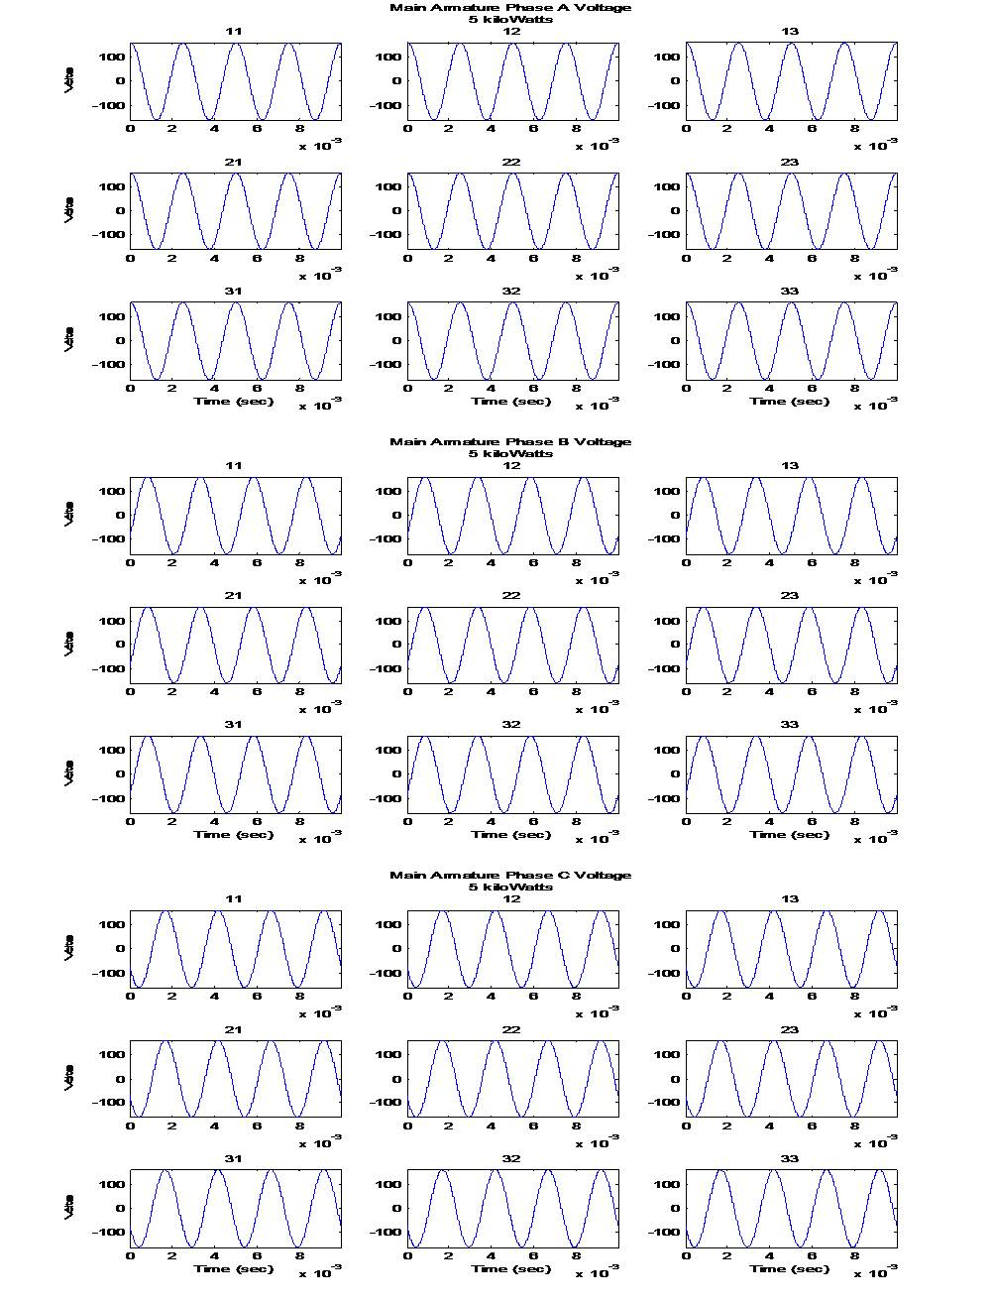Figure 16: Main Armature Voltage at 5 kilowatt
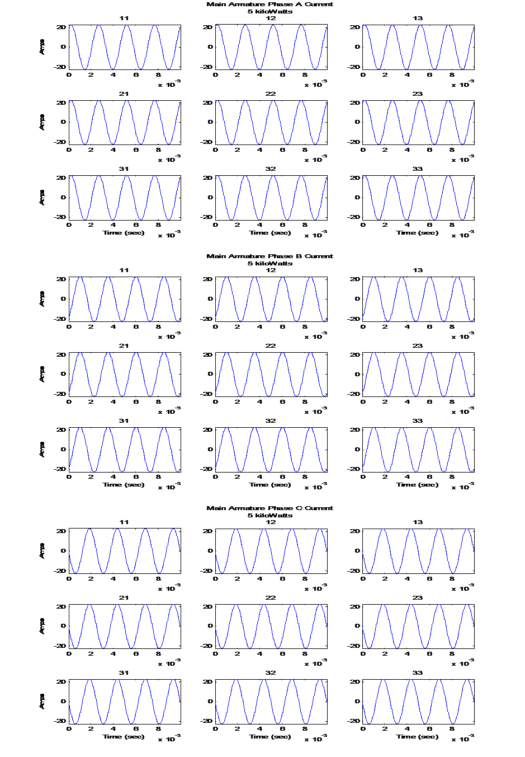Figure 17: Main Armature Current at 5 kilowatt

The 100 second flights are comprised of 7 different flight segments ranging from 5 to 40 seconds each, and have a power loading 20 to 60 percent of the 60 kilowatt nominal loading for the entire flight. For each segment, approximately 75 percent of the loading is resistive (linear) with the remaining being rectifier (nonlinear) loading. Furthermore, each load type is 75 percent steady loading with the balance being random over a range of ± 33 percent.
Each 100 second flight consists of 100 one-second periods in which the load condition is held constant. These one-second periods represents 400 cycles of the main generator AC and 1000 cycles of the exciter generator AC. It is assumed that the transient dynamics from the load switching occur within first several cycles of each generator. Therefore, the majority of the one-second period is considered to be at steady state. The data is sampled at a rate of 60 kilohertz.
As with the previous data sets, this data includes the following measurements:
- Time
- Exciter Generator Field Current
- Exciter Generator Field Voltage
- Main Generator Armature Current (3 Phase)
- Main Generator Armature Voltage (3 Phase)
Figure 18 illustrate the exciter current and voltage plots of the available measurements profiles for non-faulted 100-second flight. Figures 19 and 20 are plots of the main generator currents and voltages of same 100-second flight. As previously stated, the second flight simulation is seeded with six faults. The faulted flight data is plotted in Figures 21, 22, and 23 in the same manner as the non-faulted flight. Unlike the discrete data of the former subsection, the faults are not obvious, and provides opportunity to demonstrate the capability of the innovated method describe in the next section.

Figure 18: Flight Exciter Data from the Non-Faulted Flight

Figure 19: Main Generator Current Data from the Non-Faulted Flight

Figure 20: Main Generator Voltage Data from the Non-Faulted Flight
Figure 21: Exciter Data from the Faulted Flight

Figure 22: Main Generator Current Data from the Faulted Flight
Figure 23: Main Generator Voltage Data from the Faulted Flight

Univariate Monitoring
Traditionally, as explained in Section 2, model-based fault diagnosis systems utilize a variety of input measurements including operational information and sensed variables to simulate particular output measurements. These simulated outputs are compared to the actual outputs, and the differences are noted in the form of residuals. An analysis of the residues discerns whether the actual output is either within or has deviated from normal expected behavior. Indication of substantial deviation connotes the presence of an abnormality within the monitored system resulting in the engagement of diagnostic functions. At this point, the residues are further evaluated in order to isolate the system location where the anomaly originated, which may be sufficient enough, depending on system resolution, for determining abnormally operating (faulty) components. Highly developed diagnostic systems, however, go beyond isolation and identify the severity and time of occurrence of fault event, which can be used estimate the reliability of the component and the overall system health.
As an example, Figure 24 illustrates an AAKR diagnosis scheme. Here, the AAKR model uses exemplars composed of correlated variables to estimate the non-faulted instances of the tracked signals. These predicted signals are then subtracted from the actual system values resulting in a collection of residuals. These generated residuals are in turn evaluated by an anomaly detection algorithm such as the Sequential Probability Ratio Test (SPRT) in order to determine if the residuals are
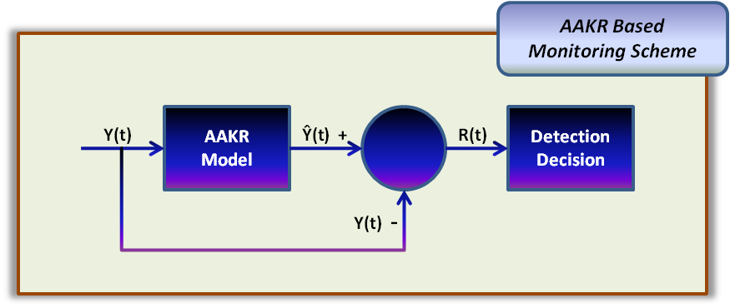
Figure 24: Traditional AAKA Monitoring via Error Correction
symptomatic of a fault. However, this type of monitoring system, as most systems based on multivariate methods, cannot be applied if significant correlation does not exist between the system variables. Therefore, an alternative a technique for monitoring a system’s health is required using a single sensed variable. Unfortunately, such techniques are scarce in the literature with much of the published research based largely on the monitoring of temporal based statistics as described in Section 2.2.1, or vibrational frequency analysis [47]. Therefore, the coming sections describe an unique univariate detection and diagnostic algorithm that estimates the specific “correct” frequency features of a single signal using operational stressors as inputs to a exemplar-based model spanning the normal operating range of a monitored system.

SUMM: Stressed-based Univariate Monitoring Method
In the physical world, measurable quantities can be expressed as a signal, and their generation is usually associated with the response of a system to stimulus or force. Therefore, it is intuitive that the effect of a stimulus or force that is not normal to a system would manifest itself has an anomaly. However, a lack of necessary correlation between a specific measurement that has been determined to be the primary indicator of system health and other sensed measurements provides unique challenges for the detection of these unexpected stimuli or forces. The presentation of such a system has spurred the development of an innovative technique for the detection and diagnosis of faults acting on the system.
Within the frequency domain, the amplitudes of the sine and cosine waves of the decomposed time domain signal are described. Measured signals often consist of lower frequency components with large magnitudes that usually determine the nominal values of the signal and higher frequency components with small amplitudes that contains information on the inner state of a system [12]. As such, a signal model based on spectral analysis could be applied that attempts to identify frequency components and pinpoint anomalies resulting from deviations in the corresponding normal signal. This particular method of fault detection has been applied to vibration measurements related to rotating machinery or electrical circuits [9, 11].
Unlike those methods that use vibrational spectral comparisons for the detection and diagnosis of faults, the stressed-based univariate monitoring method, SUMM, utilizes the differences between the normal and abnormal frequency spectrums of a single sensed measurement relative to a specific range within the overall range of the monitored system. An individual fault or combination of faults causes either an increase or decrease in the amplitude peaks. These differences between the non-faulted and the faulted features of the frequency spectrum can be used to detect and isolate specific faults. Figure 25 proposes a basic modeling approach to accomplish this.
The residual generation module is the first part of the basic concept used for this modeling approach. The expected frequency spectrum features are the product of a heteroassociative memory-based kernel regression module with some operational stressor condition as it input. The actual features are extracted from the frequency spectrum of a single monitored signal. The spectrum may be derived via a Discrete Fourier Transform (DFT) implemented by an algorithm like the Fast Fourier Transform available with Matlab®. The residuals are then calculated from the expected and actual features and input to the second part of proposed concept, the fault detection and isolation module shown in Figure 26.

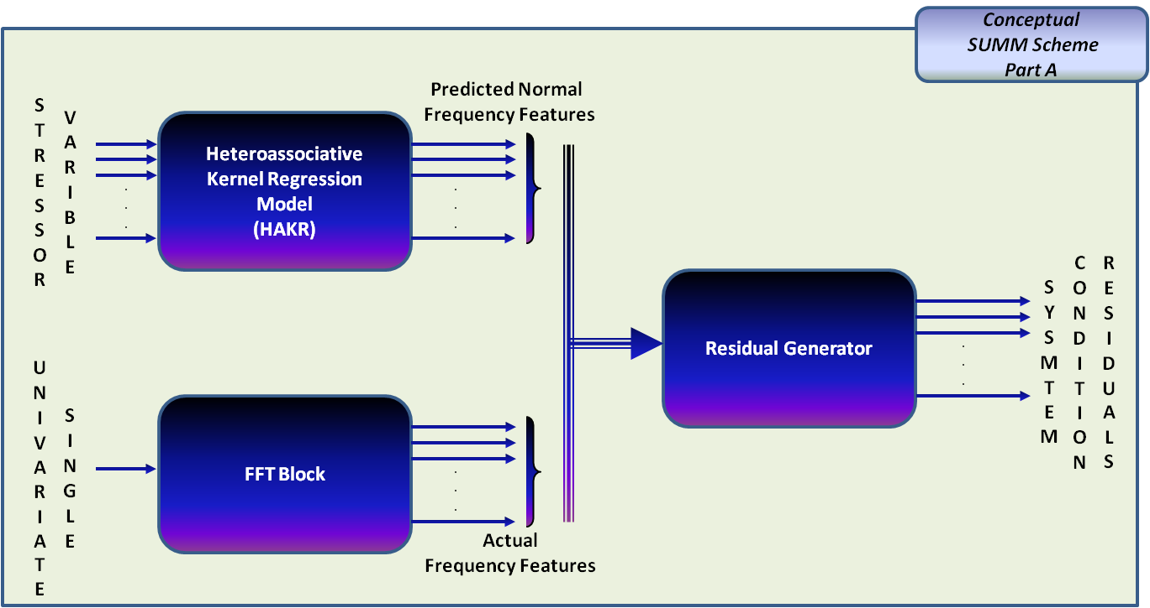
Figure 25: Proposed SUMM Residual Generator Scheme

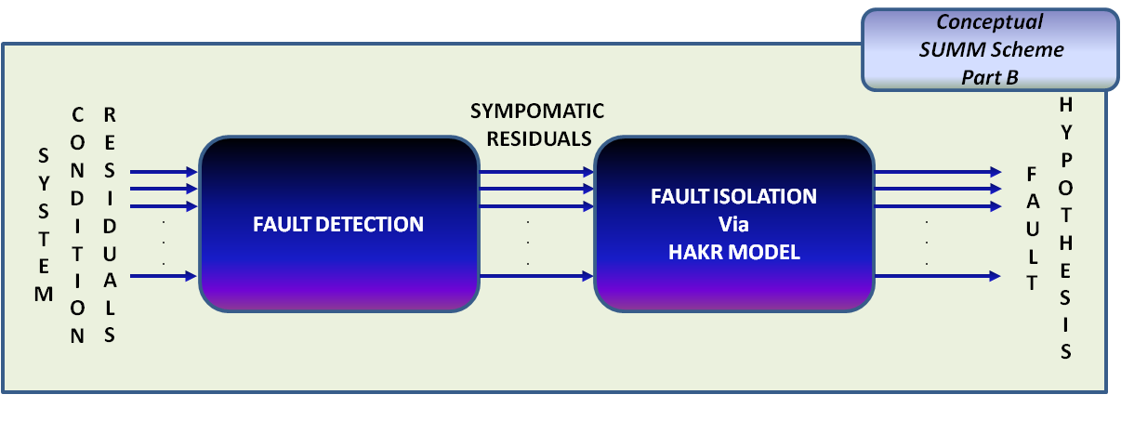
Figure 26: Proposed SUMM Fault Detection/Isolation Scheme
This module takes the resulting system condition residuals from the generation module and analyzes them to determine if they are symptomatic of any faults. If symptomatic residuals are detected, they then mapped to a programmed fault using a second HAKR memory-based model. The output of this second model effectively isolates the fault by determining its location via a fault hypothesis. Depending on the complexity of the system, the location would be a subsystem or even a specific component. Furthermore, the purposed concept, given the appropriate data, can not only isolate specific faults but identify them as well. Recall that one the major goals of the fault identification is the determination of the severity of the fault. Although the scope of this work mostly addresses the detection and isolation of a fault, the applicability of the method to fault identification, i.e., fault severity, is also demonstrated using the discrete data set.

Model Development
Both the normal spectrum feature prediction and the fault detection-diagnosis models are initialized with heteroassociative architectures. This type of architecture results in model using multiple predictors to estimate a corresponding set of responses. It differs from an autoassociative model in that the number of response values does not necessarily equal the number of predictors and the response variables are not corrected values of the predictors.
Model development follows the same general concepts as described earlier. Recall that these include data conditioning, data partitioning, variable selection, vector selection, model initialization, model optimization, and, finally, model characterization. Vector selection, model initialization, optimization, and characterization were discussed in Section 3, Empirical Modeling Approach. Data conditioning, data partition, and variable selection are briefly discussed here as it pertains more specifically to the data used in this work and the unique approach for which it is processed.

Data Conditioning
Normally, the first step in the development of a data based model is to condition the data by removing and/or correcting problems including, but not limited to, noise, outliers, missing data, and stuck data. This task is usually referred to as data cleaning, and there are several methodologies for addressing common data conditioning needs. However, the data used in this work was simulated without any of the above condition problems or noise; therefore, data cleaning is not necessary.
Nevertheless, actual data will of course include some amount of random variation about the true value. However, validating the insensitivity of similar methods to nominal levels of process and instrument noise has been successfully performed in other applications [37] which is assumed to extend to the univariate method introduce in this work.

Data Partitioning
As in any data based model development, the partitioning of the data into training, testing, and validation subsets are necessary for model initialization, optimization, and characterization. The training set should cover the entire range of the original data set including the maximum and minimum observation values. The primary function of the training set is to initialize, and as the descriptive term indicates, train the model. The testing set should include data points that fall within the range of the training set, but were not seen by the initial model. This data set is required to accomplish optimization of model parameters such as optimum bandwidth and number of memory vectors. Finally, the validation data is a small fraction, approximately 10 percent, of the original data that is randomly selected and removed before the training and testing data is partitioned. The purpose of this set of data is to characterize the model's performance. Like the testing data, the validation data must fall within the range of the maximum and minimum of the pre-partitioned data.
The three described subsets created from partitioning can be implemented using one of several methods rather easily for data drawn from the time domain. However, methods of partitioning of data within the frequency domain are limited, especially when the data itself is limited. For the models developed using the provided data, the discrete and periodic properties of the signal allow it to be partitioned into three separate data sets of equal observations by sampling every first, second, and third observation respectively. The partitioning of the frequency data with this method decimates the data whereas the sample rate for each resulting data set is a third of the original rate.

Variable and Input Selection
In the case of the simulated data described in Section 6, the direct current generated by the PMG has been identified by the OEM as one of the most useful variables for both fault detection and diagnostics. Therefore, the OEM as in effect selected the principle variable of the model. As previously noted the GPU compensates for the affects of the simulated faults, which masks the correlation between the exciter current and resulting output of the IDG. As a result , there is insufficient correlation between the exciter current and other raw signals; therefore, the use of multivariate modeling techniques such as AAKR or multivariate regression are not possible. However, the proposed method monitors selected frequency characteristics, features, of a single signal that exhibits definitive responses to changes in operation conditions. As such, an empirical model with heteroassociative architecture can be used to predict the expected features of the nominal frequency spectrum with varying operating conditions.
The signal of an identified principle health indicator, like that of the exciter current, is transformed from the time domain to that of the frequency domain. Fourier transforms are the primary connection between the time and frequency domain, and the DFT is the primary tool for determining the frequency content of a signal. The DFT returns a symmetric complex vector where the first and second halves are mirror images of each other. Therefore, the only meaningful information is contained in the first half.
Features from the frequency spectrums corresponding to various stress condition are extracted in order to build the memory matrix. These features may be peaks, valleys or ratios thereof, which change in a significant way with faulted operation. Such features are identified by comparing the nominal frequency spectrum to those of faulted operation. Useful features are those that generate sufficient symptomatic residuals with faulted operation. If enough such features can be identified, then the resulting residuals can be used to develop detection and diagnostic routines which can determine the presence, type, and possibly the severity programmed faults.
Unlike the selection of input variables for the empirical models describe in Section 3, the inputs of the proposed method are chosen from indicators of conditions that stress the system being monitored. As mentioned, features are selected from the frequency spectrum that correspond to designed stresses that the system is expected to perform. For an IDG, the obvious input stresses would be the power demand placed on the generator by the aircraft.

SUMM: Application to Discrete IDG Data
SUMM is first applied to the discrete data described in Section 4 in which the frequency domain of the exciter current is monitored for the detection and isolation of a fault or faults. Recall that the simulated faults are the result of a connection failure (Type A), an open-circuit (Type B), or a combination of both. Also recall that each of these faults was simulated at varying degrees of degradation or severity. With the availability of degradation data, the development of the three layer diagnostic system is possible.
However, before applying SUMM to this data set, let's verify that there does indeed lack sufficient correlation between the exciter current and other available measurements. A simple correlation analysis verifies this assessment. Table 3 summarizes the results of this analysis for each of the variables relative to the exciter current. As indicated, the linear dependence between the exciter field current and the other available variables is nonexistent. Now, let's analyze the data for its appropriateness for the application of SUMM.
Table 3: Correlation Coefficients for Faulted Data Relative to the Exciter Current
Exciter  Current | Main  Armature  Phase A  Current | Main  Armature  Phase B  Current | Main  Armature  Phase C  Current | Main  Armature  Phase A  Voltage | Main  Armature  Phase B  Voltage | Main Armature Phase C Voltage
1.0000 | -0.0000 | -0.0001 | 0.0001 | -0.0001 | 0.0001 | 0.0001

Figures 27 through 29 shows that the frequency domain provides an expanded insight to the effects of a fault or faults on the current generated by the exciter generator. Specifically, these figures illustrate the dependence between the amplitude and varying severity of specific fault conditions using the discrete data. Figure 27 illustrates the amplitude changes at varying degrees of a fault resulting from an open-circuit diode at a power loading of 5000 watts. Figure 28 shows changes in amplitudes that result from the severity of a lead disconnect on the third leg between the exciter and the rotating rectifier. As a final example of the dependence of amplitude on the type and severity of the fault, Figure 29 demonstrates the effects when both faults occur simultaneously. The first plot, as in the previous two figures, shows the frequency spectrum of the non-faulted current. The second and third plot shows the effect when both an armature lead disconnection and a diode open-circuit faults occur.
As noted earlier, the simulation did not include any noise or other data problems; therefore, data conditioning is not necessary. The data is partition as described earlier with Figures 30 through 32 presenting examples of the training, testing, and validation sets.
Figure 27: Amplitude - Fault Dependence of Open-Circuit Diode

Figure 28: Amplitude - Fault Dependence of Exciter Disconnect

Figure 29: Fault Dependence of Exciter Disconnect and Open-Circuit Diode

Figure 30: Normal Operation Frequency Spectrum Overlay

Figure 31: Open-Circuited Diode Operation Frequency Spectrum Overlay
Figure 32: Rectifier Disconnection Operation Frequency Spectrum Overlay
Construction of the required memory matrix for this problem is based on the selection of the appropriate frequency characteristics to the specific power demand. In this case the characteristics are response peaks that demonstrate sufficient change in magnitude with respect to previously describe faults. The actually selection of peaks for the model is initiated by first developing a template in which 50 peaks where identified that corresponded to frequencies up to 20 kilohertz of the non-faulted exciter current at 5000 watt power loading. The identified peaks are indicated on the frequency spectrum plotted in Figure 33. A function that implements the min-max and vector ordering combination method was used to select the residual exemplars that were included in model developed for this paper. The function is applied to the transpose of the residual matrix to select a subset of the 50 spectrum peaks. For the model presented here, the length of vectors was determined to be 15. Table 4 summarizes the corresponding frequencies of the 15 selected peaks. Figure 33 graphically illustrate the selected features on the non-faulted spectrum profile of the exciter current at 5 kilowatts. Features of similar profiles were selected at the 40 and 90 kilowatts power loadings.
The obvious input stressors for this model fall within the design power output range of the IDG. Recall that IDG output data has been simulated at three distinct power demands (5, 40 and 90 kilowatts). The power output is not measured directly; therefore, it is calculated via the product of the root mean square of the AC voltage and the root mean square of the AC current outputs from the main
Figure 33: Identified Peaks

Table 4: Corresponding Frequencies (in Kilohertz) of Selected Residual Vectors
1.07 | 1.95 | 3.91 | 4.40 | 4.88 | 5.86 | 7.03 | 7.42 | 7.81 | 9.77 | 11.72 | 15.63 | 17.58 | 18.54 | 19.54
generator to the IDG. The Normal Spectrum Feature Model is initialized using the root mean square (RMS) power of each phase produced by the main generator as the predictor variable for each of the three power loads. This results in a $3×3$ matrix of memory predictor variables. The response variables are the peaks from the normal-operation spectra that correspond to the frequencies in Table 4, which results in a $3×15$ matrix of memory response variables.
As for the Fault Detection and Identification Model, the residual vectors corresponding to the frequencies of Table 4 are the training exemplars and fault severity indices are the training responses. Figures 34, 35, and 36 show the selected features of the various faulted spectrum profiles of the exciter current at 5 kilowatts. Note that these features occur at the same frequency as that of the non-faulted features. The resulting memory matrix consists of 27 observations and 15 residual vectors. The response variables is a $27×2$ matrix of fault indexes, with the first column corresponding to the rectifier disconnection and the second column corresponding to the open-circuit diode.
Figure 34: Selected Model Features for Open-Circuit Diode

Figure 35: Selected Model Features for Exciter Armature Disconnect
Figure 36: Selected Model Features for Fault Combination
The following plots, Figures 37 and 38, shows the static bandwidths that were used. The optimum bandwidth for the Normal Spectrum Feature Model is 0.52 as indicated on Figure 36. From Figure 37, the bandwidth for the Fault Detection and Identification Model is 0.24.
The predictive results for each of the models are presented in Figures 38 and 39. Figure 38 illustrates the predicted selected feature versus the actual selected features for each spectrum of the three power loads. As seen, it appears that the normal spectrum feature model produces excellent results. The model resulted in mean square errors of 0.15, 3.50, and 14.89 for each power load inputs of 15, 40 and 90 kilowatts respectively.
Figure 39 illustrates the results of the Fault Detection and Identification Model. Each of the sub-plots represents the fault severity for of the two indicated faults at each of the three power loads. The model gives good predictive results overall, with only one misclassification and two 'near misses' in the 27 example cases studied.

SUMM: Application to Continuous IDG Data
Recall from simulated flight data describe in Section 4.3 that the power load on the main armature remains constant for periods of one second intervals. The 60,000 observations collected during that second are used to calculate the frequency spectrum during that period of constant power demand. As a result, the 6 million time-domain observations are reduced to 100 joint time-frequency domain
Figure 37: Optimum Bandwidth for Normal Spectrum Feature Model

Figure 38: Optimum Bandwidth for Fault Detection and Identification Model
Figure 39: Normal Spectrum Feature Model Results

Figure 40: Fault Detection and Identification Model Results

observations. Figure 41 shows the frequency spectra for normal and faulted operating conditions. The top plot shows the spectrum of the normal operating condition, the second plot shows the spectrum of the Type A fault, and the bottom plot shows the spectrum of the Type B fault. Comparison of these plots, unlike that of the discrete simulation data, shows that additional peaks appear in the frequency spectrum due to the introduction of faults. Similar results are seen at each of the load conditions simulated.
As indicated on the plots, six peaks are chosen to detect and identify faulted conditions. Because the location of the peaks of interest can shift slightly due to changes in sampling frequency and amount of available data available; frequency ranges are identified about peaks of interest as indicated on the plots. The peaks with the greatest magnitude within each range are the ones extracted for system health monitoring. This differs from the work done on the discrete data and makes the method more robust to real world data collection. Another difference from the work completed on the discrete data is that the Identification of useful frequency peaks and appropriate ranges about those peaks is accomplished by visual inspection.
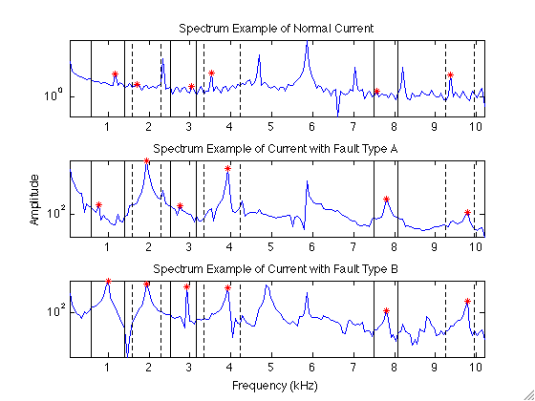
Figure 41: Frequency Spectra of Exciter Current for Normal and Faulted Operation

The chosen peaks of the frequency spectrum are used to generate residual patterns between the expected normal operation and the actual operation. Figure 42 shows the results for each type of operation: normal, Type A fault, and Type B fault. The main plot shows the exciter current measurement for a 14-second interval during the total flight. The secondary plots summarize the monitoring system execution in three subplots: the exciter current reading during a small portion of the one second interval in the top subplot, the frequency spectrum during that interval in the second subplot, and finally the residuals between the calculated frequency spectrum peaks and the expected peaks based on the load. The leftmost plot gives the results for Type A fault, the middle plot for normal operation, and the rightmost plot for Type B fault. It is clear from the residual patterns of the two fault types that they should be easily distinguishable.
After residuals between the normal and actual operating spectra are obtained from the six peaks of interest, they are run through fault detection routine to determine if the system is operating in a normal or faulted mode. In this data simulation, faults are simulated to occur for one second and then are corrected. Because of this simulation method, a simple signal threshold may be used to identify faulted operation. For the peak ranges of interest, normal operation spectra residuals are below 10 amps while faulted residuals are above 60 – 100 amps, depending on the peak.

Figure 42: Monitoring Model Results for Nominal and Faulted Operation
However, in real-world applications, the faults would more than likely begin at some small severity level and progress to greater severity eventually resulting in a failure. In addition, the noise which would be present in real-world data may muddle the ability to apply a simple signal thresholding technique. For data of this more realistic type, an SPRT fault detection routine will likely be more useful to detect incipient faults before they become large enough to cross the threshold values. In the current study, six one-second intervals in the 100-second simulation are correctly identified as operating in a faulted condition, while the remaining 94 seconds are correctly identified as normal operation.
The six observations of frequency features which have been identified as faulted operation are input to a fault identification module to determine if the system is experiencing Type A or B fault. The fault identification module uses an inferential kernel regression function which compares the residual values of the six feature peaks to those seen in the past and determines if the current observation is more likely fault A or fault B. As noted above, the residual patterns for the two fault types are clearly distinguishable. Because only six faulty observations are available (three of Type A and three Type B), a leave-one-out validation method is used to test the diagnostic model. That is, an inferential model is built using five faulted observations and tested on the remaining one; this is repeated for each of the faulted observations. The diagnostic model gives 100% accuracy in differentiating between Type A and Type B faults for the six available observations.

Conclusions
This report presents an innovated method that extends the use of frequency characteristics to the detection, diagnosis, and identification of system anomalies due to faulty operation of specific system components. A novel method for detecting and diagnosing of system faults by monitoring a single variable using extracted features from the frequency domain has been introduced as SUMM, Stressor Univariate Monitoring Method. In an effort to demonstrate the capability of this method, two case studies have been presented whereas the technique has been applied to simulated, noise free data indicative of an integrated drive generator used by modern aircraft.
The first case study utilized a set of discrete data in which three modes of operation, ranging from normal to failure, were simulated. Using this data, a three-layer detection and diagnostic system that model selected frequency characteristics of normal operation. These predicted features provided the basis for a residual generator which was implemented by a heteroassociative kernel regression model. The resulting symptomatic residuals are analyzed for indications of abnormal behavior due to the presence of component damage or failure. The application of SUMM to this data produced promising results with 26 of 27 faults were detected and diagnosed.
The second case study utilized data from the OEM simulation of actual flight. Once again the frequency characteristics of the exciter current are used for the development of a fault detection and diagnosis system using SUMM. Although the data is limited, this technique successfully detected and isolated all six of the buried faults in the faulted simulated flight. It should be noted that the OEM did not initially reveal when or where the faults here simulated.
In conclusion, using discrete simulated data, the development of an AAKR model using the available raw measurements proved to be inappropriate due to the lack of correlation. The proposed method has been shown to accurately detect abnormal operating conditions due to faulty components with a system. As demonstrated, the monitoring of the frequency spectrum of a single variable can provide adequate indication of equipment health. With the availability of the appropriate data, as that of the discrete data set, it is possible for the development of three-layer detection and diagnostic systems that provides fault detection, isolation, and identification. A three-layer detection and diagnostic system is essential in the development of more advance health monitoring and prognostic systems. With this in mind, a monitoring technique such as SUMM allows for the possible adaption. Despite some shortcomings in the simulated data available for analysis, this method is believed to be applicable to data that more realistically captures real-world relationships, including sensor noise, faults that grow with time, and unbalanced loads on the main armature. Several areas of proposed future research are outlined in the following section.

Future Work
The preceding report introduced a novel technique for monitoring a system using the frequency domain of a single variable in conjunction with process stressor. Although the results demonstrated potential for this method, the reader is reminded that the concept is well within the earlier stage of development and there is significant opportunity for future work. The following suggestions are a few areas of interest that will be beneficial not only further defining the limits of this technique, but expandingits limits as well.
One area in need of more development is the selection of those frequency spectrum characteristics that indicates deviation from normality. Although specific peaks were selected for the work presented in the report, other characteristics or combination of characteristics may be utilized. This work may also include the development of a general algorithm that analyze the frequency spectrum of a single signal and selects the appropriate number of peaks or other characteristic.
The case studies that this report is based uses simulated data. Obviously, the effectiveness of SUMM would be better understood if applied to real data. With this in mind, the model should be expanded to include a wider area of operating conditions such as load imbalances, power fluctuations, and additional fault possibilities.
A last suggestion would bring SUMM full circle by incorporating it into a PHM system as described early in the report. The incorporation of a Prognostic module, as illustrated in Figure 43, would allow for the determination of remaining useful life of equipment and overall system health.

Identification
Module

Prognostic Model
(Future Work)
Fault
Detection
&
Identification Model

.
.
.
Residuals
F1
F2
Identified Faults
Fa
RUL

FAULT DETECTIONAND IDENTIFICATION MODULE WITH ADDED PROGNOSTICS MODULE

Figure 43: Prognostic Concept Module

List of References
1. Hines, J.W., et al., Technical Review of On-Line Monitoring Techniques for Performance Assessment, Volumn 2: Theroretical Issues, 2007: Washington, D.C.
2. Vichare, N.M. and M.G. Pecht, Prognostics and health management of electronics. Components and Packaging Technologies, IEEE Transactions on, 2006. 29(1): p. 222-229.
3. Performance Based Logistics: DoD 5000.2 Policy Document, 2004: Washington, D.C.
4. Mishra, S., et al. Life Consumption Monitoring for Electronics Prognostics. in IEEE Aerospace Conference Proceedings. 2004.
5. Liao, H., W. Zhao, and H. Guo, Predicting Remaining Useful Life of an Individual Unit Using Proportional Hazards Model and Logistic Regression Model. Reliability and Maintainability Symposium (RAMS), 2006: p. 127 - 132.
6. Lu, C.J. and W.O. Meeker, Using degradation measures to estimate a time-to-failure distribution. Technometrics, 1993. 35(2): p. 161-174.
7. Coble, J.B., Merging Data Sources to Predict Remaining Useful Life – An Automated Method to Identify Prognostic Parameters, in Nuclear Engineering2010, University of Tennessee: Knoxville.
8. Palade, V., C.D. Bocaniala, and L. Jain, Computational Intelligence in Fault Diagnosis. Advanced Information and Knowledge Processing, ed. L. Jain2006, London: Springer-Verlag London Limited.
9. Simani, S., C. Fantuzzi, and R.J. Patton, Model-based Fault Diagnosis in Dynamic Systems Using Identification Techniques. Advances in Industrial Control, ed. M.J. Grimble and M.A. Johnson2003, London: Springer-Verlag London Limited. 282.
10. Chen, J. and R.J. Patton, Robust Model-Based Fault Diagnosis for Dynamic Systems1999, Boston: Kluwer Academic Publishers. 356.
11. Isermann, R. and P. Ballé, Trends in the application of model-based fault detection and diagnosis of technical processes. Control Engineering Practice, 1997. 5(5): p. 709-719.
12. Isermann, R., Process fault detection based on modeling and estimation methods--A survey. Automatica, 1984. 20(4): p. 387-404.
13. Zhao, K., An Integrated Approach to Performance Monitoring and Fault Diagnosis of Nuclear Power Systems, in Department of Nuclear Engineering2005, The University of Tennessee: Knoxville. p. 312.
14. Isermann, R., Supervision, fault-detection and fault-diagnosis methods -- An introduction. Control Engineering Practice, 1997. 5(5): p. 639-652.
15. Patton, R.J. and J. Chen. Advances in fault diagnosis using analytical redundancy. in Plant Optimisation for Profit (Integrated Operations Management and Control), IEE Colloquium on (Digest No.1993/019). 1993.
16. Chow, E. and A. Willsky, Analytical redundancy and the design of robust failure detection systems. Automatic Control, IEEE Transactions on, 1984. 29(7): p. 603-614.
17. Chow, E.Y. and A.S. Willsky. Issues in the development of a general design algorithm for reliable failure detection. in Decision and Control including the Symposium on Adaptive Processes, 1980 19th IEEE Conference on. 1980.
18. Beard, R.V., Failure Accommodation in Linear Systems Through Self-Reorganization, in Department of Aeronautics and Astronautics1971, Massachusetts Institute of Technology: Cambride, Massachusetts. p. 377.
19. Jones, H.L., Failure Detection in Linear Systems, in Department of Aeronautics and Astronautics1973, Massachusetts Institure of Technology: Cambridge, Massachusetts.
20. Alcorta García, E. and P.M. Frank, Deterministic nonlinear observer-based approaches to fault diagnosis: A survey. Control Engineering Practice, 1997. 5(5): p. 663-670.
21. Garvey, D., An Integerated Fuzzy Inference Based Monitoring, Diagnostic, and Prognostic System, in Nuclear Engineering2007, University of Tennessee: Knoxville.
22. Wald, A., Sequential Tests of Statistical Hypotheses. The Annals of Mathematical Statistics, 1945. 16(2): p. 117-186.
23. Zhang, X.J., Auxiliary Signal Design in Fault Detection and Diagnosis. Lecture Notes in Control and Information Sciences, ed. M. Thoma and A. Wyner1989, Berlin: Springer-Verlag Berlin, Heidelberg. 213.
24. Hess, A. and L. Fila. The Joint Strike Fighter (JSF) PHM concept: Potential impact on aging aircraft problems. in Aerospace Conference Proceedings, 2002. IEEE. 2002.
25. Tolani, D., et al. Anomaly detection for health management of aircraft gas turbine engines. in American Control Conference, 2005. Proceedings of the 2005. 2005.
26. Brotherton, T., et al. Prognosis of faults in gas turbine engines. in 2000 IEEE Aerospace Conference, March 18, 2000 - March 25, 2000. 2000. Big Sky, MT, United states: Institute of Electrical and Electronics Engineers Computer Society.
27. Munns, T.E. and R.M. Kent. Structural health monitoring: degradation mechanisms and system requirements. in Digital Avionics Systems Conferences, 2000. Proceedings. DASC. The 19th. 2000.
28. Orsagh, R.F., et al. Prognostic health management for avionic systems. in Aerospace Conference, 2006 IEEE. 2006.
29. Orsagh, R., et al. Prognostic health management for avionics system power supplies. in Aerospace Conference, 2005 IEEE. 2005.
30. Megahed, A.I. and O.P. Malik, An artificial neural network based digital differential protection scheme for synchronous generator stator winding protection. Power Delivery, IEEE Transactions on, 1999. 14(1): p. 86-93.
31. Tantawy, A., X. Koutsoukos, and G. Biswas. Aircraft AC generators: Hybrid system modeling and simulation. in Prognostics and Health Management, 2008. PHM 2008. International Conference on. 2008.
32. Bo, Z.Q., et al. Non-differential protection of a generator's stator utilizing fault transients. in Developments in Power System Protection, 2001, Seventh International Conference on (IEE). 2001.
33. Sottile, J., F.C. Trutt, and A.W. Leedy. Condition monitoring of brushless three-phase synchronous generators with stator winding or rotor circuit deterioration. in Industry Applications Conference, 2001. Thirty-Sixth IAS Annual Meeting. Conference Record of the 2001 IEEE. 2001.
34. Atkeson, C.G., A.W. Moore, and S. Schaal, Locally Weighted Learning. Artifical Intelligence Review, 1997. 11: p. 11-73.
35. Garvey, D. and J.W. Hines, An Adaptive Distance Measure for Use with Nonparametric Models, in 5th International Topical Meeting on Nuclear Plant Instrumentation, Control and Human-Machine Interface Technologies2006: Albuquerque, NM.
36. Hines, J.W., Alogrithms for Data Cleaning and Model Variable Selection, 2009, University of Tennessee: Knoxville, TN.
37. Hines, J.W., et al., Technical Review of On-Line Monitoring Techniques for Performance Assessment (NUREG/CR-6895) Vol. 3, Limiting Case Studies, 2008.
38. Hines, D.J.W., Locally Weighted Regression, in NE 597 Empirical Modeling2009, University of Tennessee: Knoxville.
39. Härdle, W., Applied Nonparametric Regression1990, New York: Cambridge University Press.
40. Hines, D.J.W. and D. Garvery, Traditional and Robust Vector Selection Methods for use with Similarity Based Models, in 5th International Topical Meeting on Nuclear Plant Instrumentation, Control and Human Machine Interface Technology (NPIC&HMIT '05), 2006: Albuquerque, NM.
41. Hines, D.J.W. and D. Garvey, Development and Application of Fault Detectability Performance Metrics for Instrument Calibration Verification and Anomaly Detection. Journal of Pattern Recognition Research, 2006. 1(1).
42. Garvey, J., et al., Validation of On-Line Monitoring Techniques to Nuclear Plant Data. Nuclear Engineering and Technology, 2007. 39(2).
43. Batzel, T.D. and D.C. Swanson, Prognostic Health Management of Aircraft Power Generators. Aerospace and Electronic Systems, IEEE Transactions on, 2009. 45(2): p. 473-482.
44. Humenik, K.E. and K.C. Gross, Sequential Probability Ratio Tests for Reactor Signal Validation and Sensor Surveillance Applications. Nuclear Science and Engineering, 1990. 105: p. 383-390.
45. Kennett, R.J., Integrated Drive Generators for Aircraft. Electronics and Power, 1971: p. 73 -76.
46. Sundstrand, H., Schematic of Generator Simulator, 2009.
47. Hines, J.W., J. Coble, and B.K. Bailey, A Novel Method for Monitoring Single Variable Systems for Fault Detection, Diagnostics and Prognostics. International Journal of Performability Engineering, 2010. 6(4): p. 385-394.

Appendix:
Referenced Figures

Figure A - 1: Exciter Current at 40 kilowatts
Figure A - 2: Exciter Current at 90 kilowatts
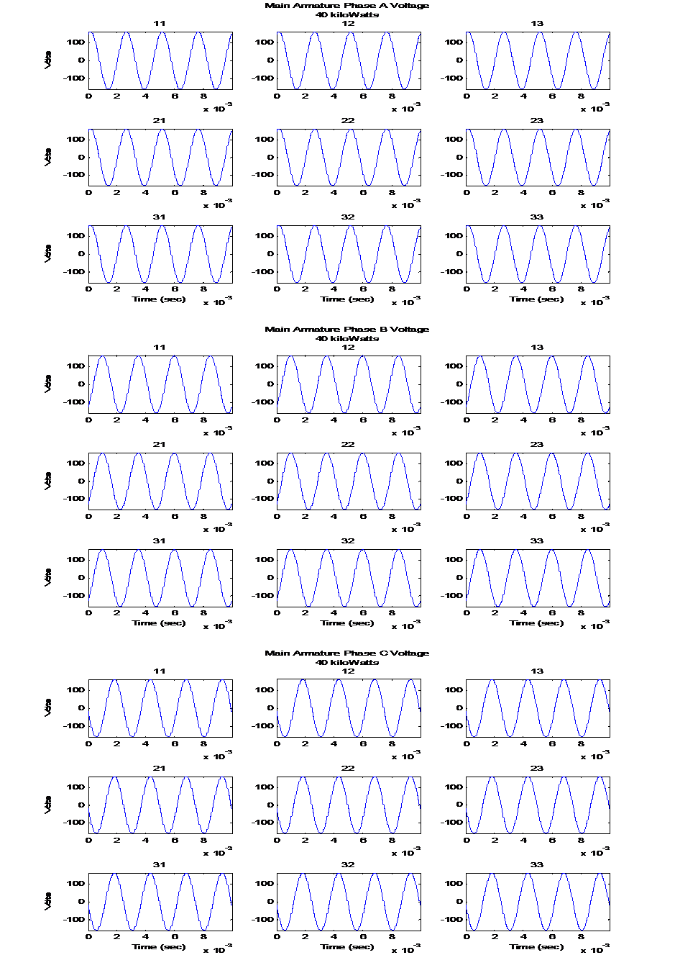Figure A - 3: Main Armature Voltage at 40 kilowatt
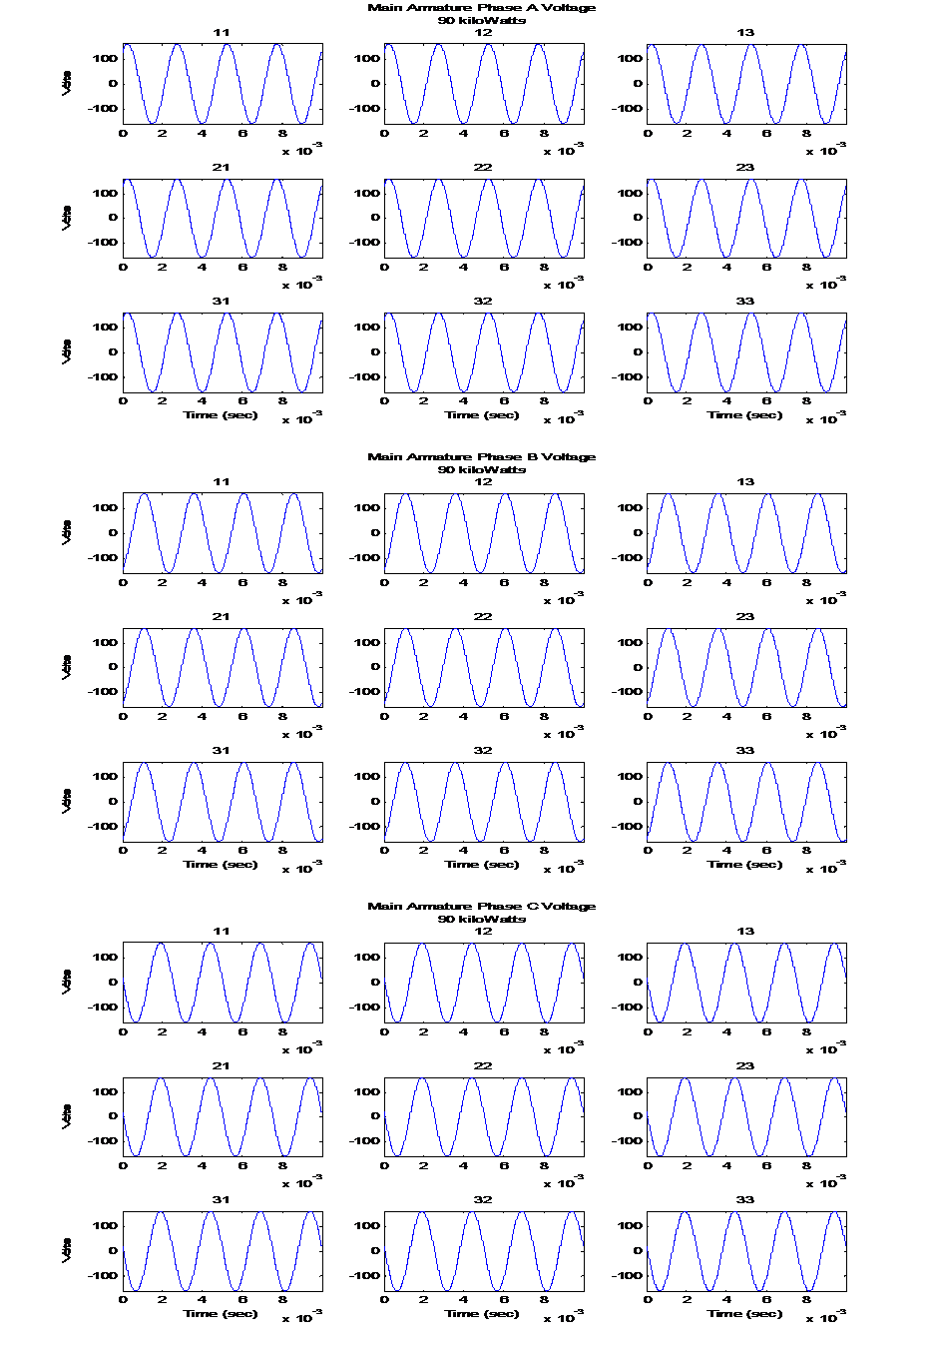Figure A - 4: Main Armature Current at 40 kilowatt
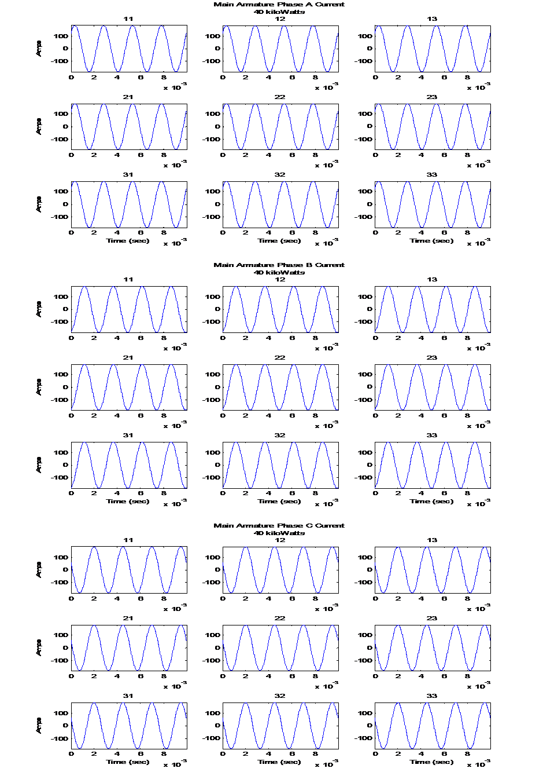Figure A - 5: Main Armature Voltage at 90 kilowatt
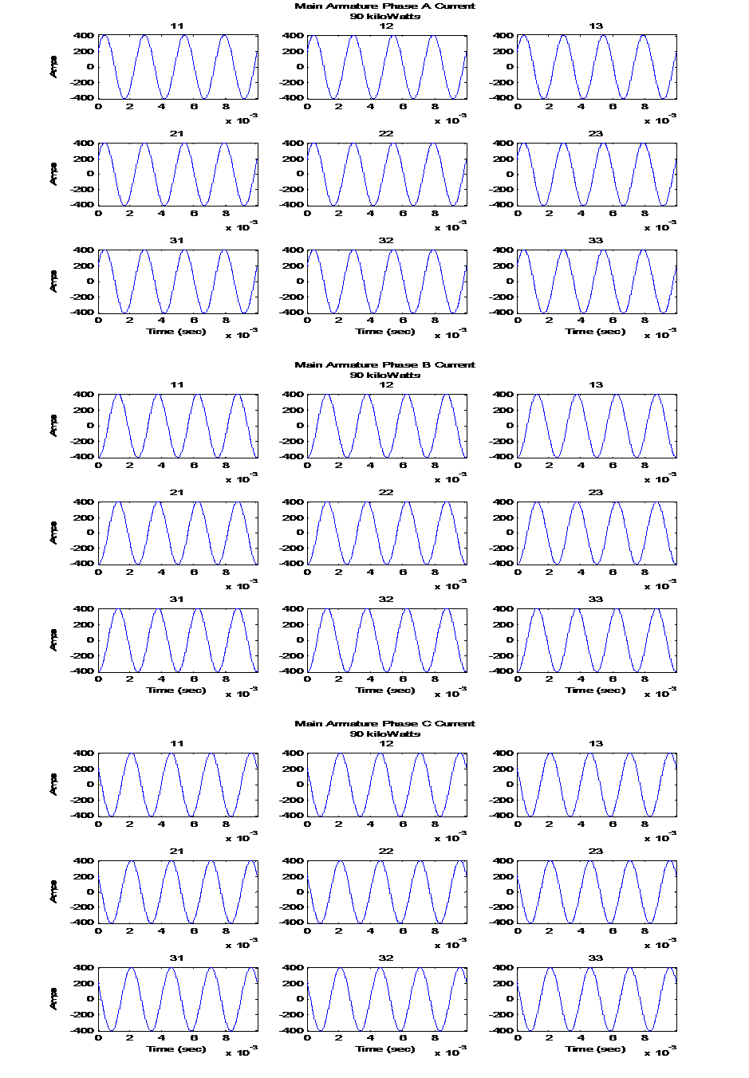Figure A - 6: Main Armature Current at 90 kilowatt

Vita
Brian Keith Bailey was born in Morristown, Tennessee to the parents of Annie B. Dreadin and Keith L. Bailey. He is the third of six children, four brothers and one sister. He graduated from Morristown-Hamblen High School EAST and continued on to Walter State Community College and Tennessee Technological University where he earned an Associate's degree in General Studies and a Bachelor of Science degree in Chemical Engineering respectively. After receiving his BS degree in May 1994, he entered the professional market as a chemical process engineer until August of 2001. At that time he returned to the University of Tennessee at Knoxville as a graduate student in the Chemical Engineering Department. Due to family obligations, he had to withdraw from the university in 2005 before completing degree requirements, but was able to return in 2009. Brian graduated with a Master of Science degree in Chemical Engineering in and has chosen to return the professional market as a practicing chemical engineer.

