Integration of Vertical Droplet Interface Bilayers with
PEDOT:PSS based Organic Electrochemical Transistors

A Thesis Presented for the
Master of Science
Degree
The University of Tennessee, Knoxville

Elizabeth Marie Klavon
August 2022

ACKNOWLEDGEMENTS

This work would not have been possible without the support of many people¹. First, I would like to thank my advisor, Dr. Andy Sarles, for his guidance, support and optimism throughout this process. I would also like to thank my labmates, Subh, Colin, Josh, Farzin, Jessie, McKayla, and Michelle for their ever-patient (and ever-needed) help. I have learned so much from them during my time in this lab, and I wish them each the best on their (new and continuing) endeavors. Lastly, my mom, my dad, Elaine, Ben, Alex, and Stefan have believed in me and supported me since the beginning.

Elizabeth Klavon

¹Funding for this project came from the 2020 Interdisciplinary Seed Grant from the Office of Research Innovation and Economic Development, which gave me the opportunity to freely experiment, discover, and learn.
ABSTRACT

Membrane biosensors utilize the sensitivity and control of artificial cell membranes to study the cell’s interaction with the environment, isolate transmembrane proteins, sense pathogen interaction, and screen new drugs. However, these devices are unable to read electrical signals and therefore be used for high-throughput data collection, which limits their applications and prevents fast, large quantity testing. Bioelectronic devices on the other hand, have the ability to transduce high-throughput data, but lack the sensitivity, molecular specificity and control that come with membrane biosensors. In this thesis, artificial cell membranes are incorporated into (organic electrochemical) transistor bioelectronic devices in order to enable electrical data collection along with precise selectivity. A droplet interface bilayer (DIB) is formed on top of a PEDOT:PSS thin film, where it provides a stimuli-responsive barrier for ion transport to the underlying film. For example, when a sufficient voltage is applied across the bilayer, voltage activated peptides form ion channels through the membrane, which allow ions to flow to the PEDOT:PSS. This flux of ions into the PEDOT:PSS de-dopes the film through hole-ion substitution, changing the conductivity of the film and, thus, the electronic current through the PEDOT:PSS film. In comparison, prior works assembled lipid membranes on the semiconductive channel of a transistor via vesicle fusion or SALB (solvent-assisted lipid bilayer) formation. These methods, however, yielded leaky membranes characterized by low membrane resistance. If a leaky defect exists in the membrane, ions can pass through the lipid assembly, rather than be modulated by the membrane or membrane ion channels. Therefore, this work uses those previous studies as motivation to create a more reliable method for bilayer formation on organic electronic transistors that yields membranes with significantly higher membrane resistance required for retaining biomolecules sensitivity and specificity.

Table of Contents

Chapter One : Introduction and General Information 1
1.1 Background 1
1.1.1 Bilayers and Droplet Interface Bilayers 1
1.1.2 Membrane Biosensors and Bioelectronic Devices 3
1.1.3 Transistors 5
1.1.4 OECT with Bilayer 5
1.2 Literature Review 7
1.3 Objectives 12
1.4 Document Overview 12
Chapter Two : Bilayer Formation on PEDOT:PSS Film 14
2.1 Materials and Methods 14
2.1.1 PEDOT:PSS Slide Preparation 14
2.1.2 Contact Angle Measurements 14
2.1.3 Initial Direct Attempts 16
2.1.4 Vertical DIB Method 18
2.2 Results 21
2.2.3 Direct Bilayer 21
2.2.4 Vertical DIB 21
2.2.4 Alamethicin 21
Chapter Three : Transistor Fabrication and Testing 24
3.1 Testing Method 24
3.2 Device Layout 24
3.3 Testing Device Designs 28
3.4 Testing (No Bilayer) 28
3.5 Testing with a Bilayer 32
Chapter Four : Conclusions and Recommendations 40
List of References 41
Vita 44

LIST OF TABLES

Table 1. Reported Resistances from Daniel’s Group 10
Table 2. Conductance Values for PEDOT:PSS. 39
LIST OF FIGURES

Figure 1. Phospholipid Cell Membrane. 2
Figure 2. Droplet Interface Bilayer Method. 4
Figure 3. Transistor Schematic. 6
Figure 4. PEDOT:PSS Chemical Structure. 6
Figure 5. Examples of Previous Work- Set up and Results 11
Figure 6. Direct Bilayer vs. Vertical DIB Methods. 15
Figure 7. Contact Angle Measurements on PEDOT:PSS. 17
Figure 8. Bilayer Formation Example. 19
Figure 9. Droplet Interface Bilayer Method vs. Vertical DIB 20
Figure 10. Picture of a Direct Bilayer Formation Attempt. 22
Figure 11. Testing Inputs and Results of a Bilayer Containing Alamethicin. 23
Figure 12. Schematic and Picture of a Droplet on the OECT. 25
Figure 13. Inputs and Outputs of Transistor Testing. 26
Figure 14. Complete PEDOT:PSS Coating vs. Reduced Channel Area Coating. 27
Figure 15. Current Response for fully PEDOT:PSS Coated Transistor. 29
Figure 16. Current Response for Transistor with Reduced PEDOT:PSS Area. 30
Figure 17. Dependence of Current on Gate Voltage. 31
Figure 18. IV Plot for Dependence on Gate Voltage Case. 33
Figure 19. Vertical DIB on PEDOT:PSS Transistor. 34
Figure 20. Bilayer Resistance to Gate Voltage. 35
Figure 21. Control Case -No Bilayer. 36
Figure 22. Comparison of Small and Large Gate Voltages. 37

:
Introduction and General Information

1.1 Background
A synthetic lipid membrane can be created in a lab environment by utilizing the self-assembly properties of phospholipids. These membranes can then be used to study cell membrane interactions and detect pathogens [1]. Simple membrane biosensors typically have visual outputs and lack the ability to collect electrical signals [1,2]. Bioelectronic devices, however, can read both ionic and electrical signals, but are difficult to incorporate with lipid membranes [1]. Previous researchers have formed lipid bilayer membranes on such OECTs but the ionic seal demonstrated was poor, as reflected by a low value of membrane resistance. Therefore, this work aims to fill in this gap by forming the membrane via the droplet interface bilayer technique on top of an OECT and demonstrating the ionic seal and quality of the bilayer.

1.1.1 Bilayers and Droplet Interface Bilayers
Cell membranes consist of phospholipids, which are lipids with a hydrophilic head and hydrophobic tails. Therefore, around a cell they arrange themselves into a double layer, or bilayer, with the tails facing each other and making up the inside of the membrane and the heads lining the inside of the cell and the outside of the cell, as shown in Figure 1. This membrane is semi-permeable meaning that some molecules are able to pass through, and some are not. This controls the exit of waste and the entrance of nutrients such as water and oxygen. Transmembrane proteins can also exist within the membrane itself. These can span the width of the membrane completely, and act as an active or passive channel for molecules that otherwise may not be able to travel through the membrane.
Membranes are highly studied for purposes of understanding their function and utilizing their unique selectivity properties [3]. Since phospholipids have hydrophilic and hydrophobic regions, membranes are able to self-assemble, making them simple to recreate. A monolayer, or a single organized layer of lipids, can easily form with lipids exposed to water and oil. The hydrophilic heads are most stable when in the water, and the hydrophobic tails are most stable when they are in the oil. Therefore, at the water/oil interface, a monolayer of lipids forms spontaneously. A bilayer can be formed by bringing two of these monolayers together. A common method called droplet interface bilayer (DIB) consists of two aqueous droplets in oil. With lipids in the droplets, in the oil, or both, lipids will similarly arrange themselves at the water/oil interface, or around each of the droplets. After about 5 minutes, droplets of about 300nL in volume have sufficiently formed monolayers around them. The droplets are typically suspended from electrodes, which are

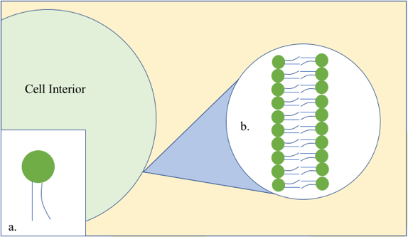
Figure 1. Phospholipid Cell Membrane.
a) The phospholipid has a hydrophilic head and two hydrophobic tails and comprises the membrane that surrounds all cells. b) The phospholipid heads form the outer walls of the cell membrane and the tails face each other, making up the interior of the membrane.
made of Ag/AgCl wire, with a bulb on the end so that the droplet hangs, rather than falls off. The electrodes allow not only electrical measurement of the system, but also allow the droplets to be manipulated. After the monolayers form, the droplets are brought together to just barely touch. At that point, a small section of the tails around the droplets are touching. As the lipid tails get close to one another, they start to constrain/order the oil molecules, which causes a reduction in entropy. Since all physical systems want to maximize entropy, excess oil is pushed away, which allows the tails to get closer together. Secondly, van der Waals attractive forces between the water molecules in each droplet further drive the droplets closer together. Lastly, steric forces between the lipids prevent the bilayer from being further compressed after oil exclusion and due to van der Waals forces. Between the lipids prevent the bilayer (Figure 2). In this way, the cell membrane can be recreated in a lab environment and analyzed electrically.

1.1.2 Membrane Biosensors and Bioelectronic Devices
Membrane biosensors and bioelectronic devices form the foundation for this work, as well as demonstrate the need for a device that fuses the two together. Membrane biosensors utilize real or synthetic cell membranes to study the interaction between the cell and its environment. The inherent properties of cell membranes make them ideal for sensing capabilities. Sensors, in general, need to sense some stimulus and output a corresponding signal. Cell membranes, with the help of transmembrane proteins, are able to detect mechanical strain, ligand binding, and electrochemical potential gradients, as well as transduce an output signal according to the input [4]. Cell membranes are also involved in all cell communication, making them an ideal topic for drug target research [1]. Since membranes are able to filter out pathogens, these devices can be used in pathogen detection [3]. Membrane biosensors exist in a variety of forms, including bilayers formed in microwells on a microchip, in microfluidic channels, supported bilayers, suspended bilayers, nanodiscs and various droplet contact methods [5]. With the addition of transmembrane proteins, these devices can be specifically designed to block or allow the transport of certain molecules, allowing for the use of specified and custom sensors [6]. Further applications of these sensors include modulating cell activity by isolating transmembrane proteins (TMPs) and screening for new drugs to combat antibiotic resistance. However, membrane biosensors typically have non-electrical outputs, slows down data collection and relies on visual outputs such as color change [2].
These biosensors are effective but lack the ability to collect high content information suitable for high-throughput data analysis because they cannot read electrical signals. Bioelectronic devices, however, can read both ionic and electrical signals. This provides electrical monitoring capability, which is preferred because it facilitates faster data collection, simplifies repetitive measurements, provides more information, and limits opportunities for error [1,3].

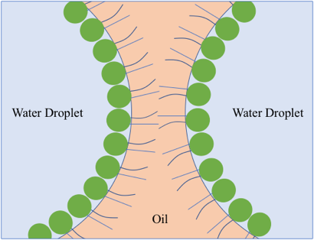
Figure 2. Droplet Interface Bilayer Method.
When two water droplets are in oil and lipids are present, the lipids associate at the water/oil interface. This is most energetically favorable because the lipid tails are hydrophobic, and the lipid heads are hydrophilic.

The goal of bioelectronic devices is to combine high speed solid-state electronics with biological materials to enable electronic measurements of biophysical events. This combination can thus be used to better understand natural phenomena and develop device technologies that can benefit healthcare. PEDOT:PSS is a popular polymeric material used in bioelectronic devices due to its conductivity, biocompatibility, and ability to be easily spin coated into a thin, mostly transparent film. With a thin PEDOT:PSS film as the semiconductor, a bioelectronic transistor can be used to sense glucose concentration in a solution. When a voltage is applied to a reservoir of glucose above the PEDOT:PSS thin film semiconductor, the change in current of the source/ drain channel can be measured. Due to electrochemical changes in the solution, the change in current is almost linear to the concentration of glucose, and therefore can be used as a glucose sensor [6]. However, the bioelectronic devices are limited in the sense that they are not easily integrated with biological membranes, because it is difficult to form bilayers on solid surfaces. Without lipid membranes, they lack the specificity that comes with sensing via bilayers [7].

1.1.3 Transistors
The transistor was invented in 1947 and revolutionized the design of computers by replacing bulky vacuum tubes. Transistors are devices made of semiconductive materials (typically germanium and silicon) that can conduct and insulate to modulate electronic current [8]. Transistors have three electrodes: a gate, source, and drain. Typically, the voltage is applied to the gate electrode and a separate voltage is applied across the source/drain channel (Figure 3). The induced current between the source and drain is measured. These devices are major building blocks of essentially all electronic devices today because they can amplify signals or act as a switch. Essentially, they allow for the control of voltage through one channel by manipulation of voltage through a different channel [9].

1.1.4 OECT with Bilayer
Organic electrochemical transistors (OECTs) are examples of bioelectronic devices that are ideal for collaborating with membrane biosensors, since they can transduce ionic currents into electrical signals through the passage of ions from an electrolyte into a semiconductor film. A transistor becomes an organic electrochemical transistor when the semi-conductor film connecting the source and drain electrodes is an organic film. In this work, the organic film is PEDOT:PSS(Poly(3,4-ethylenedioxythiophene)-poly(styrenesulfonate) (Figure 4), which has a hydrophobic core (PEDOT) surrounded by a hydrophilic shell (PSS) [10]. PEDOT:PSS is a transparent polymer that can easily be spin coated into a thin film and has a tunable conductivity. When a voltage is sent across a PEDOT:PSS film, electron holes travel from one end to another. If cations are injected into the film, they fill the electron holes and pin them in place. This limits the number of
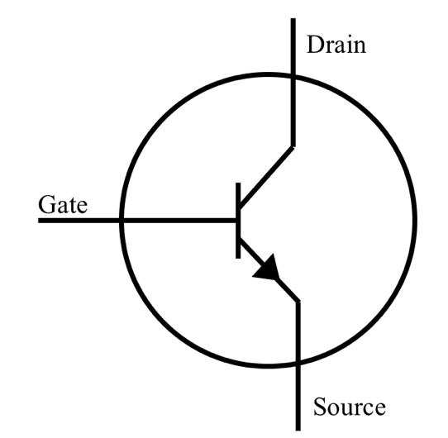
Figure 3. Transistor Schematic.
Current flows from the drain to the source across a semiconducting material. The current can be modulated by application of gate voltage.

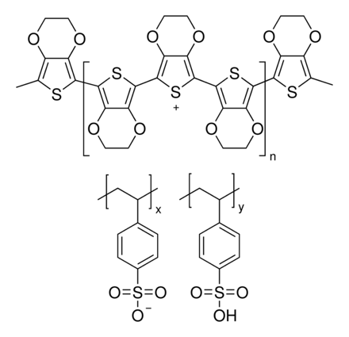
Figure 4. PEDOT:PSS Chemical Structure.
electron holes travels across the polymer, and consequently the current flowing through it as well. Therefore, if more cations are injected into the film, the conductivity of the PEDOT:PSS decreases. PEDOT:PSS is integrated into OECTs by acting as the semiconductor, connecting the source and drain electrodes. And electrolyte solution then connects the gate electrode to the semiconductor. When a positive gate voltage is applied, cations from the electrolyte are injected into the PEDOT:PSS, thereby changing the current that flows from the drain to the source. Integrating membrane biosensors with bioelectronic devices opens the door for fast, efficient, high-throughput data collection with the sensitivity and control of a cell membrane-based sensor.
However, challenges arise when integrating membrane biosensors with bioelectronic devices. Firstly, the membranes that comprise membrane biosensors are lipid bilayers require hydrated, soft, flexible, cushioned surroundings that do not restrict movement, as a rigid surface of a bioelectronic device would. To mitigate this, the surface of the bioelectronic sensor is coated in the conductive polymer PEDOT:PSS film to provide cushioning for the lipid bilayer membrane. Then, the addition of the bilayer to the transistor provides more control over the change in conductivity of the PEDOT:PSS film. As mentioned before, the transistor is the device in this system for obtaining high-throughput measuring capability and the membrane is the mechanism for obtaining sensitivity and control. Therefore, different proteins and species can be introduced into the membrane and their effects may be measured by changing conductivity of the PEDOT:PSS film. The integration of biomembranes and OECTs is a quickly growing fields of research, as reviewed in the next section.

1.2 Literature Review
In a 2006 paper by Bernards, et al., a Teflon support was immersed in an electrolyte, and a bilayer was formed by “painting” lipids onto the Teflon support. In order to test the quality of the membrane, gate voltage was applied, and the source/drain current was observed. With a well-formed bilayer, no current modulation will occur with varying input gate voltages. Then, with sufficient input voltage, the bilayer will rupture, and the input gate voltage will modulate the source/drain current. Gramicidin ion channels were then mixed into the lipids until sufficient gate currents were observed. It was shown that the gramicidin ion channels allow for the modulation of the source/drain output current by the gate voltage. The method can be used to confirm the bilayer quality, but it cannot be used to confirm formation prior to testing with ion channels, and it is unknown how consistently well-formed bilayers were achieved. Therefore, without being able to test the ionic seal of the same exact bilayer that will be used for ion channel testing, it cannot be certain that the current modulation is due to ion channel and not a leak in the lipid bilayer [11].
This method of using PEDOT:PSS as a cushion for bilayer formation has been repeatedly shown by Susan Daniel’s research team at Cornell University. Daniel’s lab has largely contributed to the biomembrane sensing research field and much of their work has inspired additional projects, including this one. Daniel’s group published nine papers (excluding reviews) on the integration of biomembranes with OECTs or PEDOT:PSS conductive polymers between 2016 and 2021.
In their 2016 paper, Zhang et al. investigated the assembly of supported lipid bilayers (SLBs) on a PEDOT:PSS film for organic electrochemical transistors (OECTs) in attempt to merge SLBs on silica with PEDOT:PSS coated OECTs. Their method consisted of a glass slide spin coated in PEDOT:PSS, which was dried and then rehydrated. Lipid vesicles were then introduced in a PBS buffer and the bilayer formed via vesicle fusion. The buffer was exchanged for DI water, after a lipid bilayer was presumed to have formed, to encourage further fusion of vesicles onto the PEDOT:PSS film. However, PEDOT:PSS has been found to be less hydrophilic, thinner, and rougher when submerged in DI water. Therefore, the PEDOT:PSS was cast with 3-glycidoxypropyltrimethoxysilane (GOPS). The addition of GOPS mitigates these effects and slightly decreases the conductivity of the film. This paper demonstrated partial formation of an SLB on PEDOT:PSS and successfully incorporated and sensed an ion pore, demonstrating the ability of the device to sense membrane function. They tested these bilayers with a 3-electrode setup and the resistance of these bilayers were in the range of 5-30 $Ω$cm²[12].
In 2019, Su et al. of Daniel's group developed a method for generating SLBs on a conducting polymer device using a solvent-assisted lipid bilayer technique (SALB). This method does not require vesicle rupture and can be used on surfaces where vesicle fusion often cannot [13,14]. However, this method still relies on the self-assembly of vesicles into a bilayer. Their goal was to emulate mammalian and bacterial membranes to test interactions with specific bacteria and antibiotics due to the lack in compatibility of biological membranes with membrane biosensors. After spin coating a glass slide with PEDOT:PSS, drying, and rehydrating it, a microfluidic chamber was adhered on top. First, a liposome solution was delivered, incubated for 30 mins, and rinsed with a PBS buffer to remove excess vesicles. Here, the bilayer was formed and interaction with a bacterial toxin and an antibiotic compound was studied [1].
Then in 2020, Daniel’s team published two more papers, one by Pappa et al. and another by Liu et al. Each developed methods for multimodal monitoring of TMP (transmembrane protein) function via mammalian biomembranes on PEDOT:PSS. The specific TMP studied was obtained and expressed by blebs, or portions of plasma cell membrane with an overexpression for the TMP. PEDOT:PSS, the transparent, electrical conducting polymer surface, allowed for dual optical and electrical monitoring of the TMP. Pappa et al. specifically focused on the integration of membrane biosensors with OECTs. This research is critical because TMPs are difficult to study due to the environment’s influence on protein conformation, mobility, biomolecule interaction and activity. The glass slide was again spin coated in PEDOT:PSS and dried and rehydrated. The cells were cultured, washed with giant plasma membrane vesicles, and incubated in a solution to induce plasma cell membrane vesicles (blebs). The bleb solution was added into a PDMS well on top of the slide, allowed to incubate and then washed off with a PBS solution. This work demonstrated the potential for high-throughput screening for TMP modulators [15,16].
A shortcoming of these approaches lies in the low values of membrane resistance that reduce device sensitivity and specificity. Many of these papers used vesicle fusion (or similarly, SALB) for bilayer formation [1,12,15,16,17,18,19]. This method relies on the rupture of lipid vesicles, followed by the subsequent arrangement of individual lipids into a lipid bilayer directly on the surface of the conductive polymer. Although effective, this method does not consistently result in high quality formed membranes and is known to produced leaky bilayers (5-1000 Ω cm² )[1,12,15,16,20]. Reported resistances from these papers are shown in Table 1. Measures have been taken to prove the quality of the solid-supported lipid membrane, such as FRAP (fluorescence recovery after photobleaching) and QCM-D (quartz crystal microbalance with dissipation monitoring technique) [1,12,15,17,19,21]. FRAP is used to quantify the ability of the lipids to laterally diffuse across the membrane. This may demonstrate the tendency of lipids to fill in nearby gaps or holes, but this does not prove that the bilayer is packed tightly enough to prevent the passage of ions. QCM-D provides time related information on the mass, thickness, and viscoelastic properties of the membrane [22]. Again, this may be helpful in demonstrating membrane formation on the solid surface but does not provide information on the quality of the bilayer. The quality is crucial to demonstrate, otherwise an ionic transport across the membrane may not be due to the transmembrane proteins, as assumed. Of these nine papers from Daniel’s group, seven involved bilayer formation on PEDOT:PSS thin film [1,12,13,14,15,16,19], all nine used vesicle fusion or SALB for membrane formation [1,12,13,14,15,17,19,23,16], seven used FRAP to evaluate the membranes formed [1,13,14,15,16,17,19,23], four used a 2-electrode set-up to electrically analyze the bilayer [13,14,16,24], two used a 3-electrode set-up to create an OECT [12,15], and none of these papers used the 3-electrode set-up to amplify signals. Examples of the 2-electrode and 3-electrode setup are shown in Figure 5.
Many other groups have published work on this topic as well. In 2020, Kawan et al. published a paper on forming and monitoring supported lipid bilayers on their specially designed n-type semiconducting polymer, lysine-based side chains tethered to a naphthalene 1,4,5,8 tetracarboxylic diimidebithio-phene backbone. Supported lipid bilayers are bilayers that are form on a solid surface, and are therefore supported, rather than freely floating or moving through a liquid. This custom semiconducting polymer was

Table 1. Reported Resistances from Daniel’s Group
Source | Resistance Reported
[1] | 0.46 kΩcm²
[12] | 5-30 Ωcm²
[13] | 4.09 kΩcm²
[14] | 42.11-58.68 Ωcm²
[15] | 40.76 Ωcm²
[17] | n/a
[16] | 0.78 kΩcm²
[18] | n/a
[19] | n/a
[23] | n/a
Average | 0.61968 kΩ cm²

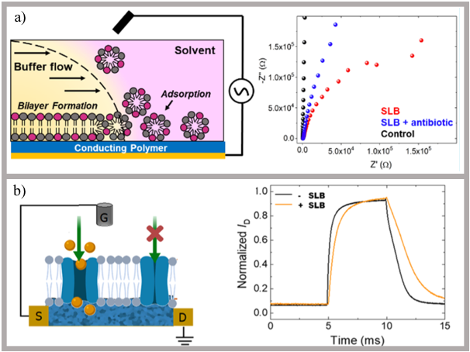
Figure 5. Examples of Previous Work- Set up and Results

a) Solvent assisted lipid bilayer formation method. This work formed a bilayer on PEDOT:PSS and used a two-electrode set up to collect impedance data. [1]. b) A bilayer is formed on a PEDOT:PSS surface which also acts as the semiconducting source/drain channel of the transistor. Here, the gate and source/drain voltage are modulated and the speed of the device response to a square gate pulse is measured[15].

created to accommodate high electrical performance and vesicle fusion bilayer formation method. This method is both commonly used and commonly questioned on its formation of a quality bilayer. This is why this group aimed to specially design their polymer to improve bilayer formation. The bilayer quality was evaluated using FRAP and QCM-D [21].
Although many papers have proven that these lipids tend to fill in spaces between themselves and disperse laterally via FRAP, this does not indicate how tightly packed the membrane is to start with. This is an area of concern, given the fact that electrical data is being collected, and that these devices are in a conductive solution. If the ionic seal is not complete, then ions may be passing from one electrode to another, simply in the gaps of the membrane, via the solution, rather than via through the membrane or the transmembrane proteins themselves. Furthermore, this setup does not allow for the testing of the ionic seal, which is most likely why it has not been tested.
This work proposes that the Droplet Interface Bilayer (DIB) method may solve these shortcomings of current membrane biosensors. The DIB method consists of two aqueous droplets in oil, suspended each by an electrode, with lipid in the aqueous solution, or oil, or both. The lipids then assemble at the oil/water interface. Usually, the droplet is then pushed against a second droplet, which also is surrounded by a lipid monolayer. When in contact, the monolayers ‘zip up’ and form a bilayer. In this case however, the bilayer was formed near the surface of the device, utilizing the PEDOT:PSS as an electrode for one of the droplets. This setup would allow for the testing of an ionic seal, due to the fact that the membrane is in oil (an insulator) as well as a 3-electrode set-up. Just as we do a seal test when testing the ionic seal of two droplets suspended from electrodes forming a DIB, we can do the same in this setup, with one electrode holding a droplet in oil, and the other touching the PEDOT:PSS, below the lipid membrane.

1.3 Objectives
There are three main objectives of this work. First, I aim to present a repeatable and consistent method for creating and evaluating a stable, well-packed bilayer on a PEDOT:PSS thin film. Second, I aim to show my understanding of a transistor and design and fabricate devices that can accommodate a bilayer where the transmembrane voltage, controlled by the gate and drain voltages, can be used to affect ion transport into the polymer and thus its change in conductance. Lastly, I aim to compare a mathematical simulation of this bilayer and transistor with experimentally found results.

1.4 Document Overview
This document is divided into four chapters. The first chapter introduces the lipid bilayer membranes, how they are created in a lab, how they can be incorporated into and beneficial to sensing applications and discusses previous work. The second chapter explains the methods used to form bilayers above the PEDOT:PSS surface, and how the chosen method was designed. The third chapter focuses on the transistor properties of the system. Here, the method for forming a bilayer above the PEDOT:PSS is applied to a transistor surface, and the transistor fabrication, set-up and testing is described. Lastly, chapter four reflects on the findings from this work, states the conclusions found, and discusses suggested future work.
Figures are placed on the page following the first mention, unless multiple figures are mentioned for the first time on a page, in which case the figures will be on the pages following, in the order that they were mentioned.

:
Bilayer Formation on PEDOT:PSS Film
The goal of this chapter was to assess lipid bilayer formation on or near the PEDOT:PSS film. This has previously been done by forming a supported bilayer well above the PEDOT:PSS film, with aqueous solution in between [11]. This can be done a number of ways, and the aqueous solution is not required to be specifically between the bilayer and the PEDOT:PSS. We hypothesized that that the PEDOT:PSS would be hydrophilic enough to support lipid monolayer formation (like a droplet-on-hydrogel bilayer) for direct DIB formation (Figure 6a). This method was then compared a version of the DIB technique, with a bilayer forming between a lipid coated sessile droplet and a lipid coated hanging droplet (Figure 6b).

2.1 Materials and Methods

2.1.1 PEDOT:PSS Slide Preparation
The PEDOT:PSS slides were prepared similarly to the methods in [12,15,16]. First, a glass slide was cleaned via sonication in water and soap (Hellmanex III) , DI water, ethynol, acetone, and propanol, each for 15 minutes. The slide is then dried with nitrogen gas and plasma cleaned. Directly after plasma cleaning, the slide is spin coated with PEDOT:PSS at 2000 rpm for 20 seconds, to create a film ~100nm thick [15]. Then, in an oven or covered on a hot plate, the PEDOT:PSS slide is baked at 115 degrees Celsius for 20 minutes. In 100mM KCl, the slide is soaked for 20 minutes. Following this procedure, the slide is allowed to dry for at least 24 hours in a vacuum.

2.1.2 Contact Angle Measurements
Prior to running this experiment, it was unknown how the aqueous droplet would wet to the film under oil. The contact angle of the bottom droplet on the PEDOT:PSS would determine whether or not this vertical DIB method would work at all. If the droplet completely wet the surface, therefore would not be enough aqueous solution for the upper, electrode suspended drop to touch down onto, without questioning that the droplet is directly touching the PEDOT:PSS itself. On the other hand, if the droplet did not wet the PEDOT:PSS at all, then it may have such a high contact angle that its position is not stable and may roll around on the PEDOT:PSS film. Therefore, the ideal conditions had to be found to achieve a contact angle between 50 and 100 degrees. Since PEDOT:PSS is hydrophilic, a water drop in air will wet the surface completely [24]. However, by placing the droplet on the PEDOT:PSS film under oil and altering the hydration of the film, I was able to observe large changes in the contact angle. In air, the droplet immediately wet the surface, while in oil, the droplet never completely wet the surface. This is due to the fact 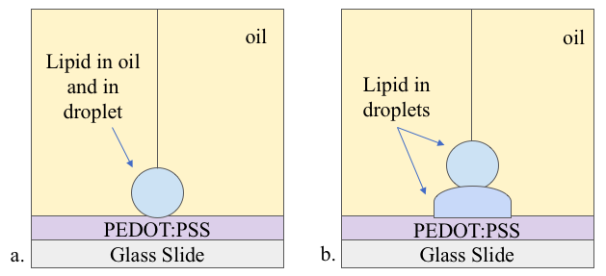

Figure 6. Direct Bilayer vs. Vertical DIB Methods.
a) The direct bilayer method. Lipid is in both the oil and the droplet, and a bilayer is formed between the droplet and the PEDOT:PSS layer. b) The vertical DIB method. Lipid is in the droplets and a bilayer is formed between the two droplets.

that lipid monolayer tension at the air-water interface is higher than at the oil-water interface [25].
Two types of slides were prepared for the contact angle measurements. The first slide type was cleaned via sonication, spin coated in PEDOT:PSS, and baked at 115 degrees C for 20 mins. The second was also cleaned, spin coated and baked, but following this it was also submerged in 100mM KCl and allowed to dry for 24 hours. The first type is referred to as “non-hydrated” and the second “hydrated”. The droplet on the non-hydrated PEDOT:PSS had an average steady state contact angle of 51.1°, and the droplet on the hydrated surface had an average steady state contact angle of 68.7°. The larger contact angle was preferred so that the droplet could be more easily seen and distinguished from the PEDOT:PSS surface (Figure 7).
Contact angle measurements were made with a Dataphysics Contact Angle Goniometer OCA 15EC. The droplets were 2mg/mL DPhPC in 100mM KCl , and 3 $μ$L volume was used for each measurement. Two different PEDOT:PSS slides were prepared. One, was cleaned and spin coated in PEDOT:PSS, and baked at 150 degrees C for 20 mins. The other was submerged in 100 mM KCl for 20 mins following baking and then dried for 24 hours in a vacuum. SCA20 image analysis software was used.

2.1.3 Initial Direct Attempts
The initial attempts of bilayer formation above the PEDOT:PSS film consisted of bilayer formation directly between an aqueous droplet and the PEDOT:PSS film itself. This 2the aqueous droplet. PEDOT:PSS has both hydrophobic and hydrophilic regions. The PEDOT core is hydrophobic and the PSS surrounding shell is hydrophilic. Therefore, it was hypothesized that if enough lipid heads arrange themselves on the hydrophilic surface of the PEDOT:PSS film, then a monolayer of lipids may form, with tails pointing upwards. Then, by lowering a droplet surrounded in a similar, monolayer down onto the monolayer that formed on the PEDOT:PSS film, a bilayer would form.
In order for this to work, the film and the droplet had to be in a well/substrate filled with oil containing lipids. The droplet itself may have contained lipids, but it was not required, since lipids had to be in the oil. The droplet was place on the end of an Ag/AgCl electrode, which was controlled by a micromanipulator (World Precision Instruments Kite Manual Micromanipulator). This allowed for control of the placement of the droplet on the surface of the PEDOT:PSS. After the 400nL droplet was placed on the electrode, 5-30 minutes was given for monolayer formation. As the lipids assemble around the droplet at the oil/water interface, the surface tension of the droplet decreases [26]. Given sufficient time, the droplet will begin to sag on the end of the electrode. This is a visible change in the shape of the droplet and is attributed to the lipids moving from inside the droplet to the perimeter.

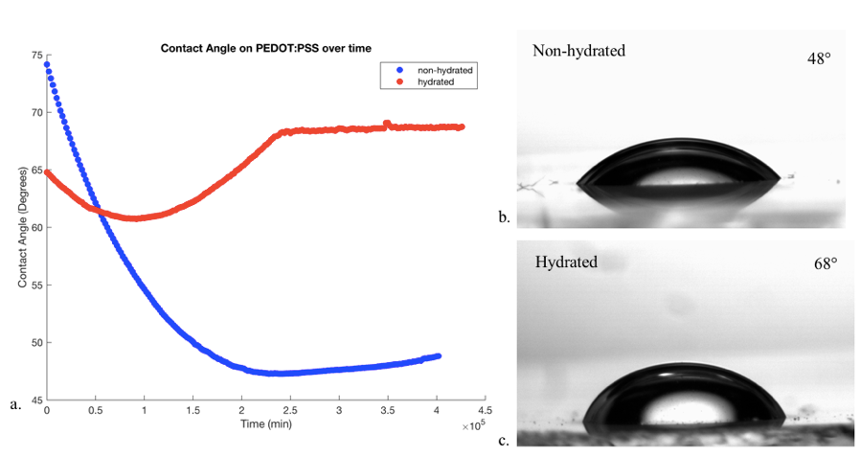
Figure 7. Contact Angle Measurements on PEDOT:PSS.

a) Change in contact angle over time for the droplet on the hydrated PEDOT:PSS (red) and the non-hydrated PEDOT:PSS (blue). b) and c) show the final steady state contact angles of droplets on both slide types.

PEDOT:PSS was polymer be wetted by water [27]. A lipid concentration of 2mg/mL DPhPC (1,2-diphytanoyl-sn-glycero-3-phosphocholine mixed with GOPS (1%wt) to maintain the polymer’s characteristics in water, ethylene glycol (5% vol) to increase the conductivity (after being decreased by the GOPS), and DBSA (0.002% vol) as a surfactant) was used for the droplets. For the surrounding oil, various lipid types and concentrations were used in attempt to form a monolayer on the PEDOT:PSS surface. First, 4mg/mL, 5mg/mL, and 10mg/mL DPhPC was used, then 5mg/mL DOPC and 5mg/mL of Lecithin were used. Hexadecane was the oil used and lipids were in the droplets and in the oil.
To assess bilayer formation, the voltage across the bilayer was measured. The PEDOT:PSS was grounded and the electrode holding the droplet was connected to the Axopatch, where voltage could be applied. A 10 Hz triangle wave of 500 mV amplitude was applied to the droplet. After the droplet has been given sufficient time for monolayer formation and appears to sag (indicating that the monolayer may have formed), the droplet was lowered to touch the PEDOT:PSS. If the monolayer on the PEDOT:PSS and the droplet are well formed, then by bringing them to touch, a bilayer may form between the two monolayers. If this happens, the triangle wave that is applied to the system will become a square, once passed across the bilayer. Bilayer formation is commonly recognized as quickly growing square wave. Once the bilayer is formed, the amplitude will become constant, and the squarer the wave, the less leaky it is. This behavior is shown in Figure 8. The bilayer electrically acts like a capacitor and a resistor in parallel, which is why the input triangle wave is output as a square wave.

2.1.4 Vertical DIB Method
The second approach, the vertical DIB, incorporated the droplet interface bilayer (DIB) method. The DIB method is shown in Figure 9a. Here, each droplet is suspended by an electrode in oil. Lipids in the droplets assemble into monolayers around each droplet, and a bilayer may form when the two lipid-covered droplets are brought to touch. The vertical DIB method, Figure 9b, uses this same idea, except one of the droplets is sitting on the PEDOT:PSS, which acts as one of the electrodes. As opposed to a single 400 nL droplet, as used in the initial direct attempts, the vertical DIB method consists of a droplet sitting directly on the PEDOT:PSS film and a second droplet suspended by an electrode (Figure 9). With lipids in the droplets, sufficient time was given for monolayer formation around both droplets. Then, the droplet hanging from the Ag/AgCl electrode was lowered with a micromanipulator onto the resting droplet for bilayer formation. As opposed to the more common DIB technique, the droplets in this case are one on top of another, instead of side by side, and only one droplet is hanging from a (micro-manipulatable) electrode, as shown in Figure 9. These bilayers were assessed and post-processed in the same way the initial direct bilayer attempts were evaluated.
Figure 8. Bilayer Formation Example.
The upper plot shows the distinctive growth in amplitude associated with bilayer formation. As the bilayer forms and its area quickly increases, more current is passed through until the bilayer reaches a stable size. The lower plot shows square wave associated with a well-formed bilayer. If the wave is not square and is more triangular, this means that the bilayer is leaky, or has not formed at all.

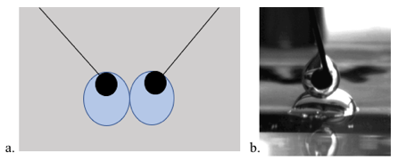
Figure 9. Droplet Interface Bilayer Method vs. Vertical DIB
a) Typically, droplet interface bilayers are formed by suspended two droplets from electrodes in oil. Lipids may in in the droplet, in the oil, or in both. b) The vertical droplet interface bilayer is formed by placing one droplet on the film and lowering a second droplet with an electrode down to touch it. Lipids may in in the droplet, in the oil, or in both for either method.

2.2 Results

2.2.3 Direct Bilayer
This first attempt at bilayer formation occurred directly between the droplet and the PEDOT:PSS (as shown in Figure 10). Out of 79 trials, 31 bilayers were formed (39.2% success rate). Qualitatively, these bilayers were leaky, were not very stable, and did not last long enough to begin more complex measurements (such as adding voltage activated channels into the bilayer). All 31 bilayers lasted less than 10 minutes, for the exception of one bilayer that lasted for over 60 mins. This bilayer was also the most stable and least leaky bilayer that was formed using this method. However, this only occurred once and was not able to be repeated. This method did not prove to be consistent enough to continue pursuing. Therefore, a second method of bilayer formation above the PEDOT:PSS film was designed and attempted.

2.2.4 Vertical DIB
The vertical DIB method was much more reliable and consistent than the previous method. Here, 31 bilayers were formed out of 37 trials (83.8% success rate). These bilayers had resistances of 1-10 kΩ cm² and, when 1:1 DPhPC:DOPC was used as the lipid in the droplets, the bilayers never ruptured prematurely and lasted over 30 minutes.

2.2.4 Alamethicin
Alamethicin was used to further prove the formation of the bilayer. This is a peptide that oligomerizes to form voltage-activated channels. This means that when voltage is applied to the bilayer, it oligomerizes with other alamethicin monomers to form a channel in the bilayer, allowing ions to pass through the bilayer. In the absence of Alamethicin, any applied potential drop will only occur across the membrane and ion transport is prevented. However, with alamethicin, applied voltage to one side of the bilayer will cause the channels to open and allow ions to flow from aqueous droplets through the bilayer. Therefore, when a 0.05 Hz sine wave of 80 mV amplitude was applied the channels will open when they experience high positive voltage, and corresponding large increases of current indicate that the channels are inserting, and a bilayer has formed (Figure 11).

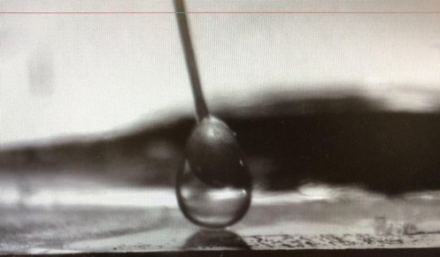
Figure 10. Picture of a Direct Bilayer Formation Attempt.
Here, an aqueous droplet containing 2mg/mL DPhPC is hanging from an Ag/AgCl electrode in in hexadecane with 5mg/mL DPhPC. The droplet rests on PEDOT:PSS, and, ideally, the bilayer forms where the droplet and PEDOT:PSS meet.

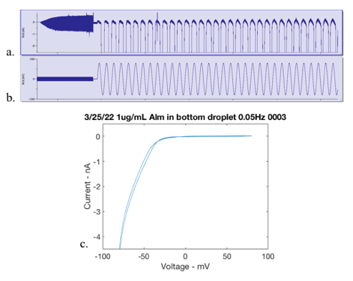
Figure 11. Testing Inputs and Results of a Bilayer Containing Alamethicin.
a) The current response when b) sine wave is applied. The Alamethicin channels insert into the bilayer membrane when sufficient positive voltage is applied and allow ions to pass through. Therefore, large amounts of current pass through and can be seen as large one-sided spikes in the current.

:
Transistor Fabrication and Testing
In this chapter, transistor device design, fabrication and testing are discussed. The transistor consisted of PEDOT:PSS spin coated on a glass slide. Two conductive wires attached to the PEDOT:PSS on either side as electrodes, and the gate electrode was a droplet touching the PEDOT:PSS, suspended by an electrode wire. As the voltage applied to the drain, across the PEDOT:PSS channel is increased, the current response also increases. However, when the applied gate voltage increases, the current around the PEDOT:PSS channel decreases. It was also found that decreasing the area of PEDOT:PSS increases this response. Therefore, the PEDOT:PSS channel size was minimized so that the region being influenced by the droplet (the active region) is significant in comparison to the entire PEDOT:PSS area.

3.1 Testing Method
The underlying OECT device was tested by applying gate voltage to a water droplet in contact with the PEDOT:PSS, in between the two Ag/AgCl wires (Figure 12). A voltage was also applied across the PEDOT:PSS film, from drain to source. Both input voltages were simultaneously applied. The gate voltage remained constant at 0 V, as the drain voltage swept from 0.5 V to -0.5 V in increments of 0.1 V. Then, the gate voltage increased to 0.2 V and the drain voltage again swept from 0.5 V to -0.5 V in increments of 0.1 V. This repeated again for gate voltages of 0.4 V and 0.6 V. From [28], where these values were found, it is shown that the output current should increase with increasing drain voltage and decrease with increasing gate voltage. This is because as the gate voltage increases, it drives more cations into the PEDOT:PSS film, de-doping the semiconducting film and decreasing the conductivity. Since typical bilayers can only withstand about 200mV, the gate voltages and drain voltages were decreased for tests including a bilayer formed at the top of the resting water droplet. Representative voltage inputs and current output of such tests are shown in (Figure 13).

3.2 Device Layout
The initial device layout was a 15 x 15 mm glass slide spin coated in PEDOT:PSS. Ag/AgCl wires were attached to the PEDOT:PSS via dried droplets of more PEDOT:PSS acting as a glue. The next device design prioritized a smaller PEDOT:PSS region. The glass slide was masked by tape everywhere except for a 2mm width strip down the center of the 15 mm long glass slide. Therefore, after spin coating, there was a 2mm by 1.5mm long PEDOT:PSS strip down the center of the glass slide. The Ag/AgCl wires were attached to the slide with conductive paint, to minimize the unaffected PEDOT:PSS area. The two device designs are compared in (Figure 14). The width of the PEDOT:PSS stripe is
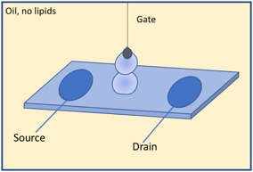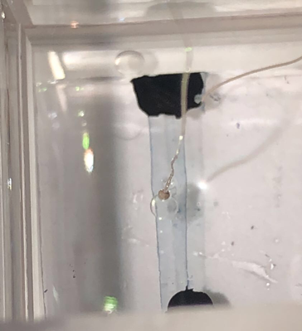
Figure 12. Schematic and Picture of a Droplet on the OECT.

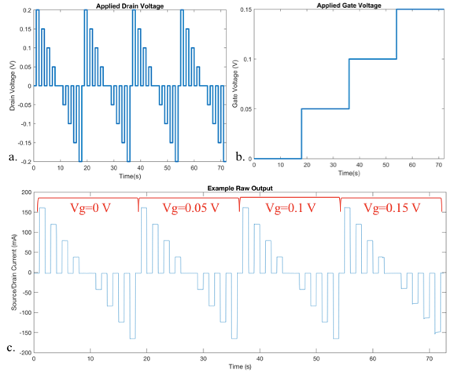
Figure 13. Inputs and Outputs of Transistor Testing.
a) and b) MATLAB figures of the applied voltage to the system. Various drain voltages are applied in 1 second pulses (with 1 second at 0V in between each). Simultaneously, a steady gate voltage is held. The drain voltage sweep repeats again for the next gate voltage value, and again until each gate voltage step is complete. c) Current across the source and drain is measured. Each consecutive sweep corresponds to a different gate voltage.

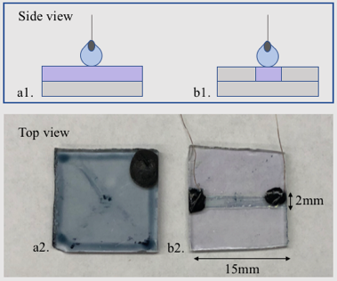
Figure 14. Complete PEDOT:PSS Coating vs. Reduced Channel Area Coating.
a1) and a2) The original design for the PEDOT:PSS device. The entire slide was coated in PEDOT:PSS. b1) and b2) This design reduced the total PEDOT:PSS are on the slide. The glass slide was masked with tape everywhere except the desired channel. This design aimed to make the total PEDOT:PSS area as small as possible, so that the effects of gate voltage could be seen.

comparable to the diameter of the 400nL droplet, which is why this size was chosen. The area of total PEDOT:PSS on this new design is 7.5 times less than the previous design. Assuming the area that the droplet interfaces with the PEDOT:PSS is about 1mm², then the ratio of the active to total PEDOT:PSS area is 1:30, as compared to the previous 1:225.

3.3 Testing Device Designs
The first device was a 15mm x 15mm glass slide completely coated in PEDOT:PSS. When this device was tested, the output current increased with increasing drain voltage, but it also remained constant with increasing gate voltages, as opposed to decreasing. This was attributed to the fact that the area of PEDOT:PSS on the device is much larger than the area of the PEDOT:PSS affected by the de-doping action of the aqueous droplet and gate voltage. For reference, the PEDOT:PSS coated glass slide is 225mm² and the active area that the droplet touches is about 1mm². Therefore, the effect felt is much smaller than if the entire PEDOT:PSS on the device was touching the aqueous droplet. The width of the PEDOT:PSS stripe is comparable to the diameter of the 400nL droplet, which is why this size was chosen. The area of total PEDOT:PSS on this new design is 7.5 times less than the previous design. Assuming the area that the droplet interfaces with the PEDOT:PSS is about 1mm², then the ratio of the active to total PEDOT:PSS area is 1:30, as compared to the previous 1:225. From this device, the effect of the increasing gate voltage can be seen much more clearly. The current measurements from each of these devices are compared in Figures 15 and 16.

3.4 Testing (No Bilayer)
The device was tested without a bilayer in order to obtain preliminary measurements with a simple setup. As shown previously in Figure 10, an aqueous droplet was placed onto the PEDOT:PSS region by an Ag/AgCl electrode controlled by a micromanipulator. The 10 drain voltages (0.5 V to -0.5 V) for all 4 gate voltages (0, 0.05, 0.1, 0.12 V) were applied to device for a total of 40 different input combinations. With the minimized PEDOT:PSS area device design, the output drain currents decreased with increasing gate voltage. In order to show that this result was dependent on the gate voltage and not an unknown cause, the input sequence was immediately repeated. This can be tested by comparing the output current when 0.5 V drain voltage and 0.6 gate voltage are applied in the first sequence, to the output current when 0.5 V drain voltage and 0 V gate voltage are applied in the second sequence. In the experiment, Figure 17 shows that the second sequence did have larger output currents for 0.5 V drain voltage and 0 V gate voltage than 0.5 V drain voltage and 0.6 gate voltage in the first sequence, indicating a repeatable effect. For the droplets, 2mg/mL 1:1 DPhPC:DOPC in 100mM KCl was used for the tests with and without a bilayer.

Figure 15. Current Response for fully PEDOT:PSS Coated Transistor.
Here, the entire glass slide was spin coated in PEDOT:PSS. This means that the area of PEDOT:PSS covered by the aqueous droplet and affected by the gate voltage is miniscule, as compared to the entire PEDOT:PSS. The results in this graph demonstrate that the changing gate voltage does not significantly affect the source/drain current response of the PEDOT:PSS channel.

Figure 16. Current Response for Transistor with Reduced PEDOT:PSS Area.
Here, the overall area of PEDOT:PSS is significantly reduced, so that the active area of the device is large enough to cause a noticeable change in conductance. This plot demonstrates that when the active PEDOT:PSS area is at least 3.33% (1/30th ) of the entire PEDOT:PSS area, then the effect of the gate voltage can be seen. As the gate voltage increases, cations are driven into the PEDOT:PSS, filling electron holes, and decreasing the conductance of film. Therefore, with higher gate voltages, the source drain current is smaller.

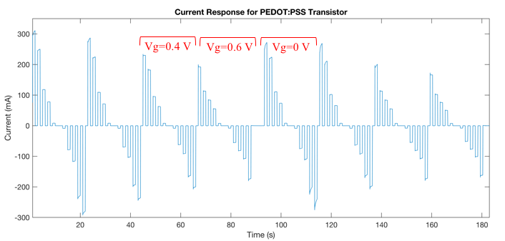
Figure 17. Dependence of Current on Gate Voltage.
Usually, the gate voltages are applied from 0-0.6 V in ascending order. Here, however, the pattern was repeated twice to show that the current pattern repeats when the gate voltage goes from a high value (0.6 V) to a low value (0 V).

After decreasing the PEDOT:PSS area on the device, the dependence of current on gate voltage was tested. It was seen in Figure 16 that as gate voltage is increased, the current response decreases. However, in order to show that this decrease in current is actually an effect of the gate voltage, the gate voltage needed to be also applied in an increasing order. Figure 17 shows that in fact, when a small or zero gate voltage is applied after 0.6 V gate, the current response increases greater than the previous response. However, the current response is still lower as compared to the initial 0 V gate voltage. Figure 18 also displays this in a current vs voltage plot. Here, it can be seen that an initial 0V gate voltage is applied its current response is plotted. When the 0.6V gate voltage is then applied, the current response decreases. Lastly, when the 0V gate voltage is applied for the second time, the current response increases again, but not to the same magnitude as the original current response for the initial application of 0V gate voltage.

3.5 Testing with a Bilayer
After the device design was improved and the behavior of the device with a bilayer was investigated, a lipid bilayer was introduced in between the electrolyte filled droplet hanging from the gate electrode and the PEDOT:PSS semiconductive film. When drain and gate voltages of -0.5-0.5 V and 0-0.6V, respectively, were applied, the two droplets on either side of the bilayer coalesced. This happened 5/5 times that a gate voltage above 0.1V was applied. The results of a trial in which the bilayer coalesced part way through are plotted in Figure 19. The bilayer was still intact during the 0V, 0.05V, and 0.1 V (pink, green, and blue) gate voltage applications. However, when 0.15V gate voltage was applied, the bilayer ruptured, and the ions were no longer prevent by the bilayer to pass through to the PEDOT:PSS. This is seen by the current response during the 0.15V and 0.2V gate voltage applications (black and red), where the conductance of the PEDOT:PSS was changed, and the increasing gate voltage then decreased the current response.
Following this test, the testing conditions were altered so that the bilayer would stay intact throughout all gate voltage applications. Drain current remained at -0.5V-0.5V and gate voltage was lowered to 0V, 0.05V, and 0.1V. The results of this test can be seen in Figure 20. The current responses for all 3 gate voltages are nearly identical, showing that the gate voltage was not able to inject ions into the PEDOT:PSS and change the conductance. In Figure 21, the same test was run without a bilayer, so that a comparison could be made among identical gate voltage applications. Here, it can be seen that the gate voltage did change the current response. Lastly, Figure 22 compares the same test, without a bilayer, but with more gate voltages. It can be seen that with small gate voltages and small changes in gate voltage, the current response is smaller.
In order to analyze this data further and investigate the effects of a bilayer present on the OECT, the conductance values for each gate voltage were found. The conductance
Figure 18. IV Plot for Dependence on Gate Voltage Case.
This IV plot shows that if gate voltages are applied in ascending order, the current response will decrease, and if gate voltages are applied in descending order, the current response will increase. However, the initial 0V application of gate voltage (blue) has a larger current response than the subsequent application of 0V gate voltage (red).

Figure 19. Vertical DIB on PEDOT:PSS Transistor.
With a bilayer, the gate voltage did not change the current output. However, when the bilayer ruptures, the gate voltage is not hindered by the resistive bilayer and changes the conductance of the PEDOT:PSS.

Figure 20. Bilayer Resistance to Gate Voltage.
When a bilayer exists between the gate electrode and the PEDOT:PSS, the gate voltage does not significantly change the current output. The resistive lipid bilayer prevents the passage of ions from the electrolyte droplet to the PEDOT:PSS film.

Figure 21. Control Case -No Bilayer.
When there is no bilayer present, ions from the electrolyte are free to travel into the PEDOT:PSS, changing its conductance when the gate voltage is applied.
Figure 22. Comparison of Small and Large Gate Voltages.

values were found by finding the slope of a trendline for each data set of different gate voltages for drain voltages of 0V to -0.5 V. this range was chosen because it appears most linear consistently. The values of conductance are reported in Table 2. “Bilayer” indicates that there were two droplets and there was a bilayer present between the gate electrode and the PEDOT:PSS channel. “No Bilayer” indicates that there was only one droplet and the gate voltage freely injected ions into the PEDOT:PSS. It can be seen from this table that when a bilayer was present, the conductance decreased by just 1.86 mA/V total for a 0.1 V increase in gate voltage. When a bilayer was not present, the conductance decreased by 63.34 mA/V for a total of 0.1 V increase in gate voltage.

Table 2. Conductance Values for PEDOT:PSS.
Gate Voltage | Bilayer | No Bilayer
0 V | 601.8 mA/V | 321.52 mA/V
0.05 V | 602.93 mA/V | 301.77 mA/V
0.1 V | 603.66 mA/V | 258.18 mA/V

:
Conclusions and Recommendations
The major goals of this work were to develop a method for reliably forming a lipid bilayer on or above the PEDOT:PSS and incorporate this method into an OECT device. The vertical droplet interface bilayer method proved to be a consistent (83.9% success rate) and highly resistive (1-10 kΩ cm²). As compared to previous works that used SALB and vesicle fusion to form bilayers on OECT solid surfaces which resulted in bilayers with resistances of 0.005-5 kΩ cm² (0.6 kΩ cm² on avergage) the vertical DIB method resulted in bilayers with resistances up to 1 million times greater.
Following this work, there are three important aspects that should be developed and improved further. First, the fabrication of the OECT devices should be controlled. Currently, these devices are made by hand and this method leaves room for error. The size and shape of the PEDOT:PSS region should be consistent, so that the devices are identical, and results may be compared across devices. The region of the PEDOT:PSS should also be decreased further, so that the results of the gate voltage may be relativity larger, which may improve the visibility of results of low voltage testing when a bilayer is present. Secondly, the testing parameters of the OECT should be optimized. The drain voltages were swept from -0.5 V to 0.5 V, and the maximum gate voltages was decreased from 0.6V to 0.1 V, in order to accommodate for the bilayer, which would rupture above 0.1V gate voltage. Further testing could experiment with keeping the maximum gate voltage at 0.6V and decreasing the drain voltage to see what the bilayer can withstand. Lastly, ion channels should be introduced into the membrane to further modulate current. This would further confirm the presence of the bilayer between the droplets and demonstrate how the ability to modulate the flow current.

List of References

[1] Su, H., et al. "Facile Generation of Biomimetic-Supported Lipid Bilayers on Conducting Polymer Surfaces for Membrane Biosensing." ACS Appl Mater Interfaces 11.47 (2019): 43799-810. Print.
[2] Park, S., et al. "Enzyme-Linked Immuno-Strip Biosensor to Detect Escherichia Coli O157:H7." Ultramicroscopy 108.10 (2008): 1348-51. Print.
[3] van den Hurk, R., and S. Evoy. "A Review of Membrane-Based Biosensors for Pathogen Detection." Sensors (Basel) 15.6 (2015): 14045-78. Print.
[4] Almeida, J. G., et al. "Membrane Proteins Structures: A Review on Computational Modeling Tools." Biochim Biophys Acta Biomembr 1859.10 (2017): 2021-39. Print.
[5] Osaki, T., and S. Takeuchi. "Artificial Cell Membrane Systems for Biosensing Applications." Anal Chem 89.1 (2017): 216-31. Print.
[6] Berggren, M., and A. Richter-Dahlfors. "Organic Bioelectronics." Advanced Materials 19.20 (2007): 3201-13. Print.
[7] Lubrano, C., et al. "New Frontiers for Selective Biosensing with Biomembrane-Based Organic Transistors." ACS Nano 14.10 (2020): 12271-80. Print.
[8] Bellis, Mary. “The Transistor Was a Little Invention That Made Way for Big Computers.” ThoughtCo, ThoughtCo, 3 July 2019, https://www.thoughtco.com/the-history-of-the-transistor-1992547#:~:text=Transistors%20transformed%20the%20world%20of,using%20less%20power%20and%20space.
[9] Riordan, Michael, Lillian Hoddeson, and Conyers Herring. "The Invention of the Transistor." More Things in Heaven and Earth: A Celebration of Physics at the Millennium. Ed. Bederson, Benjamin. New York, NY: Springer New York, 1999. 563-78. Print.
[10] SigmaAldrich. “Poly(3,4-Ethylenedioxythiophene)- Poly(Styrenesulfonate).” Millipore Sigma, www.sigmaaldrich.com/US/en/product/aldrich/655201. Accessed 4 July 2022.
[11] Bernards, Daniel A., et al. "Gating of an Organic Transistor through a Bilayer Lipid Membrane with Ion Channels." Applied Physics Letters 89.5 (2006). Print.
[12] Zhang, Yi, et al. "Supported Lipid Bilayer Assembly on Pedot:Pss Films and Transistors." Advanced Functional Materials 26.40 (2016): 7304-13. Print.
[13] Liu, H. Y., et al. "Biomembrane-Based Organic Electronic Devices for Ligand-Receptor Binding Studies." Anal Bioanal Chem 412.24 (2020): 6265-73. Print.
[14] Bint, E. Naser S. F., et al. "Detection of Ganglioside-Specific Toxin Binding with Biomembrane-Based Bioelectronic Sensors." ACS Appl Bio Mater 4.11 (2021): 7942-50. Print.
[15] Pappa, A. M., et al. "Optical and Electronic Ion Channel Monitoring from Native Human Membranes." ACS Nano 14.10 (2020): 12538-45. Print.
[16] Liu, H. Y., et al. "Self-Assembly of Mammalian-Cell Membranes on Bioelectronic Devices with Functional Transmembrane Proteins." Langmuir 36.26 (2020): 7325-31. Print.
[17] Liu, H. Y., et al. "Biologically Complex Planar Cell Plasma Membranes Supported on Polyelectrolyte Cushions Enhance Transmembrane Protein Mobility and Retain Native Orientation." Langmuir 34.3 (2018): 1061-72. Print.
[18] Zhang, Yi, et al. "Lipid Bilayer Formation on Organic Electronic Materials." Journal of Materials Chemistry C 6.19 (2018): 5218-27. Print.
[19] Richards, M. J., et al. "Membrane Protein Mobility and Orientation Preserved in Supported Bilayers Created Directly from Cell Plasma Membrane Blebs." Langmuir 32.12 (2016): 2963-74. Print.
[20] Hardy, G. J., R. Nayak, and S. Zauscher. "Model Cell Membranes: Techniques to Form Complex Biomimetic Supported Lipid Bilayers Via Vesicle Fusion." Curr Opin Colloid Interface Sci 18.5 (2013): 448-58. Print.
[21] Kawan, Malak, et al. "Monitoring Supported Lipid Bilayers with N-Type Organic Electrochemical Transistors." Materials Horizons 7.9 (2020): 2348-58. Print.
[22] Edvardsson, M. (2020, February 25). Lipid bilayer characterization with QCM-D. Biolin Scientific. Retrieved June 21, 2022, from https://www.biolinscientific.com/blog/lipid-bilayer-characterization-with-qcm-d
[23] Hsia, C. Y., et al. "A Molecularly Complete Planar Bacterial Outer Membrane Platform." Sci Rep 6 (2016): 32715. Print.
[24] Döbbelin, Markus, et al. "A New Approach to Hydrophobic and Water-Resistant Poly(3,4-Ethylenedioxythiophene):Poly(Styrenesulfonate) Films Using Ionic Liquids." Journal of Materials Chemistry 18.44 (2008). Print.
[25] Kataoka-Hamai, C., and K. Kawakami. "Determining the Dependence of Interfacial Tension on Molecular Area for Phospholipid Monolayers Formed at Silicone Oil-Water and Tricaprylin-Water Interfaces by Vesicle Fusion." Langmuir 37.24 (2021): 7527-35. Print.
[26] Pinto, O. A., and E. A. Disalvo. "A New Model for Lipid Monolayer and Bilayers Based on Thermodynamics of Irreversible Processes." PLoS One 14.4 (2019): e0212269. Print.
[27] Ulmefors, H., et al. "Formation of Supported Lipid Bilayers Derived from Vesicles of Various Compositional Complexity on Conducting Polymer/Silica Substrates." Langmuir 37.18 (2021): 5494-505. Print.
[28] Bernards, D. A, and G. G Malliaras. "Steady-State and Transient Behavior of Organic Electrochemical Transistors." Advanced Functional Materials 17.17 (2007): 3538-44. Print.

Vita
Elizabeth Klavon lived in North Carolina before she decided to attend the University of Tennessee Knoxville, for a bachelor’s in Biomedical Engineering. During her time as an undergraduate, she worked in three different research labs, the last of which being Dr. Andy Sarles’. As an undergraduate, she learned the necessary skills to study lipid bilayer membranes in the lab. After graduating in May of 2021, she began as a Graduate Research Assistant in June of 2021, and started her own project in the lab, integrating bilayer lipid membranes with bioelectronic devices, for biosensing applications. She couldn’t be more grateful for the time she spent at UT and all that she has learned in this lab. She is now looking forward to applying the acquired skills and experience and starting her professional career.

