Critical Analysis of Cognitive Assessment Methods for Patients with Cognitive Impairment and Dementia

A Thesis
Presented to
The Faculty of the Department of Neuroscience
University of Tennessee Knoxville

In Partial Fulfillment
Of the Requirements for the Degree of
Honors Neuroscience B.S.

by
John Meghreblian
April, 2020
Abstract
The focus of this thesis is to understand the purpose of cognitive assessment exams while providing a detailed analysis and critique. This is to understand their provided benefits and limitations in order to stimulate better clinical practice through implementation of these exams. This thesis first briefly details the history of humankind’s understanding of cognitive impairment and dementia. Then, the six major areas of cognition tested by most major cognitive exams are introduced and defined, including visual spatial, executive functions, verbal fluency, memory, attention, and orientation. The dysfunction in specific brain regions that lead to cognitive impairment is discussed, as well as how these brain regions regulate both general behavior and performance on different cognitive assessments. Next, six commonly used cognitive assessment exams are introduced including the Clock Draw Test (CDT), Trail Making Test (TMT), Verbal Fluency Exams, COGselftest (CST), Mini-Mental State Exam (MMSE), and the Montreal Cognitive Assessment (MOCA). This section provides background information on each exam, steps for how exams are administered, and also an analysis of the utility for each exam. Cognitive assessment exams are some of the most important tools utilized by healthcare providers to aid in the treatment of those with cognitive impairment and dementia. This paper aims to further detail their importance and provide insight into potential improvements including how to most effectively assess cognitive impairment and shaping these exams to distinguish types of dementias.

Introduction
The idea of dementia as a concept has been around for thousands of years. One of the earliest writings of dementia came from an ancient Greek philosopher known as Pythagoras. Pythagoras split the human lifecycle into five separate stages. The last two of which were attributed the title “senium” which indicated old age (Berchtold and Cotman, 1998). These two stages were described as the period in which both the human body and cognitive ability declined and decayed. The final stage was further described as one in which very few people were unfortunate enough to reach where the mind and body revert back to the stage of infancy (Berchtold and Cotman, 1998). Once just thought of as a natural process of aging, mild cognitive impairment (MCI) and dementia have plagued humanity for millennia. As average human lifespan increased however, this ailment became evermore present in society. As the number of individuals who were suffering from this mental state grew, so too did human’s curiosity in understanding it. It wasn’t until the late 1800’s when medicine and technology had developed enough to truly begin to understand the disease we now know as dementia. For the first time, humanity started to understand that there was a difference between normal age related cognitive decline and mild cognitive impairment and dementia. It wasn’t understood that MCI and dementia were due to disease, and not just an accepted part of aging, until the early 20th century.
The first named, and most common, dementia was found in 1910 by a man named Alois Alzheimer (History of dementia research, 2017). Dr. Alzheimer began his research into dementia in 1906 studying the brains of individuals during post-mortem autopsies. In examining one patient who was in her 50’s and had presented with dementia-like symptoms through her later life, Alzheimer observed the beta-amyloid plaque and tau tangles we now attribute to dementia located in the brain tissue. Because of these initial findings, plaques and filaments are central features of the disease known as Alzheimer’s Dementia. These early findings lead to a shift from accepting mild cognitive impairment and dementia as natural processes of ageing to the idea that they are products of a disease, one in which there may be a cure.
Although the disease had been identified, medical advancements were stunned by the inability to study the brain of living subjects. It wasn’t until 1927 when a neurologist named António Egas Moniz performed the first cerebral arteriogram (Bakshi, 1997). The procedure is responsible for observing cerebral blood vessels to determine if there is a blockage. With this accomplishment came new opportunity. Being able to observe a living brain opened up a new door in treating people suffering from neurological diseases like dementia. Even though this new technology was unprecedented in its ability, the medium had to be refined before it could be truly effective. The discovery of the cerebral arteriogram led to the development of the computerized tomography (CT) scan in 1973 by an electrical engineer named Godfrey Hounsfield based on the ideas of a neurologist named William Oldendorf (Bakshi, 1997). Finally, the physiological signs of dementia could be analyzed and studied in living patients. This, however, was not the end of the road. Neuroimaging could only show the physical state of the brain but didn’t give much insight into how that translated into behavior and specific cognitive function. This new technology had to be used in tandem with cognitive assessment exams in order to truly understand the malformations to behavior and cognitive ability dementia caused.
Cognitive assessment exams are used to test certain aspects of cognitive ability in patients suspected of having MCI or some form of dementia. Areas of cognition these exams measure include memory, language, and executive function to name a few. In patients experiencing severe cognitive impairment, cognitive exams can be used to determine the individual’s ability to perform regular tasks. For example, a patient’s ability to continue driving is typically assessed in a clinical setting using a trail making test (TMT). Trail making tests assess areas of cognition that are pertinent to driving such as speed and fluid intelligence (Salthouse, 2011). As such, clinicians can use the results of this exam to determine and recommend whether the patient is fit to continue driving. As indicated in this example, cognitive exams have an important advantage over neuroimaging. A patient’s ability can be assessed directly with cognitive assessment exams whereas it can only be hypothesized when looking at neuroimaging. This is why cognitive assessment exams are crucial to use in tandem with neuroimaging. Neuroimaging can only show you the areas of the brain that are impacted. Even with modern, high-resolution, scanning tools such as PET scans, which can label beta-amyloid plaque and tau-proteins, cognitive assessment exams must still be used. They are the only tool able to determine how these effected brain regions actually impact the patient in terms of cognition and behavior. Common cognitive assessment exams used today in clinics include short online exams such as the COGselftest, longer formal verbal exams such as the MOCA and MMSE, verbal fluency exams testing phonetic and semantic fluency, and written exams such as the clock draw and trail making tests. The primary limitation to most, if not all, cognitive assessment exams however is that they struggle to distinguish the type of dementia patients are suffering from. Rather, their focus is on determining the extent to which certain areas of cognition are impacted. The results of these exams, along with other factors such as medical history, genetics, lifestyle choices, and neuroimaging can, as one cohesive unit, be used to specify the specific nature of a patient’s dementia.

Six Major Aspects of Cognition Tested in Cognitive Assessments
Different cognitive exams may focus on specific areas of cognition, however, there are six main areas of cognition most exams assess. These cognitive domains are visual spatial, executive functions, verbal fluency, memory, attention, and orientation. The visual spatial domain can be tested via locating and detailing specific aspects of a clock. Visual spatial deficits typically mean that the patient has trouble localizing an object and details of it in two- and three-dimensional space (COGselftest.com, 2020). Typically, patients with visual spatial deficits have trouble accurately placing numbers on a clock face and struggle to draw proper hands to indicate a specific time.
Figure 1: Progressive deterioration of visual spatial ability through Alzheimer’s Disease (AD) in a single patient (Mattson, 2014)
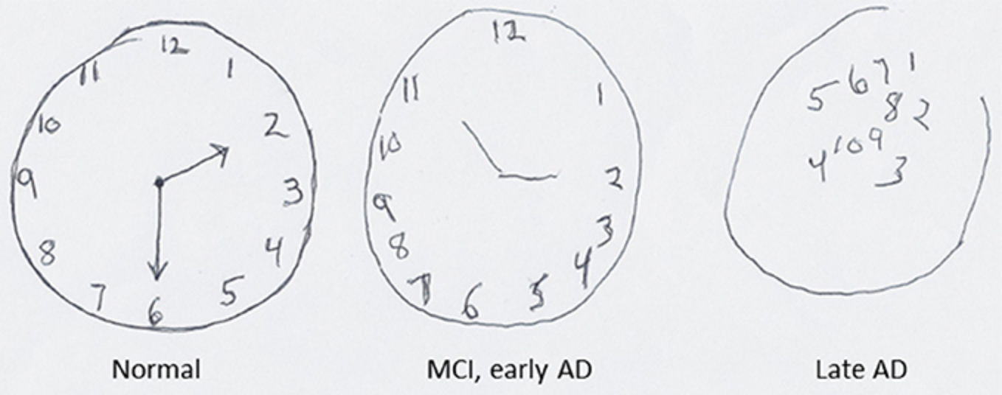

The clock draw test, as seen in figure 1, is replicated in different ways depending on the medium of the exam. For example, the COGselftest has patients point to the location on a clock that specific numbers should go. Similar results are found here dependent on the stage of cognitive impairment the patient is in. Generally speaking, this is another positive aspect of cognitive evaluation exams because the intensity of cognitive impairment can be measured and compared overtime. Another example of severe visual spatial impairment is to ask a patient to point to a doorknob. A patient with visual spatial deficits may blindly point at a wall if anything. However, if you ask a patient to leave the room, they will walk right to the door, open it with the doorknob, and walk out without any issue. Visual spatial impairment can be caused by cortical damage or atrophy in the occipital lobe, or associated areas of the parietal and temporal lobes (Cogselftest.com, 2020).
Executive functions are the second type of cognition typically evaluated from cognitive exams. The executive system is the part of the brain that controls cognition involving goal-oriented planning, flexible strategy generation, sustaining set maintenance, self-monitoring, and inhibition (Takeuchi et al, 2013). Generally, it is easier to understand that executive function is responsible for our ability to conduct abstract thinking. Executive function can be tested in a few different ways. One of the most common ways is to ask patients to describe the similarities between two objects. For example, being able to explain that bananas and apples are both fruit, or that cats and dogs are both types of domestic pets. The MOCA is an example of a cognitive assessment exam that uses this strategy to test executive function. Another common test used to measure executive function is the trail making test (TMT) (Salthouse, 2011). These tests measure executive function by having the patient maintain a goal of connecting dots in specific ways. By doing this, their ability to plan in a goal-oriented manner and generate a strategy in completing that goal are tested.
Figure 2: Trail Making Test example for someone with executive function impairment. The patient would have been instructed to draw a line between number to letter in increasing order starting with 1 and ending with 13. (Identifying neurodegenerative disease, 2020)

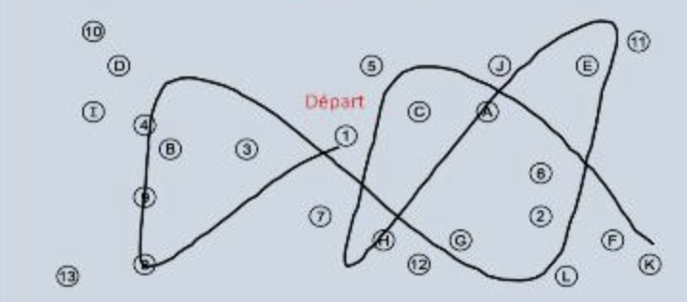

As indicated through measuring brain matter volume in comparison to performance of cognitive testing, cognitive impairment regarding executive function typically arises from damage or atrophy to the orbitofrontal cortex in the frontal lobe, dorsolateral prefrontal cortex, and the anterior cingulate cortex (Takeuchi, et al 2013). Executive function impairments are typically combatted by setting a rigid schedule for the patient that they follow every single day. This alleviates some of the stress faced by patients with these impairments as it limits their need to plan their day.
Verbal fluency is another highly tested area in cognitive exams. Generally, verbal fluency in terms of cognitive ability relates to how well a patient can form and utilize language. Patients with issues regarding verbal fluency may struggle with recalling the names of objects. They may be able to describe the object perfectly but be unable to recall its name. For instance, an individual with verbal fluency issues may be able to describe a phone presented to them as being something with a screen that lights up, and that you keep it in your pocket. However, they will be unable to say that the object is, in fact, a phone. Specific aspects of verbal fluency that are typically tested are vocabulary size, recall speed of certain words, and inhibition ability (Shao et al, 2014). These skills are tested via semantic and phonetic exams in which patients must present as many words as possible within a minute that fit specific criteria. Verbal fluency deficits have been shown to largely be caused by damage to the superior medial and left inferior frontal lobe (Robinson et al, 2012). This was determined by administering lesion analysis among healthy patients and those with frontal lobe lesions and observing the performance of these groups on verbal fluency exams. Those with lesions in the superior medial and left inferior frontal lobe generally performed worse on verbal fluency assessment than did healthy patients. As seen in figure 3, patients suffering from Alzheimer’s Disease show especially severe verbal fluency deficits even when compared to those suffering from other cognitive impairments such as Amnestic (AMN) MCI. After subjecting these groups to an FAS verbal fluency test, it was apparent that those suffering from AMN MCI and Alzheimer’s Disease performed significantly worse than did those with non-AMN MCI and healthy controls.
Figure 3: Average scores on FAS verbal fluency test between patients with Alzheimer’s, AMN MCI, non AMN MCI, and a normal comparison (NC) (Teng et al, 2013)

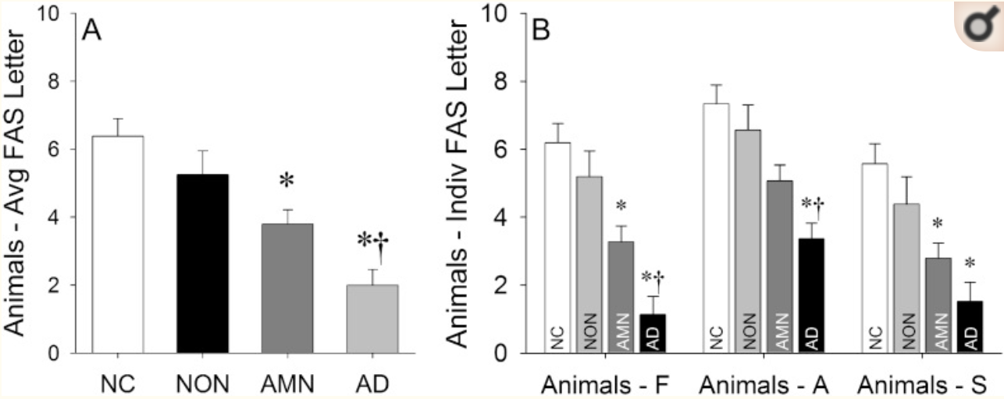

However, even with this noted difference in performance, it has been found that verbal fluency exams, such as FAS phonetic exams, do not provide a large enough distinction between MCI and Alzheimer’s Disease (Teng et al, 2013). As such, verbal fluency exams are not precise enough to be solely used to differentiate between these two types of cognitive impairments.
The fourth major area of cognition typically tested by cognitive exams is memory. Specifically, the working memory aspects associated with short term memory is the focus of many neurocognitive assessments. The most common way to test short term memory on neurocognitive assessments is to assign the patient a recall task. A patient is usually presented with 3 words then is given distraction tasks for 2-5 minutes before being asked to recall the presented words. This tests the patient’s ability to free recall, which is considered the aspect of cognition most sensitive to early diagnosis of dementia (Ivanoiu et al, 2005). As such, recall exams are extremely common throughout cognitive evaluation exams. They are present in online cognitive self-exams like the COGselftest, in the MMSE, and in the MOCA. A primary concern presented with these types of memory tests is their ability to recognize the problem the patient is facing. These tests can only show that the patient is having memory problems, but, memory problems don’t necessarily equate to MCI or dementia. After all, age-related memory loss is a natural, accepted part of aging and is distinct from both MCI and dementia.
Upwards of 40 percent of adults over the age of 65 can experience age related memory deficits without having any neurophysiologic abnormalities (Alzheimer’s Society of Canada, 2018). In addition, estimates reach up to 19 percent for adults over the age of 65 suffering from mild cognitive impairment that can limit memory (Gautheir et al, 2006). Whereas those suffering from MCI have decreased cognitive ability compared to others of the same age, it is still not as severe as other dementias such as Alzheimer’s Disease. In theory then, you can have a patient with age related memory deficit, a patient with MCI, and a patient with Alzheimer’s all perform the exact same on any given memory assessment. As such, many memory assessment evaluations cannot be used to distinguish cause of cognitive impairment, nor can they reliably be used to measure the potential decline of a patient slipping from healthy cognitive function to MCI to dementia over time.
Attention is the fifth major area of cognition tested by most cognitive evaluation exams. The MMSE, MOCA, COGselftest, TMT, and clock draw test all test some aspects of attention. Attention as a cognitive process is the ability to concentrate on a single aspect of the environment or task (Cogselftest.com, 2020). Attention deficits are often most notable in mid to late stages of most dementias. However, attention issues can be more prevalent in some dementias compared to others. Between Vascular Dementia and Alzheimer’s patients at similar stages in their diseases, Vascular Dementia patients showed increased deficit in reaction times and were less accurate on tests measuring sustained attention compared to Alzheimer’s patients (Mcguinness et al, 2010). Reaction time is an ideal indicator for attention because good reaction time requires strong cognitive ability in areas such as information-processing speed and response accuracy. Sustained attention, in this study, was measured using a variation of a Trail Making Test called a Color Trail Test. The strongest correlation of these scores was noted during the MMSE, which could suggest that the MMSE is capable of distinguishing between the two dementias based on attention performance. Attention, more specifically vigilance, has been found to be largely controlled by the fronto-parital areas of the cortex, especially in the right hemisphere (Sarter et al, 2001). Vigilance is an important indicator of attention because it relates to the ability for an individual to watch out for innocuous signals over an extended period. Attention is arguably the most crucial aspect of cognition to examine because it is the largest determining factor in a physician’s recommendation for patients to be able to continue many regular life activities. Patients who perform poorly in attention areas of cognitive assessment exams, like the Trail Making Test, are likely deemed unfit to continue aspects of life such as driving and are typically recommended to either be under regular supervision or be put into a memory facility.
Orientation is the final major area of cognition tested by cognitive evaluation exams. Testing orientation in patients is usually focused in two domains, those being, spatial orientation and temporal orientation. Spatial orientation can be tested by asking the patient the country, state, and city they are in. Temporal orientation, on the other hand, can be tested by asking patients the year, month, and day of the week. Orientation testing is present in the COGselftest, MMSE, and MOCA. One major issue regarding orientation testing is its internal validity. Whereas patients with dementia may express more orientation deficits, other healthy patients may also not perform well at orientation tasks due to matters of circumstance (Gazova et al, 2013). If a patient has to travel a distance for testing, they may not know the exact city or county they are in. Equally, healthy individuals may have not checked the calendar for what day of the month it is. Nonetheless, these individuals are still attributed with lower orientation performance based on circumstance rather than neurologic irregularity. MRI scans show that orientation related to space, time, and self are related to brain areas such as the precuneus, inferior parietal, and medial frontal cortex (Figure 4).
Figure 4: MRI scan of a healthy brain showing activity during space, person, and time orientation tasks in the precuneus, inferior parietal, and medial frontal cortex. (Peer et al, 2015)

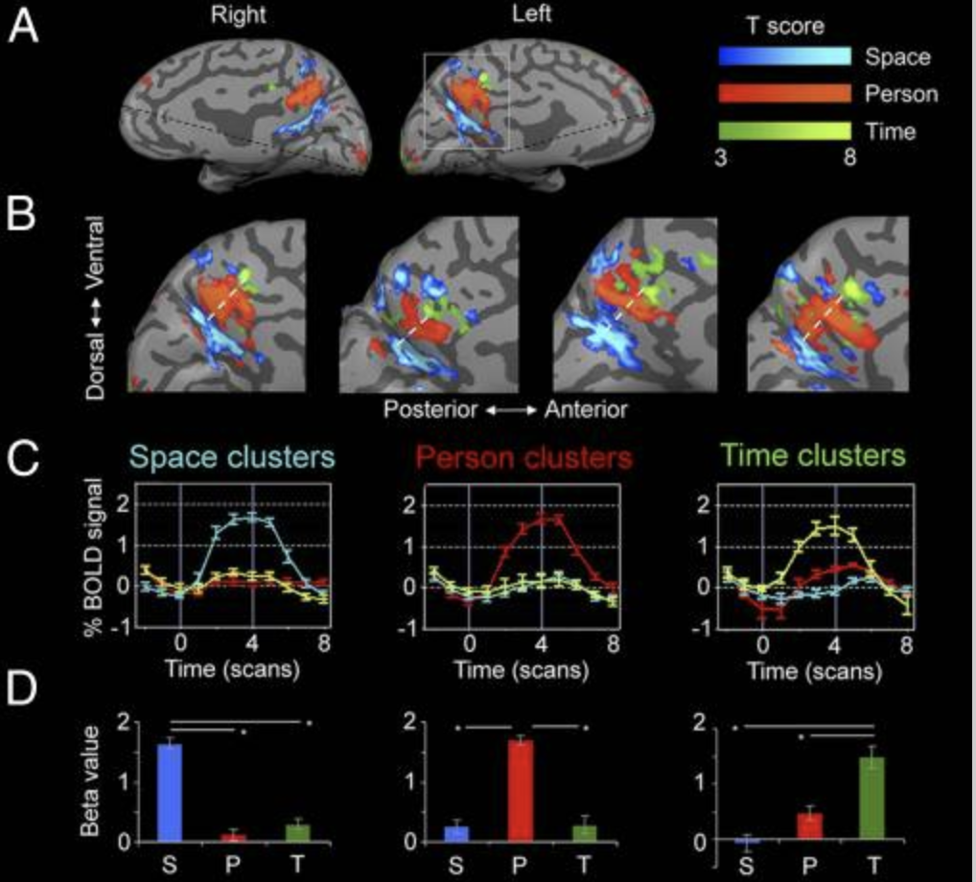

Orientation tests may be one way to distinguish Alzheimer’s Disease from Vascular Dementia. In Alzheimer’s Disease, both allocentric and egocentric orientation deficits can be witnessed. This differs from Vascular Dementia in which typically only egocentric deficits are observed (Coughlan et al, 2018).
Types of Cognitive Exams
Clock Draw
The clock drawing test (CDT) is a nonverbal cognitive exam used to asses cognitive function. One of the first administered clock draw tests used in understanding cognitive ability was in the 1940’s by Edinburg neurologists Oliver Zangwill and Andrew Patterson (Puglionesi, 2016). From these clock draw tests, Zangwill and Patterson were able to attribute failings in typical function in the clock draw test to unilateral lesions on the parietal lobe. Clock draw tests are now one of the most used tests in determining cognitive function amongst physicians. The test requires use of cognitive functions such as attention, calculation, comprehension, construction, recall, registration, repetition, and writing (Khan, 2016). As such, it is ideal for assessing the general cognitive ability of those suspected of suffering from dementia.
The clock draw test is administered to patients by a tester. They are handed a sheet of paper and asked to draw a clock. They are instructed to draw a clock with a traditional face, with all the numbers placed inside the clock, and to position the hands at a certain time. However, the time asked to set the hands to is not straight forward, “set the time to 7:25”. Rather, the instruction is slightly ambiguous to determine the patient’s comprehension, “set the time to 10 past 11:00”. The contour of the clock’s shape, presence and position of the numbers, and presence and correctness of the hands of the clock are used to determine the normalcy of the drawing.
The clock draw test in one of the best and most functional cognitive assessment exams. It has many positive aspects that lead it to be very reliable for use even in the most severe of cognitively impaired patients. Firstly, it is a fully non-verbal exam. Many severe cognitively impaired people are either unable to speak or have such an extreme case of disorganized speech that they are fully incomprehensible. Such barriers do not allow for other exams, such as the MMSE, MOCA, CST, or Verbal Fluency exams to be administered. As such, medical practitioners can administer a CDT to almost any patient, totally independent of severity of cognitive impairment, and still assess a multitude of cognitive domains. This can be used to monitor many aspects of cognition because it takes many regions of the brain to draw a clock. Many cortical and subcortical regions on both hemispheres of the brain, especially those of the frontal, temporal, and parietal regions, are necessary in clock drawing tasks (Freedman et al, 1994). This leads into the next massive benefit of CDT’s; they are very versatile.
As previously stated, clock draw tests can be used to measure a vast array of cognitive domains such as attention, calculation, comprehension, construction, recall, registration, repetition, and writing (Khan, 2016). On top of its versatility, it is also the easiest cognitive assessment exam to administer. Even the most severe of cognitively impaired patients can usually understand the premise of the exam and it takes little time to complete. Yet still, on top of its utility, it is an exam that can reliably be used to monitor for cognitive impairment.
A meta-analysis of the reliability of CDT’s to identify cognitive impairment found that they can be used reliably, and with high accuracy, to differentiate between those who have, and do not have, cognitive impairment (Aprahamian et al, 2009). One study even found that the sensitivity and specificity rivaled that of even well performing MMSE studies where they were 87 and 86 percent respectively (Tombaugh and McIntyre, 1992). Sensitivity, in relation to cognitive testing, is the ability for a test to correctly identify those with a cognitive disorder. Specificity, on the other hand, is the degree to which a test can correctly identify those without a cognitive disorder. The only noticeable downside to CDTs is that they cannot look into exact areas of cognition that are impaired with as much accuracy as other exams like the MMSE and MOCA. That is because those exams have entire sections devoted to specific areas of cognition whereas they have to seemingly be deciphered from clock draw tests. Nonetheless, CDT’s are a tried and true reliable cognitive assessment exam with high ability in discriminating healthy and cognitively impaired individuals while assessing multiple areas of cognition in a vast array of patients.
Verbal Fluency Exams
Verbal fluency exams are a type of cognitive testing that specialize in determining executive function (Shao, 2014). They are good indicators of executive function as it forces the patient to recall words from their vocabulary and make certain not to repeat them once stated. As such, Verbal Fluency Exams are the ideal exam in measuring verbal capability while also testing for executive function. These tests are easy to administer and reliable in the sense that even patients who have severe cognitive impairment can undergo this exam. These tests can either be semantic, where patients list animals, fruit, or vegetables, or phonetic, where the patient lists words starting with a certain letter. These tests usually allow the patient 60 seconds per section and each test typically has three sections.
Both the phonetic and semantic fluency exams are oral cognitive exams administered by a tester. For the phonetic exam, patients are given one minute in which they have to say all the words they can think of that start with certain letters. The words can be any the patient choses, so long as they are not the names of people, places, or numbers. Usually, the three letter the patients do this with are “F”, “A”, and “S”. An abnormal score for each is considered less than 12 unique words in the allotted minute. In total, a normal score for the entire phonetic section is 36 combined unique words. The semantic exam is similar to the phenetic exam. In this exam, the patient is presented with a category, and they must name all of the objects in that category they can think of within a minute. The three usual categories used are animals, vegetables, and fruit. An abnormal score for each section is anything less than 13 unique objects for each section. In total, a normal score for the entire semantic section is 39 combined unique objects.
One of the largest benefits of verbal fluency tests are their high face validity. They are very direct in what they measure as someone who struggles with either executive cognitive impairment or verbal impairment will undoubtably perform poorly on this exam. It has been determined that, in the case of cognitive impairment, verbal fluency impairment begins to develop upon reaching amnestic MCI and worsens as a patient progresses into early and late stage dementia (Nutter-Upham et al, 2008). As such, verbal fluency exams can be used in assessing cognitive decline over a patient’s diagnosis of cognitive impairment in areas related to executive function and verbal fluency. In fact, verbal fluency exams have been shown to accurately classify differing levels of cognitive impairment. Patients showed significant difference in performance on verbal fluency exams depending on whether they were healthy, had MCI, or had Alzheimer’s Disease (Bertola et al, 2014). Despite this, the efficacy of verbal fluency exams is disputed. Studies have shown that sensitivity of verbal fluency exams is around 76 percent while the specificity can be as low as low as 57 percent (Muangpaisan, 2007). As such, the tests can be effective but, due to them being relatively unreliable, should not be solely relied on in measuring overall cognitive impairment.
Trail Making Tests
Trail making tests (TMTs) are some of the most widely used forms of cognitive assessment in clinical settings. Versions the TMT are even present in larger, more formal exams, such as the MOCA. The first trail making rest was used in 1944 by the Canadian Army in the hopes to provide insight into cognitive aspects such as visual search, scanning, speed of processing, mental flexibility, and executive functions (Tombaugh, 2004). The application of this exam in use for cognitive impairment assessment was noted and later included in the Halstead–Reitan Battery cognitive exam. The TMT is a four-part exam that focuses on connecting dots in a specific order.
The trails cognitive test is a written cognitive exam administered to a patient via a tester. This exam is composed of four parts, two sample portions and two tested portions. To start with, the patient completes the sample of the easiest of the two tested parts. The sample is composed of eight circles. Each circle has a number inside of it with a range of 1-8. The patient is asked to draw a continuous line starting from the number 1, between the circles in increasing order. This much resembles a connect the dots art piece given to children. The tester then notices whether the patient successfully completes the trial portion. Successful trials include the patient drawing a continuous line that connects the numbers in the correct order. If this is not done, the patient has failed the trial and is not administered the tested portion. If the trial is successful, the patient moves onto the tested portion.
The tested portion is set up in the same manner as the trial, only this time there are 25 circles for the patient to connect. For this portion, the tester records the amount of time it takes for the patient to connect all the dots. After, the number of errors made is assessed and recorded by the tester. These include the patient skipping a number or not drawing a continuous line. Afterwards, the patient is given the next trial trail.
The patient is given this trial regardless of their performance on the previous two portions. On this trial, eight circles are present and have either the numbers 1-4 or the letters A-D. The patient is then instructed to draw a continuous line from number to letter in increasing order, starting with the number 1. They are also prompted on how to start by the tester saying, “for example, draw from 1, to A, to 2 and so on and so forth”. Performance is assessed in the same manner as the first trial to determine whether to patient passed or failed. Again, like the first trial, if the patient failed, they are not presented with the tested portion of the exam. If they do however pass, they are presented with a sheet with 25 circles including the numbers 1-13 and the letters A-L. Much like the trial, the patient is instructed to draw a continuous line from number to letter starting with the number 1. The tester records the time it takes for the patient to complete this and the amount of errors present. The errors include not drawing a continuous line and drawing the line in the incorrect order
The largest issue regarding trail making tests is that there are few sets of norms to compare a patient’s results to. Unlike tests like the MMSE or MOCA that have a specific cut-off score for cognitive impairment, TMTs largely rely on measuring the time it takes for a patient to complete the trail and the number of errors the patient makes to determine impairment. The idea is that the more severe the cognitive impairment in related cognitive domains, the longer the test takes, and the more errors are committed. However, TMTs have been found to have very low sensitivity and specificity in comparisons between patients at varying levels of cognitive impairment.
Figure 5: Percentage of individuals with no cognitive impairment (control), MCI, and Alzheimer’s Disease (AD) compared to number of errors made on Trail Making Tests(Ashendorf et al, 2008)

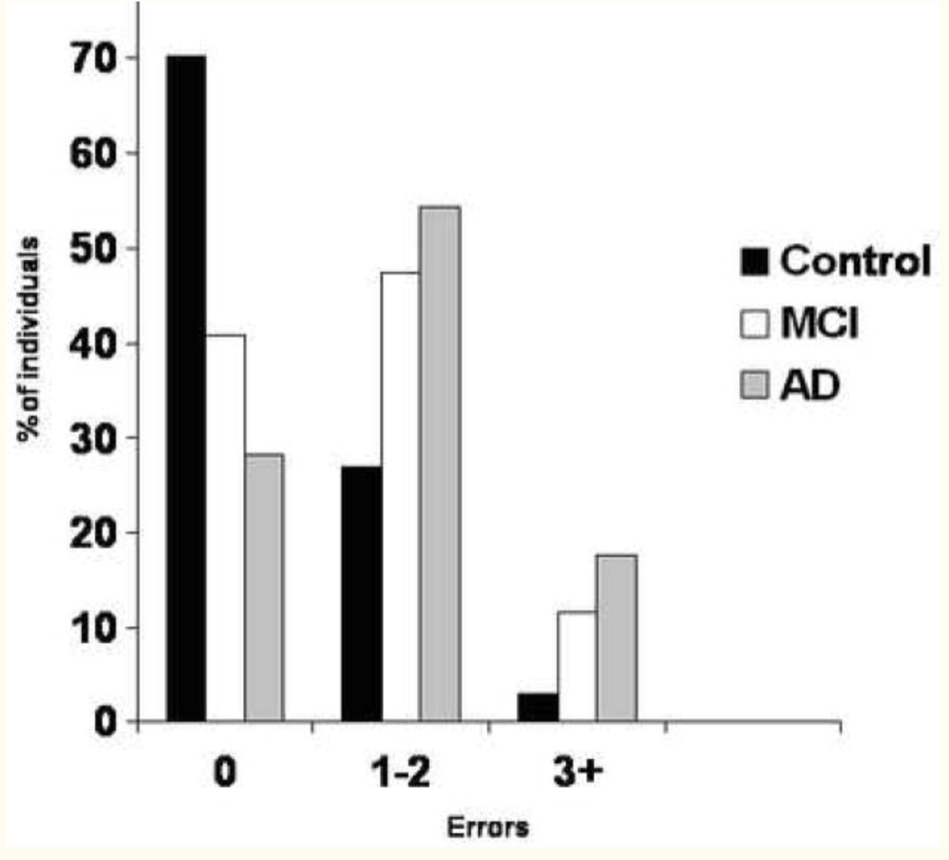

Whereas it can be noted that there is a decrease in healthy individuals making more mistakes, the number of mistakes for MCI and AD patients remains relatively proportionate to each other (figure 5). This study in which this came from, Ashendorf et al, measured number of errors and time to complete a TMT naming a control group, group of MCI patients, and group of Alzheimer’s patients. They found that time of completion was wore of a determining feature of cognitive impairment than age. Even then, there are still a substantial number of healthy individuals who make multiple mistakes on TMT’s. As such, this test cannot be reliably used to assess varying levels of cognitive impairment.
COGselftest
The COGselftest was created in 2002 by Dr. John H. Dougherty (Cogselftest.com, 2020). It was developed with the intention to increase public awareness and early screening for cognitive impairment in the hopes of lowering the number of undiagnosed neurocognitive diseases among the public. The idea was that making neurocognitive testing more accessible to the public would increase the number of people checking their cognitive ability. This, in turn, would result in more people contacting physicians about possible cognitive issues and more extensive testing. The test is used to try and help identify cognitive impairments at the earliest stages possible. This is done in the hopes of maximizing the effectiveness of treatment due to the fact that treatment is more successful the earlier the disease is diagnosed. The test started as a written exam, and then was recreated into an online version in order to further increase availability and access. Unfortunately, no tests have seemed to be conducted measuring the concurrent validity between the written and online versions of the COGselftest. Such an experiment would be good to compare the accuracy of both types of test administration.
In clinical settings, the patient sits down with a tester who guides them through the test. The patient is asked to point at their answers on the computer screen while the tester inputs them into the computer to avoid further confusion. The test starts by gathering information about the patient including their age, sex, and highest level of education completed. The patient also is asked whether they have a family history of cognitive impairment and whether they themselves believe that they suffer from cognitive impairment. Then, patient is asked to complete a computer-generated Clock Draw Test in the same way as the previous CDT was described. After this, the patient is asked to read aloud three words that pop up on the computer screen. Once the patient has said the words aloud, they are asked to memorize the words and are informed they will be asked about them later. Directly after, the patient is instructed to list 15 different types of animals. The tester takes note of the animals listed while the patient lists them. After this, the patient is asked to recall the three words they were told to remember. After that, the patient is presented with a list of the months and is asked to, starting with the month December, list the next five months in reverse order. Finally, the patient is asked questions related to orientation. These include asking for the year, the day of the week, and the month. After this, the computer version of the COGselftest is automatically graded by the computer and a grade of excellent, needs work, or below average is given in each of the six major areas of cognition previously discussed.
The COGselftest is one example of computerized cognitive exams that can be either self-administered or administered in a clinical setting. The main focus of these computerized self-tests is to be able to distinguish between healthy patients, patients suffering from MCI, and those who are suffering from advanced dementia like Alzheimer’s Disease. They are also used in the hopes of monitoring the potential changes in severity due to cognitive decline of dementia patients as they progress through their illness. Many computerized self-tests, including the COGselftest, resemble large established tests such as the MMSE and MoCA exams. As such, they have similar layouts and test for the same big six areas of cognition.
In a 2010 study by Dougherty et al, the validity of the CST tested alongside that of other cognitive exams such as the MMSE. With a sample size (n = 215) included people without cognitive impairment, with MCI, and with Alzheimer’s Disease, and the CST accurately classified 96 percent of patients based on their cognitive impairment (Dougherty, 2010). Accurate classification was dependent on the patient’s level of performance matching with their level of cognitive impairment. The more cognitively impaired the patient, the lower the score they would acquire. This compares to the 71 percent accuracy of the MMSE and the 69 percent accuracy of the Mini Cog. Along with this, the CST also correctly identified patients in six experimental groups, those being control, MCI, early Alzheimer’s, mild to moderate Alzheimer’s, moderate to severe Alzheimer’s, and severe Alzheimer’s, with 91 percent accuracy (Dougherty, 2010). This was vastly superior to that of the other exams where the MMSE only showed 54 percent accuracy and the Mini Cog only showed 48 percent accuracy. Sensitivity and specificity are important measures in testing because they show the accuracy of the test. High sensitivity and specificity would indicate a test with high internal validity (figure 6)
Figure 6: Sensitivity vs Specificity of CST, MMSE, and Mini-Cog exams in detection of cognitive impairment plotted on a receiver operating characteristic curve. As shown, the CST almost exactly follows the left-hand and top border of the ROC space indicating that the test has very high accuracy. (Dougherty, 2010)

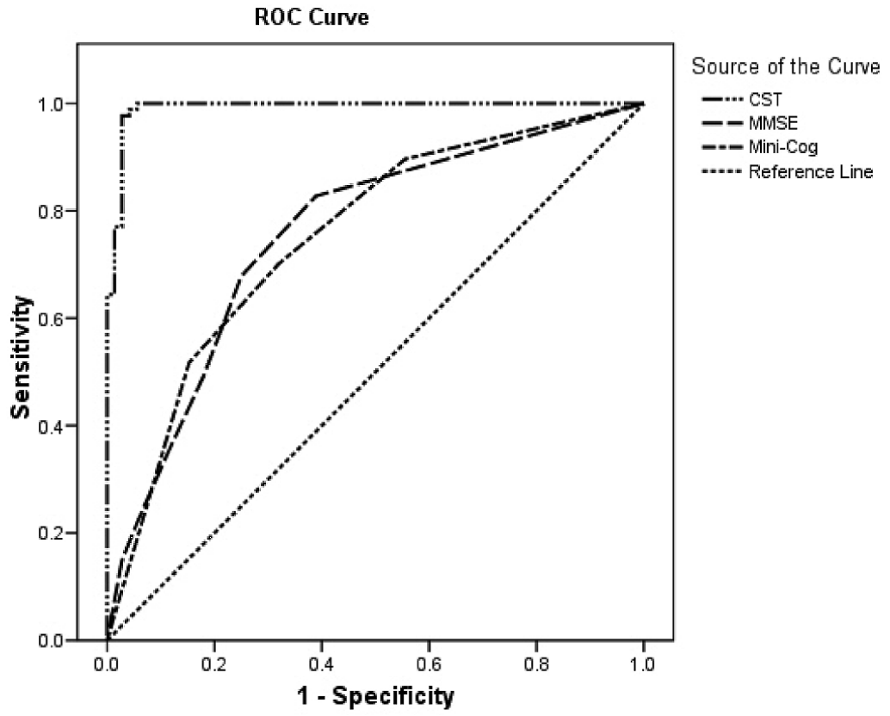

Severity of cognitive impairment on the CST is measured on a thirty-point scale. All of the questions on the CST result in a score out of thirty with each of the six major tested domains of cognition each being assigned a portion of this total score. This allows testers to observe the overall quality of cognition (figure 7) in a patient while also allowing them to see how specific areas of cognition may be impacted.
Figure 7: CST total score in relation to severity of cognitive impairment from sample n = 215. Asterisks indicate significant difference from control. Ranges of scores for each severity level derive from CST performance from individuals with that respected level of cognitive impairment. (Dougherty, 2010)

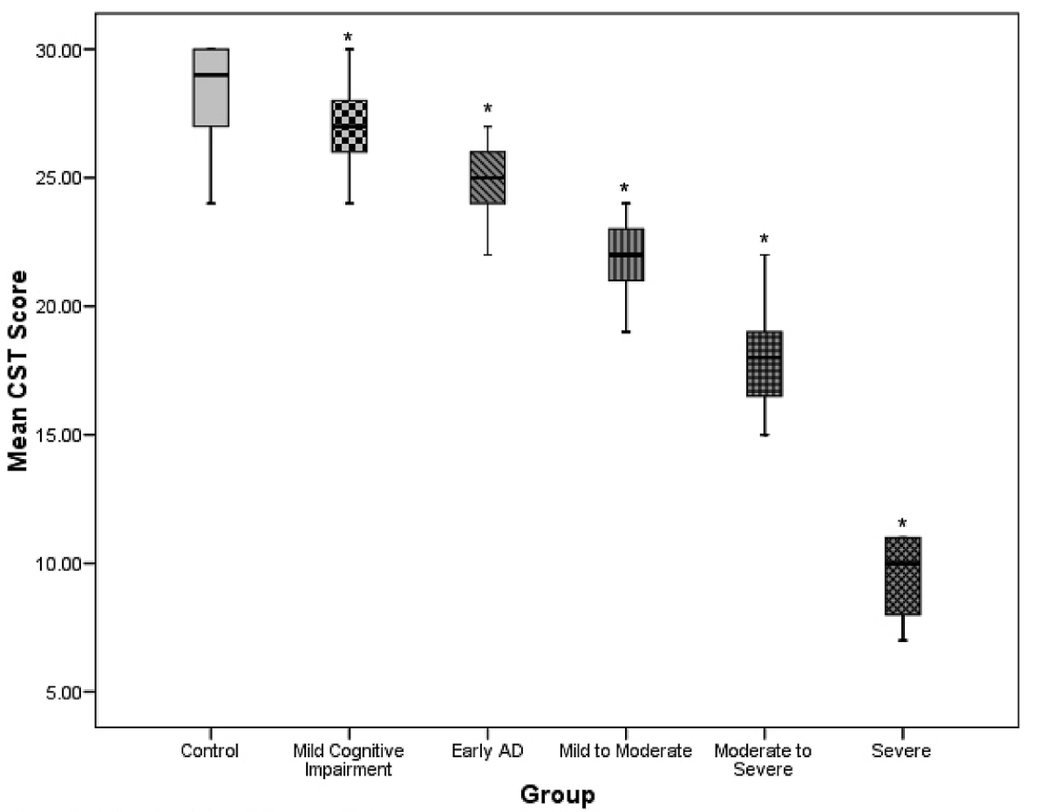

As can be noted, and would be expected, CST total score steadily decreases along with severity of cognitive impairment. As such, the COGselftest can reliably be used to measure the decline in cognitive ability between large groups of patients. However, it may be more difficult to monitor the steady decline of an individual’s level of cognitive impairment. As can be seen in figure 7, there is considerable overlap between levels of impairment severity. For instance, a score of 24 seems to be within the range of healthy controls, those with MCI, and those with early AD. That could mean a patient could have progressed from healthy to early Alzheimer’s and maintained a consistent score.
When distinguishing between a large group of healthy patients, those with MCI, and those with Alzheimer’s, the COGselftest has proven to be an accurate and reliable tool for distinguishing between these states. Furthermore, it has been shown to be reliable in accurately showing the severity of cognitive impairment amongst afflicted individuals. However, the COGselftest still can be improved upon. A primary concern about this exam is the apparent lack of clarity in its ability to distinguish between MCI and Alzheimer’s with other types of dementia like Vascular Dementia. Although general severity of cognitive impairment is still accurately measured, the COGselftest is unproven in its ability to distinguish between types of dementias. As such, it can only reliably be used to measure cognitive impairment and not be used for distinguishing between dementias. Another issue regarding the COGselftest is it’s the seeming lack of deviation in scores between healthy patients, those with MCI, and those with early AD. As shown in figure 7, people with these levels of severity can obtain the same score. This would prove the COGselftest ineffective in differentiating between these states. This is especially problematic when realizing the main function of this exam is to identify early cognitive impairment in individuals in order to implement early intervention.
MMSE
The MMSE, Mini-Mental State Examination, was created in 1975 by M. F. Folstein et al. with the intention of helping to evaluate cognitive impairment in older adults (IHPA, 2020). It is a test based on a 30-point scale that can be used to asses a person’s ability to think, communicate, understand, and remember. Although the exam can be used to test the mental state of patients who have recently suffered a head injury or infection, it is largely used in assessment of patients suspected of having some form of dementia. The MMSE can be used to assessed cognitive abilities such as short term and long-term memory, attention, concentration, language skills, communication skills, and ability to understand instructions (Healthdirect, 2019). This test is good in determining the overall cognitive impairment of a patient with dementia but is not meant to distinguish between types of dementia. The MMSE is used over a period of time to assess the gradual increase or decrease in cognitive ability of a patient.
The MMSE is split into five separate sections, those being, Orientation, Registration, Attention and Calculation, Recall, and Language. These five sections are used to assess the six major areas of cognition previously discussed. The patient is asked by the tester to list the current year, season, date, day of the week, and month to test their temporal orientation. The temporal orientation section is worth a total of 5 points. Next, the patient is asked to name the country, state, county, city, and clinic they are currently in to test their spatial orientation. The spatial orientation section is also worth a total of 5 points. This totals the worth of the orientation section to 10 total points. Next, the patient is asked to repeat three words the experimenter presents to them aloud. For example, the experimenter would say the words, “apple, book, coat” giving one second between each word so that they are clearly presented and then the patient is expected to say these three words back to the tester. This section worth three total points. The tester then asks the patient to remember those three words as they will need to recall them later. The tester then moves on to the Attention and Calculation section.
This section can be conducted in two different ways. The tester can either present the patient with a serial subtraction test where the patient subtracts 7 from 100 and then from all their corresponding answers until they get to 65. Alternatively, the tester can have the patient spell the word “world”. If the patient has a hard time spelling the word, the tester will walk them through each letter. Then, the tester will ask the patient to spell the word “world” backwards. Whichever way this section is conducted, it is worth 5 points. Next, the patient is tested on their recall ability. The patient is asked to recall the three words presented to them from the registration section. Each correct recall is worth 1 point, totaling the section value to 3 points. Finally, the patient is tested on the largest section of the MMSE, language.
The patient is first shown a pen and then a watch and is asked to identify both the objects. Correct identification of each object is worth 1 point per object. Next, the patient is asked to repeat the following sentence, “No ifs, ands, or buts”. The patient must say the sentence exactly that way in order to receive the point this part is worth. Next, the patient is tested on their ability to follow a multi-step command. They are told that they must take a piece of paper in their right hand, fold it in half, and then place the paper back on the tester’s clipboard. This section is worth three points. The patient’s reading ability is then tested. They are told that they will be presented with a sentence and that they must first say it aloud and then do what the sentence says. The patient is then shown a sentence like “close your eyes”. Finally, the patient is tested on their ability to copy. The patient is presented with a figure consisting of two overlapping pentagons and told to copy the figure in a space provided. The figure must be closed at all points and have the four-sided diamond where the figure overlaps. If either of these two qualifications are not met, the patient does not receive the point. The final total is then calculated, and the patient’s score is determined out of 30 points.
The severity of cognitive impairment can be determined by the score obtained from this exam. However, the cutoff for normal vs abnormal scores depends on the level of education the patient has received. A patient with an education level of 7th grade or lower has a normal score as low as 22/30. Those who have an 8th grade or some high school education have a normal score of 24/30. Those with a complete high school education can have a normal score as 25/30. Those who have a college level or higher education can have a normal score of 26/30. However, the typical baseline for severity is set at a score of anything below 25 being abnormal. Mild cognitive impairment would then be indicated by a score of 21-24. Moderate cognitive impairment is determined within the score range of 10 and 20. Severe cognitive impairment is represented by a score lower than 10 (Mini-mental state exam, 2005).
Much like the COGselftest, the MMSE can only be reliably used in measuring the severity of cognitive impairment while not being able to necessarily distinguish between types of dementia. Unlike the COGselftest however, the MMSE has the benefit of factoring level of education into its scoring. This is an important aspect to consider in analyzing cognitive testing due to the extent in which level of education can impact performance on cognitive assessment exams regardless of cognitive impairment. In fact, level of education has been shown to have more of an influence over cognitive assessment scores than even age (Azeredo et al, 2015). Aside from this benefit however, the MMSE has some large pitfalls. The MMSE has a fairly low sensitivity range in detecting cognitive impairment, only 45-60 percent. The specificity of detection for cognitive impairment is better, between 65-90 percent, but still has too large of as range with a low bottom end to be considered highly accurate (Langa and Levine, 2014). This is especially true when compared to cognitive evaluations such as the COGselftest. Such low specificity and sensitivity to detection greatly cripples the reliability of this exam as it does not allow for great distinction in severity of cognitive impairment. Such low sensitivity likely leads to floor and ceiling effects, limiting its real effectiveness in clinical settings to diagnose dementia.
MOCA
The MOCA, or Montreal Cognitive Assessment, was created by Dr. Ziad Nasreddine in 1995 (Hobson, 2015). The purpose of the MOCA is to aid in the diagnosis for mild cognitive impairment or early stage dementia. This exam, much like the MMSE and COGselftest, is set on a 30-point scale. Score ranging between 26-30 is considered a normal score (Hobson, 2015). The main cognitive domains that the MOCA tests are Visuospatial/Executive, Naming, Memory, Attention, Language, Abstraction, Delayed Recall, and Orientation to both time and location. The exam combines many typical cognitive screenings such as a clock-draw, trail-making, sustained attention task, and serial subtraction. As such, the MOCA is arguably the most versatile cognitive exam available in regard to the relatively short time it takes to administer.
The patient is administered the MOCA via a tester. First, the patient is tested on their visuospatial/executive function. This is done through a trail test, drawing challenge, and clock draw. The trail making portion is identical to the TMT previously presented. Next, the patient is presented with a cube, and asked to draw the cube as they see it. Finally, the patient is asked to draw a clock. The clock drawing portion is identical to the instructions previously described for the Clock Drawing Test. This section is worth a total of 5 points.
Next, the patient does a naming task. They are presented with three animals (a lion, rhinoceros, and camel) and asked to identify them. This naming task is worth 3 total points. The patient is then tested on their memory. They are presented with a list of five words and asked to repeat the list after the tester finishes presenting the list. For example, the words can be face, velvet, church, daisy, and red. The tester presents the patient with this list twice, with the patient repeating the list after each time. The specific words the patient recalls are recorded, and then they are asked to memorize the words because they will be asked about them later.
After, the patient is tested on their attention. First, the patient is given a list of five numbers and asked to repeat the list back to the tester. The patient then is given a list of three numbers and asked to say them in reverse order from how they were presented. This section is worth 2 points. The patient then is given a pen and asked to tap their chair once. They are told that each time the letter A is said in the following list of letters, they are to tap their chair one time. A long list of letters is then read aloud with the instructor saying one letter every second. For this section, the patient is allowed to make two errors and still get the point. This section is worth one point. Finally, for this section, the patient does a serial subtraction test. This section is identical to the serial subtraction test described previously in the MMSE. This section is worth 3 points.
After attention, language is then assessed. Firstly, the patient is presented with a sentence the tester says aloud and asked to repeat it. The same process is repeated afterward with a different, more complex, sentence. Each sentence is worth one point which is awarded if the patient says to sentence exactly as it is presented. Next, the patient does a phonetic test. They are given one minute and are told to say all the words they can think of that start with the letter F. The patient must say at least 11 unique words that fit the criteria of the instructions within the minute in order to receive the one-point credit.
Abstraction is tested next. For this section, the patient is asked to tell the similarities between two different sets of two words. For example, they are asked to give a similarity between a train and a bicycle, and between a watch and a ruler. However, the patient only receives credit if they say that the similarities between a train and a bicycle is that they are forms of transportation and that a watch and a ruler are both tools used for measurement. Other similarities such as “both have wheels” or “both have numbers” are not given credit. This section is worth 2 points.
The patient is then tested on their delayed recall. They are asked to recall the five words they were presented with during the memory section of the exam. This section, unlike the others, has a secondary score attribute called the MIS. If the patient gets a word right without hints, they are given three points towards their MIS score. If they get it with one hint, they receive two points to their MIS score. If they get it with two hints, they receive one point to their MIS score. If they don’t recall the word after two hints, they do not receive any points to their MIS score. The MIS section totals 15 points. These points do not affect the overall 30-point scale but are their own section and used to assess how poor the patient performed in their delayed recall.
Finally, the patient is tested on their orientation to both time and location. The tester asks the patient four questions related to time, asking for the date, month, year, and day of the week. Then, they ask two questions related to location, asking for the name of the clinic they are in (the doctors name can be used as a substitute if they don’t know the name of the clinic), and the name of the city they are currently in. The total value of the section to six points. Due to the intensity of the exam, one point is awarded to patients who have a level of education lower than a high school degree or equivalent.
The MOCA is by all accounts the best cognitive test able to be used in determining cognitive impairment. It vastly outperforms older, more clinically established cognitive exams such as the MMSE. In 2005, Nasreddine et al sought to compare the MOCA and MMSE’s ability to measure cognitive impairment in patients. In a study with over 180 subjects, the MOCA vastly outperformed the MMSE in terms of sensitivity and specificity (figures 8 and 9). The MMSE only had a sensitivity level of detection for mild cognitive impairment of 18 percent. The MOCA, on the other hand, had a sensitivity detection level of 90 percent. For patients with Alzheimer’s, the MMSE had a sensitivity detection level of only 78 percent while the MOCA had a 100 percent detection sensitivity level (Nasreddine et al, 2005). The MOCA overall produced much more refined scores which would help it better distinguish level of severity of cognitive impairment compared to that of the MOCA due to not showing a floor or ceiling effect.
Figure 8: Average MMSE and MOCA scores for normal controls (NC), MCI patients (MCI), and Alzheimer’s patients (AD) (Nasreddine et al, 2005)

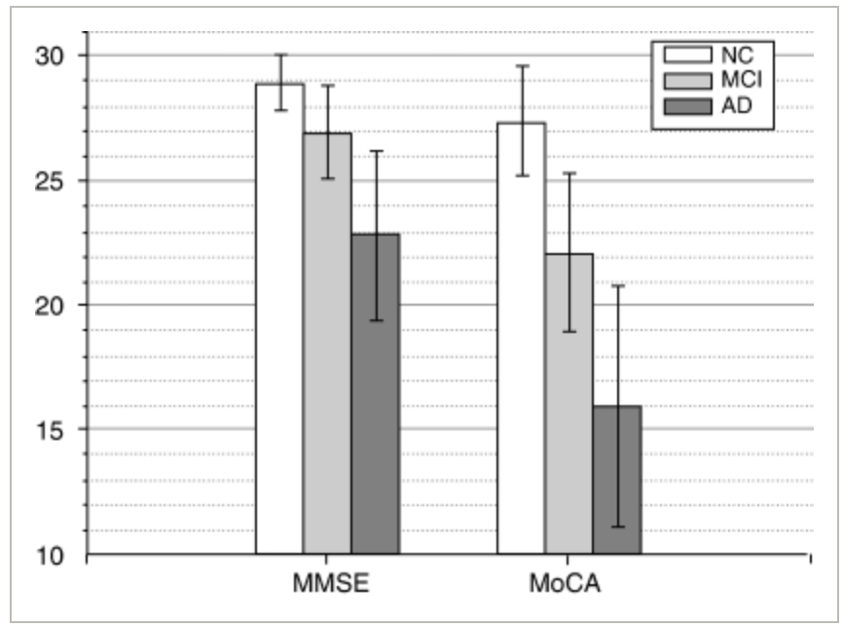

Figure 9: Scatter plot for MOCA and MMSE scores for normal controls (NC), MCI patients (MCI), and Alzheimer’s patients (AD). The MOCA shows better deviation in scores based on severity levels compared to the MMSE. This can contribute to the MOCA having higher accuracy in determination of impairment severity. (Nasreddine et al, 2005)

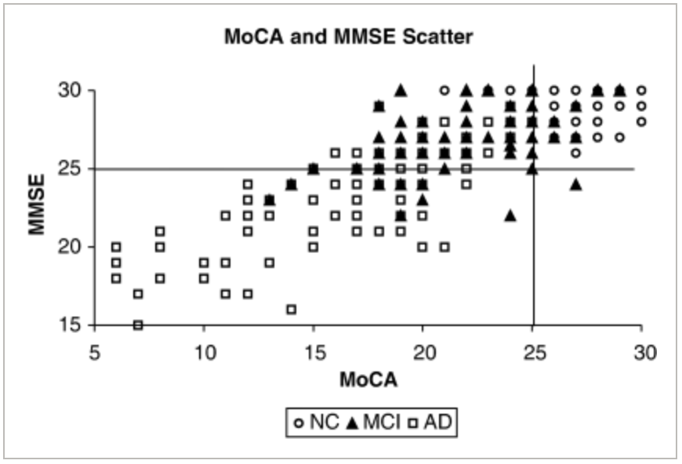

One of the most important findings in this study was the MOCAs superior ability to distinguish healthy patients and patients with MCI. In this test, the majority of NC patients scored in the normal ranges for both the MMSE and MOCA while the majority of AD patients scored in the abnormal range for both of these tests. However, three-fourths of the MCI patients who scored abnormal on the MOCA scored normal on the MMSE (Nasreddine et al, 2005). As such, this should establish the MOCA as the primary cognitive assessment exam used to distinguish healthy patients to those with MCI. The MOCA, much like the MMSE, also has the added benefit of accounting for level of education when determining final score and level of cognitive impairment. Unlike the MMSE however, the MOCA provides a more modest correction for education level which could create a situation where patients with lower levels of education are being unfairly shown as more cognitively impaired than they actually are.

Conclusion
One of the largest issues with cognitive assessment exams is their standardization. The sensitivity and specificity of every cognitive exams seems to change dramatically between different studies. The low replicability of these exams is troubling as it calls into question the general reliability of these exams to properly assess severity of cognitive impairment. This is especially problematic when considering that massive life altering decisions, such as limiting ability to drive and moving patients into memory care institutions, are based on the results of these exams. The massive swings in sensitivity and specificity between each test greatly calls into question the ability of these tests to perform their intended purpose. This potentially could stem from a lack of standardization among these cognitive assessment exams. This could potentially be fixed by making tester instructions much clearer. Whereas it is unreasonable to assume each tester will conduct an exam in the exact same manner as the next, clarifying tester instructions in how to ask questions may lower this issue. Another reason this variation may be present is that grading each response is very situational and largely must be decided by the tester. Bias that the tester may have towards a specific patient may influence their grading of performance. This is where computerized tests benefit over written tests because the computer program will grade indiscriminately. This issue could be fixed on written exams by having a more extensive grading rubric available to the tester.
Another way that diagnosis and monitoring severity of cognitive impairment could improve is by administering many cognitive assessment exams in the same sitting. Whereas each exam has unique approaches to monitoring cognition, each essentially assess the same six major areas of cognition. Those being visual spatial, executive functions, verbal fluency, memory, attention, and orientation. Administering many cognitive exams at once would have the benefit of monitoring each of these domains two or three times over. This would allow for multiple readings that could be compared to one another to accurately assess cognitive impairment with more certainty.
Cognitive assessment exams are an essential tool clinicians use to monitor and determine severity of cognitive impairment in patients with MCI and dementia. They are instrumental in understanding what areas of cognition are impacted and to the extent they affect a patient’s behavior. Cognitive assessment exams allow medical practitioners to examine how neurophysiologic degeneration, observed through neuroimaging, impacts dementia patient’s ability to conduct routine tasks that impair their daily lives. These exams are critical in the assessment of cognitive impairment severity in dementia patients and without them our understanding and ability to treat these patients would be significantly hampered.
However, cognitive assessment exams in general can still be improved. Modern cognitive exams fail in their ability to distinguish between types of dementia. At present, they can only monitor level of severity for those who are cognitively impaired. Future improvement to these exams can be aimed at distinguishing between types of dementia. Future studies could focus on localizing impairment of major cognitive functions to specific dementias. That way, when a patient is administered a cognitive exam, medical practitioners can observe the major deficits and narrow down their diagnosis. Of course, this would only further improve the accuracy of diagnosis and thus improve the care plan for the patient. It is important to realize, however, that cognitive assessment exams will always be one of many factors contributing to the diagnosis of a patient. These exams will be one tool in the toolbox used by healthcare providers alongside neuroimaging, genetic factors, and environmental factors of the patient. Even then, making these improvements to increase the accuracy of these exams will only further supplement quality patient care.

References

- N.C. Berchtold, C.W. Cotman, Evolution in the Conceptualization of Dementia and Alzheimer’s Disease: Greco-Roman Period to the 1960s, Neurobiology of Aging, Volume 19, Issue 3, 1998, Pages 173-189, https://doi.org/10.1016/S0197-4580(98)00052-9.

- History of dementia research. (2017, September 14). Retrieved April 15, 2020, from https://qbi.uq.edu.au/brain/dementia/history-dementia-research

- Bakshi, R. (Ed.). (1997). History of neuroimaging. Retrieved April 15, 2020, from https://www.asnweb.org/i4a/pages/index.cfm?pageid=3334

- Salthouse T. A. (2011). What cognitive abilities are involved in trail-making performance?. Intelligence, 39(4), 222–232. https://doi.org/10.1016/j.intell.2011.03.001

- COGselftest. (n.d.). Retrieved April 15, 2020, from http://cogselftest.com/

- Mattson Mark P., Superior pattern processing is the essence of the evolved human brain, Frontiers in Neuroscience, 8, 2014, 265, https://doi.org/10.3389/fnins.2014.00265

- Takeuchi, H., Taki, Y., Sassa, Y., Hashizume, H., Sekiguchi, A., Fukushima, A., & Kawashima, R. (2013). Brain structures associated with executive functions during everyday events in a non-clinical sample. Brain structure & function, 218(4), 1017–1032. https://doi.org/10.1007/s00429-012-0444-z

- Identifying neurodegenerative disease. (n.d.). Retrieved April 15, 2020, from https://www.dynseo.com/en/our-products-brain-games-adapted-for-all/cognitive-tests/

- Shao, Z., Janse, E., Visser, K., & Meyer, A. S. (2014). What do verbal fluency tasks measure? Predictors of verbal fluency performance in older adults. Frontiers in psychology, 5, 772. https://doi.org/10.3389/fpsyg.2014.00772

- Robinson, G., Shallice, T., Bozzali, M., & Cipolotti, L. (2012). The differing roles of the frontal cortex in fluency tests. Brain : a journal of neurology, 135(Pt 7), 2202–2214. https://doi.org/10.1093/brain/aws142

- Teng, E., Leone-Friedman, J., Lee, G. J., Woo, S., Apostolova, L. G., Harrell, S., Ringman, J. M., & Lu, P. H. (2013). Similar verbal fluency patterns in amnestic mild cognitive impairment and Alzheimer's disease. Archives of clinical neuropsychology : the official journal of the National Academy of Neuropsychologists, 28(5), 400–410. https://doi.org/10.1093/arclin/act039

- Ivanoiu, A., Adam, S., Van der Linden, M., Salmon, E., Juilleral Van der Linden, A., Mulligan, R., Seron, X. (2005). Memory evaluation with a new cued recall test in patients with mild cognitive impairment and Alzheimer’s Disease. Journal of Neurology, 252(1), 47-55. https://10.1007/s00415-005-0597-2

- Alzheimer society of Canada. (2018, August 24). Normal aging vs dementia. Retrieved April 15, 2020, from https://alzheimer.ca/en/Home/About-dementia/What-is-dementia/Normal-aging-vs-dementia

- Gauthier, S., Reisberg, B., Zaudig, M., Petersen, R., Ritchie, K., Broich, K., … Winblad, B. (2006). Mild cognitive impairment.(Seminar)(Disease/Disorder overview). The Lancet, 367(9518), 1262–1270. https://doi.org/10.1016/S0140-6736(06)68542-5

- Mcguinness, B., Barrett, S., Craig, D., Lawson, J., & Passmore, A. (2010). Attention deficits in Alzheimer’s disease and vascular dementia. Journal Of Neurology Neurosurgery And Psychiatry, 81(2), 157–159. https://doi.org/10.1136/jnnp.2008.164483

- Sarter, M., Givens, B., & Bruno, J. (2001). [Review of The cognitive neuroscience of sustained attention: where top-down meets bottom-up]. Brain Research Reviews, 35(2), 146–160. https://doi.org/10.1016/S0165-0173(01)00044-3

- Peer, M., Salomon, R., Goldberg, I., Blanke, O., & Arzy, S. (2015). Brain system for mental orientation in space, time, and person. Proceedings of the National Academy of Sciences of the United States of America, 112(35), 11072–11077. https://doi.org/10.1073/pnas.1504242112

- Coughlan, G., Flanagan, E., Jeffs, S., Bertoux, M., Spiers, H., Mioshi, E., & Hornberger, M. (2018). Diagnostic relevance of spatial orientation for vascular dementia: A case study. Dementia & neuropsychologia, 12(1), 85–91. https://doi.org/10.1590/1980-57642018dn12-010013

- Dougherty Jr., John H. et al. ‘The Computerized Self Test (CST): An Interactive, Internet Accessible Cognitive Screening Test For Dementia’. 24 Mar. 2010 : 185 – 195. DOI: 10.3233/JAD-2010-1354

- IHPA., Standardized mini-mental state examination (SMMSE). (n.d.). Retrieved April 15, 2020, from https://www.ihpa.gov.au/what-we-do/standardised-mini-mental-state-examination-smmse

- Healthdirect, Mini-mental state examination (mmse). (2019, November). Retrieved April 15, 2020, from https://www.healthdirect.gov.au/mini-mental-state-examination-mmse

- Mini-mental state exam. (2005, September 27). Retrieved from National Center for Biotechnology Information database. https://www.ncbi.nlm.nih.gov/projects/gap/cgi-bin/GetPdf.cgi?id=phd001525.1

- de Azeredo Passos, V. M., Giatti, L., Bensenor, I., Tiemeier, H., Ikram, M. A., de Figueiredo, R. C., Chor, D., Schmidt, M. I., & Barreto, S. M. (2015). Education plays a greater role than age in cognitive test performance among participants of the Brazilian Longitudinal Study of Adult Health (ELSA-Brasil). BMC neurology, 15, 191. https://doi.org/10.1186/s12883-015-0454-6

- Langa, K., & Levine, D. (2014). The Diagnosis and Management of Mild Cognitive Impairment A Clinical Review. Jama-Journal Of The American Medical Association, 312(23), 2551–2561. https://doi.org/10.1001/jama.2014.13806

- John Hobson, The Montreal Cognitive Assessment (MoCA), Occupational Medicine, Volume 65, Issue 9, December 2015, Pages 764–765, https://doi.org/10.1093/occmed/kqv078

- Nasreddine, Z., Phillips, N., Bédirian, V., Charbonneau, S., Whitehead, V., Collin, I., … Chertkow, H. (2005). The Montreal Cognitive Assessment, MoCA: A Brief Screening Tool For Mild Cognitive Impairment. Journal of the American Geriatrics Society, 53(4), 695–699. https://doi.org/10.1111/j.1532-5415.2005.53221.x

- Puglionesi A. (2016). Drawing as Instrument, Drawings as Evidence: Capturing Mental Processes with Pencil and Paper. Medical history, 60(3), 359–387. https://doi.org/10.1017/mdh.2016.28

- T.K. Khan,Clinical Diagnosis of Alzheimer’s Disease,Biomarkers in Alzheimer's Disease, Academic Press, 2016, Pages 27-48, https://doi.org/10.1016/B978-0-12-804832-0.00002-X.

- Freedman, M., Larry Leach, Kaplan, E., Shulman, K., Delis, D., & Winocur, G. (1994). Clock drawing: A neuropsychological analysis. Retrieved from https://books.google.com/books?hl=en&lr=&id=bExnDAAAQBAJ&oi=fnd&pg=PR9&ots=V2qQPwfbTI&sig=Ujz3VQbo-mCf9cNO9OGwjmiJtwE#v=onepage&q=cortical&f=false

- Aprahamian, I., Martinelli, J. E., Neri, A. L., & Yassuda, M. S. (2009). The Clock Drawing Test: A review of its accuracy in screening for dementia. Dementia & neuropsychologia, 3(2), 74–81. https://doi.org/10.1590/S1980-57642009DN30200002

- Tombaugh TN, McIntyre NT. The Mini-Mental State Examination: a comprehensive review. J Am Geriatr Soc. 1992;40:922–935.

- Nutter-Upham, K. E., Saykin, A. J., Rabin, L. A., Roth, R. M., Wishart, H. A., Pare, N., & Flashman, L. A. (2008). Verbal fluency performance in amnestic MCI and older adults with cognitive complaints. Archives of clinical neuropsychology : the official journal of the National Academy of Neuropsychologists, 23(3), 229–241. https://doi.org/10.1016/j.acn.2008.01.005

- Bertola, L., Mota, N., Copelli, M., Rivero, T., Diniz, B., Romano-Silva, M., … Malloy-Diniz, L. (2014). Graph analysis of verbal fluency test discriminate between patients with Alzheimer’s disease, mild cognitive impairment and normal elderly controls. Frontiers in Aging Neuroscience, 6, 185. https://doi.org/10.3389/fnagi.2014.00185

- Muangpaisan, W., Intarapaporn, S., & Assantachai, P. (2007). Digit span and verbal fluency tests in patients with mild cognitive impairment and normal subjects in a community setting. Journal Of The American Geriatrics Society, 55(4), S105–S105.

- Tom N. Tombaugh, Trail Making Test A and B: Normative data stratified by age and education, Archives of Clinical Neuropsychology, Volume 19, Issue 2, March 2004, Pages 203–214, https://doi.org/10.1016/S0887-6177(03)00039-8

- Ashendorf, L., Jefferson, A. L., O'Connor, M. K., Chaisson, C., Green, R. C., & Stern, R. A. (2008). Trail Making Test errors in normal aging, mild cognitive impairment, and dementia. Archives of clinical neuropsychology : the official journal of the National Academy of Neuropsychologists, 23(2), 129–137. https://doi.org/10.1016/j.acn.2007.11.005

- Gazova, I., Laczó, J., Rubinova, E., Mokrisova, I., Hyncicova, E., Andel, R., Vyhnalek, M., Sheardova, K., Coulson, E. J., & Hort, J. (2013). Spatial navigation in young versus older adults. Frontiers in aging neuroscience, 5, 94. https://doi.org/10.3389/fnagi.2013.00094

