Attitudes and beliefs of nursing student towards patients with eating disorders before and after participating in a psychiatric mental health nursing course
Primary Investigator: Kayla Hindle
Faculty Advisors: Joel Anderson PhD, CHTP, FGSA; Kathleen Thompson PhD, RN
University of Tennessee College of Nursing
Abstract
Title: Attitudes and beliefs of nursing students towards patients with eating disorders before and after participating in a psychiatric mental health nursing course
Introduction: The education of nurses includes courses focused on caring for psychiatric patients. However, there is a gap in research that demonstrates how practices and attitudes of these students exhibit toward nutritionally unhealthy patients and toward their own eating habits change after participating in a psychiatric mental health nursing course.
Purpose: The purpose of this study is to evaluate the impact of teaching nursing students about EDs on changing their practices and attitudes toward patients with disordered eating behaviors and how students’ personal eating behaviors and beliefs may influence these practices and attitudes.
Design: A quasi-experimental design was used to determine if the information provided during the psychiatric mental health course resulted in a change in beliefs and attitudes towards EDs, as well as if it improved the preparedness of junior nursing students to screen for disordered eating.
Sample: The accessible population was third-year nursing students at the University of Tennessee who took a psychiatric mental health nursing course in the spring semester of 2020. The sample size for the pre-test survey was 54 students and the sample size for the post-test was 24. Participant ages ranged between 19 and 22 years old.
Variables: The independent variable was the information offered in the psychiatric mental health nursing course. The dependent variables included the comfort level of nursing students in screening for disordered eating and their attitudes towards disordered eating.
Procedure/Measures: The pre-test included the Eating Attitudes Test-26 and demographic questions. The post-test explored the practices and attitudes of students toward disordered eating. The post-test also questioned participants about their opinion of the course content and their level of understanding. Students participated by answering the pre-test survey items one week before the eating disorders lecture, and then answered the post-test items one week after receiving the lectured information.
Analysis: Results from the surveys were analyzed using descriptive statistics. Research questions were analyzed using the pre- and post-test to assess and compare the general attitudes and beliefs towards ED patients. Students were also asked to report their own perception of self-change.
Recommendation: Attitudes and beliefs may be better altered by incorporating the consumer academic model into teaching, which provides a live experience for students, similar to clinicals and role playing.
Conclusion: The hypothesis was unable to be tested due to insufficient sample size; however, the information gained in this study can be used to evaluate the effectiveness of current nursing education. The results of this study show the majority of students in a psychiatric mental health nursing course in the College of Nursing at University of Tennessee-Knoxville did not show behaviors associated with EDs. Although most students did not report a change in their attitudes and beliefs towards patients with EDs after receiving the lecture material, this result may be used to reflect on how we might improve the nursing curriculum to improve attitudes of students.

Eating disorders (EDs) are serious and complicated mental illnesses that primarily include anorexia nervosa, bulimia nervosa, and binge ED (Culbert, Racine, & Klump, 2015). ED are biologically based, heritable and influenced by altered brain functioning. Because EDs greatly hinder the daily life activities of those affected and significantly impair cognitive function, judgment, and emotional stability, access to sufficient and timely treatment is necessary to prevent various detrimental physical and psychological consequences (Klump, Bulik, Kaye, Treasure, & Tyson, 2009). EDs affect 30 million Americans and the suicide rates among those diagnosed with an eating disorder are higher than the rates of those with any other psychiatric diagnosis (Brandt & Crawford, 2018). As the prevalence of ED increases, it is important to research methods of prevention and treatment.
Disordered eating behaviors include binge eating, purging of calories, intentional starvation, long-term ‘fad’ dieting, and misuse of supplements designed for weight loss. Attitudes are either a person’s stable entity stored in memory or a judgement based upon currently available knowledge (Gawronski & Bodenhausen, 2006).
Approximately 1% of the young female population in the United States is diagnosed with anorexia nervosa which is characterized by a morbid fear of obesity, distortion of body image and refusal to eat. Those struggling with anorexia nervosa typically experience extreme weight loss and are at risk for other health disorders including hypothermia, bradycardia, hypotension, peripheral edema, lanugo, amenorrhea, and multiple metabolic alterations (Townsend & Morgan, 2018). Bulimia nervosa affects about 4% of young females in the United States, and approximately 20% of college-aged women will experience transient bulimic symptoms during their time in college. Those experiencing bulimia nervosa partake in uncontrolled and compulsive episodes of consuming large quantities of food in a short period of time (binging) and will then engage in inappropriate compensatory behaviors such as self-induced vomiting, excessive exercise, or the use of laxatives and diuretics (purging) (Townsend & Morgan, 2018). People with bulimia nervosa are often in the normal weight range for their height, but may have issues with dehydration, electrolyte imbalance, erosion of tooth enamel, and tears in the mucosal lining of the stomach and esophagus.
Binge ED is the most common ED in the United States. It affects approximately 4% of the population and is characterized by binge eating episodes similar to those observed in bulimia nervosa; however, these episodes are not followed by compensatory actions, which places the individual at risk for substantial weight gain (Townsend & Morgan, 2018).
Nurses are widely viewed as caring and trustworthy individuals with nursing being identified as the most trusted profession in the United States on the annual Gallup Honesty and Ethics Poll every year since 2002 (Turner, 2019). Nurses are expected to provide excellent care for all people regardless of their race, gender, sexual orientation, and condition. The idea of culturally congruent care should also apply when a nurse is assessing the shape and size of a patient. Any biases or stigmas that the nurse may hold toward obesity or ED could be evident in their care of the patient. Such an alteration in care may be entirely unintentional on the nurse’s part and might go unnoticed. Attitudes and beliefs that individuals hold are sometimes reflected in their actions, therefore a nurse with insufficient knowledge about these conditions or one who has their own concerns about disordered eating may not provide optimal care. Nurses are seen as empathetic and holistic healers, so exhibiting stigmas, biases, and judgmental attitudes in caring for a patient is unacceptable and harmful to the nurse-patient relationship.
People who exhibit signs of disordered eating may go unnoticed by their healthcare team. This may be due to the fact that health professionals have too many patients to tend to and are unable to pay adequate attention to the eating habits of their patients. Another possible cause for this neglect may simply be due to a lack of knowledge about disordered eating and the signs to recognize it. When signs of unhealthy eating behaviors are not addressed and discussed properly, the patient may potentially develop an ED or become obese, placing their physical and psychiatric health in danger. Primary and secondary prevention of EDs might simply begin with a casual conversation between a health professional and their patient. While EDs are considered sensitive discussion topics, it is essential that registered nurses are able to ask important questions regarding exercise and diet habits with their patients to identify abnormal behaviors.
Nursing care for patients with EDs can be complex and is centered around restoring nutritional balance and helping the patient to develop positive coping mechanisms. It is also essential for the care team to emphasize self-esteem, positive self-image, and the importance of expression of fears and feelings (Townsend & Morgan, 2018). It is not uncommon for EDs to be associated with comorbid conditions such as depression and anxiety, and it is important for providers to realize that many EDs arise from an issue with control. Education for health care providers about the etiology and treatment of EDs may increase patient teaching and improve patient outcomes. As nurses are involved in the treatment of patients, every interaction between the nurse and patient should be aimed at developing a therapeutic relationship and building trust. It would be difficult for a nurse to facilitate the relationship building process if their own stigmas toward EDs hindered their understanding of the complexity of the patient.
Nursing education involves courses focused on caring for psychiatric patients. However, there is a gap in research that demonstrates how practices and attitudes of these students exhibit toward nutritionally unhealthy patients and toward their own eating habits change after participating in a psychiatric mental health nursing course. The purpose of this study is to evaluate the impact of teaching nursing students about EDs on changing their practices and attitudes toward patients with disordered eating behaviors and how students’ personal eating behaviors and beliefs may influence these practices and attitudes.
Review of the Literature
Search Strategies
Relevant information was identified with searches using PubMed and CINAHL Complete databases. Criteria for inclusion required that the article be published within the past 15 years. Using PubMed, the phrases “education ED” and “nursing school students’ attitudes toward ED” yielded 45 results with 14 fulfilling the inclusion criteria. Using CINAHL Complete, the same phrases were used yielding 26 results with 4 meeting the inclusion criteria.
ED
Introduction. This portion of the review of literature focuses on the increasing prevalence of EDs and the evolving methods of patient care for patients with EDs.
Prevalence. The recent increase in the prevalence of ED may partially be from the increased use of social media outlets. Many of these outlets contain ‘fitspiration’ content, which involves the use of photos, quotes and advice concerning fitness and nutrition (Raggatt et al., 2018). Fitness culture is becoming increasingly popular on social media, and while a focus on healthy lifestyle is insinuated, the content that is posted often portrays an idealized image of a thin-athletic female body type and a hyper-muscular male body type. As fitspiration content can romanticize restricted eating and exercise practices, exposure to these images can increase body dissatisfaction and negative mood for viewers, including undergraduate students.
Raggatt et al. (2018) aimed to develop a further understanding of the types of fitspiration media the general public accessed and the effects of engaging with it. While many of the participants reported positive benefits associated with fitspiration, 43% of the sample reported high or very high levels of psychological distress, which was considerably higher in comparison to the previously determined levels of the general population. This study contributes to a further understanding of the increasing prevalence of EDs and provides a topic of discussion that health professionals may talk about with their patients, especially those who are adolescent or frequently engage in social media, to identify fitness perceptions and promote teaching of healthy behaviors regarding exercise, nutrition, and body image.
Hellberg, Ladis, and Shepherd (2019) conducted a pilot study aimed to assess a personality-based approach to EDs and obsessive-compulsive disorder risk in undergraduate students. Prior to performing the study, the researchers found that perfectionism, among other personality traits was linked to symptoms of EDs in students, perhaps due to the high pressure endured throughout college. Their results demonstrated that utilizing personality characteristic analysis is useful for classifying college students with symptoms of EDs. The study team developed a transdiagnostic approach to assessment to enhance the existing models for evaluation and prevention, and their results provided support for utilizing these transdiagnostic practices in screening for EDs and various comorbid diagnoses. The researchers called for further study of this population and personality-based transdiagnostics so that more evidence-based interventions may be incorporated into caring for this population.
Patient Care. A substantial amount of research has been done to support resilience as a trait related to psychopathological processes (Hu T & Wang, 2015). Resilience is a predictive factor for improvement in mental health and social domains of quality of life and the reduction of symptoms of EDs (Calvete, Las Hayas, & Gómez del Barrio, 2018).
To examine further the utility of resilience in battling EDs specifically, Kane et al. (2016) analyzed clinical factors that influence resilience in patients struggling with anorexia nervosa. The researchers found that two primary factors influencing resilience levels in patients with anorexia nervosa were ‘self-dissatisfaction’ and ‘a feeling of being rejected by others’. Promoting feelings of self-satisfaction and acceptance from others may aid in increasing resilience levels in patients and foster healthy recovery from anorexia nervosa. Health professionals, including nurses, are heavily involved in the care of these patients, and it is important that the previously stated positive influences are endorsed through patient care.
To understand further the aspect of ‘hope’ among both patients and their nurses, Stavarski, Alexander, Ortiz and Wasser (2018) conducted a study to identify perceptions of hope and nursing interventions in a facility specializing in the treatment of EDs. Hope is associated with a decreased risk for suicide, and suicide is a large concern for patients with EDs. This study specifically focused on female patients and registered nurses in ED treatment facilities. A descriptive, comparative, correlational research design was used, and the researchers were able to identify different nursing interventions that may instill hope in patients and improve their outcomes. Patients who participated in the study felt low levels of hope and believed that the nurses caring for them could more effectively offer interventions designed to engender hope, such as providing an open caring environment, comfort, pain relief, and involving patients in their treatment. The nurses that participated in this study held the perception that they offered these interventions more effectively and more often than the patients reported. This study is significant clinically because it provides insight into the nurse-patient relationship in the context of EDs and provides support for hope-engendering nursing interventions. Perhaps more education and training involving these types of interventions and communication would promote stronger feelings of hope among patients with EDs, resulting in a decreased risk for suicide.
Attitudes of Health Professionals
Introduction. This section of the review of the literature explores the attitudes of health professionals towards EDs, including nursing students and certified professionals.
Nursing students. Phillips and LoGuidice (2019) utilized a non-experimental design to determine the relationship between inner attitudes of nursing students towards their own eating habits and how ready these students felt to screen patients for disordered eating. Nursing students completed two surveys measuring their attitudes and the quality of the students eating habits. Phillips and LoGuidice reported 34.7% of nursing students felt prepared to screen for disordered eating and 44% were taught how to screen for disordered eating. Students who personally experienced disordered eating behaviors felt more prepared to screen and had a clearer understanding of the issue, which suggested an increased level of awareness. The researchers also reported that over a third of the sample were overweight or obese, which is consistent with national college student trends and appeared to be related to binge eating in response to stress. They concluded that there are gaps in the education of future nurses related to disordered-eating behaviors. The authors suggest more in-depth training of caring for mental health patients and education for students regarding their own stress reduction and self-care.
Professionals. A systematic review conducted by Zhu and While (2011) examined the attitudes and practices of health professionals. Their synthesis of findings concluded that normal-weight health professionals were more confident in their own weight management practice and perceived fewer challenges for patients tackling weight management. They also had more negative attitudes towards obese individuals compared with the attitudes demonstrated by overweight or obese health professionals. Female health professionals and health professionals with knowledge and clinical experience with weight management had more positive attitudes toward obese patients and higher self-efficacy in weight management. The authors concluded that attitudes are affected by personal experiences and beliefs, and these attitudes are related to how health professionals care for patients.
Chao, Rajagopalan, Tronieri, Walsh and Wadden (2018) distributed a national survey to health providers to assess their levels of current knowledge in identifying binge ED. The sample included physicians, nurse practitioners, and binge ED experts. The results from this study showed that 93% of participating general healthcare providers and almost 89% of included psychiatrists were unable to identify the diagnostic criteria for binge ED correctly. As binge eating is a discrete ED, timely detection and tailored treatment are key in defeating this disorder, and the results indicate a need for change in current education and training for health providers. The research highlights the barrier to proper treatment that patients encounter when there is a missed diagnosis. Based on these results, the researchers urge health care professionals to talk with their patients about eating behaviors and weight perceptions to evade the related long-term negative psychosocial and physical effects of EDs. More clinical education and training is essential for improving awareness of binge ED. Increased health provider knowledge and awareness may increase rates of early diagnosis of binge ED and improve patient outcomes.
Nursing Student Health
Bryer, Cherkis, and Raman (2013) conducted a survey of health-promotion behaviors performed by undergraduate nursing students. The researchers aimed to understand further why nursing students, who are exposed to abundant health education, would choose to partake in unhealthy behaviors such as alcohol consumption, smoking, and irregular eating habits. Their findings showed the most popular barriers of engaging in healthy behaviors experienced by nursing students included tiredness, bad weather, and lack of money and time. The clinical significance of the study is that nursing students will one day be required to become models for demonstrating health-promoting behaviors for their patients. The researchers concluded that the intense nature of nursing school may have a significant impact on students’ health behaviors and nursing programs should implement interventions that foster health-promoting behaviors for students.
Nursing Education
As empathetic capacity is a widely valued quality in health professionals, Cunico, Sartori, Margonolli and Meneghini (2012) performed a longitudinal cohort study to understand the levels of empathy in nursing students and determine how those levels could be improved. Their intervention was a specific training course designed to increase empathetic capacity, and their results showed the course was effective. The research demonstrates that empathy is a skill that can be taught, and the researchers recommended that empathy training should play a larger role in the nursing curriculum. Empathy is a trait essential for health professionals in understanding their patients, and a further understanding should bring about better patient outcomes and satisfaction.
Happell, Scholz, Bocking and Platania-Phung (2019) performed a quantitative study to determine the importance of mental health nursing to the members of teaching teams of the consumer academic model. The consumer academic model is a teaching method that offers a lived-experience perspective. Participants believed strongly that mental health nursing skills should not be considered purely specialist, but rather essential skills in nursing for addressing patients with a variety of needs. The participants also noted that mental health nursing was often an unpopular topic of choice for their students and that fear and stigma produced negative consequences in the care of people with mental illnesses. As nursing is meant to be a holistic practice, nurses are supposed to be non-judgmental and provide consistent high-quality care to all patients regardless of diagnosis. The study utilized an intervention in which nursing students underwent consumer academic teaching, which is similar to clinical practice and role-playing methods, to improve the attitudes of the students and emphasize the importance of mental health nursing. The consumer academic model was shown to demonstrate the potential for changing attitudes of nursing students and fostering more positive opinions towards mental health nursing. This method of teaching might be useful to incorporate in nursing education curricula specifically for mental health nursing to decrease the fear and stigma towards mentally ill patients that is not uncommon among nursing students.
In conclusion, prior research has provided evidence that stigmas associated with patients with EDs exist and are maintained by health professionals. There is also support that the high-intensity environment of nursing school might increase the chance for nursing students to develop an ED, although they are provided with ample information about healthy behaviors and nutrition. The question to be answered in this study was whether the information students learn in a psychiatric mental health nursing course is effective in preparing students to screen for disordered eating and if it alters their personal attitudes towards patients experiencing EDs.
Methods
Sampling
The accessible population was third-year nursing students at the University of Tennessee-Knoxville enrolled in the psychiatric mental health nursing course in the spring semester of 2020. A convenience sampling plan was used to recruit each student in the course. Students were invited to participate via email (Appendix A) and were offered the incentive of being placed in a raffle for three $20 gift cards to Amazon. The sample size for the pre-test survey was 54 students and the sample size for the post-test was 24. Participant ages ranged between 19 and 22 years old. A sampling bias could have occurred if those who chose not to participate had a different level of knowledge than those who chose to participate. Informed consent (Appendix B) was obtained from students who agreed to participate.
Design
A quasi-experimental design was used to determine if the information provided during the psychiatric mental health course resulted in a change in beliefs and attitudes towards EDs, as well as if it improved the preparedness of junior nursing students to screen for disordered eating. The study received approval from the Institutional Review Board at the University of Tennessee-Knoxville.
Measures
The pre-test survey (Appendix C) included the Eating Attitudes Test-26. Additionally, participating students were asked to provide demographic information such as self-reported height, weight, age, and lifestyle. The Eating Attitudes Test-26 (EAT-26), which is a 26-item self-report inventory designed to screen for disordered eating behaviors (Garner, Olmstead, Bohr, & Garfinkel, 1982), was used to test knowledge. The EAT-26 includes specific questions on height, weight and gender that can be used to compute BMI, and it also involves three subscales titled ‘dieting’, ‘bulimia and food preoccupation’, and ‘oral control’. Each of these subscales contains questions answered on a 6-point Likert scale ranging from 1 (Never) to 6 (Always). Although this instrument was developed in the 1980s and eating culture has changed, the EAT-26 Test is a widely used standardized measure of symptoms and concerns characteristic of EDs and is highly reliable and valid (Garner, Olmstead, Bohr, & Garfinkel, 1982).
The second survey (Appendix D) was developed by the researcher. This questionnaire explored the practices and attitudes of students toward disordered eating. The post-test survey also contained questions asking the participant their opinion about the course content as well as their level of understanding of the content and how likely they are to use the information taught to them. Questions were asked to determine whether the participant perceived any change and whether they felt differently towards patients with EDs after receiving the course information.
Students participated by answering the pre-test survey items one week before the eating disorders lecture, and then answered the post-test items one week after receiving the lectured information. Through this method, differences in pre/post survey responses may suggest that enrollment in a psychiatric mental health nursing course is helpful both for preparing future nurses to screen for disordered eating and improving the attitudes of students.
Data Collection
Third-year nursing students attending the University of Tennessee were asked to complete two survey instruments pre- and post-receiving content about EDs. After obtaining informed consent, data were collected before the psychiatric mental health nursing course content and then one week after the course lecture regarding caring for ED patients. The pre-test survey measured the students’ personal eating habits and demographic information. The post-test survey measured the attitudes and beliefs of the students about the patients and their preparedness for disordered eating. Students were asked to complete both surveys; however, there was no required matching of pre/post surveys.

Analysis
Results from the surveys were analyzed using descriptive statistics.
- What is the effect of an educational intervention regarding psychiatric mental health nursing for junior nursing students on their attitudes and beliefs towards patients experiencing disordered eating and how does it affect their own personal eating habits?
  - When compared with their attitudes prior to the mental health nursing course, do nursing students’ attitudes and beliefs towards sensitive patients transform after learning proper care?
    - This question was analyzed using the pre- and post-test to assess and compare the general attitudes and beliefs towards ED patients.
  - Do students’ perspectives regarding their own personal dietary behaviors change after being supplied with information about healthy eating habits?
    - Pre- and post-test scores were compared, and students were asked to answer questions relating to their own perception of self-change.
Results
Percentages of self-reported eating disorder behaviors in junior nursing students are shown in Table 1.1. Percentages of reported likelihoods of the causes of EDs for both the pre-test and post-test are displayed in Table 1.2. When asked how responsible patients with EDs are for their condition, pre-test data showed that 41.1% of respondents (n=44) believed these patients are >50% responsible for their ED and 58.9% of respondents believed they are <50% responsible. When asked the same question in the post-test, 24.7% of respondents (n=24) believed patients with EDs are >50% responsible for their condition and 75.3% believed they are < 50% responsible for their condition.
When asked how much they would enjoy working with patients with EDs (n=25), 4% of participants selected ‘dislike’, 44% selected ‘do not mind either way’, 36% selected ‘enjoy’, and 16% selected ‘very much enjoy’. The majority (62.5%) of respondents (n=24) believed the information learned in their psychiatric nursing course helped to prepare them for working with patients with EDs and 59.1% of participants (n=22) felt prepared to interact with these patients after receiving the lectured information. The majority (68.2%) of respondents (n=22) felt prepared to screen patients for EDs and 86.4% felt they could recognize behaviors associated with EDs in others after receiving the lecture information. Nearly half (47.8%) of participants (n=23) reported their beliefs and attitudes toward ED patients changed after receiving the lecture information. After learning the psychiatric course materials, 50% of participants (n=22) reported a change in opinion toward their own eating and exercise habits.

Table 1.1

Percent of Self-Reported ED Behaviors (n = 54)
 | Always | Usually | Often | Sometimes | Rarely | Never | Mean  s.d.
Terrified of being overweight | 13 | 24 | 17 | 22 | 19 | 6 | 3.26  1.48
Avoid eating when hungry | 0 | 0 | 0 | 26 | 52 | 22 | 4.96  0.7
Pre-occupied with food | 4 | 7 | 24 | 30 | 30 | 6 | 3.91  1.19
Eating binges | 2 | 2 | 11 | 17 | 28 | 41 | 4.89  1.22
Cutting food into small pieces | 0 | 9 | 9 | 26 | 33 | 22 | 4.5  1.21
Aware of calorie contents in food | 7 | 28 | 19 | 20 | 15 | 11 | 3.4  1.4
Avoid high-carbohydrate foods | 0 | 6 | 11 | 35 | 24 | 22 | 4.47  1.14
Others prefer that I eat more | 0 | 0 | 2 | 9 | 27 | 61 | 5.48  0.75
Vomit after eating | 0 | 0 | 0 | 4 | 6 | 91 | 5.87  0.44
Feelings of guilt after eating | 4 | 4 | 4 | 28 | 22 | 39 | 4.78  1.31
Desire to be thinner | 7 | 15 | 26 | 28 | 15 | 9 | 3.56  1.37
Think about burning calories | 13 | 30 | 17 | 26 | 7 | 7 | 3.07  1.44
Others think I am too thin | 0 | 0 | 3 | 13 | 28 | 56 | 5.35  0.85
Pre-occupied about having fat | 2 | 7 | 13 | 30 | 30 | 19 | 4.33  1.24
Take longer than others to eat | 2 | 7 | 13 | 22 | 35 | 20 | 4.43  1.27
Avoid foods with sugar | 0 | 2 | 6 | 33 | 41 | 19 | 4.69  0.91
Eat ‘diet’ foods | 2 | 4 | 11 | 41 | 26 | 17 | 4.35  1.12
Food controls my life | 4 | 0 | 2 | 26 | 28 | 41 | 4.96  1.17
Display self-control around food | 7 | 19 | 28 | 35 | 6 | 6 | 3.3  1.22
Others pressure me to eat | 0 | 2 | 0 | 7 | 30 | 61 | 5.48  0.8
Too much time/thought to food | 2 | 9 | 7 | 37 | 22 | 22 | 4.35  1.28
Discomfort after meals | 2 | 7 | 7 | 28 | 32 | 24 | 4.52  1.26
Engage in dieting behavior | 2 | 4 | 17 | 37 | 28 | 13 | 4.24  1.12
Like my stomach to be empty | 0 | 2 | 15 | 13 | 33 | 37 | 4.89  1.13
Impulse to vomit after meals | 0 | 0 | 0 | 6 | 6 | 89 | 5.83  0.51
Enjoy trying new rich foods | 19 | 35 | 20 | 20 | 4 | 2 | 2.61  1.22

Table 1.2

Percentages of Reported Likelihoods of ED Causes (n=52)
 |  | Very Unlikely | Unlikely | Neither | Likely | Very Likely | Mean  s.d.
Emotional Issues | Pre-Test | 0 | 0 | 2 | 58 | 40 | 4.38  0.53
Emotional Issues | Post-Test  (n=26) | 4 | 0 | 0 | 42 | 54 | 4.42  0.86
Influence of Friends | Pre-Test | 2 | 14 | 17 | 40 | 27 | 3.77  1.06
Influence of Friends | Post-Test  (n=26) | 0 | 4 | 8 | 54 | 35 | 4.19  0.75
Influence of Family | Pre-Test | 2 | 19 | 7 | 42 | 27 | 3.73  1.12
Influence of Family | Post-Test  (n=26) | 0 | 4 | 0 | 65 | 31 | 4.23  0.65
Pressure of Females | Pre-Test | 2 | 6 | 11 | 35 | 46 | 4.17  0.99
Pressure of Females | Post-Test  (n=26) | 0 | 4 | 4 | 46 | 46 | 4.35  0.75
Pressure of Males | Pre-Test | 4 | 8 | 6 | 44 | 39 | 4.06  1.06
Pressure of Males | Post-Test  (n=26) | 0 | 4 | 4 | 54 | 39 | 4.27  0.72
Social Media | Pre-Test | 4 | 2 | 6 | 23 | 65 | 4.44  0.98
Social Media | Post-Test  (n=26) | 4 | 0 | 4 | 19 | 73 | 4.58  0.9
Self-Induced | Pre-Test | 2 | 6 | 14 | 42 | 37 | 4.06  0.96
Self-Induced | Post-Test  (n=26) | 8 | 8 | 23 | 23 | 39 | 3.77  1.28

Discussion
ED Behaviors
Studies have shown the intense nature of nursing school contributes to nursing students engaging in unhealthy behaviors such as eating irregularities (Bryer et al., 2013). However, in this study, the majority of students did not display behaviors associated with EDs as measured by the pre-test. The only behaviors associated with EDs occurring “Usually” for a significant number of students were “I am terrified of being overweight”, “I am aware of the calorie content in my food”, and “I think about burning calories when I am exercising”.
Students may be terrified of becoming overweight because they have received education about various diseases that may be caused by being overweight or obese. Being aware of the calorie content in food can be a healthy behavior because it can help to ensure proper amounts of macronutrients are eaten. Though the ideal mindset while exercising is to simply to move the body and increase cardiovascular endurance and health, it is not unhealthy to think about burning calories while exercising. Burning calories through exercise can be healthy as long as the energy intake is sufficient to balance the calories burned. These questions may have been answered this way if the student reporting was trying to lose weight healthily.
Some of the behaviors explored on the EAT-26 questionnaire can be healthy behaviors, as long as these behaviors are not used together to create a toxic mindset with food and/or exercise or to create a large calorie deficit. The results of this study show the majority of the sampled nursing students are not engaging in behaviors associated with EDs, although it would be interesting to study alternate unhealthy behaviors in which nursing students may be engaging to cope with the stress of nursing school, such as alcohol consumption and smoking.
Education
The majority of student participants felt the psychiatric mental health course aided in their knowledge and preparation for providing care for patients with EDs. In comparison with a study by Phillips and LoGuidice (2019) in which 34.7% of nursing students felt prepared to screen for EDs, 68.2% of respondents in this study felt prepared to screen patients for EDs and 86.4% felt that they could recognize behaviors associated with EDs in others. This difference in results may be due to the sample size or to education differences in nursing students involved. Although nursing curricula are fairly standardized, nursing programs may differ in the education provided. The psychiatric mental health nursing course at the University of Tennessee-Knoxville is effective in educating students about eating disorders so that a majority of students feel confident in their ability to screen for EDs and recognize behaviors associated with EDs.
The majority of students did not feel their attitudes and beliefs towards patients with EDs changed after receiving the lecture information. This was an expected finding given previous research demonstrating that simply providing information is not sufficient in changing attitudes and beliefs. Attitudes and beliefs may be better altered by incorporating the consumer academic model, which provides a live experience for students, similar to clinicals and role playing (Happell et al., 2019). As this method has shown success for increasing positive attitudes towards mental health nursing in other studies, the consumer academic model may be incorporated into nursing curricula for mental health nursing to improve further the attitudes and beliefs of students.
Conclusion
As nursing students will soon be interacting with patients with EDs and will be expected to screen for EDs and recognize behaviors associated with EDs, it is important to assess the effectiveness of nursing education in creating positive attitudes towards patients with EDs and providing sufficient knowledge about EDs. The purpose of this study was to evaluate the effectiveness of teaching nursing students about EDs in terms of changing their attitudes toward patients with disordered eating behaviors and how students’ personal eating behaviors and beliefs may influence these attitudes.
The hypothesis was unable to be tested due to insufficient sample size; however, the information gained in this study can be used to evaluate the effectiveness of current nursing education. The results of this study show the majority of students in a psychiatric mental health nursing course in the College of Nursing at University of Tennessee-Knoxville did not show behaviors associated with EDs, which is significant because other studies have shown that nursing students demonstrate eating irregularities in response to the stress caused by an intense educational program. The majority of students felt prepared to screen for EDs in future patients and recognize behaviors associated with EDs in others. These findings are significant because it shows that the psychiatric mental health course is successful in preparing students to work with patients with EDs.
Although most students did not report a change in their attitudes and beliefs towards patients with EDs after receiving the lecture material, this result may be used to reflect on how we might improve the nursing curriculum to improve attitudes of students. After performing a review of the literature, it seems that incorporating the consumer academic model into the mental health nursing curriculum may improve attitudes of students. Future research may include intervening with the consumer academic model and assessing its effectiveness in changing students’ attitudes and beliefs towards ED.

Appendices
Appendix A: Recruitment Email
Hello!
My name is Kayla Hindle, and I am a senior nursing student at the University of Tennessee Knoxville. You are invited to participate in a research project I am completing. I am asking you to be in this research study because I want to learn more about how effective the psychiatric mental health course you are currently enrolled is in altering the attitudes of nursing students towards certain sensitive populations. If you choose to participate in this study, you will complete the survey linked at the bottom of this email, and then you will be asked to complete a post-test survey after the relevant course material has been covered. The purpose of the research study is to evaluate the effectiveness of teaching nursing students about eating disorders has in changing their practices and attitudes toward patients with disordered eating behaviors and how students’ personal eating behaviors and beliefs may influence these practices and attitudes. While it is known that teaching alone is often not effective in directly changing attitudes, this study will serve as a tool for understanding what works well and what needs to be improved in the education process. All responses to the surveys will remain anonymous. $20 Amazon gift cards will be awarded to three students. If you have any questions you may contact me at khindle@vols.utk.edu.
(Survey link)
Thank you very much!
Kayla Hindle

Appendix B: Informed Consent
Hello! My name is Kayla Hindle and I am a senior nursing student at the University of Tennessee. I am asking you to be in this research study because I want to learn more about how effective the psychiatric mental health course you are currently enrolled is in altering the attitudes of nursing students towards certain sensitive populations. You must be age 18 or older to participate in the study. The information in this consent form is to help you decide if you want to be in this research study. Please take your time reading this form and contact the researcher(s) to ask questions if there is anything you do not understand.
Why is the research being done? The purpose of the research study is to evaluate the effectiveness of teaching nursing students about eating disorders has in changing their practices and attitudes toward patients with disordered eating behaviors and how students’ personal eating behaviors and beliefs may influence these practices and attitudes.
What will I do in this study? If you agree to be in this study, you will complete two online surveys - one pre-test and one post-test. The surveys include questions about personal attitudes and beliefs towards eating disorders, your personal eating habits, and a few demographic questions. It should take you about 30 minutes to complete each survey. You can skip questions that you do not want to answer. The link below will direct you to the pre-test survey. After the course content regarding eating disorders has been covered, I will then email you again asking you to complete the post-test survey with questions regarding how the course content has affected or not affected your views.
Can I say “No”? Being in this study is up to you. You can stop up until you submit the survey. After you submit the survey, we cannot remove your responses because we will not know which responses came from you. Either way, your decision won’t affect your grades, your relationship with your instructors, or standing with the College of Nursing at the University of Tennessee, Knoxville.
Are there any risks to me? We don’t know of any risks to you from being in the study.
Are there any benefits to me? There is a possibility that you may benefit from being in the study, but there is no guarantee that will happen. Possible benefits include further discovery about your own personal habits and attitudes. Even if you don’t benefit from being in the study, your participation may help us to learn more about how nursing students feel towards eating disorder patients and their own eating habits. We hope the knowledge gained from this study will benefit others in the future.
What will happen with the information collected for this study? The survey is anonymous, and no one will be able to link your responses back to you. Your responses to the survey will not be linked to your computer, email address or other electronic identifiers. Please do not include your name or other information that could be used to identify you in your survey responses. Information provided in this survey can only be kept as secure as any other online communication. Information collected for this study will be published and possibly presented at scientific meetings.
Will I be paid for being in this research study? $20 e-gift cards to Amazon will be awarded to three participants that will be selected from a random drawing from approximately 100 entries after completion of the post-test survey. You will enter an email address at the end of your survey to place yourself in the drawing. This email address will not be attached to your survey responses. If you win the drawing for the gift card, you will be notified and sent an e-gift card via the entered email by May 1, 2020. No personal information will be collected for the drawing other than an email address. Anyone age 18 and over may enter the drawing, even if they do not choose to participate in the research, which may be done by selecting the appropriate option below.
Who can answer my questions about this research study? If you have questions or concerns about this study, or have experienced a research related problem or injury, contact the researchers, Kayla Hindle at khindle@vols.utk.edu or Joel Anderson at jande147@utk.edu.For questions or concerns about your rights or to speak with someone other than the research team about the study, please contact: Institutional Review Board, The University of Tennessee, Knoxville1534 White Avenue Blount Hall, Room 408 Knoxville, TN 37996-1529; Phone: 865-974-7697; Email: utkirb@utk.edu
Statement of Consent: I have read this form, been given the chance to ask questions and have my questions answered. If I have more questions, I have been told who to contact. By clicking the “I agree to be in this study” button below, I am agreeing to be in this study. I can print or save a copy of this consent information for future reference. If I do not want to be in this study, I can select the "I do not agree to be in this study" option. If I do not wish to participate in this study, but would still like to be entered into the drawing for a gift card, I can select the "I do not agree to be in this study, but I want to enter an email for the gift card drawing" option. Thank you very much for your time and support. Please start the survey now by clicking on the "I agree to be in this study" button below.
- I agree to be in this study
- I do not agree to be in this study
- I do not agree to be in this study, but I want to enter an email for the gift card drawing

Appendix C: Pre-Test Survey Items

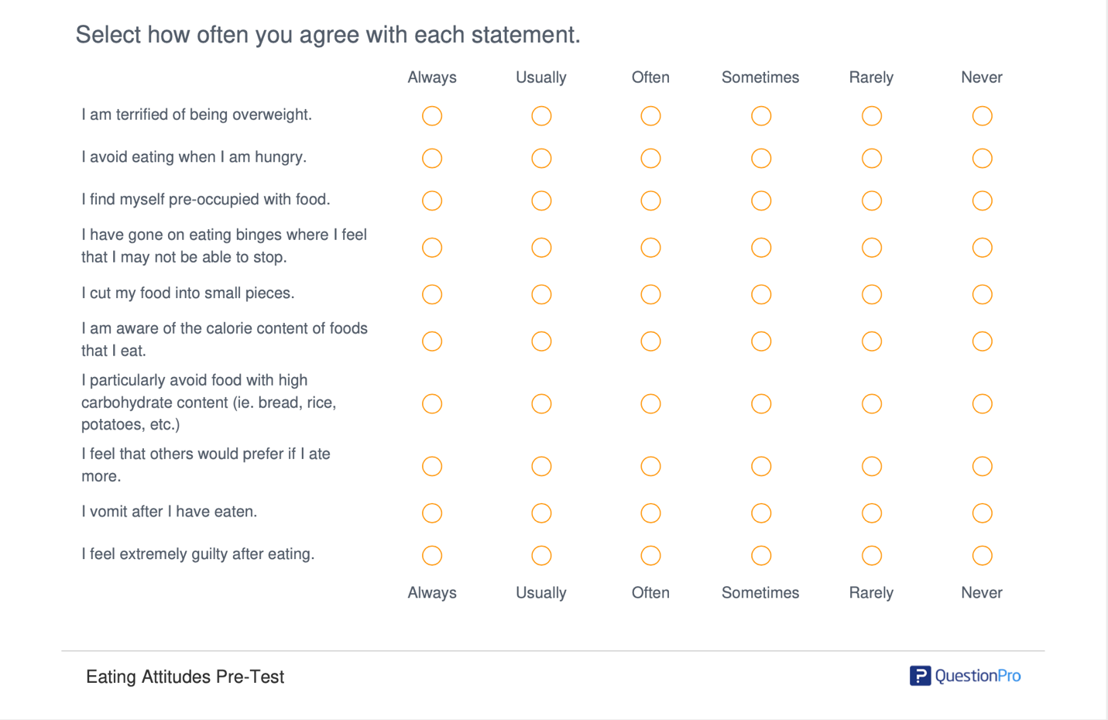

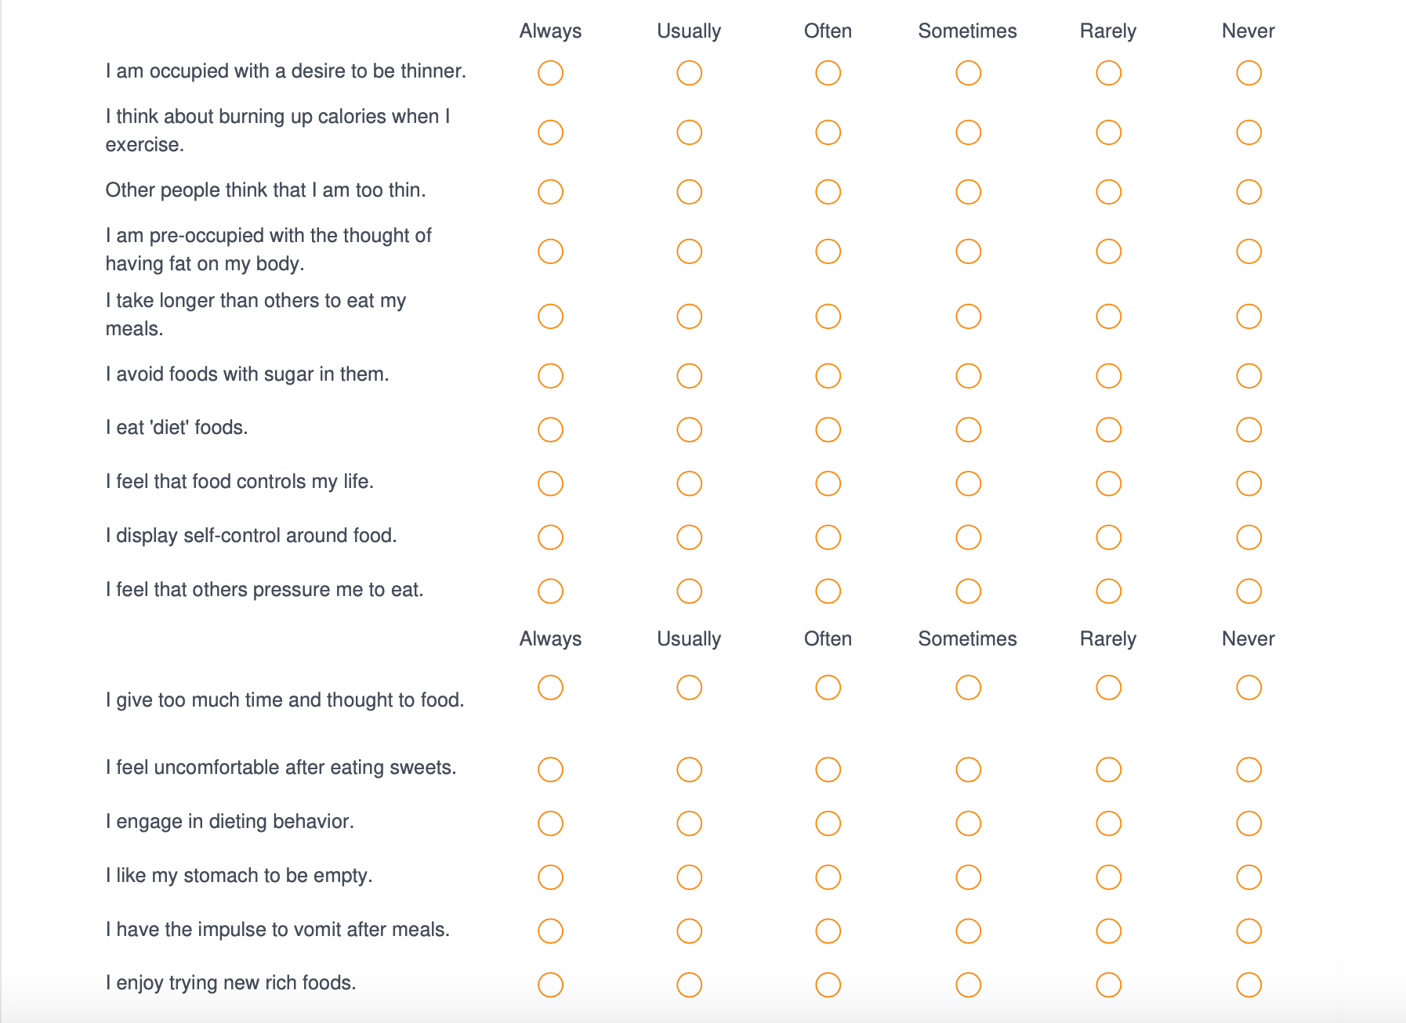
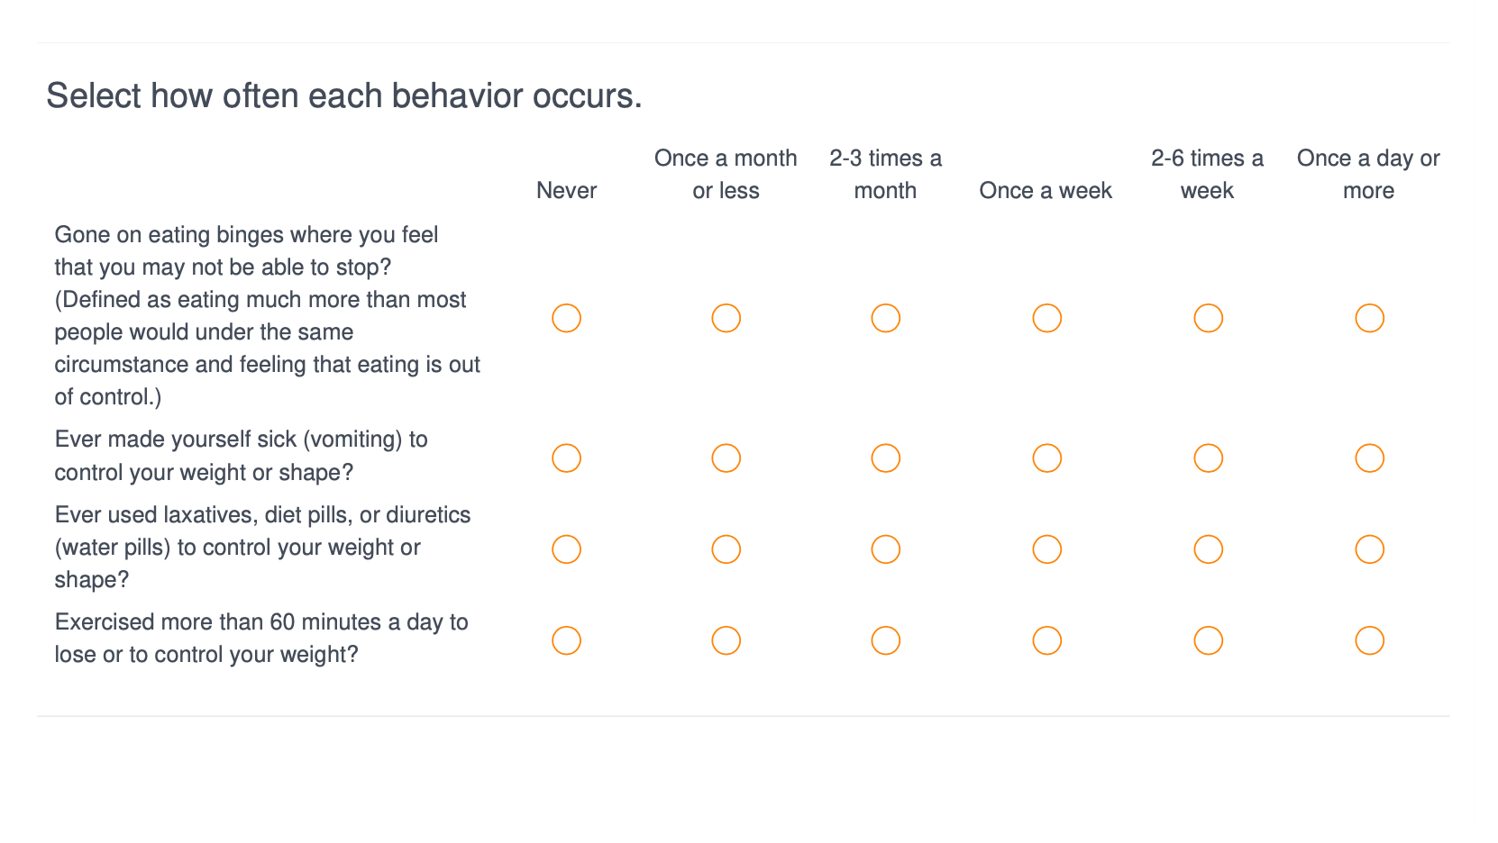
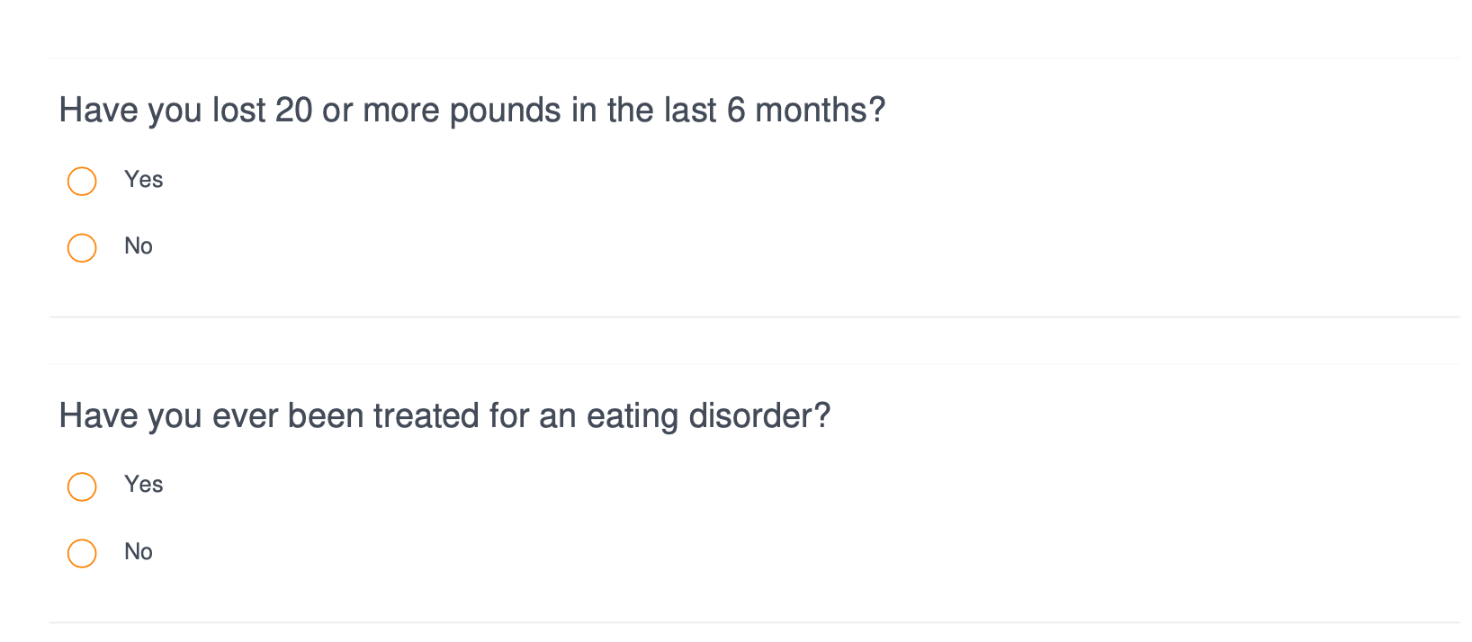
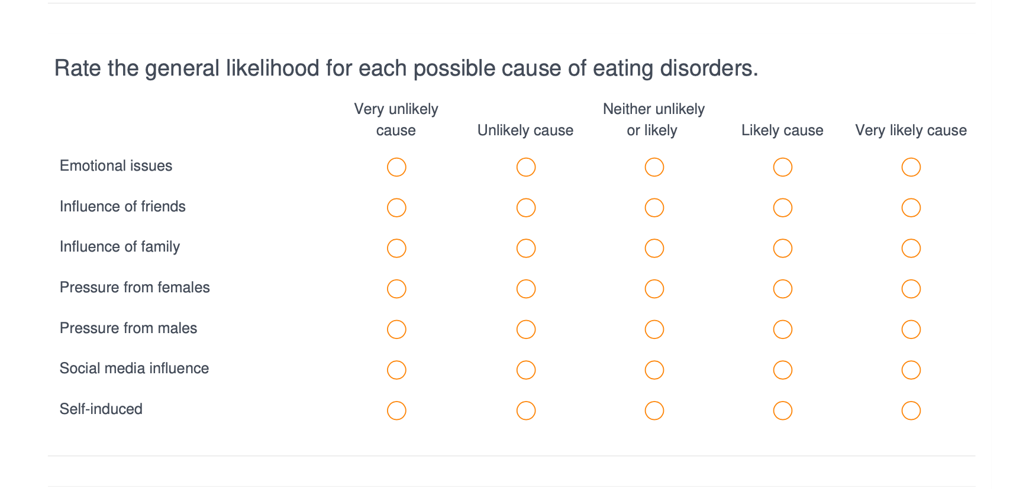
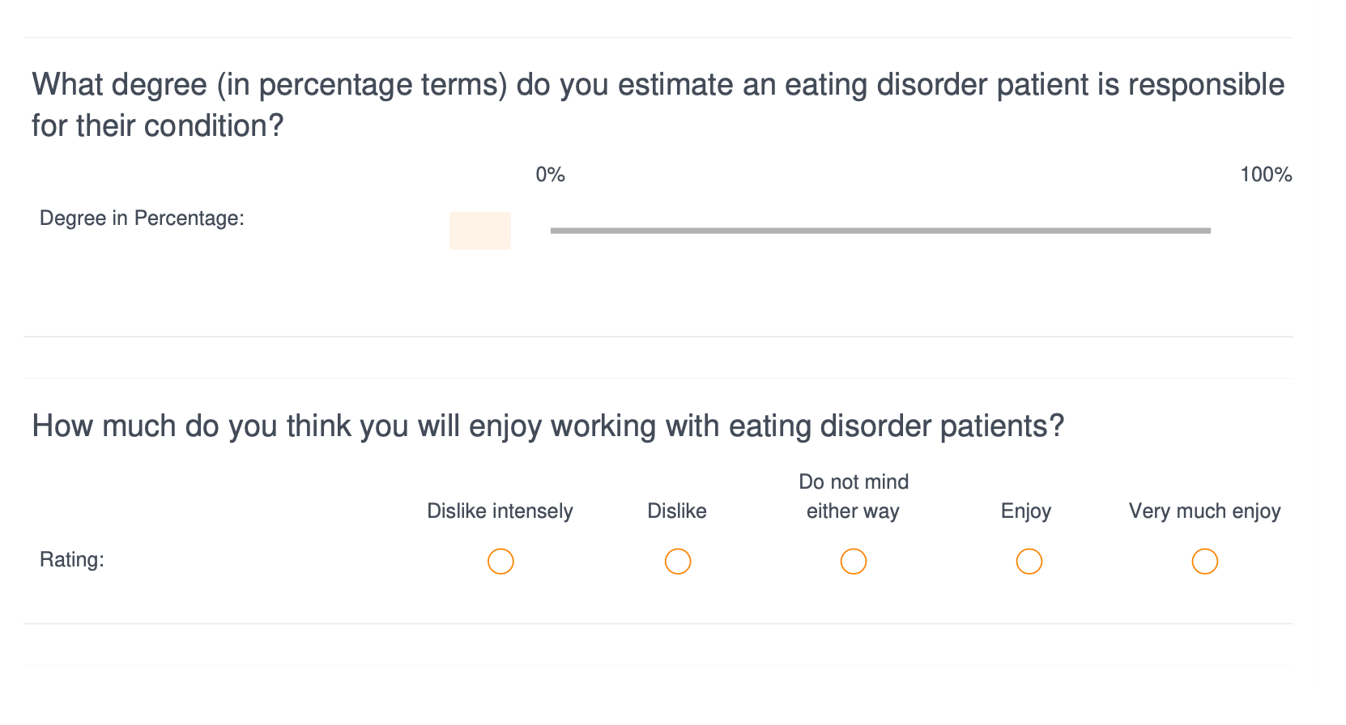

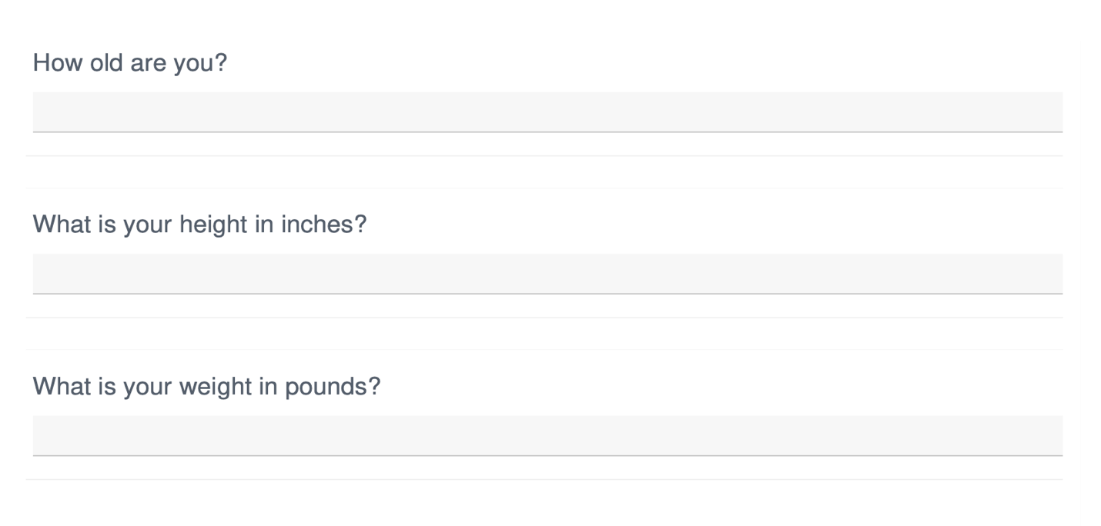

Appendix D: Post-Test Survey Items

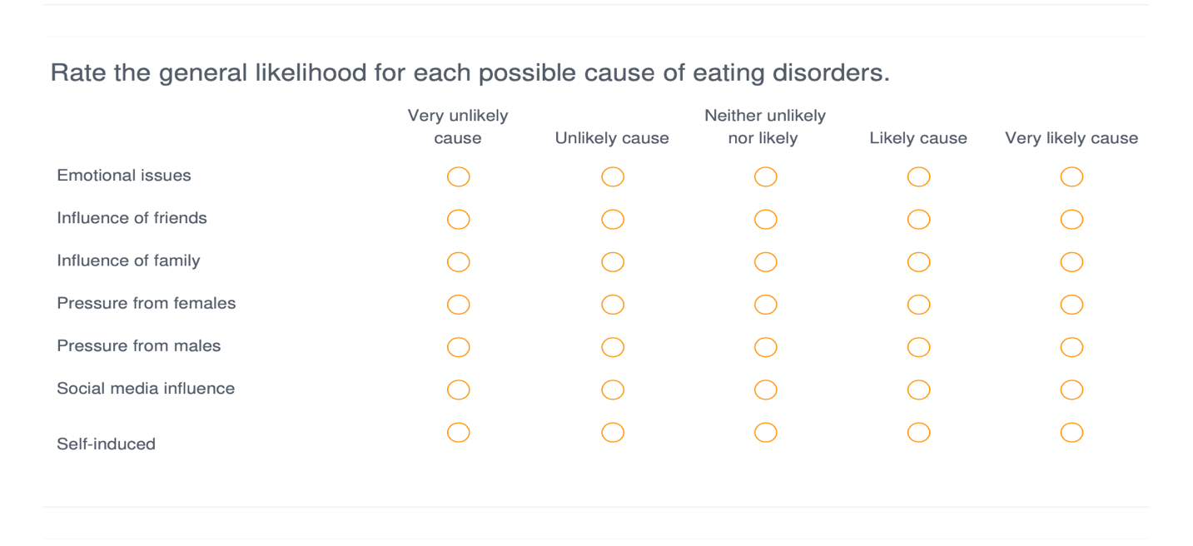
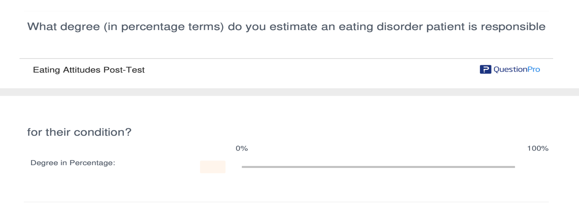
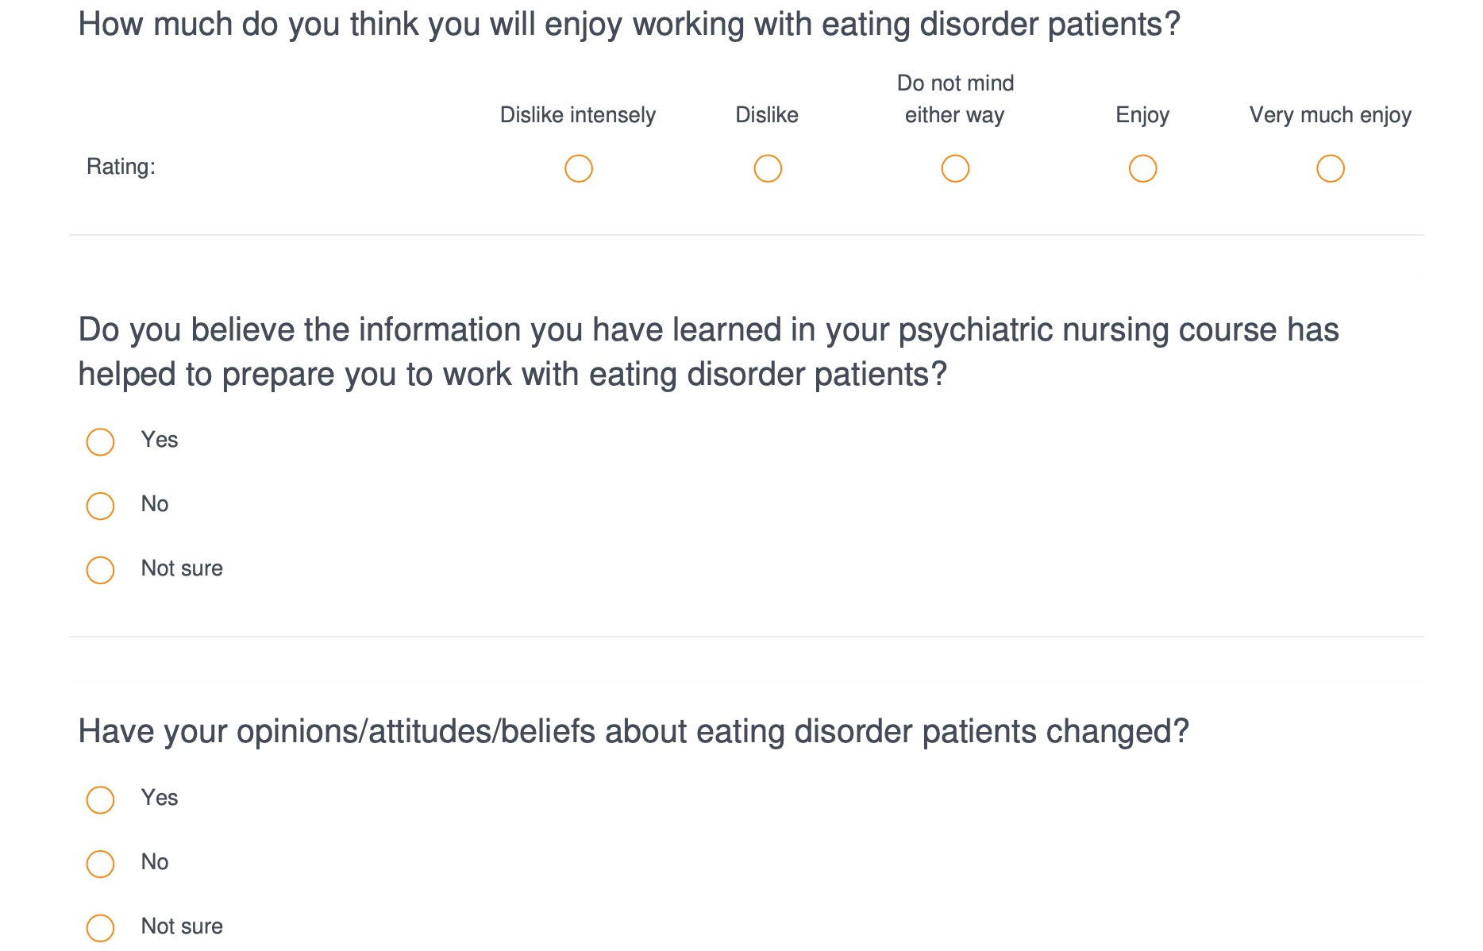
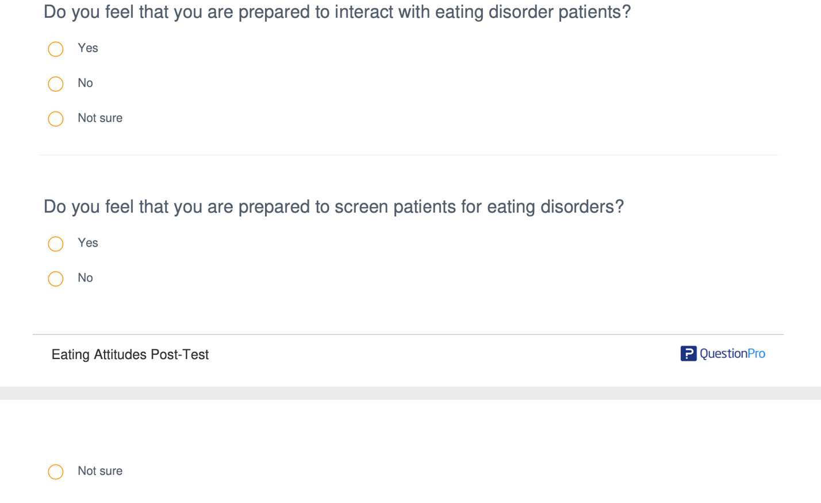
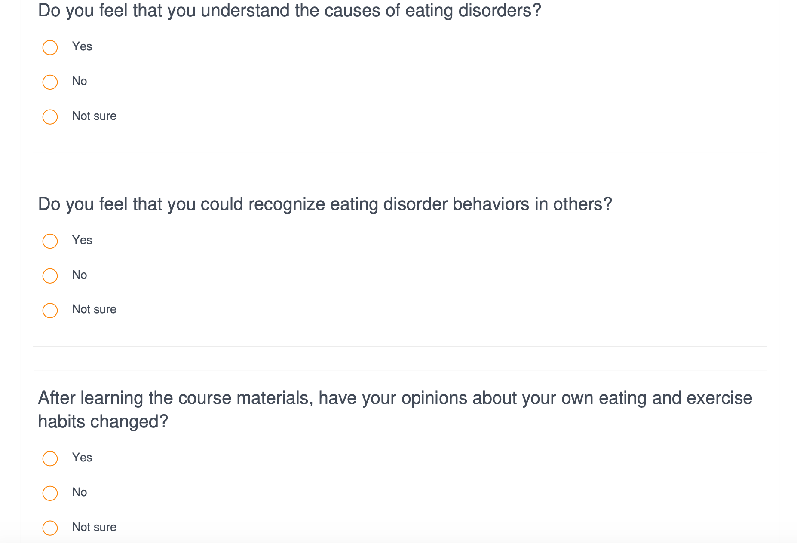

References
Brandt, H. & Crawford, S. (2018). Eating disorders 2018: New insights in diagnosis, research,
and treatment. Psychiatric Clinics of North America, 42. doi:10.1016/j.psc.2018.11.001
Bryer J., Cherkis F., & Raman J. (2013). Health-Promotion behaviors of undergraduate nursing
students: A survey analysis. Nursing Education Perspectives, 34. doi:10.5480/11-614
Calvete E., Las Hayas C., Gómez del Barrio A. (2017). Longitudinal associations between
resilience and quality of life in eating disorders. Psychiatry Research, 259, 470–475.
https://doi.org/10.1016/j.psychres.2017.11.031
Chao, A., Rajagopalan A., Tronieri J., Walsh, O., & Wadden, T. (2019). Identification of binge
eating disorder criteria: Results of a national survey of health care providers. Journal of
Nursing Scholarship, 51.4, 399-407. doi:10.1111/jnu.12468
Culbert, K., Racine S., & Klump K. (2015). Research review: What we have learned about eating
disorders – A synthesis of sociocultural, psychological, and biological research. Journal
of Child Psychology and Psychiatry, 56 (11). https://doi.org/10.1111/jcpp.12441
Cunico, L., Sartori, R., Marognolli, O., & Meneghini, A. (2012). Developing empathy in nursing
students: A cohort longitudinal study. Journal of Clinical Nursing, 21 (13-14).
https://doi.org.10.1111/j.1365-2702.2012.04105.x
Garner, D. M., Olmsted, M. P., Bohr, Y., & Garfinkel, P. E. (1982). The eating attitudes test:
Psychometric features and clinical correlates. Psychological Medicine, 12(4), 871-878.
doi:10.1017/S0033291700049163
Happell, B., Scholz, B., Bocking, J., & Platania-Phung, C. (2019). Promoting the value of mental
health nursing: The contribution of a consumer academic. Issues in Mental Health
Nursing, 40 (2), 140-147. https://doi.org/10.1080/01612840.2018.1490834
Hellberg, S., Ladis, I., & Shepherd, C. (2018). Pilot study of a personality-based approach to
assessing eating disorder and obsessive-compulsive disorder symptom risk in college
men and women. Journal of American College Health, 67.8, 801-816. doi:10.1080/07448481.2018.1515745
Hu T, Zhang D, Wang J. (2015). A meta-analysis of the trait resilience and mental health.
Personality and Individual Differences, 76, 18-27. https://doi.org/10.1016/j.paid.2014.11.039
Kane, C., Tomotake, M., Hamatani, S., Chiba, S., Kameoka, N., Watanabe, S., … Ohmori, T.
(2019). Clinical factors influencing resilience in patients with anorexia nervosa.
Neuropsychiatric Disease and Treatment, 15, 391-395. doi:10.2147/NDTS190725
Klump, K.L., Bulik, C.M., Kaye, W.H., Treasure, J., & Tyson, E. (2009). Academy for eating
disorders position paper: Eating disorders are serious mental illnesses. International
Journal of Eating Disorders, 42, 97–103.
Phillips, K. & LoGuidice J. (2019) Practices and attitudes of nursing students toward patients
with disordered eating behaviors. Nursing Education Perspectives, 41.1, 41-51.
doi:10.1097/01.NEP.0000000000000449
Raggatt, M., Wright, C., Carrotte E., Jenkinson R., Prichard, I., & Lim, M. (2018). “I aspire to
look and feel healthy like the posts convey”: Engagement with fitness inspiration on
social media and perceptions of its influence on health and wellbeing. BioMed Central
Public Health, 18. https://doi.org.proxy.lib.utk.edu/10.1186/s12889-018-5930-7
Stavarski, D., Alexander, R., Ortiz, S., & Wasser, T. (2018). Exploring nurses’ and patients’
perceptions of hope and hope‐engendering nurse interventions in an eating disorder
facility: A descriptive cross‐sectional study. Journal of Psychiatric Mental Health
Nursing, 26, (1-2). https://doi.org/10.1111/jpm.12507
Townsend, M. & Morgan, K. (2018). Psychiatric mental health nursing: Concepts of care in
evidence-based practice (9th ed.). Philadelphia, PA. F.A. Davis Company.
Turner, J. (2019). Nursing: The most trusted profession in the country. MedPage Today.
Retrieved May 6, 2019, from https://www.medpagetoday.com/nursing/nursing/77240
Zhu, D., Norman, J., & While, E. (2011), The relationship between health professionals' weight
status and attitudes towards weight management: a systematic review. Obesity Reviews,
12, 324-337. doi:10.1111/j.1467-789X.2010.00841.x

