The Opioid Crisis: A Nationwide Epidemic

By: Spencer Ammen

History of Opioids/Statement of the Problem
Introduction
The opioid crisis is one of the most pressing issues currently facing the United States and has caused serious social and economic problems for its citizens. This problem has become so severe that it was recognized as a “public health emergency” by President Donald Trump in October of 2017 (Felter, 2017). While opioids can be helpful to people seeking pain relief, the focus of this thesis will be on the negative impacts associated with its abuse. This thesis examines the social and economic costs of the opioid crisis both nationally and in Tennessee; more specifically, it compares the current federal and state policies for combatting the crisis and determines the best practices that appear to have the most potential to combat the opioid crisis. This section will define opioids and addiction, examine the causes that lead to high opioid use, and explain the social and economic costs associated with the crisis.

Addiction/Opioid Definition
The term “opiates” describes drugs that are naturally-derived from the opium plant, such as codeine and morphine. (Elkins, 2018, Rummans, Burton & Dawson, 2018). “Opioids”, on the other hand, refers to drugs that are man-made, or synthetic, and contain chemicals that are very close to those found in opiates (Elkins, 2018). Drugs included in this category include methadone, fentanyl, and tramadol (Rummans et al., 2018). These substances have become synonymous with opioids because of their similar effects on the central nervous system. This thesis will use these two terms interchangeably.

Opioids include illicit drugs, such as heroin, as well as chemically-similar legally prescribed opioids (“Opioids and Heroin,” 2019). Both illicit and prescription opioids are known to have high addiction rates (“Opioid Addiction,” 2019). “Addiction” is defined as a “compulsive drug seeking” that results in “long-lasting changes in the brain” (National Institute on Drug Abuse “The Science of Drug Use and Addiction,” 2019). While the risk of abuse is determined by many factors, opioid abuse impacts people from all backgrounds and in all areas of society.

Opioids are highly addictive given the fact that they produce endorphins, the brain’s “feel-good” neurotransmitters (“Am I vulnerable to opioid addiction?,” 2018). This chemical reaction can be very effective to treat pain relief, but oftentimes leads to addiction as the user experiences sadness and depression when attempting to stop its consumption (“Am I vulnerable to opioid addiction?,” 2018). This addictive characteristic, coupled with the ease of obtaining it, explains the rapid increase of opioid abuse.

History of the Opioid Crisis
The discovery of morphine by German pharmacist Friedrich Serturner in the early 1800’s ushered in the era of opioids (Arablouei & Abdelfatah, 2019). Serturner became the first to extract alkaloid (the ingredient that causes the feeling of being “high”) from a poppy plant (Arablouei & Abdelfatah, 2019). The German pharmacist named this ingredient “morphine” after Morpheus, the ancient Greek God of sleep and dreams (Arablouei & Abdelfatah, 2019). During the U.S. Civil War, this drug was imported in large quantities to help reduce the pain and suffering of soldiers during surgery (Jones, et al., 2018). Following the Civil War, however, some soldiers realized the drug’s degree of addictiveness (Jones et al., 2018).

During the 20th century, morphine began to be used nationwide for many health issues, including uterine and ovarian complications (Jones et al., 2018). This rapid expansion of morphine also led to the overdose deaths of many Americans (Jones, et al., 2018). The dangers of this drug gained nationwide attention and led to the passage of the Harrison Narcotic Control Act of 1914 (Jones et al., 2018). This law imposed a tax on the production, importation, and distribution of opioids within the United States (Jones, et al., 2018).
The 1980’s saw a change in public perception on opioids for certain medical treatments and sparked two studies that challenged the trend of discontinuation of opioid use for pain relief (Jones et al., 2018). One study claimed that the addiction rate of opioid users was a mere 0.03% (Jones et al., 2018). Another study claimed that the addiction rate to morphine was only five percent (Jones et al., 2018). Despite their impacts on swaying public perception, these studies were later refuted for lack of scientific rigor and accuracy (Jones et al., 2018).
In 1995, the American Pain Society began a campaign to urge the treatment of pain symptoms with opioids (Jones et al., 2018). This effort was supported by the Veterans Health Administration (VHA) and advocated opioid use for veterans struggling with pain. (Jones, et al., 2018). In 1996, The Joint Commission (TJC) released standards for pain management and announced the use of opioids (Jones et al., 2018). The Federation of State Medical Boards (FSMB) and the Drug Enforcement Agency (DEA) also relaxed its regulations and oversight on prescribers of opioids to ease the reluctance on the part of physicians to prescribe opioids (Jones et al., 2018). The U.S. Food and Drug Administration (FDA) followed by approving a wider use of opioids (“Opioid Approval and Monitoring by the U.S. Food and Drug Administration,” 2017).

As a result of these strict mandates for hospital systems, physicians and hospital administrators were forced to offer better pain control, leading to a higher use of opioids (Jones, et al., 2018). This turn of events facilitated the beginning of the opioid crisis, which occurred in three distinct “waves” (Ciccarone, D. 2018). Figure 1-1 shows the three distinct “waves” of the opioid crisis and overdose deaths that resulted from each.

The first “wave” of the opioid crisis started in the early 2000’s and introduced high amounts of prescription opioids into the marketplace that increased steadily until around 2011 (“Understanding the Epidemic,” 2018).

Figure 1-1: Opioid Overdose Deaths by Type.
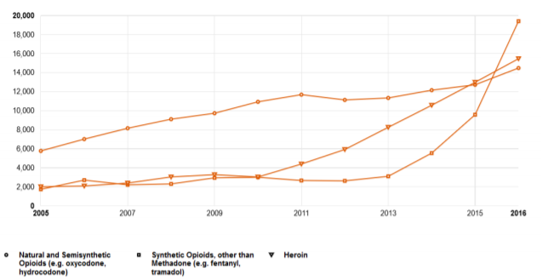
Source: Ciccarone, 2018
The second “wave” began in 2010 with the large increase in heroin use (Ciccarone, D. 2018). This surge of heroin use occurred in large part due to the supply of heroin entering the United States from Mexico (Ciccarone, D. 2018). According to the DEA, roughly 90% of the heroin supply in the U.S. comes from Mexico (Ciccarone, D. 2018). Between 2010-2015, seizure of heroin at the U.S.- Mexico border more than tripled (Villa, L. 2019). During that same time, there was a 50% increase in arrests related to heroin trafficking in the U.S. (Villa, L 2019).

The third and most recent “wave” of the opioid crisis began in 2013 with the rise of illicit synthetic opioids, mostly fentanyl (Ciccarone, D. 2018). These illicit opioids can come in either powder form as heroin, or in pills. The rise in synthetic opioids occurred due to the rise in their popularity among drug users as well as the increase in supply from foreign countries. The DEA estimates that most of the synthetic opioids, both powder and pill form, enter the country from China through Mexican gangs that package and smuggle them across the border (Ciccarone, D. 2018). This new “wave” of synthetic opioids represents an increased danger because of their higher potencies. One estimate suggests that synthetic opioids are roughly 80-100 times stronger than morphine, and 30-40 times stronger traditional heroin (Ciccarone, D. 2018). Potency also varies greatly by batch and thus represents an additional health threat to users (Ciccarone, D. 2018).

Factors Correlated with Opioid Abuse
Several factors may contribute to the rate of opioid prescriptions in a given area. These factors include: unemployment and poverty, and occupations with high rates of injuries. While prescription opioids are only one aspect of the crisis, it is the easiest to measure. It is important to point out that opioid prescriptions per se are not necessarily the problem; rather it is the “abuse” of prescription opioids that becomes problematic.
Unemployment and Poverty
Higher opioid prescription rates are associated with higher unemployment. The U.S. Department of Health and Human Services (HSS) analyzed the impact of poverty and unemployment on rates of opioid prescription between 2006-2016 for most counties in the U.S. As Figure 1-2, Figure 1-3, and Figure 1-4 illustrate, counties with high unemployment and poverty generally experienced higher rates of opioid prescriptions (Ghertner & Groves, 2018). As these maps exhibit, areas such as northern California, southwest Oregon, Appalachia, parts of the West and Midwest, and most of the South experienced high rates of unemployment, poverty, and opioid prescriptions (Ghertner & Groves, 2018). The increase in unemployment and poverty in areas like Appalachia are mostly due to the loss of nearly 5 million manufacturing jobs since 2000, as well as over two-thirds of coal mining jobs since the 1980’s (Long, 2016 Volcovici, 2018).

Figure 1-2: Poverty Rates by Area of the U.S.

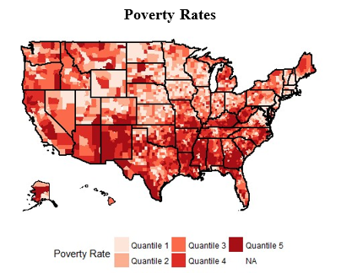
Source: Ghertner & Groves, 2018.

Figure 1-3: Unemployment Rates by Area of the U.S.

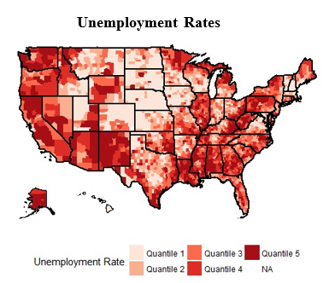
Source: Ghertner & Groves, 2018.

Figure 1-4: Retail Opioid Sales by Area of the U.S.
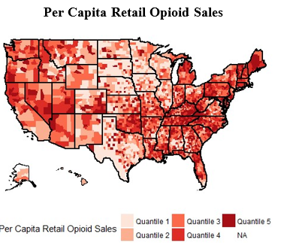
Source: Ghertner & Groves, 2018.

Figure 1-5 suggests a correlation between high rates of unemployment and poverty and opioid sales. The increase in poverty and unemployment between 2006-2012 is associated with an increase in opioid sales. A slight decrease in poverty and unemployment between 2012-2016 is also associated with a decrease in opioid sales.

Figure 1-5: Relationship between Retail Opioid Sales and Unemployment and Poverty Rates.

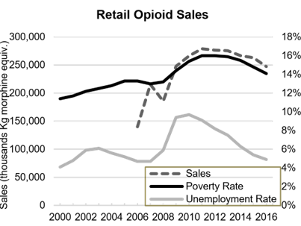
Source: Ghertner & Groves, 2018.

These data do not prove that economic conditions necessary increase opioid prescriptions, only that a positive relationship may exist. However, HSS asserts that it is likely that “economic conditions both affect and are affected by substance use” (Ghertner & Groves, 2018, P. 9). To investigate this connection, researchers at HSS modeled the impact of a 1% increase in the poverty and unemployment rates on retail opioid sales and prescriptions. As Figure 1-6 portrays, between 2006-2016, a 1% increase a county’s poverty rate was associated with a 1.4% increase in opioid sales and a 3.3% increase in prescriptions (Ghertner & Groves, 2018, P. 9). In addition, a 1% increase in unemployment corresponded with a 3.8% increase in opioid sales and a 1.9% increase in prescriptions (Ghertner & Groves, 2018, P. 9).

Figure 1-6: Correlation of 1% Increase in Unemployment and Poverty Rates on Opioid Prescription and Sales Rates.
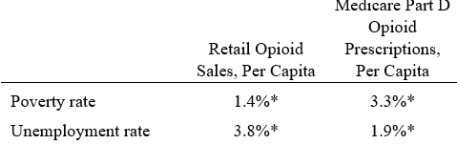
Source: Ghertner & Groves, 2018.

Figure 1-7 displays the association of higher rates of poverty with opioid prescriptions. In 2016, people in poverty were 2.1% more likely to have abused opioids in the past year, 1% more likely to have abused opioid in the past month, and more than twice as likely to have an opioid use disorder than people who were 200% or more above the poverty line (Ghertner & Groves, 2018).

In 2012, the CDC concluded that “Medicare recipients and other low-income populations are of high risk for prescription drug overdose” (Ghertner & Groves, 2018, Pg. 1). The Federal Reserve also studied this issue and determined that people with opioid use disorder generally have “less favorable assessments of economic conditions” (Ghertner & Groves, 2018, P. 2).

Figure 1-7: Association of Poverty Rate on Opioid Use.
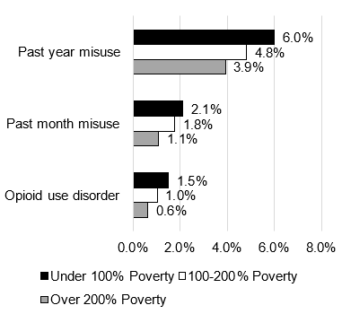
Source: Ghertner & Groves, 2018.

Jobs with High-Risk of Injury
Some areas in the U.S. with relatively high opioid prescription rates also tend to have a high number of jobs that are of high-risk of injury or that have been decimated. While the loss of manufacturing and coal mining jobs is associated with increased opioid prescriptions, the jobs themselves also may lead to higher opioid prescriptions due to injuries. This connection explains, at least in part, why areas of New England, such as Connecticut and Massachusetts, as well as central Maryland, have high opioid prescription rates despite having low poverty and unemployment rates. As Figure 1-8 illustrates, these areas also had relatively high numbers of manufacturing jobs as of 2010 (Wial, H. 2012).

Figure 1-8: Areas with Most Manufacturing Jobs as of 2010.
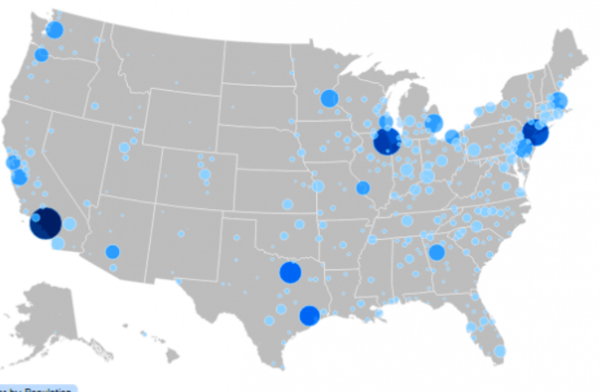
Source: Wial, 2012.

Figure 1-9 depicts areas with the most coal mining jobs as of 2015. This further illustrates why areas like Appalachia also experienced high levels of opioid prescription rates, in addition to its high unemployment and poverty (“Mining,” 2019). An interesting note is that some areas, such as southern Texas, experienced high poverty and unemployment rates but low opioid prescription rates. This is likely highly influenced by state policy, the focus of later chapters of this report.

Figure 1-9: Areas with most Coal Mining Jobs as of 2015.

Source: “Mining,” 2019.
Figure 1-10 depicts the extent of injuries for manufacturing and coal mining jobs from 1992-2010. Both manufacturing and mining jobs were the highest, with 2010 seeing rates of roughly 28 deaths per 100,000 manufacturing workers and roughly 19 deaths per 100,000 coal miners (“Fatal and Nonfatal Injuries in Construction and Other Industries,” 2019).

Figure 1-10: Highest Fatal Injury Rates in Major Industries Between 1992-2010.

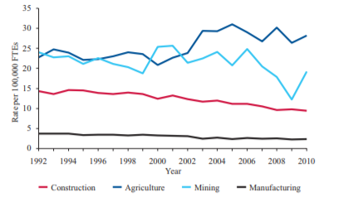
Source: “Fatal and Nonfatal Injuries in Construction and Other Industries,” 2019.

Figure 1-11 illustrates the rate of nonfatal injuries for major industries. While mining and manufacturing were below construction and agriculture, their rates were still high compared to other industries. In 2010, manufacturing and coal mining jobs had rates of roughly 125 nonfatal injuries per 100,000 manufacturing workers and 120 nonfatal injuries per 100,000 miners (“Fatal and Nonfatal Injuries in Construction and Other Industries,” 2019). An interesting trend, and one that could be studied further, is the fact that rural areas have 50% higher opioid prescription rates on average than in other areas (Ghertner & Groves, 2018). However, this report focused on the impact of economic conditions and certain job types on opioid sales and prescriptions in all areas, including rural areas, where these economic conditions and jobs are prevalent.

Figure 1-11: Highest Nonfatal Injury Rates in Major Industries Between 1992-2010.
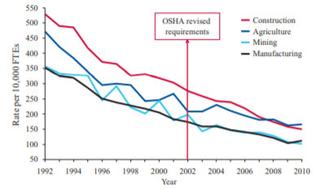
Source: “Fatal and Nonfatal Injuries in Construction and Other Industries,” 2019.
In summary, while many factors contribute to high opioid prescription rates, a few major ones are unemployment, poverty, and jobs with high injury rates. While this section does not prove a causal relationship between these variables and high opioid prescription rates, it showed several studies and graphics that support the relationship. One possible alternative may be that these types of jobs are usually located in areas that are hit harder by opioid abuse. Future research should be conducted to examine this relationship further.

U.S. Opioid Prescription Rates
High prescription rates played a huge role in opioid abuse becoming a national health crisis. In 2016, Americans received 61,862,364 prescriptions from doctors and 214,881,662 from retail pharmacies (“U.S. Opioid Prescribing Rate Maps,” 2018). Figure 1-12 shows how opioid prescription rates began increasing steadily in 2006 and peaked in 2012, which had a rate of 81.3 per 100 persons and totaled around 255 million. After an increase in awareness among doctors and patients, however, prescription rates for opioids declined significantly from 2012-2017 (“U.S. Opioid Prescribing Rate Maps,” 2018).

Figure 1-12: U.S. Opioid Prescriptions from 2006-2017.
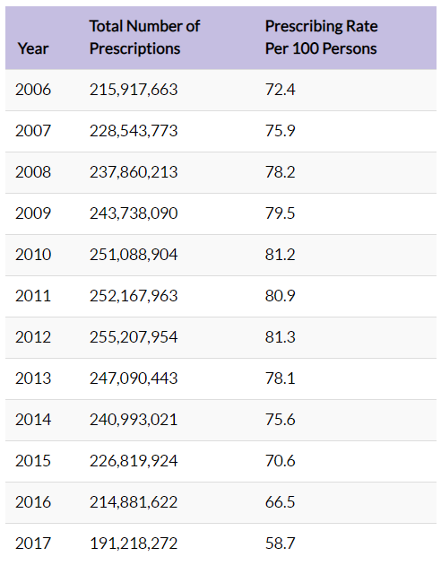
Source: “Opioid Overdose-U.S. Opioid Prescribing Rate Maps,” 2018.

Despite the recent decline of opioid prescriptions, the issue of over-prescription remains prevalent (U.S. Opioid Prescribing Rate Maps, 2018). While 2017 had the lowest prescription rate in over ten years, it remained relatively high, with 58.7 prescriptions per 100 persons (“U.S. Opioid Prescribing Rate Maps,” 2018). In addition, rates remain very high in certain areas of the country. Figure 1-13 compares how each state fared in 2017 against others in terms of prescription rates. As this figure shows, states such as Tennessee still experience high rates, discussed in-depth later in this thesis.

Figure 1-13: U.S. Opioid Prescription Rates by State.
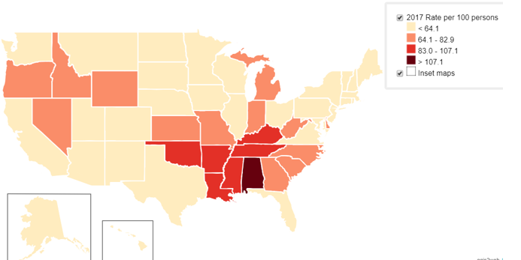
Source: “Opioid Overdose-U.S. Opioid Prescribing Rate Maps,” 2018.
This section discussed the issue of high opioid prescription rates in the U.S. and how states such as Tennessee experienced above-average rates. The next few sections will examine the various costs associated with opioid abuse.

U.S. Social Costs of Opioids

U.S. Deaths from Opioids
The opioid epidemic in the U.S. spawned a variety of social problems. Perhaps the most striking is the number of deaths due to opioid overdoses. In 2008, the number of deaths from opioids exceeded those from cocaine and heroin combined (“Vital Signs: Overdoses of Prescription Opioid Pain Relievers on the United States, 1999-2008,” 2011). On average, over one hundred and thirty Americans die per day from opioid overdoses or other health issues related to opioids (“Understanding the Epidemic”, 2018). In 2015, 33,091 people in the U.S. died from opioid abuse, 15,281 of which received the drugs via legal prescriptions (Seth, Scholl, Rudd & Bacon, 2018). The CDC states that this number increased to 47,600 deaths in 2017 (“Drug Overdose Deaths,” 2018). Total deaths related to opioid abuse totaled around 400,00 as of 2017 (“Understanding the Epidemic,” 2018). Figure 1-14 depicts the increase of overdose deaths from opioids through 2017. This graph also shows how the three “waves” influenced and exacerbated these numbers (“Understanding the Epidemic,” 2018).

Figure 1-14: Three Waves of Opioid Overdose Deaths in the U.S., 1999-2017.
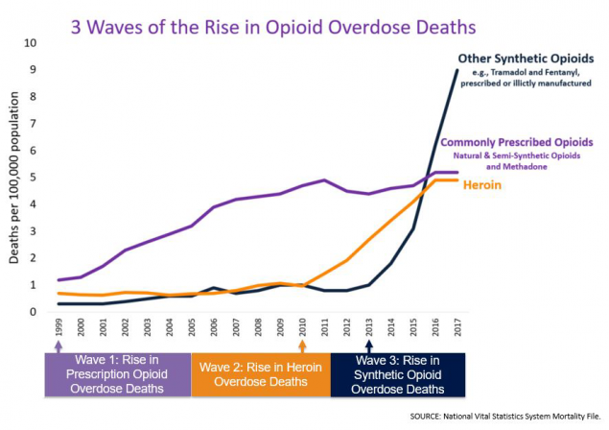
Source: “Opioid Overdose-Understanding the Epidemic,” 2018.

U.S. Crime Associated with Opioids
High crime rates are associated with increased use of opioids. A study conducted by HSS found that drug-users “are more likely than nonusers to commit crimes” (“Drug-Related Crime,” 1994 P. 1). HSS found that the cause of these crimes is primarily due to the altered behavior of drug-users and actions committed to obtain money to buy more drugs (“Fact Sheet: Drug-Related Crime,” 1994). Another study by the National Institute of Justice (NIJ) in 1992 discovered that between 42% and 79% of criminals tested positive for drug use (“Drug-Related Crime,” 1994). While these studies examined the impact of all drugs on crime, various studies have been conducted on the impact of opioids alone on crime.

Rosenfeld found that the murder rate nationwide increased from 11% in 2015 to more than 15% in 2017, around the same time of the third wave of opioids (Lopez, 2018). Rosenfeld acknowledges this trend does not necessarily prove that opioids caused this increase, but that it can be reasonably expected to have had at least some impact (Lopez, 2018). Tyler Winkelman, a clinician-investigator at Hennepin Healthcare in Minnesota, also examined the relationship between opioids and increased crime (Chatterjee, 2018). Winkelman analyzed 78,976 respondents to a national survey on drug use and found that only 3% of non-opioid users had a criminal history (Chatterjee, 2018). In contrast, 22.4% of prescription opioid users, 76.8% of heroin users, 33.2% of opioid “misusers”, and 51.7% of people with an opioid “disorder” admitted to having a record of criminal activity (George, J. 2018). Figure 1-15 depicts the relationship between the use of different types of opioids and increased crime (“Opioid Addiction and the Criminal Justice System,” 2019). While percentages vary slightly between these two studies, both show that increased use of opioids leads to much higher crime as opposed to no use, with heroin use causing the most.

Figure 1-15: Relationship between the Use of Different Types of Opioids and Increased Crime.
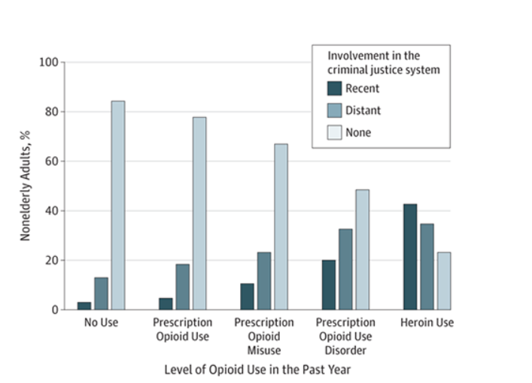
Source: “Opioid Addiction and the Criminal Justice System,” 2019.

This section provided studies and experiments that suggest a relationship between increased opioid abuse and an increase in crime. While there is no proven causation or exact correlation, there seems to be some degree of relationship between these variables.

U.S Economic Costs of Opioids

A wide range of economic costs are associated with the rise in opioid abuse. Figure 1-16 shows the estimated overall economic costs associated with opioid abuse. As this graph depicts, the overall economic cost from opioids increased from $29.1 billion in 2001 to $115 billion in 2017 (“Economic Toll of Opioid Crisis in U.S. Exceeded $1 Trillion Since 2001,” 2018). One study claimed that the total economic cost in the U.S. from the opioid abuse could be as high as $740 billion (“The Science of Drug Use and Addiction,” 2018). According to the Council of Economic Advisors, the total economic costs in 2015 equaled roughly $504 billion, or 2.8% of GDP, which they point out is “over six times larger than the most recently estimated cost of the epidemic” (“The Underestimated Cost of the Opioid Crisis,” 2019 P. 2).
Figure 1-16: Previous and Future Estimated Economic Costs of the Opioid Crisis.
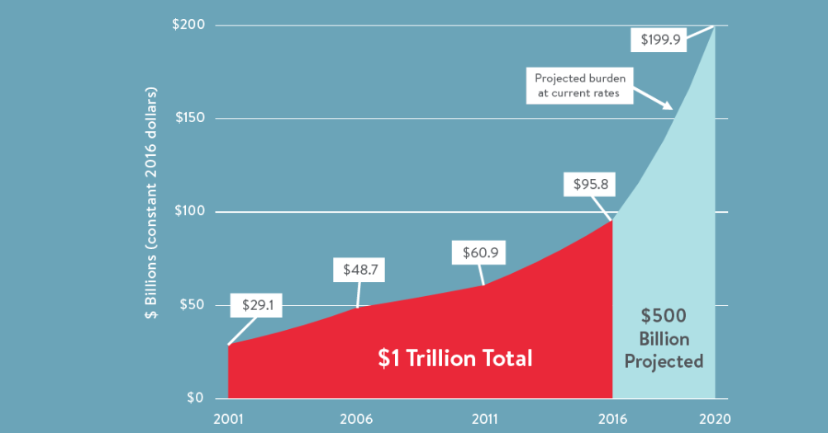
Source: “Economic Toll of Opioid Crisis in U.S. Exceeded $1 Trillion Since 2001,” 2018.

These inconsistencies with estimations illustrate the difficulty with collecting data on this issue. Undoubtedly, significant economic costs accompany the opioid crisis. Even based off low estimations, opioids have created significant economic costs for the U.S. and those costs are expected to continue to rise. One study predicts that these costs will increase by more than $500 billion by 2020 (“Economic Toll of Opioid Crisis in U.S. Exceeded $1 Trillion Since 2001,” 2018).
U.S. Unemployment, Poverty and Labor Force Participation
The opioid crisis is associated with a rise in unemployment and poverty, and a fall in labor force participation. One estimate suggests that for every person addicted to opioids, the United States’ economy loses over $800,000. (“Economic Toll of Opioid Crisis in U.S. Exceeded $1 Trillion Since 2001,” 2018). The rise in opioid abuse is also associated with an increase in unemployment. In 2017, for example, there were six million jobs were available with an unemployment rate of 4.1% (DePillis, 2018). While this gap between available jobs and unemployment is caused by many factors, a possible contributing factor is opioid addiction. This may be caused by some abusers of drugs losing the desire or ability to hold a job due to their inability to pass drug tests. According to one study, 919,400 “prime-age” citizens were unemployed due to opioids (Gitis, 2018). Figure 1-17 illustrates the areas of high unemployment and areas of high opioid sales. While there are certainly exceptions, this comparison suggests an overlap among areas with high unemployment and opioid sales.

Opioid abuse may also be connected to decreased labor force participation. One study found that the increase in prescription rates of opioids was credited for 20%-25% of the five-point drop in labor force participation between 1999-2015 (DePillis, 2018). Figure 1-17 shows the strong correlation between states with increasing opioid prescription rates and lower labor force participation (Belmonte, 2018). According to this study, 44% of the variation among states’ labor force participation is attributed to higher opioid prescription rates.

Figure 1-17: Correlation between Opioid Prescriptions and Labor Participation.

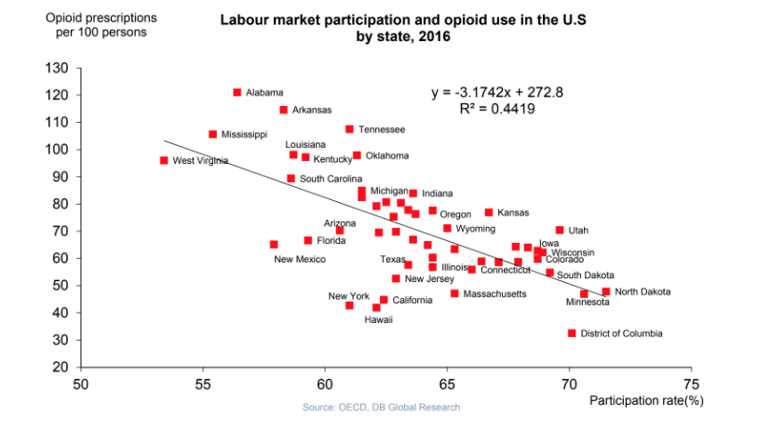
Source: Belmonte, 2018.
Between 1999- 2015, the U.S. experienced a decline in labor force participation of roughly 12.5 billion work hours (Gitis, 2018). In addition to these lost work hours hurting companies’ ability to compete, they slowed the real annual economic growth rate by 0.2%, costing $702.1 billion in real output (Gitis, 2018). Local, state, and federal governments are also impacted from lost tax revenue, roughly $16 billion as of 2016, due to the increase in unemployment (Sutherland, 2018).

Criminal Justice System Costs
Opioid abuse also has cost implications for the criminal justice system. In 2016, local and state governments spent roughly $7.8 billion on fighting opioid abuse. Figure 1-18 depicts how the biggest portion of this cost was spent on corrections and incarcerations, followed by police protection, judicial and legal, and property losses (Rhyan, 2017).

Figure 1-18: Opioid Costs Associated with U.S. Criminal Justice System.
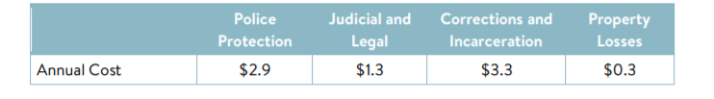
Source: Rhyan, 2017.
To make matters worse, much of these costs are recurring, given that opioid abusers often return to prison due to continued drug abuse. It is estimated that the recidivism rate is around 45% for drug addicts (LaMagna, 2018).

U.S. Healthcare Costs
Substantial healthcare costs accompany opioid abuse. These costs totaled about $215 billion between 2001 and 2018 (Allen, 2018). One study found that the “growth in costs between 2011 and 2016 was double the rate of the previous five years” and warned that the “projected to keep rising steeply” (Allen, 2018). Emergency and hospitalization visits make up a large portion of the costs of opioids. In 2015 alone, there were 78,840 hospitalizations from opioid poisoning (“2018 Annual Surveillance Report of Drug-Related Risks and Outcomes,” 2018). In the same year, there were 140,077 emergency room visits (“2018 Annual Surveillance Report of Drug-Related Risks and Outcomes”, 2018). In 2016, there were 80,000 emergency room visits and 60,000 hospitalizations of people who overdosed from opioids (Sutherland, 2018). While there was a slight reduction in these numbers between 2015-2016, they remain too high.

Many opioid addicts also require extensive rehabilitation and treatment (“Principles of Drug Addiction Treatment,” 2018). The average annual cost of methadone addiction treatment is $4,700 per person (“Principles of Drug Addiction Treatment,” 2018). This cost is incurred for the roughly 2 million people addicted to prescription opioids and 652,000 people addicted to illicit opioids (“Opioid Crisis Fast Facts,” 2019). Many opioid addicts who receive treatment cannot pay for it, forcing local and state governments to incur the costs. Figure 1-19 reveals that the largest payers are state and local governments with 29%, Medicaid with 21%, and other public resources with 18% (Orgera & Tolbert, 2019). Only 31% of opioid addicts pay out of pocket or are privately insured (Orgera & Tolbert, 2019).
Figure 1-19: Distribution of Opioid Medical Payments.
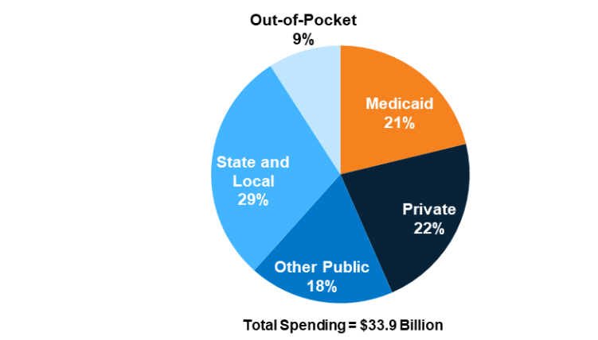
Source: Orgera & Tolbert, 2019.
This section explained the cost distribution of opioid abuse medical payments. Given that many of these patients are in poverty, much of this cost is paid for through taxpayer funded healthcare programs.

Neonatal Abstinence Syndrome (NAS)
The cost associated with babies born addicted to opioids is also substantial. Neonatal abstinence syndrome (NAS) is defined as a “postnatal drug withdrawal syndrome” which leads to “hyperactivity of the central and autonomic nervous system and gastrointestinal tract” (Sanlorenzo, Stark & Patrick, 2018 P. 1). A baby is born with this disease every fifteen minutes in the U.S. (“Dramatic Increases in Maternal Opioid Use and Neonatal Abstinence Syndrome,” 2019). Figure 1-20 shows the increase in the NAS rate from 1.5 to 8.0 per 1,000 hospital births between 2004 and 2014. This figure also illustrates the strong correlation between higher opioid use disorder and NAS cases.

Figure 1-20: U.S. Increasing Rate of Babies Born with NAS.
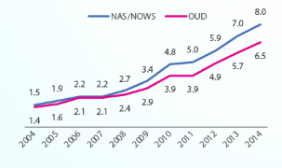
Sources: “Dramatic Increases in Maternal Opioid Use and Neonatal Abstinence Syndrome,” 2019.

Treatment of babies with this condition costs roughly $45,000 per year for each baby (Cox & Farr, 2018). In 2014, the total estimated costs associated with helping to nurture and cure these babies was $563 million (“Dramatic Increases in Maternal Opioid Use and Neonatal Abstinence Syndrome,” 2019). Given the fact that many of these babies are born to parents in poverty, 82% of this cost is covered by Medicaid (“Dramatic Increases in Maternal Opioid Use and Neonatal Abstinence Syndrome,” 2019). According to Tom Frieden, CDC Director, this issue is “a tremendous burden for the healthcare system” (Dallas, 2016 P. 1).

TN Opioid Prescription Rates
Opioid prescription rates in Tennessee are higher than many other regions of the country. In 2017, the Tennessee opioid prescription rate was the third highest in the U.S. at 94.4 prescriptions per 100 persons, (“Opioid Summaries by State,” 2019). This rate was 1.5 times higher than the national average of 58.7 prescriptions (“Tennessee Opioid Summary,” 2019). Figure 1-21 shows ranges of prescription rates for each county in Tennessee.

Figure 1-21: Tennessee Opioid Prescription Rate by County.
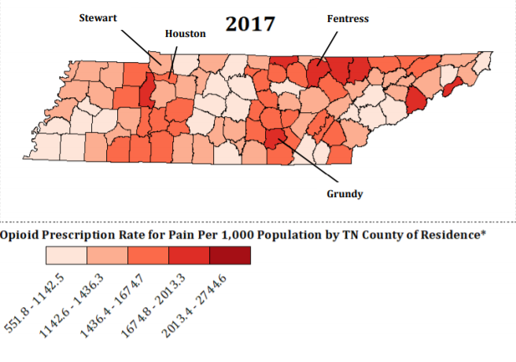
Source: “Prescription Drug Overdose Program 2018 Report,” 2017.

However, prescription rates in the state have declined as of recently. Figure 1-22 exhibits the steep decline in Tennessee between 2010, which had the highest rate of 140 prescriptions per 100 persons and 2017. Despite 2017 having the lowest prescription rate since 2006, it had the third highest nationally (“Tennessee Opioid Summary,” 2019).

Figure 1-22: Decline of Opioid Prescription Rates in Tennessee.
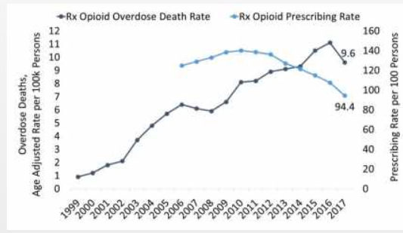
Source: National Institute on Drug Abuse- “Tennessee Opioid Summary,” 2019.
This section examined the opioid prescription rate in Tennessee and how it fares compared to the national average and with other states. While there has been a slight decrease in the past few years, there seems to be a serious issue with regards to opioid over-subscription in the state.

TN Social Costs of Opioids

TN Deaths from Opioids
Tennessee deaths associated with opioid abuse continue to rise. According to the Tennessee Department of Health (TDH) 1,268 Tennesseans died from opioid overdose in 2017, accounting for 75% of all drug overdoses (“Tennessee Deaths from Drug Overdoses Increase in 2017,” 2018). This calculates to be 19.3 deaths per 100,000 people, higher than the national average of 14.6 deaths per 100,000 people (“Tennessee Opioid Summary,” 2019). Despite the reduction in prescriptions, death from opioid overdose continues to increase each year. Figure 1-23 shows the overall increase of death from opioids and the distribution for each type. As this graph illustrates, total deaths from opioids increased each year between 2011-2017 (“Tennessee Opioid Summary,” 2019).

Prescriptions remain the most abused form of opioids. However, Figure 1-23 shows a slight decrease between 2016 and 2017 (“Tennessee Opioid Summary,” 2019). Heroin abuse, on the other hand, increased each year between 2009 and 2017 (“Tennessee Opioid Summary,” 2019). Deaths from synthetic opioids, the most recent “wave” of the opioid crisis, increased significantly between 2013 and 2017 (“Tennessee Opioid Summary,” 2019).

Figure 1-23: Tennessee Overdose Deaths from Each Opioid Type.

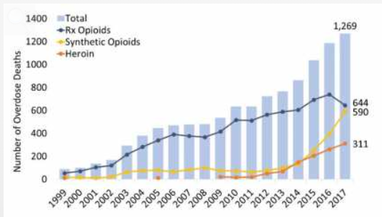

Source: “Tennessee Opioid Summary,” 2019.
Opioid abuse in Tennessee led to an increase in overdose deaths in the state. This section examined the death count for each type of opioid and the trend between 1999-2017.

TN Crime Associated with Opioids
Opioid abuse in Tennessee is also associated with an increase in crime. The Tennessee Bureau of Investigation (TBI) found that approximately 80% of crimes committed in the state are in some way drug-related (“Drugs,” 2019). While their study examined the impact of all drugs, opioids are the most common form in the state. Between 2005-2012, overall drug-related crimes in Tennessee increased by more than 33%, the same time that opioid use became prominent (“Prescription Opioid Abuse In Tennessee,” 2017).

Figure 1-24 portrays Tennessee and national homicide trends between 2007-2017. This graph, which shows higher homicide rates in Tennessee than nationally, also overlap with the timing of the three opioid “waves”. First, the sharp increase in homicides in Tennessee between 2010-2012 occurred during the same time that heroin use became prevalent (Mojica, 2018). Another trend to observe is the increase in homicides between 2013-2017, which occurred around the same time as the introduction of synthetic opioids (Mojica, 2018). The overlap between higher opioid abuse and homicides in Tennessee explains a possible relationship, though there are many other variables that may have played a role. It is worth pointing out that there is not a perfect correlation between violent crime and opioid abuse in the past decade.

Figure 1-24: Graph of Tennessee and National Homicide Trends.
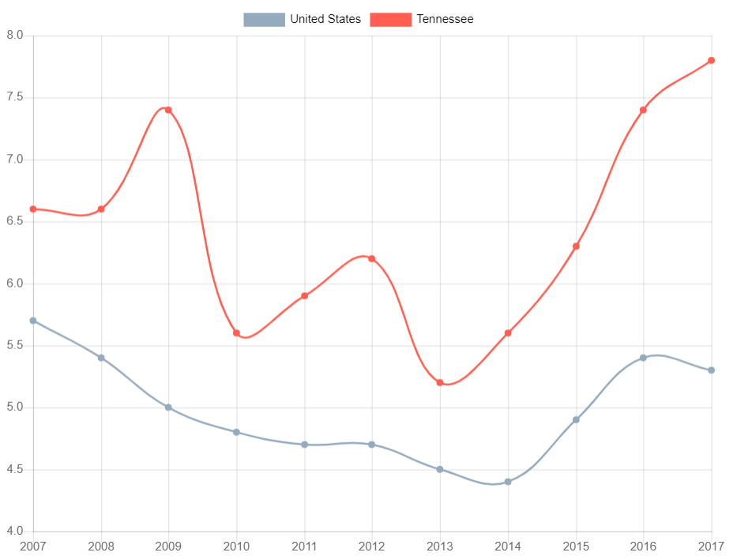
Source: Mojica, 2018.

TN Economic Costs of Opioids

TN Unemployment, Poverty and Labor Force Participation
Tennessee incurred significant economic costs linked to opioid abuse. In 2015 alone, roughly 66,900 Tennesseans were unemployed due to opioid addiction (“Tennessee,” 2018). Figure 1-25 depicts the unemployment and opioid prescription rates for each county in the state. As this comparison illustrates, there is a strong overlap between counties with high unemployment rates and those with high opioid prescription rates (“Labor Force, Employment, and Unemployment”, 2019; “Prescription Drug Overdose Program 2018 Report,” 2017). This is shown by counties like Unicoi and Hawkins, which have high unemployment and opioid prescription rates. A study by UT Economists supported this correlation by determining that a 10% increase in opioid prescription correlated with a .1% increase in county unemployment rates (Hatfield & Boehnke, 2019).
Figure 1-25: Tennessee Unemployment Rate by County.
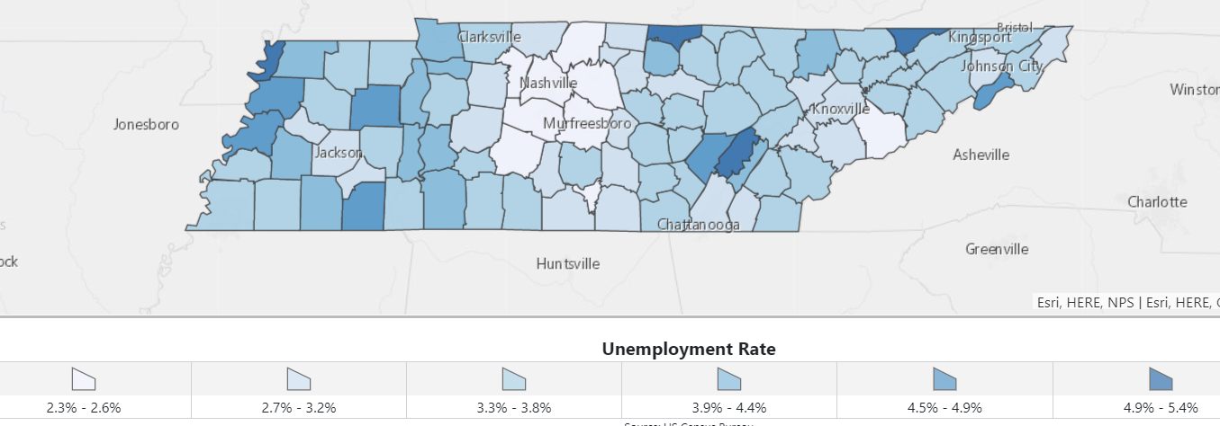
Source: “Labor Force, Employment, and Unemployment,” 2019.

One study claimed the effects of prescription opioids on the workforce is “really large” and “may explain up to half of the decline in labor force participation since 2000” (Hatfield & Boehnke, 2019 P. 1). The same study claimed that opioids cause many people to “exit the labor force entirely”, causing the labor force participation rate to be impacted more than the unemployment rate (Hatfield & Boehnke, 2019 P. 1).

Figure 1-26 shows the decrease in Tennessee’s labor force participation rate of “prime age” men and women, ages 25-54, could be related to opioid abuse. Between 1999-2015, Tennessee experienced a decrease in the participation rate of men of 2.3% and a decrease of women of 2.9%, an average rate of 2.6% (“Tennessee,” 2018). This forced companies in Tennessee to lose roughly 895 million work hours (“Tennessee,” 2018). It is estimated that this cost companies close to $1.29 billion since 1997 (“Alumn_admin,” 2018). This impacted Tennessee’s economy by reducing its real GDP by 1.1%, or $52.2 billion in economic output (“Tennessee,” 2018). In addition to hurting Tennessee companies and the state’s economy, opioid abuse is associated with a reduction of $239.4 million in tax revenue for the state government (“Drugs and Tennessee: The Sad Truth,” 2018).

Figure 1-26: Tennessee Decrease in Labor Force Participation Caused by Opioid Abuse.
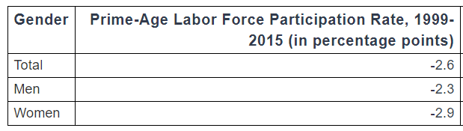
Source: “Tennessee,” 2018.

An increase in poverty in Tennessee is also associated with the opioid crisis. Figure 1-27 and Figure 1-28 compare the poverty and opioid prescription rates for each county in Tennessee. These two maps show an overlap between the counties with high opioid prescription rates and those with high poverty (“Tennessee Poverty Rate by County,” 2019 “Prescription Drug Overdose Program 2018 Report,” 2017). An example of this is Fentress county, which had high poverty rate as well as opioid prescription rate. There do exist some exceptions, such as Clay county, which had a high prescription rate but low unemployment rate.

Figure 1-27: Tennessee Poverty Rate by County.
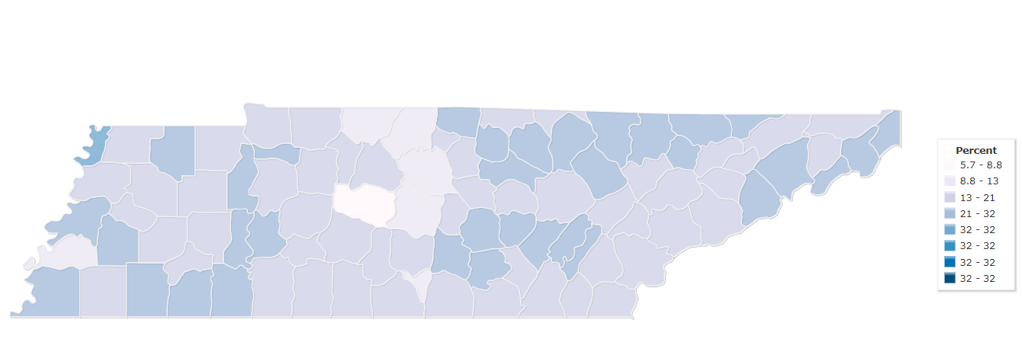
Source: “Tennessee Poverty Rate by County,” 2019.

Figure 1-28: Tennessee Opioid Prescription Rate by County.
Source: “Prescription Drug Overdose Program 2018 Report,” 2017.
Opioid abuse is associated with an increase in unemployment and poverty and a decrease in labor force participation in Tennessee. While there are a variety of factors that likely played into this issue, there seems to be a strong argument that opioid abuse is a major reason.

TN Criminal Justice System Costs Associated with Opioids
The rise of opioid abuse in Tennessee also correlated with additional costs in the criminal justice system. Between 1995-2017, the annual budget for the Tennessee Department of Corrections (TDOC) grew an average of 4.1% each year (Pellegrin, 2019). This cost was roughly $1 billion in 2018, 85% of which was from incarceration (“Blueprint for Smart Justice Tennessee”). As Figure 1-29 shows, TDOC’s budget is the fifth largest in the state, behind only k-12 education, TennCare, higher education, and taxes.

Figure 1-29: Top Six State Expenses in Tennessee from 1995-2017.
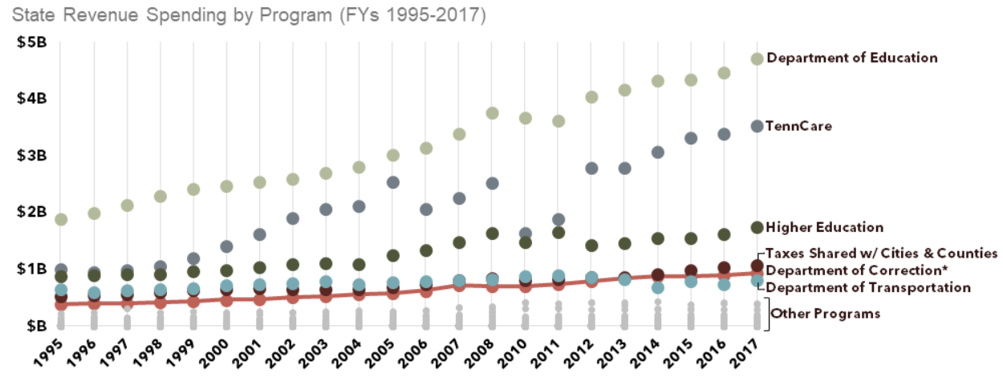

Source: Pellegrin, 2019.

Only twelve other states spend a higher percentage of their budget on corrections (Pellegrin, 2019). Figure 1-30 shows that, while several factors contributed to this large budget, incarceration of drug offenders is the largest. Between 2003-2017, drug offenses increased by roughly 44% in Tennessee (“Blueprint for Smart Justice Tennessee,” 2019). As Figure 1-30 depicts, 20% of people arrested in Tennessee in 2017 was due to illegal drug use (“Blueprint for Smart Justice Tennessee,” 2019). While this study examined all drug types, opioids are the number one form of substance abuse in the state. While these studies certainly do not prove opioids caused the increase in criminal justice costs, it is logical to think it had at least some degree of impact.

Figure 1-30: Distribution of Crimes in Tennessee in 2017.
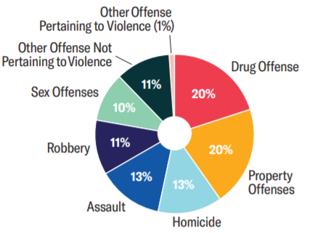
Source: “Blueprint for Smart Justice Tennessee,” 2019.
The issue of opioids forced Tennessee to incur substantial costs in its criminal justice system. This section examined these costs and explained the cost distribution in the system.

TN Healthcare Costs Associated with Opioids
The opioid crisis is connected to additional costs for the state’s healthcare system as well. One study found that roughly $422.5 million per year is spent in Tennessee on just hospitalizations from opioid abuse (Fletcher, 2017). In addition, roughly $373,000 is spent on emergency room visits from opioid abuse (Fletcher, 2017). In addition to hospitalization and emergency room visits, patients addicted to opioids require treatment and rehabilitation. This costs $2,848 per person in Tennessee, totaling roughly $45.6 million per year (Fletcher, 2017). Another study found that the costs associated with complications from opioid abuse increased 600% from 2008-2018, roughly $27.9 million per year (“Prescription Opioid Abuse In Tennessee,” 2017).

Due to many opioid addicts coming from poorer backgrounds, the state incurs much of these healthcare costs through TennCare, the state’s Medicaid program. It is estimated that, out of the $422.5 million per year on hospitalization visits, $77 million is paid for with taxpayer dollars (Fletcher, 2017). Regarding emergency room visits, approximately $68,000 is covered out of the $373,000 per year (Fletcher, 2017). Figure 1-31 shows this distribution of healthcare coverage for the 2.2 million Tennesseans addicted to opioids. As this graph shows, half of opioid abusers in the state are either uninsured or covered by Medicaid (“Blueprint for Smart Justice Tennessee,” 2019). This means that the opioid abuse in Tennessee costs the taxpayers by having to pay for many opioid abusers’ healthcare costs.

Figure 1-31: Healthcare Coverage for Opioid Addicts in Tennessee.
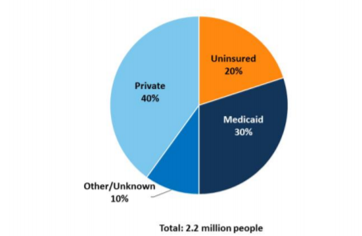

Source: “Blueprint for Smart Justice Tennessee,” 2019.
This section analyzed the healthcare costs associated with opioid abuse in Tennessee. It also studied the healthcare coverage for opioid addicts and amount paid for by taxpayers.

TN Costs of Babies Born with NAS
The surge of opioid abuse in Tennessee is also associated with the costs of babies born to opioid-addicted mothers. In 2016, for example, there were 1,068 reported cases of babies being born in Tennessee with NAS (Brantley, 2018) This is a significant increase from the fifty-five reported cases in 1999 (Brantley, 2018). Figure 1-32 shows the steady increase each year in babies born with NAS. These numbers began to increase quickly during the same time that opioid abuse became prevalent. Between 2000-2010, the rate in Tennessee increased 10-fold, much higher than the increase of 3-fold nationally (Brantley, 2018).

Figure 1-32: Number of Babies Born with NAS in Tennessee Between 1999-2016.
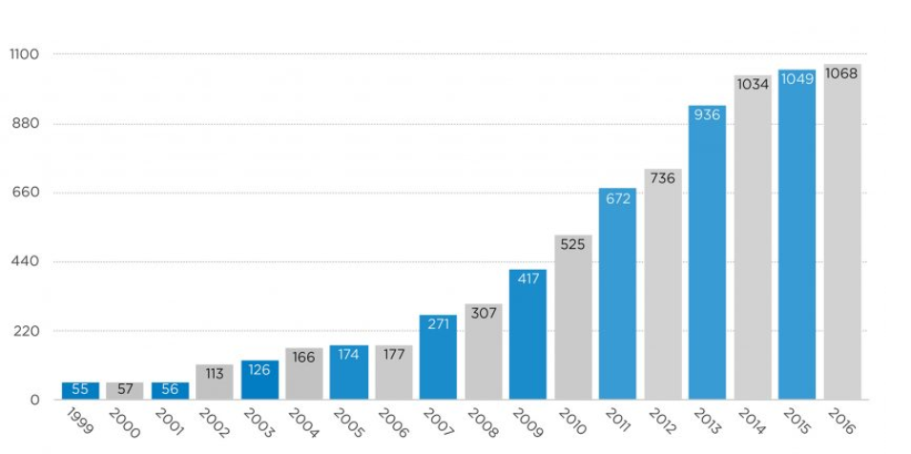
Source: Brantley, 2018.

While babies with NAS are born across all of Tennessee, certain areas had much higher rates. Figure 1-33 and Figure 1-34 show the NAS rate and opioid prescription rate per 1,000 births for each county in Tennessee. This portrays how East Tennessee experienced higher rates than other parts of the state (Brantley, 2018). This shows a strong correlation between increased opioid prescription and increased cases of babies born with this disease. Unicoi and Campbell counties, for example, had high rates of prescription opioids and babies with NAS (Brantley, 2018 “Prescription Drug Overdose Program 2018 Report,” 2017). However, exceptions do exist, such Pickett county, which has a high rate of opioid prescriptions but a very low NAS rate. As mentioned, however, there may be issues that exist with the accuracy of county data.

Figure 1-33: Tennessee Rate of NAS Births by County.
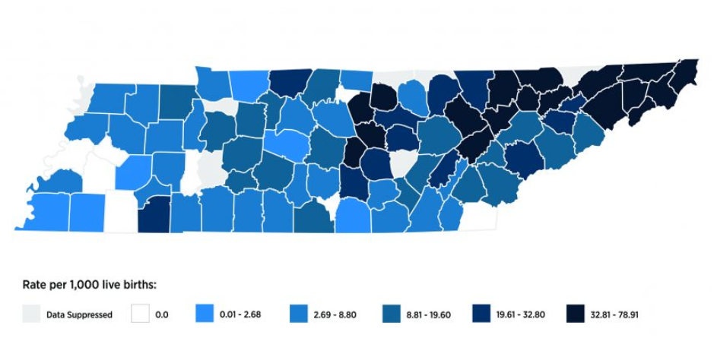
Source: Brantley, 2018.
Figure 1-34: Tennessee Opioid Prescription Rate by County.

Source: “Prescription Drug Overdose Program 2018 Report,” 2017.

The average cost to treat babies with NAS in Tennessee is roughly $46,000 for the first year, over six times higher than for babies without complications (Fletcher, 2017). In Tennessee, this totals roughly $46.5 million each year (Fletcher, 2017). Figure 1-35 provides the costs of babies with NAS covered by Tenncare. In 2016, the state spent $54 million on this problem (“Neonatal Abstinence Syndrome among TennCare enrollee,” 2016).

Figure 1-35: Table of Tennessee Costs of Babies Born with NAS.
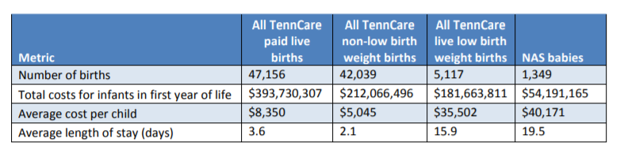
Source: “Neonatal Abstinence Syndrome among TennCare enrollees,” 2016.
This last section of chapter 1 examined the costs for Tennessee with neonatal abstinence syndrome. As is the case with opioid addict healthcare costs, a large portion of this cost is incurred by taxpayers through public-funded healthcare programs.

The opioid crisis is a serious national emergency that requires immediate action to address it. Opioid abuse in the United States began after the Civil War with soldiers becoming addicted to morphine and has recently grown into three distinct “waves” with the rise of prescriptions, heroin, and synthetics. While many factors play into the high opioid prescription rates, they seem to be most directly correlated with high unemployment and poverty, low labor force participation, and injury-prone jobs. As this chapter analyzed, there are both social and economic costs associated with opioid abuse. Among the social costs include overdose deaths and crime. The economic costs include unemployment and poverty, criminal justice, and healthcare. This chapter also compared the opioid crisis in Tennessee with the national averages and surrounding states and found that the state has higher prescription rates, social costs, and economic costs. While it is difficult to prove these relationships are causal for certain, it seems very likely that there exists a relatively strong connection between higher opioid abuse and higher social and economic costs. Further studies and experiments should be done to prove this causation. The remaining chapters of this thesis examine current policies in Tennessee and suggest policies that appear to have potential for effectively addressing this problem.

Current Tennessee Policies
This section will discuss steps taken thus far in Tennessee to help address the opioid crisis. Among these include Governor Haslam’s “Tennessee Together” plan which allocated $30 million in the 2018-2019 budget towards fighting the issue (Pellegrin, 2019 P. 1). This plan, along with others, focus on reduction of the supply of opioids, prevention of opioid abuse, and treatment of addiction.

Reduce Supply of Opioids

- Prescriptions
One major step taken in Tennessee to reduce the supply of opioids was to address the issue of over-prescriptions. One way this was done was by decreasing the duration, now three days, and strength of first-time opioid users (Pellegrin, 2019 P. 1, “TN Together”). Increased funding was also passed by the state legislature to establish improve guidelines for pain management and further medical education for prescribing (Pellegrin, 2019 Pg. 1). Furthermore, laws have been created to require medical professionals to educate patients about potential alternatives to opioids (Pellegrin, 2019 P. 1).

- Law Enforcement and Criminal Justice
In addition, Tennessee state officials are working with law enforcement to reduce the supply of opioids. This includes stricter criminal penalties for the illegal distribution of opioids, particularly those which ended in death (Pellegrin, 2019, P. 1). There was also an increase in funding to cover the costs of additional agents and training for the Tennessee Bureau of Investigation and law enforcement (“TN Together,” P. 1).

Abuse Prevention

- Education and Awareness
One focal point in attempting to prevent opioid abuse from taking place has been to raise awareness and educate people about its dangers (“TN Together,” P. 1). This includes increasing campaign efforts both in schools and for the general public (“TN Together,” P. 1).

- Data Collection and Sharing
In addition to using education and awareness to warn people of the ease and danger of becoming addicted to opioids, state legislatures and law enforcement officials are partnering to improve data collection and sharing of information about opioids. The state legislature recently passed a bill to require electronic prescriptions of opioids to track patients who have been prescribed opioids (Pellegrin, 2019, P. 1). Pharmacists must update their software systems by January first, 2021 to adhere to these new rules (Thompson, 2020, P. 1). This will prevent patients from going to different areas to get opioids as well as medical professionals from prescribing more than allowed. Government agencies are also working closely to more effectively share data among various departments to identify areas and individuals at high risk of opioid abuse (“TN Together,” P. 1).

- NAS Prevention and Services
Efforts have also been made to remove restrictions and barriers inherent in TennCare to provide access to contraceptives in order to prevent unintended pregnancies (“TN Together,” P. 1). Some believe this may help prevent some babies being born addicted to opioids or other types of drugs (“TN Together,” P. 1). Awareness is also being raised about the dangers of being addicted to opioids while pregnant (Pellegrin, 2019, P. 1). Lastly, there has been an increase in funding to assist mothers addicted to opioids and their children (Pellegrin, 2019, P. 1).

- Adverse Childhood Experiences
Another major way that state officials in Tennessee are attempting to prevent opioid abuse is through identifying children or adults with adverse childhood experiences (ACE), and dedicating resources to insure they refrain from abuse (Pellegrin, 2019, P. 1). Training has also been implemented at many schools for teachers to be aware of signs and know how to properly handle such situations (Pellegrin, 2019, P. 1).

Addiction Treatment and Recovery

- Access to Treatment
Treatment and recovery for those already addicted to opioids is an important issue as well. In recent years, there has been an increase in funding to provide treatment to people with opioid use disorder who cannot afford it (“TN Together,” P. 1). In total, $25 million has been dedicated between the federal and state government to provide these services (“TN Together,” P. 1). There are also ongoing efforts to form a statewide collaboration between the public and private sector to help address the issue. This includes working with faith-based groups to serve additional people with addictions each year (Pellegrin, 2019 P. 1). Approximately 3,900 additional Tennesseans are receiving care each year as a result (Pellegrin, 2019 P. 1). There is also more funding for emergency departments, increased access to transportation for those seeking treatment, and additional addiction research (Pellegrin, 2019 P. 1). A new law was also recently passed in 2019 to create a hotline for people with opioid addictions (Burch, 2019 P. 1).

- Treatment within the Criminal Justice System
In addition to providing increased access to treatment to the overall public, public officials and law enforcement have worked to provide treatment to people in the criminal justice system (Pellegrin, 2019 P. 1). Three additional recovery courts have been created for low risk offenders and increased funding and incentives are in place to provide inmates with help if they so desire (Pellegrin, 2019 P. 1).

- Regulations for Treatment Providers
New laws have recently been enacted to allow more use of Buprenorphine in order to treat opioid abusers (Pellegrin, 2019 P. 1). There have also been increased criminal offenses created for false or misleading marketing practices in the medical community (Pellegrin, 2019 P. 1). Parties are also currently exploring the possibility of allowing nurses and physicians prescribe the drug (Pellegrin, 2019 P. 1).

Recent laws, regulations, and initiatives have significantly helped fight the opioid crisis. While their total impact is not yet known, recent statistics show a positive trend. Between 2017-2018, opioid prescriptions decreased by roughly 13.3% (“Tennessee Medical Association,” 2019 P.1). Since 2013, this number declined by over 25% (“Tennessee Opioid Summary,” P. 1). The number of opioid overdose deaths have also decreased. In 2016, there were 739 deaths, compared to 644 in 2017 (“Tennessee Opioid Summary,” P. 1). While progress has been made, there is still much work to be done to address the opioid crisis in Tennessee.

Additional Policies to Implement
This section will examine effective policies of other states in fighting opioids that should be implemented in Tennessee. While it is difficult to compare states due to differences in demographics, geography, and other variables, it is helpful to see which laws have been helpful in fighting this issue in other states.

Naloxone for First Responders
A law that would be helpful for Tennessee to adopt would be providing naloxone, a narcotic to treat opioid overdoes, to all emergency responders (“Promising State Strategies,” 2019 P. 1). Several states have adopted this and have seen positive results. While data can be difficult to find on this topic, researchers claim that states which have done this have experienced “significantly lower opioid overdose rates” (Nelson, 2018 P. 1). While a statewide policy has not been adopted, various areas in Tennessee have done so. One example is in Knox county, which provided naloxone in opioid overdoes in 1,200 times in 2016 alone (Nelson, 2018 P. 1). While Tennessee does require state troopers to have this drug, it should be required and provided by all emergency responders. This would likely save the lives of many Tennesseans who overdose on opioids.

Greater Regulation of “Pill Mills”
As of 2017, only three states, Florida, Texas, and Kentucky had adopted “pill mill” laws to regulate and punish clinics that “operate outside the boundaries of standard medical practices” (Arizona Department of Health Services, P. 9). While many states, including Tennessee, have adopted similar laws since, there is more that can be done in this area. The data show that these states have experienced a “statistically significant” decline in opioid prescriptions since adopting these laws (Arizona Department of Health Services, P. 9). In 2009, Texas began requiring pain management clinics to be approved by the state medical board and created much stricter qualifications (Arizona Department of Health Services, P. 10). In 2012, Kentucky implemented new limits on prescriptions and increased certain requirements on reporting (Arizona Department of Health Services, P. 1). This helped lead to a decline between 8.1%-24.3% of monthly opioid prescriptions (Arizona Department of Health Services, P. 10). Lastly, In 2011 Florida passed a law to enact tougher penalties on clinics that over-prescribe opioids and created higher standards for physicians (Arizona Department of Health Services, P. 10). While these states varied in their laws, Tennessee should look at putting some or all of these variations in place to help the problem.

Emergency Declaration
Another act that Tennessee public officials should consider is declaring an emergency for the opioid crisis. This has been done by six states and the federal government. This would be beneficial because it provides additional emergency powers to the governor to fight the crisis (Arizona Department of Health Services, P. 29). This includes allocating more funding and additional training towards fighting the problem (Arizona Department of Health Services, P. 29). While Governor Lee has made a lot of progress, this would allow him to more effectively and quicker take necessary steps to solve the problem.

Alternative Pain Management
Tennessee should also work to provide and encourage alternatives to opioid use for chronic pain. As of 2017, eleven states had done so and witnessed positive results (Arizona Department of Health Services, P. 14). Such alternative treatments include physical therapy, occupational therapy, water therapy, acupuncture, T’oichi, and many others (Arizona Department of Health Services, P. 14). While the state government has created awareness campaigns to warn of the dangers of opioids, no such actions have been taken to increase support of alternatives (Arizona Department of Health Services, P. 14). Doing so would likely significantly reduce the use of opioids for pain.

Increased Reporting of Opioid Overdoses
The last major policy that should be adopted in Tennessee is to increase the reporting of overdose deaths caused by opioids. Currently three states-- New Mexico, Rhode Island, Texas-- have done so. New Mexico requires such reporting within 24 hours, Rhode Island requires it within 48 hours, and Texas does not require it within a specific timeframe but promises civil and criminal liability protections for people who do so in good faith (Arizona Department of Health Services, P. 31). Similar provisions would allow Tennessee to better track and monitor data relating to opioids and have a better knowledge of the extent of the problem. While Tennessee does now require such reporting from first responders, there remain issues. One major issue is the lack of accuracy in the statistics, and many believe the amount of overdose deaths may be up to 24% higher than the numbers suggest (Cox, Farr, P. 3). A major source of this is due to incomplete information on death certificates, county budget constraints that limit thorough autopsies, and inconsistencies with how various parties monitor and report drug overdoes (Cox & Farr, P. 3). This creates a vicious cycle because poorer counties generally experience higher opioid abuse, but they are oftentimes limited in their ability to track statistics, which limits the amount of help they receive.

This section provided examples of policies and laws, adopted by various states, that would help in fighting opioid abuse in Tennessee. While it is by no means an exhaustive list, it does provide at least a few things that could and should be done in the near future. As this shows, while the state has made significant progress in the past few years, there is still much to be done to end this crisis. The next chapter will provide a summary of this thesis.

Summary
This thesis began by introducing opioids and providing a brief history of its formation and spread within the United States. It then discussed how unemployment, poverty, and high-injury jobs is correlated with the rise in opioid abuse across Tennessee and nationwide. Next, it addressed the various social and economic costs that widespread opioid abuse has had in Tennessee and in the U.S. Next, it examined the extent of the crisis in Tennessee and found that it is among the worst states in this area. This thesis followed by addressing what state officials and law enforcement have done well in Tennessee to address this issue thus far. Lastly, this paper concluded by analyzing polices of other states that should be implemented in Tennessee as well. The purpose of this paper is to increase awareness of this issue, warn people of the dangers associated with extensive opioid use, and provide a few areas in which state officials and law enforcement could work to further address this issue. While significant progress has been made in this area, it is important that we work together to fully solve this problem before even more Tennessean and American lives are lost.

References
“2018 Annual Surveillance Report of Drug-Related Risks and Outcomes.” (2018, August 31). Retrieved from https://www.cdc.gov/drugoverdose/pdf/pubs/2018-cdc-drug-surveillance-report.pdf

Allen, Greg (2018, February 13). “Cost Of U.S. Opioid Epidemic Since 2001 Is $1 Trillion And Climbing.” Retrieved from https://www.npr.org/sections/health-shots/2018/02/13/585199746/cost-of-u-s-opioid-epidemic-since-2001-is-1-trillion-and-climbing

“Opioid Facts in Tennessee.” (2018, September 21). Retrieved from https://alumnus.tennessee.edu/2018/opioid-facts-in-tennessee/

“Am I vulnerable to opioid addiction?” (2018, February 16). Retrieved from https://www.mayoclinic.org/diseases-conditions/prescription-drug-abuse/in-depth/how-opioid-addiction-occurs/art-20360372

Arablouei, Rund & Abdelfatah, Rantin (2019, April 04). “A History Of Opioids In America.” Retrieved from https://www.npr.org/2019/04/04/709767408/a-history-of-opioids-in-america

Arizona Department of Health Services. (n.d.). Retrieved from https://www.azdhs.gov/documents/prevention/womens-childrens-health/injury-prevention/opioid-prevention/50-state-review-printer-friendly.pdf

Belmonte, Adriana (2018, September 10). “The U.S. opioid crisis is holding back certain states.” Retrieved from https://finance.yahoo.com/news/chart-u-s-opioid-crisis-holding-back-certain-states-183503446.html

“Blueprint for Smart Justice Tennessee.” (2019). Retrieved from https://50stateblueprint.aclu.org/assets/reports/SJ-Blueprint-TN.pdf

Brantley, Ashley (2018, March 23). “Health Brief: Neonatal Abstinence Syndrome (NAS).” Retrieved from https://bettertennessee.com/health-brief-neonatal-abstinence-syndrome/

Burch, Edward (2019, January 10). “New laws to combat opioid abuse are taking effect in Tennessee.” Retrieved from https://www.wsmv.com/news/new-laws-to-combat-opioid-abuse-are-taking-effect-in/article_998759f8-144c-11e9-a9fc-a3dec9e8d5c1.html

“CDC Mining Coal Industry Sector NIOSH.” (2019, June 04). Retrieved from https://www.cdc.gov/niosh/mining/statistics/CoalSector.html

Chatterjee, Rhitu (2018, July 06). “With More Opioid Use, People Are More Likely To Get Caught Up In The Justice System.” Retrieved from https://www.npr.org/sections/health-shots/2018/07/06/626176621/with-more-opioid-use-people-are-more-likely-to-get-caught-up-in-the-justice-syst

Ciccarone, Daniel (2018, September 06). “The Triple Wave Epidemic: Opioids, Heroin and Fentanyl: Supply Issues and Public Health Consequences.” Retrieved from https://docs.house.gov/meetings/FA/FA16/20180906/108650/HHRG-115-FA16-Wstate-CiccaroneD-20180906-U2.pdf

Cox, Andrew & Farr, Logan (2018, April). “The Opioid Crisis in Tennessee.” Retrieved from http://bakercenter.utk.edu/wp-content/uploads/2018/04/PolicyBrief2-2018-3.pdf

“Health Library”. (2016, September 14). Retrieved from https://medicalcityhealthcare.com/hl/?/news/NRCN714931/Opioid-Epidemic-Costs-U-S---78-5-Billion-Annually--CDC

“Data Trends: Opioid Prescribing, Overdose Deaths, and More.” (2018, July 17). Retrieved from http://core-rems.org/data-trends-opioid-prescribing-overdose-deaths-and-more/

DePillis, Lydia (2018, February 22). “The opioid crisis is draining America's workforce.” Retrieved from https://money.cnn.com/2018/02/22/news/economy/workforce-opioid-crisis/index.html

“Drugs and Tennessee: The Sad Truth.” (2018, February 14). Retrieved from https://journeypureserenitynetwork.com/510-2/

“Drugs.” (2019). Retrieved from https://www.tn.gov/tbi/crime-issues/crime-issues/drugs.html

“Economic Toll of Opioid Crisis in U.S. Exceeded $1 Trillion Since 2001.” (2018, February 13). Retrieved from https://altarum.org/news/economic-toll-opioid-crisis-us-exceeded-1-trillion-2001

Elkins, Chris (2018, June 01). “Opioid vs. Opiate.” Retrieved from https://www.drugrehab.com/addiction/opiate-vs-opioid/

“Fact Sheet: Drug-Related Crime.” (1994, September). Retrieved from https://www.bjs.gov/content/pub/pdf/DRRC.PDF

“Fatal and Nonfatal Injuries in Construction and Other Industries.” (n.d.). Retrieved from https://www.cpwr.com/sites/default/files/publications/CB page 38.pdf

Felter, Claire (2019, January 17). “The U.S. Opioid Epidemic.” (n.d.). Retrieved from https://www.cfr.org/backgrounder/us-opioid-epidemic

Fletcher, Holly (2017, December 04). “Drug, alcohol abuse saps $2 billion from Tennessee annually - an under-the-radar impact of opioid epidemic.” Retrieved from https://www.tennessean.com/story/money/industries/health-care/2017/12/04/drug-alcohol-abuse-saps-2-billion-tennessee-annually-under-the-radar-impact-opioid-epidemic/909253001/

George, Judy (2018, July 08). “Opioid Addiction, Criminal Justice Link Strong.” Retrieved from https://www.medpagetoday.org/neurology/opioids/73898?vpass=1

Ghertner, Robin, & Groves, Lincoln (2018, September 11). “The Opioid Crisis And Economic Opportunity: Geographic And Economic Trends.” Retrieved from https://aspe.hhs.gov/system/files/pdf/259261/ASPEEconomicOpportunityOpioidCrisis.pdf

Gitis, Ben (2018, March 27). “The Labor Force and Output Consequences of the Opioid Crisis.” Retrieved from https://www.americanactionforum.org/research/labor-force-output-consequences-opioid-crisis/

Hatfield, Erin, & Boehnke, Megan (2019, January 28). “High rates of opioid prescriptions may be linked to poor labor force participation.” Retrieved from https://eurekalert.org/pub_releases/2019-01/uota-hro012819.php

Jones, Mark, Viswanath, Omar, Peck, Jacquelin, Kaye, Alan, Gill, Jatdner S., & Simopoulos, Thomas (2018, June). “A Brief History of the Opioid Epidemic and Strategies for Pain Medicine.” Retrieved from https://www.ncbi.nlm.nih.gov/pmc/articles/PMC5993682/

“Labor Force, Employment, and Unemployment.” (2019, May). Retrieved from https://www.jobs4tn.gov/vosnet/analyzer/results.aspx?enc=HofuwY22SoLTS/uC bpmizGZkm52zV sR lKAe/bUj0

LaMagna, Maria (2018, August 16). “More evidence that the opioid epidemic is only getting worse.” Retrieved from https://www.marketwatch.com/story/how-much-the-opioid-epidemic-costs-the-us-2017-10-27

Long, Heather (2016, March 29). “U.S. has lost 5 million manufacturing jobs since 2000.” Retrieved from https://money.cnn.com/2016/03/29/news/economy/us-manufacturing-jobs/

Lopez, German (2018, February 06). “Why the opioid epidemic may have fueled America's murder spike.” Retrieved from https://www.vox.com/policy-and-politics/2018/2/6/16934054/opioid-epidemic-murder-violent-crime

Mojica, Adrian (2018, September 25). “Tennessee violent crime rate rises, outpaces national average per new FBI data.” Retrieved from https://fox17.com/news/local/tennessee-violent-crime-rate-rises-outpaces-national-average-per-new-fbi-data

“Dramatic Increases in Maternal Opioid Use and Neonatal Abstinence Syndrome.” (2019, January 22). Retrieved from https://www.drugabuse.gov/related-topics/trends-statistics/infographics/dramatic-increases-in-maternal-opioid-use-neonatal-abstinence-syndrome

“Opioid Summaries by State.” (2019, May). Retrieved from https://www.drugabuse.gov/drugs-abuse/opioids/opioid-summaries-by-state

“Principles of Drug Addiction Treatment.” (2018, January). Retrieved from https://www.drugabuse.gov/publications/principles-drug-addiction-treatment-research-based-guide-third-edition/frequently-asked-questions/drug-addiction-treatment-worth-its-cost

“Tennessee Opioid Summary.” (2019, March 29). Retrieved from https://www.drugabuse.gov/drugs-abuse/opioids/opioid-summaries-by-state/tennessee-opioid-summary

“The Science of Drug Use and Addiction.” (2018, July). Retrieved from https://www.drugabuse.gov/publications/media-guide/science-drug-use-addiction-basics

Nelson, Kristi (2018, January 25). “More than 1,200 in Knox got naloxone last year.” Retrieved from https://www.knoxnews.com/story/news/health/2018/01/25/who-gets-naloxone-opioid-overdose-and-how-many-get-more-than-once-collaborative-hopes-data-help-stem/1063738001/

“Neonatal Abstinence Syndrome among TennCare enrollees” (2016). Retrieved from https://www.tn.gov/content/dam/tn/tenncare/documents/TennCareNASData2016.pdf

“Opioid Addiction and the Criminal Justice System.” (2019). Retrieved from https://csgjusticecenter.org/nrrc/opioid-addiction-and-the-criminal-justice-system/

“Opioid Approval and Monitoring by the U.S. Food and Drug Administration.” (2017, July 13). Retrieved from https://www.ncbi.nlm.nih.gov/books/NBK458654/

“Opioids and Heroin.” (n.d.). Retrieved from https://www.drugabuse.gov/publications/opioid-facts-teens/opioids-heroin

“Opioid addiction Genetics Home Reference NIH.” (2019). Retrieved from https://ghr.nlm.nih.gov/condition/opioid-addiction

“Opioid Crisis Fast Facts.” (2019, July 02). Retrieved from https://www.cnn.com/2017/09/18/health/opioid-crisis-fast-facts/index.html

“Drug Overdose Deaths.” (2018, December 19). Retrieved from https://www.cdc.gov/drugoverdose/data/statedeaths.html

“U.S. Opioid Prescribing Rate Maps.” (2018, October 03). Retrieved from https://www.cdc.gov/drugoverdose/maps/rxrate-maps.html

“Understanding the Epidemic.” (2018, December 19). Retrieved from https://www.cdc.gov/drugoverdose/epidemic/index.html

“Opioid Prescription Rates in Tennessee.” (2019). Retrieved from https://www.jobs4tn.gov/vosnet/analyzer/results.aspx?enc=HofuwY22SoLTS/uC bpmizGZkm52zV sR lKAe/bUj0

Orgera, Kendal & Tolbert, Jennifer (2019, July 15). “The Opioid Epidemic and Medicaid's Role in Facilitating Access to Treatment.” Retrieved from https://www.kff.org/medicaid/issue-brief/the-opioid-epidemic-and-medicaids-role-in-facilitating-access-to-treatment/

Pellegrin, Mandy (2019, April 22). “Budgeting for Incarceration in Tennessee.” Retrieved from https://www.sycamoreinstitutetn.org/2019/02/14/budgeting-incarceration-tn/

“Prescription Drug Overdose Program 2018 Report.” (2017, September). Retrieved from https://www.tn.gov/content/dam/tn/health/documents/pdo/PDO_2018_Report_02.06.18.pdf

“Prescription Opioid Abuse In Tennessee.” (2017, December 28). Retrieved from https://bcbstnews.com/mediaresources/prescription-opioid-abuse-in-tennessee/

“Promising State Strategies.” (2019, July 16). Retrieved from https://www.cdc.gov/drugoverdose/policy/index.html

Rhyan Corwin (2017, November 17). “The Potential Societal Benefit of Eliminating Opioid Overdoses, Deaths, and Substance Use Disorders Exceeds $95 Billion.” Retrieved from https://altarum.org/sites/default/files/uploaded-publication-files/Research-Brief_Opioid-Epidemic-Economic-Burden.pdf

Rummans, Teresa Burton, Merisa & Dawson, N. L. (2018, March). “How Good Intentions Contributed to Bad Outcomes: The Opioid Crisis.” Retrieved from https://www.mayoclinicproceedings.org/article/S0025-6196(17)30923-0/pdf

Sanlorenzo, Lauren Stark, Anne & Patrick, Stephen (2018, April). “Neonatal abstinence syndrome: An update.” Retrieved from https://www.ncbi.nlm.nih.gov/pmc/articles/PMC5843557/

Schiller, Andrew (2019, June 10). “Tennessee Crime.” Retrieved from https://www.neighborhoodscout.com/tn/crime

Seth, Puja Scholl Lawrence Rudd Rose Bacon, Sarah (2018, March 30) “Overdose Deaths Involving Opioids, Cocaine, and Psychostimulants” Retrieved from https://www.cdc.gov/mmwr/volumes/67/wr/mm6712a1.htm

Sutherland, Douglas (2018, June 14). “The severe economic costs of the US opioid crisis.” Retrieved from https://thehill.com/opinion/finance/392294-the-severe-economic-costs-of-the-us-opioid-crisis

“Tennessee Deaths from Drug Overdoses Increase in 2017.” (2018, August 20). Retrieved from https://www.tn.gov/health/news/2018/8/20/tennessee-deaths-from-drug-overdoses-increase-in-2017.html

“Tennessee Opioid Summary.” (2019, March 29). Retrieved from https://www.drugabuse.gov/opioid-summaries-by-state/tennessee-opioid-summary

“Tennessee Poverty Rate by County.” (2019). Retrieved from https://www.indexmundi.com/facts/united-states/quick-facts/tennessee/percent-of-people-of-all-ages-in-poverty#map

“Tennessee Medical Association.” (2019, June 17). Retrieved from https://www.tnmed.org/TMA/News_and_Media/News/New_Data_Shows_Continued_Decline_in_Opioid_Prescriptions_in_Tennessee.aspx

“Tennessee.” (2018, September). Retrieved from https://www.americanactionforum.org/project/opioid-state-summary/tennessee/

“The Underestimated Cost of the Opioid Crisis.” (2017, November). Retrieved from https://www.whitehouse.gov/sites/whitehouse.gov/files/images/The Underestimated Cost of the Opioid Crisis.pdf

“TN Together.” (n.d.). Retrieved from https://www.tn.gov/content/dam/tn/opioids/documents/OpioidOnePager.pdf
Thompson, Yvonne (2020, January 1). “18 new Tennessee laws take effect starting Jan. 1”. Retrieved from https://www.wbir.com/article/news/local/as-seen-on-tv/eighteen-new-tennessee-laws-take-effect-on-jan-1/51-70ff1e5a-1f52-49f0-9e5e-8ae7298ff9ed
Villa, Lauren (2019, July 14). “Drug Trafficking Statistics” Retrieved from https://drugabuse.com/statistics-data/drug-trafficking/

“Vital Signs: Overdoses of Prescription Opioid Pain Relievers” (2011, November 04). Retrieved from https://www.cdc.gov/mmwr/preview/mmwrhtml/mm6043a4.htm

Volcovici, Valerie (2018, January 19). “Most U.S. states lost coal mining jobs in 2017.” Retrieved from https://www.reuters.com/article/usa-coal-jobs/exclusive-most-u-s-states-lost-coal-mining-jobs-in-2017-data-idUKL8N1PC6AC

Wial, Howard (2012, May 09). “Locating American Manufacturing.” Retrieved from https://www.brookings.edu/interactives/interactive-locating-american-manufacturing/

