PART I

INTRODUCTION

Region-wide declines of northern bobwhite (Colinus virginianus) populations have been reported throughout the bobwhite’s home range since the early 1900’s (Leopold 1931). More recently, the Breeding Bird Survey (BBS) has confirmed this population decline, with an annual decrease of -3.0% in the United States between 1966 – 2007 and within Kentucky, an annual decrease of -2.6% during that same period (Sauer et al., 2008). Although there are many factors that may influence such declines, it has become clear that the major causative factor is a loss of useable habitat (Guthery 1997, Brady et al. 1998, Veech 2006). Much of this habitat loss can be attributed to increased use of clean farming practices combined with silvicultural practices that increase tree density within stands (Brennan 1991, Twedt et al. 2006). Another factor influencing the loss of bobwhite habitat is the decreased use of prescribed burning (Twedt et al. 2006). Prescribed burning promotes early successional habitat and increases grassland plant species richness (Collins 1987), both of which contribute to bobwhite population viability (Stoddard 1931, Greenfield et al. 2003). A steady increase in urbanization, along with intensive silvicultural and agricultural practices, has led to the loss of and substantial fragmentation of early successional habitat (Terhune et al. 2005) essential for sustaining bobwhite populations at a landscape scale. Remaining early successional habitats in the southeastern United States have lost much of their native grass component, having been converted into row crops or tall fescue (Schedonorus phoenix) and other exotic grasses.
One potential opportunity for increasing bobwhite habitat throughout the eastern United States is management of reclaimed surface mine sites. Although research regarding bobwhite responses to habitat associated with reclaimed mine sites is lacking, studies have shown that such sites provide habitat used by early successional specialists (Allaire 1978, Whitmore and Hall 1978, Devault et al. 2002, Karo 2009).
Grassland habitats have been established in the eastern United States under the auspices of the Surface Mining Control and Reclamation Act of 1977 (SMCRA). This legislation was enacted to minimize the impact of surface mining on wildlife populations, unique habitat types, and other important environmental elements. Under this act, land that has been impacted by surface mining may qualify for a plan to reclaim the area for environmental improvement following mining. This has led to the reclamation of over 600,000 ha in the eastern United States, of which over 200,000 ha are in Kentucky (Table 1.1). However, establishment of dense stands of sericea lespedeza (Lespedeza cuneata) and other non-native herbaceous species is common on these reclaimed mine sites. Such vegetation has been used to quickly establish cover that minimizes soil erosion. Surface mine reclamation success has been assessed in the short-term (e.g., <5 years), such that the establishment of plant species diversity was a lower priority compared to the prevention of soil erosion (Holl 2002).
Although these non-native species have been effective in reducing erosion, the resulting habitat is unfavorable for bobwhite quail (Eddy 1999). Sericea lespedeza is an aggressive perennial legume that out-competes native grasses and quickly eliminates bare ground. These characteristics have led to this forb being classified as an exotic plant of management concern by the Southeast Exotic Pest Plant Council (Eddy et al. 2003). On reclaimed mine sites, soil is often of poor quality and may be heavily compacted. The ability of sericea lespedeza to become established and be competitive in a variety of soil types (Ohlenbusch et al. 2007) has also contributed to its domination of reclaimed mine sites. Dense fields of this legume, which often exist on these reclaimed sites, provide habitat in which bobwhites will seldom nest (Roseberry and Klimstra 1984). Management practices must be focused on removing this uniform habitat and restoring the structural variability required by bobwhites for escape, nesting, feeding, and brood rearing cover.

Table 1.1: Eastern US coal-mined land area (ha) reclaimed under
SMCRA, 1978-2005¹.

State | Phase III Released | Phase I Released (2001-2005)² | Total
E KY³ | 243,533 | 26,094 | 269,627
MD | 5,372 | 118 | 5,490
OH | 74,167 | 9,495 | 83,662
PA | 93,670 | 13,359 | 107,029
TN | 14,962 | 2,946 | 17,908
VA | 37,076 | 1,125 | 38,201
WV | 93,685 | 11,673 | 105,358
Total | 562,465 | 64,810 | 627,275
¹ Including the interim SMCRA program. Source US OSMRE “20th Anniversary of
the Surface Mining Law” (http://www.osmre.gov/annivrep.htm) and annual reports
to Congress.
² As reported by states to OSMRE; these figures overestimate total affected areas due
to double-counting of areas that were both mined and re-mined under SMCRA.
³ Estimated from total Kentucky areas, as proportionate to the east-west distribution
of surface coal tonnage.

Studies monitoring bobwhite population dynamics as a function of habitat type and quality have been focused at both the local and landscape levels in a number of ecological regions. Studies in central and western Great Plains have evaluated macrohabitat feature influences on bobwhite summer survival (Taylor et al. 1999), survival of bobwhite chicks (DeMaso et al. 1997), over-winter habitat use and winter survival (Williams et al. 2000, Williams et al. 2004), and population responses to habitat management (Webb and Guthery 1982). Cox et al. (2004) also evaluated survival and mortality of bobwhites within this region. In the Midwest, studies have examined effects of hunting pressure on survival rates (Suchy and Munkel 2000), population dynamics related to weather parameters and hunting pressure (Stanford 1972), effects of habitat use on non-breeding survival (Janke 2011), and detailed ecology of localized bobwhite populations (Roseberry and Klimstra 1984, Burger 1995b). Roseberry and Klimtra (1984) conducted an intensive 26-year population ecology study using banding in Illinois, assessing survival, cause-specific mortality, fecundity, and hunting effects on bobwhite survival. In Missouri, Burger et al. (1995) evaluated general bobwhite population dynamics and specific causes of mortality. Numerous bobwhite studies have been conducted in the Red Hills region of the Gulf Coastal Plain and have included evaluation of effects of research on bobwhite survival (Terhune et al. 2005), demographic responses to different burning scales (Wellendorf and Palmer 2007), over-winter survival in relation to landscape composition (Holt et al. 2009), and evaluation of population dynamics (Pollock et al. 1989, Palmer et al. 2002). Burger et al. (1998) evaluated bobwhite survival and cause-specific mortality within this region on intensively managed plantations. Also working within this region, Sisson et al. (2009) evaluated bobwhite survival and analyzed causes of mortality. Dixon et al. (1996), although not working in the Red Hills, examined winter bobwhite survival and habitat use in a pine-dominated Coastal Plain system in South Carolina. Within the Sandhills region, studies have included survival of bobwhites on hunted vs. non-hunted areas (Robinette and Doerr 1993) as well as documenting seasonal survival and cause-specific mortality (Curtis et al. 1988). Research efforts on population ecology of bobwhites, survival of hunted vs. non-hunted populations, and habitat effects on bobwhite survival have been extensively studied throughout many regions within the species’ range. However, few population studies have examined northern bobwhites in the mid-South region. Except for a study examining winter survival as a function of landscape composition in western Tennessee (Seckinger et al. 2008), extensive population dynamic studies within this region are entirely lacking.
Although there have been studies monitoring populations of early successional passerines (Whitemore and Hall 1978, Devault et al. 2002) and game birds (Karo 2009) in the context of reclaimed strip mines, none has monitored bobwhite populations. Habitat use for bobwhites in both breeding and non-breeding seasons needs to be evaluated on reclaimed sites to determine associated survival and fecundity rates. It is also important to assess bobwhite population responses to large-scale habitat management efforts, as bobwhite home ranges are highly variable and often depend on habitat composition and individual reproductive status (Brennan 1999). Studies in the past have focused management efforts at a relatively small scale, and research must assess large-scale habitat management and its effects on bobwhite populations. The temporal scale can also be influential in population responses to habitat management and should be evaluated.
This research was initiated to evaluate bobwhite population dynamics on a reclaimed surface mine site in western Kentucky. My objectives were to (1) document survival rates at two different scales: home range and landscape scale, (2) document fecundity, including nest success and nest productivity as a function of habitat parameters; (3) and construct a population model for the bobwhite population on our study site. In Part II, we assessed survival rates as a function of habitat parameters during the winter and summer seasons at the home range and landscape scales. In Part III, we assessed nest success as a function of habitat parameters at the microhabitat and landscape scales. Finally, we constructed a life-stage analysis model for the bobwhite population on our study site in Part IV. Individual Parts II, III, and IV are written as stand-alone manuscripts for future publication.
LITERATURE CITED
Allaire, P. N. 1978. Reclaimed surface mines: new potential for some North American birds. American Birds 32(1):3-5.
Brady, S. J., C. H. Flather, K. E. Church. 1998. Range-wide declines of northern bobwhite (Colinus virginianus): Land use patterns and population trends. International Symposium on Partridges Quails and Pheasants in the Western Palearctic and the Nearctic. Gibier Faune Sauvage, Game Wildlife 15: 413-431.
Brennan, L. A. 1991. How can we reverse the northern bobwhite population decline? Wildlife Society Bulletin 19: 544-555.
Brennan, L. A. 1999. Northern Bobwhite. The Birds of North America. No. 397.
Burger, Jr., L. W., T. V. Dailey, E. W. Kurzejeski, M. R. Ryan. 1995. Survival and cause-specific mortality of northern bobwhite in Missouri. The Journal of Wildlife Management 59(2): 401-410.
Burger, Jr., L. W., D. C. Sisson, H. L Stribling, D. W. Speake. 1998. Northern bobwhite survival and cause-specific mortality on an intensively managed plantation in Georgia. Proc. Annu. Conf. Southeast Association of Fish and Wildlife Agencies 52:174-190.
Collins, S. L. 1987. Interaction of disturbances in tallgrass prairie: a field experiement. Ecology 68: 1243-1250.
Cox, S. A., A D. Peoples, S. J. DeMaso, J. J. Lusk, F. S. Guthery. 2004. Survival and cause-specific mortality of northern bobwhites in western Oklahoma. The Journal of Wildlife Management 68:663-671.
Curtis, P.D., B. S. Mueller, P. D. Doerr, and C. F. Robinette. 1988. Seasonal survival of radio-marked northern bobwhite quail from hunted and non-hunted populations. Biotelemetry X: International Radio-telemetry Symposium 10:263-275.
DeMaso, S. J., A. D. Peoples, S. A. Cox, E. S. Parry. 1997. Survival of northern bobwhite chicks in western Oklahoma. The Journal of Wildlife Management 61:846-853.
DeVault, T. L., P. E. Scott, R. A. Bajema, S. L. Lima. 2002. Breeding bird communities of reclaimed coal-mine grasslands in the American Midwest. Journal of Field Ornithology 73(3):268-275.
Dixon, K. R., M. A. Horner, S. R. Anderson, W. D. Henriques, D. Durham, R. J. Kendall. 1996. Northern bobwhite habitat use and survival on a South Carolina plantation during winter. Wildlife Society Bulletin 24(4):627-635.
Eddy, T. A. 1999. Effects of sericea lespedeza infestations on wildlife habitat in Kansas. 61st Midwest Fish and Wildlife Conference, Iowa Conservation Commission, Des Moines.
Eddy, T. A., J. Davidson, B. Obermeyer. 2003. Invasion dynamics and biological control prospects for sericea lespedeza in Kansas. Great Plains Research 13 (Fall 2003): 217-30.
Greenfield, K. C., M. J. Chamberlain, L. W Burger, Jr., E. W. Kurzejeski. 2003. Effects of burning and discing Conservation Reserve Program fields to improve habitat quality for northern bobwhite (Colinus virginianus). The American Midland Naturalist 149:344-353.
Guthery, F. S. 1997. A philosophy of habitat management for northern bobwhites. The Journal of Wildlife Management 61:291-301.
Holl, K. D. 2002. Long-term vegetation recovery on reclaimed coal surface mines in the eastern USA. The Journal of Applied Ecology 39:960-970.
Holt, R. D., L. W. Burger, Jr., B. D. Leopold, D. Godwin. 2009. Over-winter survival of northern bobwhite in relation to landscape composition and structure. Pages 432-446 in S. B. Decerbaum, B. C. Faircloth, T. M. Terhune, J. j. Thompson, J. P. Carroll, eds. Gamebird 2006:Quail VI and Perdix XII. 31 May-4 June 2006. Warnell School of Forestry and Natural Resources, Athens Georgia, USA.
Janke, A. K. 2011. Survival and habitat use of non-breeding northern bobwhites on private lands in Ohio.Thesis, Ohio State University, Columbus, USA.
Karo, R. 2009. Sharp-tailed grouse return to mined land. 2009 National Meeting of the American Society of Mining and Reclamation, Revitalizing the Environment: Proven Solutions and Innovative Approaches. Published by ASMR.
Leopold, A. 1931. Report on a game survey of the north central states. Democrat Printing Company, Madison, Wisconsin, USA.
Ohlenbusch, P. D. 2007. Sericea lespedeza: history, characteristics, and identification. Kansas State University.
Palmer, W. E., S. D. Wellendorf, L. A. Brennan, W. R. Davidson, F. E. Kellogg. 2002. Hunting success and northern bobwhite density on Tall Timbers Research Station: 1970-2001. Pages 213-216 in S. J. DeMaso, W. P. Kuvlesky, Jr., F. Hernández, and M. E. Berger, eds. Quail V: Proceedings of the Fifth National Quail Symposium. Texas Parks and Wildlife Department, Austin, TX.
Palmer, W. E., S. D. Wellendorf. 2007. Effect of radiotransmitters on northern bobwhite annual survival. The Journal of Wildlife Management 71: 1281-1287.
Pollock, K. H., C. T. Moore, W. R. Davidson, F. E. Kellogg, G. L. Doster. 1989. Survival rates of bobwhite quail based on band recovery analyses. The Journal of Wildlife Management 53:1-6.
Robinette, C. F. and P. D. Doerr. 1993. Survival of northern bobwhite on hunted and non-hunted study areas in the North Carolina Sandhills. Pages 74-78 in K. E. Church and T. V. Dailey, eds. Quail III: National Quail Symposium. Kansas Dept. Wildl. And Parks, Pratt.
Roseberry, J. L., W. D. Klimstra. 1984. Population ecology of the bobwhite. Southern Illinois University, Carbondale, USA.
Sauer, J. R., J. E. Hines, and J. Fallon. 2008. The North American Breeding Bird Survey, Results and Analysis 1966-2007. Version 5.15. 2008. USGS Patuxent Wildlife Research Center, Laurel, Maryland, USA.
Seckinger, E. M., L. W. Burger, Jr., R. Whittington, A. Houston, R. Carlisle. 2008. Effects of landscape composition on winter survival of northern bobwhites. The Journal of Wildlife Management 72(4):959-969.
Sisson, D. C., T. M. Terhune, H. L. Stribling, J. F. Sholar, S. D. Mitchell. 2009. Survival and causes of mortality for northern bobwhites in the southeastern USA. Pages 467-478 in Cederbaum, S. B., B. C. Faircloth, T. M. Terhune, J. J. Thompson, J. P. Carroll, eds. Gamebird 2006: Quail VI and Perdix XII. 31 May- 4 June 2006. Warnell School of Forestry and Natural Resources, Athens Georgia, USA.
Stanford, J. A. 1972. Bobwhite quail population dynamics: relationships of weather, nesting, production patterns, fall population characteristics, and harvest in Missouri quail. Proceedings of the National Bobwhite Quail Symposium 1: 115-139.
Stoddard, H. L. 1931. The bobwhite quail: its habits, preservation and increase. Charles Scibner’s Sons, New York, New York, USA.
Suchy, W. J., R. J. Munkel. 2000. Survival rates for northern bobwhites on two areas with different levels of harvest. Pages 140-146 in L. A. Brennan, W. E. Palmer, L. W. Burger, Jr., T. L. Pruden (eds.). Quail IV: Proceedings of the Fourth National Quail Symposium. Tall Timbers Research Station, Tallahassee, FL.
Taylor, J. S., K. E. Church, D. H. Rusch, J. R. Cary. 1999. Macrohabitat effects on summer survival, movements, and clutch success of northern bobwhite in Kansas. The Journal of Wildlife Management 63(2):675-685.
Terhune, T. M., D. C. Sisson, J. B. Grand, H. L. Stribling. 2005. Factors influencing survival of radiotagged and banded northern bobwhites in Georgia. The Journal of Wildlife Management 71: 1288-1297.
Twedt, D. J., R. R. Wilson, A. S. Keister. 2006. Spatial models of northern bobwhite populations for conservation planning. The Journal of Wildlife Management 71: 1808-1818.
Veech, J. A. 2006. Increasing and declining populations of northern bobwhites inhabit different types of landscapes. The Journal of Wildlife Management 70:992-930.
Webb, W. M., F. S. Guthery. 1982. Response of bobwhite to habitat management in northwest Texas. Wildlife Society Bulletin 10(2):142-146.
Wellendorf, S. D., W. E. Palmer. 2007. Effects of two burning scales on northern Bobwhite demographic rates and home range size. National Quail Symposium. In Press
Whitmore, R. C., G. A. Hall. 1978. The response of passerine species to a new resource: reclaimed surface mines in West Virginia. American Birds 32:6-9.
Williams, C. K., R. S. Lutz, R. D. Applegate, D. H. Rusch. 2000. Habitat use and survival of northern bobwhite (Colinus virginianus) in cropland and rangeland ecosystems during the hunting season. Canadian Journal of Zoology 78:1562-1566.
Williams, C. K., R. S. Lutz, R. D. Applegate. 2004. Winter survival and additive harvest in northern bobwhite coveys in Kansas. The Journal of Wildlife Management 68:94-100.

PART II
INFLUENCE OF MULTI-SCALE HABITAT ATTRIBUTES ON NORTHERN BOBWHITE SURVIVAL ON RECLAIMED MINED LANDS
13 March 2012
Evan Tanner
University of Tennessee, 274 Ellington Plant Sciences, Knoxville, TN 37996
Phone: 615/642-1744
Etanner2@utk.edu

RH: Tanner et al. Multi-scale habitat effects on bobwhite survival

Influence of multi-scale habitat attributes on northern bobwhite survival on reclaimed mined lands
EVAN TANNER, Department of Forestry, Wildlife and Fisheries, University of Tennessee, 274 Ellington Plant Sciences, Knoxville, TN 37996, USA
ASHLEY UNGER, Department of Forestry, Wildlife and Fisheries, University of Tennessee, 274 Ellington Plant Sciences, Knoxville, TN 37996, USA
PATRICK KEYSER, Department of Forestry, Wildlife and Fisheries, University of Tennessee, 274 Ellington Plant Sciences, Knoxville, TN 37996, USA
CRAIG HARPER, Department of Forestry, Wildlife and Fisheries, University of Tennessee, 274 Ellington Plant Sciences, Knoxville, TN 37996, USA
JOHN MORGAN, Kentucky Department of Fish and Wildlife Resources, Frankfort, KY 40601, USA
ABSTRACT Through the auspices of the Surface Mining Control and Reclamation Act of 1977 (SMCRA), large tracts of early successional vegetation have been created throughout much of the northern bobwhite (Colinus virginianus) species’ range. Such reclaimed lands offer an opportunity to manage and create large-scale usable space for bobwhite populations. An understanding of multi-scale habitat effects on bobwhite fitness components and habitat use is essential to successfully managing large tracts of land for viable populations. To date, no study has assessed bobwhite fitness, habitat characteristics, or the relationship between them on reclaimed mined land. To better understand this relationship, we used radio telemetry on Peabody WMA, a 3,330 ha reclaimed surface mine in western Kentucky. We captured bobwhites using baited funnel traps from Sep 2009-Sep 2011 during non-breeding (1 Oct-31 March) and breeding (1 Apr-30 Sep) seasons. A total of 841 birds were fitted with necklace-style radio-collars and 619 were used in analysis. We used the known fate model in Program MARK to estimate seasonal survival rates from 61 a priori models at 2 spatial scales: 1) home range and 2) landscape scales. The only difference detected in survival rates was between sites (Sinclair = 0.141, 95% CI = 0.097-0.184; Ken = 0.316, 95% CI = 0.263-0.368) over the study period (χ² = 7.87, P = 0.005). Of all the candidate models, those including weekly time interaction, group, year, season, and the percentage of forest vegetation in a home range effects were best supported (AICc weights = 0.807), and the highest ranking model had a positive relationship on survival with the amount of forest in a home range (β = 0.018, SE = 0.010) and the amount of open herbaceous core area at a landscape scale (β = 0.080, SE = 0.050). Based on our results, evidence of scale-dependent habitat effects on bobwhite fitness components existed. To manage mined lands for bobwhite populations, management efforts should focus at both local and landscape scales.
KEY WORDS bobwhites, Colinus virginianus, home range, landscape effects, Peabody WMA, Program MARK, reclaimed mined land, survival.
Northern bobwhite (Colinus virginianus), hereafter “bobwhite”, have suffered from a 3.8% annual decline throughout the species’ range between 1966–2009 (Sauer et al. 2011). More specifically, Kentucky has seen an annual decline of 2.8% throughout the same time period. Habitat fragmentation from clean farming practices, urban sprawl, advancement of succession, and the decrease in managed disturbance have been attributed to these range-wide declines in populations (Brennan 1991, Williams et al. 2004, Twedt 2006). Such habitat fragmentation has left isolated pockets of usable habitat, and has created a need to manage early successional vegetation at a landscape scale to potentially reverse declining population trends (Guthery 1997, Dimmick et al. 2002, Williams et al. 2004).
The importance of directly assessing habitat attributes and their influence to bobwhite fitness components (e.g. survival) have been stressed in previous research to better understand what management strategies may increase population densities (Taylor et al 1999., Seckinger et al. 2008, Holt et al. 2009). Furthermore, the need to assess these attributes at different spatial scales has been suggested (Brady et al. 1993, Roseberry 1993). Seckinger et al. 2008 suggested that habitat composition at both local and landscape levels may be important in understanding bobwhite mortality in relation to predation.
Reclaimed mined lands offer a unique opportunity to increase the amount of large-scale usable space for bobwhite in many areas of the eastern United States. Large tracts of early successional vegetation are often created through the auspices of the Surface Mining Control and Reclamation Act of 1977 (SMCRA). Although much of the area created through the reclamation of a mine is in early succession, often these lands are re-vegetated with species that create unfavorable habitat for bobwhite, such as sericea lespedeza (Eddy 1999). To better understand the effects of the vegetation composition and structure on reclaimed mined lands, research must focus on directly comparing habitat attributes to survival at both local and landscape scales.
Although bobwhite is an extensively studied species within its range (Burger et al. 1995), few studies have looked at survival and cause-specific mortality within the Central Hardwoods Conservation Region (Seckinger et al. 2008). Furthermore, few studies have addressed the potential for reclaimed mined lands to be managed for bobwhite populations (Bekerle 2004), and no studies have related habitat characteristics of these areas to bobwhite fitness components. Seckinger et al. (2008) and Jange et al. (2011) showed evidence of multi-scale habitat influence on survival. Because these lands are often reclaimed in large sections, the need to directly assess habitat effects on survival at both home range and landscape levels is necessary. Furthermore, studies relating multi-scale habitat metrics to survival rates tend to focus on a single season over multiple years (Taylor et al. 1999, Seckinger et al. 2008, Holt et al. 2009), and few (Lohr et al. 2011) have included both breeding and non-breeding seasons. As seasonality has been shown to have an influence on bobwhite survival (Curtis et al. 1988, Burger et al. 1995), both breeding and non-breeding season should be assessed when relating survival to multi-scale habitat attributes to fully understand how these attributes may affect survival differently over time.
To better understand how habitat on reclaimed mined lands affected bobwhite survival, we conducted a large-scale radio telemetry study on Peabody Wildlife Management Area (WMA), Kentucky, USA from 2009-2011. Since much of Peabody WMA was planted in uniform “blocks” of vegetation during the reclamation process, we hypothesized that bobwhite survival would be higher with the increase of woody escape cover at the local scale and an increase of interspersion of vegetation types at the landscape scale. Our primary goal to was to determine what vegetation attributes contributed to increased bobwhite survival on reclaimed mined land, and if there was scale dependency related to these vegetation attributes. We also sought to document overall survival and cause specific mortality of bobwhite on a reclaimed coal mine. To assess the importance of scale on survival in relation to vegetation attributes, we focused analysis at the home range and landscape scales.
STUDY AREA
We conducted the study on a reclaimed coal mine, Peabody WMA (3,323 ha) in Muhlenberg (37°14'N, 87°15'W) and Ohio (37°17'N, 86°54'W) counties in western Kentucky, USA. The study area consisted of shrub vegetation (25%) (Table 2.1), characterized by an abundance of black locust (Robinia pseudoacacia), winged sumac (Rhus copallinum), and blackberry (Rubus spp.). Open herbaceous vegetation (36%) was dominated by sericea lespedeza (Lespedeza cuneata) and annual forbs such as common ragweed (Ambrosia artemisiifolia), sumpweed (Iva annua), and goldenrod (Solidago spp.). Deciduous forests (22%) primarily consisted of eastern cottonwood (Populus deltoides), green ash (Fraxinus pennsylvaticum) and American sycamore (Platanus occidentalis), and typically had a thick understory consisting of blackberry (Rubus spp.) and honeysuckle (Lonicera japonica and Lonicera maakii). More recently, native warm-season grasses (NWSG), including mixtures of big bluestem (Andropogon gerardii), little bluestem (Schizachyrium scoparium), indiangrass (Sorghastrum nutans), and switchgrass (Panicum virgatum), have been established (8%). Small lakes, wetlands, and annual grain food plots comprised the remainder (9%) of our study area. Areas on the WMA with timber were established under guidelines in place prior to the passage of the SMCRA (“pre-law”), while all early successional vegetation was established under post-law criteria. Habitat management on both units has included dormant-season (January-March) prescribed fire, disking (all months), herbicide spraying, and plantings of food plots and NWSG. Efforts have focused on maintaining early successional habitat while trying to limit coverage of invasive, non-native plants that had been established previously.
We conducted our research on two different sites on Peabody WMA (Ken and Sinclair). These two sites are separated by the Green River and are 11.26 miles apart. As no birds were observed emigrating between Ken and Sinclair, we considered them separate sites. Sinclair (1470.63 ha) was characterized by 22% forest, 4% NWSG, 45% open herbaceous, 22% scrub-shrub. The remaining 7% consisted of small lakes, wetlands, and annual grain food plots. Ken (1853.07 ha) consisted of 22% forest, 11% NWSG, 28% open herbaceous, 28% scrub-shrub. The remaining 11% consisted of small lakes, wetlands, and annual grain food plots.
METHODS
Land Cover
Four major vegetation types (forest, scrub-shrub, open herbaceous, and NWSG) were delineated based on aerial imagery and ground truth methods in ArcGIS 9.3 (ESRI, Redlands, CA, USA), which constituted 91% of the total land cover on our study site. To delineate between forest, scrub-shrub, and open vegetation, 1m resolution aerial imagery was used from the National Agriculture Inventory Program 2010 under the US Department of Agriculture, Farm Service Agency. We selected a single 1m x 1m cell which was known to be representative of woody cover on our study site as a template for reclassifying all cells as either “woody” or “open” with image analysis in ArcGIS. We then used the aggregate tool to create unique patches of “woody” or “open” vegetation at a 0.202 ha size, which was the average size of the smallest treatment type (discing) being implemented on the landscape. To delineate between open vegetation, scrub-shrub vegetation, and forest, we used percentage breaks within our individual raster cells based on the percent of woody vegetation present within our 0.202 ha patch. We classified 0-10% woody cover as open vegetation, 11-55% woody cover as scrub-shrub, and 56-100% woody cover as orest. We classified NWSG by mapping out areas that were comprised of >51% native grass using ArcPad 8.0 (ESRI, Redlands, CA, USA) on handheld Global Position System (GPS) units (Trimble Navigation Limited, Inc., Sunnyvale, CA), and classified areas that had <51% native grass as open herbaceous.
Data Collection
We captured bobwhites year round (Sep 2009 - Sep 2011) using funnel traps (Stoddard 1931) which were covered by burlap and vegetation to help reduce stress and predation of captured birds. We defined a biological year as 1 Oct-30 Sep and seasons as non-breeding (1 Oct-31 Mar) and breeding (1 Apr-30 Sep), based on Burger et al. (1995). We strategically placed traps (n = 120) in areas thought to have birds and where birds were heard or seen. We fitted captured birds with necklace-style collars weighing 6g (crystal-controlled, two-stage design, pulsed by a CMOS multivibrator, American Wildlife Enterprise) based on meeting a minimum body mass requirement (120g) and availability of collars. We assumed that the use of radio transmitters on birds did not affect survival (Palmer and Wellendorf 2007, Terhune et al. 2007). We leg banded (double) all captured birds. We determined the sex, age, and weight of all birds, and then released birds at their capture site. During the breeding season, we classified the sex of a bird as unknown if we were not able to determine sex because of the bird’s age. When aging birds for this study, we determined if a bird was an adult by the absence of a buff-tipped primary covert (Stoddard 1931). Our trapping and handling methods complied with the protocol determined by the University of Tennessee’s Institutional Animal Care and Use Committee Permit (no. 2042-0911).
We attempted to located radiomarked individuals a minimum of three times/week using a scanning receiver and a handheld Yagi antenna (Advanced Telemetry Systems, Inc., Isanti, MN). We located birds by homing (White and Garrot 1990) within 50m to avoid any possibility of flushing birds. Once birds were located, we recorded the distance and azimuth to the actual bird location and recorded the Universal Transverse Mercator (UTM) coordinates of the observer on a GPS unit (Garmin GPSMAP 60CSx, Garmin International, Inc. Olathe, KS, USA). We then used the distance and azimuth to estimate the location of each bird. We recorded locations of birds at different times on subsequent days to capture the variability of diurnal patterns. We also recorded the vegetation type in which the bird was located based on our four major vegetation types delineated. We located transmitters emitting a mortality signal (12-hr signal) immediately after detection and determined the fate of the individuals as predation (mammal, avian), investigator induced (consequence of research efforts), or unknown based on signs at the site of recovery and condition of the recovered transmitter (Curtis et al. 1988).
Population Estimation
We estimated fall population densities using a fall covey survey. We counted the number of coveys giving the “koi-lee” call early in the morning before leaving roost locations (Stoddard 1931, Stokes 1967). We systematically placed survey points throughout the study area to maximize coverage and efficiency. Studies in the past have used a range of audibility radii, from >900 m (Rusk et al. 2009) to as little as 400 m (Roseberry 1982); therefore, we selected a 500 m radius, a conservative figure that is well within this published range. We placed survey points (n = 20) at least 1000 m apart to avoid any potential overlap (Rusk et al. 2007), which provided 47% coverage across the entire study area. Survey points were located at ridge tops along roads to facilitate access while allowing maximum probability of detection. We conducted the survey 45 minutes before sunrise (DeMaso et al. 1992) and ceased monitoring 20 minutes beyond the last call recorded (Guthery 1986). Surveys were not conducted during extreme weather conditions or rain (Kozicky et al. 1956, Wellendorf et al. 2004). Because individuals can separate at night, there is a chance one covey may be recorded as multiple coveys. To avoid double counting, we considered covey calls from the immediate vicinity (<30 m) of another call as one covey only (Wellendorf et al. 2004). Once a covey call was heard, we took an azimuth using a hand-held compass and estimated the distance from the point ocularly. We measured call intensity and the number of covey calls/call events. Call events were defined as calls from a covey separated by >1 minute (Wellendorf et al. 2004). To minimize observer effects, all participants were exposed to and were able to identify the covey call (“koi-lee”) prior to data collection. We visited each survey point twice per fall. We compared calling rates of coveys using located with telemetry equipment prior to each fall survey, thus providing a correction factor for calling rate (Riddle et al. 2008). We estimated average covey size by flushing coveys detected during the census with bird dogs within 12 hours of completion of the census. We calculated fall population size by multiplying the average covey size by the total number of coveys heard on each site and dividing that number by the estimated calling rate multiplied by the percentage of area that was surveyed across the property (Holt et al. 2009).
Home Range Estimation
We calculated home ranges for individual birds with >20 locations (DeVos and Mueller 1993, Taylor et al. 1999) using the 95% fixed-kernel method (Worton 1989, Seaman et al. 1999) and the Animal Movement Extension (Hooge and Eichenlaub 1997) of the program ArcView 3.2 (Environmental Systems Research Institute, Inc., Redlands, California, USA). During the winter seasons, home ranges were estimated for individuals rather than coveys as covariates and survival estimates were derived for individual birds.
Data Analysis
We estimated seasonal survival rates using the known fate model with a logit link function in Program MARK (White and Burnham 1999). We censored the first 7 days after a bird was released in our analysis to control for a potential short-term effect of capturing and radio-marking (Guthery and Lusk 2004). We used a staggered-entry method to analyze survival with the known fate model (Pollock et al. 1989). This method left-censors individual’s encounter histories until they are captured and enter the monitored population. We right-censored individuals because of emigration from the study area, radio failure or loss, or unknown fate. Each survival period (non-breeding and breeding) consisted of 183 days.
Our survival analysis consisted of three hierarchical steps consisting of three different suites of models. These three suites of models represented group metrics and two different spatial scales: home range and landscape. Based on a priori models, we used a model-selection approach based on Akaike’s Information Criterion (AIC) to determine the model that best explained survival within our suites of models. We used a ΔAIC_{c} value of <2 (Burnham and Anderson 2002) to determine validity of a model for explaining variance in survival. We summed the weights of models containing parameters of interest to assess the strength of the individual covariate. After analyzing all three suites of models, we computed the model-averaged parameter estimates for daily survival using the survival estimate from each model. We then used the delta method (Powell 2007) to expand estimates to a temporal scale that encompassed a biological season. For survival, a group of variables were assessed based on previous literature and biological importance. For the group suite, we included: sex, age, weight, site, year, season, linear time, and weekly time effects (Table 2.2). Additive models were also assessed to incorporate any additive effects between multiple covariates. Our top model from the first suite was then used as the baseline model in the subsequent analyses.
At the home range scale, we included the proportion of an individual’s home range within a vegetation type (Scrub-shrub, Forest, NWSG, and Open Herbaceous) and the Home Range Size (Table 2.3). All models within this suite included the effect of the top model from the first stage of our analysis.
At the landscape scale, we included landscape metrics that were associated with a buffer placed around an individual’s home range. Buffers were created in ArcGIS 9.3 and included a radius equal to double the average daily movement observed during our study within each season: breeding (128m) and non-breeding (138m). Average daily movement was calculated as the mean distance between consecutive daily locations for an individual, averaged across all individuals (Holt et al. 2009). Similar studies have used a buffer equal to the mean daily movement observed during the study (Holt et al. 2009). We decided to use double the average daily movement to fully ensure we capture the landscape where any bird could have theoretically traveled based on their actual locations. Within each buffered home range we calculated a priori landscape metrics using FRAGSTATS (McGarigal and Marks 1994) with a 150m moving window. We included our four major vegetation types within our FRAGSTATS analysis. For our landscape metrics, we calculated: forest/open vegetation edge density, scrub-shrub/open vegetation edge density, core area of all four major vegetation types (using a 30m edge effect), and a contagion index (Table 2.4). The contagion index is a measure of patch type interspersion and overall patch dispersion (O’Neill et al. 1988), and has been shown to be important to bobwhite presence on an area (Roseberry and Sudkamp 1998). All metrics were averaged within each individual buffered home range (based on values obtained from the moving window) and used as a landscape covariate in our third suite of models. We developed models based on previous research that identified bobwhite habitat needs and population responses to habitat at different spatial scales. We hypothesized that at the landscape scale, edge density between woody cover and open vegetation would increase survival of individuals (Leopold 1933). We also included models with quadratic relationships between survival and edge density to test for a potential maximum threshold of edge before it begins to decrease survival (Guthery et al. 2001, Duren et al. 2011). We also tested for the effect of patch size and patch dispersion at the landscape level in relation to survival. The top model from our second suite of models was used as an additive effect in all models analyzed at the landscape scale. After incorporating the landscape scale models, the best approximating model based on the ΔAIC_{c} score was considered to be our best overall model across all three scales.
RESULTS
We captured and double banded 841 bobwhites (457 males, 326 females, and 58 unknowns) from 1 Sep 2009 – 30 Sep 2011. We captured more juveniles (n = 674) than adults (n = 167) during the course of our study. Of the 841 captured birds, we radiomarked 627, but were only able to use 619 in our survival analysis because of censoring. We obtained >20 locations on 235 birds for which we were able to estimate home ranges and associated habitat metrics. Our trap success was greater in non-breeding seasons (Ken = 4.1%, Sinclair = 4.2%) than in breeding seasons (Ken = 3.0%, Sinclair = 2.5%) (t = 5.49, P = 0.03).
The 2009 fall population estimate was 934 on Sinclair and 1518 on Ken. The average covey size was 7.87 (SE = 0.75) during the fall of 2009. We did not estimate a calling rate during the 2009 fall covey census, so the estimated calling rate from 2010 was used for both years. The estimated calling rate in 2010 was 0.33 (SE = 0.08). The 2010 fall population estimate was 2163 on Sinclair and 1682 on Ken. The average covey size in 2010 was 8.91 (SE = 0.70).
The only difference detected in survival rates was between sites (Sinclair = 0.141, 95% CI = 0.097-0.184; Ken = 0.316, 95% CI = 0.263-0.368; Table 2.5) over the study period (χ² = 7.87, P = 0.005). There was no difference in survival by sex on Sinclair (male = 0.122, 95% CI = 0.076-0.167; female = 0.173, 95% CI = 0.108-0.237; χ² = 0.881, P = 0.347) or Ken (male = 0.286, 95% CI = 0.223-0.348; female = 0.352, 95% CI = 0.281-0.422; χ² = 1.347, P = 0.245). Survival was not different between ages on Sinclair (juvenile = 0.141, 95% CI = 0.095-0.186; adult = 0.141, 95% CI = 0.062-0.219; χ² = 0.00005, P = 0.994) or Ken (juvenile = 0.316, 95% CI = 0.257-0.374; adult = 0.316, 95% CI = 0.227-0.404; χ² = 0.00004, P = 0.983). Seasonal survival rates based on model averaging differed among Group (χ² = 32.95, P = <0.0001) (Figure 2.1). Model averaged seasonal survival rates ranged from 0.06 (SE = 0.02) for birds without home ranges to 0.49 (SE = 0.01) for birds with home ranges. Mammal predation accounted for the highest percentage of known mortalities during the non-breeding season (0.403) while avian predation account for the highest percentage of known mortalities in the breeding season (0.145) (Table 2.6).
In the model selection process from our first suite of models, a weekly temporal effect with an interaction effect between Group was a better approximating model than other temporal models. Therefore, we included the weekly temporal effect with an interaction effect between groups in our subsequent models. The best approximating model included a group, year, site, and season effect and had an AIC_{c} weight of 0.52. Beta estimates for year (β = -0.748, SE = 0.119) and season (β = -0.327, SE = 0.118) were negative, suggesting a decrease in survival from the first year to the second, and from non-breeding to breeding seasons. The beta estimate for site (β = 0.548, SE = 0.115) suggested a higher survival on the Ken unit. The top model (wi+g+year+site+season) was used as the baseline model for our second suite of models.
From our second suite of models, the effect of proportion of forest within a home range was present in the top three models, and had a combined AIC_{c} weight of 0.547. The top model from this suite only contained the additional forest home range variable, and had an AIC_{c} weight of 0.251. This model was 1.54 times more likely than the second best approximating model. The beta estimate for the amount of forest within a home range (β = 0.018, SE = 0.010) suggested a small increase in survival associated with a higher proportion of forest vegetation in a bird’s home range. The top model (wi+g+year+site+season+forest) was used as the baseline model for our final suite of models.
The best supporting model at the landscape scale showed a positive relationship between survival and the amount of open herbaceous core area within the buffered home range (wi+g+year+site+season+forest+OH_CA) (Table 2.7). The beta estimate for the amount of open herbaceous core within a buffered home range (β = 0.08, SE = 0.05) suggested a weak positive influence on survival, as the confidence interval for this parameter (CI = -0.02-0.18) included 0. Although the final top model included the open herbaceous core area variable at the landscape level, the weight for this top model (AIC_{c} weight = 0.13) was only slightly greater than the weight for the next best supporting model containing no landscape variables (AIC_{c} weight = 0.10) (Table 2.7). The group, site, year, weekly interaction, and season variables all had importance weights of >0.99 (Table 2.8), suggesting a strong relationship between these variables and survival. The home range scale variable with the most support (FOR) had an AIC_{c} weight of 0.80, suggesting dependency of survival to a home range scale metric. Landscape scale metrics had very little support, with the top variable having an AIC_{c} weight of 0.13.
DISCUSSION
Evidence of multi-scale dependency on survival of bobwhites was present on our study site. Although survival on sites differed, the amount of forest within an individual’s home range was shown to increase survival on both sites. The influence of landscape scale metrics on survival was evident in our results, although it was minimal compared to other metrics analyzed. The amount of open herbaceous core area at the landscape scale was included in the best supporting model, though the proportion of open herbaceous vegetation contained within a home range was not in a competitive model. Likewise, no landscape-scale forest metrics carried much weight, though the amount of forest within a home range was important to survival. The variation in influence of habitat variables to survival over multiple scales showed that habitat effects present on our site were scale-dependent.
The greatest difference in survival rates was among groups. This is to be expected as birds that had a home range and associated habitat metrics had to survive long enough to be located >20 times. To incorporate all 619 birds in our analysis, we grouped birds on whether or not they had home ranges to avoid biasing our overall survival estimates. Survival rates from model averaging provided low estimates for birds with no home ranges (S = 0.06) and high estimates for birds that have home ranges (S = 0.49) compared to previous studies (Burger et al. 1995, Palmer and Wellendorf 2007, Seckinger et al. 2008, Holt et al. 2009).
The only other difference in survival detected was between sites. Ken had a higher overall survival than Sinclair. We expected a difference among sites because variation in survival across space can occur because of factors such as habitat suitability and predator abundance (Terhune et al. 2007). We expectedcan explain? Ken to have a higher survival rate than Sinclair because Ken exhibited a lower contagion index. This suggests that there is more patch interspersion on Ken, which Roseberry and Sudkamp (1998) have shown to be influential to bobwhite presence.
Survival rates were consistent with previous research for Ken (S_{pooled} = 0.316) but were relatively low on Sinclair (S_{pooled} = 0.141). Burger et al. (1995) estimated non-breeding survival at 0.159 (SE = .008) and breeding survival as 0.332 (SE = 0.027). Seckinger et al. (2008) reported pooled non-breeding survival estimates of 0.38 (SE = 0.02), while Holt et al. (2009) reported large annual variation in non-breeding survival rates, having 0.06 (SE = 0.019) survival the first year and 0.465 (SE = 0.110) survival the second year. Sisson et al. (2009) reported breeding season survival estimates that averaged 0.352 (SE = 0.013) during a 13-year study in southern Georgia and eastern Alabama, USA. The higher number of identified avian mortalities in the breeding season was similar to results from Sisson et al. (2009). However, the high percentage of mammal predation in the non-breeding season differed from their results, in which mammal predation was lower than avian predation.
Although Seckinger et al. (2008) reported an increase in bobwhite survival after removal of closed-canopy forest vegetation, our results suggest a weak positive relationship between survival and the amount of forest vegetation in a home range. These results go against common knowledge on bobwhite habitat requirements. However forest vegetation on Peabody WMA was primarily established pre-law (SMCRA 1977) and is not typical of forests in the mid-South. Forest vegetation on Peabody WMA rarely had canopy closure and as a result, was more similar to open canopy woodlands. The understory was comprised primarily of blackberry and honeysuckle, which provided woody escape cover and food sources. Increasing the availability of woody cover has been suggested as a means for increasing fitness of bobwhites, primarily in the non-breeding season (Yoho and Dimmick 1972, Roseberry and Klimstra 1984, Williams et al. 2000). This necessity for escape cover has been suggested by Roseberry and Klimstra (1984) in describing mortality of bobwhite in relation to habitat quality and security. Habitat security refers to the quality and quantity of escape cover and its spatial relationship to available food sources. As forest vegetation was able to provide woody escape cover and adequate food sources, habitat security may have been higher at the home range scale in forest vegetation compared to our other vegetation types.
At the landscape scale, the amount of open herbaceous core area within a buffered home range was contained in the top model and had a weak positive influence on survival rates. This top model included an additive effect of forest vegetation within a home range and open herbaceous core area at the landscape scale. This suggests that survival increased when available woody cover was adjacent to large areas of open herbaceous vegetation. Although open herbaceous vegetation consisted primarily of non-native species, especially sericea lespedeza, the structure provided by this vegetation may explain its influence on survival. Kopp et al. (1998) suggested that ideal bobwhite habitat consists of multiple components, including woody escape cover, exposure to bare ground, and canopy coverage of herbaceous vegetation. The structure provided by sericea lespedeza on our study site exhibited the presence of these three variables, and may provide sub-optimal but usable habitat.
Models containing landscape scale metrics were ambiguous, having similar weights among the highest competing models. Similarly, the beta estimates for landscape metrics were low and most confidence intervals contained 0. Although the top model contained the open herbaceous core area variable, the influence of this variable on survival was minimal. Instead, group, year, site, and season were all shown to have more of an influence on survival than any landscape metrics. Likewise, a temporal (weekly) effect with an interaction between groups was shown to have the most influence on survival. A strong relationship between survival and a temporal effect has been demonstrated in similar studies (Terhune et al. 2007, Janke et al. 2011). Though the influence of home range and landscape scale variables on survival was weak, they did support some evidence of multi-scale habitat effects on bobwhite survival. Similar studies have identified the importance of multi-scale habitat effects in both the breeding (Taylor et al. 1999) and non-breeding (Seckinger et al. 2008, Janke et al. 2011) seasons. Our results suggest that although time, site, seasonal, and annual variation may be the main driving factors in survival of bobwhite on reclaimed mined lands, the amount of woody escape cover and the presence of open vegetation adjacent to a bird’s home range can influence survival across spatial scales.
MANAGEMENT IMPLICATIONS
Our results exhibit the presence of multi-scale habitat effects on bobwhite survival on reclaimed mined land in the Central Hardwoods Conservation Region. Although variation from temporal and site effects are often unavoidable, management of reclaimed mined lands should focus on creating available woody escape cover throughout large uniform patches that often occur on reclaimed land. Furthermore, management efforts should focus on promoting areas of open herbaceous vegetation that provide exposure to bare ground and herbaceous canopy coverage. Where possible, native species that provide similar structure to sericea lespedeza should be promoted within open herbaceous areas on reclaimed mined lands. Native species may provide more preferable food resources as exhibited on our study area (E. Williams, Kentucky Department of Fish and Wildlife Resources, unpublished data). As suggested by Williams et al. (2004) and Seckinger et al. (2008), we believe habitat management should focus at a broad spatial scale. This may be the most effective way to manage large tracts of open vegetation that is released during the mine reclamation process.

ACKNOWLEDGMENTS
We would like to extend our appreciation to the numerous research technicians for their efforts to capture and monitor bobwhite on Peabody WMA. We would also like to thank E. Williams (Kentucky Department of Fish and Wildlife Resources [KDFWR]) and his technicians for all the habitat management and logistical help that they have provided over the years. We owe a great amount of gratitude to Keith Wethingon (KDFWR), who provided us with the knowledge and tools to accurately classify vegetation types on Peabody WMA. Finally, we would like to thank F. van Manen and J. Clark for their continued help and insight during our research. Funding for this project was provided by the Kentucky Department of Fish and Wildlife Resources, The University of Tennessee, Department of Forestry, Wildlife, and Fisheries, and Quail Forever.
LITERATURE CITED
Beckerle, L. T. 2004. Techniques for encouraging native plants and creating bobwhite quail habitat on drastically disturbed land. Proceedings of the National Meeting of American Society of Mining and Reclamation 21:127.
Brady, S. J., C. H. Flather, K. E. Church, and E. W. Schenck. 1993. Correlates of northern bobwhite distribution and abundance with land use characteristics in Kansas. Pages 115-125 in K. Church and T. Dailey, editors. Quail III: National Quail Symposium. Kansas Department of Wildlife and Parks, Pratt, Kansas, USA.
Brennan, L. A. 1991. How can we reverse the northern bobwhite population decline? Wildlife Society Bulletin 19: 544-555.
Burger, Jr., L. W., T. V. Dailey, E. W. Kurzejeski, M. R. Ryan. 1995. Survival and cause-specific mortality of northern bobwhite in Missouri. The Journal of Wildlife Management 59(2): 401-410.
Burnham, K. P., and D. R. Anderson. 2002. Model selection and inference: a practical information-theoretic approach. Springer-Verlag, New York, New York, USA.
Curtis, P.D., B. S. Mueller, P. D. Doerr, and C. F. Robinette. 1988. Seasonal survival of radio-marked northern bobwhite quail from hunted and non-hunted populations. Biotelemetry X: International Radio-telemetry Symposium 10:263-275.
DeMaso, S. J., F. S. Guthery, G. S. Spears, S. M. Rice. 1992. Morning covey calls as an index of northern bobwhite density. Wildlife Society Bulletin 20: 94-101.
DeVos, T., and B. S. Mueller. 1993. Reproductive ecology of northern bobwhite in north Florida. Proceedings of the National Quail Symposium 3: 83-90.
Dimmick, R. W., M. J. Gudlin, and D. F. McKenzie. 2002 The northern bobwhite conservation initiative. Miscellaneous Publication of the Southeastern Association of Fish and Wildlife Agencies, South Carolina, USA.
Duren, K. R., J. J. Buler, W. Jones, and C. K. Williams. 2011. An improved multi-scale approach to modeling habitat occupancy of northern bobwhite. Journal of Wildlife Management 75:1700-1709.
Eddy, T. A. 1999. Effects of sericea lespedeza infestations on wildlife habitat in Kansas. 61st Midwest Fish and Wildlife Conference, Iowa Conservation Commission, Des Moines, Iowa, USA.
Guthery, F.S. 1986. Beef, brush and bobwhites: Quail Management in Cattle Country. Caesar-Kleberg Wildlife Research Institute, Kingsville, Texas, USA.
Guthery, F. S. 1997. A philosophy of habitat management for northern bobwhites. The Journal of Wildlife Management 61:291-301.
Guthery, F. S., M. C. Green, R. E. Masters, S. J. DeMaso, H. M. Wilson, and F. B. Steubing. 2001. Land cover and bobwhite abundance on Oklahoma farms and ranches. Journal of Wildlife Management 65:838-849.
Guthery, F. S., and J. J. Lusk. 2004. Radiotelemetry studies: are we radio-handicapping northern bobwhites? Wildlife Society Bulletin 32:194-201.
Holt, R. D., L. W. Burger, Jr., B. D. Leopold, D. Godwin. 2009. Over-winter survival of northern bobwhite in relation to landscape composition and structure. Pages 432-446 in S. B. Decerbaum, B. C. Faircloth, T. M. Terhune, J. j. Thompson, J. P. Carroll, eds. Gamebird 2006:Quail VI and Perdix XII. 31 May-4 June 2006. Warnell School of Forestry and Natural Resources, Athens Georgia, USA.
Hooge, P. N., and B. Eichenlaub. 1997. Animal Movement Extension to ArcView, ver. 1.1. Alaska Biological Science Center, U. S. Geological Survey, Anchorage, Alaska, USA.
Janke, A. K. 2011. Survival and habitat use of non-breeding northern bobwhites on private lands in Ohio. Thesis, Ohio State University, Columbus, Ohio, USA.
Kopp, S. D., F. S. Guthery, N. D. Forrester, and W. E. Cohen. 1998. Habitat selection modeling for northern bobwhites on subtropical rangeland. Journal of Wildlife Management 62:884-895.
Kozicky, E. L., R. J. Jessen, G. O. Hendrickson, E. B. Speaker. 1956. Estimation of fall quail populations in Iowa. The Journal of Wildlife Management 20: 97-104.
Lebreton, J. –D., K. P. Burnham, J. Clobert, and D. R. Anderson. 1992. Modeling survival and testing biological hypotheses using marked animals: a unified approach with case studies. Ecological Monographs 62:67-118.
Leopold, A. 1933. Game management. Charles Scribner’s Sons, New York, New York, USA.
Lohr, M. T., B. M. Collins, C. K. Williams, and P. M. Castelli. 2011. Life on the edge: Northern bobwhite ecology at the northern periphery of their range. Journal of Wildlife Management 75:52-60.
McGarigal, K., and B. J. Marks. 1994. FRAGSTATS: spatial analysis program for quantifying landscape structure. Version 2.0. Forest Science Department, Oregon State University, Corvallis, USA.
O’Neill, R. V., J. R. Krummel, R. H. Gardner, G. Sugihara, B. Jackson, D. L. DeAngelis, B. T. Milne, M. G. Turner, B. Zygmunt, S. W. Christensen, V. H. Dale, and R. L. Graham. 1988. Indices of landscape pattern. Landscape Ecology 1(3):153-162.
Palmer, W. E., S. D. Wellendorf. 2007. Effect of radiotransmitters on northern bobwhite annual survival. The Journal of Wildlife Management 71: 1281-1287.
Pollock, K. H., C. T. Moore, W. R. Davidson, F. E. Kellogg, G. L. Doster. 1989. Survival rates of bobwhite quail based on band recovery analyses. The Journal of Wildlife Management 53:1-6.
Powell, L. A. 2007. Approximating variance of demographic parameters using the delta method: a reference for avian biologists. The Condor 109:949-954.
Riddle, J. D., C. E. Moorman, and K. H. Pollock. 2008. A comparison of methods for estimating northern bobwhite covey detection probabilities. The Journal of Wildlife Management 72: 1437-1442.
Roseberry, J. L. 1982. Bobwhite. Pages 68-70 in D. E. Davis, editor. Handbook of census methods for terrestrial vertebrates. CRC Press, Boca Raton, Florida, USA.
Roseberry, J. L. 1993. Bobwhite and the “new” biology. Pages 16-20 in K. E. Church and T. V. Dailey, editors. Quail III: National Quail Symposium, 14-17 July 1992. Kansas Department of Wildlife and Parks, Pratt, Kansas, USA.
Roseberry, J. L., W. D. Klimstra. 1984. Population ecology of the bobwhite. Southern Illinois University, Carbondale, USA.
Roseberry, J. L., S. D. Sudkamp. 1998. Assessing the suitability of landscapes for northern bobwhite. Journal of Wildlife Management 62:895-902.
Rusk, J. P., F. Hernández, J. A. Arredondo, F. Hernández, F. C. Bryant, D. G. Hewitt, E. J. Redeker, L. A. Brennan, R. L. Bingham. 2007. An evaluation of survey methods for estimating northern bobwhite abundance in southern Texas. The Journal of Wildlife Management 71: 1336-1343.
Rusk, J. P., J. L. Scott, F. Hernández, F. C. Bryant. 2009. Refining the morning covey-call survey to estimate northern bobwhite abundance. Pages 38-45 in Cederbaum, S. B., Faircloth, B. C., Terhune, T. M., Thompson, J. J., Carroll, J. P., eds. Gamebird 2006: Quail VI and Perdix XII. 31 May-4 June 2006. Warnell School of Forestry and Natural Resources, Athens, Georgia, USA.
Sauer, J. R., J. E. Hines, J. E. Fallon, K. L. Pardieck, D. J. Ziolkowski, Jr., and W. A. Link. 2011. The North American Breeding Bird Survey, Results and Analysis 1966-2009. Version 3.23. 2011. USGS Patuxent Wildlife Research Center, Laurel, Maryland, USA.
Seaman, D. E., J. J. Millspaugh, B. J. Kernohan, G. C. Brundige. 1999. Effects of sample size on kernel home range estimates. The Journal of Wildlife Management 63(2):739-747.
Seckinger, E. M., L. W. Burger, Jr., R. Whittington, A. Houston, R. Carlisle. 2008. Effects of landscape composition on winter survival of northern bobwhites. The Journal of Wildlife Management 72(4):959-969.
Sisson, D. C., T. M. Terhune, H. L. Stribling, J. F. Sholar, S. D. Mitchell. 2009. Survival and causes of mortality for northern bobwhites in the southeastern USA. Pages 467-478 in Cederbaum, S. B., B. C. Faircloth, T. M. Terhune, J. J. Thompson, J. P. Carroll, eds. Gamebird 2006: Quail VI and Perdix XII. 31 May- 4 June 2006. Warnell School of Forestry and Natural Resources, Athens, Georgia, USA.
Stoddard, H. L. 1931. The bobwhite quail: its habits, preservation and increase. Charles Scibner’s Sons, New York, New York, USA.
Stokes, A. W. 1967. Behavior of the bobwhite, (Colinus virginianus). The Auk 84: 1-33.
Taylor, J. S., K. E. Church, D. H. Rusch, J. R. Cary. 1999. Macrohabitat effects on summer survival, movements, and clutch success of northern bobwhite in Kansas. The Journal of Wildlife Management 63(2):675-685.
Terhune, T. M., D. C. Sisson, J. B. Grand, H. L. Stribling. 2007. Factors influencing survival of radiotagged and banded northern bobwhites in Georgia. The Journal of Wildlife Management 71: 1288-1297.
Twedt, D. J., R. R. Wilson, A. S. Keister. 2006. Spatial models of northern bobwhite populations for conservation planning. The Journal of Wildlife Management 71: 1808-1818.
Wellendorf, S. D., W. E. Palmer, P. T. Bromley. 2004. Estimating call rates of northern bobwhite coveys and censusing population. The Journal of Wildlife Management 68: 672-682.
White, G. C., and K. P. Burnham. 1999. Program MARK: survival estimation from populations of marked animals. Bird Study 46 (suppl): S120-S139.
White, G. C., and R. A. Garrot. 1990. Analysis of wildlife radio-tracking data. Academic Press, Inc. San Diego, CA, USA.
Williams, C. K., R. S. Lutz, R. D. Applegate, D. H. Rusch. 2000. Habitat use and survival of northern bobwhite (Colinus virginianus) in cropland and rangeland ecosystems during the hunting season. Canadian Journal of Zoology 78:1562-1566.
Williams, C. K., R. S. Lutz, R. D. Applegate. 2004. Winter survival and additive harvest in northern bobwhite coveys in Kansas. The Journal of Wildlife Management 68:94-100.
Worton, B. J. 1989. Kernel methods for estimating the utilization distribution in home-range studies. Ecology 70:164-168.
Yoho, N. S., and R. W. Dimmick. 1972. Habitat utilization by bobwhite quail during winter. Pages 90-99 in J. A. Morrison and J. C. Lewis, editors. Proceedings of the First National Bobwhite Quail Symposium. Oklahoma State University, Research Foundation, Stillwater, Oklahoma, USA.

Table 2.1: Delineated vegetation types and total coverage (ha) on Peabody WMA, Ohio and Muhlenberg Counties, Kentucky, USA, 2009–2011.
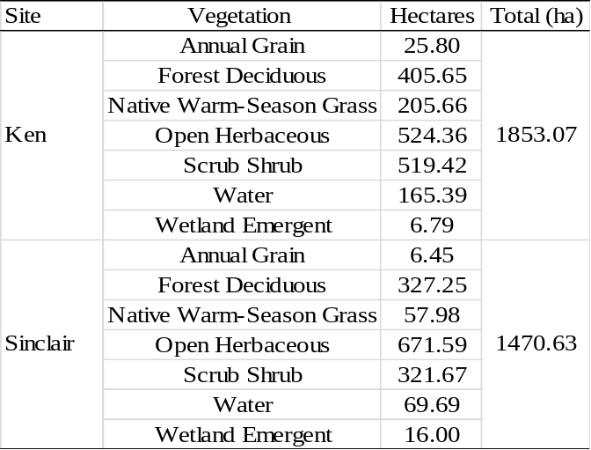

Table 2.2. List and description of group metrics used to assess effects on survival of radiomarked northern bobwhite on Peabody WMA, Ohio and Muhlenberg Counties, Kentucky, USA, 1 Sep 2009-30 Sep 2011.
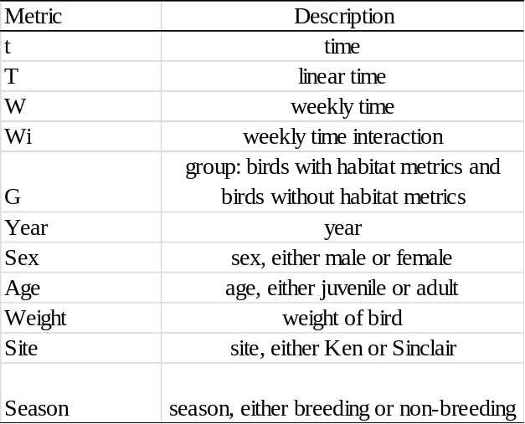

Table 2.3. List and description of metrics used to assess effects of home range composition and size on survival of radiomarked northern bobwhite on Peabody WMA, Ohio and Muhlenberg Counties, Kentucky, USA, 1 Sep 2009-30 Sep 2011.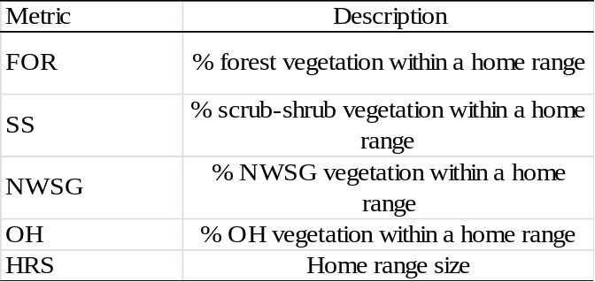

Table 2.4. List and description of metrics generated in FRAGSTATS to assess effects of landscape composition on survival of radiomarked northern bobwhite on Peabody WMA, Ohio and Muhlenberg Counties, Kentucky, USA, 1 Sep 2009-30 Sep 2011.
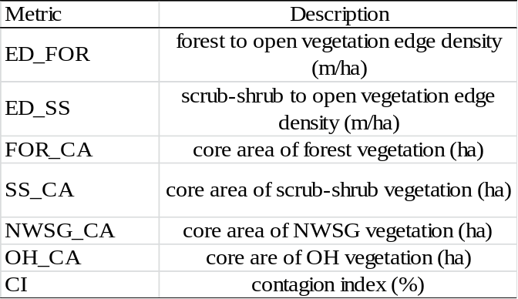

Table 2.5. Non-breeding (1 Oct-31Mar) and breeding (1 Apr-30 Sep) season survival (S) estimates of radiomarked male, female, juvenile, and adult northern bobwhite by site on Peabody WMA, Ohio and Muhlenberg Counties, Kentucky, USA, 1 Sep 2009-30 Sep 2011.
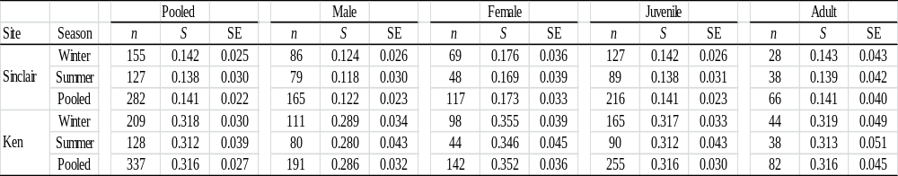

Table 2.6. Non-breeding (1 Oct-31Mar) and breeding (1 Apr-30 Sept) causes of mortality for 467 radiomarked northern bobwhite by site on Peabody WMA, Ohio and Muhlenberg Counties, Kentucky, USA, 1 Sep 2009-30 Sep 2011.
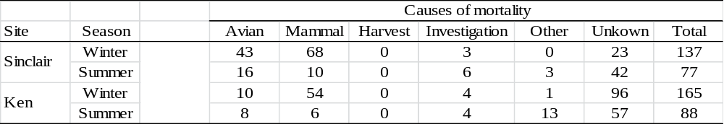

Table 2.7. Highest ranking models from 61 a priori models based on ΔAIC_{c} values and AIC_{c} weights used to assess the influence of group, home range, and landscape metrics on northern bobwhite survival on Peabody WMA, Ohio and Muhlenberg Counties, Kentucky, USA, 1 Sep 2009-30 Sep 2011ª.
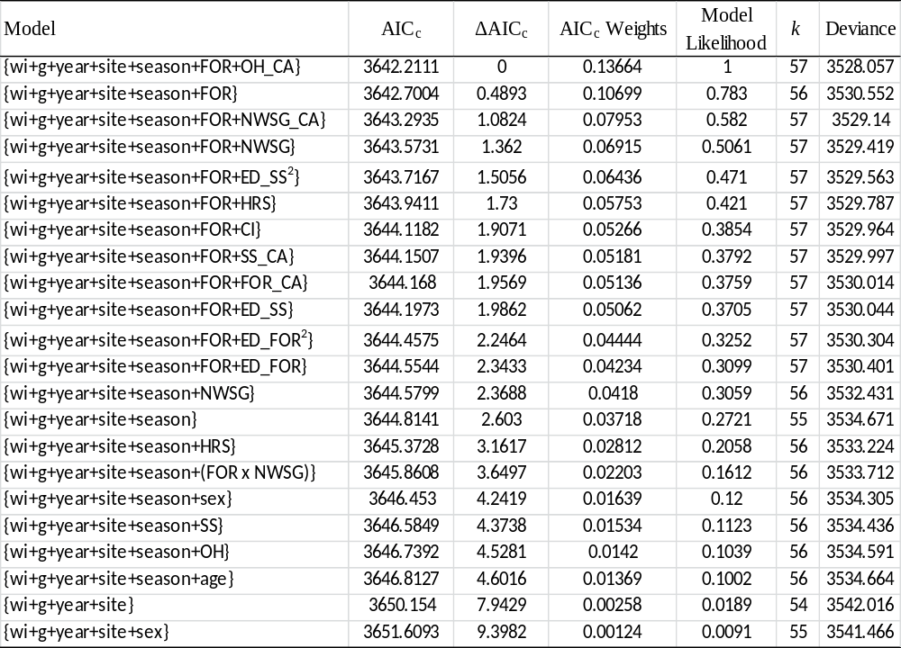 ª Notation generally follows that of Lebreton et al. (1992): wi = weekly time interaction, g = group, FOR = forest, OH = open herbaceous, NWSG = native warm season grass, SS = scrub-shrub, HRS = home range size, ED_SS = scrub-shrub to open vegetation edge density, ED_FOR = forest to open vegetation edge density, FOR_CA = forest core area, OH_CA = open herbaceous core area, NWSG_CA = native warm season grass core area, SS_CA = scrub-shrub core area, CI = contagion index

Table 2.8. Importance weights for parameters used to assess the influence of group, home range, and landscape metrics on northern bobwhite survival on Peabody WMA, Ohio and Muhlenberg Counties, Kentucky, USA, 1 Sep 2009-30 Sep 2011
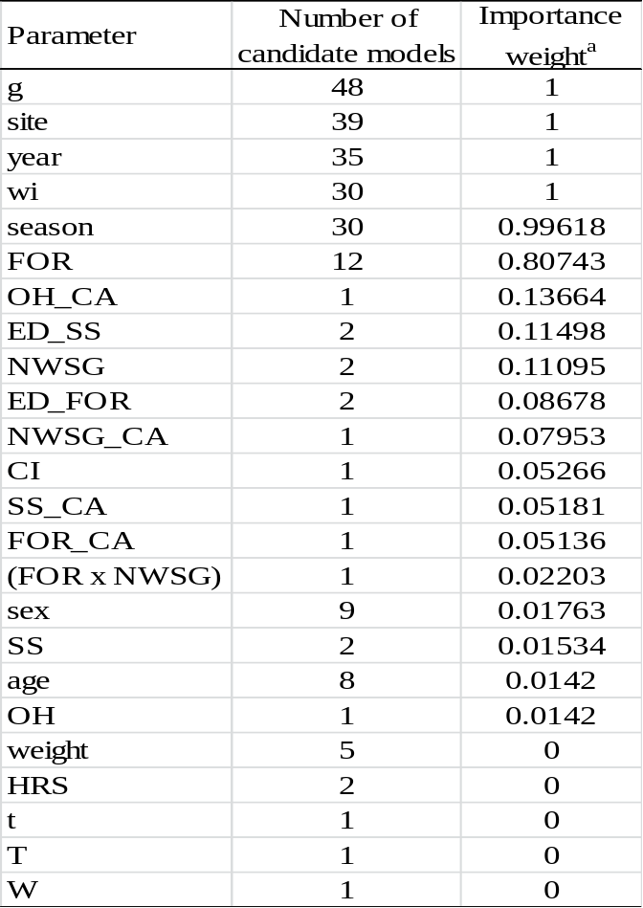
ª Importance weight of a parameter is estimated as the sum of Akaike weights from candidate models containing the parameter.

Figure 2.1. Encounter period survival rate estimates (solid line) and 95% confidence intervals (dotted lines) for each group of northern bobwhite on Peabody WMA, Ohio and Muhlenberg Counties, Kentucky, USA, 1 Sep 2009-30 Sep 2011.
APENDIX A

Table A.1. Age and sex structure of captured northern bobwhite by site and season on Peabody WMA, Ohio and Muhlenberg Counties, Kentucky, USA, 1 Sep 2009-30 Sep 2011.
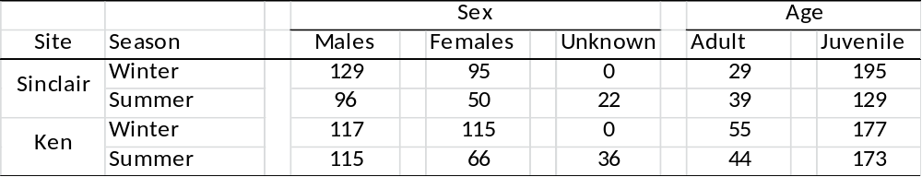

Table A.2. Summary of northern bobwhite trapping success by site and season on Peabody WMA, Ohio and Muhlenberg Counties, Kentucky, USA, 1 Sep 2009-30 Sep 2011.
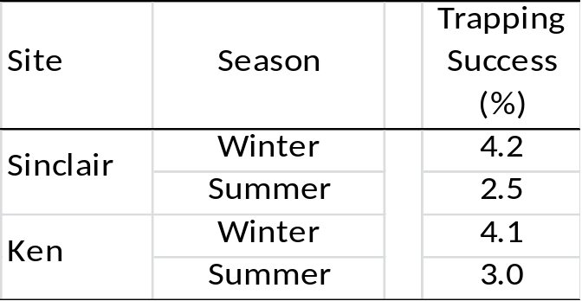

Table A.3. Summary of home range habitat metrics by site and season used to evaluate survival of northern bobwhite on Peabody WMA, Ohio and Muhlenberg Counties, Kentucky, USA, 1 Sep 2009-30 Sep 2011.
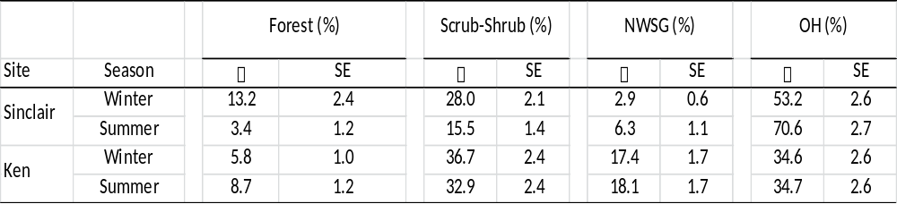

Table A.4. Summary of home range metrics by site and season used to evaluate survival of northern bobwhite on Peabody WMA, Ohio and Muhlenberg Counties, Kentucky, USA, 1 Sep 2009-30 Sep 2011.
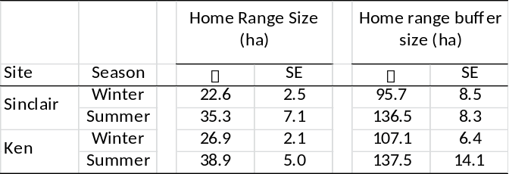

Table A.5. Summary of FRAGSTATS estimated core area and contagion index metrics by site and season used to evaluate survival of northern bobwhite on Peabody WMA, Ohio and Muhlenberg Counties, Kentucky, USA, 1 Sep 2009-30 Sep 2011.
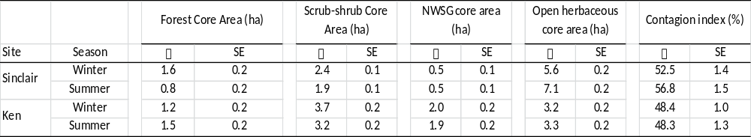

Table A.6. Summary of FRAGSTATS estimated edge density metrics by site and season used to evaluate survival of northern bobwhite on Peabody WMA, Ohio and Muhlenberg Counties, Kentucky, USA, 1 Sep 2009-30 Sep 2011.
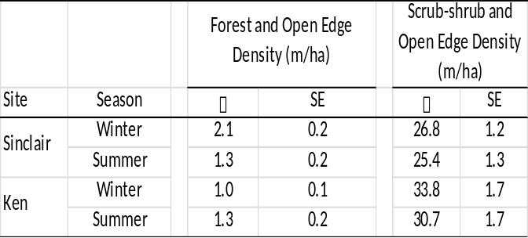

Table A.7. Ranking of all 61 a priori models based on ΔAIC_{c} values and AIC_{c} weights used to assess the influence of group, home range, and landscape metrics on northern bobwhite survival on Peabody WMA, Ohio and Muhlenberg Counties, Kentucky, USA, 1 Sep 2009-30 Sept 2011ª.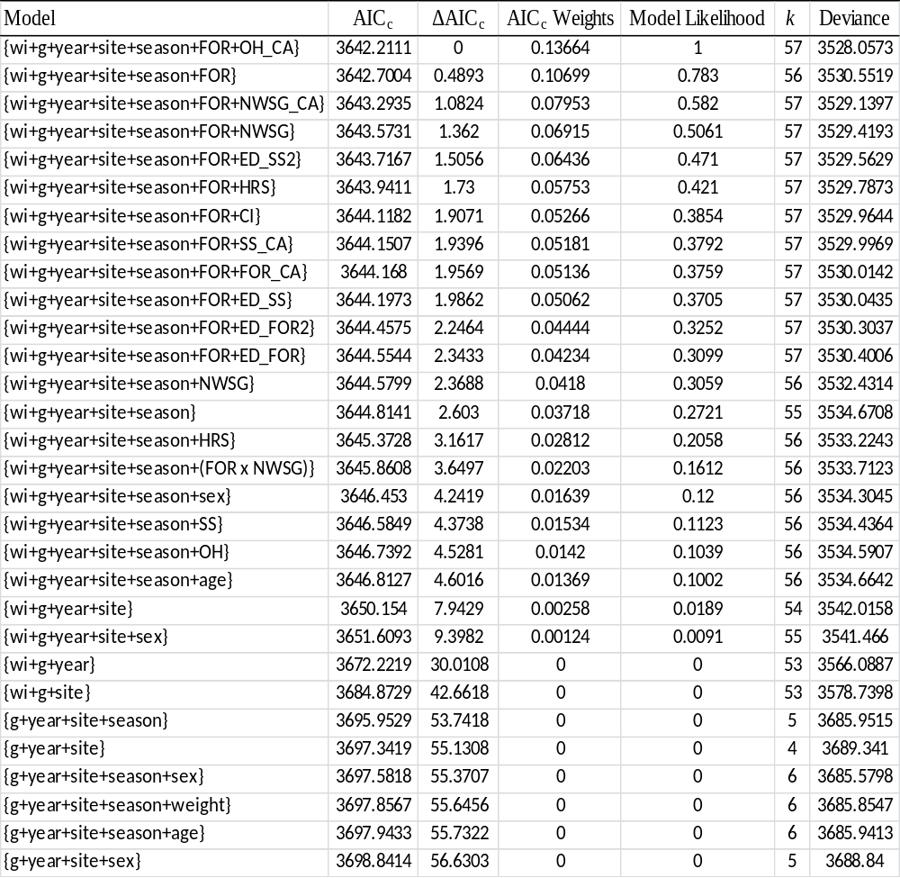Continued
Table A.6 Continued
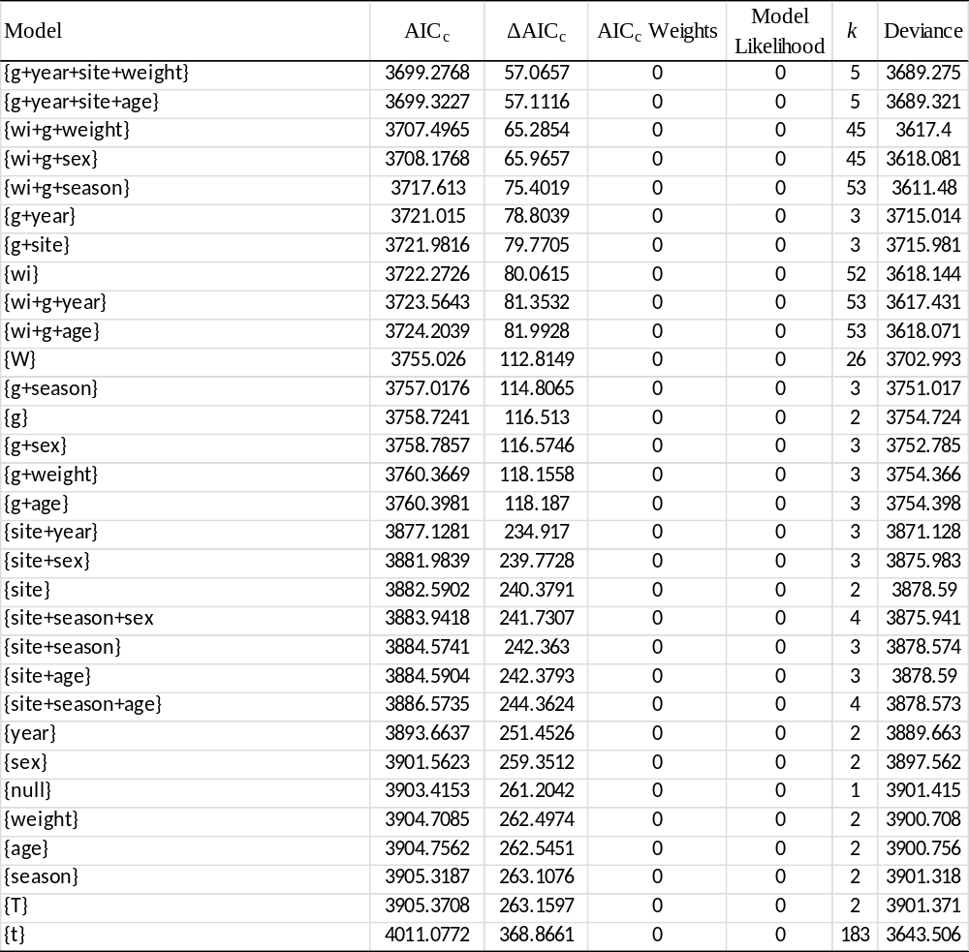 ª Notation generally follows that of Lebreton et al. (1992): wi = weekly time interaction, g = group, FOR = forest, OH = open herbaceous, NWSG = native warm season grass, SS = scrub-shrub, HRS = home range size, ED_SS = scrub-shrub to open vegetation edge density, ED_FOR = forest to open vegetation edge density, FOR_CA = forest core area, OH_CA = open herbaceous core area, NWSG_CA = native warm season grass core area, SS_CA = scrub-shrub core area, CI = contagion index

