Meta-omics to study plant-microbe interface of Populus sp. using a reductionist approach

A Dissertation Presented for the
Doctor of Philosophy
Degree
The University of Tennessee, Knoxville

Manasa Reddy Appidi
December 2024
ACKNOWLEDGEMENTS
I would like to thank everyone who made the completion of this Ph.D. dissertation a reality. First and foremost, I would like to thank my research advisor, Dr. Robert Hettich for his unwavering support and guidance.

ABSTRACT
Microbes are ubiquitously associated with plants and play a crucial role in plant health and fitness. Due to the important roles the microbiome plays, it is important to understand how the microbiomes assemble and establish themselves in various plant niches. Of the various plant niches, rhizosphere serves as a reservoir of beneficial microbes and the beneficial microbes are recruited by the plant. The plant-microbe interactions and inter-species microbial interactions that facilitate these associations between the plant and microbes are not fully known. However, studying the plant-microbe interactions in nature is challenging due to complexity and technical limitations. Reductionist approaches using constructed microbial communities and laboratory-controlled experiments have proven to be valuable in advancing our knowledge about plant-microbe interactions. High-throughput omics technologies provide invaluable information in studying these complex and dynamic plant microbiomes. Metaproteomics can identify and quantify thousands of proteins and provide insights into microbiome composition and functions of individual microbial members of the microbiome. By using metaproteomics, inter-microbial interactions and adaptation strategies of the microbes to compete and survive in its environment can be studied. Metabolomics helps in studying the chemicals released by plant and microbes that serve as nutrients and/or chemical signals to establish interactions with each other. In this dissertation, liquid-chromatography coupled mass spectrometry based metaproteomic and metabolomic approaches have been implemented to advance our understanding of interactions between the Populus sp. and its rhizosphere microbiome. The research presented here describes (1) application of metaproteomics in understanding inter-species interactions in a constructed microbial community and assembly of stable microbiomes, (2) methodological advancements to achieve spatially resolved metaproteomics along plant root axis, (3) study of microbial functions and responses to plant root chemicals using metaproteomics, (4) application of LC-MS based untargeted metabolomics to characterize root exudate profiles of Populus sp. In summary, this dissertation has contributed significantly to understanding the interactions between Populus sp. and its associated rhizosphere microbiome, development of novel methods with new capabilities and experimental platforms that can be easily applied to other plant-microbe studies.
TABLE OF CONTENTS
Chapter 1 1
Introduction to understanding plant-microbe interactions using liquid chromatography coupled mass spectrometry-based metaproteomics and metabolomics 1
Plant-microbe interactions 1
Importance of studying Populus spp. and its associated microbiome 2
Rhizosphere microbiome 2
Bridging the holistic and reductionist approaches to study plant associated microbiome 5
Omics technologies to study plant-associated microbiomes 7
Characterizing plant microbiome functions using metaproteomics 8
Metabolomics to study the metabolites produced by plant and microbes in plant holobiont 9
Overview of dissertation 10
Chapter 2 13
Methodologies for mass spectrometry-based metaproteomics and untargeted metabolomics analysis 13
Liquid chromatography coupled mass spectrometry 13
Liquid chromatography 13
Mass spectrometry instrumentation 13
Ionization sources 13
Mass analyzers and detectors 13
Tandem mass spectrometry 13
Figures of merit 13
Data acquisition 13
General workflow for metaproteomics 13
Sample preparation for bottom-up proteomics 13
Cell lysis and protein extraction 13
Enzymatic digestion of proteins to peptides 13
Peptide separation using liquid chromatography followed by tandem mass spectrometry analysis 14
Liquid chromatography for peptide separation 14
One-dimensional LC 14
Two-dimensional LC 14
Metaproteomics data processing and analysis 14
General workflow for LC-MS/MS based metabolomics 14
Sample preparation for metabolomics 14
Untargeted metabolomics measurements 14
Untargeted metabolomics data processing and analysis 14
Summary 14
Chapter 3 15
Metaproteomic analysis to study microbial community structure and inter-microbial interactions in constructed microbial communities 15
Introduction 15
Materials and methods 15
Preparation of 10-member microbial community and serial transfers in R2A and MOPS media 15
Preparation of 3-member communities with varying initial ratios 15
Sample preparation for proteomics 15
Protein identification and quantification 15
Results 15
Metaproteomics reveals details of microbial community stabilization and population equilibration as a function of growth media 15
Construction of a 3-member community and comparison of their population distributions 15
The influence of various initial inoculum ratios on the resulting community structure of the community 15
Discussion 15
Conclusions 15
Chapter 4 16
Development of an experimental approach to achieve spatially resolved plant root-associated metaproteomics using an agar-plate system 16
Introduction 16
Materials and methods 18
Preparation of plants, bacterial cultures, and a SynCom 18
Plant-agar culture growth conditions 19
Extracting microbiomes directly associated with the plant root system for metaproteomics 21
Extracting microbiomes from agar for metaproteomics 22
Protein identification and quantification 24
Statistical analysis 25
Results and discussion 25
A novel approach to extract and characterize root-associated microbiomes using metaproteomics 25
Spatially resolved metaproteomics along the plant root axis 31
Detecting functional changes in microbial activity along the plant root axis 39
Conclusions 41
Chapter 5 44
Unraveling bacterial adaptation strategies in the microbiome shaped by the chemical environment of the plant rhizosphere 44
Introduction 44
Materials and methods 47
Preparation of plants, bacterial cultures, and growth conditions 47
Expression of plant-responsive promoters on Populus roots using filter-based system 47
Bacterial inoculation on Populus roots using a filter-based system 48
Cellular protein extraction for proteomic analyses 49
Protein identification and quantification 50
Statistical analysis 51
Root colonization assays 51
Results 52
A filter-based system enables the study of bacterial responses to the plant root chemical environment without physical contact with the plant 52
Quantification of bacterial proteomes revealed varying responses to the presence of a plant by individual isolates 54
The plant-associated chemical environment impacts the microbiome population structure 57
Bacteria shift metabolic function at a taxon-specific level in response to the plant root chemical environment 62
Bacillus sp. BC15 becomes metabolically active in the presence of a plant 70
Pantoea sp. YR343 shows increased abundance of proteins related to chemotaxis, motility, nutrient transport, and metabolism in response to the plant root chemical environment 72
Discussion 75
REFERENCES 80
VITA 97

LIST OF FIGURES
Figure 1.1: Interactions in the rhizosphere. Plant-microbe interactions: Plant roots secrete root exudates and phytochemicals that interact with microbial populations to form niches. Some metabolites released by plant roots play a role in attracting beneficial microbes (indicated by green arrow), while others repel or eliminate pathogens (indicated by red arrow). Microbe-plant interactions: Beneficial microbes promote plant growth via various mechanisms including nutrient chelation and transporting them to plants, phytohormone production, secrete antibiotics to protect plants from pathogens. Microbe-microbe interactions: Cooperative interactions by nutrient cross-feeding or competitive interactions for resources such as nutrients or space. (Figure generated using Biorender.com). 4
6
Figure 1.2: Experimental approaches to study plant-microbe interactions. Holistic approaches are inherently complex and offers less control on environmental variables. In contrast, reductionist approaches simplify the system and offer control to manipulate experimental conditions to determine the effects of specific components of plant-microbe systems. (Figure generated using Biorender.com). 6
Figure 1.3: Omics approaches for studying plant associated microbiomes. Metagenomics to study which microbial species are present and metabolic potential, metatranscriptomics to determine gene expression, metaproteomics to understand function and metabolomics to study metabolites produced in the plant- microbe system. (Figure generated using Biorender.com). 8
Figure 4.1: Experimental design to achieve spatially resolved plant root-associated microbes using an agar system. 20
Figure 4.2: Proteins extracted from root-associated microbiomes using different extraction methods for plant-agar samples at 48 h. 28
Figure 4.3: Global proteomics metrics using novel agar extraction method. 29
Figure 4.4: Assessment of microbial relative population sizes based on their summed protein abundances. 32
Figure 4.5: Assessment of microbial relative population sizes based on their summed protein abundances. 33
Figure 4.6: Association with plant shows higher variation in proteome expression of synthetic community. 36
Table 4.3: PERMANOVA results of Euclidean distances of proteins. 37
Figure 4.7: Hierarchical clustering results for Pantoea sp. strain YR343. 41
Figure 5.1: Overview of experimental design and proof-of-concept. 53
Figure 5.2: Average number of proteins identified (n=3) in proteomic analysis of ten bacterial strains grown individually in the absence or presence of the plant. 55
Figure 5.3: Stacked bar charts showing the number of differentially abundant proteins for ten bacterial strains grown individually 56
Figure 5.4: Overview of number of proteins identified in metaproteomics results for ten bacterial strains grown in a mixed community in the absence or presence of a plant. 58
Figure 5.5: Relative population sizes of ten bacterial strains in the mixed community grown in the absence or presence of a plant assessed using summed protein abundances. 59
Figure 5.6: Stacked bar charts showing the number of differentially abundant proteins for ten bacterial strains grown in a mixed community 61
Figure 5.7: Functional analysis of bacterial strains grown individually in the absence or presence of a plant using Clusters of Orthologous Groups (COGs). 65
Figure 5.8: Functional analysis of bacterial strains grown in a mixed community in the absence or presence of a plant using Clusters of Orthologous Groups (COGs). 67
Figure 5.9: Stacked bar charts illustrate the distribution of identified ABC transporters in ten bacterial strains. 69
Figure 5.10: Functional changes in Bacillus sp. BC15 as a response to the chemical environment of the plant root. 71
Figure 5.11: Proteomic analysis of Pantoea sp. YR343 in response to the chemical environment of a plant root. 74

LIST OF TABLES
Table 4.1: LIMMA results using the relative abundances of the individual taxa comparing the agar sample to the root wash. 30
Table 4.2: ANOVA results for each member in the 10-member SynCom based on the relative abundances over time. 34
Table 4.4: ANOVA results for each member in the 10-member SynCom 38
Table 5.1: Bacterial strains utilized in this study 48

Chapter 1
Introduction to understanding plant-microbe interactions using liquid chromatography coupled mass spectrometry-based metaproteomics and metabolomics
Plant-microbe interactions
A plethora of microbial communities are hosted by plants and interact with them continuously in nature. These interactions include symbiotic associations that are mutually beneficial to both microbe and plant host, commensal associations in which only one species benefits while the other one neither benefits nor is harmed and pathogenic associations that are harmful to plant hosts ¹. The beneficial interactions between plants and microbes are known to improve plant growth and survival by conferring multiple advantages to their plant host such as increasing nutritional acquisition ², overcoming abiotic stresses ³ and activating defense pathways against pathogens ⁴. The plant fitness is a consequence of associations between plant and microbes that form a complex, multi-organism system, which collectively forms a plant holobiont ⁵. In the recent years, there is increased focus on studying the plant holobiont to unravel the interdependencies between the plant and their microbiome ⁶, as the knowledge gained from these studies has the potential to drive innovations in plant productivity for sustainable agriculture ^{7, 8}. The growing recognition of plant holobiont concept raises several important questions to be answered such as what are the driving factors of microbiome assembly, the processes involved in plants differentiating between symbiotic and pathogenic microbes, effects of abiotic stressors on plant-microbe interactions and effects of microbe-microbe interactions on plant-microbe interactions ^{5, 9} and consequently requires application of advanced omics technologies to address them. The structure and composition of the plant holobiont undergoes changes due to inherent dynamic interactions with the biotic and abiotic factors of the environment ¹⁰, during which the plant and microbes work together to adapt to the changing environmental conditions. Studying the underlying genetic, molecular, and metabolic relationships between plants and associated microbes across various environmental conditions would provide better understanding of the plant holobiont. This knowledge is crucial for enhancing plant health and fitness by developing strategies for improved and sustainable agricultural practices.
Importance of studying Populus spp. and its associated microbiome
Populus spp. is an economically important, leading candidate for bioenergy production ^{11, 12}. It is a woody perennial organism and has become a model organism in plant biology due to its broad distribution across North America, fast growth, vegetative propagation potential and the relative ease with which it can be manipulated for experiments ¹²⁻¹⁴. Populus trichocarpa was the first tree species that was genome sequenced ¹⁴. Populus roots and its rhizosphere serves as a hub for diverse interactions between the plant host, bacteria and fungi, which makes it an excellent model system to study the plant-microbe interactions ¹⁵. Additionally, a culture collection of 3,211 unique bacterial isolates is available for investigating the interactions between Populus and its associated bacterial strains ¹⁶. The fundamental understanding of interactions between Populus and its associated microbiome will provide valuable information for improving the plant health and growth which will be helpful for bioenergy production, carbon cycling and sequestration.
Rhizosphere microbiome
Microbes are ubiquitously present on almost every part of the plant both belowground and aboveground. The microbes assemble into diverse communities because of dynamic and complex associations with plant and environment ¹⁷. These microbial communities can be categorized into epiphytes that are found on plant surface, endophytes that are present inside plant tissues, phyllospheric microbes that grow on leaf surfaces and rhizospheric microbes that are found in soil surrounding the roots ⁷. Each of these serve as unique niches for interacting with plant host. Among these, rhizosphere microbiome is considered to significantly impact the plant health ^{18, 19} as it enhances the nutrient uptake and offer protection against pathogens ²⁰. Therefore, it is essential to understand the various processes and associations between plant roots and microbes in the rhizosphere (Figure 1.1).
Plants release 5–21% of its photosynthetically fixed carbon into surrounding soil through its roots in the form of root exudates, sloughed cells or mucilage ²¹. The root exudates consist of primary and secondary metabolites including sugars, organic acids, amino acids, and phenolics ²². The root exudates are known to play a crucial role in rhizosphere microbiome assembly and composition ²³. Plant selectively recruits microbes from soil to their rhizosphere by releasing root exudates ²⁴. The root exudates consist of metabolites that play a role in attracting beneficial microbes by providing nutrients to them and/or acting as signaling molecules for establishing interactions while others may play a role in deterring or eliminating pathogens ²⁵. The rhizosphere microbes confer several advantages to plant host such as improved nutrient availability by nutrient chelation and transporting them to plants, growth promotion by producing phytohormones, secrete antibiotics to protect plants from pathogens ²⁶. The rhizosphere bacteria help in mineralizing and breaking down organic forms of major nutrients such as phosphorus, nitrogen and potassium in soil and converting them into inorganic forms which the plant can uptake and utilize ^{27, 28}. The bacteria in rhizosphere can stimulate plant root growth by producing indole acetic acid, a plant hormone that is involved in plant growth ^{29, 30}. The beneficial microbes in the rhizosphere employ various mechanisms to protect the plant from adverse effects of pathogens by competition for space at the root surface and for essential nutrients. Some microbes produce secondary metabolites to inhibit the growth or kill pathogens and thereby protecting the plant ³¹. In addition to plant-microbe interactions, complex intraspecies and interspecies microbial interactions also occur in the rhizosphere. These interactions could be cooperative by nutrient cross-feeding or competitive interactions for essential resources such as nutrients or space ³². The plant associated microbial communities do not represent random assembly of microbial members but are governed by complex interactions among the microbes, the plant host and the environmental conditions ^{17, 33}. However, the underlying mechanisms of rhizosphere microbiome assembly are not well understood. Studying the complex processes involved in the rhizosphere microbiome assembly are crucial as they will provide insights for improving plant health and productivity.
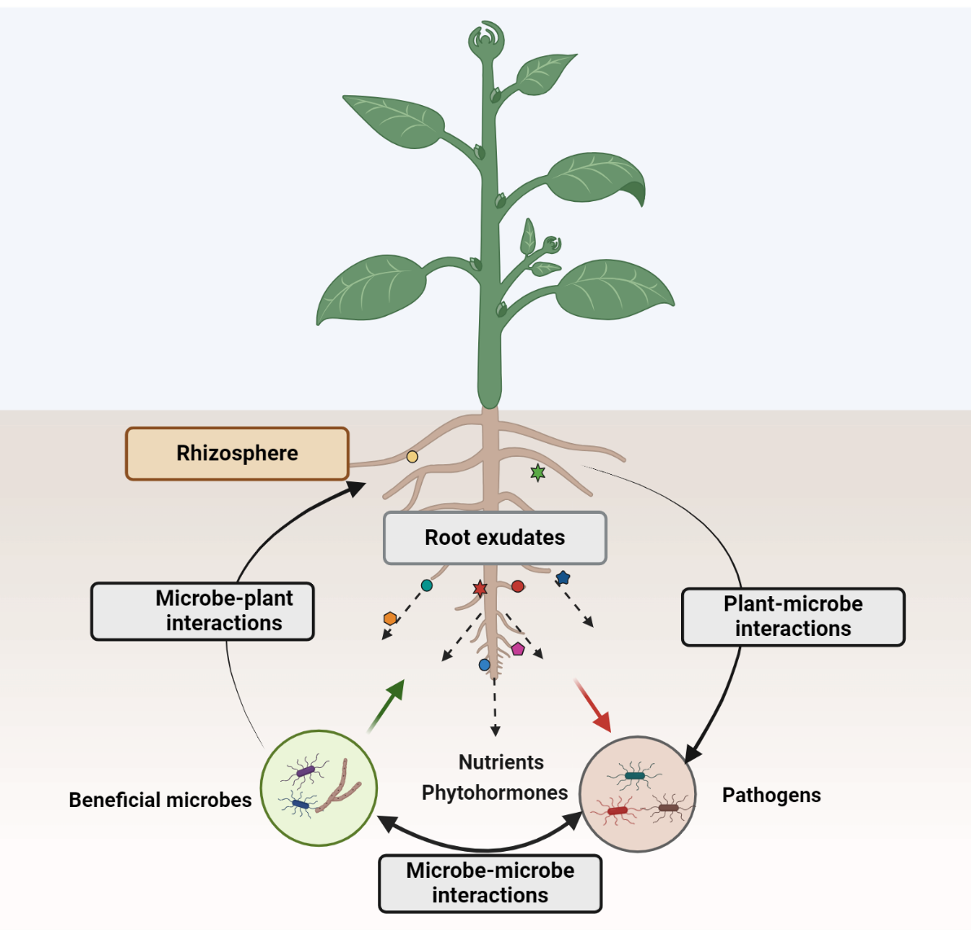
Figure 1.1: Interactions in the rhizosphere. Plant-microbe interactions: Plant roots secrete root exudates and phytochemicals that interact with microbial populations to form niches. Some metabolites released by plant roots play a role in attracting beneficial microbes (indicated by green arrow), while others repel or eliminate pathogens (indicated by red arrow). Microbe-plant interactions: Beneficial microbes promote plant growth via various mechanisms including nutrient chelation and transporting them to plants, phytohormone production, secrete antibiotics to protect plants from pathogens. Microbe-microbe interactions: Cooperative interactions by nutrient cross-feeding or competitive interactions for resources such as nutrients or space. (Figure generated using Biorender.com).
Bridging the holistic and reductionist approaches to study plant associated microbiome
To study plant-microbe interactions, researchers adopt either holistic approaches that embrace the natural complexity of these systems or reductionist approaches that allow more control of experimental factors in study and focus on specific interactions ³⁴. Both these experimental approaches are on opposite ends of the complexity-control spectrum (Figure 1.2). Use of both the reduced and high complex systems is crucial in obtaining a complete understanding of these complex plant-microbe interactions ³⁵. Using the reductionist approaches, low levels of genotypic and functional diversity are studied under controlled environmental conditions, which enables reproducible investigations of plant-microbe interactions ³⁶. Engineered habitats such as EcoFabs are used in reductionist approaches to control the complexity while enabling omics measurements ³⁷. The simplicity and control in reductionist approaches enables interpretability and understanding of the plant-microbe interactions, however, this strategy is not suitable for studying the importance of higher-order ecological processes on plant holobiont. In contrast, the holistic approaches are used to study plant-microbe interactions across complex natural environments and capture the ecological interactions between genotype, environment and functional variables and their relative influence on the plant holobiont ^{38, 39}. But the increase in complexity in holistic approaches presents a challenge for all omics techniques due to sparse data generated and methodological limitations. Additionally, it would be extremely challenging to dissect specific interactions and study them at the mechanistic molecular level. It is now very well known that plant-microbe interactions and microbial communities are highly dependent on entire ecosystem ⁴⁰. Experimental designs that can act as a bridge in between the holistic and reductionist approaches are essential in addressing some of the limitations in using only either one of these approaches in advancing our understanding of processes that govern the plant microbial communities ³⁴.
A potential approach to address the limitations of studies on highly complex natural communities and also those studies examining interactions between a monoculture and a plant host is to utilize constructed microbial communities. The constructed microbial communities or synthetic microbial communities (SynComs) are microbial consortia that are designed to represent the natural microbiome composition and functions at some scale, while reducing the complexity of natural microbiome and still preserving some of the important interactions between microbes and their hosts ⁴¹. This approach has garnered significant attention in recent years in microbiome research ³⁹. SynCom construction requires careful design, selection criteria, available culture collections of microorganisms that can effectively represent and resemble the natural microbiome. The experimental approaches using SynComs with less complexity can be used to understand specific interactions and gradually build the complexity of the system by adding more microbes, plant host, environmental variables etc. for a comprehensive understanding of microbial dynamics and their functionality in rhizosphere ³⁹.
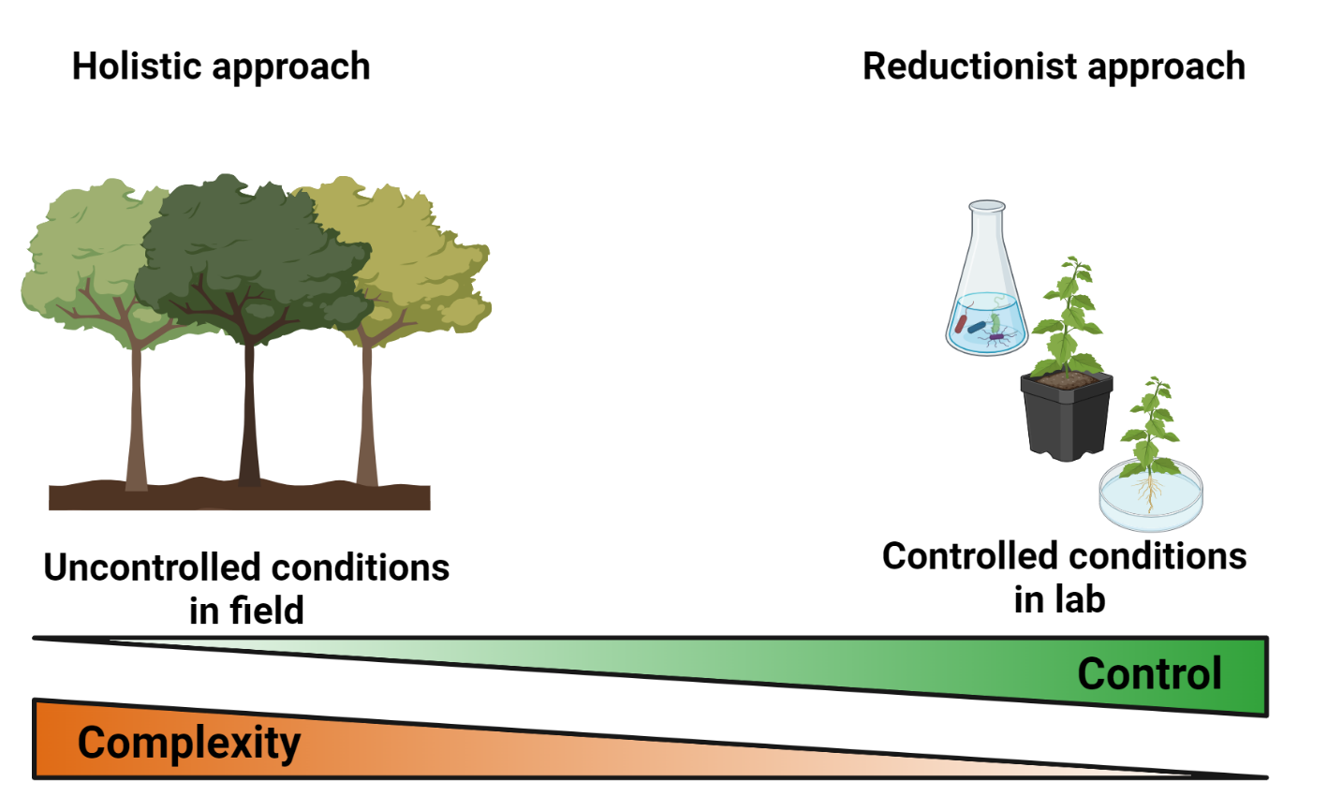

Figure 1.2: Experimental approaches to study plant-microbe interactions. Holistic approaches are inherently complex and offers less control on environmental variables. In contrast, reductionist approaches simplify the system and offer control to manipulate experimental conditions to determine the effects of specific components of plant-microbe systems. (Figure generated using Biorender.com).
Omics technologies to study plant-associated microbiomes
Advancements in high throughput sequencing platforms and various omics technologies including genomics, transcriptomics, proteomics, and metabolomics have greatly improved our understanding of the complex plant-microbe systems. Each omics technology can answer different questions related to plant holobiont (Figure 1.3). Metagenomics helps in identifying which microbial species are present in the plant environment and reveals the functional potential of microbes by measuring the DNA from microbiomes. Metatrancriptomics measures microbial RNA transcripts and is valuable in understanding which microbial genes are actively expressed. Metaproteomics provides functional information by measuring proteins produced in the microbial community. Metabolomics further provides insights into chemical signals between plant and microbes by measuring metabolites produced by plant and microbes. Each omics technology has its own advantages and limitations to study these systems⁴². Integrated multi-omics studies can provides a more comprehensive understanding of plant holobiont but are challenging because the processes of gene expression, translation and metabolite production operate on distinct timescales from each other. Additionally, metabolism is greatly influenced by the environmental factors, which makes it difficult to isolate the effects of environment factors from genetic outcomes ⁴³.
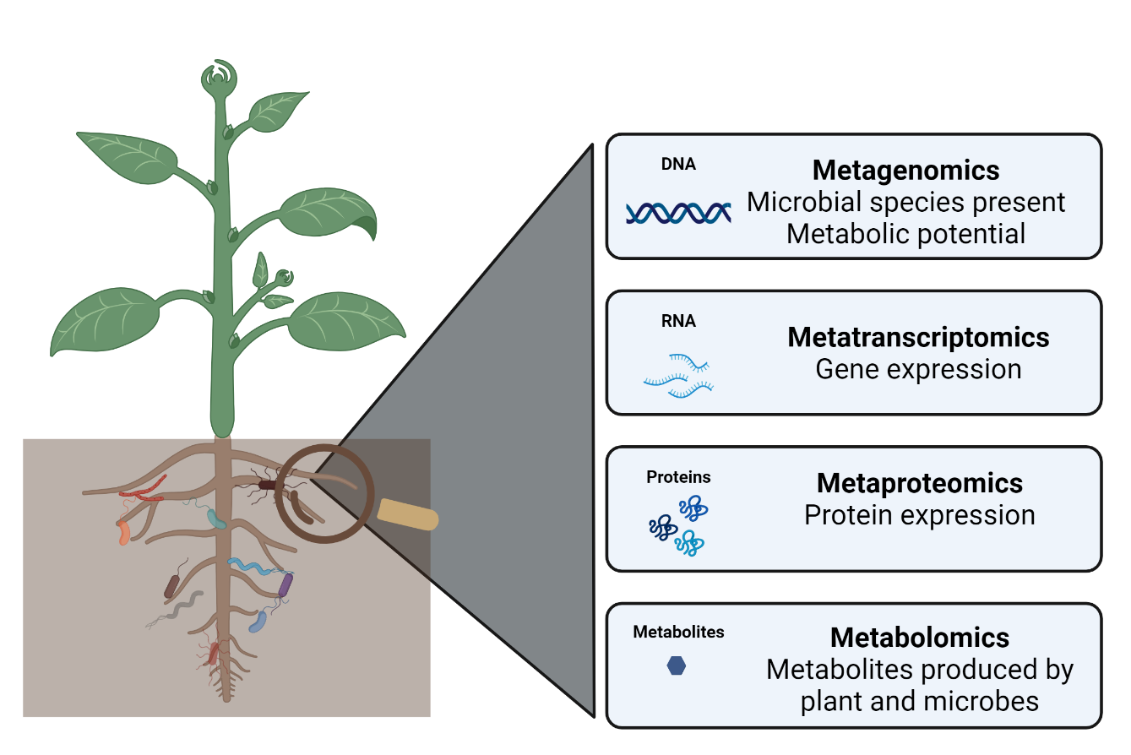
Over the past several years, our understanding of the structure and diversity of the plant endosphere, phyllosphere and rhizosphere microbiomes has expanded due to 16S ribosomal RNA (rRNA) sequencing^{44, 45}. Similarly, DNA barcoding of Internal Transcribed Spacer (ITS) region of the nuclear DNA has been instrumental for our understanding of fungal diversity⁴⁶. The core microbiome members that engage with plants consistently are identified using the high-throughput sequencing methods using marker genes (e.g., 16S rRNA, ITS)^{47, 48} ,but these methods lack the functional information. Therefore, it is important to follow up or integrate the taxonomic approaches with approaches that can provide functional information such as metagenomics, metatranscriptomics, metaproteomics, and metabolomics as there is increasing evidence of functional redundancy in microbiomes that have different species⁴⁹. It is predicted that integrating metagenomics with other downstream meta-omic approaches is essential for understanding the interactions between plants and microbes that shape the core microbiome taxa and their functions ^{50, 51}.

Figure 1.3: Omics approaches for studying plant associated microbiomes. Metagenomics to study which microbial species are present and metabolic potential, metatranscriptomics to determine gene expression, metaproteomics to understand function and metabolomics to study metabolites produced in the plant- microbe system. (Figure generated using Biorender.com).
Characterizing plant microbiome functions using metaproteomics
Metaproteomic analysis characterizes the entire suite of proteins expressed in a microbial community at a given timepoint, providing information on composition and functions in microbiomes ⁵². The mass spectrometry based metaproteomics is a powerful tool in characterizing microbial proteins and has become a critical component of microbiome research in various environments, as it enables the study of multiple interactions that occur simultaneously in an ecosystem⁵³. In recent years, several studies have applied metaproteomics to advance our understanding of microbial functions in plant such as maize⁵⁴, rice^{55, 56}. To perform metaproteomic experiments, several important things involved in the workflow need to be taken into consideration, including biomass availability, choice of sample preparation protocols and LC-MS/MS approaches to study each individual system⁵⁷. The biological diversity (i.e., the number of species present and their relative abundances) of the microbial communities being analyzed directly affects the proteome coverage of the population. In a typical experimental run, thousands of proteins can be identified and often the proteome coverage is biased towards proteins that are highly abundant in the dominant species of the populations. This makes measuring the low abundant proteins more challenging. The fewer low abundant proteins or proteins from less dominant species that are playing prominent functional roles in biological processes are overshadowed by highly expressed proteins. The dynamic range and proteome coverage for large-scale metaproteomics can be increased by using multidimensional protein identification technology (MudPIT), a multidimensional chromatography technique to separate complex protein samples prior to analyzing samples on mass spectrometry⁵⁸. Another important consideration for metaproteomic experiments is the sample biomass. Typically, several micrograms of protein will be required for adequate analysis by mass spectrometry. The protein extraction from the limited biomass of plant-associated microbiota for metaproteomics is one of the challenging steps due to the high ratio of plant to microbial proteins in the sample, which makes microbial protein detection difficult and therefore requires method optimizations⁵⁹ and new method developments. Further, availability of reference metagenomic and/or metatranscriptomic databases are required for metaproteomic analysis; these serve as reference protein databases to match peptide spectra obtained from mass spectrometry analysis⁵⁷.
Metabolomics to study the metabolites produced by plant and microbes in plant holobiont
Metabolites are the direct effectors driving the fundamental processes of recognition and communication between the plant and microbes. They are exchanged across symbiotic, commensal, parasitic and pathogenic interactions between the organisms. From the genome predictions, it is known that the plants, and their associated microbes have the ability to produce thousands of molecules that interact with and influence their ecosystems ⁶⁰. Mass spectrometry-based metabolomics is one of the key technologies that is used currently to characterize these diverse chemical inventories produced by plant and microbes ⁶¹. During the past few years, the insights gained from the metabolomics studies have been crucial in understanding the influence of plant metabolites in shaping their microbial communities and the effects of microbially derived metabolites on plant hosts and their ecosystems ^{25, 61, 62}. In plant-microbe studies, metabolomics is often applied to characterize the plant root exudate profiles and their impact on the microbes present in the surrounding environment ^{63, 64}. Additionally, the effects of associated microbes on host metabolism are also studied using metabolomic approach. While in situ analysis of metabolites provides the most relevant data for understanding the plant-microbe interactions, this can be very challenging due to several factors. The environmental factors such as soil properties are highly variable, and it would be difficult to replicate the experiments. Additionally, the metabolomic results from in situ analysis can be confounded by consumption and/or breakdown of metabolites by other organisms in soil and presence of other biomaterials in the surrounding environment ⁶⁵. Consequently, most metabolomic studies employ reductionistic approach. Studies focused on understanding the effect of rhizosphere on microbiome composition and function were mostly conducted in sterile or semi-sterile environments including soil or artificial systems such as hydroponic systems ⁶⁶⁻⁶⁸. Our understanding of root exudate compositions of Arabidopsis ⁶⁹⁻⁷¹ , rice ^{72, 73} and maize ⁷⁴ and their impact associated microbiomes ^{75, 76} has increased due to the significant technological developments in mass spectrometry. There are only a fewer number of metabolomics studies conducted in field ^{77, 78} or greenhouse soil environments ^{79, 80}. Recent experimental advances are promising for addressing challenges related to metabolomic analysis in non-sterile soil matrices ⁸¹.
Overview of dissertation
It is well-established that the microbiomes have a significant influence on the plant health. However, the limited understanding of specific mechanisms driving the dynamics of plant-associated microbial communities represents a critical knowledge gap. This dissertation seeks to advance our understanding of plant-microbe interfaces of Populus sp. and its rhizosphere microbiome by employing liquid chromatography coupled mass spectrometry-based metaproteomics and metabolomics to gain insights into factors driving microbiome assembly and the functions of microbiome. Synthetic microbial communities are invaluable in plant-microbiome research as they bridge the gap between the single microbe-plant and whole community-plant experimental approaches. This dissertation employed a constructed microbial community that taxonomically and functionally resembles a natural Populus bacterial community for fundamental understanding of microbiome assembly under various experimental conditions and additional layers of complexity such as plant host were introduced, to address more intricate questions regarding the spatial and temporal dynamics in microbiome composition along the plant root axis, their functional responses to plant root chemical environment. Root exudates, a key player influencing microbiome assembly were also studied in this dissertation.
This dissertation is divided into seven chapters including this introduction chapter. Chapter 2 describes the experimental methods used in chapters 3-6 including proteomic and metabolomic sample preparations, chromatography, mass spectrometry acquisition and downstream processing methods.
Chapter 3 focuses on gaining fundamental understanding of microbiome assembly using metaproteomic measurements of constructed microbial communities grown under different conditions. First, we explored the inter-microbial interactions and adaptation strategies employed by bacterial microbes in a ten-member constructed community grown in complex and minimal nutrient media conditions. The results from this study provides insights into the functions and metabolic activities of microbes that enabled them to persist in the stable microbial community observed. To further investigate whether the initial inoculum ratios of the bacterial strains have influence on which strain becomes abundant in the community, the three bacterial strains that persisted in the stable community were selected and a simplified three-member community was constructed using different initial inoculum ratios. By performing proteomic analysis on community samples collected at various timepoints, we uncovered the temporal functional dynamics of the individual bacterial strains in these simplified communities.
While the first research chapter focus only on the microbiome composition due to microbe-microbe interactions, Chapter 4 focus on microbiome assembly in presence of plant host. In this chapter, a novel peptide extraction method for metaproteomic characterization using plant-agar systems is described. Additionally, spatial sampling of root-associated microbiomes along the plant root axis to study microbial composition and function is demonstrated. Distinct microbiome compositions were observed surrounding distinct root regions, these observations led us to further investigate the spatial dynamics in root exudates, that are known to shape microbial community composition.
Chapter 5 focused on understanding the microbial responses and community composition in response to plant root chemical environment. In this chapter, the application of a novel filter-based experimental set up on plant roots was demonstrated to specifically isolate and study the microbial responses to chemicals released by the plant roots. In this study, proteomic analysis of both monocultures and mixed community grown in presence of plant was conducted to investigate plant-specific responses. The study provided insights into functional behaviors of bacterial strains in response to plant root chemical environment that facilitated their growth and survival in rhizosphere.
Chapter 6 describes the comprehensive spatio-temporal analysis of Populus sp. root and exudate metabolite profiles by applying LC-MS/MS based untargeted metabolomics approach. In this study, plant-agar system that facilitated spatial sampling of root exudates surrounding distinct root regions was used and a biphasic extraction method was employed to capture the diversity of root exudates. This chapter provides an in-depth analysis of differences in root and exudate metabolite profiles due to the influence of genotype and nutrient conditions.
Chapter 7 summarizes the contributions of research described in this dissertation in advancing our understanding of plant-microbe interfaces of Populus sp. and its rhizosphere microbes and future perspectives
Chapter 2
Methodologies for mass spectrometry-based metaproteomics and untargeted metabolomics analysis
Liquid chromatography coupled mass spectrometry
Liquid chromatography
Mass spectrometry instrumentation
Ionization sources
Mass analyzers and detectors
Tandem mass spectrometry
Figures of merit
Data acquisition
General workflow for metaproteomics
Liquid-chromatography coupled mass spectrometry-based proteomics involves several important steps including sample preparation, measurements, data processing and analysis. Each of these steps must be optimized based on the research question. In this dissertation, shot-gun bottom up proteomics approach was employed.
Sample preparation for bottom-up proteomics
Cell lysis and protein extraction
Enzymatic digestion of proteins to peptides

Peptide separation using liquid chromatography followed by tandem mass spectrometry analysis
Liquid chromatography for peptide separation
One-dimensional LC
Two-dimensional LC
Metaproteomics data processing and analysis
General workflow for LC-MS/MS based metabolomics
Sample preparation for metabolomics
Untargeted metabolomics measurements
Untargeted metabolomics data processing and analysis
Summary

Chapter 3
Metaproteomic analysis to study microbial community structure and inter-microbial interactions in constructed microbial communities
Introduction
Materials and methods
Preparation of 10-member microbial community and serial transfers in R2A and MOPS media
Preparation of 3-member communities with varying initial ratios
Sample preparation for proteomics
Protein identification and quantification
Results
Metaproteomics reveals details of microbial community stabilization and population equilibration as a function of growth media
Construction of a 3-member community and comparison of their population distributions
The influence of various initial inoculum ratios on the resulting community structure of the community
Discussion
Conclusions

Chapter 4
Development of an experimental approach to achieve spatially resolved plant root-associated metaproteomics using an agar-plate system
Text and figures were adapted from the following published journal article:
Appidi, M.R., Bible, A.N., Carper, D.L., Jawdy, S.S., Giannone, R.J., Hettich, R.L., Morrell-Falvey, J. and Abraham, P.E., 2022. Development of an experimental approach to achieve spatially resolved plant root-associated metaproteomics using an agar-plate system. Molecular Plant-Microbe Interactions, 35(8), pp.639-649.
Manasa R. Appidi’s contributions include study design, metaproteomic sample preparation, data collection and data analysis, writing and revisions of the manuscript.
Note: All the supplemental material including supplementary figures and tables mentioned in text are available at https://doi.org/10.1094/MPMI-01-22-0011-TA and their numbering reflects that of the online material.
Introduction
Plants are continually interacting with microbes, some of which benefit the host while others thrive at the host's expense ¹. Microbes can be found across several regions of the plant, including the phyllosphere (above the ground), endosphere (inside plant tissues both above- and belowground), and rhizosphere (belowground region surrounding the roots) ⁵. There are many interacting factors that ultimately shape the composition of the associated microbiomes, with the relative success of microbial establishment and persistence largely dependent on how well an individual competes for host-mediated resources. Across the plant root system, the deposition of a complex mixture of secondary metabolites, amino acids, secreted enzymes, and cell lysates has been shown to play a role in shaping microbial communities ⁸²⁻⁸⁴ yet how microbiomes emerge and function along the plant root axis remains poorly understood.
In general, complex plant–microbe systems can be studied using either a holistic or reductionist approach. Characterizing biological systems with a holistic approach generates a more realistic assessment but with less control over the many biotic and abiotic factors influencing experimental observations. Reductionist approaches, on the other hand, offer more control but observed outcomes may be less applicable to our understanding of natural systems because nature's many complexities are not fully considered. As such, research efforts working to bridge the holistic-reductionist divide are crucial to advancing our understanding of these complex biological systems ^{34, 85}. By first building a detailed understanding of relatively simple biological systems, high predictive power can eventually be achieved through combining different abiotic or biotic factors to recapitulate natural environments. As more complex systems are studied, certain principles governing plant–microbe interactions are expected to become more or less relevant, and these realizations will begin to uncover higher-order interactions influenced by experimental designs.
In the absence of plant hosts, experimental manipulations of nutrient availability on microbial community assemblage and compositional trajectory are often performed via serial dilution ⁸⁶⁻⁸⁸. The outcome of these experimental manipulations can uncover how different compositions of microbes may coexist or competitively exclude one another based on resource availability ^{87, 89}. Understanding the fundamental implications of resource competition on microbial community assembly and functions along a plant root is important but is currently limited by methodological challenges.
Plant root-associated microbiomes are most effectively characterized by extraction methods that aim to maximize depth and coverage of the microbial biomass without disrupting the plant host tissue to minimize measurement interference ⁵⁵. Of course, studies aiming to interrogate endophytic microbes within plant tissue becomes significantly more difficult due to competing plant biomass and, therefore, require more elaborate extraction procedures not described here ⁹⁰. Current methods to extract and subsequently characterize root-associated microbes are most often achieved via physical removal of microbial cells from the surface of the root via washing with or without sonication procedures ⁹¹. It should be expected that the success of these approaches will be influenced by the overall amount of microbial biomass available for characterization; therefore, overall root size and microbial growth and activity are important factors that must be considered.
It is now well known that different plant species select for distinct microbiome communities along their root systems through differences in rhizodeposition of resources ⁹². The dynamic nature of root growth and development leads to a continuous temporal and spatial change in the amount and composition of rhizodeposits and, in turn, dynamic changes in the local microbiome compositions and functional activity ⁹³. For example, at root tips, plants may slough off cells and secrete mucilage whereas, further up the root, exudates are passively released via root hair cells ⁹⁴⁻⁹⁶. Currently, extraction methodologies that facilitate spatiotemporal characterization of root-associated microbiomes are yet to be realized.
Plant agar-plate culture systems are widely used ⁹⁷ and would offer an appropriate platform for laboratory-controlled manipulation of root-associated microbiome assemblage to understand the influence of nutrient availability along the root axis. The semisolid agar matrix facilitates microbial movement and allows microbes to form communities based on the variable chemical environments surrounding the root. However, a method to spatially extract and characterize root-associated microbiomes at a molecular level using this agar-based platform has yet to be developed. Here, we describe and ground-truth a method by which microbiomes can be extracted from an agar matrix. In particular, we focus on an extraction method designed for mass spectrometry-based metaproteomics because it provides accurate estimates of both microbial relative abundances and functional activity ^{98, 99}. We utilized a synthetic community (SynCom) consisting of 10 taxonomically diverse bacterial strains to characterize the spontaneous assembly and function of a Populus trichocarpa root-associated microbiome. The method described herein is easy to implement and facilitates spatially resolved metaproteomics of microbial communities along the plant root axis. More broadly, this method can be used to characterize a myriad of biological systems employing agar-based culture systems.
Materials and methods
Preparation of plants, bacterial cultures, and a SynCom
Populus trichocarpa (genotype B819) shoot tips were cut from greenhouse-grown plants and sterilized for 4 h by rotating in a 50-ml solution of 1× Murashige-Skoog (MS) basal media with vitamins and glycine (Caisson) and 5% plant-preservative mixture (PPM) (Plant Cell Technology). Once sterilized, the shoot tips were rinsed in sterile H2O and rooted in a growth chamber (16-h daylength, 15.6 μmol full-spectrum LED) in 1× MS basal medium with vitamins and glycine (Caisson), 0.05% morpholineethanesulfonic acid hydrate (Sigma-Aldrich), 3% sucrose, 0.1% PPM (Plant Cell Technology), 0.5% activated charcoal (Sigma-Aldrich), and 0.18% Gelzan (Plant Media) to establish stock plants. After rooting and growing to an adequate size, axenic shoot tips were subcultured from stock plants and placed into new enclosed containers of the tissue culture media described above and grown for 3 weeks in the same growth chamber until rooted.
A previously described microbial SynCom consisting of 10 bacterial strains previously isolated from P. deltoides root systems were used ^{87, 88}. Bacterial strains used in this SynCom were Bacillus sp. BC15, Caulobacter sp. AP07, Duganella sp. CF402, Pantoea sp. strain YR343, Paraburkholderia sp. strain BT03, Pseudomonas sp. strain GM17, Rhizobium sp. strain CF142, Sphingobium sp. strain AP49, Streptomyces sp. strain YR139, and Variovorax sp. strain CF313 ^{16, 100-107}. Overnight cultures of all 10 bacterial strains were grown in R2A liquid media (Teknova) ¹⁰⁸ at 28°C and 250 rpm. For the SynCom, the 10 bacterial cultures were normalized to an optical density at 600 nm of 2.40 and equal volumes of the 10 cultures were combined to generate the bacterial inoculum used in these studies.
Plant-agar culture growth conditions
Rooted P. trichocarpa plants were removed from initial growth media (which leaves the plant roots mostly clean with no debris) and roots were submerged in 25 ml of 1/4× Hoagland's media (Hoagland modified basal salt mixture; PhytoTech Labs) supplemented with 0.1% sucrose, 0.3% agarose, and the SynCom community at a concentration of approximately 10⁷ cells/ml in a sterile Petri dish. Each plant-agar culture was incubated for 24 h (n = 3) or 48 h (n = 3) in a sterile plastic container to maintain humidity at 28°C in growth chambers with 16-h days alongside agar control plates (n = 3 for 24 and 48 h) that were similarly produced but lacked plant hosts (Figure 4.1A).
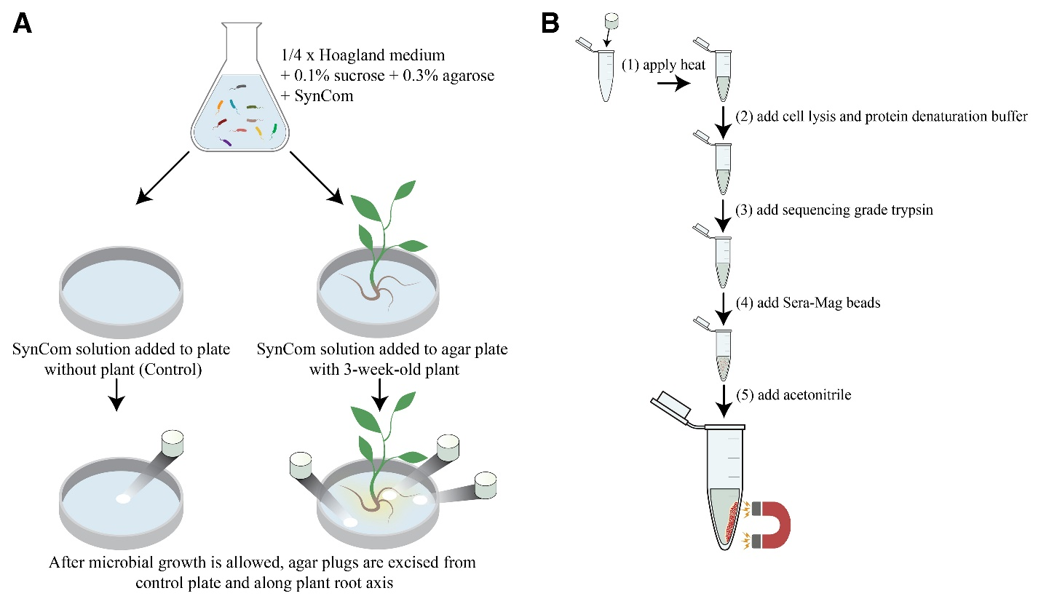

Figure 4.1: Experimental design to achieve spatially resolved plant root-associated microbes using an agar system. (A) A synthetic community (SynCom) containing 10 bacterial strains in equal numbers inoculated in 1/4× Hoagland's media + 0.1% sucrose + 0.3% agarose; control agar plates containing SynCom without a plant; plant (Populus trichocarpa B819) in agar containing SynCom; agar plugs excised from control agar plates containing SynCom without plant at 0, 24, and 48 h (n = 3); and agar plugs excised from root base, root tip, and distant regions for each plant in agar containing SynCom at 24 and 48 h (n = 3). (B) In-solution cell lysis, enzymatic protein digestion, and peptide extraction using Sera-Mag beads.

Extracting microbiomes directly associated with the plant root system for metaproteomics
To characterize microbiomes directly associated with the root surface, plant roots (biological triplicates) were excised with a sterile scalpel and transferred to Eppendorf tubes and washed in 300 µl of sodium dodecyl sulfate (SDS) lysis buffer (4% SDS [Sigma-Aldrich] in 100 mM Tris, pH 8.0) by vortexing gently to liberate microbial cells bound to roots. The roots were removed, and crude lysate suspensions were sonicated (30% amplitude, 10-s pulse with 10-s rest, 2-min total pulse time) (Branson digital sonifier) and boiled at 90°C for 10 min to complete microbial lysis. The cell lysates were centrifuged at 21,000 × g for 10 min at room temperature to remove any cell debris. Samples were reduced by adjusting to 10 mM dithiothreitol (Sigma Life Science) by incubating at 90°C for 10 min, followed by alkylation with iodoacetamide (Sigma Life Science) added to a final concentration of 30 mM and incubation for 15 min in darkness. Proteins were then extracted from the precleared lysates by protein aggregation capture ¹⁰⁹. Briefly, Sera-Mag beads (5 µl at 50 µg/µl) (GE Healthcare Life Sciences) were washed with liquid chromatography-mass spectrometry (LC-MS)-grade acetonitrile (ACN) (EMD Millipore Corp.) on a magnetic rack. Tubes were removed from the magnetic rack, and lysate was added and then adjusted to 70 % ACN to induce protein aggregation onto beads. Samples were allowed to settle for 10 min, gently resuspended, and allowed to settle for another 10 min. The samples were placed on a magnetic rack and the supernatant was removed, followed by washing with 1 ml of ACN and 1 ml of 70 % ethanol (EMD Millipore Corp.) while on a magnetic rack. The samples were removed from the magnetic rack and 50 µl of Tris buffer was added. Proteins bound to beads were processed with two sequential aliquots of sequencing-grade trypsin (Thermo-Scientific) for an overnight and 3-h enzymatic digest using a 1:75 (wt/wt) protein/trypsin ratio at 37°C with constant agitation (1,000 rpm). The samples were then adjusted to 0.1 % formic acid (FA) (Fisher Chemical), vortexed, and allowed to sit for 10 min. The samples were placed on a magnetic rack and supernatants containing the peptides were added to prewet Vivaspin 10 kDa MWCO filters (Sartorius) and centrifuged at 12,000 × g for 15 min at room temperature. Tryptic peptide flowthroughs were collected, and peptide concentrations were measured using the Nanodrop One spectrophotometer (Thermo-Scientific) and transferred to the autosampler vials for LC tandem MS (MS/MS) measurement.
Note that the root wash extraction described above was performed on a sample collected 48 h post inoculation (n = 3) with the 10-member SynCom and this measurement was paired with a “whole root plug” extract that is described below. These paired samples facilitated a metaproteomics comparison between microbiomes adhered to the root (i.e., root wash) versus those in close proximity (i.e., agar plug) (discussed above).
Extracting microbiomes from agar for metaproteomics
Microbial cell populations in agar were selectively excised using a sterilized scalpel to assess microbiome changes in composition and function across time and in response to the plant root system. To characterize how the SynCom microbiome changes across time in the absence of a plant root system, agar plugs were obtained from culture plates that lacked a plant root system at 0 h (control plug 0 h), 24 h (control plug 24 h), and 48 h (control plug 48 h) in biological triplicate. Note, because the amount of microbial cells surrounding a plant root system are expected to change for different plant hosts and starting inocula, the size (i.e., volume) of the agar plug should be evaluated per biological system. In this study, agar plugs equivalent to 0.5 ml were sufficient for each sample and, thus, used throughout this study. The agar plugs obtained at 0 h were excised immediately after the media turned into a semisolid state in order to assess whether extractions from agar alter microbiome measurements when compared with those obtained from the starting SynCom inoculum. The SynCom liquid control stock sample was prepared in biological triplicate by washing pelleted cells with phosphate-buffered saline to remove media and resuspending cells in 100 mM ammonium bicarbonate.
For plant-agar cultures, agar plugs were excised to obtain four spatial measurements: whole root, root tip, root base, and a region distant from the plant root system (approximately 3 to 4 cm distant from root, near the edges of the Petri dish). Whole-root agar plug samples were collected at 48 h and the other locations were collected at 24 and 48 h in biological triplicate. To ensure sufficient material for subsequent extractions, multiple agar plugs were pooled together; for example, agar plugs from all root tips for each plant were pooled. Prior to additional sample processing, all agar plugs (0.5 ml) were liquified by heating for 10 min at 90°C in a heat block.
Samples were processed by adding an equal volume of lysis buffer (4% sodium deoxycholate [SDC] in 100 mM ammonium bicarbonate) (Sigma-Aldrich) to bring the final concentration to 2% SDC and kept warm to avoid solidification of agar. Note, SDC was selected as the detergent because, unlike SDS, it permits trypsin activity and is easily removed (Masuda et al. 2008). The samples were sonicated (30% amplitude, 10-s pulse with 10-s rest, 2-min total pulse time) (Branson digital sonifier), then incubated at 90°C for 10 min. The cell lysates were centrifuged at 21,000 × g for 10 min at room temperature to remove any cell debris and proteins were quantified with a Nanodrop One spectrophotometer (Thermo-Scientific). Samples were reduced and alkylated as described in the section above. Samples were heated again briefly to reliquify the agar and allowed to cool down; then, proteins were processed with two sequential aliquots of sequencing-grade trypsin for an overnight and 3-h enzymatic digest using a 1:75 (wt/wt) protein/trypsin ratio at 37°C with constant shaking (1,000 rpm). Each sample was acidified with 1% FA, vortexed, and centrifuged at maximum speed for 10 min at room temperature to precipitate and remove SDC. Samples were transferred to new Eppendorf tubes where Sera-Mag beads (GE Healthcare Life Sciences) were used to aggregate and remove the agar from the samples. For each sample, Sera-Mag beads (approximately 5 µl at 50 µg/µl, previously washed and resuspended in equal volume of ACN) were added and final volumes were adjusted to 70% LC-MS-grade acetonitrile (EMD Millipore Corp.). Twice, samples were vortexed gently and allowed to rest for 10 min to allow for aggregation of the agar matrix onto the magnetic beads. Eppendorf tubes were then transferred to a magnetic rack where the supernatant solution containing peptides was removed and subsequently transferred to new tubes (Figure 4.1B). Importantly, care was taken to not aspirate Sera-Mag beads. To remove residual SDC, hydrated ethyl acetate was added to each sample at a 1:1 (vol/vol) ratio, vortexed, and centrifuged for 10 min at maximum speed. The lower aqueous layer containing the peptides was collected and cleaned again with ethyl acetate. The final lower aqueous layer containing peptides was transferred into new Eppendorf tubes, then vacuum-dried to completion using a SpeedVac Concentrator (Thermo-Fischer Scientific). The peptides were resolubilized in 0.1% trifluoroacetic acid and cleaned on a Pierce peptide desalting spin column (Thermo Scientific) per the manufacturer's instructions. Concentrated peptides were resuspended in a 25-μl aqueous solution (0.1% FA) and subsequently quantified using a Nanodrop One spectrophotometer (Thermo Scientific). Peptides were transferred to auto-sampler vials for LC-MS/MS measurements.
Protein identification and quantification
All peptides were analyzed using two-dimensional LC on an Ultimate 3000 RSLCnano system (Thermo-Fisher Scientific) coupled with a Q Exactive Plus mass spectrometer (Thermo-Fisher Scientific). For each sample, a 2-μg inject of digested peptide mixture was flowed across an in-house-built strong cation exchange (SCX) Luna trap column (5 µm by 150 µm by 50 mm) (Phenomenex) followed by a nanoEase symmetry reversed-phase (RP) C18 trap column (5 µm by 300 µm by 50 mm) (Waters) and an aqueous solvent (5% ACN and 0.1% FA), then washed for 10 min. The loaded peptide mixtures were separated and analyzed across three successive SCX fractions of increasing concentrations of ammonium acetate (35 mM, 50 mM, and 1 M), each followed by a 100-min linear organic gradient (250 nl/min flow rate) from 5% aqueous solvent (5% ACN and 0.1% FA) to 30% organic solvent (80% ACN and 0.1% FA) to separate peptides across an in-house-pulled nanospray emitter (75 µm by 350 mm) packed with C18 Kinetex RP C18 resin (1.7 µm) (Phenomenex). All MS data were acquired with Thermo Xcalibur (version 4.2.47) using the top N method, where N could be up to 10. Target values for the full-scan MS spectra were 3 × 10⁶ charges in the 300 to 1,500 m/z range with a maximum injection time of 25 ms. Transient times corresponding to a resolution of 70,000 at m/z 200 were chosen. A 1.6 m/z isolation window and fragmentation of precursor ions was performed by higher-energy C-trap dissociation with a normalized collision energy of 27 eV. MS/MS scans were performed at a resolution of 17,500 at m/z 200 with an ion target value of 1 × 10⁵ and a 50-ms maximum injection time. Dynamic exclusion was set to 20 s to avoid repeated sequencing of peptides. All MS raw data files were analyzed using the Proteome Discoverer software (version 2.5) (Thermo-Fisher Scientific) ¹¹⁰. Each MS raw data file was processed by the SEQUEST HT database search algorithm ¹¹¹ and confidence in peptide-to-spectrum (PSM) matching was evaluated by Percolator ¹¹². Peptide and PSMs were considered identified at q < 0.01 and proteins were required to have at least one unique peptide sequence. Protein relative abundance values were calculated by summing together peptide extracted ion chromatograms. Organism relative abundances were calculated by dividing their summed protein abundances from the sum total of all quantified protein abundances ^{87, 98}.
Statistical analysis
Proteins with at least one unique peptide were exported from Proteome Discoverer. Log₂-transformation of protein abundances was performed followed by local regression (LOESS) normalization and mean-centering across the entire dataset using InfernoRDN software (v1.1.7793) ¹¹³. To identify the differences in the proteome expression of the bacteria between different sample groups, PERMANOVA was performed across the control, distant from root, root tip, and root base samples at 24- and 48-h time points using the vegan package (v.2.5-7) in R ¹¹⁴. Protein abundances subset for each bacterial strain of the SynCom were extracted from the normalized dataset and further mean-centered using InfernoRDN. To improve the robustness of downstream analysis, the analysis was limited to proteins that were identified in at least two of three replicates of at least one sample group. The abundance values for proteins with missing values were imputed with random values drawn from the normal distribution (width 0.3, downshift 2.8) using Perseus software (v.1.6.12.0) ¹¹⁵. To identify the proteins that are differentially expressed across the measured proteomes, ANOVA was performed (permutation-based false discovery rate [FDR] < 0.05; number of randomizations = 250) across experimental conditions. Proteins that passed the significance threshold of P value ≤ 0.05 were characterized as significantly differentially abundant. One-way hierarchical clustering of standardized Z-scores using Euclidean distances for rows was performed for significantly changing proteins. For the clusters obtained, GO enrichment tests were performed using a Fischer's exact test using the OmicsBox software tool (v.1.4.11) (https://www.biobam.com/omicsbox). Biological process and molecular function GO terms that had an FDR-controlled P value < 0.05 were considered enriched.
Results and discussion
A novel approach to extract and characterize root-associated microbiomes using metaproteomics
Currently, extraction methods employing washing are used for metaproteomic characterization of root-associated microbiomes ^{56, 116}. Here, we evaluated the performance of a detergent-based wash solution (i.e., root wash) and compared it with the novel peptide extraction method from agar (i.e., agar extraction) (discussed below). For both methods, high-resolution mass spectrometry-based metaproteomics was employed to characterize the microbiome directly associated with a 3-week-old P. trichocarpa root surface 48 h post inoculation with a 10-member SynCom.
We found large differences in the number of total proteins identified and the plant root protein contamination between the two methods. For the root wash method, we identified 5,776 proteins, and approximately 37% (Figure 4.2A and 4.2B) of these were from Populus roots. Although metaproteomics has been applied in several root-related studies ^{56, 117, 118}, to our knowledge, there are no previous measurements that could be used to appropriately benchmark these results. Moreover, comparing these results to other studies is not trivial given that microbiome complexity (composition and function) is context specific. Nevertheless, qualitatively, these measurements achieved a similar depth in the number of organisms and proteins identified when compared with a measurement performed on a cell pellet obtained from the inoculum used for SynCom inoculation (Figure 4.3A). In general, this comparison suggests that the amount of biomass available for metaproteomic measurements in this plant–microbe root system was not a limitation.
The ability to selectively extract and characterize microbiomes from the agar surrounding the whole plant root system is expected to improve the depth and context of metaproteomic measurements for three major reasons: (i) avoiding an extraction directly from the root surface is expected to reduce the number of identified plant proteins; (ii) the amount of microbial biomass is not limited by root surface area; and (iii) spatial sampling provides locational context which, if varied across the root or nutritional gradients, enables the sampling of potential niche members or functional signatures that would otherwise be missed. Therefore, we compared the results from the root wash (whole root wash, 48 h) to an experimentally paired agar plug excised from the surrounding root (whole root plug, 48 h). Indeed, the overall metaproteomics depth achieved by this novel extraction method far surpassed the washing method alone (approximately 53% gain in protein IDs). In total, the extract and measurement from the collected whole root agar plug resulted in a higher number of proteins identified (8,853 proteins) with a notably lower percentage of plant proteins (3.3%) observed (Figure 4.2A and 4.2B). Additionally, approximately 90% of the proteins identified by the root wash method overlapped with the associated whole root agar plug.
Although the overall depth of the metaproteome coverage improved, the microbiome composition is expected to be spatially influenced by the plant root system. Therefore, we used metaproteomics to estimate relative microbial biomass amounts ⁹⁸ (Figure 4.2C; Supplementary Table S1) and performed an analysis of variance (ANOVA) test to assess the similarity of composition and relative abundance of organisms between the microbiome directly associated with the plant root system (root wash) and the microbiome in agar immediately surrounding the root (agar extraction). For this particular comparison, the overall microbiome composition was statistically unchanged (P = 1). Individually, however, a relatively low-abundance member (Rhizobium sp. strain CF142) did slightly vary in abundance between the two extractions (Table 4.1). The observed change in the abundance of this particular microbe could be indicative of a biological deviation from the averaged microbial population directly interacting with the root surface; however, an alternative explanation is that the increased metaproteomics depth resulting from reduced plant root protein “contamination” improved the accuracy of the estimated average composition of root-associated microbes. Furthermore, the agar-plug extraction method increased measurement reproducibility, as demonstrated by derived organism ratios across replicates (Figure 4.2C). Regardless, the estimated microbial compositions are nearly indistinguishable between the two approaches but, more importantly, the success of the agar-plug extraction method provides exciting new opportunities to achieve spatially resolved metaproteomics along the plant root axis.

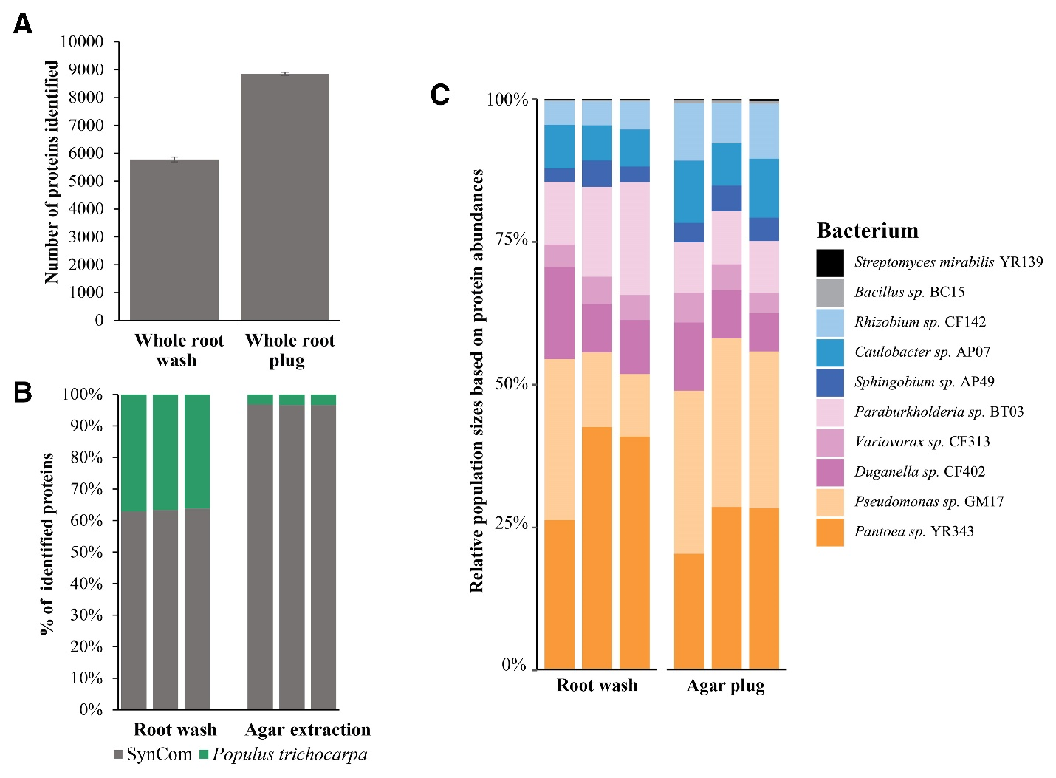
Figure 4.2: Proteins extracted from root-associated microbiomes using different extraction methods for plant-agar samples at 48 h. (A) Average number of proteins identified (n = 3). Error bars represent standard error of mean. (B) Percentage of proteins identified for synthetic community (SynCom) and Populus trichocarpa. (C) Relative organism abundances for the bacterial strains using their summed protein abundances.

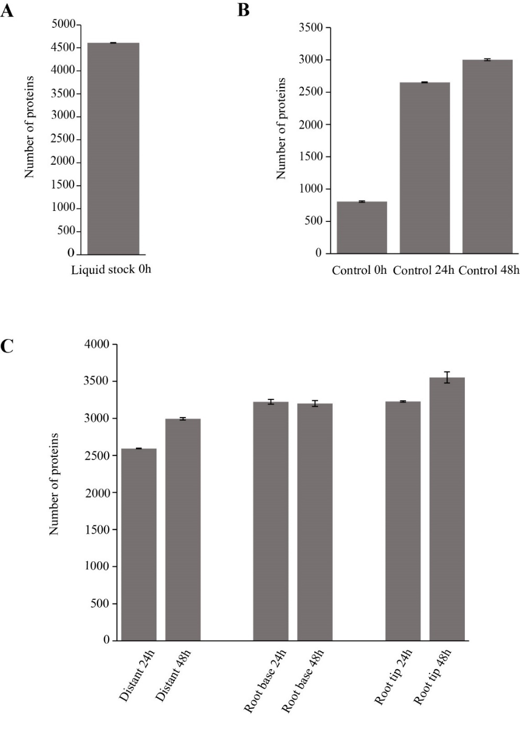

Figure 4.3: Global proteomics metrics using novel agar extraction method. (A) The average number of proteins identified from control liquid stock 0-h. (B) The average number of proteins identified from control plugs at 0-h, 24-h and 48-h (n=3). (C) The average number of proteins identified from root tip, root base and distant from root plugs at 24-h and 48-h (n=3). Error bars represent standard error of mean.

Organism | logFC | adj.P.Val
Rhizobium sp. CF142 | 0.04034625 | 0.03962449
Bacillus sp. BC15 | 0.00138612 | 0.0621787
Pantoea sp. YR343 | -0.096815 | 0.30685596
Pseudomonas sp. GM17 | 0.09726219 | 0.30990795
Caulobacter sp. AP07 | 0.020101 | 0.30990795
Paraburkholderia sp. BT03 | -0.0321095 | 0.31604486
Duganella sp. CF402 | -0.0319169 | 0.33093848
Streptomyces mirabilis YR139 | 0.00043477 | 0.33093848
Sphingobium sp. AP49 | 0.00167475 | 0.88251789
Variovorax sp. CF313 | -0.0003637 | 0.94010831

Table 4.1: LIMMA results using the relative abundances of the individual taxa comparing the agar sample to the root wash. Positive log fold change indicates increase in agar relative to root. A Benjamini-Hocherberg correction for multiple tests was applied.

Spatially resolved metaproteomics along the plant root axis
Spatiotemporal patterns of microbiome assembly, organization, and function are expected to exist along the plant root axis ^{93, 119} yet it remains unknown how, why, when, and where particular microbes successfully compete for plant-derived nutrients. Therefore, the ability to obtain high-quality metaproteomic datasets from agar motivated us to characterize the temporal and spatial assembly of the SynCom community along the P. trichocarpa plant root system.
Prior to studying the assembly and function of the SynCom along the plant root axis, we employed the newly developed extraction method to assess community composition changes between 0-, 24-, and 48-h time points in the absence of the plant (control) when allowed to grow in a modified growth media (discussed below). To support early microbial growth and motility, the Hoagland's growth media commonly used for growing plants was supplemented with 0.1% sucrose and 0.3% agarose (Figure 4.1A). On average, the number of identified proteins increased across the time points (Figure 4.3B), and this is likely a result of increases in available biomass as well as changes in the metaproteome expression profiles. Importantly, the estimated starting SynCom composition was statistically unchanged when extracted from the inoculum or using the newly developed agar extraction method (P = 1) (Figure 4.4). Based on a permutational multivariate analysis of variance (PERMANOVA) (P = 0.004), the overall community composition changed significantly in control across the 48-h period (Figure 4.5). Individually, nine members exhibited a significant change in their relative abundance between the time points (Table 4.2). In this particular environment (i.e., media sans P. trichocarpa), Pantoea sp. strain YR343 increased in relative abundance to become a dominant member of the SynCom at the 24-h time point. However, this was no longer apparent at the 48-h time point, whereby Caulobacter sp. strain AP07 and Rhizobium sp. strain CF142 became the two most dominant members.

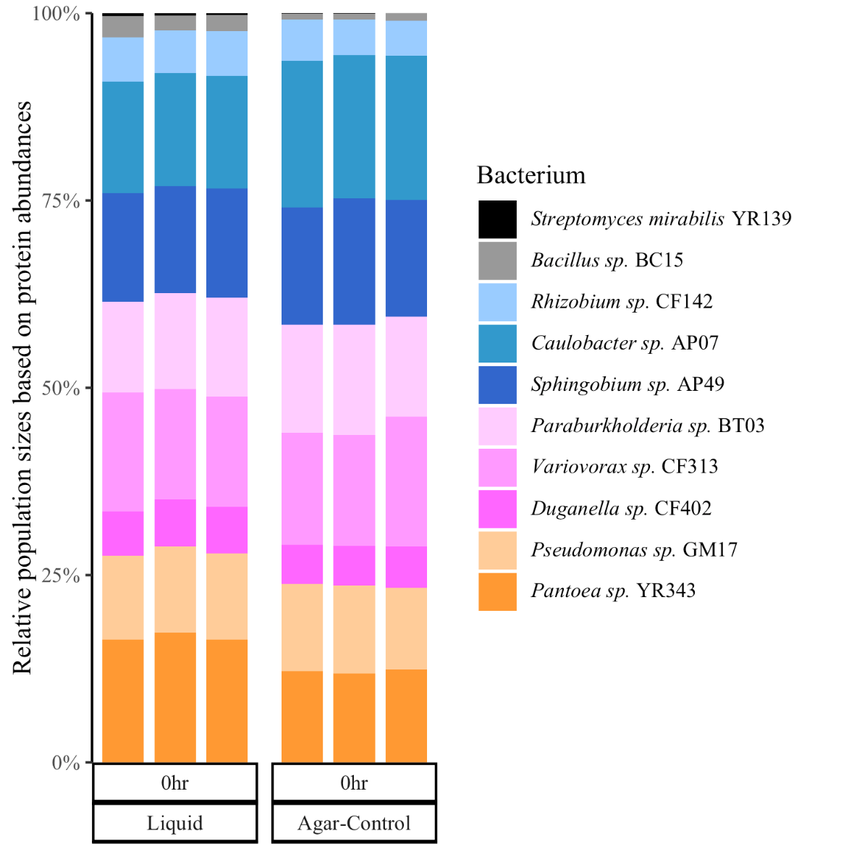

Figure 4.4: Assessment of microbial relative population sizes based on their summed protein abundances. Relative population sizes of microbes in control liquid stock 0-h and control plug 0-h, n=3.

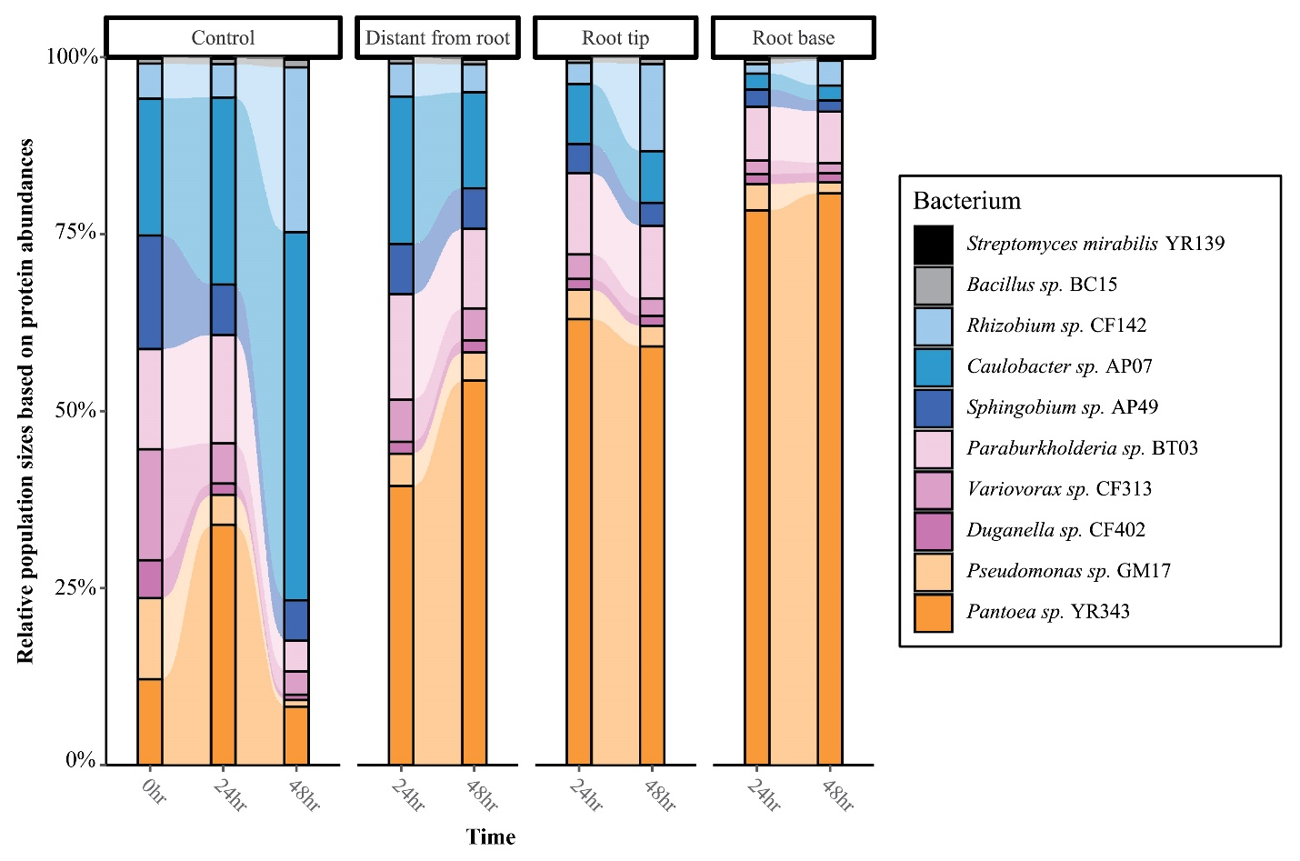
Figure 4.5: Assessment of microbial relative population sizes based on their summed protein abundances. Averaged organism relative abundances (n = 3) are illustrated for identified microbes in control plugs at 0, 24, and 48 h and three discrete locations surrounding the plant root system (root tip and base and a region distant from the root) at 24- and 48-h time points.

Organism | DF | p-value
Rhizobium sp. CF142 | 2 | 0.000865
Bacillus sp. BC15 | 2 | 0.07
Pantoea sp. YR343 | 2 | 0.00129
Pseudomonas sp. GM17 | 2 | 4.91E-08
Caulobacter sp. AP07 | 2 | 3.33E-05
Paraburkholderia sp. BT03 | 2 | 9.22E-07
Duganella sp. CF402 | 2 | 2.44E-08
Streptomyces mirabilis YR139 | 2 | 0.0017
Sphingobium sp. AP49 | 2 | 4.32E-06
Variovorax sp. CF313 | 2 | 4.67E-06

Table 4.2: ANOVA results for each member in the 10-member SynCom based on the relative abundances over time.

The same starting SynCom solution was then applied to a 3-week-old P. trichocarpa root system and allowed to grow for 48 h. To assess the influence of the plant root system on SynCom assembly, agar plugs were excised to obtain three spatial measurements: root tip, root base, and a region distant from the plant root system. Each discrete location was characterized at 24- and 48-h time points (Supplementary Table S1). Similar to the no-plant SynCom measurements, the average number of identified proteins generally increased from the 24- to 48-h time point and proteins identified per sample group ranged from 2,500 to 3,500 across the sample groups (Figure 4.3C). Overall, biological reproducibility between agar was high (average Pearson correlation coefficients of approximately 0.89).
To assess the effect of plant, spatial location, and time on the SynCom, PERMANOVA was performed on Euclidean distances using the metaproteomics data collected. Overall, the plant root system had the greatest influence on the measured microbiomes (50%), followed by the interaction between plant and time (24%), and time (14%) (Figure 4.6A; Table 4.3). Intriguingly, there was a notable difference between microbiome compositions in the control agar plug at the 48-h time point and the region distant from the root at the 48-h time point. Both sample groups were expected to have similarly assembled communities at the 48-h time point because the influence of plant nutrients was absent or presumably lacking. Given the observed differences in microbiome composition, this result suggests that the plant root's zone of influence reaches significantly outward to the edges (approximately 3 to 4 cm from nearest root) of the plant-agar culture plates. Here, the root-associated microbiome composition largely favored the abundance of Pantoea sp. strain YR343, with its relative abundances increasing in the SynCom along the root system and the greatest abundance being observed at the root base. Additionally, four individual members of the SynCom had relative abundances that were significantly changing across the plant root axis (Table 4.4). For example, Rhizobium sp. strain CF142 became the second most dominant member at the root tip at the 48-h time point (Figure 4.5).
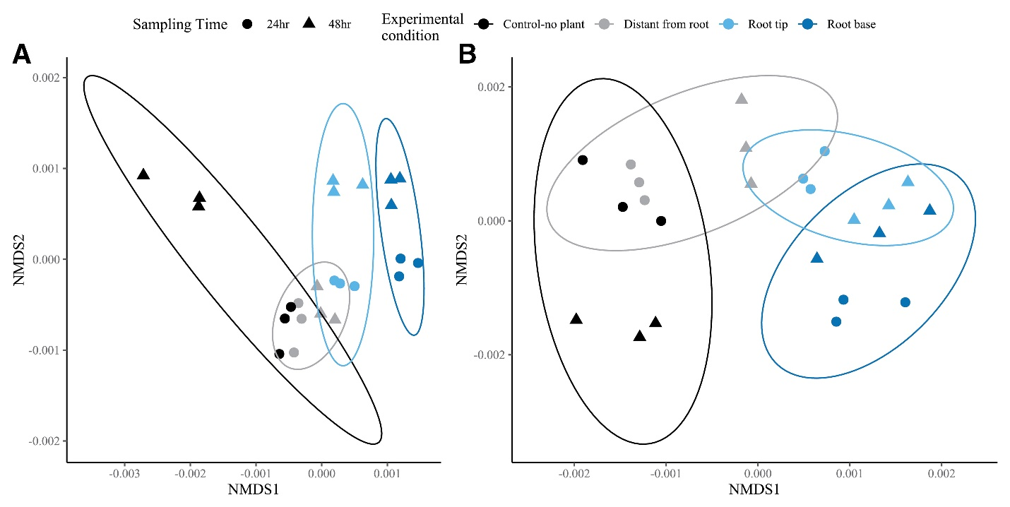
Figure 4.6: Association with plant shows higher variation in proteome expression of synthetic community. (A) Nonmetric multidimensional scaling (NMDS) plot based on Euclidean distances of 10-member proteomics data showed higher variation is observed in relation to association with the plant (permutational multivariate analysis of variance [PERMANOVA], R2 = 50.2%) followed by the interaction between the relation to plant and time (24%) and then time (13.9%). (B) NMDS plot based on Euclidean distances of Pantoea sp. strain YR343 proteomics data showed that higher variation is observed in relation to association with plant (PERMANOVA, R2 = 65.7%) followed by the interaction between the relation to plant and time (17.1%) and then time (8.4%).

A.
ADONIS 10-member SynCom results
Variable |  | Df | R2 | P
Spatial location |  | 3 | 0.502 | 0.001
Time |  | 1 | 0.139 | 0.001
Spatial location: Time |  | 3 | 0.24 | 0.001

B.
ADONIS Pantoea sp. YR343 results
Variable |  | Df | R2 | P
Spatial location |  | 3 | 0.657 | 0.001
Time |  | 1 | 0.084 | 0.001
Spatial location: Time |  | 3 | 0.171 | 0.001

Table 4.3: PERMANOVA results of Euclidean distances of proteins. (A) From all 10-member SynCom and (B) Pantoea sp. YR343 using the spatial location along the plant and time of sampling.
Organism | DF | p-value
Rhizobium sp. CF142 | 2 | 0.139
Bacillus sp. BC15 | 2 | 0.0517
Pantoea sp. YR343 | 2 | 0.0699
Pseudomonas sp. GM17 | 2 | 8.72E-04
Caulobacter sp. AP07 | 2 | 0.0513
Paraburkholderia sp. BT03 | 2 | 2.09E-01
Duganella sp. CF402 | 2 | 1.85E-01
Streptomyces mirabilis YR139 | 2 | 0.027
Sphingobium sp. AP49 | 2 | 1.45E-02
Variovorax sp. CF313 | 2 | 1.50E-03

Table 4.4: ANOVA results for each member in the 10-member SynCom based on the relative abundances at the 48h time across spatial locations.

Detecting functional changes in microbial activity along the plant root axis
Beyond estimating microbiome compositions, metaproteomics can improve our understanding of how a distinct subset of SynCom members was able to grow and thrive along the plant root system in this particular environment ^{54, 120}. To this end, we interrogated the proteome data of Pantoea sp. strain YR343, the most dominant plant-root-associated microbe, to assess its functional profile across the 24- and 48-h time points with and without the plant root system. Altogether, this analysis included 1,803 proteins representing approximately 37% of the encoded Pantoea sp. strain YR343 reference proteome. Importantly, this amount of proteome coverage is similar to what was achieved in prior proteomic studies of this individual bacteria ^{121, 122}.
Factors influencing microbiome composition were similar to those affecting proteome expression of Pantoea sp. strain YR343. PERMANOVA results indicate that the plant root system has a major influence (66%) on proteome expression, followed by the interaction of plant and time (17%) and time (8%) (Figure 4.6B; Table 4.3). To identify the differentially abundant proteins in Pantoea spp. across the measured proteomes, an ANOVA test was performed; 1,720 proteins were determined to have a significant difference in relative protein abundance across the sample groups (P value ≤ 0.05). One-way hierarchical clustering was performed providing a comprehensive picture of protein regulation across the experimental conditions (Figure 4.7). In total, four major clusters were observed. The cluster with the most membership (cluster 3; 566 proteins) consists of proteins with increased relative abundance in all plant root extractions when compared with the control samples at the 24- and 48-h time points. In other words, cluster 3 represents proteins upregulated in relative abundance in the presence of the 3-week-old P. trichocarpa root system. A gene ontology (GO) enrichment analysis on the proteins in cluster 3 revealed 36 overrepresented GO terms for biological processes and molecular functions (Supplementary Table S6). These GO terms included but were not limited to ion binding, cell motility, transport, response to stress, membrane organization, generation of precursor metabolites, and energy. At a high functional level, these molecular processes explain how Pantoea sp. strain YR343 responds to the plant root chemical environment where it competes for available resources through overexpression of several motility-related proteins such as methyl-accepting chemotaxis proteins, response regulator proteins with CheY-like receiver domains, chemotaxis signal transduction proteins, and reprogramming its growth and metabolic activities.
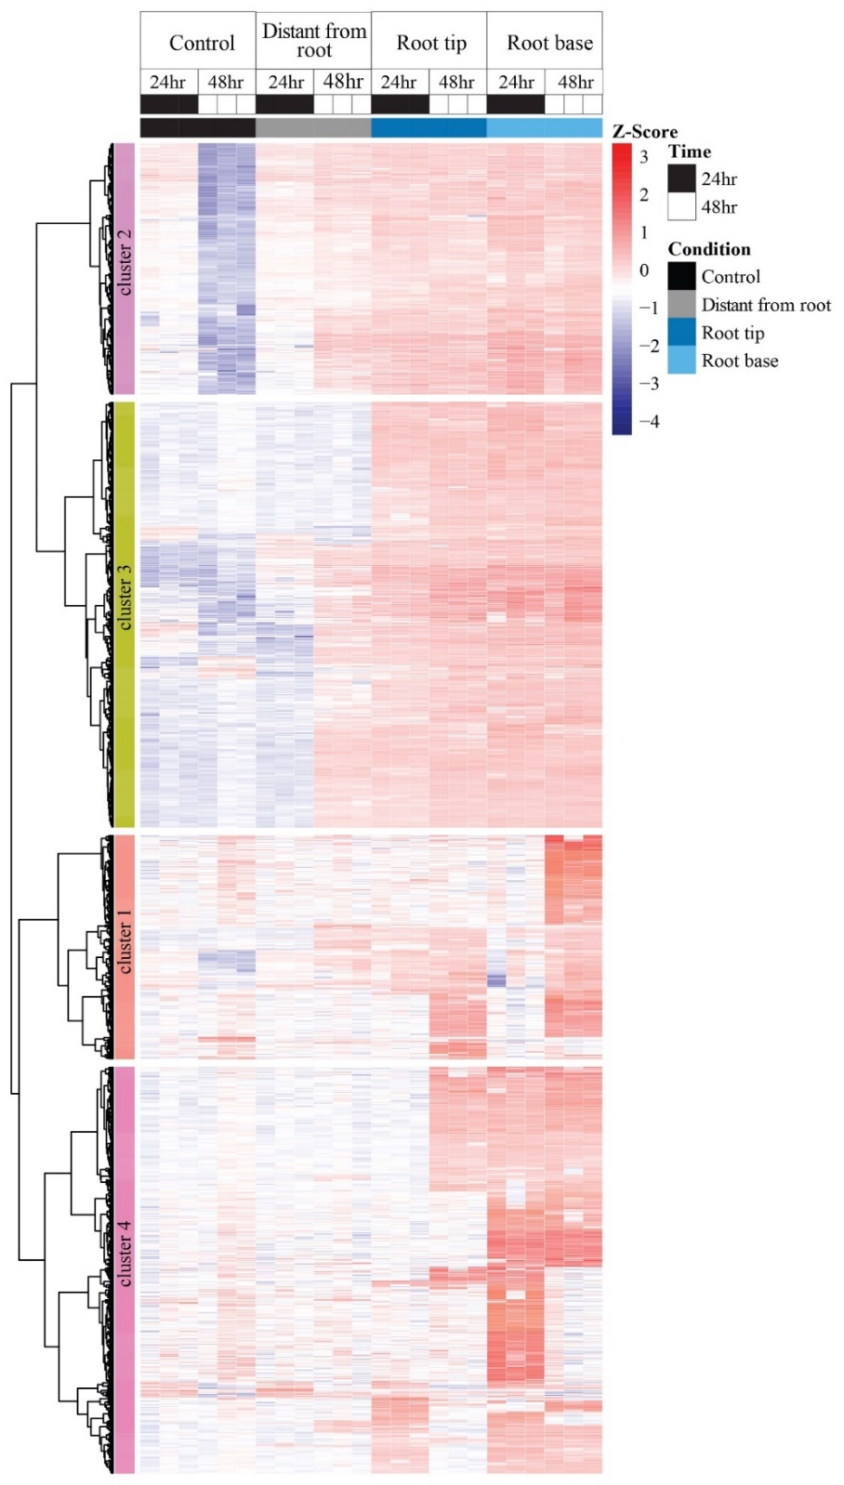
Figure 4.7: Hierarchical clustering results for Pantoea sp. strain YR343. One-way hierarchical clustering (rows = Euclidean distances) of Z-scores of log2-transformed protein abundances for significantly regulated proteins (multiple-sample test analysis of variance was performed in Perseus software, permutation-based false discovery rate < 0.05; number of randomizations = 250) across experimental conditions for Pantoea sp. strain YR343 revealed four major clusters of proteins.
Conclusions
Functional genomic measurements for plant-root-associated microbiomes are often challenged by the performance of available extraction methods ¹²³. In nature, plant root systems are surrounded by complex soil chemistries and physical properties that will vary by biome (e.g., tropical, temperate, or grassland) ^{124, 125}. In order to effectively extract the limited amount of available microbiome DNA, mRNA, or proteins, extraction protocols are often tailormade to the characteristics of the environmental matrix ^{126, 127}. For example, soils sustaining plants in natural forests or agricultural crops with higher humic acid amounts can be problematic for protein extraction methods ^{128, 129}. When successful, these holistic approaches provide necessary information for improving our understanding of plant–microbe interactions occurring in natural ecosystems by considering the interdependencies of environment, function, and genotype ^{54, 130}. Unfortunately, the complexity of these systems is often too high to answer questions related to how microbiome communities and functions are altered by plant root rhizodeposition at certain points in space or time.
In order to address knowledge gaps precluded by too much complexity, experimental representation of biological systems is instead refined to key parameters and their interplay. For plant-microbe interactions, these reductionist approaches are performed using a variety of artificial components ^{131, 132} or engineered laboratory systems and permit us to answer important questions currently unobtainable in natural ecosystems ^{37, 133}. For example, the widely used plant-agar system offers a well-controlled platform, with low-to-medium complexity, that would permit us to answer several important questions. How do microbiome communities assemble in the presence of a plant root system? How does composition and function change along the plant root system at certain points in time and space? Does assembly and maintenance of root-associated microbiomes observed with a specific plant genotype remain the same for other host genotypes? Unfortunately, a method to assess spatiotemporal plant–microbe interactions along the root system in plant-agar systems at a molecular level is yet to be realized.
In order to address this technical limitation, we developed a novel peptide extraction method for high-resolution metaproteome characterization of plant-agar systems. After inoculating a 3-week-old Populus plant root system with a 10-member SynCom and allowing growth for a 48-h period, we compared the performance (number of proteins identified) and resulting estimates of organism relative abundances between a root wash method and the newly developed agar extraction method. When comparing the two methods, we observed statistically unchanged estimates of microbiome composition and deeper metaproteome measurements (approximately 53% gain in protein identifications) for the agar extraction method, supporting the utility of the agar extraction method for whole-root characterization of microbiomes. More importantly, we demonstrated that this method affords new capabilities in sampling the spatial composition and function of root-associated microbiomes along the plant root axis.
For this particular plant–microbe biological system, substantial changes in composition and function were observed from the root base to the root tip, and even at a region distant from the plant root system. These findings have significant implications in our understanding of how microbiomes respond to plant rhizodeposition and how nutrient availability can affect the nature of microbiome assembly in different niche environments, particularly those associated with Populus spp. In fact, this study was designed to complement a previous work that used the same 10-member SynCom but assessed microbiome assembly in a liquid culture environment with rich or minimal media ⁸⁷. The high-level observation that the same 10-member SynCom forms different assemblies across varying methodological frameworks is quite intriguing because we can now work to identify rules of assembly, and understanding these rules will give us greater insight into predicting how microbiomes assemble in different environments. More broadly, we anticipate that this novel extraction approach will benefit other soft-agar plate studies that study nutrient exchange among microbes ¹³⁴.
Quite surprisingly, we recognized that the 10-member SynCom community assembled in this study is nearly identical in composition to that observed in a previously studied clay soil matrix that was measured using 16S ribosomal RNA gene amplicon sequencing ¹⁶. The major difference between the two experiments is that it took 21 or 2 days to form nearly identical communities in potted soil or plant-agar, respectively. We posit that environmental matrix properties such as hydration levels, which affect the diffusion of plant rhizodeposits and microbial mobility, resulted in these temporal differences. Although we anticipate that community assembly will become more distinct between the plant-agar system and more natural soils, the relatedness with clay soil matrix addresses concerns about the plant-agar system being too artificial.

Chapter 5
Unraveling bacterial adaptation strategies in the microbiome shaped by the chemical environment of the plant rhizosphere
Text and figures were adapted from the following published journal article:
Appidi. Manasa, Bible. Amber, Abraham. Paul, Jawdy. Sara, Hettich. Robert & Morrell-Falvey. Jennifer. (2024). Unraveling bacterial adaptation strategies in the microbiome shaped by the chemical environment of the plant rhizosphere. Phytobiomes Journal. 10.1094/PBIOMES-08-24-0081-R.
Manasa R. Appidi’s contributions include proteomic sample preparation, data collection and data analysis, writing and revisions of the manuscript.
Note: All the supplemental material including supplementary figures and tables mentioned in text are available at https://doi.org/10.1094/PBIOMES-08-24-0081-R and their numbering reflects that of the online material.
Introduction
The rhizosphere represents a dynamic and complex environment where chemical and physical factors play crucial roles in shaping microbial communities ^{135, 136}. Plant roots release a variety of compounds, such as root exudates, which serve as a rich nutrient pool for microbial populations and signals for plant-microbe interactions ^{137, 138}. These exudates, comprised of sugars, organic acids, amino acids, and other compounds, create a unique chemical milieu that attracts and sustains a diverse array of microorganisms ^{96, 138, 139}. Simultaneously, the physical structure of the rhizosphere, influenced by root morphology and soil composition, further contributes to the niche-specific conditions ^{140, 141}. The intricate interplay of chemical and physical parameters in the rhizosphere dictates the composition and functioning of associated microbial communities, impacting plant health and nutrient cycling ¹⁴². Bacteria that are beneficial to the plant are collectively referred to as plant growth-promoting rhizobacteria (or PGPR), and they influence plant growth and health by exerting a range of functions such as phosphate solubilization, nitrogen fixation, enhancing water availability, suppression of pathogenic activity, and synthesis of phytohormones ¹⁴³⁻¹⁴⁵. The intricate interactions between plants and PGPR within the rhizosphere underscore the complexity of functional dynamics in this critical zone and emphasize the pivotal role these bacteria play in fostering and modulating plant health. Beyond their direct interactions with the plant host, plant-associated bacteria interact with other soil organisms, competing for space and resources in the complex soil ecosystem ¹⁴⁶. Comparative genomic analyses of diverse bacteria have uncovered specific genes that are enriched in plant-associated bacteria compared to their non-plant-associated counterparts, particularly in genes related to carbohydrate metabolism ¹⁰⁵. Similarly, meta-transcriptomic investigations of microbial communities in the rhizosphere have unveiled specific pathways and gene products crucial for survival in this dynamic environment ^{147, 148}. Furthermore, the characterization of mutants in genetically tractable organisms has identified additional bacterial gene products contributing to plant association ^{149, 150}. Despite significant strides in unraveling the drivers of plant association, there remain considerable knowledge gaps regarding how environmental conditions in the rhizosphere, along with interactions among diverse organisms, shape the composition and functionality of the plant microbiome. To this end, metaproteomics can provide important complementary information about the detailed metabolic activities of microbial communities, thereby helping to expand our understanding of these dynamics and provide insights into the complex interplay between plant-associated bacteria and the surrounding environment.
To gain a deeper understanding into the chemical and physical cues that drive plant-microbe interactions, researchers often employ synthetic microbial communities consisting of defined mixtures of microorganisms ^{39, 151, 152}. These model systems help delineate the functions of specific microbial taxa in plant-microbe interactions, not only on an individual basis, but also within the larger context of the microbial community. Key mechanisms underlying the establishment of symbiotic relationships, nutrient cycling, and the overall resilience of plant-associated microbial ecosystems can be uncovered by manipulating synthetic communities in controlled experiments. This approach provides valuable insights into the fundamental principles governing plant-microbe interactions. In our previous studies, a metaproteomic analysis of a synthetic microbial community consisting of ten bacterial strains isolated from Populus deltoides roots grown under varying nutrient conditions revealed a number of functions and adaptation strategies employed by the most abundant bacterial species in the community in response to interspecies interactions and nutrient competition in a simplified liquid media ^{87, 88}. The bacterial strains in the ten-member constructed community were selected to be representative of the diversity found within the natural poplar microbiome ^{87, 88, 153}. In the current study, we aimed to better understand how these ten bacterial species alter their proteome in the presence of a plant host which influences microbial behavior through chemical cues and physical interactions. Historically, these types of studies present a unique set of challenges, including limited bacterial biomass, inherent difficulty in separating bacteria from plant root tissue, and extraction of plant proteins that may influence measurements of the bacterial proteome ¹⁵⁴. Recent strides in methodologies, particularly those employing a plant in an agar system, have facilitated the extraction of microbial proteomes from the agar surrounding plant roots and provided insights into the spatial dynamics of microbial recruitment and community composition ¹⁵⁵. Despite these advances, there is a need for novel approaches that can effectively surmount the existing challenges associated with studying microbial functions that are most likely influenced by the chemical environment of the plant.
In this study, we employ a unique approach for analyzing bacterial responses to the plant rhizosphere chemical environment by applying bacteria to a filter that is in contact with the plant roots. The use of a filter allows for chemical exchange between the bacteria and the plant roots but prevents physical interactions between them, thereby facilitating efficient bacterial collection for proteomics analyses. While this reductionistic approach was designed as a practical solution to studying how bacteria respond to the chemical environment of a plant, we acknowledge the constraints associated with this experimental design, namely that the bacteria are not in direct contact with the plant root, which precludes measurement of contact-dependent responses and that the quantity and composition of the applied bacterial samples may not reflect the spatial and temporal organization of the natural community. For these reasons, we take care to qualify our results in the framework of our experimental approach and avoid over-reach about the more complicated in vivo system. Using this approach, we investigated the proteome profiles of ten bacterial strains originally isolated from the Populus rhizosphere. Our experimental design involved assessing the bacterial proteomes when grown individually and in a synthetic community in both the presence and absence of a plant. Our findings demonstrate discernible differences in the behavior of individual bacterial strains in response to the chemical environment of a plant host and within a plant-associated bacterial community. This study contributes to our understanding of the dynamic interplay between bacteria and their surroundings and provides valuable insights into bacterial functional adaptations in response to the plant host and other species within the microbial community.
Materials and methods
Preparation of plants, bacterial cultures, and growth conditions
Sterile cuttings of Populus trichocarpa genotype BESC819 plants were generated from shoot tips of greenhouse-grown plants and grown in Murashige-Skoog (MS) media for three weeks for rooting in plant growth chambers as described previously ¹⁵⁰. Bacterial strains used in this study are listed in Table 5.1. All strains were grown in 100 mL liquid R2A media (Teknova) with shaking at 28°C. Most strains were grown overnight, but slower growing strains, including Rhizobium sp. CF142 and Streptomyces sp. YR139, were grown for two days. The Pantoea sp. YR343 transposon mutant MCP2190::Tn5 was described previously ¹⁴⁹.
Expression of plant-responsive promoters on Populus roots using filter-based system
Pantoea sp. YR343 (pPROBE-DGC2884) was grown overnight in R2A media with shaking at 28°C ¹⁴⁹. Cells were collected by centrifugation at 5,000 rpm for 5 minutes (Eppendorf 5424 microcentrifuge), then washed and resuspended in PBS at a final optical density of 2.11 (at 600 nm). Next, we placed 3-week old rooted Populus cuttings on the surface of agar plates consisting of 0.25 X Hoagland’s modified basal salt mixture (PhytoTech Labs) with 0.1% sucrose and 1.5% agar. A sterilized 0.45 µm nylon filter (Millipore) was placed along the length of the plant root or on top of the media as a control. Washed cells were then spotted as 5 µL drops on the sterilized filter strips and incubated in a plant growth chamber at 24°C with a 12-hour light and 12-hour dark photoperiod. After 24 hours, cells were scraped from filters and imaged for expression of GFP (green fluorescent protein) using a Zeiss LSM710 confocal microscope equipped with a 63X objective.
Bacterial strain | Phylogeny
Streptomyces mirabilis YR139 | Actinobacteria
Bacillus sp. BC15 | Firmicutes
Caulobacter sp. AP07 | α-Proteobacteria
Rhizobium sp. CF142 | α-Proteobacteria
Sphingobium sp. AP49 | α-Proteobacteria
Duganella sp. CF402 | β-Proteobacteria
Paraburkholderia sp. BT03 | β-Proteobacteria
Variovorax sp. CF313 | β-Proteobacteria
Pantoea sp. YR343 | γ-Proteobacteria
Pseudomonas sp. GM17 | γ-Proteobacteria
Engineered Strains | Reference
YR343 (pPROBE-DGC2884) | ¹⁴⁹
MCP2190::Tn5 mutant (mCherry) | ¹⁴⁹
Pantoea sp. YR343:GFP | ¹⁵⁰
Table 5.1: Bacterial strains utilized in this study
Bacterial inoculation on Populus roots using a filter-based system
We used 0.25 X Hoagland’s modified basal salt mixture (PhytoTech Labs) with 0.1% sucrose and 1.5% agar in standard 100 mm diameter petri dishes for studying bacterial responses to plant root chemicals. Fresh cultures of bacterial cells were collected by centrifugation at 5,000 rpm for 5 minutes in a F13-14x50cy rotor. Cells were washed in sterile PBS, then adjusted to a volume of 10 mL at an optical density at 600 nm (OD600) of 6.0. Next, we added individual plants to petri dishes filled with the plant media. On top of each plant root, we added a sterilized 0.45 µm nylon filter (Millipore) and took care to ensure the membrane contacted roots only, not stems or leaves. We then added 1 mL of cell culture to the filter. For control experiments that had no plants, we placed a sterilized 0.45 µm nylon filter on the plant media directly and then added 1 mL of cell culture. For the 10-member community, all ten strains were mixed in equal ratios and inoculated onto nylon filters both in the presence and absence (control) of a plant root as described above for individual strain inoculation. In order to avoid damaging the plants, lids were removed from the petri dishes for the duration of the experiment and replaced with a sterilized 8-ounce PhytoCon clear plastic container (PhytoTech labs) to maintain adequate humidity and a sterile environment. All containers were placed into a reach-in plant chamber and incubated at 24°C with a 12-hour light and 12-hour dark photoperiod for 48 hours prior to harvesting the bacteria. Bacterial cells were harvested for proteomics by rinsing filters with PBS and collecting cell pellets in microcentrifuge tubes. Cell densities were measured to allow for standardization during data analysis.
Cellular protein extraction for proteomic analyses
Cell pellets were resuspended in 300 µL of lysis buffer (4% sodium dodecyl sulfate (SDS) in 100 mM Tris, pH 8.0) by vortexing. Samples were heated at 90°C in a heat-block for 10 minutes followed by sonication for 2 mins (30% amplitude, 10-s pulse with10-s rest, 2-min total pulse time) (Branson digital soniﬁer) and heated for additional 10 minutes at 90°C. Samples were centrifuged at maximum speed for 10 minutes to remove the cell debris and the cell lysates were collected into a fresh tube. Proteins were quantified using a Nanodrop One spectrophotometer (Thermo Scientific). Samples were reduced with 10mM dithiothreitol (DTT) and incubated at 90°C for 10 minutes. Samples were then alkylated by incubating with 30 mM iodoacetamide (IAA) for 15 minutes in the dark to prevent the reformation of disulfide bonds. Proteins were agglutinated on Sera-Mag beads using Protein Agglutination Capture method as described previously ¹⁰⁹. Proteins were digested with two separate and sequential aliquots of sequencing grade trypsin (Promega) at 1:75 (wt/wt) protein:trypsin ratio. Proteins were first digested overnight, followed by 3 hours. The digestions were done at 37°C at constant shaking. The samples were acidified with formic acid to 0.5% formic acid concentration and vortexed. Vivaspin 500 columns (10 kDa MW cutoff filter) were equilibrated with 500µL of 100mM tris, pH 8.0 and centrifuged at 12,000 x g for 15 minutes. Tryptic peptides were added to the equilibrated Vivaspin columns and centrifuged at 12,000 x g for 15 minutes and the flow-through was collected. Care was taken to not aspirate Sera-Mag beads. Peptides were quantified using a Nanodrop One spectrophotometer (Thermo Scientific) and transferred to the auto-sampler vials for LC-MS/MS measurement.
Protein identification and quantification
All peptides were analyzed using two-dimensional (2D) liquid chromatography (LC) on an Ultimate 3000 RSLCnano system (Thermo Fisher Scientific, USA) coupled with a Q Exactive Plus mass spectrometer (Thermo Fisher Scientific, USA). For each sample, a 2 μg inject of digested peptide mixture was flowed across an in-house built strong cation exchange (SCX) Luna trap column (5µm, 150µm X 50mm; Phenomenex, USA) followed by a nanoEase symmetry reversed phase (RP) C18 trap column (5µm, 300µm X 50mm; Waters, USA) an aqueous solvent (5% ACN, 0.1% FA) and then wash for 10 min. The loaded peptide mixtures were separated and analyzed across three successive SCX fractions of increasing concentrations of ammonium acetate (35mM, 50mM, and 1M), each followed by a 100-minute linear organic gradient (250 nL/min flow rate) from 5% aqueous solvent (5% ACN, 0.1% FA) to 30% organic solvent (80% ACN, 0.1% FA) to separate peptides across an in-house pulled nanospray emitter (75 µm X 350 mm) packed with C18 Kinetex RP C18 resin (1.7 µm; Phenomenex, USA). All MS data were acquired with Thermo Xcalibur (version 4.2.47) using the top N method where N could be up to 10. Target values for the full scan MS spectra were 3 x 10⁶ charges in the 300 – 1,500 m/z range with a maximum injection time of 25 ms. Transient times corresponding to a resolution of 70,000 at m/z 200 were chosen. A 1.6 m/z isolation window and fragmentation of precursor ions was performed by higher-energy C-trap dissociation (HCD) with a normalized collision energy of 27 eV. MS/MS scans were performed at a resolution of 17,500 at m/z 200 with an ion target value of 1 x 10⁵ and a 50 ms maximum injection time. Dynamic exclusion was set to 20 s to avoid repeated sequencing of peptides. All MS raw data files were analyzed using the Proteome Discoverer software (version 2.5, Thermo Fisher Scientific, USA) ¹¹⁰. Each MS raw data file was processed by the SEQUEST HT database search algorithm ¹¹¹and confidence in peptide-to-spectrum (PSM) matching was evaluated by Percolator ¹¹². Peptide and PSMs were considered identified at q < 0.01 and proteins were required to have at least one unique peptide sequence. Protein relative abundance values were calculated by summing together peptide extracted ion chromatograms. Organism relative abundances were calculated by dividing their summed protein abundances from the sum total of all quantified protein abundances ⁹⁸.
Statistical analysis
Proteins with at least one unique peptide were exported from Proteome Discoverer. Log2-transformation of protein abundances was performed followed by LOESS normalization and mean-centering across the entire dataset using InfernoRDN software v1.1.7793 ¹¹³. For the community samples, protein abundances subset for each bacterial species were extracted from the normalized dataset and further mean-centered using InfernoRDN. To improve the robustness of downstream analysis, the analysis was limited to proteins that were identified in at least two out of three replicates of at least one sample group. The abundance values for proteins with missing values were imputed with random values drawn from the normal distribution (width 0.3, downshift 2.8) using Perseus software v.1.6.12.0 ¹¹⁵. To identify the proteins that are differentially abundant in the presence of a plant compared to the control for each bacterial species, a student’s t-test was performed and proteins that pass the significance threshold of p-value ≤ 0.05 and absolute Log2-fold change greater than 1 are characterized as significantly differentially abundant.
Root colonization assays
Colonization experiments were performed as described previously ¹⁵⁰. Briefly, wild type Pantoea sp. YR343 and the MCP2190::Tn5 mutant (affecting PMI39_02190) were grown overnight in R2A media as described above. We treated 3-week-old P. trichocarpa BESC819 plants that were transplanted into a clay soil supplemented with Hoagland’s nutrient solution with approximately 10⁷ cells per plant. Plants and bacteria were grown for three weeks as described above, then harvested for analysis of colony forming units and imaging of root colonization. To facilitate imaging, we used a GFP-labeled wild type strain and a mCherry-labeled MCP2190::Tn5 strain that was generated previously ¹⁴⁹. Imaging was performed using a Zeiss LSM710 confocal microscope.
Results
A filter-based system enables the study of bacterial responses to the plant root chemical environment without physical contact with the plant
The ability to examine how plant root association influences bacterial physiology has been hampered by the difficulty of separating root-associated bacterial biomass from plant material to allow for robust proteomic analyses. As a compromise, we reasoned that bacterial responses to the plant host could be examined using a filter-based system that allows chemical exchange between the plant root and bacterial inoculum but maintains physical separation to facilitate bacterial sample collection (Figure 5.1). Control experiments were performed by growing bacteria on a filter in the absence of a plant (Figure 5.1A) and compared to bacteria on a filter placed over a plant root (Figure 5.1B, 5.1C). For these experiments, we utilized nylon filters with a 0.45 µm pore size due to the convenience of sterilization, overall durability, and common use in metabolomics studies (for example, ¹⁵⁶), suggesting minimal negative effects on chemical communication between the plants and bacteria. To test this experimental design, we utilized a previously characterized plant-responsive reporter strain of Pantoea sp. YR343 in which GFP expression is driven by the promoter of a gene encoding a diguanylate cyclase (PMI39_02884) that is active in the presence of a plant host ¹⁴⁹. A nylon filter was placed on the roots of P. trichacarpa BESC819 on an agar plate containing 0.25 X Hoagland’s media supplemented with 0.1% sucrose and the Pantoea sp. YR343 reporter strain was applied to the filter and allowed to incubate for 24 hours. A control filter with the reporter strain was placed on a separate agar plate to examine the response in the absence of the plant. Comparison of GFP fluorescence levels from the Pantoea sp. YR343 reporter strain showed significantly higher fluorescence in the presence of the plant root compared to the control filter indicating that the promoter of gene PMI39_02884 can be activated under these experimental conditions (Figure 5.1D, 5.1E). This result is consistent with the assumption that bacteria can respond to the chemical environment of the plant through the filter.

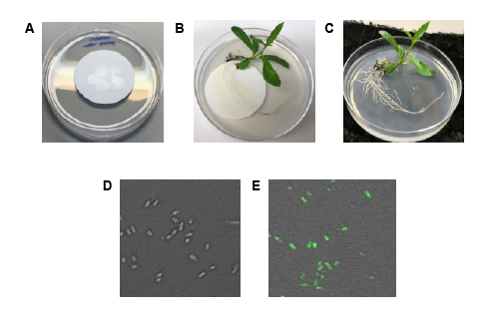
Figure 5.1: Overview of experimental design and proof-of-concept. The experimental design consisted of agar plates with nylon filters that were inoculated with bacteria and placed on agar plates as (A) a control or (B) on the roots of an axenic Populus trichocarpa BESC819 plant. (C) plant root after removal of the filter with bacteria. (D, E) GFP expression in Pantoea sp. YR343 (pPROBE-DGC2884) cells grown on filters in the (D) absence or (E) presence of a plant root. GFP expression is controlled by a plant responsive promoter that responds to chemical signals detected through the filter.

Quantification of bacterial proteomes revealed varying responses to the presence of a plant by individual isolates
Based on the results above, we proceeded to investigate the impact of the plant-associated chemical environment on the responses of ten bacterial species previously isolated from Populus deltoides roots ^{87, 88}. Each bacterial species was grown individually and inoculated onto nylon filters both in the presence and absence (control) of a plant root. Following incubation for 48 hours, the bacterial cells were collected from filters for proteomic analyses. In this global proteomic measurement, taxon-specific proteins were identified across the ten bacterial strains grown individually, with comparable measurement depths between strains grown in the absence or presence of plant roots (Figure 5.2, Supplemental Table 1).
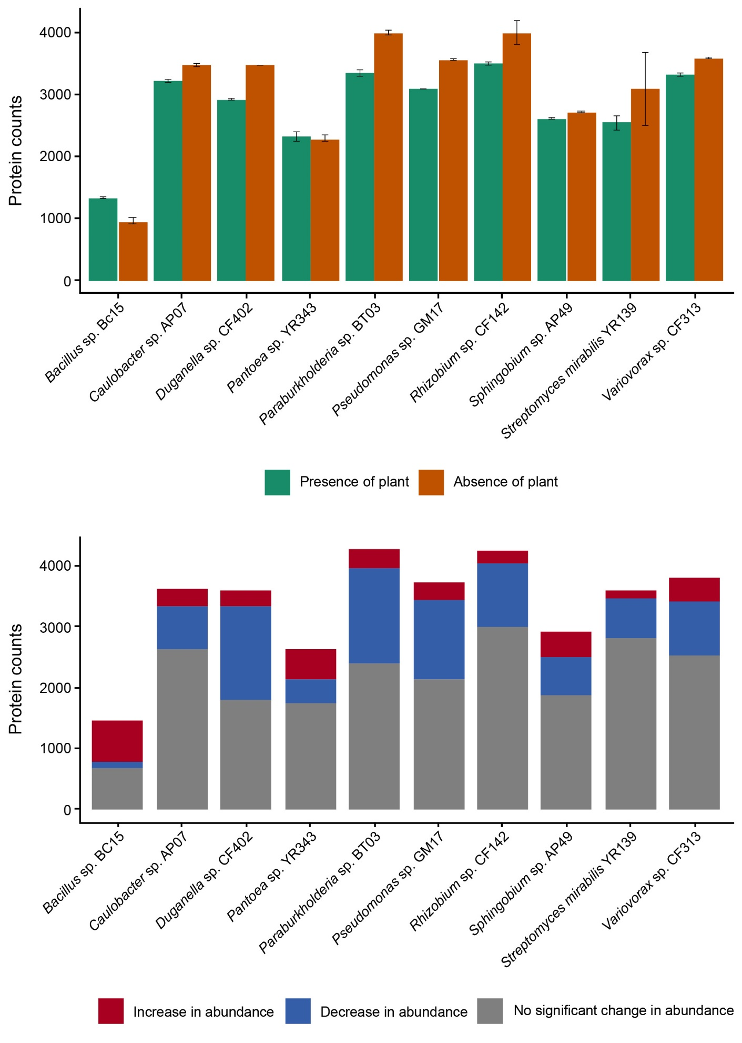
To identify the responses of these bacterial strains to the plant root environment, a differential proteomic analysis was performed for each strain. To assess changes in the abundances of individual proteins in the presence of plant compared to controls for each strain, a student’s t-test was performed and proteins with significant differences (p-value < 0.05, and absolute log2 FC >1) in protein abundances were identified (Supplemental Table 2). In response to the plant root chemical environment, these bacterial strains displayed varying degrees of changes in their proteome regulation (Figure 5.3). For example, a large percentage of the Bacillus sp. BC15 proteome underwent significant changes (~54%); a similar trend was observed in Duganella sp. CF402 (~50%). However, the directionality of change is opposite in these two strains, with 87% of the differentially abundant proteins showing an increase in abundance in Bacillus sp. BC15, whereas 85% of the differentially abundant proteins showed a decrease in abundance in Duganella sp. CF402 when grown in the presence of a plant. In Pantoea sp. YR343, although only 33% of its measured proteins displayed significant changes in the presence of a plant compared to the control, more proteins (56%) showed an increased abundance, similar to Bacillus sp. BC15. All other bacterial strains displayed a similar trend as Duganella sp. CF402, where the majority of the significantly changing proteins exhibited decreases in abundance in the presence of a plant. The shifts in protein abundances across these bacterial strains highlight strain specific patterns in response to the plant root environment under these experimental conditions.

Figure 5.2: Average number of proteins identified (n=3) in proteomic analysis of ten bacterial strains grown individually in the absence or presence of the plant. Error bars represent standard deviation of mean.

Figure 5.3: Stacked bar charts showing the number of differentially abundant proteins for ten bacterial strains grown individually in the presence of a plant compared to when grown in the absence of a plant.

The plant-associated chemical environment impacts the microbiome population structure
We then investigated the impact of the plant-associated chemical environment on proteomic changes of these ten bacterial strains when grown together in a mixed community. Based on previous studies of the 10-member community in plant root colonization ¹⁵³, we prepared a mixture of all ten strains in equal ratios that was then inoculated onto nylon filters both in the presence and absence (control) of a plant root. After 48 hours of incubation, the bacterial cells were collected from filters for metaproteomic analyses. Taxon-specific proteins were identified for the community samples from control experiments and when grown in the presence of plant roots (Figure 5.4A, 5.4B and Supplemental Table 3). The depth of the measurements decreased somewhat for each strain compared to when grown individually yet remained comparable between the presence or absence of plants. Due to variations in measurement depths for each strain when grown individually and in a community setting, we deemed it was more informative to compare functional categories rather than protein inventories to discern plant-driven and community-driven responses in these bacterial strains.
First, to identify the impact of Populus root chemical environment on the microbiome population structure after 48 hours, the relative abundances of each bacterial strain in the community were assessed and compared between control and with plant samples using summed protein abundances (i.e., summed total relative protein abundance per organism divided by the summed total protein abundance of community) (Figure 5.5). To assess how the plant affects the microbial community, PERMANOVA was performed using the metaproteomics data. Overall, the change in the relative protein abundances for the community was not statistically significant (p=0.1). However, the individual organism's relative abundances changed between the control and in the presence of the plant. Five members (Bacillus sp. BC15, Pantoea sp. YR343, Paraburkholderia sp. BT03, Pseudomonas sp. GM17, and Variovorax sp. CF313) of the 10-member community showed statistically significant increases in their relative abundances when grown with the plant compared to the control. Three species (Caulobacter sp. AP07, Duganella sp. CF402 and Sphingobium sp. AP49) showed statistically significant decreases in their relative organism abundance, while changes in relative abundances of Rhizobium sp. CF142 and Streptomyces sp. YR139 were not statistically significant (Supplemental Table 4).
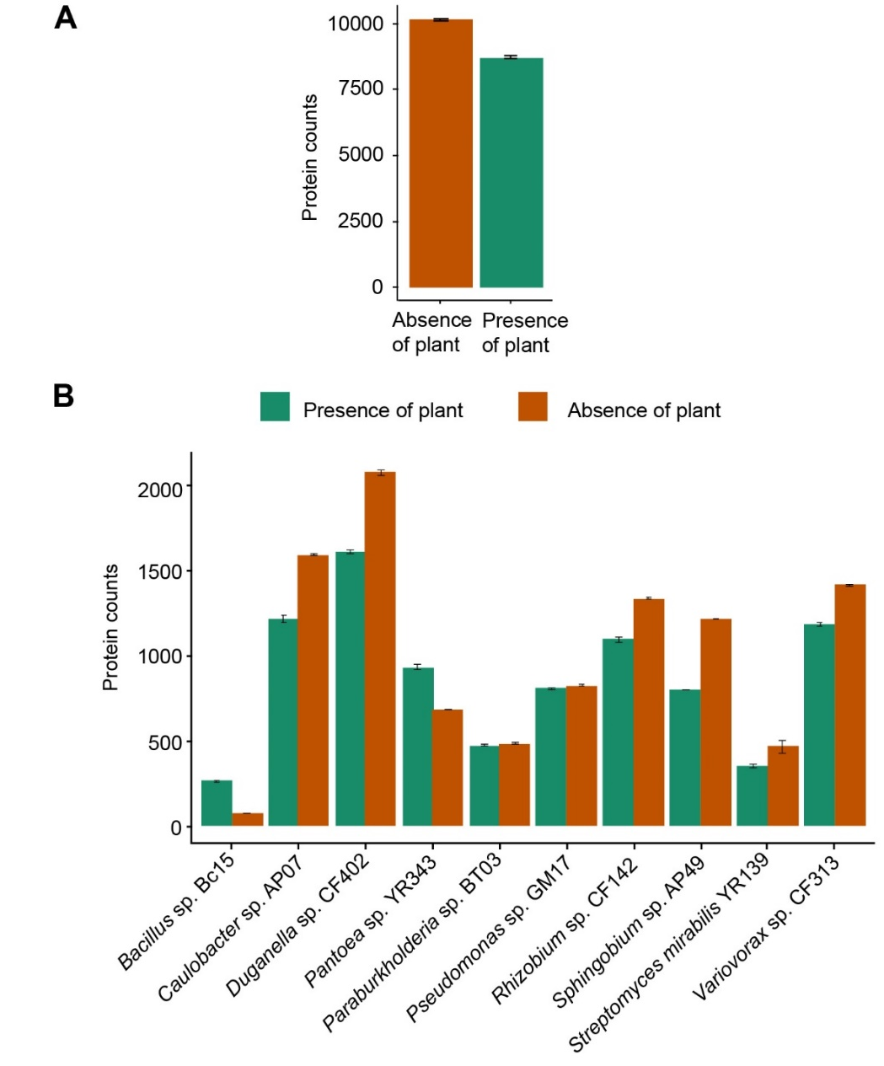
Figure 5.4: Overview of number of proteins identified in metaproteomics results for ten bacterial strains grown in a mixed community in the absence or presence of a plant. (A) Average number of proteins identified for the 10-member community grown in the absence or presence of a plant (n=3). Error bars represent standard deviation of mean. (B) Average number of proteins identified for each bacterial strain in the 10-member community grown in the absence or presence of a plant.
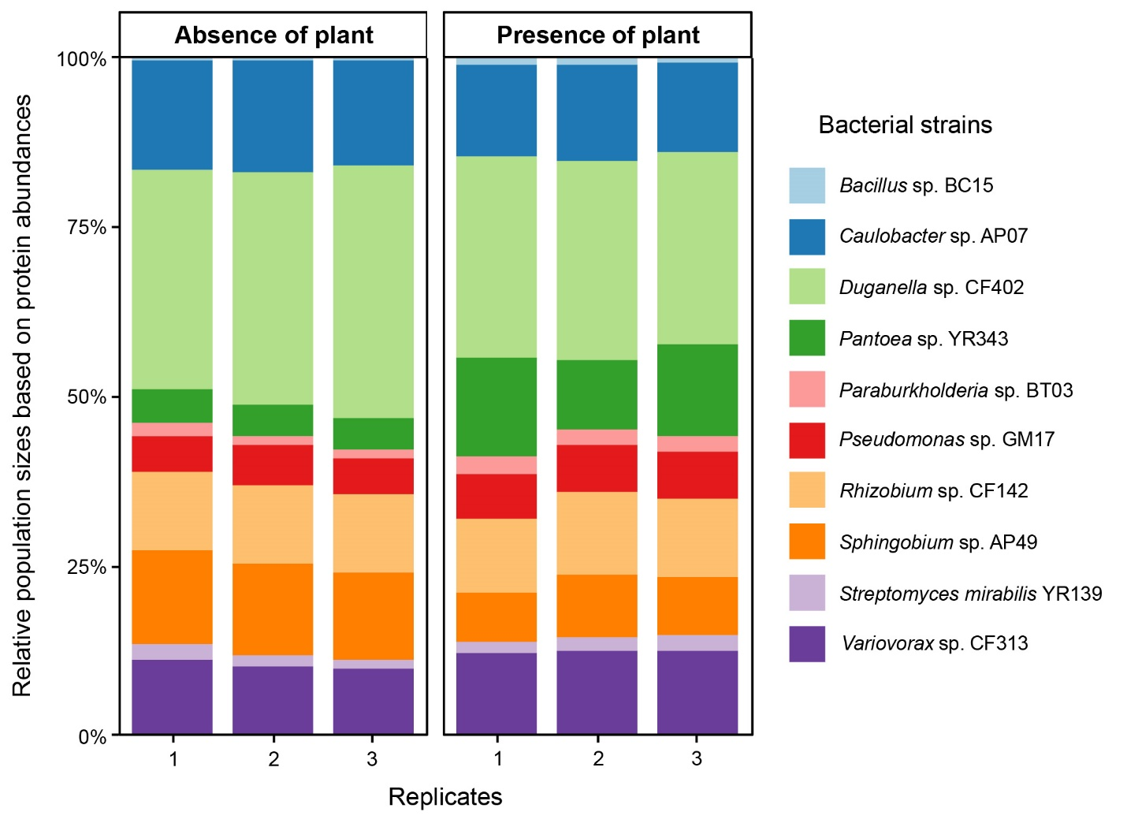
Figure 5.5: Relative population sizes of ten bacterial strains in the mixed community grown in the absence or presence of a plant assessed using summed protein abundances.

Individual proteome information of each bacterial strain was extracted from the metaproteomics data, and a differential analysis was performed between control samples and those grown in the presence of a plant for each strain to identify individual strain responses to the plant root environment when present in a mixed community. Proteins with significant differences (p-value < 0.05, and absolute log2 FC >1) in abundances were identified for each strain in the community (Supplemental Table 5). Varying degrees of proteomic changes were observed across the ten strains in the mixed community in response to the plant root environment (Figure 5.6). Interestingly, Bacillus sp. BC15 again exhibited significant changes in abundance in a large portion of its proteome (~88%) in response to the presence of a plant root, of which 86% showed increase in abundance. Similarly, ~57% of the proteins in Pantoea sp. YR343 showed significant changes in abundance, with ~84% of them increasing in abundance. In all other bacterial strains, the majority of the significantly changing proteins exhibited decreases in abundance in the presence of a plant.

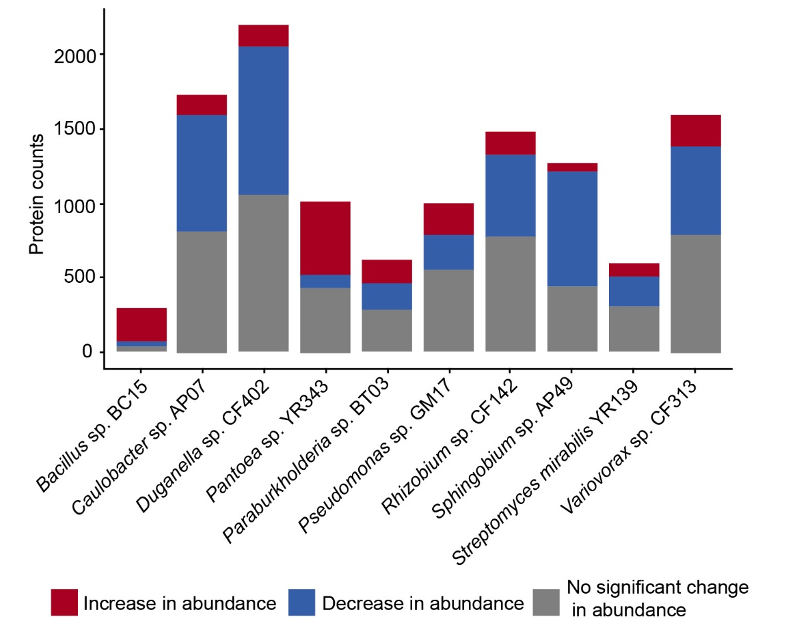

Figure 5.6: Stacked bar charts showing the number of differentially abundant proteins for ten bacterial strains grown in a mixed community in the presence of a plant compared to when grown in the absence of a plant.

Bacteria shift metabolic function at a taxon-specific level in response to the plant root chemical environment
To gain insights into the metabolic potential of the microbiome in the presence of a plant, we began by first assessing the overall functional changes for each of the ten bacterial strains grown individually in the presence of a plant compared to a control (no plant) condition (Figure 5.7). We classified the differentially abundant proteins into specific functional categories using the Clusters of Orthologous Group (COG), employing eggnog v5.0 in eggnog-mapper v2 (http://eggnog-mapper.embl.de/) ^{157, 158}. Proteins that have several COG categories assigned were counted for each COG category. The analysis was extended beyond the isolated conditions to explore how these metabolic processes change within the context of a constructed community (Figure 5.8). Notably, a substantial majority of the differentially abundant proteins identified in all bacterial strains were associated with COG categories related to metabolic processes, specifically C (energy production and conversion), E (amino acid transport and metabolism), F (nucleotide transport and metabolism), G (carbohydrate transport and metabolism), H (coenzyme transport and metabolism), I (lipid transport and metabolism), and P (inorganic ion transport and metabolism). In all isolates, we observed both increases and decreases in the abundances of proteins found in these COG categories, suggesting that the strains were undergoing dynamic metabolic remodeling in response to the chemical environment of the plant. Amino acid transport and metabolism was the most common set of proteins that showed increased abundance within the metabolism category for each of the microbes when grown with the plant. We also found that in the category related to inorganic ion transport and metabolism, Pantoea sp. YR343 and Caulobacter sp. AP07 showed the largest abundance increase in these proteins. Sphingobium sp. AP49, on the other hand, was one of the few isolates to show a significant increase in the abundance of proteins related to lipid metabolism.
While observing changes in metabolism of individuals in the presence of a plant revealed common responses to the chemical environment surrounding the plant, introduction of a microbial community yielded insights into the metabolic flexibility of microbes in an environment where other bacteria may be competing for similar resources. In this study, we found that Bacillus sp. BC15 was seemingly unaffected by the addition of the other microbial isolates and exhibited an increased abundance across several categories of metabolic proteins. Pantoea sp. YR343 also continued to display increased abundance across several metabolic categories, with a notable increase in proteins related to nucleotide metabolism. Surprisingly, Sphingobium sp. AP49 showed a dramatic decrease in the overall number of metabolism-related proteins that showed increased abundance in the presence of a plant. Lastly, we also noticed increased abundance in proteins involved in carbohydrate metabolism and transport, particularly for Paraburkholderia sp. BT03, Pseudomonas sp. GM17, Streptomyces sp. YR139, and Variovorax sp. CF313, in the presence of the community compared to when grown individually with the plant.
Because our assessment of COG categories indicated shifts in microbial metabolism in the presence of a plant, we specifically investigated the responses of ATP-binding cassette (ABC) transporter proteins, one of the largest superfamilies of transporters within the ten bacterial strains. The quantitative analysis shown in Figure 5.9 revealed noteworthy changes in the transporter protein abundances across the ten bacterial strains. The largest number of ABC transporter proteins were identified in the proteomics data from Rhizobium sp. CF142 and Variovorax sp. CF313 in both the individual isolate and community experiments. When grown individually, all of the isolates showed a larger fraction of ABC transporter proteins that were significantly less abundant in the presence of the plant compared to the fraction that was significantly more abundant, with the exceptions of Bacillus sp. BC15 and Pantoea sp. YR343. Although fewer ABC transporters were identified in the community dataset overall, the trends seen in the individual isolate data were repeated for the majority of isolates, with the exceptions of Paraburkholdaria sp. BT03 and Pseudomonas sp. GM17, which showed slightly higher or equal fractions of ABC transporters that were significantly more abundant in the presence of the plant compared to the fraction that was significantly less abundant (Figure 5.9).
Whether inoculated individually or as part of a mixed community, Bacillus and Pantoea exhibited a significant increase in the abundance of proteins across a large percentage of their proteomes when grown in the presence of plant. This augmented proteome expression is paralleled by an increase in the relative population sizes of these strains within the community in the presence of a plant compared to the control. Notably, among the ten bacterial strains in the community, Pantoea sp. YR343 increased in its relative population size to become the third most abundant member in the community at 48 hours in the presence of a plant. In contrast, Pantoea sp. YR343 was among the least abundant members in the absence of the plant (Figure 5.5). These findings strongly suggest that the proteomic responses, characterized by an increase in protein abundance, contribute to the success of Bacillus and Pantoea in the community in the presence of a plant. Note that even though Pantoea's favorable response to the presence of the plant is known, the details of the molecular mechanism driving this beneficial association are not known. To delve deeper into the underlying mechanisms and functions driving this shift in relative abundance, we further investigated the proteins that increased in abundance in response to presence of a plant for both Bacillus and Pantoea.

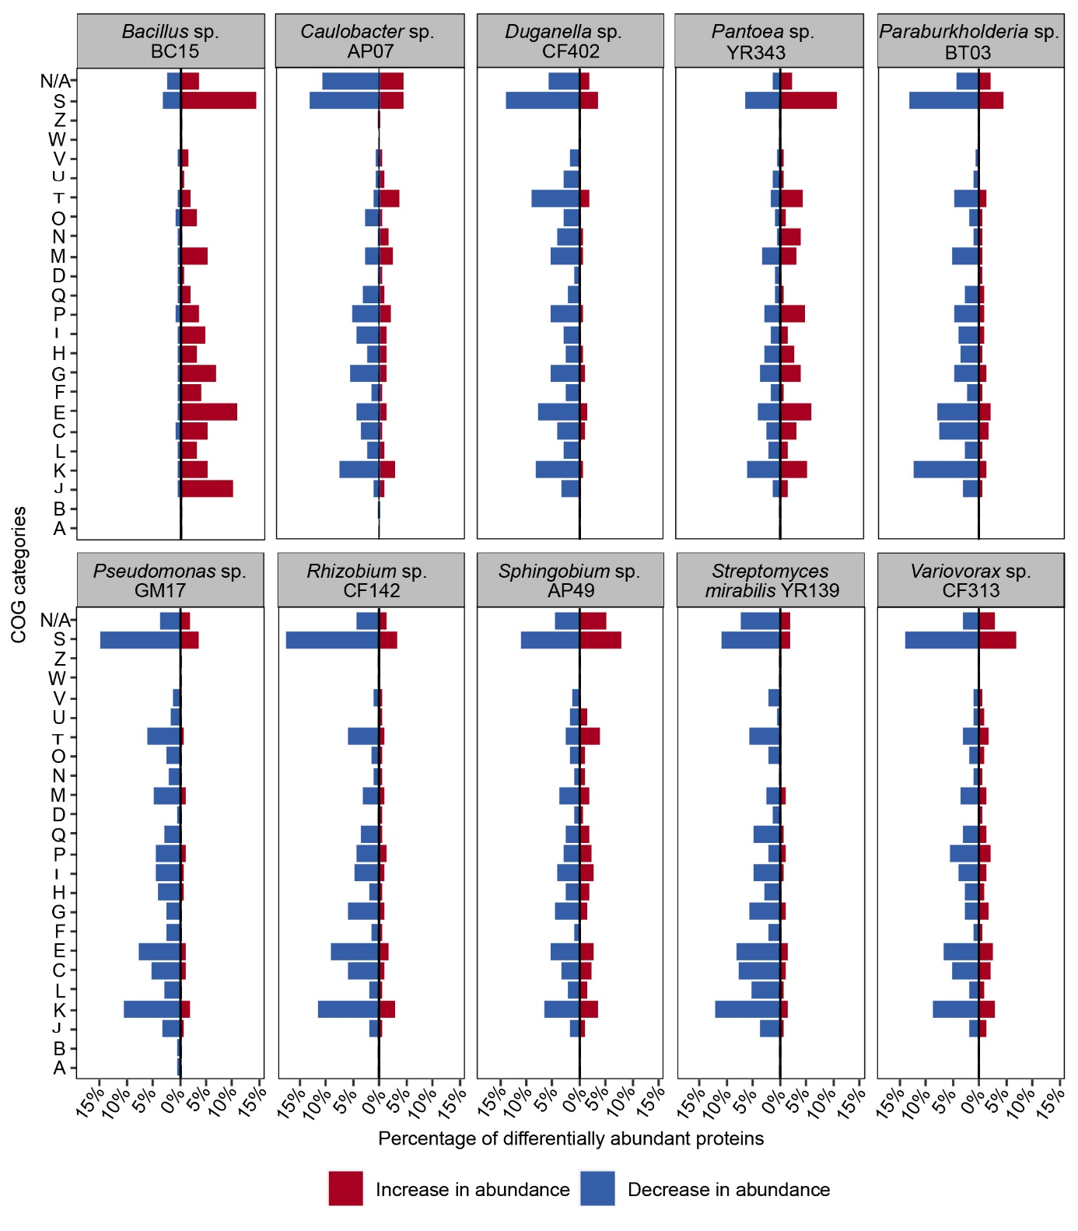
Figure 5.7: Functional analysis of bacterial strains grown individually in the absence or presence of a plant using Clusters of Orthologous Groups (COGs). Stacked bar charts show percentages of differentially abundant proteins in response to the presence of a plant. COG categories A : RNA processing and modification, B : Chromatin structure and dynamics, J : Translation, ribosomal structure and biogenesis, K : Transcription, L : Replication, recombination and repair, C : Energy production and conversion, E : Amino acid transport and metabolism, F : Nucleotide transport and metabolism, G : Carbohydrate transport and metabolism, H : Coenzyme transport and metabolism, I : Lipid transport and metabolism, P : Inorganic ion transport and metabolism, Q : Secondary metabolites biosynthesis, transport and catabolism, D : Cell cycle control, cell division, chromosome partitioning, M : Cell wall/membrane/envelope biogenesis, N : Cell motility, O : Post-translational modification, protein turnover, chaperones, T : Signal transduction mechanisms, U : Intracellular trafficking, secretion, and vesicular transport, V : Defense mechanisms, W : Extracellular structures, Z : Cytoskeleton, S : Function unknown, N/A : Not Assigned.

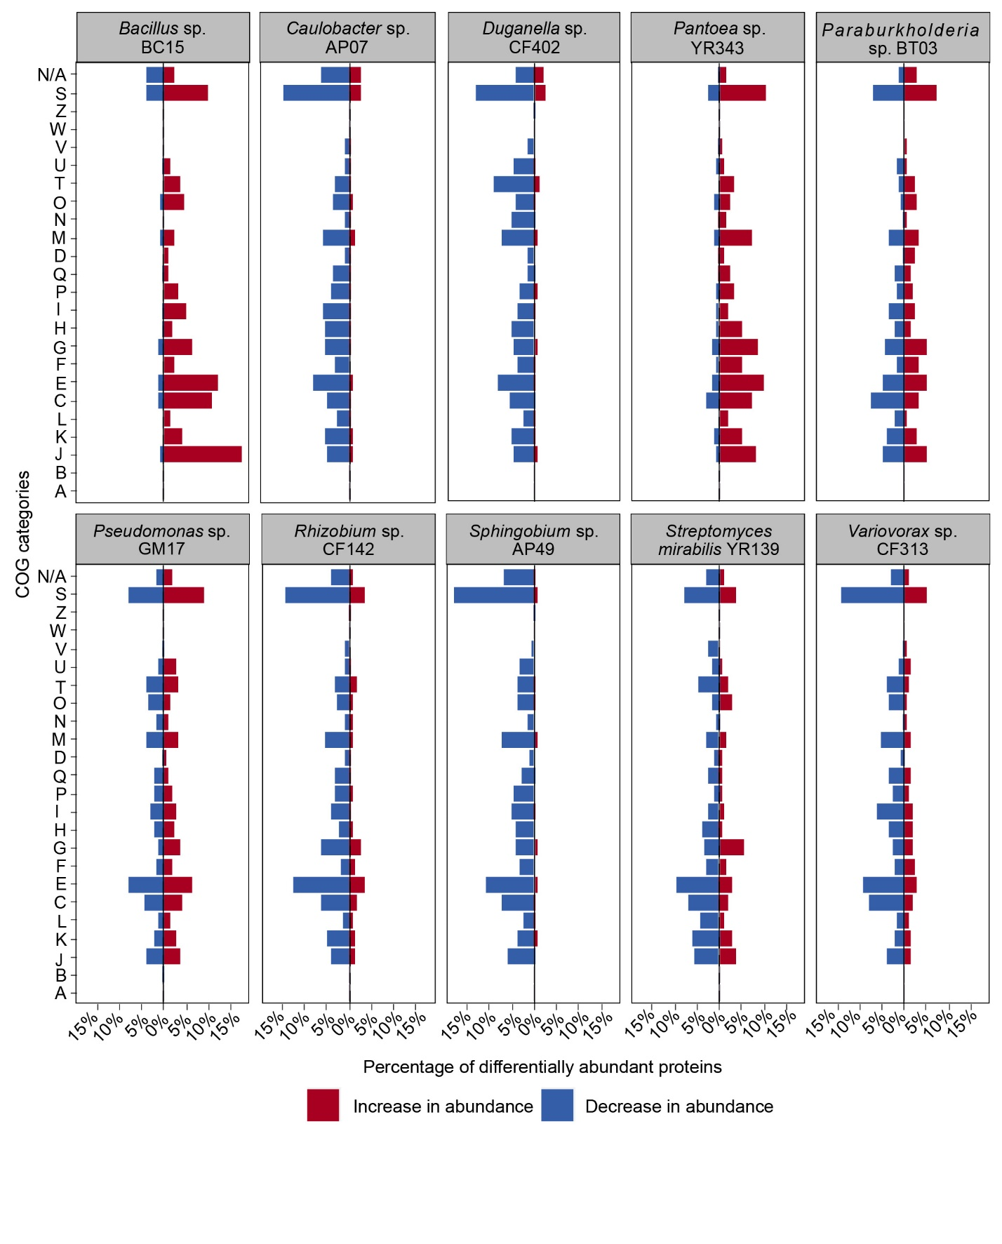
Figure 5.8: Functional analysis of bacterial strains grown in a mixed community in the absence or presence of a plant using Clusters of Orthologous Groups (COGs). Stacked bar charts show percentages of differentially abundant proteins in response to the presence of a plant. COG categories A : RNA processing and modification, B : Chromatin structure and dynamics, J : Translation, ribosomal structure and biogenesis, K : Transcription, L : Replication, recombination and repair, C : Energy production and conversion, E : Amino acid transport and metabolism, F : Nucleotide transport and metabolism, G : Carbohydrate transport and metabolism, H : Coenzyme transport and metabolism, I : Lipid transport and metabolism, P : Inorganic ion transport and metabolism, Q : Secondary metabolites biosynthesis, transport and catabolism, D : Cell cycle control, cell division, chromosome partitioning, M : Cell wall/membrane/envelope biogenesis, N : Cell motility, O : Post-translational modification, protein turnover, chaperones, T : Signal transduction mechanisms, U : Intracellular trafficking, secretion, and vesicular transport, V : Defense mechanisms, W : Extracellular structures, Z : Cytoskeleton, S : Function unknown, N/A : Not Assigned.

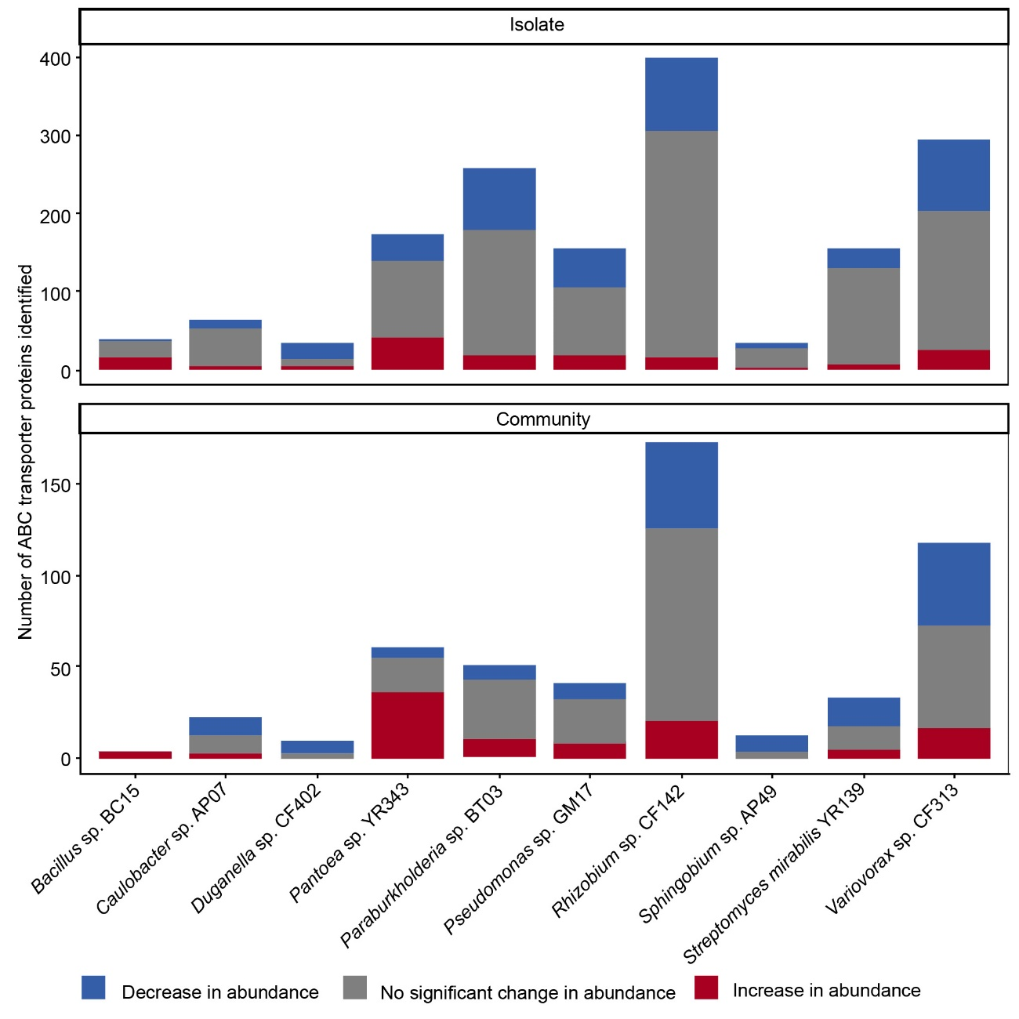
Figure 5.9: Stacked bar charts illustrate the distribution of identified ABC transporters in ten bacterial strains. Each bar represents the total number of ABC transporters identified for a bacterial strain in this study, with segments further divided to depict the counts of ABC transporters that increased in abundance, decreased in abundance, or showed no significant change in abundance in the presence of a plant.

Bacillus sp. BC15 becomes metabolically active in the presence of a plant
The findings from the differential proteomic analysis for Bacillus sp. BC15 grown in the absence or the presence of a plant (as isolates or as individuals within a community), highlighted the dynamic changes in its proteome as a response to plant root. To understand the role of the proteins that increased in abundance in the presence of a plant, a gene ontology (GO) enrichment analysis was performed, utilizing a right-sided hypergeometric test and applying a Benjamini-Hochberg correction to pathways with a p-value less than or equal to 0.05. The focus was specifically on the biological process category, and the analysis was conducted using ClueGO v2.5.6, a Cytoscape plug-in application ¹⁵⁹ (Figure 5.10). The GO enrichment analysis on proteins that increased in abundance when Bacillus sp. BC15 was grown individually revealed several GO terms as significant; these include but are not limited to organonitrogen compound metabolic process, carbohydrate metabolic process, sulfur compound metabolic process, lipid metabolic process, cellular nitrogen compound metabolic process (Figure 5.10A and Supplemental Table 6). Together, these functions suggest a response of Bacillus sp. to the presence of plant roots involving specific metabolic adaptations, consistent with the COG analyses (Figure 5.7).
The GO enrichment analysis for Bacillus sp. BC15 grown in the community also showed similar results where several GO terms associated with the proteins that increased in abundance in the presence of the plant were found to be significant, these predominantly are involved in several metabolic processes, cellular component biogenesis, generation of precursor metabolites and energy (Figure 5.10B and Supplemental Table 6). This overlap of significant GO terms highlights similar functional responses by Bacillus to the influence of a plant root, whether grown individually or in community.
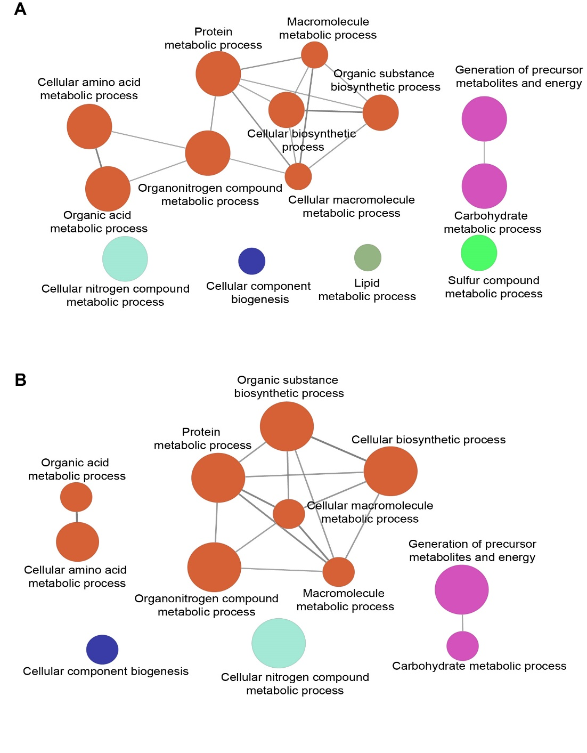
Protein level analysis revealed an increase in abundance of proteins associated with active metabolism in Bacillus in the presence of a plant. Additionally, several proteins involved in various sporulation stages and small, acid-soluble spore proteins were identified in the dataset, some of which are differentially abundant when grown with the plant, suggesting a subset of the population is sporulated (Supplemental Table 7). However, the functional analysis of Bacillus proteins that increased in abundance in the presence of a plant whether grown individually or in community suggests that these proteins are primarily involved in metabolism and cellular processes. This suggests that the Bacillus population becomes metabolically active in response to chemical cues produced by the plant.

Figure 5.10: Functional changes in Bacillus sp. BC15 as a response to the chemical environment of the plant root. Gene ontology (GO) networks representing the significant results from GO enrichment analysis of biological process category (right-sided hypergeometric test, p-value <=0.05, Benjamini-Hochberg correction) of proteins that increased in abundance in the presence of a plant. GO enrichment analysis was performed using ClueGo application in Cytoscape (minimum number of genes/GO term = 3, % genes for group merge for GO term grouping = 50) when grown (A) individually or (B) in a mixed community.
Pantoea sp. YR343 shows increased abundance of proteins related to chemotaxis, motility, nutrient transport, and metabolism in response to the plant root chemical environment
To better understand the functions of proteins that showed increased abundance in Pantoea sp. YR343 in the presence of the plant, we performed a gene ontology (GO) enrichment analysis as described above. When Pantoea was grown individually in the presence of the plant, significant GO terms were found in signal transduction and cell motility (Supplemental Table 8). When Pantoea sp. YR343 was grown in a community in the presence of a plant, this analysis revealed significant GO terms associated with translation, organonitrogen compound metabolic process, cellular component assembly, cellular amino acid metabolic process, generation of precursor metabolites and energy, and membrane organization (Supplemental Table 8).
We next compared the differentially abundant proteins of Pantoea sp. YR343 grown individually or in a community to determine whether we could identify a common response to growth in the presence of a plant. Somewhat surprisingly, only a small number of proteins were found in both datasets, with the majority increasing in abundance (Figure 5.11A and Supplemental Table 9). The functions of these common proteins include cell motility, nutrient transport, and metabolism as common responses to the presence of a plant. Among the proteins that increased in abundance in the presence of plants were several methyl-accepting chemotaxis proteins, a response regulator with a CheY-like receiver domain and flagellar machinery proteins (flagellin, flagellar motor switch protein FliM, flagellar M-ring protein) that are crucial for chemotactic responses and motility of bacteria (Figure 5.11B). The methyl-accepting chemotaxis proteins detect the environmental signals and initiate a chemotactic response in bacteria. This signal is transduced through the chemotaxis machinery and affects the flagellar motor complex allowing the bacteria to move towards favorable conditions such as root exudates. In addition, several transporter proteins essential for uptake of essential nutrients increased in abundance when Pantoea sp. YR343 was grown in the presence of a plant, including ABC-type transport system (sugar, ribose, amino acid, thiamine, iron), phosphotransferase system (PTS) proteins involved in uptake of sugars (glucose, Mannose/Fructose/Sorbose family), maltose operon periplasmic protein MalM involved in maltose uptake, and ammonium transporters involved in uptake of ammonium,(Figure 5.11C). Increased abundance of these transport proteins suggests that these resources may be more readily available in the presence of plant roots or it may reflect metabolic strategies employed by Pantoea sp. YR343 that allow these cells to thrive and compete within the chemical environment surrounding the plant root. Several proteins involved in carbohydrate metabolic processes (phosphofructokinase, a key regulatory enzyme in glycolysis), amino acid biosynthesis (histidine biosynthesis bifunctional protein HisB, involved in biosynthesis of histidine, an essential amino acid) and amino acid metabolism (methionine synthase II, involved in metabolism of methionine, an essential amino acid) also increased in abundance in the presence of a plant. The increase in abundance of proteins involved in transport of nutrients as well as metabolic processes suggest a coordinated regulation of proteins in Pantoea in response to of the chemical environment surrounding the plant root.
Finally, we examined the loss of function phenotype of one of the common proteins, a methyl-accepting chemotaxis protein (MCP). Pantoea sp. YR343 has 21 predicted methyl-accepting chemotaxis proteins based on a pfam search of proteins possessing a pfam00015 “MCP signal” domain, of which 10 MCPs showed an increase in abundance in the presence of the plant. During previous studies, we isolated a transposon mutant affecting one of these MCPs, encoded by PMI39_02190 ¹⁴⁹. Using fluorescently labeled wild type and mutant strains, we assessed colonization of P. trichocarpa BESC819 and found that the MCP mutant strain was significantly impaired in root colonization compared to the wild-type strain based on plating and imaging assays (Figure 5.11D, 5.11E). These data suggests that the increased abundance of this protein in the presence of the plant is functionally significant and plays a role in efficient root colonization.

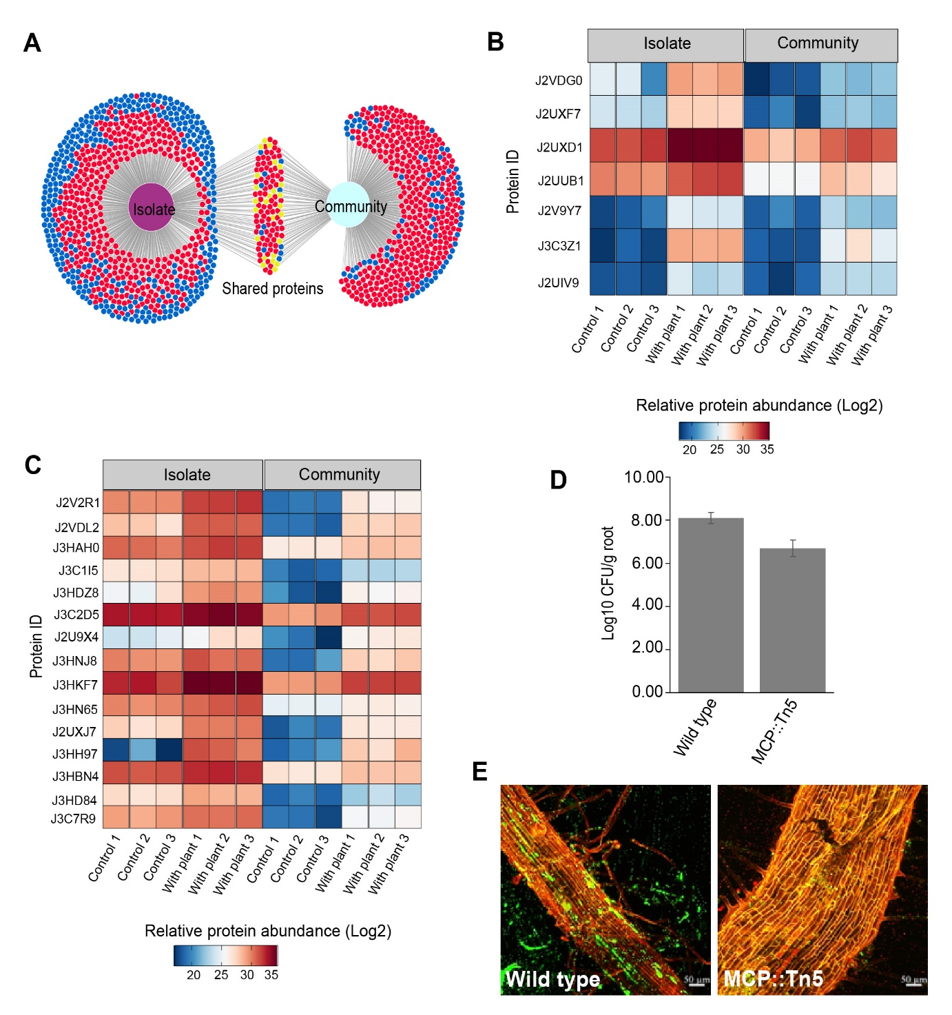
Figure 5.11: Proteomic analysis of Pantoea sp. YR343 in response to the chemical environment of a plant root. (A) Overlap of differentially abundant proteins (based on Student’s t-test performed between proteins identified in Pantoea sp. YR343 grown in the absence or presence of a plant) between individual (left) and mixed community (right) conditions. Each node represents a unique protein accession, and the color indicates whether the relative protein abundance increased (red), decreased (blue), or increased in one condition but decreased in another (yellow) in presence of plant compared to absence of plant. Figure generated using DiVenn 2.0 160. (B) Heatmap illustrating the relative protein abundances of chemotaxis and motility related proteins of Pantoea sp. YR343 when grown individually and in mixed community. (C) Heatmap illustrating the relative protein abundances of transporter proteins of Pantoea sp. YR343 when grown individually and in mixed community. (D) Bar chart showing a transposon insertion in gene (PMI39_02190) encoding a chemoreceptor (Protein ID J3C3Z1) shows reduced colonization compared to the wild type strain based on colony counts (E) Confocal images of Populus roots colonized by wild-type Pantoea sp. YR343 cells expressing GFP (left) compared to the MCP mutant expressing mCherry (right).
Discussion
The significance of the plant root chemical environment in shaping microbiome assembly is well-established ^{24, 161, 162}. In this study, we employed an in-depth proteomics approach to understand the functional adaptations of microbes in response to plant chemical signals. Historically, proteomics analysis of microbes associated with plants has proven difficult because microbial proteins are often swamped by those of the plant, thus requiring novel approaches to study each component separately. Here, we employed a simple nylon filter-based system in which bacteria were inoculated on a filter that was placed on plant roots, allowing chemical communication between the plant and bacteria but not physical contact. While this system can be used to examine responses to plant root exudates, it excludes responses driven by soil factors or physical interactions with the plant root. We validated this approach by using a plant-responsive reporter strain of Pantoea sp. YR343 which showed increased GFP fluorescence due to promoter activation in the presence of a plant root compared to control conditions indicating that the cells were able to respond to the chemical environment of the plant through the filter ¹⁴⁹.
To study responses of individual bacterial strains, an aliquot of culture (as described in methods) was inoculated on filters either with or without a plant. To study community responses, we started with equal ratios of ten bacterial strains to minimize the bias due to unequal starting ratios. This approach of using equal initial ratios allows each species to have an equal opportunity for interactions both with the plant root, as well as other microbes, and ensures the proteomic changes are attributable to experimental conditions i.e, plant root chemical signals rather than initial ratios. In both the microbial isolates as well as the microbial community samples, the proteome measurement depths for individual strains grown in the absence or presence of the plants were comparable. Not surprisingly, the measurement depths for individual strains grown in the community were lower compared to the proteomic measurements of individually grown bacteria. The proteome coverage observed for the metaproteomic studies, however, are similar to other metaproteomic studies using constructed microbial communities ⁹⁸.
The proteome profiles of individual bacterial strains in a constructed community are influenced by many factors, including interspecies interactions and competition for nutrients and space which ultimately impact the biomass and measurement depth of each strain in the community sample. To discern whether the changes observed in the proteomes of bacterial strains grown in the absence or the presence of plant are driven by biological effects rather than measurement-depth, we employed a rank-based sorting of proteins based on abundances, which revealed that the decreases in protein abundances within specific functional categories are not a systemic change, supporting the conclusion that the observed proteomic changes are biological.
Within the functional categories, we observed that in most of the bacterial strains the majority of significantly changing proteins decreased in abundance in the presence of the plant compared to the control. Because we only collected one timepoint in this study, however, it is unclear whether this result represents a step in the transition from growth in R2A liquid medium to the plant environment or is indicative of sustained growth in the presence of the plant. It is also possible that the quantity of bacteria applied to the filter was higher than would be sustained by plant exudates in the native rhizosphere, leading to nutrient limitation over time. To distinguish between these possibilities, it would be informative to collect multiple samples over a longer time period to determine how the cells adapt to the plant environment.
Metaproteomic analyses revealed population size shifts in the community in the presence of a plant and the bacterial species that displayed positive responses to the plant environment were pinpointed. The observed relative abundance changes of bacterial strains suggest a dynamic response to the chemical milieu of the rhizosphere (Figure 5.5). Notable increases in organism relative abundances exhibited by Bacillus sp. BC15 and Pantoea sp. YR343 when grown with a plant underscores the intricate interplay between bacterial community structure and the plant root environment. However, it is essential to acknowledge that generalizing these responses might oversimplify the complex dynamics at play. Therefore, gaining a nuanced understanding of the adaptive strategies employed by individual species becomes crucial for understanding the molecular mechanisms governing these responses.
Within this study, we observed that most of the differentially abundant proteins identified were in metabolism-associated COG categories and displayed both increases and decreases in abundance with respect to the presence of a plant. In the community, all the identified ABC transporters in Bacillus and about 60% in Pantoea increased in abundance in response to the presence of the plant. These observed changes in transporter protein abundances and relative organism abundances in these strains strongly suggested a strategic reprogramming of nutrient acquisition strategies in the presence of a plant and underscored the significance of not only the sheer quantity but also the dynamic regulation of transporter proteins in bacterial adaptations to the plant milieu. Upregulated nutrient transporters imply an active pursuit of essential resources, potentially indicating symbiotic relationships or competitive interactions within the microbial community. Integrating these transporter results with the increase in abundance of metabolism related proteins, we observe a coordinated interplay between nutrient uptake and metabolic pathways in Bacillus and Pantoea. While Bacillus sp. BC15 and Pantoea sp. YR343 both exhibit the highest levels of metabolism-related protein upregulation, there are interesting adaptations within the remaining members of the community when competing with Bacillus and Pantoea. For example, Paraburkholderia sp. BT03 and Pseudomonas sp. GM17 show a notable increase in the number and categories of metabolism-related genes that are upregulated in the presence of a community on a plant. We also observed an increase in abundance for proteins that fall into the category of nucleotide metabolism in most of the strains when grown in a community on the plant, with the exception of Sphingobium sp. AP49, Caulobacter sp. AP07, and Duganella sp. CF402.
Our proteomic data also indicated the presence of proteins involved in sporulation in Bacillus sp. BC15. Bacillus sp. are known to survive harsh environmental conditions by forming endospores that remain quiescent with minimal metabolic activity. Under favorable conditions, there is a morphogenic transition from dormant spores that then germinate into a metabolically active vegetative cell ^{163, 164}. Previous studies have shown that Bacillus sp. BC15 forms spores in R2A media, however, the dynamics of spore formation in this growth condition are not well understood ⁸⁷. While inoculating Bacillus sp. BC15 in the form of spores in this study was not intentional, our data indicate that Bacillus undergoes germination into vegetative cells from dormant spores and becomes metabolically active in the presence of the plant suggesting that there are plant-specific cues capable of signaling germination.
Chemotactic bacteria have been shown to have a competitive advantage for plant colonization ¹⁶⁵. Consistent with this, we observed that proteins related to chemotaxis were highly represented among the upregulated proteins on the plant both with and without the community. Using a transposon mutant that was identified in a previous study of Pantoea sp. YR343 ¹⁴⁹, we were able to show that loss of function of one of the methyl-accepting chemotaxis proteins (encoded by PMI39_02190) that is more abundant in the presence of the plant resulted in reduced plant colonization compared to the wildtype strain. It will be of particular interest to determine to which plant-related compounds the bacteria are responding and how bacterial colonization patterns correspond to the distribution of those compounds. Combined with the data about metabolism and transport, these data suggest that under these conditions, Pantoea sp. YR343 is well-adapted to survival in the presence of a plant. This result is consistent with previous studies using a plant agar-based system in which Pantoea sp. YR343 displayed a significant increase in its relative abundance in the presence of a plant ¹⁵⁵. The identified functions of Pantoea as a response to plant chemical environment cover a spectrum of activities that collectively enable it to sense, respond, and adapt to the dynamic conditions presented by the plant root environment. These adaptations are crucial for establishing beneficial interactions, nutrient acquisition, and survival in the rhizosphere. Further studies focusing on these specific protein functions and their roles in interaction with Populus roots will provide more detailed insights into the molecular mechanisms underlying Pantoea’s adaptation to the Populus root environment.
Our comparative proteomic and metaproteomic analysis have provided unique and detailed insights into the responses of various bacterial species to the plant root environment, demonstrating how these species respond and adapt on both an individual level, as well as the community level, in order to effectively navigate nutrient availability and competition in the rhizosphere.

REFERENCES
(1) Schirawski, J.; Perlin, M. H. Plant(-)Microbe Interaction 2017-The Good, the Bad and the Diverse. Int J Mol Sci 2018, 19 (5). DOI: 10.3390/ijms19051374 From NLM Medline.
(2) van der Heijden, M. G.; de Bruin, S.; Luckerhoff, L.; van Logtestijn, R. S.; Schlaeppi, K. A widespread plant-fungal-bacterial symbiosis promotes plant biodiversity, plant nutrition and seedling recruitment. ISME J 2016, 10 (2), 389-399. DOI: 10.1038/ismej.2015.120 From NLM Medline.
(3) Rodriguez, R. J.; Henson, J.; Van Volkenburgh, E.; Hoy, M.; Wright, L.; Beckwith, F.; Kim, Y. O.; Redman, R. S. Stress tolerance in plants via habitat-adapted symbiosis. Isme Journal 2008, 2 (4), 404-416. DOI: 10.1038/ismej.2007.106.
(4) Enebe, M. C.; Babalola, O. O. The impact of microbes in the orchestration of plants' resistance to biotic stress: a disease management approach. Appl Microbiol Biotechnol 2019, 103 (1), 9-25. DOI: 10.1007/s00253-018-9433-3.
(5) Vandenkoornhuyse, P.; Quaiser, A.; Duhamel, M.; Le Van, A.; Dufresne, A. The importance of the microbiome of the plant holobiont. New Phytol 2015, 206 (4), 1196-1206. DOI: 10.1111/nph.13312 From NLM Medline.
(6) Sanchez-Cañizares, C.; Jorrín, B.; Poole, P. S.; Tkacz, A. Understanding the holobiont: the interdependence of plants and their microbiome. Current opinion in microbiology 2017, 38, 188-196. DOI: 10.1016/j.mib.2017.07.001.
(7) Vishwakarma, K.; Kumar, N.; Shandilya, C.; Mohapatra, S.; Bhayana, S.; Varma, A. Revisiting Plant-Microbe Interactions and Microbial Consortia Application for Enhancing Sustainable Agriculture: A Review. Front Microbiol 2020, 11, 560406. DOI: 10.3389/fmicb.2020.560406 From NLM PubMed-not-MEDLINE.
(8) Phour, M.; Sehrawat, A.; Sindhu, S. S.; Glick, B. R. Interkingdom signaling in plant-rhizomicrobiome interactions for sustainable agriculture. Microbiol Res 2020, 241, 126589. DOI: 10.1016/j.micres.2020.126589 From NLM Medline.
(9) Harris, J. M.; Balint-Kurti, P.; Bede, J. C.; Day, B.; Gold, S.; Goss, E. M.; Grenville-Briggs, L. J.; Jones, K. M.; Wang, A. M.; Wang, Y. C.; et al. What are the Top 10 Unanswered Questions in Molecular Plant-Microbe Interactions? Mol Plant Microbe In 2020, 33 (12), 1354-1365. DOI: 10.1094/Mpmi-08-20-0229-Cr.
(10) Matyssek, R.; Lüttge, U.; zu Castell, W. Evolution of Holobiont-Like Systems: From Individual to Composed Ecological and Global Units. In Progress in Botany Vol. 83, Lüttge, U., Cánovas, F. M., Risueño, M.-C., Leuschner, C., Pretzsch, H. Eds.; Springer International Publishing, 2023; pp 203-248.
(11) Bryant, N. D.; Pu, Y.; Tschaplinski, T. J.; Tuskan, G. A.; Muchero, W.; Kalluri, U. C.; Yoo, C. G.; Ragauskas, A. J. Transgenic Poplar Designed for Biofuels. Trends Plant Sci 2020, 25 (9), 881-896. DOI: 10.1016/j.tplants.2020.03.008 From NLM Medline.
(12) Hinchee, M.; Rottmann, W.; Mullinax, L.; Zhang, C.; Chang, S.; Cunningham, M.; Pearson, L.; Nehra, N. Short-rotation woody crops for bioenergy and biofuels applications. In Vitro Cell Dev Biol Plant 2009, 45 (6), 619-629. DOI: 10.1007/s11627-009-9235-5 From NLM PubMed-not-MEDLINE.
(13) Jansson, S.; Douglas, C. J. Populus: a model system for plant biology. Annu Rev Plant Biol 2007, 58, 435-458. DOI: 10.1146/annurev.arplant.58.032806.103956 From NLM Medline.
(14) Tuskan, G. A.; Difazio, S.; Jansson, S.; Bohlmann, J.; Grigoriev, I.; Hellsten, U.; Putnam, N.; Ralph, S.; Rombauts, S.; Salamov, A.; et al. The genome of black cottonwood, Populus trichocarpa (Torr. & Gray). Science 2006, 313 (5793), 1596-1604. DOI: 10.1126/science.1128691 From NLM Medline.
(15) Gottel, N. R.; Castro, H. F.; Kerley, M.; Yang, Z. M.; Pelletier, D. A.; Podar, M.; Karpinets, T.; Uberbacher, E.; Tuskan, G. A.; Vilgalys, R.; et al. Distinct Microbial Communities within the Endosphere and Rhizosphere of
Roots across Contrasting Soil Types. Appl Environ Microb 2011, 77 (17), 5934-5944. DOI: 10.1128/Aem.05255-11.
(16) Carper, D. L.; Weston, D. J.; Barde, A.; Timm, C. M.; Lu, T. Y.; Burdick, L. H.; Jawdy, S. S.; Klingeman, D. M.; Robeson, M. S., 2nd; Veach, A. M.; et al. Cultivating the Bacterial Microbiota of Populus Roots. mSystems 2021, 6 (3), e0130620. DOI: 10.1128/mSystems.01306-20.
(17) Trivedi, P.; Leach, J. E.; Tringe, S. G.; Sa, T.; Singh, B. K. Plant-microbiome interactions: from community assembly to plant health. Nat Rev Microbiol 2020, 18 (11), 607-621. DOI: 10.1038/s41579-020-0412-1 From NLM Medline.
(18) Panke-Buisse, K.; Poole, A. C.; Goodrich, J. K.; Ley, R. E.; Kao-Kniffin, J. Selection on soil microbiomes reveals reproducible impacts on plant function. ISME J 2015, 9 (4), 980-989. DOI: 10.1038/ismej.2014.196 From NLM Medline.
(19) Bandyopadhyay, P.; Bhuyan, S. K.; Yadava, P. K.; Varma, A.; Tuteja, N. Emergence of plant and rhizospheric microbiota as stable interactomes. Protoplasma 2017, 254 (2), 617-626. DOI: 10.1007/s00709-016-1003-x.
(20) Bakker, P. A.; Berendsen, R. L.; Doornbos, R. F.; Wintermans, P. C.; Pieterse, C. M. The rhizosphere revisited: root microbiomics. Front Plant Sci 2013, 4, 165. DOI: 10.3389/fpls.2013.00165 From NLM PubMed-not-MEDLINE.
(21) Ma, W.; Tang, S.; Dengzeng, Z.; Zhang, D.; Zhang, T.; Ma, X. Root exudates contribute to belowground ecosystem hotspots: A review. Front Microbiol 2022, 13, 937940. DOI: 10.3389/fmicb.2022.937940 From NLM PubMed-not-MEDLINE.
(22) Badri, D. V.; Vivanco, J. M. Regulation and function of root exudates. Plant Cell Environ 2009, 32 (6), 666-681. DOI: 10.1111/j.1365-3040.2008.01926.x From NLM Medline.
(23) Alahmad, A.; Harir, M.; Fochesato, S.; Tulumello, J.; Walker, A.; Barakat, M.; Ndour, P. M. S.; Schmitt-Kopplin, P.; Cournac, L.; Laplaze, L.; et al. Unraveling the interplay between root exudates, microbiota, and rhizosheath formation in pearl millet. Microbiome 2024, 12 (1). DOI: ARTN 1
10.1186/s40168-023-01727-3.
(24) Pantigoso, H. A.; Newberger, D.; Vivanco, J. M. The rhizosphere microbiome: Plant-microbial interactions for resource acquisition. J Appl Microbiol 2022, 133 (5), 2864-2876. DOI: 10.1111/jam.15686 From NLM Medline.
(25) Sasse, J.; Martinoia, E.; Northen, T. Feed Your Friends: Do Plant Exudates Shape the Root Microbiome? Trends Plant Sci 2018, 23 (1), 25-41. DOI: 10.1016/j.tplants.2017.09.003 From NLM Medline.
(26) Saeed, Q.; Xiukang, W.; Haider, F. U.; Kucerik, J.; Mumtaz, M. Z.; Holatko, J.; Naseem, M.; Kintl, A.; Ejaz, M.; Naveed, M.; et al. Rhizosphere Bacteria in Plant Growth Promotion, Biocontrol, and Bioremediation of Contaminated Sites: A Comprehensive Review of Effects and Mechanisms. Int J Mol Sci 2021, 22 (19). DOI: 10.3390/ijms221910529 From NLM Medline.
(27) Thepbandit, W.; Athinuwat, D. Rhizosphere Microorganisms Supply Availability of Soil Nutrients and Induce Plant Defense. Microorganisms 2024, 12 (3). DOI: 10.3390/microorganisms12030558 From NLM PubMed-not-MEDLINE.
(28) Alori, E. T.; Glick, B. R.; Babalola, O. O. Microbial Phosphorus Solubilization and Its Potential for Use in Sustainable Agriculture. Front Microbiol 2017, 8, 971. DOI: 10.3389/fmicb.2017.00971 From NLM PubMed-not-MEDLINE.
(29) Kudoyarova, G.; Arkhipova, T.; Korshunova, T.; Bakaeva, M.; Loginov, O.; Dodd, I. C. Phytohormone Mediation of Interactions Between Plants and Non-Symbiotic Growth Promoting Bacteria Under Edaphic Stresses. Front Plant Sci 2019, 10. DOI: ARTN 1368
10.3389/fpls.2019.01368.
(30) Spaepen, S.; Vanderleyden, J.; Remans, R. Indole-3-acetic acid in microbial and microorganism-plant signaling. Fems Microbiol Rev 2007, 31 (4), 425-448. DOI: 10.1111/j.1574-6976.2007.00072.x From NLM Medline.
(31) Raaijmakers, J. M.; Paulitz, T. C.; Steinberg, C.; Alabouvette, C.; Moënne-Loccoz, Y. The rhizosphere: a playground and battlefield for soilborne pathogens and beneficial microorganisms. Plant and Soil 2009, 321 (1-2), 341-361. DOI: 10.1007/s11104-008-9568-6.
(32) Nadarajah, K.; Abdul Rahman, N. S. N. Plant-Microbe Interaction: Aboveground to Belowground, from the Good to the Bad. Int J Mol Sci 2021, 22 (19). DOI: 10.3390/ijms221910388 From NLM Medline.
(33) Berendsen, R. L.; Pieterse, C. M.; Bakker, P. A. The rhizosphere microbiome and plant health. Trends Plant Sci 2012, 17 (8), 478-486. DOI: 10.1016/j.tplants.2012.04.001 From NLM Medline.
(34) Tecon, R.; Mitri, S.; Ciccarese, D.; Or, D.; van der Meer, J. R.; Johnson, D. R. Bridging the Holistic-Reductionist Divide in Microbial Ecology. mSystems 2019, 4 (1). DOI: 10.1128/mSystems.00265-18 From NLM PubMed-not-MEDLINE.
(35) Fitzpatrick, C. R.; Salas-Gonzalez, I.; Conway, J. M.; Finkel, O. M.; Gilbert, S.; Russ, D.; Teixeira, P.; Dangl, J. L. The Plant Microbiome: From Ecology to Reductionism and Beyond. Annu Rev Microbiol 2020, 74, 81-100. DOI: 10.1146/annurev-micro-022620-014327 From NLM Medline.
(36) Liu, Y. X.; Qin, Y.; Bai, Y. Reductionist synthetic community approaches in root microbiome research. Curr Opin Microbiol 2019, 49, 97-102. DOI: 10.1016/j.mib.2019.10.010 From NLM Medline.
(37) Zengler, K.; Hofmockel, K.; Baliga, N. S.; Behie, S. W.; Bernstein, H. C.; Brown, J. B.; Dinneny, J. R.; Floge, S. A.; Forry, S. P.; Hess, M.; et al. EcoFABs: advancing microbiome science through standardized fabricated ecosystems. Nature Methods 2019, 16 (7), 567-571. DOI: 10.1038/s41592-019-0465-0.
(38) Oyserman, B. O.; Cordovez, V.; Flores, S. S.; Leite, M. F. A.; Nijveen, H.; Medema, M. H.; Raaijmakers, J. M. Extracting the GEMs: Genotype, Environment, and Microbiome Interactions Shaping Host Phenotypes. Front Microbiol 2020, 11, 574053. DOI: 10.3389/fmicb.2020.574053 From NLM PubMed-not-MEDLINE.
(39) Marin, O.; Gonzalez, B.; Poupin, M. J. From Microbial Dynamics to Functionality in the Rhizosphere: A Systematic Review of the Opportunities With Synthetic Microbial Communities. Front Plant Sci 2021, 12, 650609. DOI: 10.3389/fpls.2021.650609.
(40) Sergaki, C.; Lagunas, B.; Lidbury, I.; Gifford, M. L.; Schafer, P. Challenges and Approaches in Microbiome Research: From Fundamental to Applied. Front Plant Sci 2018, 9, 1205. DOI: 10.3389/fpls.2018.01205 From NLM PubMed-not-MEDLINE.
(41) de Souza, R. S. C.; Armanhi, J. S. L.; Arruda, P. From Microbiome to Traits: Designing Synthetic Microbial Communities for Improved Crop Resiliency. Front Plant Sci 2020, 11, 1179. DOI: 10.3389/fpls.2020.01179 From NLM PubMed-not-MEDLINE.
(42) Carper, D. L.; Appidi, M. R.; Mudbhari, S.; Shrestha, H. K.; Hettich, R. L.; Abraham, P. E. The Promises, Challenges, and Opportunities of Omics for Studying the Plant Holobiont. Microorganisms 2022, 10 (10). DOI: 10.3390/microorganisms10102013 From NLM PubMed-not-MEDLINE.
(43) Nicholson, J. K.; Lindon, J. C. Systems biology - Metabonomics. Nature 2008, 455 (7216), 1054-1056. DOI: 10.1038/4551054a.
(44) Shade, A. Diversity is the question, not the answer. Isme Journal 2017, 11 (1), 1-6. DOI: 10.1038/ismej.2016.118.
(45) Thompson, L. R.; Sanders, J. G.; McDonald, D.; Amir, A.; Ladau, J.; Locey, K. J.; Prill, R. J.; Tripathi, A.; Gibbons, S. M.; Ackermann, G.; et al. A communal catalogue reveals Earth's multiscale microbial diversity. Nature 2017, 551 (7681), 457-463. DOI: 10.1038/nature24621 From NLM Medline.
(46) Nilsson, R. H.; Ryberg, M.; Abarenkov, K.; Sjökvist, E.; Kristiansson, E. The ITS region as a target for characterization of fungal communities using emerging sequencing technologies. Fems Microbiology Letters 2009, 296 (1), 97-101. DOI: 10.1111/j.1574-6968.2009.01618.x.
(47) Shade, A.; Stopnisek, N. Abundance-occupancy distributions to prioritize plant core microbiome membership. Curr Opin Microbiol 2019, 49, 50-58. DOI: 10.1016/j.mib.2019.09.008 From NLM Medline.
(48) Beilsmith, K.; Thoen, M. P. M.; Brachi, B.; Gloss, A. D.; Khan, M. H.; Bergelson, J. Genome-wide association studies on the phyllosphere microbiome: Embracing complexity in host-microbe interactions. The Plant journal : for cell and molecular biology 2019, 97 (1), 164-181. DOI: 10.1111/tpj.14170 From NLM Medline.
(49) Lambais, M. R.; Barrera, S. E.; Santos, E. C.; Crowley, D. E.; Jumpponen, A. Phyllosphere Metaproteomes of Trees from the Brazilian Atlantic Forest Show High Levels of Functional Redundancy. Microbial Ecology 2017, 73 (1), 123-134. DOI: 10.1007/s00248-016-0878-6.
(50) Abram, F. Systems-based approaches to unravel multi-species microbial community functioning. Comput Struct Biotechnol J 2015, 13, 24-32. DOI: 10.1016/j.csbj.2014.11.009 From NLM PubMed-not-MEDLINE.
(51) Vayssier-Taussat, M.; Albina, E.; Citti, C.; Cosson, J. F.; Jacques, M. A.; Lebrun, M. H.; Le Loir, Y.; Ogliastro, M.; Petit, M. A.; Roumagnac, P.; et al. Shifting the paradigm from pathogens to pathobiome: new concepts in the light of meta-omics. Front Cell Infect Microbiol 2014, 4, 29. DOI: 10.3389/fcimb.2014.00029 From NLM Medline.
(52) VerBerkmoes, N. C.; Denef, V. J.; Hettich, R. L.; Banfield, J. F. Systems biology: Functional analysis of natural microbial consortia using community proteomics. Nat Rev Microbiol 2009, 7 (3), 196-205. DOI: 10.1038/nrmicro2080 From NLM Medline.
(53) Hettich, R. L.; Pan, C. L.; Chourey, K.; Giannone, R. J.: Harnessing the Power of High Performance Mass Spectrometry to Identify the Suite of Proteins That Control Metabolic Activities in Microbial Communities. Anal Chem 2013, 85 (9), 4203-4214. DOI: 10.1021/ac303053e.
(54) Renu; Gupta, S. K.; Rai, A. K.; Sarim, K. M.; Sharma, A.; Budhlakoti, N.; Arora, D.; Verma, D. K.; Singh, D. P. Metaproteomic data of maize rhizosphere for deciphering functional diversity. Data Brief 2019, 27. DOI: ARTN 104574
10.1016/j.dib.2019.104574.
(55) Knief, C.; Delmotte, N.; Chaffron, S.; Stark, M.; Innerebner, G.; Wassmann, R.; von Mering, C.; Vorholt, J. A. Metaproteogenomic analysis of microbial communities in the phyllosphere and rhizosphere of rice. ISME J 2012, 6 (7), 1378-1390. DOI: 10.1038/ismej.2011.192 From NLM Medline.
(56) Bao, Z. H.; Okubo, T.; Kubota, K.; Kasahara, Y.; Tsurumaru, H.; Anda, M.; Ikeda, S.; Minamisawa, K. Metaproteomic Identification of Diazotrophic Methanotrophs and Their Localization in Root Tissues of Field-Grown Rice Plants. Appl Environ Microb 2014, 80 (16), 5043-5052. DOI: 10.1128/Aem.00969-14.
(57) Salvato, F.; Hettich, R. L.; Kleiner, M. Five key aspects of metaproteomics as a tool to understand functional interactions in host-associated microbiomes. Plos Pathogens 2021, 17 (2). DOI: ARTN e1009245
10.1371/journal.ppat.1009245.
(58) Wolters, D. A.; Washburn, M. P.; Yates, J. R., 3rd. An automated multidimensional protein identification technology for shotgun proteomics. Anal Chem 2001, 73 (23), 5683-5690. DOI: 10.1021/ac010617e From NLM Medline.
(59) Salvato, F.; Vintila, S.; Finkel, O. M.; Dangl, J. L.; Kleiner, M. Evaluation of Protein Extraction Methods for Metaproteomic Analyses of Root-Associated Microbes. Mol Plant Microbe Interact 2022, 35 (11), 977-988. DOI: 10.1094/MPMI-05-22-0116-TA From NLM Medline.
(60) Bauermeister, A.; Mannochio-Russo, H.; Costa-Lotufo, L. V.; Jarmusch, A. K.; Dorrestein, P. C. Mass spectrometry-based metabolomics in microbiome investigations. Nat Rev Microbiol 2022, 20 (3), 143-160. DOI: 10.1038/s41579-021-00621-9 From NLM Medline.
(61) Gupta, S.; Schillaci, M.; Roessner, U. Metabolomics as an emerging tool to study plant- microbe interactions. Emerg Top Life Sci 2022, 6 (2), 175-183. DOI: Artn Etls20210262
10.1042/Etls20210262.
(62) Hiruma, K. Roles of Plant-Derived Secondary Metabolites during Interactions with Pathogenic and Beneficial Microbes under Conditions of Environmental Stress. Microorganisms 2019, 7 (9). DOI: 10.3390/microorganisms7090362 From NLM PubMed-not-MEDLINE.
(63) McLaughlin, S.; Zhalnina, K.; Kosina, S.; Northen, T. R.; Sasse, J. The core metabolome and root exudation dynamics of three phylogenetically distinct plant species. Nat Commun 2023, 14 (1), 1649. DOI: 10.1038/s41467-023-37164-x From NLM Medline.
(64) Jing, H.; Wang, H.; Wang, G.; Liu, G.; Cheng, Y. The mechanism effects of root exudate on microbial community of rhizosphere soil of tree, shrub, and grass in forest ecosystem under N deposition. ISME Commun 2023, 3 (1), 120. DOI: 10.1038/s43705-023-00322-9 From NLM PubMed-not-MEDLINE.
(65) Oburger, E.; Jones, D. L. Sampling root exudates - Mission impossible? Rhizosphere-Neth 2018, 6, 116-133. DOI: 10.1016/j.rhisph.2018.06.004.
(66) Kawasaki, A.; Okada, S.; Zhang, C.; Delhaize, E.; Mathesius, U.; Richardson, A. E.; Watt, M.; Gilliham, M.; Ryan, P. R. A sterile hydroponic system for characterising root exudates from specific root types and whole-root systems of large crop plants. Plant Methods 2018, 14, 114. DOI: 10.1186/s13007-018-0380-x From NLM PubMed-not-MEDLINE.
(67) Lopez-Guerrero, M. G.; Wang, P.; Phares, F.; Schachtman, D. P.; Alvarez, S.; van Dijk, K. A glass bead semi-hydroponic system for intact maize root exudate analysis and phenotyping. Plant Methods 2022, 18 (1), 25. DOI: 10.1186/s13007-022-00856-4 From NLM PubMed-not-MEDLINE.
(68) Sasse, J.; Kant, J.; Cole, B. J.; Klein, A. P.; Arsova, B.; Schlaepfer, P.; Gao, J.; Lewald, K.; Zhalnina, K.; Kosina, S.; et al. Multilab EcoFAB study shows highly reproducible physiology and depletion of soil metabolites by a model grass. New Phytologist 2019, 222 (2), 1149-1160. DOI: 10.1111/nph.15662.
(69) Ziegler, J.; Schmidt, S.; Chutia, R.; Muller, J.; Bottcher, C.; Strehmel, N.; Scheel, D.; Abel, S. Non-targeted profiling of semi-polar metabolites in Arabidopsis root exudates uncovers a role for coumarin secretion and lignification during the local response to phosphate limitation. J Exp Bot 2016, 67 (5), 1421-1432. DOI: 10.1093/jxb/erv539 From NLM Medline.
(70) Chaparro, J. M.; Badri, D. V.; Bakker, M. G.; Sugiyama, A.; Manter, D. K.; Vivanco, J. M. Root Exudation of Phytochemicals in Arabidopsis Follows Specific Patterns That Are Developmentally Programmed and Correlate with Soil Microbial Functions. Plos One 2013, 8 (2). DOI: ARTN e55731
10.1371/journal.pone.0055731.
(71) Strehmel, N.; Bottcher, C.; Schmidt, S.; Scheel, D. Profiling of secondary metabolites in root exudates of Arabidopsis thaliana. Phytochemistry 2014, 108, 35-46. DOI: 10.1016/j.phytochem.2014.10.003 From NLM Medline.
(72) Suzuki, K.; Okazaki, K.; Tawaraya, K.; Osaki, M.; Shinano, T. Gas chromatography-mass spectrometry associated global analysis of rice root exudates under aseptical conditions. Soil Sci Plant Nutr 2009, 55 (4), 505-513. DOI: 10.1111/j.1747-0765.2009.00390.x.
(73) Tawaraya, K.; Horie, R.; Wagatsuma, T.; Saito, K.; Oikawa, A. Metabolite profiling of shoot extract, root extract, and root exudate of rice under nitrogen and phosphorus deficiency. Soil Sci Plant Nutr 2018, 64 (3), 312-322. DOI: 10.1080/00380768.2018.1476828.
(74) Carvalhais, L. C.; Dennis, P. G.; Fedoseyenko, D.; Hajirezaei, M. R.; Borriss, R.; von Wirén, N. Root exudation of sugars, amino acids, and organic acids by maize as affected by nitrogen, phosphorus, potassium, and iron deficiency. J Plant Nutr Soil Sc 2011, 174 (1), 3-11. DOI: 10.1002/jpln.201000085.
(75) Stringlis, I. A.; Yu, K.; Feussner, K.; de Jonge, R.; Van Bentum, S.; Van Verk, M. C.; Berendsen, R. L.; Bakker, P.; Feussner, I.; Pieterse, C. M. J. MYB72-dependent coumarin exudation shapes root microbiome assembly to promote plant health. Proc Natl Acad Sci U S A 2018, 115 (22), E5213-E5222. DOI: 10.1073/pnas.1722335115 From NLM Medline.
(76) Hu, L.; Robert, C. A. M.; Cadot, S.; Zhang, X.; Ye, M.; Li, B.; Manzo, D.; Chervet, N.; Steinger, T.; van der Heijden, M. G. A.; et al. Root exudate metabolites drive plant-soil feedbacks on growth and defense by shaping the rhizosphere microbiota. Nat Commun 2018, 9 (1), 2738. DOI: 10.1038/s41467-018-05122-7 From NLM Medline.
(77) Phillips, R. P.; Erlitz, Y.; Bier, R.; Bernhardt, E. S. New approach for capturing soluble root exudates in forest soils. Functional Ecology 2008, 22 (6), 990-999. DOI: 10.1111/j.1365-2435.2008.01495.x.
(78) Wilson, R. M.; Tfaily, M. M.; Kolton, M.; Johnston, E. R.; Petro, C.; Zalman, C. A.; Hanson, P. J.; Heyman, H. M.; Kyle, J. E.; Hoyt, D. W.; et al. Soil metabolome response to whole-ecosystem warming at the Spruce and Peatland Responses under Changing Environments experiment. P Natl Acad Sci USA 2021, 118 (25). DOI: ARTN e2004192118
10.1073/pnas.2004192118.
(79) Li, Y.; Xu, L.; Letuma, P.; Lin, W. Metabolite profiling of rhizosphere soil of different allelopathic potential rice accessions. BMC Plant Biol 2020, 20 (1), 265. DOI: 10.1186/s12870-020-02465-6 From NLM Medline.
(80) Gao, Y. Z.; Yang, Y.; Ling, W. T.; Kong, H. L.; Zhu, X. Z. Gradient Distribution of Root Exudates and Polycyclic Aromatic Hydrocarbons in Rhizosphere Soil. Soil Sci Soc Am J 2011, 75 (5), 1694-1703. DOI: 10.2136/sssaj2010.0244.
(81) Petriacq, P.; Williams, A.; Cotton, A.; McFarlane, A. E.; Rolfe, S. A.; Ton, J. Metabolite profiling of non-sterile rhizosphere soil. The Plant journal : for cell and molecular biology 2017, 92 (1), 147-162. DOI: 10.1111/tpj.13639 From NLM Medline.
(82) Bais, H. P.; Broeckling, C. D.; Vivanco, J. M. Root Exudates Modulate Plant—Microbe Interactions in the Rhizosphere. In Secondary Metabolites in Soil Ecology, Karlovsky, P. Ed.; Springer Berlin Heidelberg, 2008; pp 241-252.
(83) Dennis, P. G.; Miller, A. J.; Hirsch, P. R. Are root exudates more important than other sources of rhizodeposits in structuring rhizosphere bacterial communities? Fems Microbiology Ecology 2010, 72 (3), 313-327. DOI: 10.1111/j.1574-6941.2010.00860.x.
(84) Doornbos, R. F.; van Loon, L. C.; Bakker, P. A. H. M. Impact of root exudates and plant defense signaling on bacterial communities in the rhizosphere. A review. Agronomy for Sustainable Development 2012, 32 (1), 227-243. DOI: 10.1007/s13593-011-0028-y.
(85) O'Banion, B. S.; O'Neal, L.; Alexandre, G.; Lebeis, S. L. Bridging the Gap Between Single-Strain and Community-Level Plant-Microbe Chemical Interactions. Mol Plant Microbe In 2020, 33 (2), 124-134. DOI: 10.1094/Mpmi-04-19-0115-Cr.
(86) Goldford, J. E.; Lu, N.; Bajic, D.; Estrela, S.; Tikhonov, M.; Sanchez-Gorostiaga, A.; Segre, D.; Mehta, P.; Sanchez, A. Emergent simplicity in microbial community assembly. Science 2018, 361 (6401), 469-474. DOI: 10.1126/science.aat1168.
(87) Shrestha, H. K.; Appidi, M. R.; Villalobos Solis, M. I.; Wang, J.; Carper, D. L.; Burdick, L.; Pelletier, D. A.; Doktycz, M. J.; Hettich, R. L.; Abraham, P. E. Metaproteomics reveals insights into microbial structure, interactions, and dynamic regulation in defined communities as they respond to environmental disturbance. BMC Microbiol 2021, 21 (1), 308. DOI: 10.1186/s12866-021-02370-4.
(88) Wang, J.; Carper, D. L.; Burdick, L. H.; Shrestha, H. K.; Appidi, M. R.; Abraham, P. E.; Timm, C. M.; Hettich, R. L.; Pelletier, D. A.; Doktycz, M. J. Formation, characterization and modeling of emergent synthetic microbial communities. Comput Struct Biotechnol J 2021, 19, 1917-1927. DOI: 10.1016/j.csbj.2021.03.034.
(89) Mello, B. L.; Alessi, A. M.; McQueen-Mason, S.; Bruce, N. C.; Polikarpov, I. Nutrient availability shapes the microbial community structure in sugarcane bagasse compost-derived consortia. Sci Rep 2016, 6, 38781. DOI: 10.1038/srep38781 From NLM Medline.
(90) Nobori, T.; Wang, Y.; Wu, J.; Stolze, S. C.; Tsuda, Y.; Finkemeier, I.; Nakagami, H.; Tsuda, K. Multidimensional gene regulatory landscape of a bacterial pathogen in plants. Nat Plants 2020, 6 (7), 883-896. DOI: 10.1038/s41477-020-0690-7 From NLM Medline.
(91) Hirsch, P. R.; Mauchline, T. H. Who's who in the plant root microbiome? Nat Biotechnol 2012, 30 (10), 961-962. DOI: 10.1038/nbt.2387 From NLM Medline.
(92) Ruger, L.; Feng, K.; Dumack, K.; Freudenthal, J.; Chen, Y.; Sun, R.; Wilson, M.; Yu, P.; Sun, B.; Deng, Y.; et al. Assembly Patterns of the Rhizosphere Microbiome Along the Longitudinal Root Axis of Maize (Zea mays L.). Front Microbiol 2021, 12, 614501. DOI: 10.3389/fmicb.2021.614501 From NLM PubMed-not-MEDLINE.
(93) Bonkowski, M.; Tarkka, M.; Razavi, B. S.; Schmidt, H.; Blagodatskaya, E.; Koller, R.; Yu, P.; Knief, C.; Hochholdinger, F.; Vetterlein, D. Spatiotemporal Dynamics of Maize (Zea mays L.) Root Growth and Its Potential Consequences for the Assembly of the Rhizosphere Microbiota. Front Microbiol 2021, 12, 619499. DOI: 10.3389/fmicb.2021.619499 From NLM PubMed-not-MEDLINE.
(94) Iijima, M.; Griffiths, B.; Bengough, A. G. Sloughing of cap cells and carbon exudation from maize seedling roots in compacted sand. New Phytol 2000, 145 (3), 477-482. DOI: 10.1046/j.1469-8137.2000.00595.x From NLM PubMed-not-MEDLINE.
(95) Knee, E. M.; Gong, F. C.; Gao, M. S.; Teplitski, M.; Jones, A. R.; Foxworthy, A.; Mort, A. J.; Bauer, W. D. Root mucilage from pea and its utilization by rhizosphere bacteria as a sole carbon source. Mol Plant Microbe In 2001, 14 (6), 775-784. DOI: Doi 10.1094/Mpmi.2001.14.6.775.
(96) Walker, T. S.; Bais, H. P.; Grotewold, E.; Vivanco, J. M. Root exudation and rhizosphere biology. Plant Physiol 2003, 132 (1), 44-51. DOI: 10.1104/pp.102.019661 From NLM Medline.
(97) Ramirez-Villacis, D. X.; Finkel, O. M.; Salas-Gonzalez, I.; Fitzpatrick, C. R.; Dangl, J. L.; Jones, C. D.; Leon-Reyes, A. Root Microbiome Modulates Plant Growth Promotion Induced by Low Doses of Glyphosate. mSphere 2020, 5 (4). DOI: 10.1128/mSphere.00484-20 From NLM Medline.
(98) Kleiner, M.; Thorson, E.; Sharp, C. E.; Dong, X.; Liu, D.; Li, C.; Strous, M. Assessing species biomass contributions in microbial communities via metaproteomics. Nat Commun 2017, 8 (1), 1558. DOI: 10.1038/s41467-017-01544-x.
(99) Long, S.; Yang, Y.; Shen, C.; Wang, Y.; Deng, A.; Qin, Q.; Qiao, L. Metaproteomics characterizes human gut microbiome function in colorectal cancer. NPJ Biofilms Microbiomes 2020, 6 (1), 14. DOI: 10.1038/s41522-020-0123-4.
(100) Aufrecht, J. A.; Timm, C. M.; Bible, A.; Morrell-Falvey, J. L.; Pelletier, D. A.; Doktycz, M. J.; Retterer, S. T. Quantifying the Spatiotemporal Dynamics of Plant Root Colonization by Beneficial Bacteria in a Microfluidic Habitat. Adv Biosyst 2018, 2 (6). DOI: ARTN 1800048
10.1002/adbi.201800048.
(101) Bible, A. N.; Fletcher, S. J.; Pelletier, D. A.; Schadt, C. W.; Jawdy, S. S.; Weston, D. J.; Engle, N. L.; Tschaplinski, T.; Masyuko, R.; Polisetti, S.; et al. A Carotenoid-Deficient Mutant in Pantoea sp YR343, a Bacteria Isolated from the Rhizosphere of Populus deltoides, Is Defective in Root Colonization. Front Microbiol 2016, 7. DOI: ARTN 491
10.3389/fmicb.2016.00491.
(102) Blair, P. M.; Land, M. L.; Piatek, M. J.; Jacobson, D. A.; Lu, T. Y. S.; Doktycz, M. J.; Pelletier, D. A. Exploration of the Biosynthetic Potential of the Populus Microbiome. Msystems 2018, 3 (5). DOI: ARTN e00045-18
10.1128/mSystems.00045-18.
(103) Brown, S. D.; Utturkar, S. M.; Klingeman, D. M.; Johnson, C. M.; Martin, S. L.; Land, M. L.; Lu, T. Y. S.; Schadt, C. W.; Doktycz, M. J.; Pelletier, D. A. Twenty-One Genome Sequences from Pseudomonas Species and 19 Genome Sequences from Diverse Bacteria Isolated from the Rhizosphere and Endosphere of Populus deltoides. J Bacteriol 2012, 194 (21), 5991-5993. DOI: 10.1128/Jb.01243-12.
(104) Hasim, S.; Allison, D. P.; Mendez, B.; Farmer, A. T.; Pelletier, D. A.; Retterer, S. T.; Campagna, S. R.; Reynolds, T. B.; Doktycz, M. J. Elucidating Duramycin's Bacterial Selectivity and Mode of Action on the Bacterial Cell Envelope. Front Microbiol 2018, 9. DOI: ARTN 219
10.3389/fmicb.2018.00219.
(105) Levy, A.; Gonzalez, I. S.; Mittelviefhaus, M.; Clingenpeel, S.; Paredes, S. H.; Miao, J. M.; Wang, K. R.; Devescovi, G.; Stillman, K.; Monteiro, F.; et al. Genomic features of bacterial adaptation to plants. Nat Genet 2018, 50 (1), 138-+. DOI: 10.1038/s41588-017-0012-9.
(106) Schaefer, A. L.; Lappala, C. R.; Morlen, R. P.; Pelletier, D. A.; Lu, T.-Y. S.; Lankford, P. K.; Harwood, C. S.; Greenberg, E. P. LuxR-and LuxI-type quorum-sensing circuits are prevalent in members of the Populus deltoides microbiome. Appl. Environ. Microbiol. 2013, 79 (18), 5745-5752.
(107) Timm, C. M.; Pelletier, D. A.; Jawdy, S. S.; Gunter, L. E.; Henning, J. A.; Engle, N.; Aufrecht, J.; Gee, E.; Nookaew, I.; Yang, Z. M.; et al. Two Poplar-Associated Bacterial Isolates Induce Additive Favorable Responses in a Constructed Plant-Microbiome System. Front Plant Sci 2016, 7. DOI: ARTN 497
10.3389/fpls.2016.00497.
(108) Reasoner, D. J.; Geldreich, E. E. A new medium for the enumeration and subculture of bacteria from potable water. Appl Environ Microbiol 1985, 49 (1), 1-7. DOI: 10.1128/aem.49.1.1-7.1985.
(109) Batth, T. S.; Tollenaere, M. X.; Ruther, P.; Gonzalez-Franquesa, A.; Prabhakar, B. S.; Bekker-Jensen, S.; Deshmukh, A. S.; Olsen, J. V. Protein Aggregation Capture on Microparticles Enables Multipurpose Proteomics Sample Preparation. Mol Cell Proteomics 2019, 18 (5), 1027-1035. DOI: 10.1074/mcp.TIR118.001270.
(110) Orsburn, B. C. Proteome Discoverer-A Community Enhanced Data Processing Suite for Protein Informatics. Proteomes 2021, 9 (1). DOI: ARTN 15
10.3390/proteomes9010015.
(111) Eng, J. K.; McCormack, A. L.; Yates, J. R. An approach to correlate tandem mass spectral data of peptides with amino acid sequences in a protein database. J Am Soc Mass Spectrom 1994, 5 (11), 976-989. DOI: 10.1016/1044-0305(94)80016-2.
(112) Kall, L.; Canterbury, J. D.; Weston, J.; Noble, W. S.; MacCoss, M. J. Semi-supervised learning for peptide identification from shotgun proteomics datasets. Nat Methods 2007, 4 (11), 923-925. DOI: 10.1038/nmeth1113.
(113) Polpitiya, A. D.; Qian, W. J.; Jaitly, N.; Petyuk, V. A.; Adkins, J. N.; Camp, D. G., 2nd; Anderson, G. A.; Smith, R. D. DAnTE: a statistical tool for quantitative analysis of -omics data. Bioinformatics 2008, 24 (13), 1556-1558. DOI: 10.1093/bioinformatics/btn217.
(114) Oksanen, J. B., F. Guillaume & Friendly, Michael & Kindt, Roeland & Legendre, Pierre & McGlinn, Daniel & Minchin, Peter & O’Hara, RB & Simpson, Gavin & Solymos, Peter & Stevens, MHH & Szöcs, Eduard & Wagner, Helene. vegan community ecology package version 2.5-7. 2020.
(115) Tyanova, S.; Temu, T.; Sinitcyn, P.; Carlson, A.; Hein, M. Y.; Geiger, T.; Mann, M.; Cox, J. The Perseus computational platform for comprehensive analysis of (prote)omics data. Nat Methods 2016, 13 (9), 731-740. DOI: 10.1038/nmeth.3901.
(116) Knief, C.; Delmotte, N.; Chaffron, S.; Stark, M.; Innerebner, G.; Wassmann, R.; von Mering, C.; Vorholt, J. A. Metaproteogenomic analysis of microbial communities in the phyllosphere and rhizosphere of rice. Isme Journal 2012, 6 (7), 1378-1390. DOI: 10.1038/ismej.2011.192.
(117) Hara, S.; Morikawa, T.; Wasai, S.; Kasahara, Y.; Koshiba, T.; Yamazaki, K.; Fujiwara, T.; Tokunaga, T.; Minamisawa, K. Identification of Nitrogen-Fixing Bradyrhizobium Associated With Roots of Field-Grown Sorghum by Metagenome and Proteome Analyses. Front Microbiol 2019, 10. DOI: ARTN 407
10.3389/fmicb.2019.00407.
(118) Mattarozzi, M.; Di Zinno, J.; Montanini, B.; Manfredi, M.; Marengo, E.; Fornasier, F.; Ferrarini, A.; Careri, M.; Visioli, G. Biostimulants applied to maize seeds modulate the enzymatic activity and metaproteome of the rhizosphere. Appl Soil Ecol 2020, 148. DOI: ARTN 103480
10.1016/j.apsoil.2019.103480.
(119) Munoz-Ucros, J.; Zwetsloot, M. J.; Cuellar-Gempeler, C.; Bauerle, T. L. Spatiotemporal patterns of rhizosphere microbiome assembly: From ecological theory to agricultural application. J Appl Ecol 2021, 58 (5), 894-904. DOI: 10.1111/1365-2664.13850.
(120) Mattarozzi, M.; Manfredi, M.; Montanini, B.; Gosetti, F.; Sanangelantoni, A. M.; Marengo, E.; Careri, M.; Visioli, G. A metaproteomic approach dissecting major bacterial functions in the rhizosphere of plants living in serpentine soil. Anal Bioanal Chem 2017, 409 (9), 2327-2339. DOI: 10.1007/s00216-016-0175-8.
(121) Estenson, K.; Hurst, G. B.; Standaert, R. F.; Bible, A. N.; Garcia, D.; Chourey, K.; Doktycz, M. J.; Morrell-Falvey, J. L. Characterization of Indole-3-acetic Acid Biosynthesis and the Effects of This Phytohormone on the Proteome of the Plant-Associated Microbe Pantoea sp YR343. J Proteome Res 2018, 17 (4), 1361-1374. DOI: 10.1021/acs.jproteome.7b00708.
(122) Kumar, S. V.; Abraham, P. E.; Hurst, G. B.; Chourey, K.; Bible, A. N.; Hettich, R. L.; Doktycz, M. J.; Morrell-Falvey, J. L. A carotenoid-deficient mutant of the plant-associated microbe Pantoea sp. YR343 displays an altered membrane proteome. Sci Rep-Uk 2020, 10 (1). DOI: ARTN 14985
10.1038/s41598-020-71672-w.
(123) Tartaglia, M.; Bastida, F.; Sciarrillo, R.; Guarino, C. Soil Metaproteomics for the Study of the Relationships Between Microorganisms and Plants: A Review of Extraction Protocols and Ecological Insights. International Journal of Molecular Sciences 2020, 21 (22). DOI: ARTN 8455
10.3390/ijms21228455.
(124) Chiu, C. Y.; Wang, M. K.; Hwong, J. L.; King, H. B. Physical and chemical properties in rhizosphere and bulk soils of Tsuga and Yushania in a temperate rain forest. Commun Soil Sci Plan 2002, 33 (11-12), 1723-1735. DOI: Doi 10.1081/Css-120004818.
(125) Shrestha, S.; Kafle, G. Variation of Selected Physicochemical and Hydrological Properties of Soils in Different Tropical Land Use Systems of Nepal. Appl Environ Soil Sc 2020, 2020. DOI: Artn 8877643
10.1155/2020/8877643.
(126) Sharma, S.; Mehta, R.; Gupta, R.; Schloter, M. Improved protocol for the extraction of bacterial mRNA from soils. J Microbiol Meth 2012, 91 (1), 62-64. DOI: 10.1016/j.mimet.2012.07.016.
(127) Chourey, K.; Jansson, J.; VerBerkmoes, N.; Shah, M.; Chavarria, K. L.; Tom, L. M.; Brodie, E. L.; Hettich, R. L. Direct Cellular Lysis/Protein Extraction Protocol for Soil Metaproteomics. J Proteome Res 2010, 9 (12), 6615-6622. DOI: 10.1021/pr100787q.
(128) Mandalakis, M.; Panikov, N. S.; Polymenakou, P. N.; Sizova, M. V.; Stamatakis, A. A simple cleanup method for the removal of humic substances from soil protein extracts using aluminum coagulation. Environ Sci Pollut R 2018, 25 (24), 23845-23856. DOI: 10.1007/s11356-018-2434-z.
(129) Qian, C.; Hettich, R. L. Optimized Extraction Method To Remove Humic Acid Interferences from Soil Samples Prior to Microbial Proteome Measurements. J Proteome Res 2017, 16 (7), 2537-2546. DOI: 10.1021/acs.jproteome.7b00103.
(130) Bona, E.; Massa, N.; Novello, G.; Boatti, L.; Cesaro, P.; Todeschini, V.; Magnelli, V.; Manfredi, M.; Marengo, E.; Mignone, F.; et al. Metaproteomic characterization of theVitis vinifera rhizosphere. FEMS Microbiology Ecology 2018, 95 (1). DOI: 10.1093/femsec/fiy204 (acccessed 12/16/2021).
(131) Hemkemeyer, M.; Pronk, G. J.; Heister, K.; Kogel-Knabner, I.; Martens, R.; Tebbe, C. C. Artificial soil studies reveal domain-specific preferences of microorganisms for the colonisation of different soil minerals and particle size fractions. FEMS Microbiol Ecol 2014, 90 (3), 770-782. DOI: 10.1111/1574-6941.12436.
(132) Poole, P. Shining a light on the dark world of plant root-microbe interactions. P Natl Acad Sci USA 2017, 114 (17), 4281-4283. DOI: 10.1073/pnas.1703800114.
(133) Yee, M. O.; Kim, P.; Li, Y. F.; Singh, A. K.; Northen, T. R.; Chakraborty, R. Specialized Plant Growth Chamber Designs to Study Complex Rhizosphere Interactions. Front Microbiol 2021, 12. DOI: ARTN 625752
10.3389/fmicb.2021.625752.
(134) Abreu, N. A.; Taga, M. E. Decoding molecular interactions in microbial communities. Fems Microbiol Rev 2016, 40 (5), 648-663. DOI: 10.1093/femsre/fuw019.
(135) Zhalnina, K.; Louie, K. B.; Hao, Z.; Mansoori, N.; da Rocha, U. N.; Shi, S.; Cho, H.; Karaoz, U.; Loque, D.; Bowen, B. P.; et al. Dynamic root exudate chemistry and microbial substrate preferences drive patterns in rhizosphere microbial community assembly. Nat Microbiol 2018, 3 (4), 470-480. DOI: 10.1038/s41564-018-0129-3.
(136) Reinhold-Hurek, B.; Bünger, W.; Burbano, C. S.; Sabale, M.; Hurek, T. Roots Shaping Their Microbiome: Global Hotspots for Microbial Activity. Annu Rev Phytopathol 2015, 53, 403-+. DOI: 10.1146/annurev-phyto-082712-102342.
(137) Bais, H. P.; Weir, T. L.; Perry, L. G.; Gilroy, S.; Vivanco, J. M. The role of root exudates in rhizosphere interactions with plants and other organisms. Annu Rev Plant Biol 2006, 57, 233-266. DOI: 10.1146/annurev.arplant.57.032905.105159.
(138) Liu, S.; Tao, C.; Zhang, L.; Wang, Z.; Xiong, W.; Xiang, D.; Sheng, O.; Wang, J.; Li, R.; Shen, Z.; et al. Plant pathogen resistance is mediated by recruitment of specific rhizosphere fungi. Isme J 2023, 17 (6), 931-942. DOI: 10.1038/s41396-023-01406-z From NLM.
(139) Canarini, A.; Kaiser, C.; Merchant, A.; Richter, A.; Wanek, W. Root Exudation of Primary Metabolites: Mechanisms and Their Roles in Plant Responses to Environmental Stimuli (vol 10, 157, 2019). Front Plant Sci 2019, 10. DOI: ARTN 420
10.3389/fpls.2019.00420.
(140) Saleem, M.; Law, A. D.; Sahib, M. R.; Pervaiz, Z. H.; Zhang, Q. M. Impact of root system architecture on rhizosphere and root microbiome. Rhizosphere-Neth 2018, 6, 47-51. DOI: 10.1016/j.rhisph.2018.02.003.
(141) Szoboszlay, M.; Lambers, J.; Chappell, J.; Kupper, J. V.; Moe, L. A.; McNear, D. H. Comparison of root system architecture and rhizosphere microbial communities of Balsas teosinte and domesticated corn cultivars. Soil Biol Biochem 2015, 80, 34-44. DOI: 10.1016/j.soilbio.2014.09.001.
(142) Garcia, J.; Kao-Kniffin, J. Microbial Group Dynamics in Plant Rhizospheres and Their Implications on Nutrient Cycling. Front Microbiol 2018, 9. DOI: ARTN 1516
10.3389/fmicb.2018.01516.
(143) Lugtenberg, B.; Kamilova, F. Plant-growth-promoting rhizobacteria. Annu Rev Microbiol 2009, 63, 541-556. DOI: 10.1146/annurev.micro.62.081307.162918.
(144) Patten, C. L.; Glick, B. R. Bacterial biosynthesis of indole-3-acetic acid. Can J Microbiol 1996, 42 (3), 207-220.
(145) Glick, B. R. Plant growth-promoting bacteria: mechanisms and applications. Scientifica (Cairo) 2012, 2012, 963401. DOI: 10.6064/2012/963401 From NLM PubMed-not-MEDLINE.
(146) Weiland-Brauer, N. Friends or Foes-Microbial Interactions in Nature. Biology (Basel) 2021, 10 (6). DOI: 10.3390/biology10060496.
(147) Nuccio, E. E.; Starr, E.; Karaoz, U.; Brodie, E. L.; Zhou, J. Z.; Tringe, S. G.; Malmstrom, R. R.; Woyke, T.; Banfield, J. F.; Firestone, M. K.; et al. Niche differentiation is spatially and temporally regulated in the rhizosphere. Isme Journal 2020, 14 (4), 999-1014. DOI: 10.1038/s41396-019-0582-x.
(148) Pathan, S. I.; Vetrovsky, T.; Giagnoni, L.; Datta, R.; Baldrian, P.; Nannipieri, P.; Renella, G. Microbial expression profiles in the rhizosphere of two maize lines differing in N use efficiency. Plant and Soil 2018, 433 (1-2), 401-413. DOI: 10.1007/s11104-018-3852-x.
(149) Bible, A. N.; Chang, M.; Morrell-Falvey, J. L. Identification of a diguanylate cyclase expressed in the presence of plants and its application for discovering candidate gene products involved in plant colonization by Pantoea sp. YR343. PLOS ONE 2021, 16 (7), e0248607. DOI: 10.1371/journal.pone.0248607.
(150) Bible, A. N.; Fletcher, S. J.; Pelletier, D. A.; Schadt, C. W.; Jawdy, S. S.; Weston, D. J.; Engle, N. L.; Tschaplinski, T.; Masyuko, R.; Polisetti, S.; et al. A carotenoid-deficient mutant in Pantoea sp. YR343, a bacteria isolated from the rhizosphere of Populus deltoides, is defective in root colonization. Front Microbiol 2016, 7, 491. DOI: 10.3389/fmicb.2016.00491 From NLM.
(151) Bai, Y.; Muller, D. B.; Srinivas, G.; Garrido-Oter, R.; Potthoff, E.; Rott, M.; Dombrowski, N.; Munch, P. C.; Spaepen, S.; Remus-Emsermann, M.; et al. Functional overlap of the Arabidopsis leaf and root microbiota. Nature 2015, 528 (7582), 364-369. DOI: 10.1038/nature16192.
(152) Voges, M.; Bai, Y.; Schulze-Lefert, P.; Sattely, E. S. Plant-derived coumarins shape the composition of an Arabidopsis synthetic root microbiome. Proc Natl Acad Sci U S A 2019, 116 (25), 12558-12565. DOI: 10.1073/pnas.1820691116.
(153) Carper, D. L.; Weston, D. J.; Barde, A.; Timm, C. M.; Lu, T.-Y.; Burdick, L. H.; Jawdy, S. S.; Klingeman, D. M.; Robeson, M. S.; Veach, A. M.; et al. Cultivating the Bacterial Microbiota of <i>Populus</i> Roots. mSystems 2021, 6 (3), 10.1128/msystems.01306-01320. DOI: doi:10.1128/msystems.01306-20.
(154) Jayaraman, D.; Forshey, K. L.; Grimsrud, P. A.; Ane, J. M. Leveraging proteomics to understand plant-microbe interactions. Front Plant Sci 2012, 3, 44. DOI: 10.3389/fpls.2012.00044.
(155) Appidi, M. R.; Bible, A. N.; Carper, D. L.; Jawdy, S. S.; Giannone, R. J.; Hettich, R. L.; Morrell-Falvey, J.; Abraham, P. E. Development of an Experimental Approach to Achieve Spatially Resolved Plant Root-Associated Metaproteomics Using an Agar-Plate System. Mol Plant Microbe Interact 2022, 35 (8), 639-649. DOI: 10.1094/MPMI-01-22-0011-TA.
(156) Young, K. D. d.; Stankeviciute, G.; Klein, E. A. Sugar-Phosphate Metabolism Regulates Stationary-Phase Entry and Stalk Elongation in Caulobacter crescentus. J Bacteriol 2020, 202 (4), 10.1128/jb.00468-00419. DOI: doi:10.1128/jb.00468-19.
(157) Cantalapiedra, C. P.; Hernández-Plaza, A.; Letunic, I.; Bork, P.; Huerta-Cepas, J. eggNOG-mapper v2: Functional Annotation, Orthology Assignments, and Domain Prediction at the Metagenomic Scale. Mol Biol Evol 2021, 38 (12), 5825-5829. DOI: 10.1093/molbev/msab293.
(158) Huerta-Cepas, J.; Szklarczyk, D.; Heller, D.; Hernandez-Plaza, A.; Forslund, S. K.; Cook, H.; Mende, D. R.; Letunic, I.; Rattei, T.; Jensen, L. J.; et al. eggNOG 5.0: a hierarchical, functionally and phylogenetically annotated orthology resource based on 5090 organisms and 2502 viruses. Nucleic Acids Res 2019, 47 (D1), D309-D314. DOI: 10.1093/nar/gky1085.
(159) Bindea, G.; Mlecnik, B.; Hackl, H.; Charoentong, P.; Tosolini, M.; Kirilovsky, A.; Fridman, W. H.; Pages, F.; Trajanoski, Z.; Galon, J. ClueGO: a Cytoscape plug-in to decipher functionally grouped gene ontology and pathway annotation networks. Bioinformatics 2009, 25 (8), 1091-1093. DOI: 10.1093/bioinformatics/btp101.
(160) Sun, L.; Dong, S.; Ge, Y.; Fonseca, J. P.; Robinson, Z. T.; Mysore, K. S.; Mehta, P. DiVenn: An Interactive and Integrated Web-Based Visualization Tool for Comparing Gene Lists. Front Genet 2019, 10, 421. DOI: 10.3389/fgene.2019.00421 From NLM PubMed-not-MEDLINE.
(161) Dastogeer, K. M. G.; Tumpa, F. H.; Sultana, A.; Akter, M. A.; Chakraborty, A. Plant microbiome-an account of the factors that shape community composition and diversity. Curr Plant Biol 2020, 23. DOI: ARTN 100161
10.1016/j.cpb.2020.100161.
(162) Jacoby, R. P.; Chen, L.; Schwier, M.; Koprivova, A.; Kopriva, S. Recent advances in the role of plant metabolites in shaping the root microbiome. F1000Res 2020, 9. DOI: 10.12688/f1000research.21796.1 From NLM Medline.
(163) Tan, I. S.; Ramamurthi, K. S. Spore formation in Bacillus subtilis. Environ Microbiol Rep 2014, 6 (3), 212-225. DOI: 10.1111/1758-2229.12130.
(164) Paredes-Sabja, D.; Setlow, P.; Sarker, M. R. Germination of spores of Bacillales and Clostridiales species: mechanisms and proteins involved. Trends Microbiol 2011, 19 (2), 85-94. DOI: 10.1016/j.tim.2010.10.004.
(165) Feng, H.; Fu, R.; Hou, X.; Lv, Y.; Zhang, N.; Liu, Y.; Xu, Z.; Miao, Y.; Krell, T.; Shen, Q.; et al. Chemotaxis of Beneficial Rhizobacteria to Root Exudates: The First Step towards Root-Microbe Rhizosphere Interactions. Int J Mol Sci 2021, 22 (13). DOI: 10.3390/ijms22136655 From NLM Medline.

VITA

