Comprehensive Studies of Magnetic Properties of Metal-Organic Frameworks and Molecular Compounds

A Dissertation Presented for the

Doctor of Philosophy

Degree

The University of Tennessee, Knoxville

Pagnareach Tin

August 2023
Copyright © 2023 by Pagnareach Tin
All rights reserved.

DEDICATION

To my parents, who sacrificed everything that they had to allow me to have a better education and a better future. To my wife and sister, who have shown full support and unwavering love at every moment.

ACKNOWLEDGEMENTS
I would like to acknowledge and thank my advisor, Dr. Zi-Ling Xue, for his full support during my time as a graduate student. Dr. Xue has always been there in my time of need and has always been a great mentor. With his guidance, he would encourage and teach me to achieve more from my studies. I would also like to thank the committee members: Dr. Sheng Dai, Dr. Konstantinos Vogiatzis, and Dr. David Mandrus for their time and valuable advice.
I would also like to thank all the collaborators including Drs. Mykhaylo Ozerov, J. Krzystek, Luke L. Daemen, Yongqiang Cheng, Likai Song, Yi-Quan Zhang, Yu-Sheng Chen, Zheng Gai, Rongyin Jin, Stefan Wessel, and Cheng Li for their much-needed support and assistance. In addition, I would like to thank Drs. Dong Shao, Xin-Yi Wang, and Xue-Tai Chen as well as Nhat N. Bui, Tieyan Chang, Jie Xing, and Nils Caci for their valuable help with the projects.
To current group members that have always been there for emotional support through the tough times and the happy times: Alexandria Bone, Adam Hand, Michael Jenkins, Adiat Fakolujo, and Brandon Sanders, thank you very much. Special thanks to Alexandria Bone, Adam Hand, and Michael Jenkins for their help on the projects. To the past group members who have helped guided me and gave me a warm welcome into the group: Dr. Duncan Moseley, Chelsea Widener, Zhiming Liu, and Peter Pham, thank you. In addition, I would like to extend my thank to Christian Scott for the countless times that he has helped me on my projects as well as his valuable advises.
A very special thank you to Dr. Hatab and the professors that I have taught classes during my time as a graduate teaching assistant for their valuable advice and guidance that contributed to improving my teaching skills. I would like to thank my parents and my sister for their unwavering support and their unconditional love. To my wife, who has always been there in my time of need and who has shown full support and love at every moment, thank you very much I would not be able to be where I am without you.
Lastly, I would like to thank the National High Magnetic Field Laboratory and the Oak Ridge National Laboratory for providing the use of various instruments and resources on all the research projects. In addition, I would like to thank the National Science Foundation and the Shull Wollan Graduate Research Fellowship for their financial support of my research.

ABSTRACT
Single-ion magnets (SIMs) are at the forefront of molecular electronic spin magnets with potential applications in magnetic memory storage devices. However, the magnetic properties of the SIMs are yet to be completely understood, especially the magnetic properties of large anisotropy systems. A part of this dissertation is to utilize optical and neutron spectroscopies such as far-IR magneto-spectroscopy (FIRMS) and inelastic neutron scattering (INS) to quantify the anisotropy and study the phonon properties of the SIMs as two-dimensional (2-D) metal-organic frameworks (MOFs) or coordination polymer (CP), and a molecular magnet. In addition, ab initio calculations are used to understand the origin of the anisotropy and the electronic structure of the systems. Furthermore, the systems studied in this dissertation can also be quantum bit (qubit) candidates. Qubits are the building blocks of quantum computers. The properties of qubits can be determined using pulsed electron paramagnetic resonance (pulsed EPR). The results yielded the spin-lattice relaxation time and the spin-spin relaxation time, where both relaxation times are crucial in determining the effectiveness of the qubit candidates. The second part of this dissertation focuses on studying the symmetry-protected topological states of a Haldane one-dimensional (1-D) spin-1 chain as a 2-D MOF. The topological properties of the Haldane spin-1 chain can be highlighted by the Haldane energy gap that exists between the non-magnetic singlet ground state and the triplet excited state, the fractionalized edge states, and the system’s robustness to external perturbations through symmetry-protection. Optical and neutron spectroscopies in addition to the magnetic susceptibility measurements were used to quantify the energy gaps as well as the anisotropy that governs the system. Furthermore, the spin chain is found to exhibit a critical field and critical temperature where the system observes a phase transition. These studies in this dissertation, in part, aim to give a complete understanding of the magnetic anisotropy and phonon properties of the SIM and qubit systems as well as to have a comprehensive understanding of the topological properties of the Haldane 1-D spin-1 chain system.

TABLE OF CONTENTS
1
2
2
6
7 1013 14
17 18
19
20
20
23
25
26

27
29
18
19
20

Chapter 1: Introduction………………………………………………………………

Magnetic Systems………………………………………………………………...

Single Molecule Magnets (SMMs) or Single-Ion Magnet (SIMs)…………..

Quantum Bits (Qubits)……………………………………………………...

Haldane One-Dimensional (1-D) Spin-1 Chains…………………………...

Metal-Organic Frameworks (MOF)……………………………………………...

Experimental Methods……………………………………………………………

Far-IR Magneto-Spectroscopy (FIRMS)…………………………………...

High-Field/-Frequency Electron Paramagnetic/Spin Resonance (HFEPR

or HFESR)………………………………………………………………….

Inelastic Neutron Scattering (INS)…………………………………………

Pulsed Electron Paramagnetic Resonance (Pulsed EPR)………………….

Current Dissertation………………………………………………………………

Chapter 2…………………………………………………………………...

Chapter 3…………………………………………………………………...

Chapter 4…………………………………………………………………...

Chapter 5…………………………………………………………………...

Chapter 2: Advanced Spectroscopic and Computational Studies of a Cobalt(II) Coordination Polymer with Single-Ion-Magnet Properties………………………...

Abstract…………………………………………………………………………...

Results and Discussions…………………………………………………………..
30
30

31
31
34
39
43
45

49
53
53
54
54
55
56
57

59
61

Single-Crystal Structure of Co-TODA at 15(2) K…………………………..

Studies of the Magnetic Transitions by FIRMS and HFEPR to Determine Spin-Hamiltonian Parameters……………………………………………...

FIRMS………………………………………………………………..

HFEPR………………………………………………………………..

INS Studies of the Inter-KD Transition and Phonon Properties…………...

Computational Studies of the Magnetic Anisotropy in Co-TODA………….

Calculated Spin Densities and a Correlation with the D Parameter………

Studies of Spin-Lattice (T1) and Spin-Spin (T2) Relaxation Times in the Ground KD by Pulsed X-band EPR………………………………………...

Experimental Section……………………………………………………………..

FIRMS………………………………………………………………………

HFEPR……………………………………………………………………...

INS…………………………………………………………………………..

Electronic Structure Calculations…………………………………………..

DFT Calculations of INS Spectrum and Spin Densities……………………

Pulsed EPR…………………………………………………………………

Chapter 3: Comprehensive Studies of a Cobalt(II) Metal-Organic Framework with Rhombic Anisotropy and Slow Magnetic Relaxation…………………………

Abstract…………………………………………………………………………...

Results and Discussions………………………………………………………….
61
62

64
64
69

71

76
79
84
84
84
86
87
87
88
89

90
92

Single-Crystal X-Ray Diffraction…………………………………………..

Determination of Spin-Hamiltonian (SH) Parameters and Spin-Phonon Couplings Through FIRMS and HFEPR…………………………………..

FIRMS……………………………………………………………….

HFEPR……………………………………………………………….

Determination of the Inter-Kramers Magnetic Transition and Phonon Properties with INS and DFT Calculations………………………………..

Studies of the Magnetic Anisotropy and the Magneto-Structure by Ab Initio Computations………………………………………………………..

Determination of the Qubit Properties Using Pulsed X-band EPR………..

Experimental Methods…………………………………………………………...

Single-Crystal X-Ray Diffraction Measurements…………………………..

FIRMS……………………………………………………………………...

HFEPR……………………………………………………………………..

INS………………………………………………………………………….

Electronic Structure Calculations………………………………………….

Calculated Phonons………………………………………………………..

Pulsed X-band EPR………………………………………………………...

Chapter 4: Haldane Spin-1 Chain in a Planar Metal-Organic Framework………

Abstract…………………………………………………………………………..

Results and Discussions………………………………………………………….
92
92
93
95
100
103
105
109

112
114
114
114
115
115
115
116

117
118
120

Single-Crystal X-Ray Diffraction…………………………………………..

Variable-Temperature Powder Neutron Diffraction (VT-PND)…………...

Magnetic Susceptibility (DC)………………………………………………

Quantum Monte-Carlo Simulation (QMC)……………………………….

Specific Heat………………………………………………………………

INS at 0 T………………………………………………………………….

HFESR…………………………………………………………………….

Phonon Spectrum from INS and Comparison with the DFT Calculated INS Spectrum…………………………………………………………………..

Experimental Methods………………………………………………………….

Single-Crystal X-Ray Diffraction…………………………………………

Magnetic Susceptibility (DC) and Specific Heat…………………………

HFESR……………………………………………………………………

Powder Neutron Diffraction (PND)………………………………………

INS………………………………………………………………………...

DFT Calculations of Phonon and Spin Densities………………………...

Chapter 5: Advanced Magnetic Resonance Studies of Tetraphenylporphyrinstoiron(III) Halides………………………………………..

Abstract…………………………………………………………………………

Results………………………………………………………………………….

HFEPR……………………………………………………………………
120
125
129
129
133
137
138
138
140

143

149

194
195
195

196

206
214

FIRMS………………………………………………………………….....

Discussion………………………………………………………………………

Overview of the ZFS in Fe(TPP)X………………………………………..

Understanding the ZFS in Fe(TPP)X…………………………………….

Experimental……………………………………………………………………

HFEPR……………………………………………………………………

FIRMS…………………………………………………………………….

Spin Hamiltonian…………………………………………………………

Chapter 6: Concluding Remarks…………………………………………………..

References……………………………………………………………………………

Appendices…………………………………………………………………………..

Appendix A. Supporting Information for Chapter 2……………………………..
A1. Synthesis of Co-TODA……………………………………………...
A2. Additional Results from the Electronic Structure Calculations Using CASPT2/RASSI-SO with MOLCAS 8.4…………………………….
A3. Crystal Structure of Co-TODA at 15(2) K and a Comparison of Selected Bond Lengths and Angles at 15(2) K and 123(2) K………
A4. Additional Results from Pulsed X-Band EPR Experiments………...
A5. Calculated Spin Densities in Co-TODA……………………………
214
232

233

233

235
240

242
245
256
273

275

275
281
291
295
306

A6. Additional Calculated INS and Experimental INS Results…………

Appendix B. Supporting Information for Chapter 3……………………………..
B1. Synthesis of [Co(μ-bpeb)₂(NCS)₂]_{n}•nG (Co-BEBN), Growth of Its Single Crystals, and Synthesis of Co-BEBN_{0.05}…………………….
B2. Additional Crystal Structural Data for [Co(μ-bpeb)₂(NCS)₂]_{n}•nG (Co-BEBN)…………………………………………………………
B3. Magnetic Susceptibility (AC and DC) Data………………………..
B4. Additional Inelastic Neutron Scattering (INS) Data and Phonon Calculations………………………………………………………..
B5. Additional Data from the Electronic Structure Calculations………
B6. Phonon Symmetries………………………………………………...
B7. Spin Densities………………………………………………………

Appendix C. Supporting Information for Chapter 4……………………………..
C1. Synthesis of NiBO and NiBO-d₈ and Characterization by Powder X-ray Diffraction and IR……………………………………………...
C2. Additional Crystal Structure of NiBO-d₈…………………………...
C3. Additional Magnetic Susceptibility (DC) Data…………………….
C4. Additional Quantum Monte Carlo (QMC) Results…………………
C5. Additional Specific Heat Data……………………………………...
C6. Additional Inelastic Neutron Scattering (INS) Data including Tables of Phonon Symmetries and Spin Densities…………………………

308

314

324

Appendix D. Supporting Information for Chapter 5……………………………..

Vita…………………………………………………………………………………..

LIST OF TABLES
24

47

48

77
104122

Table 1.1. Selected examples of single-ion Co²⁺ complexes with 2D′ > 250 cm⁻¹……....
Table 2.1. Calculated spin densities for atoms in a unit cell of Co-TODA. Ranges of spin densities are listed for O, N, C, and H atoms due to the large number of atoms existed in the unit cell……………………………………………………………...
Table 2.2. Correlation between Calculated Spin Densities on the Co^{II} Ions and ZFS Parameters of the Co^{II} Complexes/CP……………………………………………..
Table 3.1. Comparison of experimental and calculated ZFS parameters D, E (cm^{–1}), and g [g_{x}, g_{y}, g_{z}] tensors of Co-BEBN using CASPT2 and NEVPT2 with MOLCAS 8.4 and ORCA 4.2, respectively…………………………………………………….....
Table 4.1. Magnetic parameters obtained from the QMC simulations………………….
Table 5.1. Spin Hamiltonian parameters of Fe^{III}(TPP)X determined by different……....

LIST OF FIGURES

4

8

9

15

22

32

Figure 1.1. Double energy well scheme of an S = 3/2 system with D < 0 showing the energy barrier (U) and the transition between the low energy state to the high energy……………………………………………………………………………….
Figure 1.2. Energy diagram of a Haldane spin-1 chain system and the Zeeman effect on the magnetic states.…………………………............................................................
Figure 1.3. (Top) AKLT model representation of the Ni²⁺ spin-1 Haldane chain showing the antiferromagnetic coupling (gray oval) between two unpaired electrons (red and blue arrows) in the middle of the chain, leaving unpaired electrons (orange arrows) at ends of the chain.………………………………………………………..
Figure 1.4. Energy splitting diagram for S = 3/2 complexes when D > 0, where D′ = (D² + 3E²)^{1/2}.………………………………………………………………………...........
Figure 1.5. (Top-Left) [Co^{III}(CN)₆]₂[Co^{II}(TODA)]₃•nH₂O (Co-TODA). (Top-Right) Crystal structure of Co-TODA at 15(2) K. (Bottom) Packing structure of Co-TODA at 15(2) K, showing the interconnected network with pores in the MOF structure.……………………………………………………………………………
Figure 2.1. (Top) Transmittance line plot of FIRMS data at 5.3(3) K. (Bottom) 2-D FIRMS plot showing the zero-field magnetic transition originating from 80.4(1.0) cm⁻¹ and its evolution at applied high magnetic fields……………………………..
Figure 2.2. (Left) HFEPR spectrum of Co-TODA at 10(1) K and 321 GHz (black trace) and its simulation (red trace) using the following SH parameters: D = 38.3(1.0) cm⁻¹, E = 7.3(1.0) cm⁻¹, g = [2.33(6), 2.33(6), 2.06(6)]. (Right) 2-D map (magnetic field vs. frequency/energy) of turning points in HFEPR spectra of Co-TODA at 10(1) K.……………................................................................................

36

38

41

52

63

65

67
Figure 2.3. VT HFEPR spectra at 273 GHz with temperatures ranging from 5(1) K to 150(1) K. The narrow resonance at ca. 9.8 T is due to an unidentified S = 1/2 impurity……………………………………………………………………………
Figure 2.4. Bose-corrected INS spectra collected at VISION. (Left) Forward scattering. (Right) Backscattering…………………………………………………………….
Figure 2.5. Graphs of the echo intensity from pulsed X-band EPR at 5(1) K vs. time: (Left) Echo inversion recovery experiment; (Right) Hahn echo decay experiment.………………………………………………………………………..
Figure 3.1. (Left) Truncated structure of Co-BEBN showing the Co²⁺ local symmetry. (Right) Monolayer crystal structure of……………………………………………
Figure 3.2. (Top) FIRMS transmission plot of Co-BEBN at 5.3(3) K. (Bottom) 2-D FIRMS plot revealing the origination of the ZFS energy gap, where 2D′ = 262.1(1) cm⁻¹, as well as its evolution in external magnetic………………………
Figure 3.3. Fitting of the spin-phonon coupling in the FIRMS data using Maple, as black lines. The red solid line is a linear fit between the magnetic peak at zero-field and the phonon peak at 17 T corresponding to the slopes of the black lines, which is the transition energy in ZFS, E_{sp}, used in the spin-phonon fit…………………….
Figure 3.4. (Left) Derivative HFEPR graph of Co-BEBN showing three resonances corresponding to the transition M_{s} = -1/2 → M_{s} = +1/2 at 10(1) K and 203 GHz (black trace) and its simulation (red trace) using the following SH parameters: D = 126.2(1.0) cm⁻¹, E = 17.8(1.0) cm⁻¹, g = [2.54(6), 2.54(6), 2.59(6)]. (Right) 2D graph showing the turning point of the three resonances across various frequencies/energies……………………………………………………………….

70

74

76

82

83
85

94

96

97
99
Figure 3.5. Variable-temperature INS spectra of Co-BEBN. (Top) Forward-scattering data; (Bottom) backward-scattering data.…………………………………………
Figure 3.6. Comparison between the experimental INS data at 5.0(5) K and the calculated INS spectrum in the 200-400 cm⁻¹ region………………………………………...
Figure 3.7. Echo inversion recovery plot of Co-BEBN at 10(1) K with external applied magnetic field of 3.300(1) T………………………………………………………
Figure 3.8. Hahn echo decay plots: (Top) Co-BEBN; (Bottom) Co-BEBN_{0.05} at 10(1) K with external applied magnetic field of 3.300(1) T and 3.450(1) T, respectively…
Figure 3.9. Rabi oscillation plots at 10(1) K. (Top) Co-BEBN. (Bottom) Co-BEBN_{0.05}...
Figure 4.1. (Left) 2D schematic of NiBO-d₈ showing the bonding around three Ni(II) ions within the chain. Blue arrows show intra- and inter-chain directions. (Right) Structure of NiBO-d₈ along the crystallographic a-axis.………………………….
Figure 4.2. (Top) PND pattern of NiBO at 1.70 and 100 K. (Bottom) Rietveld refinement of the PND data at 1.8 K…………………………………………………………..
Figure 4.3. Temperature dependence of the DC magnetic susceptibility of NiBO at 0.1 T. Inset: magnetic susceptibility plot of $\ln{[χ\left(T\right) - χ(0)]}$ vs. 1/T for data below 55 K…………………………………………………………………………………..
Figure 4.4. Temperature dependence of the DC magnetization of NiBO at various……..
Figure 4.5. Quantum Monte Carlo results for the magnetic susceptibility as a function of temperature.……………………………………………………….......................

102
106
107
108
110
111

113

121

123

126
139
142

Figure 4.6. Magnetic field-dependent specific heats of NiBO from 1.92 to 6.00 K…….
Figure 4.7. Expected transitions A, B at 0 T and C inside magnetic fields for NiBO…..
Figure 4.8. Temperature-dependent INS data for NiBO.………………………………..
Figure 4.9. HFESR spectrum of NiBO at 4.5 K and 511 GHz………………………….
Figure 4.10. Frequency dependence of the resonance observed by HFESR…………….
Figure 4.11. The calculated phonon spectrum compares to the experimental INS spectrum at 5 K……………………………………………………………………………..
Figure 5.1. Experimental HFEPR spectra at 5-10 K of the Fe(TPP)X series of compounds (black traces) and their powder-pattern simulations (red traces).…......................
Figure 5.2. 2-D field vs. energy (frequency) HFEPR maps of the Fe(TPP)X series of compounds.……………………………………………………………………....
Figure 5.3. (Top left) 2-D map of magnetic resonance absorption (also called FIRMS) in Fe(TPP)Br at 4.6 K with HFEPR data points added as black squares. (Top right) 2-D map of magnetic resonance absorption in Fe(TPP)I. (Bottom) Simulated maps for the respective…………………………………………………………..
Figure 5.4. Structures of Fe(TPP)X series of compounds……………………………….
Figure 5.5. The effect of spin Hamiltonian (Eq. 5.4) on an S = 5/2 wavefunction………
LIST OF ABBREVIATIONS

2-D or 2D Two-dimensional
AC Alternate current
AF Antiferromagnetic
AKLT Affleck, Kennedy, Lieb, and Tasaki
AO Atomic orbital
CASPT2 Complete-active-space second-order multiconfigurational perturbation theory
CASSCF Complete-active-space self-consistent field
CP Coordination polymer
CShM Continuous Shape Measures
DC Direct current
DCS Disk chopper spectrometer
DFT Density functional theory
FD Frequency-domain
FIRMS Far-IR magneto-spectroscopy
FT Fourier transform
GGA Generalized gradient approximation
HFEPR High-frequency and -field paramagnetic resonance
HFESR High-frequency and -field spin resonance
INS Inelastic neutron scattering
IR Infrared
iso isotropic
KD Kramers doublet
LFT Ligand field theory
MCD Magnetic circular dichroism
MOF Metal-organic framework
NEVPT2 N-electron valence second-order perturbation theory
NMR Nuclear magnetic resonance
NIR Near-infrared
PAW Projector Augmented Wave
PBE Perdew-Burke Ernzerhof
PND Powder neutron diffraction
QMC Quantum Monte Carlo
Qubit Quantum bit
SCXRD Single-crystal X-ray diffraction
SH Spin Hamiltonian
SIM Single-ion magnet
SMM Single-molecule magnet
SOC Spin-orbit coupling
SOMF Spin-orbit mean-field
SSC Spin-spin contribution
SSE Stochastic series expansion
VASP Vienna ab-initio simulation package
UV Ultra-violet
VH Variable-field
VT Variable-temperature
ZFS Zero-field splitting

LIST OF SYMBOLS

χ Magnetic susceptibility
B Magnetic field
D Single-ion axial anisotropy
E Transverse or rhombic anisotropy
g g-factor
J Magnetic coupling constant
k_{i} Momenta of incoming neutrons
k_{f} Momenta of outgoing neutrons
m_{l} Magnetic quantum number
M_{s} or m_{s} Spin quantum number
M_{xy} Transverse magnetization
M_{z} Axial magnetization
Q Momentum transfer
S Spin
T₁ Spin-lattice relaxation time
T₂ Spin-spin relaxation time
T Temperature
t Time
T_{B} Blocking temperature
T_{m} Phase memory time
U_{eff} Effective energy barrier

Chapter 1

Introduction

  - Magnetic Systems
    - Single-Molecule Magnets (SMM) or Single-Ion Magnets (SIM)
Molecular-based magnets are at the forefront of magnetic materials with applications in magnetic memory storage devices and quantum computation.^{1, 2} One of the first molecules to be identified as a SMM in 1980 was a manganese oxide cluster with acetate ligands, Mn₁₂O₁₂(O₂CCH₃)₁₆(H₂O)₄.³ In 1993, Sessoli and coworkers reported studies of the magnetic properties of Mn₁₂O₁₂(O₂CPh)₁₆(H₂O)₄ (known as Mn₁₂) and its solvates, establishing the compounds as the first known SMMs.⁴ They observed spontaneous magnetization and a hysteresis loop, which are indications of the SMM characteristics. The origin of the hysteresis loop stems from the slow relaxation of magnetization between the two magnetic ground states of the spin.⁵ Subsequent studies into SMMs/SIMs have focused on improving the effectiveness of the relaxation of magnetization of the molecule through molecular designs.^{1, 2}
The process of slow relaxation of magnetization is important for SIMs due to its major impact on the effectiveness and stability of the magnetic spin states. The magnetic ground states consist of degenerate spin states that split without magnetic field through the effect of zero-field splitting (ZFS), which originates from the second-order spin-orbit coupling (SOC).⁶ The nature of the ZFS can be described by the spin Hamiltonian $(\hat{H})$ in Eq. 1.1:^{1, 6}

$\hat{H}=D\left[{\hat{S}}_{z}^{2}-\frac{S\left(S+1\right)}{3}\right]+E\left({\hat{S}}_{x}^{2}- {\hat{S}}_{y}^{2}\right)+ μ_{B}g\hat{S}∙\hat{B}$ (Eq. 1.1)
where D is the axial single-ion anisotropy, E is the transverse or rhombic anisotropy, $μ_{B}$ is the Bohr magneton, $g$ is the electron spin $g$-tensor, $\hat{S}$ is the spin operator, and $\hat{B}$ is the magnetic induction vector.
In the half-integer spin system, the spin states exist as Kramers doublets (KDs) or degenerate states from M_{S} = $±$1/2 to $±$S that split by the ZFS. In the integer spin system, the spin states split from M_{S} = 0 to $±$S. The presence of the D and E magnetic anisotropy effectively lift degeneracy of the spin states causing the formation of the KDs in the half-integer spin system. For negative D and E values, the total spin is in the z-axis (easy-axis anisotropy) placing the biggest M_{S} states at the lowest energy. For positive values, the total spin is in the xy-plane (easy-plane anisotropy) placing the smallest M_{S} states at the lowest energy. With negative anisotropy values, the unpaired electrons can transition from the ground spin states to the first excited spin states over an energy barrier ($U$). Though, there are external perturbations that can cause the relaxation faster and effectively cross over an effect energy barrier ($U_{eff}$). For half-integer and integer spin, the $U_{eff}$ can be calculated using D in Eqs. 1.2 and 1.3, respectively.¹

$U_{eff} = \left(S^{2} - \frac{1}{4}\right) \left|D\right|$ (Eq. 1.2)
$U_{eff} = S^{2} \left|D\right|$ (Eq. 1.3)
where S is the total spin of the system.

The selection rules dictate the allowed and forbidden spin transitions in the system. Only transition with ΔM_{S} = 0, $±1$ will be allowed, while the rest are forbidden transitions. Having negative anisotropy values for SIMs are desirable due to the energy barrier to magnetization relaxation of the spin, as shown in Figure 1.1. Though, there are SIMs with positive anisotropy values exhibiting slow relaxation characteristics as effective SIMs.⁷ The relaxation process of magnetization is governed by multiple mechanisms. Those relaxation mechanisms include the
Figure 1.1. Double energy well scheme of an S = 3/2 system with D < 0 showing the energy barrier (U) and the transition between the low energy state to the high energy state while relaxing back down to the low energy state across U. The dashed red arrows are the transitions and relaxation pathways through the magnetic states. The solid green double arrow is the energy barrier to relaxation of magnetization.
U
M_{s} = +3/2
M_{s} = -3/2
M_{s} = +1/2
M_{s} = -1/2
direct, Raman, and Orbach processes. Direct process occurs when there is an energy exchange between the excited spin and the phonon of the lattice. In a Raman process, the spin is excited to a virtual state and relaxes down to the ground state. Orbach process involves the excited spin transition to a higher energy spin state and relax back to the ground state. All three relaxation mechanisms can be describe by Eq. 1.4.¹

$τ^{-1} =AH^{n_{1}}T +CT^{n_{2}} + τ_{0}^{-1}exp\left(\frac{{-U}_{eff}}{kT}\right)$ (Eq. 1.4)
where $A$, $C$, and $τ$ are components that contain the elements of spin-phonon coupling, $T$ is the temperature, $H$ is the magnetic field, $U_{eff}$ is the effective energy barrier, and $k$ is the Boltzmann constant.

We can experimentally examine the relaxation mechanisms using AC susceptibility measurement. Fitting of the AC data can determine the mechanisms governing the relaxation process of a SIM. Spin-phonon coupling is a factor that can affect the relaxation process. There is little research into how the spin-phonon coupling affects the relaxation process in SIMs. Recently, studies have shown that large anisotropy led to an increase in spin-phonon relaxation.⁸ Methods such as far-IR magneto-spectroscopy (FIRMS) and high-field/-frequency electron paramagnetic resonance (HFEPR) can be used to directly determine the energy barrier to relaxation of the spin in SIMs as well as spin-phonon coupling.

    - Quantum Bits (Qubits)
Qubit, just like a classical bit, is the basic building block of computation. While the classical bit is the cornerstone of classical computers and supercomputers, the qubit is the elementary unit of the quantum computer. Unlike a classical bit, which can exist in one of the two classical states, 1 or 0, qubit exhibits the property of superposition. Superposition allows a qubit to simultaneously be in both states of a classical bit. The ability for a qubit to be concurrently in multiple states at one time can be observed in the increased processing speed of a quantum computer relative to a classical computer. Quantum computers can perform calculations 100 million times faster than classical computer.⁹⁻¹¹
There are many solutions in scientific literature that, when implemented successfully in different qubit systems, lengthened coherence (or spin-spin relaxation) time T₂. Chemical systems without nuclear spin, such as ¹²O and ³²S atoms in the ligands bound to the V atoms in [V(C₈S₈)₃]²⁻ and [VO(β-C₃S₅)₂]²⁻, were found to lengthen T₂ of the unpaired electron on V^{IV} ion relative to chemical systems which exhibit nuclear spin.^{12, 13} The results further demonstrated that nuclear spins are associated with the decoherence of the electron spin. The potential of transition metal complexes in the application of qubit and quantum computation through the use of pulsed EPR and other magnetic spectroscopic methods such as FIRMS also highlighted in this dissertation.¹¹
One example of a spin qubit based on the structure of low-spin Co(II) metal-organic framwork (MOF) is [(TCPP)Co_{0.07}Zn_{0.93}]₃[Zr₆O₄(OH)₄(H₂O)₆]₂ [TCPP²⁻ = meso-Tetra(4-carboxyphenyl)porphine dianion].¹⁴ The porphyrin ligand in the compound provides an isolated environment for the Co(II) ions in the structure. The isolation, in turn, makes the compound a more promising SIM. The deuteration of the compound with diamagnetic Zn^{II} ions was employed in the experiment with pulsed EPR. To increase the signal to noise ratio in the spectra, the interactions between the Co(II) ions must be minimized. This was accomplished by diluting the compound with diamagnetic Zn^{II} ions, increasing the distance between the individual Co(II) ions. The structure of this compound provides an opportunity to study the qubit property of a spin 1/2 system consisting of an EPR clock transition in the hyperfine region. The Hahn echo experiment was performed as a function of temperature. The T₂ of the system increases as the temperature decreases. At 5 K, the T₂ is 13.74(9) µs. The relaxation time of this compound was a major improvement compared to previously reported qubit systems of [Ho(W₅O₁₈)₂]⁹⁻ which have a reported T₂ = 8.4 µs.^{15, 16} These preliminary results imply promising potential for using MOF to contribute to advancements in the field of chemical qubits.

    - Haldane One-Dimensional (1-D) Spin-1 Chains
Haldane indicated in 1983 that antiferromagnetic (AF) Heisenberg chains of integer spin exhibit a quantum disordered ground state and a finite energy gap, whereas the half-integer spin chains are gapless, based on effective-field theory and topological considerations.^{17, 18} Figure 1.2 shows the energy diagram in a Haldane spin-1 chain system, including the anisotropic (zero-field splitting or ZFS) and Zeeman effect. The topological Haldane phase of the AF spin-1 chain is regarded as the most fundamental example of symmetry-protected topological states.¹⁹⁻²⁴ Following Haldane’s work, Affleck, Kennedy, Lieb, and Tasaki (AKLT) identified an extended spin-1 model Hamiltonian describing the ground state of the Haldane phase with one unpaired electron at each end of the chain (S = 1/2),²⁵⁻²⁹ as visualized in Figure 1.3 (Top). The two
Figure 1.2. Energy diagram of a Haldane spin-1 chain system and the Zeeman effect on the magnetic states. Here, D_{eff} and E_{eff} are axial and rhombic (or transverse) ZFS parameters for the lowest spin excitation, respectively. The right panel illustrates the Zeeman effect on the states, leading to a magnetic phase transition at about 9 T for NiBO. The labels “+1” and “−1” represent M_{S} = +1 (or |1,+1⟩) and -1 (or |1,−1⟩) states, respectively, of the excited triplet state. The energy splitting diagram is based on the z direction [i.e., along the Ni(ox) chains as shown in Figure 1.3] aligned parallel to the magnetic field.


z
Ni²⁺
Ni²⁺
Ni²⁺
Ni²⁺
Ni²⁺
Ni²⁺
Ni²⁺
Ni²⁺
---
Abbreviation for
the middle of the chain
Crystal unit cell
Haldane
topological chain
No magnetic unit cell
Ni²⁺
Ni²⁺
Ni²⁺
Ni²⁺
Ni²⁺
Ni²⁺
Ni²⁺
----
Ni²⁺
Crystal unit cell
Magnetic unit cell
Antiferromagnetic
materials (e.g., NiO)
Figure 1.3. (Top) AKLT model representation of the Ni²⁺ spin-1 Haldane chain showing the antiferromagnetic coupling (gray oval) between two unpaired electrons (red and blue arrows) in the middle of the chain, leaving unpaired electrons (orange arrows) at ends of the chain. These two unpaired electrons may have antiparallel (shown) or parallel spins, giving singlet and triplet states, respectively, in Figure 1. There is no magnetic unit cell in the Haldane system. (Bottom) Schematic of the antiferromagnetic structure in NiO below its Néel temperature. The magnetic unit cell has twice the linear dimension of the crystal unit cell, as revealed by PND.³⁰ In the crystal unit cell, Ni²⁺ ions form a face-centered cubic cell with ferromagnetically coupled sheets that are anti-parallel with adjacent sheets. O²⁻ ions are shown as small grey cycles.

electrons at the ends of the chain lead to singlet or triplet as the edge states. The topological Haldane phase is unique due to the existence of the finite energy gap that is symmetry-protected.²⁰⁻²³ As long as symmetries are preserved, the Haldane phase is stable and can withstand external perturbations.^{22, 24} The Haldane materials are in contrast to typical antiferromagnetic materials such as NiO with long-range magnetic ordering in Figure 1.3-Bottom.³⁰ In NiO, a magnetic unit cell forms in addition to its crystal unit cell, leading to the observation of Bragg reflections from the magnetic unit cell in addition to peaks from the nuclear diffraction of its crystal unit cell.³⁰
Properties of 1D Haldane spin-1 materials have been probed experimentally using, e.g., Ni(II)-based chains bridged by NO₂⁻, N₃⁻ or C₂O₄²⁻ (oxlate or ox²⁻) ligands,¹⁹ such as [Ni(en)₂(μ-NO₂)](ClO₄) (NENP; en = ethylenediamine),³¹⁻³⁶ [Ni(1,3-propanediamine)₂(μ-NO₂)](ClO₄) (NINO),^{36, 37} [Ni(en)₂(μ-NO₂)](BF₄) (NENB),³⁸⁻⁴⁰ Ni(dmpn)₂(μ-N₃)](ClO₄) (NDMAZ; dmpn = 1,3-diamino-2,2-dimethylpropane),⁴¹ [Ni(3,2,3-tet)(μ-N₃)](ClO₄) [232-tet = bis(2-aminoethyl)-l,3-propanediamine],⁴² [Ni(2,2′-bpy)(μ-ox)]_{n} (bpy = bipyridine),⁴³ [Ni(benzimidazole)₂(μ-ox)]_{n},⁴⁴ and [NiI₂(3,5-lut)₄]_{n} (3,5-lut = 3,5-lutidine).⁴⁵ In the 1D chains with μ-NO₂⁻ or μ-N₃⁻ bridging ligands such as NENP or NENB, anions ClO₄⁻ or BF₄⁻ are needed to balance the charges, forming 3D crystal structures. In [Ni(2,2′-bpy)(μ-ox)]_{n}⁴³ and [Ni(benzimidazole)₂(μ-ox)]_{n},⁴⁴ the N-ligands, 2,2′-bpy or benzimidazole, are cis-coordinated to Ni²⁺ ions, forming zig-zag structures.

  - Metal-Organic Frameworks (MOFs)
The term MOF was first coined by Omar Yaghi in 1995.⁴⁶ His contributions to the
synthesis of different MOFs have demonstrated the advantages of using MOF in various applications. MOF or coordination polymer (CP) is a crystalline porous material which consists of organic ligands and metal centers. Organic ligands are used to connect one metal center to another forming a two-dimensional or three-dimensional structure. MOF is known to be a rigid porous building block which can contain external molecules, such as solvent molecules.⁴⁷ The high porosity and surface area of MOFs provide an opportunity for many applications such as gas separation and storage, catalysis, and drug delivery.⁴⁷ Recently, MOFs have been a candidate for the potential use in quantum data processing and storage.⁴⁸⁻⁵² The rigidity of the structure and the organized crystalline pattern of MOFs provide a straightforward route to scaling up qubit assemblies.⁹ The choice of the organic spacers can greatly impact the nature of the qubit interaction between each metal node.
In SIMs, each metal ion center behaves as an isolated magnetic center. Thus, SIM in the form of MOF can be achieved by using the long organic spacers to separate the metal nodes and lower their interactions in space. SIMs to be studied in this proposed research are in the form of MOFs. There are certain advantages, such as definitive qubit separation distance, in arranging ion magnets in a perfect repeating array. MOFs provide the necessary structure for scaling the magnets to the macroscopic level.⁹ The certainty in the connectivity of the structure grants SIMs the ability to be distanced from one another at a specific length. SIMs benefit from the large degree of isolation that the local environment around the ion can provide to avoid decoherence as a qubit. Furthermore, the nature of solvent molecules in the pores of the MOF can be directly responsible for changes in the topography or the structure of the MOF. Different solvents will morph the framework into different unit cells, thus changing the magnetic properties of the
compound.
On the other hand, Haldane spin-1 chains based on MOFs with oxalate-based ligands, [Ni(μ-bpa)(μ-ox)]_{n} (bpa = 1,2-bis(4-pyridyl)ethane),⁵³ [Ni(μ-bpe)(μ-ox)]_{n} (bpe = 1,2-di(4-pyridyl)ethylene),⁵³ [Ni(μ-en)(μ-ox)]_{n},⁵⁴ and [Ni(μ-pip)(μ-ox)]_{n} (pip = piperazine),⁵⁵ have been reported to show the presence of a finite spin gap through DC magnetic susceptibility measurements. Unlike NENP and NDMAZ, the MOF-based compounds exhibit stacked 2D planar structures with decoupled magnetic 1D chains. The ox-bridged Haldane chains in the MOFs are linked by N-containing ligands. From DC magnetic susceptibility data, García-Couceiro and coworkers found that the spin gap = 7.32 and 10.29 cm⁻¹ for [Ni(μ-bpa)(μ-ox)]_{n} and [Ni(μ-bpe)(μ-ox)]_{n}, respectively.⁵³ Similarly, Keene and coworkers obtained spin gap = 11.5 cm⁻¹ for [Ni(μ-en)(μ-ox)]_{n} from DC susceptibility data.⁵⁴ The spin gaps are comparable to those of other spin-1 chain systems such as NENP and NENB.^{31, 38} It should be noted that the presence of Haldane gaps in these MOFs is essentially based on DC susceptibility data fit.^{53,54} However, the results show that 2D-MOFs containing inter-chain ligands that forms planar structures have the potential to exhibit Haldane spin-chain properties, as long as the inter-chain magnetic couplings is negligible. Moreover, 2D-MOFs can be exfoliated by overcoming the relatively weak Van der Waals force between the layers. Exfoliation of the 2D-MOFs may yield 2D nanosheets with interesting low-dimensional properties. Several exfoliation methods have been established to be effective in synthesizing the 2D-MOF nanosheets.⁵⁶⁻⁵⁸ A review article by Zhao et al. shows various chemical and mechanical exfoliation methods to create 2-D nanosheets of MOFs.⁵⁶ Synthesis methods for the 2-D MOFs include the top-down and bottom-up methods, which encompass techniques like two/three layers synthesis and surfactant-assisted synthesis. Mechanical exfoliation methods consist of sonication and the tape technique (used to exfoliate layers of graphene from graphite). Sonication yields different amounts of the exfoliated 2-D MOF based on the nature of the solvent used. Exfoliation methods for the crystal or powder samples will be needed in various microscopy experiments, such as scanning tunneling electron microscopy.

  - Experimental Methods
The most common method used to determine the ZFS parameters (D, E, and g) is the magnetic susceptibility measurement. However, many previous studies have shown that the method is largely inaccurate due to the indirect method of ZFS parameters determination using best fit analysis of the data. Therefore, direct methods of measurements are needed to accurately and effectively yield the ZFS parameters. Several optical and neutron spectroscopy methods were used to elucidate the ZFS parameters including the far-IR magneto-spectroscopy (FIRMS), high-field/-frequency electron paramagnetic/spin resonance (HFEPR or HFESR), and the inelastic neutron scattering (INS).⁷ FIRMS can be used to observe the magnetic transition between the ground state and the excited state. For example, the transition energy between the ground state and the excited state in an S = 3/2 compound is 2D' where $D'$ = (D² + 3E²)^{1/2}. When the magnetic separation is large (>30 cm⁻¹ for the user facilities at the National High Magnetic Field Laboratory or NHMFL), combined use of FIRMS and HFEPR can lead to the determination of the 2D' value and its deconvolution into D and E values. Furthermore, HFEPR
gives the g-tensors, rhombicity ratio (E/D), and the sign of the D value. The ZFS diagram for D > 0, S = 3/2 complexes is given in Figure 1.4,^{59, 60} showing that the crystal field anisotropy split
Figure 1.4. Energy splitting diagram for S = 3/2 complexes when D > 0, where D′ = (D² + 3E²)^{1/2}. The M_{S} = ±1/2 and M_{S} = ±3/2 are nominal labels for the levels due to the mixing of the two spin states when E ≠ 0.⁵⁹ Mixing coefficients a = cos β and b = sin β are described by the mixing angle β obtained from the spin-Hamiltonian (S = 3/2).^{61, 62} Mixing is a function of the rhombicity, since tan 2β = √3 (E/D). In the absence of the external magnetic field B, the excitation from the M_{S} = ±1/2 KD to the M_{S} = ±3/2 KD may be observed in far-IR spectroscopy.

the four (2S + 1) degenerate states into M_{S} = ±1/2 and ±3/2 Kramers doublets (KDs). When the crystallographic point group symmetry of the metal site (i.e., paramagnetic center) is 3-fold or higher (x = y ≠ z), E = 0; The M_{S} = ±1/2 KD is the ground state with E > 0 (easy plane of magnetization along the x,y-directions), giving the separation between the ground and excited KDs = 2D. When the crystallographic point group symmetry of the metal site is lower than 3-fold (x ≠ y ≠ z) E ≠ 0.⁶³ The mixing of the M_{S} = ±1/2 and ±3/2 KDs^{61, 62} gives 2D′ = 2(D² + 3E²)^{1/2} for the separation between the KDs.^{6, 60} Here, the M_{S} = +1/2 and −3/2 states mix with each other, as the −1/2 and +3/2 states (Figure 1.4). The mixed states are labeled φ₁ and φ₂ for the ground KD and φ₃ and φ₄ for the excited KD.
Inelastic neutron scattering (INS) can be used separately to determine the magnetic transition as well as the phonon properties of the system. Pulsed EPR is a spectroscopic method to extract spin-lattice relaxation time T₁ and coherence time T₂ as well as the Rabi oscillation for the qubit system.⁶⁴ T₁ and T₂ are relaxation times essential to understanding the effectiveness of a qubit candidate. While Rabi oscillation shows the system ability to exist in the superposition of the $|\left.1\right\rangle$ and $|\left.0\right\rangle$ state.

    - Far-IR Magneto-Spectroscopy (FIRMS)
According to Brackett and Richards, the magnetic transition in ZFS of transition metal compounds are governs by the magnetic dipole transition, therefore making the transitions allowed in the far-IR range.^{65, 66} Eq. 1.5 can be used to describe absorption cross-section of the transition between the initial $\left(|\left.i_{n}\right\rangle \right)$ and final $\left(|\left.f_{n}\right\rangle \right)$ state.⁶⁶

$α_{n}\left(v\right) = \frac{4π^{2}e^{2}N_{o}}{ħm_{e}^{2}c^{3}}vρ\left(v - v_{n}\right){\left|〈f_{n}\left|\hat{k} × \hat{π} ∙\hat{S}\right|i_{n}〉\right|}^{2}$ (Eq. 1.5)
where $N_{o}$ is the paramagnetic ions concentration, $m_{e}$ is the electron mass, $c$ is the speed of light, $ρ$ is the line-shape function, $v_{n}$ is the difference in energy between the eigenvalues of the initial and final state, $\hat{k}$ is the vector for the directions of propagation and the electric field polarization of the incident light, $\hat{π}$ is the vector for the electric field polarization of the incident light, and $\hat{S}$ is the spin operator. Furthermore, the Boltzmann distribution of the electron spin population in each state is determined at a given temperature by Eq. 1.6.⁶⁶

$P_{n}\left(T\right) = \frac{exp\left(-\frac{E_{i_{n}}}{kT}\right) -exp\left(-\frac{E_{f_{n}}}{kT}\right)}{\sum_{i}{exp\left(-\frac{E_{i}}{kT}\right)}}$ (Eq. 1.6)
where $E_{i}$ is the solution to the spin Hamiltonian of the initial state.

With the thermal distribution of the electron populations accounted for in each state. Eq. 1.7 can be used to describe the total absorption [$α\left(v\right)$] with the sum over all possible magnetic transitions in ZFS.⁶⁶

$α\left(v\right) = \sum_{n}{α_{n}\left(v\right)}P_{n}\left(T\right)$ (Eq. 1.7)

All the FIRMS experiments in the current dissertation were conducted using powder samples. The results from powder samples are the average over all orientations (x, y, z). Further studies using simulations can give the components of the magnetic transition in the x, y, and z direction parallel to the magnetic field (B). Detailed methods of the FIRMS experiment, and
analysis of the data can be found in Chapters 2 and 3.

    - High-Field/-Frequency Electron Paramagnetic/Spin Resonance (HFEPR or HFESR)
The HFEPR/HFESR experiments were performed under magnetic fields to understand the Zeeman effect on the magnetic transition as well as to directly determine the ZFS parameters. The Zeeman effect is the interaction between the unpaired electrons in the metal ions and the externally applied magnetic field. Since unpaired electrons have their own magnetic moment, degenerate levels of the up-spin and down-spin electrons will split inside a magnetic field. The magnetic transition in HFEPR can be described by Eq. 1.8.⁶⁷

$∆E= ħv=gμ_{B}B_{0}$ (Eq. 1.8)
where $v$ is the applied frequency, $g$ is the $g$-tensor, $μ_{B}$ is the Bohr magneton, and $B_{0}$ is the applied magnetic field.

The $g$-tensor is a proportionality constant that is approximately in the range of 2 to 2.5 for most transition metal complexes. For a free electron, the $g$-tensor is equal to 2.002. In the absence of the Zeeman effect, the unpaired electrons are in the same spin states. Therefore, there is no energy difference to measure. With an applied magnetic field, the spin states are separated into a low- and a high-spin state with an energy difference. The energies of the spin states diverge linearly as the magnetic field increases. For g = 2, the slope of the linear separation is 2.8 MHz/G. Therefore, the energy difference between the two states depends linearly on the magnetic field.⁶⁷
There are two methods of measurements to determine the energy difference. For a conventional spectroscopy, a constant magnetic field is applied to the system and the frequency is scanned. On the other hand, the frequency is constant, and the magnetic field can be scanned. The method used in the studies in this dissertation is the latter. A peak in the absorption can be detected when the magnetic field matches the energy difference, or the energy of the transition set by the radiation frequency. The resonance peak observed in the HFEPR experiments in these studies is the first derivative of the absorption peak. Detailed experimental methods can be found in Chapters 2 and 3.

    - Inelastic Neutron Scattering (INS)
Neutron carries magnetic moment due to its 1/2 spin, as electron. The magnetic moment of the neutron can interact with the magnetic moment of the unpaired electron in the paramagnetic ions leading to the scattering of the incident neutron off the magnetization density of the paramagnetic ions.⁶⁸ The scattering interactions result in a difference in energy of the incident neutron $\left(E_{i}\right)$ and the scattered neutron $\left(E_{f}\right)$. The difference in energy allows for the magnetic transition to occur in samples with unpaired electrons. At low temperature, the sample are likely to gain the energy from the neutron and allowing excitation to occur between a low energy state to a high energy state.⁶⁹ There are three types of INS instruments: (1) Direct-geometry time-of-flight (TOF) spectrometer; (2) Indirect-geometry TOF spectrometer; (3) Triple-axis spectrometer.⁶⁹ In this dissertation, we have used the indirect-geometry TOF vibrational spectrometer (VISION) at the Spallation Neutron Source (SNS) in Oak Ridge National Laboratory (ORNL) to study the magnetic transitions and phonon properties.
For the indirect-geometry TOF spectrometer, the incident neutrons are from a “white” (i.e., many wavelengths/energies) neutron beam where the $E_{i}$ is determined by the time for the neutrons to reach the detectors using TOF. The $E_{f}$ of the scattered neutron is fixed to a certain value. VISION can detect magnetic transitions and phonon energies between 10 and 8000 cm⁻¹. The spectrometer contains two banks of analyzers with two different scattering angles at 45° (forward scattering) and 135° (backward scattering).⁶⁹ Analysis of the neutron data were conducted using a software from the ORNL internal computational system called Mantid workbench. The background data were subtracted from the whole data and Bose-correction were performed. Bose-correction is a data processing method that accounts for the phonon population (boson) dependency on the temperature. To clearly reveal the magnetic transition of the unpaired electron (fermion), temperature-dependence measurements were performed. While fermions follow the Boltzmann distribution, bosons follow the Bose-Einstein distribution. The Bose-correction allows the intensities of phonon peaks to stay about the same as the temperatures are changed, while intensities of the magnetic transitions change with temperature due to Boltzmann distribution. Further discussions of the phonon nature in the INS experiments can be found in Chapters 2 and 3.

    - Pulsed Electron Paramagnetic Resonance (Pulsed EPR)
Pulsed EPR has been used to study the magnetization property of the qubit system. There are two important properties of qubits that can be obtained from pulsed EPR, spin-lattice relaxation time (T₁) and coherence (spin-spin relaxation) time (T₂). T₁ is the time for the magnetization of the electron to go back to the initial state in a magnetic field. T₂ is the decay of the magnetization time from the transverse plane and is used to determine the dephasing of the qubit from the superposition state.⁶⁴ The ideal condition for memory storage application is for the qubit to be in the superposition state as long as possible. Therefore, a longer T₂ is desirable. The realization of a qubit system with long T₂ is challenging, as the interaction with the local environment causes the rapid collapse of the superposition state through a process called decoherance. Effects such as nuclear spin diffusion coupling to nearby electron, methyl rotation, and spin diffusion barrier are major obstacles to prolonging the T₂.⁹ In order to avoid short T_{2,} minimizing or eliminating factors affecting T₂ is vital. Further detailed discussion of the pulsed EPR in the current dissertation can be found in Chapters 2 and 3.

  - Current Dissertation
In this dissertation, first row transition metal complexes have been studied to understand magnetic properties such as anisotropies, magnetic transitions, qubit properties, and Haldane properties. Three types of systems have been studied: (1) Two different Co(II) MOFs displacing SIM properties; (2) A topological Ni(II) MOF with Haldane gaps; (3) Molecular Fe(III) complexes. The studies comprise of the following goals: (1) Determination of ZFS parameters and the Haldane spin gap using optical and neutron spectroscopic methods such as FIRMS, HFEPR/HFESR, and INS; (2) Probing the qubit properties of the Co(II) MOFs using pulsed EPR; (3) Elucidating the Haldane properties of the Ni(II) MOF.

    - Chapter 2
Two-dimensional (2-D) coordination polymer (CP) Co-TODA, [Co^{III}(CN)₆]₂[Co^{II}(TODA)]₃·9H₂O (Structure in Figure 1.5), was recently synthesized and found to have SIM properties by some of us.⁷⁰ In the CP, there are two slightly different high-spin seven-coordinated Co(II) ions, each coordinated by a TODA and two CN⁻ ligands, in addition to a low-spin (diamagnetic) six-coordinated Co(III) ion. Cyanometallates have been widely used as building blocks to give magnetic materials.⁷⁰⁻⁷⁵ Fitting of direct current (DC) magnetic susceptibility data of Co-TODA yielded D = 29.9 cm⁻¹ and 26.5 cm⁻¹ by the PHI and Anisofit2.0 programs, respectively.⁷⁰ AC (alternating current) magnetic susceptibility data under 5500 Oe external dc field at 2.0-3.0 K gave the effective energy barrier U_{eff} = 12.6 cm⁻¹ and the relaxation time of, e.g., 130 μs at 3.0 K.⁷⁰
We are interested in an in-depth understanding of the magnetic properties of Co-TODA with the following aspects: (1) Determination of the CP structure at 15(2) K (near 1.8-3.0 K in which Co-TODA reveals the SIM properties) through single-crystal X-ray diffraction to see if there is any phase change from the reported crystal structure at 123 K;⁷⁰ (2) Spectroscopic observations of inter- and intra-KD transitions of Co-TODA to determine spin Hamiltonian parameters (D, E, and g) of the CP by a combined use of HFPER and FIRMS; (3) Probe of the inter-KD magnetic transition and phonons by INS with the help of a DFT-calculated INS spectrum; (4) Study of the magnetic anisotropy through electronic structure calculations by complete active space second-order multiconfigurational perturbation theory (CASPT2) and N-electron valence second-order perturbation theory (NEVPT2); (5) Calculations of spin densities in Co-TODA to see, when compared with other high-spin Co(II) compounds, whether there is a correlation between the axial anisotropy (D) values in the compounds (or the CP) and spin densities on the Co(II) ions;
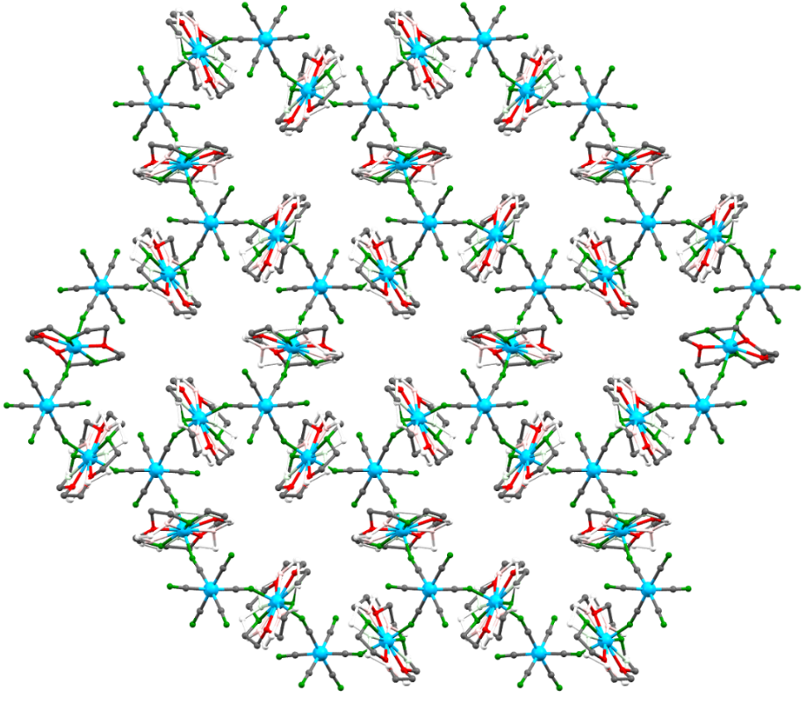
Figure 1.5. (Top-Left) [Co^{III}(CN)₆]₂[Co^{II}(TODA)]₃•nH₂O (Co-TODA). There are two different Co(II) ions (purple and green color) in the structure. The lattice water molecules are omitted. (Top-Right) Crystal structure of Co-TODA at 15(2) K. Colors: red = O, purple = N, green = Co, blue = C. H-atoms and the disordered components of the structure were omitted for clarity. (Bottom) Packing structure of Co-TODA at 15(2) K, showing the interconnected network with pores in the MOF structure. H atoms and lattice water molecules are omitted for clarity. Disorder in only one TODA ligand is shown.
(6) Determination of spin-lattice (T₁) and spin-spin (T₂) relaxation times for the intra-Kramers relaxation by pulsed EPR.

    - Chapter 3
Vallejo, Pardo, Cano, and coworkers reported the synthesis, structures and properties [Co(μ-bpeb)₂(NCS)₂]_{n}•nG, a polymorph of Co-BEBN (in the current studies) with a different crystal structure (called Co-BEBN-polymorph). Co-BEBN-polymorph shows a host structure of the MOF containing solvents as guests.⁷⁶ Their work demonstrates that the Co-BEBN-polymorph exhibits SIM properties at low temperatures through magnetic susceptibility [Alternating current (AC) and direct current (DC)] measurements. In addition, Co(II) nodes in the square layers of the Co-BEBN-polymorph minimized intermolecular interactions between Co(II) ions, thus improving the magnetic properties.⁷⁶
Significant efforts have been made over the past few years to design and synthesize compounds with large magnetic anisotropies. Among transition metal-based SIMs, Co²⁺ complexes are the most reported.⁷⁷ One approach is to use first-order SOC,⁷⁸⁻⁸⁰ leading to anisotropies typically much larger than the second-order ZFS. For Co²⁺ complexes with ZFS, few have 2D′ > 250 cm⁻¹,⁷⁷ as the list in Table 1.1 shows.
In this study, we reported the synthesis and magnetic properties characterizations of the two-dimensional (2-D) MOF Co-BEBN. We are interested in an in-depth analysis of the magnetic properties of Co-BEBN using a combination of optical and neutron spectroscopies in conjunction with ab initio calculations. Our studies demonstrate that Co-BEBN is a SIM with, to our knowledge, the largest ZFS among six-coordinated Co²⁺ systems. In addition, among those
Table 1.1. Selected examples of single-ion Co²⁺ complexes with 2D′ > 250 cm⁻¹ ª
Compound | Coord. No. | 2D′ (cm⁻¹) | D (cm⁻¹) | E (cm⁻¹) | Method | Ref.
(Ph₄P)₂[Co(C₃S₅)₂] | 4 | 322 | −161 | 0 | DC | Fataftah et al.⁸¹
CoL¹Cl₂  L¹ = 4-hept-1-ynyl-2,6-dipyrazol-1-ylpyridine | 5 | 305 | 151 | 11.6 | DC | Rajnák et al.⁸²
(HNEt₃)₂[Co(L²)₂]·H₂O, H₂L² = N,N′-bis(p-toluenesulfony1)oxamide | 4 | 288(1) | −144.1(3) | 0.02(7) | DC | Cui et al.⁸³
Co-BEBN | 6 | 262(1) | 127.3 | 17.8 | FIRMS and HFEPR | Current work
(Bu^{n}₄N)₂[Co(L³)₂]·H₂O,  H₂L³ = N,N′-diphenyloxamide | 4 | 262(1) | −130.8(9) | −0.70(0) | DC | Cui et al.⁸³
(HNEt₃)₂[CoL⁴₂],  H₂L⁴ = N,N′-bis(methanesulfonyl)oxamide) | 4 | 256 | −128.2 | −0.65 | DC | Wang et al.⁸⁴
[Co(L⁵)](BF₄)₂, L⁵ = tris(pyridylhydrazonyl)phosphorylsulfide | 6 | 255^{b} | −127.6(8) | −0.22(6) | DC | Landart-Gereka et al.⁸⁵
ª Complexes with two magnetic centers are not included in the table for single-ion magnets (SIMs). These include (CH₆N₃)₂[Co₂(citH)₂(H₂O)₄]⋅2H₂O (CH₆N₃⁺ = guanidinium; citH₄ = citric acid) with intramolecular ferromagnetic interactions [D = −226(14) cm⁻¹]⁸⁶ and [Co(dppmo)₃](CoBr₄) [dppmo = bis(diphenylphosphan)methane oxide; D = 147 and 12.3 cm⁻¹ for the octahedral and tetrahedral site, respectively].⁸⁷
^{b} From FIRMS and HFEPR experiments, 2D′ = 201 cm⁻¹.
with very large ZFS (>250 cm⁻¹) in Table 1.1, it was the only one determined by spectroscopies rather than by fitting DC susceptibility data. Co-BEBN also displays qubit properties.
Ab initio electronic structure calculations help understand the origin of the anisotropy and the magneto-structural nature of Co-BEBN.

    - Chapter 4
Here, we report that [Ni(μ-4,4′-bpy)(μ-ox)]_{n} (NiBO) is a Haldane spin-1 chain material. It has been comprehensively probed by a variety of techniques, including variable-temperature powder neutron diffraction (PND), magnetization measurements (DC magnetic susceptibility at different fields), high-field EPR (HFEPR), inelastic neutron scattering (INS), and specific heat measurements. In addition, we have performed quantum Monte Carlo (QMC) simulations of the spin-1 chains realized in NiBO, which show excellent agreement with the experimental DC magnetic susceptibility data. VT-PND data exhibit no long-range antiferromagnetic ordering down to 1.7 K, further supporting that NiBO is a quantum disordered spin-1 chain system. The spin gap extracted from the DC magnetic susceptibility measurements at 0.1 T agrees remarkably well with QMC simulations. The QMC results also identify magnetic parameters such as D, E, J, and g-factor (g) for NiBO, as detailed below. Additionally, both the magnetic susceptibility data and specific-heat data reveal a field-induced phase transition in NiBO for magnetic field beyond 9 T and temperatures below 5 K. HFESR was used to observe the effective anisotropy (D_{eff}) in ZFS through the transition within the triplet state. Furthermore, these magnetic measurements are well in accord with QMC simulations. X-ray single-crystal diffraction of deuterated [Ni(μ-4,4′-bpy-d₈)(μ-ox)]_{n} (NiBO-d₈) at 100 K revealed a non-planar structure of the 4,4′-bpy-d₈ ligand, which reduces magnetic inter-chain interactions. Inelastic neutron scattering (INS) studies provide the spin gaps between the singlet ground and the triplet excited state as well as the phonon properties of NiBO, which are supported by density functional theory (DFT)
calculations using Vienna Ab initio Simulation Package (VASP).⁶⁹

    - Chapter 5
Magnetic properties study of five-coordinate tetraphenylporphyrinatoiron complexes in Fe^{III}(TPP)X (X = F, Cl, Br, I; TPP²⁻ = meso-tetraphenylporphyrinate dianion) is presented. The series of Fe(TPP)X complexes presented in this work offers a specific case allowing the following: (1) Comparison of diverse experimental techniques, including relatively new and advanced magnetic resonance methods such as HFEPR and FIRMS, in terms of accuracy and precision of measurement; (b) From a scientific viewpoint, methodically tracking the influence of the axial halide ligand on the resulting ZFS of the given complex.

Chapter 2

Advanced Spectroscopic and Computational Studies of a Cobalt(II) Coordination Polymer with Single-Ion-Magnet Properties
This chapter is based on the following paper:

Pagnareach Tin, Alexandria N. Bone, Nhat N. Bui, Yi-Quan Zhang, Tieyan Chang, Duncan H. Moseley, Mykhaylo Ozerov, J. Krzystek, Yongqiang Cheng, Luke L. Daemen, Xiaoping Wang, Likai Song, Yu-Sheng Chen, Dong Shao, Xin-Yi Wang, Xue-Tai Chen, Zi-Ling Xue, Advance Spectroscopic and Computational Studies of a Cobalt(II) Coordination Polymer with Single-Ion-Magnet Properties. J. Phys. Chem. C 2022, 126, 13268. https://doi.org/10.1021/acs.jpcc.2c03083

Author contributions:
P. Tin, D.H. Moseley, and M. Ozerov performed the FIRMS experiments. Tin and MO interpreted FIRMS results and conducted simulations of transitions using EasySpin package. J. Krzystek performed HFEPR experiments, analyzed, and interpreted the results. N.N. Bui and L. Song performed pulsed X-band EPR experiments and helped interpret the results. Tin processed the pulsed X-band EPR data and interpreted the results. Y.-Q. Zhang performed the electronic structure calculations and interpreted the results. L.L. Daemen, Y. Cheng, and P. Tin collected VT INS spectra. Tin analyzed the INS data and interpreted the results. Cheng conducted VASP calculations of the INS spectra and spin density. Tin processed data from the calculations and interpreted results. T. Chang and Y.-S. Chen collected single-crystal X-ray diffraction data at 15 K and helped process the data. A.N. Bone processed the X-ray diffraction data and solved the structure. X. Wang resolved the disorder in the structure. D. Shao and X.-Y. Wang prepared the Co-TODA sample. X.-T. Chen initiated parts of the project and helped interpret the results. Z.-L. Xue initiated parts of the project, supervised the research, including data analyses, and interpreted the results of VASP calculations. Tin, Bone, Krzystek, Zhang, and Xue wrote the
manuscript with input from all authors.

2.1. Abstract
Two-dimensional (2-D) coordination polymer [Co^{III}(CN)₆]₂[Co^{II}(TODA)]₃•7H₂O (TODA = 1,4,10-trioxa-7,13-diazacyclopentadecane, Co-TODA) was reported earlier to show field-induced slow magnetic relaxation, displaying single-ion magnet (SIM) behaviors. Most SIMs are molecular compounds with fewer adopting coordination polymer (CP) or metal-organic framework (MOF) structures. In the current work, magnetic and phonon properties of Co-TODA have been studied by advanced spectroscopies and computations. A combined use of far-IR magneto-spectroscopy (FIRMS) and variable-temperature (VT) high-frequency and -field electron paramagnetic resonance (HFEPR) gives spin Hamiltonian (SH) parameters: Axial zero-field splitting (ZFS) parameter D as +38.0(1.0) ≤ D << +40.2(1.0) cm^{–1} and rhombic ZFS parameter E as 0 << |E| ≤ 7.3(1.0) cm^{–1}, showing that Co-TODA has the easy-plane magnetic anisotropy. Two Co^{II} centers in the CP, as determined by synchrotron single-crystal X-ray diffraction at 15(2) K, show similar magnetic properties indistinguishable in FIRMS at 5.3(3) K or in HFEPR at 5-150 K. Ab initio calculations explore the origin of the magnetic anisotropy and magnetostructural correlations. VT inelastic neutron scattering (INS) spectra of Co-TODA have been obtained to show the phonon properties of the CP. Density functional theory (DFT) calculations, giving both a calculated INS spectrum and spin distributions in Co-TODA, demonstrate that, when compared with other high-spin Co^{II} complexes, the larger spin density on a metal ion, the larger ZFS in the complex. Pulsed X-band EPR studies probe relaxations of the Co^{II} ions from the M_{S} = +1/2 to -1/2 state in the ground Kramers doublet (KD), yielding spin-lattice (T₁) and spin-spin relaxation (T₂) times. The work reported here highlights the versatility and power of the spectroscopic techniques and computations in the characterization of magnetic and phonon properties of a CP and the understanding of its magnetic anisotropy.

2.2. Results and Discussions
2.2.1. Single-Crystal Structure of Co-TODA at 15(2) K
Determination of the crystal structure of Co-TODA at 15(2) K by X-ray diffraction was prompted by the following two considerations: (1) Reported SIM behaviors of Co-TODA (and many other SMMs) are displayed at 15(2) K or below, while its reported crystal structure was determined at 123 K.⁷⁰ (2) While the structure at 123(2) K shows two Co^{II} centers, neither FIRMS nor HFEPR, discussed below, resolved the transitions from the two Co^{II} centers in Co-TODA. Thus, it is desirable to rule out a phase change between 123(2) K and 15(2) K.
The structure at 15(2) K determined by synchrotron X-ray diffraction is similar to that at 123 K. The shortest Co^{II…}Co^{II} distance is 7.52 Å, while the longest Co^{II…}Co^{II} distance is 15.4 Å with an interlayer separation of 9.18 Å between the Co^{II} ions. Each diamagnetic Co^{III} ion acts as a spacer between the Co^{II} ions, making each Co^{II} unit as a SIM. Both Co^{II} ions, Co2 and Co3, are coordinated by the five atoms (three N and two O atoms) of a TODA ligand and two N atoms of the CN⁻ ligands in similar pentagonal bipyramidal geometries. The Continuous Shape Measures (CShM) were performed on the two Co^{II} centers in the 15(2) K structure to determine their deviations from the ideal (D_{5h}) geometry. The CShM values of Co2 and Co3 show deviations of 0.791 and 0.410 from 0, respectively. With similar geometries, the magnetic properties of the two different Co are expected to be comparable.
Additional plots of the 15(2) K crystal structure in Co-TODA, showing its CP features, are given in Appendix A. Variable-temperature (VT) HFEPR was performed to observe potential changes to the magnetic properties between 5 K and 150 K due to the potential phase change. The VT-HFEPR results will be discussed below.

2.2.2. Studies of the Magnetic Transitions by FIRMS and HFEPR to Determine Spin-Hamiltonian Parameters
2.2.2.1. FIRMS
As indicated earlier, the FIRMS experiment was used to probe dominant inter-Kramers transitions from φ₁ to φ₃ and φ₄ (Figure 1.4). The experiments were performed several times at 5.3(3) K under magnetic field ranging from 0.000(2) T to 17.000(2) T with a 1 T step. Figure 2.1-Top shows a transmittance plot of the FIRMS data. The data were collected at each magnetic field separately and then normalized to a reference, which is an average of all transmission spectra. The purpose of the normalization is to eliminate instrumental arbitrations or artifacts as well as the non-magnetic spectrum background. A comparison of the 0 and 17 T transmittance plots (Figure 2.1-Top) did not clearly reveal a magnetic peak in the 0 T plot. However, a major change of ~2% in intensity between the 0 and 17 T spectra (Figure 2.1-Top) is observed around 80.4(1.0) cm⁻¹, while spectra match each other beyond this spectral range. In Figure 2.1-Bottom, a colored two-dimensional (2-D) FIRMS plot was obtained through a normalization process. In this plot, the intensity in the blue region reveals the magnetic transitions. The FIRMS and HFEPR (discussed below) do not have enough resolution to resolve the magnetic transitions from the two Co^{II} centers in the CP in the powder form. The blue region at ∼78-83 cm⁻¹ is broad,
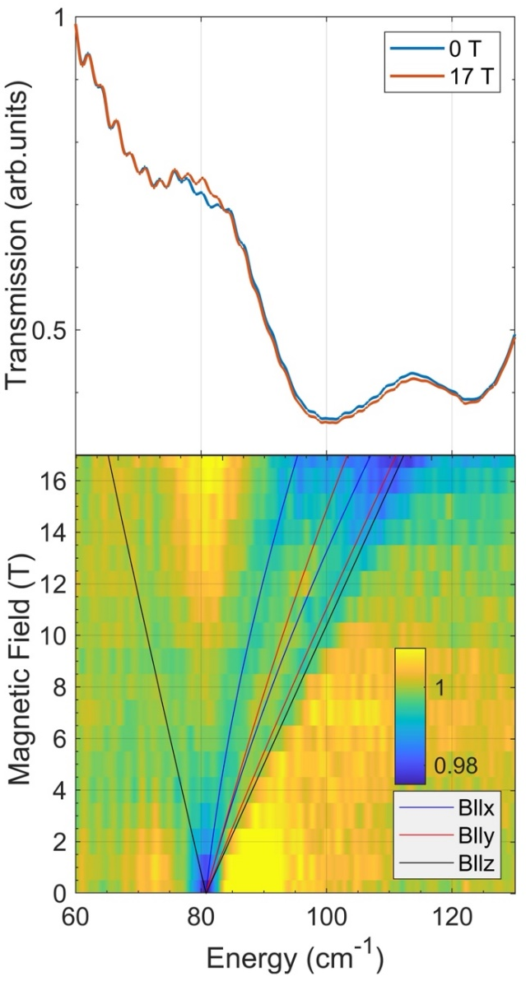
Figure 2.1. (Top) Transmittance line plot of FIRMS data at 5.3(3) K. (Bottom) 2-D FIRMS plot showing the zero-field magnetic transition originating from 80.4(1.0) cm⁻¹ and its evolution at applied high magnetic fields. The blue, red, and black lines are simulated transitions, using EasySpin on MATLAB⁸⁸, when the magnetic field is applied along the x-, y-, and z-axes of the [D,E] tensor, respectively. The ZFS parameters used in the simulations are D = 38.3(1.0) cm⁻¹, E = 7.3(1.0) cm⁻¹, and g = [2.33(6), 2.33(6), 2.06(6)], as discussed below in the HFEPR section. The 2-D FIRMS plot was obtained from data normalized to the reference spectrum, which is the average spectrum for all magnetic fields.
suggesting that transitions from both Co^{II} centers are in the 2 cm⁻¹-wide range. The transitions from two different Co^{II} centers in Co-TODA cannot be distinguished in Figure 2.1-Bottom in part because the transition is weak. Repeated FIRMS experiments to resolve the transitions from the two Co^{II} centers did not work. The energy separation between the two Kramers doublets is 2D′ = 80.4(1.0) cm⁻¹. The result from FIRMS, combine with those from HFEPR, give the SH parameters discussed below.
For S = 3/2 compounds (or CPs) with rhombic E (≠ 0) parameters, such as Co-TODA here, mixing of the two spin states (Figure 1.4) makes both inter-KD transitions from φ₁, φ₁ → φ₃ and φ₁ → φ₄, allowed inside a magnetic field. The zero-field splitting is directly observed at 80.4 cm⁻¹ (Figure 2.1-Bottom). The simulated transitions in Figure 2.1-Bottom were generated using EasySpin⁸⁸ on MATLAB and D = 38.3(1.0) cm⁻¹, E = 7.3(1.0) cm⁻¹, and g = [2.33(6), 2.33(6), 2.06(6)]. As the magnetic field increases, the two transitions from ground state φ₁ → φ₃ and φ₁ → φ₄ split, each along the B∥x, B∥y and B∥z directions of the magnetic anisotropy tensor. One B∥z transition is red-shifted to lower energy (Figure 2.1). The other B∥z transition and two B∥x and B∥y transitions each are blue-shifted with increasing field. One B∥x transition matches an observed trace in Figure 2.1-Bottom well. Another observed trace appears to follow one simulated B∥y and B∥z transitions. These lines restrict the area of the resonance frequencies, which are smeared in the magnetic field due to the arbitrary orientation of the microcrystalline in the powder sample. The FIRMS spectra and EasySpin simulations are similar to the reported FIRMS spectra of Co(acac)₂(H₂O)₂ and simulations of the spectra, which also give one red-shift and five blue-shift traces for the φ₁ → φ₃ and φ₁ → φ₄ transitions.⁵⁹ The simulations in the current work gave reasonable fits to the experimental data, which further support the direct observation of the zero-field splitting at 80.4(1.0) cm⁻¹ as well as the Zeeman splitting that occurs at a higher magnetic field.
No spin-phonon coupling was observed in FIRMS involving the magnetic transitions from 80.4(1.0) cm⁻¹, although there is a strong far-IR peak at ∼98 cm⁻¹ which may be too far from 80.4(1.0) cm⁻¹ to show spin-phonon coupling at 0 T. The magnetic transition at 80.4(1.0) cm⁻¹ in FIRMS is not strong. In addition, the CP structure leads to unique vibrational/phonon features (which appear to be different from those of molecular compounds).⁸⁹ For example, rotations of organic linkers in MOFs may be hindered. Trampoline-like motions were observed recently in a low-symmetry MOF, which was believed to be a potential source of negative thermal expansion of the MOF.⁸⁹ However, to understand why spin-phonon coupling in Co-TODA was not observed in FIRMS requires separate studies including computations similar to those reported recently for ionic and molecular compounds.⁹⁰⁻⁹⁴
INS was also performed to determine the inter-Kramers transition and phonon features in Co-TODA that are discussed below.

2.2.2.2. HFEPR
The HFEPR experiment was used to probe intra-Kramers transition φ₁ to φ₂, as shown in Figure 1.4. For each frequency used for a powder sample of Co-TODA, three peaks at different magnetic fields: B||x, B||y and B||z, are expected.
The experiment was conducted at 10(1) K with various set frequencies and variable magnetic field. Co-TODA produced a clear HFEPR pattern at any frequency, showing three peaks (turning points) when pressed into a pellet with n-eicosane. The spectrum was simulated using the SH parameters in the caption of Figure 2.2 with the assumption of powder distribution of crystallites in the sample. The simulated spectrum agrees very well with the experimental one. It is characteristic of a high-spin Co^{II} ion with positive D, i.e., easy-plane anisotropy, and pronounced rhombicity (E) of the ZFS tensor. Figure 2.2-Left shows a spectrum at 10(1) K and 321 [or 321.000(2)] GHz with its simulation. The separation of B_{x} and B_{y} turning points in the HFEPR spectra could also be a result of the g-anisotropy (g_{x} not equal to g_{y}). However, simulations show that, in order for the g-anisotropy to reproduce that separation, the g-values would have to be physically unrealistic. The actual E parameter should thus be understood as being 0 << E ≤ 7.3(1.0) cm^{–1} and D as 38.0(1.0) ≤ D << 40.2(1.0) cm^{–1}. That is, the E and D values are much closer to 7.3(1.0) cm^{–1} and 38.0(1.0) cm^{–1}, respectively, than to 0 and 40.2(1.0) cm^{–1}.
Due to the large rhombicity (E >> 0) in Co-TODA, there is a significant mixing of the M_{S} = ±1/2 and M_{S} = ±3/2 spin states, giving, e.g., φ₁ = -a |-1/2⟩ + b |+3/2⟩ and φ₂ = -a|+1/2⟩ - b|-3/2⟩ for the lower energy KD [Mixing coefficients: a = cos β, b = sin β, tan 2β = √3 (E/D)], as shown in Figure 1.4. Thus, the Zeeman splitting is a function of both g and the mixed spin states. Using the D′ = (D² + 3E²)^{1/2} value from FIRMS, a simulation to the 2-D map of turning points in Figure 2.2-Right gave the values of the spin Hamiltonian (SH) parameters D, E, and g [g_{x}, g_{y}, g_{z}]. The simulations assume that the g-tensor is axial, which we do not know since E and g-rhombicity are interrelated. We can only state that the E/D = 0.19 ratio represents the maximum value. With the combined data from FIRMS and HFEPR, we were able to quantify the values of D, E, and g in the spin
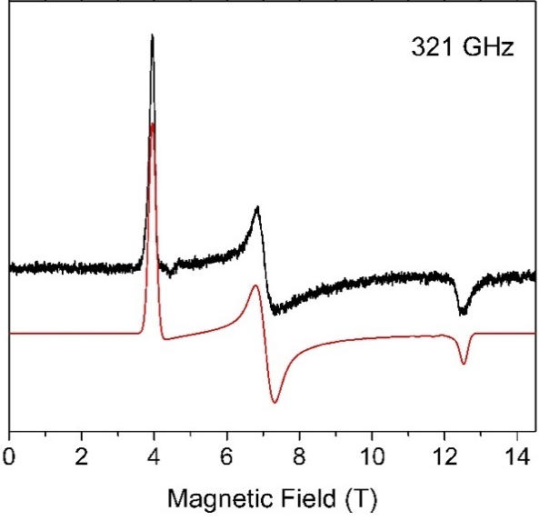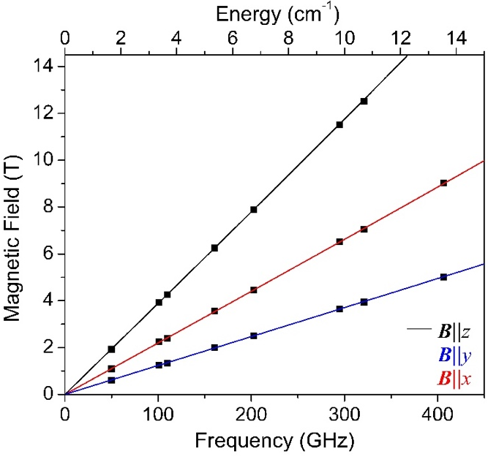
Figure 2.2. (Left) HFEPR spectrum of Co-TODA at 10(1) K and 321 GHz (black trace) and its simulation (red trace) using the following SH parameters: D = 38.3(1.0) cm⁻¹, E = 7.3(1.0) cm⁻¹, g = [2.33(6), 2.33(6), 2.06(6)]. (Right) 2-D map (magnetic field vs. frequency/energy) of turning points in HFEPR spectra of Co-TODA at 10(1) K. The squares are experimental points while the lines were simulated using best-fit SH parameters. (The D and E values were chosen such that 2D′ agrees with the ZFS transition at that was found in FIRMS).

Hamiltonian as well as determine the inter-Kramers transition energy of the CP.
The single-crystal structure of Co-TODA at 123(2) K shows two different Co^{II} centers, while both FIRMS and HFEPR data at 5-10 K, using powder samples, did not resolve the transitions from the two Co^{II} centers in Co-TODA. Repeated attempts to synthesize the CP only yielded powders or small crystals not large enough for single-crystal FIRMS and HFEPR studies. The single-crystal structure of Co-TODA at 15(2) K, discussed earlier, is similar to that at 123(2) K, ruling out a phase change between the two temperatures. In other words, the two different Co^{II} centers exist at both 15(2) K and 123(2) K. We have decided to conduct VT HFEPR at several temperatures between 5(1) K and 150(1) K to reveal potential changes in the magnetic properties of the molecule at the different temperatures. Figure 2.3 shows the VT HFEPR graph at a set frequency of 273 [or 273.000(2)] GHz. The characteristics of all three visible EPR patterns did not change as the temperature decreased. The VT HFEPR results are consistent with the single-crystal X-ray diffraction results, which showed no phase transition between 5(1) K and 150(1) K. Therefore, there are no changes to the magnetic characteristics of Co-TODA at the low temperature.
It is noted that both the current FIRMS/HFEPR spectroscopies and earlier DC susceptibility data fitting⁷⁰ show that Co-TODA has the easy-plane anisotropy, although the current spectroscopic studies give direct determination of the D and E values. The easy-plane anisotropy (D > 0) obtained from HFEPR here is supported by the ab initio calculations discussed below. Easy-axis anisotropy (D < 0) was considered to be an important criterion for SIMs because it favors high |M_{S}| states energetically.⁹⁵ In a classical picture, for molecules with the easy-plane anisotropy, there is no (when E = 0) or a small (when E ≠ 0) barrier for spin
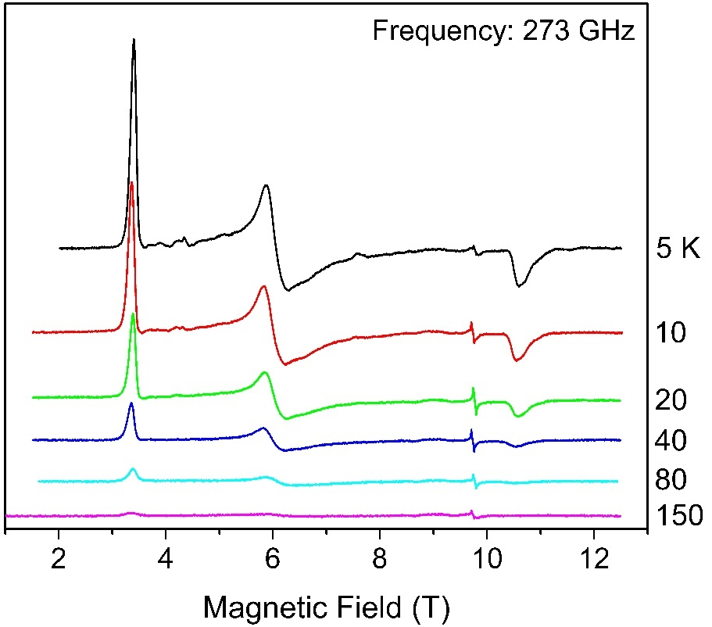
Figure 2.3. VT HFEPR spectra at 273 GHz with temperatures ranging from 5(1) K to 150(1) K. The narrow resonance at ca. 9.8 T is due to an unidentified S = 1/2 impurity.

reversal because of the condition |E| = D/3.⁹⁵ In addition, spin tunnelling rates are expected to be high.⁹⁵ Both factors contribute to the loss of magnetic memory. However, many complexes with the easy-plane anisotropy,⁹⁶⁻¹⁰⁷ including Co-TODA here,⁷⁰ have shown SIM behaviors with slow magnetic relaxation. Using Co(acac)₂(H₂O)₂ (acac⁻ = acetylacetonate) as a model, Gomez-Coca and coworkers have found that the slow relaxation in such systems is a general consequence of time-reversal symmetry that hinders direct spin–phonon processes regardless whether the complexes have the easy-plane or easy-axis anisotropy.⁹⁵ It is also noted that the reported AC susceptibility measurements of Co-TODA at 2.0-3.0 K give U_{eff} = 11 cm⁻¹,⁷⁰ which significantly lower than +38.0(1.0) ≤ D << +40.2(1.0) cm^{–1} determined spectroscopically here.

2.2.3. INS Studies of the Inter-KD Transition and Phonon Properties
INS spectra give complete phonon spectra of the sample, which may help understand phonon properties of the CP. In addition, INS may show magnetic transitions in the sample. There are generally two types of interactions between incident neutrons and a sample in the INS process. The neutrons interact with the atomic nuclei of the sample, leading to the excitation of phonons. The neutrons (spin = 1/2) also interact with the magnetic field of the sample created by its unpaired electrons, leading to the magnetic excitations.
Phonons of molecular crystals include both internal and external modes.^{108, 109} Internal mode or (intramolecular) vibration is caused by the distortion of atoms in a molecule as well as a slight shift in the molecular center of mass. External mode (or lattice vibration) is that of the lattice with little to no internal distortion of the molecule. All phonon modes, however, exhibit features of both internal and external modes. Phonons in this study refer to both external and internal modes in the solid. Variable-temperature (VT) INS may be used to differentiate the magnetic and phonon transitions. Because electrons and phonons are fermions and bosons, respectively, they will have different temperature profiles, making it possible to use Bose-corrected VT INS to distinguish magnetic transitions from those of phonons.
Current INS studies were conducted using vibrational spectrometer (VISION) at ORNL. The INS work was performed by sealing 0.5 g of sample in an aluminum container under helium. The spectra were measured at 5.0(5), 25.0(5), 50.0(5), 75.0(5), 100.0(5), 125.0(5), and 150.0(5) K for one hour at each temperature. Bose-corrected INS spectra of forward-scattering data and back-scattering data are given in Figure 2.4. Since phonons are bosons following Bose-Einstein statistics,^{98, 110-115} the Bose correction applies a frequency- and temperature-dependent normalization factor such that INS spectra measured at different temperatures are brought to a similar level for comparison. In other words, the spectrum is divided by the phonon population factor, which facilitates the comparison of the various spectra collected at different temperatures.
Phonon features at different temperatures in Bose-corrected spectra are expected to have similar profile and baseline intensity. The magnetic transition from electrons, which are fermions, does not follow the expected temperature dependence for phonons. A broad peak was observed at ~75(2) cm⁻¹ in the INS spectrum at 5.0(5) K, which is more intense in the forward-scattering (Figure 2.4-Top) than in the backscattering spectrum at 5.0(5) K (Figure 2.4-Bottom), when, e.g., compared with the peak to its right [at ~94(1) cm⁻¹]. In INS, magnetic transitions are stronger in the forward-scattering (with smaller magnitudes of the momentum transfers, ⎜Q ⎜= ⎜k_{i} – k_{f} ⎜; k_{i} and k_{f} refer to the momenta of the incoming and outgoing neutrons, respectively) than in the backscattering spectra, while phonon transitions are weaker in the forward-scattering
Figure 2.4. Bose-corrected INS spectra collected at VISION. (Top) Forward scattering. (Bottom) Backscattering.
than in the backscattering spectra.⁶⁹ Thus, it is likely that the broad peak at ~75(2) cm⁻¹, extending to >82 cm⁻¹, contains the contribution from the magnetic transition. That is,
overlapping peaks of magnetic and phonon transitions at ~75(2) cm⁻¹ make the peaks more intense in the forward-scattering spectrum at 5.0(5) K than that in the backscattering spectrum. However, the broad, likely overlapping peaks at ~75(2) cm⁻¹ from a powder sample of Co-TODA prevents definitive assignment of the magnetic contribution to the peaks. The spectrum shows two phonon features between 70 cm⁻¹ and 100 cm⁻¹. The phonon features around the region of the observed magnetic transition [80.4(1.0) cm⁻¹ from FIRMS] can potentially lower the relaxation time of the spins due to the phonon acting as an external perturbation to the system. Even though phonons are found around the region of the magnetic transition, no phonon couplings were observed in FIRMS.
DFT (density functional theory) calculations of the phonon INS spectrum of Co-TODA were conducted using VASP. The goal of the calculations is to compare the calculated phonon INS spectrum to the experimental one so a magnetic transition in the experimental INS spectra, which is not in the calculated phonon INS spectrum, may be revealed. Due to the complexity of the crystal structure of the Co-TODA and the disorder of the TODA ligands, the symmetry of the CP was lowered to P1 in the calculations. Since the calculations were not conducted in the original, higher symmetry of P2₁/c (No. 14), phonon modes were not assigned symmetries. The calculated INS spectrum in the range of 10-4000 cm⁻¹ is given in Figure A.17, in comparison with the experimental INS at 5 K. The calculated and experimental INS spectra match fairly well, considering that the magnetic transition at 80.4(1.0) cm⁻¹ overlaps with phonon peaks around 75(2) cm⁻¹.
2.2.4. Computational Studies of the Magnetic Anisotropy in Co-TODA
With the determination of the easy-plane anisotropy in Co-TODA by both FIRMS/HFEPR spectroscopies and DC susceptibility data fit, we have conducted ab initio studies to understand the anisotropy.
There are two Co^{II} ions, Co2 and Co3, in the crystal structure of Co-TODA, both coordinated by TODA ligands (Figure 1.5). The calculated molecular structures of individual Co^{II} fragments are given in Figure A.1. The energy differences between the lowest two spin-free states (Table A.1) of Co2 and Co3 are both much larger than those between the lowest two spin-orbit states (Table A.2), and the compositions of the ground spin-orbit states are almost entirely from the ground spin-free states. Thus, we can use ZFS parameters D and E to depict their magnetic anisotropies.
The calculated D, E (cm^{–1}) and g (g_{x}, g_{y}, g_{z}) tensors for Co2 and Co3 using CASPT2 and NEVPT2 with MOLCAS 8.4¹¹⁶ and ORCA 4.2,¹¹⁷ respectively, are shown in Table A.3, where the D values obtained from NEVPT2 are more consistent with the experiments when compared with those from CASPT2. Figure A.2 shows calculated orientations of the local magnetic axes (g_{x}, g_{y}, g_{z}) on Co2 and Co3 in their ground spin-orbit states using CASPT2/RASSI-SO with MOLCAS 8.4. To analyze magnetic anisotropies deeply, we gave the contributions of the excited states to D values for Co2 and Co3 in Table A.4 using NEVPT2 with ORCA 4.2. The dominant contributions to the positive D values were from the two close quartet states, particularly the third and the fourth quartet states for both Co2 and Co3. The calculations yield positive D values, which are consistent with the geometries around the Co^{II} ions and easy-plane anisotropies (g_{x}, g_{y} > g_{z}). Molecular coordination frame was chosen so that the Z axis is along the numerically largest eigenvalue of the D-tensor and the X and Y axes accordingly to the other two. The following discussion of Co d-atomic orbitals (d-AOs) is classified in accordance with this frame. The calculated relative energies (cm^{–1}) of ligand field one-electron states (in the basis of d-AOs) for Co2 and Co3 using NEVPT2 with ORCA4.2 are shown in Table A.5 according to the ab initio ligand field theory (AILFT)^{118, 119} analysis. The CASPT2 calculations gave the D values for Co2 and Co3 as 30.5 cm⁻¹ and 43.0 cm⁻¹, respectively. The experimental value of D from HFEPR [38.0(1.0) ≤ D << 40.2(1.0) cm⁻¹] is between the calculated D values of Co2 and Co3 from CASPT2.
The magnetic susceptibility of Co-TODA was calculated using CASPT2/RASSI-SO with MOLCAS 8.4. The calculated plots of magnetic susceptibilities vs. temperatures for both Co2 and Co3 are shown in Figure A.3, giving the susceptibility value of 1.5-1.7 cm³ mol⁻¹ K near 0 K that plateaus around 2.5 cm³ mol⁻¹ K at 300 K. The calculated magnetic susceptibilities of Co2 and Co3 are alike, supporting that the two Co^{II} centers have close characteristics. The calculated plots are similar to those from the earlier experiments.⁷⁰ For example, the experimental magnetic susceptibility value, which does not distinguish the contributions from Co2 or Co3, is 1.37 cm³ mol⁻¹ K at 2 K, while plateauing around 2.48 cm³ mol⁻¹ K at room temperature. Therefore, the calculated magnetic susceptibility values are agreeable with the experimental data.⁷⁰
For Co2 and Co3, the most destabilized by ligand field is the singly occupied state composed of practically pure d_{z2} AOs. The orbital energies computed for the ground states are shown in Figure A.4, where the ground states for Co2 and Co3 are both multideterminant with prevailing (62.2% and 84.1%, respectively) contribution of (d_{yz})¹(d_{xz})²(d_{xy})¹(d_{x2-y2})²(d_{z2})¹ and (d_{yz})¹(d_{xz})²(d_{xy})¹(d_{x2-y2})²(d_{z2})¹, and are mixed with another with the weightage of 13.3% and 12.1%, respectively. For Co2, the major contributions to D are from the ground to the third and the fourth excited states transitions (d_{xz} → d_{z2} and d_{x2-y2} → d_{z2}, respectively). The positive sign of the D parameter is attributed to these transitions which occur between orbitals with the different magnetic quantum number (m_{l}) values.^{120, 121} In the case of Co3, as it is similar to Co2, the largest contributions to D are also from the ground to the third and the fourth excited states transitions (d_{x2-y2} → d_{yz} and d_{x2-y2} → d_{z2}, respectively). Since these orbitals also have different m_{l} value, the contributions to the D value are positive in complete agreement with the experiments.
The multideterminantal wavefunctions of the selected excited states having important contributions to D tensor are shown in Figure A.5, where all the excited states are composed by several conﬁgurations indicating the presence of the unquenched orbital angular momentum. The calculated χ_{M}T versus T plots are shown in Figure A.2. The calculated orientations of the g_{x}, g_{y} and g_{z} in the ground spin-orbit states on Co^{II} ions of Co2 and Co3 are shown in Figure A.3.

2.2.5. Calculated Spin Densities and a Correlation with the D Parameter
Spin density calculations were performed using VASP (Vienna Ab initio Simulation Package) with the Projector Augmented Wave (PAW)^{79, 122-124} method and the local density approximation (GGA)¹²⁵ + U (U = 4.4 eV)^{126, 127} exchange correlation functional. Spin density calculation is used to study the localization of spin in the metal ions as well as the ligands. The calculations do not include the spin densities that reside in the bonds, but rather just the densities in individual atoms. The range of spin densities for each atom type is presented in Table 2.1. Detailed spin
Table 2.1. Calculated spin densities for atoms in a unit cell of Co-TODA. Ranges of spin densities are listed for O, N, C, and H atoms due to the large number of atoms existing in the unit cell
Atoms | Ranges of Spin Densities
Co^{II} | 2.69
Co^{III} | 0.01
O | 2.15 × 10⁻² to 3.57 × 10⁻²
N of TODA | 4.31 × 10⁻² to 4.33 × 10⁻²
N of CN⁻ | -1.14 × 10⁻⁴ to -1.02 × 10⁻⁴  2.11 × 10⁻⁴ to 1.92 × 10⁻²
C of CN⁻ | -2.03 × 10⁻⁴ to -1.18 × 10⁻⁴  7.89 × 10⁻⁵ to 7.23 × 10⁻³
C of TODA | -8.96 × 10⁻⁴ to -2.89 × 10⁻⁴  7.62 × 10⁻⁵ to 1.81 × 10⁻³
H | -3.14 × 10⁻⁴ to -1.2 × 10⁻⁷  2.00 × 10⁻⁸ to 2.04 × 10⁻³
Total | 17.616 (2.936 per SBU*)

*SBU = Secondary Building Unit

densities are given in Table A.9.
The results show that the spin densities are mostly concentrated on the Co^{II} ions, containing 2.68-2.69 (89.3-89.7%) of the 3 unpaired electrons on the metal ions, while the rest are dispersed on the ligands and the diamagnetic Co^{III} ions. We recently found that, among four Co^{II} complexes Co(PPh₃)₂X₂ (X = I, Br, Cl) and Co(acac)₂(H₂O)₂ (acac = acetylacetonate), the larger the spin density on a metal ion, the larger the ZFS is in the complex,¹²⁸ as summarized in Table 2.2. Co-TODA in the current work [D′ = 40.2(1.0)] follows the trend (Table 2.2). Its spin densities of 2.68-2.69 on the Co^{II} ions and D′ = 40.2(1.0) are both lower than those of Co(acac)₂(H₂O)₂ but higher than those of Co(PPh₃)₂X₂ (X = I, Br, Cl) (Table 2.2).
In both Co(acac)₂(H₂O)₂ and Co-TODA, only light N and O atoms (in the 2nd row of the periodic table) are bound to the Co^{II} ions with 6- and 7-coordination, respectively. For Co-TODA, seven N,O atoms (and other atoms in the ligands) share the spin densities from the three unpaired electrons, while in Co(acac)₂(H₂O)₂, six O atoms bound to the Co^{II} ion (and other atoms of the ligands) share the spin densities. Perhaps the different coordination numbers in Co(acac)₂(H₂O)₂ and Co-TODA is one contributor to the spin density differences between the two. In Co(PPh₃)₂X₂ (X = I, Br, Cl), the halogen atoms in the 3rd, 4th and 5th-rows of the periodic table have higher spin densities [6.69 × 10⁻² (Cl), 6.85 × 10⁻² (Br) and 6.01 × 10⁻² to 6.39 × 10⁻² (I) in the three complexes¹²⁸] than, e.g., those on N and O atoms in Co-TODA.
It should be pointed out that the number of complexes here (five in Table 2.2) is limited, and different DFT programs may give different calculated spin densities. Additional studies are needed to see if there is a correlation between the spin densities and magnitudes of ZFS.

Table 2.2. Correlation between Calculated Spin Densities on the Co^{II} Ions and ZFS Parameters of the Co^{II} Complexes/CP
Complexes | Spin Densities on the Co^{II} Ions (and Percentage of 3 Unpaired Electrons) | D′ Values (cm⁻¹)
Co(PPh₃)₂I₂ | 2.553 (85.1%) | 13.63(10)
Co(PPh₃)₂Br₂ | 2.570 (85.7%) | 13.83(2)
Co(PPh₃)₂Cl₂ | 2.585 (86.2%) | 14.89(2)
Co-TODA | 2.68-2.69 (89.3%-89.7%) | 40.2
Co(acac)₂(H₂O)₂ | 2.81 (93.7%) | 57.0

2.2.6. Studies of Spin-Lattice (T₁) and Spin-Spin (T₂) Relaxation Times in the Ground KD by Pulsed X-band EPR
Pulsed X-band EPR was used to probe the spin-lattice and spin-spin relaxation times T₁ and T₂ after the Co^{II} centers are excited from φ₁ to φ₂ (Figure 1.4). In other words, pulsed EPR here provides relaxation times for the intra-KD transition inside a magnetic field. The two relaxation times are intrinsic magnetic properties of Co-TODA.
T₁ quantifies the rate of energy transfer from the molecular spin to the lattice.⁶⁴ Using the technique of echo inversion recovery, a pulsed wave at 180° is applied inside a field,^{129, 130} leading to the flipping of the magnetization (M_{z}) from +z to –z with higher energy. Afterwards, the flipped spin will undergo spin-lattice relaxation to return to +z, releasing energy to the environment through spin-lattice relaxation. M_{z}(t), magnetization along z at different times (t) after the 180° pulse, is measured. T₁ is the time for M_{z}(t) to reach 63% of its maximum value, M_{z}(0), as shown in Eq. 2.1.^{131, 132} T₁ is also the rate at which the spins relax back to the Boltzmann equilibrium state at a given temperature after the removal of the external magnetic field. T₁ is an important magnetic property of a compound or CP, e.g., for the relaxation from φ₂ to φ₁ in Co-TODA.

M_{z}(t) = M_{z}(0)[1 - 2exp(–t/T₁)] (Eq. 2.1)
where M_{z}(0) and M_{z}(t) are the axial component of the magnetization vector at time = 0 and t, respectively; T₁ is the spin-lattice relaxation time.

Spin-spin relaxation is the process where the transverse component of the magnetization (M_{xy}) dephases or decays. According to Bloch, this process follows first-order kinetics resulting in the exponential decay.¹³¹ T₂ is the time it takes for the traverse magnetization to fall to 37% of its initial value, as shown in Eq. 2.2.¹³¹ Hahn echo decay is typically used to study the spin-spin relaxation, quantifying T₂.⁹⁴ A 90° pulse inside magnetic field flips the magnetization to the x-y plane. Then, spins in different environments begin to dephase at different speeds due to the local magnetic field inhomogeneities. Next, a 180° pulsed is used to flip the spin dephasing direction to remove the inhomogeneous dephasing so to detect the magnetization. The process is repeated with different periods (t) of dephasing before the echo.^{64, 131}

M_{xy}(t) = M_{xy}(0)exp(–t/T₂) (Eq. 2.2)
where M_{xy}(0) and M_{xy}(t) are the transverse components of the magnetization vector at time = 0 and t, respectively; T₂ is the spin-spin relaxation time.

T₂ reflects the coherence time of the two spin states and thus the effectiveness of qubits. Recently, metal complexes with long T₂ have been actively investigated as qubit candidates.^{9-11, 94, 133-136} Finding a compound with long T₂ is challenging, as interactions of unpaired electron spins in a compound with the local environment causes the rapid collapse of the superposition state through decoherence. Effects such as nuclear spin diffusion coupling to nearby electron, methyl rotation, and spin diffusion barrier are major obstacles when it comes to prolonging the T₂. Zadrozny and coworkers have quantified μs-length T₂ of various d¹ V(IV) compounds and compare the spin-spin relaxation times with those of other well-known qubits such as the nitrogen-vacancy (NV) center. For example, T₂ = ∼1 ms for (Ph₄P-d₂₀)₂[V(C₈S₈)₃] in CS₂ at 10 K, eclipsing the nitrogen vacancy center in non-isotopically enriched diamond.¹²
Pulsed X-band EPR experiments of a powder sample of Co-TODA (with no magnetic dilution of the Co^{II} ions) were performed at 5(1) K to give T₁ and T₂ times. Figure 2.5 (Top) gives the echo inversion recovery graph, giving the T₁ value of 235(4) μs at 5 K. It is interesting to note that, for Co-TODA, T₁ = 235(4) μs at 5(1) K, the lowest temperature measured in the current work, is at the same order as the relaxation time τ = 130 μs at 3.0 K, the highest temperature probed by AC (alternating current) susceptibility studies.⁷⁰ Figure 2.5 (Bottom) shows the Hahn echo decay graph with the T₂ value of 0.513(4) μs at 5(1) K. It should be noted that the Co-TODA sample used here for the pulsed X-band EPR studies is 100% Co. The relatively short T₂ value suggests the presence of inter-Co^{II} magnetic interactions in Co-TODA that may be reduced with the use of diamagnetic Zn^{II} dilution. The field swept echo graphs in Figures A.14 and A.15 show one feature at 3344(1) G or approximately 0.33 T. The feature suggested an EPR observable intra-Kramers transition from φ1 to φ2. Due to the excitation bandwidth limitations, a pulsed X-band EPR sequence can only excite a portion of the spin populations. Moreover, not all spins can be flipped by a pulse in the same angle. Therefore, only one such transition can be seen in the spectra. T₁ and T2 times at 10(1) K, 20(1) K and 30(1) K were also measured. The echo inversion recovery and the Hahn echo decay graphs of the temperatures as well as the field swept echo graphs are given in Appendix A.
The T₂ time for Co-TODA is fairly long considering that there is no magnetic dilution in the CP and that the shortest Co^{II…}Co^{II} distance is 7.52 Å in the CP, making Zn^{II}-diluted Co-TODA potential qubit candidates. The rigid and sturdy structure of a CP and its
Figure 2.5. Graphs of the echo intensity from pulsed X-band EPR at 5(1) K vs. time: (Top) Echo inversion recovery experiment; (Bottom) Hahn echo decay experiment. External magnetic field = 3344(1) Gauss.
unique phonon properties may provide an environment for the qubit centers in the CP, potentially prolonging T₂ times. Previous studies of the spin coherence times of qubit candidates were reported for Cu^{II}, Co^{II}, and V^{IV} CPs.^{14, 137-139} Yu, Freedman and coworkers have shown that a magnetically diluted Cu^{II} porphyrin MOF at the 10%, 40%, and 100% levels has the phase memory time (T_{m}) values of 0.645, 0.121, and 0.046 μs, respectively.¹³⁸ T_{m} is the measure of all processes contributing to the spin decoherence, including T₂. In the non-diluted CP, the distance between two nearest Cu^{II} centers is 13.595 Å. T₂ of 0.467 μs for Co-TODA is thus comparable to T_{m} of the 100% Cu^{II} porphyrin MOF, showing that Co-TODA is a promising qubit candidate. Another notable example is a Co^{II} porphyrin-based MOF investigated by Zadrozny, Freedman and coworkers.¹⁴ In the non-magnetically diluted MOF, the distance between the two nearest Co^{II} neighbor is 13.643 Å. Once magnetically diluted to 7% of Co^{II} (with 93% of Zn^{II}), the T₂ time was found to be 13.74(9) μs.¹⁴ The T₂ time is considerably longer than that of Co-TODA that is likely a result of the dilution of the Co^{II} magnetic centers as well as longer distances between the nearest Co^{II} neighbor in the structure. Further studies with Zn^{II}-diluted Co-TODA are needed to see if the diluted CP has the qubit properties.

2.3. Experimental Section
Polycrystalline sample of Co-TODA was prepared as reported in the literature.⁷⁰

2.3.1. FIRMS Experiment
FIRMS spectra were collected at the NHMFL (Tallahassee, Florida, USA) using a Bruker Vertex 80v Fourier-transform infrared (FT-IR) spectrometer coupled with a 17.5 T vertical-bore superconducting magnet. The experimental setup is equipped with a mercury lamp and a composite silicon bolometer (Infrared Laboratories), as an incoherent (sub)-THz radiation source and detector, respectively. The THz radiation is free-space propagating inside the optical beamline, connecting the output of the spectrometer and top of the sample probe. The radiation is then passed through the brass light pipe over a distance of 2.5 m from room temperature to the field center. The probe and beamline are evacuated to eliminate strong parasitic absorptions of the air. The studied samples are the mulls of n-eicosane and powder (~2 mg) of each complex. Both the sample and the bolometer were cooled by low-pressure helium gas to 5.3(3) K. The spectrum of the THz radiation transmitted through the samples was measured in the spectroscopic between 10 and 720 cm⁻¹ (0.3–21.6 THz) with a resolution of 0.3 cm⁻¹ (9 GHz), acquisition time of 3 min and 5 kHz scanner speed. FIRMS spectra of Co-TODA were collected a total of four times with different samples, yielding similar results.

2.3.2. HFEPR Experiment
HFEPR spectra were obtained at the NHMFL using the home-built spectrometer based on a 17-T superconducting magnet described previously,¹⁴⁰ and differs from that description only by the use of a low-frequency (8-20 GHz) microwave source complemented by a cascade of amplifiers and multipliers (Virginia Diodes, Charlottesville, VA, USA) to produce higher frequency harmonics.

2.3.3. INS Experiment
For variable-temperature INS at VISION, the sample (0.5 g) was sealed in an aluminum container and placed inside the neutron beam at Vibrational Spectrometer (VISION) at Spallation Neutron Source (SNS), ORNL. INS spectra of Co-TODA were measured at 10.0(5), 25.0(5), 50.0(5), 100.0(5) and 125.0(5) K. The design at VISION offers two banks of detectors for both forward (low |Q|) and back (high |Q|) scattering of neutrons.¹⁴¹ The phonon population effect was corrected by normalizing the INS intensity at energy transfer ω with $\coth\left(\frac{ℏω}{2k_{B}T}\right)$.¹⁴²

2.3.4. Electronic Structure Calculations
Electronic structure calculations were conducted by extracting two types of three-core units from the 2D framework complex. For each unit, there are two individual Co^{II} fragments (Co2 and Co3 in Figure A.1) needed to be calculated while the neighboring Co^{III} ions are diamagnetic. Complete active space second-order multiconfigurational perturbation theory (CASPT2) considering the effect of the dynamic electron correlation based on complete-active-space self-consistent field (CASSCF) method with MOLCAS 8.4 program package¹¹⁶ was performed on the basis of single-crystal X-ray determined geometries of the complex.
For the first CASSCF calculation, the basis sets for atoms are atomic natural orbitals from the MOLCAS ANO-RCC library: ANO-RCC-VTZP for magnetic center ion Co^{II}; VTZ for close N and O atoms; VDZ for distant atoms. The calculations employed the second order Douglas-Kroll-Hess Hamiltonian, where scalar relativistic contractions were taken into account in the basis set. The effect of the dynamical electronic correlation was applied using CASPT2 based on the first CASSCF calculation. After that, the spin-orbit coupling was handled separately in the restricted active space state interaction (RASSI-SO) procedure. The active electrons in 5+5´ active spaces considering 3d double shell effect include all d electrons [CAS(7 in 5+5´)] in the CASSCF calculations. To exclude all the doubts, we calculated all the roots in the active space. We have mixed the maximum number of spin-free state which was possible with our hardware (all from 10 quadruplets and 20 from 40 doublets). SINGLE_ANISO¹⁴³⁻¹⁴⁵ program was used to obtain zero-field splitting parameters D (E) (cm⁻¹), g tensors, energy levels, magnetic axes, et al., based on the above CASPT2/RASSI-SO calculations.
To deeply analyze the magnetic anisotropies, ORCA 4.2 calculations¹¹⁷ were performed with complete active space self-consistent field calculations (CASSCF), followed by N-electron valence second-order perturbation theory (NEVPT2). The spin-orbit coupling (SOC) operator used was the efficient implementation of the multicenter spin-orbit mean-field (SOMF) concept developed by Hess et al.¹⁴⁶ The spin-spin contributions (SSC) to the D values were also included although they are very small for our complex. The NEVPT2¹⁴⁷⁻¹⁵⁰ calculation both with seven 3d electrons in five Co 3d-based orbitals [CAS(7, 5+5´)] including 3d-double shell effects were performed on Co2 and Co3. In the calculations, the orbitals were determined for the average of 10 S = 3/2 and 40 S = 1/2 roots. All calculations were performed with triple-ζ with one polarization function def2-TZVP¹⁵¹⁻¹⁵³ basis set for all atoms.

2.3.5. DFT Calculations of INS Spectrum and Spin Densities
Spin-polarized Density Functional Theory (DFT) calculations of the Co-TODA compound were performed using the Vienna Ab initio Simulation Package (VASP).¹⁵⁴ The calculation used Projector Augmented Wave (PAW) method^{122, 123} to describe the effects of core electrons, and Perdew-Burke-Ernzerhof (PBE)¹²⁵ implementation of the Generalized Gradient Approximation (GGA) for the exchange-correlation functional. Energy cutoff was 600 eV for the plane-wave basis of the valence electrons. The lattice parameters and atomic coordinates from the original paper⁷⁰ were used as the initial structure. Ideally, the partial occupancy and structure disorder should be accounted for by creating a supercell and assigning the ligands to each possible configuration according to the occupancy probability. This is however too costly for the already large unit cell (volume >3500 Å³). As an approximation, this procedure was done within the unit cell, resulting in the same periodicity with internal disorder (loss of symmetry). The electronic structure was calculated at the Γ point only. The total energy tolerance for electronic energy minimization was 10⁻⁸ eV, and for structure optimization, it was 10⁻⁷ eV. The maximum interatomic force after relaxation was below 0.001 eV/Å. The optB86b-vdW functional¹⁵⁵ for dispersion corrections was applied, and a Hubbard U term of 3.32 eV¹⁵⁶ was applied to account for the localized 3d orbitals of Co. The interatomic force constants were calculated by finite displacement method, and the vibrational eigen-frequencies and modes were then calculated using Phonopy.¹⁵⁷ The OCLIMAX software¹⁵⁸ was used to convert the DFT-calculated phonon results to the simulated INS spectra.

2.3.6. Pulsed EPR Experiment
Pulsed X-band EPR experiments were performed on a Bruker E680 spectrometer (Billerica, MA) operating at a microwave frequency of 9.5 GHz at the NHMFL. Echo detection and T₁ and T₂ relaxation times were collected using a dielectric ER4118X-MD-5 resonator equipped with an Oxford CF-935 helium flow cryostat. The temperature was controlled and monitored using an Oxford Instrument ITC503 temperature controller. The 4-mm outer-diameter EPR tubes were used to load samples. The experiments were conducted in the temperature range of 5(1)-30(1) K. Echo-detected field swept spectra were obtained by measuring the Hahn echo intensity (π/2–τ–π–τ–echo) as a function of transverse field. The time delay (τ) between two detection pulses was 200 ns. Echo detection was swept from 100 Gauss (G) to 10000 G magnetic field. T₁ was measured using an echo-detected inversion recovery pulse sequence (π–τ₁–π/2–τ–π–τ–echo). T₂ was measured using a standard two-pulse Hahn echo sequence (π/2–τ–π–τ–echo). The lengths of the π/2 and π pulses were 16 and 32 ns for all experiments, respectively.

Chapter 3

A Hexacoordinate Co(II)-MOF-Based Single-Molecule Magnet with Very Large Magnetic Anisotropy and Qubit Properties

This chapter is based on a manuscript that has yet to be submitted for publication.

List of authors and their contributions:
Pagnareach Tin, Alexandria N. Bone, Adam T. Hand, Phattananawee Nalaoh, Nhat N. Bui, Yi-Quan Zhang, Mykhaylo Ozerov, J. Krzystek, Zheng Gai, Likai Song, Yongqiang Cheng, Luke L. Daemen, Zi-Ling Xue

P. Tin performed syntheses and grew single crystals of Co-BEBN. He prepared all samples for the experiments indicated below and prepared the manuscript. PT also coordinated research using different methods. A. N. Bone and P. Nalaoh performed the single-crystal X-ray diffraction experiment and solved the crystal structure. AB, PN, and PT analyzed and interpreted the data. P. Tin, A. T. Hand, and M. Ozerov performed the FIRMS measurements. AH generated the transition simulations and performed the spin-phonon fitting. PT and AH analyzed and interpreted the data. J. Krzystek performed the HFEPR measurement. JK and PT analyzed the data and interpreted the results. L.L. Daemen performed INS experiments at VISION. PT analyzed and interpreted the data. Y.-Q. Zhang performed the electronic structure calculations. PT and YQZ analyzed and interpreted the data. Z. Gai performed the magnetic susceptibility measurements. PT analyzed and interpreted the data. Y. Cheng performed the VASP calculations. PT analyzed and interpreted the data. N. N. Bui and L. Song performed the pulsed EPR measurements. PT analyzed and interpreted the data. Z.-L. Xue initiated the project and supervised the research, including data analyses and interpretations.

3.1. Abstract
Search for transition metal complexes with large zero-field splitting (ZFS) from magnetic anisotropy is of intense interest for applications as single-molecule (or single-ion) magnets (SMMs or SIMs). Six-coordinated transition metal complexes with nearly O_{h} geometries typically have small anisotropy (and ZFS). We have found that a Co²⁺ metal-organic framework (MOF) demonstrates SIM properties with rhombic ZFS of 262(1) cm⁻¹, the largest among reported six-coordinated Co²⁺ complexes. Comprehensive studies have been performed on magnetic properties of the SIM-MOF, including the use of far-IR magneto-spectroscopy (FIRMS), high-field electron paramagnetic resonance (HFEPR), inelastic neutron scattering (INS), and ab initio electronic structure calculations. Co-BEBN and Zn²⁺-diluted Co-BEBN_{0.05Co} (5% Co²⁺-95% Zn²⁺) show the abilities in the superposition of the 1 and 0 states between the ground doublet (M_{S} = $±$1/2) with Rabi oscillations as pulsed X-band EPR has revealed, indicating their qubit behaviors. DFT phonon calculations give energies of phonons and their symmetries as well as a calculated INS spectrum of the phonons, helping identify the magnetic peak in the experimental INS spectra.

3.2. Results and Discussions
The synthesis of Co-BEBN is given in Appendix B including the method to grow the single crystals for the single-crystal X-ray diffraction measurements. AC magnetic susceptibility data, presented in Figure B.2 and discussed in Appendix B, show that Co-BEBN exhibits an out-of-phase signal at low temperatures, indicating SIM behaviors. Moreover, DC magnetic susceptibility data, presented in Figure B.3 and discussed in Appendix B, confirms that the system consists of high-spin Co²⁺ ions. Both the AC and DC magnetic susceptibility results are similar to those previously reported.⁷⁶ The magnetic susceptibility data from the current studies are given in Appendix B.
Phonons here refer to both intra-molecular vibrations and lattice vibrations in the crystalline solid.¹⁰⁸⁻¹¹⁰

3.2.1. Single-Crystal X-Ray Diffraction
Single-crystal X-ray diffraction of Co-BEBN at 100(2) K studied the structural features of the MOF and solvent in the guest-host system. Comparisons of the structures of Co-BEBN to the reported Co-BEBN-polymorph⁷⁶ are given in Tables B.1 and B.2 in Appendix B. Co-BEBN crystallized in the monoclinic space group while Co-BEBN-polymorph⁷⁶ exhibits lower symmetry in the triclinic space group. The bpeb ligand in Co-BEBN-polymorph is fairly long (~20 Å), therefore bending of the ligand is possible inside the MOF. Figure 3.1-Right shows a monolayer crystal structure of Co-BEBN, where the bpeb ligand bends into an “S” shape. It is important to note that there are 4 solvent molecules in the pores of Co-BEBN but there are 7 solvents in Co-BEBN-polymorph.⁷⁶ The difference in the number of solvent molecules in the MOF pore may cause the ligand to bend.
The longest and shortest Co---Co ions distances are ~20.992 Å and ~20.515 Å, respectively, with an interlayer separation of ~8.984 Å between the Co²⁺ ions. Each Co²⁺ ion is bonded to four bpeb ligands in the x-y plane, while two NCS ligands bind the Co²⁺ ion using their N atoms in the z-axis, making the Co-BEBN six-coordinated (Figure 3.1-Left). Continuous Shape Measure (CShM) analysis¹⁵⁹ was used on the Co²⁺ ion to determine deviations from the
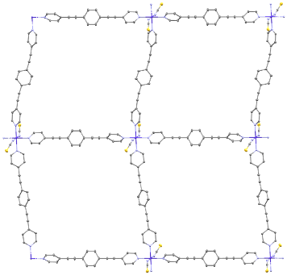
Figure 3.1. (Left) Truncated structure of Co-BEBN showing the Co²⁺ local symmetry. (Right) Monolayer crystal structure of Co-BEBN. Hydrogens and solvent molecules are omitted for clarity.

octahedral symmetry (O_{h}), giving a value of 0.044 (while the value of a perfect octahedral is 0). The result shows that the Co²⁺ ion local symmetry in Co-BEBN is close to an octahedral.

3.2.2. Determination of Spin-Hamiltonian (SH) Parameters and Spin-Phonon Couplings through FIRMS and HFEPR
3.2.2.1. FIRMS
FIRMS measurements were conducted to probe the inter-Kramers transition between the spin-1/2 state and the spin-3/2 state, where the energy gap is 2D′ when E $≠$ 0 (Figure 1.4). The experiments were performed at about 5.5 K under the magnetic field between 0 and 17 T using powder samples of Co-BEBN mixed with a small amount of the solvent (1,2-dichlorobenzene) in eicosane. Figure 3.2-Top gives the transmission plots at 0 and 17 T, indicating a possible magnetic transition in the region of 250 and 270 cm⁻¹. To reveal the magnetic transition, Figure 3.2-Bottom shows the heatmap plot of the transmission spectra, normalized to an average of spectra for all magnetic fields. The normalization process eliminates instrumental artifacts, arbitrations, and non-magnetic background. The FIRMS map shows a broad spectral feature at 262(1) cm⁻¹ shifting to higher energies as the magnetic field increases. A large slope of ~0.9 cm⁻¹/Tesla indicates the magnetic origin of the feature. Therefore, we assigned the feature to the magnetic resonance of the inter-Kramers transition. Another feature at 283(1) cm⁻¹ stem from the phonon absorption coupled to the magnetic resonance transition, leading to the observed avoided crossing discussed below.
Figure 3.2-Bottom shows an overlay of the magnetic transition calculations onto the FIRMS map. The calculations are obtained from EasySpin ¹⁶⁰ by the MATLAB software.¹⁶¹ The
Figure 3.2. (Top) Far-IR transmission spectra of Co-BEBN at 5.5 K at 0 and 17 T. (Bottom) FIRMS map reveals the ZFS gap 2D′ = 262(1) cm⁻¹ as well as its evolution in an external magnetic field, indicated with the blue color. The red, blue, and black lines are calculations from EasySpin on MATLAB.⁸⁸ The red, blue, and black lines are dependence of the transition energy on the magnetic field along the x, y, and z axis of the D tensor. SH parameters in the calculations are D = 127.3 cm⁻¹, E = 17.8 cm⁻¹, g = [2.54, 2.54, 2.59], as discussed in the HFEPR section below.

SH parameters used in the calculations are D = 127.3 cm⁻¹, E = 17.8 cm⁻¹, g = [g_{x}, g_{y}, g_{z}] = [2.54, 2.54, 2.59] discussed below. There are six calculated lines corresponding to two transitions inside the magnetic field, one from the ground state φ₁ to the excited state φ₃, and the other from φ₁ to the excited state φ₄, respectively, in Figure 1.4. Each transition follows along the x, y, and z axis (from D = [D_{x}, D_{y}, D_{z}]), leading to a total of six calculated lines. The calculations reveal that the magnetic transitions, when B$∥$x and B$∥$y, fit well with the observed blue spectral feature in the experimental FIRMS map. When B$∥$z, the transition consists of one red-shifted transition and one blue-shifted transition. Overall, the calculations fit well with the experimental FIRMS.
Strong coupling is observed between the magnetic transition and the nearby phonon at 283(1) cm⁻¹ in Figure 3.2-Bottom as a deviation from the linear dependence of the magnetic feature and the declining of the phonon feature from the linear vertical position. The former behavior is anticipated from the Zeeman splitting, while the latter is attributed to the insensitivity of the phonon feature to the magnetic field. The avoided crossing was observed around 8 T when the magnetic transition energy, blue-shifted with increasing magnetic field, comes into proximity of the phonon feature. The magnetic and phonon feature exchange during the avoided crossing, converting the magnetic feature into the phonon feature and vice versa. Such coupling between spin (magnetic feature) and phonon can influence the relaxation of the magnetic transition from the excited to the ground state and the relaxation pathways. The coupling can also impact the energy gap or the anisotropies in ZFS.⁸ It is imperative to obtain spin-phonon coupling constants for a better understanding of the effect. Figure 3.3 shows spin-phonon fittings (two overlaying black lines) on the FIRMS map. The fittings were performed on Maple¹⁶² using matrix calculation methods. For the case of two coupled transitions with one magnetic feature and one
Figure 3.3. Fitting of the spin-phonon coupling in the FIRMS data using Maple¹⁶² as black lines. The red solid line is a linear fit between the magnetic peak at zero-field and the phonon peak at 17 T corresponding to the slopes of the black lines, which is the transition energy in ZFS, E_{sp}, used in the spin-phonon fit.

phonon feature, we employed the Hamiltonian for the spin-phonon coupling model in Eq. 3.1 to describe their behavior.^{59, 110, 163}

$H= \left[{E_{sp} \atop Λ} {Λ \atop E_{ph}}\right]$ (Eq. 3.1)
where E_{sp} [262 cm⁻¹] and E_{ph} [283.8 cm⁻¹] are energies of the magnetic and phonon feature, respectively. $Λ$ is the coupling constant between the two magnetic and phonon transitions.

The solution to the Hamiltonian gives two energy eigenvalues ($E_{±}$) in Eq. 3.2.^{59, 110}

$\left[{E_{sp} - E_{±} \atop Λ} {Λ \atop E_{sp} - E_{±}}\right]=0$ (Eq. 3.2)

Results of the spin-phonon fittings rely on the visual examinations of how the black lines overlay to the magnetic and phonon peaks in the FIRMS map.

The magnetic feature was modeled from 262 cm⁻¹ at zero-field to 292 cm⁻¹ at 17 T (red line in Figure 3.3), giving the coupling constant $Λ$ = 4.5 cm⁻¹ from the best visual matching. The coupling constant is large compared to those previously reported SIMs.^{110, 128} The large coupling is also evident in the FIRMS map (Figure 3.3), showing avoided crossing even when the two features are fairly apart. Based on the work by Chakarawet, Neese, Long and workers, increase in anisotropy from the SOC effect contributes to the increase in the spin-phonon relaxation originated from spin-phonon coupling.⁸ In the previously reported SIM-CP (coordination polymer) Co-TODA,¹⁶⁴ no spin-phonon coupling was observed and its ZFS is much smaller [2D′ = 80.4(1.0) cm⁻¹]. Even though the Co²⁺ ion in Co-BEBN is nearly octahedral with six N-containing ligands, its 2D′ = 262(1) cm⁻¹ is much larger. The results support the findings correlating anisotropy with spin-phonon coupling.⁸ Even if the effect of spin-phonon coupling correlated to the increase in the anisotropy value of the system, it shortens the relaxation time of the magnetizations, which is undesirable in SIMs.

3.2.2.2. HFEPR
For HFEPR experiments, the powdered sample was stored in liquid 1,2-dichlorobenzene before being transferred into a sample holder and frozen with liquid nitrogen. The use of the liquid was to ensure that the voids in the MOF, Co-BEBN, were saturated with 1,2-dichlorobenzene. The resulting HFEPR spectra are frequency-limited to below ~215 GHz since the liquid-soaked sample absorbs sub-THz wave power more strongly with increasing frequency than a dry powder. Measurements at 10 K produced spectra characteristic for an S = 1/2 spin state, and positive D. The three features visible in Figure 3.4-Left are turning points of the intra-Kramers transition within the M_{S} = ±1/2 doublet with the magnetic field along the x, y, and z axes of the ZFS tensor, respectively. A presence of three, rather than two turning points indicates significant rhombicity of the ZFS and g-tensors.
HFEPR alone, observing a single intra-Kramers transition, cannot deliver the full set of SH parameters; however, it is possible to do so in conjunction with FIRMS. By fitting the parameters to the full set of experimental points (Figure 3.4-Right), we obtained the following values: E/D = 0.14, g = [2.54, 2.54, 2.59]. The D and E values were then chosen to be D = 127.3
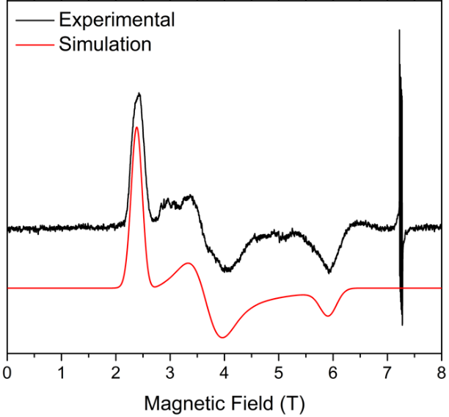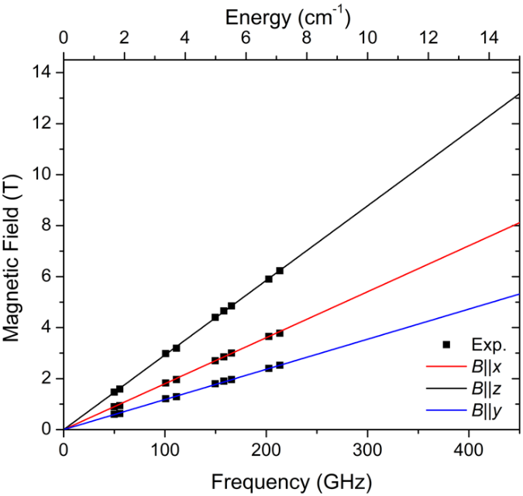
Figure 3.4. (Left) A derivative HFEPR spectrum of Co-BEBN showing three turning points corresponding of the transition M_{S} = -1/2 → M_{S} +1/2 at 10 K and 203 GHz (black trace) and its simulation (red trace) using the following SH parameters: D = 127.3 cm⁻¹ , E = 17.8 cm⁻¹ , g = [2.54, 2.54, 2.59]. The sextet of narrow lines at ~7.25 T (g = 2.00) originates from a Mn²⁺ contaminant. (Right) A 2-D graph showing the position of the experimental turning points as a function of frequency/energy. The black squares are the experimental data. The lines are simulated using the best-fit SH parameters as above.

cm⁻¹, E = 17.8 cm⁻¹ so that 2D’ = 262 cm⁻¹ (the value obtained from FIRMS). The g-tensor was assumed axial, i.e. g_{x} = g_{y} since the rhombic g anisotropy is intercorrelated with E. The reverse case, i.e. E = 0 and g_{x} ≠ g_{y} yields unphysical g-values [2.0, 3.0, 2.45]. Because of the intercorrelation, to be on the safe side, we can describe the ZFS parameters as: 127.3 cm⁻¹ ≤ D << 131 cm⁻¹ and 0 << E ≤ 17.8 cm⁻¹. The SH parameters above reproduce the experimental spectra very well, as seen in Figure 3.4-Left.
With the rhombicity of the ZFS tensor, there is a significant mixing of the spin states between M_{S} = ±3/2 and M_{S} = ±1/2 as represented by φ in Figure 1.4. The mixing may lead to a fast relaxation of magnetization as well as quantum tunneling. It is important to note that the D and E values found through FIRMS and HFEPR are directly determined in contrast to those from fittings of the magnetic susceptibility measurements, as often conducted. FIRMS and HFEPR indicate an easy-plane anisotropy (D > 0) for Co-BEBN as well as a large transverse anisotropy (E ≫ 0), which are supported by the ab initio electronic structure calculations discussed below. Most SIMs normally exhibit an easy-axis anisotropy (D < 0) with little-to-no transverse anisotropy (E = 0), giving an effective energy barrier to slow relaxation of magnetization and limiting quantum tunneling. Both characteristics are important for the application of magnetic memory storage. However, Co-BEBN is another example with easy-plane anisotropy (D > 0) but demonstrates SIM characteristics with slow magnetization relaxation.^{70, 76, 96-107, 164}

3.2.3. Determination of the Inter-Kramers Magnetic Transition and Phonon Properties with INS and DFT Calculations
INS is a powerful tool used to probe the phonon properties as well as magnetic transitions in molecular system.^{110, 111, 114, 115, 165-168} Applications of INS in coordination chemistry are recently reviewed.⁶⁹ Neutron spectroscopy is governed by the neutron kinetic energy transfer, therefore the symmetry-based selection rules for optical spectroscopies (FIRMS and HFEPR) do not apply in neutron spectroscopy. All phonons observed in the INS experiments are a combination of both the internal and external phonon modes.¹⁰⁸⁻¹¹⁰ Furthermore, ab initio density-functional-theory (DFT) calculations using the Vienna Ab-Initio Simulation Package (VASP) were employed in conjunction with the INS experimental data to give a better insight into the phonon characteristics of the system as well as help reveal the magnetic transitions.59, 108, 110, 111, 128, 158, 169-171
INS experiments using the Vibrational Spectrometer (VISION) at ORNL can reveal accurate phonon features of the solids in the energy range between 10 and 8000 cm⁻¹ as well as any magnetic transition in the system. There are two types of interactions in INS that the neutrons interact with: (1) Atomic nuclei of the sample, leading to phonon excitations; (2) Unpaired electrons through magnetic fields as both neutrons and electrons have 1/2 spins. Phonons observed in the INS experiments consist of both internal and external modes.¹⁰⁸⁻¹¹⁰
INS experiments were performed on a powder sample of Co-BEBN in 1,2-dichlorobenzene liquid sealed in vanadium can under helium gas. The measurements were taken at 5.0(5), 20.0(5), 40.0(5), 60.0(5), 80.0(5), 100.0(5), 120.0(5), and 140.0(5) K. Bose-correction was applied by using a frequency- and temperature-dependence normalization factor such that the phonon intensities are not temperature-dependence.^{98, 110-115} Bose-correction procedure mainly affects the low-energy region. The small separation between each spectra line is due to the Debye-Waller factor.¹⁷² As the temperature increases, the intensity of the peak decreases into the background and the peak width increases. INS spectra of frozen 1,2-dichlorobenzene were also taken at 5.0(5) K so its peaks could be subtracted from the data of Co-BEBN in frozen 1,2-dichlorobenzene. Four different phonon peaks are observed in the range of 200-400 cm⁻¹ from the data collected in both forward and backward detectors (Figure 3.5). The same four phonon peaks were also observed in the spectrum of frozen 1,2-dichlorobenzene at 5.0(5) K, indicating that they are from the organic compound. The intensity of all four phonon peaks does not change with temperature and the peaks are fairly sharp, indicating their phonon characteristics. The peak at 280(2) cm⁻¹ seems to exhibit magnetic characteristics, as its intensity decreased as the temperature increased. Boltzmann distribution at a lower temperature allows for more unpaired electrons to be in the ground state. Therefore, the magnetic transition to the excited state is more intense compared to a higher temperature. It is also important to note that the intensity of the peak, as well as the peak’s width, is larger in the forward scattering plot with lower momentum transfer Q (Q = ⎜Q ⎜= ⎜k_{i} – k_{f} ⎜; k_{i} and k_{f} are momenta of the incoming and outgoing neutrons, respectively).⁶⁹ In INS, the magnetic peaks are more intense in the forward-scattering than in the backward-scattering spectra, while phonon peaks are more intense in the backward-scattering than in the forward-scattering spectra.⁶⁹ The peak was not observed in the spectrum of the solvent 1,2-dichlorobenzene at 5.0(5) K. Therefore, the peak at 280(2) cm⁻¹ has magnetic contributions and is likely an overlapping peak (Figure 3.2-Top) between the magnetic transition observed at 262(1) cm⁻¹ in FIRMS and a larger phonon at 283(1) cm⁻¹ in far-IR (Figure 3.2- Bottom).
To further understand the phonon features of Co-BEBN, phonon calculations using DFT calculations by VASP were conducted based on the single-crystal X-ray diffraction data. Figure
Figure 3.5. Variable-temperature INS spectra of Co-BEBN. (Top) Forward-scattering data; (Bottom) backward-scattering data. The red dotted vertical line is an eye-guide for the peak at 280(2) cm⁻¹.

3.6 shows a comparison between the experimental INS spectrum to 5.0(5) K and the calculated phonon spectrum at 200-400 cm⁻¹. The calculated phonon spectrum fits well with the experimental spectrum, including the four intense phonon peaks. In addition, phonon calculations give the mode of individual phonon features in the system at 16-3150 cm⁻¹, as listed in Table B.7. Around the region of the observed phonon at 280(2) cm⁻¹ in far-IR (Figures 3.2-3.3), the calculated phonon spectrum shows three smaller INS peaks that potentially overlap giving the phonon in far-IR. Additional phonon information can be found in Appendix B.

3.2.4. Studies of the Magnetic Anisotropy and the Magneto-Structure by Ab Initio Computations
Ab initio calculation was conducted to understand the electronic structure as well as the origin of the anisotropy for Co-BEBN. The calculated molecular structure is given in Figure B.6. The core unit of the grid-like structure was used in the calculations. The energy difference between the lowest two spin-free states of Co-BEBN is 163.3 cm⁻¹ (Table B.3). Therefore, we can use ZFS parameters D and E to depict the magnetic anisotropy. The calculated D, E (cm^{–1}), and g (g_{x}, g_{y}, g_{z}) tensors for Co-BEBN using CASPT2 and NEVPT2 with MOLCAS 8.4¹¹⁶ and ORCA 4.2¹¹⁷ are shown in Table 3.1. The calculated ZFS parameters extracted from both methods are similar and agreeable. Calculated values from CASPT2 are agreeable with the experimental data from FIRMS and HFEPR. To deeply analyze magnetic anisotropy, we gave the contributions of the excited states to the D values for Co-BEBN in Table B.5 using NEVPT2 with ORCA 4.2. The dominant contributions to the positive D values are found to arise from the two close quartet states, particularly the first and the second quartet states. The calculations yield
Figure 3.6. Comparison between the experimental INS data at 5.0(5) K and the calculated INS spectrum in the 200-400 cm⁻¹ region.

Table 3.1. Comparison of experimental and calculated ZFS parameters D, E (cm^{–1}), and g [g_{x}, g_{y}, g_{z}] tensors of Co-BEBN using CASPT2 and NEVPT2 with MOLCAS 8.4 and ORCA 4.2, respectively

Methods | D (cm⁻¹) | E (cm⁻¹) | g_{x} | g_{y} | g_{z}
FIRMS/HFEPR | 127.3 | 17.8 | 2.54 | 2.54 | 2.59
CASPT2 | 114.0 | 23.7 | 3.000 | 2.197 | 1.715
NEVPT2 | 116.8 | 30.8 | 3.047 | 2.161 | 1.595

positive D values, which are consistent with the geometries around Co²⁺ ions and easy-plane anisotropies (g_{x},_{y} > g_{z}). The results are also consistent with the experimental SH parameters (Table 3.1).
Molecular coordination frame was chosen in such a way that the z-axis goes along the numerically largest eigenvalue of the D-tensor and the x and y-axes accordingly to the other two in Figure B.6. The following discussions of Co d-atomic orbitals (d-AOs) are classified following this frame. The calculated relative energies (cm^{–1}) of ligand field one-electron states [in the basis of d-atomic orbitals (d-AOs)] for Co-BEBN using NEVPT2 with ORCA 4.2 are shown in Table B.6 according to the ab initio ligand field theory (AILFT)^{118, 119} analysis. The orbital energies computed for the ground state are shown in Figure B.9, where the ground state for Co-BEBN has a dominant (91.1%) (d_{yz})¹(d_{xz})²(d_{xy})¹(d_{z2})² (d_{x2-y2})¹ conﬁguration. The largest contribution to D is from the ground to the first excited state transition (d_{z2} → d_{yz}; Figures B.9 and B.10). Since these orbitals also have different m_{l} values, the contributions to the D value are both positive.^{120, 121} The multideterminantal wavefunctions of the selected excited states having important contributions to the D tensor (Figure B.10). The calculated orientations of g_{x}, g_{y,} and g_{z} in the ground spin-orbit states on Co²⁺ ions are shown in Figure B.8.
The calculations were able to extract the χ_{M}T versus T plots (DC magnetic susceptibility) of Co-BEBN in Figure B.7. The magnetic susceptibility increases as the temperature increases. The magnetic susceptibility value plateaued around 3.3 cm³ mol⁻¹ K⁻¹. The increasing feature indicates an antiferromagnetic interaction in the system. The calculated DC magnetic susceptibility data is agreeable with the experimental data in Figure B.3 showing an S = 3/2 antiferromagnetic interacting system at low temperature.
3.2.5. Determination of the Qubit Properties Using Pulsed X-band EPR
Pulsed X-band EPR has previously been used to study the relaxation times or spin decoherence. Therefore, it is a crucial spectroscopy in understanding the quantum bit (qubit) properties of the system.^{12, 64, 94, 173-175} Qubit is a building block of quantum computers, and it is at the forefront of modern cutting-edge technology.^{9-11, 133-136} Three important qubit properties can be obtained from pulsed X-band EPR, including the spin-lattice relaxation time (T₁), spin-spin relaxation time (T₂), and the Rabi oscillation. T₁ reflects the time of energy transfer between the spin and its local environments. T₂ quantifies the time of spin dephasing of magnetizations in the x-y plane. Pulsed X-band EPR quantified T₁ and T₂ based on the transition between M_{S} = $-$1/2 and M_{S} = $+$1/2 state. Rabi oscillation measurements provide a unique insight into the quantum superposition state of the system and the probability of the system being in the $|\left.1\right\rangle$ or the $|\left.0\right\rangle$ state.
Pulsed X-band EPR measurements were conducted to probe the spin relaxation of Co-BEBN as well as its qubit potentials based on the intra-Kramers transition of the M_{S} = $±$1/2 state. Spin-lattice relaxation (T₁) and the spin-spin relaxation (T₂) times were measured as well as the Rabi-oscillation. The T₁ and T₂ are intrinsic magnetic properties of Co-BEBN, while the Rabi-oscillation shows qubit properties.
T₁ determines the rate of energy transfer between the spin and the crystal lattice.⁶⁴ Echo inversion recovery is a technique to probe T₁ by applying a 180°-pulse in an applied field, causing the magnetization to be flipped from +z to -z direction.^{129, 130} Then, the magnetization relaxes back to the +z direction by releasing the energy to the crystal lattice. The time-dependent magnetization along the z direction, M_{z}(t), is measured during the spin relaxation process. The process is repeated at different times (t). T₁ is the time for M_{z}(t) to reach 63% of its maximum value. It is also considered as the rate of magnetization relaxation across the energy barrier back to the thermal equilibrium. T₁ can be calculated using Eq. 3.3.^{131, 132}

M_{z}(t) = M_{z}(0)[1 - 2exp(–t/T₁)] (Eq. 3.3)
where t is time and M_{z}(0) is the magnetization when time is at 0.

T₂ is the rate at which the magnetizations are dephased in the x-y plane.⁶⁴ Bloch found that the T₂ relaxation process follows first-order kinetics, leading to exponential decay.¹³¹ Hahn echo decay is the technique used to quantify T₂ by first applying a 90° pulse to the sample. Then, the magnetization in the x-y plane begins dephasing at different speeds due to the inhomogeneities of the local magnetic field. Once the magnetization dephasing in the x-y plane is nearly complete, a 180° pulse is applied to change the spin dephasing direction and remove the inhomogeneities, allowing for the magnetization measurement. The process is repeated at different times (t) before the echo. T₂ is the time the magnetization in the x-y plane is at 37% of its initial value (Eq. 3.4).

M_{xy}(t) = M_{xy}(0)exp(–t/T₂) (Eq. 3.4)
where M_{xy}(t) and M_{xy}(0) are the magnetization vector at time t and 0, respectively.

The T₂ measurement is important for determining the effectiveness of a qubit. The dephasing time is related to the time it takes for the qubit to stay in its superposition state. The longer T₂, the more effective the material as a qubit candidate. Though, finding materials exhibiting long T₂ is challenging due to many factors limiting the time through interactions of unpaired electron spins with local environments, leading to the collapse of the superposition state. Nuclear spin diffusion coupling to nearby electrons, methyl rotation, and spin diffusion barrier are just some of the main effects with strong correlations with the T₂ time. Graham, Freedman, and coworkers recently discussed how environmental effects can negatively affect T₂ time.⁹
Pulsed X-band EPR measurements were conducted at 10 K on powders of two samples in frozen 1,2-dichlorobenzene: (1) Co-BEBN (100% Co²⁺ ion); (2) Co-BEBN_{0.05} (5% Co²⁺ ion with 95% diamagnetic Zn²⁺). Figure 3.7 is an echo inversion recovery plot that shows T₁ = 329(4) μs for Co-BEBN. It is noted that T₁ here is longer than 235(4) μs of Co-TODA, a Co²⁺-based coordination polymer (CP).¹⁶⁴ The reason for the longer observed T₁ time can be attributed to the longer distance (20.515 Å) of Co²⁺ ions in Co-BEBN in the same layer. For Co-TODA, the shortest distance between Co²⁺ ions is only 7.52 Å. More isolated Co²⁺ ions in Co-BEBN limit magnetic interactions between the neighboring Co²⁺ ions, leading to a longer relaxation time of the magnetization. For Co-BEBN, T₂ = 1.387(4) μs (Figure 3.8-Top), which is much longer than 0.513(4) μs of Co-TODA. The purpose of the diamagnetic Zn²⁺-dilution is to further limit the magnetic interactions between the Co²⁺ ions through space, potentially improving relaxation times. For Co-BEBN_{0.05}, T₂ = 1.450(4) μs (Figure 3.8-Bottom), longer than 1.387(4) μs of Co-BEBN with Zn²⁺ dilution.
Rabi oscillation measurements were also performed on Co-BEBN and Co-BEBN_{0.05} to observe the ability of the systems to stay in the superposition state or exhibit quantum coherence
Figure 3.7. Echo inversion recovery plot of Co-BEBN at 10(1) K with external applied magnetic field of 0.33 T.

Figure 3.8. Hahn echo decay plots: (Top) Co-BEBN; (Bottom) Co-BEBN_{0.05} at 10(1) K with external applied magnetic field of 0.33 T and 0.34 T, respectively.
as qubit candidates. Rabi oscillation is a procedure to observe the probability of a qubit system existing in the 1 or 0 states periodically.¹⁷⁶ By measuring the projection of the magnetization onto the z-axis with a Hahn echo as a function of time for the initial nutation pulse, Rabi oscillation is observed.¹⁷⁷⁻¹⁸² Rabi oscillation plots for Co-BEBN and Co-BEBN_{0.05} are given in Figure 3.9. The oscillating wave-like pattern in the plots suggests that the sample changes the states that it occupies periodically during the experiment. The results show that Co-BEBN is a viable option for a qubit candidate. It is important to note that the echo intensity of the wave seems to be slightly bigger for Co-BEBN_{0.05} compared Co-BEBN. The difference in intensity could be related to the inter-ion interactions between the Co²⁺ ions. The stronger echo intensity of the Rabi oscillation in Co-BEBN_{0.05} means a more stable existence in the 1 or 0 states in that period.^{176, 182} The results further support that Zn²⁺-diluted Co-BEBN_{0.05} is a better qubit candidate than Co-BEBN.

3.3. Experimental Methods
3.3.1. Single-Crystal X-Ray Diffraction Measurements
Single-crystal X-ray diffraction data were collected using a Bruker D8 Venture at 100(2) K with Mo Kα radiation. Data were collected and integrated using APEX 3 programs, reduced using Bruker SAINT program, and corrected for absorption using the SADABS multi-scan program. The structure was solved using SHELXT and refined with SHELXL-2015.

3.3.2. FIRMS
FIRMS spectra were collected at the NHMFL (Tallahassee, Florida, USA) using a Bruker
Figure 3.9. Rabi oscillation plots at 10(1) K. (Top) Co-BEBN. (Bottom) Co-BEBN_{0.05}.

Vertex 80v Fourier-transform infrared (FT-IR) spectrometer coupled with a 17.5 T vertical-bore superconducting magnet. The experimental setup is equipped with a mercury lamp and a composite silicon bolometer (Infrared Laboratories), as an incoherent (sub)-THz radiation source and detector, respectively. The THz radiation is free-space propagating inside the optical beamline, connecting the output of the spectrometer and the top of the sample probe. The radiation is then passed through the brass light pipe over a distance of 2.5 m from room temperature to the field center. The probe and beamline are evacuated to eliminate strong parasitic absorptions of the air. The studied samples are the mulls of n-eicosane, powder (~2 mg) of Co-BEBN, and 2 droplets of 1,2-dichlorobenzene. Both the sample and the bolometer were cooled by low-pressure helium gas to 5.5 K. The spectrum of the THz radiation transmitted through the samples was measured in the spectroscopic between 10 and 720 cm⁻¹ (0.3–21.6 THz) with a resolution of 0.3 cm⁻¹ (9 GHz), the acquisition time of 3 min and 10 kHz scanner speed.

3.3.3. HFEPR
HFEPR spectra were obtained at the NHMFL using the home-built spectrometer based on a 17-T superconducting magnet described previously,¹⁴⁰ and differs from that description only by the use of a low-frequency (8-20 GHz) microwave source complemented by a cascade of amplifiers and multipliers (Virginia Diodes, Charlottesville, VA, USA) to produce higher frequency harmonics.

3.3.4. INS
For variable-temperature INS at VISION, the sample (0.5 g) was sealed in an aluminum container and placed inside the neutron beam at Vibrational Spectrometer (VISION) at Spallation Neutron Source (SNS), Oak Ridge National Laboratory (ORNL). INS spectra of Co-TODA were measured at 5.0(5), 20.0(5), 40.0(5), 60.0(5), 80.0(5), 100.0(5), 120.0(5). 140.0(5) K. VISION offers two banks of detectors for both forward (low |Q|) and back (high |Q|) scattering of neutrons.¹⁴¹ The phonon population effect was corrected by normalizing the INS intensity at energy transfer ω with $\coth\left(\frac{ℏω}{2k_{B}T}\right)$.¹⁴²

3.3.5. Electronic Structure Calculations
For the first CASSCF calculation, the basis sets for all atoms are atomic natural orbitals from the MOLCAS ANO-RCC library: ANO-RCC-VTZP for magnetic center ion Co²⁺; VTZ for close N and O atoms; VDZ for distant atoms. The calculations employed the second-order Douglas-Kroll-Hess Hamiltonian, where scalar relativistic contractions were considered in the basis set. The effect of the dynamical electronic correlation was applied using CASPT2 based on the first CASSCF calculation. After that, the spin-orbit coupling (SOC) was handled separately in the restricted active space state interaction (RASSI-SO) procedure.^{146, 183} The active electrons in 5+5´ active orbitals include all d electrons [CAS(7 in 5+5´)] in the CASSCF calculations. To exclude all the doubts, we calculated all the roots in the active orbitals. The maximum number of the spin-free state were mixed, which was possible with our hardware (all from 10 quadruplets and 20 from 40 doublets). SINGLE_ANISO¹⁴³⁻¹⁴⁵ program was used to obtain zero-field splitting parameters D, E (cm⁻¹), g tensors, energy levels, magnetic axes based on the above
CASPT2/RASSI-SO calculations.
To deeply analyze the magnetic anisotropy, ORCA 4.2 calculations¹¹⁷ were performed with complete active space self-consistent field calculations (CASSCF), followed by N-electron valence second-order perturbation theory (NEVPT2). The SOC operator used was the efficient implementation of the multicenter spin-orbit mean-field (SOMF) concept developed by Hess et al.¹⁴⁶ The spin-spin contributions (SSC) to the D values were also included, although they are very small for our complexes. The NEVPT2¹⁴⁷⁻¹⁵⁰ calculation with seven 3d electrons in five Co 3d-based orbitals [CAS(7, 5)]. In the calculations, the orbitals were determined for the average of 10 S = 3/2 and 40 S = 1/2 roots. All calculations were performed with triple-ζ with one polarization function def2-TZVP¹⁵¹⁻¹⁵³ basis set for all atoms.

3.3.6. Calculations of Phonons
Spin-polarized Density Functional Theory (DFT) calculations were performed using the Vienna Ab initio Simulation Package (VASP).¹⁵⁴ The calculation used Projector Augmented Wave (PAW) method^{122, 123} to describe the effects of core electrons, and Perdew-Burke-Ernzerhof (PBE)¹²⁵ implementation of the Generalized Gradient Approximation (GGA) for the exchange-correlation functional. Energy cutoff was 600 eV for the plane-wave basis of the valence electrons. The lattice parameters and atomic coordinates from Co-BEBN CIF (Crystallographic Information Framework) file were used as the initial structure. Given the large unit cell containing 492 atoms, the electronic structure was calculated on Γ-point only. The total energy tolerance for electronic energy minimization was 10⁻⁶ eV. The maximum interatomic force after relaxation was below 0.001 eV/Å. The optB86b-vdW functional¹⁵⁵ for dispersion corrections was applied, and a Hubbard U term of 3.32 eV¹⁵⁶ was applied to account for the localized 3d orbitals of Co ion. The interatomic force constants were calculated on the unit cell by VASP, and the vibrational eigen-frequencies and modes were then calculated using Phonopy.¹⁵⁷ The OCLIMAX software¹⁵⁸ was used to convert the DFT-calculated phonon results to the simulated INS spectra.

3.3.7. Pulsed X-band EPR
Pulsed X-band EPR experiments were performed on a Bruker E680 spectrometer (Billerica, MA) operating at a microwave frequency of 9.5 GHz at the NHMFL. Echo detection and T₁ and T₂ relaxation times were collected using a dielectric ER4118X-MD-5 resonator equipped with an Oxford CF-935 helium flow cryostat. The temperature was controlled and monitored using an Oxford Instrument ITC503 temperature controller. The 4-mm outer-diameter EPR tubes were used to load samples. The experiments were conducted in the temperature range of 5(1)-30(1) K. Echo-detected field-swept spectra were obtained by measuring the Hahn echo intensity (π/2–τ–π–τ–echo) as a function of the transverse field. The time delay (τ) between two detection pulses was 200 ns. Echo detection was swept from 100 Gauss (G) to 10000 G magnetic field. T₁ was measured using an echo-detected inversion recovery pulse sequence (π–τ₁–π/2–τ–π–τ–echo). T₂ was measured using a standard two-pulse Hahn echo sequence (π/2–τ–π–τ–echo). The lengths of the π/2 and π pulses were 16 and 32 ns for all experiments, respectively.

Chapter 4

Haldane Spin-1 Chain in a Planar Metal-Organic Framework
This chapter is based on a manuscript that has yet to be submitted for publication.

List of authors and their contributions:
Pagnareach Tin, Michael J. Jenkins, Jie Xing, Nils Caci, Zheng Gai, Rongyin Jin, Stefan Wessel, J. Krzystek, Cheng Li, Luke L. Daemen, Yongqiang Cheng, Zi-Ling Xue

P. Tin performed syntheses of NiBO and NiBO-d₈ and grew single crystals of NiBO-d₈. He prepared all samples for the experiments indicated below. M.J. Jenkins performed the single-crystal X-ray diffraction experiment and solved the crystal structure. MJJ and PT analyzed and interpreted the data. Z. Gai performed the magnetic susceptibility measurement at a low magnetic field (0.1 T). PT analyzed and interpreted the data. J. Xing performed the measurements of magnetic susceptibilities at high magnetic fields (> 0.1 T) and specific heat capacity. JX, PT, and R. Jin analyzed and interpreted the data. RJ supervised the studies here. N. Caci and S. Wessel performed the quantum Monte-Carlo simulations for the magnetic susceptibility and the specific heat capacity data. NC, SW, and PT analyzed and interpreted the results. J. Krzystek performed the HFEPR measurement. PT and JK analyzed the data and interpreted the results. C. Li performed PND experiments at POWGEN. CL and PT analyzed and interpreted the data. L.L. Daemen performed INS experiments at VISION. PT and LLD analyzed and interpreted the data. Y. Cheng performed the VASP calculations. PT analyzed and interpreted the data. Z.-L. Xue initiated the project, supervised the research, including data analyses, and data interpretations.

4.1. Abstract
Haldane topological materials typically contain spin-1 chains embedded in extended three-dimensional crystal structures. Here, we demonstrate that [Ni(μ-4,4′-bipyridine)(μ-oxalate)]_{n} (NiBO) instead adopts a two-dimensional (2D) metal-organic framework (MOF) structure of Ni(II) spin-1 chains weakly linked by 4,4′-bipyridine. NiBO exhibits Haldane topological properties with a gap between the singlet ground state and the excited triplet states. The latter is split by weak axial and rhombic anisotropies. Several experimental probes, including single-crystal X-ray diffraction, variable-temperature powder neutron diffraction, inelastic neutron scattering (INS), DC susceptibility and specific heat measurements, high-field electron spin resonance, and unbiased quantum Monte Carlo simulations, provide a detailed, comprehensive characterization of NiBO. Phonon properties of NiBO have been probed by INS and density-functional theory calculations, indicating the absence of phonons near magnetic excitations in NiBO, reducing chance of spin-phonon coupling. The work here demonstrates that NiBO is indeed a rare 2D-MOF Haldane topological material with promising quantum applications.

4.2. Results and Discussions
4.2.1. Single-Crystal X-Ray Diffraction
Single-crystal X-ray diffraction performed at 100(2) K provides an in-depth analysis of the structure of NiBO-d₈ and compares it with that reported earlier at 295 K (Table C.1).¹⁸⁴ Each Ni(II) ion is coordinated with two oxalate ligands in a plane as intra-chain bridging ligands forming the spin-1 chains, while two 4,4′-bpy ligands coordinates in the z-direction as inter-chain bridging ligands, resulting in an overall 2D framework. There are only one oxalate and one 4,4′-bpy ligand and one Ni(II) in the asymmetric unit of the MOF. Figures 4.1 and C.5 illustrate the inter- and intra-chain directions of the 1D spin chains in NiBO as well as a view down the a-axis. At 100 K, we have found that the two pyridine rings in the 4,4′-bpy ligands are not co-planar, likely due to the free rotational movement of the two rings along the C-C bond in thermal environment. The resulting effect could likely reduce magnetic interactions between neighboring spin chains due to limiting π-conjugations in the 4,4′-bpy ligand, a desirable property for the Haldane material. Although the co-planar structure of the two rings in the 4,4′-bpy ligand provides a larger π-conjugation, rotations of the two pyridine rings by the thermal energy may have led to the non-co-planar structure. Further discussions of the single-crystal structures are provided in Appendix C.

4.2.2. Variable-Temperature Powder Neutron Diffraction (VT-PND)
PND was conducted at 1.7, 10, 20, 100, and 200 K to study the magnetic properties of NiBO and any potential structural phase transition at zero-field. As shown in Figure 1.3, in the Haldane phase, there is no magnetic ordering (or unit cell). Thus, only nuclear diffraction from the crystal unit cell is expected, whether the sample is in the paramagnetic and low-temperature Haldane phase. In other words, no additional PND peaks are expected when the sample is cooled and became topological (i.e., Haldane). In comparison, for antiferromagnetic NiO with long-range magnetic ordering (Figure 1.3-Bottom),³⁰ diffractions from both the magnetic unit cell and the crystal unit cell are observed.³⁰
No change was observed in the PND pattern between 1.7 and 200 K for a powder sample
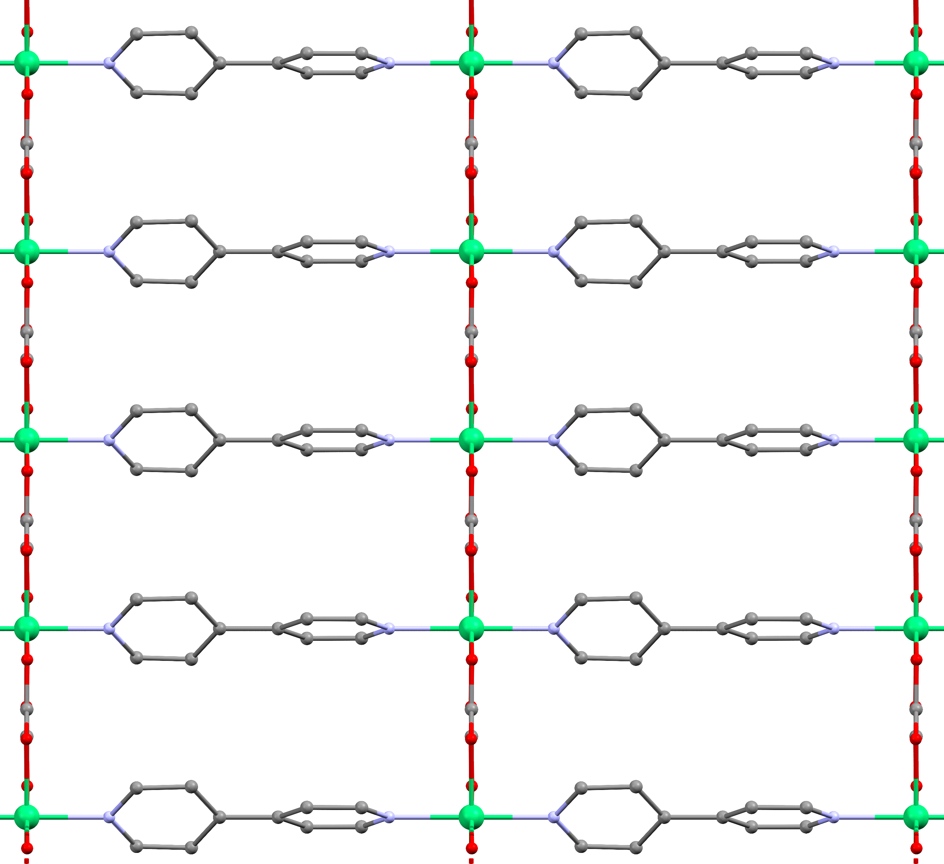
Intra-chain direction
Inter-chain direction

Figure 4.1. (Left) 2D schematic of NiBO-d₈ showing the bonding around three Ni(II) ions within the chain. Blue arrows show intra- and inter-chain directions. (Right) Structure of NiBO-d₈ along the crystallographic a-axis. Green: Ni; Red: O; Purple: N; Gray: C. Selected bond lengths (Å) and angles (°): Ni-O = 2.0488(10)-2.0533(9) Å, Ni-N = 2.092(5) Å. cis-ligand angles: O-Ni-O 82.53(4)-97.47(4), O-Ni-N 89.68(11)-90.32(11); trans-ligand angles: O-Ni-O 179.4(2)-179.5(2), N-Ni-N 180.0.

of NiBO. Figure 4.2-Top shows a comparison between the 1.7 and 100 K diffraction patterns, indicating no long-range antiferromagnetic correlations, as extra magnetic Bragg reflections were not observed at low temperature. The absence of such changes in NiBO indicates that the nature of its antiferromagnetic interaction is not of a long-range ordered state but is consistent with the Haldane phase in Figure 1.3. Furthermore, the Rietveld refinement of the PND pattern at 1.80 K reveals no long-range ordering or magnetic phase transition in NiBO at zero-field (Figure 4.2-Bottom), consistent with results obtained from both the magnetization and specific heat discussed below.

4.2.3. Magnetic Susceptibility (DC)

Temperature dependence of the DC magnetic susceptibility data on a powder sample of NiBO at 0.1 T applied external magnetic field is plotted in Figure 4.3. Upon lowering the temperature from 300 K, the magnetic susceptibility (χ) first increases and exhibits a broad maximum around 52 K, below which it decreases down to near zero magnetic susceptibility at 2 K. In the 200-300 K range, the data can be well fitted to the Curie-Weiss law in Eq. 4.1:¹⁸⁵

χ = C/(T - θ_{CW}) (Eq. 4.1)

with a Curie-Weiss temperature of θ_{CW} = −75.3(1) K, indicating antiferromagnetic interaction in NiBO. The Curie constant C can be used to extract the effective magnetic moment μ_{eff} in units of the Bohr magneton, μ_{B}, from Eq. 4.2.¹⁸⁵

Figure 4.2. (Top) PND pattern of NiBO at 1.70 and 100 K. (Bottom) Rietveld refinement of the PND data at 1.8 K.

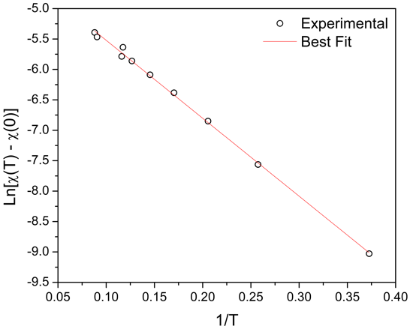
Figure 4.3. Temperature dependence of the DC magnetic susceptibility of NiBO at 0.1 T. Inset: magnetic susceptibility plot of $\ln{[χ\left(T\right) - χ(0)]}$ vs. 1/T for data below 11.5 K.

μ_{eff} = $\sqrt{8C}$ μ_{B} (Eq. 4.2)

giving μ_{eff} = 2.7(1) μ_{B}, which is comparable to the Ni(II) spin-only value of 2.8 μ_{B.}¹⁸⁶ The suppression of the DC magnetic susceptibility data at low temperatures is indicative of a finite magnetic excitation gap in such spin-1 chain systems.^{53, 54} The spin gap was extracted by fitting DC magnetic susceptibility data in the low-temperature range (T < 50 K) to an activated behavior in Eq. 4.3,^{19, 53}

χ(T) = χ(0) + C exp[-E_{g}/(k_{B}T)] (Eq. 4.3)
where E_{g} is the spin gap and χ(0) is an offset.

The inset of Figure 4.3 demonstrates an excellent fit of the experimental data to Eq. 4.3.
We obtain a value of E_{g} = 7.5(5) cm⁻¹, which is in good agreement with the spin gap as extracted from QMC simulations, as discussed in the next section. In addition, the magnetization measurements show no increase in the magnetic susceptibility down to 2 K, suggesting that there is very little to no paramagnetic contamination of the Ni(II) ions in NiBO.
To probe the stability of the gapped magnetic phase, we measured the DC magnetic susceptibility under various magnetic fields between 2 and 10 K (Figure 4.4). Note that at each temperature, $χ$ initially decreases (< 9 T) then increases (> 9 T) with increasing magnetic field. In addition, at higher fields, the magnetic susceptibility starts to increase below 5 K, suggesting a possible magnetic phase transition. Figure C.8 shows the field dependence of the DC magnetization between 2 K and 300 K, revealing the nonlinear behavior below 5 K. The increase
Figure 4.4. Temperature dependence of the DC magnetization of NiBO at various magnetic fields.

of magnetization signifies a possible field-induced phase transition. Background subtraction for the DC magnetic susceptibility data were performed through fittings of the data in the temperature range between 200 and 300 K using χ = C/(T - θ_{CW}) + χ_{para}, where χ_{para} is the paramagnetic contribution in the background.

4.2.4. Quantum Monte-Carlo Simulation (QMC)
QMC simulations were performed in conjunction with the experimental DC magnetization measurements to identify the microscopic Haldane chain parameters for NiBO. We considered an isolated spin-1 chain model, described by the Hamiltonian in Eq. 4.4:

$H=J\sum_{i=1}^{N}{S_{i}} ∙ S_{i+1} + D\sum_{i=1}^{N}{{\left(S_{i}^{z}\right)}^{2}} + E\sum_{i=1}^{N}{({\left(S_{i}^{x}\right)}^{2} - {(S_{i}^{y})}^{2})}$ (Eq. 4.4)
where J is the nearest-neighbor exchange coupling constant, D is the axial single-ion anisotropy for Ni²⁺, and E is the transverse (or rhombic) anisotropy.

To perform the QMC simulations, we used the stochastic series expansion (SSE) method,^{187, 188} and adjusted the above model parameters to obtain the best fit of the QMC magnetic susceptibility results to the experimental DC magnetic susceptibility data. The spin-1 chain was simulated with 512 sites and periodic boundary conditions to probe bulk properties. We note here the symmetry E $→$ −E. Therefore, we consider only E > 0 for the following. The Heisenberg coupling J, the g-factor, and the paramagnetic offset $χ$_{para} of the susceptibility can be obtained by comparing the susceptibility data to the QMC simulations of the isotropic chain (with D = E = 0) as seen in Figure C.11. Where J = 29.44 cm⁻¹, g = 1.87 and $χ$_{para} = 10⁻⁵ cm³/mol. The isotropic model agrees well with the experimental data at higher temperature but deviates at lower temperature. Therefore, the isotropic model does not reproduce NiBO’s low-energy spectrum. If the anisotropy D < J is small and $\left|E\right|$ < D < J, the full spectrum may be obtained using the following gaps^{189, 190} (where $Δ_{x}$ < $Δ_{y}$ < $Δ_{z}$):

$Δ_{x}=0.41J-0.57D- κ_{0}\left|E\right|$
$Δ_{y}=0.41J-0.57D+ κ_{0}\left|E\right|$
$Δ_{z}=0.41J+1.41D$ (4.5)

To compare the QMC results to the experimental DC magnetic susceptibility data of the powder sample, we performed an orientational averaging, which yields the magnetic susceptibility in Eq. 4.5:

$χ = \frac{2}{3}χ_{⊥} + \frac{1}{3}χ_{∥} + χ_{para}$ (Eq. 4.5)
where $χ_{⊥}$ ($χ_{∥}$) denotes the QMC response perpendicular (parallel) to the direction of the anisotropy term and $χ$_{para} is a paramagnetic contribution.

The results obtained from QMC simulations are compared to the experimental results in Figure 4.5 where the D and E terms are included. We fixed J, $g_{⊥}= g_{∥}$, and $χ$_{para} to the values obtained from the isotropic model, where g|| (g⊥) is the g factor for the magnetic fields applied parallel (perpendicular) to the direction of the anisotropy term [i.e., in a finite magnetic field with
Figure 4.5. Quantum Monte Carlo results for the magnetic susceptibility as a function of temperature. The inset shows the magnetic susceptibility data in the low-temperature range. The QMC data fits well with the experimental data down to the low-temperature regime.

flux density B, the Zeeman terms $H_{||}= g_{||}μ_{B}B\sum_{i}{S_{i}^{z}}$ , and $H_{}=g_{}μ_{B}B\sum_{i}{S_{i}^{x}}$ are added to the Hamiltonian (H), respectively]. The results show that with the inclusion of an additional D and E term, where D = 4.99 cm⁻¹ and $\left|E\right|$ = 1.01 cm⁻¹, the simulation fits remarkably well to the experimental DC magnetic susceptibility data across the full temperature range of 1.841 to 300 K. The model parameters obtained from the simulations are listed in Table 4.1. Simulation results for different value of $\left|E\right|$ compared to the experimental data is in Figure C.12. From D, the axial anisotropy parameter of one Ni²⁺ ion, the effective anisotropy parameter for the chain (i.e., the collective triplet) D_{eff} = −1.98D = −9.88 cm⁻¹ is obtained.^{31, 191} It should be pointed out that D_{eff} = −1.8D has also been used in the literature,^{31, 191} which would make D_{eff} here smaller.
The values of D and E are small enough for NiBO to reside within the Haldane phase rather than the large-D phase.^{192, 193} Based on the QMC simulations,¹⁹⁴ we obtain spin gaps of $Δ_{x}$ = 7.16 cm⁻¹, $Δ_{y}$ = 11.3 cm⁻¹, and $Δ_{z}$ = 19.1 cm⁻¹. In addition, QMC results for the magnetization in finite fields are shown in Figures C.18 and C.19. Similar to the experimental magnetic susceptibility data obtained in finite magnetic fields shown above, the finite-field QMC data demonstrate the stability of the Haldane phase for magnetic field strength up to the size of the zero-field spin gap. Additional QMC results and analysis can be found in Appendix C.

4.2.5. Specific Heat
Specific-heat measurements on NiBO were conducted to complement the magnetic susceptibility data. Figure C.20 shows the specific heat data between 1.8 K and 200 K at zero magnetic field and in a magnetic field of 12 T for a powder sample of NiBO. For the magnetic field beyond 9 T, a λ shape peak shows up below 5 K and shifts toward a higher temperature as
Table 4.1. Magnetic parameters obtained from the QMC simulations
Parameters | Energy (cm⁻¹)
D | 4.99
D_{eff} | $-9$.88
$$\left|E\right|$$ | 1.01
|E_{eff}| | 2.07
J | 29.44
$$Δ_{x}$$ | 7.16
$$Δ_{y}$$ | 11.3
$$Δ_{z}$$ | 19.1

the magnetic field increases, as shown in Figure 4.6. The peaks indicate a field-induced phase transition occurring in the above field and temperature range. A summary of the critical field and critical temperature of the transition line is shown in Figure C.21. The transition points observed in both the specific heat data and the magnetization data are consistent with each other, indicating that there is a single magnetic phase transition in NiBO at a magnetic field beyond 9 T and below 5 K. The change in the critical field and critical temperature of the transition is almost linear, which is similar to previous observations in NENP.¹⁹⁵

4.2.6. INS at 0 T
From the energy diagram of a Haldane spin-1 chain system and the Zeeman effect on the magnetic states in Figure 4.7, two transitions, A and B are expected at 0 T.
INS was conducted at VISION without a magnet to study the spin gaps in NiBO. The measurements were performed at 5, 7.5, 10, 15, and 20 K to determine the spin gaps between the singlet ground state and the triplet excited state. Two different spin gaps are observed at 5 K in Figure 4.8. The intensities of the two peaks at ~10 and 19 cm⁻¹ decreased with increasing temperature. The temperature-dependent of the peaks suggested magnetic origin and not phonon. The peak at 10.0(1) cm⁻¹ is determined to originate from the transition A, $\left|0,\right.\left.0\right\rangle → \left|1,\left.±1\right\rangle \right.$. The peak at 19.1(1) cm⁻¹ originates from the transition B, $\left|0,\right.\left.0\right\rangle → \left|1,\left.0\right\rangle \right.$. The value of the experimental D_{eff}(INS) and the single-ion anisotropy D(INS) can be determined using the magnetic coupling constant (J) from QMC (29.44 cm⁻¹) and peak B [$Δ_{z}$ = 19.1(1) cm⁻¹] from INS in Eqs. 4.6 and 4.7:^{31, 196}

Figure 4.6. Magnetic field-dependent specific heats of NiBO from 1.92 to 6.00 K.

Figure 4.7. Expected transitions A, B at 0 T and C inside magnetic fields for a single-crystal of NiBO, with the magnetic field aligned in the z direction.

Figure 4.8. Temperature-dependent INS data for NiBO-d₈. The pink dashed lines are at the peaks from excitations A and B in Figure 4.7 corresponding to the two spin gaps between levels 1 and 2/3 as well as between Levels 1 and 4.

D(INS) $= \frac{Δ_{z}-0.41J}{1.41}=5.0(1)$ cm⁻¹ (Eq. 4.6)
D_{eff}(INS) = $-$1.98D(INS) = $-$9.9(1) cm⁻¹ (Eq. 4.7)

We are unable to observed the splitting of peak A ($Δ_{xy}$) due to the limited resolution of the instrument. With higher resolution, peak A should split into $Δ_{x}$ and $Δ_{y}$ indicating an existance of the transverse or rhombic anisotropy (E) in NiBO. The results obtained from INS agree well with QMC and magnetic susceptibility results.

4.2.7. HFESR
HFESR measurements were performed at 4.5 K on a powder sample of NiBO to probe the electronic spin transition within the triplet excited state. The results show only a single low-intensity and broad resonance in Figure 4.9 at ~6.8 T and 511 GHz. The resonance moves to lower magnetic field upon decreasing the frequency, as shown in Figure 4.10. We interpret the observed resonance as originating from the transition $\left|1,\left.-1\right\rangle → \left|1,\left.0\right\rangle \right.\right.$. Extrapolation to 0 T gives D_{eff}(HFESR) = 7.8(2) cm⁻¹. However, this value underestimates the actual zero-field gap, as discussed in Appendix C. Instead, the results obtained based on the QMC simulations compare well with the experimental data and support the observed transition $\left|1,\left.-1\right\rangle → \left|1,\left.0\right\rangle \right.\right.$ in the powder averaged spectrum of the HFESR, as shown in Figure C.17. Furthermore, the intensity of the resonance is weak, probably resulting from the thermal depopulation of the triplet state at 4.5 K. The even lower population of the $\left|1,\left.+1\right\rangle \right.$ state may furthermore explain the absence of the resonance transition $\left|1,\left.+1\right\rangle → \left|1,\left.0\right\rangle \right.\right.$ in the spectrum. The result is consistent with observations in the ESR spectra of PbNi₂V₂O₈.¹⁹⁷ No resonances are observed for the
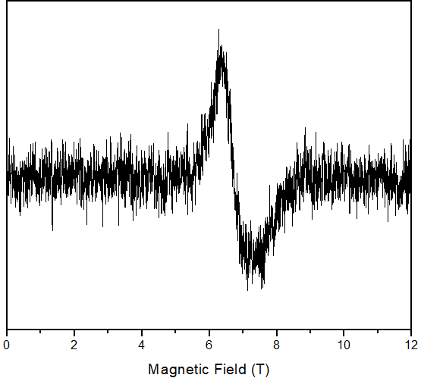
Figure 4.9. HFESR spectrum of NiBO at 4.5 K and 511 GHz.

Figure 4.10. Frequency dependence of the resonance observed by HFESR. The red line is a linear fit to the data.

formally forbidden transitions from the singlet to the triplet state, based on the selection rules. The end-chain resonance is not discernable in the spectrum due to NiBO having little to no impurities in the MOF structure as well as negligible inter-chain coupling. According to Čižmár et al., the intensity of the end-chain resonance can be attributed to the spin-1/2 fractional end-chain effect or the presence of the inter-chain coupling.¹⁹⁶ Impurities can cause fragmentation of the spin-1 chains leading to the presence of more end-chain spin-1/2. As determined in the magnetization measurements of NiBO, the magnetic susceptibility does not increase at low temperatures, which is the characteristic of a relatively pure system.

4.2.8. Phonon Spectrum from INS and Comparison with the DFT-Calculated INS Spectrum
The phonons described in these studies are of both inter- and intra-molecular vibrations. INS is based on the neutron kinetic energy transfer, which means the technique does not follow any selection rules, unlike optical spectroscopies such as HFESR. Therefore, INS can detect all the phonon excitations in the solid molecule.¹⁹⁸ Figure 4.11 shows the experimental INS spectrum at 5 K and the calculated phonon spectrum from DFT calculation. Most of the major
phonon features are located below 1,700 cm⁻¹, while one distinct major feature is at 3,100 cm⁻¹. The calculated phonon spectrum fits well to the experimental phonon spectrum, especially at the higher energy region. Further discussion of the phonon features, phonon symmetries, and spin densities are provided in Appendix C.

Figure 4.11. The calculated phonon spectrum compares to the experimental INS spectrum at 5 K.

4.3. Experimental Methods
4.3.1. Single-Crystal X-Ray Diffraction (SCXRD)
Single-crystal X-ray diffraction data were collected using a Bruker D8 Venture at 100 K with Mo Kα radiation. Data were collected and integrated using APEX 3 programs, reduced using Bruker SAINT program, and corrected for absorption using the SADABS multi-scan program. The structure was solved using SHELXT and refined with SHELXL-2015. There was no distinction made for the D isotope in NiBO-d₈.¹⁹⁹

4.3.2. Magnetic Susceptibility (DC) and Specific Heat
DC magnetic susceptibility measurements at 0.1 T were conducted at the Center for Nanophase Materials Sciences (CNMS) at Oak Ridge National Laboratory (ORNL) using the superconducting quantum interference device (SQUID) magnetometer by Quantum Design. A powder sample of NiBO with a total mass of 119.2 mg was used. Variable temperature and variable field DC magnetic susceptibility were measured using the Physical Property Measurement System (PPMS) Dynacool by Quantum Design. The magnetization measurement was measured using Vibrating Sample Magnetometer (VSM) option. The powder with a total mass of 11.7 mg was used for the temperature-dependent of magnetization under a magnetic field of 0.1 T from 2 K to 300 K. The magnetization was performed between 2 K and 300 K up to 14 T. Temperature-dependent of specific heat was measured by relaxation technique using the PPMS. A pressed pellet with a total mass of 6.5 mg was used for specific heat measurement between 2 K to 200 K from 0 T to 14 T.

4.3.3. HFESR
HFESR experiments were performed at the National High Magnetic Field Laboratory (NHMFL) using a homemade ESR spectrometer with a 17 T superconducting magnet.²⁰⁰ A low microwave source (8-20 GHz) was used in conjunction with an array of multipliers and amplifiers (Virginia Diodes, Charlottesville, VA, USA) to make higher frequency harmonics.

4.3.4. Powder Neutron Diffraction (PND)
Neutron diffraction data were collected at the POWGEN diffractometer at the Spallation Neutron Source (SNS) at Oak Ridge National Laboratory (ORNL) between 1.8 K and 200 K using an Orange Cryostat. A powder sample was loaded into a 6 mm-diameter, cylindrical vanadium sample can, and the data were collected for approximately 2 h in the high-resolution mode, using a center wavelength of 2.665 Å covering the d spacing from 1 Å to 15.0 Å. A background correction for the measured data was performed using an empty vanadium sample can measurement. The peak profile was described using a convolution of a Gaussian peak shape and a GSAS back-to-back exponential peak shape accounting for the asymmetry. The peak profile was obtained by refining data from Si (SRM 640d, NIST). All refinement was carried out using the TOPAS 6 software of the academic version.²⁰¹

4.3.5. INS
VT INS data were collected by placing ~1 g of the powder sample of NiBO-d₈ into a vanadium can specifically made for the neutron instrument. The sample vanadium can was placed into the neutron beamline at the Vibrational Spectrometer (VISION) at SNS, ORNL. There are two detector banks for the forward (low $\left|Q\right|$) and the back (high $\left|Q\right|$) scattering of neutrons. The effect of phonon population was accounted for through normalization of the INS intensity at energy transfer ω with $\coth\left(\frac{ℏω}{2k_{B}T}\right)$.²⁰²

4.3.6. DFT Calculations of Phonon and Spin Density
Spin-polarized Density Functional Theory (DFT) calculations of NiBO were performed at the Spallation Neutron Source (SNS) at Oak Ridge National Laboratory (ORNL) using the Vienna Ab initio Simulation Package (VASP).²⁰³ The calculation used Projector Augmented Wave (PAW) method^{122, 204} to describe the effects of core electrons, and Perdew-Burke-Ernzerhof (PBE)¹²⁵ implementation of the Generalized Gradient Approximation (GGA) for the exchange-correlation functional. The energy cutoff was 800 eV for the plane-wave basis of the valence electrons. The lattice parameters and atomic coordinates from the CIF file, generated by the single-crystal X-ray diffraction measurement of NiBO-d₈ at 100 K, were used as the initial structure. The electronic structure was calculated on a 3 × 3 × 7 Γ-centered mesh. The total energy tolerance for electronic energy minimization was 10⁻⁸ eV, and for structure optimization, it was 10⁻⁷ eV. The maximum interatomic force after relaxation was below 0.001 eV/Å. The optB86b-vdW functional²⁰⁵ for dispersion corrections was applied, and a Hubbard U term of 6.2 eV²⁰⁶ was applied to account for the localized 3d orbitals of Ni. A 1 × 1 × 3 supercell was created, for which the electronic structure was calculated on a 3 × 3 × 2 Γ-centered mesh. The interatomic force constants were calculated on the supercell by VASP, and the vibrational eigenfrequencies and modes were then calculated using Phonopy.¹⁵⁷ The OCLIMAX software¹⁵⁸ was used to convert the DFT-calculated phonon results to the simulated INS spectra.

Chapter 5

Advance Magnetic Resonance Studies of Tetraphenylporphyrinatoiron(III) Halides

This chapter is based on the following paper:
Pagnareach Tin, Shelby E. Stavretis, Mykhaylo Ozerov, J. Krzystek, A. N. Ponomaryov, S. A. Zvyagin, J. Wosnitza, Ching-Chin Chen, Peter P.-Y. Chen, Joshua Telser and Zi-Ling Xue, Advanced Magnetic Resonance Studies of Tetraphenylporphyrinatoiron(III) Halides. Appl. Magn. Reson. 2020, 51, 1411. https://doi.org/10.1007/s00723-020-01236-8

Author contributions:
P. Tin and M. Ozerov performed the FIRMS experiments. They analyzed and interpreted the FIRMS data. J. Krzystek, A. N. Ponomarev, S. A. Zvyagin, and J. Wosnitza performed the HFEPR experiments, analyzed, and interpreted the data. J. Telser conducted ligand-field analyses of the complexes and origins of the ZFS. S. E. Stavretis synthesized the samples of Fe(TPP)F, Fe(TPP)Br, and Fe(TPP)I for experiments. C.-C. Chen, P. P.-Y. Chen prepared the sample of Fe(TPP)Cl. Z.-L. Xue initiated the project, analyzed, and interpreted the data. All authors contributed to the writing of the manuscript.

5.1. Abstract
High-Frequency and -Field EPR (HFEPR) studies of Fe(TPP)X (X = F, Cl, Br; I, TPP²⁻ = meso-tetraphenylporphyrinate dianion) and far-IR magnetic spectroscopic (FIRMS) studies of Fe(TPP)Br and Fe(TPP)I have been conducted to probe magnetic intra- and inter-Kramers doublet transitions in these S = 5/2 metalloporphyrin complexes, yielding zero-field splitting (ZFS) and g parameters for the complexes: Fe(TPP)F, D = +4.67(1) cm⁻¹, E = 0.00(1) cm⁻¹, g⊥ = 1.97(1), g|| = 2.000(5) by HFEPR; Fe(TPP)Cl, D = +6.458(2) cm⁻¹, E = +0.015(5) cm⁻¹, E/D = 0.002, g⊥ = 2.004(3), g|| = 2.02(1) by HFEPR; Fe(TPP)Br, D = +9.03(5) cm⁻¹, E = +0.047(5) cm⁻¹, E/D = 0.005, g_{iso} = 1.99(1) by HFEPR and D = 9.05 cm⁻¹, g_{iso} = 2.0 by FIRMS; Fe(TPP)I, D = +13.84 cm⁻¹, E = +0.07 cm⁻¹, E/D = 0.005, g_{iso} = 2.0 by HFEPR and D = 13.95 cm⁻¹, g_{iso} = 2.0 by FIRMS (the sign of E was in each case arbitrarily assigned as that of D). These results demonstrate the complementary nature of field- and frequency-domain magnetic resonance experiments in extracting with high accuracy and precision spin Hamiltonian parameters of metal complexes with S > 1/2. The spin Hamiltonian parameters obtained from these experiments have been compared with those obtained from other physical methods such as magnetic susceptibility, magnetic Mössbauer spectroscopy, inelastic neutron scattering (INS), and variable-temperature and -field magnetic circular dichroism (VT-VH MCD) experiments. INS, Mössbauer and MCD give good agreement with the results of HFEPR/FIRMS; the others not as much. The electronic structure of Fe(TPP)X (X = F, Cl, Br, I) was studied earlier by multi-reference ab initio methods to explore the origin of the large and positive D-values, reproducing the trends of D from the experiments. In the current work, a simpler model based on Ligand Field Theory (LFT) is used to explain qualitatively the trend of increasing ZFS from X = F to Cl to Br and to I as the axial ligand. Tetragonally elongated high-spin d⁵ systems such as Fe(TPP)X exhibit D > 0, but X plays a key role. Spin delocalization onto X means that there is a spin-orbit coupling (SOC) contribution to D from X•, as opposed to none from closed-shell X⁻. Over the range X = F, Cl, Br, I, X• character increases as does the intrinsic SOC of X• so that D increases correspondingly over this range. To offer a brief historical background: Of the current series, Fe(TPP)Cl has been by far the most investigated of the four compounds presented here by both magnetic resonance and non-resonance methods. Fe(TPP)Br has been the next-often researched member of the group, while Fe(TPP)F and Fe(TPP)I have been only covered by some of us in previous work.⁶⁸

5.2. Results
5.2.1. HFEPR
Fe(TPP)F produced a rich set of HFEPR spectra at low temperatures, and any frequency in the ~100–430 GHz range (Figure 5.1, top left; see also Figure D.1, Appendix D; a multifrequency collection of experimental spectra is shown in Figure D.2). The spectra could be adequately simulated using spin Hamiltonian parameters as in Figure 5.1 caption and assuming a powder distribution of crystallites in the sample. The parameters, particularly the g-values, however, tended to be slightly frequency-dependent, as is usually the case in multi-frequency experiments. In order to obtain a frequency-independent set of parameters, a 2-D energy (or frequency) vs. magnetic field map of turning points was constructed, and the parameters fitted by a least-square method to the complete data set according to the tunable-frequency methodology (Figure 5.2, top left).²⁰⁷ The resulting spin Hamiltonian parameters are found in Table 5.1. Most importantly, for Fe(TPP)F, the D-value is +4.67(1) cm^{–1}, while there is no detectable rhombicity of the ZFS tensor (E = 0), thus the complex symmetry remains perfectly fourfold.
Fe(TPP)Cl produced an EPR response of very high quality at any temperature from 5 to 200 K and above, and in a wide frequency range of 50–630 GHz (Figure 5.1, top right; see also Figures D.3 and D.4, Appendix D). The experimental spectra could be well simulated and thanks to a small linewidth of the turning points, a minute E-value could be determined from the perpendicular resonances together with the D-value of +6.458(2) cm^{–1}, which translates into a rhombicity factor E/D of the ZFS tensor as small as 0.002−0.003. The final frequency-
Figure 5.1. Experimental HFEPR spectra at 5-10 K of the Fe(TPP)X series of compounds (black traces) and their powder-pattern simulations (red traces). Particular frequencies and spin Hamiltonian parameters used in the simulations are: Fe(TPP)F: frequency, 425.6 GHz, D = +4.67 cm^{–1}, E = 0, g_{iso} = 1.97; Fe(TPP)Cl: frequency, 628.8 GHz, D = +6.458 cm^{–1}, E = +0.023 cm^{–1}, g = [2.01, 2.01, 2.00]; Fe(TPP)Br: frequency, 609 GHz, D = +9.01 cm^{–1}, E = +0.05 cm^{–1}, g = [1.98, 1.99, 1.99]; Fe(TPP)I: frequency, 631 GHz, D = +13.83 cm^{–1}, E = +0.07 cm^{–1}, g = [1.995, 1.995, 2.000] (the sign of E was in each case arbitrarily assigned as that of D). The splitting of the perpendicular intra-Kramers turning points (such as the one at 10 T in Fe(TPP)Br) is indicative of an exceedingly small (E/D < 0.01) yet measurable rhombicity of the ZFS tensor in each compound except Fe(TPP)F.
Table 5.1. Spin Hamiltonian parameters of Fe^{III}(TPP)X determined by different methods

Axial ligand | Method | D (cm⁻¹) | E (cm⁻¹) | g⊥ | g|| | Ref.
X = F | HFEPR | +4.67(1) | 0.00(1) | 1.97(1) | 2.000(5) | This work
 | INS | +4.49(9) | 0 |  |  | [⁶⁸]
X = Cl | HFEPR | +6.458(2) | +0.015(5) E/D = 0.002 | 2.004(3) | 2.02(1) | This work
 | INS | +6.33(8) | 0 |  |  | [¹¹³]
 | FD-FT THz-EPR | 6.465 | 0.02  E/D = 0.003 | 2.0 | 1.95 | [²⁰⁸]
 | Far-IR | 6.5 |  |  |  | [²⁰⁹]
 | VTVH MCD | 6.9 |  |  |  | [²¹⁰]
 | Magnetic Mössbauer | 7(1) |  |  |  | [²¹¹]
 | X-band EPR | 3.2 |  |  |  | [²¹²]
 | NMR | 11.3 |  |  |  | [²¹³]
 | Magnetic susceptibility | 6.0(1)-11.9 |  |  |  | [²¹⁴⁻²¹⁷]
X = Br | HFEPR | +9.01(5) | +0.047(5)  E/D = 0.005 | 1.99(1) | 1.99(1) | This work
 | FIRMS | +9.05 |  | 2.0 | 2.0 | This work
 | INS | +8.8(2) | 0.1(2) |  |  | [⁶⁸]
 | Far-IR | 9.15 |  |  |  | [²⁰⁹]
 | Magnetic susceptibility | 4.9-12.5(5) |  |  |  | [^{214, 218, 219}]
X = I | HFEPR | +13.84 ª | +0.07  E/D = 0.005 | 2.00 | 2.00 | This work
 | FIRMS | +13.95 |  | 2.0 | 2.0 | This work
 | INS | +13.4(6) | 0.3(6) |  |  | [⁶⁸]
 | Magnetic susceptibility | 13.5(5) |  |  |  | [²¹⁹]
ª The number of data points from the HFEPR spectra of Fe(TPP)I was not sufficient to do a proper least-square fit to yield an error estimate of the D and E values.
Figure 5.2. 2-D field vs. energy (frequency) HFEPR maps of the Fe(TPP)X series of compounds. Squares are experimental turning points in the EPR powder spectra including the zero-field resonance in Fe(TPP)Br detected by FIRMS at 18.1 cm^{–1}; curves are simulations using spin Hamiltonian parameters as in Table 5.1. Red curves: simulations with magnetic field parallel to the x-axis of the ZFS tensor; blue curves: B₀ || y axis, black curves: B₀ || z axis, green curves: off-axis turning points in Fe(TPP)Cl and Fe(TPP)Br. Only those simulated turning points were plotted that show experimental points on them; others were omitted for clarity. For Fe(TPP)Cl, the splitting of the perpendicular turning points is smaller than the symbol size. For that reason, only one set of perpendicular experimental data points is shown.
independent spin Hamiltonian parameters were obtained from a 2-D map similarly to Fe(TPP)F (Figure 5.2, top right) and are to be found in Table 5.1.
The EPR response of the third complex of the series, Fe(TPP)Br, was was almost as good as those of the two previously described analogs. Figure 5.1 (bottom left) shows a typical spectrum accompanied by powder-pattern simulations using spin Hamiltonian parameters as in the figure caption. Another spectrum, obtained at a lower frequency, is shown in Figure D.5 in the Appendix D and additional multifrequency spectra in Figure D.6. The axial ZFS parameter D was established at +9.01 cm^{–1} and the very small rhombicity of the ZFS tensor (E/D ~0.005) shows in the visible splitting of the perpendicular turning point of the intra-Kramers transition at 10 T. The final frequency-independent spin Hamiltonian parameters were obtained as before from a 2-D map of turning points shown in (Figure 5.2, bottom left) and are to be found in Table 5.1.
Finally, the fourth complex, Fe(TPP)I also generated informative HFEPR spectra. Figure 5.1 (bottom right) shows one of these spectra accompanied by powder-pattern simulations using spin Hamiltonian parameters as in the figure caption. The axial ZFS parameters D was found to be +13.84 cm^{–1} and a minute rhombicity (E/D ~0.005) of the ZFS tensor shows in the visible splitting of the perpendicular turning point of the intra-Kramers transition at 9 T. Another spectrum, obtained at a lower frequency, is shown in Figure D.7 in the Appendix D with a multi-frequency collection of experimental spectra shown in Figure D.8. The final frequency-independent spin Hamiltonian parameters were obtained as before from a 2-D map of turning points shown in (Figure 5.2, bottom right) and are to be found in Table 5.1. Note that although the highest HFEPR operating frequency (631 GHz, 21 cm^{–1}) was significantly lower than the 2|D| energy gap (27.9 cm^{–1}, see the FIRMS section below), an observation of the inter-Kramers turning points such as the one visible at 3.5 T in the corresponding spectrum made it possible to obtain the D-value for Fe(TPP)I independent of FIRMS.

5.2.2. FIRMS
FIRMS has been used extensively to probe magnetic transitions in metal complexes with large zero-field splitting.^{209, 220-228} The great advantage of Fourier-transform spectroscopy is being able to cover the broad spectral range where transitions between zero-field energy levels might be observed. The application of the magnetic field gives the second variable for plotting the absorption spectrum in two dimensions, although significant costs are paid in terms of THz wave radiation power reaching the sample. Two spectra of the THz radiation transmitted through the sample were recorded for each magnetic field to estimate the signal-to-noise ratio. The magnetic resonance absorption spectrum is obtained as A = 1 − T, where T is the ratio between the THz transmission measured at each magnetic field and a reference spectrum. The latter is the average THz transmission for all magnetic fields. This approach allows one to distinguish field-dependent absorption among the field-independent spectral features, such as vibrational modes and instrumental function.
The experimental FIRMS spectra shown in Figure 5.3 in a form of 2-D maps (field vs. energy) were analyzed and simulated using an in-house written program based on the EasySpin toolbox.²²⁹ This toolbox was originally developed for the analysis of magnetic resonance absorption in the field domain, but also provides a capability for calculations of the magnetic-dipole transition probability in the frequency domain. The effect of random orientation of the
Figure 5.3. (Top left) 2-D map of magnetic resonance absorption (also called FIRMS) in Fe(TPP)Br at 4.6 K with HFEPR data points added as black squares. A zero-field transition is clearly visible at 18.1 cm^{–1} representing the transition between the ±1/2 and ±3/2 Kramers doublets. The intra-Kramers transition within the ±1/2 manifold is also visible at higher fields (4–17 T) in the low-energy region (10–24 cm^{–1}). The lines are simulations of all possible turning points (including those of nominally forbidden transitions) in the powder spectrum using: D = +9.05 cm^{–1}, E = +0.05 cm^{–1}, g_{iso} = 2.0 (g_{iso} is the isotropic g factor). (Top right) 2-D map of magnetic resonance absorption in Fe(TPP)I. A zero-field transition is clearly visible at 27.9 cm^{–1} representing the transition between the ±1/2 and ±3/2 Kramers doublets. The intra-Kramers transition within the ±1/2 manifold is also visible at higher fields (4–17 T) in the low-energy region (10–30 cm^{–1}). The lines are simulations of turning points in the powder spectrum using D = +13.95 cm^{–1}, E = +0.07 cm^{–1}, g_{iso} = 2.0. (Bottom) Simulated maps for the respective compounds. The false-color simulation reproduces the allowed (ΔM_{S} = ±1) transitions only, as different from the lines. That nominally forbidden resonances such as |−1/2⟩ → |+3/2⟩ appear in the experimental maps (the top two windows) is most likely due to the presence of a B₁ || B₀ component in the THz radiation (B₁ is the magnetic, as opposed to electrical, field of the applied radiation) in addition to the standard B₁ ⊥ B₀ one.

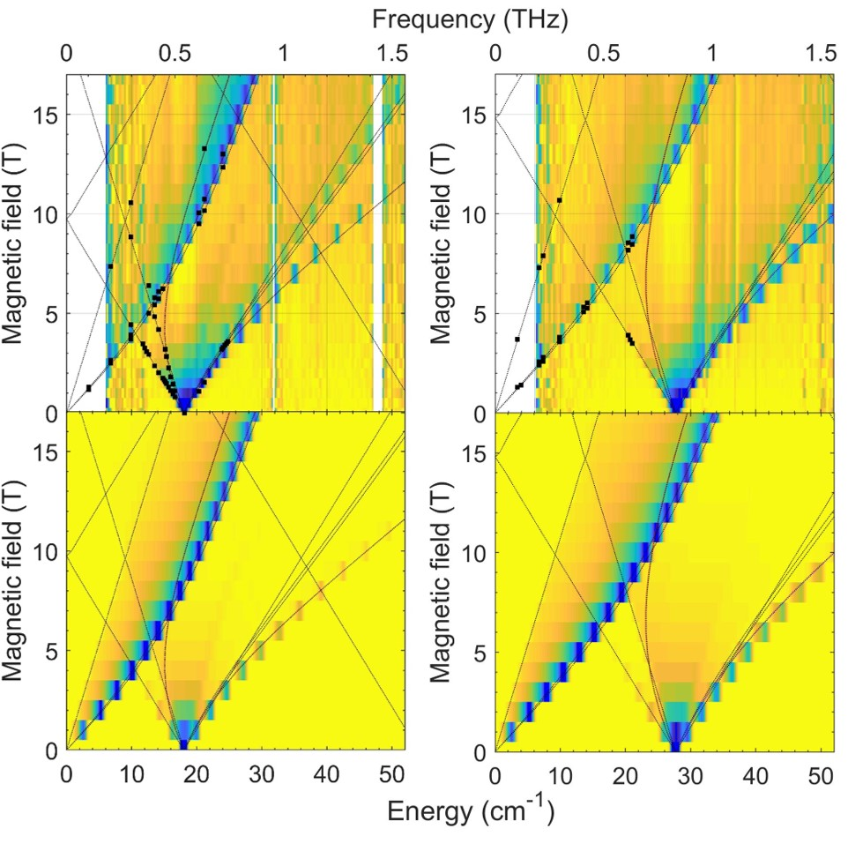

microcrystallites in the powder is taken into account and Lorentzian line broadening added to obtain the final simulated spectrum.
The lowest limit of the FIRMS spectral range is essential for spectroscopic studies of SMMs and is defined by the design of the particular experimental set-up. The intensity of the THz radiation emitted by a broadband thermal source is about 0.05% compared to mid-infrared range, which commercial FT-IR spectrometers are generally tailored to. The typical sensitivity of FIRMS measurements at NHMFL drops precipitously below 15 cm⁻¹ (Figure D.9 in Appendix D). This was one of the reasons why, of the four Fe(TPP)X complexes, only Fe(TPP)I and Fe(TPP)Br were addressed by the FIRMS technique, since the ZFS energies of Fe(TPP)F and Fe(TPP)Cl were fully determined by HFEPR. Nevertheless, a low-frequency resonance absorption at 10 cm⁻¹ (0.3 THz) can still be observed in both Fe(TPP)Br and Fe(TPP)I. This relatively strong (~30 %) absorption corresponds to the transition within the M_{S} = ±1/2 Kramers doublet and confirms the positive sign of D for both compounds. The quality of these spectra is essentially the same as those of the FD-FT THz-EPR (Frequency-Domain Fourier-Transform Terahertz-EPR) studies on Fe(TPP)Cl reported by the BESSY II facility in Berlin.²⁰⁸ Despite the microcrystallites in the powder is taken into account and Lorentzian line broadening added to obtain the final simulated spectrum.
The lowest limit of the FIRMS spectral range is essential for spectroscopic studies of SMMs and is defined by the design of the particular experimental set-up. The intensity of the THz radiation emitted by a broadband thermal source is about 0.05% compared to mid-infrared range, which commercial FT-IR spectrometers are generally tailored to. The typical sensitivity of FIRMS measurements at NHMFL drops precipitously below 15 cm⁻¹ (Figure D.9 in Appendix D). This was one of the reasons why, of the four Fe(TPP)X complexes, only Fe(TPP)I and Fe(TPP)Br were addressed by the FIRMS technique, since the ZFS energies of Fe(TPP)F and Fe(TPP)Cl were fully determined by HFEPR. Nevertheless, a low-frequency resonance absorption at 10 cm⁻¹ (0.3 THz) can still be observed in both Fe(TPP)Br and Fe(TPP)I. This relatively strong (~30 %) absorption corresponds to the transition within the M_{S} = ±1/2 Kramers doublet and confirms the positive sign of D for both compounds. The quality of these spectra is essentially the same as those of the FD-FT THz-EPR (Frequency-Domain Fourier-Transform Terahertz-EPR) studies on Fe(TPP)Cl reported by the BESSY II facility in Berlin.²⁰⁸ Despite the difference in terminology, their instrumental approach is basically the same as ours in terms of employing a Bruker FT-IR spectrometer. However, their spectrometer is coupled to an optical split-coil magnet, which yields sensitivity benefits due to the free-space propagation of the THz radiation and its direct incidence on the sample. A key difference of course is that BESSY II can also use coherent synchrotron radiation in the THz region as described elsewhere.²³⁰

5.3. Discussion
5.3.1. Overview of the ZFS in Fe(TPP)X
The most-researched complex of the Fe(TPP)X series has been Fe(TPP)Cl, its ZFS studied by a variety of experimental and theoretical methods, including magnetic susceptibility measurements,²¹⁴⁻²¹⁷ Fourier-Transform Frequency-Domain (FT-FD) THz- and HF-EPR,²⁰⁸ inelastic neutron scattering (INS),¹¹³ far-IR,²⁰⁹ Mössbauer spectroscopy,²¹¹ magnetic circular dichroism (MCD),²¹⁰ solution NMR,²¹³ and X-band EPR.²¹² It thus offers an excellent object for discussing the merits of particular techniques.
The most convenient (i.e., accessible) and least expensive method, dc magnetic susceptibility measurement as a function of temperature, is still the most widely used.²³¹ This technique, however, suffers from a number of extrinsic, practical considerations that can adversely affect the results: inaccuracy in sample mass (especially where sample quality is limited), insufficient diamagnetic corrections, ferromagnetic impurities (particularly for Fe-containing systems, where there can be Fe nanoparticle impurities) or other experimental problems such as a drift in the centering of the sample within the field. As an example of these difficulties in the present system, the reported D values for Fe(TPP)Cl from such measurements cover a very large range of energies: 6.0(1)–11.9 cm⁻¹.²¹⁴⁻²¹⁷ While the lower end of these values is close to the true value as determined by direct methods like HFEPR or FIRMS, the upper end is about 100% off. The Fe(TPP)Br analog was also studied by magnetic susceptibility,^{214, 218, 219} with the resulting ZFS parameters widely varying on the energy scale from about 50% undervalued to 30% overvalued. Also note that in neither case was the magnetic susceptibility data analysis hampered by any degree of ZFS rhombicity, as is often the case in other spin systems. This indirect technique is thus generally not accurate and should be treated with utmost skepticism when evaluating ZFS.
Interestingly, the early far-IR studies of Fe(TPP)Cl and Fe(TPP)Br by Uenoyama in 1971,²⁰⁹ which were performed using a home-made Michelson interferometer that Richards, Brackett and coworkers had developed,²³²⁻²³⁴ offered accurate if not precise values for both compounds. A modern extension of this technique which different groups practicing it call FD-FT THz-EPR or FIRMS offers an improved accuracy and precision, particularly when complemented by HFEPR. It is particularly gratifying to see the almost perfect agreement between the ZFS parameters in Fe(TPP)Cl obtained by FD-FT THz-EPR at the BESSY II facility in Berlin²⁰⁸ with those delivered by HFEPR at the NHMFL in Tallahassee (this work). Equally good agreement was achieved between HFEPR and FIRMS, both as performed within this work on Fe(TPP)Br and Fe(TPP)I.
A non-magnetic resonance method, Inelastic Neutron Spectroscopy (INS),²³⁵⁻²³⁹ has been practiced to measure ZFS in a variety of high-spin metal ions.^{68, 113-115, 225, 240-258} It was employed previously by some of us on the same series of Fe(TPP)X compounds reported in this work.^{68, 113} Because the INS experiments for Fe(TPP)X were not conducted with an external magnet,^{68, 113} they did not deliver the g-values of the system under study. This, however, is not a problem for the Fe(TPP)X series in which the g-values of the Fe^{III} ion are consistently very close to 2.00. Otherwise, INS delivers very robust values of the ZFS parameters in agreement with magnetic resonance. There are two features of INS that make it advantageous to probe magnetic transitions in molecular compounds: (1) It offers a unique dependence of the magnetic transitions on the neutron scattering angles (or momentum transfer Q), whether or not the INS experiments are conducted with an external magnet. This angular dependence was used to distinguish the magnetic transitions from those of phonons in the INS spectra of Fe(TPP)X (X = F, Cl, Br, I).^{68, 113} Thus, although INS is typically used in zero-field, it can provide the discrimination between magnetic and vibrational (non-magnetic) signals. Since Q is a vector, 4D-INS (i.e., dimensions of Q_{x}, Q_{y}, Q_{z}, and E = energy of the neutrons scattered from the sample) has been used recently to probe magnetic exchange interactions, spin dynamics, and the entanglement between molecular qubits in metal complexes.²⁵⁹⁻²⁶² (2) INS experiments can also be conducted with external magnets^{225, 226, 247} to probe both intra-Kramers (M_{S} = −1/2 → +1/2)²⁴⁷ and inter-Kramers doublet transitions in transition-metal and lanthanide SIMs^{225, 226}. For example, INS spectra of Co(acac-d₇)₂(D₂O)₂ (acac = pentane-2,4-dionate anion) at 0 – 10 T on the direct-geometry, time-of-flight Disk-Chopper Spectrometer (DCS)²³⁹ revealed both M_{S} = −1/2 → +1/2 and M_{S} = ±1/2 → ±3/2 transitions,²⁴⁷ offering comparisons with the results from other studies.^{227, 263} The intra-Kramers (M_{S} = −1/2 → +1/2) transition at 0–10 T was simulated with D, E, and g values from an earlier work.²⁶³ Another difference between the variable-temperature (VT) INS and HFEPR/FIRMS spectroscopies of Fe(TPP)X (X = F, Cl, Br, I) is that the INS spectra showed both the lower energy, M_{S} = ±1/2 → ±3/2 absorptions (at 2D in the range of 9.5–27.4 cm⁻¹) and the higher energy, M_{S} = ±3/2 → ±5/2 absorptions (at 4D in the range of ~18–55 cm⁻¹) at 10–100 K.^{68, 113} In addition, the transitions from the excited M_{S} = ±3/2 states to the ground M_{S} = ±1/2 states were also observed in the VT-INS spectra of all four Fe(TPP)X complexes.^{68, 113} For Fe(TPP)F and Fe(TPP)Br at 50 K when the highest energy ZFS states M_{S} = ±5/2 (Scheme 2) are sufficiently populated, the M_{S} = ±5/2 → ±3/2 transitions (at 4D) were also observed.^{68, 113} In such “emission” INS spectra, the neutrons scattered by the samples gain energy. For comparison, HFEPR and FIRMS spectra of the complexes in the current work were conducted at 2 − 10 and 4.6 K, respectively, when just the ground M_{S} = ±1/2 states were populated. Thus, these two spectroscopies essentially probed the M_{S} = ±1/2 → ±3/2 absorptions (at 2D).
A very small offset on the order of 2–4% in the D-values obtained by INS, in comparison to those obtained from magnetic resonances, persists for all complexes reported in this work (Table 5.1), which we are not yet able to explain. As pointed out earlier, the D-values from INS were from simulation of the spectra at zero magnetic field,^{68, 113} while those from magnetic resonances (HFEPR and FIRMS) are from simulations of the spectra collected in magnetic fields. In addition, the simulations of INS spectra involved the “emission” peaks as well as the higher energy, M_{S} = ±3/2 → ±5/2 absorptions in Fe(TPP)X (X = F, Br, I).^{68, 113}
Of other experimental techniques, both Mössbauer and MCD spectroscopies deliver dependable and accurate values of ZFS parameters, albeit without the precision of the magnetic resonance, and with Mössbauer requiring an external magnetic field and being essentially limited to Fe-containing systems.²⁶⁴ The indirect methods such as X-band EPR and solution NMR lead to very large errors and should generally be avoided for the purpose of evaluating ZFS.

5.3.2. Understanding the ZFS in Fe(TPP)X
The recent INS and ab initio studies by some of us^{68, 113} to calculate D and E values of all four complexes Fe(TPP)X were a comprehensive investigation of the iron porphyrin halides. The origin of the large and positive D-values of the ⁶A₁ ground state in Fe(TPP)X was studied by the complete active space self-consistent field (CASSCF) and the N-electron valence perturbation theory (NEVPT2), reproducing the trends of D from INS.⁶⁸ The results showed a correlation between the increase of the D-values and decrease of the π- and σ-antibonding energies (e_{π}^{X} and e_{σ}^{X}) of the Fe-X bonds from X = F to I.
We believe that a much simpler model based on Ligand Field Theory (LFT) could also explain at least semi-quantitatively the trend of increasing ZFS along the series of axial ligands, from F to Cl to Br and to I. Of particular instruction might be a comparison with an analogous series of tetraporphyrinato halide compounds with a different metal ion, Mn^{III} (3d⁴), where the trend is exactly reversed.¹¹⁵ This approach has already been used, by Gatteschi and Sorace for distorted octahedral complexes,²⁶⁵ specifically for both high-spin Fe^{III} and other high-spin ions, namely high-spin Mn^{III} (3d⁴, S = 2),²⁶⁶ perhaps most widely studied by HFEPR,²⁶⁶⁻²⁶⁸ as well as other techniques, including INS.^{68, 113} In the case of Mn^{III}, it is clear that, barring any complications from non-innocent (especially heavy atom) ligands,²⁶⁹ D < 0 corresponds to axial (tetragonal) elongation, as is the case for Mn(TPP)Cl,¹¹⁵ and D > 0 to axial compression.²⁷⁰ This situation for Mn^{III} is relatively simple because the ZFS is dominated by SOC involving excited states within the ground-state free-ion ⁵D (L = 2, S = 2) manifold. The D value depends on the ligand-field energy splitting as follows (Eq. 5.1)²⁷¹:

(Eq. 5.1)
where Δ is the octahedral splitting, δ₁ is the tetragonal splitting, which is basically the energy difference between the d_{xy} and d_{xz}/d_{yz} orbitals (degenerate in C_{4v} symmetry), and δ₃ is the energy of the most relevant (among many) triplet excited state (derived from ³T_{1g}(³H), t₂⁴e⁰).

In contrast, for Fe^{III}, there is no SOC within the ground state free-ion ⁶S manifold as L = 0. The ZFS results from mixing via SOC of primarily excited quartet states, of which there are many, even in high symmetry (i.e., O_{h} point-group): ⁴T_{1g}(⁴G, ⁴F, ⁴P), ⁴T_{2g}(⁴G, ⁴F, ⁴D), ⁴E_{g}(⁴G, ⁴D), ⁴A_{1g}(⁴G), and ⁴A_{2g}(⁴F). Most of these, however, are at very high energy with respect to the ⁶A_{1g}(⁶S) (in O_{h}) sextet ground state (t₂³e² in strong-field notation) and can be disregarded in a simple approach. This can be shown by an exact calculation using the matrix elements given by McClure²⁷² and the parameters used by Gatteschi and Sorace²⁶⁵: Racah parameters B = 536 cm⁻¹, C = 3260 cm⁻¹, and Dq = 1500 cm⁻¹ (roughly the average of the axial and equatorial octahedral splitting they used). This gives the ⁴T_{1g}(⁴G) excited state (t₂⁴e¹) lying at ~9400 cm⁻¹ above the ⁶A_{1g}(⁶S) ground state and the ⁴T_{2g}(⁴G) excited state (also t₂⁴e¹) lying at ~13 040 cm⁻¹. It should be noted that Paulat and Lehnert saw evidence in the MCD and UV-Vis-NIR spectra of Fe(TPP)Cl for these transitions at 11 584 and 13 542 cm⁻¹, respectively.²⁷³ All the other spin quartet excited states lie greater than ~22 000 cm⁻¹ above the ground state. The many spin doublet excited states are also at >20 000 cm⁻¹ above the ground state, and most are much higher in energy. There is one low-lying doublet excited state, ²T_{2g}(²I) (t₂⁵e⁰), but this requires a double-spin-flip to connect to the ground state, which is not allowed. The calculations by Gatteschi and Sorace showed that, similar to Mn^{III}, tetragonal elongation gave one sign of D and compression the other, but oppositely so [and more than an order of magnitude smaller, as |D| = 4.75(5) cm⁻¹ for Mn^{III}] in that elongation gave D ≈ +0.3 cm⁻¹ and compression gave D ≈ −0.3 cm⁻¹. In the case of Fe(TPP)X, however, due to the five-coordinate (square pyramidal) geometry, the situation is always one of tetragonal elongation, and indeed, the positive sign of D reported for these complexes (Table 5.1) is consistent with this simple model. The following LFT expression helps to demonstrate this behavior (Eq. 5.2)²⁷⁴:

, (Eq. 5.2)
where E_{i}, i = x, y, z, corresponds to the energies for excited states that involve pairing of the electron in the d_{x2−y2} (highest energy) orbital of the sextet ground state into the d_{yz}, d_{xz}, and d_{xy} orbitals, respectively. The second part of the equation is that given in the earlier ab initio studies by Stavretis et al.⁶⁸ and is suited to the axial symmetry found here, with the symmetry designations of the states derived from the ⁴T_{1g}(⁴G) excited state mentioned above. Due to π-bonding with the axial halido ligand, the ⁴E state (i.e., d_{xy}¹d_{yz}¹d_{xz}²d_{z2}¹ / d_{xy}¹d_{yz}²d_{xz}¹d_{z2}¹) is higher in energy than the ⁴A₂ state (i.e., d_{xy}²d_{yz}¹d_{xz}¹d_{z2}¹) so D is positive.

These simple (i.e., d^{n} only, n = 4, 5) LFT models work well for complexes wherein all of the ligands are light atoms. The difficulty is when the ligand, in this case the axial halido ligand, has both some non-innocent character and a large intrinsic SOC. The first point means that the traditional oxidation state assignment/electronic configuration of a Group 17 ligand as closed shell X⁻: [N.G.]ns²np⁶ (and likewise, a Group 16 ligand as E²⁻: [N.G.]ns²np⁶, etc.) is not a truly appropriate description, but the ligand may instead have atomic/radical character (i.e., X^{• 0}: [N.G.]ns²np⁵, and Group 16 as E^{• −}: [N.G.]ns²np⁵, etc.). The second point stems from the fact that the SOC constants of the Group 17 elements in their neutral atom state, i.e., [N.G.]np⁵ electronic configuration (²P_{3/2}), increases as follows (in cm⁻¹): F⁰, 269.3; Cl⁰, 588.2; Br⁰, 2328.8; I⁰, 5068.6.²⁷⁵ For fluorine, non-innocence is decidedly not the case, neither for chlorine, but for bromine, and in particular iodine, the complexes can be described to some extent as “resonance forms” of [Fe^{III}(TPP²⁻)X⁻] and [Fe^{II}(TPP²⁻)X^{• 0}] (X = Br, I). This was the situation encountered by Mossin et al. for a trans-bisiodido Mn^{III} cyclam (cyclam = 1,4,8,11-tetraazacyclotetradecane) complex,²⁶⁹ wherein [Mn^{III}(cyclam⁰)(I⁻)₂]⁺ ↔ [Mn^{III}(cyclam⁰)(I⁻)(I^{• 0})]⁺ (i.e., [(5p⁶)(d_{xy}¹d_{yz}¹d_{xz}¹d_{z2}¹) ↔ (5p⁵)(d_{xy}¹d_{yz}¹d_{xz}¹d_{z2}²) ↔ (5p⁵)(d_{xy}¹d_{yz}¹d_{xz}²d_{z2}¹) ↔ (5p⁵)(d_{xy}¹d_{yz}²d_{xz}¹d_{z2}¹)]) is minimally operative. This behavior is of course enhanced by the presence of two iodido ligands, which are involved in both σ-bonding (charge transfer into Mn d_{z2} orbital) and π-bonding (charge transfer into Mn d_{xz} or d_{yz} orbitals). In a tour-de-force of ligand-field theory, Mossin et al. showed that the ZFS was positive due to this large SOC constant of iodine that makes a net positive contribution to D.²⁶⁹ Qualitatively, the same effect is seen in the Mn(TPP)X series, wherein Mn(TPP)Cl has ZFS that is typical for Mn^{III} in a tetragonally elongated environment (D = −2.26(3) cm⁻¹), while for Mn(TPP)Br, the ZFS has changed substantially (D = −1.09 cm⁻¹), and for Mn(TPP)I, it has shifted to “the other side”: D = +1.3 cm⁻¹. What about [Fe(TPP)X]? Fe^{III} would be expected to be a stronger Lewis acid than Mn^{III} and thus [Fe^{III}(TPP²⁻)X⁻] ↔ [Fe^{II}(TPP²⁻)X^{• 0}] (X = Br, I) should be at least as relevant as in the cyclam complex. The question is, how does the right side “resonance form” contribute to D, positively or negatively? The method used by Mossin et al. is currently beyond our capabilities and is likely even more challenging for the Fe^{III} case as the operative electronic configurations have another electron: [(5p⁶)(d_{xy}¹d_{yz}¹d_{xz}¹d_{z2}¹d_{x2−y2}¹) ↔ (5p⁵)(d_{xy}¹d_{yz}¹d_{xz}¹d_{z2}²d_{x2−y2}¹) ↔ (5p⁵)(d_{xy}¹d_{yz}¹d_{xz}²d_{z2}¹d_{x2−y2}¹) ↔ (5p⁵)(d_{xy}¹d_{yz}²d_{xz}¹d_{z2}¹d_{x2−y2}¹)]. All that we can propose here is that the net contribution of SOC from the axial halide ligand is positive in this high-spin d⁵ case as well, so that the positive D value that obtains for the innocent electronic configuration, (5p⁶)(d_{xy}¹d_{yz}¹d_{xz}¹d_{z2}¹d_{x2−y2}¹), is overall added to by the contributions from the non-innocent ones. Thus, a positive D value always obtains for Fe(TPP)X, but increases smoothly in magnitude as one moves down the Group 17 elements; indeed, a plot of D values of Fe(TPP) X versus Z_{X} (atomic number of the halides X) is linear with R² = 0.98; Figure D.10 in Appendix D). Given that the behavior of the axial halide ligand is essentially the same in Fe(TPP)X as in [Mn(tetraaza-macrocycle)X]^{m+} (m = 0, 1) this analogous behavior is plausible.

5.4. Experimental
Fe(TPP)F,²⁷³ Fe(TPP)Cl,²⁷⁶ Fe(TPP)Br,²¹⁴ and Fe(TPP)I²⁷⁶ were prepared by the literature methods. The syntheses of Fe(TPP)F,²⁷³ Fe(TPP)Br²¹⁴ and Fe(TPP)I²⁷⁶ were described earlier.⁶⁸ Figure 5.4 shows the structure of Fe(TPP)X.

5.4.1. HFEPR
HFEPR studies were performed at the National High Magnetic Field Laboratory (NHMFL, Tallahassee, FL, USA) and the Dresden High Magnetic Field Laboratory (HLD-EMFL, Dresden, Germany). The NHMFL EMR Facility operates a transmission spectrometer described elsewhere²⁰⁰ modified by the use of Virginia Diodes Inc. (VDI, Charlottesville, VA, USA) sources, generating sub-THz wave radiation in a 50–640 GHz frequency range. The spectrometer is associated with a 15/17 T warm-bore superconducting magnet. HFEPR
measurements at the HLD were performed at frequencies up to 750 GHz using a 16 T cold-bore magnet-based transmission-type multifrequency spectrometer (similar to that described earlier²⁷⁷) equipped with VDI sub-THz sources. In both cases, pellets made of n-eicosane and the given compound as a powder in about ~30 mg quantity were used. Alternatively, the powder sample was immersed in an n-eicosane mull. The spectra were typically collected at 5–10 K in the NHMFL, and 2 K at HLD.

5.4.2. FIRMS
FIRMS spectra were collected at the NHMFL using a Bruker Vertex 80v FT-IR spectrometer coupled with a 17 T vertical-bore superconducting magnet in Voigt configuration. The experimental setup is equipped with a mercury lamp and a composite silicon bolometer (Infrared Laboratories), as an incoherent (sub)-THz radiation source and detector, respectively. Two gold-coated mirrors are used to guide the THz radiation from the spectrometer and to focus
Figure 5.4. Structures of Fe(TPP)X series of compounds.

it onto the top of the probe. The mirrors are mounted inside the 7.6 cm (3 inch) diameter beamline which is evacuated to 3 mbar to eliminate strong parasitic absorption of water vapor. The radiation is then passed through the brass lightpipe [OD 1.9 cm (0.75 inch)] over a distance of 2.5 m from the source at room temperature to the field center part of the probe at low temperature. An n-eicosane pellet containing the powdered compound of interest (∼7 mg) was measured in the spectral region between 5 and 50 cm⁻¹ (0.15−1.5 THz) with a resolution of 0.3 cm⁻¹ (9 GHz). Both sample and bolometer were cooled by low-pressure helium gas to ~4.5 K.

5.4.3. Spin Hamiltonian
ZFS is typically described by the spin Hamiltonian:^{274, 278}

(Eq. 5.3)
where D and E are the axial and rhombic ZFS parameters, respectively, $\hat{S}$_{x}, $\hat{S}$_{y}, and $\hat{S}$_{z} are the x, y and z components of the spin operator, and is the unitary operator.

Although higher-order terms can be considered in a spin Hamiltonian, e.g., fourth-order ZFS for S ≥ 2 (such as the cubic ZFS terms denoted a or B₄^{0,4}),²⁷⁴ we have not done so here as the zero-field data fits were sufficiently successful using only those terms given in Eq. 5.3. Fourth-order ZFS has been determined by HFEPR on powder samples in other cases.²⁷⁹
For compounds with both molecular and crystallographic symmetries higher than 2-fold,²⁷⁸ the rhombic ZFS parameter E becomes zero and the spin Hamiltonian in Eq. 5.3 is simplified into Eq. 5.4, which now also includes the electronic Zeeman terms for an axial system. Analogous to the comment above for Eq. 5.3, higher-order Zeeman terms for S ≥ 3/2²⁸⁰ are also possible, but were not considered as the parameters could be fitted to the field-dependent data sufficiently well without them.

, (Eq. 5.4)
where β_{e} is electron Bohr magneton (often given as μ_{B}), g|| and g⊥ are the parallel (along the z axis) and perpendicular (in the xy plane) components of the g factor, respectively, and B_{x}, B_{y} and B_{z} are the x, y and z components of the applied (external) magnetic field B₀.

The effect of the spin Hamiltonian (Eq. 5.4) acting on the S = 5/2 wavefunction is depicted in Figure 5.5 for positive D, which happens to be the case of all known iron(III) porphyrins, including the Fe(TPP)X series investigated in the current work. It should be noted that because of the Kramers theorem, all the ±M_{S} levels are degenerate in the absence of magnetic field, and this makes the ±1/2 pair of spin sublevels amenable to EPR at any frequency, particularly at X-band, as the transition between these sublevels is fully allowed (ΔM_{S} = ±1), and its energy scales with field. This is the reason why X-band EPR has been such a historically successful technique to investigate hemes and hemoglobin, although it alone does not offer information on the ZFS of these systems.

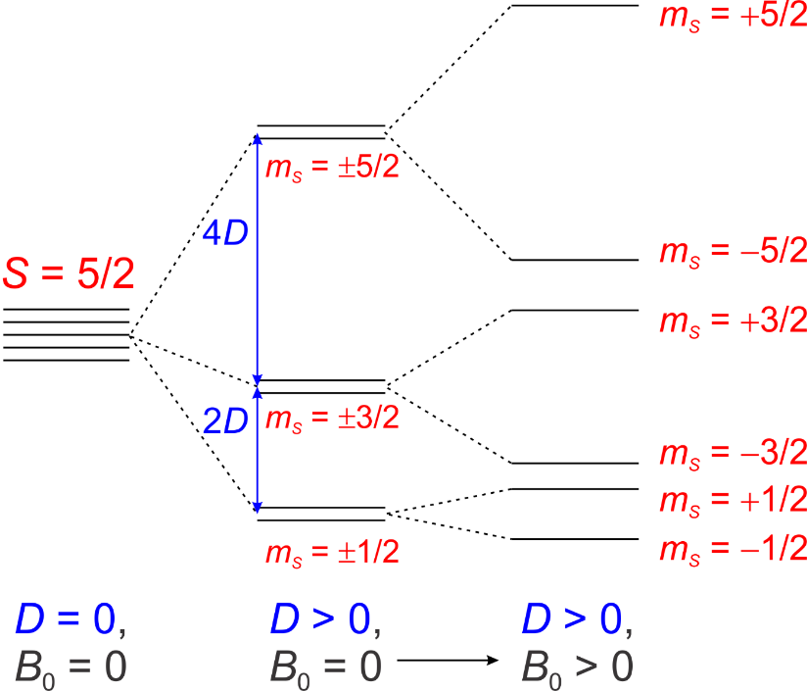

Figure 5.5. The effect of spin Hamiltonian (Eq. 5.4) on an S = 5/2 wavefunction. In high symmetry (higher than two-fold), as provided by the porphyrin ligand, E = 0. An applied external magnetic field B₀ leads to additional splittings of the M_{S} levels due to the Zeeman effect.

Chapter 6

Conclusion Remarks

- Concluding Remarks on the Work in the Current Dissertation
Part of the studies presented in this dissertation showcased the power and versatility of optical and neutron spectroscopies in the direct determination of the magnetic anisotropy in SIM-MOF systems such as the Co-TODA and Co-BEBN that exhibit second-order SOC and in molecular magnets, Fe(TPP)X. In addition, the phonon properties were characterized using INS and phonon calculations to comprehensively understand the spin and phonon effects in the systems. As in the case of Co-BEBN, the spin-phonon coupling effect was observed and the coupling constant was determined through a data-fitting model. Qubit properties were probed for Co-TODA and Co-BEBN using the pulsed EPR to determine the effectiveness of the qubit candidates.
The other part of the studies in this dissertation involves the comprehensive understanding of the topological properties of the symmetry-protected Haldane 1-D spin-1 chain. The studies involved the use of magnetic susceptibility, INS, and HFESR to probe the spin gap as well as the anisotropy of NiBO. PND experiments reveal the nature of the magnetic interaction in NiBO as well as support the antiferromagnetic interaction in a Haldane system.
In addition, QMC simulations were conducted to support the experimental findings as well as to determine magnetic parameters such as the magnetic coupling constant and g-factors.
In Chapter 2, results from the spectroscopies, combined with single-crystal X-ray diffraction at 15(2) K and ab initio calculations, offer a rare opportunity to understand the structure and properties of Co-TODA in detail. FIRMS has revealed the inter-KD magnetic transition, and, together with HFEPR, led to a direct determination of the SH parameters (D, E, and g). In other words, the combined use of FIRMS and HFEPR is critical here for the deconvolution of the D' into the D and E values. Due to the large value of the E parameter, Co-TODA exhibits significant mixing of states, as demonstrated in the simulations of the FIRMS and HFEPR spectra. The electronic structure calculations in the current work have pointed out the origin of the magnetic anisotropy and the magnetostructural correlations, giving calculated SH parameters. The calculated SH parameters as well as the calculated DC susceptibility data are in support of the experimental findings, showcasing the utilities of the ab initio calculations. INS studies have given calculated INS spectra, phonon properties, and spin densities in the CP. The current work has also showcased that pulsed EPR is a unique tool in obtaining the magnetic relaxation times T₁ and T₂ for the intra-KD transition φ₁ → φ₂. The T₂ time for the Co-TODA was found to be fairly long, with no magnetic dilution, compared to T₂ times of other transition metal MOFs. The evidence suggested Co-TODA to be a potential qubit candidate. The calculated spin densities on the Co^{II} ions in Co-TODA and other high-spin Co^{II} complexes reported earlier reveal that the larger the spin density on a Co^{II} ion, the larger the ZFS in the complex.
In Chapter 3, comprehensive studies of the magnetic and phonon properties of Co-BEBN are reported here, showcasing an isolating Co²⁺ ion MOF with unusually large magnetic anisotropy. The long distance (~20.9 Å) between Co²⁺ ions is achieved through the use of bpeb ligands to form the MOF. Versatility and power of combined optical spectroscopies (FIRMS and HFEPR) to make a direct determination of the SH parameters are showcased in the current work, which is crucial in deconvoluting D′ into D and E values. With a large E value, Co-BEBN exhibits a significant mixing of the spin states, allowing formally forbidden magnetic transitions to occur. The ab initio electronic structure calculations provide an insight into the origin of the anisotropy and the magneto-structural correlations to the spin-Hamiltonian (SH) parameters. INS and DFT calculations were crucial in understanding the phonon properties of Co-BEBN. In addition, pulse X-band EPR has provided a direct probe of the qubit properties through the determination of T₁ and T₂ and Rabi oscillations of Co-BEBN. The differences between the Zn²⁺-diluted Co-BEBN_{0.05} and non-diluted Co-BEBN suggest that the more isolated metal ions in the MOF contribute to a more effective qubit.
In Chapter 4, many previous studies have focused on studying 1D Haldane chains in 3D structures, but rarely a 2D material. Here, we have provided a thorough characterization of the magnetism in the 2D-MOF compound NiBO, which consists of stacked 2D planes of parallel spin-1 chains, formed by Ni(II) ions. From our combined analyses, using a wide range of experimental probes, including variable-temperature powder neutron diffraction (VT-PND), DC magnetic susceptibility, specific-heat and HFESR measurements, we identify NiBO as a clean realization of the Haldane spin-1 chain with weak interchain coupling, due to the stacked planar crystal structure and a twisting in the bipyridine ligands that stabilize the planar arrangement. This sets aside NiBO from various previously explored Haldane spin-1 chain compounds, which are mostly imbedded in a 3D crystal structure. VT-PND confirms that NiBO does not exhibit long-range antiferromagnetic order, supporting that NiBO is a Haldane spin-1 chain material with short-range spin correlations and a disordered ground state. Furthermore, specific-heat and DC magnetic susceptibility experiments indicate a phase transition induced by the magnetic fields beyond the gap-closing field of 9 T and at temperature below 5 K. We have conducted the first in-depth analysis of a 2D-MOF with decoupled spin-1 chain exhibiting Haldane physics, comparing remarkably well to a microscopic spin-1 chain model using unbiased QMC simulations. Parameters from QMC simulation of the microscopic spin model for NiBO are J = 29.44 cm⁻¹, D = 4.99 cm⁻¹, D_{eff} = $-$9.88 cm⁻¹, |E| = 1.01 cm⁻¹, E_{eff} = 2.07 cm⁻¹, $∆_{x}$ = 7.16 cm⁻¹, $∆_{y}$ = 11.3 cm⁻¹, and $∆_{z}$ = 19.1 cm⁻¹. INS measurements provide the energy gaps between the singlet ground state and two levels of the excited triplet state in Fig. 10 to be 10.0(1) cm⁻¹ and 19.1(1) cm⁻¹, respectively. In addition, INS studies give D_{eff}(INS) = $-$9.9(1) cm⁻¹; D(INS) = 5.0(1) cm⁻¹. HFESR probe the effective anisotropy of NiBO with a lower bound for D_{eff}(HFESR) = 7.8(2) cm⁻¹. MOFs are unique among Haldane spin-1 chain materials by providing the possibility for exfoliation into 2D nanosheets with unique magnetic properties. Our works open interesting new directions for future research on low-dimensional quantum magnetism in metal-organic frameworks.
In Chapter 5, the HFEPR and FIRMS studies of the important series of axially halide-coordinated square pyramidal iron(III) porphyrins, Fe(TPP)X (X = F, Cl, Br, I) have probed intra- and inter-Kramers doublet magnetic transitions in these S = 5/2 complexes, yielding the spin Hamiltonian parameters: ZFS (D and E) and g values. These parameters have been compared with those from earlier spectroscopic and magnetization studies and show the high level of accuracy and precision available from the combination of field-domain (i.e., HFEPR) and frequency-domain (i.e, FIRMS) magnetic resonance techniques. Other spectroscopic techniques, such as applied field Mössbauer and VTVH-MCD can yield reliable spin Hamiltonian parameters and other useful information as well, such as ⁵⁷Fe hyperfine coupling constants via the former²⁶⁴ and electronic transition information via the latter technique.²⁷³ In contrast, magnetic susceptibility, while easy and readily available, is less reliable for yielding high accuracy information on spin Hamiltonian parameters. The D values (in cm⁻¹) in the Fe(TPP)X series increase smoothly as follows: +4.67(1) (X = F), +6.458(2) (X = Cl), +9.05 (X = Br), +13.95 (X = I). A qualitative model based on LFT explained this trend by attributing it to the combination of increasing spin delocalization from Fe onto the X ligand coupled with the large increase in atomic SOC constant as the halogen atomic number increases over the range from F to I.

References

1. Frost, J. M.; Harriman, K. L. M.; Murugesu, M., The rise of 3-d single-ion magnets in molecular magnetism: towards materials from molecules? Chem. Sci. 2016, 7, 2470-2491. https://doi.org/10.1039/C5SC03224E
2. Feng, M.; Tong, M.-L., Single Ion Magnets from 3d to 5f: Developments and Strategies. Chem. Eur. J. 2018, 24, 7574-7594. https://doi.org/10.1002/chem.201705761
3. Lis, T., Preparation, structure, and magnetic properties of a dodecanuclear mixed-valence manganese carboxylate. Acta Cryst. 1980, B36, 2042-2046. https://doi.org/10.1107/S0567740880007893
4. Sessoli, R.; Tsai, H. L.; Schake, A. R.; Wang, S.; Vincent, J. B.; Folting, K.; Gatteschi, D.; Christou, G.; Hendrickson, D. N., High-spin molecules: [Mn₁₂O₁₂(O₂CR)₁₆(H₂O)₄]. J. Am. Chem. Soc. 1993, 115, 1804-1816. https://doi.org/10.1021/ja00058a027
5. Sessoli, R.; Gatteschi, D.; Caneschi, A.; Novak, M. A., Magnetic bistability in a metal-ion cluster. Nature 1993, 365, 141-143. https://doi.org/10.1038/365141a0
6. Boca, R., Zero-field splitting in metal complexes. Coord. Chem. Rev. 2004, 248, 757-815. https://doi.org/10.1016/j.ccr.2004.03.001
7. Krzystek, J.; Telser, J., Measuring giant anisotropy in paramagnetic transition metal complexes with relevance to single-ion magnetism. Dalton Trans. 2016, 45, 16751-16763. http://doi.org/10.1039/C6DT01754A
8. Chakarawet, K.; Atanasov, M.; Ellis, J. E.; Lukens, W. W., Jr.; Young, V. G., Jr.; Chatterjee, R.; Neese, F.; Long, J. R., Effect of Spin–Orbit Coupling on Phonon-Mediated Magnetic Relaxation in a Series of Zero-Valent Vanadium, Niobium, and Tantalum Isocyanide Complexes. Inorg. Chem. 2021, 60, 18553-18560. https://doi.org/10.1021/acs.inorgchem.1c03173
9. Graham, M. J.; Zadrozny, J. M.; Fataftah, M. S.; Freedman, D. E., Forging Solid-State Qubit Design Principles in a Molecular Furnace. Chem. Mater. 2017, 29, 1885-1897. http://doi.org/10.1021/acs.chemmater.6b05433
10. Gaita-Arino, A.; Prima-Garcia, H.; Cardona-Serra, S.; Escalera-Moreno, L.; Rosaleny, L. E.; Baldovi, J. J., Coherence and organisation in lanthanoid complexes: from single ion magnets to spin qubits. Inorg. Chem. Front. 2016, 3, 568-577. http://doi.org/10.1039/C5QI00296F
11. Ding, Y.-S.; Deng, Y.-F.; Zheng, Y.-Z., The rise of single-ion magnets as spin qubits. Magnetochemistry 2016, 2, 40. http://doi.org/10.3390/magnetochemistry2040040
12. Zadrozny, J. M.; Niklas, J.; Poluektov, O. G.; Freedman, D. E., Millisecond Coherence Time in a Tunable Molecular Electronic Spin Qubit. ACS Cent. Sci. 2015, 1, 488-492. http://doi.org/10.1021/acscentsci.5b00338
13. Yu, C.-J.; Graham, M. J.; Zadrozny, J. M.; Niklas, J.; Krzyaniak, M. D.; Wasielewski, M. R.; Poluektov, O. G.; Freedman, D. E., Long Coherence Times in Nuclear Spin-Free Vanadyl Qubits. J. Am. Chem. Soc. 2016, 138, 14678-14685. https://doi.org/10.1021/jacs.6b08467
14. Zadrozny, J. M.; Gallagher, A. T.; Harris, T. D.; Freedman, D. E., A Porous Array of Clock Qubits. J. Am. Chem. Soc. 2017, 139, 7089-7094. https://doi.org/10.1021/jacs.7b03123
15. Shiddiq, M.; Komijani, D.; Duan, Y.; Gaita-Ariño, A.; Coronado, E.; Hill, S., Enhancing coherence in molecular spin qubits via atomic clock transitions. Nature 2016, 531 (7594), 348-351. https://doi.org/10.1038/nature16984
16. Ghosh, S.; Datta, S.; Friend, L.; Cardona-Serra, S.; Gaita-Ariño, A.; Coronado, E.; Hill, S., Multi-frequency EPR studies of a mononuclear holmium single-molecule magnet based on the polyoxometalate [HoIII(W5O18)2]9−. Dalton Trans. 2012, 41, 13697-13704. https://doi.org/10.1039/C2DT31674A
17. Haldane, F. D. M., Nonlinear Field Theory of Large-Spin Heisenberg Antiferromagnets: Semiclassically Quantized Solitons of the One-Dimensional Easy-Axis Néel State. Phys. Rev. Lett. 1983, 50, 1153-1156. https://link.aps.org/doi/10.1103/PhysRevLett.50.1153
18. Haldane, F. D. M., Continuum dynamics of the 1-D Heisenberg antiferromagnet: Identification with the O(3) nonlinear sigma model. Phys. Lett. A 1983, 93, 464-468. https://doi.org/10.1016/0375-9601(83)90631-X
19. Yamashita, M.; Ishii, T.; Matsuzaka, H., Haldane gap systems. Coord. Chem. Rev. 2000, 198, 347-366. https://doi.org/10.1016/S0010-8545(99)00212-X
20. Pollmann, F.; Turner, A. M.; Berg, E.; Oshikawa, M., Entanglement spectrum of a topological phase in one dimension. Phys. Rev. B 2010, 81, 064439. https://link.aps.org/doi/10.1103/PhysRevB.81.064439
21. Pollmann, F.; Berg, E.; Turner, A. M.; Oshikawa, M., Symmetry protection of topological phases in one-dimensional quantum spin systems. Phys. Rev. B 2012, 85, 075125. https://link.aps.org/doi/10.1103/PhysRevB.85.075125
22. Gu, Z.-C.; Wen, X.-G., Tensor-entanglement-filtering renormalization approach and symmetry-protected topological order. Phys. Rev. B 2009, 80, 155131. https://link.aps.org/doi/10.1103/PhysRevB.80.155131
23. Hatsugai, Y.; Kohmoto, M., Numerical study of the hidden antiferromagnetic order in the Haldane phase. Phys. Rev. B 1991, 44, 11789-11794. https://link.aps.org/doi/10.1103/PhysRevB.44.11789
24. Berg, E.; Dalla Torre, E. G.; Giamarchi, T.; Altman, E., Rise and fall of hidden string order of lattice bosons. Phys. Rev. B 2008, 77, 245119. https://link.aps.org/doi/10.1103/PhysRevB.77.245119
25. Affleck, I.; Kennedy, T.; Lieb, E. H.; Tasaki, H., Rigorous results on valence-bond ground states in antiferromagnets. Phys. Rev. Lett. 1987, 59, 799-802. https://link.aps.org/doi/10.1103/PhysRevLett.59.799
26. Affleck, I.; Kennedy, T.; Lieb, E. H.; Tasaki, H., Valence bond ground states in isotropic quantum antiferromagnets. Communications in Mathematical Physics 1988, 115, 477-528. https://doi.org/10.1007/BF01218021
27. Kennedy, T., Exact diagonalisations of open spin-1 chains. J. Phys. Condens. Matter 1990, 2, 5737. https://dx.doi.org/10.1088/0953-8984/2/26/010
28. Affleck, I., Quantum spin chains and the Haldane gap. J. Phys. Condens. Matter 1989, 1, 3047. https://dx.doi.org/10.1088/0953-8984/1/19/001
29. Affleck, I., THE HALDANE GAP IN ANTIFERROMAGNETIC HEISENBERG CHAINS. Rev. Math. Phys. 1994, 06, 887-899. https://doi.org/10.1142/S0129055X94000286
30. Shull, C. G.; Strauser, W. A.; Wollan, E. O., Neutron Diffraction by Paramagnetic and Antiferromagnetic Substances. Phys. Rev. 1951, 83, 333-345. https://link.aps.org/doi/10.1103/PhysRev.83.333
31. Lu, W.; Tuchendler, J.; von Ortenberg, M.; Renard, J. P., Direct observation of the Haldane gap in NENP by far-infrared spectroscopy in high magnetic fields. Phys. Rev. Lett. 1991, 67, 3716-3719. https://link.aps.org/doi/10.1103/PhysRevLett.67.3716
32. Kobayashi, T.; Tabuchi, Y.; Amaya, K.; Ajiro, Y.; Yosida, T.; Date, M., Heat Capacities of Haldane-Gap Antiferromagnet NENP in Magnetic Field. J. Phys. Soc. Japan 1992, 61, 1772-1776. https://doi.org/10.1143/JPSJ.61.1772
33. Sologubenko, A. V.; Lorenz, T.; Mydosh, J. A.; Rosch, A.; Shortsleeves, K. C.; Turnbull, M. M., Field-Dependent Thermal Transport in the Haldane Chain Compound NENP. Phys. Rev. Lett. 2008, 100, 137202. https://link.aps.org/doi/10.1103/PhysRevLett.100.137202
34. Regnault, L. P.; Vettier, C.; Rossat-Mignod, J.; Renard, J. P., Field dependences of Haldane gaps in the S= 1 one-dimensional antiferromagnet NENP. Phys. B: Condens. Matter 1992, 180-181, 188-190. https://doi.org/10.1016/0921-4526(92)90702-T
35. Regnault, L. P.; Renard, J. P., Spin dynamics under high magnetic field in the Haldane-gap system NENP. Phys. B: Condens. Matter 1997, 234-236, 541-543. https://doi.org/10.1016/S0921-4526(96)01168-4
36. Sieling, M.; Löw, U.; Wolf, B.; Schmidt, S.; Zvyagin, S.; Lüthi, B., High magnetic-field ESR in the Haldane spin chains NENP and NINO. Phys. Rev. B 2000, 61, 88-91. https://link.aps.org/doi/10.1103/PhysRevB.61.88
37. Hagiwara, M.; Katsumata, K., ESR studies on the Haldane material Ni(C₃H₁₀N₂)NO₂ClO₄: Polarization analysis and frequency-field diagram. Phys. Rev. B 1996, 53, 14319-14322. https://link.aps.org/doi/10.1103/PhysRevB.53.14319
38. Čižmár, E.; Ozerov, M.; Ignatchik, O.; Papageorgiou, T. P.; Wosnitza, J.; Zvyagin, S. A.; Krzystek, J.; Zhou, Z.; Landee, C. P.; Landry, B. R.; Turnbull, M. M.; Wikaira, J. L., Magnetic properties of the Haldane-gap material [Ni(C₂H₈N₂)₂NO₂](BF₄). New Journal of Physics 2008, 10, 033008. https://dx.doi.org/10.1088/1367-2630/10/3/033008
39. Long, V. C.; Chou, Y. H.; Cross, I. A.; Kozen, A. C.; Montague, J. R.; Schundler, E. C.; Wei, X.; McGill, S. A.; Landry, B. R.; Maxcy-Pearson, K. R.; Turnbull, M. M.; Landee, C. P., Magnetic-field-induced modifications of the electronic structure of Ni(en)₂NO₂BF₄: A signature of the Haldane gap in the electronic-excitation intensities. Phys. Rev. B 2007, 76, 024439. https://link.aps.org/doi/10.1103/PhysRevB.76.024439
40. Orendáč, M.; Tarasenko, R.; Tkáč, V.; Orendáčová, A.; Sechovský, V., Specific heat study of the magnetocaloric effect in the Haldane-gap S = 1 spin-chain material [Ni(C₂H₈N₂)₂NO₂](BF₄). Phys. Rev. B 2017, 96, 094425. https://link.aps.org/doi/10.1103/PhysRevB.96.094425
41. Takeuchi, T.; Yosida, T.; Inoue, K.; Yamashita, M.; Kumada, T.; Kindo, K.; Merah, S.; Verdaguer, M.; Renard, J. P., Magnetic properties of new Haldane gap materials. J. Mag. Mag. Mat. 1995, 140-144, 1633-1634. https://doi.org/10.1016/0304-8853(94)01094-3
42. Escuer, A.; Vicente, R.; Ribas, J.; El Fallah, M. S.; Solans, X.; Font-Bardia, M., Two new m-azido nickel(II) uniform chains: Syntheses, structures, and magneto-structural correlations. Inorg. Chem. 1993, 32, 3727-3732. https://doi.org/10.1021/ic00069a030
43. Černák, J.; Farkašová, N.; Tomás, M.; Kavečanský, V.; Čižmár, E.; Orendáč, M., [Ni(bpy)(ox)]: a candidate in the class of Haldane gap systems (bpy = 2,2ʹ-bipyridine, ox = oxalate). J. Coord. Chem. 2015, 68, 2788-2797. https://doi.org/10.1080/00958972.2015.1058485
44. Keene, T. D.; Zimmermann, I.; Neels, A.; Sereda, O.; Hauser, J.; Bonin, M.; Hursthouse, M. B.; Price, D. J.; Decurtins, S., Heterocyclic amine directed synthesis of metal(II)-oxalates: investigating the magnetic properties of two complete series of chains with S = 5/2 to S = 1/2. Dalton Trans. 2010, 39, 4937-4950. http://dx.doi.org/10.1039/B927522C
45. Williams, R. C.; Blackmore, W. J. A.; Curley, S. P. M.; Lees, M. R.; Birnbaum, S. M.; Singleton, J.; Huddart, B. M.; Hicken, T. J.; Lancaster, T.; Blundell, S. J.; Xiao, F.; Ozarowski, A.; Pratt, F. L.; Voneshen, D. J.; Guguchia, Z.; Baines, C.; Schlueter, J. A.; Villa, D. Y.; Manson, J. L.; Goddard, P. A., Near-ideal molecule-based Haldane spin chain. Phys. rev. res. 2020, 2, 013082. https://link.aps.org/doi/10.1103/PhysRevResearch.2.013082
46. Yaghi, O. M.; Li, G.; Li, H., Selective binding and removal of guests in a microporous metal–organic framework. Nature 1995, 378 (6558), 703-706. https://doi.org/10.1038/378703a0
47. Ma, S.; Perman, J. A., Elaboration and applications of metal-organic frameworks. World Scientific: New Jersey: 2018.
48. Castells-Gil, J.; Baldoví, J. J.; Martí-Gastaldo, C.; Mínguez Espallargas, G., Implementation of slow magnetic relaxation in a SIM-MOF through a structural rearrangement. Dalton Trans. 2018, 47, 14734-14740. https://doi.org/10.1039/C8DT03421D
49. Baldoví, J. J.; Coronado, E.; Gaita-Ariño, A.; Gamer, C.; Giménez-Marqués, M.; Mínguez Espallargas, G., A SIM-MOF: Three-Dimensional Organisation of Single-Ion Magnets with Anion-Exchange Capabilities. Chem. Eur. J. 2014, 20, 10695-10702. https://doi.org/10.1002/chem.201402255
50. Aulakh, D.; Pyser, J. B.; Zhang, X.; Yakovenko, A. A.; Dunbar, K. R.; Wriedt, M., Metal–Organic Frameworks as Platforms for the Controlled Nanostructuring of Single-Molecule Magnets. J. Am. Chem. Soc. 2015, 137, 9254-9257. https://doi.org/10.1021/jacs.5b06002
51. Shi, L.; Shao, D.; Wei, H.-Y.; Wang, X.-Y., Two Interpenetrated Cobalt(II) Metal–Organic Frameworks with Guest-Dependent Structures and Field-Induced Single-Ion Magnet Behaviors. Cryst. Growth Des. 2018, 18, 5270-5278. https://doi.org/10.1021/acs.cgd.8b00714
52. Liu, C.-M.; Zhang, D.-Q.; Hao, X.; Zhu, D.-B., A Chinese Pane-Like 2D Metal-Organic Framework Showing Magnetic Relaxation and Luminescence Dual-Functions. Sci. Rep. 2017, 7, 11156. https://doi.org/10.1038/s41598-017-11006-5
53. García-Couceiro, U.; Castillo, O.; Luque, A.; García-Terán, J. P.; Beobide, G.; Román, P., Rational Design of 2D Magnetic Metal−Organic Coordination Polymers Assembled from Oxalato and Dipyridyl Spacers. Cryst. Growth Des. 2006, 6, 1839-1847. https://doi.org/10.1021/cg0601608
54. Keene, T. D.; Hursthouse, M. B.; Price, D. J., Two-Dimensional Metal−Organic Frameworks: A System with Competing Chelating Ligands. Cryst. Growth Des. 2009, 9, 2604-2609. https://doi.org/10.1021/cg800769z
55. Keene, Tony D.; Ogilvie, Helen R.; Hursthouse, Michael B.; Price, Daniel J., One-Dimensional Magnetism in New, Layered Structures: Piperazine-Linked Copper and Nickel Oxalate Chains. Eur. J. Inorg. Chem. 2004, 1007-1013. https://doi.org/10.1002/ejic.200300592
56. Zhao, M.; Huang, Y.; Peng, Y.; Huang, Z.; Ma, Q.; Zhang, H., Two-dimensional metal–organic framework nanosheets: synthesis and applications. Chem. Soc. Rev. 2018, 47, 6267-6295. http://dx.doi.org/10.1039/C8CS00268A
57. Heinrich, B. W.; Braun, L.; Pascual, J. I.; Franke, K. J., Protection of excited spin states by a superconducting energy gap. Nat. Phys. 2013, 9, 765-768. https://doi.org/10.1038/nphys2794
58. Heinrich, B. W.; Braun, L.; Pascual, J. I.; Franke, K. J., Tuning the Magnetic Anisotropy of Single Molecules. Nano Lett. 2015, 15, 4024-4028. https://doi.org/10.1021/acs.nanolett.5b00987
59. Moseley, D. H.; Stavretis, S. E.; Thirunavukkuarasu, K.; Ozerov, M.; Cheng, Y.; Daemen, L. L.; Ludwig, J.; Lu, Z.; Smirnov, D.; Brown, C. M.; Pandey, A.; Ramirez-Cuesta, A. J.; Lamb, A. C.; Atanasov, M.; Bill, E.; Neese, F.; Xue, Z.-L., Spin-phonon couplings in transition metal complexes with slow magnetic relaxation. Nat. Commun. 2018, 9, 2572. http://doi.org/10.1038/s41467-018-04896-0
60. Krzystek, J.; Zvyagin, S. A.; Ozarowski, A.; Fiedler, A. T.; Brunold, T. C.; Telser, J., Definitive Spectroscopic Determination of Zero-Field Splitting in High-Spin Cobalt(II). J. Am. Chem. Soc. 2004, 126, 2148-2155. https://doi.org/10.1021/ja039257y
61. Pilbrow, J. R., Effective g values for S = 3/2 and S = 5/2. J. Magn. Reson. 1978, 31, 479-490. https://doi.org/10.1016/S0022-2364(78)80015-8
62. Gast, P.; Groenen, E. J. J., EPR Interactions – g-Anisotropy. In eMagRes, 2016; Vol. 5, pp 1435-1444.
63. McGavin, D. G., Symmetry constraints on EPR spin-Hamiltonian parameters. J. Magn. Reson. 1987, 74, 19-55. https://doi.org/10.1016/0022-2364(87)90077-1
64. Webber, R. T., Pulsed EPR Primer. Bruker Instruments, Inc. 2000.
65. Brackett, G. C.; Richards, P. L.; Caughey, W. S., Far‐Infrared Magnetic Resonance in Fe(III) and Mn(III) Porphyrins, Myoglobin, Hemoglobin, Ferrichrome A, and Fe(III) Dithiocarbamates. J. Chem. Phys. 1971, 54, 4383-4401. https://doi.org/10.1063/1.1674688
66. Brackett, G. C. Far-Infrared Magnetic Resonance in Fe(III) and Mn(III) Porphyrins, Myoglobin, Hemoglobin, Ferrichrome A, and Fe(III) Dithiocarbamates, Ph.D. dissertation. University of California, Berkeley, 1970.
67. Bhat, S. V., An EPR primer. Reson. 2015, 20, 1012-1016. https://doi.org/10.1007/s12045-015-0269-1
68. Stavretis, S. E.; Atanasov, M.; Podlesnyak, A. A.; Hunter, S. C.; Neese, F.; Xue, Z.-L., Magnetic Transitions in Iron Porphyrin Halides by Inelastic Neutron Scattering and Ab Initio Studies of Zero-Field Splittings. Inorg. Chem. 2015, 54, 9790-9801. https://doi.org/10.1021/acs.inorgchem.5b01505
69. Xue, Z.-L.; Ramirez-Cuesta, A. J.; Brown, C. M.; Calder, S.; Cao, H.; Chakoumakos, B. C.; Daemen, L. L.; Huq, A.; Kolesnikov, A. I.; Mamontov, E.; Podlesnyak, A. A.; Wang, X., Neutron Instruments for Research in Coordination Chemistry. Eur. J. Inorg. Chem. 2019, 2019, 1065-1089. https://doi.org/10.1002/ejic.201801076
70. Shao, D.; Zhou, Y.; Pi, Q.; Shen, F.-X.; Yang, S.-R.; Zhang, S.-L.; Wang, X.-Y., Two-dimensional frameworks formed by pentagonal bipyramidal cobalt(II) ions and hexacyanometallates: antiferromagnetic ordering, metamagnetism and slow magnetic relaxation. Dalton Trans. 2017, 46, 9088-9096. https://doi.org/10.1039/C7DT01893B
71. Muñoz, M. C.; Real, J. A., Thermo-, piezo-, photo- and chemo-switchable spin crossover iron(II)-metallocyanate based coordination polymers. Coord. Chem. Rev. 2011, 255, 2068-2093. https://doi.org/10.1016/j.ccr.2011.02.004
72. Train, C.; Gruselle, M.; Verdaguer, M., The fruitful introduction of chirality and control of absolute configurations in molecular magnets. Chem. Soc. Rev. 2011, 40, 3297-3312. https://doi.org/10.1039/C1CS15012J
73. Pinkowicz, D.; Southerland, H. I.; Avendaño, C.; Prosvirin, A.; Sanders, C.; Wernsdorfer, W.; Pedersen, K. S.; Dreiser, J.; Clérac, R.; Nehrkorn, J.; Simeoni, G. G.; Schnegg, A.; Holldack, K.; Dunbar, K. R., Cyanide Single-Molecule Magnets Exhibiting Solvent Dependent Reversible “On” and “Off” Exchange Bias Behavior. J. Am. Chem. Soc. 2015, 137, 14406-14422. https://doi.org/10.1021/jacs.5b09378
74. Pinkowicz, D.; Southerland, H.; Wang, X.-Y.; Dunbar, K. R., Record Antiferromagnetic Coupling for a 3d/4d Cyanide-Bridged Compound. J. Am. Chem. Soc. 2014, 136, 9922-9924. https://doi.org/10.1021/ja5044352
75. Wei, R.-M.; Cao, F.; Li, J.; Yang, L.; Han, Y.; Zhang, X.-L.; Zhang, Z.; Wang, X.-Y.; Song, Y., Single-Chain Magnets Based on Octacyanotungstate with the Highest Energy Barriers for Cyanide Compounds. Sci. Rep. 2016, 6, 24372. https://doi.org/10.1038/srep24372
76. Vallejo, J.; Fortea-Pérez, F. R.; Pardo, E.; Benmansour, S.; Castro, I.; Krzystek, J.; Armentano, D.; Cano, J., Guest-dependent single-ion magnet behaviour in a cobalt(ii) metal–organic framework. Chem. Sci. 2016, 7, 2286-2293. https://doi.org/10.1039/C5SC04461H
77. Kumar Sahu, P.; Kharel, R.; Shome, S.; Goswami, S.; Konar, S., Understanding the unceasing evolution of Co(II) based single-ion magnets. Coord. Chem. Rev. 2023, 475, 214871. https://doi.org/10.1016/j.ccr.2022.214871
78. Yao, X.-N.; Du, J.-Z.; Zhang, Y.-Q.; Leng, X.-B.; Yang, M.-W.; Jiang, S.-D.; Wang, Z.-X.; Ouyang, Z.-W.; Deng, L.; Wang, B.-W.; Gao, S., Two-Coordinate Co(II) Imido Complexes as Outstanding Single-Molecule Magnets. J. Am. Chem. Soc. 2017, 139, 373-380.
79. Bunting, P. C.; Atanasov, M.; Damgaard-Moller, E.; Perfetti, M.; Crassee, I.; Orlita, M.; Overgaard, J.; van Slageren, J.; Neese, F.; Long, J. R., A linear cobalt(II) complex with maximal orbital angular momentum from a non-Aufbau ground state. Science 2018, 362, eaat7319. http://doi.org/10.1126/science.aat7319
80. Errulat, D.; Harriman, K. L. M.; Gálico, D. A.; Ovens, J. S.; Mansikkamäki, A.; Murugesu, M., Aufbau vs. non-Aufbau ground states in two-coordinate d7 single-molecule magnets. Inorg. Chem. Front. 2021, 8 (23), 5076-5085. 10.1039/D1QI00912E
81. Fataftah, M. S.; Zadrozny, J. M.; Rogers, D. M.; Freedman, D. E., A Mononuclear Transition Metal Single-Molecule Magnet in a Nuclear Spin-Free Ligand Environment. Inorg. Chem. 2014, 53, 10716-10721. 10.1021/ic501906z
82. Rajnák, C.; Titiš, J.; Fuhr, O.; Ruben, M.; Boča, R., Single-Molecule Magnetism in a Pentacoordinate Cobalt(II) Complex Supported by an Antenna Ligand. Inorg. Chem. 2014, 53, 8200-8202. 10.1021/ic501524a
83. Cui, H.-H.; Lu, F.; Chen, X.-T.; Zhang, Y.-Q.; Tong, W.; Xue, Z.-L., Zero-Field Slow Magnetic Relaxation and Hysteresis Loop in Four-Coordinate CoII Single-Ion Magnets with Strong Easy-Axis Anisotropy. Inorg. Chem. 2019, 58, 12555-12564. 10.1021/acs.inorgchem.9b01175
84. Wang, M.; Xu, H. J.; Sun, T. M.; Cui, H. H.; Zhang, Y.-Q.; Chen, L.; Tang, Y. F., Optimal N–Co–N bite angle for enhancing the magnetic anisotropy of zero-field Co(II) single-ion magnets in tetrahedral [N₄] coordination environment. J. Solid State Chem. 2021, 299, 122209. https://doi.org/10.1016/j.jssc.2021.122209
85. Landart-Gereka, A.; Quesada-Moreno, M. M.; Díaz-Ortega, I. F.; Nojiri, H.; Ozerov, M.; Krzystek, J.; Palacios, M. A.; Colacio, E., Large easy-axis magnetic anisotropy in a series of trigonal prismatic mononuclear cobalt(ii) complexes with zero-field hidden single-molecule magnet behaviour: the important role of the distortion of the coordination sphere and intermolecular interactions in the slow relaxation. Inorg. Chem. Front. 2022, 9, 2810-2831. 10.1039/D2QI00275B
86. Wakizaka, M.; Sato, T.; Yoshino, Y.; Takaishi, S.; Yamashita, M., Intramolecular Ferromagnetism in Di-Nuclear 3d-Transition-Metal Single-Molecule Magnets by Pseudo-Serial Arrangement. Chem. Eur. J. 2023, 29, e202203421. https://doi.org/10.1002/chem.202203421
87. Varga, F.; Rajnák, C.; Titiš, J.; Moncoľ, J.; Boča, R., Slow magnetic relaxation in a Co(ii) octahedral–tetrahedral system formed of a [CoL3]2+ core with L = bis(diphenylphosphanoxido) methane and tetrahedral [CoBr4]2− counter anions. Dalton Trans. 2017, 46, 4148-4151. 10.1039/C7DT00376E
88. Stoll, S.; Schweiger, A., EasySpin, a comprehensive software package for spectral simulation and analysis in EPR. J. Magn. Reson. 2006, 178, 42-55. http://doi.org/10.1016/j.jmr.2005.08.013
89. Ryder, M. R.; Van de Voorde, B.; Civalleri, B.; Bennett, T. D.; Mukhopadhyay, S.; Cinque, G.; Fernandez-Alonso, F.; De Vos, D.; Rudić, S.; Tan, J.-C., Detecting Molecular Rotational Dynamics Complementing the Low-Frequency Terahertz Vibrations in a Zirconium-Based Metal-Organic Framework. Phys. Rev. Lett. 2017, 118, 255502. http://doi.org/10.1103/PhysRevLett.118.255502
90. Escalera-Moreno, L.; Baldoví, J. J.; Gaita-Ariño, A.; Coronado, E., Spin states, vibrations and spin relaxation in molecular nanomagnets and spin qubits: A critical perspective. Chem. Sci. 2018, 9, 3265-3275. http://doi.org/10.1039/C7SC05464E
91. Lunghi, A.; Totti, F.; Sanvito, S.; Sessoli, R., Intra-molecular origin of the spin-phonon coupling in slow-relaxing molecular magnets. Chem. Sci. 2017, 8, 6051-6059. http://doi.org/10.1039/C7SC02832F
92. Lunghi, A.; Sanvito, S., How do phonons relax molecular spins? Sci. Adv. 2019, 5, eaax7163. http://doi.org/10.1126/sciadv.aax7163
93. Mirzoyan, R.; Hadt, R. G., The dynamic ligand field of a molecular qubit: decoherence through spin–phonon coupling. Phys. Chem. Chem. Phys. 2020, 22, 11249-11265. http://doi.org/10.1039/D0CP00852D
94. Aravena, D.; Ruiz, E., Spin dynamics in single-molecule magnets and molecular qubits. Dalton Trans. 2020, 49, 9916-9928. http://doi.org/10.1039/d0dt01414a
95. Gómez-Coca, S.; Urtizberea, A.; Cremades, E.; Alonso, P. J.; Camón, A.; Ruiz, E.; Luis, F., Origin of slow magnetic relaxation in Kramers ions with non-uniaxial anisotropy. Nat. Commun. 2014, 5, 4300. https://doi.org/10.1038/ncomms5300
96. Zadrozny, J. M.; Liu, J.; Piro, N. A.; Chang, C. J.; Hill, S.; Long, J. R., Slow magnetic relaxation in a pseudotetrahedral cobalt(II) complex with easy-plane anisotropy. Chem. Commun. 2012, 48, 3927-3929. http://dx.doi.org/10.1039/C2CC16430B
97. Vallejo, J.; Castro, I.; Ruiz-García, R.; Cano, J.; Julve, M.; Lloret, F.; De Munno, G.; Wernsdorfer, W.; Pardo, E., Field-Induced Slow Magnetic Relaxation in a Six-Coordinate Mononuclear Cobalt(II) Complex with a Positive Anisotropy. J. Am. Chem. Soc. 2012, 134, 15704-15707. https://doi.org/10.1021/ja3075314
98. Colacio, E.; Ruiz, J.; Ruiz, E.; Cremades, E.; Krzystek, J.; Carretta, S.; Cano, J.; Guidi, T.; Wernsdorfer, W.; Brechin, E. K., Slow Magnetic Relaxation in a Co^{II}–Y^{III} Single-Ion Magnet with Positive Axial Zero-Field Splitting. Angew. Chem. Int. Ed. 2013, 52, 9130-9134. https://doi.org/10.1002/anie.201304386
99. Huang, W.; Liu, T.; Wu, D.; Cheng, J.; Ouyang, Z. W.; Duan, C., Field-induced slow relaxation of magnetization in a tetrahedral Co(II) complex with easy plane anisotropy. Dalton Trans. 2013, 42, 15326-15331. https://doi.org/10.1039/C3DT51801A
100. Wu, D.; Zhang, X.; Huang, P.; Huang, W.; Ruan, M.; Ouyang, Z. W., Tuning Transverse Anisotropy in Co^{III}–Co^{II}–Co^{III} Mixed-Valence Complex toward Slow Magnetic Relaxation. Inorg. Chem. 2013, 52, 10976-10982. https://doi.org/10.1021/ic401057f
101. Zadrozny, J. M.; Atanasov, M.; Bryan, A. M.; Lin, C.-Y.; Rekken, B. D.; Power, P. P.; Neese, F.; Long, J. R., Slow magnetization dynamics in a series of two-coordinate iron(II) complexes. Chem. Sci. 2013, 4, 125-138. http://doi.org/10.1039/C2SC20801F
102. Wang, J.; Cui, H.-H.; Zhang, Y.-Q.; Chen, L.; Chen, X.-T., Magnetic anisotropy and slow magnetic relaxation of seven-coordinate cobalt(II)–nitrate complexes. Polyhedron 2018, 154, 148-155. https://doi.org/10.1016/j.poly.2018.07.050
103. Cui, H.-H.; Zhang, Y.-Q.; Chen, X.-T.; Wang, Z.; Xue, Z.-L., Magnetic anisotropy and slow magnetic relaxation processes of cobalt(II)-pseudohalide complexes. Dalton Trans. 2019, 48, 10743-10752. http://doi.org/10.1039/C9DT00644C
104. Cui, H.-H.; Ding, M.-M.; Zhang, X.-D.; Lv, W.; Zhang, Y.-Q.; Chen, X.-T.; Wang, Z.; Ouyang, Z.-W.; Xue, Z.-L., Magnetic anisotropy in square pyramidal cobalt(II) complexes supported by a tetraazo macrocyclic ligand. Dalton Trans. 2020, 49, 14837-14846. http://doi.org/10.1039/D0DT01954B
105. Chen, L.; Chen, S.-Y.; Sun, Y.-C.; Guo, Y.-M.; Yu, L.; Chen, X.-T.; Wang, Z.; Ouyang, Z. W.; Song, Y.; Xue, Z.-L., Slow magnetic relaxation in mononuclear seven-coordinate cobalt(II) complexes with easy plane anisotropy. Dalton Trans. 2015, 44, 11482-11490. http://doi.org/10.1039/C5DT00785B
106. Samuel, P. P.; Mondal, K. C.; Amin Sk, N.; Roesky, H. W.; Carl, E.; Neufeld, R.; Stalke, D.; Demeshko, S.; Meyer, F.; Ungur, L.; Chibotaru, L. F.; Christian, J.; Ramachandran, V.; van Tol, J.; Dalal, N. S., Electronic Structure and Slow Magnetic Relaxation of Low-Coordinate Cyclic Alkyl(amino) Carbene Stabilized Iron(I) Complexes. J. Am. Chem. Soc. 2014, 136, 11964-11971. https://doi.org/10.1021/ja5043116
107. Lv, W.; Cui, H.-H.; Chen, L.; Zhang, Y.-Q.; Chen, X.-t.; Wang, Z.; Ouyang, Z.; Xue, Z.-L., Magnetic anisotropy of two tetrahedral Co(II)-halide complexes with triphenylphosphine ligands. Dalton Trans. 2022, 51, 7530-7538. http://doi.org/10.1039/D2DT00121G
108. Stavretis, S. E.; Cheng, Y.; Daemen, L. L.; Brown, C. M.; Moseley, D. H.; Bill, E.; Atanasov, M.; Ramirez-Cuesta, A. J.; Neese, F.; Xue, Z.-L., Probing Magnetic Excitations in CoII Single-Molecule Magnets by Inelastic Neutron Scattering. Eur. J. Inorg. Chem. 2019, 2019, 1119-1127. http://doi.org/10.1002/ejic.201801088
109. Sherwood, P. M. A., Vibrational Spectroscopy of Solids. Cambridge Univ. Press: 1972; p 254.
110. Stavretis, S. E.; Moseley, D. H.; Fei, F.; Cui, H.-H.; Cheng, Y.; Podlesnyak, A. A.; Wang, X.; Daemen, L. L.; Hoffmann, C. M.; Ozerov, M.; Lu, Z.; Thirunavukkuarasu, K.; Smirnov, D.; Chang, T.; Chen, Y.-S.; Ramirez-Cuesta, A. J.; Chen, X.-T.; Xue, Z.-L., Spectroscopic Studies of the Magnetic Excitation and Spin-Phonon Couplings in a Single-Molecule Magnet. Chem. Eur. J. 2019, 25, 15846-15857. http://doi.org/10.1002/chem.201903635
111. Moseley, D. H.; Stavretis, S. E.; Zhu, Z.; Guo, M.; Brown, C. M.; Ozerov, M.; Cheng, Y.; Daemen, L. L.; Richardson, R.; Knight, G.; Thirunavukkuarasu, K.; Ramirez-Cuesta, A. J.; Tang, J.; Xue, Z.-L., Inter-Kramers Transitions and Spin-Phonon Couplings in a Lanthanide-Based Single-Molecule Magnet. Inorg. Chem. 2020, 59, 5218-5230. http://doi.org/10.1021/acs.inorgchem.0c00523
112. Basler, R.; Boskovic, C.; Chaboussant, G.; Güdel, H. U.; Murrie, M.; Ochsenbein, S. T.; Sieber, A., Molecular Spin Clusters: New Synthetic Approaches and Neutron Scattering Studies. Chem. Phys. Chem. 2003, 4, 910-926. https://doi.org/10.1002/cphc.200300689
113. Hunter, S. C.; Podlesnyak, A. A.; Xue, Z.-L., Magnetic Excitations in Metalloporphyrins by Inelastic Neutron Scattering: Determination of Zero-Field Splittings in Iron, Manganese, and Chromium Complexes. Inorg. Chem. 2014, 53, 1955-1961. http://doi.org/10.1021/ic4028354
114. Chen, L.; Cui, H.-H.; Stavretis, S. E.; Hunter, S. C.; Zhang, Y.-Q.; Chen, X.-T.; Sun, Y.-C.; Wang, Z.; Song, Y.; Podlesnyak, A. A.; Ouyang, Z.-W.; Xue, Z.-L., Slow Magnetic Relaxations in Cobalt(II) Tetranitrate Complexes. Studies of Magnetic Anisotropy by Inelastic Neutron Scattering and High-Frequency and High-Field EPR Spectroscopy. Inorg. Chem. 2016, 55, 12603-12617. http://doi.org/10.1021/acs.inorgchem.6b01544
115. Bone, A. N.; Stavretis, S. E.; Krzystek, J.; Liu, Z.; Chen, Q.; Gai, Z.; Wang, X.; Steren, C. A.; Powers, X. B.; Podlesnyak, A. A.; Chen, X.-T.; Telser, J.; Zhou, H.; Xue, Z.-L., Manganese tetraphenylporphyrin bromide and iodide. Studies of structures and magnetic properties. Polyhedron 2020, 184, 114488. http://doi.org/10.1016/j.poly.2020.114488
116. Aquilante, F.; Autschbach, J.; Carlson, R. K.; Chibotaru, L. F.; Delcey, M. G.; De Vico, L.; Fdez. Galvan, I.; Ferre, N.; Frutos, L. M.; Gagliardi, L.; Garavelli, M.; Giussani, A.; Hoyer, C. E.; Li Manni, G.; Lischka, H.; Ma, D.; Malmqvist, P. Å.; Mueller, T.; Nenov, A.; Olivucci, M.; Pedersen, T. B.; Peng, D.; Plasser, F.; Pritchard, B.; Reiher, M.; Rivalta, I.; Schapiro, I.; Segarra-Marti, J.; Stenrup, M.; Truhlar, D. G.; Ungur, L.; Valentini, A.; Vancoillie, S.; Veryazov, V.; Vysotskiy, V. P.; Weingart, O.; Zapata, F.; Lindh, R., Molcas 8: New capabilities for multiconfigurational quantum chemical calculations across the periodic table. J. Comput. Chem. 2016, 37, 506-541. http://doi.org/10.1002/jcc.24221
117. Neese, F., ORCA–an ab initio, density functional and semiempirical program package, Version 4.2. Max-Planck institute for bioinorganic chemistry: Mülheim an der Ruhr 2019, Germany.
118. Atanasov, M.; Ganyushin, D.; Sivalingam, K.; Neese, F., A Modern First-Principles View on Ligand Field Theory Through the Eyes of Correlated Multireference Wavefunctions. In Molecular Electronic Structures of Transition Metal Complexes II, Mingos, D. M. P.; Day, P.; Dahl, J. P., Eds. Springer: Heidelberg, 2012; pp 149-220.
119. Singh, S. K.; Eng, J.; Atanasov, M.; Neese, F., Covalency and chemical bonding in transition metal complexes: An ab initio based ligand field perspective. Coord. Chem. Rev. 2017, 344, 2-25. http://doi.org/10.1016/j.ccr.2017.03.018
120. Gomez-Coca, S.; Cremades, E.; Aliaga-Alcalde, N.; Ruiz, E., Mononuclear Single-Molecule Magnets: Tailoring the Magnetic Anisotropy of First-Row Transition-Metal Complexes. J. Am. Chem. Soc. 2013, 135, 7010-7018. http://doi.org/10.1021/ja4015138
121. Gomez-Coca, S.; Aravena, D.; Morales, R.; Ruiz, E., Large magnetic anisotropy in mononuclear metal complexes. Coord. Chem. Rev. 2015, 289-290, 379-392. http://doi.org/10.1016/j.ccr.2015.01.021
122. Kresse, G.; Joubert, D., From ultrasoft pseudopotentials to the projector augmented-wave method. Phys. Rev. B 1999, 59, 1758-1775.
123. Blöchl, P. E., Projector augmented-wave method. Phys. Rev. B 1994, 50, 17953-17979 https://doi.org/10.1103/PhysRevB.50.17953
124. Craven, M.; Nygaard, M. H.; Zadrozny, J. M.; Long, J. R.; Overgaard, J., Determination of d-Orbital Populations in a Cobalt(II) Single-Molecule Magnet Using Single-Crystal X-ray Diffraction. Inorg. Chem. 2018, 57, 6913-6920. http://doi.org/10.1021/acs.inorgchem.8b00513
125. Perdew, J. P.; Burke, K.; Ernzerhof, M., Generalized Gradient Approximation Made Simple. Phys. Rev. Lett. 1996, 77, 3865-3868. https://link.aps.org/doi/10.1103/PhysRevLett.77.3865
126. Zhou, F.; Cococcioni, M.; Marianetti, C. A.; Morgan, D.; Ceder, G., First-principles prediction of redox potentials in transition-metal compounds with LDA+U. Phys. Rev. B 2004, 70, 235121. http://doi.org/10.1103/PhysRevB.70.235121
127. Chen, J.; Wu, X.; Selloni, A., Electronic structure and bonding properties of cobalt oxide in the spinel structure. Phys. Rev. B 2011, 83, 245204. http://doi.org/10.1103/PhysRevB.83.245204
128. Bone, A. N.; Widener, C. N.; Moseley, D. H.; Liu, Z.; Lu, Z.; Cheng, Y.; Daemen, L. L.; Ozerov, M.; Telser, J.; Thirunavukkuarasu, K.; Smirnov, D.; Greer, S. M.; Hill, S.; Krzystek, J.; Holldack, K.; Aliabadi, A.; Schnegg, A.; Dunbar, K. R.; Xue, Z.-L., Applying Unconventional Spectroscopies to the Single-Molecule Magnets, Co(PPh₃)₂X₂ (X = Cl, Br, I): Unveiling Magnetic Transitions and Spin-Phonon Coupling. Chem. Eur. J. 2021, 27, 11110-11125. https://doi.org/10.1002/chem.202100705
129. Schlegel, C.; van Slageren, J.; Manoli, M.; Brechin, E. K.; Dressel, M., Direct Observation of Quantum Coherence in Single-Molecule Magnets. Phys. Rev. Lett. 2008, 101, 147203. http://doi.org/10.1103/PhysRevLett.101.147203
130. Fataftah, M. S.; Krzyaniak, M. D.; Vlaisavljevich, B.; Wasielewski, M. R.; Zadrozny, J. M.; Freedman, D. E., Metal-ligand covalency enables room temperature molecular qubit candidates. Chem. Sci. 2019, 10, 6707-6714. http://doi.org/10.1039/c9sc00074g
131. Bloch, F., Nuclear induction. Phys. Rev. 1946, 70, 460-474. http://doi.org/10.1103/PhysRev.70.460
132. Goldman, M., Formal theory of spin-lattice relaxation. J. Magn. Reson. 2001, 149, 160-87. http://doi.org/10.1006/jmre.2000.2239
133. von Kugelgen, S.; Freedman, D. E., A chemical path to quantum information. Science 2019, 366, 1070-1071. http://doi.org/10.1126/science.aaz4044
134. Aromí, G.; Aguilà, D.; Gamez, P.; Luis, F.; Roubeau, O., Design of magnetic coordination complexes for quantum computing. Chem. Soc. Rev. 2012, 41, 537-546. https://doi.org/10.1039/C1CS15115K
135. Bader, K.; Schlindwein, S. H.; Gudat, D.; van Slageren, J., Molecular qubits based on potentially nuclear-spin-free nickel ions. Phys. Chem. Chem. Phys. 2017, 19, 2525-2529. https://doi.org/10.1039/C6CP08161D
136. Atzori, M.; Morra, E.; Tesi, L.; Albino, A.; Chiesa, M.; Sorace, L.; Sessoli, R., Quantum Coherence Times Enhancement in Vanadium(IV)-based Potential Molecular Qubits: the Key Role of the Vanadyl Moiety. J. Am. Chem. Soc. 2016, 138, 11234-11244. https://doi.org/10.1021/jacs.6b05574
137. Urtizberea, A.; Natividad, E.; Alonso, P. J.; Andres, M. A.; Gascon, I.; Goldmann, M.; Roubeau, O., A Porphyrin Spin Qubit and Its 2D Framework Nanosheets. Adv. Funct. Mater. 2018, 28, 1801695. https://doi.org/10.1002/adfm.201801695
138. Yu, C.-J.; Krzyaniak, M. D.; Fataftah, M. S.; Wasielewski, M. R.; Freedman, D. E., A concentrated array of copper porphyrin candidate qubits. Chem. Sci. 2019, 10 (6), 1702-1708. https://doi.org/10.1039/c8sc04435j
139. Yamabayashi, T.; Atzori, M.; Tesi, L.; Cosquer, G.; Santanni, F.; Boulon, M.-E.; Morra, E.; Benci, S.; Torre, R.; Chiesa, M.; Sorace, L.; Sessoli, R.; Yamashita, M., Scaling Up Electronic Spin Qubits into a Three-Dimensional Metal-Organic Framework. J. Am. Chem. Soc. 2018, 140, 12090-12101. https://doi.org/10.1021/jacs.8b06733
140. Hassan, A. K.; Pardi, L. A.; Krzystek, J.; Sienkiewicz, A.; Goy, P.; Rohrer, M.; Brunel, L. C., Ultrawide Band Multifrequency High-Field EMR Technique: A Methodology for Increasing Spectroscopic Information. J. Magn. Reson. 2000, 142 (2), 300-312. http://doi.org/10.1006/jmre.1999.1952
141. Seeger, P. A.; Daemen, L. L.; Larese, J. Z., Resolution of VISION, a crystal-analyzer spectrometer. Nucl. Instr. Meth. Phys. Res. A 2009, 604, 719-728. http://dx.doi.org/10.1016/j.nima.2009.03.204
142. Mitchell, P. C. H.; Parker, S. F.; Ramirez-Cuesta, A. J.; Tomkinson, J., Vibrational Spectroscopy with Neutrons: With Applications in Chemistry, Biology, Materials Science and Catalysis. World Scientific Publishing Company: 2005.
143. Chibotaru, L. F.; Ungur, L.; Soncini, A., The origin of nonmagnetic Kramers doublets in the ground state of dysprosium triangles: evidence for a toroidal magnetic moment. Angew. Chem., Int. Ed. 2008, 47, 4126-4129. http://doi.org/10.1002/anie.200800283
144. Ungur, L.; Van den Heuvel, W.; Chibotaru, L. F., Ab initio investigation of the non-collinear magnetic structure and the lowest magnetic excitations in dysprosium triangles. New J. Chem. 2009, 33, 1224-1230. http://doi.org/10.1039/b903126j
145. Chibotaru, L. F.; Ungur, L.; Aronica, C.; Elmoll, H.; Pilet, G.; Luneau, D., Structure, Magnetism, and Theoretical Study of a Mixed-Valence Co(II)₃Co(III)₄ Heptanuclear Wheel: Lack of SMM Behavior despite Negative Magnetic Anisotropy. J. Am. Chem. Soc. 2008, 130, 12445-12455. http://doi.org/10.1021/ja8029416
146. Hess, B. A.; Marian, C. M.; Wahlgren, U.; Gropen, O., A mean-field spin-orbit method applicable to correlated wavefunctions. Chem. Phys. Lett. 1996, 251, 365-71. http://doi.org/10.1016/0009-2614(96)00119-4
147. Angeli, C.; Cimiraglia, R.; Evangelisti, S.; Leininger, T.; Malrieu, J. P., Introduction of n-electron valence states for multireference perturbation theory. J. Chem. Phys. 2001, 114, 10252-10264. http://doi.org/10.1063/1.1361246
148. Angeli, C.; Cimiraglia, R.; Malrieu, J.-P., N-electron valence state perturbation theory: a fast implementation of the strongly contracted variant. Chem. Phys. Lett. 2001, 350, 297-305. http://doi.org/10.1016/S0009-2614(01)01303-3
149. Angeli, C.; Cimiraglia, R., Multireference perturbation configuration interaction V. Third-order energy contributions in the Moller-Plesset and Epstein-Nesbet partitions. Theor. Chem. Acc. 2002, 107, 313-317. http://doi.org/10.1007/s00214-002-0336-z
150. Angeli, C.; Cimiraglia, R.; Malrieu, J.-P., n-Electron valence state perturbation theory: A spinless formulation and an efficient implementation of the strongly contracted and of the partially contracted variants. J. Chem. Phys. 2002, 117, 9138-9153. http://doi.org/10.1063/1.1515317
151. Schafer, A.; Horn, H.; Ahlrichs, R., Fully optimized contracted Gaussian basis sets for atoms Li to Kr. J. Chem. Phys. 1992, 97, 2571-2577. https://doi.org/10.1063/1.463096
152. Schäfer, A.; Huber, C.; Ahlrichs, R., Fully optimized contracted Gaussian basis sets of triple zeta valence quality for atoms Li to Kr. J. Chem. Phys. 1994, 100, 5829-5835. https://doi.org/10.1063/1.467146
153. Weigend, F.; Ahlrichs, R., Balanced basis sets of split valence, triple zeta valence and quadruple zeta valence quality for H to Rn: Design and assessment of accuracy. Phys. Chem. Chem. Phys. 2005, 7, 3297-3305. http://doi.org/10.1039/b508541a
154. Kresse, G.; Furthmueller, J., Efficient iterative schemes for ab initio total-energy calculations using a plane-wave basis set. Phys. Rev. B 1996, 54, 11169-11186. https://doi.org/10.1103/PhysRevB.54.11169
155. Klimes, J.; Bowler, D. R.; Michaelides, A., Chemical accuracy for the van der Waals density functional. J. Phys. Condens. Matter 2010, 22, 022201. http://doi.org/10.1088/0953-8984/22/2/022201
156. Wang, L.; Maxisch, T.; Ceder, G., Oxidation energies of transition metal oxides within the GGA+U framework. Phys. Rev. B 2006, 73, 195107. http://doi.org/10.1103/PhysRevB.73.195107
157. Togo, A.; Tanaka, I., First principles phonon calculations in materials science. Scr. Mater. 2015, 108, 1-5. http://doi.org/10.1016/j.scriptamat.2015.07.021
158. Cheng, Y. Q.; Daemen, L. L.; Kolesnikov, A. I.; Ramirez-Cuesta, A. J., Simulation of Inelastic Neutron Scattering Spectra Using OCLIMAX. J. Chem. Theory Comput. 2019, 15, 1974-1982. 10.1021/acs.jctc.8b01250
159. Alvarez, S.; Alemany, P.; Avnir, D., Continuous chirality measures in transition metal chemistry. Chem. Soc. Rev. 2005, 34, 313-326. 10.1039/B301406C
160. Stoll, S.; Schweiger, A., EasySpin, a comprehensive software package for spectral simulation and analysis in EPR. J. Magn. Res. 2006, 178, 42-55.
161. MATLAB https://www.mathworks.com/help/pdf_doc/matlab/rn.pdf, accessed on Apr. 6, 2023.
162. Maple, https://www.maplesoft.com/products/Maple/, accessed on Apr. 7, 2023. 2023.
163. Cohen-Tannoudji, C.; Laloe, F.; Diu, B., Quantum Mechanics. Wiley, New York: 1977; Vol. 1, p 405-415.
164. Tin, P.; Bone, A. N.; Bui, N. N.; Zhang, Y.-Q.; Chang, T.; Moseley, D. H.; Ozerov, M.; Krzystek, J.; Cheng, Y.; Daemen, L. L.; Wang, X.; Song, L.; Chen, Y.-S.; Shao, D.; Wang, X.-Y.; Chen, X.-T.; Xue, Z.-L., Advanced Spectroscopic and Computational Studies of a Cobalt(II) Coordination Polymer with Single-Ion-Magnet Properties. J. Phys. Chem. C 2022, 126, 13268-13283. https://doi.org/10.1021/acs.jpcc.2c03083
165. Bacon, G. E., Neutron Scattering in Chemistry. Butterworth, London 1977.
166. Basler, R.; Boskovic, C.; Chaboussant, G.; Güdel, H. U.; Murrie, M.; Ochsenbein, S. T.; Sieber, A., Molecular Spin Clusters: New Synthetic Approaches and Neutron Scattering Studies. ChemPhysChem 2003, 4, 910-926. https://doi.org/10.1002/cphc.200300689
167. Giansiracusa, M. J.; Vonci, M.; Van den Heuvel, W.; Gable, R. W.; Moubaraki, B.; Murray, K. S.; Yu, D.; Mole, R. A.; Soncini, A.; Boskovic, C., Carbonate-Bridged Lanthanoid Triangles: Single-Molecule Magnet Behavior, Inelastic Neutron Scattering, and Ab Initio Studies. Inorg. Chem. 2016, 55, 5201-5214. http://doi.org/10.1021/acs.inorgchem.6b00108
168. Dunstan, M. A.; Mole, R. A.; Boskovic, C., Inelastic Neutron Scattering of Lanthanoid Complexes and Single-Molecule Magnets. Eur. J. Inorg. Chem. 2019, 2019, 1090-1105. https://doi.org/10.1002/ejic.201801306
169. VASP, The Vienna Ab initio Simulation Package: Atomic scale materials modelling from first principles.
170. Togo, A., VASP & Phonopy Calculation. https://phonopy.github.io/phonopy/vasp-dfpt.html. 2009.
171. Stavretis, S. E.; Mamontov, E.; Moseley, D. H.; Cheng, Y.; Daemen, L. L.; Ramirez-Cuesta, A. J.; Xue, Z.-L., Effect of magnetic fields on the methyl rotation in a paramagnetic cobalt(II) complex. Quasielastic neutron scattering studies. Phys. Chem. Chem. Phys. 2018, 20, 21119-21126. http://doi.org/10.1039/C8CP01660G
172. Griffin, A.; Jobic, H., Theory of the effective Debye–Waller factor in neutron scattering from high frequency molecular modes. Chem. Phys. 1981, 75, 5940-5943. https://doi.org/10.1063/1.442045
173. Wang, Z.; Datta, S.; Papatriantafyllopoulou, C.; Christou, G.; Dalal, N. S.; van Tol, J.; Hill, S., Spin decoherence in an iron-based magnetic cluster. Polyhedron 2011, 30, 3193-3196. http://doi.org/10.1016/j.poly.2011.04.009
174. Abeywardana, C.; Mowson, A. M.; Christou, G.; Takahashi, S., Spin coherence in a Mn₃ single-molecule magnet. Appl. Phys. Lett. 2016, 108, 042401. http://doi.org/10.1063/1.4940437
175. Hill, S.; Edwards, R. S.; Aliaga-Alcalde, N.; Christou, G., Quantum Coherence in an Exchange-Coupled Dimer of Single-Molecule Magnets. Science 2003, 302, 1015-1018. http://doi.org/10.1126/science.1090082
176. Atzori, M.; Tesi, L.; Morra, E.; Chiesa, M.; Sorace, L.; Sessoli, R., Room-Temperature Quantum Coherence and Rabi Oscillations in Vanadyl Phthalocyanine: Toward Multifunctional Molecular Spin Qubits. J. Am. Chem. Soc. 2016, 138, 2154-2157. https://doi.org/10.1021/jacs.5b13408
177. Astashkin, A. V.; Schweiger, A., Electron-spin transient nutation: a new approach to simplify the interpretation of ESR spectra. Chem. Phys. Lett. 1990, 174, 595-602. https://doi.org/10.1016/0009-2614(90)85493-V
178. Morton, J. J. L.; Tyryshkin, A. M.; Ardavan, A.; Porfyrakis, K.; Lyon, S. A.; Briggs, G. A. D., Measuring errors in single-qubit rotations by pulsed electron paramagnetic resonance. Phys. Rev. A 2005, 71, 012332. https://doi.org/10.1103/PhysRevA.71.012332
179. Torrey, H. C., Transient Nutations in Nuclear Magnetic Resonance. Phys. Rev. 1949, 76, 1059-1068. https://doi.org/10.1103/PhysRev.76.1059
180. Vandersypen, L. M. K.; Chuang, I. L., NMR techniques for quantum control and computation. Rev. Mod. Phys. 2005, 76, 1037-1069. https://doi.org/10.1103/RevModPhys.76.1037
181. Akhtar, W.; Sekiguchi, T.; Itahashi, T.; Filidou, V.; Morton, J. J. L.; Vlasenko, L.; Itoh, K. M., Rabi oscillation and electron-spin-echo envelope modulation of the photoexcited triplet spin system in silicon. Phys. Rev. B 2012, 86, 115206. https://doi.org/10.1103/PhysRevB.86.115206
182. Yu, C.-J.; Krzyaniak, M. D.; Fataftah, M. S.; Wasielewski, M. R.; Freedman, D. E., A concentrated array of copper porphyrin candidate qubits. Chem. Sci. 2019, 10, 1702-1708. https://doi.org/10.1039/C8SC04435J
183. Malmqvist, P. Å.; Roos, B. O.; Schimmelpfennig, B., The restricted active space (RAS) state interaction approach with spin–orbit coupling. Chem. Phys. Lett. 2002, 357, 230-240. https://doi.org/10.1016/S0009-2614(02)00498-0
184. Lu, J. Y.; Lawandy, M. A.; Li, J.; Yuen, T.; Lin, C. L., A New Type of Two-Dimensional Metal Coordination Systems: Hydrothermal Synthesis and Properties of the First Oxalate−bpy Mixed-Ligand Framework [M(ox)(bpy)] (M = Fe(II), Co(II), Ni(II), Zn(II); ox = C₂O₄²⁻; bpy = 4,4‘-bipyridine). Inorg. Chem. 1999, 38, 2695-2704. https://doi.org/10.1021/ic990243w
185. Mugiraneza, S.; Hallas, A. M., Tutorial: a beginner’s guide to interpreting magnetic susceptibility data with the Curie-Weiss law. Commun. Phys. 2022, 5, 95. https://doi.org/10.1038/s42005-022-00853-y
186. Matsunaga, Y., MAGNETIC MOMENT OF Ni²⁺ ION IN (Ph₃P)₂NiBr₂(PhBr)₂. Can. J. Chem. 1960, 38, 621-622. https://doi.org/10.1139/v60-088
187. Sandvik, A. W., Stochastic series expansion method with operator-loop update. Phys. Rev. B 1999, 59, R14157-R14160. https://link.aps.org/doi/10.1103/PhysRevB.59.R14157
188. Syljuåsen, O. F.; Sandvik, A. W., Quantum Monte Carlo with directed loops. Phys. Rev. E 2002, 66, 046701. https://link.aps.org/doi/10.1103/PhysRevE.66.046701
189. Golinelli, O.; Jolicoeur, T.; Lacaze, R., Haldane gaps in a spin-1 Heisenberg chain with easy-plane single-ion anisotropy. Phys. Rev. B 1992, 45, 9798-9805. https://doi.org/10.1103/PhysRevB.45.9798
190. Golinelli, O.; Jolicoeur, T.; Lacaze, R., The magnetic field behaviour of a Haldane-gap antiferromagnet. J. Phys.: Condens. Matter 1993, 5, 7847. https://doi.org/10.1088/0953-8984/5/42/007
191. Date, M.; Kindo, K., Elementary excitation in the Haldane state. Phys. Rev. Lett. 1990, 65, 1659-1662. 10.1103/PhysRevLett.65.1659
192. Maximova, O. V.; Streltsov, S. V.; Vasiliev, A. N., Long range ordered, dimerized, large-D and Haldane phases in spin 1 chain compounds. Crit. Rev. Solid State Mater. Sci. 2021, 46, 371-383. https://doi.org/10.1080/10408436.2020.1852911
193. Tzeng, Y.-C.; Onishi, H.; Okubo, T.; Kao, Y.-J., Quantum phase transitions driven by rhombic-type single-ion anisotropy in the S=1 Haldane chain. Phys. Rev. B 2017, 96, 060404. https://link.aps.org/doi/10.1103/PhysRevB.96.060404
194. Rahnavard, Y.; Brenig, W., Spin dynamics of the anisotropic spin-1 antiferromagnetic chain at finite magnetic fields. Phys. Rev. B 2015, 91, 054405. https://link.aps.org/doi/10.1103/PhysRevB.91.054405
195. Koda, A.; Kobayashi, T.; Tabuchi, Y.; Amaya, K.; Yosida, T., Heat capacity anomaly of Haldane-gap antiferromagnet NENP below 1K. Phys. B: Condens. Matter 1994, 194-196, 1261-1262. https://doi.org/10.1016/0921-4526(94)90960-1
196. Čižmár, E.; Ozerov, M.; Ignatchik, O.; Papageorgiou, T. P.; Wosnitza, J.; Zvyagin, S. A.; Krzystek, J.; Zhou, Z.; Landee, C. P.; Landry, B. R.; Turnbull, M. M.; Wikaira, J. L., Magnetic properties of the Haldane-gap material [Ni(C₂H₈N₂)₂NO₂](BF₄). New J. Phys. 2008, 10, 033008. https://dx.doi.org/10.1088/1367-2630/10/3/033008
197. Smirnov, A. I.; Glazkov, V. N.; Kashiwagi, T.; Kimura, S.; Hagiwara, M.; Kindo, K.; Shapiro, A. Y.; Demianets, L. N., Triplet spin resonance of the Haldane magnet PbNi₂V₂O₈ with interchain coupling. Phys. Rev. B 2008, 77, 100401. https://link.aps.org/doi/10.1103/PhysRevB.77.100401
198. Manson, J. L.; Brown, C. M.; Huang, Q.; Schlueter, J. A.; Lancaster, T.; Blundell, S. J.; Singleton, J.; Lynn, J. W.; Pratt, F. L., Mn(dca)₂(o-phen) {dca=dicyanamide; o-phen=1,10-phenanthroline}: Long-range magnetic order in a low-dimensional Mn-dca polymer. Polyhedron 2013, 52, 679-688. https://doi.org/10.1016/j.poly.2012.07.087
199. Caulton, K. G.; Chisholm, M. H.; Streib, W. E.; Xue, Z.-L., Direct observation of a-hydrogen transfer from alkyl to alkylidyne ligands in (Me₃CCH₂)₃WCSiMe₃. Kinetic and mechanistic studies of alkyl-alkylidyne exchange. J. Am. Chem. Soc. 1991, 113, 6082-6090. https://doi.org/10.1021/ja00016a024
200. Hassan, A. K.; Pardi, L. A.; Krzystek, J.; Sienkiewicz, A.; Goy, P.; Rohrer, M.; Brunel, L. C., Ultrawide Band Multifrequency High-Field EMR Technique: A Methodology for Increasing Spectroscopic Information. J. Magn. Reson. 2000, 142, 300-312. https://doi.org/10.1006/jmre.1999.1952
201. Coelho, A. A., TOPAS and TOPAS-Academic: an optimization program integrating computer algebra and crystallographic objects written in C++. J. Appl. Crystallogr. 2018, 51, 210-218. https://doi.org/10.1107/S1600576718000183
202. Mitchell, P. C. H.; Parker, S. F.; Ramirez-Cuesta, A. J.; Tomkinson, J., Vibrational Spectroscopy with Neutrons. WORLD SCIENTIFIC: 2005; Vol. Volume 3, p 668.
203. Kresse, G.; Furthmüller, J., Efficient iterative schemes for ab initio total-energy calculations using a plane-wave basis set. Phys. Rev. B 1996, 54, 11169-11186. https://link.aps.org/doi/10.1103/PhysRevB.54.11169
204. Blöchl, P. E., Projector augmented-wave method. Phys. Rev. B 1994, 50, 17953-17979. https://link.aps.org/doi/10.1103/PhysRevB.50.17953
205. Klimeš, J.; Bowler, D. R.; Michaelides, A., Chemical accuracy for the van der Waals density functional. J. Phys. Condens. Matter 2010, 22, 022201. https://dx.doi.org/10.1088/0953-8984/22/2/022201
206. Wang, L.; Maxisch, T.; Ceder, G., Oxidation energies of transition metal oxides within the GGA+U framework. Phys. Rev. B 2006, 73, 195107. https://link.aps.org/doi/10.1103/PhysRevB.73.195107
207. Krzystek, J.; Zvyagin, S. A.; Ozarowski, A.; Trofimenko, S.; Telser, J., Tunable-frequency high-field electron paramagnetic resonance. J. Magn. Reson. 2006, 178, 174-183. https://doi.org/10.1016/j.jmr.2005.09.007
208. Nehrkorn, J.; Telser, J.; Holldack, K.; Stoll, S.; Schnegg, A., Simulating Frequency-Domain Electron Paramagnetic Resonance: Bridging the Gap between Experiment and Magnetic Parameters for High-Spin Transition-Metal Ion Complexes. J. Phys. Chem. B 2015, 119 (43), 13816-13824.
209. Uenoyama, H., Far-Infrared Studies on Hemin and Hemin-Like Complexes. Biochim. Biophys. Acta 1971, 230, 479-481. http://dx.doi.org/10.1016/0304-4165(71)90176-0
210. Browett, W. R.; Fucaloro, A. F.; Morgan, T. V.; Stephens, P. J., Magnetic circular dichroism determination of zero-field splitting in chloro(meso-tetraphenylporphinato)iron(III). J. Am. Chem. Soc. 1983, 105, 1868-1872. https://doi.org/10.1021/ja00345a032
211. Dolphin, D. H.; Sams, J. R.; Tsin, T. B.; Wong, K. L., Mössbauer-Zeeman spectra of some octaethylporphyrinato- and tetraphenylporphinatoiron(III) complexes. J. Am. Chem. Soc. 1978, 100 (6), 1711-1718. https://doi.org/10.1021/ja00474a011
212. Sato, M.; Rispin, A. S.; Kon, H., EPR studies on high-spin Fe(III) tetraphenylporphine having rhombic character. Spin hamiltonian and crystal field analysis of g values. Chem. Phys. 1976, 18 (1), 211-224. https://doi.org/10.1016/0301-0104(76)87048-6
213. La Mar, G. N.; Eaton, G. R.; Holm, R. H.; Walker, F. A., Proton magnetic resonance investigation of antiferromagnetic oxo-bridged ferric dimers and related high-spin monomeric ferric complexes. J. Am. Chem. Soc. 1973, 95, 63-75. 10.1021/ja00782a012
214. Maricondi, C.; Swift, W.; Straub, D. K., Thermomagnetic analysis of hemin and related compounds. J. Am. Chem. Soc. 1969, 91, 5205-5210. 10.1021/ja01047a003
215. Behere, D. V.; Mitra, S., Low Temperature Magnetisation Study on Tetraphenylporphyrin-iron(III) Chloride. Indian J. Chem. 1980, 19A, 505-507.
216. Behere, D. V.; Mitra, S., Low-temperature paramagnetic anisotropy and zero-field splitting in high-spin (tetraphenylporphyrinato)iron(III) chloride. Inorg. Chem. 1979, 18, 1723-1724. https://doi.org/10.1021/ic50196a066
217. Behere, D. V.; Marathe, V. R.; Mitra, S., Paramagnetic anisotropy and zero-field splitting in tetraphenylporphinatoiron(III) chloride. J. Am. Chem. Soc. 1977, 99, 4149-4150. https://doi.org/10.1021/ja00454a040
218. Behere, D. V.; Date, S. K.; Mitra, S., Magnetic Susceptibility, Anisotropy, Low Temperature Magnetisation and Zero Field Splitting in Tetraphenylporphynato Iron(III) Bromide. Chem. Phys. Lett. 1979, 68 (2), 544-548. https://doi.org/10.1016/0009-2614(79)87257-7
219. Behere, D. V.; Birdy, R.; Mitra, S., Effect of Axial Interaction in High-Spin Iron(III) Porphyrins. Paramagnetic Anisotropy and Zero-Field Splitting in (Tetraphenylporphyrin)iron(III) Thiocyanate and Iodide. Inorg. Chem. 1981, 20 (9), 2786-2789. https://doi.org/10.1021/ic50223a009
220. Ray, K.; Begum, A.; Weyhermüller, T.; Piligkos, S.; van Slageren, J.; Neese, F.; Wieghardt, K., The Electronic Structure of the Isoelectronic, Square-Planar Complexes [FeII(L)2]2- and [CoIII(LBu)2]- (L2- and (LBu)2- = Benzene-1,2-dithiolates): An Experimental and Density Functional Theoretical Study. J. Am. Chem. Soc. 2005, 127 (12), 4403-4415. https://doi.org/10.1021/ja042803i
221. Jiang, S.-D.; Maganas, D.; Levesanos, N.; Ferentinos, E.; Haas, S.; Thirunavukkuarasu, K.; Krzystek, J.; Dressel, M.; Bogani, L.; Neese, F.; Kyritsis, P., Direct Observation of Very Large Zero-Field Splitting in a Tetrahedral NiIISe4 Coordination Complex. J. Am. Chem. Soc. 2015, 137 (40), 12923-12928. https://doi.org/10.1021/jacs.5b06716
222. Rechkemmer, Y.; Fischer, J. E.; Marx, R.; Dörfel, M.; Neugebauer, P.; Horvath, S.; Gysler, M.; Brock-Nannestad, T.; Frey, W.; Reid, M. F.; van Slageren, J., Comprehensive Spectroscopic Determination of the Crystal Field Splitting in an Erbium Single-Ion Magnet. J. Am. Chem. Soc. 2015, 137 (40), 13114-13120. https://doi.org/10.1021/jacs.5b08344
223. Rechkemmer, Y.; Breitgoff, F. D.; van der Meer, M.; Atanasov, M.; Hakl, M.; Orlita, M.; Neugebauer, P.; Neese, F.; Sarkar, B.; van Slageren, J., A four-coordinate cobalt(II) single-ion magnet with coercivity and a very high energy barrier. Nat. Commun. 2016, 7 (1), 10467. https://doi.org/10.1038/ncomms10467
224. Vallejo, J.; Viciano-Chumillas, M.; Lloret, F.; Julve, M.; Castro, I.; Krzystek, J.; Ozerov, M.; Armentano, D.; De Munno, G.; Cano, J., Coligand Effects on the Field-Induced Double Slow Magnetic Relaxation in Six-Coordinate Cobalt(II) Single-Ion Magnets (SIMs) with Positive Magnetic Anisotropy. Inorg. Chem. 2019, 58 (23), 15726-15740. https://doi.org/10.1021/acs.inorgchem.9b01719
225. Moseley, D. H.; Stavretis, S. E.; Zhu, Z.; Guo, M.; Brown, C. M.; Ozerov, M.; Cheng, Y.; Daemen, L. L.; Richardson, R.; Knight, G.; Thirunavukkuarasu, K.; Ramirez-Cuesta, A. J.; Tang, J.; Xue, Z.-L., Inter-Kramers Transitions and Spin–Phonon Couplings in a Lanthanide-Based Single-Molecule Magnet. Inorg. Chem. 2020, 59 (7), 5218-5230. 10.1021/acs.inorgchem.0c00523
226. Stavretis, S. E.; Moseley, D. H.; Fei, F.; Cui, H.-H.; Cheng, Y.; Podlesnyak, A. A.; Wang, X.; Daemen, L. L.; Hoffmann, C. M.; Ozerov, M.; Lu, Z.; Thirunavukkuarasu, K.; Smirnov, D.; Chang, T.; Chen, Y.-S.; Ramirez-Cuesta, A. J.; Chen, X.-T.; Xue, Z.-L., Spectroscopic Studies of the Magnetic Excitation and Spin-Phonon Couplings in a Single-Molecule Magnet. Chem. Eur. J. 2019, in press. https://doi.org/10.1002/chem.201903635
227. Moseley, D. H.; Stavretis, S. E.; Thirunavukkuarasu, K.; Ozerov, M.; Cheng, Y.; Daemen, L. L.; Ludwig, J.; Lu, Z.; Smirnov, D.; Brown, C. M.; Pandey, A.; Ramirez-Cuesta, A. J.; Lamb, A. C.; Atanasov, M.; Bill, E.; Neese, F.; Xue, Z.-L., Spin–phonon couplings in transition metal complexes with slow magnetic relaxation. Nat. Commun. 2018, 9, 2572. https://doi.org/10.1038/s41467-018-04896-0
228. Widener, C. N.; Bone, A. N.; Ozerov, M.; Richardson, R.; Lu, Z.; Thirunavukkuarasu, K.; Smirnov, D.; Chen, X.-T.; Xue, Z.-L., Direct Observation of Magnetic Transitions in a Nickel(II) Complex with Large Anisotropy. Chin. J. Inorg. Chem. 2020, 36, 1149. https://doi.org/10.11862/CJIC.2020.126
229. Stoll, S.; Schweiger, A., EasySpin, a comprehensive software package for spectral simulation and analysis in EPR. J. Magn. Reson. 2006, 178 (1), 42-55.
230. Nehrkorn, J.; Holldack, K.; Bittl, R.; Schnegg, A., Recent progress in synchrotron-based frequency-domain Fourier-transform THz-EPR. J. Magn. Reson. 2017, 280, 10-19. https://doi.org/10.1016/j.jmr.2017.04.001
231. Lu, J.; Ozel, I. O.; Belvin, C. A.; Li, X.; Skorupskii, G.; Sun, L.; Ofori-Okai, B. K.; Dincă, M.; Gedik, N.; Nelson, K. A., Rapid and precise determination of zero-field splittings by terahertz time-domain electron paramagnetic resonance spectroscopy. Chem. Sci. 2017, 8 (11), 7312-7323.
232. Brackett, G. C., Richards, P. L., Caughey, W. S., Far-Infrared Magnetic Resonance in Fe(III) and Mn(III) Porphyrins, Myoglobin, Hemoglobin, Ferrichrome A, and Fe(III) Dithioncarbamates. J. Chem. Phys. 1971, 54, 4383-4401. https://doi.org/10.1063/1.1674688
233. Richards, P. L.; Caughey, W. S.; Eberspaecher, H.; Feher, G.; Malley, M., Determination of the Zero‐Field Splitting of Fe3+ in Several Hemin Compounds. J. Chem. Phys. 1967, 47 (3), 1187-1188. http://dx.doi.org/10.1063/1.1712038
234. Brackett, G. C. Far-Infrared Magnetic Resonance in Fe(III) and Mn(III) Porphyrins, Myoglobin, Hemoglobin, Ferrichrome A, and Fe(III) Dithiocarbamates. University of California, Berkeley, CA, 1970.
235. Furrer, A.; Mesot, J.; Strässle, T., Neutron Scattering in Condensed Matter Physics. World Scientific: 2009.
236. Furrer, A.; Waldmann, O., Magnetic cluster excitations. Rev. Mod. Phys. 2013, 85 (1), 367-420.
237. Borrás-Almenar, J. J.; Clemente-Juan, J. M.; Coronado, E.; Tsukerblat, B. S., High-Nuclearity Magnetic Clusters: Generalized Spin Hamiltonian and Its Use for the Calculation of the Energy Levels, Bulk Magnetic Properties, and Inelastic Neutron Scattering Spectra. Inorg. Chem. 1999, 38 (26), 6081-6088. https://doi.org/10.1021/ic990915i
238. Dunstan, M. A.; Mole, R. A.; Boskovic, C., Inelastic Neutron Scattering of Lanthanoid Complexes and Single-Molecule Magnets. Eur. J. Inorg. Chem. 2019, (8), 1090-1105. https://doi.org/10.1002/ejic.201801306
239. Xue, Z.-L.; Ramirez-Cuesta, A. J.; Brown, C. M.; Calder, S.; Cao, H.; Chakoumakos, B. C.; Daemen, L. L.; Huq, A.; Kolesnikov, A. I.; Mamontov, E.; Podlesnyak, A. A.; Wang, X., Neutron Instruments for Research in Coordination Chemistry. Eur. J. Inorg. Chem. 2019, (8), 1065-1089. 10.1002/ejic.201801076
240. Andres, H.; Basler, R.; Güdel, H.-U.; Aromí, G.; Christou, G.; Büttner, H.; Rufflé, B., Inelastic Neutron Scattering and Magnetic Susceptibilities of the Single-Molecule Magnets [Mn₄O₃X(OAc)₃(dbm)₃] (X = Br, Cl, OAc, and F): Variation of the Anisotropy along the Series. J. Am. Chem. Soc. 2000, 122 (50), 12469-12477. https://doi.org/10.1021/ja0009424
241. Carver, G.; Tregenna-Piggott, P. L. W.; Barra, A.-L.; Neels, A.; Stride, J. A., Spectroscopic and Structural Characterization of the [Fe(imidazole)6]2+ Cation. Inorg. Chem. 2003, 42 (18), 5771-5777. https://doi.org/10.1021/ic034110t
242. Basler, R.; Sieber, A.; Chaboussant, G.; Güdel, H. U.; Chakov, N. E.; Soler, M.; Christou, G.; Desmedt, A.; Lechner, R., Inelastic Neutron Scattering Study of Electron Reduction in Mn12 Derivatives. Inorg. Chem. 2005, 44 (3), 649-653. https://doi.org/10.1021/ic048931p
243. Kittilstved, K. R.; Sorgho, L. A.; Amstutz, N.; Tregenna-Piggott, P. L. W.; Hauser, A., Ground-State Electronic Structure of Vanadium(III) Trisoxalate in Hydrated Compounds. Inorg. Chem. 2009, 48 (16), 7750-7764. https://doi.org/10.1021/ic900613p
244. Dreiser, J.; Waldmann, O.; Dobe, C.; Carver, G.; Ochsenbein, S. T.; Sieber, A.; Güdel, H. U.; van Duijn, J.; Taylor, J.; Podlesnyak, A., Quantized antiferromagnetic spin waves in the molecular Heisenberg ring ${\text{CsFe}}_{8}$. Phys. Rev. B 2010, 81 (2), 024408. https://doi.org/10.1103/PhysRevB.81.024408
245. Wang, C. H.; Lumsden, M. D.; Fishman, R. S.; Ehlers, G.; Hong, T.; Tian, W.; Cao, H.; Podlesnyak, A.; Dunmars, C.; Schlueter, J. A.; Manson, J. L.; Christianson, A. D., Magnetic properties of the S = 1/2 quasisquare lattice antiferromagnet CuF${}_{2}$(H${}_{2}$O)${}_{2}$(pyz) (pyz $=$ pyrazine) investigated by neutron scattering. Phys. Rev. B 2012, 86 (6), 064439. https://doi.org/10.1103/PhysRevB.86.064439
246. Giansiracusa, M. J.; Vonci, M.; Van den Heuvel, W.; Gable, R. W.; Moubaraki, B.; Murray, K. S.; Yu, D.; Mole, R. A.; Soncini, A.; Boskovic, C., Carbonate-Bridged Lanthanoid Triangles: Single-Molecule Magnet Behavior, Inelastic Neutron Scattering, and Ab Initio Studies. Inorg. Chem. 2016, 55 (11), 5201-5214. https://doi.org/10.1021/acs.inorgchem.6b00108
247. Stavretis, S. E.; Cheng, Y.; Daemen, L. L.; Brown, C. M.; Moseley, D. H.; Bill, E.; Atanasov, M.; Ramirez-Cuesta, A. J.; Neese, F.; Xue, Z.-L., Probing Magnetic Excitations in Co^{II} Single-Molecule Magnets by Inelastic Neutron Scattering. Eur. J. Inorg. Chem. 2019, 1119-1127. https://doi.org/doi:10.1002/ejic.201801088
248. Colacio, E.; Ruiz, J.; Ruiz, E.; Cremades, E.; Krzystek, J.; Carretta, S.; Cano, J.; Guidi, T.; Wernsdorfer, W.; Brechin, E. K., Slow Magnetic Relaxation in a Co^{II}–Y^{III} Single-Ion Magnet with Positive Axial Zero-Field Splitting. Angew. Chem. Int. Ed. 2013, 52 (35), 9130-9134. https://doi.org/10.1002/anie.201304386
249. Zhong, Y.; Sarachik, M. P.; Friedman, J. R.; Robinson, R. A.; Kelley, T. M.; Nakotte, H.; Christianson, A. C.; Trouw, F.; Aubin, S. M. J.; Hendrickson, D. N., Inelastic neutron scattering study of Mn12–acetate. J. Appl. Phys. 1999, 85 (8), 5636-5638. https://doi.org/10.1063/1.369824
250. Caciuffo, R.; Amoretti, G.; Murani, A.; Sessoli, R.; Caneschi, A.; Gatteschi, D., Neutron Spectroscopy for the Magnetic Anisotropy of Molecular Clusters. Phys. Rev. Lett. 1998, 81 (21), 4744-4747. https://doi.org/10.1103/PhysRevLett.81.4744
251. Mirebeau, I.; Hennion, M.; Casalta, H.; Andres, H.; Güdel, H. U.; Irodova, A. V.; Caneschi, A., Low-Energy Magnetic Excitations of the Mn₁₂-Acetate Spin Cluster Observed by Neutron Scattering. Phys. Rev. Lett. 1999, 83 (3), 628-631. https://doi.org/10.1103/PhysRevLett.83.628
252. Dreiser, J.; Schnegg, A.; Holldack, K.; Pedersen, K. S.; Schau-Magnussen, M.; Nehrkorn, J.; Tregenna-Piggott, P.; Mutka, H.; Weihe, H.; Bendix, J.; Waldmann, O., Frequency-Domain Fourier-Transform Terahertz Spectroscopy of the Single-Molecule Magnet (NEt4)[Mn2(5-Brsalen)2(MeOH)2Cr(CN)6]. Chem. Eur. J. 2011, 17 (27), 7492-7498. https://doi.org/10.1002/chem.201100581
253. Pinkowicz, D.; Southerland, H. I.; Avendaño, C.; Prosvirin, A.; Sanders, C.; Wernsdorfer, W.; Pedersen, K. S.; Dreiser, J.; Clérac, R.; Nehrkorn, J.; Simeoni, G. G.; Schnegg, A.; Holldack, K.; Dunbar, K. R., Cyanide Single-Molecule Magnets Exhibiting Solvent Dependent Reversible “On” and “Off” Exchange Bias Behavior. J. Am. Chem. Soc. 2015, 137 (45), 14406-14422. https://doi.org/10.1021/jacs.5b09378
254. Basler, R.; Tregenna-Piggott, P. L. W.; Andres, H.; Dobe, C.; Güdel, H.-U.; Janssen, S.; McIntyre, G. J., Magnetic Excitations of CsMn(SO4)2·12D2O, Measured by Inelastic Neutron Scattering. J. Am. Chem. Soc. 2001, 123 (14), 3377-3378. https://doi.org/10.1021/ja003801a
255. Sieber, A.; Boskovic, C.; Bircher, R.; Waldmann, O.; Ochsenbein, S. T.; Chaboussant, G.; Güdel, H. U.; Kirchner, N.; van Slageren, J.; Wernsdorfer, W.; Neels, A.; Stoeckli-Evans, H.; Janssen, S.; Juranyi, F.; Mutka, H., Synthesis and Spectroscopic Characterization of a New Family of Ni4 Spin Clusters. Inorg. Chem. 2005, 44 (12), 4315-4325. https://doi.org/10.1021/ic050134j
256. Sigrist, M.; L. W. Tregenna-Piggott, P.; S. Pedersen, K.; A. Sørensen, M.; Barra, A.-L.; Hauser, J.; Liu, S.-X.; Decurtins, S.; Mutka, H.; Bendix, J., Zero-Field Splitting in Mn^{III3}(μ₃-O) Core Single-Molecule Magnets Investigated by Inelastic Neutron Scattering and High-Field Electron Paramagnetic Resonance Spectroscopy. Eur. J. Inorg. Chem. 2015, (16), 2683-2689. https://doi.org/10.1002/ejic.201500084
257. Bircher, R.; Chaboussant, G.; Ochsenbein, S. T.; Fernandez-Alonso, F.; Güdel, H. U.; Brechin, E. K., Inelastic neutron scattering study of undeuterated [Mn9O7(OAc)11(thme)(py)3(H2O)2]. Polyhedron 2005, 24 (16), 2455-2458. https://doi.org/10.1016/j.poly.2005.03.062
258. Ansbro, S.; Moreno-Pineda, E.; Yu, W.; Ollivier, J.; Mutka, H.; Ruben, M.; Chiesa, A., Magnetic properties of transition metal dimers probed by inelastic neutron scattering. Dalton Trans. 2018, 47 (34), 11953-11959. https://doi.org/10.1039/C8DT02570C
259. Baker, M. L.; Guidi, T.; Carretta, S.; Ollivier, J.; Mutka, H.; Güdel, H. U.; Timco, G. A.; McInnes, E. J. L.; Amoretti, G.; Winpenny, R. E. P.; Santini, P., Spin dynamics of molecular nanomagnets unravelled at atomic scale by four-dimensional inelastic neutron scattering. Nat. Phys. 2012, 8 (12), 906-911. https://doi.org/10.1038/nphys2431
260. Chiesa, A.; Guidi, T.; Carretta, S.; Ansbro, S.; Timco, G. A.; Vitorica-Yrezabal, I.; Garlatti, E.; Amoretti, G.; Winpenny, R. E. P.; Santini, P., Magnetic Exchange Interactions in the Molecular Nanomagnet ${\mathrm{Mn}}_{12}$. Phys. Rev. Lett. 2017, 119 (21), 217202. https://doi.org/10.1103/PhysRevLett.119.217202
261. Garlatti, E.; Guidi, T.; Ansbro, S.; Santini, P.; Amoretti, G.; Ollivier, J.; Mutka, H.; Timco, G.; Vitorica-Yrezabal, I. J.; Whitehead, G. F. S.; Winpenny, R. E. P.; Carretta, S., Portraying entanglement between molecular qubits with four-dimensional inelastic neutron scattering. Nat. Commun. 2017, 8 (1), 14543. https://doi.org/10.1038/ncomms14543
262. Garlatti, E.; Chiesa, A.; Guidi, T.; Amoretti, G.; Santini, P.; Carretta, S., Unravelling the Spin Dynamics of Molecular Nanomagnets with Four-Dimensional Inelastic Neutron Scattering. Eur. J. Inorg. Chem. 2019, (8), 1106-1118. https://doi.org/10.1002/ejic.201801050
263. Gómez-Coca, S.; Urtizberea, A.; Cremades, E.; Alonso, P. J.; Camón, A.; Ruiz, E.; Luis, F., Origin of slow magnetic relaxation in Kramers ions with non-uniaxial anisotropy. Nat. Commun. 2014, 5 (1), 4300.
264. Long, G. J., Mössbauer Spectroscopy Applied to Inorganic Chemistry. Springer: 1984.
265. Gatteschi, D.; Sorace, L., Hints for the Control of Magnetic Anisotropy in Molecular Materials. J. Solid State Chem. 2001, 159 (2), 253-261. https://doi.org/10.1006/jssc.2001.9154
266. Krzystek, J.; Ozarowski, A.; Telser, J., Multi-frequency, high-field EPR as a powerful tool to accurately determine zero-field splitting in high-spin transition metal coordination complexes. Coord. Chem. Rev. 2006, 250 (17), 2308-2324. https://doi.org/10.1016/j.ccr.2006.03.016
267. Gatteschi, D.; Sorace, L.; Sessoli, R.; Barra, A. L., High-frequency EPR: An occasion for revisiting ligand field theory. Appl. Magn. Res. 2001, 21 (3), 299-310. https://doi.org/10.1007/BF03162409
268. Krzystek, J.; Telser, J., Measuring giant anisotropy in paramagnetic transition metal complexes with relevance to single-ion magnetism. Dalton Trans. 2016, 45 (42), 16751-16763. https://doi.org/10.1039/C6DT01754A
269. Mossin, S.; Weihe, H.; Barra, A.-L., Is the Axial Zero-Field Splitting Parameter of Tetragonally Elongated High-Spin Manganese(III) Complexes Always Negative? J. Am. Chem. Soc. 2002, 124 (30), 8764-8765.
270. Shova, S.; Vlad, A.; Cazacu, M.; Krzystek, J.; Bucinsky, L.; Breza, M.; Darvasiová, D.; Rapta, P.; Cano, J.; Telser, J.; Arion, V. B., A five-coordinate manganese(iii) complex of a salen type ligand with a positive axial anisotropy parameter D. Dalton Trans. 2017, 46 (35), 11817-11829 and references therein by C. Duboc and coworkers. https://doi.org/10.1039/C7DT01809F
271. Krzystek, J.; Telser, J.; Pardi, L. A.; Goldberg, D. P.; Hoffman, B. M.; Brunel, L.-C., High-Frequency and -Field Electron Paramagnetic Resonance of High-Spin Manganese(III) in Porphyrinic Complexes. Inorg. Chem. 1999, 38 (26), 6121-6129.
272. McClure, D. S., Electronic Spectra of Molecules and Ions in Crystals Part II. Spectra of Ions in Crystals: Part II. Spectra of Ions in Crystals. In Solid State Physics, Seitz, F.; Turnbull, D., Eds. Academic Press: 1959; Vol. 9, pp 399-525.
273. Paulat, F.; Lehnert, N., Detailed Assignment of the Magnetic Circular Dichroism and UV−vis Spectra of Five-Coordinate High-Spin Ferric [Fe(TPP)(Cl)]. Inorg. Chem. 2008, 47 (11), 4963-4976.
274. Telser, J., EPR Interactions – Zero-Field Splittings. In eMagRes, 2017; Vol. 6, pp 207-234.
275. NIST NIST Atomic Spectra Database Levels Form (https://physics.nist.gov/PhysRefData/ASD/levels_form.html).
276. Adler, A. D.; Longo, F. R.; Kampas, F.; Kim, J., On the preparation of metalloporphyrins. J. Inorg. Nucl. Chem. 1970, 32 (7), 2443-2445. https://doi.org/10.1016/0022-1902(70)80535-8
277. Zvyagin, S. A.; Krzystek, J.; van Loosdrecht, P. H. M.; Dhalenne, G.; Revcolevschi, A., High-field ESR study of the dimerized-incommensurate phase transition in the spin-Peierls compound CuGeO₃. Physica B 2004, 346-347, 1-5. https://doi.org/10.1016/j.physb.2004.01.009
278. Boča, R., Zero-field splitting in metal complexes. Coord. Chem. Rev. 2004, 248, 757-815. http://dx.doi.org/10.1016/j.ccr.2004.03.001
279. Aromí, G.; Telser, J.; Ozarowski, A.; Brunel, L.-C.; Stoeckli-Evans, H.-M.; Krzystek, J., Synthesis, Crystal Structure, and High-Precision High-Frequency and -Field Electron Paramagnetic Resonance Investigation of a Manganese(III) Complex: [Mn(dbm)₂(py)₂](ClO₄). Inorg. Chem. 2005, 44 (2), 187-196. https://doi.org/10.1021/ic049180u
280. McGavin, D. G.; Tennant, W. C.; Weil, J. A., High-spin Zeeman terms in the spin Hamiltonian. J. Magn. Reson. 1990, 87 (1), 92-109. https://doi.org/10.1016/0022-2364(90)90088-Q
281. Champness, N. R.; Khlobystov, A. N.; Majuga, A. G.; Schröder, M.; Zyk, N. V., An improved preparation of 4-ethynylpyridine and its application to the synthesis of linear bipyridyl ligands. Tetrahedron Lett. 1999, 40, 5413-5416. https://doi.org/10.1016/S0040-4039(99)01019-9
282. Aquilante, F.; Autschbach, J.; Carlson, R. K.; Chibotaru, L. F.; Delcey, M. G.; De Vico, L.; Fdez. Galván, I.; Ferré, N.; Frutos, L. M.; Gagliardi, L.; Garavelli, M.; Giussani, A.; Hoyer, C. E.; Li Manni, G.; Lischka, H.; Ma, D.; Malmqvist, P. Å.; Müller, T.; Nenov, A.; Olivucci, M.; Pedersen, T. B.; Peng, D.; Plasser, F.; Pritchard, B.; Reiher, M.; Rivalta, I.; Schapiro, I.; Segarra-Martí, J.; Stenrup, M.; Truhlar, D. G.; Ungur, L.; Valentini, A.; Vancoillie, S.; Veryazov, V.; Vysotskiy, V. P.; Weingart, O.; Zapata, F.; Lindh, R., Molcas 8: New capabilities for multiconfigurational quantum chemical calculations across the periodic table. J. Comput. Chem. 2016, 37, 506-541. https://doi.org/10.1002/jcc.24221

Appendices

Appendix A. Supporting Information for Chapter 2

A1. Synthesis of Co-TODA
Polycrystalline sample of Co-TODA was prepared as reported in the literature.⁷⁰ Single-crystal sample of Co-TODA that was used in the single-crystal X-ray diffraction experiment was prepared as followed: an aqueous solution of K₃Co(CN)₆ was made by dissolving 0.0136 mg of K₃Co(CN)₆ in 3 mL of deionized (DI) water. An aqueous solution of Co(ClO₄)₂•6Η₂Ο and TODA was made by dissolving 0.0184 g of Co(ClO₄)₂•6Η₂Ο and 0.0211 g of TODA in 3 mL of DI water. Using an H-shaped tube, the aqueous solution of K₃Co(CN)₆ was added to one side of the H, while the aqueous solution of Co(ClO₄)₂•6Η₂Ο and TODA was added to the other side of the H. DI water was added to the top of both aqueous solutions until solution level passed the bridge of the H. DI water was used as a buffer. After one-week, pink block crystals were formed. Crystals were collected to be washed with water and dried in the air overnight.

A2. Additional Results from the Electronic Structure Calculations Using CASPT2/RASSI-SO with MOLCAS 8.4
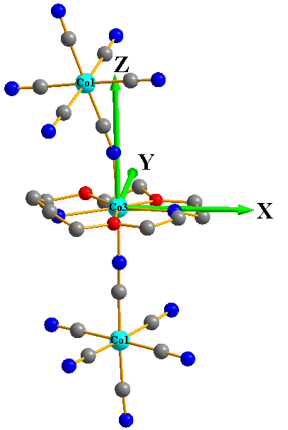
Co2 Co3
Figure A.1. Calculated molecular structures of individual Co^{II} fragments. H atoms are omitted for clarity.
Table A.1. Calculated spin-free energies (cm⁻¹) of the lowest ten terms (S = 3/2) of the Co^{II} ion of Co2 and Co3 using CASPT2/RASSI-SO with MOLCAS 8.4

Spin-free states | Co2, Energy (cm^{–1}) | Co3, Energy (cm^{–1})
1 | 0.0 | 0.0
2 | 2022.5 | 2201.3
3 | 2532.0 | 2288.5
4 | 4378.8 | 3759.2
5 | 5731.6 | 5230.1
6 | 11519.7 | 13004.6
7 | 13780.2 | 13445.9
8 | 18943.6 | 19222.8
9 | 20359.8 | 20440.4
10 | 21083.3 | 21600.6

Table A.2. Calculated weights of the five most important spin-orbit-free states for the lowest two spin-orbit states of Co2 and Co3 using CASPT2/RASSI-SO with MOLCAS 8.4
 | Spin-orbit  states | Energy  (cm⁻¹) | Spin-free states,Spin,Weights
Co2 | 1 | 0.0 | 1,1.5,0.9688 | 4,1.5,0.0115 | 2,1.5,0.0085 | 5,1.5,0.0049 | 3,1.5,0.0042
Co2 | 2 | 62.3 | 1,1.5,0.9777 | 3,1.5,0.0072 | 2,1.5,0.0053 | 4,1.5,0.0051 | 5,1.5,0.0036
Co3 | 1 | 0.0 | 1,1.5,0.9665 | 4,1.5,0.0173 | 5,1.5,0.0062 | 2,1.5,0.0059 | 3,1.5,0.0019
Co3 | 2 | 91.6 | 1,1.5,0.9842 | 5,1.5,0.0060 | 4,1.5,0.0050 | 2,1.5,0.0029 | 3,1.5,0.0008

Table A.3. Calculated ZFS parameters D, E (cm^{–1}) and g (g_{x}, g_{y}, g_{z}) tensors of Co2 and Co3 using CASPT2 and NEVPT2 with MOLCAS 8.4 and ORCA 4.2, respectively
Fragments | CASPT2 |  |  |  |  | NEVPT2
Fragments | D_{cal} | E_{cal} | g_{x} | g_{y} | g_{z} | D_{cal} | E_{cal} | g_{x} | g_{y} | g_{z}
Co2 | 30.5 | -3.7 | 2.398 | 2.313 | 2.099 | 21.5 | 2.6 | 2.359 | 2.295 | 2.152
Co3 | 43.0 | -9.2 | 2.503 | 2.295 | 2.004 | 34.7 | 5.4 | 2.412 | 2.289 | 2.034

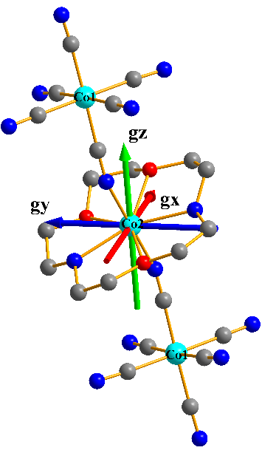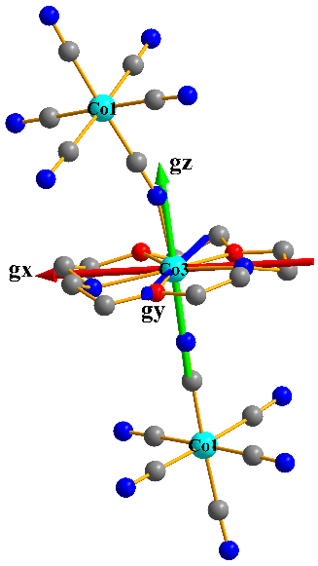
Co2 Co3
Figure A.2. Orientations of the local magnetic axes (red: g_{x}; blue: g_{y}; green: g_{z}) on Co^{II} ions of Co2 and Co3 in their ground spin-orbit states using CASPT2/RASSI-SO with MOLCAS 8.4.

Table A.4. Contributions of the excited states (with relative energy, cm^{–1}) to D values (cm^{–1}) for Co2 and Co3 using NEVPT2 with ORCA 4.2
Fragments | State No. | Multiplicity | Energy (cm^{–1}) | Contribution (cm^{–1})
 |  |  |  | D
Co2 | 3 | 4 | 3750.4 | 10.1
Co2 | 4 | 4 | 4722.1 | 10.1
Co3 | 3 | 4 | 3454.5 | 18.4
Co3 | 4 | 4 | 4571.4 | 13.1

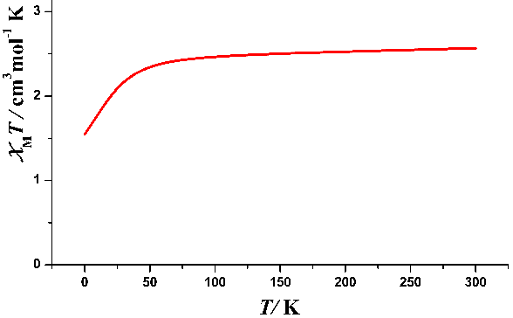
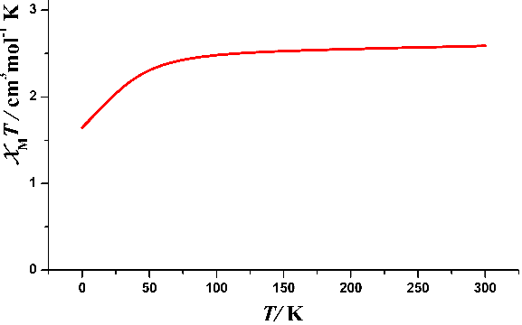

Figure A.3. Calculated (red solid line) data of magnetic susceptibilities. (Top) Co2 and (Bottom) Co3 using CASPT2/RASSI-SO with MOLCAS 8.4.

Table A.5. Relative energies (cm^{–1}) of ligand field one-electron states (in the basis of d-AOs) of Co2 and Co3 from AILFT analysis using NEVPT2 with ORCA 4.2

Fragments | No. | LF one-electron state | Energy (cm^{–1})
Co2 | 1 | – 0.81 d_{yz} + 0.49 d_{xz} – 0.24 d_{xy} | 0.0
Co2 | 2 | – 0.84 d_{xz} – 0.45 d_{yz} – 0.20 d_{xy} | 138.1
Co2 | 3 | 0.77 d_{xy} + 0.50 d_{x2-y2} – 0.38 d_{yz} | 1782.9
Co2 | 4 | – 0.83 d_{x2-y2} + 0.55 d_{xy} | 3468.6
Co2 | 5 | 0.97 d_{z2} + 0.20 d_{xz} | 8420.0
Co3 | 1 | 0.95 d_{yz} – 0.30 d_{xz} | 0.0
Co3 | 2 | 0.95 d_{xz} + 0.31 d_{xz} | 49.3
Co3 | 3 | 0.77 d_{xy} + 0.63 d_{x2-y2} | 2559.6
Co3 | 4 | 0.77 d_{x2-y2} – 0.63 d_{xy} | 2770.1
Co3 | 5 | 0.99 d_{z2} – 0.15 d_{x2-y2} | 8864.3

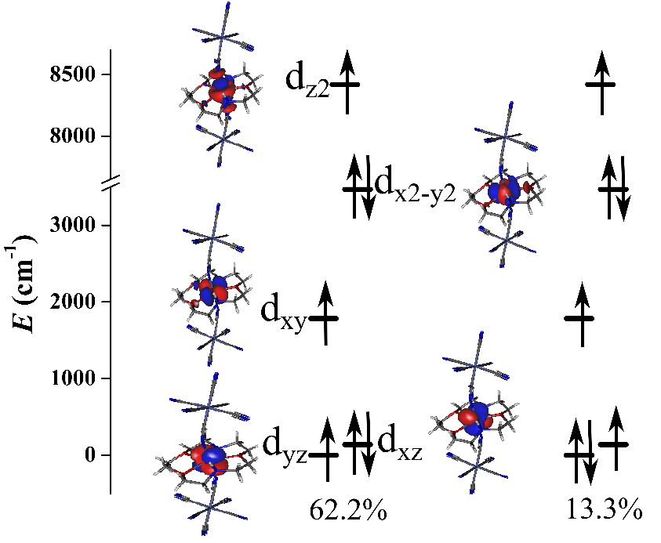
Co2
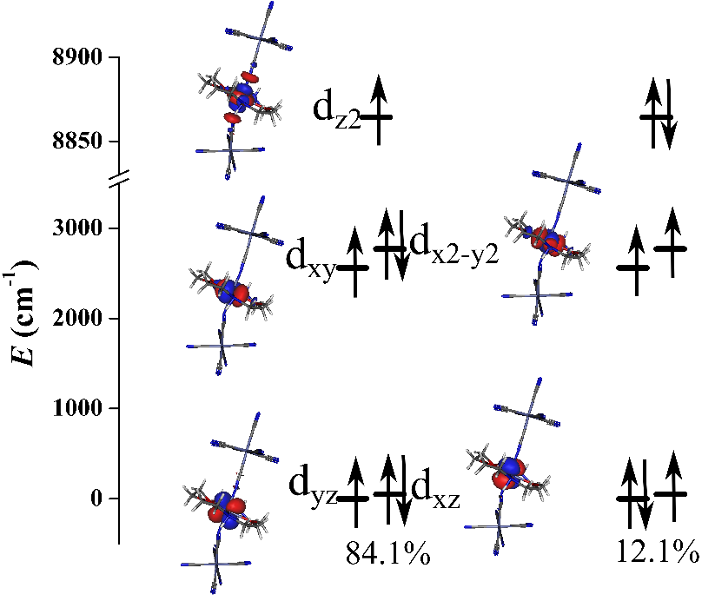
Co3
Figure A.4. Orbital energies computed for the ground state of Co2 and Co3 using NEVPT2 with ORCA 4.2. The percentage reveals the percentage of the corresponding conﬁguration mixing.
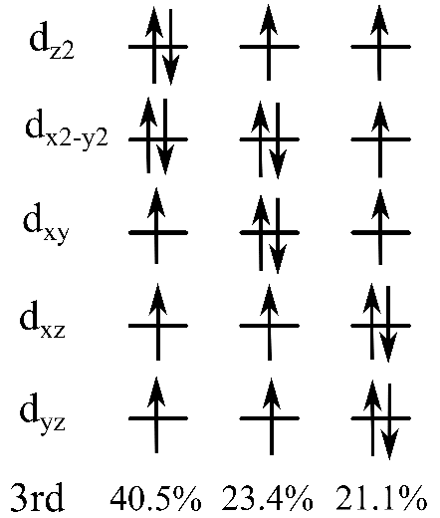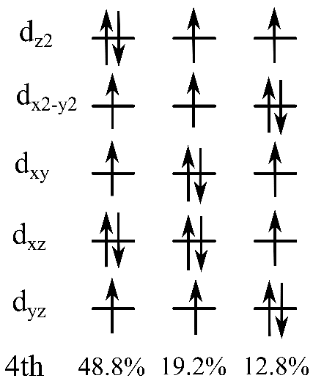
Co2

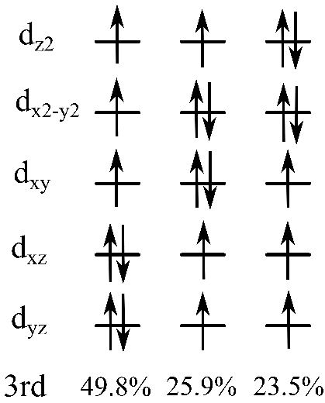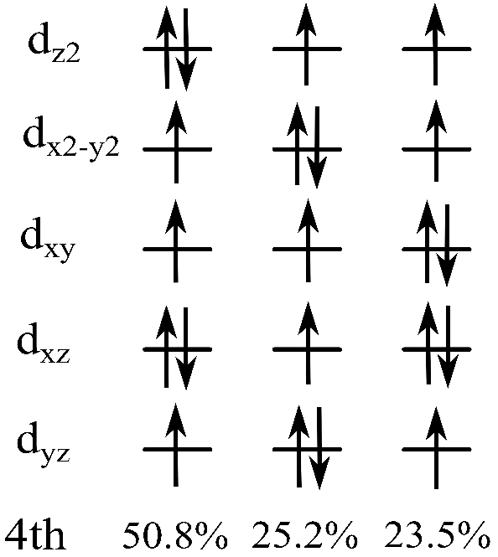
Co3
Figure A.5. Multi-determinant wavefunction of the selected excited states having important contributions to D tensor for Co2 and Co3. The computed CI coefficients that are larger than 10% are shown above.
A3. Crystal Structure of Co-TODA at 15(2) K and a Comparison of Selected Bond Lengths and Angles at 15(2) K and 123(2) K
Crystallographic data of Co-TODA using synchrotron X-ray diffraction were obtained at 15 K, confirming there is no phase change from 123(2) K to 15(2) K (Table A.6). ORTEP drawing of the crystal structure at 15(2) K is given in Figures 1.5-Right in the main text. Disorder in one TODA ligand is shown in Figure A.6. The disorder of the TODA at 15(2) K may stem from the rotation of the ligand. Additional plots of the structure at 15(2) K are given in Figures A.7-A.10.
The MOF crystallizes in the monoclinic space group P2₁/c at 15(2) K, as at 123(2) K.⁷⁰ However, only 7 water molecules were observed at 15(2) K, while 9 water molecules were present at 123(2) K. The crystals were prepared over 3 years prior to the current 15(2) K structure determination. During the time, the crystals in air may have lost lattice waters in the MOF.
The structure of Co-TODA contains a core formed by one [Co^{III}(CN)₆]³⁻ and 1.5 [Co(TODA)]²⁺ unites along with lattice water molecules. The diamagnetic [Co^{III}(CN)₆]³⁻ center is bonded to the C atoms of six CN⁻ ligands and one and a half of the [Co^{II}(TODA)]²⁺ unit plus nine water molecules. Each Co^{III} unit connects to the Co^{II} unit through three CN⁻ bridges in the fac-position. Between each layer, there are hydrogen bonding that stacks the layers in three dimensions along the a axis. The shortest Co^{II} to Co^{II} distance in a unit cell is 7.52 Å, while the longest Co^{II} to Co^{II} distance is 15.4 Å. The shortest interlayer distance between Co^{II} is 9.10 Å. The shortest Co^{II} to Co^{III} distance in a unit is 4.97 Å. The interlayer separation between the Co^{II} ions is 9.18 Å. The separation distance between the Co^{II} and Co^{II} ions are important for the
Table A.6. Comparison of crystallographic data for Co-TODA at 15(2) K and 123(2) K
 | 15(2) K | 123(2) K⁷⁰
Empirical formula | C₄₂H₈₀Co₅N₁₈O₁₆ | C₄₂H₁₀₂Co₅N₁₈O₂₇
Fw | 1387.89 | 1586.06
Temp (K) | 15(2) | 123(2)
Crystal system | Monoclinic | Monoclinic
Space group | P2₁/c | P2₁/c
a, Å | 9.1821(12) | 9.0980(3)
b, Å | 14.181(2) | 15.3049(6)
c, Å | 23.781(3) | 25.3271(8)
α, degree | 90 | 90
β, degree | 92.110(4) | 90.4180(10)
γ, degree | 90 | 90
V, Å³ | 3094.4(7) | 3526.6(2)
Z | 2 | 2
D_{calc}, g/cm³ | 1.490 | 1.494
Crystal size (mm³) | 0.04 × 0.04 × 0.06 | 0.220 × 0.350 × 0.530
θ range (degree) | 0.972–17.206 | 2.604–27.453
Reflections collected | 9294 | 8027
Independent reflections | 99274 [R(int) = 0.0886] | 29795 [R(int) = 0.0335]
Completeness to θ | 98.9%, 17.206° | 99.8%, 27.453°
GOF on F² | 1.084 | 1.055
Final R indices | R1 = 0.0874 | R1 = 0.0735
Table A.6. Continued
[I > 2σ(I)]ª | wR2 = 0.2595 | wR2 = 0.2138
R indices (all data) | R1 = 0.0931  wR2 = 0.2659 | R1 = 0.0852  wR2 = 0.2233
Largest diff. peak and hole, e.Å⁻³ | 1.693 and -1.171 | 1.720 and -1.370
ª R = Σ ||F_{o}| − |F_{c}|| / Σ|F_{o}|; R_{w} = (Σ[w(F_{o}² – F_{c}²)²] / Σ[w(F_{o}²)²])^{1/2}
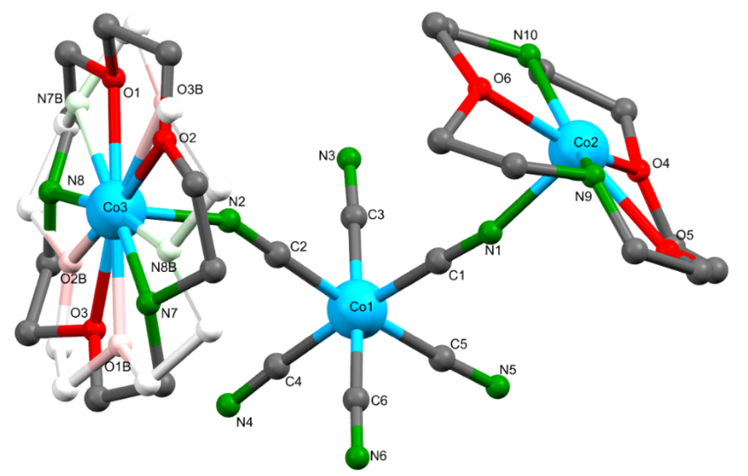

Figure A.6. Crystal structure of Co-TODA at 15(2) K. (Top) Disorder of one TODA ligand. The disordered position was contrasted in the fading of the TODA ligand in the background. The TODA ligands on both Co2 and Co3 are disordered. (Bottom) Selected bond lengths (Å) and bond angles (°): Co2-N1 2.052(4), Co2-N9 2.232(5), Co2-N10 2.216(5), Co2-O4 2.204(5), Co2-O5 2.228(5), Co2-O6 2.208(5), Co3-N2 2.063(4), Co3-N6 2.067(4), Co3-N7 2.215(5), Co3-N8 2.231(5), Co3-O1 2.212(5), Co3-O2 2.206(5), Co3-O3 2.221(5), O6-Co2-N10 72.8(3), N10-Co2-O4 74.7(3), O4-Co2-O5 73.2(3), O5-Co2-N9 70.5(3), N9-Co2-O6 71.3(3), N1-Co2-N9 101.6(3), N1-Co2-N10 92.5(3), N1-Co2-N9 78.4(3), N1-Co2-N10 87.53(3), O3-Co3-N7 73.4(3), N7-Co3-O2 75.2(3), O2-Co3-O1 70.0(3), O1-Co3-N8 71.7(3), N8-Co3-O3 70.5(3), N2-Co3-N7 91.4(2), N2-Co3-N8 93.9(2), N6-Co3-N7 84.4(2), N6-Co3-N8 86.6(2).
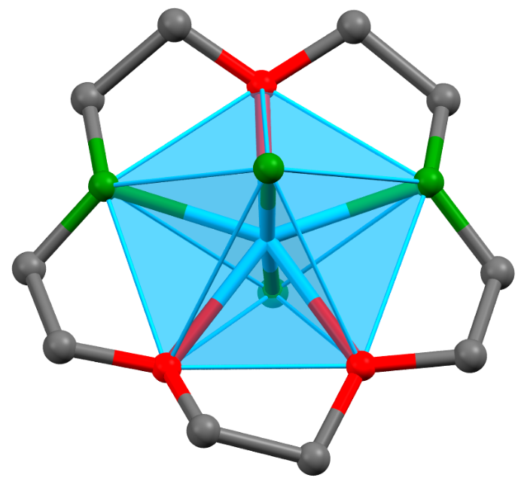
Figure A.7. Structure the Co^{II}(TODA) (Co2) moiety showing the pentagonal bipyramidal geometry. Red = O, green = N, Blue = Co^{II}. H atoms and the disordered atoms were omitted.

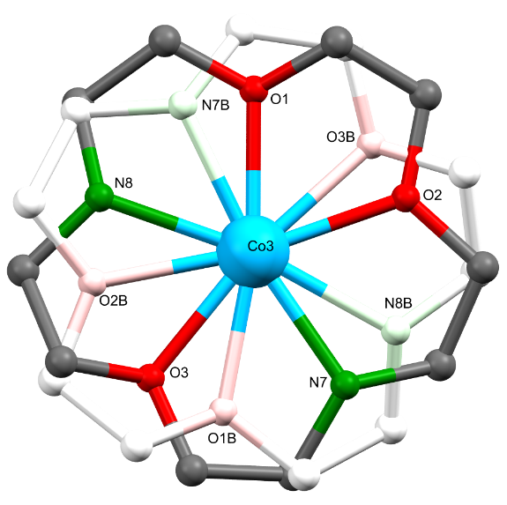
Figure A.8. Disordered Co^{II}(TODA) (Co3) moiety at 15(2) K. The disordered position was contrasted in the fading of the TODA ligand in the background. Two possible positions of the atoms of the TODA ligand were found in the crystal structure. H atoms were omitted for clarity.
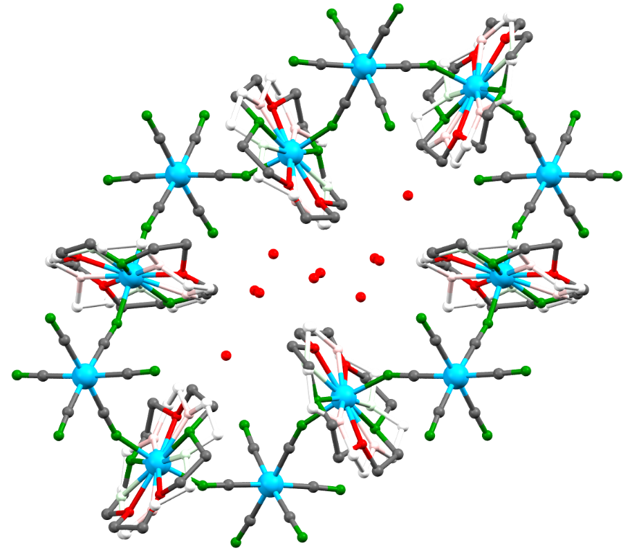
Figure A.9. Crystal structure of Co-TODA at 15(2) K showing the disorder and the lattice water molecules in the pore of the MOF. H atoms were omitted for clarity. Only one disordered TODA ligand is shown.
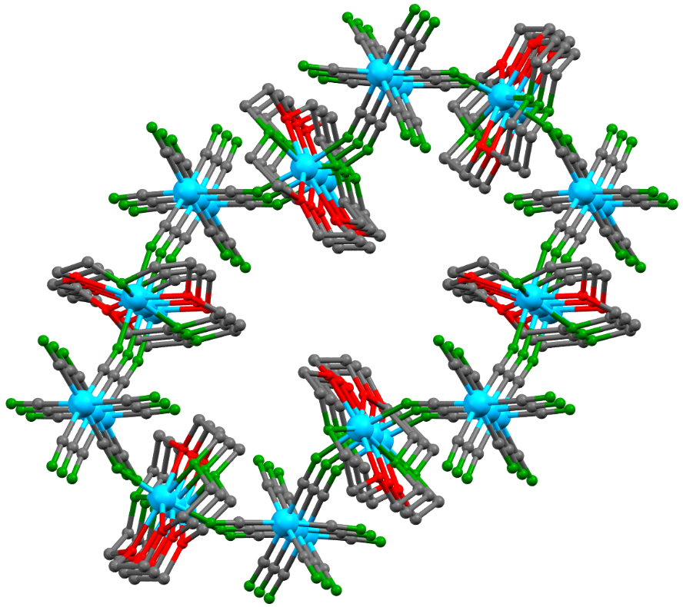
Figure A.10. Crystal structure of Co-TODA at 15(2) K showing multi-layer stacking of the MOF in the a axis. The disorders, lattice water molecules, and H atoms are omitted for clarity.

magnetic properties of Co-TODA. The larger the separation, the more isolated the individual Co^{II} ions are from each other, enhancing single-molecule magnet properties. The Co^{III} ions act as diamagnetic spacer between the paramagnetic Co^{II} ions, creating isolated [Co^{II}(TODA)]²⁺ units. All the TODA ligands are 2-fold disordered. There is a center of inversion on Co2, as shown in Figure 1.5-Left in the main text. The center of inversion at Co2, a Co^{II} ion, indicates that there are two different Co^{II} centers in the MOF.
Table A.6 gives a comparison of the crystallographic data at 15(2) K and 123(2) K. The unit cell shrinks at 15 K. The unit volume changes from 3526.6(2) Å³ to 3094.4(7) Å³, 12.3% reduction. Table A.7 shows a comparison of selected bond lengths and bond angles, showing no significant changes surrounding the Co^{II} centers at 15(2) K. Bond lengths at 15(2) K are slightly shorter than those at 123(2) K.

A4. Additional Results from Pulsed X-Band EPR Experiments
T₁ and T₂ times at four temperatures are listed in Table A.8. The pulsed X-band EPR experimental data (T₁ and T₂) for Co-TODA at 10(1) K, 20(1) K, and 30(1) K are given in Figure A.11, A.12, and A.13, respectively. The data at 5(1) K are in Chapter 2.

A5. Calculated Spin Densities in Co-TODA
The disorder in the original P2₁/c (No. 14) crystal structure makes it impossible to conduct the VASP phonon and spin density calculations. Thus, the crystal symmetry was reduced to P1 (No. 1) to conduct the calculations. Co1-Co10 labels are shown in Figure A.16.

Table A.7. Comparison of selected bond lengths (Å) and bond angles (deg) of Co-TODA at 15(2) K and 123(2) K. Atomic labeling in the two structures are different. The bond lengths and angles in the same rows are the same for comparison, although labeling may be different

15 K |  | 123 K
Co2-N1 | 2.052(4) | Co2-N1 | 2.073(4)
Co2-N1 | 2.052(4) | Co2-N1 | 2.073(4)
Co2-N9 | 2.232(5) | Co2-N7 | 2.237(7)
Co2-N10 | 2.216(5) | Co2-N8 | 2.277(8)
Co2-O4 | 2.204(5) | Co2-O1 | 2.147(8)
Co2-O5 | 2.228(5) | Co2-O2 | 2.269(8)
Co2-O6 | 2.208(5) | Co2-O3 | 2.318(8)
Co3-N2 | 2.063(4) | Co3-N2 | 2.073(5)
Co3-N6 | 2.067(4) | Co3-N6 | 2.051(5)
Co3-N7 | 2.215(5) | Co3-N9 | 2.256(8)
Co3-N8 | 2.231(5) | Co3-N10 | 2.189(9)
Co3-O1 | 2.212(5) | Co3-O4 | 2.257(7)
Co3-O2 | 2.206(5) | Co3-O5 | 2.212(8)
Co3-O3 | 2.221(5) | Co3-O6 | 2.210(7)
O6-Co2-N10 | 72.8(3) | O1-Co2-N7 | 74.5(3)
N10-Co2-O4 | 74.7(3) | N7-Co2-O3 | 69.8(2)
O4-Co2-O5 | 73.2(3) | O3-Co2-O2 | 72.2(3)
O5-Co2-N9 | 70.5(3) | O2-Co3-N8 | 71.7(3)
N9-Co2-O6 | 71.3(3) | N8-Co2-O1 | 74.9(3)
N1-Co2-N9 | 101.6(3) | N1-Co2-N7 | 93.1(2)
N1-Co2-N10 | 92.5(3) | N1-Co2-N8 | 86.8(3)
N1-Co2-N9 | 78.4(3) | N1-Co2-N7 | 93.1(2)
N1-Co2-N10 | 87.53(3) | N1-Co2-N8 | 86.8(3)
Table A.7. Continued
O3-Co3-N7 | 73.4(3) | O4-Co3-N9 | 70.7(3)
N7-Co3-O2 | 75.2(3) | N9-Co3-O6 | 73.5(3)
O2-Co3-O1 | 70.0(3) | O6-Co3-O5 | 70.6(3)
O1-Co3-N8 | 71.7(3) | O5-Co3-N10 | 73.1(3)
N8-Co3-O3 | 70.5(3) | N10-Co3-O4 | 72.8(3)
N2-Co3-N7 | 91.4(2) | N2-Co3-N9 | 89.4(3)
N2-Co3-N8 | 93.9(2) | N2-Co3-N10 | 92.0(4)
N6-Co3-N7 | 84.4(2) | N6-Co3-N9 | 87.1(3)
N6-Co3-N8 | 86.6(2) | N6-Co3-N10 | 90.5(4)

Table A.8. Values of T₁ and T₂ for the Co-TODA powder solid at 5(1), 10(1), 20(1) and 30(1) K

Temperature (K) | T₁ (μs) | T₂ (μs)
5(1) | 235(4) | 0.513(4)
10(1) | 237(4) | 0.498(4)
20(1) | 209(4) | 0.530(4)
30(1) | 206(4) | 0.550(4)

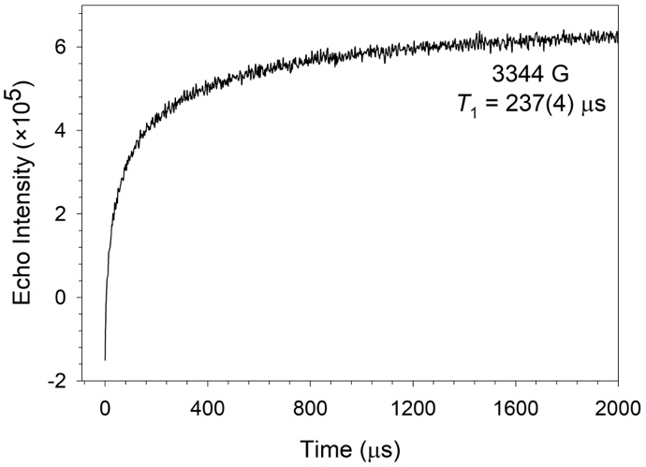
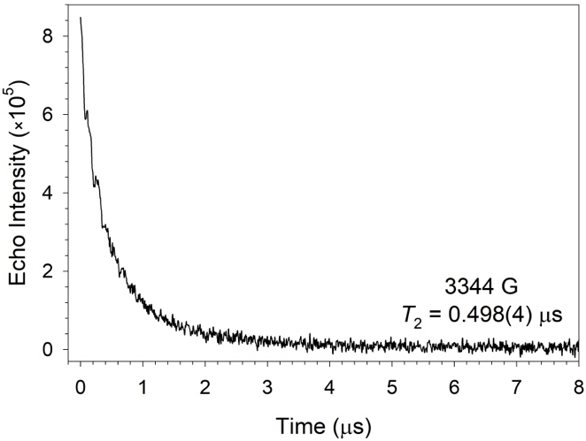
Figure A.11. Pulsed X-band EPR graphs at 10(1) K: (Top) Echo inversion recovery experiment; (Bottom) Hahn’s echo decay experiment. External magnetic field = 3344(1) Gauss.
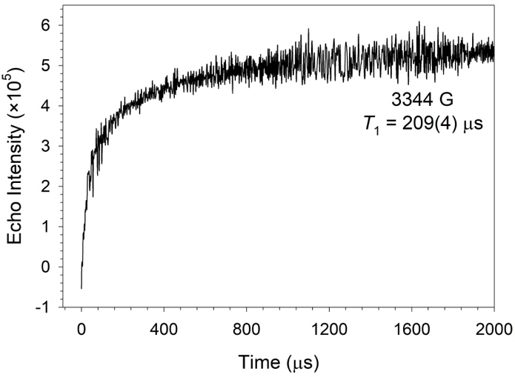
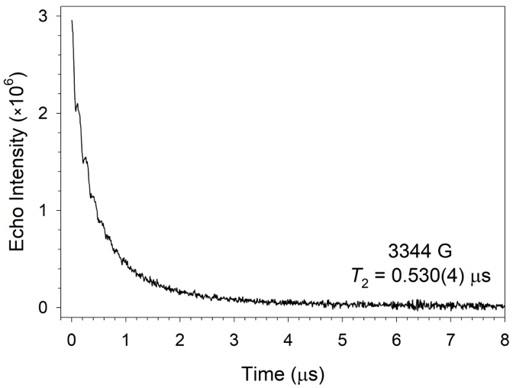
Figure A.12. Pulsed X-band EPR graphs at 20(1) K: (Top) Echo inversion recovery experiment; (Bottom) Hahn’s echo decay experiment. External magnetic field = 3344(1) Gauss.
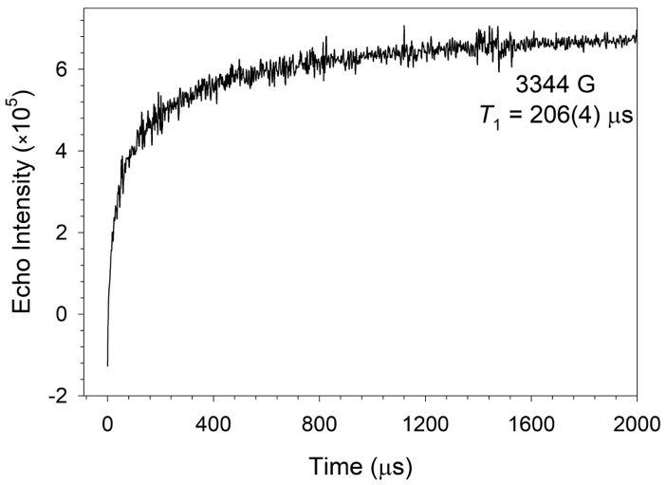
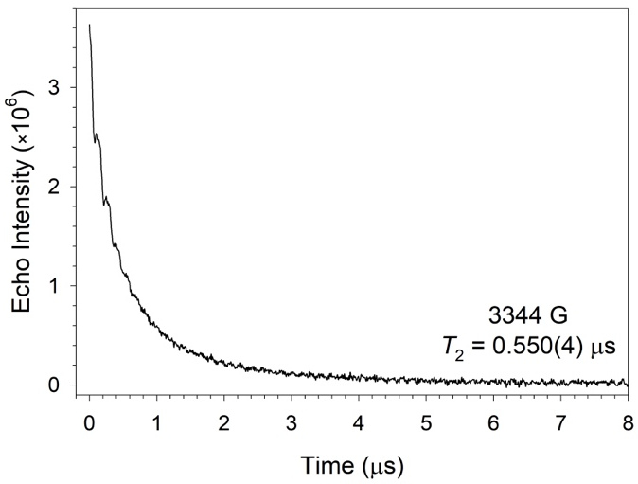

Figure A.13. Pulsed X-band EPR graphs at 30(1) K: (Top) Echo inversion recovery experiment; (Bottom) Hahn′s echo decay experiment. External magnetic field = 3344(1) Gauss.
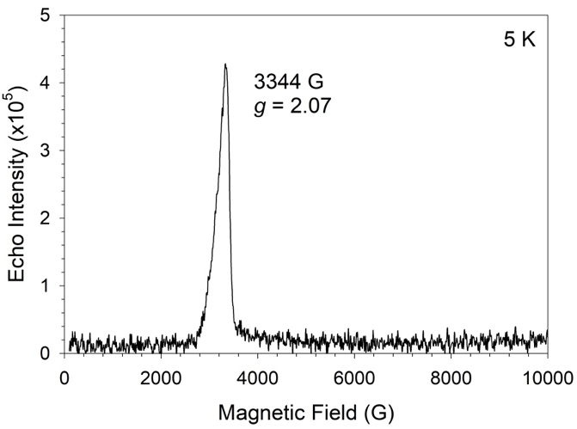
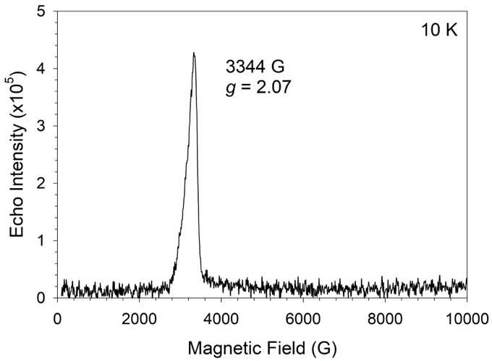
Figure A.14. Pulsed X-band EPR field swept echo graphs: (Top) 5(1) K; (Bottom) 10(1) K.

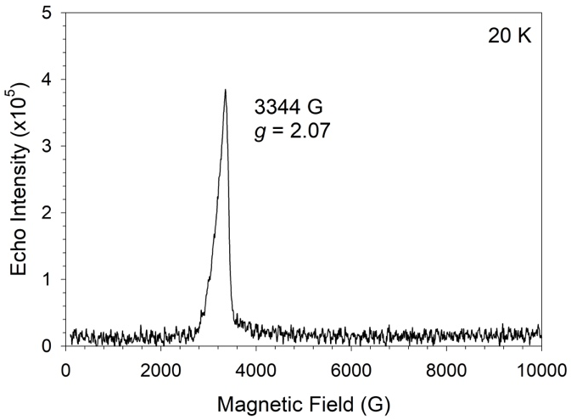
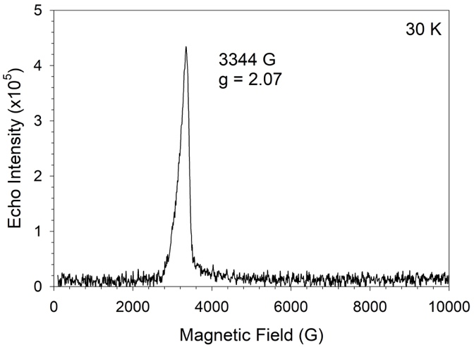
Figure A.15. Pulsed X-band EPR field swept echo graphs at 20(1) K and 30(1) K.

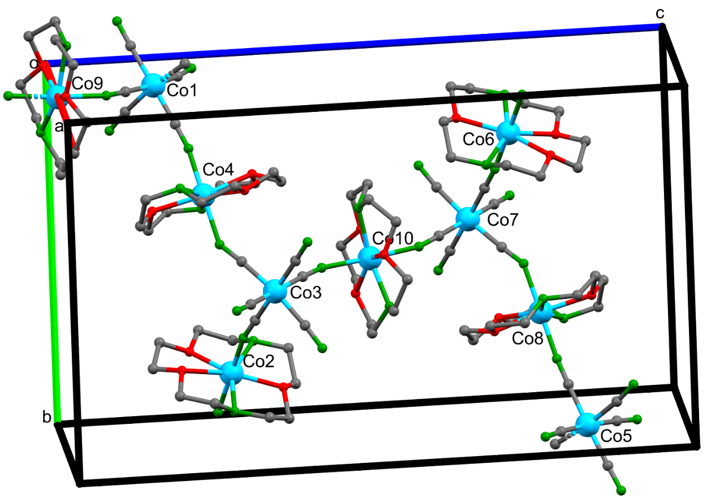
Figure A.16. P1 structure used for VASP phonon and spin density calculations. A view down the a axis of the unit cell. Lattice water molecules, H atoms, and disordered components were omitted for clarity. Only Co1-Co10 are labeled. All atom labels are given in the P1 CIF file.
Table A.9. Calculated spin densities of all atoms in the P1 unit cell of Co-TODA

Atom | Spin Density | Atom | Spin Density
Co1 | 0.010293 | H12 | 0.000962
Co2 | 2.690809 | H13 | -2.3 × 10⁻⁵
Co3 | 0.01029 | H14 | 0.001014
Co4 | 2.69109 | H15 | 0.000685
Co5 | 0.010316 | H16 | -4.7 × 10⁻⁵
Co6 | 2.692952 | H17 | 0.001964
Co7 | 0.010307 | H18 | 0.000315
Co8 | 2.692532 | H19 | 0.000948
Co9 | 2.687921 | H20 | -8.6 × 10⁻⁵
Co10 | 2.68799 | H21 | 5.87 × 10⁻⁵
O1 | 0.031695 | H22 | 0.001536
O2 | 0.024277 | H23 | 1.02 × 10⁻⁵
O3 | 0.024686 | H24 | 0.001009
O4 | 0.035667 | H25 | 0.000657
O5 | 0.023172 | H26 | 1.19 × 10⁻⁵
O6 | 0.0215 | H27 | 0.001407
O7 | 7.69 × 10⁻⁵ | H28 | 6.81 × 10⁻⁵
O8 | 2.9 × 10⁻⁵ | H29 | -0.00029
O9 | 6.62 × 10⁻⁵ | H30 | 0.00204
O10 | 0.000113 | H31 | 0.0005
O11 | 5.96 × 10⁻⁵ | H32 | 0.000549
O12 | 8.01 × 10⁻⁵ | H33 | -4.5 × 10⁻⁵
O13 | 7.46 × 10⁻⁵ | H34 | -3.2 × 10⁻⁵
O14 | 9.6 × 10⁻⁷ | H35 | 2.24 × 10⁻⁵
Table A.9. Continued
O15 | 0.000169 | H36 | 0.000784
O16 | 0.031651 | H37 | 0.000454
O17 | 0.024294 | H38 | -4 × 10⁻⁵
O18 | 0.024667 | H39 | 0.001714
O19 | 0.035657 | H40 | 0.000257
O20 | 0.023178 | H41 | 9.09 × 10⁻⁶
O21 | 0.021564 | H42 | 2 × 10⁻⁸
O22 | 7.55 × 10⁻⁵ | H43 | 4.13 × 10⁻⁶
O23 | 2.86 × 10⁻⁵ | H44 | 9.8 × 10⁻⁷
O24 | 6.7 × 10⁻⁵ | H45 | -6.9 × 10⁻⁶
O25 | 0.000116 | H46 | 4.36 × 10⁻⁶
O26 | 5.99 × 10⁻⁵ | H47 | 1.31 × 10⁻⁶
O27 | 8.1 × 10⁻⁵ | H48 | 1.21 × 10⁻⁵
O28 | 7.44 × 10⁻⁵ | H49 | 1.1 × 10⁻⁶
O29 | -1.8 × 10⁻⁷ | H50 | 4.2 × 10⁻⁷
O30 | 0.000169 | H51 | 5.5 × 10⁻⁷
O31 | 0.034733 | H52 | 2.7 × 10⁻⁶
O32 | 0.023538 | H53 | 6.2 × 10⁻⁷
O33 | 0.022636 | H54 | 1.73 × 10⁻⁶
O34 | 0.000101 | H55 | -5.8 × 10⁻⁷
O35 | 3.22 × 10⁻⁵ | H56 | -1.5 × 10⁻⁵
O36 | 6.54 × 10⁻⁵ | H57 | -2.4 × 10⁻⁶
O37 | 9.81 × 10⁻⁵ | H58 | 5.7 × 10⁻⁶
O38 | 8.22 × 10⁻⁵ | H59 | -0.00022
O39 | 0.000209 | H60 | -8.7 × 10⁻⁵
O40 | 7.74 × 10⁻⁵ | H61 | 2.28 × 10⁻⁵
Table A.9. Continued
O41 | 4.88 × 10⁻⁶ | H62 | 0.001699
O42 | 0.000154 | H63 | 3.38 × 10⁻⁵
O43 | 0.034853 | H64 | 0.000898
O44 | 0.02357 | H65 | 0.000562
O45 | 0.022638 | H66 | 2.23 × 10⁻⁵
O46 | 0.000102 | H67 | 0.001196
O47 | 3.18 × 10⁻⁵ | H68 | 0.000116
O48 | 6.43 × 10⁻⁵ | H69 | 0.001746
O49 | 9.33 × 10⁻⁵ | H70 | 0.00044
O50 | 8.4 × 10⁻⁵ | H71 | 0.000591
O51 | 0.000211 | H72 | -3.8 × 10⁻⁵
O52 | 7.73 × 10⁻⁵ | H73 | 3.49 × 10⁻⁵
O53 | 7.55 × 10⁻⁶ | H74 | 0.000964
O54 | 0.00015 | H75 | -2.1 × 10⁻⁵
N1 | 0.019245 | H76 | 0.001013
N2 | 0.018035 | H77 | 0.00069
N3 | 0.00027 | H78 | -4.7 × 10⁻⁵
N4 | -0.0001 | H79 | 0.001965
N5 | 0.000218 | H80 | 0.000321
N6 | 0.025113 | H81 | 0.000948
N7 | 0.043315 | H82 | -8.1 × 10⁻⁵
N8 | 0.043057 | H83 | 5.72 × 10⁻⁵
N9 | 0.04415 | H84 | 0.001538
N10 | 0.047197 | H85 | 1.02 × 10⁻⁵
N11 | 0.019162 | H86 | 0.001008
N12 | 0.018046 | H87 | 0.000658
Table A.9. Continued
N13 | 0.000268 | H88 | 1.18 × 10⁻⁵
N14 | -0.0001 | H89 | 0.00141
N15 | 0.00022 | H90 | 6.62 × 10⁻⁵
N16 | 0.025103 | H91 | -0.00029
N17 | 0.043315 | H92 | 0.002041
N18 | 0.043082 | H93 | 0.0005
N19 | 0.044105 | H94 | 0.000551
N20 | 0.047137 | H95 | -4.5 × 10⁻⁵
N21 | 0.020978 | H96 | -3.3 × 10⁻⁵
N22 | 0.017931 | H97 | 2.27 × 10⁻⁵
N23 | 0.000308 | H98 | 0.000786
N24 | -0.00011 | H99 | 0.000455
N25 | 0.000211 | H100 | -4 × 10⁻⁵
N26 | 0.026817 | H101 | 0.001714
N27 | 0.045433 | H102 | 0.000259
N28 | 0.045294 | H103 | 8.98 × 10⁻⁶
N29 | 0.021095 | H104 | 3 × 10⁻⁸
N30 | 0.017958 | H105 | 4.05 × 10⁻⁶
N31 | 0.000304 | H106 | 9.6 × 10⁻⁷
N32 | -0.00011 | H107 | -7.2 × 10⁻⁷
N33 | 0.000218 | H108 | 4.5 × 10⁻⁶
N34 | 0.026747 | H109 | 1.26 × 10⁻⁶
N35 | 0.045528 | H110 | 1.21 × 10⁻⁵
N36 | 0.045434 | H111 | 1.03 × 10⁻⁶
C1 | 0.00053 | H112 | 4 × 10⁻⁷
C2 | 0.000297 | H113 | 6.3 × 10⁻⁷
Table A.9. Continued
C3 | 0.001393 | H114 | 2.82 × 10⁻⁶
C4 | 0.000223 | H115 | 6.7 × 10⁻⁷
C5 | -0.00062 | H116 | 1.72 × 10⁻⁶
C6 | 0.000571 | H117 | -7.6 × 10⁻⁷
C7 | 0.000643 | H118 | -1.5 × 10⁻⁵
C8 | 0.000505 | H119 | -2.4 × 10⁻⁶
C9 | 0.000641 | H120 | 5.75 × 10⁻⁶
C10 | -0.0005 | H121 | 0.00059
C11 | 0.007198 | H122 | -3.6 × 10⁻⁵
C12 | 0.006795 | H123 | 3.33 × 10⁻⁵
C13 | 0.000105 | H124 | 0.001209
C14 | 0.0004 | H125 | 0.001003
C15 | -0.0002 | H126 | -7.9 × 10⁻⁵
C16 | 0.002129 | H127 | 7.19 × 10⁻⁵
C17 | 0.000194 | H128 | 0.001637
C18 | 0.000353 | H129 | 1.08 × 10⁻⁵
C19 | 0.001807 | H130 | 0.000978
C20 | -0.00029 | H131 | 0.000652
C21 | -0.00059 | H132 | 4.29 × 10⁻⁶
C22 | 0.000753 | H133 | 0.001394
C23 | 0.001032 | H134 | 4.05 × 10⁻⁵
C24 | 0.000303 | H135 | -0.0003
C25 | 0.000548 | H136 | 0.001882
C26 | -0.00072 | H137 | 0.000449
C27 | 0.00054 | H138 | 0.000553
C28 | 0.000292 | H139 | -3.7 × 10⁻⁵
Table A.9. Continued
C29 | 0.001396 | H140 | 3.44 × 10⁻⁵
C30 | 0.000225 | H141 | -3.5 × 10⁻⁵
C31 | -0.00063 | H142 | 0.000859
C32 | 0.000585 | H143 | 0.000469
C33 | 0.000664 | H144 | -3.1 × 10⁻⁵
C34 | 0.000497 | H145 | 0.001813
C35 | 0.000631 | H146 | 0.000323
C36 | -0.00049 | H147 | 8.82 × 10⁻⁶
C37 | 0.007228 | H148 | -1.4 × 10⁻⁷
C38 | 0.006754 | H149 | 3.58 × 10⁻⁶
C39 | 0.000108 | H150 | 2.17 × 10⁻⁶
C40 | 0.000399 | H151 | -8.1 × 10⁻⁷
C41 | -0.0002 | H152 | 3.29 × 10⁻⁶
C42 | 0.002165 | H153 | -3.1 × 10⁻⁷
C43 | 0.000195 | H154 | 5.49 × 10⁻⁶
C44 | 0.00036 | H155 | 5 × 10⁻⁷
C45 | 0.001803 | H156 | 1.07 × 10⁻⁶
C46 | -0.00029 | H157 | 3.03 × 10⁻⁶
C47 | -0.00059 | H158 | 7.12 × 10⁻⁶
C48 | 0.000752 | H159 | 3.4 × 10⁻⁷
C49 | 0.001033 | H160 | 1.98 × 10⁻⁶
C50 | 0.000301 | H161 | -1.5 × 10⁻⁵
C51 | 0.000547 | H162 | 1.85 × 10⁻⁶
C52 | -0.00072 | H163 | -2.4 × 10⁻⁶
C53 | 0.004952 | H164 | 2.97 × 10⁻⁶
C54 | 0.006736 | H165 | 0.001001
Table A.9. Continued
C55 | 8.3 × 10⁻⁵ | H166 | -7.5 × 10⁻⁵
C56 | 0.000392 | H167 | 6.19 × 10⁻⁵
C57 | -0.00012 | H168 | 0.001631
C58 | 0.000164 | H169 | 1.09 × 10⁻⁵
C59 | 7.62 × 10⁻⁵ | H170 | 0.00098
C60 | 0.000483 | H171 | 0.000647
C61 | 0.001645 | H172 | 5.2 × 10⁻⁶
C62 | -0.00029 | H173 | 0.001386
C63 | -0.0004 | H174 | 4.47 × 10⁻⁵
C64 | 0.000514 | H175 | -0.00031
C65 | 0.000536 | H176 | 0.001878
C66 | 0.000942 | H177 | 0.000445
C67 | 0.001214 | H178 | 0.000554
C68 | -0.00088 | H179 | -3.7 × 10⁻⁵
C69 | 0.004827 | H180 | 4.03 × 10⁻⁵
C70 | 0.006681 | H181 | -3.5 × 10⁻⁵
C71 | 7.89 × 10⁻⁵ | H182 | 0.000854
C72 | 0.000397 | H183 | 0.000464
C73 | -0.00012 | H184 | -2.5 × 10⁻⁵
C74 | 0.000251 | H185 | 0.001806
C75 | 6.77 × 10⁻⁵ | H186 | 0.000328
C76 | 0.000501 | H187 | 8.06 × 10⁻⁶
C77 | 0.001659 | H188 | -1.2 × 10⁻⁷
C78 | -0.0003 | H189 | 3.52 × 10⁻⁶
C79 | -0.00038 | H190 | 2.16 × 10⁻⁶
C80 | 0.000503 | H191 | -8 × 10⁻⁷
Table A.9. Continued
C81 | 0.000505 | H192 | 3.28 × 10⁻⁶
C82 | 0.000963 | H193 | -3.5 × 10⁻⁷
C83 | 0.001241 | H194 | 5.14 × 10⁻⁶
C84 | -0.0009 | H195 | 6.2 × 10⁻⁷
H1 | -0.00022 | H196 | 1.23 × 10⁻⁶
H2 | -7.60 × 10⁻⁵ | H197 | 3.2 × 10⁻⁶
H3 | 2.30 × 10⁻⁵ | H198 | 6.3 × 10⁻⁶
H4 | 0.001698 | H199 | 2.8 × 10⁻⁷
H5 | 0.0009 | H200 | 2.16 × 10⁻⁶
H6 | 0.000563 | H201 | -1.4 × 10⁻⁵
H7 | 2.05 × 10⁻⁵ | H202 | 1.88 × 10⁻⁶
H8 | 0.00011 | H203 | -2.6 × 10⁻⁶
H9 | 0.001745 | H204 | 2.98 × 10⁻⁶
H10 | 0.000445 | Total | 17.616
H11 | 3.99 × 10⁻⁵

A6. Additional Calculated INS and Experimental INS Results

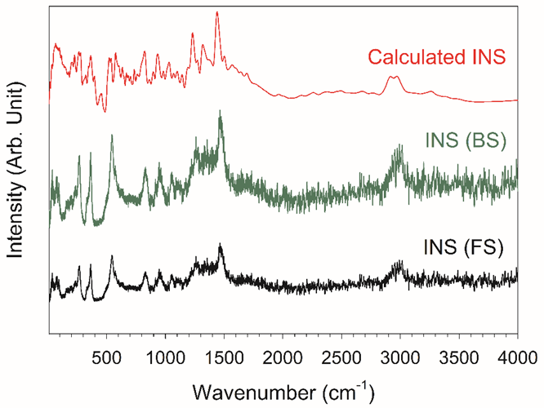

Figure A.17. Comparison range of 10-4000 cm⁻¹ between calculated INS spectrum (red) and experimental INS spectrum at 5.0(5) K [forward-scattering (FS, black) and backscattering (BS, green)].

Appendix B. Supporting Information for Chapter 3

B1. Synthesis of [Co(μ-bpeb)₂(NCS)₂]_{n}•nG (Co-BEBN), Growth of Its Single Crystals, and Synthesis of Co-BEBN_{0.05}
The ligand 1,4-bis(pyridine-4-ylethynyl)benzene (bpeb) was prepared by a literature method.²⁸¹ The chemicals used in the synthesis of Co-BEBN and bpeb were purchased commercially and used without further purification. Cobalt(II) thiocyanate [Co(SCN)₂, 98+%, Alfa Aesar]; 4-Ethynylpyridine [C₇H₅N, 95%, Enamine]; Copper(I) bromide [CuBr, 98%, Strem Chemicals, INC.]; 1,4-Diiodobenzene [C₆H₄I₂, 98%, Alfa Aesar]; Zinc thiocyanate [Zn(SCN)₂, 99.4%, Chemsavers]; 1,2-Dichlorobenzene [C₆H₄Cl₂, >99.0%, TCI]; Methanol [CH₃OH, 99.8%, Fisher Chemical].
Single-crystal samples of Co-BEBN were prepared by a three-layered method. A pink solution of 0.0019 g of cobalt(II) thiocyanate [Co(SCN)₂, 0.010 mmol] in 10 mL of MeOH was layered on top of a yellow solution of 0.0634 g of bpeb ligand [C₂₀H₁₂N₂, 0.226 mmol] in 8 mL of 1,2-dichlorobenzene and 2 mL of methanol. A buffer layer (middle layer) is a mixture of 5 mL of 1,2-dichlorobenzene and 5 mL of methanol. The three-layered mixture was placed in a glass vial. The reaction was left to grow single crystals at room temperature for up to 10 days. The longer the reaction is left to react, the larger the size of the single crystals. Orange block-shaped crystals were observed in the buffer layer in a couple of days. The orange crystals are sensitive to the environment. If the crystals are left out of the mother solution (a mixture of 1,2-dichlorobenzene and methanol) and let dry in air, the orange block-shaped crystals turn into gray polycrystalline (powder) sample. Determination of the yield was not possible due to the loss of 1,2-dichlorobenzene when crystals are outside of the mother solution. Single-crystal X-ray diffraction studies are given in Experimental Methods.
Polycrystalline samples of 95% Zn²⁺-containing Co-BEBN_{0.05} were prepared through a similar method. Instead of using 100% (0.010 mmol) of Co(SCN)₂, a mixture of 95% (0.0017 g, 0.0095 mmol) of Zn(SCN)₂ and 5% (0.00009 g, 0.0005 mmol) of Co(SCN)₂ was used in the reaction.
B2. Additional Crystal Structural Data for [Co(μ-bpeb)₂(NCS)₂]_{n}•nG (Co-BEBN)

Table B.1. Comparison of crystallographic data for Co-BEBN at 100(2) K between the reported⁷⁶ and current structure
 | Current Studies | Reported⁷⁶
Empirical formula | C₆₆H₄₀Cl₈CoN₆S₂ | C₈₄H₅₂Cl₁₄CoN₆S₂
Formula weight | 1323.69 | 1764.66
Temperature (K) | 100(2) | 100(2)
Crystal system | Monoclinic | Triclinic
Space group | C2/c (No. 15) | P$\overline{1}$ (No. 2)
a, Å | 17.3276(4) | 13.593(5)
b, Å | 20.9222(5) | 17.194(5)
c, Å | 17.1575(4) | 18.450(5)
α, degree | 90 | 99.319(5)
β, degree | 97.7120(10) | 100.076(5)
γ, degree | 90 | 107.842(5)
V, Å³ | 6163.9(3) | 3933(2)
Z | 4 | 2
D_{calc}, g/cm³ | 1.426 | 1.490
Crystal size (mm³) | N/A | 0.16 $×$ 0.18 $×$ 0.20
θ range (degree) | 2.396–31.534 | 2.30–20.74
Reflections collected | 10265 | 8262
Independent reflections | 33431 [R(int) = 0.0221] | 59588 [R(int) = 0.0728]
Table B.1. Continued
Completeness to θ | 99.9%, 31.502° | 98.6%, 20.45°
GOF on F² | 1.021 | 2.434
Final R indices | R1 = 0.0332 | R1 = 0.2181
[I > 2σ(I)]ª | wR2 = 0.0825 | wR2 = 0.5409
R indices (all data) | R1 = 0.0404  wR2 = 0.0878 | R1 = 0.2422  wR2 = 0.5584
Largest diff. peak and hole, e.Å⁻³ | 1.129 and -0.752 | 4.151and -1.015
ª R = Σ ||F_{o}| − |F_{c}|| / Σ|F_{o}|; R_{w} = (Σ[w(F_{o}² – F_{c}²)²] / Σ[w(F_{o}²)²])^{1/2}

Table B.2. Selected bond length and bond angles of Co²⁺ ion local symmetry in Co-BEBN

Bond Lengths (Å)
Current Studies |  | Reported⁷⁶
Co1-N2 | 2.0877(11) | Co1-N1S | 2.096(15)
Co1-N2 | 2.0877(11) | Co1-N1S | 2.096(15)
Co1-N1 | 2.1554(10) | Co1-N4 | 2.237(11)
Co1-N1 | 2.1555(10) | Co1-N4 | 2.237(11)
Co1-N3 | 2.1751(14) | Co1-N1 | 2.248(9)
Co1-N4 | 2.1917(14) | Co1-N1 | 2.248(9)
Bond Angles (°)
Current Studies |  | Reported⁷⁶
N2-Co1-N2 | 179.16(6) | N1S-Co1-N1S | 180.0
N2-Co1-N1 | 88.80(4) | N1S-Co1-N4 | 89.7(4)
N2-Co1-N1 | 91.21(4) | N1S-Co1-N4 | 90.3(4)
N2-Co1-N1 | 91.21(4) | N1S-Co1-N4 | 90.3(4)
N2-Co1-N1 | 88.79(4) | N1S-Co1-N4 | 89.7(4)
N1-Co1-N1 | 179.65(5) | N4-Co1-N4 | 180.0
N2-Co1-N3 | 90.42(3) | N1S-Co1-N1 | 92.8(4)
N2-Co1-N3 | 90.42(3) | N1S-Co1-N1 | 87.2(4)
N1-Co1-N3 | 89.82(3) | N4-Co1-N1 | 87.0(4)
N1-Co1-N3 | 89.82(3) | N4-Co1-N1 | 93.0(4)
N2-Co1-N4 | 89.58(3) | N1S-Co1-N1 | 87.2(4)
Table B.2. Continued
N2-Co1-N4 | 89.58(3) | N1S-Co1-N1 | 92.8(4)
N1-Co1-N4 | 90.18(3) | N4-Co1-N1 | 93.0(4)
N1-Co1-N4 | 90.18(3) | N4-Co1-N1 | 87.0(4)
N3-Co1-N4 | 180.0 | N1-Co1-N1 | 180.0

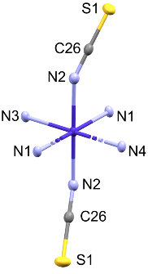

Figure B.1. Local symmetry of a Co²⁺ ion in Co-BEBN. Atom N1, N3, and N4 are of the bpeb ligands in the x-y plane, while atom N2 are of the NCS ligands in the z-axis. Dark Purple: Co; Light purple: N; Yellow: S; Gray: C. Hydrogens are omitted for clarity.

B3. Magnetic Susceptibility (AC and DC) Data
Alternate current (AC) magnetic susceptibility measurements were conducted for Co-BEBN to probe the single-ion magnet (SIM) properties. It should be noted that, for Co-BEBN-polymorph, Vallejo, Pardo, Cano, and coworkers have reported DC and AC magnetic susceptibility studies, showing that Co-BEBN-polymorph has SIM behaviors.⁷⁶ Since Co-BEBN has a different structure and possibly different properties, its magnetic susceptibility properties have been investigated.
The measurements were performed at the temperature range between 2 and 10 K. Powder sample of Co-BEBN was used in the measurements by griding the single crystals into fine powders. A couple drops of 1,2-dichlorobenzene were placed onto the powder sample to keep the sample from drying out in air. The “wet” powder samples were placed into a folded piece of weight paper with the help of some grease. The folded paper was placed into the middle of a plastic straw for mounting onto the instrument. The instrument used was the Superconducting Quantum Interference Device (SQUID) magnetometer by Quantum Design.
Temperature dependence of magnetization under 0.1 T were taken from 2 to 10 K. The in-phase magnetization of Co-BEBN shows a peak around 3.5 K at 119 Hz. The peak is moved to higher temperature (~5.5 K) as the frequency increases up to 1512 Hz. The frequency and temperature-dependent peak is the characteristic of a SIM at temperature below 10 K. Figure B.2-Top shows the in-phase magnetic susceptibility graph. Figure B.2-Bottom shows the out-of-phase magnetic susceptibility graph. The out-of-phase data shows a similar peak at temperature <2 K at 119 Hz. The peak moves to higher temperature as the frequency increases. The same SIM characteristic can be observed in the out-of-phase data. There are fluctuations in the data
Figure B.2. (Top) Temperature-dependent AC magnetic susceptibility in-phase data of Co-BEBN. (Bottom) Temperature-dependent AC magnetic susceptibility out-of-phase data.

points across multiple frequencies for both the in-phase and the out-of-phase data. The reason for the fluctuation is due to temperature fluctuation that occurred in the instrument as well as a possible slight movement of the sample inside the sample mount. A background subtraction of the diamagnetic contribution from the weight paper, grease, and the solvent were corrected for the data.
Direct Current (DC) magnetic susceptibility measurements were conducted for Co-BEBN to understand the magnetic interaction of the system. The data in Figure B.3 shows temperature-dependent data at 0.1 T from 1.8 to 200 K. The magnetic susceptibility increases as the temperature increases. The magnetic susceptibility value plateaued around 150 K at 2.65 cm³ mol⁻¹ K⁻¹. The value corresponds closely to the value of an S = 3/2 system. The increase in magnetic susceptibility from lower to higher temperature suggested an antiferromagnetic interaction in the system with the Néel point at around 150 K. The fluctuation of the data points below 20 K is due to the temperature fluctuation originating from the instrument during measurements.

B4. Additional Inelastic Neutron Scattering (INS) Data and Phonon Calculations
The phonon calculation fits generally well to the experimental INS spectrum at 5 K in the full spectrum from 10 to 5000 cm⁻¹. However, there are some differences between the experimental and calculated phonon peaks. As shown in Figure B.4, the experimental phonon peak at ~2400 cm⁻¹ is not observed in the calculated spectrum. The differences can be attributed to the single-crystal structure of Co-BEBN not being perfectly completed or that there are some contaminations in the solvent (1,2-dichlorobenzene) used in the INS experiments. The same peak
Figure B.3. Temperature-dependent DC magnetic susceptibility of Co-BEBN.

Figure B.4. Comparison between experimental INS spectrum at 5 K and calculated phonon spectrum from 10 to 5000 cm⁻¹.

is observed in the experimental solvent spectrum. Figure B.5 shows the comparison in the 0-1500 cm⁻¹ range.

B5. Additional Data from the Electronic Structure Calculations
For grid-like compound of Co-BEBN, we extracted one type of one-core unit. Complete active space second-order multiconfigurational perturbation theory (CASPT2) considering the effect of the dynamic electron correlation based on complete-active-space self-consistent field (CASSCF) method with MOLCAS 8.4 program package²⁸² was performed on the basis of single-crystal X-ray determined geometries of Co-BEBN. See Figure B.6 for the calculated model structures.

Figure B.5. Comparison between experimental INS spectrum at 5 K and calculated phonon spectrum from 10 to 1500 cm⁻¹.

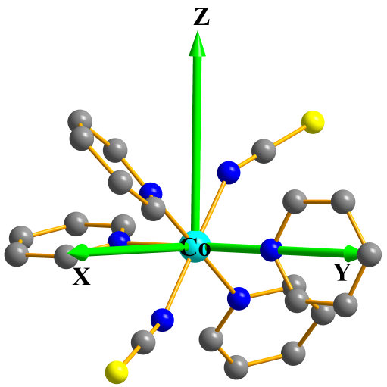
Figure B.6. Calculated model structure of individual Co²⁺ fragment. H atoms are omitted for clarity.

Table B.3. Calculated spin-free energies (cm⁻¹) of the lowest ten terms (S = 3/2) of the Co²⁺ ions of Co-BEBN using CASPT2/RASSI-SO with MOLCAS 8.4

Spin-free states | Energy (cm^{–1})
1 | 0.0
2 | 163.3
3 | 775.4
4 | 9507.5
5 | 9628.4
6 | 9955.7
7 | 20019.6
8 | 20794.6
9 | 21823.8
10 | 22587.1

Table B.4. Calculated weights of the five most important spin-orbit-free states for the lowest two spin-orbit states of Co-BEBN using CASPT2/RASSI-SO with MOLCAS 8.4
Spin-orbit  states | Energy  (cm⁻¹) | Spin-free states, Spin, Weights
1 | 0.0 | 1,1.5,0.5674 | 2,1.5,0.3492 | 3,1.5,0.0805 | 6,1.5,0.0007 | 22,0.5,0.0006
2 | 242.5 | 1,1.5,0.7380 | 2,1.5,0.2053 | 3,1.5,0.0534 | 4,1.5,0.0014 | 6,1.5,0.0005

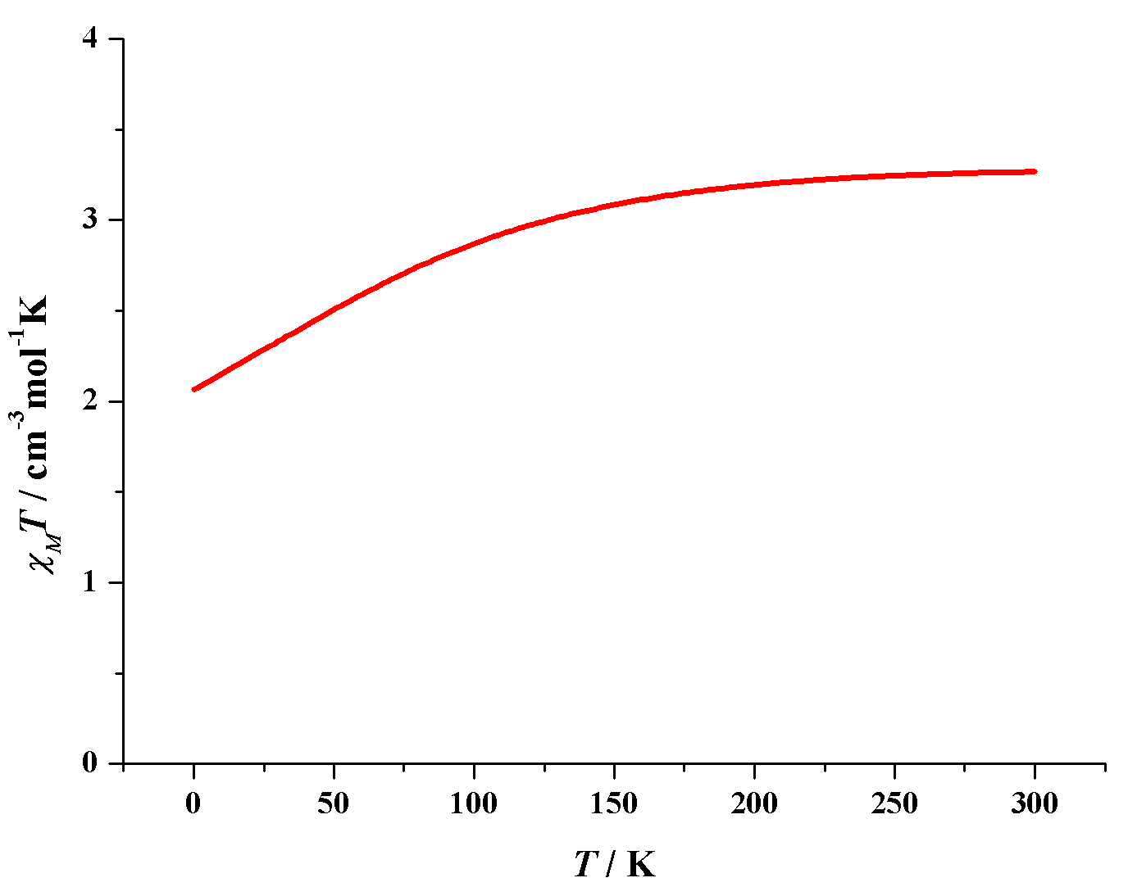
Figure B.7. Calculated (red solid line) data of magnetic susceptibilities of Co-BEBN using CASPT2/RASSI-SO with MOLCAS 8.4.

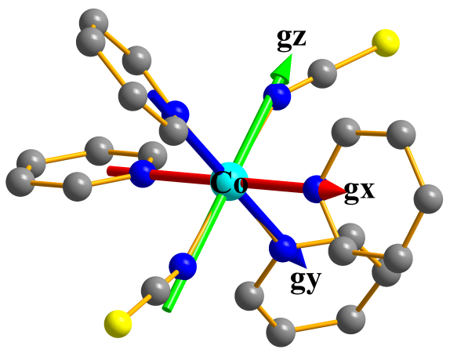
Figure B.8. Orientations of the local magnetic axes (red: g_{x}; blue: g_{y}; green: g_{z}) on Co²⁺ ions of Co-BEBN in their ground spin-orbit states using CASPT2/RASSI-SO with MOLCAS 8.4.

Table B.5. Contributions of the excited states (with relative energy cm^{–1}) to D values (cm^{–1}) for Co-BEBN using NEVPT2 with ORCA 4.2

State No. | Multiplicity | Energy (cm^{–1}) | Contribution (cm^{–1})
State No. | Multiplicity | Energy (cm^{–1}) | D
1 | 4 | 133.6 | 60.4
2 | 4 | 609.5 | 30.2

Table B.6. Relative energies (cm^{–1}) of ligand field one-electron states (in the basis of d-AOs) of Co-BEBN from AILFT analysis using NEVPT2 with ORCA 4.2

No. | LF one-electron state | Energy (cm^{–1})
1 | – 0.99 d_{yz} | 0.0
2 | – 0.99 d_{xz} | 663.8
3 | 0.99 d_{xy} | 868.8
4 | 0.97 d_{z2} + 0.23 d _{x2-y2} | 8391.3
5 | 0.97d _{x2-y2} | 9510.6

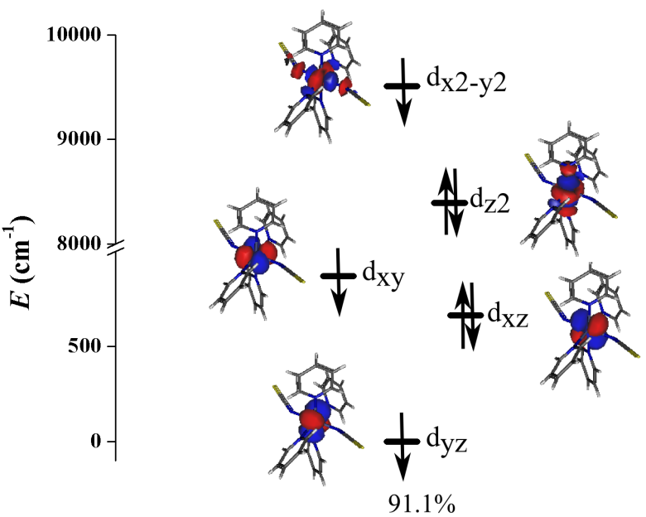
Figure B.9. Orbital energies computed for the ground states of Co-BEBN using NEVPT2 with ORCA 4.2. The percentages reveal the percents of the corresponding conﬁguration mixings.

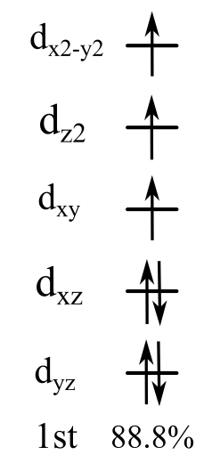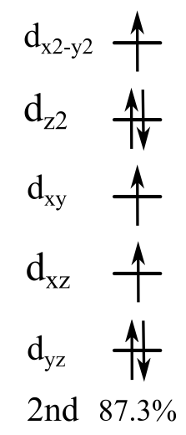
Figure B.10. Multi-determinant wavefunction of the selected excited states having important contributions to D tensor for Co-BEBN. The computed CI coefficients that are larger than 10% are shown above.

B6. Phonon Symmetries

Table B.7. Calculated phonon symmetries and modes of Co-BEBN
Wavenumber (cm⁻¹) | Symmetries of the modes | Wavenumber (cm⁻¹) | Symmetries of the modes
16.183 | B_{g} | 846.233 | A_{g}
19.086 | A_{g} | 846.933 | B_{u}
20.036 | B_{u} | 847.386 | B_{g}
22.333 | A_{u} | 849.038 | A_{u}
22.345 | B_{g} | 849.101 | A_{g}
23.341 | B_{u} | 850.947 | A_{u}
23.437 | A_{g} | 851.255 | A_{g}
24.144 | A_{u} | 851.289 | B_{u}
26.207 | A_{g} | 851.667 | B_{g}
26.680 | B_{g} | 857.090 | B_{g}
26.980 | B_{g} | 857.253 | A_{g}
27.665 | A_{u} | 860.528 | A_{u}
28.230 | B_{u} | 860.548 | A_{g}
29.200 | A_{g} | 927.933 | B_{g}
29.746 | B_{u} | 928.256 | A_{g}
30.819 | B_{g} | 929.009 | B_{u}
31.610 | B_{u} | 929.221 | A_{u}
32.554 | A_{u} | 932.012 | B_{u}
Table B.7. Continued
33.302 | A_{g} | 932.093 | B_{g}
33.687 | B_{g} | 932.434 | A_{g}
36.088 | A_{g} | 932.455 | A_{u}
36.681 | A_{u} | 944.511 | B_{u}
38.223 | B_{u} | 944.649 | B_{g}
38.572 | B_{g} | 946.339 | B_{g}
39.724 | B_{g} | 946.459 | B_{u}
41.288 | A_{g} | 949.949 | B_{g}
41.358 | A_{u} | 950.118 | B_{u}
41.440 | B_{u} | 950.856 | A_{g}
42.335 | B_{u} | 951.295 | B_{g}
42.776 | A_{g} | 955.140 | A_{u}
42.844 | B_{g} | 955.648 | A_{g}
44.580 | B_{u} | 957.073 | B_{u}
45.711 | B_{g} | 957.451 | A_{u}
47.257 | A_{u} | 957.573 | B_{g}
48.278 | A_{u} | 957.720 | A_{g}
49.624 | B_{g} | 959.098 | B_{u}
50.083 | B_{u} | 959.259 | A_{u}
50.893 | A_{g} | 959.690 | A_{g}
51.205 | A_{u} | 959.870 | A_{u}
52.256 | B_{g} | 963.303 | A_{g}
Table B.7. Continued
53.715 | A_{u} | 963.500 | A_{u}
54.092 | A_{g} | 964.056 | B_{g}
55.066 | B_{u} | 964.539 | A_{g}
56.102 | A_{g} | 966.758 | A_{u}
57.203 | B_{g} | 966.772 | B_{u}
58.403 | A_{u} | 967.974 | B_{g}
58.573 | B_{u} | 968.149 | B_{u}
60.834 | B_{g} | 968.587 | A_{g}
60.851 | A_{g} | 969.017 | A_{u}
61.849 | A_{g} | 982.460 | B_{g}
61.963 | A_{u} | 982.470 | B_{u}
63.484 | B_{g} | 982.742 | A_{g}
64.109 | B_{g} | 982.753 | A_{u}
64.115 | A_{u} | 988.358 | A_{g}
65.098 | B_{u} | 988.574 | A_{u}
66.699 | A_{g} | 991.004 | A_{g}
67.112 | A_{u} | 991.043 | A_{u}
68.602 | B_{u} | 996.709 | A_{g}
69.506 | B_{g} | 997.305 | A_{u}
70.760 | B_{u} | 997.370 | A_{g}
71.305 | A_{u} | 997.465 | A_{u}
74.895 | B_{u} | 999.809 | B_{u}
Table B.7. Continued
74.947 | A_{g} | 999.997 | B_{g}
75.407 | A_{u} | 1001.017 | A_{u}
75.435 | B_{g} | 1001.414 | B_{u}
75.942 | B_{u} | 1006.341 | B_{u}
77.593 | A_{u} | 1006.428 | A_{u}
78.511 | A_{g} | 1008.540 | B_{g}
80.674 | A_{g} | 1008.675 | A_{g}
81.205 | B_{g} | 1010.902 | A_{g}
82.813 | A_{g} | 1011.080 | A_{u}
85.072 | A_{u} | 1011.082 | B_{g}
85.693 | B_{u} | 1011.355 | B_{u}
88.429 | A_{u} | 1023.978 | B_{u}
88.991 | B_{g} | 1024.103 | A_{g}
90.004 | A_{g} | 1024.112 | B_{g}
90.187 | B_{u} | 1024.238 | A_{u}
91.752 | B_{g} | 1026.513 | B_{u}
93.946 | B_{u} | 1026.516 | A_{u}
97.101 | A_{g} | 1026.908 | A_{g}
98.447 | B_{u} | 1027.029 | B_{g}
98.802 | A_{u} | 1049.041 | A_{g}
102.034 | B_{g} | 1049.334 | A_{u}
104.263 | B_{u} | 1050.759 | B_{g}
Table B.7. Continued
106.565 | B_{g} | 1051.015 | B_{u}
106.997 | B_{u} | 1054.300 | A_{u}
107.003 | A_{u} | 1054.415 | A_{g}
108.466 | A_{g} | 1054.704 | A_{g}
110.778 | B_{g} | 1054.767 | A_{u}
112.580 | A_{u} | 1083.394 | B_{u}
117.742 | B_{g} | 1083.758 | B_{g}
122.226 | B_{u} | 1084.010 | A_{u}
122.553 | A_{g} | 1084.155 | B_{u}
124.518 | B_{g} | 1084.187 | A_{g}
128.625 | A_{u} | 1084.316 | B_{g}
132.244 | A_{g} | 1085.831 | B_{u}
136.092 | B_{u} | 1085.838 | B_{g}
138.973 | B_{g} | 1095.270 | B_{u}
140.330 | A_{g} | 1095.303 | B_{g}
140.801 | A_{u} | 1099.236 | B_{u}
141.943 | B_{g} | 1099.412 | A_{u}
150.370 | A_{u} | 1103.594 | A_{g}
151.258 | A_{g} | 1103.727 | A_{u}
155.158 | B_{u} | 1104.152 | B_{u}
156.770 | B_{g} | 1104.437 | B_{g}
157.347 | B_{u} | 1106.749 | A_{u}
Table B.7. Continued
158.324 | A_{u} | 1106.899 | B_{u}
160.531 | B_{g} | 1106.988 | A_{g}
161.081 | A_{g} | 1107.124 | B_{g}
162.437 | A_{u} | 1109.470 | A_{g}
163.426 | A_{g} | 1109.676 | B_{g}
164.354 | B_{u} | 1110.910 | B_{u}
166.374 | B_{g} | 1111.084 | A_{u}
167.260 | A_{g} | 1113.324 | B_{u}
167.507 | B_{u} | 1113.565 | A_{u}
173.658 | B_{g} | 1113.983 | B_{g}
177.703 | B_{u} | 1114.217 | A_{g}
180.284 | A_{g} | 1121.486 | B_{g}
180.599 | B_{g} | 1121.542 | A_{g}
185.796 | B_{u} | 1127.571 | A_{g}
185.906 | B_{g} | 1127.638 | A_{u}
186.772 | A_{u} | 1139.019 | B_{g}
189.529 | B_{g} | 1139.059 | A_{g}
189.742 | B_{u} | 1139.450 | B_{u}
196.794 | B_{u} | 1139.495 | A_{u}
197.061 | A_{g} | 1143.405 | A_{u}
197.095 | A_{u} | 1143.478 | B_{u}
197.144 | B_{g} | 1146.206 | A_{u}
Table B.7. Continued
200.304 | A_{g} | 1146.260 | A_{g}
204.314 | A_{u} | 1150.079 | B_{u}
205.043 | B_{u} | 1150.196 | A_{u}
207.601 | B_{g} | 1150.507 | A_{g}
208.497 | A_{u} | 1150.573 | B_{g}
209.086 | A_{g} | 1167.236 | A_{g}
210.868 | B_{u} | 1167.262 | A_{u}
212.064 | B_{g} | 1173.148 | B_{g}
213.242 | A_{g} | 1173.638 | A_{g}
214.453 | B_{g} | 1193.988 | A_{g}
214.602 | B_{u} | 1193.993 | A_{u}
223.751 | A_{u} | 1194.847 | B_{u}
225.003 | B_{g} | 1195.500 | B_{g}
228.597 | B_{u} | 1198.979 | A_{g}
231.870 | A_{g} | 1199.120 | A_{u}
235.384 | A_{g} | 1201.572 | A_{u}
235.863 | B_{g} | 1201.813 | A_{g}
235.915 | A_{u} | 1231.141 | B_{u}
235.946 | B_{u} | 1231.194 | A_{u}
240.209 | A_{u} | 1231.200 | B_{g}
240.322 | B_{u} | 1231.249 | A_{g}
240.326 | B_{g} | 1232.594 | B_{g}
Table B.7. Continued
240.533 | A_{g} | 1232.629 | B_{u}
240.982 | A_{u} | 1232.649 | A_{g}
256.953 | B_{g} | 1232.674 | A_{u}
266.580 | A_{g} | 1261.495 | B_{u}
273.054 | A_{u} | 1261.629 | B_{g}
276.599 | A_{g} | 1261.717 | A_{g}
286.045 | B_{u} | 1261.739 | A_{u}
286.717 | B_{g} | 1268.501 | B_{u}
288.712 | B_{u} | 1268.533 | B_{g}
301.364 | B_{g} | 1272.566 | B_{g}
307.920 | B_{u} | 1272.571 | B_{u}
309.620 | A_{u} | 1278.077 | B_{u}
326.281 | B_{u} | 1278.088 | B_{g}
326.303 | B_{g} | 1284.720 | A_{g}
327.658 | B_{g} | 1284.813 | B_{g}
327.671 | A_{g} | 1285.812 | A_{u}
327.703 | A_{u} | 1285.817 | B_{u}
327.725 | B_{u} | 1295.223 | B_{g}
328.664 | B_{g} | 1295.224 | B_{u}
328.671 | A_{g} | 1299.192 | A_{u}
328.778 | B_{u} | 1299.402 | B_{u}
328.897 | A_{u} | 1302.421 | B_{g}
Table B.7. Continued
338.725 | A_{u} | 1302.683 | A_{g}
339.025 | A_{g} | 1303.470 | B_{u}
341.078 | A_{u} | 1303.479 | A_{u}
341.529 | B_{u} | 1307.696 | B_{u}
343.703 | B_{g} | 1307.744 | B_{g}
357.101 | A_{g} | 1308.789 | B_{g}
357.141 | A_{u} | 1308.814 | A_{g}
360.110 | B_{u} | 1309.148 | B_{u}
360.564 | B_{g} | 1309.194 | B_{g}
361.825 | B_{u} | 1311.855 | A_{u}
364.224 | A_{g} | 1311.883 | B_{u}
366.217 | A_{u} | 1311.948 | A_{g}
372.647 | A_{g} | 1311.980 | B_{g}
372.686 | A_{u} | 1314.744 | A_{u}
387.303 | B_{u} | 1314.765 | A_{g}
388.516 | B_{g} | 1315.259 | B_{g}
394.938 | A_{u} | 1315.299 | A_{g}
395.024 | A_{g} | 1315.393 | B_{u}
399.636 | A_{g} | 1315.419 | A_{u}
400.081 | B_{u} | 1336.385 | A_{u}
400.434 | A_{u} | 1336.435 | A_{g}
400.543 | B_{g} | 1390.623 | B_{u}
Table B.7. Continued
405.935 | A_{u} | 1390.808 | A_{u}
406.006 | B_{u} | 1395.707 | B_{u}
418.578 | B_{u} | 1395.837 | B_{g}
418.627 | B_{g} | 1395.967 | A_{u}
418.780 | A_{g} | 1396.219 | A_{g}
418.807 | A_{u} | 1400.718 | B_{u}
420.205 | B_{g} | 1400.785 | B_{g}
420.291 | A_{g} | 1401.710 | B_{g}
420.343 | B_{u} | 1401.765 | B_{u}
420.499 | A_{u} | 1403.865 | B_{g}
435.643 | B_{g} | 1403.867 | B_{u}
435.786 | B_{u} | 1409.963 | A_{g}
436.075 | B_{g} | 1410.075 | B_{g}
436.488 | A_{g} | 1411.106 | A_{u}
436.924 | A_{g} | 1411.198 | B_{u}
436.997 | A_{u} | 1413.920 | A_{g}
438.752 | B_{u} | 1413.949 | A_{u}
439.729 | B_{g} | 1414.109 | B_{g}
440.102 | A_{u} | 1414.213 | B_{u}
440.674 | B_{u} | 1433.203 | A_{g}
444.587 | B_{g} | 1433.385 | B_{u}
444.970 | A_{g} | 1433.504 | A_{u}
Table B.7. Continued
447.804 | B_{u} | 1433.854 | B_{u}
447.832 | B_{g} | 1433.948 | A_{u}
450.576 | A_{u} | 1434.067 | B_{g}
450.778 | A_{g} | 1434.338 | B_{g}
464.567 | B_{u} | 1434.687 | A_{g}
464.579 | A_{u} | 1462.097 | A_{u}
464.620 | A_{g} | 1462.933 | B_{u}
464.751 | B_{g} | 1462.999 | A_{u}
465.314 | A_{u} | 1463.030 | A_{g}
465.417 | B_{u} | 1470.008 | A_{g}
465.714 | B_{g} | 1471.251 | B_{g}
465.829 | A_{g} | 1475.054 | A_{u}
467.597 | A_{u} | 1475.187 | A_{g}
468.532 | A_{g} | 1490.009 | A_{u}
471.651 | B_{u} | 1490.180 | B_{u}
471.752 | B_{g} | 1497.682 | A_{g}
476.994 | B_{u} | 1497.696 | A_{u}
477.073 | B_{g} | 1502.990 | B_{g}
483.504 | A_{u} | 1503.097 | B_{u}
484.372 | B_{u} | 1503.580 | A_{g}
490.445 | B_{g} | 1503.611 | A_{u}
490.508 | B_{u} | 1506.829 | A_{g}
Table B.7. Continued
502.587 | B_{u} | 1506.838 | B_{g}
503.783 | A_{g} | 1511.001 | B_{g}
503.826 | B_{g} | 1511.016 | B_{u}
503.886 | A_{u} | 1515.373 | B_{u}
504.577 | A_{u} | 1515.417 | B_{g}
504.656 | B_{u} | 1516.421 | B_{g}
511.313 | B_{g} | 1516.440 | B_{u}
511.406 | B_{u} | 1553.025 | B_{u}
511.569 | A_{g} | 1553.133 | B_{g}
511.625 | A_{u} | 1553.133 | A_{u}
511.793 | A_{g} | 1553.146 | A_{g}
513.390 | B_{g} | 1553.638 | B_{u}
513.669 | A_{g} | 1553.667 | A_{g}
515.698 | B_{u} | 1553.776 | B_{g}
515.702 | B_{g} | 1553.850 | A_{u}
515.798 | A_{u} | 1554.416 | B_{u}
518.857 | A_{g} | 1554.704 | A_{u}
521.884 | B_{g} | 1554.833 | A_{g}
523.822 | B_{u} | 1554.945 | B_{g}
523.986 | B_{g} | 1557.614 | B_{g}
526.694 | B_{g} | 1557.616 | A_{u}
526.836 | A_{g} | 1557.681 | A_{g}
Table B.7. Continued
538.544 | B_{u} | 1557.784 | B_{u}
538.709 | B_{g} | 1579.014 | A_{g}
542.369 | B_{u} | 1579.177 | B_{g}
542.498 | B_{g} | 1581.473 | A_{u}
545.588 | B_{u} | 1581.577 | B_{u}
546.435 | B_{g} | 1581.611 | A_{g}
547.494 | A_{u} | 1582.072 | A_{u}
547.752 | B_{u} | 1584.111 | B_{g}
553.384 | A_{u} | 1584.226 | A_{g}
553.953 | B_{u} | 1584.438 | A_{u}
555.946 | A_{g} | 1584.576 | A_{g}
556.438 | B_{g} | 1592.657 | A_{g}
629.454 | A_{u} | 1592.683 | A_{u}
629.491 | A_{g} | 2078.398 | B_{u}
631.179 | A_{u} | 2078.972 | B_{g}
635.682 | B_{u} | 2080.396 | A_{g}
639.429 | A_{g} | 2081.165 | A_{u}
639.450 | B_{g} | 2203.198 | B_{g}
641.053 | B_{u} | 2203.233 | A_{g}
641.131 | B_{g} | 2208.958 | B_{u}
648.997 | A_{u} | 2208.963 | A_{u}
649.066 | B_{u} | 2226.240 | A_{g}
Table B.7. Continued
649.073 | A_{g} | 2226.266 | A_{u}
649.127 | B_{g} | 2240.566 | A_{g}
649.913 | A_{u} | 2240.575 | A_{u}
650.121 | B_{u} | 3050.618 | A_{g}
650.174 | A_{g} | 3050.620 | A_{u}
650.377 | B_{g} | 3050.621 | B_{u}
657.215 | B_{g} | 3050.643 | B_{g}
657.251 | B_{u} | 3071.150 | B_{u}
657.706 | B_{g} | 3071.172 | A_{u}
658.126 | A_{g} | 3071.231 | B_{g}
658.131 | A_{u} | 3071.279 | A_{g}
658.133 | B_{u} | 3073.484 | A_{u}
659.436 | B_{u} | 3073.516 | A_{g}
659.525 | B_{g} | 3073.736 | B_{u}
686.333 | B_{g} | 3073.755 | B_{g}
686.376 | A_{g} | 3076.108 | B_{g}
686.577 | B_{u} | 3076.109 | B_{u}
686.629 | A_{u} | 3076.113 | A_{g}
691.771 | B_{g} | 3076.120 | A_{u}
691.792 | B_{u} | 3076.300 | A_{u}
691.890 | A_{g} | 3076.324 | B_{u}
691.923 | A_{u} | 3076.766 | A_{g}
Table B.7. Continued
717.015 | B_{g} | 3076.783 | B_{g}
717.755 | B_{u} | 3079.275 | B_{u}
717.902 | A_{g} | 3079.307 | A_{u}
718.604 | B_{g} | 3080.551 | B_{g}
721.265 | B_{u} | 3080.574 | A_{g}
721.825 | B_{g} | 3080.604 | A_{u}
722.277 | A_{u} | 3080.609 | B_{u}
722.630 | B_{u} | 3080.776 | B_{g}
722.797 | B_{g} | 3080.845 | A_{g}
723.230 | B_{g} | 3082.740 | B_{u}
723.247 | B_{u} | 3082.795 | A_{u}
723.351 | A_{g} | 3082.885 | B_{g}
723.714 | A_{u} | 3082.916 | A_{g}
724.142 | A_{g} | 3083.238 | B_{g}
724.313 | B_{u} | 3083.238 | B_{u}
725.360 | B_{g} | 3084.208 | B_{g}
726.935 | A_{g} | 3084.221 | A_{g}
727.029 | A_{u} | 3084.336 | B_{u}
727.533 | A_{g} | 3084.419 | A_{u}
728.746 | B_{g} | 3084.658 | A_{g}
729.347 | A_{u} | 3084.681 | A_{u}
729.605 | B_{u} | 3084.758 | B_{g}
Table B.7. Continued
729.850 | A_{g} | 3084.790 | B_{u}
730.252 | B_{g} | 3084.794 | A_{u}
734.310 | A_{g} | 3084.806 | A_{g}
734.389 | B_{g} | 3086.374 | B_{u}
737.885 | B_{u} | 3086.455 | A_{u}
740.037 | A_{u} | 3086.497 | A_{g}
755.311 | B_{g} | 3086.540 | B_{g}
755.527 | A_{g} | 3088.336 | B_{g}
755.988 | B_{u} | 3088.342 | B_{u}
756.134 | A_{u} | 3090.350 | A_{g}
805.101 | B_{u} | 3090.366 | A_{u}
805.238 | B_{g} | 3091.087 | B_{u}
805.929 | B_{u} | 3091.177 | A_{u}
806.202 | B_{g} | 3091.848 | B_{g}
817.813 | A_{u} | 3092.007 | A_{g}
817.977 | A_{g} | 3096.059 | B_{u}
818.693 | A_{u} | 3096.133 | A_{u}
818.799 | A_{g} | 3097.567 | B_{g}
822.588 | B_{u} | 3097.604 | A_{g}
822.955 | B_{g} | 3099.773 | A_{g}
823.375 | A_{g} | 3099.860 | B_{g}
824.345 | B_{g} | 3099.977 | A_{u}
Table B.7. Continued
825.948 | B_{u} | 3100.054 | B_{u}
826.257 | B_{g} | 3100.470 | B_{u}
826.293 | A_{u} | 3100.515 | A_{u}
827.273 | A_{g} | 3100.769 | A_{g}
827.274 | B_{u} | 3100.793 | B_{g}
828.638 | B_{g} | 3101.925 | B_{g}
828.831 | A_{u} | 3101.926 | B_{u}
829.295 | B_{u} | 3102.546 | A_{g}
836.362 | A_{u} | 3102.566 | A_{u}
836.447 | B_{u} | 3103.935 | B_{u}
837.560 | A_{u} | 3103.959 | B_{g}
837.576 | A_{g} | 3104.148 | A_{u}
841.311 | A_{g} | 3104.214 | A_{g}
841.363 | A_{u} | 3141.604 | A_{u}
842.351 | A_{u} | 3141.625 | A_{g}
842.466 | A_{g} | 3141.730 | B_{g}
844.814 | B_{u} | 3141.754 | B_{u}
845.493 | B_{g}
845.544 | A_{u}

B7. Spin Densities
Spin densities of Co-BEBN were also calculated using VASP (Vienna Ab initio Simulation Package) with the Projector Augmented Wave (PAW)^{79, 122-124} method and the local density approximation (GGA)¹²⁵ + U (U = 4.4 eV)^{126, 127} exchange correlation functional. The calculated spin density here does not include the densities that reside in the chemical bonds but rather just the densities in the individual atoms in a unit cell. The spin density results show that there are 4 different Co²⁺ ions in a unit cell of the crystal structure. The calculations show that each Co²⁺ ion contains 0.955 unpaired electron, suggesting that a majority of spin densities are on the ligands with π bonds. Table B.8 shows a range of spin densities for all the atoms in a unit cell of Co-BEBN. The single-crystal structure of Co-BEBN used in the calculations contains solvent molecules of the 1,2-dichlorobenzene that could potentially cause the calculations to treat the low-spin Co²⁺ system as the lower energy system for Co-BEBN.

Table B.8. Ranges of the calculated spin densities of all the atoms in a unit cell of Co-BEBN
Atoms | Ranges of Spin Densities
Co²⁺ | -0.955
Cl from 1,2-dichlorobenzene | 0
S from NCS | 0.003
N from the bpeb ligand | -0.041, -0.039, and 0.005
N from NCS | 0.003
C | -0.002  0, 0.001, and 0.002
H | -0.001 and 0
Total | 1.002

Appendix C. Supporting Information for Chapter 4

C1. Synthesis of NiBO and NiBO-d₈ and Characterization by Powder X-ray Diffraction and IR
For the discussion below, we will address the protonated version of [Ni(μ-4,4′-bpy)(μ-ox)]_{n} as NiBO and the deuterated version as NiBO-d₈.
Polycrystalline samples of NiBO were prepared as reported in the literature.¹⁸⁴ Repeated attempts at synthesizing NiBO were unsuccessful in obtaining single-crystals big enough for a single-crystal X-ray diffraction measurement but attempts at synthesizing NiBO-d₈ yielded single-crystals for X-ray diffraction measurements, as discussed below. The powder X-ray diffraction (PXRD) patterns of NiBO compared to the reported calculated PXRD pattern from the reported structure¹⁸⁴ can be seen in Figure C.1. The PXRD measurements for NiBO were taken at room temperature, while the reported calculated PXRD patterns were obtained from the reported single-crystal X-ray diffraction data taken at 295 K. The two compounds have similar PXRD patterns up to 50 degrees. Since we did not obtain single crystals for NiBO, we are unable to compare the unit cells to the reported structure. On the other hand, as we were successful at obtaining single-crystals for NiBO-d₈, we collected the single-crystal X-ray diffraction data and discussed them below, including a comparison to the reported structure as seen in Table C.1.

Figure C.1. Experimental PXRD patterns of NiBO compared to the reported calculated PXRD patterns.¹⁸⁴

As indicated above, we can only obtain polycrystalline from the synthesis of NiBO. On the other hand, single-crystal and polycrystalline samples of NiBO-d₈ were prepared through hydrothermal synthesis by combining nickel(II) bromide trihydrate [NiBr₂•3H₂O, 0.2731 g, 1.002 mmol], oxalic acid dihydrate [(COOH)₂•2H₂O), 0.1263 g, 1.002 mmol], and 4,4’-bipyridine-d₈ [C₁₀D₈N₂, 0.2469 g, 1.503 mmol] in 8 mL of deionized (DI) H₂O inside a 25 mL Teflon lined autoclave. The reaction was stirred for 2 minutes, and then the autoclave was sealed. The reaction was placed into a big furnace with proper insulation at 168 °C for 7 days. After 7 days, the furnace was turned off and the reaction was let to naturally cool down to room temperature inside the insulated furnace for 24 hours. The cool down process to room temperature only took about 10 hours, but the reaction vessel was left undisturbed for up to 24 hours after to let the single-crystals grew bigger in size. After 24 hours, the reaction was filtered and washed with acetone and DI H₂O. The solid sample contains a mixture of single-crystal and polycrystalline forms. The filtrate has a dark blue color, the polycrystalline sample of NiBO-d₈ MOF has a light blue color, and the single-crystals of NiBO-d₈ MOF are blue plate-shaped crystals big enough for a single-crystal X-ray diffraction measurement. The total yield is 0.2014 g [66.36% based on the NiBr₂•3H₂O and (COOH)₂•2H₂O]. Figure C.2 shows a comparison between the experimental PXRD patterns of polycrystalline NiBO-d₈ at room temperature and the calculated PXRD patterns from the single-crystal structure of NiBO-d₈ at 100(2) K. The PXRD patterns are similar up to 50°. Figure C.3 shows the IR spectrum of the polycrystalline NiBO-d₈ at room temperature.
The chemicals used in the synthesis of NiBO and NiBO-d₈ were purchased commercially and used without further purification. Nickel(II) bromide trihydrate [NiBr₂•3H₂O, 98%, Alfa Aesar], oxalic acid dihydrate [(COOH)₂•2H₂O, 99.5+%, Acros Organics], 4,4'-bipyridine [C₁₀H₈N₂, 98%, Acros Organics], 4,4'-bipyridine-d₈ [C₁₀D₈N₂, 98%-d₈, CDN Isotopes].

Figure C.2. Experimental PXRD patterns of NiBO-d₈ compared to the calculated PXRD patterns.

Figure C.3. IR spectrum of NiBO-d₈ from 400 to 2500 cm⁻¹.
C2. Additional Crystal Structure of NiBO-d₈
Table C.1 includes crystal information from the current studies measurements at 100(2) K and the reported 295 K measurements.¹⁸⁴ The single-crystal X-ray diffraction data for NiBO-d₈ were solved using hydrogen instead of deuterium due to the two elements having indistinguishable pattern in the X-ray diffraction measurements. The reported crystal structure at 295 K and NiBO-d₈ at 100(2) K are mostly similar with some major differences. The β angle of the unit cell in the 100 K structure deviated from 90° to ~116° placing the crystal system of the 100 K structure into the monoclinic (C2, No. 5) system while the 295 K structure is in the orthorhombic (Immm, No. 71) system. Continuous shape measurement (CShM) was performed on the crystal structure at 100 K. The shape of the structure is 19.860 deviating from the perfect octahedral shape at 0. The local structure shows a Ni(II) ion coordinates with two oxalate ligands in the x-y plane, while two 4,4′-bipyridine ligands coordinates in the z-direction. Figure C.4 shows the local structure around the Ni(II) ion. The Ni(II) ions across the oxalate ligands form the Haldane chains, while the 4,4′-bipyridine ligands connect the individual chains to form the 2D framework. Some of the selected bond lengths and bond angles around the Ni(II) ion at 100 K are in Table C.2. The Ni1 to N1 and N2 bond lengths are a bit longer than that of the Ni1 to O1 and O2 bond lengths. The bond angles of O1-Ni1-O1 and O2-Ni1-O2 are 179.4(2) and 179.5(2), respectively. The angles suggest that the two oxalate ligands are in the same plane (x-y plane) as one another. While the bond angles of O2-Ni1-N1 and O2-Ni1-N2 are very close to 90 degrees indicating that the two 4,4′-bipyridine ligands are in the axial positions. Figures 4.1 and C.5 show the inter- and intra-chain direction of the Haldane 1D chain MOF as well as the view down the a-axis. The view of the crystal structure down the b- and c-axis can be seen in
Table C.1. Comparison of crystallographic data for [Ni(μ-4,4′-bpy)(μ-ox)]_{n} at 100 K (current studies) and 295 K (reported)
 | 100(2) K | 295 K¹⁸⁴
Empirical formula | C₁₂H₈N₂NiO₄ | C₁₂H₈N₂NiO₄
Fw | 302.91 | N/A
Temp (K) | 100(2) | 295
Crystal system | Monoclinic | Orthorhombic
Space group | C2 (No. 5) | Immm (No. 71)
a, Å | 12.096(2) | 5.3030(11)
b, Å | 11.288(2) | 10.955(2)
c, Å | 5.3238(10) | 11.257(2)
α, degree | 90 | 90
β, degree | 115.995(5) | 90
γ, degree | 90 | 90
V, Å³ | 653.4(2) | 653.968
Z | 2 | 2
D_{calc}, g/cm³ | 1.540 | 1.538
Crystal size (mm³) | 0.062 × 0.220 × 0.258 | N/A
θ range (degree) | 2.601–30.993 | N/A
Reflections collected | 2079 | N/A
Table C.1. Continued
Independent reflections | 13697 [R(int) = 0.0297] | N/A
Completeness to θ | 100%, 30.993° | N/A
GOF on F² | 0.816 | N/A
Final R indices | R1 = 0.0160 | R1 = 0.024
[I > 2σ(I)]ª | wR2 = 0.0394 | wR2 = 0.024
R indices (all data) | R1 = 0.0161  wR2 = 0.0394 | N/A  N/A
Largest diff. peak and hole, e.Å⁻³ | 0.463 and -0.390 | N/A
a R = Σ ||F_{o}| − |F_{c}|| / Σ|F_{o}|; R_{w} = (Σ[w(F_{o}² – F_{c}²)²] / Σ[w(F_{o}²)²])^{1/2}

N2
N1
O1
O2
O2
O1
Ni1
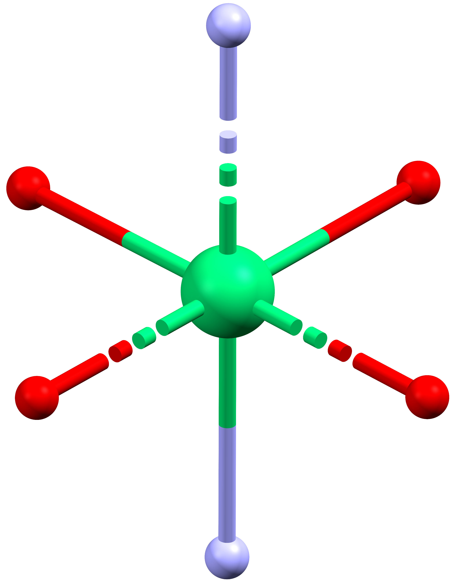

Figure C.4. The local structure around the Ni(II) ion in NiBO-d₈. Green: Ni; Red: O; Purple: N; Gray: C.

Table C.2. Selected bond lengths and bond angles around the Ni(II) ion in NiBO-d₈ at 100 K

Bond Lengths (Å)
Ni1-N1 | 2.092(5)
Ni1-N2 | 2.092(5)
Ni1-O1 | 2.0488(10)
Ni1-O1 | 2.0489(10)
Ni1-O2 | 2.0533(9)
Ni1-O2 | 2.0533(9)
Bond Angles (°)
O1-Ni1-O1 | 179.4(2)
O1-Ni1-O2 | 97.47(4)
O1-Ni1-O2 | 82.53(4)
O1-Ni1-O2 | 82.53(4)
O1-Ni1-O2 | 97.47(4)
O2-Ni1-O2 | 179.5(2)
O1-Ni1-N1 | 90.32(11)
O1-Ni1-N1 | 90.32(11)
O2-Ni1-N1 | 89.73(11)
O2-Ni1-N2 | 89.73(11)
O1-Ni1-N2 | 89.68(11)
O1-Ni1-N2 | 89.68(11)
O2-Ni1-N2 | 90.27(11)
O2-Ni1-N2 | 90.27(11)
Table C.2. Continued
N1-Ni1-N2 | 180.0

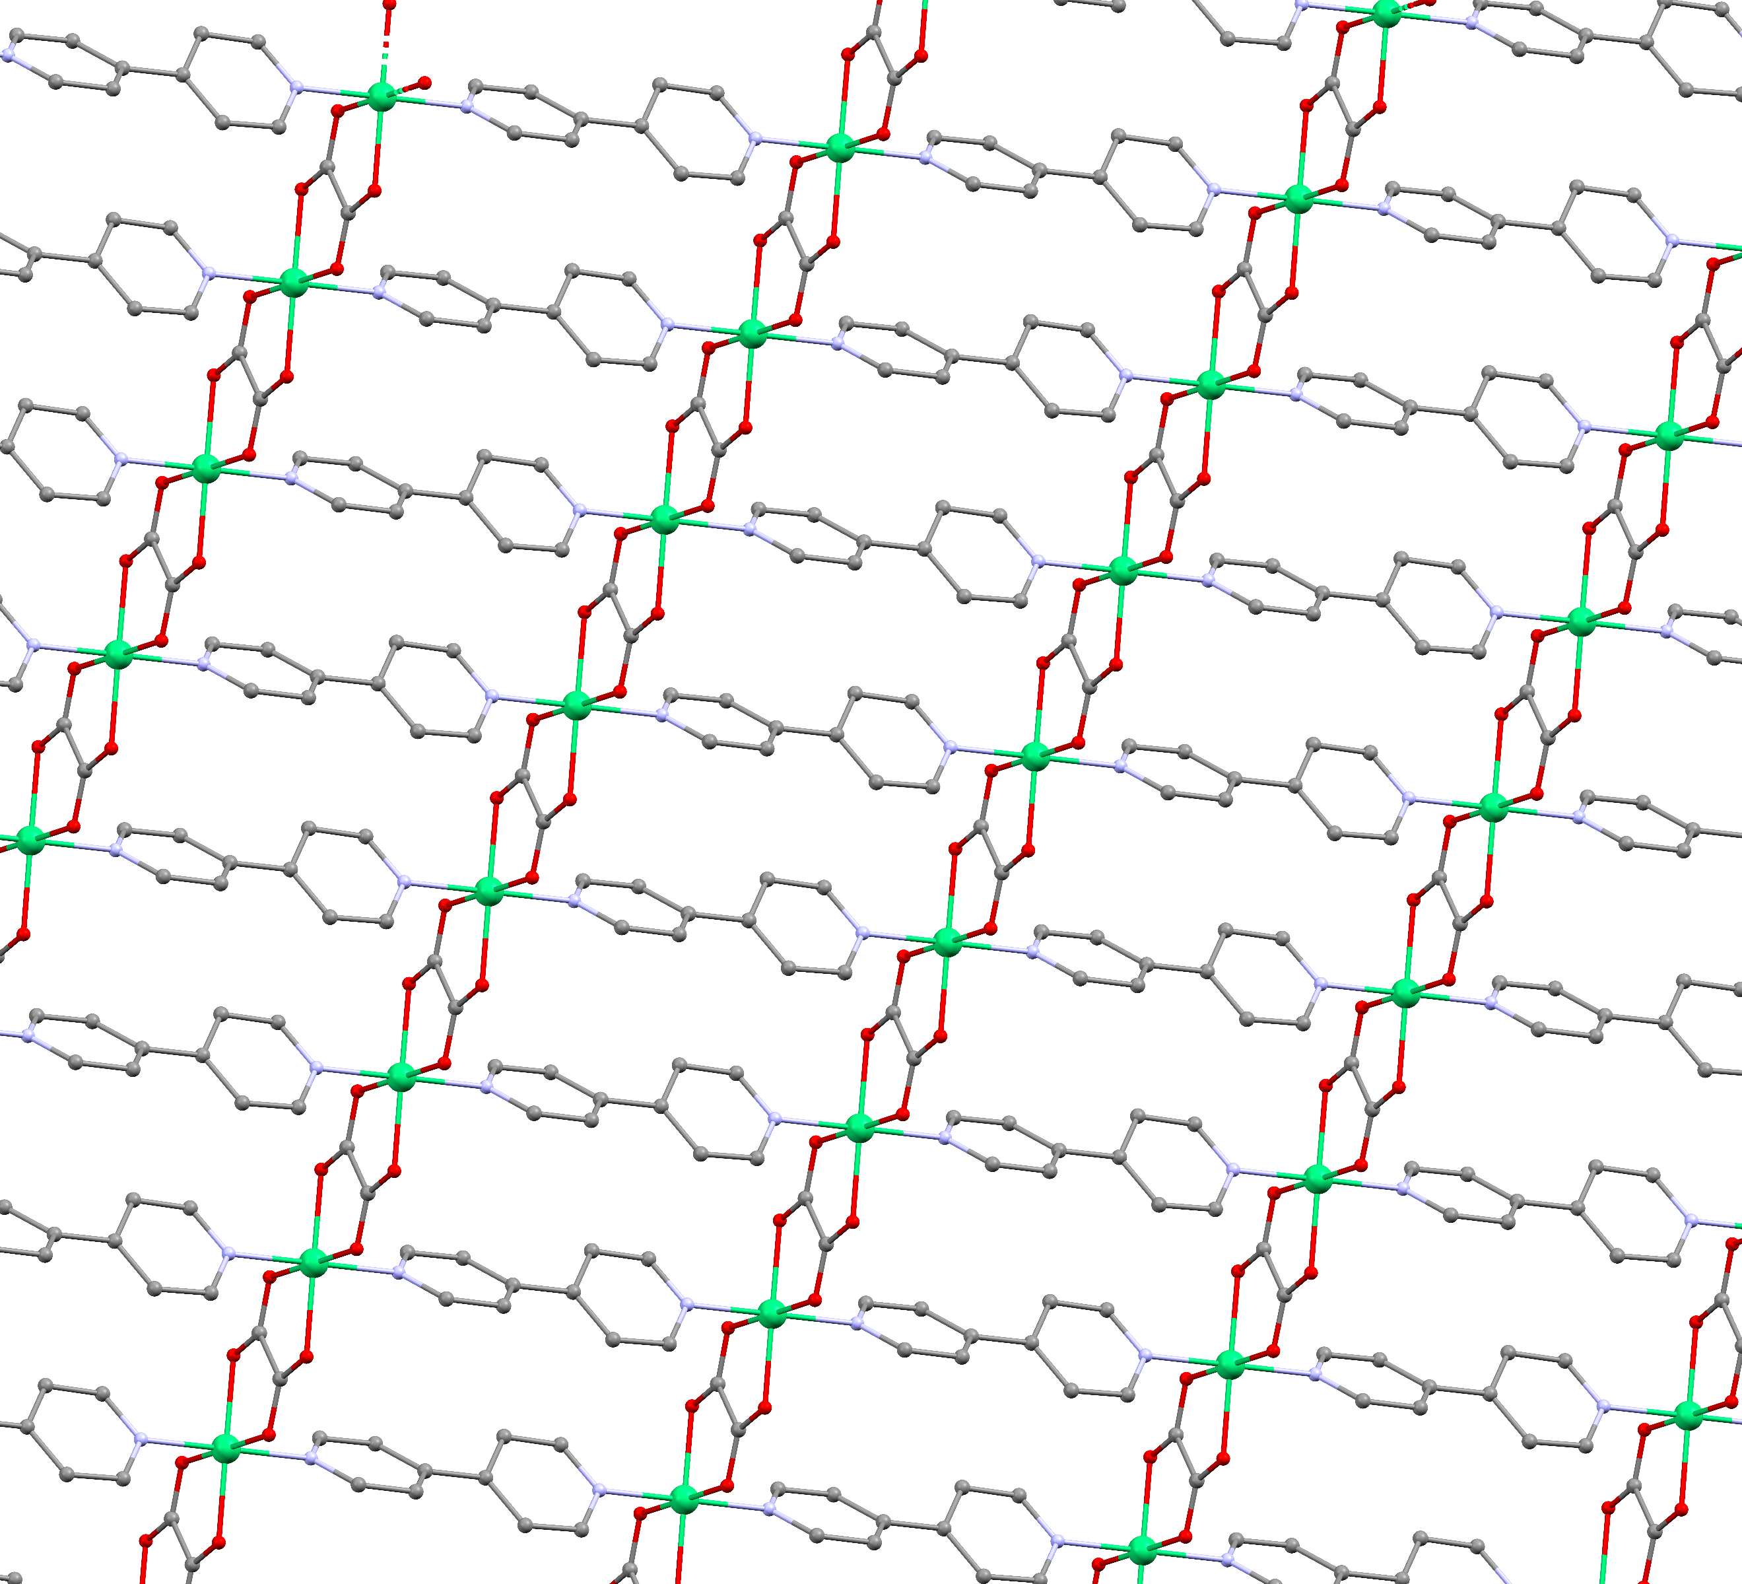
Intra-chain direction
Inter-chain direction

Figure C.5. Crystal structure of NiBO-d₈ showing inter-chain and intra-chain directions. Green: Ni; Red: O; Purple: N; Gray: C. Deuterium atoms are omitted for clarity.

Figures C.6 and C.7.
At 100 K, the refinement of the crystal structure placed the two pyridine rings in the 4,4′-bipyridine ligands rotated at two different planes, while the reported structure (295 K) shows the bipyridine rings to be in the same plane. The freezing of the bipyridine rings rotation places the structure at 100 K into a lower symmetry than that of the structure at 295 K. The rotation of the two pyridine rings allows a better understanding of the magnetic coupling strength between the two nearest nickel atoms along the inter-chain direction. With the two pyridine rings rotated off the plane to one another, the magnetic coupling strength (J) in the inter-chain direction is expected to be negligible. The result is favorable for the Haldane phase to exist in the form of a 2D-MOF. Therefore, the nickel chains that form across the oxalate ligands can be effectively considered as individual isolated Haldane 1D chains in the system.

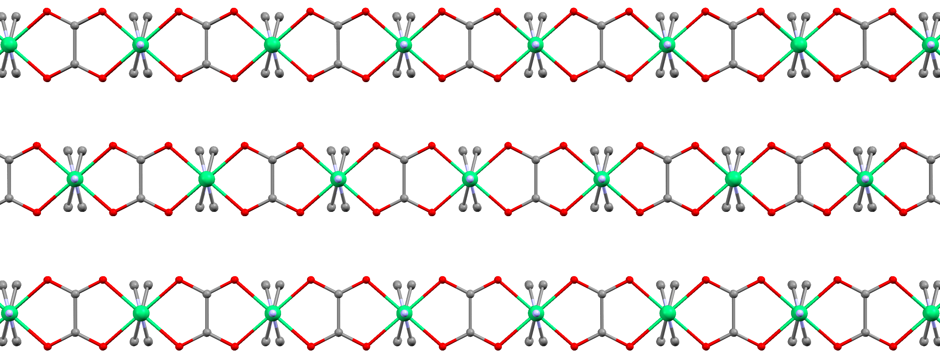

Figure C.6. Crystal structure of NiBO-d₈ view down the crystallographic b-axis. Green: Ni; Red: O; Purple: N; Gray: C. Deuterium atoms are omitted for clarity.
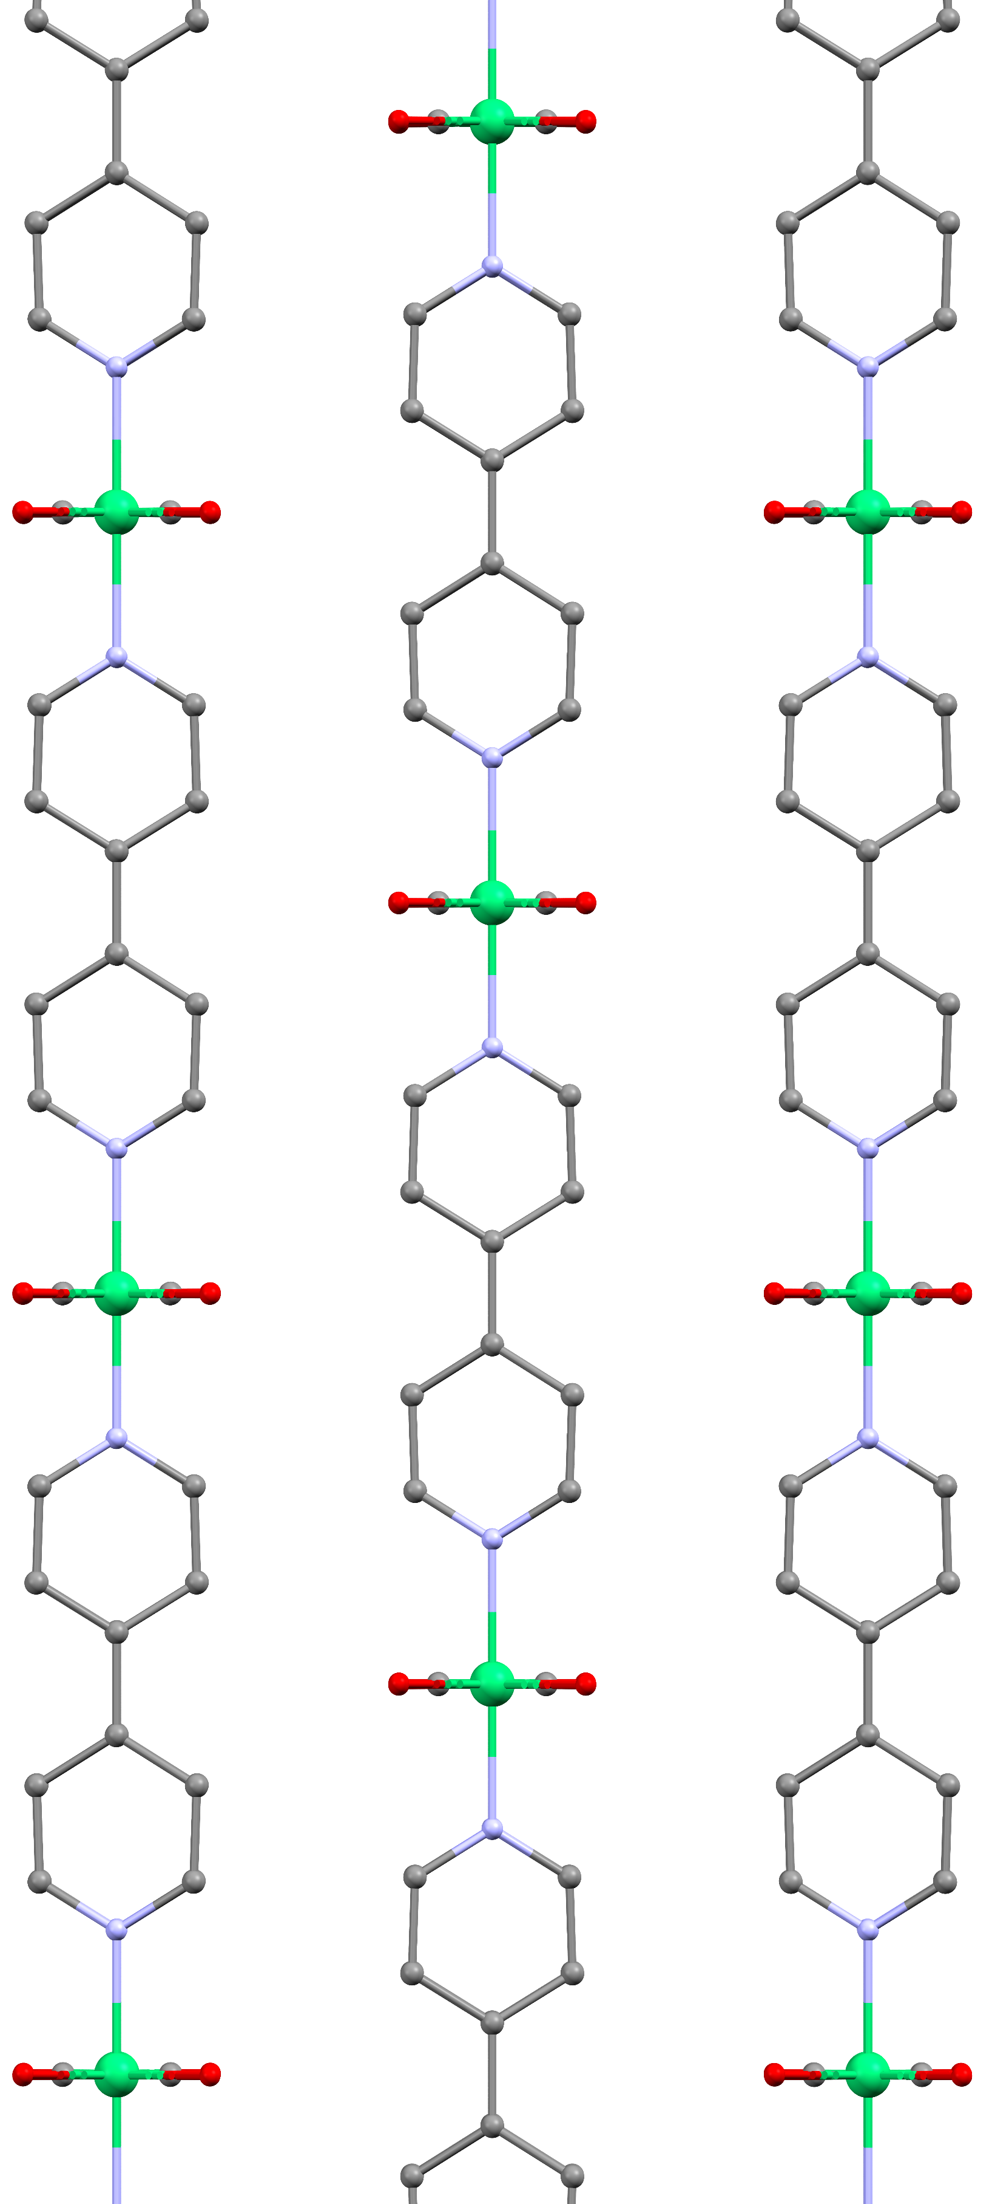

Figure C.7. Crystal structure of NiBO-d₈ view down the crystallographic c-axis. Green: Ni; Red: O; Purple: N; Gray: C. Deuterium atoms are omitted for clarity.
C3. Additional Magnetic Susceptibility (DC) Data

Figure C.8. Variable-field DC magnetization of NiBO at various temperatures.

Background subtraction of the DC magnetic susceptibility data were performed using the equation: χ = C/(T - θ_{CW}) + χ(0), where χ(0) is the paramagnetic contribution in the background.¹⁸⁵ Figure C.9-Top shows the data after background subtraction and Figure C.9-Bottom before background subtraction for each of the magnetic field. χ(0) is constant and temperature-independent. χ(0) value is not only consisting of paramagnetic or diamagnetic contributions in the system but also the background noise of the instrument as well. Figure C.10 shows the fit to find χ(0) between 200 and 300 K for 0.1 T data. The same fitting process was performed for the data at other magnetic field strength.

Figure C.9. Comparison between DC magnetic susceptibility data (Top) after and (Bottom) before background subtraction using $χ$(0).

Figure C.10. DC magnetic susceptibility data fitting between 200 and 300 K at 0.1 T. The best fit value gives $χ$(0) = 0.0033 cm³ mol⁻¹.

C4. Additional Quantum Monte Carlo (QMC) Results
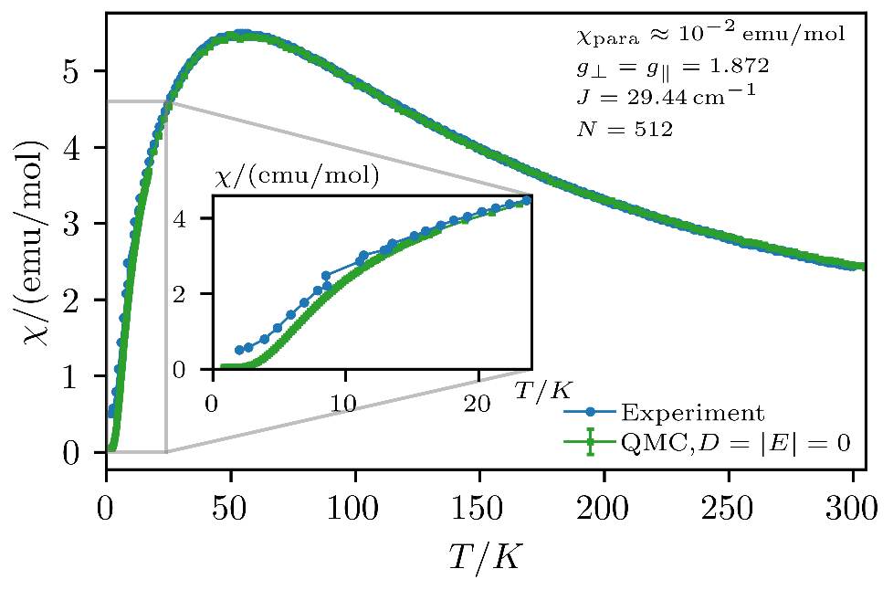
Figure C.11. Magnetic susceptibility as a function of temperature. The QMC simulations are carried out for N = 512 sites and without any additional anisotropies. Comparing the simulations to the experimental data, we obtained J = 29.4 cm⁻¹, g = 1.87, and $χ(0)$ = 10⁻⁵ cm³ mol⁻¹.

Figure C.12. Magnetic susceptibility as a function of temperature. The QMC simulations are carried out for N = 512 sites and with a D and E term. We further show the results without any anisotropies. For J, $g_{⊥}= g_{∥}$ and $χ\left(0\right)$ we used the same values (with and without anisotropies).

Before analyzing the low temperature behavior of the magnetic susceptibility, we noted that due to the transverse contribution in the powder averaging the susceptibility goes to a finite value in the zero-temperature limit, as shown in Figure 4.5. Therefore, we expect the following (asymptotic) low temperature behavior:

$$χ= χ\left(T=0\right)+ αe^{-Δ_{1}/T}$$
where $α$ denotes some constant and $Δ_{1}$ is the spin gap. Therefore, we expect on a log-scale, a linear behavior:

log$\left(χ- χ\left(T=0\right)\right)= -\frac{Δ_{1}}{T}+$ const.

The zero-temperature limit $χ(T=0)$ can be readily extracted from the QMC simulations. In Figure C.13, the spin gap ($Δ_{1}$) is in good agreement with the experimental susceptibility data, excluding the lowest two data points.
Regarding the spin gap splitting with a magnetic field in a powder sample, one obtains in first order perturbation theory the gaps outlined in Eq. 4.5.^{189, 190} If additional magnetic field is applied to the energy splitting of the spin states, at first order, the singlet ground state is not affected, and all changes affect only the triplet excited state. One may now consider in the canonical basis an additional Zeeman term of the form, which leads to a perturbation of the form:¹⁹⁰
$$H_{s}+ μ_{B}gh ∙S= \left(\begin{matrix}Δ_{x} & -iμ_{B}gh_{z} & iμ_{B}gh_{y} \\ iμ_{B}gh_{z} & Δ_{y} & -iμ_{B}gh_{x} \\ -iμ_{B}gh_{y} & iμ_{B}gh_{x} & Δ_{z}\end{matrix}\right)$$
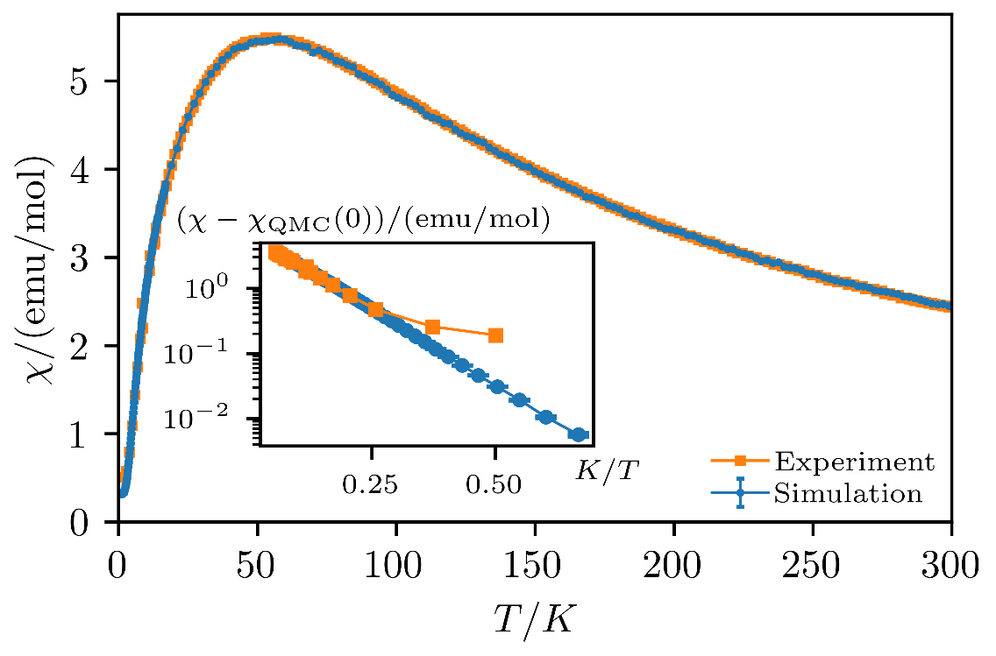
Figure C.13. Magnetic susceptibility as a function of temperature as obtained from experiments and QMC simulations. The inset shows the susceptibility subtracted by the zero-temperature limit on a logarithmic scale as a function of inverse temperature.

where h denotes the magnetic field in Tesla. From diagonalizing the effective Hamiltonian above, one can get the corrections of the triplet states in the canonical basis for an arbitrary direction of the field as shown in Figure C.14 and C.15.
For a powder sample, we must average over all field directions. Therefore, we drew 1000 random samples at each field strength to sample different directions yielding the following gaps as shown in Figure C.16. In Figure C.14 and C.15, we expect at field strengths over (roughly) 4 T a broad distribution when averaging over the different directions, which agrees with the data shown in Figure C.16.
In addition, QMC simulations extracted HFESR parameters that can be used to compare to the experimental HFESR data. In theory, both $Δ_{1}$ and $Δ_{2}$ contain mixing of the terms $\left|\left.1,±1\right\rangle \right.$. Due to the clear splitting of the gaps, we expect $Δ_{1}$ to be the thermally more occupied relevant level, such that the signal seen in HFESR should mainly show the energy difference between $Δ_{3}- Δ_{1}$. A comparison between QMC simulation results and HFESR experimental data is in Figure C.17. The results show an excellent agreement between theory and experiment.

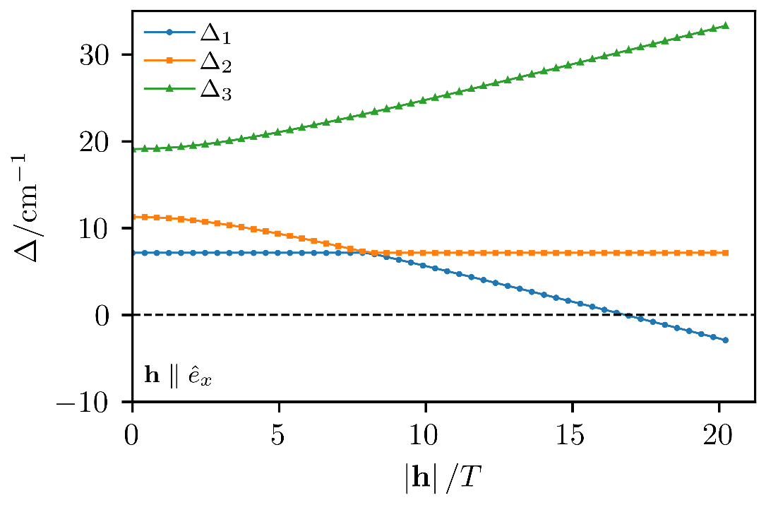
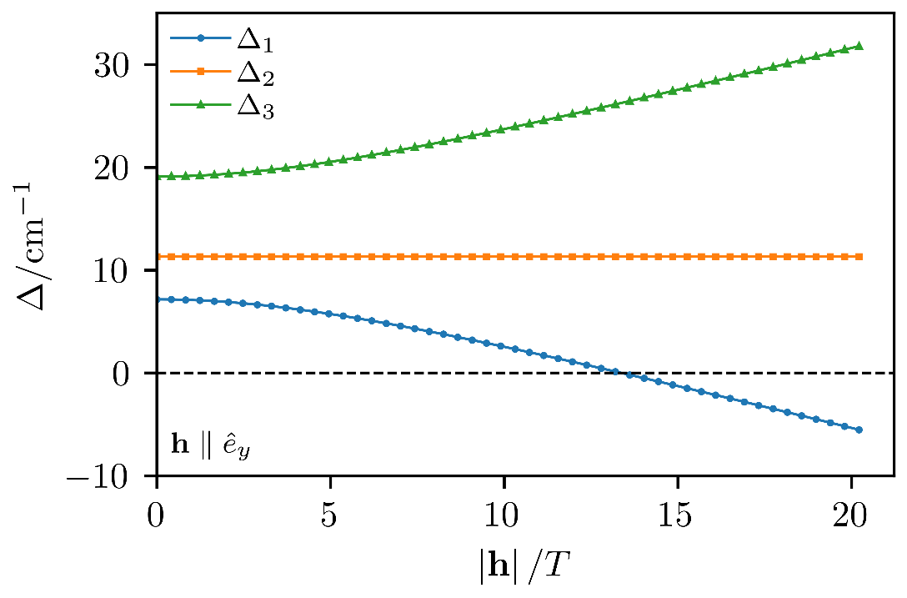
Figure C.14. Eigenvalues $Δ_{1}$, $Δ_{2}$, $Δ_{3}$ as a function of magnetic field strength for (Top) $h∥{\hat{e}}_{x}$ and (Bottom) $h∥{\hat{e}}_{y}$.

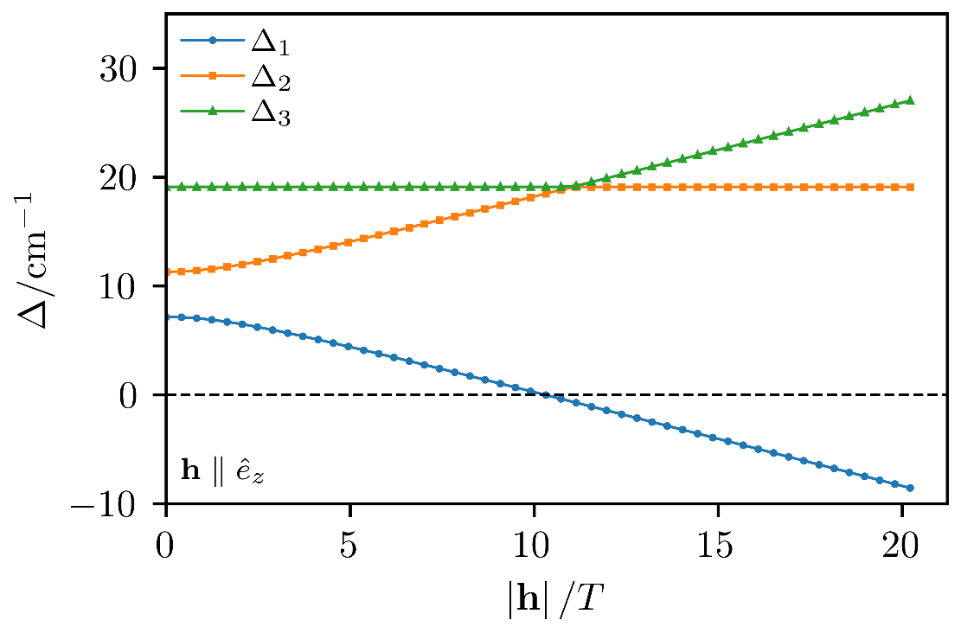
Figure C.15. Eigenvalues $Δ_{1}$, $Δ_{2}$, $Δ_{3}$ as a function of magnetic field strength for $h∥{\hat{e}}_{z}$.

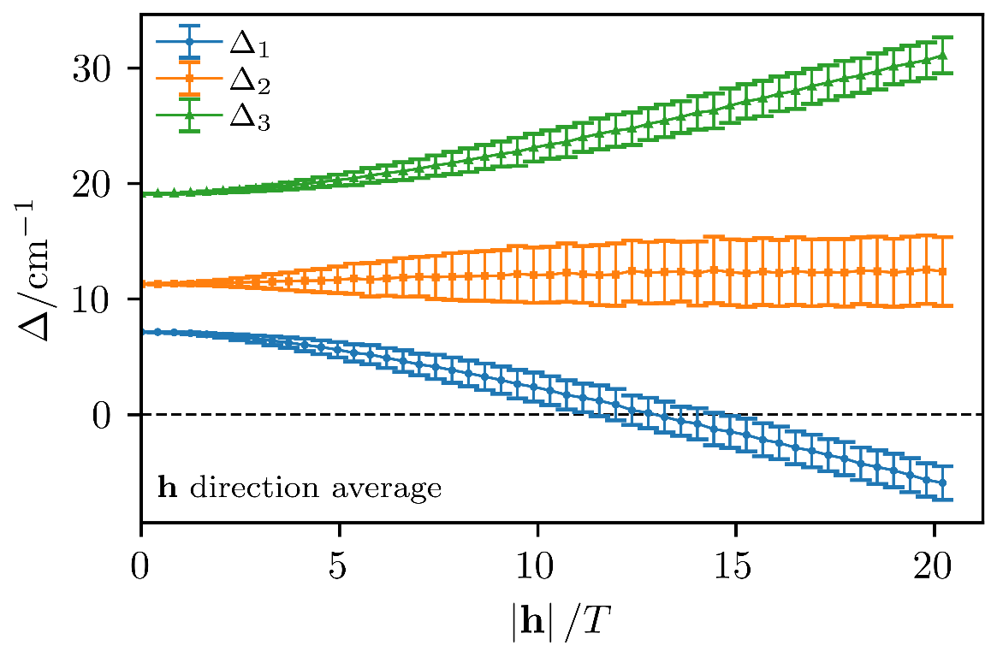
Figure C.16. $Δ_{1}$, $Δ_{2}$, $Δ_{3}$ as a function of magnetic field strength averaged over all directions. The error bars denote the standard deviation, while the markers denote the mean of the distribution.

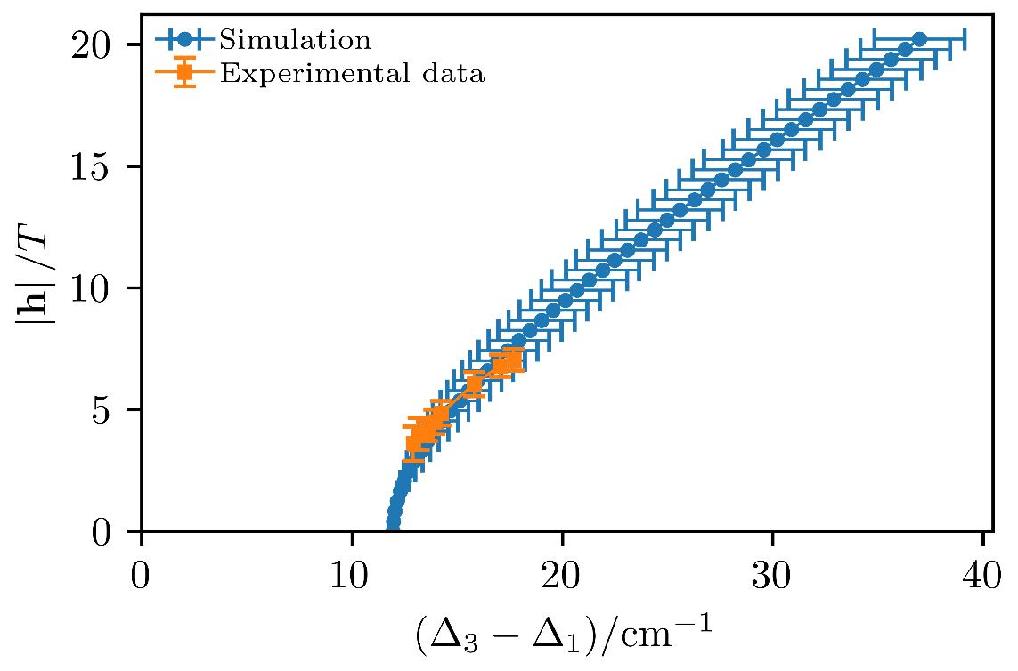
Figure C.17. Magnetic field strength vs. difference $Δ_{3}- Δ_{1}$ compared to HFESR experimental data.

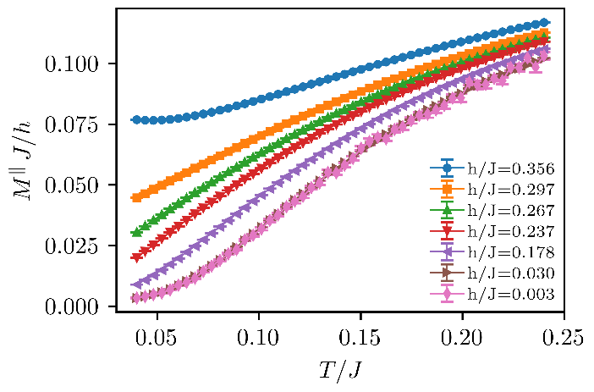
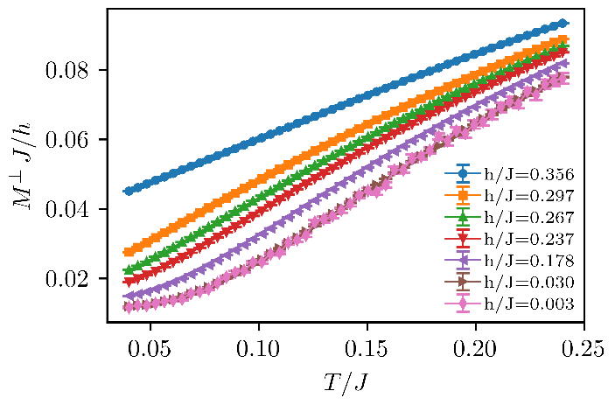
Figure C.18. (Top) QMC results for the temperature-dependent of the magnetization divided by the field strength h for finite magnetic fields oriented parallel to the easy-axis direction. (Bottom) QMC results for the temperature-dependent of the magnetization divided by the field strength h for finite magnetic fields oriented perpendicular to the easy-axis direction.
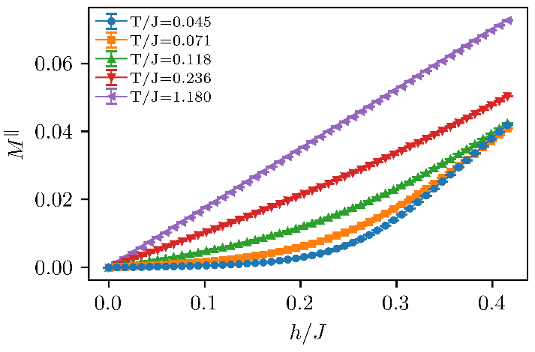
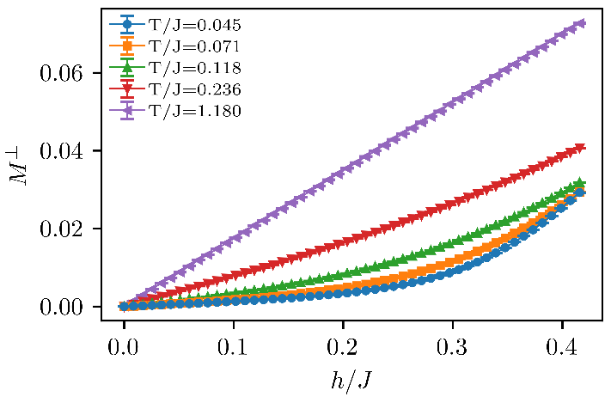
Figure C.19. (Top) QMC results for the field-dependent of the magnetization in finite magnetic fields oriented parallel to the easy-axis direction at various temperatures. (Bottom) QMC results for the field-dependent of the magnetization in finite magnetic fields oriented perpendicular to the easy-axis direction at various temperatures.
C5. Additional Specific Heat Data

Figure C.20. Specific heat of NiBO at zero-field and 12 T between 1.92 K and 202 K.

Figure C.21. Transition points estimated from specific heat and magnetization data for magnetic field beyond 9 T.

C6. Additional Inelastic Neutron Scattering (INS) Data including Tables of Phonon Symmetries and Spin Densities
The comparison of the phonon features between the 5 and 40 K can be seen in Figure C.22. At 40 K, the INS data fluctuate more in intensity than the 5 K data. The intensity fluctuation is due mostly to the thermal energy contribution. The data at both temperatures have similar phonon features.
Figure C.23 shows the comparison between the experimental INS spectrum at 5 K and the calculated phonon spectrum in the low-energy region around the Haldane gap. The calculated phonons compare reasonably well with the experimental data. Table C.3 contains a list of phonon symmetries and modes extracted from the phonon calculation.
In addition to the calculated phonon spectrum, spin densities of the compound were also obtained from the DFT calculations using VASP. Spin density provides insight into the localization of spin in the metal ions and the ligands in the system. The calculation does not include the spin densities in the bonds, but rather only shows the spin densities in individual atoms inside a unit cell. The full list of spin densities is given in Table C.4. The results show that most of the spin densities are concentrated at the Ni(II) ion, containing 1.781 (89.1%) of the 2 unpaired electrons. The rest of the spin densities are dispersed among the ligands (oxalate and 4,4′-bipyridine). We recently found that in the Co-TODA,¹⁶⁴ the spin densities concentrated in the Co(II) ions are 2.68-2.69 (89.3-89.7%) of the 3 unpaired electrons on the metal ions. The percentage of the spin concentration is comparable to the spin densities in the current Ni(II) system, which is possibly due to both compounds having only nitrogen and oxygen coordination ligands.
Figure C.22. INS spectra of NiBO at 5 and 40 K. The two spectra are similar with the 40 K spectrum having more vibrational intensity due to the increase in thermal energy compared to the 5 K spectrum.

Figure C.23. Experimental INS spectrum at 5 K in comparison with the calculated phonon spectrum (5-30 cm⁻¹ region).

Table C.3. Calculated phonon symmetries and modes of NiBO

Wavenumber (cm⁻¹) | Symmetries of the modes | Wavenumber (cm⁻¹) |  | Symmetries of the modes
68.853 | B | 887.178 |  | A
78.699 | B | 975.925 |  | B
78.873 | A | 980.973 |  | A
82.731 | A | 1002.163 |  | A
108.143 | B | 1008.519 |  | A
115.883 | B | 1033.115 |  | A
182.689 | B | 1075.207 |  | A
183.123 | A | 1077.428 |  | A
192.065 | B | 1106.668 |  | B
197.872 | B | 1108.590 |  | B
211.306 | A | 1211.672 |  | A
224.928 | B | 1223.726 |  | A
244.372 | A | 1271.586 |  | B
279.673 | A | 1284.012 |  | A
282.652 | B | 1285.602 |  | B
297.328 | B | 1313.346 |  | B
318.915 | B | 1326.318 |  | B
382.149 | A | 1331.750 |  | B
391.352 | A | 1403.771 |  | B
393.596 | B | 1405.542 |  | A
Table C.3. Continued
415.794 | B | 1417.434 |  | B
448.006 | A | 1475.766 |  | A
498.541 | B | 1499.908 |  | A
501.982 | A | 1523.854 |  | B
569.796 | A | 1550.712 |  | B
574.936 | B | 1588.764 |  | B
628.673 | A | 1594.705 |  | A
648.740 | B | 1596.594 |  | A
664.476 | B | 1598.219 |  | A
733.178 | B | 3068.039 |  | A
749.623 | B | 3069.185 |  | B
766.278 | A | 3070.673 |  | B
773.847 | B | 3072.682 |  | A
813.957 | B | 3079.726 |  | B
817.366 | B | 3080.780 |  | B
866.603 | B | 3081.382 |  | A
868.397 | A | 3083.977 | A
881.198 | A

Table C.4. Calculated spin densities of atoms in NiBO [one Ni(μ-4,4′-bpy)(μ-ox) unit]

Atom | Spin Density
Ni atom | 1.781
All O atoms | 0.035
Both N atoms | 0.035
C (in oxalate) | -0.001
C (ortho from the N atoms in bpy) | -0.001
C (para from the N atoms in bpy, i.e., C atom linked to the other ring) | -0.001
C (meta from the N atoms in bpy) | 0.002
All H atoms | <0.001
Total | 1.995

Appendix D. Supporting Information for Chapter 5

Figure D.1. Experimental HFEPR spectrum of Fe(TPP)F at 10 K and 203.2 GHz (black trace) and its powder-pattern simulation (red trace) using spin Hamiltonian parameters: D = 4.67 cm^{–1}, E = 0, g_{iso} = 1.98.
Figure D.2. A collection of multi-frequency, low-temperature (5 K) experimental HFEPR spectra of Fe(TPP)F eicosane mull.

Figure D.3. Main plot: An experimental HFEPR spectrum of Fe(TPP)Cl at 10 K and 203.2 GHz (black trace) and its simulation (red trace) using spin Hamiltonian parameters: D = 6.45 cm^{–1}, E = 0.025 cm^{–1}, g⊥ = 1.985, g|| = 2.02. Inset: a zoom-in of the perpendicular intra-Kramers turning point. The splitting is indicative of a very small (E/D ~ 0.004) yet measurable rhombicity of the ZFS tensor. The resonance at 7.1 T is from an unidentified g = 2.00 species and is not simulated.

Figure D.4. A collection of multi-frequency, low-temperature (10 K) experimental HFEPR spectra of Fe(TPP)Cl eicosane mull.

Figure D.5. An experimental HFEPR spectrum of Fe(TPP)Br at 10 K and 424 GHz (black trace) and its simulation (red trace) using spin Hamiltonian parameters: D = 9.01 cm^{–1}, E = 0.056 cm^{–1}, g = [1.98, 1.98, 2.00]. The weak resonance at 1.5 T originates from an unknown impurity and is not simulated.

Figure D.6. A collection of multi-frequency, low-temperature (10 K) experimental HFEPR spectra of Fe(TPP)Br as in eicosane pellet.

Figure D.7. An experimental HFEPR spectrum of Fe(TPP)I at 10 K and 423 GHz (black trace) and its simulation (red trace) using spin Hamiltonian parameters: D = 13.84 cm^{–1}, E = 0.08 cm^{–1}, g = [1.985, 1.985, 2.00].

Figure D.8. A collection of multi-frequency, low-temperature (10 K) experimental HFEPR spectra of Fe(TPP)I as in eicosane pellet.

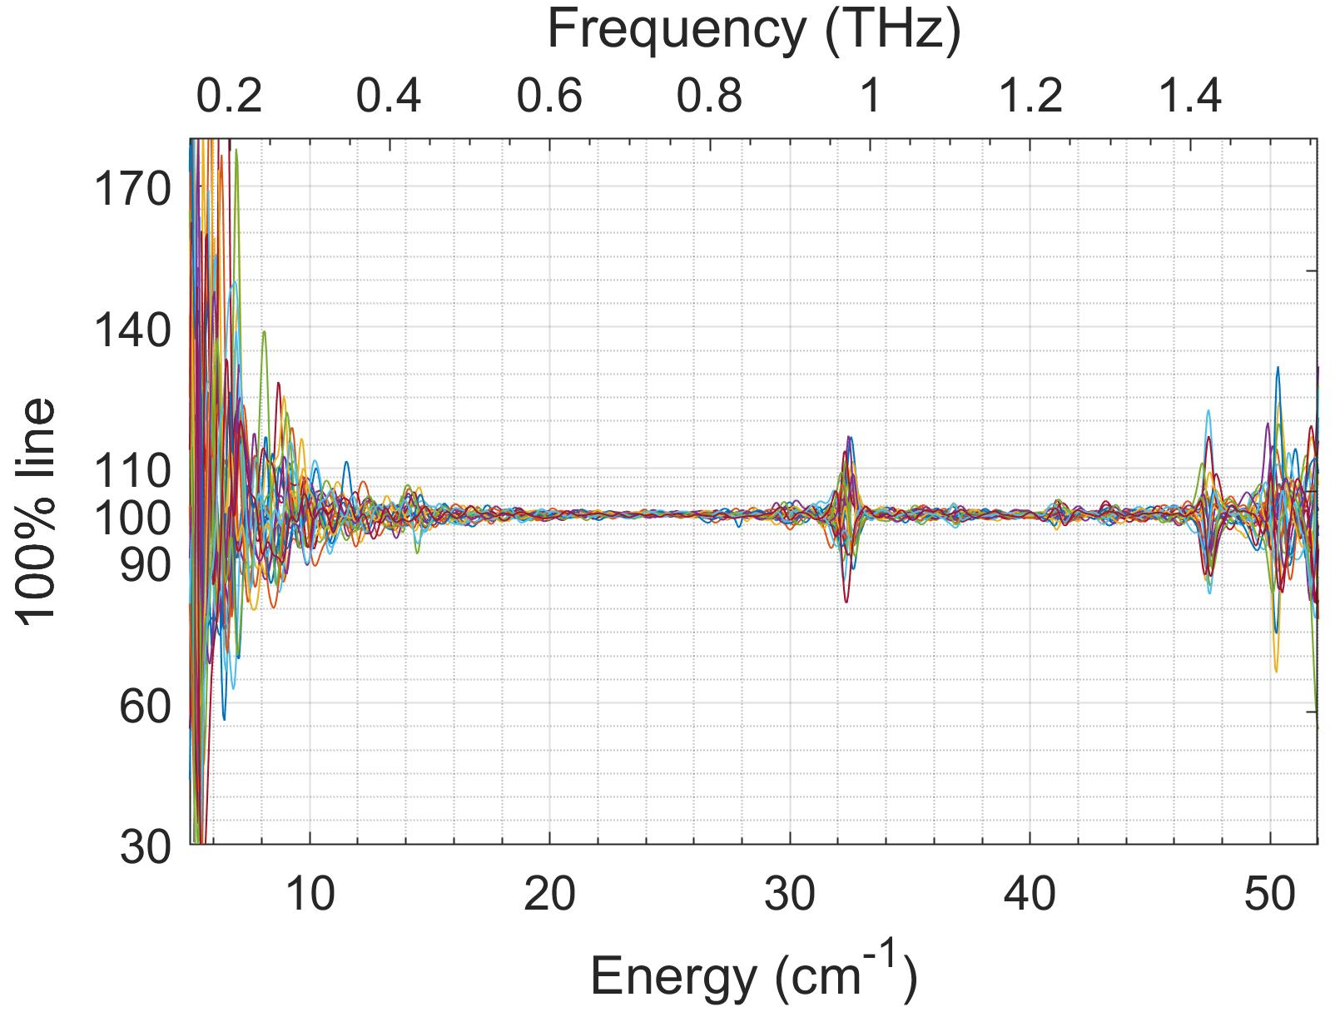

Figure D.9. The signal-to-noise of FIRMS measurements of Fe(TPP)I. The 100% line is calculated as a ratio of two transmission spectra recorded under identical conditions for each magnetic field. Ideally, the result should be a flat line at 100% transmission and the deviation from this value characterizes the validity of spectroscopic measurements in the real set-up. In this case, any field-induced changes above 2% in the transmission can be detected in the vicinity of 25 cm^{–1}, but at lower frequencies the noise level is rising which is attributed simply to the vanishing power of the THz source at these frequencies, so that the region below ~15 cm^{–1} is unreliable. In contrast, the higher frequency range (above ~47 cm^{–1}) suffers by a combination of non-magnetic spectral features, such as vibrational absorptions and instrumental artefacts.
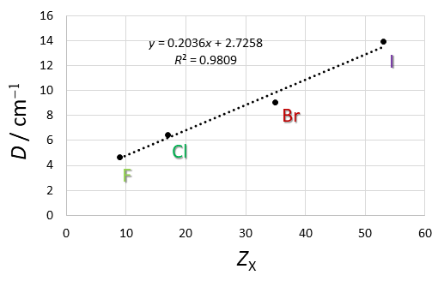
D Values (cm-1)

Figure D.10. Plot of D values of Fe(TPP)X versus Z_{X} (atomic number of the halides X).

VITA

Pagnareach Tin was born in Phnom Penh, Cambodia to Samedy S. Tin and Ponloeu Young. He immigrated to Durham, NC in March 2010 with his family. Afterward, he attended C.E. Jordan High School in Durham, NC. After graduating high school in May 2014, he moved to Asheville, NC to attend the University of North Carolina Asheville. He graduated in May 2018 with a Bachelor of Science degree in Chemistry. During his undergraduate years, he obtained a summer laboratory internship position with Doble Engineering Company, and he conducted research with Dr. Bert E. Holmes on the study of the trichloroethylene decomposition pathway in the gas phase using ultraviolet light. He joined the graduate school program at the University of Tennessee, Knoxville in August 2018, where he studied molecular magnetism with Dr. Zi-Ling Xue. Since then, he received the Shull Wollan Center Graduate Research Fellowship. As of April 2023, he has published the following two papers from his Ph.D. studies:

- Tin, P. et al. Advanced Spectroscopic and Computational Studies of a Cobalt(II) Coordination Polymer with Single-Ion-Magnet Properties. J. Phys. Chem. C 2022, 126, 13268.
- Tin, P. et al. Advanced Magnetic Resonance Studies of Tetraphenylporphyrinatoiron(III) Halides. Appl. Magn. Reson. 2020, 51, 1411.

