Total Internal Reflection: Applications in Nonlinear Microscopy and Fluorescence Anisotropy

A Dissertation Presented for the
Doctor of Philosophy
Degree
The University of Tennessee, Knoxville

Brandon Alexander Colon
December 2021
Copyright © 2021 by Brandon Alexander Colon
All rights reserved.

DEDICATION
“There is a time in every man’s education when he arrives at the conviction that envy is ignorance, that imitation is suicide; that he must take himself for better, for worse, as his portion…Trust thyself: every heart vibrates to that iron string.”
Ralph Waldo Emerson, Self-Reliance
To Ashely, Ember, Eden, Oren and my family for your love and patience.

ACKNOWLEDGMENTS
I would like to give thanks to Dr. Tessa Calhoun for invaluable guidance and advice. Thanks for both the support and the constructive criticism. I would also like to give my regards to friends and lab mates that have helped me along the way with both creative direction and thoughtful discussions. Finally, I would like to acknowledge the Department of Chemistry with express thanks to the electronics and machine shop for the many accommodating services that has aided my path through my PhD.

ABSTRACT
As technology advances to harness new energies and to create new cures, the sophistication of analysis grows not only in depth but in efficiency. Total internal reflection (TIR) has been coupled to microscopy leveraging its unique optical phenomenon on a breadth of topics. In this dissertation, the work presented will show how TIR was applied in two different instrumental analyses to evaluate two unique and complex systems. The first project features TIR paired with the transient absorption microscopy (TAM), a nonlinear optical technique, to gauge solvent mixing and diffusion in microreactors. Microreactors gained acclaim for their ability to produce high grade products while producing less waste and for their modular assembly that facilitates production. Major avenues of interest for microreactors range from pharmaceuticals to nanoparticles; however, microreactors need a quick and sensitive method in order to optimize the numerous reaction conditions: temperature, flow velocity, and reactant concentration. TIRTAM resolves these issues by measuring solvent mixing and diffusion in an on-line apparatus that allows for high throughput analysis. The second project employs TIR in tandem with fluorescence anisotropy to measure molecular dynamics in microemulsions. Microemulsions are thermodynamically stable mixtures composed of oil, water, and surfactant. The most well-known application for microemulsions is oil recovery, but an exciting, emerging application for microemulsions are acting as solutions for electron transfer in flow batteries which are intended for green energy storage. Before microemulsions can be used for such an application, the ideal composition needs to be identified. Measuring dynamic information from microemulsions can reveal structural knowledge that will aid in electron transfer, and TIR anisotropy can measure the surface versus conventional anisotropy that can only probe the bulk solution. Ascertaining surface dynamics can inform how microemulsions would be affected by electrode surfaces. These projects highlight the themes of versatility for TIR and functionality of the techniques. TIR’s capabilities have much promise and more can be gleaned and built from the work presented herein.

TABLES OF CONTENTS
Chapter 1 Introduction 1
1.1 Motivation 2
1.2 Microreactors 2
1.3 Microemulsions 4
1.4 Organization 7
Chapter 2 Theoretical Background 8
2.1 Light-Matter Interactions 9
2.2 Total Internal Reflection 10
2.2.1 Theory 10
2.3. Microscopy 13
2.3 Fluorescence Anisotropy 14
2.3.1 Theory 14
2.3.2 Intrinsic Depolarization 15
2.3.3 Extrinsic Depolarization 17
2.3.4 Optical Depolarization 18
2.3.5 Total Internal Reflection Fluorescence Anisotropy 19
2.4 Transient Absorption 23
2.4.1 Theory 23
2.4.2 Microscopy 25
Chapter 3 Total Internal Reflection Transient Absorption Microscopy: An Online Detection Method for Microfluidics 27
3.1 Abstract 28
3.2 Introduction 28
3.3 Methods 32
3.4 Results and Discussion 39
3.5 Conclusions 49
3.6 Acknowledgments 50
Chapter 4 Surface Influence on Microemulsions: Differentiating Dynamics with Total Internal Reflection Fluorescence Anisotropy 51
4.1 Abstract 52
4.2 Introduction 52
4.3 Methods 56
4.4 Results 64
4.4.1 Steady-state 64
4.4.2 Lifetime Dynamics 64
4.4.3 Time-resolve Anisotropy 68
4.5 Discussion 69
4.5.1 Probe Location 69
4.5.2 Aggregation vs Heterogenuous Environment 71
4.5.3 Surface Rotation Dynamics and Ordering 71
4.6 Conclusions 72
4.7 Acknowledgements 73
Chapter 5 Conclusion and Future Prospects 74
5.1 Conclusions 75
5.2 Outlook 75
References 76
Appendices 87
Vita 101

LIST OF TABLES
4.1Microemulsion Compositions 63
B.1 Number of exponentials for lifetime dynamics for all samples 91
B.2 Refractive index for each sample composition 92
B.3 Refractive index and calculated Devaughes correction 93
B.4 Weights for lifetime dynamics of TW20 at 525 nm emission 94
B.5 Lifetimes at 525 nm emission for all samples 95
B.6 Weights for lifetime dynamics for all samples at 480 nm emission 96
B.7 Lifetimes at 480 nm emission for all samples 97
B.8 χ² for either single or bi-exponential anisotropy models for all samples 98
B.9 Models chosen, initial anisotropy, and correlation times for bulk measurements 99
B.10 Models chosen, initial anisotropy, and correlation times for surface measurements 100

LIST OF FIGURES
  - Schematic of Microreactor 3
1.2 Structures of Microemulsions 5
2.1 Angles of incidence with either refraction or reflection resulting 12
2.2 Evanescent Field Polarizations 12
2.3 (A)Unpolarized excitation versus (B) polarized excitation 16
2.4 Spectroscopy schematic for G-factor calculation 20
2.5 Microscopy schematic for G-factor calculation 22
2.6 Emission depolarization for high NA objective 22
2.7 Transient absorption Jablonski diagram 24
3.1 Configurations of TIR with either prism(A), TIR with an objective (B), or Focused Geometry 33
3.2 Instrumental schematic of the TIRTAM microscope 35
3.3 Flow cell diagram 38
3.4 Spatial characterization 40
3.5 Temporal resolution 42
3.6 TIRTAM images and excited state dynamics of 1 mM solutions of DTTC and/or IR-144 in methanol 44
3.7 TIRTAM images and excited state dynamics of 1 mM solutions of IR-144 in methanol and/or DMSO 47
3.8 TIRTAM images and intensity profile across the channel of 1 mM solutions of IR-144 in methanol and pure methanol 48
4.1 Microemulsion structure and objective detection with evanescent wave 55
4.2 Instrumental Schematic 57
4.3 Ternary Diagram 61
4.4Steady-state emission for C153 in solvents and microemulsions 65
4.5 Lifetime dynamics at different emission maximums of C153 in different solvents with a Jablonski diagram showing aggregate energy levels 66
4.6 Initial anisotropies at 480 nm emission and correlation times at 480 and 525 nm emission for microemulsions 70
A.1 Transient absorption dynamics utilizing either s or p excitation polarization 87
A.2 Chemical structures of DTTC and IR-144 87
A.3 Transient absorption dynamics and pictures of surface functionalized coverslips 88
A.4 Excited-state dynamics of IR-144 and DTTC in methanol 88
A.5 TIRTAM images of DTTC and IR-144 at different time delays 89
A.6 Excited-state dynamics of IR-144 in methanol and DMSO 89
A.7 TIRTAM images of IR-144 in methanol and DMSO 90
B.1 Comparison between different magic angle collection and fits 91
B.2 Model of evanescent wave intensity as a function of incident angle and sample medium 92
B.3 Picture of cuvette and coverslip attachment 93
B.4 Excitation spectra at different emission maximums for solvents and 60 microemulsion 94
B.5 Model fits and residuals on 10 microemulsion in the hydrophobic bulk 98

CHAPTER 1

INTRODUCTION

1.1 Motivation
In the constant pursuit of analyzing complex systems on smaller and smaller length scales, the fields of microscopy and spectroscopy have been pushed into unexpected new directions. Microscopy on microreactors has revealed information into complex reaction schemes, and spectroscopy on microemulsions uncovered compelling structural features. However, there are barriers for both these systems. In order for microreactors to become more industrially capable, on-line measurements, which are conducted during the reaction, must be done in a high-throughput design to allow for a faster optimization, and this type of rapid feedback monitoring could be performed near the interface of a reactor channel and the solution. Likewise, microemulsions could be a great candidate as a vessel in redox flow batteries, but there is lack of information at the interface between the solid surface (e.g. an electrode) and the microemulsion which can hinder electron transfer and cause poor efficiency in energy storage. These points illustrate similar technical limitations for microreactors and microemulsions that can be overcome by studying the solid/liquid interface. In the following sections, the impetus for examining these intriguing systems is outlined and research progress is summarized.
1.2 Microreactors
Microfluidic reactors manage fluids in an organized manner that allows for even mixing by having viscosity dominate flow over inertia and balancing heat distribution. Both attributes result from the small channel size of <500 microns.¹ In Figure 1.1, a schematic of the microreactor is displayed in which the reactants are introduced through the inlets and subsequently into the channel paths of the microfluidic. After the initial mixing of the reactants, a serpentine path will utilize the most area on the device, to ensure even mixing, and to minimize the size. These types of microreactors began in the 1990s, and since then, they have been used in many different fields, among them being biological sensing², catalysis³, energy conversion⁴, and energy storage⁴. Despite this progress, microreactors have had limited commercial success. For example, many industrial microreactors that are fabricated from aluminum or stainless steel have a restricted reaction range designed for specific gas-liquid reactions. Also, the extensive academic research that has expanded a microreactors chemical range are not easily scalable because of the complex and expensive process in creating the devices. Incidentally, Elvira et al.
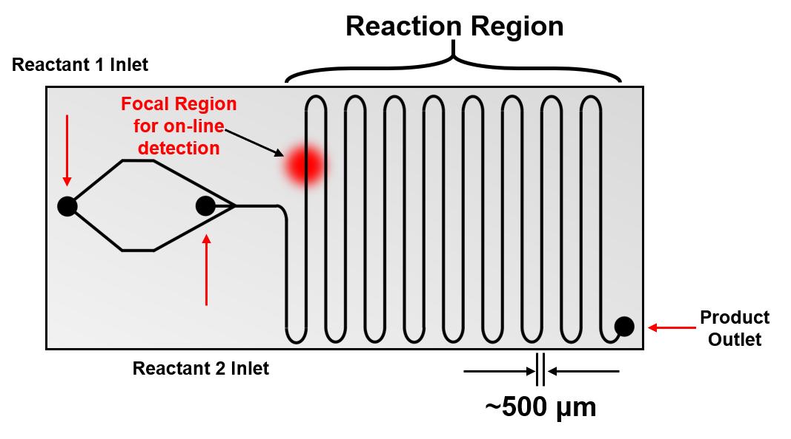
Figure 1.1: Schematic of microreactor design of similar geometries to Elvira et al.¹ Size of focal region exaggerated for visual clarity.

has posited there is a diverging interest between academia’s focus on different types of fabrication and industries’ targeting of cost-effective production that curtails collective improvement.¹ A potential answer to this ongoing issue lies in a new type of analysis: on-line detection.
On-line detection allows for measurements within the microreactors as a reaction occurs. This robust analysis can measure short-lived intermediates⁵ and gives information on the reaction during its progression, therefore, granting a faster feedback mechanism that can improve reaction yield and reduce waste⁶. On-line detection has been performed with many modalities: fluorescence, IR, X-ray, NMR, Raman, and absorption. Although there has been considerable development with on-line detection, limited chemical information has prevented from adapting microreactors for rapid optimization. Absorption can allow for better optimization by having the ability to determine concentration, but the rare report that features such a methodology requires a flow cell that is externally connected to the microreactor.⁷⁻⁸ Yue et al. have said that on-line absorbance analysis is expected to become a main priority in the field of microreactors⁹ and is our reasoning for developing a novel absorption technique.
In chapter 3, a nonlinear absorbance online detection technique is devised, and for the first time, on-line measurements are conducted without the specialized approaches that were required for the previous techniques. This methodology uses transient absorption and total internal reflection (TIR) to monitor individual species mixing and diffusing in an on-line detection geometry. The ability to measure absorbance in this manner can open many avenues of interest to provide improved efficiency in parallel production or obtain refined chemical information from complex synthesis performed within the reactor.
1.3 Microemulsions
While microreactors can impose nanoscale structure via external confinement, complex fluids exist in which nanoscale structure is inherent, and one example of these types of fluids are microemulsions. Microemulsions are optically transparent, thermodynamically stable mixtures with a ternary composition of water, oil, and surfactant/co-surfactant. Depending on the distribution between the three components, there are three main types of microemulsions. Two structures are droplets of one phase dispersed throughout the other (i.e., water droplets in oil or
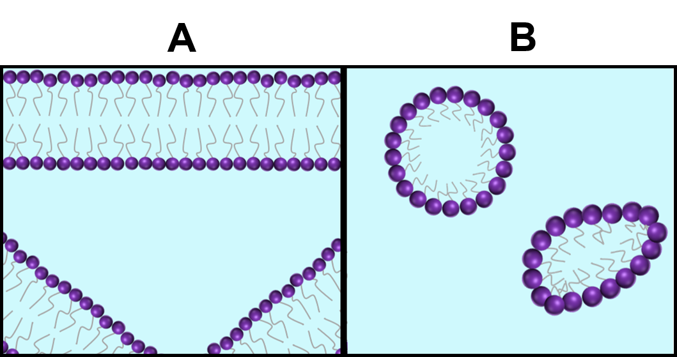
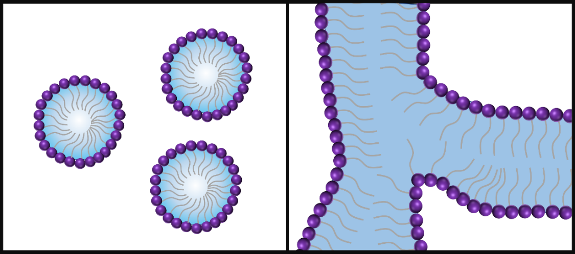
Figure 1.2: Cartoon of microemulsion structure. (A) Droplet structure. (B) Bicontinuous structure.

vice versa). The third structure has domains of oil and water that are intersected throughout by surfactant and is defined as bicontinuous (Figure 1.2). The label microemulsions (μEs) was first coined in 1959.¹⁰ However, the name is a misnomer as the word micro belies the actual nanoscale of the structure that is present, and the term emulsion implies a formation from droplets which is not always the case for many uEs.¹¹ The first major application of μEs was in oil recovery during the 1970s gas crisis where a μE was used to capture crude oil through emulsification.¹² Microemulsions efficiency in recovery was the result of the low interfacial tension, so in attempting to determine the formulations that would have an optimal interfacial tension, a vast amount of analysis into the physical chemistry of μEs was conducted over the past five decades to provide greater clarity into both their structure and properties.
Since its initial success, μEs have been implemented in fields ranging from drug delivery¹³, nanoparticle synthesis¹⁴, and in food processing¹⁵. Typically, modalities, such as NMR, DLS, and small-angle scattering, were employed to understand the structure of these compositions. Numerous models have also been developed to describe the structure or the interfacial tension. For instance, one model is the hydrophilic-lipophilic balance (HLB) which determines the hydrophilicity of nonionic ethoxylated surfactant and predicts the type of droplet μE that would be created.¹⁶ Another model known as the effective packing parameter (EPP) would use properties of the surfactant to characterize the shape of a μE by describing the surfactant self-assembly when certain amounts of water and oil are present.¹⁷ Both of these models seek to describe the structure of μEs, but each model was restricted to certain types of microemulsions. HLB requires a certain type of surfactant, and EPP can only apply to “rigid” μEs. Many more models have also been developed in the vein of classifying the abundant types of μEs that have been produced.¹⁸⁻²⁰
In chapter 4, TIR fluorescence anisotropy will be utilized for the first time on μEs to investigate how a fluorophore species will interact in a series of μEs at a surface. The reason for studying this solid/liquid surface is for electrochemical applications as the structure at this surface can impact electrode performance. A recent paper on μEs using cyclic voltammetry to measure current density at the surface of electrode that diverged drastically from the bulk composition.²¹ A fundamental difference with fluorescence anisotropy versus the previous methods used on μEs is the direct measurement of a species interacting with an assumed structure as opposed to surmising the behavior of small molecules in a μE based on direct measurement of a structure. The aim of this work is to determine how the structure of the μE would impact the rotation and lifetime of a well-defined fluorophore. Ultimately, these results can be extended to optimize compositions intended for drug delivery or for green energy storage²².
1.4 Organization
This paper is organized to first introduce a detailed background of methodology imparting a holistic understanding for the later chapters which will focus on the results of TIR on microreactors and microemulsions, respectively. In turn, Chapter 2 will focus on theoretical background. This chapter will lay the groundwork of light-matter interactions, TIR, transient absorption, and fluorescence anisotropy. Chapter 3 is centered on microreactors and the development of the novel technique that combines TIR with TAM. Chapter 4 demonstrates fluorescence anisotropy being used to elucidate the behavior of chromophore rotation near the surface interface of a microemulsion. The final chapter looks to the numerous projects that can take advantage of these TIR techniques for alternative, robust instrument designs and are capable of complex analysis.

CHAPTER 2

THEORETICAL BACKGROUND

2.1 Light-Matter Interactions
Understanding the methods that were used to study microreactors and microemulsions as described in the following chapters requires a fundamental appreciation of light-matter interactions. There are two broad categories for measurement techniques utilizing light: linear and nonlinear. Nonlinear optical phenomena occur when a material system’s response is nonlinear with respect to strength of the applied electric field.²³ These nonlinear light-matter interactions are dictated by how the dipole moment per unit volume, polarization $\tilde{P}\left(t\right),$of a material reacts to the input electric field $\tilde{E}(t)$. Here, the tilde ascribed to the term for the electric field denotes that the quantity will vary rapidly in time. The relationship between polarization and electric field provides a connection between the transition dipole moment, the process responsible for molecules absorbing light, and the applied electromagnetic radiation. This is simply done by first illustrating the induced polarization in linear light-matter interactions:
$\tilde{P}(t)=ϵ_{0}χ^{\left(1\right)}\tilde{E}(t)$ (2.1)

$χ^{\left(1\right)}$ is the linear susceptibility term that describes the degree of polarization of a material in response to an electric field, and $ϵ_{0}$ is the permittivity of free space. An example of a linear process would be a one photon excitation giving rise to fluorescence. Fluorescence anisotropy utilized polarized, linear fluorescence when studying microemulsions and will be discussed more in section 2.3. It should be noted that the induced polarization on the material from the electric relates to the dipole moment per unit volume, whereas polarization for fluorescence anisotropy refers to the orientation of the absorption and emission dipoles of the fluorophore. When explaining nonlinear phenomena, the original polarization equation is expressed as a power series to include terms for higher order susceptibilities and electric fields.

$\tilde{P}(t)=ϵ_{0}[χ^{\left(1\right)}\tilde{E}\left(t\right)+χ^{\left(2\right)}\tilde{E}\left(t\right)\tilde{E}\left(t\right)+χ^{\left(3\right)}\tilde{E}\left(t\right)\tilde{E}\left(t\right)\tilde{E}\left(t\right)+…]$ (2.2)

The second term $χ^{\left(2\right)}{\tilde{E}}^{2}\left(t\right)$ in the generalized expression of polarization is responsible for nonlinear processes like second harmonic generation, sum-frequency generation, and difference-frequency generation. Frequency resolved optical gating (FROG) is also a process that utilizes this second term is used for calibration of the temporal resolution and is detailed in chapter 3. There are two types of third-order nonlinear interactions: parametric and nonparametric. Parametric is defined as a population (e.g., an electron population) being removed from the ground state and returning to the ground state after only briefly interacting with virtual states. A nonparametric process is one where a population moves from the ground state to another real state, and a 3rd order nonlinear, nonparametric absorption is known as transient absorption which is the subject of section 2.4.
When describing light-matter interactions in terms of linear (Equation 2.1) and nonlinear (Equation 2.2) and their associated process of either absorption or fluorescence, it is conducive to describe how each process can be either linear or nonlinear. For example, linear absorption occurs when a single photon is absorbed by the material, whereas nonlinear absorption requires the absorption of multiple photons. Likewise for fluorescence, the absorption of a single photon that leads to the emission of a single photon would be linear. For nonlinear fluorescence (e.g., stimulated emission), the initial absorption of a photon promotes an electron into a higher energy state which in turn allows for a second photon to stimulate emission by allowing the instantaneous relaxation of the electron. In short, a process using a single photon when interacting with the material is linear and a process utilizing multiple photons when interacting with the material is nonlinear. Connecting the electric field more directly photon processes necessitate a review of perturbation theory and knowing that $χ^{\left(1\right)}$ involves resonance between a pair of states and $χ^{\left(3\right)}$ involves resonance with multiple energy levels. Further discussion can be found in Boyd’s Nonlinear Optics.²³ Before describing the specific linear and nonlinear processes used for the analysis of our nanostructured samples, the shared instrumental aspect between the measurements must be introduced which is total internal reflection.
2.2 Total Internal Reflection
2.2.1 Theory
A plane wave impinging on a planar interface that is constituted of two different refractive indices will produce a refracted and reflected wave defined by Fresnel coefficients and Snell’s Law.²⁴ Alternatively, if the plane wave is introduced to the interface at an angle greater than the critical angle an evanescent wave is produced, and this phenomenon is known as total internal reflection (TIR). The critical angle is defined by the sine inverse relationship between an initial refractive index ($n_{1}$) that is higher than the subsequent refractive index ($n_{2}$) (Equation 2.3).
$θ_{C}=\sin^{-1}\left(\frac{n_{2}}{n_{1}}\right)$ (2.3)
When the angle of the incoming beam (θ) is less than the critical angle ($θ_{C}$), the light will refract through the medium at an angle and when θ is equivalent to the critical angle, the incoming light will propagate along the interface between the two different substrates. Only when θ exceeds the critical angle does the light totally reflect at the interface. (Figure 2.1)
Despite the incoming light beam being totally internally reflected in the denser medium of n₁, a confined electromagnetic wave will pass through the interface and into the n₂ medium. The intensity of this wave is defined as a function of distance, z, as shown in Equation 2.4. The penetration depth (d) is defined by the incident angle, their respective refractive indices, and the wavelength of the incoming wave. (Equation 2.5). The depth varies from ten to hundreds of nanometers by selectively controlling the wavelength or angle of the incident light.²⁵
$I(z)=I_{0}e^{-z/d}$ (2.4)
$d= \frac{λ_{0}}{4π}{[n_{1}^{2}\sin^{2}θ-n_{2}^{2}]}^{-1/2}$ (2.5)
A final property of the evanescent field to consider is the polarization. Both linear and circular polarization have been used in TIR, but for our purposes we will be focusing on the linear polarizations s and p. s-polarization is a linear polarization that has an electric field oscillating in a horizontal orientation with respect to the direction of propagation; conversely, p-polarization has an electric field oscillating in a vertical orientation compared to the direction of propagation. In the TIR geometry, each of these polarizations will affect the polarization of the evanescent wave differently (Figure 2.2). When the plane wave has a s-polarization, the polarization of the evanescent wave is purely normal with respect to the plane of incidence. The p-polarization evanescent wave is more complex having an elliptical polarization that ‘cartwheels’ around the interface between the two mediums.²⁶ In Figure 2.2, the cartwheel polarization is shown by the
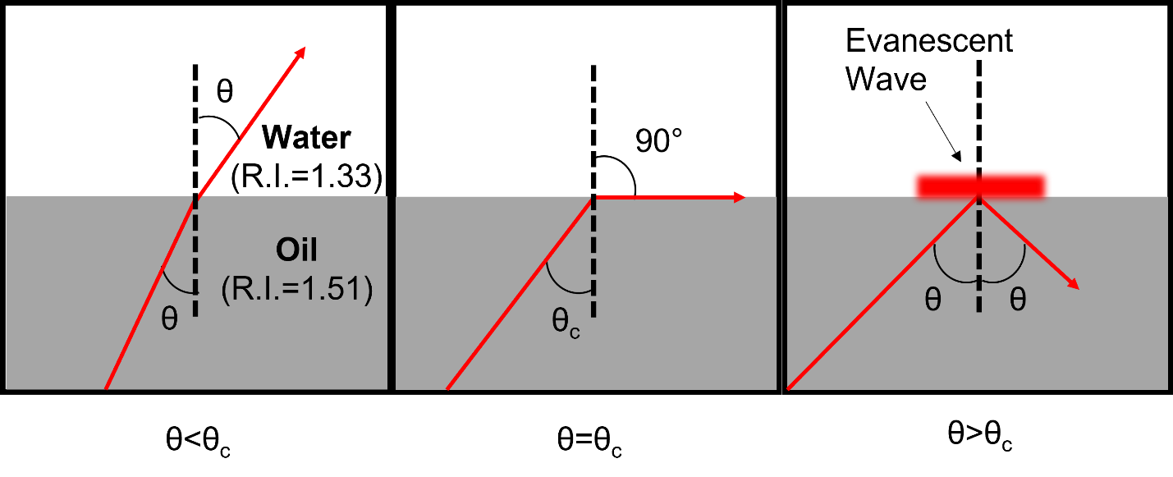
Figure 2.1: Schematic of light wave propagation depending on the angle that light is introduce at an interface. Lateral dimension of evanescent wave exaggerated for visual clarity.

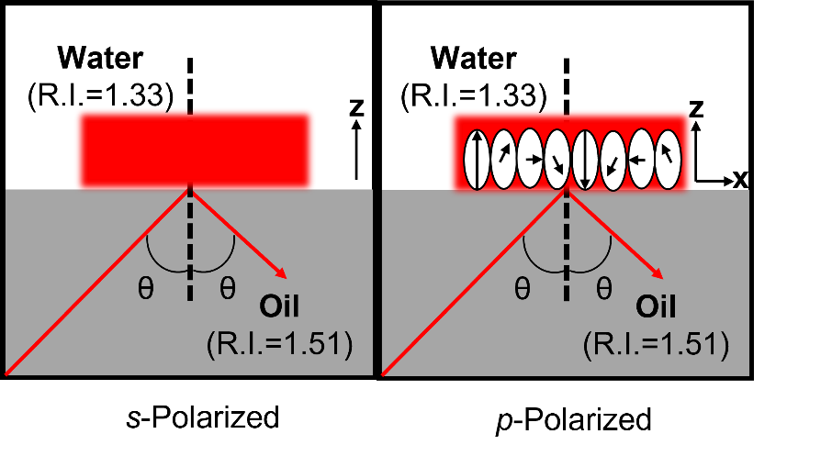
Figure 2.2: (left) s-polarization of evanescent field where the polarization is normal with to the plane of incidence and is shown to propagate in the z direction. (right) p-polarization of evanescent field where the polarization cartwheels in the z and x directions. Elliptical polarization is shown for almost 1 period of oscillation for clarity as the real polarization has many more periods of oscillation.

direction of the arrows as the polarization oscillates in the x and z dimensions. Both s- and p-polarizations are utilized for TIR anisotropy measurements and will be discussed more in section 2.3 and chapter 4.
2.2.2 Microscopy
TIR has been used in conjunction with Raman²⁷, X-ray fluorescence²⁸, and IR spectroscopy²⁹, and the coupling of TIR to conventional fluorescence (i.e., TIRF) began in the 1960’s and 1970’s depending on the interfaces used in the experiment.³⁰⁻³² TIRF itself has been combined with other fluorescence techniques such as energy transfer³³, correlation spectroscopy³⁴, and polarization³⁵. TIRF microscopy has unique advantages because of the confined excitement near a surface which will confer a low background fluorescence and decrease the probability of photobleaching. Many groups have used TIRF to track single molecule fluorescence³⁶, to measure kinetic rates of cytoskeletal R-WGA and anti-spectrin proteins in the submembrane of a red blood cell³⁷, or to study the actin adhesion between the endothelial cell and a glass substrate³⁸. The two general configurations for implementing TIRF on a microscopic platform is with either a prism or a high numerical aperture (NA) objective.
Prism-based and objective-based geometries are depicted in chapter 3 Figure 3.1. Prism configurations introduce light into the prism and fluorescence is collected by an objective. Objective-based configurations require a high NA objective and a focusing lens to obtain the supercritical angle for TIR. Prisms can limit both the types of objectives used for light collection and the types of samples. These restrictions on light collection are discussed more in chapter 3. However, prisms will have a more ideal evanescent wave for two reasons: flexibility in the denser medium and a reduction of scatter/fluorescence from the high NA objectives.²⁶ The medium for high NA objectives usually requires an immersion oil to obtain the angle necessary to produce TIR, and these oils will have some autofluorescence even when they are classified as a low fluorescence standard. Likewise, the series of optical elements that make up an objective will give rise to some scattering as the excitation light passes through each lens.
Objective configurations use a focusing lens will serve to focus a collimated beam on the back aperture of the objective and will focus the plane wave that will be incident upon the sample to create the evanescent field. The supercritical angle is produced by translating the lens laterally from the optical axis in relation to the objective, and there is a direct relationship between the translation of the focusing lens and the light’s incident angle on the sample. The maximum angle of collection ($θ_{m}$) for an objective is defined by
$NA=n_{oil}sinθ_{m}$ (2.6)
where $n_{oil}$ is the refractive index of the immersion oil which is 1.512. High NA objectives becomes necessary when the refractive index of the sample approaches the NA of the objective. For example, an objective with a numerical aperture of 1.4 would have a maximum incidence angle of 67.8°. The critical angle for an interface with a sample medium of water with a refractive index of 1.33 would be 61.59°, so TIR can be easily achieved with translation of the focusing lens to focus the beam near the periphery of the objective to obtain the necessary incident angle. For a cell sample with a higher refractive index of 1.38, the critical angle is 65.88°. For this sample, achieving the critical angle will require fine-tuning of the lens translation, and the evanescent wave will extend hundreds of nanometers into the sample. Such a critical angle will lose information near the surface as the signal will be influenced by fluorophores that are deeper in the sample. Higher NA objectives allows for TIRF in higher refractive index samples but also allows for a greater breadth of angles which simplifies alignment. Another asset for objective-based systems is the ease in construction from commercial accessories that conveniently conform to standard microscope platforms. These arrangements also have the advantage of excitation and collection taking place on the same side of the sample so that light is not lost due to propagation through the sample. For these reasons, we chose an objective-based geometry for both transient absorption and fluorescence anisotropy as potentially bulky microreactors can be analyzed or large volumes of microemulsion can be examined.
2.3 Fluorescence Anisotropy
2.3.1 Theory
Fluorescence depolarization uses polarized excitation to selectively excite fluorophores whose absorption dipoles are aligned parallel with respect to the incident light. The emission arising from this aligned subset will be initially polarized but that polarization will be lost as the molecules rotate over time. Anisotropy is defined as the ratio of the difference of polarized emission to the total emission intensity, and the general equation for is as follows:
$r=\frac{I_{∥}-I_{⊥}}{I_{∥}+{2I}_{⊥}}$ (2.7)
where r is anisotropy, $I_{∥}$ is the intensity of the emission with a polarization that is parallel to the excitation polarization, and $I_{⊥}$ is the intensity of the emission with a polarization that is perpendicular to the excitation polarization. These intensities are obtained by utilizing polarizers for both excitation and emission to collect the correct polarized orientations. The value of r will depend on many conditions: intrinsic depolarization, extrinsic depolarization, and optical depolarization.
Before discussing each of these sources of depolarization, one should be directed to a treatment by Lakowski on the symmetrical nature of emission in relation to the axis that the transition dipole is aligned.³⁹ A few important points from that discussion: θ describes the angular difference between the excitation dipole and the emission dipole, scattered light will have a θ=0 and a r=1.0, and all anisotropy is negated when θ=54.7°. The last point will be revisited when discussing instrumental error in data collection in section 2.3.4 and in chapter 4.
2.3.2 Intrinsic Depolarization
Intrinsic depolarization is dependent on the excitation/photoselection of fluorophores and the photophysical properties of the molecule itself. Excitation of fluorophore is associated to the probability of absorption which is proportional to cos²φ where φ in this case is the angle between the absorption dipole and the polarization of the excitation light. Applying a polarized excitation
source to a fluorophore will excite only a subset of the electron population. This process is known as photoselection, and in Figure 2.3, absorbing fluorophores are shown to absorb the polarized photon whose absorption dipoles are symmetrical distributed around the defined polarization of excitation source. A theoretical calculation of anisotropy based solely on intrinsic polarization will require a model solution that is vitrified (i.e., very vitreous or glasslike), dilute, and isotropic. Calculating anisotropy under these model’s conditions gives a value of r=0.4. However, many molecules do not have collinear absorption and emission dipoles, and intrinsic depolarization that stems from dipoles that are not parallel will result in a r<0.4. The parameter of r₀ is the fundamental emission anisotropy and would be equivalent to r in a solution that does not have any influence from any other depolarizing source. Extrinsic depolarization will lead to a
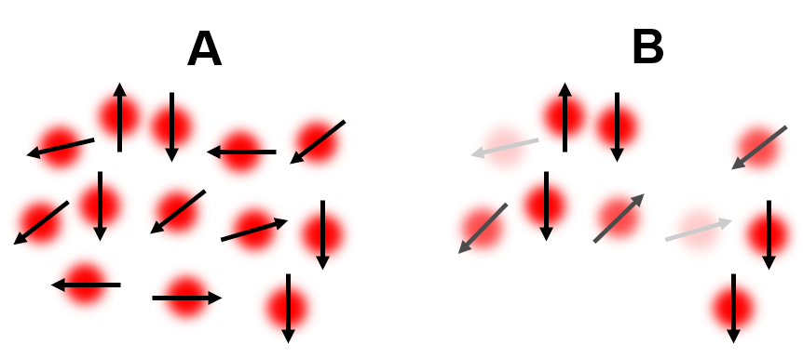
Figure 2.3: (A) Depiction of unpolarized excitation of fluorophores which allows for all molecules to be excited regardless of their orientation. (B) Depiction of vertically polarized excitation of fluorophores in which only a subset of the molecules is excited.

difference in r and r₀ over time.
2.3.3 Extrinsic Depolarization
Extrinsic depolarization occurs while the fluorophore is in the excited state. The two main extrinsic depolarization processes are energy transfer and rotational diffusion. An example of a type of energy transfer is Fӧrster resonance energy transfer (FRET). In FRET, energy from excited donor molecule will transfer to an acceptor chromophore. This event leads to depolarization when the emission dipoles of the donor and acceptor are not parallel. Rotational diffusion occurs due to the Brownian motion of molecules when they are in solution. A molecule that has a rotation that is faster than the excited state lifetime can lead to depolarization, and this phenomenon arises from the dipole moment rotating between the absorption and emission of a photon. To characterize rotational diffusional exclusively requires a time-resolved anisotropy measurement, which can be modeled with a single exponential (Equation 2.8):
$r=r_{0}e^{-t/Φ}$ (2.8)
where $r_{0}$ is the initial anisotropy, t is time, and $Φ$ is the correlation time. $Φ$ itself can be further broken down into (Equation 2.9):
$Φ=\frac{ηV}{RT}$ (2.9)
where $η$ is the viscosity, V is solute volume, T is the temperature, R is the Boltzmann constant. Radiationless energy transfer and rotational diffusion causes depolarization while the molecule is in the excited state and is defined by $Φ$ . Depolarization is inversely proportional to $Φ$, so a large correlation time indicates a small amount of depolarization over time and vice versa. It should be that depolarization can only be attributed to $Φ$ when the temporal resolution of the instrument is faster than the dynamics of the system. Any dynamics that are faster than the instrument response will only appear to decrease the r₀ and will complicate the analysis of the orientation between dipoles. A final remark on the single exponential model is that it is limited to providing a basic representation of a spherical molecule’s anisotropy, but for multiple depolarization processes or a non-spherical molecule, more expansive models are needed to properly fit the measured anisotropy.⁴⁰
2.3.4 Optical Depolarization
The last source of depolarization is optical or instrumental in nature as the processes giving rise to optical depolarization are the result of instrumental artifacts on polarization rather than from the sample itself. Optical depolarization can be caused by light scattering, reabsorption, and polarizer misalignment. A delineation should be made as scattered light was said to have a higher anisotropy, but here it serves as a source of depolarization. The difference is that scattered light that is detected as emission will increase the anisotropy but scattering of the excitation light away from the sample, or of the molecule’s fluorescence away from the detector, will lead to depolarization. As mentioned previously, the high NA objectives needed for TIR anisotropy will scatter incident light from their multiple optical surfaces and cause depolarization. The correction for this type of depolarization will be explained in the next section. In addition, different optical elements will inherently have a polarization dependent transmission efficiency. This phenomenon is a separate issue from other types of optical depolarization and is rectified by invoking a correction factor.
There are differences in transmission for optics based on the polarization of light, so a correction for those differences is known as the G-factor.³⁹ Defining the G-factor requires first defining the observed intensities for parallel or perpendicular polarization (second subscript either V or H) for vertically polarized incident light (first V subscript). These intensities are
$I_{VV}=kS_{V}I_{∥}$ (2.10)
$I_{VH}=kS_{H}I_{⊥}$ (2.11)
where k represents a proportionality factor that accounts for other measurement factors, e.g., quantum yield, S is the sensitivity of the emission channel where the polarization is indicated by the subscript, and $I_{∥}$ and $I_{⊥}$ are the unbiased emission intensities when the polarization is either parallel or perpendicular when compared to the excitation polarization, respectively. When dividing the intensities of the observed parallel and perpendicular intensities which is
$\frac{I_{VV}}{I_{VH}}=\frac{S_{V}I_{∥}}{S_{H}I_{⊥}}=G\frac{I_{∥}}{I_{⊥}}$ (2.12)
the resulting ratio of the sensitivities to each polarization is defined as G. This method of determining G is possible when there are no rotational components that contribute to the signal intensity. Experimentally the method typically employed for determining the G-factor is known as tail-matching (Figure 2.4). Tail-matching is performed by dividing $I_{∥}$ by $I_{⊥}$with signal that arises after rotational diffusion has depolarized each both intensities. The concept is that any difference between the components at that location of the lifetime must come from instrumental differences. However, when the correlation time of the sample being studied is much longer than its fluorescence lifetime, then there is no observable tail. To circumvent the problem of an absent tail, an incident horizontal polarization can be used (Figure 2.4). This horizontal polarization G-factor will account for the same differences in transmission as the tail-matching G-factor but is defined as
$\frac{I_{HV}}{I_{HH}}=\frac{S_{V}I_{⊥}}{S_{H}I_{⊥}}=\frac{S_{V}}{S_{H}}=G$ (2.13)
where the rotation of the emission polarizer appears as a perpendicular intensity that would not be affected by rotational components. To explain how this is achievable, the conventional spectroscopy arrangement must be illustrated. In Figure 2.4, the conventional schematic for fluorescence anisotropy known as the L-format is shown. In this geometry, it is possible to collect the emission similar to the horizontal polarization in spectroscopy due to the orthogonal location of the detector when exciting with the perpendicular polarization. The final definition of measured anisotropy that incorporates observed intensities and the G factor is
$r=\frac{I_{VV}-{GI}_{VH}}{I_{VV}+{2GI}_{VH}}$ (2.14)
Finally, to ensure our anisotropy measurements are not impacted by laser instability and to monitor for photobleaching data are also acquired an emission polarization angle equal to 54.7° from the parallel emission direction. This calibration checks the polarization error in each trial by comparing the vertical and horizontal intensities to the magic angle data where rotational diffusion contributions are eliminated and will be discussed in more detail in chapter 4. While calibration for standard spectroscopic anisotropy measurements revolve around the G-factor and magic-angle, additional calibration checks must be done when attempting TIRF anisotropy.
2.3.5 Total Internal Reflection Fluorescence Anisotropy
TIRF anisotropy grants the ability to probe anisotropy at the surface, but there are a few instrumental caveats that must be considered. The first correction factor is one that is present in the spectroscopic setup: G-factor. While the G-factor is relatively straightforward to calculate
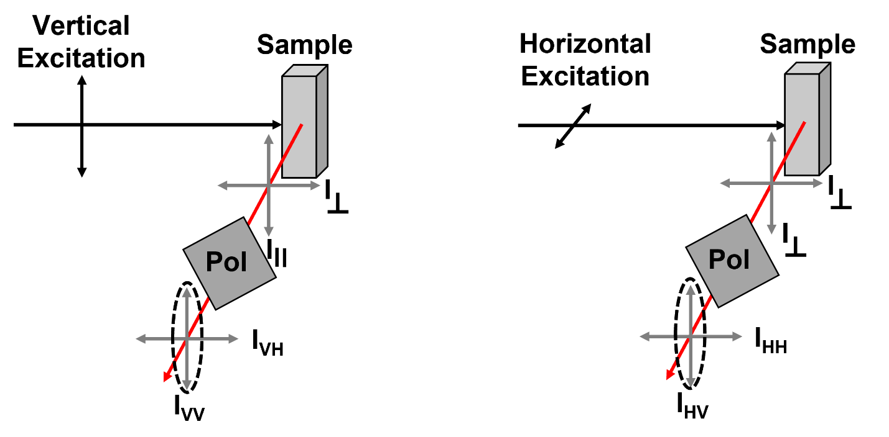
Figure 2.4: L-format spectroscopy setup for fluorescence anisotropy. (Left) Vertically polarized excitation and emission. (Right) Horizontally polarized excitation and emission. Polarizers are rotated to transmit the vertical emission component. Each excitation shows the resulting intensities that are used in calculating the G-factor.

using horizontal excitation for spectroscopy, a traditional microscopic platform prevents the use collection at 90° from the sample. In Figure 2.5, a collinear geometry reflects that using horizontal excitation does not result in the same perpendicular components like in the spectroscopy setup. Tail matching in a collinear setup remains a comparable calculation to the spectroscopic tail match; however, in order to calculate this G-factor where there is no tail is done with the following equation
$G={[(\frac{I_{VV}}{I_{VH}})*\left(\frac{I_{HV}}{I_{HH}}\right)]}^{1/2}$ (2.15)
This collinear G-factor is equivalent to the tail matching G-factor, but this calculation requires that each excitation/emission be recorded to obtain the G-factor that is independent of rotational components.⁴¹ Tail matching the G-factor in TIRF has also been used⁴², and Strohl et al. have developed a tail-independent G-factor in TIRF⁴³. This method used an incident p-polarized light at exactly the critical angle to obtain an intensity that would be polarized along the optical axis which would mirror the orthogonal nature of the horizontal polarization. We have opted to use the method Funston et al. that utilizes a scaling factor that is a result from fitting to the magic angle data before calculating the anisotropy.⁴⁴ Tail-matching is still used to gauge the amount of deviation from unity for our experiments as many of our correlation times were longer than the fluorescence lifetime of the fluorophore. Otherwise, a collinear G-factor was calculated instead. A source of instrumental depolarization that is exclusive to TIRF anisotropy stems from the high NA objectives. These objectives have large collection angles that mix different polarizations and is shown in Figure 2.6. Molecules of different orientations will be collected as the objective collects emission over a broader angle than the 90 degree spectroscopic setup. Excitation can also be affected by the large angle of the high NA objectives, but the TIR plane wave acts as a widefield illumination where the effects of this optical depolarization is negligible.⁴⁵ Devaughes et al. formulated the eponymous Devaughes method which calculates a correction factor that replaces the “2” in the anisotropy equation seen in Equation 2.14.⁴² This χ_{NA} factor is obtained by using the anisotropy values from a low NA objective, the measured intensities of the high NA objective, and the G-factor of the high NA objective. Although this method can correct for the optical depolarization, there is a lengthy, cumbersome calibration that must be performed. An alternative method devised by Axelrod uses a theoretical treatment that does not need a calibration in order to correct the depolarization and is the chosen method for our work. While
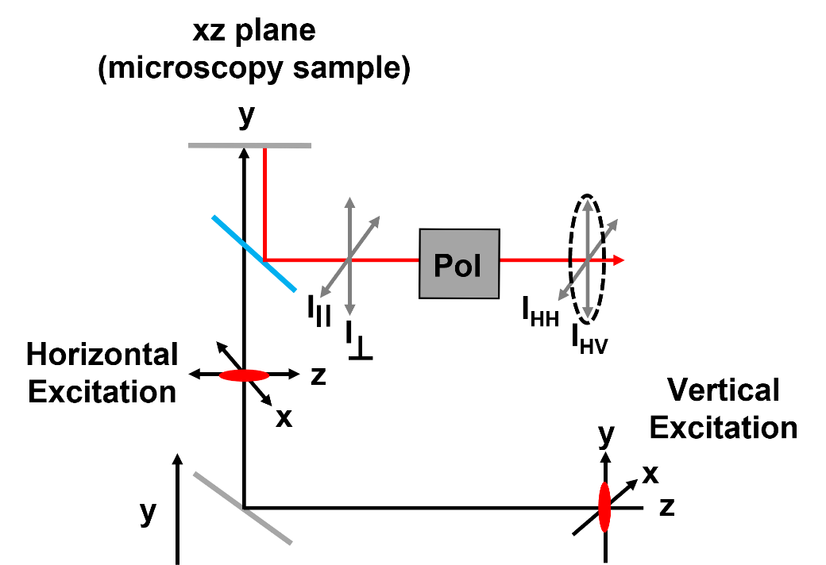
Figure 2.5: Collinear microscopy setup for fluorescence anisotropy. The initial vertical polarization on the table is switched due to the change in the plane of incidence at the sample in the xz plane. Polarizers are rotated to transmit the vertical emission component.

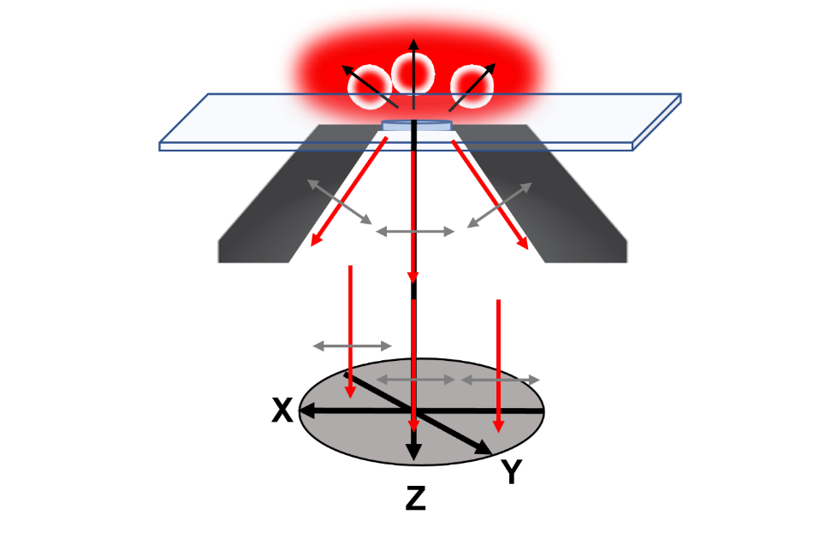
Figure 2.6: Collection of emission for a high NA objective. Emission from molecules of different orientations will be collected which will lead to depolarization.
the original calculation was introduced by Axelrod⁴⁶, we use a variation presented by Strohl et al. where the different components of the emission are defined in a straightforward manner.⁴³ Briefly,
$\left[{I_{⊥} \atop I_{∥}}\right]=\left[{K_{a}+K_{c} { K}_{b} \atop K_{a}+K_{b}{ K}_{c}}\right]\left[{I_{x} \atop I_{y}}\right]$ (2.16)
where $I_{∥}$ and $I_{⊥}$ are the measured parallel and perpendicular intensities, respectively. $I_{x}$ is the corrected parallel intensity, and $I_{y}$ is the corrected perpendicular intensity. $K_{a}$,$K_{b}$ and $K_{c}$ are weights for each of the three different orientations of emission that are collected and are defined as
$K_{a}=1/3(2-3\cos\left(α\right)+\cos^{3}\left(α\right))$ (2.17)
$K_{b}=1/12(1-3\cos\left(α\right)+{3 cos}^{2}\left(α\right)-\cos^{3}\left(α\right))$ (2.18)
$K_{c}=1/4(5-3\cos\left(α\right)-\cos^{2}\left(α\right)-\cos^{3}\left(α\right))$ (2.19)
where $α$ is the maximum half angle that is subtended by the objective. The variable $α$ is then identical to $θ_{m}$ in Eq. 2.6 and calculated accordingly. Solving equation 2.16 for $I_{x}$ and $I_{y}$ gives a final equation of

$\left[{I_{⊥}^{corrected} \atop I_{∥}^{corrected}}\right]=\left[{I_{x} \atop I_{y}}\right]=\frac{1}{(K_{b}-K_{c})(K_{a}+K_{b}+K_{c})}×\left[{K_{a}+K_{c} { K}_{b} \atop K_{a}+K_{b}{ K}_{c}}\right]\left[{I_{⊥} \atop I_{∥}}\right]$ (2.21)

These corrected intensities are fitted to obtain the final anisotropy and correlation time, and when using the scaling factor for the G-factor, the simulated sum is used instead of magic angle data.
2.4 Transient Absorption
2.4.1 Theory
Transient absorption (TA) is a nonparametric optical process that falls under the broader category of pump-probe spectroscopy. A third-order polarization on the sample occurs after interaction with three different electric fields where there are two simultaneous interactions with the pump and with the probe.⁴⁷ The three main processes that contribute to the overall TA signal are ground state bleach (GSB), excited state absorption (ESA), and stimulated emission (SE) (Figure 2.7). Specifically, for GSB, the pump excites molecules from the ground state to the
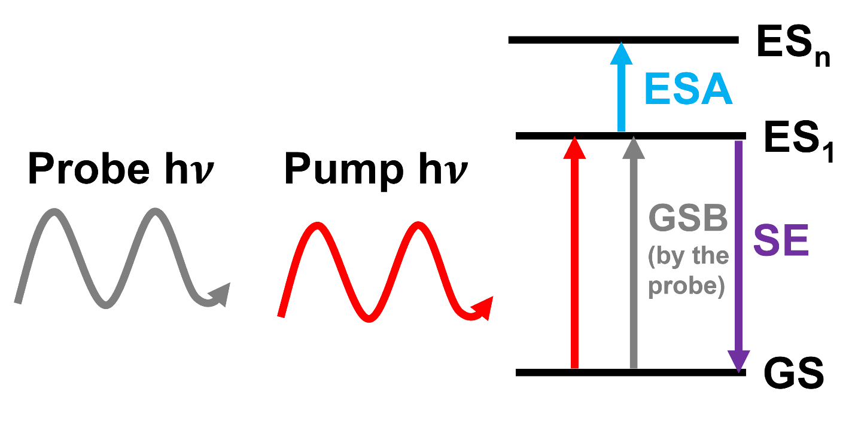
Figure 2.7: Jablonski diagram of different processes for transient absorption. Ground state bleach (GSB) in gray. Excited state absorption (ESA) is in blue. Stimulated emission (SE) is in purple.

excited state leaving a smaller population in the ground state to interact with the probe photons. This causes more probe light to reach the detector when the pump is incident on the sample first than when the pump is not causing a gain in TA signal. For SE, the increase in emission intensity develops from having a larger excited state population available after the pump interacts to be stimulated back down to ground state by the probe. This stimulation results in the emission of a photon which again increases the intensity of the probe signal on the detector. ESA, however, will cause a loss in the measured probe signal as the electrons in the first excited state will absorb the probe photons and move into a higher energy state. Depending on the sample there are additional processes that can contribute to TA signal such as absorption from a new species made after excitation of the sample.⁴⁸ It should be noted that when using a lock-in amplifier, the phase of the signal relative to the pump modulation for absorption and gain processes will be 180° out of phase, so ESA will be the opposite phase compared to GSB and SE. TA spectroscopy has utilized these phase components to characterize a wide range of systems by either determining lifetime dynamics with ultrafast temporal resolution or by elucidating electronic structure with global ( e.g. evolved associated difference spectra)⁴⁹ or target (e.g., species associated difference spectra) analyses⁵⁰. TA microscopy allows for connecting these dynamics to a spatial position within a heterogenous sample.
2.4.2 Microscopy
TA microscopy (TAM) has inherent advantages compared to both linear microscopes and other types of nonlinear modalities. When comparing TAM to linear microscopy, there is natural optical sectioning that increases the 3D resolution. This enhanced resolution is a result of the required multiphoton interactions which means that only at a high photon density, i.e., the focal position, will a nonlinear event occur. Linear microscopy draws signal from the volume of light that passes through the sample, so light outside the focal position will degrade the spatial resolution unless either deconvolution⁵¹ or a confocal pinhole⁵² is implemented. Alternative nonlinear techniques, such two-photon fluorescence, retain the advantages of nonlinear interactions, but there are sample restrictions as many materials do not exhibit an appreciable quantum yield.⁴⁷ Fluorescence tagging can overcome a sample’s inability to fluoresce, but this action can also influence the natural activity of the sample.⁵³ TAM not only has multiple modes of contrast based on the three processes within the TA signal described above, but also, information can be extracted on a sample in its native environment. An important limitation to note to TAM is that it requires the light to be resonant with energy level in the molecule. Despite TAM’s advantages, there is a large amount of background as the signal measured is small changes in intensity of the probe light. This is in contrast to fluorescence in which small intensities of light are measured on an ideally dark background. Lock-in amplifiers with frequency modulation provide a method for increasing the signal-to-noise ratio (SNR) by removing frequency components that do not belong to the signal, specifically the non-interacting probe light. Standard TAM requires a transmitted geometry due to the coherent nature of the emitted light, so objectives are placed on either side of the sample for excitation and collection. This geometry places limitations on the sample thickness. The next chapter will demonstrate how connecting TIR to TAM allows for overcoming this limitation and provides an ability for on-line detection for microreactors.

CHAPTER 3

Total Internal Reflection Transient Absorption Microscopy: An Online Detection Method for Microfluidics

A version of this chapter has been reprinted from the Journal of Physical Chemistry A from:
Colon, B. A.; Hassan, M. R.; Saleheen, A.; Baker, C. A.; Calhoun, T. R. Total Internal Reflection Transient Absorption Microscopy: An Online Detection Method for Microfluidics. J. Phys. Chem. A 2020, 124, 4160−4170.
Copyright 2020 American Chemical Society
This chapter describes experimental design by myself, C.A. Baker, and Tessa R. Calhoun. A PDMS flow cell was designed by A. Saleheen. A part of instrumental alignment was performed by M.R. Hassan. I completed all experiments, data, and figures. Data analysis was performed by myself and Tessa R. Calhoun. The manuscript was prepared by myself, M.R. Hassan, C.A. Baker, and Tessa R. Calhoun.
3.1 Abstract
Microreactors have garnered widespread attention for their tunability and precise control of synthetic parameters to efficiently produce target species. Despite associated advances, a lack of online detection and optimization methods has stalled the progression of microfluidic reactors. Here we employ and characterize a total internal reflection transient absorption microscopy (TIRTAM) instrument to image excited state dynamics on a continuous flow device. The experiments presented demonstrate the capability to discriminate between different chromophores as well as in differentiating the effects of local chemical environments that a chromophore experiences. This work presents the first such online transient absorption measurements and provides a new direction for the advancement and optimization of chemical reactions in microfluidic devices.
3.2 Introduction
Microfluidic reactors have come into prominence as a bespoke method of chemical synthesis that provides the ability to finetune environmental conditions in order to generate high-grade products.^{1, 6, 9, 54-59} Compared to manually driven batch synthesis, a microreactor’s automated model is preferred for monitoring unstable intermediates, reducing waste, and yielding high monodispersity.^{6, 55-56, 59-61} Automation of an extensive range of microreactor parameters, including flow rate, reactant amounts, and temperature, allows for the precise control over reaction conditions that are necessary to extend a microreactor’s applicability to yield complex products like those needed in pharmaceutical production, nanomaterial optimization, and catalysts development.^{9, 54, 58, 62-63} A key component to advancing the technology of microreactors is the analytical ability to monitor reactions in situ. For example, solid catalysts have been tested under multiple practical working conditions, photoluminescence spectra have been monitored to gauge size distribution and surface defects for CdSe and ZnO quantum dots, and flow schemes were observed and adjusted to provide an enhanced diffusion-controlled mixing.⁶⁴⁻⁷² These types of online detection are necessary for tuning the design of microreactors to optimize the synthesis of desired properties.^{8, 54, 73-75} Online detection is also necessary for the concept of algorithmically controlling parameters in a microfluidic, known as intelligent synthesis, which was realized on CdSe quantum dots by Krishnadasan et al.⁷⁶ Numerous spectroscopy techniques have been employed as online detection, but there are many drawbacks to the currently used techniques that restrict the growth of microreactor technology.^{54, 77}
Optical spectroscopies are especially suitable for online detection as they are noninvasive and lossless, two desirable traits for rapid reaction optimization and cost-effectiveness. This viewpoint becomes readily apparent when reviewing the vast number of optical techniques that have been employed in online detection.^{9, 54, 65, 67-68, 78-79} Of the optical spectroscopies available, linear fluorescence spectroscopy is the most prominent method employed due to its high sensitivity and ease of on-chip integration.^{65, 67-68, 78-80} However, because fluorescence is limited by a molecule’s quantum yield, the analyte of interest typically requires tagging with an exogenous fluorophore. In order to broaden the capabilities of microreactors, an online absorption technique that can monitor nonfluorescent species in situ within an inhomogeneous microfluidic flow is needed for creating new nanomaterials that are not possible with batch methods. To enable the detection of a wider range of species, online detection with either absorption or Raman spectroscopy is preferred as these methods allow for qualification of samples that are not fluorescently tagged. There also exists the potential for both of these spectroscopies to provide quantitative analysis, however, both absorption and Raman also have their own limitations. Raman signals are inherently weak, and previous absorption methods required a transmissive flow cell that was connected after the microreactor. This type of offline method is not integrated to monitor the reaction as it proceeds within the reactor.^{7, 81-82} Alternative absorption techniques needed specialized flow cells that utilized silicon oxide cladding and integrated waveguides to enable online detection.⁸³⁻⁸⁴ A significantly more advanced spectroscopic technique, two dimensional infrared spectroscopy, has also been applied to a microfluidic device. While this study highlights the highthroughput advantages that can be gained by interfacing nonlinear optical spectroscopy with microfluidic technology, this application also required a specialized sample chip.⁸⁵
Here we present an absorption method that utilizes transient absorption microscopy in conjunction with a total internal reflection excitation geometry to serve as a novel approach in online detection. Transient absorption (TA) is a nonlinear process that resolves the temporal dynamics in a sample of interest by utilizing two light pulses. The first pulse, the pump, will initially excite a population from the ground state to an excited state, and the second pulse, the probe, will stimulate a signal on the basis of the sample’s interaction with the pump. Depending on the energies of the pump and probe pulses and the electronic structure of the sample itself, the TA signal will include ESA , SE, and/or GSB components. Additionally, varying the time delay between the pump and probe pulses (Δt) allows for the dynamics of the target molecule’s excited states to be directly tracked in time.
In spectroscopic applications, TA is limited to studying homogeneous samples. In 1992, the TA signal was first collected through a microscope objective coupling the ability to obtain spatial information with excited state dynamics.⁸⁶ Since then, transient absorption microscopy (TAM) has been used to study carrier dynamics in materials such as nanowires, perovskite solar materials, and graphene.⁸⁷⁻⁹² It has also been applied to biological systems including blood vessels, living cells, and mice.⁹³⁻⁹⁵ TAM’s utility even extends to the identification of pigments in artwork and the detection of single molecules.^{48, 96} TAM’s versatility to provide unique information over a wide range of systems has been proven, but there is one main limitation that inhibits its application toward microfluidics: the experimental condition that the sample and its cuvette or flow cell be optically thin and transparent for the collection of the transmitted light. Since TA is a nonlinear optical process, a high photon density is a prerequisite for the phenomena to occur.^{47, 97} High repetition rate lasers are often used for TAM to increase the sampling of the small volume of the system being studied, but in these cases, small focal spots are essential in order to generate the high photon densities necessary for TA signal.^{47, 97} High numerical aperture (NA) objectives allow for optimal focusing in TAM, but the objectives require short working distances that constrain sample thickness to a coverslip-to-coverslip width.⁹⁸ This width cannot be easily fabricated for many microfluidic designs.^{9, 80, 99-104} To overcome the limitation of sample thickness and apply the technique to a wider range of devices, we employ total internal reflection (TIR) excitation.
TIR occurs when light approaches an interface above a critical angle and produces an evanescent wave that penetrates a finite depth into the interface.²⁵ Excitation with TIR has been generally achieved with either a prism or objective configuration, as shown in Figure 3.1. When used in linear fluorescence microscopy, TIR excitation has allowed for monitoring individual fluorophore dynamics and tracking changes in structure for protein subcomponents.¹⁰⁵⁻¹⁰⁶ TIR fluorescence has also been applied to microreactors to measure temperature distributions on the flow channel wall, and microfluidic devices have even been fabricated to convert the common inverted microscope into one with evanescent capabilities.¹⁰⁷⁻¹⁰⁸
Moving beyond linear spectroscopy, many nonlinear techniques have also previously integrated TIR to take advantage of the evanescent wave’s depth into a sample to measure properties of interfacial regions. Most nonlinear applications have relied on a prism based configuration with only one of the two beams that interact with the sample in a TIR geometry.¹⁰⁹⁻¹¹⁵ For example, two-photon fluorescence, ¹⁰⁹ second harmonic generation,¹¹⁰ transient grating,¹¹¹ and transient absorption¹¹²⁻¹¹³ have previously used a focused pump with only the probe beam incident in the TIR geometry. Shimosaka et al. introduced only the pump beam onto the sample in the TIR geometry for their photothermal spectroscopy experiment¹¹⁴ while Sugimoto et al. used both a pump and probe in TIR for their transient lens, albeit in a prism configuration.¹¹⁵ In fact, two-photon fluorescence, second harmonic generation, and electronic sum frequency generation are the only nonlinear phenomena to date that have employed an objective configuration for TIR.¹¹⁶⁻¹¹⁹ The TIRTAM instrument we present here incorporates both pump and probe into a TIR excitation geometry with an objective to provide easy adaptability for online integration in a standard inverted microscope.
Herein we report the details of our TIRTAM instrument including the characterization of its spatial and temporal resolution, and the collection of images from a dual-channel device with two parallel liquid phases that merge into a single channel. Two different sets of samples were
studied in this device to demonstrate the technique’s sensitivity to different chromophores and different solvent environments. Specifically, DTTC and IR-144 in methanol were imaged, while in a separate experiment IR-144 is imaged in both methanol and DMSO. Images taken at probe delay times show the progression of the temporal profiles, and the full range of excited state dynamics are captured in localized positions on the device. Furthermore, chromophores were measured in individual channels as well as during mixing to highlight the capability of the instrument to be used to either multiplex several different experimental conditions quickly or examine more complex solutions.
3.3 Methods
TIR arises when light is incident on an interface at a critical angle (θ_{C}) that is dependent on the substrates’ refractive indices. Specifically, the introduction of light must start on the side of the interface with a higher refractive index (n₂), and the relationship between refractive indices and the critical angle is defined in Equation 3.1.²⁵
$θ_{C}=\sin^{-1}(n_{2}/n_{1})$ (3.1)
When the angle of light exceeds the critical angle, a confined electromagnetic wave penetrates past the interface to a very limited depth. This evanescent wave decays exponentially, and the intensity of this wave, shown in Equation 3.2, is dependent on the distance away from the interface and the penetration depth (d). This depth is defined by the wavelength of the light in vacuum (λ₀), angle of incident light, and refractive indices.
$I(z)=I_{0}e^{-z/d}$ (3.2)
$d= \frac{λ_{0}}{4π}{[n_{1}^{2}\sin^{2}θ-n_{2}^{2}]}^{-1/2}$ (3.3)
Equation 3.3 shows how the penetration depth of the evanescent wave can be modified to range from tens to hundreds of nanometers into the sample by changing either the wavelength or angle.
As mentioned previously, the conditions for TIR are often achieved in either a prism or objective configuration (Figure 3.1). In the prism setup (Figure 3.1A), the primary alignment method used consists of light originating from the far side of the prism, and the internal reflection is produced in a defined area with high refractive index silica surfaces on either side of a lower refractive index medium such as water or air.¹²⁰ The prism configuration’s main advantage, aside from the straightforward assembly, is the separation of fluorescence detection

Figure 3.1: (A) Prism TIR configuration with light entering the prism and interacting with the far side of the coverslip. (B) Through-the-objective TIR configuration with light originating and leaving through the back aperture of a single objective. (C) Focused geometry with two high NA objectives on either side of a sample slide.

from the path of the excitation beam.¹¹⁷ Such a separation allows for a higher signal-to-noise compared to an objective. Despite this asset, a prism limits lateral resolution and collection efficiency as the light must travel across the sample.¹²⁰ The approach chosen in this paper is a through-the-objective configuration (Figure 3.1B), which relies on a lens to focus incoming light onto the back aperture of the objective. The position of the lens will vary the critical angle, and the reflected light will exit through the same back aperture where the light was introduced. The benefits for this method are 3- fold: accessible coupling to a standard inverted microscope, adaptability with standard excitation paths, and an increased collection performance.¹¹⁷
TAM has been typically performed in the focused geometry as depicted in Figure 3.1C. This geometry allows for a diffraction-limited resolution of 200 nm, but as mentioned before, restricts the sample being investigated due to the transmissive collection and small working distances of the objectives.¹²¹⁻¹²³ TIR excitation for TAM as shown in Figure 3.1B has a single objective requiring only a single side of the sample be accessible to the light. It should be noted that this could be considered similar to transient reflectivity;¹²⁴⁻¹²⁶ however, by utilizing TIR we are not dependent on the reflectivity of the sample itself to return a large amount of the light. For demonstrating online detection on a flow channel device, the TIR configuration for both beams was used for data collection. Images and excited state dynamics were collected from the home-built TIRTAM microscope shown in Figure 3.2.
Briefly, the initial light source emanated from a femtosecond modelocked Ti:sapphire laser (Griffin, KM Laboratories) with pulses centered at 800 nm having a pulse width of 37 fs at a repetition rate of 80 MHz. Three different prism compressors were used to maintain the ultrashort pulse width at different places along the optical path. The initial beam was split into pump and probe beams of variable power with a waveplate/thin film polarizer combination. The pump beam was modulated to 8 MHz with an acousto-optic modulator for lock-in detection. The probe beam was focused onto a photonic crystal fiber (PCF) (C110-540-000 Femtowhite 800, Newport) to produce a white-light supercontinuum. Approximately 50 nm of bandwidth was from the ∼400 nm output of the PCF supercontinuum for the probe pulse. The resulting light was collimated with an off-axis parabolic mirror and directed through a delay line to allow for the monitoring of temporal dynamics within the samples. Both beams were brought through 4×beam
Figure 3.2: Instrumental schematic of the TIRTAM microscope: PO, pickoff mirror; WP, waveplate; TFP, thin film polarizer; AOM, acousto-optic modulator; OBJ, objective; PCF, photonic crystal fiber; OAP, off-axis parabolic; DC1, dichroic mirror; APD, avalanche photodiode.

expanders and recombined with a 750 shortpass dichroic mirror (FF750-SDi02, Semrock). The beams were then focused through a 500 mm achromatic lens onto the back aperture of the 100× 1.49 NA oil immersion objective (MRD1991, Nikon). It is important to note that most applications of the through-the-objective TIR excitation do not collect the beam after it interacts with the sample. In these cases, the critical angle is often achieved by moving the beam off of the center of this focusing lens. For TIRTAM, this will lead to significant aberration in the collected beam so this alignment is avoided in our configuration. Collection of the return beam was achieved with a half-cleaved silver mirror (PFR10-P01, Thorlabs).
The final output is processed by a lock-in amplifier (SR844, Stanford Research Systems) where the signal was isolated and read by custom LabView codes. Lock-in sensitivity, ranging from 60 to 300 μV, was adjusted to maximize signal gain while reducing background noise.
When using TIR excitation, it is important to note how the polarization of the incident light impacts the evanescent wave. First the evanescent wave can have a larger intensity than the incident beam, but this effect is significantly larger for p-polarized light than for s.¹²⁷ The use of p-polarized excitation, however, also results in the generation of an evanescent field with elliptic polarization.¹²⁷ Figure A.1 shows the excited state dynamics collected from a sample of 1 mM IR-144 in methanol for both pump and probe beams either in s- or p-polarized incident light to compare the differences in intensities due to the resulting evanescent waves. For all of the other experiments performed here, the polarization of both beams was matched and set to p-polarization. Because the polarization angle between the pump and probe beams was not set to the magic angle, the observed excited state lifetimes extracted from our TA measurements will include rotational dynamics leading to differences from literature values.
The solvents used in the experiments were methanol (99.9%, Fisher) and DMSO (99.5%, Sigma) and the chromophores examined were [N,N-diethylethanamine-3- [(2Z)-2-[(2Z)-2-[(3E)-3-[(2E)-2-[1,1-dimethyl-3-(3- sulfopropyl)benzo[E]indol-2-ylidene]ethylidene]-2-(4-ethoxycarbonylpiperazin-1-ium-1-ylidene)cyclopentylidene]- ethylidene]-1,1-dimethylbenzo[E]indol-3-yl]propane-1-sulfonate] IR-144 (08690, Exciton) and [3,3′-diethylthiatricarbocyanine iodide] DTTC (381306, Sigma). Structures of these molecules are depicted in Figure A.2
In order to demonstrate online detection with TIRTAM, continuous flow devices were
devised and built in-house. A dual-channeled device that was used for the experiments is depicted in Figure 3.3.¹²⁸ A glass microscope slide served as the substrate for flow ports (N-333, IDEX), which were attached with silicone. This bonding method prevents the adhesive from contacting solvents that would degrade the connection and is more robust to DMSO than the more commonly used epoxy. The design and fabrication of the channel design in doubledsided tape (7602A53, McMaster-Carr) was made with a die cutting machine (Cricut), and the final part of the device was the coverslip. The assembled device brought two different solutions in parallel channels before combining into a single channel that is attached to the output port. Syringe pumps were used to introduce the sample solutions into the flow device with positive pressure, and the flow rates for the experiment with two solvents were 0.07 mL/min and 0.013 mL/min for methanol and DMSO, respectively. In the case of the two different chromophores with methanol, a flow rate of 0.05 mL/min for DTTC and 0.03 mL/min for IR-144 was used, respectively. The channel widths for the device were 2 mm for the single channel labeled with the red box (region I) and 1 mm for the single channel labeled with the blue box (region II) in Figure 3.3B. The single channels combined into a channel with a width of 3 mm labeled with the purple box region (III). The depth of the channel was based on the thickness of the tape, which was ∼0.1 mm. A similar coverslip-to-coverslip single channel variant has been employed before in our focused geometry TAM.⁹⁸ For image collection, the stage was scanned using motorized actuators (Newport, TRA25PPD) with a 300 ms pixel dwell time.
To explore any impact of surface effects on our measured dynamics, coverslips with both hydrophilic and hydrophobic surfaces were tested. For the hydrophobic surface, the coverslips were used as received. To produce a hydrophilic surface, the coverslips were acid washed using a procedure by Cras et al.¹²⁹ Briefly, the coverslips were first submerged in 50:50 methanol (99.9%, Fisher)/HCl (95.0%, Fisher) solution for 30 min. They were then rinsed with Milli-Q water and dried under N2 before being submerged in H2SO4 (95.0%, Fisher) for 30 min. The coverslips were then subjected to the same water wash and N2 drying steps. The coverslips were stored under methanol in sealed containers before being used in flow devices. The difference in contact angle for water on the acid-washed vs standard coverslips is shown in Figure A.3.
To study diffusion-controlled mixing and observe the intensity profile across the width of a diffusional mixing channel, a hybrid PDMS/glass microfluidic device was fabricated. A
Figure 3.3: (A) Flow cell diagram with the glass slide as the top layer with silicone adhered ports, the middle layer as the tape-cut channel, and the bottom layer as a coverslip. (B) Scaled pictured of constructed flow cell with squares outlining where single channel images (red region I and blue region II) and mixed channel images (purple region III) were obtained.

Yshaped channel geometry was cut from a 250 μm thick sheet of PDMS (HT6240, Stockwell Elastomerics, Inc.) using a direct-write CO2 laser cutting instrument (VLS 2.30, Universal Laser Systems, Inc.). Standard 25 mm × 75 mm microscope slides, 25 mm × 75 mm no. 1 coverslips, and the laser cut PDMS channels were placed together in the chamber of a plasma cleaner (PDC-001-HP, Harrick Plasma) and subjected to plasma cleaning at approximately 250 mTorr pressure of room air with the instrument operated in high power mode. Plasma was discontinued after 3 min, and the chamber was vented rapidly to allow the assembly of a microscope slide−PDMS−coverslip sandwich structure within 30 s of discontinuing the plasma. The glass−PDMS−glass sandwich was immediately placed on a hot plate at 95 °C for 1 h to allow the formation of irreversible PDMS−glass bonds, thereby sealing the device for flow experiments.
3.4 Results and Discussion
Before online detection was conducted, the spatial and temporal limits of the technique were determined to fully characterize the instrument. Spatial resolution measurements were achieved by fitting a logistic function on an oversampled TA image of an edge.¹³⁰ In most TIR microscopy applications, the TIR excitation generates a wide field of illumination that is decoupled from the spatial resolution which is determined by the fluorescence collection and detection optics. In these cases, the ideal TIR spot size is generated by focusing the incoming light on the back aperture of the objective to produce a large collimated beam on the sample. In contrast, our TIRTAM is a point-scanning technique in which the spatial resolution is determined by the TIR spot itself. As such, we have improved our spatial resolution by moving the focus away from the back aperture such that the light on the sample is not collimated and therefore illuminates a smaller area. Figure 3.4A shows the TA of IR-144 in methanol with a piece of Teflon tape (8569K16, McMaster-Carr) in the channel path. Figure 3.4B is the logistic function fit on the edge of the tape with the sample solution, which yielded a spatial resolution of ∼30 μm. Teflon was specifically chosen for the spatial resolution measurement as its similarity in refractive index to that of methanol minimized any potential changes in the beam path.¹³¹⁻¹³² If the beams had been perfectly focused on the back aperture of the lens, the resulting spot sizes on the sample would have been ∼80 μm according to the equation:¹³³
$diameter at sample=diameter at TIR lens*\frac{objective focal length}{TIR lens focal length}$ (3.4)

Figure 3.4: Spatial characterization. (A) 3 × 80 TA image used for spatial resolution with a vertical scale bar equal to 50 μm and a horizontal scale bar equal to 5 μm. The red line demarcates the data that were used for fitting. (B) Logistic function fit of an edge from the TA image.

Moving the focus away from the back aperture then significantly increases the instrument’s spatial resolution. An important consideration with this approach, however, is that care has to be taken to recollimate the light exiting the objective after interacting with the sample as it will not be propagating with the same characteristics as that in widefield TIR microscopy.
While a 30 μm focal spot size is relatively easy to generate with more conventional optics, the lack of confinement in the z-dimension afforded by the TIR excitation significantly reduces the power density and resulting nonlinear signal. In addition, the focal depth for a conventionally focused beam with the same lateral resolution would extend beyond the channel depth of our flow devices, reducing signal even more than the TIR geometry excitation. In contrast, a more tightly focused beam with a smaller focal depth would require a device design that allows for collection with a higher NA objective above the flow cell. In this way, the TIR excitation provides an alternative option to balance the needs of sample constraints and power density.
Temporal characterization was carried out with cross-correlation frequency resolved optical gating (x-FROG),¹³⁴ as shown in Figure 3.5A. In these experiments, the sum frequency generation from the pump and probe beams on a crystal of potassium dihydrogen phosphate was collected above the sample with a UV objective (LMU-40X-UVB,ThorLabs). In order to optimize the collection of the UV signal, small adjustments to the TIR lens were required but kept minimal to not significantly distort the measured dispersion from that in the TAM experiments. A nominal temporal resolution of 100 fs was measured as shown in Figure 3.5B. In order to mimic the TAM experimental conditions, the bandwidth of the probe beam was limited in its prism compression line for the xFROG measurements to match the bandwidth of the filters used for TA signal collection.
Online detection was first carried out on two different chromophores to demonstrate the instrument’s capability to separate these distinct signals. The two chromophores, IR-144 and DTTC, are both symmetrical carbocyanines and were chosen because their excited state lifetimes have previously been reported in the literature for a range of experimental conditions.¹³⁵⁻¹³⁷ A pump beam centered at 800 nm with 1.25 nJ/pulse into the microscope was used to initially excite the chromophores from the ground state to the first excited state. . A probe beam centered
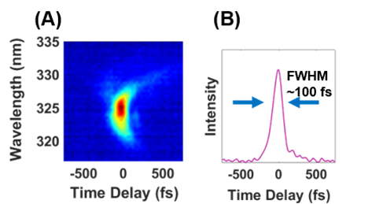
Figure 3.5: Temporal resolution. (A) xFROG spectrogram (B) Integrated intensity from the xFROG data showing a ∼100 fs fwhm temporal resolution.

at 550 nm with 0.032 nJ/pulse was used to stimulate the ground state bleach response that was monitored as the probe pulse was delayed. TIRTAM images of 1 mM solutions of the individual chromophores in methanol before mixing are shown in Figure 3.6A,B, which correspond to positions labeled as region I and II in Figure 3.3B, respectively. In Figure 3.6A, the black region represents tape and is the absence of signal while the dark blue region is signal arising from the DTTC solution. The highest signal region was at the interface between the solution and tape, and this signal most likely stems from aggregation at this interface.¹³⁸ It should be noted that this aggregation was only observed for DTTC and not IR-144, suggesting a molecularly specific interaction between DTTC and the tape.
It is, however, important to note that the flow velocity along the edges of the channel will differ from the bulk/center region. Specifically, for laminar flow conditions, such as those in our experiments, the velocity profile will be parabolic for a cylindrical channel¹³⁹ while our rectangular channels have a more complex profile.¹⁴⁰ In all channel shapes, however, the flow near the coverslip surface is significantly slower. This could be expected to impact the TIRTAM results and applications in multiple ways. First, increased photodamage may be expected for TIRTAM compared to standard transmission TA spectroscopy experiments under the same flow conditions. We did not see any significant photodamage effects in any of the experiments we report here. Second, the detection of any changes to the experimental conditions over time, for example, a change in the concentration of input solution, will lag behind and be spread in time relative to the actual input changes. Third, the region at the coverslip interface sampled by the evanescent wave in our TIR experiments may make these measurements more sensitive to molecular interactions with this surface. To explore the possible impact that any resulting surface effects may have on our observed dynamics, the excited state lifetime of IR-144 solutions were measured flowing over coverslips with either hydrophobic or hydrophilic surfaces. These results are shown in Figure A.3. IR-144 was expected to interact more strongly with the hydrophobic surface promoting additional aggregation and resulting in faster decay dynamics. No differences, however, were observed in the measured dynamics between the hydrophobic and hydrophilic surfaces, suggesting that our measured transient absorption arises predominantly from the bulk solution and not a surface specific sample.
Figure 3.6: TIRTAM images and excited state dynamics of 1 mM solutions of DTTC and/or IR-144 in methanol. (A) 32 × 32 single channel image of DTTC in region I taken at Δt = 10 ps. Scale bar is 200 μm. (B) 32 × 32 single channel image of IR-144 in region II taken at Δt = 10 ps. Scale bar is 200 μm. (C) 33 × 13 image of the solutions mixing in region III at a time of Δt = 400 ps with the red and green circles outlining where excited state dynamics were obtained for DTTC and methanol, respectively. The black unlabeled region on the right edge of the image is tape. The vertical scale bar is 10 μm and the horizontal scale bar is 200 μm. (D) Excited state dynamics obtained at the outlined locations in (C) where the red trace is DTTC and the green trace is IR-144.

The excited state dynamics of this interfacial region between the DTTC solution and the tape edge of the channel (Figure A.4) display an increased fast component compared to the solution away from the interface, which matches the dynamics observed in region III. The interfacial feature is absent in the IR-144 solutions (Figure 3.6B) where the highest signal appears in the bulk of the solution as it does in all other images obtained. The mixing channel image, taken at Δt = 400 ps, shows three regions of signal in Figure 3.6C. The highest signal is observed from IR-144 portrayed as the white region, DTTC is the primary component in the blue region, and tape again appears as the black region. Figure A.5 depicts time delay images at Δt = 10 ps and Δt = 400 ps, which were taken to demonstrate how contrast in the images changes due to the chromophores’ differences in lifetimes, and an image obtained at Δt = −13 ps confirms that the source of the signal is TA as all contrast is lost and only noise is apparent. Excited state dynamics of each chromophore (Figure 3.6D) were collected at the locations on the device marked with a red circle for DTTC and a green circle for IR-144 in Figure 3.6C. Fits of the dynamics yielded IR-144 with a dominant single exponential lifetime of 358 ps and DTTC with a biexponential decay containing a short lifetime component of 15 ps and a long component of 507 ps. The lifetime of DTTC has previously been reported as varying over a large range under different power densities, and aggregation exacerbates the contribution of the short component resulting in a biexponential decay.^{137, 141} Our IR144 result is also shorter than the published lifetime of 450 ps mostly likely due to two factors, polarization and aggregation.^{135, 142} Specifically, when measuring excited state dynamics in standard TA spectroscopy, the polarization of the pump and probe beams are set to the magic angle to eliminate any rotational components that would decrease the observed transient lifetime.¹³⁶ This behavior is difficult to match when using TIR excitation. As such, both of the beams in our experiment are incident in p-polarization, causing an evanescent wave with elliptical polarization to interact with the sample. While our measured dynamics will certainly contain rotational components, the larger source of deviation between our measured lifetimes and the literature values for IR-144 is the presence of aggregated species. The study by Yu et al. was performed with a 70 μM concentration as opposed to the 1 mM concentration in our measurements.¹⁴²
The next set of TIRTAM experiments focused on imaging contrast from the solvation dynamics of a single chromophore. IR-144 lifetimes in 1 mM solutions in DMSO and methanol have been recorded in multiple sources, and the difference in TA dynamics and intensity were used to map the signal in the images shown in Figure 3.7.
In Figure 3.7A, the IR-144 in methanol in region I of the device gave the highest signal in the bulk of the solution in the white region whereas the tape was in the black region without a signal. Figure 3.7B mimics Figure 3.7A with similar color designations for signal from IR-144 in DMSO in region II. The image of region III in Figure 3.7C features methanol with the highest signal in the white region, DMSO in the blue region, and the tape in the black region. Excited state dynamics were measured in the marked regions with the green circle denoting the location where the IR-144 in DMSO lifetime was collected and the red circle denoting where the IR-144 in methanol lifetime was collected in Figure 3.7D. Differences between the solvent environments are clearly visible in these dynamics. When moving between different solvent environments, it is important to consider the differences in their refractive indices. The critical angle for DMSO and the coverslip is ∼76°, but the critical angle for methanol is lower at ∼62°. Excited state dynamics obtained in regions I and II (Figure A.6) were collected at the critical angle to match each solvent, while in region III the angle was set to that of DMSO over the entire image. Collection at different delay times is shown in Figure A.7 and display similar results obtained in Figure A.5. The signal collected for IR-144 in methanol was seen to be affected by this angle due to differences in the evanescent field generated. Despite this discrepancy, however, it is clear that different solvent environments can be resolved for the same chromophore with TIRTAM.
Finally, TIRTAM was used to visualize a dynamic process, namely diffusion, across the channel. For these measurements, a channel ∼1 mm in width was fabricated using PDMS, as described in the Methods. A 1 mM solution of IR-144 in methanol was introduced into one port of the device while pure methanol was flowed on the other side of the channel. The intensity variation of the transient absorption signal across the channel width corresponds to the diffusion of the IR-144. Parts A and B of Figure 3.8 show the resulting images for two different flow rates. The darker blue/black regions on the bottom of the images correspond to the PDMS edge near the side of the channel with the concentrated IR-144/methanol solution. The white represents the highest concentration of IR144, and as the chromophore diffuses to lower concentration, the signal becomes shades of light blue then finally darker blue to black near the top of the image where pure methanol was introduced. While this channel width was still too large to see
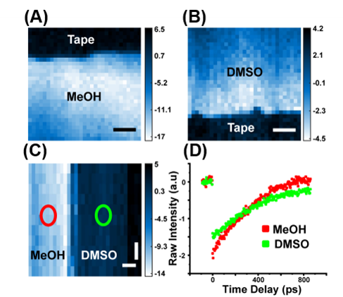
Figure 3.7: TIRTAM images and excited state dynamics of 1 mM solutions of IR-144 in methanol and/or DMSO. (A) 32 × 32 image of IR-144 in methanol in region I was taken at Δt = 10 ps. Scale bar is 200 μm. (B) 32 × 32 image of IR-144 in DMSO in region II taken at Δt = 10 ps. Scale bar is 200 μm. (C) 33 × 13 image of the solutions mixing in region III at a time of Δt = 10 ps with the red and green circles outlining where the dynamics were obtained of IR-144 in methanol and DMSO, respectively. While IR-144 decays faster in methanol, its transient absorption signal in this solvent is initially higher. The black unlabeled region on the right edge of the image is tape. The vertical scale bar is 10 μm, and the horizontal scale bar is 200 μm. (D) Excited state dynamics were obtained at the outlined locations in (C) where the red trace is IR-144 in methanol and the green trace is IR-144 in DMSO.

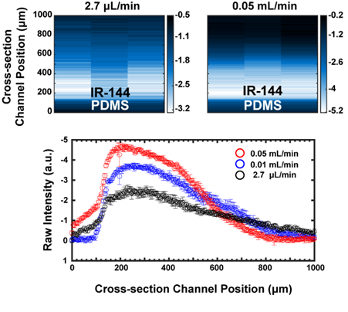

Figure 3.8: TIRTAM images and intensity profile across the channel of 1 mM solutions of IR-144 in methanol and pure methanol. All images were taken at Δt = 300 fs. (A) 3 × 200 image of IR-144 diffusing into solvent at a flow rate of 2.7 μL/min at 38 mm from the merge point. (B) 3 × 200 image of IR-144 diffusing into solvent at a flow rate of 0.05 mL/min at 38 mm from the merge point. (C) Graph of intensity versus channel position at the three different flow rates of 0.05 mL/ min (red), 0.01 mL/min (blue), and 2.7 μL/min (black). Error bars show the standard deviation from three measurements.

significant changes in the diffusion profile at different channel length positions, differences in diffusion are evident at the same position for different flow rates. Figure 3.8A was taken with both the IR-144 solution and the pure methanol introduced with a 2.7 μL/min flow rate. The extent of signal from IR-144 across the channel is greater in this image as compared to Figure 3.8B, which shows an image from the same position but with a higher flow rate of 0.05 mL/min, which significantly reduces the chromophore diffusion. To better compare the differences between these images, the average signal intensity from these images was plotted as a function of cross-sectional channel position for the different flow rates in Figure 3.8C. The data from an intermediate flow rate of 0.01 mL/min is also plotted in Figure 3.8C although the image for this flow rate is not shown. For all flow rates, the highest signal is found at the ∼200 μm channel position corresponding to the PDMS edge. Some signal is seen at positions corresponding to chromophore within the PDMS layer, which is not unexpected as PDMS is known to allow for small chromophore absorption.¹⁴³ The absorption of some of the IR-144 into the PDMS is also expected to cause differences in integrated intensities between different experiments. The fastest flow rate, 0.05 mL/min shown in red, has the highest concentration at the edge and the fastest drop in signal across the channel while the black data corresponding to the slowest, 2.7 μL/min, flow rate shows the lowest IR-144 signal at the edge and a more gradual change in signal across the channel as the chromophore has diffused more.
3.5 Conclusions
In this work, we have demonstrated the first ultrafast optical online detection method capable of probing and distinguishing the excited state dynamics of species in microfluidic channels using TIRTAM. Images and excited state dynamics on different chromophores in a single solvent environment and a single chromophore in two different solvents showcases the applicability of the technique to separate distinct species on the basis of subtle differences in the local chemistry and solvation. These experiments can readily be adapted in a microreactor to, for example, multiplex a range of conditions in parallel channels for high throughput experiments or observe the formation of a nanomaterial in a complex environment. While our TIRTAM instrumentation can be utilized with standard microfluidic devices, this technique also highlights an opportunity for improved spectroscopic measurements. Specifically, by imaging a microreactor, one can map chemical kinetics to different positions along the flow device. Measuring TAM at these different positions, and hence at different times during the reaction, allows for the collection of information on both the ultrafast, molecular time scale and the time scale for chemical kinetics. This allows for contrast in chemical reactivity to be related to changes in dynamics that take place on the molecular level. Furthermore, a quantifying online absorption technique could be realized with the introduction of an internal standard.¹⁴⁴ Coherent Raman online detection could be an easy adaptation as well because of the similarity between the optical configuration of stimulated Raman spectroscopy and transient absorption.51 Finally, envisioning a microscope platform with the ability to use fluorescence, transient absorption, and Raman would enable full characterization of microfluidic devices, and such a concept becomes possible with the instrument design presented here.
3.6 Acknowledgments
B.A.C., M.R.H., and T.R.C. were funded by the National Institutes of Health/National Institute of General Medical Sciences (NIGMS) grant R15 GM119111. A.S. and C.A.B. were funded by the National Science Foundation under Grant No. CHE-1944902. The authors thank James Russel for assisting with the fabrication of one of the flow devices and M. J. Blake for assistance with the pictures of water contact angles. We are also grateful to L. N. Miller and B. Doughty for valuable feedback and discussions.

CHAPTER 4

Surface Influence on Microemulsions: Differentiating Dynamics with Total Internal Reflection Anisotropy

A version of this chapter is in preparation for submission.
This chapter describes experimental design by myself and Tessa R. Calhoun. A part of data collection was performed by M.R. Hassan. I completed the first series of experiments. Data analysis was performed by myself and Tessa R. Calhoun. The manuscript was prepared by myself, M.R. Hassan, and Tessa R. Calhoun.
4.1 Abstract
Microemulsions (μEs) have been used in a range of applications, and most recently, a tween 20 bicontinuous formulation has been proposed as a promising solution for redox flow batteries. Previous work has revealed the nanoscale structure of these complex fluids is altered at the interface with solid substrates. In order to assess the impact of these structural changes on small molecule dynamics, time-resolve total internal reflection fluorescence (TIRF) anisotropy is employed to monitor the behavior of the fluorescent probe, coumarin 153, near the solid/liquid interface. The reduction in rotation and preferential ordering show a difference in the structure near the surface and presence of a different solvation environment.
4.2 Introduction
A microemulsion (μE) is a thermodynamically stable mixture made of a ternary composition: water, oil, and surfactant. When attempting to make certain formulations stable, a fourth component is added as a cosurfactant. These mixtures are optically transparent which indicate the underlying dimensions of the nanosized dispersions. The three structures that can be produced are water droplets in oil (w/o), oil droplets in water (o/w), and intersecting continuous phases of oil and water (bicontinuous). For the application of μEs as nanoreactors or for drug delivery, droplet systems are the dominant formulation employed; specifically, the size and interfacial area of the droplets makes them ideal in synthesizing monodisperse nanoparticles¹⁴⁵ or releasing drugs that cannot be administered in a traditional way¹⁴⁶. However, bicontinuous μEs were originally considered as the optimized composition for oil recovery applications¹¹ and display an increased capacity for electro catalytic activity¹⁴⁷. The reason for bicontinuous μEs having enhanced properties is the equal solubilization of water and oil which corresponds to the lowest interfacial tension a μE can achieve.¹¹ The nature of the surfactant also provides many of the μE’s attributes, for example, the nonionic surfactant Triton X-100 in μEs has an increased sensitivity to temperature and solvent when compared to its ionic counterparts.¹⁴⁸ Another nonionic surfactant Brij 96 μE utilized a unique transition from w/o to o/w through a bicontinuous phase that maximizes transport for anti-tuberculosis (TB) drugs.¹⁴⁹ Tween 20 (TW20), a nonionic surfactant, μEs were successful for delivering anti-TB drugs¹⁵⁰, improving the bioavailability of the anti-inflammatory curcumin¹⁵¹, and augmenting ocular uptake of the drug chloramphenicol¹⁵². TW20 μEs droplets were also used in other processes as well such as the synthesis of silver nanoparticles¹⁵³ and prolonging the shelf life of food grade peppermint oil¹⁵⁴.
Recently, a bicontinuous TW20 μE comprised of 1-butanol as the cosurfactant, water as the aqueous phase, and toluene as the oil phase (TWBT μE) was used as an electrolyte where it was shown to facilitate reversible electron transfer of ferrocene.¹⁵⁵ The rate of the electron transfer was hypothesized to arise from both the ionic and electroactive species being located close together in the surfactant region. Previous work by Hassan et al. (unpublished) showed the locations of many different probes that have different polarities. The laurdan surfactant probe demonstrated the surfactant region being loaded with water as the water percentage increased in the μE. Rhodamine 6G, an ionic fluorophore, and C153, a polar hydrophobic fluorophore, both were shown to be located in the surfactant region. Both probes were in close enough proximity in the surfactant region to experience FRET, but C153 and methyl viologen did not exhibit photoinduced electron transfer suggesting that C153 beyond the range of a few angstroms. With the concept of electrochemical systems in mind, the surface composition of the μE must be determined as it can impact electrode performance.¹⁵⁶ The structure of a μE at a surface must be characterized in order to optimize the composition needed for such an application.
A few works have also defined the μEs surface structure at the interface between the substrate and the μE with scattering techniques. A total internal reflection scattering technique observed the formation of an ionic AOT surfactant μE as droplets at a liquid/liquid interface of dodecane and water.¹⁵⁷ Other works defined the surface of a bicontinuous μE made up of the nonionic surfactant C₁₀E₄ by invoking an evanescent wave through grazing-incidence small-angle neutron scattering.¹⁵⁸ These works illustrated a lamellar structure near the surface that perforated into a bicontinuous composition .The surface dynamics were shown to be faster relative the bulk and provided insight into membrane activity when in proximity to a solid/liquid interface.¹⁵⁸ From the recent paper on TWBT μEs, neutron reflectivity detected an ordering on a surface electrode that diverged drastically from the bulk solution.²¹ When approaching from a fluorescence anisotropy perspective, we can utilize an evanescent wave technique to analyze the probe’s local environment with respect to the surface.
The TWBT μEs show much promise in the applications of redox flow batteries. For this reason, we chose to examine the bicontinuous TWBT μE. The structure of a TWBT μE was characterized with neutron reflectivity and small-angle neutron scattering, and cyclic voltammetry described the electrochemical kinetics.^{21, 155} While many different techniques were used, there is a dearth of information around the small molecule dynamics in the surface of this system. To understand the microenvironments of these TW20 μEs, we will employ time-resolved fluorescence anisotropy to examine the localized small molecule dynamics.
As previously described in Chapter 2, total internal reflection fluorescence (TIRF) anisotropy is a technique that relies on inducing an evanescent wave at an inhomogeneous interface of two different optical mediums in order to observe depolarization of the probe surface dynamics. In Figure 4.1, a schematic of our objective-based TIRF experiment on the TBWT bicontinuous μEs is shown. The previously discussed neutron scattering experiments observed a lamellar structure comprised of the surfactant extending ~20-60 nm from the surface depending on the formulation. In comparison, the evanescent wave produced in our TIRF measurements extends at ~200 nm with the highest intensity of excitation light closest to the interface. TIRF anisotropy has been primarily used for membrane dynamics in biological systems⁴² or to examine liquid-liquid interfaces¹⁵⁹. According to our literature survey, this is the first time that TIRF anisotropy has been utilized on μEs to determine the dynamics at an interface versus in the bulk solution.
A C153 probe will be used to investigate the bulk and surface microenvironments of TWBT μEs with fluorescence anisotropy and TIRF anisotropy, respectively. Anisotropy research with this probe is extensive. C153 has unusual rotational features in polar protic solvents despite its simplistic electronic structure.¹⁶⁰ The unique properties of C153 in these solvents extend to aggregation, and thus an aggregate emission at the blue edge is observed even at low micromolar concentrations.¹⁶¹ Fluorescence lifetimes can monitor the solvation dynamics to determine these different species or different environments. Time resolved anisotropy to resolve rotational
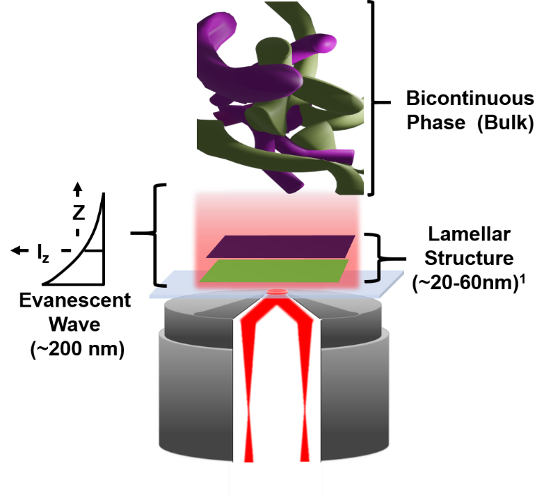

Figure 4.1: Cartoon depiction of proposed structure of a microemulsion with a structured lamellar surface versus a bicontinuous bulk. The green represents the oil phase and the purple represents the water phase. The lamellar structure should have oil and surfactant near the surface, and as the surface structure gets perforated, it leads into water phases and finally a bicontinuous bulk. Lamellar structure was proposed in a previous work.^{21,154,157}

dynamics to determine whether probe’s rotation is restricted or are allowed to freely rotate. Anisotropies that have a difference in the angle of absorption and emission can also be utilized to gauge structural differences between the surfaces and the μE compositions. Three emission wavelengths, that are arrayed along the emission spectrum, will be monitored to observe aggregate and monomeric species.¹⁶¹ Finally, surfaces will be functionalized to ascertain whether the hydrophobicity can affect the anisotropic dynamics at the surface. Given the key role the surfactant plays in mediating the behavior of electroactive species and the perturbation of the surface on the surfactant structure, we expect these interfacial dynamics to provide new insight into the use of microemulsions as electrolytes.
4.3 Methods
Steady-state fluorescence measurements were obtained on a Cary Eclipse Fluoroscence Spectrometer (Agilent). Excitation spectra were obtained at emission maximums of 480 nm, 525 nm, and 580 nm. Emission spectra were collected with an excitation wavelength of 400 nm.
A time-correlated single photon counting (TCSPC) instrument was used to record time-resolved emission decays. (Figure 4.2) Briefly, a light source originates from a femtosecond modelocked Ti:sapphire laser (MaiTai, SpectraPhysics) having pulses centered at 800 nm with a temporal pulse width of 90 fs and a repetition rate of 80 MHz. The beam was modulated to 22.6 MHz with an electro-optic modulator which was also used as a sync input for time correlation. The beam passed through a 4× beam expander and an excitation 400/25 nm bandpass filter (Edmund Optics #86-652) before being introduced into the microscope. Three different dichroic and emission filter pairs were used: a 550 longpass dichroic (Edmund Optics #69-877) with a 530/55 nm bandpass emission filter (Edmund Optics # 87-750), a 572 longpass dichroic (Omega 570 DRLP) with a 605/55 nm bandpass emission filter (Chroma AT605/55), and a 482 longpass dichroic (Edmund Optics #80-331) with a 472/30 nm bandpass emission filter (Edmund Optics #67-027). When probing the bulk of the microemulsion, a 10×0.3 NA air objective (N10X-PF) was employed to focus the light inside the sample beyond the coverslip surface. To probe the sample near the coverslip interface, the beam was focused through a 500 mm achromatic lens onto the back aperture of a 100× 1.49 NA oil immersion objective (MRD1991, Nikon). The emitted fluorescence from both bulk and TIRF measurements was focused onto a single photon avalanche detector, and the signal was time correlated by a TCSPC module (PicoHarp 300). The

Figure 4.2: Instrumental schematic of the TIRF platform: BS, beam-splitter; WP, waveplate; Pol, Glan-Thompson Polarizer; EOM, electro-optic modulator; OBJ, objective; DC, dichroic mirror; PD, photodiode; SPAD, single photon counting avalanche photodiode; TCSPC, time-correlated single photon counting.

data was recorded through the PicoHarp software and processed through custom-built MATLAB codes.
The single photon avalanche photodiode detector ($PD-050-CTD) has a stated temporal resolution of ~35 ps with a max of 50 ps. The instrument response was recorded by collecting the signal from a o-DASPMI sample that displayed lifetime dynamics of 6.6 ps.¹⁶² The DASPMI dynamics are much faster than the resolution of the detector, so DASPMI was used to record an instrument response. A FWHM of ~40 ps FWHM allowed for a picosecond temporal resolution. Typical instrumental parameters for data collection were 4 ps for each channel with a range of 20 ns and a maximum count of ~10⁴ in the peak channel. All lifetimes were collected under magic angle conditions to preclude an interference from rotational components, and the lifetimes were fit to a sum of exponentials,
$I\left(t\right)=\sum{B_{i}exp⁡(-\frac{t}{τ_{i}})}$ (4.1)
where $B_{i}$ is the amplitude for the ith component of the decay and $τ_{i}$ is the fluorescence lifetime. Contributions from each lifetime were calculated as a weighted percentage.
Time-resolved fluorescence anisotropy was obtained with the same TCSPC instrument described above, and the fluorescence emissions were collected either parallel ($I_{∥}$) or perpendicular ($I_{⊥})$ to the s-polarized excitation beam. For conventional anisotropy, (r(t)) was determined from the measured intensities by given in chapter 2. For TIRF anisotropy, Wirth et al. derived a specific magic angle of 49°, instead of the conventional 54.7°, that is related to the rotation that is oriented along the surface, and the maximum initial anisotropy for this restricted in-plane rotation is 0.5 with anisotropic equation becoming
$r=\frac{I_{∥}-{GI}_{⊥}}{I_{∥}+{GI}_{⊥}}$ (4.2)
Data with angles between excitation and emission polarization of both 49° and 54.7° were collected and fit to the number of exponentials shown in Table B.1. Figure B.1 shows no difference between the exponential fits for either magic angle data, so all anisotropy is fit to the conventional anisotropy equation.
All anisotropy measurements were fit to an iterative reconvolution model similar to Funston et al. used the magic angle data as a scaling factor.⁴⁴ The data in this chapter uses a scaling factor that is the fit result from a simulated sum of polarized intensities.
$K\left(t\right)=\sum{B_{i}exp⁡(-\frac{t}{τ_{i}})}$ (4.3)
$I_{∥}+I_{⊥}=K(t)$ (4.4)
$I_{∥}=\frac{1}{3}K(t)\exp\left(1+2r(t)\right)$ (4.5)
$I_{⊥}=\frac{1}{3}K(t)\exp\left(1-r(t)\right)$ (4.6)
K(t) is the scaling factor that is a fit sum of exponentials to the sum of the polarized intensities (Equation 4.3). This scaling factor is used to determine how much the experimental G-factor would deviate from unity. The parallel and perpendicular intensities are then simultaneously fit with the anisotropic model. The models used to fit the anisotropic decay were either single or biexponential. The single exponential is a similar equation to the lifetime model and is also expressed by equation 2.8. The biexponential model is expressed in the form
$r\left(t\right)=r_{o}\left[a_{1}\exp\left(-\frac{t}{θ_{1}}\right)+\left(1-a_{1}\right)exp\left(-\frac{t}{θ_{2}}\right)\right]$ (4.7)
where $r_{0}$ is the initial anisotropy and includes contributions from the angular displacement between absorption and emission dipoles of the molecule, and $θ$ is the correlation time which represents depolarization over time. The amplitude component, $a_{1},$ is then used to calculate an average correlation time which is expressed as
$〈θ〉=a_{1}θ_{1}+(1-a_{1})θ_{2}$ (4.8)
An average correlation time has been used in many former works to determine the correlation time for biexponential anisotropy models as it can be difficult to clearly assign and analyze the individual correlation times.⁴⁰ A final calibration check was performed by calculating the isotropic decay
$I_{iso}(t)=\frac{I_{∥}\left(t\right)+2I_{⊥}(t)}{3}$ (4.9)
This isotropic decay is compared to the obtained magic angle intensity to check for errors that can arise from laser fluctuations, photobleaching, and instrumental drift. All anisotropy data in which the isotropic decay was not within $±2\%$ of the magic angle data were rejected.
In chapter 2, the concepts of TIR were introduced such as the critical angle and penetration depth. In our experiments, the refractive index of the microemulsions will range from a refractive index of TW20 (n=1.468) to water (n=1.333), and all samples were measured with a refractometer (Atago, Japan) (Table B.2). As TIR is reliant on the refractive index of the sample ($n_{2}$), a range of different angles are needed to induce the evanescent wave, and for objective-based TIRF, there is a limit to the maximum angle accessible, which is 80.21° for a 1.49 numerical aperture (NA) objective, before the beam is blocked by the periphery of the objective’s lenses.²⁶ In turn, for these experiments we chose a constant supercritical angle that allowed for TIR in both TW20 and water. This constant angle will translate to a narrow penetration depth for a high-water percentage μE where ~ 75 nm from the interface will be equal to ~10% of the wave’s intensity versus a surfactant dominated sample where ~ 200 nm from the interface will be equal to ~10% of the intensity (Figure B.2).
The final calibration before data processing involves the high NA objective used for TIRF anisotropy. A high NA objective can collect a larger range of emission polarizations in comparison to more common spectroscopy anisotropy apparatuses because of its wide collection cone. This expanded collection results in depolarization that will substantially alter the $r_{0}$ but have a minimal effect on the correlation time.¹⁶³ Two different methods were devised to correct for this instrumental depolarization: Axelrod’s theoretical treatment⁴⁶ and Devaughes’ experimental protocol⁴². In testing both methods, the Axelrod correction was found to be more robust and recovered the initial anisotropy without being as susceptible to SNR (Table B.3). The final equation used to correct the TIRF anisotropy is shown in Equation 2.21.
The μE samples investigated are composed of TW20 (ultrapure, Thermo-Fischer) as the surfactant, 1-butanol (99.9%, anhydrous, Alfa Aesar) as the cosurfactant, toluene (99.8%, andydrous, Alfa Aesar) as the oil, and MilliQ water as the aqueous portion. The compositions follow along a water dilution path in the ternary diagram where the oil: surfactant mass ratio was kept at a constant of 1:10, and the surfactant: cosurfactant mass ratio was kept at 4.7:1 (Figure 4.3). This μE system has been investigated previously and determined to be in a bicontinuous
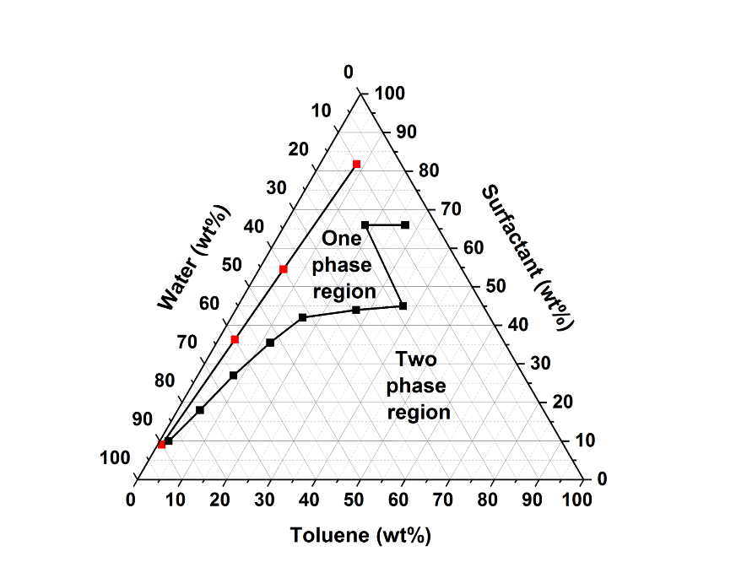

Figure 4.3: Ternary diagram for uEs with mass weight percentages on the axis. Compositions are composed along the line dotted with red markers that signify each composition. These formulations fall into the one phase region. The black marker line splits the ternary diagram from one- and two-phase regions, and it shows where a uE (one phase) is produced.

phase for the majority of compositions tested.¹⁵⁵ The fluorophore probe C153 (Lambda Physik) was used as purchased and made into a stock concentration 10⁻³ M in toluene for the μE samples. Initial preparations began by depositing the stock solution of C153, and the final solutions were made with subsequent additions of toluene, TW20, butanol, and water. All samples were mixed by vortexing for 3 minutes and were then allowed to settle for 10 minutes. Samples were made fresh before every experiment as the oxidation of the solution could affect the fluorophore. Samples are stable for up to 6 months before it separates into its different components. The final μE samples all contained a C153 concentration of 10⁻⁴ M. The labels of the compositions and the components are shown in Table 4.1. While this C153 concentration is higher than other reports¹⁶⁴, C153 displays aggregates in protic solvents at detectable levels even at low concentrations of ~10⁻⁶ M despite having a relatively high solubility of ~30 mM in these solvents.¹⁶¹ In turn, emission wavelengths have been used to monitor aggregate and monomeric species separately in our samples.¹⁶¹ Another issue that arises from probing high concentrations is reabsorption, but C153 has absorption and emission spectrums that are well separated that prevents this process from occurring.³⁹
As TIR requires a coverslip and immersion oil to achieve the supercritical angle necessary, a typical quartz cuvette could not be employed. Thin samples, with a depth of 100 microns, could be used as the 0.3 NA excitation focal volume of ~11 microns would not have surface contributions, but for ease of changing the coverslips with different hydrophilicities, a coverslip was adhered to a standard quartz cuvette. (Figure B.3) Double-sided tape (7602A53, McMaster-Carr) was fashioned with a die cutting machine (Cricut), and the adhesive was designed to cement to the edges of the cuvette which eliminates any interference in signal from the tape itself. A total volume of 1 mL of solution was added to the cuvette for each measurement.
Previously, similar TW20 uEs were characterized on hydrophobic surfaces, so purchased coverslips were identified as a hydrophobic surface as they have a measured water contact angle ~60°.¹⁶⁵ A hydrophilic surface was achieved by acid-washing coverslips using a method by Cras et al.¹²⁹ Briefly, the coverslips were initially immersed in 50:50 methanol (99.9%, Fisher)/HCl (95.0%, Fisher) solution for 30 min and were rinsed with MilliQ water and dried under N₂. The coverslips were steeped in H₂SO₄ (95.0%, Fisher) for 30 min and followed by the same water
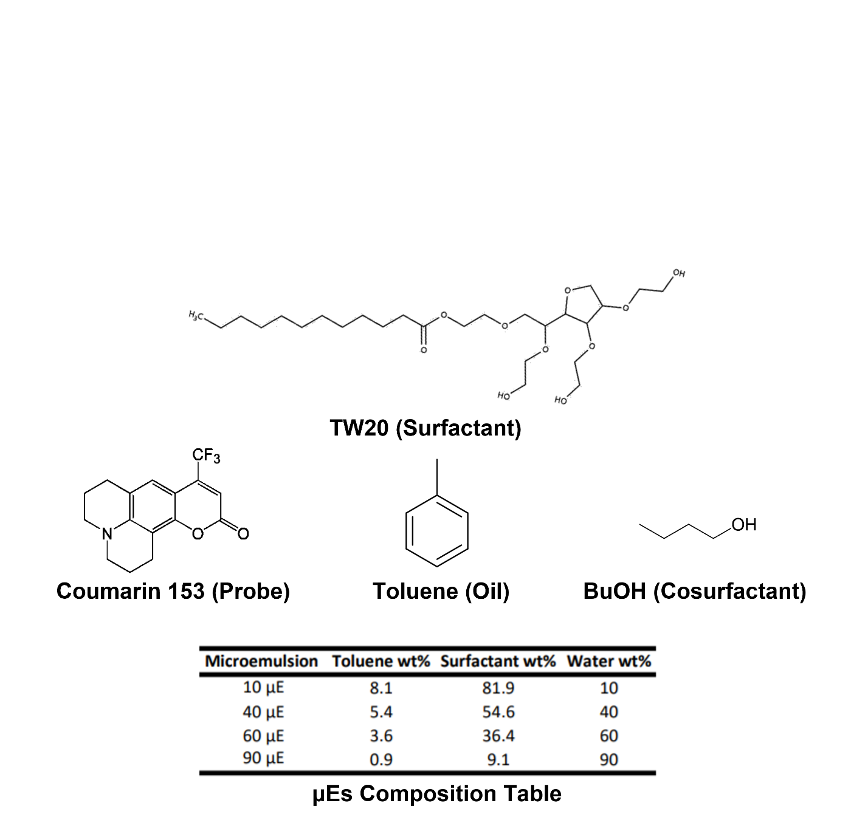

Table 4.1: Table of microemulsions labels and composition along with chemical structures of each substituent in the composition.

washing and drying steps. All coverslips were stored under methanol in sealed containers before being adhered to the quartz cuvettes. The measured contact angle for the hydrophilic surfaces were ~30°, and a picture of the contact angles are shown in Figure A.3.
4.4 Results
4.4.1 Steady-State
Emission spectra were collected in the constituent parts of the μE in which the probe was soluble: toluene, butanol, and TW20 (Figure 4.4). In butanol, a single peak is observed with an emission maximum of 525 nm. The peak blue shifts in toluene with the maximum emission becoming 480 nm. For the surfactant TW20, a broad peak that extends over the peaks of both butanol and toluene is depicted with an emission maximum of 510 nm. Emission spectra were collected of the 40 and 60 μEs, and a very small blue shift is depicted from the 60 to the 40 μE.
For each excitation spectra, three different emission wavelengths were used. Specifically, the blue edge (λ=480 nm), the center maximum (λ=525 nm), or the red edge (λ=580 nm) of the steady state C153 emission spectrum. In Figure B.4 A, butanol’s emission spectrum shifts slightly blue and displays a broad excitation peak. Figure B.4 B illustrates the blue shift of the excitation wavelength for the 60 μE, and the 480 nm peak excitation wavelength is at 400 nm which shifted from the 425 nm excitation maximum for the 525 nm and 580 nm emissions. Excitation of the probe in toluene is presented in Figure B.4 C and shows no shift in excitation wavelength. TW20’s excitation spectrum shows a smaller blue shift compared to the 60 μE, and the excitation wavelength shifts to 410 nm from 425 nm (Figure B.4 D).
4.4.2 Lifetime Dynamics
Fluorescence decays of C153 in each solvent are shown in Figure 4.5. In toluene, a nonpolar solvent, a single exponential decay of the C153 lifetime is observed at all wavelengths (Figure 4.5 A). Conversely, the blue edge emission in the polar solvents of butanol and TW20 exhibited multiexponential lifetime decays (Figure 4.5 B, 4.5 C). In each of the polar solvents the C153 lifetime was fit to a single exponential for 525 nm emission, so for the purposes of lifetime fitting, the 480 and 525 nm are fit exclusively for the μEs. A previous study into the C153 aggregation in neat solvents derived that the multiexponential emission arises from different
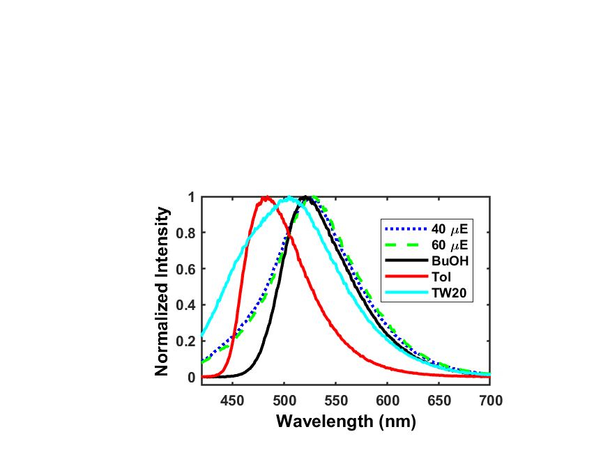

Figure 4.4: Emission spectra of C153 in toluene, butanol, TW20, and the 40 and 60 μEs. Emission spectra of the μEs overlaps with the butanol spectrum but has a blue shoulder that corresponds with tween and toluene.

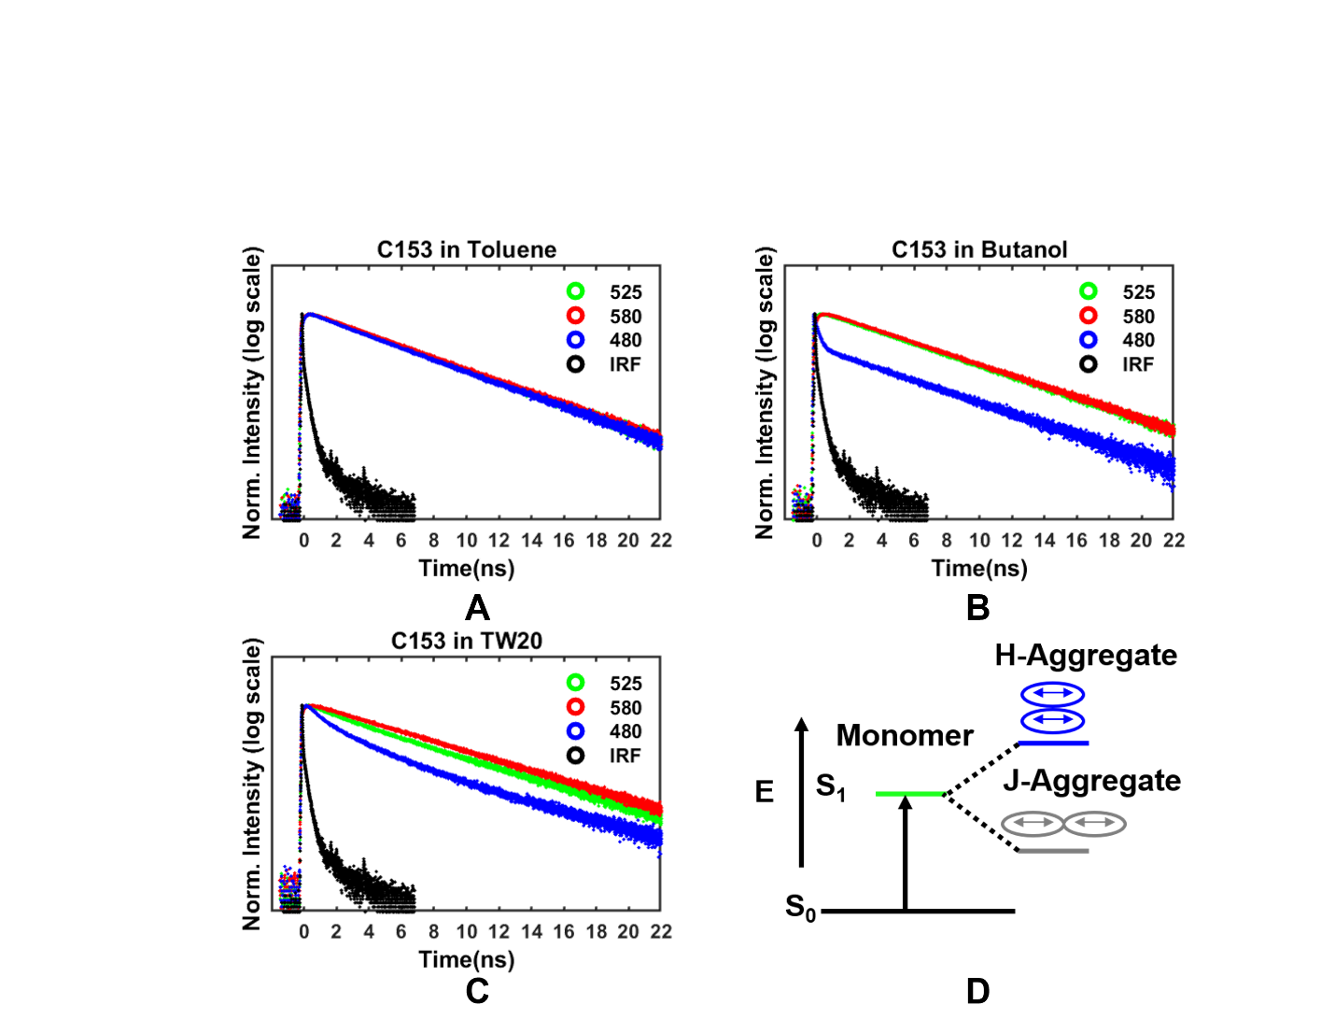

Figure 4.5: Fluorescence lifetime data of C153 in the neat solvents of toluene (A), butanol (B), and TW20 (C). The emission wavelengths of 480, 525, and 580 nm are shown in blue, green, and red, respectively. The instrument response function (IRF) is plotted in black. A Jablonski diagram depicting the electronic structure of C153, and the splitting of the S₁ energy level into two different energy levels that represent the emission levels of either the H- or J- aggregate which are expected to contribute to the lifetime decays measured at the blue and red edges of the emission spectrum, respectively (D).

aggregate orientations¹⁶¹, and the electronic structure illustrating this concept is depicted in Figure 4.5 D. The Jablonski diagram shows that multiexponential behavior at the blue edge of emission can originate from an aggregate whose orientation is stacked and is known as a H-aggregate. Moreover, an aggregate that would give rise to emission at the red edge of the spectrum would have an orientation that is tail-to-tail and is called a J-aggregate. The lack of any multiexponential behavior when probing C153 at the red edge of its emission in all solvent and μE samples confirms the absence of J-aggregates. The multiexponential behavior we observe suggests the presence of C153 H-aggregates in butanol; however, the possibility of these aggregates in the μEs or TW20 is entangled with multiexponential behavior stemming from a heterogenous environment and will be discussed below.
At the 525 nm emission, only TW20 required a bi-exponential fit whereas all other fits only a single exponential was needed. In Table B.4 and B.5, lifetime components and weights are listed for the 525 nm emission. For the 525 nm emission, there is a ~10 % for τ₁ with a lifetime of ~2.2 ns for TW20, but the lifetime is mostly dominated by τ₂ with a lifetime of ~5.6 ns. In all other samples the longest lifetime with a monoexponential fit was butanol ~5.0 ns. For the 10 μE and toluene, the lifetime is ~4.7 ns, and all the other μEs exhibit a lifetime of ~4.3 ns. These lifetimes apply for the bulk, surface, and functionalization.
For the 480 nm emission lifetimes, all decays required a triexponential fit except for butanol that utilized two exponentials. In Tables B.6 and B.7, the weights and lifetimes for the data are listed. The weight percentage of τ₁ for butanol are all ~13%, and the lifetime was ~0.12 ns except for hydrophilic surface with a longer lifetime of 0.27 ns. The τ₁ weight percentage in TW20 is the same as butanol’s weight, but the lifetime is longer ~0.5 ns. The τ₁ for the μEs is the lowest for the 10 μE with a lifetime ~0.35 ns and increases with water loading to ~0.5 ns for the 90 μE. The weight percentage for τ₁ in the μEs is the highest in the 60 μE and decreases in the 90 μE. τ₂ had the longest lifetime component that is the highest in TW20 at ~6.5 ns, and for the μEs, the lowest lifetime was ~4.5 ns for the 90 μE and ~5.2 ns for all other compositions. The weight percentage for τ₂ in TW20 is ~40 %, and for the μEs the weight percentage is lowest in the 10 μE at ~27 % and highest in the 90 μE at ~45%. The τ₂ in butanol is ~5.0 mirroring the lifetime recorded in the 525 nm emission range. τ₃ has a lifetime ~2 ns with the longest lifetime and no clear pattern could be observed, but the highest weight percentage was recorded for TW20 and the 10 μE. There were no substantial differences between the bulk, surface, or functionalization.
4.4.3 Time-resolved Anisotropy
Time-resolved anisotropy was measured by the simultaneously fit of polarized emission parallel and perpendicular with respect to the vertical excitation, and Figure B.5 shows an example of the simultaneous fits and residuals. Single and bi-exponential models were tested for fitting the anisotropy in every solution, and Table B.8 shows a comparison of the χ² values for the single and bi-exponential models. χ² calculates the sum squared of the residuals and divides by the degrees of freedom, so the lower χ² values represents the better fit. In cases where one model had a lower value than the alternative by ~0.02, that model was chosen based on the better χ². There are a few cases where the χ² was not explicitly followed depending on parameters resulting in a boundary condition or large standard deviations in correlation times or initial anisotropies that occurred from approaching these boundaries. Tables B9 and B10 shows the chosen model and the fit parameters that were extracted from the model. For butanol, toluene, and TW20 only a single exponential was needed to fit the anisotropy decay for both the bulk and the surface data. For the 10 μE, a bi-exponential was needed for both the bulk and the surface results. For all of the other μE compositions, a bi-exponential decay model was used for the bulk measurements while only a single exponential model was necessary to adequately describe the data collected near the surface in the TIRF geometry.
In Figure 4.6, the initial anisotropies and correlation times for C153 at the 480 nm and 525 nm correlation times are plotted. At the 480 nm emission (Figure 4.6 A), there is a decreased $r_{0}$ of ~ 0.2 at the surface for all samples with the lowest $r_{0}$ value measured in the pure TW20 environment. The bulk $r_{0}$ at 480 nm was ~0.35 with a value approaching the literature value of 0.375.¹⁶⁰ Across all μE compositions for the 480 nm emission, there is a constant $r_{0}$ value for both the bulk and the surface, respectively. For the 525 nm, the surface $r_{0}$ has a similar value to the 480 nm data, but the bulk $r_{0}$ decreases slightly as the water percentage increases. A large deviation is observed for toluene as the previously reported correlation time of ~40 ps approaches the temporal resolution of our measurements.⁴⁰
The correlation times for the 480 nm emission are shown in Figure 4.6 B, and the only samples to exhibit a difference between the bulk and the surface are butanol, 40 μE, and 60 μE. For butanol, the surface correlation time is higher than the bulk, but for the μEs, the surface correlation time is lower than the bulk. In the 525 nm emission, there are no differences in correlation times for the bulk compared to the surface across all samples (Figure 4.6 C). The correlation time for TW20 is much higher than any other sample with a measured time ~3500 ps for 480 nm and 525 nm emission. The μE with the highest correlation time was the 10 μE, and there is a decrease in correlation time as water the percentage increases. The one striking feature between the two emission range correlation times occurs at the 90 μE. The 480 nm emission depicts the 90 μE with the lowest correlation time, but in the 525 nm emission, the 60 μE displays the fastest dynamics as the correlation time increases for the 90 μE. In all samples, there was no observable difference between the functionalized surfaces for either $r_{0}$ or for correlation time.
4.5 Discussion
4.5.1 Probe Location
Steady-state emission spectra of C153 in Figure 4.4 showed that the fluorescent probe resides in the surfactant layer, and as the water percentage increased, a bathochromic shift of the emission maximum occurs representing the water’s increased presence in the probe’s microenvironment. Hassan et al.(unpublished) has also shown that energy transfer was observed between C153 and an ionic species associated with the surfactant layer although electron transfer to a different ionic species was not present. Overall, these results localize C153 to the headgroup region of the surfactant layer but buried a significant distance away from the water volume.
Excitation spectra are often used to gauge the presence of multiple species in a solution¹⁶⁶, and Figure B.4 shows a blue shift when approaching 480 nm. It is interesting to note that a very small shift in butanol could be the reason that there is no 3rd component needed when measuring the lifetime decays at 480 nm. When comparing TW20 and the 60 μE spectra, the blue shift is much more substantial compared to butanol, but the 60 μE has a much higher intensity in the blue shoulder and shifts further blue compared to TW20. This could be indicative of either increased aggregation in the μE or C153 accessing a different environment that is

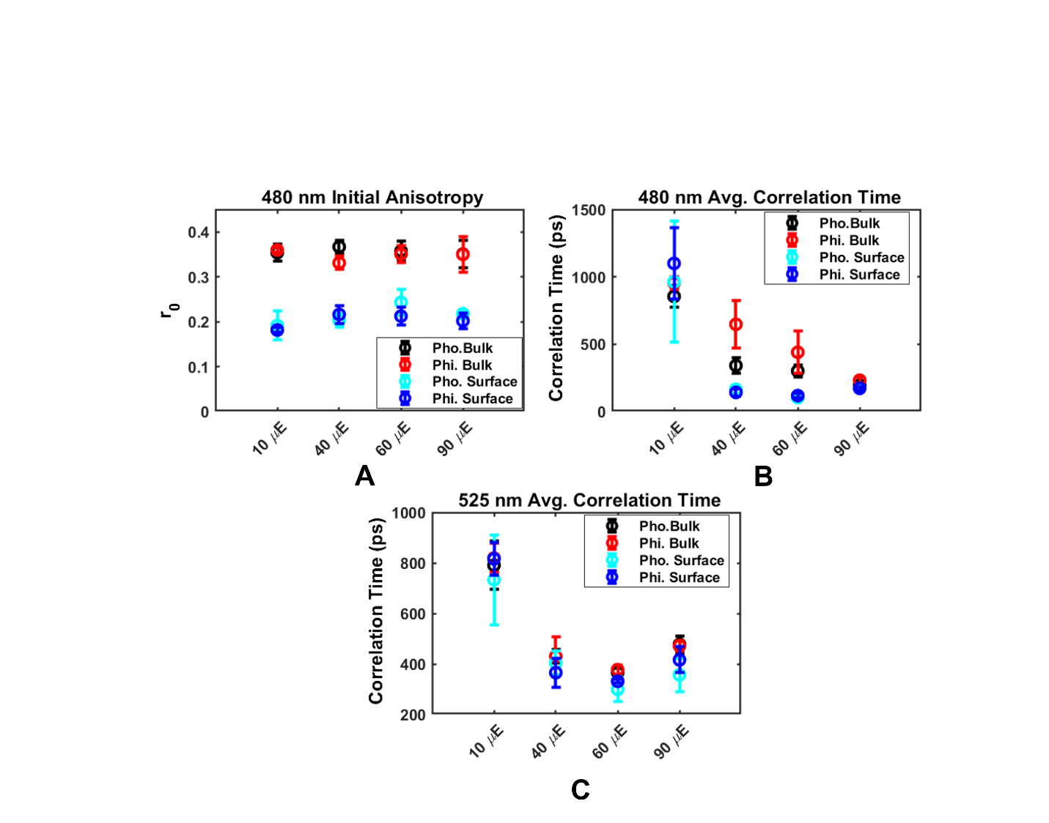

Figure 4.5: (A) 480 nm initial anisotropy versus sample. (B) Average correlation time for 480 nm emission for all samples. (C) Average correlation time for 525 nm emission for all samples.

affecting the solvent relaxation.
4.5.2 Aggregation vs Heterogenous Environment
There has been much discussion concerning the origin of the multiexponential behavior observed at the blue edge of emission. Funston et al. required a five exponential model to achieve adequate fits when measuring C153 at the blue or red edges of emission in ionic liquids, and they would not attribute any significance to these parameters as their goal was to resolve time decay emission spectra.⁴⁴ Verma et al. stated explicitly that the multiexponential behavior at the blue edge arises from the formation of C153 aggregates, and these aggregates would form in polar protic solvents (e.g. ethanol, butanol) but not in polar aprotic or nonpolar solvents.¹⁶¹ Karmakar et al. asserted that time constants that change as a function of excitation wavelength signifies a continuous time-dependent shift of the spectrum and not processes from specific energy states.¹⁶⁷ Potentially one other reason for the multiexponential behavior in complex fluids like μEs is due to the heterogeneous environment.¹⁶⁸
Our lifetime dynamics indicate the presence of three different time constants at the 480 nm emission for all the μEs and in TW20 (Figure 4.5 and Tables B.6/B.7). The fastest component τ₁ has the highest weight percentage in the 60 μE which could mean that either aggregation is the greatest in this composition or the exposure to different environments is considerable. Knowing that the 90 μE has a higher water percentage, is it interesting to see a decrease in this component as the water should induce more aggregation or insert more heterogeneity into the microenvironment. Verma et al. noted a decrease in the fastest component for C153 in ethanol along with a concomitant rise of the other slower components when decreasing concentration which would support the idea of aggregation. This experiment in concentration could aid in determining the source of this multiexponential behavior.
4.5.3 Surface Rotation Dynamics and Ordering
C153’s rotation near the surface appears to lose the bi-exponential behavior observed in the bulk. Horng et al. claimed that the rotational dynamics of C153 in certain solvents would begin to have nonexponential character due to the friction imposed on the molecule’s rotation; likewise, heterogeneity in a complex fluid can also influence the rotational dynamics as well.⁴⁰ Also rotation of different species can induce nonexponential rotation, but in certain experiments, multiple species can exhibit a single exponential anisotropy and the only parameter impacted is the overall correlation time.¹⁶¹
Our experiments clearly show an ordering at the surface as indicated by r_{0.} This decrease in the initial anisotropy at both 525nm and 480 nm reinforces that a surfactant structure is near the surface as the probe’s location is known to be in the surfactant, and through the previous study depicting surfactant ordering on the surface of an electrode.¹⁵⁵ In the case of the correlation times for C153, the only difference between the bulk and the surface is observed in the 40, 60 μEs and butanol at 480 nm emission. The difference between butanol and the μEs is that the surface correlation time is longer for butanol is longer than bulk correlation, whereas the μEs exhibit shorter correlation time on the surface versus the bulk. Aggregation could potentially explain the increase in correlation time at the surface, but it would not explain the phenomenon of the correlation time decreasing. A possible answer to a quicker correlation is C153’s rotation is being dictated by the rotation of another molecule in the bulk.
The volume and axial radii have been reported previously for C153.¹⁶⁹ Calculating the TW20 rotation yields a correlation time that is much longer than any time reported here, but association with another molecule could be possible as C153 is in the surfactant region. Calculating the correlation time of C153 in butanol yields a correlation time of 744 ps which does not describe the quicker dynamics at the surface, but this calculation also assumes a spherical molecule and an assumption that the solvent molecules are much smaller than the probe molecule (e.g., stick boundary, continuum model). Both a shaping factor and a boundary condition can be multiplied to the volume to correctly model the molecular volume. The shaping factor accounts for an ellipsoidal rotor and the boundary condition accounts for the size of the probe molecule approaching the size of solvent molecule (e.g., slip boundary, mean spherical approximation model). When calculating the correlation time under these conditions, a correlation time matching the data of 100 ps for the surface of the 60 μE can be obtained with a boundary condition approaching the slip limit of 0.09 and a shaping factor of 1.5. It should be noted that the slip limit approaches zero as the stick limit approaches unity. This data drives the hypothesis that a different rotational environment within the surfactant layer can lead to a faster correlation time near the surface.

4.6 Conclusion
TIRF anisotropy has been applied for the first time on a TWBT μE to determine the small molecule dynamics near the surface of a solid/liquid interface. Steady-state spectra also confirmed a higher absorption in bluer wavelengths compared to the surfactant and co-surfactant suggesting that the μE structure is playing a role in accessing these higher energy states. Lifetime dynamics shows a faster lifetime component being dominate in the 60 μE displaying an increased weight percentage and faster lifetime compared to the surfactant alone. This is interesting as the presence of a higher water percentage decreases the presence of this component which can support the notion of a unique bicontinuous structure in the 60 μE. TIRF anisotropy revealed an ordering at the surface due to the decrease in the initial anisotropy, and this data posits that the faster dynamics observed at the surface versus the bulk for the 40 and 60 μEs could be due C153 approaching an environment where the solvent molecules are smaller than the probe molecule. This environment can have a direct implication for μEs in redox flow batteries. More studies are needed with both a concentration dependence of C153 and different probes to fully characterize the small molecule dynamics in this surface structure.
4.7 Acknowledgments
B.A.C., M.R.H., and T.R.C. were funded by the DOE BEES Award #DE-SC0019409. The authors thank M. J. Blake for assistance with pictures of the cuvette flow cell.

CHAPTER 5

Conclusions and Future Outlook

5.1 Conclusions
In this dissertation, the development of a novel technique that brought together total internal reflection with transient absorption microscopy was introduced. This was the first time that both pump and probe were introduced in the TIR geometry through an objective-based platform. This work highlighted the capability of performing as an-online detection method for microreactors. Microreactors require a fast feedback optimization in order to thrive in industrial applications, and the TIRTAM technique displayed the fundamental elements needed when observing reaction mixing in the reactors: differentiation between two chromophores in one environment, discerning between the same chromophore in two different environment, and the ability to gauge diffusion within the flow channel. This elementary analysis can be used for many interesting systems that would help propel microreactors to the forefront in synthesizing high-grade material.
TIRF anisotropy and lifetimes were utilized for the first time on a unique system of microemulsion. This technique resolved the difference in ordering and rotational dynamics between the bulk and solid/liquid interface. Understanding the structure near the surface of this interface can allow for optimization of these systems for redox flow batteries, and the faster dynamics witnessed in certain compositions could be a factor that modulates electron transfer within these systems. Overall, this technique has begun to discern the many different dynamics that are involved with this complex fluid.
5.2 Outlook
An immediate research application for TIRTAM would be to study a more complicated reaction or applied to more industrial version of microfluidic.⁷⁷ Quantification is also a route that should be explored as absorption techniques are prized for their ability to quantify at different times in a reaction. Immediate research applications for TIRF should involve the use of cyclic voltammetry with specialized conductive substrates.¹⁷⁰⁻¹⁷¹ The ability to correctly gauge the electron transfer near the surface with TIRF will allow for a more complete characterization of the surface structure of the microemulsion and would be complementary to the anisotropy/ lifetime studies.

References
1. Elvira, K. S.; i Solvas, X. C.; Wootton, R. C.; Demello, A. J., The Past, Present and Potential for Microfluidic Reactor Technology in Chemical Synthesis. Nature chemistry 2013, 5, 905.
2. Howes, P. D.; Chandrawati, R.; Stevens, M. M., Colloidal Nanoparticles as Advanced Biological Sensors. Science 2014, 346.
3. Xia, Y.; Yang, H.; Campbell, C. T., Nanoparticles for Catalysis. Accounts of chemical research 2013, 46, 1671-1672.
4. Talapin, D. V.; Lee, J.-S.; Kovalenko, M. V.; Shevchenko, E. V., Prospects of Colloidal Nanocrystals for Electronic and Optoelectronic Applications. Chemical reviews 2010, 110, 389-458.
5. Fortt, R.; Wootton, R. C.; de Mello, A. J., Continuous-Flow Generation of Anhydrous Diazonium Species: Monolithic Microfluidic Reactors for the Chemistry of Unstable Intermediates. Organic process research & development 2003, 7, 762-768.
6. Pieber, B.; Kappe, C. O., Direct Aerobic Oxidation of 2-Benzylpyridines in a Gas–Liquid Continuous-Flow Regime Using Propylene Carbonate as a Solvent. Green chemistry 2013, 15, 320-324.
7. Ferstl, W.; Klahn, T.; Schweikert, W.; Billeb, G.; Schwarzer, M.; Loebbecke, S., Inline Analysis in Microreaction Technology: A Suitable Tool for Process Screening and Optimization. Chemical Engineering & Technology: Industrial Chemistry‐Plant Equipment‐Process Engineering‐Biotechnology 2007, 30, 370-378.
8. Löbbecke, S., Integration of Sensors and Process Analytical Techniques. Micro Process Engineering: Fundamentals, Devices, Fabrication, and Applications 2006, 249-266.
9. Yue, J.; Schouten, J. C.; Nijhuis, T. A., Integration of Microreactors with Spectroscopic Detection for Online Reaction Monitoring and Catalyst Characterization. Industrial & engineering chemistry research 2012, 51, 14583-14609.
10. Schulman, J. H.; Stoeckenius, W.; Prince, L. M., Mechanism of Formation and Structure of Micro Emulsions by Electron Microscopy. The Journal of physical chemistry 1959, 63, 1677-1680.
11. Tartaro, G.; Mateos, H.; Schirone, D.; Angelico, R.; Palazzo, G., Microemulsion Microstructure (S): A Tutorial Review. Nanomaterials 2020, 10, 1657.
12. Salager, J. L.; Forgiarini, A. M.; Bullón, J., How to Attain Ultralow Interfacial Tension and Three‐Phase Behavior with Surfactant Formulation for Enhanced Oil Recovery: A Review. Part 1. Optimum Formulation for Simple Surfactant–Oil–Water Ternary Systems. Journal of Surfactants and Detergents 2013, 16, 449-472.
13. Lawrence, M. J.; Rees, G. D., Microemulsion-Based Media as Novel Drug Delivery Systems. Advanced drug delivery reviews 2000, 45, 89-121.
14. Christopher, F. C.; Ponnusamy, S. K.; Ganesan, J. J.; Ramamurthy, R., Investigating the Prospects of Bacterial Biosurfactants for Metal Nanoparticle Synthesis–a Comprehensive Review. IET nanobiotechnology 2019, 13, 243-249.
15. Galie, S.; García-Gutiérrez, C.; Miguélez, E. M.; Villar, C. J.; Lombó, F., Biofilms in the Food Industry: Health Aspects and Control Methods. Frontiers in microbiology 2018, 9, 898.
16. Griffin, W. C., Classification of Surface-Active Agents by" Hlb". J. Soc. Cosmet. Chem. 1949, 1, 311-326.
17. Chen, S.; Evans, D. F.; Ninham, B.; Mitchell, D.; Blum, F. D.; Pickup, S., Curvature as a Determinant of Microstructure and Microemulsions. The Journal of Physical Chemistry 1986, 90, 842-847.
18. Acosta, E., Engineering Cosmetics Using the Net-Average-Curvature (Nac) Model. Current Opinion in Colloid & Interface Science 2020, 48, 149-167.
19. Salager, J.; Morgan, J.; Schechter, R.; Wade, W.; Vasquez, E., Optimum Formulation of Surfactant/Water/Oil Systems for Minimum Interfacial Tension or Phase Behavior. Society of Petroleum Engineers Journal 1979, 19, 107-115.
20. Salager, J.-L.; Marquez, N.; Graciaa, A.; Lachaise, J., Partitioning of Ethoxylated Octylphenol Surfactants in Microemulsion− Oil− Water Systems: Influence of Temperature and Relation between Partitioning Coefficient and Physicochemical Formulation. Langmuir 2000, 16, 5534-5539.
21. Shen, X.; Sinclair, N. S.; Wainright, J. S.; Imel, A.; Barth, B.; Zawodzinski, T.; Savinell, R. F., A Study of Ferrocene Diffusion in Toluene/Tween 20/1-Butanol/Water Microemulsions for Redox Flow Battery Applications. Journal of The Electrochemical Society 2021.
22. Soloveichik, G. L., Flow Batteries: Current Status and Trends. Chemical reviews 2015, 115, 11533-11558.
23. Boyd, R. W., Nonlinear Optics; Academic press, 2020.
24. Lifante, G., Integrated Photonics: Fundamentals; John Wiley & Sons, 2003.
25. Axelrod, D., Total Internal Reflection Fluorescence Microscopy. In Methods in Cell Biology, Elsevier: 1989; Vol. 30, pp 245-270.
26. Axelrod, D., Total Internal Reflection Fluorescence Microscopy in Cell Biology. Traffic 2001, 2, 764-774.
27. Rabolt, J.; Santo, R.; Swalen, J., Raman Spectroscopy of Thin Polymer Films Using Integrated Optical Techniques. Applied Spectroscopy 1979, 33, 549-551.
28. Aiginger, H., Historical Development and Principles of Total Reflection X-Ray Fluorescence Analysis (Txrf). Spectrochimica Acta Part B: Atomic Spectroscopy 1991, 46, 1313-1321.
29. Fringeli, U. P.; Günthard, H. H., Infrared Membrane Spectroscopy. Membrane spectroscopy 1981, 270-332.
30. Carniglia, C.; Mandel, L.; Drexhage, K., Absorption and Emission of Evanescent Photons. JOSA 1972, 62, 479-486.
31. Wilks Jr, P. A.; Hirschfeld, T., Internal Reflection Spectroscopy. 1967.
32. Tweet, A.; Gaines Jr, G.; Bellamy, W., Fluorescence of Chlorophyll a in Monolayers. The Journal of Chemical Physics 1964, 40, 2596-2600.
33. Burghardt, T. P.; Axelrod, D., Total Internal Reflection Fluorescence Study of Energy Transfer in Surface-Adsorbed and Dissolved Bovine Serum Albumin. Biochemistry 1983, 22, 979-985.
34. Thompson, N. L.; Burghardt, T. P.; Axelrod, D., Measuring Surface Dynamics of Biomolecules by Total Internal Reflection Fluorescence with Photobleaching Recovery or Correlation Spectroscopy. Biophysical journal 1981, 33, 435-454.
35. Burghardt, T.; Ando, T.; Borejdo, J., Evidence for Cross-Bridge Order in Contraction of Glycerinated Skeletal Muscle. Proceedings of the National Academy of Sciences 1983, 80, 7515-7519.
36. Khan, S.; Pierce, D.; Vale, R. D., Interactions of the Chemotaxis Signal Protein Chey with Bacterial Flagellar Motors Visualized by Evanescent Wave Microscopy. Current Biology 2000, 10, 927-930.
37. Stout, A. L.; Axelrod, D., Reversible Binding Kinetics of a Cytoskeletal Protein at the Erythrocyte Submembrane. Biophysical journal 1994, 67, 1324-1334.
38. Mathur, A. B.; Truskey, G. A.; Reichert, W. M., Atomic Force and Total Internal Reflection Fluorescence Microscopy for the Study of Force Transmission in Endothelial Cells. Biophysical journal 2000, 78, 1725-1735.
39. Lakowicz, J. R., Principles of Fluorescence Spectroscopy; Springer science & business media, 2013.
40. Horng, M.-L.; Gardecki, J.; Maroncelli, M., Rotational Dynamics of Coumarin 153: Time-Dependent Friction, Dielectric Friction, and Other Nonhydrodynamic Effects. The Journal of Physical Chemistry A 1997, 101, 1030-1047.
41. Siegel, J.; Suhling, K.; Lévêque-Fort, S.; Webb, S. E.; Davis, D. M.; Phillips, D.; Sabharwal, Y.; French, P. M., Wide-Field Time-Resolved Fluorescence Anisotropy Imaging (Tr-Faim): Imaging the Rotational Mobility of a Fluorophore. Review of Scientific Instruments 2003, 74, 182-192.
42. Devauges, V.; Marquer, C.; Lecart, S.; Cossec, J.-C.; Potier, M.-C.; Fort, E.; Suhling, K.; Leveque-Fort, S., Homodimerization of Amyloid Precursor Protein at the Plasma Membrane: A Homofret Study by Time-Resolved Fluorescence Anisotropy Imaging. 2012.
43. Ströhl, F.; Wong, H. H.; Holt, C. E.; Kaminski, C. F., Total Internal Reflection Fluorescence Anisotropy Imaging Microscopy: Setup, Calibration, and Data Processing for Protein Polymerization Measurements in Living Cells. Methods and applications in fluorescence 2017, 6, 014004.
44. Funston, A. M.; Fadeeva, T. A.; Wishart, J. F.; Castner, E. W., Fluorescence Probing of Temperature-Dependent Dynamics and Friction in Ionic Liquid Local Environments. The Journal of Physical Chemistry B 2007, 111, 4963-4977.
45. Gelléri, M. Tirf-Anisotropy Microscopy: Homo-Fret and Single Molecule Measurements. Universitätsbibliothek Dortmund, 2013.
46. Axelrod, D., Carbocyanine Dye Orientation in Red Cell Membrane Studied by Microscopic Fluorescence Polarization. Biophysical journal 1979, 26, 557-573.
47. Fischer, M. C.; Wilson, J. W.; Robles, F. E.; Warren, W. S., Invited Review Article: Pump-Probe Microscopy. Review of Scientific Instruments 2016, 87, 031101.
48. Villafana, T. E.; Brown, W. P.; Delaney, J. K.; Palmer, M.; Warren, W. S.; Fischer, M. C., Femtosecond Pump-Probe Microscopy Generates Virtual Cross-Sections in Historic Artwork. Proceedings of the National Academy of Sciences 2014, 111, 1708-1713.
49. Lee, S.; Lee, J.; Pang, Y., Excited State Intramolecular Proton Transfer of 1, 2-Dihydroxyanthraquinone by Femtosecond Transient Absorption Spectroscopy. Current Applied Physics 2015, 15, 1492-1499.
50. Holzwarth, A. R.; Schatz, G.; Brock, H.; Bittersmann, E., Energy Transfer and Charge Separation Kinetics in Photosystem I: Part 1: Picosecond Transient Absorption and Fluorescence Study of Cyanobacterial Photosystem I Particles. Biophysical journal 1993, 64, 1813-1826.
51. Sibarita, J.-B., Deconvolution Microscopy. Microscopy Techniques 2005, 201-243.
52. Semwogerere, D.; Weeks, E. R., Confocal Microscopy. Encyclopedia of biomaterials and biomedical engineering 2005, 23, 1-10.
53. Buehler, C.; Dong, C.; So, P.; French, T.; Gratton, E., Time-Resolved Polarization Imaging by Pump-Probe (Stimulated Emission) Fluorescence Microscopy. Biophysical journal 2000, 79, 536-549.
54. Maceiczyk, R. M.; Lignos, I. G.; Andrew, J. d., Online Detection and Automation Methods in Microfluidic Nanomaterial Synthesis. Current Opinion in Chemical Engineering 2015, 8, 29-35.
55. Goodell, J. R.; McMullen, J. P.; Zaborenko, N.; Maloney, J. R.; Ho, C.-X.; Jensen, K. F.; Porco Jr, J. A.; Beeler, A. B., Development of an Automated Microfluidic Reaction Platform for Multidimensional Screening: Reaction Discovery Employing Bicyclo [3.2. 1] Octanoid Scaffolds. The Journal of organic chemistry 2009, 74, 6169-6180.
56. Zaborenko, N.; Bedore, M. W.; Jamison, T. F.; Jensen, K. F., Kinetic and Scale-up Investigations of Epoxide Aminolysis in Microreactors at High Temperatures and Pressures. Organic Process Research & Development 2010, 15, 131-139.
57. Shimoyama, A.; Fujimoto, Y.; Fukase, K., Stereoselective Glycosylation of 3-Deoxy-D-Manno-2-Octulosonic Acid with Batch and Microfluidic Methods. Synlett 2011, 2011, 2359-2362.
58. Asai, T.; Takata, A.; Ushiogi, Y.; Iinuma, Y.; Nagaki, A.; Yoshida, J.-i., Switching Reaction Pathways of Benzo [B] Thiophen-3-Yllithium and Benzo [B] Furan-3-Yllithium Based on High-Resolution Residence-Time and Temperature Control in a Flow Microreactor. Chemistry letters 2011, 40, 393-395.
59. Wiles, C.; Watts, P.; Haswell, S. J., Clean and Selective Oxidation of Aromatic Alcohols Using Silica-Supported Jones’ Reagent in a Pressure-Driven Flow Reactor. Tetrahedron letters 2006, 47, 5261-5264.
60. Kestenbaum, H.; Lange de Oliveira, A.; Schmidt, W.; Schüth, F.; Ehrfeld, W.; Gebauer, K.; Löwe, H.; Richter, T.; Lebiedz, D.; Untiedt, I., Silver-Catalyzed Oxidation of Ethylene to Ethylene Oxide in a Microreaction System. Industrial & engineering chemistry research 2002, 41, 710-719.
61. Mogensen, K. B.; Klank, H.; Kutter, J. P., Recent Developments in Detection for Microfluidic Systems. Electrophoresis 2004, 25, 3498-3512.
62. Roberge, D. M.; Ducry, L.; Bieler, N.; Cretton, P.; Zimmermann, B., Microreactor Technology: A Revolution for the Fine Chemical and Pharmaceutical Industries? Chemical Engineering & Technology: Industrial Chemistry‐Plant Equipment‐Process Engineering‐Biotechnology 2005, 28, 318-323.
63. Mills, P. L.; Quiram, D. J.; Ryley, J. F., Microreactor Technology and Process Miniaturization for Catalytic Reactions—a Perspective on Recent Developments and Emerging Technologies. Chemical Engineering Science 2007, 62, 6992-7010.
64. Tan, C. K. C.; Delgass, W. N.; Baertsch, C. D., Spatially Resolved in Situ Ftir Analysis of Co Adsorption and Reaction on Pt/Sio2 in a Silicon Microreactor. Applied Catalysis B: Environmental 2009, 93, 66-74.
65. Chan, E. M.; Alivisatos, A. P.; Mathies, R. A., High-Temperature Microfluidic Synthesis of Cdse Nanocrystals in Nanoliter Droplets. Journal of the American Chemical Society 2005, 127, 13854-13861.
66. Lignos, I.; Protesescu, L.; Stavrakis, S.; Piveteau, L.; Speirs, M. J.; Loi, M. A.; Kovalenko, M. V.; deMello, A. J., Facile Droplet-Based Microfluidic Synthesis of Monodisperse Iv–Vi Semiconductor Nanocrystals with Coupled in-Line Nir Fluorescence Detection. Chemistry of Materials 2014, 26, 2975-2982.
67. Hoffmann, M.; Schlüter, M.; Räbiger, N., Experimental Investigation of Liquid–Liquid Mixing in T-Shaped Micro-Mixers Using Μ-Lif and Μ-Piv. Chemical engineering science 2006, 61, 2968-2976.
68. Hsieh, S.-S.; Huang, Y.-C., Passive Mixing in Micro-Channels with Geometric Variations through µpiv and µlif Measurements. Journal of Micromechanics and Microengineering 2008, 18, 065017.
69. Mouheb, N. A.; Malsch, D.; Montillet, A.; Solliec, C.; Henkel, T., Numerical and Experimental Investigations of Mixing in T-Shaped and Cross-Shaped Micromixers. Chemical Engineering Science 2012, 68, 278-289.
70. Oddy, M.; Santiago, J.; Mikkelsen, J., Electrokinetic Instability Micromixing. Analytical chemistry 2001, 73, 5822-5832.
71. Stroock, A. D.; Dertinger, S. K.; Ajdari, A.; Mezić, I.; Stone, H. A.; Whitesides, G. M., Chaotic Mixer for Microchannels. Science 2002, 295, 647-651.
72. Moon, B.-U.; Koster, S.; Wientjes, K. J.; Kwapiszewski, R. M.; Schoonen, A. J.; Westerink, B. H.; Verpoorte, E., An Enzymatic Microreactor Based on Chaotic Micromixing for Enhanced Amperometric Detection in a Continuous Glucose Monitoring Application. Analytical chemistry 2010, 82, 6756-6763.
73. Thanh, N. T.; Maclean, N.; Mahiddine, S., Mechanisms of Nucleation and Growth of Nanoparticles in Solution. Chemical reviews 2014, 114, 7610-7630.
74. Edel, J. B.; Fortt, R.; demello, J. C.; demello, A. J., Microfluidic Routes to the Controlled Production of Nanoparticles. Chemical Communications 2002, 1136-1137.
75. Phillips, T. W.; Lignos, I. G.; Maceiczyk, R. M.; deMello, A. J.; deMello, J. C., Nanocrystal Synthesis in Microfluidic Reactors: Where Next? Lab on a Chip 2014, 14, 3172-3180.
76. Krishnadasan, S.; Brown, R.; Demello, A.; Demello, J., Intelligent Routes to the Controlled Synthesis of Nanoparticles. Lab on a Chip 2007, 7, 1434-1441.
77. McMullen, J. P.; Jensen, K. F., Integrated Microreactors for Reaction Automation: New Approaches to Reaction Development. Annual review of analytical chemistry 2010, 3, 19-42.
78. Nightingale, A. M.; de Mello, J. C., Controlled Synthesis of Iii–V Quantum Dots in Microfluidic Reactors. ChemPhysChem 2009, 10, 2612-2614.
79. Krishnadasan, S.; Tovilla, J.; Vilar, R.; DeMello, A.; DeMello, J., On-Line Analysis of Cdse Nanoparticle Formation in a Continuous Flow Chip-Based Microreactor. Journal of Materials Chemistry 2004, 14, 2655-2660.
80. Mazurczyk, R.; Vieillard, J.; Bouchard, A.; Hannes, B.; Krawczyk, S., A Novel Concept of the Integrated Fluorescence Detection System and Its Application in a Lab-on-a-Chip Microdevice. Sensors and Actuators B: Chemical 2006, 118, 11-19.
81. Löbbecke, S.; Ferstl, W.; Panić, S.; Türcke, T., Concepts for Modularization and Automation of Microreaction Technology. Chemical Engineering & Technology: Industrial Chemistry‐Plant Equipment‐Process Engineering‐Biotechnology 2005, 28, 484-493.
82. Chrimes, A. F.; Khoshmanesh, K.; Stoddart, P. R.; Mitchell, A.; Kalantar-zadeh, K., Microfluidics and Raman Microscopy: Current Applications and Future Challenges. Chemical Society Reviews 2013, 42, 5880-5906.
83. Tiggelaar, R. M.; Veenstra, T.; Sanders, R. G.; Gardeniers, J. G.; Elwenspoek, M. C.; van den Berg, A., A Light Detection Cell to Be Used in a Micro Analysis System for Ammonia. Talanta 2002, 56, 331-339.
84. Tiggelaar, R. M.; Veenstra, T. T.; Sanders, R. G.; Berenschot, E.; Gardeniers, H.; Elwenspoek, M.; Prak, A.; Mateman, R.; Wissink, J. M.; van den Berg, A., Analysis Systems for the Detection of Ammonia Based on Micromachined Components Modular Hybrid Versus Monolithic Integrated Approach. Sensors and Actuators B: Chemical 2003, 92, 25-36.
85. Tracy, K. M.; Barich, M. V.; Carver, C. L.; Luther, B. M.; Krummel, A. T., High-Throughput Two-Dimensional Infrared (2d Ir) Spectroscopy Achieved by Interfacing Microfluidic Technology with a High Repetition Rate 2d Ir Spectrometer. The journal of physical chemistry letters 2016, 7, 4865-4870.
86. Masuhara, H., Space-and Time-Resolved Laser Spectroscopy and Photochemistry of Organic Solids. Journal of Photochemistry and Photobiology A: Chemistry 1992, 62, 397-413.
87. Carey, C. R.; Yu, Y.; Kuno, M.; Hartland, G. V., Ultrafast Transient Absorption Measurements of Charge Carrier Dynamics in Single Ii− Vi Nanowires. The Journal of Physical Chemistry C 2009, 113, 19077-19081.
88. Gabriel, M. M.; Kirschbrown, J. R.; Christesen, J. D.; Pinion, C. W.; Zigler, D. F.; Grumstrup, E. M.; Mehl, B. P.; Cating, E. E.; Cahoon, J. F.; Papanikolas, J. M., Direct Imaging of Free Carrier and Trap Carrier Motion in Silicon Nanowires by Spatially-Separated Femtosecond Pump–Probe Microscopy. Nano letters 2013, 13, 1336-1340.
89. Schnedermann, C.; Lim, J. M.; Wende, T.; Duarte, A. S.; Ni, L.; Gu, Q.; Sadhanala, A.; Rao, A.; Kukura, P., Sub-10 Fs Time-Resolved Vibronic Optical Microscopy. The journal of physical chemistry letters 2016, 7, 4854-4859.
90. Guo, Z.; Manser, J. S.; Wan, Y.; Kamat, P. V.; Huang, L., Spatial and Temporal Imaging of Long-Range Charge Transport in Perovskite Thin Films by Ultrafast Microscopy. Nature communications 2015, 6, 7471.
91. Simpson, M. J.; Doughty, B.; Yang, B.; Xiao, K.; Ma, Y.-Z., Spatial Localization of Excitons and Charge Carriers in Hybrid Perovskite Thin Films. The journal of physical chemistry letters 2015, 6, 3041-3047.
92. Huang, L.; Hartland, G. V.; Chu, L.-Q.; Feenstra, R. M.; Lian, C.; Tahy, K.; Xing, H., Ultrafast Transient Absorption Microscopy Studies of Carrier Dynamics in Epitaxial Graphene. Nano letters 2010, 10, 1308-1313.
93. Fu, D.; Ye, T.; Matthews, T. E.; Chen, B. J.; Yurtserver, G.; Warren, W. S., High-Resolution in Vivo Imaging of Blood Vessels without Labeling. Optics letters 2007, 32, 2641-2643.
94. Zielinski, M.; Oron, D.; Chauvat, D.; Zyss, J., Second‐Harmonic Generation from a Single Core/Shell Quantum Dot. Small 2009, 5, 2835-2840.
95. Li, J.; Zhang, W.; Chung, T.-F.; Slipchenko, M. N.; Chen, Y. P.; Cheng, J.-X.; Yang, C., Highly Sensitive Transient Absorption Imaging of Graphene and Graphene Oxide in Living Cells and Circulating Blood. Scientific reports 2015, 5, 12394.
96. Chong, S.; Min, W.; Xie, X. S., Ground-State Depletion Microscopy: Detection Sensitivity of Single-Molecule Optical Absorption at Room Temperature. The Journal of Physical Chemistry Letters 2010, 1, 3316-3322.
97. Davydova, D. y.; de la Cadena, A.; Akimov, D.; Dietzek, B., Transient Absorption Microscopy: Advances in Chemical Imaging of Photoinduced Dynamics. Laser & Photonics Reviews 2016, 10, 62-81.
98. Higgins, K.; Calhoun, T. R., Compressed Supercontinuum Probe for Transient Absorption Microscopy. Optics Letters 2018, 43, 1750-1753.
99. Roberge, D., Lonza–Hazardous Flow Chemistry for Streamlined Large Scale Synthesis. Green Processing and Synthesis 2012, 1, 129-130.
100. Cleary, A.; Garcia-Blanco, S.; Glidle, A.; Aitchison, J. S.; Laybourn, P.; Cooper, J. M., An Integrated Fluorescence Array as a Platform for Lab-on-a-Chip Technology Using Multimode Interference Splitters. IEEE Sensors Journal 2005, 5, 1315-1320.
101. Hübner, J.; Mogensen, K. B.; Jorgensen, A. M.; Friis, P.; Telleman, P.; Kutter, J. P., Integrated Optical Measurement System for Fluorescence Spectroscopy in Microfluidic Channels. Review of Scientific Instruments 2001, 72, 229-233.
102. Vazquez, R. M.; Osellame, R.; Cretich, M.; Chiari, M.; Dongre, C.; Hoekstra, H. J.; Pollnau, M.; van den Vlekkert, H.; Ramponi, R.; Cerullo, G., Optical Sensing in Microfluidic Lab-on-a-Chip by Femtosecond-Laser-Written Waveguides. Analytical and bioanalytical chemistry 2009, 393, 1209.
103. Lien, V.; Berdichevsky, Y.; Lo, Y.-H., A Prealigned Process of Integrating Optical Waveguides with Microfluidic Devices. IEEE Photonics Technology Letters 2004, 16, 1525-1527.
104. Malic, L.; Kirk, A. G., Integrated Miniaturized Optical Detection Platform for Fluorescence and Absorption Spectroscopy. Sensors and Actuators A: Physical 2007, 135, 515-524.
105. Funatsu, T.; Harada, Y.; Tokunaga, M.; Saito, K.; Yanagida, T., Imaging of Single Fluorescent Molecules and Individual Atp Turnovers by Single Myosin Molecules in Aqueous Solution. Nature 1995, 374, 555.
106. Sonnleitner, A.; Isacoff, E., [14] Single Ion Channel Imaging. In Methods in Enzymology, Elsevier: 2003; Vol. 361, pp 304-319.
107. Fu, L.-M.; Wang, J.-H.; Luo, W.-B.; Lin, C.-H., Experimental and Numerical Investigation into the Joule Heating Effect for Electrokinetically Driven Microfluidic Chips Utilizing Total Internal Reflection Fluorescence Microscopy. Microfluidics and nanofluidics 2009, 6, 499-507.
108. Le, N. C. H.; Yokokawa, R.; Dao, D. V.; Nguyen, T. D.; Wells, J. C.; Sugiyama, S., Versatile Microfluidic Total Internal Reflection (Tir)-Based Devices: Application to Microbeads Velocity Measurement and Single Molecule Detection with Upright and Inverted Microscope. Lab on a Chip 2009, 9, 244-250.
109. Bordo, V.; Loerke, J.; Rubahn, H.-G., Two-Photon Evanescent-Volume Wave Spectroscopy: A New Account of Gas-Solid Dynamics in the Boundary Layer. Physical review letters 2001, 86, 1490.
110. Meech, S. R.; Yoshihara, K., Picosecond Dynamics at the Solid—Liquid Interface: A Total Internal Reflection Time-Resolved Surface Second-Harmonic Generation Study. Chemical physics letters 1990, 174, 423-427.
111. Punzi, A.; Brodard, P.; Vauthey, E., Transient Grating Investigations at Liquid-Liquid Interfaces. Chimia 2005, 59, 116-118.
112. Ikeda, N.; Kuroda, T.; Masuhara, H., Dynamic Attenuated Total Reflection Uv-Visible Spectroscopy for Surface Photophysics and Photochemistry. Chemical Physics Letters 1989, 156, 204-208.
113. Hideki, K.; Kazuhiro, N.; Toshihiko, N., White Light Optical Waveguide Detection of Transient Absorption Spectra in Ultrathin Organic Films Upon Pulsed Laser Excitation. Chemistry Letters 2001, 30, 1300-1301.
114. Shimosaka, T.; Sugii, T.; Hobo, T.; Alexander Ross, J.; Uchiyama, K., Monitoring of Dye Adsorption Phenomena at a Silica Glass/Water Interface with Total Internal Reflection Coupled with a Thermal Lens Effect. Analytical chemistry 2000, 72, 3532-3538.
115. Sugimoto, T.; Hirose, Y.; Yui, H.; Sawada, T., Development of a Total Internal Reflection Ultrafast Transient Lens Method for Studying Molecular Dynamics on an Interface. Analytical chemistry 2004, 76, 3794-3799.
116. Watson, B. R.; Yang, B.; Xiao, K.; Ma, Y.-Z.; Doughty, B.; Calhoun, T. R., Elucidation of Perovskite Film Micro-Orientations Using Two-Photon Total Internal Reflectance Fluorescence Microscopy. The Journal of Physical Chemistry Letters 2015, 6, 3283-3288.
117. Oheim, M.; Schapper, F., Non-Linear Evanescent-Field Imaging. Journal of Physics D: Applied Physics 2005, 38, R185.
118. Watson, B. R.; Doughty, B.; Calhoun, T. R. In Shedding Light on Surface Effects: Nonlinear Probes of Complex Materials, Ultrafast Bandgap Photonics III, International Society for Optics and Photonics: 2018; p 106380M.
119. Watson, B. R.; Doughty, B.; Calhoun, T. R., Energetics at the Surface: Direct Optical Mapping of Core and Surface Electronic Structure in Cdse Quantum Dots Using Broadband Electronic Sum Frequency Generation Microspectroscopy. Nano letters 2019, 19, 6157-6165.
120. Ambrose, W. P.; Goodwin, P. M.; Nolan, J. P., Single-Molecule Detection with Total Internal Reflection Excitation: Comparing Signal-to-Background and Total Signals in Different Geometries. Cytometry 1999, 36, 224-231.
121. Staleva, H.; Hartland, G. V., Vibrational Dynamics of Silver Nanocubes and Nanowires Studied by Single‐Particle Transient Absorption Spectroscopy. Advanced Functional Materials 2008, 18, 3809-3817.
122. Hartland, G. V., Ultrafast Studies of Single Semiconductor and Metal Nanostructures through Transient Absorption Microscopy. Chemical Science 2010, 1, 303-309.
123. Lo, S. S.; Devadas, M. S.; Major, T. A.; Hartland, G. V., Optical Detection of Single Nano-Objects by Transient Absorption Microscopy. Analyst 2013, 138, 25-31.
124. Joly, A. G.; Williams, J. R.; Chambers, S. A.; Xiong, G.; Hess, W. P.; Laman, D. M., Carrier Dynamics in Α‐Fe 2 O 3 (0001) Thin Films and Single Crystals Probed by Femtosecond Transient Absorption and Reflectivity. Journal of applied physics 2006, 99, 053521.
125. Beck, S. M.; Wessel, J. E., Picosecond Transient Reflectivity of Unpinned Gallium Arsenide (100) Surfaces. Applied physics letters 1987, 50, 149-151.
126. Tanaka, T.; Harata, A.; Sawada, T., Subpicosecond Surface-Restricted Carrier and Thermal Dynamics by Transient Reflectivity Measurements. Journal of applied physics 1997, 82, 4033-4038.
127. Novotny, L.; Hecht, B., Principles of Nano-Optics; Cambridge University Press, 2012.
128. Floyd, T. M.; Schmidt, M. A.; Jensen, K. F., Silicon Micromixers with Infrared Detection for Studies of Liquid-Phase Reactions. Industrial & Engineering Chemistry Research 2005, 44, 2351-2358.
129. Cras, J.; Rowe-Taitt, C.; Nivens, D.; Ligler, F., Comparison of Chemical Cleaning Methods of Glass in Preparation for Silanization. Biosensors and bioelectronics 1999, 14, 683-688.
130. Curtin, A. E.; Skinner, R.; Sanders, A. W., A Simple Metric for Determining Resolution in Optical, Ion, and Electron Microscope Images. Microscopy and Microanalysis 2015, 21, 771-777.
131. French, R.; Rodríguez-Parada, J.; Yang, M.; Derryberry, R.; Lemon, M.; Brown, M.; Haeger, C.; Samuels, S.; Romano, E.; Richardson, R. In Optical Properties of Materials for Concentrator Photovoltaic Systems, 2009 34th IEEE Photovoltaic Specialists Conference (PVSC), IEEE: 2009; pp 000394-000399.
132. O'Neil, M. J., The Merck Index: An Encyclopedia of Chemicals, Drugs, and Biologicals; RSC Publishing, 2013.
133. Johnson, D. S.; Jaiswal, J. K.; Simon, S., Total Internal Reflection Fluorescence (Tirf) Microscopy Illuminator for Improved Imaging of Cell Surface Events. Current protocols in cytometry 2012, 61, 12.29. 1-12.29. 19.
134. Trebino, R., Frequency-Resolved Optical Gating: The Measurement of Ultrashort Laser Pulses; Springer Science & Business Media, 2012.
135. Meyer, Y. H.; Pittman, M.; Plaza, P., Transient Absorption of Symmetrical Carbocyanines. Journal of Photochemistry and Photobiology A: Chemistry 1998, 114, 1-21.
136. Joo, T.; Jia, Y.; Yu, J. Y.; Lang, M. J.; Fleming, G. R., Third‐Order Nonlinear Time Domain Probes of Solvation Dynamics. The Journal of Chemical Physics 1996, 104, 6089-6108.
137. Kobayashi, T.; Nagakura, S., The Rates of Internal Conversion and Photoisomerization of Some Carbocyanine Dyes as Revealed from Picosecond Time-Resolved Spectroscopy. Chemical Physics 1977, 23, 153-158.
138. Durchan, M.; Fuciman, M.; Šlouf, V.; Keşan, G.; Polívka, T., Excited-State Dynamics of Monomeric and Aggregated Carotenoid 8′-Apo-Β-Carotenal. The Journal of Physical Chemistry A 2012, 116, 12330-12338.
139. Paul, P. H.; Garguilo, M. G.; Rakestraw, D. J., Imaging of Pressure- and Electrokinetically Driven Flows through Open Capillaries. Analytical Chemistry 1998, 70, 2459-2467.
140. Spiga, M.; Morino, G. L., A Symmetric Solution for Velocity Profile in Laminar Flow through Rectangular Ducts. International Communications in Heat and Mass Transfer 1994, 21, 469-475.
141. Tashiro, H.; Yajima, T., Picosecond Absorption Spectroscopy of Excited States of Dye Molecules. Chemical Physics Letters 1974, 25, 582-586.
142. Yu, A.; Tolbert, C. A.; Farrow, D. A.; Jonas, D. M., Solvatochromism and Solvation Dynamics of Structurally Related Cyanine Dyes. The Journal of Physical Chemistry A 2002, 106, 9407-9419.
143. Zhou, Q.; Zhang, P.; Jia, L., Polydimethylsiloxane‐Functionalized Monolithic Silica Column for Reversed‐Phase Capillary Liquid Chromatography. Journal of separation science 2011, 34, 3303-3309.
144. Francis, A. T.; Berry, K.; Thomas, E. C.; Hill, A. H.; Fu, D., In Vitro Quantification of Single Red Blood Cell Oxygen Saturation by Femtosecond Transient Absorption Microscopy. The Journal of Physical Chemistry Letters 2019, 10, 3312-3317.
145. Bonini, M.; Bardi, U.; Berti, D.; Neto, C.; Baglioni, P., A New Way to Prepare Nanostructured Materials: Flame Spraying of Microemulsions. The Journal of Physical Chemistry B 2002, 106, 6178-6183.
146. Lv, F.-F.; Zheng, L.-Q.; Tung, C.-H., Phase Behavior of the Microemulsions and the Stability of the Chloramphenicol in the Microemulsion-Based Ocular Drug Delivery System. International journal of pharmaceutics 2005, 301, 237-246.
147. Sripriya, R.; Raja, K. M.; Santhosh, G.; Chandrasekaran, M.; Noel, M., The Effect of Structure of Oil Phase, Surfactant and Co-Surfactant on the Physicochemical and Electrochemical Properties of Bicontinuous Microemulsion. Journal of colloid and interface science 2007, 314, 712-717.
148. Andrade, S. M.; Costa, S. M.; Pansu, R., Structural Changes in W/O Triton X-100/Cyclohexane-Hexanol/Water Microemulsions Probed by a Fluorescent Drug Piroxicam. Journal of colloid and interface science 2000, 226, 260-268.
149. Kaur, G.; Mehta, S. K., Probing Location of Anti-Tb Drugs Loaded in Brij 96 Microemulsions Using Thermoanalytical and Photophysical Approach. Journal of pharmaceutical sciences 2014, 103, 937-944.
150. Mehta, S.; Kaur, G.; Bhasin, K., Tween-Embedded Microemulsions—Physicochemical and Spectroscopic Analysis for Antitubercular Drugs. AAPS PharmSciTech 2010, 11, 143-153.
151. Bergonzi, M.; Hamdouch, R.; Mazzacuva, F.; Isacchi, B.; Bilia, A., Optimization, Characterization and in Vitro Evaluation of Curcumin Microemulsions. LWT-Food Science and Technology 2014, 59, 148-155.
152. Rashid, M. A.; Naz, T.; Abbas, M.; Nazir, S.; Younas, N.; Majeed, S.; Qureshi, N.; Akhtar, M. N., Chloramphenicol Loaded Microemulsions: Development, Characterization and Stability. Colloid and Interface Science Communications 2019, 28, 41-48.
153. Harada, M.; Yamada, M.; Kimura, Y.; Saijo, K., Influence of the Organization of Water-in-Ionic Liquid Microemulsions on the Size of Silver Particles During Photoreduction. Journal of colloid and interface science 2013, 406, 94-104.
154. Chen, H.; Guan, Y.; Zhong, Q., Microemulsions Based on a Sunflower Lecithin–Tween 20 Blend Have High Capacity for Dissolving Peppermint Oil and Stabilizing Coenzyme Q10. Journal of agricultural and food chemistry 2015, 63, 983-989.
155. Peng, J.; Cantillo, N. M.; Nelms, K. M.; Roberts, L. S.; Goenaga, G.; Imel, A.; Barth, B. A.; Dadmun, M.; Heroux, L.; Hayes, D. G., Electron Transfer in Microemulsion-Based Electrolytes. ACS Applied Materials & Interfaces 2020, 12, 40213-40219.
156. Kolthoff, I.; Okinaka, Y., Effects of Surface Active Substances on Polarographic Waves of Copper (Ii) Ions1. Journal of the American Chemical Society 1959, 81, 2296-2302.
157. Tsukahara, S.; Kitaguchi, H.; Watarai, H., In Situ Measurement of Individual W/O Microemulsions of Aerosol Ot in Dodecane/Water Extraction System by Total Internal Reflection Laser Light Scattering Microscopy. Chemistry letters 2007, 36, 148-149.
158. Frielinghaus, H.; Kerscher, M.; Holderer, O.; Monkenbusch, M.; Richter, D., Acceleration of Membrane Dynamics Adjacent to a Wall. Physical Review E 2012, 85, 041408.
159. Ishizaka, S.; Nakatani, K.; Habuchi, S.; Kitamura, N., Total Internal Reflection Fluorescence Dynamic Anisotropy of Sulforhodamine 101 at a Liquid/Liquid Interface: Rotational Reorientation Times and Interfacial Structures. Analytical Chemistry 1999, 71, 419-426.
160. Horng, M.; Gardecki, J.; Papazyan, A.; Maroncelli, M., Subpicosecond Measurements of Polar Solvation Dynamics: Coumarin 153 Revisited. The Journal of Physical Chemistry 1995, 99, 17311-17337.
161. Verma, P.; Pal, H., Aggregation Studies of Dipolar Coumarin-153 Dye in Polar Solvents: A Photophysical Study. The Journal of Physical Chemistry A 2014, 118, 6950-6964.
162. Li, L.; Chang, M.; Yi, H.; Jia, M.; Cao, X.; Zhou, Z.; Zhang, S.; Pan, H.; Shih, C.-W.; Jimenez, R., Using Pyridinium Styryl Dyes as the Standards of Time-Resolved Instrument Response. Applied spectroscopy 2016, 70, 1195-1201.
163. Tramier, M.; Kemnitz, K.; Durieux, C.; Coppey, J.; Denjean, P.; Pansu, R. B.; Coppey-Moisan, M., Restrained Torsional Dynamics of Nuclear DNA in Living Proliferative Mammalian Cells. Biophysical journal 2000, 78, 2614-2627.
164. Rao, V. G.; Mandal, S.; Ghosh, S.; Banerjee, C.; Sarkar, N., Ionic Liquid-in-Oil Microemulsions Composed of Double Chain Surface Active Ionic Liquid as a Surfactant: Temperature Dependent Solvent and Rotational Relaxation Dynamics of Coumarin-153 in [Py][Tf2n]/[C4mim][Aot]/Benzene Microemulsions. The Journal of Physical Chemistry B 2012, 116, 8210-8221.
165. Colon, B. A.; Hassan, M. R.; Saleheen, A.; Baker, C. A.; Calhoun, T. R., Total Internal Reflection Transient Absorption Microscopy: An Online Detection Method for Microfluidics. The Journal of Physical Chemistry A 2020, 124, 4160-4170.
166. O'Connor, D., Time-Correlated Single Photon Counting; Academic Press, 2012.
167. Karmakar, R.; Samanta, A., Solvation Dynamics of Coumarin-153 in a Room-Temperature Ionic Liquid. The Journal of Physical Chemistry A 2002, 106, 4447-4452.
168. Seth, D.; Chakraborty, A.; Setua, P.; Sarkar, N., Interaction of Ionic Liquid with Water with Variation of Water Content in 1-Butyl-3-Methyl-Imidazolium Hexafluorophosphate ([Bmim][Pf 6])/Tx-100/Water Ternary Microemulsions Monitored by Solvent and Rotational Relaxation of Coumarin 153 and Coumarin 490. The Journal of chemical physics 2007, 126, 224512.
169. Das, S. K.; Sarkar, M., Rotational Dynamics of Coumarin-153 and 4-Aminophthalimide in 1-Ethyl-3-Methylimidazolium Alkylsulfate Ionic Liquids: Effect of Alkyl Chain Length on the Rotational Dynamics. The Journal of Physical Chemistry B 2012, 116, 194-202.
170. Zheng, Y.; Giordano, A. J.; Marder, S. R.; Saavedra, S. S., Potential-Modulated Total Internal Reflection Fluorescence for Measurement of the Electron Transfer Kinetics of Submonolayers on Optically Transparent Electrodes. Langmuir 2020, 36, 6728-6735.
171. Miomandre, F.; Lépicier, E.; Munteanu, S.; Galangau, O.; Audibert, J. F.; Méallet-Renault, R.; Audebert, P.; Pansu, R., Electrochemical Monitoring of the Fluorescence Emission of Tetrazine and Bodipy Dyes Using Total Internal Reflection Fluorescence Microscopy Coupled to Electrochemistry. ACS applied materials & interfaces 2011, 3, 690-696.

Appendices
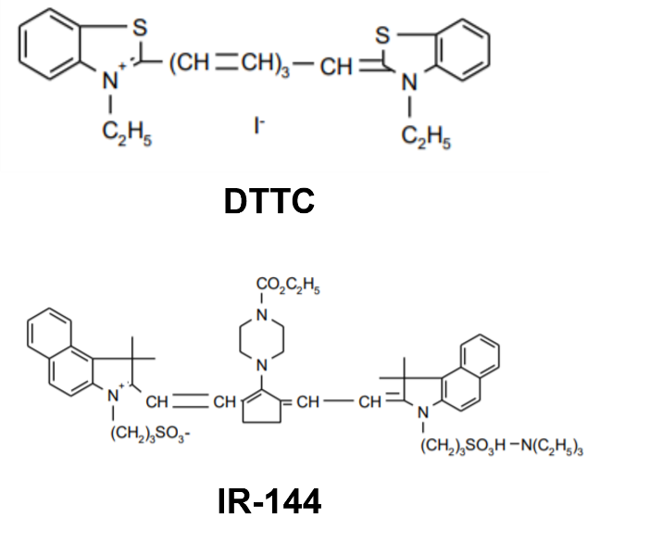
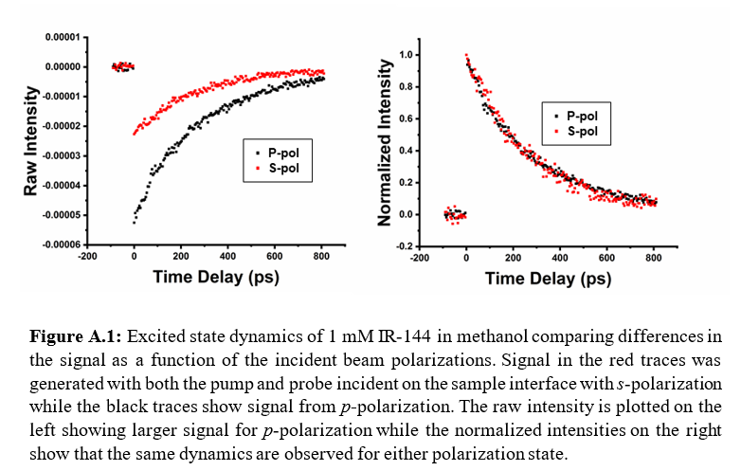
Appendix A: Supplemental Results for TIRTAM
Figure A.2: Chemical Structures of DTTC and IR-144.

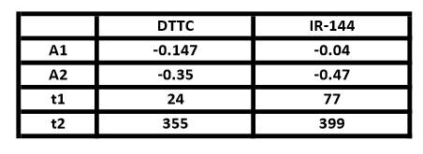
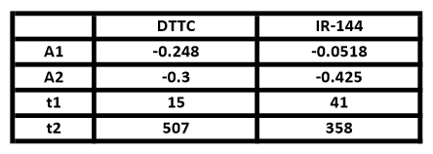
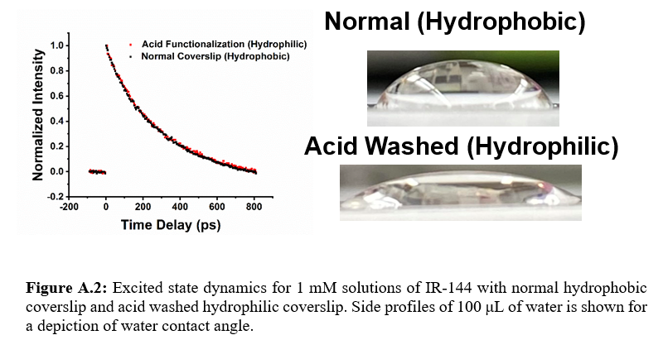
Figure A.4: Excited state dynamics for 1 mM solutions of DTTC and/or IR-144 in methanol collected in isolated channels in regions I and II (left) or in the mixed channel in region III (right). The extracted fit parameters are shown in the tables below each plot where A1 and A2 are the amplitude for the t1 and t2 lifetime components (in ps), respectively.
Figure A.3: Excited state dynamics for 1 mM solutions of IR-144 with normal hydrophobic coverslip and acid washed hydrophilic coverslip. Side profiles of 100 μL of water is shown for a depiction of water contact angle.
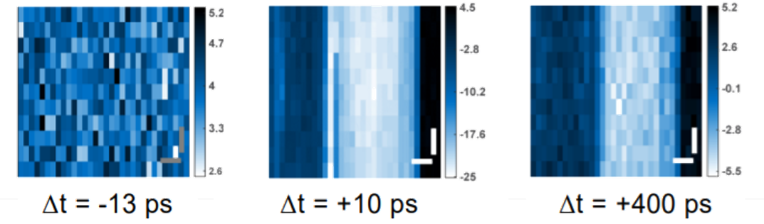
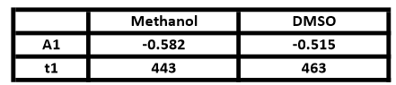
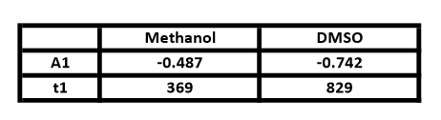
Figure A.5: TIRTAM images of DTTC and IR-144 in methanol at different delay times. On the right, no signal is observable -13 ps before time zero. In the center, 10 ps after time zero, there are three distinct regions of signal with the medium blue signal of DTTC, white high signal of IR-144, and tape in the black region. These signals are still visible at 400 ps after time zero albeit with lower overall signal as seen in the left region.
Figure A.6: Excited state dynamics for 1 mM solutions of IR-144 in methanol and/or DMSO collected in isolated channels in regions I and II (left) or in the mixed channel in region III (right). The extracted fit parameters are shown in the tables below each plot where A1 is the amplitude for the t1 and lifetime (in ps).
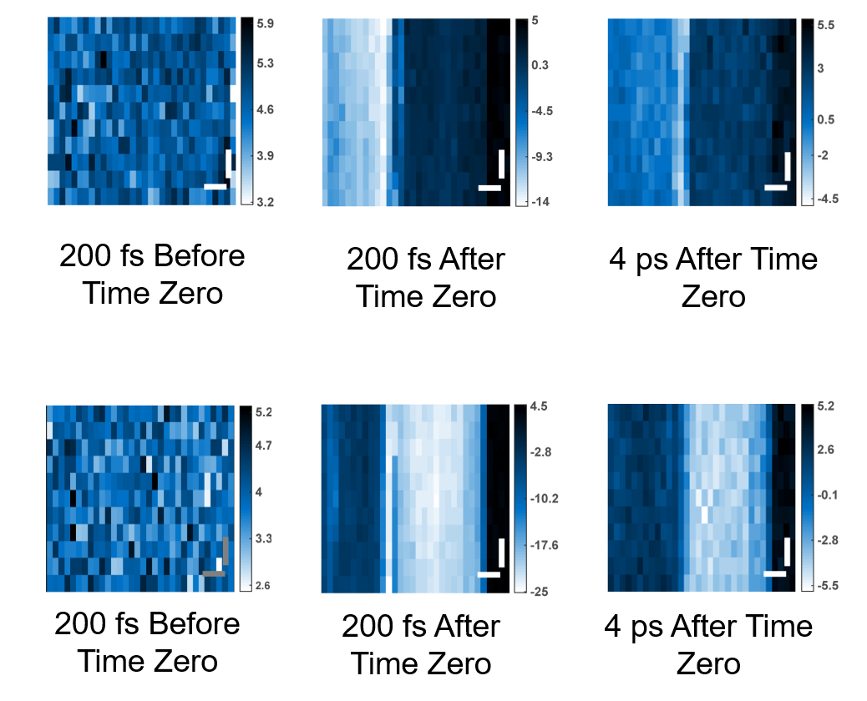
Figure A.7: TIRTAM images of IR-144 in methanol and DMSO at different delay times. On the right, no signal is observable -13 ps before time zero. In the center, 10 ps after time zero, there are three distinct regions of signal with the medium blue signal of IR-144 in DMSO, white high signal from IR-144 in methanol, and tape in the black region. These signals are still visible at 400 ps after time zero albeit with lower overall signal as seen in the left region.
Δt = -13 ps
Δt = +10 ps
Δt = +400 ps

Appendix B: Supplemental Results for TIR Anisotropy
Table B.1: Number of exponentials chosen for each emission range and composition for the magic angle lifetimes. PHO=Hydrophobic Surface and PHI=Hydrophilic Surface.

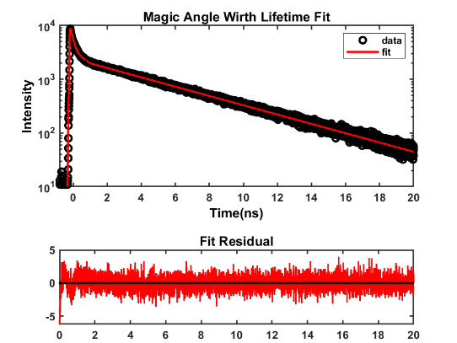
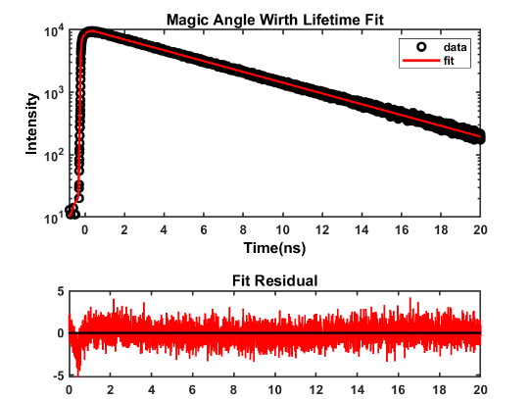
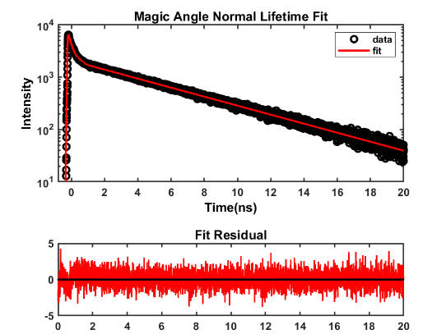
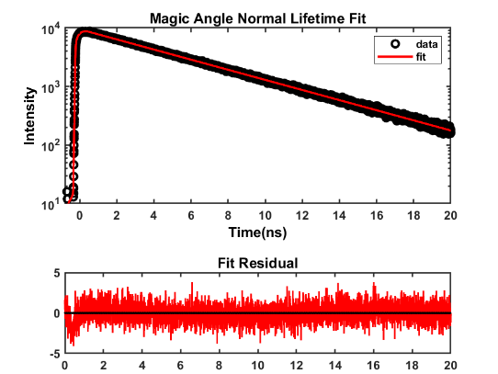

Figure B.1: Comparison between 480 nm (left) and 525 nm (right) magic angle data. There are no differences between the residuals, and the χ² values were lower for the normal magic angle lifetime.

Table B.2: Refractive index of each sample and μE composition.

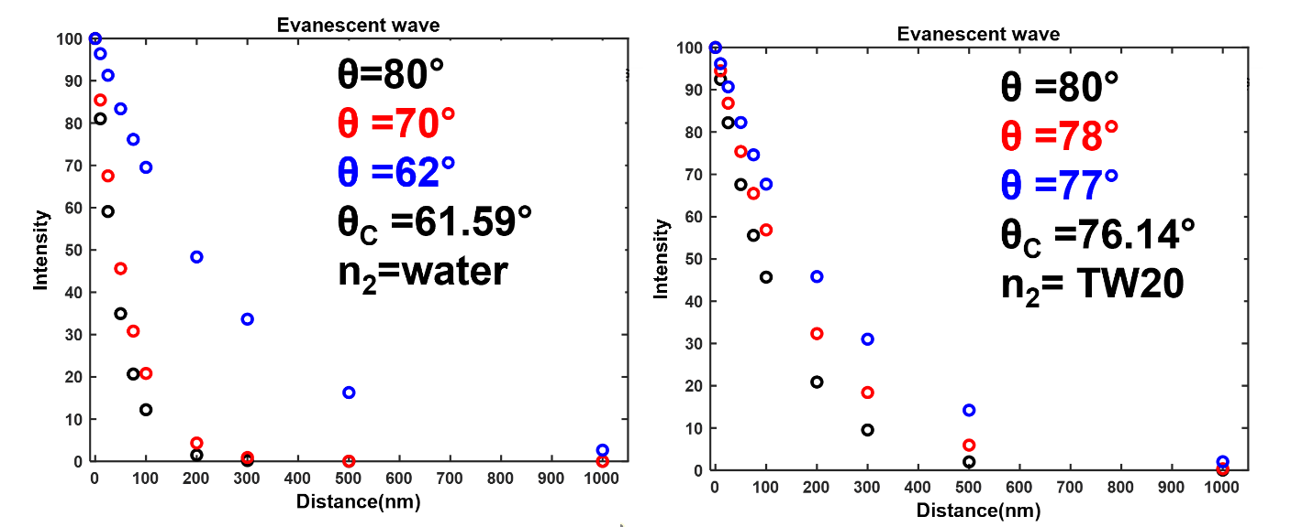

Figure B.2: Intensity and penetration depth of the evanescent wave based on the incident angle. TW20’s higher refractive index makes the penetration depth much larger.

Table B.3: Refractive index and calculated Devaughes correction. Very similar refractive indices and therefore viscosity provided large differences in the calculated correction.

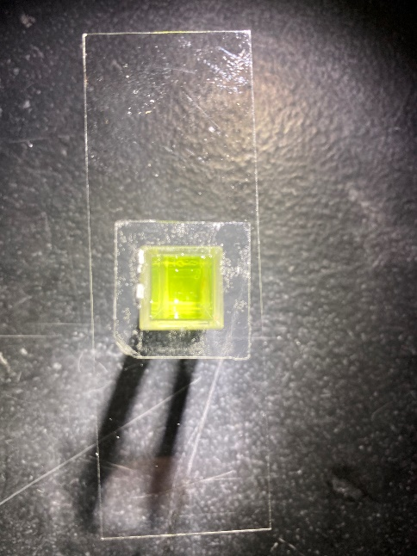

Figure B.3: Picture of Cuvette and Coverslip. Tape is in contact with only the edges of the cuvette cell to eliminate the tape’s interference with emission signal.

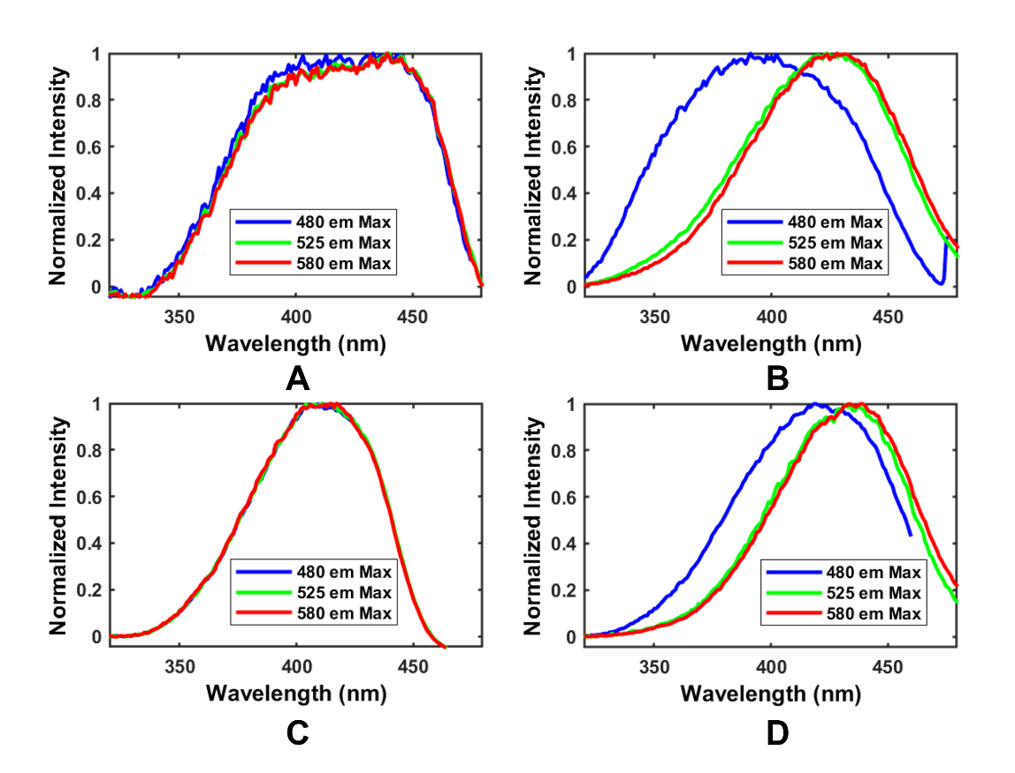

Figure B.4: Excitation spectra measured at three different emission maximums. (A) Butanol excitation spectrum. (B) 60 μE excitation spectrum. (C) Toluene excitation spectrum. (D)

Table B.4: Weights for lifetimes of TW20 at 525 nm emission.

Table B.5: Lifetimes at 525 nm emission.

Table B.6: Weights at 480 nm emission.

Table B.7: Lifetime components at 480 nm emission.

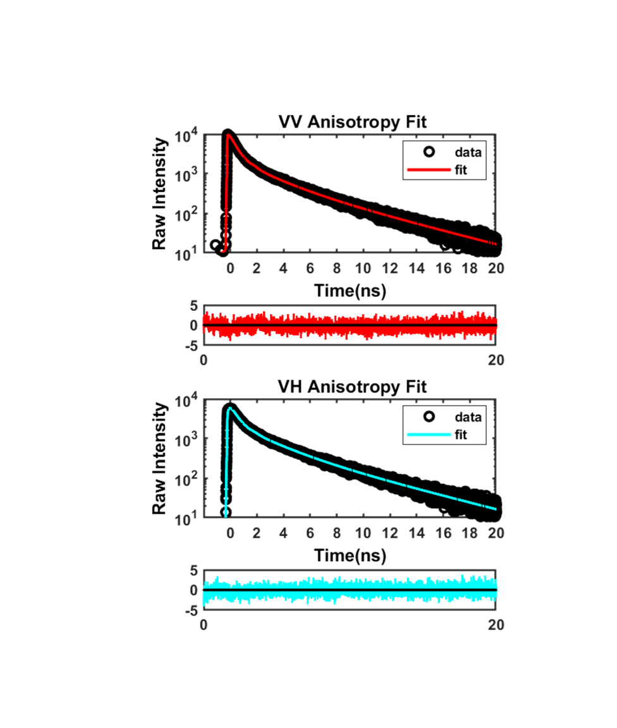

Figure B.5: Data, fit, and residuals for the 480 nm emission of the 10 μE composition in the hydrophobic bulk.

Table B.8: χ² values compared between single and bi-exponential models for anisotropy on all samples.

Table B.9: Models chosen for bulk samples with initial anisotropy and correlation time listed.

Table B.10: Models chosen for surface samples with initial anisotropy and correlation time listed.

Vita
Brandon Colon was born and raised in Pensacola, Florida where he would receive a Bachelor of Science degree in Chemistry at the University of West Florida. He pursued a Doctor of Philosophy degree in chemistry with a focus on analytical chemistry. His research interest targets instrumentation design and optimization that is geared toward either complex analysis or robust characterization. He will be seeking a position as a field service engineer or product support after graduation. He is grateful to his family and friends for support during his trek through graduate school.

