Precision Livestock Farming in the Broiler Industry: A Producer Survey on Implementation and Extension Education

A Thesis Presented for the

Master of Science

Degree

The University of Tennessee, Knoxville

Terrilyn Klingberg

May 2025

Copyright © 2025 by Terrilyn Klingberg
All rights reserved.

ACKNOWLEDGEMENTS
I would like to express my deepest gratitude to Dr. Robert Burns for mentoring me over the past two years and providing me with opportunities to expand my skills. His patience and guidance have shaped my professional and personal growth, and I look forward to applying the skills he has taught me in my future career.
I would also like to thank my committee members, Drs. Shawn Hawkins and Yang Zhao, for their support and feedback in shaping this project. I am also grateful to Tanner Thornton, Susan Schexnayder, Dr. Tom Tabler, and Dr. Hao Gan for their part in making sure this project was successful.
Additionally, this work is supported by the National Institute of Food and Agriculture, project award no. 1028091, from the U.S. Department of Agriculture’s National Institute of Food and Agriculture. Any opinions, findings, conclusions, or recommendations expressed in this manuscript are those of the author and should not be construed to represent any official USDA or U.S. Government determination policy.

ABSTRACT

Precision Livestock Farming (PLF) technology has the potential to revolutionize commercial poultry production by offering real-time monitoring and alerts when production conditions change. While several publications have identified the potential benefits of PLF in broiler production, adoption rates remain low. It is possible that low adoption is correlated to a gap in information transfer between PLF research and producers. The University of TN hosted a one-hour PLF module during the 2023 Tennessee Master Poultry Producer program based on results from a producer needs assessment identifying poultry producers’ interest in PLF education topics. This module was designed to introduce PLF to poultry producers, but did not provide resources for currently marketed technology. Because of this, a second survey was distributed in 2024 to identify producer needs for a multi-day PLF short course. This survey identified a lack of familiarity with PLF among broiler producers. Producers also expressed an interest in learning about PLF if Extension were to offer a workshop. Producer needs for PLF technology are focused on improving income and productivity without diminishing the welfare of the flock. From this survey data, we created a producer short course designed to increase broiler producers’ knowledge of PLF and allow them to make informed decisions about whether to implement PLF into their productions. This course offered insight to PLF technology applicable to poultry production, research advancements, implementation, and currently marketed technology. This thesis presents survey data representing producers needs for PLF training, producer perspectives on PLF technology in broiler production and the development of a producer short course for PLF education.

TABLE OF CONTENTS
Introduction 1
The Broiler Industry 1
Precision Livestock Farming 1
Literature Review 2
Precision Livestock Farming in the Broiler Industry 2
Extension Education for Precision Livestock Farming 4
CHAPTER I EXTENSION EDUCATION FOR PRECISION LIVESTOCK FARMING IN THE BROILER INDUSTRY 6
Abstract 8
Introduction 8
Commercial Poultry Needs Assessment 9
Short Course Topic Selection 9
Animal Environment/ Welfare 10
Mortality Management 10
Biosecurity/ Litter Management 11
Litter Land Application Management 14
Precision Farming 15
Conclusions 18
APPENDICES 19
Appendix A 19
Appendix B 22
CHAPTER II A PRODUCER SURVEY ON THE IMPLEMENTATION OF PRECISION LIVESTOCK FARMING IN THE BROILER INDSUTRY 25
Abstract 27
Introduction 27
Materials and Methods 28
Results and Discussion 29
Conclusions 34
APPENDICES 36
Tennessee Broiler Producer Survey 36
CHAPTER III DEVELOPMENT OF A PRODUCER SHORT COURSE ON PRECISION LIVESTOCK FARMING IN THE BROILER INDUSTRY 45
Introduction 46
A Producer Short Course 46
Development and Preparation 47
Topic Selection 48
Results and Impacts 49
Conclusion 49
APPENDICES 51
Appendix A 51
Appendix B 53
Appendix C 55
CONCLUSION 57
REFERENCES 58
VITA 64

LIST OF FIGURES
Figure 1.1. Precision Livestock Farming Use in the Broiler Industry……………………3
Figure 2.1. Producer Interest in Extension Topics Related to Animal Environment and Welfare 11
Figure 2.2. Producer Interest in Extension Topics Related to Mortality Management 12
Figure 2.3. Producer Interest in Extension Topics Related to Biosecurity 13
Figure 2.4. Producer Interest in Extension Topics Related to Biosecurity 13
Figure 2.5. Producer Interest In Extension Topics Related to Litter Land Application 14
Figure 2.6. Producer Interest in Extension Topics Related to Farmstead Management 16
Figure 2.7. Producer Interest in Extension Topics Related to Facility Maintenance 16
Figure 2.8. Producer Interest in Extension Topics Related to Precision Farming 17
Figure 3.1. TN Broiler Farm Size 30
Figure 3.2. Importance of Real-Time Information on Different Areas of Production……………………………………………………………………………......41
Figure 3.3. Producer Perspectives on Indicators of Poultry Productivity 33
Figure 3.4. Producer Perspectives on Indicators of Poultry Welfare and Health 33
Figure 3.5. Producer Interest in Topics for an Extension Program About Managing Broilers……………………………………………………………………………….…..44
Figure 4.1. Producer Short Course Flyer (Front) 51
Figure 4.2. Producer Short Course Flyer (Back) 52

The Broiler Industry
The demand for broiler meat and byproducts has steadily increased over the past two decades (Miller, 2022). According to the USDA-NASS, the annual pounds of broiler meat produced in the US have increased by 50 billion pounds from 1972 to 2023 (USDA-NASS, 2024). The broiler industry has maintained its standing as the highest valued poultry sector in the U.S. since before 2013, with the largest demand for consumer preference (USDA-NASS, 2024; Grossen, 2025). Producers are increasing production house size to meet these demands (Miller, 2022). With several broiler production houses per farm, monitoring and managing large numbers of broilers can become time-consuming and laborious.
With so many broilers housed in an in-closed environment, early disease detection is critical. A typical broiler house holds approximately 28,000 broilers per production cycle (Li et al, 2022). Large quantities of broilers housed in closed environments open high-risk opportunities for disease transmission that can quickly wipe out an entire flock. There is also a concern for broilers to meet their physiological limits quicker due to selective breeding for productivity traits (Korver, 2023). While broilers are reaching market weight much quicker than in the past, this opens opportunities for metabolic disease and muscle and bone quality concerns (Korver, 2023).
As the broiler industry continues to grow, whole flock monitoring becomes important to ensure efficient production is maintained without diminishing the welfare of the broilers. Whole flock monitoring can provide valuable information that can aid in early disease detection, increased productivity, and decreased input costs. However, identifying production parameter changes manually can be time consuming and inefficient. Implementing real time monitoring practices could aid broiler producers in monitoring production parameters more efficiently.

Precision Livestock Farming
Precision Livestock Farming (PLF) involves the use of non-invasive technology to monitor livestock and poultry and assist producers in making informed management decisions in a timely manner. Precision Livestock Farming technology is equipped with vision, audio, and environmental control systems that provide the producer with real time alerts when production conditions change. Because poultry specific PLF has only been researched since 2017 (Rowe, et al, 2019), integration of PLF into commercial settings has been slow.

Literature Review

Precision Livestock Farming in the Broiler Industry
Precision Livestock Farming (PLF) technology has the potential to advance current agriculture management practices through real time monitoring systems that improve productivity without diminishing the welfare of the animals (Ren, et al, 2020). While PLF research has been a topic of interest since the late 1990s (Morrone, et al, 2022), PLF in the poultry sector has only been relevant for the past 10 years, therefore limited research on the poultry sector exists (Maharjan and Liang 2020). Compared to large livestock, current PLF technologies are less than ideal and require further advancements to be feasible in commercial poultry houses due to poultry’s small body size, quick grow out periods, and large flocks (Maharjan & Lamg, 2020). For large livestock, wearable sensors offer producers real time monitoring of each individual animal. While research has been done with wearable sensors, such as radiofrequency identification (RFID), on broilers in a laboratory setting, this method is not economically compatible with broiler production due to the small value per head compared to the value of each sensor (Rizwain, et al, 2023). Because large numbers of broilers (typically 20,000 – 40,000) are housed in a single production house, individual bird monitoring is challenging. Fixed sensors such as top-view image analysis and sound analysis offer producers a more efficient way to continuously monitor their entire flocks.
Precision Livestock Farming technology suitable for broiler production relies on three parts: sensing, decision making, and control (Figure 1.1). Sensing is accomplished through cameras, microphones, and environmental sensors that collect data on the broilers and in-house environment. Sensing provides algorithms with data for decision making. When production condition changes are identified, producers are alerted in real time to act as control and manage the production change. Though some research is working to limit the dependence of producers to be the control, the goal of PLF is not to remove the producer from the house but rather make the time in the house more valuable.
Current research of image analysis for broiler motility detection (Jaihuni, et al, 2023), and estimation of feeding times (Nasiri, et al, 2023) are proving to be beneficial systems for automated broiler monitoring in a research setting. In Europe, the eYeNamic Vision System is designed for efficient monitoring of whole flocks through top view camera systems installed throughout the ceiling of the production house (Berckmans, 2017).
Figure 1.1. Precision Livestock Farming Use in the Broiler Industry

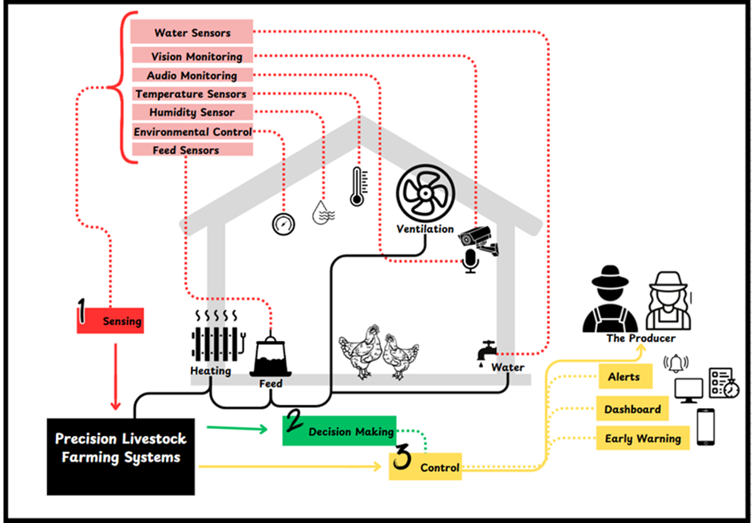

Another type of fixed sensor compatible for commercial broiler production is through sound analysis. Using microphones, producers can monitor the noise level of their flocks indicating health status and behavior level of broilers without disturbing them (Li, et al, 2020). Originally developed in Spain, a U.S. company has taken ownership of SCOUT- a robot that runs on a track throughout the entire production house and is equipped with both sound and image analysis capabilities to offer producers the most out of the use of these fixed sensors (Cumberland, 2023). While this technology has been recently taken off the market, it does provide insight into advancements in PLF technology applicable to applicable production.
Current research of image analysis for broiler motility detection (Jaihuni, et al, 2023), and estimation of feeding times (Nasiri, et al, 2023) are proving to be beneficial systems for automated broiler monitoring in a research setting. In Europe, the eYeNamic Vision System is designed for efficient monitoring of whole flocks through top view camera systems installed throughout the ceiling of the production house (Berckmans, 2017). Another type of fixed sensor compatible for commercial broiler production is through sound analysis. Using microphones, producers can monitor the noise level of their flocks indicating health status and behavior level of broilers without disturbing them (Li, et al, 2020). Originally developed in Spain, a U.S. company has taken ownership of SCOUT- a robot that runs on a track throughout the entire production house and is equipped with both sound and image analysis capabilities to offer producers the most out of the use of these fixed sensors (Cumberland, 2023). While this technology has been recently taken off the market, it does provide insight into advancements in PLF technology applicable to applicable production.

Extension Education for Precision Livestock Farming
Extension Education courses on poultry broiler production tend to focus on items such as mortality, environmental parameters (such as ventilation and temperature control), and litter management (“Master Poultry Commercial Producer”, 2022). Appendix 1 provides a list of PLF short courses offered over the past ten years that were identified in this literature review. The literature review only identified three programs that have been offered to producers, researchers, and integrators in the last decade focusing on poultry production and Precision Livestock Farming (PLF) capabilities in the industry.
From 2022 – 2024 Michigan State University offered a monthly webinar series dedicated to educating producers and students on PLF. Topics that have been addressed include computer vision for animal identification, behavior monitoring, and emotion analysis; and performance of PLF technologies in commercial farms (“Precision Agriculture”, 2022). These topics focus on all livestock and don’t target any specific species. Iowa State University held a PLF short course in 2019 highlighting topics such as implementation into commercial farms, economic feasibility, data ownership and management, sensors and algorithms, and education and training of PLF technologies (“US Precision Livestock Farming”, 2019). This course was also focused on all livestock species.
Lastly, the University of Georgia holds an annual Precision Poultry Farming (PPF) conference educating producers, integrators, and researchers on updates in PPF technology and research. Topics from these conferences are focused on the poultry industry as a whole and covers all branches including broilers, layers, and processing (“2022 International Poultry”, 2022). The 2023 UGA conference covered topics including managing footpad dermatitis without antibiotics, Farm biosecurity, Enterococcus, and a review of the Poultry 411 app (“2023 Georgia Precision Poultry”,2023). In 2022, the University of Tennessee hosted a TN Master Poultry Producer short course. While this course was not focused on PLF, it did include a module on PLF’s role in broiler production and the different technologies currently under research (“Master Poultry Commercial Producer”, 2022).
Precision Livestock Farming courses outside of the US focus on areas of welfare, algorithm development, ethics, and general areas of PLF such as installation and economics. In Europe in 2016, Dr. Daniel Berckmans published a smart farming blueprint that offered participants examples of PLF technologies tailored to specific livestock species, and covered topics addressing installation of these technologies, and how to calculate the value brought from PLF technology for the farmer (Berckmans, 2017). In 2020, the United Kingdon University Network put together a PLF workshop offering an overview of PLF including topics addressing welfare monitoring opportunities, risk and benefits of PLF, algorithm development, future applications and facial expression monitoring, potential impacts on welfare, and ethics in PLF including job losses and deskilling (“Report of Precision Livestock Farming”, 2020). In the UK, a workshop was offered in 2024 highlighting areas that PLF needs to advance to meet the needs of the poultry industry more efficiently. Topics in this workshop seem to be tailored to poultry producers and investors, and focus on sharing ways that PLF could be improved to be better incorporated into their partnered productions (“Workshops: Advancing Outcomes”, 2024). Livestock included in these courses is mostly inclusive of the entire industry and seem to not focus on any specific animal sector.
Based on this literature review, I have concluded that currently only the University of Georgia offers producers a poultry specific PLF extension education course addressing commercial broiler production with a strong integration of PLF technologies specifically designed for poultry production (“2022 International Poultry”, 2022); (“2023 Georgia Precision Poultry”, 2023). To my knowledge, no courses currently exist concerning the benefits and appropriate use of PLF technology in broiler production. Adoption of PLF into commercial broiler settings has been limited due to this gap in producer knowledge. To promote the implementation of these practices into production houses, an extension education program focused on PLF in poultry production would offer producers a better understanding of these technologies and help change any negative attitudes about the integration of them into their productions.

Extension education for precision livestock farming in the broiler industry

A version of this chapter was originally presented at the 2024 American Society of Agriculture and Biological Engineers (ASABE) AIM meeting in Anaheim, California
Klingberg, T. Burns, R., Hawkins, S., Zhao, Y., Schexnayder, S. (2024). [Poster]. Extension Education for Precision Livestock Farming in the Broiler Industry. ASABE.
Research poster data was formatted into this manuscript to be included in this thesis.

Abstract
While Precision Livestock Farming (PLF) offers many potential benefits for broiler producers, the adoption of PLF on U.S. broiler farms has been limited. Extension educational programs on PLF use in broiler production can help producers decide if PLF is something they do or do not wish to implement on their farm. A survey was sent to Tennessee broiler producers. This survey asked producers about their interest in 55 topics, including four PLF technology applications. This survey found that poultry producers perceive PLF technologies as a critical educational need. This information will be used to identify PLF training topics that will be of the greatest interest and benefit to broiler producers.

Introduction
Precision Livestock Farming (PLF) offers broiler producers real-time monitoring of their flocks. Through use of vison, audio, and environmental parameter monitoring, PLF allows producers to make important management decisions without having to manually identify issues throughout multiple production houses. Though research suggests PLF would be beneficial to commercial broiler productions, adoption of these technologies has been slow (Hartung, 2017; Astill, 2020).
While PLF has been addressed in multiple nationwide short courses, Extension PLF training courses focused on the broiler industry have been limited. From our literature review, we have identified three courses previously offered at U.S. universities addressing PLF in commercial production. Annual and monthly meetings have been held at the University of Georgia, Michigan State University, and Iowa State University to discuss PLF technology currently available or being researched (2022 International, 2022; Precision Agriculture, 2022; US Precision, 2019). Of these courses, only the University of Georgia course focused solely on the poultry industry. However, this course highlights PLF in research and focuses on an audience tailored to university personnel. We believe that an extension PLF training course tailored to the needs of broiler producers would increase their knowledge of PLF and aid them in deciding if PLF is right for their operation. A review of PLF short courses over the past 10 years is included in Appendix 1.
Previous PLF courses have mainly focused on providing an introduction to PLF. As such, identifying producers’ interests and needs would help tailor a course to cover what is most important to producers. Offering a PLF course targeted to broiler producers should increase broiler producer participation and ensure producers are gaining information most relevant to their farms. A survey was conducted with TN poultry producers in the summer of 2023. The goal of this survey was to identify the producer’s needs for the 2023 TN Master Poultry Producer short course, including a one-hour module on PLF vision systems. This helps direct topics so that producers learn about what they feel is most valuable to their production. This survey also helped to identify areas of management that PLF may be most beneficial to producers and topic areas, frequencies, and need for future PLF training courses.

Commercial Poultry Needs Assessment
The Commercial Poultry Producer Needs Assessment was distributed to TN poultry producers to gather information about the needs of broiler producers where PLF may be beneficial. Survey data were used to evaluate topics of interest to producers in a UT Master Poultry Producer course including a one-hour PLF module. Producers were asked for their preferences on learning topics from six categories: Animal Environment/ Welfare; Mortality Management; Biosecurity/ Litter Management; Farmstead Management and Facility Maintenance; and Advanced Poultry Farm Management Technologies/ Precision Farming. For each category, producers were asked to select up to three topics they were most interested in learning about. Responses were grouped into order of importance based on the total number of responses per topic. The topics most selected by respondents were included in the TN Master Poultry Course. Full survey questions are available in Appendix 2.
This survey was distributed by the TN Poultry Association (TPA) to 450 members. Associates with the TPA organized survey results by county to maintain confidentiality of members. Total number of responses (n) was determined for each question category. The response rate was determined by dividing the total number of returned surveys (26) by the total number of surveys distributed (450). The completion rate was calculated by dividing the total number of respondents that made it to the final question category (21) by the number of returned surveys (26).

Short Course Topic Selection

This survey had a response rate of 5.8%, with a completion rate of 81%. Most of the needs expressed by producers in this survey could potentially benefit from the adoption of PLF Technologies. Data from this survey suggested that poultry producers perceive PLF technologies as an educational need. Of the six categories tested, four were selected as educational needs based on producer feedback. These four categories include Animal Environment/ Welfare; Mortality Management; Biosecurity/ Litter Management; and Litter Land Application Management.

Animal Environment/ Welfare
This category asked for producer preferences on nine topics related to animal environment and welfare (Figure 2.1). Three topics were identified as educational needs. From this category, producers showed a stronger interest in the environment compared to welfare. This may be correlated to the impact an animal’s environment has on their overall welfare, creating a positive impact on feed conversion ratios (FCR) and weight gain, therefore increasing revenue. It is also possible that producers simply were not interested in the topics included in this category regarding welfare. Producers may feel that they are already experts in these topics and do not need more information on them.
Producers are most interested in litter moisture, house humidity, and ammonia control during winter; ventilation management during and between flocks; and ammonia control with litter acidifiers. Producers also showed some interest in summer heat stress management, litter moisture management to improve broiler welfare and profitability, and poultry housing air emissions and odor management. Producers showed less interest in broiler and broiler breeder stress management and welfare indicators, introduction of animal welfare programs, and broiler and broiler breeder platform and perching systems review. The animal environment, which could benefit from the adoption of PLF technology, is considered an educational need for poultry producers.
Mortality Management
This category asked about five topics related to mortality management (Figure 2.2). Two topics were identified as educational needs. Producers showed the most interest in on-farm incineration of broiler mortalities and management practices for daily mortality removal and composting. Producers also showed an interest in in-house rail systems for mortality management, broiler mortality management options, and mass mortality burial sites. Most mortality management needs addressed by producers could benefit from the adoption of PLF technology.

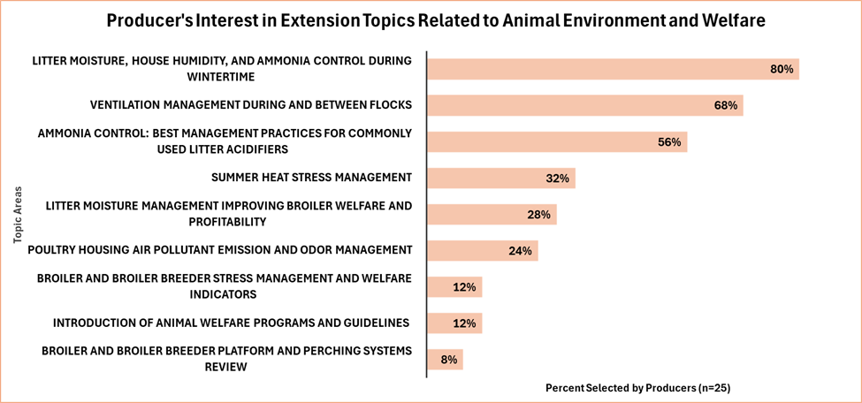
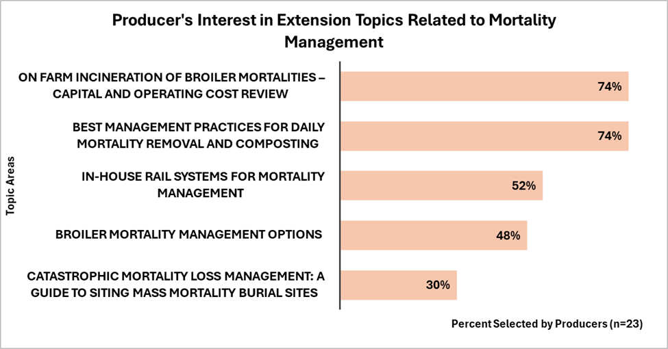
Figure 2.2. Producer Interest in Extension Topics Related to Mortality Management
Figure 2.1. Producer Interest in Extension Topics Related to Animal Environment and Welfare

Survey data suggests an interest in mortality management education among producer respondents. This could indicate that mortality management is a major area of focus for more efficient management practices in commercial broiler production. Producers’ interest in rail-mounted mortality management systems may indicate that broiler producers would be interested in learning more about real-time monitoring systems for more efficient mortality management practices.
Biosecurity and Litter Management
This category asked for producer preferences on six biosecurity topics (Figure 2.3) and seven litter management topics (Figure 2.4). Five topics were identified as educational needs. Producers showed a stronger interest in biosecurity compared to litter management. Producers indicated they were most interested in drinking water quality, sanitation, and consumption rates; management practices for darkling beetle control; remote farm surveillance and access control; recognizing and preventing poultry disease; and management practices for rodent and fly control (Figure 2.3). Producers showed less interest in litter management topics, including recycling litter from flock to flock, management practices for windrowing broiler litter, and management practices for de-caking and tilling (Figure 2.4).
Producers may have shown more interest in biosecurity compared to litter management because producers feel they already have optimal litter management practices and do not need to learn more. The biosecurity topics included in this category have an impact on input costs and productivity at the end of the production cycle. It is possible producers were more interested in these topics simply because they provide the most information for more efficient production, whereas the litter management topics discuss management practices that are commonly used already.

Litter Land Application Management
Compared to biosecurity, producers showed minimal interest in learning about litter management. However, producers showed a stronger interest in litter management practices regarding land application for fertilization of crops. This indicates that TN broiler producers produce multiple commodities other than broilers. Broiler management education may benefit from including management practices that can be utilized across multiple productions.

Figure 2.3. Producer Interest in Extension Topics Related to Biosecurity
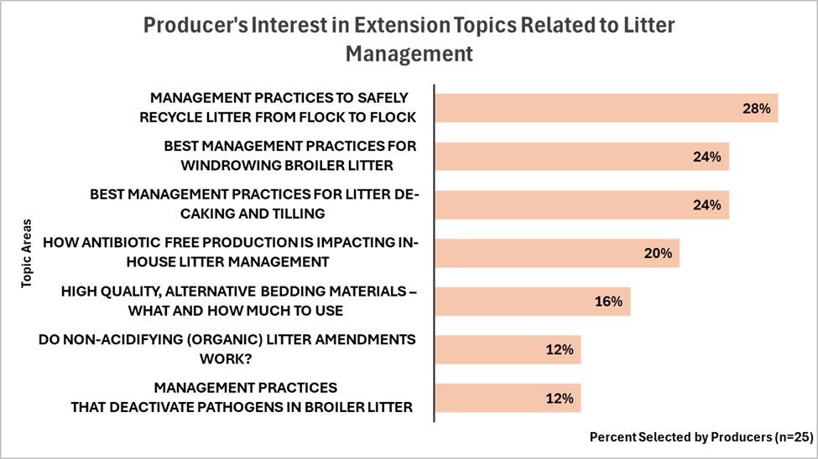
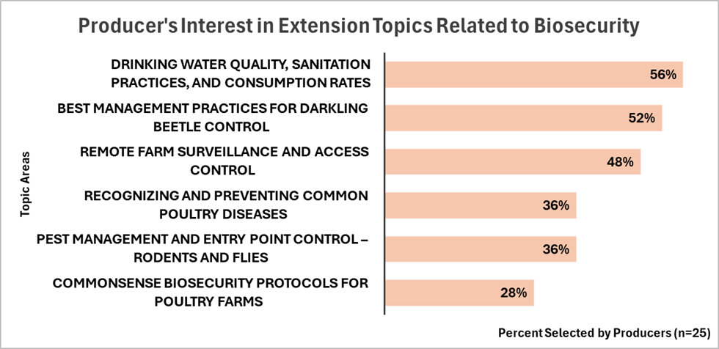
Figure 2.4. Producer Interest in Extension Topics Related to Biosecurity

This category asked for producer’s preferences on five topics related to litter land application management (Figure 2.5). Two topics were identified as educational needs. Producers showed the most interest in optimizing broiler litter fertilization of hay and pasture forages and setting agronomic litter land application rates. Producers also value odor control practices for applying land litter, and practices to protect surface water quality. Producers were less in optimizing broiler litter for corn, soybean, and cotton fertilization.
Farmstead Management and Facility Maintenance
This category asked for producer preferences for ten farmstead management topics (Figure 2.6) and nine facility maintenance topics (Figure 2.7). Five topics were identified as educational needs in this category. Producers showed the most interest in learning about controlling poultry farm utility costs, maximizing light performance while reducing lighting costs, replacement fan motor selection and maintenance, how poultry perceive and respond to light, and generator maintenance to avoid power outages. Producers were less interested in facility maintenance, including choosing conveyor belts for broiler breeder eggs, alternative broiler litter utilization options, and retrofit options for LED lights and controllers.
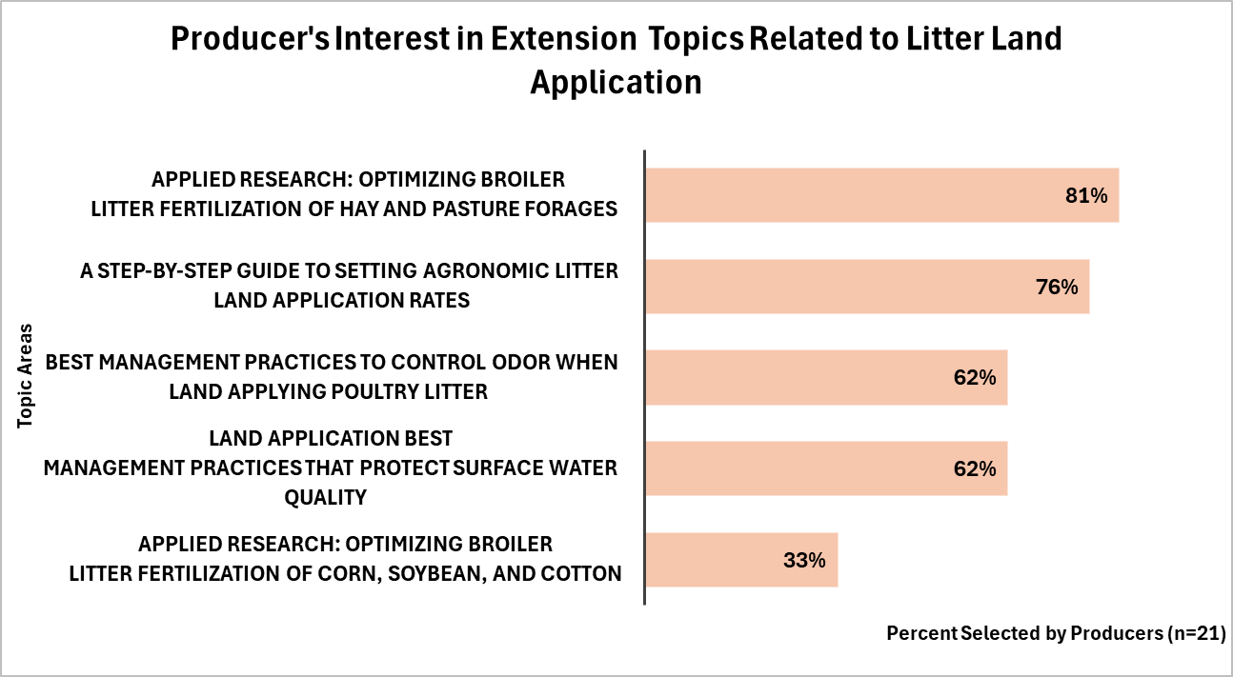
Figure 2.5. Producer Interest in Extension Topics Related to Litter Land Application
Producers showed similar interest across both farmstead management and facility maintenance topics in this category. Survey data indicated producers have an interest in reducing input costs without diminishing the welfare of the broilers. Precision livestock farming can aid in decreasing production costs through real-time monitoring of the flock, feeders, drinkers, and in-house environments that helps reduce waste from leaks and blocks and identify changes in house conditions that could contribute to higher input costs. Broiler producer education could benefit from focusing on management practices for reducing input costs such as energy, water, feed, and labor- as well as, include PLF technology demonstrations towards more efficient production practices.
Precision Farming
This category asked about four topics related to precision livestock farming (Figure 2.8). Producers showed an interest in all topics listed in this category, with automated ventilation management being the most valued. Producers also showed interest in smart controllers (house controllers with PLF integrated technology) for monitoring flock performance, PLF for broiler and broiler breeder production, and an introduction to robotic systems for poultry farm management.
Producer respondents showed an interest in all the topics included in this category. This could indicate that producers are interested in learning more about PLF technology that may be beneficial to broiler production. Producer needs for PLF technology education are focused on environmental management and whole flock monitoring. Producers also showed an interest in PLF technology for mortality disposal options in the mortality management category of this survey. This could indicate that producers have a desire to learn more about PLF technology, if they are shown to provide more efficient management practices.
Producer Educational Needs Not Addressed in Survey
This survey also asked producers to specify any topics they may be interested in that were not mentioned previously. Only 4 respondents provided feedback on this question. Producers would also be interested in learning about optimizing breeder litter fertilization of corn, soybean, hay, and pasture; understanding controller systems; investigating and applying for cost-share programs; and increased education about applying for Tennessee Agriculture Enhancement Programs (TAEP).

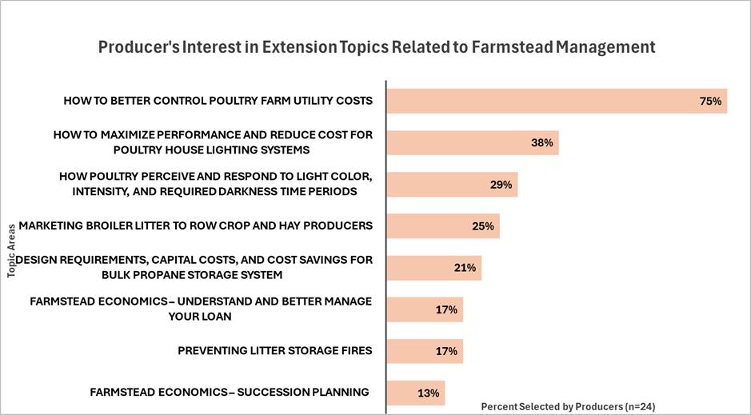
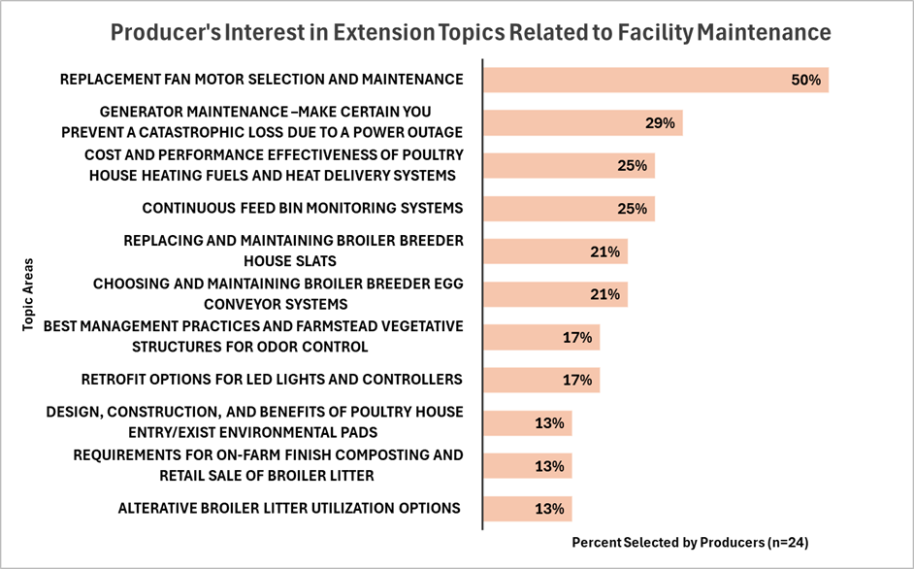
Figure 2.6. Producer Interest in Extension Topics Related to Farmstead Management
Figure 2.7. Producer Interest in Extension Topics Related to Facility Maintenance

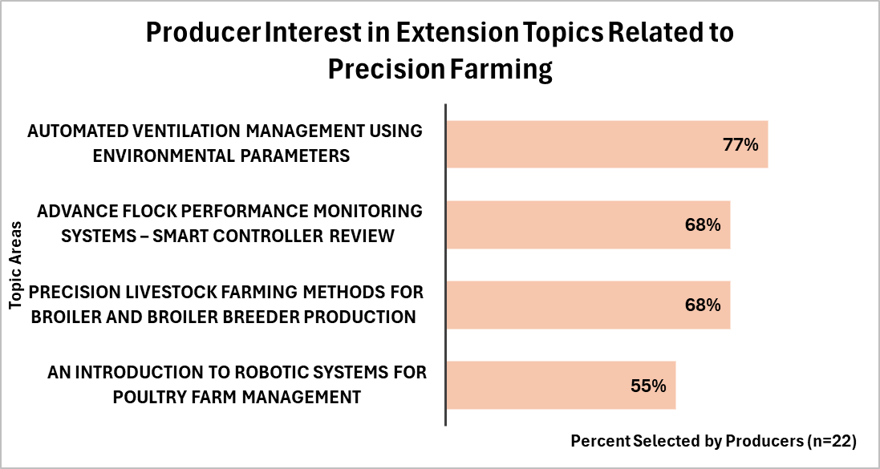
Figure 2.8. Producer Interest in Extension Topics Related to Precision Farming

Conclusions
A survey was conducted on members of the TN Poultry Association to determine topic areas that would be of most value to producers in the 2023 Master Poultry Producer course, including a one-hour Precision Livestock Farming (PLF) module focused on PLF vision systems for real-time monitoring and laboratory experiments with Radio Frequency Identification (RFID), Inertial Measurement Unit (IMU), visual and thermal image analysis, sound analysis, and poultry robots. The Commercial Poultry Producer Needs Assessment identified what topics producers are the most interested in, their needs for more efficient production, and what areas of production PLF could be most beneficial. Almost all the needs addressed by producers could benefit from the adoption of PLF technology. Producers showed a strong interest in learning about more efficient production, including reducing production input costs like utilities (water, electricity, and heating fuel) and daily mortality removal management practices. Producers also showed an interest in environmental control options such as automated ventilation systems, environmental control during the winter, and optimizing broiler litter utilization options. Producers showed a strong interest in the Precision Farming category of the survey. This could indicate that while PLF adoption has been slow in the U.S. poultry industry, producers are interested in learning more about PLF technology. Future PLF training courses could be beneficial for poultry producers and influence the adoption of PLF technology in U.S. poultry operations.

APPENDICES
Appendix A
U.S Precision Livestock Farming Short Courses Over the Last 10 Years
Table 1.1. U.S. Precision Livestock Farming Short Courses in the Last 10 Years
U.S. Precision Livestock Farming Short Course | Date | Topics
Michigan State University: Precision Livestock Farming Webinar Series | 2022- Present | -All Livestock  -Computer vision for animal identification  -CV for emotion analysis  -Engineering video analytics systems for PLF  -Performance of PLF under farm conditions
Iowa State University | 2019 | -All Livestock  -Sensors and algorithms  -Implementation  -Economic feasibility  -Data  -Rural and societal impacts  -Education and training
Purdue University: Field Implementation of PLF | 2023 | -All Livestock  -Sensing technologies  -Data management and algorithm development  -Real time monitoring of environment and nutrition management  -Societal impacts

University of Georgia: Georgia Broiler Conference | 2023 | -Poultry  -Managing dermatitis without antibiotics  -Poultry 411 app  -Brooding light programs  -Enterococcus affect on poultry
University of Georgia: International poultry short course | 2024 | -Poultry  -Poultry production  -Table egg production  -Hatching egg production  -Broiler management  -Broiler processing
Table 1.1. Continued
University of Georgia: Precision Poultry Farming Conference | 2022 | -Poultry  -Poultry Industry as a whole  -Poultry disease identification  -Table egg production  -Hatching egg production  -Broiler management  -Hot weather control for broilers  -Broiler processing

Table 1.2. U.S. Precision Livestock Farming Short Courses in the Last 10 Years (Continued)
Precision Livestock farming training courses outside the U.S. | Date | Topics
EU-PLF: Smart Farming for Europe- Daniel Berckmans | 2016 | -All Livestock  -Legislation  -Business models  -Installation of PLF technology (problems and solutions)  -Calculating value of PLF technology
UK Rethink- a WilliamReed Company: Animal Agtech Innovation Summit- Workshop: Advancing Outcomes in PLF | 2024 | -All livestock  -Full potential of PLF  -Funding needed to accelerate PLF adoption  -ROI for data collection and transparency in the supply chain  -Improving accuracy of hardware to produce reliable data  -Systems integration enhance the effectiveness of PLF platforms
UK University Network: Animal welfare research network | 2020 | - Introduction to PLF and welfare monitoring opportunities  -Risks and benefits of PLF  -Needs for algorithm development  -Future applications for PLF and fascial expression monitoring in pigs  -Potential impacts of PLF on animal welfare and how to address them  -Job losses and de-skilling

Appendix B
Tennessee Broiler Producer Needs Assessment
Choose at least three topic areas of interest from each category
Animal Environment/Welfare
☐ Ammonia control: best management practices for commonly used litter acidifiers
☐ Ventilation management during and between flocks
☐ Summer heat stress management
☐ Litter moisture, house humidity, and ammonia control during wintertime
☐ Poultry housing air pollutant emission and odor management
☐ Broiler and broiler breeder stress management and welfare indicators
☐ How better litter moisture management improves broiler welfare, as well as profitability
☐ Broiler and broiler breeder platform and perching systems review: impact on welfare and production
☐ Introduction and explanation of animal welfare programs and guidelines for poultry producers
Mortality Management
☐ Broiler mortality management options
☐ Catastrophic Mortality Loss Management: a guide to siting mass mortality burial sites
☐ Best management practices for daily mortality removal and composting
☐ On farm incineration of broiler mortalities – capital and operating cost review ☐ In-house rail systems for mortality management
Biosecurity, Litter Management
☐ Commonsense biosecurity protocols for poultry farms
☐ Remote farm surveillance and access control
☐ Recognizing and preventing common poultry diseases
☐ Pest management and entry point control – rodents and flies
☐ Best management practices for darkling beetle control
☐ Drinking water quality, sanitation practices, and consumption rates
☐ Best management practices for windrowing broiler litter ☐ Management practices that deactivate pathogens in broiler litter ☐ Do non-acidifying (organic) litter amendments work?
☐ High quality, alternative bedding materials – what and how much to use between flocks
☐ How antibiotic free production is impacting in-house litter management
☐ Best management practices for litter de-caking and tilling
☐ Management practices to safely recycle litter from flock to flock
Litter Land Application Management
☐ A step-by-step guide to setting agronomic litter land application rates
☐ Applied Research: optimizing broiler litter fertilization of corn, soybean, and cotton
☐ Applied Research: optimizing broiler litter fertilization of hay and pasture forages
☐ Land application best management practices that protect surface water quality
☐ Best management practices to control odor when land applying poultry litter
Farmstead Management and Facility Maintenance
☐ Retrofit options for LED lights and controllers
☐ How to maximize performance and reduce cost for poultry house lighting systems
☐ How poultry perceive and respond to light color, intensity, and required darkness time periods
☐ How to better control poultry farm utility costs: water, electricity, and heating fuel
☐ Cost and performance effectiveness of poultry house heating fuels and heat delivery systems
☐ Design requirements, capital costs, and cost savings for bulk propane storage system
☐ Farmstead economics – understand and better manage your loan
☐ Farmstead economics – succession planning
☐ Continuous feed bin monitoring systems
☐ Requirements for on-farm finish composting and retail sale of broiler litter
☐ Preventing litter storage fires
☐ Alterative broiler litter utilization options
☐ Marketing broiler litter to row crop and hay producers
☐ Replacing and maintaining broiler breeder house slats
☐ Best management practices and farmstead vegetative structures for odor control
☐ Choosing and maintaining broiler breeder egg conveyor systems
☐ Generator maintenance –make certain you prevent a catastrophic loss due to a power outage
☐ Poultry house replacement fan motor selection and maintenance
☐ Design, construction, and benefits of poultry house entry/exist environmental pads
Advanced Poultry Farm Management Technologies/Precision Farming
☐ Precision livestock farming methods for broiler and broiler breeder production ☐ An introduction to robotic systems for poultry farm management
☐ Advance flock performance monitoring systems – smart controller review
☐ Automated ventilation management using environmental parameters
PRODUCER EDUCATIONAL NEEDS NOT IDENTIFIED ABOVE:
______________________________________________________________________________________________________
**** END OF SURVEY****

A Producer Survey on the Implementation of Precision Livetock farming in the broiler industry

A version of this chapter is currently in review in the Journal of Applied Poultry Research (JAPR).
Klingberg, T. Burns, R., Hawkins, S., Zhao, Y., Shexnayder, S., Thornton, T. (2025). A Producer Survey on the Implementation of Precision Livestock Farming in the Broiler Industry. Journal of Applied Poultry Research. (In Review).
This article was formatted to be used for this thesis chapter. Figures were embedded into the body of the document and the appendix to meet guidelines for TRACE submission. Co-authors assisted with creating and distributing producer surveys for this project. I contributed to this project by analyzing the survey data and drafting the original manuscript. Co-authors provided feedback and assisted in editing this manuscript to be ready for submission.

Abstract
While Precision Livestock Farming (PLF) offers many potential benefits for broiler producers, the adoption of PLF on U.S. broiler farms has been limited. Determining the status of PLF implementation in the U.S. broiler industry can aid researchers in developing technology better suited to producer needs to potentially increase PLF field adoption. A survey was sent to 531 broiler producers in Tennessee, U.S. This survey was designed to gather detailed information about current PLF implementation on broiler farms, producer interest in specific PLF technology types, and their willingness to adopt PLF into their production operations. The survey included questions about the current use of fifteen specific PLF tools, the importance of real-time data in their operation, planned use of PLF tools, their goals for using PLF, their willingness to participate in a PLF cost-share program, and their trust in data security. This survey identified a lack of familiarity with PLF among broiler producers, but that they would be willing to adopt PLF if it proved to increase farm productivity and profitability.

Introduction
Precision Livestock Farming (PLF) is proving to be an important advancement for many livestock operations, as it allows producers to save time, money, and labor while ensuring welfare requirements and optimal efficiency are maintained (Ren et al, 2020). While PLF research has been advancing since the late 1990s (Morrone et al, 2022), PLF in the poultry sector has only been relevant for the past 10 years, resulting in limited research for this critical food animal sector (Maharjan & Liang, 2020). Current broiler PLF research has focused on broiler production utilizing stationary technologies that incorporate vision (Jaihuni et al, 2023), audio (Li et al, 2020), and environmental control systems (Kucuktopcu & Cemek, 2021), allowing producers to monitor whole flocks and the production environment in real-time. Though research suggests PLF would be beneficial to commercial broiler productions, adoption of these technologies has been slow (Hartung et al, 2017; Astill, 2020). Most PLF broiler research has been done in laboratory settings, with very few studies on commercial farms (Liu et al, 2020; Ali et al, 2023; Silvera et al, 2017). More on-farm research is needed to bring PLF out of the laboratory and to the broiler production industry.
The literature review identified surveys conducted in the EU to determine broiler producer perceptions and use of PLF (Hartung et al, 2017; Tuyttens et al, 2014; Banhazi et al, 2024). One U.S. survey was conducted to determine perceptions of PLF in the poultry industry among academic researchers and employees (Thornton et al, 2024). No surveys focused on U.S. broiler producers’ perceptions of PLF were identified. The low adoption of PLF in the U.S. broiler industry could be correlated to a lack of communication between broiler producers and PLF researchers. Understanding producers’ current perspectives of PLF technologies they are currently using or are most interested in can aid researchers in developing technologies suited to producers’ needs and that will ultimately result in higher adoption rates.
To bridge the gap between the needs of broiler producers and PLF research, a survey was sent to TN poultry producers in the spring of 2024. The objectives of this project are to determine producers’ current knowledge of PLF, determine areas of management in which PLF could be most beneficial to producers, and determine producers’ willingness to adopt specific PLF technologies.

Materials and Methods
A survey was sent to 531 Tennessee poultry producers and industry associates through electronic and postal mail in January of 2024. Contacts for this survey were established through the 2023 TN Master Poultry Producer participants and the TN Department of Agriculture database. The appearance of at least one poultry house was confirmed through Google Earth for all recipients. This survey was designed to determine producer’s current knowledge of PLF, their perspectives on adopting PLF, and what technologies are currently in use on broiler farms. This survey consisted of 39 questions including 19 demographic questions and 20 questions focusing on PLF and areas of production most important to producers.
Questions from this survey consisted of open-ended, yes or no, and Likert-scale type questions. Results from this survey were analyzed through Qualtrics (Qualtrics, Provo, UT) by assigning numerical values to each response for every question (“1” for yes, “2” for no). Yes or no and open-ended questions were evaluated by finding the number of responses per answer option and assigning percentages based on the total number of responses for each question; these questions are represented by cluster bar charts. Likert-scale type questions and questions with “check all that apply” answer options were evaluated by finding n for each answer to account for the variation in respondents for each answer choice. These questions are represented by stacked bar charts to represent each answer choice out of a whole.
The total number of respondents (n) was determined for each question. The response rate was calculated by dividing the total number of returned surveys (77) by the total number of surveys distributed (531). The completion rate was determined by dividing the number of respondents that made it to the final question (53) by the total number of respondents (77). Participants were offered an incentive of a $20 Amazon gift card for completion. Respondents who did not own at least one poultry house on their farm; were not over the age of 18; or were not the owner/manager of the farm were asked not to complete this survey. Full survey questions are available in Appendix A.
This study was approved by the Institutional Review Board of the University of Tennessee (IRB Approval Number: UTK IRB-22-07171-XM, Date: October 12, 2023). All procedures performed in this study involving human participants were in accordance with the ethical standards of the institution. Informed consent was obtained from all individual participants included in this study.
Results and Discussion
This survey had a response rate of 14.5% with a completion rate of 69.0%. Out of the 77 respondents, 38 returned online surveys, while 39 returned postal mail surveys. Online surveys had a completion rate of 76.0% compared to postal mail surveys with a completion rate of 62.0%; indicating producers prefer surveys delivered online compared to postal mail. The relatively low response rate for this survey was comparable to other similar surveys sent to commercial poultry producers (King et al, 2021; Rhodes et al, 2018; Greening et al, 2020). This creates a limitation for the predicted precision of the mean response data collected relative to the entire TN broiler producer population. Results and conclusions from this survey were determined based on survey data alone and reflect the views and beliefs of respondents at the time of completion.
Most TN broiler producers are diversified, managing agricultural commodities other than broilers including cattle (52.0%), sheep/goats (8.0%), and crops (8.0%); only 22.0% indicated only producing broilers on their farm. This aligns with the results from the Commercial Poultry Producer Needs Assessment identifying producers’ needs for management practices across multiple commodities. Broiler farm size ranged from 1-10 acres to over 200 acres (Figure 3.1). However, as shown in Figure 3.1, 60.5% of broiler farms are housed on equal to or less than 10 acres.
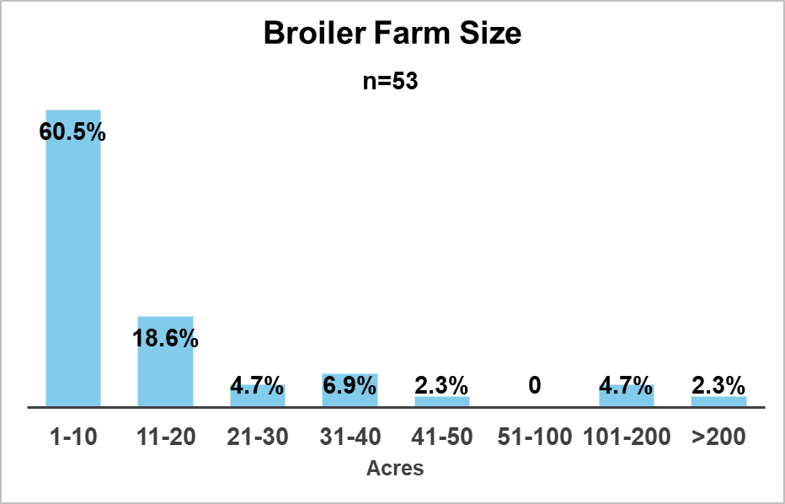
As shown in Table 3.1, producers currently utilize in-house environmental monitoring technology for temperature (98.1%) and humidity (48.2%); and automated feed and water monitoring systems such as automated feed systems (88.7%) and water flow meters (85.2%). Survey data indicated that some producers are using video cameras (25.0%), data management systems (24.6%), and automated scales (19.6%), but some would consider using them in the future (Table 3.1 is located in Appendix B). Because most PLF technologies with video monitoring also utilize thermal imaging for AI decision making, it is possible that the video cameras being used by respondents are for security purposes rather than real time monitoring. Additionally, 43.1% of producers had not heard of PLF before this survey; only 6.8% had expertise or great familiarity with PLF; and 50.1% indicated they had moderate, some, or little familiarity with PLF. Though there are several educational outlets discussing PLF’s role in the broiler industry, the low familiarity reported from this survey indicates a potential lack of information transfer between producers and PLF research. While limited PLF research has mirrored commercial broiler production, it is possible producers aren’t consuming this information simply because it doesn’t show benefits for commercial production.
Figure 3..1. TN Broiler Farm Size
Most producers (57.0%) do not currently use computer software to capture, review, or manage farm operational data, a fact that could be limiting the use of PLF technologies as they will require some form of electronic data analysis, inspection, and/or management. This may be in part due to the fact that the integrators collect the data used to determine feed conversion and quantify broiler production in order to determine grower payments. This may be correlated to only 23.0% of producers having high experience with technology, while 62.0% indicated having average experience; and 15.0% indicated minimal experience with technology. Low experience with technology may be correlated to a lack of higher education among broiler producers. Producers indicated that only 44.6% had received a college degree after high school, while 52.0% only received a high school degree or GED; 3.7% did not finish high school or receive a GED. It is possible producers aren’t learning about this technology simply because they have little experience and trust in technology in general.
Survey data indicated that most producers are not solely responsible for technology implementation decisions. While 95.0% of respondents confirmed to be contract poultry producers, 46.0% indicated they were the primary decision maker about technology use on farm; 41.0% indicated they would consult with their integrator company or technology use was stated in their contracts with the integrator company; 11.0% stated that technology use was not specified in their contract with the integrator company. It is possible that PLF training courses would be more influential for PLF adoption if they were tailored to an audience of integrators and producers, rather than producers only.
When asked to rate the importance of real-time information in five categories, producers viewed broiler environment (72.0%) and broiler health (60.0%) to be the most important (Figure 3.2 located in Appendix C). This suggests producers are interested in obtaining real-time information about their production, which could be accomplished using PLF technologies, highlighting a need for PLF education among broiler producers. Most producers (78.0%) were interested in attending a PLF workshop if Extension offered one; only 22.0% indicated they were unsure or unlikely to attend, highlighting producer desire to learn more about PLF’s capabilities and the advantages of real-time monitoring in their production operations.

Regarding productivity and welfare, producers prioritize broiler weight gain and feed/water intake as important indicators (Figure 3.3 and Figure 3.4). While footpad health and vocalizations hold some importance for both productivity and welfare, producers view broiler activity to be more important for welfare measures than productivity. Producers indicated gait score and feather coverage were the least important indicators for both productivity and welfare. This aligns with another survey of Belgium broiler producers which showed producers believe broiler welfare is largely determined by feed intake (Tuyttens et al, 2014).
Respondents indicated that if Extension offered a program about managing broilers they would be interested in learning about litter (22.0%), bird health alternatives (17.4%), profitable management (13.0%), and feed conversion (13.0%). As shown in Figure 3.5, producers are most interested in productivity, profit, and broiler health (Figure 3.5 is located in Appendix D). Surprisingly, respondents were not interested in learning about mortality management (4.3%), controller management (4.3%), and ventilation (4.3%) regarding broiler management, but they did show interest in these topics regarding PLF integration. This could indicate that producers believe they already have optimal management practices in these areas and do not need to learn more about them. However, they are interested in learning about technological advancements that can aid their current practices.
A variety of questions were asked to quantify broiler producer perspectives on their willingness to adopt and use PLF technologies. Producers (88.4%) indicated they would be interested in adopting PLF if it was shown to increase farm income; 11.6% indicated they were unsure or somewhat unlikely. If producers are better informed about the benefits of adopting PLF towards better farm income, for example with applied research that demonstrates a payback period or return on investment (ROI), these technologies would be more likely to be adopted. Survey data indicated that respondents viewed PLF as having the ability to save labor (57.0%) and reduce production costs (56.0%). Most producers (63.0%) also viewed PLF as being beneficial for future poultry production. This suggests that while the rate of adoption has been slow, producers have positive attitudes about PLF’s role in commercial broiler production. Producers may benefit from learning more about this technology and seeing it successfully implemented on commercial farms, but more data is needed to quantify producer specific needs for PLF training.
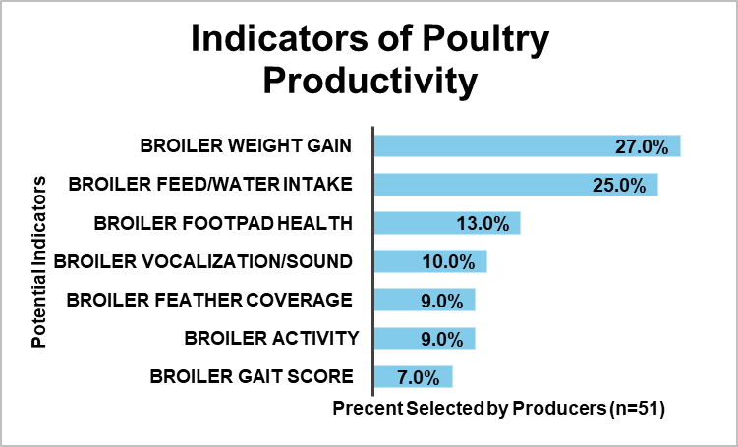
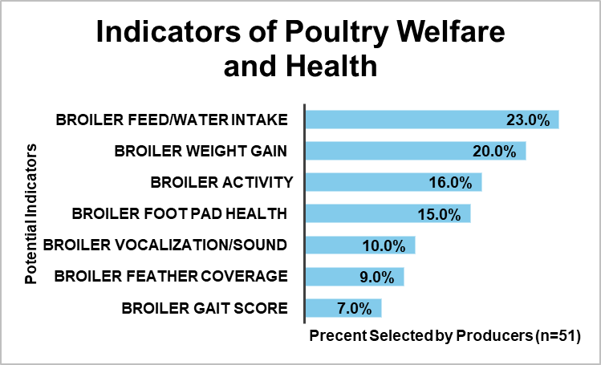
Figure 3.3. Producer Perspectives on Indicators of Poultry Productivity
Figure 3.4. Producer Perspectives on Indicators of Poultry Welfare and Health
Producers indicated they are unwilling to adopt current technologies due to cost (42.0%), complexity of the technologies (27.0%), and having to train/retrain employees to use the technology (14.0%). Some producers (31.0%) also felt that PLF technology did not fit into their production operations. However, a higher number of producers indicated they neither agree nor disagreed for each of these questions (Responses range from 46.0% to 52.0%). They may not have enough information about the factors of implementing PLF to agree or disagree. Producers (61.0%) indicated they needed to see PLF working on a farm before committing; 27.0% indicated they neither agreed nor disagreed. It is unknown if the high rate of respondents that neither agree nor disagree is correlated to a lack of information or a lack of interest. It is possible that producers are unlikely to take risks for technologies that are not shown to be useful in commercial production. Aligning with producer concern for farm profitability, 67.0% of respondent producers indicated they would be more likely to implement PLF technologies on their farms if there was a government cost-sharing program; 33.0% indicated they were unsure or unlikely. This suggests that producers may not be willing to adopt PLF technology until ROI information is reported, and technology usefulness is demonstrated in commercial production.
In summary, it appears most producers view PLF as a potential benefit to their operations, but not enough information is available to demonstrate the cost, complexity, and employee training requirements for PLF systems, as well as the ROI for them to make an investment. If producers were able to see PLF systems demonstrated with quantifiable positive impacts on production costs and labor, it appears more producers would be willing to adopt these technologies. In the same vein, PLF researchers must focus on creating technologies that are affordable and easy to use.
Conclusions
- Broiler producers have limited familiarity with what PLF technologies are and how these technologies can assist broiler production operations. However, producers showed an interest in learning more about PLF and particularly seeing PLF technology working on commercial farms. Producers expressed positive attitudes towards PLF and its ability to benefit the future of commercial poultry farming.
- Producers view weight gain and feed/water intake as critical, quantifiable pieces of information defining broiler productivity. Producers also view environmental control and broiler health as the most important areas for continuous monitoring. As such, producers currently utilize environmental and feed monitoring technologies such as temperature and humidity sensors, automated feed inventory systems, and water flow meters.
- Ninety-five percent of respondents reported being contract poultry producers. Forty- six percent of respondents indicated that they could maker decisions about technology implementation without consulting with their integrating company.
- Fifty-one point eight percent of respondents are not using video cameras, 75.9% are not using thermal cameras; 49.2% are not using data management systems; 50.7% are not using location monitors; and 50.0% are not using automated scales but would consider using them in the future. Fifty-seven percent of respondents are not using computer software to capture, review, or manage operational data. It is possible that low technology use on broiler farms is correlated to low experience and trust in technology in general.

APPENDICES
Appendix A
Tennessee Broiler Producer Survey
- Prior to this survey, how would you describe your familiarity with Precision Livestock Farming?
- I had not previously heard of precision livestock farming
- Little familiarity
- Some familiarity
- Moderate familiarity
- Great familiarity
- I have expertise in precision livestock farming

- To you, what are the important indicators for poultry productivity? Check all that apply.
- Broiler activity
- Broiler gait score
- Broiler feather coverage
- Broiler weight gain
- Broiler feed/water intake
- Broiler footpad health(including hock)
- Broiler vocalization/sound

- To you, what are the important indicators for poultry welfare and health? Check all that apply.
- Broiler activity
- Broiler gait score
- Broiler feather coverage

- Rate the importance of having real-time, continuous information for your operation for the following:
 | 1  not important |  |  |  |  |  | 7  extremely important
Broiler productivity measures | o | o | o | o | o | o | o
Broiler health/disease indicators | o | o | o | o | o | o | o
Environmental monitoring and management (ventilation, heat/ cooling, lighting) | o | o | o | o | o | o | o
Waste management | o | o | o | o | o | o | o
Data recording for production cost management | o | o | o | o | o | o | o

- Please indicate your use of each of these technologies in your poultry operation.
 | Not using it | Currently using it | Would consider using it sometime the next 5 years
Video cameras | o | o | o
Thermal cameras | o | o | o
Automated feed inventory system | o | o | o
Automated feed system | o | o | o
Water flow meters | o | o | o
Automated scales | o | o | o
Temperature sensors (house level) | o | o | o
Humidity sensors (house level) | o | o | o
Gas sensors (CO2 and/or NH3) (house level) | o | o | o
Robots | o | o | o
Drones | o | o | o
Microphone with audio processing app | o | o | o
Activity monitors | o | o | o
Location monitor | o | o | o
Data management system | o | o | o
Other: ____________________ | o | o | o
- What goals would you aim to meet if you chose to use any PLF technology? Check all that apply.
- Allow me more free/social time
- Increase production
- Decrease input costs
- Improving profit
- Optimize for environmental and resource stewardship
- Improve the welfare of my animals
- Disease control/biosecurity
- Improve worker safety
- Reduce the labor needed on my farm
- Improve genetic merit of my animals
- Improve product consistency
- Improve product quality
- Expand my operation
- Improve my record keeping for product tracing
- Improve my record keeping for better financial performance

- How would you describe your level of experience/skill with technology in general?
- Minimal
- Average
- High

- Do you currently use a smartphone and a smartphone app to capture, review, or manage any of your broiler farm operation?
- Yes
- No

- Do you currently use a computer and computer software to capture, review, or manage your broiler farm operation data?
- Yes
- No

- Do you agree or disagree with these statements about your potential use of Precision Livestock Farming technologies?
 | Strongly Disagree | Disagree | Neither disagree or agree | Agree | Strongly Agree
PLF technology could save me labor cost. | o | o | o | o | o
PLF technology could save me production cost. | o | o | o | o | o
The cost of PLF prevents me from considering it now. | o | o | o | o | o
The complexity of PLF prevents me from considering it now. | o | o | o | o | o
Having to train/retrain my employees prevents me from considering PLF now. | o | o | o | o | o
My operation is too small to benefit from these tools | o | o | o | o | o
I need to see the PLF technology working on a farm before I consider it | o | o | o | o | o
I need to be able to try out the PLF technology before committing to it | o | o | o | o | o
I am not sure the PLF technology fits with my production operations | o | o | o | o | o
PLF technology will be very important in future poultry production. | o | o | o | o | o

- If there was a government cost sharing program for the implementation of PLF technology, how likely would you be to add PLF technology for your farm?
- Extremely unlikely
- Somewhat unlikely
- Neither likely nor unlikely
- Somewhat likely
- Extremely likely

- If Extension agents offered PLF training workshops, where you could see the technology in use and learn how to use it, how likely would you be to attend?
- Extremely unlikely
- Somewhat unlikely
- Neither likely nor unlikely
- Somewhat likely
- Extremely likely

- If benefits from PLF were shown to improve broiler production and farmer income how likely would you be to add to your farm?
- Extremely unlikely
- Somewhat unlikely

- Have you completed the UT Master Poultry Producer Program?
- Yes
- No

- In what year did you begin operating a broiler operation? __________

- In what year were you born? ____

- What is your gender?
- Male ¡ Female

- What is your highest level of education?
- Less than High School ¡ Associate's Degree
- High School Graduate (or GED) ¡ Bachelor's Degree
- Some College or Technical School ¡ Master's, Doctorate or Professional Degree
- Technical School Diploma
- Other:

- Do you plan on passing your farm/operation on to someone in the future?
- Yes
- No
- Not sure

Appendix B
Table 3.1. Technology Currently Used on Commercial Broiler Farms
Technology | Not Using It | Currently Using It | Have Used It | Would Consider Using it in the Next 5 Years
Video Cameras (=56) | 51.8% | 25.0% | 3.6% | 19.6%
Thermal Cameras (=58) | 75.9% | 0.0% | 1.7% | 22.4%
Automated Feed Inventory System (n=59) | 57.6% | 11.9% | 0.0% | 30.5%
Automated Feed System (n=54) | 5.7% | 88.7% | 0.0% | 5.6%
Water Flow Meters (n=54) | 7.4% | 85.2% | 1.8% | 5.6%
Automated Scales (n=53) | 50.0% | 19.6% | 5.4% | 25.0%
Temperature Sensors (n=56) | 0.0% | 98.1% | 0.0% | 1.9%
Humidity Sensors (n=56) | 30.4% | 48.2% | 1.8% | 19.6%
Gas Sensors (n=56) | 75.0% | 7.1% | 0.0% | 17.9%
Robots (n=54) | 79.6% | 1.9% | 0.0% | 18.5%
Drones (n=59) | 78.0% | 5.1% | 0.0% | 16.9%
Microphone with App (n=53) | 84.9% | 0.0% | 0.0% | 15.1%
Activity Monitors (n=53) | 73.6% | 0.0% | 0.0% | 26.4%
Location Monitors (n=73) | 50.7% | 8.2% | 0.0% | 41.1%
Data Management Systems (n=61) | 49.2% | 24.6% | 1.6% | 24.6%

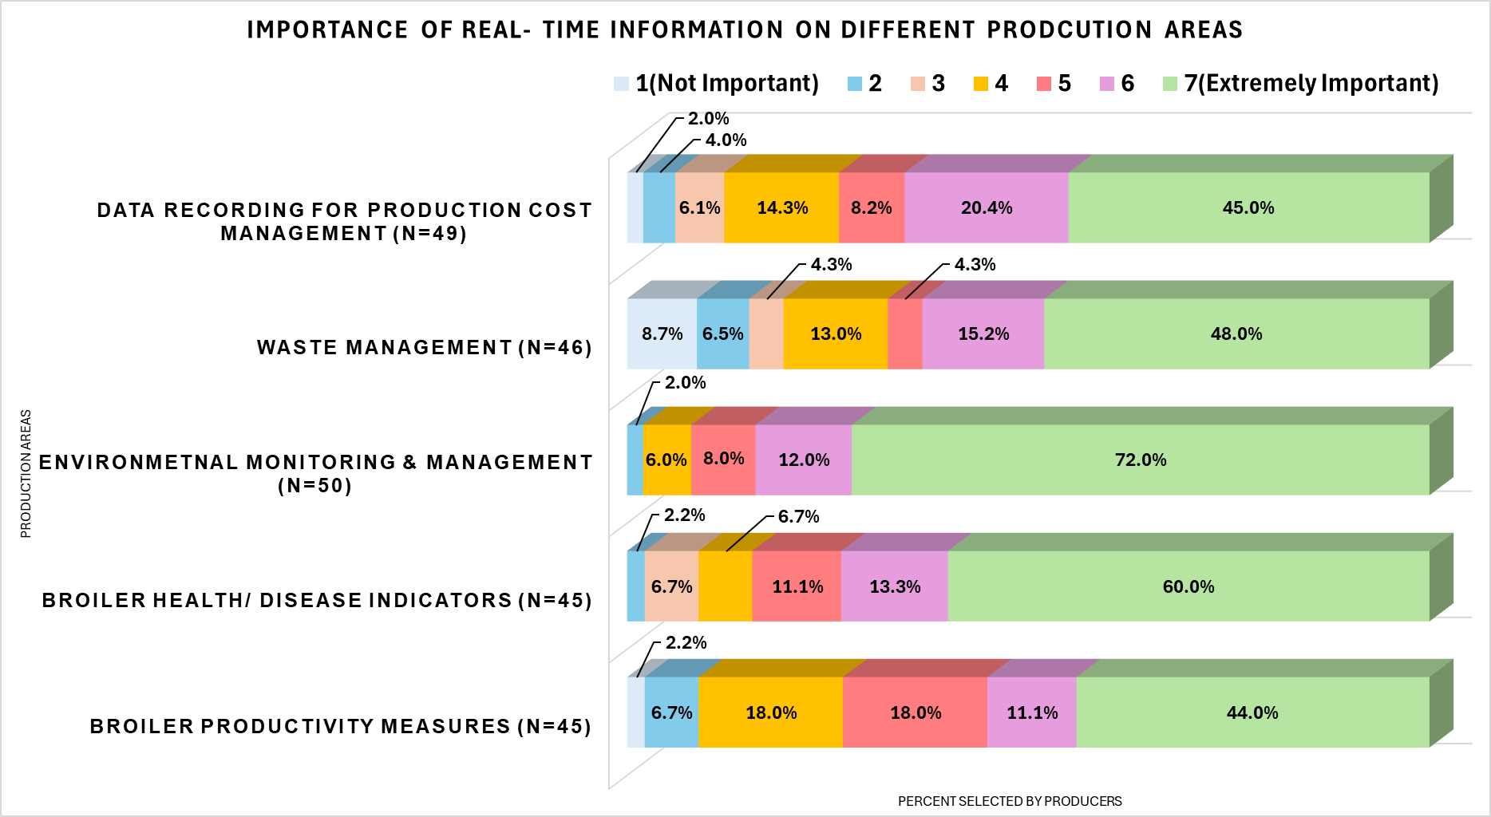
Appendix C
Figure 3.2. Importance of Real Time Monitoring on Different Production Areas

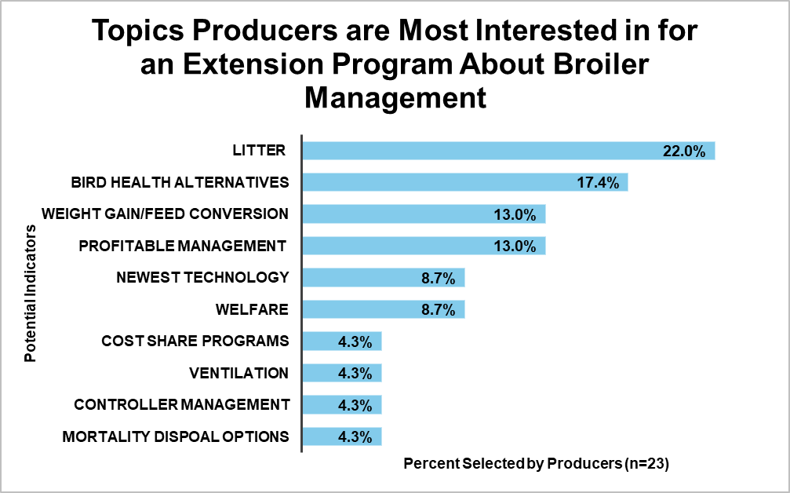
Appendix D
Figure 3.5. Producer Interest in Topics for an Extension Program About Managing Broilers

Development of a producer short course on precision livestock farming in the broiler industry

Introduction
Precision Livestock Farming (PLF) can be a useful tool for poultry producers by providing real-time data on animal and in-house ambient conditions. While several publications have identified potential benefits of adopting PLF technology, adoption rates remain low on U.S. broiler farms. Previous PLF short courses have been offered at the University of Georgia, Michigan State University, and Iowa State University (2022 International, 2022; Precision Agriculture, 2022; US Precision, 2019). These courses are a part of annual, monthly, and single short course sessions. The University of Georgia offers the only short course focused solely on poultry production in its annual PLF workshop. However, course material for these workshops is tailored to an audience of academia and researchers, not producers and the public. From my literature review, the authors found no courses previously offered in the U.S. designed to communicate to broiler producers the advancements in PLF research and the benefit of adopting such technology.
The University of Tennessee hosted the 2023 TN Master Poultry Producer course, including a one-hour PLF module focused on PLF computer vision systems applicable to the poultry industry (Master Commercial, 2022). This was the only PLF education module that was specifically tailored to the producer’s needs based on the Producer Needs Assessment distributed before the creation of the course. However, we believe that a multi-hour short course focused on PLF in the poultry industry would benefit producers' knowledge of PLF and facilitate technology adoption.
The two surveys previously mentioned in Chapters I and II (Producer Needs Assessment and TN Broiler Producer Survey) identified a lack of knowledge about PLF among broiler producers, signifying a need for PLF education among producers. The TN Broiler Producer Survey also highlighted producers’ desire to learn more about PLF technology and how it can benefit their production operations. This indicates that while there is a need for PLF training, producers are willing to partake in training, as well.
A Producer Short Course
To create a short course that not only increases producer knowledge of PLF but also provides value to their current production operations, the surveys provide valuable information about what topics producers are interested in learning about. They also allowed us to determine the needs of broiler producers where PLF may be applicable to create topics with the most value for the producer.
The Producer Needs Assessment was designed to obtain producer perspectives on training topics for the 2023 TN Master Poultry Producer course. The TMPP course offered a one-hour PLF module focused solely on PLF for poultry production. Based on the feedback from this survey, there is a need for more in-depth PLF training courses for producers. This short course will be an extension of the original PLF module from the TMPP 2023 course to include eight hours of educational contact time.
The goal of this short course is to increase producer knowledge of PLF technology and allow them to make informed decisions about adopting PLF into their production operations. This course also intends to bridge the gap in the communication between producers’ needs and PLF research advancements. After this short course, producers should have a strong understanding of the purpose of PLF and how it can be used to create more efficient monitoring practices. They should also be aware of the technology currently available to them and be able to make informed decisions about adopting PLF technology.
Development and Preparation
The target audience for this course was broiler producers and Extension agents. Sessions were recorded in one-hour modules to be included for the 2025 TMPP program. Attendees were also eligible for up to nine credit hours of TMPP by completing three content quizzes available after each night. TN Master Poultry Producer assessments were created through Qualtrics (Qualtrics, Provo, UT, 2025) and distributed through email to participating members. These assessments consisted of three demographic questions; two questions identifying changes in knowledge before and after the course; and three comprehension questions over course materials.
Registration for this course was free but required a registration survey through Qualtrics to obtain an email list of attendees for ease of communication and information distribution. This also provides us with a contact list for a post-course impact survey that will help quantify the success of the course. Three meetings were held over three days for a total of nine hours of educational contact. Virtual meetings were held through Zoom (Version 6.2.11) to avoid any biosecurity concerns associated with bringing producers together. Meetings were held synchronously to allow for active discussions and questions, increasing producers’ understanding of the course material. Zoom meetings were password protected and had waiting rooms enabled to avoid any unwanted intrusions.
Advertising for this course was accomplished through the creation of digital flyers distributed to members of the TN Poultry Association (TPA). Important course information, registration links, Zoom links, and the full itinerary were also included on the UTK PLF website (University of Tennessee, 2025) to allow for ease of access by interested attendees. The flyer for this course is included in Appendix A.
To measure the success of the short course, a post-course impact survey was created through Qualtrics (Qualtrics, Provo, UT, 2025). This survey consisted of six questions asking producers about their knowledge of PLF, their willingness to adopt it, and their perspectives on its use in commercial poultry production. This survey was distributed through email to registered members of the short course after the course. While the results for this survey will not be included in this thesis, they will provide future PLF research projects with relevant information for the needs, topics, and frequencies of future PLF short courses. The impact survey for this course is included in Appendix B.
Topic Selection
Topics for this course were formulated based on survey data from the TN Broiler Producer Survey (2024) and the Producer Needs Assessment (2023) allowing course material to reflect the needs and interests expressed by producers. These surveys highlighted producers’ interest in productivity measures like feed intake and weight gain; environmental measures such as ammonia concentration and ventilation; and production costs such as utilities and feed/water.
Topics were broken into one-hour modules to be included in the 2025 TN Master Poultry Producer course. A total of eight modules were offered including PLF use in broiler production, Precision systems for securing poultry production, ventilation and environmental management, controller management, bird health and disease detection, mortality management, behavior monitoring, and PLF field implementation. The full itinerary for this short course is available in Appendix C.
Instructors for each module were selected based on their level of expertise in each topic. This ensures the credibility of the lecture material and instills more value into the overall course offerings. Instructors for this course consist of professors, extension specialists, and graduate students with backgrounds in poultry production and PLF research.
Results and Impact
Registration for this short course was completed by 23 individuals. Of the 23 registered, 15 participated in the course meetings. Participation in this course included poultry producers (34%), researchers (60%), and Extension agents (6%). The TMPP 2025 assessments were completed by 25.0% of attendees. Unfortunately, the impact survey for this course did not offer sufficient data to quantify the overall success of the course.
The TN Broiler Producer Survey indicated that 78.0% of respondents would be interested in attending a PLF workshop if one was offered. It is possible that the low attendance compared to the survey data is correlated to the producer’s understanding of the term “workshop”. It is possible producers felt that a workshop would include real-life demonstrations of this technology rather than be an educational short course. The TN Broiler Producer Survey also indicated that most producers (61.0%) need to see PLF working on a farm before committing it. It is possible that producers are not interested in learning about technology, as much as they want to see it benefiting commercial production. Future PLF short courses should include on-farm demonstrations to prove the usefulness of this technology.
It is also possible low attendance is due to limited advertising. Future short courses should expand their advertising to multiple states or agriculture organizations. Low participation in this course creates a limitation on the ability to quantify its success. Future producer short courses should optimize advertising to a wide range of locations and offer better incentives for participating. It is also possible synchronous meetings correlated to lower participation due to time constraints. Future short courses might benefit from optimizing asynchronous material that can be completed at any time.
Conclusion
Precision Livestock Farming (PLF) has the potential to save producers time, money, and labor by offering real-time monitoring of whole production operations. While PLF research has shown the benefits of PLF implementation, adoption on U.S. broiler farms is slow. It is possible that slow adoption rates are due to a lack of technology transfer from PLF researchers to broiler producers. Educating producers about the benefits of PLF and what technology is currently available to them can allow them to make informed decisions about adopting and potentially influence higher adoption rates. While previous short courses have focused on PLF in all livestock sectors or have been tailored to an audience of academic associates, it is our belief that a short course tailored to the needs of producers will increase their knowledge of PLF technology. However, the low participation for the short course indicates that producers may not be interested in learning about this technology after all. Survey data indicated producers need to see PLF working on a commercial farm and showing benefits of implementation before considering adoption. Future PLF short courses should focus on technology demonstrations on commercial farms and include ROI and cost of investment information to increase participation.

APPENDICES
Appendix A
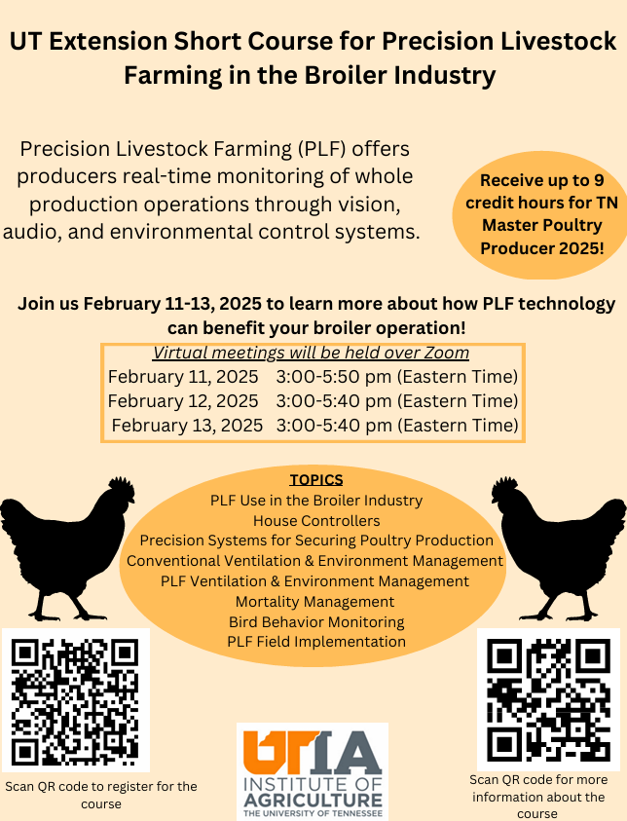
Precision Livestock Farming in the Broiler Industry Short Course Flyer
Figure 4.1. Producer Short Course Flyer (Front)
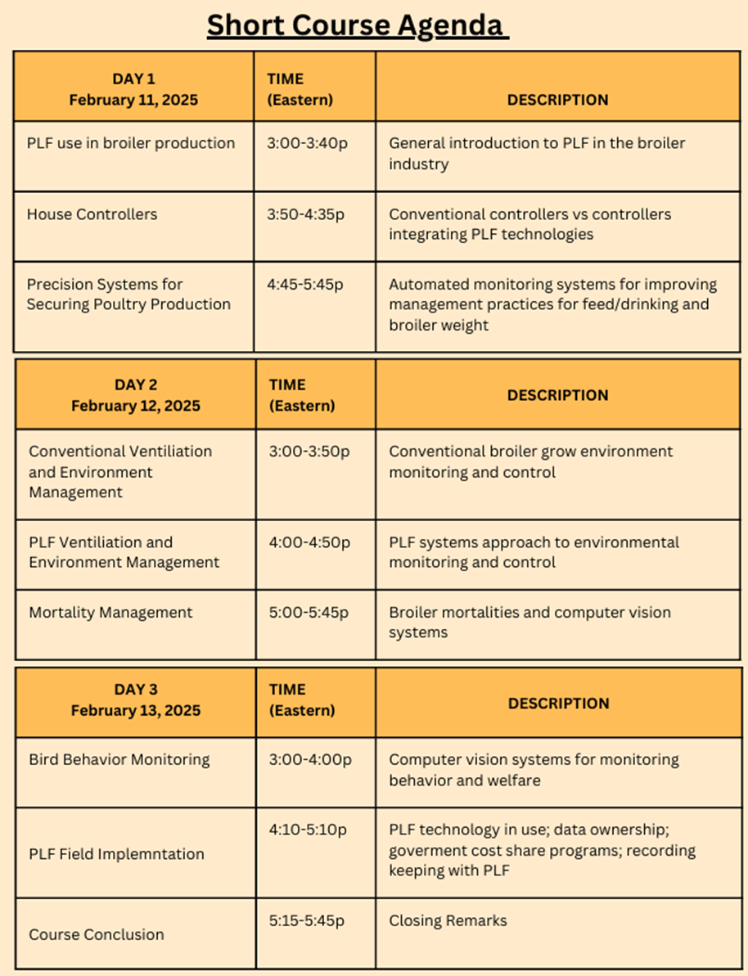
Figure 4.2. Producer Short Course Flyer (Back)

Appendix B
Precision Livestock Farming in the Broiler Industry Impact Survey
- After attending the PLF short course, has your knowledge of PLF technology
- Not changed
- Slightly increased
- Strongly increased
- After attending the PLF short course, do you plan to implement PLF technology in your broiler operation in the next 5 years?
- Yes
- No
- Not Decided
- After completing the short course, what type of technology would fit best into your current poultry operation? (Select all that apply)
- Computer Vision Systems (CVS)
- PLF integrated environmental management systems
- PLF-integrated house controllers
- Automated feed systems
- All the above
- Other
- PLF technology does not fit into my poultry operation.
- If you plan to invest in PLF technology in the next 5 years, what is your expected cost of investment?
- 10k-20k
- 20k-40k
- 40k-60k
- >60k
- I do not plan to invest in PLF technology
- PLF technology has the potential to benefit future poultry production.
- Agree
- Disagree
- If Extension were to offer future PLF short courses for poultry production, how likely would you be to attend?
- Would attend
- Might attend
- Would not attend

Appendix C
Precision livestock farming in the Broiler Industry Short Course Itinerary
Table 4.1 Short Course Itinerary
Module | Topics | Instructor | Time
PLF in the Broiler Industry Day 1 |  |  | 2 hours 40 min
PLF Use in the Broiler Industry | Production  Health  Behavior  Welfare  Labor Management  Environmental Stewardship | T. Klingberg | 30 min
Precision Systems for Securing Poultry Production | Automated monitoring for feed/drinking, weight gain, and health | Y. Zhao | 1 hour
Ventilation and Environmental Management | Litter moisture and house humidity  Environmental sensors and control  House sanitation  Octopus Poultry Safe system  House tightness  Poultry 411 app | S. Hawkins | 1 hour
PLF in the Broiler Industry Day 2 |  |  | 2 hours 30 min
Controller Management | Purpose  Selection  Operation | T. Tabler | 30 min
Bird Health and Disease | Broiler Health  Foot Pad Health  Managing footpad dermatitis  Early Disease Detection | T. Tabler | 1 hour
Mortality Management | Broiler Mortalities  SCOUT/ Computer Vision Systems | T. Tabler  S. Hawkins | 1 hour

Table 4.1. Continued
PLF in the Broiler Industry Day 3 |  |  | 2 hours 30 min
Bird Behavior Monitoring | Computer Vision Systems  Poultry welfare and behavior | H. Gan  Y. Zhao | 1 hour
PLF Field Implementation | Current PLF use  Return on Investment  Data Ownership  Record Keeping with PLF  Government Cost Share Programs  PLF Implementation Challenges  Next Steps / Future of PLF | R. Burns | 1 hour
Conclusions |  | T. Klingberg | 30 min

Precision Livestock Farming (PLF) has the potential to enhance the broiler industry and provide producers with more efficient management practices. Precision livestock farming technology utilizes real-time monitoring on whole production operations that provide producers with real time alerts when production conditions change. This technology has the potential to decrease input costs and labor while increasing productivity and profit, without diminishing the welfare of the flock.
While several publications have identified the benefits of implementing PLF technology into commercial broiler production, adoption rates remain low. A producer survey from January of 2024, identified a low familiarity with PLF among TN broiler producers. This survey also identified producer’s desire to learn more about PLF technology and areas of production where PLF may be applicable.
From this survey data, we developed a producer short course designed to bridge the gap in information transfer between PLF researchers and poultry producers. Survey data was analyzed to formulate topics that were valuable to producers. Topics in this course ranged from PLF use in the broiler industry, behavior monitoring with computer vision systems, mortality management, disease detection, and implementation measures such as return on investment (ROI), cost share programs, and data ownership. An impact survey was conducted to quantify the success of the course. While the results from the impact survey are not included in this thesis, they will be used to direct needs, frequencies, and topics for future PLF short course projects.

REFERENCES

Ali, M., Ahman, Z., Ullah, N. (2023). Evaluation of Different Litter Management Techniques on Broiler Performance and Ammonia Emissions. Indus Journal of Agriculture and Biology. Vol 2, 1. 33-40. DOI: https://doi.org/10.59075/ijab. v2i1.214
Astill, J., Dara, R. A., Fraser, E. D.G., Roberts, B., Sharif, S. (2020). Smart poultry Management: Smart sensors, big data, and the internet of things”. Elsevier, Computers and Electronics in Agriculture. Vol 170.https://doi.org/10.1016/j. compag.2020.105291\
Astill, J., Dara, R. A., Fraser, E. D.G., Roberts, B., Sharif, S. (2020). Smart poultry Management: Smart sensors, big data, and the internet of things”. Elsevier, Computers and Electronics in Agriculture. Vol 170.https://www.sciencedirect .com/science/article/pii/S0168169918316363
Banhazi, T., Bnhazi, A., Tikasz, I., Palotay, S., Mallimger, K., Neubauer, T., Corpaci, L., Marchaim, U., Kopler, I., Opaliniski, S., Olenjik, K., Kokin, E., Gunnarsson, S, Bjerre, T., Soerensen, C. (2024). Facilitating PLF technology adoption in the Pig and Poultry industries. Studies in Agricultural Economics. Vol 126, 1. 43-49. https://doi.org/10.7896/j.2725
Berckmans, Daniel. (2017). General Introduction to Precision Livestock Farming. Animal Frontiers. Vol 7, 1. 6-11. https://academic.oup.com/af/article/7/1/6/4638786
Cumberland, AGCO. 2023.https://www.cumberlandpoultry.com/en_US/searc h.html?q=SCOUT
Greening, S., Mulqueen, K., Rawdon, TG., French, NP., Gates, MC. (2020). Estimating the level of risk and biosecurity on commercial poultry farms in New Zealand. New Zealand Veterinary Journal. Vol 68, 5.https://doi.org/10.1080 /00480169.2020.1746208
Grossen, Grace. (2025). Poultry and Egg Sector at a Glance. USDA-ERS. Accessed 3/19/25 at https://www.ers.usda.gov/topics/animal-products/poultry-eggs/sector at-a-glance
Jaihuni, M., Gan, H., Tabler, T., Qi, H., Prado, M., Zhao, Y. (2023). Broiler Mobility Assessment Via a Semi-Supervised Deep Learning Model and Neo-Deep Sort Algorithm. Precision Livestock Farming Conference 2023, 331-338.
Hartung, J. Banhazi, T., Vranken, E., Guarino, M. (January 2017). European Farmers’ Experiences with Precision Livestock Farming Systems. Animal Frontiers, Volume 7, Issue 1, 38-44, https://doi.org/10.2527/af.2017.0107
King, R., Palm-Forester, L., Shober, A., Reiter, M. (2021). Report for the 2020 Poultry Litter Nutrient Distribution Producer Survey. APEC Research Reports. University of Delaware, Department of Applied Economics and Statistics.
Korver, D. (2023). Review: Current challenges in poultry nutrition, health, and welfare. Elsevier, Animal. 17, 2. https://doi.org/10.1016/j.animal.2023.100755
Kucuktopcu, E., Cemek, B. (2021). Comparison of neuro-fuzzy and neural network techniques for estimating ammonia concentration in poultry farms. Journal of environmental chemical engineering. vol 9. 4.https://doi.org/10. 1016/j.jece.2021.105699
Li, G., Chesser, G. D., Purswell, J.L., Magee, C.L., Gates, R.S., Xiong, Y. (2022). Design and development of a broiler mortality removal robot. ASABE. Mississippi State University
Li, N., Ren, Z., Li, D., & Zeng, L. (2020). Review: Automated techniques for monitoring the behavior and welfare of broilers and laying hens: towards the goal of precision livestock\ farming. Animal, volume 14, 3, 617-625.Doi:10.1017/S17 51731119002155
Liu, L., Li, B., Zhao, R., Yao, W., Shen, M., Yang, J. (2020). A novel method for broiler abnormal sound detection using WMFCC and HMM. Journal of Sensors, vol 2020, article ID 2985478, https;//doi.org/10.1155/2020/2985478
Maharjan, P., & Liang, Y. (2020). Precision Livestock Farming: The Opportunities in Poultry Sector. Journal of Agricultural Science and Technology.
Master Commercial Poultry Producer Program. (2022). University of Tennessee. https://mastercommercialpoultry.tennessee.edu/
Master Commercial Poultry Producer Program. (2022). University of Tennessee. https://mastercommercialpoultry.tennessee.edu/
Miller, M., Gerval, A., Hansen, J., Grossen, G. (Aug 2022). Poultry Expected to Continue Leading Global Meat Imports as Demand Rises. USDA, Economic research service. (Accessed 10/15/2024). https://www.ers.usda.gov/amber waves/2022/august/poultryexpected-to-continueleading-global-meat-imports-as demand-rises/
Morrone, S., Dimauro, C., Gambella, F., Cappai, M. G. (2022). Industry 4.0 and Precision Livestock Farming (PLF): An up-to-date Overview Across Animal Productions. National Library of Medicine, Sensors. DOI: 10.3390/s22124319
Olejnik, Katarzyna, Ewa Popiela, and Sebastian Opaliński. 2022. "Emerging Precision Management Methods in Poultry Sector" Agriculture 12, no. 5: 718.
Nasiri, A., Amirivojdan, A., Zhao, Y., Gan, H. (2023). Estimating the feeding time of individual broilers via convolutional neural network and image processing. Precision Livestock Farming Conference 2023, 324-330.
Precision Agriculture Webinar Series . (2022). Michigan State University. https://www.canr.msu.edu/precision-agriculture/
Precision Agriculture Webinar Series . (2022). Michigan StateUniversity. https://www .canr.msu.edu/precision-agriculture/
Ren, G., Lin, T., Ying, Y., Chowdhary, G., Ting, K. (2020, February). Agricultural robotics research applicable to poultry production: A review. Elsevier journal, 169.
Report of Precision Livestock Farming Workshop. (2023). Animal Welfare Research Network . https://awrn.co.uk/2021/02/24/report-on-precision-livestock-farming workshop/
Rhodes, J., Moyle, J., Dill, S., McCoy, T., Tablante, N., Wang, C. (2018). Measuring Extension’s Impact on Commercial Poultry Production. Journal of the NACAA. Vol 11, 1.
Rizwan, M., Darbone, T., Anderson, D. v. (2023). Continuous Monitoring of broiler welfare through audio analytics. Precision Livestock Farming Conference 2023, 316-323.
Rowe, & Dawkins, Marian & Gebhardt-Henrich, Sabine. (2019). A Systematic Review of Precision Livestock Farming in the Poultry Sector: Is Technology Focused on Improving Bird Welfare?. Animals. 9. 614.
Silvera, A.M., Knowles, T.G., Butterworth, A., Berckmans, D., Vranken, E., Blokhuis, H.J. (2017). Lameness assessment with automatic monitoring of activity in commercial broiler flocks. Elsevier, Poultry Science. Vol 96, 7. 2013-2017. DOI: 10.3382/ps/pex023
Thornton, T. (2024). Current Perceptions, Use, and Field Implementation of Precision Poultry Farming Technologies (Master’s Thesis). The University of Tennessee, Knoxville.
Tuyttens, F., Vanhonacker, F., Verbeke, W. (2014). Broiler production in Flanders, Belgium:current situation and producer’s opinions about animal welfare. World’s Poultry Science Journal. Cambridge University. doi:10.1017/S004393391400035X
University of Tennessee Institute of Agriculture. (Accessed 2/10/2025). UT Precision Livestock Farming. UT PLF. https://plf.tennessee.edu/
United State Department of Agriculture National Agriculture Statistics Service. 2024. [Chart].Broiler pounds produced. Accessed athttps://www.nass.usda.gov/Charts_and_ Maps/Poultry/brlprd.php
US Precision Livestock Farming Conference. (2019). Iowa State University. https://www.ans.iastate.edu/news/2023/iowa-state-participates-us-precision livestock-farming-conference
Workshops: advancing outcomes in precision livestock farming. (2023). Animal Agtech Innovation Summit. https://animalagtech.com/precision-livestock-farming-workshfop/
2022 International Poultry Short Course . (2022). UGA Poultry Short Course Flyer. https://poultry.caes.uga.edu/content/dam/caessubsite/poultry/d ocuments/742591_Poultry_Short%20Course_Flyer%20HW0957AM %20officialpdf
2022 International Poultry Short Course . (2022). UGA Poultry Short Course Flyer. https://poultry.caes.uga.edu/content/dam/caes subsite/poultry/documents/742591_Poultry_Short%20Course_Flyer%20HW095 AM%20official.pdf

VITA
Originally from Tennessee, Terrilyn Klingberg grew up in Crossville, Tennessee. After receiving an Associates of Science degree from Roane State Community College, she attended the University of Tennessee, Knoxville and received a Bachelor of Science in Animal Science. She chose to continue her studies at the University of Tennessee, Knoxville to pursue a master’s degree in Biosystems Engineering Technology. Her research interests include Extension education and the implementation of Precision Livestock Farming in the broiler industry. After graduation, she hopes to pursue a career in Agriculture Extension. She is incredibly grateful for all the support from her friends, family, and mentors that have helped shape her future career.

