Seasonality, Distribution, and Biological Control of Crapemyrtle Bark Scale,
A New Invasive Threat in Tennessee

A Thesis Presented for the
Master of Science
Degree
The University of Tennessee, Knoxville

Amira Cornish
December 2021

Dedication
To my mother who would have been so proud of her baby girl.
“With brave wings she flies”

Acknowledgements
I would like to express my gratitude to the Graduate Student Committee for allowing me to pursue a Master’s degree in the Department of Entomology and Plant Pathology at the University of Tennessee. I also thank the Department Head, Dr. Dewayne Shoemaker, for allowing me to undertake this research.
I am also deeply grateful for my major advisor and professor, Dr. Jerome Grant, who has provided me with guidance and support throughout my research journey. Also, thanks to Dr. Frank Hale, Extension Specialist and professor, for guidance and many informational emails regarding current research on crapemyrtle bark scale. My next thank you goes to scale expert and Professor Emeritus Dr. Paris Lambdin for his help in pushing me to begin asking questions about crapemyrtle bark scale at the beginning of this study. I am also appreciative for the knowledge Dr. Lambdin shared with me on scale insects. My next thank you goes to Research Associate Dave Paulsen for the dedication and time he provided into helping me with this research.
I want to thank the many County Agents in Tennessee who took the time to complete the crapemyrtle bark scale survey as well as the additional comments regarding crapemyrtle bark scale infestations. Special thank you to the United States Department of Agriculture for providing the funding for this research.

Abstract
Crapemyrtle bark scale, Acanthococcus (= Eriococcus) lagerstroemiae (Kuwana), an invasive pest from Asia, is a threat in the United States. to crape myrtles grown in ornamental nurseries and in landscapes. Although mortality to crape myrtles is rare, its negative effects on aesthetics is considerable. It should affect the sale (valued at >$66 million wholesale) and use of crape myrtle in landscapes. This pest species has been found in numerous states, including Tennessee, where little is known about its state-wide distribution, lifecycle, biology, natural enemies, and impact on crape myrtles. The purpose of this two-year study is to gain additional knowledge to mitigate crapemyrtle bark scale before it becomes an economic barrier for crape myrtle production and growth. This pest was first found in Shelby County in Tennessee in late 2013; as of July 2021, crapemyrtle bark scale had been documented in fifteen counties (nine of these counties are in western TN) in Tennessee. It has now been found in four major metropolitan areas (Chattanooga, Knoxville, Memphis and Nashville,), and moderate to extensive damage is apparent in these areas. Biweekly sampling of crapemyrtle bark scale suggests that the lifecycle of crapemyrtle bark scale in Tennessee encompasses eggs, three nymphal instars, and adult females (sessile) and winged males, with two or three overlapping generations per year. Overwintering populations of third-instar females, adult females, and pre-pupal/pupal males were found in mid-February. Populations of several species of lady beetles were found to reduce crapemyrtle bark scale densities at some locations. This paper will describe the results of this study highlighting distribution, seasonality and lifecycle of crapemyrtle bark scale in Tennessee.
Table of Contents
CHAPTER I Introduction 1
1.1. Crape Myrtle 1
1.1.1. History of Crape Myrtles 2
1.1.2. Economic Importance of Crape Myrtle 3
1.1.3. Insect Pests of Crape Myrtle 3
1.2. Crapemyrtle Bark Scale 4
1.2.1. Taxonomy of Crapemyrtle Bark Scale 4
1.2.2. Biology of Crapemyrtle Bark Scale 6
1.2.3. Native/Host Range and Distribution of Crapemyrtle Bark Scale 7
1.3. Dispersal of Crapemyrtle Bark Scale 12
1.4. Environmental Factors Contributing to Crapemyrtle Bark Scale 14
1.5. Natural Enemies of Crapemyrtle Bark Scale 16
1.6. Treatment and Control of Crapemyrtle Bark Scale 18
1.7. Research Objectives 19
1.8. Hypotheses Set to Achieve Research Objectives 20
CHAPTER II Distribution of Crapemyrtle Bark Scale in Tennessee 23
2.1. Introduction 23
2.2. Materials and Methods 24
2.3. Results and Discussion 25
2.4. Summary 31
CHAPTER III Lifecycle of Crapemyrtle Bark Scale in Tennessee 33
3.1. Introduction 33
3.2. Materials and Methods 33
3.3. Limitations 34
3.4. Results and Discussion 35
3.5 Summary 36
CHAPTER IV Spread and Progression of Crapemyrtle Bark Scale in Tennessee 41
4.1. Introduction 41
4.2. Materials and Methods 41
4.3. Limitations 42
4.4. Results and Discussion 43
4.5. Summary 49
CHAPTER V Natural Enemies of Crapemyrtle Bark Scale in Tennessee 50
5.1. Introduction 50
5.2. Materials and Methods 51
5.3. Limitations 52
5.4. Results and Discussion 52
5.5. Summary 56
CHAPTER VI Dispersal of Crapemyrtle Bark Scale Crawlers 59
6.1. Introduction 59
6.2. Materials and Methods 59
6.3. Limitations 66
6.4. Results and Discussion 66
6.5. Summary 76
CHAPTER VII Influence of Variety of Crape Myrtle on Crapemyrtle Bark Scale Infestations 77
7.1. Introduction 77
7.2. Materials and Methods 77
7.3. Limitations 79
7.4. Results and Discussion 79
7.5. Summary 83
References 87
Appendix 94
Vita 96

List of Tables
Table 1.1. Host plants of Acanthococcus lagerstroemiae in Asia and Hungary 13
Table 6.1. Crapemyrtle bark scale sticky trap results when placed 3.05 m (10 feet) from infested crape myrtles 67
Table 6.2. Influence of direction, distance and height of sticky trap on number of crapemyrtle bark scale collected, University of Tennessee East Tennessee AgResearch and Education Center, Knoxville, TN, 2021. 72
Table 7.1. Number of adult male, adult female and immature (1st instar crawlers and 2nd instar nymphs), and total number of crapemyrtle bark scale, as well as infestation rating, on five varieties of crape myrtle, University of Tennessee East Tennessee AgResearch and Education Center, Knoxville, TN, 2021 80
Table 7.2. Influence of crape myrtle variety on crapemyrtle bark scale, University of Tennessee, East Tennessee AgResearch and Education Center, Knoxville, TN, 2021 81
Table 7.3. Influence of variety of crape myrtle on the mean number of adult male , female and immature (1st instar crawlers and 2nd instar nymphs) crapemyrtle bark scale, University of Tennessee East Tennessee AgResearch and Education Center, Knoxville, TN, 2021 82

List of Figures
Figure 1.1. Crapemyrtle bark scale infestation on crape myrtle 5
Figure 1.2. Distribution of crapemyrtle bark scale in the United States, 2021 8
Figure 1.3. Expected range of Acanthococcus lagerstroemiae in the United States 10
Figure 1.4. Expected cold tolerance mortality of Acanthococcus lagerstroemiae in the United States 11
Figure 2.1. Map illustrating responsive counties, where a University of Tennessee/Tennessee State University County Agent returned a crapemyrtle bark scale survey 26
Figure 2.2. Symbolic representation of University of Tennessee/Tennessee State University County Agent results from the crapemyrtle bark scale survey 28
Figure 2.3. Map illustrating counties where crapemyrtle bark scale has been assessed, either with email surveys or visual monitoring in Tennessee. 29
Figure 2.4. Distribution map of crapemyrtle bark scale in Tennessee 30
Figure 2.5. Localized distribution of crapemyrtle bark scale in Knox County, Knoxville, TN 32
Figure 3.1. Seasonality of crapemyrtle bark scale in west Knox County, Knoxville, TN 37
Figure 3.2. Distribution of life stages of crapemyrtle bark scale in Jefferson Park subdivision 38
Figure 3.3. Distribution of life stages of crapemyrtle bark scale in A) Montgomery Cove subdivision and B) Mallard Bay subdivision, west Knox County, Knoxville, TN (data were not collected in August 2020) 39
Figure 4.1. Localized distribution of crapemyrtle bark scale in Knox County, Knoxville, TN 44
Figure 4.2. The housing subdivisions where crapemyrtle bark scale was observed at the beginning of the study in 2019, west Knox County, Knoxville, TN 45
Figure 4.3. The housing subdivisions with crapemyrtle bark scale at the end of the study (July 2021), west Knox County, Knoxville, TN 46
Figure 4.4. Progression of crapemyrtle bark scale with heavy and moderate infestations, west Knox County, Knoxville, TN 47
Figure 4.5. Progression of crapemyrtle bark scale with a light infestation, west Knox County, Knoxville, TN 47
Figure 4.6. Progression of crapemyrtle bark scale with varying levels of infestation, west Knox County, Knoxville, TN 48
Figure 5.1. Lady beetle predators associated with crapemyrtle bark scale in three subdivisions in west Knox County, Knoxville, TN 53
Figure 5.2. Number of each life stage of each lady beetle genera found associated with crapemyrtle bark scale, west Knox County, Knoxville, TN 55
Figure 5.3. Seasonality (by month) of populations of three genera of lady beetle predators on crapemyrtle bark scale, west Knox County, Knoxville, TN 57
Figure 6.1. Design of sticky traps to collect crapemyrtle bark scale crawlers 61

Figure 6.2. Design schematic to assess dispersal of crapemyrtle bark scale 63
Figure 6.3. Design of second dispersal study using sticky traps, University of Tennessee East Tennessee AgResearch and Education Center, Knoxville, TN 64
Figure 6.4. Center design of dispersal study illustrating location of crapemyrtle bark scale-infested branches, University of Tennessee East Tennessee AgResearch and Education Center, Knoxville, TN. 65
Figure 6.5. Close-up comparison of crapemyrtle bark scale crawlers collected on sticky traps in relation to an adult hover fly 68
Figure 6.6. Higher magnification of crapemyrtle bark scale crawlers collected on sticky traps 69
Figure 6.7. Crapemyrtle bark scale crawler in relation to hairs on the body of a tachinid fly 69
Figure 6.8. Cluster of crapemyrtle bark scale crawlers in relation to an adult thrips 70
Figure 6.9. The Influence of direction and distance on the number of crapemyrtle bark scale crawlers collected on sticky traps, University of Tennessee East Tennessee AgResearch and Education Center, Knoxville, TN, 2021 73
Figure 6.10. Influence of direction on the number of crapemyrtle bark scale crawlers collected on sticky traps, University of Tennessee East Tennessee AgResearch and Education Center, Knoxville, TN, 2021 74
Figure 6.11. Influence of distance on the number of crapemyrtle bark scale crawlers collected on sticky traps, University of Tennessee East Tennessee AgResearch and Education Center, Knoxville, TN, 2021 75
Figure 7.1. Rating of crapemyrtle bark scale infestations on five varieties of crape myrtle, University of Tennessee East Tennessee AgResearch and Education Center, Knoxville, TN, July 19, 2021 85
CHAPTER I
Introduction
  - Crape Myrtle
Landscaping plays such a crucial role in our everyday life. The art of landscaping can bring life and meaning to the places where we spend much of our time, such as our homes or where we work. Effective landscaping adds economic and aesthetic value to properties. Within a landscape, increases in aesthetic value can contribute to feelings of comfort, calmness, and relaxation.
One of the most popular and common landscape trees in the southern United States is crape myrtle, Lagerstroemia spp. (L.) (Frank 2010). Large, beautiful blooms with stunning crinkled petals, gorgeous bark, and a variety of plant sizes, flower colors, and green or red foliage, are some of the many characteristics of crape myrtle that grasp the attention of homeowners and others in the landscape. Its prolific summer flowers, as well as its heat- and drought-tolerance, combined with its beautiful foliage and bark, provide year-round interest in the landscape. Pink, white, red, and lavender are just a few of the many bloom colors of this popular deciduous ornamental tree. Crape myrtles also are used in buffer strips around parking lots and for median plantings along highways (National Agriculture Statistics Service 2020). Its popularity continues, as it remains a favorite plant in landscaping and commercial areas today.

    - History of Crape Myrtle
French botanist André Michaux is credited with introducing crape myrtles into the United States, specifically to South Carolina in 1790 (Cothran 2004). Crape myrtles are classified in the Lagerstroemia genus, and in the family Lythraceae (USDA FS 1993). Pomegranate trees and the flowering plant known as loosestrife also belong to the Lythraceae family and share some similarities with crape myrtle trees. About 50 wild species of Lagerstroemia grow in warm regions from India and Asia to northern Australia and islands in the Pacific Ocean. Wild crape myrtles usually grow in warm or tropical regions as shrubs or trees and have red flower blooms. These naturally-occurring trees are typically found in forests among taller trees, in sunny clearings or on the edges of woody areas (The Tree Centers 2016).
The plants that Michaux introduced, and which formed the beginnings of the many varieties available today, belonged to the species Lagerstroemia indica (L). This species grows naturally in China, Korea, Japan, and India. Often known as the ‘common crape myrtle’ (The Tree Centers 2016), this plant is characterized as a medium to large shrub or small multi-stemmed tree reaching up to 12.2 m (National Agriculture Statistics Service 2020).
Other species of crape myrtle also are grown throughout the world. Lagerstroemia fauriei (Koehne), the Japanese crape myrtle, yields white flowers with a hint of pink. It also is more cold-hardy and resistant to powdery mildew than L. indica. This characteristic makes it an ideal parent species for hybrid varieties to be better suited to grow and survive in colder zones. Lagerstroemia subcostata (Koehne), the Chinese crape myrtle, is smaller than L. indica and L. fauriei. The Chinese crape myrtle is a shrub or small tree that is recognized for its beautiful burnt orange bark color. Alongside its gorgeous bark, the flowers are white with pink or purple markings standing out from the previous species mentioned. Lagerstroemia limii (Merrill) is also native to China and is a small multi-stemmed tree that grows to reach around 3.6 m with reddish-pink flowers. L. indica, L. fauriei, L. subcostata, and L. limii are all crucial species in bringing desirable characteristics into the breeding programs that have produced the modern hybrid crape myrtles that are so widely grown today (The Tree Centers 2016).
    - Economic Importance of Crape Myrtle
Crape myrtle trees are used in numerous ways to add aesthetic value to many different properties. As a result of the trees popularity throughout the United States, the sales for Lagerstroemiae species continue to remain high. In 2014, the annual wholesale value of crape myrtles was approximately $66 million (National Agriculture Statistics Service 2020). The value of crape myrtle has doubled since 1998, illustrating the popularity of crape myrtle in the landscape (Marwah et al. 2021).
    - Insect Pests of Crape Myrtle
As of 2003, only a few insect species were known to be pests of crape myrtle. These pests included the crapemyrtle aphid, Tinocallis kahawaluokalani (Kirkaldy), which uses its piercing-sucking mouthparts to feed on leaves and young twigs. In addition, the Japanese beetle, Popillia japonica (Newman), uses its chewing mouthparts to feed on leaves and flowers. Feeding by aphids can produce large amounts of honeydew (a sugary liquid), which serves as a substrate for the development of sooty mold. Extensive amounts of sooty mold can reduce the photosynthetic ability of the plant, as well as decrease its aesthetic value. Feeding by aphids also can lead to yellow spotting and discoloration of the leaves. Feeding by Japanese beetle can cause excessive leaf skeletonization, as well as extensive damage to flowers (Mizell and Knox 1993). Recently, crape myrtle trees have become a target to a new exotic species, which diminishes the aesthetics of this tree.
1.2 Crapemyrtle Bark Scale
Crapemyrtle bark scale, Acanthococcus (=Eriococcus) lagerstroemia (Kuwana) (Hemiptera: Eriococcidae), is a newly introduced insect pest on crape myrtles (Wang et al. 2016). Crapemyrtle bark scale was first discovered in a nursery in Richardson, TX, in 2004. Upon this discovery, scientists were unsure if the azalea bark scale, Acanthococcus azalea (Comstock), had established on a new host or if it was a new scale insect. As of 2014, DNA and morphological tests confirmed that this species was a newly invasive scale known in Asia as A. (E.) lagerstroemiae (Cai et al. 2016). Crapemyrtle bark scale is easily recognized by the white, waxy material covering its body. Crapemyrtle bark scale is found on the bark of the trunk, branches, wounds, pruning cuts and crevices of the tree (Fig. 1.1).
1.2.1. Taxonomy of Crapemyrtle Bark Scale
In 2013, the scale genus known as Eriococcus was combined into the genus Acanthococcus (Acanthococcidae) (Kozár), along with 345 species (Kozár et al 2013). This group is in the superfamily Coccoidea (scale insects) and the order Hemiptera (true bugs). Felt scales, also called bark scales, are not considered either armored scales or soft scales (Borden et al. 2018). Felt scales are best described as resembling mealybugs with a white waxy covering. Many scale species from this family can be pests of ornamental plants; however, the primary families are armored scales (Diaspididae), soft scales (Coccidae), and felt scales (Eriococcidae) (Frank 2010).

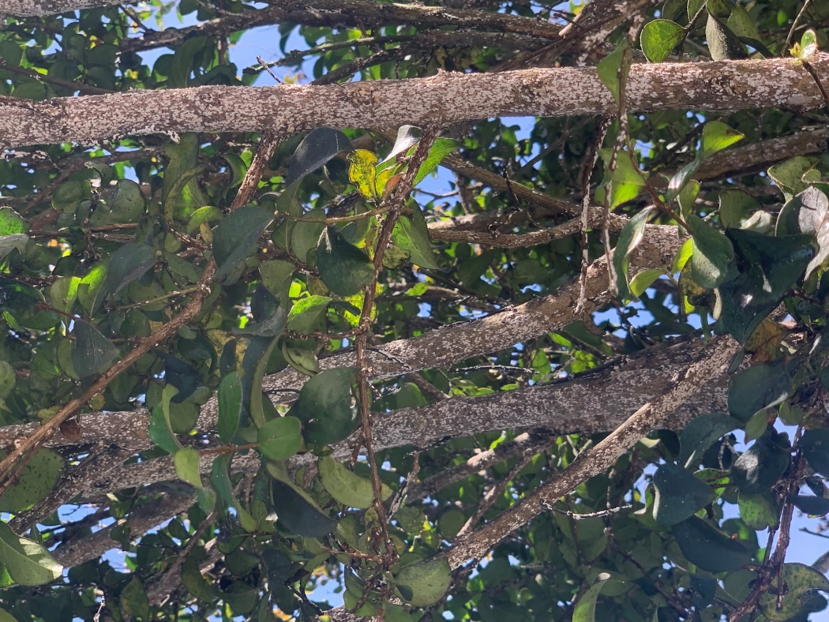
Figure 1.1. Crapemyrtle bark scale infestation on crape myrtle (easily recognized by white masses on trunk, branches, wounds, pruning cuts and crevices of the tree).

1.2.2. Biology of Crapemyrtle Bark Scale
The lifecycle of A. lagerstroemiae consists of small pink eggs, two instar nymphal stages that include pink crawlers that are mobile and second-instar nymphs that are lightly covered with newly grown filaments that appear white on their now grayish colored body. Sessile females are 2.0 ± 0.9 mm long, 1.2 ± 0.6 mm wide (n = 20), wingless, pink, and sessile (Wang et al. 2016). As the female nymph matures, it secretes waxy white threads that become felted or matted into a thick whitish scale covering its entire body (Gu et al. 2014). Under this whitish covering, females lay from 114 to 320 eggs during their lifetime and then later die (Jiang et al. 1998). Winged males have pink pre-pupae and pupae, are non-feeding, immobile, and are
completely enclosed by white sacs. Male pre-pupae are 0.9 ± 0.1 mm long, 0.4 ± 0.1 mm wide (n=20), and male pupae are 1.2 ± 0.1 mm long and 0.5 ± 0.1 mm wide (n = 20). The blackish eyes and wing pads in the pupal stage are distinct from the prepupae. Adult males are pink, alate, and have two long white filaments at the tip of the abdomen (Wang 2017). Apart from the sessile females, nymphs are pink and mobile. The first instars or crawlers are 0.5 ± 0.1 mm long and 0.15 ± 0.05 mm wide (n = 20). After hatching, crawlers settle on the woody parts of the stem and new growth (Wang et al. 2016). All stages feeding on the sap of crape myrtles excrete copious amounts of honeydew.
Crapemyrtle bark scale infestations appear as white or gray, waxy crustations on stems, large twigs, and trunks, but are rarely found on foliage. These scales especially congregate in branch crotches and at pruning sites (Williamson 2015). On infested crape myrtles, female scales tend to congregate heavily on the twigs of branches, while males tend to be found on the undersides of leaves near the veins, and sometimes on the twigs as well. With a magnifying glass, first-instar crawlers can be identified by their bright pink appearance as well as identifying the moving body on the branch or twig. Whereas second-instar nymphs eventually settle on the branch and begin to produce a whitish waxy covering.
The lifecycle of A. lagerstroemiae in the southern United States, as well as the number of generations completed in one year, has been unclear. It is possible that adult females and eggs overwinter; however, crawlers have been observed overwintering in bark crevices in some areas (Robbins et al. 2014).
1.2.3. Native/Host Range and Distribution of Crapemyrtle Bark Scale
The crapemyrtle bark scale is a scale insect native to East Asia that feeds primarily on crape myrtle (Lagerstroemiae spp.) and beautyberry (Callicarpa americana L.) trees in the United States (Matos 2018). It has been documented that the most northern and southern locations reported in Asia are Beijing, China and Tamil Nadu, India (Wang et al. 2 016).
As of March 2021, A. lagerstroemiae has been found in 15 states in the United States. In order of documentation: Texas (2004), Oklahoma (2011), Louisiana (2012), Georgia (2013), Tennessee (2013), Alabama (2014), New Mexico (2014), Arkansas (2014), Virginia (2014), Mississippi (2015), North Carolina (2016), South Carolina (2019), Nebraska (2019), Kansas (2019), and Delaware (2020) (Fig. 1.2) (EDDMaps 2021). A. lagerstroemiae has quickly moved through much of the southern parts of the United States; however, this invasive scale insect is only found in certain counties within each state.
Although A. lagerstroemiae is native to Asia, it has a relatively obtuse range. Two temperature-dependent focused studies have been conducted to understand the range of

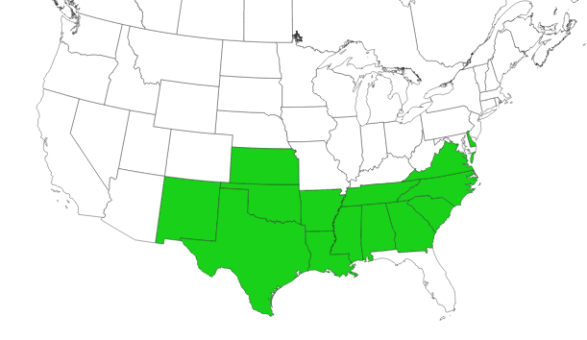
No Spp. Reported
Spp. Reported
Figure 1.2. Distribution of crapemyrtle bark scale in the United States, 2021 (EddMaps 2021).

A. lagerstroemiae in its native environment and how its native range relates to what can be expected for its range in the United States. The first study was conducted in 2016 (Wang et al. 2019), where markers were placed throughout the native range of A. lagerstroemiae pinpointing 82 locations where A. lagerstroemiae had been documented. From here they performed a niche modeling exercise where altitude and bioclimatic variables were used to express temperature and precipitation. As a result, a map was produced (Fig. 1.3) which predicted where A. lagerstroemia could establish in different climates within the United States.
The second temperature-dependent study, also conducted by Wang et al. (2019), consisted of accessing temperature data, extracting air temperature data from the three coldest cold fronts observed in a day, and modeling these factors together to produce a new map. With this new map the goal was to understand the northern limit of A. lagerstroemiae in relation to daily cold fronts that are observed. As a result, a similar map was produced as the first study showing where A. lagerstroemiae is predicted to occur. In addition, this map also showed that with the establishment of the scale beyond 43 ˚ latitude, the mortality rate of the scale increases as a result of an increase as you go north (Fig. 1.4).
Both studies are beneficial in helping scientists to understand the geographical and environmental factors affecting A. lagerstroemiae. These studies will allow for the process of implementing monitoring and control programs. Strategic and tactical decisions for the management of invasive alien species depend on accurate spatial and temporal characterizations of pest risk (Venette et al. 2010). Although these studies show the limits and range of where A. lagerstroemiae can be expected, more research on the biology of the scale will be beneficial in understanding population dynamics and population growth.

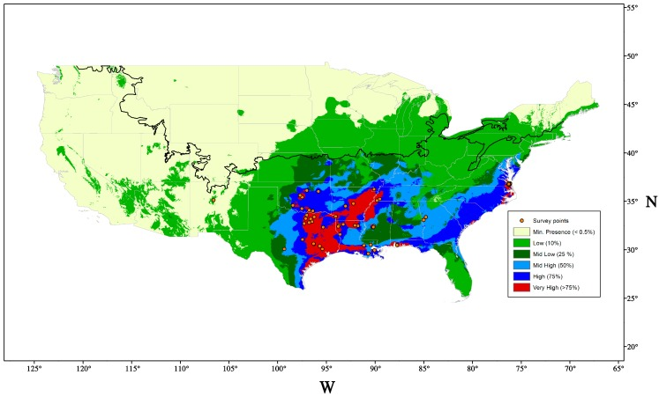
Figure 1.3. Expected range of Acanthococcus lagerstroemiae in the United States (Wang et al. 2016).

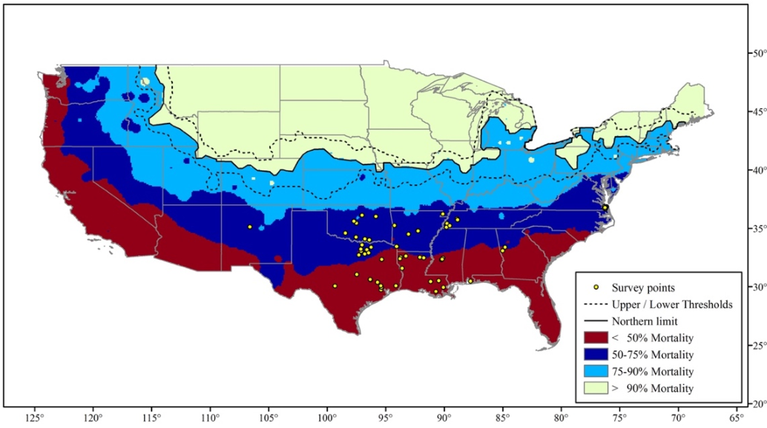

Figure 1.4. Expected cold tolerance mortality of Acanthococcus lagerstroemiae in the United States (Wang et al. 2019)

Understanding the host range of exotic pests is critical to determine potential risks and economic losses (Wang et al. 2019). Host records revealed that A. lagerstroemiae not only attacks crape myrtle but also other plant species in different families. In China, Hungary, and Korea, this pest has been reported on 16 other plants of ecological and economic importance (Table 1.1).
In the United States, naturally occurring crapemyrtle bark scale infestations have been reported on American beautyberry, C. americana (L.), crape myrtle, St. John’s wort, Hypericum (Hellenius), meadowsweets, Spiraea (Borkh), henna, L. inermis (L.), pomegranate, P. granatum (L.), sinicuichi, H. salicifolia (Lindley), and winged loosestrife, L. alatum (Pursh) (Xie et al. 2020, Wang et al. 2019). As research continues to accumulate on this novel scale it is crucial that we better understand this specialist feeder. Understanding what makes a plant suitable and unsuitable for feeding by A. lagerstroemiae will aid in developing an effective A. lagerstroemiae suitable integrated pest management program. The current knowledge of the host range of A. lagerstroemiae allows for preventative measures that can be implemented to avoid infestation.
1.3. Dispersal of Crapemyrtle Bark Scale
Commercial exchanges have provided scale insects with an effective route of dispersion. Coccoidea often go unnoticed at border control centers due to their morphology, biology, and
behavior, being mainly concealed on hidden parts of their host plants (Mazzeo et al. 2014). The dispersion of A. lagerstroemiae is important in containing the scale as well as understanding how to limit dispersion. No studies have been conducted to understand the mechanisms of dispersal of A. lagerstroemiae. Short dispersal of A. lagerstroemiae may be attributed primarily

Table 1.1. Host plants of Acanthococcus lagerstroemiae in Asia and Hungary (except for Lagerstroemia spp.) (Wang et al. 2016).
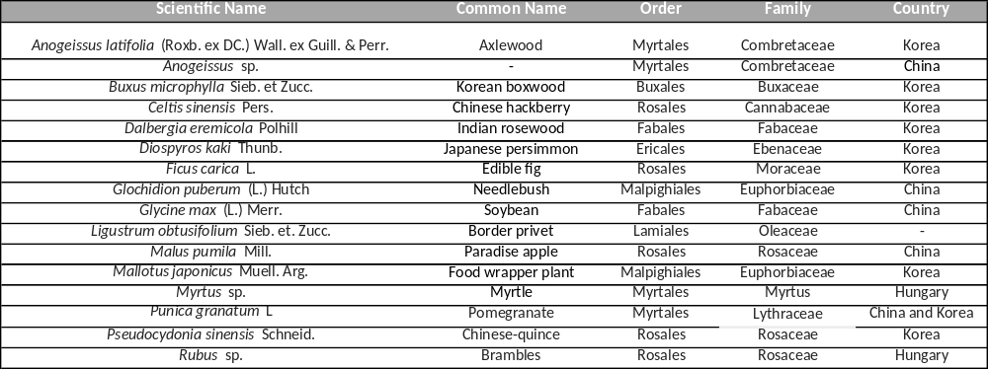

to crawler or nymph mobility, while long-distance dispersal may be attributed to wind, birds, or human traffic (Wang et al. 2016). Morphological characters of crawlers could facilitate its dispersal by wind including its minute and flat body, relatively long legs, and lateral wax filaments on the body fringe (Gullan and Kosztarab 1997). It is known that birds or smaller animals can assist in the dispersal of scale insects. When observing crape myrtles, it is common to observe bird nests that have been built, so it is not farfetched to believe that this interaction does play a role in crapemyrtle bark scale dispersion. In fact, in 2016, an experiment was conducted that showed birds can transfer the nymphs of a similar insect, the hemlock woolly adelgid, Adelges tsugae (Annand) (Russo et al. 2016). When understanding the dispersion of insects, it is common to reference human traffic via interstate routes. It is possible that the movement of infested plants to retail outlets plays a major role in the dispersion of A. lagerstroemiae. More dispersal research on A. lagerstroemiae could potentially aid in slowing the spread of A. lagerstroemiae across the United States.

1.4. Environmental Factors Contributing to Crapemyrtle Bark Scale
Just as with human beings, our environment and surroundings help shape us for the good or the bad. This scenario is the same with trees. Environmental stress weakens plants and makes them more susceptible to insect and disease attack. Although trees are adapted to living in stressful conditions in nature, many times the stress they experience in the landscape may make them more susceptible to insects and diseases (Limbwalker Tree Service 2017).
Crape myrtles are ideally suited for community plantings since it is a low maintenance tree that has a long-life expectancy (50 plus years), withstands droughts after becoming established, and is relatively free of disease and insect difficulties (Wade and Woodward 2009). Crape myrtles tolerate a wide range of soil types, including clay. They prefer a well-drained but moist soil (Wilson 2016). Crape myrtles should be watered at least once a week if there is a lack of rainfall. Although, they can tolerate water drought, flowering is enhanced during dry periods of the flowering season. Full sun is another factor that will enhance the growth and flowering of crape myrtles. While heavy shade will reduce growth and flowering of the tree, they also increase disease problems such as sooty mold on the foliage and powdery mildew on the flower buds and new growth (Wade and Woodward 2009). In relation to A. lagerstroemiae, crape myrtles in sunnier sites often have smaller infestations of crapemyrtle bark scale than plants growing in more shade. In addition, plants grown in shade typically have more crawlers than those in full sun. So, it is often recommended to plant crape myrtles in the full sun areas of the landscape to assist in preventing infestations of crapemyrtle bark scale (Williamson 2015).
A common phenomenon that circulates when studying pest insects is that healthy plants often have fewer insects. Is that really true? The answer is a definite yes and no. It is generally true that healthy plants are better able to withstand insect attack, but healthy plants can actually be more attractive to some insects (Nixon 2003). Healthy trees have a high sap flow that could make them better suited for infestation by sap-sucking insect pests. Further understanding of what makes certain crape myrtles a better host for crapemyrtle bark scale will be beneficial in developing and implementing preventative control measures.

1.5. Natural Enemies of Crapemyrtle Bark Scale
Biological control has been defined simply as the utilization of natural enemies to reduce the damage caused by noxious organisms to tolerable levels (DeBach and Rosen 1991). One approach to biological control has been termed “classical biological control”; it involves the discovery, importation, and establishment of exotic natural enemies with the hope that they will suppress a particular organism’s population. This approach has been most successful in situations in which an organism moves or has been transported to a new environment, usually without the natural enemies that have regulated its population and prevented major outbreaks (Shelton and Eccleston n.d.).
In its native range, A. lagerstroemiae has a range of parasitoids and predators to reduce the number of scales present on crape myrtles. Combined, Texas and Louisiana have five lady beetle species (Coleoptera: Cooccinellidae) associated with A. lagerstroemiae infestations. These include two species of the twice-stabbed lady beetle, Chilocorus cacti (L.) and Chilocorus stigma (Say), two species of Hyperaspis lady beetles, Hyperaspis bigeminata (Randall) and Hyperaspis lateralis (Mulsant), and the multicolored Asian lady beetle, Harmonia axyridis (Pallas) (Wang et al. 2016). Along with the recognized natural enemies of crapemyrtle bark scale, three unidentified hymenopteran parasitoids were reared from females in the field in Beijing, China, and one parasitoid reared from nymphs in Louisiana. In addition, a small predacious beetle C. nipponicus (Enrody-Young) was reared from the colony of A. lagerstroemiae in Beijing, China (Wang et al. 2016). Investigating the role of these lady beetle species and expansion upon parasitoids of A. lagerstromiae will greatly increase the use of biological control on this novel scale insect.
Although the research conducted on A. lagerstroemiae is limited, informative studies have been completed. One study completed in May of 2020 (Ibiyemi and Held 2020) observed how synthetic lures played a role in attracting lady beetles, and the mortality of A. lagerstroemiae. The first part of this research showed that the use of methyl salicylate (M) and limonene (L) lures combined attracted an average of 42 lady beetles, while crape myrtles without lures averaged 34 lady beetles. After 10 days, infested branches were observed for scale mortality and it showed an 80-95% mortality rate on the scale irrespective of lures (Ibiyemi and Held 2020). Extending the current knowledge on the role of lady beetles with A. lagerstroemiae infestation could possibly determine if the introduction of lady beetles will effectively control certain stages of A. lagerstroemiae.
Chilocorus cacti is a predator of eggs and crawlers of A. lagerstroemiae in Louisiana and Texas (Wang et al. 2016). Hyperaspis bigeminata lady beetle larvae have been observed feeding on crawlers in Tennessee, but it is unclear if they prey on other stages. The Harmonia lady beetle has also been observed on A. lagerstroemiae infestations, but some research suggests this lady beetle species also could be a predator of the crapemyrtle aphid, Tinocallis kahawaluokalani (Kirkaldy). The effectiveness of biological control agents on infested crape myrtles could potentially help suppress the spread of A. lagerstroemiae.

1.6. Treatment and Control of Crapemyrtle Bark Scale
Acanthococcus lagerstroemiae (Kuwana) is currently managed using chemical and/or mechanical methods in the United States. The protective covering secreted by A. lagerstroemiae and its feeding behavior under bark crevices make control by contact insecticides difficult (Gu et al. 2014). As research on effective chemical control continues, there are a few different approaches that homeowners can consider if their crape myrtle has been infested. Biological control of A. lagerstroemiae was discussed in the previous section as a likely control tactic for suppression. Good monitoring practices of infested crape myrtle will lead to effective management of A. lagerstroemiae (Vafaie et al. 2018).
Cultural control of crape myrtles consists of proper mulching, irrigation, fertilization, and proper pruning (Williamson 2015). In addition, proper planting and selecting a suitable environment for crape myrtles is also a form of cultural control. Mechanical control of A. lagerstromiae consists of physically removing adult scales and sooty mold with a soft-bristled brush and soapy water. Power washing infested crape myrtles is a type of mechanical control for A. lagerstroemiae. Mechanical control is a temporary control mechanism and regular cleaning may be required to keep scale populations low and prevent sooty mold from growing (Vafaie et al. 2020).
In a study conducted between 2016 and 2017, researchers showed that infested crape myrtles saw a significant reduction of scale populations for 4-61 weeks after a spring imidacloprid treatment (Merchant et al. 2014). Therefore, for chemical control, the most effective chemical controls are soil-applied systemic insecticides containing the active ingredients imidacloprid, imidacloprid + clothianidin, dinotefuran, or thiamethoxam. Foliar sprays containing the insect growth regulator products pyriproxyfen or buprofezin are also available for application as crawler sprays (Layton 2015). Other alternatives for controlling A. lagerstroemiae are horticultural and dormant oils. However, due to the waxy protective covering on the mature scales, horticultural and dormant oils may not penetrate through this layer. Exposed stages of A. lagerstromiae, such as the nymphs and crawlers, are more prone to horticultural and dormant oils because they lack the protective layer (Layton 2015).
To ensure that treatment and control tactics are most effective, timing of application is extremely important. When comparing areas in China with similar USDA hardiness zones,
two to three generations of the scale may occur per year in Zone 8, and up to three or four generations in Zones 9 and 10 (a suspected fourth generation of the scale has been observed in the Dallas area) (Gu et al. 2014). From this information, the importance of understanding the lifecycle of A. lagerstromiae in each infested area is emphasized.
The economic impact of A. lagerstroemiae has not been quantified. However, failure to manage this exotic pest could lead to serious economic loss for wholesale and retail nurseries, landscape professionals, and consumers (Wang et al. 2016).

1.7. Research Objectives
The overall goal of this two-year study is to gain additional knowledge to mitigate crapemyrtle bark scale before it becomes an economic barrier for crape myrtle production and growth in Tennessee. The following objectives were developed to address crapemyrtle bark scale in Tennessee:

Objective 1: Assess the distribution of crapemyrtle bark scale in Tennessee.
- Determine state-wide distribution via surveys and site visits
- Assess localized distribution in Knox County
- Evaluate the role of home garden centers and nurseries in contributing to the spread of crapemyrtle bark scale
Objective 2: Determine the lifecycle of crapemyrtle bark scale in Tennessee.
Objective 3: Evaluate the spread and progression of crapemyrtle bark scale in Tennessee.
Objective 4: Assess presence and distribution of natural enemies on crapemyrtle bark scale.
Objective 5: Determine the impact of wind and variety on dispersal of the crawler stage of crapemyrtle bark scale.

1.8. Hypotheses Set to Achieve the Objectives
Objective 1: Assess the distribution of crapemyrtle bark scale in Tennessee.
Alternate hypothesis Crapemyrtle bark scale will be clumped in areas where documentation has occurred.
Null hypothesis Crapemyrtle bark scale will not be clumped where documentation has occurred.
Objective 2: Determine the lifecycle of crapemyrtle bark scale in Tennessee.
Alternate hypothesis The lifecycle of crapemyrtle bark scale will be different from the lifecycle documented in other states.
Null hypothesis The lifecycle of crapemyrtle bark scale will not be different from the lifecycle observed in other states.
Objective 3: Evaluate the spread and progression of crapemyrtle bark scale in Tennessee.
Alternate hypothesis Crapemyrtle bark scale will continue to spread locally at a rapid rate.
Null hypothesis Crapemyrtle bark scale will not spread locally at a rapid rate.
Objective 4: Assess presence and distribution of natural enemies on crapemyrtle bark scale.
Alternate hypothesis Consistent distribution will be seen between the natural enemies of crapemyrtle bark scale.
Null hypothesis Consistent distribution will not be seen between the natural enemies of crapemyrtle bark scale.
Objective 5: Determine if wind dispersion and variety impact the crawler stage of crapemyrtle bark scale.
Alternate hypothesis A few crawlers will be impacted by the wind and there will not be varietal differences in infestation levels by crapemyrtle bark scale.
Null hypothesis Many crawlers will be impacted by the wind and there will be varietal differences in infestation levels by crapemyrtle bark scale.

CHAPTER II
Distribution of Crapemyrtle Bark Scale in Tennessee
2.1. Introduction
Acanthacoccus lagerstroemiae continues to expand its presence within the United States. First found in 2004 in a nursery in Richardson, TX, it has now been found in 15 states, including Tennessee, where it was documented in 2013 (EDDMaps 2021). Crapemyrtle bark scale was first found in Shelby County (West Tennessee); since then, it has been found in several counties in West Tennessee and a few counties in Middle and East Tennessee. Its state-wide distribution in Tennessee is unclear.
Before A. lagerstroemiae becomes an economic barrier to the wholesale and nursery industry, it is important to understand its current distribution so that educational programs can be initiated to reduce its spread and to make homeowners and nursery growers aware of its potential establishment in their areas. Thus, the overall objective of this study was to assess the distribution of crapemyrtle bark scale in Tennessee. Three subobjectives were employed to achieve this objective:
- Determine the state-wide distribution of crapemyrtle bark scale using surveys and site visits,
- Assess localized distribution of crapemyrtle bark scale in west Knox County, and
- Evaluate the role of home garden centers and nurseries in contributing to the spread of crapemyrtle bark scale.
2.2. Materials and Methods
A survey was developed to gain knowledge on crapemyrtle bark scale in each of the 95 counties in Tennessee (Appendix I). The survey contained questions related to the presence of crapemyrtle bark scale in a county and, if the scale was present, to assess how widespread it had spread, if damage had been observed, and the types of mitigation efforts that had been initiated. Once developed, the survey had to be submitted to the University of Tennessee Institutional Review Board (IRB) for approval. This step was necessary because the survey was to be sent to County Extension Agents and the confidentially of respondees had to be maintained. The entire approval process required many months to complete and greatly slowed the completion of this objective. Once approved, the survey was distributed via email to the University of Tennessee County Extension Office representing each county in Tennessee. Responses were compiled, and non-responding counties were sent the survey two more times. After the last email survey, a list of non-responding counties was compiled, and visual surveys were conducted in some of these counties to assess presence of crapemyrtle bark scale.
Visual observations of crape myrtles in the non-responding counties were conducted by sampling as many crape myrtles as possible in each county. In all counties, locations were scouted for crape myrtle plants, and when found, at least five (and no more than 12) locations were sampled. In most cases, at least 25 crape myrtles were surveyed for crapemyrtle bark scale. In a few counties, low numbers of crape myrtles were available to sample. A listing of counties sampled, number of locations/counties, number of trees/locations, and notes regarding the plants were compiled. All results will be compared to known confirmations of crapemyrtle bark scale in EDDMaps (EDDMaps 2021). This information will be compiled with both returned surveys and visual observations. Visual observations will be conducted to better understand state-wide distribution of crapemyrtle bark scale and associated infestation levels.
To evaluate the role of home garden centers and nurseries in contributing to the spread of crapemyrtle bark scale in Tennessee, six popular nurseries and 11 home and garden centers were visited to monitor for the presence of crapemyrtle bark scale on crape myrtles being sold. Each nursery and home and garden center were observed by selecting crape myrtles between 56.7 liters to 113.5 liters (15 gallon to 30 gallon) to determine if crapemyrtle bark scale was present. As each plant at the nursery and home and garden store was observed, the varieties present were noted, as well as overall health, noticeable damage, and predator presence.
In addition to assessing these businesses, public attractions, such as restaurants and shopping centers, also were observed for the presence of crapemyrtle bark scale on crape myrtles in landscapes. The nurseries and home and garden centers that were monitored were:
- Nurseries Dixie Lee Nursery, Ellenburg Nursery, Kirby Plants, Loves Creek Nursery, Stanley’s Greenhouse, and Threes Nursery.
- Home and garden centers Lowe’s Home Improvement (4), The Home Depot (4), and Mayo’s Garden Center (3).
2.3. Results and Discussion
Of the 95 surveys distributed via email, survey responses were received from county agents in only 37 counties (38% response rate) (Fig. 2.1). Of these responses, 23 indicated that crapemyrtle bark scale was not present in their counties, and 14 indicated that crapemyrtle

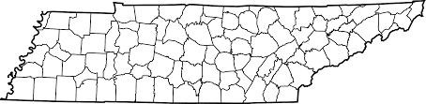

Figure 2.1. Map illustrating responsive counties (n-37), where a University of Tennessee/ Tennessee State University County Agent returned a crapemyrtle bark scale survey (non-responsive counties are listed below).
Non-responsive Counties:
- Bledsoe
- Blount
- Cannon
- Carter
- Chester
- Claiborne
- Clay
- Cocke
- Coffee
- Decatur
- Dekalb
- Dickson
- Dyer
- Fentress
- Franklin
- Giles
- Grainger
- Greene
- Grundy
- Hancock
- Hardin
- Hawkins
- Henderson
- Henry
- Hickman
- Houston
- Humphreys
- Jackson
- Jefferson
- Lawrence
- Lewis
- Lincoln
- Marion
- Marshal
- McNairy
- Meigs
- Montgomery
- Morgan
- Obion
- Overton
- Perry
- Pickett
- Putnam
- Rhea
- Roane
- Robertson
- Scott
- Sequatchie
- Sevier
- Stewart
- Sullivan
- Unicoi
- Union
- Van Buren
- Warren
- Wayne
- White

bark scale was present in their county (Fig. 2.2). Interestingly, two of the county agents who indicated that crapemyrtle bark scale was not present in their county did have this invasive pest present in their county based on confirmations listed in EDDMaps (EDDMaps 2021). Several county agents provided beneficial information on how crapemyrtle bark scale was managed in their county. Many of the County Extension Agents who have had crapemyrtle bark scale present in their county for at least one year while responded with control mechanisms such as synthetic insecticides, soil drenches, horticultural oil and even removing the top portion of infested crape myrtles. The common active ingredients mentioned were imidacloprid and dinotefuran.
Of the 95 counties where surveys were sent to the County Extension Agents, 57 did not return a survey (Fig. 2.1) (EDDMaps 2021). Of the non-responsive counties, 21 of them were visually surveyed for crapemyrtle bark scale (Fig. 2.3), and no crapemyrtle bark scale was found on plants in any of these counties. In total, 56 of 95 counties were assessed for crapemyrtle bark scale. Because crapemyrtle bark scale was first found in West Tennessee in Shelby County in 2013, more counties in that area are now infested with this invasive insect (Fig. 2.4). Infestations of crapemyrtle bark scale are now present in several counties in Middle Tennessee and a couple of counties in East Tennessee (Fig. 2.4). This invasive pest has now been found in the four major metropolitan areas of Tennessee (Chattanooga, Knoxville, Memphis, and Nashville).

23 ‘No’
(negative)
14 ‘Yes’
(positive)

Figure 2.2. Symbolic representation of University of Tennessee/Tennessee State University County Agent results from the crapemyrtle bark scale survey (37 responses; 23 ‘No’ and 14 ‘Yes’).

v

Counties with Surveys Returned (n=37)
c
Counties with Visual Surveys (n=28)
cv
Counties with Both (n=8)
cv

Figure 2.3. Map illustrating counties where crapemyrtle bark scale has been assessed, either with email surveys or visual monitoring in Tennessee. Responsive counties are those that returned the completed survey as well as those counties that were visually surveyed for crapemyrtle bark (counties that did not return a survey or did not have a visual survey conducted are listed below).
Counties with No Returned Surveys or Visual Surveys:
- Bledsoe
- Blount
- Cannon
- Chester
- Clay
- Coffee
- Decatur
- Dekalb
- Dickson
- Dyer
- Fentress
- Franklin
- Giles
- Grundy
- Hardin
- Henderson
- Henry
- Hickman
- Houston
- Humphreys
- Lawrence
- Lewis
- Lincoln
- Marion
- Marshall
- McNairy
- Obion
- Overton
- Perry
- Pickett
- Putnam
- Scott
- Sequatchie
- Sevier
- Van Burren
- Warren
- Wayne
- White

Before 2015
2015
2016
2017
2018
2019
2020

Figure 2.4. Distribution map of crapemyrtle bark scale in Tennessee (15 counties with the scale, including nine counties in West Tennessee, four in Middle Tennessee, and two in East Tennessee).

Visits were made to home garden centers and nurseries throughout Knox County to observe plants for crapemyrtle bark scale (Fig. 2.5). Of all these visits, only one female crapemyrtle bark scale was found on the upper trunk area of a ‘Tonto’ crape myrtle being sold in west Knox County (Fig. 2.5).
2.4. Summary
The response rate of the email surveys sent to county agents throughout Tennessee was low. This low response rate could represent the lack of interest in crapemyrtle bark in some counties, or the lack of knowledge about this newly invasive scale insect. The distribution of crapemyrtle bark scale across Tennessee can be observed in clumps within West, and Middle Tennessee. However, East Tennessee does not display this distribution pattern, but East Tennessee also includes some of the newer county records.
Both home garden centers and nurseries provided crape myrtles in acceptable condition with extremely low probability of crapemyrtle bark scale infestations. The home garden centers presented buyers with a limited number of varieties for selection. However, one of the positive aspects of buying crape myrtles in these stores is that the prices were usually lower. The crape myrtles sold at nurseries were typically higher in price; however, the crape myrtles being sold were usually in better condition with a larger selection of varieties from which to choose and, in some cases, larger plants. Overall, the hypothesis that the distribution of crapemyrtle bark scale was clumped throughout Tennessee was accepted.

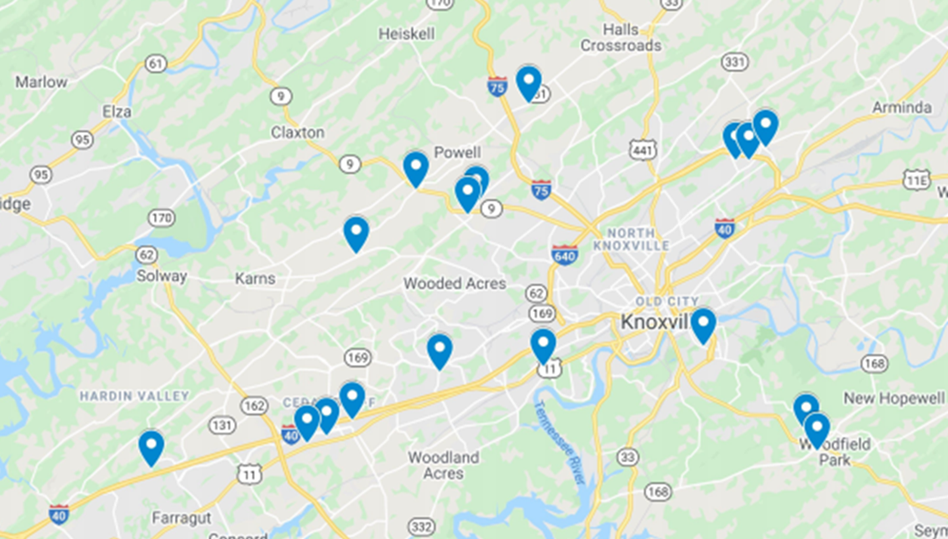
Figure 2.5. Localized distribution of crapemyrtle bark scale in Knox County, Knoxville, TN (location pins represent home garden centers and nurseries that were observed for crapemyrtle bark scale) (The arrow indicates where crapemyrtle bark scale was found on one tree being sold in west Knox County.)

CHAPTER III
Lifecycle of Crapemyrtle Bark Scale in Tennessee
3.1. Introduction
The lifecycle of this novel scale insect continues to be uncertain. Several scientists have continued to expand the knowledge of the lifecycle of crapemyrtle bark scale in different states (Wang et al 2016 and Gu et al 2014). To better understand the research those previous scientists completed, it is important to consider the plant hardiness zones. Zone One experiences the coldest temperatures, while Zone 13 experiences the hottest temperatures. Based on observations from areas in China with USDA hardiness zones similar to the United States, two to three generations of the scale may occur per year in zone eight, and up to three or four generations in zones nine and ten (Gu et al 2014).
The overwintering stages of crapemyrtle bark scale is another area that scientists are investigating. It is possible that adult females and eggs overwinter, but crawlers and later-stage nymphs have been observed overwintering in Arkansas under loose bark and in cracks and crevices (Robbins et al. 2014). The objective of this study was to determine the lifecycle of crapemyrtle bark scale in Tennessee, specifically in eastern Tennessee. Tennessee is compromised of seven USDA hardiness zones: going from left to right across Tennessee it includes 5a, 5b ,6a, 6b, 7a, 7b, and 8a (Simpson 2019).
3.2. Materials and Methods
Crapemyrtle bark scale was established with thriving populations in a subdivision (Jefferson Park) in west Knox County, and populations had been present in this area for several years. This location was the first documented case of crapemyrtle bark scale in Knox County (a new county record first documented in 2019). Three housing subdivisions (Jefferson Park, Mallard Bay, and Montgomery Cove) were selected in this area for a long-term study to determine the lifecycle of crapemyrtle bark scale on crape myrtle in west Knox County. These three subdivisions were selected based on the number of crape myrtles with crapemyrtle bark scale infestations (a subdivision was acceptable if it had at least ten crape myrtles with various levels of infestation throughout the subdivision). As mentioned above, Jefferson Park had the oldest known infestation of crapemyrtle bark scale in Knox County and was the main subdivision of interest. The second subdivision is Mallard Bay, which is the subdivision west of Jefferson Park. The third subdivision is Montgomery Cove, which is south of Jefferson Park.
Sampling for crapemyrtle bark scale on crape myrtle began on July 27, 2020; sampling continued biweekly until December, when samples were collected monthly. In April, sampling began again and continued until late July 2021. This aspect of the study began with 20 infested crape myrtles and the number slowly declined as infested crape myrtles were removed from the landscape. Each infested crape myrtle was examined using a hand magnifying glass to determine the life stages of the scale present on infested twigs. Five twigs that were identified as the smaller branches coming off the main branches around the crape myrtle were randomly selected to count. Each twig (8.0 cm long) sampled was assessed for life history of crapemyrtle bark scale. Each stage was documented and counted and numbers were later entered in Excel.
3.3. Limitations
All infested crape myrtles within a subdivision were not surveyed. For example, crape myrtles growing in landscapes closer to homes (private property) were not sampled. Emphasis was placed on sampling trees that were growing alongside the street or closer to the street to avoid trespassing on private property. Fortunately, more crape myrtles were growing in these types of accessible areas without being too far into the homeowner’s yard. Height of crape myrtles also was a concern as some of the trees were too tall to sample, even though they were infested with crapemyrtle bark scale. As homeowners began to learn more about this invasive pest from conversations with the research team, crape myrtles began to become heavily trimmed, pruned, or completely removed from the landscape.
3.4. Results and Discussion
Along with the data collected and observations of infested crape myrtles, two, possibly three, generations were documented. Gravid females were observed in low numbers beginning in May, and gradually increased until they begin to decline in September. Overlapping with the gravid females observed, at the end of June and the start of July the crawlers were observed to emerge from under the adult female. As the crawlers continued to emerge the adult female began to shrink in size, and the scale covering appeared dirty white as sooty mold grew on everything. By October, the crawler densities peaked on infested branches and began maturing into their next stage by November. Crawlers began emerging in July and no crawlers were found by the beginning of November (five months). However, the next generation of crawlers was seen in late November. It took the crawlers three months to mature into second-instar nymphs. The second-instar nymphs were observed between the months of January to late March and again from July to late November. Males were observed in July 2020 with high numbers that began declining at the end of September. They were again observed from late February to July. Several male pupae were observed throughout the data collection process, and small numbers of males were observed on the infested twigs (Fig. 3.1, 3.2, 3.3 A, B).
A closer examination of the lifecycle of crapemyrtle bark scale in each subdivision was important to understand if differences or similarities among areas existed. The lifecycle of crapemyrtle bark scale among all three subdivisions was similar for the most part except for slight differences observed in Jefferson Park (the oldest known infested area in Knox County) (Fig. 3.2, 3.3 A, B). Unlike the other two subdivisions, in July, the density of first-instar nymphs in Jefferson Park was not increasing (Fig. 3.2), but rather the numbers were decreasing.
After October, the scales present on crape myrtles remained at low numbers. It is unknown when crapemyrtle bark scale was first observed in the other two subdivisions, Montgomery Cove and Mallard Bay, however the peaks for different stages of crapemyrtle bark scale seem to align with one another (Fig. 3.3 A, B).
3.5. Summary
The lifecycle of crapemyrtle bark scale in west Knoxville (Tennessee) is not as definitive as it was expected to be at the end of this study. The hypothesis that the lifecycle of crapemyrtle bark scale would differ from other states cannot be clearly accepted or rejected. However, when observing the seasonality of crapemyrtle bark scale in different subdivisions, important peaks in the densities of different scale stages are similar across sampling dates in September, December, and February.

Figure 3.1. Seasonality of crapemyrtle bark scale in west Knox County, Knoxville, Tennessee. This graph represents the combined lifecycle data collected for each housing subdivision. Please note that data were not collected in August 2020.

Figure 3.2. Distribution of life stages of crapemyrtle bark scale in Jefferson Park subdivision, west Knox County, Knoxville, TN (data were not collected in August).

B
A

Figure 3.3. Distribution of life stages of crapemyrtle bark scale in A) Montgomery Cove subdivision and B) Mallard Bay subdivision, west Knox County, Knoxville, TN (data were not collected in August 2020).
It is likely that there are two, possibly three, overlapping generations of crapemyrtle bark scale in Tennessee. The third generation cannot be clearly determined at this point. In each subdivision, substantial population peaks were observed to provide an understanding of the lifecycle observed in east Tennessee. More data should be collected to better understand the lifecycle of crapemyrtle bark scale in Tennessee. Additional research on the importance of each stage will also be beneficial for proper timing of treatment with crapemyrtle bark scale infestation.

CHAPTER IV
Spread and Progression of Crapemyrtle Bark Scale in Tennessee
4.1. Introduction
Crapemyrtle bark scale continues to spread across the United States at a rapid rate; however, it is unclear how this invasive pest spreads. As of March 2021, crapemyrtle bark scale has been found in 15 states in the United States. In order of documentation: Texas (2004), Oklahoma (2011), Louisiana (2012), Georgia (2013), Tennessee (2013), Alabama (2014), New Mexico (2014), Arkansas (2014), Virginia (2014), Mississippi (2015), North Carolina (2016), South Carolina (2019), Nebraska (2019), Kansas (2019), and Delaware (2020) (Fig. 1.2) (EDDMaps 2021). crapemyrtle bark scale has quickly moved through much of the southern United States; however, this invasive scale insect is only found in certain counties within each infested state. Humans, birds, or larger insects could all contribute to its spread and establishment in new areas. The objective of this study was to evaluate the spread and progression of crapemyrtle bark scale in Tennessee.
4.2. Materials and Methods
Crapemyrtle bark scale was established with thriving populations in a subdivision (Jefferson Park) in west Knox County, and populations had been present in this area for several years. This location was the first documented case of crapemyrtle bark scale in Knox County (a new county record first documented in 2019). Three housing subdivisions (Jefferson Park, Mallard Bay, and Montgomery Cove) were selected in this area for a long-term study to determine the lifecycle of crapemyrtle bark scale on crape myrtle in west Knox County. These three subdivisions were selected based on the number of crape myrtles with crapemyrtle bark scale infestations (a subdivision was acceptable if it had at least ten crape myrtles with various levels of infestation throughout the subdivision). Jefferson Park had the oldest known infestation of crapemyrtle bark scale in Knox County and was our main subdivision of interest. The second subdivision is Mallard Bay, which is the subdivision west of Jefferson Park. The third subdivision is Montgomery Cove, which is south of Jefferson Park.
Sampling to understand the progression of crapemyrtle bark scale on crape myrtle began on July 27, 2020.; sampling continued biweekly until December, when samples were collected monthly. In April, sampling began again and continued until late July 2021. This aspect of the study began with 20 infested crape myrtles and the number slowly declined as infested crape myrtles were removed from the landscape. Each infested crape myrtle was examined using a handheld magnifying glass to determine the life stages of the scale present on infested twigs. Five twigs that were identified as the smaller branches coming off the main branches around the crape myrtle were randomly selected to count. Each twig (8.0 cm long) sampled was assessed for life history of crapemyrtle bark scale. Each stage was documented and counted, and numbers were later entered in Excel.
4.3. Limitations
In each subdivision, some homeowners began treating for crapemyrtle bark scale; in some cases, whole infested trees were removed by homeowners, which limited the number of crape myrtles that could be used to understand how crapemyrtle bark scale progressed and established in neighborhoods with different levels of infestation. The infestation level of each crape myrtle was also documented to assess progression and establishment of crapemyrtle bark scale. Different types of treatments were applied to crape myrtles, ranging from soil drench, granular applications to the soil, and mechanical treatment from homeowners or pest companies.
4.4. Results and Discussion
Crapemyrtle bark scale was observed in two areas in west Knox County (Fig. 4.1), and one of these areas was used exclusively to understand crapemyrtle bark scale in this area. Displayed in Figure 4.2 at the beginning of the study, several housing subdivisions were surveyed and monitored for the presence of crapemyrtle bark scale in this area since the first documentation of crapemyrtle bark scale in Jefferson Park. There were three housing subdivisions that had crapemyrtle bark scale infestations on multiple crape myrtles and these became the three housing subdivisions where data were collected. By the end of this two-year study, all of the nearby housing subdivisions that previously did not have crapemyrtle bark scale were all moderately to heavily infested in the time span of one year (Fig. 4.3).
To understand crapemyrtle bark scale life stage distribution, progression and establishment, crape myrtles were rated between light and heavy at the beginning of the study and grouped by infestation level. Females were observed in abundance during the first week of light infestations, and then the life stage distribution began to even out (Fig. 4.4, Fig. 4.5). This scenario was similar to what was observed with heavy and moderated infestations during week one. Last, in Figure 4.6, two crape myrtles with ratings of moderate and very light infestations

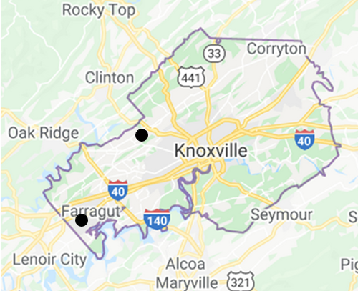
Figure 4.1. Localized distribution of crapemyrtle bark scale in Knox County, Knoxville, TN.

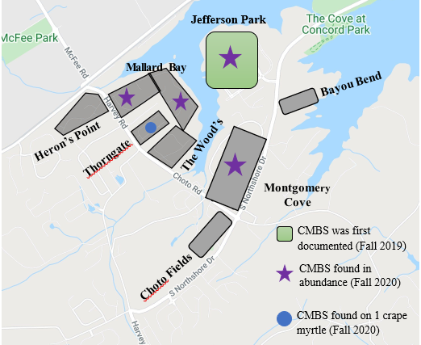
Figure 4.2. The housing subdivisions where crapemyrtle bark scale was observed at the beginning of the study in 2019, west Knox County, Knoxville, TN (stars indicate where data were collected to further understand crapemyrtle bark scale in Knoxville).

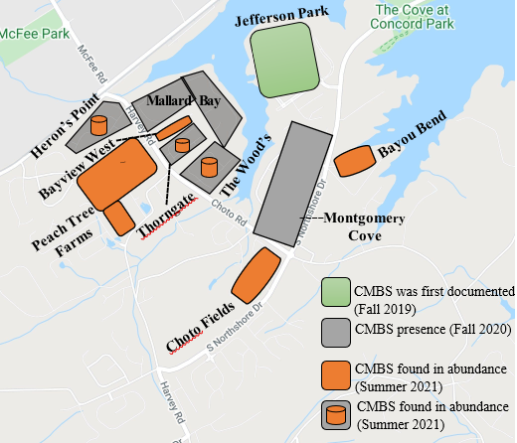
Figure 4.3. The housing subdivisions with crapemyrtle bark scale at the end of the study (July 2021), west Knox County, Knoxville, TN.

Figure 4.4. Progression of crapemyrtle bark scale with heavy and moderate infestations; with both levels of infestation, from week one to week four the scale distribution remains similar between each stage, west Knox County, Knoxville, TN.

Week 7
Week 5
Week 3
Week 1
Figure 4.5. Progression of crapemyrtle bark scale with a light infestation. During week one, a large presence of females are present, and by week four the stages have begun to evenly distribute with the other stages, west Knox County, Knoxville, TN.

Figure 4.6. Progression of crapemyrtle bark scale with varying levels of infestation (illustrates changes in the stages of scale observed on crape myrtles that were rated as having very light (VL) and moderate (M) infestations at the beginning of the study), west Knox County, Knoxville, TN.

were compared over the course of this study. Data show that the very light infestation increased rapidly for some life stages when compared to a moderate infestation.
4.5. Summary
Crapemyrtle bark scale does not seem to spread rapidly over large areas; however, it does seem to establish quickly in neighborhoods. This rapid establishment in confined areas could also help to explain the clumping presence of crapemyrtle bark scale throughout counties in Tennessee. The initial hypothesis was accepted because this invasive scale spreads rapidly in areas where establishment has occurred. The initial weeks following a new establishment of crapemyrtle bark scale prove to be a crucial time to reduce the potential damage threat and to reduce population density before it drastically increases. Females were observed in abundance during the first week, and then the stage distribution levels begin to even out, similar to what was observed with heavy and moderate infestations.
When the progression of crapemyrtle bark scale on a moderately infested crape myrtle is compared to the progression of crapemyrtle bark scale on a very lightly infested crape myrtle, the development could signify that crapemyrtle bark scale progresses rapidly on lighter-infested crape myrtles. Or it could be concluded that on older infestations, the number of nymphs observed decreases over time. It is unclear the role of predators with these infestations, but they could also contribute to a reduction of nymphs observed with these infestations. It is important that crape myrtles are closely monitored, and infestations of crapemyrtle bark scale identified quickly to slow the progression and spread that occurs in areas where crapemyrtle bark scale is established.
CHAPTER V
Natural Enemies of Crapemyrtle Bark Scale in Tennessee
5.1. Introduction
Several natural enemies have been identified and associated with crapemyrtle bark scale infestations. Natural enemies serve an important role especially with invasive insects. In its native range, A. lagerstroemiae has a host range of parasitoids and predators to control the number of scales present on crape myrtles. Combined, Texas and Louisiana have associated five lady beetles (Coleoptera: Cooccinellidae) with A. lagerstroemiae infestations. These include two species of the twice-stabbed lady beetle, Chilocorus cacti (L.) and Chilocorus stigma (Say), two species of Hyperaspis lady beetles, Hyperaspis bigeminata (Randall) and Hyperaspis lateralis (Mulsant), and the Asian multicolored lady beetle, Harmonia axyridis (Pallas) (Wang et al. 2016). Along with the recognized natural enemies of crapemyrtle bark scale, three unidentified hymenopteran parasitoids were reared from females in the field in Beijing, China, and one parasitoid reared from nymphs in Louisiana. In addition, a small predacious beetle C. nipponicus (Enrody-Young) was reared from the colony of A. lagerstroemiae in Beijing, China (Wang et al. 2016). Investigating the role of these lady beetle species and expansion upon parasitoids of A. lagerstromiae will greatly increase the use of biological control on this novel scale insect.
Chilocorus cacti is a predator of eggs and crawlers of A. lagerstroemiae in Louisiana and Texas (Wang et al. 2016). The Hyperaspis lady beetle larva has been observed feeding on crawlers in Tennessee, but it is unclear if they prey on other stages. The Harmonia lady beetle has also been observed on A. lagerstroemiae infestations, but some research suggests this lady beetle species also could be a predator of the crapemyrtle aphid. The effectiveness of biological control agents on infested crape myrtles could potentially help suppress the spread of A. lagerstroemiae. When these insects are found naturally occurring, it is important to understand their role and behavior with the targeted invasive insect. Like gaining a better understanding of crapemyrtle bark scale, the same type of information is needed for the natural enemies. Thus, the objective of this study is to assess the presence and distribution of natural enemies of crapemyrtle bark scale in Tennessee.
5.2. Materials and Methods
Populations of natural enemies of crapemyrtle bark scale were monitored on crape myrtles in three subdivisions (Jefferson Park, Mallard Bay, and Montgomery Cove) in west Knox County, Knoxville, TN. Populations had been present in this area of the county for several years. More information (trees sampled, sampling process, etc.) on these three subdivisions is provided in Chapters III and IV. These three subdivisions were selected based on the number of crape myrtles with crapemyrtle bark scale infestations (a subdivision was acceptable if it had at least ten crape myrtles with various levels of infestation throughout the subdivision). As mentioned earlier, Jefferson Park had the oldest known infestation of crapemyrtle bark scale in Knox County and was the main subdivision of interest.
Sampling for natural enemies (mainly predators) of crape myrtle began on July 27, 2020; sampling continued biweekly until December, when samples were collected monthly. In April, sampling began again and continued until late July 2021. This aspect of the study began with 20 infested crape myrtles and the number slowly declined as infested crape myrtles were removed from the landscape. Each infested crape myrtle was examined for predators by flipping over leaves, pulling down taller branches and using a hand-held magnifying glass when necessary for identification purposes. The species and life stages of each predator that was present on infested twigs was determined and counted; numbers were later entered in Excel.
5.3. Limitations
Sampling for natural enemies in dense foliage makes it difficult to find and count all individuals. Thus, it is possible that not every natural enemy was accounted for due to the height of the crape myrtles which prevented those areas from being reached and sampled.
5.4. Results and Discussion
Three predator species associated with crapemyrtle bark scale were found to be associated with infestations in Tennessee. Harmonia, Chilocorus, and Hyperaspis were the three genera of lady beetles that were observed on crape myrtle in the subdivisions located in west Knox County (Fig. 5.1). It is important to note that Jefferson Park is the subdivision where crapemyrtle bark scale was first documented in Knox County, and the additional subdivisions are in the vicinity around this subdivision. The total number of Asian multicolored lady beetles as observed in similar numbers among all three subdivisions that were sampled (Fig. 5.1). However, the numbers of H. bigeminata lady beetles were highest in two subdivisions (Jefferson Park and Mallard Bay), where they were 5x higher than populations of H. bigeminata in Montgomery Cove. This difference may be attributed to the Hyperaspis lady beetles establishing first in those areas where the crapemyrtle bark beetle infestations were first

Figure 5.1. Lady beetle predators associated with crapemyrtle bark scale in three subdivisions in west Knox County, Knoxville, TN (data include each stage [larva, pupa, and adult] of lady beetle).

documented (first in Jefferson Park and then in Mallard Bay) (Fig. 5.1). However, Chilocorus lady beetles were observed in low numbers in all three subdivisions and were the lowest in Jefferson Park and the highest in Mallard Bay (Fig. 5.1). It is unclear why populations were higher in the Mallard Bay subdivision, but it could be caused by varietal preference, changes in environmental conditions, or other plants that attracted the Chilocorus lady beetle .
Chilocorus and Hyperaspis lady beetles are commonly associated with crapemyrtle bark scale. However, H. axyridis is a generalist feeder, usually feeding on larger insects, such as aphids. Its presence on crape myrtle may be more opportunistic than specific crapemyrtle bark scale-driven, while the other two species are more specific to feeding on scales.
Harmonia were relatively abundant across all three subdivisions, while Hyperaspis were ca. 5x more abundant than Harmonia at Jefferson Park and Mallard Bay (Fig. 5.1). By far, the most abundant lady beetle was Hyperaspis, and its densities were ca. 100x higher than those of Chilocorus at Jefferson Park (Fig. 5.1).
Adult, larvae, and pupae of all three lady beetle genera were found at all three subdivisions (Fig. 5.2). The most encountered stage of Harmonia and Chilocorus was the adult stage. The number of larvae and pupae of Chilocorus found were extremely low and almost non-existent. Although populations of Harmonia did reproduce on crape myrtle, they reproduced in low densities. However, populations of Hyperaspis reproduced and survived extremely well on crape myrtle, with high numbers of larvae found in all three subdivisions. Interestingly, few pupae of Hyperaspis were found. Research should focus on the reasons for

Figure 5.2. Number of each life stage of each lady beetle genera found associated with crapemyrtle bark scale, west Knox County, Knoxville, TN.

such low numbers of pupae, following such high densities of larvae It should also be noted that due to the low number of pupae being accounted for, surrounding areas near infested crape myrtles such as the curb and driveway should be monitored for the presence of pupae.
The seasonality of all three lady beetles on crape myrtle is shown in Figure 5.3. Each species is present on crape myrtle at various times throughout the year (Fig. 5.3). In September, all three lady beetles were abundant. Hyperaspis lady beetles were observed on crape myrtles as early as March, and their population densities was consistently high peaking in October (Fig. 5.3). However, Harmonia and Chilocorus lady beetles were observed for a slightly longer period then the Hyperaspis lady beetle. The Harmonia lady beetle was found from late July to early December. The Chilocorus lady beetle was observed slightly longer and was observed between late July and mid-January. The importance of this predator is not fully understood. It is important to understand predator fluctuations and their importance in reducing populations of crapemyrtle bark scale. These data suggest that Hyperaspis is an important predator of crapemyrtle bark scale, and research should address ways to enhance their presence in the field.
5.5. Summary
For this objective, the hypothesis was rejected, because the rate of predators observed on infested crape myrtles was not consistent. Each lady beetle and stage also exhibited different behaviors on infested crape myrtles. Harmonia lady beetles aggregated in small numbers and moved around together on the crape myrtles. By contrast, the Hyperaspis larvae were more solitary and scattered quickly when disturbed. However, adult Hyperaspis and

Figure 5.3. Seasonality (by month) of populations of three genera of lady beetle predators on crapemyrtle bark scale, west Knox County, Knoxville, TN.

Chilocorus were not easily observed, because it was common to find these adults hiding between curled up leaves. Some of the adults could be found on the bark or leaves of crape myrtles. For example, some Hyperaspis adults were found in March hiding under the bark of crape myrtle. It is possible that some adults were active during other times, such as night.
It is unclear if all three predator species feed on crapemyrtle bark scale and if so to what extent. Hyperaspis larvae were commonly observed to feed on crapemyrtle bark scale and may be important in regulating populations of crapemyrtle bark scale. Further analysis of the role of each lady beetle species will be beneficial in implementing timely releases of each predator to target different stages of crapemyrtle bark scale to reduce damage that they cause to crape myrtles.

CHAPTER VI
Dispersal of Crapemyrtle Bark Scale Crawlers
6.1. Introduction
The mechanisms of dispersal and spread of crapemyrtle bark scale, both long-and short-distance, are unclear. Research suggests that morphological characteristics of crawlers could facilitate its dispersal by wind (Gullan and Kosztarab 1997). If crapemyrtle bark scale is dispersed by wind, this type of dispersal could help explain its short-distance and moderate-to long-distance spread. It is especially important to understand the means of dispersion to inform nursery and retail growers of crape myrtles to enable them to strengthen their mitigation efforts against crapemyrtle bark scale. Two separate dispersal studies were designed and initiated to better understand dispersal and the role of wind dispersal on crawlers of crapemyrtle bark scale.
6.2. Materials and Methods
The first dispersal study included the establishment of sticky traps on crape myrtles at the Davis Family YMCA in west Knox County near the housing subdivisions where many of the field studies have been conducted. The second dispersal study was conducted at the University of Tennessee East Tennessee AgResearch and Education Center.

The first dispersal study was conducted simply to determine if sticky traps could be used to collect and monitor for crapemyrtle bark scale in and around crape myrtles. If the study was successful, these traps would be used in a more extensive study to assess dispersal of crapemyrtle bark scale. Each sticky trap (7.0 cm x 20.3 cm) was cut and arranged on foam sheets (Fig. 6.1). Three sticky traps were placed on two 2.4 m tall garden posts. One garden stake was placed 3.0 m away from the infested crape myrtle in the parking lot of The Davis Family YMCA on level ground. These trees were heavily infested, and the initiation of the study coincided with crapemyrtle bark scale egg hatch and crawler dispersal.
On the stake mentioned above, three foam sheets (10.2 cm x 15.2 cm) were used to place the Raid and Black Flag window fly traps on the front and back side. From here two holes were punched at the bottom and top of each foam sheet to tie a jute cord through it and secure it to the stake. After the sticky traps were constructed, one was placed at 2.4 m, 1.8 m, and 1.2 m high on the stake. These steps were duplicated for the second garden stake which was placed near the road of the YMCA. This stake was placed on a downward incline about 3.0 m away from the infested branches. This study was not replicated because its purpose was to answer if crapemyrtle bark scale crawlers can disperse and be collected on sticky traps. The second dispersal study will be more in depth, depending upon the success of the first study.

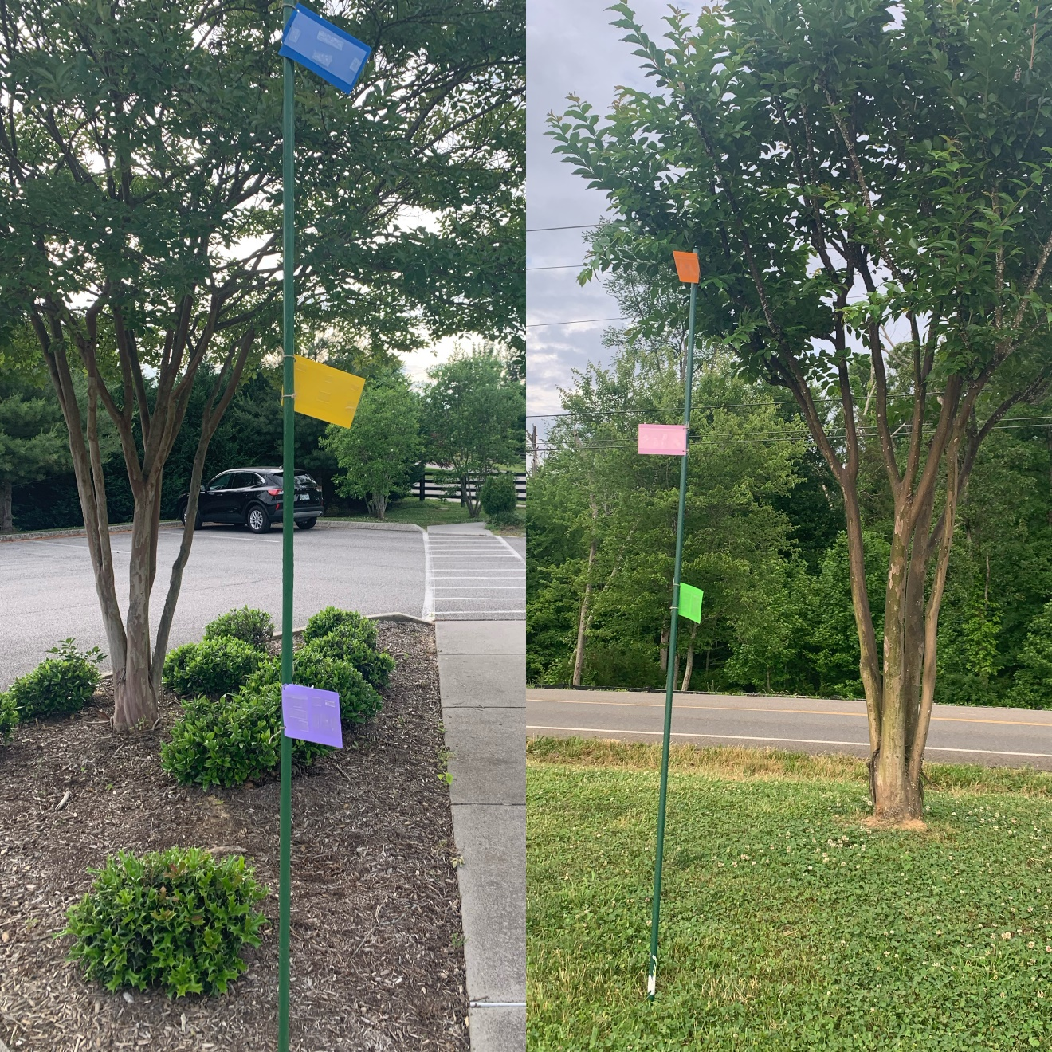
Figure 6.1. Design of sticky traps to collect crapemyrtle bark scale crawlers, YMCA, west Knox County, Knoxville, TN.

For the second dispersal study, the design was a 3x3x4 randomized complete block design, with three distances (1.5 m, 4.6 m, and 13.7 m), 3 heights (0.9 m, 1.8 m, and 2.7 m), and four directions (each cardinal direction - north, east, south, and west) arranged around a central point, with three replications (Fig. 6.2). This entire study was contained in a 30.5 m x 30.5 m area (Fig. 6.3). Holes were drilled into a 3.1 m PVC pipe at 0.9 m, 1.8 m, and 2.7 m; three plastic clipboards were placed at each height on the PVC pipe using pieces of wire in addition to the holes to secure the clipboards. A clear sleeve that was coated with Tanglefoot sticky glue was secured on each clipboard with binder clips. Once the sticky traps (n=36) were constructed, PVC pipes were placed over rebar that had been placed in the ground at each location around the gradient. For each replication, the three PVC pipes were placed 0.31 m away from each other in a horizontal line. To ensure that a PVC pipe did not block the next distance, the PVC pipes were staggered at each distance. Once all the sticky traps were installed, crapemyrtle bark scale-infested twigs were placed in a bucket with moistened floral foam and raised to sit on top of two 208.2-liter barrels (0.9 m tall each) in the center of the study (Fig. 6.4). These twigs had been collected from the field from heavily-infested twigs containing naturally-occurring populations of crapemyrtle bark scale. The bucket was secured using rope and attaching it to stakes that were placed in the ground. As the study progressed, different materials (yellow sticky cards [10.2 cm x 15.2 cm], white sticky cards [21.6 cm x 28.0 cm], etc.) were used as a substrate for the sticky traps.
In addition to the placement of sticky traps at distances away from the center of the study, sticky traps were placed directly in the vicinity of the center dispersal site. Directly

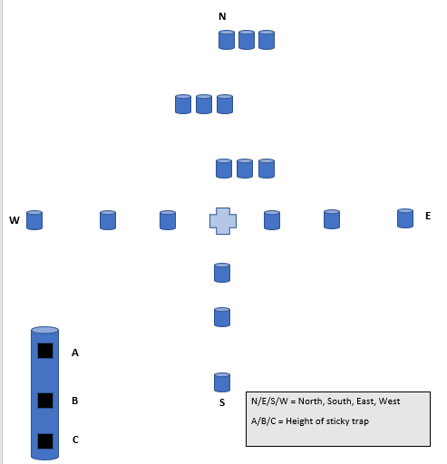
Figure 6.2. Design schematic to assess dispersal of crapemyrtle bark scale, University of Tennessee East Tennessee AgResearch and Education Center, Knoxville, TN.

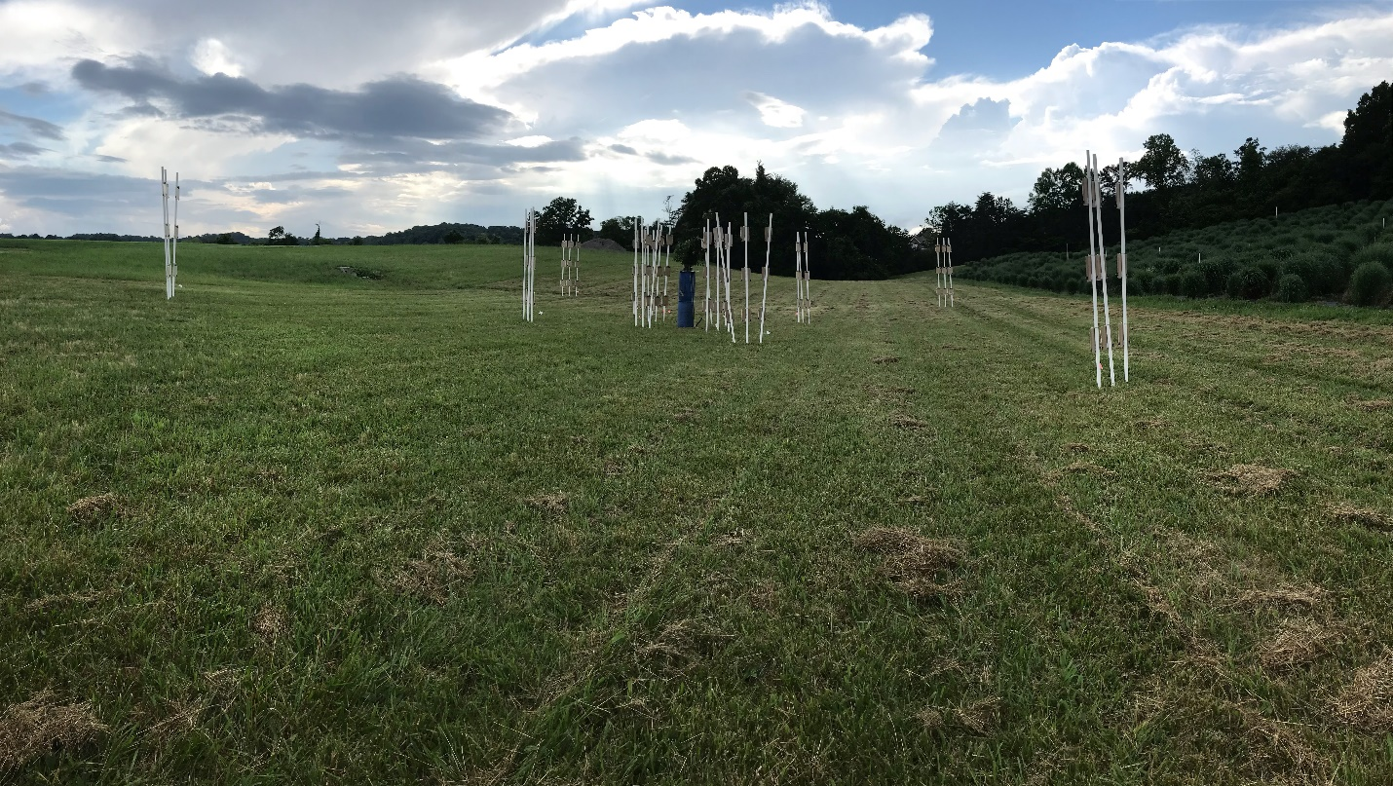
Figure 6.3. Design of second dispersal study using sticky traps, University of Tennessee East Tennessee AgResearch and Education Center, Knoxville, TN.

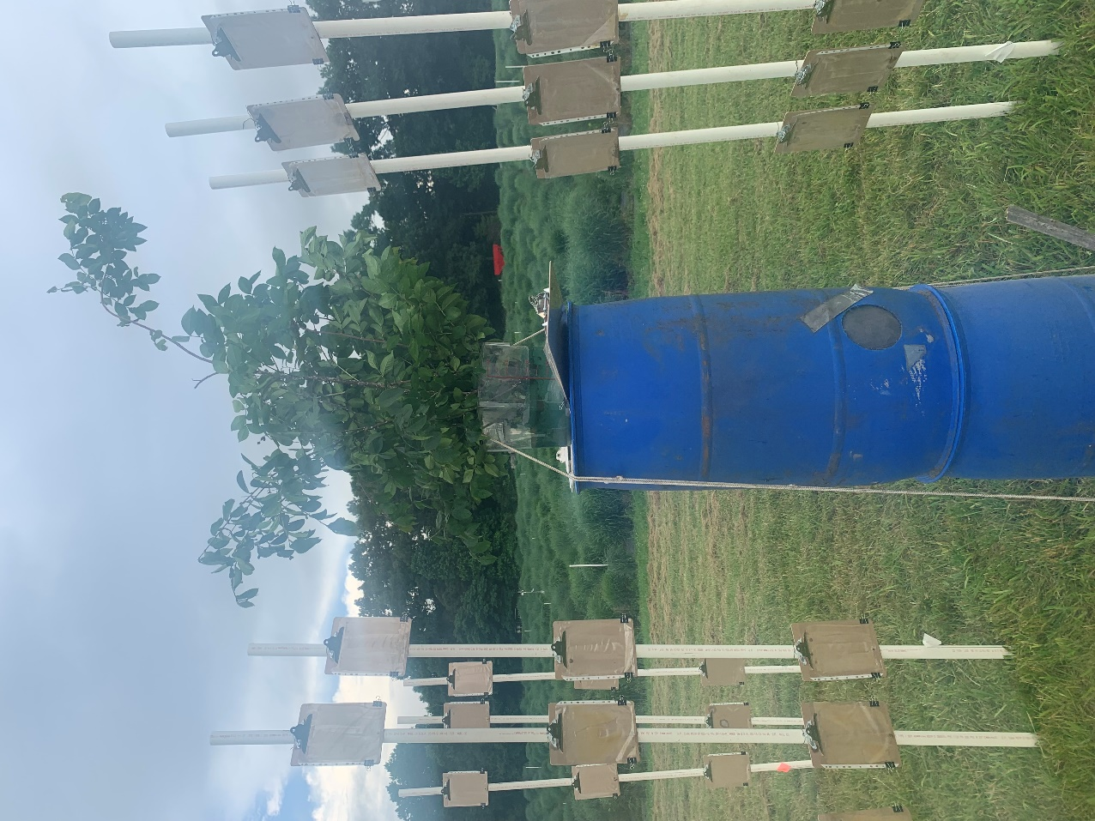

Figure 6.4. Center design of dispersal study illustrating location of crapemyrtle bark scale-infested branches, University of Tennessee East Tennessee AgResearch and Education Center, Knoxville, TN.

underneath the center dispersal site, four sticky traps were placed around the bottom of the barrels to assess the numbers of scale that dropped instead of dispersed via the wind (Fig. 6.4).
Sticky traps were removed and replaced each week. Sticky traps were taken to the laboratory, where they were processed and stored. The number of crawlers on each card were collected. Data were analyzed using ANOVA with total scale crawler as the response variable and distance, height, direction, and variety as the independent variables. Ranked transformation was applied when diagnostic analysis exhibited violation of normality assumptions using Shapiro–Wilk test. Post hoc multiple comparisons were performed with Tukey’s adjustment. Statistical significance was identified at the level of 0.05. Analyses were conducted in JMP Pro 15 (SAS institute Inc., Cary, NC).
6.3. Limitations
It is possible that due to the heat, the Tanglefoot sticky glue melted on the clipboards and dripped down the PVC pipes. This process could have included crawlers that were caught on the trap and were not included in this study. Size variation of the sticky traps could have impacted the number of crawlers observed as the number of emerging crawlers decreased. The traps placed closer to the infested crape myrtle branches could have intercepted crawlers that would have traveled further.
6.4. Results and Discussion
Crapemyrtle bark scale does have the ability to move via wind (Table 6.1). Figures 6.5 through 6.8 show how the wind has the capability to disperse the crawlers in clumps, as well as the size of the nymphs in relation to some different insects collected on the trap. The sticky Table 6.1. Crapemyrtle bark scale sticky trap results when placed 3.05 m (10 feet) from infested crape myrtles, YMCA west Knox County, Knoxville, TN.
Crapemyrtle Bark Scale Crawlers Collected on Sticky Traps Placed at Three Heights
Level Ground |  | Downward Incline
Height | Number of Crawlers | Height | Number of Crawlers
2.5 m | 25 | 2.5 m | 428
1.8 m | 61 | 1.8 m | 413
1.2 m | 47 | 1.2 m | 97

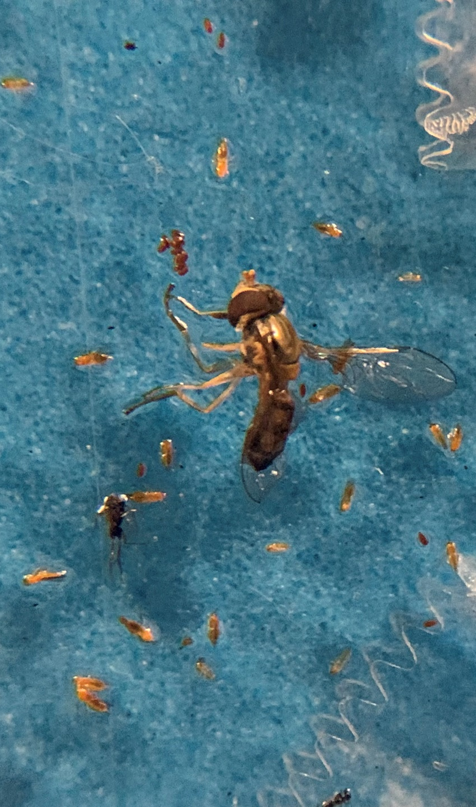
Figure 6.5. Close-up comparison of crapemyrtle bark scale crawlers collected on sticky traps in relation to an adult hover fly.

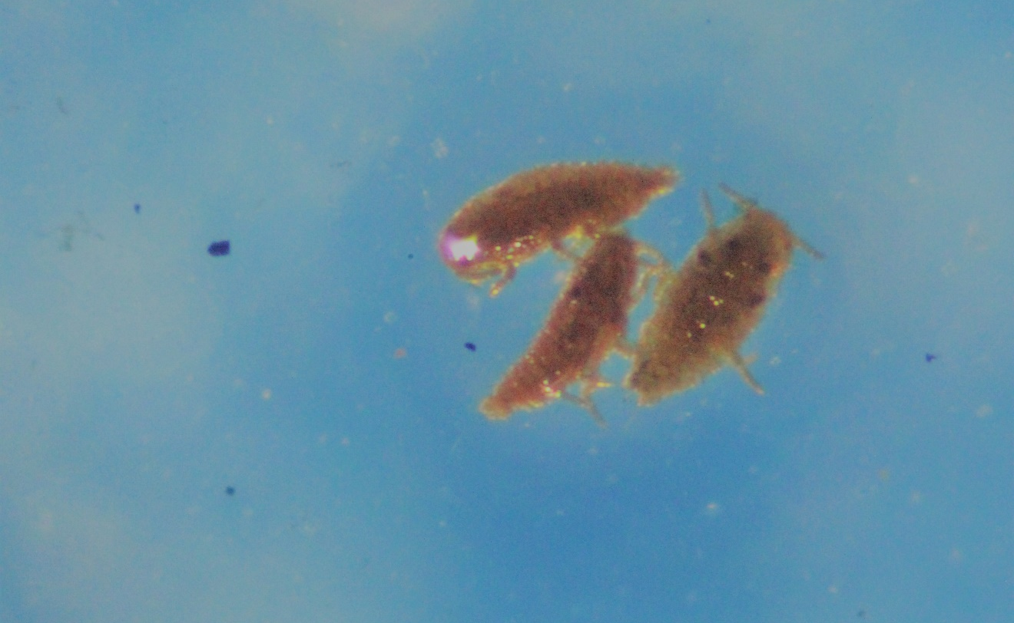
Figure 6.6. Higher magnification of crapemyrtle bark scale crawlers collected on sticky traps.
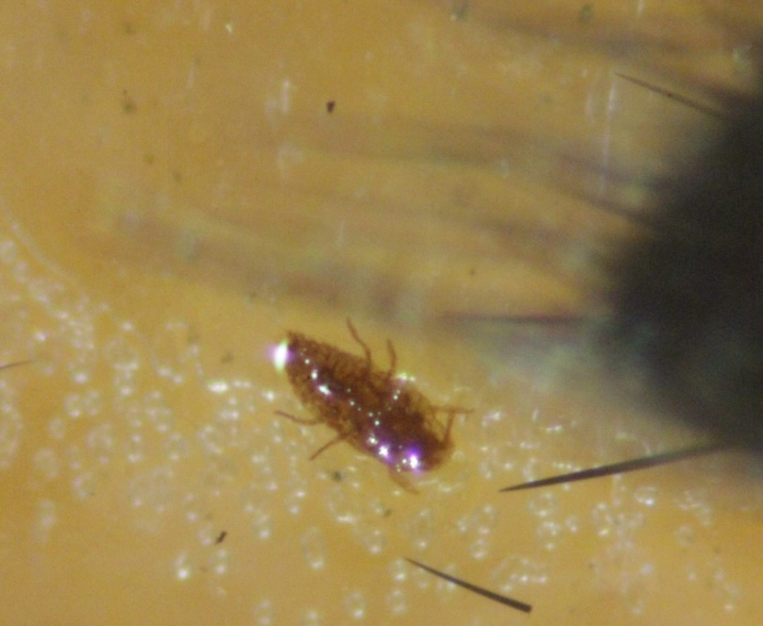
Figure 6.7. Crapemyrtle bark scale crawler in relation to hairs on the body of a tachinid fly.
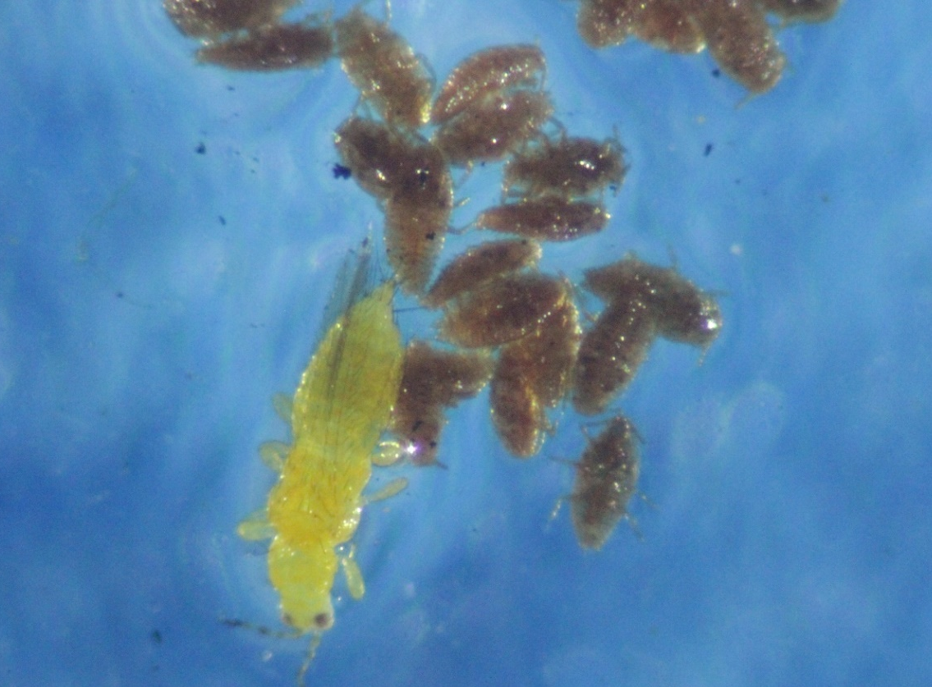
Figure 6.8. Cluster of crapemyrtle bark scale crawlers in relation to an adult thrips.

traps in the first dispersal study were used to provide information to better understand if the crapemyrtle bark scale crawlers could be found on sticky traps.
Following this positive discovery, a larger scale dispersal study was developed and initiated (Fig. 6.3). Direction and distance showed significant differences in the number of crawlers collected on each trap (Table 6.2). Significantly fewer numbers of crawlers were found on traps placed in the North direction, while significantly greater numbers of crawlers were collected on the traps placed in the East direction (Fig. 6.9 and 6.10). However, Figure 6.11 does show that the traps placed at the 1.5 m mark received a larger number of nymphs on the traps.
Sticky traps placed 13.7 m away from the infested branches in all directions collected significantly lower numbers of nymphs than those traps placed 1.5 m and 4.6 m away (Fig. 6.11). Interestingly, sticky traps placed directly under the infested branches had a large number of nymphs; however, there were no significant differences in direction for those nymphs found on sticky traps placed at the bottom of the branches at the center of the study. No significant differences in the number of crapemyrtle bark scale crawlers collected were detected due to height of the sticky traps placed on the 3.0 m-tall PVC pipes (Table 6.2).

Table 6.2. Influence of direction, distance and height of sticky trap on number of crapemyrtle bark scale collected, University of Tennessee East Tennessee AgResearch and Education Center, Knoxville, TN, 2021.
Type 3 Tests of Fixed Effects
Effect | Num DF | Den DF | F Value | Pr > F
Direction | 3 | 6 | 6.84 | 0.0231
Distance | 2 | 4 | 9.07 | 0.0326
Height | 2 | 4 | 6.82 | 0.0514

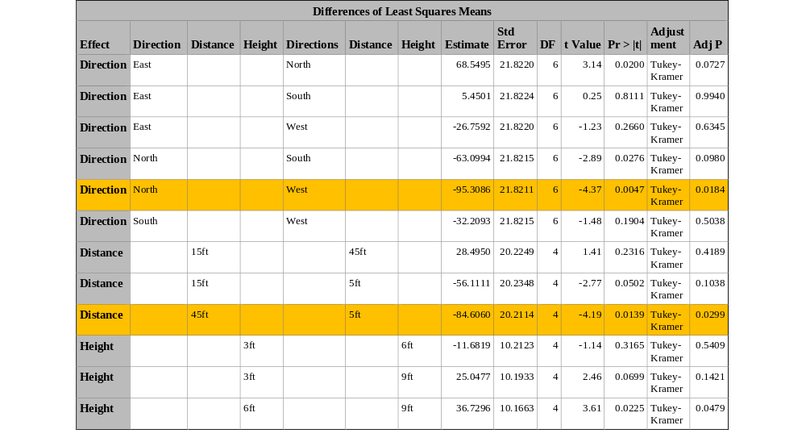

1.5 m
4.6 m
13.7 m
Figure 6.9. The influence of direction and distance on the number of crapemyrtle bark scale crawlers collected on sticky traps, University of Tennessee East Tennessee AgResearch and Education Center, Knoxville, TN.

Figure 6.10. Influence of direction on the number of crapemyrtle bark scale crawlers collected on sticky traps, University of Tennessee East Tennessee AgResearch and Education Center, Knoxville, TN, 2021.

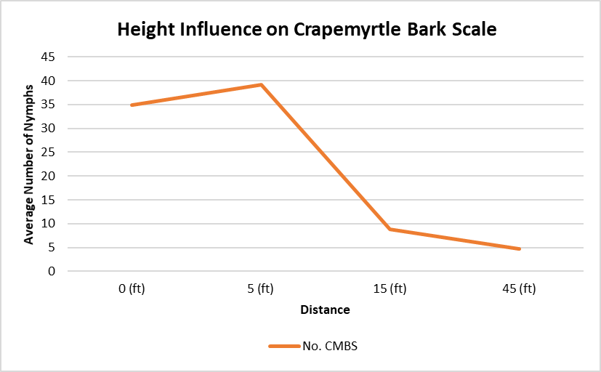
0 m (0 ft) 1.5 m (5 ft) 4.5m (15 ft) 13.7 m (45 ft)

Figure 6.11. Influence of distance on the number of crapemyrtle bark scale crawlers collected on sticky traps, University of Tennessee East Tennessee AgResearch and Education Center, Knoxville, TN, 2021.

6.5. Summary
This aspect of the study shows that wind can move crapemyrtle bark scale crawlers in all directions. It takes only one crawler to land on a crape myrtle, develop to adulthood and reproduce to start an infestation. However, only a few crawlers were found on sticky traps placed 13.7 m away. For this study, short distance was represented by 0 m and 1.5 m, and moderate to long distance was represented by 4.6 m and 13.7 m. Longer distances such as 30.5 m were not represented in this study. Most of the crawlers were observed in high numbers on traps placed 0 m and 1.5 m away. This information is important when considering wholesale production of crape myrtles as well as placement of crape myrtles in a retail setting because they are typically placed near each other.
Data show that wind can move crawlers in all direction with an increase in crawlers observed at shorter distances. When monitoring infested crape myrtles, birds and bird nests were sometimes observed in crape myrtles. Mockingjay and Starling birds could contribute to long-distance dispersal of crapemyrtle bark scale crawlers; however, no data were collected to confirm or deny this assumption. Continued research on dispersion of crawlers of crapemyrtle bark scale will be important to fully understand dispersal and management of this invasive insect pest. Future studies that further examine the impact of wind speed and direction will be beneficial in understanding how crawlers are dispersed.

CHAPTER VII
Influence of Variety of Crape Myrtle
on Crapemyrtle Bark Scale Infestations
7.1. Introduction
Flower color and bark appearance are two of the many features of crape myrtles that attract buyers. As crape myrtles continue to gain popularity for their gorgeous characteristics, newer varieties are added to the market to give buyers a larger selection from which to choose. However, varieties of crape myrtle may differ in their susceptibility to crapemyrtle bark scale. Information on varietal differences would be beneficial for homeowners to enable them to implement effective management programs. To understand if a varietal preference for crapemyrtle bark scale exists among crape myrtles, a study was designed to assess the influence of variety of crape myrtle on infestation by crapemyrtle bark scales.
7.2. Materials and Methods
Varietal selection was determined by considering flower blooms, bark appearance, and availability of varieties of crape myrtle. Numerous varieties and individual plants within a variety were examined at Home Depot (Cedar Bluff area, Knoxville, TN) and Mayo’s (Cedar Bluff area, Knoxville, TN). After examining all plants and considering the selected characteristics, five crape myrtle varieties were selected to evaluate differences in susceptibility to crapemyrtle bark scale, if any, among these varieties. The five varieties were: Enduring Red, Midnight Magic, Muskogee, Natchez, and Tuscarora. Three crape myrtles (3.78 liter pots) of each of the five varieties were selected and taken to a shade house at the University of Tennessee East Tennessee AgResearch and Eduation Center, Knoxville, TN.
Inside the shade house, varieties were arranged into a randomized complete block design with three replications. One individual of each variety was randomly placed into each block; plants within a block were placed side by side, and each block was arranged separately from the other blocks so that none of the blocks were within 2 m of each other in the shade house. After the varieties were placed in random groups, a crapemyrtle bark scale-infested twig that was 0.2 m long was placed in the center of each variety. These infested twigs were obtained from known populations of crapemyrtle bark scale on trees in landscape settings in west Knox County. These infested twigs contained eggs of crapemyrtle bark scale; these eggs were hatching, and crawlers were emerging when the infested twigs were placed on the varieties in the shade house.
After three weeks, the infested twigs were removed (after all eggs had sufficient time to hatch and the crawlers had settled onto the live plants) and the plants were separated so that none was touching. The crape myrtles were watered and monitored for establishment of crapemyrtle bark scale every week. Two to three weeks after infested twigs had been removed, the number of crapemyrtle bark scales on each individual plant was counted and rated (0-5, with 0=no scale and 5=heavy scale infestation). PROC ANOVA and LSMeans were conducted to determine differences among the means (p<0.05).

7.3. Limitations
The number of females present on the infested twigs were not counted. If a twig had more females present, the number of crawlers produced would have been greater contributing to the observation of more scale on certain varieties. A larger supply of crape myrtle varieties also could have increased the number of times the study was conducted to understand significance between crape myrtle varieties.
7.4. Results and Discussion
Crapemyrtle bark scale was found on all five varieties of crape myrtle, although the densities varied considerably among varieties (Table 7.1). No significant differences were detected among varieties, probably due to the low number of replications (Table 7.2). Due to plant cost and plant availability, only three replications of each variety were used in this study. Additional replications would have strengthened this dataset. Even though no differences were detected on limited varieties, it was obvious that trends were observed (Table 7.3).
Interestingly, the number of males on each variety was generally much greater than the number of females on the same variety (Table 7.3). For example, the average number of males on Enduring Red was 172.33, although the number of females was only 2.33. This trend was consistent for all varieties.
Considering only females, which are the most important life stage because they produce the eggs that continue the population, the most infested varieties were Natchez (23.67 female/plant) and Muskogee (12.33 female/plant). The least susceptible varieties were

Table 7.1. Number of adult male, adult female and immature (1st instar crawlers and 2nd instar nymphs), and total number of crapemyrtle bark scale, as well as infestation rating, on five varieties of crape myrtle, University of Tennessee East Tennessee AgResearch and Education Center, Knoxville, TN, 2021.
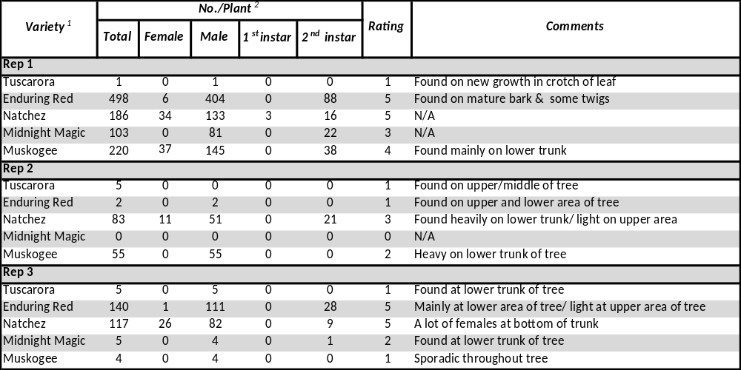
¹Varieties were replicated three times; plants were arranged in blocks (1 plant/variety) and field-collected infested branches were placed across the plants to allow crawlers to move and infest plants (June 15, 2021).
²Counts were made about four weeks after infested branches were placed on the crape myrtles (July 12, 2021)

Table 7.2. Influence of crape myrtle variety on crapemyrtle bark scale, University of Tennessee East Tennessee AgResearch and Education Center, Knoxville, TN, 2021.

Least Squares Means
Effect | Variety¹ | Estimate² | Standard  Error | DF | t Value | Pr > |t|
Variety | Enduring Red | 10.0000 | 2.4631 | 10 | 4.06 | 0.0023
Variety | Midnight Magic | 6.0000 | 2.4631 | 10 | 2.44 | 0.0351
Variety | Muskogee | 8.3333 | 2.4631 | 10 | 3.38 | 0.0070
Variety | Natchez | 11.3333 | 2.4631 | 10 | 4.60 | 0.0010
Variety | Tuscarora | 4.3333 | 2.4631 | 10 | 1.76 | 0.1090

¹Varieties were replicated three times; plants were arranged in blocks (1 plant/variety) and field-collected infested branches were placed across the plants to allow crawlers to move and infest plants (June 15, 2021).
²Counts were made about four weeks after infested branches were placed on the crape myrtles (July 12, 2021)

Table 7.3. Influence of variety of crape myrtle on the mean number of adult male, female and immature (1st instar crawlers and 2nd instar nymphs) crapemyrtle bark scale, University of Tennessee East Tennessee AgResearch and Education Center, Knoxville, TN, 2021.
Variety¹ | Mean No.²
Variety¹ | Male | Female | Crawlers and  2nd instar nymphs | Total
Enduring Red | 172.33 | 2.33 | 38.67 | 166.33
Midnight Magic | 28.33 | 0.00 | 7.67 | 36.0
Muskogee | 68.0 | 12.33 | 12.67 | 93.0
Natchez | 88.67 | 23,67 | 16.33 | 90.00
Tuscarora | 3.67 | 0.00 | 0.00 | 3.67

¹Varieties were replicated three times; plants were arranged in blocks (1 plant/variety) and field-collected infested branches were placed across the plants to allow crawlers to move and infest plants.
²Counts were made four weeks after infested branches were placed on the crape myrtles.

Midnight Magic and Tuscarora with no females on any of the plant’s representative of these varieties.
Similar results were observed with plant ratings of crapemyrtle bark scale infestations (Table 7.4, Fig. 7.1). Those varieties rated lowest were Tuscarora (1.00) and Midnight Magic (1.67) (as discussed above, neither of these varieties had females settle onto them). On the other hand, the variety rated the highest was Natchez (4.33), which corresponded to the variety with the highest scale density.
Tuscarora was the only variety found to have crapemyrtle bark scale on the new growth of the foliage. The remaining varieties were infested on the mature sections of the crape myrtle. Although, crapemyrtle bark scale was consistently observed at the lower trunk area for some of the varieties, at least one of the replications showed Tuscarora, Muskogee, Enduring Red and Natchez as having crapemyrtle bark scale in small numbers higher up in the tree (Table 7.2).
7.5. Summary
Each selected crape myrtle variety was infested by crapemyrtle bark scale. Although each plant received the same amount of water during this study, Muskogee and Natchez endured the most stress, although they grew much more than the other varieties. The other varieties did not show signs of stress during the one-month study. Enduring Red, Muskogee, and Natchez were the first varieties to become infested by the scale. A closer examination of the data is necessary to better understand stage differentiation among varieties when infestation begins. This information will be beneficial in understanding how crapemyrtle bark

Table 7.4. Influence of variety of crape myrtle on the infestation rating of crapemyrtle bark scale, University of Tennessee East Tennessee AgResearch and Education Center, Knoxville, TN, 2021.

Variety¹ | Rating²
Enduring Red | 3.67
Midnight Magic | 1.67
Muskogee | 2.33
Natchez | 4.33
Tuscarora | 1.00
¹Varieties were replicated three times; plants were arranged in blocks (1 plant/variety) and field-collected infested branches were placed across the plants to allow crawlers to move and infest plants (June 15, 2021).
²Ratings (0 to 5, with 0 = no infestations and 5 = heavy infestations) were made about five weeks after infested branches were placed on the crape myrtles (July 19, 2021).

Figure 7.1. Rating of crapemyrtle bark scale (CMBS) infestations on five varieties of crape myrtle, University of Tennessee East Tennessee AgResearch and Education Center, Knoxville, Tennessee, July 19, 2021.

scale establishes on varying varieties. To quantify the varieties that are at risk of becoming infested by crapemyrtle bark scale, more varieties should be evaluated as well as increasing the number of plants to be infested.

REFERENCES

Borden, M., X. Martini, & A. Dale. 2018. Featured Creatures: common name: crapemyrtle bark scale, scientific name: Acanthococcus (=Eriococcus) lagerstroemiae (Kuwana) (Insecta: Hemiptera: Eriococcidae), EENY-711 https://entnemdept.ufl.edu/creatures/ORN/SCALES/crapemyrtle_bark_scale.html
Cai, X., H. Dou, M. Gu, M. Merchant, & E. Vafaie. 2016. Update on crapemyrtle bark scale.
Acta Hortic. 1140, 415-418, https://doi.org/10.17660/ActaHortic.2016.1140.94
Cothran, J. 2004. Treasured ornamentals of southern gardens - Michaux's lasting legacy. Castanea 149-157. https:/www.jstor.org/stable/26797065
Debach, P., & D. Rosen. 1991. Biological control by natural enemies, 2nd edition. Cambridge University Press
EDDMapS. 2021. Early Detection and Distribution Mapping System. The University of Georgia - Center for Invasive Species and Ecosystem Health. Available online at http://www.eddmaps.org/
Frank, S. 2010. Soft Scale Identification and Management on Ornamental Plants: North Carolina State Extension Publications. https://content.ces.ncsu.edu/soft-scale-identification-and-management-on-ornamental-plants.
Gu, M., M. Merchant, J. Robbins, & J. Hopkins. 2014. Crape Myrtle Bark Scale: A New Exotic Pest. EHT-049, Texas A&M AgriLife Extension. https://extensionentomology.tamu.edu/files/2017/06/Crape-mrytle-bark-scale-EHT-049.pdf
Gullan, P. J., & M. Kosztarab. 1997. Adaptations in scale insects. Annual Review of Entomology 42: 23–50. https://doi.org/10.1146/annurev.ento.42.1.23
Ibiyemi, O., & D. Held. 2020. Attracting lady beetles for conservation biocontrol of crapemyrtle bark scale: Crapemyrtle bark scale. https://stopcrapemyrtle bark scale.com/2020/05/14/attracting-lady-beetles-for-conservation-biocontrol-of-crapemyrtle-bark-scale/#
Limbwalker Tree Service. 2017. Insect and Disease Problems. https://www.limbwalking.com/learning-center/insect-disease-problems/
Jiang, N., and H. Xu. 1998. Observation on Eriococcus lagerstroemiae Kuwana. J. Anhui Agric. Univ., 25: 142–144. (In Chinese)
Kozár, F., M. Kaydan, K. Bora., Z. Benedicty, & E. Szita. 2013. Acanthococcidae and Related Families of the Palaearctic Region. Plant Protection Institute, Centre for Agricultural Research, Hungarian Academy of Sciences, Budapest. ISBN 978-963-508-678-8
Layton, B. 2015. Crape myrtle bark scale identification and control. Bug Eye’s View 7(No. 4), Mississippi State University Extension, Publication 2938 http://extension.msstate.edu/newsletters/bug%E2%80%99s-eye-view/2021/crape-myrtle-bark-scale-vol-7-no-4
Marwah, P., Y. Zhang, & M. Gu. 2021. Investigating producers’ preferences for crapemyrtle and their perceptions regarding crapemyrtle bark scale. Horticulture 7, 146. https://doi.org/ 10.3390/horticulturae7060146
Matos, G. 2018. Crape Myrtle Bark Scale. LSU AgCenter. https://www.lsuagcenter.com/topics/environment/invasive%20species/crape%20myrtle%20bark%20scale
Mazzeo G., S. Longo, G. Pellizzari, F. Porcelli, P. Suma, & A. Russo. 2014. Exotic scale insects (Coccoidea) on ornamental plants in Italy: A never-ending story. Acta Zoologica Bulgarica, 6: 55–61.
Merchant, M., M. Gu, J. Robbins, E. Vafaie, N. Barr, A.D. Tripodi, & A.L. Szalanski. 2014. Discovery and spread of Eriococcus lagerstroemiae Kuwana (Hemiptera: Eriococcidae), a new invasive pest of crape myrtle, Lagerstroemia spp. https://bugwoodcloud.org/resource/pdf/ESAPosterDiscovAndSpread2014.pdf
Mizell, R. F., & G. W. Knox. 1993. Susceptibility of crape myrtle, Lagerstroemia indica L., to the crapemyrtle aphid (Homoptera: Aphididae) in North Florida. Journal of Entomological Science. 28(1): 1–7. https://doi.org/10.18474/0749-8004-28.1.1
National Agriculture Statistics Service. 2020. Census of Agriculture: Census of Horticultural Specialties (2019), Volume 3, Special Studies, Part 3 (AC-17-SS-3). U.S. Department of Agriculture, National Agricultural Statistics Service, Washington, D.C. 26 pp. Table 21.
Nixon, P. 2003. Insect Response to Plant Health. University of Illinois Extension. http://hyg.ipm.illinois.edu/pastpest/200320d.html
Robbins J, J. Hopkins, M. Merchant, & M. Gu. 2014. Crapemyrtle Bark Scale: A New Insect Pest, FSA7086. University of Arkansas Cooperative Extension https://www.uaex.edu/publications/pdf/fsa-7086.pdf
Russo, N., & C. Cheah, & M. Tingley. 2016. Experimental evidence for branch-to-bird transfer as a mechanism for avian dispersal of the hemlock woolly adelgid (Hemiptera: Adelgidae). Environmental Entomology. 45. nvw083. 10.1093/ee/nvw083
Shelton, A., & J. Eccleston. (n.d.). Biocontrol Success Stories. Cornell University, College of Agriculture and Life Sciences. https://biocontrol.entomology.cornell.edu/success.php
Simpson, T. 2019. Tennessee hardiness zones. The Spruce.https://www.thespruce.com/plant-hardiness-zone-in-memphis-2321958
The Tree Centers. 2016. Crape Myrtle Varieties and Guide. https://www.thetreecenter.com/crape-myrtle-varieties-and-guide/
USDA FS. 1993. Lagerstroemia indica - crape-myrtle. USDA Forest Service. Fact Sheet ST-342.

Vafaie, E., M. Merchant, & M. Gu. 2018. Crapemyrtle bark scale. Texas A&M AgriLife Extension. https://extensionentomology.tamu.edu/insects/crapemyrtle-bark-scale/
Vafaie, E., M. Merchant, & M. Gu. 2020. Biology and Management of the Crapemyrtle Bark Scale: Landscape and Nursery Growers. Texas A&M Agrilife Extension. https://extensionentomology.tamu.edu/files/2020/10/Screen-Shot-2020-10-16-at-1.17.48-PM.png
Venette, R., D. Kriticos, R. Magarey, F. Koch, R. Baker, S. Worner . . . J. Pedlar. 2010. Pest risk maps for invasive alien species: A roadmap for improvement. BioScience 60(5): 349-362. doi:10.1525/bio.2010.60.5.5
Wade, G.L., & J.W. Woodward. 2009. Crape myrtle culture. University of Georgia Cooperative Extension. Circ. 944.
Wang, Z., Y. Chen, & R. Diaz. 2019. Temperature-dependent development and host range of crapemyrtle bark scale, Acanthococcus lagerstroemiae (Kuwana) (Hemiptera: Eriococcidae). The Florida Entomologist, 102(1): 181–186. https://doi.org/10.1653/024.102.0129
Wang, Z., Y. Chen, M. Gu, E. Vafaie, M. Merchant, & R. Diaz. 2016. Crapemyrtle bark scale: A new threat for crapemyrtles, a popular landscape plant in the U.S. Insects (Basel, Switzerland), 7(4): 78. https://doi.org/10.3390/insects7040078
Wang, Z. 2017. Biology and Ecology of Crapemyrtle Bark Scale, Acanthococcus lagerstroemiae (Kuwana) (Hemiptera: Eriococcidae). Louisiana State University Master's Thesis. 4479.
Williamson, J. 2015. Crapemyrtle Bark Scale. Home and Garden Information Center. Clemson University, South Carolina. https://hgic.clemson.edu/factsheet/crapemyrtle-bark-scale/

Wilson, B. 2016. How to plant a crape myrtle tree or shrub in the ground or a pot. https://www.wilsonbrosgardens.com/how-to-plant-a-crape-myrtle.html
Xie, R., B. Wu, H. Dou, C. Liu, G.W. Knox, H. Qin, & M. Gu. 2020. Feeding preference of crapemyrtle bark scale (Acanthococcus lagerstroemiae) on different species. Insects. 11(7): 399. https://doi.org/10.3390/insects11070399

APPENDIX

CMBS (Crapemyrtle Bark Scale) Survey
County Agents

List the Name of Your County: ______________________
Please answer the following questions:
- Has CMBS been documented in your county?
  - If yes, continue to #2
  - If no (or you don’t know), stop and return survey

- When was CMBS first documented in your county? __________________________________________
Do you know where CMBS was first found in your county? If yes, where was it first found? _____________________________________________________________________

- Do you know if CMBS has been found in multiple locations in your county? Yes __ No __

- If CMBS has been found in multiple locations in your county, estimate how many locations (e.g., 2, 5, 8, 10, more than 20, etc.) _____________________________________________________________________

- Has damage to crape myrtle been observed? Yes ____ No ______

- How would you rate any damage that has been observed?
Low ______ Moderate ______ High ______ Extensive ______

- Do you know of any treatments against CMBS in your county (treatments may have been made by homeowners, Tennessee Department of Agriculture, county personnel, etc.)? Yes ______ No ______

- If yes, what treatment(s) were used? (be as specific as possible – e.g., high pressure water spray, horticultural oil, biologicals, synthetic pesticides, etc.) _____________________________________________________________________
_____________________________________________________________________

- OPTIONAL: Please provide any additional comments on CMBS and crape myrtles that you feel would benefit our survey:
_______________________________________________________________________________________________________________________________________________________________________________________________________________________________________________________________________________________________________________________________________________________________________________________Thank you for your contributions to our survey. Return the completed survey to Jerome Grant, jgrant@utk.edu. If you have any questions, please call 865.974.0218. When completed, a summary of results will be sent to each county.
VITA
Amira Cornish was born on February 10, 1996 to Raynette and Larry Cornish. She was homeschooled for the majority of elementary school and later attended public middle school in Columbus, Ohio. She continued her high school education at Columbus Africentric Early College High School and graduated with honors as the salutatorian in June 2014.The following August she attended Spelman College in Atlanta, Georgia, where she attained her Bachelor of Science degree in Biology by May 2018. In August of 2021, Amira Cornish will have completed her Master of Science degree at the University of Tennessee in the Department of Entomology and Plant Pathology. She is a member of the Tennessee Entomological Society and the Entomological Society of America.

