Modeling Water Age and Disinfection Byproduct Formation in Drinking Water Distribution Systems in East Tennessee

A Thesis Presented for the
Master of Science
Degree
The University of Tennessee, Knoxville

Seth Adam Fischer
August 2015

Copyright © 2015 by Seth Fischer
All rights reserved.

DEDICATION

I would like to dedicate this thesis to my wife, Jennifer. Your boundless love and support are greatly appreciated and were instrumental in accomplishing this goal. I could not and would not want to achieve this dream or any of our other dreams without you.
And to my three sons; Noah, Adam and Sam. I have missed time with you and thought of you constantly through this process. Now that it is finished, “Let the wild rumpus start!”

Seth/Daddy
ACKNOWLEDGEMENTS

I would like to thank Dr. Qiang He for serving as advisor, for keeping me on track, for encouragement and for advice; both thesis related and otherwise. I would also like to thank Dr. Chris Cox and Dr. Kimberly Carter for serving on my committee.
Thank you to my friends and colleagues at First Utility District, Harriman Utility Board, Northeast Knox Utility District, and South Blount County Utility District, who contributed data to this project, and at Cannon & Cannon, Inc. All of whom are dedicated to providing the highest quality drinking water and to constant improvement of their product. The time and effort you contributed to this project are greatly appreciated.
ABSTRACT

Chlorine disinfection of drinking waters is responsible for the standard of health we enjoy today and the eradication of waterborne disease. Chlorine also reacts with natural organic matter (NOM) to form disinfection byproducts (DBPs) which have been linked to cancer as well as reproductive and developmental issues. The exact mechanism for formation of regulated DBPs, trihalomethanes (THMs) and haloacetic acids (HAAs), is unknown. The literature has identified relationships between DBP formation and, most notably, characteristics of NOM, chlorine contact time, temperature, pH [negative log of hydrogen ion concentration], and chlorine dose. This study develops models both specific to individual utilities, and general to utilities with surface water sources using NaClO [sodium hypochlorite] for disinfection within the geographic region of East Tennessee. The study utilizes existing data from four utilities collected for compliance with regulations. Calibrated hydraulic models of the four distribution systems are employed to accurately determine water age (chlorine contact time) in the distribution system, often a limitation of field scale models. Multivariate power functions predict THMs and HAAs for individual utilities and across utilities with similar raw water characteristics and treatment processes. $R^{2}$ [coefficient of determination] ranges from 0.56 to 0.83. Developed models account for actual distribution system conditions, including water age, and predict THM and HAA levels for the four utilities with a higher $R^{2}$ value than applicable existing lab scale and field scale models. Results arm utilities with strategies to develop specific DBP models using existing data, control DBP levels, improve quality of drinking water, and achieve compliance with regulations.

TABLE OF CONTENTS

1.0 INTRODUCTION 1
2.0 METHODS 10
2.1 Utilities Studied 10
2.1.1 South Blount County Utility District (SBCUD) 10
2.1.2 Harriman Utility Board (HUB) 11
2.1.3 Northeast Knox Utility District (NEKUD) 12
2.1.4 First Utility District (FUD) 13
2.2 Raw Data Collection 14
2.3 Water Age Modeling 15
2.4 Final Data Set 19
2.5 Non-Linear Multivariate Regression 19
3.0 RESULTS 21
3.1 Water Age 21
3.2 Natural Organic Material Parameters 23
3.3 Trihalomethane 25
3.3.1 SBCUD Trihalomethane 25
3.3.2 HUB Trihalomethane 27
3.3.3 NEKUD Trihalomethane 29
3.3.4 FUD Trihalomethane 31
3.3.5 General Trihalomethane Model 33
3.4 Haloacetic Acid 35
3.4.1 SBCUD Haloacetic Acid 35
3.4.2 HUB Haloacetic Acid 37
3.4.3 NEKUD Haloacetic Acid 39
3.4.4 FUD Haloacetic Acid 39
3.4.5 General Haloacetic Acid Model 43
4.0 DISCUSSION 45
5.0 CONCLUSION 58
LIST OF REFERENCES 60
APPENDICES 65
LIST OF TABLES

Table 1 Hydraulic Model Development Methods 18
Table 2 SBCUD THM Model Parameters 26
Table 3 HUB THM Model Parameters 27
Table 4 NEKUD THM Model Parameters 29
Table 5 FUD THM Model Parameters 31
Table 6 General THM Model Parameters 33
Table 7 SBCUD HAA Model Parameters 36
Table 8 HUB HAA Model Parameters 37
Table 9 NEKUD HAA Model Parameters 39
Table 10 FUD HAA Model Parameters 41
Table 11 General HAA Model Parameters 43
Table 12 THM Residual, Utility, and Fluoride Dose Effect Tests 52
Table 13 HAA Residual, Utility, and Fluoride Concentration Effect Tests 53
Table 14 THM Model Summary 67
Table 15 HAA Model Summary 68

LIST OF FIGURES

Figure 1 Diurnal Demand Pattern 16
Figure 2 Tank Level Comparison Model and SCADA 22
Figure 3 Water Age at Sampling Site in NEKUD 22
Figure 4 Comparison of Potential NOM surrogates 23
Figure 5 Relationships between turbidity and TOC 24
Figure 6 SBCUD Predicted and Actual THMs 26
Figure 7 SBCUD THM Residual Distribution 26
Figure 8 HUB Predicted and Actual THMs 28
Figure 9 HUB THM Residual Distribution 28
Figure 10 NEKUD Predicted and Actual THMs 30
Figure 11 NEKUD THM Residual Distribution 30
Figure 12 FUD Predicted and Actual THMs 32
Figure 13 FUD THM Residual Distribution 32
Figure 14 General Predicted and Actual THMs 34
Figure 15 General THM Model Residual Distribution 34
Figure 16 SBCUD Predicted and Actual HAAs 36
Figure 17 SBCUD HAA Residual Distribution 36
Figure 18 HUB Predicted and Actual HAAs 37
Figure 19 HUB HAA Residual Distribution 38
Figure 20 NEKUD Predicted and Actual HAA 40
Figure 21 NEKUD HAA Residual Distribution 40
Figure 22 FUD Predicted and Actual HAAs 41
Figure 23 FUD HAA Residual Distribution 42
Figure 24 General Model Predicted and Actual HAAs 44
Figure 25 General HAA Model Residual Distribution 44
Figure 26 Two-Way ANOVA THM Residual without Fluoride Parameter 52
Figure 27 Two-Way ANOVA HAA Residual without Fluoride Parameter 53
Figure 28 Comparison of Models SBCUD 55
Figure 29 Comparison of Models HUB 56
Figure 30 Comparison of Models NEKUD 56
Figure 31 Comparison of Models FUD 57
Figure 32 Comparison of Models All Utilities 57

1.0 INTRODUCTION
The practice of disinfecting drinking water at water treatment plants over the past hundred years is largely responsible for our standard of health today. Drinking water disinfection has essentially eradicated infectious waterborne diseases from our society. However, disinfection is not without negative side effects. Chlorine, in one of several forms, is the most commonly used disinfectant. Chlorine is a powerful oxidant and highly reactive. These properties lead to chlorine’s effectiveness in disinfection but also lead to the tendency to form disinfection byproducts (DBPs). Chlorine reacts with natural organic matter (NOM) in source water to form DBPs. Over 600 different DBP’s have been identified in disinfected drinking water (Richardson et al. 2007). DBPs have been linked to cancer of the liver, kidney, and large intestine, as well as reproductive and developmental issues (Boorman et al. 1999).
Because of the health concerns associated with DBPs, many countries, including the U.S. regulate Trihalomethanes (THMs) and Haloacetic acids (HAAs). The U.S. Environmental Protection Agency (EPA) Stage II Disinfection Byproduct Rule (DBPRII) tightened regulations on the two groups of regulated DBPs. While maximum contaminant levels (MCL) remain unchanged (80µg/L for THM and 60 µg/L for HAA), sampling and reporting requirements became more stringent. Public water systems must now report a rolling annual average for the area of the system with maximum DBP levels, usually based on quarterly sampling. Many utilities have difficulty complying with the new rule and would benefit from a better understanding of the formation of DBPs in their distribution systems.
The exact mechanism for formation of disinfection byproducts is as yet unknown and likely varies. What is known is that disinfection method and dose, source water chemistry, water age (chlorine contact time), pH, and temperature affect the amount and type of DBPs formed (Reckhow et al. 1990, McLellan 2000, Hua and Reckhow 2008, 2012, Zhang et al. 2013).
Chlorine for disinfection of drinking water is most commonly applied in East Tennessee as free chlorine (${Cl}_{2}$), and less frequently as chlorine dioxide (${ClO}_{2}$), or chloramines (${NH}_{2}Cl$). Chlorine and chlorine dioxide are suitable as primary disinfectants for killing or inactivating bacteria and viruses at the treatment plant, or secondary disinfectants providing a defense against organisms that enter the distribution system. Chloramines are only useful as a secondary disinfectant.
Free chlorine is applied to water as chlorine gas (${Cl}_{2}$) or as hypochlorite (${Cl0}^{-}$), either in solid form as calcium hypochlorite (${Ca(ClO)}_{2}$), or liquid form as bleach (sodium hypochlorite (NaClO). Chlorine gas, when dissolved in water, forms hypochlorous acid (HClO) according to reaction 1. Hypochlorous acid will reach equilibrium with hypochlorite according to reaction 2. The pKa of reaction 2 is 7.5 at 25°C. Therefore, at pH below 7.5, hypochlorous acid will be the dominant species. Hypochlorous acid is preferable to hypochlorite ion as it is a much more effective disinfectant.
$${Reaction 1: Cl}_{2}+H_{2}O→HOCl+H^{+}+{Cl}^{-}$$
$$Reaction 2: HOCl↔H^{+}+{OCl}^{-}$$
Halogens, i.e. chlorine, bromine and iodine, react with NOM present in surface water forming THMs, HAAs, and other organic halogens according to the following general reaction:
$$HOCl+NOM→DBPs$$
Components of NOM, specifically humic and fulvic acids, which constitute over half of the dissolved organic carbon in most surface waters, show favorable reactivity with chlorine (Amy et al. 2000). Other components of NOM include hydrophilic acids, carbohydrates, carboxylic acids, and proteins and amino acids. Because of the high reactivity with chlorine and large fraction of the makeup of NOM, aquatic humic materials (AHMs) are considered to be responsible for the majority of formation of DBPs. (Amy et al. 2000) Hydrophilic acids and amino acids will also react with chlorine to produce chloroform, and other byproducts which contribute to total DBP formation. The carbohydrate and carboxylic acid portions of NOM have low reactivity with chlorine and do not contribute significantly to DBP formation (Amy et al. 2000).
AHMs have been shown to have a significant effect on formation of THMs and HAAs in drinking water (Pomes et al. 1999, Reckhow et al. 1990). AHMs have relatively large molecular weights in the several hundred to tens of thousands range. Fulvic acids have a smaller molecular weight than humic acids as well as higher oxygen and carboxyl content (Snoeyink and Jenkins 1980). Humic acids will precipitate in dilute acid, while fulvic acids are soluble in both dilute acid and dilute base.
The exact structure of AHMs varies with each source water and no two are exactly alike (Reckhow et al. 1990). Therefore, the chemical pathway(s) for formation of organic halide byproducts is not well understood. AHMs are believed to contain a significant fraction of aromatic groups. Aromatic compounds are hydrocarbons with alternating single and double bonds between six carbon atoms forming a ring. These compounds are thought to contain large numbers of carboxyl groups, phenolic groups, methoxyl groups, ketones, and aldehydes. Phenolics, which consist of a hydroxyl group bonded to an aromatic carbon group, and other activated aromatic structures are known to be highly reactive with chlorine (Reckhow et al. 1990).
DBPs exhibit the chemical structure of hydrocarbons in which one or more hydrogen atoms are replaced with halide ions. THMs are composed of a hydrogen atom and a carbon atom with three halide ions, ${Cl}^{- }or {Br}^{-}$in the case of drinking water disinfection. The four regulated THMs are Chloroform (${CHCl}_{3}),$ Bromoform (${CHBr}_{3})$, Bromodichloromethane (${CHBrCl}_{2}$), and Chlorodibromomethane (${CHBr}_{2}Cl$). HAAs are carboxylic acids in which a halogen atom takes the place of one or more hydrogen atoms in acetic acid. The five regulated HAAs are Bromoacetic Acid (${CH}_{2}BrCOOH$), Chloroacetic Acid (${CH}_{2}ClCOOH$), Dibromoacetic Acid (${CHBr}_{2}COOH$), Dichloroacetic Acid (${CHCl}_{2}COOH$), and Trichloroacetic acid (${CCl}_{3}COOH$). Both THMs and HAAs are formed through a series of oxidation and substitution reactions with functional groups of AHMs
Source water quality, since it provides reactants for the formation of DBPs, has a large effect on the quantities and types of DBPs formed. NOM in surface waters results from degradation of flora and fauna in the natural environment. Because NOM varies with each source water in chemical composition, it is only practical to define chemical groups having similar properties (Zhang et al. 2013) These chemical groups are commonly analyzed for chemical characteristics based on fraction of total NOM. Correlations between characteristics of NOM and disinfection byproduct formation potential (DBPFP) provide a better understanding of the formation mechanisms and potential of DBPs.
Total organic carbon (TOC) and dissolved organic carbon (DOC) are commonly used to quantify NOM in source waters. Perhaps the strongest surrogate parameter for the amount of AHMs or hydrophobic aromatic compounds is a water’s specific ultraviolet absorbance (SUVA) (Liang & Singer 2003, Kitis et al 2002). SUVA is defined as ${100UV}_{254}/DOC$ where ${UV}_{254}$ is ultraviolet absorbance at 254nm. This correlation is largely due to the fact that humic and fulvic acids are responsible for the color (yellow or brown tint) of natural waters. A source water’s potential to form DBPs can be predicted by this analytical technique.
Retention time and chemical properties in the distribution system will affect the formation or degradation of DBPs after leaving the plant. The formation of DBPs occurs rapidly during the first 10-12 hours after chlorination and then slows but continues to increase for several days (Hua & Reckhow 2008, Zhang et al. 2013). Only certain non-regulated DBPs begin to decompose rapidly and only at temperatures above the range that would be seen in distribution systems (Zhang et al. 2013).
Many studies have shown that THM formation will increase with increasing pH. Hua and Reckhow (2008) noted a three-fold increase in THM formation from pH 5 to 10. Base-catalyzed reactions are known to play an important role in the formation of THMs (Reckhow et al. 1990). Conversely, HAA formation will decrease with increasing pH. THMs and HAAs are thought to form from a common trihalomethyl intermediate. Under alkaline conditions this intermediate is hydrolyzed to THM and under neutral or acidic conditions it can be oxidized to HAA. However, Hua and Reckhow (2008) found that as pH was increased from 5 to 10, the increase in THMs and decrease in HAAs were not equal. The authors also found that unknown total organic halogen (UTOX) decreased with increasing pH.
Temperature has a more clearly defined relationship with DBP formation. Water temperature may vary seasonally between 5 and 25ºC at the treatment plant and in the distribution system. In addition, water with a chlorine residual may be heated to as high as 40ºC for a significant time period in customers’ water heaters (Zhang et al. 2013). Hua and Reckhow (2008) observed an increase in THM, HAA, and UTOX concentrations as temperature was increased from 5 to 30 °C. The exception to this is a reduction in UTOX and some non-regulated DBPs at the higher end of the temperature range after a relatively short time period. Zhang et al (2013) noted that UTOX would form quickly and decompose quickly at high temperatures while the regulated DBPs increase steadily even at the highest temperatures (50ºC). When temperatures rose above 30°C, a greater fraction of TOX was in the form of HAAs and THMs. While UTOX decreased, TOX continued to increase. Increased temperature is known to increase the rate of most reactions. Temperature has a greater effect on halogenation reactions in general than dehalogenation, resulting in higher concentrations of DBPs (Hua & Reckhow 2008, Zhang et al. 2013). The positive relationship between temperature and DBP formation holds true for both chlorination and chloramination.
On an individual DBP basis, THMs show much greater sensitivity to temperature changes than do HAAs (McLellan 2000, Hua and Reckhow 2008, Zhang et al. 2013). Water treatment plants will likely see an increase in DBPs, specifically THMs, during warm seasons. HAAs will not exhibit quite the same increase. NOM concentration and composition is also likely to fluctuate along with temperature as seasons change (Hua and Reckhow 2008, Zhang et al. 2013). Changes in NOM and algae blooms could mitigate or amplify DBPFP during seasonal temperature changes.
Emphasis in the literature has been on employing knowledge of these relationships (NOM characteristics, time, temp, pH) to predict DBP formation rather than calculate yield. At least 118 unique models have been developed to predict chlorine DBP levels. Sadiq and Rodriquez (2003) reviewed and compared 25 different models for THMs and HAAs. In 2009, Chowdhury et al. reviewed and compared 118 DBP models from 48 scientific publications, 63 of which predicted THMs or HAAs. These models used water quality and operational parameters to predict and control DBP formation in drinking waters. Over three times as many models focused on predicting THMs (49) than HAAs (14). As expected, the parameters most frequently utilized include TOC, DOC, ${UV}_{254}$, SUVA, pH, temperature, bromide ion concentrations, chlorine dose, and reaction time (Chowdhury et al. 2009).
Chowdhury points out that generally, models based on field data are more realistic as they account for specific treatment process sequences and distribution systems. In contrast, certain parameters, namely water age or chlorine contact time, are difficult to accurately estimate. Furthermore field-scale models are often site specific (Chowdhury 2009). Previous field scale models often rely on tracer studies, or retention time calculations based on volume and flow, to estimate water age. Many studies focused on one treatment and distribution system and the varied results can be considered site specific. Aside from mathematical models, many studies have investigated spatial and temporal impacts on DBP formation in distribution systems (Rodriquez et al. 2004, 2007, Wei et al. 2010, Summerhayes et al. 2011, Charisiadis et al. 2015, Scheili et al. 2015).
With 60 plus models, it might be challenging for utilities to decide which model(s) will accurately predict THM and HAA formation in their particular system. Field scale studies that capture the entire treatment and distribution process, yet employ an accurate estimate of water age are lacking. There is limited research on whether field scale studies can produce models that are also applicable to other utilities in the same geographic region with similar source water and similar or different treatment processes.
This study first aims to develop an accurate DBP model specific to a utility using a hydraulic model and data each utility already has on hand from Stage I or Stage II DBPR reporting and monthly operation reports (MORs). This method, though site specific, could be replicated for any utility with minimal effort. Second, DBP models were developed that span the four utilities. Water age at all sampling sites of four utilities was determined using calibrated hydraulic models. Non-linear multivariate regression equations were developed to predict both THMs and HAAs using water age and raw and finished water parameters from MORs. DBP levels were predicted with $R^{2}$ of 0.52 to 0.80.

2.0 METHODS

2.1 Utilities Studied

2.1.1 South Blount County Utility District (SBCUD)

South Blount County Utility District (SBCUD) operates a pall membrane water treatment plant rather than a conventional coagulation and filtration plant. Source water is Tellico Reservoir on the Little Tennessee River just as it leaves the Great Smoky Mountains National Park. There are no major industries and no major population centers upstream of the raw water intake resulting in very high raw water quality. In fact, SBCUD is not required to monitor TOC quarterly due to low historical levels. The membrane plant is rated at 8 million gallons per day (MGD), produces 2.7 MGD on an average day and as many as 5.0 MGD on a peak day. Raw water is pumped into a 0.5 MG storage tank and then directly through 6 racks of pall membranes with no pretreatment. After membrane racks, water passes through an ultraviolet (UV) disinfection system and into a static mixer where treatment chemicals are introduced. Chemicals added are solution lime (Ca(OH)_{2(aq)} ) and carbon dioxide (${CO}_{2})$ for pH adjustment and added alkalinity to combat corrosion, fluoride for dental health, and sodium hypochlorite (NaClO) to provide a disinfection residual in the distribution system. UV disinfection reduces chlorine consumption and allows operators to keep NaClO doses low and still provide a safe residual at the ends of the system.
SBCUD serves a relatively small population for the vast area it covers. The Utility covers 132 square miles with 440 miles of pipe and serves a population of approximately 35,500 at 14,194 meters. Water customers are predominantly residential (rural and suburban) with little commercial. System storage is 7.7 million gallons (MG) in four tanks, two of which have mixing systems. There are no chlorine boosters in the system.
High quality raw water source, membrane filtration, and UV disinfection are excellent indicators for low DBP levels; however the vastness of the system for the relatively low volume of water produced leads to long chlorine contact times.

2.1.2 Harriman Utility Board (HUB)

Harriman Utility Board (HUB) operates a conventional settling and filtration plant rated at 4.0 MGD. Average day production is approximately 1.8 MGD with peak days of 2.0 MGD. Source water is the Emory River which is not impounded at the raw water intake but is influenced by backwaters of the Tennessee River impoundment at Watts Bar Lake just downstream of the water plant. Sodium permanganate ($NaMnO_{4}$), an oxidant which does not form DBPs, is added immediately at the raw water intake. Alum (${AL}_{2}(SO_{4})_{3}$◦${14H}_{2}O$), a coagulant, is added to promote settling. Caustic soda (NaOH) is added for softening, and blended phosphate is added to inhibit corrosion. Water passes through mixed media filters and is dosed with NaClO as primary disinfectant and to provide residual in the system. Fluoride is also added to the finished water.
HUB operates a complex distribution system with 13 pressure zones due to a series of ridges and valleys in the service area. Elevation differential within the system is 1,360 ft. Two hundred miles of pipe cover 50 square miles. Thirteen tanks provide 2.23 MG of storage. There are no disinfectant boosters in the distribution system. HUB serves 14,000 customers at just over 6,000 meters. Most customers are residential with some commercial and very little industrial. The service area includes a town of 6,350 but is mostly rural by area. Customers are spread out and use little water compared to the American Water Works Association (AWWA) typical usage. Low usage, combined with the fact that water must pass through and reside in five pressure zones (and possibly tanks) to reach the extents of the system, leads to high water ages.

2.1.3 Northeast Knox Utility District (NEKUD)

Northeast Knox Utility District (NEKUD) operates a conventional filtration plant with a capacity of 6.9 MGD. Average Daily Demand is 1.9 MGD with peak day demands of 2.9 MGD. Raw water intake is on the Holston River at mile 10.5 just upstream from its convergence with the French Broad River to form the Tennessee River. Raw water is immediately dosed with potassium permanganate and then a polyaluminum chloride blend for coagulation. Water then splits to three settling basins for coagulation and sedimentation in tube settlers before passing through three sets of mixed media (gravel, sand, anthracite) filters. NaClO, phosphate and fluoride are added post filtration.
NEKUD serves a population of 22,295 at 9,175 meters. Residential customers are rural and suburban and the utility has some commercial and industrial customers. The distribution system covers 62 square miles with 240 miles of pipe divided into three pressure zones. System storage is 4.9 MG. Two of eight tanks have mixing systems.

2.1.4 First Utility District (FUD)

FUD operates a considerably larger conventional filtration plant than other utilities in the study. The plant capacity is 34 MGD with average production of 12 MGD and peak production of 24 MGD. Source water is a reservoir, Fort Loudon Lake, which passes through an urban setting and has considerable population centers and industry upstream. Raw water is pumped from the reservoir through an inline rapid mixer where sodium permanganate and poly aluminum chloride (coagulant) are added. Water then proceeds through three staggered mixing chambers and six settling basins before it is filtered through anthracite and sand. Approximately 0.1 parts per million (ppm) chlorine is added prior to filtration (as NaClO) with the bulk (1.8-2 ppm) added post filtration. Pre-chlorination was moved from the headworks to just before the filters to reduce contact time prior to filtration and removal of NOM. Fluoride is also added to the finished water.
FUD serves approximately 80,000 customers at 32,000 meters in a more urban and suburban setting than the other utilities studied. There is significant commercial usage, but little industrial. System storage totals 17 MG with mixing systems in all nine tanks and another 4 MG storage at the plant. The distribution system consists of 435 miles of pipe covering 55 square miles. The system is divided into two pressure zones, both of which are fed directly from the treatment plant. Higher density water consumption and lack of pressure zones in series lead to relatively low chlorine contact times.

2.2 Raw Data Collection
Raw water and finished water data are collected from the four utilities’ Monthly Operation Reports (MORs). MORs provide a daily record of water quality parameters including temperature, pH, alkalinity, hardness, turbidity, chlorine dosage, volume of water produced, concentration of naturally occurring minerals and dose of all chemicals added during water treatment. All measurements in the MOR are determined by each utility’s in-house laboratory. An example MOR can be found in the Appendix.
DBPs are sampled quarterly at four to eight sites throughout the distribution system in accordance with the EPA Stage I or Stage II DBPR. Stage II DBPR was implemented over the course of several years depending on the population served by the utility. Data from both Stage I and Stage II were included in this analysis. Sampling and analyses methods did not change between the two rules, only sampling locations and reporting requirements. THM and HAA levels are determined by independent laboratory analysis using EPA methods 524.2 and 552.2 respectively. EPA method 524.2 measures purgeable organic compounds (THMs) in water by capillary column gas chromatography and mass spectrometry. EPA method 552.2 employs liquid-liquid extraction, derivatization, and gas chromatography with electron capture detection to determine HAA levels. Two independent laboratories analyzed THM and HAA samples for the four utilities.
NOM surrogates (DOC, TOC, ${UV}_{254}$, and SUVA) are important factors in DBP formation. Unfortunately, only TOC is monitored, quarterly at most and not necessarily in the same timeframe as DBP monitoring. SBCUD does not monitor TOC due to historically low levels. HUB and FUD monitor TOC quarterly. NEKUD monitors ${UV}_{254}$, SUVA, TOC, and DOC quarterly with the same sample. Daily raw and finished turbidity from the MOR are the most likely surrogates for NOM.

2.3 Water Age Modeling
Water Age, the most important factor in DBP formation, was determined by water quality simulations from calibrated hydraulic models of the four distribution systems. Innovyze’s Infowater 10.5 was used to develop system models and perform water quality simulations. A carefully constructed and calibrated model is essential to this analysis as water age is known to be a leading factor in DBP formation and the water age determined would also determine the timeframe for all other parameters used in the analysis.
Model infrastructure was built from GIS and/or record drawings of the water system. Pipes, tanks and pump stations were all imported in to the model and assigned elevations from digital elevation models. Tank overflow elevations, ground level elevations, and diameters were entered from historical records of survey data. Pump station elevations and pump curves were also entered from records.
Demands were added by applying each customer’s historical usage to the model node closest to their physical meter. When available, a year’s worth of billing data was analyzed to determine average and peak flows at each customer location. Meter locations were determined from existing GIS layers or from geocoding addresses for each water customer account. Each location was also assigned a daily usage pattern based on usage type (residential, commercial, industrial, school). Diurnal residential usage patterns were determined by analyzing tank level data from Supervisory Control And Data Acquisition (SCADA) systems. Figure 1 illustrates the diurnal demand pattern for SBCUD calculated from SCADA data for tank level and output from the water treatment plant, as well as the diurnal demand pattern input into the water model. The average demand for each customer was multiplied by a factor for each hour of the day corresponding to the diurnal pattern. Demands were also increased to match system wide demand to daily plant production, accounting for real and apparent water loss.

Figure 1 Diurnal Demand Pattern

Once all known facilities information, including tank dimensions and elevations, pipe diameters, pump curves and controls, and customer demands, were entered into the model, pipe roughness became the only unknown. To determine pipe roughness and calibrate the model, the following information must be gathered: flow and pressures from hydrant tests, water elevation readings in the system’s tanks, and whether pumps were on or off.
Multiple hydrant flow tests were performed at locations throughout each distribution system. Flow at one hydrant and pressure at up to three hydrants upstream were recorded along with relevant tank elevations and pump status. Tests were performed during the early morning hours when system use is lowest and unknown large demands are minimized. Hydrants were chosen to represent pressure zones and different pipe materials and ages. Static readings taken prior to the test verified elevation accuracy and tank elevations. Readings taken at upstream hydrants while flowing a hydrant provided a pressure drop for a specific volume flow. Considering and accounting for elevation differences, the roughness of each section of pipe was calculated using the Hazen-Williams equation:
$$h_{f}=0.002083({100}/{C)^{1.852}Q^{1.852}}/D^{4.8655}$$
solving for C;
$$C=100/(\frac{h_{f}{*D}^{4.8655}}{0.002083*L*Q^{1.85}})^{(\frac{1}{1.85})}$$
where; C= Hazen-Williams roughness constant
$h_{f}$ = friction head loss in feet
Q = volume flow in gpm
D = hydraulic diameter in inches
Calculated roughness coefficients were then entered for all pipes of similar material and age throughout the distribution system. Finally, model operation was compared to SCADA operational data and adjusted accordingly.
It should be noted that the hydraulic model for FUD used in this study was built by a colleague using many of the same methods. Not all steps (i.e. SCADA data calibration) were possible for all models. Table 1 shows which steps were employed for each model.

Table 1 Hydraulic Model Development Methods
Methods Employed in Model Development | SBCUD | HUB | NEKUD | FUD
Import Pipes, Tanks, Pumps | From GIS | From GIS | From existing outdated model | From GIS
Update Pipes, Tanks, Pumps | Tank elevations and pump curves, pipe updates per Utility employees | Tank elevations and pump curves, pipe updates per Utility employees | Tank elevations and pump curves, pipe updates per Utility employees | Tank elevations and pump curves, pipe updates per Utility employees
Customer Locations | From GIS | GIS/ Geolocation | From existing model | Geolocation
Customer Demands | Typical Residential/  Billing data for large customers | Billing data | Adjusted existing demands to match plant output | Billing Data
Diurnal Pattern | SCADA | SCADA | Typical Residential, Industrial, Commercial | Mass Balance from Calibration Data
Pipe Roughness Calibration | Yes | Yes | Yes | Yes
SCADA Calibration | Yes | Yes | No | Yes

2.4 Final Data Set
Once water age was determined for each site, raw and finished water parameters from the appropriate time period were compared to THM and HAA levels at that site. If water age was determined to average 96 hours (4 days) at a given site, averaged MOR data from three, four, and five days prior was used in the analysis. The resulting database marries raw water and finished water parameters from the plant with DBP levels at sample sites. Water quality measurements at the utility were specific to the time the sampled water left the plant (perhaps days ago), rather than the time the water is sampled. The database compiled from MORs, questionnaires, and DBP samples includes over 40 parameters to be compared to DBP levels. Some parameters are known to influence DBP formation (pH, temperature) and others have no known relationship (fluoride dose). System demand, and therefore plant production and water age, vary seasonally and otherwise. To account for this fluctuation, a column from the MOR measuring water pumped to the system was included. Any fluctuations in water age due to increased or decreased consumption and production should be captured by this variable.

2.5 Non-Linear Multivariate Regression
Non-linear multivariate regression by taking the natural logarithm of DBP levels and independent variables produced the strongest correlations. Engerholm and Amy (1983) discovered that in lab tests, formation of chloroform (a THM) from humic acid could be accurately modeled by transforming chloroform concentration, humic acid concentration, and independent variables such as pH, temperature, and chlorine ratio into natural log forms. This ln-ln method has been used in many previous DBP models (Amy et al. 1987, 1998, Watson 1993, Chang et al. 1996, Rathbun 1996a,b, Huixian et al.1997, Rodriquez et al. 2000, McBean et al. 2010). Only pH was not transformed to the natural logarithm as it is already the negative logarithm (base 10) of the concentration of hydrogen ion and this provided slightly better results. Linear multivariate regression and neural networks were also modeled, however results were less promising.
Samples either from a single location or a single sample date were not included in the development of each model and were used as a validation set. This allowed for validating the model against both a new location (and water age) and a new sample date (and water quality parameters). Eight THM samples were discarded because their residuals from a model using only age and temperature (the two most important parameters as is shown later) were greater than two standard deviations from the mean.
The mixed stepwise method was employed to determine which parameters to include in the model. The mixed stepwise method is a combination of forward selection and backward elimination. During the forward step, variables are considered for addition to the model based on a rule, in this case a p-value threshold of 0.1. Each forward step is followed by a backward step where variables are eliminated from the model if the rule is violated. The process ends when no further improvement can be made to the model. JMP Pro version 11.1.1 by SAS Institute, Inc. was employed for statistical modeling.

3.0 RESULTS

3.1 Water Age
Calibrated model runs were compared to SCADA data (when available) for tank levels and pump run times for each pressure zone to ensure the finished model was operating as closely as possible to the actual water system. This exercise involved adjusting demands for each pressure zone to accurately reflect water loss in addition to known customer consumption. Figure 2 shows the resulting modeled and actual tank level over a week for a pressure zone in the HUB system.
Once the model was built, calibrated, and accurately reflected real world operations as recorded through SCADA, water quality simulations were run to determine the water age at each sampling site for each utility. Extended simulations of at least 30 days (720 hours) were run to allow water age to stabilize in a constant pattern. Since water age varies daily as water is supplied by either tanks or pumps, the last 72 hours of water age were averaged for each site. Figure 3 illustrates water age at a site in NEKUD and the portion that was averaged to determine a representative maximum water age.
Using the determined water ages and MOR parameters from the time the water at each sampling site was calculated to have left the plant, models for THM and HAA levels were developed with $R^{2}$ values between 0.52 and 0.80. Water age is consistently the most important or second most important parameter in each model. The importance of water age and $R^{2}$ values of the models indicate that water age has been accurately calculated.

Figure 2 Tank Level Comparison Model and SCADA

Figure 3 Water Age at Sampling Site in NEKUD

3.2 Natural Organic Material Parameters
An analysis of finished water measurements of ${UV}_{254}$, SUVA, TOC, DOC, and turbidity at NEKUD found that turbidity, TOC, and DOC levels were closely related. However, dramatic fluctuations in ${UV}_{254}$ and SUVA were not reflected in turbidity or TOC levels (Figure 4). Turbidity appeared to be a reasonable surrogate for DOC or TOC but not for ${UV}_{254}$ or SUVA. Turbidity is also influenced by non-organics in the water.

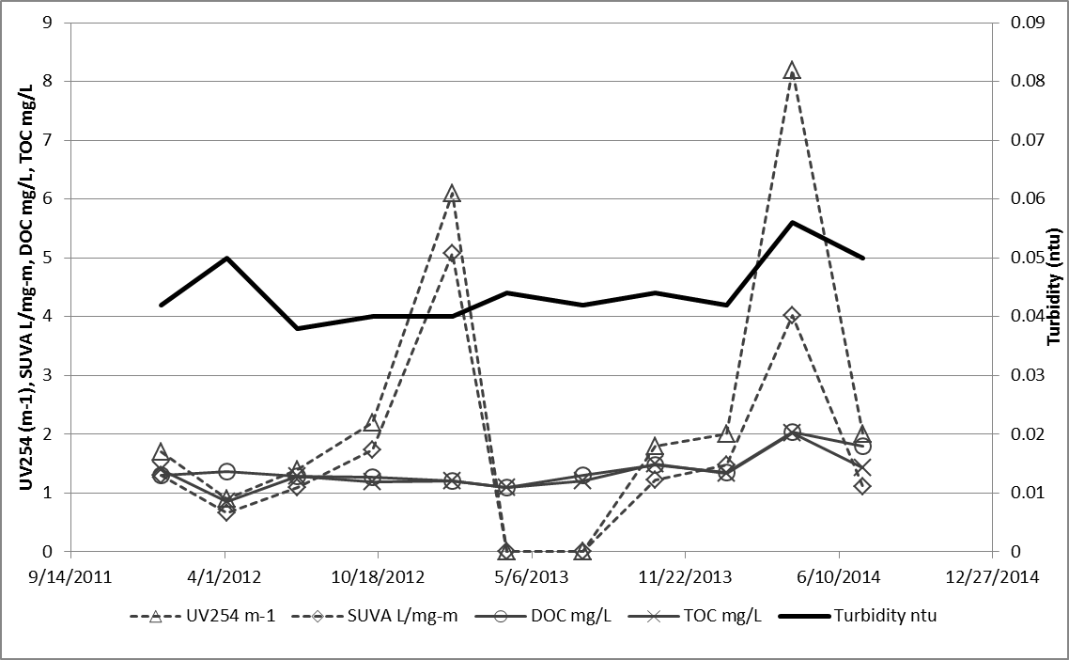
Figure 4 Comparison of Potential NOM surrogates

In fact linear relationships between finished water TOC and finished water turbidity were developed for the three utilities that monitor TOC quarterly (figure 5). The three relationships were unique in slope, and while TOC ranges were similar, turbidity ranges varied widely.

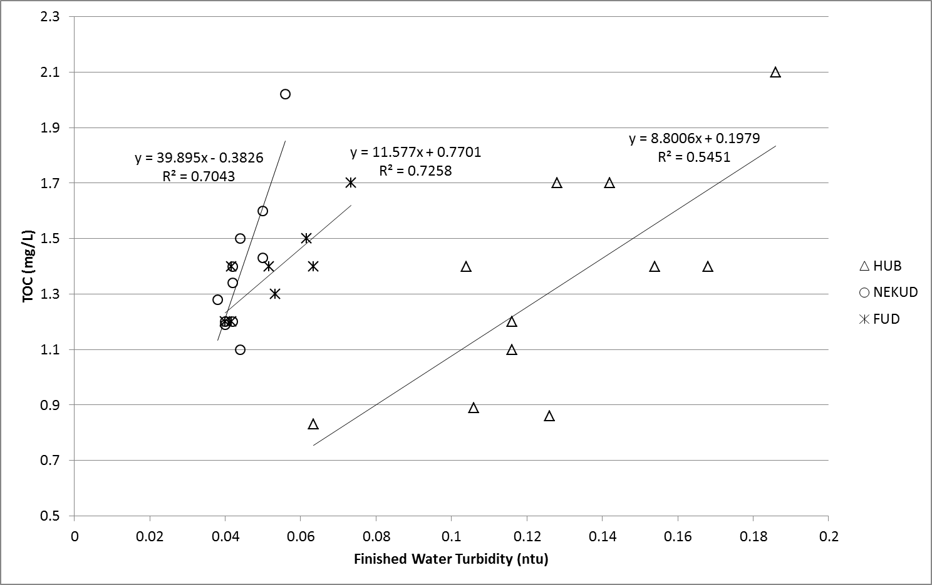
Figure 5 Relationships between turbidity and TOC

3.3 Trihalomethane
Models for trihalomethane levels were developed with $R^{2}$ values between 0.73 and 0.80 for individual utilities and with $R^{2}$ of 0.75 for all utilities combined. Nine unique water quality and treatment parameters were included in at least one model.

3.3.1 SBCUD Trihalomethane

A THM formation model was developed for SBCUD with $R^{2}$=0.73 using age (hours), temp (°C) and lime dose (mg/L). As expected, water age and temperature have a significant positive relationship with THM levels. Lime dose has an inverse relationship with THM formation. Data from one THM sampling date (July 2013) were not included in the development of the model and were predicted within 10 µg/L. Overall, 87% of values were predicted within 10 µg/L. Table 2 shows parameter estimates, statistics, and boundary conditions for the model. Within boundary conditions, the model will predict THM values from 20 to 70 µg/L, the range typically experienced in the system. Figure 6 illustrates actual and predicted values of THMs, and Figure 7 illustrates the distribution of residuals. The equation for SBCUD is:

$$THMs=10.0368{(t)}^{0.2134}{(T)}^{0.8244}{(L)}^{-0.5238}$$

Where:

t= water age (chlorine contact time) in hours
T=temperature in degrees Celsius
L= Lime dose in mg/L

Table 2 SBCUD THM Model Parameters
Parameter | Estimate | Prob>[t] | Lower Boundary | Upper Boundary | Importance Rank
Intercept | 2.3063 |  | na | na
t | 0.2134 | <0.0001 | 13 | 130 | 1
T | 0.8244 | <0.0001 | 14 | 24 | 2
L | -0.5238 | 0.0028 | 26.5 | 46.5 | 3

Figure 6 SBCUD Predicted and Actual THMs

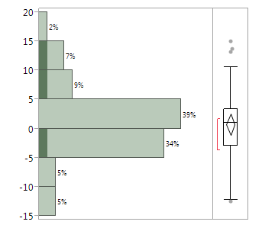
Dark values represent validation set
Figure 7 SBCUD THM Residual Distribution

3.3.2 HUB Trihalomethane

Water age (hours), temp (C), finished water turbidity (NTU), and pH adjustment dose (mg/L) are all significant predictors of THM levels for HUB ($R^{2}=0.79)$. Water age, temperature, and turbidity have a positive relationship with THM formation. Caustic soda (Sodium Hydroxide, NaOH) dose, added to adjust pH, exhibits an inverse relationship with THM formation. Data from one sampling site were not included in the development of the model. THM levels at this site were predicted within 20 µg/L, while overall 84% of values were predicted within 20 µg/L. Table 3 shows parameter estimates, statistics, and boundary conditions for the final model. The prediction range within boundary conditions is 9 to 180 µg/L, which more than encompasses the range of THM levels experienced in the distribution system. Figure 8 illustrates actual and predicted values of THM, and Figure 9 shows residual distribution. The equation for HUB is:
$$THMs=20.47081{(T)}^{0.6470}{(t)}^{0.1808}{(ntu)}^{0.5385}{(pHd)}^{-0.4156}$$

Where:
NTU= Finished Water Turbidity in Nephelometric Turbidity Units (NTU)
pHd= pH adjustment dose (mg/L)

Table 3 HUB THM Model Parameters
Parameter | Estimate | Prob>[t] | Lower Boundary | Upper Boundary | Importance Rank
Intercept | 3.0190 | <0.0001 | na | na
T | 0.6470 | <0.0001 | 3.3 | 30 | 1
t | 0.1808 | <0.0001 | 8 | 360 | 2
NTU | 0.5385 | 0.0263 | 0.085 | 0.223 | 3
pHd | -0.4156 | 0.0844 | 1.94 | 5.15 | 4

Figure 8 HUB Predicted and Actual THMs

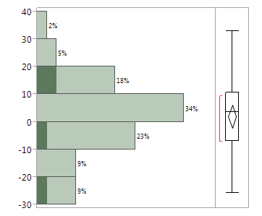
Dark values represent validation set
Figure 9 HUB THM Residual Distribution

3.3.3 NEKUD Trihalomethane

A model was developed with $R^{2}$=0.79 using age (hours), temp (C), disinfectant (NaClO) dose (mg/L), and finished water turbidity (NTU). All independent variables exhibit positive relationships with THM formation. Ninety percent of values were predicted within 20 µg/L. Data from one sampling site was employed as a validation set and THM levels were predicted within 20 µg/L with the exception of one value that was predicted 48µg/L higher than the actual value. All validation predictions were high, indicating water age may be less than calculated at this site, possibly due to a nearby water leak. Table 4 shows parameter estimates, statistics, and boundary conditions. The range of possible predictions within boundary conditions is 16 to 142 µg/L, coinciding with the range of observed values. Figure 10 illustrates actual and predicted values of THMs, and Figure 11 shows residual distribution. The equation for NEKUD is:

$$THMs=3.1166{(t)}^{0.2540}{(Cl)}^{1.4439}{(T)}^{0.4157}{(ntu)}^{0.4523}$$

Where:
Cl= Disinfectant (NaClO) Dose (mg/L)

Table 4 NEKUD THM Model Parameters
Parameter | Estimate | Prob>[t] | Lower Boundary | Upper Boundary | Importance Rank
Intercept | 1.1367 | <0.0001 | na | na
t | 0.2540 | <0.0001 | 10 | 181 | 1
Cl | 1.4439 | 0.0033 | 3.2 | 5.1 | 2
T | 0.4157 | 0.0075 | 9.3 | 25 | 3
NTU | 0.4523 | 0.0465 | 0.034 | 0.074 | 4

Figure 10 NEKUD Predicted and Actual THMs

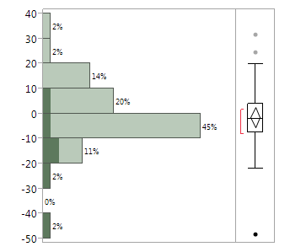
Dark values represent validation set
Figure 11 NEKUD THM Residual Distribution

3.3.4 FUD Trihalomethane

The final model for FUD ($R^{2}$=0.80) includes age (hours), temp (°C), pH of finished water, and finished water pumped to the distribution system (1,000 gal). Water age, temperature and pH exhibit expected positive relationships with THM formation. Water pumped to the distribution system is essentially an adjustment on water age for periods of extreme high or low flows through the distribution system. As distribution system throughput increased, water age and THM levels decrease. Data from one sampling date was withheld from model formation and predicted within 12 µg/L, overall 87% of values were predicted within 10 µg/L. Table 5 shows parameter estimates, statistics, and boundary conditions. Boundary conditions enable predictions from 8 to 159 µg/L, well outside the range of observed values. Figures 12 and 13 illustrate actual and predicted values of THMs as well as residual distribution. The equation for HUB is:
$$THMs=exp⁡(8.0208){(T)}^{1.2735}{(t)}^{0.1863}{(P)}^{-1.0682}exp⁡{(pH*0.1609)}^{}$$

Where:
P = Finished Water Pumped to system (1,000 gallons) (age adjustment)
pH= pH of finished water

Table 5 FUD THM Model Parameters
Parameter | Estimate | Prob>[t] | Lower Boundary | Upper Boundary | Importance Rank
Intercept | 8.0208 | 0.0016 | na | na
T | 1.2735 | <0.0001 | 9.63 | 26.6 | 1
t | 0.1863 | <0.0001 | 5 | 105 | 2
P | -1.0682 | 0.0003 | 5,882 | 14,738 | 3
pH | 0.1609 | 0.0299 | 6.8 | 7.9 | 4

Figure 12 FUD Predicted and Actual THMs

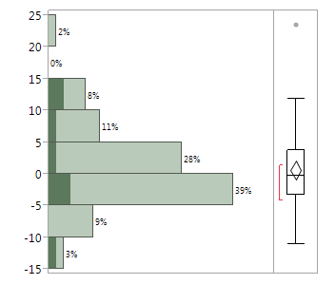
Dark values represent validation set
Figure 13 FUD THM Residual Distribution

3.3.5 General Trihalomethane Model

A general model was developed with $R^{2}$=0.75 using temperature (°C), water age (hours), finished turbidity (NTU), finished alkalinity (mg/L as ${CaCO}_{3}$), finished pH, and fluoride dose (mg/L). THMs increased with temperature, water age, turbidity, alkalinity, and pH. Interestingly, THM formation decreased significantly with fluoride dose in the finished water. Table 6 shows parameter estimates, statistics, and boundary conditions. Figure 14 illustrates actual and predicted values of THMs. The model was developed based only on data from SBCUD, HUB, and FUD. THM values for NEKUD are predicted within 20 µg/L in 80% of cases and within 30 µg/L in 95% of cases, comparable to the training set (92% within 20 µg/L). Means of residuals for the training and validation sets, as well as each of the four utilities, are not significantly different from each other. The equation for the general THM model is:
$THMs=1.0149{\left(T\right)}^{0.6525}{\left(t\right)}^{0.1712}{\left(NTU\right)}^{0.3545}{\left(Alk\right)}^{0.1271}exp⁡(pH*0.2123)(F^{-})^{-0.2704}$

Where:
Alk = Finished Water Alkalinity (mg/L as CaCO3)
$F^{-}$= fluoride dose (mg/L)

Table 6 General THM Model Parameters
Parameter | Estimate | Prob>[t] | Lower Boundary | Upper Boundary | Importance Rank
Intercept | 0.0148 |  | na | na
T | 0.6525 | <0.0001 | 3.3 | 30 | 1
t | 0.1712 | <0.0001 | 5 | 360 | 2
NTU | 0.3545 | <0.0001 | 0.01 | 0.22 | 3
Alk | 0.1271 | 0.0002 | 11.7 | 146 | 4
pH | 0.2123 | 0.0004 | 6.8 | 8.4 | 5
$$F^{-}$$ | -0.2704 | 0.0007 | 0.23 | 0.90 | 6

Figure 14 General Predicted and Actual THMs

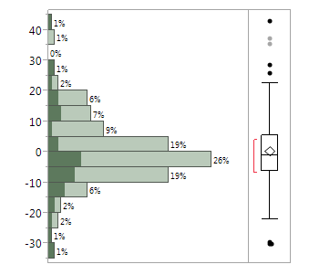
Dark values represent validation set
Figure 15 General THM Model Residual Distribution

3.4 Haloacetic Acid
Natural log models for haloacetic acid levels were developed with $R^{2}$ values between 0.52 and 0.77 for individual utilities and with $R^{2}$ of 0.67 for all utilities combined. Ten unique water quality and treatment parameters (water age, temperature, pH, turbidity, corrosion inhibitor dose, alkalinity, water pumped to system, disinfectant dose, coagulant dose, and fluoride concentration) were included in at least one model.

3.4.1 SBCUD Haloacetic Acid

A model was developed with $R^{2}$=0.76 using age (hours), and finished pH. Age exhibited the expected positive relationship with HAA levels, while pH exhibits the expected inverse relationship. Temperature is notably absent from the model. Table 7 shows parameter estimates, statistics, and boundary conditions. The range of predicted values is 20 to 40 µg/L and all values are predicted within 8 µg/L. One sample date was withheld from model development and was predicted within 5 µg/L. Figure 16 illustrates actual and predicted values of THMs. Figure 17 shows the distribution of residuals. The HAA equation for SBCUD is:

$$HAAs=51.9021{(t)}^{0.2078}exp{(pH*-0.1760)}^{ }$$

Where:

HAAs = Haloacetic acid concentration (µg/L)

Table 7 SBCUD HAA Model Parameters
Parameter | Estimate | Prob>[t] | Lower Boundary | Upper Boundary | Importance Rank
Intercept | 3.9494 | <0.0001 | na | na
t | 0.2078 | <0.0001 | 13 | 130 | 1
pH | -0.1760 | 0.0655 | 7.47 | 8.37 | 2

Figure 16 SBCUD Predicted and Actual HAAs

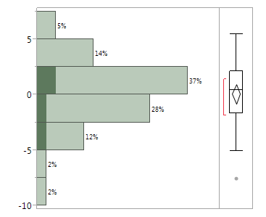
Dark values represent validation set
Figure 17 SBCUD HAA Residual Distribution

3.4.2 HUB Haloacetic Acid

A model was developed with $R^{2}$=0.77 using age (hours), temperature (C) and finished water turbidity (NTU) all with positive relationships. Table 8 shows parameter estimates, statistics, and boundary conditions. The model will predict HAAs from 12 to 102 µg/L within boundary conditions. Ninety percent of all values were predicted within 20 µg/L. Figure 18 illustrates actual and predicted values of THMs. The equation for HUB is:
$$HAAs=16.2750{(T)}^{0.7230}{(t)}^{0.1305 }{(NTU)}^{0.7997}$$

Table 8 HUB HAA Model Parameters
Parameter | Estimate | Prob>[t] | Lower Boundary | Upper Boundary | Importance Rank
Intercept | 2.7896 |  | na | na
T | 0.7230 | <0.0001 | 3 | 30 | 1
t | 0.1305 | 0.0010 | 8 | 360 | 2
NTU | 0.7997 | 0.0013 | 0.085 | 0.223 | 3

Figure 18 HUB Predicted and Actual HAAs

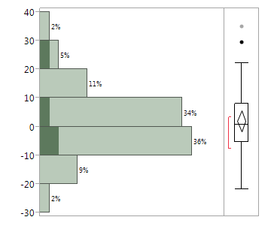
Dark values represent validation set
Figure 19 HUB HAA Residual Distribution

3.4.3 NEKUD Haloacetic Acid

A model was developed with $R^{2}$=0.52 using age (hours), temperature (C) and corrosion dose (mg/L). Increased corrosion inhibitor (phosphate, ${PO}_{4}$) dose results in decreased HAAs. Table 9 shows parameter estimates, statistics, and boundary conditions. Within boundary conditions, HAA levels from 4 to 37 µg/L can be predicted. One sampling location was employed as a validation set. Validation values were predicted within 5 µg/L, and 95% of all values were predicted within 15 µg/L. Figure 20 illustrates actual and predicted values of THMs. The equation for NEKUD is:
$$HAAs=0.2406{(T)}^{0.85500}{(t)}^{0.2296 }{(C)}^{-1.1672}$$
Where:

C = corrosion inhibiter dose (mg/L)

Table 9 NEKUD HAA Model Parameters
Parameter | Estimate | Prob>[t] | Lower Boundary | Upper Boundary | Importance Rank
Intercept | -1.4247 |  | na | na
T | 0.8550 | <0.0001 | 9 | 25 | 1
t | 0.2296 | 0.0002 | 10 | 181 | 2
C | -1.1672 | 0.0268 | 0.38 | 0.66 | 3

3.4.4 FUD Haloacetic Acid

A model was developed with $R^{2}$=0.59 using age (hours), corrosion dose (mg/L), finished alkalinity (mg/L as CaCO3), and water pumped to the distribution system per day (1,000 gal). One sample date was used as a validation set. All validation and 98%

Figure 20 NEKUD Predicted and Actual HAA

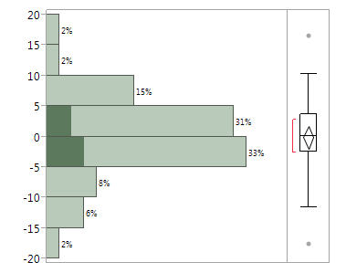
Dark values represent validation set
Figure 21 NEKUD HAA Residual Distribution

of all values were predicted within 15 µg/L. Validation values are generally over predicted, likely due to actual water age being lower than calculated possibly because of a nearby leak. The model is capable of predicting HAA values from 10 to 51 µg/L. Table 10 summarizes parameter estimates, statistics, and boundary conditions. Figure 22 illustrates actual and predicted values of THMs. Figure 23 presents distribution of residuals. The equation for FUD is:
$$HAAs=exp⁡(7.7448){\left(t\right)}^{0.1437}{\left(C\right)}^{-0.8260 }{\left(Alk\right)}^{-0.5257}{(P)}^{-0.3391}$$

Table 10 FUD HAA Model Parameters
Parameter | Estimate | Prob>[t] | Lower Boundary | Upper Boundary | Importance Rank
Intercept | 7.7448 |  | na | na
t | 0.1437 | <0.0001 | 5 | 105 | 1
C | -0.8260 | <0.0001 | 0.39 | 0.80 | 2
Alk | -0.5257 | 0.0031 | 81 | 146 | 3
P | -0.3391 | 0.0175 | 5,880 | 14,740 | 4

Figure 22 FUD Predicted and Actual HAAs

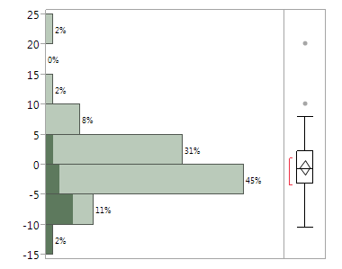
Dark values represent validation set
Figure 23 FUD HAA Residual Distribution

3.4.5 General Haloacetic Acid Model

A model was developed with $R^{2}$=0.67 using disinfectant dose (mg/L), coagulant dose, (mg/L), age (hours), temp (C), and finished fluoride concentration (mg/L). Disinfectant dose, age, and temperature have significant positive relationships with HAA formation, as expected. Similar to the THM model, fluoride concentration has an inverse relationship with HAA formation. Coagulant dose also exhibits an inverse relationship. Table 11 shows parameter estimates, statistics, and boundary conditions for the model. FUD data was not included in the development of the model and was used as a validation set. A wide range of HAA values, well outside those observed, can be predicted. Eighty percent of values are predicted within 10 µg/L for both training and validation sets. Means of residuals are not significantly different among training and validation sets, or among utilities with the exception of HUB. Figure 24 illustrates actual and predicted values of THMs. The equation for the general HAA model is:
$$HAAs=0.6845{\left(Cl\right)}^{1.5673}{\left(coag dose\right)}^{-0.0797 }{\left(t\right)}^{0.1686}{(T)}^{0.2231}{{(F}^{-})}^{-0.4625}$$

Where:
Coag dose = coagulant dose (mg/L)

Table 11 General HAA Model Parameters
Parameter | Estimate | Prob>[t] | Lower Boundary | Upper Boundary | Importance Rank
Intercept | -0.3791 |  | na | na
Cl | 1.5673 | <0.0001 | 1.5 | 8.7 | 1
Coag dose | -0.0797 | <0.0001 | 0* | 52.5 | 2
t | 0.1686 | <0.0001 | 5 | 360 | 3
T | 0.2231 | 0.0034 | 3 | 30 | 4
F- | -0.4625 | 0.0068 | 0.38 | 1.07 | 5

Figure 24 General Model Predicted and Actual HAAs

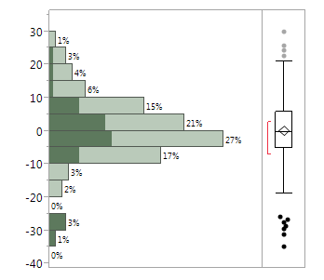
Dark values represent validation set
Figure 25 General HAA Model Residual Distribution

4.0 DISCUSSION

Lack of accurate water age is often a criticism of field scale DBP models. Earlier work has employed tracer studies or calculations of retention time based on pipe and tank volume and distance from treatment plant. Other field scale models where developed at one site or multiple sites independently and do not include water age as a parameter in the reported model.
A tracer at the NEKUD site shown in figure 4 could have been detected as early as 90 hours after introduction if it bypassed one or more storage tanks and traveled directly to the sampling location. In reality, water age at that site is as high as 180 hours with an average age of 155 hours. Tracer studies do not always provide a complete understanding of water age variation at a given site.
Simple retention time calculations based on storage volume in tanks and pipes and flow rate out of the plant are likewise not as accurate as the thousands of detailed calculations performed by a calibrated hydraulic model. This method omits spatial variability in demand as well as hydraulic flow nuances through different routes in the system.
For comparison, water ages at NEKUD were calculated using the retention time method often employed in field scale studies. Volume of pipes and tanks between the plant and sampling site were divided by flow rate through the system to determine age. This method was used by Shimazu et al. (2005) and Shimazu (2006) successfully ($R^{2}>0.74)$. Calculated ages were generally lower, on average 48 hours below modeled ages and 50% of modeled age. Next, NEKUD data was input into the general THM model with both modeled age and calculated age. NEKUD data was not included in the development of the general THM model and therefore modeled ages did not influence the model. With modeled age $R^{2}$=0.44 and with calculated age $R^{2}$ drops to 0.31. Furthermore, using calculated age a specific model for NEKUD could only be developed with $R^{2}$=0.67 and turbidity was no longer significant. For comparison the specific model with modeled water age had an $R^{2}$ of 0.79.
Water age proved to be the single most important predictor of THM and HAA formation. Water age ranked first in importance in four models, second in five, and third in one and was the only parameter to be included in all ten models. The importance of water age in each model and $R^{2}$ values of the models indicate that water age was calculated accurately. In fact $R^{2}$ values are higher than many field scale studies, even those at single sites that omit water age. Serodes et al. (2003) performed laboratory tests on treated waters from three utilities in Quebec. This study reported $R^{2}$ values of 0.56-0.92 using exact known time, along with temperature, TOC, and chlorine dose. A comparison of $R^{2}$ values is further evidence that water age calculations are accurate.
Although THM and HAA models with $R^{2}$ values ranging from 0.52 to 0.80 were developed for each individual utility as well as general models for all four utilities, parameters included in each model varied. Eleven parameters monitored at all utilities were included in at least one model. Some parameters have not been reported in THM or HAA models previously. Parameter estimates varied for independent variables included in multiple models, indicating the uniqueness of DBP formation at each Utility. Models were developed not solely on the basis of predictive power, but also on reasonable chemical principles. The appearance or absence of each parameter in each model can be explained chemically. In general, the absence of expected parameters is likely due to tightly controlled ranges during water treatment. Table 14 (in the appendix) summarizes all five THM models and the parameters included, as well as boundary conditions for each utility for each parameter, whether included in the model or not. Table 15 in the appendix does the same for HAAs.
Only water age (chlorine contact time) and temperature were included in every model. Furthermore, both of these parameters ranked first or second in importance in every model but one. Relationships between THM formation, chlorine contact time and temperature are well documented in the literature. THMs are slow forming and chemically stable, even at high finished water temperatures. Formation increases with temperature, but degradation does not.
Water pumped to the system only appeared in both FUD models as an adjustment to water age. FUD sees a 2.5 times increase in water production and consumption from a low day to peak day. The other three utilities see peak day over low day ratios of 1.3 to 1.5. These ratios likely do not drastically affect water age. Seasonal usage variation has been shown to have little effect on water age at a given location in some systems (Rodriquez 2004).
Finished water turbidity has a positive relationship with TOC and DOC (figure 1), hence its appearance in four models. The three linear relationships between TOC and turbidity (figure 5) were unique in slope indicating turbidity is affected by non-organics to varying degrees at the different utilities. These varied relationships indicate that TOC would be a better predictor of DBPs in the general models than turbidity. However, TOC calculated from these relationships was not a significant parameter in a model attempt using data from the three utilities that monitor TOC. This method of calculating TOC for each utility was also employed for comparison to existing models that include TOC as a parameter.
Increased chlorine dose, which appeared in two models, resulted in increased formation of both THMs and HAAs in the study. The omission of chlorine dose from the other eight models indicates that either chlorine dose does not vary sufficiently to affect DBP formation or that NOM, not chlorine, is the limiting reactant.
Coagulant dose appeared in the general HAA model with an inverse relationship to HAA formation. Coagulation is known to increase removal of DBP precursors (Vrijenhoek et al. 1998, Archer and Singer 2006, Duan et al. 2012). Especially interesting is the fact that this parameter appeared in the general model even though SBCUD coagulant dose is zero, yet its membrane filtration is expected to more efficiently remove precursors than conventional coagulation and filtration. In fact SBCUD’s turbidity range is lower than the other three. Membrane filtration may not be as effective in removal of NOM precursors specific to formation of HAAs over THMs.
The relationship between pH and DBP formation is also well known. THMs increase with pH while HAAs decrease. Finished pH was significant in the FUD and general THM models and in the SBCUD and general HAA models. Finished pH likely does not appear in other models because there is not enough variability in pH to have a significant effect on DBP formation. The general models allow for greater variability of parameters and the appearance of their effect on DBP formation.
Alkalinity and pH dose are closely related to pH and were often significant when pH was not. Alkalinity resists changes in pH in the distribution system, where pH tends to decrease. As would be expected, higher alkalinity results in higher THM formation in the general model and lower HAA formation in the FUD model. In these cases, resistance to change in pH is more significant than pH leaving the plant, as it may provide a better indication of pH after several days residence in the distribution system during which DBPs continue to form.
Lime and caustic soda are added to adjust (increase) finished water pH. Lime and caustic dose have inverse relationships with THM formation in two models (SBCUD and HUB). This is counterintuitive as the chemicals are meant to increase pH which would increase THM formation. However, when raw water is more acidic, more of these chemicals are required to adjust pH to the required range. Increased dose is not indicative of increased finished pH but rather increased chemical demand due to lower pH.
Added lime and caustic soda may also be softening the water. Water softening is known to have the observed negative affect on THM formation. As Calcium and Magnesium ions are precipitated out of solution, NOM that has adsorbed to the precipitates is also removed (Thompson et al. 1997, Gerwe 2003, Roalson et al. 2003, Russell et al. 2009). It is unclear whether pH at SBCUD and HUB is ever high enough for effective softening. A column in each data set was created for softening during treatment by taking the difference between raw and finished water hardness. This parameter did not turn out to be significant. NEKUD and FUD do not add chemicals specifically for pH adjustment or softening to their treated water. NEKUD and FUD do add corrosion inhibitors to combat corrosion in the distribution system. Corrosion inhibitor dose exhibited an inverse relationship with HAA formation at both utilities.
An interesting and unexpected relationship was found between fluoride concentration in finished water and DBP formation. An inverse relationship was significant in both general THM and general HAA models. Fluorine is a halogen, in the same group of the periodic table as chlorine, bromine, and iodine (all of which are known to form DBPs). However, Fluoride is extremely stable and non-reactive. In fact, fluoride is often used as a tracer because of its chemical stability (as is bromide). No existing literature was found studying the relationship between fluoride and chlorinated DBPs.
If fluoride concentrations vary among the four utilities, the parameter could appear in general models as an adjustment for some other uncaptured difference among the four utilities. Indeed, the means at the four utilities vary from 0.55 mg/L to 0.72 mg/L. An analysis of means showed that in fact only the means of NEKUD and FUD are not significantly different from each other.
Whether the general models were using fluoride to adjust among different utilities was investigated further. A two way analysis of variance (ANOVA) was performed on the residuals of general models developed for both THMs and HAAs without the fluoride parameters. The two parameters compared to residuals were Utility and fluoride dose (THMs) or concentration (HAAs). The results showed that fluoride dose was a significant predictor of THM residuals (Prob > F less than 0.1), but individual utility was not significant. For HAAs, both utility and fluoride concentration were significant. Each utility experienced near identical decreases in DBP residuals with increased fluoride dose/concentration. Figures 26 and 27 illustrate the results of the ANOVA and tables 12 and 13 provide statistics. The results of the two-way ANOVA do not prove that fluoride is simply compensating for otherwise uncaptured differences among utilities. Fluoride dose was not significant in any individual Utility’s models.
Fluoride dose exhibited several significant relationships with other water quality parameters. As fluoride dose increased, so did turbidity, alkalinity, raw pH, hardness, and disinfectant dose. Finished pH decreased significantly with fluoride dose. Most of these relationships would increase DBP formation, while DBP formation actually decreased with fluoride dose. The effect of fluoride dose/concentration on DBP formation should be studied in an experimental setting to rule out any relationship.
Figure 26 Two-Way ANOVA THM Residual without Fluoride Parameter

Table 12 THM Residual, Utility, and Fluoride Dose Effect Tests
Source | Nparm | DF | Sum of Squares | F Ratio | Prob > F
ln F- dose (mg/L) | 1 | 1 | 0.39847724 | 8.9433 | 0.0033
Utility | 2 | 2 | 0.07470941 | 0.8384 | 0.4345

Figure 27 Two-Way ANOVA HAA Residual without Fluoride Parameter

Table 13 HAA Residual, Utility, and Fluoride Concentration Effect Tests
Source | Nparm | DF | Sum of Squares | F Ratio | Prob > F
ln Finished F- (mg/L) | 1 | 1 | 0.3441663 | 3.1072 | 0.0803
Utility | 2 | 2 | 1.4171092 | 6.3971 | 0.0022

Predictive power of existing models was studied for comparative purposes. Many existing THM and HAA models did not apply as they used parameters not included in the data set, often SUVA, ${UV}_{254}$, or Bromide ion concentration. Bromine, which is not monitored on MORs, can take the place of Chlorine in both THMs and HAAs. Brominated DBPs varied by utility and accounted for approximately 8-65% of THMs and 0-35% of HAAs in the study. Three existing THM models and one existing HAA model could be applied to the data set.
When data was input to existing models, results varied. Appendix B includes comparisons of existing models for THMs and HAAs that clearly do not apply to these utilities. Interestingly, a THM model produced by Rodriguez et al. (2000) by combining US lab scale data developed by Amy et al. (1987a), Rathbun (1996a) and Montgomery Watson and AWWA (1991) does a decent job of predicting DBP formation in East TN. In every case, the utility specific model has the highest R² followed by the general model and then Rodriguez’s model. Rodriguez’ model has a comparable R² value to the general model for SBCUD. Rodriquez’s model had worse performance for the other three utilities. Furthermore, this model under predicts nearly every value for HUB and there is a clear pattern to residuals for FUD (low values are under-predicted and high values are over-predicted). Nonetheless, there appear to be similarities across geographic regions. The equation for Rodriguez’s model is:
$$THM=0.044{(DOC)}^{1.030}t^{0.262}{pH}^{1.149}D^{0.277}T^{0.968}$$

To be fair, DOC was calculated from a relationship with turbidity to enable the use of this model. R² values for Rodriquez’s model might likely be higher if DOC was measured. Certainly, all models would improve if DOC had been included in the data set. Figures 28 through 32 compare actual and predicted values for each of the three models (specific, general, and Rodriguez) for each of the four utilities. R² values are reported in the figures for each model and may differ from those reported above as they now include validation values in the R² calculation.

Figure 28 Comparison of Models SBCUD

Figure 29 Comparison of Models HUB

Figure 30 Comparison of Models NEKUD

Figure 31 Comparison of Models FUD

Figure 32 Comparison of Models All Utilities

5.0 CONCLUSION
Water age determined by hydraulic modeling with carefully calibrated water models is a significant predictor of both THM and HAA levels in the distribution system. Water age ranked first in importance in four models, second in five, and third in one and was the only parameter to be included in all ten models. Accurate calculations of this influential parameter are imperative. The hydraulic modeling method of determining water age can eliminate the problem of unknown or estimated water age in field scale THM and HAA formation studies.
Relationships of water age, temperature, pH, chlorine, and turbidity were confirmed and quantified. Chemicals that have not appeared in previous models, and are added for other aspects of treatment also predicted DBP formation (i.e. corrosion inhibitor, lime, caustic soda, fluoride). Caution should be exercised in interpreting the effect of these chemicals on DBP formation. Increased dosage may not increase/decrease DBP formation, rather changes in dose are a result of an underlying condition. The application of these chemicals must balance their intended use with DBP formation. Through an understanding of specific and regional relationships, Utilities are armed with strategies to control DBP formation.
Residuals in developed models are likely at least partially explained by fluctuations in TOC, DOC, UV254 or SUVA. Syncing TOC monitoring with DBP sampling and including UV254 and SUVA could improve models. Residuals are likely further explained by variations in retention time at each site identified by hydraulic modeling.
In this study Fluoride (concentration or dose) is a significant predictor of both THMs and HAAs but is known to be non-reactive. Further experimental study is needed on the relationship between Fluoride and DBP formation.
Utilities can quickly develop their own site specific THM and HAA models from data already on hand and a hydraulic model. Data from MORs can predict DBP formation for a specific utility with higher accuracy than previous laboratory and field studies. Parameters with known relationships are often not significant in these models as they are essentially held constant at the treatment plant.
General models for THM and HAA formation predicted levels at all four utilities with consistent accuracy. Greater variability in parameters across utilities allowed for the appearance of additional variables. Field scale studies of multiple utilities can produce a model that is not site specific but applies to utilities in the same geographic region with similar source water and treatment processes. Utilities must be cautious in using existing models as they may poorly predict DBP formation in the Utility’s specific situation. A comparison to an existing model developed with databases of laboratory data from different regions suggests a universal model could be created. However, as models become more general, they also become less accurate.

LIST OF REFERENCES

Amy, G. L., Chadik, P.A. and Chowdhury, Z.K. (1987) Developing models for predicting trihalomethane formation potential and kinetics. Journal AWWA 79 (9), 89-97.

Amy, G.L., Siddiqui, M., Ozekin, K., Zhu, H. and Wang, C. (1998) Empirical based models for predicting chlorination and ozonation byproducts: haloacetic acids, chloral hydrate, and bromate. EPA report CX 819579.

Amy, G., Bull, R., Craun, G.F., Pegram, R.A. and Siddiqui, M. (2000) Environmental health criteria 216: Disinfectants and disinfectant byproducts. World Health Organization, Geneva.

Archer, A.D., Singer, P.C. (2006) Effect of SUVA and enhanced coagulation on removal of TOX precursors. Journal AWWA 98 (8), 97-107.

Boorman, G.A., Dellarco, V., Dunnick, J.K., Chapin, R.E., Hunter, S., Hauchman, F., Gardner, H., Cox, M. and Sills, R.C. (1999) Drinking water disinfection byproducts: review and approach to toxicity evaluation. Environmental Health Perspective 107(Suppl. 1), 207-217.

Chang, E.E., Chao, S., Chiang, P. and Lee, J. (1996) Effects of chlorination on THM formation in raw water. Toxicological & Environmental Chemistry 56 (1-4), 211-225.

Charisiadis, P., Andra, S.S., Makris, K.C., Christophi, C.A., Skarlatos, D., Vamvakousis, V., Kargaki, S. and Stephenou, E.G. (2015) Spatial and seasonal variability of tap water disinfection by-products within distribution pipe networks. Science of the Total Environment 506-507, 26-35.

Chowhurdy, S., Champagne, P. and McLellan, P.J. (2009) Models for predicting disinfection byproduct (DBP) formation in drinking waters: A chronological review. Science of the Total Environment 407, 4189-4206.

Duan, J., Cao, X., Chen, C., Shi, D., Li, G., Mulcahy, D. (2012) Effects of Ca${(OH)}_{2}$ assisted aluminum sulfate coagulation on the removal of humic acid and the formation potentials of tri-halomethanes and haloacetic acids in chlorination. Journal of Environmental Sciences 24 (9), 1609-1615.

Engerholm, B., and Amy, G.A. (1983) A predictive model for chloroform formation from humic acids. Journal AWWA 75 (8), 418-423.

Gerwe, C.E. (2003) Natural organic matter adsorption onto and coprecipitation with solids formed during softening. Doctoral dissertation, University of Texas, Austin.
Hua, G. and Reckhow, D.A. (2008). DBP formation during chlorination and chloramination: Effect of reaction time, pH, dosage, and temperature. Journal AWWA 100 (8), 82-95.

Hua, G. and Reckhow, D.A. (2012) Effect of alkaline pH on the stability of halogenated DBPs. Journal AWWA 104 (2), 49-50.

Huixian, Z., Sheng, Y., Xu, X. and Ouyong, X. (1997) Formation of POX and NPOX with chlorination of fulvic acid in water: empirical models. Water Research 31 (6), 1536-1541.

Kitis, M., Karanfil, T., Wigton, A. and Kilduff, J.E. (2002) Probing reactivity of dissolved organic matter for disinfection byproduct formation using XAD-8 resin adsorption and ultra-filtration fractionation. Water Research 36, 3834-3848.

Liang, L. and Singer, P.C. (2003) Factors influencing the formation and relative distribution of haloacetic acids and trihalomethanes in drinking water. Environmental Science and Technology 37 (13), 2920-2928.

McBean, E., Zhu, Z. and Zeng, W. (2010) Modeling formation and control of disinfection byproducts in chlorinated drinking waters. Water Science & Technology: Water Supply 10 (5), 730-739.

McClellan, J.N. (2000) Modeling chlorine decay and chlorination by-product formation in water treatment and distribution. Doctoral dissertation, University of Massachetts, Amherst.

Montgomery Watson and AWWA. (1991) Disinfection/ disinfection by-products database and model project. American Water Works Association, Denver, Colorado.

Pomes, M.L., Green, W.R., Thurman, E.M. and Orem, W.H. (1999) DBP formation potential of aquatic humic substances. Journal AWWA 91 (3), 103-115.

Rathbun, R.E. (1996a) Regression equations for disinfection byproducts for the Mississippi, Ohio and Missouri rivers. Science of the Total Environment 191 (3), 235-244.

Rathbun, R.E. (1996b) Speciation of trihalomethane mixtures for the Mississippi, Missouri and Ohio rivers. Science of the Total Environment 180 (2), 125-135.

Reckhow, D.A., Singer, P.C. and Malcolm, R.A. (1990) Chlorination of humic materials: By-product formation and chemical interpretations. Environmental Science and Technology 24, 1655-1664.

Richardson, S.D., Plewa, M.J., Wagner, E.D., Schoeny, R. and Demarini, D.M. (2007) Occurrence, genotoxicity and carcinogenicity of regulated and emerging disinfection by-products in drinking water: A review and roadmap for research. Mutation Research 636, 367-373.

Roalson, S.R., Kweon, J., Lawler, D.F., Speitel, G.E., Jr. (2003) Enhanced softening: effects of lime dose and chemical additions. Journal AWWA 95 (11), 97-109.

Rodriquez, M.J., Serodes, J-B. and Morin, M. (2000) Estimation of water quality compliance with trihalomethane regulations using modelling approach. Journal of Water Supply Research Technology AQUA 49, 57-73.

Rodriquez, M.J., Serodes, J-B. and Levallois, P. (2004) Behavior of trihalomethanes and haloacetic acids in a drinking water distribution system. Water Research 38, 4367-4382.

Rodriquez, M.J., Serodes, J-B., Levallois, P. and Proulx, F. (2007) Chlorinated disinfection by-products in drinking water according to source, treatment, season, and distribution location. Journal of Environmental Engineering and Science 6, 355-365.

Russell, C.G., Lawler, D.F., Speitel, G.E., Jr. (2009) NOM coprecipitation with solids formed during softening. Journal AWWA 101 (4), 112-124.

Scheili, A., Rodriguez, M.J. and Sadiq, R. (2015) Seasonal and spatial variations of source and drinking water quality in small municipal systems of two Canadian regions. Science of the Total Environment 508, 514-524.

Serodes, J.B., Rodriguez, M.J., Li, H., Bouchard, C. (2003) Occurrence of THMs and HAAs in experimental chlorinated waters of the Quebec City area (Canada). Chemosphere 51, 253-263.

Shimazu, H., Kouchi, M., Sugita, Y., Yonekura, Y., Kumano, H., Hashiwata, K., Hirota, T., Ozaki, N., Fukushima, T. (2005) Developing a model for disinfection by-products based on multiple regression analysis in a water distribution system. Journal of Water Supply Research and Technology-AQUA 54 (4), 225-237.

Snoeyink, V.L. and Jenkins, D. (1980) Water Chemistry, John Wiley & Sons, USA.

Summerhayes, R.J., Morgan, G.G., Lincoln, D., Edwards, H.P. Earnest, A., Rahman, B., Byleveld, P., Cowie, C.T. and Beard, J.R. (2011) Spatio-temporal variation in trihalomethanes in New South Wales. Water Research 45, 5715-5726.

Sadiq, R. and Rodriguez, M.J. (2004) Disinfection by-products (DBPs) in drinking water and predictive models for their occurrence: a review. Science of the Total Environment 321, 21-46.

Thompson, J., White, M., Harrington, G., Singer, P. (1997) Enhanced softening: Factors influencing DBP precursor removal. Journal AWWA 89 (6), 94-105.

Vrijenhoek, E.M., Childress, A.E., Elimelech, M., Tanaka, T.S., Beuhler, M.D. (1998) Removing particles and THM precursors by enhanced coagulation. Journal AWWA 90 (4), 139-150.
Watson, M. (1993) Mathematical Modelling of the Formation of THMs and HAAs in chlorinated natural waters. AWWA, Denver, Colorado.

Wei, J., Ye, B., Wang, W., Yang, L., Tao, J. and Hang, Z. (2010) Spatial and temporal evaluations of disinfection by-products in drinking water distribution systems in Beijing, China. Science of the Total Environment 408, 4600-4606.

Zhang, X.-L., Yang, H., Wang, X., Fu, J., Xie, Y.F. (2013) Formation of disinfection by-products: Effect of temperature and kinetic modeling. Chemosphere 90(2), 634-639.

APPENDICES

Appendix A Example MOR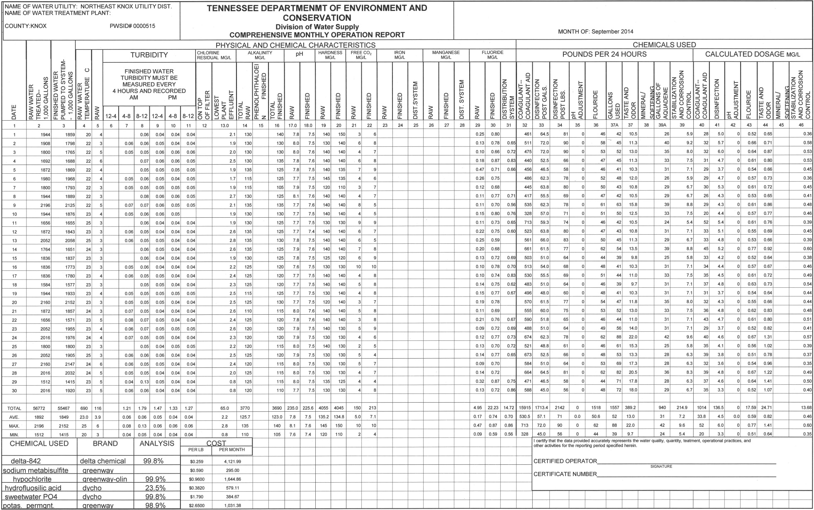

Appendix B Summary Tables

Table 14 THM Model Summary

Table 15 HAA Model Summary

Appendix C Comparison to Existing Models

VITA

Mr. Seth Fischer was born in Westfield, NJ on August 29, 1982. Seth’s family moved to Cary, NC in 1995 where he graduated from Athens Drive High School in 2000. Seth enlisted in the United States Army in June, 2004. He served as a wheeled vehicle mechanic and later as a technical engineer at various posts within the US and two tours in Iraq. While on Army Reserve status, Seth pursued a civil engineering degree at the University of Tennessee in Knoxville. He graduated August, 2011 with a Bachelor of Science in Civil Engineering and Environmental Engineering minor. Seth was honorably discharged from the U.S. Army in June 2012 with the rank of Staff Sergeant. Since graduation, Seth has worked in consulting engineering at Cannon & Cannon, Inc. in the Utility Department. He is now a project manager with experience in both drinking water and wastewater modeling, design, and construction administration. Seth earned a Master of Science in Environmental Engineering with an Environmental concentration from the University of Tennessee, Knoxville in August 2015. Seth lives in Knoxville, TN with his wife of 10 years, Jennifer, their three sons; Noah, Adam, and Sam, and two boxers, Oscar and Daisy.

