THE JOURNEYS OF SIX MOM PEDAGOGUES: ENACTING PERSONAL CONVICTIONS
AND DISRUPTING THE STATUS QUO

A Dissertation Presented for the
Doctor of Philosophy
Degree
The University of Tennessee, Knoxville

Macy Halladay
August 2022

Copyright © 2022 by Macy Halladay
All rights reserved.

ACKNOWLEDGEMENTS
Thank you to Dr. Moran, Dr. Akpovo, Dr. Potnis and Dr. Brookshire. You have been an amazing group of mentors, who fought for me and my success, no matter the circumstance. Special thanks for Dr. Jennifer Ward, Desmond and Bennett. Thanks to the Halladay Family, the Ward Family and all my friends.

I also dedicate my work to my past self who struggled and fought hard for this. Harder than I could have ever imagined. You did it.

ABSTRACT
Home education or “homeschooling” began to re-emerge in the late 1960’s in the US, parallel to civil rights initiatives and shifting educational policies (Murphy, 2014). Nevertheless, few studies have been dedicated to examining the lives and practices of homeschool parents (Goldberg, 2021; Lois, 2006; Ray, 2021). Rather, topics have largely centered on homeschool demographics, academic outcomes and challenges (Hauseman, 2011; Isenberg, 2007).

The purpose of this qualitative study was to examine the lived experiences of six homeschool mothers’ everyday lives and the meanings assigned to their pedagogical decisions and related feelings in their journeys of becoming Mom Pedagogues. The study took place in a metropolitan area in the southeastern region of the US. Six mothers, who were members of a home school group, were recruited through snowball sampling and were all female, white and middle class.

The study took place across nine months, including 39 weekly home visits and final, in-depth interviews. Data sources included field notes, audio recordings, and photographs taken by participants. At each visit, seminal moments of the week were represented and mediated through mothers’ photographs, which chronicled their experiences and recollections of memories from their childhoods in traditional school settings.

Three findings emerged that include (a) the identification of turning points in participants’ lives that led to homeschooling, (b) the role of desire, ethic of care, and need to ensure emancipatory learning experiences for their children, and (c) references to convictions to ensure learning experiences drew upon their children’s needs, everyday lives, and interests and a tolerance for an uncertainty that they were making the right decisions for their children. Findings illustrate the ways in which the mothers aimed to fill their lives with direction and meaning in accordance with their lifelong values and beliefs, taking advantage of everyday experiences imbued with their children’s decisions and desires to enact and pursue meaningful learning. Implications for future research include the need to value participants’ reflections and experiences from their childhoods to motherhoods, as they navigated their mothering and pedagogical roles in an effort to disrupt the status quo of formal educational for their children.

Table of Contents
CHAPTER ONE INTRODUCTION 1
Statement of Problem 2
Background and Context 3
Addressing the Phenomenon 4
Searching for the Gap in the Literature 5
Chapter Summary 6
CHAPTER TWO LITERATURE REVIEW 7
Theoretical Background 9
Bioecological Theory 9
Sociocultural Theory 12
Frameworks Influenced by Sociocultural Theory 18
Women’s Ways of Knowing, Ethic of Care and Maternal Desire 18
Women’s Ways of Knowing (WWK) 19
Ethic of Care 22
Maternal Desire 27
Foucault’s Analysis Power and Discipline 29
The Concept and Practice of Bildung 36
Review of the Literature and Homeschooling Trends in the Unites States 39
Historical Perspective 39
The Ideologues: The Moore’s and the Conservative Homeschooling Movement 41
The Pedagogues: John Holt and the Unschooling Movement 42
Current Homeschooling Trends and Research 44
Reasons to Homeschool 46
Homeschooling Teaching Approaches 47
Chapter Summary 48
CHAPTER THREE PURPOSE AND PROCEDURES 50
Purpose 51
Original Focus and Research Shift 51
Sampling and Protection of Human Participants 52
Context and Setting 55
Procedures and Timeline 57
Data Collection 57
Recruitment and Rapport Building 57
Consenting Process and First Visits 59
Collection of the Bulk of Data 59
Cleaning and Screening of Data 59
Data Sources 60
Demographic Questionnaire 60
Home Maps 60
Field Notes 62
Photographs 62
Photo Chat Transcription 65
Final Interview Transcriptions 65
Reflexive Journal 66
Data Analysis 68
Final Interviews and Photo Chats Analyses 69
Transcription Procedures 69
Coding Procedure 69
Open Coding 70
Axial Coding 74
Selective Coding 77
Field Notes and Reflexive Journal Analyses 79
Trustworthiness 80
Chapter Summary 84
CHAPTER FOUR MY ROLE AS A RESEARCHER 85
Positionality 86
My Ontological Assumptions 87
My Epistemological Assumptions 87
Human Nature Situated within Cultural Contexts 89
Being an Insider 89
Being an Outsider 90
Participant Observer 91
Reflexivity 93
My Ontological Assumptions 94
My Epistemological Assumptions 96
Human Nature Situated within Cultural Contexts 98
Chapter Summary 99
CHAPTER FIVE FINDINGS 101
Presentation of the Findings 102
Finding 1: Rejection and Renegotiation: Mothers’ Turning Points Toward Homeschooling 104
Recalling and/or Rejecting Childhood Experiences 106
Renegotiation of Parenting Practices 109
Family of Origin 109
Personal Parenting Practices 117
Leaving Public-school for Homeschooling 123
Finding 2: Becoming a Mom Pedagogue: Desire, Caring, and Emancipation 128
Maternal Desire and Ethic of Care 129
Maternal Desire 130
Ethic of Care 133
Becoming a Mom Pedagogue 141
Emancipation 141
Bildung 147
Finding 3: Enacting Personal Convictions through Uncertainty 156
Making Sense of Difficult Situations 158
Imagining a Positive Future 163
Communicating Beliefs and Values 167
Chapter Summary 177
CHAPTER SIX CONCLUSIONS, LIMITATIONS AND DISCUSSION 179
Limitations of the Research 181
Discussion Of Research Question 1: What are the Key Aspects that Influenced 182
Contribution to Women’s Ways of Knowing 185
Discussion Of Research Question 2: What Meanings Did the Participants Assign to Their Experiences and Emotions as Homeschooling Mothers? 187
Contribution to Bildung 193
Discussion of Research Question 3: In What Ways Did the Mothers Sustain Their Commitment to Homeschooling? 195
Contribution to Ethic of Care 198
Implications for Future Research 200
Methodological Considerations 201
Chapter Summary 202
LIST OF REFERENCES 204
APPENDICES 236
APPENDIX A 237
APPENDIX B 238
APPENDIX C 239
APPENDIX D 242
APPENDIX E 244
APPENDIX F 245
APPENDIX G 249
Vita 250

LIST OF TABLES
Table 1. Participant Profiles……………………………………………………….56
Table 2. Qualitative and Verification Criteria for Assessing Research Quality and
Trustworthiness.……………………………………….……………………..……..83

LIST OF FIGURES
Figure 1. Timeline of Study and Key…………………………………………...……… 58
Figure 2. Home Layout by Tessa and her Children (September 5th, 2019) .……….......61
Figure 3. Mother and her Kids from my Reflexive Journal (September 16th, 2019)..…..63
Figure 4. Example of a Participant Photo Sent During the Week (October 22, 2019)....64
Figure 5. Example of a Participant Photo Sent During the Week (October 11, 2019)....64
Figure 6. Final Interview Activity (January 7th, 2020) ……………………….………...67
Figure 7. Screenshot of Line-By-Line Analysis in Microsoft Excel ……….…………....72
Figure 8. Screenshot of A Chunk and Conceptual Memo in Microsoft Excel…..…….…72
Figure 9. 42 Open Codes Chart ……………………………………………………...…73
Figure 10. Example of Round 1 Axial Coding ……………………………………….…75
Figure 11. Example of Round 2 Axial Coding ……………………………………….…75
Figure 12. Final Axial Codes Chart …………………………………………....………76
Figure 13. Example of Selective Coding ……………………………………...………..78
Figure 14. Erica and her Family at the Aquarium …………………………..…….….115
Figure 15. Jamie’s Child Doing Math on the Floor of their Homeschooling Room ….119
Figure 16. Brittany and her Children Participating in a Homeschooling Activity ..….122
Figure 17. Brittany’s and Children Playing a Game during Homeschooling………….126
Figure 18. Tessa and her Children Looking at a Caterpillar ………………………..132
Figure 19. Emily and Tessa’s Children at an Amusement Park ……………………...135
Figure 20. Emily and her Children on an Adventure to a Park ……….……………...138
Figure 21. Zoey’s Children Playing at a Farm ………………………………...….....140
Figure 22. Tessa’s Youngest Child Playing in a Creek …………………….………...143
Figure 23. Brittany’s Homeschooling Task Board ………………………….………..145
Figure 24. Fay’s Children Diverting the Creek ……………………………………...150
Figure 25. Tessa’s Homeschooling Table ……………………………………………153
Figure 26. The FFTT Group at a Museum …………………………………………...161
Figure 27. Tessa Reading with her Children in their Home …………...…………….172
Figure 28. Jamie’s Homeschooling Bulletin Board ………………………………….174
Figure 29. Tessa’s Daughter Running as a Butterfly through the Park ...…………...176

Introduction
The practice of homeschooling can be considered one of the oldest forms of personal education throughout history, but eventually disappeared into the background of American life with the emergence of public education and policy during the early 1900’s (Beck, 2018). However, home education or “homeschooling” began to re-emerge in the late 1960’s with civil rights initiatives and shifting educational policies (Murphy, 2014). This re-emergence has continued to grow until the present day. Generally, homeschooling parents aim to have an active and supportive presence in their children’s everyday lives and are dedicated to providing both individualized learning experiences and close familial interactions (Godfrey Smith, 2022; Greenwalt, 2019).
Nevertheless, the term “homeschooling” is disingenuous and often leads others to envision children crouched around worksheets with their parent acting as a “home teacher.” Homeschooling parents, however, commonly seek to create unique and rich learning experiences both inside and outside the home which often translates into an instilled appreciation for learning. Yet, few studies have been dedicated to examining the lives and practices of homeschool parents (Goldberg, 2021; Lois, 2006; Ray, 2021). Rather, topics are usually centered on homeschool demographics, academic outcomes and challenges (Hauseman, 2011; Isenberg, 2007; Lines, 2000; Shepherd, 2010). The primary purpose of this study was to investigate the deeper meaning and processes of homeschool mothers’ behaviors related to their children’s learning, situated in the individual spaces and places of each family.

Statement of Problem
Research shows the homeschool movement is experiencing an unprecedented rise in the United States (Lawrence, 2012; Ray, 2021), with the fastest growing group of homeschoolers being “secular or non-religious” (McShane, 2018, p. 14). As the homeschool movement within has gained traction, researchers began to study homeschooling parents directly (Coleman, 2014; Gaither, 2008). Specifically focusing on homeschool family demographics and parental motivations. For example, Davis (2011) proclaimed:
Homeschooling requires a great deal of work in deciding and developing curriculum, learning how to manage time, learning how to organize requirements and document everything, understanding the laws and regulations for homeschooling, ability to apply curriculum to the state standards, and designing curriculum that is both effective and engaging. For parents who do not have teaching backgrounds, homeschooling can be a daunting endeavor. (p. 33)
By examining the endeavors and experiences of homeschooling parents, there is an opportunity for homeschool research to examine the meaningful ways in which parents practice homeschooling as they care for their children. Therefore, this qualitative study sought to explore the lived experiences of six homeschooling mothers by asking the following research questions:
RQ 1: What are the key aspects that influenced homeschooling mothers to homeschool their young children?
RQ 2: What meanings did the participants assign to their experiences and emotions as homeschooling mothers?
RQ 3: In what ways did the mothers sustain their commitment to homeschooling?

Background and Context
This dissertation is positioned to inform how these homeschooling mothers cared for and educated their children, and how to potentially engage future homeschoolers. Homeschoolers are not a monolithic group but by examining the dual roles of both mother and teacher, it can illustrate the value of tailoring learning to both the parent and their children. Thus, it is worth examining the day-to-day life and rich interpersonal exchanges between these Mom Pedagogues and their children. The term Mom Pedagogue is defined and generated from the data for this dissertation as a homeschool mother who facilitates learning with her children through the creation of settings in which her children are able discover their own uniqueness as individuals and actively participate in real-life activities, with an emphasis on the caring relationship between mother and child.
My interest in homeschooling mothers stems from my own curiosity of parenting and learning, for example, the tools parents use to help their children learn and grow within the home. I conducted this research from a first-person narrative informed by my etic point of view as a participant observer, as well as the participants’ emic viewpoints (Denzin & Lincoln, 1998; Miles & Huberman 1994). Further, a majority of the previous research conducted on homeschooling has been almost entirely focused on homeschooled children, with few studies centered on the homeschooling parents, themselves.
This study is anchored in the key tenets of Bioecological and Sociocultural Theories and how mothers viewed their own roles and how they act out those identities through actions and meaning making. The theories informed my understandings about the ways in which the mothers developed their own personal epistemological beliefs, the acquisition of knowledge, their role in the learning process for themselves and their children, and their lifelong experiences. In addition to the key tenets of the above theories, five frameworks including Women’s Ways of Knowing,
Ethic of Care and Maternal Desire followed by Foucault’s analysis of power and discipline and the concept of Bildung helped illuminate the stories of the six Mom Pedagogues.

Addressing the Phenomenon
This qualitative research was conducted with six homeschooling mothers and their families located in a metropolitan area in the Southeastern, United States. Data was collected across nine months, during which observations, journals, photo chats related to participant photographs and the final interviews were conducted in the participant homes. Data were collected within the smaller context of each mother’s home, and usually took place in the spaces designated by each participant. The triangulation of data was the rationale for generating data across multiple sources were focused participants narratives, discourses and the meanings the participants assigned to them (Denzin & Lincoln, 1998).
This study used images as a tool to help empower, facilitate and mediate conversations with the mothers about their experiences. The photographs and related conversations illuminated various practices, marked by essential spaces and materials, which helped the mothers develop tools and strategies needed to engage their children. The storytelling aspects of the narratives helped mothers reveal parts of themselves while recollecting on their everyday experiences as Mom Pedagogues. Use of styles is helpful in generating a table of contents. This sample document uses the headings to automatically generate the table of contents, list of tables, and list of figures.

Searching for the Gap in the Literature
A review of the literature was conducted with the direction of a university department librarian (whose expertise includes a focus on children and families) to survey the research on homeschool, mother and motivations, perspectives, and experiences. The combination of mother and homeschool was used first to identify empirical articles with the following databases: ERIC, PsycInfo, and ProQuest. My goal was to determine if the emerging trends in my early data analysis were prevalent or not in the literature and 3,281 articles were identified.
In the subsequent review round, the following terms were added motivations, perspectives, experiences in combination with the previous terms of mother and homeschool resulting in the identification of 74 articles. In the third round of the review, articles were removed that did not specifically focus on the lived experiences of homeschooling mothers, as opposed to reasons for homeschooling, homeschooling demographics and academic outcomes. These three topics have dominated the empirical trends of homeschooling research in recent decades and therefore, were eliminated leaving 38 articles that represented the criteria. Next, all articles which were focused on child outcomes or child related research procedures were removed. At the end of four rounds of review, 15 articles remained and deemed relevant to the focus of the study and were referenced in this dissertation. Once you use styles to generate the lists, you can update them quickly and easily.

Chapter Summary
Homeschooling research has increased in popularity in the past twenty years and is beginning to explore more nuanced topics (Baker, 2021; Goldberg, 2021; Kunzman & Gaither, 2013; Ray 2010b/2021), including parental motivations and factors about why they choose to homeschool their children (Davies & Aurini, 2003; Green & Hoover-Dempsy, 2007; Kunzman, 2012; Ray, 2010b). Therefore, a more in-depth study of the homeschool mothers and their lived experiences is warranted. This study’s purpose and rationale have been introduced with the theoretical underpinnings and conceptual frameworks used to analyze the data.
In Chapter II, a description of the scholarly and theoretical contexts is provided. The review of literature ends with the historical background and current research and practices related to homeschooling in the United States. Chapter III focuses on the purpose and procedures of the study, followed by a more in-depth exploration of my Role as a Researcher in Chapter IV. Findings from analyses of the data are presented in Chapter V. Chapter VI includes discussion of findings, limitations and implications for future research.

Literature Review
This qualitative study explored the lived experiences of six homeschooling mothers and the aspects that influenced their ways of being. Children often experience institutionalized expectations of how to behave and learn when attending public and/or private school. Thus, these mothers in this study sought to provide different experiences for their children free from the constraints and expectations of formal education. These mothers continued to fulfill the demands of their motherhood role while also taking on expectations associated with their “teacher role” of their children’s education. The focus of this present study was to explore beyond homeschooling curricula by examining the lived experiences of homeschooling mothers with a focus on both their mother and teacher selves. This study is informed by key tenets of Bioecological and Sociocultural Theories in order to explore the motivations and influences of these Mom Pedagogues. Using participant observation and storytelling approaches made visible by photographs taken by mothers made visible everyday homeschool experiences.
This study aimed to follow the mothers across nine months of homeschooling to understand and uncover the meaning of their experiences. In many homeschool families, the parents must serve a dual role in being both the parent and teacher, working hard to create an optimal and productive learning environment for their children (Green, Hoover-Dempsey & Sandler 2007; Kraft & Dougherty, 2013). In this role, parents become active participants in the homeschool process with their children and how that participation may look is often influenced from their own cultures (Danley & Burch, 1978; Gann & Carpenter, 2017). Culture connects the human experience and transforms activity into development and learning as soon as a person (child) becomes a part of the socialization process (Smyth, Downs & McInerney 2014).
The following review of the literature explores the application of theories and frameworks used for this study, the history of the homeschooling movement, and current homeschooling research and trends. This review will begin with a description of Bioecological and Sociocultural Theories related to how mothers view their own roles and how they act out these identities through their actions and meaning making. These theories help inform the ways in which the mothers developed their own personal epistemological beliefs, acquisition of knowledge, and roles in the learning process for themselves and their children. Further, key theoretical constructs help illuminate how the lived experiences of the mothers became shared practices with their children, materials, and their environments.
Following an overview of the two major theories, additional applications of the key tenets of Sociocultural Theory through smaller yet influential frameworks will be used to interpret the lives of these mothers. The applications begin with Women’s Ways of Knowing, Ethic of Care and Maternal Desire, followed by Foucault’s analysis of power and discipline and ending with the concept of Bildung. A review of the background and history of homeschooling will follow and conclude with current issues and trends of homeschooling, followed by homeschool practices and families’ motivations and reasons to homeschool their children while situating this study within the review.

Theoretical Background
Two primary theories, Bioecological Theory (Bronfenbrenner, 1994) and Sociocultural Theory (Vygotsky, 1987) informed this study. In particular, the key tenets of Bioecological Theory include (a) how the contexts of development are organized, (b) the interdependency among various environments and (c) changing contexts of becoming mothers and teachers. Sociocultural Theory will be used to contextualize and interpret homeschooling learning environments by examining the interactions and cultural beliefs of the participants. The theory emphasizes that human development occurs through participation in cultural activities situated in communities (McLean, 2021; Rogoff, 1995). Additionally, the theory posits cultural groups and individuals do not remain the same because individuals relate to their communities and experiences in emerging different ways (Purwati, 2022; Tour, 2020; Vygotsky, 1978). Thus, utilizing Sociocultural Theory to evaluate the influences and experiences of homeschooling mothers allowed for further examination of their lived experiences, as well as the meanings assigned to their practices. Collectively, the main theories and supplementary frameworks illuminated the stories of the participants regarding their decisions to homeschool and provided a complementary lens for understanding the lived experiences of six homeschooling mothers.

Bioecological Theory
Bioecological Theory argues that one’s development and behavior is a function of interactions between the individual and environment (Bronfenbrenner, 1979). Therefore, Bioecological Theory is grounded in the interactional study of individuals, families, and communities (Brown & Sumner, 2019; Bubolz & Sontag, 1993). This theory focuses on how environments and the ways contexts shape an individual’s behavior such as parenting values, beliefs, practices and/or community involvement. Additionally, this theory helps explain the experiences of individuals within their environments as well as the study of the whole system, suggesting the interdependence of the nested environments (Bubolz & Sontag, 1993). Consequently, the core tenet of Bioecological Theory is that the individual interacts with the environment and the environment interacts with the individual (McGuire & Norman, 2018). The environment is also comprised of multiple levels, each affecting one another. For these homeschooling mothers, no single factor defined how they became who they are, rather a bidirectional relationship between people, and in particular settings, contributed to their lifelong experiences.
Bioecological Theory lends itself to interpreting and exploring homeschooling mothers as it directly addresses the interdependency between various environments and the changing contexts of homeschooling mothers (McGregor, 2020; Cowan & Cowan, 1995). Specifically, homeschooling mothers not only face changes on an individual level resulting from shifting roles, but relationships are also renegotiated upon taking on a new role in their children’s learning lives. Moreover, larger systems including the family of origin may often influence expectations of the homeschooling experience (Firmin, Younkin & Sackett, 2018; Fletcher, 2019). Particularly, these systems are not solely mutually exclusive and, therefore, must operate with mutual support to balance mothers’ roles as parents and teachers (Ahi & Sengil-Akar, 2021; Corbitt, 2020; Margolin, Gordis, & John, 2001).
Bronfenbrenner (1981) theorized that a person is, from the moment of birth, nested within social and cultural systems that inform and permeate every interaction. He organized the contexts of development into five embedded bidirectional environmental systems. This framework offers understandings of the relationships in which children learn across multiple environments as well as their material use. He proposed that the individual is embedded within a microsystem or “immediate environment.” The microsystem includes, for example, home and school interactions. The microsystem may also include individual characteristics or individual trajectories. Next is the mesosystem, which is comprised of connections between immediate or microsystem environments (e.g., home-school interactions). The mesosystem often includes those with whom the individual interacts on a regular basis, usually children and their parents/guardians and/or family members. Moving outward from the mesosystem is the exo-system or “environmental settings.” Domains that exist within the exo-system indirectly affect development and usually do not include the individual (e.g., the parent's workplace, parent’s social network). Next, is the macrosystem which refers to main social ideologies and cultural values that may influence the other bioecological systems.
Bronfenbrenner (1989) later added the chronosystem which highlights the effect of time on all systems and all developmental processes. This refinement allowed the theory to be applied across the life course of an individual, bringing more similarities to other life course theories. Bronfenbrenner would argue that an individual’s parenting behaviors and practices are the product of multiple influences from one’s bioecological systems and a parents’ cognitions and decisions related to learning and care are influenced by their personality and developmental history, the child’s individual features, and the broader social context in which the parent–child relationship exists.

Sociocultural Theory
Rogoff’s (1981) and Wiesner’s (2002) work, influenced by key tenets of Vygotsky’s theory, has furthered Bronfenbrenner’s writing and thinking by placing culture as an intricate part of proximal development processes. Wertsch and Tulviste (1992) explain that Vygotsky viewed human functioning as “inherently social, or socio cultural, in that it incorporates socially evolved and socially organized cultural tools” (p. 551). Sociocultural Theory proposes that social interactions and cultural beliefs jointly contribute to an individual’s development (Vygotsky, 1978). This theory also argues that individuals “in all communities are cultural participants, living in a particular community at a specific time in history” and culture is dynamic and ever changing (Rogoff, 2003, p. 10). Further, development “depends in large part on the circumstances that are routine in their community and on the cultural practices they are used to” (Rogoff, 2003, p. 6). Additionally, Greenfield (2016) has presented a review of Sociocultural Theory that highlights some key tenets of the framework that helped guide this study. These include:
- Human development is multi-level and happens in response to a combination of personal short and long-term lived experiences as well as changes in social structure and cultural evolution.
- Development and learning are defined by social and cultural contexts, making analysis of cultural norms, practices, and biases a critical part of analyzing the learning process.
- Learning is directly tied to social contexts and the relationships that the learner holds with those around her or him. (p. 87)
Cultural process is understood to be an approach that acknowledges that several cultural communities tend to expect individuals to participate in different developmental activities at different times throughout their lives (England-Mason & Gonzales, 2020; Rogoff, 1990). This perspective of knowledge construction, being amassed and constructed through social and cultural schemas, may be particularly helpful in understanding the lived experiences and practices in homeschooling contexts (Abuzandah, 2020; Sabol, 2018; Schwartz, 2018). The challenge with understanding how cultural norms and practices impact learning and development lies in the understanding of what constitutes culture. Culture will be defined as normalized beliefs and practices which serve as models that help individuals make sense of the world around them (Loera, Rueda, & Nakamoto, 2011, p. 133).
The choice to homeschool comes with certain philosophical and pedagogical decisions and takes place in a different social and cultural context than does traditional schooling approaches. Parents in homeschool families contextualize the learning environments for their children and interpret them through a sociocultural lens that best aligns to both their parenting and learning values and motivations (Rogers & Way, 2021; Rogoff, 2014; Sabol, 2018). Sociocultural Theory has evolved as a theory of human development that connects the ontogeny of an individual with the cultural-historical environment in which she or he participates (Engerstrom, 1986; Thorne, 2005; Takeuchi, 2021; Vygotsky & Cole, 1987).
In the case of homeschooling mothers, who may find themselves transitioning back and forth between the culture surrounding motherhood and the culture surrounding educating children, the task of interpreting and abiding by group norms can be incredibly complex. Vygotsky’s (1980) claims that the “process of a person acquiring and creating knowledge always occurs in a social context and arises from not only the encounter of new and previous knowledge, but also the interrelationship of the person and the environment” (p. 575). Learning involves the creation of meaning and is directly tied to both short and long-term lived experiences, along with continuously evolving relationships with others. This orientation has profound relevance in understanding how these mothers understood themselves and conceptualized how they cared for and educated their children (Ertmer & Newby, 2013).
Vygotsky applied these principles by arguing that developmental processes and mental functioning must be addressed both historically and collectively. Sociocultural Theory is based on how culture mediates experiences, activities, routines, and individual cognitive functioning. Learning is viewed as a part of human nature and occurs through negotiation of meaning in everyday life (Bruner, 1986; Rogoff & Gardner, 1984). Vygotsky (1962) stated:
Direct teaching of concepts is impossible and fruitless. A teacher who tries to do this usually accomplishes nothing but empty verbalism, a parrotlike repetition of words by the child, simulating a knowledge of the corresponding concepts but actually covering up a vacuum. (p. 150)
Therefore, to understand human thinking and learning one must examine the context in which that thinking, and learning occurs, including the use of tools and sign that facilitate the co-construction of knowledge. These contemporary tools and materials often serve as the “go between” (Moran & Tegano, 2005) what is originally in the head of the learner and about to be learned via social and material interactions that promote learning and development, particularly in the context of a home-learning environments (Means & Olson, 1997; Wertsch & Tulviste, 1992). Therefore, children and adults living together allows for children to not only observe what adults do in everyday life, but they also interact with them in many situations. Children’s activities and learning to be adults cannot be separated from their daily lives (Lave & Wenger, 1991).
Rogoff (1990) has coined the phrase participatory appropriation as the process in which individuals’ appropriate new knowledge through participation in social settings (p. 139). Rogoff (2016) suggests that members of a given community undergo a process of socialization that might be called apprenticeship. During this apprenticeship process, “participants benefit from guided participation provided by community members and within communal activities and events, leading to individual members processes of participatory appropriation” (p. 473). This process allows individuals to participate fully in shaping and being shaped by their community. In this context, learning is seen not as an independent, individual process with social aspects but rather as a product of participation in a community. Barratt-Peacock (2003) explained that homeschooling can serve as a “super-model of a community of practice” (p. 36) because home learning usually takes place within the family unit of which children are members. Children who homeschool can experience mentorship and guided participation with other children as well as, through direct learning experiences from their parents (Jackson, 2015).
The context in which children are raised gives rise to the practice of activities and the use of cultural tools and materials for mediating activities, defined by Karan Barad as “intraactivities” (Barad, 2007; Hollin, Forsyth, Giraud & Potts, 2017). Barad (2007) argues that “materials and meaning are not separate elements” (p. 3) but are rather joined together during interactions. Aronsson and Taguchi (2018) have further developed Barad’s work by contending that intra-activity can also be re-conceptualized as an early childhood pedagogy in which meanings are produced in the intra-actions between children and materials. Intra-active pedagogy re-evaluates the ways in which children learn within the “more-than-human world” (Andersson, Korp, & Reinertsen, 2020, p. 7). Intra-active pedagogy can be used to examine homeschooling, culture, history, discourse, and ‘the environment’ within the child’s world without privileging any single area (Barad, 2007; Butler, 1990). Aronsson and Taguchi (2018) argue that meaning making and children’s learning are reliant on the material world that surrounds them, and the material world acts upon one’s thinking just as much as one’s thinking acts upon it (p. 15).
Further, Rogoff's notion of guided participation highlights the role of communication and coordination among community members in the pursuit of shared endeavors. For Rogoff (1995), the "'guidance' referred to in guided participation involves the direction offered by cultural and social values, as well as hands-on involvement in an activity" (p. 142). The use of tools (including spoken and inner language) during learning experiences can facilitate the co-construction of knowledge and contribute to independent problem solving, growth and development (Fernández, Wegerif, Mercer & Rojas-Drummond, 2015).
Sociocultural and Bioecological theorists contend that the construction of knowledge is jointly fostered by the constructive efforts contributed by one person (parent, teacher, etc.) interacting with another (child), as well as the materials (homeschooling materials and space) surrounding them (Aronsson & Taguchi, 2018). Vygotsky (1981) believed that the boundary between a child and her or his larger environment is fluid and necessary for development but also believed in what the children bring to their interactions. The activities in which individuals engage in and the tools which are used in those activities change people. Day-to-day activity changes who individuals are and what is known and through exploring and participating in activities that help promote the relationship between participating and learning. Rogoff (1995) explains,
Guidance and participation include tacit forms of communication and distal arrangements of children's activities, as well as explicit verbal interaction. The mutual roles played by children and their caregivers rely on both the interest of caregivers in fostering mature roles and skills and children's own eagerness to participate in adult activities and to push their development. (p. 272)
This equal focus on the contributions to learning by both the child and the adult/other is especially relevant when examining the lived experiences of Mom Pedagogues.

Frameworks Influenced by Sociocultural Theory

Women’s Ways of Knowing, Ethic of Care and Maternal Desire
The choice to include Women’s Ways of Knowing (WWK), Ethic of Care and Maternal Desire as additional frameworks to support the foundational theories above are due to the gender-specific nature of this research. Considering these frameworks is helpful for answering questions such as: How do these women perceive the world? How do these mothers come to make sense of their perceptions regarding caring and teaching? How do they develop internal senses of knowing, including instincts towards homeschooling? Potential responses to such questions include actions, feelings, intuitions, and thoughts, and ways of knowing regarding how the mothers choose to teach and care for their children.
Vygotsky claimed that “knowledge construction is an active process influenced by social interactions within the historical, social, and cultural context” (1986, p. 13). Cultural tools and sign in the form of language, diagrams, symbols, and writing are the mediators or processes of thinking within contexts of particular cultures. Therefore, motherhood must be construed as a sociocultural practice in which the woman interacts with others (her family) in social spaces amenable to sharing experiences and cultural tools across a wide range of learning activities between her child(ren) and herself (Scribner, 1984; Street, 1993; Vygotsky, 1997). Rogoff (1990) argues that individuals do not only engage in activities but are shaped by them (p. 153). Consequently, motherhood includes culturally imbedded practices and behaviors from which meaning is made and knowledge gained.
Educational researchers have built on these Vygotskian tenets by often directing teachers to relate new learning material and to prior knowledge as a best educational practice (Marzano, Pickering, & Pollock, 2001). This approach supports Vygotsky (1997) by encouraging the notion that an individual’s preexisting knowledge and skills should be employed in order to enable the individuals additional learning. Thus, these frameworks provide a better understanding on how these homeschooling mothers construct knowledge and how they share that knowledge with their children.

Women’s Ways of Knowing (WWK)
Recognizing that women’s voices have long been overlooked or discounted in research concerning epistemology, Belenky, Clinchy, Goldberger, and Tarule (1986) pursued the question of how women know (1986). Following Gilligan’s (1982) pioneering work on the missing viewpoints of women in psychological theories of human and moral development, Belenky et al. (1986, 1997) recognized that the research on knowing had almost entirely represented men’s voices and required a new model to understand how women come to know. They sought to investigate the challenges female students had regarding schooling experiences. The researchers were heavily influenced by the work of Vygotsky and his theory of development which emphasized that cognitive skills develop in social interaction rather than in an independent and autonomous mind. Additionally, they found female adult learners experienced doubt about their abilities and capabilities, alienation in educational settings, and awareness of gaps in their learning.
WWK argues that knowledge is relational and necessarily embedded within social contexts. Therefore, the knower perceives everything through a cultural lens and is situated in a social and cultural context (Alcoff & Potter, 1992). For example, Tarule (1986) notes Vygotsky’s work in WWK:
We were drawn to this analysis of the development of thought as concurrent with the development of language and the ability to speak because it emphasizes the role of interaction with others as central to human growth, just as our interviewees had emphasized the importance of relationships in developing a voice and in learning (p. 277).
The WWK framework provides a sociocultural understanding and an epistemological perspective on the lives of these homeschooling mothers because their teaching and mothering cannot be separated from their social contexts.
The findings of the WWK study were organized into five categories representing perspectives, rather than stages, in a spectrum of development for women. Each of the ways of knowing describes the information processing and understanding of the women themselves, their relationship to others, and their perceptions, values and beliefs. According to the authors (1986), none of the five perspectives are “meant to stand alone as single identifiers of a woman’s experience with reality and learning” (p. 19). That is, any woman’s experiences can be understood and found within any single way of knowing, as the five are not linear (Ciofalo, 2018).
The five ways of knowing described in the WWK framework are (a) silence, (b) received knowing, (c) subjective knowing, (d) procedural knowing, and (e) constructed knowing (Belenky et al., 1986/1997). According to Belenky et al., silence is characterized by a sense of isolation and disconnection from others. Women experiencing silence generally do not have their own voice or much, if any, internal dialog or independent thought. Women in silence are subject to authority; they do not interact with those in power but rather are subordinate to the direction and pressures of authority. Received knowing is described as a dependence on others for knowledge and one cannot create information by oneself. Subjective knowing is distinguished by an independence in thought and personalization of experience. Outside sources of information and evidence are not relied on to interpret truth and create one’s knowledge, except in cases where the information supports the individual’s own perspective. Procedural knowledge emerges from the processes of the consideration and evaluation of information from both external and internal origins and sources. Constructed knowing is characterized by the efficient incorporation of knowledge from external and internal sources, as well as the understanding of the context of the learning. This perspective allows a woman to connect with others, while at the same time maintaining her own voice and continuing to develop through new learning.
Later, Belenky et al. (1997) argued that experiences of events and occurrences result in increased self-awareness and self-knowledge. They contend that feelings, values and beliefs are also integrated into the learner’s making of meaning and become a working part of the knowing and developmental process continuing to generate “assumptions about the nature, limits, and certainty of knowledge” over the course of a lifetime (Magolda, 2002, p. 16). These experiences include exposure to different educational events, life changes such as becoming a mother, experiencing job loss, participating in relationships with others, exposure to a wide variety of thinking, as well as the choice to homeschool. Additionally, Kegan (1982) identifies the process of making meaning as a developmental one (p. 106). For example, one of Vygotsky’s key concepts (1981) is the "zone of proximal development” or ZPD, an area of interaction where learners can develop their skills and abilities, with the assistance of a more experienced ‘other’. In this area an individual in a new set of circumstances and in coordination with a more experienced partner or mentor with a different set of tools and memories can reach beyond herself to develop new skills and accomplish new tasks (pp. 144-150).
WWK offers a feminist perspective as an alternative model for interpreting gender-based reality in the hope of promoting transformation of professional and societal roles (Gould, 1988). WWK attempts to understand the differences in personal epistemologies while offering "a form of respectful, compassionate, and authentically interested inquiry into another's experiences” (Mahoney, 1996, p. 134) in a way that acknowledges the complex relationships between self-knowing and knowing of others. Further, WWK provides a means to understand gender related experiences through examining the unique backgrounds, assumptions, interests, and other characteristics of each individual and how they are incorporated into relationships, thus promoting greater understanding (Belenky et al., 1997).

Ethic of Care
An additional conceptual framework that was utilized to analyze the data was the Ethic of Care approach proposed by Carol Gilligan (1982), built upon by the early work of Nel Noddings (1984; 2002). Noddings, one of the most recognized and well cited scholars of care research, claims that caring must be primarily relational and, thus, researchers must consider the qualities of both the carer (the one-caring) and the recipient of care (the cared for) (1984, p. 3). Thus, in examining the intersection of care and teaching for these homeschooling mothers and their child(ren), an Ethic of Care is worthy of being included.
Noddings (1984) argued that a relationship cannot be considered a caring one if both the one-caring and the cared for do not partake of and contribute to the relationship (p. 4). Carol Gilligan (1982) furthered this bi-directional concept of care by stating that an Ethic of Care must be grounded in voice and relationships, and that both the one-caring and the cared for should have a voice and be listened to carefully (p. 210). The central quality of the one-caring is an experience of "feeling with" the other in which the one-caring sincerely hears, sees, or feels what the cared for is trying to convey (Noddings, 1984, p. 30). This process is not exclusively an emotional one but also a cognitive one, where the one-caring is able to elicit and listen to how the cared for are feeling and what they are thinking.
Gilligan (2011) states that all who are in the caring relationship must be heard with respect “in their own right and on their own terms” (p. 2). An Ethic of Care focuses on the need for responsiveness in relationships (paying attention, listening, responding) and mutual regard. The one-caring needs to evaluate others’ needs, intent, and behaviors to help them engage in self-evaluation, and to help them grow as individuals in caring relationships (Noddings, 2003).
Noddings (1984) proposed:
Ethical caring, the relation in which we do meet the other morally… [arises]… out of natural caring – that relation in which we respond as one-caring out of love or natural inclination. The relation of natural caring… [is] … the human condition that we consciously or unconsciously, perceive as ‘good’. It is that condition toward which we long and strive, and it is our longing for caring – to be in that special relationship – that provides the motivation for us to be moral. We want to be moral in order to remain in the caring relation and to enhance the ideal of ourselves as one-caring. (pp. 4-5)
Thus, an Ethic of Care does not separate self and the other in caring, but rather identifies the joint contributions of the one-caring and the cared for (Held, 1995).
Noddings (2013) argued that caring “is the very bedrock of all successful education” (p. 27) and can transform learning at all levels and circumstances. An Ethic of Care can be taught and demonstrated when individuals are shown how to care by their teachers, parents, and others acting as caregivers. Individuals do not learn to care simply by being told how to care; rather, they learn to care by example, within the context of caring relationships. The co-construction of care routines and practices can include showing children how to care for younger siblings or pets, teaching children how to feed and care for family members, and/or fostering a desire to help others and contribute to the community, for example. This suggestion to model care for others is reflects Vygotsky's conception of learning within the zone of proximal development (ZPD) in which potential learning is scaffolded by a more experienced individual. Such learning is dependent upon intersubjectivity, the ability of one to understand the other through joint
attention as one appropriates new knowledge, skills and dispositions (Kozulin, 1990; Lightfoot, 2003; Muuse, 1988; Vysgotsky, 1978).
Additionally, language and dialogue are essential to the caring relationship. A discourse between the cared for and one-caring represents a cooperative pursuit for understanding, awareness, gratitude, and/or empathy and helps connect and maintain caring relationships (Gilligan, 1982 & Noddings, 2005). Noddings explained that dialogue builds up a significant insight into one another that serves to guide the practice of caring (Noddings, 2002, p. 23). This ongoing exchange between learner and teacher is also seminal to Vygotsky's explanation of the process of internalization and appropriation of knowledge. Vygotsky’s ZPD involves the kind of open-ended, co-constructed discourse and exchanges (both verbal and non-verbal) that Noddings and Gilligan believed is central to moral education from a caring point of view (Gilligan, 1982; Kohlberg & Kramer, 1969; Noddings, 2005) Sprengel and Kelley (1992) further argue, “the capacity to care is the foundation of moral consciousness,” and therefore, “the capacity to care is a prerequisite to ethical behavior” (p. 233).
Practicing an Ethic of Care encourages a relationship of care that is respectful and honors the wholeness and autonomy of children and adults. Rogoff (2003) shared a similar perspective when she proposed that development arises from processes of guided participation, wherein teachers/caregivers and children work together in ways that employ sign and tools that represent and mediate knowledge construction. For the purposes of this study, this perspective suggests that children can begin to learn the skills, attitudes, and values of moral members in society (p. 14).
The Ethic of Care begins from the assumption that humans are innately relational and responsive to each other, and the human condition is one of connectedness and interdependence (Gilligan, 1982). Learning how to care sometimes takes practice and diligence, similar to developing any new set of skills, abilities, and attitudes. Noddings (2005) argued, "we need to provide opportunities for them [children] to gain skills in caregiving and, more important, to develop the characteristic attitudes of caring” (p. 24).
Research in caring has been directly connected to the importance of student/teacher relationships in formal education since the 1990’s (Berk & Winsler, 1995; Gilligan & Attanucci 1988; Noddings, 2013; Parks & Barta, 2018; Page, 2018). However, practice in caring can also occur in the home. As, Hesse-Biber and Carter (2005) posited, “we need to recognize that our family life must be protected and promoted, and that caregiving, one of the most basic human acts, must be cherished and equitably shared” (p. 246). Cooperative learning experiences within families can provide children with the opportunity to engage in genuine, mutual, caring relationships in a space and place familiar to them (Higgins-Desbiolles & Monga, 2021). The practice of caring teaches children to learn how to shift attention gently and sensitively from themselves to those that may need caretaking. Moreover, overtly engaging in care practice (i.e., co-constructing with others through language and other contextual tools) allows for the development of shared knowledge about how to care for self and others (Bryson, 2021).
Gilligan and Attanucci (1988) explained that care ethics help define the self and proclaim its worth on the basis of ability to care for and protect others (p. 496). Similarly, Vygotsky (1993) contended that the development of higher mental functioning is centered on children's practice of learning and how their physical worlds are transformed (p. 33). This can be accomplished with the use of physical tools, a specific space or place and also by the use of psychological and cognitive tools and interactions (Bhatia, 2000; Rogoff & Lave, 1984).
Children's participation in cultural activities, such as caretaking with the guidance of more skilled others, allows them to learn to use the tools for thinking, caring and approaching problem-solving that have been practiced in the contexts in which they have been cared for (Keary, Reupert, Kaukko & Wilkinson, 2022; Swail, 2020; Tappan, 1997). Ethic of Care not only cultivates but facilitates children’s development within a trusting, mutually supportive relationship between teacher and student or in terms of homeschooling— mother and child.

Maternal Desire
Another important addition to the current research on caring relationships is the framework of Maternal Desire proposed by de Marneffe (2005). Maternal Desire suggests that women who choose to become mothers are choosing to engage in a bidirectional relationship with their children that also contributes to mothers’ well-being (de Marneffe, 1997; Warner, 2005). For example, Gangl and Ziefle (2015) asserted that “parenthood is above all a relationship, not a skill to be acquired” (p. 55). Coincidingly, Noddings (1984) also remarked that “mothering is not a role, but a relationship” (p. 128). Instead of claiming that women are forced into certain caretaking roles and obligated to dedicate their lives to their children, Maternal Desire re-conceptualizes motherhood as a “positive framework for expressing a form of desire that is otherwise dismissed by some as self-destructive” (Kawash, 2011, p. 989). Kawash (2011) further explained Maternal Desire as “a different sort of feminist perspective, one that begins from women’s desires and pleasures, and from their own sense of the value and meaning of what they do” (p. 989). Maternal Desire argues that motherhood can bring a wholeness to a woman’s life (Haugh, 2017; Koegel, Carter & Koegel, 2003; Robinson, 2013). de Marneffe (2004) further notes,
Motherhood puts women in a different relationship to themselves. It really does; not as some sort of pale ‘shifting of priorities,’ but as a new relationship to experience. As such, it can cause them to reopen themselves to forgotten depths of emotional experience, and to rethink their identity in light of what they discover. (p. 112)
Maternal Desire is the practice of caring that is receptive to mother’s own needs and the needs of their children. This means mothers are aware of and honor their values, as well as teach their children to practice that self-awareness. As Mayeroff (1971) explained, “I do not try to help the other grow in order to actualize myself, but by helping the other grow I do actualize myself” (p. 40). This tandem experience may include moments of harmony and peace within the relationship between mother and child, however Maternal Desire must also include growth and care during times of tension and conflict (Haugh, 2017).
Maternal Desire acknowledges that there are many ways to mother, and to “live by the knowledge that mothering is not about perfection but about love, acceptance, responsibility and engagement, toward our children and ourselves” (de Marneffe, 2004, p. 333). It involves a physically felt need for time together in which each person comes to discover and progressively know the other (p. 350). de Marneffe argued that women who practice care according to their own authentic desires, “grow toward greater awareness and a truer model of the self” (p. 336). Thus, as mothers explore their caring relationship, they come to know themselves and their children and the caring relationship is strengthened.

Foucault’s Analysis Power and Discipline
To further explore the lives and decisions of homeschooling mothers, this research is epistemologically grounded in the Foucauldian framework related to power and discipline (Foucault, 1972, 1978 & 1988). A constructivist approach is at the center of Foucault’s framework (1972) and his interest in how knowledge is generated. Among his most fundamental questions were: “What is considered ‘normal’ and what is not? What can be thought of and communicated and what cannot?” (p. 75). Foucault’s concepts are particularly useful in understanding the roles that language and cultural discourses play in the process of identity negotiation. Foucault (1972, 1978) argued that certain sets of knowledge and social practices establish what is accepted as reality in a given society. For example, there are cultural standards regarding how a child should act and behave that shape understandings of how children should be taught in school or how they should be parented in the home (Markula-Denison & Pringle, 2007; McGannon & Spence, 2012). Much of the work and research surrounding Foucault has been applied to education, the family, and the early years. Feminist scholars have interpreted Foucault’s work to examine the family as an institution intersecting with the other institutions of state power, that influence (constrain) ideas of child rearing and parenthood (Deveaux, 1994).
These socially constructed sets of knowledges, or the way society represents and interprets expectations of children, constitute a discourse of ideal child behavior. Subjectivity, or how one thinks who they are and how they situate themselves in the world, is then constituted through the discourses to which the subject has access (Butler, 1997; McGannon & Spence, 2012). Thus, the ways regarding how children should be taught and disciplined are limited within dominant discourses of education and child development, to which the adults in the child(ren)’s lives have access.
According to Foucault (1972, 1978), these mechanisms of power are what regulate the behavior of individuals in a social body and cause problems or anxiety for those who may fall outside of that supposed ideal behavior. For example, failing to conform to the cultural standards and expectations of public-schools, which are constructed within a discourse of an ideal child or student, may cause a child or student to experience tensions about her abilities or sense of self.
Highlighting the relationship between context and power, the term “subject position” is used by Foucault (1978, 1988) to identify the ways that people are categorized into hierarchies (of normalcy, health, class, gender, etc.) in relation to dominant discourses, associated with particular rights, ways of feeling, thinking and behaving (Liu & Wang, 2022, Trethewey, 2007). This can be especially problematic for children who may have little say in how they exist and function within their “subject positions.”
Children are broadly subjected to their positions with little agency and power, which are structured constraints, because any change in their position or power requires access to choices, consciousness and self-knowledge, of which children have little access to (Foucault, 1988; Holmes & Gagnon, 2018). Structured constraints are enduring restrictions that limit the options for individuals and funnels outcomes into a narrow range of expectations (Knowles, 1997). According to Foucault (1980), modern societies create “regimes of truth.” Truth is to be understood as a system of ordered procedures for the production, regulation, distribution, circulation and operation of assertions. He explained that every society, thus, has its own mechanisms and/or structures that distinguish ‘true’ from ‘false’ statements (p. 38).
Further, Foucault (1996) wrote about punishment and its retributive nature because people fear power and falling outside that power because punishment was usually made into a public spectacle. Foucault’s work on disciplinary punishment focuses on the social and psychological reality of individuals under control of those in power. He also suggested individuals are punished through surveillance. Foucault’s (1978) central tenet to his conceptualization of power is that it cannot be located because “it is everywhere and therefore also inside us” (p. 108). In fact, Foucault (1975) proposed that in the 20th century punishment became post-structuralist, suggesting that social institutions are not the only enforcers of control over behavior. He proposes that individuals “surveil” themselves through different means. For example, mothers surveil one another through social interactions and observations. These exchanges may include sharing beliefs about appropriate child behavior, discipline and punishment and other parenting practices (Harmon & Houser, 2010, p. 234). This constant surveillance propagates the standards and expectations of behavior, often without structural constraints. Therefore, applications of Foucauldian discipline and power suggest that children exist in a modern age of constant surveillance; they surveil themselves, and others in power (parent, teachers, principals) surveil them. The judgments of those in power are based somewhat on the formal guidelines for parenting behavior and child development, but they are often arbitrary, based on obedience, confronting how a child should act.
Douglas and Michaels (2004) argued that there are countless images and stories that exist of “bad parents” and “bad kids” who are being punished for bad behavior (e.g., yelling at a child, humiliation, problematic parent/teacher conferences, the “dunce cap”) within popular media and other visible institutions. This reinforces the idea that parents and children should constantly be on watch, out of fear that an objective authoritative figure will see “unfavorable behavior” and punish accordingly (p. 235). Because of the formal social institutions’ seemingly objective standards for learning and behavior, children behave in a way that is indicative of Foucault’s principles of punishment rather than choosing to behave for the benefit of themselves and/or their communities. Foucault (1978) further argued that people who are subject to the formal rules and regulations of the social institutions have simply internalized those rules, to the point that they become normative. He posited that social institutions are machines for creating and sustaining power that automatizes and de-individualizes power (p. 201).
For example, the pressure to raise children in prescribed ways can arise from several sources, including the education system, through teachers and administrators, or through the health care system via health care workers such as pediatricians (Douglas & Michaels, 2004). According to Foucault (1972), as parents internalize the power relationship between them and formal institutions, they may feel pressured to act or behave in a certain way. He argued that people who are subject to the formal rules and regulations of the social institutions have simply internalized those rules, to the point that they become normative (p. 6). Yet, Foucault’s work also focuses on shifts and rupture points of “displacements and transformations of concepts” (Foucault, 1972, p. 4), moments of discontinuity and change in political, economic, institutional and societal practices. He encouraged individuals to pose questions and reflect on how certain systems of thought, practices and/or paradoxes, and “the conditions in which human beings ‘problematize’ what they are, what they do, and the world in which they live” (Foucault, 1988, p. 10). Foucault (1996) explained that this call for change or disruption emerges by questioning how discourses and associated practices come to be accepted as true or legitimate and how individuals can disrupt those within their social, political and epistemological contexts.
Foucault’s framework provides educators with a new set of assumptions to [re]assemble the details of their practices that can better emancipate children from a specific set of behaviors and expectations. Foucault (1996) argued that from a power perspective, the lack of variation with a focus on order and control in education can easily turn a child’s daily learning environment into a “machine for learning” where creativity, innovation, and thinking, are compromised in the name of efficiency and what appears to represent an “effective education”
(p. 28). He goes on to propose,
In thinking of the mechanisms of power, I am thinking […] of its capillary form of existence, the point where power reaches into the very grain of individuals, touches their bodies and inserts itself into their actions and attitudes, their discourses, learning processes and everyday lives (p. 39).
Foucault’s aim was to demonstrate how power is exercised as an instrument to repress and regulate human subjects. Both academic and popular press discourses on social change and innovation involve a variety of cases as well as conceptual notions of diffusion or decentralization of power (Avelino 2021, Avelino & Rotmans, 2011; Partzsch, 2015; van der Have & Rubalcaba 2016). This decentralization of power is often conceptualized as a spectrum of freedom and emancipation that includes: (1) “power over” (coercion and manipulation), (2) “power to” (resistance and empowerment), and (3) one with power can have “power with” (cooperation and learning) (Avelino, 2021; Holmes & Gagnon, 2018).
Foucault (1978) traced the principal sources of power across history by focusing on two specific concepts: (1) sovereign power and (2) disciplinary power. Foucault (1980) explained that sovereign power are hierarchical power structures with mechanisms, through which techniques of domination are exercised (p. 95). Disciplinary power involves the acquisition of obedience through techniques of discipline and/or “the training of behavior” (Foucault, 1995, p. 129). In this framework of sovereign and disciplinary power, institutions such as hospitals, schools, and prisons fulfill key functions, as they help create ‘the right individual’ through corrective and punitive practices. Therefore, Foucault encouraged the individuals and society to renew and reorganize structures and institutions in meaningful ways that challenge, change and replace both sovereign and disciplinary practices of power (Boje & Rosile 2001, p. 111).
Foucault (1974) argued that the family continues to play a fundamental collaborative role within a disciplinary society. A family's sovereign power is essential for inserting family members into disciplinary institutions. Thus, a family could insist that children go to school, and adults go to work each day, and traditionally, when individuals fail to do what is expected or normal, they could be consigned “to asylums or taking them to therapy and rehab” (Taylor, 2021, p. 205). Moreover, the family could become surveillance agents for themselves, where decisions and actions are not based on what is best for members of the family, but rather, centered on the question, ‘‘What will the neighbors think?’’ (Feder, 2007, p.15).
In summary, the application of Foucault’s (1988) analysis of power and discipline suggests that sovereign and disciplinary powers produce formal guidelines for parenting behavior and child development, but are often subjective, based on heightened fear. He proposed that parents exist in a modern age of constant surveillance; they surveil themselves, as well as other parents. Foucault’s (1975) key tenet in his conceptualization of power is that it is everywhere and therefore also inside individuals, which cultivates blame and guilt within parents (p. 108).
Therefore, the mothers of this study, each in their own way described homeschooling as a form of transformative power. They aim to emancipate themselves and their children from being subjected to the pressure of being watched and disciplined by others in formal and informal public-school settings (Rahaman, 2021). Transformative power emerges from individuals aiming to change, alter and replace structures and institutions, paradigms or ideologies (Maze, 2018; Tamboukou; 2012). As such, homeschooling is an opportunity to challenge the formal public schooling system in order to allow children to delve into their own interests rather than adhere to the criteria and curricula predetermined by school boards or other entities.

The Concept and Practice of Bildung
Bildung is a fundamental aspect of European educational thinking (Sjöström & Eilks, 2020), that is at times the way in which Foucault’s theoretical ideas characterize the meanings assigned to the German word for “image” (Bild) and the verb meaning “to form, shape, construct” (bilden). When applied to individuals and education, Bildung is defined as a kind of “quasi-aesthetic formation of one's character” (Stoll, 2020, p. 82). Additionally, Bildung is seen as the process in which outer influences of self-formation interact with the inner processes of self-formation through contact with culture and relationships (Kluge, 2007). Although, like the English term ‘education’, Bildung, too, has acquired a variety of meanings and is likely to now be more associated as a practice to cultivate “holistic development of the individual” in the hope for the creation of a better society (Horlacher, 2004, p. 409; Taylor, 2019). For the purpose of this review, holistic development is conceptualized as learning that emphasizes the importance of the physical, emotional and psychological well-being of children (Sjöström, Frerichs, Zuin & Silks, 2017). Holistic learning helps children to connect with the world around them and learn in a way that differs from the conventional form of schooling (Lunga, Esterhuizen, & Koen, 2022).
Traditionally, Bildung is most associated with Wilhelm von Humboldt and his establishment of the University of Berlin in 1810. Humboldt sought to establish a path of learning that did not provide specific technical or vocational skills directed by the university, but rather, a holistic education that taught students to find and sustain their own journeys through life (Andresen & Fegter, 2011; Andresen, Otto, & Ziegler, 2008; Stoll, 2020). The practice of Bildung, pioneered by Humboldt, aimed to teach students to become autonomous individuals and contributing citizens by developing powers of reason and free thinking. Typically, Bildung is never seen as the end goal of learning but rather a life-long pursuit of authentic self-formation and individual autonomy (Fielding & Moss, 2010; Moss & Petrie, 2019).
Dahlberg and Lenz Taguchi (1994) describe Bildung as something that humans must learn to do for themselves, yet it is facilitated by an educator or teacher who seeks to increase their students’ possibility of freedom (p. 73). It is an emancipatory approach that views learning as an opportunity to actively create knowledge and encourage students to think for themselves. Expanding upon their work, Dhalberg, with Moss (2008), further argued that Bildung is not simply an exercise in promoting individuality but is rather a relational practice and a pedagogical philosophy that has potential to connect society (p. 21). Bildung builds upon the progressive traditions of education instantiated by educators like John Dewey (1916) whose philosophy included teaching human beings to become participatory citizens, who actively construct meaning and knowledge according to their independent desires and ambitions (Moss & Petrie, 2019). As Dewey pointed out, "There is more than a verbal tie between the words common, community, and communication. [People] live in a community in virtue of the things which they have in common; and communication is the way in which they come to possess things in common" (p. 5).
Bildung is an overarching concept capable of spanning and infusing many areas of education and philosophy and has emerged as an important theoretical element because it provides common ground for education and the specific pedagogical approaches of these homeschooling mothers in this study. Bildung is defined by Norwegian philosopher, Skjervheim (1976), as “the life-long labor on the perfection of one’s own person” (p. 276) that prioritizes the development and cultivation of one’s own self (Helskog, 2016). When Bildung is an orientation for homeschooling, parents aim to facilitate learning by situating their children in particular contexts based on their children’s interests with the hope that they will draw upon their own curiosities and authentic desires.

Review of the Literature and Homeschooling Trends in the Unites States

Historical Perspective
The early seeds of the homeschool movement emerged during the “Progressive” school reform movement of the 1920’s and 30’s in the United States (US), led by educational philosopher, John Dewey. Beginning in the early 1920s, there was momentum and interest in experimental approaches in US education (Bertozzi, 2006; Dewey, 1928; Dewey & Dewey, 1915; Kunzman, R., & Gaither, 2013). Dewey’s arguments that children thrive in environments in which they learn literacy, mathematics, science, and history by actively engaging in authentic, everyday experiences (i.e., building furniture, creating a garden), facilitated the emergence of the earliest homeschooling communities in the US (Dewey, 1928; English, 2014; Gaither 2009).
Additionally, Dewey’s beliefs regarding learning as social and interactive created a jumping off point for additional radical frameworks at the time and ushered in sweeping educational reforms.
For example, in 1900, six percent of America’s children graduated from high school; however, by 1945, 51 percent of American teens had graduated (Jolly & Matthews, 2020). As Dewey noted, “Education is not a preparation for life; it is life itself” (1916, p. 239). In the midst of this strong institutional and nationwide push towards formal education, a popular counterculture of practicing home education co-emerged (Kunzman & Gaither, 2013; Murphey, 2012; Sabol, 2018).
By the 1950’s, half of American teenagers were attending college and the country was teeming with postwar promises. By the 1960’s, multiple regulatory changes and educational policies shifted the culture and educational practices from schools that were smaller, and more community based to larger institutions that were led by national policies. This shift caused some parents to question the educational system as a viable educational option for their children (Gaither, 2009; Neuman & Guterman, 2017). For example, the number of school days increased from 144 in the late 1940’s to 178 by 1965 (Kunzman & Gaither, 2013). Additionally, the number of school districts across the country by the mid 1960’s decreased in half (Gaither, 2009). Subsequently, school districts were larger and less accessible institutions, governed by bodies of elected officials that distanced some parents and families from public-school settings. Public-schools became more formal and standardized, leaving some parents feeling uncomfortable and isolated (Kerns, 2016). The desegregation movement in the 1960’s in the US added to the increased public-school enrollments of students from diverse neighborhoods, resulting in changes to many public-school populations (Farley, Wurdock & Richards, 1980; Rossell & Armor, 1996; Smylie, 1983).
The burgeoning enrollment comprised of greater students representing broader cultural, racial, and ideological values resulted in some parents leaving public-school systems for homeschooling (Gaither, 2017; Medlind, 2013; Tilhou, 2020). Commensurate with the increased diversity of school populations was the increased size of schools and curricular changes that better met the needs of a wide range of students. Schools were becoming more secular as opposed to more ethnocentric, leaving some parents feeling threatened and motivated to remove their children from the shifting and uncertain cultural changes (e.g., desegregation, no school sanctioned prayer, and less Bible-led instruction) (Gaither, 2017; Tan, 2020; Wiseman, 2017). By the 1970’s, the full implementation of new educational laws, policies, practices and regulations caused two divisive groups of homeschoolers to emerge: (a) the ideologues (Christian homeschoolers) and (b) the pedagogues (homeschoolers concerned with pedagogy) (Anthony & Burroughs, 2010; Lees, 2014; Qayumi, 2001; Tan, 2020).

The Ideologues: The Moore’s and the Conservative Homeschooling Movement
An important wave in the homeschooling movement in the 1960’s and ‘70’s consisted of individuals who were mainly motivated by their Christian beliefs (Glenn, Applegate, Pentimonti, & Justice, 2011; Isenberg, 2007; Lempinen & Niemi, 2017). Conservative and religious parents’ felt uncomfortable with emerging cultural changes across the country and began to retreat into their own religious communities; it was at this time that home instruction began in earnest (Kerns, 2016). The beliefs and choices of the Christian conservatives or ideologues regarding homeschooling has been attributed to the major growth in the number of homeschoolers during the latter part of the twentieth century (Anthony & Burroughs, 2011; Knowles, Marlow & Muchmore; 1992). The central figures for this movement were Raymond and Dorothy Moore who believed children were being sent to public-schools’ too early and needed more time with warm and religious parents for positive cognitive development (Cox & Jones, 2017; Scheriff, 2008). Raymond Moore argued that homeschooling was the only ethical option for Christian families (Moore & Moore, 1984; Mayberry, 1988; Murphy, 2013; Tyler & Carper, 2000). By the 1990’s, Christian homeschoolers were the largest group of homeschoolers throughout the US and remain the largest group today (Apple, 2005, Acker, Grey, Jalali & Pascal, 2012; Jackson, Kaiser, Battle, Wan, Quenneville, Kincel, & Cox, 2021; Joyce, 2009).
In summary, Acker, Grey, Jalali & Pascal (2012) found that Christian homeschoolers choose to homeschool for two major reasons that include: a) to counteract the secular nature of schools and the potential for their children to be exposed to non-Christians, and (b) the potential for students to be exposed to curricula and/or subject matter that contradicted their Christian beliefs. Thus, for many Christian families, homeschooling provided a more affordable option to expensive Christian private schools and accessible homeschool curricular materials influenced by conservative Christian ideology (Apple, 2005).

The Pedagogues: John Holt and the Unschooling Movement
While the largest population of homeschoolers continue to identify as conservative Christians, many scholars attribute the beginning of the modern homeschooling movement in the US to John Holt and his liberal or non-mainstream followers (Bachrach, 1983; Bertozzi, 2006; Block-Weiss, 2019; Butson, 2011; Guterman & Neuman, 2017; Halverson, & Sheridan, 2014). John Holt was a free school activist and humanist and a leader in education reformation and the decentralization of public-schools (Murphy, 2013). Holt’s beliefs about free schooling stemmed from the work of Neill (1960) and his ‘free-learning’ British boarding school ‘Summerhill.’ Building on Neill’s efforts, Holt helped pioneer the contemporary homeschooling movement in the late 1960’s (Lines, 1991; Kwiek, 2012). Holt believed that public-schools helped children fail instead of promoting the development of their critical thinking and decision-making skills (Collum, 2005; Holt, 1964; Winstanley, 2009). It was in the first issue of Holt’s magazine, Growing Without Schooling (1977), that Holt originated the term “unschooling” and believed that the unschooling movement could be an “important and lasting social change” (p. 572). Holt advocated that unschooling must include the rights of the child to learn in all settings with self-autonomy of determination, self-definition and governance and that a child's authority must be equivalent to an adult’s regarding rights and privileges (Holt, 1964; Murphy, 2013; Welner, 2002).
The ideals and beliefs of these early liberal homeschoolers, led by Holt, embraced their mission to liberate children from institutions by keeping them in the home. This child-centered and individualized approach, promulgated by Holt and his pedagogical beliefs, continues to influence many homeschoolers today (Snyder, 2013; Wilhelm & Firmin, 2009). Goyette (2008) reported that unschoolers or the homeschooling pedagogues approach homeschooling by individually accommodating a child with a routine of holistic learning practices, instead of standardized materials (p. 461). Unschooling instruction seeks to bring creativity and individuality back to education and ensure children learn through exploration and their curiosities (Martin-Chang, Gould & Meuse, 2011; Medlin, 2013; Romanowski, 2006). In 2019, a national survey found that 10-15% of all homeschoolers identified as “unschoolers” (Medway, Megra, Jackson, Padgett & Battle, 2022). Unschoolers have identified issues such as bullying, fears about safety, low quality schools, discrimination, disability, limited curricula for gifted children, philosophical, and political policies (Anthony & Burroughs, 2010; Kuzman & Gaither, 2014; Mortin, 2010). Understanding the history of homeschooling offers a glimpse into past pedagogical and ideological practices, highlighting that the background of homeschooling remains present and connected to current methods and trends.

Current Homeschooling Trends and Research
Many families who participated in the early years of the homeschool movement were considered radicals and deviants (Bauman, 2002), but this is not the case in recent years. Following the decades of legal victories and choice-oriented education reforms and technological innovations, homeschooling is now considered a valid educational alternative for children (Kerns, 2016; Knowles et al., 1992). As such, participation in homeschooling has continued to grow. Thomas (2016) identifies homeschooled students as those who “spend a portion of their educational time in the home or an alternate place, other than the public-school, under the supervision of the parents” (p. 234). Homeschool students represent a wide range of backgrounds and abilities and includes individuals who have special needs and/or who struggle emotionally, students with special talents whose schedules do not fit within a traditional school day, and/or students who merely do not fit into traditional public-school settings (Burke, 2022; Harper & Brewer, 2022; Thomas, 2001).
By 1993, all states had legalized homeschooling, however, it wasn’t until 2012 that all states in the US had instituted a range of laws and procedures to protect the rights of families who choose to homeschool their children (Acker, Grey, Jalali, & Pascal, 2012). The National Center for Educational Homeschooling (NCES) estimated that in 2016 approximately 1.7 million children, or 3.3% of the school-age population, was homeschooling (McQuiggan, Megra, & Grady, 2017). Now, as of 2020, the US has approximately 2.5 million homeschool students in grades K-12, which represents 4% of school-aged children (Burke, 2022; Medway, Megra,
Jackson, Padgett, & Battle, 2022).
Reflecting back on decades of research on homeschooling families, examining homeschooling education and learning outcomes has been one of the more popular topics to explore (Holt, 1982; Murphy, 2012; Reich, 2008). This research is primarily focused on tools and curricula that measure a child’s success or failure at learning at home (Gaither, 2009; Sabol, 2018). However, measuring homeschool outcomes is difficult because of the lack of consistency and methodology used from home to home. Additionally, state by state data also makes it difficult to conduct large-scale quantitative research (Gaither & Gaither, 2017; Murphy, 2014).
All of these factors contribute to limited quantitative evidence of homeschool outcomes research on homeschooling outcomes explained this unique phenomenon: Not all homeschooled students take standardized achievement tests. Some parents shun these instruments. Indeed, they may have been one of the reasons that they opted out of the public-schools. Therefore, those students who take standardized achievement tests may not represent homeschoolers as a whole (p. 314). Homeschool academic outcomes have been found to be positive and outdated ideas about negative social outcomes have been debunked (Godfrey Smith, 2022). Examining parents’ choices and involvement related to student achievement has been a new direction for homeschooling research (Robledo, 2022). Homeschool allows parents flexibility in creating personalized learning environments centered around individual interests. However, parents must determine the best structure or style of learning for their children and decide which materials, resources, and spaces to use for their homeschooling practice.

Reasons to Homeschool
Various studies have examined homeschooling and reasons parents and families choose to homeschool, although, reasons for homeschooling have changed significantly over time (Anthony & Ogg, 2019; Neuman & Gutermam, 2016). Religious motives were most often cited as the reason for homeschooling in the 1990s (Meehan & Stephenson, 1994). For example, Jerub (1995) found that there were four significant reasons for homeschooling, (1) academic purpose, (2) the need for socialization, (3) family motivation, and (4) religious purposes, with religious purposes being the most common motivation reported. Nevertheless, more recent studies discuss ideological, pedagogical, and practical reasons that families choose to homeschool (Greenwalt,
2016; Murphy, 2021; McQuiggan & Megra, 2017). For example, research by Fields-Smith and Wells-Kisura (2013) who conducted interviews with African American homeschool parents to identify motivating reasons in their decision to homeschool. They found a key motivating factor for these parents was the ability to impart “Black/African American culture” (p. 27).
Generally, motivation to homeschool today, can be sorted into broad categories: (1) dissatisfaction with public-school, (2) academic and pedagogical concerns, (3) religious values, or (4) family needs (Baker, 2021; Endress, 2011). Additionally, in a study conducted by the National Household Education Survey Program (NHES) in 2019, found 35% of homeschooled students had parents who claimed it was the unfriendly and unsympathetic setting of public schools as the main reason for homeschooling (Medway, Cardaville, Paek, Dias, Kaiser, Megra, & Pulizzi, 2022). Now, families have many more reasons for choosing to homeschool that includes faith, careers, learning abilities, and sociocultural factors— and each one of those reasons will impact how parents and children approach their own teaching and learning experiences.

Homeschooling Teaching Approaches
Largely, homeschool practices can be categorized as structured learning or unstructured learning. Structured practices are described as content and process related and unstructured practices are described as accommodating to the wants and wishes of the child (Neuman & Gutermam, 2016). Hanna (2012) identified four primary pedagogical approaches that homeschool families choose. These include: (1) traditional, (2) eclectic, (3) classical, and (4) unschooling. The traditional approach usually includes a “boxed curriculum” ready made to ship and ordered by the homeschool parents. This curriculum approach is often used by Christian conservative or ideologue homeschool groups. Second, the eclectic homeschool approach is described as a combination of boxed, individualized, and/or personally created curricula. The third is the classical homeschooling model, designed according to three subjects (e.g., grammar, dialectic, and rhetoric) and involves teaching based on the three stages of learning: the grammar stage, the logic stage, and the rhetoric stage (Burke, 2022). Lastly, unschooling methods include child centered curricula that center on children’s individuality, creativity and self-determination (Walters, 2015). In an unschooling learning environment, a routine is rarely established, and the routines are loosely based and usually unpredictable. The curriculum, content, and material used in unstructured learning is fluid and does not depend on place or time and is often child led (Neuman & Gutermam, 2016).
Researchers and families maintain a variety of reasons to homeschool. Pedagogically, families feel like they have more control over the curricula at home and can improve upon the curricula provided at the public-school. Ideologically, families desire to provide more religious or moral instruction for their child(ren). Further, there are also a variety of practical reasons that families choose to educate in the home such as having more family time and a more flexible daily schedule and school year. Lastly, many parents who homeschool are considered the instructor, however, parents report they also see themselves as learners (Godfrey Smith, 2022; Greenwalt, 2019). They view themselves as active participants in the homeschool process with their children and how that participation may look is often drawn from their own cultures and ontologies (Gann & Carpenter, 2018; Nichols, 2005; Garth Vigilant, Anderson & Trefethren, 2014).

Chapter Summary
This chapter first reviewed how the two primary theories (Bioecological and Sociocultural) were used to contextualize and interpret the learning environments, interactions and cultural beliefs of six Mom Pedagogues. Sociocultural and Bioecological theorists insist that the construction of knowledge is jointly developed by one person (parent, teacher, etc.) interacting with another (child), as well as the materials (homeschooling materials and space) surrounding them. Next, this chapter reviewed the supporting frameworks blending feminist, social psychology and educational approaches to elaborate further on how these mothers’ historical and cultural contexts shaped their behaviors such as parenting values, beliefs and practices. These frameworks included Women’s Ways of Knowing, Ethic of Care and Maternal Desire, Foucault’s analysis of power and discipline and the concept of Bildung.
The chapter concluded with a historical overview of homeschooling within the US and summarized relevant trends and current research of homeschooling today. Understanding the history and relevant literature on homeschooling offers a glimpse into past pedagogical and ideological practices and emphasizes that the background of homeschooling remains pertinent to the current study. Chapter III follows and will include the purpose and procedures of the study.

PURPOSE AND PROCEDUReS
This study used a qualitative research design to explore aspects that influence homeschooling mothers’ behaviors related to their children’s learning. Capturing and illuminating the meaning-making process that homeschooling mothers attribute to their homeschooling activities was at the core of the research design. My observations took place in the homes of these mothers across nine months and demonstrated to me that the meaning making process does matter. Additionally, the process must be located in relation to particular sets of experiences, grounded in practices and settings, and situated in relationships within a complex sociocultural context.
As an interdisciplinary and sometimes counter-disciplinary field, qualitative research facilitates an interpretive and naturalistic approach to research (Denzin & Lincoln, 2008, p. 4). Considering the complexities inherent in learning and the cultural context in which learning takes place, this qualitative research design uses the “messiness” of research to navigate the tensions and incongruities over the research itself (Darder, Mirón, Denzin, Lincoln, Guba, Olesen & Spivak, 2008). This includes the research procedures, analysis, and how the findings and interpretations emerged. This chapter begins with a review of the purpose of the study and research procedures including participant selection criteria, setting, approaches to data collection, data analysis, and measures to ensure the study’s trustworthiness. The chapter concludes with a summary before shifting to the position and role of the researcher in Chapter IV.

Purpose
The purpose of this study was to examine the meaning and processes of homeschool mothers’ behaviors and feelings related to their children’s learning, situated in the individual spaces and places of each family. This qualitative single case study approach was employed and guided by the following research questions:
RQ 1: What are the key aspects that influenced homeschooling mothers to homeschool their young children?
RQ 2: What meanings did the participants assign to their experiences and emotions as homeschooling mothers?
RQ 3: In what ways did the mothers sustain their commitment to homeschooling?

Original Focus and Research Shift
This study originally began with a focus on how parental values, beliefs and practices influenced the incorporation of technology use in teaching homeschool children. However, it became clear within the first few visits with each family that technology use was too narrow a focus and most of the mothers in the study had little to say about how technology came in and out of their lives.
Only one mother had unique convictions about technology in the home and decided to have her children use no technology and/or media (Participant, Consenting Visit, 8/28/2019). However, for the rest of participants, technology and entertainment devices were so commonplace and omnipresent, there seemed to be little meaning-making happening with these mothers about its use. Demographics demonstrated that all these mothers are in the millennial generation and have had access to many devices for years. These realizations facilitated a shift in the study’s focus very soon after the first consenting visit.
It became clear that the study needed to broaden to capture a more complete story of these homeschoolers as they almost immediately began sharing thoughts and experiences that went deeper and wider than the technology, they use every day. Therefore, this study provides insight and understanding of the lived experiences of homeschooling mothers by exploring these women’s perspectives of motherhood, learning and family life. By expanding the focus of the study, a more nuanced vision of mothering and home education has been illustrated.

Sampling and Protection of Human Participants
Prior to beginning data collection for this study, approval was obtained through the University of Tennessee Institutional Review Board (IRB). A snowball convenience sampling procedure was used to seek potential participants from a specific homeschool community group. This group, hereafter referred to as the FFTT group, (Families who Field Trip Together) describes itself as a “peaceful and secular homeschool group” (Families who Field Trip Together Facebook Page, n.d.). The group states that they formed to provide a community for homeschool families that is “inclusive to all children and can provide a safe zone for kids of all gender variations, sexualities and religious beliefs” (Families who Field Trip Together Facebook Page, n.d.). Members of the FFTT group were asked via a Facebook announcement, posted by the FFTT administrators, to volunteer for the study. Possible participants were directed to a QuestionPro Survey to see if they qualified for participation, therefore this sample selection will not lend itself to the generalization of the data.
Participants were contacted by telephone once they submitted the initial online survey indicating their interest in the study and their consent to be contacted. During our telephone conversation, each participant was given a detailed description of the study and if they agreed to participate, a date and time for the first meeting was arranged. This meeting preceded the field observations and first photo chat interview, and the consent was reviewed, and all questions answered. Consent was obtained for both the parent and children participating in the study. The children who participated were walked through an age-appropriate assent process and were asked to sign an X or their name on the assent form.
Provisions for protection of their identity and confidentiality were stressed along with assurances that each participant would have the opportunity to drop out of the study if ever needed, without penalty. The majority of participants who agreed to meet for an interview stressed that there would most likely be lots going during the visit, and most interviews took place with every child home and in between homeschooling activities. Participants were assured that the meeting each week would be about an hour (40 minutes for an observation and 20 minutes for the photo chat). However, once participants began to feel comfortable following Week 2, the time would often stretch from one to two hours. The shortest visit was 32 minutes, and the longest visit was 144 mins with an average visit being 72 minutes.
The criteria for selection included that families participated in the FFTT group and had at least one child between the ages of 3-8. This age range was chosen because it is the upper range of early childhood education in the US and represents children who are in the pre-operational and concrete operational stages of development (Piaget, 1972). Children in this five-year age range typically develop early literacy and math skills, represent ideas with concrete objects, develop intuitive thought, and experience a “cognitive shift” or increased cognitive flexibility that enables shifting among varying concepts and deconstruction/re-construction of thought (Piaget, 1963). Consequently, it was expected that the homeschooling parents of children in this age range were likely to utilize similar teaching materials and practices and engage in similar experiences when teaching their children.
Once the participants qualified to participate, possible participants were contacted by telephone and if they agreed to participate, a date and time for the first meeting was arranged. 19 potential participants filled out and consented to the original QuestionPro Survey. Since more possible participants expressed interest than was needed for the study, each participant was assigned a number, the numbers were placed in a container, and the assigned numbers were drawn out one at a time. The participant numbers were recorded in the order in which they were selected and then participants were contacted in the order they were selected.
Twelve participants returned or answered the initial phone call. Eventually, ten participants agreed to the first meeting and one participant decided that she did not want to participate following the consent process. Two families dropped out once the study began due to medical emergencies and one family removed themselves from the study halfway through the data collection process due to emergency family legal matters. No data were used from the mothers who dropped from the study.
Participants in the present study included six homeschooling mothers with a total of 13 children as secondary participants. Children were included in the participant photos, mentioned during interviews and chats, and noted in field notes and reflexive journal entries, however, they were not formally observed or recorded. The six mothers were all white with an average age of 34 years old (30-38, SD = 2.7) (See Table 1). Each participant is hereafter referred to using pseudonyms.

Context and Setting
Participants selected for this study lived near or in a metropolitan city in the Southeastern United States. Data were collected within the smaller context of each participant’s home and usually took place in the space which the participant designated within their home. Accordingly, this qualitive study is a case study of six homeschooling mothers and their children as secondary participants. Each participant was asked to choose a space to be observed in which much of the homeschooling took place. Each home had its own style of how and where children participated in homeschooling. For example, some mothers had a specific designated area for homeschooling, while others chose to have no specified space, and usually let the children decide where they spent their time.

Table 1
Participant Profiles
Name | Age | # of Children in Study | Highest  Level of  Education | Years  Homeschooling | Relationship  Status | Current  Employment
Fay | 35 | 2 | Some  College | 4 | Married | Stay-at-home mom
Tessa | 37 | 4 | Some  College | 5 | Married | Stay-at-home mom
Jamie | 38 | 2 | Some  College | 4 | Married | Stay-at-home mom
Erica | 30 | 2 | Some  College | 4 | Married | Stay-at-home mom
Zoey | 35 | 2 | Some  College | 3 | Married | Part-time  Employment
Brittany | 34 | 2 | Some  College | 6 | Married | Stay-at-home mom

Procedures and Timeline
This study took place over an eleven-month period (August 2019 – July 2020). The study timeline [Figure 1], demonstrates the time span required for each research element of the study, from the initial meeting with the FFTT group in August 2019 to the analysis of data in July 2020.

Data Collection
Data collection was conducted in four specific phases from August 2019 until February 2020. The phases included: (a) recruitment and rapport building, (b) consenting process and first visits, (c) collection of the bulk of data and (d) cleaning and preparation of data for analysis.

Recruitment and Rapport Building
The first phase involved recruitment and rapport building (August 2019). Once the FFTT group was selected, a meeting was set up with one of the FFTT administrators on August 2nd, 2019. The meeting involved a discussion of the group’s history, statistics, community needs, and the research project. The administrator decided that it would be appropriate for me to join the Facebook group and attend the upcoming field trip. I did not make any formal announcement or direct contact with the members online but followed group posts and announcements and began informally observing the group’s behaviors and culture. I attended the field trip activity on August 7th, 2019. I was able to meet around approximately 15 homeschooling families and further learn about the community and their homeschooling practices.
 | Aug  19 | Sep  19 | Oct  19 | Nov  19 | Dec  2019 | Jan  20 | Feb  20 | Mar  20 | Apr  20 | May  20 | Jun  20 | July  20
IM/A
Fay
Tessa
Jamie
Erica
Zoey
Britt

Key:
Initial Meeting and Recruitment
Data Collection
Transcription of Photo Chats and Interviews
Analysis of Data
Figure 1
Timeline of Study and Key

Consenting Process and First Visits
The second phase began in September and includes the consenting process and first visits. Consent was obtained for both the parent and children participating in the study as well as consent to collect photographs. The children who participated were walked through an age-appropriate, however, the children were secondary participants and were only briefly noted in observations and participant photographs. The mothers were asked to fill out a demographic questionnaire and included questions about their homeschooling philosophy, choices, and history. Finally, home maps were created during this first visit to get an overall view of the materials used and the family’s space these mothers existed in. Home mapping This was also used as an activity to build rapport and establish comfort between both the mother, and her children, and me.

Collection of the Bulk of Data
The majority of the data collection took place during this phase and lasted nine months, during which observations, journals, photo chats and the final interviews were conducted in and close by the participant homes (journals written in my car).

Cleaning and Screening of Data
The final phase involved the cleaning and screening of data, to prepare for data analyses, and drafting of the findings.

Data Sources
Data collection comes from six sources: (a) demographic interviews, (b) home maps, (c) field notes, (d) participant photos and photo chat transcriptions, (e) final interview transcriptions, and (f) reflexive journal.

Demographic Questionnaire
- The demographic questionnaire included 20 questions that took the mothers 15-20 minutes to complete
- Questions were guided by past homeschooling research (Lois, 2009; Sabol, 2018) and were slightly adjusted to reflect the mores of the FFTT group members I met
- For example, the mothers often referred to themselves as “unschoolers” and the impact of their religious life and their homeschooling.

Home Maps
- Home maps were created to (a) build a better relationship with he families and (b) create an image of how parents and families conduct their daily family life before the formal observations began.
- These maps were created with the mothers and the children and tables, devices, couches, bookshelves etc. were drawn onto a printed-out home template (See Figure 2) and took about 10-20 minutes for each family.
- As the study evolved, the home maps served as an icebreaker and a way to initially connect with the family and were not analyzed.

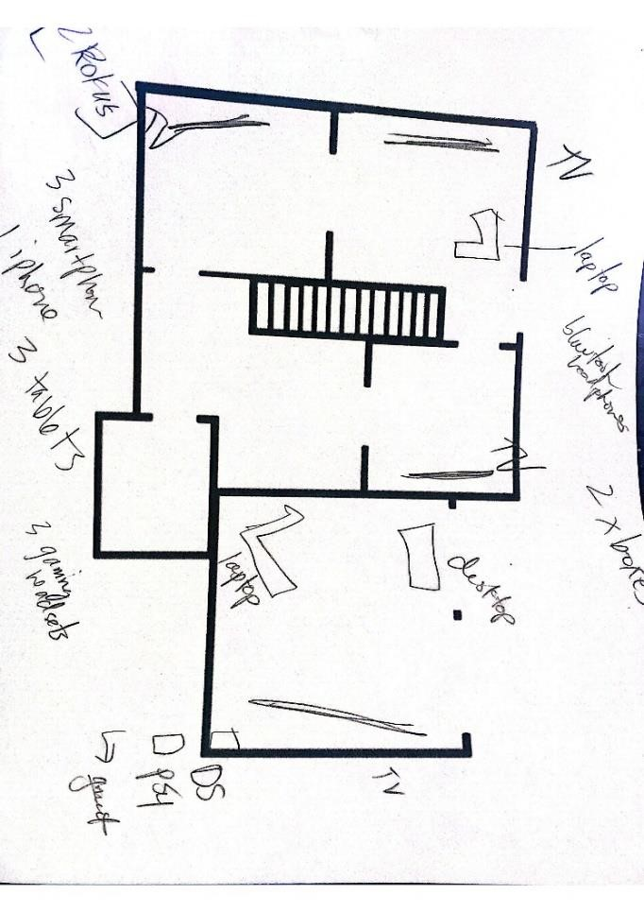
Figure 2
Home Layout by Tessa and her Children (September 5th, 2019)

Field Notes
- Observations were conducted in each family’s home 6-8 times for 40-45 minutes, during each visit throughout the data collection process.
- If feasible, observations were conducted different times of the day. This was done to capture a more complete glimpse of the homeschooling practices.
- The focus of the observations was the mother, the elements of her interactions, practices, and routines with her children.
- For example, during one observation a drawing was created to illustrate how many times a mother had to turn to each to child that needed her attention during a homeschooling observation (See Figure 3).

Photographs
- Each week, participants were asked to send 6-8 photos, each, across the 6-8 weeks of home visits (See Figure 4-5 Below). Each week participants sent between (2-10 photos each with an average of 5 photos weekly).
- The participants sent their photos through a University Vault system. This Vault system is a secure file transfer service that allows users to easily send large files quickly and securely.
- At the end of the study there were a total of 135 photographs collected from the six participants.

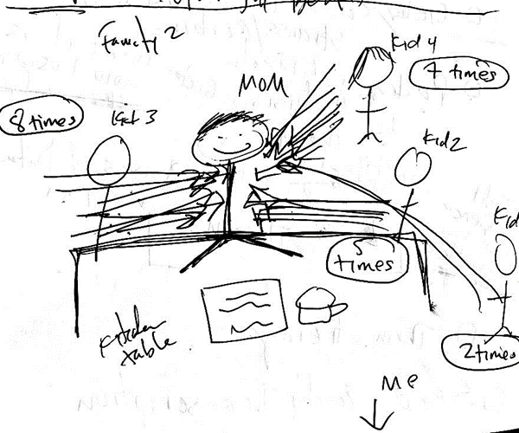
Figure 3
Mother and her Kids from my Reflexive Journal (September 16th, 2019)


Figure 4
Example of a Participant Photo Sent During the Week (October 22, 2019)


Figure 5
Example of a Participant Photo Sent During the Week (October 11, 2019)

Photo Chat Transcription
- At the end of each observation period in the home, mothers were asked to discuss her photos in what came to be known as our “photo chats.” A total of 30 photo chats were conducted.
- The participants selected their most meaningful photos, and/or the photos they are most interested in talking about, and/or the photos that they felt best represented something related to their homeschooling practice from the previous week
- Each mom described what was happening in each photo and were asked to talk about the meaning they assigned to their selected photos.
- The chats were audio recorded with a digital audio recorder. These photo chats aimed to be between 15-20 minutes, however, the shortest photo chat interview was 8 minutes long while the longest photo chat was 72 minutes, with an average length of 23 minutes.

Final Interview Transcriptions
- The final interviews were conducted during the last visit and consisted of two separate interview activities
- For the first activity, participants were presented with all the photos they had previously selected for each photo chat. They were provided different size canvases, markers, and tape and asked to make a collage or layout of the photos that best represented their homeschooling experience.
- During the second activity, participants were given their photos again and the same materials, and yet this time they were asked to create a story (with a beginning, middle and end) with their photos (See Figure 6).
- Following both activities, semi-structured interviews were conducted. These interviews ranged from 38 minutes to 124 minutes with an average interview lasting 66 minutes.
- Final interviews were recorded using a digital audio recorder.

Reflexive Journal
- My reflexive journal served multiple purposes that ranged from informing the unfolding study procedures, considering my role as a participant observer, as well as what I was wondering about, what stood out to me regarding a participant’s comment or actions, and how to prepare for the next visit. From time to time, these notes included observations of a participant’s tone, an exchange between a mom and her children, and/or the content of a photo chat. I often wrote about what I was thinking during the visits regarding my possible biases, feelings, and reactions.
- Additionally, my reflexive journal served as a place to document how I made methodological decisions (i.e., choosing to switch from takes notes on my computer to pen and paper during observations).

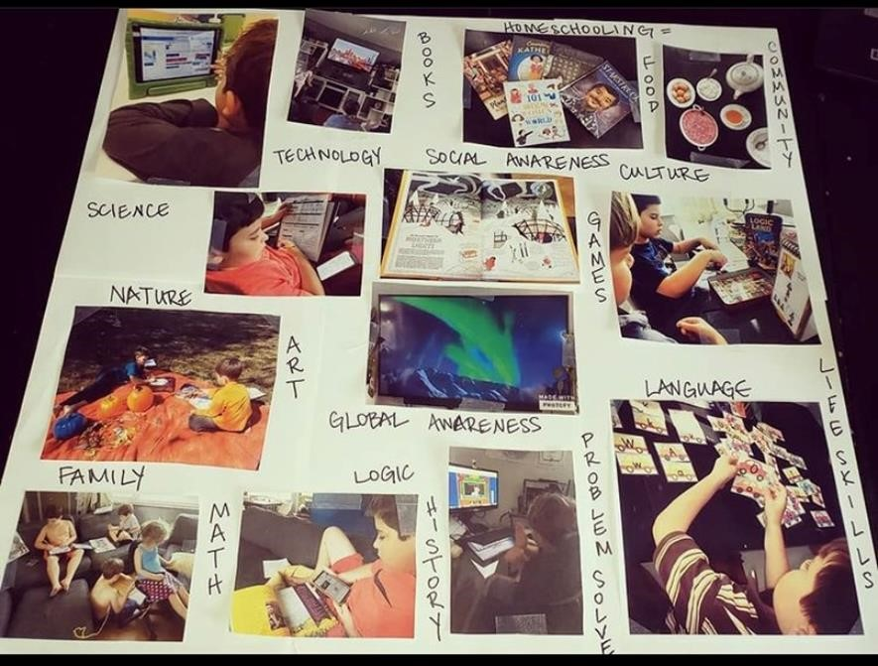

Figure 6
Final Interview Activity (January 7th, 2020)

Data Analysis
Data analysis was conducted across five rounds guided and informed by the constant comparative method (Glaser, 1965) and a data reduction coding paradigm proposed by Strauss and Corbin (1990). Glaser argues that the constant comparative method is best suited when analyzing data across a variety of sources, including observations, interviews, documents, articles, and books (p. 437). This method allowed for comparisons to be made across participants’ interviews, photo chats, photos and my reflexive journal entries and field notes. For the purpose of this study, constant comparative analysis is defined as a “process that includes the comparison of incidents applicable to each category, and then the integration of categories and their properties” (p. 438). Additionally, this technique allowed for a more continuous and evolving process throughout each round of analysis, corresponding to the natural progression of the study.
The specific procedures used for reducing data were informed by guidelines proposed by Strauss and Corbin (1990). Strauss and Corbin defined data reduction as conceptual abstraction through a process of assigning general concepts (codes) to singular incidences in the data. This is accomplished through open, axial and selective coding (p. 88). In the following section, the data reduction process and timeline are described, and comprised of three phases beginning with open coding followed by axial coding and ending with selective coding. Ultimately, this process led to the identification of the study’s core category: The Journeys of Six Mom Pedagogues:
Enacting Personal Convictions and Disrupting the Status Quo.

Final Interviews and Photo Chats Analyses

Transcription Procedures
The final interviews and photo chats were transcribed verbatim using oTranscribe, a free software application. This software was selected because it provided quick and easy keyboard shortcuts that paused audio when needed and track backward and forward throughout the transcriptions to ensure audio was transcribed correctly. The length of final interview transcripts ranged from 6 to 18 pages single spaced while the range for photo chats was from 3 to 9 pages, single spaced. All the final interview recordings were transcribed by me. Listening to, typing and re-listening both the final interviews and photo chats, allowed me to become immersed in the data, early and often in preparation for the analysis process. Transcribing also allowed me to linger and consider the emerging trends in the data that were later analyzed using open, axial and selective coding. For example, it became clear, during the transcription phase that all mothers discussed their personal histories and education backgrounds throughout the interviews and chats.

Coding Procedure
The analysis of final interviews and photo chats unfolded across two rounds of open coding, followed by two rounds of axial coding, and ending with a third round of selective coding.

Coding Rounds
The data were reduced from an initial 42 open codes to 32 axial codes and ultimately to a final six selective codes, leading to a final core category. A description of this process follows and concludes with the process for determining the core category of the study. This series of analyses was tracked and recorded using Microsoft Excel. The following excerpt of a final interview is used to illustrate each coding category, starting with open coding:
I just wish more people knew how easy homeschooling could be. It doesn’t have to be public schooling at home. I wish I could just talk to more people about it, spread the gospel. I just feel for children that have to be in public-school every day. I just want to change society. (Excerpt from Final Interview)

Open Coding
Open coding was conducted for both final interviews and photo chats. Open coding is an analytical process in which codes or tags are attached to chunks of data. Codes are typically descriptive but can also be more complex, like using metaphors (Miles & Huberman, 1994). This iterative process proceeded through two rounds aimed at the “conceptualization and categorization of phenomena” (Volstadt & Rezat 2019, p. 86). First, a line-by-line analysis was utilized to identify emerging patterns and/or themes (Strauss & Corbin, 1990). Each line was read and reread to identify units of meaningful words or phrases that seemed to relate to the study’s overarching purpose.
The line-by-line coding is illustrated below in Figure 7 and includes brief categorical labeling. The yellow row exemplifies (a) each line of the quote and (b) the corresponding category, in the cell directly above, the tagged line.
Once a line-by-line analysis was conducted, a second round was employed to identify chunks or data segments. These chunks were re-sorted, labeled and briefly described using conceptual memos. This process is important to build concepts and categories. Open Coding includes classifying concepts, defining and developing categories based on their properties and dimensions (Khandkar, 2009).
For this study a chunk or data segment was defined as one idea or a piece of important information, “usually one to three sentences long” but could be much shorter (McMillan & Schumacher, 2006, p. 371). A conceptual memo was written for each chunk and an axial code was created as seen, in Figure 8. Open coding aims to break your data into discrete parts and create “codes” to label them, and this was done with each line of the transcriptions. By breaking up my data and labeling them, I was able to continuously compare and contrast date chunks.
Next, each chunk of data and the corresponding conceptual memos were used to reduce and generate 42 over-arching codes (Figure 9), followed by further data reduction in the two axial coding rounds. Axial coding was the second step of coding and where I began to draw connections between codes.

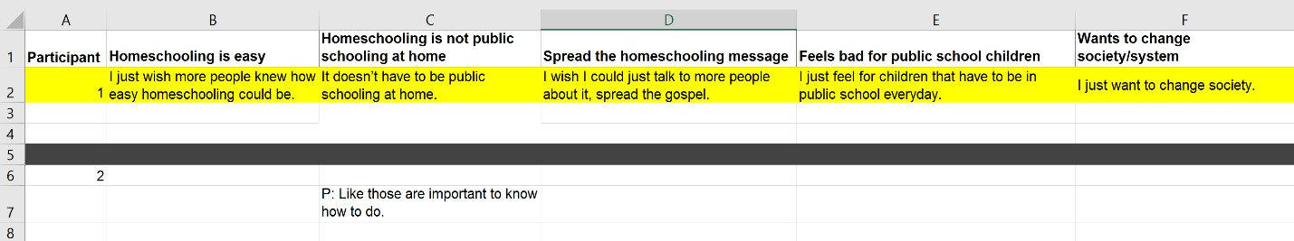
Figure 7
Screenshot of Line-By-Line Analysis in Microsoft Excel

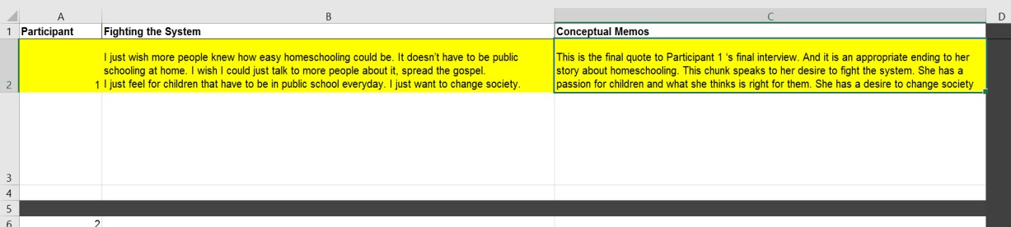
Figure 8
Screenshot of A Chunk and Conceptual Memo in Microsoft Excel

1. Getting Stuff Done | 2. Materials | 3. Sharing with Others
4. Space | 5. Structured  Homeschooling | 6. Guilt
7. Play | 8. Homeschooling is not public-school at  home | 9. Inner Conflict
10. Testing | 11. Siblinghood | 12. Community
13. Facing the unknown | 14. Equality | 15. Stigma
16. Imagination | 17. Confidence | 18. Flexibility
19. Hands off teaching | 20. A safe place | 21. Freedom
22. Fighting the system | 23. Problem Solving | 24. Womanhood
25. Sacrifices | 26. Support | 27. Sharing with others
28. Validation | 29. Personal History with  Homeschooling | 30. Legacy Members
31. Everyone is a teacher | 32. Mom’s Role | 33. Curriculum
34. Authenticity | 35. Kindness | 36. Motherhood
37. Feminism | 38. Love | 39. Media/Technology
40. Religion | 41. Finding your people | 42. Identity Development

Figure 9
Open Codes

Axial Coding
Two rounds of axial coding took place to further reduce the data by considering the relationships between concepts and categories and merging or coupling some open codes into axial codes. Strauss and Corbin (1990) argued that axial coding is best used when guided by a coding paradigm that prevents any analysis from missing “density and precision” (p. 14). For this to occur, they suggest using five conditions that include (a) causal conditions (the phenomenon with regard to any incidents or occurrences), (b) context (set of characteristics in which the phenomenon is embedded), (c) intervening strategies (conditions that influence action/interaction strategies), (d) action or interaction strategies (activities directed towards the phenomenon in order to overcome it, perform it or react to it), and (e) consequences (after-effects that unfold from action and/or interactions) (pp. 3-21).
The data reduction process included the categorization and linkage of open codes across one of the five conditions. For example, the process included (1) reviewing a code, (2) identifying a corresponding quote from the code, and (3) assigning one of the coding conditions to that particular open code (Figure 10). Round 2 of axial coding included grouping together the codes that were assigned to each condition. There were some axial codes in each condition that were further reduced and relabeled. Some axial codes could not be reduced; therefore, they kept their label assigned during the open coding phase. This reduction of codes and/or label change is illustrated below in Figure 11. Following two rounds of axial coding, 42 open codes were reduced to 32 axial codes (Figure 12).

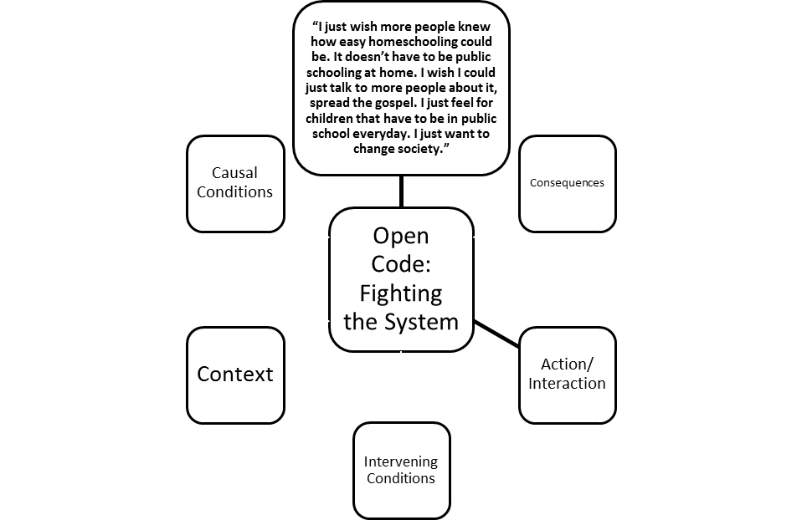
Figure 10
Example of Round 1 Axial Coding



Axial Code
Desire For Change
Coding Paradigm
Action/Interaction
Open Codes
Homeschooling is Not
Public School at Home
Fighting the System
Sharing with Others
Stigma
Figure 11
Example of Round 2 Axial Coding
1. Home Management | 2. Materiality | 3. Planning for the Future
4. Rituals and Routines | 5. Inner Conflict | 6. Play
7. Space | 8. Structured  Homeschooling | 9. Learning Together
10. Freedom | 11. Desire for Change | 12. Child Led Learning
13. A Focus on  Relationships | 14. Being on the Right  Track | 15. Guilt
16. Using Imagination | 17. Problem Solving | 18. Challenges
19. Investment | 20. Using Others as  Teachers | 21. Authenticity
22. Confidence | 23. Place | 24. Ethic of Care
25. Mother’s Personal  History | 26. Mother’s Role in the  Home and Teaching | 27. Community
28. Equality | 29. Mother’s Educational  History | 30. Resources
31. Flexibility | 32. Identity Development
Figure 12
Final Axial Codes Chart

Selective Coding
Strauss and Corbin (1990) argued that there is not a large difference between axial and selective coding, except at the level of abstraction. They noted that the main purpose of selective coding is where the storyline develops by “integrating, interpreting and refining the axial codes” (p. 98). Traditionally, selective coding is used to help develop a new theory during a grounded theory analysis. However, for this study and its limited scope, established theoretical frameworks were integrated to interpret and finalize codes rather than creating a new theoretical direction.
Aspects drawn from key tenets of Bioecological and Sociocultural Theories along with smaller influential frameworks such as, Women’s Ways of Knowing, Ethic of Care and Maternal Desire, Foucault’s analysis of power and discipline and the concept of Bildung, were used to validate, refine and further elaborate the axial codes (Corbin & Strauss, 2008, p. 14). One round of selective coding was conducted for the final interviews and photo chats to finalize the selective codes and select a core category or “the central phenomenon” (Corbin & Strauss, 1990, p. 19). The 32 axial codes were reduced by taking each code and applying a specific aspect of a theoretical framework to that axial code and creating a corresponding conceptual memo. These codes were then grouped together, examined and renamed to create new selective codes and conceptual memos as exemplified below in Figure 13. This process is cyclical and facilitates an evolving data loop by constantly comparing data and applying data reduction, and consolidation procedures (Williams & Moser, 2019).

Selective Code
Setting and Context: Disrupting Place and Shaping Beliefs
Theoretical Framework
Structures and Dynamics of Power
Foucault (1980)
Axial Codes
Desire for Change
Freedom
Equality
Rituals and Routines
Figure 13
Example of Selective Coding

Through this process, 32 axial codes were reduced to the following six selective codes:
1). Ways of Being: The Value and Actions of Being a Mom Pedagogue
2). Materiality and Space
3). Community of Practice: Interpersonal Learning
4). Living in Uncertainty: Convictions to Homeschool
5). Parental Background: A Cultural Tool
6). Setting and Context: Disrupting Place and Shaping Beliefs
A final review of the selective codes was conducted to examine and subsume them under a single, core category. A core category encompasses the integration of all previous codes into a central phenomenon or story line from which all codes were integrated. Volstadt & Rezat (2019) describes a core category as the path “that leads the way through all the trees so that the wood can finally be seen” (p. 116). The core category for this study is: The Journeys of Six Mom Pedagogues: Enacting Personal Convictions and Disrupting the Status Quo.

Field Notes and Reflexive Journal Analyses
Field notes and reflexive journal entries were used during each round but heavily relied upon in open coding. Field notes and the reflexive journal were used with each chunk when they were re-sorted, labeled and described in the conceptual memos. Notes for the participants were matched with the corresponding interview, and were used to write the conceptual memo, which often included quoting directly from the field notes or reflective journal in the conceptual memo. For example, this quote was selected from a reflexive journal entry following a final interview:
This final interview had more personal history and it seems like this participants narrative of herself is that she is this maverick or outlier in society. There was little reflection on the actual homeschooling, but the focus was on her and her story. She had so much to say about herself in context with the fighting and standing up to institutions. I just have this sense the participant is always pushing up against something. Whether that is traditional schooling, her husband, feminism, media. (Reflexive Journal, 11/25/2019)
This quote was used in a conceptual memo during the open coding process to help identify units of meaningful words or phrases and provide more context for the specific chunk or data segment.
Using a constant comparative method and the Strauss and Corbin (1990) coding paradigm as a guide, the storyline of these homeschooling mothers was able to be examined at a higher level of abstraction, by integrating theory and reducing the data into a single core category. Thus, the final core category of: The Journeys of Six Mom Pedagogues: Enacting Personal Convictions and Disrupting the Status Quo and the corresponding findings emerged. Next, trustworthiness and credibility of the data and data analysis will be described.

Trustworthiness
In qualitative research, the matter of trustworthiness of data is of importance and the criteria used to judge the quality of an investigation and its findings that contribute to believable outcomes within the academic community (Lincoln & Guba, 1985). Lincoln and Guba identify four important characteristics/aspects of one’s ability to establish trustworthiness that include (1) credibility (2) transferability (3) dependability and (4) confirmability (p. 283). Further, this study was guided by verification standards set by Creswell and Miller (2000) that include: (a) prolonged engagement and persistent observation (b) triangulation (c) peer debriefing (d) clarifying research bias (e) member checks, and (f) thick descriptions (p. 5). Qualitative researchers aim for the
goal of trustworthiness, which means when the work is read and interpreted, there is a sense of confidence in what the researcher has reported (Stahl & King, 2022). They must establish how data analysis has been conducted through recording, systematizing, and unveiling the methods of analysis to enable the reader to determine whether the process is credible (Attride-Stirling, 2001; Ryan, Coughlan, & Cronin, 2007).
Thick descriptions were created from the data to convey narratives of participants’ thinking, actions, feelings and experiences. For the purposes of this study, a thick description is a record of subjective explanations and meanings provided by the people engaged in the behaviors (Geertz, 2008, p.11). These thick descriptions contributed to the transferability of the findings by including elements of the flow of dialogue, examples of the homeschooling dynamics or context that may be outside the scope of the research questions, in order to allow for more complete meanings to arise. Table 2 below details the criteria and measures that were employed to ensure the trustworthiness of the data and analysis process. This trustworthiness criteria was selected in order to examine the acceptability and usefulness of this research (Lincoln & Guba, 1985; Tobin & Begley, 2004).

Table 2
Qualitative and Verification Criteria for Assessing Research Quality and Trustworthiness
Qualitative Term  (Lincoln & Guba, 1985) | Verification Procedure  (Creswell & Miller, 2000) | Strategies  Employed
Credibility | Prolonged Engagement | 6-8 weeks was spent with each family and establish a more secure rapport at around 2-3 weeks with each participant.
 | Use of Peer Debriefing | Weekly debriefings with  Doctoral  Committee  Advisor (Dr.  Mary Jane Moran).
 | Triangulation | Data collected through final interviews, photographs, etc.

Table 2 Continued

Qualitative Term  (Lincoln & Guba, 1985) | Verification Procedure  (Creswell & Miller, 2000) | Strategies  Employed
 | Purposive Sampling | Administrators assisted with recruitment and making deliberate sampling decisions based on respondents’ qualities.
Transferability | Triangulation | Data collected through final interviews, photographs, photo chats, home observations, field journals, and reflective journal.
Dependability | Use of peer debriefing | Weekly debriefing with Dr.  Mary Jane Moran
Confirmability | Clarifying research bias | Reflexive journal and debriefing were used to examine  objectivity, feelings of bias and personal reflections.

Chapter Summary
This chapter provided an overview of the methodological components, purpose and procedures used for this research study. Distinct descriptions of the qualitative research methods and the rationale for the research design used to investigate the lived experiences of the six homeschooling mothers were included, along with descriptions of the sampling process and collecting data through a demographic questionnaire, home maps, field notes, participant photos and photo chat transcriptions, final interview transcriptions, and reflexive journal. Further, the specific steps and stages of analyses were diagrammed and described. Data analysis procedures were illustrated through examples of open, axial, and selective coding coupled with key theoretical tenets to assist in explaining the analytical approach of data analysis and interpretation. Trustworthiness was established through a range of procedures supported by multiple researchers and the triangulation of data. The role of the researcher will be addressed in the next chapter.

My role as a researcher
The nature of qualitative research is to examine how people learn about and make sense of themselves and others and how they structure and give meaning to their daily lives (Creswell, 2017). It is reasonable to expect that the researcher’s beliefs, political stance, cultural background (gender, race, class, socioeconomic status, educational background) are important elements that may affect the research process. Just as the participants’ experiences are situated in sociocultural contexts, so too are those of the qualitative researcher (Yilmaz, 2013). Qualitative research is interpretive, lending itself to the potential for bias; therefore, it is necessary for the researcher to plainly consider personal preconceptions, values, and opinions to ensure that the findings are presented as accurately as possible (Creswell, 2013, p. 253).
The role of the researcher is influenced by “where the researcher is coming from” and involves exploring the researcher’s ontological and epistemological assumptions about how human nature is situated within cultural contexts (Bourke, 2014, p. 2). I did this by entering each home with an awareness of ethical issues coupled with an intent to suspend earlier preconceptions of homeschooling while acknowledging my role as an academic from a formal learning institution (Creswell & Creswell, 2018; Giorgi, 2009). This meant that my aim was to honor the voices of my participants in the field and within the analytical process (Creswell & Creswell, 2018; Philippi & Lauderdale, 2018).
The intent of this chapter is to explore my role through my (a) ontological and (b) epistemological assumptions, as well as (c) my understandings of human nature within cultural contexts. These three concepts will be interwoven in my discussions of (1) my positionality and (2) my reflexivity as a qualitative researcher. Each section will begin with the definition of terms followed by examples and applications that reflect my research process over the nine months of field work, in particular.

Positionality
The term positionality both describes an individual’s world view and the position they adopt about a research task and its social and cultural context (Foote & Bartell 2011, Savin, Baden & Howard-Major, 2013; Rowe, 2014). Positionality influences how research is conducted, its outcomes, as well as what a researcher has chosen to investigate (Malterud, 2001; Grix, 2019). Positionality refers to how differences in social position and power can shape identities and access in society (Fought & Misawa, 2016, p. 26). Duarte and van der Meij (2017) explain that positionality “requires researchers to identify their own degrees of privilege through factors of race, class, educational attainment, income, ability, gender, and citizenship, among others” (p. 135) for the purpose of analyzing and acting from one’s social position “in an unjust world” (p. 135). Positionality is rooted in the belief that knowledge production is interwoven with power relations between the researcher and the researched (Charmaz, 2014; Lune & Berg, 2017; Smith, 1987). Thus, positionality is determined by where one stands in relation to ‘the other’” (Saldaña, 2015, p. 411).

My Ontological Assumptions
Ontological assumptions are defined as an individual’s beliefs about the nature of social reality and what is knowable about the world (Spradley, 2016). My interest in homeschooling stems from my own curiosity about parenting and learning, for example, the tools parents use to help their children learn and grow within the home. As a millennial and “digital native” (Barlow, 1996) one of my concerns as a parent has been how to incorporate technology in successful ways for my children. This crossroads of parenting and technology is where my first research interests emerged, and my early research projects focused on online mom support groups, such as the FFTT Homeschooling Group. Their work and experiences interested me, and I knew that their story should be told.
I believe that I am typical of many people who have limited homeschooling experience. As a child I did not know anyone who was homeschooled but as a parent I have come across friends and other mothers who have made that choice. I had little knowledge about homeschooling parents’ day-to-day lives until this dissertation study. I conducted this research from a first-person narrative informed by my etic point of view, as well as the participants’ emic perspectives (Darder et al., 2008; Miles & Huberman 1994).

My Epistemological Assumptions
Epistemological assumptions are defined as individual’s beliefs about the nature of knowledge (Scotland, 2012). While my original focus was to explore digital tools within homeschooling settings, I also ascribed to a Feminist Post-Structural perspective. I do not believe that conditions for judging “reality” are absolute but rather arise from lived experiences regarding what is useful and what has meaning. Feminist Post-Structuralism claims that shared “cultural narratives, or discourses, are social constructions and that their processes of production are worth examining” (Lyotard, 1979, p. xxiv). It was this belief that helped guide my shift from my original research focus of technology use in homeschooling.
In the early weeks of the study, I quickly realized I needed to embrace the story my participants were revealing rather than what I was assigning to them, thus the change in my research aims and focus to the general lived experiences of these mothers rather than a singular focus on their technology use. This shift was justified because in the first few weeks of the study, it became clear to me why my participants chose to homeschool and enacted their roles and homeschool rituals and routines that dominated their behaviors and our conversations. Thus, my participants played an important role in my reconceptualization of the focus of this study.
I chose to involve the participants in the research process in many ways that also influenced my positionality. For example, I requested they take photos across the weeks and choose their favorite photo each week and tell me why they chose it. These photo chats, at the close of each visit, included both discussions about what was going on in a particular photograph and the meanings participants assigned to their representations. Consequently, this process repositioned me as a listener and provocateur and the mothers as a guide. Each mother soon embraced the role of leading what she wanted to share about her day-to-day life and these rich exchanges fostered emerging, ongoing, authentic discussions about how they made sense of their lives as Mom Pedagogues. For example, in an exchange with Tessa, she shared the following: T: There is a ton of stuff that we still do that they would do in school and there’s lots of stuff that they wouldn’t do in school. And I’m not saying that this is better than school necessarily, it’s just different. But it does work for us, for sure.
M: I see that you have tears in your eyes, talking about this. What do these photos mean to you?
T: I hope that it means that they are not only getting a well-rounded education but they are also having an authentic childhood too. You know? Just seeing them… playing and exploring and having those experiences and things is always my goal. (Photo Chat 6, 12/10/2019)

Human Nature Situated within Cultural Contexts
Assumptions about how human nature is situated within cultural contexts is defined as an individual’s ideas about the way she interacts with her environment and relates to it (Grix, 2019).

Being an Insider
As the research was conducted with homeschooling mothers, I was an insider regarding sharing the experiences of motherhood. I also knew multiple members of the FFTT group from other parenting groups and mom circles, which helped with recruitment, building trust and rapport with my participants, early in the study. Further, my insider stance helped me share issues around parenting, such as when many of the participants brought up gentle parenting practices, the struggles of motherhood and memorable moments with our children (Field Journal, 11/11/2019, pp.1-12). There were also times during my visits, our photo chats, and final interviews that I was able to utilize what Delgado Bernal (1998) refers to as ‘cultural intuition’ when discussing their roles as mothers, which helped build rapport and facilitate collective knowledge construction (p. 555).

Being an Outsider
I may have been an insider as a mother, but I was an outsider in regard to being a homeschooler. Prior to designing the study, I met with the leaders of the FFTT group who provided valuable insights into recruitment and potential data collection. Moreover, each mother in this study, made a choice to remove their children from the institutions of formal education, and I was conducting research within their home as a representative and employee of a formal educational institution. My position as a researcher gave me power over the researcher participant relationship, that if not examined could have hindered rapport building and my interpretation of the homeschooling practices I observed.
Qualitative research embodies a shared space, shaped by both researcher and participant, as such, the characteristics of both have the potential to impact the research process (England, 1994). Positionality acknowledges that people have multiple overlapping identities and individuals “make meaning from various aspects of their identity . . .” (Kezar, 2002, p. 96). Further, positionality can be used to deconstruct the embedded politics in the specific relationship between researcher and participant (Foucault, 1972; Butler, 1992; Fraser & Nicholson, 1990). It felt essential to continually revisit my position as an academic, in order to be aware and respectful, while in the homes of women who felt frustrated and discouraged by learning institutions in order to have a more equitable relationship and seek relevant data.

Participant Observer
In this qualitative study, my role of the researcher was as a participant observer. The process of participant observation requires the researcher to become involved as a participant in a social setting and make descriptive observations of him/herself, of others, and of the setting (Spradley, 1980). The purpose of a participant observer is to obtain data about behavior through direct contact and in terms of specific situations in which the researcher is on the outside of that community (Kluckhohn, 1940, p. 194).
A participant observer asks ethnographic-like questions, generates data, makes a record, analyzes the data, and writes a manuscript (Spradley, 2016). They commonly gather data through “casual conversations, in-depth, informal, and unstructured interviews, as well as formally structured interviews and questionnaires” (Merriam, Johnson-Bailey, Lee, Lee, Ntseane, & Muhamad, 2001, p. 411). Images and video are especially useful to the researcher, when there are events, the researcher misses in her process of observation (Banks, 1998; Moran & Tegano, 2005; Rose, 2001). The images taken by the participants served as a tool that often mediated what a mother was thinking and feeling in the present and earlier times during the week
(Jorgensen, 1989). Without the images, the mothers may not have been as forthcoming and or remember what they experienced throughout the week, and it provided me an opportunity to facilitate and probe them about their experiences.
Laurier (2003) emphasized “that the best participant observation is generally done by those who have been involved in participating and observing and tried to do and/or be a part of the things they are observing” (2003, p. 135). While I did not directly participate in the homeschool teaching, I did choose to be in the homes and immerse myself in the everyday lives of the families and teaching practices of the participants. I also chose to mirror each mom’s position within the space of her home. For example, if Fay chose to stand on her porch to watch her children from a distance, that is where I stood to do my observation of the children as well. Or, when Jamie sat on the floor with her children, I, too, sat on the floor as this was the position Jamie often took in her homeschooling practice (Methodological Journal, 10/10/2019).
At the beginning of the study, I did have to remind participants that I was not involved with child services because for a while, I believed some mothers “performed” homeschooling out of fear or judgement and/or child services during my early visits. Their “performance of homeschooling” ended during the first few weeks of my observations as they seemed to feel safer and could sense my lack of judgement on their homeschooling practices. For example, one mother asked, “You don’t report to child services, do you? Because we just had one of our moms get in big trouble because someone turned her into child services because her daughter ‘wasn’t reading where she should’” (Field Journal, 10/11/2019). Soon after the first 2-3 weeks, I experienced a much more natural homeschooling atmosphere as their interactions with their children and me seemed more relaxed and natural. Nevertheless, I had to be intentional about not coming across judgmental or concerned about how their children were being taught and what work they were doing or not doing.
The participant observer relationship requires rapport combined with objectivity (Miller, 1952). This orientation required that I continually checked in on my biases and judgements as part of my reflective writing and in weekly meetings with Dr. Moran. Weekly debriefings helped me continually bracket my inherent biases or assumptions in an effort to remain sensitive to the needs of my participants and, more generally, open to the various homeschooling approaches and beliefs by the mothers.

Reflexivity

While positionality requires that both acknowledgment and allowance are made by the researcher to locate their views, values, and beliefs about the research design, reflexivity involves self-analysis (Delgado-Gaitan, 1993). It is a continuing mode of awareness of the relationship between the researcher and the “other” (Chiseri-Stater, 1996; Pillow, 2003). Reflexivity is the concept that the researcher should acknowledge and disclose themselves in their research and seek to understand their part in it, and/or influence on it (Villenas, 1996; Cohen et al., 2011). Reflexivity helps inform the positionality of the researcher and requires sensitivity to cultural, political, and social contexts (Bryman, 2016) because an individual’s own story, experiences and values may well influence the research process (Greenbank, 2003; Bourke, 2014).

My Ontological Assumptions
I am a white, female, millennial, a mother of two small boys, a wife, and a former marriage and family therapist. My role as a former therapist had a significant influence on how I interacted with the participants. My knowledge and skills on listening closely and asking questions to enhance understanding guided how I built rapport, created a safe and supportive environment, asked open-ended questions, and encouraged reflection and introspection. While there are differences between a therapeutic conversation and a research interview, the role of clinician provided me the skills to solicit stories and follow up on some of the more emotional moments in my conversations.
Regardless of the advantages that my prior role as a therapist provided me, there were instances when it conflicted with my role as a researcher. For example, there were times when I felt overwhelmed by the emotional needs of both the children and the mothers during my visits. Sometimes, I had a desire to take care of the children and let them interact and engage with me that could leave me feeling overwhelmed. When I traveled to visit families and drove up to their homes, children were usually waiting for me in their front yards and/or at their front windows. I was met with them running up to me so that they could catch me up on all the things I had missed throughout the week (Field Journal, 10/28/2021). At times, I felt challenged conducting essential research tasks in my study that included observing from afar or writing my observations. For example, in my reflexive journal following my fourth visit with Zoey and her family I wrote:
When I got to Zoey’s house, the children were waiting for me on the porch. And Zoey said they had been asking about when I was coming since early that morning. As soon as I got there, they were hugging me, grabbing me and dragging me around to all the things they had made that week, they showed me their rooms again. I leave this house, feeling really exhausted and drained. (Reflexive Journal, 11/17/2019)
I also felt torn, at times, to provide emotional support to the mothers, who sometimes described feeling overwhelmed and lonely in their homeschooling roles. For example, after visiting Jamie on my third visit, I wrote:
Jamie now has my preferred coffee waiting for me when I arrive to her house. At first, I was uncomfortable, but I realized, if I give her time to make me coffee, and chat a little bit before our photo chat, she seems more open to sharing and being vulnerable. (Reflexive Journal, 10/22/2019)
There seemed to be a tension that emerged between my therapist self and my researcher self, which sometimes meant I needed to debrief more often and to become more strategic in how I approached my home visits. For example, from in my methodological journal I wrote, after discussing it with Dr. Moran, I will be making the following changes: (1) observe some of the families by using a pen and paper and (2) remain standing when appropriate. My reasoning is that I have been struggling to blend into the background during the observation time, especially related to the children. They like to interrupt or wonder what I am doing on my computer. They also like climbing on me and sitting on my lap. Thus, Dr. Moran and I believe this change will help (Methodological Journal, 9/21/2019).

My Epistemological Assumptions
My epistemological assumptions are based in the belief that knowledge is constructed through lived experiences as individuals participate in various events and as our multiple selves emerge and change. Further, I reject the rigid boundaries between my different selves and accept the ambiguity and psychological fluidity of being a mother, former therapist and researcher. It is this integration of selves within my current cultural context in which I make sense of the world (s). This combination of selves empowered me to foster deeper conversations with my participants, despite my position as an outsider to this homeschool community. For example, Tessa shared this part of her story after we discussed the challenges of motherhood:
M: Motherhood is hard. Like really hard but you seem to be in your element. Tell me more about how you approach it and how you’re able to handle both motherhood and homeschooling?
T: Oh, this feels like it’s going to go really deep, but I think a lot of us, all of us, walk into parenting with childhood wounds or whatever it is. Mine were pretty major and I worked through them and adulthood but motherhood for me was part of the healing process and homeschooling has been like an extension of that. (Photo Chat 2, 9/16/2019)
Moreover, a majority of my personal self-inquiry surfaced from my journals and weekly debriefs throughout the study. It was important I re-examined my autobiographical selves and grapple with issues related to my positionality, such as my “beliefs, interests, experiences, and identities” (King & Horrocks, 2010, p. 213) that could have an impact on my research.
I know that my past and present experiences influenced how I presented myself to participants and contributed to my sense of self within the study. As I engaged in the research process, I approached my field work and analysis as a curious learner about homeschooling and the everyday practices of these Mom Pedagogues. I did not come as an expert or authority on child education, homeschooling or child behavior, but rather interacted with my participants with a determination to be open and listen to stories and experiences. An example of this came from a conversation I had with Erica during her final interview:
E: It’s really hard to juggle all the things at home and then trying to keep up with them and their work and their books and all that stuff.
M: That does seem really hard. How do you cope with all of that?
E: I just have to remind myself that it’s worth it I mean if I have to take a break for a day. I will take a break. We will get behind but eventually I know will get back to where we need to be. And I think next year I think we are going to do a co-op. Which will help take some of the burden off of me. And they will get a little bit of a school experience and I will get a little bit of a break, which sounds like a lot of fun.
M: I need my breaks too. How did you come to the decision to join a co-op?
E: Well, both of them have been saying that they want to go to public-school, and I don’t really want that for them. So basically, what I wanna do is I want to give them a taste of that without having to make that commitment of actual school. (Final Interview, 11/29/2019)
In this example, my role as a researcher stood contrary to the principle of “objective detachment” (Schram, 2003) because I was able to (a) reflect and mirror Erica’s emotions on feeling overwhelmed, (b) connect to her need of taking a break and (c) safely probe further on how she made the decision about choosing to join a co-op. As I examined and engaged in self-narrative inquiry, I believe I was able to lessen the distance between me and my participants.

Human Nature Situated within Cultural Contexts
In my role, I aimed to acknowledge some of the injustices described by these mothers and their actions to guide their children toward different learning experiences. These views motivated me to bring a voice to their narratives. I believe that knowledge should be constructed by “empowered agents of change… with the ability to challenge and reshape notions of power, privilege, authority, and other forms of oppression” (Kopish, 2014, p. 3). I did not seek to become a homeschooling advocate for these mothers, but rather sought to facilitate a relationship of trust, mutual respect and learning that facilitated “holistic, flexible and/or emergent data” (Yilmaz, 2013, p. 315). I found power in the narrative that emerged from these mothers and sought to create informed, authentic stories that honored the complexity of their past and present experiences.
As a participant observer, across nine months and 39 home visits, I was able to move into spaces and observe everyday experiences that are often not seen by outsiders. I sought to avoid making predictions or assumptions about homeschooling but rather saw these Mom Pedagogues and their behaviors as unique and context dependent individuals (Pardo, 1998). My close proximity to participants’ ordinary rituals and routines helped me understand why they chose to be Mom Pedagogues, chose certain practices, and made particular choices significant to them – all manifested in their evolving caring and teaching selves. Both the mothers and I gained insights into their homeschooling values, beliefs and goals that offered opportunities for me to uncover new and fresh insights (Morrison, 2002) about my role, and, concomitantly, the mothers’ roles.

Chapter Summary
My role in this study was to conduct a qualitative investigation into the lived experiences of six homeschooling mothers. My intention throughout the data collection and analysis phases was to establish rapport with my participants and address my biases and personal conflicts during the overall processes. My role was influenced by “where the researcher is coming from” (Bourke, 2014, p. 2) and involved exploring my ontological and epistemological assumptions about how human nature is situated within cultural contexts.
I became examining the lives of these mothers as a participant observer. In this role, I made descriptive observations of the daily practices as Mom Pedagogues within their own settings and spaces. I had to be aware of my personal biases and aimed to interpret and analyze the data fairly and faithfully. The biases I had were result of my previous experiences as a mother, therapist, academic and my small exposure to homeschool families.
I used bracketing within my reflexive journal and de-briefing with my advisor to address my biases and sought to often examine my reasons for doing this research, personal judgments and experiences throughout the study. Trustworthiness was further stablished through a range of procedures supported by multiple researchers and the triangulation of data. I know that my past and present experiences impacted how I presented myself to participants and added to my sense of self within the study. In my role, I approached my field work and analysis as a learner about homeschooling and the everyday practices of these Mom Pedagogues. The next chapter will review the findings from the study.

FINDINGS
The aim of this study was to explore the lived experiences of six homeschooling mothers and the various aspects that influenced their ways of being. For these mothers, the process was a complex and multilayered phenomenon, distinctive for each participant. However, there were also commonalities throughout their stories. As they recalled and reflected on their own lives, past experiences seemed to lead to and illuminate how these mothers’ made decisions and navigated their homeschooling roles. Participants shared experiences, feelings and thoughts related to their daily practices and reflected about their uncertainties and the positives as Mom Pedagogues.
Mom Pedagogue is a label that emerged as the data were analyzed to incorporate both the participants’ roles as mothers and as teachers. These roles were intertwined in a range of ways that were anchored to life events and their emerging experiences while creating learning spaces at home for their children. Across this study, the Mom Pedagogues drew upon their memories, as well as present-day thoughts and experiences, across time, to recount lived experiences, pivotal moments, and seminal reactions related to schooling, family and community. Consequently, their reflections and references began to illuminate new understandings about why they chose the path of homeschooling their children and how their decisions benefitted not only their children but themselves. As they shared their stories, the Mom Pedagogues’ patterns and practices became increasingly linked to their personal selves, characterized by self-transformations and related meaning making about themselves and their children.
The process of being and becoming a Mom Pedagogue was reported to be engaging and challenging. Each mother expressed joy and pride along with feelings of stress and insecurity as they reflected on their homeschooling experiences. Thus, as each mother co-constructed her Mom Pedagogue identity, her emotions shifted in relation to her homeschooling context, space and relationships with others and understandings about herself. For these women, homeschooling provided a way to fill their lives with form and direction and create meaning in accordance with their lifelong values and beliefs. What became clear, regardless of their differences, is that they were similar in the need to act and enact their deeply held principles about what they believed is right and good about their decisions to homeschool. The narratives shared during weekly home visits and, particularly, photo chats and final interviews were not shaped by a single event, but rather a sequence of events across time, which brought them closer to their decisions to homeschool and influenced their own development and that of their children’s.

Presentation of the Findings
Narrative methodology was chosen as a way to present the wide range of experiences of these mothers, through their stories and the meaning they assigned to them. Polkinghorne (1995) asserted that a collection of individual stories can offer greater insight than a single story could (p. 6). Thus, these findings are framed by a collection of narratives, informed by weekly researcher field notes and photo chats, reflective journal entries, and in-depth final interviews. Presenting the findings by weaving together narratives allowed for a more nuanced understanding of life circumstances and experiences across time, shaped by the mothers’ decision-making and actions in the contexts of their homeschooling and family lives (Garcia-
Hallett, 2019; Ryan & Bernard, 2003).
The traces of what characterized their roles as Mom Pedagogues are as thin as their decisions to not create a typical school schedule to as thick as the protection of their children’s fundamental rights “to become” – free from bias, constraints, preconceived notions of what is a passing grade, or the characteristics of the “good school.” In essence, the mothers’ journeys are about the ways they came to seek emancipation for their children from constraints to fit a predetermined mold or learn a programmed set of facts or skills, while at the same time, emancipate themselves from their own constraints and societal expectations. As such, what has emerged is that the Mom Pedagogues embraced a humanistic approach to learning and self-actualization for both themselves and their children, reflected across three overarching findings (Figure 16) that include:
- Finding 1: Rejection and Renegotiation: Mothers’ Turning Points Toward
Homeschooling
- Finding 2: Becoming a Mom Pedagogue: Desire, Caring, and Emancipating
Meaningful Learning
- Finding 3: Enacting Personal Convictions through Uncertainty

These findings include (a) the chronicling of participants’ lived experiences with public education, (b) the lessons learned from decisions that influenced their home schooling approaches, and (c) the dilemmas and doubts that emerged alongside their everyday lives as Mom Pedagogues. The chapter concludes with a summary of the findings.

Finding 1: Rejection and Renegotiation: Mothers’ Turning Points Toward Homeschooling
Motherhood is a thought-provoking experience in which women often face multiple choices about their lives and the lives of their children (Hobart & Kneese, 2020). For the mothers in this study, some of their essential choices emerged as they were faced with crossroads towards homeschooling as opposed to public education for their children. For some of the mothers, this was a single “aha” moment and for others it was a slow and steady emergence toward the inevitability that public or traditional schooling could not work for them or their families. The definition of “what is good or best” for each mother’s children varied, yet they all agreed that there is a deficit, a perceived harm, and/or a limitation or separation of what they understand is most important for one to grow up safe, happy and productive. All the mothers shared the belief that they should play an active role in their children’s education, and that they have the ability to help their children succeed in learning. These beliefs were informed by vital turning points in their lives, defined as:
a point where life fundamentally changes decisions concerning one’s own life are reevaluated, one’s way of living changes and new role expectations are met… They offer a personal developmental crisis that has positive impacts on the personal values, life goals and wellbeing. (Yair, 2009, p. 35)
These moments resulted in significant changes in themselves, their parenting, and how they participated in the care and education of their children. Homeschooling created change both in the practical sense of how their children learned and developed as well as from an emotional and intellectual sense in how they felt and thought about their lives. Homeschooling provided an opportunity to create an alternative learning space for their children, which in turn, helped shape the mothers’ identities and further promoted an authorship of each mother’s own life. This process inspired each mother to become a better Mom Pedagogue for her children. All the participants reflected on the situated learning and cultural contexts of their own early experiences and applied emerging understandings toward their children and their futures. These perceptions challenged the ways in which they thought about and understood their lives and the world. Their desires to homeschool were linked to memories, cultural narratives, and what being a mother represented to each of them.
Three types of turning points were identified and shared, including: (1) recalling and/or rejecting childhood experiences, (2) renegotiating parenting practices, and (3) leaving public school for homeschooling. This finding reveals the importance of identifying these turning points in their lives and the ways in which their life histories and cultural backgrounds informed their perspectives and related behaviors.

Recalling and/or Rejecting Childhood Experiences
Mothers identified point(s) in their lives when the established ways of teaching and interacting with children no longer reflected their values, beliefs and goals. The mothers used words like, “I want to create a better learning environment than I had”, provide “more than the status quo” which is “not good enough’ for ‘my children [who] deserve better” (Field Journal, pp. 1-10). Mothers frequently looked back on their lives before homeschooling and motherhood and recalled negative or adverse experiences in their own education. Five out of the six mothers described feeling ‘ignored’ and ‘stifled’, unable to choose activities that appealed to them, and an ever-present sensation of boredom. For example, Tessa remembered her early experiences in school as challenging and hurtful during our first photo chat conversation:
I was in school, and it was like ‘you need to go to college.’ You need to become a businesswoman. And that was my mom’s thing, but I was a really creative kind of person, and nobody was looking at my gifts and my skills and helping me hone those. They were just like, ‘well you need to go this route’ and it’s been interesting in adulthood, seeing how that was really damaging to my future. No one asked or guided me to what was best for me. (Photo Chat 1, 9/12/2019)
Tessa, who is a mother of four, and the administrator of the FFTT group and mentor to many homeschoolers, was often reflective about her childhood. In every data source reviewed that was related to this finding, she made connections from her past to her homeschooling choices and practices today (Reflexive Journal, pp. 1-12). For example, in our second photo chat, while we sat at her kitchen table, she continued to describe her early learning experiences. She recalled feeling ignored and forgotten in school and there was a real sense of regret and frustration as she looked back on a specific experience while in the hospital when a teacher only focused on the lessons she dropped off and not on Tessa’s sadness and grief about her ill father. She proclaimed:
I just won’t do that to my children. I am not here to force anything on them. Or tell them they should do this or be this. Or not feel grief or pain. I am just a facilitator. That is my approach to homeschooling, when they're ready for it, they will soak it in. And to someone on the outside it may look like they're behind. But I am not trying to force them to do something that they're not ready for. (Photo Chat 2, 9/16/2019)
This moment in her life seemed to be a turning point for Tessa and her decision to homeschool. Her reflection generated a re-evaluation of what her beliefs and values were in regard to learning and education as she found meaning in her crisis and used it as one explanation for her decision to homeschool, many years later.
All of the mothers shared similar stories from their pasts that motivated them to provide a different experience for their children. One example was when Zoey described her own homeschooling experiences as we sat on her living room floor. She recalled her memories being homeschooled by her mom:
My idea of what homeschooling looks like is different than how I was raised. My mom had a lesson plan in a binder and in the morning, at 9:00am, we started school, and we already were dressed like we were going to actual school. We went and did a morning devotional and then we did some stretches and then the day was planned out in every way. I've learned I'm definitely not like that. And even if I spent time planning each lesson, that kind of day doesn’t work for me or my kids. I am not going to force them to do anything but let them choose how and what they want to learn for the day.
(Photo Chat 3, 10/28/2019)
Zoey’s early experiences are unique in that she was the only participant who was homeschooled. However, she often articulated a desire to homeschool in different ways than what her mother provided for her as a child. Zoey recalled that many of her mother’s homeschooling practices were centered on religion and those decisions were often motivated by her father’s profession as a preacher. She also shared that she was not interested in homeschooling her children under the microscope of religion. She continued this thread as we talked,
My beliefs about homeschooling come from leaving religion, which sounds really broad, but you have to really ponder human nature, and why humans have religion and why even in modern times, people still cling to it. I think a lot of that leads to a lot of thoughts on how people work together, how they answer questions, how they deal with unknowns and so I guess a lot of that just brings you down to questioning human nature and what it means to be around each other, and are you able to be considerate of others and those questions are what I am trying to foster in my children. (Photo Chat 3, 10/28/2019)
Both mothers’ reflections are illustrative of the introspection and recollection I heard from all of the mothers. They often talked about their beliefs and/or their families of origin and evidenced a strong desire to apply their reflections to how they have created new paths toward changes for their own children’s lives. Each mother made connections between their past experiences and current decisions as a way to ensure their children experienced learning more positively, holistically, and genuinely. The goal to nurture the essence of what they believed to be most worthwhile—that is, their children’s love of learning and freedom of expression— was informed by what was most challenged and unfulfilled in their own childhoods. This discontent also led to an examination of how they were parented and/or chose to parent.

Renegotiation of Parenting Practices

Family of Origin
Each mother reflected a broader goal of creating more gratifying experiences for her children that reflected her emerging value systems about how her children are best taught and cared for. As a whole, they all described change(s) in how they regarded the promise and possibilities of homeschooling as they evolved as mothers and women. Through this process they described the connections between how their perceptions of motherhood guided them toward homeschooling. Four of the mothers recalled how homeschooling enabled them to (a) draw upon the change in the patterns and practices of their parents, while two of them (b) made linkages between their values and beliefs and evolving current parenting practices.
Four mothers spoke about their parents and negative experiences of their childhoods and family relationships. One poignant example came from Fay, who grew up on a self-sustaining commune in Northern California, as she talked about a disconnection she felt from her mother because she was working outside the home and Fay was away at school. This was a common theme for Fay, and we often discussed her mother and the meaning of motherhood:
F: I feel like sometimes feminism has gone too far. Because I am traditional in the way that I accept how other people want to do their life, but I just wish there was that acceptance on how I want to be.
M: It’s interesting because as I listen to your story, I would describe your childhood as non-traditional, however you just described yourself as traditional. Tell me more about what being traditional means to you.
F: Well, I guess in a world where traditional is not so common, it could be considered non-traditional. It is very rare to find a mom who stays home…Well, there are lots of moms that stay home but there are not very many women who are homemakers. Who provide the love and time and care to their kids… Being traditional for me is rebelling because that’s not how I was raised. My mom was not a homemaker. Her and my dad built a business together, so they worked a lot. Basically, from right after I was born and for a long time, they were very focused on their business. (Photo Chat 6, 11/11/2019)
Fay continued to share about her mother, as she processed her mother’s history and behavior: My mom was the only white girl on her street in San Francisco and she sought a more quiet life with nature. However, I don't think she knows who she is or knew who she was. Her mother passed when my mom was in her twenties and so she didn’t know her mom very well. It was a strained part of her life and I think those experiences impacted her parenting. My mom has always been very hands on with activities but not super nurturing. There was a lot of conflict between her and me. My mom ‘checked out’ a lot and she drank a lot, and she did not know how to handle being a parent to us. (Photo Chat 1, 9/1/2019)
Fay’s decision to stay close, both physically and emotionally, to her children was strikingly different from her relationship with her mother. She reasoned, “My relationship with my kids is at the heart of our homeschooling journey and having my kids away at school puts cracks in the bonds that we have formed” (Final Interview, 11/26/2019). Fay often described the joy of being together all the time as a family and how choosing to not separate for school felt like it was in direct opposition to the ‘checked out’ mother she experienced as a child. Fay aimed to create a home space where her children could be free and safe to learn and grow and rely on her when they needed.
Tessa also frequently recalled experiences growing up and the ways in which her mother influenced her childhood and ultimately her role as a mother, as she reviewed photos with me of her and her children in our first photo chat:
One of the reasons why I started homeschooling was because I identified with general attachment parenting philosophy. Because I never felt respected as a person when I was a child. I felt like I was a second-class citizen my whole life, and my wants or my desires or my needs never mattered. Sometimes I joke that I went too far the other way from my non-involved, non-present mother. I feel like I am on a constant evolution of “who am I?” As their mother… as a woman… as my role in the world. (Photo Chat 1, 9/12/2019)
Tessa’s transition to a homeschooling mother involved many transformations within herself, describing a complex relationship about being a woman, a mother and a facilitator for her children’s learning. As Tessa examined her own childhood, she referenced the evolution of her motherhood. She revealed:
I've always told my kids if you think I'm doing something you don’t like— it is okay to question me. There's no such thing as backtalk in our house. If you have something to say— say it. I might disagree with you, and I might get frustrated and angry with you, but you have a voice. (Photo Chat 2, 9/16/2019)
Tessa not only identified specific ways in which homeschooling allowed for a more desired and secure relationship with her children, but also explained her own healing in our final conversation together:
I think a lot of us, all of us walk into parenting with childhood wounds or whatever it is.
Mine were pretty major and I worked through them, and motherhood for me was part of the healing process and homeschooling has been an extension of that. (Final Interview, 1/7/2019)
Tessa was able to articulate multiple times that healing and reflecting on her past provided a greater sense of and meaning to her choice to homeschool her children. By protecting, comforting and providing nurturing activities, Tessa was able to guide the participation of her children and then, in turn, herself. Both Fay and Tessa actively engaged in making sense of their homeschooling practice by reflecting on and interpreting their past.
Erica, a mom of four, also described her negotiation and renegotiation of her own development and evolution toward the mother she is today. Erica became a mom when she was 19 years old. As she remembered, “I was pretty much a teen parent. I had my oldest when I was so young. So, from the get-go, I wanted to do it right and I had to learn fast on how to be a parent (Photo Chat 2,10/19/2019). For Erica, becoming a mother forced her to ask bigger existential questions quite early in life about how she was raised and how she wanted to raise her children. Therefore, she knew from a young age that she wanted to be more present and have more time with her children in ways that public-school prevented and in ways that weren’t afforded to her as a child. She was able to weave together her experiences of the past and what she has come to know now regarding how to care and spend time with her children. She reflected on her childhood:
I just didn’t get a lot of attention growing up. I think that’s what homeschooling is for me – getting the opportunity for loving on each other. I think that’s my guess. My parents and I didn’t do a whole lot of stuff together and I wanted to change that. (Consenting Visit, 10/04/2019)
This desire to resist and eschew the loneliness she experienced as a child guided her toward a reconsideration of what it means to parent and spend time together as a family. And that path includes an opportunity to ‘love on each other’ through homeschooling because of the close proximity and protection created in her family dynamic. She explained further as we looked at a photo [Figure 14] of her son in front of a jellyfish tank:
I just love the opportunity to explore outside the classroom and then doing something that he [Damien] loves and he loves jellyfish. He lights up when he is learning about or talking about animals. I want to be able to go on adventures with them. I want to give them a better learning experience than what I had. I want to keep them in our bubble. I want to build relationships with them. I want to be their safety. (Photo Chat 2,10/19/2019)
For Erica, the energy and time needed to keep her children in a bubble and to spend as much time as possible with them is worth it for her. It allows her to feel wanted and part of a family that she felt she never had. Homeschooling provides a setting in which she can cater to her children’s’ learning through engagement in activities that interest them. Erica shared her belief that her son was more inclined to learn by actively participating in a learning experience that interests him. Erica and her son are both transforming within their homeschooling environment by spending time together and participating in authentic, informal, and contextual learning. I witnessed Erica’s “bubble” and the reinforcement of love and connection with her children during my observations. Following my time in Erica’s home, I often reflected on my own expectations of what I thought homeschooling was. In my reflexive journal, I noted, little ‘formal schooling’ taking place during my visits with Erica and her children (Field Journal, 10/19/2019). But I did observe a lot of caretaking and family interactions during my time in her home.


Figure 14
Erica and her Family at the Aquarium

I observed each of the older children take turns holding and caring for the baby and “seemed to be thrilled to do it” (Field Journal, 10/10/2019). I also watched children
making food for the whole family. I continued on in my field journal:
Today, I witnessed a lot of silliness, game playing and laughter with Erica and her children. Multiple times, the children showed me creations they had made or collections they had formed, and then would show me things their siblings did or collected. For example, on one visit, two of the children brought their brother’s gymnastic trophies and medals and explained his accomplishments. (Field Journal, 10/10/2019)
On every visit, I observed similar patterns of care between Erica and her children. I continued to note little “book learning”, but plenty of instances of them spending time together and enjoying that time with each other. Following one visit, I reflected:
This family had a lot going on today and I felt overwhelmed. During my visit, Erica breastfed and answered phone calls, the oldest was playing the Nintendo Switch at the table, Damien was making pancakes in the kitchen, Sarah was feeding the baby Hot Cheetos. Erica has not mentioned schoolwork to me or shown me any work they had done or are doing for a few visits now, and I am not sure if I should bring it up, I just don’t think it’s her style. It mostly seems like five best friends hanging out and creating this world. (Reflexive Journal, 11/01/2019)
My observations and written reflections about Erica contributed to my own existential shift, in which I realized that, perhaps, homeschooling was less about doing and more about becoming.

Personal Parenting Practices
Two of the mothers made linkages between their values and beliefs and their developing current parenting practices. Jamie, a mother of two, described an evolution she experienced in her own parenting, which in turn, led her to homeschooling:
I think I found homeschooling when I began gentle parenting. Because we started out spanking them. And it didn’t work. He (McKay) was so little, and I was getting angry that he wasn’t listening to what I wanted him to do and be. And so, we punished him, and I feel awful that I did that, and I knew we needed a change… So, I started to research, and I found gentle parenting and that led me to a group of gentle parent homeschoolers. That is the thing with gentle parenting, there are a lot of ways to interact with, teach and discipline your children and that’s what led us to homeschool him and his younger brother. I think we read about it [homeschooling] and then tried to do it. (Photo Chat 2, 10/31/2019)
Becoming a gentle parent created a shift for Jamie in the strategies she used to parent her boys. It helped her to be less punitive and more understanding toward them. These changes led to new questions regarding how she wanted to spend time with her sons and led her to the choice to homeschool. For example, I noted in my reflexive journal that whenever she gave one of her children feedback it usually came with a request for eye contact and a compliment first (Reflexive Journal, 10/15/2019). I wrote in my field notes on one observation that her children were wrestling and being rambunctious and Jamie responded with, “Hey guys, look at me. While I appreciate you being silly and having fun with each other, this is actually work time” (Photo Chat 3, 10/22/2019). I asked Jamie about her approach with her children during our final interview:
M: What do you think is key or the “secret sauce” to your experiences with your children? J: I think spending time with them and getting on their level. I always try and get on the floor with them when we are learning together (See Figure 15). I try to not have high expectations of them and learn with them. Even when we’re doing math… And I really struggle with math… And I messed up on this problem and we worked it out together and laughed and McKay made fun of me. I think children think that their parents can’t mess up and that they’re perfect. But I’m giving them a real experience and teaching them, ‘Look I am still valuable even though I made a mistake.’ (Final Interview, 12/1/2019)
Jamie’s growth as a parent helped her become more vulnerable with her children and show them that it is okay to make mistakes. This approach of leading by example often described how she led their homeschooling practice as well.
For Jamie, gentle parenting allowed her to hold a more caring space for her child’s development in ways that are more aligned to her values, and then, in turn, can hold responsibility with her own existence simultaneously. Jamie’s reflection of the past seemed to inform her growth as a parent. She shared how her desire to become a better parent meant providing her children a kinder and more gentler learning environment than public school could provide.

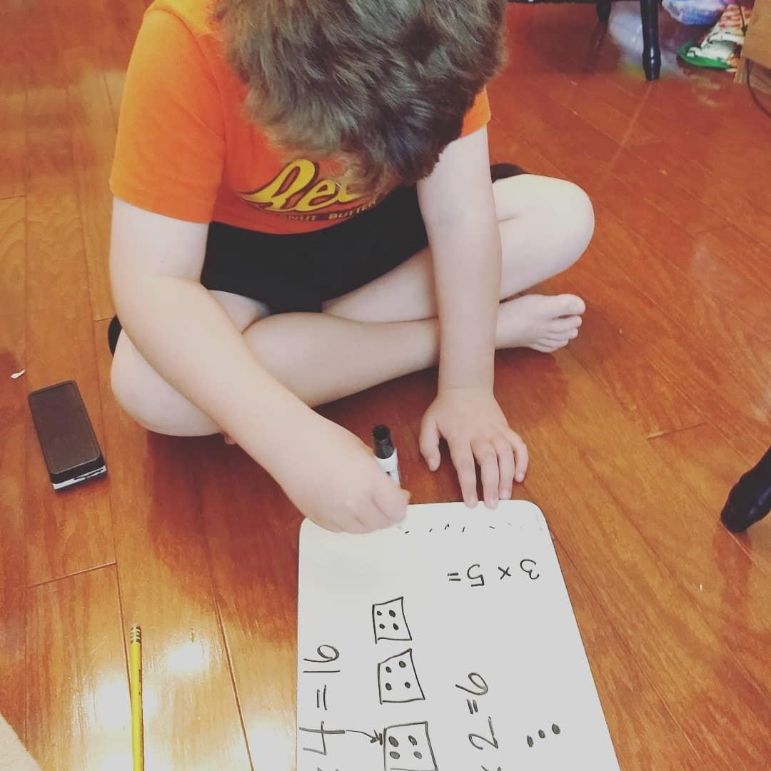
Figure 15
Jamie’s Child Doing Math on the Floor of their Homeschooling Room

For Jamie, gentle parenting allowed her to hold a more caring space for her child’s development in ways that are more aligned to her values, and then, in turn, can hold responsibility with her own existence simultaneously. Jamie’s reflection of the past seemed to inform her growth as a parent. She shared how her desire to become a better parent meant providing her children a kinder and more gentler learning environment than public school could provide.
Both Brittany and Jamie were unhappy with traditional approaches to parenting and managing a child’s behavior and sought a change. Brittany recalled:
You know we tried lots of things. We totally had a career. We had our business and stuff and we sent them to school, and we went to work. And we were the parents, and they were the kids. These are the rules. We took the traditional or “in the box” approach to life. We tried all the things and it sucked. It's been an evolution with everything, our parenting, our jobs and our homeschooling. (Photo Chat 4, 12/16/2019)
Her unhappiness led her to seek multiple paths in her journey of parenting on her own way to finding homeschooling. This change in becoming a homeschooling mother helped her reevaluate her goals, expectations, and relationships as she incorporated a new sense of self as a mother. Brittany sought more authentic ways of being, when it came to how she and her husband parented within their family’s dynamic:
Oh my gosh, our first year of homeschooling, I can’t even. Sometimes I look back and I'm like, ‘Oh, that was the worst year of my life.’ My two oldest fought a lot. But I have been reflecting a lot on how hard it was in the beginning and what a weird sacrifice I thought it was for me to be doing this. (Photo Chat 4, 12/16/2019)
Brittany faced not only a new dynamic of sharing space and time with her children but the ways in which she prioritized their educational needs and interests. These changes brought into question many aspects of herself toward the reorganization and transformation of self-identity, such as becoming more understanding and capable in helping her daughter with special needs. One poignant example of this came in a later photo chat:
You know she will be like, I'm stuck. And I will tell her to stand up and get showered, shake it up and try again. ‘You choose how you want to shake it up, whatever you want, I don't care how you do it.’ And so, we just do a lot of talking and I need to have a lot of patience. Like we talked a lot about how we should spend our time and how much more fun we could be having if we would just get our work done. But she struggles so we do a lot of reminding and a lot of hand holding. That's my oldest baby. Yeah, so you just try to give them ways to cope in a healthy way when they are struggling [See Figure 16]. With homeschooling you can pay better attention to the skill set that each kid has and help guide them better during difficulties. (Photo Chat 4, 12/16/2019)
While the stories of Jamie and Brittany varied, there were similarities in the causal moments that triggered the mothers’ evaluation of themselves, and their decisions around their own parenting.

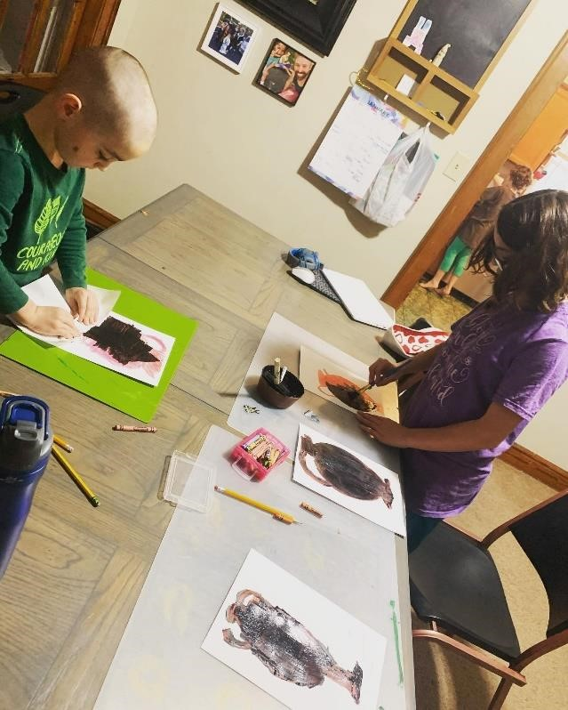
Figure 16
Brittany and her Children Participating in a Homeschooling Activity

These turning points emerged from a process of re-visiting and evaluating the connection between their values and priorities of parenthood and their children’s traditional schooling. In all these cases, homeschooling provided the mothers an opportunity to be physically close to their children, have more time with their children, and explore more positive parenting approaches. For some mothers this renegotiation between the old and new ways of parenting came from a reflection of what they experienced as children, while others were unhappy with their present parenting and sought a change that ultimately benefitted both the children and the mothers.

Leaving Public-school for Homeschooling
Mothers who homeschool their children often face a degree of stigma, pushback or negative responses from family, friends and strangers (Lois, 2012). In Western society, it is the cultural norm for children to attend public-school and a phenomenon that is routine (English, 2016). Accordingly, five out of the six mothers initially sent their children to public-school and then made the choice that it was not the right path for them and/or their children. As a result, they encountered another turning point towards homeschooling. They all believed public education was insufficient in one way or the other and were willing to endure a process of uncertainty, tiredness, and loss of time for themselves in order to challenge educational norms and reevaluate their purpose and aspirations as mothers.
These five women reported going into motherhood with the expectation of sending their children to traditional school, however, each described frustrating, and at times hurtful experiences that led them on their different paths of homeschooling. Most mothers pronounced that they were able to provide a better learning experience for their children than public-school. For example, during a later visit in our time together, Fay expressed deep regret for sending her oldest child to public-school when she recalled:
The head teacher at the school pushed us a little too fast to get him in school. Jared is a really sensitive child and honestly it was too soon for him. We only sent him for a couple weeks, but it changed his routine and really impacted him. He used to be confident and then all of a sudden, he didn’t want to leave me. He was scared and so I didn’t make him go anymore. We were tight knit parents before that, and it really shifted our connection and was quite traumatic for all of us. (Photo Chat 6, 11/08/2019)
The ability to make meaning of this event, provided a powerful motivation for Fay to choose to homeschool. In a later conversation, she continued to use this event as a unit of measurement to evaluate how her son is doing now since she made the decision to homeschool:
You know six years later of homeschooling his confidence is back and he is learning on his own. He is not afraid and when he gets on the ball field, he just shines. He went from this shy timid boy to somebody who is confident, and it’s been amazing to watch it and share and I am so glad I listened to my gut and pulled him from school. (Photo Chat 7, 11/16/2019)
By first enrolling her son and then removing her son from public-school, Fay experienced a turning point in her life in which she was able to take action to align with her values for how she wanted to raise her son. According to Fay, Jared was able to be more successful and Fay was also successful in finding a more authentic sense of purpose and direction for her life. Correspondingly, Brittany also shared multiple experiences she had with the public education system and her family, when she recalled,
My oldest was super-duper duper premature and was in the NICU for months and months. She now has ADHD and some sensory issues. And we did the medication route while she was in public-school and it didn't help and mostly hurt, in every way. I would say, a solid year with all the trauma of having to make her swallow pills. And year after year, every parent teacher conference was a negative experience. So, we knew we needed to provide a different experience for her [See Figure 17]. All I knew was that we needed to let her go at her own pace, and that led us to homeschooling. (Photo Chat 1, 11/1/2019)
Brittany described herself as someone who came from a public-school background and has family members that are public-school teachers and often felt torn between following the social and cultural norms of public education and exercising her right to provide the best learning environment for her children (Field Journal, 12/16/2019).
She remarked, “we really tried and really failed at sending our kids to public-school” (Photo Chat 4, 12/16/2019). This gradual break from public education led to the unfurling of new ways in which they taught and interacted with their children. This process was communicated through the photo chats and final interviews and observed during the time spent with each family.

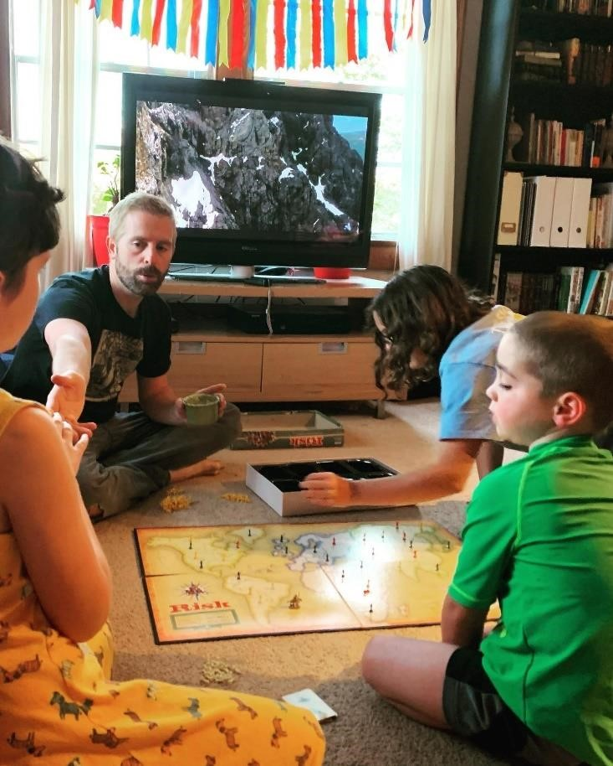
Figure 17
Brittany’s Husband and Children Playing a Game during Homeschooling

Brittany explained the experience further in her final interview:
Homeschooling became really important to me when it became clear that public-school wasn't going great for my girls. I knew they were beginning to hate learning. And that caused me to reflect a lot about all the reasons I'm doing this to them. Why am I sending them to somewhere they hate? They were exhausted and we were exhausted. And we changed directions and there are great things about doing this [homeschooling]. (Final Interview, 2/3/2020)
Brittany’s change of direction and desire to give her children what she believed is the best learning experience for them was challenging, but at the same time deeply meaningful.
In conclusion, all the mothers from Fay to Brittany identified turning points that led them to make decisions to homeschool so that they could ensure their children’s needs were better met. Consequently, their children began to thrive in a range of ways that convinced these Mom Pedagogues they were on the right educational and social-emotional paths with their children. Each mother described how choosing to homeschool was a decision that was best for her children, and all explained how that choice also benefited them. For these mothers, a transition to homeschooling was often a rejection of their own educational paths and childhoods, which led to many positives changing for them and their families. Mothers reported their own sense of self also shifted positively, due to their desires to create change for themselves and their emerging homeschooling practices. Overall, this finding suggests there were key turning points that contributed to the mothers’ decisions to homeschool, even as they provided their children a place to flourish educationally and emotionally. Further, as a result, it also encouraged a more authentic way of everyday living and learning and evidenced the ways each mother transformed into the Mom Pedagogues they are today.

Finding 2: Becoming a Mom Pedagogue: Desire, Caring, and Emancipation
The first finding of this chapter described how the mothers’ past and current experiences led to a desire to homeschool their children. These mothers engaged and reflected on moments that were meaningful and perhaps pivotal from which they found awareness about themselves in relation to schooling and learning experiences. Their reflections ultimately informed their decisions to homeschool their children. The turning points unfolded across their lifetimes and became important moments in a rich tapestry of lived experiences that helped shape their beliefs and values and ultimately their practices as “Mom Pedagogues.” Their engagement in a wide range of cultural contexts appears to have influenced how they defined their parenting in diverse, yet similar, homeschooling settings.
While the mothers, at some time, expressed doubt or unease about homeschooling, more often they expressed satisfaction and fulfillment. Their roles that were regularly described by the mothers as the position of “‘facilitator’’ and “coordinator” were informed by their over-arching goals for their children (Field Journal, 11/11/2019). The mothers often acknowledged they were not replacing teachers but rather re-positioning themselves as pedagogical guides of their children’s learning. For example, none of the mothers reported (nor did I observe them participate in) educational micro-management or many formal teaching behaviors (Field Journal, 2/1/2020). Rather, they often engaged in a wide range of practices centered on caring for their children, as their children learned. This second finding is focused on the mothers’ perceptions and actions within the contexts of their roles as Mom Pedagogues and how these roles manifested in (a) the fulfillment of their maternal desires and ethic of care and (b) the emancipation of their children, through holistic, child-centered homeschooling experiences.

Maternal Desire and Ethic of Care
A key aspect regarding how the mothers practiced and participated in homeschooling was their personal motivations and beliefs related to perspectives and decision-making as Mom Pedagogues. Generally, two philosophical ideologies shaped their approaches, which included (a) maternal desire and (b) ethic of care. Ethic of care has been described by Sprengel and Kelley (1992) as the “capacity to care which is the foundation of moral consciousness and moreover, the capacity to care is a prerequisite to ethical behavior and therefore ethics and caring are not really separable” (p. 233). This ethic of care, influenced by maternal desire, seemed related to the fulfillment of the cared-for as well as the one-caring (Noddings, 2003). This finding explores the caring relationships each mother revealed with her children and how their relationships influenced both homeschooling practices and mothers’ processes of becoming. Maternal desire included both the mothers’ desires to care for their children and, in so doing, the ways it became a “feature of their self-development and self-expression, rather than its negation” (de Marneffe, 2004, p. 25). The interplay between caring for self and their children characterized many of their lived experiences as they assumed the roles of “gentle parents.”
Four of the mothers referred to themselves as “gentle parents.” The other two moms did not use this term but did identify with key aspects of gentle parenting that they called “conscious parenting,” “peaceful parenting,” “responsive parenting” and/or “gentle guidance” (Field Journal, 11/11/2019). Gentle parenting focuses on encouraging the qualities one wants to support in a child by being compassionate and enforcing consistent boundaries (Lasio, Serri, Ibba & Manuel De Oliveira, 2019). Broadly speaking, gentle parenting emphasizes the creation of a positive environment conducive to teaching and modeling behavior with children (Grady, 2019; Katzman, 2020). Across the multiple weeks of my observations, all the mothers revealed these patterns, although they were varied. Their exchanges with their children were typically flexible and often boosted their children’s self-esteem, along with an emphasis on the relationships within each family (Field Journal, pp. 1-32). For example, I wrote, “These mothers have such patience and understanding with their children. It pretty amazing that they can be as engaged as they are with them while trying to teach, take care of the house and gentle parent” (Reflexive Journal, 10/19/2019).

Maternal Desire
Each mother described a deep desire to nurture their children and this yearning included the choice to homeschool. To these moms this meant to not simply have children, but to actively care for them in meaningful ways. de Marneffe (2004) explained that maternal desire is not the simple assumption that it is woman’s duty to mother, a compulsion to mother, or the submission of women to prescribed roles, but instead it is a choice (p. 3-5). It is a “longing felt by a mother to nurture her children, insofar as it is possible, to put her desire into practice” (de Marneffe, 2004, p. 3). For example, Tessa discussed her maternal desire along with her decision to homeschool during a photo chat, during my second observation. She declared,
All I know is that I care about their experiences in this life. And I am going to do all that I can- to cater their life to what they need to have the best experiences and for us that means homeschooling [See Figure 18]. (Photo Chat 2, 9/16/2019)
Her comment illustrates the types of affirmations heard from many of the mothers as they reported to me and reminded themselves why they chose to homeschool their children.
For example, the mothers’ maternal desire to care for their children by homeschooling served as an essential function critical for long-term goals and parenting values for themselves. This stance to nurture and care while educating became a strategic perspective for helping the mothers deal with the stressors and role strain of homeschooling. For example, Zoey mentioned her innate maternal desire to nurture her children through homeschooling when she recalled, “I really get to focus on what their important skills are [and] what their strengths are, and I can pour into that” (Photo Chat 3, 11/07/2019). Maternal desire seemed to be at the center of how the mothers saw themselves and brought to the surface their own autonomous goals of self-actualization.
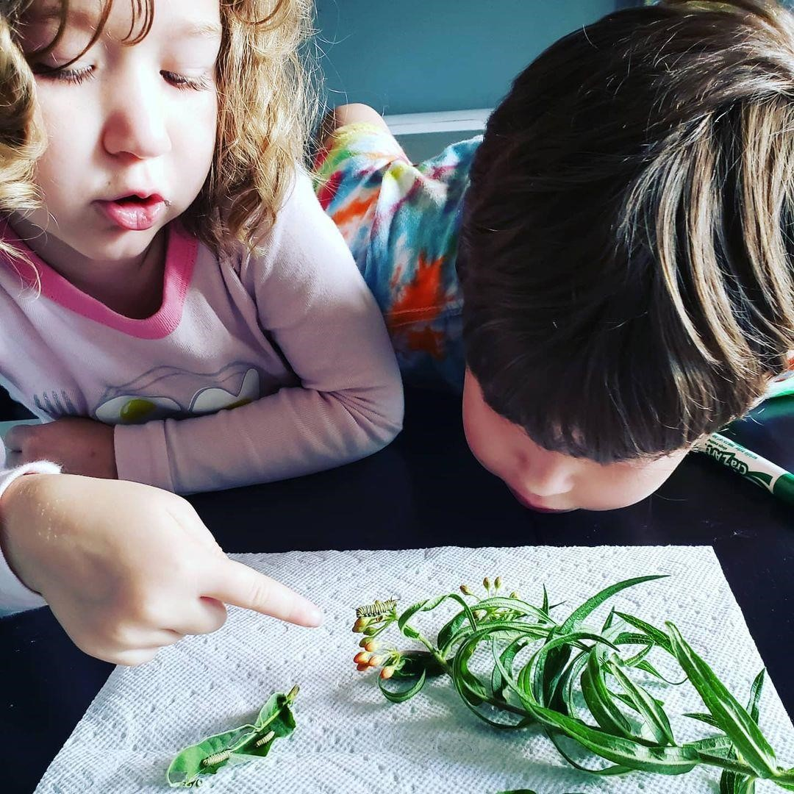
Figure 18
Tessa and her Children Looking at a Caterpillar

Tessa, referenced this shift in her final interview sitting at her kitchen table:
I just felt like my life didn't fit in this box. That there was something wrong with me, and I just never want my children to feel that way… And that’s when I asked myself, ‘what if homeschooling allowed me to raise people who were emotionally healthy, who felt like they could ask questions and could be their authentic selves?’ And I knew I needed to do it because it was something that I never got for myself. (Final Interview 01/7/2019)
Homeschooling allowed Tessa the opportunity to be responsive to her children’s needs, as well as her own in ways she felt she never received growing up. Like Tessa, all the mothers expressed how their maternal desire fits within the context of their parenting and homeschooling values and supported their personal well-being. Congruently, maternal desire served as a key stratagem for the emotional well-being for both the mothers and children.

Ethic of Care
In addition to maternal desire, the mothers were guided by an ethic of care that informed why and how they chose to homeschool. Generally speaking, ethic of care includes the completion and fulfillment of the lives of the cared-for and the one-caring (Noddings, 1984). Thus, the desire to care for their children shaped each mother as she created what it meant for her to be a Mom Pedagogue. This process of becoming was centered in empathy, and responsiveness towards their children, and, in turn, a more authentic life for themselves. For example, Brittany succinctly explained this perspective as she reflected on her homeschooling journey during an early photo chat:
Yeah, just I never saw myself being like a stay-at-home mom at all. My mom works like eighty hours a week. My mom was always taking care of the house, too, and making sure we were all eating. I was just raised to do both. So, I never ever, ever saw myself as a homeschooling mom. But it was just like something I had to do. And now it’s what I am, and I am proud of myself and what I can and have done for my children. I am proud of how far we have come as a family. (Photo Chat 2, 12/10/2019)
Brittany’s reflection represents how the mothers’ individual journeys to become Mom Pedagogues were fundamental to how they cared for and homeschooled their children. Each mother revealed how homeschooling allowed her to retain her identity as well as her ethical response to protect and provide for her children, in what she perceived as the best learning environment. Erica shared a memory during her final interview as we were sitting on her couch surrounded by her four children:
I guess it's opened up a lot of options for us. I mean even for me. Now we are going to new places and trying new things. I am doing things, I never thought I would get to do. Like, we just went to Universal Studios and went to Harry Potter World [See Figure 19] because we just read the books and we probably wouldn’t be able to do that if they were in school. I am learning new things about my relationships with them and then building those relationships. Being a homeschooling mom has given me more opportunity to love on them how I know to best love them. (Final Interview, 11/29/2019)

Figure 19
Emily and Tessa’s Children at an Amusement Park

Erica describes the personal growth she recognized through new experiences and her own way to care for her children that was different from how she was raised. Another aspect of the mothers’ ethic of care was a strong belief that public-school could not provide adequate care for their children. All of the mothers framed public-school as contrary to their ideals and values and challenged the ways they wanted to nurture their children. For example, Fay discussed public schooling in an early photo chat when she responded to a question I posed:
M: One last question- What stands out to me listening to you talk about your kids and this photo is how important relationships are in your family. Where do you think that comes from?
F: (laughs) I raised them that way. I raised them to put each other and our family first. I was nursing Jared when I got pregnant with her (Sarah), and I continued to nurse even though I dried up and even though it was the most uncomfortable thing I have ever done. I told him, when she was born, she was going bring milk and she was going to share it with him, but he had to share my breasts too. Just like I am sharing my milk and breasts with him and his new sister. So, I started them from the very beginning, they shared. And that is just how our family is. We share and sacrifice for each other. And I am able to see them do that for each other in everything they do down there [while spending time at the creek]. That wouldn’t happen if they were in separate classrooms. (Photo Chat 1,
9/1/2019)
In this exchange, Fay shared her desire to not only nurture and nourish her children but to also teach them an important lesson of sharing and teamwork. She made the argument that without homeschooling, their early experiences could not foster teamwork between them as well. She described both her maternal desire to care for her children and how that care manifested in her children’s actions. Fay’s maternal desire differed from the other moms; in that she showed her care by staying out of her children’s way. For Fay, nurturing her children meant ensuring
freedom for her children,
Now that I have become an adult, I just want to see what my kids are doing. What they are making and creating. How they are helping and directing each other. It’s really kind of fun. So, that is my favorite time, is that I can actually go out on my deck and actually listen and just watch them and they don’t know I am there. It’s pretty cool to see them in their element. (Photo Chat 1, 9/1/2019)
Fay describes the pleasure she gained from being “alone together,” by doing things near her children and feeling comforted by their presence while attending to her own activities. Fay’s gratification came from watching her children develop, grow, and change, and being involved in the people they were becoming.
On the other hand, for Erica, caring and homeschooling her children meant directly participating directly in different activities and field trips with them. During our first photo chat she reflected, “I know I wanted to go on adventures with them. I knew I wanted more memories and experiences with them [See Figure 20]. And the freedom of homeschooling lets me do that” (Photo Chat 1, 10/11/2019).
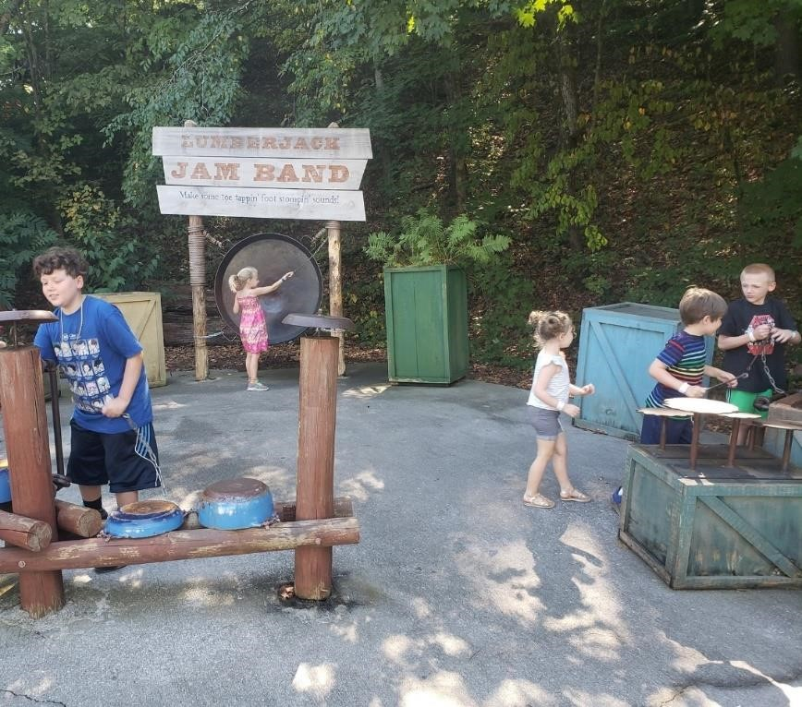
Figure 20
Emily and her Children on an Adventure to a Park

Erica’s focus in caring for her children included spending time with them, engaged in new, shared experiences. Zoey shared similar sentiments about learning and sharing experiences, “We are always exploring, and we are always talking about how we can learn from things” (Photo Chat 2, 10/21/2010). During my third observation, I wrote about Zoey’s homeschooling practice
that often takes place outside the home, and her particular style of care for her children:
Zoey’s photos from this week were all outside of the home doing activities. They were at the Museum of the Mountains, on hikes, at a farm [Figure 21], the grocery store, rock climbing at the gym, and helping at their family business. Zoey has few materials and supplies in her home, so I can see why. They seem to always be on the go and that seems to best suit her and her children. (Field Journal, 10/28/2019)
In summary, all the mothers demonstrated a range of ways in which they chose to homeschool their children, as they referenced their desire to care for them in ways that fostered freedom, self-respect, independence, curiosity, and creativity (Reflexive Journal, 12/16/2019, pp. 1-12). I observed mothers facilitating activities and learning, which helped children become self-directed and responsible for their own learning while also demonstrating obvious care and love for them (Field Journal, 12/16/2019, pp. 1-32). Mothers argued that the amount of care and attention they gave to their children would not be possible if they were attending public-school and spending less time with each other.

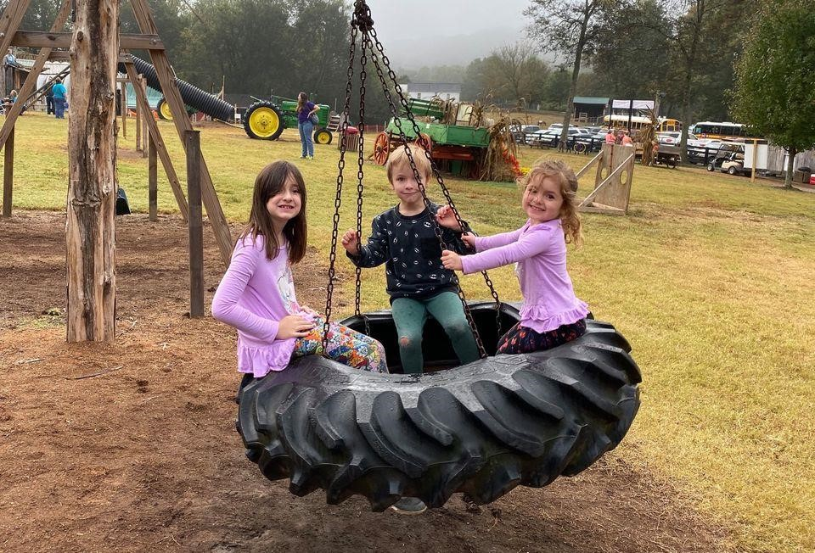
Figure 21
Zoey’s Children Playing at a Farm

Each of the six mothers indicated that homeschooling was the best choice for them and their children because it provided the best opportunity to build and maintain relationships within their family unit. de Marneffe (2004) proclaimed that maternal desire “is the wish to participate in a mutual relationship with their children; and the choice, insofar as it is possible, to put her desire into practice” (p. 37). By creating trust and building a mutual relationship between mothers and children, the children’s natural growth toward learning is honored by treating each child with love and respect. These examples demonstrate how the Mom Pedagogue goes beyond a clearly delineated parent/teacher roles to a much more meaningful and complex integration that represents- the role of a Mom Pedagogue.

Becoming a Mom Pedagogue

Emancipation
Like any pedagogue, the approach in how these mothers taught their children is grounded in their teaching and learning philosophies. For these mothers, a major element of their pedagogical approaches centered on their desires to emancipate their children from the confines and demands of traditional schooling. Each mother described wanting to free her children from (1) the formality of public-school and (2) the disciplinary patterns and practices that train and normalize individuals. Foucault (1988) described this kind of emancipation as “freedom from the sovereign” and “freedom from disciplinary powers” (p. 123). Foucault postulates that sovereignty is not only power of the state but is a “whole series of power networks that invest the body, sexuality, the family, kinship, knowledge, technology, and so forth” (p. 123).
All of the mothers described uncertainty, disappointment and resentment toward the public school system (Reflexive Journal, 11/30/2019, pp 1-9). For example, public-school was described as “controlling,” “a ‘government day camp,” and “a place where many tears were shed” (Field Journal, pp. 1-20). Additionally, all the mothers expressed a desire to free their children from the disciplinary powers that train children to act a certain way. Or as Tessa expressed, “Kids are being programmed that they should learn by sitting still. They are being trained to be quiet all day. I wanted them to be children, experience life and not just learn to sit at a desk [See Figure 22]” (Photo Chat 1, 9/11/2019).
Tessa persists:
I think what continues to motivate me to do homeschooling is having their formative years when their brain is developing, be so heavily influenced by people that I have no control over or how they learn or how people treat them or care for them. They are told ‘this is right, this is wrong. You do right- you get to go to the treasure box, you do wrong, and I shame you.’ I don’t want that for them. And in my opinion, I even think parental rights go out the window where you don't even really have a say anymore. (Photo Chat 1, 9/11/2019)
Tessa articulated the importance of others not imposing their own direction onto her children and by choosing to homeschool she has been able to protect them from being labeled or forced to do something unwanted. The mothers shared a common belief that by listening to their children, they offer them the freedom to learn, and facilitate a respectful, caring relationship from which their children are provided greater autonomy.
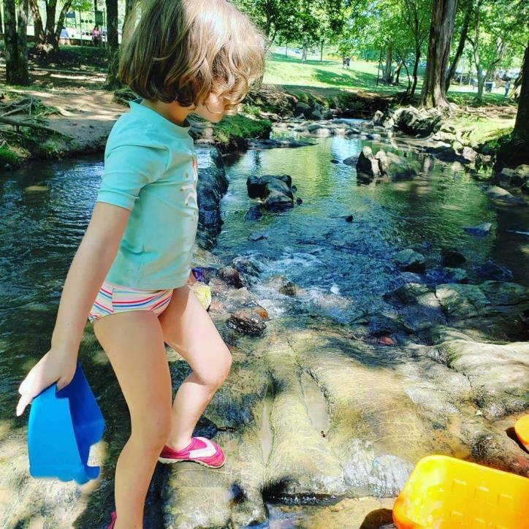
Figure 22
Tessa’s Youngest Child Playing in a Creek

Child centered learning was the most common reported practice of emancipation among the mothers. Each mother expressed a similar expectation that children organically develop as parents and children explore the world together (Willard, Busch, Cullum, Letourneau, Sobel, Callanan & Legare, 2019). For example, five out of six of the mothers reported, in varying ways, that when selecting what to study for the day they listened to their children, and then built their lesson plans related to their interests. For instance, when I asked Zoey when they start their school day, she explained, “We start when they are ready to start. I just kind of follow their moods and when they are ready to go. Which was not how I was homeschooled. We started at 9:00am sharp” (Photo Chat 4, 12/16/2019). Tessa also mentioned, “our school year ends when my children say they are ready, they decide” (Final Interview 01/07/2019). Brittany was the only mother who did not allow her children to directly choose their work. However, I wrote about a pattern where she actively attempted to encourage her children to take charge of their homeschooling choices,
Brittany follows a pretty formal curriculum for all three of her children. Her youngest follows an LDS curriculum with explicit tasks and worksheets every day. Each morning, Brittany reviews what each child must get done, according to their curriculum and their co-op homework and writes those tasks on their family white board hanging in their dining room (See Figure 23). Tasks I observed on the whiteboard include math, reading, French, piano, science and social studies. However, Brittany reports (and I observed) her children choosing the order in which they want to do their work every day (Field Journal, 11/02/2019).
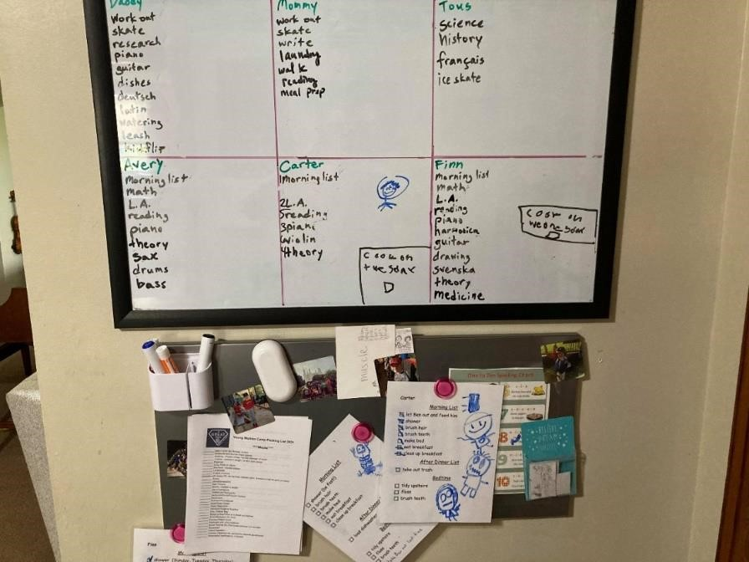
Figure 23
Brittany’s Homeschooling Task Board

When I asked Brittany about this approach, she explained,
You know, at the beginning of the school year we set like individual goals with the kids, and I have some goals for them myself, but they are in charge of their learning. For example, I leave it up to my kids to decide when they are ready to start and done with the semester. So, every day I want to remind them that this their time and schooling. I can't make you learn anything -- that is up to you. So, you decide what your day looks like and how long its gonna’ take you to get your work done (Photo Chat 2, 12/10/2019).
Similarly, Zoey described learning practices determined by her children as she recalled, “I want my kids to know that I see them. I am not going to tell them, ‘This is how you do things’ but rather let them find how they see themselves and the world” (Photo Chat 3, 11/07/2019). My observations of Zoey and her children mirrored her explanation. For example, during my first visit I wrote:
Zoey’s house is quite empty. The family room in which I do most of my observations is a large open room with one couch, a tv, and one small bookshelf with encyclopedias. Occasionally there would be crayons, papers, or books scattered on the ground where the family would be working. Today I watched them do tangrams on the ground together. (Field Journal, 10/26/2019)
Zoey explained her homeschooling approach in a later photo chat:
Our days usually start with these encyclopedias. They were my grandfathers. If one of my kids is curious about something we will open these up and sort of learn and talk about what they are interested in. Like when Ruth asked about chocolate. We looked it up in our encyclopedias and, and I went with it. I decided we would do a chocolate day. I threw a lesson plan together. (Photo Chat 4, 12/07/2019)
These examples reflect the ways in which, some of the mothers freed their children from the often fast-paced and pre-programed teaching that is typical in public-school classrooms. Based on my observations, the mothers strived to provide their children “a rich and stimulating learning environment” in which their children “would learn what they are ready to learn, when they are ready to learn it” (Holt, 1964, p. 113). Or as Zoey noted, “It means that we aren’t as focused on 2+2 and what the correct answer is for 100. We are more focused on their curiosity and that will lead them to figure things out on their own” (Photo Chat 5, 12/16/2019). Each mother, in their own way, sought to emancipate their children from the confines of traditional public-school by facilitating meaningful learning that repeated their children’s own unique needs, capacities, and interests. This meant letting their children make choices about how, when and what they learned and being willing to provide the materials, space and relationships to make the children’s learning desires come to fruition.

Bildung
The second approach the mothers reflected was fostering a holistic learning experience for their children, focused on their children’s unique talents that may be beyond their intellectual capabilities. Thus, much of the daily practice of these mothers included encouraging their children to discover their own uniqueness as individuals and actively participate in real-life activities, with a de-emphasis on grades and learning outcomes, in order to help children, pursue their own interests (Field Journal, 10/26/2019).
Moss and Petrie (2019) contend that Bildung centers on the potential of a human being,
“as an entity that builds or creates herself or himself in a way that is not pre-ordained, a process of self-development or self-formation” (p. 400). This process of self-development can be seen in the practices of all these mothers, as they created spaces that promoted problem solving, creativity and an openness to learning styles that matched their children. As Fay explained,
My husband is working with a bunch of guys, were prior military, went to public-school and they are having issues. They do not know how to figure things out themselves without being told. Their brains are not wired to problem solve. And so, I think we are building them [our children] a foundation of problem solving, which I feel is pretty important and they have opportunities to do that every day on our property (Photo Chat 1,
9/1/2019).
Fay wanted to develop her children’s ability to make independent decisions and critically perceive, formulate and solve problems for themselves. For example, she and I discussed one of her photographs, mid-way through the study, she explained,
F: They are diverting the creek in this photo
M: Cool. And it was their idea to divert the creek?
F: Oh yeah, I had nothing to do with that decision. I don't get involved with their stuff down there. It’s all their creative ideas and actually this ended up being a bridge they built. My oldest leads the way on their projects. He designs and leads, and she follows, all on their own. Not many 7- and 5-year-olds are doing that kind of work (See Figure 24). I just want them to be self-sufficient (Photo Chat 5, 11/1/2019).
Lenz-Taguchi (2018) often drew upon the concept of Bildung when she wrote, “the human being is, or should be, a being that constructs her/himself into something not decided beforehand” (p. 16) “…through a dynamic undertaking that creates learning opportunities to increase children’s possibilities for freedom” (p. 13). Thus, Fay’s role did not include the goal of providing an academic curriculum, but, rather, to focus on facilitating opportunities of personal growth and freedom for her children. She described another example in an early photo chat as she described her son’s evolving knowledge of trees,
M: Your son just finished giving me a tour of your trees. He was telling me the name of each tree and the pros and cons of the tree as a building material.
F: He knows all of the trees. My mom is a horticulturist, so she taught him everything. And so, they would learn the trees together and so they would look around and learn them all, ever since a baby. I knew it was important for her to teach him and so they spend hours and hours in the woods together. And now he uses that information to build and improve his structures. For example, his first structures were not that sturdy, and now, it is a legit survival structure. (Photo Chat 1, 9/1/2019)

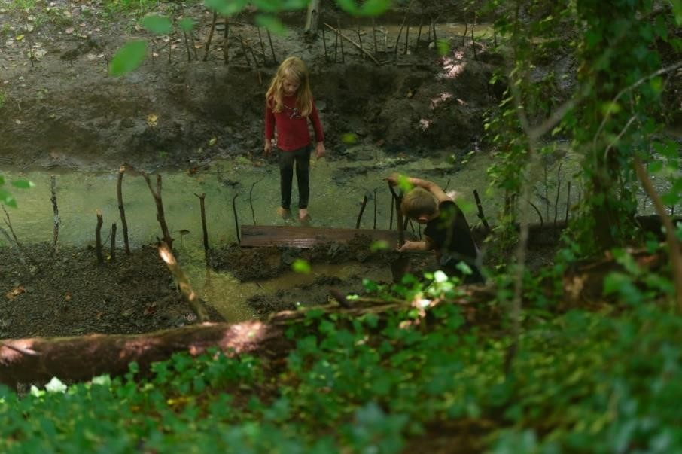
Figure 24
Fay’s Children Diverting the Creek

Fay’s description of her homeschooling often stressed the importance of meaningful outdoor activities, such activities foster critical thinking and self-knowledge while allowing her children to relate to what is learned, as they engage in their social and natural environments. Similarly, multiple mothers sought learning experiences outside of their homes, in order promote self-discoveries and expose their children to more diverse experiences. Mothers reported that attending the FFTT group and other community activities cultivated caring individuals who participate in socially meaningful activities, with like-minded peers and friends.
Four out of the six homeschool families routinely and consistently participated in FFTT activities and/or other community activities or projects, including classes at museums or church sponsored community service events. Making the choice to participate in these field trips, allowed them more opportunities and choices for their children to participate in experiences that interested them. For Tessa, socializing and doing activities outside of the home, was the whole purpose of homeschooling. She explained,
I think the stigma of homeschoolers is changing. It is not just people who are religious extremist and want to keep their kids away from the popular culture. People always seem to tell me when they hear that we homeschool- "you are sheltering your kid from the world." Well, I am actually doing the opposite. I don’t want my kid only reading whitewashed history from books and are only around kids their age. I want them experiencing life outside the school. I want them to be out in the world (Photo Chat 2, 9/16/2019).
Zoey also shared a similar sentiment, “My goal is exposure to all different lifestyles and being able to get out of the house and learn from all types of people. I just want them to have exposure to things, people, textures and sites” (Photo Chat 3, 10/28/2019).
I often observed all the mothers’ focus on holistic personal growth for their children in how they provided nurturing conditions that supported both independence and interdependence inside and outside their homes. For example, in my field notes from my visits with Tessa, I wrote,
Tessa called her kitchen table the “homeschool table” although I rarely observed any child sit down and work at the table [See Figure 25]. I did observe children constantly coming in and out of the kitchen where they often checked in with their mother about the task they were doing. I saw children coming from their bedrooms, from outside, bathroom and other parts of the home. Each time, a child checked in with Tessa, a hug or physical touch between her and the child would occur, and they would sometimes ask her a question, get help with a worksheet, ask permission to go outside, etc. More than a few occasions, I watched the three older children go into the kitchen and make food for themselves and/or the family. (Field Journal, 9/22/2019)
I asked Tessa about her space. She explained, “I had this realization that our home was the ideal learning space for them, so why not try it. And I just try to make a space that is best for our family” (Photo Chat 4, 9/30/2019).
Tessa expressed how she often sought to provide a space where children can grow that is safe and open to their learning ideas, a place where Bildung can flourish.
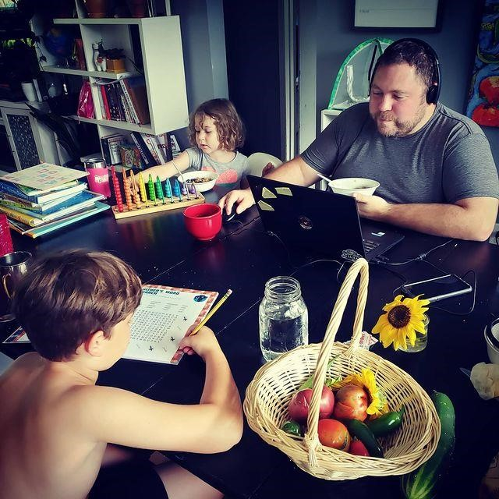
Figure 25
Tessa’s Homeschooling Table

Tessa’s desire to create the best possible learning space for her children included two distinguishing features about her homeschooling practice. First, she is the best person to teach and guide her children and, second, her home is the ideal space in which to do it. She continues on in her final interview:
Ultimately my goal is just to make sure they’re freaking cool good people. That’s what I’m trying to do by homeschooling. I am going to love them through it all. I don’t want them to feel shame or feel judged about who they are in their life and what their experiences are. (Final Interview, 1/7/2020)
Tessa made explicit links between her personal experiences and goals with homeschooling and provided an educational experience that focuses on the child as a whole person. She aimed to “nurture creative abilities” in her children so they can “express themselves, understand others, and be kind” (Photo Chat 4, 9/30/2019). Zoey also shared similar thoughts during her final interview, when she remarked, “I am trying to cultivate the most well-rounded humans that we can” (Photo Chat 2, 10/21/2019). Schäfer (2016) described the emphasis of holistic learning in regard to Bildung:
Bildung is about allowing young people to unfold and create themselves in ways that are driven by their souls, their spirits, and their internal motivation. It is about allowing young people, and all people, to learn in the world, to use whatever available resources, methods, and tools the learner chooses. (p. 142)
The mother’s discussions of their homeschooling were often rooted in one of the key principles of holistic learning: to develop curious and authentic human beings (Breeze, 2019, p. 64). They expressed aims and values in which learning, caring, general wellbeing and development are viewed as inseparable. They are, however, in direct contrast to those of social conformity. Zoey outlined her approach, during our second visit, “Homeschooling means teaching my children to be curious but to have common sense. I just really want our kids to be able to be kind” (Photo Chat 2, 10/21/2019). Erica also shared similar desires in an emotional moment during her final interview:
M: All right share with me something that comes to mind that was surprising to you as you did this activity when putting these photos together?
E: I think it's surprising how much they've grown up.
M: How does it feel seeing them growing up.
E: (Starts to cry) Scary. [All three children see their mother crying and immediately go over to comfort her]
E: (still crying) I really hope that I can set them up for being okay people. That’s what I want for them. Just to be good people. (Final Interview, 12/20/2019)
Erica and Zoey identified the core of their roles as Mom Pedagogues, as the development of their children’s positive self-esteem. Each sought to empower them to make decisions and take actions that promote their own development and well-being and brings kindness to those around them. They both practiced Bildung in order to ensure their children’s wellbeing, learning, and growth. The two main strategies included child centered learning and holistic learning approaches the mothers sought to create in order to facilitate situated, meaningful learning experiences for their children was to emancipate their children from both (1) sovereign and (2) disciplinary powers. The goal of emancipation allowed for aspects in the mothers’ and children’s’ culture as contexts emerged in their daily lives, providing both the opportunity to achieve self-knowledge and relate to what they learned and were taught. Among these mothers, homeschooling provided the time, space, and opportunities to guide the appropriation of knowledge through necessary for pedagogical flexibility that reflected their values, beliefs, and goals aimed at meeting their children’s needs in their roles as Mom Pedagogues.

Finding 3: Enacting Personal Convictions through Uncertainty
The journey of being and becoming a Mom Pedagogue was reported to be both deeply engaging and demanding. Tensions around homeschooling slowly emerged over the duration of this study, related to operationalizing their roles as they challenged the status quo. Although the mothers displayed glimpses of this tension during their photo chats and my weekly visits, their anxieties were made fully visible during our final interviews. The experience of taking homeschooling photographs and then reflecting on their favorite ones, uncovered emotions— at times, characterized by elements of vulnerability, that they were quick to describe yet seemingly complex. For example, participants highlighted these moments as they cried and shared their stories. Each participant also expressed joy and pride along with her feelings of stress and insecurity as they reflected on their experiences. Overall, our conversations allowed for the gestalt of their experiences as Mom Pedagogues to come to the surface.
A dialectical point of view was used to examine the emotional lives of the mothers and how the mothers engaged with their emotions related to their convictions. Making meaning as a Mom Pedagogue included a host of lived experiences and emotions tied to their role – positive, negative, and everything in between. For example, all the participants in the study spoke of pride and feelings of certainty that contributed to a positive sense of self; nevertheless, they also described feelings of fear, doubt and uncertainty. It is these complex set of emotions that seemed to influence their ideological convictions. Ultimately, they relied on their imagined positive outcomes, characterized by their desire to promote holistic learning for their children as part of what is considered unconventional schooling. Each mother communicated her commitment to the physical, emotional and psychological well-being of her children.
Personal convictions are typically fundamental to one’s identity and conceptualized as one’s willingness to defend one’s position (Stancato & Keltner, 2021; Verplanken, Marks & Dobromir, 2020). Convictions in this study, are defined as individual’s mental states that are achieved through beliefs and practices that generate excitement and optimism as well as manage doubts and anxiety (Johnson, Bilovich & Tuckett, 2020, p. 314). This finding explores the ways in which the participants tolerated their uncertainties grounded in their deep beliefs and values about why they decided homeschooling mattered to their children’s quality of life as well as their own. The mothers’ journey guided their convictions and commitment helped them confront challenges and doubts in four primary different ways: (a) to make meaningful sense of difficult situations and identify opportunities for action, (b) to imagine a positive future for their children and themselves, (c) to communicate their beliefs and values to others, and (d) to sustain a commitment to protect and provide rich experiences of learning and life lessons for their children.

Making Sense of Difficult Situations
The mothers often spoke and revealed an adaptive capacity regarding how they homeschooled their children, developed through being able to learn and grow from experiences (both planned and unplanned) that were often were explained as transformative. This process was filled with complexity, enthusiasm, tension and contradiction.
For example, Tessa explained:
M: It sounds like a lot of homeschooling mothers look up to you and turn to you for advice and help. How does that feel when I say that?
T: You know, I post a lot about the things we do because I want people to see that people can do this. But sometimes the days feel really really hard.
M: Tell me more about that.
T: You asked me why I started crying when I saw all my pictures together. I think part of me is crying because I don’t ever really get to feel that or see what I’m doing. And more times or not, when it comes to homeschooling, it’s a feeling of failure. Because honestly, you’re often just beating yourself up which is really hard to not do. (Final Interview, 1/7/2019)
Tessa, who often evidenced moments of conviction and commitment to homeschool, also shared feelings about her self-doubt and thoughts about her own emotions. Another clear example of uncertainty came from Fay in her final interview, sitting out on her deck:
M: Talk to me about your use of the word “failure”
F: Oh, I feel it constantly (laughs)
M: (Laughs) Like every day?
F: Almost every day. And the other hard part is having so many people thinking I am going to fail as well. (Final Interview, 11/23/2019)
I was often able to sense the weight of failure and uncertainty when the mothers shared their emotions and tears with me during our conversations. Jamie described her uncertainty in her final interview when she recalled,
I feel like in the beginning I was like, ‘Oh god, I don't want anyone to think that I'm still doing this lesson, or I am not teaching. He needs to be learning and doing worksheets all the time. How do I measure up to public-school today?’ But, you know, the group leaders were talking with me, and they were like ‘Relax it’s okay, you do not have to be perfect.’ I don't need to compare myself to them or to public-school. (Final Interview, 12/1/2019)
All the mothers expressed moments of stress and doubt and reported that their day-to-day concerns were less important in the grand scheme of what homeschooling was providing for their children. Fay articulated this as we sat at her kitchen table:
I like seeing these photos. These are my photos of them. And seeing them they make me feel secure and confident. They make me feel better. They make me feel less worried about how I am raising them. Because I can see that I am giving them a life and permission to not fit in and be put into a box. Because I don’t want them to not have permission to follow their passions like me. Can you imagine if we had permission like them to be what we wanted? (Photo Chat 5, 11/1/2019)
Fay had reflected on her own powerlessness in her choices as a child and then in turn spoke about a desire to provide a more assured and free future for her children. Her conviction seems to give meaning to the everyday worries she has about them. Erica also shared similar feelings of conviction that she was able to draw upon as she recalled pressure she felt from others:
Right. I mean, all of society is looking at you like: Are you gonna’ be able to do this? Are you making the right choice? We were taking a class at a museum [See Figure 26] as a homeschooling group and the teacher asked if the children knew how to read. I know she wouldn’t have asked that if she knew they were public-school kids. People just don’t think homeschooling kids can do anything. And people just think that they're entitled to ask you questions just because you're doing something differently. And there is a lot of pressure to make sure you are on the right track, and I want to show people that we are normal, and my kids are learning what they should be. (Photo Chat 2,10/19/2019)
The worries and anxieties described by these mothers highlights how being and becoming a Mom Pedagogue is, at times, deeply contradictory and uncertain. Mothers often spoke about the stigma they experienced by people on the outside of the homeschooling community and how it impacted them. They seemed overwhelmed and determined to change the public perspective of homeschooling because they knew what it provided for their children. Each Mom Pedagogue demonstrated and shared a passion and dedication to provide better learning and developmental experiences for their children.
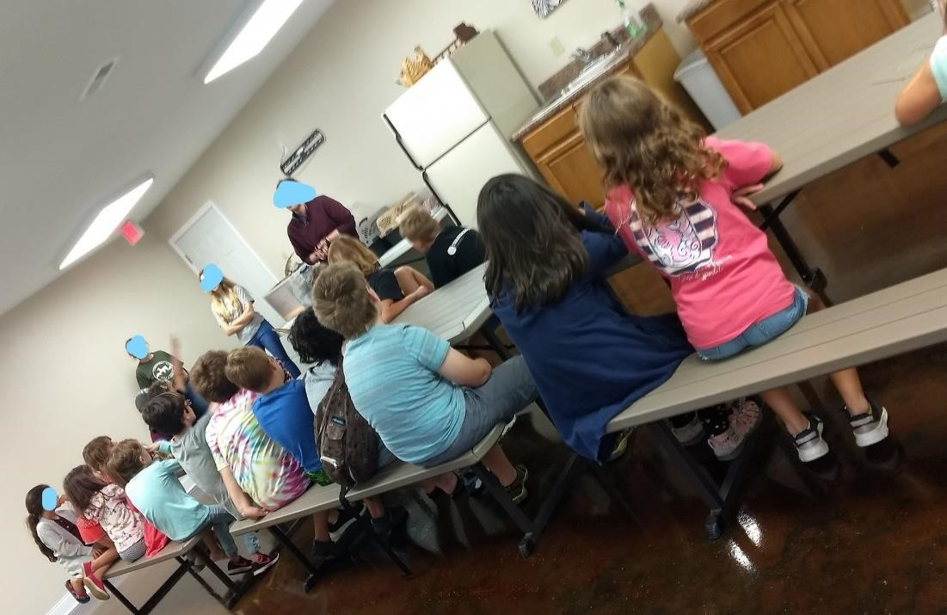
Figure 26
The FFTT Group at a Museum

The worries and anxieties described by these mothers highlights how being and becoming a Mom Pedagogue is, at times, deeply contradictory and uncertain. However, each demonstrated a passion and dedication to provide better learning and developmental experiences for their children. Zoey emphasized these ideas as we spoke in her kitchen:
You know, society has a very small interpretation about what intelligence is and what creativity is. And it is hurting kids. I think creativity can be all types of things and I hated that my daughter was taught that there is only this one way to do or look at things. You must do your work this certain way to be successful. I think she still is caught up in that a little bit even though we’ve been homeschooling her for a few years now. I am still worried that she is going to be someone who is gonna’ feel the need to conform to these made-up rules or ways of life. I just want them to have a different experience of learning than what a normal public-school kid would get. (Photo Chat 3, 10/28/2019)
Taken together, these exclamations illustrate how personal and emotional the choice to homeschool is for these mothers and their children. For example, Zoey is sufficiently convinced that society’s vision for children’s success is problematic, and it is this sense-making that motivates her to take action and provide a different future for her children through homeschooling. Across all the mothers, uncertainty in homeschooling was characterized by self-doubt, frustration, and/or feelings of exclusion or judgment. Going against the norm in raising and educating their children intensified these mothers’ uncertainty at times, resulting in some bigger existential questions and experiences. Nevertheless, their feelings of fear, exhaustion, and anxiety allowed them to construct the meaning in their choice to homeschool and transformed their worries into love, excitement and pride in their children. This sensemaking seemed to contribute to the development of their own interpretations and understandings of what is going on in the relationship between their experiences (past and present) and their convictions to homeschool.

Imagining a Positive Future
For many mothers, the added layers of self-doubt and pressure in choosing to homeschool their children was tolerated by imagining a better future for themselves and their children. Mothers often spoke of a future that inspired them to act in the present day, especially when faced with challenges. For example, Erica shared her vision for her son in an early photo chat:
E: My oldest really hates writing and he thinks he doesn’t need it to do it for what he wants to do for his job.
M: What does he want to do?
E: Be a YouTube star.
M: Oh okay. I think you still may need writing skills for that.
E: Yes exactly. Can you tell him that please? But he has a paper coming up and it’s like his first time he has to research, and he has to check his sources. And I am just struggling to get him motivated to do it. So much of my daily energy just goes into convincing him to write. And he always asks me, ‘Well, why do I have to learn this?’ And, I said, ‘Well, if you want to go to college- this is primarily your college experience. Paper writing.’ And he may not want to go to college, but I still have to give him the tools in order to get there. You know? Because I want him to go to college knowing how to think for himself and have the confidence to do it. I was so good at math and science in high school, but I never felt supported in that. I want him to go to college because he likes to learn, and I know it is my job to instill that in him. (Photo Chat 2,10/19/2019)
Many of the mothers acknowledged their concerns or fears regarding possible negative outcomes for their children, and yet they also remained hopeful and confident in their abilities and the future, we continued our conversation,
M: I’m curious about hearing any examples of challenges or tricky elements of homeschooling that have been difficult or brought uncertainty.
E: The biggest issue is that I feel like they’re behind all the time. That they’re not doing what everything that people in school are doing. They don’t write as much… I mean because school is like busywork, but it is a lot more practicing. So, I think that is pretty much the biggest worry for all homeschool parents is that they are getting behind. But I know we will be able to do it. I will be able to do it. I haven’t figured out how yet, but I know I’ll find a way (laughter). (Photo Chat 2,10/19/2019)
Erica’s conviction allows her to prepare and consider actions that are best for her children even though she may not be able to accurately know what the outcomes might be for them. Her desire to lead and prepare an authentic life for her children seems to remedy the struggles and uncertainties related to her choice to homeschool. Overall, the mothers often imagined, deliberated upon, and communicated about their futures. For example, Tessa expressed this relationship early in our conversations:
I choose to homeschool them because I would rather have them be well informed people who know what their options are. So, if they wanna go - ‘I’m ready to be done with school and homeschooling and hurry and finish my diploma and now I just want to travel the world and go backpacking in Europe or whatever.’ They can. I just don’t want them to feel like they have to follow some sort of specific way of doing things and I worry that if we don’t do this [homeschooling], if I don’t show them that they can be themselves and choose whatever path they want, they will end up lost and not know what they want or who they want to be. (Photo Chat 1, 9/11/2019)
Tessa examines a greater existential question, “If I don’t homeschool them, what then?” Similarly, Brittany discussed her imagined future for her children:
M: What keeps you going during the hard days?
B: I like to see my husband who is incredibly smart and so curious. And he is getting his PhD, but it took him a long time to get where he is. He also came from a public-school background and this entrepreneur way of life like ‘Go out, work, make money, pull yourself up by your bootstraps.’ And he was good at that. I mean we did it all, but he was so stressed all the time. Doing the same thing. And now he is studying what he loves, teaches our children French and Piano, and is so involved in their homeschooling. I can’t imagine not having a partner who doesn’t help everyday with their learning. So, I think in a way, watching him go back to school and then choosing to homeschool is our little bit of a rebellion. We are giving them permission to do whatever they want to do. I don’t want them to have to start over like us. I realized we can make life how we want it. I want them to have the future they want and hopefully homeschooling is showing them that.
(Photo Chat 4, 12/16/2019)
Brittany weighs in on her husband’s life while stressing the importance of freedom of choice for her children in the future. Tessa and Brittany spoke about their fears if they chose not to homeschool yet were grounded in the maternal desire and care for their children and their future. Another poignant example of this position was when Erica became emotional, reflecting on her experiences and hopes for the future of her children. She explained her perspective during her final interview, sitting on the couch surrounded by her four children:
M: You seem surprised that you are crying. Tell me what comes to mind as you did this activity with your photos?
E: I think it's surprising how much they've grown up.
M: How does it feel seeing them grown-up?
E: Scary. They are just growing up so fast and I just really hope that I can set them up for being okay and having a good life. And seeing these photos made me realize that I was a lot more capable than I thought I was. (Final Interview, 12/20/2019)
Erica’s emotional response reveals her desire to lead and prepare a meaningful life for her children. Perhaps reflecting on her own negative experiences as a child, she foresees the impact she will have on her children and anticipates providing a different experience for them.
These mothers shared feelings of discomfort that they weren’t doing enough for their children. Yet, at the same time, expressed a yearning for their children’s success and believe they have found a way to ensure it. They reported that imagining a better future for their children allowed them to live more fully in the present and alleviate uncertainties about themselves and others.

Communicating Beliefs and Values
Homeschooling families in the United States exist in a culture in which sending children to public-school is the norm (Riley, 2017). The mothers in this study often expressed feeling judged and stigmatized for being homeschoolers and believed there was the need to communicate their commitment and conviction, to others. Strikingly, four out of the six mothers described stigma and doubts about their homeschooling practices from their husbands and/or significant others. For example, Jamie recalled the back and forth she had with her husband and how she has to reassure him, and perhaps herself, in her ability to successfully homeschool their children:
I think homeschooling makes my husband nervous. Like he will ask- ‘What did you guys do at school today? I didn't see you guys do schoolwork for a couple weeks. Where are the worksheets?’ I think, he felt it was um, he wanted to do more school. And so finally I told him like, ‘I’ve got this. And you know what- that’s not the point of homeschooling.’ Yeah, he took it and he heard me I think but I still I felt like he was being a principal and being my boss. And I get it, they’re his kids too, but I was like, ‘I’ve got this. Can you just trust me?’ And he has gotten better but sometimes we still call him ‘Principal Dad or
Principal Zach.’ (Photo Chat 3, 10/22/2019)
Similarly, Tessa shared the doubt she felt from her husband, when she recalled, “At the beginning, my husband really struggled with the lack of testing. He is much more of an academic than me and so he’s always like, ‘How do I know that they’re getting everything they need?’” (Photo Chat 2, 9/16/2019). All the mothers seemed to be able to cope with these feelings of stigma and doubt as they communicated what they have done and plan to do. Some of them challenged the doubts of others by sharing their convictions publicly, sometimes with strangers. An enlightening example of this came from Jamie in her final interview, as she described her experiences defending homeschooling:
People usually look down on homeschooling. So, when I post on social media, I am trying to show our pictures for people that think that they're too good for homeschool. I post for people that think that they have it so much better or the people that are like ‘Oh homeschooling is you know, dumb.’ I post because my mom is like, ‘Are you sure that you’re doing a great job?’ and I'm like, ‘Hey, yeah I am.’ I also post for my other homeschooling friends, and they can be like ‘Wow, this is really fun.’ Like, yeah I like posting for like validation or just to tell or to show other people that like, ‘Hey, I came up with this- you could do something like this to or you know, just kind of, and it's just sort of fun for people to be like, ‘Hey, you're such a great homeschooling mom!’ (Final Interview, 12/21/2019)
Jamie’s self-talk was illustrative of most of the mother’s passion for wanting to demonstrate the positive and beneficial experiences of homeschooling for their children. Tessa described a poignant incident during a later photo chat:
T: Homeschooling allows me to provide an education that matches the needs and desires of my children, something I never had. And that is why I do it- despite what people may say about us.
M: Did you have a negative experience with someone this week?
T: Oh yes, I have to tell you, my neighbor. She came over and gave me a long speech about seeing my kids in the alley way with their bikes.
M: Like her alley way?
T: No! It was just like a common area. It wasn’t her yard. But she said that they needed more supervision and if they are gonna be out there an adult should be there, too.
M: Wow.
T: I wanted to tell her to worry about something else. Because that’s what kids are supposed to do. Go play and do what they want. We have taken that freedom from children these days. We don’t just let them go play. Homeschooling allows me to give that to them. I, of course, make sure they check in with me and we get their stuff done but then I want them to go explore. The longer I homeschool, the more I feel dedicated to changing people’s minds about it and fighting back when I need to. (Photo Chat 5, 12/15/2019)
Here, Tessa felt challenged by her neighbor and this provocation crystallized her decision to homeschool. Mothers described wanting to communicate and gain support from others, often to justify their choice to homeschool. I experienced this in my first meeting with Erica as she sought to confront me and my possible stereotypes toward homeschoolers. From my reflexive journal after my first visit with Erica:
I asked Erica’s daughter to sign the consent form and I asked her if she could write her name or if she wanted to sign an X. And Erica got very upset, and it shook me up a little. She thought I was implying that homeschool kids don’t know how to write their own name... She said that people judge homeschoolers and sort of implied that I need to keep an eye out to not do that as well. She also talked about a friend of hers who was a homeschooling mom who just had someone call Child Protective Services on her because ‘they didn’t think she was teaching her children.’ I left realizing I had some work to do in building rapport and safety with my participants and she’s the second mom to bring up CPS concerns to me. (Photo Chat 1, 10/11/2022)
The mothers in this study shared a desire to resist the educational system and/or potentially transform it in some way and Erica seemed to be highlighting negative experiences she has witnessed with those who do not understand homeschooling. Her emotions surrounding the stigma and discrimination of homeschoolers came out in our first few moments together. Her distrust of me eventually declined but her initial response was illustrative of her discomfort towards formal education and social services.
Additionally, participants reaffirmed their choices to others and to me by deliberately stressing the work involved in homeschooling, making parallels with paid work. Mothers described homeschooling as ‘a way of life’ and ‘like a job’ (Field Journal, 10/19/2019). An example of this perspective took place during an early photo chat with Tessa:
This is my job. This is my everything. This is 100% what I chose for my life. But it’s not about me. It’s very weird. It is my full-time, job. But I don’t get a raise I don’t get like an annual review. I don’t get a paycheck; I don’t get work trips. I mean there’s like no incentive besides like watching them with pride. (Photo Chat 2, 9/16/2019)
At various times throughout the interviews and photo chats, mothers shared experiences about negative experiences and feedback they experienced from others. However, each time, they relied on their “calling” and dedication to fulfill a freed and holistic future for themselves and their children. Tessa saw providing “the ideal learning space” as an essential and special experience for herself and for her children (Figure 27). From the earliest visits, the mothers each expressed strong convictions about who they were as homeschooling mothers and what they thought they were providing for their children. They were so eager to share that passion with me and with those who needed to have their minds changed about homeschooling and the freedom it provided for their children and themselves.
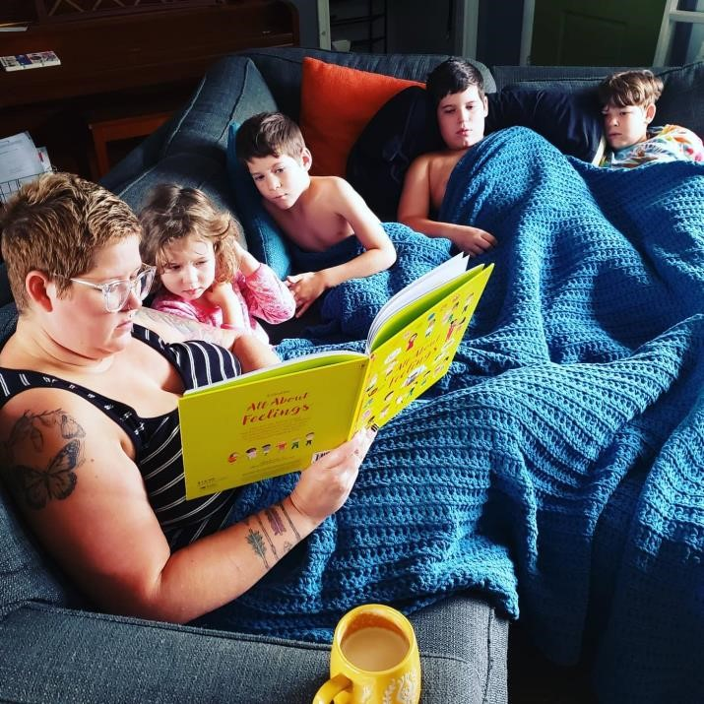
Figure 27
Tessa Reading with her Children in their Home

Jamie spoke about her mandate to homeschool her children during a tour she gave me early in the study of her homeschooling room:
M: So, what is this on his bulletin board? [See Figure 28]
J: An art project! That I made up. I did that. And I taught the whole homeschooling group how to do it as well! I just love doing art stuff and they were both struggling that day and I just was like ‘can we please just do art?’
M: And you did it.
J: Yes. And can you imagine if they were in public-school and struggling? I can’t even think about it. I probably wouldn’t even know they were having a hard time until they get like a bad note, or something. With homeschooling I know right when they get up, what kind of day they are going to have, and I can just choose to do art with them if I know they aren’t gonna’ be able to focus on math or whatever. I can be their mom and help them to learn. (Photo Chat 3, 10/22/2019)
Jamie not only rejected public-schooling in a practical sense but used it as a reminder to herself of the value and positive consequences of her choice to homeschool her children. Despite the uncertainty they may face, each mother described a calling to protect their children from being influenced or taught by someone other than themselves, as well as a found satisfaction and fulfillment in caring for and teaching their children. Each of the participants shared a conviction to provide new and different opportunities for their children.

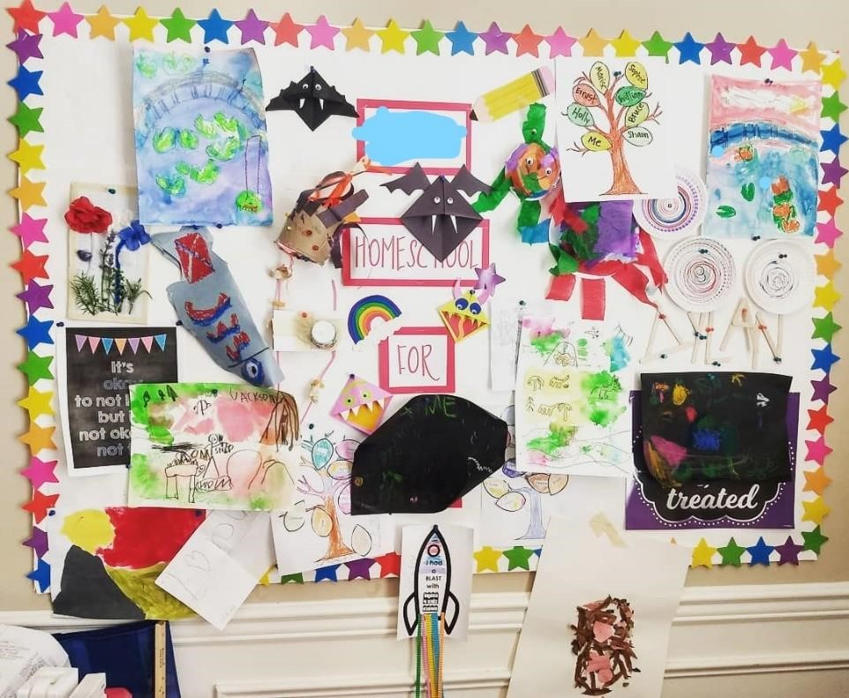
Figure 28
Jamie’s Homeschooling Bulletin Board

In discussing the future for her children, for example, Fay talked about the lifestyle she seeks for her children by homeschooling. She describes her vision during a later photo chat:
I just don’t want them to become mindless and have a job where they don’t actually use their brains. I don’t want that for them. I don’t want them to have these “careers.” I mean, if they find something they want to do then that is wonderful. But I don’t want that to be the end all or the peak of their lives. Because a career isn’t going to be everything, it’s just what you do to survive. And that’s what we are trying to teach them, and I have to remind myself of that sometimes. (Photo Chat 6, 11/11/2019)
Fay acknowledges the uncertainty of the future, but counter acts her related fears by articulating the vision she has for her children’s lives and an unwavering motivation to protect them. Fay and the other mothers acknowledged that they could not influence or control all the variables when it comes to who their children will become, but they all articulated some kind of version they hoped for. They demonstrated and communicated an ability to anticipate, envision and maintain flexibility while at the same time, creating a viable future for their children. Tessa tearfully expressed this in a later chat:
M: You are tearing up again, tell me what you are feeling?
T: Just seeing them in these photos makes me tear up… I like being able to see them playing and exploring and having those experiences and things [See Figure 29]…That has always been my goal. And seeing them doing those things, makes me think they will be okay.

Figure 29
Tessa’s Daughter Running as a Butterfly through the Park

This exchange reflects Tessa’s hope for a positive outcome in homeschooling her children. She is striving to provide a learning environment that emancipates her children and provides care in ways that allows them to play and explore. All the mothers articulated a confidence that they can manage whatever comes and conveyed their self-efficacy throughout the study. Their passion for their children’s freedom was a strength that enabled a kind of resistance to their uncertainties and fears. While most mothers acknowledged the taxing nature to homeschooling their children, each of them described and demonstrated an ability to persevere through the challenges with resilience and optimism. They were able to accomplish this balance by focusing on what they could control or influence in their homeschooling practice, giving them the sense of moving forward and being able to accomplish something worthwhile.

Chapter Summary
This chapter presented the findings of six mothers’ lived experiences of becoming and sustaining their roles as Mom Pedagogues. Analysis of the mothers’ narrative accounts reveal three predominant findings. These themes are (a) Rejection and Renegotiation: Mothers’ Turning Points Towards Homeschooling, (b) Becoming a Mom Pedagogue: Desire, Caring, and Emancipating Meaningful Learning (c) Enacting Personal Convictions through Uncertainty. Implicitly interwoven in these findings are the ways in which these Mom Pedagogues aim to fill their lives with direction and meaning in accordance with their lifelong values and beliefs. The process of becoming a Mom Pedagogue has been revealed to be a multifaceted phenomenon, and at times, distinctive for each participant, yet filled with a similar push-pull tensions between convictions and uncertainties. Their narratives illustrated their shared commonalities as well as they reflected on their own lives and made decisions on how to navigate their homeschooling and motherhood roles. The participants shared experiences, feelings and thoughts related to the care and learning they provided and made meaning from both their uncertainties and positive experiences as Mom Pedagogues. In Chapter 6, an interpretation of the findings, implications, limitations and recommendations for future research will be presented.

Conclusions, Limitations and Discussion
This chapter discusses the most prominent themes that emerged from the findings in relation to relevant excerpts from the literature. This qualitative study explored the lived experiences of six homeschooling mothers and the aspects that influenced their ways of being as they navigated meeting the demands of motherhood while also taking on expectations related to homeschooling their children. Accordingly, this study adds new knowledge to the field of homeschooling research beyond outcomes related to homeschooling curricula and child outcomes by using observation, storytelling approaches and participants’ photographs as strategies for accessing their pedagogical practices and beliefs, values and goals as Mom Pedagogues. Following are the three research questions that guided this study:
RQ 1: What are the key aspects that influenced homeschooling mothers to homeschool their young children?
RQ 2: What meanings did the participants assign to their experiences and emotions as homeschooling mothers?
RQ 3: In what ways did the mothers sustain their commitment to homeschooling?
This study examined the meaning and processes of homeschool mothers’ behaviors related to their children’s learning, situated in the individual spaces and places of each family. Participants’ narratives represented their continuing journeys in which homeschooling was less about doing and more about becoming. The mothers believed it was their duty to help their children become free, expose them to diverse learning experiences and guide them to live a life of their children’s’ design. For these six mothers, homeschooling was much more than a pedagogical choice, but rather their decisions were influenced and informed by key characteristics of their past experiences, aspects of their daily lives, and a conviction and dedication to the future of their children.
Homeschooling as an alternative educational path has been growing steadily since the 1970s, although its origins in the US date back to the “Progressive” school reform movement of the 1920’s and 30’s (Kunzman & Gaither, 2013). While a small body of literature has revealed the specific experiences of homeschooling parents, few studies have investigated the meaning, processes and practices of homeschooling mothers beyond their motivations to homeschool and choice of curricula. It is, therefore, important to understand the significance and nuance of the lived experiences of these Mom Pedagogues, not only from a teaching viewpoint, but also, from both an inter-and intra- personal perspective.
Homeschooling research has focused on various pedagogical aspects such as the selection and use of pre-packaged curricula, children’s processes of learning, scholastic achievements, teaching methods and materials (Aurini & Davis, 2005; Gaither, 2008; Kunzman, 2009; Lees, 2014). However, the findings of the present research indicate that for these mothers, homeschooling is more than a pedagogical decision but instead a response to their need to emancipate their children from the cultural and structural constraints regarding how children should act, behave and learn. In addition, the participants’ dual roles as mothers and teachers guided them toward insuring their children experienced authentic self-formation and individual autonomy.
The intent of this chapter is to discuss the ways in which the findings contribute to the literature by deepening understandings and extending knowledge regarding how homeschooling mothers may understand themselves while facilitating their children’s learnings. The discussion unfolds guided by the sequence of the three research questions and leads to implications for future research and practice. Throughout this discussion, the participants’ processes of becoming Mom Pedagogues influenced by Bioecological and Sociocultural principles, elements of the Ethic of Care and Maternal Desire, Foucault’s Analysis of power and discipline and Bildung are interwoven with the emerging understandings of how these mothers developed their personal epistemological beliefs, acquisition of knowledge, and roles in the learning process about themselves and their children.

Limitations of the Research
One overarching limitation of this study is all participants are white, and female and recruited from a single homeschooling group in the Southeast of the US. Potential participants were based on those who met the criteria and available to have me conduct observations in their homes for extended times. Future research will benefit from a more diverse pool of participants. Further, a second limitation, is the inability to generalize the findings to the broader society due to the small number of participants. With that said, the small number of participants did allow for extensive time in each of their homes across nine months that included 39 visits. Further, the intent of the study was interpretive rather than prescriptive in order to capture a more nuanced and in-depth understanding about what it means to be a homeschooling mother in a particular space and place (Atkinson & Delamont, 2006).

Discussion Of Research Question 1: What are the Key Aspects that Influenced
Homeschooling Mothers to Homeschool their Young Children?
All mothers described how choosing to homeschool was a decision that was influenced by historical and present-day factors that represent the mothers’ values and beliefs about what was best for their children, and themselves. For these mothers, a transition to homeschooling was often a rejection of their own educational paths and childhoods, which led to many positive changes for them and their families. As Bronfenbrenner (1979) noted, environments and contexts shape individuals’ behaviors such as parenting values, beliefs, practices and/or community involvement. Individuals interact with the environment and the environment interacts with individuals (McGuire & Norman, 2018). This bi-directional influence was similar to the ways in which the mothers’ life histories and present-day experiences influenced one another. For example, Erica was able to weave together her experiences of the past and what she has come to know now regarding how to care and spend time with her children:
I just didn’t get a lot of attention growing up. I think that’s what homeschooling is for me – getting the opportunity for loving on each other. I think that’s my guess. My parents and I didn’t do a whole lot of stuff together and I wanted to change that. (Consenting Visit, 10/04/2019)
Her longing to avoid the loneliness she experienced as a child steered her toward a re-consideration of what it means to parent and spend time together as a family. Thus, pivotal turning points experienced by all the mothers’ lives contributed to their lifelong experiences and perspectives about how and why they wanted to educate and care for their children.
Their prior experiences ranged from “aha” moments for some, and the slow and steady determination to homeschool for others that were, ultimately, transformational for each of the mothers. The importance of this study lies in the influential and seminal occurrences within the initial stories of the participants and their homeschooling parenting practices (i.e., rather than examining the reasons for choosing homeschooling using a questionnaire). Sharing these important moments helped the mothers bring to the front various life events and transformations, and as a result they reflected on their own sense of identity as homeschooling mothers (Berntsen & Rubin 2004; Gergen & Gergen 1987; Roesler, 2006).
These ‘turning points’ were proclaimed by all the participants to be life-altering and contributed to the commitment and dedication to homeschool their children. Becoming a Mom Pedagogue was a continuously evolving process of co-creating a more authentic life for themselves and their children, by reconstructing past moments and reconceptualizing everyday lived experiences made visible by the study methods. This research highlights how these singular, yet linked, critical and meaningful experiences of the Mom Pedagogues stand in contradiction and expand upon most of the research, today, on homeschooling mothers.
For the participants in this study, they facilitated learning through observation and relationship-centered participation, driven by a maternal ethic of care. However, in much of the homeschooling research, motherhood and homeschooling practice seem to be at odds with each other. For example, most of the studies on homeschooling and motherhood have argued that homeschooling has negative mental health outcomes for mothers (Baker, 2019/2021; Lois, 2006/2009/2017; Ray, 2010b). The bulk of the literature reviewed for this study claims that the relationship between homeschooling and motherhood is a paradoxical one (Froyum, 2010; Lois, 2012; Machovcová, Beláňová, Kostelecká, & Mccabe, 2021; Sherfinski, 2014), in which mothers believe children are “priceless,” and nothing is more valuable than the mother-child bond (Crittenden, 2010; Dillaway & Paré, 2008). This trend in the literature, further concludes that the child’s self-esteem and safe psychosocial development are more important than the emotional and physical well-being of the mother. This hardship of homeschool messaging appears to be driven by gender roles and the ideologies of motherhood that create a false belief that mothers are solely responsible for the work of educating their children (Rizzo, Schiffrin & Liss, 2013). Further, such studies have argued that this pressure results in role strain that has been associated with high levels of stress and discouragement among homeschooling mothers (Baker, 2019/2021; Derya, 2019; Tardy, 2000).
Nevertheless, based on the findings of this study, it appears the role of a Mom Pedagogue is mostly positive, nuanced and complex as evidenced throughout the photo chats and interviews, homes observations, reflexive journal entries and chats about their weekly photographs. While there were periodic struggles expressed, each mother repeatedly conveyed many happy and fulfilling experiences and emotions related to their time spent homeschooling their children.
One significant contribution of this research is that rather than feel burdened by the choice to homeschool, mothers uniformly felt driven by an ethic and conviction to focus on their children as whole people. Moreover, homeschooling served as an opportunity for discovery by the mothers, as much as for their children, as opposed to disenfranchisement and struggle. Generally, the mothers treasured their opportunities to spend time and develop strong relationships and intimacy with their children. Or, as Fay succinctly articulated, “My relationship with my kids is at the heart of our homeschooling journey and having my kids away at school puts cracks in the bonds that we have formed” (Final Interview, 11/26/2019). Fay’s decision to stay close, both physically and emotionally, to her children was at the center of her role as Mom Pedagogue. These caring relationships influenced both their everyday practices and their processes of becoming. The phenomenon of becoming was centered on empathy, and responsiveness towards their children, and, in turn, a more authentic life for themselves. When seen through this lens of becoming, the mothers’ wonderings about and explorations of learning are tied to the development of who they are and who they want their children to become.

Contribution to Women’s Ways of Knowing
Firstly, most of the literature on Women’s Ways of Knowing focuses on the present activities and beliefs of women but rarely examines past experiences or turning points within the women’s life (Areepattamannil et al., 2020; Belenky et al., 1986; Chen, 2012; Schommer, 1990). Further, research exploring Women’s Ways of Knowing is especially limited for homeschooling mothers (Lin, 2002; Song & Chang, 2012). For instance, Chen (2012) found that ways of knowing of female students were centered on current epistemological beliefs like science motivation, achievement, and recent career aspirations (p. 16). However, the mothers in this study chose to emancipate their children from public schooling through the reflection of past educational and parenting experiences, as well as present epistemic belief, values and goals. This finding contributes to Women’s Ways of Knowing (Blinky et al., 1986) by emphasizing the importance of personal histories in order to better understand how the mothers came to know themselves and shared this knowledge with their children.
All the mothers were at different points on their journeys of knowing and becoming, and their approaches and the ways they facilitated their homeschooling practices were influenced by their pasts and their negotiations of what being a mom looked like for each of them. For example, Emily sought homeschooling in order to have a different family experience with her children than she had with her parents. Whereas Jamie homeschooled her children in order to change her own parenting practices and habits. Tessa chose to homeschool her children because she felt her academic interests were ignored as a child. Each mother was in their own stage of knowing according to key tenets of Women’s Ways of Knowing (Belenky et al., 1986).
Applying Women’s Ways of Knowing to the everyday and past experiences of homeschooling mothers, demonstrates and validates the complex nature of knowing and how that knowledge holds meaning for the mothers. This finding suggests, therefore, that there is a need for more research on how both prior turning points and daily practices of homeschooling mothers influence their ways of knowing. It is recommended that addressing both the past and present life experiences may help increase understanding on how homeschooling mothers push back against the status quo and become different “types of knowers” (Belenky et al., 1986). Exploring multiple layers of motherhood identities can be positioned to better understand what is meant to be a homeschooling mother.
Being a homeschooling parent is a dialogic experience that is relationally situated to one’s past and present circumstances and social context, and critical to consider in future homeschool research. This should be done in order to better understand how homeschooling parents provide spaces and opportunities for their young children that draw from their own rich experiences (Dyson, 2013; Yoon, 2013). This finding supplements the literature of Women’s Ways of Knowing by incorporating past experiences as an influential factor on how they create, maintain and share their knowledge.

Discussion Of Research Question 2: What Meanings Did the Participants Assign to Their Experiences and Emotions as Homeschooling Mothers?
Homeschooling mothers need to learn pedagogical skills to help their children engage in authentic, informal learning experiences within and outside their home (Block-Weiss, 2019). They often acknowledged they were not replacing teachers but, rather, re-positioning themselves as pedagogical guides of their children’s learning. The role of Mom Pedagogue was regularly described by them as a position of “facilitator’’ and “coordinator” of leading and preparing an authentic life for their children. This finding demonstrates a range of ways in which they chose to homeschool their children, as they referenced their desire to care for them in order to foster freedom, self-respect, independence, curiosity, and creativity.
Mothers often referred to their aims and values in which learning, caring, general wellbeing and development are viewed as inseparable. They were able to accomplish weaving together attention onto both cognitive and social-emotional development by facilitating child-centered learning and holistic learning approaches in order to emancipate their children from both sovereign and disciplinary powers (Foucault, 1988). Fay expressed this form of emancipation,
I like seeing these photos. These are my photos of them. And seeing them they make me feel secure and confident. They make me feel better. They make me feel less worried about how I am raising them. Because I can see that I am giving them a life and permission to not fit in and be put into a box. Because I don’t want them to not have permission to follow their passions like me. Can you imagine if we had permission like them to be what we wanted? (Photo Chat 5, 11/1/2019)
An important outcome of this research were the numerous examples of how these mothers socially co-constructed knowledge with their children through activities, relationships and the meanings they assigned to their practices, in-situ.
Mothers sought to be present in the daily lives of their children, giving them both the opportunity to achieve self-knowledge and relate to what they learned and taught. They often argued that the amount of care and attention they gave their children would not be possible if they were attending public-school. Each mother believed public-school forced inauthenticity onto her children and resulted in learning that was not productive or useful. For all of them, homeschooling was not about academic achievements, outcomes or testing results but rather an opportunity to create trust and build a mutual relationship between the mother and the child as they participated in meaningful experiences. For example, Jamie articulated,
Can you imagine if they were in public-school and struggling? I can’t even think about it. I probably wouldn’t even know they were having a hard time until they get like a bad note, or something. With homeschooling I know right when they get up, what kind of day they are going to have, and I can just choose to do art with them if I know they aren’t gonna be able to focus on math or whatever. I can be their mom and help them to learn. (Photo Chat 3, 10/22/2019)
Jamie’s experiences echoed that of all the mothers Ethic of Care that was embedded in their lives every day and gives rise to questions about concerning the importance of empathy and responsiveness when examining homeschooling practices and learning outcomes in future research.
Further, many of the activities, described by the mothers in which they participated alongside their children were not framed by classroom techniques replicated in the home, but rather everyday activities of enculturation and apprenticeship (Lave, 1988). Apprenticeship in learning emphasized the significance of activity in learning and knowledge and “highlights the inherently context-dependent, situated, and enculturating nature of learning” (Brown, Collins & Duguid, 1989, p. 9).
Many of the practices and activities I observed and have reported on were innate to motherhood and created in settings by the participants purposefully in order to free and empower their children to guide their own learning in a wide range of ways. For example, mothers promoted learning through activities such as preparing food, playing games, using tools, and caring for others which comforted and taught their children at the same time. Vygotsky (1981), Rogoff (2014) and others suggest that such guidance by a more competent other is especially helpful for young children’s learning. The mothers in this study often acted as more experienced learners and partners when they guided their children in the process of learning new skills, gaining new knowledge and navigating their moral and cognitive learning journeys. Often, children’s daily experiences were practical and purposefully situated to develop well-rounded human beings in the present and for the future. Kelman (2018) argued, “The most successful learning endeavors engage learners in ‘constructivist’ activities, in which the learners are not imagined as empty vessels to be filled, but active participants in the construction of meaning and new knowledge” (p. 129). Such meaningful and cooperative learning experiences provided their children with opportunities to engage in genuine, mutual, caring relationships in a space and place familiar to them. Tessa tearfully referenced this point in photo chat:
M: I see that you have tears in your eyes, talking about this. What do these photos mean to you?
T: I hope that it means that they are not only getting a well-rounded education but
they are also having an authentic childhood too. You know? Just seeing them…
playing and exploring and having those experiences and things is always my goal. (Photo Chat 6, 12/10/2019)
Mothers sought to nurture the children’s learning endeavors by facilitating activities that simultaneously practiced skills in the present while also preparing the children for their futures.
Across many ways, mothers to attune their children in ways that prepared and empowered them to continue their learning, reflects the meanings assigned to the concept of Bildung. In this finding the relationship between children’s learning in context and their enculturation of processes of coming to know as they learn is evidenced repeatedly as opposed to the dominant discourse in the literature focused on children’s academic outcomes, test results and canned curricula. For example, studies that have examined homeschooling parents are singularly focused on parental motivations and factors about why they choose to homeschool their children (Davies & Aurini, 2003; Green & Hoover-Dempsy, 2007; Kunzman, 2012; Ray, 2010b). Further, a portion of educational research assumes a separation between knowing and doing, and that knowledge is often independent of the situations in which it is learned and used (Brown, Collins & Duguid, 1989). Thus, it was evidenced that the mothers took full advantage of situated learning opportunities, recognizing that such authentic experiences, imbued with their children’s decisions to act and pursue learning, are valuable because they empower them to chart their own learning journeys.
Unlike the research reported in Chapter II, this study sought to understand how mothers homeschool their children in holistic and diverse ways beyond using canned curricula prescribed teaching practices and prepared teaching materials (Aurini & Davis, 2005; Hamlin, 2019; Kunzman & Gaither, 2020). Mothers often expressed a desire to foster holistic learning experiences for their children, focused on their children’s unique talents and interests that may be beyond their intellectual capabilities. Much of their daily practices of these mothers included encouraging their children to discover their own uniqueness as individuals and actively participate in real-life activities, with a de-emphasis on grades and learning outcomes, in order to help their children, pursue their own interests. Fay shared an example of this, when we were reviewing her weekly photographs,
They are diverting the creek in this photo. I had nothing to do with that decision. I don't get involved with their stuff down there. It’s all their creative ideas and actually this ended up being a bridge they built. My oldest leads the way on their projects. He designs and leads, and she follows, all on their own. Not many 7- and 5-year-olds are doing that kind of work. I just want them to be self-sufficient (Photo Chat 5, 11/1/2019).
Reflecting on the process of becoming a Mom Pedagogue has implications for educators, policymakers, academics, and parents because it demonstrates and validates the complex nature of socially grounded, everyday experiences that hold meaning for children and their mothers. Findings from this study may inform others regarding strategies for investigating homeschooling mothers by reflecting on their personal lives as they relate to their choice to homeschooling and parenting and teaching practices. Individualized and holistic support for mothers may be needed to support future homeschooling families’ needs where mothers are in the role of the educator. The examination of the dual roles of mother and pedagogue is a promising practice to begin to unpack the lived experiences reflected in how participants assign meaning to their emotional and psychological selves and everyday life.

Contribution to Bildung
This finding demonstrated the efforts and practices of these Mom Pedagogues to instill self-determination, freedom, autonomy, and responsibility in their children. The mothers were not only concerned with teaching and acquiring skills but rather caring and strengthening their relationships with their children. They sought to facilitate meaningful learning and growth and/or Bildung. Bildung is a layered educational concept which has undergone many changes and re-interpretations over the past few centuries. It is only recently that the concept of Bildung has been included in the discourse about the aims and orientations of education and child development, primarily within European contexts. As such, applications of Bildung within homeschooling families remains missing and this research aims to address this gap. Further, critics of Bildung argue that its practice is often related to social capital and thus closely linked to economic wealth, status, and distinction. Being able to practice Bildung is often seen as a social position as well as symbolic and structural power (Ricken, 2015, p. 47).
Bildung in America is often associated and practiced within specific early education contexts like Montessori, Waldorf, Reggio schools and other private schools environments ((Montessori, 1993; Cives, 2008; De Giorgi, 2013). Institutions where teachers are qualified and paid enough to expand a child’s “discriminative skills, heighten perception, and foster the ability to understand the world and its various moral, aesthetic, social and spiritual aspects” (Schiedi, 2021, p. 96). These educational contexts are often inaccessible to those who cannot afford to attend such institutions or schools (Trottenberg & Thomas, 2015, p. 16). For example, in educational policy and research, Bildung has generally been associated with the socialization of children rather than the emancipation of them from traditional learning environments (Biesta, 2012a). Further, Reichenbach (2014) described that the concept of Bildung has largely disappeared from the educational policy agenda, especially in the West, let alone in smaller more unique educational settings such as homeschooling. This finding addresses this gap, by reflecting on the power relations in the context of Bildung outside of well-resourced educational contexts and raises significant questions regarding the application of its pedagogical traditions. This study demonstrates the value of exploring Bildung within an emancipatory “micro-context” which aims to promote empowerment of children while also acknowledging structural limitations of such a practice (Fujii, Kutscher & Peters, p. 87).
Gustavsson (2012, 2014) has identified five constructs of Bildung, that include (a) classical Bildung, (b) liberal education, and (c) critical-hermeneutic Bildung (d) the Scandinavian folk-Bildung tradition, and (e) democratic education. Of significance for this study is (b) “liberal education.” Liberal education, as understood within the framework of Bildung, is a rich and complex practice described as the “development of human beings who know how to use their minds” and know to think for themselves (Hadzigeorgiou, 2015, p. 8). Character formation and/or personal development is emphasized over traditional learning (Burman, 2014).
Liberal education includes a focus on fostering lifelong learning and promoting critical thinking (Burman, 2011). Reinchenbach (2014) has further argued that the discourse related to liberal education has undergone an empirical turn toward psychological, sociological, and assessment trends as opposed to explorations related to “educational values, ethics and policies” (p. 171). Bildung incorporates the concepts of power and knowledge into the everyday educational practices of individuals (Biesta, 2002b). Thus, it remains questionable whether a liberal education can breakthrough, resolve, or compensate for social inequality.
In the context of the debate on Bildung and inequality, non-formal educational contexts must be considered (Kessl, Kutscher, Otto, & Ziegler, 2004; Kutscher, 2017). From this position, a Foucauldian (1992) understanding of Bildung means reflecting what possibilities are available to marginalized or stigmatized individuals. Thus, in the context of this finding, Bildung has been identified as a crucial experience in the development for these mothers, their children and needs to be further addressed within home school settings.

Discussion of Research Question 3: In What Ways Did the Mothers Sustain Their Commitment to Homeschooling?
Fundamentally, this study paints a portrait of meaningful, rich, and unique lived experiences of homeschooling mothers. A common thread connecting all the participants’ stories was the personal convictions the mothers expressed in their desire to homeschool their children. Their convictions were fundamental to their roles and their willingness to defend their positions. These convictions enabled the mothers to generate excitement and optimism while managing uncertainties. The mothers were able to sustain their commitment to homeschool by remaining grounded in their deep beliefs and values about why they decided homeschooling mattered to their children’s quality of life— as well as to their own.
The study aimed to provide insight into the ways in which homeschooling parents make meaning and find purpose and fulfillment from homeschooling their children. The journey of being and becoming a Mom Pedagogue was reported to be both engrossing and demanding. An example of this is found in a discussion I had with Erica during her final interview:
E: It’s really hard to juggle all the things at home and then trying to keep up with them and their work and their books and all that stuff.
M: That does seem really hard. How do you cope with all of that?
E: I just have to remind myself that it’s worth it I mean if I have to take a break for a day. I will take a break. We will get behind but eventually I know will get back to where we need to be. (Final Interview, 11/29/2019)
Each participant also expressed joy and pride along with their feelings of stress and insecurity. These feelings of confidence contributed to a positive sense of self; nevertheless, they also described feelings of fear, doubt and uncertainty. It is these complex sets of emotions that seemed to influence their ideological convictions.
Across these mothers, homeschooling provided the time, space, and opportunity to guide their children’s appropriation of knowledge by utilizing pedagogical flexibility that reflected their values, beliefs, and goals. They shared experiences, feelings and thoughts related to the care and learning activities they provided and made meaning from both their uncertainties and positive experiences as Mom Pedagogues. Zoey articulated this when she recalled,
My beliefs about homeschooling come from leaving religion, which sounds really broad, but you have to really ponder human nature, and why humans have religion and why even in modern times, people still cling to it. I think a lot of that leads to a lot of thoughts on how people work together, how they answer questions, how they deal with unknowns and so I guess a lot of that just brings you down to questioning human nature and what it means to be around each other and are you able to be considerate of others and those questions are what I am trying to foster in my children. (Photo Chat 3, 10/28/2019)
Zoey’s reflections are illustrative of the introspection and recollection I heard from all of the mothers. They often talked about their beliefs and demonstrated a strong desire to apply their reflections to how they have created new paths toward changes for their own children’s lives. Each mother shared a passion to ensure her children experienced learning more positively, holistically, and genuinely. The goal to nurture the essence of what they believed to be most worthwhile—that is, their children’s love of learning and freedom of expression was often referenced. The process of becoming a Mom Pedagogue was revealed to be a multifaceted phenomenon, and at times, distinctive for each participant, yet filled with similar, push-pull tensions between their convictions and uncertainties.
Analyzing the lives of six homeschooling mothers has delineated how they came to see themselves as Mom Pedagogues who practice with a sense of purpose toward making differences in their children’s lives. This research fills a void in the literature on homeschooling because it begins to uncover how Mom Pedagogues can choose to disrupt the status quo through their commitment to educate and care for their children at home outside of sovereign and disciplinary expectations.

Contribution to Ethic of Care
Firstly, both Gilligan (1982) and Noddings (1984) contended that an Ethic of Care is demonstrated within personal relationships as well as interdependence. Noddings (1984) argued that caring involves a “displacement” of self-interest and that an individual who deeply and genuinely cares does not impose their own ideas of what they would want. Instead, they focus on what the person they are caring for would want or need. However, a majority of studies on Ethic of Care, lack an examination of autonomy and self-determination for both the cared for and the one-caring (Slote, 2007; Yasmin, 2022). For example, while the Mom Pedagogues in this study, aimed to care for their children by catering to their needs and desires, they all spoke of their own fulfillment rather than a “displacement” of self-interest. The Ethic of Care demonstrated by the mothers was not solely for the benefit of their children but rather a bi-directional relationship that contributed to their own well-being (de Marneffe, 1997). Therefor this finding takes a better account of autonomy and interdependence for both those who give and receive care than previously demonstrated in the literature (Tronto, 1993).
Secondly, much of the research does not account for the conflicting emotions and needs that unavoidably arise during care work (Martino, Airton, Kuhl & Cumming-Potvin, 2019). For the mothers, in this study, these conflicting emotions could be seen across their prior and current life experiences and was often tied to their choices to homeschool. All the participants in the study spoke of pride and feelings of certainty as well as feelings of fear and doubt. The role of emotion, vulnerability and authenticity is regularly not addressed in caring literature (Felten, 2017).
Lastly, an Ethic of Care was developed more so as a caring response to what educators and school administrators could do to better support and care for students. However, critiques of the framework note that an Ethic of Care must include a commitment to care for the individual while bringing systemic change (Lorde, 1988; Noddings, 2013; Tronto, 1993). Feminist scholars have suggested that care work cannot be understood without positioning it within a political context that considers “institutionalized structures of power” (Tronto, 1993, p. 110). The mothers in this study were driven by a conviction to provide a better environment for their children as well as promoting and demonstrating how homeschooling can help children and families. For example, Fay explained,
I just wish more people knew how easy homeschooling could be. It doesn’t have to be public schooling at home. I wish I could just talk to more people about it, spread the gospel. I just want to change society.
Although all the mothers reported some challenges and tensions associated with their choices, they were able to articulate positive meanings surrounding those difficulties due to their passion and dedication to homeschool their children. The mothers were able to articulate a found meaning through their sense of purpose that aligned with their personal values and desires to bring about systemic change. They shared a desire to resist educational systems and/or potentially transforming institutionalized learning in some way. They reported wanting to a need to confront the systems and organizations that were oppressive to them as children as well as to their children, in order to imagine a better future for their children. Thus, by making visible the systemic dynamics of both sovereign and disciplinary powers seen in this study, there is a better understanding of enacting meaningful change within the care work of homeschooling parents (Foucault, 1972). Care work is attending to the physical and emotional needs of others but also as a social capacity that can lead to a greater questioning of certain sets of knowledge and social practices that is accepted as reality (Noddings, 2013; Yasmin, 2022). Therefore, this research has begun to contribute a new perspective regarding how homeschool contexts coupled with an ethic of care nurture the intellectual and emotional lives of their children as well as themselves.

Implications for Future Research
The findings underline the importance for homeschooling research to shift from a primary focus on teaching and academic outcomes to include a parent-centered inquiry and seek deeper understandings about homeschooling parents understand themselves and facilitate learning for their children. This study demonstrated that education is not only about knowledge construction but also includes social learning withing affectual caring relationships that embrace a wider picture of human existence. It further provides a new way of thinking about motherhood and homeschooling as a process that is unfolding and influenced by experiences in the mother’s childhoods through their motherhoods. This study identified the need for and value of looking closer at the nuanced aspects of being a homeschooling mother.
To address the limitations of this study, the replication of the study with a larger and more diverse sample size is necessary. Future research could involve examining the ways in which Mom Pedagogues experiences and practices have meaning in accordance with their lifelong values and beliefs. Studying the narratives of homeschooling mothers may also illuminate the value of participants reflecting on their own lives as they make decisions regarding how to navigate their homeschooling and motherhood roles.

Methodological Considerations
This study demonstrated the usefulness of using photography and other visual representations and narrative to make visible and open a deeper dialogue on parenting and homeschooling. For example, the photographs and related conversations captured various practices, situated in particular spaces as well as the presence and use of materials, which helped the mothers develop tools and strategies needed to engage their children. Further their recollections of for their everyday experiences and related feelings were represented and revisited often which created a context for learning about themselves as Mom Pedagogues. The procedures described in Chapter III not only functioned as a data collection method but also facilitated the mothers’ personal introspections and validations as they reviewed the photos and recalled, reflected, and sometimes reconsidered the emotions and perspectives they assigned to their homeschooling experiences. For example, Brittany, recalled in her final interview:
M: How did this experience make you feel? Looking back on all this?
B: Thinking back and looking at all these photos, made me realize I am like totally a recovering perfectionist. You know, part of me screams like, ‘Hey, this should be what our everyday should be like! What am I doing!? But, then I as I think about this- it is almost every day! These are just our regular days, and I am doing it! So, this has been validating and makes me feel good. (Final interview, 2/3/2020)
The methods used in this chapter, enabled what Raider-Roth & Feiman-Nemser (2019) called “make[ing] learning matter in the present” (p. 231). Using images offered additional ways of understanding how parents developed their identities within the social and physical contexts of their space and place. The storytelling aspects of the narratives helped mothers reveal parts of themselves while reminiscing on their everyday experiences as Mom Pedagogues. Further, this process of engagement was necessary for each mother in order to be—and continue to become—a Mom Pedagogue. This research approach holds promise for engaging homeschooling mothers in their processes of developing in their roles of a Mom Pedagogues by allowing them to reflect on and review upon to everyday moments to reflect on why they do what they do as they gain greater understandings of their homeschooling practices.

Chapter Summary
As noted in the introduction, the core of this research design was to seek and illuminate the meaning-making process that homeschooling mothers attributed to their homeschooling activities. Specifically, this study used a qualitative research design to explore aspects that influenced homeschooling mothers’ values, beliefs and goals behaviors related to their children’s learning and their pedagogical practices. Observations took place in the homes of six homeschooling mothers across nine months rounded in a particular set of experiences, practices, settings, and situated in relationships within a complex sociocultural context.
The process of becoming a Mom Pedagogue was revealed to be a multifaceted phenomenon in which mothers aimed to fill their lives with direction and meaning in accordance with their lifelong values and beliefs. Their narratives illustrated shared commonalities and reflected how they made decisions to navigate their homeschooling and motherhood roles. The six Mom Pedagogues shared experiences, feelings and thoughts related to the care and learning they provided for their children influenced by their childhood and motherhood experiences. Thus, by examining the dual roles of both mother and teacher, it was possible to illustrate the interplay of mother and teacher revealing how their roles influenced one another. This study revealed a new way of thinking about homeschooling and motherhood— it is not stationary but an evolution. This study has identified the need for and value of homeschooling research to examine the complex and nuanced lived experiences of homeschooling mothers and has revealed a new approach in how to study homeschooling and motherhood that is socio-historically linked and not stationary— but rather evolutionary.

LIST OF REFERENCES

Abuzandah, S. (2020). Social skills for homeschooling students. Creative Education,
11(7), 1064-1072.
Acker, K. A., Gray, M. W., Jalali, B., & Pascal, M. (2012). Mathematics and home schooling. Notices of the AMS, 59(4).
Ahi, B., & Sengil-Akar, S. (2021). Understanding the initial stories of families preferring homeschooling: A Narrative Study. Education and Urban Society, 53(5), 515-535. Alcoff, L., & Potter, E. (2013). Feminist Epistemologies. Routledge.
Andresen, S., & Fegter, S. (2011). Children growing up in poverty and their ideas on what constitutes a good life: Childhood studies in Germany. Child Indicators Research, 4(1), 1-19.
Andersson, Å., Korp, P., & Reinertsen, A. B. (2020). Thinking with new materialism in qualitative case studies. International Journal of Qualitative Methods, 19.
Andresen, S., Otto, H.U. & Ziegler, H. (2008) Bildung as human development: An educational view on the capabilities approach, in: H.U. Otto & H. Ziegler (Eds) Capabilities – Handlungsbefahigung und verwirklichungschancen in der erziehungswissenschaft. vs verlag f € ur sozialwis- € senschaften, 165–197.
Anthony, K. V. and Burroughs, S. (2010). Making the transition from traditional to home schooling: home school family motivations, Current Issues in Education, 13(4), 1–33.
Anthony, C.J., & Ogg, J.A. (2019). Parent involvement, approaches to learning, and student achievement: Examining longitudinal mediation. School Psychology, 34 (4), 376-385 .
Apple, M. W. (2000). The cultural politics of home schooling. Peabody Journal of Education, 75(1-2), 256-271.
Aronsson, L., & Lenz Taguchi, H. (2018). Mapping a collaborative cartography of the encounters between the neurosciences and early childhood education practices.
Discourse: Studies in the cultural politics of education, 39(2), 242-257.
Atkinson, P., & Delamont, S. (2006). Rescuing narrative from qualitative research. Narrative inquiry, 16(1), 164-172.
Aurini, J., & Davies, S. (2005). Choice without markets: Homeschooling in the context of private education. British journal of sociology of education, 26(4), 461-474.
Avelino, N. (2021). Dizer não ao poder: Foucault, an-arqueologia, neoliberalismo. Aurora., 14(41), 97-120.
Avelino, F., 2009. Empowerment and the challenge of applying transition management to ongoing projects. Policy Sciences, 42 (4), 369–390.
Bachrach, L. L. (1983). An overview of deinstitutionalization. New Directions for Mental Health Services, 1983(17), 5–14.
Baker, E. E. (2019). Motherhood, homeschooling, and mental health. Sociology Compass, 13(9), e12725.
Baker, E. (2021). Understanding the Impact of Homeschooling on Mothers' Mental Health (Doctoral dissertation, Wayne State University).
Barad, K. (2007). Meeting the universe halfway: Quantum physics and the entanglement of matter and meaning. Duke University Press
Barlow, J. P. (1996). Electronic Frontier Foundation. A Declaration of the Independence of Cyberspace, 56(3), 1-2.
Barratt-Peacock, J. (2003). Australian home education: a model. Evaluation and Research in Education, 17 (2), 101-111.
Beck, B. (2018). A Case Study To Understand Global Awareness Among A Christian Homeschooling Group (Doctoral dissertation, Liberty University).
Belenky, M. F., Clinchy, B.M., Goldberger, N.R., & Tarule, J.M. (1997). Women's ways of knowing: The development of self, voice, and mind (2nd ed.). New York: Basic Books.
Berntsen, D., & Rubin, D. C. (2004). Cultural life scripts structure recall from autobiographical memory. Memory & Cognition, 32(3), 427-442.
Bertozzi, V. (2006). Unschooling media: Participatory practices among progressive homeschoolers. (Master’s thesis, Massachusetts Institute of Technology).
Berk, L., & Winsler, A. (1995). Scaffolding children’s learning: Vygotsky and early childhood education. Washington, DC: NAEYC Press.
Bhatia, S. (2000). Language socialization and the construction of socio-moral meanings. Journal of Moral Education, 29, 149–166.
Block-Weiss, A. (2019). Lighting the Way: A Narrative Analysis of the Experiences of Homeschoolers in College (Doctoral dissertation, California State University Channel Islands).
Boje, D. M., & Rosile, G. A. (2001). Where’s the power in empowerment? Answers from Follett and Clegg. The Journal of Applied Behavioral Science, 37(1), 90-117.
Bourke, B. (2014). Positionality: Reflecting on the research process. The Qualitative Report, 19(33), 1-9.
Breeze, R. (2019). Emotion in politics: Affective-discursive practices in UKIP and Labour. Discourse & Society, 30(1), 24-43.
Brown, J. S., Collins, A., & Duguid, P. (1989). Situated cognition and the culture of learning. Educational Researcher, 18(1), 32-42.
Bruner, J. (1986). Actual minds, possible worlds. Harvard University Press.
Bronfenbrenner, U. (1979). Contexts of child rearing: Problems and prospects. American psychologist, 34(10), 844
Bronfenbrenner, U. (1981). Children and Families: 1984. Society, 18(2), 38-41.
Bronfenbrenner, U. (1989). A Response to Lawton's Theoretical Challenge. Social Structure and Aging: Psychological Processes, 85.
Bronfenbrenner, U., Husen, T., & Postlethwaite, T. N. (1994). International encyclopedia of education. Ecological Models of Human Development, 3, 37–43.
Brown, T. J., & Sumner, K. E. (2019). Cross-national examination of work-family in parents of children with disabilities using a bioecological model. Child & Youth Care Forum, 48(5), 703–718.
Bryson, S. A. (2021). An ethic of care? Academic administration and pandemic policy. Qualitative Social Work, 20(1-2), 632-638.

Bubolz, M. M., & Sontag, M. S. (1993). Human ecology theory. In P. G. Boss, W. J. Doherty, R. LaRossa, W. R. Schumm, & S. K. Steinmetz (Eds.), Sourcebook of family theories and methods: A contextual approach (pp. 419–450). Plenum Press.
Burke, K. M. (2022). How do homeschoolers approach creative arts learning and how can they be supported? Developing a flexible framework for homeschool contexts. British Educational Research Journal.
Butler, J. (1997). The psychic life of power: Theories in subjection. Stanford University
Press.
Butler, J. (1990). Gender trouble, feminist theory, and psychoanalytic discourse. Feminism/postmodernism, 327, 324-340.
Butson, R. (2011). Does higher education need deschooling? Industry and Higher Education, 25(3), 153-160.
Charmaz, K. (2014). Constructing grounded theory. Thousand Oaks, CA: Sage.
Ciofalo, N. (2019). Indigenous psychologies: A contestation for epistemic justice. Indigenous psychologies in an Era of Decolonization, 1-38.
Collum, E., & Mitchell, E. (2005). Home schooling as a social movement: Identifying the determinants of homeschoolers’ perceptions. Sociological Spectrum, 25, 273–305
Corbin, J. M., & Strauss, A. (1990). Grounded theory research: Procedures, canons, and evaluative criteria. Qualitative Sociology, 13(1), 3-21.
Corbin, J., & Strauss, A. (2008). Strategies for qualitative data analysis. Basics of Qualitative Research. Techniques and procedures for developing grounded theory, 3(10).
Corbitt, R. (2020). Transitioning Autistic Students from the Traditional Classroom to the Homeschool: A Phenomenological Study of Parent's Perceptions (Doctoral dissertation, Lamar University-Beaumont).
Creswell, J. D. (2017). Mindfulness interventions. Annual Review of Psychology, 68(1).
Creswell, J. W., & Creswell, J. D. (2017). Research design: Qualitative, quantitative, and mixed methods approaches. Newbury Park, CA: Sage Publications.
Creswell, J. W., & Miller, D. L. (2000). Determining validity in qualitative inquiry. Theory into practice, 39(3), 124-130.
Dahlberg, G. & Lenz Taguchi, H. (1994) Förskola och skola – om två skilda traditioner och om visionen om en mötesplats [Pre-school and school – two different traditions and the vision of a meeting place]. Stockholm: HLS Förlag.
Danley, W., & Burch, B. G. (1978). Teacher perceptions of the effective instructional leader. The Clearing House: A Journal of Educational Strategies, Issues and Ideas, 52(2), 78–79.
Darder, A., Miron, L. F., Denzin, N. K., Lincoln, Y. S., Guba, E., Olesen, V., ... Spivak,. G. C. (2014). Locating the field: Performing theories of decolonizing inquiry. In N. K. Denzin, Y. S. Lincoln, & L. T. Smith (Eds.), Handbook of critical and Indigenous methodologies (pp. 21–430). Thousand Oaks, CA: Sage Publishing.
Davies, S., & Aurini, J. (2003). Homeschooling and Canadian educational politics: Rights, pluralism and pedagogical individualism. Evaluation & Research in Education, 17(2-3), 63-73.
de Marneffe, D. (1997). Bodies and words: A study of young children's genital and gender knowledge. Gender and Psychoanalysis, 2(1), 3-33.
de Marneffe, D. (2004). Maternal desire. On children, love, and the inner life. New York and Boston: Back Bay Books.
Denzin, N., & Lincoln, Y. S. (2008). The landscape of qualitative research. Thousand Oaks, CA: Sage.
Dewey, J., & Dewey, E. (1915). Schools of to-morrow. New York, NY: Dutton.
Derya, G. Ü. L. (2019). Evaluation of digital media usage of women through motherhood models s a cultural ideology. Galatasaray Üniversitesi İletişim Dergisi, (31), 137-167.
Deveaux, M. (1994). Feminism and empowerment: A critical reading of Foucault. Feminist studies, 20(2), 223-247.
Dewey, J. (1916). Democracy and education: An introduction to the philosophy of education. New York: MacMillan
Dewey, J. (1928). Progressive education and the science of education. Recherche formation, 92(3), 71-82.
Duarte, J., & van der Meij, M. (2018). A holistic model for multilingualism in education. EuroAmerican Journal of Applied Linguistics and Languages, 5(2), 24-43.
Engerstrom, Y. (1986). The Zone of Proximal Development as the Basic Category of Educational Psychology. The Quarterly Newsletter of the Laboratory of Comparative Human Cognition 8(1): 23-42.
England-Mason, G., & Gonzalez, A. (2020). Intervening to shape children’s emotion regulation: A review of emotion socialization parenting programs for young children. Emotion, 20(1), 98–104.
English, R. (2014). Too cool for homeschool? Accessing underground unschoolers with Web 2.0. In K. Trimmer, A. Black, & S. Riddle (eds.), Mainstreams, margins and the spaces In between: New possibilities for education research (pp. 112-124). London, UK: Routledge
Ertmer, P. A., & Newby, T. J. (2013). Behaviorism, cognitivism, constructivism: Connecting “yesterday’s” theories to today’s context. Performance Improvement Quarter, 26, 43–71.
Farley, R., Richards, T., & Wurdock, C. (1980). School desegregation and white flight: An investigation of competing models and their discrepant findings. Sociology of Education, 123-139.
Fernández, M., Wegerif, R., Mercer, N., & Rojas-Drummond, S. (2015). Re-conceptualizing" scaffolding" and the zone of proximal development in the context of symmetrical collaborative learning. Journal of Classroom Interaction, 54-72.
Fielding, M., & Moss, P. (2010). Radical education and the common school: A democratic alternative. Routledge.
Fields-Smith, C., & Kisura, M. W. (2013). Resisting the status quo: The narratives of Black homeschoolers in Metro-Atlanta and Metro-DC. Peabody Journal of Education, 88(3), 265-283.
Firmin, M. W., Younkin, F. L., Sackett, T. A., Fletcher, J., Jones, T., & Parrish, E. (2019). Qualitative perspectives of homeschool parents regarding perceived educational success. Journal of Higher Education Theory & Practice, 19(1).
Fletcher, J. (2019). Qualitative perspectives of homeschool parents regarding. Journal of Higher Education Theory and Practice, 19(1), 45.
Foote, M. Q., & Gau Bartell, T. (2011). Pathways to equity in mathematics education: How life experiences impact researcher positionality. Educational Studies in Mathematics, 78(1), 45-68.
Foucault, M. (1972). The archaeology of knowledge. Routledge.
Foucault, M. (1977). Discipline and punish: The birth of the prison. Pantheon
Foucault, M. (1980b). Power/Knowledge: Selected interviews and other writings 1972–1977. Harvester Press
Foucault, M. (996). History, discourse and discontinuity (A. M. Nazzaro, Trans.). In S. Lotringer (Ed.), Foucault live: Interviews, 1961–1984 (pp. 33–50).
Foucault, M. (1996). Truth and juridical forms. Social Identities, 2(3), 327-342.
Fought, R. L., & Misawa, M. (2016). Effective leadership in academic health sciences libraries: A qualitative phenomenological study. Journal of Library Administration, 56(8), 974989.
Froyum, C. M. (2010). The reproduction of inequalities through emotional capital: The case of socializing low-income black girls. Qualitative Sociology, 33(1), 37-54.
Gangl, M., & Ziefle, A. (2015). The making of a good woman: Extended parental leave entitlements and mothers’ work commitment in Germany. American Journal of Sociology, 121(2), 511-563.
Gann, C., & Carpenter, D. (2018). STEM teaching and learning strategies of high school parents with homeschool students. Education and urban society, 50(5), 461-482.
Garcia-Hallett, J. (2019). Maternal identities and narratives of motherhood: A qualitative exploration of women’s pathways into and out of offending. Feminist Criminology, 14(2), 214-240.
Garth Vigilant, L., Anderson, T. C., & Trefethren, L. W. (2014). “I'm sorry you had a bad day, but tomorrow will be better”: stratagems of interpersonal emotional management in narratives of fathers in Christian homeschooling households. Sociological Spectrum, 34(4), 293-313.
Geertz, C. (2008). Thick description: Toward an interpretive theory of culture. In The Cultural Geography Reader (pp. 41-51). Routledge.
Gergen, K. J., & Gergen, M. M. (1987). The self in temporal perspective. Life-Span Perspectives And Social Psychology, 121-137.
Gilligan, C., & Attanucci, J. (1988). Two moral orientations: Gender differences and similarities. Merrill-Palmer Quarterly, 34, 223–237.
Gilligan, C. (1982). In a different voice: psychological theory and women's development. Cambridge, MA: Harvard University Press.
Gilligan, C. (1993). In a different voice: Psychological theory and women's development.
Cambridge, MA: Harvard University Press.
Gilligan, C. (2011). Joining the resistance. Polity Press.
Glaser, B. G. (1965). The constant comparative method of qualitative analysis. Social Problems, 12(4), 436-445.
Godfrey Smith, M. (2022). Homeschool: The New Way to do School. Family Perspectives, 3(1), 8.
Giorgi, A. (2009). The descriptive phenomenological method in psychology: A modified Husserlian approach. Duquesne University Press.
Goyette, K. A. (2008). Race, social background, and school choice options. Equity & Excellence in Education, 41(1), 114-129.
Grady, J. S. (2019). Parental gentle encouragement promotes shy toddlers’ regulation in social contexts. Journal of Experimental Child Psychology, 186, 83-98.
Green, C. L., Walker, J. M., Hoover-Dempsey, K. V., & Sandler, H. M. (2007). Parents' motivations for involvement in children's education: An empirical test of a theoretical model of parental involvement. Journal of educational psychology, 99(3), 532.
Greenwalt, K. (2016). Home/Schooling: Creating schools that work for kids, Parents and Teachers. Springer.
Greenfield P. M. (2016). Social change, cultural evolution, and human development. Current Opinion Psychology. 8, 84–92.
Grix, J. (2019). The foundations of research. London: Palgrave Macmillan.
Goldberg, S. D. (2021). Parent-Child Relationships in Homeschooling Families: An Exploratory Study (Doctoral dissertation, Roosevelt University).
Guterman, O., & Neuman, A. (2017). The role of family and parental characteristics in the scope of social encounters of children in homeschooling. Journal of Child and Family Studies, 26(10), 2782-2789.
Hamlin, D. (2019). Do homeschooled students lack opportunities to acquire cultural capital? Evidence from a nationally representative survey of American households. Peabody Journal of Education, 94(3), 312-327.
Hanna, Linda G. (2012). Homeschooling education: Longitudinal study of methods, materials, and curricula. Education and Urban Society, 44(5), 609-631.
Harper, A., & Brewer, T. L. (2022). A homeschool‐based cognitive behavioral program to improve adolescent mental health. Journal of Child and Adolescent Psychiatric Nursing, 35(2), 179-188.
Haugh, B. (2016). Becoming a mother and learning to breastfeed: An emergent autoethnography. The Journal of Perinatal Education, 25(1), 56.
Hein, S. F. (2017). Deleuze’s new image of thought: Challenging the dogmatic image of thought in qualitative inquiry. Qualitative Inquiry, 23(9), 656–665.
Helskog, G. H. (2019). Bildung towards wisdom, through philosophical dialogue in teacher education. Arts and Humanities in Higher Education, 18(1), 76–90.
Hesse-Biber, S. N., & Carter, G. L. (2005). Working women in America: Split dreams. New York: Oxford University Press.
Higgins-Desbiolles, F., & Monga, M. (2021). Transformative change through events business: a feminist ethic of care analysis of building the purpose economy. Journal of Sustainable Tourism, 29(11-12), 1989-2007.
Hollin, G., Forsyth, I., Giraud, E., & Potts, T. (2017). (Dis)entangling Barad: Materialisms and ethics. Social Studies of Science, 47(6), 918–941.
Holmes, D., & Gagnon, M. (2018). Power, discourse, and resistance: Poststructuralist influences in nursing. Nursing Philosophy, 19(1), e12200.
Holt, J. (1964). How children fail. New York: Dell Publishing
Hobart, H. I. J. K., & Kneese, T. (2020). Radical care: Survival strategies for uncertain times. Social Text, 38(1), 1-16.
Horlacher, R. (2004). Bildungstheorie vor der Bildungstheorie: die Shaftesbury-Rezeption in Deutschland und der Schweiz im 18. Jahrhundert. Königshausen & Neumann.
Jackson, G. (2015). Reflections on Australian home education research and Vygotskian learning theory. In P. Rothermel (Ed.), International perspectives on home education: Do we still need schools? (pp. 30–43). Basingstoke: Palgrave Macmillan.
Johnson, S. G., Bilovich, A., & Tuckett, D. (2020). Conviction narrative theory: A theory of choice under radical uncertainty. Behavioral and Brain Sciences, 1-47.
Joyce, K. (2009). Quiverfull: Inside the Christian patriarchy movement. Boston: Beacon Press.
Isenberg, E. J. (2007). What have we learned about homeschooling?. Peabody Journal of Education, 82(2-3), 387-409.
Katzman, G. (2020). Child development leading to the pursuit of virtues and the avoidance of vices. Child Development, 32(10).
Kawash, S. (2011). New Directions in Motherhood Studies. Signs, 36(4), 969–1003.
Keary, A., Reupert, A., Kaukko, M., & Wilkinson, J. (2022). Education and an ethics of care when working with refugee families during COVID-19. Early Years, 1-14.
Kelman, A. Y. (2018). Learning about learning in Jewish education. In J. A. Levisohn & J. S. Kress (Eds.), Advancing the learning agenda in Jewish education (pp. 53–68). Academic Studies Press.
Kerns, J. D. (2016). Learning at home: A phenomenology examining the perceptions of homeschooling parents regarding the social, emotional, and cognitive development of their children (Doctoral dissertation, Drake University).
Kegan, R. (1982). The evolving self. Cambridge, MA: Harvard University Press.
Kingston, S. T., & Medlin, R. G. (2006). Empathy, altruism, and moral development in homeschooled children. Home School Researcher, 16(4), 1–10.
Kluge, S. (2007). An allegory of ’Bildung’. Friedrich schlegel’s interpretation of goethe’s wilhelm meisters lehrjahre. Orbis Litterarum, 62(3).
Knafle, J. D., & Wescott, A. L. (2000). Public, private, and home school children’s views of forgiveness and retribution in Cinderella. Home School Researcher, 14(1), 15–23.
Knowles, J. G., Marlow, S. E., & Muchmore, J. A. (1992). From pedagogy to ideology: Origins and phases of home education in the United States, 1970–1990. American Journal of Education, 100(2), 195–235.
Koegel, L. K., Carter, C. M., & Koegel, R. L. (2003). Teaching children with autism selfinitiations as a pivotal response. Topics in language disorders, 23(2), 134-145.
Kohlberg, L., & Kramer, R. (1969). Continuities and discontinuities in childhood and adult moral development. Human Development, 12, 93–120.
Kozulin, A. (1990). Vygotsky’s psychology: A biography of ideas. Cambridge, MA: Harvard University Press.
Kraft, M. A., & Dougherty, S. M. (2013). The effect of teacher–family communication on student engagement: Evidence from a randomized field experiment. Journal of Research on Educational Effectiveness, 6(3), 199–222.
Kunzman, R., & Gaither, M. (2013). Homeschooling: A comprehensive survey of the research. The Journal of Educational Alternatives, 2(1), 4-59.
Kunzman, R., & Gaither, M. (2020). Homeschooling: An updated comprehensive survey of the research. The Journal of Educational Alternatives, 9(1), 253-336.
Kwiek, M. (2012). Changing higher education policies: From the deinstitutionalization to the reinstitutionalization of the research mission in Polish universities. Science and Public Policy, 39(5), 641-654.
Jolly, J. L., & Matthews, M. S. (2020). The shifting landscape of the homeschooling continuum. Educational Review, 72(3), 269-280.
Lasio, D., Serri, F., Ibba, I., & Manuel De Oliveira, J. (2019). Hegemony and heteronormativity: Homonormative discourses of LGBTQ activists about lesbian and gay parenting. Journal of Homosexuality, 66(8), 1058-1081.
Lave, J., & Wenger, E. (1991). Learning in doing: Social, cognitive, and computational perspectives. Situated learning: Legitimate peripheral participation, 10.
Lees, E. H. (2014). Education without Schools — Discovering Alternatives. Bristol, UK: Policy Press.
Lempinen, S & Niemi A.M. (2017). Special support and neighborhood school allocation in Finland: a study on parental school choice. European Journal of Special Needs Education. 33.
Levisohn, J. A. (2019). Jewish education as initiation into the practices of Jewishness. Beyond Jewish Identity, 216.
Lightfoot, C. (2003). Fantastic self: A study of adolescents’ fictional narratives, and aesthetic activity as identity work. In C. Daiute & C. Lightfoot (Eds.), Narrative analysis: Studying the development of individuals in society. Thousand Oaks, CA: Sage.
Lincoln, Y. S. & Guba, E. G. (1985) Naturalistic Inquiry. Newbury Park, CA: Sage Publications. Lines, P. (1991). Home instruction: The size and growth of the movement. In J. Van Galen & M. Pitman (Eds.), Home schooling: Political, historical, and pedagogical perspectives (pp. 9 – 41). Norwood, NJ: Ablex Publishing
Liu, Y., & Wang, W. (2022). Discipline and resistance in the representation of motherhood: postpartum recovery discussion on Xiaohongshu. Feminist Media Studies, 1-17.
Loera, G., Rueda, R., & Nakamoto, J. (2011). The association between parental involvement in reading and schooling and children's reading engagement in Latino families. Literacy Research and Instruction, 50(2), 133-155.
Lois, J. (2006). Role strain, emotion management, and burnout: Homeschooling mothers' adjustment to the teacher role. Symbolic Interaction, 29(4), 507-529.
Lois, J. (2009). Emotionally layered accounts: Homeschoolers' justifications for maternal deviance. Deviant Behavior, 30(2), 201-234.
Lois, J. (2013). Home is where the school is. New York: New York University Press.
Lois, J. (2017). Homeschooling motherhood. In M. Gaither (Ed.), The Wiley Handbook of Home Education. Malden, MA: Wiley Blackwell.
Lune, H., & Berg, B. L. (2017). Qualitative research methods for the social sciences. Pearson.
Lunga, P., Esterhuizen, S., & Koen, M. (2022). Play-based pedagogy: An approach to advance young children’s holistic development. South African Journal of Childhood Education, 12(1), 12.
Machovcová, K., Beláňová, A., Kostelecká, Y., & Mccabe, M. (2021). Homeschooling mothers: Precarious by choice?. Human Affairs, 31(1), 73-88.
Magolda, M. B. B. (2002). Helping students make their way to adulthood: Good company for the journey. About campus, 6(6), 2–9.
Mahoney, M. A. (1996). The problem of silence in feminist psychology. Feminist Studies, 22(3), 603–625.
Malterud, K. (2002). Reflexivity and metapositions: Strategies for appraisal of clinical evidence. Journal of evaluation in Clinical Practice, 8(2), 121-126.
Margolin, G., Gordis, E. B., & John, R. S. (2001). Coparenting: a link between marital conflict and parenting in two-parent families. Journal of Family Psychology, 15(1), 3.
Markula-Denison, P., & Pringle, R. (2007). Foucault, sport and exercise: Power, knowledge and transforming the self. Routledge.
Martin-Chang, S., Gould, O. N., & Meuse, R. E. (2011). The impact of schooling on academic achievement: Evidence from homeschooled and traditionally schooled
students. Canadian Journal of Behavioral Science / Revue canadienne des sciences du comportement, 43(3), 195–202.
Marzano, R. J., Pickering, D. J., & Pollock, J. E. (2001). Classroom instruction that works: Research-based strategies for increasing student achievement. Alexandria VA: ASCD.
Mayberry, M. (1988). Characteristics and attitudes of families who home school. Education and Urban Society, 21(1), 32-41.
Mayeroff M. (1971) On Caring. New York, NY: Harper and Row.
Maze, J. (2018). Towards an analytic of violence: Foucault, Arendt & power. Foucault Studies, 120-145.
McGannon, K. R., & Spence, J. C. (2012). Exploring news media representations of women’s exercise and subjectivity through critical discourse analysis. Qualitative research in sport, exercise and health, 4(1), 32-50.
McGregor, S. L. T. (2020). Conceptualizing Transdisciplinary Human Ecology. Human Ecology Review, 26(1), 159–178.
McGuire, L., & Norman, J. O. H. (2018). Parents coping with cyberbullying: A bioecological analysis. In Reducing cyberbullying in schools (pp. 61-72). Academic Press.
McLean, K. E. (2021). ‘Post-crisis masculinities’ in Sierra Leone: revisiting masculinity theory. Gender, Place & Culture, 28(6), 786-805.
McMillan, J., & Schumacher, S. (2006). Research in education: Evidence-based inquiry. Pearson.
Means, B., & Olson, K. (1997). Technology and education reform: Studies of education reform. Diane Publishing.
Medlin, R. G. (2007). Homeschooled children’s social skills. Home School Researcher, 17(1), 1–8.
Medlin, R. G. (2013). Homeschooling and the Question of Socialization Revisited. Peabody Journal of Education, 88(3), 284–297.
Medway, R., Megra, M., Jackson, M., Padgett, Z. and Battle, D. (2022). National Household Education Surveys Program of 2019: Methodological Experiments Report (NCES 2022001). U.S. Department of Education. Washington, DC: National Center for Education
Statistics.
Medway, R., Scardaville, M., Paek, C., Dias, P., Kaiser, A., Megra, M., & Pulizzi, S. (2022). National Household Education Surveys Program of 2019: Methodological Experiments Report (NCES 2022-001). U.S. Department of Education. Washington, DC: National Center for Education Statistics.
Merriweather, D. (2021). Strategies to Translate Curriculum from Face-to-Face Instruction to Online Learning: A Multiple-Case Study (Doctoral dissertation, Northcentral University).
McQuiggan, M., Megra, M., & Grady, S. (2017). Parent and family involvement in education: Results from the National Household Education Surveys Program of 2016 (NCES 2017100). Washington DC: U.S. Department of Education, National Center for Education Statistics
Miles, M. B. & Huberman, A. M. (1994). Qualitative data analysis – Second edition. London: Sage Publications.
Moore, R. S., & Moore, D. (1984). Home style teaching. Waco, TX: Word Books
Moss, P., & Dahlberg, G. (2008). Beyond quality in early childhood education and care:
Languages of evaluation. New Zealand Journal of Teachers’ Work, 5(1), 3-12.
Moran, M. J., Tegano, D. W. (2005). Moving toward visual literacy: Photography as a language of teacher inquiry. Early Childhood Research and Practice, 7.
Moss, P., & Petrie, P. (2019). Education and social pedagogy: What relationship?. London Review of Education.
Murphy, J. (2013). Riding history: The organizational development of homeschooling in the US. American Educational History Journal, 40(1/2), 335.
Muuss, R. E. (1988). Carol Gilligan's theory of sex differences in the development of moral reasoning during adolescence. Adolescence, 23(89), 229–243.
Ndaruhutse, S., Gibbs, E., & Fitzpatrick, R. (2020). What are countries doing that already use remote learning extensively? What can we learn from them?. Education Development Trust.
Neill, A.N., (1960) A radical approach to child rearing. New York, NY: Hart Publishing Co.
Neuman, A., & Guterman, O. (2017). Homeschooling is not just about education: Focuses of meaning. Journal of School Choice, 11(1), 148-167.
Nichols, J. (2005). Music Education in Homeschooling: A Preliminary Inquiry. Bulletin of the Council for Research in Music Education, 166, 27–42.
Noddings, N. (1984). Caring: A feminine approach to ethics and moral education. University of California Press.
Noddings, N. (2002). Starting at home: Caring and social policy. University of California Press.
Noddings, N. (2003). Happiness and education. Cambridge University Press.
Noddings, N. (2005). The challenge to care in schools (2nd ed.). Teachers College Press.
Noddings, N. (2012). The caring relation in teaching. Oxford Review of Education, 38(6), 771– 781.
Noddings, N. (2013). Caring: a relational approach to ethics and moral education. University of California Press.
Pannone, S. J. (2017). The influence on homeschooling on entrepreneurial activities: A collective case study. Education and Training, 59, 706-719.
Parks, E.S., & Barta, K. (2018). Are You My Mother? Perpetuating Gender Inequality through Listening Expectations and Relational Roles. Journal of Research in Gender Studies, 8, 28.
Partzsch, L. (2015). The power of celebrities in global politics. Celebrity studies, 6(2), 178-191.
Philippi, J., & Lauderdale, J. (2018). A guide to field notes for qualitative research: Context and conversation. Qualitative Health Research, 28(3), 381–388.
Piaget, J. (1963). The origins of intelligence in children. New York: Norton.
Piaget, J. (1972). Intellectual evolution from adolescence to adulthood. Human Development, 15(1), 1-12.
Polkinghorne, D. E. (1995). Narrative configuration in qualitative analysis. International journal of qualitative studies in education, 8(1), 5-23.
Purwati, O. (2022). In-service EFL Teachers’ Sociocultural-based TPACK Beliefs and Practices: Voice of Teachers and Students. Computer Assisted Language Learning, 23(1), 278-293.
Qayumi S. (2001). Piaget and his role in problem based learning. Journal of investigative surgery: The official journal of the Academy of Surgical Research, 14(2), 63–65.
Ray, B. D. (2010b). The harms of homeschooling? Where are the premises? Home School Researcher, 25(3), 11–16.
Ray, B. (2021). Should educators promote homeschooling? Worldwide growth and learner outcomes. Journal of Pedagogy, 12(1), 55-76.
Rahaman, H. (2021). Doctor Stockmann and Greta Thunberg: Some implications of intellectual resistance, eco-activism and unschooling. Journal of Unschooling and Alternative Learning, 15(29).
Raider-Roth, M., & Feiman-Nemser, S. (2019). Bringing Practitioner Research in Jewish Education to Life. Journal of Jewish Education, 85(2), 221-226.
Riley, G. (2020). Exploring the Growth of Homeschooling and Unschooling. In Unschooling (pp. 37-50). Palgrave Macmillan.
Rizzo, K. M., Schiffrin, H. H., & Liss, M. (2013). Insight into the parenthood paradox: Mental health outcomes of intensive mothering. Journal of Child and Family Studies, 22(5), 614620.
Robinson, Fiona (2013) Discourses of motherhood and women’s health: Maternal Thinking as feminist politics, Journal of International Political Theory, 10(1), pp. 94-108.
Robledo, R. From Surfing to Schooling: There Is More to Homeschool Than Worksheets. In This is Homeschooling (pp. 139-149). Routledge.
Roesler, C. (2006). A narratological methodology for identifying archetypal story patterns in autobiographical narratives. Journal of Analytical Psychology, 51(4), 574-586.
Romanowski, M. H. (2006). Revisiting the common myths about homeschooling. The Clearing House: A Journal of Educational Strategies, Issues and Ideas, 79(3), 125-129.
Rogers, L. O., & Way, N. (2021). Child development in an ideological context: Through the lens of resistance and accommodation. Child Development Perspectives, 15(4), 242-248.
Rogoff, B. (1981). The relation of age and sex to experiences during childhood in a Highland Maya community. Anthropology UCLA, 11, 25–41.
Rogoff, B. (1990). Apprenticeship in thinking: Cognitive development in social context. New York, NY: Oxford University Press.
Rogoff, B. (1995). Observing sociocultural activity on three planes: Participatory appropriation, guided participation, and apprenticeship. In J. V. Wertsch, P. del Río, & A. Alvarez (Eds.), Sociocultural Studies of Mind (pp. 139–164). Cambridge University Press.
Rogoff, B. (2003). The cultural nature of human development. New York, NY: Oxford University Press.
Rogoff, B. (2014). Learning by observing and pitching in to family and community endeavors: An orientation. Human Development, 57(2–3), 69–81.
Rogoff, B. (2016). Culture and participation: A paradigm shift. Current Opinion in Psychology, 8, 182–189.
Rogoff, B., Ellis, S., & Gardner, W. (1984). Adjustment of adult–child instruction according to child's age and task. Developmental Psychology, 20(2), 193–199.
Rogoff, B., & Lave, J. (Eds.). (1984). Everyday cognition: Its development in social contexts. Cambridge, MA: Harvard University Press.
Rossell, C. H., & Armor, D. J. (1996). The effectiveness of school desegregation plans, 19681991. American Politics Quarterly, 24(3), 267–302.
Rowe, F. (2014). What literature review is not: diversity, boundaries and recommendations. European Journal of Information Systems, 23(3), 241-255.
Ryan, G. W., & Bernard, H. R. (2003). Techniques to identify themes. Field methods, 15(1), 85109.
Sabol, J. M. (2018). Homeschool parents' perspective of the learning environment: a multiplecase study of homeschool partnerships (Doctoral dissertation, Pepperdine University).
Saldaña, J. (2015), The coding manual for qualitative researchers, Sage, Thousand Oaks, CA
Savin-Badin, M., Howell-Major, C., 2013. Qualitative Research: The essential guide to theory and practice. Routledge, Oxford.
Schäfer, L. (2016). Geschmacklos beraten in einer Migrationsgesellschaft. BDK-Mitteilungen, 52(4), 20-23.
Schwartz, B. (2018). Culture and collective memory: Comparative perspectives. In Routledge Handbook of Cultural Sociology (pp. 639-647). Routledge.
Sherfinski, M. (2014). Contextualizing the tools of a classical and Christian homeschooling mother‐teacher. Curriculum Inquiry, 44(2), 169-203.
Scotland, J. (2012). Exploring the philosophical underpinnings of research: Relating ontology and epistemology to the methodology and methods of the scientific, interpretive, and critical research paradigms. English Language Teaching, 5(9), 9-16.
Scribner, S. (1984). Literacy in three metaphors. American Journal of Education, 93(1), 6-21.
Sheridan, K. M., & Halverson, E. R. (2014). The Maker Movement in Education. Harvard Educational Review, 84(4), 495-504.
Sjöström, J., & Eilks, I. (2020). The Bildung theory—from von Humboldt to Klafki and beyond.
In Science education in theory and practice (pp. 55-67). Springer.
Sjöström, J., Frerichs, N., Zuin, V. G., & Eilks, I. (2017). Use of the concept of Bildung in the international science education literature, its potential, and implications for teaching and learning. Studies in Science Education, 53, 165–192.
Skjervheim, H (1976) Eit grunnproblem i pedagogisk filosofi. [A foundational problem
in pedagogical philosophy]. In: Skjervheim, H (ed.) Deltakar og Tilskodar og
Andre Essays, Oslo: Tanum, pp. 226–245.
Smith, D. E. (1987). The everyday world as problematic: A feminist sociology.
University of Toronto Press. Snyder, Marc. (2013). An evaluative study of the
academic achievement of homeschooled students versus traditionally schooled
students attending a catholic university. Catholic Education: A Journal of Inquiry
and Practice, 16(2), 288-308.
Spradley, J. P. (2016). Participant observation. Waveland Press.
Sprengel, A., & Kelley, J. (1992). The ethics of caring: A basis for holistic care. Journal of Holistic Nursing, 10(3), 231–239.
Stancato, D. M., & Keltner, D. (2021). Awe, ideological conviction, and perceptions of ideological opponents. Emotion, 21(1), 61.
Street, B. (1993). Introduction: The new literacy studies. In B. V. Street (Ed.), Cross-cultural approaches to literacy (pp. 1-21). Cambridge, UK: Cambridge University Press.
Swail, C. (2020). Growing Old in the Patriarchy: A Feminist Analysis of Gender, Age, and Care (Doctoral dissertation, City University of Seattle).
Taguchi, H. L. (2018). The fabrication of a new materialisms researcher subjectivity. In C.Åsberg, & R. Braidotti (Eds.) A feminist companion to the posthumanities (pp. 211-221). Cham, SUI: Springer
Takeuchi, M. A. (2021). Geopolitical configuration of identities and learning: Othering through the institutionalized categorization of “English Language Learners.” Cognition and Instruction, 39(1), 85-112.
Tamboukou, M. (2012). Truth telling in Foucault and Arendt: Parrhesia, the pariah and academics in dark times. Journal of Education Policy, 27(6), 849-865.
Tan, M. H. (2020). Homeschooling in Singaporean Chinese families: beyond pedagogues and ideologues. Educational Studies, 46(2), 135-153.
Tappan, M. (1997). Language, culture, and moral development: A Vygotskian perspective. Developmental Review, 17, 78–100
Tardy, R. W. (2000). “But I Am a Good Mom” The Social Construction of Motherhood through Health-Care Conversations. Journal of Contemporary Ethnography, 29(4), 433-473.
Taylor, C. (2019). The Gendered History of Bildung as Concept and Practice: A Speculative Feminist Analysis. In C. A. Taylor, C. Amade-Escot, & A. Abbas (Eds.), Gender in Learning and Teaching: Feminist Dialogues Across International Boundaries (1st ed., pp. 11-23). Routledge.
Thomas, B. (2001). The new pioneers: Black home schoolers. Home school legal defense association: The home school court report, 17(4), 4–10
Thorne, S. L. (2005). Epistemology, Politics, and Ethics in Sociocultural Theory. The Modern Language Journal 89(3): 393-409.
Tilhou, R. (2020). Contemporary homeschool models and the values and beliefs of home educator associations: A systematic review. Journal of School Choice, 14(1), 75-94.
Tour, E. (2020). Teaching digital literacies in EAL/ESL classrooms: Practical strategies. TESOL Journal, 11(1), 1–12.
Trethewey, A. (1997). Resistance, identity, and empowerment: A postmodern feminist analysis of clients in a human service organization. Communications Monographs, 64(4), 281301.
Tyler, Z. P., & Carper, J. C. (2000). From confrontation to accommodation: Home schooling in South Carolina. Peabody Journal of Education, 75(1-2), 32-48.
Van der Have, R. P., & Rubalcaba, L. (2016). Social innovation research: An emerging area of innovation studies?. Research Policy, 45(9), 1923-1935.
Verplanken, B., Marks, E., & Dobromir, A. I. (2020). On the nature of eco-anxiety: How constructive or unconstructive is habitual worry about global warming?. Journal of Environmental Psychology, 72, 101528.
Vollstedt, M., & Rezat, S. (2019). An introduction to grounded theory with a special focus on axial coding and the coding paradigm. Compendium for Early Career Researchers in Mathematics Education, 13, 81-100.
Vygotsky, L. S., & Cole, M. (1978). Mind in society: Development of higher psychological processes. Cambridge, MA: Harvard University Press.
Vygotsky, L.S. (1981). The genesis of higher mental functions. In J. V. Wertsch (ed.),
The Concept of Activity in Soviet Psychology (pp.144−188). Armonk, NY: M.E. Sharpe.
Vygotsky, L. (1987). Thinking and speech. In L. S. Vygotsky, R. Rieber & A. Carton, Eds., N. Minick, Trans. The collected works of L.S. Vygotsky, Vol. 1: Problems of general psychology (pp. 37–285). New York: Plenum Press.
Vygotsky, L. S. (1986). Thought and Language. Cambridge, MA: MIT Press.
Vygotsky, L. (1997). Educational Psychology. Boca Raton, FL: St. Lucie Press.
Warner, J. (2005). Perfect madness: Motherhood in the age of anxiety. New York, NY:
Riverhead Books.
Weisner, T. S. (2002). Ecocultural understanding of children’s developmental pathways. Human Development, 45, 275–281.
Welner, K. (2002). Exploring the democratic tensions within parents’ decisions to homeschool. New York, NY: National Center for the Study of Privatization in Education, Columbia University
Wertsch, J. V., & Tulviste, P. (1992). L. S. Vygotsky and contemporary developmental psychology. Developmental Psychology, 28(4), 548–557.
Wilhelm, G.M., & Firmin, M.W. (2009). Historical and contemporary developments in home school education. Journal of Research on Christian Education, 18, 303 - 315.
Willard, A. K., Busch, J. T., Cullum, K. A., Letourneau, S. M., Sobel, D. M., Callanan, M., & Legare, C. H. (2019). Explain this, explore that: A study of parent–child interaction in a children's museum. Child Development, 90(5), e598-e617.
Winstanley, C. (2009). Too cool for school? Gifted children and homeschooling. Theory and Research in Education, 7, 347–362.
Wiseman, P. (2017). Alternative education provision–international perspectives. In International and Comparative Education (pp. 7-20). Routledge.
Wright, B. A. (2014). Homeschoolers returning to public school: Why do they come back? (Doctoral dissertation, Capella University).
Yair, G. (2009). Cinderellas and ugly ducklings: positive turning points in students' educational careers—exploratory evidence and a future agenda. British Educational Research Journal, 35(3), 351-370.
Yilmaz, K. (2013). Comparison of quantitative and qualitative research traditions: Epistemological, theoretical, and methodological differences. European journal of education, 48(2), 311-325.

AppendiCES

APPENDIX A

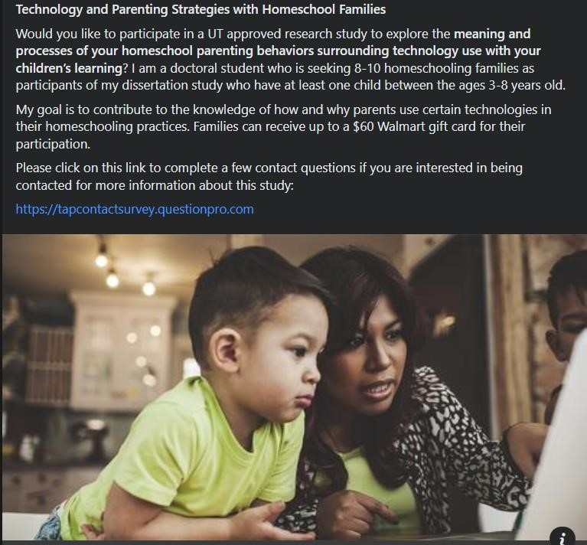

APPENDIX B


APPENDIX C
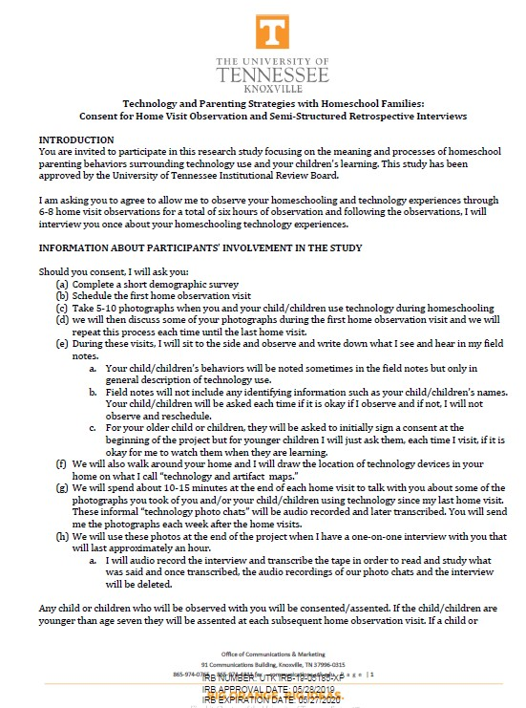
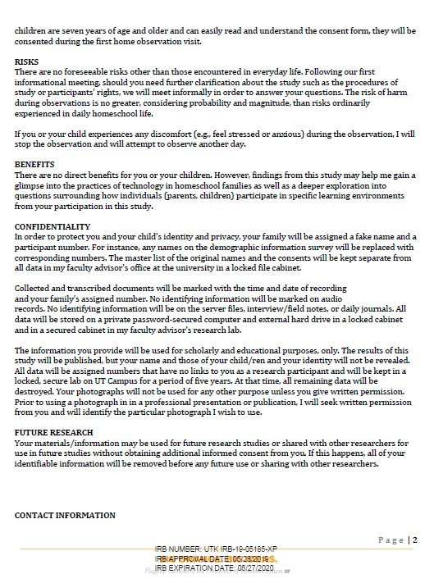



APPENDIX D
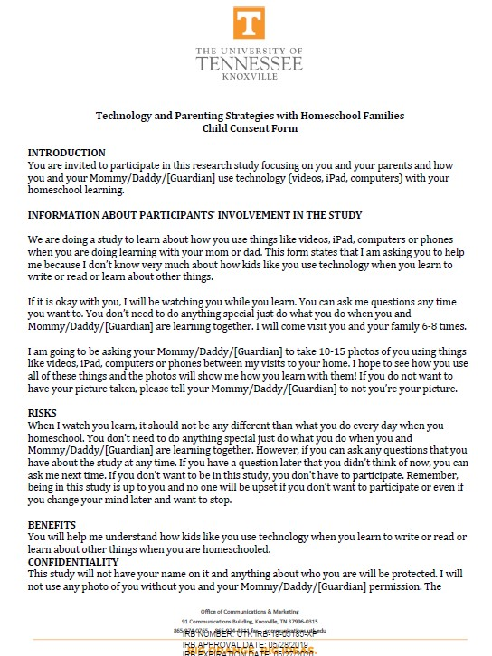



APPENDIX E


APPENDIX F
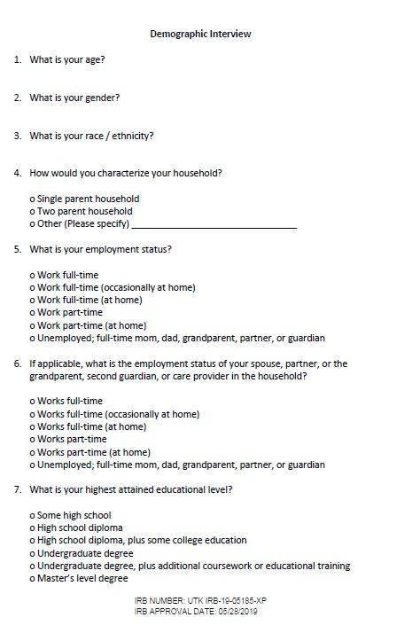



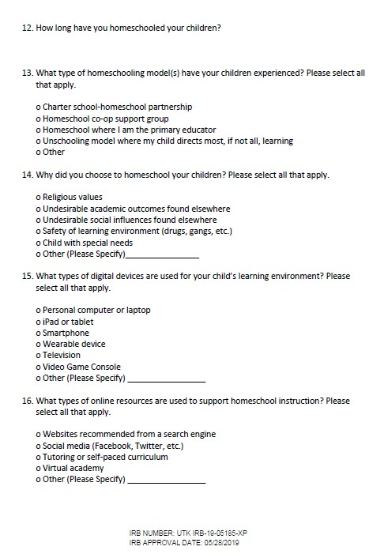

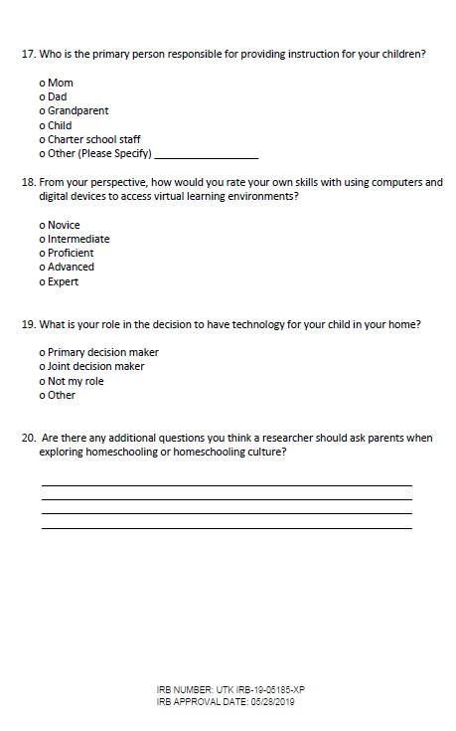

APPENDIX G
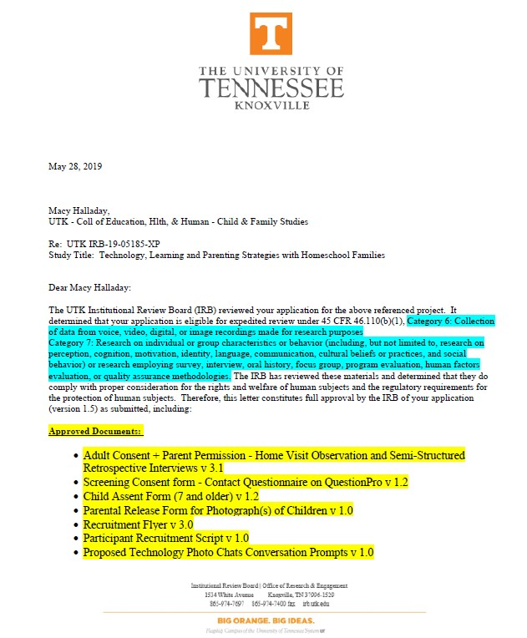

Vita
Macy received her Masters of Marriage and Family Therapy from the University of Southern California and received her doctorate degree at the University of Tennessee in Child Development and Family Studies. Her research interests include examining mothers’ caretaking experiences and patterns in self-transformation and meaning making; and the role community plays in helping mothers find support and information seeking behaviors. Macy believes the best parenting emerges when empirical science meets cultural practices. Macy is a human mom, dog mom and loves to kayak and listen to podcasts (sometimes at the same time!)

