Spontaneous Plant Colonization of Newly Established Green Roofs:
An Experimental Approach

A Thesis Presented for the
Master of Science
Degree
The University of Tennessee, Knoxville

Braden Matthew Coats
August 2024

Acknowledgements
I want to thank all of those who have supported and helped me both in skill and emotionally, my family, my friends, my cohort. I would like to thank my advisors- Mike McKinney and Mike Ross, my committee members- Dan Hembree and David Butler, and the GREL Team.
This Project was made possible through collaborations with the Departments of Earth, Environmental, and Planetary Science, Plant Sciences, The UT School of Landscape Architecture, and the UT gardens and with initial funding generously provided by campus Green Fees and the Office of Sustainability. The research units were designed and constructed by students, including myself, in the Department of Earth and Planetary Science, School of Landscape Architecture, and the Department of Plant Sciences’ Sustainable Landscape Design concentration.

Abstract
Extensive green roofs (EGR) are novel ecosystems composed of shallow (2 - 20cm) lightweight substrate with a mix of intentional (planted) and unintentional (spontaneous) species that perform ecosystem services on roofs. Research has examined ways to reduce the obstacles of implementing EGRs to maximize accessibility and efficacy of the structure’s provision of ecosystem services. The success of various ratios of plant mixtures and interactions occurring between spontaneous and intentional plant species have been tested with the goal of utilizing spontaneous plants as viable additions to EGR plant diversity and ecosystem function. However, few studies focus on spontaneous plant activity of completely barren substrate, typically referring to the substrate immediately after EGR installation and before planting. Understanding initial spontaneous plant activity during this time could aid EGR designers and practitioners with innovative planting strategies by providing a list of potential spontaneous species. This project utilizes twelve 2.4 m raised bed units in the student-constructed Green Roof Experimental Lab (GREL) at The University of Tennessee, Knoxville to assess the occurrences of spontaneous vegetation immediately after installation. Each unit was split into equal quadrants, and each quadrant was assigned a substrate depth of 5cm or 15cm to assess substrate depth’s role in spontaneous species community composition. The spontaneous plant community included 55 individual plants belonging to 10 different species. The ecosystem services associated with the 10 species functional identities include nutrient cycling, pollinator support, thermal regulation, food/ fodder, disturbance prevention, water provision, and waste regulation. Depth treatments were not found to significantly differ in plant communities during the study. These results provide the foundations for further research into the utility of spontaneous vegetation in EGRs in Knoxville, TN.
Table of Contents
Chapter 1. Introduction 1
1.1. Types of Green Roofs 1
1.2. EGR Plant Assemblage 2
1.3. Spontaneous Vegetation 3
1.4. Spontaneous Colonization Filters 3
1.5. Research Question and Objectives 4
Chapter 2. Methods 5
2.1. Study Area 5
2.2. Growing Media Depth Manipulation 5
2.3. Observations and Analysis 11
2.3.1. Plant Community Assessment 11
2.3.2. Photo Collection and Observation 11
2.3.3. Fixing Observation Camera Distortion 12
2.3.4. Canopy Cover Estimation 12
2.4. Statistical Analysis 12
Chapter 3. Results 13
3.1. Plant Presence Among Quadrants 13
3.1.1. Presence by Depth 13
3.2. Plant Community Dynamics 17
3.2.1. Spontaneous Colonizer Identification and Characteristics 17
3.2.2. Species Richness 17
3.2.3. Abundance 21
Chapter 4. Discussion 35
4.1. What plants colonize barren substrate immediately following installation? 35
4.1.1. What influenced the spontaneous plant community? 35
4.1.2. Substrate depth did not significantly influence the plant community in this study. 36
4.1.3. Hinted substrate depth influence on specific plant species 36
4.2. Identifying potential ecosystem services from species functional identities 37
4.3. Practical Implications 38
Chapter 5. Conclusion and Future Work 40
Works Cited 41
Vita 48

List of Tables
Table 1. GREL Construction and Study Timeline 7
Table 2. Spontaneous Species Inventory and Characteristics 18
Table 3. Reported Ecosystem Services Associated with Observed Spontaneous Species 19
Table 4. Each week’s Shannon diversity (H), Species richness (R), and species evenness (E) for both 5 and 15 cm communities 31

List of Figures
Figure 1. Aerial drone image of test site preinstallation of GREL. The test site (in green outline) is surrounded by a mix of heavily managed landscape (UTK Garden’s to the west), unmanaged landscape (weedy area to the north), riparian area (Third Creek to the east and the Tennessee River to the south), and urban development (Neyland Drive to the south) 6
Figure 2a (right) & 2b (below). Each unit was constructed from wood with a planting box with outer dimensions of 102cm x 122 cm (2a, solid line) and inner dimensions of 92 cm x 112 cm x 30 cm deep (2a, 2b dashed line) secured on top of a pallet. The research units elevate the substrate surface to reach 2.4 m above ground 8
Figure 3. GREL Unit Layout. The green and gray units are research units (2.4 m high), and the orange units are for outreach and education (1.2m high). The green units are numbered 1 to 12 and are the units used in this study 9
Figure 4. Each of the 12 units were further divided into quadrants and assigned a depth in a checkered arrangement using foam slabs to elevate substrate to equal heights. Quadrants 1 and 4 contained 5cm of growing medium and quadrants 2 and 3 were set to contain 15cm of growing medium 10
Figure 5. Presence/absence of plants recorded at each observation. Each numbered box represents a unit. Each row represents a quadrant within that box. Each colored column is an observation 14
Figure 6. This graph depicts the total number of quadrants with living plants present from June 21 to August 29, 2023 15
Figure 7. This graph depicts the weekly total number of quadrants separated by depth with living plants present from June 21 to August 29, 2023. The purple line is the shallower 5cm depth. The orange line is the deeper 15 cm depth 16
Figure 8. This graph depicts the weekly average species richness per quadrant from June 21 to August 29, 2023 20
Figure 9. Observed species richness in each unit and quadrant. The top quadrants (3,2) in each unit are the deeper 15cm, and the bottom (4,1) are the shallower 5cm. The scale of high to low is 4(Highest) to 0(lowest) number of species in each quadrant 22
Figure 10. This graph shows the average species richness in quadrants of each depth. The purple line is the shallower 5cm depth. The orange line is the deeper 15 cm depth 23
Figure 11. This figure depicts the changes in plant abundance as a sum across the whole study 24
Figure 12. This figure shows the changes in plant species abundance over time 25
Figure 13. Plant abundance by depth. The red line is the shallower 5cm depth. The blue line is the deeper 15 cm depth. The graph shows the total number of individual plants in each depth’s quadrants 26
Figure 14. Plant Species Abundance by Depth. The purple line is the plant number of that plant species in the shallower 5cm depth. The orange line is the plant number of that plant species in the deeper 15 cm depth 27
Figure 15. This figure shows the Shannon Diversity Index (H) for both depth communities over time 28
Figure 16. Shannon Diversity Index (H) of study site over time 30
Figure 17. Average Fractional Green Canopy Cover (FGCC (%)) per quadrant of the whole study by week 32
Figure 18. Fractional Green Canopy Cover (FGCC) is a measure of the percentage of green plant cover present in the digital photos taken of each quadrant. The graph shows the average % of quadrants covered in green canopy in both depths. The purple line is the shallower 5cm depth. The orange line is the deeper 15 cm depth 33
Figure 19. Fractional Green Canopy Cover (FGCC) is a measure of the percentage of green plant cover present in the digital photos taken of each quadrant. This graph shows the measured values with error bars. The blue indicates 15cm depth quadrants and the red indicates 5cm depth quadrants 34
Figure 20. Daily reported max temperature (Fahrenheit) and precipitation (inches) from May 13 to August 30, 2023. The red line represents maximum temperature and the blue bar graph in measured daily precipitation. Open source data from NOAA National Weather Service 2023 39

Chapter 1. Introduction
Green infrastructure, such as green roofs, is a growing trend in constructing urban environments because it offers many benefits, such as storm water management, an increase in urban habitat and biodiversity, and thermal regulation leading to a reduction of the urban heat island (UHI) effect (McKinney, 2002; Getter and Rowe, 2006; Oberndorfer et al., 2007; Grimm et al., 2008). The UHI effect is a significant phenomenon in urban areas, whereby anthropogenic materials such as concrete and asphalt have high specific heat, increase local surface, and air temperatures (Getter and Rowe, 2006; Hass et al., 2016; Ellis et al., 2015). This can cause heat-related health risks in ‘gray spaces’ where these materials are more concentrated (Hass et al., 2016). Green roof installations have become an important strategy to reduce the denser concentration of gray spaces through converting bare roofs, which make up 20 - 30% of the total urban surface area, to combinations of growing media and plants, materials that mitigate the UHI effect and thus reduce heat risk (Frazer, 2005; Oberndorfer et al., 2007; Francis and Lorimer, 2011). The green roof’s efficacy in mitigating UHI relies on the plant’s physical characteristics (biomass, canopy cover, specific leaf area) which are dictated by how each individual plant responds to the design, management, structural intention, and climate of the green roof ecosystem (Oberndorfer et al., 2007; Lundholm et al., 2010). Additionally, the composition and diversity of plant communities also influences the ecosystem services performed by EGRs (Lundholm et al., 2010; Lee et al., 2014; Bevilacqua, 2015). For example, the distribution and diversity of plant traits within a community determines the density of canopy cover (amount of provided shade) which lessens solar exposure of substrate and increases albedo thus decreasing the amount of absorbed heat in the system (Lundholm et al., 2010; Cook-Patton and Bauerle, 2012; Lee et al., 2014).

  - Types of Green Roofs
There are two types of green roofs: intensive and extensive (Oberndorfer et al., 2007; MacIvor and Lundholm, 2011; Bevilacqua et al., 2015). Regardless of type, green roofs implementation includes installation of a roof membrane and a selected growing medium, however, the two types differ in weight, cost, depth, maintenance requirements, and vegetation possibilities (Oberndorfer et al., 2007; Getter and Rowe, 2006; Bevilacqua et al., 2015). Intensive green roofs (IGR) are more expensive, have deeper growing media (>20 cm), and thus can support the widest variety of plant life from mosses to deeper rooted trees (Oberndorfer et al., 2007; Bevilacqua et al., 2015). Due to increased weight and installation requirements, IGRs often must be included in the building plan and design during initial construction (Bevilacqua et al., 2015). Due to this and the more frequent labor-intensive management, IGRs require more funding (Oberndorfer et al., 2007; Bevilacqua et al., 2015). Extensive green roofs (EGR) have less of a structural requirement due to shallower growing media (< 20 cm), are cheaper, require less management, and are more readily retrofitted to existing roofs (Oberndorfer et al., 2007; Bevilacqua et al., 2015). As such, most green roof research focuses on the variables affecting the implementation and performance of extensive green roofs (Oberndorfer et al., 2007).

  - EGR Plant Assemblage
Given the shallow growth media limits nutrient and water storage capacities and the elevated temperatures and strong sun exposure typical of rooftop environment, EGR designers’ intentional planting selections are limited to hardy stress tolerant species (Lundholm et al., 2010; Lee et al., 2014). The limitation lessens available cover that can be met by planted species without increasing management inputs, however, also introduces an unusual plant composition strategy being observed on EGRs versus other urban landscapes. EGR plant assemblages are often novel ecosystems with a mixture of planted (intentional) and spontaneous (unintentional) species, with percentages of each varying with management, ecological interactions, and time (MacIvor and Lundholm, 2011; Cook-Patton and Bauerle, 2012; Madre et al., 2014).
Studies have attempted to explore the novelty of EGR plant communities by running various mixtures of intentional and spontaneous species to test the possibility of spontaneous plants as viable additions to EGR diversity and function (Bonthoux et al., 2019; Vanstockem et al., 2019b). It is reported that, over time, intentional green roof plant communities often transform to a new dissimilar community highly dominated by spontaneous species if not continuously managed (Dunnett et al., 2008; Olly et al., 2011; Vanstockem et al., 2019b).

  - Spontaneous Vegetation
Spontaneous vegetation refers to plant species that colonize, establish, and survive on a site without being intentionally planted (Madre et al., 2014; Bonthoux et al., 2019). The species composition is highly dependent on the local species pool (Bonthoux et al., 2019; Vanstockem et al., 2019b). Dispersal of these species occurs via animals, wind, or accidental anthropogenic introductions such as propagules within growing media (Brown and Lundholm, 2015; Li et al., 2019). Abiotic factors influencing the colonization of spontaneous vegetation include: substrate depth, shading, temperature, and moisture (Anderson and Minor, 2019; Li et al., 2019; Vanstockem et al., 2019b; Qian et al., 2020). Spontaneous species are often perceived as an indication of a failure or lack of proper management leading to physical or chemical removal (Oberndorfer et al., 2007). A common justification for the removal is that spontaneous species can include invasive or non-native species that can alter or damage the intended plant community structure and design intent (McKinney, 2006; Vila et al., 2011; Yee et al., 2021). However, research suggests that when spontaneous vegetation become dominant in an EGR’s plant community, they often exhibit successful stress-tolerant traits and provide beneficial ecosystem services resembling intentionally planted species (Deng and Jim, 2017; Thuring and Dunnett, 2019; Heim et al., 2024).

  - Spontaneous Colonization Filters
The substrate depth on a green roof can significantly impact both plant survival, growth, and species diversity (Nardini et al., 2012; Catalano et al., 2016; Ksiazek-Mikenas et al., 2018). Deeper substrates generally provide more water and nutrient storage, reducing the frequency of drought stress and potentially supporting a wider range and higher abundance of plant species (Kohler and Poll, 2010; Nardini et al., 2012). As the plant community develops, sun exposure and growing media depth become limiting factors for plant establishment and survival due to shallower substrates having less available space for rooting and low buffering capacity against extreme or shifting temperatures (Rowe et al., 2012). Established plant communities begin responding to these stimuli and individuals initiate respective survival tactics to compete with one another for the required resources (Rowe et al., 2012). The community response to the stimuli introduces complex environmental intersectionality between the already established community, new colonizers, and the environment (Hodkinson et al., 2002; Rowe et al., 2012; Vanstockem et al., 2019a). The composition of the established plant community influences selective pressures for species with the ability to fill niches or gaps that are not occupied or otherwise lacking competitors that serve as a barrier to colonization (Grime, 2006; Bonthoux et al., 2019; Vanstockem et al., 2019a). For example, it was reported that colonist’s dry mass and richness decreased with increasing resident plant cover (Aloisio et al., 2019). Likewise, colonizing plants with similar growing requirements as preexisting individuals may not colonize as readily or successfully and additionally may have complications or interactions that affect the life cycles of both individuals (Vanstockem et al., 2019b). This suggests that the interactions between resident plants and colonizing species can be complex and may be influenced by factors such as niche overlap and complementarity in rhizosphere dynamics (Vanstockem et al., 2019b).
For practitioners in Knoxville, Tn to successfully utilize spontaneous vegetation, we must first understand how local abiotic and biotic factors might influence the local vegetation’s colonizing ability. This understanding is vital for maximizing the diversity of plant communities as well as improving the overall design and sustainability of EGRs as effective providers of ecosystem services.

  - Research Question and Objectives
Our study observed and inventoried spontaneous species that colonize experimental platforms during the summer (May – August) of 2023 to determine what spontaneous species colonize unmanaged bare substrate on extensive green roofs in Knoxville, Tennessee immediately following installation. Substrate depths of 5 cm and 15 cm were used to assess the influence of growing media depth on the two resulting plant communities in terms of species composition and abundance. Filling this knowledge gap of what happens to newly established, unmanaged, barren green roofs could prove useful to designers and landscape architects by: 1. identifying a list of observed, readily colonizing, spontaneous species on EGRs; 2. providing an example of how early spontaneous EGR plant communities develop in Knoxville, TN; and 3. evaluating the early performance and development of plant communities in two different substrate depths within the EGR range (5 and 15 cm).

Chapter 2. Methods

2.1. Study Area
The study utilized the student constructed Green Roof Experimental Lab (GREL) on The University of Tennessee, Knoxville’s campus in Knoxville, TN. Knoxville is in the Southeastern United States and has a humid subtropical climate. During the study (May – August 2023), average weekly temperatures range from 67.2°F – 82.67°F and total rainfall of 37.719 cm (NOAA-NWS, 2024). GREL is an experimental research station constructed and established in May of 2023 (35°56'37"N, 83°56'10"W). The design of GREL started in the Spring of 2022. The 200 m² research area was once used as a storage area for soil and mulch (fig. 1). The construction of the twenty research units at 2.4 m high and four education and outreach units at 1.2 m high began in Summer 2022 and was completed by February 2023 (Table 1). All units are made of wood and have outer dimensions of 122 cm x 102 cm, planting area 92 cm x 112 cm with a maximum depth of 30 cm (fig. 2a, 2b). roofing paper was used as the roof membrane lining the inside of the boxes and drainage holes were drilled to mitigate water retention within the units and prevent wood rot. The units are placed in six rows of four at 35°56'36"N 83°56'10"W with site ground level elevation 250.69 m (fig. 3)

2.2. Growing Media Depth Manipulation
The study utilized 12 research (2.4m high) units from May 15 to August 29, 2023 (fig. 3). The 92 cm x 112 cm planting area of each raised bed was subdivided into 46 x 56 cm quadrants (fig. 4). All 12 green roof modules were installed using the same proprietary commercial substrate/growing medium, “OMNI Infinity” - comprised of lightweight mineral aggregate and cellulosic components (OMNI Ecosystems, 2022). The layering of the roof lining, mineral aggregate, and cellulosic components were implemented following the OMNI Ecosystems - Green roof Installation Manual (OMNI Ecosystems, 2022). The mineral aggregate and cellulosic components were sanitized pre-installation May 2023 using a Siebring SG15 Steam Generator and AB28 Aeration Blower that utilizes high temperature steam to remove any viable seeds that could have been deposited in transport or storage (Seibring Manufacturing, INC.). The green
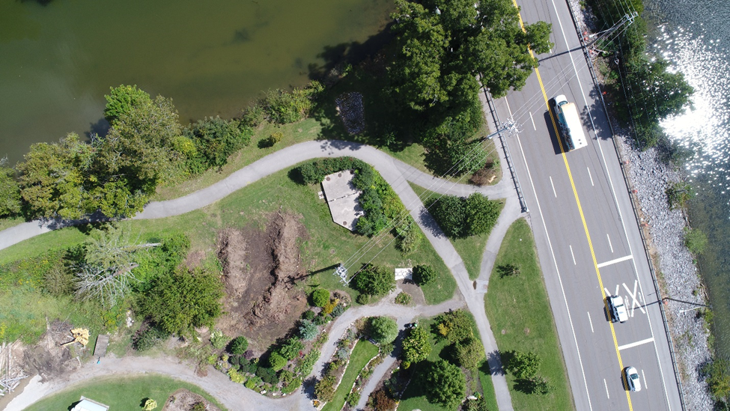

Figure 1. Aerial drone image of test site preinstallation of GREL. The test site (in green outline) is surrounded by a mix of heavily managed landscape (UTK Garden’s to the west), unmanaged landscape (weedy area to the north), riparian area (Third Creek to the east and the Tennessee River to the south), and urban development (Neyland Drive to the south).

Step | Date completed
Final Materials Received | 09-19-2022
Placement of completed raised bed units | 10-28-2022
Substrate arrives from OMNI | 10-28-2022
Foam Arrives and Cutting starts | 10-31-2022
Finish construction of green roof experimental lab (GREL) | 02-11-2023
Substrate is Sanitized | 05-10-2023
Start of Study | 05-15-2023 Week 1
Observation 1 | 06-21-2023 Week 6
Observation 2 | 07-07-2023 Week 9
Observation 3 | 07-17-2023 Week 10
Observation 4 | 07-27-2023 Week 11
Observation 5 | 08-04-2023 Week 12
Observation 6 | 08-18-2023 Week 14
Observation 7 | 08-29-2023 Week 16
Table 1. GREL Construction and Study Timeline

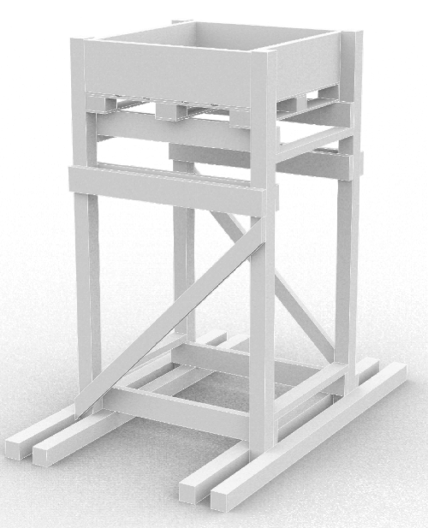
2.4 m
122 cm
102 cm
92 cm
112 cm

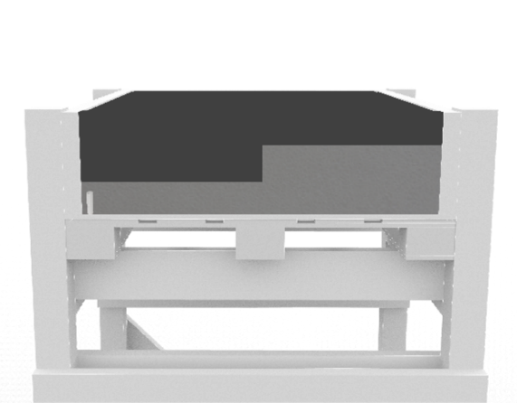

30 cm

Figure 2a (right) & 2b (below). Each unit is constructed from wood with a planting box with outer dimensions of 102cm x 122 cm (2a, solid line) and inner dimensions of 92 cm x 112 cm x 30 cm deep (2a, 2b dashed line) secured on top of a pallet. The research units elevate the substrate surface to reach 2.4 m above ground.
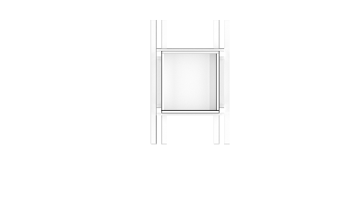
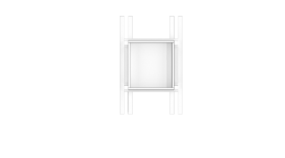
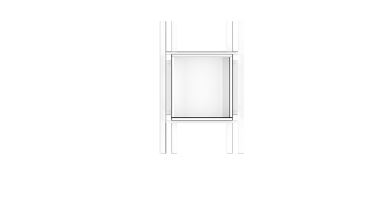

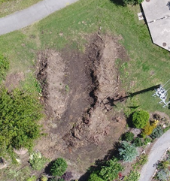
4
1
2
5
8
7
6
12
3
9
10
11
N
Figure 3. GREL Unit Layout. The green and gray units are research units (2.4 m high), and the orange units are for outreach and education (1.2m high). The green units are numbered 1 to 12 and are the units used in this study.

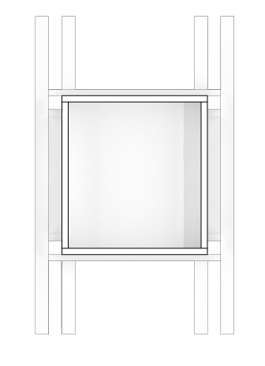

Q2
15cm
5cm
Growing Media
Q1
5cm
15cm

Q4
5cm
foam
Q3
15cm
N

Figure 4. Each of the 12 units were further divided into quadrants and assigned a depth in a checkered arrangement using foam slabs to elevate substrate to equal heights. Quadrants 1 and 4 contained 5cm of growing medium and quadrants 2 and 3 were set to contain 15cm of growing medium.

roof installation and layering of OMNI infinity media followed the OMNI Ecosystems 2022 installation manual and included an application of proprietary probiotic element (OMNI Ecosystems, 2022). In each unit, the quadrants were assigned to have growing media depths of either 5 cm or 15cm resulting in a uniform checkered formation (fig. 4). Two-inch foam slabs were used to fill the needed space to get the substrate to the desired depth: 3 pieces of foam were set for each 5cm quadrant (1 and 4), and 1 piece of foam was set for the 15cm quadrant (2 and 3). The units were not irrigated for the duration of the study to eliminate any possible management biases affecting the colonization of spontaneous species that may occur during the study.

2.3. Observations and Analysis

2.3.1. Plant Community Assessment
The presence of spontaneous vegetation was recorded in binary fashion: “1” was assigned when present and “0” for absent (no plants). The abundance of individual plants was counted and reported for each quadrant at each observation. Each plant was categorized by species, family, possible growth durations, growth habit, season, native or exotic, mode of reproduction, seed dispersal methods, documented performed ecosystem services, and the week a representative was first observed in quadrants of either depths. Species richness was found by counting the number of different species in each quadrant. Alpha diversity refers to the average species diversity in a community (Whittaker, 1972). Shannon’s diversity index (H) was the alpha diversity index used to compare the two depth’s resulting communities (Shannon, 1948). Species evenness was calculated by dividing Shannon’s diversity index value (H) by the natural logarithm of species richness (Shannon, 1948).

2.3.2. Photo Collection and Observation
Periodic observations were recorded in the form of digital photos taken directly above each unit between 1100 - 1500 h from May 22, 2023 to August 29, 2023 to be used for plant identification and counts. Cloud cover was usually very low. The camera specs: 50 MP, f/1.8, 23mm (wide), 1/1.56", 1.0µm, dual pixel PDAF, OIS. The images were taken with the camera kept at about 1.5 m from the top of the canopy to prevent overestimation of coverage.

2.3.3. Fixing Observation Camera Distortion
Select observation images were subject to some angle distortion. To correct this, the images were uploaded to Adobe Photoshop and the images perspective was corrected using the Perspective Crop tool eliminating the angular distortion. All images were uploaded to photoshop then cropped into four equal rectangles using the quadrant reference lines drawn on each unit to ensure each cropped quadrant was correctly sized.

2.3.4. Canopy Cover Estimation
To assess canopy cover, the cropped images of each quadrant were uploaded to the mobile MATLAB based application Canopeo. Canopeo is an automatic color threshold classification (ACT) mobile application developed using MATLAB (Patrignani and Tyson, 2015). The application was used for percent canopy cover estimation. The mobile application uses a device’s camera to take media, such as pictures or videos, and convert them into high contrasting black and white images. It does this by calculating the Fractional Green Canopy Cover % (FGCC%) of each image by assigning white to pixels with mostly green color spectra (sensitivity = 91%) and all other colors default to black (specificity = 89%) (Patrignani and Tyson, 2015). It then calculates the ratio of white pixels to all pixels and reports it as a percentage. This percentage represents the amount of photosynthesizing, or active, above ground plant material represented in the image (Patrignani and Tyson, 2015).

2.4. Statistical Analysis
Open-source R 4.3.3 and R studio were used to conduct statistical analyses and create figures (R Core team, 2024). A Shapiro-Wilks test was used to check for normality (p > 0.05) among response variables. Normality was not observed as the data was not normally distributed due to the higher density of “zero” values when plants were absent in quadrants at each observation. To analyze the non-normally distributed data, the following nonparametric tests were used in their respective situations, the correlations amongst two independent variables Kendall Rank Correlation was used to measure the strength of dependence between two measured quantities and the Wilcoxen rank sum test was used when comparing two independent sample’s distributions.

Chapter 3. Results

3.1. Plant Presence Among Quadrants
Of the 336 total individual quadrant observations, 180 (~ 53.6%) had plants present (presence = 1) and 156 had no observed colonization at the time of observation (presence = 0) (fig. 5). The 180 individual quadrant observations with colonization occurred in 31 of the total 48 quadrants during at least one of the seven recorded over the 16-week study (fig. 6). Of these, 17 of the 31 quadrants had plants present at every observation (~55%). A general increase was observed in the number of quadrants that had plants with each sequential observation. The maximum number of quadrants with plant colonists was recorded in week 14. Between week 14 and 16, 4 quadrants belonging to 4 different units (fig 5) experienced complete plant mortality, decreasing the number of quadrants with living plant cover from 31 in week 14 to 27 in week 16 (fig 6).

3.1.1. Presence by Depth
Depth was not found to significantly influence the colonization (presence) of plants (Wilcox Rank Sum, p > 0.05). Among the 5cm depth quadrants, 16 of the 24 (~67%) had plant colonization, 11 of the 16 (~69% of the 16 with plants; ~49% of all) 5cm quadrants with presence had plants at all observations (fig. 7). Among the 15cm depth quadrants, 15 of the 24 (~63%) saw some plant colonization, 6 of those 15 (~40%; 25% of all) 15cm quadrants with presence had plants present at every observation (fig. 7).
The two depths showed similar changes in total quadrants regarding plants’ presence over time. However, the number of 5 cm quadrants experienced the respective shifts first. The number of quadrants with plants present in the shallower 5cm depth was higher at both the initial and final observations. (fig. 7). The total number of 15 cm quadrants with plant presence did rise from initial observation until week 10, overtaking the number of 5cm depth quadrants with plants present in them due to the lack of colonization in the 5cm quadrats from week 9 to 11 (fig.7). This four-week lack of colonization was also observed in the 15 cm depths from weeks 10 to 12 after which the two communities had a respective total 14 quadrants each with plants present (fig.7). The week 16 observation saw a drop of 2 quadrants per depth treatment.
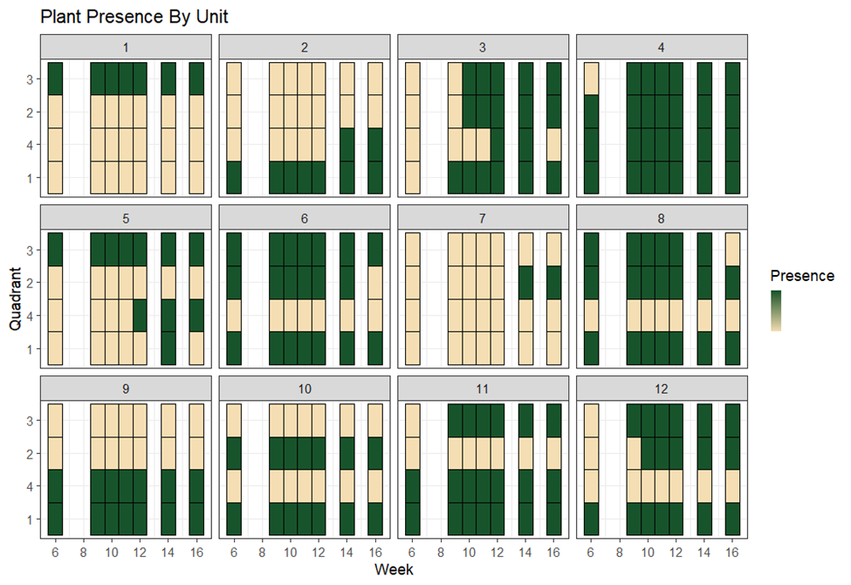
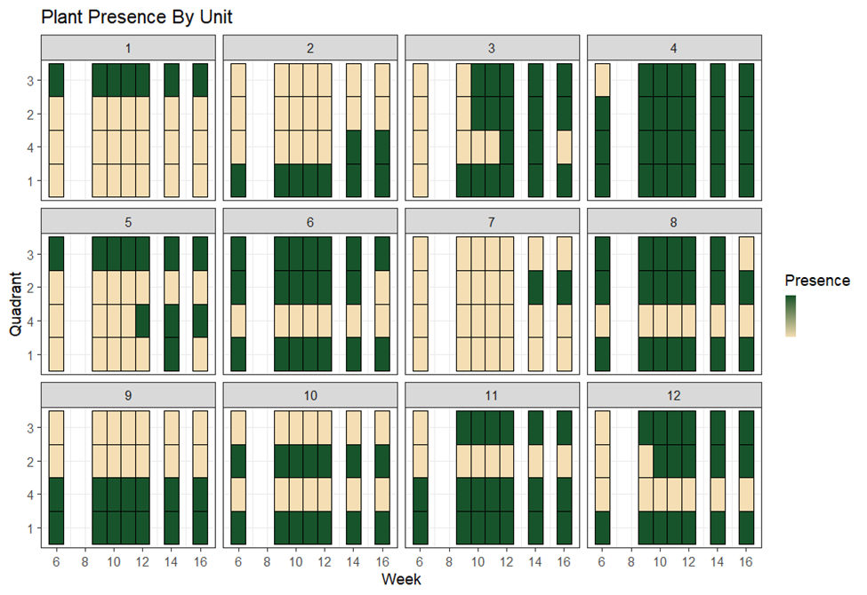
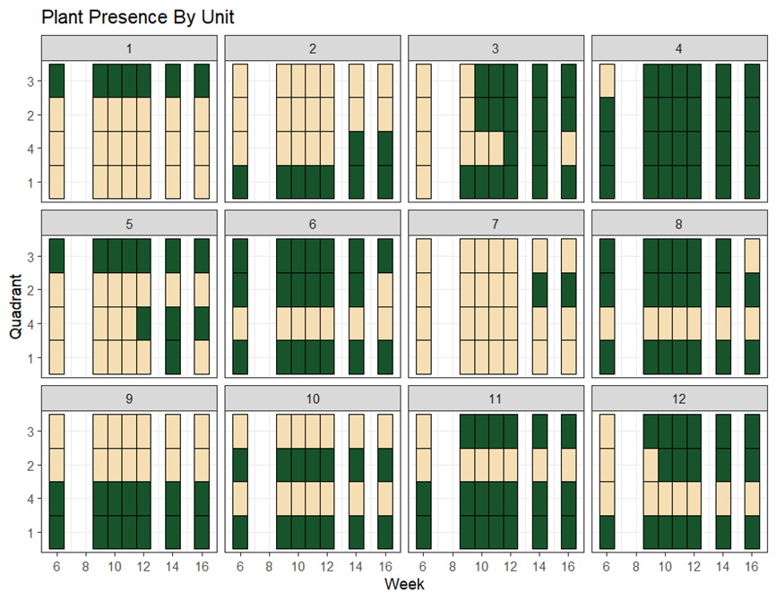

Present
Absent

Figure 5. Presence/absence of plants recorded at each observation. Each numbered box represents a unit. Each row represents a quadrant within that box. Each colored column is an observation.

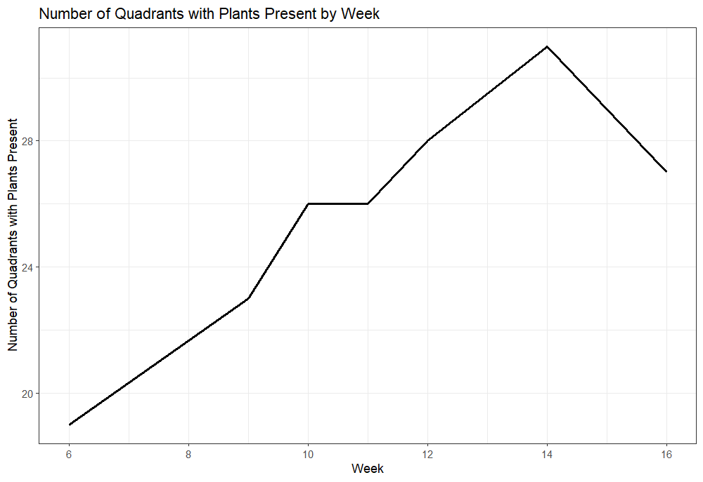
Figure 6. This graph depicts the total number of quadrants with living plants present from June 21 to August 29, 2023.

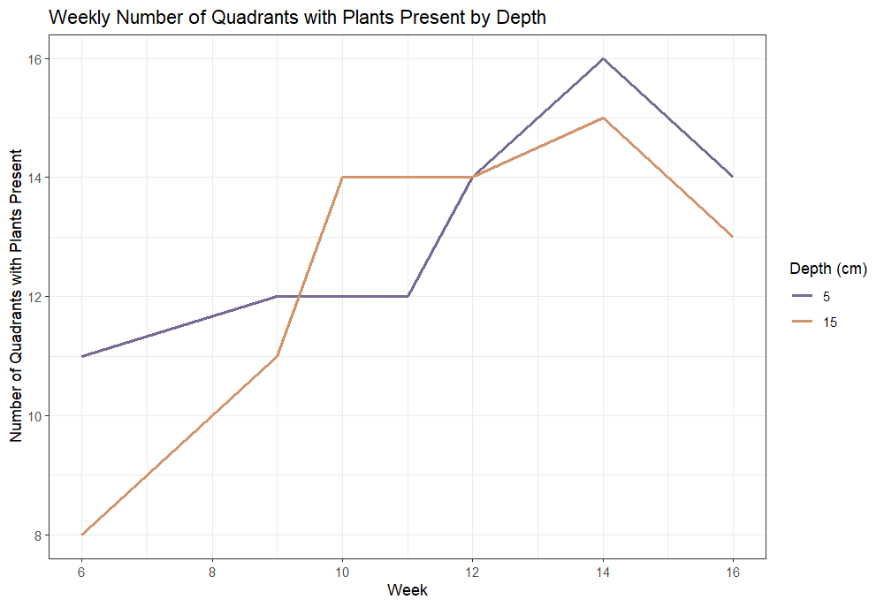Figure 7. This graph depicts the weekly total number of quadrants separated by depth with living plants present from June 21 to August 29, 2023. The purple line is the shallower 5cm depth. The orange line is the deeper 15 cm depth.

3.2. Plant Community Dynamics

3.2.1. Spontaneous Colonizer Identification and Characteristics
A total of 10 different species belonging to 6 different families were found to colonize the raised beds. Each plant that colonized the 31 of 48 quadrants was identified by family and species then classified by various colonization traits such as reproductive and dispersal modes. Three different types of growth habits and both warm and cool season plants were observed in the following degrees, four (Eupatorium serotinum, Sonchus asper, Chenopodium album, and Pontentilla norvegica) non-leguminous warm season forbs/herbs, one (Trifolium repens) leguminous cool season forb/herb, two (Persicaria lapathifolia, Polygonum aviculare) warm or cool season non-leguminous forb/herb, one cool season grass (Lolium perenne), one warm season grass (Panicum virgatum), and one warm or cool season grass (Digitaria serotina). Four species (Eupatorium serotinum, Pontentilla norvegica, Digitaria serotina, Panicum virgatum) are native to Tennessee, six species (Chenopodium album, Sonchus asper, Polygonum aviculare, Persicaria lapathifolia, Trifolium repens) are exotic (USDA, 2023).
Seven of the 10 colonizing species were observed over the full duration of the study. Two species, Sonchus asper and Pontentilla norvegica, were first observed during week 9, and one species, Trifolium repens, was not observed until week 11 (Table 2). All 10 colonizing species are adapted to thrive in various climate conditions, but most prefer well drained moist soil conditions. All 10 species are primarily dispersed through seed, with eight species having seed dispersal by wind (anemochory) and two species dispersing via birds (endozoochory) (Table 2). Panicum virgatum can also be dispersed in the form of a rhizome. Digitaria serotina, Trifolium repens, and Potentilla norvegica can also be dispersed in the form of stolons (Table 2). The potential ecosystem services based on functional identity of each species were taken from a review done by Brown and Anand, 2022 (table 3).

3.2.2. Species Richness
The average species richness per quadrant across the whole study was 0.8601 and median was 1 (fig. 8). The average species richness per quadrant increases from the minimum 0.52 at week 6 to the max average species richness at 1.1 by week 14, it then decreased back to 1 at week 16
Scientific Name | Common Name | Family | Duration | Growth habit | Season | Native /Exotic | Reproductive Mode | Dispersal Mode | Observed  5 cm | Observed 15 cm
Chenopodium album | Common Lambsquarter | Amaranthaceae | Annual | forb | Warm | E | Seed | Anemochory | 6 | -
Digitaria serotina | Dwarf Crab Grass | Poaceae | Annual | Grass | Warm/ Cool | N | Seed, Stolon | Anemochory | 6 | 6
Eupatorium serotinum | Lateflowering Thoroughwort | Asteraceae | Perennial | forb | Warm | N | Seed | Anemochory | - | 6
Lolium perenne | Perennial Ryegrass | Poaceae | Perennial | Grass | Cool | E | Seed | Anemochory | 6 | 6
Panicum virgatum | Switchgrass | Poaceae | Perennial | Grass | Warm | N | Seed, Rhizome | Anemochory | 6 | 6
Persicaria lapathifolia | Pale Smartweed | Polygonaceae | Annual | forb | Warm/ Cool | E | Seed | Endozoochory | 6 | 6
Polygonum aviculare | Prostrate Knotweed | Polygonaceae | Annual Perennial | forb | Warm/ Cool | E | Seed | Anemochory | 6 | 6
Pontentilla norvegica | Mock Strawberry | Rosaceae | Annual Biennial Perenniel | forb | Warm | N | Seed, Stolon | Endozoochory | 9 | 10
Sonchus asper | Spiny Sowthistle | Asteraceae | Annual | forb | Warm | E | Seed | Anemochory | 9 | 10
Trifolium repens | White Clover | Fabaceae | Perennial | legume | Cool | E | Seed, Stolon | Anemochory | 11 | 14
Table 2. Spontaneous Species Inventory and Characteristics
Scientific Name | Nutrient Cycling | Pollinator Support | Thermal Regulation | Food/ Fodder | Disturbance Prevention | Water Provision | Waste Regulation
Chenopodium album |  |  | Shade, Transpiration |  |  | Moisture Retention
Digitaria serotina | Soil Fertility |  | Transpiration |  | Drought Resilience
Eupatorium serotinum | Decomposition | Provision | Shade, Transpiration |  |  | Moisture Retention
Lolium perenne | Soil Fertility, Decomposition |  | Transpiration |  | Drought Resilience
Panicum virgatum | Soil Fertility, Decomposition |  | Transpiration |  | Drought Resilience |  | C4 - Soil Remediation
Persicaria lapathifolia |  |  | Shade, Transpiration |  |  | Moisture Retention
Polygonum aviculare |  |  | Shade, Transpiration
Pontentilla norvegica | Decomposition | Provision | Shade, Transpiration | Fruit |  | Moisture Retention
Sonchus asper |  | Provision | Shade, Transpiration
Trifolium repens | Soil Fertility | Provision | Shade, Transpiration |  |  | Moisture Retention
Table 3. Reported Ecosystem Services Associated with Observed Spontaneous Species
The table shows links and associations of species functional identities (duration, growth habit, growing season, native /exotic, reproductive mode, dispersal mode) and ecosystem services based on a review of literature.

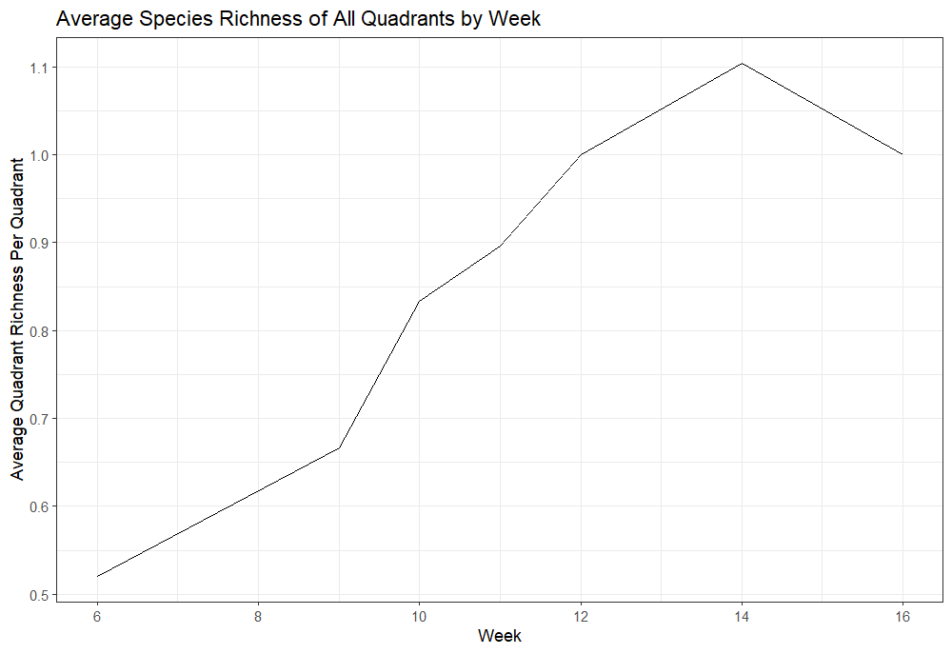
Figure 8. This graph depicts the weekly average species richness per quadrant from June 21 to August 29, 2023.

(fig. 8). The highest species richness in one quadrant was 4, containing Trifolium repens, Persicaria lapathifolia, Panicum virgatum, Lolium perenne in unit 2 quadrant 1 from week 11 to 16 (fig. 9). Depth was not found to be a statistically significant influence on the species richness (number of different species) in each quadrant (Wilcox Rank Sum, p > 0.05).
Similar community shifting as what was observed in presence by depth, the 15cm depth quadrants had higher species richness between week 9 and 12, and the 5cm quadrants have higher average species richness before and after that range (fig. 10). The maximum richness for both depths was observed in week 14 with a decline from week 14 to 16 observations (fig. 10). The 15 cm depth quadrants had a higher average species richness in most units (U1,3:8,10,12) at most observations (fig. 9).

3.2.3. Abundance
A total of 55 individual plants colonized the raised beds by week 14 (fig. 11). Persicaria lapathifolia was the most abundant species with a sum of 15 individuals, and Chenopodium album is the least abundant species with only one individual observed (fig. 12). Depth was not influential on the abundance of the species in this study (Wilcox Rank Sum, p > 0.05). The 5cm quadrants reached a max plant abundance of 29 at week 14 (fig. 13). The 15cm quadrants had a max of 26 individuals at week 12 (fig 13). Panicum virgatum growing in the 15cm depth quadrants was the only plant to lose any individuals before week 14 observation (fig. 14). Both depth communities experienced some loss from week 14 to 16 (fig. 13). The 5cm quadrants lost 1 individual from the Panicum virgatum, Polygonum aviculare, and Lolium perenne populations and the 15cm quadrants lost 1 individual from both Polygonum aviculare and Lolium perenne, and two individuals from Persicaria lapathifolia (fig 14). All the species that experienced losses were species that had individuals present from week 6 (fig. 14). No species that colonized afterweek 6 experienced any losses during the study (fig. 14).

3.2.4. Plant Community Diversity
Comparing depth treatments, statistically, the difference in depth did not have a significant influence in the alpha diversity (Shannon diversity, H) index for the green roof communities (Wilcoxen rank sum test, W = 37, p > 0.05, fig. 15). The only observed difference in the two
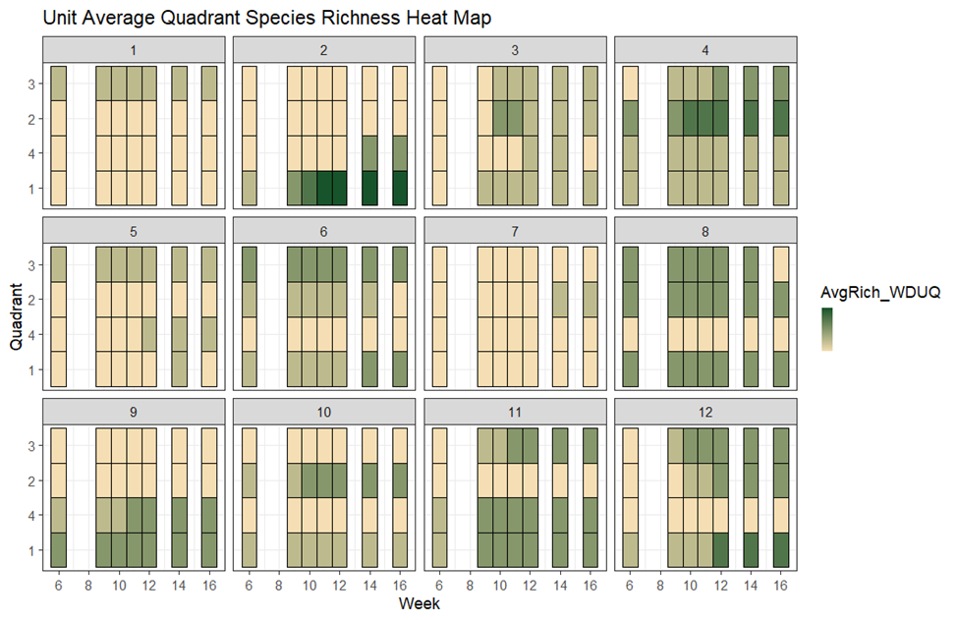
Low
High

Figure 9. Observed species richness in each unit and quadrant. The top quadrants (3,2) in each unit are the deeper 15cm, and the bottom (4,1) are the shallower 5cm. The scale of high to low is 4(Highest) to 0(lowest) number of species in each quadrant.

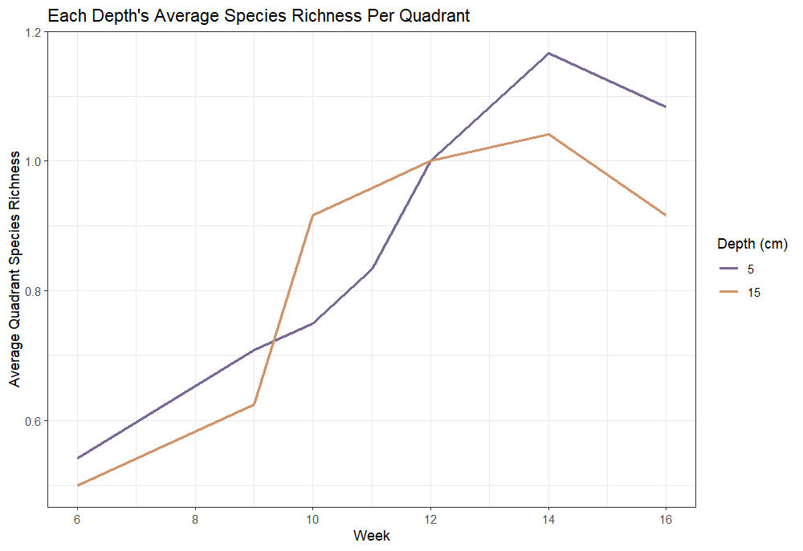
Figure 10. This graph shows the average species richness in quadrants of each depth. The purple line is the shallower 5cm depth. The orange line is the deeper 15 cm depth.

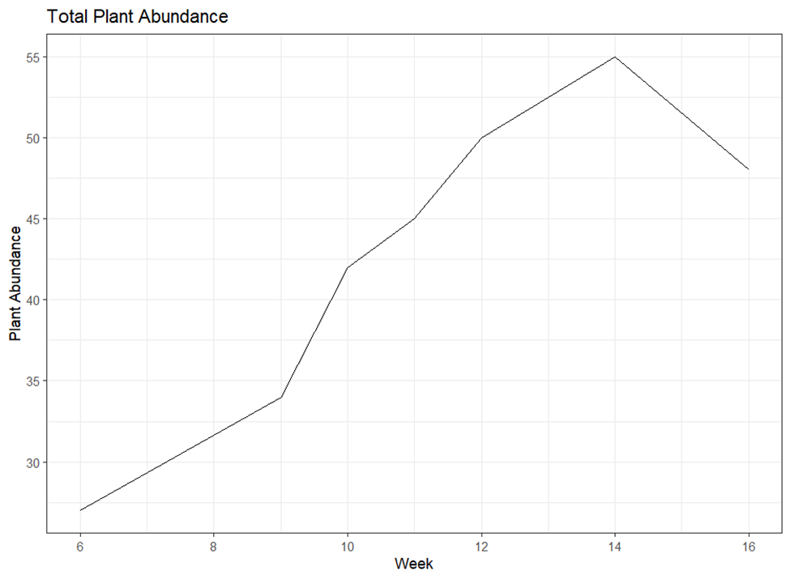
Figure 11. This figure depicts the changes in plant abundance as a sum across the whole study.

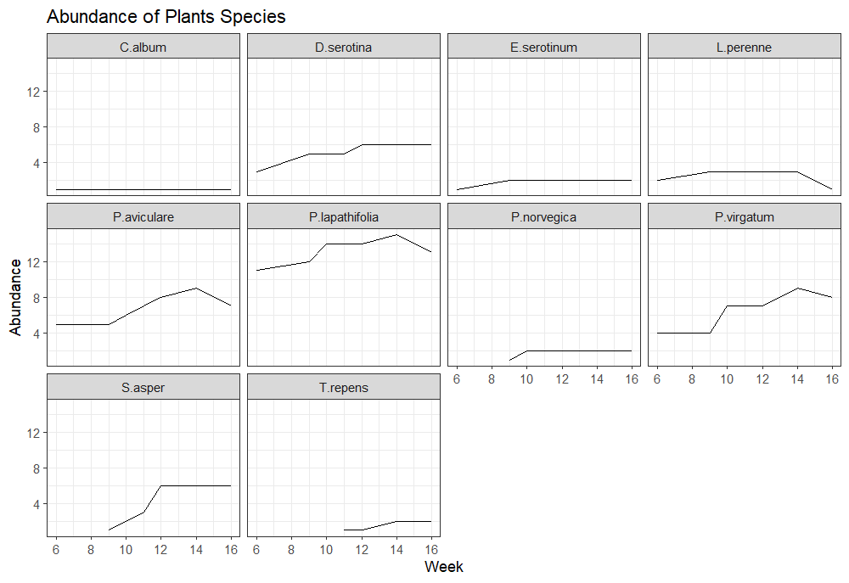
Figure 12. This figure shows the changes in plant species abundance over time.

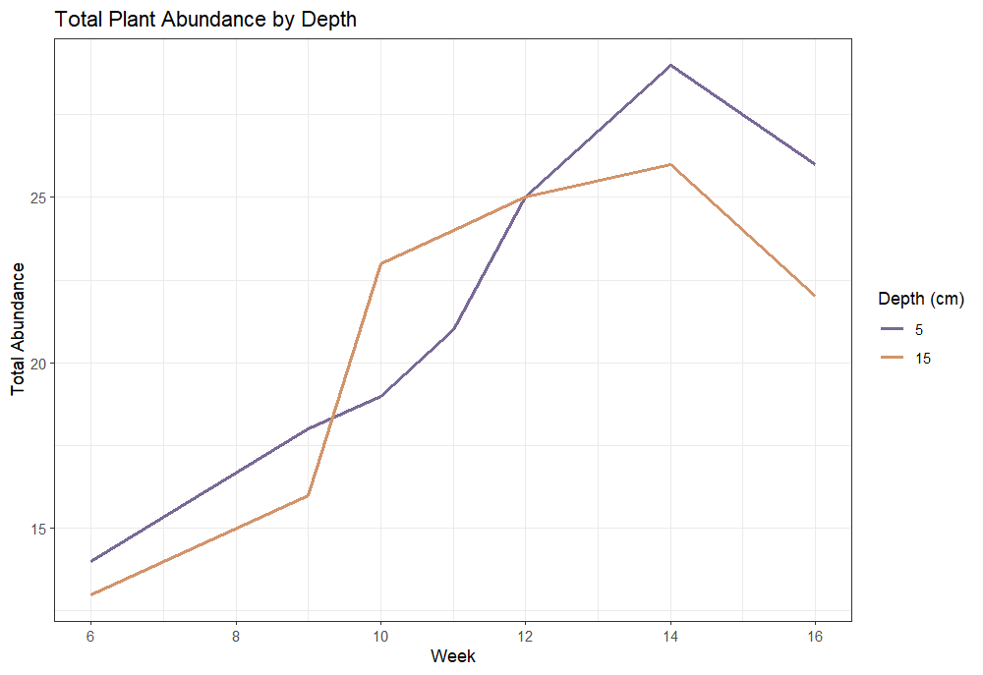
Figure 13. Plant abundance by depth. The red line is the shallower 5cm depth. The blue line is the deeper 15 cm depth. The graph shows the total number of individual plants in each depths quadrants.

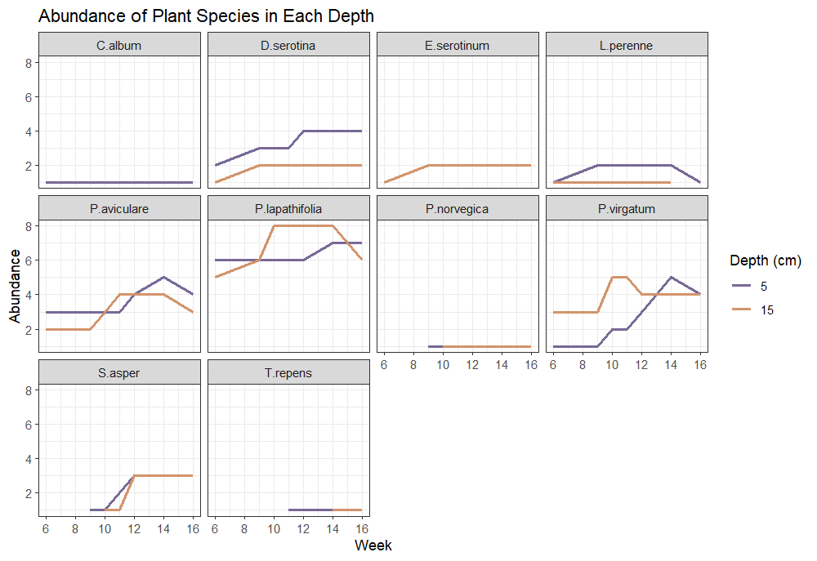
Figure 14. Plant Species Abundance by Depth. The purple line is the plant number of that plant species in the shallower 5cm depth. The orange line is the plant number of that plant species in the deeper 15 cm depth.

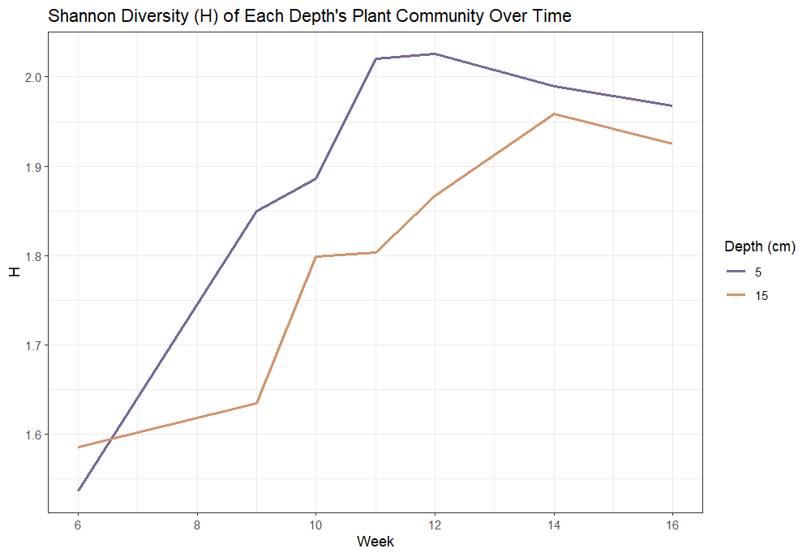
Figure 15. This figure shows the Shannon Diversity Index (H) for both depth communities over time.

depth treatments’ final plant communities were in the species composition. Chenopodium album only appeared in the 5cm depth and Eupatorium serotinum only appeared in 15cm (fig 16).
The two communities were most alike at week 14 and most different, though still very similar, at week 9 (Table 4). The Shannon diversity index of the entire study site saw an increase from week 6 to 14, then decreased to week 16 (fig. 16).

3.2.5. Percent Fractional Green Canopy Cover
The average FGCC% per quadrant grew to ~1.71% by week 12 then decreased to 1.63% by week 16 (fig. 17). The difference in depth did not have a significant influence on the average cover per quadrant during this study (Wilcoxen Rank Sum p>0.05, fig. 18). The highest FGCC% (27.2%) was found in unit 9 quadrant 4 where the single Chenopodium album was the lone plant observed (fig 19).

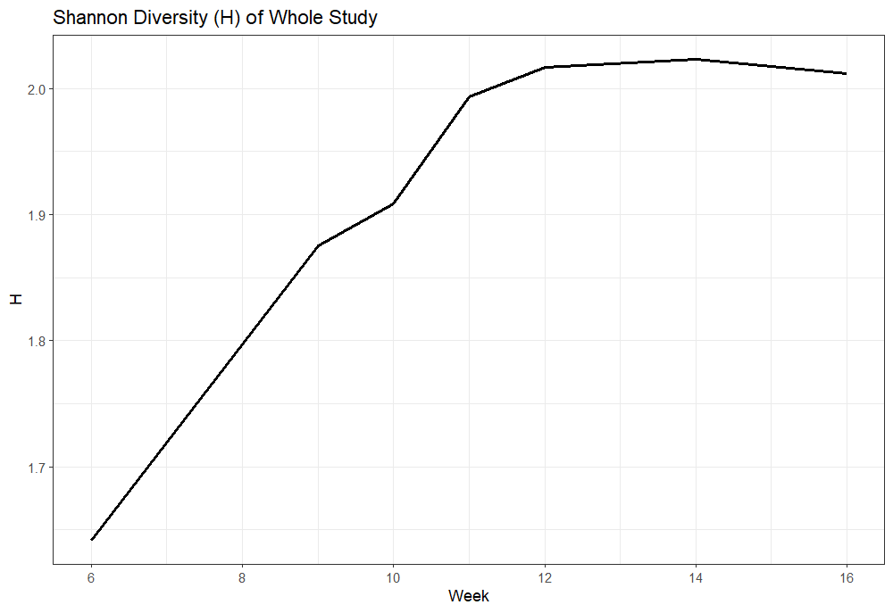
Figure 16. Shannon Diversity Index (H) of study site over time.

Table 4. Each week’s Shannon diversity (H), Species richness (R), and species evenness (E) for both 5 and 15 cm communities.
 | Week | 6 | 9 | 10 | 11 | 12 | 14 | 16
5cm | H | 1.54 | 1.85 | 1.89 | 2.02 | 2.03 | 1.99 | 1.97
 | R | 6 | 8 | 8 | 9 | 9 | 9 | 9
 | E | 0.86 | 0.89 | 0.91 | 0.92 | 0.92 | 0.91 | 0.90
15cm | H | 1.59 | 1.63 | 1.80 | 1.80 | 1.87 | 1.96 | 1.92
 | R | 6 | 6 | 8 | 8 | 8 | 9 | 8
 | E | 0.89 | 0.91 | 0.86 | 0.87 | 0.90 | 0.89 | 0.93

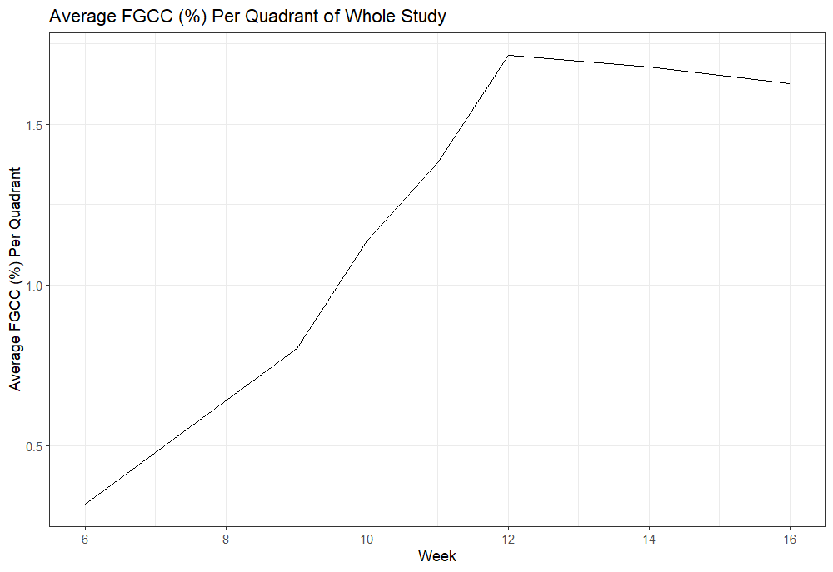
Figure 17. Average Fractional Green Canopy Cover (FGCC (%)) per quadrant of the whole study by week.

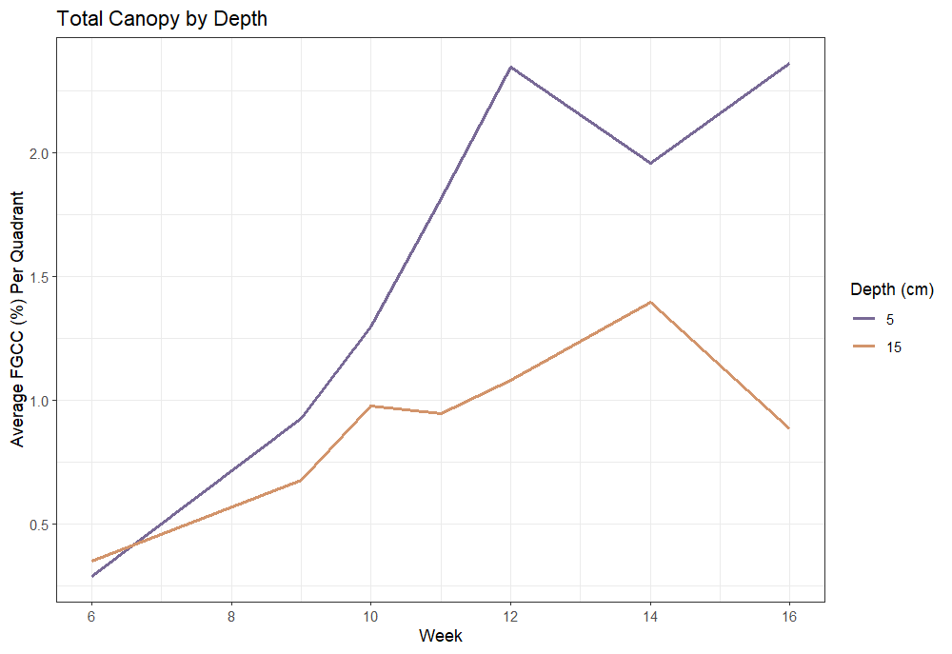
Figure 18. Fractional Green Canopy Cover (FGCC) is a measure of the percentage of green plant cover present in the digital photos taken of each quadrant. The graph shows the average % of quadrants covered in green canopy in both depths. The purple line is the shallower 5cm depth. The orange line is the deeper 15 cm depth.

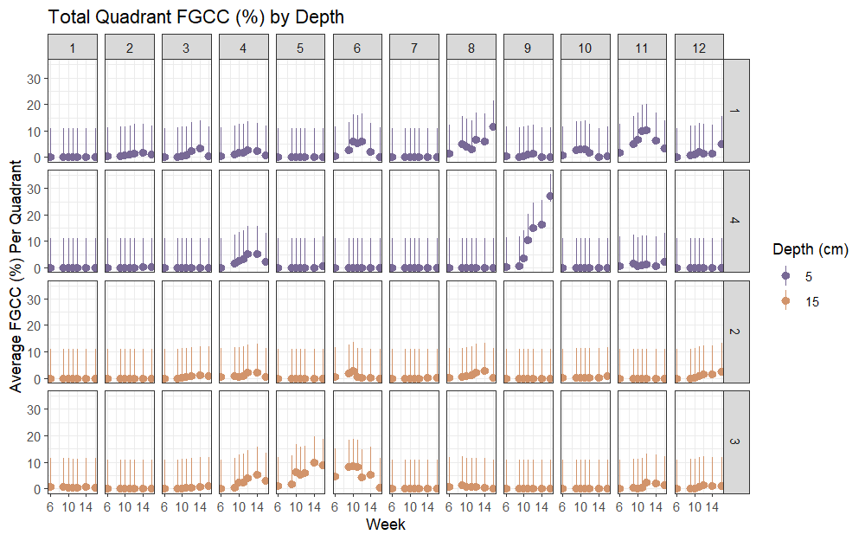
Figure 19. Fractional Green Canopy Cover (FGCC) is a measure of the percentage of green plant cover present in the digital photos taken of each quadrant. This graph shows the measured values with error bars. The blue indicates 15cm depth quadrants and the red indicates 5cm depth quadrants.

Chapter 4.Discussion

4.1. What plants colonize barren substrate immediately following installation?
Immediately following installation of growing media, EGRs become available to seed dispersal. Our study didn’t have an observation of plant presence until week 6, however, this does not indicate that there were no seeds deposited on the roof before this time. Without studies who report observations during the time immediately following EGR installation it is unknown what factors might influence the initiation of spontaneous plant species seed deposition outside of the dispersal mode, seasonality, and expected stochasticity involved in seed dispersal.
The primary dispersal mode shared amongst most of our observed species is wind dispersed seed with some species being colonized via endozoochory. The lack in variety of dispersal methods could be a consequence of abiotic colonization filters (Vanstockem et al., 2019b). A study by Vanstockem et al., 2019b found that the plant functional composition, or collection of traits present on their green roofs, was heavily influenced by landscape factors such as building height, age, and ecosystem connectivity (or distance a seed must travel to colonize). Similar to ours, nearly all the species on their sampled 129 extensive green roofs were long-distance wind dispersing species who could overcome the building height range (1.36 -25.93 m) required to colonize (Vanstockem et al., 2019b). Building height in this case is acting as an abiotic filter preventing spontaneous species that might be seen at ground level but lacking longer distance seed dispersal traits from colonizing on the roofs.

4.1.1. What influenced the spontaneous plant community?
The number of empty quadrants observed in week 14 and the similar niche ranges of the observed species likely support the increase of abiotic stress over the possibility of limited niche availability (Vidaller et al., 2023). The plant loss observed to occur within quadrants of both depths after week 14 indicates some type of localized control or stress experienced by the plants during or previous to this observation. This implies possible abiotic control or limited resource driven response in the plant community. A likely inference based on EGR studies like Lonnqvist et al., 2021 is that this abiotic control or stress likely comes from water availability and experienced temperatures. Uncharacteristically low precipitation amounts and lack of events after day 91 (during week 13) resulting in a local drought. This inferred drought paired with the daily increases in max temperatures experienced by the plants most likely caused the mortality (Brown and Lundholm 2015; Lonnqvist et al., 2021).

4.1.2. Substrate depth did not significantly influence the plant community in this study.
Many other longer-term studies (reporting 1 or more years) credit substrate depth as the main driver in plant species compositions and functional diversity (Madre et al., 2014; Brown and Lundholm, 2015; Heim and Lundholm, 2022; Vidaller et al., 2023, Muratet et al., 2024). This is an important consideration when discussing seed bank development on EGRs as successfully colonizing species are primary contributors to the density and richness of the filtered seed bank over time (Vidaller et al., 2023). However, when focusing on spontaneous colonization immediately following EGR installation, our study did not measure any significant influence of substrate depth on the plant community. In fact, there was no statistically significant influence from the difference in depth on the presence of plants within a quadrant, abundance of individual plants or specific species that colonized, species richness, calculated diversity, or measured plant canopy cover (FGCC%) in our study. Our newly installed and sanitized EGR substrates lacked an initial seed bank and thus was subject only to incoming seed dispersal for initial colonization. This could prompt further studies focusing on complementarity of intentional and spontaneous seeding of EGR substrate and the measured effect this planting strategy might have on observed plant functional identities and thus potential ecosystem services.

4.1.3. Hinted substrate depth influence on specific plant species
Though it did not statistically influence the abundance of specific species, an observed short-term occurrence of an initial colonization preference to the shallower depth was observed in Trifolium repens, Sonchus asper, and Potentilla indica. These species were observed in the 5cm quadrants one to three weeks before being observed in any of the 15cm depth quadrants. Due to this potential growth preference, the 5cm depth community reached its max diversity (H = 2.02) two weeks prior to the 15 cm depth community that peaked at week 14 (H=1.96). The 5cm plant community did not increase in species richness after week 11 whereas the 15 cm community continued developing after week 11 where Potentilla indica and Sonchus asper were observed at week 10 and finally Trifolium repens at week 14.

4.2. Identifying potential ecosystem services from species functional identities
Plant functional traits have been used to categorize and characterize plant species into potential ecosystem services they can provide on green roofs (Lundholm et al., 2010; Mechelen et al., 2014; Brown and Anand, 2022). The measure of functional traits can affect how well the ecosystem services are performed (Lundholm et al., 2010; Mechelen et al., 2014). In this study we used the functional identities (or labels based on characteristic plant traits) of observed spontaneous plant species to characterize what ecosystem services we might receive from them (table 3; Mechelen et al., 2014; Brown and Anand, 2022).
The ecosystem service potentially performed by all observed plants at some capacity is thermal regulation. Thermal regulation involves the mitigation of temperature changes (Brown and Anand, 2022). All plant identities have been shown at varying degrees to cool EGR substrate surfaces through transpiration, a process by which the plant transpires water through the stomata reducing the surrounding surface and air temperatures (Brown and Anand, 2022; Heim et al., 2024). It has been stated that in addition to transpiration, herbaceous plants provide efficient thermal regulation by providing shading below their canopy (MacIvor and Lundholm, 2011; Brown and Anand, 2022; Heim et al., 2024). It is also supported that grasses could potentially provide thermal regulation as well (MacIvor and Lundholm, 2011). MacIvor and Lundholm, 2011 reported graminoids (grasses) as performing the best in reducing green roof surface temperatures when compared to creeping shrubs and tall forbs, however this could be due to the higher survival rate in their grasses versus the lower survival rates of the other two life forms. Findings like these highlight the importance of focused yet inclusive studies on specific measurements of performed ecosystem services and the plant functional traits of the plant species performing them.
The provision of ecosystem services can also depend on plant types and their specialized relationships to other organisms (Lundholm, 2015). For example, biological nitrogen fixation is a natural process in which inert atmospheric N₂ is converted into biologically available NH₃ improving soil fertility (Raza et al., 2020). In nature this process can only be mediated by N-fixing rhizobia bacteria that form symbiotic relationships with leguminous plants like the one observed in our study, Trifolium repens (Raza et al., 2020). Other species in our study (Digitaria serotina, Eupatorium serotinum, Lolium perenne, Panicum virgatum, and Pontentilla norvegica) have different plant traits and relationships that potentially also improve growing media fertility through processes involving carbon sequestration and decomposition of plant matter (Lundholm, 2015; Brown and Anand, 2022).

4.3. Practical Implications
Freshly installed barren EGR substrates, like in situations where they are awaiting intentional planting, have the potential to be colonized by spontaneous species if left unmanaged. The inclusion of spontaneous species, in support of the novelty associated in extensive green roofs, could be beneficial to the installation’s success and performance of ecosystem services. However, our final measurements of canopy cover were largely below 10% indicating not much coverage was achieved in the first 16 weeks. The only exception involved a lone Chenopodium album covering 27.2% of the quadrant it inhabited. Our study highlighted the importance of spontaneous vegetation’s part in the novelty of EGRs and the ecosystem services they provide. We also give insight to what spontaneous species can colonize barren freshly installed EGRs in Knoxville, TN. Using the found data, design should account for the complex, non-static novelty occurring along green roof succession to maximize the utility and sustainability of these structures and improve urban biodiversity, habitat availability, and ecosystem services.

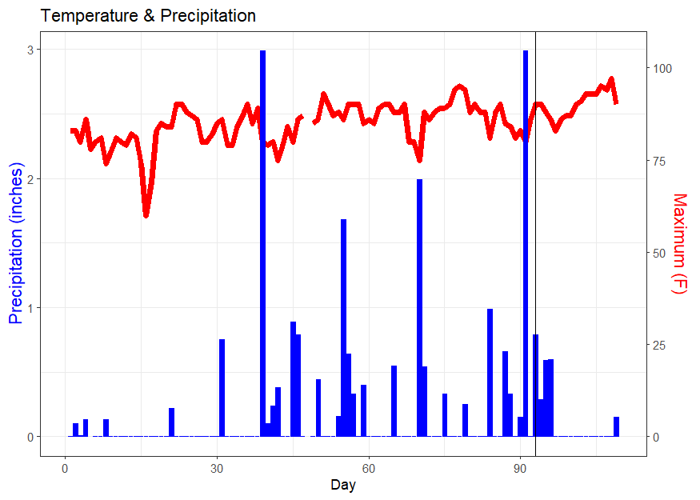
Figure 20. Daily reported max temperature (Fahrenheit) and precipitation (inches) from May 13 to August 30, 2023. The red line represents maximum temperature and the blue bar graph in measured daily precipitation. Open source data from NOAA National Weather Service 2023

Chapter 5. Conclusion and Future Work
Our study focused on the immediate colonization following the installation of barren extensive green roof research units at two different depths (5 and 15 cm), the observed spontaneous plant community included 55 individual plants belonging to 10 different species. Depth did not significantly influence the planting communities in this study, but substrate depth has been shown to be a leading influence in multiyear studies. This could indicate a lack of substrate depth influence in the early or initial plant colonization of barren substrates and could be due to the presence of more pressing controls such as sun exposure, temperature, or precipitation. Published ecosystem services associated with the observed 10 species functional identities included nutrient cycling, pollinator support, thermal regulation, food/ fodder, disturbance prevention, water provision, and waste regulation. The potential of these ecosystem services being performed on the green roof could prove helpful in supporting the use of spontaneous plants as a viable early-stage planting strategy. Further work should build on this data with focuses on spontaneous plant community development in response to substrate depth differences, measured changes to environment such as substrate fertility, and below surface interactions should be conducted in order to build a more complete understanding of spontaneous colonization of EGRs in Knoxville, TN.

Works Cited
Aloisio, J.M., Palmer, M.I., Tuininga, A.R., Lewis, J.D. (2020). Introduced and native species composition of vacant unmamanged green roofs in New York City. Urban Ecosystems, 23: 1227-1238. https://doi.org/10.1007/s11252-00-00992-6.
Anderson, E.C., Minor, E.S. (2019). Assessing social and biophysical drivers of spontaneous plant diversity and structure in urban vacant lots. Science of the Total Environment, 653: 1272-1281. https://doi.org/10.1016/j.scitotenv.
Bevilacqua, P., Coma, J., Pérez, G., Chocarro, C., Juárez, A., Solé C., Simone M.D., Cabeza, L.F. (2015). Plant cover and floristic composition effect on thermal behaviour of extensive green roofs. Building and Environment, 92: 305-316. https://doi.org/10.1016/j.buildenv.2015.04.026.
Bonthoux, S., Voisin, L., Bouche-Pillon, S., Chollet, S. (2019). More than weeds: Spontaneous vegetation in streets as a neglected element of urban biodiversity. Landscape and Urban Planning, 185:163-172. https://doi.org/10.1016/j.landurbplan.
Brown, C., Lundholm, J. (2015). Microclimate and substrate depth influence green roof plant community dynamics. Landscape and Urban Planning. 143: 134-142. http://dx.doi.org/10.1016/j.landurbplan.201507.009.
Brown,C. and Lundholm, J. (2015). Microclimate and substrate depth influence green roof plant community dynamics. Landscape and Urban Planning, 134-142. https://doi.org/10.1016/lanurbplan.2015.07.009.
Brown, L.M. and Anand, M. (2022). Plant functional traits as measures of ecosystem service provision. ECOSPHERE, 13(2). https://doi.org/10.1002/ecs2.3930.
Carlisle, S., Piana, M. (2015). Green Roof Plant Assemblage and Dynamics. In: Sutton, R. (eds) Green Roof Ecosystems. Ecological Studies, vol 223. Springer, Cham. https://doi.org/10.1007/978-3-319-14983-7_12.
Catalano, C., Maceno, C., Laudicins, V.A., Guarino, R. (2016). Thirty years unmanaged green roofs: ecological research and design implications. Landscape and Urban Planning, 149, 11-19. https://doi.org/10.1016/j.landurbplan.2020.103816.
Chenot, J., Gaget, E., Moinardeau, C., Jaunatre, R., Buisson, E., Dutoit, T. (2017). Substrate Composition and Depth Affect Soil Moisture Behavior and Plant-Soil Relationship on Mediterranean Extensive Green Roof. Water, 9(11): 817. https://doi.org/10.3390/w9110817.
Cook-Patton, S.C. and Bauerle, T.L. (2012). Potential benefits of plant diversity on vegetated roofs: A literature review. Journal of Environmental Management, Volume 106, 85-92, https://doi.org/10.1016/j.jenvman.2012.04.003.
Deng, H., and Jim, C. Y. (2017). Spontaneous plant colonization and bird visits of tropical extensive green roof. Urban Ecosystems, 20(2), 337-352. https://doi.org/10.1007/s11252-016-0596-3.
Droz, A.G., Coffman, R.R., Fulton, T.G., Blackwood, C.B. (2021). Moving beyond habitat analogs: Optimizing green roofs for a balance of ecosystem services. Ecological Engineering, 173: 106422. https://doi.org/0.1016/j.ecoleng.2021.106422.
Dunnett, N., Nagase, A. & Hallam, A. (2008). The dynamics of planted and colonising species on a green roof over six growing seasons 2001–2006: influence of substrate depth. Urban Ecosystem, 11, 373–384. https://doi.org/10.1007/s11252-007-0042-7
Eksi, M. and Rowe, B. (2019). Effect of substrate depth and type on plant growth for extensive green roofs in a mediterranean climate. Journal of Green Building, 14(2):29-44. https://doi.org/10.3992/1943-4618.14.2.29.
Ellis, K.N., Hathaway, J.M., Mason, L.R., Howe, D.A., Epps, T.H., Brown, V.M. (2015). Summer temperature variability across four urban neighborhoods in Knoxville, Tennessee, USA. Theory of Applied Climatology, 127:701-710. https://doi.org/10.1007/s00704-015-1659-8.
Francis and Lorimer (2011). Urban reconciliation ecology: The potential of living roofs and walls. Journal of Environmental Management, 92, 1429-1437. https://doi.org/10.1016/j.jenvman.2011.01.012
Frazer, L. (2005). Paving Paradise: The Peril of Impervious Surfaces. Environmental Health Perspectives. Vol 113, 7, pg A456-A462. https://doi.org/10.1289/ehp.113-a456.
Getter, K.L. and Rowe, B. (2006). The Role of extensive Green Roofs in Sustainable Development. HortScience, 41(5): 1276-1285. https://doi.org/10.21273/HORTSCI.41.5.1276.
Grimm, N. B. et al. (2008). Global Change and the Ecology of Cities. Science, 319,756-760. https://doi.org/10.1126/science.1150195.
Hass, A. L. (2016). Heat and Humidity in the City: Neighborhood Heat Index Variability in a Mid-Sized City in the Southeastern United States. International Journal of Environmental Research and Public Health, 13, 117. https://doi.org/10.3390/ijerph13010117.
Heim, A., Biermann, B., Hicks, T., Buffam, I., Lundholm, J. (2024). More than sedum: Colonizing weedy species can provide equivalent green roof ecosystem services. Nature-Based Solutions, 5, 100101. https://doi.org/10.2026/j.nbsj.2023.100101.
Isbell, F., Calcagno, V., Hector, A. et al. (2011) High plant diversity is needed to maintain ecosystem services. Nature 477, 199–202. https://doi.org/10.1038/nature10282
Kohler, M. and Poll, Ph. (2010). Long-term performance of selected old Berlin greenroofs in comparison to younger extensive greenroofs in Berlin. Ecological Engineering, 36, 722-729.
Kravka, M., Danek, M., and Rabenseifer, R. (2015). Extensive Green Roof in Central European Climate. Applied Mechanics and Materials, 824:795-802. https://doi.org/10.4028/www.scientific.net/AMM.824.795.
Ksiazek-Mikenas, K., Herrman, J., Menke, S.B., Kohler, M. (2018). If you build it, will they come? Plant and arthropod diversity on urban green roofs over time. Urban Nature, 1, 52-72.
Kuronuma, T., Watanabe, H., Ishihara, T., Kou, D., Toushima, K., Ando, M., Shindo, S. (2018). CO2 Payoff of Extensive Green Roofs with Different vegetation Species. Sustainability, 10(7): 2256. https://doi.org/10.3390/su10072256.
Lee, K.E., Williams, K.J.H., Sargent, L.D., Farrell, C., Williams, N.S. (2014). Living roof preference is influenced by plant characteristics and diversity. Landscape and Urban Planning, 122, 152-159. https://doi.org/10.1016/j.landurbplan.2013.09.011.
Li, X.P., Fan, S.X., Hao, P.Y., Dong, L. (2019). Temporal variations of spontaneous plants colonizing in different type of planted vegetation – a case of Beijing Olympic Forest Park. Urban Forestry & Urban Greening. https://doi.org/10.1016/j.ufug.
Lonnqvist, J., Hanslin, H.M., Johannessen, B.G., Muthanna, T.M., Viklander, M., Blecken, G. (2021). Temperatures and Precipitation affect vegetation dynamics on Scandinavian extensive green roofs. International Journal of Biometeorology, 65:837-849. https://doi.org/10.1007/s00484-020-02060-2.
Lundholm J. (2015). The ecology and evolution of constructed ecosystems as green infrastructure. Frontiers in Ecology and Evolution. 3 (106): 1-7. https://doi.org/10.3389/fevo.2015.00106.
Lundholm, J. (2016). Spontaneous dynamics and wild design in green roofs. Israel Journal of Ecology and Evolution, 62: 23-31. https://doi.org/10.1080/15659801.2015.1025511.
Lundholm J., MacIvor, J.S., MacDougall, Z., Ranalli, M. (2010). Plant species and functional group combinations affect green roof ecosystem functions. PLoS One; San Francisco. 5(3). https://doi.org/ 10.1371/journal.pone.0009677.
MacIvor, J.S., Lundholm, J. (2011). Performance evaluation of native plants suited to extensive green roof conditions in a maritime climate. Ecological Engineering, 37(3), 407-417. https://doi.org/10.1016/j.ecoleng.2010.10.004.
Madre, F., Vergnes, A., Machon N., Clergeau, P. (2014). Green roofs as habitats for wild plant species in urban landscapes: First insights from a large-scale sampling. Landscape and Urban Planning, 122: 100-107. https://doi.org/10.1016/j.landurbplan.2013.11.012.
McKinney, M.L. (2002). Urbanization, Biodiversity, and Conservation: The impacts of urbanization on native species are poorly studied, but educating a highly urbanized human population about these impacts can greatly improve species conservation in all ecosystems. BioScience, 52(10), 883–890. https://doi.org/10.1641/0006-3568.
McKinney, M.L. (2006). Urbanization as a major cause of biotic homogenization. Biological Conservation, 127(3):247-260. https://doi.org/10.1016/j.biocon.2005.09.005.
Mechelen, C.V., Meerbeek, K.V., Dutoit, T., Hermy, M. (2015). Functional diversity as a framework for novel ecosystem design: The example of extensive green roofs. Landscape and Urban Planning, 136, 165-173. http://dx.doi.org/10.1016/j.landurbplan.2014.11.022.
Muratet, A., Barra, M., Hardion, L., Chiron, F. (2024). Origins and drivers of roof plant assembalges: Designing green roofs for biodiversity conservation. Urban Forestry & Urban Greening, 94, 128247. https://doi.org.utk.idm.oclc.org/10.1016/j.ufug.2024.128247.
Nardini, A., Andri, S. and Crasso, M. (2012). Influence of substrate depth and vegetation type on temperature and water runoff mitigation by extensive green roofs: shrubs versus herbaceous plants. Urban Ecosystem, 15, 697–708. https://doi.org/10.1007/s11252-011-0220-5.
National Oceanic and Atmospheric Administration, National Weather Service. (2024). NOWData. Retrieved January 20, 2024, from https://www.weather.gov/wrh/Climate.
Oberndorfer, E., Lundholm, J., Bass, B., Coffman, R.R., Doshi, H., Dunnett, N., Gaffin, S., Köhler, M., Liu, K.K.Y., Rowe, B., Green Roofs as Urban Ecosystems: Ecological Structures, Functions, and Services, BioScience, 57(10): 823–833. https://doi.org/10.1641/B571005.
Olly, B., Bates, A., Sadler, J., and Mackay, R. (2011). An initial experimental assessment of the influence of substrate depth on floral assemblage for extensive green roofs. Urban Forestry and Urban Greening, 10, 311-316.
OMNI Ecosystems. (2022). OMNI GREEN ROOF INSTALLATION MANUAL FOR CERTIFIED INSTALLATION PROVIDERS. ©OMNI Ecosystems.
Qian, S., Qin, D., Wu, X., Hu, S., Hu, L., Lin, D., Zhao, L., Shang, K., Song, K., Yang, Y. (2020). Urban growth and topographical factors shape patterns of spontaneous plant community diversity in a mountainous city in southwest China. Urban forestry & Urban Greening, 55. https://doi.org/101016/j.ufug.2020.12814.
R Core Team (2024). R: A language and environment for statistical computing. R Foundation for Statistical Computing, Vienna, Austria. https://www.R-project.org/.
Raza, A., Zahra, N., Hafeez, M.B., Ahmad, M., Iqbal, S., Shaukat, K., Ahmad, G. (2020). Nitrogen Fixation of Legumes: Biology and Physiology. The Plant Family Fabaceae, 43-74. https://doi.org/10.1007/978-981-15-4752-2_3.
Riviere, L., Sellier, A., Dutoit, T., Vidaller, C., Buisson, E., Mahy, G. (2023). The contribution of seedbank to the green roof plant community dynamics analogous tosemi-natural grasslands. Frontiers in Ecology and Evolution, 11:1152319. https://doi.org/10.3389/fevo.2023.1152319.
Rowe, D. B., Getter, K.L., and Durhman, A.K. (2012). Effect of green roof media depth on Crassulacean plant succession over seven years. Landscape and Urban Planning, 104, 310-319.
Schrieke, D., Williams N.S.G., and Farrell, C. (2023). Response of Spontaneous Plant Communities to Sedum mexicanum Cover and Water Availability in Green Roof Microcosms. Land, 12(6):1239. https://doi.org/10.3390/land12061239.
Shannon, C.E. (1948). A mathematical theory of communication. The Bell Technical Journal. 27: (3), 379-423. Nokia Bell Labs. doi: https://doi.org/10.1002/j.1538-7305.1948.tb01338.x.
Thuring, C.E. and Dunnett, N.P. (2019). Persistence, loss and gain: Characterising mature green roof vegetation by functional composition. Landscape and Urban Planning, 185:228-236. https://doi.org/10.1016/j.landurbplan.2018.10.026.
Thuring, C.E., Berghage, R., Beattie, D.J. (2010). Green Roof Plant Responses to Different Substrate Types and Depths under various Drought Conditions. Horttechnology, 20(2):395-401. https://doi.org/10.21273/HORTTECH.20.2.395.
Vanstockem, J., Somers, B., Hermy, M. (2019a). Weeds and gaps on extensive green roofs: Ecological insights and recommendations for design and maintenance. Urban Forestry & Urban Greening. https://doi.org/10.1016/j.ufug.2019.126484.
Vanstockem, J., Bastiaens, A., Helsen, K.,Somers, B., Hermy, M. (2019b). Community assembly on extensive green roofs: Effects of dispersal-, abiotic- and biotic filtering on the spontaneous species- and functional diversity. Journal of Vegetation Science, 30:1078-1088. https://doi.org/10.1111/jvs.12789.
Vila, M. et al. (2011). Ecological impacts of invasive alien plants: a meta-analysis of their effects on species, communities and ecosystems. Ecology Letters, 14: 702-708. https://doi.org/10.1111/j.1461-0248.2011.01628.x.
Walker, E.A. and Lundholm, J. (2018). Designed habitat heterogeneity on green roofs increases seedling survival but not plant species diversity. Journal of Applied Ecology, 55(2):694-704. https://doi.org/10.1111/1365-2664.12970.
Whittaker RH (1960). "Vegetation of the Siskiyou Mountains, Oregon and California". Ecological Monographs. 30 (3): 279–338. doi:10.2307/1943563. JSTOR 1943563.
Whittaker, R. H. (1972). Evolution and Measurement of Species Diversity. Taxon, 21, 213-251. doi:10.2307/1218190.
Wolf, D., Lundholm, J. (2008). Water uptake in green roof microcosms: Effects of plant species and water availability. Ecological Engineering, 33 (2), 179-186. https://doi.org/10.1016/j.ecoleng.2008.02.008
Yee, E.C., Callahan, H.S., Griffin, K.L., Palmer, M.I., Lee, S. (2021). Seasonal patterns of native plant cover and leaf trait variation on New York City green roofs. Urban Ecosystems, 25:229-240. https://doi.org/10.1007/s1125-021-01134-2.

Vita
Braden Coats was born in Altus, Oklahoma and grew up in Granite, Oklahoma. He completed high school Valedictorian of his graduating class at Granite Public Schools. He was an officer in both 4-H and FFA, and he represented his chapter well in livestock shows and craft contests. Being from a rural farming/ranching community, Braden has always felt close to the environment. After high school, he moved to Stillwater, Oklahoma to attend Oklahoma State University where he majored in Environmental Science and Natural Resources with a minor in Soil Sciences. Braden was an active undergraduate researcher in the research lab of Dr. Wilson and worked in the Office of Undergraduate Research. Upon completion of his bachelors Braden moved to Knoxville, Tennessee to get his masters in Geology. While there, he was a part of the team that constructed the Green Roof Experimental Lab (GREL) and re-established the UTK Chapter of the Society for Ecological Restoration (SER). He presented at 2 departmental conferences and the Council of Educators in Landscape Architecture 2024 Conference. After receiving his degree, Braden plans on pursuing a job and begin traveling.

