Anthropology in a Rural Archive: A Study That Moves Along and Against the Archival Grain

A Thesis Presented for the
Master of Arts
Degree
The University of Tennessee, Knoxville

Julian William McDaniel
May 2023
ABSTRACT

Anthropologists have long engaged with archival materials in order to provide historically accurate information that might assist in the production of ethnographic projects. Archives are unique institutions where historical data can be found that contributes valuable information about particular groups of people; however, archives themselves are again and again being controlled by a higher power, particularly that of the State, and this act of ownership contributes to acts of omission that misconstrue historical narratives as well as descriptions of the people and places depicted within an archive. In this project, I engage with an archive located in a rural town in Appalachia in order to determine what information can be revealed about the history of individuals and communities living in said space. Materials found from within the archive are examined along and against the archival grain in order to develop an understanding of the ways in which historical narratives about people in rural Appalachia are presented and why they are presented as such. As a critical engagement with archival material, this project points out historical absences from the archive and critically examines what can be found from archival material when it is analyzed directly without other sources. The goal of this project is to contribute to various literatures that examine rural lifeways in Appalachia and urge anthropologists to follow in a critical pursuit of archival materials when developing a broader ethnographic project about groups of people, particularly those living in rural areas. As was found in this project, the Hamblen County Archive contains several historical silences. When archival material is analyzed alone, it presents incomplete descriptions about the people living in Morristown, Tennessee, and their associated histories. In this thesis, I argue that anthropologists and community should engage in the processes of building archives that exist as entities separated from the state apparatus, as state power can have impact on the process of knowledge production that takes place within the walls of an archive. Community-based archives are already being developed throughout Appalachia and these are sites where more holistic knowledges can be preserved and presented to audiences of researchers and the general public, as well as future generations of people who seek information about the past.

TABLE OF CONTENTS
INTRODUCTION 1
CHAPTER 1: ANTHROPOLOGY AND THE ARCHIVES 10
The Archive 10
Anthropology and History: Interrelated Disciplines 16
Archival Scholarship: The Ethnographic Archive and Beyond 22
The Ethnographic Archive 23
Anthropology, the Archives, and What is Possible 36
Analytical Methodologies 27
CHAPTER 2: PRESENTATION OF THE ARCHIVAL MATERIAL 31
An Overview of the Archival Materials Being Presented 31
The Available History of Hamblen County 32
The Archive’s Narrative of History 39

Traces of History: Information from Other Archival Materials 48

Marriage Records of Hamblen County 52

Newspaper Clippings: Ten Years of Samples from the Archive 55

Ethnographic Engagement with Criminal Court Documents 59

War Materials and Armed Conflicts 69

CHAPTER 3: ANALYZING THE MATERIAL ALONG AND AGAINST THE GRAIN 75
The Historical Information About Hamblen County 75
Analysis of the Marriage Materials 82
Analysis of the Newspaper Clippings 84
Analysis of the Court Documents 89
Analysis of the War Materials 92
The Lack of Digital Records 96
DISCUSSION AND CONCLUSION 99
Unsilencing the Past and Pushing for Alternatives 99
Conclusion 102
ARCHIVE MATERIALS CITED 105
WORKS CITED 108
VITA 118

LIST OF FIGURES
Figure 1: The Hamblen County Court House 2
Figure 2: Cover of Historic Hamblen (1870-1970) 34
Figure 3: Cover of A Pictorial History 35

Figure 4: Cover of A History of Hamblen County, Tennessee and Its People 37
Figure 5: Cover of Hamblen County, Tennessee: History and Families 38
Figure 6: Copy of the petition put forth to establish Hamblen County 42
Figure 7: Alleged photo of Hezekiah Hamblen 43
Figure 8: An example of the timeline from the HCCC publication..............................................45
Figure 9: Covers of Marriage Documents, projects from the HCA 53
Figure 10: Sample cover of Citizen Tribune on microfilm 57
Figure 11: Sample of opinion page in Citizen Tribune 58
Figure 12: Sample of the start page of court documents on microfilm 62
Figure 13: Sample of opening page of Hamblen County Circuit Court on microfilm 63
Figure 14: Certificate of authenticity of Hamblen County Circuit Court records on microfilm 64
Figure 15: Sample of court case document on microfilm 65
Figure 16: Sample of document from punishment form found within court records 66
Figure 17: Sample of cover from war document found within the archives 71
Figure 18: Sample of acknowledgment found in war documents in the HCA 72
Figure 19: Civil War document cover photograph 73
Figure 20: Copy of flyer from the hanging of Anthony Blair 81
Figure 21: Picture of Opinion columns from Citizen Tribune 85

Figure 22: Picture of Opinion columns from Citizen Tribune 86

INTRODUCTION
The archives are a place of abundant historical information relevant to all sorts of ethnographic projects that have been developed by anthropologists and their community members with whom they are conducting research. In rural spaces, however, where ethnographic research is scant, archives might be one of the few sources of material accessible for researchers who want to develop a better understanding of the social and cultural landscape of a particular area. This becomes a difficult endeavor when considering how archives themselves tend to be underfunded and understaffed in rural areas.
This project developed as a result of several months of reading and critical engagement with archival materials found within the walls of the Hamblen County Archives, located in Morristown, Tennessee (SEE FIGURE 1). I was driven by the desire to understand what could be gathered from the archive materials themselves, but to also notice and point out what is missing. In order to develop a fuller understanding of the city of Morristown, information was analyzed along the archival grain and against it.
Morristown, Tennessee is located in Hamblen County. It is a place where the only side of my family to whom I am attached has lived for several generations. Morristown is known as an industrial hub; there are a large number of manufacturing firms, chicken plants, and other related industries that have their factories within the Hamblen County lines. My attachment to Morristown is what partially guided me to develop this project.
Appalachia is full of rural cities with industrial towns that are currently experiencing massive industrial development projects, as one can find throughout any deep historical analysis of rural areas, particularly those in Appalachia, as well as demographic shifts that have been going on for decades. Morristown, Tennessee is a perfect example of an industrial town, where
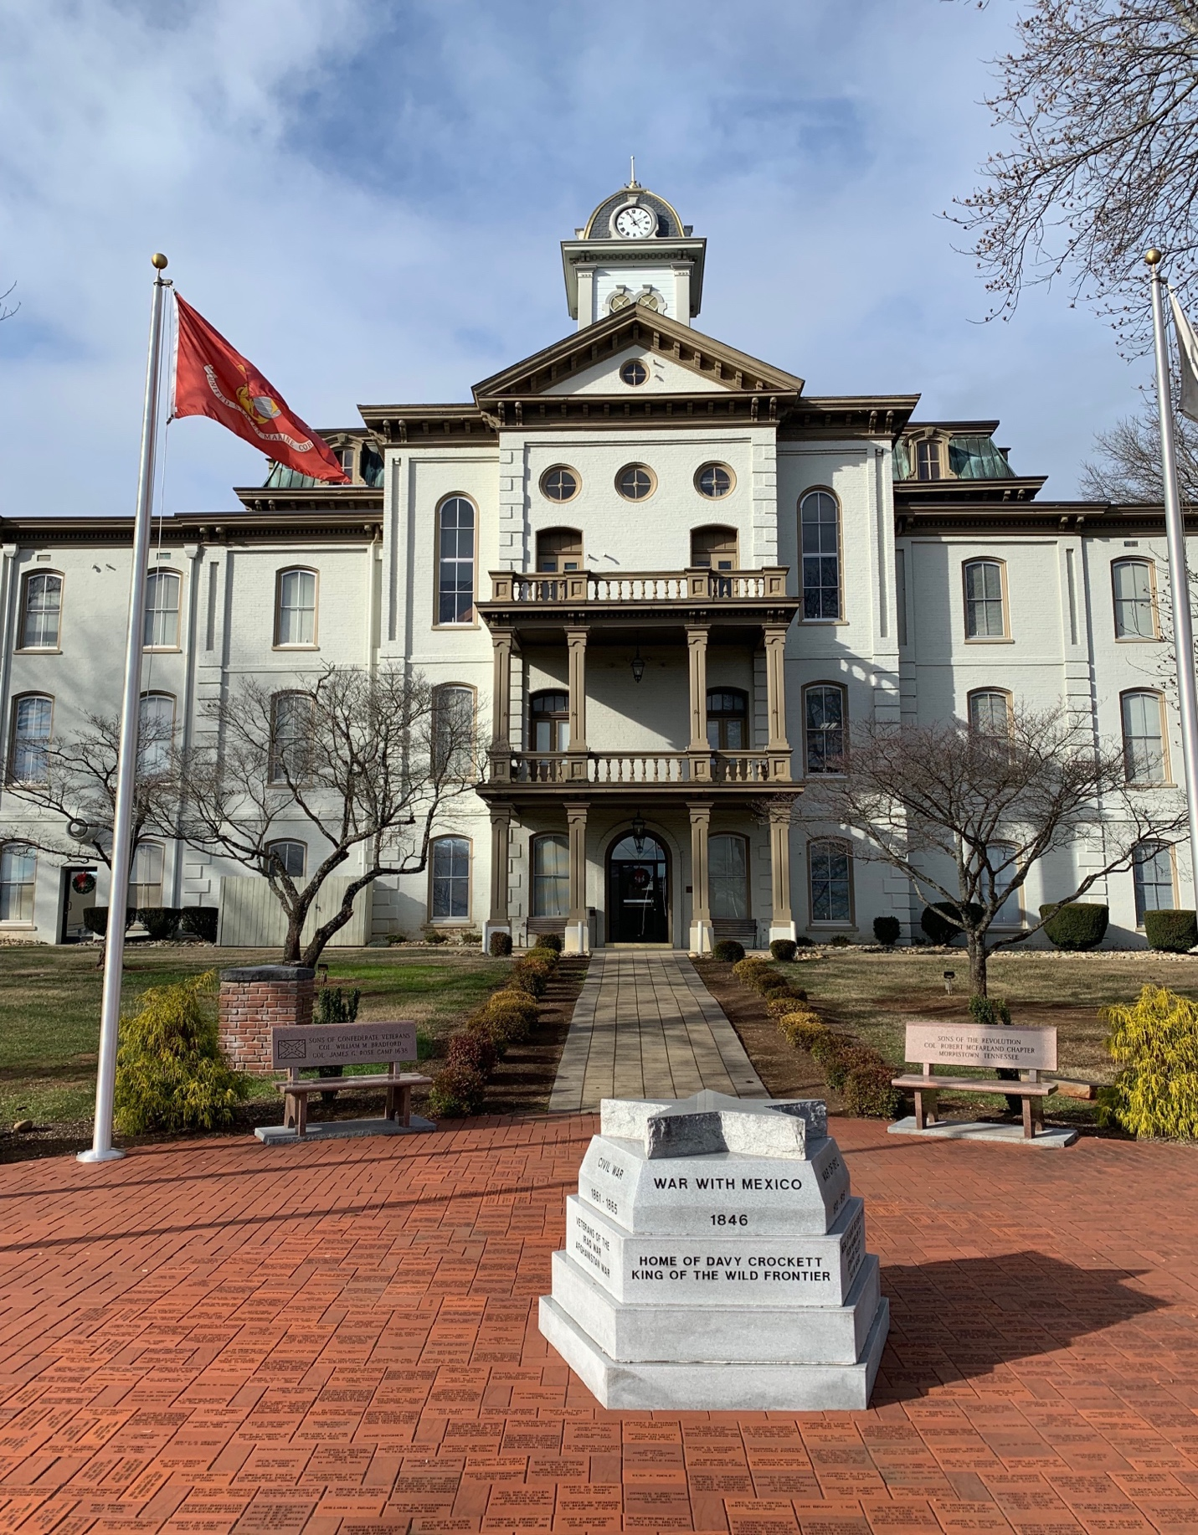
FIGURE 1: Hamblen County Courthouse.
a lot of the people have attachments to one of the many factories and companies whose operations take place within the city limits. Prior to conducting this research, my understanding of Morristown and Hamblen County’s history exclusively came from members of my own family and the newspapers, some of which are presented and analyzed in Chapters 2 and 3.
Histories of such a small industrial town are not widely available. Hence, as happened with me, histories are often formed through engagement with oral histories, random traces, and in relation to noteworthy events. Additionally, throughout my entire life, I have witnessed first-hand how social inequalities experienced by the working-class people in Morristown have become more apparent and how little effort by has been made by the local and state governments to relieve the struggles augmented by neoliberal capitalism. My original goal for this project was to develop a better history of Morristown with a focus on industry, labor, and social inequalities. Due to the relative lack of information available about the city in academic and popular media forms, I realized that one of the best places to start would be the Hamblen County Archives.
This project sought to uncover information about the lifeways of people living in Morristown, Tennessee. I wanted to develop an understanding of how the current material conditions of the town developed and how they were shaped over time. I began with an interest in industrial development, labor, and social inequalities. The main question guiding this project was as follows: What information about lifeways and material conditions in Morristown, Tennessee can be revealed through an ethnographic engagement with a rural archive? Additionally, I found myself asking: how might anthropological engagement with archives be helpful for developing a better understanding of the lifeways in a particular area? While attempting to answer this question, I became aware of some historical silences within the archive. Ethnographic engagement with archival material can give a lot of insight as to what events and processes led to the current material conditions experienced by those living in a particular area. Throughout this project, I found myself wondering about related issues. In particular, I asked myself what the benefits of archival research might be and what can be said about its limitations. The archive can reveal a lot of information, but it is crucial to understand that state actors are the ones who construct the archive, determine what material is present and how said material is presented. In Hamblen County, an archivist has been employed by the state, but the archive also was contributed to and organized by many volunteers over various years, many, if not all, of whom were white men and women. These identity features as well as their class backgrounds no doubt had an impact when determining what is and what is not worthy of presenting in the archives.
Certain individuals with social and economic privilege were likely the ones who put together the material for the archives. Volunteers, as I understand, all wound up being cisgender couples who donated material about their families. The men were quite domineering throughout the process. At the same time, there were many other volunteers who simply loved spending their time at the archives. That stopped following the COVID-19 pandemic and as of May 2023, there still were no current volunteers at the Hamblen County Archives. Beyond that, the majority of the people showing up during the months that I was examining materials in the archive were interested in construction records, land deeds, and other construction-related material for ongoing commercial property development, train track repair, etc. They seemed rather impatient. I am used to demanding behavior when people are in a rush in business, and I am sure that they are merely on a time schedule. Nevertheless, I could not help but feel that workers are exploited heavily enough as it is.
In the Hamblen County Archive, it appeared that many of the materials were donated by government operations once their construction projects were complete. Then, state actors presumably had approval over the types of materials being presented and what should be denied. Some volunteers, like members of the East Tennessee Genealogical Society (formally known as The Journal of East Tennessee History) compiled and donated volumes, but some are dated and are only hidden in a small corner. A lot of the project organizers were elderly volunteers who quit at the beginning of the COVID-19 pandemic. As I was made aware, there were occasional individuals who were interested in history who were willing to drop off their genealogical information after the passing of their loved ones. I do believe that most of these men and women were white, privileged, heterosexual-presenting men and women who had the times and means available to do so. One might go as far as to say that the men probably often had control over what can and cannot be included. There also appeared to be class dynamics at play.
It is important to note that the State is represented here in this thesis as the county government and local governments. In this county archive, it appears that most of the materials gathered in the formation of this archive were overwhelmingly dictated by the wishes and wills of white, heterosexual men and women who have had social, political, and economic ties to Morristown, Tennessee. Additionally, ethnographic material, if gathered in the formation of an archive, might be missing certain details, as it comes from the perspective of the anthropologist as well as the perspectives of the people with whom the anthropologist met. No ethnographic information was found in this archive, but it is important for an anthropologist to keep such an idea in mind, especially if they are in the process of re-examining fieldwork with the people they study so that they can also recognize what historical information might be missing about the people with whom they did or are doing research. With this understood, I sought to determine how anthropological research might be used in the development of an alternative sort of archive that can be constructed alongside people who are members of a community with whom is being conducted. I asked this question in order to contribute to the literature about other sorts of archives that operate outside of the purview and procedures of the state. Community and public, or “popular,” archives that are separate might be useful in preserving historical information about particular communities and lead to a better understanding of social relations.
These sorts of questions were kept mind throughout the entirety of this project. I was limited and unable to participate in ethnographic research involving people and community members living in Hamblen County. As a result, I had to find an alternative. Conducting research in the Hamblen County Archive felt like the best place to begin and it felt appropriate to use secondary research alongside certain archival materials in order to successfully find out more about the place that my family and others have called home for generations. Anthropologist’s efforts to re-examine ethnographies done in the past as well as those being done in the present need to situate the perspectives of both the ethnographer and those who were interviewed and observed by the ethnographer. Additionally, given the sacredness of oral history telling, this information might be invaluable in such an archive.
Engagement with archives can provide crucial information that might be useful for the purposes of anthropological research. Anthropological research gathered through ethnography is great for developing ideas about a particular place or population, but ethnographic research alone might not be enough for certain types of projects. Historical information about the past is crucial for explaining the present material conditions under which ethnographic subjects are constructed and under which they operate. Ideally, anthropological research should contain both ethnographic data gathered through methods like participant observation and interviews, but it should also include information obtained through critical engagements with material stored in archives, especially archives that are owned and operated by the communities themselves rather than those that exist as an extended arm of the state apparatus. An anthropologist can gather crucial information that leads to a better understanding of the places where interlocutors are operating in as well as important information about the interlocutors themselves by exploring archives associated with or linked to their sites of inquiry. Archival engagement can reveal a lot about how the past history of a place has contributed to the current material conditions that define a place in the present, but it might also contribute valuable historical insights in future research-based projects.
I argue that important information can be uncovered through an ethnographic engagement with the archives. By reading along and against the archival grain, I critically analyzed archival materials in order to uncover important information about the history of Morristown which has shaped the current material conditions under which people in the city operate. I show that the narratives of individualistic success, industrial prosperity, heroic nationalism, and white supremacy are in primary view when the archival materials are analyzed on their own. The narratives of non-white communities, the collective struggles of the working-class majority, and various other groups (particularly groups who might be considered vulnerable) are generally not included in the historical record. This contributes to larger discourses and bodies of literature pertaining to the incredible diversity of people and groups currently living and working in Appalachia. I present information that will hopefully be of use for future anthropological research conducted in rural Appalachia. I show that anthropologists would benefit greatly by incorporating this type of archival work alongside or along with traditional ethnographic research.
I show what can be gathered through anthropological engagement with the archives. I also point to the limits of engaging with archives, specifically those that are controlled by a higher power, like the state, and suggest that since secondary, community-owned and operated archives are already under construction, anthropologists should seek out opportunities and contribute time, labor, and funding to them as a form of solidarity to the organizations taking on these projects in order to help further their development. I suggest that anthropological work would be a great addition to these community owned archives. Funds should be put towards collecting written as well as digital materials that can all be placed in a physical as well as digital space.
Chapter 1 of this thesis is where I focus exclusively on the archive. I dive into various literatures in order to determine a proper understanding of an archive, how an archive can be used in social science research and present certain debates around what an archive is, what analyzing archival materials can do, and what can be utilized from an archive. I highlight the approach to an archive that I felt was appropriate for this project: a postmodern approach.
Archival material from the Hamblen County archive is presented in Chapter 2. The overwhelming majority of material found in the archive pertains to family genealogy
projects that were likely put together by volunteers and families interested in preserving their history. Using certain archival texts, including the only books that presented historical traces of Hamblen County’s development, I put together a brief historical overview of Morristown, Tennessee, and present various types of materials that can be found in the archive. First, I put together a condensed historical timeline of Hamblen County and the formation of Morristown as a city. This timeline is quite underdeveloped and there are ranges of dates that were skipped over as a result. Part of this is due to the fact that the history of Hamblen County, like many other areas, is developed in relation to events deemed noteworthy by those in power. A fully documented, all-inclusive, historical timeline of Morristown is not currently available in a singular formatted text. Secondly, I present marriage materials that were compiled by volunteers and were presented in the archive. I move on and present a few newspaper clippings from 2010-2020 that were examined on microfilm and analyzed on a basic windows computer during my time in the archive. Then, I present information about Hamblen County criminal court documents that were available for examination on microfilm. These were also analyzed during some of my numerous trips to the archive and I recorded the first fifty cases presented on the microfilm for ten years, totaling five hundred criminal cases from 1986-1997. Finally, I present material related to wars and armed conflicts that involved several families and individuals throughout Appalachia, including East Tennessee. In this thesis, I also presented and analyzed the only academic material found within the archive: The Journal of East Tennessee History. The goal is to give readers an idea of what sorts of material can be found within the archive and set up the purpose of Chapter 3.
In the final chapter, I critically engage with the archival material and analyze what was gathered. I analyze each set of materials individually and use outside resources to point to the historical silences found within the archive. I also focus attention on the fact that the Hamblen County Archive seems to preserve a certain ideal identity that fits within an acceptable image of what a person should be and what the history of Morristown should actually look like.

CHAPTER 1: ANTHROPOLOGY AND THE ARCHIVES
THE ARCHIVE
A standard understanding of an archive might be conceived of as the following: a place that holds documents about a particular area, subject, or population group; a state-sanctioned or company-sanctioned housing of relevant material to the above-mentioned groups, like a particular county or a corporation; a personal, familial place where genealogies are kept for newer generations to visit; or, perhaps, a community space where communal knowledge is stored and preserved for future generations.
All of the above understandings are true; however, a more literal and theoretical understanding of the archive as a hub of knowledge production is crucial before proceeding to describe the Hamblen County Archives, the archive place which was researched and deconstructed for the purposes of this thesis project.
The work of Jacques Derrida and Michel Foucault has strongly influenced the ways that researchers in many of the social science disciplines think about and understand the archives. Derrida’s famous text, Archive Fever, was printed in English as a formulation of the lectures Derrida had given in France and it is a text that was developed during a particular moment in archival science and anthropology: during a time when the archival turn was taking place and when anthropologists began debating issues related to “writing culture” and anthropological representations of “other” cultures. Derrida presents the archive in relation to Freudian psychoanalysis. In particular, Derrida notes that Freudian psychoanalysis offers a theory of the archive based on the conflict between the death drive and the conservation (archive) drive linked to the pleasure principle (Manoff, 2004: 11). Derrida argued that the archive is attempting to store something out of public memory that can only be accessed, even in its reduced and acceptable form, by those who have institutional access. In essence, the act of archiving reduces a document into a form that is agreeable by the state and ensures that it can only be accessed by those operating within a larger state apparatus (Derrida, 1996: 12-17). In some cases, this may be true; however, it would also be apt to also suggest that the act of archiving selects documents that are in forms that are agreeable to them and the people under which they operate.
Marlene Manoff (2004) elaborates further, mentioning how, according to Derrida, the historical record is constructed as a negotiation between the death drive and the pleasure principle (11). In other words, and in my understanding, Derrida is suggesting that there are always forces at play that seek to destroy parts of the archival record while there are also forces at play that seek to preserve the past and make promises about the future. Most influentially, Derrida’s notion of archivization has had a lot of influence in the world of archival science, which is conceived of as the discipline concerned with the study of archives. Derrida’s elaborated notion that “the structure of the archive determines what can be archived” and that history, as well as memory, are shaped by the methods of archivization (12). In essence, the archive follows the orders of those who operate within the archive. If the archive, such as the Hamblen County Archive, is owned and operated by the state, the documents within will undoubtedly be presented as a historical narrative that fits within the state’s definition of history and what it allows to be presented. The archive itself is shaped by sociopolitical forces. There are many examples of this that can be found within the Hamblen County Archive, but this will be further delved into in Chapter 2 of this thesis.
Foucault viewed the archive in a similar way, viewing it as an instrument of the state (Zeitlyn, 2017: 462). According to Foucault, the archive represents the discursive power of the state. The state determines what can and cannot be said; it is a “system that governs the appearance of statements as unique events” (Foucault, 1972: 129). Foucault does not see the archive as a mere gathering of documents that are used to describe the natural order of a state or a society; the archive is not the totality of all things representative of a culture or society. For Foucault, the archive establishes the possibility of what can or cannot be said, as it is more than an institution but rather a representation of that which is deemed acceptable by those who hold the power of governmentality. This is related to Foucault’s understandings of academic disciplines, such as anthropology and history, in which he argues that each discipline is a “systematic conceptual framework” that establishes and follows its own “truth criteria” (Manoff, 2004: 18).
The Derridean and Foucauldian notions of the archive both suggest that the archive is a place and the means through which historical knowledge is constructed, stored, and remembered. If the state sanctions an archive, the state’s workers (under the influence of state power) will determine what is collected and catalogued. The same can be said about a corporate archive: the corporation determines what needs to be stored and what needs to be kept for record keeping purposes. Merewether (2006) notes that the archive is not the actual reflection of history or as memory. Rather, the archive manifests itself in the form laid out by the historical traces it contains. The archive does have the power to fragment or destabilize collective memory and the written historical record; the archive exists as “sufficient means of providing the last word in the account of what has come to pass” (Merewether, 2006: 10).
A critique of the overemphasis on the Foucauldian approach to the archives is worth mentioning. As Elizabeth Edwards and Christopher Morton mention:
[The] problem with much Foucault-inspired analysis of […] the archive was that there was an uncomfortable tendency to dichotomize and over-determine the dynamics of power relations and their visualizing rhetoric, sometimes to almost nihilist effect. Such was the weight of these arguments that not only could they become analytically paralyzing in their trade in absolutes, but even more troubling they effectively silenced precisely those voices – the indigenous, the “Other”, the disempowered – that they were intended to valorize. (2009: 19)
Arjun Appadurai (2003) also argues that the true nature of the archive in a Foucauldian sense is too dark of an understanding, as the archive can have a large role than one related to policing, surveilling and governing. This critique is no doubt worthy of considering when approaching the archives that are underfunded and understaffed, not attached to some colonial power or even the state itself. In the case of the Hamblen County Archive, in my understanding, there are no state authorities involved in the deep management of collecting and reviewing materials. Most of the materials in the Hamblen County Archive were put there by elderly volunteers working tirelessly, as well as one worker employed by the mayor of Morristown, TN. That said, there remains no collection of texts or documents related to resistance to power and authority that I found within the archives. For example: there are no records to be found of labor union successes or examples of protests against the building of new punitive systems like jails and prisons. The state does have ultimate authority to remove documents if some sort of anti-state or other radical sentiments were to appear. In fact, it might be said that the state would remove anything that contested the prominent narratives of military heroicness, religious purity, and other themes that I will be illustrating in Chapter 2. As Michel-Rolph Trouillot notes, within every single system of domination is information speaking in order to prop up its own sense of normalcy. To acknowledge resistance is to acknowledge the possibility that something is wrong with the system (Trouillot, 1995: 84). This is perhaps why, in part, resistance tends to be missing in many archives, especially those in the colonial world (Stoler, 2009: 19).
In Archive Fever, Derrida makes note of the ways in which psychoanalysis, like the archives, would have an entirely different shape if Freud had access to electronic technologies such as emailing. The digital age has developed a new understanding of the archive as a place representing a collective group’s contributions towards the building of a site for collective memory (Appadurai, 2003: 15-17). More about archival digitization is discussed at various points throughout this thesis, particularly in Chapter 3, but for now, it is worth mentioning that the digital age has spawned increased interest in the archives and produces the possibilities necessary for the development of radical archives that are more accessible and representative of a collective groups that have been historically subordinated rather than merely a reflection of what those in power deem is appropriate and fitting.
As I argue in this thesis, one method of producing an archive that is more accurate and accessible is to put forth an effort that would build a better archive outside of the confines of the state. A critique should be leveraged to those in power at the county level for not distributing proper resources to the archive for it to be able to function as an accessible site. Instead, only those who have the time to contribute are able to construct the archive. Thus, the historical narratives developed by the archive tend to be attached to specific political positions, religious congregations, veterans organizations and appreciation for the capitalist mode of production. As Howard Zinn famously stated: the archive is not a neutral place; it is representative of the status quo and is far more related to those in power than to those who are not (1997: 516-528). Nonetheless, it is my opinion that those of younger generations in Appalachia should participate in the development of community archives that are open to the public, run by those who are left out of the state-sanctioned archive and ones that includes narratives that not only oppose but perhaps even destroy the historical narratives pushed forth by the state.
The account of the archive that I rely on throughout this thesis would best be referred to as the postmodernist approach to the archives. This approach is summarized well by Eric Ketelaar (2001), who notes that the archive is reflective of the realities as perceived by those responsible for archiving. Extending Derrida’s notion of archivization, Ketelaar coined the phrase of “archivilization,” which means “the conscious or unconscious choice (determined by social and cultural factors) to consider something worth archiving” (133). Social, cultural, political, economic, and religious contexts determine the narratives provided by the archive (136). Such factors are represented by the documents and materials kept within an archive. The archival materials reflect these contexts, which serve as the main influences or drives of a person’s or a group’s lifeway; these contexts reveal much about the processes of worlding that take place in relation to spatial and temporal factors.
The documents and materials in the archive are not complete and they should not be viewed together as the providers of the factual historical narrative related to a city, an institution, a population, or a corporation. Achille Mbembe makes a point that private documents, such as church documents, court records, specific family genealogies (those in power, those who have the time to archive personal narratives, those deemed “important” by the state), and industrial/corporate records are included without problem, as they are related to the general work of the state (Mbembe, 2002: 19). When documents are given to the archivist, they go through a process of coding and systematizing, a management process that develops acceptable archives that can be presented to the public. This general process is slightly different in the Hamblen County Archive, but this will be described later on.
A postmodern approach to studying the archives comes with particular emphases on external matters that are important to consider when developing a more concrete understanding of what can be revealed through studying an archive. The postmodern approach is a departure from the modernist, or “positivist” thinking, that has been an integral part of academic disciplines since the Enlightenment period (Nesmith, 2002: 26). The modernist view, or what might be thought of as the view associated with positivist thinking, holds that forms of communication, such as the (re)presentation of archival material, can reveal all that needs to be said about sociopolitical and historical processes. A modernist view of the archive, the traditional archiving ideology, rests on an enlightenment-based notion of how knowledge is constructed. It holds that knowledge is something objective, factual, and neutral. Postmodernists note that general means of communication are limited in what can be conveyed and that, at the same time, it is important to understand the dynamics of power that shape forces of communication. The postmodernist view of communication holds that there is no way of neutralizing the power of the influences that shape and determine our communications as well as our understandings of those communications (26). With this in mind, social scientists and historians analytically must consider the ways that power influences, shapes, and determines the formation of materials.
In sum, it is important to note how the political nature of the archive reinforces the idea that it is a political technology designed to promote a liberal mode of governmentality (Joyce, 1999: 36). Beyond this, it is also important to note that reading archives reveals tacit narratives that are crucial for a more complex understanding of an area, of a group, of a population. This postmodern approach reveals what is important about anthropological engagements with the archives.
ANTHROPOLOGY AND HISTORY: INTERRELATED DISCIPLINES
As a student of anthropology conducting research in a historical setting like the Hamblen County Archive, it is important to provide some key information about why this project can exist as a worthwhile contribution to both anthropology and history. Anthropology and history are two academic disciplines that attempt to expand the general understanding of human groups and how they were shaped by the past. Understanding the methodologies and knowledges produced by these disciplines are important to discuss before moving onto the presentation of archival material. It is commonly stated that the archive is to the historian like the field is to the (cultural) anthropologist. As an anthropology student acting like a historian, I believe that it is important to put these two disciplines side by side and discuss their differences as well as their interrelatedness.
Bernard Cohn (1981) provides a brief history of the two disciplines and describes their formations and relatedness. History and anthropology are the two disciplines that developed particular forms of knowledge that have shaped the cultural practices and historical experiences of the West. He also notes that anthropology was a part of history until the eighteenth century (227). The West, as a term, is used here as a heuristic device that places Europe and the United States as a linked space in which these knowledges have formed and have had an impact on society.
Europeans have constructed history that was a part of a growing process of control over space. History has been developed in relation to the boundaries of states and nations (228). Anthropology developed separately from history and focused its attention on the “primitive” or “declining” populations which lacked a written record and collection of historical documents. It was the anthropologist’s mission to study and develop a historical record of other cultures and populations in order to place them within growing capitalist economies of various empires.
During the first half of the nineteenth century, anthropologists continued their studies of the savage “others” in various parts of the world. Prior to the mid-1800s, anthropological knowledge was developed as a form of history. Due to the relative lack of material and documents related to the groups being studied, anthropologists were unable to develop a “chronology,” outside of oral histories that were gathered by early anthropological scholars, which is the basis of historical research. Thus, anthropologists began using the comparativist method in order to reconstruct the social and cultural factors that led to the development of societies (229). Thus, anthropologists were using their own sets of methods in order to reconstruct the history of groups that lacked material documents.
Historians, as scholars, usually conduct their work in libraries and archives. Historians use materials and documents, some of which might have been left alone in archives for a century or more, and contribute to the popular narratives of historical development. Anthropologists would no doubt have an issue with this mode of writing history because many historians construct narratives about societies based on material documents alone (Cohn, 1981: 7-80.) Historians tend to compromise events in order to fit them neatly within a chronological order. Anthropologists, however, tend to conduct work in areas where documents, such as those in an archive, might have never developed to begin with, might have been destroyed, or might have been written from a Eurocentric notion of history and a colonizer point of view, such as when archives were developed by colonial forces attached to an imperialist empire. More about this will be discussed later on, but it is no doubt true that history and anthropology have strong interdisciplinary ties with one another that continue to strengthen in particular places. It should be noted that Cohn’s critique was written more than forty years ago.
In his groundbreaking work titled Structural Anthropology, Claude Levi-Strauss, one of the leading figures in the discipline of sociocultural anthropology, discusses history and anthropology as interrelating disciplines. Levi-Strauss goes into detail when discussing the technical differences between the two. For example, he writes that when anthropologists take on a historical method, as opposed to an ethnographic one, the concept of time dimensions escapes the anthropologists (3). Here, Levi-Strauss is making note that anthropologists have a trouble reconstructing a past whose history we are incapable of grasping. Nonetheless, through an examination of Franz Boas’s work, Levi-Strauss notes that history lies beyond the reach of ethnographic accounts provided by anthropologists. He argued that anthropologists could only develop a sort of “microhistory,” a kind of history of the fleeting moment that can be captured through ethnography (9).
On that same note, anthropologists formally shaped by the work of Malinowski and the notion that an empirical observation of a single society would make it possible to understand universal tendencies of all social behaviors is critiqued in depth by Levi-Strauss. Therefore, it is worth taking Levi-Strauss’ claim into account when moving forward with this paper. He argues that some anthropologists make note of things they think are specific to a particular community and over-analyze things as if they have just discovered something new (14). The combination of historical and ethnographic work is crucial for developing a more developed account of the nature and behavior of any population group, any culture and/or any society. Ethnography on its own does not allow the researcher to uncover historical details that can be gathered from a deep engagement with available archives. At the same time, only historical examinations of the archives do not, on their own, reveal social facts about a particular group of people. Thus, both ethnographic studies and archival studies should exist side-by-side. As Levi-Strauss says: “if anthropology and history once begin to collaborate in the study of contemporary societies, it will become apparent that here, as elsewhere, the one science can achieve nothing without the help of the other” (25). Though this project, itself, deals with an anthropological engagement within the archive, it is argued that this project would be a good contribution to the literatures involving Appalachian cultures and populations.
Critiques of both history and anthropology since the 1970s have led to a reconfiguration of both of the disciplines. Together, as Saurabh Dube notes, the disciplines of anthropology and history are both disciplines of modernity. This is the understanding of the two disciplines and their interrelatedness that I used when approaching archival research as an anthropologist. Anthropology and history have formed as distinct disciplines in their own right, but they both came from the same underlying tide. Anthropology and history were each institutionalized in Europe, and both developed a specific notion of universal history (Dube, 2023: 21-22). Anthropology and history have “common antinomies” and “mutual hierarchies” concerning time and space, linking them together as modern enquiries (28). Therefore, as many scholars in academia have suggested, I am also of the belief that it would be worthwhile for a historian to engage with the documents of a professional anthropologist in the same way that it would be worthwhile for an anthropologist to engage with the materials and documents normally engaged by a professional historian. Ethnographic materials, as well as materials from the archive, should both be examined with a complete understanding of the limits that each provide. Thus, I maintain that archives can only reveal so much about a particular population (in the case of this project, rural Appalachians from Hamblen County) and they should therefore be read along and against the grain. This methodology, described later on in this chapter, presents a sort of blending between anthropological and historical methods.
It is the work of Michel-Rolph Trouillot that has influenced my own understanding of what happens when archives and history are studied from a particular lens that focuses on what is missing and what is lacking. Trouillot’s methods of historical analysis are of utmost importance for anybody engaging with historical documents and archival work. Trouillot (1995) examines major historical events, specifically the Haitian Revolution, the Holocaust, chattel slavery and colonialism, in order to show us how the past relates to the presence of silences in historical narratives and what these silences reveal about the inequalities of power that exists at the contemporary moment.
Deconstructing history and learning about its development is crucial for crystalizing an appropriate understanding of history that frames history as being much more than academic materials and publications. Trouillot points out that there are two forms of historicity that are dialectically linked: historicity 1 is what actually happened and historicity 2 is that which is said to have happened (Trouillot, 1995: 106). Historicity 1 is “the materiality of the sociohistorical process” and contributes entirely to the historical narratives developed in the future, which is the definition of historicity 2 (29).
For Trouillot, silences exist in many historical narratives, especially those containing events that occurred under colonial rule, a revolutionary timeframe, or during some sort of disaster. Trouillot shows us how inequalities of power shape history as well as the present moment. This is important to note for this thesis, as many people in rural Appalachia (including numerous members of my family) gather and present history through the use of available historical materials. There are, of course, exceptions to this notion, as many of my friends and family members hold onto their oral history traditions very dearly. History is mainly preserved by those who have time to do so. For example: in the Hamblen County Archives, only certain people preserve their family histories, their involvement in broader historical processes (i.e., being a loyalist during the Civil War), and the writings are usually done by people as a hobby rather than a profession which creates a certain story and privileges certain narratives. More about this will be discussed in Chapter 3.
Trouillot’s contributions to the study of history are important for anthropologists and other scholars who are interested in history. In particular, Trouillot notes how historians are only able to construct a history that is acceptable in the Western world by leaving out certain ideas, certain people, and certain processes. A lot of archives were originally constructed based on the dominant politics of the time and have been added to and maintained following a similar protocol. Because of this fact, history is constructed in a particular way that defines the past and, in effect, shapes the future (Palmié, 2013). During this process, things are left out. Whether this is done on purpose or by accident is not always clear. This is an important thing to note as the discussion moves to the section that describes how an anthropologist explores, uses, and deconstructs archival material for the purposes of research and scholarly contribution.
ARCHIVAL SCHOLARSHIP: THE ETHNOGRAPHIC ARCHIVE AND BEYOND
A deep dive into the literatures intersecting anthropology, history and the archives tends to be centered around discussions related to what is referred to as the ethnographic archive. Anthropologists, during fieldwork, engage in their own forms of archival construction: their fieldnotes, their interviews, their photographs and other forms of media are taken together and form a sort of personal archive. There have been a lot of arguments that seem to be pro-ethnographic archive and many that are against such an endeavor. In this section, an overview of these positions is provided, as is a discussion of anthropological engagement with archives. Anthropologists and other scholars engaging with different types of archives can produce meaningful works.

The Ethnographic Archive
Whether or not the field work of anthropologists should be contributed for the purposes of establishing an ethnographic archive remains up for debate. This debate perhaps took off during the 1990s, when the culture debates were dominant in anthropological discourse. One of the largest contributors of the culture debates was George E. Marcus and he, himself, made important remarks about the idea of an ethnographic archive.
To Marcus (1998), a total collection of anthropological texts is not, and should not be, constitutive of an archive. There are a couple of main reasons for this. First, when an anthropologist conducts fieldwork, they are working at a particular moment of time. All cultures, all societies, go through changes over time. Colonization, for instance, brought about immense changes to cultures and societies across the entire world. Secondly, an anthropologist is not always an actual member of the society or culture in which they are conducting fieldwork. Whether or not an anthropologist can be thought of as a true expert of a culture is constantly a question worth considering when going over anthropological materials. These two points can be highlighted in the overview of the Human Relations Area Files provided by Marcus, a site where anthropological research was collected in the attempt of establishing a universal archive of social and cultural material (51).
Karl-Heinz Kohl (2014) provides a different type of argument and in fact believes that an ethnographic archive is crucial for the advancement of the entire discipline. Kohl argues against some of the postcolonial critiques of classical anthropological fieldwork and notes that an ethnographic archive is crucial in the face of globalization. In a weird sort of way, Kohl makes a good point: the encroachment of a globalized order leads to the changes of cultures and societies that might have, perhaps at one point, been left to flourish on their own right. At the same time, Kohl’s arguments that an ethnographic archive is necessary seems to come from a fetishized view of the subaltern groups that anthropologists have given a lot of attention towards since the discipline’s inception. Kohl’s positionality as a western anthropologist is important to consider, for it seems that Kohl is arguing for an ethnographic archive for the main purpose of advancing the discipline of anthropology, not as an act of solidarity with sociocultural groups that are threatened by the increasingly powerful forces of globalized neoliberal capitalism.
There are some important things to note about the proposal of an ethnographic archive. Ethnographic archives have been utilized by indigenous people to find out some information about their cultures that were erased as a result of colonial projects (Kohl, 2014; Marsh et al., 2021). This has been proven possible through engagement and increased access to the National Anthropological Archives (NAA), which is an important part of the National Museum of Natural History (Marsh et al., 2021). One of the main issues with the realignment of archival work in the discipline of anthropology is the fact that some archives are being managed by private companies. For example: major tech companies like Google control a lot of user data that might be valuable for archives. Publishing companies and media outlets might also hold the rights of a lot of photographs that would make great archival material. One of my points in the conclusion notes that one way to move past this is to encourage anthropological engagement with archives in the development of community-based archives. Amanda Wray (2020) shows that these types of archives can reveal useful information related to community growth and resistance while also allowing marginalized communities, such as queer folks in Appalachia, to tell stories about their own struggles as well as important figures in the struggle for liberation. Another example of this would be the work being done by Dr. Tamar Shirinian and Donna Braquet’s efforts to collect materials about queer lifeways, protest, existence, and resistance in Knoxville, Tennessee.
Some anthropologists have worked with ethnographic archives and have produced material that has helped contribute to the knowledge of various cultures and societies. Zoe Cormack (2020) analyzed songs from the Dinka society from Southern Sudan as they appeared in the archive of anthropologist Godfrey Lienhardt. These songs are important because they offer perspectives of what life was like for some of the Dinka communities while they lived under colonial rule, as the songs are considered to be a form of art with their own modes of interpretation (332). Salah Punathil (2021) analyzed archival materials along with ethnographic material in order to study “communal” violence in South Asia. Violence between Christian and Muslim communities in the coastal villages of Thiruvananthapuram District in Kerala, India, which were recorded in archival reports in India that argued, with an orientalist and colonialist mindset, that religious identity was a precondition for violence between different religious communities in India (313).
For the purposes of this project, I would argue that ethnographic information might make a nice addition for an archive, but ethnographic data should not be constituted as an archive in its own right. Ethnographic information must be regarded as the information gathered by anthropologists for a variety of purposes representative of a particular time and space. An archive must include information that extends beyond the extent to what is possible to be gathered by ethnography. The pairing of ethnography as well as other kinds of documents provided by an archive are important for several reasons and analyses of both types of material have the potential to reveal important realities of current and former groups who remain connected throughout the ever-growing and ever-changing sociocultural landscapes that exist in an increasingly globalized world being altered and ordered in accordance with neoliberal capitalism.
Anthropology, the Archives, and What is Possible
Elisabeth Kaplan (2002) notes how Anthropology provides a “fruitful basis” for comparison with archival science. Both anthropology and archival science are concerned with representations of people, cultures, events, history, and the formation of memory. Both disciplines “exercise power in the creation and use of records,” which is perhaps the most important thing to make note of for the purposes of this project. This power involves the power over representation, the power to access particular information and the power to (re)present the material found within archives. Both anthropology and archival science are deeply embedded in social and political frameworks that ultimately shape the analyses that follow (211).
There are numerous approaches to studying the materials found within the walls of an archive as well as the archive itself. Anthropologists are but one of a variety of scholars representative of their respective disciplines who engage with archives for research purposes, either as a complement to a broader research project or as a stand-alone project. There are a few particular examples of this work that have greatly influenced the ways in which research was conducted for this project.
As part of a larger ethnographic project situated within a small town in Hawaii, Sally Engle Merry (2002) analyzed a great deal of court documents available in a variety of archives, from roughly 1850 through 1900, in order to get an idea of the nature of the courts, the types of crimes that were most commonly brought to trial, and what information could be uncovered through ethnographic engagement with the archives. In total, Merry found that most of the individuals who were defendants in these cases were involved in court due to their recreational habits, like drinking and gambling, and social performances that differed from the Western cultural norm. The majority of the defendants were laborers who were brought in to work in fruit plantations. The judiciary class was largely white people and native Hawaiians who were educated in missionary schools. The judges and prosecutors viewed the incoming/imported laborers as threatening to the status quo they were more familiar with and thus had to enact a method of controlling them, bringing them to an acceptable form. It was this project, in fact, that influenced me to gather information about 500 criminal cases tried in the Hamblen County Circuit Courts from the most recent archive materials over the past ten years.
Scholars from a variety of disciplines have done great work by examining slavery archives. Avery Gordon (1997) has engaged with slavery archives in order to search for what is missing, what haunts the archives. Discriminations based on race, gender, and class, along with the horrors that accompanied them, were not always described in detail throughout archival materials. Saidiya Hartman has developed narratives through engagement with a variety of slavery archives. Hartman (2008) notes that archival research involves a critical reading of the archive that mimes the figurative dimensions of history (11). Hartman also argues that there are boundaries to archival research and that the acts of developing narratives from archives that are not explicitly revealed in their own true form might be a mode of violence that further contributes to the silences already found from within (2). This type of information is crucial for the purposes of deconstructing archive materials, as this project does to some degree.
ANALYTICAL METHODOLOGIES
Data was collected and material was analyzed in this project with a particular methodology in mind, inspired by Ann Laura Stoler. In Stoler’s book, Along the Archival Grain: Epistemic Anxieties and Colonial Commonsense, Stoler provides an in-depth analysis of colonial archive material in the Dutch Indies. By analyzing the documents at face value while also considering the context in which the documents were collected, questioning the people involved in archiving the material, and understanding that power dynamics are involved in the shaping of every archive, Stoler illustrates a particular approach that fits neatly in the previously mentioned postmodernist understanding of the archive (Stoler, 2009). Reading along the archival grain is one of the two general methods of studying archives (Zeitlyn, 2012: 464). The other method is referred to as reading against the archival grain.
The most popular critical approach of studying archives is the act of reading archives against the grain. In colonial contexts, this approach allows researchers to critically analyze the materials present in the archive in order to develop a new historical narrative about former colonies that comes from the perspective of the underclasses (46-47). Researchers can deconstruct the archive and analyze it as a set of materials collected by those at the top, as one would be correct in saying that the dominant forms of historicity were put together by those in positions of power and authority.
An example of this approach was utilized by Nathan Sowry (2012) in a reading of the British East India Company’s records of an attempted mutiny between Bengali sepoys and Javanese aristocrats in 1815. As Sowry suggests, reading archives, particularly those from a colonial power, against the grain allows readers and archivists to gather information in a unique way. Readers can understand better what might be missing from the archival materials. Additionally, by reading against the grain, readers can develop an understanding of what sorts of forces were at play in the structuring of the archival materials and why they may have been provided the way they were. For example: if there were certain names left out of archival materials, or if pages of a certain document were missing, reading against the grain might allow readers to develop an idea about the reasons why these silences are found in the archive. In the case of a mutiny, British officers’ names might be left out for the purpose of preventing further acts of violence against the British colonizers.
The second method is not necessarily the exact opposite of reading against the grain but is commonly referred to as reading “along the grain”. This is not the antithesis of reading against the grain because this method is not any less critical than the previous one. It is not accurate to say that this is merely reading the archival materials at face value. Rather, this is an approach that analyzes the material presented by those in power, including the state, the colonizers, etc. By reading along the grain, studies of the colonial archive materials can reveal a lot about the nature of colonial ruling and their perceptions of what might be considered resistance. It also reveals what life was like for the colonial figures that developed these archives. In the context of this project, it is important to understand the historical development of the Hamblen County Archive in order to develop an understanding of rural Appalachian lifeways as they are presented in and developed by the archive.
This body of work is complex, important, and has helped me develop a fuller understanding of what is at stake when it comes to engagement with archives but is mentioned in this thesis in order to develop a proper understanding of the two general methods of analysis used in this project. Reading along the grain is the sort of method used in the analysis present in this project and has guided me in the collection and analysis of the material from the Hamblen County Archive. An approach that might be constituted as “reading against the grain” is one that seeks to understand what is missing from the archives. It allows us to uncover silences by comparing archival material with other sources in order to uncover silences, modes of resistance, and a more accurate account of the context in which a rural Appalachian town developed. It allows us to understand how its residents responded to the forces of extractive capitalism and helps develop an understanding of how archives might be used in the future. This will be discussed further in Chapter 3. This methodology requires an understanding that is generally provided in the archive but kept almost as a secret. The material in the archive is that which is deemed acceptable by a higher power, which, in this case, is the state. By studying the archival material against the grain, one can see that which is missing. We can understand that the material provided is not necessarily representative of the true reality outside of the narratives, stories, histories, etc., provided by the archives. We can also understand that reality outside of the archives is more complex than that which is presented within the documents collected by volunteers who may be guided by specific guidelines set up by a higher power. Some individuals might be given grant money to fund a project for an archive, or some volunteers might gain social capital due to their engagement in the preservation of history.
Stoler (2002, 2009) pushes for a shift in focus within anthropological research. She insists on looking at archives as sources of knowledge production and not merely as sites of knowledge retrieval. In essence, archives should be understood as state ethnography (Stoler, 2002: 85). In general, this is the sort of methodology that is used in this project. In the next chapter, archive materials are presented along with a general reading of the sources at face value. The critical analysis in Chapter 3 follows the two methods found within this section, as the materials are read both along and against the grain to reveal information about the nature lifeways in rural Appalachia and the nature of the Hamblen County Archives themselves.

CHAPTER 2: PRESENTATION OF THE ARCHIVE MATERIAL
AN OVERVIEW OF THE ARCHIVAL MATERIALS BEING PRESENTED
The archival texts and archival materials presented in this chapter are gathered entirely from the Hamblen County Archives. Some of these books, documents and materials may be found in other archives throughout Appalachia. Before delving into them, a few points are worth mentioning. Morristown is the only incorporated city in Hamblen County, so Morristown is the central area discussed throughout this thesis. When discussing the history of Hamblen County, one is inherently discussing the history of Morristown. Nonetheless, as this research took place in the Hamblen County Archives, Morristown is mentioned along with the names of various communities found within Hamblen County. Material presented in this chapter will be described here. The analysis of these materials will be the focus of Chapter 3. Nonetheless, brief mentions of the nature of the documents and materials will be provided in this chapter in order to serve as a basis upon which chapter three will build further.
This chapter begins with information about the Hamblen County Archives. Then, materials from the archive are presented along with the historical narratives they provide. These presentations, when taken at face value, represent a partial documentation of history that moves along the archival grain. More can be found when using the methods of reading along and against the grain, but this will be done more in detail in Chapter 3.
The first set of materials presented in this chapter are books containing documented accounts of the history of Hamblen County, its people, its institutions, its families (exclusively those who were able to contribute pictures, documents, and other materials) and numerous legacies that were deemed worthy of including. Following the descriptions of these texts is a presentation of the historical record of Hamblen County provided by these texts.
Accompanying these historical texts is information found within different types of archival materials, including peer-reviewed articles from the only scholarly materials found in the Hamblen County Archive.
The second set of materials found within this chapter come from collections of marriage records that were put together by volunteers at the Hamblen County Archive. Analysis of these materials is included and follows in the subsequent chapter as well. The third set of materials found within this chapter come from the newspaper microfilm reels. The Citizen Tribune is the name of the newspaper that has been the most popular news publication documenting the news of Hamblen County and other parts of East Tennessee.
The fourth set of materials presented in this chapter are court cases from the ten most recent years available on microfilm. Fifty court cases were documented from the years 1988-1997. This range was chosen because 1996-1997 was the most recently available year of court records available on film and I decided to look over an even ten-year range. The final set of materials that are presented in this chapter are collections of materials documenting the involvement people from Hamblen County in armed conflicts on behalf of the United States as a nation, which neatly contribute to a particular identity structure of heroicness and a sense of nationalism that is found throughout the archive itself.
THE AVAILABLE HISTORY OF HAMBLEN COUNTY
The earliest document that provides a presentation focusing exclusively on the history of Hamblen County was put together by the Hamblen County Centennial Committee (HCCC) in 1970. Fifty-two years ago, in relation to the completion date of this project, a group of individuals got together in order to celebrate the city of Morristown and the county more broadly. The text is titled “Historic Hamblen: 1870-1970” and presents a particular rundown of the historical development of the county. There are three to four prefaced letters attached in the very beginning of the document: the first was written by Buford Ellington, a former governor of Tennessee; the second is by a man named Guy H. Collins, the chairman of the Hamblen County Court; the third letter was written by George and Perk Prater, the general chairmen of the Hamblen County Centennial Committee; and, finally, a letter was written by R. K. Rudicil, the chairman of the Historical Program Committee (SEE FIGURE 3). These men were all white.
Each and every page of this text includes a sponsor from one of many companies or corporations located in Morristown, TN. From banks to grocery store chains to some of the factories located in one of many industrial parks that Morristown is famous for, it seems like this book was able to be compiled and completed as a result of the funds collected from various industries. This type of fundraising seems apparent in each of the four texts that present a history of Hamblen County.
The second historical text about Hamblen County presented by the Hamblen County Archive is titled “Hamblen County, Tennessee: A Pictorial History,” written by Jim Claborn and Bill Henderson (SEE FIGURE 4). The book is a wonderful collection of photographs taken since 1870 when the county was established. Claborn’s name has appeared several times in various documents examined and it would be correct in stating that he is perhaps the most well-versed person when it comes to the history of Hamblen County and Morristown, Tennessee.
The contents in this book include the following: a brief history of Hamblen County; a collective history and photographs of churches; a collection of photographs and blurbs about education and schools in the county; an entire chapter titled “conflict” with photographs of soldiers and mentions of armed conflicts in which Hamblen County residents took part; a section on “Early Morristown;” and, finally, a chapter containing information about each and every
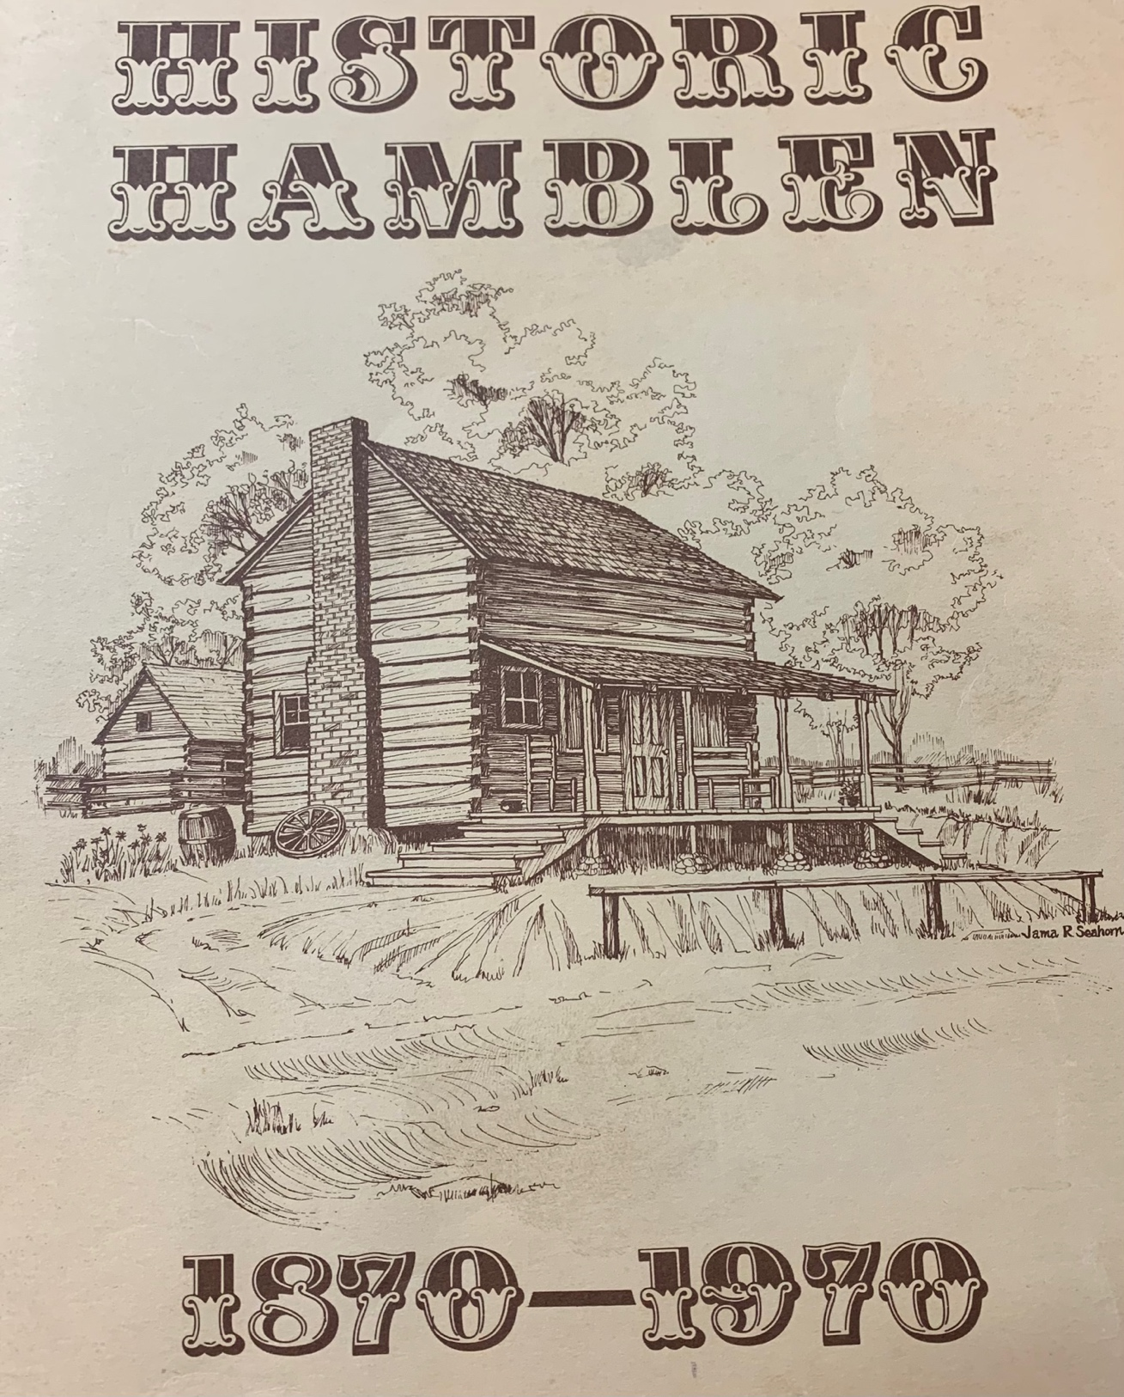
FIGURE 2: Cover of Historic Hamblen, the first of four Hamblen County history books from the archives.
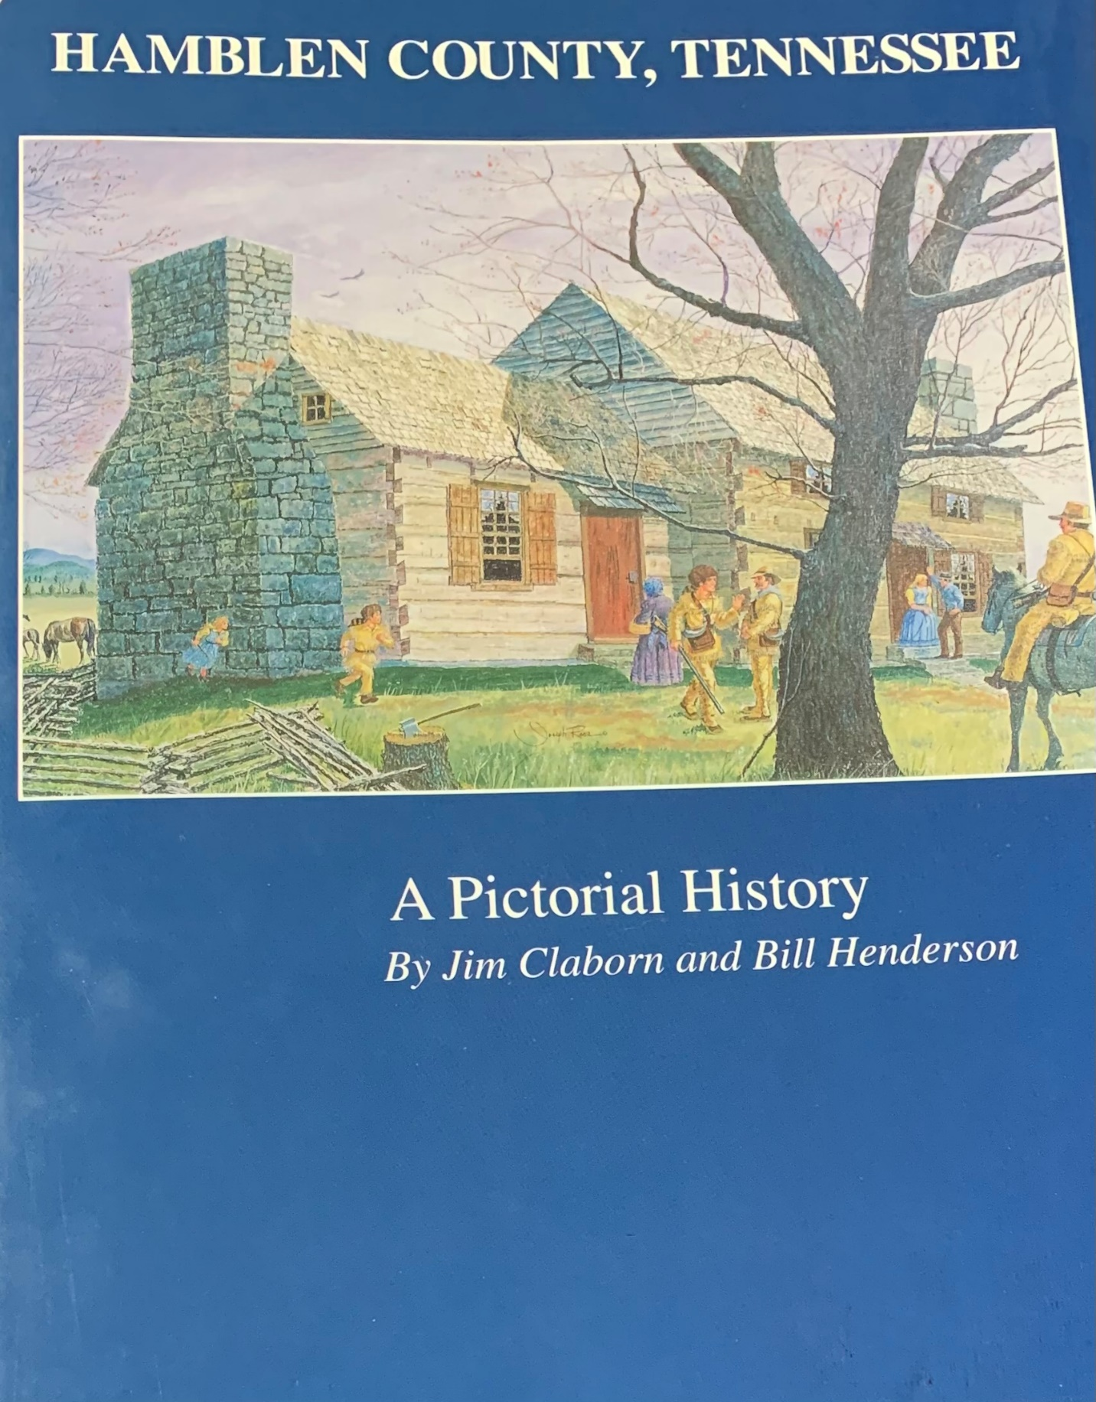
FIGURE 3: Cover of A Pictorial History, the second Hamblen County history book from the archives.
community in Hamblen County. There are photographs of people scattered throughout the book and various photographs of events that the authors deemed were appropriate for publication. The power of photographs will be discussed in Chapter 3.
A History of Hamblen County and Its People is the third text (in terms of publication date) available in the archives devoted to presenting a history of Hamblen Count (SEE FIGURE 45. This book was put together by a committee called “The Hamblen County Heritage Book Committee,” or HCHBC, and was published in 1986. It presents a historical overview of Hamblen County and provides a lot of information pertaining to institutions throughout the city.
In 2020, The Hamblen County Genealogical Society (HCGS) published an updated volume for the one-hundred-and-fifty-year anniversary of Hamblen County’s establishment that complements the original book by the Hamblen County Heritage Book Committee (HCHBC) that was published in 1986 (SEE FIGURE 6). The 2020 volume by the HCGS presents a historical narrative that is similar to those of the other three books. It includes new and updated information as well as some never before published photographs of various people, places, and events. In the next section, a historical narrative derived from these four texts will be provided. It presents Morristown and Hamblen County as a place organized by religion, industry, military involvement, education and clubs and organizations. Additionally, genealogical information about families in Morristown are provided. A deep dive into the information provided by these texts is included in Chapter 3. For now, it is crucial to mention that the historical narratives provided in these books do not provide the citations that are essential and common in academic publishing. Additionally, some of the narratives provided come from oral history, which is one of the main ways that rural Appalachian folks provide information about their history and information about their current material conditions. Nonetheless, a particular historical narrative
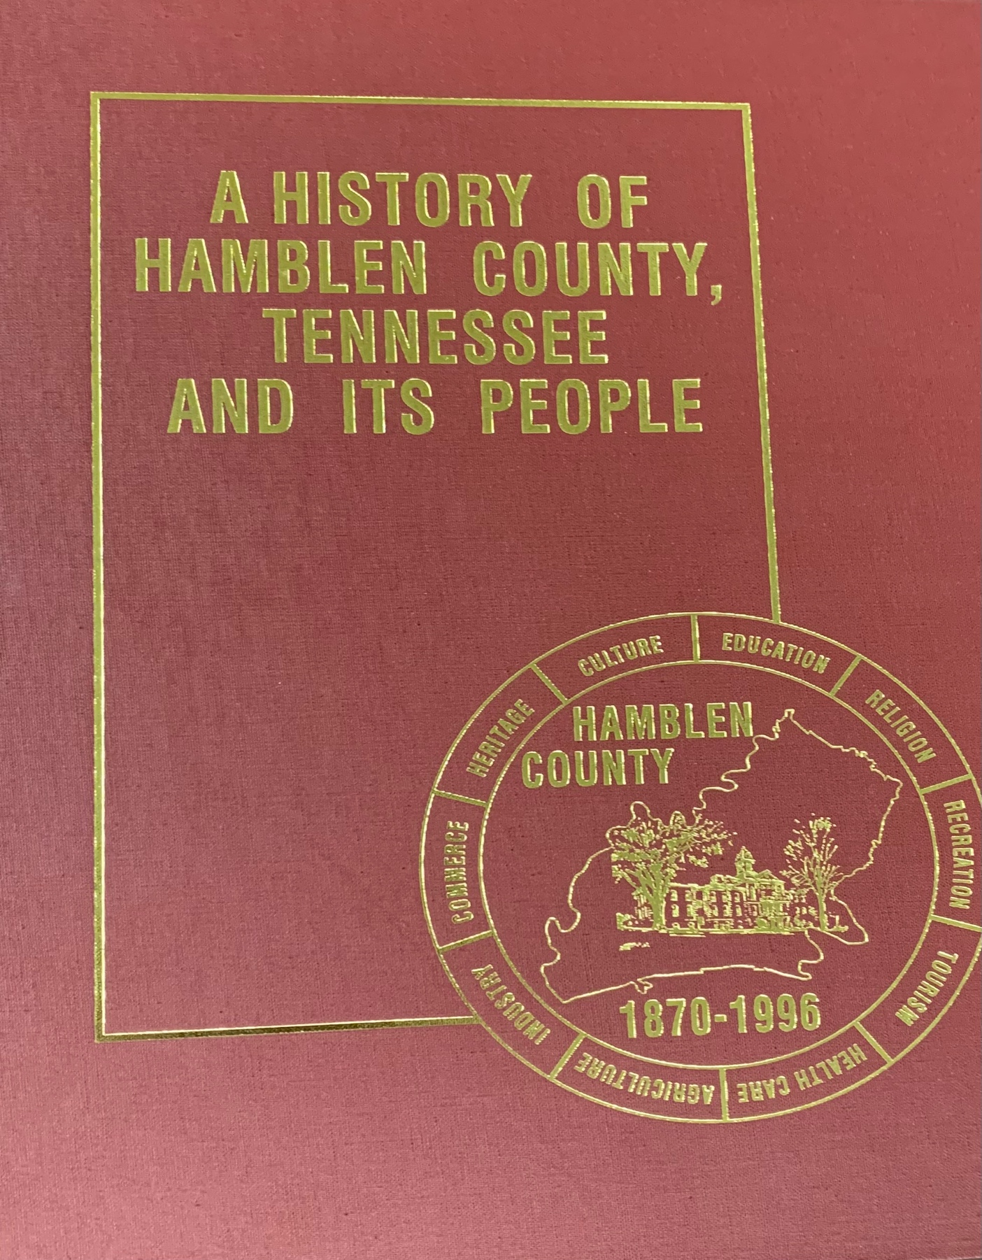
FIGURE 4: Cover of A History of Hamblen County, Tennessee, and Its People (Vol 1), the third of four Hamblen County history books presented by the archives.

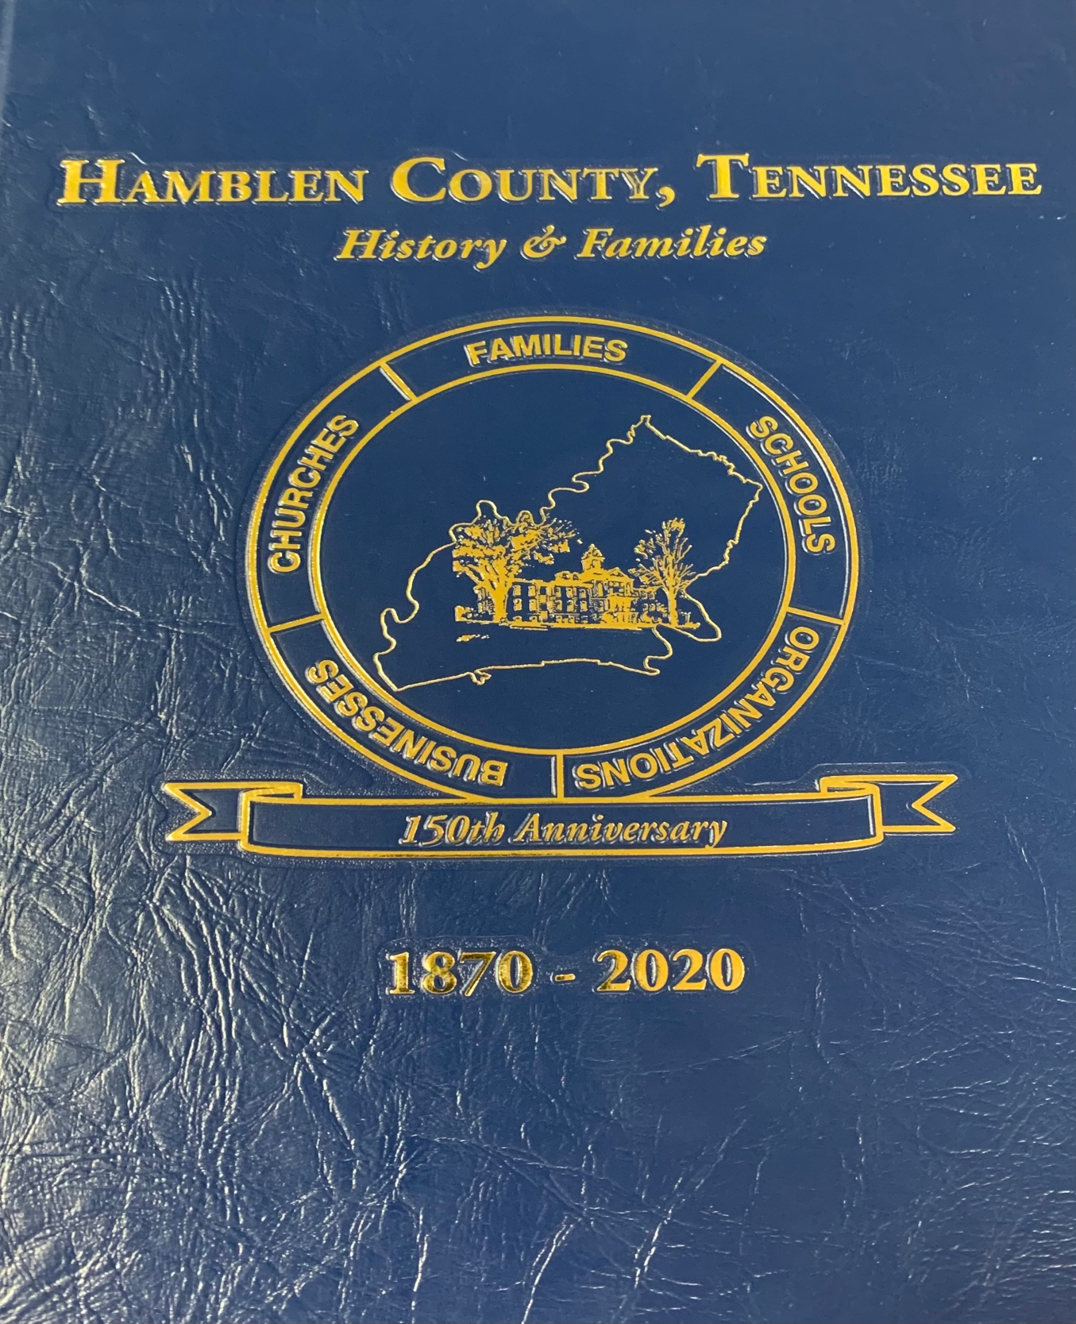

FIGURE 5: Cover of Hamblen County, Tennessee: History & Families (Vol 2), the fourth of four Hamblen County history books presented by the archives.
about the history of Hamblen County is provided by the four presented archival materials and is conferred in the following section.
While engaging with these texts, the history of Hamblen County is presented as fairly simple. It is important to keep in mind the fact that these four texts were produced for celebratory purposes, which might lend credence to the idea that harsh realities are not covered in the texts. That said, the fact that these are, perhaps, the only four books that provide detailed historical information about Hamblen County in particular is something worth noting because there are no doubt silences developed as a result. Not all county developments were always developed freely and with full approval of citizens in Hamblen County. For example, during this project, I uncovered a photograph, which is believed to have been taken in 1974, of my grandmother and grandfather protesting the development of a new prison complex. Organizers and protestors decided to set up and block the paths that construction machinery needed to take in order to begin construction. In the end, the project itself was abandoned and the prison was never built.
While the historical timeline is provided by these four texts, it seems crucial to provide caveats and additional information when appropriate. The caveats mentioned in the next section about the history of Hamblen County came from other archival materials that simply mentioned Hamblen County and/or Morristown while on course to accomplish a set of tasks that differ from the four texts that shape the following section.
THE ARCHIVE’S NARRATIVE OF HISTORY
The historical narrative in the four volumes previously mentioned begins at 1540, when “non-Indian visitors” from Spain walked along a trail near the Hamblen County area. In 1673, the names of James Needham and Gabriel Arthur are mentioned as they allegedly passed through Hamblen County on a journey that is not listed in these texts. Before the founding of the United States, it is mentioned how many hunters traveled through and pass the East Tennessee area in order to hunt deer and sell deerskins for money. Family stories in Morristown claim that Daniel Boone and his group first saw the Hamblen County area while on their “treks with the great frontiersman” (Claborn & Henderson, 1996: 11). The Hamblen County Centennial Committee does make a brief note that “the true history of the county began long before white men set foot in the area” (HCCC, 1986: 6).
Following the end of the revolutionary war, many soldiers were rewarded with large land grants “on the great frontier,” and by 1782, settlers first began settling down in what is now known as Hamblen County. In the same year, Charles McClung had surveyed a road from Knoxville, following an “old Indian trail,” which eventually became a rough wagon road, which eventually led to rapid socioeconomic development (13). This road eventually became known as The Big Road and the arrival of the East Tennessee, Virginia, and Georgia Railroad further established the area as a growing population and economic place (14).
Hamblen County was established in the year 1870. After the “War Between States,” one thousand and fifty-seven settlers signed a petition in order to establish a new county. The reason for this, according to the Hamblen County Book Committee, was that it was difficult to conduct business because settlers had to travel to the cities of Dandridge, TN, located in Jefferson County, or Rutledge, TN, located in Grainger County, in order to use ledgers for conducting county business (HCHBC, 1995: 2). According to the authors from the Hamblen County Centennial Committee, a story that has been passed down by word of mouth for more than a hundred years states that there were two settlers, Colonel I. P. Haun and Colonel Mark M. Murrell, who, together with a third man whose identity remains unknown, sat under a tree that existed where the First Baptist Church Educational Building sits today, and decided that a new county needed to be form due to the problems of transportation and communication. Back then, settlers in what is now Hamblen County had to travel to different counties in order to conduct business and gather necessary goods and services (HCCC, 1986: 7).
Areas that were previously portions of Jefferson, Grainger and Hawkins Counties were absorbed into one single entity known as Hamblen County (HCGS, 2020: 10). There was a lot of controversy around this act, which was spurred as a result of the petition signed by more than one thousand settlers who lived in the three portions of the three counties (SEE FIGURE 6). This petition was circulated around the settlers living in Morristown, the core city of Hamblen County, as well as the surrounding area in the 1860s and the final petition with all lists of signatories would go on to be presented to the Tennessee General Assembly (Claborn & Henderson, 1995: 15).
In the end, a state senator from Hawkins County named William Green was given the right to name the county. He named it Hamblen County as a way to honor his grandfather, Hezekiah Hamblen. The HCCC, the HCHBC and the HCGS texts mention him as an honorable man. In fact, there is a picture hanging in the Hamblen County Archives that is regularly described as the “only” photograph of Hezekiah Hamblen (SEE FIGURE 7). The photograph was presented and hailed at a 1996 jubilee in Morristown; however, thanks to another archival text, it turns out that the photo is of another man and is not actually Hezekiah Hamblen (Trent, 2010: 175). Hezekiah Hamblen and this photograph are discussed further during the analysis of the archival materials provided in Chapter 3. The Hamblen County Centennial Committee attempted to provide information about the early history of Morristown. The section begins with a statement declaring that, to this day, it is impossible to know who the “first white man” was that stepped and settled into what is now referred to as Morristown (HCCC, 1986: 29).
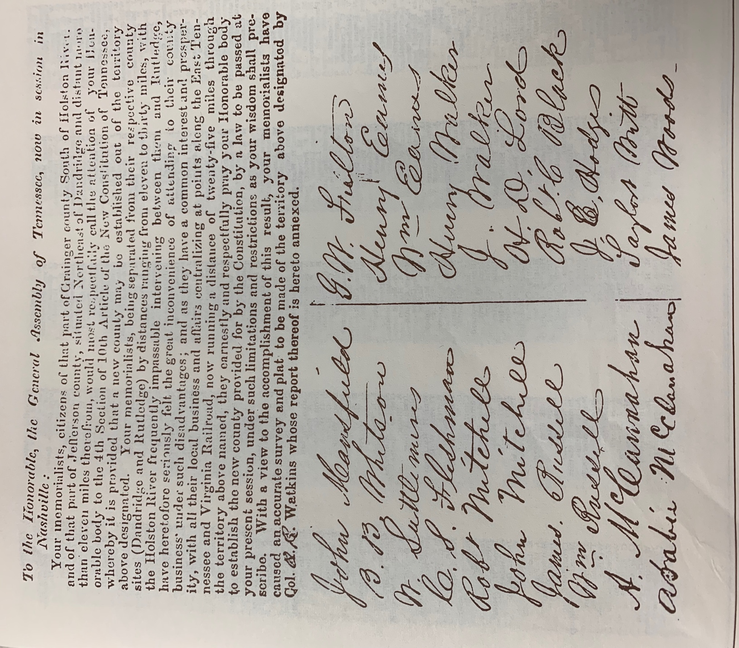
FIGURE 6: The front page of the original petition used to sway the Tennessee government to establish Hamblen County, as found in the TN State Archives, presented by Hamblen County Centennial Committee’s text from 1986.
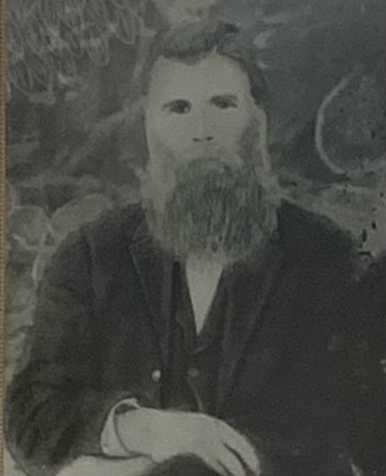
FIGURE 7: Photograph framed and displayed in Hamblen County Archives allegedly portraying Hezekiah Hamblen. There is a caveat posted under the photograph that mentions how it is not actually a photograph of Hezekiah Hamblen, but it was and still remains celebrated as the only remaining photograph of the man whose namesake was used to honor the county name.
The book says that on September 20th, 1787, land grants were issued to three men: Edward and Jesse Riggs and Gideon Morris. Later land deeds referenced those land grants, thus serving as proof that this is the origin of Morristown (29). The text also says that the first settlers to come to Morristown were named Robert McFarland and Alexander Outlaw, both of whom are listed as settling in the “bend of the Nolichucky River” in 1783 (29). The documents that name these men, including the abovementioned land deeds, are not provided and nor is any information about where these documents could be found provided in the text.
The 2020 publication focusing on the history of Hamblen County provides a timeline of events that, when taken together, provide numerous points of entry into the broader historical narrative of the area.
The majority of the dates provided in the definitive historical timeline are interesting because of what they indicate about the city. The time period from 1787-1935 is largely uncovered in terms of historical narratives being provided by these archival materials. There is no particular text or set of materials dedicated to documenting history as a timeline. Rather, the historical timeline is set up using mentions of various events, the founding of businesses, policy initiatives, and oral histories provided by families. In sum: the historical materials about Hamblen County are lacking in various ways. A detailed sort of history must be put together using small traces of information gathered from a variety of materials and would be worthwhile in a future research endeavor.
Most of the dates in the timeline (SEE FIGURE 8) have to do with various companies and institutions opening, closing, and even sometimes failing. For example: in June of 1908,
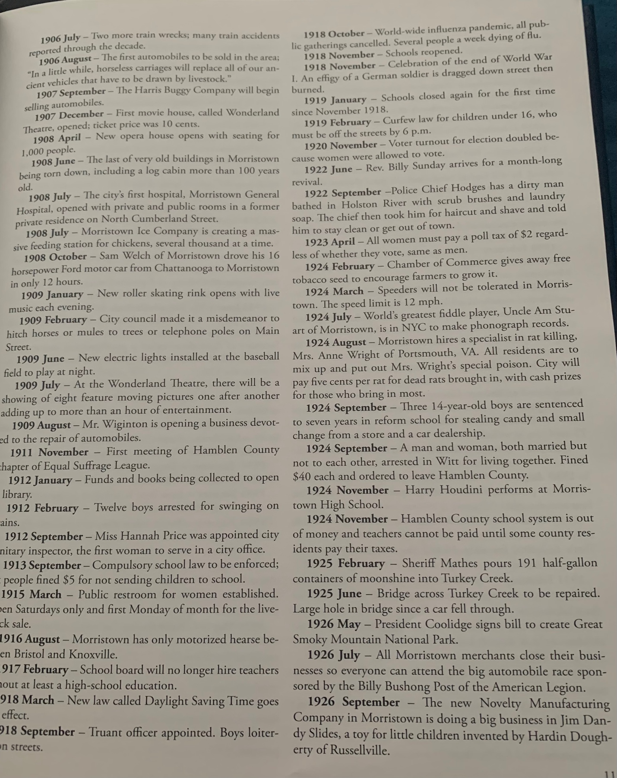
FIGURE 8: An example of some of the mentions made on the historical timelines from the 2020 publication.
the last of very old buildings in Morristown were being torn down, including a log cabin that was more than 100 years old at the time.
The same timeline includes numerous mentions of industrial development. For example, in March 1950, the American Enka Plant presented a plan to expand and increase production, increasing employment. In October of 1970, it is mentioned that Coca Cola opened a plant in one of the major industrial parks of the town and in 1972, it is noted that the first McDonalds is opened. This heavy emphasis on industrial development is one of the main ways that history is remembered in Morristown (HCGS 13-15). Along with armed conflict, heterosexual marriage arrangements, court proceedings and land deals, Morristown’s history is presented as a place where business is always in development, where certain (white) people are always doing well, and the religious doctrines of Christianity are preserving the Western ideal notions of the family.
The rest of the “history” provided by the books has to do with contributing genealogical information regarding families from Tennessee. There is an entire section in the HCGS publication dedicated to “the first families of Tennessee,” whereby the names of settlers who came to Tennessee prior to 1796 are named and information about their legacies are discussed. There is no mention whatsoever of the Native Americans who were pushed out of the area as a result of the land grants given to former soldiers after the armed conflicts that took place in rural Appalachia. The names of people mentioned in these four texts that focus exclusively on the history of Hamblen County dedicate a lot to industry and successful businesses. Small details are mentioned about churches and schools, including their dates of opening and when/if they closed. Only those deemed “successful” are given an opportunity to preserve their places in history throughout the Hamblen County Archives. The 2020 text does include a little bit of information about Black and Latinx folks who are from Hamblen County, particularly about Latinx restaurants.
One of the most geographical defining moments in the history of Hamblen County occurred during the massive TVA project that impacted several counties throughout East Tennessee. During the years 1939-1941, the Tennessee Valley Authority acquired land through immanent domain in order to develop the Cherokee Lake as part of their larger process of generating electrical power (HCGS, 2020: 58-59). No mention is made of the indigenous land that exists underneath Cherokee Lake. This represents another silence of colonialism that exists throughout the texts in the archive. It is worth mentioning, however, that most of the land that was acquired was owned and operated by poor white people, Melungeons and indigenous people. This is an example of one of the silences left out of the four abovementioned texts. That said, there is other silent information left out of this entire process, as described later on in Chapter 3.
At the time of this writing, the most recent historical text is the 2020 book previously cited. Additionally, the archive is somewhat lacking in historical material documenting the history of Hamblen County, some of which can be found online via the tennesseeencyclopedia.net website and TNGenWeb.com website. At the same time, there is very little information about historically oppressed groups of people, particularly black, indigenous, people of color, as well as migrant communities, poor people of color, and melungeons, provided by the archive. While the archive material is read along and against the grain in Chapter 3, the information provided by the archive is compared with broader accounts of the realities experienced by people in Southern Appalachia and the entire region more broadly. There has been very little published about Hamblen County academically, except for a couple of pieces about labor and migration. Nonetheless, there are large bodies of literature about migration into the US South, about Appalachia and about identity construction in the rural areas of Appalachia that do provide material upon which the archival information can be analyzed.
TRACES OF HISTORY: INFORMATION FROM OTHER ARCHIVAL MATERIALS
There are other archival materials that provide historical information about Hamblen County more broadly as well as Morristown, Tennessee more specifically. The previous section discussed information from the only four books available that focused exclusively on the history of Hamblen County. The information in this section was primarily gathered from the only set of scholarly, peer-reviewed texts available in the archive. The majority of this information comes from copies of the Journal of East Tennessee History, previously titled as the East Tennessee Historical Society’s Publications. Other information was gathered from independently published books and solo projects that focused on different themes relevant to the history of Hamblen County. This information is worth providing as it contributes to the questions of what can be attained through a deep engagement with a rural archive. In fact, the bulk of each of the two main historical texts (the HCGS red book and the HCCC blue book) are devoted to businesses and their owners. The most recent publication listed a vast number of businesses as well as their histories, the narratives of which were provided by the families contributing information and who were likely paying for advertising in these books. Only the most recent HCGS publication provides information about successful people of color and women, while the rest focus almost exclusively on white, apparently heterosexual men.
The rest of the historical texts from the archives provide information about East Tennessee more broadly and include information that is likely found at some of the neighboring archives. This makes some sense, as Morristown, TN, was founded after pieces of Jefferson, Grainger and Hawkins counties were formed into a single county entity. Nonetheless, there is a peculiar revisionist type of history that is provided in these texts.
Betsy Creekmore (1959) wrote a text that was published by the University of Tennessee Press. In “Arrows to Atoms: The Story of East Tennessee,” Creekmore devotes a few chapters out of the 142-page book about historical events. Creekmore is a white woman who was actually acknowledged by the University of Tennessee in Knoxville due to the gift she made for funding the archives and the book mentioned here was published in 1959 during the Civil Rights Era. There is an uncomfortable story that positions Cherokee Natives as dishonest “Others” deserving of their colonial treatments by white settlers. Creekmore does not define or explore the misdeeds of settler-colonialism, but instead makes a point that the Cherokee were “making and breaking” treaties with white settlers (21). Throughout this entire book, white settlers are referred to as “heroes” several times and she makes sure to include the kindnesses of Cherokee Natives that were shown to the settlers, who even the Cherokee viewed as “heroes.”
The book continues on to provide a revisionist history of slavery as it existed in East Tennessee. Various texts in the archive like to make the distinction that East Tennessee had less slaves than Middle or West Tennessee, as the state itself is sometimes thought of as a divided area; however, Creekmore (1959) provides an entire chapter that nearly praises slave owners. By leaving out historical silences, the story of chattel slavery in East Tennessee is depicted in a positive light. Creekmore notes that many slaves developed deep affections with their masters as the East Tennessee slave owners were kind. Slaves were treated as skilled artisans who worked alongside their masters in trade or business (60). Even if these narratives contain some truth, no mention is made that the slaves were literally conceptualized as property merely being exploited for their labor. No mention is made about the fact that they were not paid for their labor. This is very much a white supremacist, revisionist history of East Tennessee.
The peer-reviewed articles provided by the East Tennessee Historical Society (the most recent examples of which are titled The Journal of East Tennessee History) do provide additional historical information that does seem to be more detail-oriented and critically examined, providing more accurate historical narratives. At the very least, the information about East Tennessee is provided in such a way that lives up to the peer-review process and thus, one can at least expect the articles are more researched and have survived rounds of revision and critique.
There are only select articles relevant to the history of Hamblen County, as the majority are about more popular areas in East Tennessee, like Knoxville, TN. Nonetheless, the complementary information is worthy of mention because its focus is on historical events rather than cheerful capitalist tales. In discussing the legacy of colonialism, James Allen Bryant (2017) provides information about the boarding schools that were established on Cherokee land. The boarding schools were established as part of the Christian mission aimed at “saving” Native American children from their “savage” culture and bring them towards a path of enlightenment (7). He also notes that the Cherokee, in particular, suffered a lot of losses during the American “Revolutionary” War.
What is lacking in all of these historical journals is information about non-European, non-white migrants who provide a huge impact on the industries and economies upon which these archival data are built. There is an entire journal dedicated to the Scotch-Irish migrants who settled in East Tennessee and worked in the mines of Appalachia. Walter T. Durham (2006) provides a detailed account of European migration to the East Tennessee region, noting that these settlements began around the year 1770 (30). The Scotch-Irish migrants are presented as heroes and heavily influential in the establishment of the state of Tennessee. There are some important class dynamics involved when discussing these early settlers, particularly as working-class whites were taken advantage of by extractive capitalist industries. Nonetheless, these types of mentions focus the conversation around Appalachia in such a way that the region is presented as the “Other” America. This information is important for gathering more context about the working class of Hamblen County, but do not point to the area itself (Wolfe, 1981: 40). It is also crucial to note that no real discussions of resistance can be found in the archive material.
The Journals of East Tennessee History do provide information that is not discussed in the other archival materials, specifically that regarding chattel slavery in the American South. The reality of the slave trade and life of plantations in East Tennessee appear several times throughout the texts (Purcell, 2006; Leventhal, 2006). The typical downplaying of the demand and impact of slavery is rooted out in these articles. For example: it is noted that the slave population in Tennessee had grown to 13,584 in the year 1800 but increased six-fold by the year 1820 (Purcell, 2006: 5). As Purcell (2006) notes, the demand for land is the only demand that exceeded the demand for slaves in East Tennessee. Additional information is provided about the freedmen groups that existed after the American Civil War and other information is provided that focus on the lifeways of former slaves and their descendants. In particular, mentions of Morristown College, which was once located in Hamblen County, makes several appearances in these journals. Charles F. Bryan, Jr., and JoVita Wells (1981) mention how important the college was for the education of black folks in rural Appalachia. Before the integration of public schools, black folks were required to attend separate institutions. Morristown College, originally called Morristown Normal and Industrial College, was one of the only two institutions of higher education for black folks in the entire region of Appalachia (Bryan & Wells, 1981: 61). Established by a Methodist Episcopal Church, the successes of Judson S. Hill, an important figure during the formation of the college, is mentioned as he was able to win over the political and financial support of the white population in Hamblen County (67). This type of information is a better representation of the lifeways of Black folks in Appalachia, which rarely gets mentioned in the definitive historical texts of Hamblen County. The only mention within the four previously listed books that focused exclusively on the historical formation of Hamblen County is the mention of Andrew Fulton, who was a slave who apparently said that he became a “free man” after finding Jesus Christ (HCGS, 2020: 74-75). Morristown College is mentioned a little bit and small mentions of successful business owners who are non-white are provided in the most recent issue.
MARRIAGE RECORDS OF HAMBLEN COUNTY
Volunteers have developed projects using a lot of the older documents stored in the backrooms of the Hamblen County Archives. As a result, these volunteers have made more accessible materials. One such example of this are the four volumes of marriage records from Hamblen County (SEE FIGURE 9). The original marriage records, as well as the original court and military records, are stored behind the desk of the archive in rooms. Some of the books are from the late 19th and early 20th centuries and are only accessible by request and through the use of gloves and other safety mechanisms so that the documents do not decay at a faster rate. These marriage record books were put together by the elderly volunteers who worked tirelessly to compile information in order to make texts accessible to the public of Hamblen County. Ever since the COVID-19 pandemic, the sets of volunteers that once worked in the archives are either working on small projects at home or have finished their work altogether.
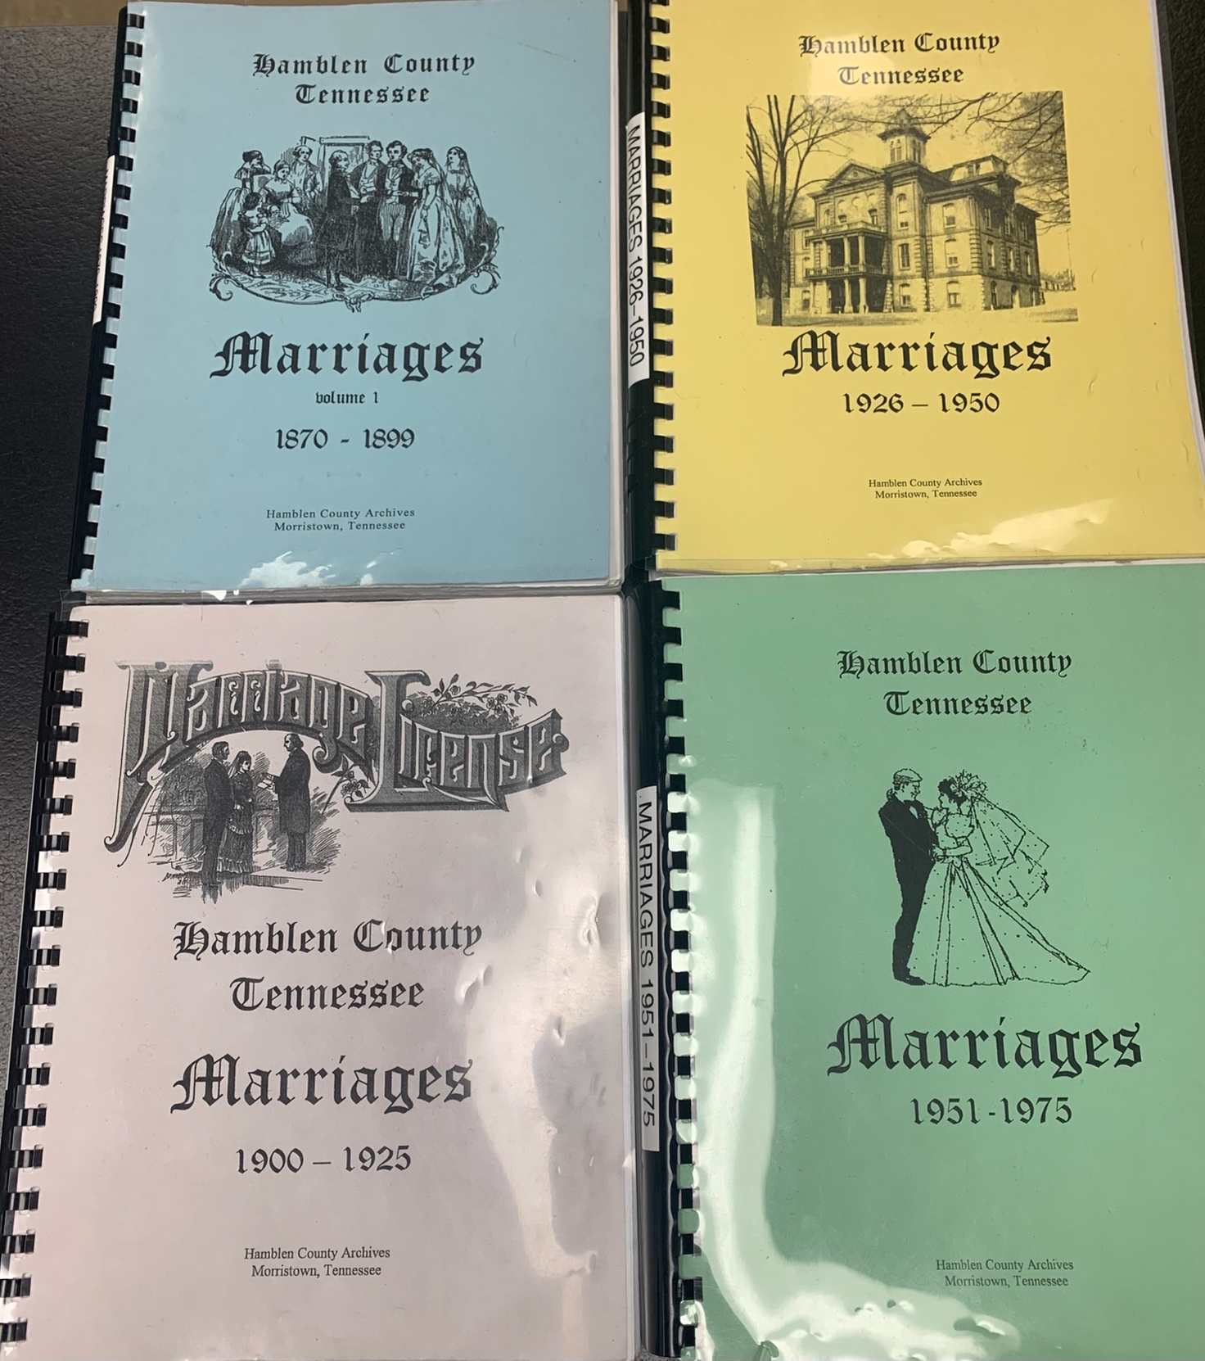

FIGURE 9: Photo of the four volumes of the marriage projects. The actual records are kept in the back of the archives, which are only accessible through appointments and under the guide of the archivist in order to prevent deterioration.

Nonetheless, the first of three volumes of the marriage records include information about the grooms and brides who were married at some point between the years 1870 and 1899. There are roughly seventy-two pages titled “The Groom List” and there are also seventy-two pages titled “The Bride List” in the first volume. The grooms and brides are listed in alphabetical order in each list according to the surnames of the grooms followed by the surnames of the brides. The dates of the marriage certificates being issued are mentioned along with the books that were kept by the county court and which are stored in the back of the Hamblen County Archives.
The second volume of marriage records is compiled the same way and contains the records from the year 1900 through the year 1925. There are one hundred and five pages of the grooms list and the same amount for the brides list. The third volume has the marriages compiled in the same way from the years 1926 through 1950, totaling a grooms list with one hundred and twenty-five pages as well as the same amount for the brides list. The fourth and final volume covers the years 1951 through 1975. Each list contains two hundred and fifty-six pages of grooms followed by brides, alphabetically ordered by surnames.
There are lists of the various churches where these weddings have taken place, if such information was available to the volunteer who put them together. A lot of detailed information about the wedding is missing, but there were some examples of noteworthy things. For example: there were roses placed in front of a certain Presbyterian church. Additionally, various churches also posted advertisements in the local newspaper and online. In fact, during my analysis of the newspaper clippings, I came across several of these.
It would be nice for a contemporary updated list to be made that would include same-sex and queer couples, as well as other forms of intimate partnerships that individuals feel are healthy and consensual. Whether or not this is an ongoing effort is not to my knowledge Marriage takes center stage in the archives because it might serve as useful genealogical information for individuals in Hamblen County who want to learn more about their family tree. The older, historical records are preserved in the back. Official state documents are the only documents that are not always available for public view, but this is largely due to the fact that the official documents themselves are older and are deteriorating more quickly. Thus, the marriage books that were analyzed in this thesis are the main books that are accessible to visitors of the archive. While looking at these books, I felt like the volunteers who put the books together viewed marriage as an incredible life defining moment worth preserving, as small details about the marriages were provided along with details about weddings.
NEWSPAPER CLIPPINGS: TEN YEARS OF SAMPLES FROM THE ARCHIVES
The Citizen Tribune is the newspaper publication based in Hamblen County that has operated since 1966. It is the most popular newspaper in Morristown, TN, that focuses on the communities found within the Morristown-Hamblen area of East Tennessee but that also includes sensationalized information about East Tennessee more broadly.
Two months, chosen at random, from each year during the period of 2010-2020 were examined and records, notes and some photocopies were kept in my personal possession about the types of stories they were discussing. It is worth noting that the documents from the Citizen Tribune were some of the only newspaper clippings and fully published editions available on microfilm as a permanent collection in the Hamblen County Archives. It is not within the county’s purview to gather newspaper clippings involving Hamblen County that were published elsewhere, nor is it possible given the very low amount of funding afforded to the archives.
I paid particular attention to the community and opinion sections of the newspapers. These sections were examined in order to get an idea of what sorts of impacts on the communities of Morristown were worth noting and what sorts of discourses were dominating the media record. More detail will be provided in Chapter 3 where this information is analyzed; however, some broader points are worth mentioning here. A large portion of the newspaper included sections on local sports. Several pages of each newspaper included information related to arrests that had taken place within the timeframe covered by the particular paper. There were always pages of obituaries and death records of people living throughout Morristown. Like many popular media records, there were always feel-good stories and stories related to local politics. On top of these, there were always stories of crime that would, no doubt, attract the views of many people living in the Morristown-Hamblen area.
When reading these papers, I could not help but think about the fact that Citizen Tribune is highly read in Morristown. The types of opinion and editorial pieces being presented are consumed by a large amount of people in the town, which has a listed population of 30,077 according to the US Census Bureau. The fact that ultra-right-wing narratives are presented as objective claims can, no doubt, have an impact on the general beliefs and wisdoms held by folks who might not access or who cannot access other sources for news (SEE FIGURES 10 and 11).
As the newspapers are presented in order for 12 months (from January to December) on each roll microfilm, I kept certain notes regarding newspaper pieces that stood out to me. In the 2018 microfilm, in pieces from November-December, there were a lot of opinion pieces about immigration. I made note that there was a huge anti-immigration piece highlighted in one of the opinion sections. Under Donald Trump’s presidency, there were a lot of anti-immigration policies set into place. In particular, the “Zero Tolerance” migrant separation policy separated more than 3,000 children from their families. Additionally, there was a lot of talk about a “border crisis” and the Trump administration tried to end Temporary Protected Status designations,
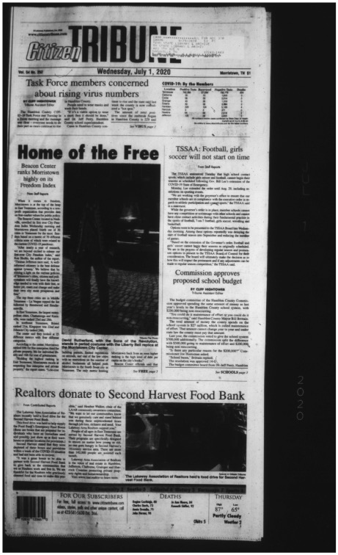

FIGURE 10: Front page of Citizen Tribune from July 1st, 2020.
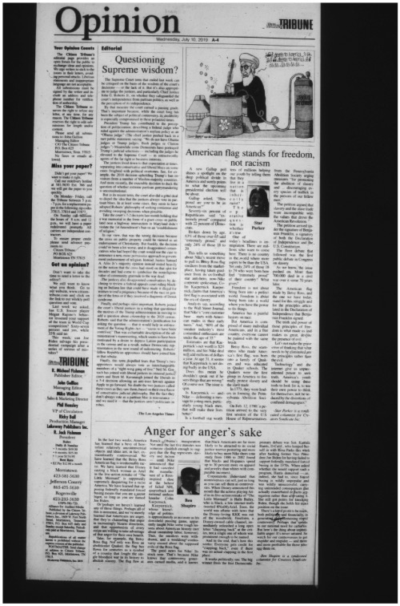
FIGURE 11: Sample of Opinion page on the July 10th, 2019, edition from Citizen Tribune.

which would have impacted hundreds of thousands of immigrants who have lived in the United States for many years (Karas, 2018).
The ten or so newspaper pieces that I analyzed from the 2018 reel were focused on immigrants from Mexico and provided negative opinions about them. One editorial from November 1st, 2018, argued that people in the United States should be afraid of “pregnant women” who are deliberately traveling across the border to give birth in the United States (The Charleston Post and Courier, 2018). When Morristown residents are presented with anti-immigration sentiments, one can imagine that it creates tension amongst residents living in Hamblen County. One must imagine the concerns that immigrants and their relatives, many of whom were actually born in the United States and are thus United States citizens, might have to deal with. Speaking from personal experience, I have witnessed several instances where racist individuals made comments about the Latin American communities that live on Cumberland Avenue in Morristown, specifically about how they want to get rid of what is known as “Little Mexico” in Hamblen County.
ETHNOGRAPHIC ENGAGEMENT WITH CRIMINAL COURT DOCUMENTS
The Hamblen County Archives contains a lot of documents that serve as historical renderings of state operations. Found within the walls of the courthouse are large books containing minutes and other records pertaining to both the civil and criminal courts of Hamblen County. Influenced by the work of Sally Engle Merry (2002), it felt worthwhile to examine some of the most recent information available. Fifty court cases were reviewed and examined for each of the ten-year period of time from 1988-1997 on microfilm. The microfilms had documents pertaining to criminal court cases that were tried in the Hamblen County Court system. Totaling five hundred cases, the types of cases reviewed can reveal much about the lifeways of people in Hamblen County.
The archives contain two microfilm wheels of court documents for each year, starting with the most recent year of 1997. For the purposes of this project, the first fifty cases on each reel per year were documented. Sometimes, the reels would start in the beginning of the year (January or February) and sometimes wheels would start with a month like September and end with December. The court cases were not presented in a particular order. The individuals involved in the cases’ names were not presented alphabetically. In fact, there were no particular patterns of cases. In some instances, however, there were presentations of cases that followed certain offenses. For example: in some instances, individuals who were in court for child support obligations had their cases presented back-to-back. Another example would be the violations of the habitual motor offender act, where an individual was charged with a crime while driving. When these instances appeared in the record, I took notes of the repetition and after three of these cases were apparent, the film was progressed to find the next case that broke the pattern. The cases were marked by the changes of the defendants’ names. Figure 14 is an example of the case pages that were examined and documented.
I chose examples that had names written that were not readily readable. While these criminal records are technically public records, it is a privileged access to see them. Criminal records in the archive might be an instance where a person is able to find themselves or their ancestors in the archive and their crimes do not represent them as people. For this thesis, the types of charges were analyzed in order to get an understanding of what they might reflect about the sociopolitical reality of Morristown, TN, and Hamblen County.
There were several types of documents that were found within the microfilms that were not relevant to the data gathering process. Some of these documents included: notice of inmate transfers; documents pertaining to appeals of sentences; documents pertaining to appointing or changing of legal counsel; notices about sentencing extensions or finalizing; and information pertaining to court costs, court payments, court housekeeping information or punishments like rescinding a driving license (SEE FIGURE 16).
The types of criminal cases in each year were documented for several reasons. Understanding the types of criminal cases being processed through courts can reveal information about the lifeways of people in a rural Appalachian town.
Additionally, it is crucial to note that many individuals who would not otherwise appear in the archive do wind up being presented in these types of records. It is safe to say that, given the sociopolitical landscape of Morristown, TN, and Hamblen County more broadly, where the gross medium income is roughly $20,000 per year (United States Census Bureau), most of the individuals who are found within the archives in books such as the marriage volumes previously discussed were the ones who were fortunate enough to gather genealogical information about their families. They were the types of families who were able to spend money to uncover facts about their ancestors. Additionally, they were, in large part, white, Christians with a heterosexual family structure. They were largely representative of the types of families that are deemed acceptable in a rural Appalachian city like Morristown. It is safe to say that many of the migrant families who live in Morristown, some of which have lived in Morristown for multiple generations by this point in time, are not afforded the same forms of representation in the Hamblen County Archives.
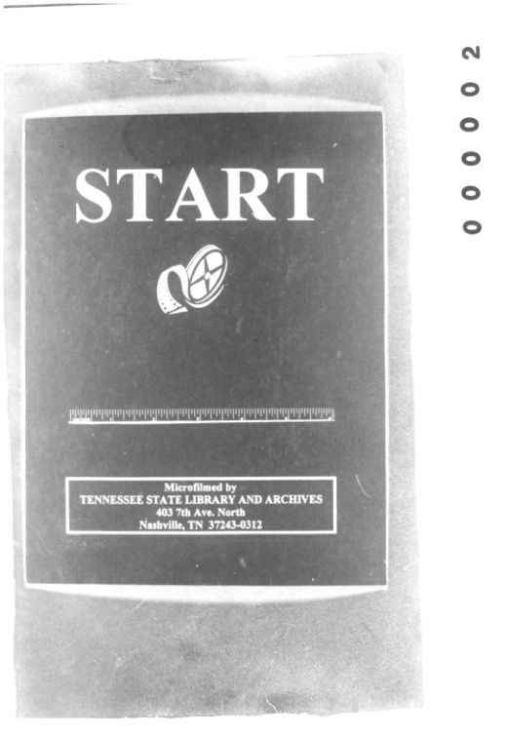

FIGURE 12: Start of one of the microfilm reels of the Hamblen County Circuit Court records.
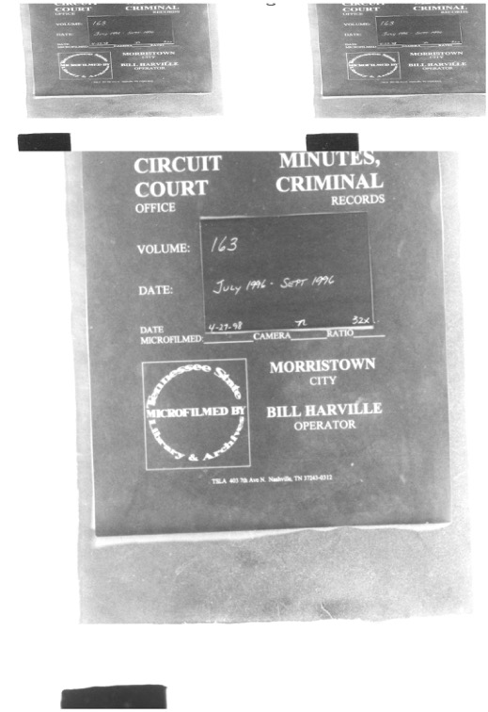
FIGURE 13: The opening page of the Hamblen County Circuit Court records on microfilm.
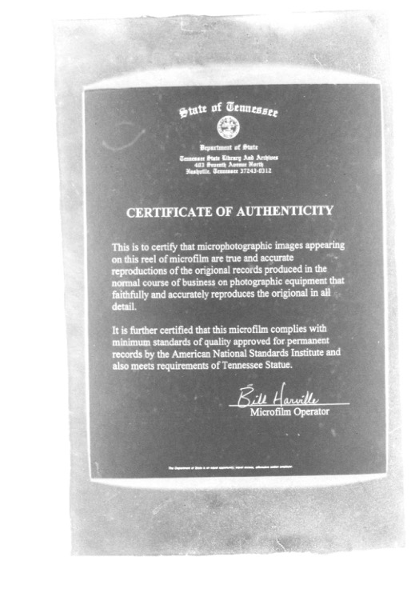
FIGURE 14: Certificate of Authenticity of Hamblen County Circuit Court records on microfilm.
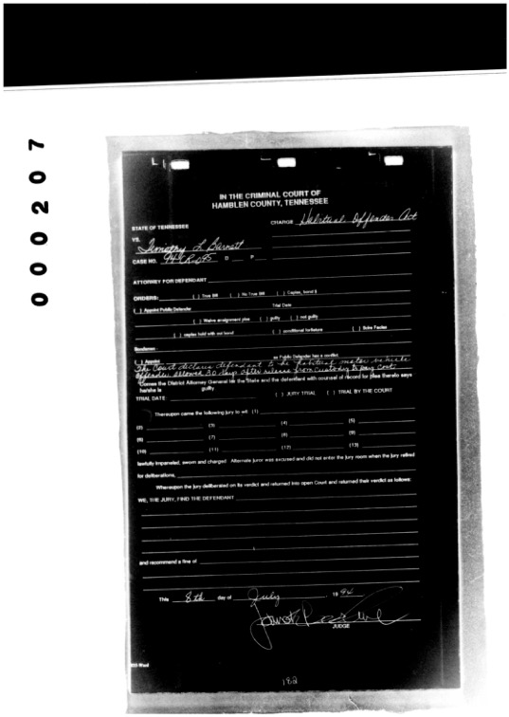

Figure 15: Sample of court case file found within the microfilm.

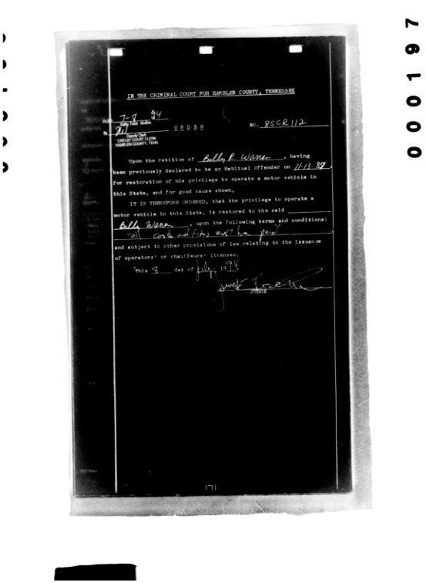
Figure 16: Sample of document listing a punishment of revoking driving privileges found on circuit court microfilm that was not relevant for the data gathering process.

The cases will be examined in further detail in Chapter 3, but when the cases were transferred from fieldnotes into an excel document, several things were noticed. First and
foremost, while the names and races of individuals charged with a criminal offense were left out for this project, the overwhelming majority of the cases I examined were people whose last names would likely be considered of European descent. Although popular images depict Latinx migrants and their relatives as criminals, it appears that, based on the appearance of Hispanic surnames in the 500 records that I reviwed (recognizing that not all Latinx have Hispanic surnames), the members of the Latinx communities in Hamblen County were way less likely to be charged with a crime than their white counterparts.
Secondly, the overwhelming majority of the cases were associated with substance use issues and violation of what was referred to as the “habitual motor offender act.” These types of cases are reflective of a post-industrial town during the neoliberal turn, when industries were removed from the state of Tennessee and sent abroad for the further exploitation of labor by the American capitalist regime. While industrial development did continue in Morristown, as industrial parks are still being developed to this very day, the quality of positions and payment, along with the decrease of union activities, were likely contributing factors that led to the types of cases being heard at the criminal court.
While analyzing these documents, I came across various cases that told stories that seem to represent the ways of life in Hamblen County. On the microfilm presenting court cases from July of 1996 until March of 1997, the overwhelming majority of cases were noted as being tried with public defenders. I became aware of this as many pages of motions to declare indigency were provided in the files, meaning that an individual was unable to pay their fines (court costs, punishment fines) and many others were unable to afford an attorney. Thus, the State would provide one for them. When considering the fact that the majority of people living in Morristown are working-class individuals who work in the factories and industrial parks, one can begin to imagine the difficulties they must experience as a result of interactions with the police. Overpolicing has become a reality for a lot of people living in the United States, especially those living in poor neighborhoods (Diep, 2019). In fact, police violence is one of the leading causes of death for young men in the United States (Edwards, Lee & Esposito, 2019). Dawn Deaner, a public defender in Tennessee, writes that public defenders witness two justice systems operating in the state: “one for people with money and one for people without.” (Deaner, 2018: 27). According to Deaner, lawyers representing poor criminal defendants are paid $40 an hour. Additionally, they are overworked (27-28). When the majority of defendants in the Hamblen County Courts are assigned to a limited number of public defenders, their cases are likely not given the same amount of attention that an expensive attorney would give them due to the simple fact that public defenders juggle a larger number of defendants.
If a working-class individual winds up getting their license suspended, they find themselves in a vulnerable position. They will not be able to make it to work without a vehicle, given the ways that rural areas like Morristown are structured, and therefore must take the risk of driving without a license. It is important to keep in mind that licenses can be suspended for a variety of reasons, including health reasons. Within the first 50 cases examined in the year 1996, 10 of them included individuals being charged with violating the habitual motor offender act. Violations of this mainly include driving on a revoked or suspended license. One can imagine that individuals stuck in the previously mentioned situation have to knowingly drive without their license privileges in order to survive, but they might find themselves locked up in a jail for simply trying to make ends meet.
WAR MATERIALS AND ARMED CONFLICTS
The way the materials are presented in the Hamblen County Archives represents an idealized notion of whiteness that beams off nationalist tendencies and urges. A primary example of this is the material pertaining to wars, armed conflicts and individuals from Hamblen County and East Tennessee who were enlisted into the United States armed forces for a variety of historical conflicts.
There are a lot of military records related to things like pensions, awards for service, burial information, etc., that can be found within the Hamblen County Archives; however, this information, like a lot of the older court records from the Hamblen County court system, are contained within heavy, leather-bound books that require specific gloves for handling and are usually only accessible during special appointments. These documents are usually analyzed for the purposes of gathering genealogical information about one’s family.
Nonetheless, there are several documents that are much more accessible that provide not only an overview of the armed conflicts, but also provides narratives about the people involved. There are six books written by a man named Stephen H. Street. Street, along with volunteers, compiled books pertaining to several armed conflicts, covering a span of nearly three hundred years of time.
Street (2021) analyzed all sorts of available documents available inside and outside of the Hamblen County Archives pertaining to armed conflicts (SEE FIGURE 17). This text, along with others, was part of the Hamblen County Mapping Project. The majority of the texts provides information about armed conflicts involving both European settlers and Native Americans. The war between the American colonies and the British Empire, also known as the American Revolutionary War, is also discussed throughout this text. Additionally, there is a text dedicated to the Civil War. In Hamblen County, people who supported the Union as others who supported the Confederacy were recruited. Some members of the same family might have fought on opposite sides.
The books also contain photographs of various soldiers in each of the conflicts, including some of their military portraits. Additional photographs include photos of the land where battles were fought, the graves of some of the soldiers, and military parades that championed and expressed feelings of nationalism before and after the armed conflicts. For example: the book about World War 1 shows traditionally patriotic photos of the men who served, the list of medals earned by soldiers, along with biographical information about those who served (Street, 2019). Each of the books contain a brief overview of each of the conflicts mentioned in the books and some provide timelines of the major incidents that define the historical narrative of each war.
The inside pages included salutes in Times New Roman font along with bits of information about each war. These bits of information come from a Western perspective.
As will be shown in Chapter 3, however, there was a lot of information that is left from the books. Taken together, the books present a revisionist historical account that fuels white nationalism that paint the soldiers in each of these wars in a positive light, arguing that the freedom of the United States was guaranteed by and protected by the soldiers in these conflicts.
The fact that the archive makes these war and armed conflicts materials readily available might contribute to the already large military recruitment that takes place in Morristown. There are signs all over town that ask people to visit the recruitment offices located near the major shopping mall on Morris Boulevard. As Robert Comancho (2022) notes, the United States military’s target audience remains the same: young men from low-income and rural areas are solicited regularly in school and at work. Inside the Hamblen County Courthouse, there are many
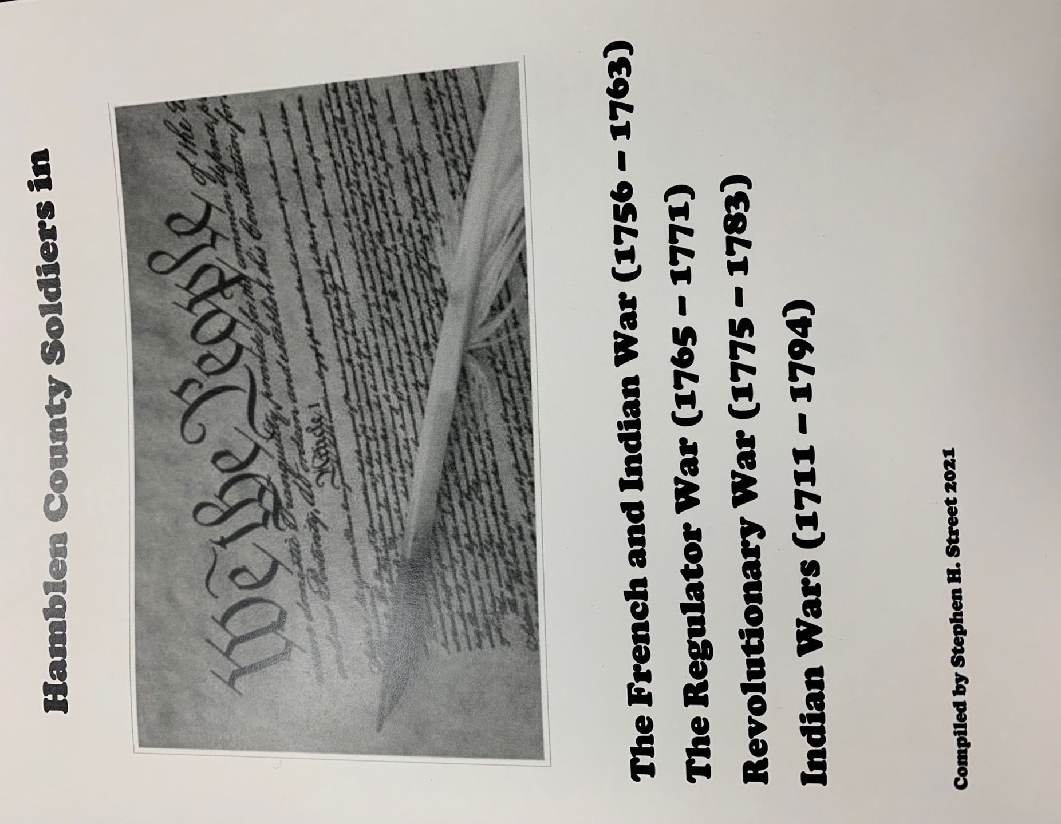
FIGURE 17: An example of the cover page of one of the Stephen H. Street books regarding military and armed conflicts found within the Hamblen County Archive.
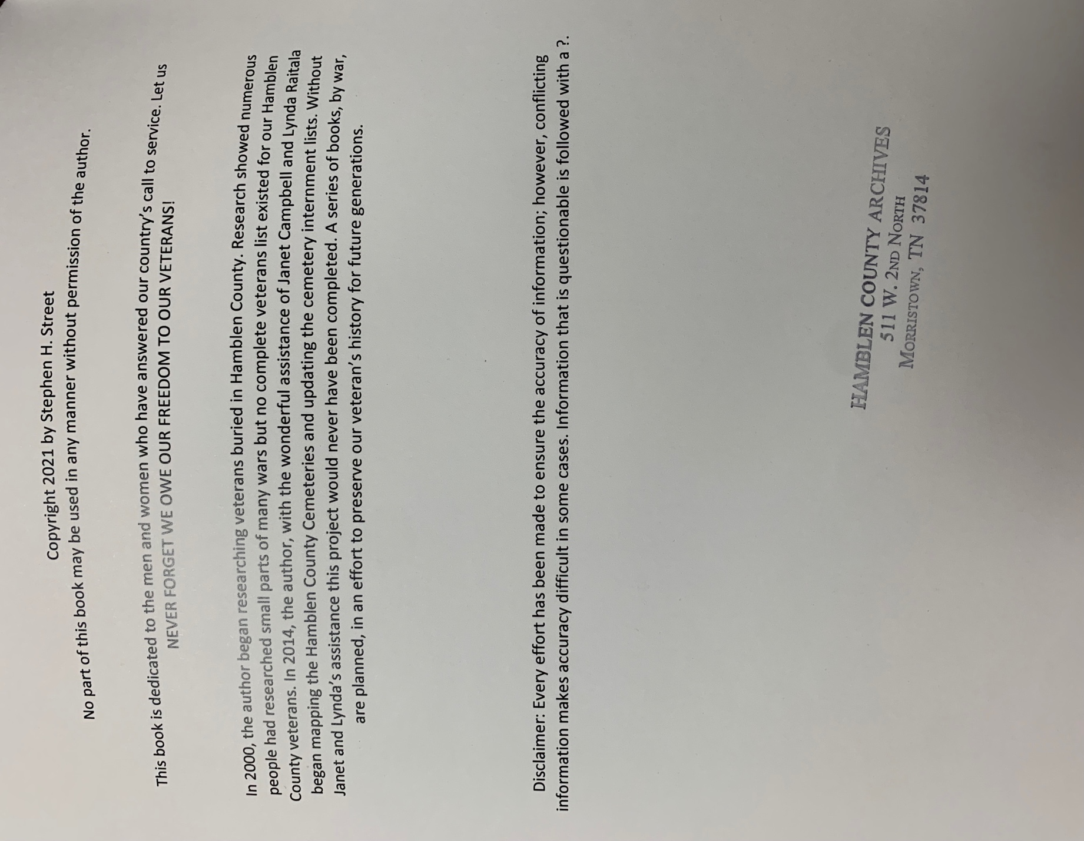
FIGURE 18: An acknowledgment similar to all of the ones found within all of the Street military documents found in the Hamblen County Archives.
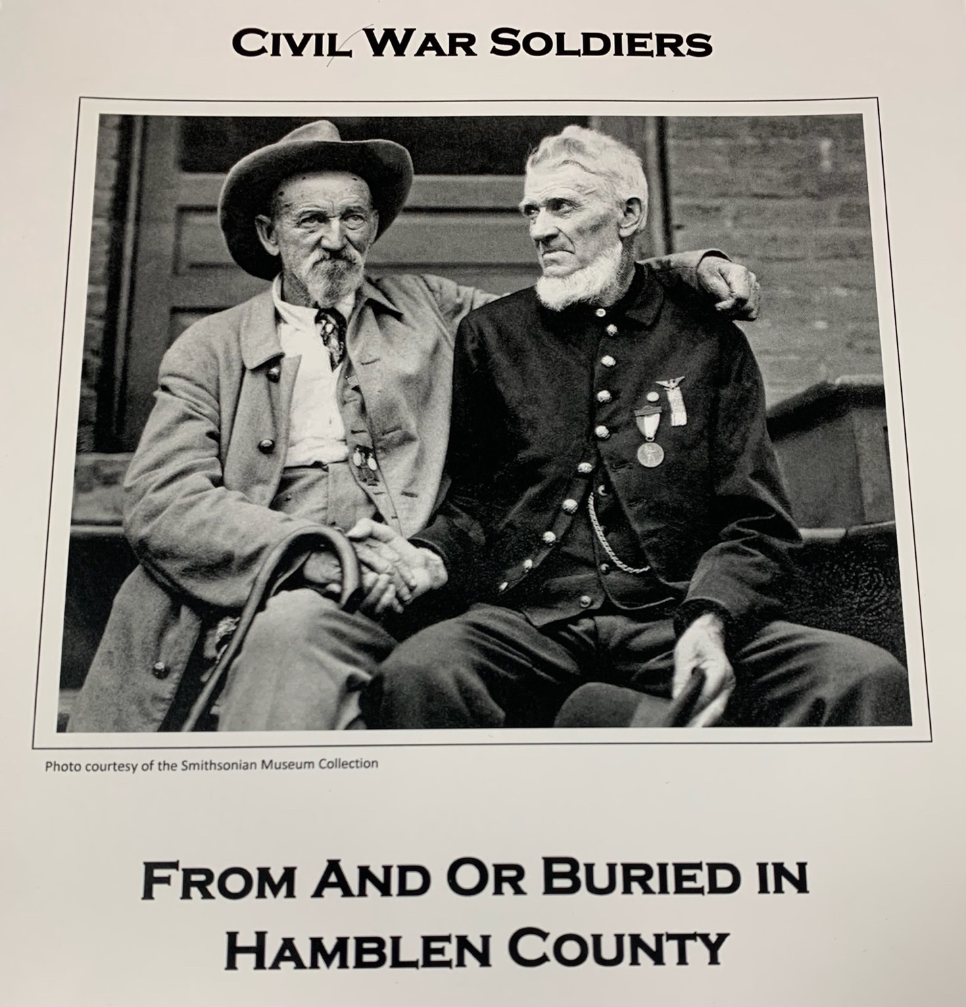

FIGURE 19: Cover of the Civil War Soldiers text showing a union soldier and a confederate soldier shaking hands, found within the Hamblen County Archives.
posters and plaques honoring the United States military service members and their families. One would not be too far-reaching if they made the argument that the war documents might serve as propaganda pieces for the United States armed forces.

CHAPTER 3: ANALYZING THE MATERIAL ALONG AND AGAINST THE GRAIN

THE HISTORICAL INFORMATION ABOUT HAMBLEN COUNTY
There is a particular focus of the archival material on the early histories of Hamblen County. There is no doubt a focus on a white, settler, revisionist history that begins prior to and around the county’s formation. From the middle of the 20th century onwards, a lot of the information pertaining to the history of Hamblen County has to do with tidbits of information along a timeline that presents the histories of successful people, their businesses and various industrial development. If this is read along the grain, it might be argued that Hamblen County Archives is, after all, a repository of state documents. Therefore, the majority of historical information found within the archive are military documents, marriage records, court documents, etc. Additionally, Morristown, TN, while it remains an industrial hub of Southern Appalachia, is a rural city. The population remains around 30,000 people more broadly (United States Census Bureau, 2022).
There are important pieces of information to gather from analyzing the historical documents along and against the grain. While all of the abovementioned information is true, the census for 2022 reveals that roughly 20% of the entire population are listed as “Hispanic or Latino,” with 7% of the population listed as African American, 1% of the population as Asian American and less than 1% as Native American. 7.7% of the population is listed as biracial (United States Census Bureau, 2022). It is important to keep in mind that this is only from the populations of peoples who were registered by this government census and does not include some migrants who lack permanent residence or citizenship status. When reading the archive against the grain, the lack of information about Latinx migrants in the Hamblen County Archive, as well as the particular framings of Latin American lifeways and experiences, reveals a troubling story.
There is an abundance of material sources outside of the archives documenting the violence faced by Latinx migrants throughout East Tennessee, particularly with regards to state violence and labor exploitation. Many jobs in Hamblen County, particularly factory and other industrial jobs, are organized through the temporary employment agencies that exist in abundance throughout the entire region. In 2006, one of the temporary employment companies known as The Garcia Labor Company, Inc., which also served as an employment agency, was in the spotlight of national news coverage when the owner, his wife, and another executive were arrested in Cincinnati. They were charged with forty counts of “illegal alien employment” and “money laundering” (Ramos, 2006). This case was discussed by a lot of people in Hamblen County. Growing up, I personally remember when this happened. Instead of focusing on the fact that many migrants were being exploited and trafficked for their labor, the news coverage (including the source used in this thesis) tended to throw gasoline into the fire between working class white people and the migrants from Latin America.
The struggles that Latinx migrants face in Hamblen County, particularly with regards to labor exploitation and unfair treatment, are lacking in the Hamblen County Archives. During an organization drive in the mid 2000s, almost every worker from a poultry factory who was present at the organization meetings (most of whom were Latinx) mentioned an issue, an act of injustice, or an act of aggression they faced while working at the factories (Ansley, 2012: 168). These types of stories are lacking in the archive, as I did not find any mention of resistance throughout the archival materials I examined. In fact, quite the opposite: the Hamblen County Archives presents its main historical narrative as one that is defined by the hard work of white settlers who were successful in numerous industries, particularly in agriculture and poultry production. The owners of these businesses fit neatly into the historical narrative preserved and presented by the Hamblen County Archive. Meanwhile, the working class is presented as a group of lucky individuals who work modestly and live comfortable lives. The actual truth of the working-class struggle for fair treatment, better working conditions, and more pay are lacking. Additionally, no mention about the racist treatment of non-white workers might experience was found. No mention of the queerphobic treatment non-heterosexual workers might experience and no mention of the horrors that migrant workers might be facing as a result of their precarious statuses in the United States were found throughout the entire archive. The 2020 Hamblen County Genealogical Society does mention one instance involving migrants, but again depicts scenes of violence and subjugation without information about discrepancies and impacts: in April 2018, Federal immigration officers arrested ninety-seven workers at a local meat packing plant, leaving a number of local American-born children without their parents. (HCGS, 2020: 17). There is no mention of what happened to the families after these arrests and there was no mention of any further legal actions taken, including deportations.
The person who is associated with the namesake of Hamblen County, Hezekiah Hamblen, is presented as an honorable man. The Hamblen County Genealogical Society said that “Hamblen County can be proud to be named after such a distinguished man whose pioneering spirit and hard work helped found our state and our region.” Historic Hamblen (1870-1970) does present him in a truer sort of way: he was a man who owned a lot of land and who owned a lot of slaves. Nonetheless, this is presented in an unproblematic fashion. It contributes to the dominant narratives of Appalachia as a place where racial justice issues are treated vaguely and with a lack of urgency. It also contributes to the idea that this sort of settler identity is acceptable and worth celebrating. Resistance was missing and little to no mention of the indigenous people upon whose lands the region of Appalachia was built, the lives of people who were enslaved, union and labor successes, or working-class struggles were found in the materials I examined. The man Hezekiah Hamblen, himself, was a contributor to the project of settler colonialism in Southern Appalachia.
The only available film about Morristown, titled “Morristown: In the Air and Sun,” would be a good contribution to the archives; however, the only digital presence that the archives has is on a public website. This website has a broad description of some of the materials available to the public and does list a few excel sheets related to projects undertaken by volunteers; however, as an institution, the Hamblen County Archives are lacking a digital archive. Nonetheless, there are narratives that discuss the issues related to migrant experiences in Morristown available in sources not captured within the archive. The film mentioned above is augmented by an article in Southern Spaces that provides information about the experiences of the people in the film, in both the United States and in Mexico, as well as information pertaining to migrant struggles, their journey to Hamblen County, and examples of resistance efforts to combat the capitalist institutions that benefit greatly from migrant labor (Ansley & Lewis, 2011). This source was not found within the archive, but rather through a separate search during a literature review for this project. Union activity is an important part of the history of Appalachia as a whole but is left out of the archives due to the fact that business owners and exploitative people in positions of authority dominate the narratives found within. To cement the point: the Hamblen County Archives lack mentions of resistance.
The Tennessee Valley Authority was established in 1933 in order to coordinate flood control, inhibit forest restoration, and pursue projects of economic development along the Tennessee River and its tributaries. This information is presented in the archives as an ideal path of economic progress for Hamblen County, as it helped established Cherokee Lake and has created one of the major landmarks of Panther Creek State Park, also located in Hamblen County. Nonetheless, the TVA’s missions actually shifted dramatically during and after World War 2, as it instead moved away from its initial focus on human development and conservation and instead focused on creating cheap electrical power for industrial use (Eller, 2013: 38-39). As Ronald Eller (2013) notes, the TVA, which originally developed in order to conserve the environment and improve the quality of life in Appalachia, actually wound up contributing directly and indirectly to the further desolation of the region, especially in places like East Tennessee (39). This information is not included in any of the archival works. Rather, like other documentations of industries and institutions, it is merely presented as an instance of progress for the entire mountains. Reading the archive along the grain shows us that the TVA led to the prosperity of those in power, but reading against the grain allows us to see that the TVA eventually succumbed to the influences of capitalist development and wound up contributing to the economic disparity of the underclasses. Additionally, there have been cases of environmental disaster as a result of TVA-related projects, including the Kingston Fossil Plant’s impoundment failure, which resulted in one of the most significant industrial accidents in East Tennessee history (Ritchie, Little and Campbell, 2018).
The concepts of race rarely appear as a separate focus in materials found within the archive. Aside from the mentions of black success, all of which situates black enjoyment and fulfillment within a capitalist framework, there is little mention of the conflicts that existed between white settlers and enslaved black people, indentured servants, and the struggles that black people have faced during Jim Crow, the Civil Rights period, and the contemporary moment. One thing that was uncovered, however, was the mention of the hanging of Anthony Blair.
The hanging of Anthony Blair (FIGURE 20) is mentioned in two of the four historical accounts of the Hamblen County area. It is mentioned in both instances as “the only public hanging of a black man” in Hamblen County. If analyzed along the grain, one can come to the agreement that it seems like Hamblen County is presenting this case as the only instance of public execution that black people faced at the hands of white settlers and under the guide of the white people in positions of power and authority. However, when this event is analyzed against the grain, one could argue that this is a mystified version of events. This is presented as the only lynching of a black man in public but is presented alongside gruesome details of the case itself, which almost seems like a way of justifying this public execution. Given the legacy of public lynching in the United States, the way in which this case was presented is worthy of being put under some scrutiny. The lynching seems to take the center focus of race relations in the Hamblen County Area and the narratives about Morristown, along with the authors who structure it, are disregarding all of the untold silences of black struggle in the area.
No further details are provided about the case of Anthony Blair. It is worth noting, however, that black folks suffered immensely throughout East Tennessee and Appalachia more broadly. Various sources in the archive noted that black lynching occurred more frequently in Middle and West Tennessee, which is backed up by outside sources (Bennett, 2017), and the archival materials, including the historical ones presented in Chapter 2 and others that were not included in this thesis, make the claim that black folks were treated better in East Tennessee than other parts of the state. Nonetheless, there is a clear silencing of black suffering found within the archive materials.
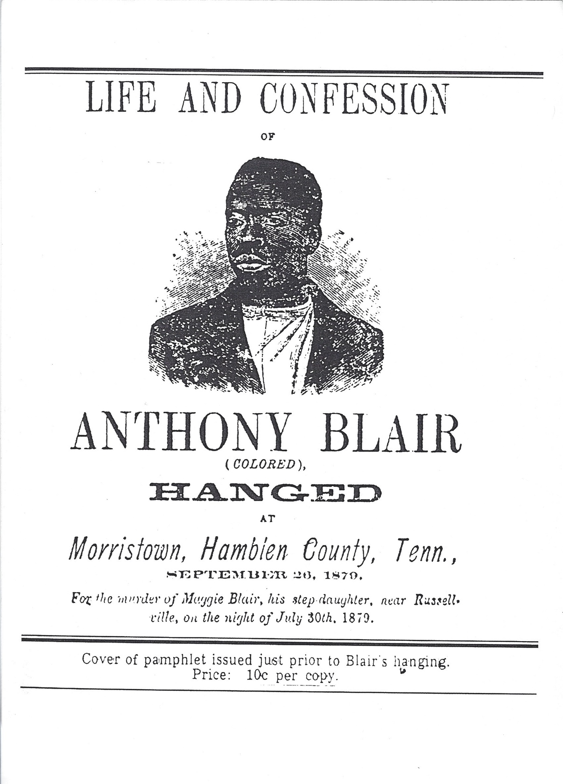

FIGURE 20: Copy of pamphlet issued prior to the hanging of Anthony Blair, depicted in archival sources as the only public hanging of a black man at the hands of white settlers.
Lynching occurred throughout Appalachia in places like the coalmines of Kentucky (Brown, 2018: 36-38) and other forms of violence could be found throughout the entire region. Presenting the hanging of Anthony Blair as the only public form of violence black and brown people faced by white settlers living in the same area underplays the realities of oppression experienced by nonwhite people in Hamblen County, East Tennessee, and Appalachia as a whole. It is presented as a justified act of violence and an incident rather than a public fact impossible to hide. By presenting it as such, the struggles of black people in Hamblen County are overlooked. In addition, examples of black resistance are overlooked.
Hamblen County is currently in a neoliberal boom that has been ongoing since about the 1980s. Some of the abovementioned texts highlight some businesses, like restaurants and auto parts, that formed in Hamblen County. There are also some mentions of factories opening. What is lacking is material more specific to this new form of industrial boom. Part of the reason for this could be due to the fact that land processes are very secretive and there has been resistance to corporations buying up swaths of land to contribute to industrial toxicity.
ANALYSIS OF THE MARRIAGE MATERIALS
The marriage materials found within the archive are, for those in charge of piecing together the materials of the archive, perhaps some of the most important documents presented within the walls because they prop up the traditional family structure that is considered the “norm” in a place like Hamblen County. The fact that so many old registers (a record containing entries in the form of a list, administration documents, etc.), marriage certificates and other related information (including the offspring of the married couples, intimate details about their weddings, etc.) reflects the fact that the archive is controlled by the state.
I did not find any mention of queer lifeways, relationships, representation, or struggle in any of the archival materials that I examined, including the ones presented in this thesis. Instead, what is propped up constantly is the standardized “norm” of the white, heterosexual couple who participates in religious activities and is prepared to give their life for the purposes of preserving life and freedom in the United States. Kinship is certainly a part of the basis for any society; however, in Appalachia, the cultural realities specific to this region are expressed throughout the archive. The notion of the nuclear family is important for the family structure in Appalachia. The family structure itself operates as a form of social control for “deviant behavior” (Keefe, 1988).
The families presented by the Hamblen County Archive materials are all compacted together and are presented as the typical heterosexual, Christian couple. The nuclear family form is the one that is accepted and worthy of presentation by the state. What is lacking in any marriage records are any version of kinship formation that differs from this state-approved one. This is not to say that queer kinship formations are impossible to be found in the documents that were analyzed. Rather, it is worth pointing out that the only mentions of families are those that can be found within this traditional family formation, the businesses they own or the genealogies of white settlers. Queer people and people of color are lacking most of the mentions of kinship formations in the materials I examined in the archive.
As 1975 was the last date of the marriage materials analyzed, it goes without saying that same-sex marriages were not included in the documents. Same-sex marriage became legal in Tennessee in 2015, but one cannot make the claim that queer relationships were non-existent prior to that time. In fact, the Hamblen County Commission has battled against same-sex marriage. In 2017, certain members of the Hamblen County Commission attempted to pass a resolution encouraging the Tennessee General Assembly to ban same-sex marriage. This brought about protests in the city against the commission and ultimately the resolution failed, as members voted 4-5 against the resolution (Wright & Erickson, 2017).
During my analysis of the newspaper clippings from Citizen Tribune, I did not find any mention of the protests or the resolution itself. This is an example of the lack of presentation of queer struggles and resistance to state oppression. Queer people are not given accurate presentation in the archive.
ANALYSIS OF THE NEWSPAPER CLIPPINGS
Ten years of newspapers published by the Citizen Tribune newspaper were examined on microfilm. The most recent newspapers were from December of 2020. Because of the number of articles found within the archive, I decided to look at two random months of newspapers published each year during the period of 2010-2020 in order to keep the data pool limited.
The opinion pieces in almost every single of the Citizen Tribune newspapers would fit the description of right-wing, nationalist tendencies. The overwhelming majority of the opinion pieces reflected harsh narratives towards migrants and any sorts of resistance to white, conservative opinions (SEE FIGURE 21 and FIGURE 22). There were many examples of editorial pieces presented in the paper as well that only focused on right-wing issues that could be found in popular political discourses.
The majority of the pieces that were analyzed from the archive, dating from the year 2020 to 2010, were authored by people associated with Creators Syndicate. Richard S. Newcombe is the founder and chairman of Creators Syndicate, which is an organization of over 200 writers and artists who contribute to various publications all over the country. The Citizen Tribune authors represented by the Creators Syndicate include right wing nationalists like Ben Shapiro, Dennis Prager, Patrick Buchanan, and Star Parker. The first three individuals are white,
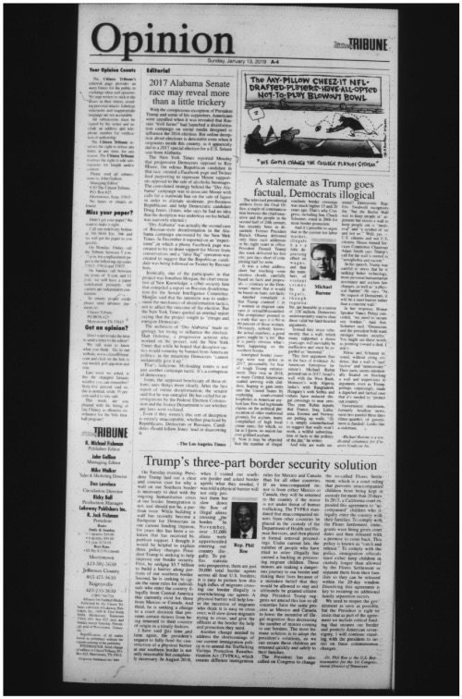
FIGURE 21: Picture of Opinion columns from Citizen Tribune, the dominant newspaper in Hamblen County, representing right-wing, conservative opinions.
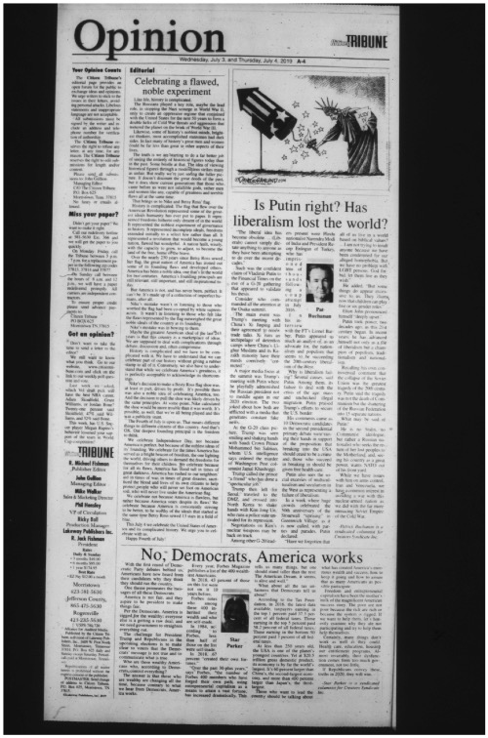

FIGURE 22: Picture of Opinion columns from Citizen Tribune, the dominant newspaper in Hamblen County, representing right-wing, conservative opinions.
heterosexual men who are well known for their ultra-right-wing beliefs and tendencies; however, Creators Syndicate does promote people of color, including Star Parker, who is a black woman, whose pieces reinforce white nationalist talking points and oppose any sort of resistance to the institutions of authority in the United States. In fact, Star Parker’s pieces were included various times throughout the more recent newspapers. In various pieces, Parker expresses her identity while simultaneously promoting ultra-conservative talking points.
When Latinx migrants are mentioned in the archive, it is usually in relation to crime and punishment, in the court records, or brief mentions of business owners. In fact, right in front of the Hamblen County Court House which houses the archives is a monument dedicated to those who fought in the “War Against Mexico.” What is not included are mentions of the working-class migrants and their relatives located in Hamblen County, some of whom were born and raised in Morristown, TN. There is little to no mention of the community efforts undertaken by the Latinx communities in Morristown. I did not come across any pieces mentioning Latinx resistance to violence and oppressive policies being enacted at the local, state, and national level.
Occasionally, there would be reviews about restaurants and cuisine, and I did come across some mention of a local non-profit. Additionally, there are mentions of migrants in the newspaper clippings, particularly in reference to the manufactured “migrant crisis,” which promotes racist views about United States border control and security. These types of stories promote nationalist myths of white supremacy and inform the sociopolitical opinions of people throughout Hamblen County.
Migrants have community places throughout the city of Morristown. On Cumberland Avenue, which is right in the center of town, there are loads of businesses, including auto shops and grocery stores where remittances can be sent back home, restaurants, and even Latinx churches. I did not find many mentions of the work that these communities are involved in with the exception of a local non-profit, whose name appeared in one or two articles about community engagement. No mention is made about the activities of these communities, particularly any religious ceremonies or social gatherings. The only mentions were made when restaurants were being advertised, which might have been paid for by the owners of said businesses. As was revealed in the analysis of the court documents, which can be found in the following section, migrants and their relatives rarely appeared at all in the court documents. This coincides with the factual data that suggests that migrants are half as likely to be arrested for violent crimes than U.S.-born individuals (Moyer, 2020). Nonetheless, there is still an issue that lies in the fact that one of the few places where migrants are featured in the archive are when court issues are the center of focus. Migrants throughout Morristown, whether they are from Latin America or somewhere else, deserve a proper place within the historical narratives of the city and of Hamblen County. A community-based archive developed outside of the state apparatus would serve well to preserve the cultures of these communities and contribute to a more holistic understanding of Hamblen County.
It would be a mistake to characterize the entirety of Appalachia as a racist place. In fact, Appalachia should be first and foremost thought of as a site of resistance to extractive capitalism, environmental degradation, and the general abandonment of the region. The Citizen Tribune newspaper clippings reinforce some of the generally accepted vision of Appalachia as the “Other” America (Catte, 2018: pp. 36). A prime example is the notion that everybody in Appalachia is a born-again Christian, which is how religion seems to be depicted, albeit in a slightly less radical sense, in the Hamblen County Archives. In order to combat this faulty image of Appalachia, there are many individuals who have gotten involved as activists and scholars from the region. Radical bookstores, harm reduction groups, mutual-aid organizations, and individual activists who I know personally have dedicated a lot to working class and racial justice struggles. At the academic level, there is current debate over the notion of the “internal colony” model, which tends to oversimplify the political economy of the region, but others are beginning to build upon this model by looking both within and beyond the region where economic exploitation is imposed on all people regardless of their identities (Fisher & Smith, 2016).
ANALYSIS OF THE COURT DOCUMENTS
The Hamblen County Archives, in general, are lacking in materials related to the numerous migrant communities present in Morristown, TN. In particular, the Latinx communities, particularly those from Mexico and Guatemala, are only mentioned in subtle ways throughout the entire archive. Mentions of Latinx people are made alongside mentions of businesses, times of crisis, and in court records. There is a lot that is left out of the archive. There is a mention of conflict between the United States and Mexico, but very little mention can be found regarding the actual people living in Morristown who can trace their roots to countries throughout Latin America. It should be noted that the court documents from 1997-1988 do not mention the race or other identity features of those whose cases are being reviewed or decided upon; however, there are certain family names mentioned in the documents, along with first names, that point to the possibility of Latinx heritage and familial belonging. Out of the 500 cases that were analyzed, roughly 15 of these surnames could be found. Hamblen County’s population is roughly 65,000, 12% of which is people reported as Hispanic or Latino. In 1990, the census suggests that the population total was 50,480. This indicates that people of Latinx ancestry are committing less crime than other groups of people, which is counteractive to the claims made by right-wing commentators who suggest that immigrants are all criminals.
The overwhelming majority of the crimes examined in this project had to do with the following: habitual motor offender violations, possession of controlled substances and driving under the influence and/or driving with a revoked license. The other crimes were predominately petty theft crimes that involved interpersonal dynamics. I would argue that these crimes reflect the socioeconomic realities of rural Appalachian communities devastated by the neoliberal turn, the exploitation of labor by industrial parks, the lack of social service programs offered by the local, state, and federal governments to Appalachia, and the impacts of the War on Drugs. Women in particular, throughout rural Appalachia, are repeatedly facing the heavy burden of the War on Drugs and poverty issues that plague the reasons. In general, state systems are built to entangle those who have been pushed aside by the dominant neoliberal capitalist, patriarchal systems in place into a harsh, punitive system (Buer, 2020: 23). Individuals who are responsible for taking care of their families face special burdens when there is a lack of socioeconomic opportunities. Meanwhile, elites (such as those who might be involved in compiling archives) tend to overlook class dynamics, and privilege anybody who has white skin (Pruitt, 108-110). The working-class people of Appalachia, including the working-class people in Morristown, are written-off in popular media depictions and given a status of backwardness, associated with the Appalachian Otherness, and the class antagonisms create even more issues in places like Hamblen County. All of these issues are overlooked by the archives, which, instead, presents the working-class people in all of Hamblen County as ascribing to the same features and notions of personhood as are generally advocated by its more privileged, white residents.
Because the Hamblen County Archive is lacking historical and contextual information about the people living in Morristown, including information about the struggles faced by working-class people, and because the archive does not appear to provide material related to resistance and collective action, a certain damning act happens when the only time a person’s name is mentioned in the archive is in relation to a criminal charge they were faced with: their entire being is reduced to a criminal act instead of their true character. They merely become a criminal rather than an individual with families, friends, passions, creativities, desires, goals, and struggles.
There is relevant information about the issues of mass incarceration and the criminalization of the poor that cannot be found within the walls of the archive. For example, in April 2022, a report was issued by the Vera Institute of Justice that examined the criminalization of poverty in Tennessee. Written by Jack Norton, Stephen Jones, Bea Halbach-Singh, Jasmine Heiss and the Free Hearts Leadership, an abundance of information about Hamblen County is provided which gives insight into the material conditions experienced by people in Morristown. Citing the Vera Institute of Justice’s incarceration trends project (2021), in 1970, 16 out of every 10,000 people were incarcerated in the county jail and by 2018, 103 out of every 10,000 people were incarcerated, calculated as a 544 percent increase. At this very moment (in April 2023), the Hamblen County government is looking to build another community jail due to the overcrowding of the local jail.
Many individuals in Hamblen County are experiencing despair as a result of cash-bail programs and overpolicing. There is a large presence of court materials, and the newspaper clippings reveal a lot of information about arrests as well as crimes, but what is lacking in the Hamblen County Archive are mentions from residents about the conditions they face as a result of the strong, punishing arm of the state. This is an example of why community-based or public archives might be beneficial in documenting the history of Hamblen County. Further ethnographic research with people in Hamblen County about their experiences with police might contribute a great deal of information that documents the impacts of the United States’ constant increase of police funding.
ANALYSIS OF THE WAR MATERIALS
The majority of information found within the Hamblen County Archives is either pertaining to war, court cases and religion or the genealogical contributions of various families whose settler origins can be dated back to earlier times in the county’s historical record. One might be willing to ask: why is there so much information pertaining to wars and armed conflicts?
People throughout the United States are honored when they or their loved ones contribute their labor and attention to the armed forces. The United States military is overwhelmingly documented as a beacon of hope and the force behind the global expansion of democracy. What is left out of these narratives, however, is the fact that the United States has a long history of violent oppression across the globe. When reading along the grain, one can make the point that the abundance of war records in the Hamblen County Archives is representative of the state’s ownership of the space. Additionally, one can analyze further and argue that the representation of these documents is a major source of nationalist myths regarding the United States armed forces.
Street (2021) provides an analysis that, without a doubt, positions the white settlers as brave and heroic and depicts Native Americans in a particularly racist view coinciding with the casting of the noble “savage.” There are loads of excuses for the progression of settler colonialism in east Tennessee and Appalachia more broadly as well as points detailing the expansion of the American Empire. For example, from 1760-1762, Street notes that there was a “Cherokee Uprising” that ended with the Cherokees signing away the rights of 2 million acres “to satisfy debts with white traders” (4). Additionally, from 1777-1794, there was a conflict titled the Cherokee-American War, which is noted as a “two-decade guerilla war terrorizing the western frontier settlements from Virginia to Georgia” (4). Depicting the conflicts between settlers and Natives in such a light seems to portray America’s original inhabitants as the antithesis of white settlers. Not only are Natives the enemies of the settlers, but they terrorize and end the lives of many. In the end, the Settlers are painted as heroes who were brave enough to give up their lives and comforts in order to defend the formation of the settler colonies. This text alone presents a timeline full of information pertaining to the signing of treaties; however, there is no mention of the fact that settlers were stealing the land of Native Americans, there is no mention of the fact that every single one of these treaties were violated by settlers, and there is no mention of the fact that settlers routinely took advantage of Native Americans. The last page of documented material in this text provides “other interesting facts” about the veterans involved in these wars and includes such information pertaining to the soldiers’ religiosity, their activity in local government and the fact that many veterans were business owners (11).
In his 2020 document presenting and discussing conflicts between white settlers and Native Americans, Stephen Street does provide a few details that discuss some of the violence experienced by the natives. For example, in discussing the Cherokee disturbance and removal, it is mentioned that the greed of white settlers led them to force Cherokee leaders to sign the New Echota Treaty in May of 1836, which ordered their immediate removal (Street, 2020: 4). White greed was mentioned in a couple of the other events, such as the 2nd Creek war and removal (4). Additionally, details of the three wars between settlers and the Seminole people were provided, including an acknowledgment that the Seminole people fought hard to defend their land. Nonetheless, there is no other mention, by Street, of resistance to settler colonialism, there is no mention of the negative impacts caused by these wars except for the number of lives lost, and there is no mention about how the treaties themselves were unfair and part of a larger project of Native American genocide.
In Street’s large text about the United States Civil War, there is absolutely no mention of the disputes over chattel slavery that eventually led to the Civil War. All that is mentioned is that there was conflict between states in the North and states in the South after diplomacy collapsed (Street, 2020: 2). There are a couple of detailed sections about the role that black folks played in this conflict, particularly how the Union allowed black people to serve in various roles. It is mentioned that, once the country became a unified polity again after the war, the United States government provided the vast majority of these soldiers pensions after the war. The post-war United Sates is not presented as a slave society, but rather as a kind entity that granted freedoms to those men who fought bravely to bring peace in the country.
Reading the documents of the Mexican War along and against the grain are interesting, given the fact that this is one of the only documents in the Hamblen County Archives that mentions any bit of history pertaining to Mexican people. In fact, although the Latinx population in Morristown hovers around 20%, migrants were not found to be mentioned in any of the genealogical information contained in the archive, were not specifically identified in the marriage documents, and are only mentioned once in the war documents, specifically pertaining to this conflict. There is no doubt a reason why the documents pertaining to the “Mexican War” are provided by the Hamblen County Archives and even sold by the front desk: Tennessee is known as the Volunteer State in part due to the war between white settlers and Mexican people throughout Texas. It is written that over thirty thousand men responded to calls for service in this conflict (Street, 2019: 3). The larger association and impacts of this armed conflict are not mentioned whatsoever, but it is interesting to note that the University of Tennessee’s students, faculty, administration, and sports teams are known as the Volunteers as a result of the “bravery” of the white settlers during this period of time. There is no mention of the fact that these wars were fought in order to advance the project of settler colonialism.
No mention of United States imperialism is mentioned in any of the war documents. Quite the opposite: the United States is not only presented as a beacon of freedom, but is also presented as the county responsible for the independence of former colonies. For example: the provided overview of the Philippine Insurrection War mentions how the war started as a result of the United States’ brave attempt to “Americanize” the islands of the Philippines. Additionally, it is mentioned that the Philippines were “granted independence by the United States” in 1946 (Street, 2019: 3). No mention is made of the Filipino people who were brave enough to protect their land and families against Spanish colonization as well as United States colonialism and imperialism. If this document were read along the grain, it seems apparent that the archive tries to mention the United States in as many armed conflicts as possible because of the availability of the documents provided by the state. Military records are one of the ways that people in the United States are able to receive genealogical information. This is one of the tools upon which Ancestry.com is built. Nonetheless, it appears that the State allows these documents open to the public because it paints the U.S. soldiers as heroes and responsible for spreading freedom, hope, and democracy domestically and abroad. There are, unfortunately, a lot of historical materials that place the United States as “victorious,” pointing to how dominant the U.S. armed forces were, which contribute to the popular acceptance of United States hegemony (May, 1983). When we read documents against the grain, one can find information about the atrocities committed by American soldiers in the Philippines, which included the torturing of prisoners and the murder of unarmed civilians (Welch, 1974: 233).
The stories gathered from the military and armed conflict records never once indicated the fact that Appalachian people from all walks of life were recruited with the promise of a better life, a process that still runs rampant. There are multiple offices for armed forces recruitment in Morristown, TN, as recruiting poor people for the wars of the United States has long been a standard maneuver by the state. Appalachia, more broadly, is a region where war-time economic booms rewarded jobs to people in various resource-driven industries like coal and timber, but also served as a place for the recruitment of young soldiers during the second world war and beyond (Eller, 2013: 12-14).
THE LACK OF DIGITAL RECORDS
None of the detailed information from the archives is available online. In fact, very little is available online whatsoever unless it is a project published on the Hamblen County Archive’s website. Some of these projects include excel sheets containing demographic information about smaller communities in the county and information about the founding of public schools. The website also contains a small historical timeline and brief mentions of some of the materials that one can expect to find. The fact remains: the Hamblen County Archives is lacking in resources. Some of these resources could include county funding, which could be used to develop a better, larger physical location for the archival materials as well as the production of a digital archive that is accessible online. Additionally, the Hamblen County Archive is lacking in terms of contribution from volunteers. It would benefit greatly from more involvement by the community and more funding from the state, which could be used to employ people who might contribute greatly to the archive’s expansion and preservation.
In Archive Fever, Derrida (1996) makes the argument that if Freud had had access to digital technologies, the entire field of psychoanalysis would differ. He connects this with a point about the archive, noting that the advancement of technology would contribute to a brand-new shape of the archive. Arjun Appadurai (2003) does note how the advancement of digital spaces allows the archives to be removed from the power of the nation-state and its “official network” (17).
As digitization requires a lot of expenses and labor, the State can no doubt fund such endeavors; however, I would argue that such a process might only serve the needs of those in positions of power and authority. This process might allow the State to further fund the project of developing revisionist historical narratives that are imbued with nationalist themes, settler-colonial and white supremacist apologetics and that are suffering from immense silences. Instead, efforts at establishing accessible community archives would serve as a good alternative. The archives owned and operated by the state tend to present material from a top-down approach.
Instead, community archives and what might be referred to as “popular” or “public” archives can be constructed from a “bottom-up” approach and volunteer labor can act as a sort of catalyst for contributing to community resilience in rural cities (Beel et al., 2015). These sorts of archives can provide crucial information about social justice struggles that are left out of dominant historical narratives, including those related to Palestinian resistance against settler-colonialism, particularly how the archive can be used to combat land dispossession by settlers (Butler, 2020). For example, the “Nakba” archives were a type of popular archivism that were formed and can be found on the website www.nakba-archives.org. (231). Additionally, organizations that are not affiliated with the State can, themselves, take upon efforts at re-opening archives that were previously abandoned or hidden from public view. For example: political groups in Chile have advocated for the re-opening of Pinochet-era archive materials in order to reveal truths about state-sanctioned violence to the general public and contribute to holding people responsible for crimes against humanity accountable (Blanco-Rivera, 2020).

DISCUSSION AND CONCLUSION:
UNSILENCING THE STATE ARCHIVES AND PUSHING FOR ALTERNATIVES
It is important for anthropologists who engage with archives to critically examine the information contained within. Anthropologists and/or their community members, like historians, should engage in an analysis of archival materials while simultaneously paying attention to the ways in which archive records are kept, collected and (re)presented.
UNSILENCING THE PAST AND PUSHING FOR ALTERNATIVES
One suggestion that anthropologists should keep in mind is the political act of unsilencing the archives that are controlled and operated by the state apparatus. As discussed in Chapter 3, there are many instances in which the information presented in the Hamblen County Archives are presented in such a manner that silences and erases parts of history that help with the preservation of a certain identity and history associated with whiteness in Appalachia.
Critical interventions into the already existing archives are methods that would serve a variety of purposes. It is important to know that rural archives, such as the Hamblen County Archive, do, in fact, serve purposes for individuals that seek basic information about their families. Scholars who engage with rural archives might be able to find information pertinent to their research projects that might, themselves, serve a broader project.
As I sought to do throughout this project, anthropologists should carefully study and engage with the archival materials as they are currently presented. It is important to keep in mind the specific details of each archive. It is important to consider information about the individuals involved in collecting archival materials and the processes of putting together archives. Keeping into consideration this information when developing a project such as the one presented in this thesis might serve as a tool that would benefit those engaging in historical perseveration and recollection in rural spaces.
Unsilencing the archive is a political project that anthropologists should engage in. As was stated throughout this thesis, acts of silencing and historical erasures are themselves a political act, regardless of whether or not the intentions were deliberately made or were a result of underfunding and overlooking by individuals working for the state of Tennessee. Anthropologists have the ability and universities certainly have the resources available that would help broaden the scope of already existing archives and may, in some instances, be able to add information to the archives that might work to combat the historical silences that are prevalent in archives like the Hamblen County Archive. There are some issues that will remain, however. Although underfunding is definitely an issue in rural archives, the individuals involved in (re)presenting material donated to the archives still have a power of control over what information is deemed worthy of being stored. This reason alone is enough for the argument to be held that community alternatives to state-operated archives should also be given more attention.
That said, I do make the argument that, along with a continued effort of critical archival investigation, community members whose information is lacking in state-operated archives should be assisted in the effort to establish new, community-based archives. These archives might be able to establish records for a variety of purposes. Archival projects such as these might help with a broad spectrum of sociopolitical issues, such as reclaiming land and historical narratives, contributing to cultural and historical preservation, and even act as a hub for advancing social justice struggles already at operation in the communities where these archives might be established.
A prime example of this would be the work of Black in Appalachia, a non-profit that works in collaboration with a variety of libraries, archives, universities, and media companies in order to highlight the contributions and histories of Black people in Appalachia. Black in Appalachia is currently engaged in the production of a Community History Project through the development of a digital archive (Black in Appalachia, 2022). As was shown and discussed in this thesis, many archives, including the Hamblen County Archive, are lacking in terms of digital space and collections. Working together with various institutions and community groups in East Tennessee, Black in Appalachia and the individuals involved with the group are contributing a great amount of time, labor, and effort into the preservation of culture and histories that appear to be lacking in state-operated archives, including the Hamblen County Archive.
One such example of the silences that were mentioned in this thesis would be the history of Morristown College. As mentioned in this thesis, Morristown College is hardly mentioned at all in the Hamblen County Archive. It does make a presence as a result of some academic work, but the fact that the second largest institution of higher education for Black people in Appalachia was barely mentioned in an archive is itself an example of the silences found from within the Hamblen County Archive. Beginning in April of 2018, Black in Appalachia has partnered with The Africa to Appalachia Foundation in order to digitize materials associated with Morristown College and make it accessible to those interested in learning more about the institution (Black in Appalachia, 2023).
I feel that the local non-profit who works with members of the Latinx communities in Morristown would benefit greatly from individuals who are willing to contribute pieces of material and documents to the Hamblen County Archive. The only mention of them that I found was briefly mentioned in a newspaper clipping. Additionally, community members themselves could put together and organize a community archive.
With regards to the marriage records, I do believe that an updated list of marriages that includes same-sex relationships, queer partnerships, and other non-Christian traditional relationships as records. This not only honors their relationship as something beautiful, but it also acknowledges queer people as human beings with human emotions. These notions of queer identity are sometimes left out of discussions of queerness, especially today. There is, as mentioned previously, a queer-based archive being put together by Dr. Tamar Shirinian and Donna Braquet at the University of Tennessee. Contributions from queers from Morristown or Hamblen County more broadly might be good additions.
CONCLUSION
Ultimately, archives are developed by people working with institutions who have the ability and means to preserve materials. The workers of the archives are not always the ones responsible for the construction and addition of materials. Sometimes, works are donated by families; other times, books and journals are donated that are influenced in ways representative of different, specific sites of knowledge production. The archive, while it (re)presents material gathered from beyond and within its walls, also works as a site of knowledge production. Those who have been historically marginalized, those who do not have extra time on their hands to control an archive, those whose ancestries have histories of oppression and exploitation deserve to be afforded an opportunity to represent their own lifeways in the historical record. That said, a place like Hamblen County Archive remains underfunded and staffed by only one part-time paid worker. It is this place where volunteers might intervene; it is this place where one can critique the nation-state’s ability to control the historical record (which is interesting in a place like Appalachia), but it is also, perhaps, rather indicative of the necessity of developing community-based archives, as well as public and popular archives, that will hopefully be able to flourish in the face of state involvement in the production of the past.
This thesis is one example of an ethnographic engagement with a state-owned and operated archive. There was a lot to be found within the archive, but if they are analyzed along the grain, this material usually represents the acceptable forms of lifeways, personhood and family practices that the state views as worth preserving. What is missing in the archive are mentions of non-white people, resistance, struggles brought about by capitalist production, and any mention of the difficult positions that many people in rural Appalachia currently find themselves in.
What the Hamblen County Archives also lack in are digital resources. The only digital footprint available can be found via the county archives website, which does post a very brief historical timeline of Hamblen County and some of the projects undertaken by volunteers. Nonetheless, simply calling for more funding would probably contribute more to the problem observed throughout this thesis: that the state-owned archive is merely operating in order to preserve dominant social and cultural norms that are approved by the state and appeal to those holding positions of power.
Morristown, like other rural areas, needs more community-based, community-owned, and community-operated archives that present a variety of materials that link people with one another rather than with the state alone. Official state-sanctioned documents, like land deeds, graves, marriage records, court records, etc., do not present an accurate interpretation of a region or culture alone in their own right. These types of materials may be great resources for scholars, researchers, and educators who seek to bring to light information about Hamblen County and Appalachia more broadly that might not yet be available to the public. For this reason, there should also be a push for the formation of “public” or “popular” archives as well. That said, materials such as documents, photographs, forms of expression, forms of resistance, artwork, and other mediums of information should be gathered, documented, preserved, and made accessible to people who are wishing to see them. Money should be used to fund these community-based archives, which would be a great benefit for anthropologists and historians who are interested in learning more about particular areas – especially rural areas that lack many of the sorts of technological enterprises that contribute to cultural preservation and historical unsilencing.

ARCHIVE MATERIALS CITED

Bryant, James Allen. 2017. “A King of Pious Davey Crockett”: The Reverend Gideon Blackburn and Cherokee Education, in The Journal of East Tennessee History, vol. 89, pp. 4-22

Bryan, Charles F. & JoVita Wells. 1981+1982. Morristown College: Education for Blacks in the Southern Highlands, in East Tennessee Historical Society’s Publication. 1981-1982, vol. 52+53, pg. 61, 67.

Claborn, Jim & Bill Henderson. 1995. Hamblen County, Tennessee: A Pictorial History. Virginia Beach, VA: The Donning Publishing Company, pp.

Creekmore, Betsey. 1959. Arrows to Atoms: The Story of East Tennessee. The University of Tennessee Press.

Durham, Walter T. “Ulster Immigrants and the Settlement of Tennessee,” in The Journal of East Tennessee History 77 Supplement, pp. 30-44.

Hamblen County Centennial Committee. 1970. Historic Hamblen: 1879-1970, pp. 6, 7, 9

Hamblen County Genealogical Society. 2020. Hamblen County, Tennessee: History & Families. Morley, Missouri: Acclaim Press, pp. 10, 17,

Hamblen County Heritage Book Committee. 1996. A History of Hamblen County, Tennessee and Its People. Don Mills, Inc. & The Hamblen County Heritage Book Committee, pp. 2,

Leventhal, David S. 2006. “Freedom to Work, Nothing More Nor Less:” The Freedmen’s Bureau, White Planters, and Black Contract Labor in Postwar Tennessee, 1965-1968, in The Journal of East Tennessee History, vol. 78.

Purcell, Aaron D. 2006. “A Damned Piece of Rascality:” The Business of Appalachian Slave Trading in Southern Appalachia, in The Journal of East Tennessee History, vol. 78.

Street, Stephen H. 2021. Hamblen County Soldiers in: The French and Indian War (1756-1763), The Regulator War (1765-1771), Revolutionary War (1775-1783) & Indian Wars (1711 1794). Copyright: Stephen H. Street, accessed via the Hamblen County Archives, pp. 4, 11

Street, Stephen H. 2020. Civil War Soldiers From and or Buried in Hamblen County. Copyright: Stephen H. Street, accessed via the Hamblen County Archives.

Street, Stephen H. 2020. War of 1812-1815 and Indian Wars (1813-1858) Including: 1st & 2nd Creek Wars (1812-1836), Cherokee Disturbance & Removal (1836-1839) and 1st, 2nd, and 3rd Seminole Wars (1817-1858). Copyright: Stephen H. Street, accessed via the Hamblen County Archives, pp. 4

Street, Stephen H. 2019. Mexican War Veterans From or Buried in Hamblen County, Tennessee. Copyright: Stephen H. Street, accessed via the Hamblen County Archives.

Street, Stephen H. 2019. World War 1 Soldiers From or Buried in Hamblen County, Tennessee. Copyright: Stephen H. Street, accessed via the Hamblen County Archives.

Street, Stephen H. 2019. Veterans of the Spanish-American War (1898-1898) & Philippine Insurrection War (1898-1913) Buried in or From Hamblen County, Tennessee. Copyright: Stephen H. Street, accessed via the Hamblen County Archives.

The Charleston (SC) Post and Courier. 2018. “Birthright Citizenship is Not a Campaign Platform,” in Citizen Tribune. Opinion, A-4. Accessed via microfilm.

Trent, William S. 2010. Across the Mountain Over on Clinch, A Folk History: Volume 2. Copyright 2010 By: William S. Trent.

WORKS CITED

Ansley, Fran. 2012. “Talking Union in Two Languages: Labor Rights and Immigrant Workers in East Tennessee,” in Transforming Places: Lessons from Appalachia, ed. Stephen L. Fisher & Barbara Ellen Smith.

Ansley, Fran & Anne Lewis. 2011. Going South, Coming North: Migration and Union Organizing in Morristown, Tennessee, in Southern Spaces, accessed on Jan 26th, 2023, at https://southernspaces.org/2011/going-south-coming-north-migration-and-union organizing-morristown-tennessee/

Appadurai Arjun. 2003. Archive and Aspiration, In Information Is Alive, edited by Brouwer Joke, Mulder Arjen, 14–25. Rotterdam: V_2 Publications.

Beel, David E., Claire D. Wallace, Gemma Webster, Hai Nguyen, Elizabeth Tait, Marsaili Macleod & Chris Mellish. 2017 (2015). Cultural Resilience: The Production of Rural Community Heritage, Digital Archives, and the Role of Volunteers, in Journal of Rural Studies, vol. 54, pp. 459-468,

Bennett, Kathy. 2017. Lynching, in Tennessee Encyclopedia. Tennessee Historical Society, accessed on Jan 29th, 2023, at https://tennesseeencyclopedia.net/entries/lynching/

Black in Appalachia. 2023. Community History Archive. Accessed on March 23rd, 2023, at https://www.blackinappalachia.org/community-history-archive.

Black in Appalachia. 2023. Morristown College History Project. Accessed on March 23rd, 2023, at https://www.blackinappalachia.org/morristown.

Blanco-Rivera, Joel A. 2020. Social Justice and Historical Accountability in Latin America: Access to the Records of the Truth Commissions in Chile, in Archives, Recordkeeping, and Social Justice, ed. by David A. Wallace, Wendy M. Duff, Renée Saucier, and
Andrew Flinn. London and New York: Routledge, Taylor & Francis Group, pp. 149-168

Brown, Karida L. 2018. Gone Home: Race and Roots Through Appalachia. The University of North Carolina Press, pp. 36-38

Buer, Leslie-Marie. 2020. RX Appalachia: Stories of Treatment and Survival in Rural Kentucky. Chicago, Illinois: Haymarket Books, pp. 23,

Butler, Beverly. 2020. Archives “Act Back”: Re-configuring Palestinian Archival Constellations and Visions of Social Justice, in Archives, Recordkeeping, and Social Justice, ed. by David A. Wallace, Wendy M. Duff, Renée Saucier, and Andrew Flinn. London and New York: Routledge, Taylor & Francis Group, pp. 223-241

Catte, Elizabeth. 2018. What You Are Getting Wrong About Appalachia. Belt Publishing, pp. 36-53

Cohn, Bernard S. 1981. Toward a Reproachment: Anthropology and History in the 1980s, in Journal of Interdisciplinary History, vol. 12. No. 2, The New History: The 1980s and Beyond, pp. 227-252

Cohn, Bernard S. 1987. An Anthropologist Among the Historians and Other Essays. Oxford University Press, Delhi. Oxford, New York, pp. 7-8

Comancho, Roberto. 2022. Marginalized Students Pay the Price of Military Recruitment Efforts. Prism Reports, accessed at https://prismreports.org/2022/04/18/marginalized-students military-recruitment/

Cormack, Zoe. 2020. The Ethnographic Archive and the Poetics of History: Revisiting Godfrey Lienhardt’s Archive, in History and Anthropology, vol. 32, no. 3, pp. 332

Deaner, Dawn. 2018. Public Defense in Tennessee: Public Pretense?, in Belmont Criminal Law Journal, vol. 1., article 3.

Derrida, Jacques. 1996. Archive Fever: A Freudian Impression, translated by Eric Prenowitz. Chicago & London: The University of Chicago Press, pp. 12-17,

Diep, Francie. 2019. Police Are Most Likely to Use Deadly Force in Poorer, More Highly Segregated Neighborhoods. Pacific Standard, accessed at https://psmag.com/news/police-are-most-likely-to-use-deadly-force-in-poorer-more highly-segregated-neighborhoods

Dube, Saurabh. 2023. Disciplines of Modernity: Archives, Histories, Anthropologies. Routledge, Taylor & Francis Group: London & New York, pp. 21, 22, 28

Edwards, Frank, Hedwig Lee & Michael Esposito. 2019. Risk of Being Killed by Police Use of Force in the United States by Age, Race-Ethnicity, and Sex, in Proceedings of the National Academy of Sciences, vol. 116, no. 34.

Eller, Ronald D. 2013 (2008). Uneven Ground: Appalachia Since 1945. The University of Kentucky Press, pp. 12-14, 37, 38,

Fisher, Steve & Barbara Ellen Smith. 2016. Internal Colony – Are You Sure? Defining, Theorizing, Organizing Appalachia, in Journal of Appalachian Studies, vol. 22, no. 1, pp. 45-50.

Foucault, Michel. 2010 (1972). The Archaeology of Knowledge and the Discourse of Language. New York, NY: Vintage Books Edition, Penguin Random House, pp. 129,

Gordon, Avery. 1997. Ghostly Matters: Haunting and the Sociological Imagination. University of Minnesota Press.

Hamblen County – Place Explorer. In Datacommons, accessed at https://datacommons.org/place/geoId/47063?utm_medium=explore&mprop=income&p pt=Person&cpv=age%2CYears15Onwards&hl=en

Hartman, Saidiya. 2008. Venus in Two Acts, from Small Axe, Number 26, vol. 12, no. 2, Duke University Press, pp. 2, 11

Joyce, Patrick. 1999. The Politics of the Liberal Archive, in History of the Human Sciences, vol. 12, no. 2, pp. 36.

Kaplan, Elizabeth. 2002. ‘Many Paths to Partial Truths’: Archives, Anthropology, and the Power of Representation, in Archival Science, vol. 2, pp. 211.

Karas, Tania. 2018. 10 Pivotal Moments for US Immigration in 2018, in The World. Accessed at https://theworld.org/stories/2018-12-27/10-pivotal-moments-us-immigration-2018

Ketelaar, Eric. 2001. Tacit Narratives: The meanings of Archives, in Archival Science, vol. 1, pp. 133, 136,

Keefe, Susan Emley. 1988. Appalachian Family Ties, in Appalachian Mental Health. University of Kentucky Press.

Kohl, Karl-Heinz. 2014. The Future of Anthropology Lies in Its Own Past: A Plea for the Ethnographic Archive, in Social Research: An International Quarterly, vol. 81, no. 3, pp. 555-569

Levi-Strauss, Claude. 1963. Introduction: History and Anthropology, in Structural Anthropology. New York, NY: Basic Books, pp. 3, 9, 14, 25

Manoff, Marlene. 2004. Theories of the Archive from Across the Disciplines, in Libraries and the Academy, vol. 4., no. 1, pp. 11, 17,

Marcus, George E. 1998. The Once and Future Ethnographic Archive. History of the Human Sciences, vol. 11, no. 4, pp. 49-63. SAGE Publications, pp. 55,

Marsh, Diane E., Joshua A. Bell, Candace Greene & Hannah Turner. 2021. Bridging Anthropology and its Archives: An Analysis from the Smithsonian’s National Anthropological Archives. Anthropology Today, vol. 37, no. 2, pp 19-22.

May, Glenn A. 1983. Why the United States Won the Philippine-American War, 1899-1902, in Pacific Historical Review, vol. 52, no. 4, pp. 353-377.

Mbembe, Achille. 2002. The Power of the Archive and its Limits, in Refiguring the Archive, eds. Carolyn Hamilton, Verne Harris, Jane Taylor, Michele Pickover, Graeme Reid & Razia Saleh. Springer Science + Business Media, B.V, pp. 19

Merewether, Charles. 2006. Introduction: Art and the Archive, in The Archive: Documents of Contemporary Art, ed. Charles Merewether. Whitechapel & The MIT Press, pp. 10,

Merry, Sally Engle. 2002. Ethnography in the Archives, in Practicing Ethnography in Law: New Dialogues, Enduring Methods, ed. By June Starr & Mark Goodale. New York, NY: Palgrave Macmillan, pp. 128-142.

Moyer, Melinda Wenner. 2020. Undocumented Immigrants are Half as Likely to Be Arrested for Violent Crimes as U.S.-Born Citizens, in Scientific American, accessed at https://www.scientificamerican.com/article/undocumented-immigrants-are-half-as-likely to-be-arrested-for-violent-crimes-as-u-s-born-citizens/

Nesmith, Tom. 2002. Seeing Archives: Postmodernism and the Changing Intellectual Place of Archives, in The American Archivist, Spring-Summer, vol. 65, no. 1, pp. 26.

Norton, Jack, Stephen Jones, Bea Halbach-Singh, Jasmine Heiss & Free Hearts Leadership. 2022. The Criminalization of Poverty in Tennessee. Vera Institute of Justice, pp. 25

Palmié, Stephan. 2013. The Trouble with History. In Small Axe, Vol. 17, No. 3. Duke University Press, pp 193-202.

Puntahil, Salah. 2021. Archival Ethnography and Ethnography of Archiving: Towards an Anthropology of Riot Inquiry Commission Reports in Postcolonial History, in History and Anthropology, vol. 32, no. 3, pp. 313

Pruitt, Lisa R. 2019. What Hillbilly Elegy Reveals about Race in Twenty-First Century America, in Appalachian Reckoning: A Region Responds to Hillbilly Elegy, ed. Anthony Harkins and Meredith McCarroll. West Virginia University Press, pp. 110,

Ramos, Mario. 2006. “Two labor companies and three individuals charged with harboring illegal alien workers and conspiring to launder $12 million.” VisaBlog, Mario-Ramos.com, accessed at http://www.mario-ramos.com/blog/archives/2006/07/two_labor_compa.html

Ritchie, Ashley Liesel, Jani Little & Nnenia M. Campbell. 2018. Resource Loss and Psychosocial Stress in the Aftermath of the 2008 Tennessee Valley Authority Coal Ash Spill, in International Journal of Mass Emergencies & Disasters, vol. 36, no. 2, pp. 179 207.

Sowry, Nathan. 2012. Silence, Accessibility, and Reading Against the Grain: Examining Voices of the Marginalized in the India Office Records. Interactions: UCLA Journal of Education and Information Studies, vol. 8, no. 2.

Stoler, Ann Laura. 2002. Colonial Archives and the Arts of Governance: On the Content in the Form, in Refiguring the Archive, eds. Carolyn Hamilton, Verne Harris, Jane Taylor, Michele Pickover, Graeme Reid & Razia Saleh. Springer Science + Business Media, B.V., pp

Stoler, Ann Laura. 2009. Along the Archival Grain: Epistemic Anxieties and Colonial Commonsense. Princeton & Oxford: Princeton University Press, pp. 46, 47

Trouillot, Michel-Rolph. 1995. Silencing the Past: Power and the Production of History. Beacon Press, pp. 29, 106

United States Census Bureau. 2022. QuickFacts: Morristown, TN. Accessed on https://www.census.gov/quickfacts/morristowncitytennessee on January 20th, 2022.

Vera Institute of Justice. 2021. Incarceration Trends. Accessible at https://trends.vera.org.

Welch, Richard E. 1974. American Atrocities in the Philippines: The Indictment and the Response, in Pacific Historical Review, vol. 43, no. 2, pp. 233.

Wray, Amanda. 2020. Holly Boswell: Asheville’s Social Justice Warrior, Voices from the LGBTQIA+ Archive of Western North Carolina, in Journal of Appalachian Studies, vol. 26, no. 2.

Wright, Aaron & Melissa Erickson. 2017. Hamblen Co. Resolution Against Same-Sex Marriage Fails. 10 News, WBIR. Accessed at https://www.wbir.com/article/news/local/hamblen co-commission-taking-up-resolution-against-same-sex-marriage/51-501508182

Zeitlyn, David. 2012. Anthropology In and Of the Archives: Possible Futures and Contingent Pasts. Archives as Anthropological Surrogates, in Annual Review of Anthropology, vol 41, pp. 462,

Zinn, Howard. 1997 (1977). Secrecy, Archives, and the Public Interest, in The Zinn Reader: Writings on Disobedience and Democracy. New York, NY: Seven Stories Press, pp. 516 528.

VITA
Julian McDaniel grew up in Boca Raton, Florida and was always interested in community work. Julian’s attachment to anthropology as a discipline came early on in his undergraduate career. In 2019, Julian graduated from the University of Tennessee, Knoxville, and received a Bachelor of Arts degree in anthropology with a focus on sociocultural anthropology. He enrolled in the graduate school at the University of Tennessee, Knoxville as a student seeking a Master of Arts degree in anthropology with a focus on sociocultural anthropology in the Fall of 2019. While working as a graduate teaching assistant in the Department of Anthropology, Julian contributed to a variety of research projects. His interests, widely speaking, include archives, social justice, community organizing, and abolition. Earlier projects were delayed and eventually changed shape as a result of COVID-19, but his thesis eventually developed into what was presented herein. I owe a special gratitude to my partner Aniza Alawi for all of the love and care work they showed me even at the toughest moments brought about by my disability. Julian Co-Organized a mutual aid group in Morristown and runs a community lending library in East Tennessee that is in the process of developing. Julian is incredibly grateful for his advisor, Dr. Raja Swamy, and his committee members, Dr. Tamar Shirinian and Dr. De Ann Pendry. The cultural prong of the Department of Anthropology is a small but dedicated community of wonderful activists and scholars who worked closely and in solidarity with Julian to ensure his success as a graduate student despite the COVID-19 pandemic and his ongoing medical issues that led to a delay in his thesis work. Julian wishes to thank and acknowledge Cliff McDaniel, his father and caregiver, as well as his twin brother, Brennan McDaniel, for all of their love and support during his time as a graduate student.

