SMART WAREHOUSING IMPLEMENTAION AND EDUCATION OF SUPPLY CHAIN MANAGEMENT LEADERS

A Dissertation Presented for the
Doctor of Philosophy
Degree
The University of Tennessee, Knoxville

David Quintanilla
May 2023
ACKNOWLEDGEMENTS

This journey was not easy, and this could not be done without a great support system behind me.

First and foremost, I want to thank my loving wife Lauren for her unwavering support throughout the years of my professional and academic journey. She has earned this doctorate just as much as I have. I would like to thank my son Dave Jr. as although he was just a baby, he gave me the extra motivational push to complete and of course his help with research. Thank you to my mother Flor Rodriguez for instilling in me a solid foundation growing up and pushing education throughout my life.

Thank you to Dr. Ostrowski for taking a chance on a distance PhD student. A special thank you to Dr. Mingzhou Jin for your constant and unwavering support throughout this program. You took me under your wing and taught me new ways to think. Thank you to Dr. Wallace at Kettering University who convinced me to pursue a PhD in the first place. Also, thank you to Katy Daniels who assisted me in portions of the extensive research in paper #2.

Lastly, I would like to thank everyone who doubted me along the way. Now you can call me Dr. Quintanilla.

ABSTRACT

Paper #1 Overview

Businesses have to adapt to new challenges and technologies in the marketplace which influence warehousing. In order to support this growth, Industry 4.0 technologies have been implemented along the value chain to optimize their organizations and production processes; however, there are still gaps for warehousing research for Industry 4.0. We present four pillars⎯location strategy, infrastructure/design, data management, and advanced planning and control⎯ as a framework for businesses to use for their adaptation into smart warehousing. In particular, this framework will guide companies in their logistics journey into Industry 4.0. Industry experts and senior logistics professionals were interviewed to examine what are potential gaps between philosophical and real-world practices, as well as solidify the four proposed pillars. Additionally, a case study of a large multi-national manufacture has been used to demonstrate a real-world implementation of smart warehousing with proposed solutions. The case illustrates the overall method and presents improvements in Key Performance Indicators.

Paper #2 Overview

The Supply Chain Management (SCM) field has many studies regarding its importance on the increasing skill gaps demanded by industry and talent management, such as retention and increasing the number of employees to fulfill industry demands. Research into SCM education has also gained popularity with a focus on undergraduate and graduate programs. Conversely, there is limited research on SCM college programs and how they prepare students for roles in industry; even rarer are studies on how they prepare students for Chief Supply Chain Officers (CSCO) level roles. Many universities have created programs incorporating SCM topics, garnering prestigious rankings and demands for admittance, but are these programs placing the students on a path to CSCO levels? To explore this, we investigate the top SCM university programs (as ranked by U.S. News and Gartner), the Fortune 100 and Gartner 25 companies, and the CSCO in those companies to determine if there are commonalities. This paper aims to tie these topics together and determine if there are any trends or divergencies.

Table of Contents

CHAPTER ONE : FOUR PILLARS FOR SMART WAREHOUSING IMPLEMENTATION: A MEANS TO ASSIST FIRMS IN THEIR READINESS AND RESILIENCE 1
1. Introduction 1
2. Overview of Smart Warehousing Technologies 6
3. Design Process of Smart Warehouses 9
3.1 Location Strategy 10
3.2 Infrastructure/Design 17
3.3 Data Management 23
3.4 Advanced Planning and Control 27
4. Validation through A Survey and Interviews 31
5. Case Study 38
6. Discussion and Conclusion 49
CHAPTER TWO : HOW CAN WE PREPARE A FUTURE SUPPLY CHAIN MANAGEMENT LEADER? 52
1. Introduction 52
2. Overview/background 56
2.1 Literature Review 61
3. Research Scope and Data 65
3.1 Colleges 66
3.2 Companies 67
3.3 Executives 71
4. Descriptive Statistics 72
4.1 Undergraduate Programs 72
4.2 Graduate Programs 85
4.3 Statistics of CSCOs and Executives 92
5. Discussion/validation 98
6. Conclusion/recommendations 107
LIST OF REFERENCES 114
APPENDICES 130
Appendix 1: Interviewee Questionnaire 130
Appendix 2: Interviewee Demographics 131
Appendix 3: Description and benefits of automation tools which interact with SAP 132
Appendix 4: Undergraduate Rankings: 137
Appendix 5: Gartner 25 Rankings (2020 – 2022) compared to 2022 Fortune 100 138
Appendix 6: ANOVA single factor comparing all 3 columns 139
Appendix 7: ANOVA single factor comparing U.S. News vs. Gartner only 142
Appendix 8: Graduate Rankings: 143
Appendix 9: SCM UG Demographic data for 20 of 36 universities 144
VITA 145

LIST OF TABLES

Table 1.1. Summary Table for the Four Pillars of Smart Warehousing. 12
Table 1.2. Case Study Initial KPI Results. 41
Table 1.3. Case Study Benefit/Cost Calculation. 47
Table 1.4. Case Study 2021 KPI results. 47
Table 2.1. Ranking Factors for U.S. News College Ranking 2022. 68
Table 2.2. Three Evaluation Criteria for Undergraduate SCM Programs. 68
Table 2.3. Portion of Fortune 500 Ranking criteria. 70
Table 2.4. Ranked universities that do not offer SCM degree. 75
Table 2.5. Differences of program components B.S., B.A., BSBA, BBA. 78
Table 2.6. ANOVA single factor test comparing all 3 columns. 103
Table 2.7. ANOVA single factor test comparing only U.S. News and Gartner. 103
Table 2.8. 2022 Gartner top 25 Companies, Masters. 105
Table 2.9. Top 10 Undergraduate degrees earned. 108
Table 2.10. Top 10 Undergraduate universities attended. 109
Table 2.11. Top 10 Graduate degrees earned. 110
Table 2.12. Top 10 Graduate universities attended. 111
Table A1. Interviewee Demographics. 131
Table A2. Gartner 25 rankings compared to Fortune 100. 138
Table A3. ANOVA single factor test comapring all 3 colmns. 141

LIST OF FIGURES

Figure 1.1. Industry 1.0 to 4.0 Overview and Timeline 8
Figure 1.2. Four Pillars of Smart Warehousing 11
Figure 2.1. Industry 1.0 to 4.0 Overview and Timeline 59
Figure 2.2. Comparision b/w U.S. News and Gartner SCM UG rankings 74
Figure 2.3. UG SCM degrees for 2022 U.S. News and Gartner top SCM programs 79
Figure 2.4. UG schools within UG Universities offering SCM degrees 79
Figure 2.5. Percentage split b/w male and female enrollment in UG SCM 81
Figure 2.6. Percentage split b/w minority and international students in UG SCM 81
Figure 2.7. Number of UG top 25 Gartner schools by state 86
Figure 2.8. Comparison in graduate rankings b/w U.S. News and Gartner 89
Figure 2.9. Graduate SCM degrees U.S. News and Gartner 93
Figure 2.10. Number of Graduate top 25 Gartner schools by state 94
Figure 2.11. Number of UG and G top 25 Gartner and U.S. News by state 94
Figure 2.12. CSCO Male vs. Female average years experience 96
Figure 2.13. Percentage of Male vs. Female top CSCO 96
Figure 2.14. CSCO Job Role Percentages on career 97
Figure 2.15. Percentage of CSCO of Fortune 100 with undergraduate degree 97
Figure 2.16. Percentage of CSCO of Fortune 100 with graduate degree 99
Figure 2.17. CSCO Male vs. Female undergradaute program participation 99
Figure 2.18. CSCO Male vs. Female graduate program participation 100
Figure 2.19. CSCO attended ranked UG programs as a percentage 100
Figure 2.20. Position Title Commonalities 106
Figure 2.21. Educational Background Percentages 111
Figure A1. Inventory Dashboard in Power BI 135
Figure A2. Days on Hand (DOH) report in Power BI 135
Figure A3. Inventory Management Report in Tableau 136
Figure A4. Sample Alteryx Workflow 136
Figure A5. 2022 UG SCM rankings U.S. News and Gartner 137
Figure A6. ANOVA data set 139
Figure A7. ANOVA data set U.S. News vs Gartner 142
Figure A8. 2022 Graduate SCM rankings U.S. News and Gartner 143
Figure A9. SCM UG demographic data for 20 of 36 universities 144

:
Four Pillars for Smart Warehousing Implementation: A Means to Assist Firms in Their Readiness and Resilience

Introduction
Logistics and Supply Chain Management are considered key components of a company’s competitiveness and financial performance. Warehousing activities traditionally concerned the physical storage and retrieval of materials (Gunasekaran, 1999), but this function of warehouses just being distribution centers has been expanded; and warehouse management has become a strategic business process (Yerpude and Singhal, 2018). With the rise of e-commerce and globalization, warehouse sizes are growing exponentially due to the high amount/variety of Stock Keeping Units (SKUs) and long supply chain lead times. Many corporations are seeking to reduce their warehousing costs while increasing throughput, responsiveness and reliability. Therefore, warehousing is now considered a critical part in supply chains that must be enhanced to improve competitiveness of today’s businesses and at the same time enjoys many opportunities through rapid technology advances.
Warehousing technologies (e.g., automated guided vehicles, artificial intelligence, digital shop floor management) are evolving at quick rates. Firms are often confused on what technologies exist, which ones are relevant for their business models, and how to effectively implement them. There lacks a comprehensive method or guideline for how to choose correct technologies from the perspective of warehousing and logistics practitioners. The majority of warehousing research is several years or decades old and new phenomena (e.g., smart warehousing concepts) have not been well considered. Additionally, existing research and papers often concentrate on an isolated problem or single subsystem (e.g., task sequencing of a specific automatic storage and retrieval system), but do not provide a method for firms to choose or implement technologies out of many options into their business model. This gap can be accredited to a lack of convergence between researchers and practitioners, with the knowledge being produced from those research papers not being relevant to managerial needs nor being correctly implemented in the real-world. Today’s warehouse environments are evolving fast, and thus a holistic and practical approach to research needs to be taken.
The main functions for warehouses are: holding inventory to fulfill customer requirements relative to demand, consolidating shipments from multiple sources, adjusting shipping quantities based on needs, transloading high-volume shipments, and combining products according to customer orders (Ballou, 1978). Today’s warehouses are evolving to a new business environment with influences from globalization, higher volumes of SKUs, longer supply chain lead times, fluctuating freight costs, lack of workforce, governmental green initiatives and the Covid-19 pandemic. Companies are implementing risk mitigating technologies and redesigning their logistics footprints to achieve new governmental and intra-company sustainability targets. These impacts are disruptive to supply chain design and effectiveness due to the fact that supply chains have to consider distanced travelled, types of transportation, resource management, among other inputs to ship their product, while now having to make sustainable targets from a societal and environmental point of view. Agility is needed within supply chains to provide smooth inbound and outbound logistics, along with flexibility and a reduced overall cycle time. The rise of E-commerce and digitalization at the customers’ fingertips has created an environment where customers are accustomed to instant gratification. Any delay is met with criticism and a potential loss of customers to other willing competitors. These drivers form a dynamic and challenging environment for companies. Industry 4.0 and the Internet of Things (IoT) Technologies further highlight the gap in research versus implementation for warehousing.
In order to minimize supply chain disruptions, businesses tend to plan warehouses far in advance, but warehouses can potentially be behind the technological curve by the time they are implemented due to the fast-paced technological advances in warehousing activities. Warehouse design is a complex task with many inputs and trade-offs to consider, such as location, size and investment strategy, and has become a focal point for managerial discussion with the overall business plan (Yerpude and Singhal, 2018). Increasing complexity due to customer ordering profiles dictate that traditional warehouse operations need to adapt to this new market condition. Real-time data driven by customized orders; companies now produce small batch sizes with high variety. Emerging technologies provide businesses new opportunities to plan even further ahead with regards to space management, layout, material handling equipment, lease vs. buy and talent acquisition. Due to the aforementioned, some managers tend to study and implement new technologies into their warehousing operations to reduce overall costs while increasing customer service and supply chain reliability, but they have run into gaps with regards to published materials supporting their efforts. Warehouse literature focuses on design, layout, and operations in the traditional sense, but has not kept pace with new technologies in Industry 4.0 and IoT. While having an impact on the overall supply chain performance, current warehousing research makes up only a fraction of overall supply chain research (Hassan et. al., 2015). This gap presents research opportunities to address new questions, problems, and disruptive Industry 4.0 technologies such as Artificial Intelligence (AI) and Automation, which are forecasted to impact 39-79 million jobs in the US by 2030 (McKinsey and Company, 2017). Further, a majority of warehouse studies focus on theoretical methods and analytical modelling, which do not provide practical insight or real -world case studies (Davarzani and Norrman, 2015).
The focus of this paper is smart warehousing, which is the emerging trend with regards to logistics and supply chain management. Smart warehouses can be defined as warehouses that implement automation and technology into their existing processes to increase efficiencies, become flexible to demand changes, and reduce overall supply chain costs. In order to achieve these benefits, smart warehouses use Cyber-Physical Systems (CPS) to combine physical processes with software and other technologies such as AI, augmented reality, big data, and various IoT connected devices to create what is known as a cyber-physical environment. CPS uses feedback loops of data and then allows users to extract derived information to design, model and analyze processes to make further improvements (ARC, 2020). CPS networks connect people, objects and physical processes in warehouse operations over communication networks (Culler and Long 2016). This brings the Warehouse Management System (WMS) to a CPS-WMS environment, integrating technology and administrative functions, which is another element to creating the next generation of “smart warehouses.” This market volume is expected to reach $30 billion by 2026 (Logistics IQ, 2022), thus implementing smart warehouse technologies becomes the focus of companies who want to optimize their processes, especially accelerated due to the Covid-19 pandemic and its influences on the market.
Different businesses require varying types and degrees of smart warehouses (van Geest et. al., 2020). This paper aims to distinguish a smart warehouse from a traditional warehouse by proposing four pillars of smart warehousing that firms can use as a potential guideline for their business planning, conducting insight investigations to validate the proposed guideline, and providing a case study to find out the roles of new technologies which enhance warehouse operations to meet new strategic goals. The proposed four pillars of smart warehousing fill the gap between theoretical research and practice of smart warehouse and improve the managerial approaches to design and improve state-of-the-art warehousing operations. Specifically, this paper will answer the following three questions for a warehouse:
- What are possible opportunities and potential barriers for smart warehousing?
- Does the warehouse have the right infrastructure and facilities to effectively operate new smart technologies?
- What workforce skillsets does a warehouse need to support smart warehousing?
The remainder of this paper is structured as follows. Section 2 summarizes and discusses smart warehousing, as well as Industry 4.0 and the IoT. Section 3 proposes and discusses the four pillars of smart warehousing, with supplemental information from literature reviews. Section 4 presents the validation of the four pillars through interviews and perspectives from industry experts. Section 5 describes a real-world case study that further strengthens this methodology and gives examples of how firms can learn to implement smart warehousing techniques. Lastly, Section 6 concludes the paper and gives insights for future research topics.

Overview of Smart Warehousing Technologies
Smart warehousing technologies are cutting-edge and focus on the elimination of repetitive tasks, allowing operators to focus on value-added operations. In addition to replacing standard handling equipment with automated machinery, such as robots or Automated Storage and Retrieval Systems (AS/RS), smart warehouses operate using warehouse management systems (WMS), which guide operators and equipment in processes such as goods receipt and picking to optimize warehouse resources. Smart warehouses typically incorporate four key technologies: automation, WMS, Radiofrequency identification (RFID) and other tracking technologies, and other disruptive technologies, such as blockchain, IoT, big data, etc.
High labor costs are a major driver for warehouse automation. Additionally, the rising land price and customer responsiveness requirement make many warehouses operate 24/7 (Azadeh, 2019b). In this new business environment, companies must adopt information systems that can dynamically manage manufacturing and distribution activities and implement immediate corrective actions to resolve disruptions in order to maintain a high customer satisfaction. To compete in todays’ hyper competitive environment with mass customization and responsive production practices, firms are forced to use real-time business intelligence (Du et al., 2006). In other words, firms have to re-engineer their business processes into a dynamic operational model, which uses real-time information to reduce process delays (Kopitsch, 2005). Such a dynamic operational model could be facilitated by Industry 4.0 and IoT.
The term Industry 4.0, sometimes referred to as the “Fourth Industrial Revolution,” originated in 2011 out of a German Governmental industrial project that focused on the improvement of manufacturing, especially with regards to digitalization. The experts are billing Industry 4.0 as revolutionary in comparison to the previous Industrial Revolutions because in this case, Industry 4.0 focuses on data transparency and connected devices throughout the world that talk to one another with the focus of improving communication and reduction of human interfaces. Each industrial revolution builds upon the prior, and Industry 4.0 (See Figure 1.1) builds upon the third by leveraging new technologies such as additive manufacturing, advanced robotics, AI, blockchain, drones and IoT. The McKinsey Global Institute states that these technologies can potentially generate up to $3.7 Trillion of value by 2025 (Manyika et al., 2015). With such a claim, there is no surprise that firms are looking to capitalize on Industry 4.0 and IoT solutions to gain a competitive edge. New technologies and real-time mega-data that aim to transform manufacturing and service fields are now focusing on the Logistics and Supply Chain fields.
IoT has inspired and will continue to inspire innovations on supply chain management. An ideal IoT connects each object and form a network to facilitate the

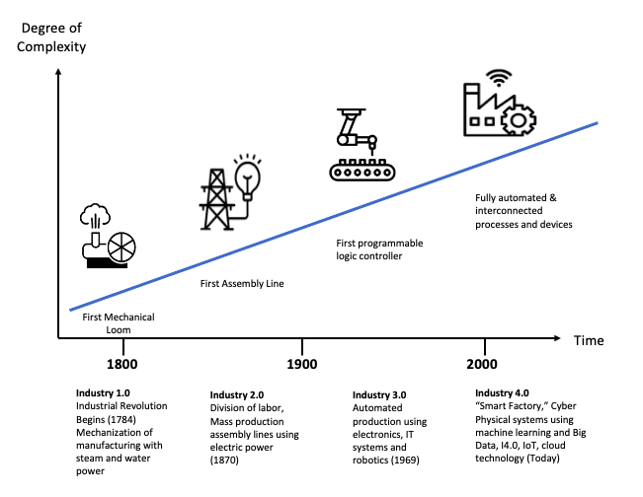
Figure 1.1: Industry 1.0 to 4.0 Overview and Timeline

exchange of commodities, services, and information (Liu and Sun, 2011). In the
warehousing setting, IoT, for example, can provide pickers location information of the targeted items and real-time routing recommendations based on traffic condition.

Design Process of Smart Warehouses
During the Covid-19 pandemic, supply chains were thrown into disarray when the society was ground to a halt to ensure that the medical system was not overwhelmed. Complex global supply chains cannot be filled immediately when restarting operations as there are a myriad of sub-processes with varying lead times. These impacts created bubbles in global supply chains, influencing both businesses and consumers. During the pandemic, reshoring is occurring with companies moving production capacity closer to the point of use because once the total end-to-end costs are calculated, the labor cost savings by moving production to far-flung regions of the globe are disintegrated, or in some cases negative. The key goal that companies spoke in 2022 is supply chain resilience, and with reshoring, the push for solutions such as smart warehousing is coming to the forefront.
Re-shoring operations does not necessarily mean instant success for a company. There are several key factors to consider such as location, supply chain readiness, which goods or services to move, and labor capacity. Along with supply chain impacts, Covid-19 has created severe headwinds with regards to labor capacity, especially technically inclined labor. This is where this paper proposes the implementation of four pillars of smart warehousing (see Figure 1.2): Location Strategy, Infrastructure/Design, Data Management, and Advanced Planning & Control. Each of the pillars complements the others, and all together provide the structure around creating an efficient and resilient smart warehouse. Additionally, each pillar is encompassed by Key Activity Items (KAIs) and Key Performance Indicators (KPIs). KAIs are the key activities that one needs to perform in order to deliver value propositions to customers and add value to the KPIs (Oakley, 2018). KPIs are quantitative metrics that measure the performance of an organization in achieving its goals and objectives. KPIs measure strategic value drivers, driving accountability and the ability to track progress of target achievements throughout all parts of the organization (Bauer, 2004).
The high-level goals of a smart warehouse are to be efficient, reliable, scalable and flexible to any challenging scenario versus a traditional warehouse. The successful implementation of the proposed four pillars will help to minimize hidden supply chain costs and provide efficiencies throughout each step of the value chain. Table 1.1 summarizes the proposed four pillars of smart warehousing, which will be detailed in the following subsections.

3.1 Location Strategy
The methods in which goods flow through the supply chain have increased the importance and changed the role of warehouses. Location selection is a strategic planning problem that shall include the placement of facilities and transportation decisions, as well as customer responsiveness (Kumar et. al., 2020). The first pillar of smart warehousing is the location strategy. KAIs within this pillar are: vendor/customer, in/outbound transportation (rail, seaport, highways, trucking), talent (colleges, blue/white collar), socioeconomic stability in location, and tax/government implications. Logistics fundamentals tie together to reduce the overall cost of the supply chain; thus, the physical location of a warehouse is paramount to the longevity of success.

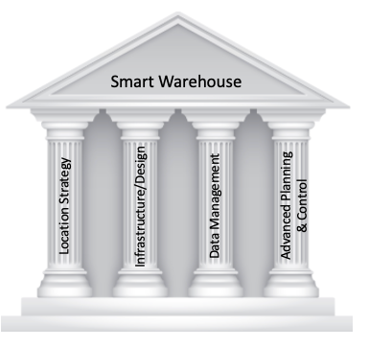
Figure 1.2: Four Pillars of Smart Warehousing

Table 1.1: Summary Table for the Four Pillars of Smart Warehousing
Pillar | Key Activity Items | Key Performance Indicators | Smart Technologies
Location Strategy | - Vendor/Customer Proximity  - In/Outbound Transportation Network  - Talent Proximity and stability  - Tax/Tariff implications | - Transportation Cost  - FTE Turnover | - Advanced data analytics  - Optimization
Infrastructure / Design | - Human Infrastructure (talent)  - Physical Infrastructure (automation)  - Utilization of space  - Productivity | - Utilization of space (%)  - Handling units/time (#)  - Quality (PPM) | - Warehouse Management System (WMS)  - Dynamic Simulation  - AS/RS, AGVs, picking robotics
Data Management | - I4.0 and IoT solutions  - EDI/ASN Connectivity  - Cybersecurity | - Quality (PPM)  - % EDI/ASN Connectivity (%) | - Cloud Computing  - Blockchain, RFID, barcodes
Advanced Planning & Control | - Forecasting/Scheduling Accuracy  - Inventory Management  - Picking, routing, storage strategies  - Excess and Obsolescence  - Expedited freight reduction | - Downtime Reduction  - Inventory Management (DOH, $)  - Scrap cost reduction ($)  - Expedited freight reduction ($) | - Enterprise Resource Planning (ERP) Software  - PowerBI, Tableau, Altyrx, Automation Anywhere  - Data Analytics  - Effects-based thinking

A traditional warehouse had to find a correct balance between the location from its vendor and customer bases. Bowen (2008) indicated that air and highway transportation accessibility strongly influences warehouse locations, which is only increasing its importance over time. Smart warehouses need to consider other important factors with regards to their physical locations. First, firms must consider the complexity caused by the globalization of production networks. Second, firms are increasingly having to compete based on timing of service to consumers. Third, consumer demand has become more diverse and shifted towards customization. Fourth, the rise of e-commerce has complicated logistics because companies need to deliver a variety of goods and services to more diverse destinations.
The location of a warehouse has a consequential effect on the transportation modes, markets served, and customer service levels provided (Schary, 1984). Fundamental studies over the years show that the basics of a logistics system design are the number of facilities, locations, and the product assignment of those locations. Further, Cooper (1990) argued that when choosing a warehouse site location, the following factors should be considered: total landed costs of the supply chain, market conditions, production operation, product complexity, communications, financial impacts, type of warehouse and local impacts. Not much has changed from those times; matter of fact these fundamentals should align with the location pillar for smart warehousing. To build a smart warehouse, a firm should place the warehouse with regards to the total logistics cost, local business climate, talent in the area to support relevant technologies, and orientation to its production and customer base. A simple model developed by Korpela and Tuominen (1996) shows their analytic hierarchy process (AHP) for dealing with intangible criteria that can be applied to the decision theory and conflict resolution when choosing the site location for a warehouse.
The benefit of choosing the right location is that well positioned warehouses are locations where far-reaching production networks can be integrated to minimize complexity. An additional benefit, especially important with the rise of e-commerce, is that the speed and frequency of deliveries can increase with demand-pull logistics (Bowen, 2008). Conversely, due to the rise of e-commerce and globalization, there is a heavy reliance on sea shipments from foreign countries, forcing warehouses to move closer to seaports. The site selection for smart warehouses must be made based on synergies between production and customers, but an intangible benefit is the human infrastructure to support smart warehouses. Thus, smart warehouses should be located in a place where the white collar and blue-collar workforce have the correct skillsets to support the used technologies. For example, an ideal site location is near a college or university with Supply Chain Management and Logistics majors, as well as Engineering or other STEM majors. Additionally, if there are other established competitors in the area, this could be an opportunity to poach already trained talent to support the operation. In light of the Covid-19 pandemic, another factor to consider is the mobility of the workforce. If the local area is not conducive to attracting or maintaining businesses with a fair tax rate, it is most likely that the higher tax rates and cost of living affect the workforce as well. If wages are stagnant, but costs of living rise, this trained workforce could potentially vacate to a more advantageous location, thereby leaving the smart warehouse without the talent needed to maintain operations (Azadeh, 2019b). Potentially this could ultimately lead to the operation shutting down to relocate and losing the investment made to launch in the first place.
Warehouses were traditionally adjacent to a firm’s main operations but have moved to locations which better suit the productivity needs of the warehouses over time. A trend of the warehousing industry between the 1990s and 2000s has been to relocate farther inland (i.e., the Mid-West) to lower overhead costs such as governmental taxes and labor. An interesting fact is that these relocations have not been in the city-centers themselves, but rather in adjacent communities that are still close to major metropolitan centers and are able to take advantage of its infrastructure benefits (i.e., highways, bridges, human talent). Logistics executives balance the costs for green-field versus brown-field sites with regards to locating their warehouses. The advantages of a green-field site are that the warehouse can be placed almost anywhere, with any technology tailor suited to fit the company’s needs; however, the disadvantage are the upfront investment costs. The advantages of a brown-field site are that in most cases upfront infrastructure and personnel costs have already been made, making these very advantageous; however, the disadvantages are the locations might not be ideal to optimize transportation costs and/or the costs to facilitate the site for the business needs might be high.
A real-world example for implementing smart warehousing is the Cincinnati/Northern Kentucky (NKY) region in the US, which boasts its ability to service serve 65% of the nation’s population within a 10-hour drive or 90-minute flight. Additional benefits include five commercial airports within 600 miles, two major air freight shipping hubs (UPS and DHL), 19 interstate highways, 2,800 miles of class-I rail, and 1,100 miles of commercial waterways (Lane Report, 2020). It leaves little to the imagination as to why in 2017 Amazon chose to place its Prime Air hub in the Cincinnati/Northern Kentucky International Airport (CVG) in Hebron, Kentucky, representing a $1.5 billion investment and creation of over 2,700 jobs. The region has attracted Wayfair and DHL to operate their large logistics hubs. The region has been given a Grade A in Logistics Industry Health (Manufacturing Scorecard, 2020) and is considered highly attractive by the more than 100 logistics companies located there. Investments in the region has led to Northern Kentucky University partnering with Rockwell Automation to open a mechatronics lab in 2019 to prepare the next generation to operate, assemble and program integrated manufacturing and robotic systems critical to the growth of the logistics industry. The NKY region has been dubbed the “Silicon Valley of Logistics” with 10 universities offering higher education and training programs geared to supporting the future of logistics and implementation of smart warehousing technologies (NKY Tri-Ed, 2021). Freight Brokerage and 3PL firm Total Quality Logistics (TQL) president Kerry Byrne stated that “with many large corporations in the Tri-State (area), along with multiple colleges and universities, a large part of our success has been driven by top recruits from this area.” With companies like Amazon, DHL and FedEx investing in the region and pushing smart warehousing technologies, engineers and technologists are needed to control these systems, making choosing the right location pivotal to the successful implementation of smart warehousing.
The growth in smart warehousing has primarily been suburban and even exurban, potentially creating adverse implications for low-skill minority workers who overwhelmingly operate these large warehouses (US EEOC, 2004). The reason for moving into these areas is for lower per square foot rent and construction costs, which is critically important as the sizes of warehouses continue to grow exponentially. This key factor coincides with local tax and labor policies to attract and retain these businesses long term. In the NKY region there are over 105,000 workers in the transportation, logistics and warehousing industry, with 35% of those aged 25-64 having a bachelor’s degree or higher (JobsEQ, 2019). Since the largest part of the 105,000-employee total is direct hourly workforce, choosing a location in a Right to Work state is another factor to consider. Under Right to Work laws, states have the right to decide whether workers can be required to join a labor union to get or keep a job (NCSL, 2021). Kentucky is one of such states in the US.
In summary, important factors to consider for the Location Strategy pillar of smart warehousing are air, maritime, highway and rail accessibility, talent training and retention, location stability, and tax/government implications. The increased important of air and highway transportation in a more time-critical economy has facilitated smart warehousing implementation.

3.2 Infrastructure/Design
Once the physical location of a smart warehouse has been successfully chosen, the infrastructure and design of the smart warehouse begins. The second pillar of smart warehousing is Infrastructure/Design, whose KAIs are: physical (automation), human (talent), utilization of space (as a percentage) and productivity (number of handling units per time period). Infrastructure is divided into two categories due to the fact that most firms concentrate on automation (physical) and robotic technologies in their warehouses, but tend to overlook the underlying need for the proper human infrastructure (talent) to effectively run smart warehouses. This subsection will discuss the importance of both and how they tie in together. To further solidify this pillar, Gu et al. (2010) found that warehouse design affects performance, such as throughput, lead-time, quality, costs, space and equipment utilization. Additionally, Richards (2014) stated that the biggest challenge of modern warehouse management in the era of Industry 4.0 are inventory accuracy, space utilization, process management and picking optimization.
Warehouse professionals use the term “clear height” to refer to the distance from the lowest point on the roof joists to the floor slab in order to calculate the racking potential of the space, allowing for fire suppression tolerances, mechanicals and ample lighting. Until the 1970s, the average traditional warehouse clear height across North America was under 20 feet high. The rise of e-commerce pushed technology advancements in warehousing, compiled with increased prices per square foot, and clear heights rose to an average of 28 feet in the 2000s to increase storage capacity. Since 2011, 89% of the 554 large warehouses built in the U.S. have had clear heights between 28 and 36 feet, according to brokerage CBRE Inc. Additional 52 warehouses (or 9.4%), have had clear heights between 36 and 40 feet, and other 11 were above 40 foot high (Whelan, 2015). Cushman and Wakefield, a leader in warehouse real estate, has commented that not only are higher ceilings better for most product types, 36-to-40-foot clear heights, but also important to consider are column spacing with 50 to 60 feet being the standard (West, 2018).
In recent years, as e-commerce companies are maximizing warehouse efficiency with new automation and racking systems, motivating developers to raise clear heights in warehouse design, with 36-to-40-foot clear heights becoming the norm. These increased heights allow new automation technologies such as racking and picking robots and new storage systems, allowing firms to build vertically instead of horizontally, saving money and requiring less land. An additional benefit of vertical warehouse space is that e-commerce providers have leveraged that space by installing mezzanine levels, allowing these companies to put more human inventory pickers in each location. Recent labor shortages and wage impacts brought upon by the Covid-19 Pandemic are pushing warehouses to invest in automated technologies, which take advantage of the warehouse heights allowing firms to install automated picking robots, some of which having dynamic storage capabilities. Lift trucks and other material handling equipment in taller facilities, coupled with labor price increases are cost prohibitive, leading to the implementation of picking robots.
As e-commerce continues to grow, retailers are forced to keep a wider variety of SKUs on-hand in order to fulfill same-day or instant deliveries to customers, which was estimated to make up 15% of last-mile volume in 2020 and will continue to grow (McKinsey and Co., 2016). This prospect has led e-commerce firms to target high population density centers, such as New York or Dallas, which have a large number of millennials with disposable and discretionary income, and increasingly relying on same-day or instant delivery services. Smart warehouses placed in these urban centers reduce last-mile shipping costs, which often exceed 50% of the total-parcel delivery expense (Morris, 2018). An interesting trend supporting this conundrum is in Asia where warehouses that are three-stories are being built in dense cities; albeit Asian countries use smaller trucks, which allows these types of structures to become feasible. Although this has not taken off in U.S. cities, this could be a potential topic for future research with the further rise of e-commerce and around how to accommodate our larger trucks.
Over the past 10-20 years, companies have increasingly implemented technologies into their warehouses. Common technologies have been conveyors, AS/RS, Automated Guided Vehicles (AGVs), robotics, and various forms of scanning. These technologies have been adopted in response to labor shortages in manufacturing and supply chains. The most labor-intensive process and bottleneck operation in warehouses and distribution centers is order picking, accounting for approximately 55% of total expenses (Accorsi et al., 2014). Considering this, many companies have replaced manual operations with automation and WMS to reduce costs, improve efficiency, and enhance environmental sustainability. Compared to humans, robots don’t need lights or air conditioning to perform operations, meaning firms can save overhead costs and reduce their environmental impacts. Indeed, it takes a long time for operators to become familiar with the location of goods within the warehouse while simultaneously picking goods in a traditional warehousing system. The emergence of AGVs has saved non-value-added travel time for operators and shortened training time. The inherent nature of these devices makes it difficult to expand upon or make additional changes to warehouse layouts without significant expenditures; further indicating that the proper infrastructure and design of a warehouse is paramount for success. To combat the lack of flexibility with AGVs, firms are starting to test a technology named swarming AGVs (Lee, 2018); also referred to as multi-agent systems (MAS). Defined by Stone and Veloso (2000), an MAS is a group of entities working together to solve complicated problems that cannot be solved by an individual. By swarming AGVs, direct human labor and resources are reduced and utilization of space is maximized; however, the shortfall is that these areas need to be segregated from human interaction for safety purposes and require a highly technical command center to operate. By using swarming AGVs, warehouses are converting to goods-to-person order fulfilment process. Swarm robotics benefits include robustness, flexibility, and scalability; much like studies that have observed social insects with regards to swarm robotics (Sahin, 2004). A robust swarm can still perform well even if some individual robots fail. As for scalability, the swarm can complete tasks with different sizes and complexities. Humans now are transitioning to specific workstations, which are more comfortable, safe and attractive compared with traditional set-ups. This transformation can completely change the low morale of the worker within a traditional setting, which causes a high turnover in the warehouse industry (Lee, 2018). Although firms are equipping their warehouses with automated material handling equipment to optimize the picking process, there lacks a holistic and sensible approach when implementing these technologies.
A challenge for warehouses and fulfillment centers is adapting their picking capacity to the increasing volumes of orders, especially as the height of warehouses increased, so did the height and capacity of their pallet racking. An additional technology adopted by smart warehouses to combat this challenge is the autonomous vehicle-based storage and retrieval systems (AVS/RS). There are two main categories: horizontal, in which robots only travel horizontally and lifts are used for vertical transport, and vertical, in which robots also move vertically (Azadeh et al., 2019b). Horizontal systems better coincide with an already existing racking structure and can optimize throughput by finding the unique balance between the correct number of shuttle and lifts. Vertical systems are designed to operate with racking that hold fixed-sized product totes, and due to this, outperforms the horizontal systems on throughput and has a lower operating cost (Marchet et al. 2012).
One intent of planning a smart warehouse is the effective utilization of the space, i.e., ensuring the size of the warehouse is correct for the nature of a business. The rise of e-commerce has led to the building of mega warehouses; with the typical sizes of warehouses built in 2021 range from 1.25 to 1.5m square feet. These mega-warehouses were built to handle the high number of SKUs and increased demand from e-commerce shoppers who are purchasing more from their home rather than going to a brick-and-mortar store due to the Covid-19 Pandemic. Walmart has reacted to this new trend with a $220 million investment by opening a 3,000,000 square foot distribution center in Ridgeville, South Carolina filled with varying smart warehousing technologies; primarily to support food distribution to its supermarket areas in their stores. This distribution center is so massive and pulling so much volume that the Ports of Charleston will see an increase of 5% when it is fully operational (SC Ports, 2020). By launching in Ridgeville, Walmart is also leveraging the already existing human infrastructure in the various local warehouses by targeted recruitment (Griffis, 2020). Additionally, the Charleston Metro Area has been a magnet for trained logisticians from Clemson University, as well as its distinguished Supply Chain Programs at the College of Charleston. This is a smart warehouse example that chose the right location, proper space and is now investing in the human infrastructure to support.
IoT provides an efficient method for collecting and sharing information and can help to realize smart warehouses. IoT technologies, such as sensors, RFID, Wi-Fi, and cloud computing, help Industry 4.0 expand its reach. RFID is still beneficial due to its low cost and robustness, which can be easily integrated onto/into products within the supply chain via tags and readers. A study by Liu, et. al. (2018) argued that smart warehouses should focus on four key metrics with regards to RFID technology: availability, mobility, reliability, and scalability, which further encapsulates the overall theme of this research paper on the Pillars of smart warehousing. Lastly, new technologies are emerging into the market for accurate and robust product localization, automatic product tracking and sorting within warehousing to support an Industry 4.0 and IoT framework. 5G, GPS, Wi-Fi and Bluetooth enabled devices are integrated together with RFID to provide further tracking capabilities in indoor and outdoor environments; albeit with some still requiring further technological advances such as battery life for Bluetooth devices and limited 5G access (Liu, 2018).

3.3 Data Management
Traditional warehouses use paper documents, XLS files, email communication, fax and enterprise resource planning (ERP) software to perform the transactions and management of their operations. New business environments have become more global, complex, competitive, and volatile. Examples of KAIs are Electronic Data Interface (EDI) and Advanced Shipping Notices (ASN) to the customer and supply bases, internal technologies (AGVs, AS/RS, RFID), digital forecasting, picking, financial and inventory management. Customer relationship management and e-commerce pressure are creating requirements for large, integrated data scenarios and data analytics capabilities. The evolution into smart warehouses eliminate these manual interfaces, but they also have to store and manage many forms of data. Vast arrays of data dictate the need for a method of data management for the smart warehouse, which has led to technologies such as cloud storage and blockChain. A concern with data remains cybersecurity and data sensitivity to ensure that this data is not misused, stolen, or manipulated for ulterior motives and how this data is properly backed-up so that it may be retrieved in the event of a system failure.
IoT connects the end-to-end supply chain through enabled devices that are able to transmit large quantities of diverse data, with the goal of turning the data into useable inputs for more effective and proactive decision making, many times based on behavior and trends. The IoT infrastructure has four layers (Farahani et al. 2017), with each layer having potential security issues:
- Sensing layer identifies, tracks, and collects data from physical objects.
- Networking layer receives the data, links the cloud and physical objects, being responsible to transmit the data to the service layer through wired or wireless networks.
- Service layer provides efficient and secure services to the networking and interfaces layers by managing services to satisfy user requirements, frequently using data analytics.
- Interface layer delivers data output between users and other applications to analyze data.
Indeed, the growing use of new technologies, such as IoT, AI and blockchain, will affect supply chain management. In the supply chain, blockchain technology enables the real-time track and trace of product, with all its underlying information, as well as identity management solutions (Di Vaio, 2019). Some benefits include improved cybersecurity and protection, transparency and accountability (Kshetri, 2018; Zou et al., 2018), traceability and fraud prevention (Biswas et al., 2018). Customers benefit by being able to trace their goods throughout the supply chain and enhanced trust; albeit most customers are unaware of blockchain technology working in the background to accomplish these improvements. Although blockchain technology provides benefits through the supply chain, it depends on management support to ensure there is a collaborative culture in their workforce to achieve high performance levels.
The key characteristics and benefits of blockchain technology are decentralization, persistency, anonymity, and auditability. Blockchain technology consists of distributed ledger technology (DLT), in which data the security is guaranteed by cryptography through a consensus mechanism (Beck, 2017). In simple terms: Blockchain is a public ledger in which all transactions are stored in a chain of blocks which continually grow when new blocks are attached to it forming chains. Blockchain has started to play a relevant role in supply chains due to the aforementioned increase in data, primarily due to Industry 4.0 technologies such as RFID, sensors, barcodes and GPS, which allows the tracking and tracing of products throughout the supply chain with data integrity. Data integrity is important because poor decisions can be made based on bad data, which is why securing, supporting and storing the data becomes an important role within smart warehousing. Blockchain technology advances the authentication, validation and reliability of supply chains, and critical to this is an auditing process to creating a transactional record (Kshetri, 2018).
There have been several studies with regards to data, IoT, and warehousing, with varying focus areas. One such example from Patil (2018) proposed a dynamic web application system and Software-as-a-Service (SaaS) to provide a cloud-based application of WMS, where software enabled data accessibility and analysis for increased accuracy in warehouse operations which were previously performed manually. A study by Pane et al. (2018) implemented an RFID system in WMS using microcontroller technology with the benefits being efficient operations control, efficient work processes, reduction of errors, increased warehouse productivity and modernized work processes; all qualities to support smart warehousing. Supplementing the next pillar was a study from Mao (2018) which designed a functional framework of an intelligent WMS based on a cloud model using RFID, GPS and an algorithm to solve the scheduling issues in the cloud, providing real-time data management to improve scheduling and decision making. In summation, the integration of these technologies into smart warehouses improve efficiencies, departmental coordination, reduction of labor dependence and cost reduction.
Building upon the previous location strategy pillar, it is quite important to ensure the location of a smart warehouse and supporting data center as moving to another location can be costly and detrimental to the data. Additionally, as smart warehouses continue to expand technologies, it is pivotal to have the properly trained IT staff to manage and support the data integrity of the entire system. Management support and sponsorship is equally as important, having been identified as one of the most important factors for data warehousing success (Curtis and Joshi, 1998). Management motivates people in the organization to support new data technologies, organizational changes, resource dedication and investments that accompany these initiatives. (Watson et al., 1998). It is very difficult to track the benefits of data warehousing projects, making it difficult to get funding and business-unit justification (Sammon and Finnegan, 2000); which is another reason why having proper management support is key to pushing through these barriers.

3.4 Advanced Planning and Control
The final smart warehousing pillar is Advanced Planning and Control, concentrating on managing the ongoing activities of the operations so as to best satisfy customer demand. The main purpose of planning and control is to ensure that operations run effectively and produce products and services as they should (Slack et al., 2001). KAIs for this pillar include forecasting/scheduling accuracy, inventory management (DOH, $), excess and obsolescence reduction, EDI connection (or the like), picking, routing (internal) and storage (dynamic) strategies, expedited freight reduction/coordinate between inbound and outbound. Planning decides what shall be done and how; referring to management decision that affect the intermediate term, such as inventory management and storage location assignment (Van den Berg, 1998). Control is the process of ensuring that the desired output is obtained (Van Goor et al., 2003); referring to the operational decisions that affect the short term, such as routing, sequencing, scheduling and order batching (Van den Berg, 1998). New supply chains have to be faster, accurate, efficient, and provide end-to-end transparency throughout the supply chain. This acceleration in the use of technology, digitization, and new forms of working (i.e., working from home) are going to be sustained for the long term for planning and control. Mass customization of data allows firms to offer a wider range of products, as well as the automation of both physical tasks and planning increasing overall efficiency.
Blockchain technology is used to coordinate all the elements of the supply chain, achieving a level of integration and a competitive advantage not available with traditional logistics systems (Blome et al. 2014). Consumers now take for granted receiving their goods with the click of a button, but the backend is driven by blockchain technology which influences planning and control of the supply chain. A test of this technology came during the Covid-19 Pandemic where customers transitioned from brick-and-mortar retail to online purchasing. This crisis sped up this transition within planning and control in areas such as AI and digitization by several years and even faster in Asia (Sneader and Singhal, 2021). A McKinsey survey published in October 2020 discovered that companies are three times likelier than they were before the crisis to conduct at least 80 percent of their customer interactions digitally. For firms to satisfy customer needs and to maintain a competitive edge, they will have to continually reconfigure and transform the method in which they conduct business.
Warehouse processes that benefit from Advanced Planning and Control include: inbound material handling, product storage strategies, order-to-stock allocation and batching, picking, packing, other value-added logistics activities, and shipment (Ackerman and La Londe, 1980; Frazelle, 2002). In order for an advanced planning and control department to be successful, an ERP system must be used; the most common being from the software developer SAP. The software’s goal is to centralize data management, bringing together different business functions into one database. In this manner, various business functions can co-exist, reducing redundancies, lowering IT costs and risk of data errors. With a centralized source of data management, companies can better manage complex business processes with real-time insights across the business landscape (SAP, 2021). An effective ERP system is important for planning as businesses can improve operational efficiency, improve customer experience, raise productivity and increase profits by reducing obsolescent and excess stocks throughout the value chain. The goal of ERP systems is to reduce or eliminate administrative tasks holistically with automated paperwork administration.
Another tool that planning and control departments use is a Warehouse Management System (WMS), which are used to digitally manage physical, electronic and inventory movements throughout the warehouse (Van den Berg, 1998). WMS software creates synergies within warehousing operations tying together logistics planning, transportation, and other processes within the value chain. Examples of WMS extended warehouse management capabilities from SAP include:
- Inbound processing management: data validation of advanced shipping notifications, confirmation of production receipts and automated goods receiving.
- Outbound processing management: scheduling of packing and shipping activities, picking optimization, stock processing.
- Storage and operations management: optimizing cycle counting and stock taking, internal processes, transparency of available stock, and handling equipment status.
- Cross-functional management features: track and trace capability of shipments, scheduling of inbound shipments, quality and warranty data tracking, and data analytics.
In smart warehouses, Planning and Control departments dictate the put-away process; sometimes referred to as the slotting strategy. WMS default settings push received material to empty pallet rack locations; typically, closer to the shipping end of the warehouse. This strategy might drive Non-Value-Added-Activities (NVAA) on the initial put-away; however, when the material is retrieved for shipment, there is less travel time and handling. With the rise of e-commerce, order picking strategies are of high important to ensure labor costs and picking errors are the lowest possible (Lee et. al., 2018). The picking process is the most inefficient and error prone part of the warehouse process having adverse effects on order fulfillment. An effective storage-location assignment plan can reduce the need for space and the travel time for storage/retrieval and order picking. Thus, there are a few key strategies below which have been implemented successfully by Planning and Control departments:
- Strict order picking: Each worker handles one order at one time
- Batch order picking: Each worker will pick more than one order at one time
- Sequential Zone Picking: Each worker will pick the goods from their zone and then pass the picking list to another worker. The next worker also will pick the goods from their own zone and then pass it again until the picking list is finished and then go through all the zones.
- Batch Zone picking: Orders are picked and placed on the conveyor belt, where sorting is conducted in the final area.
- Wave Picking: The worker picks batch items requiring long completion times where the worker will finish the first wave and then start to pick the second wave. The wave picking is not finished until all the waves are picked.

Validation through A Survey and Interviews
The proposed four pillars of smart warehousing for firms who wish to improve their business performance are validated by five semi-structured interviews with industry experts. In order to recruit participants for this research, an initial number of participants from automotive logistics corporations and industry consulting firms were recruited. These respondents were chosen based upon their extensive industry experience (see Appendix for Interviewee Demographics) and to solidify the closure of the aforementioned mentioned research gap. The survey and questionnaire are aimed at solidifying the hypothesis of this paper with the input of researchers/professors, consultants, and industry professionals (see Appendix for questionnaire). The interviews were structured and designed with proposed questions primarily related to:
  - Readiness of their company towards Industry 4.0 and IoT solutions within the warehousing industry, i.e., knowledge, implementation stage, and future strategic plans.
  - The current and planned use of technologies within their logistics processes, i.e., ERP, MRP, Smart Warehousing, Transportation, RFID.
  - Investment levels for Industry 4.0 and IoT solutions with regards to obstacles and advantages.
  - Impacts due to Covid-19 and how Industry 4.0 or IoT allowed their firms to navigate through the pandemic, i.e., remote workforce, maintenance and/or downtime solutions.
There were several insights which came from the interviews, such as the respondents were in concurrence that investments do not need to be excessive with regards to overall revenue. For example, a firm with revenue of $100M can implement a significant amount of automation with $1-2M of investment. Concurrently, respondents agreed that the return on investment should be within 1 year or the maximum 2 years. One respondent stated: “Why invest a significant amount of money when that technology might be obsolete in 2-3 years? You might be better off purchasing technology that is already 1-2 years old and at a discount.” Another respondent agreed saying “it shows there is a gap between academics and the real-world because most firms will not spend crazy money on unproven technology; we will sit and wait to see someone else go through the learning pains.” This second quote is good to keep in mind since once those technologies improve throughout launch phases, the later versions should have those problems fixed, becoming more reliable with lower costs.
The interview respondents support the framework of the four pillars of smart warehousing. A common theme among respondents was that warehousing technology is moving so rapidly that most firms do not know what to do. An issue most companies have is a lack of standardization, processes and control measures in place as a foundation, which makes taking on these new technologies even more difficult. Further, companies lack a roadmap with real-world examples to follow in order to implement these technologies correctly with a logical methodology. One respondent with 25 years of supply chain and logistics experience stated: “The four pillars serve as a Lean tool that firms can follow when they strategize their journey into smart warehousing.” Another respondent, a 30-year logistics consulting veteran in Europe, stated “the four pillars of smart warehousing are absolutely the correct method as they are anticipatory and a pro-active approach for firms to use as a framework.” All interviewees agreed that the smart warehousing Pillars discuss and have the proper KAIs to address the shortfalls they are seeing in the marketplace. Concurrently, the interviewees stated that the approach of integrating a pillar for Advanced Planning and Control is unique and makes logical sense. Two respondents from Europe, where warehouses are traditionally treated as “off-sets” of the supply chain ran by 3PL providers with the customer’s firm performing the Planning and Control functions, stated that logically it makes sense to have the warehouse perform Planning and Control activities. Although this is not widely implemented in Europe, they mentioned that they will now keep this in mind with future projects; especially considering reading the case study contained in this paper. Indeed, when a warehouse has a team responsible for Advanced Planning and Control, the warehouse can more accurately forecast demands and needs for the business, providing robust inventory accuracy. Inventory accuracy is paramount for data integrity, which is the backbone of smart warehousing technology.
Unplanned in the interview, but discussed by every interviewee, was workforce and talent management in the post Covid-19 world. Talent management for smart warehouses was an issue even before the Covid-19 pandemic, but now firms are facing what one respondent referred to as a “war of talents.” Firms need to invest funds and technologies into their organizations to reduce the need for direct labor, but the focus now shifts to the indirect workforce. The President of a logistics training and consulting firm in the Southeast United States said that “the Location pillar is very important because firms only look at inbound and outbound but forget that humans have to run the business.” An executive recruiter with over 30 years’ experience, specializing in the logistics and supply chain fields, mentioned “warehouses are getting upgrades as a profession.” The current warehouse industry needs a higher reliance on tech skills, which is surpassing other sectors in the logistics field, coinciding with the rise of e-commerce pushing the development of smart warehouses. The interviewee went on to mention that critical hires are harder to find, leading to sign-on bonuses and high counteroffers previously never seen. An unfortunate outcome of the lack of talent is that even mediocre talent is jumping to other companies and are receiving higher salaries due to the desperation in the marketplace to fill open roles. The interviewee stated: “Firms are realizing that unless they have the right supply chain, managed by the right talent, that they could be further impacted by global disruptions in the future, so they are willing to pay a premium for talent.”
Further complimenting the Location and Infrastructure/Design pillars, interviewees continued to discuss the importance of locations with respect to talent for smart warehousing. A common challenge shared is that most of the younger talent want to work either fully remote or primarily remotely; however, many functions in a smart warehouse need the talent onsite or at least nearby to be available in short notice to fix a problem. The executive recruiter went on to mention that millennials are concentrating more on work/life balance, working from home and having the ability to travel for pleasure and work remotely. On the other hand, older employees are resistant to changes and the “Baby Boomer” aged workforce are starting to retire in droves, making the situation on finding talent even more difficult for the employers. Contributing to the importance of location are the inflated home prices and difficulty in finding homes in the post Covid-19 era, making relocation difficult for employees who do want to relocate for employment and very expensive for employers who pay for relocation. The latter is a reason that employers are now seeking out younger talent who are renters as they are easier and less costly to relocate. Thus, choosing the right location for a smart warehouse is a delicate balance and something to consider in order to have the proper talent available.
Although the interviewees were complimentary and supportive of the Four Pillars of smart warehousing, there were surprising outlier comments which could potentially be contributed from their personal experiences versus the others. One interviewee stated that he does not feel that smart warehouses need talent inside of the warehouses. In his Amazon experience, he elaborated that Amazon centralizes their digital talent in very few locations (i.e., Seattle) to support the distribution centers. This respondent said that other firms might have different strategies, but this difference with Amazon is mainly due to their heavy reliance on Amazon Web Services (AWS) and being labeled as a technology company. A second surprising comment was when an interviewee with 25+ years logistics experience, currently a Senior Vice President of Industry 4.0 for a large multi-national corporation, stated that the return on investment for Industry 4.0 technologies should be 4-5 years and be at least 10% of revenue. As he was one of two European interviewees, this statement might stem from the conservative and longer time frame nature versus the American colleagues. He went on to mention that warehouses should not be fully automated as most technologies do not provide enough of a savings over traditional labor, but he did disclaim that this is based on his automotive experience and might not translate into other sectors. Lastly, it was a pleasant surprise that the interviewees confirmed part of the gap statement that there is a large gap between the academic-world and the real-world with regards to warehousing. Making it even more surprising was that two of the five interviewees had PhD degrees.
The interviews shed informative feedback with regards to the three questions that this paper aims to answer. Potential opportunities for smart warehousing include a short-term focus on talent retention and training, coupled with a shortage of employees will push warehouses to implement smart warehousing technologies. An additional opportunity is proper benefit to cost ratios to ensure that the firms are making the most logical choice for technologies over the correct time frame to support their businesses. Potential barriers include investment and talent. Interviewees commonly stated that in the new post Covid-19 world, firms are chasing the market and reacting by purchasing technologies without thinking it through due to high customer demands and an unstable workforce. Additional challenges are selecting and deciding on proper technology, supply chain network design, data integrity and security.
Next, does the smart warehouse have the infrastructure and/or facilities to operationalize new technology? As previously mentioned, interviewees stated that the smart warehouses of the future need to not only think about their center of gravity with suppliers and customers, but also the talent needed to run these warehouses. It is too early to determine, but the future is starting to point to local-for-local manufacturing and distribution, which will push warehouse to centers of gravity towards talent and performance, rather than traditional supplier/customer relationships. Interviewees commonly said that there are no common frameworks or pathways for firms to follow for technologies to implement. Due to this, companies are divergent on technologies, which ends up making consultants very rich, but the true benefits are not fully proven. In summary, smart warehouses should focus their attention to ensure the proper infrastructure and facilities are in place to operate new technologies.
Last, what skillsets do the smart warehouses need to support their operations? During the interviews, it was evident that the skill sets needed are two-fold: direct shop-floor associates and the white-collar workforce. For the direct shop-floor employees: dynamic and tech savvy employees who can work flexible hours and work side by side with automation (robotics, etc.). The white-collar workforce will need to be familiar with current smart warehousing technology and then have to have the adaptability to learn new, cutting-edge technology. This workforce might be remote in the new post Covid-19 world, which might mean companies have to become flexible to accommodate this new talent requirement or concentrate their technology talent in a remote location from its distribution centers (i.e., Amazon in Seattle). These shop floor and white-collar associates also need to be stable in their employment because companies will be investing in their knowledge and talent development to run these smart warehouses, thus employee retention will be a high focus.

Case Study
Academic literature has recognized that the case study approach is a useful method to investigate unexplored phenomena (Eisenhardt, 1989) and allows one to examine phenomena separately from their context and to consider specific variables (Yin, 1994). In this section, a manufacturing company (alias name Alpha) is discussed and studied. Alpha is a reputable, multi-national manufacturer of electronic automotive components for the Original Equipment Manufacturers (OEMs) and aftermarket sales businesses. Electronic components have a high complexity of raw materials and semi-finished goods, with long lead times, creating difficulties for Alpha to maintain lean inventory levels. The automotive business yields low profit margins (3-5%), which in turn drives a high-pressure environment for its suppliers to meet demands without costly delays. Additionally, the automotive business has gone through an upheaval during the past decade where its customers want more customization with their vehicles, driving complexity throughout the production process.
Throughout its 100-year history, Alpha has been a market leader; however, new business environments have eroded profits, necessitating the need for a transformational change. The transformational journey for Alpha is highlighted below provides an example of what companies who adopt Industry 4.0 and IoT solutions could potentially expect. Alpha produces approximately 50% of its products in Europe and China, importing those products to North America into a network of warehouses in Canada, Mexico, and the United States. To justify the Location Strategy Pillar of smart warehousing, Alpha’s business model strategically located its warehouses where it had historical presence in those countries, with a trained workforce and existing manufacturing facilities nearby. This strategy allowed Alpha to scale up its warehousing operations with lower risks and costs. On the other hand, this business model has the potential to create hardships due to long lead times, transportation costs and logistics planning forecasting.
At the onset of this transformational journey in 2018, Alpha was suffering from fulfilling customer orders and rising logistics costs. The planning organization was facing scrutiny and received the majority of the blame for this lack of performance. Performance evaluation is important for both warehouse design and operation, providing feedback on the quality of the operation and most importantly how to improve it (Gu, et. al, 2009). The following Key Performance Indicators (KPIs) in Table 1.2 with their initial values were chosen as a method to monitor and track performance.
New leadership was brought in with a focus on employee engagement, training, fundamentals, accountability and digitalization in order to transform into a pro-active planning organization. Alpha was already using an SAP ERP system, but the data integrity was lacking, both systemically and physically; if data is not cleaned up or accurate, orders and scheduling is taking into account fictitious data which further compounds the problematic KPIs. The first order of business was to count the material in the warehouses with a “wall to wall” physical inventory, performed simultaneously at all warehouses. The results of this inventory indicated that upwards of $25m of inventory in the warehouses did not have valid customer orders for over 6 months; this meant that Alpha was potentially sitting on $25m of obsolete stock in its warehouse network. This news did not go over well with business stakeholders, further pushing to a transformation.
Once the physical inventory was performed, SAP Warehouse Management System (WMS) was updated with correct inventory levels, locations and customer demands. The final result was $19m USD in obsolete and dead stocks; meaning this material does not have active or forecasted customer orders. Unfortunately, this material had to be scrapped, but highlighted the necessity for inventory accuracy and transparency. With the obsolete material removed from the warehouse, the average storage capacity in the warehouse was approximately 90%, which allowed a further cost savings by discontinuing a contract with an offsite 3PL that stored overflow material.

Table 1.2: Case Study Initial KPI Results
KPI | Units | 2019
Inbound Quota | % | 89.8%
Outbound Quota | % | 92.7%
Inventory Inaccuracy Cost * | $ | $19m
Warehouse Space Utilization | % | 105%
Productivity | pallets/man hour | 0.84
Quality | PPM | 5500
* Cost associated with blocked/obsolete/scrap inventory

Technological advances require an investment in training, which meant that the organization began rigorous training in SAP ERP and WMS to ensure that the associates understood the various transactions. These activities supported the Infrastructure/Design pillar of smart warehousing and were essential to ensure that the associates did not inadvertently misuse the SAP tools, which could potentially undo the progress previously mentioned. The first investment in the warehouse was in barcode and scanning technology with automatic integration into SAP ERP and WMS. The goal of this technology is to provide inventory transparency resulting in fewer lost parts, less material shrinkage, reduced labor, and time savings because of fully automated data capture. Now planners can have a real-time view of the on-hand material to calculate accurate vendor orders versus customer demands, allowing for an optimization of the supply chain.
Although SAP is a common tool for companies to use, it is not user friendly, and it is not regarded as a benchmark tool for logistics operations; mainly used in financial and HR applications. It was not financially feasible for Alpha to replace SAP with a proprietary or another system. The new leadership noticed that planners downloaded information from SAP into Excel to perform analysis or other tasks, and then re-imported that information into SAP. This increases the potential for human error, creating data integrity concerns. The planning team researched different automation tools that could interact with SAP and found the following systems:
- PowerBI,
- Tableau,
- Altyrx, and
- Automation Anywhere
Further descriptions and benefits of these tools can be found in Appendix 3. With the use of these tools, the planning team-maintained SAP data integrity and created an automated system to display the information in a user-friendly format to make proactive decisions, highlighting the Data Management pillar of smart warehousing.
Once this foundation was established, a larger investment of $250k was made in 2020 into RFID technology. RFID technology presents increased data capability and the ability to read RFID tags without line of sight. This technology was implemented strategically in the areas with higher reliability on labor and areas which had data discrepancies. The initial area was receiving due to a high level of human error when physically scanning material, because either an operator forgot to scan or bar-code labels were damaged, leading to either mis-scanned material or lost labor to manually enter information. Another aspect of this investment was integrating RFID tags on incoming returnable containers. A further benefit of RFID technology is the ability to track the product through its lifecycle, which is important to ensure that quality tracking methods are followed in the event of a recall or other similar event.
Alpha integrated a Planning and Control organization to manage these new technologies, who quickly developed automation tools to proactively detect fluctuations in demand forecasts to mitigate production order risks. Results indicated that the use of adaptive planning tools and distributed intelligence outperform planning and production methods which do not incorporate these methods (Tu, et. al., 2017). These tools further improve inventory control policies, as the case study proved above, as well as created these efficiencies further upstream and downstream. With IoT technology, material flow is controlled, and information flow is transparent, allowing the planners to quickly respond to any situation. Compared with traditional forecasting and planning, IoT allows the planners and warehouse personnel to obtain relevant contextual information and increase SCM performance, while lowering logistics costs. Alpha has real-time material monitoring and prompt order-change handling capabilities. IoT and Industry 4.0 solutions have allowed Alpha to monitor a wide variety of materials and handle different disruption scenarios automatically.
During the implementation of RFID technology, the previously mentioned automation tools Tableau and PowerBI, were implemented in the warehouse to integrate the Warehouse and Planning and Control teams. Tableau is used to track stock deviations, inbound and outbound freight, and labor performance; driving improvement on labor reduction by leveling out delivery window times to optimize labor with minimal downtime. PowerBI is used during inventory management review meetings, daily shop floor reviews to monitor stock levels and scheduling expedites. The implementation of these automation and inventory forecasting tools lead to increased inventory control policies, also reducing operations to 1.5 daily shifts versus the prior 2 daily shift operating pattern. This structure also improved employee morale and customer satisfaction, further bolstering the Advanced Planning and Control pillar of smart warehousing.
With these technologies stabilized, the next evolution in the warehouse will be automated put-away of materials by using automated turret fork trucks. This technology is still under development by a third-party vendor who specializes in warehouse automation vehicles, with a tentative launch of late 2023 to early 2024. The warehouse currently leases six manual turret trucks, each with the capability to put away an average of 350 pallets per 8-hour shift; the automated vehicles will improve this metric to 450 pallets per 8-hour shift, reducing the overall number of trucks required. For the purposes of this case study, a benefit/cost calculation is in Table 1.3. This technology generates a positive cost savings relative to other potential projects, providing an estimated yearly savings of $143,560. The labor shortages in the wake of the Covid-19 pandemic indicate this project’s importance: eliminating the reliance on manpower. Issues related to warehouse operations are the second most studied theme in literature, specifically with resource utilization (Kumar, et. at., 2020), thus making these improvements pivotal for the success of the business.
The choice of KPIs and their respective targets should be decided by the performance managers to achieve the desired level of outputs. It ultimately depends on the organization to design the smart warehousing systems to be deployed (Parhi, et. al., 2020). Warehouse KPIs vary by industry and company, and the ones suggested in this case study are valid for implementation in smart warehouses. For example, most of the warehouse work is in order picking, thus the number of order lines is a good indicator for the total amount of work done in the warehouse (Drury, 1988). Additionally, according to a 2019 Warehouse Education and Research Council Operational Benchmarking report, out of their 5 suggested top KPIs for benchmarking warehouse performance, the case study presented in this paper has 3 of them: outbound quota, average warehouse capacity, and inventory accuracy.
Further strengthening the four pillars of smart warehousing KPIs are the results of the case study (see Table 1.4), which approach or beat industry benchmark levels (Tillman, et. al., 2019). Today’s consumers demand receiving their product in the quickest and cheapest manner possible, making outbound quota an extremely important for their businesses. Best-in-class companies achieve 99.7%, where Alpha achieves 100% for outbound quota. Average warehouse capacity used over a certain time is a key space utilization for warehouses; where best-in-class companies average 92.54% of their warehouse space and Alpha averaged 78% in 2021. With respect to warehouse productivity improvements, firms who implemented state of the art technologies were able to improve performance by 16.9% (van Gils, et. al., 2019), whereby the case study had an improvement of 42%. Best-in-class companies have 99.9% inventory count accuracy by location, where Alpha commands an inventory accuracy of 100% ($220k of blocked/obsolete/scrap stock over an average inventory of $165m). The above case study results further indicate lean SCM with regards to lower inventory carrying costs, reduced transportation costs, smoother ramp-up of new parts and less end-of-life obsolescence. The case study proves that by integrating the Advanced Planning and Control pillar of smart warehousing, there is an increase in the company’s reliability, scalability, and flexibility.

Table 1.3: Case Study Benefit/Cost Calculation
Manual Turret |  |  | Automated Turret
Yearly Lease and maintenance | $144,000 |  | Yearly Lease and Maintenance | $200,000
Yearly Wages | $274,560 |  | Technician Wages | $75,000
Yearly Operating Costs | $418,560 |  | Engineering Cost (1 time) | $125,000
 |  |  | Year 1 Operating Costs | $400,000
 |  |  | Year 2 Forward Operating Costs | $275,000

Table 1.4: Case Study 2021 KPI results
KPI | Units | 2019 | 2021 | Improvement
Inbound Quota | % | 89.8% | 99.9% | 10.1%
Outbound Quota | % | 92.7% | 100% | 7.3%
Inventory Inaccuracy Cost | $ | $19m | $220k | 98.8%
Warehouse Space Utilization | % | 105% | 78% | 27.0%
Productivity | pallets/man hour | 0.84 | 1.26 | 42.0%
Quality | PPM | 5500 | 110 | 98.0%

The smart warehousing principles suggested in the four pillars provide many advantages such as space saving due to automation, savings on labor costs, material availability, and savings on operational costs such as HVAC and electricity. Indeed, automation technologies provide scalability and throughput flexibility, which is essential in e-commerce environments with high demand variability (Azadeh, 2019b). Warehouse operations can be improved with intelligent pick-and-pack capabilities, barcode scanning, automated cycle counting and WMS integration throughout its processes; all of which improve reliability, scalability, and flexibility. smart warehousing technologies require scalability and a long-term vision, as the return on investments are earned back typically in the medium to longer term.
Now to reflect on the initial questions that the intent of this paper was to answer. The potential opportunities for smart warehousing are the improvement of performance KPIs, customer performance metrics, cost savings potentials and adaptability towards the future of warehousing with the influence of e-commerce. On the other hand, there are barriers for smart warehousing; primarily being barriers to entry with the investment needed to bring in this technology, as well as the adaptability and knowledge of the workforce. Second, this paper demonstrated that the 4 Pillars of Warehousing provides the infrastructure and facilities needed to operate these new technologies. Third, the paper demonstrates that smart warehouses need to ensure the properly trained workforces are available to support operations. Key items to keep in mind are the location in relation to universities, locations that do not have high turnover in population and can draw talent, and close in proximity to other smart warehouses to take advantage of existing talent. The case study and interviews validated the premise of the four pillars of smart warehousing, proving a framework for firms to implement and improve their operational performance.

Discussion and Conclusion
The four proposed pillars of smart warehousing respond to all three of the questions posed in Section 1, although the application of the KAIs requires attention to be focused on them all. Therefore, it is beneficial for both practitioners and researchers to consider all of the aspects identified in evaluating and refining their businesses. The four pillars give a holistic approach to practitioners, with the intention of demonstrating a framework as a guideline. Complimenting the holistic viewpoint of this paper was the perspective of Gu et al. (2009) on warehouse design and performance: warehouse decisions are strongly coupled, and it is difficult to define a sharp boundary between them.
This research contributed to the study of warehouse management by developing a proposed framework for smart warehousing. The four Pillars of smart warehousing serve as a guide for firms to measure their performance and determine suitable steps for implementation. This research focused on warehousing trends in the United States, with a case study in the Automotive Industry; albeit based on a large multi-national conglomerate. The case study clearly demonstrates the effectiveness of this framework due to the fact that the company was able to achieve benchmark levels of KPI results. This study helps warehouse managers benchmark their warehouse against the framework discussed in this paper. Cross fertilization between the groups of practitioners and researchers appears to be very limited (Gu et. al., 2009). This paper contributed to the gap between research and real-world implementation by demonstrating a case study that could be extrapolated or cross-referenced to different businesses.
Future research could be conducted to further validate the four Pillars of smart warehousing by testing in warehouses located in non-Western countries. Another potential future research topic would be the comparison on safety metrics between traditional warehouses and smart warehouses. Additionally, a cost comparison between various types of Industry 4.0 and IoT warehouse technologies to show what are potential returns on investments (ROI) that companies could anticipate. Lastly, a study can center around a decision matrix with pro/con and risk/benefits between Industry 4.0 and IoT warehouse technologies so that companies could gage where their current operations are and what are future stages to implement into their businesses.
The Covid-19 pandemic uncovered vulnerabilities in the intertwined and expansive supply chains of many companies, making the timing of this paper helpful for firms needing insight into smart warehousing. Coming out of the pandemic, firms are having to rebalance and strategize their future operations; many firms did not make it out of the pandemic. A key strategy that was touched in this paper, but will require future research, is re-shoring. According to McKinsey and Co., as much as a quarter of global goods exports, or $4.5 trillion, could shift by 2025. Further accelerating this trend is the cost differences among developing and developed countries is narrowing, mainly due to the advancements of technologies that rely less on direct labor; i.e., smart warehousing. Companies that adopt Industry 4.0 and IoT principles can offset half of the labor cost differential between China and the United States (Sneader and Singhal, 2021). This is something to keep in mind when optimizing end-to-end supply chains ad there is the potential to reduce this cost differential further. The aforementioned does not mean that multinational firms are rushing to re-shore operations; there are some operations that have regional expertise and would not benefit by moving. Questions on security and resiliency mean that companies are likely to be more thoughtful and proactive about the business cases for such decisions. Overall, the implementation of the 4 smart warehousing Pillars proves to be a means to assist firms in their readiness and resilience.

: How can we prepare a future supply chain management leader?

Introduction
The supply chain management (SCM) field has emerged over the past two decades from a functional perspective with a central focus on the physical distribution of goods, to a multidisciplinary concept that touches almost every aspect of our daily lives. Influences in the marketplace such as e-commerce, offshoring, and globalization have created global networks which have necessitated the need for companies to have a SCM focus on their businesses. These influences have pushed changes in company culture, organizational structures, key performance indicators (KPIs), strategic decisions, information systems, and planning processes. With these changes in SCM needs, companies are creating executive roles in their organization’s top management teams (TMT) (Kroes et al., 2021) to handle SCM and logistics topics. Common names for these roles are Chief Supply Chain Officer (CSCO), Chief Procurement Officer (CPO) and Materials Management Officers, with these roles becoming more commonplace after the economic downturn of the economy in 2009. The creation of high-level CSCO positions can be attributed to the awareness that mitigating risk and volatility in the supply chain can generate a competitive advantage for firms and increase profitability. A common definition for a CSCO is a TMT-level executive who is explicitly responsible for enterprise-wide supply chain management activities, including coordination with suppliers and customers, demand and supply-side matching, and a flow perspective (Roh et al., 2016), including coordination with suppliers and customers, demand and supply-side matching, and a flow perspective (Mentzer et al., 2008). An operational benefit includes a larger span of control for supply chain activities aligning the firm’s overall strategy with the supply chain in mind, which develops strategic business partnerships. According to Rho, et al. (2016), the increase in CSCO appointments is consistent with the claims of operations management researchers, who argue that operations capabilities are crucial sources of competitive advantage in many corporations and that operations executives should be integrated in strategic decision making.
A Harvard Business Review paper by Slone et al. (2007) argued that to have the highest talent in the supply chain a company needs to pick the right leaders, initiate benchmarking, create incentives, keep up with technology and trends, factor supply chain management into business plans, and resist short-term thinking. In the early 2000s, many CEOs did not quickly react to market changes, nor did they understand the business-critical nature of the supply chain operation. Further, companies had found themselves having to convince CEOs that SCM and Sales and Operations Planning (S&OP) were critical for their company’s success. Slone et al. (2007) interviewed 27 supply chain executives who worked at large manufacturers and retailers and found that five majored in SCM as undergraduates, four had earned MBAs in SCM, and five more had taken SCM executive development courses. An interesting aspect was that the other 13 executives had no SCM training or experience before taking on their assignments. Overall, a low take rate on SCM education in the higher levels of SCM management.
Although many companies now employ CSCOs, these positions are a new development in comparison to other C-suite roles (Kador, 2012), which has led to companies scrambling to fill these roles with qualified candidates with the proper skillsets. It would not be prudent for a CEO to appoint a person with little to no manufacturing experience to an executive role responsible for manufacturing; thus, the same method should be applied for appointments to CSCO roles. Through the past 20 years, CEOs have realized that their supply chains have become more complicated, touching various business functions and processes, which present the opportunity for strategic initiatives to positively affect their profitability. An added benefit to experience is that companies can keep up with Supply Chain technologies and trends, such as Smart Warehousing and network optimization, with other process tools such as Lean and Six Sigma to increase performance along the entire supply chain. Indeed, no matter how capable a candidate might be, CEOs and Board Members are appointing CSCOs and Senior SCM executives who have a formal SCM education, significant prior SCM experience or both (Slone, et. al, 2007).
Many organizations have relied on executive education programs, such as executive MBA degrees or certificate programs in SCM, to assist in finding or developing the needed talent for CSCO roles. Executive education is reactive because executives have typically reached a point in their career where they potentially need to fulfill this education requirement to pass onto the next promotion or role, rather than learning skills to improve performance. Indeed, it is difficult to categorize business executives into a category; however, there are some participants of executive courses that have a practical outlook on education and have specific problems in mind to solve when attending these courses (Bernon, 2013). Although executive education participants are more mature and approach leaning in a different way than younger students in formal education, it begs the question: which method is more effective?
According to Vokurka (2011), SCM education and career preparation has six major gaps with regard to SCM competencies: strategic visibility and alignment; talent management and leadership; supply chain models including optimization, risk and cost; process orientation including measures, information, and integration; relationships and trust; and supply chain architecture and structure. Firms struggle to find capable managers that can execute effective SCM strategies which create value across organizational and international borders. In a study by Fawcett (2009), companies have pled to universities to create the curriculum needed to produce this effective type of manager, but firms are finding it difficult to find people with the right skills, with a deep functional know-how guided by a holistic, collaborative vision to turn strategies into reality. Although this study is over 10 years old, it is important to note the time frame with regards to the study this paper intends to discuss: the effectiveness or ineffectiveness of SCM University Programs with regards to executive roles in SCM. To our knowledge, there does not exist a study that compares the top SCM University Programs against top CSCO executives to determine if there are any correlations. This study could identify if these SCM programs create value for students who want to rise to the level of CSCO.
The idea for this research paper was developed after the recent university program rankings for SCM, while listening to college interns and executives at a multi-national firm discuss these rankings. The timing is at a critical moment for our society as the supply chains and employment markets are still impacted from the Covid-19 pandemic. In determining contingency and succession planning for roles in his own organization, the author attempted to find information with regards to SCM university programs and correlation with senior level SCM roles but could not find existing information. Additionally, the recent graduates coming out of university lack real-world skills, sufficient experience, or patience to learn the business, yet believe they are ready for senior level SCM roles. In the SCM industry, there is a belief that there is a shortfall of supply chain programs which are preparing students for success in this career field. This paper seeks to answer the following questions:
  - Can a future leader of Supply Chain Management be molded from an early stage?
  - Are there any educational patterns among CSCOs?
    - i.e., universities, majors, career patterns
  - Which degrees will prepare people better for executive level management in SCM and is there a return on investment?
    - i.e., universities, coursework, cases, programs

Overview/background
To be competitive in today’s economy, companies have become global with their footprint, and because of those extended supply chains have integrated supply chain management into their strategies. With the involvement of CSCOs in daily business, many companies have seen financially positive results as they proactively deal with supply chain shocks and disruptions. These same firms have changed their mindsets from having primarily manufacturing executives controlling most of the firms’ resources (Womack et. al., 2007) to having CSCOs controlling most of the company’s expenditures and span of control with employee reporting (O’Marah, 2016). As Logistics and SCM continues to influence all business sectors to a degree, CSCOs are now rising to the COO and CEO level of these corporations so that they can influence product offerings, sales, and services. A study from Körber, M., Cotta (2021) indicated that CSCOs are most effective in large corporations with complex supply chains, and that corporations who have a CSCO on their TMT can quickly resolve issues, improve quality, and influence strategic decisions.
As the role of CSCO has solidified, so have the main responsibilities, of which the following tend to be common among various sources: leader of the supply chain organization (Swink et. al, 2014), risk reduction, cost improvements and creating strategic and synergistic partnerships with other members of the company’s TMT (Demeester et. al, 2014). With these factors in mind, it is critical that a company’s decision makers, such as Boards and CEOs, choose a qualified CSCO well-versed in the SCM field. Well-versed executives lean on experience and education to make their supply chains smarter and integrate new technologies that keep their companies on the cutting edge. Indeed, during the recent Covid-19 pandemic, many companies and executives were caught by surprise by the severe supply chain disruptions, with many going out of business or posting financial losses. CSCOs will not omit all risks due to unforeseen supply chain disruptions due to a global pandemic, but companies who have highly qualified CSCOs were able to withstand the vulnerabilities, pressure, and disruptions better than firms who did not have CSCOs.
Butner (2010) performed a study in conjunction with IBM interviewing 400 global senior executives who were responsible for their organizations supply chain strategies and operations. The main premise of this study was to find out if CSCOs should exist and if so, what were their key factors of importance. The study indicated that CSCOs should have expertise in the SCM field to interconnect various points, create synergies, reduce costs, and have flexibility along the supply chain when challenges arise. Further, the study produced five key findings for the state of supply chain management and focus areas for CSCOs:
- Cost containment: supply chains and CSCOs need to adapt to adverse influences such as pandemics, inflation, energy prices, and employment levels.
- Visibility: effective decision making based upon information sharing and collaboration.
- Risk: how effective can the CSCO and supply chain mitigate risks.
- Customer focus: supply chains must focus on customer satisfaction.
- Globalization: ability of the supply chain to manage globalization challenges such as unreliable suppliers, long lead times, pandemics, and political strife while still generating revenue.
Since that study, many industry changes have influenced SCM, such as Industry 4.0 (I4.0) and the Internet of Things (IoT). Experts are billing I4.0 as revolutionary in comparison to the previous Industrial Revolutions because I4.0 focuses on data transparency and connected devices throughout the world that talk to one another with the focus of improving communication and reduction of human interfaces. Each industrial revolution builds upon the prior, and I4.0 (See Figure 2.1) builds upon the third by leveraging new technologies such as additive manufacturing, advanced robotics, AI, blockchain, drones and IoT. IoT has inspired many innovations within logistics and supply chains and will continue to further influence on supply chain management. New

Figure 2.1: Industry 1.0 to 4.0 Overview and Timeline

technologies along with real-time mega-data aim to transform manufacturing and service fields and are now focusing on the Logistics and Supply Chain fields.
Throughout the Industrial Revolutions, education and skills have influenced the workforce along the way, only accelerating with further influences into SCM. For example, during the period between the two World Wars, college attendance increased fivefold, from 250,000 to 1.3 million students (Thelin, 2019); although during this era college degrees or academic credentials were not job requirements. The Third Industrial Revolution brought more academic changes, primarily driven by the rise of computers and digital technologies, with more students attending colleges and companies starting to require academic credentials (Li, 2020). Logistics and SCM were also changing rapidly with the advent of standardized packaging, sea container boxes for trade between countries, globalization, and other new transportation inventions, necessitating the need for an educated workforce to manage this new field. During this time, Community and Junior Colleges grew, while universities began to focus on technical and managerial programs to support the expanding economy. The Fourth Industrial Revolution is commonly known by educators, scientists, and university professors to have impacted the roles and curriculums at universities, especially in logistics with degree programs starting and companies seeking out qualified candidates.
Corporations are now seeking talents with more soft skills, conceptual knowledge, and a holistic, global mindset (Fawcett and Rutner, 2014) versus a traditional technical skillset, indicating needing stronger ties between academia and industry. Kerr (2008) complimented this thought with a study on CSCOs and needed industry skills, concluding that supply chain professionals need to have strong analytics skills, tools for evaluating business options, communication, and presentation skills, with broad spans of control. Further, an MIT study regarding the shortage of SCM talent (Cottrill, 2010) indicated that ideal managerial skills include managers who can thrive in ambiguity, balance of hard and soft skills, and global/cultural awareness; especially important as globalization pushed managers to manage teams in multiple countries. Blanchard (2011, 2014) indicated that there are not enough qualified managers in the SCM field, primarily due to increasing complexity, and that academia needs to adjust to this new demand. One school of thought is to link competency-based education in business schools for SCM (van Hoek et. al. 2011); supporting this argument were Fawcett and Rutner (2014) who argued that SCM students who understood finance and economics could make better decision making. Indeed, the rise of online education, coupled with industry partnerships, is finding its way into the industry to keep investing in SCM talent within their organizations.

2.1 Literature Review
The 1950’s were selected as a “starting point” for logistics as this time frame is commonly referred to as the “Transportation Era;” being when the Federal Government began the Federal Highway Act of 1956 and authorized the National Interstate Highway and Defense Highway System (Ahmed, 2022). The history of Supply Chain and Logistics in academia started in the in the military, becoming refined during the 1950s and one of the first books on this subject was Economics of Transportation by D. Philip Locklin (1954). By the 1970s, there was a focus on transportation and distribution due to deregulation of industry, with universities now starting to research and publish papers on logistics. SCM became a wide research topic during the 1980s as globalization and international trade started to take hold, and the first college courses started to be offered in the 1990s (Bernon, 2013). During the 1990s businesses were implementing cost control measures to improve performance, with digital communication such as e-mail and EDI. Academia, in conjunction with corporations, began introductory university and executive courses in SCM, but this was still a reactive method to raise the skill level (Freeman and Cavinato, 1992). Published textbooks during this time, which the industry now holds in high regard, include Fundamentals of Logistics Management (Lambert et. al 1998) and Business Logistics Management (Ballou, 1998). By the 2000s, many colleges were offering courses and curriculum in SCM, including significant growth in online education platforms (Southern, 2011). Key to note is that undergraduate courses focused on technical topics, not on strategy and leadership (van Hoek et. al, 2002), which would be interesting to see if this leads to potential gaps in executive roles later. A study by Sinha, et. al (2015) found that gaps exist between SCM talent requirements required by industry and the skills generated in university, which further highlights the need to focus in this area.
Research into SCM has gained popularity, with research trends focusing both on undergraduate and masters’ programs (van Hoek et al., 2011); however, there remains a gap in research if there is a direct correlation on SCM educational programs preparing professionals for reaching CSCO levels. The number of articles on logistics and SCM have increased over time, and a Larson (1998) study found that there were only 147 papers written between 1980 to 1997 specifically discussing SCM in academia. This makes plausible sense as SCM programs grew in popularity towards the late 1990s, along with the rise of CSCO-like positions. Indeed, it is important to determine what skills executives need to perform at the CSCO level. In response, many universities rushed to create new curricula and courses incorporating SCM topics, which were based off existing management, logistics, or purchasing courses. Michigan State University (MSU) became the first degree-granting program for SCM in the United States (Melnyk et al., 2000). The program was unique with collaboration with SCM practitioners and organizations, focusing on relevant professional skill sets. The delivery method between undergraduate/masters’ and executive education are different. Executive education should be interactive, include case studies and discussions (Freeman and Cavinato, 1992), as well as guest lecturers (van Hoek et. al, 2011) to bring in a variety of insights to real-world problems. This method assists executives in understanding the implications of their decisions in a less expensive and faster method. Coincidentally, another school in Michigan, Eastern Michigan University (EMU), was a pioneer with integrating an SCM curriculum into their MBA program as early as 2002 (Sauber et. al. 2008). EMU chose this method to reflect the needs and requirements of the business community. Perhaps MSU and EMU were on the forefront of SCM education due to the heavy influence of the automotive and manufacturing footprint in Michigan, which is also heavily influenced by globalism.
A University of Central Oklahoma study (Bahouth et. al 2014) highlighted the twelve categories for the SCM field (Johnson and Pyke, 2000), which are commonly referred to as the backbone of the industry and used as a base for university curriculums. This paper was rare in that it even mentioned the U.S. News ranking but does not discuss a tie to CSCO or alumni in the professional world. This study investigated 10 U.S. News ranked universities with undergraduate SCM education and found that each university had different structures and curriculum, and that by all intents and purposes will never agree on a common method. A conclusion was made by several papers of this time period that SCM is still a newcomer to business education and that very little research on SCM undergraduate programs exist. Throughout screening research papers from the mid-2010s, lower tiered schools such as the University of Nevada, University of Nebraska at Kearny, Eastern Illinois, and University of Central Oklahoma, began writing papers regarding SCM with increasing volume. Perhaps this could indicate SCM growing in popularity or the willingness of lower-tired universities to adapt their curriculums.
A Bernon (2013) study looked at 197 customized education programs since 2000 and found that the needs of practitioners have evolved from competency-based training to broader, wider skillset thinking. The middle 2010s began to see a shift to the structure of undergrad and grad SCM education curriculum via varying student demographics (i.e., male to female ratio and international students), as well as companies stating that the needs of industry are not being fulfilled by college graduates. Several papers began to discuss this gap, and an Akalin (2016) study reviewed the core requirements at 447 business departments accredited by the Association to Advance Collegiate Schools of Business (AACSB). The author discovered that Operations Management is being replaced by SCM in business school core curriculums. This reinforced SCM in industry as there has been a shift with many companies taking foot in logistics (i.e., Amazon, Wal-Mart) and needing talent to fuel their growth. To fuel this growth, it is important that universities and industry partner to enhance curriculum and create opportunities such as internships to improve job prospects after graduation.
For over a decade, corporations have indicated that supply chain talent will be in short of demand in the future due to the rise of globalization and e-commerce; further exacerbated with the Covid-19 Pandemic. Most important to these corporations are talent who can “hit the ground running,” and in a 2022 study Birou et. al researched the content of undergraduate SCM courses and determined that this level of coursework can be useful for entry level jobs, but still have gaps for higher level jobs; thus, it will be interesting to determine if universities are teaching the skills valued in industry. The gap in SCM education and industry needs was studied by Sinha et. al. (2016), where they identified the link between formal education and the skills necessary to succeed in the SCM field. In another study, Lutz (2021) surveyed graduate level SCM courses finding that the SCM industry is evolving at such a rapid pace, that courses are rendered obsolete prematurely. Allden et. al (2018) confirmed the gap between the skills that the SCM industry needs versus the university curriculums and went on to say that “academia is not cognizant of the needs of industry.”

Research Scope and Data
We place strategic limits to this research to control scope creep and at the same time be able to impact large parts of the SCM demographics. First, the scope of colleges and universities are limited to just the top programs in the United States that teach logistics and/or SCM and are ranked by U.S. News and Gartner. Second, companies chosen for the study are limited to the Fortune 100 and Gartner top 25 companies. These companies were selected because publicly traded U.S. companies are required to report the names and titles of executive-level officers in their filings to the Security and Exchange Commission (SEC). Lastly, the top Supply Chain executives at these Fortune 100 companies are in focus for this research. To our knowledge, no study has been performed with the aforementioned framework and the data analysis in section 4 will effectively answer the research questions. In the following, we will provide descriptive statistics of the colleges, companies, and executives that are covered by this research.

3.1 Colleges

U.S. News is widely regarded as the benchmark for North American college rankings using nine weighted ranking factors (see Table 2.1), where universities are grouped by their academic missions. U.S. News collects data on a total of 1,850 colleges and universities (Morse and Brooks, 2022), making it the most exhaustive ranking system in North America. The U.S. News ranking at the undergraduate level for institutions considers differentiating factors, obvious signs of the times as shown in Table 2.1.
In addition to the U.S. News rankings, we reviewed the Gartner top 25 North American SCM undergraduate programs to see if there were any divergences in the rankings. Gartner mentioned key takeaways in their rankings this year: 1) second- and third-tier schools have a greater influence and can dynamically change their curriculums to respond to the skills that the industry demands, 2) data analytics remains a key focus with 90% of programs offering dedicated courses, 3) new product development courses are now in 14% of programs, and 4) customer management is now offered in 39% of all programs (Gartner, 2022). From the diversity aspect, females account for 39% of undergraduate enrollment (down slightly from 2018), female faculty account for 24% of full-time instructors (up slightly from 2018), and people of color account for 30% of full-time instructors.
Gartner uses three weighted categories of performance to rank the SCM undergraduate programs in North America (see Table 2.2), which is slightly different and more streamlined than U.S. News. Gartner focused on well-rounded curricula focused on global problem solving because they believe that industry values a broader understanding of supply chains, rather than a focus on technical aspects. As a consulting company, Gartner has deep industry ties and leverages these connections using industry surveys asking SCM practitioners their opinions on which colleges prepare talent best, and which their corporations recruit from for internships and full-time hires. Lastly, program size is graded with a focus on the universities ability to sustain a pipeline of qualified SCM talent for the industry (Gartner, 2022).

3.2 Companies
This study includes U.S. companies listed in Fortune 100 and additional ones in Gartner top 25 Supply Chain companies. Fortune magazine, one of the world’s leading business media brands, has made a name for itself with their rankings of companies, referred to as the Fortune 500, which is the ranking of the top 500 largest companies in the United States by total revenue for their respective fiscal years. Then a percent change

Table 2.1: Ranking Factors for U.S. News College Ranking 2022 (U.S. News, 2022)

Ranking Factor | Weighting Percentage
Graduation and Retention Rates | 22%
Social Mobility | 5%
Graduation Rate Performance | 8%
Undergraduate Academic Reputation (Peer assessment Survey) | 20%
Faculty Resources for Academic Year (Class size, compensation, # full-time, student-faculty ratio) | 20%
Student Selectivity for the fall entering class | 7%
Financial Resources per Student | 10%
Average Alumni Giving Rate | 3%
Graduate Indebtedness | 5%
Total | 100%

Table 2.2: Three Evaluation Criteria for Undergraduate SCM Programs (Gartner, 2022)

Program Scope | Industry Value | Program Size
- Curriculum  - Representation of Global Content  - Global problem solving | - Recruit Mentions + “Best” Mentions  - Internship Participation  - Average Starting Salary  - Diversity of Student Body and Faculty | - Number of Full-time Professors  - Number of Full-Time and Part-Time Students
Criteria Weighting: 40% | Criteria Weighting: 40% | Criteria Weighting: 20%

for revenue, net income, and earnings per share are compared to prior results to determine growth or decline. Additional ranking detail can be found in Table 2.3.
Each year, Gartner, a highly respected technology research and consulting firm, puts together their ranking of the top 25 Supply Chain companies based upon business performance and opinion. Business performance comes in the form of public financial information and ESG (environmental, social, governance) data over the past three years. The opinion component is derived from Gartner insight with a reflection on the leadership and future potential of the company within the supply chain community. Gartner’s list is composed of companies from the Fortune 500 and Forbes Global 2000, with an annual revenue of over $12b each. In recognition of supply chain excellence, a “masters” category was added in 2015, in which a company must have achieved top-five composite scores for seven out of the last ten years. This aspect is key as CSCO look to these organizations with regards to benchmarking and best practices. In 2022, four macro-trends emerged from the rankings:
1) CSCO driving environmental and sustainability efforts.
2) Supply chains becoming self-stabilizing using task-force teams and adaptive funding techniques to scale up or down.
3) Sustainability as a focus including “net zero” goals and circular economy models.
4) Human-Centric Digital Automation using educational and applied learning programs in digital literacy and dexterity.

Table 2.3: Portion of Fortune 500 Ranking criteria (Fortune, 2022)

Revenues | - Includes consolidated subsidiaries and exclude excise taxes.  - Includes revenues from discontinued operations when published  - Includes interest and noninterest revenues, premium and annuity income, investment income, and capital gains or losses.
Profits | - Profits are shown after taxes, extraordinary credits or charges, cumulative effects of accounting changes, and noncontrolling interests, but before dividends.
Balance Sheet | - Assets are the company’s year-end total.  - Total stockholders’ equity is the sum of all capital stock, paid-in capital, and retained earnings at the company’s year-end.  - Excluded: equity attributable to noncontrolling interests, mandatory redeemable preferred stock, dividend paid on such stock.
Employees | - Total is the fiscal year-end number.  - Part-time employees are counted as one-half of a full-time employee.
Earnings Per Share | - Figure shown is the diluted earnings-per-share figure from the income statement.  - Per-share earnings are adjusted for stock splits and dividends.
Total Return to Investors | - Includes price appreciation and dividend yield to an investor in the company’s stock.  - Returns are adjusted for stock splits, dividends, recapitalizations, and corporate reorganizations.  - Total-return percentages are the returns received by the hypothetical investor.

3.3 Executives
It is important to look at the executive ranks of SCM as this is what many students strive to be in their future careers when they are choosing a college or university program. This research paper wants to determine if there are any correlations or trends at the CSCO level back to academia and educational backgrounds, or if these executives had a different path. Creating a CSCO position sends a positive signal to the stock market about the importance of SCM to the firm, resulting in higher priced stocks (Hendricks and Singhal, 2015). Hiring an outsider as CSCO brings new experience, knowledge, perspectives, and can assess situations objectively, but can send adverse signals to existing talent in the organization. Internal promotions to CSCO facilitate loyalty, employee morale, leveraging existing networks, and generate opportunities for career advancement within the company.
To determine the CSCO for the Fortune 100 and Gartner 25 companies, we embarked on a manual process with steps such as visiting each company website to locate their corporate officers and if there was a lack of information, the use of SEC filings, LinkedIn, and Google searches with key words would result in a CSCO or highest-ranking supply chain offer in that company. Once a CSCO (or highest-level supply chain officer) is found, a demographic profile for each was generated consisting of undergraduate school, graduate school (if applicable), years worked, demographics, and career path. In the event after this exhaustive search there was no result, that CSCO information was left blank for that corporation. This data will be used to determine if there are any correlations with the Gartner top 25 Undergraduate and Graduate SCM program rankings. This information will be helpful for universities, professors, and companies to determine if their current methods are yielding positive results or not.

Descriptive Statistics

4.1 Undergraduate Programs

During research for the top undergraduate programs in SCM, we first looked at the most recent 2022 U.S. News undergraduate SCM program Rankings, yielding 22 programs, with 3 ties; odd considering most other rankings have 25. Concurrently, Gartner released their top 25 undergraduate SCM programs for 2022, with no ties. An initial assumption was that programs would be similarly ranked between the two platforms; however, there were only eleven common rankings and from that only four had a divergence of five places or less (see Figure 2.2). This was determined to be a significant difference to investigate, which then led to researching each university, SCM degree offered, school in university, as well as other categories such as enrollment and demographics. The first interesting divergence found was that there were six universities (see Table 2.4) ranked for U.S. News that did not even offer a SCM degree or program, which potentially indicates a flaw in their ranking methodology such as opinion or name recognition instead of a focus on program rankings. For example, there is one Ivy League school, four highly name recognized schools and one large mid-western university. A second interesting divergence came upon interviewing several SCM executives, non-SCM colleagues, and students; most are only familiar with U.S. News rankings and have never heard of Gartner rankings. Perhaps this might be due to clever marketing (i.e., when people call tissues Kleenex) by U.S. News and other media outlets who commonly cite the U.S. News rankings, seldom mentioning Gartner. Third, there are fourteen schools who are uniquely ranked by Gartner and not U.S. News, compared to ten schools uniquely ranked by U.S. News and not Gartner.
Between the two rankings, there were thirty-six universities to be included in our study (see Appendix 4). To determine the degrees offered for each university, our research process entailed searching at the official school website for each university program, searching for degree programs and which college within the university they were offered. Out of the thirty-six, twenty-two offer a B.S., B.A., BBA, or B.S.B.A in SCM; with the most common being B.S. with eleven and of the twenty-two, eleven were unique to Gartner rankings (see Figure 2.3). The degrees offered were deemed interesting to research to determine if there was a particular reason why a degree choice was offered versus another.
A Bachelor of Science (B.S.) generally has an emphasis on math and science, where a Bachelor of Arts (B.A.) focuses on humanities and arts. A B.S. degree typically has a more substantial major requirement than a B.A. to build a technical understanding of the major, with an average major credit requirement of 54 versus 36 for a B.A (Cromwelle, 2021). B.S. degrees are focused on technical fields, there are more labs and science coursework focused on technology which better prepare the students for focused thinking. A B.A. program is less specialized and more flexible, with an emphasis on humanities and elective courses which allow students to have a broader range of topic understanding (Moody, 2021). B.A. degrees are focused on liberal arts, communication, music, and journalism building a foundation on interests and passion versus technical

Figure 2.2: Comparison in undergraduate SCM rankings between U.S. News and Gartner
(Source: www.gartner.com and www.usnews.com)

Table 2.4: Universities ranked in U.S. News but not in Gartner that do not offer SCM undergraduate degree and/or program

Institution | U.S. News SCM undergraduate Ranking
Massachusetts Institute of Technology | 5
The Ohio State University | 6
University of Michigan, Ann Arbor | 7
University of Pennsylvania | 10
Carnegie Mellon University | 14
Indiana University, Bloomington | 15

fields. A further difference is the B.S. graduates typically focus on research and statistics during higher level degrees, versus B.A. graduates who focus on wide varieties of electives. Both degree paths produce graduates with skills for the workplace, but the ultimate decision on which is more suitable for the job comes down to the employer according to James W.C. White (Dean of Arts and Sciences at UNC Chapel Hill). White goes on to mention that there is no “national standard” for a B.S. or B.A. degree, bringing the decision of what degree to award to the individual university. Further, Dr. Schendel (professor at Grand Valley State University) says the differences between the two degrees are not vast, showing that the “disciplines have grown and changed and become more complicated.” For example, some majors allow for a B.S. or B.A. degree, where the main difference comes down to a few courses or electives where the students can build skills in areas which are more complimentary to their skill sets (see Table 2.5).
In the event an employer notices a candidate has a B.S. or B.A. in SCM, they should be aware of the varying focuses in curriculum for each. For example, a B.A. might typically have more of hands-on approach, where a B.S. might prefer to be a single contributor and focus on technical aspects. Historically speaking, the B.A. degree was considered a premiere degree stemming from the countries first institutions such as the Ivy Leagues. The trend changed in the late 19th century with the Morrill Act establishing state universities, the industrial revolution creating the need for technical knowledge, and the GI bill, making the B.S. degree more common with science, engineering, and business concentrations. In choosing between a B.S. or B.A degree, it ultimately comes down to the preference of the student (i.e., flexibility vs. technical focus) and the universities curriculum plan.
The next commonly compared and interchanged degrees are the Bachelor of Science in Business Administration (BSBA) and Bachelor’s in Business Administration (BBA). BSBA programs typically place an emphasis on math and analysis, with a curriculum focus on general knowledge in business, economics, and accounting (Chopade, 2020). For example, a BSBA at Drexel University focuses on STEM courses to develop an analytical mindset, but also allows for other majors such as accounting, economics, and legal studies, many times incorporating a co-op work experience and case studies (Drexel, 2022). BBA programs place an emphasis on liberal arts studies, allowing students to create a generalized foundation on broad topics, with a curriculum focus on advanced financial and technical skills (Drexel, 2022). From an academic perspective, both degrees are equally valued with the BSBA degree targeting analytical, single contributor roles and a BBA degree targeting managerial roles.
Of the total thirty-six universities, fourteen were uniquely ranked in Gartner, as well as the previously mentioned six universities that do not offer an SCM program were not ranked in Gartner. Further, old powerhouses in SCM such as Michigan State University are not even ranked in Gartner and other new programs have entered the rankings, clearly indicating that these new programs have improved and refined their programs. Based on these results, it was determined the Gartner Top 25 Undergraduate rankings were more robust to use for this study.

Table 2.5: Differences of program components B.S., B.A., BSBA, BBA

Key Components | Bachelor of Science | Bachelor of Arts | BSBA | BBA
Average credit hours for major | 54 | 36 | 42 | 24
Average required credits in 300-400 level for Major | 40 | 40 | 36 | 34
Time to complete degree | 3-5 years | 3-4 years | 4 years | 3-4 years
Average credit hours for electives | 12 | 28 | 24 | 30
Common Fields of Study | - Mathematics  - Science  - Business  - Computer Science  - Information Technology  - Engineering | - Liberal Arts  - Communication  - Foreign Languages  - English  - Music  - Journalism | - Accounting  - Finance  - Economics  - Marketing  - Int’l Business | - Liberal Arts  - Business Math  - Statistics  - Corporate Finance  - Marketing Management

Figure 2.3: Undergraduate SCM degrees for 2022 U.S. News and Gartner top SCM programs (Source: www.gartner.com and www.usnews.com)

Figure 2.4: Schools within undergraduate Universities where SCM degrees are offered for 2022 U.S. News and Gartner top SCM programs. (Source: www.gartner.com and www.usnews.com)

An overall commonality is that SCM programs are tied to the business school of the university (twenty-seven of the thirty-six), which indicates the importance of SCM with regards to various businesses (see Figure 2.4). Logically this makes sense since most programs are a B.S., B.S.B.A., or B.B.A., as well as many graduate degrees are tied to an MBA program. Later in this research paper, we will determine if there is a correlation in comparing top SCM programs and CSCOs of Fortune 100 companies. The balance of SCM programs were evenly split between management and engineering schools.
In 2022, male enrollment in top SCM undergraduate programs holds a significant majority with 62% of enrollment versus 38% for female (see figure 2.5), which is an inverse with these same universities on a holistic basis where female enrollment is slightly higher at 52% versus 48% for males. This demographic data is not openly published, thus we contacted each of the total 36 universities for their male, female, minority, and international student enrollment within SCM programs, with 20 universities replying with the relevant information (see appendix 9). These demographic results for SCM programs tie directly to the CSCO demographics found in section 4.3. For the holistic university results, the information stemmed from the main website for each university in the U.S. News and Gartner rankings, and searching for male, female, minority, and international enrollment figures.
The SCM undergraduate results are different than the National Student Clearinghouse Research Center, which states that women accounted for nearly 60% of all college students by the 2021 - 2022 academic year (Grothaus, 2021). An interesting fact

Figure 2.5: Percentage split between male and female enrollment in SCM undergraduate programs ranked by U.S. News or Gartner for 2022. (Source: www.gartner.com and www.usnews.com)

Figure 2.6: Percentage split between minority and international student enrollment in the SCM universities ranked by U.S. News and Gartner for 2022.
(Source: www.gartner.com and www.usnews.com)

is for the 2021 - 2022 academic year, 3.8 million women applied to college compared to 2.8 million men; highlighting an even further decline in male college enrollment due to the recent Covid-19 pandemic. Additionally, there were approximately 700,000 fewer students enrolled in colleges in spring 2021 compared to spring 2019 (Belkin, 2021). The Wall Street Journal highlighted the shifting representation of men and women on U.S. college campuses, pointing out that men accounted for 71% of the overall enrollment decline across the last five years—and 78% of pandemic-related dropouts (Georgetown, 2021). Potential reasons for pandemic related dropouts could be that men quit school to work to provide for their families, since many women had to stay home with children due to school closures. Overall, there are several other reasons that men are not graduating college such as lack of affordability, lack of desire, and availability of good paying jobs that do not require a college degree.
The passage of Title IX in 1972 enabled women to increasingly enroll in universities and made gains in labor force participation (Bryant, 2021). Prior to Title IX, during the 1950s to 1970s, women typically married after high school and tended to pursue female oriented occupations such as teaching or social work if they attended college at all. Women earned 45.1% of bachelor’s degrees in business in 1985 and 50% by 2002, up from only 9.1% in 1971 (NBER, 2021). Prior to the 1960s, women were expected to take care of the house and raise children, but during the 1970s the mindset changed to participate in the workforce by having not just jobs, but careers. By the early 1980s, the median age of marriage for college-educated women increased to 25 which allowed women to also begin their careers. It will be interesting to determine if there is any correlation with the demographics of the CSCOs of the Fortune 100 companies.
Over the past 30 years, universities have experienced an increase in minority and international student bodies, driven by political, economic, cultural, and academic evolutions (de Wit, 2019). Globalization has influenced the SCM industry, which increased the need for robust education around the globe and drove up enrollment from international students seeking out higher education. This coincides with the top SCM undergraduate programs, as the student population is 32% minority and 7% international (see Figure 2.6) on average. Another key element is the impact of the global knowledge economy, which is the technology and science based globalized set of economic relations which requires high levels of skills, knowledge, and international relations. An increase in disposable income in developing countries leads students to come to the United States for education, bringing with them their international influence and money. Governments are investing into programs to become globally competitive, stimulating competition for international students (de Wit & Rumbley, 2017) who not only contribute financially to the institutions’ budgets, but also bring that knowledge back to their home countries. According to survey results from the 5th Global survey on Internationalization by the International Association of Universities (IAU), 67% of university leaders consider internationalization an important agenda issue (de Wit, 2019), which is driving competition on talent, and pushing universities to achieve higher rankings and reputation.
Although the overall number of undergraduate international students has grown, there has been a holistic decline in the graduate level with most of this decline (47%) coming from science and engineering fields (Choudaha, 2018). This makes sense as potentially over the past 20-30 years, the international alumni have returned to their countries and increased the level of education there. More career opportunities in their home countries could also contribute as there is less of a reward going overseas if they can reside locally to their families and earn a good living. This decline has stressed universities because they rely on international students to fill budget gaps because these students typically do not qualify for scholarships. Choudaha (2018) goes on to describe the international student population in waves by years which depicts this decline:
- Wave 1: 1999-2006 +10%
- Wave II: 2006-2013 +39%
- Wave III: 2013-2020 +18%
Recent developments in demographics have been impacted by geopolitical policies and the Covid-19 pandemic, which universities have to navigate. With regards to the demographics of the United States, Asian and Multi-cultural individuals are the fastest growing segment of the population at 3%, followed by Hispanics at 2%, and African American with 1.7% (Chappell, 2017). These demographic changes were confirmed by Dr. Nathan Grawe, author of Demographics and the Demand for Higher Education, during an interview with the Education Advisory Board (EAB) (Amoruso, 2021). Dr. Grawe projects that there will be a decline in African American students in higher education due to lower birth rates and increasing high school dropout rates. He confirms that Hispanics are representing most of the minority growth in 4 year private and public universities. Regarding the Covid-19 Pandemic, he states that due to lower birthrates, there will be lower attendance rates starting in the mid-2030s and short-term impacts will be felt due to economic constraints.
As a further demographic step, we compared the locations of the Gartner Top 25 Undergraduate SCM programs, and the programs are predominantly on the Eastern half of the United States, with Texas home to six programs (see Figure 2.7). As a further step, we will compare these locations to the locations of the top graduate SCM programs in section 4.2. As a future research option, it might be beneficial to compare the locations of the undergraduate, graduate, and Fortune 100 companies to investigate if there are any correlations.

4.2 Graduate Programs

In this section, we perform a similar analysis as in the undergraduate section: comparing the U.S. News to Gartner rankings, program types by granted degree, and location. Regarding the rankings for the top graduate programs in SCM, the most recent U.S. News and Gartner rankings for 2022 both had 25 programs with no ties; for an additional comparison layer, the 2020 Gartner rankings were included. There were only 12 programs that were ranked in both programs, with 10 programs uniquely ranked by U.S. News and 4 with Gartner (see Figure 2.8). The same divergencies between the ranking agencies in undergraduate remain in the graduate rankings (i.e., Stanford does not offer a SCM degree, UPenn and Northwestern offer just an MBA concentration in SCM). Like the undergraduate rankings, Gartner has more robust ranking protocols and will be the basis for comparison for the balance of this research paper. Between the two rankings, there were forty-one universities to compare (see Appendix 8). Out of these

Figure 2.7: Number of undergraduate top 25 Gartner Schools by State
(Source: www.gartner.com)

universities, 46% offer a Master of Science, 29% offer an MBA, and 12% offer a blend of both (see Figure 2.9 for further breakdown). This makes plausible sense compared to the undergraduate SCM degrees which are mainly a Bachelor of Science and are tied to the business school in the university.
An M.S. degree is a graduate degree that is focused on a wide range of scientific fields, including mathematics, physical science, engineering, behavioral science, computer science, and medicine. M.S. programs can include a master’s thesis component and/or a research capstone project or paper. An M.S. degree will prepare a student for a career in research or analysis, or for a potential PhD program using quantitative data, as well as writing and evaluating scientific literature (University of Minnesota, 2022). Students typically focus on a specialized field of study, through research and analysis, which helps graduates develop best practices for implementation. These programs range from one-to-two years to complete with full-time enrollment, with admissions requirements such as a bachelor’s degree from an accredited university, GRE or GMAT scores, and potentially specific undergraduate GPA or course prerequisites (Tooley, 2022). M.S. graduates have a good job market and command higher salaries than M.A. or other graduate programs due to its specialization and ties to science-based learning.
M.S. degree holders commonly advance their fields of study, with the potential to impact large populations, it is a natural fit with SCM, which is why the Master of Science in Supply Chain Management (MSSCM) was created. Although some universities offer a have a Master of Supply Chain Management, here we specifically discuss universities granting an MSSCM. This degree is tailored to working professionals, with focus topics around data, adaptability, regulations, sustainable business practices, and globalization impacts, which is why many of these degrees are offered in an online format or weekend format (University of Arizona, 2022). Michigan State University, a pioneer in the SCM field, developed their program to create transformational leadership through faculty with industry ties and experience, with a focus on a “big picture” understanding of SCM. The curriculum has cross-functional courses which tie SCM to other areas such as IT and finance, further preparing graduates for their daily performance in their SCM careers (Michigan State University, 2022). An example of a real-world MSSCM curriculum focus is from the University of Kentucky, where their 11-month program blends strategic sourcing, data analytics, and business knowledge into an end-to-end supply chain concept. Michigan State and other top schools typically offer a 2–3-year program for a full-time student, although these universities are beginning to tailor their offerings to executive clients who want a degree in 18 months or less. These MSSCM programs are geared for candidates who already possess a bachelor’s degree and are already in the SCM field in a mid-to-top level role.
There were three ranked universities who offer a Master of Supply Chain Management (MSCM degree. Ohio State University’s MSCM degree is offered through its business college, both in-person and online, focusing on technical expertise and cross-functional business skills to understand the end-to-end-supply chain (Ohio State, 2022). Penn State’s MSCM degree emphasized problem-based learning, collaborative learning experiences, and is offered solely online through its PSU World Campus geared to working professionals (Penn State, 2022). These degrees follow a more traditional

Figure 2.8: Comparison in graduate rankings between U.S. News and Gartner
(Source: www.gartner.com and www.usnews.com)

curriculum set up ranging from 30-33 credits, 6-9 elective credits, team-based projects, and a real-world capstone project. University of Michigan’s SCM degree is offered through its business school and is a 1-year, STEM designated program for college graduates. This short program contains a comprehensive curriculum focused on end-to-end global SCM, with real-world insights stemming from their industry ties. There was limited information on the Michigan degree; however, from a demographic standpoint there were 70 students, 55% women, with students having an undergraduate primarily in engineering (41%) and business (23%) (University of Michigan, 2022). Unique to Ohio State’s program are a Supply Chain Consulting Studio for action-based learning with corporations, on-campus immersion experiences for online students, career support and dedicated coaching, and no graduate pre-requisites or GMAT/GRE testing requirements. Penn State follows a traditional admissions pre-requisite but does not require GMAT/GRE test scores and offers a unique optional global immersion experience located in different locations based on business climate, designed to enhance cultural and global business aspects.
A Master of Business Administration (MBA) is a graduate degree which is focused on practical and theoretical business management topics, generally lasting two years. Typically, an MBA focuses on accounting, finance, marketing, or entrepreneurship; however, many universities have begun to offer specialty MBA programs which has become a natural fit for SCM (Zbrog, 2022). MBA degrees are appealing for higher salary prospects and career advancement. A Wall Street Journal article (Thomas, 2021) mentions that MBA graduates from University of Pennsylvania and University of Chicago typically have starting salaries of $155,000, not including bonuses, which continues with salary increases over their career and 99% having job offers at program completion. Another attractive aspect to an MBA is that companies highly take into consideration an MBA degree with regards to promotional opportunities. According to Wharton and Walden University, other benefits of an MBA can include new career paths, improved communication skills, greater global market awareness, and increased collaboration and networking with business professionals.
MBA programs typically require students to have prior work experience and an undergraduate degree; however, there are several programs offering an MBA concurrently with an undergraduate degree. To get into an MBA program, applicants need to successfully take the Graduate Management Admission Test (GMAT), with higher scores required by the most competitive programs. As MBA programs are geared towards working professionals, there are several different offerings (Corporate Finance Institute, 2022):
- Part-Time MBA: geared to working professionals who do not have the time or money to devote to a full-time program. Most schools require students to complete the program within a determined time (e.g., up to five years).
- Full-time MBA: geared to full-time students, generally taking two years to complete.
- Accelerated MBA: full-time programs which run on a shorter time frame, allowing graduates to begin earning a return on investment faster.
- Executive MBA: geared for experienced professionals working in management or leadership roles, focusing less on academics and more on leadership-based skills.
- International MBA: an MBA program focused on global operations, typically held in satellite campuses around the globe and in conjunction with multinational firms.
Indeed, MBA programs can be tailored to various disciplines and due to this flexibility, it makes logical sense for an SCM concentration to integrate with an MBA degree. Demonstrating this need, many companies are still struggling with supply chain issues caused by the Covid-19 pandemic and are looking to MBA graduates with an SCM focus to help navigate new business challenges.

Like the undergraduate SCM programs, the majority of graduate programs are in the Eastern half of the United States, with Texas having the most, and for the first time a Canadian school ranked (see Figure 2.10). In Figure 2.11, both undergraduate and graduate are placed on the same map, and results indicate that although Texas is still home to the most, the mid-Western states appear to be the concentration of programs.

4.3 Statistics of CSCOs and Executives

Although logistics and SCM is a contemporary focus for many companies, as we determined in research of the Fortune 100 companies, there still are companies who do not have a CSCO. Concurrently, the CSCO position is also new, having come into corporations in the mid-to-late 2000s and with higher frequency in the 2010 decade.

Figure 2.9: Graduate SCM degrees for 2022 U.S. News and Gartner top SCM programs
(Source: www.gartner.com and www.usnews.com)


Figure 2.10: Number of graduate top 25 Gartner Schools by State
(Source: www.gartner.com and www.usnews.com)


Figure 2.11: Number of undergraduate and graduate top 25 Gartner and U.S. News by State (Source: www.gartner.com and www.usnews.com)

The demographics of the top CSCOs of the Fortune 100 companies shows that CSCOs have an average of 25 years career experience, regardless of male or female (see Figure 2.12) and that the split of male to female is 68% to 32% respectively (see Figure 2.13). As part of due diligence, we further looked at the backgrounds of these CSCOs and determined that 57% of the CSCOs have had a full career in SCM roles but bouncing to different companies to advance their career, 32% have had solely SCM roles, 7% having SCM roles solely in the same company, and only 4% have had a full tenure with the same company but transitioned roles throughout their career (see Figure 2.14). Leaders and experts in the supply chain management field are primarily professionals who have spent their careers in SCM, having begun in manufacturing, engineering, or finance.
SCM as an academic discipline is relatively new, having increased presence over the past 20 years, and many industry leaders do not have a formal SCM undergraduate education. 97% of the top Chief Supply Chain Officers (CSCO) (or similar roles if the company does not have a CSCO) of the Fortune 100 companies have an undergraduate degree (see Figure 2.15) and 64% have a master’s degree (see Figure 2.16).
SCM as an academic discipline is relatively new, having increased presence over the past 20 years, and many industry leaders do not have a formal SCM undergraduate education. 97% of the top Chief Supply Chain Officers (CSCO) (or similar roles if the company does not have a CSCO) of the Fortune 100 companies have an undergraduate degree (see Figure 2.15) and 64% have a master’s degree (see Figure 2.16). The next data point indicated that the CSCOs overwhelmingly possess an undergraduate education,

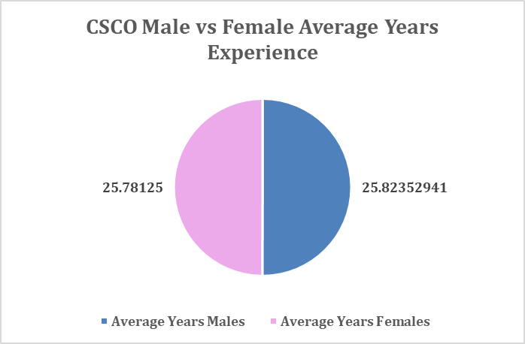
Figure 2.12: CSCO Male vs. Female Average years’ Experience (Fortune.com)

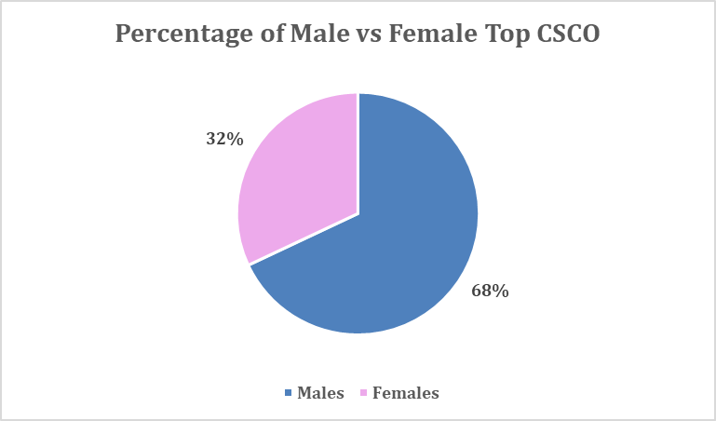
Figure 2.13: Percentage of Male vs. Female top CSCO (Fortune.com)

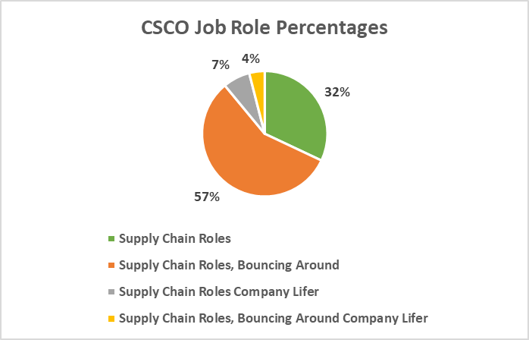
Figure 2.14: CSCO Job Role Percentages on career

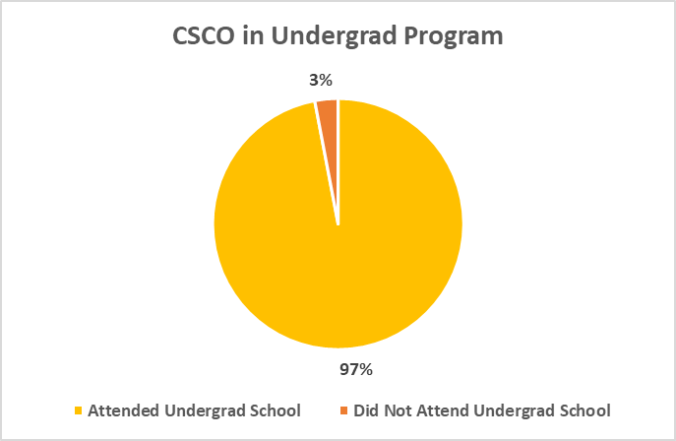
Figure 2.15: Percentage of CSCO of Fortune 100 with an undergraduate degree

regardless of sex (see Figure 2.17), but this lowers with regards to graduate degrees (see Figure 2.18). This was surprising to the author as most higher-ranking company officials and industry experts within his network hold a graduate level degree. A comparison was performed to determine if any of the CSCOs attended the U.S. News or Gartner Top 25 programs, and the results were surprising: 74% of the universities the CSCOs attended were not ranked in either ranking system (see Figure 2.19). Only 15% attended U.S. News ranked schools, 9% attended schools ranked in both, and 4% attended schools ranked by Gartner. A limitation of the study will be data integrity as to find the universities attended by CSCOs proved difficult, with a majority not listing a degree. A safe assumption will be that the majority, if not all, of the CSCOs did not receive an undergraduate or graduate SCM degree from a Gartner or U.S. News ranked program.
As this study was not able to determine a correlation between CSCOs and ranked SCM programs, a second study comparing selected SCM firms from the 2022 Gartner Top 25 SCM companies and other selected firms.

Discussion/validation
At the onset of this research paper, the initial hypothesis was that there is a correlation between CSCOs and top SCM programs; however, as the research paper evolved it began to show that this was not the case. It is important to mention that as a degree program, SCM does not have the longevity as other disciplines; however, there has been an increased focus on SCM as an industry over the past 20 years, which gives the misnomer that the SCM degree is much older than it really is. If there is a commonality between highly ranked undergraduate, graduate SCM programs, and CSCO

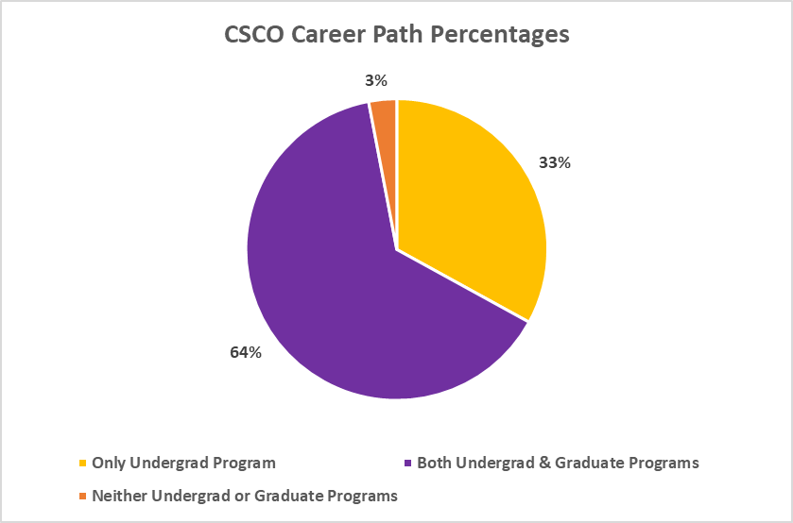
Figure 2.16: Percentage of CSCO of Fortune 100 with a graduate degree

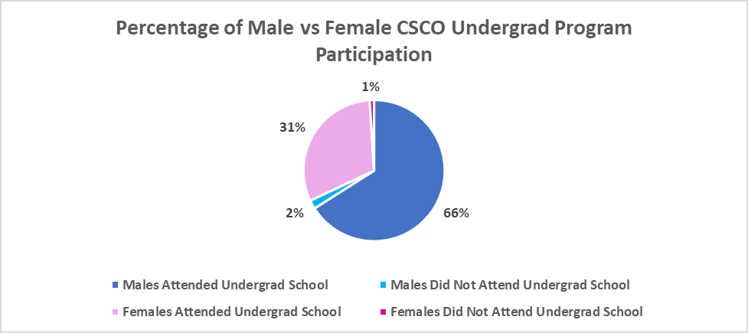
Figure 2.17: CSCO Male vs. Female Undergraduate Program Participation

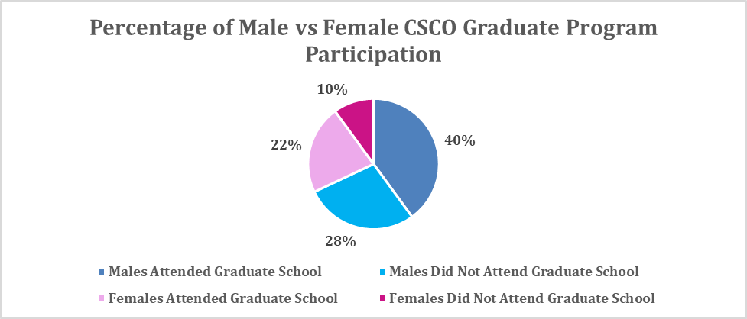
Figure 2.18: CSCO Male vs. Female Graduate Program Participation

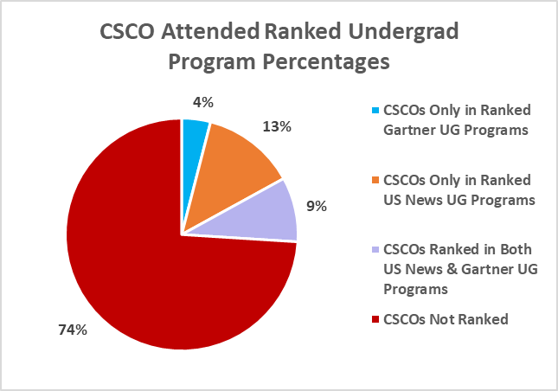
Figure 2.19: CSCO attended ranked Undergrad programs as a percentage
executive levels, this will further solidify their ranking stature and give a guide path to a future generation of leaders who enter these programs. On the other hand, if there are differences, this can potentially mean that the programs are not teaching the right skills, the CSCO level does not require the skill sets taught in these programs, or that there has not been enough time elapsed from the founding of these programs to determine a significant impact at the CSCO level.
To test the differences of the university rankings between the two ranking systems we performed a single factor ANOVA test (see Table 2.6 and Appendix 6). The average indicates that there are more undergrad and graduate universities ranked in U.S. News, closely followed by both ranked in Gartner. This is significant since the F statistic is greater than the F crit meaning that we reject the null hypothesis. The p-value is not greater than 0.05, which confirms rejecting the null hypothesis. The null hypothesis is that the likelihood of being ranked in U.S. News is the same as Gartner; however, this is not the case. ANOVA is comparing the variation between the columns, as well as the variation within each group. The conclusion of this single factor ANOVA is that there is a statistically significant difference in the mean rankings of the universities with both undergrad and graduate programs.
A second ANOVA test was run just comparing undergraduate and graduate universities being ranked in U.S. News or Gartner (see Table 2.7). This is important because the column for both U.S. News and Gartner rankings is dependent on the other two columns, and this can skew the data by making it appear with more variation between groups. The average tells us that there are more universities with undergrad and graduate programs ranked in U.S. News than ranked in Gartner. This is not too significant since the F statistic is slightly less than the F crit meaning that we cannot reject the null hypothesis. The p-value is much greater than 0.05, so this also confirms we cannot reject the null. The null hypothesis is that the likelihood of being ranked in U.S. News is the same as Gartner; therefore, this is very close to being the case. These are two ways of telling us that these values are not statistically significantly different. ANOVA is comparing the variation between the columns, as well as the variation within each group. The conclusion for this test is that there is not a statistically significant difference in the mean rankings of the universities with both undergrad and graduate programs.
Based on the F statistics and p-value from tables 2.6 and 2.7, this analysis proves there is no correlation between the Top 25 Gartner SCM Undergraduate / Graduate programs and Fortune 100 CSCOs; therefore, we decided to perform a broader study to investigate if there could potentially be a correlation. The intention of this study is to determine if there are any commonalities with these supply chain professionals in these companies and compare if their university programs had any correlations to the Gartner top 25 SCM Undergraduate and Graduate programs. For this new scope, we chose to use the Gartner Top 25 Supply Chain companies, five companies listed by Gartner as Supply Chain Masters, top ten logistics companies per 2021 Transport Topics rankings, and five other randomized well-known logistics companies for a total of number of forty-five companies (see Table 2.8).

Table 2.6: ANOVA single factor test comparing all 3 columns

t-Test: Two-Sample Assuming Equal Variances
 | Variable 1 | Variable 2
Mean | 0.387755102 | 0.326530612
Variance | 0.242346939 | 0.224489796
Observations | 49 | 49
Pooled Variance | 0.233418367
Hypothesized Mean Difference | 0
df | 96
t Stat | 0.627250048
P(T<=t) one-tail | 0.265992187
t Critical one-tail | 1.66088144
P(T<=t) two-tail | 0.531984373
t Critical two-tail | 1.984984312

Table 2.7: ANOVA single factor test comparing only U.S. News and Gartner

SUMMARY
Groups | Count | Sum | Average | Variance
Both U.S. News 2022 Ranking | 49 | 19 | 0.387755 | 0.242347
Both 2022 Gartner Ranking | 49 | 16 | 0.326531 | 0.22449

ANOVA
Source of Variation | SS | df | MS | F | P-value | F crit
Between Groups | 0.091837 | 1 | 0.091837 | 0.393443 | 0.53198437 | 3.940162717
Within Groups | 22.40816 | 96 | 0.233418
Total | 22.5 | 97

To increase the sample size for executives in this new study, we found the top five-to-ten logistics professionals in each company. Like the previous CSCO study, it
was a manual process to determine the top professionals in each company, with the process entailing looking each company on LinkedIn for key words such as “Vice President,” “Director,” “Head,” or similar. Once an executive was found, we listed each title, undergraduate and/or graduate university and degree. This resulted in a total resource pool of 261 SCM leaders, with the most common title being “Vice President of Supply Chain” (see Figure 2.20). Various indicates a role that had between two-to-three titles, thus was grouped for ease of clarification.
Table 2.9 displays the top 10 undergraduate degrees that these logistics executives earned, with a total of 287 data points. The highest total was N/A which indicates neither an undergraduate nor graduate degree was earned. An interesting finding was the high count for B.S. in Mechanical and Industrial Engineering; degrees that were not included as part of the top 25 SCM programs in both ranking systems, which can indicate that an engineering degree is useful in SCM. The other degrees in Table 2.9 are in alignment with the program degrees in section 3 of this research paper. The corresponding top 10 universities attended by these logistics executives do not overwhelmingly indicate a particular university,but there are a few universities that were part of the Gartner and U.S. News top 25 rankings (see Table 2.10). In alignment with Table 2.9, N/A was the top result for the executives who did not attend an undergraduate program and there was a total of 62 unique universities attended by the balance of executives. A limitation of this

Table 2.8: 2022 Gartner Top 25 Supply Chain Companies, Gartner Supply Chain Masters, top 10 logistics companies. (Sources: www.gartner.com, https://www.ttnews.com/logistics/rankings/2021)

Gartner Rank | Company | Transport Topic Rank | Company
1 | Cisco Systems | 1 | C.H. Robinson Worldwide
2 | Schneider Electric | 2 | XPO Logistics
3 | Colgate-Palmolive | 3 | UPS
4 | Johnson & Johnson | 4 | Expeditors International
5 | PepsiCo | 5 | J. B. Hunt Transport
6 | Pfizer | 6 | Kuehne + Nagel Americas
7 | Intel | 7 | DHL Supply Chain
8 | Nestlé | 8 | Transportation Insight Holding
9 | Lenovo | 9 | Total Quality Logistics
10 | Microsoft | 10 | Burris Logistics
11 | L’Oréal | 11 | Ryder Supply Chain Solutions
12 | The Coca-Cola Company | 15 | Schneider
13 | Nike | 18 | Penske Logistics
14 | Walmart | 23 | FedEx
15 | HP Inc. | 32 | Knight-Swift Transportation
16 | Diageo | SCM Master | Amazon
17 | Dell Technologies | SCM Master | Apple
18 | Inditex | SCM Master | McDonald’s
19 | BMW | SCM Master | Procter & Gamble
20 | AbbVie | SCM Master | Unilever
21 | Siemens
22 | AstraZeneca
23 | General Mills
24 | British American Tobacco
25 | Alibaba

Figure 2.20: Position Title Commonalities

study is determining if a degree earned had an SCM concentration or program affiliation, in this case we assume the university tally in Table 2.10 are an SCM degree.
These same executives earned a graduate degree at a lower rate than undergraduate, with the overwhelming degree obtained being an MBA (see Table 2.11), which aligns with the study in Section 3 of this research paper. Per Figure 2.21, the educational background for these executives indicates that 60.15% have both an undergraduate and graduate degree, and surprisingly 5.36% have no degree at all. A total of 155 graduate degrees (graduate degree, PhD, and secondary master’s degree) were obtained versus 287 undergraduate degrees. Table 2.12 displays the top 10 graduate universities attended, and again the results here do not indicate a correlation to the Gartner top 25 SCM graduate programs, nor indicate an overwhelming university attended.

Conclusion/recommendations
The main goal of this paper is to determine if there is a pathway to the CSCO level by attending a top SCM ranked undergraduate or graduate program. The benefit of this research paper is that the data and literature review are all contemporary, thus the results will be beneficial to various audiences. Unfortunately, after significant research, both studies in this paper do not indicate that there are any significant correlations between the top 25 SCM university programs and top SCM executives. This could potentially indicate that there has not been enough time elapsed since the start of SCM education to truly determine if CSCOs went to these ranked programs. On the contrary, this could indicate a larger issue such as the ranking agencies are not truly performing the

Table 2.9: Top 10 Undergraduate degrees earned
Undergraduate Degree: | Count:
N/A | 32
BS Mechanical Engineering | 31
BA | 30
BBA | 23
BS Industrial Engineering | 22
BS Business | 20
BS Chemical Engineering | 13
BS Accounting | 9
BS Economics | 8
BS SCM | 8
Total UG Degrees: | 287

Table 2.10: Top 10 Undergraduate universities attended
Undergraduate University: | Count: | U.S. News Rank: | Gartner Rank:
N/A | 14 | - | -
Penn State University | 6 | 4 | 10
University of Massachusetts | 5 | - | -
University of Tennessee | 5 | 3 | 2
Purdue University | 4 | 10 | 24
Rutgers University | 4 | 17 | 5
Southern University and A&M College | 4 | - | -
University of Notre Dame | 4 | - | -
Drexel University | 3 | - | -
Michigan State University | 3 | 1 | -
Total Undergraduate Universities: | 62 | 5 Ranked | 4 Ranked

Table 2.11: Top 10 Graduate degrees earned
Graduate Degree: | Count:
MBA | 94
MS General Engineering | 8
MS SCM | 5
MS Mechanical Engineering | 4
MS Industrial Engineering | 3
MS Organizational Management | 3
Doctor of Mechanical Engineering | 2
Doctor of Business Administration | 2
MS Business | 2
MS Computer Science | 2
Total Graduate Degrees: | 155

Table 2.12: Top 10 Graduate universities attended
Graduate University: | Count: | U.S. News Rank: | Gartner Rank:
Purdue University | 4 | 8 | 24
Stanford University | 4 | 10 | -
Loyola University Chicago | 3 | 14 | -
Massachusetts Institute of Technology | 3 | 2 | -
Mercer University | 3 | - | -
Northeastern University | 3 | - | 22
Penn State University | 3 | 5 | 3
Rensselaer Polytechnic Institute | 3 | - | -
University of Arizona | 3 | - | -
University of Phoenix | 3 | - | -
Total Graduate Universities: | 154 | 5 Ranked | 3 Ranked

Figure 2.21: Educational Background Percentages

correct metrics when ranking programs or that a formal SCM education to reach the CSCO level is not needed.
Potential future research can compare the curriculums of the various programs to determine if there are commonalities or divergencies in theories. Additionally, do middle or lower tier colleges adapt to changing industry trends better than “top tier” colleges? Are there any correlations with European or Asian SCM ranked programs and corporations in those regions? From a regional perspective, it would be interesting to determine if are there any correlations between top ranked SCM undergraduate, graduate, and top ranked logistics companies. It would be interesting to revisit the gaps mentioned by Vokurka (2011) with regards to curricula at top SCM programs. Stemming from the findings of this paper, it would be interesting to dive deeper into the correlation of SCM executives with engineering backgrounds. The author of this paper has an extensive engineering education, with high success in the SCM executive field, thus curriculum changes in SCM could potentially benefit from engineering influences.
Since a top-down approach to determine a correlation between SCM executives and SCM programs did not indicate any correlations, perhaps a bottoms-up study investigating alumni from each university program would point to a correlation. The difficulty with this study would be getting a detailed list of all alumni, so perhaps this would have to be done on a program-by-program basis depending on availability of alumni directories. Sticking with alumni, an interesting study would be to track the career paths of these alumni 10 or 20 years after graduation to determine if there is a “perfect career path.” This career path could open a study to check the curriculum at the top SCM programs to determine if adjustments need to be made to improve the programs even further.
Although Covid-19 is mentioned in this research paper, there are some influences of the pandemic, but more time will have to pass to tell true impacts of the pandemic. The Covid-19 pandemic has expanded online education, allowing universities to offer courses and degrees to a global community. A future study could investigate the effects of online or remote learning with regards to the quality of graduate’s skills.

List of References
“About Fortune.” Fortune, https://fortune.com/about-us/. Accessed on July 3, 2022.
“About Gartner.” Gartner, https://www.gartner.com/en/about. Accessed July 3, 2022.
Accorsi, R., Manzini, R., and Maranesi, F. (2014). A decision-support system for the design and management of warehousing systems. Computers in Industry, Vol. 65 (1), pp. 175–186.
Ackerman, K.B. and La Londe, B.J. (1980), “Making warehousing more efficient”, Harvard Business Review, Vol. 58 No. 2, pp. 94-102.
Ahmed, M. (2022). “History and evolution of supply chain and logistics.” SCMdojo.com. Retrieved on October 15, 2022, from: https://www.scmdojo.com/history-and-evolution-of-supply-chain-and-logistics/
Akalin, G., Huang, Z. and Willems, J., 2016. “Is Supply Chain Management Replacing Operations Management in the Business Core Curriculum?” Operations and Supply Chain Management: An International Journal, 9(2), pp.119-130.
Allden, M., Niemann, W. and Kotze, T. (2018), “Industry expectations of supply chain management graduates: perspectives from third-party logistics providers in South Africa”, Journal of Transport and Supply Chain Management, Vol. 12, pp. 1-14.
Ammar, M. et. al. (2021). “Improving material quality management and manufacturing organizations system through Industry 4.0 technologies.” Materials Today: Proceedings, vol. 45 (2021) pp. 5089-5096.
Amoruso, S. (2021). “Higher ed’s demographic future.” Educational Advisory Board. https://eab.com/insights/daily-briefing/strategy/higher-ed-demographic-future/. Accessed on August 15, 2022.
ARC Advisory Group. (2020). “Five Key Industry 4.0 Technologies.” https:// ottomotors.com/blog/5-industry-4-0-technologies (accessed December 24, 2021).
Azadeh, K., De Koster, R., and Roy, D. (2019a). Robotized and automated warehouse systems: Review and recent developments. Transportation Science, 53(4), 917–945. https://doi.org/10.1287/trsc.2018.0873
Azadeh, K., Roy, D., and De Koster, R. (2019b). Design, modeling, and analysis of vertical robotic storage and retrieval systems. Transportation Science, 53(5), 1213–1234. https://doi.org/10.1287/trsc.2018.0883
Bahouth, S., Hartmann, D., Willis, G. (2014). “Supply Chain Management: How the Curricula of the top ten undergraduate universities meet the Practitioners’’ knowledge set.” American Journal of Business Education, Fourth Quarter 2014, Vol. 7, No. 4, pp. 285-298.
Ballou, R. H., 1978. Basic Business Logistics. Prentice-Hall, Englewood Cliffs, NJ.
Bauer, K. “KPIs - The Metrics That Drive Performance Management.” DM Review 14.9 (2004): 63–. Print.
Beck, R., and Müller-Bloch, C. (2017). Blockchain as radical innovation: A framework for engaging with distributed ledgers as incumbent organization. Proceedings of the 50th Hawaii International Conference on System Sciences (pp. 5390–5399).
Belkin, D. (2021). “A Generation of American Men Give Up on College: ‘I Just Feel Lost.’” The Wall Street Journal. https://www.wsj.com/articles/college-university-fall-higher-education-men-women-enrollment-admissions-back-to-school-11630948233. Accessed on August 20, 2022.
Benson, G., Chau, N., (2019). “The Supply Chain Management Applied Learning Center: A University -industry collaboration.” Industry and Higher Education, 2019, vol. 33 (2), pp. 135-146.
Bernon, M. and Mena, C., (2013), “The evolution of customized executive education in supply chain management.” Supply Chain Management: An International Journal, 18/4 (2013), pp. 440-454.
“Best Undergraduate Supply Chain Management / Logistics Programs.” U.S. News, https://www.usnews.com/best-colleges/rankings/business-supply-chain-management-logistics. Accessed July 2, 2022.
Birou, L., Van Hoek, R. (2021). “Supply chain management talent: the role of executives in engagement, recruitment, development and retention.” Supply Chain Management: An International Journal, May 2021. DOI: 10.1108/SCM-08-2020-0418
Birou, L., Lutz, H., Walden, J. (2022). “Undergraduate supply chain management courses: content, coverage, assessment and gaps.” Supply Chain Management: An International Journal, Vol. 27, No. 1, pp. 1-11.
Biswas, K., Muthukkumarasamy, V., and Tan, W. L. (2017). Blockchain based wine supply chain traceability system. Future Technologies Conference December.
Blanchard, D. (2014), “Supply chain and logistics: the competitive advantage of a supply chain”, Industry Week, available at: www.industryweek.com/comptetitive-chain
Bowen, J. (2008). “Moving places: the geography of warehousing in the US.” Journal of Transport Geography, vol. 16, pp.379-387.
Bryant, J. (2021). “Women Continue to Outnumber Men in College Completion.” Best Colleges, https://www.bestcolleges.com/news/analysis/2021/11/19/women-complete-college-more-than-men/. Accessed on August 20, 2022.
“BSBA vs. BBA Degree – What’s the Difference?” Drexel University, https://www.lebow.drexel.edu/news/bsba-vs-bba-degree-what-s-difference. Accessed August 13, 2022.
Butner, K. (2010). “The smarter supply chain of the future.” Strategy & Leadership, vol. 38, no. 1, pp. 22-31.
Chappell, B. (2017). “Census Finds a More Diverse America, As Whites Lag Growth.” Npr.org. https://www.npr.org/sections/thetwo-way/2017/06/22/533926978/census-finds-a-more-diverse-america-as-whites-lag-growth. Accessed on August 14, 2022.
Chopade, A. (2020). “BSBA vs. BBA: Which Business Degree is Right for You?” Grand Canyon University. https://www.gcu.edu/blog/business-management/bsba-vs-bba. Accessed on August 13, 2022.
Choudaha, R. (2018). “A Third Wave of International Student Mobility: Global Competitiveness and American Higher Education.” Center for Studies in Higher Education. University of California, Berkeley. Research & Occasional Paper Series: CHSE.8.18
Chumakov, C., Stiller, D. (2020). “Top 25 North American Supply Chain Undergraduate University Programs, 2020.” Gartner Inc, Published June 29, 2020.
Cooper, J. (1990). Logistics and Distribution Planning. Kogan Page, London.
Cottrill, K. (2010). “Are you prepared for the supply chain talent crisis?” MIT Center for Transportation & Logistics White Paper. Fall 2010
Cromwelle, J. (2021). “BA vs. BS – What’s the Difference?” https://www.mydegreeguide.com/types-of-degrees/ba-vs-bs/. Accessed on August 13, 2022.
Culler, D., Long, J. (2016). “A Prototype Smart Materials Warehouse Application Implemented Using Custom Mobile Robots and Open-Source Technology Developed Using EmguCV.” Procedia Manufacturing, Volume 5, 2016, pp. 1092-1106.
Curtis, M. B., Joshi, K. (1998). “Lessons Learned from the Implementation of a data Warehouse.” Journal of Data Warehousing (3:2), 1998, pp. 12-18
Davarzani, H., and Norrman, A. (2015). “Toward a relevant agenda for warehousing re- search: Literature review and practitioners’ input.” Logistics Research, vol. 8 (1), pp. 1–18.
de Wit, H., & Rumbley, L. E. (2017). “Professional development in international education: The example of the Boston College MA in international higher education.” Internationalization of Higher Education, A Handbook, 3, 2-14.
de Wit, H. (2019). “Internationalization in higher education, A critical Review.” Simon Fraser University Educational Review, vol. 12, No. 3, Fall 2019.
Demeester, L., De Meyer, A., Grahovac, J. (2014). “The role of operations executives in strategy.” Journal of Operations Management. 32, 403e413.
Di Vaio, A., Varriale, L. (2019). “Blockchain technology in supply chain management for sustainable performance: Evidence from the airport industry.” International Journal of Information Management, Vol. 52, pp. 1-16.
Du, X., Jiao, J. and Tseng, M.M. (2006), “Understanding customer satisfaction in product customization”, The International Journal of Advanced Manufacturing Technology, Vol. 31 Nos 3-4, pp. 396-406.
Eisenhardt, K. M. (1989). Building theories from case study research. The Academy of Management Review, 14(4), 532–550. https://doi.org/10.5465/amr.1989.4308385.
Etikan, I., Alkassim, R., and Abubakar, S. (2016). “Comparison of Snowball Sampling and Sequential Sampling Technique.” Biometric and Biostatistics International Journal, Vol. 3, No. 1, pp. 1-2.
Facchini, F., Oleskow-Szlapka, J., Ranieri, L., Urinati, A. (2019). “A Maturity Model for Logistics 4.0: An Empirical Analysis and a Roadmap for Future Research.” MDPI, vol. 12 (2019) pp. 1-18.
Farahani, B., Firouzi, F., Chang, V., Badaroglu, M., Constant, N. and Mankodiya, K., Towards Fog-driven IoT eHealth: Promises and Challenges of IoT in Medicine and Healthcare, Future Generation Computer Systems, Vol. 78, no. 2, pp. 659-676, 2018. Doi: http://dx.doi.org/10.1016/j.future.2017.04.036.
Fawcett, S.E., Wallin, C., Allred, C. and Magnan, G. (2009), "Supply chain information‐sharing: benchmarking a proven path", Benchmarking: An International Journal, Vol. 16 No. 2, pp. 222-246.
Fawcett, S.E. and Rutner, S.M. (2014), “A longitudinal view of supply chain education”, The International Journal of Logistics Management, Vol. 25 No. 1, pp. 180-201.
“Fortune 500 Companies.” Fortune, https://fortune.com/fortune500/2022/search/. Accessed July 2, 2022.
“Fortune announces 2022 Fortune List.” Fortune, https://www.prnewswire.com/news-releases/fortune-announces-2022-fortune-500-list-301552608.html. Accessed on July 2, 2022.
Frazelle, E.H. (2002), World-Class Warehousing and Material Handling, McGraw-Hill, New York, NY.
Freeman, V.T. and Cavinato, J.L. (1992), “Fostering strategic change in a function through executive education: the case of purchasing”, Journal of Management Development, Vol. 11 No. 6, pp. 25-30.
“Gartner Announces Rankings of the 2022 North American Supply Chain Undergraduate University Programs.” Gartner, https://www.gartner.com/en/newsroom/press-releases/2022-06-07-gartner-announces-rankings-of-the-2022-north-american-supply-chain-undergraduate-university-programs. Accessed July 2, 2022.
“Gartner Announces Rankings of the 2022 Global Supply Chain Top 25.” Gartner, https://www.gartner.com/en/newsroom/press-releases/2022-05-26-gartner-announces-rankings-of-the-2022-global-supply-chain-top-25. Accessed July 2, 2022.
“The Gartner Supply Chain Top 25 for 2021.” Gartner, https://www.gartner.com/smarterwithgartner/the-gartner-supply-chain-top-25-for-2021. Accessed, July 2, 2022.
“The Gartner Supply Chain Top 25 for 2022.” Gartner, https://www.gartner.com/en/articles/the-gartner-supply-chain-top-25-for-2022. Accessed July 2, 2022.
Griffis, T. (December 7, 2022). “Construction begins on Walmart distribution center in Dorchester County.” Charleston Business. Retrieved on 2/5/22 from: https://charlestonbusiness.com/news/distribution-logistics/79713/
Gu, J., Goetschalckx, M., McGinnia, L. (2009). “Research on warehouse design and performance evaluation: A comprehensive review.” European Journal of Operational Research, Vol. 203 (2010), pp. 539-549.
Grothaus, M. (2021). “Women now make up almost 60% of college students – an all time high.)” Fast Company, https://www.fastcompany.com/90673368/women-now-make-up-almost-60-of-college-students-an-all-time-high. Accessed on August 20, 2022.
Gunasekaran, A., Marri, H.B., Menci, F., (1999). “Improving the effectiveness of warehousing operations: a case study.” Industrial Management and Data Systems, Vol 99, No. 8, pp. 328-339.
Hailey, L. (January, 31, 2020). “Northern Kentucky is a logistics powerhouse.” Lane Report, retrieved on 1/17/21 from: https://www.lanereport.com/121443/2020/01/logistics/
Hamilton, T. (2022, March 26). Automation Anywhere Tutorial: What is, RPA and Types of Bots. Guru99. Retrieved on April 8, 2022 from: https://www.guru99.com/automation-anywhere-tutorial.html
Hassan, M., Ali, M., Aktas, E., and Alkayid, K. (2015). “Factors affecting selection decision of auto-identification technology in warehouse management: An international delphi study.” Production Planning and Control, vol. 26 (12), pp. 1025–1049.
Johnston, D., 1999. Amazon.com is adding a warehouse. New York Times (January 8), C1.
Hendricks, K., Hora, M., Singhal, V. (2015). “An Empirical Investigation on the Appointments of Supply Chain and Operations Management Executives.” Management Science 61(7):1562-1583. https://doi.org/10.1287/mnsc.2014.1987
Johnson, M. E. & Pyke, D. F. (2000). A framework for teaching supply chain management. Production and Operations Management Journal, Vol. 9(1), pp. 2–18.

Kador, J. 2012. “How to get the most from your Chief Supply Chain Officer.” Chief Executive. Accessed 14 January 2019. https://chiefexecu- tive.net/how-to-get-the-most-from-your-chief-supply-chain-officer/
Kamali, A. (2019). “Smart Warehouse vs. Traditional Warehouse – Review.” International Journal of Automation and Autonomous System, Vol. 11, No. 1 (2019) pp. 9-16.
Kerr, J. (2008). “A New Direction for Executive.” Supply Chain Management Review, April 2008, pp. 30-38.
Kopitsch, F. (2005), “I&C technologies for a real-time enterprise (RTE)”, in Kuhlin, B. and Thielmann, H. (Eds), The PracticalReal-Time Enterprise, Springer, Berlin and Heidelberg.
Körber, M., Cotta, D. (2021). “Supply Chain in the C-Suite: the effect of chief supply chain officers on incidence of product recalls.” Supply Chain Management: An International Journal, 2021, vol. 26/4, pp. 495-513
Korpela, J., Tuominen, M. (1996). “A decision aid in warehouse site selection.” International Journal of Production Economics, vol. 45, pp. 169-180.
Kroes, J., Manikas, A., Gattiker, T., Castel, M. (2021). “The operational impacts of Chief Supply Chain Officers in manufacturing firms.” The Journal of Production Planning & Control, DOI: 10.1080/09537287.2021.1877840
Kshetri, N. (2018). Blockchain’s roles in meeting key supply chain management objec- tives. International Journal of Information Management, 39, 80–89. https://doi.org/10. 1016/j.ijinfomgt.2017.12.005
Kumar, S., Narkhede, B., Jain, K. (December 11, 2020). “Revisiting the warehouse research through an evolutionary lens: a review from 1990 to 2019.” International Journal of Production Research, Vol. 50, No. 11, pp. 3470-3492.
Lambert, Douglas M., James R. Stock and Lisa M. E1Jram (1998), FundamentJJlso/Logistics Management, Boston: Irwin McGraw-Hill, p.504.
Larson, P., Rogers, D. (1998) “Supply Chain Management: Definition, Growth and Approaches,” Journal of Marketing Theory and Practice, 6:4, 1-5.
Lee, CKM, "Development of an Industrial Internet of Things (IIoT) based Smart Robotic Warehouse Management System" (2018). CONF-IRM 2018 Proceedings. 43.
http://aisel.aisnet.org/confirm2018/43
Lee, CKM, Yaqiong Lv, K.K.H. Ng, William Ho and K.L. Choy (2018) Design and application of Internet of things-based warehouse management system for smart logistics, International Journal of Production Research, Vol. 56:8, pp. 2753-2768
Li, D.X., Wu, H. and Shancang, L. (2014), “Internet of things in industries: a survey.” IEEE Transactions on Industrial Informatics, Vol. 10 No. 4, pp. 2233-2243.
Li, L. (2020). “Education supply chain in the era of Industry 4.0.” Systems Research and Behavioral Science, 2020, vol. 37, pp. 579-592.
Liu, X. and Sun, Y. (2011), “Information flow management of vendor-managed inventory system in automobile parts inbound logistics based on internet of things.” Journal of Software, Vol. 6 No. 7, pp. 1374-1380.
Liu, Xiulong et al. “CPS-Based Smart Warehouse for Industry 4.0: A Survey of the Underlying Technologies.” Computers (Basel) 7.1 (2018)
LogisticsIQ (2022). “Warehouse Automation Market: Post Covid-19 Opportunities worth $30B by 2026.” Retrieved on 4/2/22 from: https://www.thelogisticsiq.com/research/warehouse-automation-market/
Lutz, H., Birou, L., Walden, J. (2021). “Survey of graduate supply chain courses: content, coverage and gaps.” Supply Chain Management: An International Journal. DOI 10.1108/SCM-12-2020-0367
MacLeod, C. (August 22, 2019). “Raising the roof: is there a ceiling on clear heights?” Stream Realty. Retrieved on 2/5/22 from: https://streamrealty.com/stream-insights-macleod-raising-the-roof-is-there-a-ceiling-on-clear-heights/
Mahroof, K. (2018). “A human-centric perspective exploring the readiness towards smart warehousing: The case of a large retail distribution warehouse.” International Journal of Information Management, vol. 45 (2019) pp. 176-190.
Manyika, J., Chui, M., Bisson, P., Woetzel, J., Dobbs, R., Bughin, J., Aharon, D. (2015). “Unlocking the potential of the Internet of Things.” McKinsey and Co.
Mao, J., Xing, H. and Zhang, X., Design of Intelligent Warehouse Management System, Wireless Personal Communications, pp. 1-13, DOI: https://doi.org/10.1007/s11277-017-5199-7.
Marchet G,, Melacini M,, Perotti S,, Tappia E. (2012). “Analytical model to estimate performances of autonomous vehicle storage and retrieval systems for product totes.” International Journal Production Res. 50(24): 7134–7148.
Marchet G,, Melacini M,, Perotti S,, Tappia E. (2013). “Development of a framework for the design of autonomous vehicle storage and retrieval systems.” International Journal Production Res. 51(14):4365–4387.
“Master of Business Administration (MBA).” Corporate Finance Institution, https://corporatefinanceinstitute.com/resources/career/master-of-business-administration-mba/. Accessed on 11/30/22.
“Master of Supply Chain Management.” Ohio State University, https://fisher.osu.edu/graduate/mscm. Accessed on 12/4/22.
“Master of Supply Chain Management.” University of Michigan, https://michiganross.umich.edu/graduate/master-of-supply-chain-management. Accessed on 12/4/22.
Melnyk, S., Stank, T., Closs, D. (2000). “Supply Chain Management at Michigan State University: The Journey and the Lessons Learned.” Production and Inventory Management Journal, 3rd Quarter 2000, pp. 13-18.
Mentzer, J., Stank, T., Esper, T. (2008) “Supply chain management and its relationship to logistics, marketing, production, and operations management.” Journal of Business Logistics, 21 (1), 31e46.
“Methodology for Fortune 500.” Fortune, https://fortune.com/fortune500/2019/methodology/. Accessed July 3, 2022.
Michigan State University (20220). “Master of Science in Supply Chain Management.” Michigan State University. Retrieved on 11/24/22 from: https://www.michiganstateuniversityonline.com/programs/degrees/ms-supply-chain-management/
Moody, J. (2021). “The Difference Between a B.A. and B.S. Degree.” US News, https://www.usnews.com/education/best-colleges/articles/understand-the-difference-between-a-ba-and-bs-degree. Accessed August 13, 2022.
Morris, K. (Jan 27, 2018). “In New York City, Warehouses have nowhere to go but up.” The Wall Street Journal. https://www.wsj.com/articles/in-new-york-city-warehouses-have-nowhere-to-go-but-up-1517061600?mod=searchresults&page=1&pos=1
Morse, Robert and Brooke, Eric. “How U.S. News Calculated the 2022 Best Colleges Rankings.” U.S. News, https://www.usnews.com/education/best-colleges/articles/how-us-news-calculated-the-rankings. Accessed July 2, 2022.
National Conference of State Legislatures (2021). Right-to-work resources. Retrieved on 1/17/21 from: https://www.ncsl.org/research/labor-and-employment/right-to-work-laws-and-bills.aspx
Oakley, D. (2018). “Key Activities in the Business Model Landscape.” Denis Oakley and Co. Retrieved on 1/20/22 from: https://www.denis-oakley.com/key-activities/
O'Marah, K. (2016). “Supply chain Leader as CEO.” Forbes. http:// www.forbes.com/sites/kevinomarah/2016/04/21/supply-chain-leader-as-ceo/ #63e7e09c362d (accessed May 20, 2022).
Pane, S. F., Awangga, R. M. and Azhari, B. R., Qualitative Evaluation of RFID Implementation on Warehouse Management System, TELKOMNIKA, vol. 16, no. 3, pp. 1303-1308, 2018.
Parhi, S., Joshi, K., Akarte, M. (2020). “Smart manufacturing: a framework for managing performance.” International Journal of Computer Integrated Manufacturing, Vol. 34, No. 3, pp. 227-256.
Patil, A., Shah, A., Rokade, O. and Kukreja, P., Cloud Based Warehouse Management Firm, International Research Journal of Engineering and Technology (IRJET), vol. 5, no. 3, pp. 695-697, 2018.
Prevoe, B. (March 2018). “Raise the roof! When to consider higher cubic clear heights for your warehouse operations.” Savills Studley. Retrieved on 3/24/22 from: https://pdf.euro.savills.co.uk/usa/in-depth-reports/ov-warehouseoperations-isg-2018-03-29.pdf
Q&A: What is Alteryx?: Answer business questions quickly & efficiently. Capitalize Analytics. (n.d.). Retrieved on April 8, 2022 from: https://capitalizeconsulting.com/qa-what-is-alteryx/
Richards, G. (2014). Warehouse Management: A Complete Guide to Improving Efficiency and Minimizing Costs in the Modern Warehouse. London: Kogan Page.
Roh, J., Krause, R., Swink, M. (2016). “The appointment of chief supply chain officers to top management teams: A contingency model of firm-level antecedents and consequences.” Journal of Operations Management, vol. 44, pp. 48-61.
Rossetti, K., Supply Chain in Northern Kentucky. NKY Tri-Ed. Retrieved on 1/17/21 from: https://northernkentuckyusa.com/site-selection/supply-chain/
Şahin, E. (2004, July). Swarm robotics: From sources of inspiration to domains of application. In International workshop on swarm robotics (pp. 10-20). Springer, Berlin, Heidelberg.
Sammon, D., Finnegan, P. (2000). “The Ten Commandments of Data Warehousing.” The Data Base for Advances in Information Systems, Vol. 31. No. 4, pp. 82-91.
Sauber, M., McSurely, H., Tummala, V. M. (2008). “Developing supply chain management program: a competency model.” Quality Assurance in Education, Vol. 16, No. 4, 2008, pp. 375-391
Schary, P. B., (1984) Logistics Decisions – Texts and Cases. The Dryden Press, USA.
Sivitanidou, R., 1996. Warehouse and distribution facilities and community attributes: an empirical study. Environment and Planning A 28, 1261– 1278.
Sinha, A., Millhiser, W.P. and He, Y. (2016), “Matching supply and demand in supply chain management education”, The International Journal of Logistics Management, Vol. 27 No. 3, pp. 837-861.
Slack, N., Chambers, S. and Johnston, R. (2001), Operations Management, 3rd ed., Prentice-Hall, Harlow.
Slone, R., Mentzer, J., Dittmann, J. (2007). “Are you the weakest link in your company’s supply chain?” Harvard Business Review, September 2007.
Sneader, K., Singhal, S. (January 4, 2021). “The next normal arrives: Trends that will define 2021—and beyond.” McKinsey and Co.
South Carolina Ports (December 3, 2020). “Walmart breaks ground on distribution center in South Carolina.” South Carolina Ports. Retrieved on 2/5/2022 from: http://scspa.com/news/walmart-breaks-ground-on-distribution-center-in-sc/
Southern, R. N. (2011), “Historical Perspective of the Logistics and Supply Chain Management Discipline.” Transportation Journal, Vol 50, No. 1, pp. 53-64.
Stone, P., and Veloso, M. (2000). Multiagent systems: A survey from a machine learning perspective. Autonomous Robots, 8(3), 345-383.
“Supply Chain Management.” Pennsylvania State University, https://bulletins.psu.edu/graduate/programs/majors/supply-chain-management/#text. Accessed on 12/4/22.
Tatham, P., Wu, Y. (2015). “Supply chain management skills to sense and seize opportunities.” The International Journal of Logistics Management, Vol. 28, No. 2, 2017, pp. 266-289.
Taylor, D. (2022, March 19). Power bi tutorial: What is Power Bi? why use? Dax examples. Guru99. Retrieved on April 8, 2022 from: https://www.guru99.com/power-bi-tutorial.html
Taylor, D. (2022, February 12). Tableau Tutorial for beginners: Learn basics in 3 days. Guru99. Retrieved on April 8, 2022 from: https://www.guru99.com/tableau-tutorial.html
Thelin, J. (2019). “A history of American higher education.” Baltimore, Maryland: John Hopkins University Press.
Thomas, P. (2021). “M.B.A. Starting Salaries are soaring.” Wall Street Journal. Retrieved on 11/29/22 from: https://www.wsj.com/articles/m-b-a-starting-salaries-are-soaring-11636952464
Tillman, J., Manrodt, K. Williams, D. (2019). “Annual survey and report on industry metrics: DC Measures.” Warehousing Education and Research Council. Retrieved on 3/5/22 from: https://cdn2.hubspot.net/hubfs/476052/2019_WERC_DC_Measures%202019_Handout.pdf
Tooley, A (2022). “Question: What is an MS degree?” Onlineeducation.com. Retrieved on 11/23/22 from: https://www.onlineeducation.com/faqs/what-is-an-ms-degree
University of Arizona (2022). “Online Master of Supply Chain Management.” University of Arizona. Retrieved on 11/24/22 from: https://asuonline.asu.edu/online-degree-programs/graduate/supply-chain-management-ms/
University of Minnesota (2022). “What is a Master of Science (MS) Degree?” University of Minnesota. Retrieved on 11/23/22 from: https://www.sph.umn.edu/academics/degrees-programs/ms/degree-information/
Van den Berg, J. (November 1998). “A literature suvey on planning and control of warehousing systems.” HE Transactions (1999) vol. 31, pp. 751-762.
van Hoek, R., Chatham, R. and Wilding, R. (2002), “Managers in supply chain management, the critical dimension”, Supply Chain Management: An International Journal, Vol. 7 No. 3, pp. 119-125.
van Hoek, R., Godsell, J. and Harrison, A. (2011), “Embedding ‘insights from industry’ in supply chain programmes: the role of guest lecturers”, Supply Chain Management: An International Journal, Vol. 16 No. 2, pp. 142-147.
Van Gils, Teun, An Caris, Katrien Ramaekers, Kris Braekers (2019). “Formulating and Solving the Integrated Batching, Routing, and Picker Scheduling Problem in a Real-Life Spare Parts Warehouse.” European Journal of Operational Research. 277 (3), pp. 814-830
Van Goor, A.R., Ploos van Amstel, M.J. and Ploos van Amstel, W. (2003), European Distribution and Supply Chain Logistics, Stenfert Kroese, Groningen.
Vokurka, R. (2011). “Supply Chain Manager Competencies.” SAM Advanced Management Journal. Spring 2011, pp. 23-28.
Wagner, S., Kemmerling, R. (2014). “Supply chain management executives in corporate upper echelons.” Journal of Purchasing & Supply Management, Vol. 20, 2014, pp. 156-166.
Watson, H. J., Haines, M., Loiacono, E. T. (1998). “The Approval of Data Warehousing Projects: Findings from Ten Case Studies.” Journal of Data Warehousing (3:3), 1998, pp. 29-37.
West, J. (October 3, 2018). “The Sweet Spot of Speculative Warehouse Design.” Cushman and Wakefield. Retrieved on 2/5/22 from: https://www.cushmanwakefield.com/en/united-states/insights/us-articles/2018-10-indust-the-sweet-spot-of-speculative-warehouse-design
Whelan, R. (May 12, 2015). “Raising the roof making all the difference in warehouses.” The Wall Street Journal. https://www.wsj.com/articles/raising-the-roof-making-all-the-difference-in-warehouses-1431451962
“Why do Women Outnumber Men in College?” National Bureau of Economic Research (NBER), https://www.nber.org/digest/jan07/why-do-women-outnumber-men-college. Accessed on August 20, 2022.
“Why get an MBA?” Walden University. https://www.waldenu.edu/online-masters-programs/master-of-business-administration/resource/why-get-an-mba-5-reasons-to-get-an-mba-degree. Accessed on November 29, 2022.
Womack, J., Jones, D., Roos, D., (2007). “The Machine that Changed the World: The Story of Lean Production Toyota's Secret Weapon in the Global Car Wars that Is Now Revolutionizing World Industry.” Free Press, NY.
“Women increasingly outnumber men at U.S. colleges – but why?” (2021) Georgetown University, https://feed.georgetown.edu/access-affordability/women-increasingly-outnumber-men-at-u-s-colleges-but-why/. Accessed on August 20, 2022.
Yerpude, S., Singhal, T. (2018). “SMART Warehouse with Internet of Things supported Inventory Management System.” International Journal of Pure and Applied Mathematics, Vol. 118, No. 24, pp. 1-15.
Yin, R. K. (1994). “Discovering the future of the case study method in evaluation research.” Evaluation Practice, 15(3), 283–290. https://doi.org/10.1177/ 109821409401500309.
Zbrog, M. (2022). “What is an MBA Degree? Definition and Explanation.” bschools.org. Retrieved on 11/28/22 from: https://www.bschools.org/faq/what-is-an-mba

Appendices

Appendix 1: Interviewee Questionnaire
- Based on your experience, what do you see as the trend in warehousing and logistics?
- What are the top three challenges facing warehousing and logistics?
- Should Industry 4.0 and IoT solutions be in a company’s strategy?
- What are the top challenges facing Industry 4.0 and IoT implementation? Choose one: Investment, Time, Talent, Resources, Strategy, Resistance, Other.
- How Important is it for your company to invest in Industry 4.0 and IoT solutions? Very Important, Important, Somewhat Important, Neutral, Not Important
- How much should companies invest in these solutions as a % of revenue? Choose one: 0-4%, 5-9%, 10-14%, 15-19%, 20% plus.
- How long of a payback period should these solutions take? Choose one: > 1 year, 1-2 years, 3-4 years, 5+ years
- Do the 4 Pillars of Smart Warehousing help address the challenges above?
- Any additional comments regarding the 4 Pillars of Smart Warehousing?

Appendix 2: Interviewee Demographics
Table A1: Interviewee Demographics

Respondent | Years of Experience | Level of Education | Role(s) | Location
A | 15 | Masters of Engineering | President of Logistics Consulting and 3PL | Charleston, South Carolina, USA
B | 20 | Masters of Engineering | Industry 4.0 and IoT expert for large multi-national | Stuttgart, Germany
C | 30 | PhD, Engineering | Partner, Logistics Consulting Firm | Frankfurt, Germany
D | 25 | PhD, Engineering | VP, Global Warehousing for large multi-national | Stuttgart, Germany
E | 30 | Bachelors | Partner, Executive Recruiting firm | Detroit, Michigan, USA

Appendix 3: Description and benefits of automation tools which interact with SAP
Power BI:
Description: Power BI is a data visualization software developed by Microsoft to provide users with an interactive business intelligence experience. Power BI is used to turn unrelated data sources into coherent, visually impactful, and interactive insights. Data can be inputted by reading directly from a database, webpage, or even a structure file such as spreadsheets (XLS files), CSV files, and XML files (Taylor, 2022).
Benefits: Power BI enables the user to quickly gain insights with an uncomplicated setup. The publication and distribution are streamlined with the use of a Power BI report server which minimizes the need to email large files or the use of a shared drive. The server also enables data refreshes whenever the underlying dataset is refreshed. Since dashboards can be updated in real-time, viewers now can solve problems and identify potential solutions quickly and effectively (See Figures A1 and A2). The visuals are also fully interactive, and the underlying data can be exported into CSV or XLSX formats.
Tableau:
Description: Tableau is an interactive data visualization software focused on business intelligence. Tableau can query relational databases, online analytical processing (OLAP) cubes, cloud databases, and spreadsheets to generate graphical visualizations.
Benefits: Tableau produces excellent and interactive dashboards and reports that provide more insights than reports created using spreadsheets (See Figure A3). It can combine complex datasets, algorithms for data transparency, and easy to read dashboards. It takes very little time to create impressive reports and dashboards with the use of drag and drop functions. Tableau also can work with very large datasets. It can handle millions of data rows with ease enabling users to create many types of visualizations from big data without impacting the overall speed and performance (Taylor, 2022).
Alteryx:
Description: Alteryx is a software solution that allows users to quickly access, manipulate, analyze an output data. Alteryx workflows act as a form of process documentation that allows users to see, collaborate on, support, and enhance the process (See Figure A4). Data can be read and written to files, databases, and Application Programming Interfaces (APIs). Alteryx also comes with built in functionality that enables predictive analytics and geospatial analysis (Hamilton, 2022).
Benefits: The Alteryx platform is a major building block in the digital transformation and automation initiative which is easy to use for business operators with minimal to no IT background. It can build standard processes in an efficient, repeatable, less error-prone, and scalable way. Alteryx fills a niche that no other tool has been able to fulfill. It allows users to automate processes that have relied heavily on Excel or IT to develop.
Automation Anywhere:
Description: Automation Anywhere is a popular Robotic Process Automation (RPA) tool which performs actions that mimics a human user to perform and is able to automate repetitive business processes. It utilizes a web-based management system and a control room to run the automated tasks, or task bots (Q&A, 2022).
Benefits: Task bots automate rule-based, repetitive tasks, in areas like inventory management, excel automation, and ERP system integration. Automation Anywhere does not require any programming knowledge; you can simply record your actions like the Excel record macro feature. Automation Anywhere also eliminates human error, increases transaction speed allowing time and cost savings, helps automate data transfers, and the import/export of data.

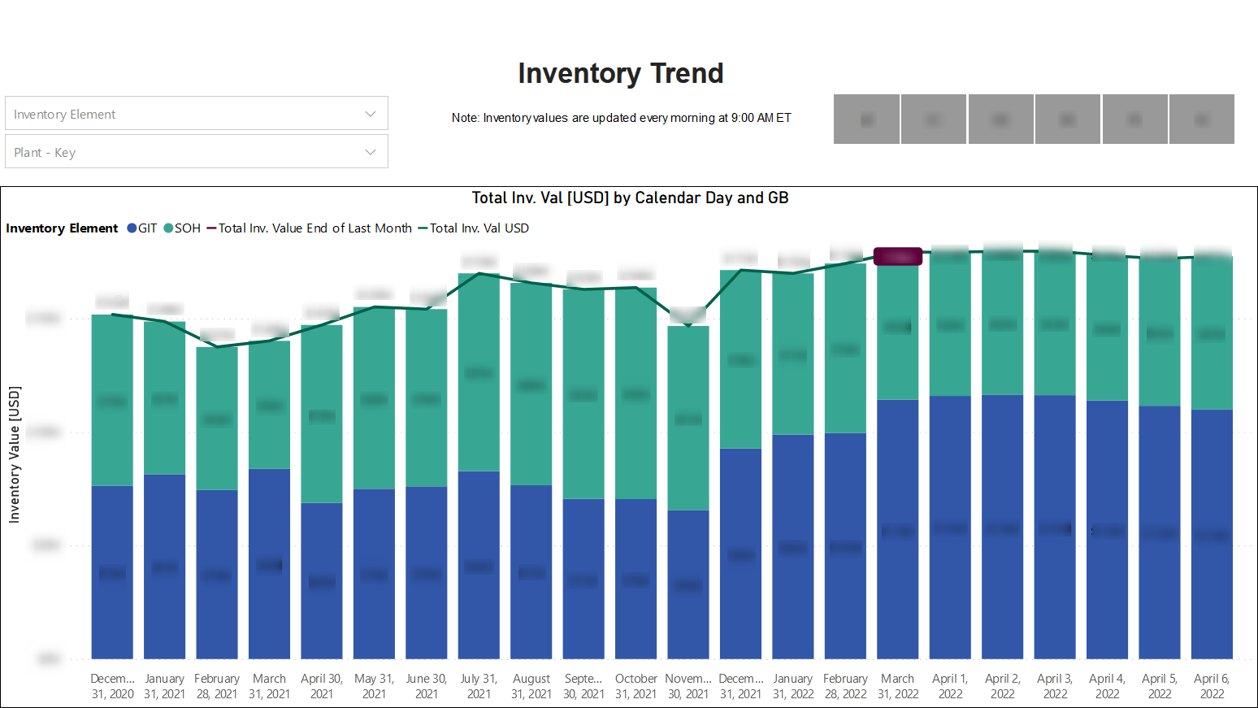
Figure A1: Inventory Dashboard in Power BI
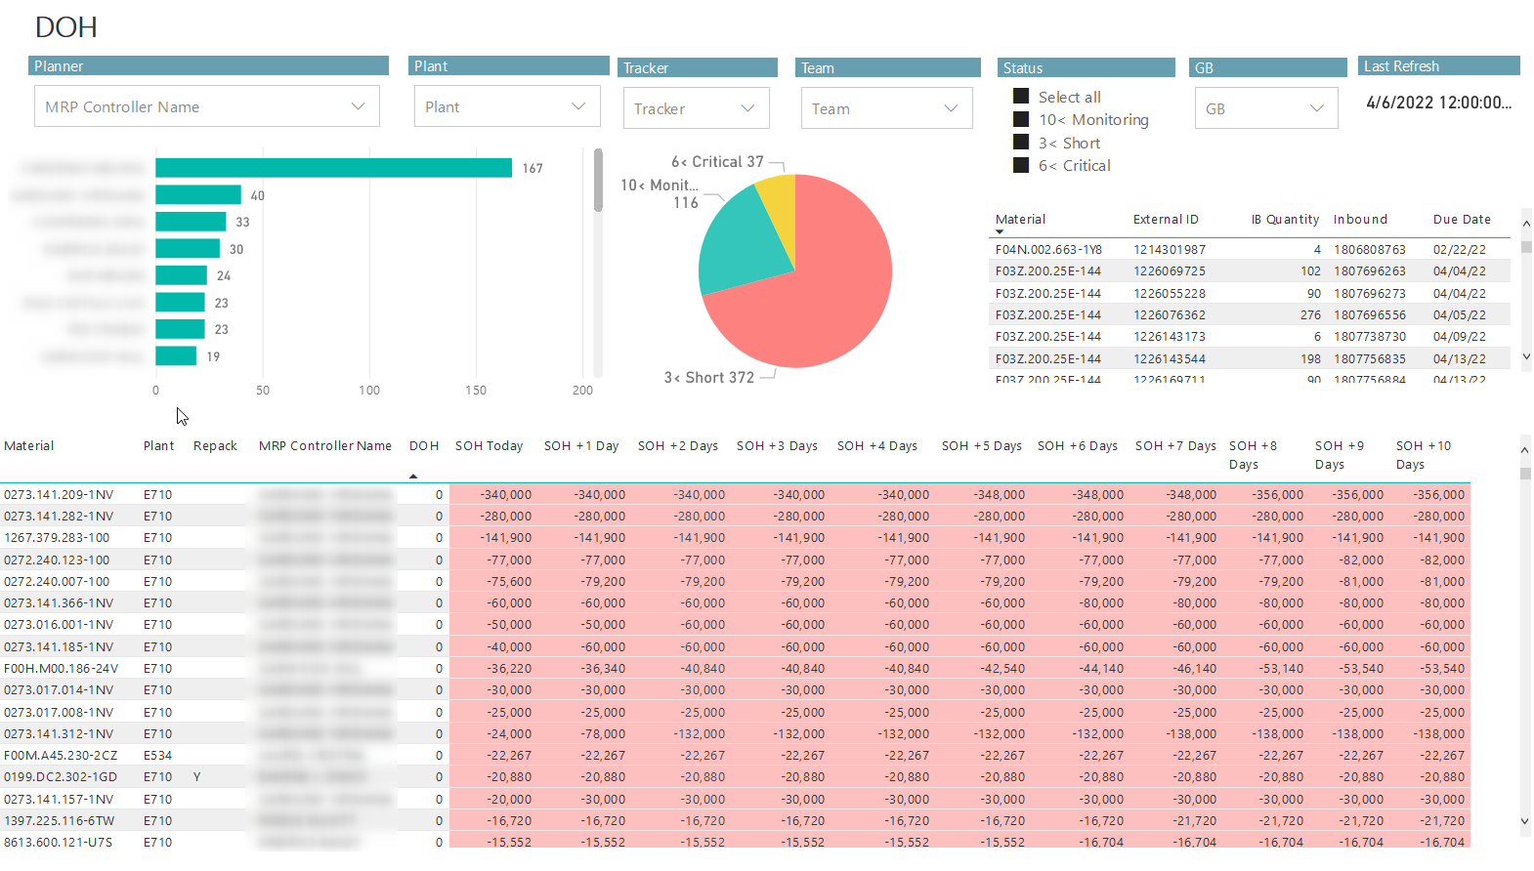
Figure A2: Days on Hand (DOH) report in Power BI

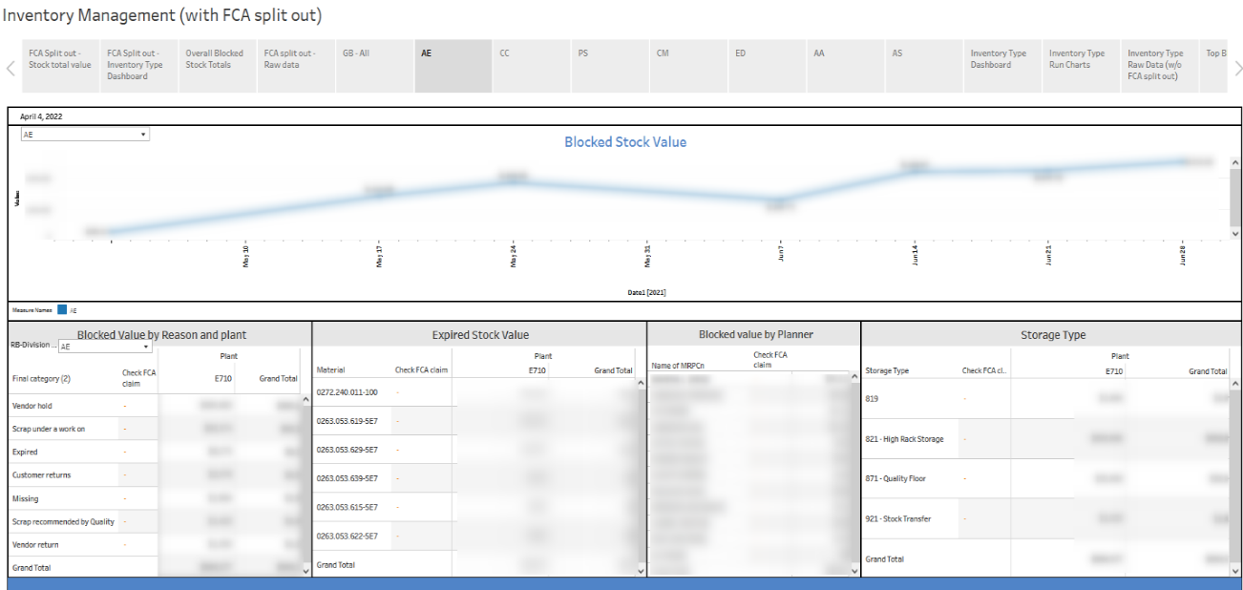
Figure A3: Inventory Management Report in Tableau

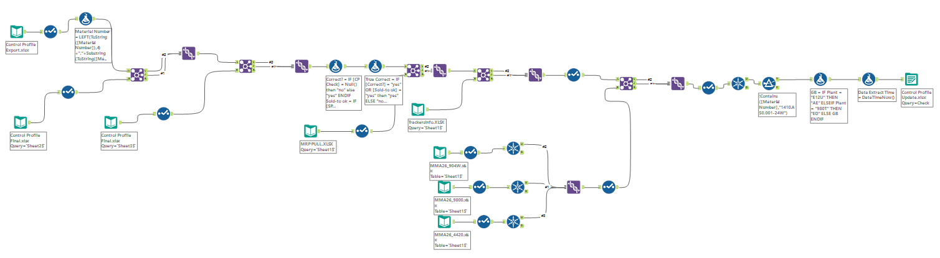
Figure A4: Sample Alteryx Workflow

Appendix 4: Undergraduate Rankings:

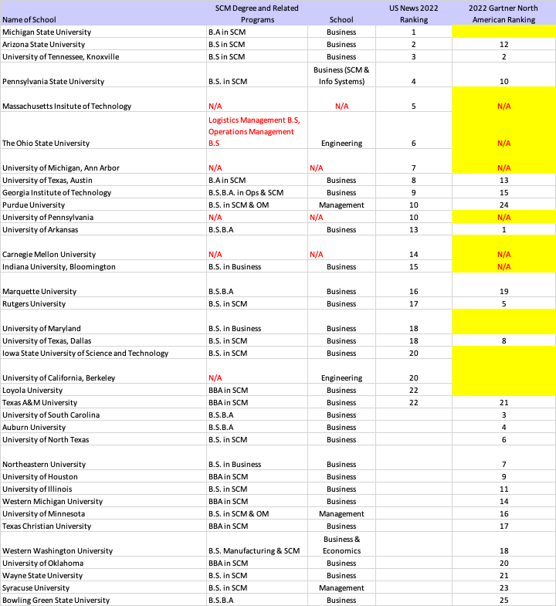

Figure A5: 2022 Undergraduate SCM Rankings U.S. News and Gartner

Appendix 5: Gartner 25 Rankings (2020 – 2022) compared to 2022 Fortune 100
Table A2: Gartner 25 rankings for 2020 through 2022 compared to Fortune 100
(Source: www.fortune.com)

Company | 2020 (Gartner) | 2021 (Gartner) | 2022 (Gartner) | 2022 (Fortune)
Cisco Systems | 1 | 1 | 1 | 74
Schneider Electric | 4 | 4 | 2
Colgate-Palmolive | 2 | 2 | 3
Johnson & Johnson | 3 | 3 | 4 | 37
PepsiCo | 6 | 7 | 5 | 45
Pfizer |  | 21 | 6 | 43
Intel | 8 | 6 | 7 | 46
Nestle | 5 | 5 | 8
Lenovo | 15 | 16 | 9
Microsoft |  |  | 10 | 14
L’Oréal | 10 | 9 | 11
The Coca-Cola Company | 13 | 18 | 12 | 93
Nike | 16 | 12 | 13 | 83
Walmart | 11 | 8 | 14 | 1
HP Inc. | 12 | 15 | 15 | 59
Diageo | 14 | 17 | 16
Dell Technologies |  | 14 | 17 | 31
Inditex | 9 | 13 | 18
BMW | 18 | 20 | 19
AbbVie | 17 | 11 | 20 | 63
Siemens |  |  | 21
AstraZeneca |  |  | 22
General Mills |  | 23 | 23
British American Tobacco | 21 | 19 | 24
Alibaba | 7 | 10 | 25
Starbucks | 19 | 22
H&M | 20
3M | 22 | 25
Reckitt Benckiser | 23
Biogen | 24
Kimberly-Clark | 25
Bristol Myers Squibb |  | 24 |  | 82

Appendix 6: ANOVA single factor comparing all 3 columns

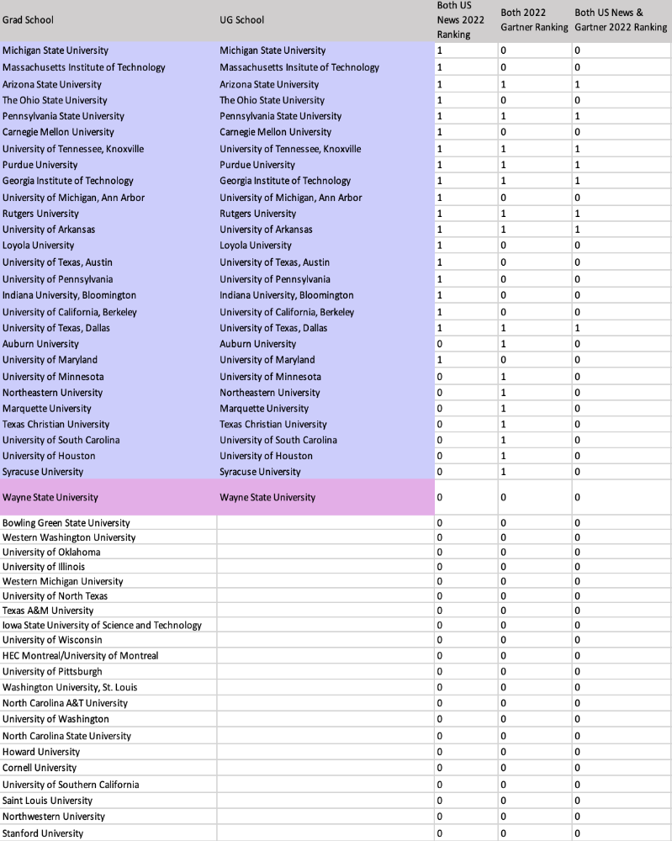

Figure A6: ANOVA data set
The SUMMARY table below has two parts: the first part provides summary statistics for the rows and the second part provides summary statistics for the columns. Summary statistics include the number of scores in each row and in each column along with the sums, means, and variances. The ANOVA table presents the Sums of Squares, df, Mean Squares, F, P-values, and critical F-ratios for the indicated df. The table features two values for F. One F is for the rows, and the other is for the columns. The P-value is the proportion of area that the F cuts off in the upper tail of the F-distribution. If this value is less than .05, reject H0. Although the ANOVA table includes an F for the rows, this doesn’t concern you in this case, because H0 is only about the columns in the data. Each row represents the data for one person. A high F implies that people are different from one another.

Table A3: ANOVA single factor test comparing all 3 columns

Anova: Single Factor | <--- Compares all three columns

SUMMARY
Groups | Count | Sum | Average | Variance |  | Standard Deviation
Column 1 | 49 | 19 | 0.387755 | 0.242347 |  | 0.492287455
Column 2 | 49 | 16 | 0.326531 | 0.22449 |  | 0.473803541
Column 3 | 49 | 8 | 0.163265 | 0.139456 |  | 0.373437789

ANOVA
Source of Variation | SS | df | MS | F | P-value | F crit
Between Groups | 1.319728 | 2 | 0.659864 | 3.265077 | 0.04103996 | 3.058928001
Within Groups | 29.10204 | 144 | 0.202098
Total | 30.42177 | 146

Correlation | Column 1 | Column 2 | Column 3
Column 1 | 1
Column 2 | 0.160409 | 1
Column 3 | 0.555056 | 0.634381 | 1

Covariance | Column 1 | Column 2 | Column 3
Column 1 | 0.237401083
Column 2 | 0.036651395 | 0.219908372
Column 3 | 0.099958351 | 0.109954186 | 0.136609746

Appendix 7: ANOVA single factor comparing U.S. News vs. Gartner only

Figure A7: ANOVA data U.S. News vs. Gartner

Appendix 8: Graduate Rankings:
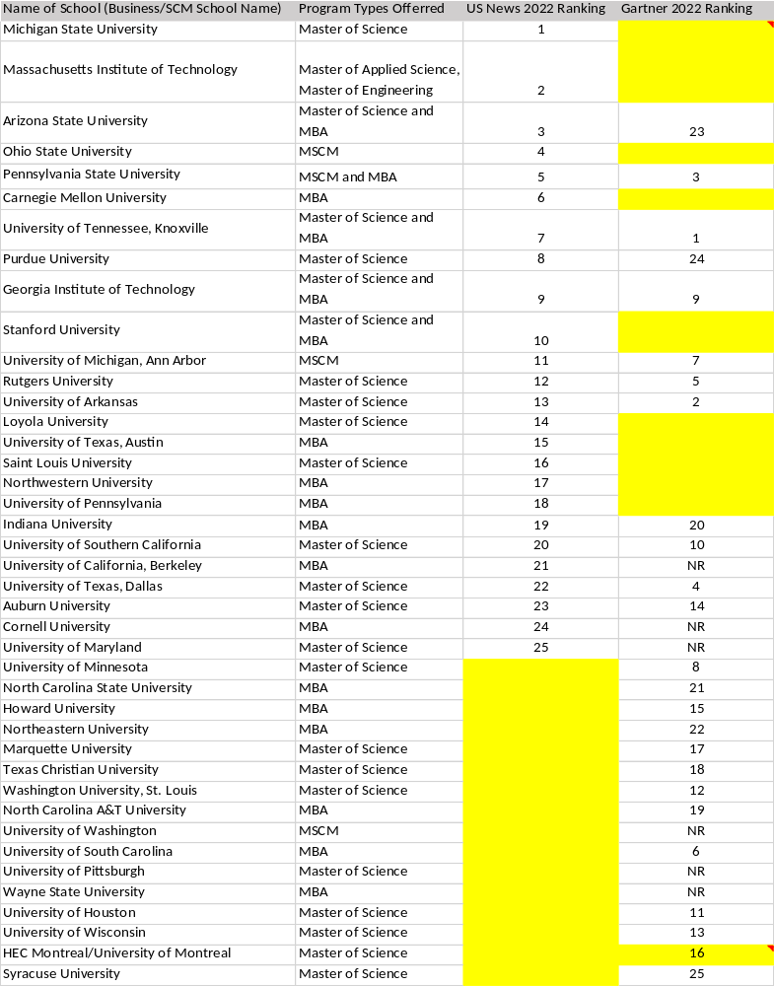

Figure A8: 2022 Graduate SCM Rankings U.S.News and Gartner

Appendix 9: SCM UG Demographic data for 20 of 36 universities

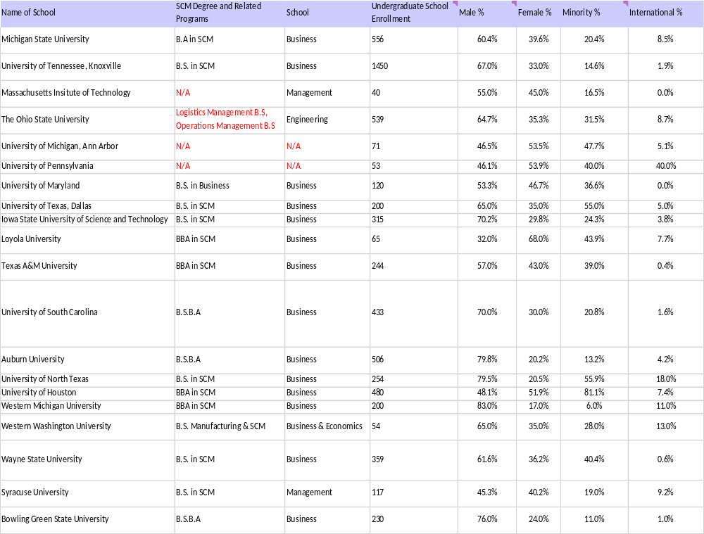

Figure A9: SCM UG Demographic data for 20 of 36 universities

Vita
David Quintanilla is the Director of Logistics Planning & Warehousing Operations – North America at Bosch USA. He holds an undergraduate degree in Industrial Engineering, as well as two master’s degrees in Operations Management and Engineering Management, all from Kettering University. He is also a PhD student at the Industrial and Systems Engineering department at the University of Tennessee, Knoxville.

