AN ANALYSIS OF THE SUSPENDED SEDIMENT RATING CURVE PARAMETERS IN THE UPPER MISSISSIPPI RIVER BASIN AT THE MONTHLY AND ANNUAL LEVELS

A Thesis Presented for the

Master of Science

Degree

The University of Tennessee, Knoxville

Vi Thi Tuong Tran

August 2014

Acknowledgements

I would like to express my sincere gratitude to my advisor, Dr. Carol Harden for her guidance and advice in the work of this thesis. I also thank Dr. Liem Tran for his mentorship and motivation in the past two years. I thank Dr. John Schwartz for serving as a helpful member in my committee.

I would like to thank the faculty, fellow graduate students, and staff in the Department of Geography at the University of Tennessee for their help and encouragement.

Lastly, I would like to address my deep gratitude to my beloved family as they are always supportive on every milestone in my life.

Abstract

Suspended sediment rating curve parameters were analyzed to investigate the relationship of suspended load and discharge in the Upper Mississippi River Basin (UMRB) at the annual and monthly levels. The rating curve parameters were obtained from the power function of load and discharge: Load = a × (Discharge)^{b} [(Discharge)^b]. The function was solved by ordinary least squares regression on its logarithmic form.
The annual rating coefficient a and exponent b ranged from 0 to 0.25 (kg/s)(s/m³)^{b} [(kg/s)(s/m^3)^b] and from 0.91 to 4.27, respectively. The monthly rating coefficient a and exponent b ranged from 0 to 0.239 (kg/s)(s/m³)^{b} and from 0.09 to 3.72, respectively. The intercept ln(a) and slope b of the logarithmic graph of suspended load and discharge were negatively correlated. This correlation was stronger for rivers categorized as having high discharge (> 218 m³/s [m^3/s]). This study also showed negative correlations between the rating coefficient a and stream discharge at annual and monthly levels, indicating that in large rivers, the rating curve tends to have a smaller intercept and larger slope. Smaller values of a and b in winter compared to other seasons suggested a low supply of sediment into streams due to frozen ground and the inactive state of streams in transporting sediment during winter months. The dominant shape of annual sediment rating curves in the region was convex, suggesting a transport-limited system for sediment transport in the basin. The transport-limited system indicates the potential of a flow to entrain additional sediment (possibly of larger grain sizes) during high discharge due to its higher competence. The apparent contradiction between the transport-limited condition and the findings of Meade and Moody (2010) is attributed to different approaches to the issue (trend of mean suspended load over time versus sediment rating curve). The results of this thesis also suggested that the UMRB has remained transport-limited after the flood in 1993, although this merits further investigation.

Table of Contents

Chapter I Introduction 1
Chapter II Literature Review 4
1. Sources of sediment 4
1.1. Upland erosion 4
1.1.1. Climate 4
1.1.2. Soil 6
1.1.3. Topography 7
1.1.4. Land use/ Land cover 7
1.2. Stream-bank erosion 8
1.3. Streambed re-suspension 10
2. Sediment transport 10
3. Using discharge to estimate suspended sediment load 11
3.1. Sediment rating curve 11
3.2. Interpreting the sediment rating parameters 12
3.3. Issues in using sediment rating curve for load estimation 14
4. Impact of locks and dams on sediment transport 15
Chapter III Study Area 17
1. Physiography and geology 17
2. Climate 21
3. Soil 25
4. Land use – Land cover 27
5. Sediment transport in the UMRB 28
Chapter IV Methodology 31
1. Data 31
2. Methods 35
2.1. Manipulating data 35
2.2. Analyses of the rating parameters 35
Chapter V Results 39
1. Descriptive statistics and spatial patterns of sediment rating parameters 39
2. The relationship between $ln(a)$ and $b$ at annual and monthly levels 40
3. The association of rating curve parameters with the mean stream discharge 41
4. Seasonal patterns of the rating parameters at the monthly level 41
5. The effects of dams on the rating parameters at pre- and post-dam stations 42
6. The effects of land use on the rating parameters 43
Chapter VI Discussion 72
1. Descriptive statistics and spatial patterns of rating parameters 72
2. The relationship between $ln(a)$ and $b$ at annual and monthly levels 76
3. The association between rating parameters and stream discharge 78
4. Seasonal patterns of the monthly rating parameters 79
5. The effect of dams on the rating parameters 80
6. The effects of land cover on the rating parameters at the annual and monthly levels 81
Chapter VII Conclusions and Recommendations 83
References Cited 86
Appendices 97
Vita 113

List of tables

Table 2-1. K (soil erodibility) values for soils of different textures (Dion 2002) 6
Table 3-1.Percentages of land cover in the UMRB in 1992 28
Table 5 - 1. Descriptive statistics of the rating parameters at annual and monthly levels for 64 gauging stations in the UMRB 44
Table 5 - 2. The Global Moran’s I of the rating parameters at 64 gauging stations in the UMRB at annual and monthly levels 45
Table 5 - 3. Spearman correlation coefficients of $ln(a)$ and $b$ at annual and monthly levels, measured for all streams, large streams, and small streams. 46
Table 5 - 4. Spearman correlation coefficient of mean discharge versus $ln(a)$ and $b$ at annual and monthly levels 47
Table 5 - 5. Pre- and post-dam stations associated with the dams used in the study 48
Table 5 - 6. Z scores of the comparison of the rating parameters between pre-dam and post-dam stations 49
Table 6 - 1. The rating parameters of some rivers in other studies and this study 73

List of figures
Figure 3-1. The Upper Mississippi River Basin 19
Figure 3-2. Physiographic regions of the UMRB 20
Figure 3-3. Elevation in the UMRB 20
Figure 3-4. Mean annual precipitation in the UMRB 22
Figure 3-5. Monthly average precipitation (1985–1995) in five cities in the UMRB 23
Figure 3-6. Monthly average discharge measured at five gauging stations in the UMRB 24
Figure 3-7. Soil permeability and soil erodibility factor (K) in the UMRB (soil loss per erosion unit) 26
Figure 3-8 . Land cover in the UMRB in 1992 30
Figure 4-1. Locations of monitoring stations and dams in the Upper Mississippi River Basin used in this study 34
Figure 5 - 1. Histogram of the annual $ln(a)$ as measured at 64 gauging stations in the UMRB. 52
Figure 5 - 2. Histogram of the annual exponent $b$ as measured at 64 gauging stations in the UMRB. 52
Figure 5 - 3. Histogram of the annual $a$ as measured at 64 gauging stations in the UMRB. 53
Figure 5 - 4. Histograms of the monthly $ln(a)$ as measured at 64 gauging stations in the UMRB. 53
Figure 5 - 5. Histogram of the monthly exponent $b$ as measured at 64 gauging stations in the UMRB. 54
Figure 5 - 6. Histograms of the monthly $a$ as measured at 64 gauging stations in the UMRB. 55
Figure 5 - 7. Distribution of the shapes of the suspended sediment rating curve at annual level. 56
Figure 5 - 8. Map of the Local Moran’s I of the rating exponent $b$ at the annual level. 57
Figure 5 - 9. Scatterplot of $ln(a)$ and $b$ as measured at 64 gauging stations in the UMRB at the annual level. 58
Figure 5 - 10. Scatterplots of $ln(a)$ and $b$ as measured at 64 gauging stations in the UMRB. 59
Figure 5 - 11. Scatterplots of $ln(a)$ and $b$ in large streams and small streams at the annual level. 60
Figure 5 - 12. Scatterplot between $ln(a)$ and $b$ in large streams at the monthly level. 61
Figure 5 - 13. Scatterplot of $ln(a)$ and $b$ in small streams at the monthly level. 62
Figure 5 - 14. Scatterplot of mean annual stream discharge versus the annual coefficient $a$ and the annual exponent $b$. 63
Figure 5 - 15. Scatterplot of mean annual stream discharge versus the annual coefficient $a$ in logarithmic forms 64
Figure 5 - 16. Scatterplot of mean monthly stream discharge versus monthly coefficient $a$. 65
Figure 5 - 17. Scatterplot of mean monthly stream discharge versus monthly coefficient $a$ in logarithmic form. 66
Figure 5 - 18. Scatterplot of mean monthly stream discharge versus monthly exponent $b$. 67
Figure 5 - 19. Distribution of the shapes of the suspended sediment rating curve at the monthly level. 68
Figure 5 - 20. Map of the Local Moran’s I of the rating exponent $b$ at the monthly level. 69
Figure 5 - 21. The number of significant differences in the monthly values of $ln(a)$ between pairs of seasons. 70
Figure 5 - 22. The number of significant differences in the monthly values of $b$ between pairs of seasons. 71

Introduction
Suspended sediment in streams is one of the most ubiquitous water pollutants causing degradation of water quality and riverine ecosystems (US EPA 2005; Julien and Vensel 2005; Davinroy et al. 2006; UMRBA and FTN Associates 2007). Suspended sediment carried in streams comprises not only fine particles, but also toxic chemicals attached or adsorbed to particle surfaces (O’Conner et al. 1976; Auld and Shubel 1978; Gregory 1990). Furthermore, changes in sediment regimes also change the habitats and food sources of aquatic species. For example, a study by Auld and Shubel (1978) showed that suspended sediment with concentrations of 1000 mg/l significantly reduced the hatching success ratio of white perch and striped bass. Those fish species may suffer from lack of oxygen or lack of food (Dougherty and Hall 1995). Box and Mossa (1999) showed that the decline of the freshwater mussel population in many rivers in North America is due to land-use modifications that change sediment regimes. In the context of water supply, higher sediment concentrations are associated with higher water treatment costs for operation and maintenance, as pumps and turbines can be worn by sediment (US EPA 1994). Furthermore, sediment can reduce the capacity of a reservoir to store water for power generation and other uses.
In the Upper Mississippi River Basin (UMRB), the problem of suspended sediment has been one of the greatest concerns of water managers (Davinroy et al. 2006). The suspended sediment yield has gradually declined in the past 50 years due to changes of river structure and flow regime, which have resulted from human activities such as engineering structures and conservation practices on agricultural land use (Meade 1995; Meade and Moody 2010; Horowitz 2010; Heimann et al. 2011). Researchers are interested in collecting more data for studies of suspended sediment transport; however, monitoring suspended sediment concentration is prohibitively expensive. An alternative method is to develop the sediment rating curve based on observed data of sediment concentration and discharge (Colby 1956; Asselman 1999; Asselman 2000 Horowitz 2003). The rating curve is used to estimate sediment concentrations (mass per volume of water) at known discharges, which can later be used to calculate the sediment load (mass per time) (Walling 1977; Horowitz et al. 2001). Alternatively, the sediment rating curve can be similarly generated with the record of suspended sediment load (Leopold and Maddock 1953; Syvitski et al. 1987; Syvitski et al. 2000). The details of the rating curve and the difference between using concentration and load to generate the curve will be discussed in detail in the literature review. In this study, I used the sediment rating curve derived from estimates of suspended load and stream discharge.
The purpose of this thesis is to derive the rating curve parameters for 64 gauging stations in the UMRB to examine the relationships between suspended load and stream discharge at annual and monthly time levels at each individual station, and to explore other factors that might affect these relationships. The primary questions are:
- What are the values of the rating coefficients $a$and the rating exponents$b$ at 64 gauging stations in the UMRB, as calculated at annual and monthly levels?
- Are $ln(a)$ and the exponent $b$ correlated with each other at annual or monthly levels?
- Are the annual and monthly rating parameters correlated with stream discharge?
- What are the seasonal patterns of the monthly values of the rating parameters?
- What are the effects of navigational constructions (i.e. locks and dams) on the annual and monthly values of the sediment rating parameters?
- What are the effects of land use on the annual values of the sediment rating parameters?
This thesis is organized into seven chapters. Chapter II introduces the overall mechanism of sedimentation, the sediment rating curve, and the effect of navigational construction on suspended sediment transport. Chapter III introduces the study area, which is the UMRB. It contains information about the natural characteristics and the current state of land use and navigation constructions in the basin. Chapter IV describes the data used in the thesis as well as the methods used to analyze the data. Chapter V displays the results of the analysis. Chapters VI and VII contain the discussion and conclusions from my study, respectively.

Literature Review

Sources of sediment
Sediment enters streams through various sources. Because the UMRB is a large basin, the sources of sediment in the basin are widespread and differ in different stream segments. The Upper Mississippi River – main stem of the basin – receives sediment from its tributaries and also from erosion due to runoff from the landscape, bank erosion, and re-suspension from the streambed (UMRBA 1993). The amount of sediment from these sources is controlled by the characteristics of the soil and sediment; the erosive forces; and external factors, including climate and land use/land cover. These factors are discussed in the sections below.

Upland erosion
Soil erosion is the detachment and transport of soil particles. Erosion occurs when the forces applied to soil by wind or water exceed the resistance of the soil to these forces. In the sub-humid continental climate of the UMRB, upland erosion is primarily caused by moving water (Lorenz et al. 2009). The following sections discuss the environmental conditions of climate, soil, topography, and land use/land cover, which determine the types and rates of soil erosion at a particular location.

Climate
Rainfall dislodges soil particles through the forces exerted by raindrops striking soil and by the moving water of rainfall runoff (Toy et al. 2001). The characteristics of rainfall in a region affect the potential for rain to cause soil erosion. Variables used to describe the erosivity of rainfall are rainfall amount, rainfall intensity, and kinetic energy of the rain (Foster et al. 1982). Rainfall intensity is measured as the rate of precipitation (mm per hour) (Ackerman and Knox 2011).
Erosion by raindrop impact is caused by raindrops that fall on the land surface and generate a shear stress that dislodges soil particles from their original positions. The kinetic energy of the raindrop is expressed in the equation:
$E= \frac{1}{2}mv^{2}$ (1)
According to equation (1), larger raindrops deliver more energy to the soil surface than smaller raindrops (Caracciolo et al. 2012). Larger raindrop mass (m) is usually associated with higher rainfall intensity.
Soil erosion caused by the energy transferred to soil particles by surface runoff is related to the rate and amount of runoff generated. The rate of runoff generation depends on the rainfall intensity and the infiltration capacity of the soil. The location and intensity of erosion by rainfall runoff are affected by the microtopography of the hillslope surface, which channels the runoff into rills of faster, higher-energy flow. Rill erosion is more intense on cultivated landscapes where tillage operations have formed the initial pattern of channels on the surface (Maynord and Martin 1996). Tillage activities also loosen soil particles, which accelerates the erosion process.
The type of precipitation also affects soil erosion. Snowfall does not cause soil erosion, but, in winter, when the subsoil is frozen, rainfall on thawing soil can cause a high rate of soil erosion because water that cannot infiltrate into frozen soil produces surface runoff. This phenomenon has been reported in the Northwestern United States (Renard et al. 1997), and can occur in other locations where rain falls on thawing soil.

Soil
The infiltration capacity of soil has an important impact on the erosion process. At the early stage of a rain event, water is easily infiltrated into unsaturated soil. When the rainfall intensity exceeds the soil’s infiltration capacity, or when the soil becomes saturated, runoff will occur. Different soil types have different infiltration capacities. Soils with coarser textures, such as those with high proportions of sand and silt, absorb water more rapidly, while clay soil absorbs water more slowly (Page 1952). Therefore, runoff is more likely to occur on clay soil than on sandy soil.
Soil erodibility also depends on soil texture. As the cohesive forces of clays are higher than those of other particle-size classes, particles of clay soil are harder to detach. Hence, soil with clay texture has low soil erodibility. Meanwhile, even though particles of sandy soil can be easily detached, sandy soils do not often generate runoff; therefore, this type of soil also has a low erodibility. The soil erodibility factor (K factor from USLE; Wischmeier and Smith 1960) is high for medium-textured soils, since both runoff generation and soil particle detachability are high. The erodibility of a soil increases as the silt proportion increases (Table 2-1).
Table 2-1. K (soil erodibility) values for soils of different textures (Dion 2002)
Texture | K values ^{a,b}
Sandy, fine sand, loamy, sand | 0.10
Loamy sand, loamy fine sand, sandy loam, loamy, silty loam | 0.15
Loamy, silty loam, sandy clay loam, fine sandy loam | 0.24
Silty clay loam, silty clay, clay, clay loam, loam | 0.28
ªUnit of K (from Dion 2002): soil loss rate per erosion unit index
^{b}Unit of K from USLE (Foster et al. 1981): $\frac{ton × ha × hour}{ha × megajoulle × mm}$

Topography
Another factor affecting soil erosion is topography, the geometry of the land surface. Topographic metrics include slope length and steepness, and the shapes of landforms in profile view and plan view. Soil erosion at a location on a slope is a function of the distance traveled by the surface runoff and the steepness of that location (Toy et al. 2001). Sediment available for transport at a location on the slope is related to the amount of soil eroded upslope that has been deposited at that location.
The effect of topography on soil erosion is greater where soil is more susceptible to erosion by runoff than by raindrop impact, for example, at tree-canopied areas (Mannering and Meyer 1963). In addition to the direct controls on the velocity of overland flow by the length and steepness of the slope, topography also has indirect effects on erosion through its relationship to soil moisture. Because water flows downhill, soil moisture tends to be higher at the base of a slope than at the upper hill slope (Weltz et al. 2006). Spatial differences in soil moisture and consequent differences in vegetation density contribute to the spatial variability of soil erosion rates over a landscape (Foster et al. 1982).

Land use/ Land cover
Land use, which affects patterns of vegetative cover and the infiltration characteristics of the land surface, has an important effect on soil erosion. Land use and land management can enhance or decrease erosion rates. Land use is generally categorized as urban land, agricultural land, forest land, or wetland (Fry et al. 2011). The presence of vegetation is one of the main factors affecting the impact of land use on soil erosion. Vegetation provides canopy, which intercepts the energy from raindrops before they hit the surface, and organic matter, which increases the water-holding capacity of soil and decreases soil erodibility. At areas not covered by plants, bare soil is vulnerable to erosion. Lopes et al. (2001) studied the effect of vegetation management practices on the suspended sediment concentrations of three forested watersheds in Arizona. Their study area included a cleared watershed, a strip-cut watershed, and an undisturbed, control watershed. They found that the suspended sediment concentration in the stream draining from the cleared watershed was the highest, while the strip-cut watershed yielded more suspended sediment to the river than the control watershed.
Human activities involving agriculture and construction also affect the amount of suspended sediment transported to the streams. Agricultural landscapes are sensitive to soil erosion because tillage and grazing activities reduce water infiltration, hence increase rates of surface runoff (Julien and Vensel 2005). Furthermore, agricultural activities create large patches of bare soil which are vulnerable to erosion (Toy et al. 2001). Soil erosion from farms has been considered the greatest upland source of sediment in the UMRB, one of the most agriculturally active areas in the world (UMRBA 1993).

Stream-bank erosion
Stream-bank erosion is one of the major contributors of sediment (UMRBA and FTN Associates 2007). The mechanism and causes of stream-bank erosion have been the subjects of numerous studies. Bank erosion consists of the processes of internal failure, soil particle displacement, and transport of displaced and failed soil from the channel banks (USACE 1981). The internal failure process occurs due to wet/dry or freeze/thaw condition cycling, or seepage and piping underneath the surface soil. These phenomena weaken the bank soil and make it more vulnerable to displacement (Thorne and Tovey 1981). On the Illinois River, piping was found to be the primary cause of bank erosion (Hagerty and Spoor 1989). Displacement of soil particles by undercutting can lead to basal scour, which destabilizes the bank and leads to bank failure caused by gravity (Maynord and Martin 1996).
The process of bank erosion depends on channel size and geometry, structure of stream banks, properties of the bank materials, hydraulics of stream flow, and climatic characteristics (Thorne and Tovey 1981). The main stream in the UMRB, the Upper Mississippi River, is a classic meandering river with a wide floodplain (Fisk 1947). Naturally, meandering rivers migrate laterally in floodplains by eroding the outer banks and depositing sediment on point bars. Meandering, which is both a cause and a result of the erosion and sedimentation process, affects the spatial variation in bank erosion rates (Hooke 1979). High flow is another factor that induces stream bank erosion. Many authors have concluded that tractive force caused by high flow was not the most important factor causing bank erosion (e.g. Schumm 1973; Hughes 1977; Thorne and Tovey 1981). High water levels enhance water infiltration into the bank. This process softens the soil, reduces its cohesion, and makes it more vulnerable to bank failure (Leopold 1994). When the water level falls, seepage flows occur through the non-cohesive layers in the river banks (US AED 1977; Hagerty 1991a; Hagerty 1991b). Loss of material in non-cohesive layers by seepage flows can destabilize an upper cohesive layer, which, in turn, causes more severe bank erosion (Simons et al. 1979; Browne 1980; Ullrich et al. 1986; Keller et al. 1990). Hill (1973), who studied the erosion of river banks composed of glacial till in Ireland, showed that in summer, when the bank soil was dry, major rises of stream discharge did not result in severe erosion of stream banks, as compared to similar flood events in winter, when bank soil had been loosened by frost.
In the UMRB, erosion of sediment from the river bank results, not only from natural processes, but also from the activities of vessels on the river (Maynord and Martin 1996). According to Karaki and Van Hoften (1975), the impact of wave wash from boats varies from location to location, depending on the river bank stability and form. Their study also showed that river banks that have been eroded by waves are more vulnerable to this kind of erosion and that fast-moving vessels are more erosive than slow-moving vessels.

Streambed re-suspension
In-stream sources of sediment, namely re-suspension of bed materials, have become more important as the improvement in channel-bank and soil-surface conservation techniques have prevented upland sediment from entering the Mississippi River and its tributaries and as river traffic has increased on the Mississippi River. Wuebben et al. (1983) studied the effect of boat traffic on the re-suspension of streambed materials. They used the term “explosive liquefaction” to describe the saltation of bottom sediment caused by the imbalance between the pore pressure in the bed soil and water pressure on the riverbed. This mechanism repeated whenever a vessel passed, causing re-suspension of sediment.

Sediment transport
Suspended sediment consists of particles suspended in the flow, in the water column. The suspension of a particle is maintained by the lift force generated by pressure differences on the top and bottom sides of the particle (Jeffreys 1929). The amount and size of sediment moving through a river channel are determined by two factors: capacity, and sediment supply (Hickin 1995). Capacity transport of a river refers to the maximum amount of sediment of a given size that the river can transport in its channel. Capacity transport, given the case of unlimited sediment supply, depends on the channel gradient, discharge, and sediment grain size. Capacity transport is higher for fine sediment and lower for coarse sediment, and it can only reach its maximum when sediment supply, the amount and grain size of sediment that is present in the channel, is not limiting. Sediment supply and hydraulic limitations of the flow are two constraints used to distinguish supply-limited and transport-limited (also called capacity-limited) conditions for sediment transport. River channels are typically supply-limited for fine sediment and transport-limited (capacity-limited) for coarser material (Hickin 1995).
Particles remain in suspension until the lift force caused by the turbulent motion of water falls below the force of gravity on the particle, and gravitational settling occurs. Deposition processes are directly related to flow velocity and grain size (Hjulström 1935). The deposition of suspended sediment aggrades channel margin surfaces and forms floodplains and deltas (Bourke 2002), as well as in-channel deposits.

Using discharge to estimate suspended sediment load

Sediment rating curve
Researchers have long been interested in studying fluvial suspended sediment transport to evaluate various issues such as contaminant transport, water-quality trends, soil erosion and loss, or reservoir sedimentation (e.g., Colby 1956; Ferguson 1986; Horowitz et al. 2001). However, due to the lack of continuous suspended sediment concentration records, suspended sediment loads cannot be directly calculated (Phillips et al. 1999). Suspended sediment moves at a velocity that is closely to flow velocity (McMahon et al. 2004). As suspended sediment load is a function of water discharge, many studies have used stream discharge to estimate the suspended sediment load (Leopold and Maddock 1953; Walling 1977; Ferguson 1986; Walling and Webb 1988; Sichingabula 1998; Asselman 2000; Horowitz 2003; Hu et al. 2011). The relationship between suspended sediment concentration or load, and stream discharge is displayed by the sediment rating curve (Campbell and Bauder 1940; Walling 1977; Asselman 2000). The basic form of the sediment rating curve was developed for suspended sediment load ($Load$) and water discharge ($Q$), as shown below (Leopold and Maddock 1953):
$Load=aQ^{b}$ (2)
where $a$ and $b$ are empirical parameters. The sediment rating curve can also be developed for suspended sediment concentration ($C$) and water discharge, yielding the equation:
$C = aQ^{b-1}$ (3)
Many studies have used equation (3) to develop the sediment rating curve (Walling 1977; Thomas 1988; Asselman 1999; Hu et al. 2011; Zhang et al. 2012). More complicated forms of sediment rating curve have been developed, to account for the effect of seasonality in sediment transport, the hydrological periods of a flood event (i.e. rising limb/ falling limb of a hydrograph), to enhance the accuracy of load estimates (Crawford 1998; Morehead et al. 2003; Runkel et al. 2004).

Interpreting the sediment rating parameters
While a few researchers argue that the rating parameters $a$ and $b$ have no physical meaning (Colby 1956; Ferguson 1986), others claim that these coefficients have physical interpretation (Walling 1974; Morgan 1995; Asselman 2000; Morehead et al. 2003). The rating coefficient $a$ represents the sediment concentration at unit discharge, which depends on the availability of sediment in the area contributing to the site of measurement and whether the sediment is easily eroded and transported by stream flow. This coefficient, therefore, is influenced by the soil erodibility and suspended sediment input in the basin upstream of the gauging site (Morgan 1995; Asselman 2000). The rating coefficient $a$ has multiple units and varies with the value of the exponent $b$: (kg/s)(s/m³)^{b}.
The rating exponent $b$ indicates the changing rate of the suspended sediment load per change of unit water discharge. There are three possibilities for the range of values for the exponent $b$ (Asselman 2000; Morehead et al. 2003):
- $b$ = 1: The suspended sediment load increases in a linear fashion with the increase of stream discharge. The shape of the rating curve with this exponent value is a straight line.
- 0 < $b$ < 1: The suspended load increases in a diminishing rate with the increase of discharge. In this case, the rating curve has a concave shape. Rivers with this kind of rating curve are supply-limited, which means that the amount of sediment transported is constrained by the amount of sediment available (Hickin 1995; Meade and Moody 2010).
- $b$ > 1: The suspended load increases at an increasing rate with the increase of discharge. The shape of the rating curve in this case is convex. Rivers of this kind of rating curve are expected to be transport (capacity) limited (Asselman 2000). This condition would occur in a river with coarse material (Hickin 1995), or in which stream discharge reaches a threshold that is competent to suspend the available sediment (Asselman 2000).
To estimate suspended sediment concentration from stream discharge, scientists have applied equation (2) or (3) for particular rivers over different scales of time, such as for a single flood event, for annual data, or for interannual discharge discharge (Horowitz 2008; Hu et al. 2011; Zhang et al. 2012; Araujo et al.; Wang and Tian 2013). Other studies have found that the rating parameters are also associated with factors such as river channel morphology, surface air temperature, and basin relief (Syvitski et al. 2000; Yang et al. 2007).

Issues in using sediment rating curve for load estimation
The mechanics of sediment particle suspension are complex due to the interaction of various external factors (e.g. climate and land-use effects on the availability of sediment sources, channel geometry). Although many scientists have attempted to estimate suspended sediment load from stream discharge, there is still a high degree of scatter on the plot of sediment load and discharge at a station due to the lack of a unique relationship between these parameters (Kim and Ivanov 2014).
Because stream discharge is used as a surrogate for the measure of shear stress and stream power, errors in load estimation using a sediment rating curve can be expected when there are inequalities between discharge and stream power (Hickin 1995). Such inequalities occur when there are discontinuities in the fluid mechanics, such as a sudden change in turbulence in rapids, and changes in the form of the channel bed. Furthermore, most rivers transport sediment according to the sediment supply. However, sediment enters the stream from various sources; hence, it is impossible to predict the amount and timing of sediment delivered to the stream (Hickin 1995; Sichingabula 1998; Asselman 2000).
The scatter around the sediment rating curve can be a result of the hysteresis effect. For a flood event, the interrelation of suspended load and discharge can be better described as a loop, rather than a single rating curve, because the availability of sediment is different before and after the peak discharge (Horowitz 2003; Morehead et al. 2003). Sediment concentration is usually higher on the rising limb of the flood hydrograph, when sediments are still available, than on the falling limb, when sediment sources are no longer accessible (Pye 1994).
Another problem in estimating suspended load using a sediment rating curve is a mathematical one. The power function between discharge and suspended load is commonly solved with ordinary least squares regression, which requires a logarithmic transformation. The geometric mean of the antilog is always smaller than the arithmetic mean of the load in log form. Therefore, the estimated $Load$ is always lower than the real value, which causes the biased estimation in this method (Ferguson 1986; Ferguson 1987). On the other hand, values of the exponent $b$ are also underestimated because plots of discharge and suspended load have a high degree of scatter, especially at large discharge, due to the amplification of external factors during periods of high discharge.

Impact of locks and dams on sediment transport
The Upper Mississippi River is influenced by the system of locks and dams between Minneapolis and St. Louis, which create impoundments that alter the sediment transport (US EPA 1999). Reservoirs formed by the dams cause sediment to be deposited, as water flows into these reservoirs at a lower velocity compared to the velocity of unregulated flow. According to Bhowmik and Adams (1989), the sedimentation regime of Peoria Lake (Illinois) was shifted by the closure of the Peoria lock dam in 1939. Prior to 1939, the sedimentation rate of this lake was 0.63%/year. After 1939, the sedimentation rate doubled to 1.44%/year. The rate, by far, has been the highest among the lakes and reservoirs in Illinois. The creation of artificial islands by selective dredging of certain areas is considered to have increased the sedimentation problems of Peoria Lake (Demissie 1989). Furthermore, dams attenuate the peak annual discharge, which accounts for a large amount of sediment transported (Alexander et al. 2012). At a broad scale, dams on the Mississippi River intercept sediment from upstream, causing a downstream decline in the sediment yield of the river (Meade 1995).
Over time, large rivers respond to natural stressors (e.g. climate), and adjust their geometries (channel size and shape); over space, they traverse a variety of landscapes with local and regional geologic, climatic, and biologic changes that influence the geometry and hydraulics of the channel and floodplain (Alexander et al. 2012). Changes of sediment regime have affected channel stability. For instance, streambed degradation of up to 3.6 meters, measured on the Missouri River, altered the magnitude, frequency, and temporal distribution of flows in the river (Mellema and Wei 1986; Curini et al. 2002). Along with locks and dams, engineers have used revetments and levees to prevent riverbank erosion. Revetments prevent bank erosion by armoring the bank, while levees confine sediment to the channel, instead of letting it be deposited onto the surrounding land. These changes affect the sources of sediment in the Upper Mississippi River.

Study Area
The UMRB encompasses an area of 492,000 km² in the headwaters of Mississippi River and extends southward to the confluence of the Mississippi River with the Ohio River near Cairo, Illinois. The UMRB covers parts of seven states: Minnesota, Wisconsin, Iowa, Missouri, Illinois, and Indiana (Figure 3.1). The Mississippi River serves as the backbone of the UMRB. It provides habitats for many aquatic species and drinking water for more than 18 million people living in the basin (Meade 1995). The main contributors of water and sediment to the Upper Mississippi River are the large tributaries, including the Minnesota River, the Missouri River, and the Des Moines, Illinois, Iowa Rivers (Julien and Vensel 2005).

Physiography and geology
The UMRB is located on the oldest bedrock of the United States (Davinroy et al. 2006). The center and northern parts of the UMRB are in the Superior Upland and Central Lowland physiographic regions, while the southern tip of the basin falls into the Ozark Plateaus, Coastal Plain, and Interior Low Plateaus (Vigil et al. 2000) (Fig. 3.2). The bedrock under the basin is mostly of Paleozoic and Cambrian age. The Central Lowlands are composed of old sedimentary rock from material eroded from the Appalachian Mountains and upland areas of the Great Lakes (Lew 2009). On the other hand, the Superior Upland, a part of the Canadian Shield, is composed of metamorphic rocks, which have been the source of important industrial materials (Vigil et al. 2000).
The surfaces of the UMRB landscape were formed by glacial and fluvial processes. During the Pleistocene Epoch, the northern area of the UMRB was glaciated. The Pleistocene Glacial River Warren was the predecessor of the Minnesota River (Meade 1995). Landforms and landscapes of the basin affect the rainfall runoff rate and the infiltration rate of soil. The UMRB is on the low plateau portion of the larger Mississippi River basin. The land surface of the Mississippi River basin is mostly covered by glacial outwash, which consists of silts, clays, and gravels (Davinroy et al. 2006). More than 50% of the landforms of the southern UMRB are flat plains or gently rolling moraines (NRC 2008). The remaining landforms consist of hills and low mountains in the north of the basin (Davinroy et al. 2006). Figure 3.3 shows elevations of the UMRB. Overall, the elevation of the basin decreases from north to south. While the southern part of the basin is lower and flatter, the northern part is higher, with more steep slopes.
Pleistocene glaciation left large areas of wetlands and lakes in the north of the basin. These wetlands slow runoff and trap pollutants from the northern upland before they reach the Mississippi River (NRC 2008). However, due to the demand for agricultural land and urban development, wetlands have been transformed to croplands over the past 150 years (Prince 1998). Silt, which was deposited in glacial outwash across surfaces of the plains, made soils of this area suitable for agricultural activities.

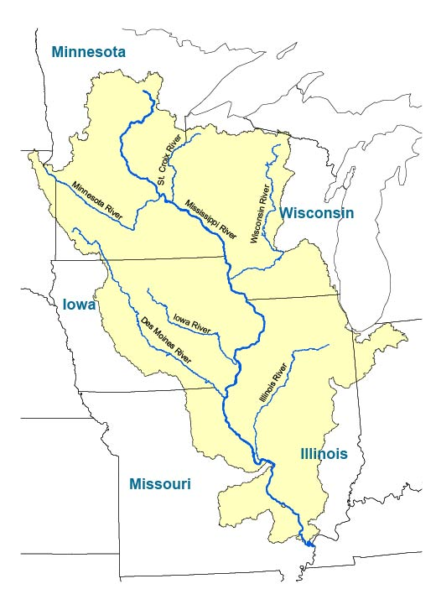
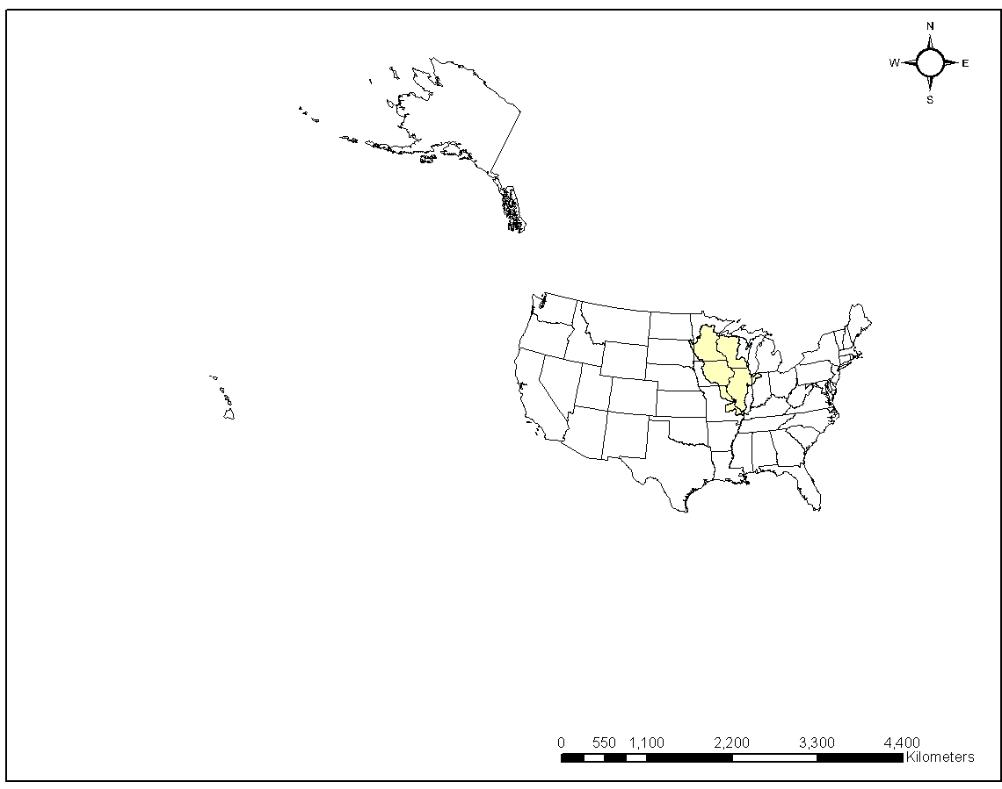
Figure 3-1. The Upper Mississippi River Basin

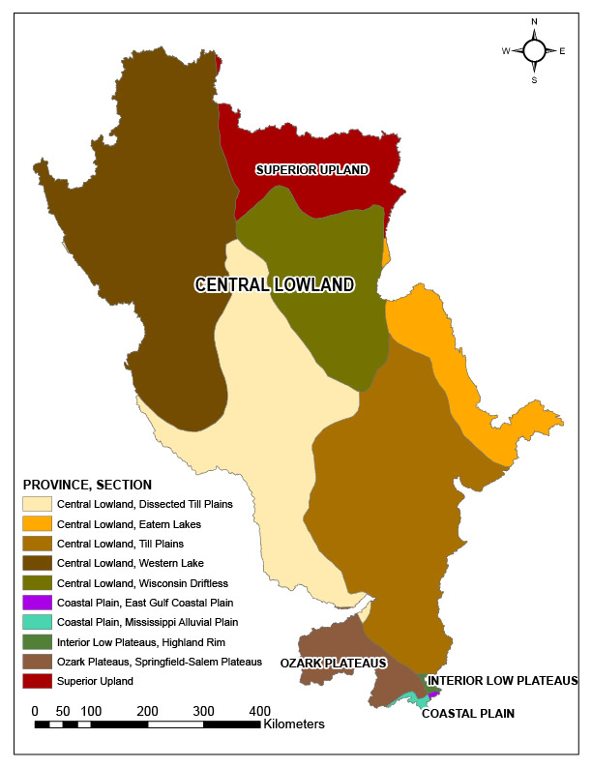  Figure 3-2. Physiographic regions of the UMRB  (Source: USGS 2004) | 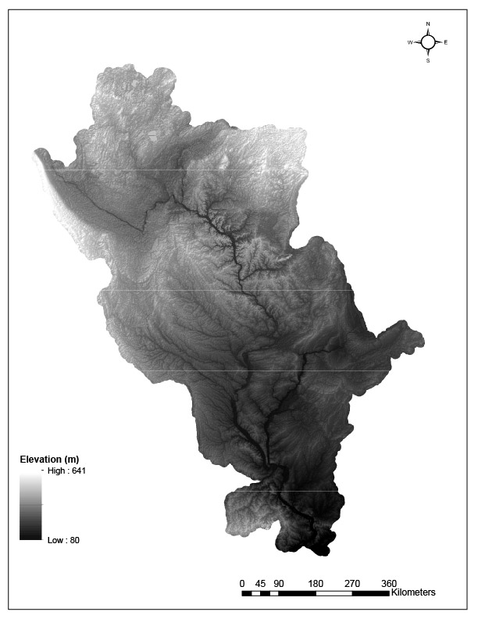  Figure 3-3. Elevation in the UMRB  (Source: USGS 2006)

Climate
Located in inland North America, the UMRB has a subhumid continental climate (Lorenz et al. 2009). In the northern sections, average monthly temperatures range from -12 ºC in the winter to 18 ºC in the summer. Meanwhile, the range of average monthly temperature, from winter to summer, is from 2 ºC to 24 ºC for southern sections (Davinroy et al. 2006).
Figure 3.4 shows the mean annual precipitation across the basin. Average precipitation increases southward in the basin. Figure 3.5 shows average monthly precipitation from 1985 to 1995 at stations in five cities in the UMRB. According to the graphs, Minneapolis had the highest precipitation during that time. Generally, precipitation is higher in the months of June, July, and August; while the driest months are December, January, and February. In the cities of Chicago, St. Louis, and Peoria, precipitation does not vary greatly over the year, while summer precipitation greatly exceeds precipitation during the winter months in Minneapolis and Ankeny. At most of the cities, except for St. Louis, the highest precipitation was observed in July. Figure 3.6 shows the discharge at five stations on major tributaries of the Upper Mississippi River. Of these stations, the Illinois River contributes the most discharge to the main river. Discharge in the region is consistently higher during late spring (i.e. April and May) at those stations.
According to 100 years of historical records, there is currently an upward trend of precipitation in the UMRB (IPCC 2001). If the upward trend continues, it will potentially lead to more runoff which, in turn, is expected to increase the amount of sediment in the channels (Davinroy et al. 2006). A study of the impact of climate change in the UMRB by Jha et al. (2004) estimated a future scenario in which a 21% increase in precipitation intensity would result in a 51% increase in the amount of surface runoff and a 50% increase in total water yield. This result demonstrated the non-linear nature of hydrologic budget components, such as snowmelt, evapotranspiration, surface runoff, and ground water flow.

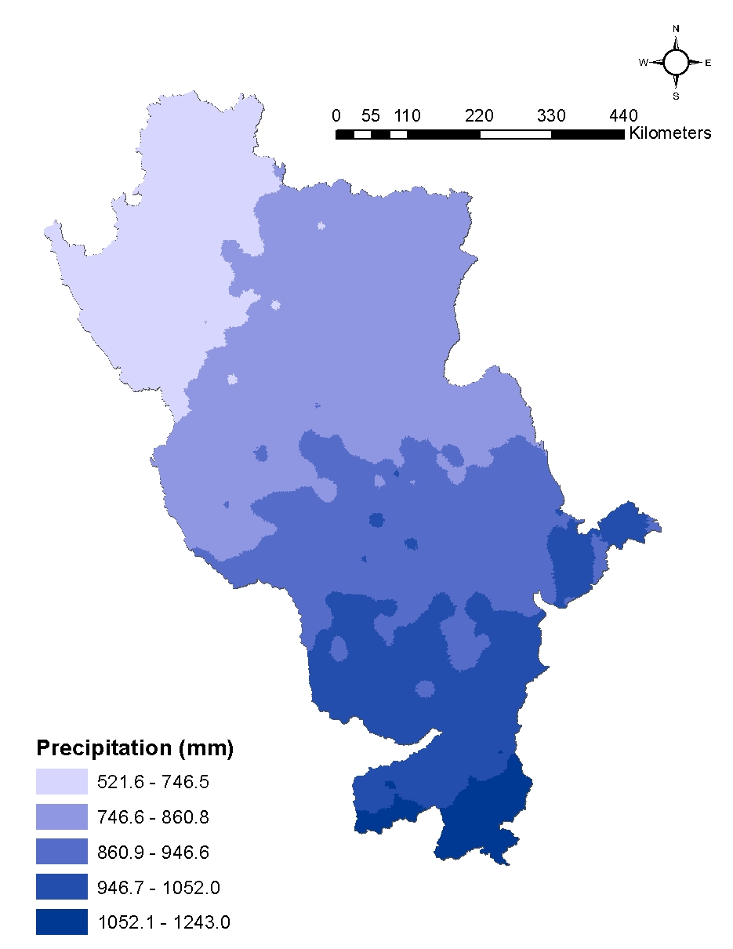
Figure 3-4. Mean annual precipitation in the UMRB
(Source: Daly and Taylor 1998)

- Chicago (Illinois) | - St Louis (Missouri)
- Peoria (Illinois) | - Minneapolis (Minnesota)
- Ankeny (Iowa) | 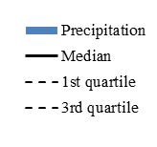
Figure 3-5. Monthly average precipitation (1985–1995) in five cities in the UMRB
(Source: NOAA and NCDC 2013)
- Minnesota River at Fort Snelling State Park, MN | - Iowa River at Oakville, IA
- Wisconsin River at Muscoda, WI | - Illinois River at Valley City, IO
- Mississippi River at St. Louis, MO | 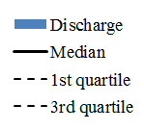
Figure 3-6. Monthly average discharge measured at five gauging stations in the UMRB
(Source: USGS 2001)

Soil
The soil permeability map (Figure 3.7), derived from USGS soil data, (Wolock 1997), shows that, in most portions of the basin, the rate of soil permeability is in the range from 6.19 to 83.57 millimeters/hour. These rates are classified as slow to moderate permeability for agricultural soils. Areas of low permeability generate rainfall runoff more readily, thus having greater potential to erode soil. In addition, the K-factor map (Figure 3.7) shows that soils in the central to southern part of the UMRB are more erodible than soils in other parts of the basin. The two maps show an association between low values of soil permeability and high values of soil erodibility in the southern part of the basin. Soils in this area are mostly Mollisols (Web Soil Survey, 2014) with high organic matter contents and a silt-loam texture (Soil Survey Staff 1999).

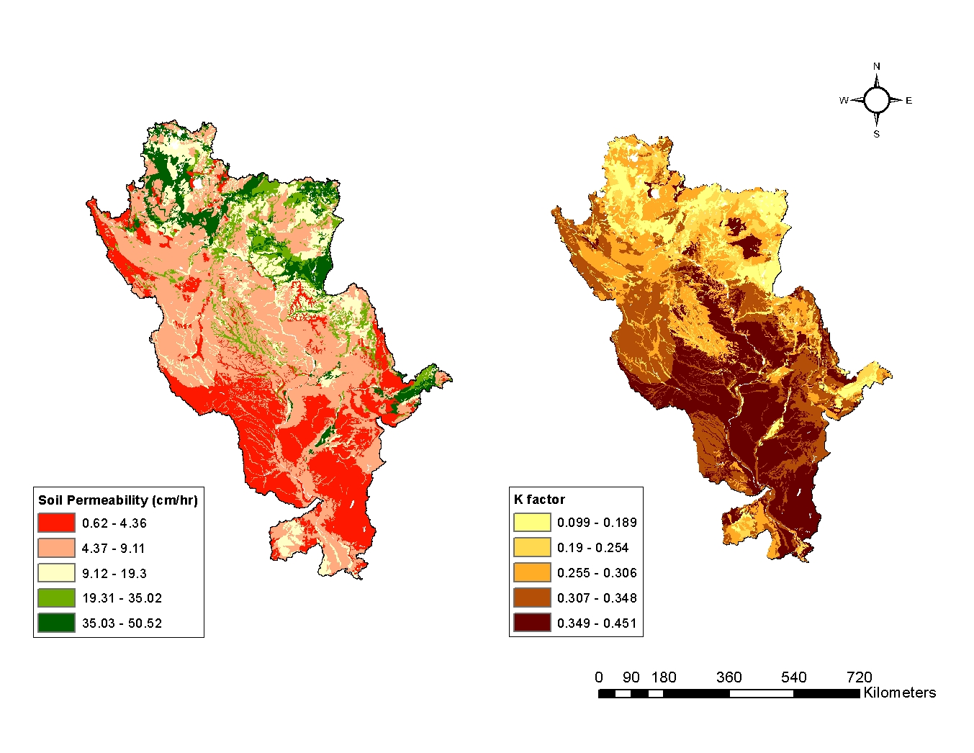
Figure 3-7. Soil permeability and soil erodibility (K factor) in the UMRB (soil loss per erosion unit)
(Source: Wolock 1997)

Land use – Land cover
Agriculture has been the predominant land use in the UMRB from the time of European settlement (1700s) until the present (Julien and Vensel 2005). There is also a mixture of other land covers, such as forest, wetlands, lakes, prairies, and urban areas (UMRBA and FTN Associates 2007). Table 3-1 and Figure 2.7 show the distribution of land cover in the basin in 1992.
To convert wetlands to croplands, farmers have used drainage systems (Prince 2003). In the UMRB, subsurface drainage, in the form of drain tiles, has been popular since the 1830s. Plastic drainage tiles now underlie 16–28 million hectares of the Mississippi River basin (Mitsch et al. 2001). The usage of drainage tiles increases annual runoff, storm runoff, and peak discharge, which cause potential flooding and erosion. Moore and Larson (1980) studied the hydrologic response of agricultural drainage and natural drainage in two watersheds in southwestern Minnesota. Their results showed that the mean annual runoff depth was greater in the watershed with a drain tile network.

Table 3-1.Percentages of land cover in the UMRB in 1992
Land cover | Percentage (%)
Water | 2.70
Low Intensity Residential | 1.02
High Intensity Residential | 0.63
Commercial/ Industrial/Transportation | 1.00
Bare Rocks/Sand/Clay | 0.02
Quarries/Strip Mines/Gravel Pits | 0.08
Transitional | 0.12
Deciduous forest | 18.15
Evergreen Forest | 1.15
Mixed Forest | 1.68
Shrubland | 0.08
Orchards/Vineyards/Other | 0.00
Grasslands/Herbaceous | 1.47
Pasture/Hay | 19.22
Row Crops | 45.16
Small Grains | 0.69
Urban/Recreational Grass | 0.61
Woody Wetlands | 3.89
Emergent Herbaceous Wetlands | 2.32
*Calculated from the UMRB’s NLCD 1992 map.

5. Sediment transport in the UMRB
Sediment transport regimes in the UMRB have been affected by navigation structures, and main-stem or tributary impoundments since the early twentieth century (Julien and Vensel 2005). On the Mississippi River, the U.S Army Corps of Engineers maintains 29 locks, from St. Anthony Falls to Chain of Rocks (USACE 2012). The construction of locks and dams on the river created reservoirs and backwaters that act as sediment traps (Davinroy et al. 2006; Meade and Moody 2010). Furthermore, conservation practices and bank protection have been applied in the UMRB since the 1930s (Meade and Moody 2010). Heimann et al. (2011) found that trends of suspended sediment concentration and load in the Mississippi River were commonly downward in the period of 1976–2009. During that time, a decrease in the proportion of silt and clay in suspended sediment reflected the influence of conservation practices, which reduced erosion of topsoil from agricultural land.
The Great Flood of 1993 also affected the interrelationship between suspended sediment load and stream discharge in the UMRB (Horowitz 2010). The flood of 1993 flushed out the stored sediment in the basin and scoured streambanks (Julien and Vensel 2005). Sediment that was transported by the flood ended up in overbank deposits or downstream sections of the rivers. The record of sediment transported to the Lower Mississippi Basin showed a major decline in the following years, indicating a reduction of sediment supplied from the Missouri River and/or the Upper Mississippi River (Horowitz 2010). Due to the rapid decline in sediment discharge, Meade and Moody (2010) concluded that the sediment transport in the Missouri-Mississippi River system had shifted from transport-limited to supply-limited.

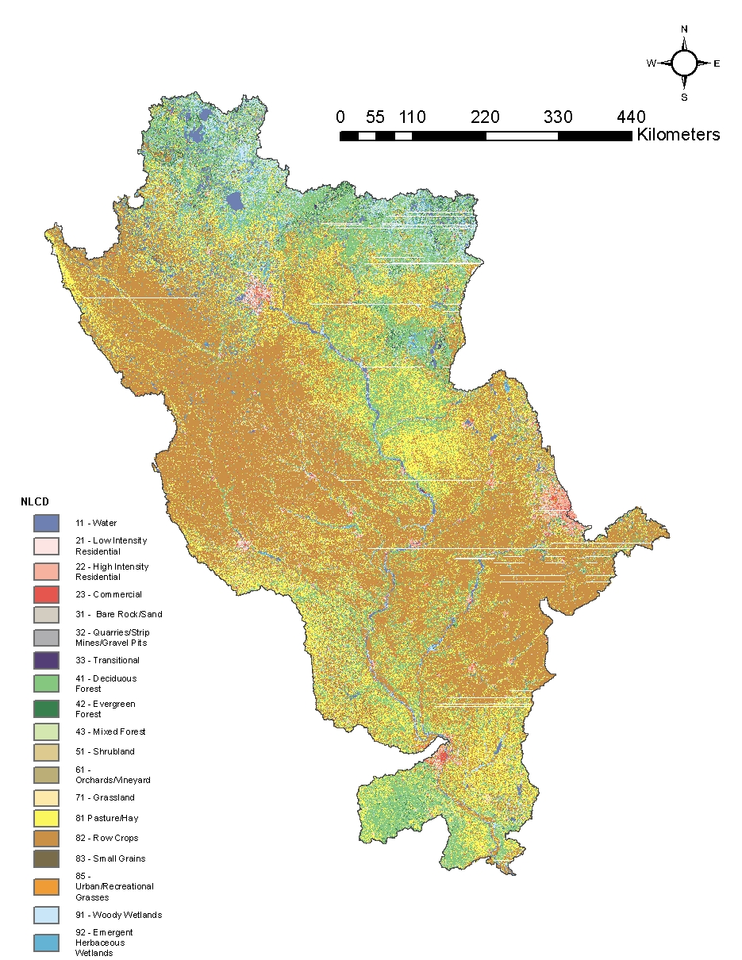
Figure 3-8 . Land cover in the UMRB in 1992
(Source: Vogelmann et al. 2001)

Methodology

Data
The data used for this thesis were a part of the Upper Mississippi Basin Loading Database (http://www.umesc.usgs.gov/data_library/sediment_nutrients/sediment_nutrient_page.html) which was prepared and published by the USGS Upper Midwest Environmental Sciences Center (UMESC). The UMESC provides scientific information for research that serves to protect and restore the ecosystem in the UMRB and the Midwest (UMESC 2014). The dataset consists of annual and monthly measurements of stream flow and several water-quality constituents, including suspended sediment, from 80 monitoring sites in the UMRB. These sites belong either to the Water Resource Division or the Long-Term Resource Monitoring Program (LTRMP) of the U.S. Geological Survey.
The sampling process includes collecting instantaneous measurement of discharge and suspended sediment concentration. Rating curves were developed from these data to estimate daily suspended loads, which were then aggregated to monthly and annual loads. The LOADEST2 (USGS) model was used to generate the sediment rating curves for individual stations. LOADEST2 used three methods for load estimation, including maximum likelihood (MLE), adjusted maximum likelihood (AMLE), and least absolute deviation (LAD). Additionally, LOADEST2 provided a set of predefined models that can be selected by users, or be automatically chosen based on Akaike Information Criterion (AIC) and Schwarz Posterior Probability Criterion (SPPC). These predefined models take into account the seasonality of discharge to enhance load estimation (Crawford 1998). One way to assess the uncertainty of the model is to compare the results of load estimates from three methods. In this case, the similarity of load estimates between the three methods indicated accuracy and robustness of the results (UMESC 2006).
The dataset includes load estimates of the year of the Great Flood of 1993. This might affect the long-term pattern of sediment transport during this period. In fact, estimated loads from stations on the Mississippi River show that the suspended load was substantially higher in 1993 than in previous years. Because floods are a part of the natural process, the data from 1993 were still included in the dataset (UMESC 2006). No drought year occurred in the time range of the dataset
The fact that data used in this study are simulated has some effect on the calculation of the rating parameters. Because the daily load estimates are unbiased (because of the adjustment for seasonality in LOADEST2), the monthly and annual aggregations are also unbiased. Furthermore, the scatter in the plot of simulated data (suspended load versus discharge) is less than in plots of observed data. Hence, despite the usage of logarithmic data to calculate the rating parameters, values of the exponents $b$ are not much different from those obtained using the antilog data. Using the annual data of station 07030005-30003 as an example, the value of $b$ from a nonlinear fitting model is 1.91, while the value of $b$ from the linear regression is 1.87. The detail of this illustration is shown in the Appendix A6.
Data from 64 monitoring stations (out of total 80 stations) were used for the study. Nine of the 80 stations were excluded because of short periods of record. Seven other stations were not used because they are replicates of stations nearby. The length of the records of the 64 stations varies from 7 years to 29 years; the shortest record is from January 1991 to January 1997, and the longest is from January 1967 to January 1996. The stations are located mostly on the Upper Mississippi River (29 stations) and also on the tributaries of the Upper Mississippi River (Figure 4-1). I included the station near the confluence of the Missouri River and Mississippi River and the station on the Mississippi River below that confluence (Figure 4-1) in this study to help depict a broad picture of sediment transport in the UMRB. The Missouri River is a major sediment contributor in the Mississippi River; hence, sediment loads at these two stations are high, compared to loads at other stations in the dataset. Although the station on the Missouri River was included in the dataset, its contributing area is not included in the UMRB, meaning that cumulative land-use/land-cover data for this station had to be imported to the database to complete the land-cover analyses.
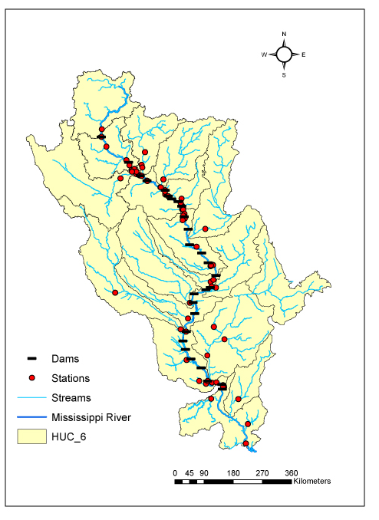
Figure 4-1. Locations of monitoring stations and dams in the Upper Mississippi River Basin used in this study
(Source: UMESC 2006)

Methods

Manipulating data
First I used a log transformation to linearize equation (2). The linear form is equation (4). Then I used least squares regression to solve equation (4) and derive the rating parameters $a$ and $b$ ($a$ was derived by back-transforming $ln(a)$).
$\ln\left(Load\right)=\ln\left(a\right)+bln⁡(Q)$ (4)
At the annual level, I used the data of annual discharge and annual suspended sediment load to calculate $a$ and $b$. At the monthly level, I repeated the calculation using the monthly values of discharge and suspended sediment load.
Accordingly, there are a total of 64 annual rating parameters $a_{annual},b_{annual}$ and 64 monthly rating parameters $a_{monthly},b_{monthly} ×$ 12 months. The mean standard error (MSE) was reported to show the uncertainty of the model. Lower MSE values indicate higher accurate model performance. I ran the least squares regression in MATLAB R2013b on Windows 7. Then I ran the analyses of the rating coefficients with R version 3.0.2.

Analyses of the rating parameters
The analyses are described below for each research question.
Question 1: What are the values of the rating coefficients $a$and the rating exponents$b$ at 64 gauging stations in the UMRB, as calculated at annual and monthly levels?
After manipulating the data and deriving the parameters with least squares regression, I applied the Shapiro-Wilk test on the output to check the assumption of normality assumption for later tests. I applied the Global Moran’s I to determine whether a spatial pattern existed in annual and monthly rating parameters in the UMRB. Additionally, I presented the distribution of the shape of the annual rating curves at 64 stations on a map. To characterize the rating parameters at annual and monthly levels, I calculated descriptive statistics of $a$ and $b$.
Question 2: Are $ln(a)$ and the exponent $b$ correlated with each other at annual or monthly levels?
Depending upon the result of the normality test, I used either the Pearson or Spearman correlation test on the annual and monthly values of $ln⁡(a)$ and $b$. There were 13 correlation analyses, one using annual values and 12 with monthly values.
Question 3: Are the annual and/or monthly rating parameters correlated with stream discharge?
I tested the correlation between the mean discharge and each of the two rating parameters at the monthly and annual levels (e.g., annual versus annual, January versus January, and so on). The type of correlation test (Pearson or Spearman) was based on the data distribution.
Question 4: What are the seasonal patterns of monthly values of the rating parameters?
I applied the two independent sample Z test (significance level of 0.05) to compare the rating parameters ($a$ or $b$) from each month of one season with every month in one other season. Because the time length at the stations extended up to 29 years, the two independent sample T test had more than 60 degrees of freedom. With such a large number of degrees of freedom, there would be no difference in the results between a two-sample T test and a two-sample Z test. Hence, it is reasonable to use the two-sample Z test in this study.
I used the information of the population of rating parameters that was obtained from the regression model (i.e. the regression coefficients and the standard errors). Hence, the formula of the Z test is:
$Z= \frac{(Regression coefficient 1)-(Regression coefficient 2)}{\sqrt{{(Standard error 1)}^{2}+{(Standard error 2)}^{2}}}$ (5)
Because the output from the regression was applicable for $ln(a)$, I used $ln(a)$ for the Z test. The results were then interpreted for $a$, accordingly.
At a station, there were a total of nine comparisons between each pair of seasons. Since the data used in this thesis were reported by month, a season was arbitrarily defined by a window of three months. For example, Spring was defined as a group from March to May, and so on. At each station, then, the number of significant differences between monthly rating parameters across two seasons varied from 0 to 9 for each $ln(a)$ and $b$. I interpreted these differences as the strength of the variation of one season versus another, with 9 as the highest. I applied the Global Moran’s I to the number of significant differences in the monthly rating parameters between pairs of seasons to determine whether there is a spatial pattern in the seasonality of the rating parameters in the UMRB. I then inspected spatial autocorrelation at the local level using Local Moran’s I. Additionally, I presented the distribution of the shape of the rating curves at all stations in two representative months – April and September. I chose these months because April and September are the months of annual high flow and low flow, respectively.
Question 5: What are the effects of navigational constructions (i.e. locks and dams) on the annual and monthly values of the sediment rating parameters?
In the UMRB, most of the navigational constructions are built on the Mississippi River, as it is the main stem of the basin. To categorize an upstream or a downstream station with respect to a dam, I applied the definitions of pre-dam reach and post-dam reach proposed by Schmidt and Wilcock (2008). Pre-dam reach is defined as the river section from the dam upstream to the first tributary. Post-dam reach is defined as the river section from the dam downstream to the first tributary. Stations located in pre-dam/post-dam reaches are categorized as pre-dam/post-dam stations.
Only three dams have both pre-dam and post-dam stations in the UMRB region. For those stations, I used the Z test (significance level of 0.05) to determine whether annual values of the rating curve parameters differed between pre- and post-dam stations. I repeated the procedure using monthly values. The tests were applied for $ln(a)$ and interpreted accordingly for $a$.
Question 6: What are the effects of land use on the annual values of the sediment rating curve parameters?
Because the variation of suspended sediment yielded to the stream has been shown to be related to the type of land use (e.g., Lopes et al. 2001; Tran and O’Neill 2013), I hypothesized there would be an association between land use and the rating parameters $a$ and $b$. Due to the lack of land-use data in the UMRB, I used land-cover data for this test.
The land-cover data were obtained from the NHD Plus Dataset Version 1 (USGS 2006). The data include the cumulative percentage of land cover to the catchment where the station is located. In fact, the land-cover data in NHD Plus were derived from the National Land Cover Dataset 1992 (NLCD 1992) (Vogelmann et al. 2001). Classes in the land-cover data consist of water, developed area, barren land, forest, shrubland, non-natural woody, herbaceous upland, planted/cultivated land, and wetlands. I tested the correlation between the rating parameters against these classes of land cover. Depending upon the normality of the data distribution, I applied the Pearson or Spearman correlation test to analyze the association between percentages of cumulative land cover and the rating curves parameters at the annual and monthly levels.

Results
The results presented in this chapter are divided into sections according to the research questions proposed in Chapter I. As noted, additional results are included in the Appendix.

Descriptive statistics and spatial patterns of sediment rating parameters
The coefficients obtained from the linear regression described in equation (4) include the intercept $ln(a)$ and the slope $b$. The value of coefficient $a$ gets closer to zero as $ln(a)$ becomes more negative. Histograms show that the distribution of annual values of $ln(a)$ and $b$ for the 64 stations was not a normal distribution (Figure 5-1, Figure 5-2). The Shapiro-Wilk test confirmed this conclusion (P < 0.001). At the annual level, the coefficient $a$ varied from 0 to 0.254 (kg/s)(s/m³)^{b}, while the range of the rating exponent $b$ was from 0.61 to 4.27 (dimensionless). The distribution of the annual coefficient $a$ is right-skewed, with the mean of 0.023 and the median of 0.002 (Figure 5-3).
On the other hand, histograms show that monthly values of $ln(a)$ and $b$ were normally distributed (Figure 5-4, Figure 5-5). The Shapiro-Wilk test confirmed this observation (P > 0.05). Meanwhile, the distribution of values of the monthly coefficient $a$ is right-skewed (Figure 5-6). Table 5-1 shows the descriptive statistics of the rating parameters derived from the linear regression. Values of the coefficient $a$ and the exponent $b$ at annual and monthly levels for each station are reported in the Appendix.
The exponent $b$ also shows the shape of the suspended sediment rating curve. Depending upon the value of exponent $b$, the shape of the rating curve can change from concave to linear or convex, as specified in the literature review. Figure 5-7 shows the distribution of the shapes of the sediment rating curves in the UMRB at the annual level. The dominant form of sediment rating curves in the basin is convex.
The Global Moran’s I showed clustering of values of the annual exponent $b$ in the region (P < 0.05) (Table 5-2). The Local Moran’s I indicated clustering of high values of the annual exponent $b$ at stations located in Pool 5 and Pool 6 in the Mississippi River (Figure 5-8). Global Moran’s I was not significant for coefficient $a$ (P > 0.05) (Table 5-3), indicating no significant spatial clustering of values of the coefficient$a$.

The relationship between $ln(a)$ and $b$ at annual and monthly levels
According to the distribution of the annual and monthly $ln(a)$ and $b$, I applied the appropriate correlation test to each pair of parameters. Significant Spearman correlation coefficients of $ln(a)$ and $b$ at annual and monthly levels range from -0.966 to -0.450 (Table 5-3). The Spearman correlation coefficient (r_{s}) shows a negative correlation between annual $ln(a)$and $b$ (Figure 5-9). The Pearson correlation coefficients (r_{p}) also show a negative correlation between the monthly values of $ln(a)$ and $b$ (Figure 5-10).
Further analysis showed that the correlation between $ln(a)$ and $b$ varied with stream size. I used the median value of annual stream discharge to categorize stream size. Streams with annual median discharge in the third and fourth quartiles were categorized as large streams (218 to 6596 m³/s) and the rest as small streams (2 to 218 m³/s). At the annual level, the correlation (r_{s}) of $ln(a)$ and $b$ in large streams increased significantly compared to when stream of all sizes were considered; while in small streams, it was not significant (P > 0.2) (Figure 5-11, Table 5-3). At the monthly level, the correlation (r_{p}) of $ln(a)$ and $b$ was substantially stronger at stations located in large streams (Figure 5-12, Table 5-3). In small streams, this correlation was not significant for most months, except for March, April, and June (Figure 5-13, Table 5-3).

The association of rating curve parameters with the mean stream discharge
Correlation analysis revealed statistically significant relationships between mean discharge and both rating parameters at annual and monthly levels (Table 5-4). At the annual level, the exponent $b$ and mean annual stream discharge showed a weak, positive correlation (r_{s} = 0.251, P < 0.05) (Figure 5-14, Table 5-4). Meanwhile, the r_{s} showed a negative correlation of annual coefficient $a$ with mean annual discharge (P < 0.001, Table 5-4). A scatterplot of mean annual discharge and the annual values of $a$ showed that their relationship is nonlinear (Figure 5-15). The coefficient $a$ and the mean annual discharge seem to have a log linear relationship (Figure 5-13).
At the monthly level, the r_{s} between coefficient $a$ and mean monthly discharge indicated a negative correlation (P < 0.001) (Table 5-4), and the scatterplot between monthly $a$ and mean monthly discharge showed a nonlinear relationship between the two variables (Figure 5-16). Similar to the patterns seen at the annual level, the monthly coefficient $a$ and the mean monthly discharge have a log linear relationship (Figure 5-17). There was no significant correlation between exponent $b$ and mean monthly discharge (Figure 5-18).

Seasonal patterns of the rating parameters at the monthly level
The highest means of the monthly $ln(a)$ were in July, August, and September, indicating sediment concentration per unit discharge (coefficient $a$) was highest in these months. Values of the monthly means for exponent $b$, on the other hand, were highest in the months of April, May, and June (Table 5-1).
The shape of the rating curve was inspected for April and September because they are the representative months for the annual peak flow (April) and low flow (September) in the UMRB. Figure 5-15 shows the shapes of the sediment rating curves across the study area for those two months. In both periods, the dominant shape of the rating curves was convex.
I found no spatial association of monthly values of coefficient $a$ in April and September (Global Moran’s I, P > 0.05) (Table 5-2). Meanwhile, high values of exponent $b$ were spatially clustered in April and September. Monthly values of exponent $b$ showed spatial autocorrelation in both April and September. In April, the Local Moran’s I showed clustering of values of the exponent $b$ at stations in the Mississippi River section between the Minnesota River and the Root River (Figure 5-19). In September, a cluster of stations with high values of exponent $b$ was present in the southern part of the basin (Figure 5-20).
Figure 5-21 and Figure 5-22 summarize season-to-season differences in the values of coefficient $ln(a)$ and the exponent $b$. Coefficient $ln(a)$ appears to be more variable than the exponent $b$, with more change from season to season. The rating parameters in winter show more significant differences from those in spring and summer, compared to fall. There was no spatial pattern in the variation of coefficient $ln⁡(a)$ and the exponent $b$ between seasons in the basin.

The effects of dams on the rating parameters at pre- and post-dam stations
In the UMRB, the three dams that have pre- and post-dam stations are three hydroelectric dams: Blanchard Dam, Coon Rapid Dam, and Lock and Dam Number 2. Table 5-5 shows the number code of the gauging stations associated with each dam. Table 5-6 shows the Z scores obtained in the comparison of annual and monthly rating parameters between pre- and post-dam stations. The analysis showed that the effect of dams on the rating parameters at the stations was not significant at the annual level (P > 0.2), but was significant at some stations at the monthly level. In particular, in all 12 months, $ln(a)$ at the post-dam station of Blanchard Dam was consistently higher than at the pre-dam station (P < 0.01), while the exponent $b$ was consistently lower (P < 0.01)
Two post-dam stations were associated with the Coon Rapids Dam. The distances upstream to the Coon Rapids dam from post-dam stations 10013 and 10011 are 12 km and 30.1 km, respectively. The effects of the dam on suspended sediment load at these stations differ. Between stations 10009 (pre-dam) and 10013, $ln(a)$ was significantly higher at station 10009 than at post-dam station 10013 in most months, except for April and May. On the other hand, the exponents $b$ at pre-dam station 10009 were significantly lower than at post-dam station 10013 in January, February, July, August, November, and December. The rating parameters at post-dam station 10011 were not significantly different from the parameters of pre-dam station 10009.
At Lock and Dam 2, $ln(a)$ was significantly higher at the post-dam station than at the pre-dam station, and $b$ was significantly higher at the pre-dam station than at the post-dam station in April and July.

The effects of land use on the rating parameters
The proportions of different land uses in the contributing areas of all stations are not significantly correlated with the rating parameters at the annual level (P > 0.1, Table 5-7). At the monthly level, I used the Spearman correlation for the coefficient $a$ and the Pearson correlation for the exponent, as the monthly exponents $b$ met the assumption of normal distributions.

Table 5 - 1. Descriptive statistics of the rating parameters at annual and monthly levels for 64 gauging stations in the UMRB
 |  | Annual | January | February | March | April | May | June
$$a$$ | Max | 0.254 | 0.151 | 0.194 | 0.208 | 0.239 | 0.208 | 0.147
$$a$$ | Min | 0.000 | 0.000 | 0.000 | 0.000 | 0.000 | 0.000 | 0.000
$$a$$ | Mean | 0.023 | 0.012 | 0.012 | 0.021 | 0.017 | 0.014 | 0.018
$$a$$ | Median | 0.002 | 0.003 | 0.002 | 0.003 | 0.002 | 0.004 | 0.005
$$b$$ | Max | 4.274 | 2.780 | 2.850 | 3.140 | 3.720 | 3.010 | 3.350
$$b$$ | Min | 0.905 | 0.620 | 0.620 | 0.090 | 0.580 | 0.960 | 0.820
$$b$$ | Mean | 1.869 | 1.557 | 1.661 | 1.559 | 1.673 | 1.688 | 1.683
$$b$$ | Median | 1.631 | 1.560 | 1.610 | 1.585 | 1.610 | 1.690 | 1.625
 |  |  | July | August | September | October | November | December
$$a$$ | Max |  | 0.185 | 0.165 | 0.148 | 0.104 | 0.109 | 0.099
$$a$$ | Min |  | 0.000 | 0.000 | 0.000 | 0.000 | 0.000 | 0.000
$$a$$ | Mean |  | 0.021 | 0.019 | 0.016 | 0.012 | 0.012 | 0.010
$$a$$ | Median |  | 0.007 | 0.007 | 0.004 | 0.003 | 0.003 | 0.002
$$b$$ | Max |  | 2.570 | 2.970 | 2.310 | 2.340 | 2.590 | 2.540
$$b$$ | Min |  | 1.010 | 1.040 | 0.990 | 1.120 | 0.670 | 0.940
$$b$$ | Mean |  | 1.632 | 1.602 | 1.620 | 1.623 | 1.613 | 1.595
$$b$$ | Median |  | 1.590 | 1.570 | 1.635 | 1.570 | 1.605 | 1.565

Table 5 - 2. The Global Moran’s I of the rating parameters at 64 gauging stations in the UMRB at annual and monthly levels
 | Rating parameters | Global Moran’s I | P-value
Annual | $$a$$ | 0.155 | 0.070
Annual | $$b$$ | 0.309ª | 0.002
April^{b} | $$a$$ | 0.018 | 0.724
April^{b} | $$b$$ | 0.241 | 0.012
September | $$a$$ | 0.079 | 0.354
September | $$b$$ | 0.295 | 0.003
ªThe bolded numbers indicate significant results
^{b}April and September were chosen to be the representative months for the Global Moran’s I at the monthly level

Table 5 - 3. Spearman correlation coefficients of $ln(a)$ and $b$ at annual and monthly levels, measured for all streams, large streams, and small streams.

r_{s} | Annual | January | February | March | April | May | June
Total | -0.667  (***) | -0.500  (***) | -0.564  (***) | -0.524  (***) | -0.603  (***) | -0.513  (***) | -0.435  (***)
Large streams | -0.966  (***) | -0.931  (***) | -0.918  (***) | -0.866  (***) | -0.910  (***) | -0.930  (**) | -0.894  (***)
Small streams | -0.223 | -0.193 | -0.336 | -0.471  (**) | -0.563  (**) | -0.298 | -0.450  (**)
 |  | July | August | September | October | November | December
Total |  | -0.436  (***) | -0.345  (***) | -0.350  (***) | -0.424  (***) | -0.403  (***) | -0.529  (***)
Large streams |  | -0.909  (***) | -0.912  (***) | -0.922  (***) | -0.930  (***) | -0.932  (***) | -0.907  (***)
Small streams |  | -0.340 | -0.180 | -0.297 | -0.246 | -0.239 | -0.137
(***): P <0.001
(**): P < 0.01
(*): P < 0.05

Table 5 - 4. Spearman correlation coefficient of mean discharge versus $a$ and $b$ at annual and monthly levels
 | Annual | January | February | March | April | May | June
$a$ vs $Q$ | -0.624  (***) | -0.486  (***) | -0.451  (***) | -0.583  (***) | -0.525  (***) | -0.627  (***) | -0.639  (***)
$b$ vs $Q$ | 0.246  (*) | -0.016 | 0.073 | 0.287 | -0.071 | 0.162 | 0.133
 |  | July | August | September | October | November | December
$a$ vs $Q$ |  | -0.634  (***) | -0.670  (***) | -0.698  (***) | -0.747  (***) | -0.699  (***) | -0.558  (***)
$b$ vs $Q$ |  | 0.179 | 0.127 | 0.156 | 0.237 | 0.089 | 0.059
(***): P <0.001
(*): P < 0.05
Table 5 - 5. Pre- and post-dam stations associated with the dams used in the study
Dam | Type of dams | Pre-dam station |  | Post-dam station
Dam | Type of dams | Station code | Distance to the dam | Station code | Distance to the dam
Blanchard | Hydroelectric dam | 07010104-10001ª | 42.95 km | 07010104-10003 | 0.2 km
Coon Rapids | Hydroelectric dam | 07010206-10009 | 8.75 km | 07010206-10013 | 12 km
Coon Rapids | Hydroelectric dam | 07010206-10009 | 8.75 km | 07010206-10011 | 30.1 km
Lock and Dam Number Two | Hydroelectric dam | 07010206-20019 | 0.5 km | 07010206-20021 | 0.4 km
ªThe station code consists of the HUC-8 and the site code assigned by the agency that is responsible for the monitoring station. I will use only the site code from this point to refer to the station.

Table 5 - 6. Z scores of the comparison of the rating parameters between pre-dam and post-dam stations
Time period | Blanchard Dam |  | Coon Rapid Dam |  |  |  | Lock and Dam Number 2
Time period | Stations 10001 vs. 10003 |  | Stations 10009 vs. 10013 |  | Stations 10009 vs. 10011 |  | Stations 20019 vs. 20021
Time period | $ln(a)$ª | $$b$$ | $$ln(a)$$ | $$b$$ | $$ln(a)$$ | $$b$$ | $$ln(a)$$ | $$b$$
Annual | -1.068^{b} | 0.701 | 0.671 | -0.275 | 0.327 | -0.204 | -1.665 | 1.535
January | -3.298* | 2.809* | 3.169* | -2.866* | -0.345 | 0.483 | 1.549 | -1.811
February | -2.948* | 2.405* | 2.714* | -2.223* | -0.189 | 0.425 | 0.760 | -1.063
March | -3.563* | 3.314* | 2.006* | -1.318 | 0.461 | -0.168 | -0.373 | 0.420
April | -2.727* | 2.715* | -0.075 | 0.769 | 1.065 | -0.946 | -2.049* | 2.105*
May | -5.148* | 4.694* | 1.776 | -0.631 | 0.785 | -0.453 | -1.593 | 1.525
June | -6.111* | 4.969* | 2.179* | -1.154 | 0.554 | -0.209 | -1.357 | 1.119
July | -6.897* | 5.304* | 3.390* | -2.322* | 0.250 | 0.125 | -2.585* | 2.319*
August | -5.696* | 3.885* | 4.221* | -3.379* | -0.310 | 0.559 | -1.549 | 1.111
September | -4.666* | 3.496* | 2.253* | -1.713 | 0.137 | 0.000 | -1.628 | 1.296
October | -4.916* | 3.962* | 1.761 | -1.447 | 0.145 | -0.097 | -1.272 | 0.814
November | -3.059* | 2.504* | 2.293* | -2.309* | -0.150 | 0.177 | -0.739 | 0.350
December | -3.341* | 2.820* | 2.966* | -2.877* | -0.319 | 0.450 | 0.596 | -0.939
(*): Statistically significant difference between pre-dam and post-dam stations.
ª The rating parameter that was used in the Z test.
^{b} The value of the Z score

Table 5 - 7. Correlation coefficients between the monthly rating parameters at 64 gauging stations and percentage of cumulative land use contributing to these stations in the UMRB
Spearman correlation coefficients (r_{s})
Monthly coefficient $a$ | Water | Developed area | Barren | Forested | Shrubland | Semi-natural | Agriculture | Wetland
January | -0.339** | -0.121 | -0.222 | -0.040 | -0.135 | 0.007 | 0.225 | 0.152
February | -0.319** | -0.097 | -0.202 | -0.014 | -0.106 | 0.068 | 0.212 | 0.126
March | -0.263** | -0.059 | -0.267 | -0.054 | -0.165 | -0.019 | 0.152 | 0.115
April | -0.270** | -0.141 | -0.197 | 0.052 | -0.099 | 0.176 | 0.146 | 0.133
May | -0.311** | -0.095 | -0.171 | 0.013 | -0.118 | 0.100 | 0.159 | 0.054
June | -0.327** | -0.056 | -0.144 | 0.027 | -0.105 | 0.121 | 0.136 | 0.042
July | -0.304* | -0.052 | -0.177 | 0.017 | -0.093 | 0.082 | 0.121 | 0.061
August | -0.343** | -0.042 | -0.170 | -0.030 | -0.107 | 0.084 | 0.148 | 0.018
September | -0.346** | -0.119 | -0.135 | 0.018 | -0.081 | 0.072 | 0.174 | 0.033
October | -0.388** | -0.122 | -0.172 | -0.001 | -0.079 | 0.049 | 0.225 | 0.093
November | -0.351** | -0.159 | -0.171 | 0.046 | -0.064 | 0.027 | 0.199 | 0.068
December | -0.285** | -0.187 | -0.159 | 0.077 | -0.087 | -0.022 | 0.142 | 0.088
Pearson correlation coefficients (r_{p})
Monthly exponent $b$ | Water | Developed area | Barren | Forested | Shrubland | Semi-natural | Agriculture | Wetland
January | 0.008 | -0.225 | 0.036 | 0.197 | -0.016 | 0.054 | 0.023 | 0.000
February | 0.029 | -0.202 | 0.096 | 0.110 | -0.021 | -0.037 | 0.043 | 0.004
March | 0.070 | -0.140 | 0.014 | 0.108 | 0.031 | -0.017 | 0.017 | -0.101
April | 0.092 | -0.075 | -0.029 | 0.031 | 0.010 | -0.159 | 0.066 | -0.015
May | 0.212 | -0.141 | -0.008 | 0.102 | 0.054 | -0.146 | -0.026 | -0.115
Table 5 – 7. Continued.
Pearson correlation coefficients (r_{p})
Monthly exponent $b$ | Water | Developed area | Barren | Forested | Shrubland | Semi-natural | Agriculture | Wetland
June | 0.051 | -0.091 | -0.061 | 0.091 | 0.078 | -0.132 | 0.073 | -0.127
July | 0.096 | -0.163 | 0.028 | 0.087 | 0.064 | -0.061 | 0.081 | -0.129
August | 0.090 | -0.168 | -0.078 | 0.112 | 0.046 | -0.089 | 0.115 | -0.067
September | 0.026 | -0.222 | -0.057 | 0.104 | 0.057 | -0.075 | 0.034 | -0.009
October | 0.090 | -0.191 | -0.045 | 0.230 | 0.045 | -0.052 | -0.110 | -0.057
November | 0.207 | -0.171 | 0.004 | 0.145 | 0.027 | -0.058 | -0.043 | -0.043
December | 0.106 | -0.099 | -0.054 | 0.084 | 0.041 | 0.021 | 0.026 | -0.033
(***): P < 0.01
(*): P < 0.05

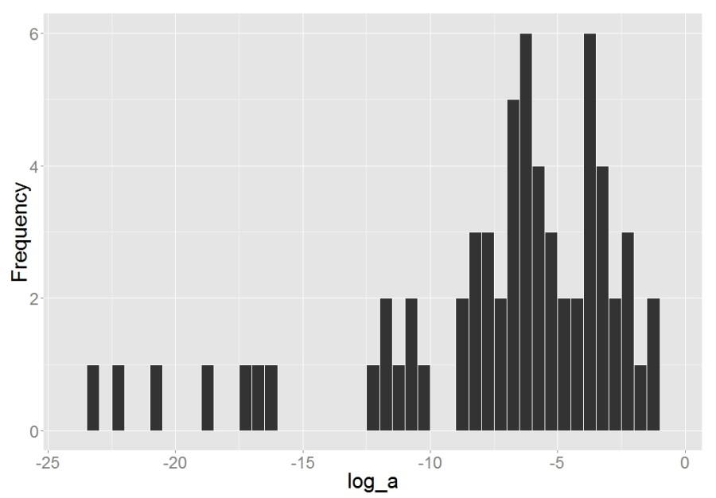
Figure 5 - 1. Histogram of the annual $ln(a)$ as measured at 64 gauging stations in the UMRB.
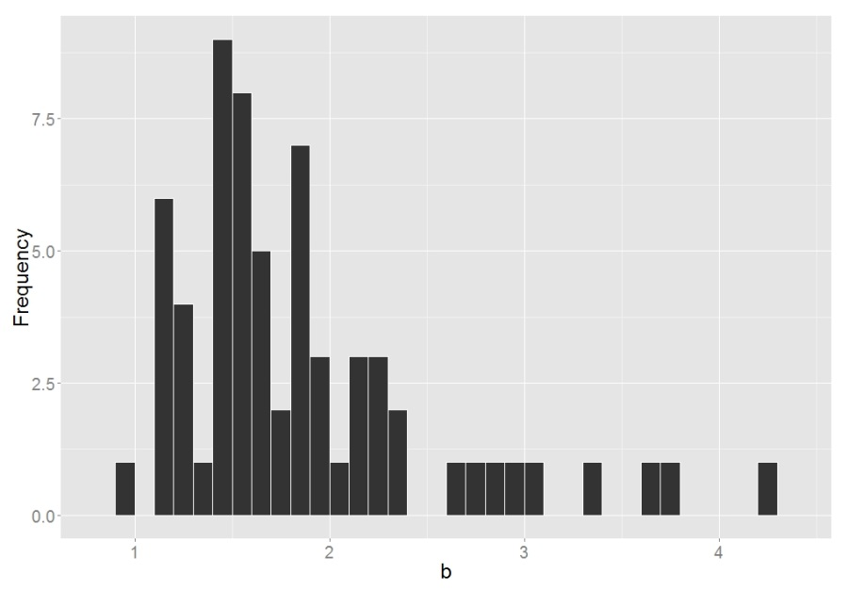
Figure 5 -2. Histogram of the annual exponent $b$ as measured at 64 gauging stations in the UMRB.
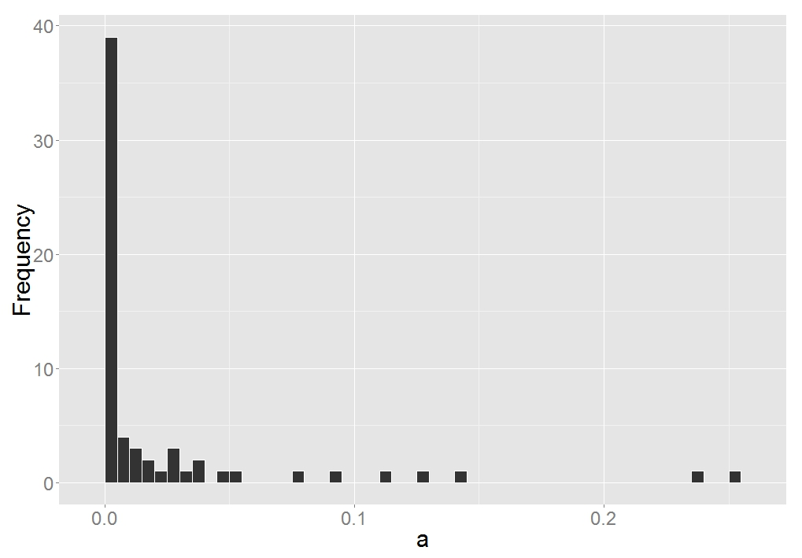
Figure 5 - 3. Histogram of the annual $a$ as measured at 64 gauging stations in the UMRB.

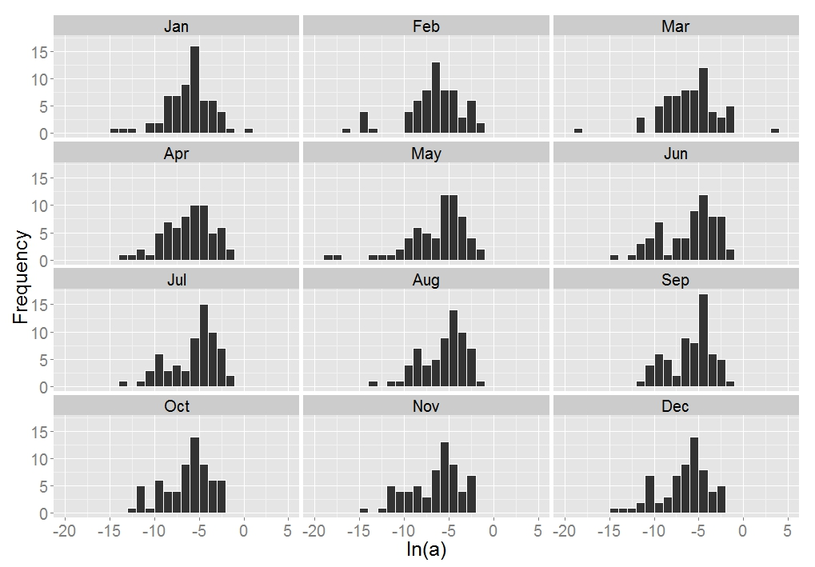
Figure 5 - 4. Histograms of the monthly $ln(a)$ as measured at 64 gauging stations in the UMRB.

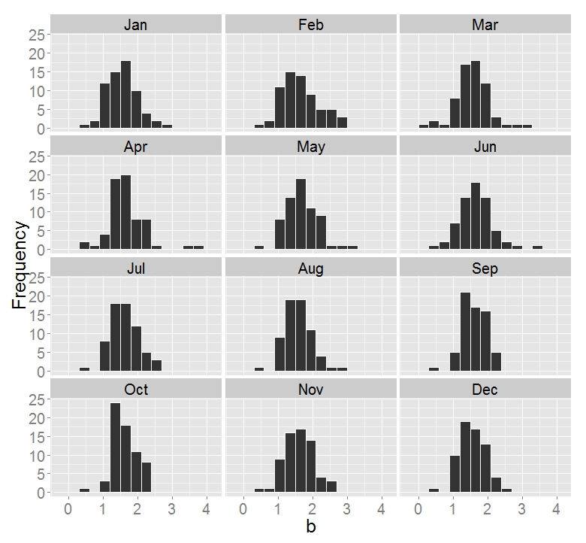
Figure 5 - 5. Histogram of the monthly exponent $b$ as measured at 64 gauging stations in the UMRB.
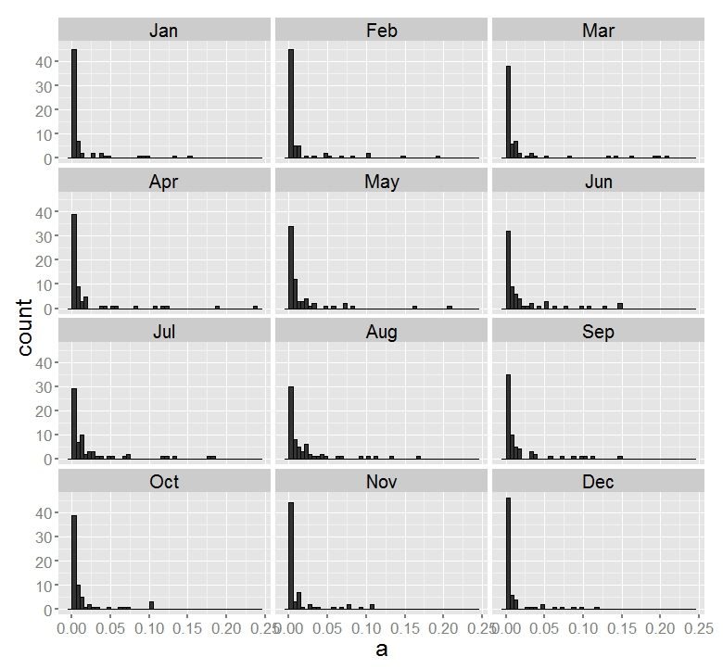
Figure 5 -6. Histograms of the monthly $a$ as measured at 64 gauging stations in the UMRB.

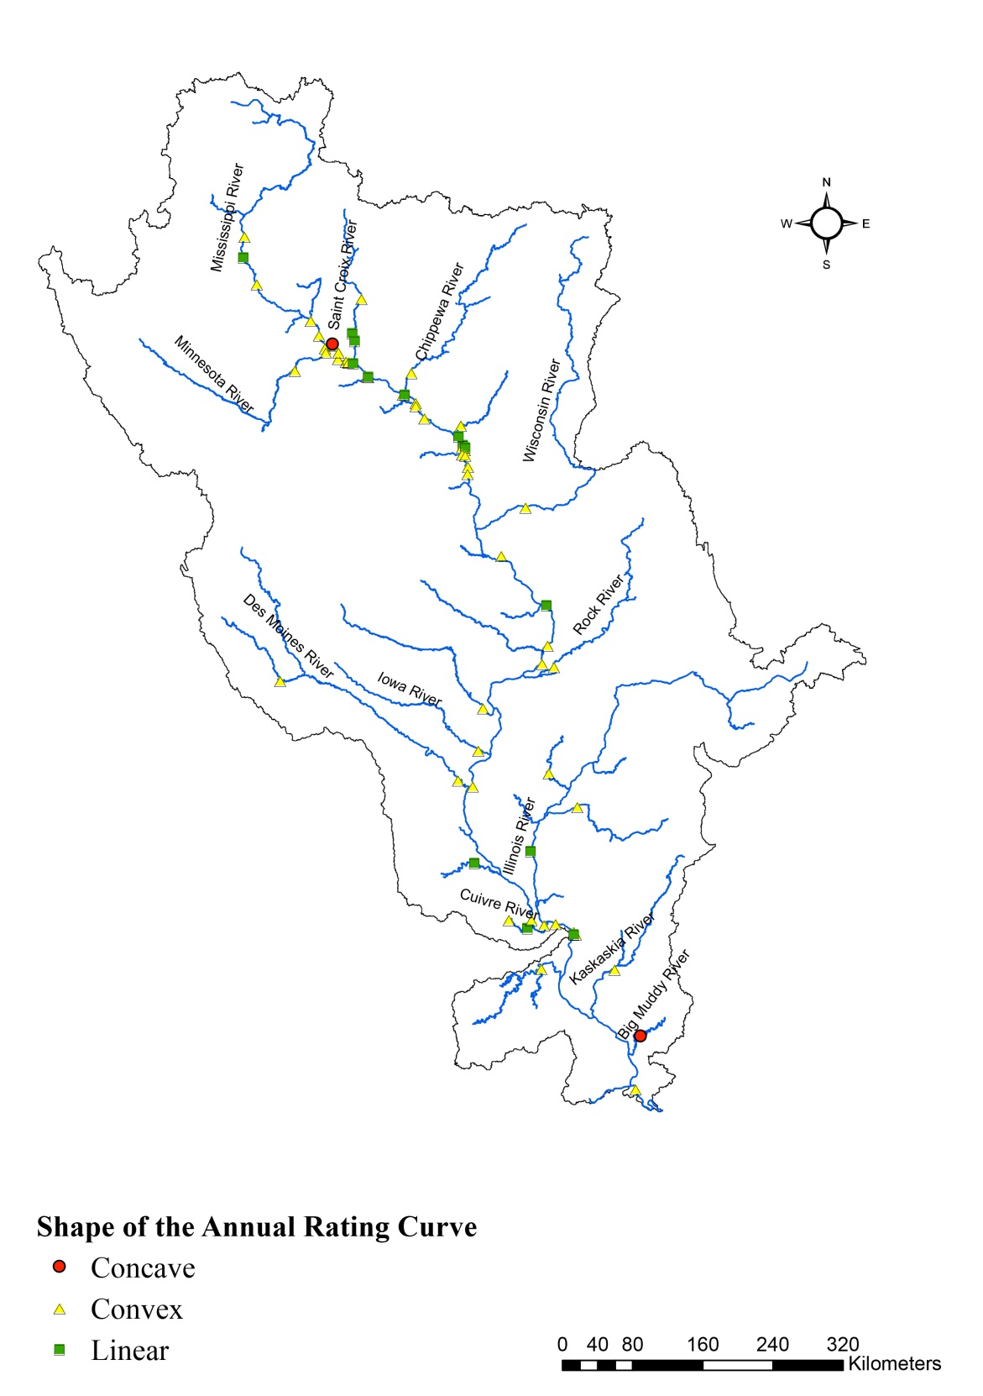
Figure 5 - 7. Distribution of the shapes of the suspended sediment rating curve at annual level.

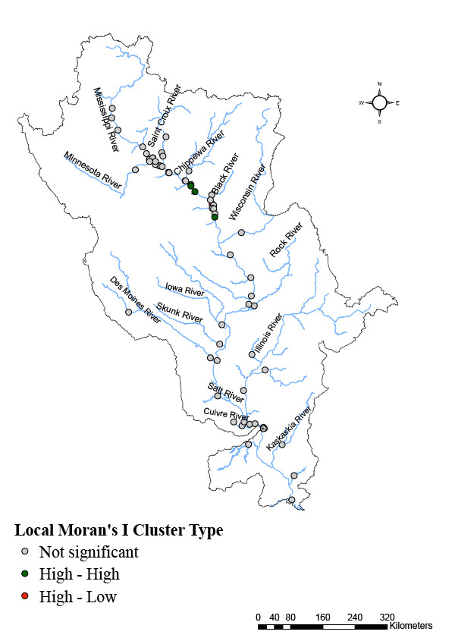
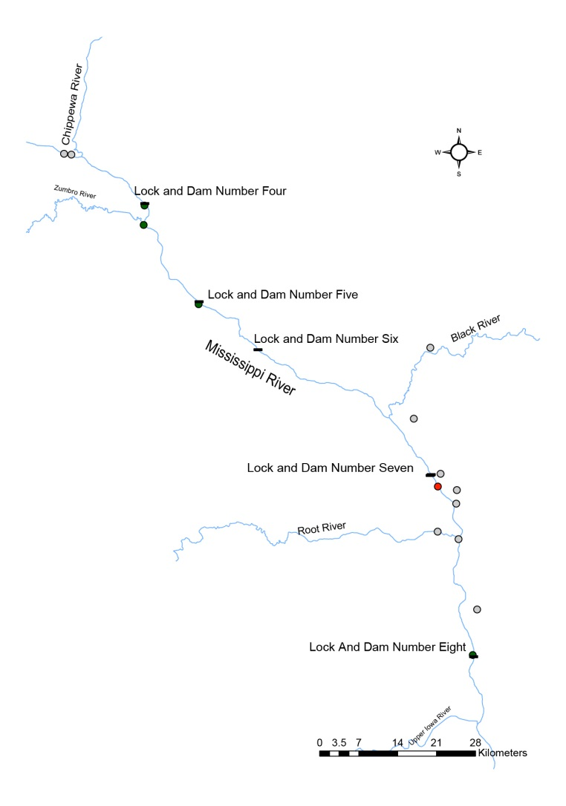

Figure 5 - 8. Map of the Local Moran’s I of the rating exponent $b$ at the annual level.

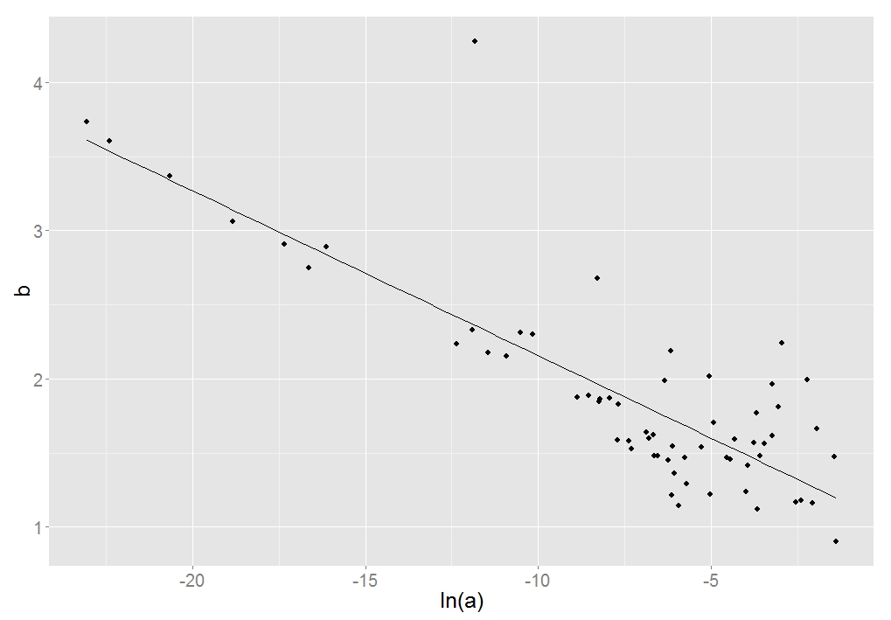

Figure 5 - 9. Scatterplot of $ln(a)$ and $b$ as measured at 64 gauging stations in the UMRB at the annual level.
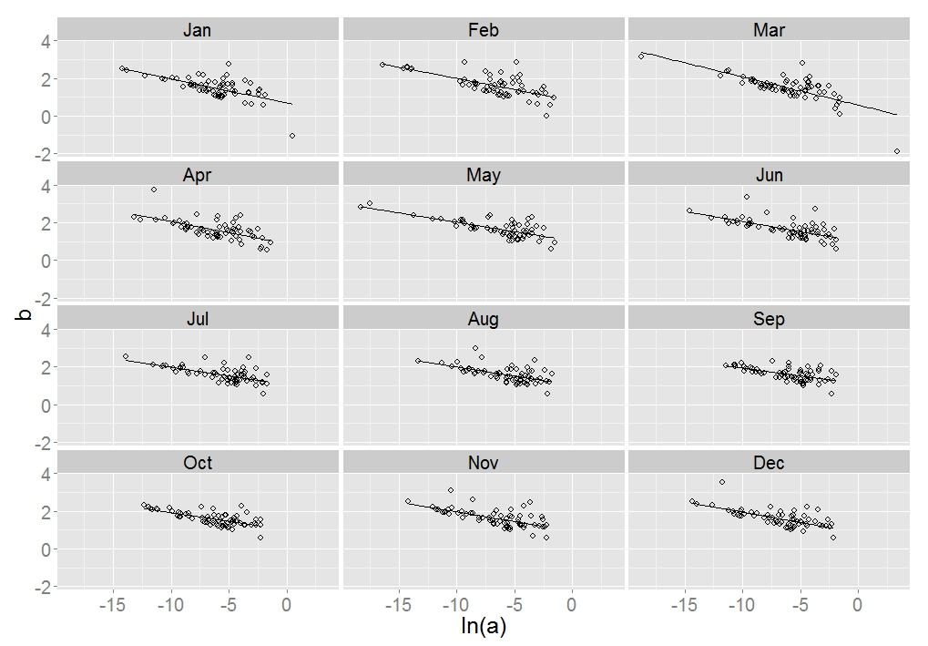
Figure 5 - 10. Scatterplots of $ln(a)$ and $b$ as measured at 64 gauging stations in the UMRB.

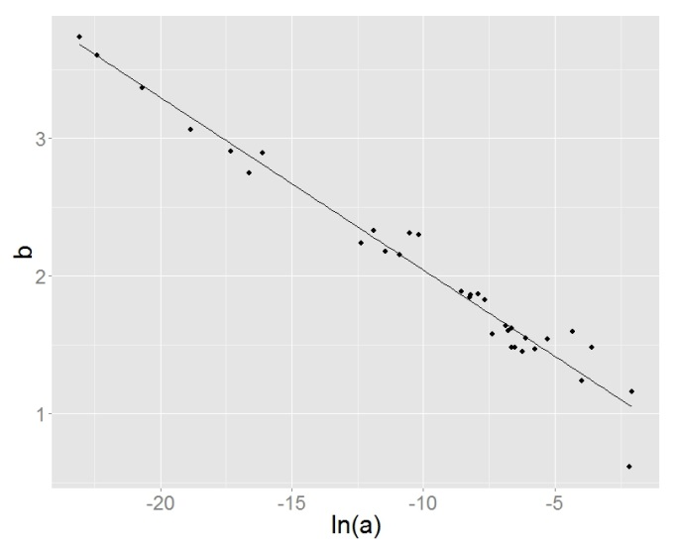
(a)
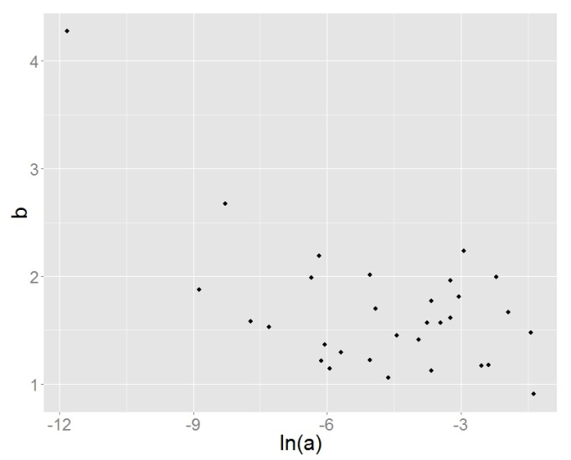
(b)
Figure 5 - 11. Scatterplots of $ln(a)$ and $b$ at the annual level in (a) large streams (218 to 6596 m³/s) and (b) small streams (2 to 218 m³/s).
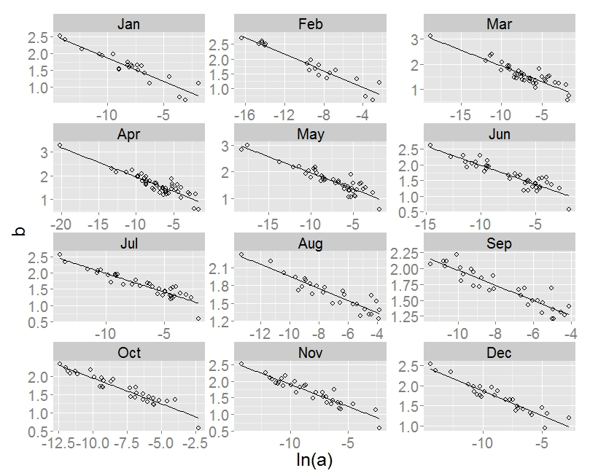
Figure 5 - 12. Scatterplot between $ln(a)$ and $b$ in large streams at the monthly level.
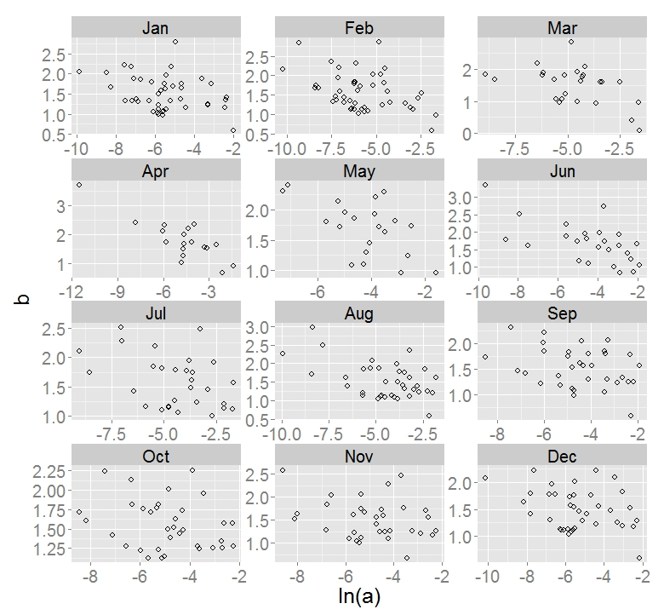
Figure 5 - 13. Scatterplot of $ln(a)$ and $b$ in small streams at the monthly level.

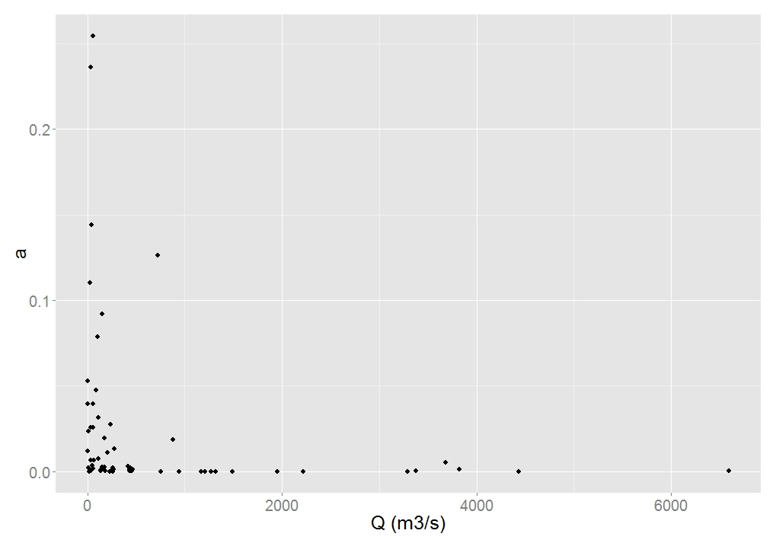
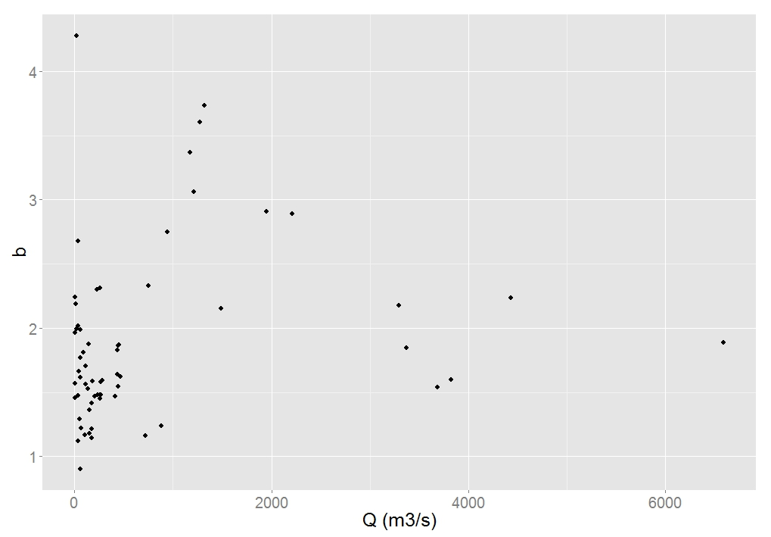
Figure 5 - 14. Scatterplot of mean annual stream discharge versus the annual coefficient $a$ and the annual exponent $b$.
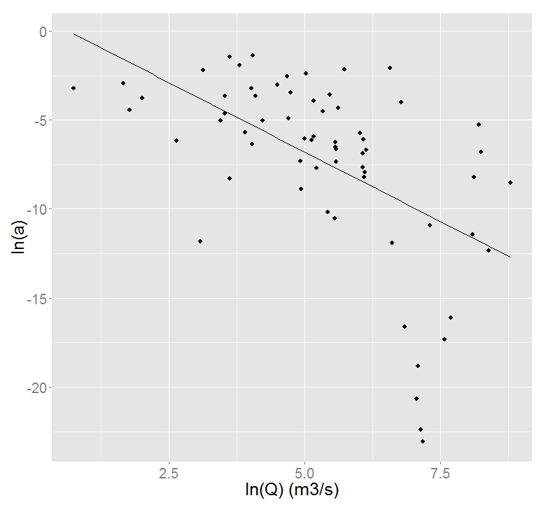
Figure 5 - 15. Scatterplot of mean annual stream discharge versus the annual coefficient $a$ in logarithmic forms
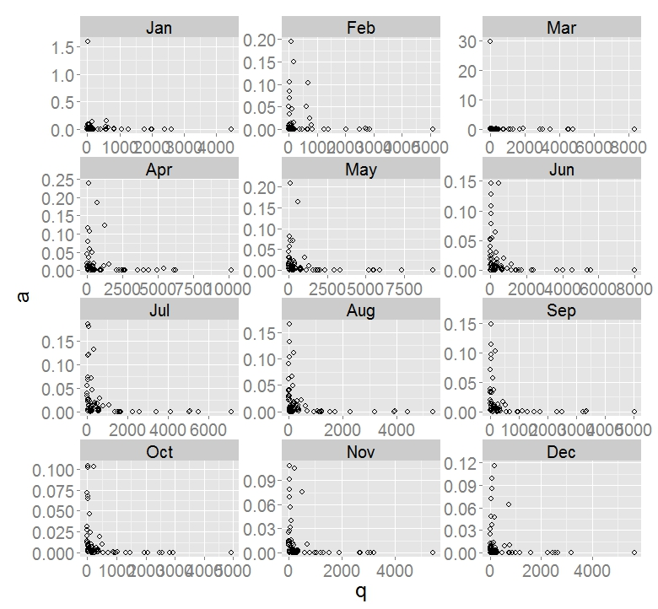
Figure 5 - 16. Scatterplot of mean monthly stream discharge versus monthly coefficient $a$.
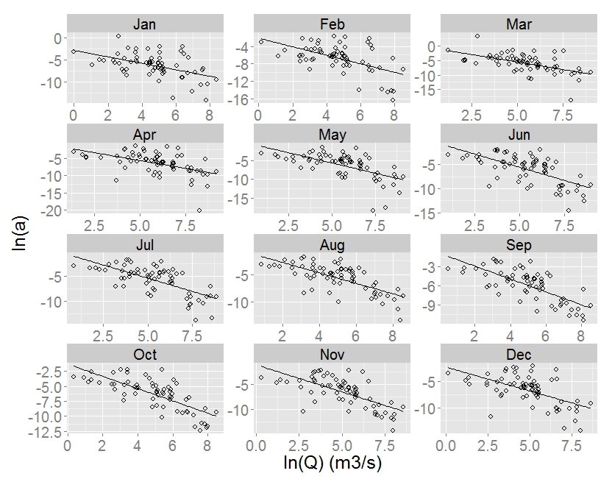
Figure 5 - 17. Scatterplot of mean monthly stream discharge versus monthly coefficient $a$ in logarithmic form.

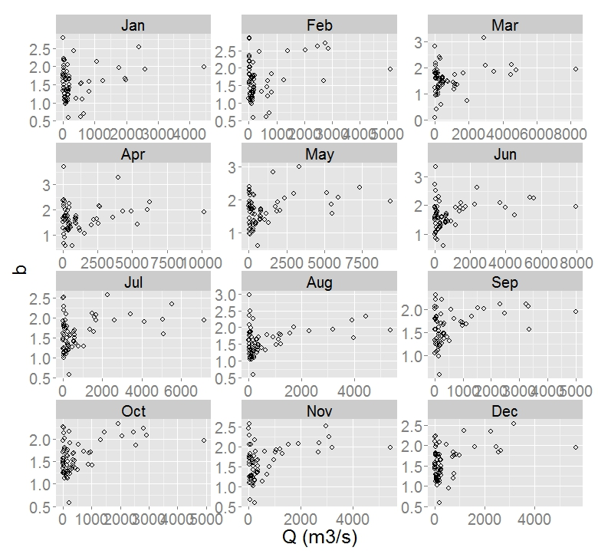
Figure 5 - 18. Scatterplot of mean monthly stream discharge versus monthly exponent $b$.

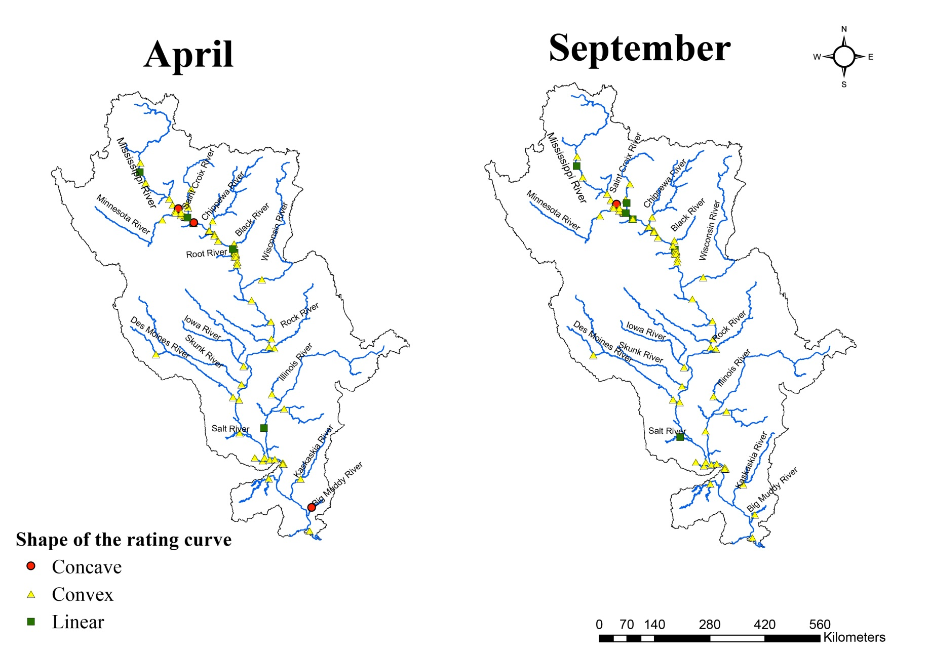
Figure 5 - 19. Distribution of the shapes of the suspended sediment rating curve at the monthly level.

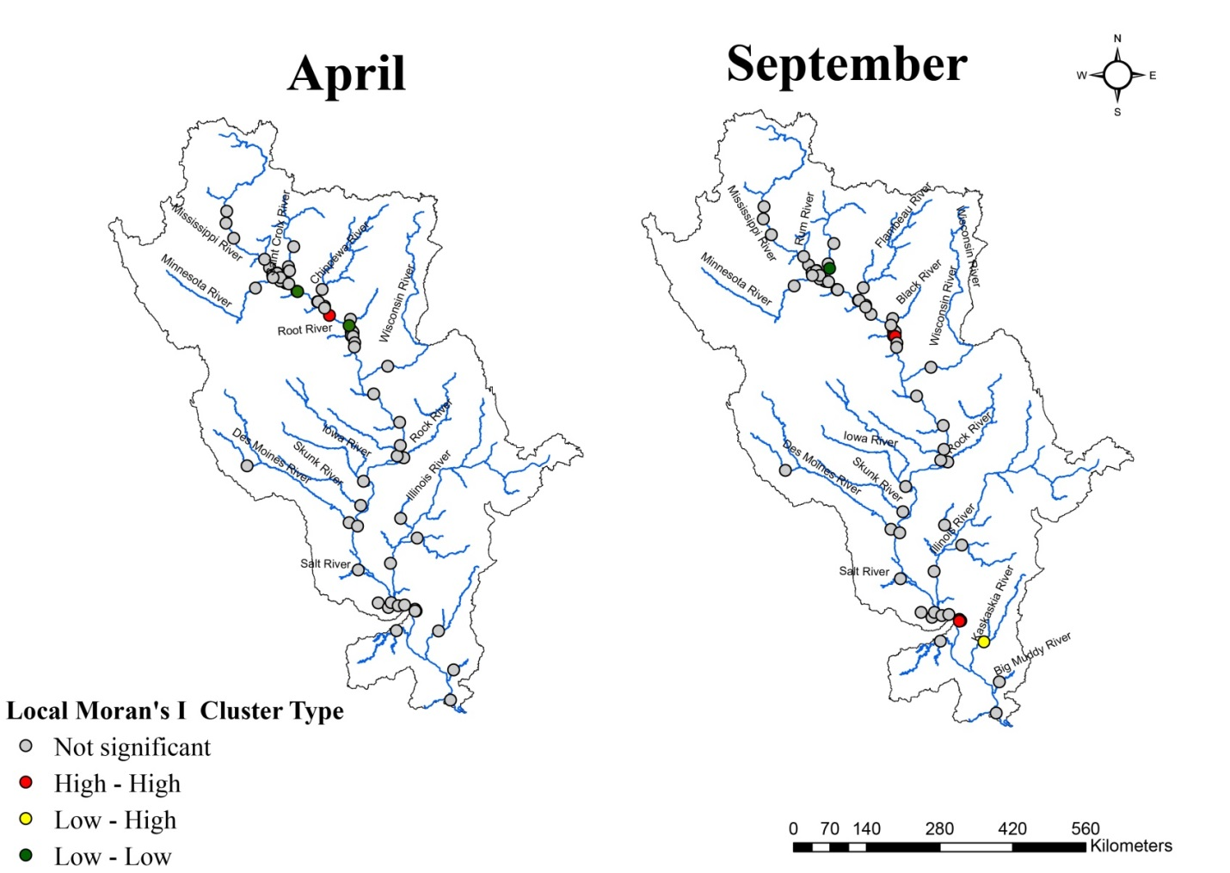

Figure 5 - 20. Map of the Local Moran’s I of the rating exponent $b$ at the monthly level.

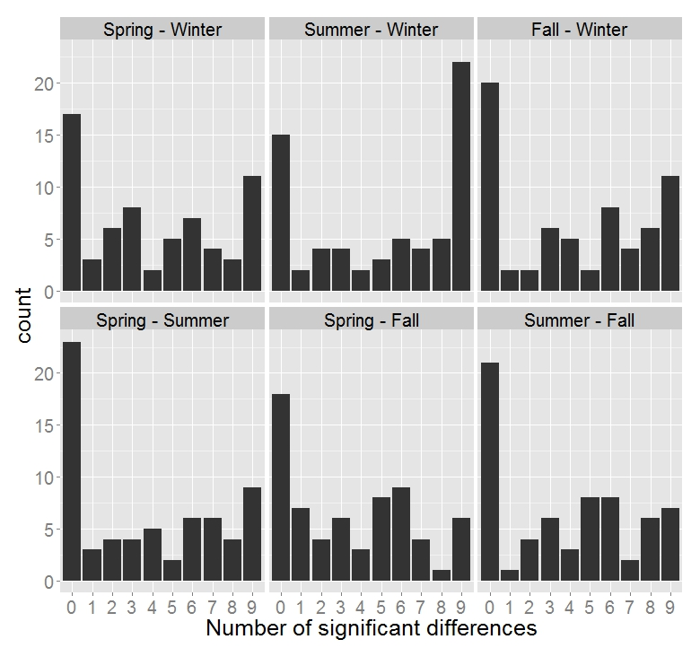
Figure 5 - 21. The number of significant differences in the monthly values of $ln(a)$ between pairs of seasons.
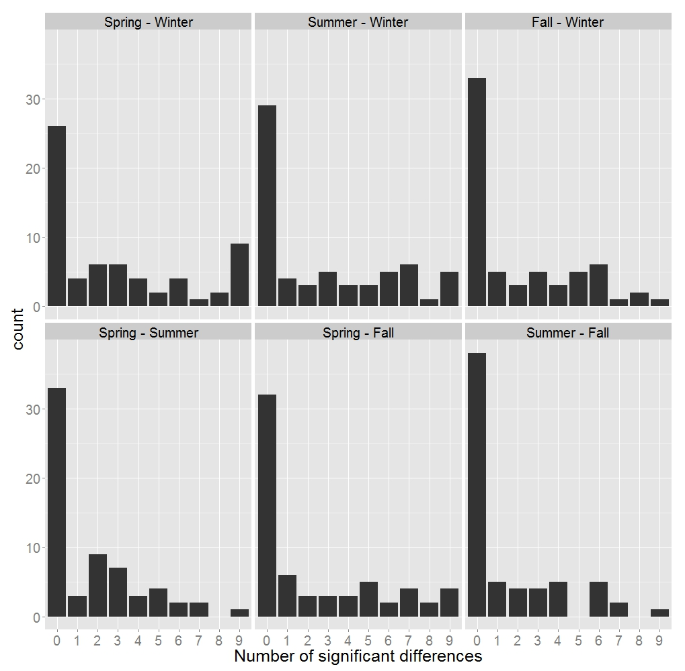
Figure 5 - 22. The number of significant differences in the monthly values of $b$ between pairs of seasons.

Discussion
The discussion in this chapter is divided into sections according to the research questions proposed in Chapter I.

Descriptive statistics and spatial patterns of rating parameters
The rating coefficient $a$ represents the sediment concentration at unit flow at the monitoring stations. Hence, the value of the coefficient $a$ at a station is closely related to the sources of sediment from upstream. The $a$ coefficients of tributaries of the Mississippi River had a wider range compared to those of the main channel (Table 6.1), which indicates the variety of flow regimes and sediment sources in the tributaries.
Compared to other studies, values of the rating parameters varied depending on the time level of the data and the equation form of the rating curve. In Table 6.1, the monthly rating parameters in this study can be compared to those developed by Hu et al. (2011) as they were both derived from monthly load and discharge data. Like the Changjiang River basin, the UMRB has a large drainage area in which soil conservation practices have been implemented for decades. Hence, low values of the coefficients $a$ in both studies arguably indicate low sediment concentrations in streams of these two basins. These results are compatible with the conclusion in previous studies of Meade and Moody (2010) and Heimann et al. (2011) that the sediment concentrations in several rivers in the UMRB were decreasing because of soil conservation and the presence of dams.

Table 6 - 1. The rating parameters of some rivers in other studies and this study
Study | Study Area | Range of the annual rating coefficient $a$  (kg/s)(s/m³)^{b} | Range of the annual rating exponent $b$ª (derived for load versus discharge) (unitless) | Time level of data | Equation of the rating curve used
Syvitski et al (2000) | North America rivers | 0 – 0.19 | 1.38 – 2.81 | Daily | $$C=aQ^{b-1}$$
Asselman (2000) | Rhine River, Germany | 0.0003 – 306 | 0.74 – 2.55 | Daily | $$C=aQ^{b-1}$$
Hu et al (2011) | Changjiang River, China | 0 – 0.06 | 1.82 – 3.33 | Monthly | $$C=aQ^{b-1}$$
Reid and Frostick (1987) | Rivers of temperate and humid climate | 0.004 – 40 | 2.4 – 3.5 | Daily | $$C=aQ^{b-1}$$
This study | Mississippi River (main channel) | 0 – 0.009 | 1.06 – 3.37 | Annual | $$L=aQ^{b}$$
This study | Mississippi River  (tributaries) | 0 – 0.25 | 0.90 – 4.27 | Annual | $$L=aQ^{b}$$
This study | Mississippi River (main channel) | 0 – 0.19 | 0.62 – 3.30 | Monthly | $$L=aQ^{b}$$
This study | Mississippi River  (tributaries) | 0 – 0.24 | 0.09 – 3.72 | Monthly | $$L=aQ^{b}$$
ª The exponent $b$ in this table is referred to the load-based exponent derived in this study. Hence, for the studies that used sediment concentration, rating exponent equals $b$– 1.

Values of the exponent $b$ at the annual and monthly levels indicate that at 64 gauging stations, the rating curves present linear, concave, or convex shapes. Most of the monthly exponent $b$ that is smaller than one appeared in winter months (Appendix A5), during which time the supply of sediment is limited due to frozen ground. Most of the stations in the UMRB have convex rating curves at the annual level, even those in the tributaries. Convex rating curves suggest a transport-limited system in most of the streams in the UMRB, indicating a limit in the hydraulic power of the streams to carry sediment. These results may relate to the fact that many rivers, especially the main stem, in the basin are highly affected by engineering works such as locks and dams. Asselman (2000) and Hu et al. (2011) suggested that higher values of the exponent $b$ were associated with the presence of dams in the river, indicating the importance of high discharge in transporting sediment in regulated rivers. The convex shape of the rating curves, on the other hand, might represent the importance of high discharge, which could be capable of transporting sediment of larger grain size, due to high competence of flow at high discharge (Walling 1974). Such effects result in an increasing rate of suspended sediment load with the increase of discharge. The importance of high discharge in carrying large grain size of sediment was shown in a study by Holmes (1996), in which the sediment grain size distribution in the flood of 1993 was investigated at some stations in the central Mississippi River. The study showed a high portion of suspended sand carried during the flood, indicating large storage of sand-sized sediment at multiple sites prior to 1993.
The transport-limited system in the UMRB, determined from sediment rating curves in this thesis, seems to contradict the conclusion of Meade and Moody (2010), whose study found a declining trend of sediment yield at the mouth of the Mississippi River. They concluded that sediment transport has shifted to a supply-limited condition in the Mississippi-Missouri River basin. The difference between the conclusions of this thesis study and the study by Meade and Moody could be attributed to different approaches and definitions of supply/transport-limited systems in the two studies. Meade and Moody (2010) defined the supply-limited system based on the decreasing rate of fine sediment yield at the mouth of the basin over decades, which was attributed to conservation practices and engineering constructions in the basin. Meanwhile, this thesis defined the transport-limited system based on the interrelation between suspended sediment load and stream discharge, which is represented as the rating curves. On the other hand, in the study by Meade and Moody, after the mid 1960s, at least half of the suspended sediment in the Mississippi River at Tarbert Landing, New Orleans, was from the UMRB and the Ohio River indicating a large supply of suspended sediment from the Upper Basin. Thus, while the Lower Mississippi Basin might have become supply-limited, the UMRB was still the major source of suspended sediment at the mouth of the Mississippi-Missouri River basin and did not present a supply-limited system.
Some stations in this dataset present the suspended load and discharge in the period of 1993 to 1998 (Appendix A1). Although the flood in 1993 might have flushed out the stored sediment from local storage sites (Horowitz 2010), the sediment rating curves at these stations continued to represent transport-limited systems. This result provides evidence suggesting that sediment transport in the UMRB, at the annual level, might have remained transport-limited after the flood in 1993.
The Missouri River provides an abundant source of sediment into the Mississippi River. At station 270001, located at the mouth of the Missouri River, and station 30001, on the Mississippi River below the confluence with the Missouri River, suspended sediment loads in the dataset were larger than those for the Mississippi River above the Missouri-Mississippi confluence. Values of the exponent $b$ at these two stations also indicate a transport-limited system, which may either reflect the large input of sediment from the Missouri River that is increasingly transported with the rise of discharge, or the additional sediment of larger grain size that is entrained into the stream as discharge increases.
The Global Moran’s I of the annual coefficients $a$ was not significant, indicating that there was no spatial autocorrelation in the values of the coefficient $a$. The random pattern of the coefficient $a$ may be explained by the variety of flow regimes of streams in the UMRB, which relates to streams’ bed forms. The heavy navigational engineering structures present in the basin may enhance the variety of flow regimes in different stream segments.
The Global Moran’s I showed a clustering pattern of the annual exponent $b$. For example, at Pool 5 and Pool 6, values of $b$ fluctuate between 3.06 and 4.27, the highest values of exponent $b$ among the stations in the basin. Such high exponents $b$ indicate a substantially increasing rate of suspended load with an increase of discharge. Increasing discharge might be considered as a proxy for increasing erosivity of the flow that would be capable to entrain particles of large sizes that would not have been transported in lower flows. Hence, a local source of sediment stored in this area might be a reason for such clustering pattern of the annual exponent $b$.

The relationship between $ln(a)$ and $b$ at annual and monthly levels
The negative relationships between $ln(a)$ and $b$ at annual and monthly levels suggest that, for rivers with small values of the intercept (i.e. small $ln(a)$), the slope of the log-transformed graph tends to be steeper (i.e. large exponent $b$). Such a relationship between the intercept and the slope of the logarithmic graph of suspended load and discharge has been seen in other studies (Thomas 1988; Asselman 2000; Hu et al. 2011). Although the rating parameters in those studies were derived from suspended sediment concentration, the linearity of the relationship between $ln(a)$ and $b$ in this study is comparable to the linearity in those studies, as the exponent derived from sediment concentration equals $b$ – 1, where $b$ is the rating exponent developed from the sediment load used in this study. Thomas (1988) explained that the strong correlation between $ln(a)$ and $b$ is because the rating curves tend to go through a “common point” that is the mean sediment concentration or load, and $b$ was then expressed as a linear function of $ln(a)$ with parameters that depend on the coordinate of the common point. The sediment rating curves in other studies were developed at a single station or at multiple stations along a relatively short river. Hence, slope $b$ and intercept $ln(a)$ in those studies were more likely to have a negative relationship, as datasets had similar mean values of log-transformed discharge and sediment load. In this study, the rating curves were derived for different stations on different rivers in the UMRB, yet $ln(a)$ and $b$ still had a negative correlation (Table 5-4). Syvitski et al. (2000) found a stronger negative relationship between $ln(a)$ and $b$ (R² = 0.73) among different rivers in North America. They explained that this correlation was because of “physical controls on North American rivers which create a natural balance between the two rating parameters” (p. 2753). Although the study by Syvitski et al. was at the global scale (samples of rivers in North America, Europe, and China), the relationship between $ln(a)$ and $b$ in their study was slightly stronger than those in this thesis (R² = 0.67).
In this study, the relationship of $ln(a)$ and the exponent $b$ was stronger at locations in rivers of high discharge (Figure 5-9, Table 5-3) at both annual and monthly levels. Meanwhile, the relationship was much weaker, or even not significant, for small streams. This difference may occur because stations on the large streams in the region, which connect to the main stem of the Mississippi River, are located close to each other, whereas gauging stations on the small streams are scattered in different parts of the basin. The distribution of stations in the basin could be a reason for the difference in the relationship between $ln(a)$ and $b$ in large streams versus small streams.

The association between rating parameters and stream discharge
The negative Spearman correlation between the rating coefficient $a$ and mean discharge was statistically significant at both annual and monthly levels (at annual level: r_{s} = -0.601, at monthly level: r_{s} = -0.462 to -0.747). The relationship indicates that rivers with larger discharges have smaller suspended sediment concentrations at unit flow. This result agrees with those in the study by Syvitski et al. (2000), who also found a negative correlation between mean annual discharge and the coefficient $a$ (R² = 0.65). The negative correlation between the rating coefficient $a$ and discharge could be explained by the ratio of sediment yield to discharge and suggests that in large rivers, the rating curve tends to have a small intercept and steeper slope (as $ln(a)$ and $b$ are negatively correlated). In other words, given the same increase in discharge, a larger river will have a higher increasing rate of sediment load compared to a smaller river, as an increment of high discharge might be likely to exceed a threshold that makes the stream competent to carry sediment at larger grain sizes. This interpretation could be more applicable to those rivers with mean annual discharge > 218m³/s, as the correlation of $ln(a)$ and $b$ is stronger for those streams.
The rating exponent $b$, on the other hand, had a weak positive relationship with mean annual discharge (r_{s} = 0.251), indicating that, at the annual level, suspended sediment loads in large streams likely increase at faster rates than those in small streams. However, this relationship was not significant at the monthly level of analysis. Such results could be attributed to the nature of the exponent $b$, which represents the dynamic of the sediment transport by river flow. In fact, the amount of sediment transported is not only affected by the competence of stream discharge and grain size of sediment (Hickin 1995), but also by basin relief and surface temperature (Syvitski et al. 2000). Hence, it is understandable if $b$ does not have a strong or any correlation with stream discharge.

Seasonal patterns of the monthly rating parameters
Results from the two-sample Z test show that the coefficient $a$ was significantly larger in summer than in winter. In particular, the mean of coefficient $a$ in summer is 674% larger than the mean for winter months. Possible explanations are that agricultural activities, which occur mostly in summer, yield more sediment into the streams in summer than in other seasons of the year; or that, because most of the surface land is frozen in winter, little sediment enters the streams during the winter.
The exponent $b$ is significantly higher in spring than in winter. This coincides with the snowmelt that happens during late spring, which releases sediment into the rivers at a high rate (Julien and Vensel 2005). Moreover, spring is the time when annual peak flow occurs in the region. The higher values of the exponent $b$ may be due to the higher erosive potential of the stream and/or the more readily transported sediment from runoff on thawing soil during the snowmelt time. Therefore, in spring, the changing rate of suspended load with the increase of discharge is higher than in winter. Similarly, Sichingabula (1998) found that, in the Fraser River (Canada), the shape of the sediment rating curve was mostly convex (i.e. $b$ > 1) during the annual snowmelt periods.
A change in the shape of the rating curve implies a change in the sediment transport regime. For example, at stations 30002, 40001, and 240001, the rating curves were convex in April but linear in September. The convex rating curve in April indicates the erosive power of the stream during the annual high flow. The linear rating curve implies a balance in the amount of sediment provided into streams and the carrier – stream flow – given that the flow is lower in September. On the other hands, at some stations such as 30007, 40007, 70005, 260007, and 290001, the monthly rating curve changed from concave to convex, or from linear to convex, which indicates an excess of sediment getting into the stream, so that even during the annual low flow (September), the suspended sediment load increases quickly with a small increase of stream discharge.
The Local Moran’s I showed that the spatial clustering pattern in the values of the exponent $b$ was not consistent from April to September (Figure 5-16). Hence, the local factors that cause the clustering pattern of the exponent $b$ appear to exist during some part of but not throughout the year.

The effect of dams on the rating parameters
The literature shows that dams in the Mississippi River serve as sediment traps. Hence, the outflow stream of a dam usually lacks sediment. Differences in the rating parameters above and below dams would reflect the effect of dams on the sediment transport associated with stream discharge. Based on the physical meaning of the rating parameters and the effect of dams on sediment transport, one would expect the coefficient $a$ (i.e. sediment concentration at unit flow) to be higher in the pre-dam reach (at a gauging station located above the reservoir of the dam), and the exponent $b$ (i.e. erosivity of stream) to be higher in the post-dam reach. In fact, studies have found that the values of $b$ were higher in a downstream flow with the presence of a dam (Asselman 2000; Hu et al. 2011). The disadvantage of the analysis in this thesis for this question was that the sample size is small (only three dams were studied), and that the conditions among the dams are not similar (i.e. differences in distances of stations to the dams). Hence, it is not possible to draw general conclusions from this preliminary analysis about the effect of dams on the rating parameters.

The effects of land cover on the rating parameters at the annual and monthly levels
No effect of land cover on the annual rating parameters was detected with the Spearman correlation test in this study. However, there were some statistically significant correlations between rating parameters and the percentages of different classes of land cover in the contributing areas of gauging stations when analyzed at the monthly level. At the monthly level, the rating coefficient $a$ was negatively correlated with the percentage of land cover in the class "water" in the contributing area of the gauging station. Land classified as "water" in the UMRB consists of open water only and includes rivers, lakes, and ponds. The negative correlation between $a$ and percentage of land cover of class “water” simply represents the correlation between $a$ and stream discharge.
One finding in this study is the lack of correlation between the rating parameters and the percentage of agricultural lands in the contributing portion of the basin, even though agricultural lands account for more than 45% of the land cover in the basin (Table 3-1). Although other studies have found that agricultural activities affected the suspended sediment concentration/load in streams (Lopes et al. 2001; Mitsch et al. 2001; Julien and Vensel 2005), I found no significant correlation between percentage of agriculture and the rating parameters at either the annual and monthly level of analysis. This could be because the rating parameters do not have a linear relationship with the proportion of land in agriculture, or because of a lack of other controlling factors in the analysis. Factors that could also be taken into account include soil erodibility, temperature, precipitation, and stream velocity. Other factors include the relative distance from the agricultural sites to the tributary network, the connectivity of runoff pathways, or the presence of sediment sinks between a land parcel and the river, which could cause disconnection between sediment sources and rivers. On the other hand, the design of the analysis did not avoid the problem of nested input in hydrologic modelling (i.e. the percentage of land use contributing to a station includes all land in the basin that contributes runoff and sediment to that point), which may affect the correlation between sediment rating curve parameters and land cover by violating the assumption of independent errors in the linear regression. Another reason for the non-significant results may be that the percentage of land use contributing to each station was not the best choice of parameter to link land use to sediment in the rivers. Some other indices that could be used include NDVI (Normalized Difference Vegetation Index) or absolute values of land use contributing to the catchment of each station, as suggested in study of Wang et al. (2013).

Conclusions and Recommendations

Rating curves have been used in many studies to model the empirical relationship between suspended sediment load and stream discharge. In this study, I calculated and examined the sediment rating curve parameters $a$ and $b$ to characterize the annual and monthly sediment transport at 64 gauging stations in the UMRB. The major findings are:
- The ranges of the annual rating coefficient $a$ and exponent $b$ are from 0 to 0.25 (kg/s)(s/m³)^{b} and 0.91 to 4.27, respectively. The ranges of the monthly rating coefficient $a$ and exponent $b$ are from 0 to 0.239 (kg/s)(s/m³)^{b} and 0.09 to 3.72, respectively.
- Small values of annual and monthly coefficient $a$ indicate small sediment concentrations at unit flow the rivers, especially in the Upper Mississippi River.
- The dominant shape of sediment rating curves in the URMB is convex at both annual and monthly levels of analysis. The convex shape of the rating curves indicates a transport-limited condition in the relationship between suspended sediment load and stream discharge. This information provides a general picture about sediment transport associated with discharge in the UMRB.
- This study found that $ln(a)$ and $b$ were significantly correlated at both annual and monthly levels. However, the strength of this relationship varied with stream size. The correlation was stronger among large streams (streams with mean annual discharge > 218 m³/s) than when the analysis lumped parameters of all stream sizes together. Among small streams, the correlation between $ln(a)$ and $b$ was weak at the annual level and was not significant at the monthly level, with the exceptions of March and April. This finding suggests that stream sizes or distribution of the stream may create such a strong correlation between the intercept and the slope of the logarithmic rating curve.
- There was a statistically significant correlation between the rating coefficient $a$ and mean stream discharge at both annual and monthly levels of analysis. The rating exponent $b$, on the other hand, was weakly correlated with mean annual discharge; this correlation was not even statistically significant for monthly values.
- The study found that the coefficient $a$ and exponent $b$ were smaller in winter, compared to summer and spring, respectively. The results indicate low supply of sediment into streams due to frozen ground, and the inactive state of streams in transporting sediment during winter months, in comparison with other seasons.
Although the study of Meade and Moody (2010) stated that the Missouri–Mississippi River system had shifted to a supply-limited system of sediment transport, the results from this thesis show that the UMRB still had a transport-limited system. The difference in the conclusions of the two studies might be attributed to the definition of supply/transport-limited system, and how the issue was approached in each the study. While Meade and Muddy defined the supply-limited system based on the declining trend of sediment yielded, this thesis defined the transport-limited system based on the interrelationship between suspended sediment load and stream discharge. Hence, interpretation of technical terms should also consider the approach of study that refers to that term.
The annual transport-limited system observed at several stations with data after 1993 suggests a contradictory conclusion about the effect of the flood in 1993 on sediment transport in the UMRB as compared to other studies (Horowitz 2010). However, the disadvantage of this analysis is the short time record at those stations (1993–1998). Future studies could still consider using the sediment rating curve to explore the interrelationship between suspended load and discharge prior to and after 1993 with a longer time record. Such study would shed light on the effect of the Great Flood on sediment transport in the UMRB.

References Cited

Ackerman, Steven A., and John A. Knox. 2011. Meteorology: Understanding the Atmosphere. 580: Johes and Barlett Learning. http://www.barnesandnoble.com/w/meteorology-steven-a-ackerman/1100116211.
Alexander, Jason S., Richard C. Wilson, and W. Reed Green. 2012. USGS Circular 1375: A Brief History and Summary of the Effects of River Engineering and Dams on the Mississippi River System and Delta. http://pubs.usgs.gov/circ/1375/.
Araujo, H. Andres, Andrew B. Cooper, Marwan A. Hassan, and Jeremy Venditti. “Estimating Suspended Sediment Concentrations in Areas with Limited Hydrological Data Using a Mixed-Effects Model.” Hydrological Processes.
Asselman, N. E. M. 1999. “Suspended Sediment Dynamics in a Large Drainage Basin: The River Rhine.” Hydrological Processes 13 (10): 1437–50. doi:10.1002/(SICI)1099-1085(199907)13:10<1437::AID-HYP821>3.0.CO;2-J.
Asselman, N.E.M. 2000. “Fitting and Interpretation of Sediment Rating Curves.” Journal of Hydrology 234 (3–4): 228–48. doi:10.1016/S0022-1694(00)00253-5.
Auld, A. H., and Schubel J.R. 1978. “Effects of Suspended Sediment on Fish Eggs and Larvae: A Laboratory Assessment.” Estuarine and Coastal Marine Science 6: 153–64.
Bhowmik, Nani G., and J. Rodger Adams. 1989. “Successional Changes in Habitat Caused by Sedimentation in Navigation Pools.” In Sediment/Water Interactions, edited by Peter G. Sly and Barry T. Hart, 17–27. Developments in Hydrobiology 50. Springer Netherlands. http://link.springer.com/chapter/10.1007/978-94-009-2376-8_3.
Bourke, M. C. 2002. “Suspended Sediment Concentrations and Geomorphic Effect of Sub-Bankfull Flow in a Central Australian Stream.” The Structure, Function and Management Implications of Fluvial Sedimentary Systems, 315–24.
Box, Jayne Brim, and Joann Mossa. 1999. “Sediment, Land Use, and Freshwater Mussels: Prospects and Problems.” Journal of the North American Benthological Society 18 (1): 99–117. doi:10.2307/1468011.
Browne, W. H. 1980. “Effect of Navigation Dams on Banks of the Ohio River.” In Proceedings of the National Waterways Roundtable. U.S. Army Engineer Water Resources Support Center, Fort Belvoir, VA.
Campbell, F. B., and H. A. Bauder. 1940. “A Rating-Curve Method for Determining Silt-Discharge of Streams.” Transactions, American Geophysical Union 21: 603–7. doi:10.1029/TR021i002p00603.
Caracciolo, C., M. Napoli, F. Porcù, F. Prodi, S. Dietrich, C. Zanchi, and S. Orlandini. 2012. “Raindrop Size Distribution and Soil Erosion.” Journal of Irrigation and Drainage Engineering 138 (5): 461–69. doi:10.1061/(ASCE)IR.1943-4774.0000412.
Colby, B. R. 1956. Relationship of Sediment Discharge to Streamflow. OFR - 56-27. United States Geological Survey. http://pubs.er.usgs.gov/publication/ofr5627.
Crawford, C.G. 1998. LOADEST2 Version 1.101: Single Station Version of LOADEST, , a Program to Calculate Mean River Loads at 149 Coastal National Stream Quality Accounting Network (NASQAN) Stations. 5957 Lakeside Boulevard, Indianapolis, Indiana 46278: USGS in Cooperation with the National Oceanic and Atmospheric Administration.
Curini, A., A. Simon, R. Thomas, and F. Shields. 2002. “Case Study: Channel Stability of the Missouri River, Eastern Montana.” Journal of Hydraulic Engineering 128 (10): 880–90. doi:10.1061/(ASCE)0733-9429(2002)128:10(880).
Daly, C., and G. Taylor. 1998. “United States Average Monthly or Annual Precipitation 1961-1990”. Corvallis, OR: Spatial Climate Analysis Service at Oregon State University.
Davinroy, Rob, Jon Hendrickson, and Lyle Steffen. 2006. Sedimentation in the Upper Mississippi River Basin. St. Louis District: US Army Corps of Engineers.
Demissie, M. 1989. “Peoria Lake Sedimentation and Proposed Artificial Islands.” In , 46–57. University of Illinois Water Resources Center Special Report No. 18.
Dion, Thomas R. 2002. Land Development for Civil Engineers. New York: Wiley.
Dougherty, T.C, and A.W. Hall. 1995. Environmental Impact Assessment of Irrigation and Drainage Projects. FAO Irrigation and Drainage Paper 53. FAO.
Ferguson, R. I. 1986. “River Loads Underestimated by Rating Curves.” Water Resources Research 22 (1): 74–76. doi:10.1029/WR022i001p00074.
———. 1987. “Accuracy and Precision of Methods for Estimating River Loads.” Earth Surface Processes and Landforms 12 (1): 95–104. doi:10.1002/esp.3290120111.
Fisk, Harold Norman. 1947. Fine-Grained Alluvial Deposits and Their Effects on Mississippi River Activity. Waterways Experiment Station.
Foster, F. Lombardi, and W. C. Moldenhauer. 1982. “Evaluation of Rainfall-Runoff Erosivity Factors for Individual Storms.” Transactions of the ASAE 25 (1): 0124–29. doi:10.13031/2013.33490.
Foster, G.R., McCool, D.K., Renard, K.G., Moldenhauer, W.C. 1981. “Conversion of the Universal Soil Loss Equation to SI Metric Units.” Journal of Soil & Water Conservation 36 (6): 355–59.
Fry, J., G. Xian, S. Jin, J. Dewitz, C. Homer, L. Yang, C. Barnes, N. Herold, and J. Wickham. 2011. “Completion of the 2006 National Land Cover Database for the Conterminous United States.” PE&RS 77 (9): 858–64.
Gregory, R. S. 1990. “Effects of Turbidity on Benthic Foraging and Predation Risk in Juvenile Chinook Salmon”. presented at the Effects of dredging on anadromous Pacific coast fishes: workshop proceedings., University of Washington and Washington Sea Grant Program. Seattle, Washington.
Hagerty, D. 1991a. “Piping/Sapping Erosion. I: Basic Considerations.” Journal of Hydraulic Engineering 117 (8): 991–1008. doi:10.1061/(ASCE)0733-9429(1991)117:8(991).
———. 1991b. “Piping/Sapping Erosion. II: Identification‐Diagnosis.” Journal of Hydraulic Engineering 117 (8): 1009–25. doi:10.1061/(ASCE)0733-9429(1991)117:8(1009).
Hagerty, D. J., and M.F. Spoor. 1989. “Alluvial Stream Bank Erosion-a Ten Year Study.” In , 594–99. New Orleans: American Society of Civil Engineers.
Heimann, David C., Lori A. Sprague, and Dale W. Blevins. 2011. USGS Scientific Investigations Report 2011–5200: Trends in Suspended-Sediment Loads and Concentrations in the Mississippi River Basin, 1950–2009. US Geological Survey. http://pubs.usgs.gov/sir/2011/5200/.
Hickin, Edward J. 1995. River Geomorphology. Wiley.
Hjulström, Filip. 1935. “Studies of the Morphological Activity of Rivers as Illustrated by the River Fyris. Inaugural Dissertation,”. Uppsala: Almqvist & Wiksells.
Holmes, Robert R. 1996. Sediment Transport in the Lower Missouri and the Central Mississippi Rivers, June 26 through September 14, 1993. CIR - 1120-I. United States Geological Survey. http://pubs.water.usgs.gov/circ1120-i.
Hooke, J. M. 1979. “An Analysis of the Processes of River Bank Erosion.” Journal of Hydrology 42 (1–2): 39–62. doi:10.1016/0022-1694(79)90005-2.
Horowitz, Arthur J. 2003. “An Evaluation of Sediment Rating Curves for Estimating Suspended Sediment Concentrations for Subsequent Flux Calculations.” Hydrological Processes 17 (August): 3387–3409.
———. 2008. “Determining Annual Suspended Sediment and Sediment-Associated Trace Element and Nutrient Fluxes.” Science of The Total Environment 400 (1–3): 315–43. doi:10.1016/j.scitotenv.2008.04.022.
———. 2010. “A Quarter Century of Declining Suspended Sediment Fluxes in the Mississippi River and the Effect of the 1993 Flood.” Hydrological Processes 24 (1): 13–34. doi:10.1002/hyp.7425.
Horowitz, Arthur J., Kent A. Elrick, and James J. Smith. 2001. “Estimating Suspended Sediment and Trace Element Fluxes in Large River Basins: Methodological Considerations as Applied to the NASQAN Programme.” Hydrological Processes 15 (7): 1107–32. doi:10.1002/hyp.206.
Hu, Bangqi, Houjie Wang, Zuosheng Yang, and Xiaoxia Sun. 2011. “Temporal and Spatial Variations of Sediment Rating Curves in the Changjiang (Yangtze River) Basin and Their Implications.” Quaternary International 230 (1–2): 34–43.
Hughes, D.J. 1977. “Rates of Erosion on Meander Arcs.” In River Channel Changes, K.L. Gregory ed., 193–205. London: John Wiley.
IPCC. 2001. Climate Change 2001: The Scientific Basis. Edited by J. T. Houghton, et Al., . Contribution of Working Group I to the Third Assessment Report of the Intergovernmental Panel on Climate Change, Cambridge University Press, Cambridge. 2001. 881 Pp. ISBN 0521 01495 6. Contrinution of Working Group I to the Third Assessment Report of the Intergovernmental Panel on Climate Change, Cambridge University Press, Cambridge. http://onlinelibrary.wiley.com/doi/10.1002/qj.200212858119/abstract.
Jeffreys, H. 1929. “On the Transport of Sediments in Streams.” Proc. Cambridge Philo. Soc. 25.
Jha, Manoj, Zaitao Pan, Eugene S. Takle, and Roy Gu. 2004. “Impacts of Climate Change on Streamflow in the Upper Mississippi River Basin: A Regional Climate Model Perspective.” Journal of Geophysical Research: Atmospheres 109 (D9). doi:10.1029/2003JD003686.
Julien, Pierre Y., and Chad W. Vensel. 2005. Review of Sedimentation Issues on the Mississippi River. Report Presented to the UNESCO: ISI. Dept. of Civil and Environmental Engineering.
Karaki, S., and J. Van Hoften. 1975. Resuspension of Bed Material and Wave Effects on the Illinois and Upper Mississippi Rivers Caused by Boat Traffic. Defense Technical Information Center.
Keller, Edward A., G. Mathias Kondolf, D. J. Hagerty, and G. Mathias Kondolf. 1990. “Chapter 15. Groundwater and Fluvial Processes; Selected Observations.” In Geological Society of America Special Papers, 252:319–40. Geological Society of America. http://specialpapers.gsapubs.org/content/252/319.full.pdf+html.
Kim, Jongho, and Valeriy Y. Ivanov. 2014. “On the Nonuniqueness of Sediment Yield at the Catchment Scale: The Effects of Soil Antecedent Conditions and Surface Shield.” Water Resources Research 50 (2): 1025–45. doi:10.1002/2013WR014580.
Leopold, L. B., and Thomas Maddock. 1953. The Hydraulic Geometry of Stream Channels and Some Physiographic Implications. PP - 252. United States Geological Survey. http://pubs.er.usgs.gov/publication/pp252.
Leopold, Luna Bergere. 1994. A View of the River. Harvard University Press.
Lew, Alan. 2009. Geography USA : A Virtual Textbook. Northern Arizona University. http://www.geog.nau.edu/courses/alew/gsp220/text/chapters/.
Lopes, V., P. Ffolliott, and M. Baker Jr. 2001. “Impacts of Vegetative Practices on Suspended Sediment from Watersheds of Arizona.” Journal of Water Resources Planning and Management 127 (1): 41–47. doi:10.1061/(ASCE)0733-9496(2001)127:1(41).
Lorenz, David L, Dale M. Robertson, David W. Hall, and David A. Saad. 2009. USGS Scientific Investigations Report 2008–5213: Trends in Streamflow and Nutrient and Suspended-Sediment Concentrations and Loads in the Upper Mississippi, Ohio, Red, and Great Lakes River Basins, 1975–2004. 2008-5213. http://pubs.usgs.gov/sir/2008/5213/.
Mannering, J. V., and L. D. Meyer. 1963. “The Effects of Various Rates of Surface Mulch on Infiltration and Erosion1.” Soil Science Society of America Journal 27 (1): 84. doi:10.2136/sssaj1963.03615995002700010029x.
Maynord, Stephen T., and Sandra K. Martin. 1996. Upper Mississippi River System: Navigation/Sedimentation Study. HL-96-10. US Army Corps of Engineers.
McMahon, Thomas A., Brian L. Finlayson, and Christopher J. Gippel. 2004. Stream Hydrology: An Introduction for Ecologists. John Wiley and Sons.
Meade, Robert H. 1995. Contaminants in the Mississippi River, 1987-92. U.S. Geological Survey Circular 1133. U.S. Geological Survey. http://pubs.usgs.gov/circ/circ1133/.
Meade, Robert H., and John A. Moody. 2010. “Causes for the Decline of Suspended-Sediment Discharge in the Mississippi River System, 1940–2007.” Hydrological Processes 24 (1): 35–49. doi:10.1002/hyp.7477.
Mellema, W.J., and T.C. Wei. 1986. “Missouri River Aggradation and Degradation Trends.” In Proceedings of the Fourth Federal Interagency Sedimentation Conference, 421–30. Army Engineer District, Omaha.
Mitsch, Jr Day, J. W. Gilliam, P. M. Groffman, D. L. Hey, G. W. Randall, and N. Wang. 2001. “Reducing Nitrogen Loading to the Gulf of Mexico from the Mississippi River basIn: Strategies to Counter a Persistent Ecological Problem.” BioScience 51: 373–88.
Moore, Curtis L., and Curtis L. Larson. 1980. “Hydrologic Impact of Small Depressional Watersheds.” Journal of the Irrigation and Drainage Division 106 (4): 345–63.
Morehead, Mark D., James P. Syvitski, Eric W.H. Hutton, and Scott D. Peckham. 2003. “Modeling the Temporal Variability in the Flux of Sediment from Ungauged River Basins.” Global and Planetary Change 39 (1–2): 95–110. doi:10.1016/S0921-8181(03)00019-5.
Morgan, R. P. C. 1995. Soil Erosion and Conservation. 2nd ed. Longman, London.
NOAA, and NCDC. 2013. “Climate Data Online.” http://www.ncdc.noaa.gov/.
NRC. 2008. Mississippi River Water Quality and the Clean Water Act: Progress, Challenges, and Opportunities. Washington DC.: National Research Council, The National Academies Press. http://www.nap.edu/openbook.php?record_id=12051.
O’Conner, J.M., Newmann D.A., and Sheck J.A. 1976. “Lethal Effects of Suspended Sediments on Estuarine Fish.” U.S. Coastal Engineering Research Technical Paper. 76(20):1-38.
Page, J. B. 1952. “Role of Physical Properties of Clays in Soil Science.” Clays and Clay Minerals 1 (1): 167–76. doi:10.1346/CCMN.1952.0010119.
Phillips, J. M., B. W. Webb, D. E. Walling, and G. J. L. Leeks. 1999. “Estimating the Suspended Sediment Loads of Rivers in the LOIS Study Area Using Infrequent Samples.” Hydrological Processes 13 (May): 1035–50. doi:10.1002/(SICI)1099-1085(199905)13:7<1035::AID-HYP788>3.0.CO;2-K.
Prince, Hugh. 1998. Wetlands of the American Midwest: A Historical Geography of Changing Attitudes. The University of Chicago Press. http://www.press.uchicago.edu/ucp/books/book/chicago/W/bo3633450.html.
———. 2003. “Review of Wetlands Drainage, River Modification, and Sectoral Conflict in the Lower Illinois Valley, 1890-1930 by John Thompson.” Geographical Review 93 (1): 141–43.
Pye, Kenneth. 1994. Sediment Transport and Depositional Processes. Blackwell Scientific Publication.
Reid, I., and L.E. Frostick. 1987. “Discussion of Conceptual Models of Sediment Transport in Stream.” In Sediment Transport in Gravel-Bed Rivers, 410–11. New York: John Wiley.
Renard, K.G, Foster G.R., Weesies G.A., McCool D.K., and Yoder D.C. 1997. Predicting Soil Erosion by Water: A Guide to Conservation Planning with the Revised Universal Soil Loss Equation (RUSLE). U.S Government Priting Office, Washington, DC: USDA Agricultural Handbook 703.
Schmidt, John C., and Peter R. Wilcock. 2008. “Metrics for Assessing the Downstream Effects of Dams.” Water Resources Research 44 (4): n/a–n/a. doi:10.1029/2006WR005092.
Schumm, S.A. 1973. “Geomorphic Thresholds and Complex Response of Drainage Systems.” In Proceedings of Symposia, Fluvial Geomorphology, 299–310. Binghamton, New York.
Sichingabula, Henry M. 1998. “Factors Controlling Variations in Suspended Sediment Concentration for Single-Valued Sediment Rating Curves, Fraser River, British Columbia, Canada.” Hydrological Processes 12 (12): 1869–94. doi:10.1002/(SICI)1099-1085(19981015)12:12<1869::AID-HYP648>3.0.CO;2-G.
Simons, D.B., J.W. Andrew, M.A. Alawady, and R.M. Li. 1979. Report on: Connecticut River Streambank Erosion Study, Massachusetts, New Hampshire and Vermont. Technical Report. Non Paid ADAS. http://www.ntis.gov/search/product.aspx?ABBR=ADA080466.
Soil Survey Staff. 1999. Soil Taxonomy: A Basic System of Soil Classification for Making and Interpreting Soil Surveys. Agricultual Handbook 436. Natural Resources Conservation Practice, United States Department of Agriculture.
Syvitski, James P. M., David C. Burrell, and Jens M. Skei. 1987. Fjords: Processes and Products. Springer-Verlag.
Syvitski, James P., Mark D. Morehead, David B. Bahr, and Thierry Mulder. 2000. “Estimating Fluvial Sediment Transport: The Rating Parameters.” Water Resources Research 36 (9): 2747–60. doi:10.1029/2000WR900133.
Thomas, Robert B. 1988. “Monitoring Baseline Suspended Sediment in Forested Basins: The Effects of Sampling on Suspended Sediment Rating Curves.” Hydrological Sciences Journal 33 (5): 499–514. doi:10.1080/02626668809491277.
Thorne, Colin R., and N. Keith Tovey. 1981. “Stability of Composite River Banks.” Earth Surface Processes and Landforms 6 (5): 469–84. doi:10.1002/esp.3290060507.
Toy, Terrence J., George R. Foster, and Kenneth G. Renard. 2001. Soil Erosion Processes, Prediction, Measurement, and Control. John Wiley & Sons.
Tran, Liem T., and Robert V. O’Neill. 2013. “Detecting the Effects of Land Use/land Cover on Mean Annual Streamflow in the Upper Mississippi River Basin, USA.” Journal of Hydrology 499 (August): 82–90. doi:10.1016/j.jhydrol.2013.06.041.
Ullrich, C. Robert, D. Joseph Hagerty, and Ronald W. Holmberg. 1986. “Surficial Failures of Alluvial Stream Banks.” Canadian Geotechnical Journal 23 (3): 304–16. doi:10.1139/t86-044.
UMESC. 2006. “Upper Midwest Basin Loading Database (Sediment and Nutrients): Loading Estimated Background Information.”
———. 2014. “Upper Midwest Environmental Sciences Center.” www. umesc.usgs.gov.
UMRBA. 1993. Upper Mississippi River Water Quality Initiative: Report of the Sedimentation Workshop. St. Paul, MN: Upper Mississippi River Basin Association.
UMRBA, and FTN Associates. 2007. Sediment-Related Water Quality Criteria for the Upper Mississippi River.
US AED, Ohio River. 1977. Ohio River Bank Erosion. The Division Engineer’s Steering Committee, Cincinnati, OH.
US EPA. 1994. Assessment and Remediation of Contaminated Sediments (ARCS) Program - Chapter 6. EPA 905-B94-003. Chicago, Ill.: Great Lakes National Program Office: US Environmental Protection Agency. http://epa.gov/glnpo/arcs/EPA-905-B94-003/B94-003.ch6.html.
———. 1999. Protocol for Developing Sediment TMDLs. Washington DC.: U.S. Environmental Protection Agency, Office of Water.
US EPA, Office of Wetlands. 2005. “National Management Measures to Control Nonpoint Source Pollution from Forestry”. US EPA. http://www.epa.gov/owow/nps/forestrymgmt/.
USACE. 1981. Final Report to Congress, The Streambank Erosion Control Evaluation and Demonstration Act of 1974, Section 32, Public Law 93-251: Main Report, Supplemented by Appendices A-H in Separate Volumes. The Corps.
———. 2012. The U.S. Waterway System : Transportation Facts and Information. US Army Corps of Engineers.
USGS. 2001. “USGS Water Data for the Nation.” http://waterdata.usgs.gov/usa/nwis/sw.
———. 2004. “Physiographic Divisions of the Conterminous U. S. Dataset.” http://water.usgs.gov/GIS/metadata/usgswrd/XML/physio.xml.
———. 2006. “NHD Plus - NHDPlus Version 1 Dataset.” http://www.horizon-systems.com/NHDPlus/NHDPlusV1_home.php.
Vigil, Jose F., Richard J. Pike, and David Howell. 2000. A Tapestry of Time and Terrain. Investigation Series 2720. US Geological Survey. http://tapestry.usgs.gov/.
Vogelmann, J.E., S.M. Howard, L. Yang, Curtis L. Larson, B.K. Wylie, and J.N. Van Driel. 2001. “Completion of the 1990’s National Land Cover Data Set for the Conterminous United States.” Photogrammetric Engineering and Remote Sensing 67: 650–62.
Walling, D. E. 1974. Suspended Sediment and Solube Yield from a Small Catchment prior to Urbanization. In Gregory, K.J and Walling, D.E (eds) Fluvial Processes in Instrumented Watersheds. Institute of British Geographers Special Publication 6, IBG.
———. 1977. “Assessing the Accuracy of Suspended Sediment Rating Curves for a Small Basin.” Water Resources Research 13 (3): 531–38. doi:10.1029/WR013i003p00531.
Walling, D. E., and B.W. Webb. 1988. “The Reliability of Rating Curve Estimates of Suspended Sediment Yield: Some Further Comments.” Sediment Budgets IAHS Publication No. 1974: 337–50.
Wang, Jie, Hiroshi Ishidaira, Wenchao Sun, and Shaowei Ning. 2013. “Development and Interpretation of New Sediment Rating Curve Considering the Effect of Vegetation Cover for Asian Basins.” The Scientific World Journal 2013 (December): e154375. doi:10.1155/2013/154375.
Wang, You-Gan, and Ting Tian. 2013. “Sediment Concentration Prediction and Statistical Evaluation for Annual Load Estimation.” Journal of Hydrology 482 (March): 69–78. doi:10.1016/j.jhydrol.2012.12.043.
Weltz, M. A., M. R. Kidwell, and H. D. Fox. 2006. “Influence of Abiotic and Biotic Factors in Measuring and Modeling Soil Erosion on Rangelands: State of Knowledge.” Journal of Range Management Archives 51 (5): 482–95.
Wischmeier, W. H., and D. D. Smith. 1960. “A Universal Soil-Loss Equation to Guide Conservation Farm Planning.” Transactions 7th Int. Congr. Soil Sci. 1: 418–25.
Wolock, D.M. 1997. STATSGO Soil Characteristics for the Conterminous United States. 656. Lawrence, KS: U.S. Geological Survey. http://water.usgs.gov/lookup/getspatial?muid.
Wuebben, James L., United States Department of the Army Cold Regions Research and Engineering Laboratory, COLD REGIONS RESEARCH AND ENGINEERING LAB HANOVER NH, and United States Army Corps of Engineers Detroit District. 1983. Effect of Vessel Size on Shoreline and Shore Structure Damage Along the Great Lakes Connecting Channels. U.S. Army Cold Regions Research & Engineering Laboratory.
Yang, Guifang, Zhongyuan Chen, Fengling Yu, Zhanghua Wang, Yiwen Zhao, and Zhangqiao Wang. 2007. “Sediment Rating Parameters and Their Implications: Yangtze River, China.” Geomorphology, Monsoon Rivers of Asia, 85 (3–4): 166–75. doi:10.1016/j.geomorph.2006.03.016.
Zhang, Wei, Xiaoyan Wei, Zheng Jinhai, Zhu Yuliang, and Yanjing Zhang. 2012. “Estimating Suspended Sediment Loads in the Pearl River Delta Region Using Sediment Rating Curves.” Continental Shelf Research 38 (April): 35–46. doi:10.1016/j.csr.2012.02.017.

Appendices

Appendix A1. Information about 64 gauging stations in the UMRB

HUC | Sitecode | Data Source Agency | Stream | Monitoring Location | State | Period of Record
07010104 | 10001 | Minnesota Pollution Control Agency | Mississippi River | Camp Ripley, MN | MN | 6-1987 to 12-1996
07010104 | 10003 | USGS Water Resources Division | Mississippi River | near Royalton, MN | MN | 10-1974 to 9-1994
07010203 | 10005 | Minnesota Pollution Control Agency | Mississippi River | Sauk Rapids, MN | MN | 8-1988 to 12-1996
07010206 | 10009 | Metropolitan Council Environmental Services | Mississippi River | Anoka, MN | MN | 1-1976 to 12-1996
07010206 | 10011 | Metropolitan Council Environmental Services | Mississippi River | Lock and Dam #1 | MN | 1-1976 to 12-1996
07010206 | 10013 | Minnesota Pollution Control Agency | Mississippi River | Fridley, MN | MN | 1-1967 to 12-1996
07020012 | 20001 | Metropolitan Council Environmental Services | Minnesota River | near confluence with Mississippi R. | MN | 1-1976 to 12-1996
07020012 | 20007 | USGS Water Resources Division | Minnesota River | near Jordan, MN | MN | 10-1974 to 9-1994
07010206 | 20009 | Minnesota Pollution Control Agency | Mississippi River | St. Paul, MN | MN | 1-1973 to 12-1996
07010206 | 20011 | Metropolitan Council Environmental Services | Mississippi River | St. Paul, MN | MN | 1-1976 to 12-1996
07010206 | 20015 | Metropolitan Council Environmental Services | Mississippi River | Newport, MN | MN | 1-1976 to 12-1996
07010206 | 20017 | USGS Water Resources Division | Mississippi River | at Ninninger, MN | MN | 1-1977 to 12-1995
07010206 | 20019 | Metropolitan Council Environmental Services | Mississippi River | Lock and Dam #2 | MN | 1-1976 to 12-1996
07010206 | 20021 | Minnesota Pollution Control Agency | Mississippi River | Lock and Dam #2 | MN | 1-1967 to 12-1996
07010206 | 20023 | Minnesota Pollution Control Agency | Mississippi River | Grey Cloud Island | MN | 1-1975 to 8-1998
Appendix A1 continued.

HUC | Sitecode | Data Source Agency | Stream | Monitoring Location | State | Period of Record
07030005 | 30001 | Metropolitan Council Environmental Services | St.Croix River | near confluence with Mississippi R. | WI | 1-1976 to 12-1996
07030005 | 30002 | Minnesota Pollution Control Agency | St.Croix River | Hudson, WI | WI | 1-1967 to 12-1996
07030005 | 30003 | USGS Water Resources Division | St.Croix River | at St. Croix Falls, WI | WI | 10-1974 to 9-1994
07030005 | 30004 | Metropolitan Council Environmental Services | St.Croix River | Stillwater, WI | WI | 1-1976 to 12-1996
07040001 | 30007 | Long Term Resource Monitoring Program | Mississippi River | Lock and Dam #3 | MN - WI | 1-1991 to 7-1998
07040001 | 40001 | Long Term Resource Monitoring Program | Vermillion River | near confluence with Mississippi R. | MN | 1-1991 to 9-1997
07040002 | 40007 | Long Term Resource Monitoring Program | Cannon River | near confluence with Mississippi R. | MN | 10-1991 to 9-1997
07050005 | 40011 | Long Term Resource Monitoring Program | Chippewa River | near confluence with Mississippi R. | WI | 1-1991 to 9-1997
07050005 | 40013 | USGS Water Resources Division | Chippewa River | at Durand, WI | WI | 10-1974 to 9-1994
07040003 | 40015 | Long Term Resource Monitoring Program | Mississippi River | Lock and Dam #4 | MN - WI | 1-1993 to 7-1998
07040001 | 40017 | Long Term Resource Monitoring Program | Mississippi River | Lake Pepin Outflow | MN - WI | 1-1993 to 9-1997
07040004 | 50001 | Long Term Resource Monitoring Program | Zumbro River | near confluence with Mississippi R. | MN | 1-1993 to 9-1997
07040003 | 50007 | Long Term Resource Monitoring Program | Mississippi River | Lock and Dam #5 | MN - WI | 1-1993 to 7-1998
07040006 | 70001 | Long Term Resource Monitoring Program | Black River | Clinton St. Bridge at La Crosse, WI | WI | 1-1991 to 12-1997

Appendix A1 continued.

HUC | Sitecode | Data Source Agency | Stream | Monitoring Location | State | Period of Record
07040007 | 70005 | Long Term Resource Monitoring Program | Black River | Lytle's Bridge at Onalaska, WI | WI | 1-1993 to 9-1997
07040007 | 70007 | USGS Water Resources Division | Black River | near Galesville, WI | WI | 10-1974 to 9-1994
07040006 | 80001 | Long Term Resource Monitoring Program | La Crosse River | near confluence with Mississippi R. | WI | 8-1992 to 09-1997
07040008 | 80003 | Long Term Resource Monitoring Program | Root River | near confluence with Mississippi R. | MN | 1-1991 to 9-1997
07040008 | 80005 | Minnesota Pollution Control Agency | Root River | at MN-26 Bridge | MN | 1-1967 to 12-1996
07060001 | 80007 | Long Term Resource Monitoring Program | Coon Creek | near confluence with Mississippi R. | WI | 1-1993 to 9-1997
07040006 | 80009 | Long Term Resource Monitoring Program | Mississippi River | Below Lock and Dam #7 | MN - WI | 1-1991 to 12-1997
07060001 | 80011 | Long Term Resource Monitoring Program | Mississippi River | Above Lock and Dam #8 | MN - WI | 1-1991 to 12-1997
07070005 | 100001 | USGS Water Resources Division | Wisconsin River | at Muscoda, WI | WI | 10-1974 to 9-1994
07060003 | 110001 | USGS Water Resources Division | Grant River | at Burton, WI | WI | 1-1973 to 12-1994
07060005 | 130003 | Long Term Resource Monitoring Program | Apple River | near confluence with Mississippi R. | IL | 1-1993 to 9-1997
07080101 | 140003 | USGS Water Resources Division | Mississippi River | at Clinton, IA | IA - IL | 10-1974 to 9-1994
07080101 | 140005 | Long Term Resource Monitoring Program | Mississippi River | Lock and Dam #14 | IA - IL | 1-1993 to 8-1998
07090005 | 160001 | USGS Water Resources Division | Rock River | near Joslin, IL | IL | 10-1974 to 9-1994

Appendix A1 continued.

HUC | Sitecode | Data Source Agency | Stream | Monitoring Location | State | Period of Record
07080209 | 180001 | USGS Water Resources Division | Iowa River | at Wapello, IA | IA | 1-1976 to 12-1995
07080107 | 190001 | USGS Water Resources Division | Skunk River | at Augusta, IA | IA | 1-1976 to 12-1995
07080104 | 190003 | USGS Water Resources Division | Mississippi River | at Keokuk, IA | IA - IL | 10-1974 to 1-1988
07100009 | 200001 | USGS Water Resources Division | Des Moines River | at St. Francisville, MO | IA | 1-1973 to 12-1992
07100006 | 200003 | USGS Water Resources Division | Raccoon River | at Van Meter, IA | IA | 7-1975 to 6-1995
07110007 | 240001 | USGS Water Resources Division | Salt River | near New London, MO | MO | 1-1973 to 12-1992
07110004 | 250001 | Long Term Resource Monitoring Program | Mississippi River | Lock and Dam #25 | IL - MO | 1-1997 to 9-1997
07110008 | 260001 | Long Term Resource Monitoring Program | Cuivre River | near confluence with Mississippi R. | MO | 1-1993 to 9-1997
07110008 | 260003 | USGS Water Resources Division | Cuivre River | near Troy, MO | MO | 1-1982 to 12-1994
07130011 | 260005 | Long Term Resource Monitoring Program | Illinois River | near confluence with Mississippi R. | IL | 1-1991 to 9-1997
07130011 | 260007 | USGS Water Resources Division | Illinois River | at Valley City, IL | IL | 1-1975 to 12-1994
07110009 | 260009 | USGS Water Resources Division | Mississippi River | below Grafton, IL | IL - MO | 1-1989 to 12-1994
07110009 | 260011 | USGS Water Resources Division | Mississippi River | below Alton, IL | IL - MO | 10-1974 to 12-1988
07110009 | 260013 | Long Term Resource Monitoring Program | Mississippi River | Lock and Dam #26 | IL - MO | 1-1993 to 9-1997
07130005 | 260015 | USGS Water Resources Division | Spoon River | at Seville, IL | IL | 1-1977 to 12-1993
Appendix A1 continued.

HUC | Sitecode | Data Source Agency | Stream | Monitoring Location | State | Period of Record
07130008 | 260017 | USGS Water Resources Division | Sangamon River | near Oakford, IL | IL | 1-1976 to 12-1994
10300200 | 270001 | Long Term Resource Monitoring Program | Missouri River | near confluence with Mississippi R. | MO | 1-1993 to 9-1997
07140102 | 280001 | USGS Water Resources Division | Meramec River | near Eureka, MO | MO | 1-1978 to 12-1994
07140204 | 280003 | USGS Water Resources Division | Kaskaskia River | near Venedy Station, IL | IL | 1-1974 to 12-1993
07140106 | 290001 | USGS Water Resources Division | Big Muddy River | at Murphysboro, IL | IL | 1-1974 to 5-1993
07140105 | 300001 | USGS Water Resources Division | Mississippi River | at Thebes, IL | IL - MO | 1-1974 to 12-1993

Appendix A2. Results of the annual and monthly rating coefficient $a$ at 64 gauging stations in the UMRB
(at annual level and at monthly level from January to June)

Station  (HUC – Sitecode) | Annual | January | February | March | April | May | June
07010104-10001 | 0.001 | 0.000 | 0.000 | 0.000 | 0.000 | 0.000 | 0.000
07010104-10003 | 0.002 | 0.004 | 0.003 | 0.011 | 0.003 | 0.009 | 0.008
07010203-10005 | 0.000 | 0.001 | 0.001 | 0.000 | 0.000 | 0.000 | 0.001
07010206-10009 | 0.002 | 0.003 | 0.003 | 0.003 | 0.002 | 0.007 | 0.010
07010206-10011 | 0.001 | 0.004 | 0.003 | 0.002 | 0.001 | 0.005 | 0.007
07010206-10013 | 0.001 | 0.001 | 0.001 | 0.002 | 0.002 | 0.004 | 0.005
07010206-20009 | 0.000 | 0.000 | 0.000 | 0.001 | 0.001 | 0.001 | 0.002
07010206-20011 | 0.002 | 0.001 | 0.001 | 0.003 | 0.002 | 0.006 | 0.007
07010206-20015 | 0.001 | 0.001 | 0.001 | 0.002 | 0.002 | 0.003 | 0.004
07010206-20017 | 0.000 | 0.000 | 0.000 | 0.001 | 0.001 | 0.001 | 0.001
07010206-20019 | 0.001 | 0.003 | 0.002 | 0.001 | 0.001 | 0.002 | 0.004
07010206-20021 | 0.003 | 0.002 | 0.002 | 0.002 | 0.002 | 0.004 | 0.007
07010206-20023 | 0.000 | 0.001 | 0.001 | 0.000 | 0.000 | 0.001 | 0.001
07020012-20001 | 0.019 | 0.011 | 0.009 | 0.010 | 0.010 | 0.023 | 0.031
07020012-20007 | 0.092 | 0.036 | 0.034 | 0.053 | 0.050 | 0.071 | 0.064
07030005-30001 | 0.003 | 0.003 | 0.002 | 0.003 | 0.001 | 0.004 | 0.002
07030005-30002 | 0.002 | 0.003 | 0.003 | 0.005 | 0.002 | 0.005 | 0.003
07030005-30003 | 0.000 | 0.004 | 0.002 | 0.000 | 0.000 | 0.000 | 0.001
07030005-30004 | 0.003 | 0.002 | 0.002 | 0.004 | 0.003 | 0.009 | 0.007
07040001-30007 | 0.000 | 0.000 | 0.000 | 0.000 | 0.017 | 0.001 | 0.003
07040001-40001 | 0.012 | 0.002 | 0.002 | 0.006 | 0.009 | 0.015 | 0.041
07040001-40017 | 0.000 | 0.002 | 0.000 | 0.000 | 0.001 | 0.000 | 0.000
07040002-40007 | 0.026 | 0.003 | 0.002 | 0.026 | 0.116 | 0.057 | 0.108
07040003-40015 | 0.000 | 0.000 | 0.000 | 0.000 | 0.000 | 0.000 | 0.000
07040003-50007 | 0.000 | 0.000 | 0.000 | 0.000 | 0.000 | 0.000 | 0.000
07040004-50001 | 0.000 | 0.005 | 0.001 | 0.034 | 0.000 | 0.001 | 0.000
07040006-70001 | 0.003 | 0.004 | 0.004 | 0.005 | 0.008 | 0.009 | 0.011
07040006-80001 | 0.002 | 0.003 | 0.002 | 0.002 | 0.009 | 0.017 | 0.019
07040006-80009 | 0.000 | 0.048 | 0.050 | 0.001 | 0.000 | 0.000 | 0.000
07040007-70005 | 0.007 | 0.000 | 0.001 | 0.141 | 0.108 | 0.014 | 0.054
07040007-70007 | 0.002 | 0.001 | 0.001 | 0.002 | 0.003 | 0.003 | 0.004
07040008-80003 | 0.000 | 0.001 | 0.000 | 0.013 | 0.000 | 0.001 | 0.000
07040008-80005 | 0.006 | 0.001 | 0.001 | 0.002 | 0.002 | 0.007 | 0.004
07050005-40011 | 0.001 | 0.001 | 0.001 | 0.000 | 0.003 | 0.002 | 0.003

Appendix A2 continued.

Station  (HUC – Sitecode) | Annual | January | February | March | April | May | June
07050005-40013 | 0.000 | 0.000 | 0.000 | 0.000 | 0.000 | 0.000 | 0.000
07060001-80007 | 0.039 | 0.044 | 0.051 | 0.208 | 0.045 | 0.046 | 0.052
07060001-80011 | 0.000 | 0.027 | 0.024 | 0.001 | 0.000 | 0.000 | 0.000
07060003-110001 | 0.053 | 0.007 | 0.008 | 0.008 | 0.019 | 0.030 | 0.024
07060005-130002 | 0.023 | 0.006 | 0.002 | 0.006 | 0.010 | 0.010 | 0.032
07070005-100001 | 0.000 | 0.000 | 0.000 | 0.000 | 0.000 | 0.000 | 0.000
07080101-140003 | 0.000 | 0.000 | 0.000 | 0.000 | 0.000 | 0.000 | 0.000
07080101-140005 | 0.000 | 0.000 | 0.000 | 0.190 | 0.000 | 0.000 | 0.000
07080104-190003 | 0.000 | 0.000 | 0.000 | 0.000 | 0.000 | 0.000 | 0.000
07080107-190001 | 0.048 | 0.004 | 0.006 | 0.011 | 0.010 | 0.021 | 0.019
07080209-180001 | 0.013 | 0.001 | 0.002 | 0.014 | 0.018 | 0.018 | 0.018
07090005-160001 | 0.011 | 0.009 | 0.014 | 0.007 | 0.006 | 0.007 | 0.009
07100006-200003 | 0.025 | 0.009 | 0.010 | 0.013 | 0.016 | 0.024 | 0.026
07100009-200001 | 0.028 | 0.009 | 0.013 | 0.018 | 0.011 | 0.015 | 0.013
07110004-250001 | 0.000 | 0.000 | 0.000 | 0.000 | 0.000 | 0.000 | 0.000
07110007-240001 | 0.039 | 0.091 | 0.070 | 0.031 | 0.036 | 0.031 | 0.079
07110008-260001 | 0.144 | 0.006 | 0.009 | 0.014 | 0.003 | 0.005 | 0.009
07110008-260003 | 0.110 | 0.027 | 0.011 | 0.016 | 0.013 | 0.022 | 0.051
07110009-260009 | 0.001 | 0.000 | 0.000 | 0.000 | 0.005 | 0.001 | 0.001
07110009-260011 | 0.000 | 0.001 | 0.001 | 0.000 | 0.000 | 0.000 | 0.000
07110009-260013 | 0.000 | 0.000 | 0.000 | 0.000 | 0.000 | 0.000 | 0.000
07130005-260015 | 0.236 | 0.095 | 0.084 | 0.081 | 0.080 | 0.081 | 0.127
07130008-260017 | 0.032 | 0.004 | 0.006 | 0.005 | 0.005 | 0.005 | 0.010
07130011-260005 | 0.018 | 0.011 | 0.010 | 0.011 | 0.012 | 0.011 | 0.010
07130011-260007 | 0.126 | 0.151 | 0.102 | 0.131 | 0.124 | 0.031 | 0.020
07140102-280001 | 0.007 | 0.004 | 0.003 | 0.004 | 0.006 | 0.006 | 0.007
07140105-300001 | 0.000 | 0.000 | 0.000 | 0.000 | 0.000 | 0.000 | 0.000
07140106-290001 | 0.254 | 0.087 | 0.194 | 0.200 | 0.239 | 0.208 | 0.147
07140204-280003 | 0.079 | 0.037 | 0.045 | 0.036 | 0.059 | 0.071 | 0.095
10300200-270001 | 0.005 | 0.001 | 0.000 | 0.000 | 0.000 | 0.000 | 0.000

Appendix A3. Results of the annual and monthly rating coefficient $a$ at 64 gauging stations in the UMRB
(at monthly level from July to December)

Station  (HUC – Sitecode) | July | August | September | October | November | December
07010104-10001 | 0.000 | 0.000 | 0.000 | 0.000 | 0.000 | 0.000
07010104-10003 | 0.009 | 0.009 | 0.008 | 0.007 | 0.004 | 0.004
07010203-10005 | 0.000 | 0.001 | 0.001 | 0.000 | 0.000 | 0.000
07010206-10009 | 0.014 | 0.016 | 0.007 | 0.004 | 0.003 | 0.003
07010206-10011 | 0.012 | 0.018 | 0.007 | 0.004 | 0.004 | 0.003
07010206-10013 | 0.006 | 0.006 | 0.004 | 0.002 | 0.002 | 0.001
07010206-20009 | 0.002 | 0.002 | 0.001 | 0.001 | 0.000 | 0.000
07010206-20011 | 0.007 | 0.008 | 0.004 | 0.003 | 0.002 | 0.001
07010206-20015 | 0.004 | 0.005 | 0.003 | 0.002 | 0.001 | 0.001
07010206-20017 | 0.002 | 0.002 | 0.002 | 0.001 | 0.001 | 0.001
07010206-20019 | 0.007 | 0.012 | 0.007 | 0.004 | 0.003 | 0.003
07010206-20021 | 0.017 | 0.020 | 0.013 | 0.006 | 0.004 | 0.002
07010206-20023 | 0.002 | 0.004 | 0.002 | 0.001 | 0.001 | 0.001
07020012-20001 | 0.046 | 0.050 | 0.037 | 0.025 | 0.016 | 0.012
07020012-20007 | 0.071 | 0.067 | 0.056 | 0.046 | 0.040 | 0.037
07030005-30001 | 0.003 | 0.003 | 0.002 | 0.001 | 0.004 | 0.002
07030005-30002 | 0.006 | 0.008 | 0.009 | 0.003 | 0.003 | 0.003
07030005-30003 | 0.002 | 0.003 | 0.001 | 0.001 | 0.001 | 0.002
07030005-30004 | 0.008 | 0.009 | 0.005 | 0.003 | 0.004 | 0.002
07040001-30007 | 0.013 | 0.001 | 0.000 | 0.000 | 0.000 | 0.000
07040001-40001 | 0.033 | 0.030 | 0.033 | 0.012 | 0.010 | 0.004
07040001-40017 | 0.000 | 0.000 | 0.000 | 0.000 | 0.000 | 0.009
07040002-40007 | 0.068 | 0.040 | 0.017 | 0.008 | 0.015 | 0.006
07040003-40015 | 0.000 | 0.000 | 0.000 | 0.000 | 0.000 | 0.000
07040003-50007 | 0.000 | 0.000 | 0.000 | 0.000 | 0.000 | 0.000
07040004-50001 | 0.001 | 0.000 | 0.002 | 0.004 | 0.003 | 0.003
07040006-70001 | 0.014 | 0.011 | 0.009 | 0.006 | 0.005 | 0.004
07040006-80001 | 0.024 | 0.022 | 0.013 | 0.010 | 0.013 | 0.005
07040006-80009 | 0.000 | 0.001 | 0.000 | 0.001 | 0.000 | 0.000
07040007-70005 | 0.011 | 0.021 | 0.005 | 0.005 | 0.032 | 0.000
07040007-70007 | 0.004 | 0.003 | 0.002 | 0.002 | 0.001 | 0.001
07040008-80003 | 0.001 | 0.000 | 0.001 | 0.001 | 0.000 | 0.000
07040008-80005 | 0.004 | 0.006 | 0.003 | 0.002 | 0.001 | 0.001
07050005-40011 | 0.004 | 0.003 | 0.002 | 0.002 | 0.001 | 0.001
07050005-40013 | 0.000 | 0.000 | 0.000 | 0.000 | 0.000 | 0.000
07060001-80007 | 0.054 | 0.040 | 0.034 | 0.031 | 0.025 | 0.031
Appendix A3 continued.

Station  (HUC – Sitecode) | July | August | September | October | November | December
07060001-80011 | 0.000 | 0.001 | 0.000 | 0.001 | 0.000 | 0.000
07060003-110001 | 0.038 | 0.039 | 0.038 | 0.020 | 0.015 | 0.012
07060005-130002 | 0.025 | 0.027 | 0.019 | 0.014 | 0.009 | 0.007
07070005-100001 | 0.001 | 0.001 | 0.000 | 0.000 | 0.000 | 0.000
07080101-140003 | 0.000 | 0.000 | 0.000 | 0.000 | 0.000 | 0.000
07080101-140005 | 0.000 | 0.000 | 0.000 | 0.000 | 0.000 | 0.000
07080104-190003 | 0.000 | 0.000 | 0.000 | 0.000 | 0.000 | 0.000
07080107-190001 | 0.023 | 0.020 | 0.013 | 0.008 | 0.005 | 0.004
07080209-180001 | 0.019 | 0.012 | 0.006 | 0.003 | 0.002 | 0.001
07090005-160001 | 0.012 | 0.012 | 0.008 | 0.008 | 0.009 | 0.007
07100006-200003 | 0.027 | 0.023 | 0.016 | 0.014 | 0.011 | 0.009
07100009-200001 | 0.015 | 0.018 | 0.011 | 0.010 | 0.012 | 0.014
07110004-250001 | 0.000 | 0.000 | 0.000 | 0.000 | 0.000 | 0.000
07110007-240001 | 0.179 | 0.133 | 0.114 | 0.104 | 0.109 | 0.099
07110008-260001 | 0.020 | 0.031 | 0.033 | 0.027 | 0.028 | 0.025
07110008-260003 | 0.072 | 0.091 | 0.097 | 0.072 | 0.069 | 0.048
07110009-260009 | 0.001 | 0.000 | 0.001 | 0.000 | 0.000 | 0.000
07110009-260011 | 0.000 | 0.000 | 0.000 | 0.000 | 0.000 | 0.000
07110009-260013 | 0.000 | 0.000 | 0.000 | 0.000 | 0.000 | 0.000
07130005-260015 | 0.185 | 0.165 | 0.148 | 0.102 | 0.079 | 0.072
07130008-260017 | 0.012 | 0.008 | 0.007 | 0.005 | 0.005 | 0.004
07130011-260005 | 0.011 | 0.010 | 0.011 | 0.011 | 0.011 | 0.011
07130011-260007 | 0.028 | 0.021 | 0.016 | 0.019 | 0.076 | 0.065
07140102-280001 | 0.006 | 0.005 | 0.007 | 0.005 | 0.005 | 0.003
07140105-300001 | 0.000 | 0.000 | 0.000 | 0.000 | 0.000 | 0.000
07140106-290001 | 0.119 | 0.061 | 0.071 | 0.065 | 0.092 | 0.085
07140204-280003 | 0.120 | 0.103 | 0.090 | 0.068 | 0.057 | 0.047
10300200-270001 | 0.000 | 0.000 | 0.000 | 0.000 | 0.000 | 0.000

Appendix A4. Results of the annual and monthly rating coefficient $b$ at 64 gauging stations in the UMRB
(at annual level and at monthly level from January to June)

Station  (HUC – Sitecode) | Annual | January | February | March | April | May | June
07010104-10001 | 1.53 | 1.67 | 1.69 | 1.83 | 1.76 | 1.71 | 1.77
07010104-10003 | 1.36 | 1.12 | 1.18 | 0.98 | 1.25 | 1.11 | 1.16
07010203-10005 | 1.58 | 1.34 | 1.33 | 1.60 | 1.78 | 1.74 | 1.56
07010206-10009 | 1.45 | 1.11 | 1.14 | 1.23 | 1.36 | 1.26 | 1.25
07010206-10011 | 1.48 | 1.05 | 1.08 | 1.25 | 1.47 | 1.30 | 1.27
07010206-10013 | 1.48 | 1.30 | 1.31 | 1.32 | 1.31 | 1.29 | 1.31
07010206-20009 | 1.83 | 1.65 | 1.69 | 1.60 | 1.67 | 1.65 | 1.67
07010206-20011 | 1.55 | 1.41 | 1.44 | 1.36 | 1.45 | 1.39 | 1.42
07010206-20015 | 1.62 | 1.50 | 1.53 | 1.44 | 1.49 | 1.49 | 1.51
07010206-20017 | 1.87 | 1.73 | 1.75 | 1.65 | 1.67 | 1.72 | 1.71
07010206-20019 | 1.64 | 1.22 | 1.28 | 1.45 | 1.59 | 1.50 | 1.46
07010206-20021 | 1.47 | 1.33 | 1.36 | 1.42 | 1.47 | 1.42 | 1.39
07010206-20023 | 1.86 | 1.38 | 1.46 | 1.62 | 1.76 | 1.70 | 1.63
07020012-20001 | 1.41 | 1.17 | 1.24 | 1.37 | 1.42 | 1.34 | 1.38
07020012-20007 | 1.18 | 1.25 | 1.28 | 1.24 | 1.26 | 1.22 | 1.26
07030005-30001 | 1.14 | 1.03 | 1.14 | 1.06 | 1.27 | 1.05 | 1.18
07030005-30002 | 1.22 | 1.00 | 1.03 | 0.97 | 1.19 | 1.05 | 1.19
07030005-30003 | 1.87 | 0.96 | 1.13 | 1.68 | 1.97 | 1.78 | 1.62
07030005-30004 | 1.14 | 1.06 | 1.15 | 1.07 | 1.22 | 1.07 | 1.16
07040001-30007 | 2.33 | 2.42 | 2.47 | 1.51 | 1.07 | 1.57 | 1.46
07040001-40001 | 1.45 | 1.80 | 1.84 | 1.23 | 1.27 | 1.30 | 1.01
07040001-40017 | 2.75 | 1.12 | 1.34 | 1.48 | 1.39 | 2.84 | 1.93
07040002-40007 | 1.12 | 1.49 | 1.62 | 0.94 | 0.68 | 0.97 | 0.86
07040003-40015 | 3.06 | 1.53 | 1.46 | 1.45 | 1.45 | 1.79 | 1.79
07040003-50007 | 3.60 | 1.54 | 1.63 | 1.75 | 2.15 | 1.92 | 2.08
07040004-50001 | 4.27 | 1.34 | 2.36 | 1.60 | 3.72 | 2.40 | 3.35
07040006-70001 | 1.29 | 1.08 | 1.09 | 1.08 | 1.04 | 1.09 | 1.09
07040006-80001 | 2.19 | 1.59 | 1.83 | 1.90 | 1.52 | 1.45 | 1.55
07040006-80009 | 3.37 | 0.62 | 0.62 | 1.39 | 1.61 | 1.66 | 1.94
07040007-70005 | 1.22 | 2.03 | 1.59 | 0.40 | 0.58 | 1.11 | 0.82
07040007-70007 | 1.99 | 1.87 | 1.95 | 1.81 | 1.75 | 1.80 | 1.87
07040008-80003 | 2.68 | 2.21 | 2.84 | 1.62 | 2.42 | 2.30 | 2.52
07040008-80005 | 2.02 | 2.17 | 2.20 | 2.18 | 2.13 | 1.95 | 2.22
07050005-40011 | 1.58 | 1.34 | 1.37 | 1.58 | 1.29 | 1.36 | 1.41
07050005-40013 | 2.30 | 2.04 | 2.16 | 2.41 | 2.09 | 2.17 | 2.31
07060001-80007 | 1.96 | 1.76 | 1.14 | 0.09 | 1.53 | 1.82 | 1.61
Appendix A4 continued.

Station  (HUC – Sitecode) | Annual | January | February | March | April | May | June
07060001-80011 | 3.73 | 0.70 | 0.73 | 1.35 | 1.64 | 1.68 | 1.88
07060003-110001 | 2.24 | 2.78 | 2.85 | 2.83 | 2.37 | 2.28 | 2.73
07060005-130002 | 1.57 | 1.68 | 2.31 | 1.81 | 1.68 | 1.85 | 1.50
07070005-100001 | 2.31 | 1.66 | 1.79 | 2.35 | 2.24 | 2.13 | 2.14
07080101-140003 | 2.16 | 1.58 | 1.84 | 1.79 | 2.14 | 2.04 | 1.97
07080101-140005 | 2.91 | 2.13 | 1.66 | 0.74 | 1.72 | 2.18 | 2.05
07080104-190003 | 2.89 | 1.60 | 2.50 | 3.14 | 3.30 | 3.01 | 2.63
07080107-190001 | 1.81 | 1.97 | 2.04 | 1.92 | 2.01 | 1.92 | 1.97
07080209-180001 | 1.60 | 1.85 | 1.80 | 1.49 | 1.50 | 1.56 | 1.60
07090005-160001 | 1.47 | 1.37 | 1.31 | 1.50 | 1.56 | 1.57 | 1.55
07100006-200003 | 1.77 | 1.76 | 1.82 | 1.77 | 1.76 | 1.72 | 1.74
07100009-200001 | 1.48 | 1.65 | 1.60 | 1.54 | 1.61 | 1.55 | 1.58
07110004-250001 | 2.18 | 1.97 | 2.51 | 1.85 | 1.95 | 1.85 | 1.94
07110007-240001 | 1.61 | 1.36 | 1.43 | 1.60 | 1.58 | 1.63 | 1.38
07110008-260001 | 1.67 | 2.18 | 2.02 | 1.81 | 2.34 | 2.13 | 1.95
07110008-260003 | 2.00 | 1.87 | 2.18 | 2.08 | 2.23 | 2.20 | 1.92
07110009-260009 | 1.60 | 2.53 | 2.55 | 1.74 | 1.42 | 1.59 | 1.67
07110009-260011 | 1.85 | 1.63 | 1.63 | 1.93 | 2.00 | 2.20 | 2.09
07110009-260013 | 2.24 | 1.93 | 2.70 | 2.13 | 2.31 | 2.37 | 2.25
07130005-260015 | 1.47 | 1.42 | 1.56 | 1.59 | 1.65 | 1.73 | 1.66
07130008-260017 | 1.57 | 1.75 | 1.75 | 1.81 | 1.86 | 1.90 | 1.80
07130011-260005 | 1.24 | 1.30 | 1.32 | 1.31 | 1.29 | 1.31 | 1.31
07130011-260007 | 1.16 | 1.10 | 1.20 | 1.18 | 1.20 | 1.40 | 1.45
07140102-280001 | 1.70 | 1.63 | 1.72 | 1.69 | 1.65 | 1.71 | 1.73
07140105-300001 | 1.89 | 1.98 | 1.96 | 1.95 | 1.91 | 1.96 | 1.95
07140106-290001 | 0.90 | 1.17 | 0.98 | 0.97 | 0.93 | 0.96 | 1.06
07140204-280003 | 1.17 | 1.22 | 1.19 | 1.27 | 1.22 | 1.24 | 1.23
10300200-270001 | 1.54 | 1.66 | 2.62 | 2.08 | 1.96 | 2.06 | 2.29

Appendix A5. Results of the annual and monthly rating coefficient $b$ at 64 gauging stations in the UMRB
(at monthly level from July to December)

Station  (HUC – Sitecode) | July | August | September | October | November | December
07010104-10001 | 1.75 | 1.70 | 1.73 | 1.72 | 1.63 | 1.64
07010104-10003 | 1.16 | 1.14 | 1.12 | 1.14 | 1.22 | 1.15
07010203-10005 | 1.65 | 1.39 | 1.46 | 1.61 | 1.52 | 1.41
07010206-10009 | 1.21 | 1.13 | 1.21 | 1.22 | 1.17 | 1.13
07010206-10011 | 1.20 | 1.08 | 1.21 | 1.23 | 1.15 | 1.08
07010206-10013 | 1.31 | 1.29 | 1.30 | 1.30 | 1.31 | 1.30
07010206-20009 | 1.66 | 1.64 | 1.67 | 1.67 | 1.66 | 1.65
07010206-20011 | 1.43 | 1.40 | 1.46 | 1.44 | 1.43 | 1.41
07010206-20015 | 1.50 | 1.48 | 1.49 | 1.51 | 1.52 | 1.49
07010206-20017 | 1.69 | 1.70 | 1.69 | 1.69 | 1.67 | 1.64
07010206-20019 | 1.41 | 1.31 | 1.36 | 1.39 | 1.36 | 1.27
07010206-20021 | 1.28 | 1.24 | 1.27 | 1.34 | 1.34 | 1.32
07010206-20023 | 1.57 | 1.48 | 1.49 | 1.54 | 1.52 | 1.42
07020012-20001 | 1.33 | 1.29 | 1.30 | 1.28 | 1.27 | 1.22
07020012-20007 | 1.24 | 1.22 | 1.24 | 1.25 | 1.26 | 1.25
07030005-30001 | 1.17 | 1.14 | 1.22 | 1.28 | 1.01 | 1.11
07030005-30002 | 1.10 | 1.05 | 0.99 | 1.12 | 1.09 | 1.03
07030005-30003 | 1.42 | 1.21 | 1.42 | 1.42 | 1.29 | 1.13
07030005-30004 | 1.15 | 1.12 | 1.18 | 1.22 | 1.05 | 1.11
07040001-30007 | 1.29 | 1.77 | 1.99 | 1.88 | 1.89 | 2.03
07040001-40001 | 1.24 | 1.32 | 1.05 | 1.44 | 1.24 | 1.54
07040001-40017 | 1.72 | 1.72 | 1.80 | 1.72 | 1.49 | 0.94
07040002-40007 | 1.01 | 1.12 | 1.30 | 1.39 | 1.10 | 1.29
07040003-40015 | 1.65 | 1.65 | 1.73 | 1.69 | 1.67 | 1.72
07040003-50007 | 2.01 | 1.78 | 1.71 | 1.71 | 1.86 | 1.76
07040004-50001 | 2.51 | 2.97 | 2.02 | 1.71 | 1.62 | 1.57
07040006-70001 | 1.06 | 1.09 | 1.09 | 1.12 | 1.11 | 1.11
07040006-80001 | 1.49 | 1.50 | 1.57 | 1.52 | 1.24 | 1.46
07040006-80009 | 2.12 | 1.49 | 1.65 | 1.43 | 1.92 | 1.84
07040007-70005 | 1.26 | 1.04 | 1.37 | 1.23 | 0.67 | 1.80
07040007-70007 | 1.85 | 1.85 | 1.85 | 1.81 | 1.83 | 1.78
07040008-80003 | 2.28 | 2.50 | 2.31 | 2.24 | 2.59 | 2.23
07040008-80005 | 2.20 | 2.07 | 2.21 | 2.13 | 2.05 | 1.97
07050005-40011 | 1.36 | 1.37 | 1.42 | 1.35 | 1.36 | 1.38
07050005-40013 | 2.10 | 2.25 | 2.22 | 2.17 | 2.17 | 2.08
Appendix A5 continued.

Station  (HUC – Sitecode) | July | August | September | October | November | December
07060001-80007 | 1.45 | 1.62 | 1.79 | 1.96 | 2.47 | 2.09
07060001-80011 | 2.08 | 1.51 | 1.68 | 1.41 | 1.94 | 1.77
07060003-110001 | 2.49 | 2.36 | 2.07 | 2.26 | 2.29 | 2.22
07060005-130002 | 1.61 | 1.41 | 1.57 | 1.48 | 1.56 | 1.42
07070005-100001 | 1.78 | 1.61 | 1.89 | 1.91 | 1.88 | 1.65
07080101-140003 | 1.95 | 1.79 | 1.85 | 1.97 | 1.82 | 1.75
07080101-140005 | 1.94 | 2.01 | 2.03 | 2.14 | 2.06 | 2.37
07080104-190003 | 2.57 | 1.83 | 2.01 | 2.34 | 2.08 | 1.97
07080107-190001 | 1.95 | 1.98 | 2.04 | 2.01 | 2.06 | 2.02
07080209-180001 | 1.58 | 1.63 | 1.69 | 1.76 | 1.76 | 1.78
07090005-160001 | 1.51 | 1.50 | 1.53 | 1.50 | 1.42 | 1.44
07100006-200003 | 1.74 | 1.77 | 1.80 | 1.74 | 1.73 | 1.76
07100009-200001 | 1.56 | 1.53 | 1.62 | 1.63 | 1.59 | 1.56
07110004-250001 | 1.91 | 1.94 | 1.91 | 2.06 | 2.10 | 1.97
07110007-240001 | 1.12 | 1.21 | 1.25 | 1.28 | 1.27 | 1.29
07110008-260001 | 1.78 | 1.76 | 1.85 | 1.24 | 1.76 | 1.47
07110008-260003 | 1.92 | 1.84 | 1.78 | 1.57 | 1.71 | 1.82
07110009-260009 | 1.60 | 1.68 | 1.57 | 2.14 | 2.52 | 2.54
07110009-260011 | 2.09 | 1.89 | 2.11 | 1.86 | 1.87 | 1.87
07110009-260013 | 2.34 | 2.32 | 2.07 | 2.08 | 1.98 | 1.84
07130005-260015 | 1.57 | 1.62 | 1.56 | 1.57 | 1.56 | 1.53
07130008-260017 | 1.79 | 1.88 | 1.83 | 1.81 | 1.75 | 1.77
07130011-260005 | 1.30 | 1.31 | 1.31 | 1.31 | 1.31 | 1.31
07130011-260007 | 1.37 | 1.38 | 1.40 | 1.35 | 1.14 | 1.20
07140102-280001 | 1.81 | 1.88 | 1.75 | 1.77 | 1.68 | 1.73
07140105-300001 | 1.94 | 1.91 | 1.94 | 1.96 | 1.99 | 1.95
07140106-290001 | 1.14 | 1.38 | 1.34 | 1.34 | 1.18 | 1.18
07140204-280003 | 1.21 | 1.25 | 1.25 | 1.25 | 1.21 | 1.20
10300200-270001 | 1.96 | 2.21 | 2.11 | 2.23 | 2.25 | 2.34

Appendix A6. Illustration of the difference of values of b using nonlinear regression and ordinary least square regression:

Data taken from station 07030005-30003:

Annual mean discharge (m³/s) | Annual mean suspended sediment load (kg/s)
156.06 | 3.08
105.93 | 1.50
108.73 | 0.77
141.57 | 1.65
152.92 | 2.42
83.35 | 0.51
131.86 | 1.28
163.56 | 1.83
181.51 | 1.70
198.21 | 2.72
180.56 | 1.87
237.66 | 4.59
79.14 | 0.43
78.55 | 0.48
96.47 | 0.85
106.18 | 0.78
172.80 | 1.85
137.61 | 1.17
141.51 | 1.43

- Ordinary least square regression (with logarithmic data):
Model: $ln(Load) = ln(a) + b×ln(Q)$

Estimated Coefficients:
 | Estimate | Standard Error | pValue
$$ln(a)$$ | -8.869 | 0.901 | 0.000
$$b$$ | 1.874 | 0.183 | 0.000

Root Mean Squared Error: 0.251
R-squared: 0.859, Adjusted R-Squared 0.851
F-statistic vs. constant model: 104, p-value = 1.17e-08

- Nonlinear regression (with raw data):
Model: $Load = aQ^{b}$

Estimated Coefficients:
 | Estimate | Standard Error | pValue
$$a$$ | 0.000 | 0.000 | 0.000
$$b$$ | 1.906 | 0.250 | 0.000

Root Mean Squared Error: 0.475
R-Squared: 0.801, Adjusted R-Squared 0.79
F-statistic vs. zero model: 146, p-value = 2e-11

Vita
Vi Tran was born and raised in Ho Chi Minh City, Vietnam. After pursuing the Bachelor Degree in Environmental Engineering at the University of Science, VN, she was immediately hired as a researcher at the lab of the Department of Environment of the same school. She came to America for her master's degree in Geography in 2012 at the University of Tennessee, Knoxville. In fall 2014, she will join the Department of Agricultural and Natural Resources Economics for her second master's degree. In the future, she plans to work in the field of environment conservation, and conduct research about environment issues and geospatial application.

